
NORTHERN COMMITTEE
EIGHTH REGULAR SESSION
3-6 September 2012
Nagasaki, Japan
SUMMARY REPORT OF THE EIGHTH REGULAR SESSION OF THE
SCIENTIFIC COMMITTEE
WCPFC-NC8-2012/IP-05

Opening of the Meeting

- The Eighth Regular Session of the Scientific Committee (SC8) was held in Busan, Republic of Korea from 7–15 August 2012. N. Miyabe chaired the meeting.

Review of Fisheries

- The provisional total Western and Central Pacific Fisheries Commission Statistical Area (WCP-CA) tuna catch for 2011 was estimated at 2,244,776 mt, the lowest since 2005 and 300,000 mt lower than the record in 2009 (2,544,679 mt) (Figure 1). This catch represented 79% of the total Pacific Ocean catch of 2,833,020 mt, and 55% of the global tuna catch (the provisional estimate for 2011 is 4,077,814 mt, which is the lowest for 10 years). The 2011 WCP-CA catch of skipjack (1,540,189 mt – 69% of the total catch) was only the fifth highest recorded and around 215,000 mt less than the record catch of 2009 (1,756,628 mt). The WCP-CA yellowfin catch for 2011 (430,506 mt – 19%) was the lowest since 1996 and more than 170,000 mt lower than the record catch taken in 2005 (602,892 mt) due to poor catches in the purse seine fishery. The WCP-CA bigeye catch for 2011 (151,533 mt – 7%) was close to the average for the past decade. The 2011 WCP-CA albacore catch (122,548 mt - 5%) was relatively stable and close to the average for the past decade. The 2011 WCP-CA albacore catch includes catches of north and south Pacific albacore in the WCP–CA, which comprised 81% of the total Pacific Ocean albacore catch of 152,195 mt in 2011. The south Pacific albacore catch in 2011 was 75,258 mt.
Figure 1. Catch (mt) of albacore, bigeye, skipjack and yellowfin in the WCP–CA.
- The provisional 2011 WCP-CA purse seine catch of 1,688,336 mt was the lowest catch for five years and more than 220,000 mt lower than the record attained in 2009 (1,919,424 mt) (Figure 2). The 2011 WCP-CA pole-and-line catch (164,416 mt) was the lowest annual catch since the mid-1960s and continuing the trend in declining catches for three decades. The provisional WCP-CA longline catch (251,298 mt) for 2011 was the fifth highest on record, at around 15,000 mt lower than the highest on record attained in 2002 (266,963 mt). The 2011 South Pacific troll albacore catch (3,119 mt) was higher than the catch in the past two years, mainly due to higher catches experienced in the New Zealand domestic fishery.

Figure 2. Catch (mt) of albacore, bigeye, skipjack and yellowfin in the WCP–CA, by longline, pole-and-line, purse seine and other gear types

DATA AND STATISTICS THEME

Data gaps of the Commission

- The SC noted the request by the Commission’s Scientific Services Provider for CCMs to review their data provision status on the WCPFC website (http://www.wcpfc.int/statprov), to ensure the provisions of scientific data reflects what they have provided to the Commission, and to acknowledge and plan to resolve any of the gaps highlighted.

- The SC recognised the importance of the provision of operational-level catch and effort data for the work of the Commission, with an important example highlighted as a recommendation in an earlier SC8 presentation summarising the outcomes of the WCPO bigeye tuna assessment peer review (refer to SC8-SA-WP-01).

- The SC noted that several CCMs have not provided operational catch/effort data and none of these CCMs have submitted a Data Improvement Plan, as recommended by WCPFC7.

- SC8 recommended that:

- CCMs who have yet to provide operational level catch and effort data provide Data Improvement Plans to TCC8. It was also recommended that until operational catch/effort data are provided, these CCMs should provide annual catch estimates by gear and species for waters of national jurisdiction and high seas areas separately, as per the scientific data provision rules of the Commission.

- The paper SC8-ST-WP-01 Rev.1 be forwarded to TCC8 to highlight data gaps that need addressing and for use in the CCMM process.

- The Data Gaps Report should include references to relevant WCPFC CMMs to clarify the data obligations of CCMs particularly in regards to chartered vessels.

- WCPFC9 adopt and include the recommended length size class intervals in Section 5 of “Scientific Data to be provided to the Commission”, as follows:
  - Skipjack tuna – 1cm
  - Albacore tuna – 1cm
  - Yellowfin tuna – ideally 1cm, but not more than 2 cm
  - Bigeye tuna – ideally 1cm, but not more than 2 cm
  - Billfish – ideally 1cm, but not more than 5 cm

- WCPFC9 adopt and include the following text into Sections 1 and 5 of “Scientific Data to be provided to the Commission”:
“The statistical and sampling methods that are used to derive the size composition data shall be reported to the Commission, including reference to whether sampling was at the level of fishing operation or during unloading, details of the protocol used, and the methods and reasons for any adjustments to the size data. Where feasible, this shall also be applied to all historical data.”

- WCPFC9 adopt and include the following text into Sections 3, 4 and 5 of “Scientific Data to be provided to the Commission”:
“Information on operational changes in the fishery that are not an attribute in the data provided are to be listed and reported with the data provision.”

Species composition of purse seine catches

- SC8 recommended that:

- SC8-WCPFC8-08 “Plan for the improvement of the availability and use of Purse seine catch composition data” be referred to TCC8 for consideration, and to consider the broader application of spill sampling across the ROP.

- Future papers relating to the availability of purse seine catch composition data should indicate the level of improvement in the accuracy of logsheet reporting of purse seine species composition by fleet.

- CCMs identified in Table 1 of SC8-WCPFC8-08 should collaborate with SPC and the WCPFC Secretariat to further increase the number of paired sampling trips.

- Project 60 be continued through 2013. The study has a target of 50 trips to be sampled, of which 35 trips will be completed by the end of 2012. The Data and Statistics Theme forwarded a 2013 budget request of US$75,000 based on US$5,000 per trip for the remaining 15 trips.

Data issues with the ISC

- SC8 noted that no significant issues have arisen in the past year, and that the Commission’s Scientific Services Provider continues to carry out informal dialogue with the ISC.
Requests from CMM 2008-01

- SC8 recommended that:

      - Noting that no reports for “Other Commercial Tuna Fisheries Fishing for Bigeye and Yellowfin Tuna” were received, in accordance with paragraph 39 of CMM 2008-01, this issue is forwarded to TCC8 for consideration.

      - Agenda Item 3.2.1 be removed from future SC agendas, and be addressed in the Data Gaps Report.

Regional Observer Programme

- SC8 endorsed the report on “Summary of Regional Observer Programme Audits” (SC8-ST-IP-03), and noted that consistent with previous SC advice, observer coverage should be spatially and temporally representative of each fishery operating in the Convention Area.

STOCK ASSESSMENT Theme

WCPO bigeye tuna

Peer Review of 2011 bigeye tuna stock assessment

- Key Panel recommendations called for:

- conducting a Pacific-wide assessment to test the assumption that a WCPO-only assessment is appropriate;
- addressing the uncertainty related to the tagging data for eastern Australia and the early CPUE data from the Japanese longline fisheries as a priority in the next assessment; and
- removing Japanese “training vessel” length-frequency data from the assessment until these data are better understood.

Finally, the Panel found no definite basis to select between estimating B_{MSY} based on the entire sequence of recruitment and spawning biomass estimates versus more recent values, and recommended consideration of harvest strategies based on fishing mortality as these should be robust to this uncertainty.

- CCMs agreed that all of the TORs were addressed by the panel, and responses and recommendations were reasonable. There were 26 general recommendations and 12 recommendations specific to MULTIFAN-CL (Attachment G). Budget implications were estimated at US$160,000 annually to the Scientific Services Provider to address the general recommendations and US$40,000 to complete the MULTIFAN-CL recommendations.

Indicator Analysis

- SC8 noted that fishery indicators provide information on trends in the fishery for years when a stock assessment is not conducted. SC8 recommended that future versions of SC8-SA-WP-02 should present explanatory detail for the figures and a brief interpretation of the trends.

Progress Report on Project 35 (Refinement of Bigeye Parameters Pacific-wide)

- SC8 noted the progress of the Project 35 and recommended continuation in 2013.

Provision of scientific information

- SC8 noted that no stock assessment was conducted and there is no new information to inform stock status for WCPO bigeye in 2012; therefore, the a) Stock status and trends and b) Management advice and implications from SC7 are still current.

WCPO yellowfin tuna

Review of research and information

- SC8 noted Korea’s CPUE analysis as a preliminary analysis, and expanding the work is encouraged as it appears to be a useful approach and may provide an index of yellowfin tuna abundance in the future.

Provision of scientific information

- SC8 noted that no stock assessment was conducted and there is no new information to inform stock status for WCPO yellowfin in 2012; therefore, the a) Stock status and trends and b) Management advice and implications from SC7 are still current.

WCPO skipjack tuna

Provision of scientific information

- SC8 noted that no stock assessment was conducted and there is no new information to inform stock status for WCPO skipjack in 2012; therefore, the a) Stock status and trends and b) Management advice and implications from SC7 are still current.

South Pacific albacore

Status and trends

- The 2012 assessment results are generally similar to, but more optimistic than those of the 2009 and 2011 assessments (Table ALB1).

- Time trends in estimated recruitment, biomass, fishing mortality and fishery impacts are shown for the reference case model in Figs. ALB1−4.

- The key conclusions, based on the median of the grid, are that overfishing is not occurring and the stock is not in an overfished state (Fig. ALB5). Spawning potential depletion levels (${SB}_{curr}/{SB}_{{curr}_{F=0}}$) of albacore were moderate at ~37% However SC8 noted that depletion levels of the exploitable biomass is estimated between about 10% and 60%, depending on the fishery, having increased sharply in recent years.

Table ALB1: Management parameters estimated from the 2012 base case (determined as the median from the structural uncertainty grid), the 2011 base case model, and the 2009 assessment, for comparison. Note that the definitions for current change through time.
Management quantity | 2012 base case  (grid median) | 2011 base case | 2009 base case | 2009 median
$$C_{current}$$ | 78,664 | 54,520 | 66,869 | 65,801
$$C_{latest}$$ | 89,790 | 56,275
$$MSY$$ | 99,085 | 85,130 | 97,610 | 81,580
$$C_{current}/MSY$$ | 0.79 | 0.64 | 0.69 | 0.80
$$C_{latest}/MSY$$ | 0.90 | 0.66
$$F_{mult}$$ | 4.81 | 3.86
$$F_{current}/F_{MSY}$$ | 0.21 | 0.26 | 0.25 | 0.29
SB₀ | 442,350 | 400,700 | 460,400 | 406,600
$${SB}_{MSY}/{SB}_{0}$$ | 0.23 | 0.26 | 0.26 | 0.24
$${SB}_{current}/{SB}_{0}$$ | 0.59 | 0.59 | 0.59 | 0.60
$${SB}_{latest}/{SB}_{0}$$ | 0.56 | 0.47
$${SB}_{current}/{SB}_{MSY}$$ | 2.56 | 2.25 | 2.28 | 2.44
$${SB}_{latest}/{SB}_{MSY}$$ | 2.38 | 1.82
$${SB}_{curr}/{SB}_{{curr}_{F=0}}$$ | 0.63 | 0.63 | 0.68 | 0.64
$${SB}_{latest}/{SB}_{{latest}_{F=0}}$$ | 0.58 | 0.6

Figure ALB1: Annual recruitment (number of fish) estimates from the reference case model. Grey area represents parameter uncertainty estimated from the Hessian matrix.

Figure ALB2: Annual estimates of spawning potential from the reference case model. The grey area represents parameter uncertainty estimated from the Hessian matrix.
Figure ALB3: Annual estimates of fishing mortality for juvenile and adult South Pacific albacore from the reference case model.

Figure ALB4: Estimates of reduction in spawning potential due to fishing (fishery impact = ${1-SB}_{t}/{SB}_{t_{F=0}}$) attributed to various fishery groups (TR_DN = Troll and driftnet fisheries; OTH_LL = ‘Other’ Longline fisheries; PIC_AUNZ_LL = Pacific Island and Australia and New Zealand longline fisheries; JP_TW_KR_LL = Japanese, Korean and Chinese Taipei distant water longline fisheries).
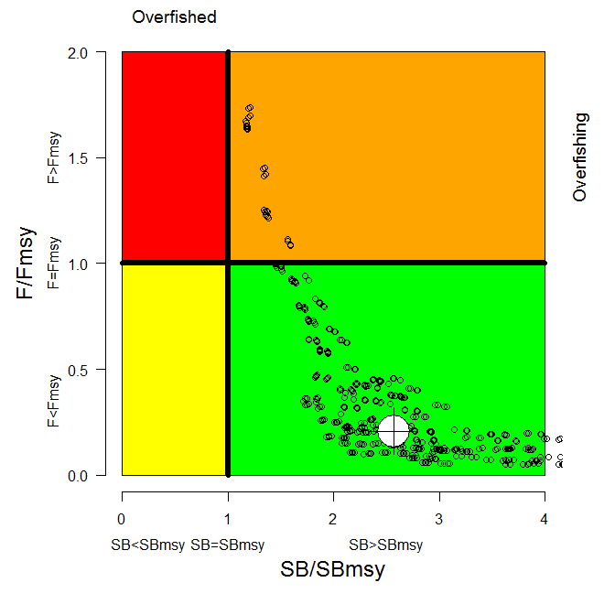
Figure ALB5: $F_{current}/F_{MSY}$ and ${SB}_{current}/{SB}_{MSY}$ for 540 model runs in the uncertainty grid (black hollow circles) and the median (large white circle). Note that some grid model runs extend as far as 7 for ${SB}_{current}/{SB}_{MSY}$.

Management Advice and Implications

- The South Pacific albacore stock is currently not overfished and overfishing is not occurring. Current biomass is sufficient to support current levels of catch. However, for several years the SC has noted that any increases in catch or effort are likely to lead to declines in catch rates in some regions, especially for longline catches of adult albacore, with associated impacts on vessel profitability. SC8 further noted that vessel activity must be managed, as per the requirements of CMM 2010-05.

- Given the recent expansion of the fishery and recent declines in exploitable biomass available to longline fisheries, and given the importance of maintaining catch rates, the SC recommends that longline fishing mortality be reduced if the Commission wishes to maintain economically viable catch rates.

Recommendations

- The SC requests that the Scientific Services Provider conduct deterministic projections for south Pacific albacore to be presented to WCPFC9. Projections would be based on scalars of the 2010/2011 [final year] catches as used in the assessment. Specifically, longline scalars of 0.7 to 1.5 in 0.1 increments and scalars of 1, 2, 5 for the surface troll fishery are proposed. Outputs should be similar to those commonly reported for projections, plus information on predicted changes in vulnerable biomass. In making this request it is noted that the management advice was based on the median of the uncertainty grid and some consideration will be required of the technical approaches to be used to undertake these projections.

- SC8 recognized the potential for analysis of trade data to reduce the uncertainty in reported catch.

South Pacific swordfish

Review of research and information

- SC8 recommended that, if possible, the sex specific growth and other biological parameters should be incorporated prior to undertaking the next stock assessment. SC8 recommended that SPC conduct the south Pacific swordfish stock research under the proposed work plan as follows:

    - finalise the development of the method of sex specific stock assessment;
    - stock assessment conducted through collaboration from the EU and results will be presented at SC9;
    - the Scientific Services Provider will present an update on their analysis of SWO as a component of their stock status report to WCPFC9.

Status and trends

- SC8 noted that no stock assessment was conducted for South Pacific swordfish for SC8. Therefore, the stock status description from SC5 is still current.

Management Advice and Implications

- SC8 noted that no stock assessment was conducted for South Pacific swordfish in 2012. Therefore, the management recommendations from SC5 are still current and SC8 recommended provision of management advice to the Commission be deferred to SC9.

Southwest Pacific striped marlin

Status and trends

- The SC selected the reference case model from the assessment to characterize stock status and selected several key sensitivity runs to characterize uncertainty in trends in abundance and stock status (Figures MLS1-MLS5 and Tables MLS1 and MLS 2). It was noted that the use of the reference case and key sensitivities selected by SC8 (see Table MLS1) leads to slightly different conclusions in terms of stock status compared to that based on the uncertainty grid used in the assessment. The reference case and five of the six other key sensitivity runs estimated F_{current}/F_{MSY} to be less than one indicating that overfishing is unlikely to be occurring. However, when considering SB_{current}/SB_{MSY}, the reference case and four of the six other key sensitivity runs are estimated to be less than one, indicating evidence that the stock may be overfished.

Table MLS1. Estimates of management quantities for selected stock assessment models from the 2012 Ref.case model and the six plausible key model runs. For the purpose of this assessment, “current” is the average over the period 2007–2010 and “latest” is 2011.
 | Ref.case | sel_JP_AU_3log | CP_JP2_AU_2_3 | h=0.65 | h=0.95 | Growth_est | Sz_data_wt
$$C_{current}$$ | 1758 | 1753 | 1785 | 1759 | 1759 | 1707 | 1764
$$C_{latest}$$ | 1522 | 1523 | 1512 | 1522 | 1522 | 1476 | 1521
$$MSY$$ | 2081 | 2017 | 2256 | 1914 | 2276 | 2182 | 2179
$$C_{current}/MSY$$ | 0.85 | 0.87 | 0.79 | 0.92 | 0.77 | 0.78 | 0.81
$$C_{latest}/MSY$$ | 0.73 | 0.76 | 0.67 | 0.80 | 0.67 | 0.68 | 0.70
$$F_{mult}$$ | 1.24 | 1.10 | 1.39 | 0.83 | 1.98 | 1.79 | 1.42
$$F_{current}/F_{MSY}$$ | 0.81 | 0.91 | 0.72 | 1.21 | 0.51 | 0.56 | 0.71
$${SB}_{0}$$ | 15,130 | 14,530 | 16,590 | 16,790 | 14,220 | 15,360 | 16,000
$${SB}_{MSY}/{SB}_{0}$$ | 0.27 | 0.27 | 0.27 | 0.32 | 0.22 | 0.28 | 0.26
$${SB}_{current}/{SB}_{0}$$ | 0.24 | 0.22 | 0.25 | 0.21 | 0.25 | 0.31 | 0.25
$${SB}_{latest}/{SB}_{0}$$ | 0.24 | 0.23 | 0.25 | 0.22 | 0.26 | 0.32 | 0.26
$${SB}_{current}/{SB}_{MSY}$$ | 0.87 | 0.81 | 0.92 | 0.67 | 1.14 | 1.11 | 0.95
$${SB}_{latest}/{SB}_{MSY}$$ | 0.90 | 0.84 | 0.92 | 0.70 | 1.19 | 1.14 | 1.00
$${SB}_{curr}/{SB}_{{curr}_{F=0}}$$ | 0.34 | 0.32 | 0.37 | 0.34 | 0.34 | 0.44 | 0.37
$${SB}_{latest}/{SB}_{{latest}_{F=0}}$$ | 0.37 | 0.34 | 0.39 | 0.37 | 0.37 | 0.46 | 0.40
Steepness (h) | 0.80 | 0.80 | 0.80 | 0.65 | 0.95 | 0.80 | 0.80

Table MLS2. Comparison of southwest Pacific Ocean striped marlin reference points from the 2012 reference case model and the range of the seven models in Table MLS1; the 2006 base case model (steepness estimated as 0.51). NA = not available.
Management quantity | 2012 assessment  Ref.case (uncertainty) | 2006 assessment  Base case
Most recent catch | 1758 mt (2011) | 1412 mt (2004)
MSY | 2081 t  (1914 – 2276) | 2610 t
F_{current}/F_{MSY} | 0.81 (0.51-1.21) | 1.25
B_{current}/B_{MSY} | 0.83 (0.70-0.99) | 0.70
SB_{current}/SB_{MSY} | 0.87 (0.67-1.14) | 0.68
Y_{Fcurrent}/MSY | 0.99 (0.93-1.00) | 0.99
B_{current}/B_{current, F=0} | 0.46 (0.44-0.53) | 0.53
SB_{current}/SB_{current, F=0} | 0.34 (0.32-0.44) | NA

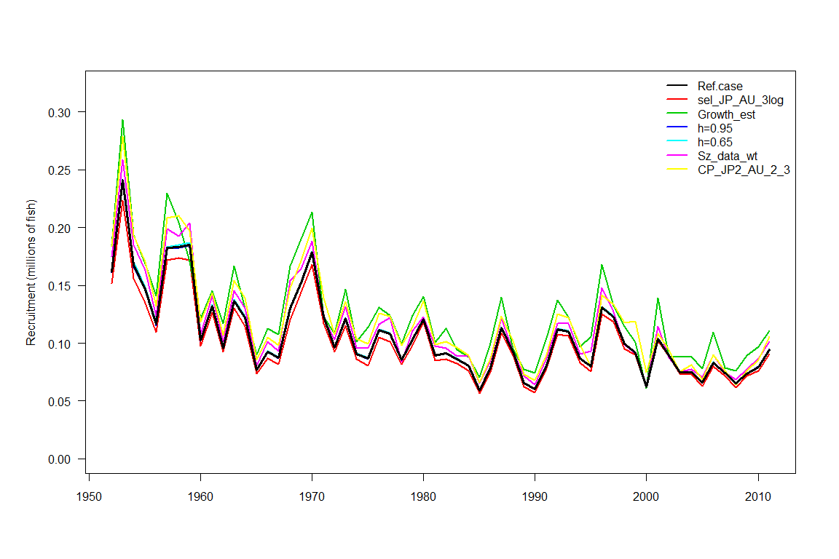
Figure MLS1: Estimated annual recruitment (millions of fish) for the southwest Pacific Ocean striped marlin obtained from the Ref.case model (black line) and the six plausible key model runs.
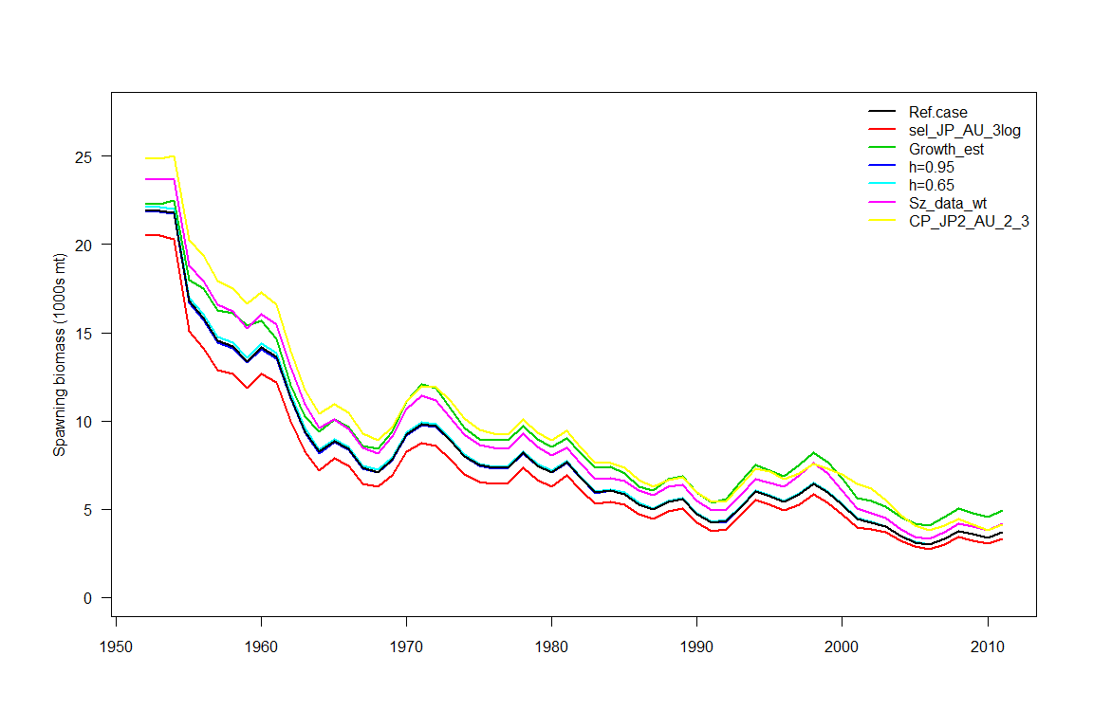
Figure MLS2: Estimated average annual average spawning potential for the southwest Pacific Ocean striped marlin obtained from the Ref.case model (black line) and the six plausible key model runs.

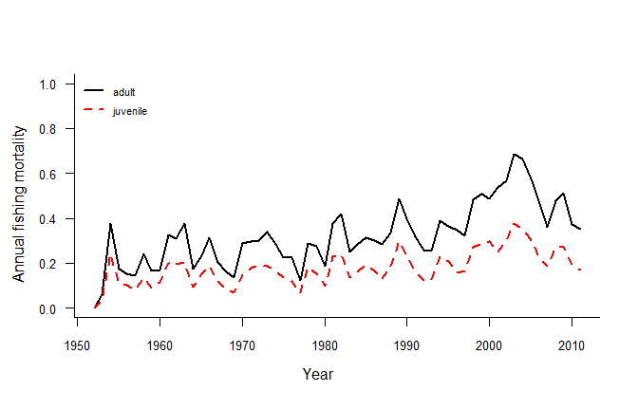
Figure MLS3: Estimated annual average juvenile and adult fishing mortality for the southwest Pacific Ocean striped marlin obtained from the Ref.case model.
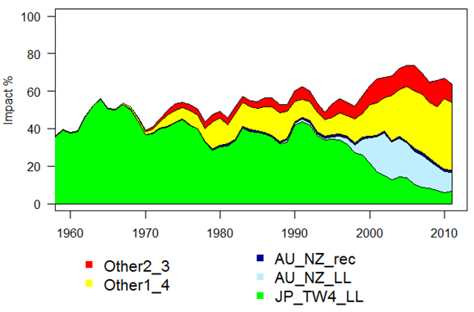
Figure MLS4: Estimates of reduction in spawning potential due to fishing (fishery impact = ${1-SB}_{t}/{SB}_{t_{F=0}}$ ) for the southwest Pacific Ocean striped marlin attributed to various fishery groups (Ref.case model). JP_TW4+LL = Japanese longline fisheries in sub-areas 1 to 4 and Taiwanese longline fishery in sub-area 4; AU_NZ_LL = Australian and New Zealand longline fisheries; AU_NZ_rec = Australian and New Zealand recreational fisheries; Other1_4 = all longline fisheries in sub-areas 1 and 4 excluding Taiwanese in sub-area 4 and excluding Japanese; Other2_3 = all longline fisheries in sub-areas 2 and 3 excluding Japanese, Australian and New Zealand.

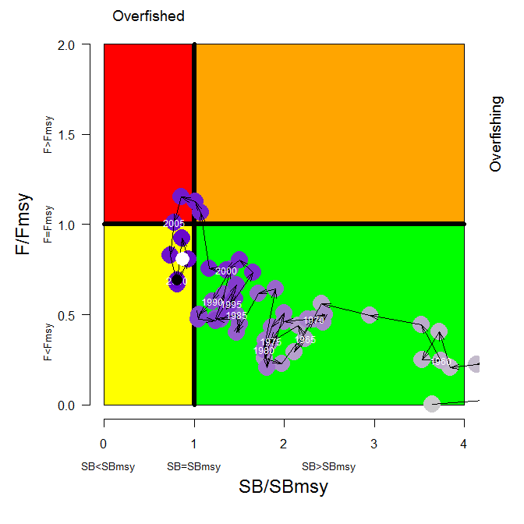
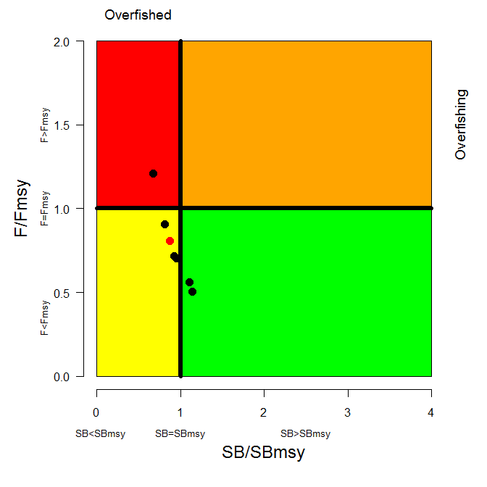
Figure MLS5: Temporal trend in annual stock status, relative to SB_{MSY} (x-axis) and F_{MSY} (y-axis) reference points for the Ref.case (top) and $F_{current}/F_{MSY}$ and ${SB}_{current}/{SB}_{MSY}$ for the Ref.case (red circle) and the six plausible key model runs. See Table MLS1 to determine the individual model runs.

Management Advice and Implications

- The southwest Pacific striped marlin assessment results indicate that the stock is fully exploited, and is not experiencing overfishing but may be overfished. The SC noted that recent catches are close to MSY, and that recent fishing mortality is slightly below F_{MSY}, and that recent spawning biomass is slightly below SB_{MSY}. The recent catch increase is driven in part by increases in catch in the northern area of the stock area that is not subject to the current CMM for this stock.

- SC8 recommends measures to reduce overall catch of this stock, through the expansion of the geographical scope of CMM 2006-04 to cover the distribution range of the stock.

- In designing such a measure to implement this recommendation from SC8, the Commission may need to consider the historic trends in the fishery, including the catch declines in the traditional central and southern areas and the recent catch increases in the northern areas.

- SC8 recognizes that striped marlin is often caught as a non-target species. SC8 therefore recommends data analysis be conducted to identify areas of high catch concentration that could be subject to targeted management.

North Pacific Striped Marlin

- Noting the delay in the western and central North Pacific striped marlin (WCNPSTR) assessment, and the associated lack of timely submission of assessment documents, SC8 recommends that the Commission consider tasking the Scientific Services Provider with conducting the next assessment unless the ISC can demonstrate that it will prevent such delays in future and that the ISC Chair cooperates for more timely submission of stock assessment analyses and reports.

Status and trends

- The WCNPSTR stock is overfished and experiencing overfishing. The current (2010) spawning biomass is 65% below SB_{MSY}=2,713 mt and the current fishing mortality (2007-2009) exceeds F_{MSY}=0.61 by 24% (Figure WCNPSTR4). Reducing fishing mortality would likely increase spawning stock biomass and may improve the chances of higher recruitment.

Figure WCNPSTR4. Kobe plot of the trends in estimates of relative fishing mortality and relative spawning biomass of Western and Central North Pacific striped marlin (Kajikia audax) during 1975-2010.

Management Advice and Implications

- SC8 noted ISC’s conservation advice for the Commission’s consideration as follows:

Noting that the last year of the model was 2010 and F₂₀₁₂ is likely to be different to F_{current}, current fishing mortality (average 2007-2009) is estimated to be 24% above F_{MSY}. Fishing at F_{MSY} would lead to an estimated spawning biomass increase of roughly 45% to 72% by 2017. Seven additional harvest scenarios were also modelled using either resampled recruitment estimates from 1994-2008 or randomly generated deviations around the assumed spawner-recruit relationship. Included in the alternative harvest scenarios were: constant catch at 2,500 mt, that represents 80% of average catches during 2007-2009; constant catch at 3,600t that represents catch levels prescribed in CMM 2010-01; fishing at the current F (average 2007-2009); and fishing at the average F (2001-2003):

- Fishing at a constant catch of 2,500 mt was estimated to increase spawning biomass by 133% to 223% by 2017.
- Fishing at a constant catch of 3,600 mt was estimated to increase spawning biomass by 48% to 120% by 2017.
- In comparison, fishing at the current (2007-2009) fishing mortality rate was estimated to increase spawning biomass by 14% to 29% by 2017, and fishing at the average 2001-2003 fishing mortality rate would lead to a spawning biomass decrease of 2% under recent recruitment to an increase of 6% under the stock-recruitment curve assumption by 2017.

- The SC8 recommended that the ISC conduct an additional set of projections of the WCNPSTR striped marlin based on the 2012 stock assessment results. The projections should be based on resampling only recruitment from the most recent 5 year period (2004-2008). Recruitment during that period is below the average of the 1994-2008 and may represent a different and more pessimistic recruitment regime than assumed in the current projections. The 8 harvest scenarios examined in the 2012 stock assessment should be evaluated with this more pessimistic assumption, and an additional run using this recruitment scenario and constant catch at the 2011 level should also be included. Probabilities of stock recovery as well as trajectories of spawning biomass and catch should be documented and presented to WCPFC9.

- Given the current pessimistic status of the stock, SC8 recommends that the Commission strengthen the existing CMM to ensure the recovery of North Pacific striped marlin based on information provided by ISC.

North Pacific albacore tuna

Status and trends

- SC8 noted that no stock assessment was conducted for North Pacific albacore in 2012. Therefore, the stock status description and management recommendations from SC7 are still current.

Management Advice and Implications

- SC8 noted that no stock assessment and management advice was provided since SC7. Therefore the advice from SC7 should be maintained pending a new assessment or other new information.

Pacific bluefin tuna

Status and trends

- SC8 noted that no stock assessment was conducted for Pacific bluefin tuna in 2012. Therefore, the stock status description and management recommendations from SC7 are still current.

Management Advice and Implications

- SC8 noted that no stock assessment and management advice was provided since SC7.

- SC8 noted the following conservation advice from the ISC:

“Until a new stock assessment result becomes available, ISC12 agreed to carry over the previous conservation advice, albeit with the precautionary note that the uncertainty in the stock status has increased through the passage of time and stock biomass may have declined since the last stock assessment. The advice on Pacific bluefin stock status from ISC11 is: ’Given the conclusions of the July 2010 PBFWG workshop (ISC/10/ANNEX/07), the current (2004 -2006) level of F relative to potential biological reference points, and the increasing trend of F, it is important that the level of F is decreased below the 2002- 2004 levels, particularly on juvenile age classes‘. ”

North Pacific swordfish

Status and trends

- SC8 noted that no stock assessment was conducted for north Pacific swordfish in 2012. Therefore, the stock status description and management recommendations from SC6 are still current.

Management Advice and Implications

- SC8 noted that no stock assessment and management advice was provided since SC6. Therefore the advice from SC6 should be maintained, pending a new assessment or other new information.

Oceanic Whitetip Shark

Status and trends

- Spawning biomass, total biomass and recruitment all exhibit a declining trend since 1995 (the first year of the assessment) (Figure OCS1). Current spawning biomass is low and is estimated to be at 15% of SB_{MSY}.

- Fishing mortality from the non-target longline fishery has an increasing trend since 1995 while the fishing mortality from the targeted longline fishery and the purse seine fisheries has varied without trend (Figure OCS4). Current fishing mortality is high and is estimated to be over 6 times greater than F_{MSY}.

- The key conclusions are that overfishing is occurring and the stock is in an overfished state relative to MSY-based reference points (SB_{current}/SB_{MSY} 0.153 (0.082-0.409)) and depletion based reference points (SB_{current}/SB_{zero} 0.065 (0.034-0.173)) (Tables OCS1-2). This conclusion is robust to uncertainties in key model assumptions.

Table OCS 1. Estimates of management quantities for the reference case and sensitivity runs.

Table OSC2. Estimates of management quantities for the reference, median, 5th, and 95th quantiles of the uncertainty grid.

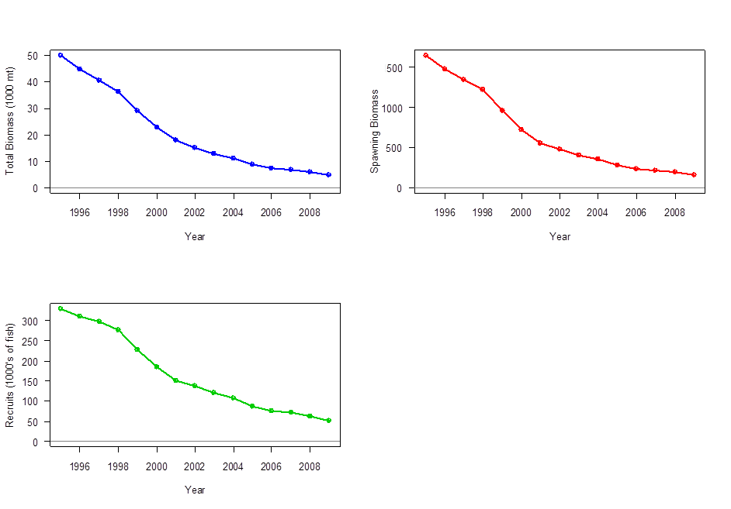
Figure OCS 1. Estimated total biomass (top left, 1000 metric tons), estimated spawning biomass (top right) and estimated annual recruitment (1000’s of fish) in the WCPO for the reference case.
Figure OCS 2. Sensitivity analysis effects on total biomass (top) and recruitment (bottom) of alternate variable levels on the reference case. The figures on the left show the effects of the natural mortality, SigmaR (the s.d. on the recruitment devs.), and the steepness. The figures on the right show the effects of changing the catch inputs, initial depletion, sample size down weighting, and the CPUE inputs.

Figure OCS 4. Estimated fishing mortality by fleet for the reference case over the model period.

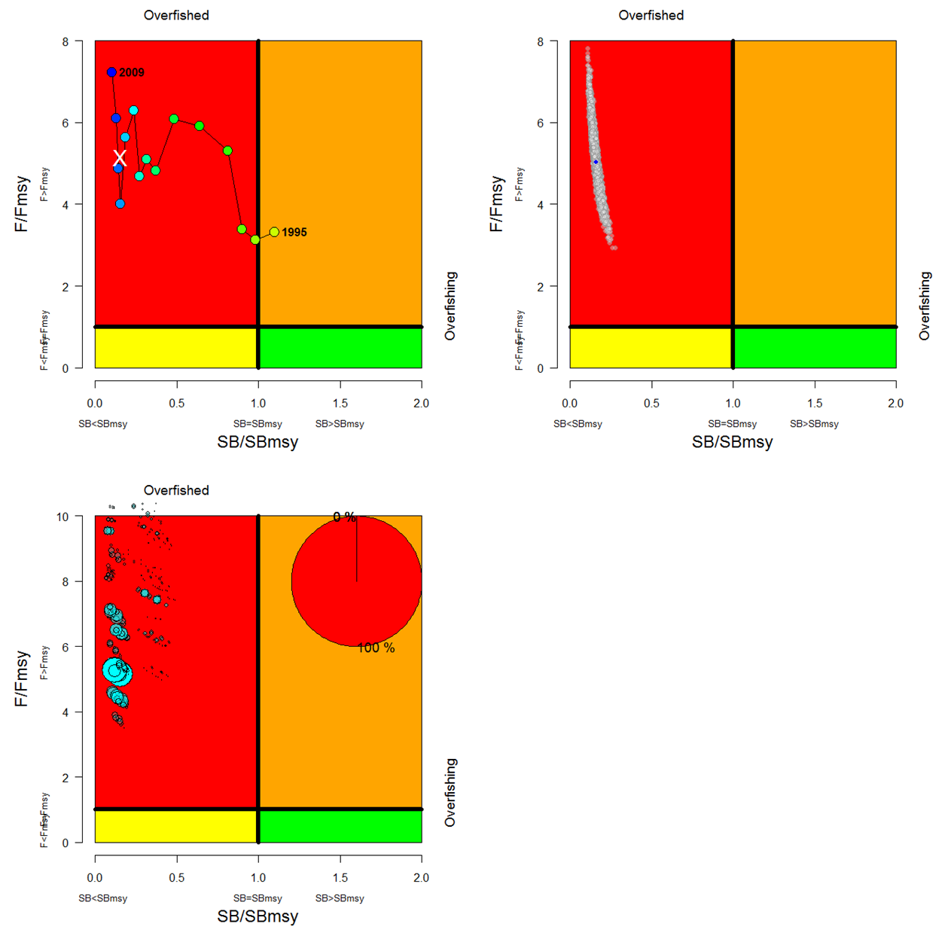
Figure OCS 6. Kobe plots indicating annual stock status, relative to SB_{MSY} (x-axis) and F_{MSY} (y-axis) reference points. These present the reference model for the period 1995–2009 (top left panel), the statistical uncertainty based on the MCMC analysis for the current (average of 2005-2008) status (top right panel, blue dot indicates current estimates), and based on the current (average of 2005-2008) estimates for all 648 models in the grid (bottom panel). In the bottom panel the size of the blue circles is proportional to the weight (plausibility) of the model run. The pie chart in the top right summarises the proportion of model weight in each quadrant. Note that the y-axes range differ in the bottom plot.
Management Advice and Implications

- Despite the data limitations going into the assessment, and the wide range of uncertainties considered, all of the accepted model runs indicate that the WCPO oceanic whitetip shark stock is currently overfished and overfishing is occurring relative to commonly used MSY-based reference points and depletion-based reference points. Management measures to reduce fishing mortality and to rebuild spawning biomass have been agreed to under CMM 2011-04, but mitigation to avoid capture is recommended.

- Given the bycatch nature of most of the fishery impacts, mitigation measures provide the best opportunity to improve the status of the WCPO oceanic whitetip shark stock.

- Reference points for non-target species, including oceanic whitetip sharks, should be developed as envisaged under Articles 5 and 10 of the WCPF Convention.

Silky Shark

Status and trends

- The 2012 silky shark assessment was the first assessment completed for this species. There is conflict among the different CPUE series and this conflict carries through the assessment to indicate very different management implications. The longline bycatch series suggests significant declines in abundance (and overfishing), while the models incorporating the purse seine CPUE series resulted in unrealistically high biomass estimates, with no sustainability concerns.

- It might be expected that the CPUE series developed on longline bycatch would be more reflective of changes in abundance than the target longline CPUE series, which is extremely spatially limited, or the purse seine CPUE series which has no clear measure of fishing effort. The SC considered that the incorporation of additional existing observer data could lead to significantly different conclusions from the assessment, and therefore additional work is required. Therefore, the SC concluded that it was not possible to determine estimates of stock status and yields.

- SC8 noted the findings of WCPFC-SC7-2011/EB-WP-03 which state:
“Although silky sharks have been shown to have declining catch rate trends in past studies in the Pacific, no strong trends were found in recent (2011) WCPO analyses. Nevertheless, declining size trends in two datasets, declining catch rates in these two datasets for the most recent years of the time series, and increasing removals all indicate a need for close, ongoing monitoring of indicators. Further research may allow better definition of trends and a clearer depiction of stock status.”

Refining standardized CPUE and the assessment

- There is large structural uncertainty in the silky shark assessment which needs to be addressed in future assessments, however the 2012 silky shark assessment represents the best available information. The conflicting trends in the standardized longline (declines after 2004) and purse seine (increases in most of the time series) fisheries require further investigation. The model fit to the highly influential bycatch longline series is poor. Particular investigation should be made on the divergence between standardized and nominal CPUE after 2004 which occurs when vessel effects are incorporated into the standardization process.

Management Advice and Implications

- Noting SC8s concerns over the data conflict and potential biases in the silky shark assessment, it is not possible to provide management advice based on the assessment at this time. However, noting that some basic fishery indicators (e.g. mean lengths and some CPUE series) are showing declines in recent years, the SC recommends no increase in fishing mortality on silky sharks.

- Further, recognizing that the major fishery impacts relate to non-target fisheries, the SC recommends that the Commission consider mitigation measures to reduce the impact of these non-target fisheries as a precautionary measure. SC8 recommends that the silky shark assessment be updated to incorporate all potentially important data series.

- Reference points for non-targets species, including silky sharks, should be developed as envisaged under Articles 5 and 10 of the WCPF Convention.

MANAGEMENT ISSUES THEME

Limit Reference Points

- SC8 noted the hierarchical approach to identifying the key limit reference points (LRPs) for the key target species in the WCPFC recommended by SC7 and adopted by the Commission at WCPFC8.

- SC8 recommended, noting the current level of research and the uncertainties in our knowledge on steepness, particularly on the level where recruitment overfishing may start, that LRPs for BET, YFT and south Pacific ALB be set at Level 2 with regard to the biomass-based LRP of 20%SB_{recent,F=0} , with deferral of a recommendation on the value of X% in the Level 2 fishing mortality-based LRP of F_{x%SPR} to SC9 (note that SPR refers to the spawning-potential-per-recruit and SB_{recent,F=0} refers to the estimated average spawning biomass over a recent period in the absence of fishing). The LRP for SKJ was recommended to be set at Level 3, i.e. 20%SB_{recent,F=0}.

- One CCM recommended F_{20%SPR} as a LRP for Level 2. This CCM stated that F_{20%SPR} is logically consistent with 20%SB_{recent,F=0} as a means of maintaining a minimal spawning potential. This CCM noted that it is important to have LRPs for both harvest rate and depletion level to conserve spawning potential. Finally, this CCM stated that estimates of F_{20%SPR} are more robust to biological uncertainties than 20%SB_{recent,F=0} because F_{20%SPR} does not require an estimate of unfished recruitment.

- SC8 recommended that the probability of breaching a limit reference point should be very low.

- SC8 recommended that the allowable risk of breaching a limit reference point may be applied on a species-specific basis, for example higher risk for yellowfin and bigeye tunas but a more precautionary lower risk to skipjack and south Pacific albacore tuna.

- SC8 noted that a range of risk levels of breaching the LRP were suggested by CCMs with a majority of CCMs recommending a 10% level and that a lower more precautionary value could be considered in some cases.

- SC8 recommended that the Management Objectives Workshop review appropriate values for specifying the level of risk for individual species.

- SC8 recommends that further work be undertaken by SPC on the identification of:
  - the appropriate period for estimating the average recruitment for each species in the LRP 20%SB_{recent,F=0}, and
  - the appropriate values of X for each species in the LRP F_{x%SPRo},
and that this work be presented to SC9 for review and for final specification of these LRPs.

- SC8 recommends that work should continue to move all key WCPFC stocks to the Level 1 reference points.

- SC8 recommended that SPC further develop a common approach to characterisation of uncertainty and estimation of risk in relation to limit reference points, in order to ensure consistency in the provision of management advice to the Commission, and that this approach be reviewed at SC9.

- SC8 further recommends SPC present working paper SC8-MI-WP-01 to the Management Objectives Workshop, which is to be held prior to WCPFC9, for further discussion.

Target Reference Points and Harvest Control Rules

- SC8 considered working papers SC8-MI-WP-02 and SC8-MI-WP-03 on target reference points and harvest control rules and recommends these papers be presented to the Management Objectives Workshop which is to be held prior to WCPFC9.

- SC8 also recommends that in preparing information for the Management Objectives Workshop that SPC take into consideration the following:
- use of the limit reference points recommended by SC8;
- consideration of the multi-species implications of target reference points; and
- the role for empirical indicators in the harvest control rules.

Review of CMM 2008-01

- The SC8 recommends that the TCC and the Commission note the following conclusions based on the analyses presented in working papers SC8-MI-WP-04 and SC8-MI-WP-06 when reviewing the effectiveness of CMM 2008-01 (and its extension under CMM 2011-01) and in the development of a revised CMM for bigeye, yellowfin and skipjack tuna stocks:

- the limits placed on purse seine operations have not adequately constrained total purse seine effort, with total effort in 2011 estimated to be 31% higher compared to effort in 2004 and 46% higher than the 2001-2004 level;
- that the number of days reported with any activity related to a drifting FAD was 16.1% in 2009, 6.8 % in 2010 and 8.2% in 2011 during the FAD closure periods. The observed incidence of vessels drifting at night with fish aggregation lights on increased from 2.3% in 2009 to 6.8% in 2010 and was 3.4% in 2011;
- despite the FAD closure the total estimated number of FAD sets made in 2011 was a record high, largely due to high a FAD set ratio outside of the FAD closure period and increased purse seine effort overall. Nevertheless, several fleets (notably Japan, Philippines, New Zealand) have substantially changed their fishing operations, focusing more on unassociated set fishing in 2010 and 2011 than they had in the past but others remain highly dependent on FADs;
- the catch of bigeye tuna, small yellowfin and small skipjack can be significantly reduced by purse seines switching from FAD sets to unassociated sets;
- the total purse seine catch of bigeye during 2011 was the highest on record (77,095 mt) and only the second time that the purse seine catch had exceeded the longline catch;
- available data indicates that the high-seas pocket closure since 1 January 2010 has largely been respected. Since January 2010, effort has been concentrated mainly in the EEZs, with no apparent re-distribution of effort to the eastern high seas, though effort in this area could increase with the predicted return of ENSO-neutral or El Niño conditions;
- closing areas/time entirely to purse seine fishing without consideration of the fate of displaced fishing effort will not be effective for bigeye conservation and less profitable to purse seine operations as a whole;
- the provisional longline catch of bigeye tuna in 2011 is 24% lower than the 2001-2004 level. However, in the core area of the tropical longline fishery, the reduced catches have been paralleled by a decline in nominal CPUE and no apparent reduction in fishing effort, which indicate that the recent catch declines could be more the result of further declines in adult bigeye tuna abundance than reduced fishing mortality or a shift in target species;
- the provisional longline catch of yellowfin tuna in 2011 is close to the 2001-2004 average level;
- stock projections undertaken using the reference case models for the 2011 assessments for bigeye tuna indicate that maintenance of bigeye tuna catch and effort levels observed in the fishery in 2009 results in F/F_{MSY} remaining high, with a projected level of 1.40 in 2021. However, for the scenario best approximating the reported catch and effort in the fishery in 2010, F/F_{MSY} declines and is at a projected level of 0.96 in 2021. This is driven by several factors: the lower than usual FAD use in 2010, the lower longline catches, and a large (30%) reduction in reported catches from the domestic fisheries of Indonesia and the Philippines. For the scenario approximating 2011 fishery conditions, F/F_{MSY} stabilises at a projected level of 1.29. The difference between 2010 and 2011 fishery outcomes is mainly due to the return to higher levels of FAD-based purse seine effort in 2011;
- for scenarios that mimic a total purse seine closure (i.e., where FAD effort is not transferred to unassociated fishing), there is a small incremental reduction in F/F_{MSY} compared to that achieved by a FAD closure. However, this comes at a cost of substantial reductions in total catch, particularly of skipjack in the purse seine fishery. This conclusion is robust to the use of base years from 2001-2009 to characterize the differences;
- it is estimated that if the CMM was implemented without exemptions, approximately an additional half of the overfishing that is estimated could occur under the CMM as written could be removed (reduction of bigeye tuna F/F_{MSY} from 1.35 to 1.17);
- estimation of the individual impacts on bigeye tuna F/F_{MSY} of observed levels of catch or effort for the longline, purse seine and domestic Philippines and Indonesia fishery groups in 2009 and 2010 against a base of 2004 indicates that the reduction in purse seine FAD effort in 2010 has the greatest effect in terms of removing overfishing (67.4% of overfishing removed) followed by the reduction in longline catch in 2010 (34.7% of the overfishing removed).

- Based on the above observations and analyses, and noting that the fishing mortality for bigeye has not been reduced to the level intended under CMM-2008-01, SC8 supports the need for additional or alternative targeted measures to reduce the fishing mortality on bigeye. In the development of a revised CMM for bigeye, yellowfin and skipjack tuna stocks SC8 recommends the Commission consider:
- a strengthening of the control of FAD activities;
- building on the apparent success of some fleets in reducing their dependence on FADs to achieve greater control of FAD activity outside the closures, including control of the number of FADs set throughout a year instead of FAD time-closures;
- a reduction of the total number of FAD sets to the levels no greater than those in the fishery in 2010;
- clear definition of the limits on purse seine effort that are applicable in different areas;
- reductions in fishing mortality on bigeye tuna from the longline fishery; and
- the adoption of management measures that apply to all sectors of the fishery.

- SC8 recommends that the Commission take account of the information in working paper SC8-MI-WP-05 “Mapping the distribution of the conservation burden” in its consideration of new management measures for the WCPFC.

- SC8 recommends that the Management Objectives Workshop consider the issues raised in working paper SC8-MI-WP-05.

ECOSYSTEM AND BYCATCH MITIGATION THEME

Ecosystem effects of fishing

- SC8 reiterated the need to improve knowledge on the influence of environmental effects on tuna fisheries to reduce the uncertainty in short, medium and longer term projections of tuna abundance. SC8 recognises that the outcomes of the project proposed in EB-WP-01 and its supportive linkages with the ongoing development of SEAPODYM will complement the SC’s programme of work. SC8 recognizes that this project will not require direct contributions in funds or manpower from the Commission and endorses the development and implementation of the project if external funding can be secured.

- SC8 noted the progress of the Kobe Technical Working Group for bycatch and provides the following advice: (1) the participation of the WCPFC secretariat (or its delegate) in the harmonisation of longline observer data is desirable; (2) encourages development of the Bycatch Mitigation Information System into a tuna RFMO wide resource; (3) submission of the ACAP harmonised seabird identification guide to the WCPFC Secretariat to coordinate its review.

6.2 Sharks

- SC8 noted the progress made in support of the Shark Research Plan while also noting that meaningful progress in some areas remains hindered by data availability and quality.

- SC8 recommended that the Commission assist in providing or identifying funds to distribute existing shark identification guides and promote the development of species identification guides harmonized where appropriate with other RFMOs to improve data reporting.

- SC8 through the Commission encourages CCMs to adopt and promote the recording of data by their longline fleets on harmonized and sufficiently detailed longline logsheets that include the key shark species.

- SC8 recommends that the Scientific Services Provider conduct a study on the spatial and temporal distribution of whale shark in the WCPO based on observer data and other data sources as appropriate.

- SC8 supports the finding of the Scientific Services Provider that whale shark meets the basic criteria for consideration as a key shark species and recommends that the whale shark (Rhincodon typus) be defined as a key shark species of the WCPFC.

6.3 Seabirds

- Following the review of the papers presented, the SC determined that currently, there is no single mitigation measure that can reliably prevent the incidental mortality of seabirds in most pelagic longline fisheries.

- SC8 recognizes the advice from ACAP that the following seabird bycatch mitigation measures are the most effective: weighted branch lines, night setting and bird scaring lines.

- SC8 recommends that a combination of techniques should be used, especially those including weighted branch lines, bird scaring lines, and night setting that have proven most effective for reducing seabird bycatch of the seabird fauna prevalent in a particular region of concern. Other factors such as safety, practicality and the characteristics of the fishery should also be recognised.

- SC8 recognizes that different longline fleets have obtained lower interaction rates with different mitigation methods. SC8 also noted that a combination of longline deployment techniques and other gear attributes used in the Hawaii-based longline fisheries effectively reduce incidental seabird capture.

- SC8 reiterates advice that a spatial management approach be employed for seabird mitigation and recommends that the Commission consider the following advice when it revises the seabird CMM 2007-04:

- Southern hemisphere
SC8 recommends that fisheries south of 30 degrees S are required to use at least two of these three measures: weighted branch lines, night setting and bird scaring lines. When using bird scaring lines the descriptions outlined in SC8-EB-WP-06 should be used.

- Northern hemisphere
SC8 recommends that the table in CMM 2007-04 be revised to eliminate redundancy by removing weighted branch lines and underwater setting chute in column B.

- Branch Line Weighting
With regard to branch line weighting, SC8 recognises that research in Australia (SC8-EB-WP-09 and SC8-EB-WP-10) has demonstrated that the use of at least one weight of 40g within 50cm of the hook, or of 45- 60 g within 1 m of the hook, is more effective to quickly sink baited hooks beyond the depths at which they may be available to seabirds. Other options using weights at greater distance from the hook are not as effective.

- Vessel length
SC8 recommends that the potential impacts of the North Pacific vessel size exemption be addressed. Nations conducting longline fishing in the North Pacific to the north of 23 degrees north should provide vessels numbers <24 and =>24m for recent years. Annual Reports-Part 1 have statistics on vessel size by GRT, however statistics on vessel length should be presented to SC9.

- Spatial management
SC8 reiterates advice that a spatial management approach should be employed for seabird mitigation. In clearly defined areas south of 30 degrees S and north of 23 degrees N, exemption from the following requirements could be considered if seabird interaction rates can be scientifically demonstrated to be minimal, with observer coverage rates that are sufficient to quantify rare events in these areas. The SC should determine appropriate (minimal) levels of interaction rates when representative observer data are available.

- ROP Data Fields
SC8 recommends that the TCC give consideration to the inclusion of data fields on: the mass of added weight attached to branch lines, distance between weight and hook (in meters), and the fate (dead, alive or injured) and number of seabirds for each species in each of these categories and whether the seabirds were released alive or discarded dead.

FAD bycatch and mitigation

- SC8 supported the research objectives of the ISSF bycatch research cruises and encouraged further work by ISSF and all CCMs to develop and test purse seine mitigation efforts that prioritize avoidance or selective release of bycatch from the net; that maximize the condition factor of released animals; and that scientifically verify their post-release condition using pop-up archival tags and other technology.

Food security issues with bycatch

- SC8 requested that the Commission Scientific Services Provider continue to produce and update the type of analysis presented in Estimation of catches and fate of edible bycatch species taken in the equatorial purse seine fishery (SC8-EB-WP-18) for presentation to the SC, with analyses to include the WCPO longline fishery and to address some of the issues raised in the Next Steps section of the paper.

Other research projects

West Pacific East Asia Oceanic Fisheries Management Project (WPEA OFM Project)

- SC8 agreed that the WPEA OFM Project has contributed significantly to the Commission’s data holdings for these important fisheries.

- SC8 recommended the WCPFC Secretariat work with GEF/UNDP to develop a further project to continue the improvement of data collection, fisheries management and governance for tuna species in the southeast Asian region.

Pacific Tuna Tagging Project

- SC8 adopted SC8-RP-PTTP-01, the Summary Report of the Sixth Steering Committee Meeting for the PTTP, and noted the importance of tagging data for stock assessments of tropical tunas in the WCPFC area.

Future Work Program and Budget

Review of SC List of Work Programme Items

- The SC tasked the Secretariat with updating the List of Work Programme of the Scientific Committee (SC8-GN-WP-05 (rev. 2)), in accordance with the recommendations of the ISG as specified above.

Development of 2013 Work Programme and budget, and projection of 2014-2015 provisional work programme and indicative budget

- The SC Vice-Chair introduced the proposed 2012-2013 SC Work Programme and Budget and 2013-2015 SC Provisional Work Programme and Budget (SC8-GN-WP-05). He noted that the budget includes additional costs for the following functions:
- $75,000 for Project 60 (Purse Seine species composition);
- $40,000 for bigeye MULTIFAN-CL improvements (recommended by the bigeye peer review); and
- $160,000 for additional resourcing for SPC for stock assessment tasks and improvements as recommended by the bigeye peer review.

- In addition, it was noted that there was a proposal to carry over $30,000 from 2012 unallocated funds to apply to Project 57 (Limit Reference Points) in 2012-2013.

- SPC noted that, as a general rule, under the current Service Level Agreement for Scientific Services can conduct two tuna stock assessments and one shark stock assessment. Any additional work would require additional funding.

Recommendation

- SC8 tasked the Scientific Services Provider to undertake a review of data holdings for sailfish in order to inform discussions at SC9 regarding the necessary budget for undertaking further analyses.

- SC8 recommended that the Commission consider the proposed 2013 Scientific Committee Work Programme and Budget and the Provisional 2014-2015 Scientific Committee Work Programme and indicative Budget (SC8-GN-WP-09). SC8 also considered SPC-OFP’s indicative science services for 2013-2015 (SC8-GN-WP-10). Both documents are appended as Attachment J.

- SC8 recommended that the Commission consider extending the Shark Research Programme conducted by the Scientific Services Provider beyond December 2013 when the current funding from the Commission expires.

- SC8 recommended that the Management Objectives Workshop consider continued research and associated budgets (using funds available in the unobligated budget) for Project 58 (Evaluation of Reference Points and Decision Rules) and Project 66 (Identification and Evaluation of Target Reference Points) and recommend the Commission consider the inclusion of this research within the SC Work Programme and Budget.

List of Scientific Committee work programme titles and budget for 2013, and indicative budget for 2014–2015, which require funding from the Commission’s core budget (in USD).
Research Activity / Project with priority | 2,013 | 2,014 | 2,015
Project 14. WPEA OFM | 25,000 | 25,000 | 25,000
Project 35. Refinement of bigeye parameters | 70,000 | 75,000 | 75,000
Project 42. Pacific-wide tagging project | 10,000 | 10,000 | 10,000
Project 57. Limit reference points | 30,000
Project 66. Target reference points
Project 63. Harvest control rules
Project 60. PS species composition | 75,000
Sail Fish (data analysis)
Peer review of Pacific Bluefin tuna
Bigeye multifan CL | 40,000
Additional resourcing SPC | 160,000 | 160,000 | 160,000
SUBTOTAL | 410,000 | 270,000 | 270,000
UNOBLIGATED BUDGET | 83,000 | 83,000 | 83,000
SPC-OFP BUDGET | 871,200 | 871,200 | 871,200
GRAND TOTAL | 1,364,200 | 1,224,200 | 1,224,200

Administrative Matters

Peer review of stock assessments

- SC8 recommended that:
  - the Terms of Reference (Attachment J, SC7 Summary Report) be adopted future stock assessment reviews, noting that minor revision may be required to address assessment-specific issues.
  - The selection procedure of a review panel developed at SC7 (Paras. 580 and 581, SC7 Summary Report) be used for future peer review of stock assessments.
  - The Commission requests the NC to conduct a scientific peer review of the Pacific bluefin tuna stock assessment once it is completed.

Future operation of the Scientific Committee

- SC8 agreed that future SC meeting agendas would include Data and Statistics, Stock Assessment, Management Issues and Ecosystem and Bycatch Themes only.

- SC8 adopted the Guidelines for the Theme Convenors and SC Chair contained in SC8-GN-WP-06 (Attachment K).

- SC8 approved L. Kumoru as the new Data and Statistics Theme Convenor and A. Batibasaga as one of the Ecosystem and Bycatch Theme Co-Convenors.

- SC9 is provisionally scheduled for 6-14 August 2013 with a venue to be determined inter-sessionally and agreed on at WCPFC9.

Details of the SPC-OFP Science Services for 2013 – 2015 are tabulated below

