

The Commission for the Conservation and Management of
Highly Migratory Fish Stocks in the Western and Central Pacific Ocean

Fifteenth Regular Session of the Scientific Committee

Pohnpei, Federated States of Micronesia
12–20 August 2019

SUMMARY REPORT

TABLE OF CONTENTS

EXECUTIVE SUMMARY iii
SUMMARY REPORT 1
AGENDA ITEM 1 — OPENING OF THE MEETING 1
AGENDA ITEM 2 — REVIEW OF FISHERIES 4
AGENDA ITEM 3 — DATA AND STATISTICS THEME 12
AGENDA ITEM 4 — STOCK ASSESSMENT THEME 23
AGENDA ITEM 5 — MANAGEMENT ISSUES THEME 106
AGENDA ITEM 6 — ECOSYSTEM AND BYCATCH MITIGATION THEME 140
AGENDA ITEM 7— OTHER RESEARCH PROJECTS 157
AGENDA ITEM 8 — COOPERATION WITH OTHER ORGANISATIONS 159
AGENDA ITEM 9 — SPECIAL REQUIREMENTS OF DEVELOPING STATES & TERRITORIES 159
AGENDA ITEM 10 — FUTURE WORK PROGRAM AND BUDGET 160
AGENDA ITEM 11 — ADMINISTRATIVE MATTERS 162
AGENDA ITEM 12 — OTHER MATTERS 163
AGENDA ITEM 13 — ADOPTION OF THE SC15 REPORT 163
AGENDA ITEM 14 — CLOSE OF MEETING 164
ATTACHMENTS 165
ATTACHMENT A — LIST OF PARTICIPANTS 165
ATTACHMENT B — OPENING REMARKS BY THE NORMA EXECUTIVE DIRECTOR 177
ATTACHMENT C — OPENING REMARKS BY THE WCPFC CHAIR 179
ATTACHMENT D — AGENDA 180
ATTACHMENT E — ISG-4 OUTCOMES 184
ATTACHMENT F — SHARK RESEARCH PLAN UPDATE 189
ATTACHMENT G — REPORT OF ISG-09 AND SCIENTIFIC COMMITTEE WORK PROGRAMME AND BUDGET FOR 2020-2022 194
ATTACHMENT H — LIST OF ABBREVIATIONS 215

The Commission for the Conservation and Management of
Highly Migratory Fish Stocks in the Western and Central Pacific Ocean

Scientific Committee
Fourteenth Regular Session

Busan, Republic of Korea
8–16 August 2018

EXECUTIVE SUMMARY

AGENDA ITEM 1 — OPENING OF THE MEETING

- The Fifteenth Regular Session of the Scientific Committee of the Commission for the Conservation and Management of Highly Migratory Fish Stocks in the Western and Central Pacific Ocean (SC15) took place from 12–20 August 2019 in Pohnpei, Federated States of Micronesia.

- The following WCPFC Members, Cooperating Non-members and Participating Territories (CCMs) attended SC15: Australia, China, Cook Islands, European Union (EU), Federated States of Micronesia (FSM), Fiji, French Polynesia, Indonesia, Japan, Kiribati, Republic of Korea, Republic of Marshall Islands (RMI), Nauru, New Caledonia, New Zealand, Palau, Philippines, Papua New Guinea (PNG), Samoa, Solomon Islands, Chinese Taipei, Tokelau, Tonga, Tuvalu, United States of America (United States), Vanuatu and Vietnam.

- Observers from the following inter-governmental organizations attended SC15: Pacific Islands Forum Fisheries Agency (FFA), Inter-American Tropical Tuna Commission (IATTC), Parties to the Nauru Agreement (PNA), the Pacific Community (SPC) and the Food and Agriculture Organization of the United Nations (FAO).

- Observers from the following non-governmental organizations attended SC15: Birdlife International, International Seafood Sustainability Foundation (ISSF), The Nature Conservancy, The Pew Charitable Trusts (Pew), Sustainable Fisheries Partnership (SFP) Foundation, World Tuna Purse Seine Organisation (WTPO), and the Worldwide Fund for Nature (WWF).

- The Executive Director of the FSM National Oceanic Resource Management Authority Eugene Pangelinan, the Commission Chair Jung-re Riley Kim, and the SC Chair Ueta Jr. Faasili (Samoa) delivered opening and welcome speeches.

- The theme conveners and their assigned themes were:
Data and Statistics | Ueta Jr. Faasili (Samoa)
Stock Assessment | Keith Bigelow (United States) and Hiroshi Minami (Japan)
Management Issues | Robert Campbell (Australia)
Ecosystem and Bycatch Mitigation | John Annala (New Zealand) and Yonat Swimmer (United States)

- SC15 established nine informal small groups (ISGs) but eight were active to facilitate the meeting process:
ISG-ID | Title | Agenda | Facilitators
ISG-01 | Project 90 (Better data on fish weights and lengths for scientific analyses) | 3.1.3 | Withdrawn
ISG-02 | Project 93 (Commission’s data needs) | 3.1.4 | T. Halafihi (Tonga)
ISG-03 | Guidelines for economic data provision | 3.4 | S. Chand (Fiji)
ISG-04 | Review of SC14 bigeye tuna research recommendations | 4.1.1 | K. Satoh (Japan)
ISG-05 | Skipjack assessment – uncertainty axes and weighting | 4.1.3 | SA theme conveners
ISG-06 | Oceanic whitetip shark assessment – uncertainty axes and weighting | 4.3.1 | SA theme conveners
ISG-07 | SW Pacific striped marlin assessment – Uncertainty axes and weighting | 4.4.2 | SA theme conveners
ISG-08 | Shark research plan and future work plan | 6.2.3 | F. Carvalho (USA)
ISG-09 | SC budget for 2020– 2022 | 10.1 | U. Faasili (Samoa)

AGENDA ITEM 2 — REVIEW OF FISHERIES

- P. Williams (SPC-OFP) and C. Reid (FFA) introduced SC15-GN-WP-01 Overview of tuna fisheries in the western and central Pacific Ocean, including economic conditions – 2018, which provides an overview of the WCPO key fisheries, including billfish and trends in purse-seine fishery capacity. They noted that SC15-ST-IP-01 Estimates of annual catches in the WCPFC Statistical Area, and Annual Reports- Part 1 provides additional detail.

- The provisional total WCP–CA tuna catch for 2018 was estimated at 2,716,396 mt, the second highest on record, at around 170,000 mt below the record catch in 2014 (2,885,044 mt). The WCP–CA tuna catch (2,716,396 mt) for 2018 represented 81% of the total Pacific Ocean catch of 3,373,512 mt, and 55% of the global tuna catch (the provisional estimate for 2018 is 4,930,621 mt, which is the second highest and only 6,000 mt from the record global catch in 2014).

- The 2018 WCP–CA catch of skipjack (1,795,048 mt – 66% of the total catch) was the fifth highest, at nearly 215,000 mt less than the record in 2014 (2,008,934 mt). The WCP–CA yellowfin catch for 2018 (666,971 mt – 25%) was the second highest recorded (only 15,000 mt lower than the record catch of 2017); the past three years have been the highest annual yellowfin catches. The WCP–CA bigeye catch for 2018 (142,402 mt – 5%) was the lower than the previous 10-year average, but around 15,000 mt higher than in 2017. The 2018 WCP–CA albacore catch (108,974 mt – 4%) was amongst the lowest for the past twenty years, and nearly 40,000 mt lower than the record catch in 2002 at 147,793 mt. The south Pacific albacore catch in 2018 (68,454 mt), was a significant decline on the record catch in 2017 (93,290 mt). This decline is primarily due to a drop in the longline fishery (from 90,627 mt in 2017 to 65,410 mt in 2018), which may be related in part to the absence of any catch reported by the China longline fleet in the Eastern Pacific Ocean, south of the equator.

- The provisional 2018 purse-seine catch of 1,910,725 mt was the second highest on record, at nearly 150,000 mt less than the record in 2014 (2,059,008 mt). The 2018 purse-seine skipjack catch (1,469,520 mt; 77% of total catch) was the third highest on record, 170,000 mt lower than the record in 2014 (1,639,791 mt). The 2018 purse-seine catch for yellowfin tuna (374,062 mt; 20%) was over 100,000 mt lower than the record catch in 2017 (480,176 mt) but still amongst the highest annual catches for this fishery. The provisional catch estimate for bigeye tuna for 2018 (64,119 mt) was the highest since 2014 and slightly higher than the past ten-year average.

- The provisional 2018 pole-and-line catch (170,038 mt) was slightly higher than the 2017 catch which was the lowest annual catch since the mid-1960s, due to reduced catches in both the Japanese and the Indonesian fisheries.

- The provisional WCP–CA longline catch (254,850 mt) for 2018 was at the average level for the past five years. The WCP–CA albacore longline catch (84,930 mt – 34%) for 2018 was the lowest for ten years, and around 16,000 mt lower than the record of 101,820 mt attained in 2010. The provisional bigeye catch (71,305 mt – 28%) for 2018 was higher than the recent five-year average, but well down on the bigeye catch levels experienced in the 2000s (e.g. the 2004 longline bigeye catch was 99,705 mt). The yellowfin catch for 2018 (94,543 mt – 38%) was at the average level for the past five years and more than 30,000 mt less that the record for this fishery (1980: 125,113 mt).

- The 2018 South Pacific troll albacore catch (2,847 mt) which was the highest catch for five years. The New Zealand troll fleet (144 vessels catching 2,272 mt in 2018) and the United States troll fleet (16 vessels catching 475 mt in 2018) accounted for all the 2018 albacore troll catch.

- Market prices in 2018 were mixed with prices for purse seine-caught product generally declining after significant increases in 2016 and 2017, although yellowfin prices at Yaizu continued to move higher. Yaizu prices for pole and line caught skipjack also saw significant declines. Prices for longline caught yellowfin were mixed with prices for fresh imports into the US and Japan increasing while fresh and frozen prices at Japanese ports declined. Prices for longline caught bigeye in 2018 rose by between 5% and 14% across the selected markets. Thai imports prices for albacore have risen significantly since 2017 with the 2018 average being the highest seen since 2012 while for June 2019 (the latest period for which data is available) the average price exceeded $4,000/mt for the first time.

- The total estimated delivered value of the tuna catch in the WCP-CA increased by 1% to $6.01 billion in 2018. The value of the purse seine catch ($3.26 billion) accounted for 54% of the total value of the tuna catch. The value of the longline fishery increased 16% to $1.72 billion accounting for 29% of the total value of the tuna catch. The value of the pole and line catch continued to decline to be at $343 million in 2018 with the catch by other gears valued at $669 million. The 2018 WCP–CA skipjack catch was valued at $2.95 billion, the yellowfin catch at $1.92 billion, the bigeye catch at $780 million its highest level since 2014, and the albacore catch at $360 million.

- Economic conditions in 2018 in the purse seine, tropical longline and southern longline fisheries of the WCP-CA showed mixed results. In the tropical purse seine fishery despite falls in prices and increases in fuel costs a surge in catch rates saw the continuation of good economic conditions. In the southern and tropical longline fishery after recent improvements economic conditions have again deteriorated as catch rates fall and fuel costs rise.

Figure 01. Catch (mt) of albacore, bigeye, skipjack and yellowfin in the WCP–CA, by longline, pole-and-line, purse seine and other gear types | Figure 02. Catch (mt) of albacore, bigeye, skipjack and yellowfin in the WCP–CA
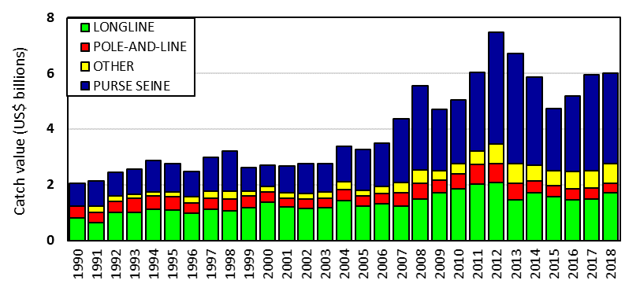 | 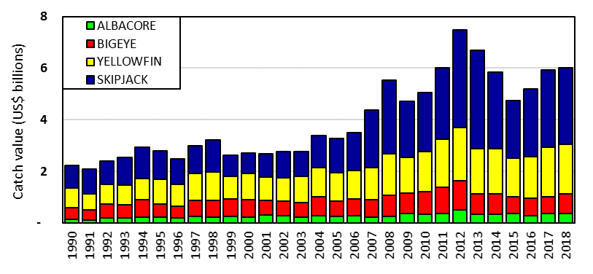
Figure 03. Catch value of albacore, bigeye, skipjack and yellowfin in the WCP–CA by longline, pole-and-line, purse seine and other gear types | Figure 04. Catch value of albacore, bigeye, skipjack and yellowfin in the WCP–CA

AGENDA ITEM 3 — DATA AND STATISTICS THEME

  - Data gaps

    - Data gaps of the Commission

- SC15 requested that SPC provide an update to TCC15 on the issues raised in SC15-ST- WP-01.

- SC15 recommended that the charter notification issues raised in SC15-ST-WP-01 be taken into account in the review leading to the new/replacement Charter Notification CMM. For example, when the coverage of operational data submitted is not 100% and chartered vessels for that flag state have been notified to the Commission, then the flag state shall submit a list of vessels representing the catches compiled for their annual catch estimates and aggregate catch/effort data (with these data submissions).

- SC15 recommended that the WCPFC Scientific Services Provider make the following enhancements to the tables on longline observer coverage in the Regional Observer Programme (ROP) data management paper (SC15-ST-IP-02) in the future:
- Separate the observer coverage of domestic CCM fleets active in their home EEZ (non-ROP coverage), where such information is voluntarily provided from a CCM, from the observer coverage of CCM fleets fishing outside their home EEZ (ROP coverage;
- List all (ROP and non-ROP) longline observer coverage for each fleet based on HOOKS or SETS as measured by WCPFC data submissions. This information is intended to provide estimates of total longline observer coverage in the WCPFC Area for reference, and will not be used for compliance purposes. The WCPFC Scientific Services Provider will provide an update to TCC15 for CCM review.
- Include a column to describe the coverage of longline E-Monitoring data in the table of longline E-Monitoring coverage based on FISHING DAYS or SETS.

- SC15 acknowledged the cannery data submissions (representing ~37% of the tropical WCPFC purse seine catch in recent years) to the WCPFC by International Seafood Sustainability Foundation (ISSF) participating companies, and the potential of cannery data for the work of the Commission, specifically Project 60. SC15 recommended that the WCPFC Scientific Services Provider (with assistance from the WCPFC Secretariat) investigate what Commission mechanisms could be used and/or updated to facilitate the voluntary submission, and ensure an appropriate level of confidentiality, of cannery data from other processors for future Commission work (Project 60), and report the findings to SC16.

- SC noted the recurrent difficulties of the WCPFC Scientific Services Provider to reconcile the discrepancies between the number of trips and observer appointments in Tables 1 and 2 of SC15-ST-IP-02 and recommended that the WCPFC Scientific Services Provider and WCPFC Secretariat investigate how these discrepancies could be addressed, in view to facilitating the work of SC and TCC.

    - Species composition of purse-seine catches (Project 60)

- SC15 recommended that the following activities be considered under Project 60 over the coming year, with the outcomes reported to SC16:
Activity | Priority
1. Paired grab-spill trips (target: 4 to 6):  - Targeting fleets with likely availability of comprehensive landings slips data (to be provided on a voluntary basis).  - Additional data should allow for improved estimates of bias correction factors, and provide a more powerful dataset for testing for species and/or school association specific correction factors | High
2. Continue to explore opportunities for collaboration with members, specifically undertaking comparisons of observer samples, and potentially model-based, species composition estimates, with accurate unloadings / landings / cannery data | High
3. Investigation of video-based sampling for estimation of species and size compositions | Medium
4. Simulation model  - Exploration of potential bias from between-brail variability in size  - Inform need for set and/or species-specific correction factors | Medium
5. Cost-benefit analysis of alternative sampling approaches for long-term estimation of species compositions (i.e. at-sea sampling vs port sampling) | Low

- SC15 recommended that the following changes (as outcomes from Project 60) be incorporated into the process for generating the aggregated purse seine species catch estimates in the future:
- Multinomial-model based correction factors be used to correct existing and future grab sample data, rather than the estimates of ‘availability’;
- The beta-response models be used to generate catch estimates; and,
- Observer samples are stratified by flag when used to directly estimate species compositions.

- SC15 acknowledged the recent work on the potential of EM to enhance the collection of scientific data (size and species composition) onboard purse seine vessels, potentially freeing the observer to concentrate on other duties. Additional work in support of the proposed Project 60 work plan for August 2019 onwards was proposed. SC15 recommended the outcomes of any further work be reported to SC16.

    - Project 90 (Better size data (length and weight) for scientific analyses)

- SC15 recommended that the WCPFC Scientific Services Provider proceed to coordinate the activities proposed for Project 90 for the coming year (as listed in ANNEX 2 of SC15-ST-WP-03), and report the progress to SC16.

    - Project 93 (Review of the Commission’s data needs and collection programmes).

- SC15 recognised the usefulness of the work conducted to date under Project 93 and recommended the WCPFC Secretariat prepare and distribute a circular drawing attention to the tables in SC15-ST-WP-04, following their discussion by the ISG-02, requesting CCMs provide further feedback prior to TCC15, when it will be further discussed.

  - Regional Observer Programme

  - Electronic Reporting and Electronic Monitoring

  - Economic data

- SC15 considered the development of guidelines for the voluntary provision of economic data to the Commission and recommended that intersessional work be undertaken to further develop the draft guidelines as provided in SC15-ST-WP-05 and provide guidance on appropriate ways to address issues raised. CCMs wishing to participate in this intersessional work should provide a contact point for inclusion in this intersessional working group which will be facilitated by Fiji and the FFA Secretariat. SC15 further recommended that the outcomes of this intersessional work be considered by SC16.

  - Comprehensive review of Commission reporting requirements

- SC15 noted the paper SC15-ST-WP-06 Streamlining WCPFC reporting requirements – discussion paper that was introduced by the Secretariat. Noting that a finalised version of the paper will be submitted to TCC15 for decisions on recommendations on the way forward to WCPFC16, SC15 encouraged interested CCMs and observers to submit views on the discussion paper to the Secretariat no later than Wednesday 28th August 2019.

AGENDA ITEM 4 — STOCK ASSESSMENT THEME

- Improvement of MULTIFAN-CL software

  - WCPO tunas

    - WCPO bigeye tuna (Thunnus obesus)

      - Research and information

      - Provision of scientific information

- Stock status and trends

- SC15 noted that no stock assessment was conducted for WCPO bigeye tuna in 2019. Therefore, the stock status description from SC14 is still current. For further information on the stock status and trends from SC14, please see https://www.wcpfc.int/node/32155

- SC15 noted that the total bigeye catch in 2018 was 145,402 mt, a 13% increase from 2017 and a 1% decrease from the average 2013-2017.

- Longline catch in 2018 (71,305 mt) was a 23% increase from 2017 and a 7% increase from the 2013-2017 average. Purse seine catch in 2018 (64,119 mt) was a 10% increase from 2017 and a 4% increase from the 2013-2017 average. Pole and line catch (1,677 mt) was a 3% increase from 2017 and a 60% decrease from the average 2013-2017 catch. Catch by other gear (8,301 mt) was a 25% decrease from 2017 and 45% decrease from the average catch in 2013-2017.

- SC15 noted that under recent fishery conditions, the bigeye stock is initially projected to increase as recent estimated recruitments support adult stock biomass. Adult stock biomass is then projected to decline slightly before again increasing. Projected fishing mortality is below F_{MSY} (median F₂₀₂₀/F_{MSY} = 0.62, the risk of F₂₀₂₀ > F_{MSY} = 0%) and projected median spawning biomass is above the LRP (SB₂₀₂₀/SB_{F=0} = 0.2) (median SB₂₀₂₀/SB_{F=0} = 0.41; median SB₂₀₂₀/SB_{MSY} = 1.79. Risk that SB₂₀₂₀ < LRP = 0%). Projections are from the updated model runs of Vincent et al. (2018).

- Management advice and implications

- SC15 noted that no stock assessment has been conducted since SC14. Therefore, the advice from SC14 should be maintained, pending a new assessment or other new information. For further information on the management advice and implications from SC14, please see https://www.wcpfc.int/node/32155

- Research Recommendations

- SC15 reviewed progresses for the research recommendations from SC14 for bigeye growth and noted that the following research issues need to be addressed further, after classifying these research items as short-term (preferably before SC16) and long-term (preferably before the scheduled 2023 stock assessment).
  - Develop MULTIFAN-CL functionality that can accommodate spatial variation in growth rates and movement between western and eastern Pacific to consider the appropriateness of delineating the two stocks at 150˚W (long-term).
  - Carry out further otolith age validation studies for fish in the western and central Pacific. Consider chemically marking fish at release in future tagging programs and then analyzing otoliths from recaptured marked fish (long-term). Apply other age validation methodology including radiocarbon age validation (short to long-term). SC15 noted potential issues of the spatial pattern of radiocarbon in the Pacific Ocean and its implications for mobile adult tuna.
  - Continue to develop and document protocols for daily and annual ageing by IATTC and WCPFC (short-term).
  - Continue efforts under Project 94 to collect very small bigeye caught by the Indonesian, Vietnamese, and Philippines domestic fisheries in region 7 to aid in the estimation of the size at age-1 qtr-1 parameter (L1) within the assessment model (short to long-term).
  - Compile a high confidence tagging dataset for growth analysis and develop integrated growth models incorporating the tagging data and the otolith data (short-term).
  - Conduct sensitivity analysis using alternative growth models in the stock assessment, if new growth models are developed such as an integrated growth model (short -term), a conditional age-at-length growth model (short-term), and other growth models after conducting further growth analysis listed above.
  - Undertake a genetic stock structure analysis (long-term).

    - WCPO yellowfin tuna (Thunnus albacares)

      - Research and information

      - Provision of scientific information

- Stock status and trends

- SC15 noted that no stock assessment was conducted for WCPO yellowfin tuna in 2019. Therefore, the stock status description from SC13 is still current. For further information on the stock status and trends from SC13, please see https://www.wcpfc.int/node/29904

- SC15 noted that the total yellowfin catch in 2018 was 666,971 mt (the second highest catch on record), a 2% decrease from 2017 and a 9% increase from the average 2013-2017.

- Purse seine catch in 2018 (374,062 mt) was a 22% decrease from 2017 and a 1% increase from the 2013-2017 average. Longline catch in 2018 (94,509 mt) was an 11% increase from 2017 and a 4% increase from the 2013-2017 average. Pole and line catch (12,201 mt) was a 1% decrease from 2017 and a 48% decrease from the average 2013-2017 catch. Catch by other gear (186,199 mt) was a 79% increase from 2017 and 51% increase from the average catch in 2013-2017.

- SC15 noted that under recent fishery conditions, the yellowfin stock is initially projected to increase as recent estimated recruitments support adult stock biomass. Adult stock biomass is then projected to decline slightly before again increasing. Projected fishing mortality is below F_{MSY} (median F₂₀₂₀/F_{MSY} = 0.74, the risk of F₂₀₂₀ > F_{MSY} = 3%) and projected median spawning biomass is above the LRP (SB₂₀₂₀/SB_{F=0} = 0.2) (median SB₂₀₂₀/SB_{F=0} = 0.32; median SB₂₀₂₀/SB_{MSY} = 1.33. Risk that SB₂₀₂₀ < LRP = 8%).

- Management advice and implications

- SC15 noted that no stock assessment has been conducted since SC13. Therefore, the advice from SC13 should be maintained, pending a new assessment or other new information. For further information on the management advice and implications from SC13, please see https://www.wcpfc.int/node/29904

- Research Recommendations

- SC15 encouraged the continuation of project 82 on yellowfin tuna age and growth for the next stock assessment.

- SC15 noted that the following research issues need to be addressed for yellowfin tuna after classifying these research items as short-term (preferably before SC16) and long-term (preferably before the scheduled 2023 stock assessment).
        - Carry out further otolith age validation studies for yellowfin in the western and central Pacific such as applying radiocarbon age validation (short to long-term).
        - Compile a high confidence tagging dataset for growth analysis and develop an integrated growth model incorporating the tagging data and the otolith data (short-term).
        - Continue to develop and document protocols for daily and annual ageing by IATTC and WCPFC (short-term).

    - WCPO skipjack tuna (Katsuwonus pelamis)

      - Research and information

      - Provision of scientific information

- Stock status and trends

- SC15 noted that the total provisional catch in 2018 was 1,795,048 mt, a 10% increase from 2017 and a 1% decrease from 2013-2017. Purse seine catch in 2018 (1,469,520 mt) was a 15% increase from 2017 and a 2% increase from the 2013-2017 average. Pole and line catch (138,534 mt) was a 4% increase from 2017 and a 9% decrease from the average 2013-2017 catch. Catch by other gear (182,888 mt) was a 16% decrease from 2017 and 19% decrease from the average catch in 2013-2017.

- SC15 agreed to use the 8-region model to describe the stock status of skipjack tuna because SC15 considers that it better captures the biology of skipjack tuna than the existing 5 region structure. Stock status was determined over an uncertainty grid of 54 models with assumed weightings as illustrated in Table SKJ-01.

- The median values of recent (2015–2018) spawning biomass depletion (SB_{recent}/SB_{F=0}) and relative recent (2014–2017) fishing mortality (F_{recent}/F_{MSY}) over the uncertainty grid of 54 models (Table SKJ-02) were used to define stock status. The values of the upper 90th and lower 10th percentile of the empirical distributions of relative spawning biomass and relative fishing mortality from the uncertainty grid were used to characterize the probable range of stock status.

- The spatial structure used in the assessment model is shown in Figure SKJ-01. Time series of total annual catch (1000’s mt) by fishing gear for all regions is shown in Figure SKJ-02 and by region separately is shown in Figure SKJ-03. The annual average recruitment, spawning potential, and total biomass by model region for the diagnostic model are shown in Figure SKJ-04. The overall spawning potential summed across region for the diagnostic model is shown in Figure SKJ-05. The estimated annual average juvenile and adult fishing mortality for the diagnostic model is shown in Figure SKJ-06. The estimated impact of fishing (1 – SB_{latest}/SB_{F=0}) by region and overall regions for the diagnostic model is shown in Figure SKJ-07. The median and 80th percent quantile trajectories of fishing depletion for models in the weighted structural uncertainty grid in Table SKJ-01 is shown in Figure SKJ-08, where it can be seen that the median has been below the target since 2009. The Majuro plot shows the recent fishing mortality and spawning potential relative to the unfished spawning potential for all models in the structural uncertainty grid for (i) spawning potential in the recent time period (2015–2018) in Figure SKJ-09, and (ii) spawning potential in the latest time period (2018) in Figure SKJ-10. The Kobe plot shows the recent fishing mortality and spawning potential relative to spawning potential at MSY for all models in the structural uncertainty grid for (i) spawning potential in the recent time period (2015–2018) in Figure SKJ-11, and (ii) spawning potential in the latest time period (2018) in Figure SKJ-12.

- SC15 noted that the median level of spawning potential depletion from the uncertainty grid was SB_{recent}/SB_{F=0} = 0.44 with a probable range of 0.37 to 0.53 (80% probability interval). There were no individual models where SB_{recent}/SB_{F=0} < 0.2, which indicated that the probability that recent spawning biomass was below the LRP was zero.

- SC15 noted that the grid median F_{recent}/F_{MSY} was 0.45, with a range of 0.34 to 0.60 (80% probability interval) and that no values of F_{recent}/F_{MSY} in the grid exceed 1. Therefore, SC15 noted that there was a zero probability that the recent fishing mortality exceeds F_{MSY}.

- SC15 noted that the largest uncertainty in the structural uncertainty grid was due to the assumed tag mixing period. In addition, SC15 acknowledges that further study is warranted to investigate the uncertainty surrounding the appropriate mixing period for the tagging data.

- SC15 acknowledges that the spatial extent of the Japanese pole-and-line fishery has decreased over the time period and that the future use of this standardized CPUE index within future stock assessments is uncertain.

- Therefore, SC15 acknowledges that further study of alternative indices of abundance is warranted, such as investigation of standardizing the purse seine fishery and evaluation of the feasibility of conducting fishery independent surveys.

Table SKJ-01. Description of the updated structural sensitivity grid used to characterize uncertainty in the assessment.
Axis | Value | Relative weight
Steepness | 0.65 | 0.8
 | 0.80 | 1.0
 | 0.95 | 0.8
Growth | Low | 1.0
 | Diagnostic | 1.0
 | High | 1.0
Length composition | 50 | 0.8
scalar | 100 | 1.0
 | 200 | 1.0
Tag mix | 1 | 1.0
 | 2 | 1.0

Table SKJ-02. Summary of reference points over the various models in the structural uncertainty grid. F_{mult} is the multiplier of recent (2014-2017) fishing mortality required to attain MSY, F_{recent} is the average fishing mortality of recent (2014-2017), SB_{recent} is the average spawning potential of recent years (2015-2018) and SB_{latest} is the spawning potential in 2018.
 | Mean | Median | Minimum | 10th %ile | 90th %ile | Maximum
C_{latest} | 1,755,328 | 1,755,693 | 1,749,846 | 1,753,471 | 1,757,057 | 1,757,083
Y_{Frecent} | 1,877,914 | 1,864,040 | 1,679,600 | 1,737,702 | 2,043,556 | 2,135,200
f_{mult} | 2.282 | 2.258 | 1.472 | 1.757 | 2.957 | 3.705
F_{MSY} | 0.223 | 0.222 | 0.180 | 0.189 | 0.264 | 0.270
MSY | 2,296,566 | 2,294,024 | 1,953,600 | 1,995,987 | 2,767,083 | 2,825,600
F_{recent}/F_{MSY} | 0.461 | 0.447 | 0.270 | 0.343 | 0.600 | 0.679
SB_{F=0} | 6,220,675 | 6,299,363 | 5,247,095 | 5,580,942 | 6,913,431 | 7,349,557
SB_{MSY} | 1,100,947 | 1,064,400 | 631,900 | 723,742 | 1,544,060 | 1,688,000
SB_{MSY}/SB_{F=0} | 0.175 | 0.176 | 0.117 | 0.131 | 0.225 | 0.23
SB _{latest}/SB_{F=0} | 0.414 | 0.415 | 0.325 | 0.36 | 0.487 | 0.525
SB _{latest}/SB_{MSY} | 2.468 | 2.382 | 1.551 | 1.779 | 3.356 | 3.925
SB _{recent}/SB_{F=0} | 0.440 | 0.440 | 0.336 | 0.372 | 0.530 | 0.551
SB _{recent}/SB_{MSY} | 2.623 | 2.579 | 1.601 | 1.892 | 3.613 | 4.139

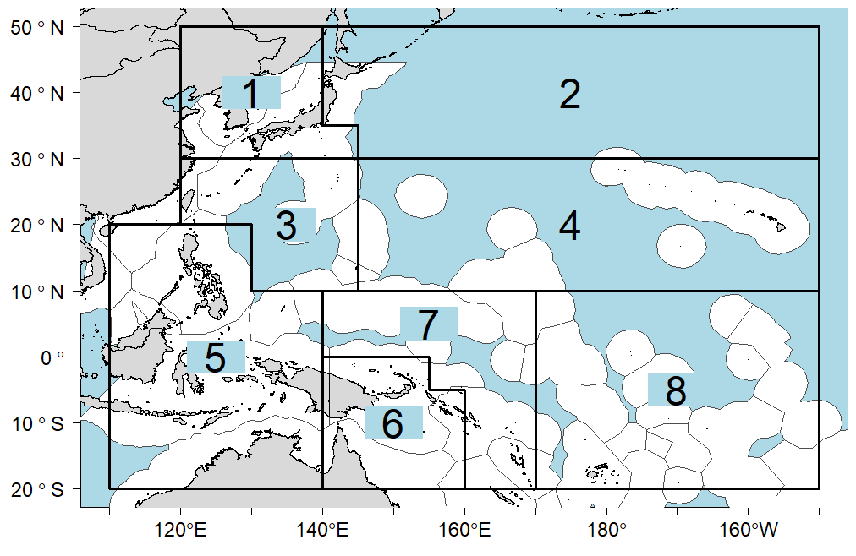 | 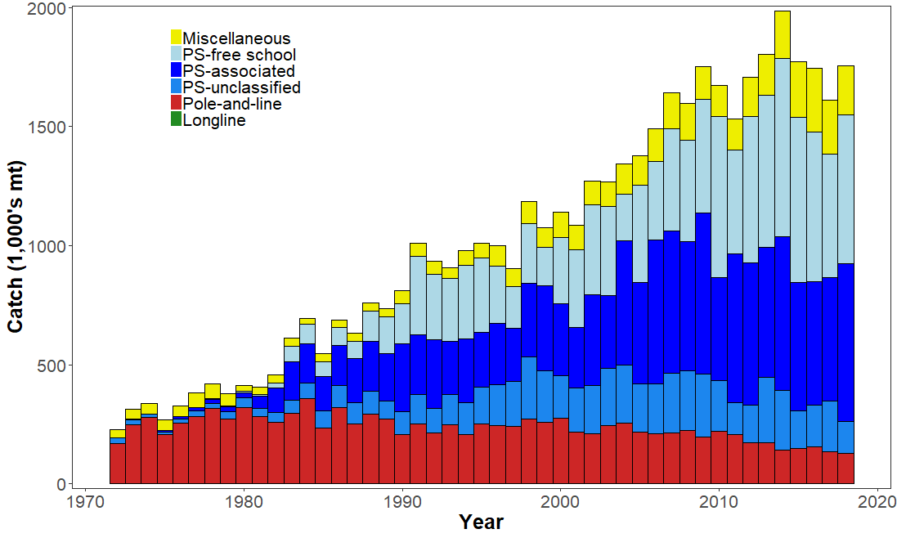
Figure SKJ-01. Eight region spatial structure used in the 2019 stock assessment model. | Figure SKJ-02. Time series of total annual catch (1000's mt) by fishing gear over the full assessment period.
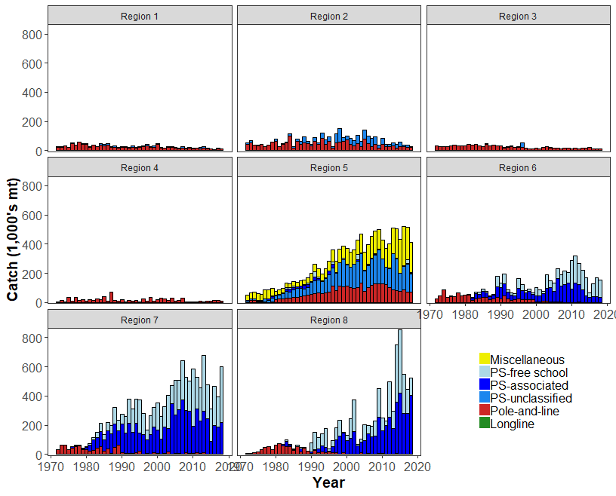 | 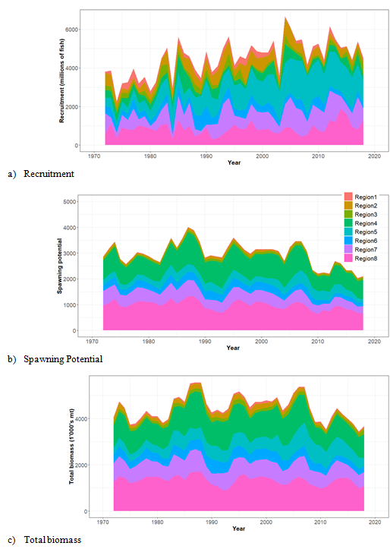
Figure SKJ-03. Time series of total annual catch (1000's mt) by fishing gear and assessment region over the full assessment period. | Figure SKJ-04. Estimated annual average recruitment, spawning potential and total biomass by model region for the diagnostic model, showing the relative sizes among regions.

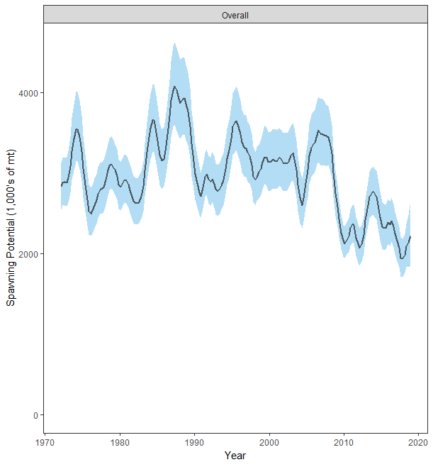 | 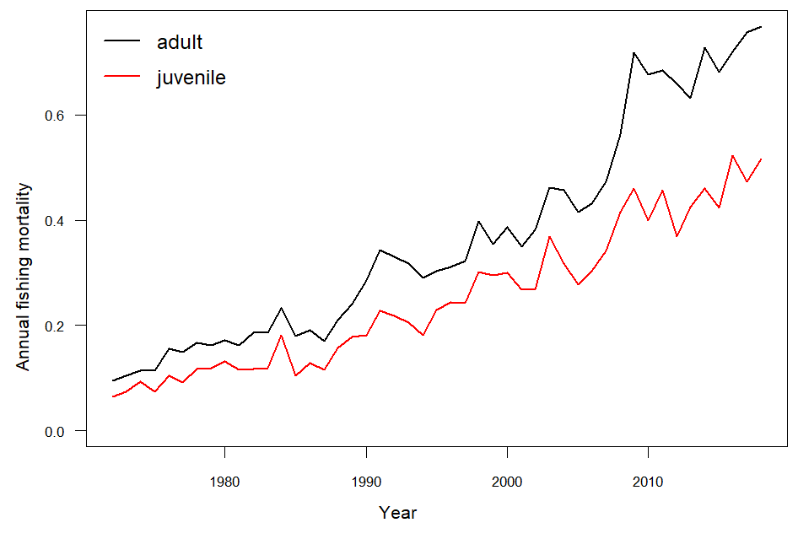
Figure SKJ-05. Estimated temporal overall spawning potential summed across regions from the diagnostic model, where the shaded region is ± 2 standard deviations (i.e., 95% CI). | Figure SKJ-06. Estimated annual average juvenile and adult fishing mortality for the diagnostic model.
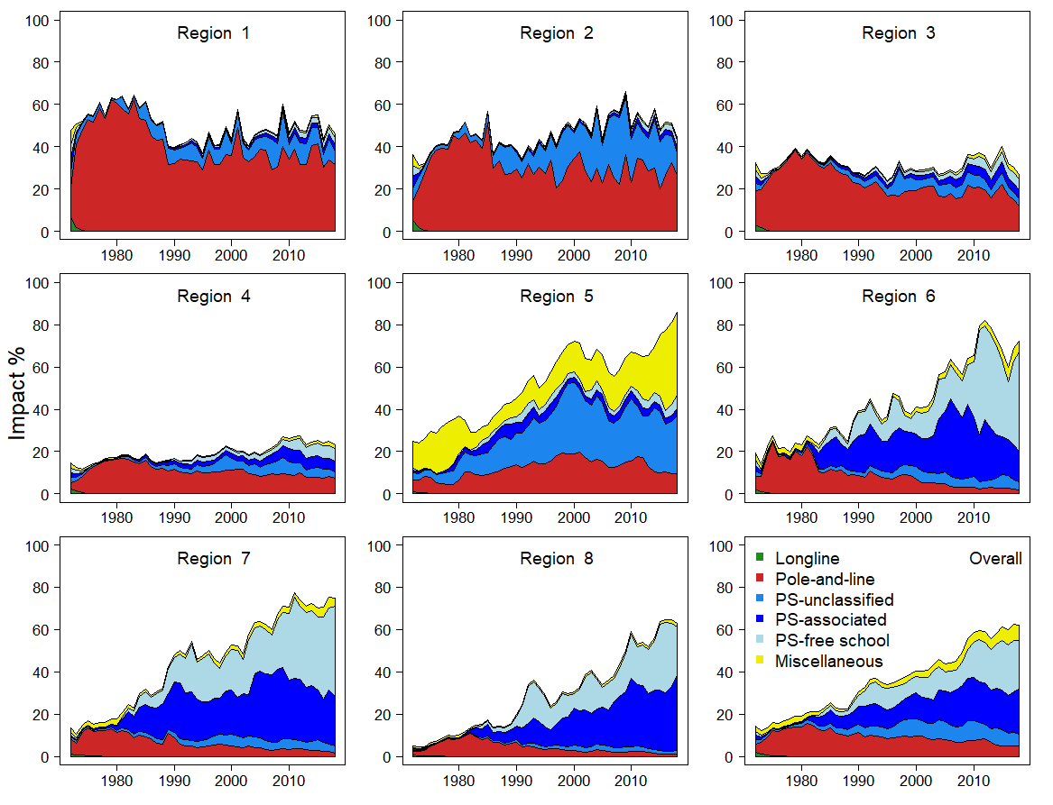 | 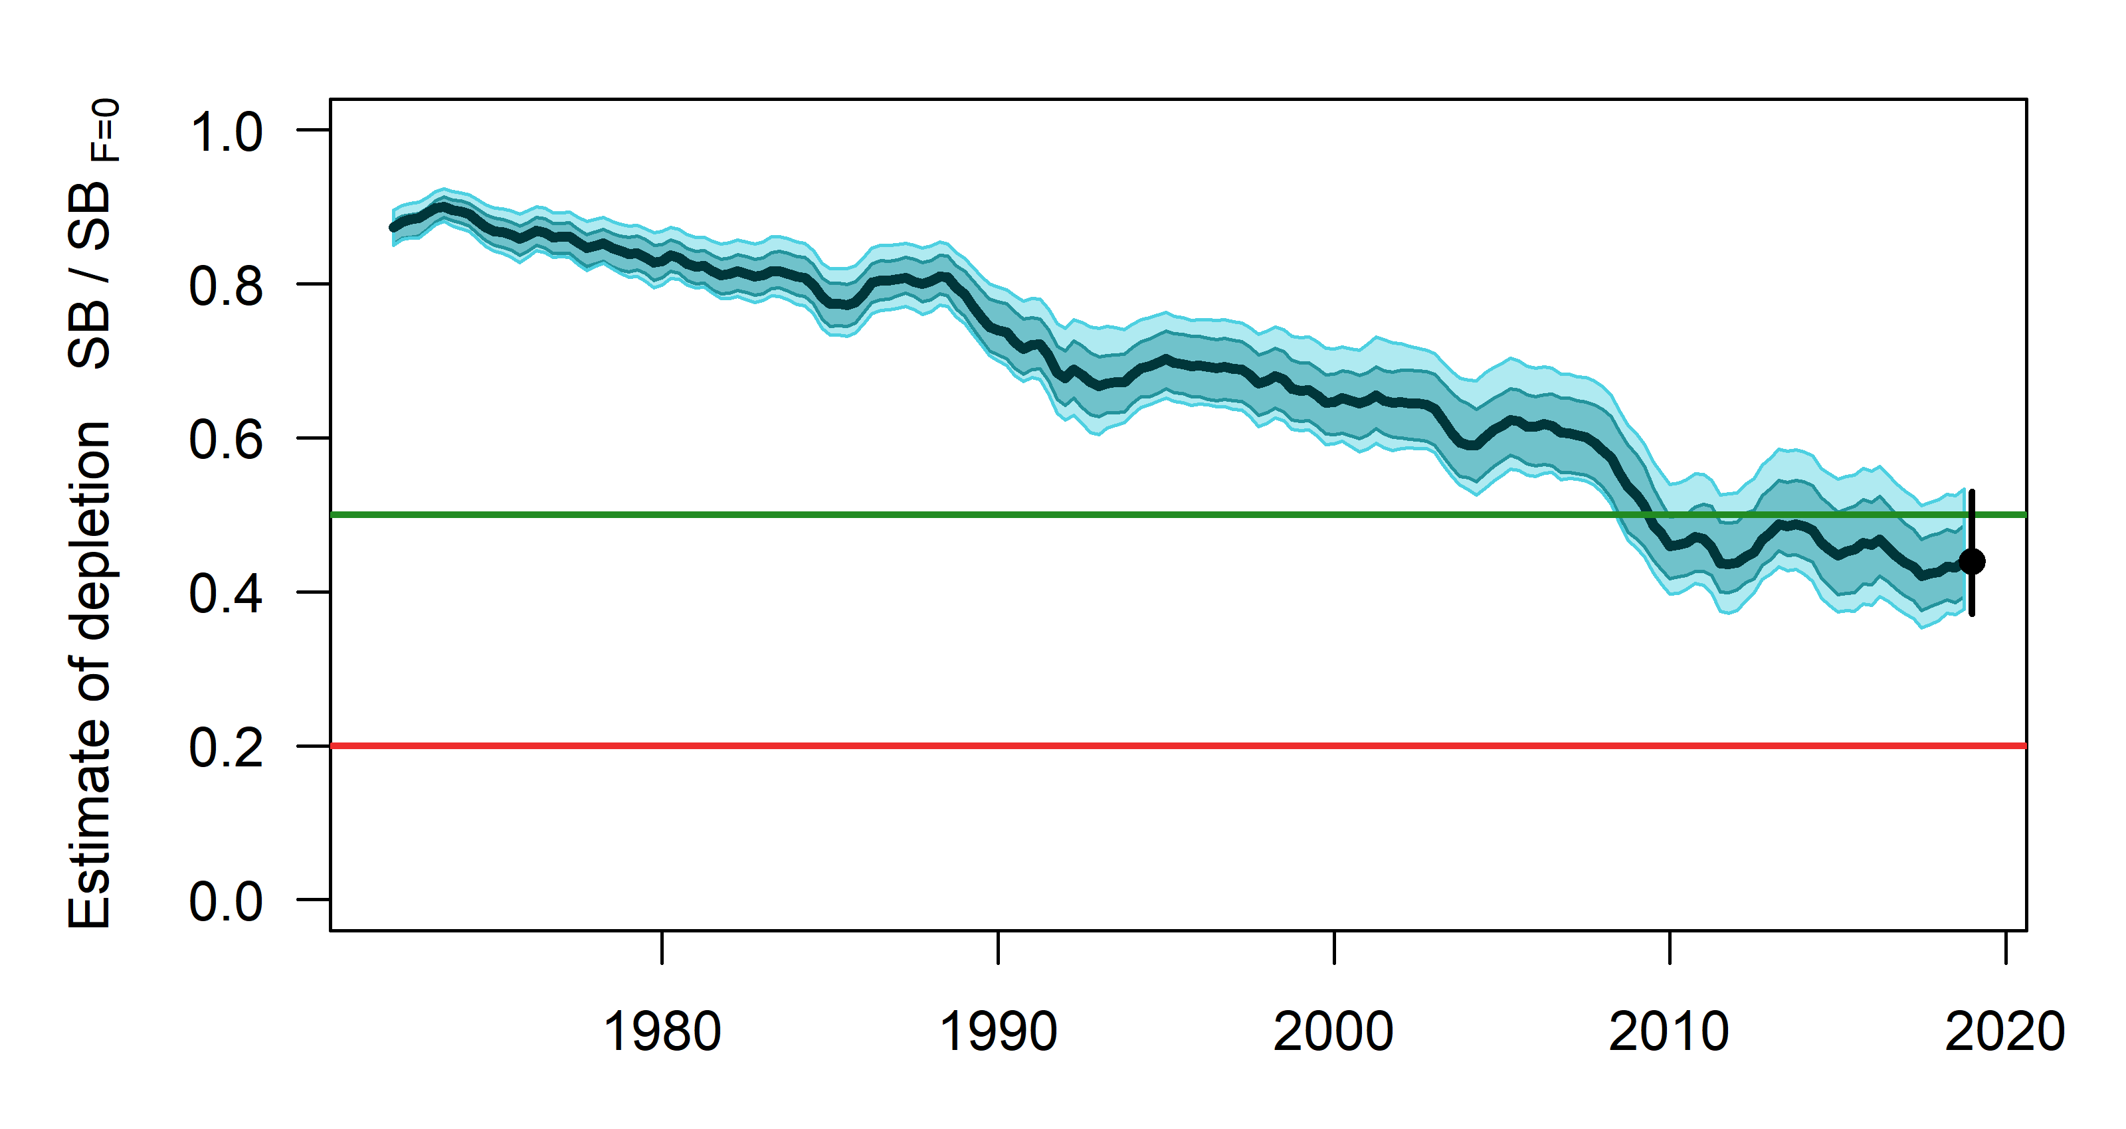
Figure SKJ-07. Estimates of reduction in spawning potential due to fishing (fishery impact = 1-SB _{latest}/SB _{F=0}) by region for the diagnostic model. | Figure SKJ-08. Plot showing the trajectories of spawning potential depletion for the model runs included in the structural uncertainty grid weighted by the values given in Table SKJ-01. Red horizontal line indicates the agreed limit reference point, the green horizontal line indicates the interim target reference point.

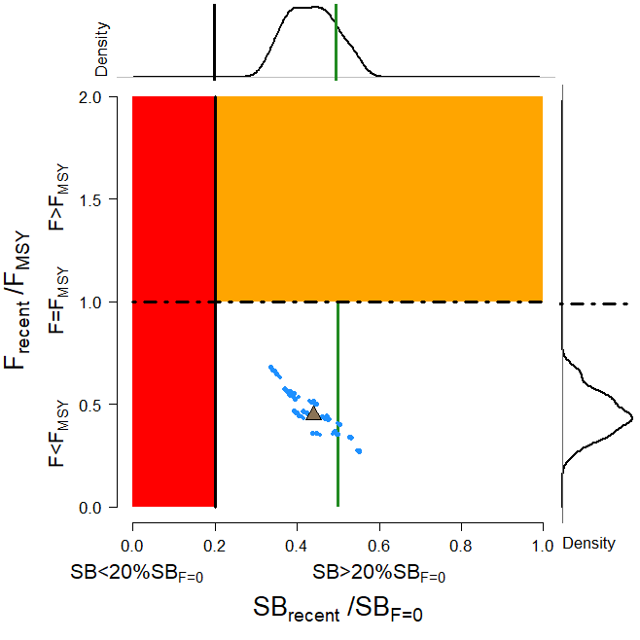  Figure SKJ-09. Majuro plot for the recent spawning potential (2015 – 2018) summarizing the results for each of the models in the structural uncertainty grid with weighting. The plots represent estimates of stock status in terms of spawning potential depletion and fishing mortality, and marginal distributions of each are presented. Vertical green line denotes the interim TRP. Brown triangle indicates the median of the estimates. The size of the circle relates to the weight of that particular model run. | 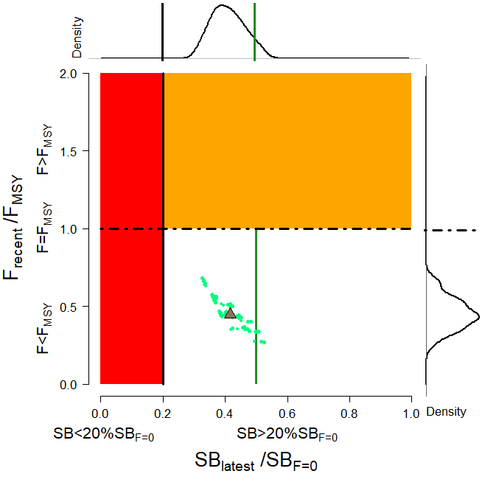  Figure SKJ-10. Majuro plot for the latest spawning potential (2018) summarizing the results for each of the models in the structural uncertainty grid with weighting. The plots represent estimates of stock status in terms of spawning potential depletion and fishing mortality, and marginal distributions of each are presented. Vertical green line denotes the interim TRP. Brown triangle indicates the median of the estimates. The size of the circle relates to the weight of that particular model run.
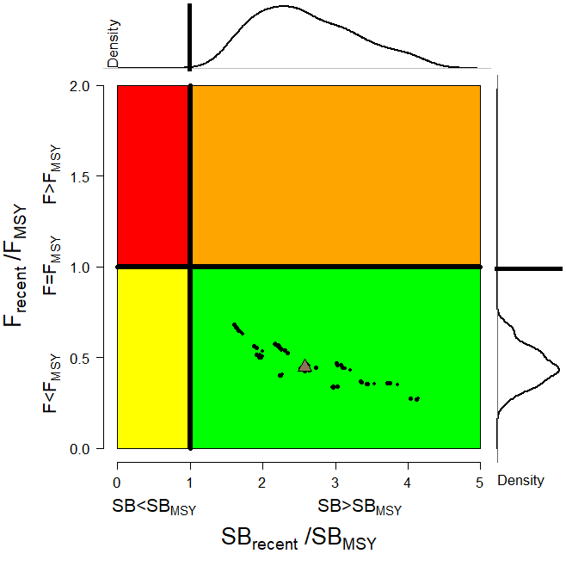  Figure SKJ-11. Kobe plot for the recent spawning potential (2015 – 2018) summarizing the results for each of the models in the structural uncertainty grid. The plots represent estimates of stock status in terms of spawning potential depletion and fishing mortality and marginal distributions of each are presented. Brown triangle indicates the median of the estimates. The size of the circle relates to the weight of that particular model run. | 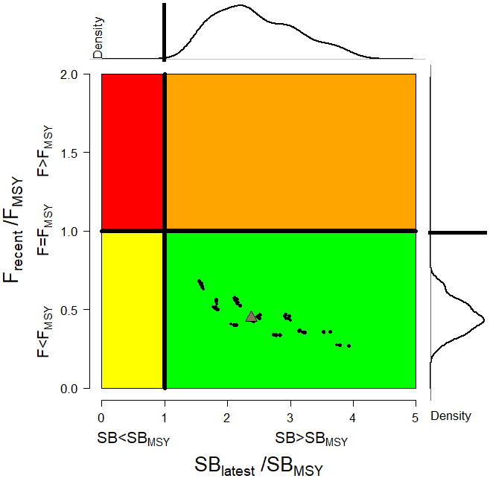  Figure SKJ-12. Kobe plot for the latest spawning potential (2018) summarizing the results for each of the models in the structural uncertainty grid. The plots represent estimates of stock status in terms of spawning potential depletion and fishing mortality and marginal distributions of each are presented. Brown triangle indicates the median of the estimates. The size of the circle relates to the weight of that particular model run.
- Management advice and implications

- SC15 noted that the skipjack assessment continues to show that the stock is currently moderately exploited and the level of fishing mortality is sustainable.

- The 2019 stock assessment includes additional data and a range of model improvements such as a change to the maturity schedule used in this assessment, with length-at-maturity now larger than in the previous assessment, which has resulted in a reduction in the estimate of potential spawning biomass, relative to the 2016 assessment.

- SC15 noted that the stock was assessed to be above the adopted Limit Reference Point and fished at rates below F_{MSY} with 100% probability. Therefore, the skipjack stock is not overfished, nor subject to overfishing. At the same time, it was also noted that fishing mortality is continuously increasing for both adult and juvenile while the spawning biomass reached the historical lowest level.

- The skipjack interim Target Reference Point (TRP) is 50% of spawning biomass in the absence of fishing. The trajectory of the median spawning biomass depletion indicates a long-term trend, and has been under the interim TRP since 2009 (i.e., for 10 years). Since the median spawning biomass has been consistently below the interim TRP, SC15 recommends that the Commission take appropriate management action to ensure that the biomass depletion level fluctuates around the TRP (e.g., through the adoption of a harvest control rule).

- Research Recommendations

- In order to maintain the quality of stock assessments for this important stock SC15 recommends:
- continuing work to develop an index of abundance based on purse seine data and from FAD acoustic sensors;
- evaluating the possibility of conducting fishery independent surveys to provide relative abundance indices;
- conducting regular large-scale tagging cruises and expanding the infrastructure for rapid return of recaptured tags in a manner that provides the best possible data for stock assessment purposes;
- investigating skipjack growth by validation studies of otolith readings and/or estimation of growth within MFCL from tag recapture data;
- attempting to provide finalized catch estimates to SPC no later than June 1st.

    - South Pacific albacore tuna (Thunnus alalunga)

      - Research and information

      - Provision of scientific information

- Stock status and trends

- SC15 noted that no stock assessments were conducted for South Pacific albacore in 2019. Therefore, the stock status descriptions from SC14 are still current for South Pacific albacore. For further information on the stock status and trends from SC14, please see https://www.wcpfc.int/node/32155. Updated information on fishery trends and indicators were compiled for and reviewed by SC15.

- SC15 noted that the total provisional Pacific Ocean catch south of the equator in 2018, updated since the paper was submitted, was 80,820 mt, a 13% decrease from 2017 and a 2% decrease from the average 2013-2017. Longline catch in 2018 (77,776 mt) was a 14% decrease from 2017 and an 8% decrease from the 2013-2017 average.

- The average stock status in 2016 (the last year of the assessment) across the 72 model runs was SB_{latest}/SB_{F=0} = 0.52, below the interim target reference point (SB_{latest}/SB_{F=0} = 0.56) established by the WCPFC in 2018. The probability of being below the TRP in 2016 is 63%. The stock is not overfished nor is overfishing occurring.

- SC15 noted projections from the 2018 assessment which apply to the WCPFC Convention Area. The historical status and projections have a greater uncertainty in spawning stock depletion than observed for bigeye and yellowfin tuna because South Pacific albacore has a different grid which incorporates natural mortality and growth, and this gives a wider spread of uncertainty. SC15 noted that under recent fishery conditions of assuming that the 2018 catch remains constant, the albacore stock is initially projected to increase as recent estimated relatively high recruitments support adult stock biomass, then decline as future recruitment is sampled from the long-term historical estimates The projections indicate that median F₂₀₂₀/F_{MSY} = 0.24; median SB₂₀₂₀/SB_{F=0} = 0.43; and median SB₂₀₂₀/SB_{MSY} = 3.2. The risk that SB₂₀₂₀/SB_{F=0} < LRP = 0%, SB₂₀₂₀ < SB_{MSY} = 0% and F₂₀₂₀ > F_{MSY} = 0%.

- The stock biomass is expected to decline from the 2016 level of 0.52 to 0.39 by 2035. The risk of the stock biomass breaching the LRP in 2035 is expected to be 23%. The longline-vulnerable biomass (the longline CPUE proxy) is expected to decrease by 36% relative to 2013 levels.

- Management advice and implications

- Given the stock assessment in 2018 and SC15 projections, SC15 advises that WCPFC develop comprehensive binding South Pacific albacore management measures which will result in the stock reaching the TRP within the 20-year time horizon. SC15 advises WCPFC16 may consider establishing a CMM to further reduce total catch or effort in order to reverse the projected decline in the vulnerable biomass.

- SC15 notes that the 2018 South Pacific albacore stock assessment pertained to the WCPFC Convention Area. The South Pacific albacore catch in the eastern Pacific Ocean has recently increased and the scheduled 2021 South Pacific albacore assessment may pertain to the entire south Pacific stock in order to incorporate all population dynamics. WCPFC and IATTC compatible measures would be more easily implemented should an entire south Pacific assessment be conducted.

- Research recommendation

- SC15 noted that the assumed future recruitment can have a large impact on the projection result. It was recommended that research be undertaken to quantify autocorrelation behavior of recruitment to be included in the future projection.

  - Northern stocks

    - North Pacific albacore (Thunnus alalunga)

      - Research and information

      - Provision of scientific information

  - Stock status and trends

- SC15 noted that no stock assessments were conducted for North Pacific albacore in 2019. Therefore, the stock status descriptions from SC13 are still current for North Pacific albacore. For further information on the stock status and trends from SC13, please see https://www.wcpfc.int/node/29904. Updated information on catches was not compiled for and reviewed by SC15.

- SC15 noted that the provisional total NPALB catch by Canada, Japan, USA, Korea, Mexico and Chinese Taipei in 2018 was 49,300 mt, a 9% decrease from 2017 and a 24% decrease from the 2013-2017 average. The detailed catch information by fishery is available in ISC 2019 report (SC15-GN-IP-02). North Pacific albacore is caught by various fishing gears including longline, troll, and pole-and-line.

  - Management Advice and implications

- SC15 noted that no management advice has been provided since SC13 for North Pacific albacore. Therefore, the advice from SC13 should be maintained, pending a new assessment or other new information. For further information on the management advice and implications from SC13, please see https://www.wcpfc.int/node/29904

    - Pacific bluefin tuna (Thunnus orientalis)

      - Research and information

      - Provision of scientific information

  - Stock Status and trends

- SC15 noted that no stock assessment was conducted for Pacific bluefin tuna in 2019. Therefore, the stock status description from SC14 is still current. For further information on the stock status and trends from SC14, please see https://www.wcpfc.int/node/32155

- SC15 noted that the total Pacific bluefin tuna catch by ISC members in 2018 was 10,148 mt, a 31% decrease from 2017 and a 25% decrease from the 2013-2017 average. Pacific bluefin tuna is caught by various fishing gears including purse seine, longline, set net, troll, pole-and-line, handline and recreational fisheries. The detailed catch information by fishery is available in the ISC19 Plenary Report (SC15-GN-IP-02).

  - Management advice and implications

- SC15 advises the Commission to note the current very low level of spawning biomass (3.3% B₀), the current level of overfishing, and that the projections are strongly influenced by the inclusion of a relatively high but uncertain recruitment in 2016. While noting that additional positive signs of Pacific bluefin tuna stock were observed after the last assessment, and while noting that the agreed Harvest Control Rule could allow for catch limit increases, some of CCMs recommended a precautionary approach to the management of Pacific bluefin tuna until the rebuilding of the stock to higher biomass levels is achieved.

- One CCM recommended that ISC consider a grid approach for taking into account the structural uncertainty for the provision of stock status and management advice.

- SC15 also noted the following management advice of ISC19:

“The following requests were made to ISC by the IATTC-WCPFC NC Joint Working Group meeting in September 2018 at NC14 (see Attachment E of NC14 Summary Report (https://www.wcpfc.int/node/31946)). Responses from ISC PBFWG are provided below the requests.

Request 1: review the updated abundance indices, including recruitment index, up to 2017 to evaluate the need to change its scientific advice in 2018.

Response from ISC
The WG noted that some positive signs for the PBF stock were observed after the last assessment. In the 2018 assessment, the projections were considered optimistic because they were influenced by a high but uncertain recruitment in the terminal year (2016). The WG notes that the Japanese troll recruitment index value estimated for 2017 is similar to its historical average (1980-2017), that Japanese recruitment monitoring indices in 2017 and 2018 are higher than the 2016 value and that there is anecdotal evidence that larger fish are becoming more abundant in the EPO, although this information needs to be confirmed for the next stock assessment expected in 2020.

After reviewing the updated CPUE indices as well as the Japanese recruitment monitoring results, the PBFWG recommends maintaining the conservation advice from ISC18 (in 2018) that the projection mimicking the current management measures under the low recruitment scenario resulted in an estimated 98% probability of achieving the initial rebuilding target (6.7%SSB_{F=0}) by 2024 and that of achieving the second rebuilding target (20%SSB_{F=0}) 10 years after the achievement of the initial rebuilding target or by 2034, whichever is earlier, is 96%.

In the projections reported here, the projected future SSBs are the medians of the 6,000 individual SSB calculated for each 300 bootstrap replicates (i.e. catch, CPUE and size) to capture the uncertainty of parameter estimations followed by 20 stochastic simulations based on the different future recruitment time series. The projection assumes that each harvesting scenario is fully implemented and is based on certain biological or other assumptions of base case assessment model. If conditions change, the projection results would be more uncertain.

Request 2: Conduct projections of harvest scenarios shown below based on 2018 assessment and provide probability of achieving initial and 2nd rebuilding targets in accordance with paragraph 2.1 of HS2017-02.

Scenarios for catch increase
West Pacific |  | East Pacific
Small fish | Large fish
0 | 600t | 400t
5% | 1300t | 700t
10% | 1300t | 700t
5% | 1000t | 500t
0 | 1650t | 660t
5% |  | 5%
10% |  | 10%
15% |  | 15%
* 250t transfer of catch limit from small fish to large fish by Japan is assumed to continue until 2020.

Response from ISC
PBFWG conducted projections in the same manner as in the 2018 assessment. The recruitment scenario followed paragraph 2.1 of WCPFC Harvest Strategy 2017-02; and was kept at a low level (re-sampling from 1980-1989) until the initial rebuilding target is achieved and then changed to the historical average level.

The projection results are shown in Table PBF-02 and Figure PBF-01. The results show that increasing the catch limit of small PBF (<30 kg) in the WPO has the largest impact on the probability of achieving the interim and 2nd rebuilding targets. In addition, an overall increase in catch from the current limits, particularly a 15% increase, has the largest impact on achieving rebuilding targets.

Table PBF-01. Future projection scenarios for Pacific bluefin tuna (Thunnus orientalis).

Table PBF-02. Probability of achieving targets under projection scenarios for Pacific bluefin tuna. Future projection scenarios for Pacific bluefin tuna and their probability of achieving various target levels by various time schedules based on the 2018 base-case model.

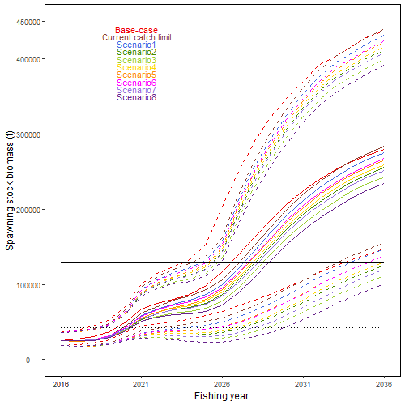
Figure PBF-01. Time series of the projected spawning stock biomass by various harvest scenarios listed on the Table PBF-01. Each colored solid and broken lines indicate the median spawning stock biomass and its 95% confidence intervals, respectively. The black dotted and solid lines are corresponded to the spawning stock biomasses of the initial and second rebuilding targets of Pacific bluefin tuna, respectively.

    - North Pacific swordfish (Xiphias gladius)

      - Research and information

      - Provision of scientific information

- Stock status and trends

- SC15 noted that no stock assessments were conducted for North Pacific swordfish in 2019. Therefore, the stock status descriptions from SC14 are still current for North Pacific swordfish. For further information on the stock status and trends from SC14, please see https://www.wcpfc.int/node/32155. Updated information on catches was not compiled for and reviewed by SC15.

- Management Advice and implications

- SC15 noted that no management advice has been provided since SC14 for North Pacific swordfish. Therefore, the advice from SC14 should be maintained, pending a new assessment or other new information. For further information on the management advice and implications from SC14, please see https://www.wcpfc.int/node/32155

  - WCPO sharks

    - Oceanic whitetip shark (Carcharhinus longimanus)

      - Research and information

      - Provision of scientific information

- Stock status and trends

- The median values of relative recent (2013-2015) spawning biomass (SB_{recent}/SB_{F=0}, SB_{recent}/SB_{MSY}) and relative recent fishing mortality (F_{recent}/F_{MSY}) over the structural uncertainty grid were used to measure the central tendency of stock status. The span of the recent time period was determined to only include years following the adoption of CMM-2011-04. The values of the upper 90th and lower 10th percentiles of the empirical distributions of relative spawning biomass and relative fishing mortality from the uncertainty grid were used to characterize the probable range of stock status.

- Descriptions of the updated structural sensitivity grid used to characterize uncertainty in the assessment are provided in Table OCS-01. Historical catch data used for the diagnostic case is presented in Figure OCS-01. Estimated annual average total biomass, recruitment and spawning biomass are shown in Figure OCS-02, and fishing mortality in Figure OCS-03. The time series of depletion in spawning biomass over all runs in the structural uncertainty grid is shown in Figure OCS-04. Kobe and Majuro plots summarizing the results for each of the models in the structural uncertainty grid retained for management advice are represented in Figures OCS-05 and OCS-06. Table OCS-02 provides a summary of reference points used to determine stock status over the 648 models in the structural uncertainty grid using the grid weights agreed upon by SC and outlined in Table OCS-01.

- SC15 noted that the median level of spawning biomass depletion from the uncertainty grid was SB_{recent}/SB₀ ₌ 0.04 with a probable range of 0.03 to 0.05 (80% probability interval). While no limit reference point has been adopted, the depletion in spawning biomass is very high. The median level of recent spawning biomass relative to that leading to MSY was SB_{recent}/SB_{MSY} = 0.09 (range: 0.05–0.17).

- SC15 noted that the recent relative fishing mortality was very high and the grid median F_{recent}/F_{MSY} was 3.94, with a range of 2.67 to 5.89 (80% probability interval), and that there were no model runs in the grid where F_{recent}/F_{MSY} was below 1.

- The key conclusions are that overfishing is occurring and the stock is in an overfished state relative to MSY and depletion-based reference points (noting that depletion-based reference points have only been adopted for tunas) (Tables OCS-1 and OCS-2). This conclusion is robust to uncertainties in key model assumptions (Figure OCS-5).

- SC noted that the inclusion of discard mortality (DM) scenarios in the historical catches was an improvement to the assessment and was necessary to account for the potential impacts of the no-retention measure (CMM-2011-04) for oceanic whitetip sharks.

- SC noted that stock status improved relative to F-based reference points in the period since CMM 2011-04 became active, which covers the last 4 years of the assessment’s time-span (2013–2016). Notably, F/F_{MSY} is predicted to have declined by more than half from 6.12 to 2.67 (n=432, unweighted grid median) (Figure OCS-2), for the last year of the assessment when the impact of CMM 2011-04 on survival is accounted for under 25% and 43.75% discard mortality scenarios (Figure OCS-6 and OCS-7). Relative fishing mortalities under two alternative reference points that have not been adopted by the WCPFC, specifically F /F_{lim,AS} (the fishing mortality resulting in 0.5 of SB_{MSY}) and F/F_{crash,AS} (the fishing mortality resulting in population extinction when sustained over the long-term, follow similar trends. Under the survival scenarios above, median SB/SB_{MSY} is predicted to have increased slightly from 2013 to 2016 (8.6% to 9.2%).

- SC15 noted that there was some inconsistency between observed and estimated CPUEs for 2013-2016 in the diagnostic case, which is probably caused by the assumptions about the stock recruitment relationship in this stock assessment. Whether or not this inconsistency is present in all models across the included uncertainty grid remains unknown.

- Management advice and implications

- Despite the data limitations going into the assessment and the wide range of uncertainties considered, all of the feasible grid model runs indicate that the WCPO oceanic whitetip shark stock continues to be overfished and overfishing is occurring relative to commonly used depletion and MSY-based reference points.

- SC15 noted that while the assessment estimates that overfishing is still occurring (F_{recent}/F_{MSY} was 3.94) the stock assessment also estimates a slight recovery in stock biomass in recent years (2013-2016). It remains unclear whether the stock status will continue to improve or perhaps decline in the future. To help clarify this issue SC15 recommends that stock projections based on the assessment are undertaken and presented to SC16.

- SC15 noted that there now appear to be few if any major fisheries targeting oceanic whitetip. The greatest impact on the stock is attributed to bycatch from the longline fisheries, with lesser impact from purse seining.

- Noting that there are existing CMMs directed at oceanic whitetip, SC15 recommended that further efforts to mitigate catch and improve handling and release practices are required to further reduce fishing mortality and improve stock status.

- SC15 noted that the assessment would be improved with better data collection for longline fisheries, such as improved observer coverage, as these fisheries are the major component of fishing mortality and would provide additional information on interaction rates, mitigation options and the fate and condition at release.

- SC15 recommends that, as a minimum, CCM’s meet the observer coverage specified in CMM 2018-05.

- SC15 noted the need for improved estimates of age, growth and fecundity, as well as new length-length conversion factors that would allow for an improved assessment and the inclusion of a greater number of observed lengths.

- SC15 noted that following the implementation of CMM 2011-04 and CMM 2014-05, the amount of scientific information available per year on oceanic whitetip sharks and other sharks species covered by a retention ban and the ban on shark lines or wire traces (e.g., bycatch estimates, length measurement, species and sex identification, and biological samples) has declined. SC15 also noted that the decline in information available for the oceanic whitetip shark assessment resulted in higher uncertainty in stock status, especially in more recent years since the introduction of these CMMs. This will also affect the capacity of SC to undertake future assessments if this decline in available information persists. SC15 recommends that WCPFC16 gives more consideration to the data needs for estimating reliable CPUE and other inputs into assessments when management measures are put in place, as these measures may have unintended consequences on continued availability and reliability of data. SC15 also recommended that WCPFC16 also take these considerations into account when reviewing the relevant sharks CMMs.

- Noting that no limit reference points have been adopted for oceanic whitetip sharks, as well as other WCPO shark species, SC15 recommends that WCPFC16 consider identifying appropriate limit reference points for WCPO sharks.

Table OCS-01. Description of the axes for the structural uncertainty grid, and assigned weight by level in the final resampling of stock status metrics. Settings used under the diagnostic case are highlighted with a star.
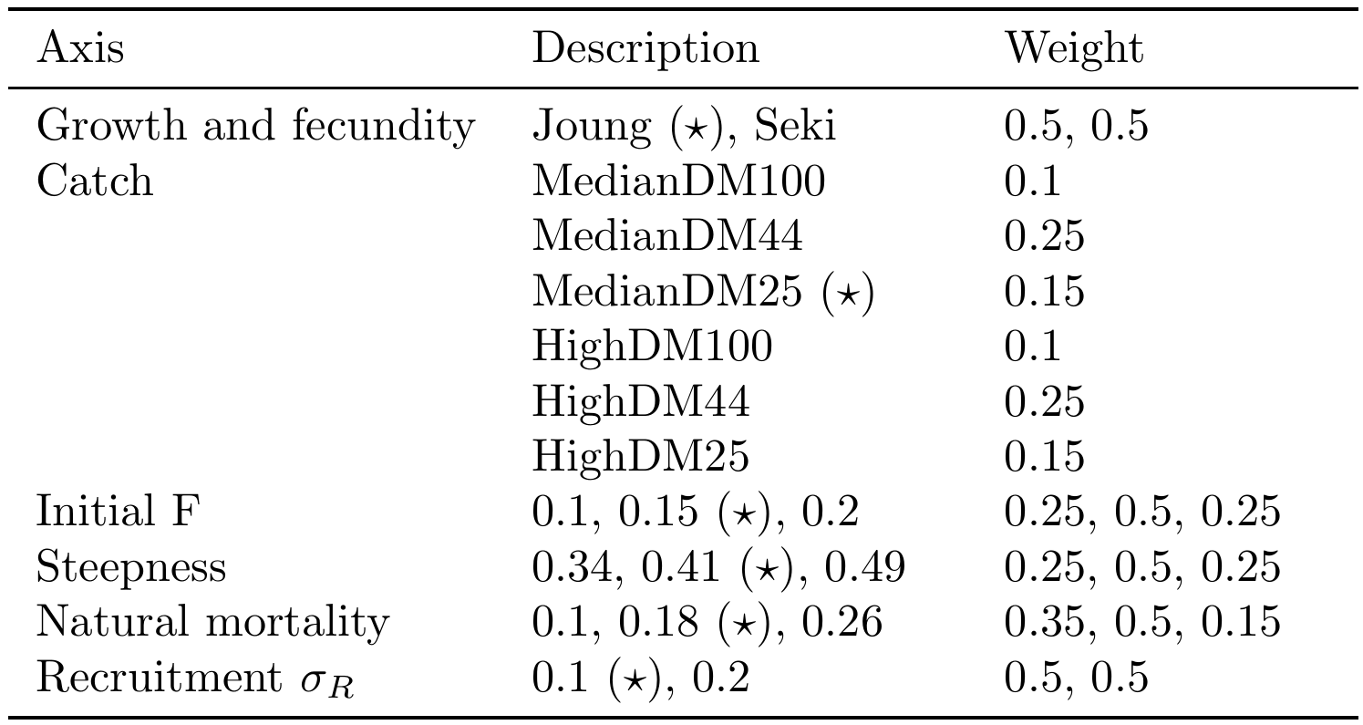

Table OCS-02. Summary of reference points using SC15 adopted weights by axes over the 648 models in the structural uncertainty grid.
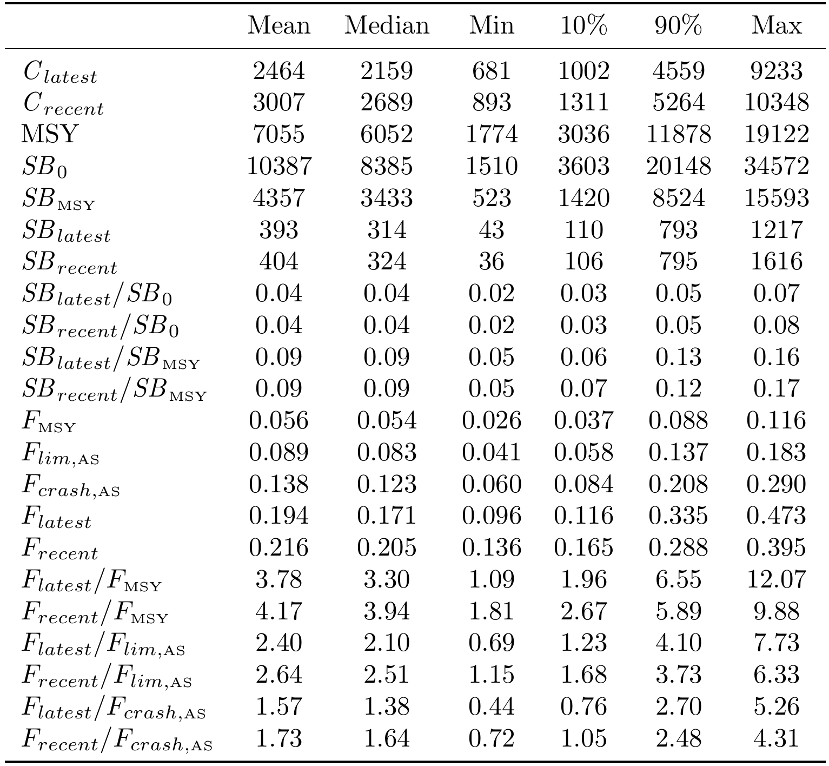

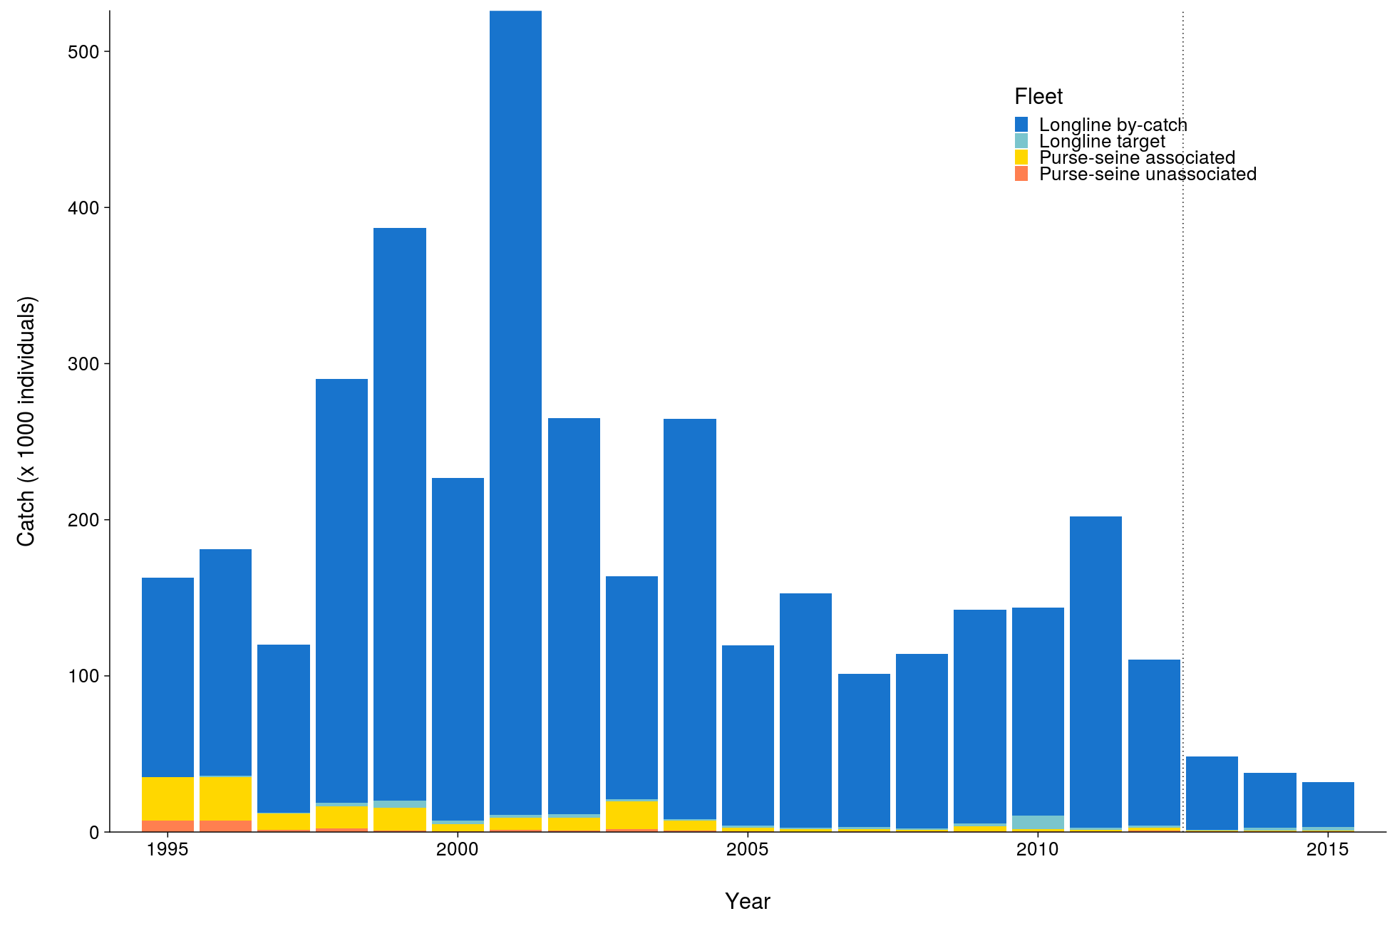 | 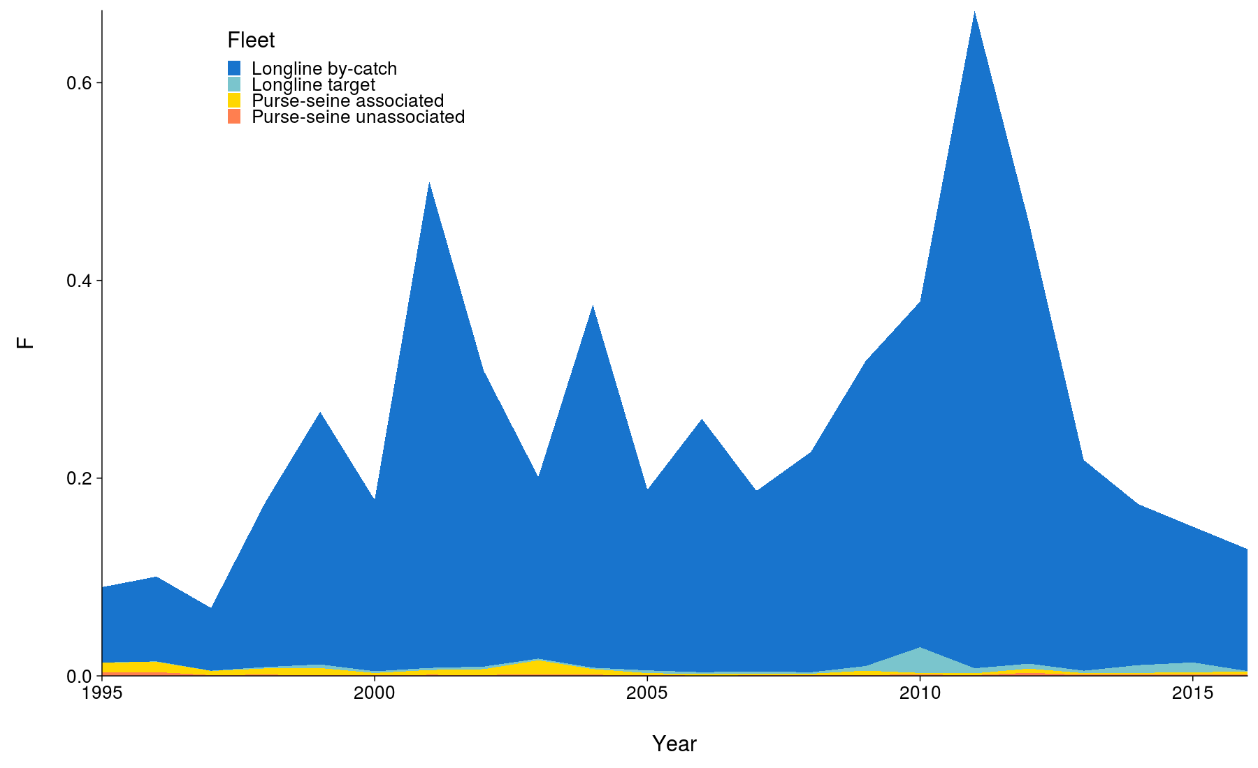
Figure OCS-01. Total reconstructed catches by fleet over time used for the diagnostic case. | Figure OCS-02. Cumulative fishing mortality by fleet estimated for the diagnostic case over the time-span of the assessment (1995-2016).
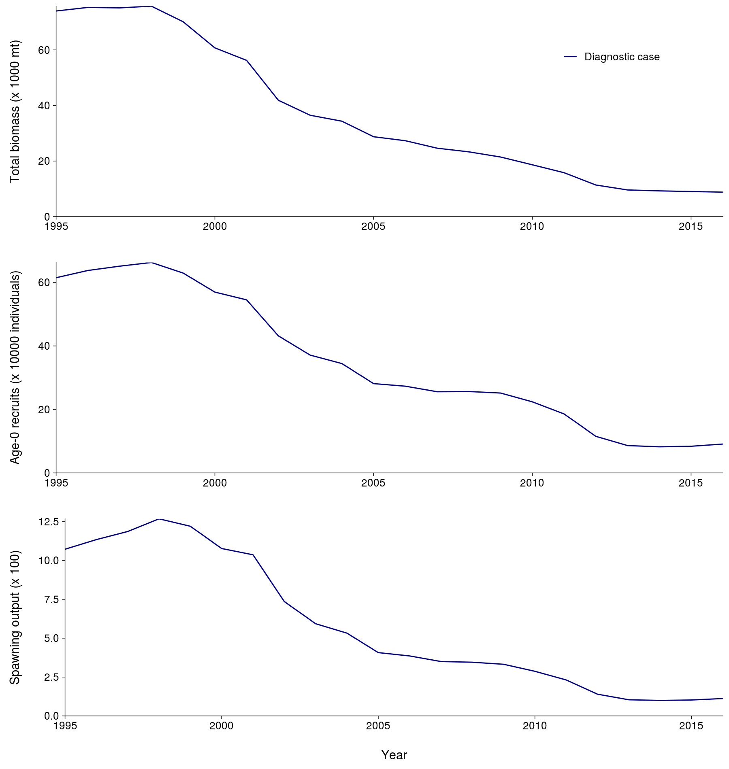 | 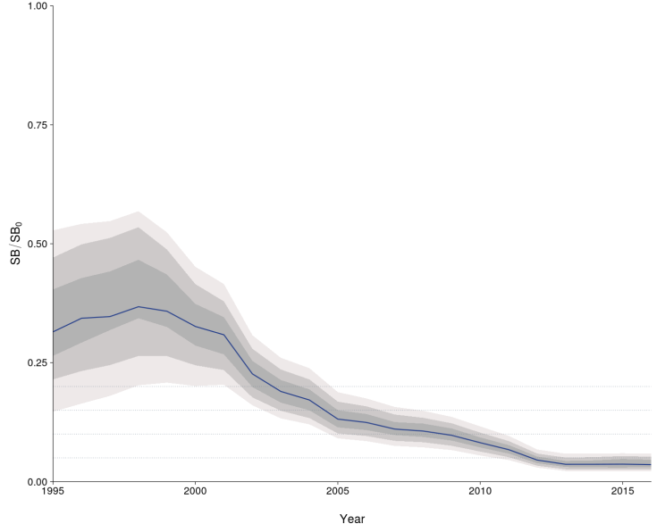
Figure OCS-03. Total biomass, recruitment and spawning biomass for the diagnostic case over the time-span of the assessment (1995-2016). | Figure OCS-04: Median estimates of depletion in spawning biomass over all (weighted) grid runs, with 2.5th -97.5th, 10th-90th and 25th -75th quantile intervals. Horizontal grey lines are placed at intervals of 5% in the lower part of the graph to aid visualization.

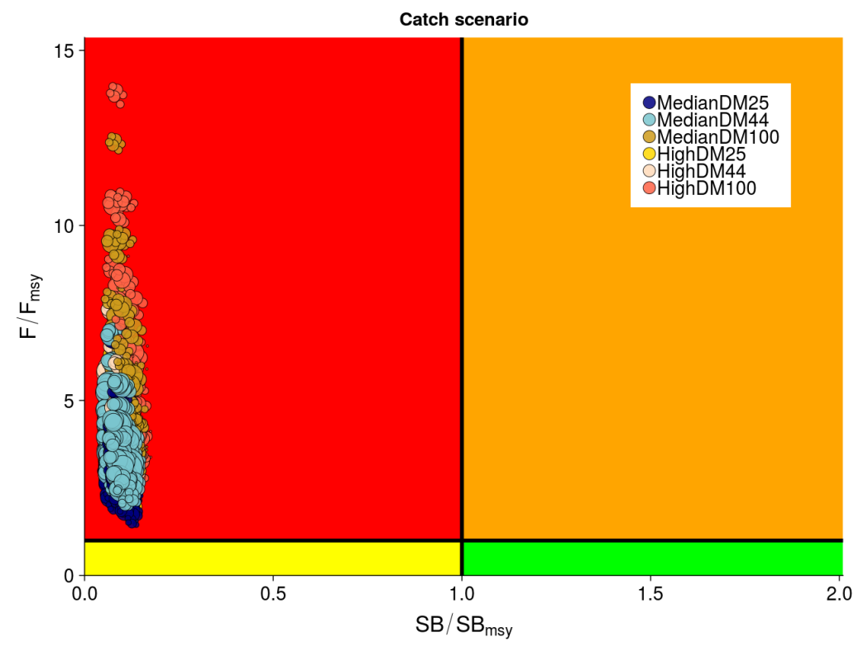
Figure OCS-05: Kobe plot summarizing recent status (2013-2015) for each of the (weighted) models in the structural uncertainty grid, based on SB/SB_{MSY} and F/F_{MSY}. The stock is considered to be overfished when SB/SB_{MSY} > 1 and undergoing overfishing when F/F_{MSY} > 1. The points are coloured according to the catch scenario that was used as input to the individual grid run. The size of the circle relates to the weight of that particular model run.

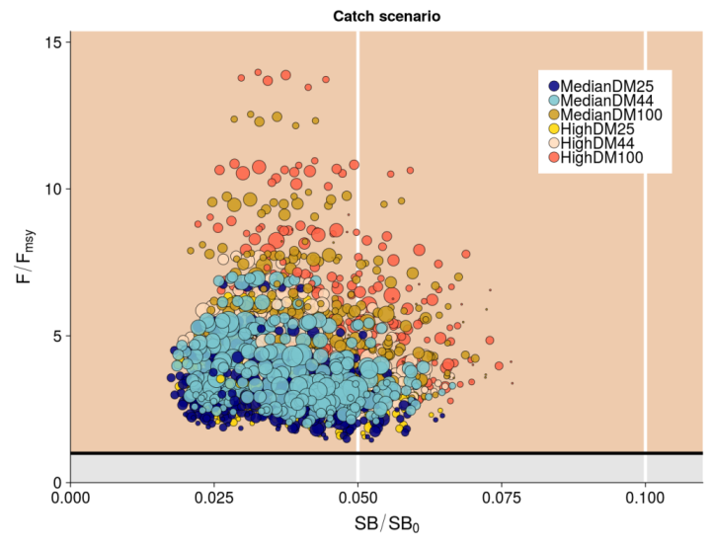 | 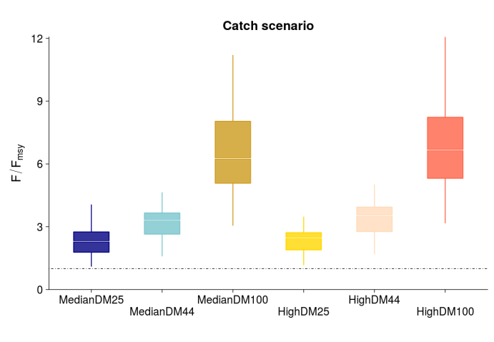
Figure OCS-06: Panel plot summarizing recent stock status (2013-2015) for each of the weighted models in the structural uncertainty grid for SB/SB₀ and F/F_{MSY}, noting no limit or target reference points have been adopted for oceanic whitetip shark. The stock is considered to be undergoing overfishing when F/F_{MSY} > 1 (beige zone). The SB/SB₀ axis was scaled to span the range of depletion values. Guidelines were added in white at 0.5SB/SB₀ and 0.1SB/SB₀. The points are coloured according to the catch scenario that was used as input to the individual grid run. The size of the circle relates to the weight of that particular model run. | Figure OCS-07: Median (white bar) and inter-quartile bounds (box) for F/F_{MSY} in the final year of the assessment (2016) under the 6 catch scenarios used in the structural uncertainty axis. The catch scenarios included baseline and high levels of catches with 3 scenarios of discard mortality (25%, 43.75% and 100%). The whiskers extend to 1.5 times the interquartile range.
    - Silky shark (Carcharhinus falciformis)

      - Research and information

      - Provision of scientific information

- Stock status and trends

- SC15 noted that no stock assessments were conducted for silky shark in 2019. Therefore, the stock status descriptions from SC14 are still current for silky shark. For further information on the stock status and trends from SC14, please see https://www.wcpfc.int/node/32155. Updated information on catches was not compiled for and reviewed by SC15.

- Management advice and implications

- SC15 noted that no management advice has been provided since SC14 for silky shark. Therefore, previous advice should be maintained, pending a new assessment or other new information. For further information on the management advice and implications from SC14, please see https://www.wcpfc.int/node/32155.

    - South Pacific blue shark (Prionace glauca)

      - Research and information

      - Provision of scientific information

- Stock status and trends

- SC15 noted that no stock assessments were conducted for South Pacific blue shark in 2019. Therefore, the stock status descriptions from SC13 are still current for South Pacific blue shark. For further information on the stock status and trends from SC13, please see https://www.wcpfc.int/node/29904. Updated information on catches was not compiled for and reviewed by SC15.

- Management advice and implications

- SC15 noted that no management advice has been provided for South Pacific blue shark.

    - North Pacific blue shark (Prionace glauca)

      - Research and information

      - Provision of scientific information

- Stock status and trends

- SC15 noted that no stock assessments were conducted for North Pacific blue shark in 2019. Therefore, the stock status descriptions from SC13 are still current for North Pacific blue shark. For further information on the stock status and trends from SC13, please see https://www.wcpfc.int/node/29904. Updated information on catches was not compiled for and reviewed by SC15.

- Management advice and implications

- SC15 noted that no management advice has been provided since SC13 for North Pacific blue shark. Therefore, previous advice should be maintained, pending a new assessment or other new information. For further information on the management advice and implications from SC13, please see https://www.wcpfc.int/node/29904.

    - North Pacific shortfin mako (Isurus oxyrinchus)

      - Research and information

      - Provision of scientific information

- Stock status and trends

- SC15 noted that no stock assessments were conducted for North Pacific shortfin mako shark in 2019. Therefore, the stock status descriptions from SC14 are still current for North Pacific shortfin mako shark. For further information on the stock status and trends from SC14, please see https://www.wcpfc.int/node/32155. Updated information on catches was not compiled for and reviewed by SC15.

- Management advice and implications

- SC15 noted that no management advice has been provided since SC14 for North Pacific shortfin mako shark. Therefore, previous advice should be maintained, pending a new assessment or other new information. For further information on the management advice and implications from SC14, please see https://www.wcpfc.int/node/32155.

    - Pacific bigeye thresher shark (Alopias superciliosus)

      - Research and information

      - Provision of scientific information

- Stock status and trends

- SC15 noted that no stock assessments were conducted for Pacific bigeye thresher shark in 2019. Therefore, the stock status descriptions from SC13 are still current for Pacific bigeye thresher shark. For further information on the stock status and trends from SC13, please see https://www.wcpfc.int/node/29904. Updated information on catches was not compiled for and reviewed by SC15.

- Management advice and implications

- SC15 noted that no management advice has been provided since SC13 for Pacific bigeye thresher shark. Therefore, previous advice should be maintained, pending a new assessment or other new information. For further information on the management advice and implications from SC13, please see https://www.wcpfc.int/node/29904.

    - Porbeagle shark (Lamna nasus)

      - Research and information

      - Provision of scientific information

- Stock status and trends

- SC15 noted that no stock assessments were conducted for southern porbeagle shark in 2019. Therefore, the stock status descriptions from SC13 are still current for southern porbeagle shark. For further information on the stock status and trends from SC13, please see https://www.wcpfc.int/node/29904. Updated information on catches was not compiled for and reviewed by SC15.

- Management advice and implications

- SC15 noted that no management advice has been provided since SC13 for southern porbeagle shark. Therefore, previous advice should be maintained, pending a new assessment or other new information. For further information on the management advice and implications from SC13, please see https://www.wcpfc.int/node/29904.

    - Whale shark (Rhincodon typus)

      - Research and information

      - Provision of scientific information

- Stock status and trends

- SC15 noted that no stock assessments were conducted for whale shark in 2019. Therefore, the stock status descriptions from SC14 are still current for whale shark. For further information on the stock status and trends from SC14, please see https://www.wcpfc.int/node/32155. Updated information on catches was not compiled for and reviewed by SC15.

- Management advice and implications

- SC15 noted that no management advice has been provided since SC14 for whale shark. Therefore, previous advice should be maintained, pending a new assessment or other new information. For further information on the management advice and implications from SC14, please see https://www.wcpfc.int/node/32155.

  - WCPO billfishes

    - South Pacific swordfish (Xiphias gladius)

      - Research and information

      - Provision of scientific information

  - Stock Status and trends

- SC15 noted that no stock assessments were conducted for south Pacific swordfish in 2019. Therefore, the stock status descriptions from SC13 are still current for south Pacific swordfish. For further information on the stock status and trends from SC13, please see https://www.wcpfc.int/node/29904. Updated information on catches was not compiled for and reviewed by SC15.

- Management Advice and implications

- SC15 noted that no management advice has been provided since SC13 for south Pacific swordfish. Therefore, previous advice should be maintained, pending a new assessment or other new information. For further information on the management advice and implications from SC13, please see https://www.wcpfc.int/node/29904

    - Southwest Pacific striped marlin (Kajikia audax)

      - Research and information

      - Provision of scientific information

- Stock Status and trends

- The description of the updated structural sensitivity grid used to characterize uncertainty in the assessment is provided in Table SMLS-01. The spatial structure used in the assessment model is shown in Figure SMLS-01, with sub-regions used to define fisheries shown. Catch trend data is presented in Figure SMLS-02. Estimated annual average recruitment, spawning biomass, and total biomass from the diagnostic case are shown in Figure SMLS-03. Fishing mortality and depletion estimated from the diagnostic case are shown in Figures SMLS-04 and SMLS-05, respectively. The median and 80 percent quantile trajectories of the fishing depletion for models in the structural uncertainty across the grid axes in Table SMLS-01 are shown in Figure SMLS-6.

- The Majuro plot summarizing the results for each of the models in the structural uncertainty grid retained for management advice are represented in Figure SMLS-07. Figure SMLS-08 presents the Kobe plot summarizing the results for each of the models in the structural uncertainty grid retained for management advice.

- SC15 noted that the median of recent spawning biomass depletion relative to the unfished condition was (SB_{recent}/SB_{F=0}) = 0.198, with a probable range of 0.093 to 0.464 (80% probable range), and there was a roughly 50.33% probability (151 out of 300 models) that the recent spawning biomass depletion relative to the unfished condition was below the LRP adopted for tunas (SB_{recent}/SB_{F=0} = 0.2). The median estimate (0.198) is below that estimated from the previous (2012) assessment (SB₂₀₀₆₋₂₀₀₉/SB_{F=0} = 0.34) (see SC8-SA-WP-05), noting the differences in the use of the grid in the two assessments and different model assumptions. In the current assessment the feasible grid consisted of 300 models (186 model runs removed from 486 grid models).

- SC15 noted that the median of recent spawning biomass relative to the spawning biomass at MSY was (SB_{recent}/SB_{MSY}) = 0.737 with a probable range of 0.334 to 1.635 (80% probable range), and there was a roughly 68.66% probability (206 out of 300 models) that the recent spawning biomass depletion was below the spawning biomass at MSY. The median estimate (0.737) is below that estimated from the previous (2012) assessment (SB_{current}/SB_{MSY} = 0.87) (see SC8-SA-WP-05), noting the differences between the two assessments.

- SC15 noted that the median of relative recent fishing mortality was (F_{recent}/F_{MSY} = 0.911) with an 80% probability interval of 0.313 to 1.891, and there was a roughly 44.3% probability (133 out of 300 models) that the recent fishing mortality was above F_{MSY}. The median estimate (0.911) is above that estimated from the previous assessment (F_{current}/F_{MSY} = 0.81) (see SC8-SA-WP-05), noting the differences in the use of the grid in the two assessments.

Table SMLS-01. Description of the structural sensitivity grid used to characterize uncertainty in the assessment. The star denotes the level assumed in the diagnostic case.
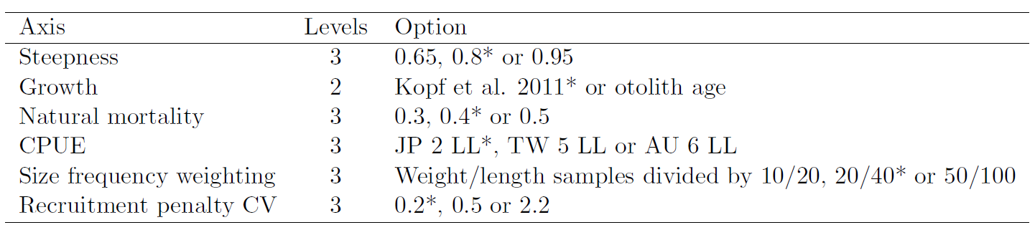

Table SMLS-02. Summary reference points over the models in the structural uncertainty grid.
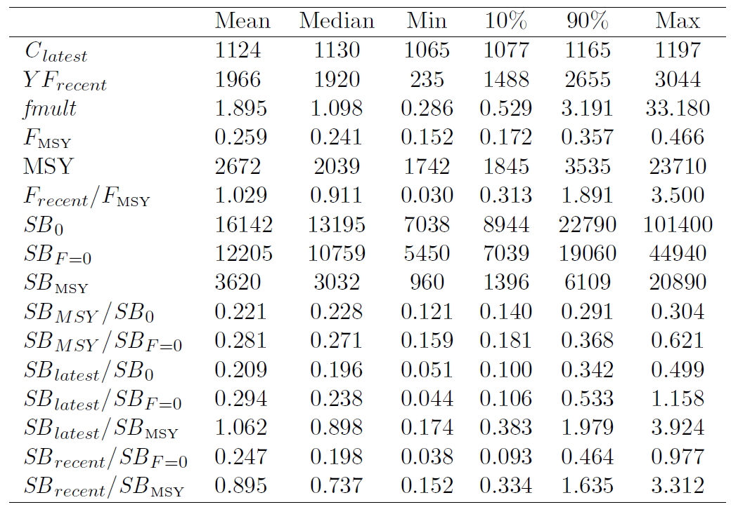

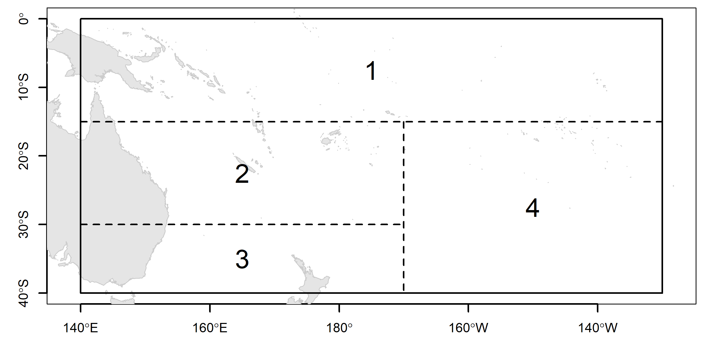 | 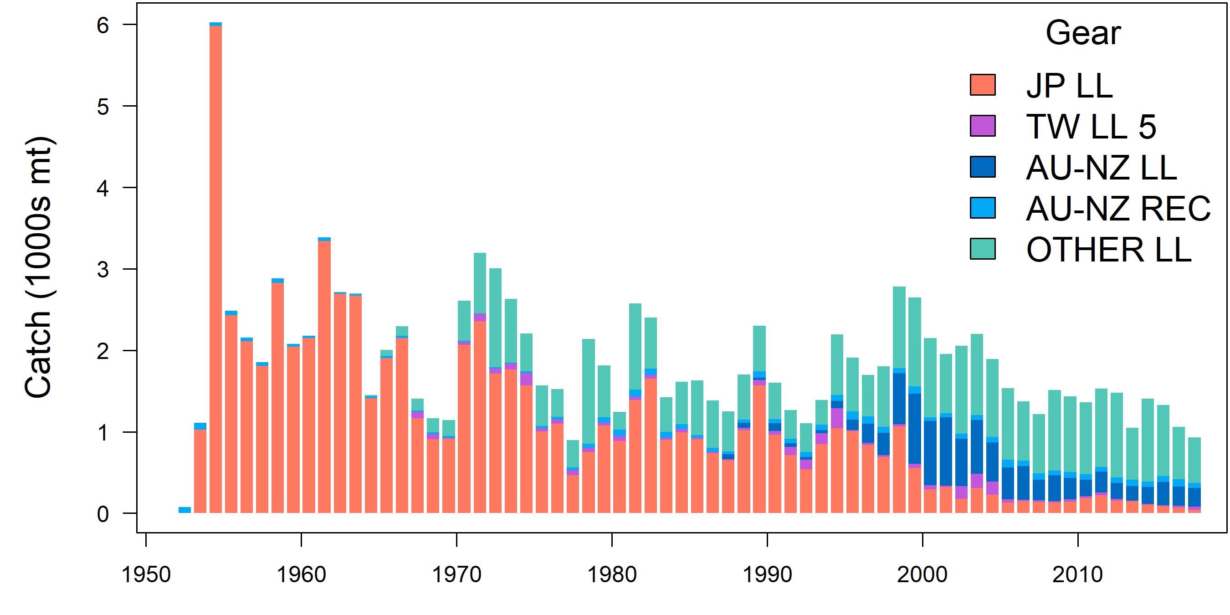
Figure SMLS-01. Single region spatial structure used in the 2019 stock assessment. | Figure SMLS-02. Time series of total annual catch (1000s mt) by fishery group over the full assessment period.
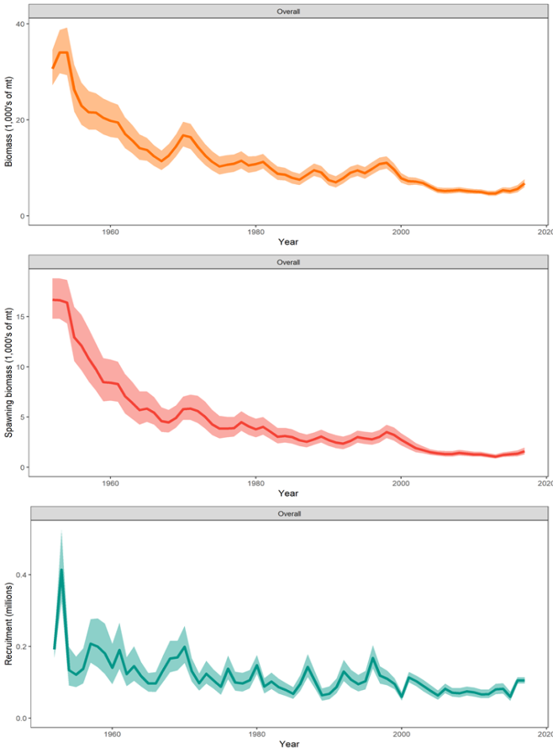 | Figure SMLS-03. Estimated annual average total biomass, spawning biomass, and recruitment for the diagnostic model. Shaded region gives ± 2 standard deviations (i.e., 95% CI).
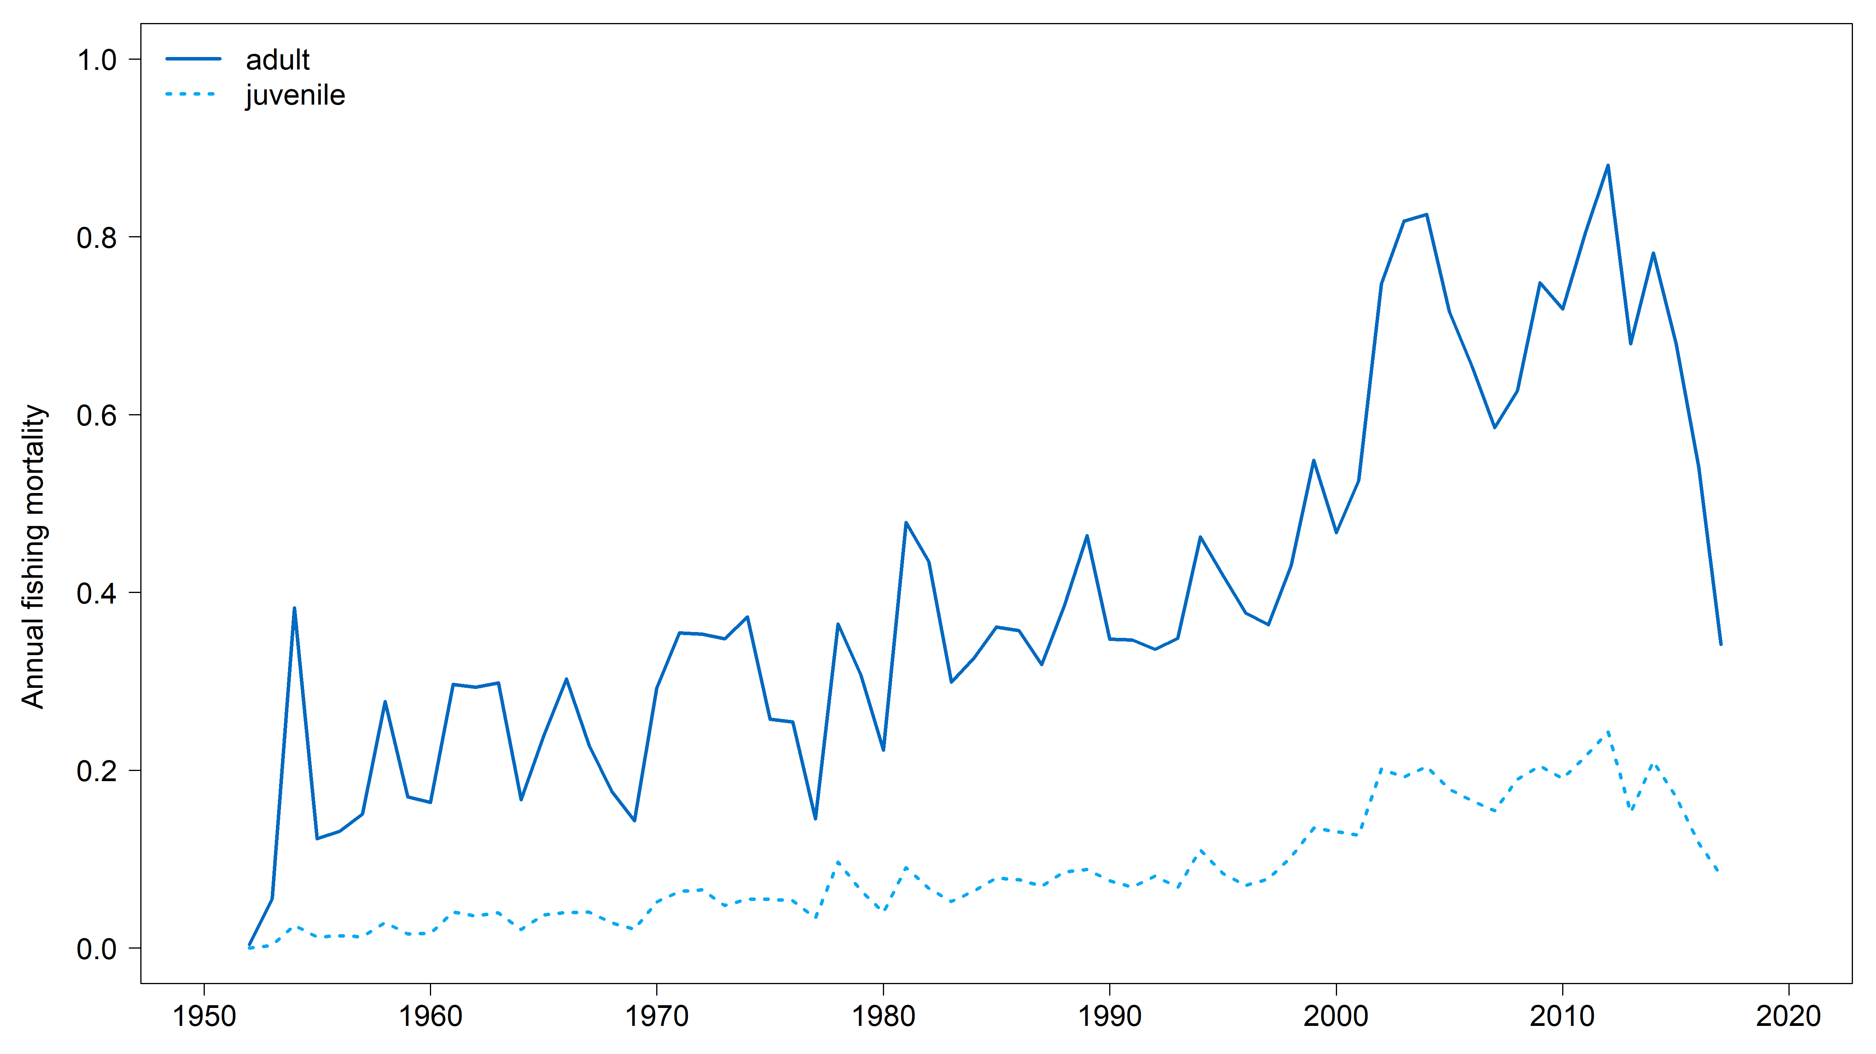 | 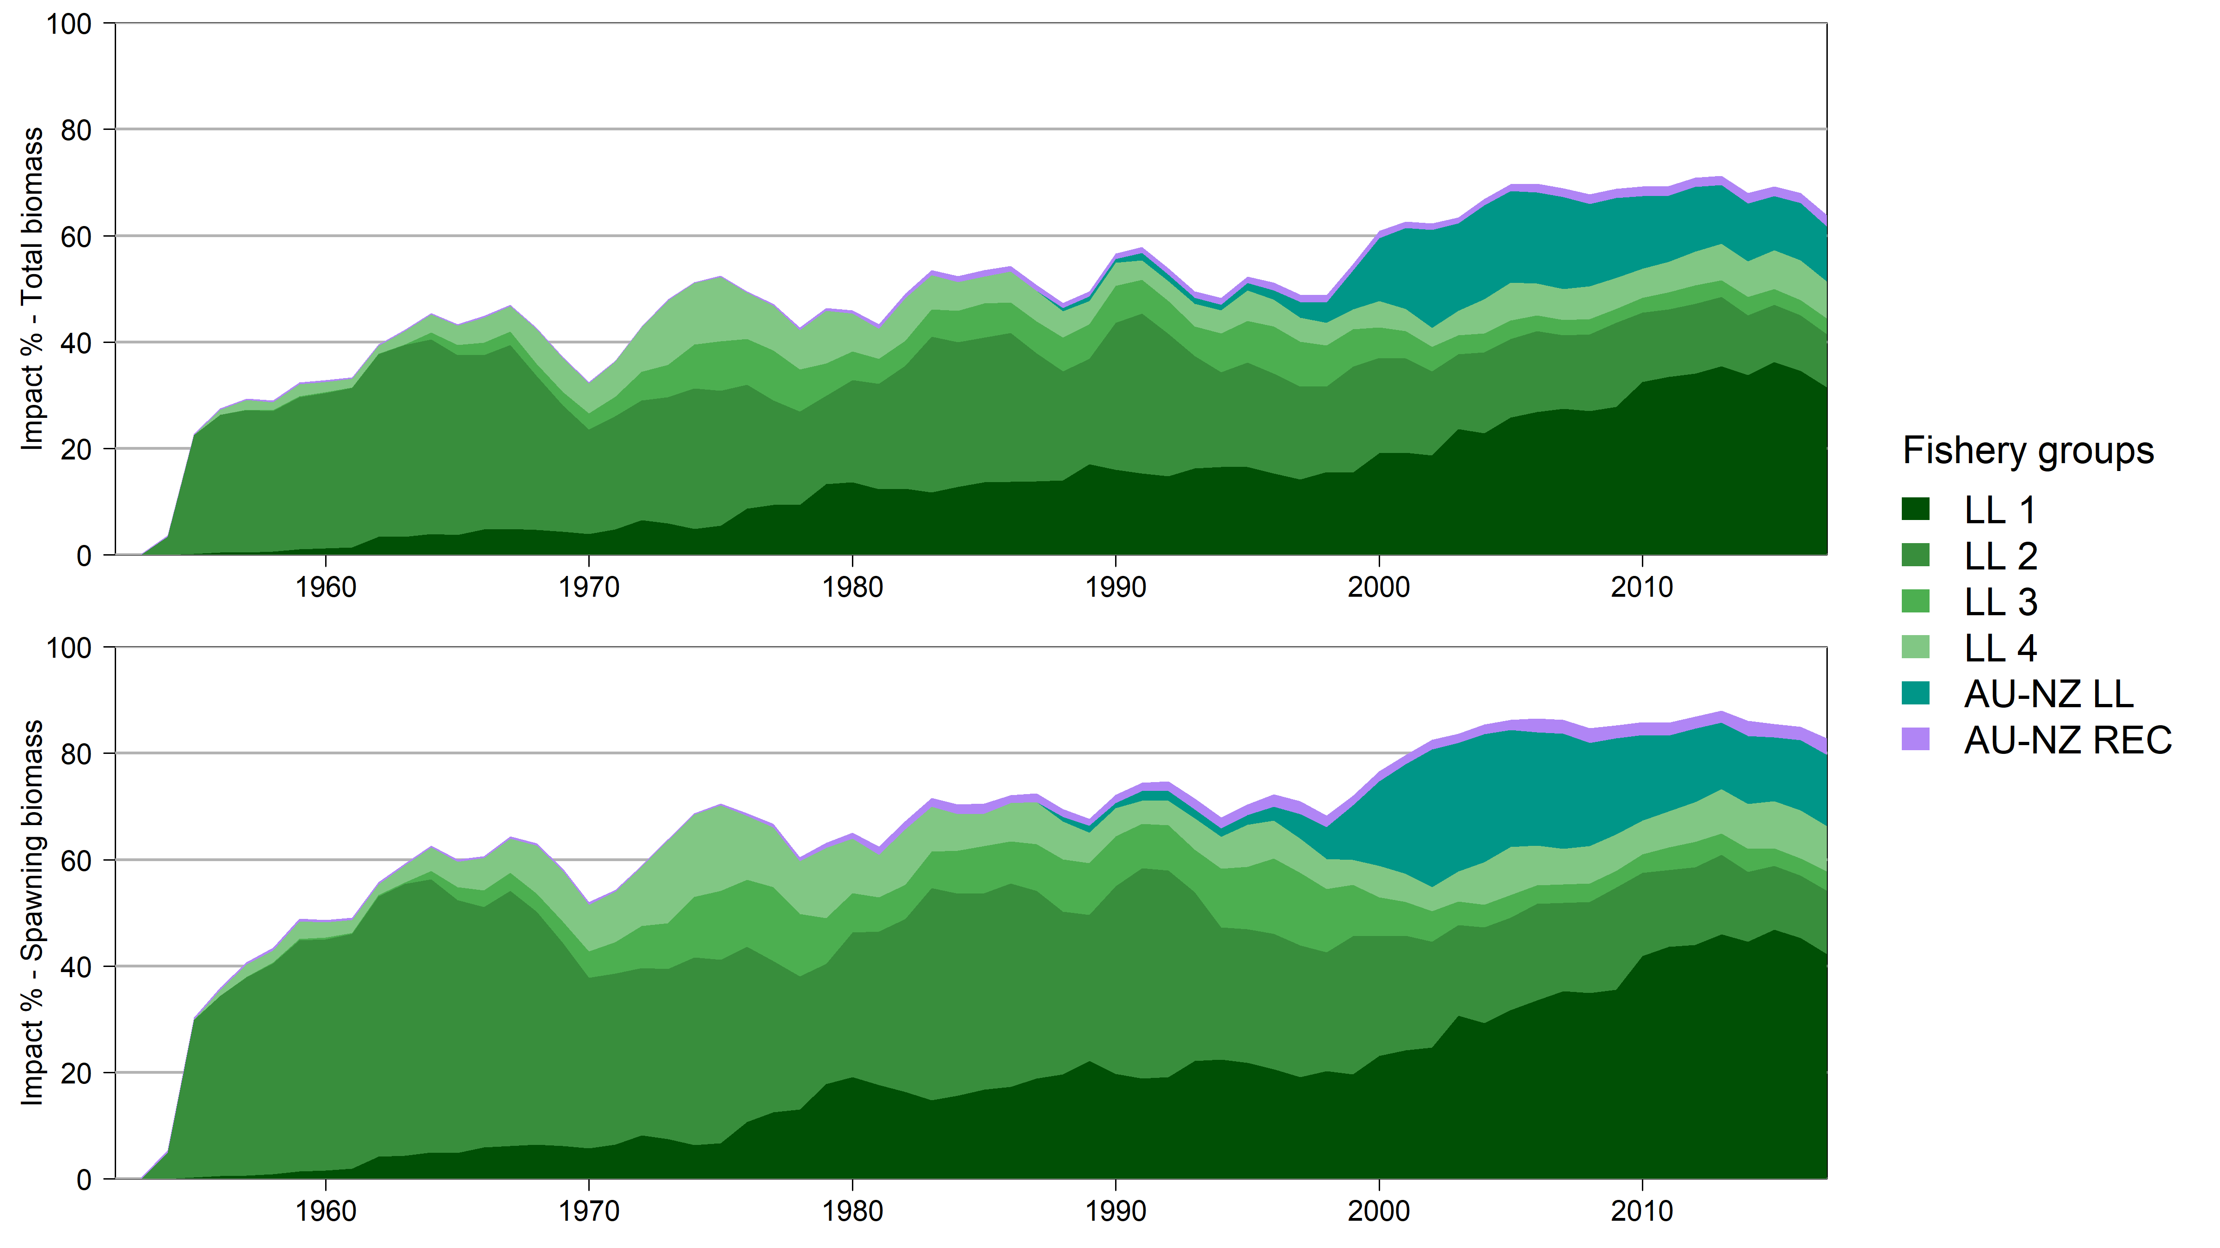
Figure SMLS-04. Estimated annual average juvenile and adult fishing mortality for the diagnostic model. | Figure SMLS-05. Estimates in reduction in spawning biomass and total biomass due to fishery impact for the diagnostic case model.

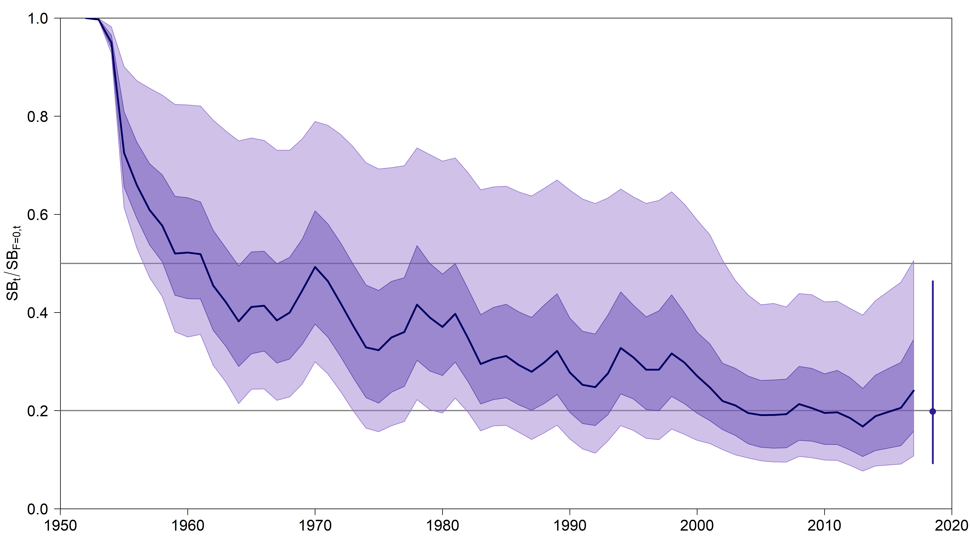 | 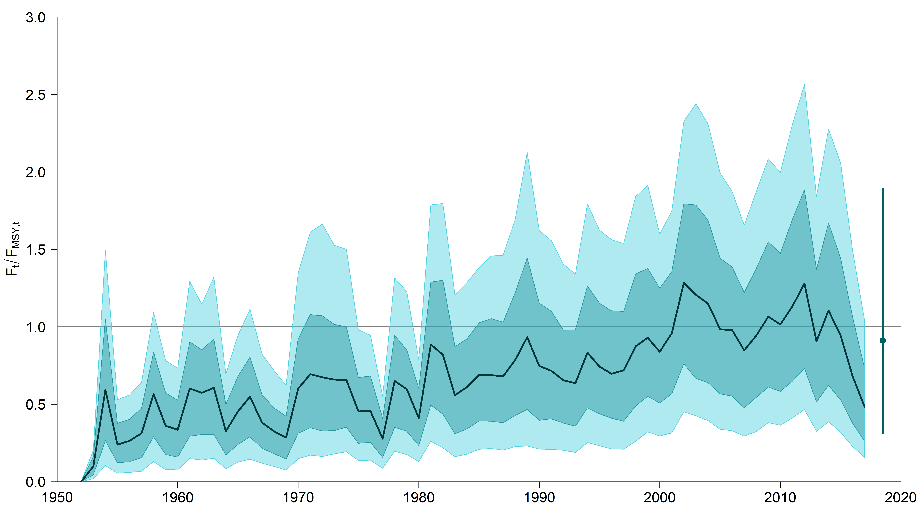
Figure SMLS-06. Plot showing the trajectories of spawning biomass depletion for the model runs included in the structural uncertainty grid described in Table SMLS-01. Gray horizontal lines indicate 50% and 20% levels of depletion. On the right of the depletion is the median point estimate of the recent level reference point with the bar indicating the 80th percentile. | Figure SMLS-06bis. Plot showing the trajectories of fishing mortality for the model runs included in the structural uncertainty grid described in Table SMLS-01. Gray horizontal lines indicate F_{MSY}. On the right of the depletion is the median point estimate of the recent level reference point with the bar indicating the 80th percentile.
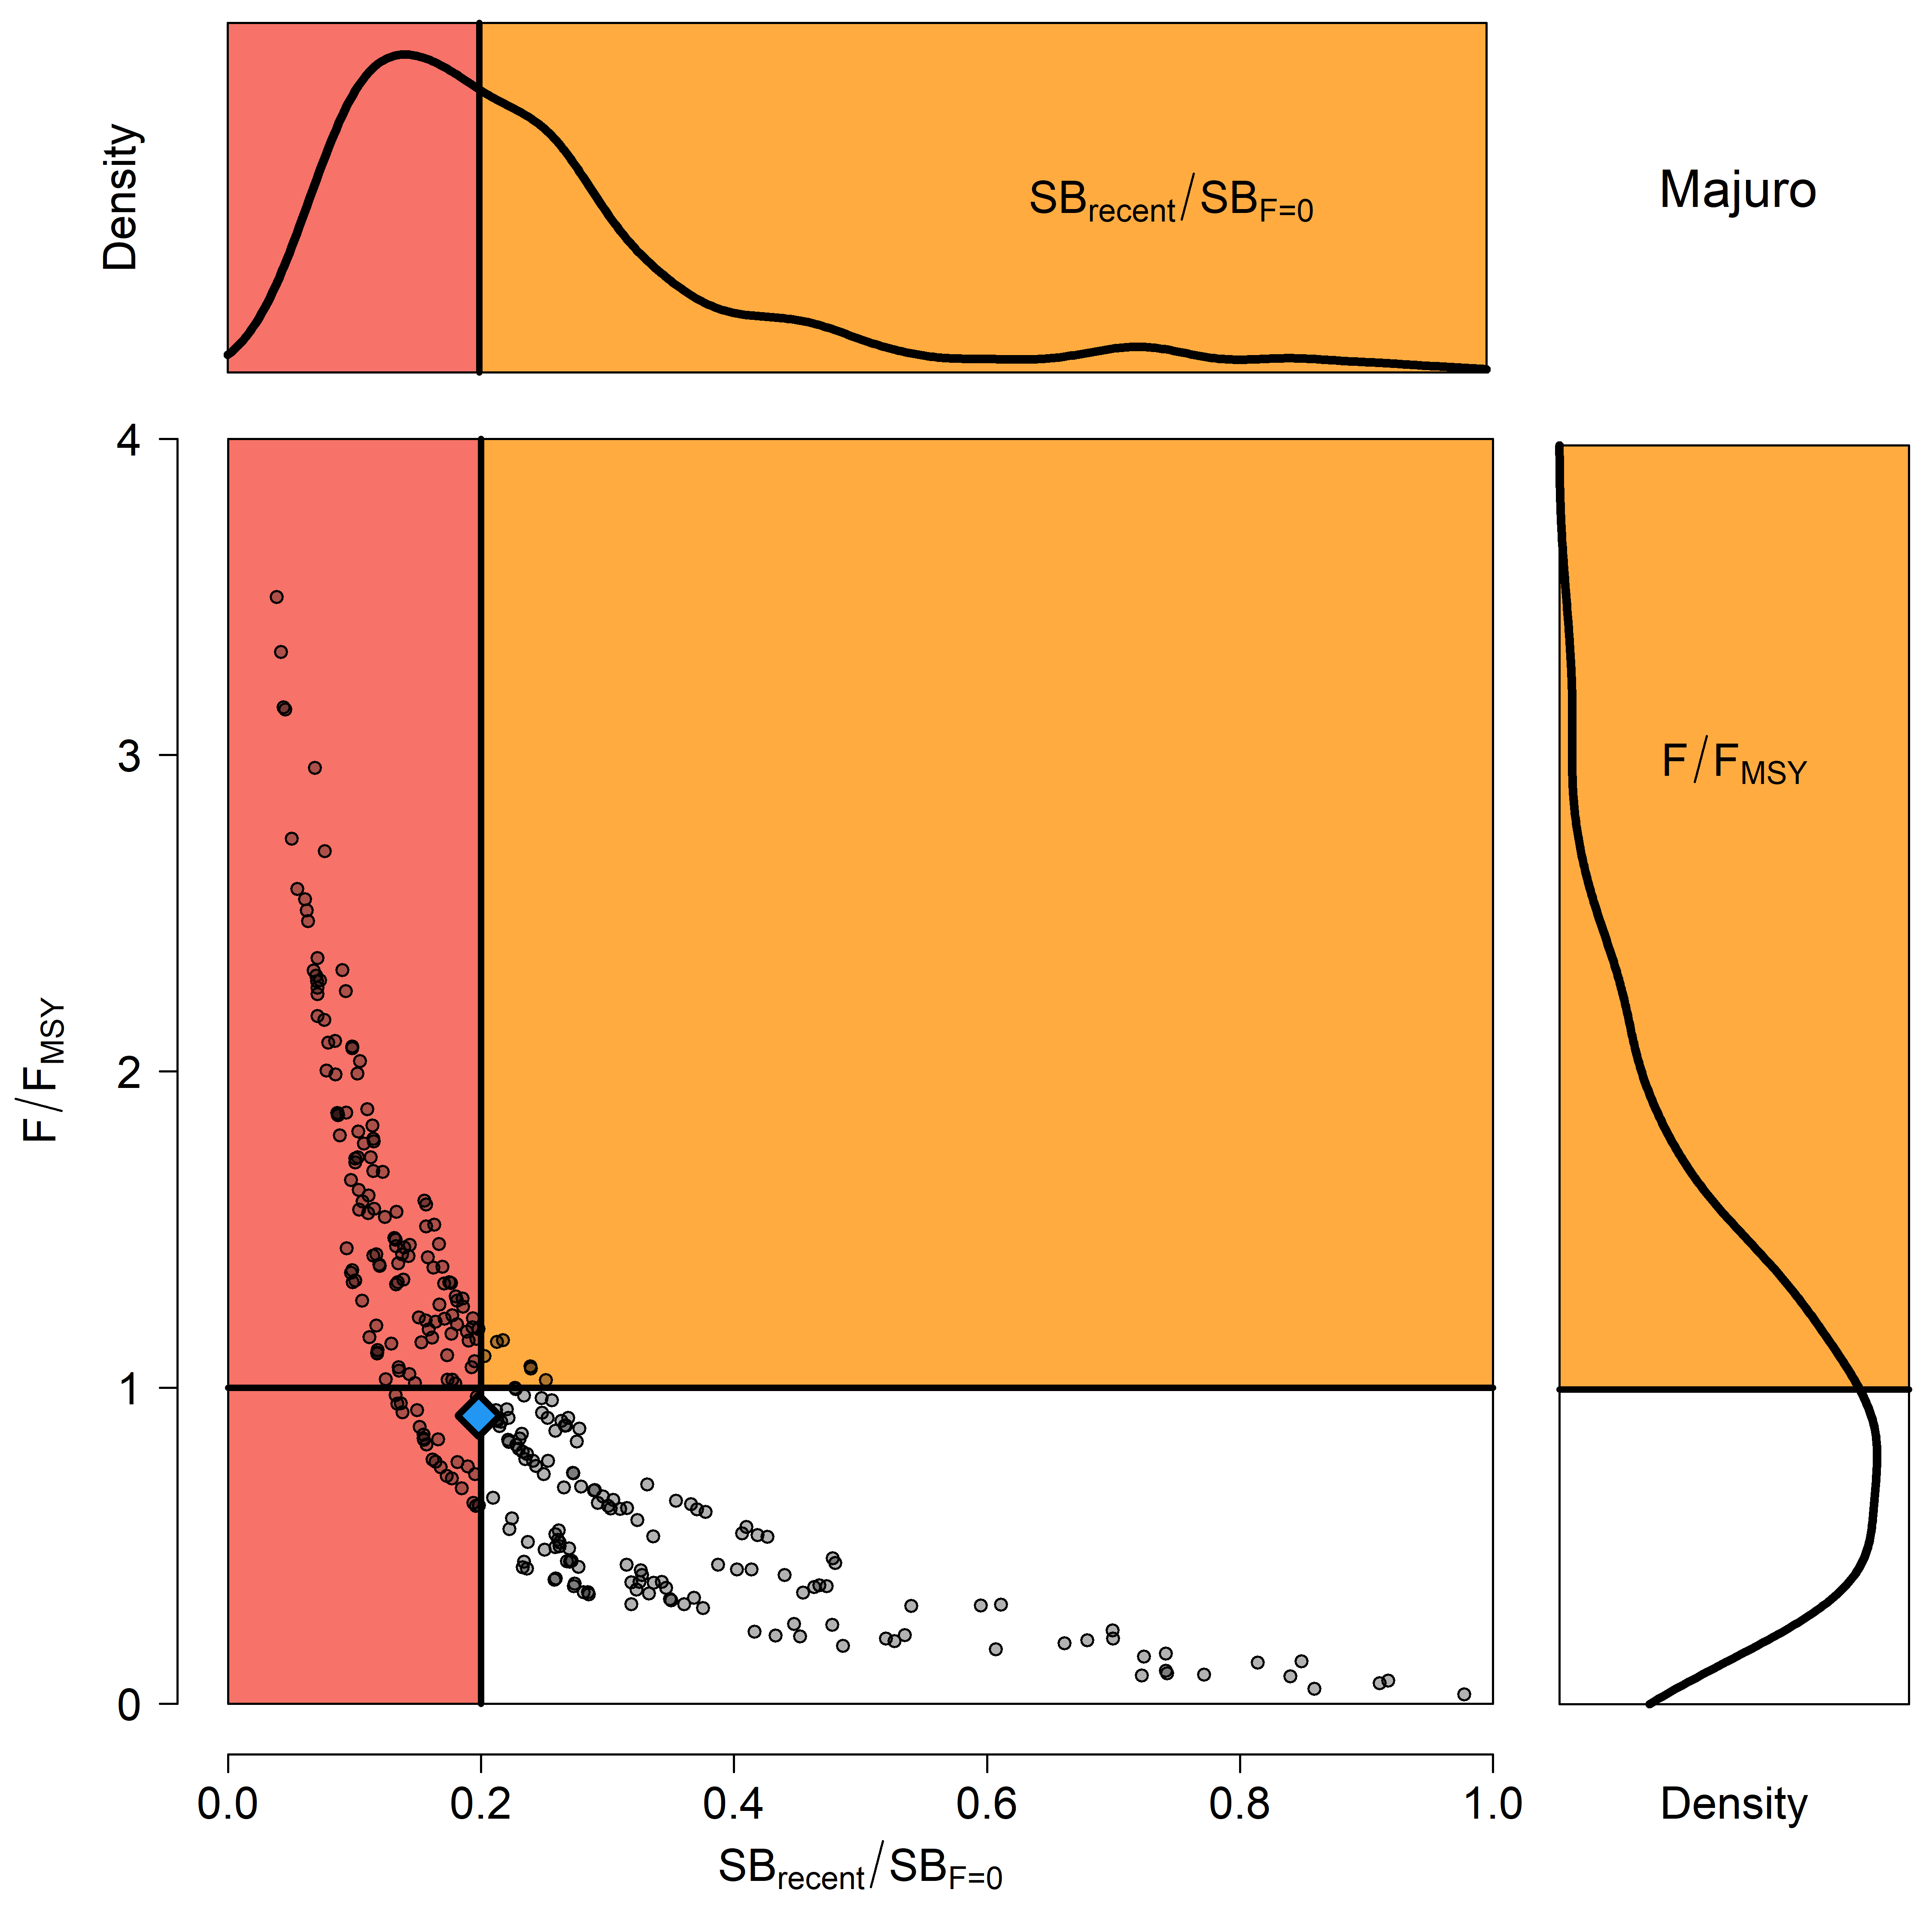 | 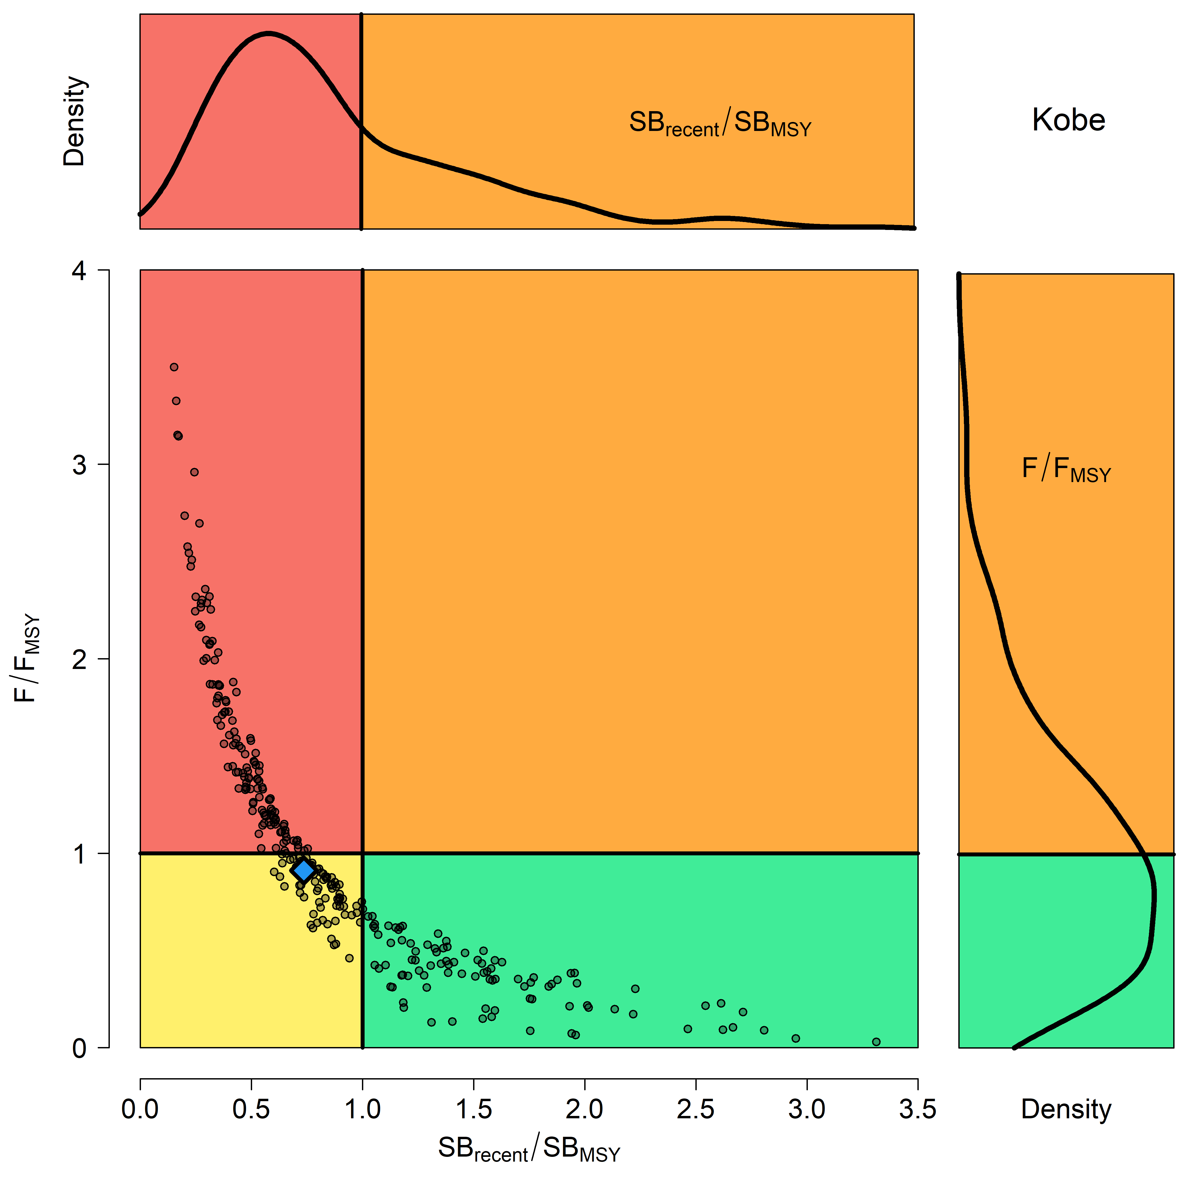
Figure SMLS-07. Majuro plot for the recent spawning biomass (2014 – 2017) summarizing the results for each of the models in the structural uncertainty grid. The plots represent estimates of stock status in terms of spawning biomass depletion and fishing mortality, and marginal distributions of each are presented. The blue square is the median of the grid. | Figure SMLS-08. Kobe plot for the recent spawning biomass (2014 – 2017) summarizing the results for each of the models in the structural uncertainty grid. The plots represent estimates of stock status in terms of spawning biomass relative to the spawning biomass that produces MSY and fishing mortality, and marginal distributions of each are presented. The blue square is the median of the grid.

- Management Advice and implications

- SC15 noted that there are no agreed limit reference points for the WCPO billfish. However, SC15 also noted that based on the adopted uncertainty grid, the southwest Pacific striped marlin assessment results indicate that the stock is likely overfished, and close to undergoing overfishing according to MSY-based reference points. SC15 recommends that WCPFC16 identify an appropriate limit reference point for this stock. Key management quantities can be found in Table SMLS-02. The recent spawning biomass depletion relative to the unfished condition was close to the LRP adopted for tunas (SB_{recent}/SB_{F=0} = 0.2).

- SC15 noted that recent catches are approximately half the MSY, and that recent fishing mortality is slightly less than the fishing mortality that would result in MSY.

- SC15 recommended SC16 use stochastic stock projections, including the expansion of the geographic scope of CMM2006-04 by assuming average fishing effort during 2000-2004 by CCMs and zero fishing mortality in assessment region 1, to evaluate the potential long-term performance of the CMM.

- SC15 recommended that WCPFC16 consider measures to reduce the overall catch of this stock, including through the expansion of the geographical scope of CMM2006-04, in order to cover the distribution range of the stock.

- Research recommendations

- The following research activities were recommended by SC15 in order to progress the assessment of Southwestern Pacific striped marlin.
- Improved estimates of life history parameters including growth, maturity, and natural mortality. Verify the aging method used to derive the growth relationship in order to inform meta analyses for M and steepness specific to SWPO striped marlin. Additionally, efforts should be made to increase sampling of smaller individuals.
- Better estimates of striped marlin movement (>180 days) are needed to characterize mixing rates across model region in order to develop spatially explicit model structure and improve upon “areas as fleets” approach.
- Improved estimates of conversion factors (such as weight-to-length and length-to-length) are needed, together with improved length-at-age estimates to better inform the data inputs used in the stock assessment.
- Conduct sensitivities analyses with respect to the uncertainties in conversion factors used in the stock assessment and assess whether this should be included as an axis in the structural uncertainty grid.
- Develop better estimates of historical catch (1950-1960) to resolve the potential issue of misidentification caused by merging the billfishes datasets.

    - North Pacific striped marlin (Kajikia audax)

      - Research and information

      - Provision of scientific information

- Stock Status and trends

- SC15 noted that ISC provided the following conclusions on the stock status of Western and Central North Pacific striped marlin:

Estimates of population biomass of the Western and Central North Pacific Ocean (WCNPO) striped marlin fluctuated without trend between 1975 and 1993. The population deceased substantially in 1994 and fluctuated without trend until the present year. Population biomass (age-1 and older) averaged roughly 17,969 mt, or 54% below unfished biomass during the 1975-1993 period and declined to 4,508 mt, or 89% below unfished biomass by 2008. The minimum spawning stock biomass was estimated to be 618 t in 2011 (76% below SSB_{MSY}, the spawning stock biomass to produce MSY, Figure NMLS-1a). In 2017, SSB = 981 t and SSB/SSB_{MSY} = 0.38. Fishing mortality on the stock (average F on ages 3-12) has been around F_{MSY} since 2014 (Figure NMLS-1b). It averaged roughly 0.64 yr-1 during 2015-2017, or 7% above F_{MSY} and in 2017, F=0.80 yr-1 with a relative fishing mortality of F/F_{MSY} = 1.33 (Table NMLS-02). Fishing mortality has been above FMSY in every year except 1984, 1992, and 2016. The predicted value of the spawning potential ratio (SPR, the predicted spawning output at current F as a fraction of unfished spawning output) is estimated to be SPR₂₀₁₅₋₂₀₁₇ = 17% and is approximately equal to the SPR required to produce MSY. Recruitment averaged about 263,000 age-0 recruits between 1994 and 2017, which was 34% below the 1975-2017 average. No target or limit reference points have been established for the WCNPO striped marlin stock under the auspices of the WCPFC. Despite the relatively large L50/Linf ratio for WCNPO striped marlin, the stock is expected to be highly productive due to its rapid growth and high resilience to reductions in spawning potential. Recent recruitments have been lower than expected and have been below the long-term trend since 2005. Although fishing mortality has decreased since 2000, due to the prolonged low recruitment and landings of immature fish, the biomass of the stock has remained below MSY. When the status of WCNPO striped marlin is evaluated relative to MSY-based reference points, the 2017 spawning stock biomass of 981 mt is 62% below SSB_{MSY}(2,604 t) and the 2015-2017 fishing mortality exceeds F_{MSY} by 7%. Therefore, relative to MSY-based reference points, overfishing is occurring and the WCNPO striped marlin stock is overfished (Figure NMLS-02).

Biological reference points were computed for the base case model with Stock Synthesis (Table NMLS-01 and Table NMLS-02). The point estimate of maximum sustainable yield (MSY) was 4,946 t. The point estimate of the spawning biomass to produce MSY (adult female biomass, SSB_{MSY}) was 2,604 t. The point estimate of F_{MSY}, the fishing mortality rate to produce MSY (average fishing mortality on ages 3 – 12) was 0.60 and the corresponding equilibrium value of spawning potential ratio at MSY was SPR_{MSY} = 18%.

Stock projections for WCNPO striped marlin were conducted using the age-structured projection model software AGEPRO. Stochastic projections were conducted using results from the base case model to evaluate the probable impacts of alternative fishing intensities or constant catch quotas on future spawning stock biomass and yield for striped marlin in the WCNPO. For fishing mortality projections, a standard set of F-based projections were conducted. For catch quota projections, the set of rebuilding projection analyses requested by NC14 were conducted. Two future recruitment scenarios were evaluated (Figure 3 and Figure 4): (1) a short-term recruitment scenario based on resampling the empirical cumulative distribution function of recruitment observed during 2012-2016 and (2) a long-term recruitment scenario based on resampling the empirical cumulative distribution function of recruitment observed during 1975- 2016. The short-term recruitment scenario had an average recruitment of 134,020 age-0 fish and the long-term recruitment mean was 306,989 age-0 fish. The stochastic projections employed model estimates of the multi-fleet, multi-season, size- and age-selectivity, and structural complexity in the assessment model to produce consistent results. Fishing mortality-based projections started in 2018 and continued through 2037 under five levels of fishing mortality and the two recruitment scenarios. The five fishing mortality stock projection scenarios were: 1) F status quo (average F during 2015-2017), 2) F_{MSY}, 3) F at 0.2·SSB₀, 4) F_{High} at the highest 3-year average during 1975-2017, and 5) F_{Low} at F_{30%.} For the F-based scenarios, fishing mortality in 2018-2019 was set to be F status quo (0.64) and fishing mortality during 2020-2037 was set to the projected level of F. Catch-based projections also ran from 2018 to 2037 and included seven levels of constant catch for the long-term recruitment scenario and 10 levels of catch for the short-term recruitment scenario. For the catch-based scenarios, catch biomass in 2018-2019 was set to be the status quo catch during 2015-2017 (2,151 t) and annual catches during 2020-2037 were set to the projected catch quota. The ten constant catch stock projection scenarios were: 1) Quota based upon WCPFC CMM10-01, 2) 90% of the quota, 3) 80% of the quota, 4) 70% of the quota, 5) 60% of the quota, 6) 50% of the quota, 7) 40% of the quota, 8) 30% of the quota, 9) 20% of the quota, and 10) 10% of the quota. Results show the projected female spawning stock biomasses and the catch biomasses under each of the scenarios (Table NMLS-03, Figure NMLS-03 and Figure NMLS-04).

- SC15 noted the following stock status from ISC:

Biomass (age 1 and older) for the WCNPO striped marlin stock decreased from 17,000 t in 1975 to 6,000 t in 2017. Estimated fishing mortality averaged F=0.97 yr-1 during the 1975-1994 period with a range of 0.60 to 1.59 yr-1, peaked at F=1.71 year-1 in 2001, and declined sharply to F=0.64 yr-1 in the most recent years (2015-2017). Fishing mortality has fluctuated around F_{MSY} since 2013. Compared to MSY-based reference points, the current spawning biomass (average for 2015- 2017) was 76% below SSB_{MSY} and the current fishing mortality (average for ages 3 – 12 in 2015-2017) was 7% above F_{MSY}.

Based on these findings, the following information on the status of the WCNPO striped marlin stock is provided:
- There are no established reference points for WCNPO striped marlin;
- Results from the base case assessment model show that under current conditions the WCNPO striped marlin stock is overfished and is subject to overfishing relative to MSY- based reference points (Table NMLS-01, Table NMLS-02, and Figure NMLS-01).

- SC15 noted that the assessment results are sensitive to the growth assumption and the ISC billfish working group (hereafter, WG) chair noted that the WG will attempt to revise the growth curve at the next stock assessment.

- SC15 also highlighted the sharp decline in the stock biomass in the mid-1990s and recommends that ISC further investigate the reasons for this decline.

- Management advice and implications

- SC15 noted that some CCMs expressed concerns that based on the new assessment the WCNPO striped marlin stock was overfished and overfishing was occurring relative to MSY-based reference points.

- SC15 noted that while fishing mortality has declined since 2000 fishing mortality has generally remained above F_{MSY} since the introduction of CMM 2010-01 and the stock biomass continues to remain well below SB_{MSY} and the NC target, while noting that the assessment model overestimate biomass in the terminal years. This is despite the phased reduction of the total catch to 80% of the levels caught in 2000-2003 as prescribed in the CMM. SC15 recommends that WCPFC16 note that further reduction in catch will be required to rebuild the stock to MSY levels and the NC target.

- SC15 also noted that this stock does not have agreed upon limit reference points and measures on catch limits and reductions in fishing mortality to allow rebuilding of this stock.

- SC15 recommends that WCPFC16 consider identifying appropriate limit reference points for WCNPO striped marlin.

- SC15 recommends the WCPFC consider appropriate actions to ensure rebuilding this stock to the NC14 rebuilding target. SC15 noted that if lower than average recruitment persists over the near future the probability of rebuilding the stock would be low, noting that there has been a long-term decline in recruitment since the 1990s. Under the F_{MSY} scenario with short-term recruitment assumptions, the probability of achieving 20%SB₀ in 2027 is <0.5%.

- SC15 noted the following conservation advice from ISC:

The status of the WCNPO striped marlin stock shows evidence of substantial depletion of spawning potential (SSB2017 is 62% below SSBMSY), however fishing mortality has fluctuated around F_{MSY} in the last four years. The WCNPO striped marlin stock has produced average annual yields of around 2,100 t per year since 2012, or about 40% of the MSY catch amount. However, the majority of the catch are likely immature fish. All of the projections show an increasing trend in spawning stock biomass during the 2018-2020 period, with the exception of the high F scenario under the short-term recruitment scenario. This increasing trend in SSB is due to the 2017 year class, which is estimated from the stock-recruitment curve and is more than twice as large as recent average recruitment.

Based on these findings, the following conservation information is provided:
- Projection results under the long-term recruitment scenario show that the stock has at least a 60% probability of rebuilding to 20%SSB₀, the rebuilding target specified by NC14, by 2022 for all harvest scenarios, with the exception of the highest F scenario (Average F 1975-1977);
- However, if the stock continues to experience recruitment consistent with the short- term recruitment scenario (2012-2016), catches must be reduced to 60% of the WCPFC catch quota from CMM 2010-01 (3,397 t) to 1,359 t in order to achieve a 60% probability of rebuilding to 20%SSB₀=3,610 t by 2022. This corresponds to a reduction of roughly 37% from the recent average yield of 2,151 t;
- For the constant catch projection scenarios that were tested, it was notable that all of the projections under the long-term recruitment scenario would be expected to achieve the spawning biomass target by 2020 with probabilities ranging from 61% to 73% and corresponding catch quotas ranging from 3,397 to 1,359 t (Table NMLS-03).

It was also noted that retrospective analyses show that the assessment model appears to overestimate spawning potential in recent years, which may mean the projection results are ecologically optimistic.

Special Comments

The WG achieved a base-case model using the best available data and biological information. However, the WG recognized uncertainty in some assessment inputs including drift gillnet catches and initial catch amounts, life history parameters such as maturation and growth, and stock structure.

Overall, the base case model diagnostics and sensitivity runs show that there are some conflicts in the data (ISC/19/ANNEX/11). When developing a conservation and management measure to rebuild the resource, it is recommended that these issues be recognized and carefully considered, because they affect the perceived stock status and the probabilities and time frame for rebuilding of the WCNPO striped marlin stock.

Research Needs

To improve the stock assessment, the WG recommends continuing model development work, to reduce data conflicts and modeling uncertainties, and reevaluating and improving input assessment data.

Existing genetic studies suggest regional spawning subgroups of striped marlin throughout the entire Pacific. More research is needed to improve upon knowledge of regional stock structure and regional mixing for incorporation into the stock assessment.

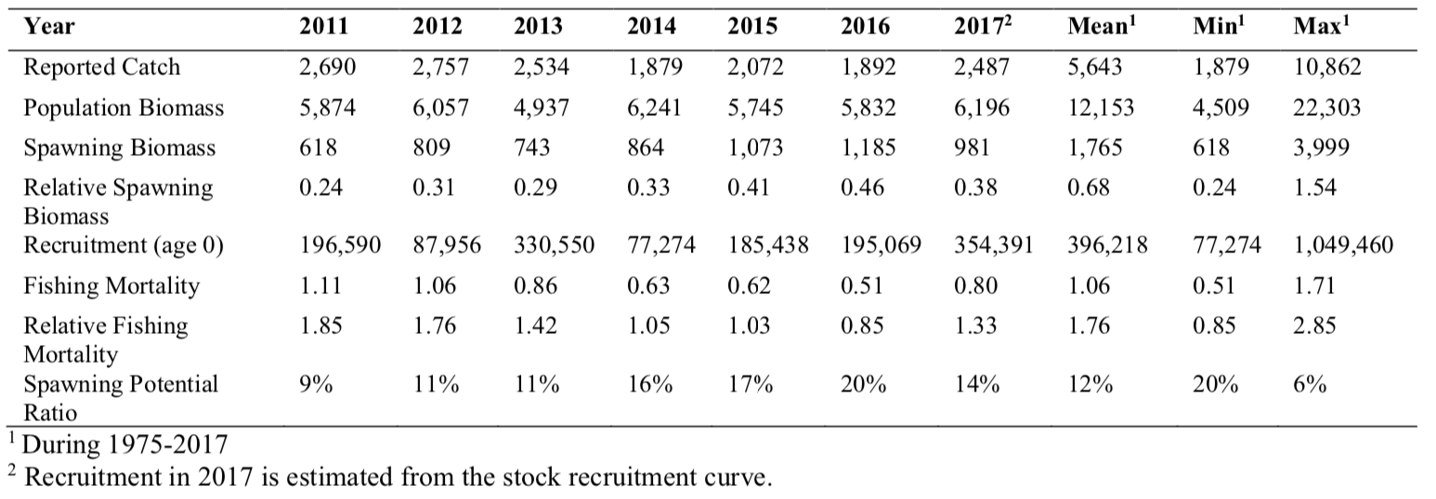
Table NMLS-01. Reported catch (t) used in the stock assessment along with annual estimates of population biomass (age-1 and older, t), female spawning biomass (t), relative female spawning biomass (SSB/SSB_{MSY}), recruitment (thousands of age-0 fish), fishing mortality (average F, ages-3 – 12), relative fishing mortality (F/F_{MSY}), and spawning potential ratio of WCNPO striped marlin.

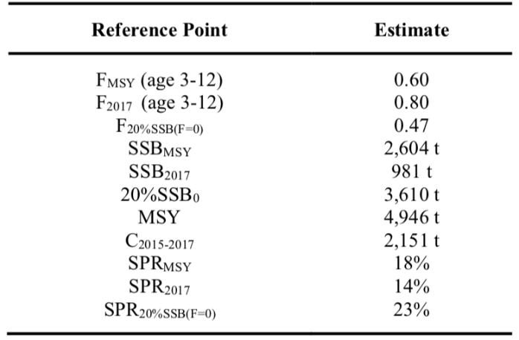
Table NMLS-02. Estimates of biological reference points along with estimates of fishing mortality (F), spawning stock biomass (SSB), recent average yield (C), and spawning potential ratio (SPR) of WCNPO MLS, derived from the base case model assessment model, where “MSY” indicates reference points based on maximum sustainable yield.
Table NMLS-03. Projected median values of WCNPO striped marlin spawning stock biomass (SSB, t), catch (t), and probability of reaching 20%SSB0 under five constant fishing mortality rate (F) and ten constant catch scenarios during 2018-2037. For scenarios which have a 60% probability of reaching the target of 20%SSB_{F=0}, the year in which this occurs is provided; NA indicates projections that did not meet this criterion. Note that 20%SSB_{F=0} is 3,610 t and SSB_{MSY} is 2,604 t.
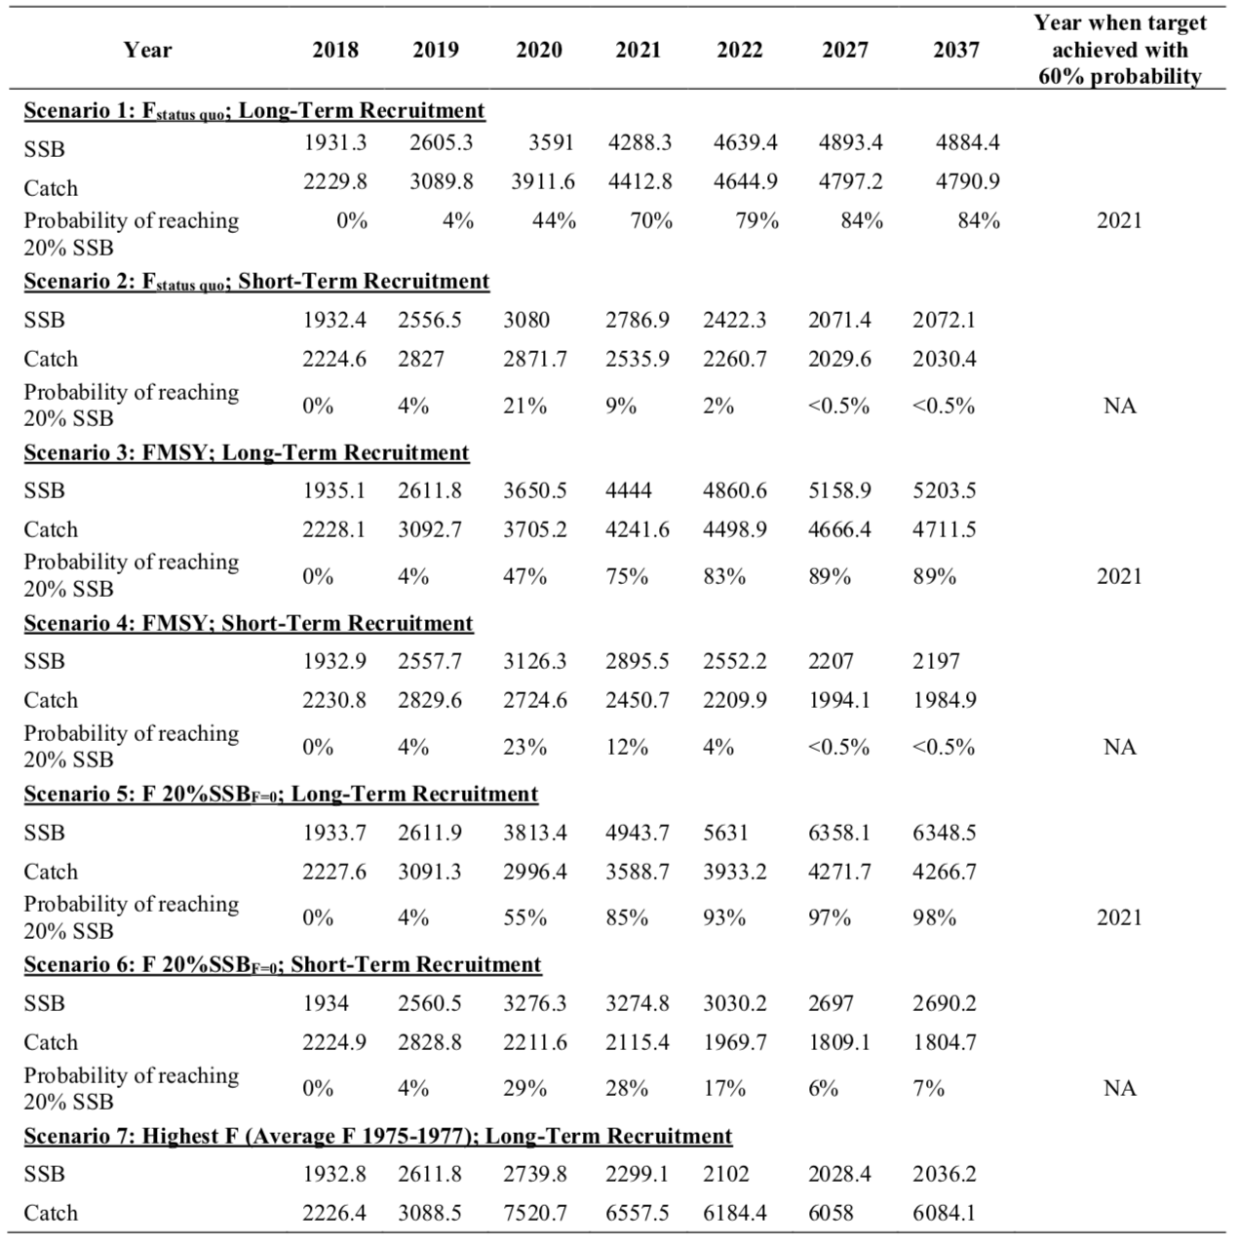

Table NMLS-03. (Continued)
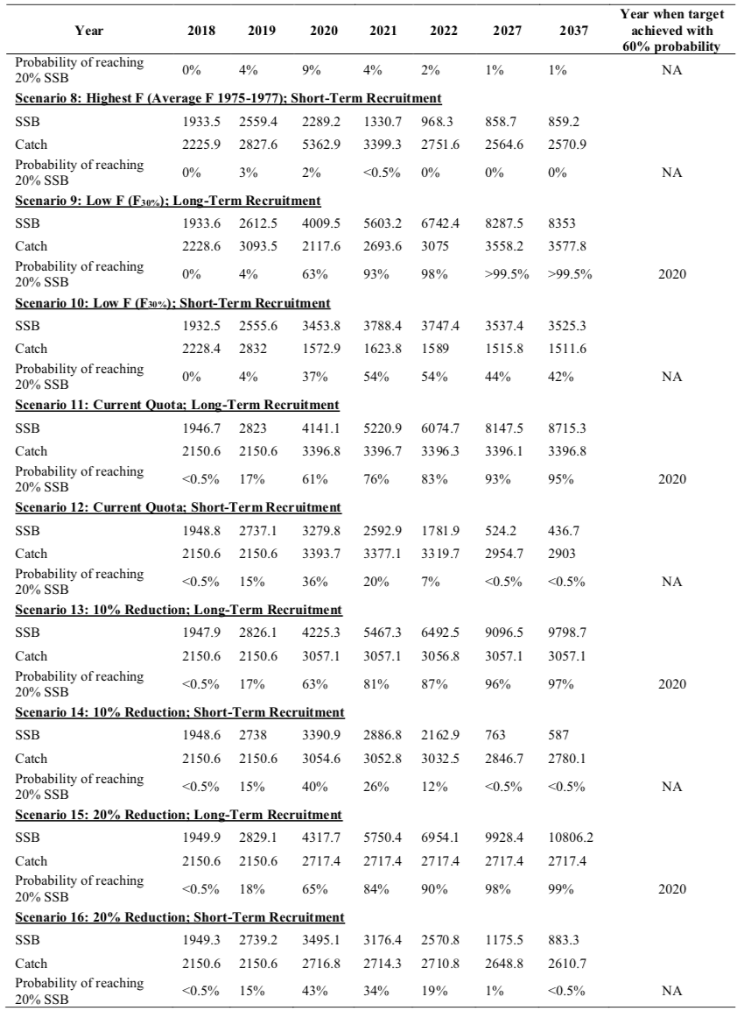

Table NMLS-03. (Continued)
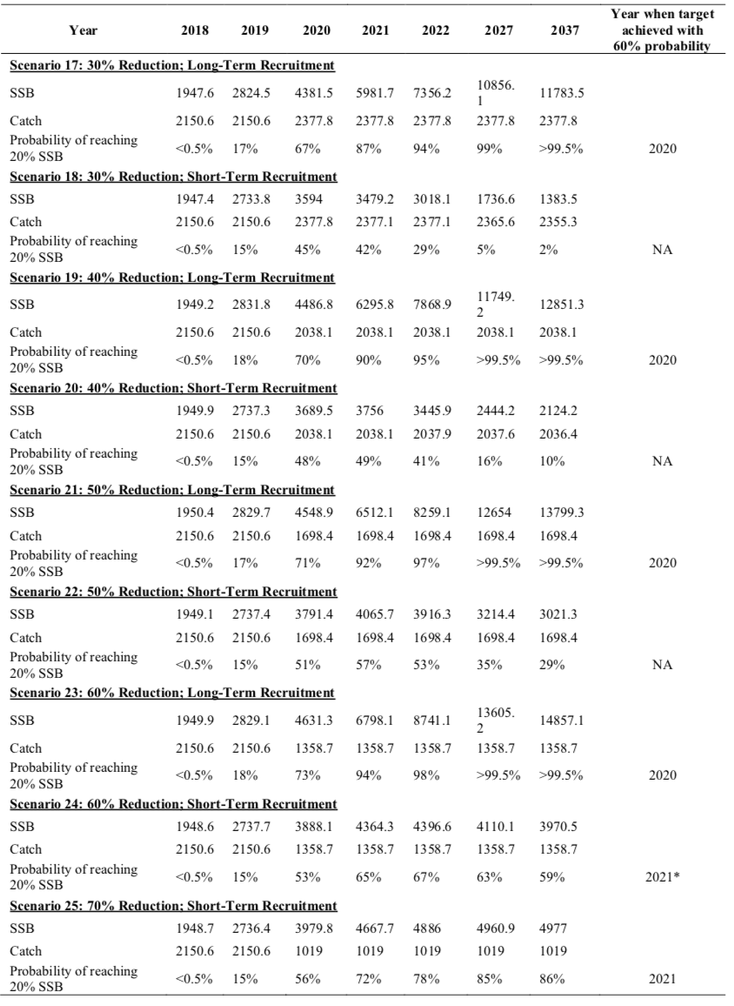

Table NMLS-03. (Continued)
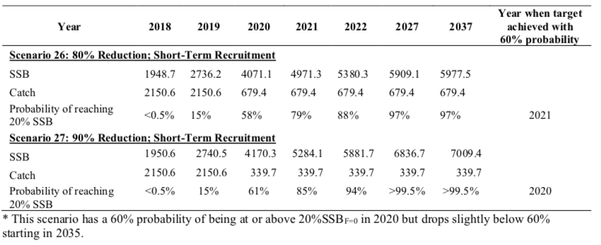

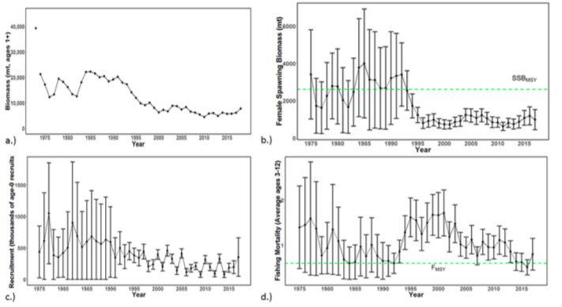 | 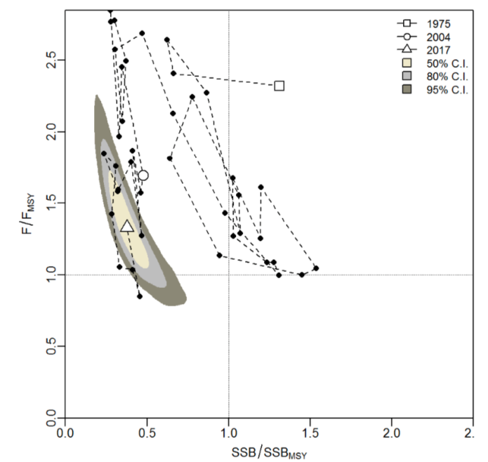
Figure NMLS-01. Time series of estimates of (a) population biomass (age 1+), (b) spawning biomass, (c) recruitment (age-0 fish), and (d) instantaneous fishing mortality (average for age 3-12, year-1) for WCNPO striped marlin (derived from the 2019 stock assessment. The circles represent the maximum likelihood estimates by year for each quantity and the error bars represent the uncertainty of the estimates (95% confidence intervals), green dashed lines indicate SSB_{MSY} and F_{MSY}. | Figure NMLS-02. Kobe plot of the time series of estimates of relative fishing mortality (average of age 3-12) and relative spawning stock biomass of WCNPO striped marlin during 1975-2017. The white square denotes the first year (1975) of the assessment, the white circle denotes 2004, and the white triangle denotes the last year (2017) of the assessment.
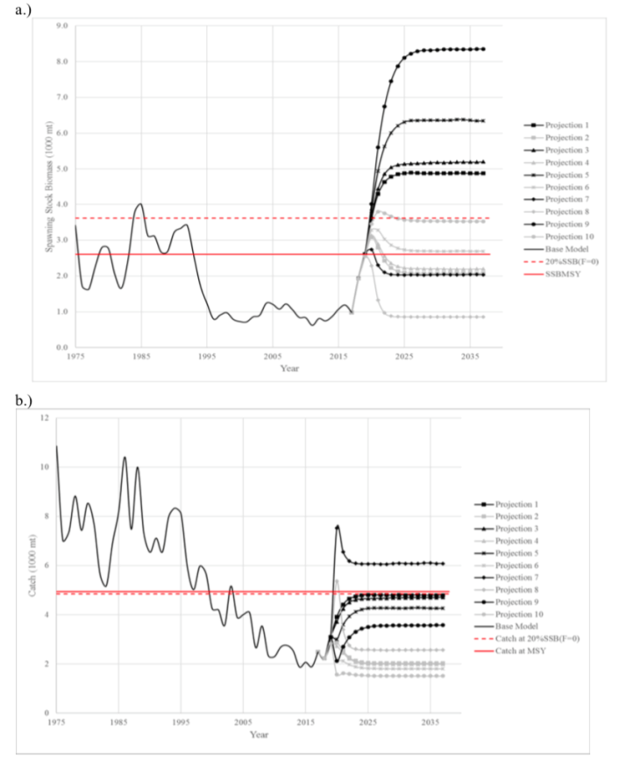 | 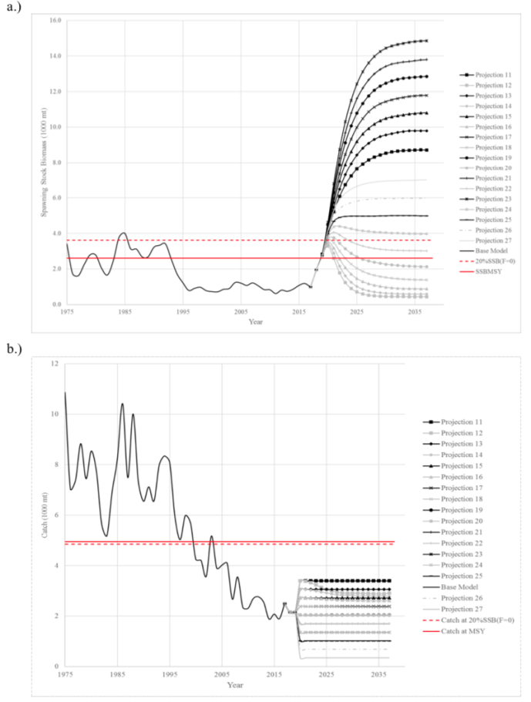
Figure NMLS-03. Historical and projected trajectories of spawning biomass and total catch from the WCNPO striped marlin base case model based upon F scenarios (projection 1-10): (a) projected spawning biomass and (b) projected catch. | Figure NMLS-04. Historical and projected trajectories of spawning biomass and total catch from the WCNPO striped marlin base case model based upon constant catch scenarios (projections 11-15): (a) projected spawning biomass; and (b) projected catch.

Note on Figure NMLS-3 and Figure NMLS-4: Black lines are the long-term recruitment scenario results; grey lines show the short-term recruitment scenario results. The red dashed line shows the catch or spawning stock biomass at 20%SSB_{F=0} and the solid red line is the catch or spawning stock biomass at SSB_{MSY}. The list of projection scenarios can be found in Table NMLS-03.

    - Pacific blue marlin (Makaira nigricans)

      - Research and information

      - Provision of scientific information

- Stock Status and trends

- SC15 noted that no stock assessments were conducted for Pacific blue marlin in 2019. Therefore, the stock status descriptions from SC12 are still current for Pacific blue marlin. For further information on the stock status and trends from SC12, please see https://www.wcpfc.int/node/27769. Updated information on catches was not compiled for and reviewed by SC15.

- Management Advice and implications

- SC15 noted that no management advice has been provided since SC12 for Pacific blue marlin. Therefore, previous advice should be maintained, pending a new assessment or other new information. For further information on the management advice and implications from SC12, please see https://www.wcpfc.int/node/27769

AGENDA ITEM 5 — MANAGEMENT ISSUES THEME

  - Development of harvest strategy framework

- Progress of the harvest strategy workplan

- Target reference points

  - Yellowfin and bigeye tuna

- SC15 reviewed information on what would be the minimum setting for a candidate spawning-biomass-depletion-based TRP (or maximum fishing-mortality-based TRP) for yellowfin and bigeye tuna that avoids breaching the LRP with a specified level of probability under the current uncertainty framework (SC15-MI-WP-01). While SC15 noted that the main biological consideration for a TRP is that it should be sufficiently above the LRP, SC15 also noted that the choice of a TRP can be based on a combination of biological, ecological and socioeconomic considerations. In this regard consideration of other factors (such as CPUE and the financial performance of typical vessels) in the selection of candidate TRPs would be welcome.

- SC15 welcomed the consideration of multi-species impacts based on the selection of a minimum TRP based on a given risk of exceeding the LRP for a given species, and whilst desirable noted the difficulty in extending this analysis to include the impact on South Pacific albacore.

- SC15 recommends that the Scientific Services Provider update the analysis to incorporate the updated assessment for skipjack, and that WCPFC16 take note of these results when identifying appropriate TRPs for yellowfin tuna and bigeye tuna in 2019 as scheduled in the Harvest Strategy Work Plan. In so doing WCPFC16 should clarify the management objectives for these species.

  - South Pacific albacore tuna

- SC15 reviewed information on alternative catch trajectories to achieve the South Pacific albacore interim TRP within no later than 20 years (SC15-MI-WP-02). SC15 noted the historical status and the projections have a greater uncertainty in spawning stock depletion for South Pacific albacore than observed for bigeye and yellowfin tuna because South Pacific albacore has a different grid which incorporates natural mortality and growth, and this gives a wider spread of uncertainty. SC15 noted that the recovery target can be achieved through many different approaches with the assumed long-term recruitments. However, catch (and effort) reductions from the 2014-16 average (of 60,000 mt) are required under all scenarios, and the resulting stock trajectories have different consequences for the associated fisheries. For example, if catch reductions are insufficient, or management action is delayed, the stock declines in the short term, with the consequence that management interventions may then need to be greater to achieve the interim TRP within 20 years, as stock recovery will be from a lower biomass level. Delays in the introduction of the reduction of catch may also increase the risk (12% in 2022 under 2014-2016 average catch levels) of breaching the LRP in the short term.

- Several CCMs expressed a preference for a recovery time shorter than 20 years, while one CCM stated that the introduction of legally-binding catch quotas would be needed to order to implement a re-building strategy.

- SC15 also noted that constant catch scenarios may mask declines in catch rates and associated economic conditions and requested that the Scientific Services Provider undertake a similar set of analyses based on fishing effort-based projections. SC15 recommends that WCPFC16 take note of both sets of results in consideration of rebuilding the South Pacific albacore stock to the interim TRP within 20 years.

  - Skipjack tuna

- As requested in the Harvest Strategy Work plan (SC to advise on required analyses to support TRP review), SC15 provided the following advice to the Scientific Services Provider on technical approaches and analyses which should be undertaken to assist WCPFC16 review the performance of the interim skipjack tuna TRP.
- Table 4 in SC15-MI-IP-09 (Current and projected stock status of skipjack to inform consideration of target reference points, MOW3-WP-03) be updated based on the updated skipjack tuna assessment agreed by SC15. This table should indicate changes in effort and biomass from 2012 and the recent levels and median equilibrium yield (as a proportion of MSY) associated with strategies that maintain a median of spawning biomass depletion (SB/SB_{F=0}) of 40%, 45%, 50%, and 55%.
- The projection results for skipjack tuna reported in SC15-MI-WP-11 also be updated based on the updated skipjack tuna assessment agreed by SC15.

- SC15 recommends that WCPFC16 take into consideration the information contained in these updated analyses when reviewing the performance of the interim skipjack tuna TRP.

- SC15 also notes that WCPFC16 may identify a reference year, or set of years, which may be appropriate to use as a baseline for a skipjack TRP

- Progress on the development of Harvest Control Rules and Management Strategy Evaluation (MSE)

- Review of harvest control rules for skipjack tuna

- SC15 reviewed several papers related to ongoing work which is being undertaken by the Scientific Services Provider as specified in the Harvest Strategy Work Plan on the management strategy evaluation (MSE) framework for skipjack.

- First, SC15 reviewed information on the outputs for the skipjack harvest strategy and the work undertaken to test candidate MPs based upon the latest MSE framework (SC15-MI-WP-05), noting that the technical details of the evaluation framework that underpins the results are documented in a separate information paper (SC15-MI-IP-02). SC15 welcomed the progress on this issue and noted the following:
- The estimation model is model-based as the use of purse-seine CPUE as an index of abundance is problematic due to effort creep associated with technological developments (e.g. acoustic FADs);
- Further work is required so that Performance Indicator 5 (the impact of harvest strategies on Small Island Developing States) can be included;
- Work is progressing on identifying specific El-Nino and La-Nina distribution models so that non-stationary movement can be estimated and help account for possible climate change related impacts.

- Second, SC15 reviewed information on the range of uncertainty which will need to be considered in the modelling framework when testing a management procedure (MP) (SC15-MI-WP-06). In particular, SC15 reviewed the Reference set of uncertainties (considered to reflect the most plausible hypotheses) which is the primary basis against which all candidate HCRs should be evaluated, and the Robustness set of uncertainties (comprising hypotheses that are considered less likely but still plausible) against which a final sub-set of candidate HCRs would be evaluated in order to determine the ‘best’ management strategy.

- SC15 also noted that as part of the monitoring strategy it will be necessary to define ‘exceptional circumstances’ to identify those situations that fall outside of the range of scenarios against which the implemented MP has been tested. SC15 again welcomed the progress on these issues and in reviewing the Reference set of uncertainties used in the MSE noted that these expand on the set of uncertainties included in the structural grid used in the stock assessment. SC15 recommended that an expanded set of diagnostics be provided so that the plausibility of the fit of each operating model used in the Reference set could be investigated. SC15 also recommended that the Scientific Services Provider conduct appropriate inter-sessional consultation with CCMs on the conditioning of the operating model and other relevant issues to ensure greater inclusiveness for MSE process.

- Third, noting that stakeholder engagement is a key component of the harvest strategy approach, SC15 reviewed information on a tool (Performance Indicators and Management Procedures Explorer, PIMPLE) for exploring and comparing the relative performance of alternative candidate MPs and the included HCRs (SC15-MI-WP-09). SC15 noted that PIMPLE was a useful tool and recommends it to mangers and WCPC16 so that they can understand the performance of various MPs for achieving management objectives. CCMs and participants were also encouraged to develop their own HCRs and make them available to the Scientific Services Provider for possible evaluation and inclusion in PIMPLE.

- SC15 recommends that WCPFC16 note the progress on the development of the MSE being undertaken under the Harvest Strategy Work Plan for skipjack tuna and provide additional elements, if any, as specified in the Harvest Strategy Work Plan to further progress this work against the scheduled time-lines noted in this Work-Plan. SC15 also requested the Secretariat create a webpage under the current “Harvest Strategy” tab that compiles the latest information of MSE development so that stakeholders can find the relevant information easily.

- Review of harvest control rules for South Pacific albacore

- SC15 reviewed several papers related to ongoing work which is being undertaken by the Scientific Services Provider as specified in the Harvest Strategy Work Plan on the MSE framework for South Pacific albacore.

- First, noting that the initial work on the development of harvest strategies for South Pacific albacore has focused on developing an empirical MP that uses standardised CPUE as the primary indicator of stock status, SC15 reviewed information on alternative sources of CPUE data and standardisation approaches to inform this process (SC15-MI-WP-07). SC15 endorsed the use of both the traditional GLM and the geostatistical modelling approaches for standardizing CPUE and their use in the Reference Set of uncertainties. Furthermore, noting difficulties associated with the use of the daily set-by-set data (currently used in the assessment) within the MSE framework, SC15 also endorsed the use of the aggregated catch/effort data set. However, SC15 also noted some small differences in the resulting biomass indicators based on these two different data sets, and requested that the Scientific Services Provider undertake some additional analyses to clarify any consequences on the performance of candidate HCRs which may be used to achieve management objectives.

- Second, SC15 reviewed a demonstration set of southern longline fishery performance indicators (PIs, taken from the list of prioritized indicators identified at WCPFC14) for evaluating the relative performance of candidate MPs South Pacific albacore, noting that the lack of inclusion of a PI, at this stage, does not imply it has reduced priority in the framework (SC15-MI-WP-03). SC15 noted that the utility of many economic indicators is currently limited by the unavailability of specific fleet-based economic data with the consequence that less informative proxies have to be used. CCMs also noted that several of the PIs are similar and perhaps redundant. Several CCMs also noted that a number of important PIs are currently not included in the demonstration set (often due to a difficulty in calculation due to a lack of information) but expressed a willingness to work with the Scientific Services Provider and other CCMs on providing more information for improving the calculation of these proposed PIs. SC15 recommends that WCPFC16 take note of this demonstration set of PIs and provide feedback to the Scientific Services Provider as needed.

- Third, SC15 reviewed the current status of the MSE framework for South Pacific albacore and the details of some illustrative analyses that have been completed (SC15-MI-WP-08). SC15 made a number of suggestions aimed at clarifying and improving aspects of the analyses, such as being able to see retrospective analysis of the CPUE generated from the operating model, incorporating the DWFN index in the HCR, and including a density dependence/hyperstability option and recruitment autocorrelation in the Reference Set of the uncertainty grid. One CCM also suggested inclusion of an additional flux of South Pacific albacore from the IATTC convention area as an additional axis of uncertainty, but it was noted that this would be difficult. CCMs were also invited to suggest possible HCRs for testing in this MSE framework for South Pacific albacore. SC15 recommends that WCPFC16 note the current status of the MSE framework for South Pacific albacore and provide feedback to the Scientific Services Provider as needed.

- SC15 recommends that WCPFC16 note the progress on the development of the MSE being undertaken under the Harvest Strategy Work Plan for South Pacific albacore tuna and provide additional elements, if any, as specified in the Harvest Strategy Work Plan to further progress this work against the scheduled time-lines noted in this Work Plan.

- MSE for North Pacific albacore

- SC15 noted the work undertaken by ISC on the development of an MSE framework for North Pacific albacore (SC15-MI-IP-10) and brings this to the attention of WCPFC16.

- Multi-species modeling framework

- Given that the main target species in the WCPO are caught by an overlapping mix of fisheries, an important consideration when developing harvest strategies is how to account for mixed fishery interactions. Towards this end, SC15 reviewed two potential approaches for modeling mixed fisheries in the WCPO harvest strategy evaluations (SC15-MI-WP-04). Noting the challenges in developing a multi-species modeling framework, and the difficulties and time required to develop a fully integrated multispecies-based operating model, SC15 endorsed the use of a hierarchical approach based on single species operating models.

- However, SC15 also noted the possible need for the inclusion of PIs from interacting fisheries/stocks in the development of MPs for any single species within such a hierarchical approach. Further consideration was also needed on the framework of MPs within this approach and what species may need to be given a priority, as MPs for healthy stocks may give unintended negative impacts on unhealthy stocks. One CCM suggested that priority may need to be given based on stock status relative to respective reference points. This CCM also emphasized that an MP for bigeye tuna should include control of purse seine fisheries, as currently almost half of the bigeye tuna catch is made by the fleet. One CCM also noted the need for management controls to be applied to all managed species due to the potential of target switching and resource substitution if one or more are left unregulated.

- SC15 recommends that WCPFC16 note the approaches outlined in the above paper, and the possible implications of the challenges in developing a multi-species modelling framework on this item within the schedule of the Harvest Strategy Work Plan.

- Other matters: Science and management dialogue

- SC15 noted a final report which reviewed reference points, harvest control rules, management strategy evaluation development across each of the tuna-RFMOs (SC15-MI-WP-14). SC15 also noted the usefulness of following developments on MSE in other RFMOs and recommended that the WCPFC continues engaging in the work of the joint tuna-RFMO MSE working group.

- Noting the decision made by WCPFC15 to hold a 6-day annual meeting in 2019 with additional time devoted for the Commission to discuss harvest strategies, SC15 re-iterated its support for a Science-Management Dialogue as outlined in the recommendation from SC14 (Paras. 469-473, SC14 Summary Report) for prompt development of harvest strategies. Noting the work on Harvest Strategies at SC15 and the increasing number of issues that require the attention of managers, some CCMs expressed the view that a Science-Management Dialogue session after SC15 meeting would have been useful, and supported such an approach after SC16.

  - Limit reference points for WCPFC sharks

- Noting the final report of the project “Identifying appropriate reference points for elasmobranchs within the WCPFC” (SC15-MI-IP-04), the outcomes of the stock assessments for oceanic whitetip sharks reviewed by this meeting, but an inability to fully consider this agenda item due to time constraints, SC15 deferred consideration of appropriate limit reference points for elasmobranchs for the WCPFC to SC16. SC15 recommends that the key conclusions of SC15-MI-IP-04 and previous reports are summarized and presented to SC16 together with any other relevant information. Nevertheless, SC15 recommends that WCPFC16 note the conclusions of the above report and the ongoing need to identify appropriate limit reference points for WCPO elasmobranchs.

  - Implementation of CMM 2018-01

    - Effectiveness of CMM 2018-01

- As requested in paragraph 15 of CMM-2018-01 (The Commission at its 2019 annual session shall review and revise the aims set out in paragraphs 12 to 14 in light of advice from the Scientific Committee), SC15 reviewed information on the likely outcomes in relation to the stated objectives of this measure (SC15-MI-WP-11). Outcomes were evaluated using the 2016 WCPO skipjack assessment and reviewed under three different future catch and effort scenarios which are consistent with this measure: ‘2013-2015 avg’ as well as ‘pessimistic’ and ‘optimistic’ scenarios based on the current CMM.

- The minor adjustments to the CMM 2017-01 text contained in CMM 2018-01, including the inclusion of paragraph 18, were found to not materially affect the management conditions assumed under this evaluation. SC15 noted, however, the difficulty in evaluating the impacts of paragraph 18 because of the need for clearer guidance on the interpretation of “small garbage”. SC15 recommends that the Commission revise paragraph 18 to include a more quantifiable and precise definition, so that a more meaningful evaluation of impacts may be undertaken.

- SC15 noted that the results are comparable to the results previously presented for bigeye and yellowfin. For bigeye tuna the results are strongly influenced by the assumed future recruitment levels and the time period of the projections. If recent positive recruitments continue into the future, all scenarios examined achieve the aims of the CMM, in that median spawning biomass is projected to remain stable or increase relative to recent levels, and median fishing mortality is projected to decline slightly (the exception to the latter being the pessimistic CMM scenario, although median fishing mortality remains below F_{MSY}). If less positive longer-term recruitments continue into the future, spawning biomass depletion worsens relative to recent levels under all scenarios, and the future risk of spawning biomass falling below the limit reference point (LRP) is around 20% or greater dependent on the scenario. In turn, all three future fishing scenarios imply increases in fishing mortality under those recruitment conditions more than doubling to median levels well above F_{MSY}.

- For yellowfin long-term recruitment patterns were assumed to hold into the future. Results under the 2013-2015 average and ‘optimistic’ scenarios are comparable, with the stock stabilising at 33% SB/SB_{F=0} (a 1% decrease from recent assessed levels) and F/F_{MSY} reducing to 0.68 (a 7%-8% reduction). The ‘pessimistic’ scenario, which implies a 35% increase in longline yellowfin catch, had a greater impact, with yellowfin biomass falling to 30% SB/SB_{F=0} (an 8% reduction from recent levels), F/F_{MSY} remaining stable at 0.73F/F_{MSY}, and the risk of breaching the adopted limit reference point increasing to 16%.

- Although results based on 2016 skipjack assessment were reviewed by SC15, the analysis of skipjack based on the 2019 assessment was not provided due to the timing of the assessment.

- Several CCMs questioned how much emphasis should be placed on the pessimistic scenarios, given that these seem dependent on LL fisheries fishing at their maximum catch limits allowed under the CMM regardless of the biomass levels. Several CCMs also suggested that future revisions of CMM 2018-01 could include measures that are more precautionary with regard to possible variations in bigeye recruitment.

- SC15 recommended that the working paper be updated based on the WCPO skipjack tuna assessment agreed by SC15, including the additional analyses requested by CCMs, and forwarded to WCPFC16.

    - Management issues related to FADs

    - FAD tracking

- SC15 reviewed information on analyses of the PNA’s FAD tracking program (SC15-MI-WP-12). Consistent with previous meetings, SC15 expressed its strong support for this type of research and its continuation, noting that this program is adding substantial value to the scientific understanding of WCPO fisheries.

- SC15 again noted the ongoing practice of SC not receiving full data (through practices such as geo-fencing) which undermines the scientific value of the information and prevents the SC from being able to provide comprehensive advice to the Commission on FAD dynamics, economics and management. However, SC15 was informed that PNA was finalising a new measure that will require full tracking data be made available that should fix this problem.

- Based on analysis of the available data (estimated to cover 30%-40% of all FAD trajectories, including FADs completely absent and FADs with some portion of trajectories missing, within the WCPFC convention area) SC15 noted:
- the number of individual FAD buoys active has continually increased since 2016, with estimates of 10,918 buoys in 2016; 18,357 in 2017; and 20,319 in 2018, likely due to the increase in data provision.
- that over 90% of the FAD sets in the WCPO were made in PNA waters.
- the number of both associated and unassociated sets increases with FAD density, while skipjack, bigeye, and total CPUE show a slight decrease with increasing FAD density. Similarly, CPUE from all unassociated sets decreases slightly with increasing FAD densities. Additional work is needed to validate these initial findings.
- simulated FAD tracks based on ocean currents show the dispersion of FADs across a wide area of the equatorial WCPO.

- Several CCMs expressed concern about the high FAD densities in some areas (400 to 500 FADs in a 1-degree square per month). Also, SC15 again expressed concern about the estimated high rate (6.7%) of tracked FAD beaching events, resulting in pollution and safety issues with respect to navigation, together with the estimated high rate of ‘lost’ FADs (up to 52%) (defined as when a FAD drifts outside the fishing ground of the company owning it). SC15 was informed that some pending analyses (these will be published soon) identify areas of FAD deployments that are more likely to result in beaching events.

- SC15 recommends that this paper be forwarded to WCPFC16 who may wish to support the continuation of this work.

- SC15 also recommends more comprehensive work at the Pacific-wide level as EPO FADs may drift into the WCPFC Convention area, and encourages CCMs to collect additional data on FAD beaching occurrences in their EEZs to enable the Scientific Services Provider to develop a database for further work.

    - Acoustic FAD analysis

- SC15 reviewed information on preliminary analyses of acoustic data from echo-sounder buoys deployed on FADs (SC15-MI-WP-13 and SC15-EB-WP-08).

- With regards to SC15-MI-WP-14, SC15 noted that:
- the deployment of echo-sounder buoys on FADs has increased in recent years, from around 76% in 2016 to 98% in 2019.
- the estimates of biomass were found to be influenced by i) the time of the day, with maximum biomass estimated before sunrise, and ii) the lunar phase, with a slight increase in biomass detected during and just after the full moon.
- biomass estimates showed a significant increase up to around 30 days drifting.
- while an increasing trend in estimated biomass was detected over the two to five days before a fishing set, in general, high variability was detected and no clear pattern could be identified between catch and echo-sounder biomass estimates.
- the acoustic buoys currently cannot differentiate species, although new buoys being used by some fleets can potentially estimate biomass per species which in future may be able to be used to reduce bycatch of bigeye.
- access to a larger dataset covering the whole WCPO would improve these analyses and the potential, over the longer-term, to derive an index of abundance from these data that could be used in stock assessments.

- With regards to SC15-EB-WP-08, SC noted the following preliminary results:
- Juvenile bigeye tuna departures from FADs were higher when skipjack tuna biomass was low, as estimated from FAD-attached echo-sounder buoys.
- Lower SST and greater changes in sea surface height were associated with a lower probability of departure of bigeye tuna from a FAD.
- Quarter and full moon periods, lower sea surface temperatures, and higher local FAD density were all associated with a greater probability of presence of tagged bigeye tuna at the FAD during pre-dawn.

- SC15 endorsed the continued cooperative relationship with the fishing community to obtain business confidential data for analysis by regional scientists, particularly with regard to FADs, and the fishing strategies involved in their use.

- SC15 indicated strong support for these projects, identifying the need for improved information on skipjack abundance and that this work can also serve several other research purposes. SC15 recommends that WCPFC16 support the continuation of this work.

AGENDA ITEM 6 — ECOSYSTEM AND BYCATCH MITIGATION THEME

  - Ecosystem effects of fishing

    - FAD impacts

      - Research on non-entangling FADs

      - Joint Tuna RFMO FAD Working Group Meeting

  - Sharks

    - Review of conservation and management measures for sharks

- Related to CMM 2010-07 (CMM for Sharks), SC15 recommends that:

TCC15 and WCPFC16 note that since the adoption of the CMM 2010-07, SC has been unable to confirm the validity of using a 5% fin-to-carcass ratio, that an evaluation of the 5% ratio is not currently possible due to insufficient or inconclusive information, and that there is still no mechanism for generating the data necessary to review the fin-to-carcass ratio if such a ratio is to be used as a tool for promoting the full utilization of sharks in the WCPFC.

    - Safe release guidelines

- SC15 suggests that WCPFC note that:
- Together, SC15-EB-WP-01 and SC15-EB-WP-04 provide more robust estimates of post release mortality within the longline fisheries and the shark handling and release factors that influence this.
- There is good evidence across the five shark species examined in SC15-EB-WP-01 and SC15-EB-WP-04 that minimising the trailing line (ideally leaving less than 0.5 meters of line attached to the animal) results in a significant reduction in post-release mortality, as noted in SC15-EB-IP-02.
- SC15-EB-WP-04 provides evidence that releasing by cutting the shark from the line while it is still in the water results in a lower mortality than bringing the shark on board and removing the gear.
- It is also important to take into account the safety of fishermen and flexibility for handling sharks and consider vessel size and operational fishing practices when the safe release guidelines are next updated.

- SC15 recommends to WCPFC that:
- When the safe release guidelines are next updated they should properly reflect the findings in SC15-EB-WP-01 and SC15-EB-WP-04 and subsequent research on post release mortality mitigation, noting some CCMs expressed concerns that research mentioned in SC15-EB-WP-04 only applies to six fleets (New Zealand, Fiji, , Marshall Islands, New Caledonia, American Samoa, and Hawaii) and that there might be other choices of better safe release methods.
- The Monte Carlo analysis undertaken in 2015 (SC11-EB-WP-02) for oceanic whitetip and silky sharks be updated and amended as necessary using the latest results on post-release mortality under different handling and release practices. This analysis should explore and quantify the impact of different combinations of gear, mitigation and handling practices on fishing related mortality. The example R code to conduct this analysis is provided as an appendix to SC15-EB-WP-01.

    - Progress of Shark Research Plan

    - Project 91 – A study on Operational Planning for Shark Biological Data Improvement;

    - Shark post-release mortality tagging study (assigned as Project 95)

    - Update of Shark Research Plan

- SC15 accepted the outputs of ISG-08 and the Shark Research Plan, which is in Attachment A.

  - Seabirds

    - Review of seabird researches

- SC15 notes the following in making its recommendations to WCPFC:
- the annual mortalities of seabirds in WCPFC longline and purse seine fisheries from 2015 to 2018 were estimated between 13,000 and 19,000 individuals (SC15-EB-WP-03). Longline fisheries north of 20°N accounted for approximately two-thirds of this total while longline fisheries south of 30°S accounted for approximately one-quarter of mortalities. Available data suggest that seabird mortalities in the purse seine fishery are negligible.
- that these are subject to large uncertainties because of limited data coverage, including the absence of some fleets from the analysis due to low coverage or missing observer data, and likely underestimated because cryptic seabird mortality is not considered.
- the concern over the very high estimated mortality of seabirds by longline fishing within a concentrated area of two 5x5 degree grids to the east of Tasmania and south of 40°S (Figure EB-01). This relatively small area is estimated to account for around 60% of the longline seabird bycatch south of 30°S and 15% of the total seabird bycatch in the WCPFC Convention Area, noting that this longline effort includes fleets targeting southern bluefin tuna managed by CCSBT or species managed by the WCPFC.
- the concern over the large number of seabirds incidentally caught in WCPFC fisheries in the northern WCPO and the need to understand the long-term impact of these mortalities on the sustainability of the populations concerned, noting that no clear evidence of decline in such populations has been observed in the recent period..
- the Southern hemisphere seabird species estimated to be most frequently captured are the white-capped albatross and Buller’s albatrosses with highly vulnerable species including Antipodean and Gibson’s albatrosses, Westland petrel and black petrel all in the top ten most frequently captured seabird species, noting that the level of identification of seabird catches varies between fleets.
- the low or absent observer coverage in key longline fleets in high latitude areas (both north and south) precludes accurate estimation of seabird bycatch inclusive of spatial and temporal trends. The estimation of annual trend of seabird mortality since the first WCPFC seabird CMM (CMM-2006-02) is not possible with the extent of currently available data.
- that some seabirds are captured and released alive, with higher chances of survival when safe handling procedures are implemented.
- the need for continued support for research on seabird bycatch mitigation methods in longline fisheries, noting successful accumulation of relevant information material in BMIS.
- The importance of improved observer coverage and the potential use of electronic monitoring in order to better estimate bycatch rates over time and over a wider geographic range.
- that longline fisheries operating in the area where the seabird CMM applies are one of the largest threats to some seabird populations, in particular albatrosses and petrels in the Southern hemisphere.
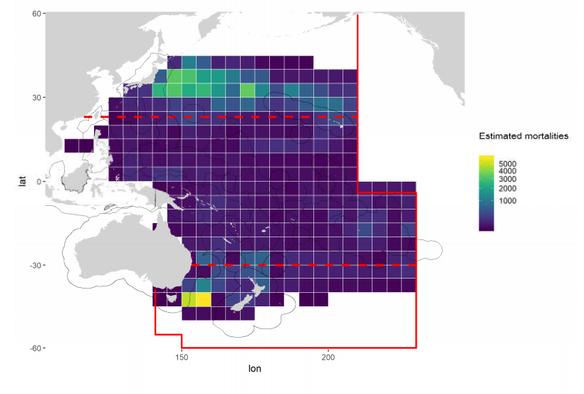
Figure EB-01. Estimated seabird mortalities at-vessel (individuals) by longline fisheries, 2015-2018. The red lines show the WCPFC convention boundaries and the red dashed lines show the 30°S and 23°N lines of longitude.

- SC15 recommends that:
- TCC and WCPFC pay particular attention to assessing compliance against the requirements of the seabird mitigation measure CMM 2018-03.
- WCPFC adopt the ACAP best practice on hook removal from seabirds as a safe handling guideline across all WCPFC longline, and other hook fisheries (SC15-EB-WP-10).
- WCPFC notes that, in view of analyzing the effectiveness of night setting within the seabird bycatch mitigation measure, the Coordinated Universal Time (UTC) set time will need to be provided or obtainable from the WCPFC ROP longline data field.
- WCPFC consider supporting the analysis of overlap between fishing effort distribution and species-specific seabird distribution (as outlined in SP15-EB-WP-03) to both the WCPO Southern and Northern Hemispheres and to support an assessment of risk to populations resulting from fisheries- induced mortalities.
- WCPFC requests CCMs to meet their obligations with respect to the minimum levels of observer coverage required by CMM 2018-05.

    - Review of CMM 2018-03 (CMM to mitigate the impact of fishing for highly migratory fish stocks on seabirds)

  - Sea turtles

    - Review of sea turtle researches

    - Review of CMM 2008-03

  - Bycatch management

  - Other issues

6.6.1 Review of relevant reports from other tRFMOs

AGENDA ITEM 7 — OTHER RESEARCH PROJECTS

  - West Pacific East Asia Project

  - Pacific Tuna Tagging Project

- SC15 noted the successful 2018 CP13 tagging cruise, in which 1,133 tropical tunas, mainly bigeye and yellowfin tuna, were tagged with conventional and/or archival tags.

- SC15 noted the importance of effective tag seeding to estimating reporting rates, supported increased deployment and fleet coverage of tag seeding experiments and noted the need for continued CCM participation and support in tag reporting.

- SC15 supported additional tagging of tropical tuna marked with strontium chloride, to assist in validating otolith-based ageing methods, and requested the support of CCMs in enabling the collection of samples from such recaptured tagged fish.

- SC15 supported the 2020 tagging programme, and associated budget ($645,000), the 2021-2022 tagging programmes and their associated indicative budgets ($730,000; $730,000), and the PTTP work plan in general for 2019-2022.

  - ABNJ (Common Oceans) Tuna Project-Shark and Bycatch Components

  - WCPFC Tissue Bank (Project 35b)

- SC15 noted the reduction in sampling in 2018 and requested that SPC develop initiatives to reverse this trend if possible, and report these to SC16.

- SC15 encouraged CCMs to visit the TTB web page www.spc.int/ofp/PacificSpecimenBank and provide feedback to SPC on its information content, usability and structure.

- SC15 endorsed the TTB work plan for 2019-2020, as well as the proposed 2020 budget ($99,195) and 2021-22 indicative budgets ($101,180; $103,204).

  - Other Projects

AGENDA ITEM 8 — COOPERATION WITH OTHER ORGANISATIONS

AGENDA ITEM 9 — SPECIAL REQUIREMENTS OF DEVELOPING STATES AND PARTICIPATING TERRITORIES

AGENDA ITEM 10 — FUTURE WORK PROGRAM AND BUDGET

  - Development of the 2020 work programme and budget, and projection of 2021-2022 provisional work programme and indicative budget

- SC15 adopted the proposed budget (Table 01) and forwarded it to the Commission. Detailed descriptions of the SC15 work programme, budget and terms of reference for each project are in Attachment B.

Table 01. Summary of SC work programme titles and budget for 2020, and indicative budget for 2021–2022, which requires funding from the Commission’s core budget (USD).
Project Title | Essential | Priority | 2020 | 2021 | 2022
SPC-OFP Scientific Services | Yes | ongoing | 924,524 | 943,015 | 961,875
SPC Additional resourcing | Yes | ongoing | 166,480 | 168,145 | 169,827
Project 35b - WCPFC Tuna Tissue Bank | Yes |  | 99,195 | 101,180 | 103,204
Project 42 - Pacific Tuna Tagging Program | Yes |  | 645,000 | 730,000 | 730,000
Project 60 – Purse Seine Species Composition | No | ongoing | 40,000 | 40,000
Project 68 - Seabird mortality | No | ongoing |  |  | 75,000
Project 88 - Acoustic FAD analyses | No | High 2 | 30,000 | 15,000
Project 90 - Length weight conversion | No | ongoing | 30,000 | 20,000
Project 97 – Shark Research Plan 2021-2025 |  | High 1 | 46,000
Project 98 - Radiocarbon aging workshop |  | High 1 | 35,000
Project 99 – Southwest Pacific striped marlin population biology |  | High 1 | 33,000
Project 100 - Close-kin mark-recapture |  | High 1 | 7,500
Project 101 – Monte Carlo simulations - shark mitigation |  | High 1 | 40,000
Project 102 - Population projections for oceanic whitetip shark |  | High 1 | 35,000
Project 103 – Limit reference points for WCPO elasmobranchs |  | High 1 | 25,000
Project Budget (WCPFC budget only) |  |  | 1,232,175 | 1,074,325 | 1,078,030
Total budget with SPC services |  |  | 2,156,700 | 2,017,340 | 2,039,905

- SC15 agreed that SPC will conduct stock assessments for bigeye and yellowfin tuna in 2020 (Table 02).

Table 02. WCPFC provisional assessment schedule 2020-2024 as discussed in the Plenary session. The ISC will inform SC16 on the schedule for N Pacific blue shark and shortfin mako shark. In the above schedule, Tuna are scheduled for assessment every 3 years; swordfish every 4 years; and sharks and other billfish every 5 years.
Species | Stock | Last assessment | 2020 | 2021 | 2022 | 2023 | 2024
Bigeye tuna | WCPO | 2018 | X |  |  | X
Bigeye tuna | Pacific | 2015
Skipjack tuna | WCPO | 2019 |  |  | X
Yellowfin tuna | WCPO | 2017 | X |  |  | X
Albacore | S Pacific | 2018 |  | X |  |  | X
Albacore | N Pacific |  | X |  |  | X
Pacific bluefin | N Pacific | 2018 | X |  | X |  | X
Striped marlin | SW Pacific | 2019 |  |  |  | X
Striped marlin | NW Pacific | 2019 |  |  |  |  | X
Swordfish | SW Pacific | 2017 |  | X
Swordfish | N Pacific | 2018 |  |  | X
Silky Shark | WCPO | 2018 |  |  |  | X
Oceanic whitetip shark | WCPO | 2019
Blue shark | S Pacific | 2016 |  | X
Blue shark | NW Pacific | 2017 |  |  | X
Mako | NW Pacific | 2018 |  |  |  | X
 | S Pacific |  |  |  | X
Bigeye thresher | Pacific | 2017
Porbeagle | S Pacific | 2017

AGENDA ITEM 11 — ADMINISTRATIVE MATTERS

  - Future operation of the Scientific Committee

  - Election of Officers of the Scientific Committee

- SC15 recommended the current SC Chair U. Faasili continue for his second term and T. Halafihi (Tonga) as a SC Vice Chair.

  - Next meeting

- SC15 recommended to the Commission that SC16 would be held in Apia, Samoa during 11– 20 August 2020. Tonga offered to host in 2021, and Palau offered to serve as host in 2021 should circumstances prevent Tonga from hosting.

AGENDA ITEM 12 — OTHER MATTERS

AGENDA ITEM 13 — ADOPTION OF THE SUMMARY REPORT OF THE FOURTEENTH REGULAR SESSION OF THE SCIENTIFIC COMMITTEE

- SC15 adopted the recommendations of the Fifteenth Regular Session of the Scientific Committee. The SC15 Summary Report will be adopted intersessionally according to the following schedule:

Tentative Schedule | Actions to be taken
20 August | Close of SC15  By 29 August, SC15 decisions will be distributed to all CCMs and Observers. (By Rules of Procedure, the Outcomes Document will be circulated within 7 working days).
27 August – 10 September | The Secretariat will receive the Draft Summary Report from the rapporteur, review it, and distribute it to all Theme Conveners.
10-17 September | Theme Convenors will review the Draft Report and send it back to the Secretariat by 17 September.
17-24 September | The Secretariat will finalize Draft Summary Report and distribute/post the Draft Report for review by all CCMs and Observers.
4 November | CCMs and Observers will submit their inputs in track-change to the Secretariat (Science Manager sungkwon.soh@wcpfc.int) by 4 November 2019.

AGENDA ITEM 14 — CLOSE OF MEETING

- The meeting closed at 16:15 on 20 August 2019.

The Commission for the Conservation and Management of
Highly Migratory Fish Stocks in the Western and Central Pacific Ocean

Scientific Committee
Fifteenth Regular Session

Pohnpei, Federated States of Micronesia
12 – 20 August 2019

SUMMARY REPORT

AGENDA ITEM 1 — OPENING OF THE MEETING

- The Fifteenth Regular Session of the Scientific Committee of the Commission for the Conservation and Management of Highly Migratory Fish Stocks in the Western and Central Pacific Ocean (SC15) took place from 12–20 August 2019 in Pohnpei, Federated States of Micronesia.

- The following WCPFC Members, Cooperating Non-members and Participating Territories (CCMs) attended SC15: Australia, China, Cook Islands, European Union (EU), Federated States of Micronesia (FSM), Fiji, French Polynesia, Indonesia, Japan, Kiribati, Republic of Korea, Republic of Marshall Islands (RMI), Nauru, New Caledonia, New Zealand, Palau, Philippines, Papua New Guinea (PNG), Samoa, Solomon Islands, Chinese Taipei, Tokelau, Tonga, Tuvalu, United States of America (United States), Vanuatu and Vietnam.

- Observers from the following inter-governmental organizations attended SC15: Pacific Islands Forum Fisheries Agency (FFA), Inter-American Tropical Tuna Commission (IATTC), Parties to the Nauru Agreement (PNA), the Pacific Community (SPC) and the Food and Agriculture Organization of the United Nations (FAO).

- Observers from the following non-governmental organizations attended SC15: Birdlife International, International Seafood Sustainability Foundation (ISSF), The Nature Conservancy, The Pew Charitable Trusts (Pew), Sustainable Fisheries Partnership (SFP) Foundation, World Tuna Purse Seine Organisation (WTPO), and the Worldwide Fund for Nature (WWF).

- The full list of participants can be found at Attachment A.

  - Welcome address

- The head of the delegation from Tonga gave the opening prayer.

- Eugene Pangelinan, Executive Director of the FSM National Oceanic Resource Management Authority on behalf of President Panuelo welcomed the Commission Chair, Ms Riley Kim; the SC Chair, Ueta Jr. Faasili; Dr. John Hampton and his staff from SPC; the WCPFC Secretariat; and delegates and other participants to SC15. He noted the progress made since establishment of the Commission in 2004, including improvements in data collection, stock assessments and models, as well as positive developments in the status of bigeye tuna stocks. He noted that the tuna catch in the WCPFC area now accounts for about 2.5 million to 2.8 million mt, or around 60% of the world’s tuna catch; the 2019 catch will be the 2nd highest in WCPO history. He voiced his confidence that the SC would provide an update on the status of the Commission’s tuna resources and the best scientific recommendations to the Commissioners on sustainable resource management. In this regard, he noted SC has important issues to address, such as the skipjack stock assessment, which SC would have to ensure is linked with the Target Reference Point (TRP) and Harvest Strategies (HS). He observed that the scientific data provided by members continues to improve and thanked members for their efforts, while noting the need for future work to streamline WCPFC reporting requirements. He also observed that climate change is an issue of concern for many, and climate change scenarios should continue to be developed and included in the tuna stock assessments to reflect the impact on Western and Central Pacific Ocean (WCPO) fisheries. Regional fisheries ministers have noted that climate change impacts represent one of the largest threats to social and economic development in the Pacific, which we must note and address where we can. He recognized the importance and contribution of the Pacific Community – Oceanic Fisheries Programme, to the work of the Commission by providing the best quality scientific services, and recognized the close cooperation among the WCPFC, FFA and PNA and all CCMs for proper management of Pacific tuna resources. He closed by wishing all participants a positive, productive and constructive meeting. His full remarks are appended as Attachment B.

- Ms. Jung-re Riley Kim, Chair of the WCPFC, welcomed delegates to SC15. She thanked Mr. Eugene Pangelinan, Executive Director of National Oceanic Resource Management Authority for his inspiring remarks, and the government of the FSM for hosting the meeting in Pohnpei. She also thanked the Secretariat, SPC and ISC for their excellent support and service, and the SC Chair, Theme Conveners and delegates for their intersessional efforts leading to up to SC15. She noted the tremendous contributions made by SC to the work of the Commission, and SC’s commitment to providing the best available scientific advice. She looked forward to recommendations and advice that will be produced from SC 15, especially on key tuna stocks, ecosystem-related species, data improvements, HS and electronic monitoring (EM). She observed that five of the six key tuna stocks are in a biologically stable condition, similar to 2018, and efforts were ongoing to conserve and manage Pacific bluefin tuna. She underlined that increasing importance of science–management interaction in fisheries management, and stated she was inspired that managers from many delegations are also attending the SC. She closed by thanking the Chair, the Science Manager, SPC and all those attending for their involvement in this important work. Her full remarks are appended as Attachment C.

- Delegates were welcomed by the SC Chair Ueta Jr. Faasili (Samoa). He thanked the government of FSM for their welcome, and for hosting the meeting and making the meeting facilities available. He noted the participation of the Commission Chair, Ms. Riley Kim. He also thanked other members of the Secretariat, the theme conveners, SPC-OFP, and all those involved in preparing the papers to be discussed at the meeting, including both CCMs and NGOs. He also thanked all the WCPFC members for their work in progressing the work of the Commission through the SC. He declared SC15 open at 8:53 am.

  - Meeting arrangements

- The chair noted that S. Soh, the WCPFC Science Manager, was also serving as the acting Executive Director (Executive Director Feleti Teo was attending the South Pacific Forum leaders meeting in Tuvalu). The Chair outlined procedural matters, including the meeting schedule, administrative arrangements, steering committee meetings, and the list of theme conveners. The theme conveners and their assigned items were:
Theme | Conveners
Data and Statistics | Ueta Jr. Faasili (Samoa)
Stock Assessment | Keith Bigelow (United States) and Hiroshi Minami (Japan)
Management Issues | Robert Campbell (Australia)
Ecosystem and Bycatch Mitigation | John Annala (New Zealand) and Yonat Swimmer (United States)

- The informal small working groups were:

ISG-ID | Title/TOR | Agenda | Proposed Facilitator
ISG-01 | Project 90 (Better data on fish weights and lengths for scientific analyses)  - discuss and enhance the priorities and activities proposed in the Project 90 future activities | 3.1.3 | Withdrawn
ISG-02 | Project 93 (Commission’s data needs)  - Seek CCM’s scientific feedback on the Project 93 tables (SC15-ST-WP-04) | 3.1.4 | Tuikolongahau Halafihi (Tonga)
ISG-03 | Guidelines for economic data provision  - SC15- ST-WP-05 | 3.4 | Shelvin Chand (Fiji)
ISG-04 | Review of SC14 BET Research Recommendations  - Paragraphs 183 and 184, SC14 Summary Report  - Accomplishments prior to next stock assessment (SC16)  - Discussion on planning and funding | 4.1.1 | Keisuke Satoh (Japan)
ISG-05 | Skipjack (SKJ) Assessment – Uncertainty axes and weighting | 4.1.3 | SA theme co-conveners (USA and Japan)
ISG-06 | Oceanic Whitetip Shark (OCS) Assessment – Uncertainty axes and weighting | 4.3.1 | SA theme co-conveners (USA and Japan)
ISG-07 | SW Pacific striped marlin (MLS) assessment – Uncertainty axes and weighting | 4.4.2 | SA theme co-conveners (USA and Japan)
ISG-08 | Shark Research Plan and future work plan  - SC15-EB-WP-02 | 6.2.3 | Felipe Carvalho (USA)
ISG-09 | SC Budget for 2020– 2022 | 10.1 | Ueta Faasili (Samoa)

  - Issues arising from the Commission

- The Chair noted SC15-GN-IP-03 Issues arising from the Commission, which compiled most of the key recommendations from SC14 and SC-related information and requests from WCPFC15. He observed that most of the issues were reflected in the SC15 agenda and meeting papers.

  - Adoption of the agenda

- The SC15 provisional agenda was adopted (Attachment D).

  - Reporting arrangements

- The Science Manager noted that SC15 would adopt its recommendations at the meeting, and develop a Summary Report with an Executive Summary that would be adopted intersessionally. The Executive Summary would include a synopsis of stock status and management advice and implications, research plans, findings or conclusions on the stock status, reports and recommendations, as directed by the Commission or at the initiative of the SC (Paragraph 2, Article 12 of the Convention). The recommendations would be adopted at the meeting and the Summary Report would be adopted intersessionally.

  - Intercessional activities of the Scientific Committee

- The Chair noted SC15-GN-IP-04 Intersessional activities of the Scientific Committee. The paper summarizes scientific services provided by SPC, progress and status of seven SC work programmes (under agenda item 11), cooperation with other organizations where the Secretariat attended their meetings, and a summary of four research projects: ABNJ (Common Oceans) Tuna Project, the Japan Trust Fund (JTF) project, the WCPFC Tissue Bank project and the West Pacific East Asia project. Some details are presented under Agenda item 7. The paper also details voluntary contributions from members and observers.

AGENDA ITEM 2 — REVIEW OF FISHERIES

  - Overview of Western and Central Pacific Ocean fisheries

- P. Williams (SPC-OFP) and C. Reid (FFA) introduced SC15-GN-WP-01 Overview of tuna fisheries in the western and central Pacific Ocean, including economic conditions – 2018, which provides an overview of the WCPO key fisheries, including billfish and trends in purse-seine fishery capacity. They noted that SC15-ST-IP-01 Estimates of annual catches in the WCPFC Statistical Area, and Annual Reports- Part 1 provides additional detail.

- The provisional total WCP–CA tuna catch for 2018 was estimated at 2,716,396 mt, the second highest on record, at around 170,000 mt below the record catch in 2014 (2,885,044 mt). The WCP–CA tuna catch (2,716,396 mt) for 2018 represented 81% of the total Pacific Ocean catch of 3,373,512 mt, and 55% of the global tuna catch (the provisional estimate for 2018 is 4,930,621 mt, which is the second highest and only 6,000 mt from the record global catch in 2014).

- The 2018 WCP–CA catch of skipjack (1,795,048 mt – 66% of the total catch) was the fifth highest, at nearly 215,000 mt less than the record in 2014 (2,008,934 mt). The WCP–CA yellowfin catch for 2018 (666,971 mt – 25%) was the second highest recorded (only 15,000 mt lower than the record catch of 2017); the past three years have been the highest annual yellowfin catches. The WCP–CA bigeye catch for 2018 (142,402 mt – 5%) was the lower than the previous 10-year average, but around 15,000 mt higher than in 2017. The 2018 WCP–CA albacore catch (108,974 mt – 4%) was amongst the lowest for the past twenty years, and nearly 40,000 mt lower than the record catch in 2002 at 147,793 mt. The south Pacific albacore catch in 2018 (68,454 mt), was a significant decline on the record catch in 2017 (93,290 mt). This decline is primarily due to a drop in the longline fishery (from 90,627 mt in 2017 to 65,410 mt in 2018), which may be related in part to the absence of any catch reported by the China longline fleet in the Eastern Pacific Ocean, south of the equator.

- The provisional 2018 purse-seine catch of 1,910,725 mt was the second highest on record, at nearly 150,000 mt less than the record in 2014 (2,059,008 mt). The 2018 purse-seine skipjack catch 1,469,520 mt; 77% of total catch) was the third highest on record, 170,000 mt lower than the record in 2014 (1,639,791 mt). The 2018 purse-seine catch for yellowfin tuna (374,062 mt; 20%) was over 100,000 mt lower than the record catch in 2017 (480,176 mt) but still amongst the highest annual catches for this fishery. The provisional catch estimate for bigeye tuna for 2018 (64,119 mt) was the highest since 2014 and slightly higher than the past ten-year average.

- The provisional 2018 pole-and-line catch (170,038 mt) was slightly higher than the 2017 catch which was the lowest annual catch since the mid-1960s, due to reduced catches in both the Japanese and the Indonesian fisheries.

- The provisional WCP–CA longline catch (254,850 mt) for 2018 was at the average level for the past five years. The WCP–CA albacore longline catch (84,930 mt – 34%) for 2018 was the lowest for ten years, and around 16,000 mt lower than the record of 101,820 mt attained in 2010. The provisional bigeye catch (71,305 mt – 28%) for 2018 was higher than the recent five-year average, but well down on the bigeye catch levels experienced in the 2000s (e.g., the 2004 longline bigeye catch was 99,705 mt). The yellowfin catch for 2018 (94,543 mt – 38%) was at the average level for the past five years and more than 30,000 mt less that the record for this fishery (1980: 125,113 mt).

- The 2018 South Pacific troll albacore catch (2,847 mt) which was the highest catch for five years. The New Zealand troll fleet (144 vessels catching 2,272 mt in 2018) and the United States troll fleet (16 vessels catching 475 mt in 2018) accounted for all of the 2018 albacore troll catch.

- Market prices in 2018 were mixed with prices for purse seine-caught product generally declining after significant increases in 2016 and 2017, although yellowfin prices at Yaizu continued to move higher. Yaizu prices for pole and line caught skipjack also saw significant declines. Prices for longline caught yellowfin were mixed with prices for fresh imports into the US and Japan increasing while fresh and frozen prices at Japanese ports declined. Prices for longline caught bigeye in 2018 rose by between 5% and 14% across the selected markets. Thai imports prices for albacore have risen significantly since 2017 with the 2018 average being the highest seen since 2012 while for June 2019 (the latest period for which data is available) the average price exceeded $4,000/mt for the first time.

- The total estimated delivered value of the tuna catch in the WCP-CA increased by 1% to $6.01 billion in 2018. The value of the purse seine catch ($3.26 billion) accounted for 54% of the total value of the tuna catch. The value of the longline fishery increased 16% to $1.72 billion accounting for 29% of the total value of the tuna catch. The value of the pole and line catch continued to decline to be at $343 million in 2018 with the catch by other gears valued at $669 million. The 2018 WCP–CA skipjack catch was valued at $2.95 billion, the yellowfin catch at $1.92 billion, the bigeye catch at $780 million its highest level since 2014, and the albacore catch at $360 million.

- Economic conditions in 2018 in the purse seine, tropical longline and southern longline fisheries of the WCP-CA showed mixed results. In the tropical purse seine fishery despite falls in prices and increases in fuel costs a surge in catch rates saw the continuation of good economic conditions. In the southern and tropical longline fishery after recent improvements economic conditions have again deteriorated as catch rates fall and fuel costs rise.

Figure 01. Catch (mt) of albacore, bigeye, skipjack and yellowfin in the WCP–CA, by longline, pole-and-line, purse seine and other gear types

Figure 02. Catch (mt) of albacore, bigeye, skipjack and yellowfin in the WCP–CA.

Figure 03. Catch value of albacore, bigeye, skipjack and yellowfin in the WCP–CA by longline, pole-and-line, purse seine and other gear types

Figure 04. Catch value of albacore, bigeye, skipjack and yellowfin in the WCP–CA

Discussion

- The United States referenced two noteworthy trends: the catch data for bigeye for the purse seine fleet was the highest since 2014 and slightly higher than the past 10-year average, and the proportion of sets on drifting FADs in 2018 was 31%, the highest in nearly 21 years. They observed that the purse seine catch is stable, but with declining purse seine effort, and asked SPC to comment regarding changes in recorded transit days vs. fishing days, noting that a change would result in a shift in nominal CPUE. P. Williams agreed this was a potential issue, stating that this had been raised in the past but would take some work to address. He noted there had been changes in reporting over time that go back a number of years.

- Australia observed that the data showed a flattening of total catch in the fishery, and questioned whether a natural limit was being reached on the basis of market demand, or whether the flattening in total catch over the prior 7–8 years was driven by management measures in the fishery. In response C. Reid stated that the Vessel Day Scheme (VDS) price has likely had a significant impact and acted to restrict effort, stating that he suspected that in the absence of an increasing VDS price, effort would have increased.

- Tonga commented on the recent decline in the number of purse seine vessels, following relative stability during 1992 to 2006, and inquired whether the recent decline was related to the status of the skipjack stock, or to the effect of management decisions. P. Williams stated that the decline was complex, noting that there had been changes at the fleet level that in some cases have resulted in declines. He suggested that the Annual Reports Part 1 may have some information that is relevant.

- Japan stated that, as noted by the United States, there had been an increase in the number of FAD operations, and a resultant increase in bigeye tuna catch. Given that effort is generally declining and there are some limits to FAD operations, Japan suggested it was possible that some vessels may be operating on multiple FADs on a single day, and inquired whether there was research to indicate whether there was a possible increase in FAD operations despite the limits that are in place. P. Williams indicated that SC15-MI-IP-05 Evaluation of effort creep indicators in the WCPO purse seine fishery might partially address the question raised by Japan.

- Indonesia stated they share the concern regarding the catch of small skipjack and yellowfin tuna, especially by purse seine fisheries, but require more information on how much can be couched “small in size” in relation to the condition of the stock; this is important in relation to management measures for vessels operating in their archipelagic waters, as well as the EEZ and high seas. Second, Indonesia inquired whether the market price varied by condition (e.g., frozen or fresh), and whether the market price was affected by certification (such as by the Marine Stewardship Council). Indonesia noted that the current price for pole and line (P&L) caught skipjack is higher than for skipjack caught using other methods, and queried whether the P&L price was driven by the certification process or by quality of the fish. C. Reid (FFA) stated that their analysis used the Yaizu price for the Japanese catch, and the Thai import (Bangkok market) price for other catches. He indicated that they did not have another price series available. The Yaizu price is typically higher, and reflects the higher product quality. P. Williams (SPC) noted issues related to catch of small skipjack and yellowfin tuna would be addressed during the stock assessment theme.

- The EU suggested it would be useful to add to the presentation similar available information about other species of interest for the Commission, especially northern stocks and inquired regarding the approach used to assess the number of fishing days and the number of sets. The EU also inquired whether any attempt to factor in access fees in the economic conditions analysis had been made, and whether it resulted in similar trends. P. Williams indicated that cumulative effort is based on VMS data, which results in near real-time data, and can be used to indicate what is happening in the current year. Regarding the number of transit days, VMS days does not give information on activity (e.g., transit or fishing days), but this is estimated by SPC based on the VMS data. He noted that SPC was consistent in how transit days are identified and removed from data used to represent cumulative effort, but stated that SPC has not sought to use more sophisticated methods to address transit vs. fishing. C. Reid stated that the economic analysis sought to examine economic conditions affecting the fishery, but not the profitability of vessels within the fishery, and that identifying the recipients of any economic returns from the fishery was a separate issue. He noted that if the VDS price (which has been rising) was included, relative returns, from a vessel perspective, would be lower in the latter years of the series than indicated for the fishery.

- Australia, on behalf of FFA members, thanked SPC and FFA for the preparation of the report, which they stated provides a very useful and informative background to SC15 discussions. FFA members drew attention to the renewed decline in catch rates in the southern longline fishery, following increases in effort in 2017. FFA members expressed concern that whenever economic conditions recover in this fishery, effort expands, driving down CPUE and impacting future economic conditions. The fishery has ups and downs, but each successive “down” is lower than the last, and the fishery continues its downward spiral. Australia noted the contrast with the purse seine fishery, in which there has been a significant period of sustained above-average economic conditions without a subsequent expansion of effort.

- The Philippines stated that it would be helpful to see changes in the catch of species (especially yellowfin, bigeye and skipjack) by region. P. Williams indicated that the figures in the paper provided some information that would be helpful in this regard.

- Palau stated that the paper showed clearly the continuing effectiveness of the control of the purse seine fishery, where the PNA VDS plays a major role in generally contributing towards the stable size, catch and effort of the purse seine fleet (Palau referenced Figures 3.1.1 and 3.1.2). Palau noted that these trends are further illustrated in SC15-ST-IP-04 (Purse Seine Activity in the PNA area). They suggested that future reporting include more information on “other fisheries”, and referenced Fig 2.1 of SC15-GN-WP-01, which shows the “other fisheries” catch as being far more than the P&L catch, and continuing to grow.

- Tuvalu referenced Figure 3.2.1, stating that while in the past it was appropriate to show the combined catch of the Pacific Island fleet, when the combined catch was less than any one of the distant water fishing nations (DWFNs), it would now be helpful to disaggregate the data and present more detail.

- Australia noted fairly large declines in the catch price for skipjack in the purse seine fishery, which were coming off quite a high value and reverting to a more normal price, and inquired if larger declines in prices in the Yaizu market for the P&L fleet reflected a similar phenomenon, or if other factors were driving the decline. FFA confirmed the P&L price decline was also a decline from similar high prices.

- United States noted that bias in CPUE that may result from issues of transit vs. searching days (raised earlier) was not really addressed by SC15-MI-05 regarding effort creep, as had been suggested, and stated they would like research on this issue in the future.

Recommendations

- SC15 recommended that future versions of the SC15-GN-WP-01 paper include:
• summaries of northern stocks in the WCPFC Convention Area; and
• more information on the “other” fisheries.

  - Overview of Eastern Pacific Ocean fisheries

- K. Schaefer (IATTC) presented SC15-GN-WP-02 Report on the Tuna Fishery, Stocks, and Ecosystem in the eastern Pacific Ocean in 2018, which addressed the fisheries, assessments and conservation measures for the major stocks of tropical tunas in the Eastern Pacific Ocean. The fishing capacity of the purse-seine fleet fishing in the eastern Pacific Ocean (EPO) increased rapidly from 1995 to 2005, and was fairly stable during 2006-2013, but has increased to 250 vessels and a total well volume of 262,000 cubic meters in 2018. The reported nominal annual longline effort has fluctuated between about 300 and 100 million hooks over the past 30 years. The peak of about 300 million hooks in 2002-2003 was followed by a distinct decline to about 100 million hooks, but in recent years this has increased to about 200 million hooks. Total tuna catches increased starting in 1999, peaked in 2003, and in 2018 were similar to the average of the previous ten years. For yellowfin tuna, catches were fairly stable from 1986-1999 followed by a peak during 2001-2003, a substantial decline during 2006-2008, and then an upward trend until 2016. The 2018 catch from dolphin- associated schools substantially increased from that in 2017 and was similar to the previous five-year average, for sets on floating objects there is an increasing trend in catch over the past four years, and for unassociated schools there is a decreasing trend in the catch over the past four years. The updated stock assessment for yellowfin tuna utilizing data through 2018 indicated that the yellowfin spawning biomass in the EPO is below the target reference point (TRP) (SB<SB_{MSY}), and fishing mortality is greater than the level corresponding to the MSY (F>F_{MSY}). However, the results are considered unreliable because there is uncertainty associated with the update assessment results, including the utility of the longline standardized CPUE index due to decreased effort and spatial coverage. Some stock status indicators evaluated support a hypothesis of low abundance, but other indicators are in conflict with that concept.

- Currently it is not possible to conduct a stock assessment for skipjack tuna in the EPO because there is no reliable index of relative abundance, nor age-composition data or suitable tagging data. The status of the skipjack stock has been evaluated using eight different data- and model-based indicators. The purse-seine catch had been increasing significantly since 1995, but in 2018 there was a significant decline below the 2016 catch, which was highest ever recorded, and substantially above the upper reference level. The average weight has been steadily decreasing over the past 15 years, and in 2018 was at the lower reference level. There is considerable uncertainty about the status of skipjack tuna in the EPO, and concerns about the increasing trend in numbers of sets on floating objects and the decreasing trend in the catch per set on floating objects.

- There have been substantial historical changes in the bigeye fishery in the EPO. Beginning in 1994, purse-seine catches increased substantially, due to the expanded use of drifting fish-aggregating devices (FADs) in the equatorial EPO. The estimated total purse-seine catch of bigeye of 65,000 metric tons (mt) in 2018 is about 9% greater than the average of the previous 5 years. The estimated longline catch of bigeye of 21,000 mt in 2018 is the lowest on record in past 20 years and 44% less than the average of the previous 5 years. The results of the update stock assessment of bigeye tuna conducted in 2018 revealed several uncertainties which led the staff to question its use as a basis for management advice. The staff has therefore developed a suite of stock status indicators for bigeye, as an alternative basis for management advice and for monitoring the stock and the fishery until the uncertainties in the stock assessment have been resolved. All the indicators, except catch, show strong trends over time, indicating increasing fishing mortality and reduced abundance, and are at, or above, their reference levels. The increasing number of sets and the decreasing catch per set and mean weight of the fish in the catch suggests that the bigeye stock in the EPO is under increasing fishing pressure, and measures additional to the current seasonal closures, such as limits on the number of floating-object sets, are required.

- IATTC Resolution C-17-02 on the conservation measures for tropical tunas in the EPO during 2018-2020, includes an annual EPO-wide 72-day closure for purse-seine vessels of carrying capacity greater than 182 mt, along with a 30-day closure of a core offshore FAD fishing area. For longline vessels greater than 24 m length overall, the resolution includes bigeye catch limits for China, Japan, Korea, Chinese Taipei, and the United States, and those countries can make a single transfer up to 30% of their catch limit to one another. Other members are limited to the greater of 500 mt or their respective catches in 2001.

- Taking into account the continuing increase in fishing effort in the purse-seine fishery, particularly in the number of sets on floating-objects, the IATTC staff is concerned with potential increase in fishing mortality for all three species of tropical tuna. In 2018 and 2019, the staff recommended limiting the number of floating-object and unassociated sets combined by Class 6 vessels to 15,723 (2015–2017 average level) in 2019 and 2020, respectively. However, these recommendations were not supported by the IATTC Scientific Advisory Committee. In response to requests to investigate alternative measures, the staff developed an approach that meets conservation and management needs by adjusting the active fish-aggregating device (FAD) limits currently in force under Resolution C-17-02, thus affecting only sets on FADs, not the other types of purse-seine sets. Based on data on active FADs and numbers of floating-object sets, the staff has estimated that a 30% reduction in the active FAD limits would correspond to its recommendation to restrict effort to the 2015–2017 average level. This recommendation was presented and discussed at the 94th meeting of the IATTC (July 2019), but did not reach consensus.

Discussion

- Australia inquired whether the skipjack caught on sets on objects were smaller than those caught on unassociated sets, and observed that there had been a large increase in the number of FADs in use, which could help explain a decrease in size per set, as fish are distributed across more FADs. K. Schaeffer stated that the size of skipjack caught on floating objects is smaller than on unassociated sets, and that the number of FADs deployed has increased. He stated that it was unclear whether catches per set on FAD sets decreased because of the distribution of fish across more FADs, or whether it truly indicated lower abundance.

- The EU referenced the second recommendation regarding a restriction in the total number of associated and unassociated sets, noting that continued setting on dolphins was allowed once the limits were otherwise reached, although sets on dolphins do contribute to catch of yellowfin in particular. The EU also inquired regarding the schedule for addressing the methodological challenges in the bigeye and yellowfin assessments, and to what degree IATTC and WCPFC were cooperating. The EU also noted that SC15-GN-WP-02 indicates significant catches of albacore in the EPO, but that there was no advice for management of South Pacific albacore stocks, and observed that WCPFC15 requested that IATTC and WCPFC cooperate in the management of South Pacific albacore. The presenter indicated the inclusion of continued fishing on dolphins was not intended, but was a holdover from 2018, when the situation was different. He reviewed the workplan for the IATTC stock assessment group (which is included in SC15-GN-WP-02), and which is seeking to resolve issues for the bigeye and yellowfin stock assessments for 2020. He noted that collaboration between IATTC and SPC scientists is ongoing, and reviewed several meetings and workshops, including a January 2019 workshop on growth models. He noted that indices of abundance and composition were being developed for use in addition to the Japanese longline fleet data in undertaking benchmark assessments in 2020. He also noted that the presentation did not address South Pacific albacore in the interest of brevity, and instead focussed solely on tropical tunas.

- The Cook Islands inquired whether the assessment takes into account the composition of catches of fleets operating in the EPO and WCPO, and inquired how catches could be differentiated. They also observed that SPC received a late submission of China’s catch data for the EPO, and inquired if that was reflected in the presentation. The presenter stated that there was considerable cooperation and collaboration with regard to observer coverage in regards to purse seine in WCPO and EPO, and suggested P. Williams (SPC) could provide details on this. He noted that there were some issues with respect to data quality of South Pacific albacore catches by China, but was not able to provide details.

- The United States stated that in June 2012 the WCPFC enacted a mandatory 5% longline observer coverage requirement, and there is a similar requirement in the IATTC. WCPFC publishes annual reports on the percentage of longline coverage by members (for example, SC15-ST-IP-02). IATTC publishes a paper on observer data — in 2019, IATTC SAC-10-4 (Synopsis of longline observer data reported pursuant to resolution C-11-08) — but this does not include the percent coverage achieved by various members, but simply indicates if data was submitted. The United States inquired if IATTC will provide percentage coverage in the future? The presenter stated he did not know whether IATTC will be providing those percentages, and delivered the following prepared statement, drafted in consultation with IATTC staff, regarding observer coverage: Most members submit a summary annual report regarding their annual observer programs. Most are estimated to have achieved at least 5% coverage. Both summary reporting and percent observer coverage remain imperfect. Operational observer data, which is required, lags much further behind, but IATTC did approve a resolution at the annual meeting which may improve data submission. The quality and completeness of the data that has been submitted is at an early stage of evaluation.

- Australia inquired regarding the bigeye purse seine catch, noting the large proportional increase in 1993, which was accompanied by a decrease in longline CPUE for bigeye at same time. They noted that currently there is an almost unlimited increase in effort on objects, and a large decrease in the spatial distribution of Japanese longline effort. Australia inquired whether the decrease was driven by the low catch rates resulting in fishing becoming uneconomic, or whether other factors were responsible; noting that this was obviously a concern for monitoring, Australia asked if it was clear why effort is decreasing. The presenter indicated there has been a shift in targeting, from bigeye to albacore, but declined to comment on economic viability. Japan confirmed that effort has decreased continuously since 1991, and is currently just 25% of the 1991 peak. It noted that a 2-year project (2018–2019) was looking at the issue of decreased effort, and stated that the next ISC stock assessment would reflect the findings.

  - Annual Report – Part 1 from Members, Cooperating Non-Members, and Participating Territories

- The SC Chair noted that members’ Annual Reports Part 1 had been posted on the Commission website for the past month. There were no requests from CCMs for clarifications.

  - Reports from regional fisheries bodies and other organizations

- There were no reports offered by regional fisheries bodies and other intergovernmental or non-governmental organizations observing SC15.

AGENDA ITEM 3 — DATA AND STATISTICS THEME

  - Data gaps

    - Data gaps of the Commission

- P. Williams (SPC) presented SC15-ST-WP-01 Scientific data available to the Western and Central Pacific Fisheries Commission. All CCMs with fleets active in the WCPFC Convention Area provided 2018 annual catch estimates by the deadline of the 30th April 2019, although there was one gap, which was resolved in late July 2019. The issues previously reported in annual catch estimates have been further reduced and the lack of any estimates for key shark species remains the main gap for some CCMs, particularly in years before 2017.

- Aggregate catch/effort data for 2018 were provided by the deadline of 30th April 2019 for all fleets. The quality of aggregate data provided continues to improve with a reduction in the number of data-gap notes assigned to the aggregate data in recent years. The main data gap concerns the low coverage of operational data available to generate aggregate data for the Vietnam and Indonesia fleets, and the anticipated under-reporting of key shark species in general.

- All CCMs with active fleets provided operational catch/effort data for 2018, with the main gaps being
- the low coverage in the data provided for the Indonesia and Vietnam fleets;
- the non-provision of a number of required fields in the Indonesia and Vietnam operational data (catch in number for longline and handline fisheries), and
- catches of key shark species are not included in the Vietnam fleet data.

- The coverage of 2018 operational data for some fleets is not complete (100%), although there was some improvement in coverage compared to the 2017 data.

- In reference to SC15-ST-IP-02 (Status of ROP data management), P. Williams noted the following recent developments:

- Increases in longline observer coverage from 2017 to 2018 (Tables 3 and 4 in the paper)
- New tables showing contribution from Pacific Islands observer programmes (Table 5)
- New tables showing longline EM coverage (Table 6)
- Clear improvement in timeliness of 2018 purse seine observer data submissions
- CCMs now providing longline data using WCPFC ER standards (United States, Korea and Chinese Taipei; Japan has progressed)

- Other matters raised in the presentation included an update of the potential uses of cannery data (referring to SC15-ST-IP-03), responses to SC14 data gap recommendations and an update of recent developments in the latest version of Bycatch Data Exchange Project data dissemination.

Discussion

- Korea stated that it was working to identify and organize operational data prior to adoption of its electronic reporting system, and referenced SC15-ST-IP-02, stating that Korea and SPC are working to compare data. Korea will update observer coverage for 2018 from days fished to days at sea.

- Cook Islands, on behalf of FFA Members, thanked SPC for the update of the data gaps paper (SC15-ST-WP-01), stating that FFA members continue to monitor with interest the highlighting of key gaps in the Commission’s data holdings, while noting that some remaining data gaps could be filled, and dong so is vital for the science work undertaken by SPC. FFA members encouraged those CCMs holding data to make every effort to submit these, emphasising that the importance of the information, particularly to the work of SC, could not be overstated. They stated that FFA members understand that some CCMs may have concerns that historical operational data may occasionally suggest that fishing has taken place in areas where it shouldn’t have; that logsheet positions are not always recorded correctly; and that data-punching errors can be made. FFA members suggested that SC could recommend to WCPFC that CCMs consider an agreement such that historical operational data dating from pre-Commission years can only be used for scientific purposes and not for compliance or enforcement purposes. They acknowledged that alternative solutions to making this valuable data available for scientific purposes no doubt exist, and welcomed ideas on the issue.

- The EU acknowledged the progress that has been made, and hoped this would continue. Re. Table 1, the EU stated it appeared about 25% of trips are noted as being of unknown status with respect to observer coverage and wondered, where there was 100% provision of operational data, whether a check could be made to see if the numbers are improving. P. Williams indicated that this was difficult because what needs to be measured is whether a trip is a legitimate fishing trip; SPC aggregates VMS data at a trip level, but is aware that a number of trips are for transit or other non-fishing purposes. He noted observer placement data, and data on which observer covered a particular vessel, would be helpful in distinguishing actual fishing trips.

- Fiji, on behalf of FFA members, stated appreciation for the work on the use of cannery data for the independent verification of purse seine catch and species size, noting the importance for the work of SC, and expressed their continuing support. Fiji stated that FFA members would consider the benefits of setting up clearly specified, voluntary arrangements for cannery data submission to the WCPFC Scientific Services Provider as science data manager, and indicated more discussion was needed, particularly on the protection of commercial confidentiality through the WCPFC rules for data access and dissemination.

- PNG, on behalf of FFA members, addressed the issue of charter notifications, stating that occasionally double-reporting occurs that results in over-reporting of the catch of some CCMs. The charter notification scheme should be able to deal with these anomalies, but there is concern that the WCPFC Secretariat and the Scientific Services Provider may be constrained by the data rules from communicating with each other on certain aspects of charter notifications. PNG stated the need to identify and resolve the problem.

- Kiribati, on behalf of FFA members, encouraged consistency among the metrics used by CCMs to report their longline observer coverage, and noted that while CMM2007-01 requires ‘coverage of effort’, there are several ways of quantifying effort. Kiribati encouraged all CCMs to use the same metrics for the measurement of observer coverage, and asked the Scientific Services Provider if they could provide advice on what they recommend as the most useful metric for the measurement of longline observer coverage. Kiribati also noted that some members had not reported observer coverage for domestic fishing trips within EEZs, as it is not a requirement under ROP data rules, while others have. FFA members proposed to SPC that this particular row of the report form be split into two — one indicating domestic fishing trips within the EEZ of Coastal States, and the other international fishing trips — so the observer coverage reporting is easier to reconcile against WCPFC requirements. P. Williams (SPC) indicated the best metric is hooks, which is the most representative. He acknowledged the FFA’s comment regarding the report form, which SPC will treat as a recommendation for modifying the table on longline observer coverage.

- Australia stated that it was encouraging that observer coverage for the longline fleet has improved over time, and noted that adoption of EM would make it difficult to count hooks, and might entail using number of sets as a metric. Australia suggested it would be helpful to compare observer coverage on the basis of both hooks and sets to see whether these correspond to each other. P. Williams agreed that sets would be a useful metric, which SPC had not used because their figures were derived from aggregate data, which does not include sets. However, operational data could be used, which would give information on sets.

- United States noted that provision of data was improving, and gaps declining. The United States referenced p. 5 of SC15-ST-WP-01, and inquired regarding the plan for provision of data by China, noting several instances of erroneous inclusion of charter data, and recommended strengthening the Charter notification schemes with the object of eliminating double counting.

- Marshall Islands, on behalf of FFA members, note that the data gaps paper draws attention to the capacity of certain developing CCMs and CNMs to usefully quantify their main tuna fisheries, and commended the efforts being made by Indonesia and Vietnam in this regard.

- Vietnam thanked the WPEA project for assistance in attending SC15. Vietnam noted that additional training would be provided to new staff members on data collection, which would improve results. It also noted that some key shark species data were submitted in the Annual Report Part 1. P. Williams acknowledged that data on key shark species are provided in the annual catch estimates, but noted that Vietnam’s logbook data that were provided indicated no interactions with key shark species, and offered to discuss the matter further with Vietnam.

- Indonesia thanked SPC for long-standing help with the WPEA project, and stated they realize that Indonesia operational data is not complete, but that this was being addressed. Observer numbers as reported in their Annual Report Part 1 have increased significantly, from 41 to 276, covering 1,881 days at sea. However, most observer activities are in archipelagic waters, in relation to Indonesia’s harvest strategy. There are some activities in Fishery Management Area (FMA) Nos. 716 and 717, which are obligated to be reported to WCPFC, but there is incomplete observer coverage for purse seine and longline fisheries in those areas. Indonesia had a national plan for observers for 2020, and will seek to increase coverage in FMA 716 and FMA 717. They are also seeking to identify aggregate effort for P&L and purse seine, which will be reported to the Secretariat and the Commission.

- Korea noted regarding Para. 10 in SC15-ST-IP-02 that data provided by Korea was not mentioned, and requested that their data be integrated into the database. SPC noted this was an oversight in the report, and that other countries should likely also be included. SPC will ensure the information is updated.

- The Philippines stated they are addressing coverage issues within the Philippines EEZ, including by enacting a new policy which addresses integrated and environment monitoring, and have a system ready to be implemented for large handlines. Estimates for small-scale municipal gear are being addressed through provisions under their stock assessment program. The Philippines hopes to improve coverage for their next submission.

Recommendations

- SC15 requested that SPC provide an update to TCC15 on the issues raised in SC15-ST- WP-01.

- SC15 recommended that the charter notification issues raised in SC15-ST-WP-01 be taken into account in the review leading to the new/replacement Charter Notification CMM. For example, when the coverage of operational data submitted is not 100% and chartered vessels for that flag state have been notified to the Commission, then the flag state shall submit a list of vessels representing the catches compiled for their annual catch estimates and aggregate catch/effort data (with these data submissions).

- SC15 recommended that the WCPFC Scientific Services Provider make the following enhancements to the tables on longline observer coverage in the Regional Observer Programme (ROP) data management paper (SC15-ST-IP-02) in the future:
- Separate the observer coverage of domestic CCM fleets active in their home EEZ (non-ROP coverage), where such information is voluntarily provided from a CCM, from the observer coverage of CCM fleets fishing outside their home EEZ (ROP coverage;
- List all (ROP and non-ROP) longline observer coverage for each fleet based on HOOKS or SETS as measured by WCPFC data submissions. This information is intended to provide estimates of total longline observer coverage in the WCPFC Area for reference, and will not be used for compliance purposes. The WCPFC Scientific Services Provider will provide an update to TCC15 for CCM review.
- Include a column to describe the coverage of longline E-Monitoring data in the table of longline E-Monitoring coverage based on FISHING DAYS or SETS.

- SC15 acknowledged the cannery data submissions (representing ~37% of the tropical WCPFC purse seine catch in recent years) to the WCPFC by International Seafood Sustainability Foundation (ISSF) participating companies, and the potential of cannery data for the work of the Commission, specifically Project 60. SC15 recommended that the WCPFC Scientific Services Provider (with assistance from the WCPFC Secretariat) investigate what Commission mechanisms could be used and/or updated to facilitate the voluntary submission, and ensure an appropriate level of confidentiality, of cannery data from other processors for future Commission work (Project 60), and report the findings to SC16.

- SC noted the recurrent difficulties of the WCPFC Scientific Services Provider to reconcile the discrepancies between the number of trips and observer appointments in Tables 1 and 2 of SC15-ST-IP-02 and recommended that the WCPFC Scientific Services Provider and WCPFC Secretariat investigate how these discrepancies could be addressed, in view to facilitating the work of SC and TCC.

    - Species composition of purse-seine catches (Project 60)

- T. Peatman (SPC) presented SC15-ST-WP-02 Better purse seine catch composition estimates: progress on the Project 60 work plan, summarising progress on the Project 60 work plan endorsed by the SC14. The main activities undertaken since SC14 were: a paired grab/spill trip, conducted on a Solomon Island-flagged purse seiner; construction of beta response models of species compositions; and, estimation of species-specific purse seine catch estimates with a variety of changes to the currently used methodology.

- The generalised additive models currently used to estimate species compositions fit poorly to observations, particularly for bigeye. Zero and one inflated beta models achieved better fits and are recommended as a more robust basis for model-based species composition estimates. The beta-response models detected between-flag variability in catch compositions. As such, SPC recommends that observer samples are additionally stratified by flag when estimating species compositions directly with observer samples. Additionally at SC14, SPC recommended that grab samples be adjusted with ‘correction factors’ to account for grab sample bias. Stepwise changes to species-specific catch estimates were generated to quantify the effects of the proposed changes on catch estimates. Annual species-specific catch estimates were insensitive to the switch to ‘correction factor’ bias correction, and the additional stratification of observer samples by flag. Annual species-specific catch estimates were most sensitive to the change to beta-response model-based estimates. The beta-response models estimated substantially lower yellowfin proportions and higher skipjack proportions for the period from 1997 to 2006, and estimated higher bigeye proportions from 1975 to 1995. The report concluded with a proposed work plan for 2020 for consideration by SC15.

Discussion

- Japan noted that when looking at figures of actual catch estimation and proportion, it appears results basically show no change after 2010, and inquired why this was. The presenter stated that post-2010 estimates are generally based directly on observer samples because observer coverage is over 20% (if it was lower it would be based on model results). As such, the post-2010 estimates are only impacted by changes to the methodology for observer-sample based estimates, i.e. for one of the four estimation methods.

- Solomon Islands, on behalf of FFA members, acknowledged the efforts made over many years to improve comparisons between observer-sampled species composition estimates, model-based estimates, and unloadings, landings, and cannery data. Better species-composition and size data are important contributors to more accurate stock assessments. Although noting that there is some potential for this sampling work to impact vessel operations, most of the work described in the current paper was carried out aboard a Solomon Islands vessel without significant interruption. Solomon Islands encouraged other CCMs to support the proposed work plan for the project.

- Australia commended the excellent work being done, stating that it appeared the new model can eliminate some anomalous changes we have seen previously.

- Tuvalu noted that the project had been running for a long time, and addresses an important issue, particularly the impact of purse seine fishing on bigeye stocks. It asked whether the question of bias in observer sampling could be addressed once and for all – and if not, what are the issues? T. Peatman stated that there are two components to understand and address bias in observer samples: correcting for bias in historical samples and minimising bias in future samples. Historical bias cannot be reduced but it is necessary to get the best estimate of the bias that exists. To say with confidence that the best possible estimate for the fishery has been made may require higher resolution estimates; this would require determining whether there is a difference in bias between species, but SPC has not been able to answer this with information available to date. Additional data from paired trips may allow SPC to explore whether some patterns in the data suggest a differing bias between species. To address future bias, although past work indicates grab samples can give unbiased species composition estimates, this does not necessarily mean grab samples should be continued. Observer-based samples cannot sample a large portion of the catch because catch volume is so large. SPC noted that the proposed work plan for Project 60 includes a cost-benefit analysis to determine how to best move forward.

- Japan indicated the model appeared to have been significantly improved, and suggested the need to consider, from a budgeting standpoint, how much the project should be prioritized relative to other projects.

- The EU inquired regarding the impact of stratifying data by flag, and the influence of reported catch composition on catch estimates. T. Peatman noted that stratifying data by flag does not make a difference to catch estimates used in assessments, but does impact catch estimates at a finer scale, e.g. at the stratification of SPC’s aggregate purse seine catch data. Regarding reported catch composition and the influence on catch estimates, he stated that SPC looked at rerunning models but not including skipjack catch composition, which flattens the catch trend for skipjack and yellowfin. A main driver for large scale temporal trends in catch composition is reported catch composition in the aggregate data, but this may be problematic if there have been temporal trends in species reporting over time.

- FSM stated they have plans to do bycatch sampling onshore, and are working with SPC regarding the sampling design. The looked forward to possibly being one of the ports for the project.

- D Itano (TNC) presented a summary of SC15-ST-WP-07 Comparing and contrasting EM derived purse seine fishery data with human observer, onboard sampling and other data sources in support of Project 60. The project compared fishery and scientific data collected on or related to a commercial tuna purse seine fishing trip conducted in the WCPO during late 2018 with data collected by an eight-camera video electronic monitoring (EM) system. EM system derived data was compared to data collection from the onboard human observer, spill sampling, vessel logsheet, port sampling and cannery offloading weights. It was noted that EM holds promise to automate repetitive data collection tasks that would potentially allow observers to concentrate on specific duties more efficiently conducted by human observation. However, further work is needed to verify and improve EM data quality. Future work to examine ways to scale up EM systems to increase size and species composition sample size and EM verification trials paired with accurate port sampling and unloading data was proposed for 2019-2020 in support of Project 60.

Discussion

- Japan stated it seems possible to have accurate length/frequency (L/F) data, and asked for clarification regarding the measurement of length, whether this was done by a person or software, and how fish are measured when some are covered by others in a chute that is being viewed by a camera. Japan also asked whether the number of fish was being undercounted if L/F could be measured accurately but set size could not. The presenter indicated the L/F estimate could be very accurate if cameras are correctly calibrated; the recommendation for future would be to test a dynamic calibration system and perhaps a stereo camera system. Set size could be calibrated based on well volumes; estimates in the study were systematically biased, but can be corrected in the future. He noted fish length was measured by human reviewers using an integrated video-based measuring tool, and that there were efforts to develop automated software and incorporate AI learning for both length measurements and species identification.

- Solomon Islands, on behalf of PNA members, thanked those involved for their efforts, and stated that the work supported the FFA’s view that the focus of EM should be on longline vessels, rather than duplicating the work of observers on purse seine vessels through any systematic review of EM footage on purse seine vessels. The presenter noted that EM on purse seine vessels is still experimental and designed to not duplicate human observer tasks but to enhance data collection and monitoring efforts.

- The United States expressed its support for the emerging technology, and noted further work is needed. It inquired if the problem in estimating set size was the multi-layering of the fish, or whether it could be resolved through better well volume measurements. The presenter indicated that the actual capacity of a 100-ton tank varied by species, and by how tightly the fish are packed. He concurred with the United States the contractor’s performance on bycatch was disappointing, but could be easily improved just as observer program data has greatly improved from the initial years of observer programs in the region.

- Korea inquired about the application of EM systems for longline operations. P Williams (SPC) stated that the 2018 IWG on ER and EM heard many presentations on application of EM to longline operations, which many countries are implementing. He noted the ER and EM IWG would meet in 2020, and expected comprehensive presentations at SC16.

- The EU observed that EM can very usefully complement the work of human observers, in both longline and purse seine fisheries, and voiced its support for more work of the type described. The EU inquired whether those involved were seeking support for the work. The presenter indicted that while TNC was supporting some of the work, additional funding support would be welcome, and indicated the project had been designed to fit within Project 60, to mesh TNC’s funding and interest with availability of Commission and other funding sources.

- Chinese Taipei suggested that engaging an experienced observer in the EM review and analysis could possibly produce a different result. The presenter stated they would be discussing these issues with the vendor and looking at options, stating that much more data could be analysed.

Recommendations

- SC15 recommended that the following activities be considered under Project 60 over the coming year, with the outcomes reported to SC16:

Activity | Priority
1. Paired grab-spill trips (target: 4 to 6):  - Targeting fleets with likely availability of comprehensive landings slips data (to be provided on a voluntary basis).  - Additional data should allow for improved estimates of bias correction factors, and provide a more powerful dataset for testing for species and/or school association specific correction factors | High
2. Continue to explore opportunities for collaboration with members, specifically undertaking comparisons of observer samples, and potentially model-based, species composition estimates, with accurate unloadings / landings / cannery data | High
3. Investigation of video-based sampling for estimation of species and size compositions | Medium
4. Simulation model  - Exploration of potential bias from between-brail variability in size  - Inform need for set and/or species-specific correction factors | Medium
5. Cost-benefit analysis of alternative sampling approaches for long-term estimation of species compositions (i.e. at-sea sampling vs port sampling) | Low

- SC15 recommended that the following changes (as outcomes from Project 60) be incorporated into the process for generating the aggregated purse seine species catch estimates in the future:
- Multinomial-model based correction factors be used to correct existing and future grab sample data, rather than the estimates of ‘availability’;
- The beta-response models be used to generate catch estimates; and,
- Observer samples are stratified by flag when used to directly estimate species compositions.

- SC15 acknowledged the recent work on the potential of EM to enhance the collection of scientific data (size and species composition) onboard purse seine vessels, potentially freeing the observer to concentrate on other duties. Additional work in support of the proposed Project 60 work plan for August 2019 onwards was proposed. SC15 recommended the outcomes of any further work be reported to SC16.

    - Better size data (length and weight) for scientific analyses (Project 90)

- P. Williams (SPC-OFP) presented SC15-ST-WP-03: Project 90 Update: Better data on fish weights and lengths for scientific analyses, and briefly outlined progress in the first 6 months of WCPFC Project 90, an initiative to enhance conversion factor data for the work of the Commission, referring to SC15-ST-WP-03. Work to date has covered the establishment and initial population of the WCPFC conversion factors database, which can be access on the WCPFC web site through the PREVIEW tool. SC15 was invited to consider and comment on the progress to date and the Project 90 work plan and activities for the coming year (outlined in Annex 2 of SC15-STWP-03), noting that discussions on establishing the field work component of the project with several CCMs have commenced.

Discussion

- Australia noted the importance of the project, stating that the first objective was filling gaps, but that there is also a need to address conversion factors that are introduced from other parts of the Pacific. Australia stressed that local fishery conversion factors are needed, which is suggested by objective 3, and inquired how variability in conversion factors across the Pacific could be addressed. P. Williams stated that SPC was trying to address this in the way data is being structured, and indicated the need to identify what is used in the current WCPFC stock assessments; SPC will seek to structure the database to accept multiple conversion factors for specific species and geographic areas.

- SC15 recommended that the WCPFC Scientific Services Provider proceed to coordinate the activities proposed for Project 90 for the coming year (as listed in Annex 2 of SC15-ST-WP-03), and report the progress to SC16.

    - Project 93 (Review of the Commission’s data needs and collection programmes).

- T. Adams (FFA Secretariat) presented SC15-ST-WP-04. Update on Project 93 (Review of the Commission's data needs and data sources, including the potential for eMonitoring to address gaps). He explained that Project 93 arose as a result of difficulties faced by the 3rd WCPFC ER&EM WG in reaching agreement on a set of objectives and priorities for the process of developing the WCPFC E-monitoring Standard. Project 93 was designed by SC14 and approved by WCPFC15 to carry out a high-level inventory of WCPFC data needs, of current sources of data to supply those needs, and identify the main gaps that could be effectively addressed by EM. Although the project is still underway, and open to further input and comment from CCMs, the initial work by SPC, FFA, PNA and WCPFC secretariats strongly suggested that the largest WCPFC data gaps, and the most constrained capacity to provide robust data to fill those gaps, lay within the longline fisheries. CCMs were invited to contribute further information to the exercise with a view to enabling an updated matrix of data needs versus sources to be submitted to TCC, and finalising the output of Project 93 in time for the ER&EM WG to decide its priorities and draft a CMM on EM for consideration by the Commission in 2020, as required by WCPFC15.

Discussion

- New Zealand, on behalf of FFA members, observed that Project 93 has been carried out as a joint SPC/FFA/PNA/WCPFC secretariat exercise and stated that was the first time that FFA members have seen a progress report. It recalled the inception of the project following the difficulty of agreeing priorities and objectives for the ER&EM WG’s EM Standards in 2018, and stated that the identification of the Commission’s data requirements, and how EM might match some of these needs, was instructive. New Zealand suggested all would agree that the biggest remaining data gaps of the commission are found in the high seas longline fishery, and Project 93 is already making it clear that many of these gaps can either be filled, or reporting compliance can be improved, by EM. Purse-seiners are already subject to the gold standard of 100% human observer coverage, but to aim for 100% longline observer coverage is not realistic. Some CCMs struggle to achieve even 5%. On the other hand, EM coverage of 100% of longliners is definitely feasible, particularly because there is not a need to routinely analyse 100% of the footage. Even a small random percentage of footage analysis could lead to a dramatic improvement in reporting compliance, especially of bycatch. And the full record would remain available for more intensive scientific analysis in future if required.

- The EU acknowledged the effort and time spent on this, noting that it was very useful to identify data needs and possible sources for covering these. The EU expressed the hope that it would be possible to share comments in conjunction with TCC15.

- Tuvalu, on behalf of PNA members supported the comments made by FFA members, stating that PNA members broadly supported the analysis and conclusions in the paper, and indicating the paper provides a good basis for a more structured discussion on the broader purpose of developing understanding of objectives for EM. Tuvalu noted two points stand out as starting points for discussion on the role of EM: (i) to prioritise application of EM in the longline fishery to address data gaps that arise from the low level of observer coverage, and (ii) to identify EM as being applied primarily for verification purposes rather than for primary data collection. The tables in SC15-ST-WP-04 suggest that there is a need for some strengthening of reporting by vessel operators on vessel and gear attributes and species of special interest. Tuvalu looked forward to discussing the paper further in an ISG.

- The United States noted the complexity of the tables in SC15-ST-WP-04 and suggested holding a single ISG to review them, with the tables subsequently distributed by circular following SC15, with comments to be provided prior to TCC15.

- The Chair, noting there were no objections to the suggestion by the United States, confirmed the tales would be reviewed through ISG-02, facilitated by T. Halafihi (Tonga), and then be made available by circular, with comments prior to TCC15.

Recommendations

- SC15 recognised the usefulness of the work conducted to date under Project 93 and recommended the WCPFC Secretariat prepare and distribute a circular drawing attention to the tables in SC15-ST-WP-04, following their discussion by the ISG-02, requesting CCMs provide further feedback prior to TCC15, when it will be further discussed.

  - Regional Observer Programme

- Japan presented a brief report on its observer data with reference to WCPFC Circular No. 2019/19, dated March 28th. In December 2018, the National Research Institute of Far Seas Fisheries (NRIFS) informed the Fisheries Agency of Japan (FAJ) that they had found suspicious and/or inconsistent descriptions of seabird and other species data in certain observer reports recorded on Japanese large-scale longline vessels fishing for southern bluefin tuna in high-latitude areas of the southern hemisphere. Although the investigation is still underway, FAJ has recognized that there was either a serious lack of and/or modifications in seabird and other species data in observer reports recorded in certain trips conducted in 2016 and 2018; specifically, 1 trip out of 22 trips in 2016, and 1 trip out of 11 trips in 2018. Because there are serious concerns regarding the reliability of the observer data from those two trips, FAJ requested the Secretariat to suspend the use of them for the time being. Japan will provide update WCPFC with the results of the investigation in due course. FAJ has also notified this matter to other relevant tuna RFMOs.

Discussion

- New Zealand stated that having the updated report available in time for discussion at TCC15 would be very useful.

  - Electronic Reporting and Electronic Monitoring

- There was no discussion under this agenda item.

  - Economic data

- C. Reid (FFA) presented SC15-ST-WP-05: Guidelines for the Voluntary Submission of Economic Data to the Commission by CCMs. He noted they were based on the principles agreed at WCPFC14, which were designed to inform the development of guidelines for voluntary data submission. It was further noted that several of the principles agreed by WCPFC14 will require other decisions to be made by the Commission, beyond the decision of whether to adopt the guidelines or not. The guidelines were then presented, and the specific agreed principles they addressed were noted.

Discussion

- Japan noted the need for caution when considering voluntary guidelines that can become obligatory over time, and indicated its view that each time “submission” is stated it should be written as “voluntary submission”. Japan noted that some economic information was considered proprietary by industry, and that economic data analysis was not usually done by SPC. It indicated the need to be very careful, and to consult carefully with Japan’s industry. Japan suggested holding a single ISG meeting, with comments by CCMs by TCC15.

- Palau, on behalf of FFA members, thanked Fiji and FFA for preparing the report, and stated it provides a useful and informative overview of what is required with regard to establishing a process to allow for the voluntary provision of economic data by CCMs to the Commission, as well as providing draft guidelines for this process. Palau stated that FFA members view the draft guidelines as meeting the principles agreed by WCPFC14 to the extent possible given the Rules and Procedures for the Protection, Access to, and Dissemination of Data Compiled by the Commission as they currently stand. FFA members accepted that for the guidelines to be adopted the Data Rules and Procedures may need to be amended to ensure that they align with the agreed principles regarding data classification and dissemination. FFA members also accepted that it is the role of the Commission and not SC to do this, and recognised that CCMs will need time to consider how this alignment can best be achieved. However, Palau stated FFA members view it as worthwhile for SC to provide advice to the Commission on the draft guidelines provided, even though that advice would be conditioned; FFA members proposed SC support the adoption of the draft guidelines subject to agreement being reached on amending the Data Rules and Procedures so that they align with the principles agreed to at WCPFC14.

- Chinese Taipei stated that it would need time to consult with their industry on the issues raised.

- Indonesia noted that the work outlined would entail more effort in the way of data collection, but emphasized the important link with management objectives and the harvest strategy, stating it was very important, although voluntary. Indonesia further encouraged inclusion of data fields that measure the impact of the development of the fishery in a manner that reflect the impacts on and needs of communities.

- Korea stated that they have concerns with voluntary data submission, noting the data may not be analysed by SPC. They referenced experience with economic data submissions for the Indian Ocean, which has not been analysed, and would give attention to the analysis of this type of data.

- The Chair, noting there were no objections, stated that the issues raised in SC15-ST-WP-05 would be discussed in ISG-03, facilitated by S. Chand (Fiji), with CCMs to provide feedback before TCC15.

- SC15 considered the development of guidelines for the voluntary provision of economic data to the Commission and recommended that intersessional work be undertaken to further develop the draft guidelines as provided in SC15-ST-WP-05 and provide guidance on appropriate ways to address issues raised. CCMs wishing to participate in this intersessional work should provide a contact point for inclusion in this intersessional working group which will be facilitated by Fiji and the FFA Secretariat. SC15 further recommended that the outcomes of this intersessional work be considered by SC16.

  - Comprehensive review of Commission reporting requirements

- L. Manarangi-Trott (WCPFC Compliance Manager) presented SC15-ST-WP-06: Streamlining WCPFC reporting requirements – discussion paper, which reviews the annual reporting requirements of the Commission, with the goal of streamlining them to avoid or minimize duplicative reporting. The presentation noted that some of the issues related to duplicative reporting had arisen during the Review of the Compliance Monitoring Scheme (CMS) during 2017-2018. The discussion paper is part of the collective efforts to enhance the efficiency and effectiveness of the CMS (as required by CMM 2018-07 paragraph 45 and TCC Workplan 2019 - 2021 priority project specific tasks). The paper was circulated to CCMs in late July as Circular 2019/36 and is seeking comment and input, so comments offered at SC15 will also be considered. A finalized version of the Discussion Paper will be submitted to TCC15, for decisions on recommendations on the way forward to WCPFC16.

Discussion

- The Cook Islands commended the Secretariat for developing the paper, and proposing to eliminate the duplicative reporting of Annual Reports parts 1 and 2. They stated it was appropriate that SPC provide certain data, including reporting on smaller shark species, and that it would especially benefit smaller administrations such as Cook Islands. They looked forward to considering the issue at TCC15 and WPCFC16, and inquired regarding reclassification of data as public domain data. The presenter stated that data will generally be considered non-public domain. However, the Commission has already taken a past decision for part of Annual Report Part 2 (specifically CMM 2013-07 Reporting on SIDS), to be reclassified as public domain data. There are additional suggestions made in SC15-ST-WP-06 regarding other areas where the Commission might consider maintaining classifications of certain annual reporting as public domain data. Reclassification is a matter for the Commission, but might be considered because data was originally to be submitted in Annual Report Part 1, or because circumstances merit reclassification of some formerly Annual Report Part 1 requirements as non-public domain data. She noted that the paper highlighted where a conscious decision may need to be made.

- Samoa, on behalf of FFA members, thanked those involved in the preparation of the discussion paper, especially the WCPFC Secretariat, stating SC15-ST-WP-06 provides a very good basis for discussion towards completing this element of the CMS workplan outlined in Section 9 of CMM 2018-07. Paragraph 46.2 of Section 9 committed the Commission to undertake a comprehensive review of all the Commission’s reporting requirements, with recommendations to remove duplicative reporting and ensure that the Commission’s data and information needs are met as part of a workplan to make the CMS more efficient and effective by streamlining processes. FFA members note that this issue will fall largely to TCC to address, and that the WCPFC Secretariat has asked for comments on the Discussion Paper before a final version of the paper is presented to TCC15 for consideration. FFA members looks forward to providing comments as requested.

- Tokelau on behalf of FFA members stated they have considered the proposals in the three science-related areas in the paper identified by SC15-ST-WP-06.

- First, FFA members supported the proposed approach on reporting related to scientific data submissions in pages 13–17 of the paper, noting that it addresses the need for a process for data revision.
- Second, on reporting related to impact of species of special interest (SSIs) in pages 19 – 22 of the paper, FFA members agreed with the paper that with some further work, the adoption of a Comprehensive Shark CMM should address much of the duplicative reporting on SSIs. This would result in the reporting on implementation of SSI CMMs being shifted to Part II reports, which FFA members support.
- Third, FFA members agreed with the proposed next steps (pages 26–28) towards making annual reporting more manageable overall, stating that the principles in para. 69 provide a good basis for progress in several areas. In particular they stated they appreciate and support the proposal that if a CCM has provided operational catch and effort data, it should be possible for SPC-OFP and the relevant CCMs to collaborate to prepare and publish the summary tables currently required in Part I reports.

- The United States inquired how much latitude there was to remove reports that were no longer of interest to the Commission, as some were required in CMMs. The Secretariat concurred this was a problem, and noted that decisions on this would have to be made by the Commission; she observed the North Pacific albacore 6-monthly report is one the Secretariat identified as potentially being duplicative.

- Birdlife provided a statement on behalf of Birdlife, PEW, WWF and SFP, stating that they recognise the importance of streamlining the reporting process and support the reduction of excessive reporting burden. Of the options for reclassifying data, they would be greatly concerned with any movement of data that is currently in the public domain to the non-public domain.

- SC15 noted SC15-ST-WP-06 Streamlining WCPFC reporting requirements – discussion paper that was introduced by the Secretariat. Noting that a finalised version of the paper will be submitted to TCC15 for decisions on recommendations on the way forward to WCPFC16, SC15 encouraged interested CCMs and observers to submit views on the discussion paper to the Secretariat no later than Wednesday 28th August 2019.

AGENDA ITEM 4 — STOCK ASSESSMENT THEME

- H. Minami (Japan) and K. Bigelow (United States), stock assessment theme co-convenors, reviewed the proposed report format for the stock assessment theme, and outlined there were 13 working papers that would be addressed in presentations, as well as a number of information papers that would serve as background for the discussions. They acknowledged the support rapporteurs for the stock assessment theme.

- Improvement of MULTIFAN-CL software

- The theme conveners noted SC15-SA-IP-02 Developments in the MULTIFAN-CL software 2018–2019.

- There was no discussion on this agenda item.

  - WCPO tunas

- The following papers were referenced as background in relation to the discussions on WCPO tunas: SC15-SA-IP-01 Report from the SPC pre-assessment workshop, Noumea, April 2019; SC15-SA-IP-03 Stock structure considerations for Pacific Ocean tunas; SC15-SA-IP-13 Connectivity of tuna and billfish species targeted by the Australian Eastern Tuna and Billfish Fishery with the broader Western Pacific Ocean; and SC15-SA-IP-15 Population Structure and Connectivity of Tropical Tuna Species across the Indo-Pacific Ocean Region.

    - WCPO bigeye tuna (Thunnus obesus)

      - Research and information

- Project 94 (Workshop on yellowfin and bigeye tuna age and growth)
- J. Farley (Commonwealth Scientific and Industrial Research Organization, or CSIRO) introduced SC15-SA-WP-02 Workshop on yellowfin and bigeye age and growth, with reference to SC15-SA-IP-19 Report of the Workshop on Age and Growth of Bigeye and Yellowfin Tunas in the Pacific Ocean. The paper described work undertaken by CSIRO, Fish Ageing Services (FAS) and the IATTC to assess and improve consistency in ageing methods using otoliths for bigeye and yellowfin. The objectives were to analyse otoliths from mark-recapture individuals for age validation purposes; compare daily and annual age estimates from paired otoliths from the same fish; analyse otoliths from 50 very small bigeye from assessment area 7 using daily ageing methods; and participate in an inter-lab workshop to jointly read and examine otoliths and share ageing methods to improve skill and resolve differences in the approaches used. Results of the initial age validation work provide evidence that counts of daily growth increments are not a reliable source of age information for yellowfin and bigeye in the western Pacific Ocean for the size range of fish examined. However, counts of annual growth increments may be a reliable source of age information for these species. Through the collaborative work between laboratories, it became apparent that the microstructure in bigeye and yellowfin tuna otoliths from fish caught in the WPO are more difficult to interpret than otoliths from fish caught in the EPO, and that differences in daily age estimates by IATTC and FAS is due to different interpretation methods through “problematic” areas of the otolith. Differences in age estimates from counting daily (IATTC) and annual (FAS) increments in sister otoliths from the same individuals were not resolved in the workshop. They may only be resolved through large-scale direct age validation studies, such as mark-recapture experiments and/or the application of bomb radiocarbon validation methods.

Discussion

- Japan suggested the existence of some discrepancies between the number of days at sea and the number of daily age estimates even after applying the EPO daily age estimate methodology. They also indicated a conclusion has not been reached as to whether the daily increment is a reliable source for indicating daily age because of the low number of specimens, and encouraged that additional mark-recapture samples be obtained, although this could be a mid- or long-term study. They also supported the idea of exploring other age validation methods, including radiocarbon analysis. They noted that the newly developed integrated growth model yielded estimates of L∞ = 161 cm, which is larger than the otolith-only growth model (156 cm). Noting the outcomes from the IATTC growth workshop report (SC15-SA-IP-19) that “The residuals of the tagging data tended to show that the recapture lengths were generally larger than the length predicted by the model”, they expressed further the need to explore the reason for this growth rate difference between tagging data and otolith annulus reading data. In conclusion, Japan invited SC15 to include the following recommendations:
- SC15 should recommend conducting further age validation using informative mark-recapture otolith from tagging experiments, and also applying other age validation methodologies, including radiocarbon analysis.
- SC15 should recommend developing an integrated growth model that uses otolith reading and tagging data simultaneously; hopefully the otolith age used for the integrated model will be confirmed through further age validation.
- SC15 should support budget requirements for these further growth analyses if needed.
- SC15 should recommend that the stock assessment for this species should use the revised growth model after conducting further age validation and resolving discrepancies in growth between the two data sources.

- Japan expressed concerns about using the invalidated growth curve in the next stock assessment even though the current growth curve is the best available science. They suggested that growth model changes will significantly impact the stock assessment results, and suggested that further work to improve age validation be done before next assessment.
- Tonga, on behalf of FFA members, thanked the authors of the study for their efforts to resolve the differences in age estimates between daily increment counting techniques used by IATTC and the annual increment counting used by FAS, while noting the issue was not completely resolved at the inter-lab workshop. FFA members also noted that in the study, evidence from available mark-recapture studies showed that daily growth increments are not a reliable source of age information for yellowfin larger than 74 cm, and bigeye larger than 82 cm in the western Pacific. They acknowledged that the mark-recapture study involved only a small number of fish, that more samples will provide better information, and that FFA members therefore support the authors’ suggestion for further direct validation studies for bigeye and yellowfin, across the entire size range, in order to gain sufficient knowledge and confidence in the estimates. However, until this work is complete, FFA members consider that, for the WCPO, the current annual age estimation method represents the best available scientific information, and that its use should continue.

- The EU thanked the presenters for their work, stating they were aware of how important the work is for stock assessments. Regarding the mark recapture studies, the EU noted the estimates can be biased due to anchoring of the age at release. In 2018 it was recommended that other model approaches be explored, such as a length/condition approach, and wondered if this had been explored. The EU suggested the current approach assumes each sample of length is a random sample for the age, but the asymptotic length may change a lot, and asked whether this had been examined. J. Hampton (SPC) confirmed the need to be careful how age and length data are modelled. He confirmed the EU’s comment that modelling age at length, when used to convert length to age within an assessment, can lead to some biases. To address this, if the otolith data is used directly in the assessment SPC models the age distribution at length, rather than the length distribution at age. He noted that when doing external analyses, it was important to pay close attention to this issue. He also agreed on need for extra validation, which is being pursued through further strontium chloride (SrCl) injections at release. He stated they would tag as many bigeye and yellowfin as possible, but that over 90% of the catch on the current tagging cruise was skipjack, and thus likely would not provide further validation material for the bigeye stock assessment if that is conducted on schedule in 2020. He also commented that otolith weight could possibly provide some relative information on age differences, which the presenter indicated was not discussed at the workshop. J. Farley noted that this had not been discussed at the workshop, but that weight could serve as somewhat of a proxy for age. In response to a further query from the EU regarding further work with IATTC, J. Farley indicated that both organisations were looking forward to continued collaboration, as took place through the workshop, and indicated that CSIRO would be obtaining some otoliths from IATTC.

- K. Schaeffer (IATTC) stated that there are only two yellowfin otoliths marked with SrCl from the mark-recapture experiment conducted in the Coral Sea that have been examined to explore the daily increment deposition rate. He stated his opinion that a sample size of two is inadequate to evaluate daily increment deposition rate in otoliths of yellowfin from the WCPO and proposed that daily increments may not be useful for ageing yellowfin of any particular size. The daily increment deposition rate was validated and published for 127 yellowfin from 40 to 148 cm FL from OTC injection mark-recapture experiments in the ETPO, and there is no reason to suspect that the physiology and rate of daily increment deposition would differ for yellowfin in different regions of the Pacific. Regarding the results of the evaluation of daily and annual increment counts from 66 otolith pairs from yellowfin from the ETPO, a fundamental issue in the objective discrimination of annual increments was reported by FAS: there were no discernible annual increments present in the otoliths of yellowfin 2 years of age or less, and annual increments in otoliths of yellowfin larger than 120 cm were difficult to discriminate. The adjusted annual age estimates were on average 2 years older than the estimated age at length from the daily increment counts for the yellowfin greater than 120 cm. There are abstracts on these two points in the report of the age and growth workshop on bigeye and yellowfin, and he encouraged those interested in the topic to read the report. J. Farley noted that annual increments in many tuna species are quite indistinct up to age 1 or 2; most labs would look at daily aging at least to 1 year of age. For larger fish annual increments are indistinct in teenage years for most tuna — only when tuna are larger can they be seen distinctly. She noted this was being investigated, and would be further discussed in relation to yellowfin.

- Chinese Taipei noted there was some discrepancy between daily and annual ageing and in terms of results between labs. They stated the sample size was very small, the discrepancy pattern was not clear, and it was not clear how the discrepancy pattern may change with age. Chinese Taipei suggested including more samples, and developing an aging error matrix. A measure could be used such as an error growth model, or including ageing error in the stock assessment.

- In response to a query from PNG about why a sample from the eastern Atlantic Ocean was included, J. Farley indicated this was done to include a sample that was larger in size.

- Korea stated that the last slide of the presentation mentioned differences in minor elements of otolith increments in the WCPO and EPO. They inquired whether this was a method of distinguishing WCPO and EPO stocks. J. Farley stated that WCPO otoliths are harder to read—the increments are not deposited daily, or these are harder to distinguish. She confirmed the need to enlarge the sample size to see where the divergence occurs, where it is no longer daily.

- Japan noted that it had previously suggested the next assessment should use a validated growth curve, while FFA suggested the current growth model is the best available. Japan observed there is more uncertainty about growth than when the last stock assessment was carried out, and stated that it was agreed a better model was needed. Japan expressed concern regarding use of the existing growth model for the next stock assessment. The presenter noted additional work could be done with a lab in the United States, which just validated methods with bomb radiocarbon, and indicated it may be possible to analyse some otoliths to confirm the aging protocols.

- Australia noted that counting daily age increments was more difficult in the WCPO than the EPO; they noted the thermocline is deeper in east, and suggested that the difference in the otoliths could be driven by different seasonality.

- The Chair noted that the stock assessment would be discussed further in ISG-04.

- Fishery indicators
- S. Brouwer (SPC) introduced SC15-SA-WP-01 A compendium of fisheries indicators for tuna stocks, which provided empirical information on recent patterns in fisheries. While the paper provided indicators for four tuna species (bigeye, skipjack, yellowfin and south Pacific albacore) the presentation concentrated on the indicators for bigeye only. The indicators included: total catch by gear, nominal CPUE trends, spatial distribution of catch and associated trends, size composition of the catch and trends in average size. Stock projections were performed based upon the actual fishing levels by fleet in 2016 to 2020 based upon the assumption that levels of effort or catch would remain constant at 2016 levels. The bigeye stock was initially projected to decline as recent estimated recruitments move through the stock, and then to recover in the longer term. Median F₂₀₂₀/F_{MSY} = 0.62; median SB₂₀₂₀/SB_{F=0} = 0.41.

Discussion

- Australia referenced the plot of bigeye CPUE for purse seine fleet in Figure 17 of SC15-SA-WP-01, noted the long-term decline in the CPUE associated with anchored FADs, and inquired what was driving this decline. S. Brouwer stated that some of the decline may be environmental, and some may be related to changes in the fisheries, especially around Indonesia and the Philippines, given that the areas with anchored FADs are quite restricted geographically. J. Hampton (SPC) affirmed that there had been a shift in the spatial distribution of anchored FAD fishing, which now occurs mostly in the archipelagic waters of PNG and Solomon Islands, while it formerly included open areas closer to the high seas pocket.

- The theme convener noted that the outcome of ISG-04 was accepted by SC-15 (Attachment E).

- Update of bigeye tuna stock assessment information
- There was no discussion on this agenda item.
      - Provision of scientific information

          - Stock status and trends

- SC15 noted that no stock assessment was conducted for WCPO bigeye tuna in 2019. Therefore, the stock status description from SC14 is still current. For further information on the stock status and trends from SC14, please see https://www.wcpfc.int/node/32155

- SC15 noted that the total bigeye catch in 2018 was 145,402 mt, a 13% increase from 2017 and a 1% decrease from the average 2013-2017.

- Longline catch in 2018 (71,305 mt) was a 23% increase from 2017 and a 7% increase from the 2013-2017 average. Purse seine catch in 2018 (64,119 mt) was a 10% increase from 2017 and a 4% increase from the 2013-2017 average. Pole and line catch (1,677 mt) was a 3% increase from 2017 and a 60% decrease from the average 2013-2017 catch. Catch by other gear (8,301 mt) was a 25% decrease from 2017 and 45% decrease from the average catch in 2013-2017.

- SC15 noted that under recent fishery conditions, the bigeye stock is initially projected to increase as recent estimated recruitments support adult stock biomass. Adult stock biomass is then projected to decline slightly before again increasing. Projected fishing mortality is below F_{MSY} (median F₂₀₂₀/F_{MSY} = 0.62, the risk of F₂₀₂₀ > F_{MSY} = 0%) and projected median spawning biomass is above the LRP (SB₂₀₂₀/SB_{F=0} = 0.2) (median SB₂₀₂₀/SB_{F=0} = 0.41; median SB₂₀₂₀/SB_{MSY} = 1.79. Risk that SB₂₀₂₀ < LRP = 0%). Projections are from the updated model runs of Vincent et al. (2018).

b. Management advice and implications

- SC15 noted that no stock assessment has been conducted since SC14. Therefore, the advice from SC14 should be maintained, pending a new assessment or other new information. For further information on the management advice and implications from SC14, please see https://www.wcpfc.int/node/32155

c. Research recommendations

- SC15 reviewed progresses for the research recommendations from SC14 for bigeye growth and noted that the following research issues need to be addressed further, after classifying these research items as short-term (preferably before SC16) and long-term (preferably before the scheduled 2023 stock assessment).
  - Develop MULTIFAN-CL functionality that can accommodate spatial variation in growth rates and movement between western and eastern Pacific to consider the appropriateness of delineating the two stocks at 150˚W (long-term).
  - Carry out further otolith age validation studies for fish in the western and central Pacific. Consider chemically marking fish at release in future tagging programs and then analyzing otoliths from recaptured marked fish (long-term). Apply other age validation methodology including radiocarbon age validation (short to long-term). SC15 noted potential issues of the spatial pattern of radiocarbon in the Pacific Ocean and its implications for mobile adult tuna.
  - Continue to develop and document protocols for daily and annual ageing by IATTC and WCPFC (short-term).
  - Continue efforts under Project 94 to collect very small bigeye caught by the Indonesian, Vietnamese, and Philippines domestic fisheries in region 7 to aid in the estimation of the size at age-1 qtr-1 parameter (L1) within the assessment model (short to long-term).
  - Compile a high confidence tagging dataset for growth analysis and develop integrated growth models incorporating the tagging data and the otolith data (short-term).
  - Conduct sensitivity analysis using alternative growth models in the stock assessment, if new growth models are developed such as an integrated growth model (short -term), a conditional age-at-length growth model (short-term), and other growth models after conducting further growth analysis listed above.
  - Undertake a genetic stock structure analysis (long-term).

    - WCPO yellowfin tuna (Thunnus albacares)

      - Research and information

          - Project 82 (Yellowfin tuna age and growth in the WCPO)

- J. Farley (CSIRO) presented SC15-SA-WP-03 Progress on yellowfin tuna age and growth in the WCPO (WCPFC Project 82). The aims of the project are to develop ageing protocols for yellowfin tuna, create a reference otolith collection, and prepare and read 1500 otoliths for annual age estimation and 150 otoliths for daily age estimation. Previous work has indicated that otoliths are a suitable structure for estimating annual age of yellowfin tuna and over 1500 otoliths have been selected for analysis in the project. Otoliths from some of the largest fish were prepared for ageing, but it was decided not to prepare additional otoliths from the remaining fish until after an inter-laboratory ageing workshop with IATTC was complete, as this was likely to influence the choice of the most appropriate ageing method. The proposed workshop could not be held until June 2019 due to the United States federal government shutdown in late 2018 - early 2019, which caused some flow-on delays to the current project. Before ageing protocols can be finalised and final annual age readings for this study are completed, additional collaborative work is planned with IATTC aimed at more accurately determining the location of the first few annual increments in transverse sectioned otoliths. Cooperation with labs that have recently validated annual ageing protocols for yellowfin using bomb radiocarbon in the Atlantic Ocean is also planned. An updated work plan to complete the project was provided. It is anticipated that the work can be completed and reported at SPC’s 2020 Pre-Assessment Workshop and SC16.

Discussion

- Japan stated they would support conducting a further age validation study methodology (e.g., using radiocarbon analysis). They invited SC15 to support the budget requirement for the analyses if necessary. Regarding the yellowfin stock assessment, they suggested that the validated growth model should be used.

- Chinese Taipei referenced the bomb radiocarbon dating technique, and inquired whether this could be applied to new otolith samples, or only to older samples. The presenter stated that the technique could be used for both old and new samples.

- Indonesia inquired regarding how sampling for aging was selected, and whether the methods and techniques used will these be comparable with those used by the Australian Centre for International Agricultural Research (ACIAR). The presenter stated that the methods were comparable; the ACIAR project was looking at the age of fish across the Indonesian archipelago.

- Fishery indicators

- S. Brouwer (SPC) introduced SC15-SA-WP-01 A compendium of fisheries indicators for tuna stocks, which provided empirical information on recent patterns in fisheries. While the paper provided indicators for four tuna species (bigeye, skipjack, yellowfin and south Pacific albacore) the presentation concentrated on the indicators for yellowfin only. The indicators included: total catch by gear, nominal CPUE trends, spatial distribution of catch and associated trends, size composition of the catch and trends in average size. Stock projections were performed based upon the actual fishing levels by fleet in 2016 to 2020 based upon the assumption that levels of effort or catch would remain constant at 2016 levels. The yellowfin stock was initially projected to decline as recent estimated recruitments move through the stock, and then to recover in the longer term. Median F₂₀₂₀/F_{MSY} = 0.74; median SB₂₀₂₀/SB_{F=0} = 0.32.

Discussion

- In response to a query from Japan regarding discrepancies in the revised CPUE for both species, and the origins of the CPUE time series used for assessment purposes, S. Brouwer stated that the assessment data were collected by fleet and aggregated by fleet level. The data presented to SC15 were instead aggregated by flag, and included the small-scale Japanese longline vessels. This would not have affected the assessment because it used a different series.

- Australia noted that the yellowfin purse seine CPUE, unlike a similar plot for bigeye, yields a similar result across different set types. Australia also noted that many of the indicators shown in the paper have a spatial component effect (CPUE and size changes across fisheries) and that some of these differences may be due to changes in specific regions. They inquired whether it would be useful to examine the data at a specific regional level rather than combining all regions into one analysis. S. Brouwer stated that the intent was to present broad-scale trends that will inform the group regarding the stocks between assessments. He stated that SPC could split the fishery data and CPUE and length data by assessment regions, if that was thought to be worthwhile. Australia confirmed its interest in having the main stock assessment indicators presented for the eight assessment areas as well as well as for the fishery as a whole.

- PNG noted the increase in anchored FAD CPUE, and the decrease in drifting FAD CPUE, and inquired whether this reflected the limited number of anchored FADs and increase in drifting FADs. S. Brouwer replied that the CPUE data are not standardized, so should not be given too much weight in terms of abundance. A change in CPUE could reflect a switch in the way the fishery is working (i.e., FADs being used), which SPC could examine if desired.
- Update of yellowfin tuna stock assessment information

- There was no discussion on this agenda item.
      - Provision of scientific information
a. Stock status and trends
- SC15 noted that no stock assessment was conducted for WCPO yellowfin tuna in 2019. Therefore, the stock status description from SC13 is still current. For further information on the stock status and trends from SC13, please see https://www.wcpfc.int/node/29904

- SC15 noted that the total yellowfin catch in 2018 was 666,971 mt (the second highest catch on record), a 2% decrease from 2017 and a 9% increase from the average 2013-2017.

- Purse seine catch in 2018 (374,062 mt) was a 22% decrease from 2017 and a 1% increase from the 2013-2017 average. Longline catch in 2018 (94,509 mt) was a 11% increase from 2017 and a 4% increase from the 2013-2017 average. Pole and line catch (12,201 mt) was a 1% decrease from 2017 and a 48% decrease from the average 2013-2017 catch. Catch by other gear (186,199 mt) was a 79% increase from 2017 and 51% increase from the average catch in 2013-2017.

- SC15 noted that under recent fishery conditions, the yellowfin stock is initially projected to increase as recent estimated recruitments support adult stock biomass. Adult stock biomass is then projected to declines slightly before again increasing. Projected fishing mortality is below F_{MSY} (median F₂₀₂₀/F_{MSY} = 0.74, the risk of F₂₀₂₀ > F_{MSY} = 3%) and projected median spawning biomass is above the LRP (SB₂₀₂₀/SB_{F=0} = 0.2) (median SB₂₀₂₀/SB_{F=0} = 0.32; median SB₂₀₂₀/SB_{MSY} = 1.33. Risk that SB₂₀₂₀ < LRP = 8%).

b. Management advice and implications

- SC15 noted that no stock assessment has been conducted since SC13. Therefore, the advice from SC13 should be maintained, pending a new assessment or other new information. For further information on the management advice and implications from SC13, please see https://www.wcpfc.int/node/29904

c. Research Recommendations

- SC15 encouraged the continuation of project 82 on yellowfin tuna age and growth for the next stock assessment.

- SC15 noted that the following research issues need to be addressed for yellowfin tuna after classifying these research items as short-term (preferably before SC16) and long-term (preferably before the scheduled 2023 stock assessment).
      - Carry out further otolith age validation studies for yellowfin in the western and central Pacific such as applying radiocarbon age validation (short to long-term).
      - Compile a high confidence tagging dataset for growth analysis and develop an integrated growth model incorporating the tagging data and the otolith data (short-term).
      - Continue to develop and document protocols for daily and annual ageing by IATTC and WCPFC (short-term).

    - WCPO skipjack tuna (Katsuwonus pelamis)

      - Research and information

a. Review of 2019 skipjack tuna stock assessment

CPUE standardization approaches

- N. Ducharme-Barth (SPC) and J. Kinoshita (Japan) presented SC15-SA-WP-04 Simulation analysis of pole and line CPUE standardization approaches for skipjack tuna in the WCPO and SC15-SA-WP-14 Standardized catch per unit effort (CPUE) of skipjack tuna of the Japanese pole-and-line fisheries in the WCPO from 1972 to 2018.

- Simulation (SC15-SA-WP-04). A simulation of the Japanese pole-and-line fishery for skipjack tuna was used as a case study to evaluate the effectiveness of CPUE standardization model performance in the case where spatial sampling coverage decreases over time. Key findings include:
- geostatistical delta-generalized linear mixed models (delta-GLMMs) improve upon the performance of conventional delta-generalized linear models (delta-GLMs) in simulations where shifts in spatiotemporal sampling occurred.
- Geostatistical delta-GLMMs (also referred to as geostats) have the flexibility to correctly estimate divergent regional trends, if present.
- The ability to estimate changes in catchability over time using the geostatistical delta-GLMM was influenced by the spatial distribution of the data. Shifts in spatial sampling were confounded with changes in catchability.
- Conventional delta-GLMs with additive spatial and temporal effects perform just as well as geostatistical delta-GLMMs models provided spatiotemporal shifts in sampling are not too extreme.
- Interpolating into unsampled areas is only valid if the assumption that biomass still exists there and that those areas are unsampled due to external barriers is met. Otherwise the model can be modified to not predict into unsampled areas.

- Application (SC15-SA-WP-14). Catch per unit effort (CPUE) of skipjack caught by Japanese pole-and-line (P&L) fishing vessels in two spatial structures (the same as used in the 2016 stock assessment and the alternative spatial structure for the 2019 stock assessment) was estimated from logbook data between 1972 and 2018. Three years of data (2016 to 2018) were added since the 2016 stock assessment, although 2018 data input are only about 75% completed so far. Two estimation methods were used: the GLM method (delta-GLM) and model configuration for estimating standardized CPUE used previously for the 2016 stock assessment; and an extension of the 2016 stock assessment model configuration in the form of a geostatistical delta-GLMM (geostats). Additionally, two versions of data screening procedures (SP) related to the model inputs were investigated; short cruises less than five days were removed (SP1) as occurred for the 2016 SA, or not removed (SP2). In the 2016 SA spatial structure, overall trends of standardized CPUEs calculated here were similar to the results of the 2016 SA in every region in spite of different SP inputs. As for the alternative spatial structure, standardized CPUEs obtained from SP1 were unable to be run because of data limitation; on the other hand, those derived from SP2 showed reasonable trends with inter-regional similarity among regions 2 (temperate area), 4 (northern subtropical area), 7 and 8 (tropical area). Comparison between the delta-GLM and geostats indices showed similar regional trends in both spatial structures.

Discussion

- EU stated there were many benefits to using the geostatistical approach, but inquired what the implications were of a lack of or no data from one area (region 8) for a number of years, and whether an accurate picture could be gained in unsampled areas. They also inquired about the inclusion of SST, and asked whether it is thought to affect catchability. The presenters responded that they felt comfortable interpolating into unfished areas because there were still purse seine skipjack catches in that area, although not P&L catch. They would not extrapolate into areas where there was no data available. Using SST as a covariate is thought to aid in interpolation as skipjack are abundant around the equator but SST may affect catchability in higher latitudes. They indicated this was a good issue for further work.

- In response to a query from Australia, the presenter indicated the spatial scale of the delta GLM simulation was 5° x 5°. Australia noted that only region 3 was consistently sampled across all time series, but that Figure 5 suggests the geostats model produced better estimates in region 8, where sampling falls to 0, than in region 3, where there are a lot of samples, and asked why. The presenters stated there was more quarterly variation, and performance is not as good when drawn out to an annual scale. They stated they would have to examine how this variability affected the performance of the geostats vs. delta-GLM models. Australia stated that the geostats model’s spatial random effect and spatiotemporal effects at each knot were good, but in region 8 there is a spatial mesh to use but no spatiotemporal data available, and asked whether this effect was accounted for by the spatiotemporal data in other regions? The presenter replied that the model uses spatiotemporal random effects so observations in other regions can and do influence the interpolation into region 8. Australia noted that for several reasons, an area may no longer be fished (for management reasons, and/or lack of fish, or changes in fishing practices), and modellers need to be aware of that when doing the modelling.

- Chinese Taipei inquired regarding the large uncertainty in areas 2 and 3 that the presenter indicated may result from seasonality, observing that with the patchy area or r error type geostats model seems to be more effective. Chinese Taipei inquired what would cause such a pattern, observing that geostats model appeared to provide a better result for regions 7 and 8, but not in 2 and 3. The presenter stated that areas 2 and 3 have much seasonal variability, with monthly scale data that was aggregated quarterly. There were only 15,000observations across all areas and all years for the entire study, and the limited number of samples could have affected indices in those regions. They indicated their intention to continue working on CPUE indices, and looking at change in CPUE and trends over time is useful to determine causes of variability within the model. Within the delta-GLM approaches one can compare different GLM models to determine the best fit, but it is not possible to compare between delta-GLM and geostats. However, in geostats one can do a best fit test to determine the best approach.

- Indonesia inquired about the bias induced by the data filtering for the application study (filter 3 omitted the data in the last 5 days of each cruise). This data filtering may omit cruises for which the duration is less than 5 days. The presenter (Japan) noted that their fishing ground is rather far from Japan, thus there were not many cruises of less than five days duration. Responding to a suggestion from Indonesia to test the model using by including zero catch in the data set (i.e., a zero-inflated model), they noted that current study did not test a zero-inflated model, but this could be done in the future.

- Australia inquired, regarding the P&L data analysis, whether the number of vessels fishing for less than 5 days was increasing? The presenter stated that in near coastal areas most trips are 2–3 days, with fewer long trips; excluding short trips was a way to exclude that area (nearshore), without excluding by targeted species (skipjack vs. albacore). Australia indicated that for the delta-GLM there was a linear effect but the geostats model had a spline effect which allowed more degrees of freedom. They noted that both models had vessel ID effects, and it could be helpful to treat those effects in the same way across the models. Australia asked if the results were confounded by vessel ID effects (vessel class vs. size)? The presenter indicated they did look if there was confounding between class and vessel size. It was widespread around those two variables, so they were comfortable treating them separately. Australia noted that in Fig 3 in SC15-SA-WP-04, the simulation analysis had a substantial increase in catchability due to year effects, and wondered what caused this. The presenters replied this was simulated data. Australia speculated that it would have been nice to have known the influence of using the two fleets by GLM model – the reason for differences may be due to splitting of two fleets (offshore and near shore) or combining them as in the geostats model. The presenters considered stepwise effects during the assessment process to see if combining fleets would make a difference, but it didn’t.

Reproductive traits of female skipjack tuna

- S. Ohashi (Japan) presented SC15-SA-WP-10 Reproductive traits of female skipjack tuna Katsuwonus pelamis in the western central Pacific Ocean (WCPO). The reproductive traits of female skipjack tuna in the tropical to temperate WCPO were described using a histological approach based on large-scale sampling conducted from 2006 to 2016. The sex ratio was generally 1:1 over the whole WCPO, though it was slightly biased in some small and large size classes. In areas except for the temperate zone (<30° N), ovaries in the spawning capable phase were recognized at any time of the year, and in the temperate area (>30° N) it was recognized to appear from June to October (with the majority in July and August). Minimum sizes at maturity were approximately 40 cm FL in all areas, however, the proportions of matured individuals in the 40 cm size class were less than 10%. The size at 50% maturity were different among the areas, varying between approximately 50–56 cm, and were larger in the northern areas. The batch fecundity increased with increasing body size. Relative batch fecundity tended to be larger in the southern area than the northern area. Spawning intervals showed no large differences among the areas.

Discussion

- Indonesia addressed the size at sexual maturity and its possible effect on spawning biomass and MSY. Referencing Figure 1 in SC15-SA-WP-10, Indonesia stated that only a few samples are from region 4 (now region 5); Indonesia inquired whether further studies are planned to examine differences between the WCPO and EPO, and between regions 4 and 5. The presenter noted that sampling bias is very important, and that efforts were being made to collect more samples, through research or training vessels if data could not be collected via industry.

- China noted the difficulty of conducting a study across different areas and seasons, and inquired about the age of fish 38–41 cm in length, which it suggested are normally assumed to be 3 years old. The presenter indicated that they now think fish of that length are typically about 1 year old.

- Chinese Taipei noted that the size range of the samples from the three areas (temperate/tropical/subtropical) is slightly different, and at around size 65 cm mature females in temperate zone were not as large as tropical and subtropical, and inquired how this might affect the results. They also asked how the sample is corrected for fecundity – because samples and results may differ based on how hydrated the oocytes are. The presenter stated that all samples were based on the Japanese P&L fishery; the next step to improve the study would be to include other data. Regarding fecundity samples: because sampling was from the Japanese P&L fishery, with a very large sample set, there were many hydrated and non-hydrated oocytes, implying that measuring fecundity was not a problem.

- Australia stated it was good to see the large sample sizes, and commented on the slide showing the proportion of maturation by region, where for the temperate region (>30° N) a lot of fish are classed as immature. They suggested there could there be a stage missing, as they could have done restricted spawning and then regenerate (and then look like immature fish), thus shifting the maturity index artificially lower. J. Farley (Australia) offered to help with the histology. The presenter stated they recognized that maturity differences may be further analysed.

- In response to a query from Tonga, the presenter stated that size at maturity was based only on female fish.

Maturity schedule in model settings

- Y. Aoki (Japan) presented SC15-SA-WP-12 Evaluation of changes in model settings focusing on the maturity schedule in the reference case model of the 2016 skipjack stock assessment, which presented potential impacts of the change in maturity schedule proposed in SC15-SA-WP-10 on spawning stock biomass, depletion, and recruitment by comparing the results with those in the 2016 reference case. As expected, the late maturity schedule works to decrease the spawning biomass. The trend of decrease as a result of late maturity was also found with respect to depletion. However, the maturity schedule was found to have little effect on recruitment. The model version and settings used in the 2016 reference case were different from the 2019 skipjack stock assessment, but this sensitivity analysis proposes that the potential impacts of the maturity schedule are independent of the stock assessment.

Discussion

- Japan stated, with respect to the estimate of depletion, one would expect a smaller SSB with later maturity, but SSB_{F=0} would also decrease, because only older ages are in the SSB. Based on that Japan would expect the depletion to overlap, as it does. However, recruitment is calculated based on 0.8, and thus would expect to have less recruitment with later maturity. Japan asked SPC to clarify why this is happening in MULTIFAN-CL. J. Hampton (SPC) stated that the results and maturity schedule are as SPC expected. Having an older SB increases depletion, which is cumulative with age. The inclusion of a lack of any impact on recruitment is an internal adjustment, but predictions of recruitment are largely in sync with this.

- Australia inquired regarding whether the presenter had a preference for one of the two maturity schedules. The presenter indicated schedule 1 is based on results from the 2016 reference assessment, but assumes that if you use 50 cm for 100% maturity that this would be the minimum case because 50 cm = 50% maturity. This schedule is shown just to demonstrate the minimum case.

- Indonesia inquired whether the steepness value was the same as that used in the 2016 stock assessment MULTIFAN-CL model, observing that the change in SB did not appear to affect recruitment, and asked if other changes may affect recruitment. The presenter stated that the steepness value was the same as that used in 2016. Recruitment is linked to SB, but the 2016 stock assessment gave a weak linkage. The effect of SB on recruitment would be insignificant. John H. (SPC) stated that the 2011 bigeye stock assessment review recommendations were to not let fitting of the S/R relationship influence other dynamics within the model, thus the weak link from recruitment.

- In reply to a query from PNG regarding the maturity schedule, and the slope of the 2016 reference case and the schedule 1 maturity schedule, the presenter noted that the difference in slope results from the difference in maturity for each age class: the reason to set it this way is to try and reflect 50 cm as 100% maturity.

- Chinese Taipei asked if they compared maturity with how many individual fish at age were sampled, and why the 2016 model was used when a newer model is available. The presenter stated that they had not compared the selectivity, but did look at fishing mortality; changing the maturity schedule did change the definition of spawning biomass only. The 2016 reference case was used for comparison purposes.

- Indonesia referenced SPC’s comment to not let fitting the S/R relationship influence other model aspects (based on the bigeye stock assessment review), and inquired whether this was appropriate given that skipjack has different reproductive and growth parameters than bigeye. John H. (SPC) stated that for tunas generally there is not strong evidence that the SB level impacts the level of recruitment, and thus using this modelling approach for all tuna species is appropriate. In sharks there is a much stronger relationship between adult biomass and subsequent recruitment, so for sharks they would relax that assumption.

- Tonga referenced the 50% size at maturity, and inquired whether it was possible to use age at length, as opposed to an age class. The presenter confirmed that it was possible to use length rather than age classes for maturity percentages.

Spatial structure configuration

- H. Kiyofuji presented SC15-SA-WP-11 A conceptual model of skipjack tuna in the Western and Central Pacific Ocean (WCPO) for the spatial structure configuration. The authors attempted to develop a conceptual model of skipjack tuna in the WCPO for stock assessment that shows hypothesis of spawning area, migration patterns and reproductive traits, which are the basic information to take into account for spatial structures as well as model configurations. In particular, they considered a historical overview of fisheries, size distribution from Japanese P&L logbook data, larvae distribution, spawning potential, SST distributions and movement. Based on consideration of those 6 components, it is appropriate to use the 8-region spatial structure for skipjack tuna in the WCPO. In addition, an adequate reproductive parameter and recruitment should be considered in each area, especially in marginal areas (at least in the northern area), where their spawning potential is relatively low because of their seasonal migration, which is limited by lower temperature tolerance. The following research is needed: (i) evaluate the spatial structure in the tropical area to determine whether it should be divided into two areas (west and east); and (ii) explore the “area-as-fleet” approach in single-area model to investigate the validity of movement assumptions in the current MULTIFAN-CL model and conduct a collaborative tagging project to represent the age/size specific movement rate in the WCPO, and estimate a precise abundance index.

Discussion

- Australia stated that this provides a good structure for defining areas (i.e., regions), and asked whether any factors are more important to consider – size structure was more important in the older models, is it still considered the most important? The presenter confirmed that size data remains the most important factor for determining stock assessment area.

- Indonesia noted this study provides more complete information on using more areas, but the evidence needs to include size, movement, and other factors. It proposed dividing the region (Region 5 in the 8-region model) in two (eastern and western tropical waters), and adding a third central tropical area for future work (thus east, west, and central tropical waters).

- PNG referred to the slide of spatial characteristics. Noting that SPC used previous structures because they wanted to characterize regions by fleet type (implying that specific regions were proxies for individual fleets), they asked how these new regions would cover the individual fleets. SPC stated that a description of the fleets or fisheries in the model would be described in another presentation. SPC has already adopted the new 8-region structure for stock assessments, as they feel it is most appropriate, but also include the previous 5 region model structure used in this analysis.

Stock assessment of skipjack tuna

- M. Vincent presented SC15-SA-WP-05 Stock assessment of skipjack tuna in the western and central Pacific Ocean (Rev.01), which described the 2019 stock assessment of skipjack tuna Katsuwonus pelamis. An additional 3 years of data were available since the previous assessment in 2016, and the model extends through the end of 2018. New developments to the stock assessment including addressing the recommendations of the 2016 stock assessment report, revision and incorporation of new data sources such as maturity-at-length, creation of an additional spatial structure, exploration of model uncertainty, and improving the diagnostics of previous assessments.

- Changes made in the progression from the 2016 to 2019 diagnostic models that influence perception of skipjack stock status were the:
- update of data through the end of 2018;
- adoption of an eight-region model to better describe the biology of the stock;
- estimation of the tagging overdispersion parameter;
- incorporation of Japanese tag releases that did not have release length from 1989 onward;
- estimation of growth curves prior to the diagnostic model, which were subsequently fixed for all models in the uncertainty grid;
- incorporation of newly available maturity-at-length data.

- The general conclusions of this assessment are as follows:
- Total biomass and spawning potential remained relatively stable, with fluctuations, until the mid-2000s, after which it declined. Estimated recruitment shows an increasing trend from 1980 to the recent period.
- Average fishing mortality rates for juvenile and adult age-classes increase throughout the period of the assessment.
- All models in the structural uncertainty grid assessed the stock to be above the adopted LRP, and fished at rates below F_{MSY}, with 100% probability. We conclude the skipjack stock is not overfished, nor subject to overfishing.
- Overall median depletion over the recent period (2015-2018; SB_{recent}/SB_{F=0}) was 0.44 (80 percentile range 0.34-0.53) for the 8-region model.
- Results from both regional structures indicate a stock status currently on average below the interim target reference point (TRP) for skipjack. 85% of the weighted grid estimated SB_{recent}/SB_{F=0} to be less than the interim TRP (50% SB_{F=0}).
- Median recent fishing mortality of the grid (2014-2017; F_{recent}/F_{MSY}) was 0.45 (80 percentile range 0.34-0.60).

- A number of key research needs were identified in undertaking the assessment that should be investigated either internally or through directed research:
- Improved estimates of growth for skipjack are required that could be accomplished through incorporation of tagging-based length-increment data or validation studies of otolith aging by marking with strontium-chloride.
- A thorough evaluation of alternative sources of CPUE time series such as a fishery-independent survey or a standardized purse seine fishery CPUE series.
- Further evaluation of the tagging data and associated model settings and consideration of time-varying movement functionality in MULTIFAN-CL are potential improvements for future assessments.

Discussion

- PNG inquired regarding 1) the effect of the change in model structure on the fleet definition, 2) the length composition scalars used for the uncertainty grid, and 3) how the decision was made to estimate overdispersion in this model. M. Vincent stated that the 8-region model used a total of 31 fisheries (an additional 8 fisheries over the 5-region model, with 3 additional P&L fisheries in the north and 2 purse seine fisheries in regions 2 and 3). Equatorial fisheries were largely unchanged. For the length composition scalars values of 50/100/200 were used to try to reduce conflict between the tagging and length composition data. Regarding overdispersion, the 2016 model used the default Poisson distribution, which assumed the variance equals the mean. However, there is high variability in terms of tag returns due to the schooling behaviour of tuna, making it unreasonable to assume a Poisson distribution for the tagging data. The goal is for overdispersion to accurately reflect the data observed in the model; arbitrarily choosing a value might result in unreasonable estimates of other parameters.

- The United States noted the presentation (Figure A1) and paper (Figure A4) that showed that tagging data is in conflict with sizing data and CPUE indices in terms of the scale of biomass, and asked whether it would be good to develop a better way to capture relative abundance in these stocks. M. Vincent observed that fisheries-independent studies (using acoustic or aerial surveys that try to measure abundance in a specific region during spawning) have been used in some areas, but that this could be difficult in the Pacific. A standardized method of catching fish from numerous boats in different areas could be attempted, but would require collaboration to cover such a wide area. He noted the logistics would be challenging, but would be valuable given the importance of the fishery.

- FSM, on behalf of FFA members, thanked SPC for the comprehensive work, and noted that the 2019 stock assessment includes a range of model improvements and additional data, which they welcomed. They supported the conclusions and the recommendations for further work. They also noted that new research has resulted in a change to the maturity schedule used in this assessment, with length-at-maturity now larger than in the previous assessment, which in turn has resulted in a reduction in the definition of potential spawning biomass relative to the previous definition. However, they noted that the modelling indicates that the stock biomass remains stable relative to the reference period when the interim TRP was established, which is as intended. Therefore, FFA members propose that SC review the interim TRP on the basis of the new information available since the last assessment. FFA members noted that the stock was assessed to be above the adopted LRP and fished at rates below F_{MSY} with 100% probability. Therefore, as indicated in the assessment report, the skipjack stock is not overfished, nor subject to overfishing. Nor has the perception of the biomass changed much between 2011 and 2018 within the bounds of the current models. While both the 5-region and 8-region models indicate a relatively similar stock status, FFA members supported the use of the 8-region model in this and future assessments as this regional structure seems to better reflect the biological assumptions and the fisheries operating in the north Pacific. FFA members viewed the apparent changes in spawning biomass due to a change in the biological understanding and model parameters as a valuable learning experience and one to be mindful of when developing Harvest Strategies. It is important to remember that within a Harvest Strategy, the estimation model remains fixed and independent of the stock assessment.

- Indonesia referenced page 13 in SC15-SA-WP-05 stating that in regions 5 and 6, the purse seine abundance index was used in place of abundance based on the Japanese P&L fishery. They inquired, given the differences between the fisheries, whether there was a method for addressing this, such as a sensitivity analysis. Indonesia also asked if SPC plans to use observer data to determine searching time; noting that longline fisheries catch skipjack in very small amounts, they inquired why these data would be included in the analysis. SPC stated that the longline fishery was included because it caught large skipjack, but acknowledged the amount caught is relatively low. Regarding searching time, they noted that data would not be available to observers. Searching now includes many new methods (e.g., drones, helicopters), which need to be included when doing an analysis of the area searched by each vessel. M. Vincent acknowledged the data may not be available, but was open to collaboration with industry to explore this.

- PNG referred to the maturity schedule, which used a weighted maturity. In relation to the change that resulted in a lower proportion of biomass being available to SSB, PNG inquired about additional work that can be done so can link the two; noting the recommendation for additional vessel work to be done, it asked what could be done in the short term. The presenter indicated that it might be possible to do some tag recapture data but that without otolith data this could not necessarily be used in a stock assessment. Otoliths cannot be validated for daily growth, so unless new ways to count otoliths are developed, they were unsure that this could be done by next assessment. PNG indicated they had done some recent otolith work and suggested discussing that and future tagging opportunities.

- Japan stated they are now using otolith data from larger fork length samples (over 80 cm) and sought to collaborate with countries that could pursue similar work. Japan inquired which spatial structure produces better results (such as better CPUE fitting). M. Vincent stated they did not develop a specific metric to evaluate the models. The likelihood profile shown indicates less conflicting data in the 8-region model. SPC could do some goodness of fit tests, but data treatment in the models is slightly different, so calculating it in the model would be difficult; this could be looked at for the future.

- Chinese Taipei noted that the SB decreases over time but the estimation of recruitment has increased in the recent period, and asked how the model accounts for this. They also noted the time series for region 5 was very short, and wondered how the model handles estimation of biomass in the earlier timeline for that region where there is no information. M. Vincent stated that increasing recruitment is present in all runs — CPUE remains constant over time, but catch is increasing, and the model compensates with increasing recruitment — which may mean biomass is underestimated early in the time series. The 5-region model is likely doing something similar. When a CPUE index is available SPC will be able to more adequately compare CPUE and catch together.

- The United States noted the assessment shows no interannual variation in the movement parameter, and asked if changes in spatial distribution over time could explain movement across regions. M. Vincent stated that skipjack abundance changes in El Nino phases, but could not be accounted for in MULTIFAN-CL. If it could be split into two time periods (i.e., El Nino vs non-El Nino years) it could be beneficial.

- Australia inquired whether revised catches were based on the updated paper 2, or were based on previous estimated catches. M. Vincent stated that the catch does not reflect the changes in the Project 60 working paper, because SC had not a chance to review the paper. Australia noted that in region 6 of the study the analysis is based on associated sets, but in that region (since 2012) most of the catch is on unassociated sets (80% in 2016). Australia asked that, because this index is based on associated sets, does this framework have a future, since the catch is now from unassociated sets. M. Vincent confirmed there were few associated sets, but was not confident that switching to unassociated sets would have any impact, other than on the number of sets. SPC is looking into other ways to analyze and standardize the CPUE indices across the two types of purse seine sets. Australia also noted the disconnect in Fig. 45 between recruitment and spawning potential — Region 5 has largest level of recruitment, but low spawning potential, whereas Region 4 has highest biomass but lowest level of catch — and inquired what caused these discrepancies. M. Vincent stated the need for caution regarding recruitment, as discrepancies could be caused by the methodology to estimate recruitment in the stock assessment model. In MULTIFAN-CL recruitment begins with fish 25 cm, with no information on what happens at < 25 cm. The model does not care what individual spawning potential and recruitment are in various regions. The high spawning potential in region 4 is because low levels of fishing mortality make it possible for the area not to be fished out, and allow more fish to actually survive long enough to spawn. J. Hampton (SPC) noted that if you did this analysis in unexploited regions you would see same results as in region 4; also, the relative P&L data does not inform this model, but is independent of this. There was good coherence of pole and line CPUE among regions, and good agreement of biomass level in comparison with SEAPODYM.

- The EU noted that as of April 2019 the 8-region model was not performing well, and inquired whether there could be too many tags being removed (excluded) from the study, and if the effective mixing period could be lower than expected. The criteria for violation of the mixing period assumption is important — the EU inquired if the timing of the tagging data could be adjusted, and also asked about mixing effects result of a 2-quarter sensitivity run, suggesting the number of tags remaining after a two-quarter mixing period might be too low, and inquired about the results of a sensitivity test for region 4. M. Vincent stated that MULTIFAN-CL does not take into account when an individual fish is tagged and when it is recaptured, but simply counts released vs. captured in each quarter. Regarding 2nd quarter mixing – in Figures 31 and 32, the black line shows returns relative to number of releases; the majority of tag recaptures (75%) are removed when mixing across two quarters, resulting in lower mortality. A high proportion of zero returns would make biomass estimates increase.

- Japan stated that in the mixing period (quarter 2) the mortality estimate seems unreasonable, and inquired regarding natural mortality estimates, and model convergence. M. Vincent stated that natural mortality looked initially similar to the 2016 stock assessment. When SPC decreased the influence of the length data, it produced the “U” shape in the resulting figure. When the number of tags is reduced, length measures take over within the model. Regarding convergence, all models converged to a value of 1 E-03, and this is correct for all models in the grid. Japan inquired regarding the biomass in region 4, where very little fishing occurs, and asked if there was a cryptic biomass in region 4. The presenter stated that the SEAPODYM model and the Japanese P&L analysis both indicate the abundance result in region 4 is reasonable, and thus they accept the result; SPC noted that stock assessments do generally work better with higher F. Japan stated that, regarding management advice, it would be good to provide the current situation relative to the TRP, and to provide the F value at 50% to show how the current fishing level is relative to the biomass. Japan suggested that after agreeing on the grid, it would be useful to have a % reduction level needed to achieve the TRP, which would need to be done prior to WCPFC16. Japan observed the need to note in the report that current biomass is about the lowest ever, and fishing effort is continuously increasing. M. Vincent stated that SC could make recommendations for SPC to perform these tasks prior to WCPFC16.

- The United States noted that Figures 64 and 65 indicate a long-term trend to be under the TRP of 50%, and suggested that this long-term trend be noted to managers within the management section of the report, and an appropriate management response encouraged.

- Marshall Islands, on behalf of the PNA, inquired if SPC could provide (i) the median and distribution values for the time series from 2000 to 2018 for the 8-region model shown in Figure 64(a) and the 5-region model shown in Figure 65(a); and (ii) and the average of the median values from 2010 to 2018 for each of these plots? Marshall Islands also inquired regarding SPC’s view on the selection of models for the uncertainty grid, and which suite of models SPC considers most plausible. M. Vincent stated that the average of the median for 2010-2018 for the 8-region model = 0.45, and for the 5-region model = 0.41. The theme convener informed the meeting that questions on the uncertainty grid would be addressed at the ISG session.

- Australia stated that the situation in region 4 was unusual, in that if there are many fish in an area industry typically tries to catch them. They noted the area is quite large, and extends far to the east, and inquired if biomass is proportional to areal size of the region in the model. M. Vincent stated that it is not. Australia stated that Figure 2 and Figure 12 show large movements from regions 2 and 3, but not from other areas, and suggested the model seems to struggle with movement rates. M. Vincent stated that although there is no specification for size of area within the model, the geostats and SEAPODYM models do include size of area. Movement based on tagging data shows that the trends are the same between quarters, indicating that estimates of movement are reasonable within the model. Australia noted that Region 1 only contributes 4% to movement, but Region 3 has 90% of the movement, observing it appeared there is a large movement from Region 3 to 1, but no movement from Region 1, and these results do not reflect what they thought they would see.

- Indonesia referred to the recommendation in the presentation to conduct annual Vietnam and Indonesia catch estimates earlier in the calendar year in order to be included in analyses and stated that Indonesia could not do this at present. They also noted that the depletion rate in Region 5 appears close to the LRP in the 8-region model and this is similar to 5 region model results, and requested additional analysis in region 5 to inform their harvest strategy. The presenter indicated the stock assessment used estimates from 2018 purse seine and troll catch, but 2017 P&L data. P Williams (SPC) indicated that the timing of the annual catch estimates from Indonesia resulted in some data not being ready in time to incorporate in the 2018 estimates; the 2018 P&L estimates will be incorporated into the subsequent analysis.

- PNG, on behalf of the PNA, thanked SPC and those that supported the work, and supported the FFA statement made by FSM, stating that the PNA supported the conclusions and the recommendations for future work. PNG noted the scope for further improvement to the assessment from the areas identified in the recommendations for further work, and suggest that SC advise the Commission that the elements addressed in those recommendations are very high priority because of the importance of effective management of the skipjack stock. The PNA supported the conclusions as presented, and looked forward to participating in the ISG to review the uncertainty grid to refine the model output regarding the estimate of stock status. Regarding the status and trends and management advice, they stated it will be important to be careful about how the results are communicated to the Commission in relation to the interim TRP, and expressed the view that the results broadly indicate that the current status of the stock is close to where it was when the Commission adopted the TRP.
      - Provision of scientific information

a. Stock status and trends

- SC15 noted that the total provisional catch in 2018 was 1,795,048 mt, a 10% increase from 2017 and a 1% decrease from 2013-2017. Purse seine catch in 2018 (1,469,520 mt) was a 15% increase from 2017 and a 2% increase from the 2013-2017 average. Pole and line catch (138,534 mt) was a 4% increase from 2017 and a 9% decrease from the average 2013-2017 catch. Catch by other gear (182,888 mt) was a 16% decrease from 2017 and 19% decrease from the average catch in 2013-2017.

- SC15 agreed to use the 8-region model to describe the stock status of skipjack tuna because SC15 considers that it better captures the biology of skipjack tuna than the existing 5-region structure. Stock status was determined over an uncertainty grid of 54 models with assumed weightings as illustrated in Table SKJ-01.

- The median values of recent (2015–2018) spawning biomass depletion (SB_{recent}/SB_{F=0}) and relative recent (2014–2017) fishing mortality (F_{recent}/F_{MSY}) over the uncertainty grid of 54 models (Table SKJ-02) were used to define stock status. The values of the upper 90th and lower 10th percentile of the empirical distributions of relative spawning biomass and relative fishing mortality from the uncertainty grid were used to characterize the probable range of stock status.

- The spatial structure used in the assessment model is shown in Figure SKJ-01. Time series of total annual catch (1000’s mt) by fishing gear for all regions is shown in Figure SKJ-02 and by region separately is shown in Figure SKJ-03. The annual average recruitment, spawning potential, and total biomass by model region for the diagnostic model are shown in Figure SKJ-04. The overall spawning potential summed across region for the diagnostic model is shown in Figure SKJ-05. The estimated annual average juvenile and adult fishing mortality for the diagnostic model is shown in Figure SKJ-06. The estimated impact of fishing (1 – SB_{latest}/SB_{F=0}) by region and overall regions for the diagnostic model is shown in Figure SKJ-07. The median and 80th percent quantile trajectories of fishing depletion for models in the weighted structural uncertainty grid in Table SKJ-01 is shown in Figure SKJ-08, where it can be seen that the median has been below the target since 2009. The Majuro plot shows the recent fishing mortality and spawning potential relative to the unfished spawning potential for all models in the structural uncertainty grid for (i) spawning potential in the recent time period (2015–2018) in Figure SKJ-09, and (ii) spawning potential in the latest time period (2018) in Figure SKJ-10. The Kobe plot shows the recent fishing mortality and spawning potential relative to spawning potential at MSY for all models in the structural uncertainty grid for (i) spawning potential in the recent time period (2015–2018) in Figure SKJ-11, and (ii) spawning potential in the latest time period (2018) in Figure SKJ-12.

- SC15 noted that the median level of spawning potential depletion from the uncertainty grid was SB_{recent}/SB_{F=0} = 0.44 with a probable range of 0.37 to 0.53 (80% probability interval). There were no individual models where SB_{recent}/SB_{F=0} < 0.2, which indicated that the probability that recent spawning biomass was below the LRP was zero.

- SC15 noted that the grid median F_{recent}/F_{MSY} was 0.45, with a range of 0.34 to 0.60 (80% probability interval) and that no values of F_{recent}/F_{MSY} in the grid exceed 1. Therefore, SC15 noted that there was a zero probability that the recent fishing mortality exceeds F_{MSY}.

- SC15 noted that the largest uncertainty in the structural uncertainty grid was due to the assumed tag mixing period. In addition, SC15 acknowledges that further study is warranted to investigate the uncertainty surrounding the appropriate mixing period for the tagging data.

- SC15 acknowledges that the spatial extent of the Japanese pole-and-line fishery has decreased over the time period and that the future use of this standardized CPUE index within future stock assessments is uncertain.

- Therefore, SC15 acknowledges that further study of alternative indices of abundance is warranted, such as investigation of standardizing the purse seine fishery and evaluation of the feasibility of conducting fishery independent surveys.

Table SKJ-01. Description of the updated structural sensitivity grid used
to characterize uncertainty in the assessment.
Axis | Value | Relative weight
Steepness | 0.65 | 0.8
 | 0.80 | 1.0
 | 0.95 | 0.8
Growth | Low | 1.0
 | Diagnostic | 1.0
 | High | 1.0
Length composition | 50 | 0.8
scalar | 100 | 1.0
 | 200 | 1.0
Tag mix | 1 | 1.0
 | 2 | 1.0

Table SKJ-02. Summary of reference points over the various models in the structural uncertainty grid. F_{mult} is the multiplier of recent (2014-2017) fishing mortality required to attain MSY, F_{recent} is the average fishing mortality of recent (2014-2017), SB_{recent} is the average spawning potential of recent years (2015-2018) and SB_{latest} is the spawning potential in 2018.
 | Mean | Median | Minimum | 10th %ile | 90th %ile | Maximum
C_{latest} | 1,755,328 | 1,755,693 | 1,749,846 | 1,753,471 | 1,757,057 | 1,757,083
Y_{Frecent} | 1,877,914 | 1,864,040 | 1,679,600 | 1,737,702 | 2,043,556 | 2,135,200
F_{mult} | 2.282 | 2.258 | 1.472 | 1.757 | 2.957 | 3.705
F_{MSY} | 0.223 | 0.222 | 0.180 | 0.189 | 0.264 | 0.270
MSY | 2,296,566 | 2,294,024 | 1,953,600 | 1,995,987 | 2,767,083 | 2,825,600
F_{recent}/F_{MSY} | 0.461 | 0.447 | 0.270 | 0.343 | 0.600 | 0.679
SB_{F=0} | 6,220,675 | 6,299,363 | 5,247,095 | 5,580,942 | 6,913,431 | 7,349,557
SB_{MSY} | 1,100,947 | 1,064,400 | 631,900 | 723,742 | 1,544,060 | 1,688,000
SB_{MSY}/SB_{F=0} | 0.175 | 0.176 | 0.117 | 0.131 | 0.225 | 0.23
SB _{latest}/SB_{F=0} | 0.414 | 0.415 | 0.325 | 0.36 | 0.487 | 0.525
SB _{latest}/SB_{MSY} | 2.468 | 2.382 | 1.551 | 1.779 | 3.356 | 3.925
SB _{recent}/SB_{F=0} | 0.440 | 0.440 | 0.336 | 0.372 | 0.530 | 0.551
SB _{recent}/SB_{MSY} | 2.623 | 2.579 | 1.601 | 1.892 | 3.613 | 4.139

Figure SKJ-01. Eight region spatial structure used in the 2019 stock assessment model.

Figure SKJ-02. Time series of total annual catch (1000's mt) by fishing gear over the full assessment period.

Figure SKJ-03. Time series of total annual catch (1000's mt) by fishing gear and assessment region over the full assessment period.

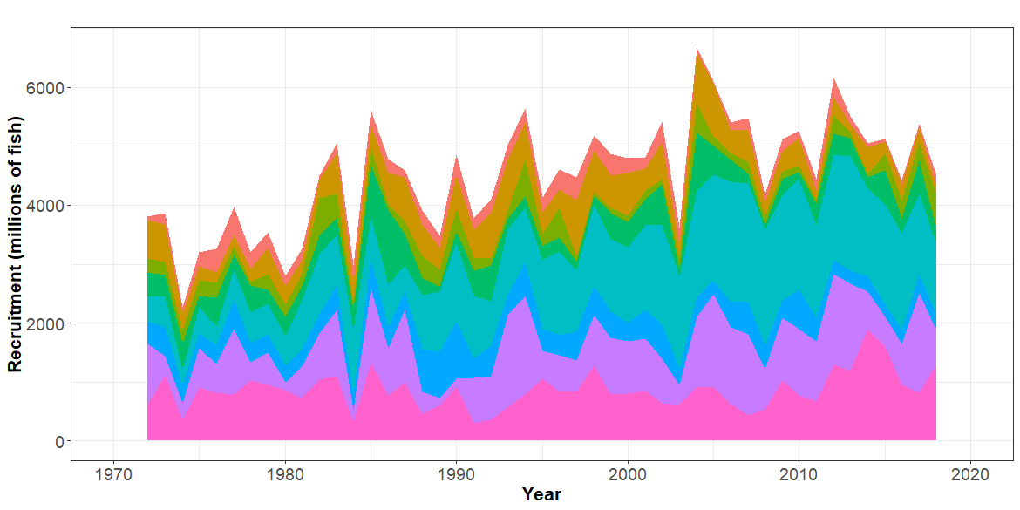
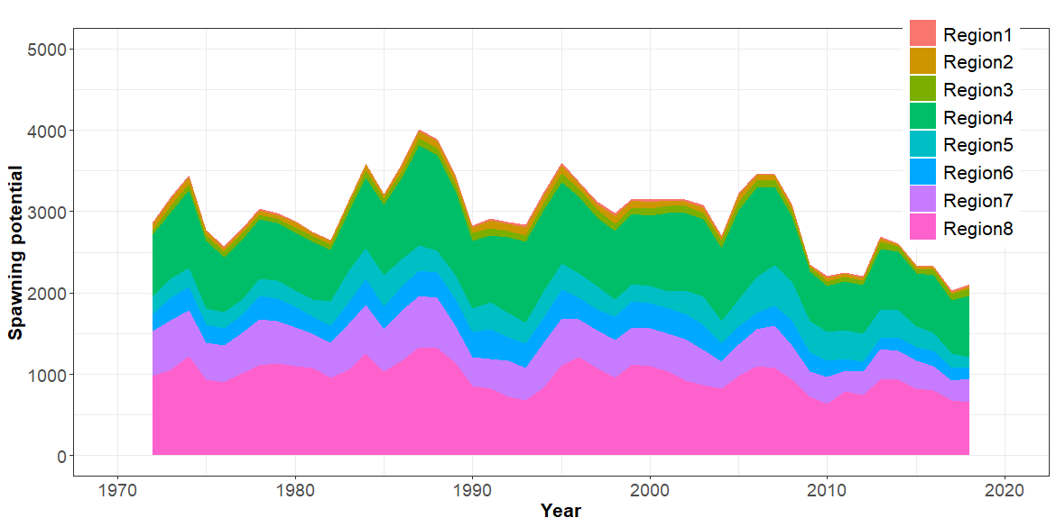
- Recruitment
- Spawning Potential
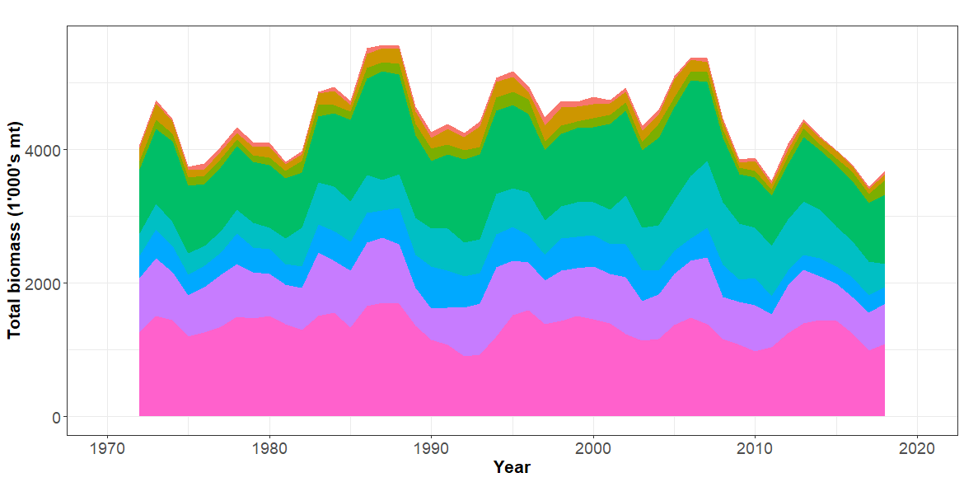
- Total biomass
Figure SKJ-04. Estimated annual average recruitment, spawning potential and total biomass by model region for the diagnostic model, showing the relative sizes among regions.

Figure SKJ-05. Estimated temporal overall spawning potential summed across regions from the diagnostic model, where the shaded region is ± 2 standard deviations (i.e., 95% CI).

Figure SKJ-06. Estimated annual average juvenile and adult fishing mortality for the diagnostic model.

Figure SKJ-07. Estimates of reduction in spawning potential due to fishing (fishery impact = 1-SB _{latest}/SB _{F=0}) by region for the diagnostic model.
Figure SKJ-08. Plot showing the trajectories of spawning potential depletion for the model runs included in the structural uncertainty grid weighted by the values given in Table SKJ-01. Red horizontal line indicates the agreed limit reference point, the green horizontal line indicates the interim target reference point.

Figure SKJ-09. Majuro plot for the recent spawning potential (2015 – 2018) summarizing the results for each of the models in the structural uncertainty grid with weighting. The plots represent estimates of stock status in terms of spawning potential depletion and fishing mortality, and marginal distributions of each are presented. Vertical green line denotes the interim TRP. Brown triangle indicates the median of the estimates. The size of the circle relates to the weight of that particular model run.

Figure SKJ-10. Majuro plot for the latest spawning potential (2018) summarizing the results for each of the models in the structural uncertainty grid with weighting. The plots represent estimates of stock status in terms of spawning potential depletion and fishing mortality, and marginal distributions of each are presented. Vertical green line denotes the interim TRP. Brown triangle indicates the median of the estimates. The size of the circle relates to the weight of that particular model run.

Figure SKJ-11. Kobe plot for the recent spawning potential (2015 – 2018) summarizing the results for each of the models in the structural uncertainty grid. The plots represent estimates of stock status in terms of spawning potential depletion and fishing mortality and marginal distributions of each are presented. Brown triangle indicates the median of the estimates. The size of the circle relates to the weight of that particular model run.

Figure SKJ-12. Kobe plot for the latest spawning potential (2018) summarizing the results for each of the models in the structural uncertainty grid. The plots represent estimates of stock status in terms of spawning potential depletion and fishing mortality and marginal distributions of each are presented. Brown triangle indicates the median of the estimates. The size of the circle relates to the weight of that particular model run.

b. Management advice and implications

- SC15 noted that the skipjack assessment continues to show that the stock is currently moderately exploited and the level of fishing mortality is sustainable.

- The 2019 stock assessment includes additional data and a range of model improvements such as a change to the maturity schedule used in this assessment, with length-at-maturity now larger than in the previous assessment, which has resulted in a reduction in the estimate of potential spawning biomass, relative to the 2016 assessment.

- SC15 noted that the stock was assessed to be above the adopted Limit Reference Point and fished at rates below F_{MSY} with 100% probability. Therefore, the skipjack stock is not overfished, nor subject to overfishing. At the same time, it was also noted that fishing mortality is continuously increasing for both adult and juvenile while the spawning biomass reached the historical lowest level.

- The skipjack interim Target Reference Point (TRP) is 50% of spawning biomass in the absence of fishing. The trajectory of the median spawning biomass depletion indicates a long-term trend, and has been under the interim TRP since 2009 (i.e., for 10 years). Since the median spawning biomass has been consistently below the interim TRP, SC15 recommends that the Commission take appropriate management action to ensure that the biomass depletion level fluctuates around the TRP (e.g., through the adoption of a harvest control rule).

c. Research recommendations

- In order to maintain the quality of stock assessments for this important stock SC15 recommends:
- continuing work to develop an index of abundance based on purse seine data and from FAD acoustic sensors;
- evaluating the possibility of conducting fishery independent surveys to provide relative abundance indices;
- conducting regular large-scale tagging cruises and expanding the infrastructure for rapid return of recaptured tags in a manner that provides the best possible data for stock assessment purposes;
- investigating skipjack growth by validation studies of otolith readings and/or estimation of growth within MFCL from tag recapture data;
- attempting to provide finalized catch estimates to SPC no later than June 1st.

    - South Pacific albacore tuna (Thunnus alalunga)

      - Research and information

- Update of South Pacific albacore tuna stock assessment information

- There was no discussion on this agenda item.
- Trends in the South Pacific albacore longline and troll fisheries

- Stephen Brouwer (SPC) presented SC15-SA-WP-01 A compendium of fisheries indicators for tuna stocks, and SC15-SA-WP-08 Recent trends in the south Pacific albacore fishery, which provided empirical information on recent patterns in fisheries. While the paper provided indicators for four tuna species (bigeye, skipjack, yellowfin and south Pacific albacore) the presentation concentrated on the indicators for albacore only. The indicators included: total catch by gear, nominal CPUE trends, spatial distribution of catch and associated trends, size composition of the catch and trends in average size. Stock projections were performed based upon the actual fishing levels by fleet in 2016 to 2020 based upon the assumption that levels of effort or catch would remain constant at 2016 levels. The albacore stock was initially projected to decline as recent estimated recruitments move through the stock, and then to recover in the longer term. Median F₂₀₂₀/F_{MSY} = 0.24; median SB₂₀₂₀/SB_{F=0} = 0.43.

Discussion
- Australia (referring to the longline CPUE plot, Figure 5 in SC15-SA-WP-08) noted there have been changes in the size distribution, with some large recruitments, and increase in mean size of catch; they observed that there have been some significant changes in targeting in the Chinese Taipei fleet. Australia stated the Japanese time series shows a huge change in CPUE, and inquired what drives this. S. Brouwer stated that they assume that this is a targeting effect, but noted this is unstandardized data. Regarding the size distribution, SPC is not seeing many recruits in the longline fishery — most recruits are visible first in the troll fishery.
- The EU referenced the stock projection figure, and inquired why the projected 2018 catch was below the average of the previous year that had more catch without an apparent impact on biomass, and asked whether this was possibly related to recruitment being oversampled. In relation to projections that are catch-based, the EU noted these can be misleading, especially when there are large changes in biomass if associated effort level is not taken into account. G. Pilling (SPC) stated that stock assessment models suggest some good recruitments are coming through the fishery, and this can be seen in the early part of the projection period (in particular in 2018). Good recruitments are reflected in the stock assessment, but unless these continue over a number of years, on average, those recruitments move through the fishery and the projection declines toward 0.4 at the end of the time period.
- Australia, on behalf of FFA members thanked SPC for SC15-SA-WP-08, and the comprehensive suite of projections they made on the 2018 assessment, stating that these enable SC to provide advice to WCPFC16 on the latest status and management implications for this stock, particularly in relation to the interim South Pacific albacore TRP determined by WCPFC. FFA members suggested that among the management advice emerging on South Pacific albacore, SC should emphasise the following:
a. That the median recent stock depletion ratio against the unfished biomass, across the 72 model runs of the latest assessment, was 0.52, which was below the interim TRP of 0.56 established by the WCPFC in 2018.
b. According to the projections in SC15-SA-WP-08:
- the stock biomass will decline from the 2016 level of 0.52 to 0.39 by 2035 if the lower catch levels experienced in 2018 remain constant.
- the risk of the stock breaching the biomass LRP by 2035 will be 23%.
- longline-vulnerable biomass (the longline CPUE proxy) will decrease by 36% relative to 2013 levels. FFA members noted that 2013 was the reference year for the southern albacore TRP, but the objective of the TRP is to restore and maintain CPUE of southern albacore in the southern longline fishery to 8% above 2013 levels, using longline-vulnerable biomass as the proxy for CPUE. This means that the projections estimate that in 2035 the CPUE proxy will have decreased to nearly half of the level that forms the basis for the TRP.
c. As a result of these projections, SC should advise WCPFC that action will need to be taken to reduce total catch or effort still further in order to reverse the projected decline in the vulnerable biomass. This will permit a return to a limited but profitable southern longline fishery that can ride out the low points in the albacore CPUE cycle. The situation is urgent in some of our member states, with domestic operators facing default on their loans or bankruptcy, in the medium, or even short-term future.

- China stated their view that because the South Pacific albacore stock assessment was conducted in 2018, management advice should be based on that stock assessment. They noted the TRP was adopted in 2018, and suggested that SC request that the Commission develop comprehensive management measures for South Pacific albacore based on the 2018 stock assessment and TRPs. To reach the TRP in the desired 20-year timeframe the Commission needs to take action — the sooner the better. They note that SC15 has heard that the EPO catch has increased, and voiced concern that both WCPFC and IATTC should have comprehensive compatible CMMs. The theme convener note that the assessment was based on the convention area, not the entire Pacific albacore stock, and observed that the relative advantages and disadvantages of addressing the entire stock should be noted.

- Chinese Taipei stated that the nominal CPUE series should interpreted very carefully, and noted changes in longline targeting (bigeye in the north and South Pacific albacore in the south). Regarding the stock projection, they observed in comparing the three WCPO tuna species, uncertainty in South Pacific albacore is quite large. In the 2017 South Pacific albacore projection the range of depletion is 0.2 to over 1.0, indicating a large uncertainty in this projection, which was not observed in bigeye and yellowfin. Regarding the change in the 2018 albacore catch, they inquired whether this was caused by fleet behaviour or movement. S. Brouwer stated they were unsure why the drop-in catch occurred. There is an increase in CPUE from some fleets and decrease from others. Economic conditions in this fleet are not very good, and there may be fewer vessels fishing in 2018. G Pilling (SPC) addressed the levels of uncertainty in the historical and projection period, noting that South Pacific albacore has a different grid from bigeye and yellowfin, and that grid incorporates uncertainty in natural mortality and growth. This gives a wider spread of model uncertainty, which uncertainty in future recruitment levels then amplifies in the projection period. He noted that general trend for most model runs is downward, although some runs (20%) are above the TRP.
- The EU noted that SC15-GN-IP-03 (Issues from the Commission) indicates that Para. 212 of the WCPFC15 Summary Report states that consideration should be given to including the entire Pacific albacore stock in future SAs, and inquired if this was being planned. SPC stated that they would discuss the issue with IATTC following SC15.
- French Polynesia stated that they share FFA members’ concern about CPUE projections, and asked that SC request the Commission to take action to address this.

      - Provision of scientific information

a. Stock status and trends

- SC15 noted that no stock assessments were conducted for South Pacific albacore in 2019. Therefore, the stock status descriptions from SC14 are still current for South Pacific albacore. For further information on the stock status and trends from SC14, please see https://www.wcpfc.int/node/32155. Updated information on fishery trends and indicators were compiled for and reviewed by SC15.

- SC15 noted that the total provisional Pacific Ocean catch south of the Equator in 2018, updated since the paper was submitted, was 80,820 mt, a 13% decrease from 2017 and a 2% decrease from the average 2013-2017. Longline catch in 2018 (77,776 mt) was a 14% decrease from 2017 and an 8% decrease from the 2013-2017 average.

- The average stock status in 2016 (the last year of the assessment) across the 72 model runs was SB_{latest}/SB_{F=0} = 0.52, below the interim target reference point (SB_{latest}/SB_{F=0} = 0.56) established by the WCPFC in 2018. The probability of being below the TRP in 2016 is 63%. The stock is not overfished nor is overfishing occurring.

- SC15 noted projections from the 2018 assessment which apply to the WCPFC Convention Area. The historical status and projections have a greater uncertainty in spawning stock depletion than observed for bigeye and yellowfin tuna because South Pacific albacore has a different grid which incorporates natural mortality and growth and this gives a wider spread of uncertainty. SC15 noted that under recent fishery conditions of assuming that the 2018 catch remains constant, the albacore stock is initially projected to increase as recent estimated relatively high recruitments support adult stock biomass, then decline as future recruitment is sampled from the long-term historical estimates The projections indicate that median F₂₀₂₀/F_{MSY} = 0.24; median SB₂₀₂₀/SB_{F=0} = 0.43; and median SB₂₀₂₀/SB_{MSY} = 3.2. The risk that SB₂₀₂₀/SB_{F=0} < LRP = 0%, SB₂₀₂₀ < SB_{MSY} = 0% and F₂₀₂₀ > F_{MSY} = 0%.

- The stock biomass is expected to decline from the 2016 level of 0.52 to 0.39 by 2035. The risk of the stock biomass breaching the LRP in 2035 is expected to be 23%. The longline-vulnerable biomass (the longline CPUE proxy) is expected to decrease by 36% relative to 2013 levels.

b. Management advice and implications

- Given the stock assessment in 2018 and SC15 projections, SC15 advises that WCPFC develop comprehensive binding South Pacific albacore management measures which will result in the stock reaching the TRP within the 20-year time horizon. SC15 advises WCPFC16 may consider establishing a CMM to further reduce total catch or effort in order to reverse the projected decline in the vulnerable biomass.

- SC15 notes that the 2018 South Pacific albacore stock assessment pertained to the WCPFC Convention Area. The South Pacific albacore catch in the eastern Pacific Ocean has recently increased and the scheduled 2021 South Pacific albacore assessment may pertain to the entire south Pacific stock in order to incorporate all population dynamics. WCPFC and IATTC compatible measures would be more easily implemented should an entire south Pacific assessment be conducted.

c. Research recommendation

- SC15 noted that the assumed future recruitment can have a large impact on the projection result. It was recommended that research be undertaken to quantify autocorrelation behaviour of recruitment to be included in the future projection.

  - Northern Stocks

- S. Nakatsuka (Japan), on behalf of the ISC, presented SC15-GN-IP-02 Report of the Nineteenth Meeting of the International Scientific Committee for Tuna and Tuna-like Species in the North Pacific Ocean. ISC held its 19th plenary meeting in July 2019 in Taipei. Its working groups reported its activities in the past year; most notably, the Billfish WG conducted a benchmark stock assessment of western and central north Pacific striped marlin. The ISC Plenary reviewed the results of the stock assessment and provided Stock Status and Conservation Information. No other stock assessment was conducted last year, and the past recommendations were carried forward for those species. The Pacific bluefin tuna Working Group (PBFWG) provided responses to requests from RFMOs, which will be provided to the WCPFC NC – IATTC Joint Working Group meeting in September. In addition, MSE-related work is in progress in ISC; the 4th workshop on North Pacific albacore and the 2nd workshop on Pacific bluefin tuna were held by ISC last year and results will be provided to relevant forum, in particular the Northern Committee for feedback from managers. In 2020, benchmark assessments for North Pacific albacore, Pacific bluefin tuna, and possibly North Pacific blue shark will be conducted.
Discussion
- The EU stated their desire to have more information presented on these stocks and related fisheries at the committee, similar to what is presented by SPC in terms of the overview of the fisheries. The presenter affirmed that an overview was presented in terms of fisheries information on the northern stocks, but stated that in terms of stock information they are providing quite extensive results. He stated that if the ISC receives a request from the SC, the ISC Chair would consider how much additional information can be provided in terms of fishing activity in northern areas.

    - North Pacific albacore (Thunnus alalunga)

a. Stock status and trends

- SC15 noted that no stock assessments were conducted for North Pacific albacore in 2019. Therefore, the stock status descriptions from SC13 are still current for North Pacific albacore. For further information on the stock status and trends from SC13, please see https://www.wcpfc.int/node/29904. Updated information on catches was not compiled for and reviewed by SC15.

- SC15 noted that the provisional total North Pacific albacore catch by Canada, Japan, United States, Korea, Mexico and Chinese Taipei in 2018 was 49,300 mt, a 9% decrease from 2017 and a 24% decrease from the 2013-2017 average. The detailed catch information by fishery is available in ISC 2019 report (SC15-GN-IP-02). North Pacific albacore is caught by various fishing gears including longline, troll, and pole-and-line.

b. Management advice and implications

- SC15 noted that no management advice has been provided since SC13 for North Pacific albacore. Therefore, the advice from SC13 should be maintained, pending a new assessment or other new information. For further information on the management advice and implications from SC13, please see https://www.wcpfc.int/node/29904

    - Pacific bluefin tuna (Thunnus orientalis)

- S. Nakatsuka (Japan), and chair of the PBFWG presented SC15-SA-IP-20 Report of the Pacific Bluefin Tuna Working Group Intersessional Workshop (ISC19 – ANNEX 08). The PBFWG held a workshop on 18-22 March 2019 in Jeju, Korea. The PBFWG needed to respond to requests to ISC from RFMOs relevant to Pacific bluefin management, including reviewing the current Conservation Advice based on latest information and implementing projections under additional harvest scenarios. The PBFWG reviewed the latest information and concluded that the Conservation Advice in 2018 should be maintained. In addition, the PBFWG conducted projections based on the 2018 assessment under additional harvest scenarios in accordance with the requests from RFMOs. The responses to the requests from RFMOs were compiled in Appendix 6 of PBFWG report and they will be provided to RFMOs at the occasion of IATTC – WCPFC NC Joint Working Group meeting in September.

Discussion

- The EU stated it was happy to see progress made in the work of the joint PBFWG, and the positive trends. They highlighted this is the WCPFC stock with the worst conservation status, with estimated biomass levels largely below any limit reference point used for the management of other tuna species, and reiterated the need for SC to stress the need for management to take a precautionary approach. The presenter suggested carefully considering last year’s recommendation, noting that management decisions should be left to managers. Japan noted that the precautionary approach was included in the projection through an assumption of low recruitment. The presenter observed that in the case of recovery stocks current stock status and stock projections can have different implications, observing that the projection for bluefin tuna is very good, although the stock remains in the “red zone” in terms of its current status.

- PNG referenced Japan’s comment that the projections use a low recruitment value, and inquired whether the steepness value is reflective of a precautionary approach. The presenter noted that future recruitment is based on historical values, and that the low recruitment period in the 1980s was used. Using steepness of 0.99 has little impact on the projection.

- The EU followed up on the intervention from Japan and PNG, and inquired how uncertainty due to some key parameters such as steepness was captured noting that the model fit for lower steepness values seemed not to be good, as well as that the grid approach used for including structural uncertainty in the definition of tropical tunas stock status was not used for this species. The presenter stated they did not have the exact method being used, but stated that a very large number of simulations (6000 runs) is used to look at the variability in recruitment and other factors to evaluate uncertainty.

- The United States noted the current spawning potential of bluefin tuna is very low, and advised there was a need to consider whether additional catch is wise. They noted that if a different steepness value was used, the results would be different, stating that there is no compensation for reduced biomass, which differs from the approach used for tropical tunas. The presenter agreed that the result could change if a different steepness value was used, explaining that 0.99 was used because the current stock assessment says stock status is very low, but a recruitment reduction has not been observed. A benchmark stock assessment will be conducted in 2020 and steepness values and their effect evaluated. Tropical tunas use 0.8, but past recruitment does not use steepness; it is used only for future recruitment. J. Hampton (SPC) noted that apart from steepness, the main difference in dealing with Pacific bluefin tuna is that no uncertainty is recognized for natural mortality, growth, etc. — the only uncertainty comes from resampling for recruitment. In contrast the 2019 skipjack stock assessment used 54 different model runs from which it is possible to evaluate many of the sensitivities to biological factors such as growth and natural mortality. The presenter stated they routinely check steepness for many model assumptions such as growth to check sensitivity. They considered using the model grid approach, but ISC scientists are happier with the single model approach, with sensitivity runs, rather than weighting probability as used for tropical tunas.

- PNG stated that the projections are encouraging, and hoped the PBFWG continues efforts to reach the rebuilding targets that have been set.

a. Stock status and trends

- SC15 noted that no stock assessment was conducted for Pacific bluefin tuna in 2019. Therefore, the stock status description from SC14 is still current. For further information on the stock status and trends from SC14, please see https://www.wcpfc.int/node/32155

- SC15 noted that the total Pacific bluefin tuna catch by ISC members in 2018 was 10,148 mt, a 31% decrease from 2017 and a 25% decrease from the 2013-2017 average. Pacific bluefin tuna is caught by various fishing gears including purse seine, longline, set net, troll, pole-and-line, handline and recreational fisheries. The detailed catch information by fishery is available in the ISC19 Plenary Report (SC15-GN-IP-02).

b. Management advice and implications

- SC15 advises the Commission to note the current very low level of spawning biomass (3.3% B₀), the current level of overfishing, and that the projections are strongly influenced by the inclusion of a relatively high but uncertain recruitment in 2016. While noting that additional positive signs of Pacific bluefin tuna stock were observed after the last assessment, and while noting that the agreed Harvest Control Rule could allow for catch limit increases, some of CCMs recommended a precautionary approach to the management of Pacific bluefin tuna until the rebuilding of the stock to higher biomass levels is achieved.

- One CCM recommended that ISC consider a grid approach for taking into account the structural uncertainty for the provision of stock status and management advice.

- SC15 also noted the following management advice of ISC19:

The following requests were made to ISC by the IATTC-WCPFC NC Joint Working Group meeting in September 2018 at NC14 (see Attachment E of NC14 Summary Report (https://www.wcpfc.int/node/31946)). Responses from ISC PBFWG are provided below the requests.

Request 1: review the updated abundance indices, including recruitment index, up to 2017 to evaluate the need to change its scientific advice in 2018.

Response from ISC
The WG noted that some positive signs for the Pacific bluefin stock were observed after the last assessment. In the 2018 assessment, the projections were considered optimistic because they were influenced by a high but uncertain recruitment in the terminal year (2016). The WG notes that the Japanese troll recruitment index value estimated for 2017 is similar to its historical average (1980-2017), that Japanese recruitment monitoring indices in 2017 and 2018 are higher than the 2016 value and that there is anecdotal evidence that larger fish are becoming more abundant in the EPO, although this information needs to be confirmed for the next stock assessment expected in 2020.

After reviewing the updated CPUE indices as well as the Japanese recruitment monitoring results, the PBFWG recommends maintaining the conservation advice from ISC18 (in 2018) that the projection mimicking the current management measures under the low recruitment scenario resulted in an estimated 98% probability of achieving the initial rebuilding target (6.7%SSB_{F=0}) by 2024 and that of achieving the second rebuilding target (20%SSB_{F=0}) 10 years after the achievement of the initial rebuilding target or by 2034, whichever is earlier, is 96%.

In the projections reported here, the projected future SSBs are the medians of the 6,000 individual SSB calculated for each 300 bootstrap replicates (i.e. catch, CPUE and size) to capture the uncertainty of parameter estimations followed by 20 stochastic simulations based on the different future recruitment time series. The projection assumes that each harvesting scenario is fully implemented and is based on certain biological or other assumptions of base case assessment model. If conditions change, the projection results would be more uncertain.

Request 2: Conduct projections of harvest scenarios shown below based on 2018 assessment and provide probability of achieving initial and 2nd rebuilding targets in accordance with paragraph 2.1 of HS2017-02.

Scenarios for catch increase
* 250t transfer of catch limit from small fish to large fish by Japan is assumed to continue until 2020.

Response from ISC
PBFWG conducted projections in the same manner as in the 2018 assessment. The recruitment scenario followed paragraph 2.1 of WCPFC Harvest Strategy 2017-02; and was kept at a low level (re-sampling from 1980-1989) until the initial rebuilding target is achieved and then changed to the historical average level.

The projection results are shown in Table PBF-02 and Figure PBF-01. The results show that increasing the catch limit of small Pacific bluefin (<30 kg) in the WPO has the largest impact on the probability of achieving the interim and 2nd rebuilding targets. In addition, an overall increase in catch from the current limits, particularly a 15% increase, has the largest impact on achieving rebuilding targets.

Table PBF-01. Future projection scenarios for Pacific bluefin tuna (Thunnus orientalis).

Table PBF-02. Probability of achieving targets under projection scenarios for Pacific bluefin tuna. Future projection scenarios for Pacific bluefin tuna and their probability of achieving various target levels by various time schedules based on the 2018 base-case model.

Figure PBF-01. Time series of the projected spawning stock biomass by various harvest scenarios listed on the Table PBF-01. Each colored solid and broken lines indicate the median spawning stock biomass and its 95% confidence intervals, respectively. The black dotted and solid lines are corresponded to the spawning stock biomasses of the initial and second rebuilding targets of Pacific bluefin tuna, respectively.”

    - North Pacific swordfish (Xiphias gladius)

- Stock status and trends

- SC15 noted that no stock assessments were conducted for North Pacific swordfish in 2019. Therefore, the stock status descriptions from SC14 are still current for North Pacific swordfish. For further information on the stock status and trends from SC13, please see https://www.wcpfc.int/node/29904. Updated information on catches was not compiled for and reviewed by SC15.

- Management Advice and implications

- SC15 noted that no management advice has been provided since SC14 for North Pacific swordfish. Therefore, the advice from SC14 should be maintained, pending a new assessment or other new information. For further information on the management advice and implications from SC14, please see https://www.wcpfc.int/node/32155

  - WCPO sharks

    - Oceanic whitetip shark (Carcharhinus longimanus)

      - Research and information

a. Oceanic whitetip stock assessment

- L. Tremblay-Boyer (Dragonfly Data Science) presented SC15-SA-WP-06 Stock assessment for oceanic whitetip shark in the Western and Central Pacific Ocean, which is the second stock assessment for oceanic whitetip shark in the WCPO following that conducted by J. Rice and S. Harley in 2012 (SC8-SA-WP-06 Rev. 1), and the first since CMM2011-04, the non-retention measure for oceanic whitetip shark, became active in 2013. This assessment for oceanic whitetip shark was performed in the Stock Synthesis modelling framework, an integrated age-structured population model previously used to assess the status of sharks in the Pacific Ocean and elsewhere. The population dynamics model was informed by three sources of data: historical catches, time series of catch-per-unit-effort and length frequencies. The four-fleet structure used in the previous stock assessment was retained, splitting the longline fishery into bycatch and target fleets, and the purse-seine fishery into fleets of associated and unassociated sets. A new development in this assessment was the inclusion of discard mortality (DM) scenarios in the historical catches. This was a key step to account for the potential impacts of the no-retention measure for oceanic whitetip sharks. Three scenarios were used assuming 25%, 43.75% and 100% mortality on the discards, accounting for mortality at different stages of the discarding process from the catch event and crew handling to post-release mortality. In addition, results from two new WCPO growth studies predicted a much less productive profile for the stock than what had been assumed previously. Because growth was a key uncertainty in this assessment, two growth and fecundity assessment ‘profiles’ were used to reflect the differences between growth studies. The authors presented a diagnostic case for the assessment based on the model with the best overall diagnostics, an informative likelihood profile, and the most reasonable assumptions about biology and fleet settings based on current knowledge about oceanic whitetip shark and the fisheries that catch this species. Based on the results from the one-off sensitivities from the diagnostic case and previous discussions at the Pre-Assessment workshop, a set of uncertainty axes for the model was defined outlining alternative values for key uncertainties and influential model or biological parameters. The combination of all levels across axes forms the structural uncertainty grid with a total of 648 individual model runs. Stock status was obtained by summarizing reference points over all grid runs to account for the assumptions about life-history parameters and impact of fishing underpinning the assessment. The stock was estimated to be overfished and undergoing overfishing based on SB/SB_{MSY} and F/F_{MSY} reference points and assuming equal weightings for grid levels. This overall conclusion is the same as that from the previous assessment, despite a wider range of uncertainties being considered, notably in the growth and fecundity parameters. In terms of the depletion of the spawning biomass, most model runs predict SB/SB₀ to be below 0.05, and all model runs predict SB/SB₀ to be below 0.1.

- The authors found that F-based reference points improved in the period since CMM2011-04 became active, which covers the last 4 years of the assessment’s timespan (2013–2016). Notably, F /F_{MSY} is predicted to have declined by more than half from 6.12 to 2.67 (median) for the last year of the assessment when the impact of CMM2011-04 on survival is accounted for under the 25% and 43.75% discard mortality scenarios. F levels relative to two alternative reference points, F/F_{[lim,AS]} and F/F_{[crash,AS]} follow similar trends following the adoption of the measure. All catch scenarios accounting for discard mortality < 100% showed a very slight increase in spawning biomass since 2013, but final levels of depletion (SB/SB₀) remain very low over all grid runs (median: 0.0367, 95% CI: 0.021–0.061). Given the assessment assumes oceanic whitetip sharks to become mature after 4 or 8 years, stock recovery should be expected to be slow in the period following the conservation measure while the spawning biomass rebuilds. Despite the relative improvements in F-based reference points since 2013, the median value of F/F_{crash} over all 648 grid runs for 2016 remains above 1 (median: 1.41, 95% CI: 0.98–2.15), indicating that the population should go extinct in the long-term under current levels of fishing mortality.
Discussion

- Japan noted the very comprehensive analysis, with significant progress. They referred to the fitting of the CPUE in the assessment model to the standardized CPUE for the longline fishery (Fig 21 in SC15-WP-06), focusing on the last 5 years. In 2017 there were no mitigation measures for oceanic whitetip shark, and a standardized CPUE, which has been increasing, but the CPUE line decreasing trend. They suggested this inconsistent trend has a large impact on the future projection. They stated this was explained as being caused by a very tight CV for the stock recruitment relationship. The principle for basic weighting of data in the model seems prioritized to CPUE. They suggested that the model should be fitted well to the CPUE first, prior to conducting a sensitivity analysis and grid analysis. Looking at LRPs for key shark species applied in 2018, this LRP is based on the surface production framework. They noted that application of the RP to this species is premature because of the use of an integrated stock synthesis model, suggesting it not be used until it was determined appropriate for this kind of model assessment. Japan inquired how the previous paper calculated the steepness. The presenter stated that regarding fit to the CPUE, in general when CPUE varies quickly in a time series it is easier for that CPUE to be fitted when high recruitment deviation is allowed for. This species matures at age 6 (diagnostic case), with 50% maturity at age 7. Thus, the lag and the fitted CPUE catches up to the observed CPUE. The model cannot cope with such quick changes in CPUE over time. The RPs were derived in a surplus production framework, but do implicitly have an intuitive interpretation that works for stock assessment models. MSY-based RPs are estimated from interim assessment models, and used for tuna assessments. It is appropriate to use F_{Lim}/F in this framework. A yield simulation can be done to find FM that leads to a crash in the population at equilibrium, and that concept translates well from a surplus production framework to an integrated stock assessment framework, such as stock synthesis. Steepness was selected for the old stock assessment — in 2012 values were chosen that seemed to cover reasonable a reasonable range. If we could have more information on steepness that should be prioritized.
- Chinese Taipei raised the issue of how to justify a value of 0.1 for the S/R deviation and 0.15 for CPUE, and inquired if the authors had documentation. Regarding a new reference point for sharks, the previous study used a symmetrical production curve, which does not reflect the biology of shark species. The production curve can be carried over from the stock synthesis model, and this might be better. They stated that SSB₀ is the unfished condition, or dynamic B_{0,} but there is much uncertainty in the initial stage, and inquired about the presentation of results, and uncertainty. The presenter replied that the basic settings were discussed at the pre-assessment workshop, and it was agreed the 2012 stock assessment would be used as a template. Only one setting was not discussed: using a tighter CV for the CPUE. They added as an axis in the uncertainty grid a sigma R of 0.2, noting that 0.3 would not be reasonable. This resulted in no clear changes in the final depletion levels. Regarding CPUE CV, they did run some sensitivity runs, using different indices. They explored that assumption pretty well, which had minor impacts on estimates of depletion. Regarding the RP, it was correct that integrated stock assessments lack a symmetric surplus production framework to model the yield, but that was accounted for; the yield curves from the stock assessment are not symmetric. The comment by Chinese Taipei on symmetry may apply to F_{Lim}, but not to the F_{crash} reference point. Regarding SSB₀, it is not dynamic, and they did not account for any environmental effects on recruitment over time. The presenter apologised for not including a plot of the trajectory of the grid of SB over time.
- Kiribati, on behalf of FFA members, expressed deep concern for the stock status of this species, noting that all model runs, alternative modelling methods, and other indicators are consistent in painting a very bleak picture, which reflects poorly on the Commission's ability to manage fishing impacts on this species. SC needs to bring this continuing overfishing problem to the further attention of the Commission, noting that bycatch in the longline fishery is the overwhelming contributor to ongoing oceanic white tip mortality. If more effective mitigation measures are not enacted, then the only effective way to avoid effective extinction of this stock will be to reduce longline fishing effort in those areas that do not apply effective mitigation. The Monte Carlo simulations presented at SC11 in SC11-EB-WP-02 strongly suggested significant improvement in survival of hooked sharks would only be achieved by prohibiting the use of wire trace and prohibiting the use of shark lines, rather than allowing these to be alternative options. FFA members have already agreed to do this in their own waters through the FFA Minimum Terms and Conditions. Having said that, FFA members noted recent reductions in fishing mortality and stabilising of the biomass (although this at an extremely low level), and hoped that this suggests the decline in biomass has been arrested, and that the Commission has some hope of rebuilding the population. Although there is a ‘no retention’ rule already in effect, FFA members encouraged all CCMs to take steps to improve the condition of released sharks by following the safe-release guideline that recommends that sharks be brought close to the vessel before cutting the line, as close to the sharks mouth as possible, to limit the length of trailing line, which can cause mortality. They suggested there may be some scope for EM to provide some help with verifying the fate of released sharks and in providing much needed information on the size of sharks, and this will likely improve assessment.
- The EU noted the excellent work, and commented on the uncertainty in the catch level (in Figure A41), noting the pattern in the retrospective analysis indicates that depletion increases slightly. They inquired whether this could be partially linked to underestimation of stock size, and in turn related to systematic unaccounted/unreported catch removal? They suggested that SC should reiterate the recommendation made at SC14 regarding a draft shark CMM, requiring sharks to be hauled to the side of vessel to facilitate species identification whenever there is an observer on board; if not done systematically the future estimates of stock fishery will become even more uncertain. The presenter agreed it was hard to estimate catches through retrospective analysis. Would have been useful to display this — under the 90% catch scenario could have been helpful. They stated their interpretation was that there was a big decline in catches in the diagnostic case following 2012, which overlaps the timeframe covered by the retrospective analysis, and the model implicitly scales the productivity of the stock up and down.
- Australia noted that assessments such as this are highly reliant on observer data, and the recommendations list some areas where observer collected data can be improved. However, when using observer data, it is usually assumed that the data is representative of the fleet being covered, but this may not always be the case. For example, referring to Figure 4 (which indicates the proportion of deep sets in each fleet), the estimated proportion of deep-sets seems too high for the Australian fleet. Logbook data in Australia shows that before 2005 this proportion was < 20%, and in the past decade at most 50% are deep sets, while Fig 4 indicates > 80%. Underestimating the percentage of shallow set is likely to underestimate the catch of oceanic whitetip shark. Also, Figure 11 indicates that the proportion of oceanic whitetip shark discarded for the Australian fleet has been close to zero for most years, whereas the logbook data for this fleet indicates that there has been a steady increase from around 40% in 2000 to 100% in 2016. While the reasons for these discrepancies remain unknown, the Australian observer coverage was generally not random but focused during some parts of the year on the southern part of the fishery where southern bluefin tuna were caught. The Australian catch is only a very small part of the fisheries in the WCPO and so the discrepancies mentioned will not impact the results of this assessment, but this highlights that when using observer data there is a need to be aware that the data may not be representative of an entire fleet’s catch and effort. While the Australian observer coverage has generally been between 5%–10%, this may be a particular problem when observer effort is low. Australia has long advocated having adequate observer coverage to address the Commission’s extensive scientific requirements and this only adds to that case. The presenter noted that while the proportion of the deep sets for Australia may not be representative, the data came from the model dataset. They stated they were well aware this might add uncertainty, because some countries without full coverage of the number of hooks between floats (HBF) over time would likely have errors. Australia had effort classified by HBF. The model only classified sets where the information had not been previously provided, and perhaps this should be followed up. They noted it was very important to account for this variable, given the much higher catch rate for shallow than deep sets for this species. Regarding the discard rate, they noted it was low for Australia, but that the values came from the observer data set, and stated it would also be good to follow up on that issue. She confirmed Australia’s comment that these analyses are only as good as the observer set, and the data provided to SPC.
- The United States commended the excellent assessment, and noted the fitting of CPUE was somewhat off in the most recent years, which may affect the projection in the future. They inquired whether there had been an attempt to try model fits with highly variable CPUE CVs. The presenter stated she did not, but either used the model-based CVs or a constant assumed CV. The CV for the later part of time series was generally below 0.15. The tighter CV was mostly constrained to fit the early part of time series and not the later part. The United States stated that the stock assessment shows that a decline in catch over recent years has contributed to a slight recovery in SB starting in 2013, and F/F_{MSY} has declined by more than 50% in the end of the stock assessment, but F/F_{crash} remains above 1 for all discard mortality scenarios. They noted the importance of having guidance regarding how F could be reduced and what the outcome might be, stating that though they recognized the comments about the fit of the CPUE in the final years of the assessment, they recommended development of future projections.
- Pew spoke on behalf of The Pew Charitable Trusts, WWF, Sustainable Fisheries Partnership, Birdlife and ISSF, stating that the findings of the current oceanic whitetip shark stock assessment are greatly concerning. They supported the intentions of CMM 2011-04 to reduce as much as possible the impacts of fishing on this species. Unfortunately, the 2019 assessment indicates that current fishing mortality with the CMM in place is still unsustainable and the population will go extinct in the long-term if this situation remains unchanged. This population requires a comprehensive recovery plan that incorporates new management measures to reduce interactions with fishing gear, improved data collection and regular monitoring of population trends. Regarding data collection, they noted that there remains significant uncertainty around the impacts of the longline fishery on this species and supported the recommendations in the assessment report to reduce this uncertainty. However, the greatest source of uncertainty in longline impacts is due to the very low observation rate. They called on SC to strongly recommend that in 2019 the Commission adopts (1) increasing longline observer coverage and (2) additional measures to significantly reduce fishing mortality of oceanic whitetip sharks allowing the population to recover.
- The EU also expressed concern regarding the prospect for determining conservation status of the stock. Noting Japan’s comments on the use of proposed LRPs, the EU recalled it has strongly supported the continuation and finalisation of the project on LRPs on sharks at SC14. They hoped this could be prioritized in the next year.
- Australia noted it was clear that fishery status is very dependent on catch series and the assumption of catch mortality, which emphasizes the issues being discussed in the EB theme. Mitigation, handling and release practices are critical to the future status of this species. The inquired whether the discard mortality 44% series corresponds closely to the finding in the two PRM studies, especially the study from the United States (SC15-EB-WP-04). The presenter stated that the mortality assumes 25% are discarded dead, and 25% are PRM. Understanding from the United States study was that 33% were discarded dead, 4% discarded injured, and 13% PRM assumed by the Cox model. While these figures are not identical, both are around 44%, suggesting the scenario is appropriate for the species. Australia noted a significant difference in catch rates between the shallow and deep sets. Hooks per basket (HPB) is used as a proxy for the depth but gear has changed significantly over time, leading to a discontinuity in the relationship between HPB and depth. Australia did an extensive study with depth monitors on longline vessels, and they queried whether a similar study was needed across the WCPO, or possibly such data should be collected through observers or in another way.
- The United States stated that based on the study conducted of the Hawaii and American Samoa fleets (SC15-EB-WP-04) the survival rate for oceanic whitetip was 87%, (CI 77%–99% survivorship). For the two fisheries combined (Hawaii and American Samoa), alive at vessel = 55%, not meeting either alive or injured criteria = 6.6%, alive and injured = 5%, and dead = 33.6%.

- Project 92 (Testing the performance of alternative stock assessments approaches for oceanic whitetip shark)

- L. Tremblay-Boyer (Dragonfly Data Science) presented SC15-SA-WP-13 Alternative Assessment Methods for Oceanic Whitetip Shark on behalf of the first author P. Neubauer. This study evaluated potential alternative assessment methods for sharks, using oceanic whitetip shark (Carcharhinus longimanus) as a case study, and allowing comparisons with the 2019 age-structured integrated stock assessment of this species (SC15-SA-WP-06) conducted with the Stock Synthesis 3 (SS3) software and also presented to SC15. The most recent previous integrated assessment of oceanic whitetip shark concluded that the stock was overfished and that overfishing was occurring, but potential changes in fishing mortality due to CMMs implemented increased uncertainty about current stock status. The authors compared three approaches in conjunction with the current integrated stock assessment of oceanic whitetip shark. These approaches were catch-only simulations, a general spatial risk assessment model, and a Bayesian dynamic surplus production model. They also illustrated the impact of different assumptions on estimates of fishing mortality (F) and risk (F/F_{crash}) to the oceanic whitetip shark stock in the Western and Central Pacific Ocean. Their findings suggest that catch-only methods are most valuable as a tool to refine Bayesian priors in more sophisticated analyses, since, on their own, catch-only methods are dependent on assumptions and provide no relevant management outputs. Nevertheless, the authors show that by making simple and relatively broad assumptions about the current depletion level, catch alone can constrain initial population size (unfished and/or starting depletion for the catch time series) and productivity and, thereby, serve as a priori constraint on these parameters. The application of dynamic surplus production models (DSPMs) showed that these models may provide a reasonable tool to rapidly assess shark stocks, either alongside or instead of fully integrated stock assessments. DSPMs can be readily applied to sharks: their implementation in widely-available software packages means that they are a cost-effective assessment tool that requires few assumptions. In addition, these models can provide estimates of management-relevant quantities (e.g., stock status, fishing mortality), which have been shown to be robust for sharks. Furthermore, depletion-based catch-only simulations can be used to construct useful priors for Bayesian implementations of these models. Nevertheless, the reliance of DSPMs on a reliable biomass index (e.g., CPUE time series with contrast) and on complete removal estimates (i.e. the availability of a catch series which accurately reflects total catch) limits their application to species for which these time-series data can be derived. This aspect may exclude the application of DSPMs to species with poor historical identification records such as many shark species. The authors also applied a spatial risk assessment (SRA), as this approach only requires recent catch and effort data to estimate fishing mortality, so is less constrained by historical data limitations. Because SRAs generally do not use complete time series of removals, they cannot provide information about stock status. The most commonly employed SRA methods are conceptually similar to fisheries surveys, as they use estimates of gear efficiency to scale observed spatial catch to overall catch via a spatial population density estimate. To derive absolute fishing mortality and risk, however, these methods need to make assumptions about the spatial interaction of the fishing gear with the local population density. This scaling is difficult to establish for longline gear and has a large effect on estimated risk. For this reason, the authors suggested that risk assessment methods are employed when 1) no robust time series for catch and CPUE can be derived, and 2) it is possible to make reasonable assumptions about the spatial effect of the fishing gear. Even with these limitations risk assessment methods can be particularly valuable for prioritising assessment and conservation efforts, as they can be readily employed across species in a standardised framework, even for species with limited historical data. Application of a variety of models to the oceanic whitetip shark stock showed that DSPM, SRAs and SS3 provided similar results, but SRA results were strongly dependent on the assumption of spatial gear effects. All methods suggested that there is a substantial risk that current fishing mortality remains above F_{crash}, the fishing mortality that would lead to extinction in the long term (and by extension, F >> F_{Lim} and F_{MSM}). The SS3 assessment estimated slightly higher overall fishing mortality and lower productivity and stock status, and therefore provides the most pessimistic view of current fishing mortality and sustainable fishing mortality. All methods suggest that reductions of fishing mortality below likely values in the last year of the assessment (2016; ≈ 45 % total fishing mortality including haul-back, handling and post-release mortality) would substantially lower extirpation risk for this stock.

Discussion

- Japan noted concern about 5-year downward CPUE trend, which has a large impact on future projections for the stock. They suggested it might be possible to increase the population in the future, and suggested conducting a future projection and study. Japan inquired (i) why the model could not trace the trend of standardized CPUE; and (ii) if a stock increase in the near future is possible under the current CMM? The presenter replied that the surplus production model does fit the CPUE better for the later part of the time series. A key difference between a surplus production model and an integrated stock assessment model is that with a surplus production model there is no S/R relationship constraint, because the model is not fitting biomass. Regarding F/F_{crash} late in the time series, this does decrease for the most optimistic (25%) discard mortality (DM) scenario, but it is important to keep in mind this is the most optimistic of the scenarios used. Japan inquired that, assuming there is no conflict between CPUE and life history parameters, what is causing the decline in population, noting both the 25% DM (F/F_{crash}) and the 44% DM trends were declining. The presenter stated that although F_{crash} is declining the median line is above F_{crash} for most time series. When F is greater than F_{crash} individuals are removed more quickly than they are replaced, and thus the population declines.

- Chinese Taipei inquired how process error was included in the catch-only simulation. The inflection point of the production curve on the biomass scale is very important in indicating how the population responds to F. The assumption also impacts the LRP as a dimension of the F_{mean} = 0.75 x R_{max}. The presenter stated that regarding the catch-only method, process error is not explicitly accounted for but implicitly, by using very wide error assumptions (values for R and K). They agreed that there is much more flexibility and biological realism in an integrated stock synthesis, but there are trade-offs about how much you trust the data and how good the time series is.

- The United States commented that one issue about using DSPMs and integrated models simultaneously for stock assessments is that the choice of production model parameterization may not necessarily be compatible with the input parameters considered in the integrated model. The Schaefer model, in predicting MSY at 50% unfished biomass, rarely matches the typical range of steepness values. One way to reduce the gap between model parameterization of integrated models and DSPMs is to use the same life history sources used to generate priors for R_{max} and steepness. In this study case for example, h was fixed on the value from the 2013 stock assessment, but for the DSPM presented here R_{max} was generated using more recent life history information. They noted this was a comment for consideration when developing comparisons between DSPMs and integrated models. The presenter stated that using the same prior for steepness and other parameters is something they considered, but they decided to use 2 different growth profiles, thus results were not fully comparable. Noted that for assessments that don’t make these kinds of assumptions, it was best to draw from the same set of priors.

- Indonesia inquired regarding the comparative effectiveness, ease of use, and consequences of using less costly, data-limited modelling approaches that could be useful for some countries. The presenter noted that that the conclusion is not that we should use data poor methods as a replacement for others, but given the 5-year stock assessment schedule for sharks, using the simpler methods between full SAs may be useful. The projects described in the paper had a non-negotiable amount of time that went into the catch reconstruction. In terms of weighing one data-poor method against another: it depends on the quality of the data. Genetic estimates of population size could have really improved the quality of the spatial risk assessment method. Those are quick to apply once you have that catch reconstruction. Because they lacked such estimates, they relied on a measure of gear affected area, which for longline is quite arbitrary, and hard to estimate. But given an independent estimate of stock size (e.g., from genetics, or independent surveys) one could possibly use a spatial risk assessment that does not rely on the earlier part of the time series of observer data (it is known there are coverage issues throughout the time series, especially at the start). They suggested that for each species it was necessary to determine how much trust could be placed in the data, and whether an independent estimate of stock size was available.

- Australia quoted a passage from the paper, and then stated that SC needed to give more attention to the requirements for generating reliable estimates of CPUE when management measures are put in place, because these measures may have unintended consequences on the continued availability and reliability of data. Australia stated that the project was done to establish whether we can use these more data poor (or less data demanding) methods for a range of shark species when we may not have all the data for a fully integrated SS type model. SC15 should note that the alternative and less data demanding stock assessment approaches of spatial risk assessment and DSPM reached similar conclusions, which gives some confidence for applying these approaches to other key shark species. SC15-SA-WP-13 provides useful guidance on what assessments to apply to key sharks as well as advice on their frequency and utility. SC15 should recommend that these findings should be reflected in the Shark Research Plan and the future assessment schedule, with particular reference to Fig 14. With respect to oceanic whitetip shark stock status and trends, SC15 should reflect the stock status using the agreed grid in the usual way.

- Australia suggested the following with respect to management advice and implications:
- All of the accepted model runs indicate that the WCPO oceanic whitetip shark stock continues to be overfished and overfishing is occurring relative to commonly used MSY-based reference points.
- Recent fishing mortality is also estimated to exceed the candidate shark limit reference points of F_{lim} and F_{crash}.
- SC15 noted that there now appear to be few if any major fisheries targeting oceanic whitetip.
- While recognising there are existing conservation and management measures directed at oceanic whitetip, SC15 recommend that further efforts to mitigate catch and improve handling and release practices are required to further reduce fishing mortality and improve stock status

- Japan agreed that the results among different methods show similar results, but stated this is not a data-poor situation: the species has sufficient data for use of an integrated model, and thus the study applied data sufficient for a data-rich method to a data-poor method. Performing a real evaluation of the data poor method requires running the data-rich model, and then degrading the data for use in the data-poor model, and comparing the results. Japan inquired if that was needed. The presenter stated that this was an interesting suggestion. The 1st step, as outlined in SC13-SA-WP-13, was to use the full data set in both types of models. But now that both models performed properly, Japan’s suggestion could be useful. The presenter did note that the shark assessments were relatively data poor in any case, with large uncertainties at when performing region-wide analysis.

- Australia further stated that SC15 should note the following findings of SC15-SA-WP-13:
- Inferences from different models indicate that oceanic whitetip shark continues to be overfished, and overfishing may still be occurring owing to incidental mortality from fishing, despite non-retention measure CMM 2011-04. Estimated fishing mortality rates for the last year in the assessment (2016) lead to substantial risk that the stock will not persist.
- Spatial risk assessment methods should be employed for species with poor historical records (e.g., poor species identification), but for which recent records are judged reliable. In addition, a standardised methodology based on spatial risk assessment methodology could be employed to prioritise assessment and conservation efforts.
- Surplus production models can provide a robust cost- and time- effective way to assess shark populations, and provide similar outputs to fully integrated stock assessments such as SS3. Therefore, they may be considered as a rapid assessment tool, either alongside or instead of fully integrated stock assessments, which could be employed for species of high priority.
- Depletion-based catch-only simulations should be considered for constructing priors for DSPMs and to understand the amount of additional information provided by fitting the DSPM.

      - Provision of scientific information

a. Stock status and trends

- The median values of relative recent (2013-2015) spawning biomass (SB_{recent}/SB_{F=0}, SB_{recent}/SB_{MSY}) and relative recent fishing mortality (F_{recent}/F_{MSY}) over the structural uncertainty grid were used to measure the central tendency of stock status. The span of the recent time period was determined to only include years following the adoption of CMM-2011-04. The values of the upper 90th and lower 10th percentiles of the empirical distributions of relative spawning biomass and relative fishing mortality from the uncertainty grid were used to characterize the probable range of stock status.

- Descriptions of the updated structural sensitivity grid used to characterize uncertainty in the assessment are provided in Table OCS-01. Historical catch data used for the diagnostic case is presented in Figure OCS-01. Estimated annual average total biomass, recruitment and spawning biomass are shown in Figure OCS-02, and fishing mortality in Figure OCS-03. The time series of depletion in spawning biomass over all runs in the structural uncertainty grid is shown in Figure OCS-04. Kobe and Majuro plots summarizing the results for each of the models in the structural uncertainty grid retained for management advice are represented in Figures OCS-05 and OCS-06. Table OCS-02 provides a summary of reference points used to determine stock status over the 648 models in the structural uncertainty grid using the grid weights agreed upon by SC and outlined in Table OCS-01.

- SC15 noted that the median level of spawning biomass depletion from the uncertainty grid was SB_{recent}/SB₀ ₌ 0.04 with a probable range of 0.03 to 0.05 (80% probability interval). While no limit reference point has been adopted, the depletion in spawning biomass is very high. The median level of recent spawning biomass relative to that leading to MSY was SB_{recent}/SB_{MSY} = 0.09 (range: 0.05–0.17).

- SC15 noted that the recent relative fishing mortality was very high and the grid median F_{recent}/F_{MSY} was 3.94, with a range of 2.67 to 5.89 (80% probability interval), and that there were no model runs in the grid where F_{recent}/F_{MSY} was below 1.

- The key conclusions are that overfishing is occurring and the stock is in an overfished state relative to MSY and depletion-based reference points (noting that depletion-based reference points have only been adopted for tunas) (Tables OCS-1 and OCS-2). This conclusion is robust to uncertainties in key model assumptions (Figure OCS-5).

- SC noted that the inclusion of discard mortality (DM) scenarios in the historical catches was an improvement to the assessment and was necessary to account for the potential impacts of the no-retention measure (CMM-2011-04) for oceanic whitetip sharks.

- SC noted that stock status improved relative to F-based reference points in the period since CMM 2011-04 became active, which covers the last 4 years of the assessment’s timespan (2013–2016). Notably, F/F_{MSY} is predicted to have declined by more than half from 6.12 to 2.67 (n=432, unweighted grid median) (Figure OCS-2), for the last year of the assessment when the impact of CMM 2011-04 on survival is accounted for under 25% and 43.75% discard mortality scenarios (Figure OCS-6 and OCS-7). Relative fishing mortalities under two alternative reference points that have not been adopted by the WCPFC, specifically F /F_{lim,AS} (the fishing mortality resulting in 0.5 of SB_{MSY}) and F/F_{crash,AS} (the fishing mortality resulting in population extinction when sustained over the long-term, follow similar trends. Under the survival scenarios above, median SB/SB_{MSY} is predicted to have increased slightly from 2013 to 2016 (8.6% to 9.2%).

- SC15 noted that there was some inconsistency between observed and estimated CPUEs for 2013-2016 in the diagnostic case, which is probably caused by the assumptions about the stock recruitment relationship in this stock assessment. Whether or not this inconsistency is present in all models across the included uncertainty grid remains unknown.

b. Management advice and implications

- Despite the data limitations going into the assessment and the wide range of uncertainties considered, all of the feasible grid model runs indicate that the WCPO oceanic whitetip shark stock continues to be overfished and overfishing is occurring relative to commonly used depletion and MSY-based reference points.

- SC15 noted that while the assessment estimates that overfishing is still occurring (F_{recent}/F_{MSY} was 3.94) the stock assessment also estimates a slight recovery in stock biomass in recent years (2013-2016). It remains unclear whether the stock status will continue to improve or perhaps decline in the future. To help clarify this issue SC15 recommends that stock projections based on the assessment are undertaken and presented to SC16.

- SC15 noted that there now appear to be few if any major fisheries targeting oceanic whitetip. The greatest impact on the stock is attributed to bycatch from the longline fisheries, with lesser impact from purse seining.

- Noting that there are existing CMMs directed at oceanic whitetip, SC15 recommended that further efforts to mitigate catch and improve handling and release practices are required to further reduce fishing mortality and improve stock status.

- SC15 noted that the assessment would be improved with better data collection for longline fisheries, such as improved observer coverage, as these fisheries are the major component of fishing mortality and would provide additional information on interaction rates, mitigation options and the fate and condition at release.

- SC15 recommends that, as a minimum, CCM’s meet the observer coverage specified in CMM 2018-05.

- SC15 noted the need for improved estimates of age, growth and fecundity, as well as new length-length conversion factors that would allow for an improved assessment and the inclusion of a greater number of observed lengths.

- SC15 noted that following the implementation of CMM 2011-04 and CMM 2014-05, the amount of scientific information available per year on oceanic whitetip sharks and other sharks species covered by a retention ban and the ban on shark lines or wire traces (e.g., bycatch estimates, length measurement, species and sex identification, and biological samples) has declined. SC15 also noted that the decline in information available for the oceanic whitetip shark assessment resulted in higher uncertainty in stock status, especially in more recent years since the introduction of these CMMs. This will also affect the capacity of SC to undertake future assessments if this decline in available information persists. SC15 recommends that WCPFC16 gives more consideration to the data needs for estimating reliable CPUE and other inputs into assessments when management measures are put in place, as these measures may have unintended consequences on continued availability and reliability of data. SC15 also recommended that WCPFC16 also take these considerations into account when reviewing the relevant sharks CMMs.

- Noting that no limit reference points have been adopted for oceanic whitetip sharks, as well as other WCPO shark species, SC15 recommends that WCPFC16 consider identifying appropriate limit reference points for WCPO sharks.

Table OCS-01. Description of the axes for the structural uncertainty grid, and assigned weight by level in the final resampling of stock status metrics. Settings used under the diagnostic case are highlighted with a star.

Table OCS-02. Summary of reference points using SC15 adopted weights by axes over the 648 models in the structural uncertainty grid.

Figure OCS-01. Total reconstructed catches by fleet over time used for the diagnostic case.

Figure OCS-02. Cumulative fishing mortality by fleet estimated for the diagnostic case over the timespan of the assessment (1995-2016).

Figure OCS-03. Total biomass, recruitment and spawning biomass for the diagnostic case over the timespan of the assessment (1995-2016).

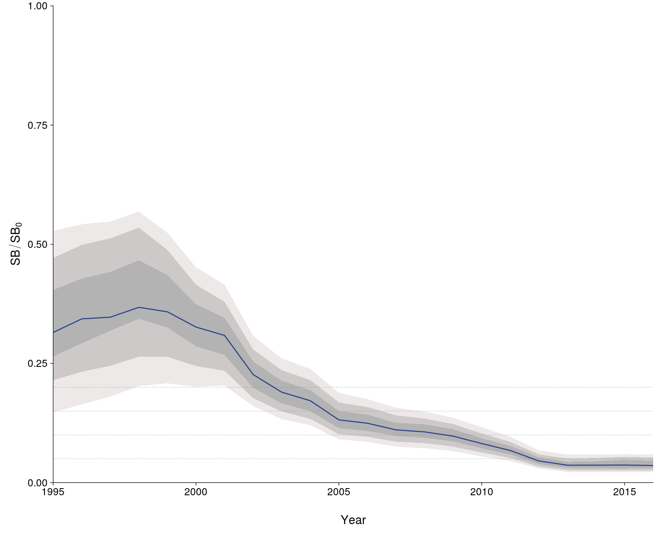
Figure OCS-04: Median estimates of depletion in spawning biomass over all (weighted) grid runs, with 2.5th -97.5th, 10th-90th and 25th -75th quantile intervals. Horizontal grey lines are placed at intervals of 5% in the lower part of the graph to aid visualization.

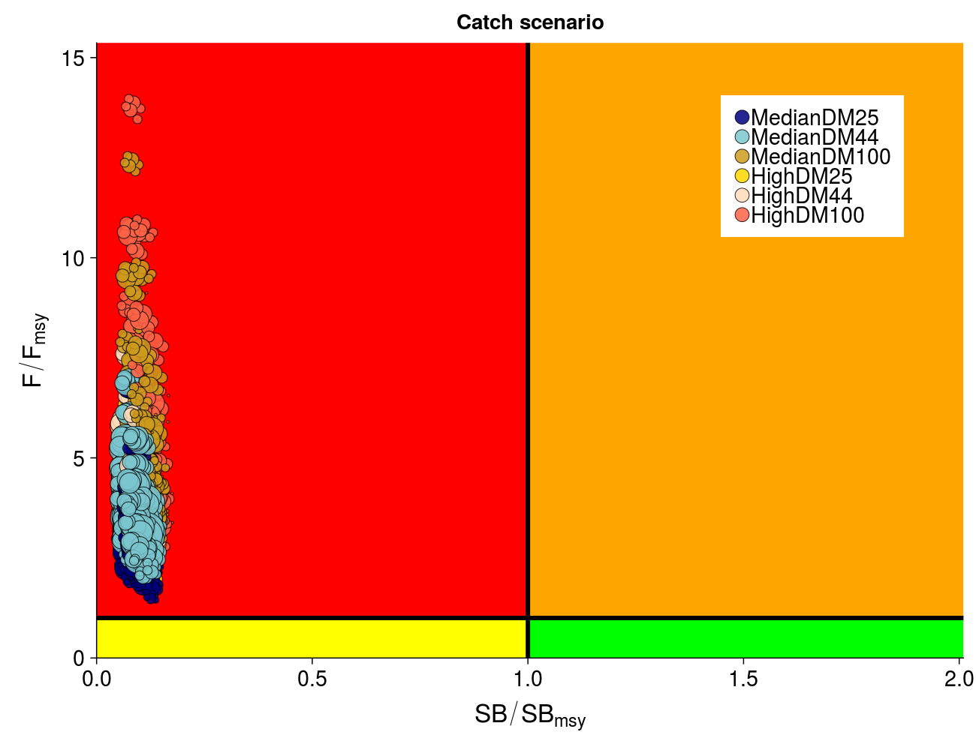
Figure OCS-05: Kobe plot summarizing recent status (2013-2015) for each of the (weighted) models in the structural uncertainty grid, based on SB/SB_{MSY} and F/F_{MSY}. The stock is considered to be overfished when SB/SB_{MSY} > 1 and undergoing overfishing when F/F_{MSY} > 1. The points are coloured according to the catch scenario that was used as input to the individual grid run. The size of the circle relates to the weight of that particular model run.

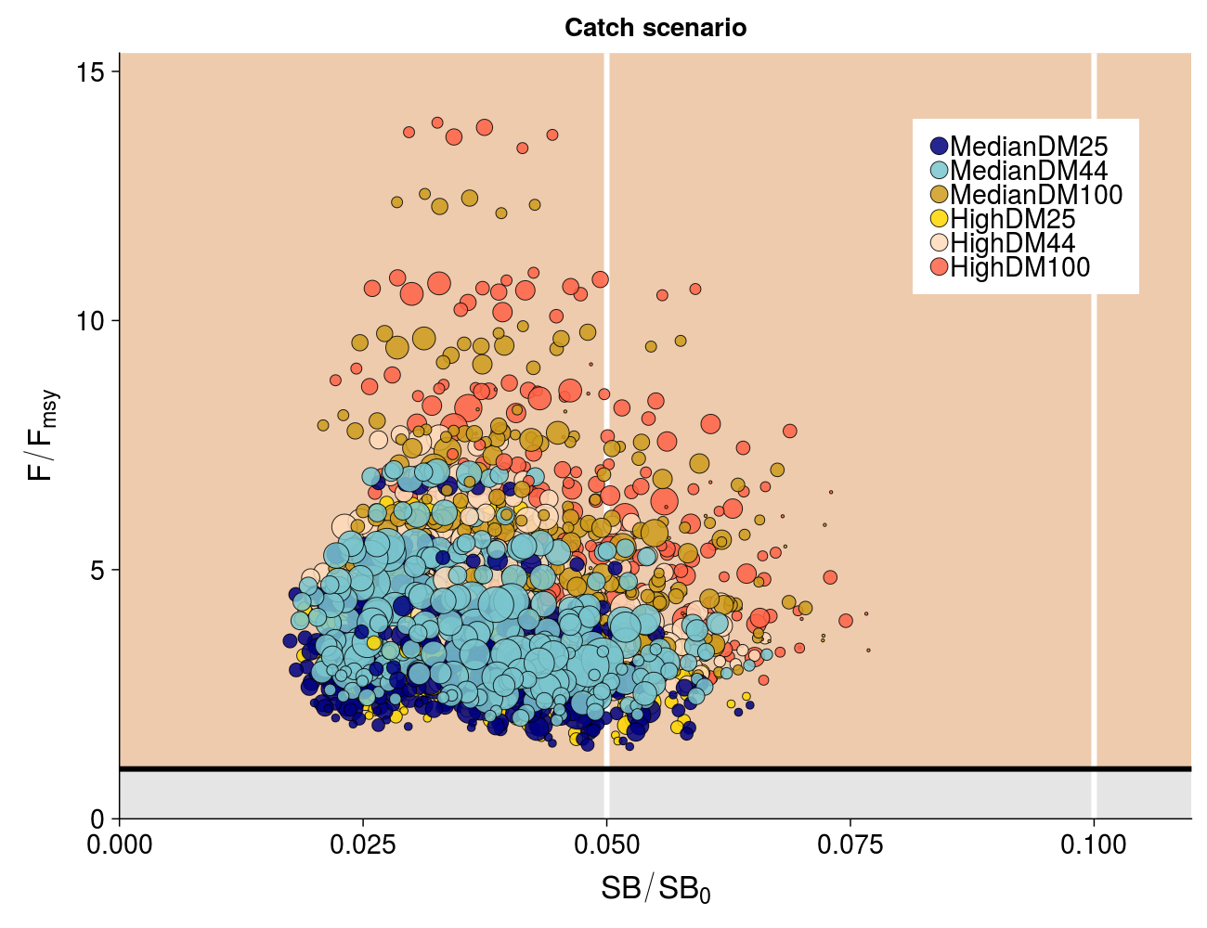
Figure OCS-06: Panel plot summarizing recent stock status (2013-2015) for each of the weighted models in the structural uncertainty grid for SB/SB₀ and F/F_{MSY}, noting no limit or target reference points have been adopted for oceanic whitetip shark. The stock is considered to be undergoing overfishing when F/F_{MSY} > 1 (beige zone). The SB/SB₀ axis was scaled to span the range of depletion values. Guidelines were added in white at 0.5SB/SB₀ and 0.1SB/SB₀. The points are coloured according to the catch scenario that was used as input to the individual grid run. The size of the circle relates to the weight of that particular model run.

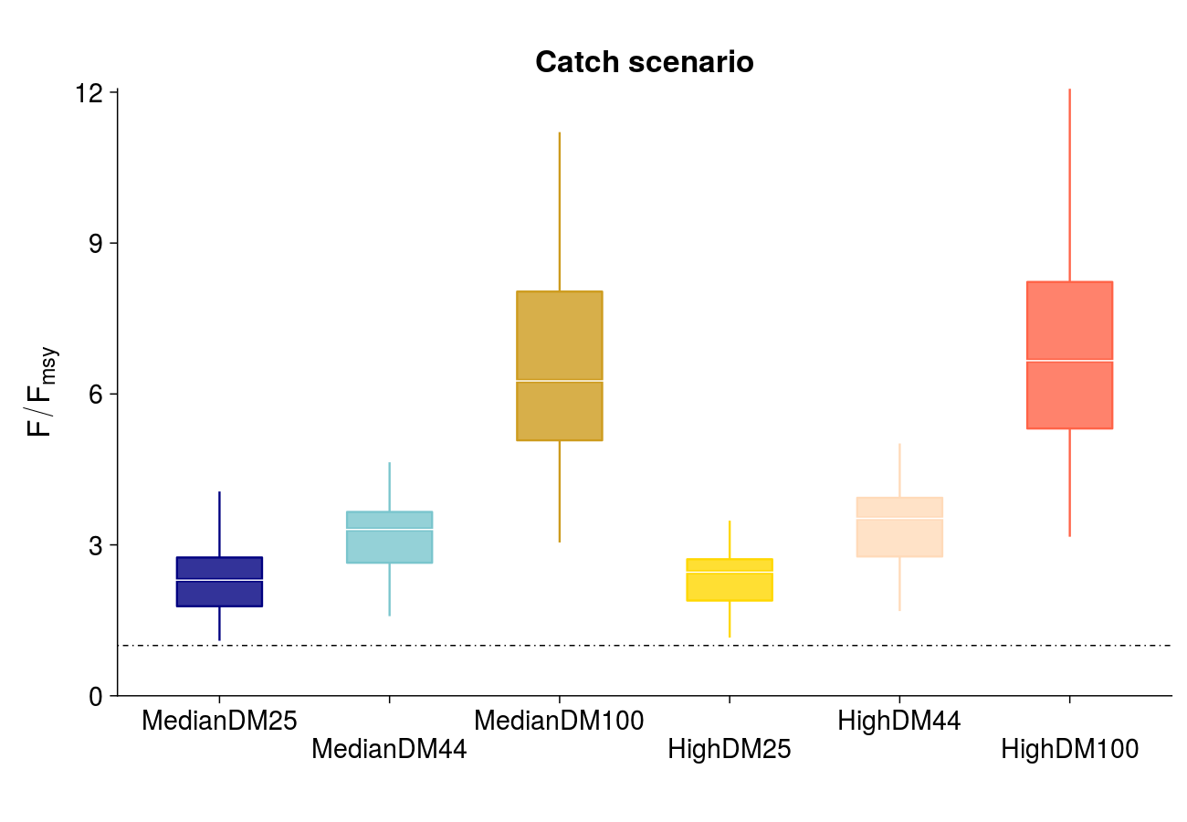
Figure OCS-07: Median (white bar) and inter-quartile bounds (box) for F/F_{MSY} in the final year of the assessment (2016) under the 6 catch scenarios used in the structural uncertainty axis. The catch scenarios included baseline and high levels of catches with 3 scenarios of discard mortality (25%, 43.75% and 100%). The whiskers extend to 1.5 times the interquartile range.

    - Silky shark (Carcharhinus falciformis)

      - Research and information

- The last stock assessment was conducted in 2018 and there was no new information.
      - Provision of scientific information

a. Stock status and trends

- SC15 noted that no stock assessments were conducted for silky shark in 2019. Therefore, the stock status descriptions from SC14 are still current for silky shark. For further information on the stock status and trends from SC14, please see https://www.wcpfc.int/node/32155. Updated information on catches was not compiled for and reviewed by SC15.

b. Management advice and implications

- SC15 noted that no management advice has been provided since SC14 for silky shark. Therefore, previous advice should be maintained, pending a new assessment or other new information. For further information on the management advice and implications from SC14, please see https://www.wcpfc.int/node/32155.
    - South Pacific blue shark (Prionace glauca)

      - Research and information

- The theme Convener noted SC15-SA-IP-14 Data preparation for Southeast Pacific blue and shortfin mako sharks.

      - Provision of scientific information

a. Stock status and trends

- SC15 noted that no stock assessments were conducted for South Pacific blue shark in 2019. Therefore, the stock status descriptions from SC13 are still current for South Pacific blue shark. For further information on the stock status and trends from SC13, please see https://www.wcpfc.int/node/29904. Updated information on catches was not compiled for and reviewed by SC15.

b. Management advice and implications

- SC15 noted that no management advice has been provided since SC13 for north Pacific blue shark. Therefore, previous advice should be maintained, pending a new assessment or other new information. For further information on the management advice and implications from SC13, please see https://www.wcpfc.int/node/29904

    - North Pacific blue shark (Prionace glauca)

      - Research and information

- The last stock assessment was conducted in 2017 and there was no new information.
      - Provision of scientific information

a. Stock status and trends

- SC15 noted that no stock assessments were conducted for Pacific bigeye thresher shark in 2019. Therefore, the stock status descriptions from SC13 are still current for Pacific bigeye thresher shark. For further information on the stock status and trends from SC13, please see https://www.wcpfc.int/node/29904. Updated information on catches was not compiled for and reviewed by SC15.

b. Management advice and implications

- SC15 noted that no management advice has been provided since SC13 for north Pacific blue shark. Therefore, previous advice should be maintained, pending a new assessment or other new information. For further information on the management advice and implications from SC13, please see https://www.wcpfc.int/node/29904

    - North Pacific shortfin mako shark (Isurus oxyrinchus)

      - Research and information

- The last stock assessment was conducted in 2018 and there was no new information.
      - Provision of Scientific Information

a. Stock status and trends

- SC15 noted that no stock assessments were conducted for North Pacific shortfin mako shark in 2019. Therefore, the stock status descriptions from SC14 are still current for North Pacific shortfin mako shark. For further information on the stock status and trends from SC14, please see https://www.wcpfc.int/node/32155. Updated information on catches was not compiled for and reviewed by SC15.

b. Management Advice and implications

- SC15 noted that no management advice has been provided since SC14 for North Pacific shortfin mako shark. Therefore, previous advice should be maintained, pending a new assessment or other new information. For further information on the management advice and implications from SC14, please see https://www.wcpfc.int/node/32155.

    - Pacific bigeye thresher shark (Alopias superciliosus)

      - Research and information

- A Pacific-wide sustainability risk assessment of bigeye thresher shark was conducted in 2017. SC15 received no new information.

      - Provision of scientific information

a. Stock status and trends
- SC15 noted that no stock assessments were conducted for Pacific bigeye thresher shark in 2019. Therefore, the stock status descriptions from SC13 are still current for Pacific bigeye thresher shark. For further information on the stock status and trends from SC13, please see https://www.wcpfc.int/node/29904. Updated information on catches was not compiled for and reviewed by SC15.

b. Management advice and implications
- SC15 noted that no management advice has been provided since SC13 for Pacific bigeye thresher shark. Therefore, previous advice should be maintained, pending a new assessment or other new information. For further information on the management advice and implications from SC13, please see https://www.wcpfc.int/node/29904

    - Porbeagle shark (Lamna nasus)

      - Research and information

- A Southern Hemisphere stock status assessment of porbeagle shark was undertaken in 2017. SC 15 received no new information.

      - Provision of scientific information

a. Stock status and trends

- SC15 noted that no stock assessments were conducted for southern porbeagle shark in 2019. Therefore, the stock status descriptions from SC13 are still current for southern porbeagle shark. For further information on the stock status and trends from SC13, please see https://www.wcpfc.int/node/29904. Updated information on catches was not compiled for and reviewed by SC15.

b. Management advice and implications
- SC15 noted that no management advice has been provided since SC13 for southern porbeagle shark. Therefore, previous advice should be maintained, pending a new assessment or other new information. For further information on the management advice and implications from SC13, please see https://www.wcpfc.int/node/29904..

    - Whale shark (Rhincodon typus)

      - Review of research and information

- The last assessment was conducted in 2018 and there was no new information.
      - Provision of scientific information

- Stock status and trends

- SC15 noted that no stock assessments were conducted for whale shark in 2019. Therefore, the stock status descriptions from SC14 are still current for whale shark. For further information on the stock status and trends from SC14, please see https://www.wcpfc.int/node/32155. Updated information on catches was not compiled for and reviewed by SC15.

b. Management advice and implications

- SC15 noted that no management advice has been provided since SC14 for whale shark. Therefore, previous advice should be maintained, pending a new assessment or other new information. For further information on the management advice and implications from SC14, please see https://www.wcpfc.int/node/32155.

  - WCPO billfishes

    - South Pacific swordfish (Xiphias gladius)

      - Research and information

- SC15 noted that the last South Pacific swordfish stock assessment was conducted in 2017.

      - Provision of scientific information

a. Stock status and trends

- SC15 noted that no stock assessments were conducted for South Pacific swordfish in 2019. Therefore, the stock status descriptions from SC13 are still current for South Pacific swordfish. For further information on the stock status and trends from SC13, please see https://www.wcpfc.int/node/29904. Updated information on catches was compiled but not reviewed by SC15.

b. Management advice and implications

- SC15 noted that no management advice has been provided since SC13 for south Pacific swordfish. Therefore, previous advice should be maintained, pending a new assessment or other new information. For further information on the management advice and implications from SC13, please see https://www.wcpfc.int/node/29904.

    - Southwest Pacific striped marlin (Kajikia audax)

      - Research and information

- N. Ducharme-Barth (SPC-OFP) presented SC15-SA-WP-07 Stock assessment of SW Pacific striped marlin in the WCPO, which described the 2019 stock assessment of striped marlin Kajikia audax. An additional 6 years of data were available since the previous assessment in 2012, and the model extends through the end of 2017. New developments to the stock assessment including addressing the recommendations of the 2012 stock assessment report, revision and incorporation of new data sources such as maturity-at-length, exploration of model uncertainty, and improving the diagnostics of previous assessments. Key changes made in the progression from the 2012 reference case to the 2019 diagnostic case model include:
- Updating all data through to the end of 2017.
- Using standardized CPUE for the Japanese and Chinese Taipei longline fisheries calculated using a geostatistical model.
- Updating the biological information on maturity and defining this process as a function of length and not age.
- Uncertainty in the stock status and key reference points was high, though a consensus of models indicated a clear, declining trend in stock status. This decline was informed by a decline in the median weight in the New Zealand recreational fishery, as well as a decline in the CPUE index. As noted in the previous assessment, lack of knowledge on key biological processes (natural mortality and steepness) contributed to the overall level of uncertainty in the assessment. Three different, fixed levels were considered for the baseline level of average annual natural mortality (0.3, 0.4, and 0.5) and steepness (0.65, 0.8, and 0.95) in the structural uncertainty grid. Across grid runs, models assuming higher values for either of these two quantities generally estimated a more optimistic stock status. Lack of observations of small individuals did not allow these age-specific processes to be well estimated. Appropriate levels for these values are informed by meta-analyses based on life-history theory, which generally rely heavily on the growth relationship. A high research priority should be placed on verifying the aging method used to derive the growth relationship in order to inform levels of biological uncertainty assumed in the grid. Efforts should also be made to improve sampling of smaller individuals. If a spatially explicit model is to be considered for this assessment, improving upon the “areas-as-fleets” approach taken, estimates of movement (>180 days) from multiple-different areas in the model region will need to be developed.

- The general conclusions of this assessment are as follows:
- Consistent with the findings of the previous Southwest Pacific striped marlin assessments, persistent declines in biomass and spawning biomass were estimated since the start of the assessment period. Recent years show a slight improvement in stock status relative to a low point at the beginning of the current decade (2010s).
- The negative trend in recruitment identified in the previous two stock assessments remains a feature of the current model. Recruitment variability (RV) appears to have reduced in the last decade as spawning stock biomass has decreased.
- Fishing mortality has gradually increased over time. The rate of increase accelerated for both the juvenile and adult components in the early 2000s before peaking at the beginning of the current decade (2010s). Fishing mortality is estimated to have declined since then.
- With respect to MSY-based reference points, 69% of runs estimate recent spawning biomass to be less than the spawning biomass that supports MSY.
- In terms of spawning biomass depletion, 50% of runs indicate that recent spawning biomass is at less than 20% of the unfished level of spawning biomass.
- With respect to fishing mortality, 56% of model runs estimate recent levels of fishing mortality to be less than the fishing mortality that would result in MSY.
- This assessment concludes that the Southwest Pacific striped marlin stock is likely overfished, and close to undergoing overfishing according to MSY-based reference points.

Discussion

- Australia thanked the presenter for their work and presentation. They inquired if any model runs down-weighted the New Zealand size data, given that it is a very small part of the total catch? In reply SPC indicated that all size data was down-weighted in some model runs, but they did not consider down-weighting just the New Zealand data. Australia inquired whether the model runs that were excluded from the grid contained certain axis values, or did the excluded runs occur across all grid values? SPC stated that some axis combinations resulted in fewer runs being retained. When the relative composition weight was down-weighted, more of those runs were excluded; this was also true for higher values of recruitment CV, and fitting to the Australian longline fishery in subregion 2. Australia observed the weight component in the likelihood is probably the most influential, but noted this needs good conversion of length/weight and length/age, and stated that in this light it is good to see project 90 is being undertaken. Given the influence of the weight data on the model fits, and the need to accurately convert weight to length and then to age, they asked if a sensitivity analysis on the use of different conversion factors could be useful? SPC stated they did not explore alternate weight conversion factors; if the factors used caused a difference, it could be useful, but that is uncertain without performing the analysis.

- The United States stated that a structural uncertainty gird that excludes about 40% of models is a serious concern, and suggests there are issues with the development of the axes. They noted there was a change of maturity from 2012-2019 (in 2012 L50 median length/maturity was about 150 cm, while in 2019 L50 > 200 cm), which may result from a mis-identification of post-spawning individuals as they mature, as well as a small geographic area being sampled. They suggested this is a serious issue in terms of approximating the biology of this species, and asked what the basis of the maturity ogive is, relative to 2012. SPC stated that the 2012 maturity ogive was based on North Pacific fish in the 1970s and 1980s. The 2019 ogive is informed by a study conducted by Keller Kopf in 2012 for Southwest Pacific striped marlin, based on a wide area in the stock assessment region, and which also incorporated the sex ratio at length (something that was not done in the 2012 assessment). The sex ratio was modified because SPC felt that sex ratio at lower age was unrealistic. Looking at the maturity curve from the 2012 assessment and the maturity at length used to create the maturity ogive for the current assessment, the difference is not so large. The 2012 curve was not based on striped marlin from the Southwest Pacific; there are genetic differences in striped marlin between North and South Pacific, and therefore the 2019 value was used. The United States inquired why not refit the recruitment penalty (or sigma R), stating that an empirical estimate of the recruitment penalty (sigma R) could be made, and then used in the model run. They inquired if SPC considered refitting with a new sigma R? SPC stated that for this stock assessment they did not consider refitting for sigma R. Recruitments relative to the mean trend for all three recruitment CVs when rescaled were identical, and the result could have been unchanged. Regarding results across the grid with respect to that axis: there was not a large difference across axes. The model does not seem affected greatly by recruitment CV in this case. The United States noted the steep recent decline in adult fishing mortality (50% reduction) and inquired why this would happen? SPC noted a decrease in catch in the recent period, which could contribute, as could the fixing of recruitments at the mean level for the last 2 years.

- Japan stated that with respect to the diagnostic case there was a conflict between the CPUE and length composition data, and suggested examining the data weighting and fishery definition in next stock assessment. In reply to a query from Japan regarding the spatial distribution of the catch, SPC stated their understanding that younger striped marlin are present in the equatorial region, with larger individuals farther south in more temperate regions. They suggested striped marlin in the South Pacific may be targeted by fisheries other than Japan’s.

- The EU referenced the issue raised by Australia regarding data for New Zealand, and inquired whether this was a local or systemic issue. SPC stated that tagged fish undertake large and rapid movement after tagging, with much movement and dispersal, with low potential for localized depletion. The EU observed that the S/R relationship seemed higher than in other stock assessments and inquired why. SPC stated that there was a higher penalty in the fit to the S/R relationship, explaining that a decision was made in 2012 to improve the stability of the stock assessment, and remove the trends in recruitments that were seen. They tried different recruitment CV values to test this assumption.

- NZ on behalf of FFA members, notes with concern the continued apparent decline in this stock, in particular the persisting negative trend in recruitment as the biomass has decreased. They drew specific attention to the results of the assessment that indicate spawning biomass is likely less than SB_{MSY} and that 50% of model runs indicate spawning biomass is below B_{lim}, or 20% of the unfished spawning biomass, a situation which would normally trigger an appropriate response for any species managed by the Commission. They also noted that the authors identify better information from the recreational sector as a possible critical input to the assessment of this largely bycatch species and encourage those CCMs with recreational striped marlin fisheries to take steps to improve collection of and access to this data for assessment purposes.

- Chinese Taipei noted there were large catches early in the time series, and inquired whether the authors investigated different configurations in the early time period to see and if they impact the results. The presenter stated this was addressed in the report. The 2019 stock assessment workshop noted the large catches in the 1950s, and SPC investigated if this had too large an impact, but found there was no difference in terminal stock estimates when they started the model in 1955 following those large catches. Japan stated that for the CPUE standardization there was no pre-1975 information, so care was needed in analysing early impacts.

- United States stated that growth, maturity and natural mortality life history parameters for the species are all uncertain, and recommended that SC allocate resources to developing a better understanding of the life history parameters of Southwest Pacific striped marlin.

- Australia referenced Figure 23 of SC15-SA-WP-07 (Catchability, panels 9 and 10 for recreational sectors in Australia and NZ), stating that since 1990 there was a significant increase in catchability, but in recent years there appears to be a decline. They inquired regarding the impact of gear and any understanding of changes in recreational sector gear over time. The presenter stated their understanding was that there have been technical improvements in gear, and in means to find striped marlin, just as there are in the commercial fishery, and thus the increase in catchability is not unexpected.

- The theme convener noted that other relevant information was presented in SC15-SA-IP-07 Background analyses for the 2019 stock assessment of SW Pacific striped marlin, SC15-SA-IP-16 Characterisation of New Zealand striped marlin fisheries, and SC15-SA-IP-18 Preliminary ageing of striped marlin in the southwest Pacific using otoliths.

      - Provision of scientific information

a. Stock status and trends
- The description of the updated structural sensitivity grid used to characterize uncertainty in the assessment is provided in Table SMLS-01. The spatial structure used in the assessment model is shown in Figure SMLS-01, with sub-regions used to define fisheries shown. Catch trend data is presented in Figure SMLS-02. Estimated annual average recruitment, spawning biomass, and total biomass from the diagnostic case are shown in Figure SMLS-03. Fishing mortality and depletion estimated from the diagnostic case are shown in Figures SMLS-04 and SMLS-05, respectively. The median and 80 percent quantile trajectories of the fishing depletion for models in the structural uncertainty across the grid axes in Table SMLS-01 is shown in Figure SMLS-6.

- The Majuro plot summarizing the results for each of the models in the structural uncertainty grid retained for management advice are represented in Figure SMLS-07. Figure SMLS-08 presents the Kobe plot summarizing the results for each of the models in the structural uncertainty grid retained for management advice.

- SC15 noted that the median of recent spawning biomass depletion relative to the unfished condition was (SB_{recent}/SB_{F=0}) = 0.198, with a probable range of 0.093 to 0.464 (80% probable range), and there was a roughly 50.33% probability (151 out of 300 models) that the recent spawning biomass depletion relative to the unfished condition was below the LRP adopted for tunas (SB_{recent}/SB_{F=0} = 0.2). The median estimate (0.198) is below that estimated from the previous (2012) assessment (SB₂₀₀₆₋₂₀₀₉/SB_{F=0} = 0.34) (see SC8-SA-WP-05), noting the differences in the use of the grid in the two assessments and different model assumptions. In the current assessment the feasible grid consisted of 300 models (186 model runs removed from 486 grid models).

- SC15 noted that the median of recent spawning biomass relative to the spawning biomass at MSY was (SB_{recent}/SB_{MSY}) = 0.737 with a probable range of 0.334 to 1.635 (80% probable range), and there was a roughly 68.66% probability (206 out of 300 models) that the recent spawning biomass depletion was below the spawning biomass at MSY. The median estimate (0.737) is below that estimated from the previous (2012) assessment (SB_{current}/SB_{MSY} = 0.87) (see SC8-SA-WP-05), noting the differences between the two assessments.

- SC15 noted that the median of relative recent fishing mortality was (F_{recent}/F_{MSY} = 0.911) with an 80% probability interval of 0.313 to 1.891, and there was a roughly 44.3% probability (133 out of 300 models) that the recent fishing mortality was above F_{MSY}. The median estimate (0.911) is above that estimated from the previous assessment (F_{current}/F_{MSY} = 0.81) (see SC8-SA-WP-05), noting the differences in the use of the grid in the two assessments.

Table SMLS-02. Description of the structural sensitivity grid used to characterize uncertainty in the assessment. The star denotes the level assumed in the diagnostic case.

Table SMLS-02. Summary reference points over the models in the structural uncertainty grid.

Figure SMLS-01. Single region spatial structure used in the 2019 stock assessment.

Figure SMLS-02. Time series of total annual catch (1000s mt) by fishery group over the full assessment period.
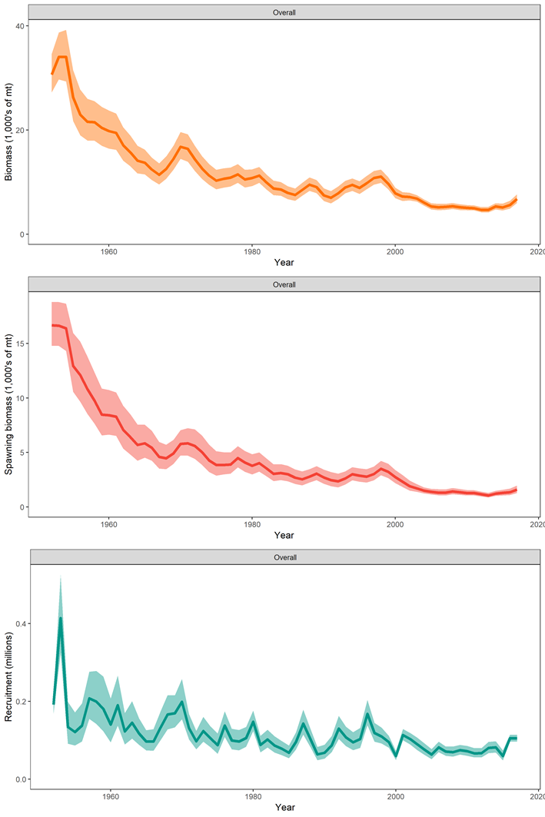
Figure SMLS-03. Estimated annual average total biomass, spawning biomass, and recruitment for the diagnostic model. Shaded region gives ± 2 standard deviations (i.e., 95% CI).
Figure SMLS-04. Estimated annual average juvenile and adult fishing mortality for the diagnostic model.

Figure SMLS-05. Estimates in reduction in spawning biomass and total biomass due to fishery impact for the diagnostic case model.

Figure SMLS-06. Plot showing the trajectories of spawning biomass depletion for the model runs included in the structural uncertainty grid described in Table SMLS-01. Grey horizontal lines indicate 50% and 20% levels of depletion. On the right of the depletion is the median point estimate of the recent level reference point with the bar indicating the 80th percentile.

Figure SMLS-06bis. Plot showing the trajectories of fishing mortality for the model runs included in the structural uncertainty grid described in Table SMLS-01. Grey horizontal lines indicate F_{MSY}. On the right of the depletion is the median point estimate of the recent level reference point with the bar indicating the 80th percentile.

Figure SMLS-07. Majuro plot for the recent spawning biomass (2014 – 2017) summarizing the results for each of the models in the structural uncertainty grid. The plots represent estimates of stock status in terms of spawning biomass depletion and fishing mortality, and marginal distributions of each are presented. The blue square is the median of the grid.
Figure SMLS-08. Kobe plot for the recent spawning biomass (2014 – 2017) summarizing the results for each of the models in the structural uncertainty grid. The plots represent estimates of stock status in terms of spawning biomass relative to the spawning biomass that produces MSY and fishing mortality, and marginal distributions of each are presented. The blue square is the median of the grid.

b. Management Advice and implications
- SC15 noted that there are no agreed limit reference points for the WCPO billfish. However, SC15 also noted that based on the adopted uncertainty grid, the southwest Pacific striped marlin assessment results indicate that the stock is likely overfished, and close to undergoing overfishing according to MSY-based reference points. SC15 recommends that WCPFC16 identify an appropriate limit reference point for this stock. Key management quantities can be found in Table SMLS-02. The recent spawning biomass depletion relative to the unfished condition was close to the LRP adopted for tunas (SBrecent/SBF=0 = 0.2).

- SC15 noted that recent catches are approximately half the MSY, and that recent fishing mortality is slightly less than the fishing mortality that would result in MSY.

- SC15 recommended SC16 use stochastic stock projections, including the expansion of the geographic scope of CMM2006-04 by assuming average fishing effort during 2000-2004 by CCMs and zero fishing mortality in assessment region 1, to evaluate the potential long-term performance of the CMM.

- SC15 recommended that WCPFC16 consider measures to reduce the overall catch of this stock, including through the expansion of the geographical scope of CMM2006-04, in order to cover the distribution range of the stock.

c. Research recommendations

- The following research activities were recommended by SC15 in order to progress the assessment of Southwestern Pacific striped marlin.
- Improved estimates of life history parameters including growth, maturity, and natural mortality. Verify the aging method used to derive the growth relationship in order to inform meta analyses for M and steepness specific to SWPO striped marlin. Additionally, efforts should be made to increase sampling of smaller individuals.
- Better estimates of striped marlin movement (>180 days) are needed to characterize mixing rates across model region in order to develop spatially explicit model structure and improve upon “areas as fleets” approach.
- Improved estimates of conversion factors (such as weight-to-length and length-to-length) are needed, together with improved length-at-age estimates to better inform the data inputs used in the stock assessment.
- Conduct sensitivities analyses with respect to the uncertainties in conversion factors used in the stock assessment and assess whether this should be included as an axis in the structural uncertainty grid.
- Develop better estimates of historical catch (1950-1960) to resolve the potential issue of misidentification caused by merging the billfishes datasets.

    - North Pacific striped marlin (Kajikia audax)

      - Research and information

- H. Ijima (Japan), chair of the ISC Billfish Working Group (BILLWG), introduced SC15-SA-WP-09 Stock Assessment Report for Striped Marlin (Kajikia audax) in the Western and Central North Pacific Ocean through 2017, and presented the benchmark stock assessment for the Western and Central North Pacific Ocean (WCNPO) striped marlin (Kajikia audax) stock conducted in 2019 by the BILLWG. The 2019 assessment consisted of applying a Stock Synthesis model with the best- available catch, abundance index, and length composition data for 1975-2017. The results indicated that biomass (age 1 and older) for the WCNPO striped marlin stock decreased from 17,000 mt in 1975 to 6,000 mt in 2017. Estimated fishing mortality averaged F=0.97 during 1975-1994 with a range of 0.60 to 1.59, peaked at F=1.71 year⁻¹ in 2001, and declined sharply to F=0.64 year⁻¹ in the most recent years (2015-2017). Fishing mortality has fluctuated around FMSY since 2013. Compared to MSY-based reference points, the current spawning biomass (average for 2015-2017) was 76% below SSB_{MSY} and the current fishing mortality (average for ages 3 – 12 in 2015-2017) was 7% above F_{MSY}. The base case model indicated that under current conditions the WCNPO striped marlin stock was overfished and was subject to overfishing relative to MSY-based reference points.
Discussion

- Japan thanked the ISC for the work and the presentation. They commented regarding slide 32 of the presentation, stating that the sensitivity analysis and growth curve results of Kobe plot changes significantly and becomes optimistic, and inquired if the BILLWG planned to revise the growth curve in the next stock assessment. The presenter indicated the BILLWG would examine the growth curve and possibly revise it for the next stock assessment.

- Marshall Islands on behalf of FFA members thanked the ISC BILLWG for the assessment. FFA members expressed concern over the worsening state of the species, noting that under the new assessment, the WNCPO striped marlin stock evaluated relative to MSY-based reference points was overfished, and overfishing was occurring. The 2017 spawning stock biomass is 62% below SB_{MSY} and the 2012-2017 fishing mortality exceeds F_{MSY} by 7%. These stated that trends are disturbing and clearly CMM2010-01 is not working in reducing total catch of striped marlin north of the equator.

- Australia noted that there was no figure in the SC15-SA-WP-09 showing the S/R relationship, but given the trends shown in SSB and recruitment they inferred that there is a reasonable relationship between SSB and recruitment similar to that estimated for the Southwest Pacific striped marlin (described in SC15-SA-WP-07). If so, while the stock biomass remains low, and until it rebuilds, one would expect lower than average recruitments to persist over the near future indicating that any management advice for rebuilding this stock should be based on the low recruitment projection results. Australia further indicated that they were having some trouble reconciling the large decline estimated to have occurred in the SSB between 1993-1995 and the time-series of other indicators. As shown in Fig 2, the catch between 1975 and 1995 was variable but stable around an average of 7500 mt. During this period SSB increased (Fig 18) and fishing mortality decreased to F_{MSY} (Fig 20), suggesting that over that 20-year period a catch of that size appeared to be sustainable. However, between 1993 and 1996 the SSB is estimated to have halved and then remained relatively stable. Since 1996 catches have declined from around 6000 mt to 3000 mt or less but with no recovery in SSB. They noted it was strange that high catches were maintained for around 20 years with no decline in the SSB, but since 1995 the stock biomass has halved and can only able to sustain a much lower catch. They suggested it appears that something happened during 1990-1995. Australia noted that as shown in Fig 3 there is only one pre-1995 CPUE time-series — the JP-Q3-A1 fleet (S2) — although this time-series is broken between 1993 and 1994, the period when the SSB is estimated to have suddenly declined. These two CPUE time-series have similar absolute values between 1990-2000, and if used as an index of abundance do not seem to indicate a sudden change in biomass. Based on these observations, the presenter was asked to identify the data input(s) that influenced the large decline estimated in SSB around 1994. The presenter noted the model has a strong conflict between the early and late periods. ISC divided the data set between pre- and post-1994. After 1994 it was easier to fit CPUE. A higher biomass is required for early dates (pre-1994). Australia stated that the catch time series is driving that spawning biomass, which increased over a period of high catches. But noting the significant decline in biomass with decreasing catch, they asked if there is there a discontinuity in how SB is being reconciled over that time period? The presenter stated that in the early period catch (including Japanese catch data) may be overestimated. Australia and the authors agreed to continue their discussion privately.

- The Marshall Islands, on behalf of FFA members, strongly suggested it was very ill advised to use the long-term recruitment projections for the recovery of the stock, mainly because there has been very low recruitment over the past 20 years, with 34% below the long-term average. They stated that two major CCMs were catching the bulk of this species and FFA members encouraged those CCMs to take the lead in efforts to recover the stock. They noted that North Pacific striped marlin is caught as bycatch in some FFA EEZs north of the equator, and forms an important component of FFA members’ domestic fisheries, including their recreational sector. Therefore, they looked forward to discussions on recommendations for the recovery of the stock, noting the stocks lack agreed RPs, and stringent CMMs to limit catch and reduce fishing mortality to allow rehabilitation of this stock.

- The EU stated they welcomed the opportunity to engage with others in developing guidance for the Commission. They noted WCPFC15 discussed this stock and had strongly encouraged those CCMs whose fleets are catching North Pacific striped marlin to submit a draft rebuilding plan to WCPFC16 for the stock. The EU stated they had hoped that there would be a document developed for this stock to inform SC regarding such a plan, that SC15 could review and commend to the Commission. The presenter stated that SC15-SA-WP-09 was the best available scientific information available from the ISC at present; they indicated the need to devise a growth curve, determine catch data and the boundary of the stock assessment area, and then revise the stock assessment, stating that SC15-SA-WP-09 was an initial result.

      - Provision of scientific information

a. Stock status and trends
- SC15 noted that ISC provided the following conclusions on the stock status of Western and Central North Pacific Striped Marlin:
Estimates of population biomass of the WCNPO MLS fluctuated without trend between 1975 and 1993. The population deceased substantially in 1994 and fluctuated without trend until the present year. Population biomass (age-1 and older) averaged roughly 17,969 mt, or 54% below unfished biomass during the 1975-1993 period and declined to 4,508 mt, or 89% below unfished biomass by 2008. The minimum spawning stock biomass was estimated to be 618 t in 2011 (76% below SSB_{MSY}, the spawning stock biomass to produce MSY, Figure 1a). In 2017, SSB = 981 t and SSB/SSB_{MSY} = 0.38. Fishing mortality on the stock (average F on ages 3-12) has been around FMSY since 2014 (Figure 1b). It averaged roughly 0.64 yr-1 during 2015-2017, or 7% above FMSY and in 2017, F=0.80 yr-1 with a relative fishing mortality of F/F_{MSY} = 1.33 (Table 2). Fishing mortality has been above FMSY in every year except 1984, 1992, and 2016. The predicted value of the spawning potential ratio (SPR, the predicted spawning output at current F as a fraction of unfished spawning output) is estimated to be SPR₂₀₁₅₋₂₀₁₇ = 17% and is approximately equal to the SPR required to produce MSY. Recruitment averaged about 263,000 age-0 recruits between 1994 and 2017, which was 34% below the 1975-2017 average. No target or limit reference points have been established for the WCNPO MLS stock under the auspices of the WCPFC. Despite the relatively large L50/Linf ratio for WCNPO MLS, the stock is expected to be highly productive due to its rapid growth and high resilience to reductions in spawning potential. Recent recruitments have been lower than expected and have been below the long-term trend since 2005. Although fishing mortality has decreased since 2000, due to the prolonged low recruitment and landings of immature fish, the biomass of the stock has remained below MSY. When the status of WCNPO MLS is evaluated relative to MSY-based reference points, the 2017 spawning stock biomass of 981 mt is 62% below SSB_{MSY} (2,604 t) and the 2015-2017 fishing mortality exceeds F_{MSY} by 7%. Therefore, relative to MSY-based reference points, overfishing is occurring and the WCNPO MLS stock is overfished (Figure 2).
Biological reference points were computed for the base case model with Stock Synthesis (Table 1 and Table 2). The point estimate of MSY was 4,946 t. The point estimate of the spawning biomass to produce MSY (adult female biomass, SSB_{MSY}) was 2,604 t. The point estimate of F_{MSY}, the fishing mortality rate to produce MSY (average fishing mortality on ages 3 – 12) was 0.60 and the corresponding equilibrium value of spawning potential ratio at MSY was SPR_{MSY} = 18%.
Stock projections for WCNPO MLS were conducted using the age-structured projection model software AGEPRO. Stochastic projections were conducted using results from the base case model to evaluate the probable impacts of alternative fishing intensities or constant catch quotas on future spawning stock biomass and yield for MLS in the WCNPO. For fishing mortality projections, a standard set of F-based projections were conducted. For catch quota projections, the set of rebuilding projection analyses requested by NC14 were conducted. Two future recruitment scenarios were evaluated (Figure 3 and Figure 4): (1) a short-term recruitment scenario based on resampling the empirical cumulative distribution function of recruitment observed during 2012-2016 and (2) a long-term recruitment scenario based on resampling the empirical cumulative distribution function of recruitment observed during 1975- 2016. The short-term recruitment scenario had an average recruitment of 134,020 age-0 fish and the long-term recruitment mean was 306,989 age-0 fish. The stochastic projections employed model estimates of the multi-fleet, multi-season, size- and age-selectivity, and structural complexity in the assessment model to produce consistent results. Fishing mortality-based projections started in 2018 and continued through 2037 under five levels of fishing mortality and the two recruitment scenarios. The five fishing mortality stock projection scenarios were: 1) F status quo (average F during 2015-2017), 2) F_{MSY}, 3) F at 0.2·SSB₀, 4) FHigh at the highest 3-year average during 1975-2017, and 5) F_{Low} at F_{30%}. For the F-based scenarios, fishing mortality in 2018-2019 was set to be F_{status quo} (0.64) and fishing mortality during 2020-2037 was set to the projected level of F. Catch-based projections also ran from 2018 to 2037 and included seven levels of constant catch for the long-term recruitment scenario and 10 levels of catch for the short-term recruitment scenario. For the catch-based scenarios, catch biomass in 2018-2019 was set to be the status quo catch during 2015-2017 (2,151 t) and annual catches during 2020-2037 were set to the projected catch quota. The ten constant catch stock projection scenarios were: 1) Quota based upon WCPFC CMM10-01, 2) 90% of the quota, 3) 80% of the quota, 4) 70% of the quota, 5) 60% of the quota, 6) 50% of the quota, 7) 40% of the quota, 8) 30% of the quota, 9) 20% of the quota, and 10) 10% of the quota. Results show the projected female spawning stock biomasses and the catch biomasses under each of the scenarios (Table 3, Figure 3 and Figure 4).
- SC15 noted the following stock status from ISC:
Biomass (age 1 and older) for the WCNPO MLS stock decreased from 17,000 t in 1975 to 6,000 t in 2017. Estimated fishing mortality averaged F=0.97 yr-1 during the 1975-1994 period with a range of 0.60 to 1.59 yr-1, peaked at F=1.71 year-1 in 2001, and declined sharply to F=0.64 yr-1 in the most recent years (2015-2017). Fishing mortality has fluctuated around F_{MSY} since 2013. Compared to MSY-based reference points, the current spawning biomass (average for 2015- 2017) was 76% below SSB_{MSY} and the current fishing mortality (average for ages 3 – 12 in 2015-2017) was 7% above F_{MSY}.
Based on these findings, the following information on the status of the WCNPO MLS stock is provided:
- There are no established reference points for WCNPO MLS;
- Results from the base case assessment model show that under current conditions the WCNPO MLS stock is overfished and is subject to overfishing relative to MSY- based reference points (Table 1, Table 2, and Figure 1).
- SC15 noted that the assessment results are sensitive to the growth assumption and the ISC billfish working group (hereafter, WG) chair noted that the WG will attempt to revise the growth curve at the next stock assessment.

- SC15 also highlighted the sharp decline in the stock biomass in the mid-1990s and recommends that ISC further investigate the reasons for this decline.

- Management advice and implications
- SC15 noted that some CCMs expressed concerns that based on the new assessment the WCNPO striped marlin stock was overfished and overfishing was occurring relative to MSY-based reference points.

- SC15 noted that while fishing mortality has declined since 2000 fishing mortality has generally remained above F_{MSY} since the introduction of CMM 2010-01 and the stock biomass continues to remain well below SB_{MSY} and the NC target, while noting that the assessment model overestimate biomass in the terminal years. This is despite the phased reduction of the total catch to 80% of the levels caught in 2000-2003 as prescribed in the CMM. SC15 recommends that WCPFC16 note that further reduction in catch will be required to rebuild the stock to MSY levels and the NC target.

- SC15 also noted that this stock does not have agreed upon limit reference points and measures on catch limits and reductions in fishing mortality to allow rebuilding of this stock.

- SC15 recommends that WCPFC16 consider identifying appropriate limit reference points for WCNPO striped marlin.

- SC15 recommends the WCPFC consider appropriate actions to ensure rebuilding this stock to the NC14 rebuilding target. SC15 noted that if lower than average recruitments persist over the near future the probability of rebuilding the stock would be low, noting that there has been a long-term decline in recruitment since the 1990s. Under the F_{MSY} scenario with short-term recruitment assumptions, the probability of achieving 20%SB₀ in 2027 is <0.5%.

- SC15 noted the following conservation advice from ISC:

The status of the WCNPO striped marlin stock shows evidence of substantial depletion of spawning potential (SSB2017 is 62% below SSBMSY), however fishing mortality has fluctuated around F_{MSY} in the last four years. The WCNPO striped marlin stock has produced average annual yields of around 2,100 t per year since 2012, or about 40% of the MSY catch amount. However, the majority of the catch are likely immature fish. All of the projections show an increasing trend in spawning stock biomass during the 2018-2020 periods, with the exception of the high F scenario under the short-term recruitment scenario. This increasing trend in SSB is due to the 2017 year class, which is estimated from the stock-recruitment curve and is more than twice as large as recent average recruitment.

Based on these findings, the following conservation information is provided:
- Projection results under the long-term recruitment scenario show that the stock has at least a 60% probability of rebuilding to 20%SSB₀, the rebuilding target specified by NC14, by 2022 for all harvest scenarios, with the exception of the highest F scenario (Average F 1975-1977);
- However, if the stock continues to experience recruitment consistent with the short- term recruitment scenario (2012-2016), catches must be reduced to 60% of the WCPFC catch quota from CMM 2010-01 (3,397 t) to 1,359 t in order to achieve a 60% probability of rebuilding to 20%SSB₀=3,610 t4 by 2022. This corresponds to a reduction of roughly 37% from the recent average yield of 2,151 t;
- For the constant catch projection scenarios that were tested, it was notable that all of the projections under the long-term recruitment scenario would be expected to achieve the spawning biomass target by 2020 with probabilities ranging from 61% to 73% and corresponding catch quotas ranging from 3,397 to 1,359 t (Table NMLS-03).
It was also noted that retrospective analyses show that the assessment model appears to overestimate spawning potential in recent years, which may mean the projection results are ecologically optimistic.

Special Comments

The WG achieved a base-case model using the best available data and biological information. However, the WG recognized uncertainty in some assessment inputs including drift gillnet catches and initial catch amounts, life history parameters such as maturation and growth, and stock structure.
Overall, the base case model diagnostics and sensitivity runs show that there are some conflicts in the data (ISC/19/ANNEX/11). When developing a conservation and management measure to rebuild the resource, it is recommended that these issues be recognized and carefully considered, because they affect the perceived stock status and the probabilities and time frame for rebuilding of the WCNPO striped marlin stock.

Research Needs
To improve the stock assessment, the WG recommends continuing model development work, to reduce data conflicts and modeling uncertainties, and re-evaluating and improving input assessment data.
Existing genetic studies suggest regional spawning subgroups of striped marlin throughout the entire Pacific. More research is needed to improve upon knowledge of regional stock structure and regional mixing for incorporation into the stock assessment.

Table NMLS-01. Reported catch (t) used in the stock assessment along with annual estimates of population biomass (age-1 and older, t), female spawning biomass (t), relative female spawning biomass (SSB/SSB_{MSY}), recruitment (thousands of age-0 fish), fishing mortality (average F, ages-3 – 12), relative fishing mortality (F/F_{MSY}), and spawning potential ratio of WCNPO striped marlin.

Table NMLS-02. Estimates of biological reference points along with estimates of fishing mortality (F), spawning stock biomass (SSB), recent average yield (C), and spawning potential ratio (SPR) of WCNPO MLS, derived from the base case model assessment model, where “MSY” indicates reference points based on maximum sustainable yield.
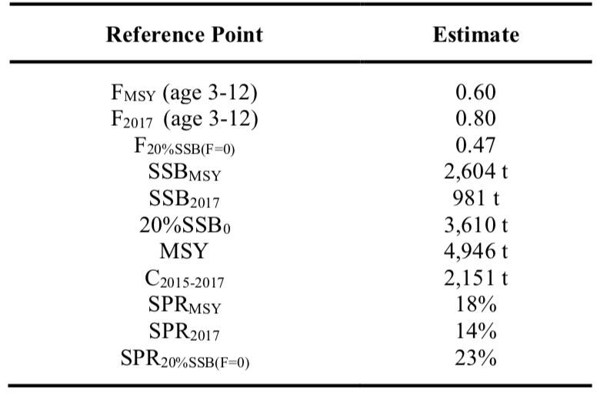

Table NMLS-03. Projected median values of WCNPO striped marlin spawning stock biomass (SSB, t), catch (t), and probability of reaching 20%SSB0 under five constant fishing mortality rate (F) and ten constant catch scenarios during 2018-2037. For scenarios which have a 60% probability of reaching the target of 20%SSB_{F=0}, the year in which this occurs is provided; NA indicates projections that did not meet this criterion. Note that 20%SSB_{F=0} is 3,610 t and SSB_{MSY} is 2,604 t.

Table NMLS-03 (continued).

Table NMLS-03 (continued).

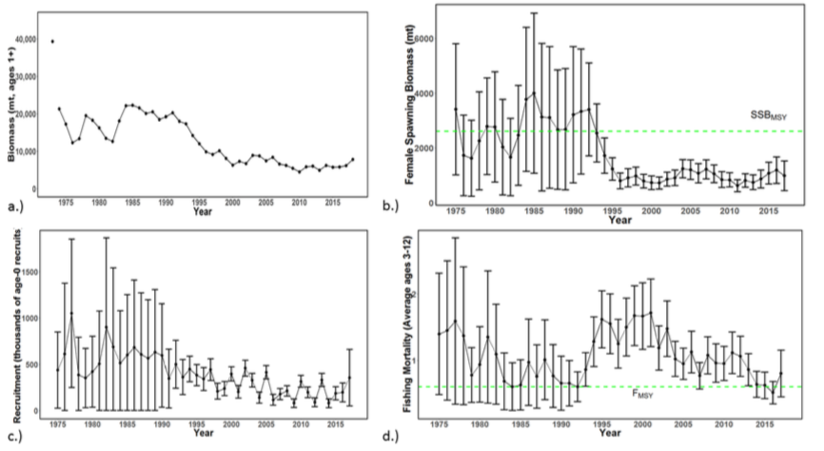
Figure NMLS-01. Time series of estimates of (a) population biomass (age 1+), (b) spawning biomass, (c) recruitment (age-0 fish), and (d) instantaneous fishing mortality (average for age 3-12, year-1) for WCNPO striped marlin (derived from the 2019 stock assessment. The circles represent the maximum likelihood estimates by year for each quantity and the error bars represent the uncertainty of the estimates (95% confidence intervals), green dashed lines indicate SSB_{MSY} and F_{MSY}.
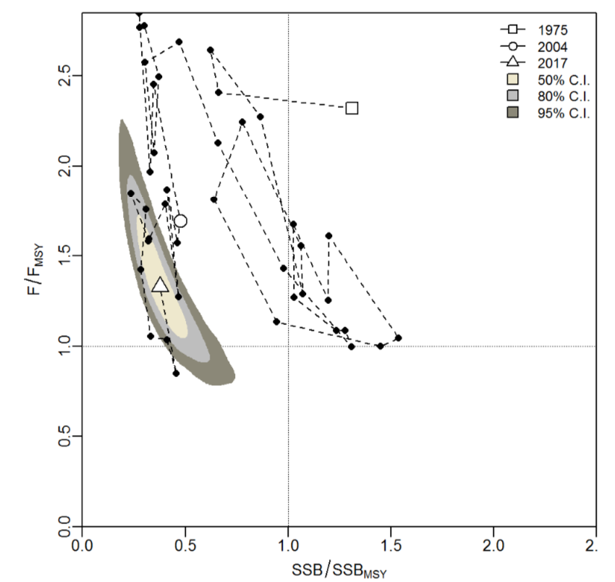
Figure NMLS-02. Kobe plot of the time series of estimates of relative fishing mortality (average of age 3-12) and relative spawning stock biomass of WCNPO striped marlin during 1975-2017. The white square denotes the first year (1975) of the assessment, the white circle denotes 2004, and the white triangle denotes the last year (2017) of the assessment.
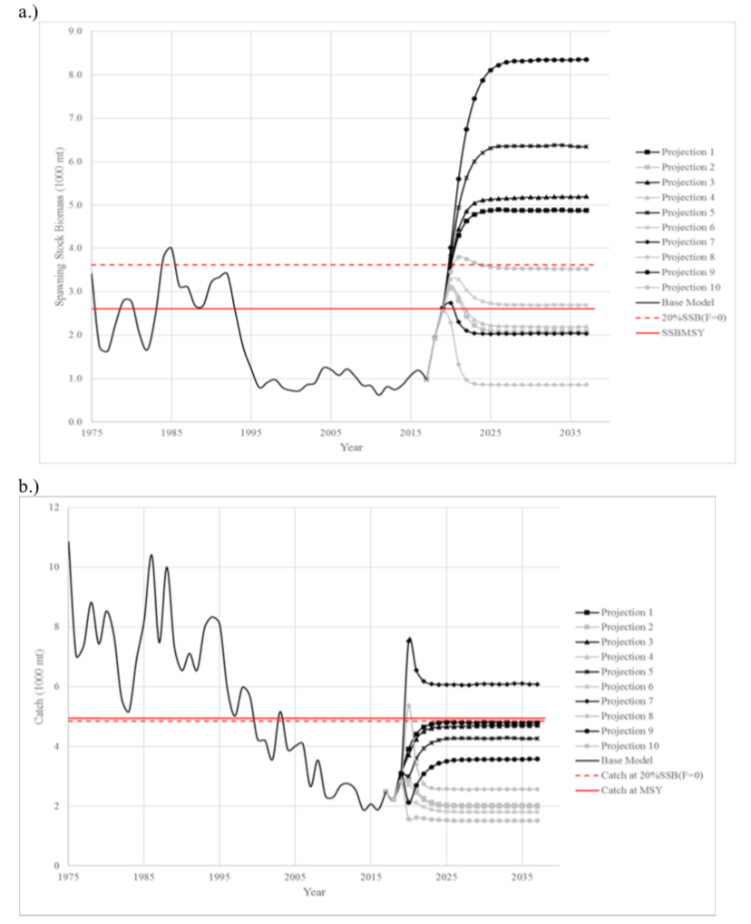
Figure NMLS-03. Historical and projected trajectories of spawning biomass and total catch from the WCNPO striped marlin base case model based upon F scenarios (projection 1-10): (a) projected spawning biomass and (b) projected catch.

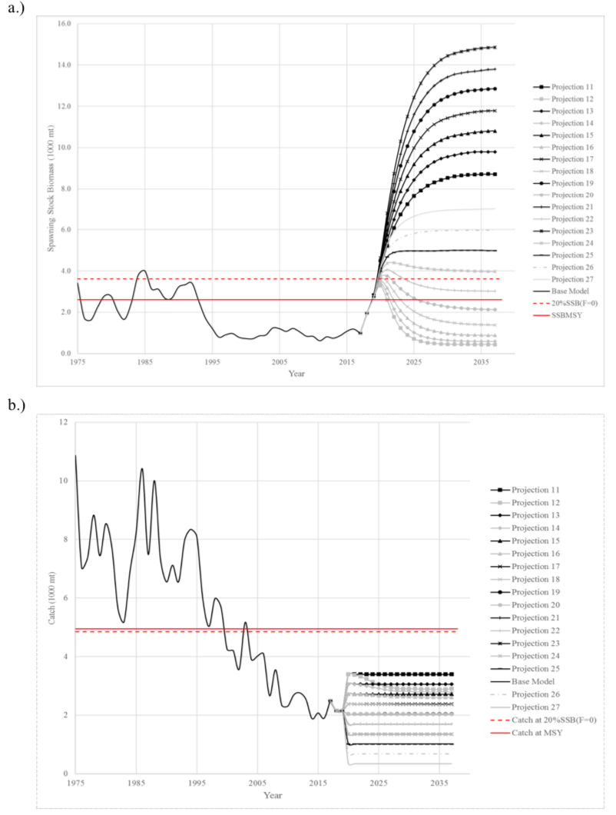
Figure NMLS-04. Historical and projected trajectories of spawning biomass and total catch from the WCNPO striped marlin base case model based upon constant catch scenarios (projections 11-15): (a) projected spawning biomass; and (b) projected catch.

Note on Figure NMLS-3 and Figure NMLS-4: Black lines are the long-term recruitment scenario results; grey lines show the short-term recruitment scenario results. The red dashed line shows the catch or spawning stock biomass at 20%SSB_{F=0} and the solid red line is the catch or spawning stock biomass at SSB_{MSY}. The list of projection scenarios can be found in Table NMLS-03.

    - Pacific blue marlin (Makaira nigricans)

      - Research and information

- The last Pacific blue marlin stock assessment was conducted in 2016.

      - Provision of scientific information

a. Stock status and trends
- SC15 noted that no stock assessments were conducted for Pacific blue marlin in 2018. Therefore, the stock status descriptions from SC12 are still current for Pacific blue marlin. For further information on the stock status and trends from SC12, please see https://www.wcpfc.int/node/27769. Updated information on catches was not compiled for and reviewed by SC15.

b. Management advice and implications
- SC15 noted that no management advice has been provided since SC12 for Pacific blue marlin. Therefore, previous advice should be maintained, pending a new assessment or other new information. For further information on the management advice and implications from SC12, please see https://www.wcpfc.int/node/27769

AGENDA ITEM 5 — MANAGEMENT ISSUES THEME

- The Management Issues (MI) theme was convened by R. Campbell (Australia). The theme convener informed the meeting that 14 working papers would be presented during the seven sessions allocated to the MI theme and that a further 11 information papers had been prepared.

  - Development of harvest strategy framework

    - Progress of the harvest strategy workplan

- The theme convener provided a brief summary of progress-to-date the under the Work Plan for the Adoption of Harvest Strategies under CMM-2014-06 and informed the meeting of the updates to this work-plan agreed by WFCPF15 in December 2018 as outlined in Attachment I of the WCPFC15 Summary Report (and provided as SC15-MI-IP-01).

    - Target reference points

a. Yellowfin and bigeye tuna
- G. Pilling (SPC) introduced SC15-MI-WP-01 Minimum Target Reference Points for WCPO yellowfin and bigeye tuna consistent with alternative LRP risk levels, and multispecies implications. SC14 and WCPFC15 reviewed information on the minimum setting for candidate ‘minimum’ spawning-biomass-depletion-based TRPs for yellowfin and bigeye tuna that if achieved on average, avoided breaching the agreed LRP with a specified level of probability under the current uncertainty framework. SPC re-calculated these median levels of spawning biomass depletion (SB/SB_{F=0}) through stock projections across the relevant structural uncertainty model grids from the latest agreed assessments, and relate them to the most recent stock status estimates, and to paragraphs 12 and 14 of CMM 2018-01. SPC also examined the relative consequences of each minimum TRP level for a stock for the other tropical tuna stocks, including skipjack, across a range of combinations of fishing by the major fishing gears that all achieved that TRP stock level, using deterministic projections. SPC again related these potential multi-species consequences used the general objectives detailed in CMM 2018-01 as guidance (paragraphs 12 to 14). As a new skipjack assessment should be agreed at SC15, SPC qualitatively used the 2016 assessment to infer the TRP implications for skipjack tuna, relative to paragraph 13.

- Maintaining recent fishery conditions achieves the CMM 2018-01 objective for bigeye if recent recruitment holds (but not under long-term recruitments), and marginally fails to meet that objective for yellowfin tuna (slight declines in stock) and skipjack tuna (stock status slightly below the TRP). A yellowfin TRP consistent with a 5% risk implies a small reduction in overall fishery impact, and achieves the CMM 2018-01 objective for yellowfin and bigeye (under recent recruitments, but not under long-term recruitment patterns), and if purse seine effort were reduced slightly to achieve the yellowfin TRP, would have a positive effect on achieving the skipjack interim TRP. For bigeye tuna, if recent recruitments hold, minimum TRPs consistent with all examined levels of risk fails to achieve the objectives for both the bigeye and yellowfin stocks; a TRP corresponding to a less depleted bigeye stock level would be required to do so. If long term recruitments occur, a bigeye TRP consistent with a 5% risk achieves objectives for bigeye and yellowfin, and where levels of reduction occur in the purse seine fishery to achieve that, skipjack tuna would likely meet or exceed its interim TRP. A number of assumptions underpin these analyses, and are detailed within the paper.

Discussion

- Nauru, on behalf of FFA members thanked SPC for SC15-MI-WP-01. They acknowledged the new tools used for the analysis and stated they feel the analysis will be useful in the future. Further analysis, of the type carried out in developing the skipjack and South Pacific albacore TRPs would be useful, to examine the implications of candidate TRPs on factors such as CPUE, and on the financial performance of typical vessels. However, they recognized the last analysis would be particularly difficult when these stocks are taken by different fisheries, and because little economic data are available. However, knowing the risk of different candidate TRPs breaching the LRP is an excellent starting point. FFA members are also impressed by the SPC Multispecies LRP risk plot in Figures 2 and 3 of SC15-MI-WP-01, and feel it could be a useful way of visualising the impact of management factors on the interactions between stocks. They inquired whether it would be possible for skipjack and albacore stocks to be included as additional interactions, or whether that would be totally unwieldy. G. Pilling stated that in terms of analyses, they could look into some of the issues in terms of displaying the CPUE implications of the LRPs. He stated that he suspected if you meet the CMM interim objective, you should see stability in CPUE, but that depends on the gear selectivity. He noted skipjack can be displayed, but would simply be a vertical line. SPC would need to consider how to display albacore, because this represents a different segment of the fishery.

- Japan remarked that minimum candidate TRPs for yellowfin and bigeye, as discussed in SC14, need to be recognized as minimums, and stated that CCMs may want to consider higher TRPs (e.g., for socioeconomic reasons). Japan noted the suggestion from FFA to provide implications of TRPs on CPUE. Depletion-based results are not a good basis for TRPs. They are good in terms of biomass, but a given depletion level may have different biomass impacts from year to year, depending on recruitment and other factors. For skipjack, if the TRP was intended to achieve a certain level at the time it was agreed to, there should be an agreement to maintain the biomass of a certain year, or at an absolute level. The message when considering economic aspects is that possibly we should think about the absolute catch level or CPUE (which are basically equivalent) so we do not entirely rely on the depletion analysis. This is probably not sufficient to avoid the situation we see with skipjack. Japan noted that multi-species consideration is very useful, but observed, regarding the use of colour, the need to emphasise increase and decrease, rather than suggesting the stock is “in the red”, and requested that this be updated when the skipjack stock assessment is presented to WCFC16. Japan also asked if the results could be updated. The presenter agreed that the presentation would be updated when the new skipjack stock assessment is defined by SC. He agreed this is a minimum level of biomass. He stated that the South Pacific albacore conversation was largely about the condition and catch rates of the fishery, and these could be translated into depletion-based TRPs.

- PNG agreed with Japan that using other colours for the display would be useful. Regarding the TRP, PNG spoke on behalf of the PNA, stating that the working paper provides the kind of information the Commission needs, on the minimum TRPs for different levels of risk of breaching the LRPs. The paper invites SC to consider if there are relevant socioeconomic factors that the Commission should consider when drafting TRPs for yellowfin and bigeye. On this, PNA members support the FFA statement that referred to the need for the Commission to consider economic objectives and multi-species interaction. From the experience with the skipjack TRP, PNA members have learned that it is essential for the Commission to adopt clear objectives or benchmarks for the TRP, against which the performance of the TRP can be assessed and, if necessary, adjusted, especially in relation to changes to the assessment models.

Recommendations

- SC15 reviewed information on what would be the minimum setting for a candidate spawning-biomass-depletion-based TRP (or maximum fishing-mortality-based TRP) for yellowfin and bigeye tuna that avoids breaching the LRP with a specified level of probability under the current uncertainty framework (SC15-MI-WP-01). While SC15 noted that the main biological consideration for a TRP is that it should be sufficiently above the LRP, SC15 also noted that the choice of a TRP can be based on a combination of biological, ecological and socioeconomic considerations. In this regard consideration of other factors (such as CPUE and the financial performance of typical vessels) in the selection of candidate TRPs would be welcome.

- SC15 welcomed the consideration of multi-species impacts based on the selection of a minimum TRP based on a given risk of exceeding the LRP for a given species, and whilst desirable noted the difficulty in extending this analysis to include the impact on South Pacific albacore.

- SC15 recommends that the Scientific Services Provider update the analysis to incorporate the updated assessment for skipjack, and that WCPFC16 take note of these results when identifying appropriate TRPs for yellowfin tuna and bigeye tuna in 2019 as scheduled in the Harvest Strategy Work Plan. In so doing WCPFC16 should clarify the management objectives for these species.

b. South Pacific albacore tuna
- G. Pilling (SPC) presented SC15-MI-WP-02 Alternative trajectories to achieve the South Pacific albacore interim TRP (Rev.01). WCPFC15 adopted an interim TRP for South Pacific albacore of 56% SB_{F=0} and tasked the Scientific Services Provider to identify: “a range of alternative catch pathways and timeframes that achieve [the interim TRP] no later than 20 years. … information from all fisheries will be included while noting… management measures must take account of the impact of different gear types.” (Paras. 209-210 of the WCPFC15 Summary Report).

- SPC performed stochastic stock projections across the grid of 72 assessment models under future fishery scenarios to examine their performance in recovering the stock to the TRP, including:
- The consequences of continued fishing at recent levels for the south Pacific albacore stock. Under 2014-16 average catch conditions, the stock declines to 42% SB_{F=0} on average by 2040, with a 21% risk of falling below the LRP.
- Alternative stock trajectories to achieving the candidate TRP, specifically:
        - ‘Close the fishery’, representing the fastest recovery to the TRP. The stock recovers to the TRP in 3 years, strongly supported by relatively positive recent estimated recruitments.
        - ‘Achieve the TRP in 20 years’: a specific fixed year-on-year reduction off the 2014-16 average level in both longline and troll catch. An annual reduction equivalent to 1.6% of the 2014-16 average catch (approximately 965 mt per annum) achieves the TRP in 20 years (a reduction of approximately 19,300 mt over that period).
        - ‘Achieve the TRP sooner’: alternative larger fixed annual percentage catch reductions. A 2% equivalent annual reduction recovers the stock in 17 years, while a 3% equivalent annual reduction achieves recovery in 12 years. Shortening of recovery time is not linear as larger annual reductions limit initial stock declines, so recovery is from a larger ‘minimum’ stock level.
        - ‘Achieve the TRP in 20 years minimising overshoots’: All previous scenarios achieve the TRP in a set time, but overshoot the TRP after that time. This scenario reduces catch in both longline and troll fisheries in the first 10 years, but then allows smaller year-on-year increases in catch for the next 10 years to transition to maintaining the stock at the TRP. A 3.75% reduction for the first 10 years, followed by a 2.75% catch increase for the following 10 years, approximately achieves this.
- Examine the impact of the different South Pacific albacore fishery components (longline and troll) on stock recovery. If the troll fishery were maintained at 2014-16 average catch levels, an additional 0.1% reduction in longline catch in each year (to approximately 985 mt per annum, a longline-specific increase of 55 mt) would compensate and recover the stock to the TRP in 20 years.

- A recovery period of 20 years implies lower short-term impacts on fisheries compared to shorter recovery periods. However, as the stock declines in the short term if catch reductions are insufficient or management action is delayed, overall management interventions then need to be greater. The corresponding economic implications of candidate recovery programmes should be evaluated to inform managers. Only a small sub-set of management scenarios are examined. Simple annual catch reductions will achieve the TRP, but will lead to overshoots unless notable catch is rapidly allowed back into the system to maintain the stock at the TRP. While scenario B(iv) does not achieve this perfectly, it demonstrates the more complex management approaches that can be considered. The harvest strategy approach could identify management procedures that achieve this, and all options should be evaluated through management strategy evaluation (MSE) to ensure they are robust to uncertainty.

Discussion

- The Convener inquired if the goal was to remain at the TRP, and minimize overshoot, what would the catch level be in 2040? SPC replied it would be slightly less than the 54,000 mt level.

- China thanked SPC for their study. They stated that the conclusion must be agreed by the Commission. Their understanding in 2018 was that the TRP adopted by the Commission (interim TRP for South Pacific albacore of 56% SB_{F=0}) covers all fisheries, including the troll fishery, with an assumption that the troll fishery will maintain their catch at the 2014-2016 level. But the TRP is based on the 2013 catch level. That is one uncertainty; in addition, the TRP is not a catch limit, thus there is no catch limit for South Pacific albacore. China understands the need to take action, and the sooner the better, possibly by reducing catch slightly. They stated their view that closure of the fishery is not a good option, and suggested that the Commission consider options for a total allowable catch; to avoid any problems with interpretation in the future they stated it should be compulsory and legally binding, and not expressed simply through the Commission report. The presenter stated the TRP was based on the 2013 CPUE plus 8%. Most of these scenarios did include troll reductions; only the last one did not.

- Cook Islands stated it was clear that catch and effort reductions are required in all of the scenarios that aim to meet and maintain the interim TRP for South Pacific albacore. They stated the analysis was very useful, in particular with the work on the South Pacific albacore Harvest Strategy, which they expected would be advanced through the albacore roadmap. They noted that the decision on the trajectory to achieve and maintain the TRP is one to be made by the Commission, but that the results were interesting, and they looked forward to hearing views from other CCMs. They stated their preference that the stock be restored to the TRP in a timeframe shorter than 20 years, and supported the suggestion to include these projections in the MSE framework to identify some of the indicated uncertainties. They inquired whether the MSE framework could take into account climate change projections, and recalled that SC14 noted that longline fishing mortality and longline catch could be reduced to avoid further decline in the vulnerable biomass so that economically viable catch rates can be maintained, especially for longline catches of adult albacore. In addition, they stated that WCPFC14 agreed on the need to set a TRP at WCPFC15 with an HCR to come into effect in 2021, and observed that the work undertaken by SPC would enable the Commission to consider progressing the TRP work. They stated SC15 should make it clear to the Commission that an annual catch of albacore in excess of 60,000 mt (which is the 2014-2016 average for the WCPO south of the equator) will not achieve the interim TRP within the maximum timeframe specified.

- Japan stated they were very interested in the concept of the minimum overshoot approach, observing that it appears the projection will bottom out in 2022 regardless of what is done, and at that point there will be more than a 5% risk of breaching the TRP. They stated SC should draw the attention of the Commission to the fact that there is a large risk of breaching the TRP in 2022. G. Pilling stated they could identify the specific estimated risk, although there is considerable uncertainty in the assessment grids.

- Australia stated that it is clear that catch reductions are required to achieve the TRP in all catch trajectory scenarios and similarly that status quo catches are not an option, noting that this is important information to aid the Commissions understanding of the challenges ahead. Australia observed that these trajectories are an adjunct to the harvest strategy process, and that these trajectories, along with more traditional feedback-based HCRs, can be tested in coming years through MSE. Regarding China’s suggestion that formal decisions of the Commission made outside of CMMs are not binding, they stated that this would not be Australia’s position, but was in any case a question for the Commission and presumably the Legal Advisor.

- Tuvalu commended SPC on the interesting paper provided on the trajectories for achieving the TRP. Tuvalu supported the views of other FFA members on the desirable timeline for achieving improved CPUE in this fishery, but wondered if it may be better to tackle this through a harvest strategy approach. In reply G. Pilling noted that in the long run looking at these scenarios and developing a Harvest Strategy and HCRs could be beneficial, but as reflected in a number of CCMs’ comments, rapid action will help limit the level of stock depletion in the near term.

- Chinese Taipei stated that the TRP value was justified by seeking to increase the vulnerable biomass level and addressing socioeconomic concerns. They noted that several scenarios are evaluated, and inquired whether the results are consistent with the objective of achieving the TRP and increasing CPUE over the 2013 level. G. Pilling stated that the analysis under the TRP is an equilibrium analysis; the goal is to fluctuate around the TRP, so that you achieve it on average in the longer term.

- China reiterated that the Commission may need to establish a total allowable catch, and stated that while it was reasonable to require fleets to reduce the catch that could be taken by a small percentage annually, having a legally binding decision by the Commission was essential in ensuring cooperation. The theme convener suggested that discussion should be pursued in a different forum.

- The EU inquired whether it was possible or advisable to include some projections of effort, noting that as the stock declines into the future, effort may increase significantly to achieve the constant catch level. G. Pilling stated that the assumption behind the status quo is indeed that the catch will remain constant, which would entail larger effort to maintain the catch as the stock declines. He stated that the Commission asked for a stock-based management approach, but that SPC could perform status-quo effort projections.

- Sustainable Fisheries Partnership stated that the projections appeared to assume a decision would be made in 2019, and inquired whether the need for reductions would be greater if a decision was delayed. G. Pilling confirmed that a delay would mean that the stock will have to recover from a lower status, stating that the longer a decision is delayed, the greater the impact will have to be from any management actions that are enacted.

Recommendations

- SC15 reviewed information on alternative catch trajectories to achieve the South Pacific albacore interim TRP within no later than 20 years (SC15-MI-WP-02). SC15 noted the historical status and the projections have a greater uncertainty in spawning stock depletion for South Pacific albacore than observed for bigeye and yellowfin tuna because South Pacific albacore has a different grid which incorporates natural mortality and growth and this gives a wider spread of uncertainty. SC15 noted that the recovery target can be achieved through many different approaches with the assumed long-term recruitments. However, catch (and effort) reductions from the 2014-16 average (of 60,000 mt) are required under all scenarios, and the resulting stock trajectories have different consequences for the associated fisheries. For example, if catch reductions are insufficient, or management action is delayed, the stock declines in the short term, with the consequence that management interventions may then need to be greater to achieve the interim TRP within 20 years, as stock recovery will be from a lower biomass level. Delays in the introduction of the reduction of catch may also increase the risk (12% in 2022 under 2014-2016 average catch levels) of breaching the LRP in the short term.

- Several CCMs expressed a preference for a recovery time shorter than 20 years, while one CCM stated that the introduction of legally-binding catch quotas would be needed to order to implement a re-building strategy.

- SC15 also noted that constant catch scenarios may mask declines in catch rates and associated economic conditions and requested that the Scientific Services Provider undertake a similar set of analyses based on fishing effort-based projections. SC15 recommends that WCPFC16 take note of both sets of results in consideration of rebuilding the South Pacific albacore stock to the interim TRP within 20 years.

c. Skipjack tuna
- The Theme Convener noted that the Commission adopted CMM 2015-06 (CMM on a TRP for WCPO Skipjack Tuna), which will be reviewed by the Commission no later than 2019 (Para 8, CMM 2015-06). The Convener noted SC15-MI-IP-09 Current and projected stock status of skipjack tuna to inform consideration of Target Reference Points, and the range of information that would be available to the Commission in 2019, including an update of SC15-MI-WP-11 (projections based on 2016 skipjack stock assessment, which will be updated using the 2019 stock assessment and presented to WCPFC16).

Discussion

- PNG, on behalf of the PNA, welcomed the opportunity for review of the interim skipjack TRP. They noted that the experience with the use of the current skipjack TRP shows that the TRP needs to be reviewed. For the PNA, the starting point for that review is to recognize that the TRP is not an end in itself. They stated that the current TRP was chosen on the basis of analysis showing that it would deliver certain fishery outcomes, and they looked forward to the outcome of the analysis.

- In response to a request from the EU, SPC stated it would provide an updated table (including consequences of 40%/50%/60% SB depletion, and that also captures the situation when the decision was made, and make this available to the Commission.
- Japan welcomed any additional information that could inform the Commission. They suggested indicating to the Commission that in the case of South Pacific albacore, as noted by FFA countries, the intention of 50%/60% should be clarified (to maintain the CPUE of a certain year). In the TRP for skipjack there is no clarification, just 50%; thus, SC can advise the Commission that it is better to clarify the intention rather than just setting a number.

- PNG supported the suggestion from Japan.

Recommendations

- As requested in the Harvest Strategy Work plan (SC to advise on required analyses to support TRP review), SC15 provided the following advice to the Scientific Services Provider on technical approaches and analyses which should be undertaken to assist WCPFC16 review the performance of the interim skipjack tuna TRP.

- Table 4 in SC15-MI-IP-09 (Current and projected stock status of skipjack to inform consideration of target reference points, MOW3-WP-03) be updated based on the updated skipjack tuna assessment agreed by SC15. This table should indicate changes in effort and biomass from 2012 and the recent levels and median equilibrium yield (as a proportion of MSY) associated with strategies that maintain a median of spawning biomass depletion (SB/SBF=0) of 40%, 45%, 50%, and 55%.

- The projection results for skipjack tuna reported in SC15-MI-WP-11 also be updated based on the updated skipjack tuna assessment agreed by SC15.

- SC15 recommends that WCPFC16 take into consideration the information contained in these updated analyses when reviewing the performance of the interim skipjack tuna TRP.

- SC15 also notes that WCPFC16 may identify a reference year, or set of years, which may be appropriate to use as a baseline for a skipjack TRP

    - Progress on the development of Harvest Control Rules and Management Strategy Evaluation (MSE)
- The Theme Convener noted SC15-MI-IP-03 Report of the Second Expert Consultation Workshop on Management Strategy Evaluation.

- Review of harvest control rules for skipjack tuna
Initial evaluations of management procedures
- R. Scott (SPC) presented SC15-MI-WP-05 Results of Initial Evaluations of Management Procedures for Skipjack, which presents information on the management strategy evaluation (MSE) framework for skipjack. It presents a summary of the results of recent evaluations and considers the next steps that will need to be taken as scheduled in the harvest strategy work-plan. This paper should be considered alongside a number of other papers presented to SC15, specifically SC15-MI-IP-02 The WCPO Skipjack MSE Modeling Framework, SC15-MI-WP-06 Considering Uncertainty When Testing and Monitoring WCPFC Harvest Strategies, and SC15-MI-WP-09 Harvest strategy engagement tools. In particular, SC15-MI-IP-02 details a number of specific technical developments to the skipjack MSE framework that have not previously been presented to SC including the development, testing and validation of an estimation model, refinement of the procedures for generating pseudo data, and modifications to the MSE uncertainty grid.

- SC15-MI-WP-05 presents outputs for the skipjack harvest strategy, based upon the latest MSE framework for the stock. It represents a significant step forward in the development of management procedures for skipjack. It provides only a brief summary of the results of the evaluations and SPC encourages members to use the web-based tool PIMPLE to interrogate the results in more detail. To progress this work, we consider the short-term priority areas for key decisions for skipjack to be the definition and calculation of performance indicators and the specification of the monitoring strategy, which will include consideration of exceptional circumstances.

Discussion

- Japan noted the progress made over the last year, and stated they had hoped to see more detailed information regarding the HCR operating model before discussing the management procedure. They observed that the operating model appears to have the same uncertainty grid as the stock assessment. Given that the purpose of MSE is to evaluate uncertainty, they inquired what uncertainty is present in addition to the stock assessment uncertainty grid. R. Scott stated that the stock assessment uncertainty grid is the starting point. The length composition weighting was not included (it was in the 2016 stock assessment), but SPC did address a number of others — e.g., two levels of effort creep, and levels of uncertainty associated with future levels of data, such as catch and effort, and tag recaptures (there are options for different levels of tag release into the future). SPC also looked at recruitment – the long-term time series has a lower level of future recruitment. Japan asked if the model would be reconditioned based on the 2019 stock assessment. SPC stated they were planning to look at this, following comments from SC, and that if the operating model was conditioned correctly, the new stock assessment should fall within the bounds of the model. Japan stated they generally considered the 2019 stock assessment to be a considerable improvement, and inquired why the management procedure did not use CPUE. SPC replied that CPUE in the purse seine fishery is typically hard to interpret. It was decided that the level of biomass is the best estimate for skipjack, and thus SPC chose the model-based approach. Japan noted they were not opposed to a model-based approach, but observed a P&L CPUE was not included, although it is a good indicator. SPC noted that one concern with regard to the stock assessment is the decline of the P&L fishery in the southern regions, and stated they were looking at the future availability of information. Japan noted they would prefer the P&L data be retained. They stated that SC needs to see the conditioning report for each operating model, particularly if the model uses targeting data, and asked what SPC’s plan was to enable SC to review the conditioning of the operating model, and asked to see the trend of the trajectory, and the fit to the tag information. SPC indicated there was a paper presented to SC14 (SC14-MI-WP-03 Selecting and Conditioning Operating Models for WCPO Skipjack) that discussed the conditioning of operating models for skipjack; it has not been updated but remains relevant. The uncertainty bands in SC15-MI-WP-05 display the 20th to 80th percentiles. In the future SPC may configure PIMPLE to allow users to select the bounds of uncertainty they are seeing.

- Marshall Islands, on behalf of PNA members, thanked SPC for the presentation and for all the papers on this agenda item. They stated that there was a large volume of valuable work and high-quality documentation provided for this agenda item. However, they stated that even with the advantage of a recent workshop with SPC on skipjack HCRs, PNA members have not fully evaluated the results in these papers, so are not in a position to respond to some of the questions raised by the papers, because of the short time since the papers became available. Regarding SC15-MI-WP-05, they observed that the clarification of the role of the robustness set to the MSE framework was helpful, although there will likely need to be further discussion about the composition of the reference and robustness sets. On the HCRs, they stated PNA members were presently not in a position to contribute to the guidance and advice that the paper seeks from the SC. Regarding the performance indicators, more work is needed on performance indicator 5 relating to the impact on SIDS. Regarding PIMPLE, PNA members appreciated the work involved in developing the tool and found it useful for improving their understanding of the HCR process, and stated they have a few suggestions that might add value to it. SC15-MI-WP-05 asks for feedback on the evaluation framework that is described in SC15-MI-IP-02. They stated that PNA members are becoming more comfortable with the framework in Figure 1 and SC15-MI-IP-02, and in particular, have come to understand that the estimation method for the HCR is fixed over time, without the normal stock assessment process.

- PNG commented on the MSE uncertainty grid, observing that the comment regarding availability of P&L CPUE data also applies to ENSO movement in the future, and asked how this would be incorporated. SPC replied that their intention is to investigate the potential use of SEAPODYM, which examines the spatial temporal distribution of tuna stocks in relation to environmental effects, to estimate movement and incorporate the data into MULTIFAN-CL models, and that work on that was in progress.

- In response to a query from Indonesia regarding which model regions were used, and how they were chosen, SPC stated the 5 regions from the 2016 stock assessment model were used. Using the 2012 distribution of fishing across those regions makes the assumption that the future distribution of fishing will continue as it has been recently.

- Nauru, on behalf of the PNA, stated they consider that additional work is needed on a performance indicator addressing the impact of harvest strategies on SIDS. Para. 12 of CMM2014-06 states that “Harvest strategies shall not result in transferring, directly or indirectly, a disproportionate burden of conservation action onto developing States Parties, and territories and possessions.” For the PNA, this means that there must be some consideration of whether disproportionate burden is being placed on SIDS in the evaluation of HCRs. The PNA have suggested that consideration of the burden on SIDS should include a performance indicator relating to the relative impact of Harvest Strategies on catches in SIDS waters. The PNA’s position is that Indicator 5 relating to the relative catches in SIDS waters, or some similar indicator, must be included in the MSE for Harvest Strategies, to meet the requirements of CMM2014-06.

- Australia noted that HCRs with near vertical lines or step functions should be avoided, and suggested they would discuss this directly with SPC. They also stated that often HCRs have been maximum change rules, and if there are minimum or maximum catch or effort components in an HCR these also need to be modelled.

Uncertainty in testing and monitoring harvest strategies

- F. Scott (SPC) presented SC15-MI-WP-06 Considering Uncertainty When Testing and Monitoring WCPFC Harvest Strategies. Initial developments in the harvest strategies for WCPO skipjack and South Pacific albacore have focussed on the inclusion of uncertainty in the evaluations to test candidate management procedures (MPs) through the use of a reference set of plausible uncertainty scenarios (Scott et al., 2018b). The next stages will require developing additional elements to further consider uncertainty in the harvest strategy approach:
• The robustness set: the set of additional uncertainty scenarios which are less likely, though still plausible and contribute to the selection of MPs before adoption;
• Exceptional circumstances: an important component of the monitoring strategy that are considered once the selected MP is in operation.

- The robustness set is used to test whether the performance of the MP is substantially worse when exposed to the additional uncertainties. Judgement can then be made on whether to retain that MP. It is recommended that the robustness set includes a smaller number of scenarios than the reference set. In this paper we explore some of the proposed scenarios in the robustness set for skipjack, specifically more extreme effort creep and hyperstability (density-dependent catchability), and alternative movement scenarios. The results presented here are exploratory only but will inform future model development. The role of the monitoring strategy is to confirm that key management objectives are being achieved by the MP selected by managers and implemented in the fishery. There has been limited activity on this element of the harvest strategy to date but should be the subject of increased focus in future work. A key part of the monitoring strategy is the identification and agreement by stakeholders of situations within the fishery, or stock, that are termed ‘exceptional circumstances.’ These are events that fall outside the range of assumptions over which the adopted MP has been tested. Exceptional circumstances should be agreed prior to implementation of the selected MP and be defined in broad terms. If exceptional circumstances occur, it will be necessary to revisit the MP and determine future action.

Discussion

- Japan inquired regarding the relationship between RV and steepness, asking for example that if RV = 1 and steepness = 0.8, then is future recruitment calculated based on the period on which RV is based? SPC replied the RV applies to the years from which the residuals are drawn for the S/R relationship, which are then used in the stock assessment to simulate the variability. The steepness is essentially the deterministic S/R relationship. Japan stated they were unsure if a review of operating model (OM) recruitment fits, tagging, or size data has been available under the 144 OMs to determine how plausible each OM can be – or if that can be done, and requested that they be able to view the diagnostics. SPC indicated that the expert consultation workshop (SC15-MI-IP-02) agreed weighting of the OMs was not needed, and thus all are assumed to be equally plausible. Weighting could be looked at in the future if desired. Japan noted that the workshop report reflected no specific discussion regarding the particular OMs, and asked if conditioning was reviewed at the workshop. SPC indicated a paper presented to SC14 looked at refitting MULTIFAN-CL across the range of model uncertainty. They examined estimates of abundance and depletion from those models, and various diagnostics of the fit, and presented that to the review panel, which suggested examining the likelihood profiles and diagnostics, some of which were presented in the previous presentation. SPC inquired whether SC desired a comprehensive report regarding OM documentation and their fit diagnostics. Japan stated they understood the concern about how much work this would require, and suggested a good solution was needed. SC15-MI-WP-03 only shows the biomass trend and maximum gradient across the model, which Japan did not consider sufficient. They stated that SC is using the suggested management procedure, and needs to see how the information is estimated in each model and whether it fits or not. The theme convener requested SPC and Japan discuss the matter further in the margins of the meeting.

- In reply to a query from PNG regarding hyperstability, R. Scott stated that SPC assumes a fixed value for it and that two settings are considered representing zero hyperstability and moderate hyperstability.

- Marshall Islands, on behalf of the PNA members, thanked SPC for the very clearly presented paper, and stated it covers the major areas of uncertainty that they were aware of, while expressing broader concerns about uncertainty in the harvest strategy process itself. For example, they stated SC agreed to maintain LRPs at 20% on the understanding that the Commission wanted to keep well clear of the LRP, and that there are serious consequences for breaching it, including reductions and greater variability in recruitment. They noted that the latest assessment placed the LRP for skipjack above SB_{MSY}, which the PNA did not expect; they stated they might not have supported a 20% LRP if that had been known at the time. They noted the interim TRP also hasn’t worked as expected. However, they stated PNA members remain committed to the development of harvest strategies and expect them to ultimately improve decision making, noting that these experiences had made them more aware of the uncertainty in the harvest strategy process itself, and more cautious about what the results of the further development of harvest strategies might be.

Harvest strategy engagement tools

- F. Scott presented SC15-MI-WP-09 Harvest strategy engagement tools. Developing a harvest strategy is a stakeholder led process and stakeholder engagement is a key component of the harvest strategy approach. Stakeholder engagement includes capacity building so that stakeholders can fully engage with the harvest strategy process. Some components of a harvest strategy can be technically demanding, for example HCRs and MPs, and it is important that stakeholders understand how these components operate. To assist with capacity building, three interactive software tools have been developed which demonstrate how HCRs and MPs work (Amazing Management Procedures Exploring Device, AMPED). These software tools explore the basic operation of HCRs, how different HCRs can give different performance, the impact and importance of uncertainty, measuring the performance of HCRs and how to compare and choose between a suite of candidate MPs. The tools and tutorials can be seen at https://ofp-sam.shinyapps.io/amped-intro-hcr/ (introduction to HCRs), https://ofp-sam.shinyapps.io/amped-intro-uncertainty/ (introduction to uncertainty and performance indicators) and https://ofp-sam.shinyapps.io/amped-measuring-performance/ (measuring and comparing performance). The intention is to continue developing these tools and provide additional online capacity building material.

- Another important area of stakeholder engagement is the communication of results. When developing a harvest strategy, candidate MPs are evaluated using MSE (SC12-SA-WP-02, SC14-MI-IP-02, and Punt et al. 2014.) Performance indicators are used by stakeholders to evaluate the expected relative performance and trade-offs between candidate MPs, allowing preferred MPs to be identified (SC14-MI-WP-04). Not all indicators will be of interest to all stakeholders and different stakeholders will likely focus on different sets of indicators depending on their priorities for the fishery. It is important that the results from the evaluations, including the indicators, are communicated to stakeholders in a way that allows them to select their preferred MPs. For the evaluations for the WCPO tuna stocks, each of the performance indicators will be calculated over three time periods (short-, medium- and long-term) (SC14-MI-WP-04). Additionally, each indicator reports a distribution of values to reflect the uncertainty in the results and not a single value (except for the probability-based indicators, such as the probability of SB/SB_{F=0} being above the LRP). As well as the performance indicators, other sources of information can be used to compare the relative performance of the MPs (e.g., Majuro plots). Thus, a lot of information can be presented through the performance indicators and other results from the MSE, making selecting a preferred MP difficult. For example, for the current preliminary results for the skipjack evaluations 8 performance indicators are calculated (more will be added later) and each indicator is calculated over the three time periods, producing 24 indicators to consider for each candidate MP, nearly all of which are distributions rather than single values. As more MPs are evaluated, the amount of information that needs to be communicated to stakeholders can become very large, potentially making it difficult to select a preferred MP. To assist in the communication of the evaluation results an interactive software tool is being developed (Performance Indicators and Management Procedures Explorer, or PIMPLE). The aim of the tool is to facilitate the interactive exploration of the evaluation results, thereby making it easier to compare and evaluate the relative performance of candidate MPs. By selecting and deselecting from the list of available performance indicators and candidate MPs it is possible to ’drill down’ into the results. This makes it easier for each stakeholder to focus on the key indicators of interest and consequently identify the preferred MP. As different stakeholders have different preferences for how the results are presented, the tool includes a range of different plot types including bar charts, box plots, time series plots and radar plots as well as summary tables. More plot types and presentation methods can be added if desired. The user guide for the development version of PIMPLE is included in the Appendix below. Note that all plots in the user guide are demonstration plots only. The development version of the tool can be seen at this address: https://ofp-sam.shinyapps.io/pimple/.

Discussion

- The theme convener inquired whether PIMPLE allowed a user to construct their own HCR, noting a recommendation that SC15 provide more HCRs for consideration. SPC indicated each HCR takes some time to test, but stated SPC welcomed suggestions, noting the design of the HCRs should not be driven by SPC. They encouraged CCMs to send any suggestions regarding PIMPLE.

- Japan stated PIMPLE would be a useful tool to enable managers to grasp how HCRs work, and supported the ability to view all trajectories, and to allow users to choose target levels and other factors, if possible. They also remarked on the use of the term management procedure (MP) vs. HCR, stating their preference for HCR in this context, as MP includes broader range of actions (thus discussion of MPs may be narrowed to select an HCR). Japan suggested using the terms interchangeably may give too simplistic a view. The theme convener concurred regarding the importance of using the terms correctly.

- Marshall Islands, on behalf of PNA Members, thanked SPC for developing PIMPLE, which they found useful for communicating the concept and results of the evaluations. PNA members supported the continued development of the PIMPLE tool. With respect to the feedback questions posed in the working paper, PNA members have some thoughts on how the tool could be improved and will share those with SPC.

- In reply to a suggestion from Japan regarding simplifying access by managers to information relevant to MSEs and development of MPs, the Science Manager noted that the Secretariat has a harvest strategy website (https://www.wcpfc.int/harvest-strategy, located under key documents on the Commission website), which they would continue to develop.

Recommendations

- SC15 reviewed several papers related to ongoing work which is being undertaken by the Scientific Services Provider as specified in the Harvest Strategy Work Plan on the management strategy evaluation (MSE) framework for skipjack.

- First, SC15 reviewed information on the outputs for the skipjack harvest strategy and the work undertaken to test candidate MPs based upon the latest MSE framework (SC15-MI-WP-05), noting that the technical details of the evaluation framework that underpins the results are documented in a separate information paper (SC15-MI-IP-02). SC15 welcomed the progress on this issue and noted the following:

- The estimation model is model-based as the use of purse-seine CPUE as an index of abundance is problematic due to effort creep associated with technological developments (e.g. acoustic FADs);
- Further work is required so that Performance Indicator 5 (the impact of harvest strategies on Small Island Developing States) can be included;
- Work is progressing on identifying specific El-Nino and La-Nina distribution models so that non-stationary movement can be estimated and help account for possible climate change related impacts.

- Second, SC15 reviewed information on the range of uncertainty which will need to be considered in the modelling framework when testing a management procedure (MP) (SC15-MI-WP-06). In particular, SC15 reviewed the Reference set of uncertainties (considered to reflect the most plausible hypotheses) which is the primary basis against which all candidate HCRs should be evaluated, and the Robustness set of uncertainties (comprising hypotheses that are considered less likely but still plausible) against which a final sub-set of candidate HCRs would be evaluated in order to determine the ‘best’ management strategy.

- SC15 also noted that as part of the monitoring strategy it will be necessary to define ‘exceptional circumstances’ to identify those situations that fall outside of the range of scenarios against which the implemented MP has been tested. SC15 again welcomed the progress on these issues and in reviewing the Reference set of uncertainties used in the MSE noted that these expand on the set of uncertainties included in the structural grid used in the stock assessment. SC15 recommended that an expanded set of diagnostics be provided so that the plausibility of the fit of each operating model used in the Reference set could be investigated. SC15 also recommended that the Scientific Services Provider conduct appropriate inter-sessional consultation with CCMs on the conditioning of the operating model and other relevant issues to ensure greater inclusiveness for MSE process.

- Third, noting that stakeholder engagement is a key component of the harvest strategy approach, SC15 reviewed information on a tool (Performance Indicators and Management Procedures Explorer, PIMPLE) for exploring and comparing the relative performance of alternative candidate MPs and the included HCRs (SC15-MI-WP-09). SC15 noted that PIMPLE was a useful tool and recommends it to mangers and WCPC16 so that they can understand the performance of various MPs for achieving management objectives. CCMs and participants were also encouraged to develop their own HCRs and make them available to the Scientific Services Provider for possible evaluation and inclusion in PIMPLE.

- SC15 recommends that WCPFC16 note the progress on the development of the MSE being undertaken under the Harvest Strategy Work Plan for skipjack tuna and provide additional elements, if any, as specified in the Harvest Strategy Work Plan to further progress this work against the scheduled time-lines noted in this Work-Plan. SC15 also requested the Secretariat create a webpage under the current “Harvest Strategy” tab that compiles the latest information of MSE development so that stakeholders can find the relevant information easily.

b. Review of harvest control rules for South Pacific albacore

CPUE analysis

- N. Yao (SPC) presented SC15-MI-WP-07 CPUE analysis for South Pacific albacore. Initial work on the development of harvest strategies for South Pacific albacore has focused on developing an empirical management procedure (MP) that uses CPUE as the primary indicator of stock status. This approach relies heavily on the use of CPUE data and is consistent with the focus of recent discussions for the southern longline fishery on catch rates and fleet profitability, as reflected in the economic management objectives that were noted at WCPFC14 (WCPFC14 Summary Report, attachment K) and in the basis for the TRP that was agreed at WCPFC15 (Para. 207 of the WCPFC15 Summary Report). Approaches for using CPUE as the primary indicator of stock status are under development and we are still considering the range of options and sources of information available to us. The operational data available for analysis for the 2018 stock assessment cannot be used for MSE modelling given its size and issues of data security. When considering alternative sources of information, it will be necessary to understand how well those data reflect the underlying stock status and their ability to inform the management procedure. This paper therefore examines alternative sources of CPUE data and standardisation approaches to inform this process. Two approaches are used to standardize CPUE indices based upon aggregate longline catch/effort data: the ‘traditional’ CPUE analysis and the geostatistical CPUE standardization method. These two approaches are consistent with the 2018 South Pacific albacore stock assessment. The fitness of the model is evaluated based on the diagnostic plot. The CPUE indices’ ability to represent the South Pacific albacore stock adult biomass is also assessed. In addition to the regional longline indices, the CPUE indices from the DWFN and Pacific Island longline fleets are also standardized. The results suggest that the CPUE indices presented here are sufficient to use within the South Pacific albacore MSE framework.

Discussion

- Chinese Taipei stated that the 2018 stock assessment improved CPUE standardization, and that it was now proposed to return to using the traditional approach. They noted the difficulties regarding security and handling large data sets in the MSE framework, but stated there were also concerns in using traditional aggregate data, as targeting information is important for each fishery, and targeting behaviour may change. They noted there are issues regarding resolution of vessel-dependent targeting behaviour, and stated that the 2018 stock assessment that used a new CPUE has a quite different SSB trend, which may impact interpretation of whether the TRP has been achieved. The presenter stated that the MSE analysis would not use the traditional CPUE standardization method; for the 2018 assessment the geostatistic CPUE was used for the diagnostic case, and the traditional CPUE indices were included in the uncertainty grid. The MSE framework proposed to take the same approach. They noted that 5° x 5° aggregate catch and effort data differs from the operational data. In regions 1, 2, 3 and 4 the results of cluster analysis of the type series analysis should be very similar with the 2018 assessment, with some differences in region 5. But region 5 is very data poor, with multiple data gaps, and this may account for the difference. She also noted the work is ongoing, and SPC was still considering other data sources for the CPUE indices for the project. Chinese Taipei asked what caused the difference in terms of the SSB estimate in terms of the new CPUE and the previous one? The presenter stated that the difference is likely the inclusion of the CPUE data. When we seek to achieve the TRP, the objective is to have an 8% increase in CPUE over 2013, so it may be OK to use the adult biomass from the new CPUE to represent the adult biomass, as long as we retain a very similar trend.

Performance indicators for comparing management procedures

- N. Yao (SPC) presented SC15-MI-WP-03 Performance indicators for comparing management procedures for South Paciﬁc albacore using the MSE modelling framework. A key element of the harvest strategy approach is the development and use of a range of performance indicators (PIs) for evaluating the relative performance of candidate management procedures. The WCPFC14 Summary Report (Attachment K) includes a proposed list of PIs for southern longline fisheries for this purpose. This paper calculates a demonstration set of southern longline fishery PIs from Attachment K. Throughout, we have taken a very similar approach to SC14-MI-WP-04, which calculated PIs for the Western and Central Pacific Ocean (WCPO) skipjack stock. The structure of the recent albacore assessment additionally allows PIs to be developed at a fleet-group level. The indicators presented herein are generated from the proof of concept MSE framework for albacore that is currently under development (SC15-MI-WP-08) and are not intended for management purposes. They are calculated over three time periods (short-, medium- and long-term). Some indicators are currently challenging to interpret and therefore may need further consideration. In turn, the MSE framework considers multiple sources of uncertainty resulting in a distribution of values for each indicator. Additional indicators can be developed as required as the harvest strategy work progresses.

- It is not yet possible to calculate all of the indicators in Attachment K. Noting the comments of CCMs concerning the definition of PIs for South Pacific albacore and the ongoing discussions, we consider the calculation of these outstanding indicators to be a priority concern that will need to be addressed as soon as possible. We stress that the lack of a calculated value for a PI, at this stage does not imply it has reduced priority in the framework.

Table MI-01. Summary of proposed performance indicators (PIs) for the southern longline fishery (WCPFC14 Summary Report Attachment K). The Calculated column notes whether or not the indicator can be calculated using the current operating models. * Description modified to better reflect the original intent of the PI.
 | Objective  type | Objective Description | Performance Indicator (WP14) | Calculated
1 | Biological | Maintain ALB (and SWO, YFT and  BET) biomass at or above levels that  provide fishery sustainability throughout  their range | Probability of SB/SB_{F =0} > 0.2 as determined from MSE | Y
2 | Economic | Maximise economic yield from the fishery | Predicted effort relative to E_{MEY} (to take account of multi-species considerations, BET and other spp. may be calculated at the individual fishery level). B_{MEY} and F_{MEY} may also be considered at a single species level | N
3 | Economic | Maximise economic yield from the fishery | Average expected catch (may also be calculated at the assessment region level) | Y
4 | Economic | Maintain acceptable CPUE | Average deviation of predicted ALB CPUE from reference period levels | Y
5 | Economic | Taking Article 30 of the WCPFC convention into account: Maximise SIDS revenues from resource rents∗ | Proxy: average value of SIDS / non-SIDS catch | N
6 | Economic | Catch stability | Average annual variation in catch | Y
7 | Economic | Stability and continuity of market supply | Effort variation relative to reference period level (may also be calculated at the assessment region level) | Y
8 | Economic | Stability and continuity of market supply | Deviation from SB/SB_{F =0} > 0.56 (ALB) in the short-, medium- and long-term as determined from MSE (may also be calculated at the assessment region level) | Y
9 | Social | Food security in developing states (import  replacement) | As a proxy: average proportion of CCMs catch to total catch for fisheries operating in specific regions | N
10 | Social | Avoid adverse impacts on small scale fishers | • MSY of ALB, BET, YFT  • Possible information on other competing fisheries targeting ALB (may also be calculated at the assessment region level)  • Any additional information on other fisheries/species as possible | N
11 | Ecosystem | Minimise bycatch | Expected catch of other species | N

Discussion

- China stated they understand the need for indicators to check fisheries performance, stating that socioeconomic indicators should be considered, such as the profitability of the fisheries. They noted provision of economic data will be on a voluntary basis, but could create difficulties because some CCMs have no ability to provide economic data, and suggested delaying collection of economic data for that reason. The theme convener agreed that collection of economic data was difficult, and thus proxies were being used for some data.

- Japan stated it was important for SC to move forward. Regarding Table MI-01, they stated they appreciated the effort made by SPC, but suggested some economic indicators were duplicative (e.g., 6 on catch stability is OK, but 8 is duplicative; similarly, 4 and 7 can be the same indicator), and there was no need to have a number of indicators that show the same thing. SPC stated that all indicators were based on Attachment K of the WCPFC15 Summary Report, but agreed that a small number of indicators would be easier to implement. The theme convener agreed that effort should be made to limit information to the Commission to avoid repetition.

- Chinese Taipei agreed that integrating economic information could be very complicated. These stated that only one indicator is focused on CPUE, others are based on catch and other issues, and asked that since the main focus is on CPUE, why was CPUE not addressed more? They noted that maximum economic yield is more realistic but SPC suggests not using this, and recommended that more discussion be held on how to choose performance indicators. SPC acknowledged that this would be beneficial.

- Samoa, on behalf of FFA members, thanked the SPC for the analysis and work underlying SC15-MI-WP-03. They noted the importance of PIs for measuring the effectiveness of management procedures under the MSE and framework and stated they appreciated SPC’s explanation concerning ongoing efforts to work on PIs currently not being calculated. They recognised that not all objectives can be reflected as PIs, but emphasised the importance of the objectives and stated they need to be fully recognised in the monitoring strategy. They looked forward to working with SPC and other CCMs to provide more information to improve the calculation of proposed PIs.

- United States commented concerning the inability to monitor or optimize capacity, observing that excess capacity implies the capacity to overfish, and thus United States hoped it would be possible to develop such an indicator that addresses the long-term sustainability of the fishery. SPC agreed, stating they are seeking different ways to address this.

- The theme convener wondered if a PI based on effort could serve as a proxy in the short term, looking at effort by fleet. SC15 was invited to look at the table of indicators and suggest modifications, in particular to reduce their number.

Management strategy evaluation framework

- R. Scott (SPC) introduced SC15-MI-WP-08 South Pacific albacore management strategy evaluation framework, which describes the current status of the MSE framework for South Pacific albacore. It provides details of the analyses that have been conducted to inform the development of the framework so far following discussions at SC14, and highlight areas for additional work. For the initial development of the framework, work has focussed on two specific areas; the conditioning and selection of models for the operating model reference set and the design of candidate harvest control rules (HCRs) that use CPUE. The paper presents an initial proposal for the range of model settings that will comprise the operating model reference set, which is closely related to the uncertainty grid of the 2018 stock assessment, but does not identify scenarios for the robustness set of models.

Table MI-02. South Pacific albacore operating model (OM) uncertainty grid. Scenarios shown in bold are proposed for the reference set. ‡ denotes specific MFCL models

Axis Levels Options
Reference Robustness 0 1 2
Process Error
Recruitment Variability 1 1982-2014
Observation Error
Catch and effort 1 30%
Model Error
Steepness ‡ 3 0.8 0.65 0.95
Natural Mortality ‡ 2 0.3 0.4
Growth ‡ 2 estimated fixed, Chen-Wells
Size freq wtg ‡ 1 50
CPUE ‡ 2 geo-statistics traditional
Implementation Error
Scenarios to be developed

- The South Pacific albacore MSE framework represents the first to focus on CPUE as the driver for the management procedure. To this end the paper presents a ‘proof of concept’ of this framework. The authors outline a preliminary design for the management procedure and two preliminary HCRs, both of which use CPUE as the primary source of information for controlling future catches. The settings for the evaluations have been selected based on the type and style of settings used in other analyses and we seek advice and recommendations from SC15 on any additional factors that will need to be considered for developing the framework and any alternative settings that may be more appropriate for South Pacific albacore.

Table MI-03. Settings for the South Pacific albacore proof of concept MSE.

Axis Setting
Management period 3 years
Projection period 30 years
Years for catch scaling 2014:2016
Years for HCR CPUE calculations last 5 years
Reference CPUE year 2013
Management quantity catch
Managed fisheries all fisheries

Discussion

- Japan noted that slide 5 included an area distribution, and observed this presentation would also be useful for skipjack. They noted the use of two CPUEs in region 2, and suggested it would be useful to see the OM estimates of those indices vs. the actual observation to ensure there is no pattern of residuals. They inquired whether the result is based on that MP – two indices in region 2 — and asked for clarification regarding data generation in the estimate model. SPC agreed that it would be useful to do a retrospective analysis to examine the generation of the CPUE index from the operating model; this would entail going back in time to compare with what has been seen in practice. They clarified that they used the Pacific Island countries fisheries index for the CPUE. They could put multiple indices into an HCR if desired.

- Chinese Taipei noted that the RV considered only one option, whereas with skipjack there were two options; this is also the case for catch and effort, which was not quite stable over time, and suggested adding additional reference catch may better capture uncertainty. They noted that in this fishery the CPUE catch rate is very important. They noted the concern with density dependent catchability (and hyperstability), which was not included for albacore, but this is the most influential for the OM to be considered. For CPUE input data can be derived from geostats or a traditional GLM, and it is known know that determining the empirical dimension under the MSE from operational data can be difficult under a geostats model. They suggested introducing a handicap for the traditional CPUE for the empirical indicator. SPC stated that regarding recruitment, there were two time periods included for skipjack evaluations, with higher recruitment in more recent period. For albacore, that trend is not so apparent, so a single time period is assumed for variability in recruitment, but SPC would welcome suggestions for additional scenarios. For catch and effort variability, they are looking at generating future “pseudo” catch and effort data, and looking at how to introduce variability in those data. For skipjack they settled on 20%, which generated future data with variability levels similar to those observed in the past. For South Pacific albacore the value is about 30%; that is assumed here. This approach may not be ideal, and they are looking at future enhancements to MULTIFAN-CL that will allow more appropriate projection of future catch and effort variability. SPC confirmed that skipjack had two elements for both effort creep and hyperstability, and these can be included for South Pacific albacore.

- The United States stated they would like to see an additional variable of influx and outflux of albacore from the IATTC to WCPFC convention area. SPC noted that the work conducted was based on the 2018 stock assessment (5 regions); they suggested a region wide stock assessment might be needed to include the flux between the two regions.

- In reply to queries from the theme convener, SPC indicated that, after refining the evaluation framework and developing workable HCRs, they would use PIMPLE or something similar to present the results for albacore. They indicated that they hoped to progress the work on albacore during the next year and present evaluation framework results to SC16, with the goal of selecting an agreed framework. They confirmed they would be seeking input on proposed HCRs for South Pacific albacore.

Recommendations

- SC15 reviewed several papers related to ongoing work which is being undertaken by the Scientific Services Provider as specified in the Harvest Strategy Work Plan on the MSE framework for South Pacific albacore.

- First, noting that the initial work on the development of harvest strategies for South Pacific albacore has focused on developing an empirical MP that uses standardised CPUE as the primary indicator of stock status, SC15 reviewed information on alternative sources of CPUE data and standardisation approaches to inform this process (SC15-MI-WP-07). SC15 endorsed the use of both the traditional GLM and the geostatistical modelling approaches for standardizing CPUE and their use in the Reference Set of uncertainties. Furthermore, noting difficulties associated with the use of the daily set-by-set data (currently used in the assessment) within the MSE framework, SC15 also endorsed the use of the aggregated catch/effort data set. However, SC15 also noted some small differences in the resulting biomass indicators based on these two different data sets, and requested that the Scientific Services Provider undertake some additional analyses to clarify any consequences on the performance of candidate HCRs which may be used to achieve management objectives.

- Second, SC15 reviewed a demonstration set of southern longline fishery performance indicators (PIs, taken from the list of prioritized indicators identified at WCPFC14) for evaluating the relative performance of candidate MPs South Pacific albacore, noting that the lack of inclusion of a PI, at this stage, does not imply it has reduced priority in the framework (SC15-MI-WP-03). SC15 noted that the utility of many economic indicators is currently limited by the unavailability of specific fleet-based economic data with the consequence that less informative proxies have to be used. CCMs also noted that several of the PIs are similar and perhaps redundant. Several CCMs also noted that a number of important PIs are currently not included in the demonstration set (often due to a difficulty in calculation due to a lack of information) but expressed a willingness to work with the Scientific Services Provider and other CCMs on providing more information for improving the calculation of these proposed PIs. SC15 recommends that WCPFC16 take note of this demonstration set of PIs and provide feedback to the Scientific Services Provider as needed.

- Third, SC15 reviewed the current status of the MSE framework for South Pacific albacore and the details of some illustrative analyses that have been completed (SC15-MI-WP-08). SC15 made a number of suggestions aimed at clarifying and improving aspects of the analyses, such as being able to see retrospective analysis of the CPUE generated from the operating model, incorporating the DWFN index in the HCR, and including a density dependence/hyperstability option and recruitment autocorrelation in the Reference Set of the uncertainty grid. One CCM also suggested inclusion of an additional flux of South Pacific albacore from the IATTC convention area as an additional axis of uncertainty, but it was noted that this would be difficult. CCMs were also invited to suggest possible HCRs for testing in this MSE framework for South Pacific albacore. SC15 recommends that WCPFC16 note the current status of the MSE framework for South Pacific albacore and provide feedback to the Scientific Services Provider as needed.

- SC15 recommends that WCPFC16 note the progress on the development of the MSE being undertaken under the Harvest Strategy Work Plan for South Pacific albacore tuna and provide additional elements, if any, as specified in the Harvest Strategy Work Plan to further progress this work against the scheduled time-lines noted in this Work Plan.

c. MSE for North Pacific albacore
- The Chair of the North Pacific Albacore Working Group (Japan) noted they had recently finished their initial MSE work, and had held three workshops. The OM and HCRs were still being developed, with the next MSE workshop scheduled for 2020 or 2021. The next benchmark stock assessment for North Pacific albacore will be conducted in March. In answer to a query from the theme convener, the WG chair noted that R. Scott (SPC) had attended some of the ISC meetings.

- SC15 noted the work undertaken by ISC on the development of an MSE framework for North Pacific albacore (SC15-MI-IP-10 Report of the First North Pacific Albacore Management Strategy Evaluation) and brings this to the attention of WCPFC16.

d. Multi-species modeling framework

- F. Scott presented SC15-MI-WP-04 Mixed fishery and multi-species issues in harvest strategy evaluations. WCPFC12 agreed to a workplan for the adoption of harvest strategies for WCPO skipjack, bigeye, yellowfin tuna and South Pacific albacore. These four tuna stocks are caught by an overlapping mix of fisheries. Management measures aimed at one particular stock can therefore have impacts on other stocks. An important consideration when developing harvest strategies is how to account for mixed fishery interactions. The report describes three potential approaches for modelling mixed fisheries in the WCPO harvest strategy evaluations, which have different levels of technical complexity. The paper raises some issues that require management consideration within the paper, but suggests these require WCPFC16 consideration, and focuses on technical issues for SC15.

- The authors identify two potential options for modelling mixed fisheries in the harvest strategy evaluations:
- Fully integrated modelling approach that attempts to capture all the mixed fisheries considerations in a single framework and uses multi-species management procedures (MPs). The authors note that this approach has significant technical overheads.
- Hierarchical approach that develops prospective single-stock MPs for skipjack, South Pacific albacore and bigeye tuna, for direct application to all relevant fisheries impacting those stocks. A key feature of this approach is that management of the major fisheries – purse seine, tropical and northern longline and southern longline – will each be driven by one focal species-based MP – skipjack in the case of purse seine, bigeye in the case of tropical and northern longline, and South Pacific albacore in the case of southern longline. Therefore, the management settings for these fisheries will be determined by the application of MPs that consider the stock status of the respective focal species only. This is consistent with the staged approach of the harvest strategy work plan agreed by WCPFC. However, some interaction among the MPs will be required to fully incorporate the impacts of all fisheries. For example, the bigeye tuna MP will need to consider the impact of the purse seine fisheries, the southern longline fishery and others on the bigeye stock. The activity of these fisheries in the relevant regions of the bigeye model can be taken from the skipjack and South Pacific albacore MP evaluations, respectively, using a method similar to that employed for the tropical tuna Conservation and Management Measures (CMM2018-01) evaluations. Likewise, the South Pacific albacore MP will also need to consider the impacts on albacore of the tropical longline fishery south of the Equator, the albacore catches of which would depend on the settings of the bigeye MP for that fishery. Under this approach, yellowfin tuna does not have a dedicated species-based MP. Rather, the impact on yellowfin tuna would be evaluated from the application of the combined MPs for skipjack, bigeye and South Pacific albacore to all fisheries that significantly impact yellowfin. This framework would be used to identify those MP combinations that have an acceptably high chance of achieving management objectives for all stocks, including yellowfin. While the hierarchical approach does not fully capture mixed fishery/mixed species interactions in an integrated framework (which would require multi-species MPs), it provides an initial step to pursuing the further development of harvest strategies, highlighting potential areas for subsequent management focus and informing future model development.

Discussion

- Japan observed that it seemed clear that a fully integrated model may not be feasible in the near future, making a theoretical approach the only option. Regarding the current proposed approach, they raised some concerns about the order of species, which they observed could be based on the status of the stock, from bad to good. SPC indicated the order of development of the MPs was driven by the status of the harvest strategies, with no prejudice regarding the hierarchy or particular stocks. The theme convener indicated that how to develop MPs was the question, noting that constraints or inputs from other species could be introduced — MPs could be multi-species, but based on single species stock models. Japan clarified it was referring not to timing of the order of MPs, but about application —application of a first MP may cause a problem in a subordinate fishery or stock, and should not predetermine application of future MPs.

- Cook Islands on behalf of FFA members thanked SPC for SC15-MI-WP-04, which it noted was extremely useful. The stated that multispecies considerations go to the heart of what the Commission needs to achieve in its management approach over the next few years, and the harvest strategy approach will only work if it can be applied so that it takes account of the interactions between target stocks and fisheries. They stated that SC15-MI-WP-04 was very much on the right track, and FFA members welcomed discussions to evaluate the hierarchical and fully integrated approaches.

- Australia stated that this is a complex and very important issue. From a technical perspective, a fully integrated multispecies OM and MP appears to be out of the question, meaning some form of the hierarchical approach with species-specific management procedures with a level of interaction between them seems appropriate. However, more details are needed in order to properly understand how the system can work as a whole. In that regard they stated they recognised that the specifics would have to be develop over time. For example, whether effort or catch controls are applied in the longline fishery would seem to have important consequences. Longline fishery catch controls that apply to only one or two species may leave an opening to target higher volumes of species that are unconstrained. An axiom of fisheries economics says that fishers will tend to gravitate towards the unregulated components of the fishery — in this case potential output substitution. Australia noted that targeting shifts are not included in the SPC multispecies analysis but it is an important issue to keep in mind. Finally, they addressed what the hierarchical and similar approaches mean for scheduling, and specifically the harvest strategy workplan. SPC stated that this needs to be discussed, but that they have not considered in detail how long this might take.

- Marshall Islands on behalf of PNA Members thanked SPC for the paper, noting the subject was clearly complex but the paper was well written and the main proposal clear. They supported, in principle, the hierarchical approach proposed in the paper, as an initial step towards mixed fishery and multispecies harvest strategy evaluations. They noted that the yellowfin stock is an important one for several Pacific Island countries and sought assurance that this approach is was not downgrading the role of yellowfin in this analysis. They also inquired whether the outcome for yellowfin is likely to meet the MSC certification requirement for a well-defined HCR, stating that PNA members are interested in seeing some consideration of schemes that would involve trade-offs in the achievements of the TRPs of the different stocks. FFA members expect that it will not usually be possible to achieve all the TRPs, and that the final mixed fisheries harvest strategies will likely lead to one or two stocks being overfished in terms of their TRP, while other stocks might be underfished in terms of their TRP. Ultimately, the models need to be able to evaluate mixed fishery harvest strategies of this kind. SPC stated they were unsure of the MSC certification requirements. They noted yellowfin has no direct management procedures in this case, but that they hoped the combined approach would allow the impact on yellowfin to be discerned, and that management strategy PIs could be calculated.

- Indonesia referenced SC15-MI-IP-11 Harvest strategies for tropical tuna in archipelagic waters of Indonesia: Update, and stated that Indonesia’s archipelagic waters have a harvest strategy, that uses P&L data for size indices, which are applied to all fisheries catching skipjack. They inquired whether a similar approach would be used by SPC. The presenter stated that in the single stock management procedure for skipjack, the stock status for skipjack would be evaluated, and then used to set the fishing opportunities for several fisheries, including tropical purse seine, and possibly northern purse seine, P&L, and Indonesian and Philippine fisheries as well. How they would affect the fisheries would have to be decided. Indonesia noted the difficulties of implementing management measures when looking at several fisheries catching specific species, and stated that the Commission would need to pay specific attention to this.

Recommendations

- Given that the main target species in the WCPO are caught by an overlapping mix of fisheries, an important consideration when developing harvest strategies is how to account for mixed fishery interactions. Towards this end, SC15 reviewed two potential approaches for modeling mixed fisheries in the WCPO harvest strategy evaluations (SC15-MI-WP-04). Noting the challenges in developing a multi-species modeling framework, and the difficulties and time required to develop a fully integrated multispecies-based operating model, SC15 endorsed the use of a hierarchical approach based on single species operating models.

- However, SC15 also noted the possible need for the inclusion of PIs from interacting fisheries/stocks in the development of MPs for any single species within such a hierarchical approach. Further consideration was also needed on the framework of MPs within this approach and what species may need to be given a priority, as MPs for healthy stocks may give unintended negative impacts on unhealthy stocks. One CCM suggested that priority may need to be given based on stock status relative to respective reference points. This CCM also emphasized that an MP for bigeye tuna should include control of purse seine fisheries, as currently almost half of the bigeye tuna catch is made by the fleet. One CCM also noted the need for management controls to be applied to all managed species due to the potential of target switching and resource substitution if one or more are left unregulated.

- SC15 recommends that WCPFC16 note the approaches outlined in the above paper, and the possible implications of the challenges in developing a multi-species modelling framework on this item within the schedule of the Harvest Strategy Work Plan.

    - Other matters

Science–management dialogue

- S. Varsamos (EU) presented SC15-MI-WP-14 State of play of the MSE process across tuna RFMOs. Management procedures (equivalent to the WCPFC harvest strategies) developed by tuna RFMOs require the adoption of management objectives and timeframes for achieving them. These can greatly benefit from using RPs to develop appropriate limits, targets or trigger points and help define the parameters of the management framework. Such reference points together with detailed rules on how to define allowable catches/exploitation (i.e. HCRs) can then be tested under different scenarios of state of nature and uncertainty to assess their effectiveness and trade-offs among different management strategies. MSE provides a platform for simulation-testing such alternative management strategies explicitly accounting for uncertainty and has therefore been increasingly used in fisheries management to support management decisions. MSE is mainly used to test how well existing or proposed management strategies perform under different scenarios or identify the most effective management strategies from a set of candidate strategies and for a given set of objectives. In this study a review of MSE has been developed in all tuna RFMOs. In particular, the paper provides an inventory of the RPs adopted and under development for all tuna stocks an inventory of the types of HCRs and MP being considered. The authors also identify strengths and weaknesses of the process to develop HCRs and MSE frameworks within tuna RFMOs; and propose alternatives for improving MSE frameworks across tuna RFMOs. They support the study with case studies from WCPFC, ICCAT and IOTC to provide a more detailed picture of the MSE process and its progress.

Discussion

- Tokelau, on behalf of members of the PNA, thanked the EU and the authors for the report, stating it provided useful background, particularly as SC begins to look at mixed fisheries management, and reinforces the need to be clear about how multi-species aspects will be handled. This paper illustrates that we can expect multi-species HSs to result in a mix of outcomes in relation to the TRPs. This would mean that we can expect to end up underfishing one or two of the tropical tuna stocks in terms of their TRPs, and overfishing one or two of the stocks in relation to their TRPs. Consequently, our MSE models and harvest strategies processes need to provide for this kind of outcome.

- The EU stressed the importance of being aware of what happens in other tuna RFMOs, and hoped WCPFC would remain engaged with the joint t-RFMOs working group on MSE and make sure the Commission is informed about the developments in other RFMOs.

- In reply to a query from the Cook Islands, the presenter stated report SC15-MI-WP-14 was finalized in July 2018, and not updated, and observed it would be useful to have it updated on an ongoing basis.

- The theme convener noted that there was general support for the international cooperation for the MSE work across tuna commissions. Regarding the Science and Management Dialogue, the Commission agreed to hold a 6-day annual meeting in 2019 with additional time devoted for the Commission to discuss harvest strategies. The theme convener referenced SC15-MI-IP-07 Improving communication: the key to more effective MSE processes and SC15-MI- IP-08 Terms of reference for science-management dialogue, and noted the extensive discussions on this issue at SC14 and WCPFC15, and that an additional day had been added to WCPFC16 for a science management dialogue. The theme convener noted the objectives of the Science-Management Dialogue (as contained in SC15-MI-IP-08) and that the Commission had requested further input from SC15 this year. Given SC15’s recent discussions, the convener reflected on possible discussions that might take place in a science-management dialogue. He observed that SC15-MI-WP-02 outlines catch pathways and timelines to achieve an interim TRP for South Pacific albacore. While the paper provides a scientific framework for consideration by the Commission, an important next step is implementation — once the pathway is agreed upon, it must be implemented, through a legally binding TAC, as one example. Thus, determining how to implement a pathway is an important issue, and where a science-management dialogue could have an important role.

Discussion

- Japan agreed that SC14 had a good discussion on the issue, stating that unfortunately the Commission decided to not to have a full dialogue meeting; in Japan’s view the proposal from SC14 remains current, noting that it was evident from SC15-MI-IP-07 and SC15MI-07-08 that a dialog meeting is needed to advance MSE. They suggest reemphasizing the importance of having this kind of function if the Commission wants to make serious progress on MSE, as there is even more reason today for this to happen.

- New Zealand fully supported Japan’s statement, stating that having a science-management dialogue that includes stakeholders is vital to gain understanding and buy in from the groups that are involved in the MSE process.

- Tokelau, speaking on behalf of the PNA, stated they had previously expressed a preference that the Harvest Strategy work should be undertaken without establishing any new Commission meetings or bodies. In this respect, the PNA is comfortable with the arrangement for 2019 to have an extended WCPFC16 to allow more time for work on Harvest Strategies. However, they have also agreed to compromise on an outcome of holding a Science Management Dialogue after the SC, on a trial basis. Considering the work on Harvest Strategies at SC15 and the increasing number of issues that really require the attention of managers, they stated holding a science-management dialogue session after SC15 would have been useful, and indicated they would continue to work towards agreement on that for 2020.

- The United States noted that SC14 and WCPFC15 endorsed the dialogue, but that the difference was on the timing, which still needs to be resolved.

- The EU raised the issue of improving interaction between CCM experts and SPC intersessionally. They noted the very useful process of pre-assessment workshops and inquired if something similar could be devised for interacting with SPC in the context of MSE development. They noted an SPC paper that informed SC regarding a technical workshop held where they received advice from external experts, and suggested such a workshop that included CCMs could be considered. The theme convener indicated that SPC already undertakes broad consultation for the MSE process, and stated that perhaps this could be facilitated through another process.

Recommendations

- SC15 noted a final report which reviewed reference points, harvest control rules, and management strategy evaluation development across each of the tuna-RFMOs (SC15-MI-WP-14). SC15 also noted the usefulness of following developments on MSE in other RFMOs and recommended that the WCPFC continues engaging in the work of the joint tuna-RFMO MSE working group.

- Noting the decision made by WCPFC15 to hold a 6-day annual meeting in 2019 with additional time devoted for the Commission to discuss harvest strategies, SC15 re-iterated its support for a Science-Management Dialogue as outlined in the recommendation from SC14 (Paras. 469-473, SC14 Summary Report) for prompt development of harvest strategies. Noting the work on Harvest Strategies at SC15 and the increasing number of issues that require the attention of managers, some CCMs expressed the view that a Science-Management Dialogue session after SC15 meeting would have been useful, and supported such an approach after SC16.

  - Limit reference points for WCPFC sharks

- The Convener noted SC15-MI-IP-04 Identifying appropriate reference points for elasmobranchs within the WCPFC, while proposing that a substantive discussion on the paper be delayed to SC16 next year, when if possible the researchers involved would be requested to make a presentation.

Discussion.

- WWF, on behalf of WWF, Pew, Birdlife, Sustainable Fisheries Partnership and ISSF, commented in reference to SC15-MI-IP-04, stating that they believe that this analysis forms a workable basis to further develop and establish LRPs and TRPs for sharks and rays under the authority of the WCPFC. They stated that given that many shark and ray species face substantive management challenges due to their life histories, as demonstrated by oceanic whitetip shark, they should be given priority for RP development among the non-tuna species. This should start with the key shark species for assessment, given that managers require both an assessment and reference points for each stock to enable appropriate management. They called on SC to recommend that WCPFC require further development and establishment of LRPs for sharks and rays, and suggested prioritizing the key shark species, which would hopefully avoid a repeat of the oceanic whitetip situation for other shark species.

- The EU expressed regret that this was not proposed as a working paper, noting that SC14 tasked consultants with additional work that had was not being reviewed by SC15. They sought reassurance that SC15 would ensure any urgent work called for in SC15-MI-IP-04 would be addressed. The theme convener suggested the issue be addressed by the shark ISG.

Recommendation

- Noting the final report of the project “Identifying appropriate reference points for elasmobranchs within the WCPFC” (SC15-MI-IP-04), the outcomes of the stock assessments for oceanic whitetip sharks reviewed by this meeting, but an inability to fully consider this agenda item due to time constraints, SC15 deferred consideration of appropriate limit reference points for elasmobranchs for the WCPFC to SC16. SC15 recommends that the key conclusions of SC15-MI-IP-04 and previous reports are summarized and presented to SC16 together with any other relevant information. Nevertheless, SC15 recommends that WCPFC16 note the conclusions of the above report and the ongoing need to identify appropriate limit reference points for WCPO elasmobranchs.

  - Implementation of CMM 2018-01

    - Effectiveness of CMM 2018-01

- G. Pilling introduced SC15-MI-WP-11 Evaluation of CMM 2018-01 for tropical tuna, while noting SC15-MI-IP-05 Evaluation of effort creep indicators in the WCPO purse seine fishery, and SC15-MI-IP-06 Catch and effort tables on tropical tuna CMMs. CMM 2018-01 notes ‘The Commission at its 2019 annual session shall review and revise the aims set out in paragraphs 12 to 14 in light of advice from the Scientific Committee’ (paragraph 15). This paper aims to support those SC15 discussions. It evaluates the potential for CMM 2018-01 to achieve its objectives for each of the three WCPO tropical tuna stocks. It uses the latest SC-agreed stock assessments, and hence does not use the 2019 WCPO skipjack assessment to be agreed at SC15.

- CMM 2018-01 contains minor adjustments to the CMM 2017-01 text. Key differences are:
- Removal of footnote 1 (Cook Islands charter): no impact here as overall purse seine effort is assumed to remain constant.
- Paragraph 18, exclusion of ‘small amounts of … garbage without a tracking buoy attached’ from the definition of a FAD: analysis of available observer data described herein indicates minimal impact here. However, the current language of paragraph 18 requires interpretation, which hinders our ability to evaluate its impact on CMM performance. Although small, any increase in the number of ‘FAD sets’ due to this paragraph will lead to ‘an increase in bigeye and small yellowfin tuna catch’.
- Paragraphs 19-20 (non-entangling FAD designs), no impact here as non-entangling/bio-degradable FADs are expected to perform similar to existing designs.
- Deletion of paragraph 29 (American Samoa clause): no impact on the evaluation as the overall purse seine effort for the fleet is assumed to remain constant, and the breakdown of set types to remain consistent with the scenarios being considered.
- Paragraph 40, ongoing transfer of 500mt of bigeye catch between Japan and China: the transfer is assumed not to continue beyond February 2021. The consequence of this transfer is calculated but not evaluated: it would increase the longline catch scalar of the optimistic scenario only, from 0.98 to 0.99.
- Overall, these changes do not materially affect the management conditions assumed under this evaluation. Therefore, this paper presents results comparable to those seen by WCPFC15 for all three stocks (WCPFC15-2018-12_rev2). The authors use an approach similar to that within recent tropical tuna CMM evaluations to:
- Step 1. quantify provisions of each Option – i.e., translate each specified management Option into future potential levels of purse seine effort and longline catch. As it is difficult to precisely define the impact of the CMM on fishing levels, we develop three scenarios: ‘2013-15 average levels’, ‘optimistic’, and ‘pessimistic’;
- Step 2. evaluate potential consequences of each Option over the long-term for bigeye tuna, against the aims specified in CMM 2018-01.

Table MI-04. Median values of reference point levels (adopted limit reference point (LRP) of 20% SB_{F=0}; F_{MSY}) and risk¹ of breaching reference points from the 2018 re-assessment of WCPO bigeye tuna incorporating ‘updated new growth’ models only, and in 2045 under the three future harvest scenarios (2013-2015 average fishing levels, optimistic, and pessimistic) and alternative recruitment hypotheses.
Scenario |  | Scalars relative to 2013-2015 |  | Median SB₂₀₄₅/SB_{F=0} | Median SB₂₀₄₅/SB_{F=0} v  SB₂₀₁₂₋₁₅/SB_{F=0} | Median  F₂₀₄₁₋₂₀₄₄/F_{MSY} | Median F₂₀₄₁₋₂₀₄₄/F_{MSY} v  F₂₀₁₁₋₁₄/F_{MSY} | Risk
Recruitment | Fishing level | Purse seine | Longline |  |  |  |  | SB₂₀₄₅ < LRP | F>F_{MSY}
Bigeye assessment (‘recent’ levels) |  |  |  | 0.36 | - | 0.77 | - | 0% | 6%
Recent | 2013-2015 avg | 1 | 1 | 0.42 | 1.18 | 0.73 | 0.95 | 0% | 11%
Recent | Optimistic | 1.11 | 0.98 | 0.41 | 1.15 | 0.75 | 0.98 | 0% | 13%
Recent | Pessimistic | 1.12 | 1.35 | 0.36 | 1.00 | 0.89 | 1.15 | 5% | 30%
Long-term | 2013-15 avg | 1 | 1 | 0.30 | 0.84 | 1.60 | 2.09 | 17% | 93%
Long-term | Optimistic | 1.11 | 0.98 | 0.29 | 0.82 | 1.64 | 2.13 | 18% | 94%
Long-term | Pessimistic | 1.12 | 1.35 | 0.25 | 0.70 | 1.84 | 2.38 | 32% | 98%
¹ Risk within the stock assessment is calculated as the (weighted) number of models falling below the LRP (X / 36 models). Risk under a projection scenario is the number of projections across the grid that fall below the LRP (X / 3600 [36 models x 100 projections]).

Table MI-05. Median and relative values of reference points and risk of breaching reference points levels (adopted limit reference point (LRP) of 20% SB_{F=0}; F_{MSY}) in 2045 from the 2016 skipjack and 2017 yellowfin stock assessments, under the three future harvest scenarios (2013-2015 average fishing levels, optimistic, and pessimistic) and long-term recruitment patterns.
Stock | Fishing level | Scalars relative to 2013-2015 |  | Median SB₂₀₄₅/SB_{F=0} | Median SB₂₀₄₅/SB_{F=0} v  SB₂₀₁₂₋₁₅/SB_{F=0} | Median  F₂₀₄₁₋₂₀₄₄/  F_{MSY} | Median F₂₀₄₁₋₂₀₄₄/F_{MSY} v  F₂₀₁₁₋₁₄/F_{MSY} | Risk
Stock | Fishing level | Purse seine | Longline |  |  |  |  | SB₂₀₄₅ < LRP | F>F_{MSY}
Skipjack tuna | 2013-2015 avg | 1 | 1 | 0.47 | NA¹ | 0.49 | 1.01 | 0% | 0%
Skipjack tuna | Optimistic | 1.11 | 0.98 | 0.47 | NA¹ | 0.49 | 1.02 | 0% | 0%
Skipjack tuna | Pessimistic | 1.12 | 1.35 | 0.47 | NA¹ | 0.49 | 1.03 | 0% | 0%
Yellowfin tuna | 2013-2015 avg | 1 | 1 | 0.33 | 0.99 | 0.68 | 0.92 | 7% | 2%
Yellowfin tuna | Optimistic | 1.11 | 0.98 | 0.33 | 0.99 | 0.68 | 0.93 | 7% | 2%
Yellowfin tuna | Pessimistic | 1.12 | 1.35 | 0.30 | 0.92 | 0.73 | 0.99 | 16% | 9%
¹ The stated aim of CMM 2018-01 for skipjack was to maintain the stock on average around the TRP of 50%SB_{F=0} (CMM2018-01 Para. 13).
Discussion

- In response to a request from Japan, SPC confirmed that the paper could be updated using the latest skipjack stock assessment, with the probability of being above the TRP at the end of the 30-year period added, for submission to WCPFC16.

- Solomon Islands on behalf of FFA members thanked SPC for presenting an evaluation of the performance of one of the Commission’s key CMMs, noting the conclusion was a qualified yes — the CMM is meeting its stated objectives. However, they asked how much emphasis should be placed on the pessimistic scenarios given that these seem very dependent on longline fisheries fishing at their theoretical limits. They inquired if the reference period should be interpreted as the ‘realistic’ scenario, and if this reference period remained realistic relative to most recent changes in the fishery? They noted that, for bigeye, potential outcomes under 2013-2015 average and CMM scenario conditions were strongly influenced by the assumed future recruitment levels, and suggested there should be a discussion on how future revisions of CMM 2018-01 could include measures that are more precautionary with regard to possible variations in bigeye recruitment, suggesting this could be taken into account as the Commission develops and progresses its Harvest Strategies.

- Indonesia raised concerns regarding the catch limits tables for longline bigeye for the pessimistic, optimistic and 2013-2015 average, and queried why some catch figures for the optimistic scenario were below those for the pessimistic scenario. SPC stated that each scenario is designed to cover the future uncertainty in the longline catch. SPC assumes at the fleet level that every one that has a limit will behave accordingly; those w/o limits will fish at the same level they have previously. SPC does not suggest that any of these scenarios is exact, especially at the flag level, but they illustrate the likely consequences of what is allowed by the CMM.

- United States in seeking to fully understand the expected effects of CMM 2018-01, requested the Scientific Services Provider to explicitly consider and evaluate the expected effects of footnote 1 of CMM 2018-01, which relates to exemptions from the three-month FAD closure. The evaluation could be expressed in comparative fashion, such as comparing the effects of zero vessels taking the exemption versus 49 vessels taking the exemption, as occurred in 2018. The United States also requested the Scientific Services Provider to explicitly evaluate the expected effects of the exemptions for vessels of Kiribati and the Philippines under paragraph 17 of CMM 2018-01, which relates to exemptions from the additional two-month FAD closure for the high seas. It may be helpful to scale these evaluations relative to the effects of the FAD closures more generally; for example, what are the respective magnitudes of the effects of footnote 1 and paragraph 17 relative to the expected effects of the FAD closure? Ideally, these analyses would be incorporated into future routine evaluations of tropical tunas CMMs. SPC stated they would try to do those evaluations.

- The EU inquired whether the purse seine effort repeatedly observed in the HS in recent years by CCMs not bound by HS effort limits was captured by the scenarios and requested that it is addressed in future simulations. SPC stated that it is assumed that the overall level of purse seine fishing sets/days is consistent with the average over 2013-2015, and acknowledged that it could useful in the next version to compare recent level to the 2013/2015 baseline.

- Kiribati, on behalf of the PNA, thanked SPC for the work. They noted the report conclusion that the changes to the Tropical Tuna CMM at WCPFC15 do not significantly affect the outcomes of the measure and, therefore, the results are comparable to the results previously presented. These analyses are complicated by the difference between the applicable limits and actual catches or effort, especially in relation to the bigeye longline catch limits. The bigeye analysis is complicated by the differences in recruitment assumptions. In response to the provision in Para. 15 of the CMM2018-01 — that SC15 will provide advice on the objectives in the measure — the PNA’s view is that there is no basis for changing the objectives of the CMM 2018-01 at present, but that SC should advise the Commission that a review of the skipjack TRP needs to be undertaken before any changes are made to the CMM in relation to skipjack management. In addition, they agreed with Japan that SC should ask SPC to present an updated version of SC15-MI-WP-11 to the Commission that uses the new skipjack assessment.

- Korea noted an error in SC15-MI-WP-11 (in Appendix 1, Table of Longline bigeye catch assumed for CCMs, third column showing 2017 CMM levels or 2013-15 if lower). Korea’s should read 12,869 mt instead of 12,095 mt. The value in the paper was verified as being correct during out-of-plenary discussions.
- The United States recognized that SPC did attempt to evaluate the effects of Para. 18 of CMM2018-01. They recognized there are problems in evaluating that paragraph, and sought a recommendation from SC that the Commission further define some elements in Para 18.

- Palau asked for an analysis of the effect of overshooting of the high seas’ effort limits shown in Table 2 of SC15-MI IP-06. SPC stated it could try to include that in the CMM evaluation, as well as evaluating the impact of the effort and catches of CCMs fishing in the High Seas without limits as prescribed in CMM2018-01.

Recommendations

- As requested in paragraph 15 of CMM-2018-01 (The Commission at its 2019 annual session shall review and revise the aims set out in paragraphs 12 to 14 in light of advice from the Scientific Committee), SC15 reviewed information on the likely outcomes in relation to the stated objectives of this measure (SC15-MI-WP-11). Outcomes were evaluated using the 2016 WCPO skipjack assessment and reviewed under three different future catch and effort scenarios which are consistent with this measure: ‘2013-2015 avg’ as well as ‘pessimistic’ and ‘optimistic’ scenarios based on the current CMM.

- The minor adjustments to the CMM 2017-01 text contained in CMM 2018-01, including the inclusion of paragraph 18, were found to not materially affect the management conditions assumed under this evaluation. SC15 noted, however, the difficulty in evaluating the impacts of paragraph 18 because of the need for clearer guidance on the interpretation of “small garbage”. SC15 recommends that the Commission revise paragraph 18 to include a more quantifiable and precise definition, so that a more meaningful evaluation of impacts may be undertaken.

- SC15 noted that the results are comparable to the results previously presented for bigeye and yellowfin. For bigeye tuna the results are strongly influenced by the assumed future recruitment levels and the time period of the projections. If recent positive recruitments continue into the future, all scenarios examined achieve the aims of the CMM, in that median spawning biomass is projected to remain stable or increase relative to recent levels, and median fishing mortality is projected to decline slightly (the exception to the latter being the pessimistic CMM scenario, although median fishing mortality remains below FMSY). If less positive longer-term recruitments continue into the future, spawning biomass depletion worsens relative to recent levels under all scenarios, and the future risk of spawning biomass falling below the limit reference point (LRP) is around 20% or greater dependent on the scenario. In turn, all three future fishing scenarios imply increases in fishing mortality under those recruitment conditions more than doubling to median levels well above FMSY.

- For yellowfin long-term recruitment patterns were assumed to hold into the future. Results under the 2013-2015 average and ‘optimistic’ scenarios are comparable, with the stock stabilising at 33% SB/SBF=0 (a 1% decrease from recent assessed levels) and F/FMSY reducing to 0.68 (a 7%-8% reduction). The ‘pessimistic’ scenario, which implies a 35% increase in longline yellowfin catch, had a greater impact, with yellowfin biomass falling to 30% SB/SBF=0 (an 8% reduction from recent levels), F/FMSY remaining stable at 0.73F/FMSY, and the risk of breaching the adopted limit reference point increasing to 16%.

- Although results based on 2016 skipjack assessment were reviewed by SC15, the analysis of skipjack based on the 2019 assessment was not provided due to the timing of the assessment.

- Several CCMs questioned how much emphasis should be placed on the pessimistic scenarios, given that these seem dependent on longline fisheries fishing at their maximum catch limits allowed under the CMM regardless of the biomass levels. Several CCMs also suggested that future revisions of CMM 2018-01 could include measures that are more precautionary with regard to possible variations in bigeye recruitment.

- SC15 recommended that the working paper be updated based on the WCPO skipjack tuna assessment agreed by SC15, including the additional analyses requested by CCMs, and forwarded to WCPFC16.

    - Management issues related to FADs

a. FAD tracking
- L. Escalle presented SC15-MI-WP-12 Report on analyses of the 2016/2019 PNA FAD tracking programme The paper presents analyses of the PNA’s fish aggregating device (FAD) tracking programme including: a description of the data processing required; a description of the spatio-temporal distribution of buoy deployments and number of FADs at sea; FAD densities, including a correction procedure using ocean-current driven simulations; matching positions within FAD tracking and VMS data; and an analysis of the fate of FADs. As FADs drift in the ocean, the associated electronics can be replaced, making it difficult to follow individual FADs, therefore for the purposes of this analysis we followed the satellite buoys, unless otherwise stated. The filtered dataset consisted of 21.9 million transmissions from 41,000 unique buoys and covered the period from 1st January 2016 to 30th May 2019. It was noted that the data received by PNA are still modified by fishing companies prior to submission. The number of deployments varied over time, with a total of 62,544 deployments from 2016–2019. The main deployments areas were Kiribati south of the Gilberts Islands and Kiribati east of the Phoenix Islands, Nauru, and to the east of Papua New Guinea. The number of transmissions from buoys almost doubled in 2017 (8.7 million compared to 4.5 in 2016), likely reflecting an increase in data provision rather than an increase in FADs. Then the number of transmissions kept increasing in the first few months of 2018 (maximum of 25,000 transmissions per day in 2017 to 30,000 transmissions per day at the beginning of 2018). However, from April 2018, a large drop in the number of transmissions occurred for unknown reasons. Nevertheless, the number of individual FAD buoys active has continually increased since 2016, with 10,918 buoys in 2016; 18,357 in 2017; and 20,319 in 2018. The average drift time and straight-line drift distance per FAD are 3 months and 1,033 km, whereas the average active time is 6 months, with an average distance between first and last position of 1,617 km.

- The raw spatial distribution of buoy densities was investigated, with higher densities in Kiribati south of the Gilbert Islands and around the Phoenix Islands, Tuvalu, Papua New Guinea, and the Solomon Islands. However, this distribution clearly highlights the lack of FAD tracking data in some high seas areas due to issues related to geo-fencing. A simulation method, based on ocean currents, was therefore implemented to fill in the gaps in trajectories with missing sections. Corrected FAD densities could then be compiled and used to further study the influence of FAD densities on the occurrence of associated and free school sets, CPUE, and catch per set.

- Generalised additive models (GAMs) were fitted to evaluate the influence of various factors, in particular FAD densities, soak time and FAD characteristics, on the occurrence of associated and free school sets, CPUE and catch per set. The number of associated sets increased with FAD density, while skipjack, bigeye, yellowfin, and total CPUE showed a slight decrease with increasing FAD density. The analysis suggests that skipjack CPUE decreases with FAD densities above 180 per 1° cell per month. Similarly, CPUE from all unassociated sets slightly decreased with increasing FAD densities. GAM models, at the set level, also showed the influence of FAD drifting duration and FAD depth on catch per species. Vessel VMS positions from five randomly selected vessels were matched with FAD tracking data in 2018, based on date (±1h) and position (27.8 km apart), with an actual visit to a FAD identified by at least five matching positions between a FAD and a vessel. This allowed the identification of deployment and setting activities. Buoy positions at the end of their trajectories were investigated to study the fate of FADs, using a refined approach that considered that a FAD was lost when drifting outside the fishing ground of the company owning it (where the majority of that company’s vessels were fishing). On that basis, 51.8% of FADs were classified as lost, 10.1% were retrieved; 6.7% were beached; 15.4% were sunk, stolen or had a malfunctioning buoy; and 14.0% were deactivated by the fishing company and left drifting, unmonitored at sea. In addition, the distance between the last position of lost FADs and core fishing ground of the company owning the FAD was 1,000–2,700 km, with an average of 2,000 km. Lost FADs were also found at a distance of 500–900 km from port, with an average of 750 km.

Discussion

- Japan commended the authors for an impressive study. They expressed surprise, looking at the density figure, that almost 400–500 FADs were present per month in a 1° x 1° square, noting this was cause for concern. Japan requested clarification on the meaning of ‘FAD numbers’ in plots of the catch rate model terms. SPC confirmed that this referred to FAD densities, with units of FAD numbers per 1° square per month for models of aggregate catch data, and units of FAD numbers per 1° square by day for set level models. Japan noted the small number of relatively high FAD densities in the set-level dataset, and asked whether these datapoints may have a large influence on the shape of the fitted FAD density effects. SPC responded that the FAD density effects of the set-level models were not always significant. However, the aggregate-level models did detect decreasing catch rates in areas with higher FAD densities and were informed by more observations.

- Tuvalu acknowledged the excellent analysis in this paper, and commended the work of the PNA office in making FAD tracking in the region a reality. They stated the fishery in Tuvalu’s waters is highly dependent on FADs, and understanding and optimizing their use for the benefit of all participants is important, and that they trust that scientists from the main fishing nations also recognize the value of this work and will encourage their industries to cooperate more fully.

- French Polynesia stated they were happy to see that FAD tracking studies are gaining more importance in the Commission and thanked the presenter for her work. French Polynesia noted FAD fisheries are banned in their waters, but stated that they are nevertheless impacted by FADs, which damage the environment and pose a danger to navigation. French Polynesia urged SC to take the conclusions and recommendations of the study into account in order to improve FAD management, and especially address the issue of marine pollution, the loss of FADs, and FAD beaching issues, not only at the WCPFC level but in a comprehensive way at the Pacific ocean level.

- PNG sought clarification from SPC regarding the relationship between FAD numbers and skipjack catch rates for the model fitted to aggregate catch and effort data. SPC confirmed that the lower catch rates of skipjack were associated with areas of high FAD densities.

- The EU noted that this was a work in progress and expressed their support. They noted that the recommendations highlight that “at least an additional 7%” are beached in addition to the more than 50% of FADs that are lost. The EU asked whether it was possible to ID areas or methods of deployment that would be most likely to result in beaching events. SPC replied that it looked at the relationship between areas of beaching and deployment; high rates of beaching in PNG and Solomon Islands of FADs deployed throughout the Convention area were driven by westerly currents. Beached FADs around Kiribati’s Gilbert Islands are typically deployed in that area, where deployment rates are relatively high, hence increasing beaching in this region.

- Indonesia noted the excellent work, stating they were quite surprised by the number of FADs, and the percentage lost and beached. Indonesia offered comments regarding the simulated tracks of FADs entering Indonesian waters, stating that drifting FADs are not used in their waters, and the currents did not appear realistic. SPC stated the projections were based on oceanic currents. For each simulation they released 10 particles, each of which may take a different path. Looking at FAD densities, these are very low in Indonesian waters, but it was possible a few FADs do take that path. The presenter noted that the projected paths were a simulation, and not necessarily entirely reflective of reality.

- The Marshall Islands requested clarification as to whether the reported inter-FAD distances reflected reported FAD positions only, or whether they included simulations positions of FADs. SPC confirmed that the inter-FAD distances were based on reported FAD positions in the PNA FAD tracking dataset and as such true inter-FAD distances would be lower.

- FSM, on behalf of the PNA, thanked the presenter, expressed appreciation to SPC for the continued support for work on PNA FAD tracking and the new simulation method. Over 90% of the industrial FAD sets in the WCPO are made in PNA waters and this kind of information is critical for the effective management of fishing in PNA EEZs. They found the results on the potential effects of FAD density particularly interesting. The analysis indicates that FADs density could be having a significant effect on the economics of the fishery and it might also help to explain the apparent absence of effort creep in terms of CPUE increases. The analysis on the fate of FADs is also important in informing discussion about FADs that are lost or no longer monitored, including beaching. PNA members advised that they are finalising a new PNA measure that will require full tracking data, which should fix the problem of gaps in the FAD tracking data caused by geofencing.

- The theme convener inquired what percentage of FADs SPC receives transmission data for. The presenter stated they had not recalculated this for 2019, but during 2017-2018 30%-40% of the trajectories could be linked with the PNA dataset. The theme convener suggested this indicated that actual densities are likely to be much higher than calculated, and inquired regarding the number of FADs estimated to be beached (based on the 7% figure reported in the paper). The presenter said that this is equal to about 1,600 FADs over the study period.

Recommendations

- SC15 reviewed information on analyses of the PNA’s FAD tracking program (SC15-MI-WP-12). Consistent with previous meetings, SC15 expressed its strong support for this type of research and its continuation, noting that this program is adding substantial value to the scientific understanding of WCPO fisheries.

- SC15 again noted the ongoing practice of SC not receiving full data (through practices such as geo-fencing) which undermines the scientific value of the information and prevents the SC from being able to provide comprehensive advice to the Commission on FAD dynamics, economics and management. However, SC15 was informed that PNA was finalising a new measure that will require full tracking data be made available that should fix this problem.

- Based on analysis of the available data (estimated to cover 30%-40% of all FAD trajectories, including FADs completely absent and FADs with some portion of trajectories missing, within the WCPFC convention area) SC15 noted:
- the number of individual FAD buoys active has continually increased since 2016, with estimates of 10,918 buoys in 2016; 18,357 in 2017; and 20,319 in 2018, likely due to the increase in data provision.
- that over 90% of the FAD sets in the WCPO were made in PNA waters.
- the number of both associated and unassociated sets increases with FAD density, while skipjack, bigeye, and total CPUE show a slight decrease with increasing FAD density. Similarly, CPUE from all unassociated sets decreases slightly with increasing FAD densities. Additional work is needed to validate these initial findings.
- simulated FAD tracks based on ocean currents show the dispersion of FADs across a wide area of the equatorial WCPO.

- Several CCMs expressed concern about the high FAD densities in some areas (400 to 500 FADs in a 1-degree square per month). Also, SC15 again expressed concern about the estimated high rate (6.7%) of tracked FAD beaching events, resulting in pollution and safety issues with respect to navigation, together with the estimated high rate of ‘lost’ FADs (up to 52%) (defined as when a FAD drifts outside the fishing ground of the company owning it). SC15 was informed that some pending analyses (these will be published soon) identify areas of FAD deployments that are more likely to result in beaching events.

- SC15 recommends that this paper be forwarded to WCPFC16 who may wish to support the continuation of this work.

- SC15 also recommends more comprehensive work at the Pacific-wide level as EPO FADs may drift into the WCPFC Convention area, and encourages CCMs to collect additional data on FAD beaching occurrences in their EEZs to enable the Scientific Services Provider to develop a database for further work.

b. Acoustic FAD analysis

- L. Escalle introduced SC15-MI-WP-13 Report on preliminary analyses of FAD acoustic data .The deployment of satellite and echo-sounder buoys on drifting Fish Aggregating Devices (FADs) has dramatically increased their use by the purse seine fishery, with more than 30,000 FADs estimated to be deployed annually in the Western and Central Pacific Ocean (WCPO). This large volume of echo-sounder readings transmitted every day by buoys on FADs has the potential to be a useful source of information for scientific analysis that could help inform mitigation measures, enhance our understanding of fishery dynamics, and potentially provide independent data on tuna biomass for regional stock assessments. To this end, the current study investigates the type of data available, ‘ground truths’ acoustic estimates, and identifies further avenues of research. The available data comprise acoustic data from over 5000 buoys deployed on FADs from US-based private sector firms Tri Marine and South Pacific Tuna Corporation in the WCPO in 2016–2018. This included data from two different satellite echo-sounder buoys: Satlink and Zunibal, which present different operational characteristics, such as biomass estimates, depth bins, transmission frequency. The biomass estimates from echo-sounder buoys were found to be influenced by i) the time of the day, with maximum biomass estimated before sunrise, and ii) the lunar phase, with a slight increase in biomass detected during and just after the full moon.

- FAD colonization processes were investigated using the maximum daily biomass estimates after deployment. Biomass estimates showed a significant increase up to around 30 days drifting. To investigate the biomass colonization before a fishing set, catch per set from logsheet operational data were matched with the acoustic dataset using position (≤ 2km) and date/time (same date). In general, high variability was detected and no clear pattern could be identified between catch and echo-sounder biomass estimates. Many factors may influence both the echo-sounder estimated biomass and the catch per set. For instance, it would be relevant to assess the catch/biomass relationships by large areas of the WCPO, as they would present different environmental characteristics. In general, an increasing trend in estimated biomass was detected over the 2-5 days before a fishing set. Relatively high biomass was noted >15 days before a set for many FADs. The annual spatial distribution of biomass estimated from buoys was investigated. Although this was influenced by the fishing grounds of the two fishing companies and by the difference in estimated biomass between both echo-sounder buoy brands, it showed higher biomass in the eastern WCPO from 2°S to 10°S and 2°N to 5°–10°N. Visual comparison with maps of total CPUE from associated sets showed some similarities in areas with high estimated biomass and high CPUE.

Discussion

- FSM, speaking on behalf of the PNA, thanked SPC, Tri Marine and South Pacific Tuna Corporation (SPTC) for the work. They noted that these are only preliminary analyses, but stated the work is very important because of the need for improved information on skipjack abundance in particular, noting that this work can also serve several other research purposes. They supported a recommendation from SC for continuation of this work, noting its scientific value.

- The EU agreed that the work is interesting and important, and indicated that a voluntary contribution would be provided to support further research in this area of scientific work.

- The Convener inquired whether it would be possible to use this type of analysis to estimate biomass by calculating the average biomass under a series of small buoys and relating that to the density of FADs. The presented stated that given their better understanding of FAD densities, this would be possible.

- In reply to a query from Indonesia, the presenter stated that the biomass estimate was based on unmodified data from the Satlink buoys. She noted that in contrast to the Satlink buoy data, the Zunibal buoy data could be accessed directly and used to calculate biomass. In reply to a query from the theme convener she stated that the choice of which acoustic device to use appeared to be simply a matter of preference on the part of the fleets.

- The Philippines inquired if the data could be analysed in terms depth, given that the aim is to reduce the catch of bigeye and yellowfin. The presenter agreed that it will be very important to look at depth distribution rather than total biomass. The challenge at present is that the biomass estimate is for the entire school, and cannot be differentiated by species. But a new buoy is starting to be used by some fleets (including possibly in the WCPFC Convention Area) that could potentially estimate the biomass by species. That hopefully could be used in future.

Recommendations

- SC15 reviewed information on preliminary analyses of acoustic data from echo-sounder buoys deployed on FADs (SC15-MI-WP-13 & SC15-EB-WP-08).

- With regards to SC15-MI-WP-14 SC15 noted that:
- the deployment of echo-sounder buoys on FADs has increased in recent years, from around 76% in 2016 to 98% in 2019.
- the estimates of biomass were found to be influenced by i) the time of the day, with maximum biomass estimated before sunrise, and ii) the lunar phase, with a slight increase in biomass detected during and just after the full moon.
- biomass estimates showed a significant increase up to around 30 days drifting.
- while an increasing trend in estimated biomass was detected over the two to five days before a fishing set, in general, high variability was detected and no clear pattern could be identified between catch and echo-sounder biomass estimates.
- the acoustic buoys currently cannot differentiate species, although new buoys being used by some fleets can potentially estimate biomass per species which in future may be able to be used to reduce bycatch of bigeye.
- access to a larger dataset covering the whole WCPO would improve these analyses and the potential, over the longer-term, to derive an index of abundance from these data that could be used in stock assessments.

- With regards to SC15-EB-WP-08, SC noted the following preliminary results:
- Juvenile bigeye tuna departures from FADs were higher when skipjack tuna biomass was low, as estimated from FAD-attached echo-sounder buoys.
- Lower SST and greater changes in sea surface height were associated with a lower probability of departure of bigeye tuna from a FAD.
- Quarter and full moon periods, lower sea surface temperatures, and higher local FAD density were all associated with a greater probability of presence of tagged bigeye tuna at the FAD during pre-dawn.

- SC15 endorsed the continued cooperative relationship with the fishing community to obtain business confidential data for analysis by regional scientists, particularly with regard to FADs, and the fishing strategies involved in their use.

- SC15 indicated strong support for these projects, identifying the need for improved information on skipjack abundance and that this work can also serve several other research purposes. SC15 recommends that WCPFC16 support the continuation of this work.

AGENDA ITEM 6 — ECOSYSTEM AND BYCATCH MITIGATION THEME

  - Ecosystem effects of fishing

    - FAD Impacts

      - Research on non-entangling FADs

BIOFAD Project

- F. Abascal presented SC15-EB-WP-11 Preliminary results of the BIOFAD Project: Testing designs and identify options to mitigate impacts of drifting fish aggregation devices on the ecosystem The EU project BIOFAD was launched in August 2017. This 28-months EU project is coordinated by a Consortium comprising three European research centers: AZTI, IRD (Institut de recherche pour le développement) and IEO (Instituto Español de Oceanografía). The International Seafood Sustainability Foundation (ISSF) is also actively collaborating by providing the biodegradable materials needed to test biodegradable drifting FADs (dFADs). Following IOTC, along with other tuna RFMOs, recommendations and resolutions to promote the use of natural or biodegradable materials for dFADs, this project is seeking to develop and implement the use of dFADs with both characteristics, non-entangling and biodegradable, in the IOTC Convention Area. However, there are no technical guidelines on the type of materials and FAD designs to be used. The main objectives of the project are: (1) to test the use of specific biodegradable materials and designs for the construction of dFADs in real fishing conditions; (2) to identify options to mitigate dFADs impacts on the ecosystem; and (3) to assess the socio-economic viability of the use of biodegradable dFADs in the purse seine tropical tuna fishery. This document shows the preliminary results regarding the effectiveness of around 716 biodegradable dFADs deployed, in terms of tuna aggregation, drift, materials’ durability, etc. in comparison to currently deployed non-entangling dFADs. The project BIOFAD has involved since inception collaboration with the EU purse seine tuna fishery and, more recently, has also collaborated with the Korean purse seine fleet. No significant difference in the lifespan of the FADs was found. Catch data indicated catch rates were not significantly different between the FAD designs. The presenter stated that BIOFADs appear to be cost-effective, but required testing regionally. They noted there are also other ongoing initiatives to test BIOFADs.

Discussion

- Nauru, on behalf of the PNA, thanked the EU and the participants in the research for the very useful paper, and looked forward to further results from the work.

- PNG observed that only about 20 sets were analyzed for this work and inquired how many sets should be analyzed to provide confidence in the results. The presenter confirmed the number was very low, stating that they had discovered a number of sets that had not been reported, and will undertake to extend the analysis when they receive more data. PNG stated they would be very interested in seeing more information on the degradation rates of different materials.

- China questioned whether the cost-effectiveness of the FADs was evaluated. The presenter stated that an analysis of economic feasibility is being undertaken, but was still in progress. They noted that the design and cost of FADs would vary depending on the specific traits of each region. The goal is to be able to design the cheapest most efficient FAD based on affordability of locally available materials.

Electronic tagging for the mitigation of bigeye and yellowfin tuna juveniles

- T. Peatman (SPC) presented SC15-EB-WP-08 Electronic tagging for the mitigation of bigeye and yellowfin tuna juveniles by purse seine fisheries. The project aims to significantly expand the number of electronic tags released on drifting FADs in the WCPO and conduct integrated analyses of the electronic tagging data to identify the potential for interventions to reduce FAD-related mortality of smaller bigeye and yellowfin tuna. The paper presents the first review of the data obtained by the project during the Pacific Tuna Tagging Programme CP13 tagging cruise. During CP13, 179 sonic tagged fish were released, at eight acoustic receiver equipped drifting FADs, providing individual behavioural data for 1,846 days from 86.6% of the fish tagged. Data were received from 97 bigeye, 45 yellowfin and 13 skipjack tuna, and metrics of presence and depth distribution during day-time, night-time and a typical purse seine set pre-dawn period were calculated. Using the known location of the drifting FADs during detected association periods, oceanographic and other covariates were linked to individual fish behaviours and examined as explanatory variables in several, preliminary, statistical models. Depth distributions overlapped between all species while associated with FADs, but were generally shallow and had the greatest overlap during the pre-dawn period. Cohesion of behaviours between fish released into the same school was clear during the initial association event, though after departing the FAD of release, few tagged fish re-associated simultaneously. Satisfactory preliminary generalised additive models were fitted to data of bigeye tuna departures from FADs, and whether they were present at the FAD during the pre-dawn period. For departures, low skipjack tuna biomass, estimated from FAD-attached echo-sounder buoys, was associated with increased departure probability in bigeye tuna. Lower SST and greater changes in sea surface height were associated with a lower probability of departure from a FAD. Quarter and full moon periods, lower sea surface temperatures, and higher local FAD density were all associated with a greater probability of presence of tagged bigeye tuna at the FAD during pre-dawn. The report concludes with suggested areas for further work.

Discussion

- Japan noted that it would be ideal to one day have all FADs equipped with this function. They inquired whether the data was physically collected from the FADs, and asked how fish behaved immediately following release. The presenter stated that the model of acoustic receiver used transmits the data remotely, so there is no need to physically retrieve them. He stated that a number of fish departed the FAD quickly (some on the first day), while others remained with the associated FAD for a number of days.

- In reply to a query from the EU, the presenter stated that with a sufficient number of tagged fish and instrumented FADs, the information could be used to estimate mixing and movement rates over time, and possibly mortality rates too though this would likely be more challenging. Other studies have indicated the potential to generate fisheries independent indices of relative abundance, but that was not the intent here.

- In reply to queries from the theme convener and Palau, the presenter stated that depth is derived directly from the tag, and there is very little separation in depth distribution between species at these FADs, particularly during the pre-dawn period where the depth distributions were shallowest.

      - Joint Tuna RFMO FAD Working Group Meeting

- S. Varsamos (EU) presented on behalf of J. Santiago (Chair of the joint tuna RFMOs FADs working group [JWG]) SC15-EB-WP-13 Report of the 2nd Meeting of the Joint Tuna RFMOs Working Group on FADs held on May 2019. The meeting was organized by IATTC, and all documents are available on IATTC website. This was a follow-up to the 2017 meeting in Madrid. The JWG’s recommendations are detailed in Appendix 6 of SC15-EB-WP-13.

Discussion

- Nauru commented on behalf of the PNA, stating that some meeting outcomes were useful, and that the PNA does not object to participation by WCPFC in a similar manner to what was done for the meeting being discussed, but expressed significant concerns about the Kobe process. They stated that the PNA’s activities remain their current priority. They asked that that SC note the report only.

- The United States expressed its appreciation for the work described in SC15-EB-WP-13, and in particular to the Chair Dr. J. Santiago. The United States supports many of the recommendations from the JWG, especially those that relate to collaboration, mutual trust, and sharing of knowledge among tuna RFMOs, industry, NGOs, and scientists in order to promote the sustainable management of FAD fisheries. They supported WCPFC’s continued engagement in the process.

- French Polynesia stated that in general they support this type of collaborative work, as it can help support work on beaching FADs, particularly at the Pacific-wide level.

- The EU commented that their delegation strongly supported continued engagement in the joint tuna RFMO process. They stated that WPCFC has a lot to share and learn from others, and that they see this collaboration process as very useful. They emphasised that it is a voluntary process of engagement.

- The presenter stated that the tuna RFMO Joint Working Group had requested feedback to be provided, including by the scientific committees of the tuna RFMOs. They asked whether a means could be found to provide feedback on the report, either through SC or the WCPFC FAD working group.

- Palau reiterated their view that they preferred that the report be noted but not the recommendations, noting that the PNA was working on FAD management, and did not want to weaken that work.

- The theme convener stated that SC15 noted SC15-EB-WP-13 Report of the 2nd Meeting of the Joint Tuna RFMOs Working Group on FADs, and suggested if additional action was desired by any CCM, then they should submit a delegation paper to WCPFC requesting further action by SC on this paper.

  - Sharks

    - Review` of conservation and management measures for sharks

- The theme convener noted that there are currently five shark-related CMMs: CMM 2010-07 (CMM for Sharks), CMM 2011-04 (CMM for oceanic whitetip shark), CMM 2012-04 (CMM for protection of whale sharks from purse seine fishing operations), CMM 2013-08 (CMM for silky sharks), and CMM 2014-05 (CMM for sharks)

- Related to CMM2010-07 (CMM for Sharks), SC15 recommends that TCC15 and WCPFC16 note that since the adoption of the CMM 2010-07, SC has been unable to confirm the validity of using a 5% fin-to-carcass ratio, that an evaluation of the 5% ratio is not currently possible due to insufficient or inconclusive information, and that there is still no mechanism for generating the data necessary to review the fin-to-carcass ratio if such a ratio is to be used as a tool for promoting the full utilization of sharks in the WCPFC.

    - Safe release guidelines

- The Theme Convener noted that the Commission has adopted the following three guidelines for safe release:
      - Guidelines for the Safe Release of Encircled Whale Sharks (2015)
      - Best Handling Practices for the Safe Release of Manta and Mobulids (2017)
      - Best Handling Practices for the Safe Release of Sharks (Other than Whale Sharks and Mantas/Mobulids) (2018)

- In addition, WCPFC14 (in Para. 331 of the WCPFC14 Summary Report) directed SC15 to consider any further scientific research related to the effectiveness of the release methods, and other proposals to refine guidelines for the safe release of sharks and rays, with priority on development of guidelines for safe release of silky shark and oceanic whitetip sharks.

- M. Hutchinson (United States) presented SC15-EB-WP-01 Report of the Workshop on Joint Analysis of Shark Post-Release Mortality Tagging Results, on behalf of the Common Oceans (ABNJ) Tuna Project. WCPFC, with funding from the ABNJ Tuna Project and the EU, commissioned a shark PRM study to assist in evaluating whether existing WCPFC conservation and management measures are effective in reducing mortality and conserving shark stocks. An expert workshop was convened in January 2017 to design the study, which was then executed during May 2017-April 2019. The presentation described the findings of a second expert workshop convened in June 2019 to analyze the data and provide recommendations on ways to reduce shark PRM and account for it in management. In accordance with the study design, a total of 117 ‘survival’ popup archival tags (sPAT) were attached to shortfin mako and silky sharks in New Zealand (n=35), Fiji (n=58), New Caledonia (n=10) and the Republic of the Marshall Islands (n=14). PRM status was determined for 110 sharks (57 shortfin mako and 53 silky sharks). Tagged sharks were classified as either “alive and uninjured” or “alive and injured”; most tagged sharks of both species were uninjured (89%) and most sharks (88%) survived until tag loss or the programmed popup date. Based on a simple tally of tags that reported data, the total number of mortalities were 7 shortfin mako and 6 silky sharks. The workshop recommended minimizing the length of trailing gear left on released sharks as this was found to be a significant factor in determining PRM for both shortfin mako and silky sharks. This can be accomplished by bringing the shark close to the vessel while still in the water, and using a line cutter to cut the line as close to the hook as possible. The workshop also found that although the WCPFC study provided no data showing that hauling sharks on deck contributed to PRM, it did show that injured sharks are less likely to survive, and it considered that the probability of injury is higher when sharks are hauled onboard. Other recommendations that came out of the workshop included data collections to further enable evaluation of shark mitigation effectiveness, these include; handling practices and release methods, condition at haulback and condition at release, shark length, length of trailing gear, gangion materials, hooking location, hook type.

Discussion

- Japan stated that they participated in the workshop in Wellington, and were well aware of the challenges in the analysis. In particular they noted that the results are best interpreted in the context of the specific fleets and areas where the tags were collected. Japan noted that analysis is ongoing, and does not currently have comprehensive results from the entire WCPFC area; further PRM analyses are needed, especially for species covered by the retention ban. It should also be clarified what further research is needed so that the results can be properly updated to be representative of WCPO-wide PRM.

- The EU acknowledged the project as one of the largest efforts of its kind, stating it understood the challenges in implementing this, and commended the coordinator of the study for their efforts. They noted that a number of tags had not been deployed. Because the EU contributed financially, they sought a better understanding of how the remaining tags would be used. The EU noted they were supportive of the recommendations that have resulted, and suggested there could be value in undertaking a meta-analysis approach that considers results from different oceans and species, and encouraged interested parties to participate in such an effort. The presenter confirmed that 87 tags were not deployed. They stated the tags had been allocated to the Hawaii longline study, to focus on oceanic whitetip, mako and bigeye thresher sharks, based on analysis during the June 2019 workshop. The theme convener, the Secretariat and the EU agreed to meet during SC15 to clarify the allocation of the tags to the Hawaii longline study, in the context of specific TORs associated with the EU funding.

- M. Hutchinson (United States) presented SC15-EB-WP-04 Quantifying post release mortality rates of shark bycatch in Pacific tuna longline fisheries and identifying handling practices to improve survivorship. The paper assessed post release mortality rates of blue (Prionace glauca), bigeye thresher (Alopias superciliosus), oceanic whitetip (Carcharhinus longimanus), and silky (C. falciformis) sharks discarded in two tuna target fisheries in the western and central Pacific Ocean. During the course of the study, 148 sharks were tagged with satellite linked pop-off archival tags, by fishery observers and fishers. The handling and damage data recorded by trained observers indicated that most sharks (93.22%) were released by cutting the branchline. In the Hawaii-based tuna fishery this means that most sharks were released with an average of 9.02 meters of trailing gear, which typically includes a stainless-steel hook, 0.5 m of braided wire leader, a 45-gram weighted swivel, and monofilament branchline ranging in length from 1.0–25.0 m. Sharks released by cutting the line in American Samoa were released with an average of 3.038 m of trailing gear which is composed of a stainless-steel hook to an all monofilament line ranging in length from 1.0–9.0 m. The study found, that the condition at release (good versus injured) and the amount trailing gear left on the animals were the two factors that had the largest effect on post release fate. Where sharks that were released in good condition without trailing gear had the highest rates of survival. When assessed by species it was shown that handling method and fishery have an effect on survival outcomes for oceanic whitetip sharks. Oceanic whitetips that were tagged in the American Samoa tuna fishery had higher mortality rates and oceanic whitetip sharks that had the gear removed (which requires additional handling often times to bring sharks onboard) also had higher mortality rates.

- The paper made the following conclusions:

- Handling and discard methods impact release condition;
- Handling, discard methods and trailing gear had the greatest impact on survival probabilities for sharks in good condition at capture;
- Sharks that were brought onboard or handled to remove gear have higher mortality rates;
- Sharks released with longer lengths of trailing gear had higher mortality rates; and
- Delayed mortality (> 30 days) in blue sharks with long lengths of trailing gear may be high.

- Recommendations for future work included:
- Observers should record catch & release condition, hooking location, handling method, trailing gear;
- Fishers should cut as much trailing gear away from sharks as possible while sharks are still in the water; and
- More tagging is required to refine survival probabilities.

Discussion

- Korea inquired regarding the range of longline vessel length and tonnage in the study, and whether they are representative of the overall longline fleet. They noted that when fishermen bring sharks close to the vessel to cut line as close as possible to the hook, it may pose a danger to the fishermen. They inquired if there are guidelines to minimize safety concerns while implementing the recommendations. The presenter stated that she was not able to provide an immediate answer regarding the range of specific vessels used in the tagging study, but could examine whether the vessels used in the study are representative of longline vessels across the WCPO.

- Japan noted that the Kaplan-Meier analyses combined all species, but observed that there was no large species effect, and inquired whether species-specific analysis had been done in addition to aggregated species models. The presenter stated that they did perform an analysis by species. In the overall analysis species was not an important variable. The analyses looked at all species combined in all conditions; all species in good condition; and individually blue sharks, oceanic threshers, and white tip sharks. Japan noted they would like more analyses on condition specifics, given the importance of condition at release as a key variable.

- The EU commended the presenter for the very useful work. They noted the estimates of survival rates of blue shark vary with the type of tag used (30-days vs. 180/360-days release) and asked why this occurred. The presenter stated that the same observers were doing the tagging. Three blue sharks in good condition died on the first day after tagging. A review of the tagging event video did not reveal any issues that would lead to the tags being discarded on the basis of shark condition or observer handling issues; no reasonable explanation was found for the observed difference in early survival based on available evidence.

- Japan noted that the two fleets from American Samoa and Hawaii use different material for their gear (AS = monofilament from snap to hook; HI = 45 g weighted swivel and ~0.5 m wire leader attached to hook end of branchline), meaning the trailing material varies, and inquired whether the study examined survival with wire vs. monofilament gear. Japan also spoke regarding observer obligations, stating that it should be confirmed that the recommendation regarding what the observer should record in terms of shark condition is in accordance with the minimum standard observer guidelines. The presenter indicated that the only species tagged in both fisheries was oceanic whitetip. Unexpectedly, sharks tagged in American Samoa, which uses all monofilament rather than wire as is used in Hawaii, had higher PRM rates.

- Australia noted that PRM has been a significant uncertainty, both in undertaking assessments and mitigation, and inquired whether any specific handling practices were identified to minimize mortality, and if these were well reflected in the current safe release guidelines. The presenter stated that the safe release guidelines adopted at WCPFC15 do say to cut away as much gear as possible but lack recommendations regarding not bringing the animals onboard. The length of the trailing gear may warrant further discussion. The guidelines in SC15-EB-IP-02 specify trailing gear of not over 0.5m.

- Australia made the following recommendation.

SC15 should note:
- Together, SC15-EB-WP-01 and SC15-EB-WP-04 provide the Commission with more robust estimates of post release mortality within the longline fisheries and the shark handling and release factors that influence this.
- That there is good evidence across the five shark species examined in SC15-EB-WP-01 and SC15-EB-WP-04 that minimising the trailing line (to less than the body length) results in a significant reduction in post release mortality.
- SC15-EB-WP-04 provides evidence that releasing by cutting the shark from the line while it is still in the water results in a lower mortality than bringing the shark on board and removing the gear.

SC15 recommendations should include:
- That the safe release guidelines be reconsidered to ensure they properly reflect the findings in SC15-EB-WP-01 and SC15-EB-WP-04.
- That the Monte Carlo analysis undertaken in 2015 (SC11-EB-WP-02) for oceanic whitetip and silky sharks be updated and amended as necessary using the latest results on post release mortality under different handling and release practices. This analysis should explore and quantify the impact of different combinations of gear, mitigation and handling practices on fishing related mortality.

- China remarked regarding the finding that sharks brought aboard have a higher mortality rate, and indicated this might raise problems — if the fishermen cannot bring the shark onboard, some may not be able to accurately identify various shark species. It also noted that while longer lengths of trailing gear could create higher mortality rates, cutting trailing gear short was more dangerous for crew, and asked how this could be balanced. The presenter agreed that it was more difficult to identify species in water at night, but suggested if the shark is brought closer to the vessel, most species can be readily identified at the side of the vessel. She agreed that there was a need to discuss crew safety on an ongoing basis, noting also that line fly-back can be a problem if swivels (cf. bird mitigation) are used in the fleet.

- Japan indicated it would be willing to note this result, while stating the results were based on particular fleets. It indicated the results might not be applicable to all fleets (including Japan). Japan looked forward to reviewing draft recommendations that considered issues such as crew safety, the burden on observer, and applicability to other areas.

- Chinese Taipei stated that crew member safety should be the first consideration, indicating that sometimes a thresher shark tail will hit fishermen, which could become more likely if fishermen were required to cut lines shorter.

- China inquired how delayed mortality was assessed. The presenter stated that a small tagging effort on blue shark put out 10 tags for 180- and 360-day deployment to see if trailing gear changed mortality beyond the 30-day periods of the original study.

- The EU agreed with Chinese Taipei and Japan that safety of crew is a priority, and noted that the current handling guidelines (from SC14) stress safety as the key priority, and may cover the concerns expressed by other CCMs.

Recommendations

- SC15 suggests that WCPFC note that:
- Together, SC15-EB-WP-01 and SC15-EB-WP-04 provide more robust estimates of post-release mortality within the longline fisheries and the shark handling and release factors that influence this.
- There is good evidence across the five shark species examined in SC15-EB-WP-01 and SC15-EB-WP-04 that minimising the trailing line (ideally leaving less than 0.5 meters of line attached to the animal) results in a significant reduction in post-release mortality, as noted in SC15-EB-IP-02.
- SC15-EB-WP-04 provides evidence that releasing by cutting the shark from the line while it is still in the water results in a lower mortality than bringing the shark on board and removing the gear.
- It is also important to take into account the safety of fishermen and flexibility for handling sharks and consider vessel size and operational fishing practices when the safe release guidelines are next updated.

- SC15 recommends to WCPFC that:
- When the safe release guidelines are next updated they should properly reflect the findings in SC15-EB-WP-01 and SC15-EB-WP-04 and subsequent research on post release mortality mitigation, noting some CCMs expressed concerns that research mentioned in SC15-EB-WP-04 only applies to six fleets (New Zealand, Fiji, Marshall Islands, New Caledonia, American Samoa, and Hawaii) and that there might be other choices of better safe release methods.
- The Monte Carlo analysis undertaken in 2015 (SC11-EB-WP-02) for oceanic whitetip and silky sharks be updated and amended as necessary using the latest results on post-release mortality under different handling and release practices. This analysis should explore and quantify the impact of different combinations of gear, mitigation and handling practices on fishing related mortality. The example R code to conduct this analysis is provided as an appendix to SC15-EB-WP-01.

    - Shark Research Plan

- S. Brouwer (SPC) presented SC15-EB-WP-02 Progress on the WPCFC stock assessments and shark research plan (summary table), which provided an update and outlined previously agreed work and potential new work for 2020. SC15 was invited to review those projects and the stock assessment schedule, which included the shark research plan; recommend any changes to project list; and provide indicative budgets for each project.

- SC15 reviewed the shark assessment schedule. The ISC Shark WG chair noted that they planned to go to a 5-year schedule. They will prepare intermediate data assessments and examine future projections. The ISC Shark WG will decide on a complete schedule in November, and report to SC16.

- The EU noted that shark assessments were frequently delayed, and inquired whether any new approaches were available for some pending assessment to be conducted. The theme convener agreed that the lack of data was a limitation, and inquired of SPC if there were any options available. J. Hampton (SPC) stated that there were systemic issues with conducting shark assessments, and that a fundamental problem was inadequate observer coverage, noting that when longline observer coverage reaches perhaps 20% SPC will be able to undertake these assessments. However, it is clear that something must be done in in short run. He stated it would interesting to see what contribution modern genetic techniques could make, and suggested a feasibility analysis could be undertaken to see what could be done to augment the more formal assessments for which we SPC does have sufficient enough data. He suggested this could be explore with CSIRO.

- The United States noted that SC8 suggested a 5-year assessment schedule for sharks, and a 4-year schedule for billfish.

- The EU inquired whether performing a South Pacific-wide stock assessment of blue shark (that included EPO data) would improve the ability to undertake a stock assessment. SPC stated that CPUE, catch reconstruction and size composition data would be needed for the EPO.

- CCMs discussed the options for scheduling shark assessments, and the problems associated with the lack of data. The theme convener noted that catch reconstruction is the paramount issue, and inquired whether anything could be done to fill data gaps for silky shark in 2023. They also noted that an assessment was considered for South Pacific blue shark in 2016 but a decision was made not to proceed. J. Hampton stated that a 2018 report from J. Rice (SC14-EB-WP-02 Report for Project 78: Analysis of Observer and Logbook Data Pertaining to Key Shark Species in the Western and Central Pacific Ocean) analysed SPC’s data and what could be done in terms of analysis. The conclusion was some analysis could be performed, but the difficulty is not simply a lack of data, but the need to find trends in the data. He also noted that in 2020 SPC has stock assessments scheduled for bigeye and yellowfin, as well as requests for additional data and diagnostics on those species, and wants to ensure they can deliver those items for the Commission in 2020.

- The EU reiterated their concern that SC must find a way to improve the data situation and thus enable an assessment of these stocks to be undertaken. Australia stated that they are developing a toolkit for shark stock assessments, and suggested utilising the close-kin mark-recapture approach. Australia suggested inviting a colleague from CSIRO to the SC16 to introduce SC to these techniques. The theme convener agreed that could be useful.

Recommendations

- SC15 accepted the outputs of ISG-08 and the Shark Research Plan, which is in Attachment F.

  - Seabirds

6.3.1 Review of seabird research

- T. Peatman (SPC) introduced SC15-EB-WP-03 Project 68: Estimation of seabird mortality across the WCPFC Convention Area, which is the final report for Project 68. The scope of Project 68 included: estimate total annual seabird mortalities in WCPFC fisheries; assess mortality per year since the first WCFPC seabird CMM and assess whether there is any detectable trend; describe the methods used, including treatment of data gaps; identify limitations in available data; and, given available data, generate advice on what further level of seabird assessment can be conducted. Total longline seabird bycatch and mortalities were estimated using a simulation modelling framework, with bycatch rate and condition at-vessel distributions estimated using generalised additive models (GAMs). Purse seine bycatch and mortalities were estimated using a non-parametric bootstrapping procedure. Additionally, species-specific bycatch for southern hemisphere longline fisheries was estimated using the overlap between fishing effort and estimated seabird distributions.

- Estimated annual mortalities of seabirds in longline and purse seine fisheries from 2015 to 2018 were between 13,000 and 19,000 individuals (95 % confidence intervals spanning 10,800 to 25,000). Approximately two-thirds of the estimated seabird mortalities were accounted for by longline fisheries north of 20°N, with approximately one-quarter of mortalities accounted for by longline fisheries south of 30°S. Seabird mortalities in the purse seine fishery were estimated to be approximately one individual per annum. Total bycatch estimates from the overlap method were similar to those obtained from the GAM-based estimates. The species with the highest estimated captures were white-capped albatross, Buller’s albatross and white-chinned petrel. Of the great albatross species, Gibson’s albatross had the highest estimated bycatch. Estimates of bycatch and mortality were not adjusted to reflect cryptic mortalities and did not cover fishing effort with insufficient available representative observer data to robustly estimate seabird bycatch and mortalities. A range of limitations in available observer data were discussed, including the imbalanced nature of available longline observer data with respect to spatial and temporal coverage by fleet, and low levels of observer coverage in specific high latitude areas in the WCPFC Convention Area. A range of additional analyses were suggested that could be undertaken with available data.

Discussion

- New Zealand stated that it has the highest global diversity of albatross and petrel species in the world, with several species assessed as being at high or very high risk from commercial fisheries bycatch. As such, their protection is of great importance to New Zealand, which is concerned that despite the implementation of a CMM in 2006 to reduce seabird bycatch, Project 68 estimates bycatch levels as high as 13,000-19,000 birds per year, not including cryptic mortality. This important study provides clear evidence that further effort is required to reduce seabird bycatch in the WCPFC area. Despite recent improvements to the seabird CMM, it is likely that further improvement may be needed to reduce seabird bycatch. Given the concerning levels of seabird bycatch estimated, New Zealand recommends that particular attention be paid by TCC to assess current compliance with the seabird CMM. New Zealand also recommends that the WCPFC encourages greater observer coverage and the use of EM in order to get improved estimates of bycatch rates over time.

- Japan stated that SC14 had discussed minimum standards and the WCPFC Rules of Procedure, and concluded that a comprehensive discussion was needed regarding data items and the Rules of Procedure. Japan stated they still hoped to have a comprehensive discussion on the subject.

- Australia thanked the presenter and inquired regarding Figure 10 from SC15-EB-WP-03, (GAM-based estimates of seabird bycatch). Australia inquired how much of the seabird bycatch the two 5° x 5° grids in the southern Tasman east of Tasmania represent. The presenter indicated the 2 cells account for about 60% of the seabird bycatch south of 30°S, and about 15% of the convention area bycatch. He stated that the distribution maps from the overlap analysis indicate some species have relatively high densities in those cells, but this may also be the case farther south. The effort in the two cells predominantly targets southern bluefin tuna.

- China stated that some data include purse seine vessels and suggested a need to point out that purse seine also has interaction with seabirds. SPC replied that according to their data purse seine mortalities of seabirds is very rare (about 1 bird per year) and that this does not reflect a high risk for seabirds from purse seine fisheries.

- The EU inquired if data holdings at SPC could provide insights regarding the effectiveness of the various mitigation measures used by different fleets. It also inquired whether assessments of longline vessels on a global scale (SC15-EB-WP-07) drew similar or consistent conclusions with those from regional studies. The presenter stated that attempts to evaluate the relative effectiveness of various mitigation measures was complicated by not knowing the set times in relation to the time of sunrise and sunset, which has a large effect on seabird bycatch rates at setting. As such, it would not be possible to use available observer data to compare the relative effectiveness of mitigation options. He stated that, although it was not possible to obtain specific bycatch estimates by RFMO from the global analysis, the global study appeared to give higher seabird bycatch estimates. He noted that different assumptions were made in the for the global analysis for fleets for which observer data were not available or provided.

- Australia noted that year effects are not included in the study for the southern region and asked why? The presenter indicated that in the North Pacific much of the effort comes from the United States fleet with high observer coverage rates which have been consistent through time, and that provides enough information for temporal effects to be included. However, the South Pacific observer data set is more imbalanced with respect to temporal coverage by flag, and so it was not possible to include temporal effects in the models Australia noted that the observer effect (vessels behave differently with observers aboard) may have an impact, and inquired what percentage of effort in the longline fleet is not covered by this analysis? SPC indicated that in the North Pacific 15% of total effort was excluded. Domestic longline fisheries, which make up a high proportion of total effort in the Convention Area, were also not included. Australia observed that total mortality is likely underestimated — on the whole probably about 20%, but could be more than 20%.

- Birdlife expressed its appreciation for the analysis and noted that it fulfils the 2012 CMM goals of providing the Commission with estimates of seabird mortality. They noted that it is likely to be an underestimate as it does not account for cryptic mortality or all the fleets. They also noted some unexplained low bycatch rates reported by some fleets, which may be linked to under-detection or under-reporting, suggesting 13,000-19,000 is an underestimate of mortality. The paper points to a number of data limitations and that there is limited observer coverage of longliners between 25°-30° S, which is an important area for threatened albatross species. The figures also show large data gaps in the Northwest Pacific, an area of estimated high seabird density. They were pleased to hear that there has been a general increase in observer coverage. Birdlife also observed that the report notes but cannot explain the discrepancies between fleets. Under-reporting and under-detection of seabird bycatch are known to be common within fishing fleets. They welcomed the assessment that the discrepancy in bycatch rates between fleets declined but stated that it needs to be further reduced, stating that the amount of seabird bycatch is of concern and emphasising that it is the duty of WCPFC to minimise bycatch as well as minimise the impacts on populations as established in the UN Fish Stocks Agreement. Accordingly, the proposed risk assessment needs to look at the number of birds killed as well as the impact on populations. Birdlife supported the recommendations and also the suggested additions by New Zealand.

- Birdlife International presented SC15-EB-WP-07 Report of the Final Global Seabird Bycatch Assessment Workshop, which presented the results from the final workshop of the FAO ABNJ Global Seabird Assessment held in February 2019. The workshop brought together twenty-seven experts from fishing nations operating in the Southern Hemisphere and representatives from the Secretariats of WCPFC, ICCAT and IOTC. The workshop objectives were to estimate global seabird bycatch in pelagic longline fishing in the Southern Hemisphere with associated measures of uncertainty, to assess the population level impact of bycatch for key species, and to develop a toolbox of methods to estimate bycatch. Prior to the workshop, the participants examined methods to estimate seabird bycatch using their own national observer data and some combination of them. Three approaches were identified to use: two birds per unit effort standardisation approaches (GAM and Integrated Nested Laplace Algorithms, or INLA) and one risk assessment approach (Spatially Explicit Fisheries Risk Assessment, or SEFRA). At the workshop, observer data (by 5° x 5° degree and by quarter) from nine sources were combined for joint analysis, representing the largest and most comprehensive seabird dataset ever compiled. Estimates of seabird density distribution based on tracking data were also made available to the workshop. Total longline effort available from the tuna RFMOs was used to generate the estimates of total seabird bycatch. While the combined dataset covered the years 2012–2016, low levels of observer data prevented an analysis of bycatch trend. Instead, the data were used to produce estimates for 2016. The two best models were selected for each approach (GAM, INLA, SEFRA), plus a stratified ratio-based estimate. The seven analyses produced broadly similar estimates of total seabird mortality, with a mean of 36,000 birds killed south of 20° S in 2016. This estimate does not take cryptic mortality into account. The spatial distribution of predicted bycatch was also broadly similar between most methods, identifying several areas of higher bird bycatch, which arise as a result of high birds per unit effort and/or high fishing effort. All models selected a model incorporating seabird density distribution data. The workshop also examined the impacts of bycatch on selected seabird populations, using a population viability analysis, forward projection based on demographic data, and in the context of SEFRA. Workshop participants discussed the potential to present the results of the analyses by ocean but concluded that this might be misleading, as differences may be arising as a function of gaps in seabird distribution data. More broadly, the workshop identified multiple sources of bias and uncertainty that can have a significant impact on the estimate of bycatch. The best available information was used in the estimates. Nevertheless, there remain areas for improvement to reduce sources of uncertainty.

Discussion

- Japan stated that the current estimate of bycatch is biased by a lack of information, such as on seabird distribution, and suggested more data are needed.

- The EU inquired why other (non-pelagic) longline fisheries were not included in the study, which was global in scope. The presenter stated that the project was at an early stage, and was designed to assess the impact of pelagic longline fisheries, and not specifically to address bycatch of other species. The program originated as part of the tuna component of the ABNJ project. The longline fishery is one of the biggest factors in terms of bycatch, and those involved in mortality estimation are seeking to access additional data and extend the estimations to the other fisheries’ bycatch.

- New Zealand stated that the results further underlined concerns regarding the levels of bycatch occurring, and encouraged efforts to ensure enough observer data was collected to allow for good estimates of seabird bycatch. The presenter noted that susceptible seabirds are found over three oceans, and that an accurate assessment requires a more global assessment. They strongly encouraged strengthened coordination and collaboration between the tuna RFMOs with regard to assessing seabird impacts.

- D. Ochi (Japan) introduced SC15-EB-WP-06 Research update about the effective design of tori-line for Japanese small-scale fleet in the North Pacific. Throughout research longline operations in the western North Pacific by the Japanese small-scale longline vessel, effectiveness of the tori-line design without streamers, which was made of lightweight material, was experimentally compared with the conventional one in respect of aerial extent, seabird attacking behavior and bycatch rate. The lightweight tori-line had wider aerial extent, but the performance of bycatch reduction was slightly not significant though there was a tendency to reduce bycatch risk. The result indicates that it is premature to conclude the effective and practical design for the small-scale longline fleet in the North Pacific and it needs further research to confirm its effectiveness and to solve an issue about the limitation of tori-pole specification for the small-scale fleet.

Discussion

- In response to a query from PNG D. Ochi stated the sample size was two years (two cruises).

- New Zealand welcomed the work, stating they appreciated the collaboration with Japan on the issue, and encouraged continued experimentation with streamers to reduce bycatch. New Zealand encouraged Japan to conclude this important work and report back at SC 16.

- Japan noted that in this study we do not use streamers – as it is a “trade off” when using streamers, because they become quite heavy and are difficult to use on small scale boats – we don’t discourage use of small streamers, but at this moment, they are not applicable on small vessels.

- H. Ayrton (New Zealand) presented SC15-EB-WP-10 Safe handling and release guidelines for seabirds. Bycatch in pelagic longline fisheries is one of the greatest threats to seabirds, particularly albatrosses and petrels. Some seabirds caught on longline hooks, or in fishing nets, are retrieved alive at the vessel on hauling. In some fishing operations a substantial proportion of birds may be alive. During discussions on safe release guidelines at SC14 (Agenda Item 6.2.3), and in relation to the Workshop on WCPFC Bycatch Mitigation Problem-Solving (reported to SC14 in SC14-EB-WP-12), it was noted that guidelines for release of live-caught seabirds would be helpful to reduce the impact of fisheries on seabirds. This paper provides such guidelines for longline and other hook fisheries based on best practice advice developed by the Agreement for the Conservation of Albatrosses and Petrels (ACAP) and notes the current development of advice for removing entangled seabirds from nets, which will be relevant to purse seine fisheries. New Zealand recommended that SC15 consider the ACAP guidelines for the safe release of seabirds, and recommend that the Commission agree that the ACAP best practice on hook removal from seabirds be adopted as seabird safe handling guidelines across all WCPFC longline and other hook fisheries
.
- Cook Islands noted the WCPFC guidelines were non-binding but very appropriate, and align well with the ACAP guidelines. Samoa would like to thank New Zealand for their presentation on potential safe handling and release guidelines for seabirds in longline and other hook fisheries. Samoa recognizes the importance of good guidance on the safe handling and release of seabirds that are caught as bycatch in longline fisheries. Therefore, Samoa supports New Zealand's proposal for the SC to recommend that Commission adopts ACAP best practice handling guidelines for longline and other hook fisheries.

- China thanked New Zealand for the proposal, and stated that to apply the guidelines across all areas may not be appropriate.

- The EU stated that, although not binding, the ACAP safe handling and release guidelines for seabirds would a useful supplement to the measures the Commission has in place, and supported their adoption.

- Australia supported the adoption of the ACAP best handling guidelines.

Recommendations

- SC15 notes the following in making its recommendations to WCPFC:
- the annual mortalities of seabirds in WCPFC longline and purse seine fisheries from 2015 to 2018 were estimated between 13,000 and 19,000 individuals (SC15-EB-WP-03). Longline fisheries north of 20°N accounted for approximately two-thirds of this total while longline fisheries south of 30°S accounted for approximately one-quarter of mortalities. Available data suggest that seabird mortalities in the purse seine fishery are negligible.
- that these are subject to large uncertainties because of limited data coverage, including the absence of some fleets from the analysis due to low coverage or missing observer data, and likely underestimated because cryptic seabird mortality is not considered.
- the concern over the very high estimated mortality of seabirds by longline fishing within a concentrated area of two 5x5 degree grids to the east of Tasmania and south of 40°S (Figure EB-01). This relatively small area is estimated to account for around 60% of the longline seabird bycatch south of 30°S and 15% of the total seabird bycatch in the WCPFC Convention Area, noting that this longline effort includes fleets targeting southern bluefin tuna managed by CCSBT or species managed by the WCPFC.
- the concern over the large number of seabirds incidentally caught in WCPFC fisheries in the northern WCPO and the need to understand the long-term impact of these mortalities on the sustainability of the populations concerned, noting that no clear evidence of decline in such populations has been observed in the recent period.
- the Southern hemisphere seabird species estimated to be most frequently captured are the white-capped albatross and Buller’s albatrosses with highly vulnerable species including Antipodean and Gibson’s albatrosses, Westland petrel and black petrel all in the top ten most frequently captured seabird species, noting that the level of identification of seabird catches varies between fleets.
- the low or absent observer coverage in key longline fleets in high latitude areas (both north and south) precludes accurate estimation of seabird bycatch inclusive of spatial and temporal trends. The estimation of annual trend of seabird mortality since the first WCPFC seabird CMM (CMM-2006-02) is not possible with the extent of currently available data.
- that some seabirds are captured and released alive, with higher chances of survival when safe handling procedures are implemented.
- the need for continued support for research on seabird bycatch mitigation methods in longline fisheries, noting successful accumulation of relevant information material in BMIS.
- The importance of improved observer coverage and the potential use of electronic monitoring in order to better estimate bycatch rates over time and over a wider geographic range.
- that longline fisheries operating in the area where the seabird CMM applies are one of the largest threats to some seabird populations, in particular albatrosses and petrels in the Southern hemisphere.
Figure EB-01. Estimated seabird mortalities at-vessel (individuals) by longline fisheries, 2015-2018. The red lines show the WCPFC convention boundaries and the red dashed lines show the 30°S and 23°N lines of longitude. (Source: T. Peatman, SPC)

- SC15 recommends that:
- TCC and WCPFC pay particular attention to assessing compliance against the requirements of the seabird mitigation measure CMM 2018-03.
- WCPFC adopt the ACAP best practice on hook removal from seabirds as a safe handling guideline across all WCPFC longline, and other hook fisheries (SC15-EB-WP-10).
- WCPFC notes that, in view of analyzing the effectiveness of night setting within the seabird bycatch mitigation measure, the Coordinated Universal Time (UTC) set time will need to be provided or obtainable from the WCPFC ROP longline data field.
- WCPFC consider supporting the analysis of overlap between fishing effort distribution and species-specific seabird distribution (as outlined in SP15-EB-WP-03) to both the WCPO Southern and Northern Hemispheres and to support an assessment of risk to populations resulting from fisheries- induced mortalities.
- WCPFC requests CCMs to meet their obligations with respect to the minimum levels of observer coverage required by CMM 2018-05.

    - Review of CMM 2018-03 (CMM to mitigate the impact of fishing for highly migratory fish stocks on seabirds)
- There was no discussion under this agenda item

  - Sea turtles

- There was no discussion under this agenda item

  - Bycatch management

- There was no discussion under this agenda item

  - Other issues

6.6.1 Review of relevant reports from other tuna RFMOs
Selecting ecosystem indicators for tuna fisheries
- F. Abascal (EU) presented SC15-EB-WP-12 Selecting ecosystem indicators for fisheries targeting highly migratory species: An EU project to advance the operationalization of the ecosystem approach to fisheries management in ICCAT and IOTC. Several international legal agreements and guidelines have set the minimum standards and key principles to guide the implementation of an ecosystem approach to fisheries management. However, the implementation of an ecosystem approach to fisheries management in tuna RFMOs has been patchy and lacks a long-term plan, vision and guidance on how it should be implemented. This project highlights successes and best practices from other regions in implementing the ecosystem approach that could potentially be transferred to ICCAT and IOTC (or other tuna RFMOs). It delivered a list of potential ecosystem indicators of relevance to tuna RFMOs that can be used to track the impacts, on the broader pelagic ecosystem, of fisheries targeting tuna and tuna-like species. It also designed a general framework based on a rule-based decision tree to provide guidance on how reference points could be set and used for diverse types of ecosystem indicators. The study proposes candidate ecoregions within the Atlantic and Indian Oceans that could be used to guide region-based ecosystem plans, assessments and research to ultimately provide better ecosystem-based advice to inform fisheries management. It also developed pilot ecosystem plans for two case study regions—the tropical ecoregion within the ICCAT convention area, and the temperate ecoregion within the IOTC convention area—that seek to create awareness about the need for ecosystem planning, and initiate discussions about the elements required within the planning process, and the potential needs of tuna RFMOS with respect to ecosystem plans and their function. Finally, the project provided recommendations to foster the potential development, use, and implementation of ecosystem plans in ICCAT and IOTC.

Discussion

- China observed that the paper addresses regions outside the Convention area, and inquired whether the recommendations could be used by or were relevant to the WCPFC. The presenter stated that, most importantly, the project comprises an overview of how to set up an ecosystem approach, and how it is structured, noting four elements should be common to all tuna RFMOs, but emphasising that the specifics would require discussion in each RFMO. They noted that the IOTC will hold a meeting for the selection of ecoregions. China suggested that to consider practical implementation in the near future, it would be valuable to research various candidate indicators. They recalled past WCPFC studies related to the food web, and inquired if that research could inform current work. The presenter indicated this was not his area of expertise, but stated that WCPFC are pioneers on these issues compared to other areas. He agreed this past work should be considered, and noted for example SC8-EB-IP-11 WCPO ecosystem indicator trends and results from Ecopath simulations.

- PNG requested feedback from SPC on progress on these issues. J. Hampton (SPC) stated that work on trying to understand trophic relationships in the pelagic food web is ongoing. He noted a database was being developed since the early 2000s. An ecosystem workshop will be held in November 2019 to address updating of the modelling of ecosystem relationships, and SPC will keep CCMs updated on the progress on these issues.

- Japan expressed disappointment that the presentation was largely unchanged from that presented at ICCAT. The concept was designed by FAO for application to organisations responsible for the entire ecosystem management in a region. Application to tuna RFMOs, which have a special focus on tuna, may differ and be much more streamlined. ICCAT is probably most advanced in these discussions, and has decided not to employ ecoregions, which is the concept introduced here. An expert consultation will be held with FAO (ABNJ) in late September, with a focus on application of the ecosystem approach to a tuna RFMO. She indicated that individual CCMs may be interested in the concept for use in their own waters, but for WCPFC they strongly suggested waiting for results of the work being undertaken by ICCAT and FAO. The presenter stated that regarding the selection of ecoregions, in the context of ICCAT, it is a sensible approach given the diversity of ecosystems. They stressed that the approach was simply a skeleton that needed to be developed by each RFMO. They noted that managing fisheries instead of ecoregions was another viable approach, and that the options needed to be discussed.

- EU supported further work on the issue, in particular the work done by SPC, and suggested that SC16 could review relevant work already completed and consider what work could possibly be progressed.

- The theme convener noted this was last discussed by SC11, and that the Commission asked SC to provide guidance on whether it should seek to develop ecosystem indicators; discussions in the margins made it clear that it wasn’t one of their priorities.

Overview of recent research cruises in the WCPO and the Indonesian archipelagic waters

- Kiyofuji (Japan) presented SC15-EB-WP-05 Overview of recent research cruises in the WCPO and the Indonesian archipelagic waters by the R/V Shunyo-Maru of NRIFSF, which presents preliminary results of recent research cruises conducted during 2012 to 2018 in the WCPO. The survey areas included the Indonesian archipelagic water (2017), EEZ of the U.S.A in the Northern Mariana (2015), the Republic of Palau (2015 and 2017) and the Federated States of Micronesia (2012 and 2013). The main objectives of this research cruises are to collect samples to describe spatial and vertical distributions of juvenile skipjack, albacore, bigeye and yellowfin tunas and their relation to environmental conditions as well as to understand species composition in the area. To collect juvenile of tunas, several mid-water trawl operations at night were conducted with oceanographic observations (CTD, water sampling for nutrients and chlorophyll-a and plankton sampling by a NORPAC net). Preliminary result of trawl survey in 2017 shows that collected samples consist of fish (87.3%) and squid (12.7%). Juvenile skipjack represents the majority of catch of tuna species. It should be noted that the juvenile skipjack were found in relatively deeper water compared to other tunas with high chlorophyll-a and such physical and biological characteristics may have affected and limited their vertical distribution.

Discussion

- Indonesia thanked Japan for the work, and expressed appreciation that Indonesia was included in the project. They noted the interesting findings regarding juvenile skipjack and albacore. Indonesia will undertake a stock assessment in FMA Nos. 716 and 717, and a Japanese team will assist with sampling for the stock assessment work. Japan asked that SC acknowledge the collaborative research and encourage coastal CCMs to undertake similar collaborative research in both the high seas and EEZ areas.

- Tonga thanked Japan for the presentation. They supported the recommendation, and especially the study of the life history of tuna species, and the growth of juvenile skipjack and other tunas.

- Palau thanked Japan, and suggested where possible when such research is conducted that it would be beneficial to have someone from the CCM fisheries departments join in on the research.

- The Theme Convener stated that SC15 supported the recommendations made in the paper, acknowledged the commitment and collaboration shown by the project, and encourages other CCMs to participate on collaborative research in the future.

AGENDA ITEM 7 — OTHER RESEARCH PROJECTS

  - West Pacific East Asia Project

- S. Soh (Secretariat) introduced SC15-WPEA-01 WPEA Project Progress Report. He stated that the last phase of the GEF-funded WPEA-SM Project commenced in 2014, and was officially terminated on 27 April 2019. The WPEA-Improving Tuna Monitoring (WPEA-ITM) Project is now continuing with funding from New Zealand. During the last year, the WPEA-SM project continued its activities in relation to:
- tuna catch data collection from port sampling;
- three country workshops on selected themes;
- various project activities including climate change, harvest strategy, market-based sustainability, and the ecosystem approach to fisheries management; subsequent review workshops; and project board meetings.
The Secretariat is preparing the Project Terminal Evaluation process, which is detailed in the WPEA Project Progress Report.

Discussion

- Indonesia stated that thanked the Science Manger, without whom the project would not have met its goals, as well as P. Williams and the staff at SPC, and the WCPFC Secretariat for their support. They noted several outcomes (e.g., a National Tuna Management Plan and a strategy for pelagic tuna) and thanked New Zealand for their support and collaboration, which was enabling the project to continue.

- The Philippines thanked the Commission, the WCPFC Secretariat, UNDP, GEF and SPC for helping to implement various WPEA project activities in support of the project’s objectives. The Philippines stated it has benefited from various capacity building activities funded by the project, which has greatly helped them actively participate in the work of the Commission. Through the WPEA project, Philippines had participated in the three-country workshops, tuna data workshops, and WCPFC meetings (e.g. SC, TCC, Commission). The project also assisted Philippines to improve its data collection systems (e.g. observer and port sampling data collection). The Philippine government is committed to continuing to improve and to strengthen its data collection systems, including by improving its Vessel Monitoring System (VMS) and implementing its E-Reporting system, as part of its obligations to the Commission. In this regard, they requested CCMs for continued support in these initiatives. Finally, they thanked the New Zealand government for their support for the latest phase of the WPEA project (the WPEA-ITM).

- Vietnam stated that the WPEA project was very important in enabling improvement of their fisheries management, which was strengthened to the point that enough data was available to support a management scheme in Vietnam waters. They expect to have more capacity (scientists and other staff) to enhance their ability to collect data on tuna fisheries. They noted that the use of stock assessment models developed by SPC was enabling Vietnam to manage their tuna fisheries effectively.

  - Pacific Tuna Tagging Project

- J. Hampton (SPC) introduced SC15-RP-PTTP-01 Report of the PTTP Steering Committee. The Pacific Tuna Tagging Programme (PTTP) is a joint research project being implemented by SPC. The goal of the PTTP is to improve stock assessment and management of skipjack, yellowfin and bigeye tuna in the Pacific Ocean. Information collected includes age‐specific rates of movement and mixing, movement between this region and other adjacent regions of the Pacific basin, species‐specific vertical habitat utilization by tunas, and the impacts of FADs on behaviour. The steering committee reviewed accomplishments and the work plan. He noted some main issues discussed during the steering committee meeting: i) the successful 2018 tagging cruise tagged 1,133 tropical tunas, mostly bigeye and yellowfin w/conventional and archival tags; ii) biological sapling during tagging voyages; iii) tag database and data capture improvements; iv) the importance of effective tag seeding to establish reporting rates, and support increased deployment and fleet coverage of tag seeding experiments; and v) tag data analysis.

Discussion

- The United States inquired regarding strontium chloride marking that was undertaken during cruise WP5, and asked if this as preferred to other otolith markers. J. Farley replied that strontium chloride was preferred. In reply to a query from China, the Science Manager indicated the annual budget from WCPFC is US$730,000, which rises to over $1 million with country contributions.

Recommendations

- SC15 noted the successful 2018 CP13 tagging cruise, in which 1,133 tropical tunas, mainly bigeye and yellowfin tuna, were tagged with conventional and/or archival tags.

- SC15 noted the importance of effective tag seeding to estimating reporting rates, supported increased deployment and fleet coverage of tag seeding experiments and noted the need for continued CCM participation and support in tag reporting.
- SC15 supported additional tagging of tropical tuna marked with strontium chloride, to assist in validating otolith-based ageing methods, and requested the support of CCMs in enabling the collection of samples from such recaptured tagged fish.
- SC15 supported the 2020 tagging programme, and associated budget ($645,000), the 2021-2022 tagging programmes and their associated indicative budgets ($730,000; $730,000), and the PTTP work plan in general for 2019-2022.

  - ABNJ (Common Oceans) Tuna Project-Shark and Bycatch Components

- The Science Manager introduced SC-15 RP-ABNJ-01 Update on the ABNJ (Common Oceans) Tuna Project’s Shark and Bycatch Components, 2018–2019. He noted that under the no-cost extension the project would cease on 30 September 2019, and that the contract of the S. Clarke, the technical coordinator-sharks and bycatch, had ended on 16 August 2019.

  - WCPFC Tissue Bank (Project 35b)

- J. Hampton (SPC) introduced SC15-RP-P35b-01, Rev. 1 Project 35b: WCPFC Tuna Tissue Bank, which reported on the work of the WCPFC Tuna Tissue Bank (TTB). He reviewed the outcomes of the Steering Committee meeting, which made the following recommendations:
- SC15 should task the Scientific Services Provider to develop initiatives to increase rates of observer biological sampling and report this to SC16, noting that this contribution is essential to the ongoing success of WCPFC’s work;
- SC15 participants should visit www.spc.int/ofp/PacificSpecimenBank and provide feedback intersessionally to SPC-OFP;
- SC15 should incorporate the identified budget into the 2020 budget and the 2021-22 indicative budgets, given that the WCPFC Tuna Tissue bank is intended to be ongoing, is considered essential, and given its success and measured quality to date;
- In addition to maintaining and operating the WCPFC Tuna Tissue Bank in 2019-20, the work plan for 2019-20 (see above) should be pursued by the Scientific Services Provider.

Discussion

- In reply to a query by China SPC indicated they would include budget figures in the document, and thanked CCMs for supporting this key piece of infrastructure.

Recommendations

- SC15 noted the reduction in sampling in 2018 and requested that SPC develop initiatives to reverse this trend if possible, and report these to SC16.

- SC15 encouraged CCMs to visit the TTB web page www.spc.int/ofp/PacificSpecimenBank and provide feedback to SPC on its information content, usability and structure.
- SC15 endorsed the TTB work plan for 2019-2020, as well as the proposed 2020 budget ($99,195) and 2021-22 indicative budgets ($101,180; $103,204).

  - Other Projects

- The Science Manger noted the voluntary contribution by the EU of €1 million since 2017, and the 3rd five-year program by Korea, which began in 2019, and provides about $170,000 per year.

AGENDA ITEM 8 — COOPERATION WITH OTHER ORGANISATIONS

- The Chair referenced SC15-GN-IP-01, Cooperation with other Organizations.
He noted that in 2019 the WCPFC updated its Memorandum of Understanding with SPC, which has been replaced with a Memorandum of Agreement.

AGENDA ITEM 9 — SPECIAL REQUIREMENTS OF DEVELOPING STATES

AND PARTICIPATING TERRITORIES

- A. Nighswander, WCPFC Finance and Administrative Manager, briefed SC15 on the Japan Trust Fund (JTF), with reference to RP-JTF-01 Japan Trust Fund Status Report (2019), and RP-JTF-02 Japan Trust Fund Steering Committee Meeting Report (2019). He reviewed 2019 activities, which included the Development of National Competent Authority [HACCP strategy] for Cook Islands Offshore Fisheries, and assisting Cook Islands in improving the participation and engagement in international fisheries forums; assistance for Tonga with longline observer training, port sampling and data entry, and capacity building and strengthening of Tonga’s Fisheries Legal Section. Three of these activities were carried over into 2020; in addition, three other activities were carried over from 2018 to 2020, which provide assistance to Fiji, Nauru, and Tuvalu. He noted that at the Steering Committee meeting the grant recipients, the Steering Committee and the WCPFC Secretariat expressed appreciation to Japan and the Japan Trust Fund for their generous support and assistance in strengthening the capacity of developing states.

Discussion

- Tonga expressed its sincere thanks and appreciation for the support provided by Japan.

AGENDA ITEM 10 — FUTURE WORK PROGRAM AND BUDGET

  - Development of the 2020 work programme and budget, and projection of 2021-2022 provisional work programme and indicative budget

- The SC Chair noted that ISG-08 held two meetings to discuss the Scientific Committee Work Programme and Budget for 2020-2022. The Secretariat noted that the proposed budget for 2019 was an increase of about 2.4% over the allocated budget for 2019. Seven additional projects were proposed for inclusion in the SC’s 2020 budget.

Discussion

- Japan thanked the CCMs who participated in ISG-8 and inquired regarding the categories “High 2” and “High 1”. The Chair indicated that “High” is the highest level of priority; “High 2” projects ae those with co-funding.

- R. Campbell, Management Issues Theme Convener, and a long-term participant at the SC, made a comment in relation to the Commission’s science budget. He stated that the list of research issues facing the WCPFC is large, with SC15 again identifying a large range of research projects needing to be addressed in order to reduce the ongoing uncertainties incumbent in the assessments undertaken for most species. SC15 has noted that the value of the fishery is presently estimated to be around US$6 billion while the science component of the Commission’s budget is approximately US$2 million – equating to only 0.03% of the value of the fishery. Whilst acknowledging that considerable further investment is made by CCMs in science delivery and research in the fishery, even if one takes those contributions into account the total science budget for the fishery is still likely to be less than 0.1% of the value of the fishery. On the other hand, a study undertaken by IBM indicates that research and development costs as a percentage of revenue varies from around 0.4% to 8.4% (average 1.9%) across various sectors of an economy. By any standard, the research budget for this large fishery (which accounts for 55% of the global tuna catch) is quite small. The present disconnect between the present and ongoing research needs of the fishery and the present science budget raises the question as to whether the science and research investment in the fishery should be increased. If the answer to this question is affirmative, then the next question is how such an increase could be achieved. While these questions are ultimately up to the Commission to decide, he stated he felt it would be remissive of the Scientific Committee to not be proactive in progressing this issue and making some recommendations as to how an increase in the research budget could be achieved. Identifying an appropriate and equitable means is always problematic. As such, he offered the following suggestion (which could be one of many). The Vessel Day Scheme (VDS) in the purse-seine fishery has been successfully administered by the PNA for a number of years. He stated that while unaware of the exact number, a search of the internet indicates that the Total Allowable Effort in 2018 was set at 44,033 days, while the fishing day fee was raised to US$8,000 on January 1, 2015. This indicates an annual revenue from the VDS scheme is in excess of US$350 million. If one were to raise the fishing day fee, say by 0.5%, in order to collect a small research levy then such a levy would raise around US$1.75 million. This would equate to a near doubling of the present science budget of the Commission. A 1% levy, raising around US$3.5 million, would almost triple the science budget. If a similar VDS scheme was introduced for other sectors of the fishery, e.g. the longline sector and those fleets fishing on the high seas, then such a levy could be distributed across a larger portion of the fishery and allow a smaller rate to be levied. Alternatively, one could just add such a research levy to the catch component of the WCPFC funding formula. Such a levy could ensure ongoing funding for the present Pacific Tuna Tagging Program as well as the funding for many of the other priority projects identified by the SC. While any discussion on an appropriate level for the science and research budget in this fishery, and the manner in which funding for this budget can be achieved, can go in many directions, he stated that he offered this suggestion in good faith in an effort to raise the profile of this vexing issue, and felt it would be remissive of the Scientific Committee (which is tasked with providing the best available scientific advice to the Commission) to not be proactive in progressing these issues and making recommendations to the Commission. Research is undertaken to address management issues, and an appropriate investment in the research needs for this fishery will no doubt help address many of the ongoing and long-term management issues facing the Commission and required to ensure a long-term sustainable and profitable fishery. He closed by reiterating that he made the statement in his position as the current convenor of the Management-Issues Theme.

- J. Annala, co-convener of the Ecosystem and Bycatch Theme, supported the statement by R. Campbell. He observed that he had attended the FAC for several years, and had been dismayed by the lack of support for research on the part of some CCMs attending the FAC. He stressed that the WCPFC has the largest tuna fishery in the world, with a value of about US$6 billion, but a research budget of just US$2 million.

- Palau supported the goal of additional funding, but noted that the PNA is just beginning to make money, which was needed for infrastructure, school and roads, while some nations have benefitted for many years.

- SC15 adopted the proposed budget (Table 1) and forwarded it to the Commission.

Table 1. Summary of SC work programme titles and budget for 2020, and indicative budget for 2021–2022, which requires funding from the Commission’s core budget (USD).
Project Title | Essential | Priority | 2020 | 2021 | 2022
SPC-OFP Scientific Services | Yes | ongoing | 924,524 | 943,015 | 961,875
SPC Additional resourcing | Yes | ongoing | 166,480 | 168,145 | 169,827
Project 35b - WCPFC Tuna Tissue Bank | Yes |  | 99,195 | 101,180 | 103,204
Project 42 - Pacific Tuna Tagging Program | Yes |  | 645,000 | 730,000 | 730,000
Project 60 - PS Species Composition | No | ongoing | 40,000 | 40,000
Project 68 - Seabird mortality | No | ongoing |  |  | 75,000
Project 88 - Acoustic FAD analyses | No | High 2 | 30,000 | 15,000
Project 90 - length weight conversion | No | ongoing | 30,000 | 20,000
Project 97 - SRP 2021-2025 |  | High 1 | 46,000
Project 98 - Radiocarbon aging WS |  | High 1 | 35,000
Project 99 - SWP MLS population biology |  | High 1 | 33,000
Project 100 - Close-kin mark-recapture |  | High 1 | 7,500
Project 101 - MC simulations - shark mitigation |  | High 1 | 40,000
Project 102 - Population projections for OCS |  | High 1 | 35,000
Project 103 - LRPs for WCPO elasmobranchs |  | High 1 | 25,000
Project Budget (WCPFC budget only) |  |  | 1,232,175 | 1,074,325 | 1,078,030
Total budget with SPC services |  |  | 2,156,700 | 2,017,340 | 2,039,905

- Detailed descriptions of the SC15 work programme, budget and terms of reference for each project are in Attachment G.

- SC15 agreed that SPC will conduct stock assessments for bigeye and yellowfin tuna in 2020 (Table 2).

Table 2. WCPFC provisional assessment schedule 2020-2024 as discussed in the Plenary session. The ISC will inform SC16 on the schedule for N Pacific blue shark and shortfin mako shark. In the schedule, tunas are scheduled for assessment every 3 years; swordfish every 4 years; and sharks and other billfish every 5 years.
Species | Stock | Last assessment | 2020 | 2021 | 2022 | 2023 | 2024
Bigeye tuna | WCPO | 2018 | X |  |  | X
Bigeye tuna | Pacific | 2015
Skipjack tuna | WCPO | 2019 |  |  | X
Yellowfin tuna | WCPO | 2017 | X |  |  | X
Albacore | S Pacific | 2018 |  | X |  |  | X
Albacore | N Pacific |  | X |  |  | X
Pacific bluefin | N Pacific | 2018 | X |  | X |  | X
Striped marlin | SW Pacific | 2019 |  |  |  | X
Striped marlin | NW Pacific | 2019 |  |  |  |  | X
Swordfish | SW Pacific | 2017 |  | X
Swordfish | N Pacific | 2018 |  |  | X
Silky Shark | WCPO | 2018 |  |  |  | X
Oceanic whitetip shark | WCPO | 2019
Blue shark | S Pacific | 2016 |  | X
Blue shark | NW Pacific | 2017 |  |  | X
Mako | NW Pacific | 2018 |  |  |  | X
 | S Pacific |  |  |  | X
Bigeye thresher | Pacific | 2017
Porbeagle | S Pacific | 2017

AGENDA ITEM 11 — ADMINISTRATIVE MATTERS

  - Future operation of the Scientific Committee

- New Zealand referenced SC15-GN-WP-03. They stated that they would defer presentation of SC15-GN-WP-03 at SC15, because of the following events. First, WCPFC15 decided not to request a 2-day Science-Management dialogue at the SC meeting (there had been suggestions in 2018 that the SC meeting should be reduced in length (from 8 to 6 days) to allow for a 2-day science management dialogue meeting. That dialogue was instead attached to the Commission meeting, reducing the urgency to find “savings” in time. Second, New Zealand noted the need to address comments received on the paper, most seriously indications that some of their proposals did not adhere to the Commission’s Rules of Procedure, which could require either changing the rules of the Commission, or developing separate rules for SC. They indicated they would research the issue and submit an updated paper to SC16.

  - Election of Officers of the Scientific Committee

- SC15 recommended the current SC Chair U. Faasili continue for his second term, and recommended T. Halafihi (Tonga) as SC Vice Chair.

- SC15 agreed on the following Theme Conveners for SC16:

Theme | Conveners
Data and Statistics Convener | V. Post (United States)
Stock Assessment Co-conveners | H. Minami (Japan) and United States (TBD)
Management Issues Co-conveners | Robert Campbell (Australia) and TBD
Ecosystem and Bycatch Mitigation Co-conveners | John Annala (New Zealand) and Yonat Swimmer (United States); L. Bell (Samoa, support)

  - Next meeting

- SC15 recommended to the Commission that SC16 would be held in Apia, Samoa during 11– 20 August 2020. Tonga offered to host in 2021, and Palau offered to serve as host in 2021 should circumstances prevent Tonga from hosting.

AGENDA ITEM 12 — OTHER MATTERS

- The EU noted that a joint tuna RFMO bycatch working group meeting would take place in December in Portugal, and stated it would be useful and valuable to have WCPFC represented at the meeting at the meeting, possibly through SPC and/or the science manager, and proposed a recommendation stating that it would be useful that WCPFC participate in the meeting.

- Japan thanked the EU, and suggested that one option was not to actually designate a participant but ask a CCM to attend as an observer, on behalf of WCPFC. Japan suggested that if the meeting was held in Europe perhaps the EU could attend as an observer.

- The EU stated they would be happy to fill that role, but suggested it would be preferable to have the Commission represented directly, and not through a CCM. They inquired if there was opposition to their suggestion.

- Palau asked for clarification on the proposal, and suggested it be discussed at TCC.

- The Chair suggested that in general in relation to WCPFC representation at joint tuna RFMO working groups that a proposal be made and submitted to SC. They suggested that the EU prepare a proposal for discussion of the issue to TCC15.

AGENDA ITEM 13 — ADOPTION OF THE SUMMARY REPORT OF THE FIFTEENTH REGULAR SESSION OF THE SCIENTIFIC COMMITTEE

- SC15 adopted the recommendations of the Fifteenth Regular Session of the Scientific Committee. The SC15 Summary Report will be adopted intersessionally according to the following schedule:

Tentative Schedule | Actions to be taken
20 August | Close of SC15  By 29 August, SC15 decisions will be distributed to all CCMs and observers (Outcomes Document within 7 working days, Rules of Procedure).
27 August | Secretariat will receive Draft Summary Report from the rapporteur.
10 September | Secretariat will clear the Draft report, and distribute the cleaned report to all Theme Convenors for review.
17 September | Theme conveners will review the report and return it back to the Secretariat
24 September | The Secretariat will distribute/post the draft Summary Report for all CCMs’ and Observers’ review
4 November | Deadline for the submission of comments from CCMs and Observers

AGENDA ITEM 14 — CLOSE OF MEETING

- On behalf of all CCMs, the EU thanked their hosts for supporting the meeting, and thanked the WCPFC Secretariat, rapporteurs, participants, and the SC Chair. Japan echoed the comments by the EU, and looked forward to seeing the Chair at SC16. The Science Manager, on behalf of the Executive Director, thanked all CCMs for their cooperation and support during SC15.

- The Chair thanked all participants for their hard work, and particularly those who had prepared working papers or served as theme conveners, or conveners of ISGs. He also thanked the Science Manager and Secretariat staff for their hard work.

- The meeting closed at 16:15 on August 20, 2019.

Attachment A

The Commission for the Conservation and Management of
Highly Migratory Fish Stocks in the Western and Central Pacific Ocean
Scientific Committee
Fifteenth Regular Session
Pohnpei, Federated States of Micronesia
12 – 20 August 2019

LIST OF PARTICIPANTS

CHAIR

Matai’a Ueta Faasili Jr.
Principal Officer
Fisheries Division - Ministry of Agriculture and Fisheries
PO Box 1874 Apia
Samoa
685 20005
ueta.faasili@maf.gov.ws

AUSTRALIA

James Larcombe
Senior Scientist
Australian Department of Agriculture
GPO Box 858
Canberra City ACT 2601
+61415084514
jwp.larcombe@gmail.com

Robert Campbell
Principal Fisheries Scientist
CSIRO
Private Bag No. 1
Aspendale VIC 3195
+61 3 9239 4681
Robert.Campbell@csiro.au

CHINA

Dai Xiaojie
Professor
Shanghai Ocean University
Shanghai
jdai@shou.edu.cn

Xiaobing Liu
Visit Professor
Shanghai Ocean University
Shanghai
86-13501359986
xiaobing.liu@hotmail.com

Zhu Jiangfeng
Professor
Shanghai Ocean University
Shanghai
jiangfeng@shou.edu.cn

COOK ISLANDS

Marino-O-Te-Au Wichman
Data Manager
Ministry of Marine Resources
PO Box 85, Rarotonga
+68228721
m.wichman@mmr.gov.ck

Chloe-Ane Wragg
Data Analyst
Ministry of Marine Resources
PO Box 85, Rarotonga
+68228721
c.wragg@mmr.gov.ck

European Union

Stamatios Varsamos
Scientific Officer
European Commission
DG MARE
Brussels/Belgium
stamatios.varsamos@ec.europa.eu

Francisco J. Abascal Crespo
Fisheries Scientist
Spanish Institute of Oceanography
Darsena Pesquera s/n. PCL8
38180 Santa Cruz de Tenerife
Spain
Francisco.abascal@ieo.es

Federated States of Micronesia

Naiten Bradley Phillip Jr.
Assistant Director Fisheries Science Division
National Oceanic Resource Management Authority (NORMA)
PO Box PS-122, Palikir, Pohnpei 96941
bradley.phillip@norma.fm

William Kostka
Executive Director
Micronesia Conservation Trust
PO Box 275, Pohnpei 96941
691 3205739
director@ourmicronesia.org

Dan Gilmete
EM/ER Coordinator
National Oceanic Research Management Authority (NORMA)
PO Box PS-122, Palikir, Pohnpei 96941
dan.gilmete@norma.fm

Jamel T James
Assistant Fisheries Biologist
National Oceanic Resource Management Authority (NORMA)
PO Box PS-122, Palikir, Pohnpei 96941
jamel.james@norma.fm

Mavrick Adolf
Electronic Reporting Officer
National Oceanic Resource Management Authority (NORMA)
PO Box PS-122, Palikir, Pohnpei 96941
(691) 320-2700
mavrick.adolf@norma.fm

Fiji

Shelvin Sudesh Chand
Fisheries Officer
Ministry of Fisheries
Takayawa Building, Level 1
Toorak, Suva
679 3301611
chand13.shelvin@gmail.com

Indonesia

Fayakun Satria
Senior Scientist
Research Institute for Marine Fisheries, Ministry of Marine Affairs and Fisheries
Jalan Raya Bogor KM. 47 Nanggewer Mekar Cibinong, Jawa Barat
fsatria70@gmail.com

Putuh Suadela
Capture Fisheries Production Manager
Ministry of Marine Affairs and Fisheries
Gedung Mina Bahari 2 lt. 14, Jl. Medan Merdeka Timur No. 16 Jakarta
putuhsuadela@gmail.com / sdi.djpt@yahoo.com

Muhammad Anas
Head of Sub Division for Data
Ministry of Marine Affairs and Fisheries
Gedung Mina Bahari 2 lt. 12, Jl. Medan Merdeka Timur No. 16 Jakarta
mykalambe@yahoo.com

Lilis Sadiyah
Senior Scientist
Center for Fisheries Research, Ministry of Marine Affairs and Fisheries
Jalan Pasir Putih II, Ancol Timur, Jakarta Utara
sadiyah.lilis2@gmail.com

Japan

Shuya Nakatsuka
Head, Pacific Bluefin Tuna Resources Group
National Research Institute of Far Seas Fisheries
Fisheries Research Agency
5-7-1 Orido, Shimizu, Shizuoka
543366035
snakatsuka@affrc.go.jp

Hidetada Kiyofuji
Skipjack and Albacore Group
Skipjack and Tuna Resources Division
National Research Institute of Far Seas Fisheries
Fisheries Research Agency
5-7-1 Orido, Shimizu, Shizuoka 424-8611
hkiyofuj@affrc.go.jp

Keisuke Satoh
Head, Tuna Fisheries Resources Group
National Research Institute of Far Seas Fisheries
Fisheries Research Agency
5-7-1 Orido, Shimizu, Shizuoka, 4248633
+81543366045
kstu21@fra.affrc.go.jp

Hirotaka Ijima
Researcher
National Research Institute of Far Seas Fisheries
Japan Fisheries Research and Education Agency
ijima@affrc.go.jp

Akihiko Yatsuzuka
Advisor
Overseas Fishery Cooperation Fundation of Japan
3-2-2 Toranomon, Minato-ku, Tokyo
81-3-68955382
yatsuzuka@ofcf.or.jp

Hiroshi Minami
Director
Tuna and Skipjack Resources Department
National Research Institute of Far Seas Fisheries
Fisheries Research Agency
5-7-1 Orido, Shimizu, Shizuoka
81543366000
hminami@affrc.go.jp

Nobuhiro Katsumata
Fisheries Expert Business Support Division
Overseas Fishery Cooperation Foundation of Japan
Toranomon 30 Mori Bldg.,2-2, Toranomon 3, Minato-ku, Tokyo, 105-0001
+81-3-6895-5382
katsumata@ofcf.or.jp

Sachiko Tsuji
Technical Advisor
National Research Institute of Far Seas Fisheries
2-12-4 Fukuura, Kanazawa-ku, Yokohama
+81 45 788 7511
sachiko27tsuji@gmail.com

Ziro Suzuki
visiting scientist
National Research Institute of Far Seas Fisheries
Fisheries Research Agency
5-7-1 Orido, Shimizu, Shizuoka
810543491077
sszuzukizziro@gmail.com

Hirohide Matsushima
Assistant Director, International Affairs Division
Fisheries Agency of Japan
hiro_matsushima500@maff.go.jp

Junji Kinoshita
Researcher
National Research Institute of Fisheries Science
Japan Fisheries Research and Education Agency
2-12-4 Fukuura, Kanazawa, Yokohama, Kanagawa 236-0004,
+81-(0)45-788-7634
kinoshitaj@affrc.go.jp

Ko Fujioka
National Research Institute of Far Seas Fisheries
Fisheries Research Agency
5-7-1 Orido, Shimizu, Shizuoka 424-8633
fuji88@affrc.go.jp

Kei Okamoto
Researcher
National Research Institute of Far Seas Fisheries
Fisheries Research Agency
5-7-1 Orido, Shimizu, Shizuoka424-8633
+81-543365835
keiokamoto@affrc.go.jp

Shinpei Ohashi
Associate Scientist
National Research Institute of Far Seas Fisheries
Fisheries Research Agency
5-7-1 Orido, Shimizu, Shizuoka424-8633
shinohashi@affrc.go.jp

Hitoshi Honda
Researcher
National Research Institute of Far Seas Fisheries
Japan Fisheries Research and Education Agency
5-7-1 Orido, Shimizu-ku, Shizuoka, 424-8633
81-54-336-6000
hhonda@affrc.go.jp

Yoshinori Aoki
Skipjack and Albacore Group
National Research Institute of Far Seas Fisheries
Fisheries Research Agency
5-7-1 Orido, Shimizu, Shizuoka
+81543366044
aokiyoshinori@affrc.go.jp

Yuji Uozumi
visiting scientist
National Research Institute of Far Seas Fisheries
Fisheries Research Agency
5-7-1 Orido, Shimizu, Shizuoka
81 54 336 6000
uozumi@affrc.go.jp

Koji Uosaki
Tuna and Skipjack Resources Division
National Research Institute of Far Seas Fisheries
Fisheries Research Agency
5-7-1 Orido, Shimizu, Shizuoka, 424-8637
+81-54-336-6052
uosaki@affrc.go.jp

Mikihiko Kai
Senior Researcher
National Research Institute of Far Seas Fisheries
Fisheries Research Agency
5-7-1 Orido, Shimizu, Shizuokas
kaim@affrc.go.jp

Shunji Fujiwara
Advisor
Japan NUS Co., LTD
Nishi-Shinjuku Prime Square 5F, 7-5-25 Nishi-Shinjuku, Shinjuku-KU, Tokyo 160-0023
+81-3-5925-6770
fjwr-snj@janus.co.jp

Daisuke Ochi
Senior Scientist,
Head, Ecologically Related Species Group
Tuna and Skipjack Resources Department
National Research Institute of Far Seas Fisheries
Fisheries Research Agency
5-7-1 Orido, Shimizu, Shizuoka
81543366047
otthii@affrc.go.jp

Akihito Fukuyama
Executive Secretary
Japan Far Seas Purse Seine Fishing Association
6F Shonan Bldg. 14-10, Ginza 1-Chome, Chuo-ku, Tokyo 104-0061
+81-3-3244-2315
fukuyama@kaimaki.or.jp

Yoshihiro Notomi
Managing Director
National Offshore Tuna Fisheries Association of Japan
Tohan No.3 Bldg, 1-3-1, Uchikannda, Chiyoda-ku, Tokyo
+81-3-3295-3721
notomi@kinkatsukyo.or.jp

Kiribati

Kaon Tiamere
Principal License Officer
Ministry of Fisheries and Marine Resource Development (MFMRD)
PO Box 64
Bairiki, Tarawa
kaont@mfmrd.gov.ki

Kobure Norman
Licensing Officer
Ministry of Fisheries and Marine Resources Development (MFMRD)
PO Box 64
Bairiki, Tarawa
752 21099
koburen@mfmrd.gov.ki

REPUBLIC OF KOREA

Doo Nam Kim
Senior Scientist
National Institute of Fisheries Science
216, Gijanghaean-ro, Gijang-eup, Gijang-gun, Busan, 46083
+82-51-720-2330
doonam@korea.kr

Sung Il Lee
Scientist
National Institute of Fisheries Science
216, Gijanghaean-ro, Gijang-eup, Gijang-gun, Busan
+82 51 1720 2331
k.sungillee@gmail.com

Mi Kyung Lee
Distant Water Fisheries Resources Division
National Institute of Fisheries Science
216, Gijanghaean-ro, Gijang-eup, Gijang-gun, Busan, 46083
+82-51-720-2332
ccmklee@korea.kr

Zang Geun Kim
Invited Scientist
National Institute of Fisheries Science
216,Gijanghaean-ro, Gijang-eup, Busan, 46083
+82 -10-2549-5803
zgkim5676@gmail.com

Ilkang Na
International Cooperation Specialist
Ministry of Oceans and Fisheries
ikna@korea.kr

Bongjun Choi
Assistant Manager
Korea Overseas Fisheries Association
bj@kosfa.org

Lee Minsung
Assistant Manager
Sajo Industries Co., Ltd
ted@sajo.co.kr

Jack Ryu
Regional Manager
Dongwon Industries Co., Ltd
vip0716@dongwon.com

Lucas Park
Regional Manager
Dongwon Industries Co., Ltd
psm@dongwon.com

Sung-chul Kim (Sancho)
Manager
Silla Co.,Ltd
Republic of Korea
sancho@sla.co.kr

Tak Bobae (Bella)
Staff
Silla Co., Ltd
bbtak@sla.co.kr

REPUBLIC OF MARSHALL ISLANDS

Berry Muller
Chief - Oceanic Division
Marshall Islands Marine Resources Authority
P.O. Box 860
Majuro, MH 96960
+692 625-8262
bmuller@mimra.com

Beau Bigler
Fisheries Officer
Marshall Islands Marine Resources Authority
PO Box 860
Majuro, MH 96960
bbigler@mimra.com

Nauru

Ace Capelle
Senior Fisheries Officer
Nauru Fisheries and Marine Resources Authority (NFMRA)
Anibare District
acecapelle@gmail.com

Julian Itsimaera
Oceanic Enforcement Officer
Nauru Fisheries and Marine Resources Authority (NFMRA)
Anibare District
(674) 558 2066
julian.itsimaera2016@gmail.com

Karlick Agir
Catch Data Officer
Nauru Fisheries and Marine Resources Authority (NFMRA)
Anibare District
(+674) 558 5455
k.agir1957@gmail.com

New Zealand

John H Annala
Principal Scientist
New Zealand Ministry for Primary Industries
34-38 Bowen Street, Wellington 6011
644-819-4718
john.annala@mpi.govt.nz

Hilary Ayrton
Fisheries Analyst
Ministry for Primary Industries
Charles Fergusson Building
34-38 Bowen St, Pipitea Wellington, 6011
64 2 041410118
hilary.ayrton@mpi.govt.nz

Palau

Kathleen Sisior
Fisheries Lic./Rev. Officer II
Ministry of Natural Resources, Environment and Tourism
No.1 Street Peched, Koror
4884938
utau.sisior@gmail.com

Papua New Guinea

Brian Kumasi
Executive Manager
Fisheries Management
National Fisheries Authority (NFA)
11th Floor Kina Bank Haus, Douglas Street, Port Moresby
+675-3093000
bkumasi@fisheries.gov.pg

Benthly Sabub
Research Officer
Tuna Fishery
National Fisheries Authority (NFA)
11th Floor Kina Bank House, Douglas Street, Port Moresby
+675 309 0443
bensabub@gmail.com

Philippines

Rafael V. Ramiscal
Chief Aquaculturist
Bureau of Fisheries and Aquatic Resources (BFAR)
PCA Building, Elliptical Road, Diliman, Quezon City
632 9299597
rv_ram55@yahoo.com

Elaine V. Garvilles
Senior Aquaculturist
Bureau of Fisheries and Aquatic Resources (BFAR)
PCA Building, Elliptical Road, Diliman, Quezon City
632 9299597
egarvilles@yahoo.com

Marlo B. Demo-os
Aquaculturist II
Bureau of Fisheries and Aquatic Resources (BFAR)
PCA Building, Ellipticial Road
Diliman Road, Quezon City
mbdemoos@gmail.com

Rosanna B. Contreras
Executive Director
Socsksargen Federation of Fishing and Allied Industries, Inc.
Mezzanine Floor, Market 3 Hall, Gensan Fishport Complex, Tambler
General Santos City
fishing.federation@gmail.com

SAMOA

Lui Apela Johannes Junior Bell
Senior Fisheries Officer
Ministry of Agriculture and Fisheries
PO BOX 2552 Apia
+6857714381
lui.bell.jnr@gmail.com

Moli Amosa Iakopo
Fisheries Officer
Ministry of Agriculture and Fisheries
PO BOX, 1874, Apia
+6857233250
moliamosaiakopo@gmail.com

Solomon Islands

Joanna Victoria Mesepitu
Senior Fisheries Officer
Government - Ministry of Fisheries and Marine Resources
Ministry of Fisheries and Marine Resources
PO Box G2 Honiara
(+677) 39143
JMesepitu@fisheries.gov.sb

Robert Maneiria
Chief Fisheries Officer
Government
Ministry of Fisheries and Marine Resources
PO Box G2 Honiara
677 – 39139
rmaneiria@fisheries.gov.sb

Francis Tofuakalo
Deputy Director Offshore Fisheries
Ministry of Fisheries and Marine Resources
Ministry of Fisheries and Marine Resources
PO Box G2 Kukum Highway, Honiara
(677) 39143
ftofuakalo@fisheries.gov.sb

Chinese Taipei

Hsiang-Yi Yu
Secretary
Fisheries Agency, Council of Agriculture
hsiangyi@ms1.fa.gov.tw

Ren-Fen Wu
Director of Information Division
Overseas Fisheries Development Council
fan@ofdc.org.tw

Hung-I Liu
Fisheries Statistician
Overseas Fisheries Development Council
luoe@ofdc.org.tw

Shui-Kai Chang
Professor
National Sun Yat-sen University
skchang@faculty.nsysu.edu.tw

Yi-Jay Chang
Assistant Professor
National Taiwan University
yjchang@ntu.edu.tw

Tzu-Yu Sun
Specialized assistant
F.C.F. Fishery Co., Ltd
jubby@fcf.com.tw

Wen-Chih Chiang
Specialized assistant
F.C.F. Fishery Co., Ltd
eddie@fcf.com.tw

Tonga

Tuikolongahau Halafihi
Chief Executive Officer
Ministry of Fisheries
Tonga Ministry of Fisheries
Nuku’alofa
00 676 21399
supi64t@gmail.com

‘Amelia Taholo
Nuku’alofa
00 676 21399
miataholo@gmail.com

Matini Finau
Principal Fisheries Officer
Ministry of Fisheries
Nuku'alofa, TONGA
00 676 21399
finau.martin@gmail.com

Tuvalu

Siouala Malua
Senior Fisheries Officer (Licensing & Data)
Tuvalu Fisheries Department
Funafuti
+688 20343
sioualam@tuvalufisheries.tv

Laitailiu Seono
Longline Licensing & Data Entry Officer
Tuvalu Fisheries
Tuvalu Fisheries Department
Teone, Funafuti,
688-20343
slaitailiu@gmail.com

United States of America

Keith Bigelow
Supervisory Fisheries Research Biologist
NOAA PIFSC
1845 Wasp Blvd, Bldg 176
Honolulu, HI 96818
+1 (808) 725-5388
keith.bigelow@noaa.gov

Yonat Swimmer
Research Fishery Biologist
NOAA PIFSC
501 W. Ocean Blvd #4200
Long Beach, CA 90802
yonat.swimmer@noaa.gov

Daniel Curran
Fisheries Biologist
NOAA PIFSC
1845 Wasp Blvd, Bldg 176
Honolulu, HI 96818
+1 (808) 725-5382
daniel.curran@noaa.gov

Emily Crigler
Fishery Policy Analyst
NOAA PIRO
1845 Wasp Blvd, Bldg 176
Honolulu, HI 96818
emily.crigler@noaa.gov

Felipe Carvalho
Research Mathematical Statistician
NOAA PIFSC
1845 Wasp Blvd, Bldg 176
Honolulu, HI 96818
felipe.carvalho@noaa.gov

Jon Brodziak
Mathematical Statistician
NOAA PIFSC
1845 Wasp Blvd, Bldg 176
Honolulu, HI 96818
+1 (808) 725-5617a
jon.brodziak@noaa.gov

Melanie Hutchinson
Fisheries Bycatch Researcher
NOAA PIFSC
1845 Wasp Blvd, Bldg 176
Honolulu, HI 96818
United States of America
melanie.hutchinson@noaa.gov

Mark D. Fitchett
Pelagic Fisheries Ecosystem Scientist
Western Pacific Fisheries Management Council
1164 BISHOP ST, STE 1400
Honolulu, HI
8085228141a
mark.fitchett@wpcouncil.org

Beth Vanden Heuvel
Chief Scientist
Trimarine
bvandenheuvel@trimarinegroup.com

Randi Thomas
Consultant
American Tunaboat Association
One Tuna Lane
San Diego CA 92101
rthomas@rptadvisors.com

Vanuatu

Tony Taleo
Principal Data Officer
Vanuatu Fisheries Department
PMB 9045, Port Vila
ttaleo@vanuatu.gov.vu

PARTICIPATING TERRITORIES

French Polynesia

Marie Soehnlen
fisheries officer
Direction des ressources marines
+689 40 50 25 14
marie.soehnlen@drm.gov.pf

New Caledonia

Prioul FranÃ§ois
New Caledonia Head of observer program
New Caledonia Fisheries Department
2 bis rue Felix Russeil
BP M2 - 98849 NoumÃ©a Cedex
+687500174
francois.prioul@adecal.nc

Tokelau

Luisa Naseri-Sale
Manager, Policy & Planning
Fisheries Management Agency
Atafu
naserisale@gmail.com

Feleti Tulafono
Director
Fisheries Management Agency
Fakaofo
+690 22255
ftulafono@gmail.com

COOPERATING NON MEMBER

Vietnam

Vu Duyen Hai
Deputy Director
Vietnam Directorate of Fisheries
Directorate of Fisheries, No. 10 Nguyen Cong Hoan, Hanoi, Vietnam
+84 913364925
vuduyenhai10@gmail.com

OBSERVERS

Birdlife International

Sue Maturin
Regional Manager
Birdlife International/Forest and Bird NZ
Royal Forest and Bird Protection Society
Box 6230 Dunedin 9012
+64 21 222 5092
s.maturin@forestandbird.org.nz

Inter-American Tropical Tuna Commission (IATTC)

Kurt Schaefer
Senior Scientist
Inter-American Tropical Tuna Commission (IATTC
8901 La Jolla Shores Drive
La Jolla, CA 92037
8585467159
kschaefer@iattc.org

International Seafood Sustainability Foundation (ISSF)

Victor Restrepo
Vice-President, Science
International Seafood Sustainability Foundation (ISSF)
International Seafood Sustainability Foundation
1440 G Street NW
Washington, DC 20005
+1 703-226-8101
vrestrepo@iss-foundation.org

Pacific Islands Forum Fisheries Agency (FFA)

Wetjens Dimmlich
Fishery Management Advisor
Pacific Islands Forum Fisheries Agency (FFA)
1 FFA Road, PO Box 629, Honiara
+677 21124
wetjens@ffa.int

Rhea Moss-Christian
Adviser
Pacific Islands Forum Fisheries Agency (FFA)
rhea.moss@gmail.com

Tim Adams
Director Fisheries Management
Pacific Islands Forum Fisheries Agency (FFA)
1 FFA Road, PO Box 629, Honiara
tim.adams@ffa.int

Taro Kawamoto
Tuna industry Adviser
Pacific Islands Forum Fisheries Agency (FFA)
1 FFA road PO Box 629, Honiara
taro.kawamoto@ffa.int

Christopher Reid
Chief Economist
Pacific Islands Forum Fisheries Agency (FFA)
1 FFA Road, PO Box 629, Honiara
+677 21124
chris.reid@ffa.int

Julie Lloyd
Fisheries Adviser
Pacific Islands Forum Fisheries Agency (FFA)
1 FFA Road, PO Box 629, Honiara
+677 7781145
julie.lloyd@ffa.int

Joyce Samuelu-Ah Leong
Fisheries Management Adviser
Pacific Islands Forum Fisheries Agency
1 FFA Road, PO Box 629, Honiara
joyce.samuelu-ahleong@ffa.int

Parties to the Nauru Agreement (PNA)

Ludwig Kumoru
CEO
Parties to the Nauru Agreement (PNA)
ludwig@pnatuna.com

Les Clark
Advisor
Parties to the Nauru Agreement (PNA)
les@rayfishresearch.com

Sangaalofa Clark
Policy Advisor
Parties to the Nauru Agreement (PNA)
sangaa@pnatuna.com

Pew Charitable TrustS

Glen Holmes
Officer, International Fisheries
The Pew Charitable Trusts
gholmes@pewtrusts.org

Secretariat of the Pacific Community (SPC)

John Hampton
Chief Scientist and Deputy Director
FAME (Oceanic Fisheries)
Oceanic Fisheries Programme, The Pacific Community
B.P. D5, Noumea 98848
687 260147
johnh@spc.int

Graham Pilling
Principal Fisheries Scientist
Oceanic Fisheries Programme, The Pacific Community
B.P. D5, Noumea 98848
grahamp@spc.int

Peter Williams
Principal Fisheries Scientist (Data Mgmt.)
Oceanic Fisheries Programme, The Pacific Community
B.P. D5, Noumea 98848
peterw@spc.int

Lauriane Escalle
Fisheries Scientist
Oceanic Fisheries Programme, The Pacific Community
B.P. D5, Noumea 98848
laurianee@spc.int

Robert Scott
Senior Fisheries Scientist
Oceanic Fisheries Programme, The Pacific Community
B.P. D5, Noumea 98848
robertsc@spc.int

Finlay Scott
Senior Fisheries Scientist
Oceanic Fisheries Programme, The Pacific Community
B.P. D5, Noumea 98848
finlays@spc.int

Nan Yao
Fisheries Scientist
Oceanic Fisheries Programme, The Pacific Community
B.P. D5, Noumea 98848
nany@spc.int

Nicholas Ducharme-Barth
Fisheries Scientist (Stock Assessment)
Oceanic Fisheries Programme, The Pacific Community
B.P. D5, Noumea 98848
nicholasd@spc.int

Stephen Brouwer
Senior Fisheries Scientist (National and Sub-Regional Team Leader)
Oceanic Fisheries Programme, The Pacific Community
B.P. D5, Noumea 98848
stephenb@spc.int

Tom Peatman
Senior Fisheries Scientist
Oceanic Fisheries Programme, The Pacific Community
B.P. D5, Noumea 98848
thomasp@spc.int

Matthew Vincent
Fisheries Scientist (Stock Assessment)
Oceanic Fisheries Programme, The Pacific Community
B.P. D5, Noumea 98848
matthewv@spc.int

Laura Tremblay-Boyer
Fisheries Scientist
Dragonfly Data Science
158 Victoria St
Te Aro Wellington
New Zealand 6141
laura@dragonfly.co.nz

Sustainable Fisheries Partnership (SFP) Foundation

Geoff Tingley
Fishery Technical Director
Sustainable Fisheries Partnership (SFP) Foundation
4348 Waialae Ave.#692, Honolulu, HI 96816 USA
+64 21 047 8587
geoff.tingley@sustainablefish.org

The Nature Conservancy (TNC)

David Itano
Contractor
The Nature Conservancy - Indo Pacific Tuna Program
689 Kaumakani Street
Honolulu, Hawaii 96825, USA
daveitano@gmail.com

World Tuna Purse Seine Organisation (WTPO)

Marcel Roderick C. Chiu
Secretary
World Tuna Purse seine Organization
17th Floor Frabelle Business Centre
111 Rada Street, Legaspi Village, Makati City,
Metro Manila, Philippines
+63 9179469370
wtpo.secretariat.manila@gmail.com

World Wide Fund for Nature (WWF)

Bubba Cook
Western and Central Pacific Tuna Programme Manager
World Wide Fund for Nature (WWF)
49 Boulcott Street
Level 6, Davis Langdon House
Wellington, 6035
New Zealand
+64 (0)27 833 0537
acook@wwf.org.nz

Andrew "Andy" Cornish
Leader, WWF Sharks Restoring the Balance
World Wide Fund for Nature (WWF)-Hong Kong,
15/F, Manhattan Centre,
8 Kwai Cheong Road, Kwai Chung,
Hong Kong SAR, China
+852 96447002
andycornish@wwf.org.hk

WCPFC Secretariat

Jung-re Riley Kim
WCPFC Chair / Assistant Director,
Multilateral Fisheries Cooperation Team
Ministry of Oceans and Fisheries
Government Complex Sejong Bldg #5
94, Dasom 2-ro, Sejong Special Self-
Governing City 30110 Republic of Korea
+82 44 200 5398
riley1126@korea.kr

SungKwon Soh
Science Manager
WCPFC Secretariat
Kaselehlie Street, PO Box 2356
Pohnpei FM 96941
(691) 320 1992/1993
sungkwon.soh@wcpfc.int

Lara Manarangi-Trott
Compliance Manager
WCPFC Secretariat
Lara.Manarangi-Trott@wcpfc.int

Aaron Nighswander
Finance and Administration Manager
WCPFC Secretariat
aaron.nighswander@wcpfc.int

Albert Carlot
Vessel Monitoring System Manager
WCPFC Secretariat
Albert.Carlot@wcpfc.int

Karl Staisch
ROP Coordinator
WCPFC Secretariat
karl.staisch@wcpfc.int

'Ana Taholo
Assistant Compliance Manager
WCPFC Secretariat
Ana.Taholo@wcpfc.int

Lucille A. Martinez
Administrative Officer
WCPFC Secretariat
lucille.martinez@wcpfc.int

Donald David
Data Quality Officer
WCPFC Secretariat
Donald.David@wcpfc.int

Milo Abello
VMS Operations Officer
WCPFC Secretariat
Milo.Abello@wcpfc.int

Arlene Takesy
Executive Assistant
WCPFC Secretariat
Arlene.Takesy@wcpfc.int

Samuel Rikin
IT Officer
WCPFC Secretariat
Samuel.Rikin@wcpfc.int

Emma S. Nelson-Mori
Project Management Assistant
WCPFC Secretariat
emma.mori@wcpfc.int

Jessica Farley
WCPFC Consultant / Senior
Experimental Scientist
CSIRO
GPO Box 1538, Hobart, Tasmania 7001
Australia
+61 3623 25189
jessica.farley@csiro.au

Mark Smaalders
Rapporteur
WCPFC Secretariat
mark.smaalders@gmail.com

Nathan Bonnice
Consultant
WCPFC Secretariat
nathan@bmc.fm

Rosalin George
Support Staff
WCPFC Secretariat

Attachment B

The Commission for the Conservation and Management of
Highly Migratory Fish Stocks in the Western and Central Pacific Ocean
Scientific Committee
Fifteenth Regular Session
Pohnpei, Federated States of Micronesia
12–20 August 2019
Opening Remarks by Eugene Pangelinan,
Executive Director of the FSM National Oceanic Resource Management Authority

Madam Chair of the Commission Ms Riley Kim, the Scientific Committee Chair Mr Ueta Jr. Faasili, The Manager of the SPC-Oceanic Fisheries Programme, Dr John Hampton, the WCPFC Secretariat, and distinguished delegates, observers, colleagues, Ladies and Gentlemen.

Good morning and a warm Kaselehlie to you all. Welcome to Pohnpei and thank you for this opportunity to make this opening remarks at the start of the 15th regular session of the Scientific Committee in the absence of the Executive Director of the Tuna Commission.

The Commission has been here for 15 years as part of our lives since it was established back in 2004 and it’s been a long journey for us all. When we started, we found that our bigeye stock was not in a healthy state and perhaps was being overfished. This has resulted in so much debate and discussions around its true state and with improvements in data collection, stock assessments and models and the incorporation of new and updated information, today, we find that it is in a healthy state. On such good note, on behalf of President Panuelo, it’s my pleasure to welcome you to our Island home which we call Paradise in our backyard. For many of you who have been here before, welcome back to Pohnpei. To those of you who arrived on our shores to Pohnpei for the first time, welcome to Pohnpei. Pohnpei and keep an umbrella nearby. Pohnpei is the largest of the four constituent states of the Federated States of Micronesia, and this area we are in Palikir, is the seat of our national capital and national government offices, as well as the largest and most active and vibrant business community in the FSM. We hope that during your stay here, you will contribute and play a big role in maintaining our vibrant business activities.

I understand that tuna catch in the WCPFC area now accounts for around 60% of the world’s tuna catch with annual total catches fluctuating between 2.5 to 2.8 million mt recently. I heard that this year, we will have the 2nd highest tuna catch in the WCPO history.

That high catch amount from commercial fisheries makes me a bit worried but I am confident that this Committee will tell us the exact status of our tuna resources and provide the best scientific recommendations to the Commissioners for the sustainable management and use of our valuable resources. In this regard, we have a handful of important theme issues to address in the next few days such as the skipjack stock assessment which is a valuable piece of work that needs common understanding and interest of all in ensuring there is linkage with the Target Reference Point and Harvest Strategies. The scientific data provided by members continues to improve and I am thankful for your collective effort noting there is future work to streamline WCPFC reporting requirements to make it efficient and effective. Climate change is an issue of concern for many of us and climate change scenarios should continue to be developed and included in the tuna stock assessments to reflect its impact on the WCPO fisheries. The recent regional fisheries ministers noted that climate change impact represents one of the largest threats to our social and economic development and we must take serious note of this and address it where we can.

Together with the WCPFC, I recognize the importance and contribution of the Pacific Community – Oceanic Fisheries Programme, to the work of the Commission by providing the best quality scientific services, not only on stock status of tuna and tuna-like species but also on data management and bycatch mitigation effort. I also recognize close cooperation among the WCPFC, FFA and PNA and all CCMs here today for the proper management of our tuna resources – I appreciate them all.

In closing, I wish you all have a positive, productive and constructive meeting. Do take the time out of your busy schedule to visit the Nan Madol ruins a UNESCO World Heritage Site, drink some sakau and have an enjoyable stay in Pohnpei.

Kalahngan and Kaselehlie

Attachment C

The Commission for the Conservation and Management of
Highly Migratory Fish Stocks in the Western and Central Pacific Ocean
Scientific Committee
Fifteenth Regular Session
Pohnpei, Federated States of Micronesia
12–20 August 2019
Opening Remarks by the WCPFC Chair, Ms. Riley Kim

I am very pleased and honoured to address the 15th session of the Scientific Committee of the Western and Central Pacific Fisheries Commission.

I’m grateful that Mr. Eugene Pangelinan, Executive Director of Norma is here with us this morning and has shared his inspiring remarks and warm words of congratulations, and I would like to take this opportunity to thank the government of the FSM for hosting the meeting here in Pohnpei, which I always enjoy coming back to. I would also like to thank the Secretariat and the SPC and ISC for their excellent support and service, and I sincerely appreciate delegates, the SC Chair, and Theme Conveners for your intersessional efforts leading to the regular session of the Scientific Committee.

Over the last 15 years, the Scientific Committee has made tremendous contributions to the work of the Commission as one of the load bearing pillars of the Commission. At the start of the Heads of Delegation meeting yesterday, the SC Chair expressed the commitment of the SC to providing the best available scientific advice to the Commission, and I know full well that the Commission has been, and will be ahead of the game when it comes to science-based fisheries management thanks to this commitment. As a case in point, the Commission accomplished a great deal last year. The 15th Session in Honolulu agreed to maintain the strength of the tropical tuna measure including the FAD measures; revised the CMS; adopted an interim target reference point for South Pacific albacore; and agreed to give an extra day to the annual session this year to allow for more time to discuss Harvest Strategy, and established an intersessional working group on transshipment, to just name a few.

Building on these accomplishments, I am confident that the Commission this year will also deliver results that contribute to the objectives of the Commission. In this regard, I am looking very much forward to recommendations and advice that will be produced from SC 15, especially on key tuna stocks, ecosystem-related species, data improvements, harvest strategy and electronic monitoring.

The results of the stock assessment for skipjack tuna and the monitoring of other key tuna stocks indicate that five of the six key tuna stocks are in biologically stable condition, similar to last year. I understand that Members of the Northern Committee have making great efforts and cooperating with their Eastern Pacific colleagues to conserve and manage Pacific bluefin tuna.

Outlining what we have done and are set to do, I would like to underline that the interaction between management and science has become more relevant than ever in fisheries management, as the Commission has been gearing towards Harvest Control Rules, and in this regard, I am inspired that managers from many delegations are also attending the SC. I am confident that the outcomes from the SC will guide the Commission in making informed decisions on many important issues so that we all can look back on the 16th session of the annual session of the Commission with pride next year as well.

Again, thank you for this opportunity to address the 15th session of the SC, and I would like to close by thanking Dr. Ueta Jr Faasili, the Chair of the SC; Dr SK Soh, the Science Manager and Dr John Hampton and his team at the SPC and every one of you involved in this important work. I wish you all the best over the next two weeks. Thank you.

Attachment D

The Commission for the Conservation and Management of
Highly Migratory Fish Stocks in the Western and Central Pacific Ocean
Scientific Committee
Fifteenth Regular Session
Pohnpei, Federated States of Micronesia
12–20 August 2019
AGENDA

- OPENING OF THE MEETING

  - Welcome address
  - Meeting arrangements
  - Issues arising from the Commission
  - Adoption of agenda
  - Reporting arrangements
  - Intersessional activities of the Scientific Committee

- REVIEW OF FISHERIES

  - Overview of Western and Central Pacific Ocean (WCPO) fisheries
  - Overview of Eastern Pacific Ocean (EPO) fisheries
  - Annual Report – Part 1 from Members, Cooperating Non-Members, and Participating Territories
  - Reports from regional fisheries bodies and other organizations

- DATA AND STATISTICS THEME

3.1 Data gaps
3.1.1 Data gaps of the Commission
3.1.2 Species composition of purse-seine catches (Project 60)
3.1.3 Project 90 (Better size data (length and weight) for scientific analyses)
3.1.4 Project 93 (Review of the Commission’s data needs and collection programmes).
3.2 Regional Observer Programme
3.3 Electronic Reporting and Electronic Monitoring
3.4 Economic data
3.5 Comprehensive review of Commission reporting requirements

- STOCK ASSESSMENT THEME

4.0 Improvement of MULTIFAN-CL software
4.1 WCPO tunas
4.1.1 WCPO bigeye tuna (Thunnus obesus)
4.1.1.1 Research and information
    - Project 94 (Workshop on yellowfin and bigeye tuna age and growth)
    - Fishery indicators
    - Update of bigeye tuna stock assessment information
4.1.1.2 Provision of scientific information
- Stock status and trends
- Management advice and implications
4.1.2 WCPO yellowfin tuna (Thunnus albacares)
4.1.2.1 Research and information
    - Project 82 (Yellowfin tuna age and growth)
    - Fishery indicators
    - Update of yellowfin tuna stock assessment information
      - Provision of scientific information
- Status and trends
- Management advice and implications
4.1.3 WCPO skipjack tuna (Katsuwonus pelamis)
4.1.3.1 Research and information
- Review of 2019 skipjack tuna stock assessment
4.1.3.2 Provision of scientific information
- Status and trends
- Management advice and implications
4.1.4 South Pacific albacore tuna (Thunnus alalunga)
4.1.4.1 Research and information
  - Update of South Pacific albacore tuna stock assessment information
  - Trends in the South Pacific albacore longline and troll fisheries
4.1.4.2 Provision of scientific information
- Status and trends
- Management advice and implications
4.2 Northern stocks
4.2.1 North Pacific albacore (Thunnus alalunga)
4.2.2 Pacific bluefin tuna (Thunnus orientalis)
4.2.3 North Pacific swordfish (Xiphias gladius)
4.3 WCPO sharks

4.3.1 Oceanic whitetip shark (Carcharhinus longimanus)
4.3.1.1 Research and information
  - Oceanic whitetip shark stock assessment
  - Project 92 (Testing the performance of alternative stock assessments approaches for oceanic whitetip shark)
4.3.1.2 Provision of scientific information
- Status and trends
- Management advice and implications
4.3.2 Silky shark (Carcharhinus falciformis)
4.3.3 South Pacific blue shark (Prionace glauca)
4.3.4 North Pacific blue shark (Prionace glauca)
4.3.5 North Pacific shortfin mako (Isurus oxyrinchus)
4.3.6 Pacific bigeye thresher shark (Alopias superciliosus)
4.3.7 Porbeagle shark (Lamna nasus)
4.3.8 Whale shark (Rhincodon typus)
4.4 WCPO billfishes
4.4.1 South Pacific swordfish (Xiphias gladius)
      - Research and information
      - Provision of scientific information
- Status and trends
- Management advice and implications
4.4.2 Southwest Pacific striped marlin (Kajikia audax)
4.4.2.1 Research and information
4.4.2.2 Provision of scientific information
- Status and trends
- Management advice and implications
4.4.3 North Pacific striped marlin (Kajikia audax)
4.4.3.1 Research and information
4.4.3.2 Provision of scientific information
- Status and trends
- Management advice and implications
4.4.4 Pacific blue marlin (Makaira nigricans)

- MANAGEMENT ISSUES THEME

5.1 Development of harvest strategy framework
5.1.1 Progress of the harvest strategy workplan
5.1.2 Target reference points
a. Yellowfin and bigeye tuna
b. South Pacific albacore tuna
c. Skipjack tuna
5.1.3 Progress on the development of Harvest Control Rules and Management Strategy Evaluation (MSE)
a. Review of harvest control rules for skipjack tuna
b. Review of harvest control rules for South Pacific albacore
c. MSE for North Pacific albacore
d. Multi-species modeling framework
5.1.4 Other matters
5.2 Limit reference points for WCPFC sharks

5.3 Implementation of CMM 2018-01
5.3.1 Effectiveness of CMM 2018-01
5.3.2 Management issues related to FADs
    - FAD tracking
    - Acoustic FAD analysis

- ECOSYSTEM AND BYCATCH MITIGATION THEME

6.1 Ecosystem effects of fishing
6.1.1 FAD impacts
6.1.1.1 Research on non-entangling FADs
6.1.1.2 Joint Tuna RFMO FAD Working Group Meeting
6.2 Sharks
6.2.1 Review of conservation and management measures for sharks
6.2.2 Safe release guidelines
6.2.3 Progress of Shark Research Plan
    - Project 91 – A study on Operational Planning for Shark Biological Data Improvement;
    - Shark post-release mortality tagging study (assigned as Project 95)
    - Update of Shark Research Plan

6.3 Seabirds

6.3.1 Review of seabird researches
6.3.2 Review of CMM 2018-03 (CMM to mitigate the impact of fishing for highly migratory fish stocks on seabirds)
6.4 Sea turtles

6.4.1 Review of sea turtle researches
6.4.2 Review of CMM 2008-03
6.5 Bycatch management
6.6 Other issues
6.6.1 Review of relevant reports from other tuna RFMOs

- OTHER RESEARCH PROJECTS

7.1 West Pacific East Asia Project
7.2 Pacific Tuna Tagging Project
7.3 ABNJ (Common Oceans) Tuna Project-Shark and Bycatch Components
7.4 WCPFC Tissue Bank (Project 35b)
7.5 Other Projects

- COOPERATION WITH OTHER ORGANISATIONS

- SPECIAL REQUIREMENTS OF DEVELOPING STATES AND PARTICIPATING TERRITORIES

- FUTURE WORK PROGRAM AND BUDGET

10.1 Development of the 2020 work programme and budget, and projection of 2021-2022 provisional work programme and indicative budget

- ADMINISTRATIVE MATTERS

11.1 Future operation of the Scientific Committee
11.2 Election of Officers of the Scientific Committee
11.3 Next meeting

- OTHER MATTERS

- ADOPTION OF THE SUMMARY REPORT OF THE FIFTEENTH REGULAR SESSION OF THE SCIENTIFIC COMMITTEE

- CLOSE OF MEETING

Attachment E

The Commission for the Conservation and Management of
Highly Migratory Fish Stocks in the Western and Central Pacific Ocean
Scientific Committee
Fifteenth Regular Session
Pohnpei, Federated States of Micronesia
12–20 August 2019
Report from the ISG-04
(Review of SC14 Bigeye Research Recommendations)

The requests from Head of Delegation meeting of SC15 for informal small group 4 (ISG-04) is to review of SC14 BET Research Recommendations.
- Paragraphs 183 and 184, SC14 Summary Report
- Accomplishments needed prior to next stock assessment (SC16)
- Discussion on planning and funding

Although the request from Head of Delegation meeting is to grasp urgent research item to be accomplished before next stock assessment (SC16), ISG-04 noted that it is useful to distinguish not only for short-term research items but also long-term one (desirably before the time after next stock assessment, currently scheduled in 2013) for growth analysis.

Three meetings to discuss bigeye and yellowfin growth research were held since SC14, the workshop on Age and Growth of Bigeye and Yellowfin Tunas in the Pacific Ocean held at La Jolla in January 2019 and the otolith technical workshop in June 2019. There was also some discussion for growth in the Preparatory Stock Assessment Workshop at SPC Headquarter in April 2019. The objectives of these meetings included 1) to evaluate methodologies being employed for counting daily and annual increments in the otoliths and 2) to compare daily and annual increment counts from pairs of otoliths, 3) to compare growth rates from length-at-age data based on otolith increment counts with those from tagging data, and 4) to evaluate the growth models being used in stock assessments for bigeye and yellowfin tunas in the EPO and WCPO.

During SC15, the ISG-04 reviewed progress for each bigeye research recommendations listed in the paragraphs 183 and 184 of SC14 summary report and discussed feasibility and priority for the research items to be accomplished prior to next stock assessment (SC16) or later (desirably before the time after next stock assessment), including funding issue. Although these recommendations are for bigeye, similar problems were also observed for yellowfin tuna growth study (SC15-SA-WP-03). Therefore, it is useful to discuss for both species especially in age validation issue. The recommendations in the two paragraphs from SC14 were discussed one by one as follows.

para. 183. SC14 noted that the acceptance of the updated new growth model for BET raises a number of issues in relation to patterns of growth and stock structure of BET across the Pacific Ocean and recommended that the following research issues need to be addressed:

1) Two different growth models separated at 150˚W effectively means that Pacific BET should be assessed as a two-stock resource between the WCPO and EPO. However, catch information indicates that the fishing grounds near 150˚W are a core area of BET catch, thus influencing the assessments of both the WCPFC and IATTC. Also, tagging information suggests movement of BET between the WCPO and EPO. Therefore, the appropriateness off delineating the two stocks at 150˚W needs to be investigated.

Progress since SC14
There was no study directly address this issue, however a new hypothesis was developed to consider the influence of growth difference on stock assessment between the WCPO and the EPO during the growth workshop (SC15-SA-IP-19). In this study, spatial variability in growth will be modeled using a “growth morphs” approach (equivalent to growth being genetically determined depending on region of origin), and in the longer term, using a length-based modelling approach incorporating region-specific estimated growth transition matrices (equivalent to growth being environmentally determined according to the region fish occupy at any time) in future research on growth and its use in MULTIFAN-CL-based integrated stock assessments. The workshop also recommended to develop Pacific-wide assessments that can accommodate spatial variation in growth rates and reflect stock structure and movement hypotheses.

Desired outcome
- Applying the hypothesis for spatial variation in growth rates and movement through the development of MULTIFAN-CL functionality is considered long term research item.

2) The updated new growth analysis suggests area variant growth across the Pacific. While the level of variation is seen to be relatively small within the WCPO (and possibly within the margins of observation error), there is a suggestion of substantial change in growth around the boundary between the WCPO and the EPO (c.f. Figure 14 in SC14-SA-WP-01). The reasons for this suggested change in growth remains unknown, but SC14 noted the utility of collecting more information from the regions either side of this boundary to inform a greater understanding of possible changes in growth around this area. While the incorporation of area-variant growth within the assessment model would also help explore this issue, SC14 noted the difficulty of this task.

Progress since SC14
Although the reasons for the growth differences around the boundary between the WCPO and the EPO are still unknown, comprehensive comparisons related to tropical tuna species growth between these areas were conducted thorough the growth workshop (SC15-SA-WP-02).
The comparison of methodology for daily ring reading between FAS (Fish Ageing Services) and IATTC revealed that preparation of otoliths for daily ageing is not causing their count differences but the difference was found to be due to the different interpretation methods on “problematic” areas of the otolith. The comparison also indicated the differences in the micro-structure in otoliths from the western and eastern Pacific, which make counts of daily rings in otoliths of fish from the western Pacific more difficult to interpret. There were differences in age estimates from counting daily (IATTC) and annual (FAS) increments in sister otoliths from the same individuals. These differences were not able to be resolved in the workshop. It would be desirable to obtain additional mark-recapture samples to confirm whether the daily ring and annual ring are reliable source of age information in the WCPO area or not. The application of other methodology, such as radiocarbon age validation, was also suggested. Correlations between otolith weight and fish length might be useful for investigating spatial distribution in growth, and it was suggested to conduct spatial analyses based on otolith weight. The EPO otolith weight data in this figure 14 in SC14-SA-WP-01 was updated using from the full-size range of fish including IATTC otolith weight data. The changes of growth between the eastern and western Pacific is less clear.
According to the progress report (SC15-SA-WP-02), the number of specimens for daily ring reading by IATTC and FAS was three in total for bigeye and yellowfin using sister otolith. The comparison between daily age estimates by IATTC and annual age estimates by FAS was conducted on six specimens in total for bigeye and yellowfin. The number of daily age estimates by IATTC for the mark-recapture otolith for both species is five.

Desired outcome
- SC15 encourages further bigeye growth study to address reliability of annual reading by FAS using further collecting mark-recapture specimen, and also using radiocarbon age validation methods. Although some of them are long term analysis, some of them might proceed by the next stock assessments. The ISG-04 also noted potential issues of the spatial pattern of radiocarbon in the Pacific and its implications for mobile adult tuna.
- SC15 encourages to publish document of protocols for daily and annual ageing of the collaborative work following the recommendation of the growth workshop for bigeye and in the project 82 for yellowfin.
- SC15 recommends conducting sensitivity analysis of alternative growth model, if available.

3) SC11 concluded that the stock status of WCPO BET from the Pan-Pacific assessment and the WCPO-only assessment were similar when the growth models were similar in the EPO and WCPO. This conclusion needs to be revisited in light of the different growth between EPO and WCPO by adopting the new growth.

Progress since SC14
This item is covered by 4) in the above.

Desired outcome
This item is covered by 4) in the above.

para. 184. The following additional research activities were also recommended by SC14 in order to improve the understanding of the age and growth of BET across the Pacific:

1) A WCPO growth model based on size composition and tagging data, as well as the use of additional modeling approaches (e.g., length-conditional), should also be evaluated.
* header 6) is duplicated in the original text of the SC14 meeting report.

Progress since SC14
The integrated growth using tagging data and otolith data was presented (SC15-SA-IP-19). The newly developed model yielded estimates of L∞ = 161.37, k = 0.30, and t0 = -0.61. The estimate of L∞ was sensitive to the integration of tagging data but the t0 and k parameters were not (for otolith only model; L∞ = 156.85, k = 0.30, and t0 = -0.69). The residuals of the tagging data tended to show that the recapture lengths were generally larger than the length predicted by the model. The observed length of tag recoveries was also generally larger than those observed in the otolith data. In the growth workshop, preliminary analysis of a conditional age-at-length model were also presented (SC15-SA-IP-19).

Desired outcome
- SC15 encourages to compile a high-confidence tagging dataset for growth analysis and develop integrated growth model incorporating the tagging data and the otolith data prior to next stock assessment (SC16) if available.
- SC15 encourages to develop the conditional age-at-length growth model

2) Collaboration with the IATTC to analyze bigeye growth from otolith and tagging data collected across the entire Pacific, to better characterize the apparent regional difference in growth between the WCPO and EPO, and possible environmental determinants of such differences.

Progress since SC14
There is no specific contribution in point of view to characterize regional difference in growth and to reveal the possible environmental determinants of such differences. However, regarding regional difference in growth within the EPO was presented. Separation of EPO tag releases at different longitude (95°W and 140°W) showed different growth rates, despite predominantly eastward movement of fish tagged at 140°W. The 95°W data were similar to the daily increment otolith data (SC15-SA-IP-19). The newly developed hypothesis mentioned above is helpful to address this spatial difference of growth.

Desired outcome
- This item is covered by header 4) in the above.

3) Analyzing the same otoliths by different laboratories, to build confidence in ageing estimates and to estimate ageing error.

Progress since SC14
This item is covered by header 5) in the above.

Desired outcome
This item is covered by header 5) in the above.

4) Continued development of a high-confidence tagging dataset for growth analysis, with particular focus on larger bigeye tuna and events with reliable measurements at release. Such data would assist with the validation of the age estimates of large bigeye in the WCPO, and could potentially be incorporated directly into the assessment model as an additional data set. However, a reliable measurement of both length at release and recapture are necessary to accurately estimate incremental growth.

Progress since SC14
This item is covered by header 6) of the paragraph 184 in the above.

Desired outcome
This item is covered by header 6) of the paragraph 184 in the above.

5) Collect otoliths of very small bigeye that are captured by the Indonesian, Vietnamese, and Philippines domestic fisheries in region 7 and estimate age through daily ring counts to aid in the estimation of the size at age-1 qtr-1 parameter (L1) within the assessment model.

Progress since SC14
The project 94 plan to collect otoliths for this work and the ageing will be completed in this project.

Desired outcome
- SC15 recommends conducting sensitivity analysis of alternative growth model for the new L1 parameter, if available.

Discussion on planning and funding
The following research items may need budget.
- Radioactive carbon analysis (C14 analysis) (short to long term)
- Mark-recapture tagging program (long-term) (covered by ATTP)
- Stock structure (genetics) - to indicate the possibility of separate WCPO, EPO and perhaps CPO spawning areas that have natal fidelity. This would provide information on whether growth differences might be genetic, or a function of the environment. (long-term)

Research recommendations
For bigeye
- SC15 reviewed progresses for the research recommendations from SC14 for bigeye growth and noted that the following research issues need to be addressed further, after classifying these research items as short-term (desirably before SC16) and long-term (desirably before the time after next stock assessment).
- Develop MULTIFAN-CL functionality that can accommodate spatial variation in growth rates and movement between western and eastern Pacific to consider the appropriateness of delineating the two stocks at 150˚W (long-term).
- Carry out further otolith age validation studies for fish in the western and central Pacific. Consider chemically marking fish at release in future tagging programs and then analyzing otoliths from recaptured marked fish (long-term). Apply other age validation methodology including radiocarbon age validation (short to long-term). SC15 noted potential issues of the spatial pattern of radiocarbon in the Pacific Ocean and its implications for mobile adult tuna.
- Continue to develop and document protocols for daily and annual ageing by IATTC and WCPFC (short-term).
- Continue efforts under Project 94 to collect very small bigeye caught by the Indonesian, Vietnamese, and Philippines domestic fisheries in region 7 to aid in the estimation of the size at age-1 qtr-1 parameter (L1) within the assessment model (short to long-term).
- Compile a high confidence tagging dataset for growth analysis and develop integrated growth models incorporating the tagging data and the otolith data (short-term).
- Conduct sensitivity analysis using alternative growth models in the stock assessment, if new growth models are developed such as an integrated growth model (short term), a conditional age-at-length growth model (short to long-term), and other growth models after conducting further growth analysis listed above.

ISG-04 was tasked to address only for bigeye research issues, however some of research items listed above could be useful for yellowfin tuna.
For yellowfin
- SC15 encouraged the continuation of project 82 on yellowfin tuna age and growth for the next stock assessment.
- SC15 noted that the following research issues need to be addressed for yellowfin tuna after classifying these research items as short-term (desirably before SC16) and long-term (desirably before the time after next stock assessment).
- Carry out further otolith age validation studies for yellowfin in the western and central Pacific such as applying radiocarbon age validation (short to long-term).
- Compile a high confidence tagging dataset for growth analysis and develop an integrated growth model incorporating the tagging data and the otolith data (short-term).
- Continue to develop and document protocols for daily and annual ageing by IATTC and WCPFC (short-term).
Attachment F

The Commission for the Conservation and Management of
Highly Migratory Fish Stocks in the Western and Central Pacific Ocean
Scientific Committee
Fifteenth Regular Session
Pohnpei, Federated States of Micronesia
12–20 August 2019
SHARK RESEARCH PLAN UPDATE – SUMMARY TABLE Report of the ISG-08

The Informal Small Group on the Shark Research Plan (ISG-08) met in the margins of SC15. The updated Shark Research Plan is annexed in Table A1 and Table A2 below.

The group discussed the following key points to be included in the next Shark Research Plan:
- Identify expectations of what needs to be reported in a shark stock assessment to improve budgeting (e.g. are projections required?);
- Prepare an assessment schedule for all key species;
- Map out the steps involved in undertaking a fully integrated assessment and alternative assessment methods for key shark species (e.g. Mobula spp.)
a. Prepare a chart timeline to fill any data gaps identified in step 3. This will also inform step 2.

Table A1. WCPFC’s stock assessment schedule for 2019-2023.
Species | Stock | Last assessment | 2019 | 2020 | 2021 | 2022 | 2023
Bigeye tuna | WCPO | 2018 |  | X |  |  | X
Bigeye tuna | Pacific-wide | 2015
Skipjack tuna | WCPO | 2016 | Stock assessment  (SC15-SA-WP-05) SPC |  |  | X
Yellowfin tuna | WCPO | 2017 |  | X |  |  | X
Albacore | S Pacific | 2018 |  |  | X
Albacore | N Pacific | 2017 |  | X
Pacific bluefin | N Pacific | 2018 (Update) |  |  |  | X
Striped marlin | SW Pacific | 2012 | Stock assessment  (SC15-SA-WP-07) SPC |  |  |  | X
Striped marlin | NW Pacific | 2012 | Stock assessment  (SC15-SA-WP-  09) ISC |  |  |  | X
Swordfish | SW Pacific | 2017 |  |  | X
Swordfish | N Pacific | 2018 |  |  |  | X
Silky Shark | WCPO | 2018 |  |  |  |  | X
Oceanic whitetip shark | WCPO | 2012 | Stock assessment  (SC15-SA-WP-06) SPC
Blue shark | S Pacific | 2016 |  |  | X
Blue shark | NW Pacific | 2017 |  |  |  | X
Mako | NW Pacific | 2018 |  |  |  |  | X
Bigeye thresher | Pacific-wide | 2017 |  |  |  | X
Porbeagle | S Pacific | 2017 |  |  |  | X

Table 2A. WCPFC Shark Research Plan. Two new projects are proposed for 2020 (Project #5 and #9). The TOR for Project #5 is annexed to this table and the TOR for Project #9 is in Project 97, Attachment B of this document. For 2019, work submitted to SC15 with reports or project updates are indicated in red with the corresponding SC15 paper number for ease of reference. Projects listed in green were listed in 2018 but did not receive WCPFC funding for 2019 and were not undertaken. H, M and L are the research priorities assigned by ISG7 in 2018 (refer to SC15-EB-WP-02 for the details).

Note for ISG: this table could be split into two 1) WCPFC work; and 2) a table that notes other non-WCPFC work so that WCPFC does not duplicate work going on elsewhere.
Species | Stock | Last assessment | 2019 | 2020 | 2021 | 2022 | 2023
Research plan - Sharks
Silky shark | WCPO - H | 2018 | Post release mortality update (SC15-EB-WP01) ABNJ/SPC
Silky shark | Pacific - H | 2018 | Stock discrimination  ? Note: Maybe better directed at another  species? PSAT tagging  underway in the Cook  Islands and Niue  (see also EBWP-09) | Stock discrimination? |  |  | Assessment
Oceanic whitetip shark | WCPO - H | 2012 | Stock assessment (SC15-SA-WP-06) SPC  (see general work below  SC15-SA-WP-13)
Blue shark | SE Pacific - H | -
Blue shark | SW Pacific - H | 2016 |  | Assessment data preparation | Assessment (if data supports)
Blue shark | S Pacific - H | - | Data preparation to support assessment  (SC15-SA-IP14) | Assessment | Assessment  (if data supports)
Blue shark | N Pacific - H | 2017 |  | Assessment  (ISC- tentative)
Mako shark  (shortfin) | SE Pacific -  H | - | Data preparation to support assessment  (SC15-SA-IP-14)
Mako shark  (shortfin) | SW Pacific - H | - | Post release mortality  update (SC15-EB-WP01) ABNJ/SPC |  | Assessment  (if data supports) #2
Mako shark  (shortfin) | N Pacific - H | 2018 |  |  | Assessment  (tentative)
Mako shark  (shortfin) | S Pacific - H | - | Data preparation to support assessment |  | Assessment  (if data supports)
Mako shark  (longfin) | Pacific - L | -
Porbeagle | S Pacific - L | 2017 |  |  |  | X
Thresher (bigeye) | Pacific - M | 2017 |  |  |  | X
Thresher (pelagic) | Pacific wide - L | -
Thresher (common) | Pacific wide - L | -
Hammerhead | WCPO - L |  |  |  |  | Biological research to  determine  species-specific  age, growth and reproductive  parameters? #3  Update catch history? Can be done as part of #4 SC13 #8 can be withdrawn if  rolled into #4  Both projects above should be discussed pending the  2021-2025 SRP  priorities | Stock discrimination?  Biological research to  determine species-  specific age, growth and  reproductive  parameters? #3 continued
Whale shark | WCPO - L | - |  | Stock discrimination (Project #5) | Stock discrimination?
 | Pacific wide - L | 2018  Risk assessment |  |  |  |  | X
Manta and mobulids | WCPO – M | - |  | Improve data collection and species  identification  Improved  LHP, post-release mortality (PRM)  estimates for LL and PS fisheries (EB- IP-04)
General shark work | WCPO | NA | Identifying (LRPs) for elasmobranchs (project 57) (SC15- MI-IP-04)  SRP mid-term review (project 84 – not done as covered in Project 78  SC14-EB-WP-02)  Testing the performance of alternative stock assessments approaches for oceanic whitetip shark. (project 92) (SC15-SA-WP-13)  Post-release mortality  (SC15-EB-WP-04)  Study on operational  planning for shark biological sampling  (Project 91) (SC15-EB-IP-04) - H  Graphics for Best Handling Practices for the Safe Release of Sharks (SC15-EB-WP-14)  Shark and ray ID guide (ongoing) SPC/ABNJ | Develop a  2021-2025 shark research plan to be  presented to  SC16 in 2020  Project #9 –LH  Develop future projections for OCS based on the 2019 stock  assessment.  Update 2015 Monte Carlo  simulations of CMMs for OCS & FAL using new PRM scenarios  presented in  2019 SC15-EB-WP-01, SC15-EB-WP-04 | Operational and management  histories #4 - L  Updated indicator  analysis?  (Pending outcome of Project 78 and SC14 deliberations  decide on scope and species to  be covered) - L  Shark modelling  Project #6 - L  Assess recruit relationships?  #8 - L
Review of shark CMM(s) | WCPFC key sharks - ? | Not previously  undertaken | Potentially scheduled for 2023 if suggested review is retained in the CMM under development in 2019. However, some alternative suggestions in the text require review in 2021. This should be decided after any finalised shark CMM is agreed.

Project #5 | Whale shark stock discrimination
Objectives | Develop an understanding of the stock structure of whale sharks in the Pacific Ocean.
Rationale | The stock structure of whale sharks in the Pacific Ocean is not well understood and developing an understanding of a population’s stock structure and connectivity is essential for effective management of any species, as it identifies the appropriate spatial context for management actions. Whale shark population connectivity have been assessed through photographic identification, however, whale sharks are observed only rarely throughout their range except for the few locations where seasonal aggregations of whale sharks occur. Satellite tags have been used in a few studies with either limited deployments or in discreet areas such as the Red Sea. Genetic analysis has indicated that whale sharks represent three major populations in the Pacific, Caribbean, and Indian Oceans. Within each ocean there is little genetic differentiation between animals, indicating historical gene flow between populations and well mixed populations within each Ocean. Both the tagging and genetic analyses have been based on low numbers of samples and have not covered the Pacific Ocean particularly well.
Assumptions | - Enough work has been undertaken elsewhere to evaluate effective tagging, genetic or other methods.  - The personnel and budget are available to undertake this work.
Scope | This work should have two phases. Phase 1: determine the best and most cost-effective method to assess whale shark stock structure in the Pacific Ocean; and Phase 2: pending approval from SC15, undertake the biological sampling and analysis proposed under Phase 1.  Phase 1 of this project should be a desktop analysis to outline effective methods and design ways to undertake the analyses, provide full costings for each and identify potential difficulties with each method. This work should include potential costings of each method and be presented to SC15 for consideration of Phase 2.  Note: at SC12 a review of the data availability, data quality and data gaps for sharks was proposed, the results of that work presented in SC13-EB-WP-07 and SC14-EB-WP-02 should to be considered prior to considering this project.
Budget | 0.3 FTE

Attachment G

The Commission for the Conservation and Management of
Highly Migratory Fish Stocks in the Western and Central Pacific Ocean
Scientific Committee
Fifteenth Regular Session
Pohnpei, Federated States of Micronesia
12–20 August 2019
REPORT OF ISG-09
SCIENTIFIC COMMITTEE WORK PROGRAMME AND BUDGET FOR 2020-2022

Table 1. Summary of SC work programme titles and budget for 2020, and indicative budget for 2021–2022, which requires funding from the Commission’s core budget (USD).

Project Title | Essential | Priority | 2020 | 2021 | 2022
SPC-OFP Scientific Services | Yes | ongoing | 924,524 | 943,015 | 961,875
SPC Additional resourcing | Yes | ongoing | 166,480 | 168,145 | 169,827
Project 35b - WCPFC Tuna Tissue Bank | Yes |  | 99,195 | 101,180 | 103,204
Project 42 - Pacific Tuna Tagging Program | Yes |  | 645,000 | 730,000 | 730,000
Project 60 - PS Species Composition | No | ongoing | 40,000 | 40,000
Project 68 - Seabird mortality | No | ongoing |  |  | 75,000
Project 88 - Acoustic FAD analyses | No | High 2 | 30,000 | 15,000
Project 90 - length weight conversion | No | ongoing | 30,000 | 20,000
Project 97 - SRP 2021-2025 |  | High 1 | 46,000
Project 98 - Radiocarbon aging WS |  | High 1 | 35,000
Project 99 - SWP MLS population biology |  | High 1 | 33,000
Project 100 - Close-kin mark-recapture |  | High 1 | 7,500
Project 101 - MC simulations - shark mitigation |  | High 1 | 40,000
Project 102 - Population projections for OCS |  | High 1 | 35,000
Project 103 - LRPs for WCPO elasmobranchs |  | High 1 | 25,000
Project Budget (WCPFC budget only) |  |  | 1,232,175 | 1,074,325 | 1,078,030
Total budget with SPC services |  |  | 2,156,700 | 2,017,340 | 2,039,905

Terms of Reference

Project 35b | WCPFC Tuna Tissue Bank

The scope of ongoing work will include, but not limited to, the following:
- Maintain and develop:
  - the public SPC webpage informing interested parties of the tissue bank, including the rules of procedure to access samples from the tissue bank.
  - a web-accessed database holding non-public data
  - a relational database that catalogues the samples to include fishery/sampling metadata
  - the Brisbane (CSIRO) storage site, including sorting specimens on arrival and reconciling with quarantine data, entering data describing specimens received into BioDaSys, storing specimens systematically so that they can be retrieved when requested and the laboratory and storage materials needed to complete curation.
- Tissue sample utilisation and a record of outcomes/outputs will also be detailed in the relational database.
- Subject to approval by the WCPFC Executive Director:
  - metadata will be made available to institutions or organizations responsible for providing scientific advice in fisheries through the web-accessible component of the database, and subsequently,
  - SPC-OFP will facilitate the transmission of requested samples to specified researchers/organisations, and the return of unused and/or processed samples to the relevant storage facility.
- Australia has provided access to their quarantine and sample storage infrastructure through CSIRO. Under current funding samples are curated at the Brisbane site on an ongoing basis. CSIRO have committed to the in-kind contribution of maintaining space and transfer of specimens. The specific work is to:
  - Sort specimens on arrival and reconcile with quarantine data
  - Enter data describing specimens received into BioDaSys
  - Store specimens systematically so that they can be retrieved when requested
  - Laboratory and storage materials to complete curation

As agreed at the annual project steering committee meeting (SC15-RP-P35b-01), in addition to maintaining and operating the WCPFC Tuna Tissue Bank in 2019-20, work will focus on TB samples, support initiatives to obtain super-cold storage capacity; and the work plan for 2019-20 in Section 3.4.3 a to m (see SC15-RP-P35b-02) should be pursued by the Scientific Services Provider.

WCPFC Tissue Bank Access Protocols (SC12 – Attachment I)

Background

- The WCPFC has established a tissue bank of biological samples collected from pelagic species in the WCPO for the purposes of studies to advance fisheries management in the WCPO. The bank contains otoliths, fin spines, gonads, liver, muscle, stomach and blood from tuna, billfish and other pelagic species.

- The purpose of this document is to specify the rules for scientific researchers to access these samples for the purpose of scientific study.

- For projects approved and funded by the WCPFC, nominated researchers who have identified their need to access the WCPFC tissue bank to undertake the project do not have to follow the selection and approval process set out in paragraph 10 below. However, all the other access protocols will apply to such access.

- In the planning stages of a project, applications by researchers to access the web-data tool for metadata describing the WCPFC tissue bank’s samples should be sought from the WCPFC Scientific Services Provider. The Scientific Services Provider will only supply such a log-in to allow the project’s researchers appropriate access and for a limited period of time.

Rules and Procedures

- Applications to access samples from the tissue bank should be addressed to the Executive Director, WCPFC Secretariat and must include:

  - WCPFC Scientific Committee Project Name, Project Number, Objectives, or recommendation if applicable
  - Specification of the samples to be withdrawn from the bank (number, type, species, size of sample and proportion of available sample to be used, any location/sex/date limits, etc.)
  - The methods for processing and analyses of the samples (in particular whether the method will destroy part or all of a sample, and what sample record will be retained, e.g. sectioned otolith slides)
  - Past contributions to the tissue bank by the researcher or CCM
  - Intended collaborations with other researchers or institutions
  - Timeline for the study and intended outcomes.

Additional information may be requested from the researcher by the WCPFC Research Sub-Committee or the WCPFC Secretariat to assist in considering the application.

- It will be a requirement of access to the WCPFC tissue bank for the researcher or CCM to provide an annual report to the Executive Director, WCPFC Secretariat. This must include documentation of raw and analysed results, however this does not imply a requirement for this data to be publicly available. When data can be made publicly available a report to WCPFC’s Scientific Committee is required on progress of the study. The reports must follow WCPFC standards and must include method description and meta data. All data derived from WCPFC tissue bank samples will become publicly available 5 years after WCPFC Secretariat determines the project analyses are complete or at WCPFC’s discretion.

- The WCPFC Research Sub-Committee will give consideration to the sequencing of analyses such that those which involve the samples being destroyed or modified are undertaken last when approving applications. For example, otolith weight and morphometric analyses may be prioritised before sectioning, which may be prioritised before chemical analyses.

- Where the analyses involve the preparation of secondary products such as sectioned otoliths and histological slides these products are to be provided to the WCPFC tissue bank at the completion of the study for future curation, comparative reference and study.

- Researchers or CCM’s must acknowledge the WCPFC tissue bank in any publication of results from the study undertaken.

- The selection and approval of projects will be determined by the WCPFC Research Sub-Committee. This sub-committee may meet within the margins of WCPFC meetings or electronically. This subcommittee will prepare and submit a summary of its decision on each project proposal to the WCFPC Executive Director for final approval. Decisions should be taken within 30 days of the application being received. The project approval process will consider, inter alia, the following:
  - Preferential access to the tissue bank will be given to researchers or WCPFC CCM’s who have contributed to the collection of samples,
  - Preferential access to the tissue bank will be given to collaborative projects with priority to those where the collaboration includes the WCPFC Scientific Services Provider and more than one WCPFC CCM.
  - Priority will be given to requests that are part of the WCPFC Scientific Committee’s research and work plan and those projects whose spatial scale is regional in preference to local and
  - Past participation with those who acknowledge the source of the samples and provide secondary products as required above given priority.

- Once approval for access to samples from the tissue bank has been provided by the WCPFC Research Sub-Committee the researcher/CCM will enter into a formal agreement with the Secretariat of the WCPFC that will specify access requirements, reporting and any data confidentiality that the WCPFC may require.

- A reasonable fee may be charged for the cost associated with preparing the samples for shipping and cost recovery for freight or transport agent fees and freight (loss and damage) insurance. An additional fee will be charged to applications from researchers or institutions that are not associated with WCPFC CCMs. This fee will be based on the full cost recovery of the collection of samples requested (estimated at USD10 per sample in 2015). The total amount of this second fee that is collected in each year will be used to offset WCPFC’s costs of running the tissue bank in the following year.

Project 42 | Pacific Tuna Tagging Programme (PTTP)

Project title | Essential | Priority /  Rank | 2020 | 2021 | 2022
Project 42 Pacific Tuna Tagging  Program (PTTP) | Yes | High | 730,000¹ | 730,000 | 730,000
Budget with $170,000 p.a. from  Republic of Korea (2019-2023) and |  |  | 730,000 | 730,000 | 730,000
Project title | Essential | Priority /  Rank | 2020 | 2021 | 2022
PTTP personal costs and some publication costs from SPC |  |  | 170,000    1,185,000 | 170,000    1,185,000 | 170,000    1,185,000
¹ Note that annual variations have occurred in recent years given carry-overs of specific funds (e.g. Korean government contributions) such that the 2020 CP cruise contribution by WCPFC is budgeted at $645,000.

It has been highlighted in SC12-SA-WP-04, SC12-MI-WP-05 and SC12-RP-PTTP-01 that regular tagging is required to support stock assessment and harvest strategy implementation for tropical tuna. SC12-RP-PTTP-01 proposed that skipjack and yellowfin focused tagging using pole-and-line fishing and bigeye tagging using handline fishing be conducted in alternate years. WCPFC 13 agreed to this approach and included a budget for 2017 and an indicative budget for out-years in its 2017 budget. SC13-RP-01 and SC-13-RP-02 highlight implementation of that approach and this project will support continuation in the medium term. In 2018 SC endorsed the PTTP work-plan for 2018-2021 included a revised budget and reiterated its support for the ongoing tagging programme as part of the high priority work of the SC. WCPFC15 in that year agreed to the recommendation, allocating additional funds for 2019 and indicated funding for 2020-21 to continue this work. Under this plan, a SKJ+YFT (PL) research voyage will occur in 2019 (currently ongoing) and 2021, and a BET (HL) research voyage will occur in 2020 and 2022.

The following funding support is required to implement this work on an ongoing basis, which would target the release of 25,000 skipjack tuna and 5,000 yellowfin tuna in each pole-and-line (PL) two-month voyage, and 2,000 bigeye tuna in each handline (HL) five-week voyage (with 100 archivally tagged). The two budget columns below refer to the alternating years targeting SKJ/YFT and BET:

Budget item | SKJ+YFT (PL) | BET (HL)
Vessel charter | 965,000 | 360,000¹
Tags/equipment | 40,000 | 150,000
Personnel at-sea  Personnel PTTP  Travel | 85,000  275,000  35,000 | 50,000  275,000  35,000
Tag recovery rewards | 55,000 | 15,000
Analysis/reporting/publications | 15,000 | 15,000
TOTAL | 1,470,000 | 900,000
¹ note 2018 CP cruise charter cost was USD 361,741.
These amounts averaged across two years give an annualised budget for the PTTP of $1,185,000. To date, SPC has met the PTTP personnel costs from a variety of sources, as well as a range of analysis, reporting and publications costs ($285,000 p.a.). Until at least 2021 this can continue, however in future that is dependent on the goodwill and priorities of SPC’s donors. The Republic of Korea has been a long-term direct supporter of the PTTP and during SC14 announced it would continue this funding for another five years from 2019-2023 ($170,000 p.a.; however recent discussions indicate that Korea will contribute US$166,000 to the program and an indirect contribution of $4,000 as a cooperative project with Korean scientists). With these two sources of external funding for the PTTP, the balance left to be met by WCPFC on an annualised budget basis is $730,000 per annum.

Project 60 | Improving Purse Seine Species Composition

This work continues to build upon work to date under Project 60 and reported in SC13-ST-WP-02 and SC13-ST-WP-03. SC13 recommended that the:
- future work proposed by the Scientific Services Provider under Project 60 (Improving purse seine species composition) continue over the coming year with a report to SC14 and agreed that this work should continue in the medium-term subject to annual review; and
- Scientific Services Provider explore opportunities to undertake comprehensive comparisons of corrected grab sample based species compositions with accurate composition estimates from import sampling with other CCMs who hold the required data.

The scope of work will include, but not limited to, the following items below:
- Continue to identify key sources of sampling bias in the manner in which species composition data are currently collected from WCPO purse seine fisheries and investigate how such biases can be reduced
- Review a broad range of sampling schemes at sea as well as onshore; develop appropriate sampling designs to obtain unbiased species composition data by evaluating the selected sampling procedures; extend sampling to include fleets, areas and set types where no representative sampling has taken place; verify, where possible, the results of the paired sampling against cannery, unloading and port sampling data
- Review current stock assessment input data in relation to purse-seine species composition and investigate any other areas to be improved in species composition data, including the improvements of the accuracy of collected data,
- Update standard spill sampling methodology if required.
- Analyse additional data collected to evaluate the benefits of spill sampling compared to corrected grab-sampling.

Project 68 | Estimation of Seabird Mortality across the WCPO Convention Area

- Fulfil the requirement under the WCPFC seabird CMMs to estimate the total number of seabirds being killed per year in WCPFC fisheries.
- Assess mortality per year over the ten years since the first WCPFC seabird CMM, as requested under CMM2006-02, CMM 2007-04 and CMM 2012-07, and assess whether there is any detectable trend.
- Describe the methods used to estimate total mortality, including treatment of data gaps, and
- Identify the limitations in the data available, allowing the SC to generate advice to the Commission on what improvements are needed to enable better analyses to be made.
- Generate advice on what further level of seabird assessment at species or species-group level can be conducted, given the amount and quality of data currently available

Project 88 | Acoustic FAD Analysis
Background | SPC has been working with industry partners to undertake a preliminary analysis of acoustic buoy data from FADs in the WCPO. This study has shown that:  - The format of available data allows feasible analyses  - Historical data are available from buoy suppliers  - Acoustic FAD data and logsheet/observer set data can be related (although
assumptions are required)
- There are some signals in the data related to catch levels, but there is also notable variability.
- Available data are from acoustic gear that do not have multi-frequency capability. Further analysis is required to better understand the information and variability seen, and a larger data set would enable additional analyses into factors affecting variability.
Objectives | Project objectives are two-fold:  1. Identify whether acoustic buoys on drifting FADs could provide new fishery independent data for stock assessments (e.g. indices of abundance).  Identify whether limiting sets to only those FADs that have a large biomass beneath them can reduce the levels of small bigeye and yellowfin caught.
Rationale | Objective 1:  - The primary index of skipjack abundance – the pole and line fishery – is declining in volume, and contracting in space. Identifying alternative sources of abundance information for skipjack in particular is of primary importance.  - Acoustic data from echo-sounder buoys could provide information on the biomass of tuna under a FAD at a given time, which can be related to other variables such as location, soak time, time of day, FAD density effects and environmental conditions within potential analyses. These and other variables would need to be considered when understanding the patterns in acoustic biomass compared to the resulting catch of species.  - The significant number of FADs indicated within the WCPO from existing tracking data suggests reasonable coverage of the tropical region (core skipjack habitat), a critical area for alternative abundance indices.  - While acoustic information has shown promise for discriminating skipjack from other species, those buoys are not yet routinely used in commercial fishing equipment. However, initial analyses linked to archival tag information have indicated some temporal patterns in stock association with FADs that may offer a basis to evaluate this further. Identifying signals that discriminate other species within the WCPO, building on existing work by e.g. ISSF in this area, would be a focus of Phase 2 of the project (at sea trials).  Objective 2:  - Larger purse seine sets on FADs tend to have higher proportions of skipjack and commensurately lower proportions of yellowfin and bigeye (Lawson 2008, WCPFC-SC4-ST-WP3).  - As for objective 1, the acquisition of acoustic FAD data has the potential to provide insight into dynamics of the interaction between tuna and FADs that might aid differentiation.  - Information could inform FAD design options, FAD deployment, remote identification of size and abundance of tuna under echo-sounder- equipped FADs, and spatial management considerations.  - Providing an incentive to limit sets to only FADs with large biomass could reduce the proportion of small bigeye and yellowfin caught.
Assumptions | - Tuna biomass can be assessed through acoustic buoys.  - Catch is an unbiased representation of the acoustic tuna biomass and species composition under the FAD, so that catch species composition (e.g. from observers) and acoustic biomass estimates can be directly related. Initial analyses of available data indicate variable consistency between catch levels and estimated biomass, but further research and refinement of input values is required.
- Existing acoustic information can be made available for analysis, combined with sufficient information to relate that information to a setting event. Historical time series of information from specific industry partners has been made available for the previous preliminary study that indicates acoustic information and setting events can be matched. A much more comprehensive set of data over space/time would be required to allow the influence of key factors to be examined statistically.
- Although pre-processing of biomass estimates is frequently performed by providers, where raw acoustic data are available, target strength information from other studies must be sufficiently robust and comparable to that in the WCPO that it can be assumed to apply to data used within this study.
- There is a consistent relationship between biomass levels on FADs and tuna species composition across the WCPO, as indicated in Lawson (2008), SC4-ST-WP3.
Scope | The scope of work is divided into two phases, a primarily desk-based Phase 1, and a fieldwork-based Phase 2. The value of undertaking Phase 2 will to an extent depend on the outcomes of Phase 1. We therefore describe and estimate costs involved with Phase 1 here, and provide summary details of Phase 2 for information.  Phase 1: Identifying relationships between dFAD catch volumes, species composition, and acoustically-estimated biomass.  Phase 1 is divided into two stages. The first continues analyses on FAD acoustic data already available to SPC. Phase 2 will rely on the provision of acoustic data from a wider range of fishing companies and will require the assistance of WCPFC members. While this Phase will begin on project start up, the preliminary analysis indicates we can anticipate a delay while data are made available.  Stage 1. Examination of existing data to investigate the relationship between estimated total biomass, resulting catch, and species/length composition  Based upon existing combined logsheet/observer data from FAD sets, investigate the relationship between total biomass/catch size and the degree of small bigeye/yellowfin, both spatially and temporally within the WCPO.  Review available information on the vertical behaviour of individuals of different sizes relative to e.g. thermoclines and/or times of day, to examine whether a specific depth layer and time could provide a better signal within acoustic data to discriminate between species/sizes.  Identify relationships between acoustic estimated total biomass or biomass in relevant depth band(s) and resulting catch. Noting that a high proportion of acoustic estimates are acquired around sunrise, evaluate whether acoustic estimates at a particular time of day better relate to total/species-specific catch levels achieved. Evaluate spatial patterns in acoustic biomass relative to identified key factors.  Stage 2. Extension of analyses to a larger data set of (historical) FAD echo-sounder buoy data and observer-based FAD set data.  For this stage of the project arrangements with key fishing companies will be needed for the supply of acoustic data. This will be a critical phase in the project and agreement of WCPFC to supply such information – which will remain confidential – is essential for its success.  Using an expanded data set, further analyses will be performed to confirm that relationships identified in Stage 1 remain consistent across space and time. The larger
data set should also allow an expansion of the comparison of relationships to relevant operational factors (e.g. location, FAD and vessel information, regional FAD density, environmental factors etc.) that would be needed to develop a consistent index of abundance from acoustic data. Developed estimates will be compared to existing indices where overlaps occur. Potential reductions in bigeye/yellowfin catch that might be gained by limiting sets to those with larger biomass will be calculated.

Results of analyses will be presented to WCPFC SC for scientific review and where relevant for the consideration of advice to TCC and the Commission.

Phase 2: Undertake at-sea experimental fishing trials to identify effective acoustic equipment and operational approaches (outside the scope of the current proposal) In collaboration with industry, and building on outputs from Phase 1, this phase would design and implement a limited fishing trial of current and alternative advanced acoustic gear/settings (e.g. multi-frequency) to obtain acoustic information on FAD associated tuna biomass and species/size composition, and related fishing trials to ‘ground-truth’ that information based upon resulting catches. Gaining target strength measurements for single schools (in particular of yellowfin) will be particularly important. Trials should be sufficiently extensive to examine the influence of spatial and potentially oceanographic factors. Analyses of acoustic information from these advanced buoys will help identify their utility to support WCPO management options.
Timeframe | 18 months (Phase 1) + approx. 18 months (Phase 2)
Indicative Budget | Phase 1:  1.5 year FTE at SPC  €180,000  Associated travel and subsistence to relevant WCPFC and other meetings  €20,000  Potential costs of data acquisition  €20,000  NOTE: at SC15 the EU indicated it would fund this project through its 2019 voluntary contribution. WCPFC budget levels therefore reflect the 20% matching funding requirement.  Phase 2 (fieldwork + analysis):  Not costed at this time, as contingent on the outcomes of Phase 1 work. It is likely to be on the scale of €500,000, although cost savings might be made by incorporating some fieldwork into other voyages.
Additional considerations | If project proceeds to the Phase 2 fieldwork stage, additional input on the design of the at-sea component should include consideration of concurrent data collection in the context of tuna foraging and links to ecosystem modelling (e.g. SEAPODYM).

PROJECT 90 |  | Better Data on Fish Weights and Lengths for Scientific Analyses
Objectives |  | This project has three objectives  The first component aims to identify gaps, address those gaps which can be resolved with existing information, and develop the sampling plan and protocol to resolve additional gaps, through the following activities (but not limited to):  • identify the priority gaps in conversion factor data for the WCPFC key tuna
species, key shark species, and key billfish species
- expand the conversion factors to cover the WCPFC key shark species for groups: mako, thresher and hammerhead shark, after gap analysis against existing conversion factors
- produce a list of species of special interest (SSIs, excluding key shark species) that require conversion factor data
- produce a list of commercially important bycatch species (not covered in the items above)
- include more information on source of data for each conversion factor (e.g. reference of study, sample size, R2, minimum/maximum size of sample, etc.) in tables of conversion factors which will inform the need for more data collection
- produce a list of the remaining bycatch species that require conversion factor data
- produce standard protocols for conversion factor data collection to be collected by observers and port samplers,
- prioritize this list so that the most important work is achieved, and
- present the findings at SC15 for review, acknowledging that some observer providers will voluntarily collect conversion factor data prior to SC15.

The second component relates to investigating potential innovative methods to obtain length-length conversion factor data, including:
- explore the use of EM tools to capture multiple length measurements from fish e-measured by EM Analysts.

The third component relates to collecting the conversion factor data:
- systematically collect representative samples of length measurements of bycatch species support future estimation of fish bycatch in the WCPO; and
- systematically collect length:length, length:weight and weight:weight data on all species to better inform future estimation of fish bycatch in the WCPO.
Note |  | Although these three objectives are distinct, they have been combined into a single project to avoid any possible duplication of effort and, as there will likely be combined tasking of Pacific Island observers and port-samplers, in future data collection arising from the project.  The project acknowledges that flag state CCMs with national port sampling and observer programmes may also want to collect conversion factor data using the standard protocols established under this project; these initiatives would be an invaluable contribution to the project.  The project will also involve the work in transferring the conversion factor information compiled from other sources, such as the information presented in Clarke et al. (2015) Report of the Pacific Shark Life History Expert Panel Workshop, 28-30 April 2015; SC11-EB-IP-13, and conversion factor data compiled from the Australia domestic longline fishery.  Project 90 implementation acknowledges that issues of observer safety, overall workload and work conditions are paramount. The development of the data collection protocols for conversion factor measurements through observers should take into account the challenges with on-board observer activities, including, but not limited to;
- Potential difficulty in measuring large specimens on small boats;
- Evaluating the feasibility of weighing fish at sea. For example, consideration of the following:
  - Ensure any weighing equipment does not hinder the fishing operation.
  - Simplifying the process of any onboard weight measurements;
  - To what extent the assistance of the crew will be expected, and
  - Avoiding duplicate weighing of specimens by keeping and weighing removals.

- Note that any sharks which fishers are not allowed to retain will not be in the observer protocol for this project.
*Rationale |  | Estimates of bycatch are currently collected through the ROP in units of number, weight or both. In order to convert from numbers to weight, and vice versa, it is necessary to have information on both the size of caught individuals, and appropriate length:weight relationships for the species in question. This conversion between numbers and weight allows analyses of bycatch data to use the full observer dataset, rather than a subset with a consistent unit of measurement, therefore maximising the utility of the bycatch data recorded by observers. Furthermore, bycatch length data allows for consideration of the life-stages of individuals. This information could be of particular interest when considering bycatches of SSIs. There are currently insufficient, or unrepresentative, length samples for species caught in purse seine and longline fisheries, with the exception of bigeye, yellowfin and bigeye in purse seine catches, which are sampled through observer grab samples. This project would fill this data gap.  At least SEVEN (7) Pacific Island member countries with observer programmes have expressed interest in participating in conversion factor data collection, as long as funding support is available to cover any reasonable request for the additional work required by observers and port samplers.  Accordingly, this project addresses objectives arising from discussions at SC13 about the results of regional estimates of purse seine and longline bycatch (Peatman et al., 2017; Peatman et al., 2018a; Peatman et al., 2018b). As a result of the discussions in 2017, SC13 recommended that the Scientific Services Provider be tasked with:  - designing and coordinating the systematic collection of representative samples of length measurements of bycatch species; and  - a project to design and co-ordinate the systematic collection of length:length, length:weight and weight:weight data on all species to better inform bycatch estimation.
Assumptions |  | Achievement of the objectives is subject to the following assumptions:  - sufficient data are available to support the sampling design analyses;  - sampling designs can be developed which are statistically robust and would support future estimation of fish bycatch in the WCPO;  - current observer equipment (e.g. calipers) is suitable for the length sampling protocols;  - suitable and cost-effective equipment can be sourced for robust weight data collection;  - data collection can be integrated into existing sampling events in-port and at-sea;  - resources are available within selected countries to undertake this work; and  - the sub-regional DCC observer conversion factors form will be the basis for data collection.
Scope |  | The proposed work programme comprises:  - data compilation activities;  - subsequent statistical analysis activities to design future sampling approaches;  - evaluation of designs for practical field application;  - trials of selected sampling approaches in the field along with trials of equipment required to complete the sampling designs;  - finalisation of future sampling protocols;  - development of associated training standards;  - incorporation of training into trainer trainings and biological sampling trainings as required;  - ongoing co-ordination of sample collection and data submission; and  - reporting on designs and progress with implementation and data collection.  It is intended that a preliminary report would be prepared for SC15 and a more comprehensive report for SC16 and a final report at SC17.
Timeframe |  | 33 months (from January 2019 through September 2021)
Budget |  | - US$60,000  - US$30,000  - US$20,000  Note that this funding is intended to cover the work of the Scientific Services Provider in the design and co-ordination of this work. This will cover the analytical components identified in the scope of the project. It will also cover trials of methodologies identified at-sea and in-port.  The funding in 2019 includes the costs to cover the additional work for selected observers from some observer providers, which will inform the process for refining the budget for this project in subsequent years.  The 2019 funding also includes the costs to investigate and purchase 1-2 weighing devices in the initial implementation phase.  It does not cover the costs of CCMs in implementing the protocols or the purchase of related equipment. This will require co-funding or additional funding depending on the designs selected in the design and testing phase and may require additional requests for funding from SC15.
References |  | Peatman, T., Allain, V., Caillot, S., Williams, P., and Smith, N. 2017. Summary of purse seine fishery bycatch at a regional scale, 2003-2016. SC13-ST-WP-05. Thirteenth regular session of the Scientific Committee of the Western and Central Pacific Fisheries Commission. Rarotonga, Cook Islands, 9-17 August 2017.  Peatman, T., Bell, L., Allain, V., Caillot, S., Williams, P., Tuiloma, I., Panizza, A., Tremblay-Boyer, L., Fukofuka, S., and Smith, N. 2018a. Summary of longline fishery bycatch at a regional scale, 2003-2017. SC13-ST-WP-02. Fourteenth regular session of the Scientific Committee of the Western and Central Pacific Fisheries Commission.  Busan, Republic of Korea, 8-16 August 2018.  Peatman, T., Allain, V., Caillot, S., Park, T., Williams, P., Tuiloma, I., Panizza, A., Fukofuka, S., and Smith, N. 2018b. Summary of purse seine fishery bycatch at a regional scale, 2003-2017. SC13-ST-IP-04. Fourteenth regular session of the Scientific Committee of the Western and Central Pacific Fisheries Commission. Busan, Republic of Korea, 8-16 August 2018.
Project 97 | Shark Research Plan 2021-2025
Objectives | Develop the WCPFC Scientific Committee’s 2021-2025 shark research plan, and to evaluate progress against the 2016-2020 plan.
Rationale | The first Shark Research Plan (SRP) covered 2010-2014. At its Tenth Session the  Scientific Committee (SC10) agreed on a programme of shark work for the Scientific  Services Provider (SSP). This work was to be carried out in 2015, and included that the SSP draft a new SRP for consideration by SC11 to cover work of the SSP and wider WCPFC community over the period 2016-2020.  This project will evaluate progress against that 2016-2020 plan. It will also consider the necessary elasmobranch information requirements to support analyses and assessments relevant to WCPFC through the development of a plan for the years 2021-2025.  This work will evaluate the need for the original SRP components:  - Note the assessments to be undertaken within the existing Stock assessment schedule and review the available data;  - Develop a workplan for the SSP (and wider WCPFC community) to ensure the data and information needs of the planned assessments are met prior to the assessment year; and  - Note the recommendations from the 2019 shark research plan ISG, SC14-EBWP-04 and SC15-EB-IP-04 and the SC14 and SC15 recommendations for future work directions required to inform the WCPFCs elasmobranch management needs.
Assumptions | SPC or another regional body has the personnel and budget available to undertake this work.
Scope | While this document will focus on the WCPFC key shark species, other elasmobranchs will be considered as required.
Budget | 0.4 FTE ($40,000)  Travel to SC16 ($6,000)  Total $46,000

Project 98 | Bomb radiocarbon otolith age validation workshop
Objectives | Assess the feasibility of applying the bomb radiocarbon technique to the validation of annual age counts on otoliths of tunas from the western and central Pacific Ocean (WCPO).
Rationale | As seen from the most recent assessment of WCPO bigeye tuna (McKechnie et al., 2017; Vincent et al., 2018), the specification of growth in integrated stock assessment models such as MULTIFAN-CL can have profound effects on stock status indicators. It is therefore essential that such assessments utilize the best growth data and/or growth model estimates possible within such assessments. To this end, WCPFC in recent years has commissioned extensive research efforts to collect and analyse bigeye tuna (Farley et al., 2018), and more recently yellowfin tuna (Farley et al., 2019a) otoliths to improve the assessments of those species in the WCPO. This work has relied mostly on counting presumed annual opaque zones on otoliths to provide the basis for determining annual age. Preliminary validation of this approach has been made through the analysis of a limited number of otoliths from tagged and recaptured
tunas that had been injected with SrCl at release to essentially timestamp the otolith at the time of tagging. At a recent workshop held at IATTC on bigeye and yellowfin tuna growth (Farley et al., 2019b; IATTC, 2019), it was concluded that “Further direct age validation studies for bigeye and yellowfin daily and annual ageing methods, spanning the entire size range and expected range of longevity, are urgently needed in the Pacific”.

During a follow-up technical workshop to compare ageing methods, recent progress was noted in the use of bomb radiocarbon methods (Ishihara et al., 2017, Andrews et al., 2019) for the validation of tuna species including Pacific bluefin tuna, bigeye and yellowfin otolith-based annual ageing methods in the vicinity of Japan and the Gulf of Mexico. In this method, the ¹⁴C composition of the otolith core is compared to reference data, often from coral cores, for the region in question in order to determine the year of birth. This may then be compared to age determined from opaque-zone counts.

As a first step to a potential age-validation study in the WCPO, it is proposed to hold an expert workshop to examine the feasibility and research design for such a project.

Assumptions | ● Suitable experts will be available to participate. The intention would be to identify and invite 2-3 experts in the field of bomb radiocarbon age validation, as well as a selection of 3-4 scientists involved in tuna age and growth research and tuna stock assessment.
Scope | The workshop will:  - Determine the overall feasibility of applying the bomb radiocarbon method to the validation of opaque-zone counts on bigeye and yellowfin tuna otoliths from the  WCPO;  - If feasible, specify a research design to undertake such a study; ● Produce a workshop report, to be presented to SC16 in 2020.
Timeframe | The workshop would be held over 2-3 days as early as possible in 2020 at SPC Headquarters in Noumea, New Caledonia.
Budget | US$35,000 – travel for up to 6 participants to Noumea, per diem for 4 days, airport transport costs Noumea, catering, facilities charges, etc.
References | Andrews A.H., Pacicco A., Allman R., Falterman B.J., Lang E.T., and Golet W. (2019). Validated longevity of yellowfin (Thunnus albacares) and bigeye (T. obesus) tuna of the northwestern Atlantic Ocean. (abstract). Proceedings of the 70th Annual Tuna Conference, May 20-23, Lake Arrowhead, California.  Farley J., Eveson P., Krusic-Golub K., Clear N., Sanchez C., Roupsard F., Satoh K., Smith N., and Hampton J. (2018a). Update of bigeye age and growth in the WCPO. WCPFC Project 81. WCPFC-SC14-2018/SA-WP-01, Busan, Republic of Korea, 8-16 August 2018.  Farley J., Krusic-Golub K., Clear N., Eveson P., Roupsard, F., Sanchez, C. and Smith  N. (2019a). Progress on yellowfin tuna age and growth in the WCPO. WCPFC Project 82. WCPFC-SC15-2019/SA-WP-03, Pohnpei, Federated States of Micronesia, 12-20 August 2019.  Farley J., Krusic-Golub K., Clear N., Eveson P., Smith N., and Hampton J. (2019b).
Project 94: Workshop on yellowfin and bigeye age and growth. WCPFC-SC15-
2019/SA-WP-02, Pohnpei, Federated States of Micronesia, 12-20 August 2019.
IATTC (2019). Report of the Workshop on Age and Growth of Bigeye and Yellowfin Tunas in the Pacific Ocean. WCPFC-SC15-2019/SA-IP-19, Pohnpei, Federated States of Micronesia, 12-20 August 2019.
Ishihara T., Abe O., Shimose T., Takeuchi Y., Aires-da-Silva A., (2017) Use of postbomb radiocarbon dating to validate estimated ages of Pacific bluefin tuna, Thunnus orientalis, of the North Pacific Ocean. Fisheries Research, 189, 35-41.
McKechnie, S., Pilling, G. and Hampton, J. (2017). Stock assessment of bigeye tuna in the western and central Pacific Ocean. WCPFC-SC13-2017/SA-WP-05, Rarotonga, Cook Islands, 9-17 August 2017.
Vincent, M., Pilling, G. and Hampton, J. (2018). Incorporation of updated growth information within the 2017 WCPO bigeye stock assessment grid, and examination of the sensitivity of estimates to alternative model spatial structures.
WCPFC-SC14-2018/SA-WP-03, Busan, Republic of Korea, 8-16 August 2018.

Project 99 | Southwest Pacific striped marlin population biology
Objectives | Assess age, growth and maturity estimates for SW Pacific striped marlin.
Rationale | Accurate life history parameters are required for robust stock assessments and to develop management advice. Age, growth and maturity parameters were estimated for southwest Pacific (SWP) striped marlin in the late 2000s (Kopf et al. 2009; 2011). Age was estimated using counts of assumed annuli in sectioned dorsal fin spines (Kopf et al. 2011) and growth parameters were included in the 2012 stock assessment (Davies et al. 2012). A recent study, however, recommended that estimating age from otoliths should be investigated for billfish stocks as they are likely to be more reliable than spines, especially in larger/older fish (Farley et al. 2016). A preliminary assessment of 17 otoliths from fish 222 to 269 cm LJFL indicated that striped marlin may live longer than previously estimated based on fin spines (Farley et al. 2019).  An initial von Bertalanffy growth model was fit to the new otolith annual age data and daily age data from Kopf et al (2011) for use in the 2019 stock assessment (Ducharme-Barth et al. 2019). The stock status estimates had a high degree of uncertainty that was attributed to uncertainty in biological information, including growth parameters. It was recommended that additional work on age and growth be prioritized to reduce the uncertainty in future assessments (Ducharme-Barth et al. 2019).  The 2019 stock assessment also used an updated maturity ogive for striped marlin (Ducharme-Barth et al. 2019a, 2019 b). The maturity ogive was a product of the sex ratio at length and the proportions of females mature-at-length from Kopf et al. (2012). The updated maturity ogive shifted the spawning potential to older individuals relative to the ogive used in the 2012 assessment. Concerns were raised that the estimate of proportions of females mature-at-length from Kopf et al. (2012) may be biased toward larger individuals if large mature-resting females were misidentified as immature.  The aim of this project is to (i) continue to evaluate the suitability of striped marlin otoliths to provide estimates of age and growth of SW Pacific striped marlin and (ii) determine if the estimate of proportion mature-at-length by Kopf et al (2009) is
unbiased and precise. Additional unread otoliths from Kopf et al. (2012) and a small number of otoliths in the WCPFC tissue bank will be analysed. All ovary histology from Kopf et al. (2012) will be re-read and a small number of ovaries in the WCPFC tissue bank will be analysed. Additional histological criteria (such as ‘maturity markers’) will be used to confirm the maturity status of females. As most samples are from large mature fish, the project will investigate the potential to collect additional samples from immature fish; these will be analysed if collected early in the project.

Direct validation of ageing methods is not possible in this project, but bomb radiocarbon validation may be possible and could be explored in the “Bomb radiocarbon otolith age validation workshop”, proposed for WCPFC funding.

Assumptions | - The otoliths and ovary histology identified as available by project partners are provided in a timely manner.  - Work to be completed by project partners is finished on time.  - Otoliths from the WCPFC Tuna Tissue Bank will be released without needing to have the research proposal approved by the SC Research Committee.  - CSIRO will undertake the core work and will actively collaborate with the Scientific Services Provider
Scope | This work will:  - Continue to evaluate the suitability of striped marlin otoliths for providing estimates of age and growth;  - Evaluate the histological criteria used to determine maturity status of females by Kopf et al. (2009).  •  Specifically, the project will:  - Prepare and read ~200 otoliths using the annual increment method;  - Compare increment counts from otoliths and spines;  - Re-read 187 ovary histology slides from Kopf et al (2009) using additional histological criteria (such as ‘maturity markers’) to confirm the maturity status of each female;  - Prepare and read ovary histology from tissue bank samples (n <20).  - Determine if the otolith and ovary samples analysed are sufficient to provide robust estimates of growth and proportion mature-at-length;  - If required, specify a research design to provide robust estimates of growth and proportion mature at length for use in stock assessments; • Produce a report, to be presented to SC16 in 2020.
Timeframe | 12 months
Budget | US$33,000 - preparing and reading otoliths, preparing and reading ovary histology, sampling, data analysis, preparing a report.
References | Ducharme-Barth, N., Pilling, G., Hampton, J. (2019a). Stock assessment of SW Pacific striped marlin in the WCPO. WCPFC-SC15-2019/SA-WP-07.  Ducharme-Barth, N., Pilling, G. (2019b) Background analyses for the 2019 stock assessment of SW Pacific striped marlin. WCPFC-SC15-2019/SA-IP-07.  Davies, N., Hoyle, S., and Hampton, J. (2012). Stock assessment of striped marlin (Kajikia audax) in the Southwest Pacific Ocean. WCPFC-SC8-2012/SA-WP-05.  Farley, J., Clear, N., Kolody, D., Krusic-Golub, K., Eveson P. and Young, J. (2016).
Determination of swordfish growth and maturity relevant to the southwest Pacific stock. WCPFC-SC12-2016/ SA-WP-11.
Farley J., Preliminary ageing of striped marlin in the southwest Pacific using otoliths. WCPFC-SC15-2019/SA-IP-18
Kopf, R. K., Davie, P. S., Bromhead, D., and Pepperell, J. G. (2011). Age and growth of striped marlin (Kajikia audax) in the Southwest Pacific Ocean. ICES Journal of Marine Science, 68(9):1884{1895.

Project 100 | Close-kin mark-recapture estimation of the population size within the WCPO
Objectives | To hold a workshop to discuss the feasibility and costs of undertaking close-kin mark-recapture estimation of the population size of species caught within the  WCPO.
Rationale | Close-kin mark-recapture estimation is a novel method recently developed by CSIRO scientists which can be used to provide an absolute measure of population size. Given the challenges assessing the status of shark populations in the WCPO, the application of the close-kin mark-recapture estimation method was identified by SC15 as an alternative method for assessing the size of shark populations. SC15 also endorsed holding a workshop to examine the feasibility and costs of applying this method to shark populations in the WCPO. However, as this method has also been applied to tuna populations, the scope of this project should be extended to also consider the suitability of this method for estimation of tuna populations within the  WCPO.
Objectives | - To convene a small workshop of relevant experts to examine the feasibility and costs of applying the close-kin mark-recapture estimation of the population size to species caught within the WCPO.  - To identify the scientific issues that conducting such a study would help address.  - To identify those species in the WCPO for which it may be appropriate to conduct a close-kin mark-recapture study.  - To outline the elements of a small project, identifying possible project investigators and associated costs, aimed at conducting a feasibility study in the  WCPO.
Method | Hold a 2-day workshop at the SPC laboratories in Noumea in conjunction with the 2020 Pre-Assessment Workshop.
Budget | Flights, accommodation and meals for 3 days in Noumea for three CSIRO experts. Total $7,500
References | Bravington, M.V., Skaug, H.J., Anderson, E.C. (2016) Close-kin mark-recapture. Statistical Science, 31 (2) 259-274.  Bravington, M.V, Grewe, P., Dacies, C.R. (2016) Absolute abundance of southernbluefin tuna estimated by close-kin mark-recapture. Nature Communication, DOI: 10.1038/ncomms1316.  Hillary, R, et. al. (2018) Genetic relatedness reveals total population size of white sharks in eastern Australia and New Zealand. Scientific Reports, 8:2661, DOI:10.1038/s41598-018-20593.  Bradford, R. W. et al. (2018) A close-kin mark-recapture estimate of the population size and trend of east coast grey nurse shark. Report to the National  Environmental Science Program, Marine Biodiversity Hub. CSIRO Oceans & Atmosphere, Hobart, Tasmania.

Project 101 | Updated Monte Carlo simulations of the potential of longline shark mitigation approaches incorporating updated knowledge
Objectives | Update of analyses undertaken in SC12-EB-WP-06 incorporating the latest information on shark post release mortality.
Rationale | SC12-EB-WP-06 evaluated the potential impact of several longline gear restrictions of fishing-related mortality on oceanic whitetip shark and silky shark, in particular the potential impacts of fleet choice that CMM 2014-05 “Conservation and  Management Measure for sharks” allows on longline mitigation approaches for these two shark species. Monte Carlo simulations were used, which required assumptions on the likely gear configurations, catch rates, and post-release mortality levels.  Work presented at SC15 (SC15-EB-WP-04) provides improved information on the potential levels of post-release mortality levels for oceanic whitetip and silky sharks in pelagic longline fisheries.  This work will revisit the analysis of SC12-EB-WP-06 to:  - Update modelling code used in that paper;  - Update the priors for post-release mortality levels for these two shark stocks;  - Re-evaluate the potential impact of CMM 2014-05 on overall mortality rate compared to ‘status quo’ conditions; and  - Prepare a working paper for SC16 presenting the results of the analyses.
Assumptions | SPC or another regional body has the personnel available to undertake this work or can sub-contract appropriately.
Scope | The work is focused upon updating the analyses presented in SC12-EB-WP-06 relative to CMM 2014-05.
Budget | $40,000 including incurred travel costs.

Project 102 | Population projections for oceanic whitetip shark
Objectives | Develop future projections for the 2019 WCPO oceanic whitetip stock assessment to assess the impacts of future fishing mortality on recovery timelines
Rationale | The updated stock assessment for oceanic whitetip shark presented to SC15 (SC15-SA-WP-06) showed that the stock was overfished and undergoing overfishing, but also highlighted a small reduction in stock depletion, and improvements in recruitment and F-based reference points under certain catch scenarios. However, since oceanic whitetip sharks are late-maturing and fishing mortality on juveniles is high, uncertainty remains as to the effectiveness of the non-retention measure active for the last 4 years of the assessment (CMM-2011-04) and the resulting timeline for recovery. In parallel, SC15-EB-WP-04 presented new results quantifying post-release mortality for oceanic whitetip shark that were not available at the time SC12-SA-WP-06 was completed.  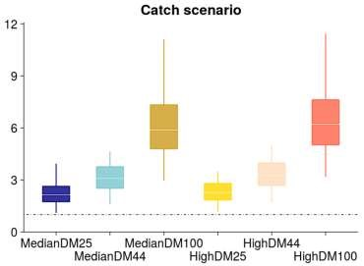  Median (white bar) and inter-quartile bounds (box) for F /F_{MSY} in the final year of the assessment for each structural uncertainty axis. The whiskers extend to 1.5 times the interquartile range.  Under this project, Stock Synthesis population projections for 2016-2026 would be performed from. Generation time for oceanic whitetip shark are between 5 and 8 years. The 2016 projection horizon should allow the work to quantify the expected timeline for recovery for this stock, and could also inform short- to medium-term recovery plans. The projections would provide Markov Chain Monte Carlo (MCMC) projection probabilities given catch scenarios accounting for discard mortalities and candidate mitigation measures. They would be carried out using the Stock Synthesis forecast module and implemented with stochastic recruitment in the projection period (estimated recruitment deviations) by treating the future projection period as part of the estimation period. Stochastic recruitment uncertainty in the projection period will be implemented as an approximation of the recruitment uncertainty that would have been achieved by randomly selecting annual recruitment deviation from stock recruitment parameters with a statistical distribution, noting the oceanic whitetip shark stock assessment allowed for little variation of predicted recruitments around the predicted spawner-recruit relationship.  Uncertainty scenarios would cover that already presented in the assessment and also be expanded to include new information on PRM for oceanic whitetip shark, as well as additional scenarios useful to inform mitigation measure. The modelling framework should be developed so that projections incorporating new information on discard mortality scenarios can be easily updated.  This work would be completed in time for the 2020 meeting of the Scientific Committee (SC16).
Assumptions | - The 2019 stock assessment adequately represents population dynamics for oceanic whitetip shark  - A 10-year projection window is enough to capture ongoing change of stock status following management measures and future changes in recruitment do not compromise the quality of the projections
Scope | This work will:  ● Perform projections of population status from 2016 to 2026 under all
uncertainty axes accounted for in the structural uncertainty grid from SAWP-06 that were accepted by the Scientific Committee to describe the status of this stock.
- Include additional scenarios of discard rates and discard mortality based on ongoing work on Post release mortality or candidate mitigation measure.
- Present results to SC16 in 2020.
Timeframe | 4 months
Budget | US$35,000*  *Note that this includes 5000$USD for travel for the presentation of the results
References | Tremblay-Boyer, Laura; Felipe Carvalho; Philipp Neubauer; Graham Pilling (2019).  Stock assessment for oceanic whitetip shark in the Western and Central Pacific  Ocean, 98 pages. WCPFC-SC15-2019/SA-WP-06. Report to the WCPFC Scientific Committee. Fifteenth Regular Session, 12–20 August 2018, Pohnpei, Federated States of Micronesia.

Project 103 | Appropriate LRPs for WCPO elasmobranchs
Objective | To facilitate a recommendation by SC16 to WCPFC17 on appropriate LRPs for elasmobranchs in the WCPO.
Rationale | SC15 noted the final report of the project “Identifying appropriate reference points for elasmobranchs within the WCPFC” (SC15-MI-IP-04) and the outcomes of the stock assessments for oceanic whitetip sharks. However, due to time constraints SC15 deferred consideration of appropriate limit reference points for elasmobranchs for the WCPFC until SC16. In order to facilitate this process SC15 recommended that the key conclusions of the above report and other reports presented to previous SCs are summarized and presented to SC16 together with any other relevant information.
Method | A shark expert/consultant to prepare a short report summarizing information relevant to identifying appropriate LRPs for elasmobranchs in the WCPO.  A 2-3 day workshop to be attended by the consultant and a small group of other interested scientists to further discuss issues relevant to this issue.  A final report to be prepared by the workshop and presented by the consultant to SC16.
Budget | Seven days for summarizing previous reports, collating other relevant information and preparing report for workshop ($7,000).  Attendance at workshop. (14,000)  Flights, accommodation and meals for consultant to attend SC16 in Samoa (4-days, $4000).  Total $25,000
References | Zhou, S., Deng, R., Hoyle, S. and Dunn, M. (2019) Identifying appropriate reference points for elasmobranchs within the WCPFC. Information paper SC15-2019/MIIP-04 to 15th meeting of the Scientific Committee for the WCPFC, held 12-20 August 2019, Pohnpei, Federated States of Micronesia.  Clarke, S. and Hoyle, S. (2016) Development of limit reference points for elasmobranchs. Information paper SC10-2014/MI-WP-07 to 10th meeting of the Scientific Committee for the WCPFC, held 6-14 August 2014, Majuro, Republic of the Marshall Islands.

Attachment H

The Commission for the Conservation and Management of
Highly Migratory Fish Stocks in the Western and Central Pacific Ocean
Scientific Committee
Fifteenth Regular Session
Pohnpei, Federated States of Micronesia
12–20 August 2019
LIST OF ABBREVIATIONS

ABNJ | – | Areas Beyond National Jurisdiction Program (Common Oceans)
ACAP | – | Agreement for the Conservation of Albatrosses and Petrels
ALC  ANCORS | –  – | Automatic Location Communicator  Australian National Centre for Ocean Resources and Security
BILLWG | – | ISC Billfish Working Group
BMIS | – | Bycatch Mitigation Information System
B_{MSY} | – | biomass that will support the maximum sustainable yield
CCM | – | Members, Cooperating Non-members and participating Territories
CCSBT | – | Commission for the Conservation of Southern Bluefin Tuna
CDS | – | catch documentation scheme
CLAV | – | Consolidated List of Authorised Vessels
CMM | – | Conservation and Management Measure
CMR | – | Compliance Monitoring Report
CMS | – | Compliance Monitoring Scheme
CNM  CNMI | –  – | Cooperating Non-Member  Commonwealth of the Northern Mariana Islands
the Convention | – | The Convention for the Conservation and Management of Highly Migratory Fish Stocks in the Western and Central Pacific Ocean
CPUE | – | catch per unit effort
CSIRO | – | Commonwealth Scientific and Industrial Research Organization (Australia)
CV | – | Coefficient of variation
Delta-GLM | – | delta-generalized linear model
Delta-GLMM | – | delta-generalized linear mixed model
DFLL  DM  DSPM  DWFN  EAFM  EDF | –  –  –  –  –  – | deep frozen tuna longline  discard mortality  dynamic surplus production model  distant water fishing nation  ecosystem approach to fisheries management  Environmental Defense Fund
EEZ | – | exclusive economic zone
EM | – | electronic monitoring
ENSO | – | El Niño-Southern Oscillation
EPO | – | eastern Pacific Ocean
ER | – | electronic reporting
ERandEM | – | electronic reporting and electronic monitoring
ERA | – | ecological risk assessment
EHSP-SMA | – | Eastern High Seas Pocket-Special Management Area
EU | – | European Union
F  FAC | –  – | fishing mortality rate  Finance and Administration Committee
FAD | – | fish aggregation device
FAO | – | Food and Agriculture Organization of the United Nations
F_{current} | – | average fishing mortality rate over the period xxxx–xxxx
FFA | – | Pacific Islands Forum Fisheries Agency
FL | – | fork length
F_{MSY} | – | fishing mortality that will support the maximum sustainable yield
FMA  FNA | –  – | fishery management area  fins naturally attached
FRP  FSA | –  – | fishing mortality-based reference point  United Nations Fish Stock Agreement
FSI | – | Flag State Investigation
FSM  GAM  GEF | –  –  – | Federated States of Micronesia  Generalised additive model  Global Environment Facility
geostats | – | geostatistical delta-GLMMs
HCR | – | harvest control rule
HSBI | – | high seas boarding and inspection
IATTC | – | Inter-American Tropical Tuna Commission
ICCAT  IELP  IGOs  IMO | –  –  –  – | International Commission for the Conservation of Atlantic Tunas  International Environmental Law Project  intergovernmental organizations  International Maritime Organization
IMS | – | Information Management System
IOTC  IPNLF | –  – | Indian Ocean Tuna Commission  International Pole and Line Foundation
ISC | – | International Scientific Committee for Tuna and Tuna-like Species in the North Pacific Ocean
ISSF | – | International Seafood Sustainability Foundation
IT | – | information technology
IUU | – | illegal, unreported and unregulated
IWG | – | intersessional working group
JTF | – | Japan Trust Fund
LRP | – | limit reference point
M | – | mortality
M_{FMT} | – | maximum fishing mortality threshold
MCS  MIMRA | –  – | Monitoring Control and Surveillance  Marshall Islands Marine Resources Authority
MOC | – | management options consultation
MOU  MP  MSC | –  –  – | memorandum of understanding  management procedure  Marine Stewardship Council
MSE | – | management strategy evaluation
MSY | – | maximum sustainable yield
mt | – | metric tonnes
MTU | – | Mobile Transceiver Unit
NC  NGO  NP  NZ  OM  P&L  PBFWG  pCMR | –  –  –  –  –  –  –  – | Northern Committee  Non-governmental Organization  North Pacific  New Zealand  operating model  P&L  Pacific bluefin tuna working group (ISC)  provisional Compliance Monitoring Report
PEW  PI  PITIA | –  –  – | The Pew Charitable Trusts  performance indicator  Pacific Islands Tuna Industry Association
PNA | – | Parties to the Nauru Agreement
PNG  PRM  RFV | –  –  – | Papua New Guinea  post-release mortality  Record of Fishing Vessels
ROP | – | Regional Observer Programme
RFMO | – | regional fisheries management organization
RMI | – | Republic of the Marshall Islands
RV | – | recruitment variability
SB | – | spawning biomass
SBF=0 | – | spawning biomass in the absence of fishing
SC | – | Scientific Committee of the WCPFC
SIDS  SIP | –  – | small island developing states  strategic investment plan
SPA-VIWG  SPC | –  – | South Pacific albacore virtual intersessional working group  Secretariat of the Pacific Community
SPC-OFP | – | The Pacific Community Oceanic Fisheries Programme
SRA | – | spatial risk assessment
SRF | – | Special Requirements Fund
SRR | – | stock-recruitment relationship
SS3 | – | Stock Synthesis 3 (software)
SSB | – | spawning stock biomass
SSI | – | species of special interest
SST  SWG | –  – | sea surface temperature  small working group
T  TCC  TNC | –  –  – | metric ton  Technical and Compliance Committee  The Nature Conservancy
TOR  TRP  TUFMAN  UN  UNCLOS | –  –  –  –  – | terms of reference  target reference point  Tuna Fisheries Database Management System  United Nations  United Nations Convention on the Law of the Sea
USA | – | United States of America
USD  VDS  VID  VMS | –  –  –  – | US dollars  vessel day scheme  vessel identification (number)  vessel monitoring system
WCPFC | – | Western and Central Pacific Fisheries Commission
WCPFC Convention Area | – | Area of competence of the Commission for the Conservation and Management of Highly Migratory Fish Stocks in the Western and Central Pacific Ocean, as defined in Article 3 of the Convention
WCPFC Statistical Area | – | The WCPFC Statistical Area is defined in para. 8 of “Scientific data to be provided to the Commission” (as adopted at WCPFC13)
WCNPO | – | Western and Central North Pacific Ocean
WCPO | – | western and central Pacific Ocean
WG  WPEA  WPO  WPFMC | –  _  – | working group  West Pacific and East Asian Seas  Western Pacific Ocean  Western Pacific Regional Fishery Management Council
WTPO | – | World Tuna Purse Seine Organisation
WWF | – | World Wide Fund for Nature

The rebuilding target, 20% SSB0, is estimated from the stock recruitment curve.
Spatial Ecosystem And POpulation DYnamics Model (SEAPODYM)
Punt, A. E., Butterworth, D., de Moor, C., De Oliveira, J., and Haddon, M. (2014). Management strategy evaluation: best practices. Fish and Fisheries, (DOI:10.111/faf12104).
C. Schaeffer. How much should I invest in innovation?
PNA. The PNA Vessel Day Scheme
PNA. PNA increases fishing day price to US$8,000 for 2015
Title in SC15-SA-IP-19; Growth models utilized in recent bigeye tuna assessments in the WCPO, and future considerations
Title in SC15-SA-IP-19; Confidence tagging data and length at age data based on annual increment counts (decimal age) from bigeye otoliths from the WCPO.
Title in SC15-SA-IP-19; Length composition data in the WCPFC WCPO bigeye stock assessment and the sensitivity of assessment results to the estimated L∞ value.
Title in SC15-SA-IP-19; Growth models utilized in recent bigeye tuna assessments in the WCPO, and future considerations
Title in SC15-SA-IP-19; Comparisons of length-based growth rates from models fit separately to high confidence tagging data and length-at-age data based on daily increment counts from bigeye otoliths from the EPO
Tuna scheduled for assessment every 3 years, billfish, every 4 years and sharks every 5 years.
This budget has been updated based on costs in 2016, 2017 and 2018 to date.

