

**The Commission for the Conservation and Management of**

**Highly Migratory Fish Stocks in the Western and Central Pacific Ocean**

**Fifteenth Regular Session of the Scientific Committee**

**Pohnpei, Federated States of Micronesia**

**12–20 August 2019**

**OUTCOMES DOCUMENT (Rev.02)**

**The Commission for the Conservation and Management of   
Highly Migratory Fish Stocks in the Western and Central Pacific Ocean**

**Scientific Committee**

**Fifteenth Regular Session**

Pohnpei, Federated States of Micronesia

12–20 August 2019

|  |
| --- |
| **OUTCOMES DOCUMENT** |

**AGENDA ITEM 1 — OPENING OF THE MEETING**

* 1. **Welcome address**
  2. **Meeting arrangements**
  3. **Issues arising from the Commission**
  4. **Adoption of agenda**
  5. **Reporting arrangements**
  6. **Intersessional activities of the Scientific Committee**

# AGENDA ITEM 2 — REVIEW OF FISHERIES

* 1. **Overview of Western and Central Pacific Ocean (WCPO) fisheries**

1. SC15 recommended that future versions of the SC15-GN-WP-1 paper include:

* Summaries of northern stocks in the WCPFC Convention Area; and
* More information on the OTHER FISHERIES.
  1. **Overview of Eastern Pacific Ocean (EPO) fisheries**
  2. **Annual Report – Part 1 from Members, Cooperating Non-Members, and Participating Territories**
  3. **Reports from regional fisheries bodies and other organizations**

# AGENDA ITEM 3 — DATA AND STATISTICS THEME

* 1. **Data gaps**
     1. **Data gaps of the Commission**

1. SC15 requested that SPC provide an update to TCC15 on the issues raised in SC15-ST- WP-01.
2. SC15 recommended that the charter notification issues raised in SC15-ST-WP-01 be taken into account in the review leading to the new/replacement Charter Notification CMM. For example, when the coverage of operational data submitted is not 100% and chartered vessels for that flag state have been notified to the Commission, then the flag state shall submit a list of vessels representing the catches compiled for their annual catch estimates and aggregate catch/effort data (with these data submissions).
3. SC15 recommended that the WCPFC Scientific Service Provider make the following enhancements to the tables on longline observer coverage in the Regional Observer Programme (ROP) data management paper (SC15-ST-IP-02) in the future:
4. Separate the observer coverage of domestic CCM fleets active in their home EEZ (non-ROP coverage), where such information is voluntarily provided from a CCM, from the observer coverage of CCM fleets fishing outside their home EEZ (ROP coverage;
5. List all (ROP and non-ROP) longline observer coverage for each fleet based on HOOKS or SETS as measured by WCPFC data submissions. This information is intended to provide estimates of total longline observer coverage in the WCPFC Area for reference, and will not be used for compliance purposes. The WCPFC Scientific Services Provider will provide an update to TCC15 for CCM review.
6. Include a column to describe the coverage of longline E-Monitoring data in the table of longline E-Monitoring coverage based on FISHING DAYS or SETS.
7. SC15 acknowledged the cannery data submissions (representing ~37% of the tropical WCPFC purse seine catch in recent years) to the WCPFC by International Seafood Sustainability Foundation (ISSF) participating companies, and the potential of cannery data for the work of the Commission, specifically Project 60. SC15 recommended that the WCPFC Scientific Services Provider (with assistance from the WCPFC Secretariat) investigate what Commission mechanisms could be used and/or updated to facilitate the voluntary submission, and ensure an appropriate level of confidentiality, of cannery data from other processors for future Commission work (Project 60), and report the findings to SC16.
8. SC noted the recurrent difficulties of the WCPFC Scientific Services Provider to reconcile the discrepancies between the number of trips and observer appointments in Tables 1 and 2 of SC15-ST-IP-02 and recommended that the WCPFC Scientific Services Provider and WCPFC Secretariat investigate how these discrepancies could be addressed, in view to facilitating the work of SC and TCC.
   * 1. **Species composition of purse-seine catches (Project 60)**
9. SC15 recommended that the following activities be considered under Project 60 over the coming year, with the outcomes reported to SC16:

|  |  |
| --- | --- |
| **Activity** | **Priority** |
| 1. Paired grab-spill trips (target: 4 to 6):   * Targeting fleets with likely availability of comprehensive landings slips data (to be provided on a voluntary basis). * Additional data should allow for improved estimates of bias correction factors, and provide a more powerful dataset for testing for species and/or school association specific correction factors | High |
| 2. Continue to explore opportunities for collaboration with members, specifically undertaking comparisons of observer samples, and potentially model-based, species composition estimates, with accurate unloadings / landings / cannery data | High |
| 3. Investigation of video-based sampling for estimation of species and size compositions | Medium |
| 4. Simulation model   * Exploration of potential bias from between-brail variability in size   + Inform need for set and/or species-specific correction factors | Medium |
| 5. Cost-benefit analysis of alternative sampling approaches for long-term estimation of species compositions (i.e. at-sea sampling vs port sampling) | Low |

1. SC15 recommended that the following changes (as outcomes from Project 60) be incorporated into the process for generating the aggregated purse seine species catch estimates in the future:

* Multinomial-model based correction factors be used to correct existing and future grab sample data, rather than the estimates of ‘availability’;
* The beta-response models be used to generate catch estimates; and,
* Observer samples are stratified by flag when used to directly estimate species compositions.

1. SC15 acknowledged the recent work on the potential of EM to enhance the collection of scientific data (size and species composition) onboard purse seine vessels, potentially freeing the observer to concentrate on other duties. Additional work in support of the proposed Project 60 work plan for August 2019 onwards was proposed. SC15 recommended the outcomes of any further work be reported to SC16.
   * 1. **Project 90 (Better size data (length and weight) for scientific analyses)**
2. SC15 recommended that the WCPFC Scientific Services Provider proceed to coordinate the activities proposed for Project 90 for the coming year (as listed in ANNEX 2 of SC15-ST-WP-03), and report the progress to SC16.
   * 1. **Project 93 (Review of the Commission’s data needs and collection programmes).**
3. SC15 recognised the usefulness of the work conducted to date under Project 93 and recommended the WCPFC Secretariat prepare and distribute a circular drawing attention to the tables in SC15-ST-WP-04, following their discussion by the ISG-02, requesting CCMs provide further feedback prior to TCC15, when it will be further discussed.
   1. **Regional Observer Programme**
   2. **Electronic Reporting and Electronic Monitoring**
   3. **Economic data**
4. SC15 considered the development of guidelines for the voluntary provision of economic data to the Commission and recommended that intersessional work be undertaken to further develop the draft guidelines as provided in SC15-ST-WP-05 and provide guidance on appropriate ways to address issues raised. CCMs wishing to participate in this intersessional work should provide a contact point for inclusion in this intersessional working group which will be facilitated by Fiji and the FFA Secretariat. SC15 further recommended that the outcomes of this intersessional work be considered by SC16.
   1. **Comprehensive review of Commission reporting requirements**
5. SC15 noted the paper SC15-ST-WP-06 *Streamlining WCPFC reporting requirements – discussion paper* that was introduced by the Secretariat. Noting that a finalised version of the paper will be submitted to TCC15 for decisions on recommendations on the way forward to WCPFC16, SC15 encouraged interested CCMs and observers to submit views on the discussion paper to the Secretariat no later than Wednesday 28th August 2019.

# AGENDA ITEM 4 — STOCK ASSESSMENT THEME

1. **Improvement of MULTIFAN-CL software**
   1. **WCPO tunas**
      1. **WCPO bigeye tuna (*Thunnus obesus*)**
         1. **Research and information**
         2. **Provision of scientific information**
2. **Stock status and trends**
3. SC15 noted that no stock assessment was conducted for WCPO bigeye tuna in 2019. Therefore, the stock status description from SC14 is still current. For further information on the stock status and trends from SC14, please see <https://www.wcpfc.int/node/32155>
4. SC15 noted that the total bigeye catch in 2018 was 145,402 mt, a 13% increase from 2017 and a 1% decrease from the average 2013-2017.
5. Longline catch in 2018 (71,305 mt) was a 23% increase from 2017 and a 7% increase from the 2013-2017 average. Purse seine catch in 2018 (64,119 mt) was a 10% increase from 2017 and a 4% increase from the 2013-2017 average. Pole and line catch (1,677 mt) was a 3% increase from 2017 and a 60% decrease from the average 2013-2017 catch. Catch by other gear (8,301 mt) was a 25% decrease from 2017 and 45% decrease from the average catch in 2013-2017.
6. SC15 noted that under recent fishery conditions, the bigeye stock is initially projected to increase as recent estimated recruitments support adult stock biomass. Adult stock biomass is then projected to decline slightly before again increasing. Projected fishing mortality is below FMSY (median F2020/FMSY = 0.62, the risk of F2020 > FMSY = 0%) and projected median spawning biomass is above the LRP (SB2020/SBF=0 = 0.2) (median SB2020/SBF=0 = 0.41; median SB2020/SBMSY = 1.79. Risk that SB2020 < LRP = 0%). Projections are from the updated model runs of Vincent et al. (2018).
7. **Management advice and implications**
8. SC15 noted that no stock assessment has been conducted since SC14. Therefore, the advice from SC14 should be maintained, pending a new assessment or other new information. For further information on the management advice and implications from SC14, please see <https://www.wcpfc.int/node/32155>
9. **Research Recommendations**
10. SC15 reviewed progresses for the research recommendations from SC14 for bigeye growth and noted that the following research issues need to be addressed further, after classifying these research items as short-term (preferably before SC16) and long-term (preferably before the scheduled 2023 stock assessment).
    1. Develop MULTIFAN-CL functionality that can accommodate spatial variation in growth rates and movement between western and eastern Pacific to consider the appropriateness of delineating the two stocks at 150˚W (long-term).
    2. Carry out further otolith age validation studies for fish in the western and central Pacific. Consider chemically marking fish at release in future tagging programs and then analyzing otoliths from recaptured marked fish (long-term). Apply other age validation methodology including radiocarbon age validation (short to long-term). SC15 noted potential issues of the spatial pattern of radiocarbon in the Pacific Ocean and its implications for mobile adult tuna.
    3. Continue to develop and document protocols for daily and annual ageing by IATTC and WCPFC (short-term).
    4. Continue efforts under Project 94 to collect very small bigeye caught by the Indonesian, Vietnamese, and Philippines domestic fisheries in region 7 to aid in the estimation of the size at age-1 qtr-1 parameter (L1) within the assessment model (short to long-term).
    5. Compile a high confidence tagging dataset for growth analysis and develop integrated growth models incorporating the tagging data and the otolith data (short-term).
    6. Conduct sensitivity analysis using alternative growth models in the stock assessment, if new growth models are developed such as an integrated growth model (short -term), a conditional age-at-length growth model (short-term), and other growth models after conducting further growth analysis listed above.
    7. Undertake a genetic stock structure analysis (long-term).
       1. **WCPO yellowfin tuna (*Thunnus albacares*)**
          1. **Research and information**
          2. **Provision of scientific information**
11. **Stock status and trends**
12. SC15 noted that no stock assessment was conducted for WCPO yellowfin tuna in 2019. Therefore, the stock status description from SC13 is still current. For further information on the stock status and trends from SC13, please see <https://www.wcpfc.int/node/29904>
13. SC15 noted that the total yellowfin catch in 2018 was 666,971 mt (the second highest catch on record), a 2% decrease from 2017 and a 9% increase from the average 2013-2017.
14. Purse seine catch in 2018 (374,062 mt) was a 22% decrease from 2017 and a 1% increase from the 2013-2017 average. Longline catch in 2018 (94,509 mt) was an 11% increase from 2017 and a 4% increase from the 2013-2017 average. Pole and line catch (12,201 mt) was a 1% decrease from 2017 and a 48% decrease from the average 2013-2017 catch. Catch by other gear (186,199 mt) was a 79% increase from 2017 and 51% increase from the average catch in 2013-2017.
15. SC15 noted that under recent fishery conditions, the yellowfin stock is initially projected to increase as recent estimated recruitments support adult stock biomass. Adult stock biomass is then projected to declines slightly before again increasing. Projected fishing mortality is below FMSY (median F2020/FMSY = 0.74, the risk of F2020 > FMSY = 3%) and projected median spawning biomass is above the LRP (SB2020/SBF=0 = 0.2) (median SB2020/SBF=0 = 0.32; median SB2020/SBMSY = 1.33. Risk that SB2020 < LRP = 8%).
16. **Management advice and implications**
17. SC15 noted that no stock assessment has been conducted since SC13. Therefore, the advice from SC13 should be maintained, pending a new assessment or other new information. For further information on the management advice and implications from SC13, please see <https://www.wcpfc.int/node/29904>
18. **Research Recommendations**
19. SC15 encouraged the continuation of project 82 on yellowfin tuna age and growth for the next stock assessment.
20. SC15 noted that the following research issues need to be addressed for yellowfin tuna after classifying these research items as short-term (preferably before SC16) and long-term (preferably before the scheduled 2023 stock assessment).
    * + - 1. Carry out further otolith age validation studies for yellowfin in the western and central Pacific such as applying radiocarbon age validation (short to long-term).
          2. Compile a high confidence tagging dataset for growth analysis and develop an integrated growth model incorporating the tagging data and the otolith data (short-term).
          3. Continue to develop and document protocols for daily and annual ageing by IATTC and WCPFC (short-term).
      1. **WCPO skipjack tuna (*Katsuwonus pelamis*)**
         1. **Research and information**
         2. **Provision of scientific information**
21. **Stock status and trends**
22. SC15 noted that the total provisional catch in 2018 was 1,795,048 mt, a 10% increase from 2017 and a 1% decrease from 2013-2017. Purse seine catch in 2018 (1,469,520 mt) was a 15% increase from 2017 and a 2% increase from the 2013-2017 average. Pole and line catch (138,534 mt) was a 4% increase from 2017 and a 9% decrease from the average 2013-2017 catch. Catch by other gear (182,888 mt) was a 16% decrease from 2017 and 19% decrease from the average catch in 2013-2017.
23. SC15 agreed to use the 8-region model to describe the stock status of skipjack tuna because SC15 considers that it better captures the biology of skipjack tuna than the existing 5 region structure. Stock status was determined over an uncertainty grid of 54 models with assumed weightings as illustrated in Table SKJ-01.
24. The median values of recent (2015–2018) spawning biomass depletion (SBrecent/SBF=0) and relative recent (2014–2017) fishing mortality (Frecent/FMSY) over the uncertainty grid of 54 models (Table SKJ-02) were used to define stock status. The values of the upper 90th and lower 10th percentile of the empirical distributions of relative spawning biomass and relative fishing mortality from the uncertainty grid were used to characterize the probable range of stock status.
25. The spatial structure used in the assessment model is shown in Figure SKJ-01. Time series of total annual catch (1000’s mt) by fishing gear for all regions is shown in Figure SKJ-02 and by region separately is shown in Figure SKJ-03. The annual average recruitment, spawning potential, and total biomass by model region for the diagnostic model are shown in Figure SKJ-04. The overall spawning potential summed across region for the diagnostic model is shown in Figure SKJ-05. The estimated annual average juvenile and adult fishing mortality for the diagnostic model is shown in Figure SKJ-06. The estimated impact of fishing (1 – SBlatest/SBF=0) by region and overall regions for the diagnostic model is shown in Figure SKJ-07. The median and 80th percent quantile trajectories of fishing depletion for models in the weighted structural uncertainty grid in Table SKJ-01 is shown in Figure SKJ-08, where it can be seen that the median has been below the target since 2009. The Majuro plot shows the recent fishing mortality and spawning potential relative to the unfished spawning potential for all models in the structural uncertainty grid for (i) spawning potential in the recent time period (2015–2018) in Figure SKJ-09, and (ii) spawning potential in the latest time period (2018) in Figure SKJ-10. The Kobe plot shows the recent fishing mortality and spawning potential relative to spawning potential at MSY for all models in the structural uncertainty grid for (i) spawning potential in the recent time period (2015–2018) in Figure SKJ-11, and (ii) spawning potential in the latest time period (2018) in Figure SKJ-12.
26. SC15 noted that the median level of spawning potential depletion from the uncertainty grid was SBrecent/SBF=0 = 0.44 with a probable range of 0.37 to 0.53 (80% probability interval). There were no individual models where SBrecent/SBF=0 < 0.2, which indicated that the probability that recent spawning biomass was below the LRP was zero.
27. SC15 noted that the grid median Frecent/FMSY was 0.45, with a range of 0.34 to 0.60 (80% probability interval) and that no values of Frecent/FMSY in the grid exceed 1. Therefore, SC15 noted that there was a zero probability that the recent fishing mortality exceeds FMSY.
28. SC15 noted that the largest uncertainty in the structural uncertainty grid was due to the assumed tag mixing period. In addition, SC15 acknowledges that further study is warranted to investigate the uncertainty surrounding the appropriate mixing period for the tagging data.
29. SC15 acknowledges that the spatial extent of the Japanese pole-and-line fishery has decreased over the time period and that the future use of this standardized CPUE index within future stock assessments is uncertain.
30. Therefore, SC15 acknowledges that further study of alternative indices of abundance is warranted, such as investigation of standardizing the purse seine fishery and evaluation of the feasibility of conducting fishery independent surveys.

**Table SKJ-01.** Description of the updated structural sensitivity grid used to characterize uncertainty in the assessment.

|  |  |  |
| --- | --- | --- |
| **Axis** | **Value** | **Relative weight** |
| **Steepness** | 0.65 | 0.8 |
|  | 0.80 | 1.0 |
|  | 0.95 | 0.8 |
| **Growth** | Low | 1.0 |
|  | Diagnostic | 1.0 |
|  | High | 1.0 |
| **Length composition** | 50 | 0.8 |
| **scalar** | 100 | 1.0 |
|  | 200 | 1.0 |
| **Tag mix** | 1 | 1.0 |
|  | 2 | 1.0 |

**Table SKJ-02.** Summary of reference points over the various models in the structural uncertainty grid. Fmult is the multiplier of recent (2014-2017) fishing mortality required to attain MSY, Frecent is the average fishing mortality of recent (2014-2017), SBrecent is the average spawning potential of recent years (2015-2018) and SBlatest is the spawning potential in 2018.

|  |  |  |  |  |  |  |
| --- | --- | --- | --- | --- | --- | --- |
|  | Mean | Median | Minimum | 10th %ile | 90th %ile | Maximum |
| Clatest | 1,755,328 | 1,755,693 | 1,749,846 | 1,753,471 | 1,757,057 | 1,757,083 |
| YFrecent | 1,877,914 | 1,864,040 | 1,679,600 | 1,737,702 | 2,043,556 | 2,135,200 |
| fmult | 2.282 | 2.258 | 1.472 | 1.757 | 2.957 | 3.705 |
| FMSY | 0.223 | 0.222 | 0.180 | 0.189 | 0.264 | 0.270 |
| MSY | 2,296,566 | 2,294,024 | 1,953,600 | 1,995,987 | 2,767,083 | 2,825,600 |
| Frecent/FMSY | 0.461 | 0.447 | 0.270 | 0.343 | 0.600 | 0.679 |
| SBF=0 | 6,220,675 | 6,299,363 | 5,247,095 | 5,580,942 | 6,913,431 | 7,349,557 |
| SBMSY | 1,100,947 | 1,064,400 | 631,900 | 723,742 | 1,544,060 | 1,688,000 |
| SBMSY/SBF=0 | 0.175 | 0.176 | 0.117 | 0.131 | 0.225 | 0.23 |
| SB latest/SBF=0 | 0.414 | 0.415 | 0.325 | 0.36 | 0.487 | 0.525 |
| SB latest/SBMSY | 2.468 | 2.382 | 1.551 | 1.779 | 3.356 | 3.925 |
| SB recent/SBF=0 | 0.440 | 0.440 | 0.336 | 0.372 | 0.530 | 0.551 |
| SB recent/SBMSY | 2.623 | 2.579 | 1.601 | 1.892 | 3.613 | 4.139 |

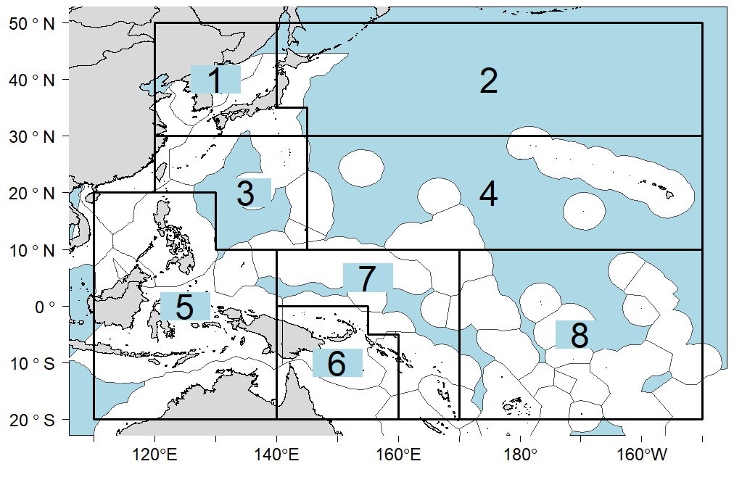

**Figure SKJ-01.** Eight region spatial structure used in the 2019 stock assessment model.

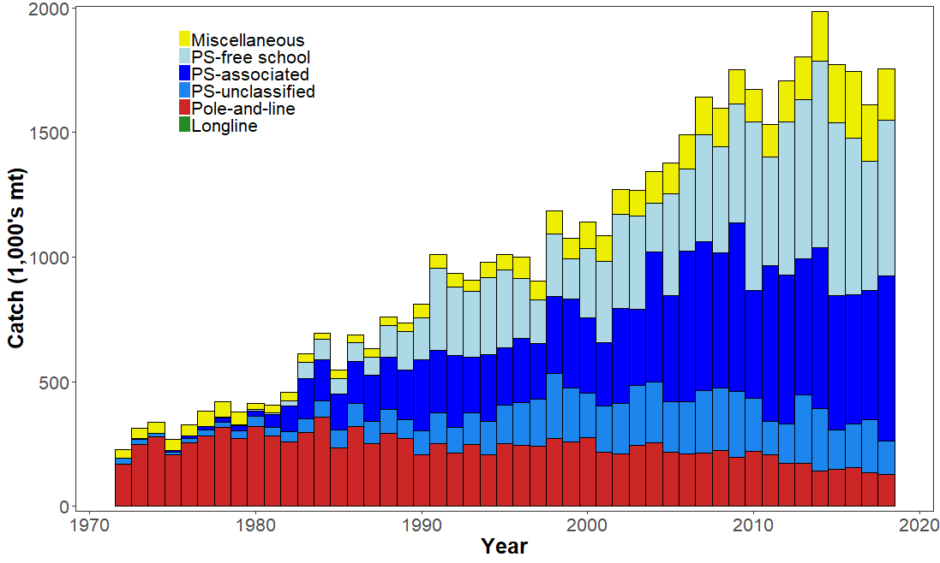

**Figure SKJ-02.** Time series of total annual catch (1000's mt) by fishing gear over the full assessment period.

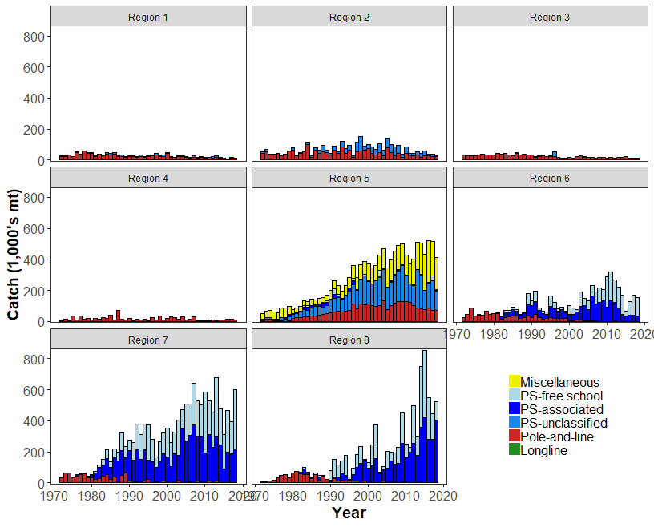

**Figure SKJ-03.** Time series of total annual catch (1000's mt) by fishing gear and assessment region over the full assessment period.

1. 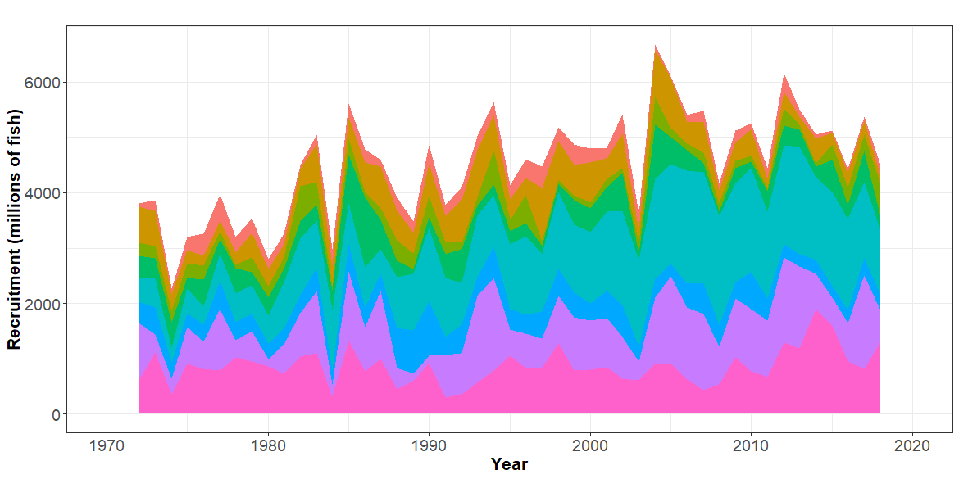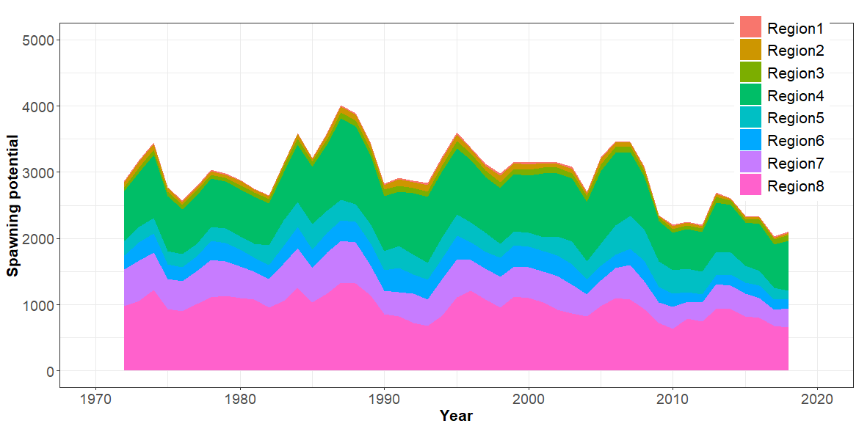Recruitment
2. Spawning Potential
3. 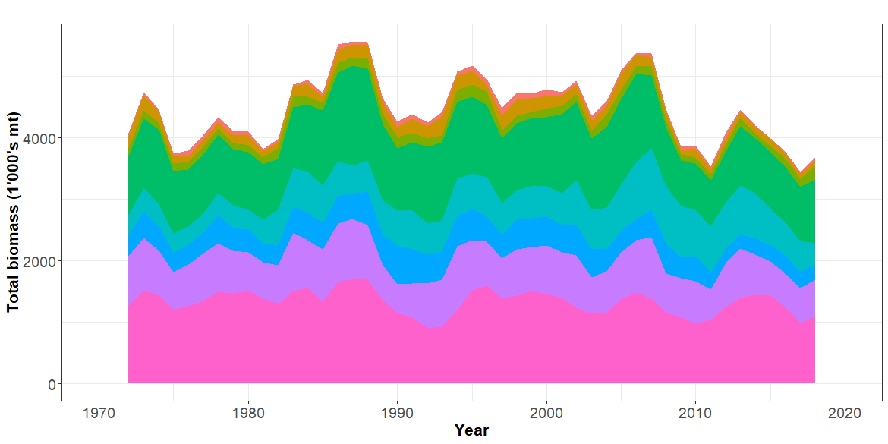Total biomass

**Figure SKJ-04.** Estimated annual average recruitment, spawning potential and total biomass by model region for the diagnostic model, showing the relative sizes among regions.

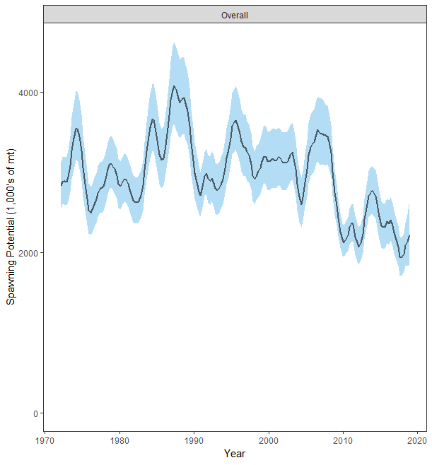

**Figure SKJ-05.** Estimated temporal overall spawning potential summed across regions from the diagnostic model, where the shaded region is ± 2 standard deviations (i.e., 95% CI).

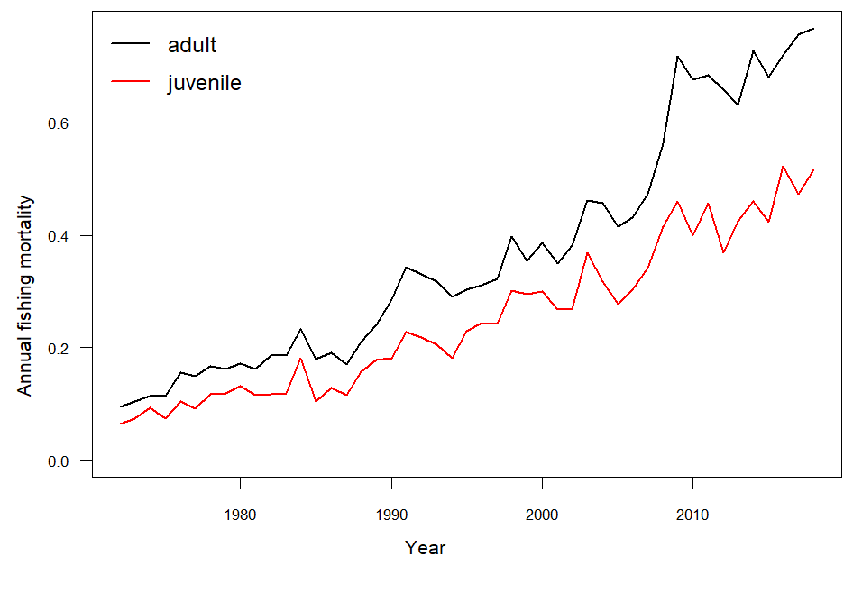

**Figure SKJ-06.** Estimated annual average juvenile and adult fishing mortality for the diagnostic model.

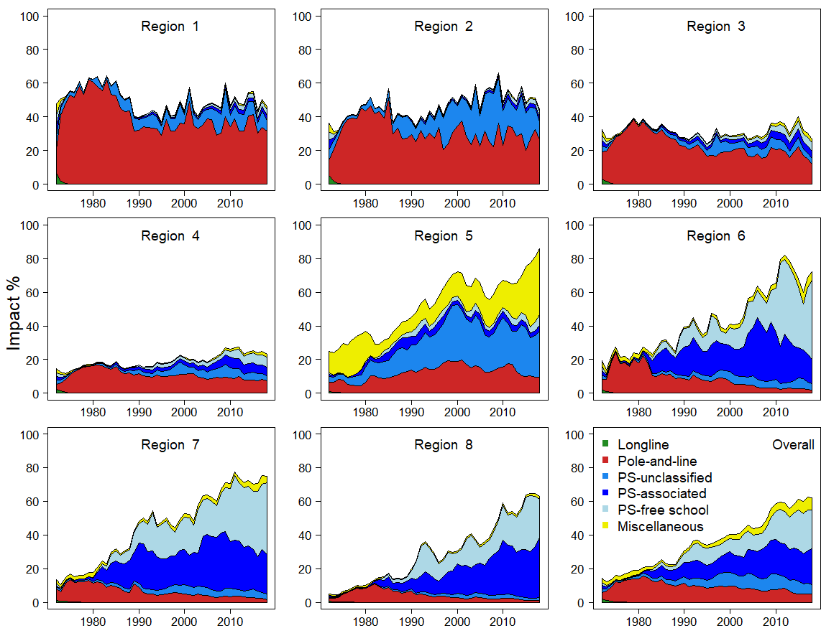

**Figure SKJ-07.** Estimates of reduction in spawning potential due to fishing (fishery impact = 1*-SB latest*/SB *F*=0) by region for the diagnostic model.

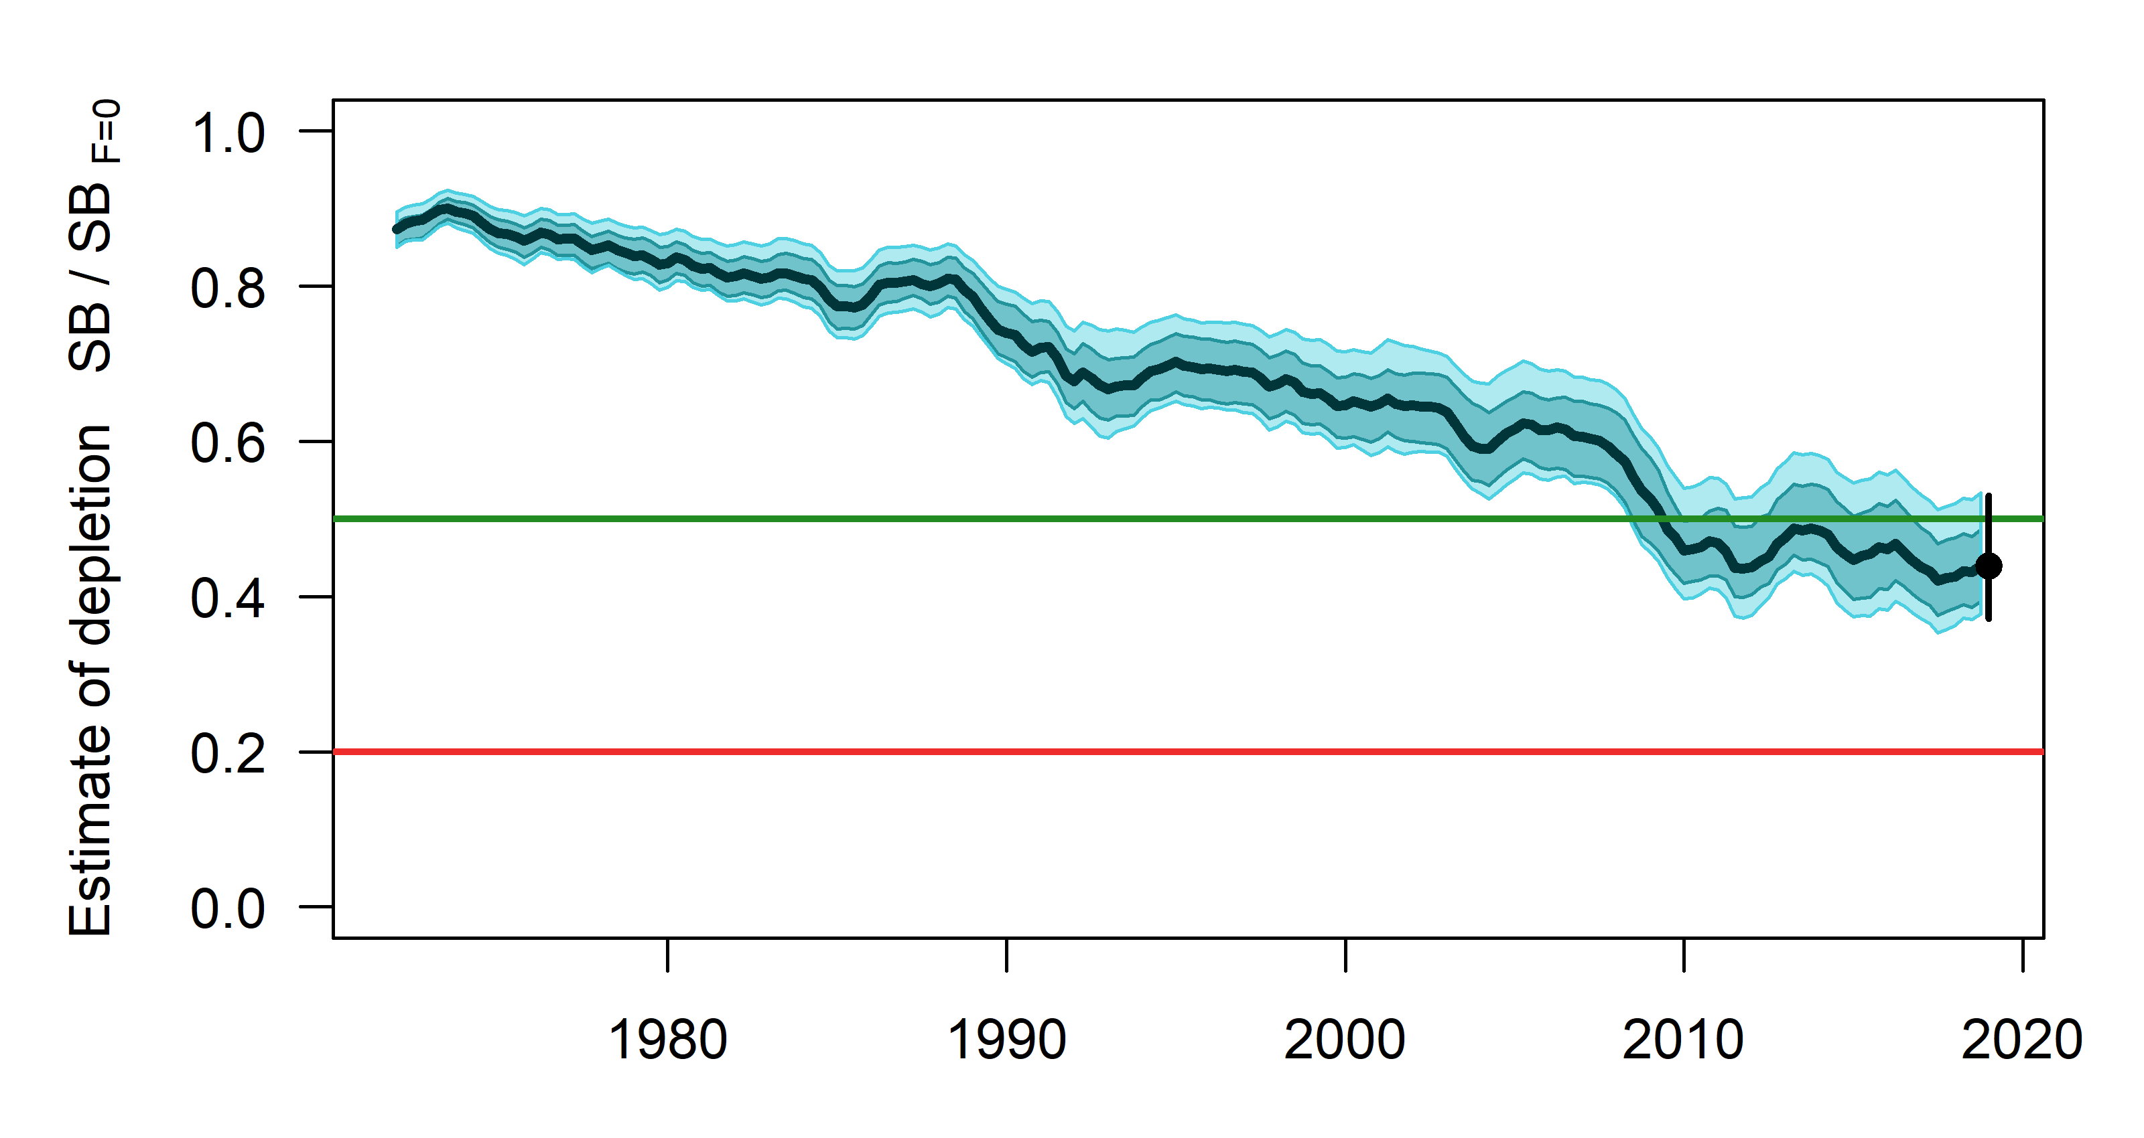

**Figure SKJ-08.** Plot showing the trajectories of spawning potential depletion for the model runs included in the structural uncertainty grid weighted by the values given in Table SKJ-01. Red horizontal line indicates the agreed limit reference point, the green horizontal line indicates the interim target reference point.

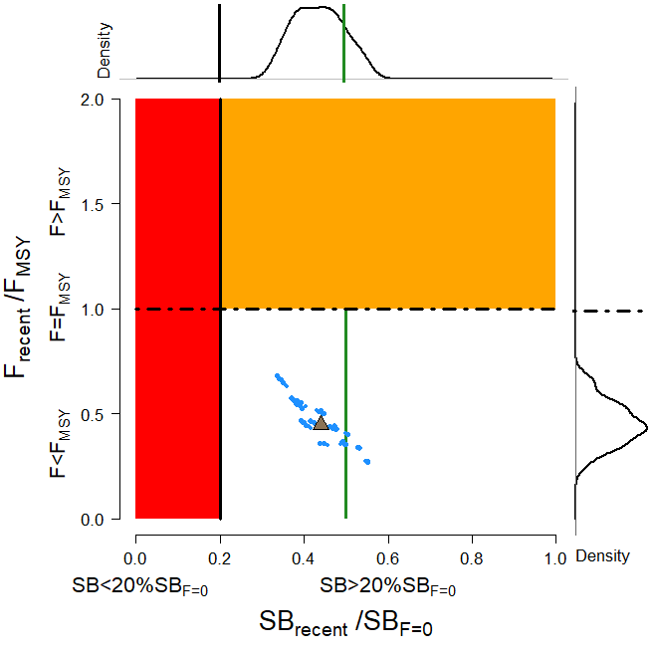

**Figure SKJ-09**. Majuro plot for the recent spawning potential (2015 – 2018) summarizing the results for each of the models in the structural uncertainty grid with weighting. The plots represent estimates of stock status in terms of spawning potential depletion and fishing mortality, and marginal distributions of each are presented. Vertical green line denotes the interim TRP. Brown triangle indicates the median of the estimates. The size of the circle relates to the weight of that particular model run.

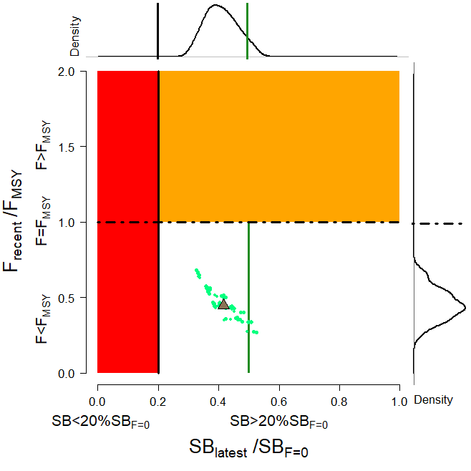

**Figure SKJ-10**. Majuro plot for the latest spawning potential (2018) summarizing the results for each of the models in the structural uncertainty grid with weighting. The plots represent estimates of stock status in terms of spawning potential depletion and fishing mortality, and marginal distributions of each are presented. Vertical green line denotes the interim TRP. Brown triangle indicates the median of the estimates. The size of the circle relates to the weight of that particular model run.

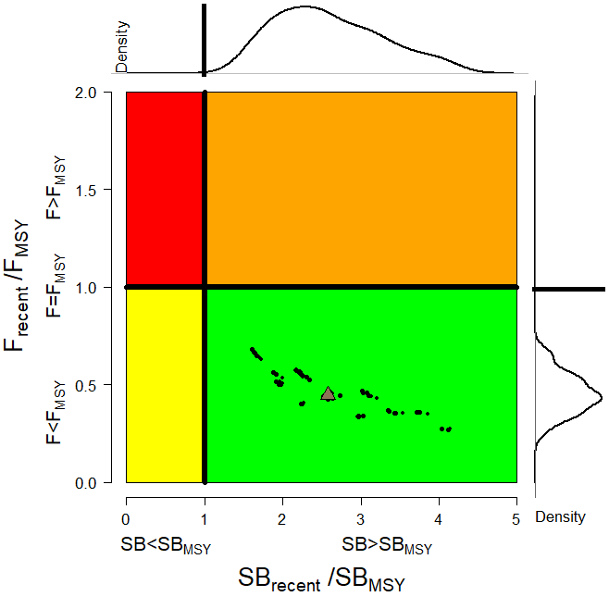

**Figure SKJ-11**. Kobe plot for the recent spawning potential (2015 – 2018) summarizing the results for each of the models in the structural uncertainty grid. The plots represent estimates of stock status in terms of spawning potential depletion and fishing mortality and marginal distributions of each are presented. Brown triangle indicates the median of the estimates. The size of the circle relates to the weight of that particular model run.

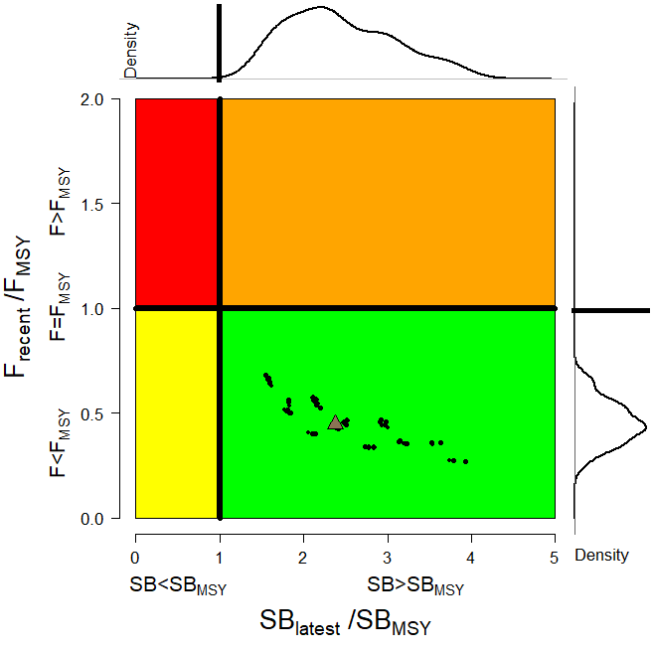

**Figure SKJ-12**. Kobe plot for the latest spawning potential (2018) summarizing the results for each of the models in the structural uncertainty grid. The plots represent estimates of stock status in terms of spawning potential depletion and fishing mortality and marginal distributions of each are presented. Brown triangle indicates the median of the estimates. The size of the circle relates to the weight of that particular model run.

1. **Management advice and implications**
2. SC15 noted that the skipjack assessment continues to show that the stock is currently moderately exploited and the level of fishing mortality is sustainable.

1. The 2019 stock assessment includes additional data and a range of model improvements such as a change to the maturity schedule used in this assessment, with length-at-maturity now larger than in the previous assessment, which has resulted in a reduction in the estimate of potential spawning biomass, relative to the 2016 assessment.
2. SC15 noted that the stock was assessed to be above the adopted Limit Reference Point and fished at rates below FMSY with 100% probability. Therefore, the skipjack stock is not overfished, nor subject to overfishing. At the same time, it was also noted that fishing mortality is continuously increasing for both adult and juvenile while the spawning biomass reached the historical lowest level.
3. The skipjack interim Target Reference Point (TRP) is 50% of spawning biomass in the absence of fishing. The trajectory of the median spawning biomass depletion indicates a long-term trend, and has been under the interim TRP since 2009 (i.e., for 10 years). Since the median spawning biomass has been consistently below the interim TRP, SC15 recommends that the Commission take appropriate management action to ensure that the biomass depletion level fluctuates around the TRP (e.g., through the adoption of a harvest control rule).
4. **Research Recommendations**
5. In order to maintain the quality of stock assessments for this important stock SC15 recommends:
6. continuing work to develop an index of abundance based on purse seine data and from FAD acoustic sensors;
7. evaluating the possibility of conducting fishery independent surveys to provide relative abundance indices;
8. conducting regular large-scale tagging cruises and expanding the infrastructure for rapid return of recaptured tags in a manner that provides the best possible data for stock assessment purposes;
9. investigating skipjack growth by validation studies of otolith readings and/or estimation of growth within MFCL from tag recapture data;
10. attempting to provide finalized catch estimates to SPC no later than June 1st.
    * 1. **South Pacific albacore tuna (*Thunnus alalunga*)**
         1. **Research and information**
         2. **Provision of scientific information**
11. **Stock status and trends**
12. SC15 noted that no stock assessments were conducted for South Pacific albacore in 2019. Therefore, the stock status descriptions from SC14 are still current for South Pacific albacore. For further information on the stock status and trends from SC14, please see <https://www.wcpfc.int/node/32155>. Updated information on fishery trends and indicators were compiled for and reviewed by SC15.
13. SC15 noted that the total provisional Pacific Ocean catch south of the equator in 2018, updated since the paper was submitted, was 80,820 mt, a 13% decrease from 2017 and a 2% decrease from the average 2013-2017. Longline catch in 2018 (77,776 mt) was a 14% decrease from 2017 and an 8% decrease from the 2013-2017 average.
14. The average stock status in 2016 (the last year of the assessment) across the 72 model runs was SBlatest/SBF=0 = 0.52, below the interim target reference point (SBlatest/SBF=0 = 0.56) established by the WCPFC in 2018. The probability of being below the TRP in 2016 is 63%. The stock is not overfished nor is overfishing occurring.
15. SC15 noted projections from the 2018 assessment which apply to the WCPFC Convention Area. The historical status and projections have a greater uncertainty in spawning stock depletion than observed for bigeye and yellowfin tuna because South Pacific albacore has a different grid which incorporates natural mortality and growth, and this gives a wider spread of uncertainty. SC15 noted that under recent fishery conditions of assuming that the 2018 catch remains constant, the albacore stock is initially projected to increase as recent estimated relatively high recruitments support adult stock biomass, then decline as future recruitment is sampled from the long-term historical estimates The projections indicate that median F2020/FMSY = 0.24; median SB2020/SBF=0 = 0.43; and median SB2020/SBMSY = 3.2. The risk that SB2020/SBF=0 < LRP = 0%, SB2020 < SBMSY = 0% and F2020 > FMSY = 0%.
16. The stock biomass is expected to decline from the 2016 level of 0.52 to 0.39 by 2035. The risk of the stock biomass breaching the LRP in 2035 is expected to be 23%. The longline-vulnerable biomass (the longline CPUE proxy) is expected to decrease by 36% relative to 2013 levels.
17. **Management advice and implications**
18. Given the stock assessment in 2018 and SC15 projections, SC15 advises that WCPFC develop comprehensive binding South Pacific albacore management measures which will result in the stock reaching the TRP within the 20-year time horizon. SC15 advises WCPFC16 may consider establishing a CMM to further reduce total catch or effort in order to reverse the projected decline in the vulnerable biomass.
19. SC15 notes that the 2018 South Pacific albacore stock assessment pertained to the WCPFC Convention Area. The South Pacific albacore catch in the eastern Pacific Ocean has recently increased and the scheduled 2021 South Pacific albacore assessment may pertain to the entire south Pacific stock in order to incorporate all population dynamics. WCPFC and IATTC compatible measures would be more easily implemented should an entire south Pacific assessment be conducted.
20. **Research recommendation**
21. SC15 noted that the assumed future recruitment can have a large impact on the projection result. It was recommended that research be undertaken to quantify autocorrelation behavior of recruitment to be included in the future projection.
    1. **Northern stocks** 
       1. **North Pacific albacore (*Thunnus alalunga*)** 
          1. **Research and information**
          2. **Provision of scientific information**
    2. **Stock status and trends**
22. SC15 noted that no stock assessments were conducted for North Pacific albacore in 2019. Therefore, the stock status descriptions from SC13 are still current for North Pacific albacore. For further information on the stock status and trends from SC13, please see <https://www.wcpfc.int/node/29904>. Updated information on catches was not compiled for and reviewed by SC15.
23. SC15 noted that the provisional total NPALB catch by Canada, Japan, USA, Korea, Mexico and Chinese Taipei in 2018 was 49,300 mt, a 9% decrease from 2017 and a 24% decrease from the 2013-2017 average. The detailed catch information by fishery is available in ISC 2019 report (SC15-GN-IP-02). North Pacific albacore is caught by various fishing gears including longline, troll, and pole-and-line.
    1. **Management Advice and implications**
24. SC15 noted that no management advice has been provided since SC13 for North Pacific albacore. Therefore, the advice from SC13 should be maintained, pending a new assessment or other new information. For further information on the management advice and implications from SC13, please see <https://www.wcpfc.int/node/29904>
    * 1. **Pacific bluefin tuna (*Thunnus orientalis*)** 
         1. **Research and information**
         2. **Provision of scientific information**
    1. **Stock Status and trends**
25. SC15 noted that no stock assessment was conducted for Pacific bluefin tuna in 2019. Therefore, the stock status description from SC14 is still current. For further information on the stock status and trends from SC14, please see <https://www.wcpfc.int/node/32155>
26. SC15 noted that the total Pacific bluefin tuna catch by ISC members in 2018 was 10,148 mt, a 31% decrease from 2017 and a 25% decrease from the 2013-2017 average. Pacific bluefin tuna is caught by various fishing gears including purse seine, longline, set net, troll, pole-and-line, handline and recreational fisheries. The detailed catch information by fishery is available in the ISC19 Plenary Report (SC15-GN-IP-02).
    1. **Management advice and implications**
27. SC15 advises the Commission to note the current very low level of spawning biomass (3.3%B0), the current level of overfishing, and that the projections are strongly influenced by the inclusion of a relatively high but uncertain recruitment in 2016. While noting that additional positive signs of Pacific bluefin tuna stock were observed after the last assessment, and while noting that the agreed Harvest Control Rule could allow for catch limit increases, some of CCMs recommended a precautionary approach to the management of Pacific bluefin tuna until the rebuilding of the stock to higher biomass levels is achieved.
28. One CCM recommended that ISC consider a grid approach for taking into account the structural uncertainty for the provision of stock status and management advice.
29. SC15 also noted the following management advice of ISC19:

“The following requests were made to ISC by the IATTC-WCPFC NC Joint Working Group meeting in September 2018 at NC14 (see Attachment E of NC14 Summary Report (<https://www.wcpfc.int/node/31946>)). Responses from ISC PBFWG are provided below the requests.

**Request 1**: review the updated abundance indices, including recruitment index, up to 2017 to evaluate the need to change its scientific advice in 2018.

**Response from ISC**

The WG noted that some positive signs for the PBF stock were observed after the last assessment. In the 2018 assessment, the projections were considered optimistic because they were influenced by a high but uncertain recruitment in the terminal year (2016). The WG notes that the Japanese troll recruitment index value estimated for 2017 is similar to its historical average (1980-2017), that Japanese recruitment monitoring indices in 2017 and 2018 are higher than the 2016 value and that there is anecdotal evidence that larger fish are becoming more abundant in the EPO, although this information needs to be confirmed for the next stock assessment expected in 2020.

After reviewing the updated CPUE indices as well as the Japanese recruitment monitoring results, the PBFWG recommends maintaining the conservation advice from ISC18 (in 2018) that the projection mimicking the current management measures under the low recruitment scenario resulted in an estimated 98% probability of achieving the initial rebuilding target (6.7%SSBF=0) by 2024 and that of achieving the second rebuilding target (20%SSBF=0) 10 years after the achievement of the initial rebuilding target or by 2034, whichever is earlier, is 96%.

In the projections reported here, the projected future SSBs are the medians of the 6,000 individual SSB calculated for each 300 bootstrap replicates (i.e. catch, CPUE and size) to capture the uncertainty of parameter estimations followed by 20 stochastic simulations based on the different future recruitment time series. The projection assumes that each harvesting scenario is fully implemented and is based on certain biological or other assumptions of base case assessment model. If conditions change, the projection results would be more uncertain.

**Request 2**: Conduct projections of harvest scenarios shown below based on 2018 assessment and provide probability of achieving initial and 2nd rebuilding targets in accordance with paragraph 2.1 of HS2017-02.

Scenarios for catch increase

|  |  |  |
| --- | --- | --- |
| West Pacific | | East Pacific |
| Small fish | Large fish |  |
| 0 | 600t | 400t |
| 5% | 1300t | 700t |
| 10% | 1300t | 700t |
| 5% | 1000t | 500t |
| 0 | 1650t | 660t |
| 5% | | 5% |
| 10% | | 10% |
| 15% | | 15% |

* 250t transfer of catch limit from small fish to large fish by Japan is assumed to continue until 2020.

**Response from ISC**

PBFWG conducted projections in the same manner as in the 2018 assessment. The recruitment scenario followed paragraph 2.1 of WCPFC Harvest Strategy 2017-02; and was kept at a low level (re-sampling from 1980-1989) until the initial rebuilding target is achieved and then changed to the historical average level.

The projection results are shown in Table PBF-02 and Figure PBF-01. The results show that increasing the catch limit of small PBF (<30 kg) in the WPO has the largest impact on the probability of achieving the interim and 2nd rebuilding targets. In addition, an overall increase in catch from the current limits, particularly a 15% increase, has the largest impact on achieving rebuilding targets.

**Table PBF-01.** Future projection scenarios for Pacific bluefin tuna (*Thunnus orientalis*).



**Table PBF-02**. Probability of achieving targets under projection scenarios for Pacific bluefin tuna. Future projection scenarios for Pacific bluefin tuna and their probability of achieving various target levels by various time schedules based on the 2018 base-case model.



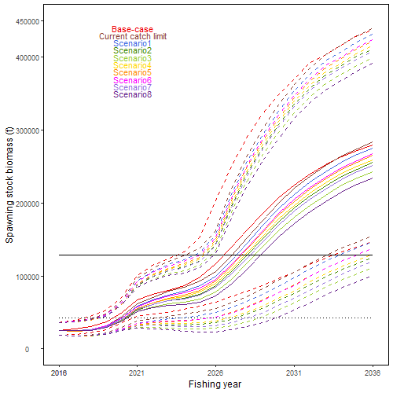

**Figure PBF-01**. Time series of the projected spawning stock biomass by various harvest scenarios listed on the Table PBF-01. Each colored solid and broken lines indicate the median spawning stock biomass and its 95% confidence intervals, respectively. The black dotted and solid lines are corresponded to the spawning stock biomasses of the initial and second rebuilding targets of Pacific bluefin tuna, respectively.

* + 1. **North Pacific swordfish (*Xiphias gladius*)**
       1. **Research and information**
       2. **Provision of scientific information**

1. **Stock status and trends**
2. SC15 noted that no stock assessments were conducted for North Pacific swordfish in 2019. Therefore, the stock status descriptions from SC14 are still current for North Pacific swordfish. For further information on the stock status and trends from SC14, please see <https://www.wcpfc.int/node/32155>. Updated information on catches was not compiled for and reviewed by SC15.
3. **Management Advice and implications**
4. SC15 noted that no management advice has been provided since SC14 for North Pacific swordfish. Therefore, the advice from SC14 should be maintained, pending a new assessment or other new information. For further information on the management advice and implications from SC14, please see <https://www.wcpfc.int/node/32155>
   1. **WCPO sharks** 
      1. **Oceanic whitetip shark (*Carcharhinus longimanus*)**
         1. **Research and information**
         2. **Provision of scientific information**
5. **Stock status and trends**
6. The median values of relative recent (2013-2015) spawning biomass (SBrecent/SBF=0, SBrecent/SBMSY) and relative recent fishing mortality (Frecent/FMSY) over the structural uncertainty grid were used to measure the central tendency of stock status. The span of the recent time period was determined to only include years following the adoption of CMM-2011-04. The values of the upper 90th and lower 10th percentiles of the empirical distributions of relative spawning biomass and relative fishing mortality from the uncertainty grid were used to characterize the probable range of stock status.
7. Descriptions of the updated structural sensitivity grid used to characterize uncertainty in the assessment are provided in Table OCS-01. Historical catch data used for the diagnostic case is presented in Figure OCS-01. Estimated annual average total biomass, recruitment and spawning biomass are shown in Figure OCS-02, and fishing mortality in Figure OCS-03. The time series of depletion in spawning biomass over all runs in the structural uncertainty grid is shown in Figure OCS-04. Kobe and Majuro plots summarizing the results for each of the models in the structural uncertainty grid retained for management advice are represented in Figures OCS-05 and OCS-06. Table OCS-02 provides a summary of reference points used to determine stock status over the 648 models in the structural uncertainty grid using the grid weights agreed upon by SC and outlined in Table OCS-01.
8. SC15 noted that the median level of spawning biomass depletion from the uncertainty grid was SBrecent/SB0 = 0.04 with a probable range of 0.03 to 0.05 (80% probability interval). While no limit reference point has been adopted, the depletion in spawning biomass is very high. The median level of recent spawning biomass relative to that leading to MSY was SBrecent/SBMSY = 0.09 (range: 0.05–0.17).
9. SC15 noted that the recent relative fishing mortality was very high and the grid median Frecent/FMSY was 3.94, with a range of 2.67 to 5.89 (80% probability interval), and that there were no model runs in the grid where Frecent/FMSY was below 1.
10. The key conclusions are that overfishing is occurring and the stock is in an overfished state relative to MSY and depletion-based reference points (noting that depletion-based reference points have only been adopted for tunas) (Tables OCS-1 and OCS-2). This conclusion is robust to uncertainties in key model assumptions (Figure OCS-5).
11. SC noted that the inclusion of discard mortality (DM) scenarios in the historical catches was an improvement to the assessment and was necessary to account for the potential impacts of the no-retention measure (CMM-2011-04) for oceanic whitetip sharks.
12. SC noted that stock status improved relative to F-based reference points in the period since CMM 2011-04 became active, which covers the last 4 years of the assessment’s timespan (2013–2016). Notably, F/FMSY is predicted to have declined by more than half from 6.12 to 2.67 (n=432, unweighted grid median) (Figure OCS-2), for the last year of the assessment when the impact of CMM 2011-04 on survival is accounted for under 25% and 43.75% discard mortality scenarios (Figure OCS-6 and OCS-7). Relative fishing mortalities under two alternative reference points that have not been adopted by the WCPFC, specifically F /Flim,AS (the fishing mortality resulting in 0.5 of SBMSY) and F/Fcrash,AS (the fishing mortality resulting in population extinction when sustained over the long-term, follow similar trends. Under the survival scenarios above, median SB/SBMSY is predicted to have increased slightly from 2013 to 2016 (8.6% to 9.2%).
13. SC15 noted that there was some inconsistency between observed and estimated CPUEs for 2013-2016 in the diagnostic case, which is probably caused by the assumptions about the stock recruitment relationship in this stock assessment. Whether or not this inconsistency is present in all models across the included uncertainty grid remains unknown.
14. **Management advice and implications**
15. Despite the data limitations going into the assessment and the wide range of uncertainties considered, all of the feasible grid model runs indicate that the WCPO oceanic whitetip shark stock continues to be overfished and overfishing is occurring relative to commonly used depletion and MSY-based reference points.
16. SC15 noted that while the assessment estimates that overfishing is still occurring (Frecent/FMSY was 3.94) the stock assessment also estimates a slight recovery in stock biomass in recent years (2013-2016). It remains unclear whether the stock status will continue to improve or perhaps decline in the future. To help clarify this issue SC15 recommends that stock projections based on the assessment are undertaken and presented to SC16.
17. SC15 noted that there now appear to be few if any major fisheries targeting oceanic whitetip. The greatest impact on the stock is attributed to bycatch from the longline fisheries, with lesser impact from purse seining.
18. Noting that there are existing CMMs directed at oceanic whitetip, SC15 recommended that further efforts to mitigate catch and improve handling and release practices are required to further reduce fishing mortality and improve stock status.
19. SC15 noted that the assessment would be improved with better data collection for longline fisheries, such as improved observer coverage, as these fisheries are the major component of fishing mortality and would provide additional information on interaction rates, mitigation options and the fate and condition at release.
20. SC15 recommends that, as a minimum, CCM’s meet the observer coverage specified in CMM 2018-05.
21. SC15 noted the need for improved estimates of age, growth and fecundity, as well as new length-length conversion factors that would allow for an improved assessment and the inclusion of a greater number of observed lengths.
22. SC15 noted that following the implementation of CMM 2011-04 and CMM 2014-05, the amount of scientific information available per year on oceanic whitetip sharks and other sharks species covered by a retention ban and the ban on shark lines or wire traces (e.g., bycatch estimates, length measurement, species and sex identification, and biological samples) has declined. SC15 also noted that the decline in information available for the oceanic whitetip shark assessment resulted in higher uncertainty in stock status, especially in more recent years since the introduction of these CMMs. This will also affect the capacity of SC to undertake future assessments if this decline in available information persists. SC15 recommends that WCPFC16 gives more consideration to the data needs for estimating reliable CPUE and other inputs into assessments when management measures are put in place, as these measures may have unintended consequences on continued availability and reliability of data. SC15 also recommended that WCPFC16 also take these considerations into account when reviewing the relevant sharks CMMs.
23. Noting that no limit reference points have been adopted for oceanic whitetip sharks, as well as other WCPO shark species, SC15 recommends that WCPFC16 consider identifying appropriate limit reference points for WCPO sharks.

**Table OCS-01**. Description of the axes for the structural uncertainty grid, and assigned weight by level in the final resampling of stock status metrics. Settings used under the diagnostic case are highlighted with a star.

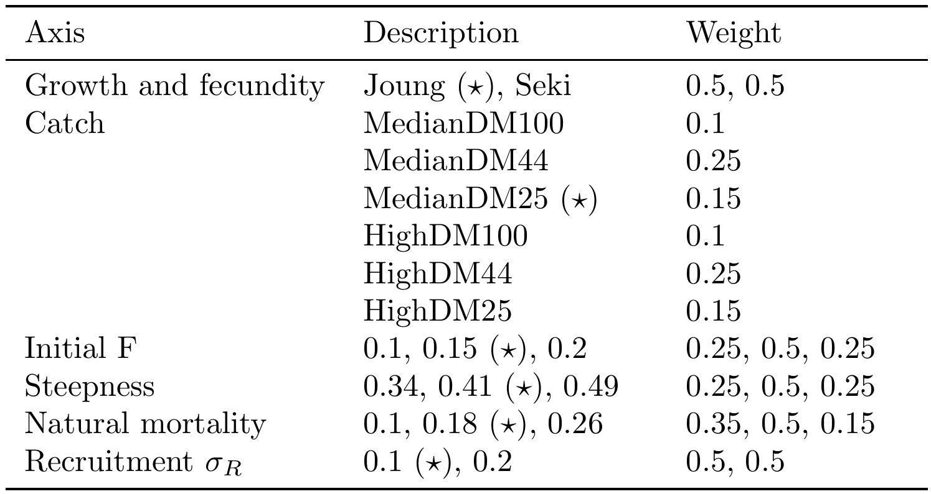

**Table OCS-02**. Summary of reference points using SC15 adopted weights by axes over the 648 models in the structural uncertainty grid.

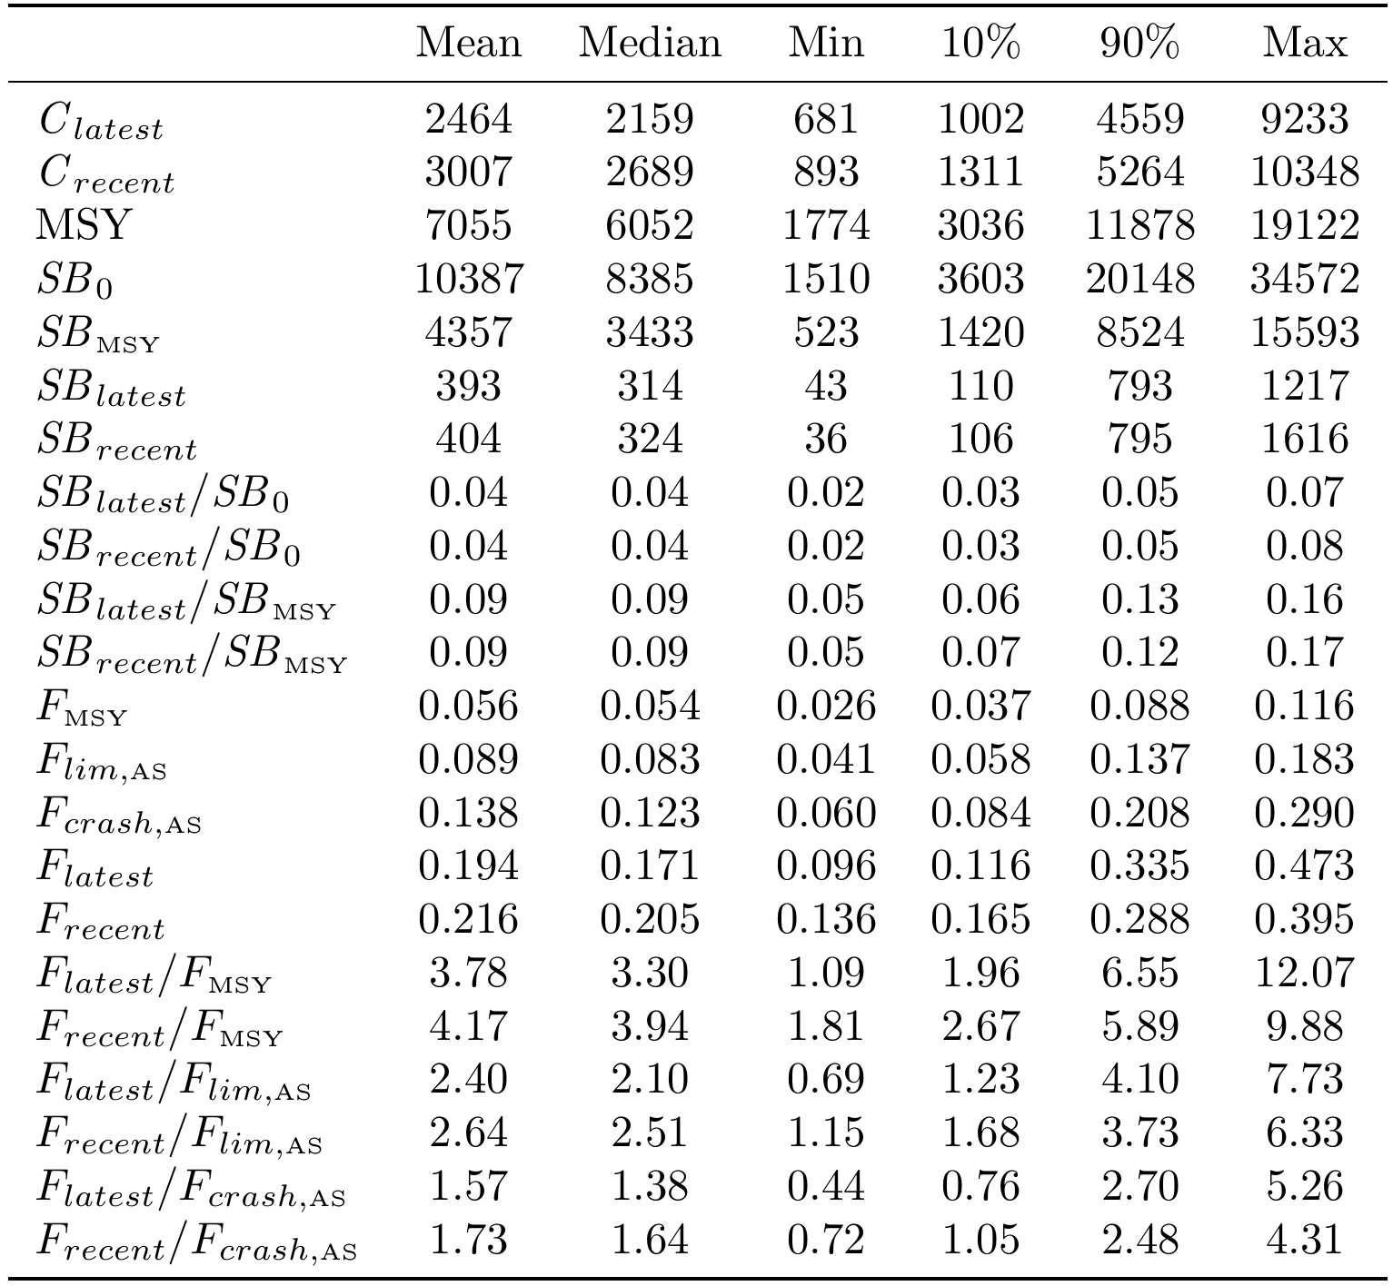

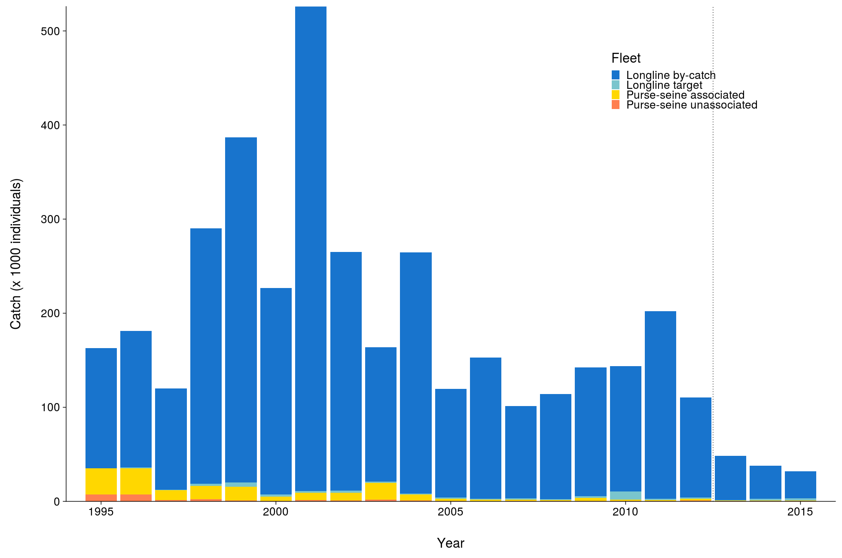

**Figure OCS-01**. Total reconstructed catches by fleet over time used for the diagnostic case.

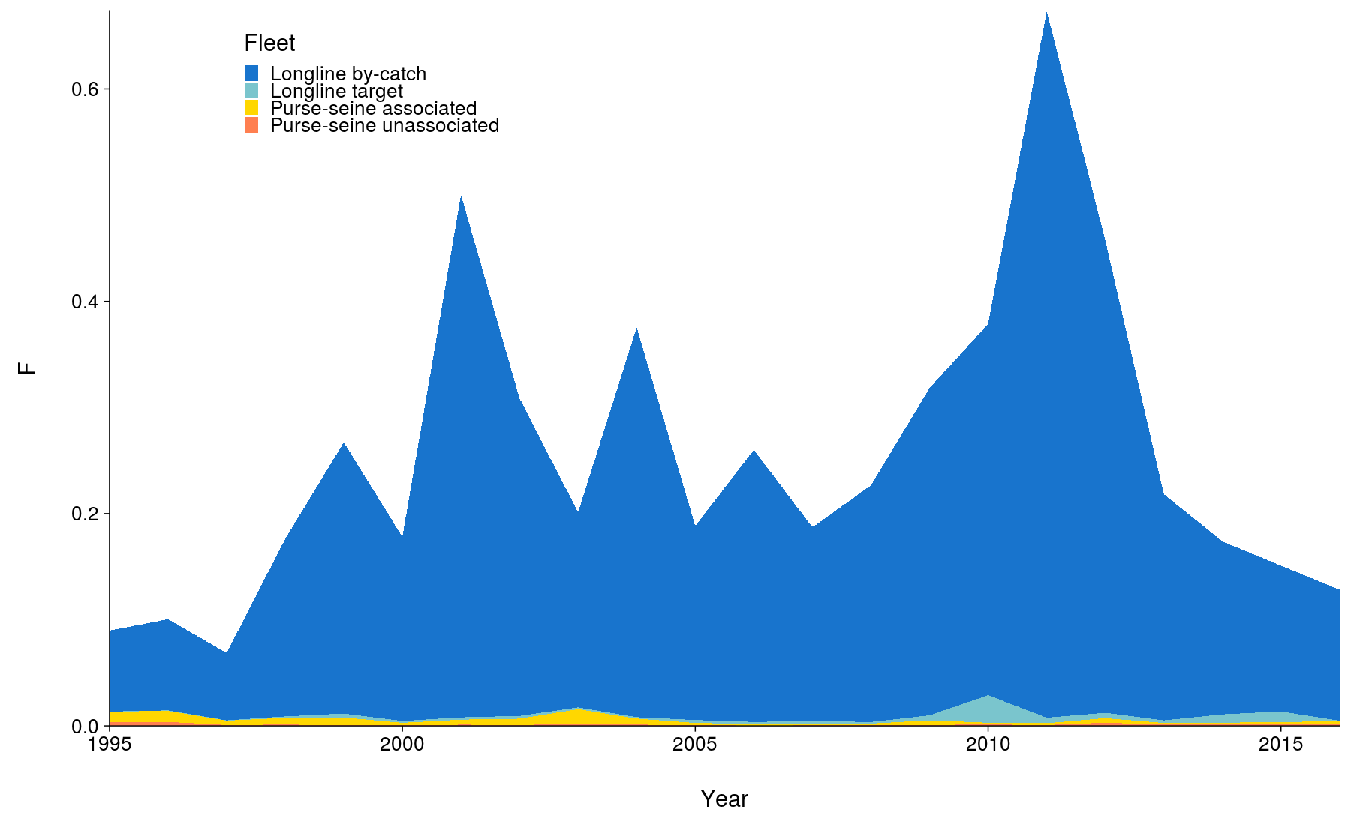

**Figure OCS-02.** Cumulative fishing mortality by fleet estimated for the diagnostic case over the timespan of the assessment (1995-2016).

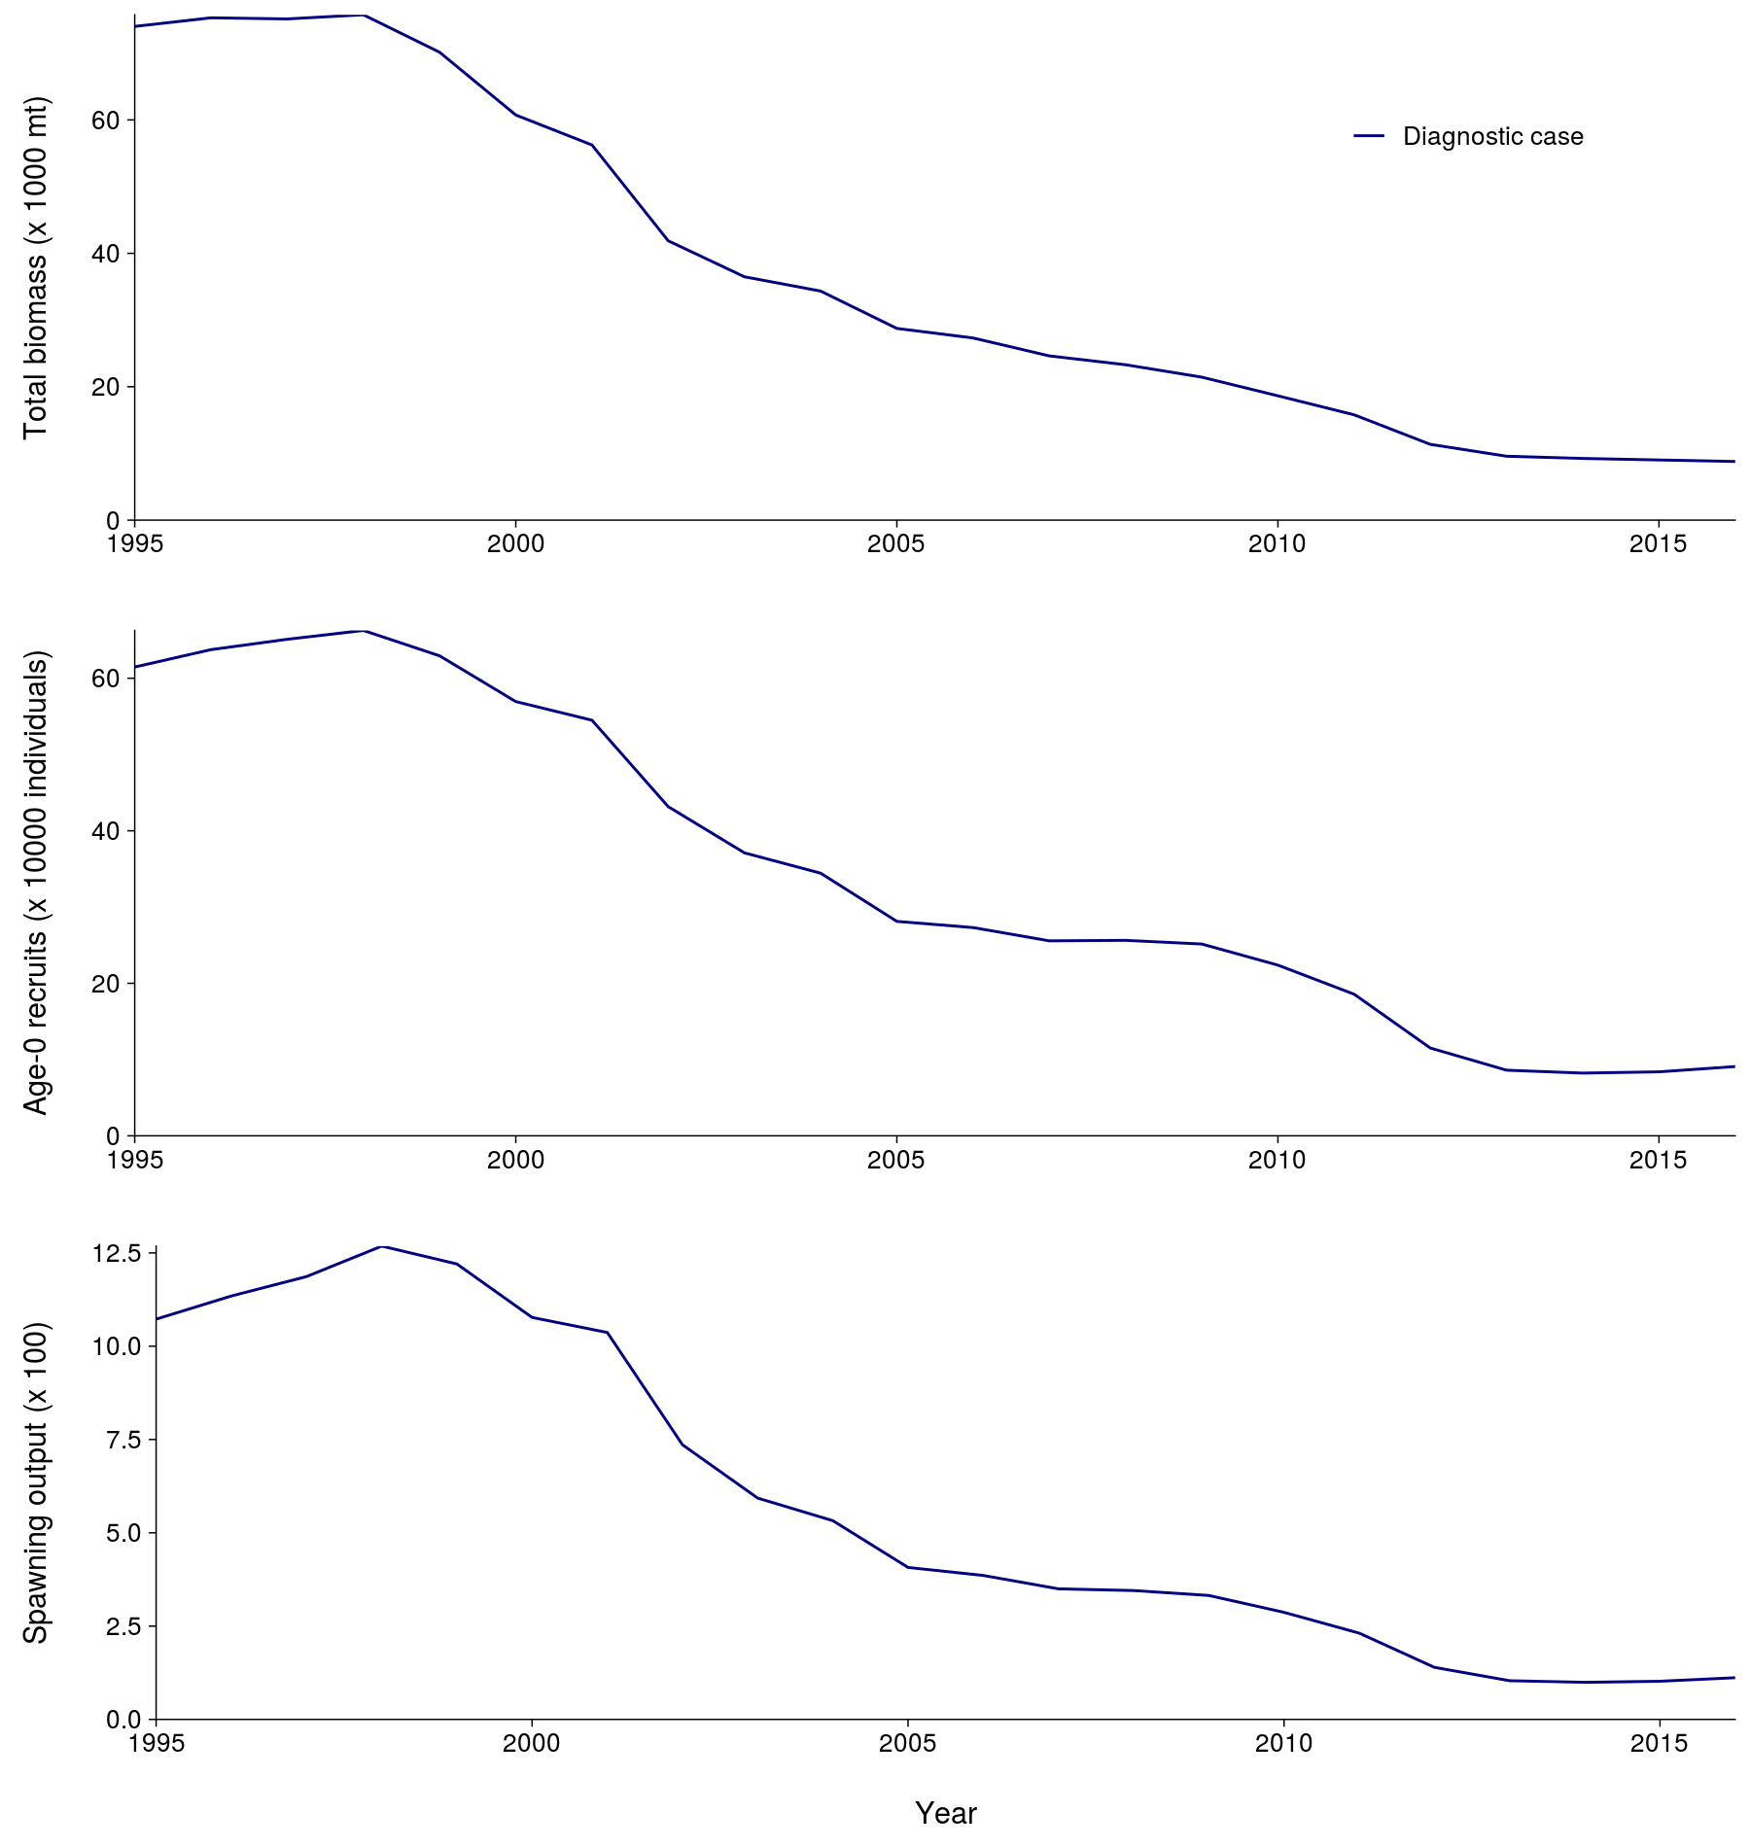

**Figure OCS-03**. Total biomass, recruitment and spawning biomass for the diagnostic case over the timespan of the assessment (1995-2016).

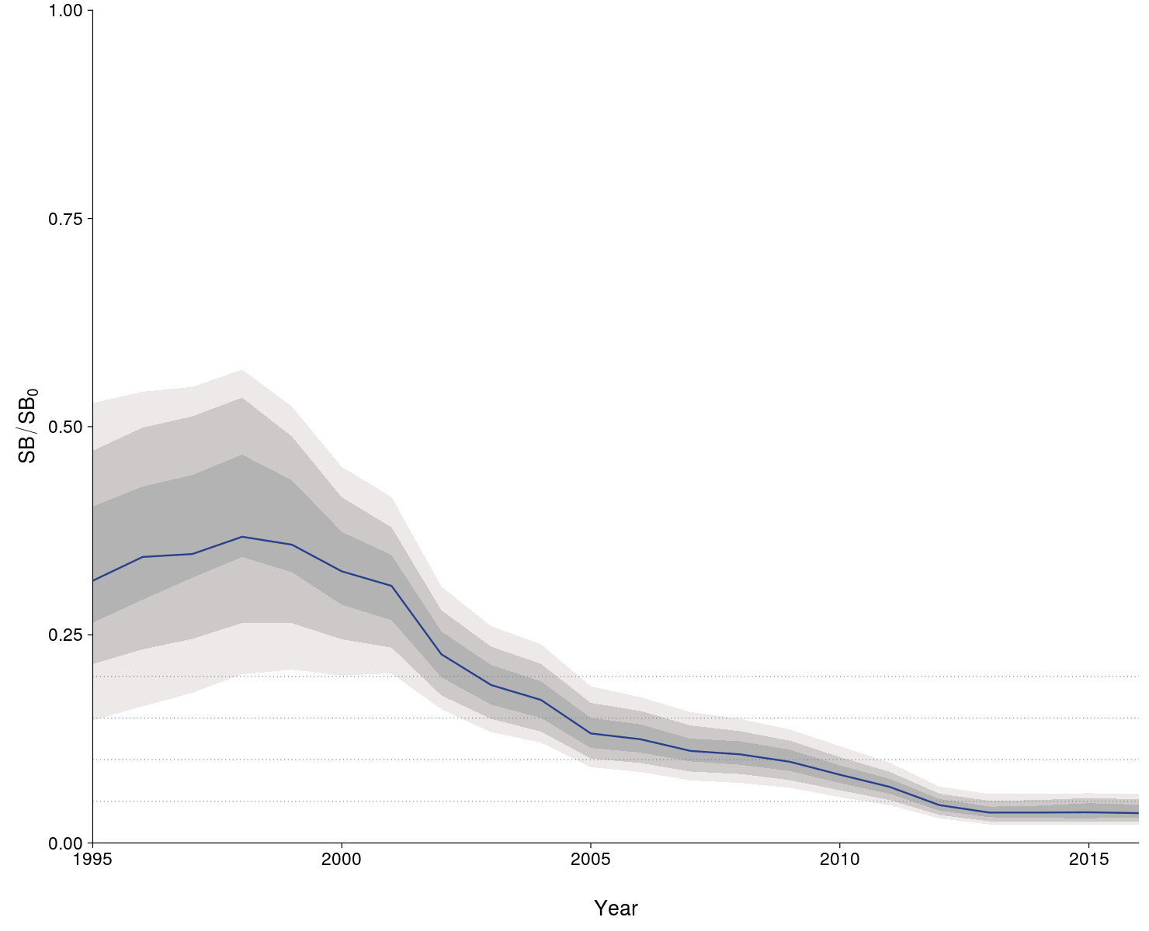

**Figure OCS-04**: Median estimates of depletion in spawning biomass over all (weighted) grid runs, with 2.5th -97.5th, 10th-90th and 25th -75th quantile intervals. Horizontal grey lines are placed at intervals of 5% in the lower part of the graph to aid visualization.

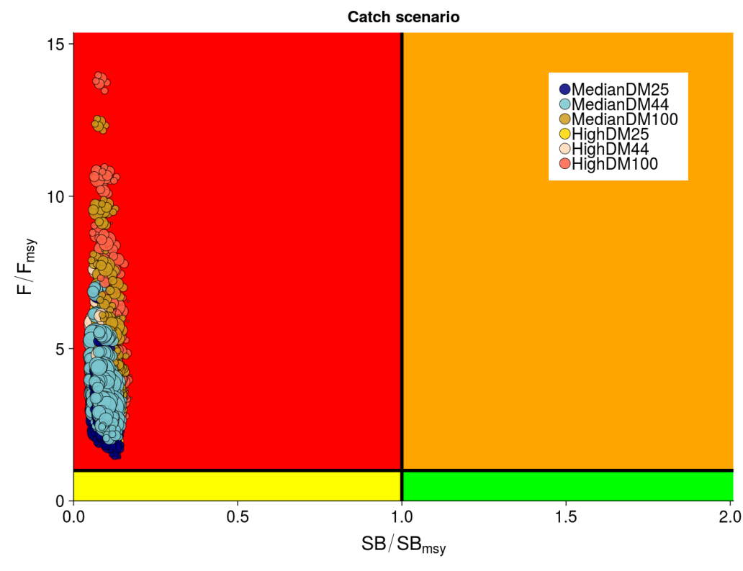

**Figure OCS-05**: Kobe plot summarizing recent status (2013-2015) for each of the (weighted) models in the structural uncertainty grid, based on SB/SBMSY and F/FMSY. The stock is considered to be overfished when SB/SBMSY > 1 and undergoing overfishing when F/FMSY > 1. The points are coloured according to the catch scenario that was used as input to the individual grid run. The size of the circle relates to the weight of that particular model run.

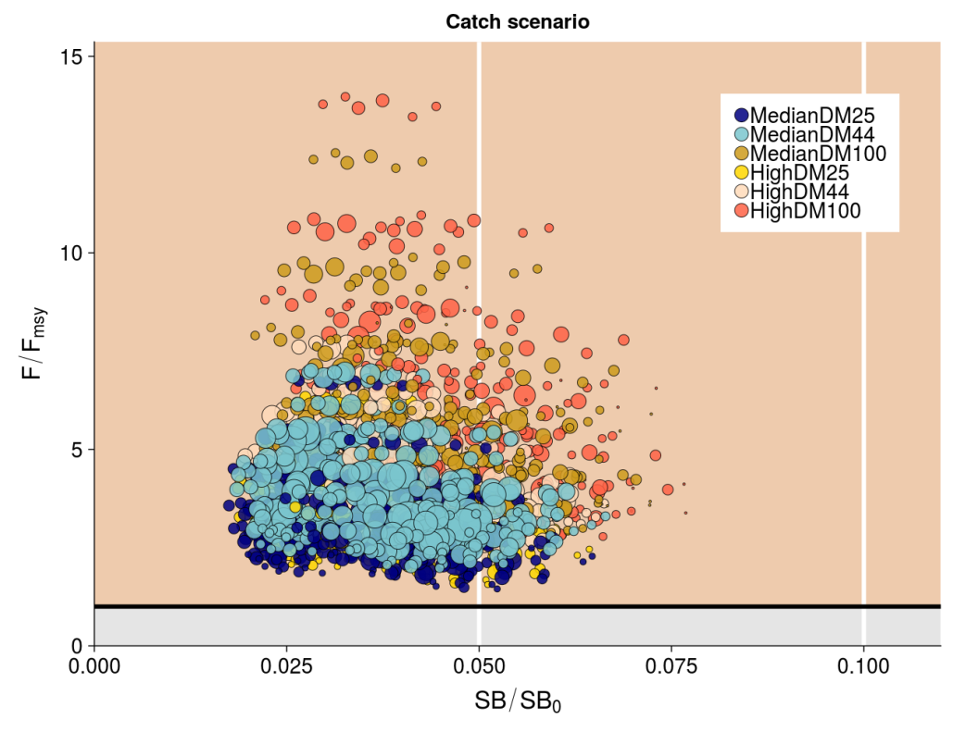

**Figure OCS-06**: Panel plot summarizing recent stock status (2013-2015) for each of the weighted models in the structural uncertainty grid for SB/SB0 and F/FMSY, noting no limit or target reference points have been adopted for oceanic whitetip shark. The stock is considered to be undergoing overfishing when F/FMSY > 1 (beige zone). The SB/SB0 axis was scaled to span the range of depletion values. Guidelines were added in white at 0.5SB/SB0 and 0.1SB/SB0. The points are coloured according to the catch scenario that was used as input to the individual grid run. The size of the circle relates to the weight of that particular model run.

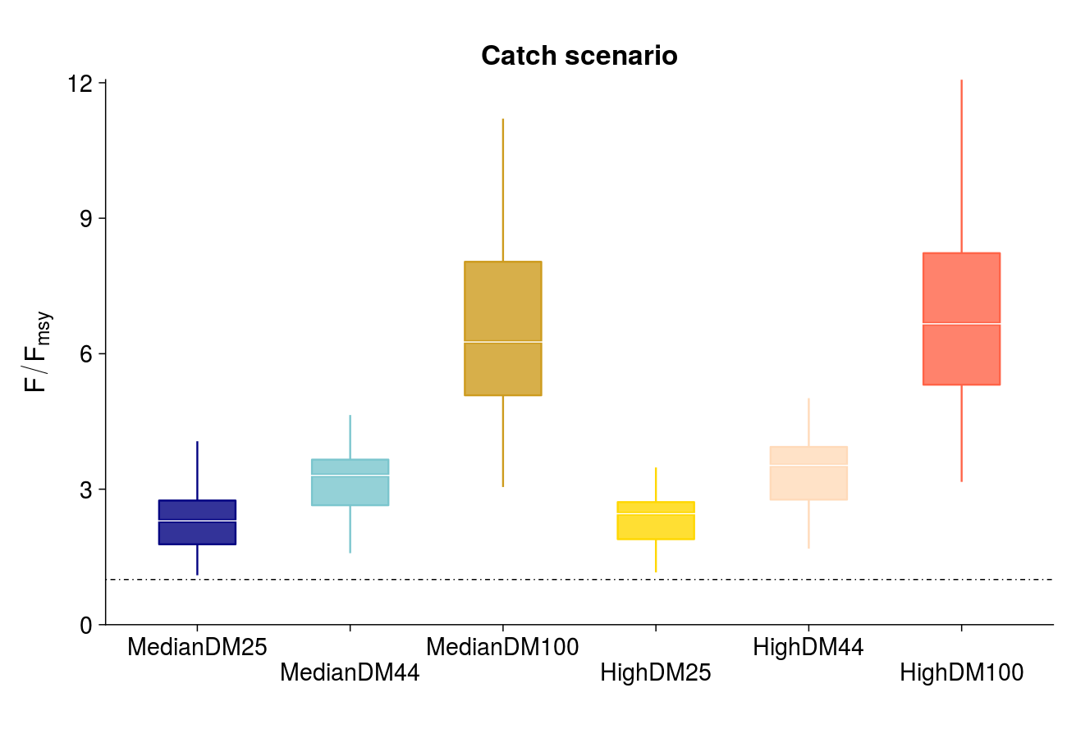

**Figure OCS-07**: Median (white bar) and inter-quartile bounds (box) for F/FMSY in the final year of the assessment (2016) under the 6 catch scenarios used in the structural uncertainty axis. The catch scenarios included baseline and high levels of catches with 3 scenarios of discard mortality (25%, 43.75% and 100%). The whiskers extend to 1.5 times the interquartile range.

* + 1. **Silky shark (*Carcharhinus falciformis*)**
       1. **Research and information**
       2. **Provision of scientific information**

1. **Stock status and trends**
2. SC15 noted that no stock assessments were conducted for silky shark in 2019. Therefore, the stock status descriptions from SC14 are still current for silky shark. For further information on the stock status and trends from SC14, please see <https://www.wcpfc.int/node/32155>. Updated information on catches was not compiled for and reviewed by SC15.
3. Management advice and implications
4. SC15 noted that no management advice has been provided since SC14 for silky shark. Therefore, previous advice should be maintained, pending a new assessment or other new information. For further information on the management advice and implications from SC14, please see <https://www.wcpfc.int/node/32155>.
   * 1. **South Pacific blue shark (*Prionace glauca*)**
        1. **Research and information**
        2. **Provision of scientific information**
5. **Stock status and trends**
6. SC15 noted that no stock assessments were conducted for South Pacific blue shark in 2019. Therefore, the stock status descriptions from SC13 are still current for South Pacific blue shark. For further information on the stock status and trends from SC13, please see <https://www.wcpfc.int/node/29904>. Updated information on catches was not compiled for and reviewed by SC15.
7. Management advice and implications
8. SC15 noted that no management advice has been provided for South Pacific blue shark.
   * 1. **North Pacific blue shark (*Prionace glauca*)**
        1. **Research and information**
        2. **Provision of scientific information**
9. **Stock status and trends**
10. SC15 noted that no stock assessments were conducted for North Pacific blue shark in 2019. Therefore, the stock status descriptions from SC13 are still current for North Pacific blue shark. For further information on the stock status and trends from SC13, please see <https://www.wcpfc.int/node/29904>.Updated information on catches was not compiled for and reviewed by SC15.
11. Management advice and implications
12. SC15 noted that no management advice has been provided since SC13 for North Pacific blue shark. Therefore, previous advice should be maintained, pending a new assessment or other new information. For further information on the management advice and implications from SC13, please see <https://www.wcpfc.int/node/29904>.
    * 1. **North Pacific shortfin mako (*Isurus oxyrinchus*)**
         1. **Research and information**
         2. **Provision of scientific information**
13. **Stock status and trends**
14. SC15 noted that no stock assessments were conducted for North Pacific shortfin mako shark in 2019. Therefore, the stock status descriptions from SC14 are still current for North Pacific shortfin mako shark. For further information on the stock status and trends from SC14, please see <https://www.wcpfc.int/node/32155>. Updated information on catches was not compiled for and reviewed by SC15.
15. Management advice and implications
16. SC15 noted that no management advice has been provided since SC14 for North Pacific shortfin mako shark. Therefore, previous advice should be maintained, pending a new assessment or other new information. For further information on the management advice and implications from SC14, please see <https://www.wcpfc.int/node/32155>.
    * 1. **Pacific bigeye thresher shark (*Alopias superciliosus*)**
         1. **Research and information**
         2. **Provision of scientific information**
17. **Stock status and trends**
18. SC15 noted that no stock assessments were conducted for Pacific bigeye thresher shark in 2019. Therefore, the stock status descriptions from SC13 are still current for Pacific bigeye thresher shark. For further information on the stock status and trends from SC13, please see <https://www.wcpfc.int/node/29904>. Updated information on catches was not compiled for and reviewed by SC15.
19. Management advice and implications
20. SC15 noted that no management advice has been provided since SC13 for Pacific bigeye thresher shark. Therefore, previous advice should be maintained, pending a new assessment or other new information. For further information on the management advice and implications from SC13, please see <https://www.wcpfc.int/node/29904>.
    * 1. **Porbeagle shark (*Lamna nasus*)**
         1. **Research and information**
         2. **Provision of scientific information**
21. **Stock status and trends**
22. SC15 noted that no stock assessments were conducted for southern porbeagle shark in 2019. Therefore, the stock status descriptions from SC13 are still current for southern porbeagle shark. For further information on the stock status and trends from SC13, please see <https://www.wcpfc.int/node/29904>. Updated information on catches was not compiled for and reviewed by SC15.
23. Management advice and implications
24. SC15 noted that no management advice has been provided since SC13 for southern porbeagle shark. Therefore, previous advice should be maintained, pending a new assessment or other new information. For further information on the management advice and implications from SC13, please see <https://www.wcpfc.int/node/29904>.
    * 1. **Whale shark (*Rhincodon typus*)**
         1. **Research and information**
         2. **Provision of scientific information**
25. **Stock status and trends**
26. SC15 noted that no stock assessments were conducted for whale shark in 2019. Therefore, the stock status descriptions from SC14 are still current for whale shark. For further information on the stock status and trends from SC14, please see <https://www.wcpfc.int/node/32155>. Updated information on catches was not compiled for and reviewed by SC15.
27. Management advice and implications
28. SC15 noted that no management advice has been provided since SC14 for whale shark. Therefore, previous advice should be maintained, pending a new assessment or other new information. For further information on the management advice and implications from SC14, please see <https://www.wcpfc.int/node/32155>.
    1. **WCPO billfishes**
       1. **South Pacific swordfish (*Xiphias gladius*)** 
          1. **Research and information**
          2. **Provision of scientific information**
    2. **Stock Status and trends**
29. SC15 noted that no stock assessments were conducted for south Pacific swordfish in 2019. Therefore, the stock status descriptions from SC13 are still current for south Pacific swordfish. For further information on the stock status and trends from SC13, please see <https://www.wcpfc.int/node/29904>. Updated information on catches was not compiled for and reviewed by SC15.
30. **Management Advice and implications**
31. SC15 noted that no management advice has been provided since SC13 for south Pacific swordfish. Therefore, previous advice should be maintained, pending a new assessment or other new information. For further information on the management advice and implications from SC13, please see <https://www.wcpfc.int/node/29904>
    * 1. **Southwest Pacific striped marlin (*Kajikia audax*)**
         1. **Research and information**
         2. **Provision of scientific information**
    1. **Stock Status and trends**
32. The description of the updated structural sensitivity grid used to characterize uncertainty in the assessment is provided in Table SMLS-01. The spatial structure used in the assessment model is shown in Figure SMLS-01, with sub-regions used to define fisheries shown. Catch trend data is presented in Figure SMLS-02. Estimated annual average recruitment, spawning biomass, and total biomass from the diagnostic case are shown in Figure SMLS-03. Fishing mortality and depletion estimated from the diagnostic case are shown in Figures SMLS-04 and SMLS-05, respectively. The median and 80 percent quantile trajectories of the fishing depletion for models in the structural uncertainty across the grid axes in Table SMLS-01 are shown in Figure SMLS-6.
33. The Majuro plot summarizing the results for each of the models in the structural uncertainty grid retained for management advice are represented in Figure SMLS-07. Figure SMLS-08 presents the Kobe plot summarizing the results for each of the models in the structural uncertainty grid retained for management advice.
34. SC15 noted that the median of recent spawning biomass depletion relative to the unfished condition was (SBrecent/SBF=0) = 0.198, with a probable range of 0.093 to 0.464 (80% probable range), and there was a roughly 50.33% probability (151 out of 300 models) that the recent spawning biomass depletion relative to the unfished condition was below the LRP adopted for tunas (SBrecent/SBF=0 = 0.2). The median estimate (0.198) is below that estimated from the previous (2012) assessment (SB2006-2009/SBF=0 = 0.34) (see SC8-SA-WP-05), noting the differences in the use of the grid in the two assessments and different model assumptions. In the current assessment the feasible grid consisted of 300 models (186 model runs removed from 486 grid models).
35. SC15 noted that the median of recent spawning biomass relative to the spawning biomass at MSY was (SBrecent/SBMSY) = 0.737 with a probable range of 0.334 to 1.635 (80% probable range), and there was a roughly 68.66% probability (206 out of 300 models) that the recent spawning biomass depletion was below the spawning biomass at MSY. The median estimate (0.737) is　below that estimated from the previous (2012) assessment (SBcurrent/SBMSY = 0.87) (see SC8-SA-WP-05), noting the differences between the two assessments.

1. SC15 noted that the median of relative recent fishing mortality was (Frecent/FMSY = 0.911) with an 80% probability interval of 0.313 to 1.891, and there was a roughly 44.3% probability (133 out of 300 models) that the recent fishing mortality was above FMSY. The median estimate (0.911) is above that estimated from the previous assessment (Fcurrent/FMSY = 0.81) (see SC8-SA-WP-05), noting the differences in the use of the grid in the two assessments.

**Table SMLS-01.** Description of the structural sensitivity grid used to characterize uncertainty in the assessment. The star denotes the level assumed in the diagnostic case.

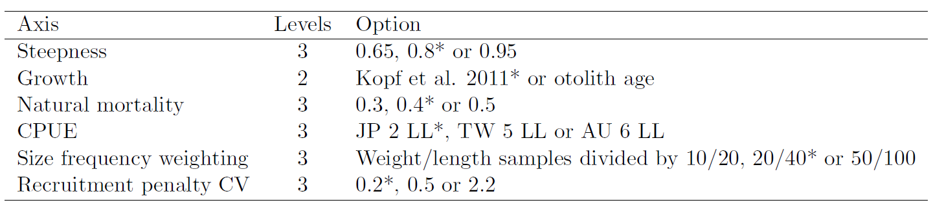

**Table SMLS-02.** Summary reference points over the models in the structural uncertainty grid.

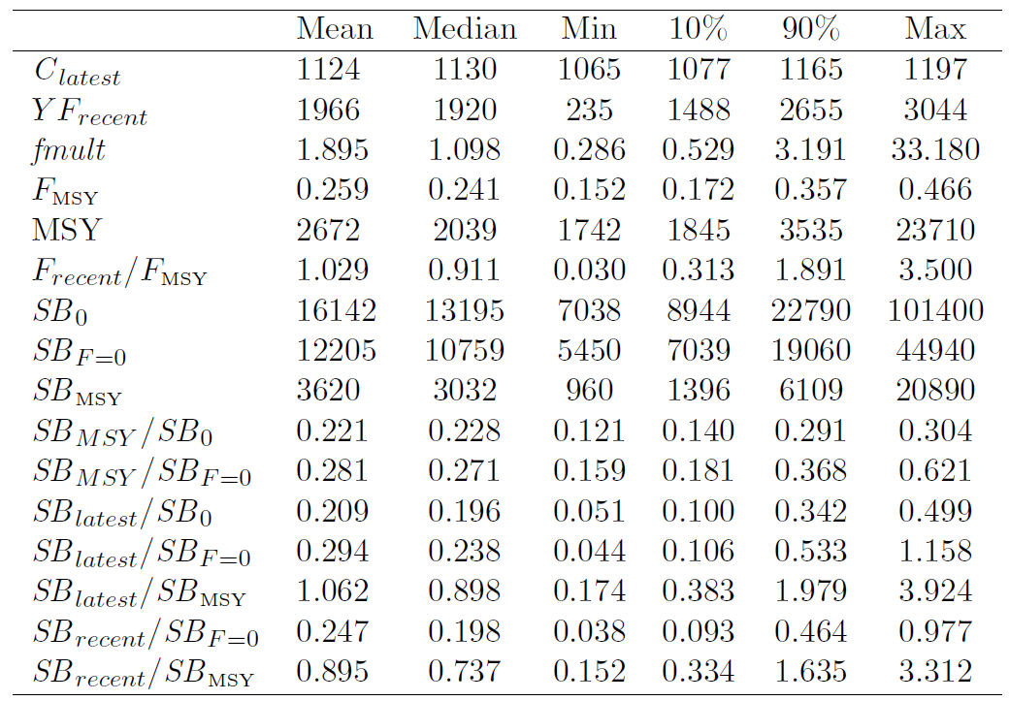

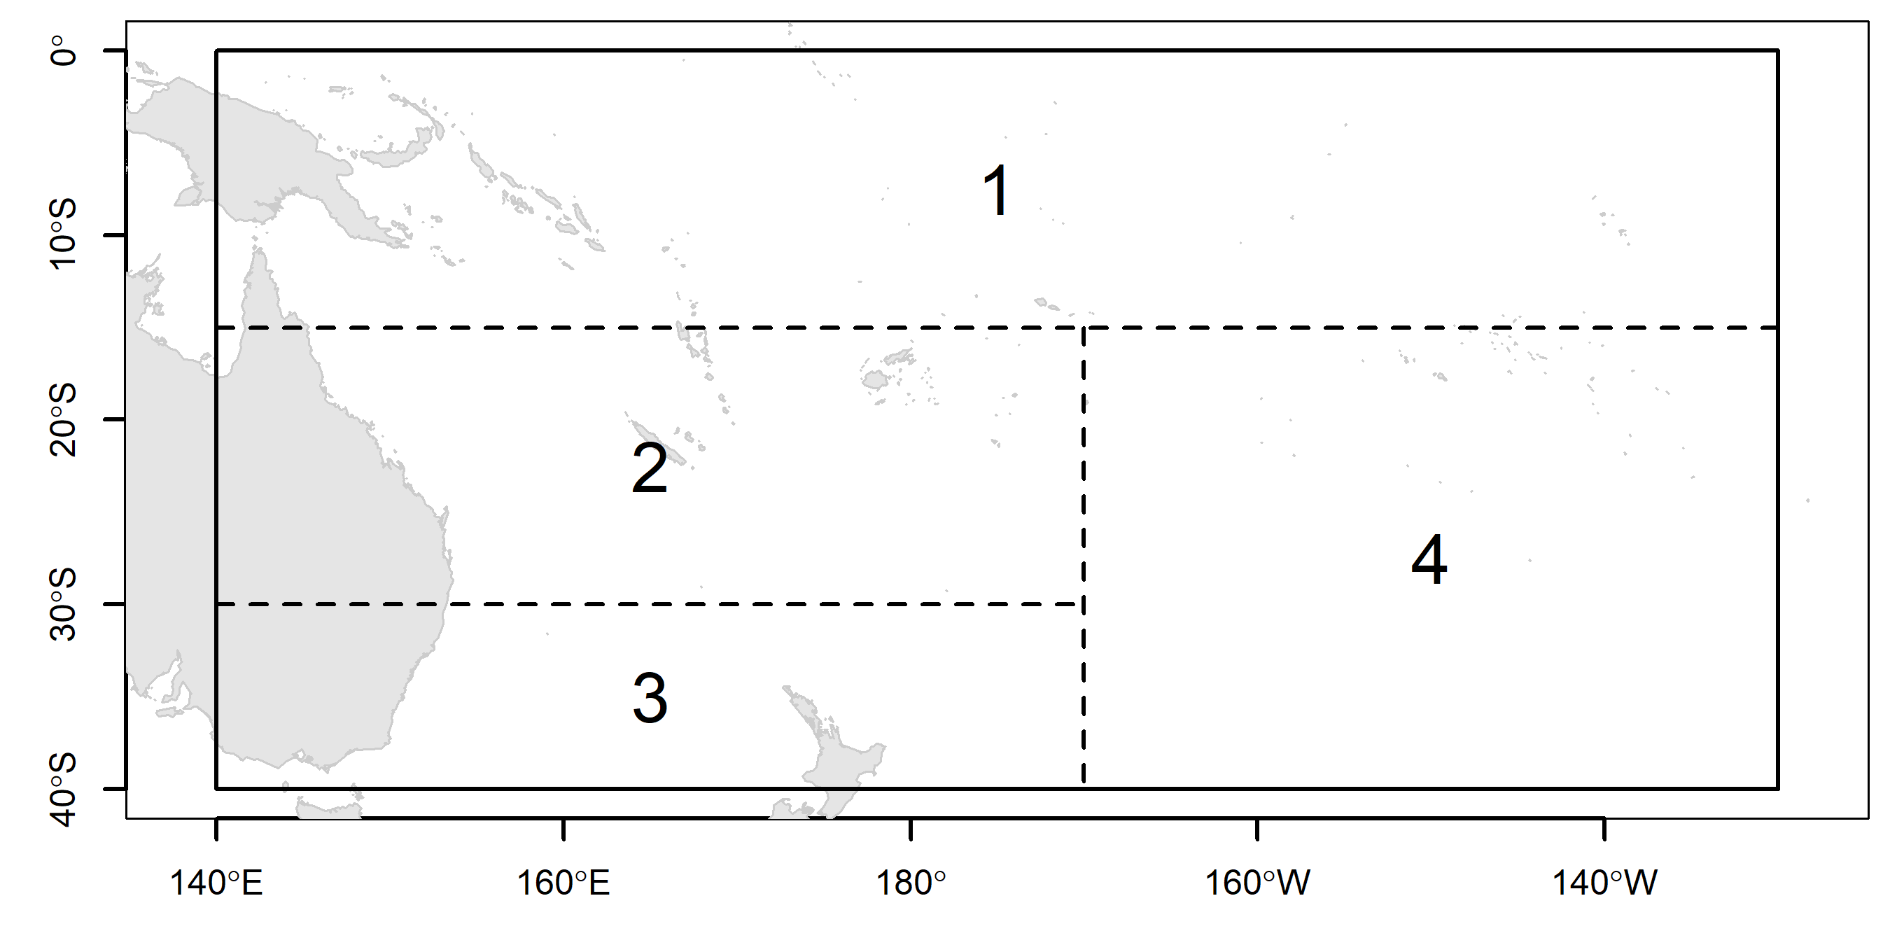

**Figure SMLS-01.** Single region spatial structure used in the 2019 stock assessment.

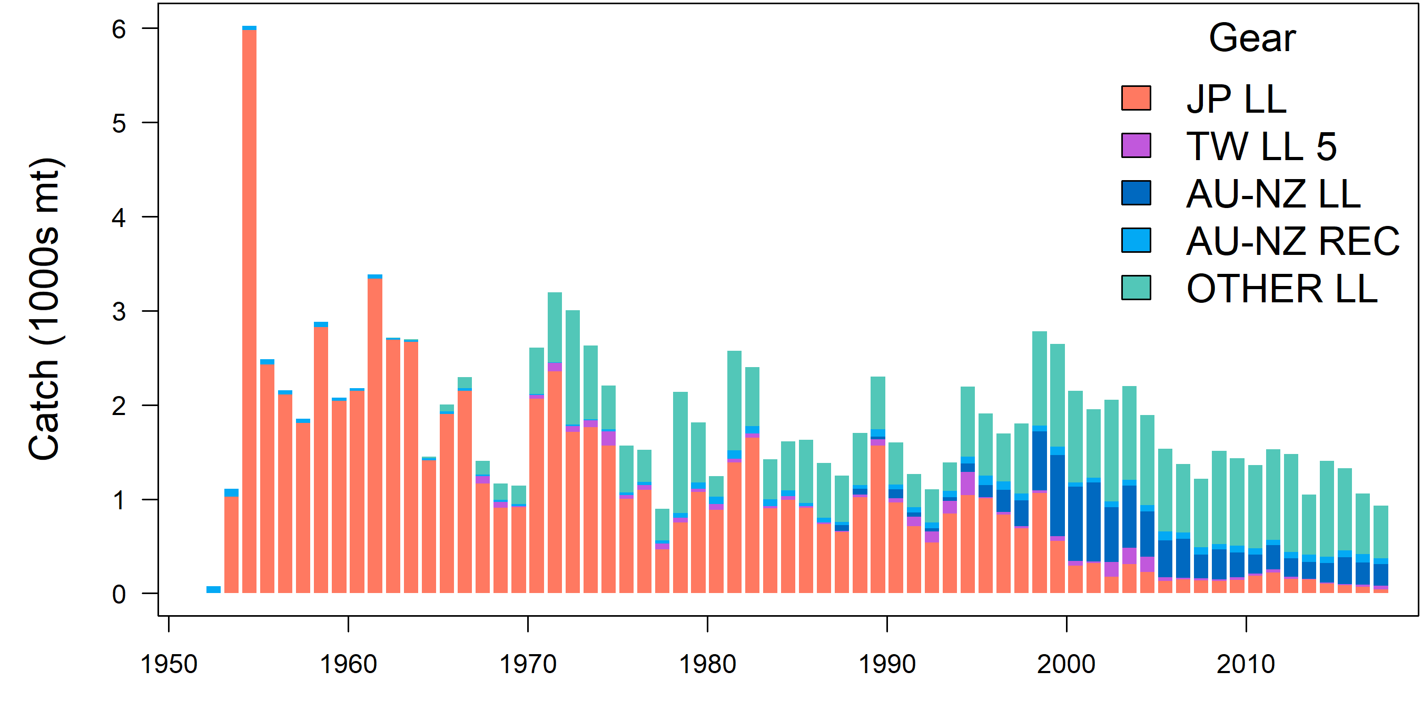

**Figure SMLS-02.** Time series of total annual catch (1000s mt) by fishery group over the full assessment period.

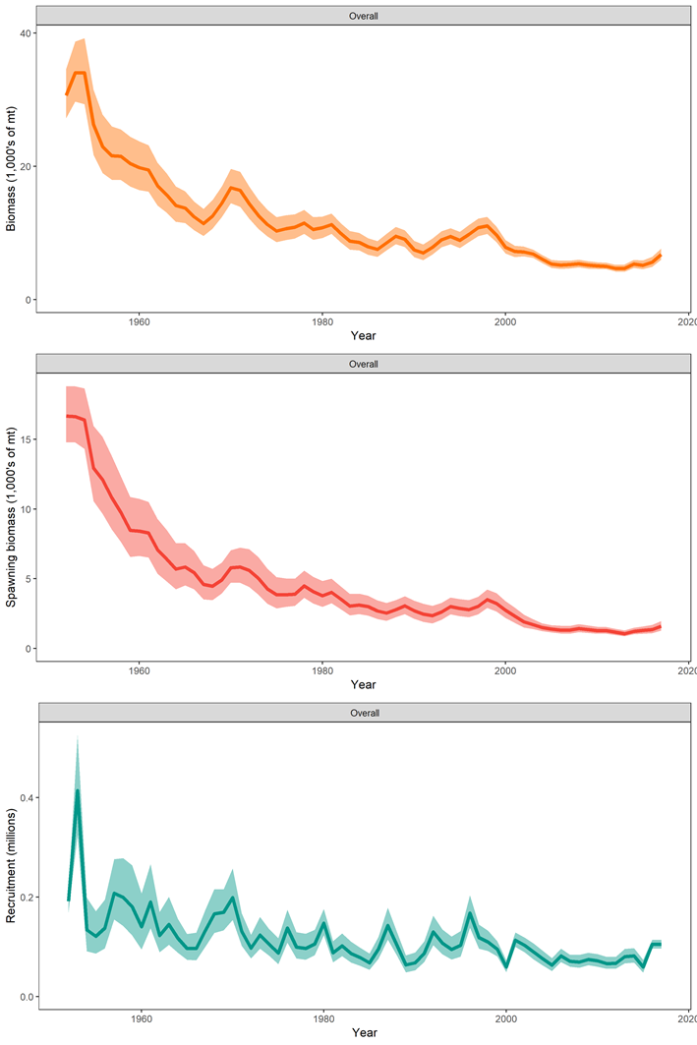

**Figure SMLS-03*.*** Estimated annual average total biomass, spawning biomass, and recruitment for the diagnostic model. Shaded region gives ± 2 standard deviations (i.e., 95% CI).

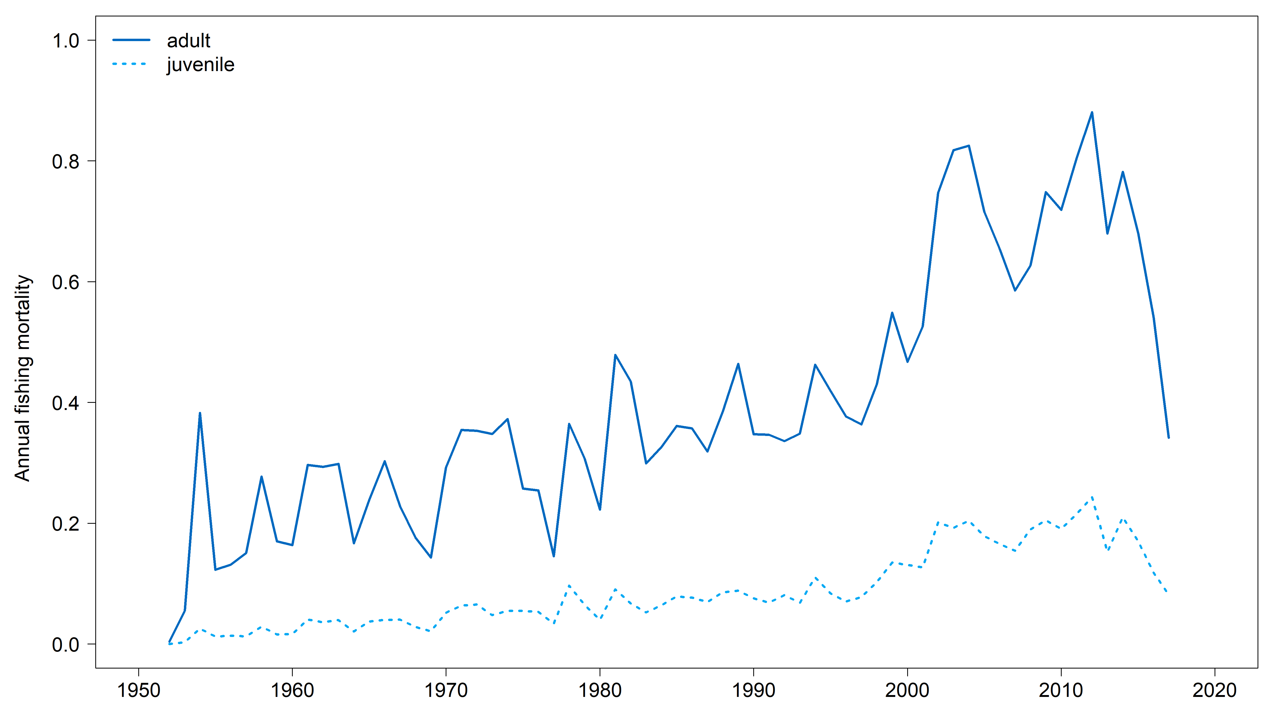

**Figure SMLS-04*.*** Estimated annual average juvenile and adult fishing mortality for the diagnostic model.

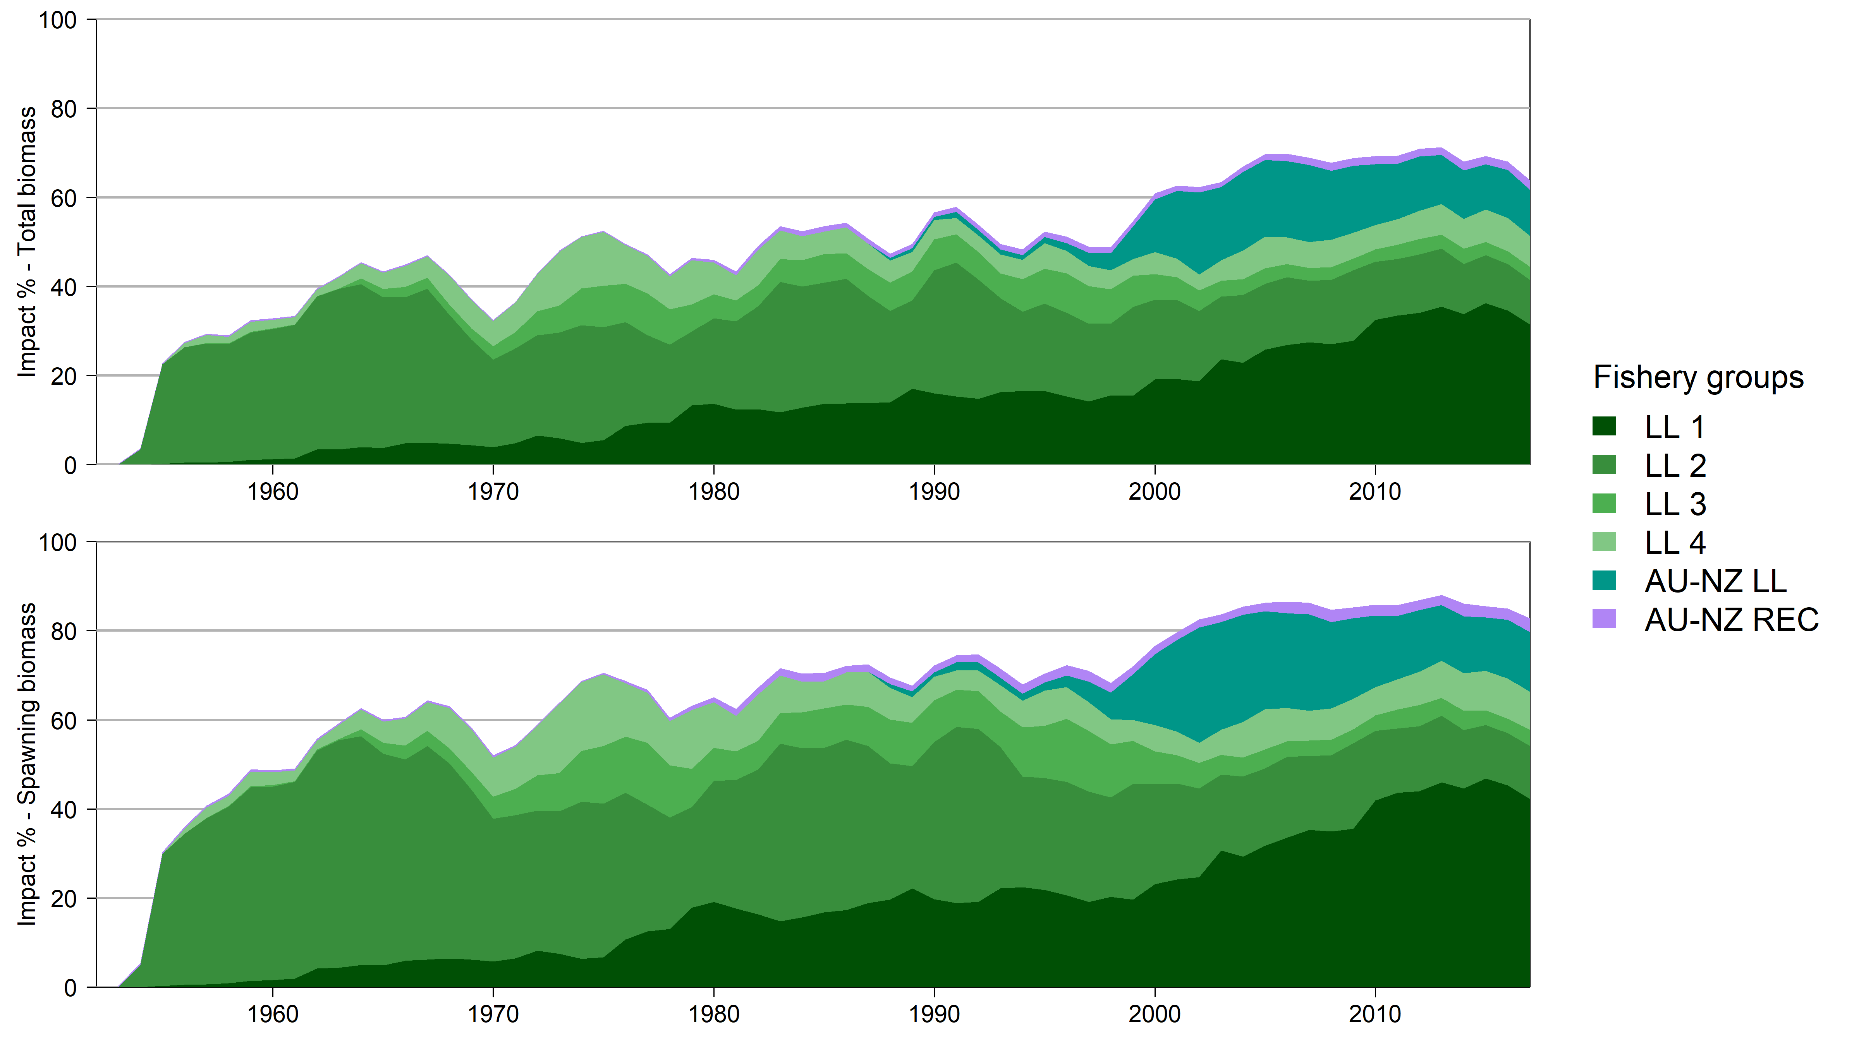

**Figure SMLS-05*.*** Estimates in reduction in spawning biomass and total biomass due to fishery impact for the diagnostic case model.

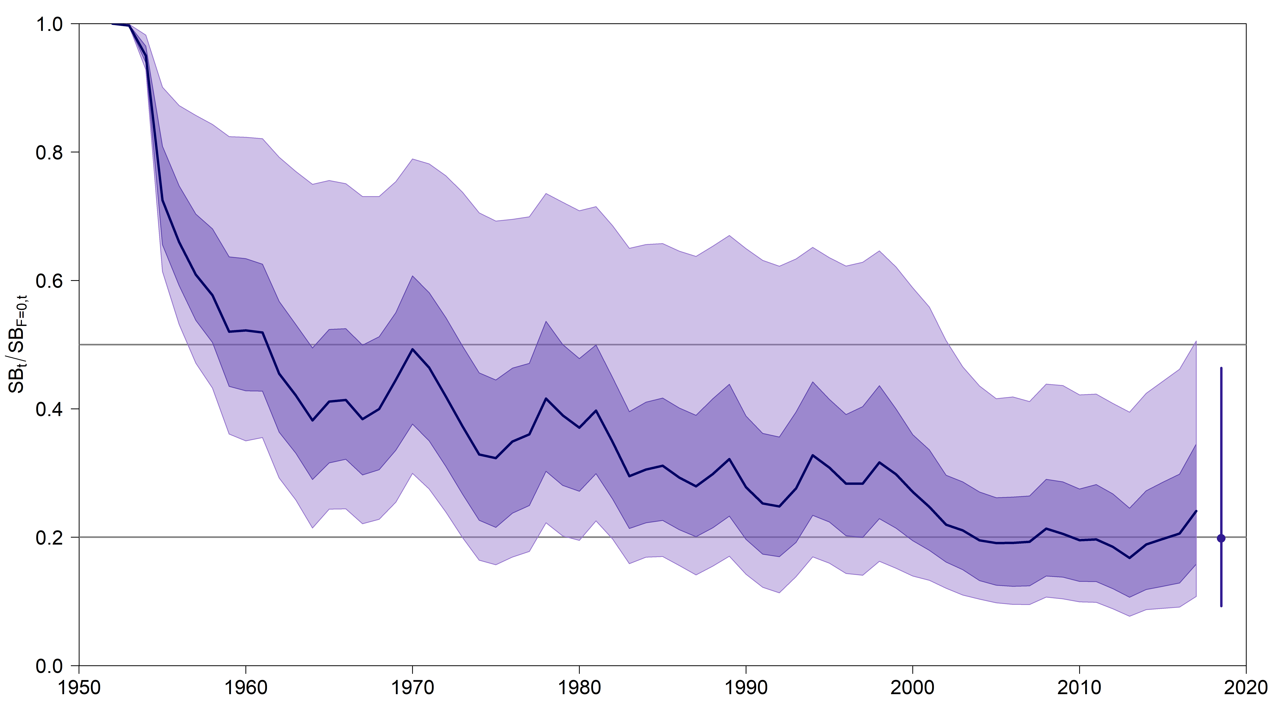

**Figure SMLS-06*.*** Plot showing the trajectories of spawning biomass depletion for the model runs included in the structural uncertainty grid described in Table SMLS-01. Gray horizontal lines indicate 50% and 20% levels of depletion. On the right of the depletion is the median point estimate of the recent level reference point with the bar indicating the 80th percentile.

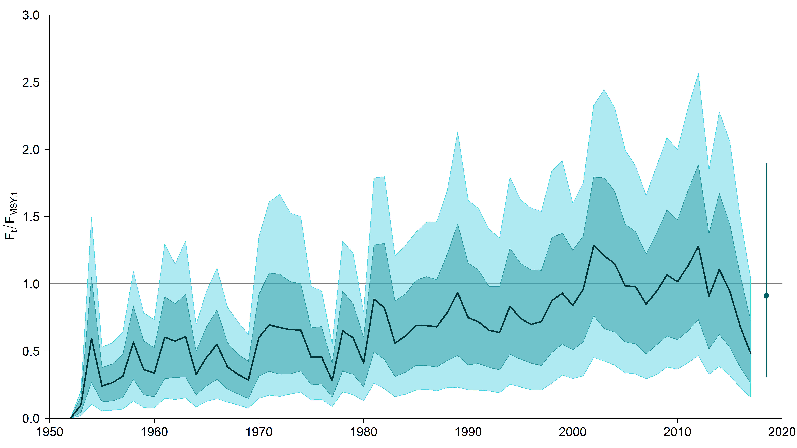

**Figure SMLS-06bis*.*** Plot showing the trajectories of fishing mortality for the model runs included in the structural uncertainty grid described in Table SMLS-01. Gray horizontal lines indicate FMSY. On the right of the depletion is the median point estimate of the recent level reference point with the bar indicating the 80th percentile.

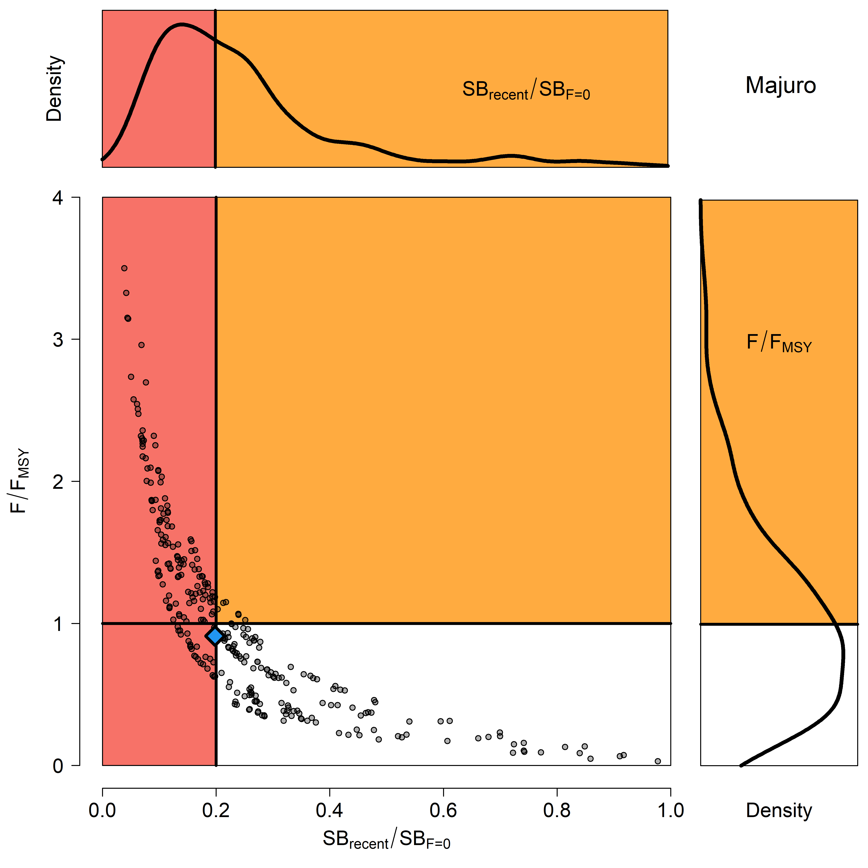

**Figure SMLS-07*.*** Majuro plot for the recent spawning biomass (2014 – 2017) summarizing the results for each of the models in the structural uncertainty grid. The plots represent estimates of stock status in terms of spawning biomass depletion and fishing mortality, and marginal distributions of each are presented. The blue square is the median of the grid.

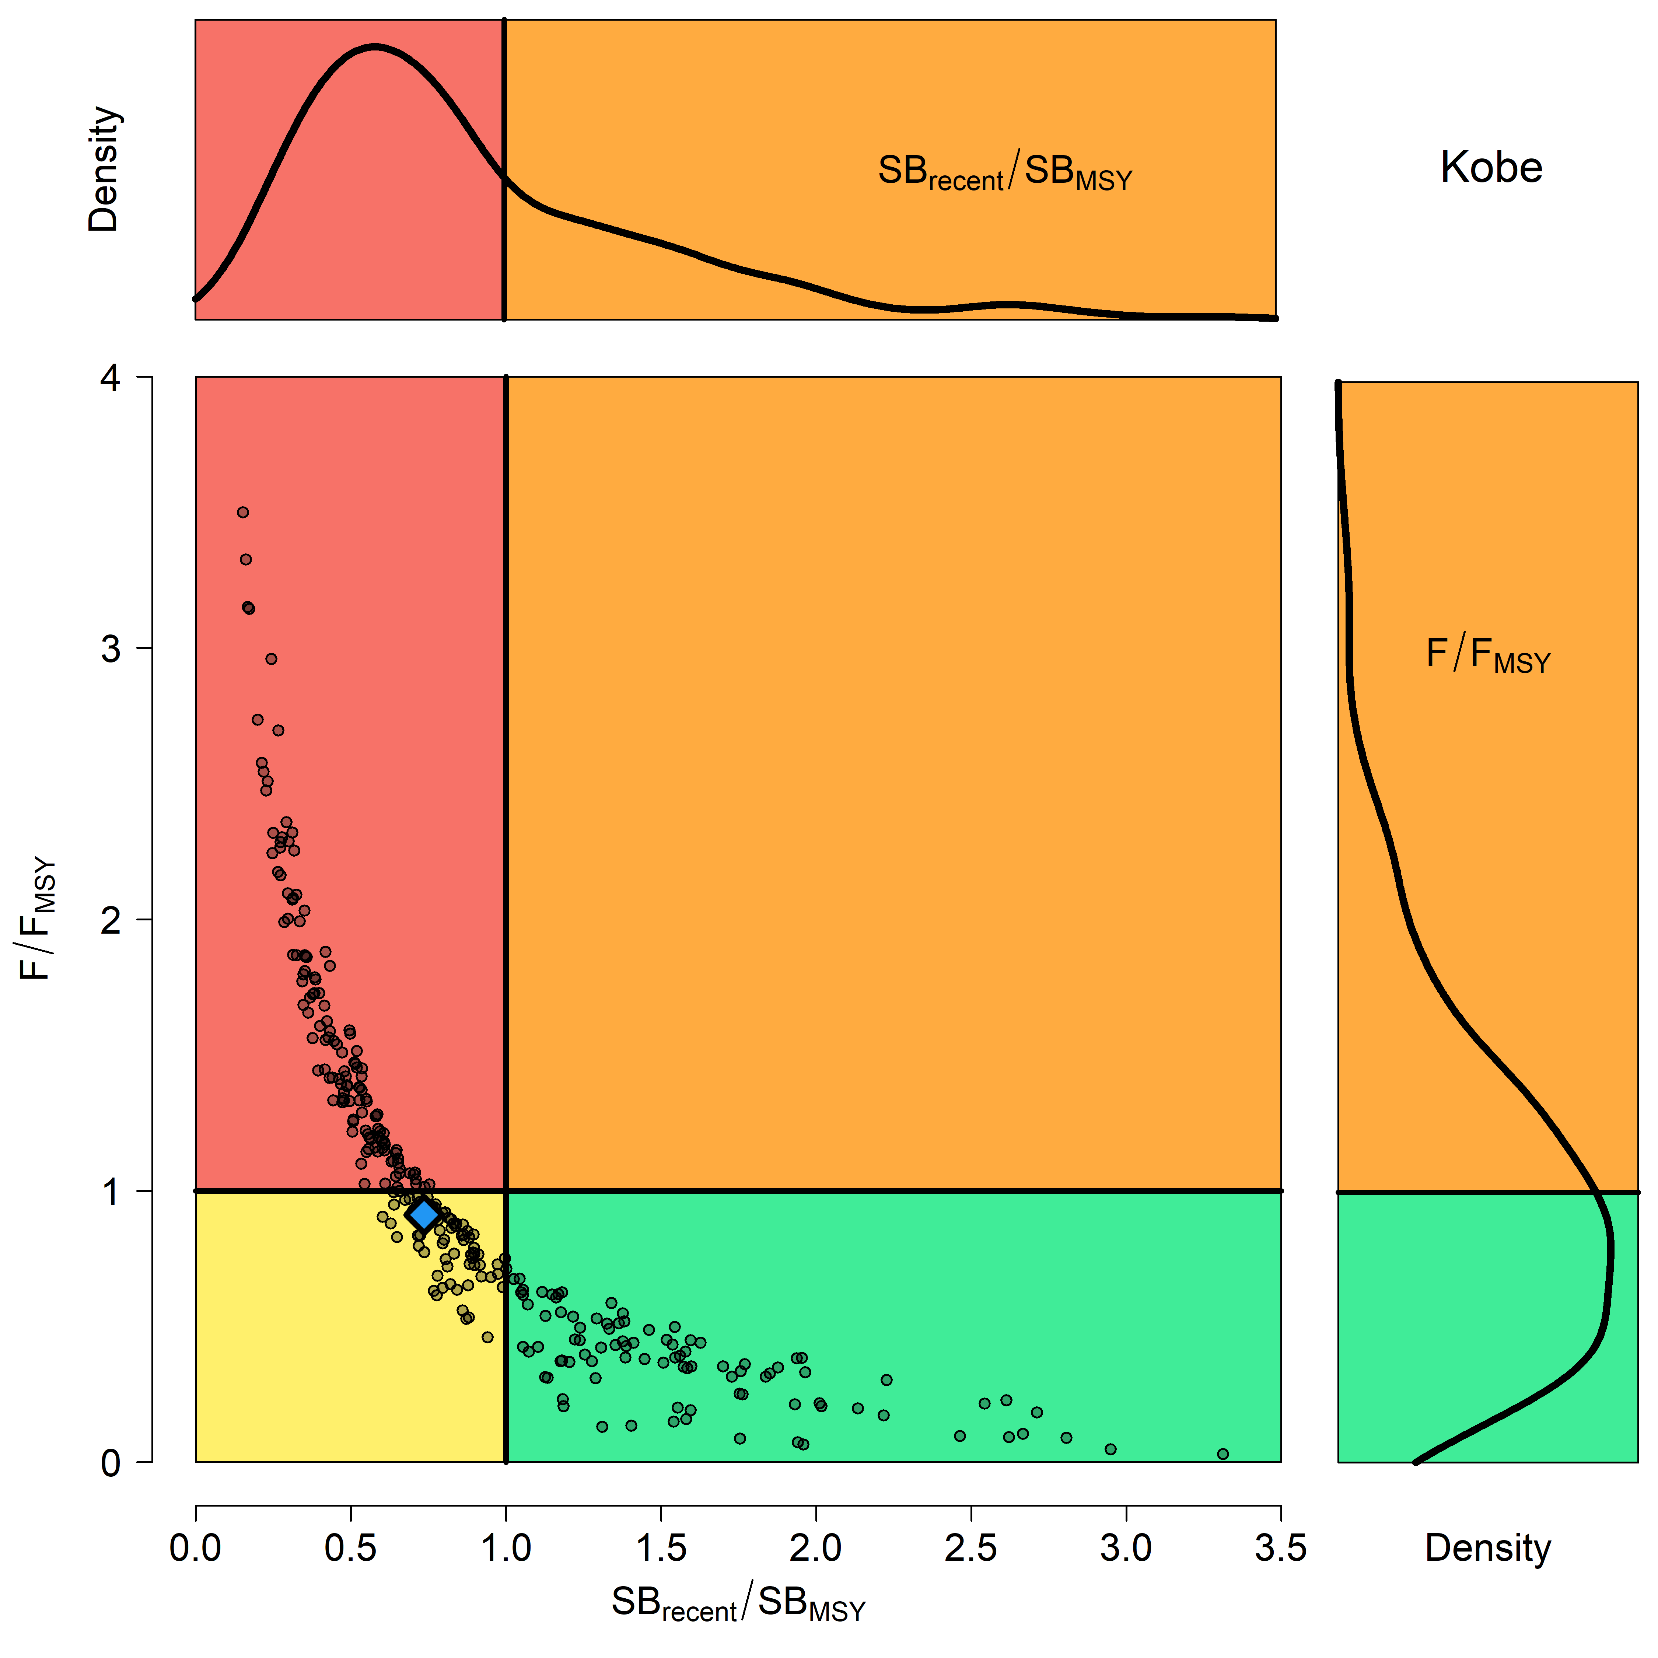

**Figure SMLS-08*.*** Kobe plot for the recent spawning biomass (2014 – 2017) summarizing the results for each of the models in the structural uncertainty grid. The plots represent estimates of stock status in terms of spawning biomass relative to the spawning biomass that produces MSY and fishing mortality, and marginal distributions of each are presented. The blue square is the median of the grid.

1. **Management Advice and implications**
2. SC15 noted that there are no agreed limit reference points for the WCPO billfish. However, SC15 also noted that based on the adopted uncertainty grid, the southwest Pacific striped marlin assessment results indicate that the stock is likely overfished, and close to undergoing overfishing according to MSY-based reference points. SC15 recommends that WCPFC16 identify an appropriate limit reference point for this stock. Key management quantities can be found in Table SMLS-02. The recent spawning biomass depletion relative to the unfished condition was close to the LRP adopted for tunas (SBrecent/SBF=0 = 0.2).
3. SC15 noted that recent catches are approximately half the MSY, and that recent fishing mortality is slightly less than the fishing mortality that would result in MSY.
4. SC15 recommended SC16 use stochastic stock projections, including the expansion of the geographic scope of CMM2006-04 by assuming average fishing effort during 2000-2004 by CCMs and zero fishing mortality in assessment region 1, to evaluate the potential long-term performance of the CMM.
5. SC15 recommended that WCPFC16 consider measures to reduce the overall catch of this stock, including through the expansion of the geographical scope of CMM 2006-04, in order to cover the distribution range of the stock.
6. **Research recommendations**
7. The following research activities were recommended by SC15 in order to progress the assessment of Southwestern Pacific striped marlin.
8. Improved estimates of life history parameters including growth, maturity, and natural mortality. Verify the aging method used to derive the growth relationship in order to inform meta analyses for M and steepness specific to SWPO striped marlin. Additionally, efforts should be made to increase sampling of smaller individuals.
9. Better estimates of striped marlin movement (>180 days) are needed to characterize mixing rates across model region in order to develop spatially explicit model structure and improve upon “areas as fleets” approach.
10. Improved estimates of conversion factors (such as weight-to-length and length-to-length) are needed, together with improved length-at-age estimates to better inform the data inputs used in the stock assessment.
11. Conduct sensitivities analyses with respect to the uncertainties in conversion factors used in the stock assessment and assess whether this should be included as an axis in the structural uncertainty grid.
12. Develop better estimates of historical catch (1950-1960) to resolve the potential issue of misidentification caused by merging the billfishes datasets.
    * 1. **North Pacific striped marlin (*Kajikia audax*)**
         1. **Research and information**
         2. **Provision of scientific information**
13. **Stock Status and trends**
14. SC15 noted that ISC provided the following conclusions on the stock status of Western and Central North Pacific striped marlin:

Estimates of population biomass of the Western and Central North Pacific Ocean (WCNPO) striped marlin fluctuated without trend between 1975 and 1993. The population deceased substantially in 1994 and fluctuated without trend until the present year. Population biomass (age-1 and older) averaged roughly 17,969 mt, or 54% below unfished biomass during the 1975-1993 period and declined to 4,508 mt, or 89% below unfished biomass by 2008. The minimum spawning stock biomass was estimated to be 618 t in 2011 (76% below *SSB*MSY, the spawning stock biomass to produce MSY, Figure NMLS-1a). In 2017, SSB = 981 t and SSB/SSBMSY = 0.38. Fishing mortality on the stock (average *F* on ages 3-12) has been around FMSY since 2014 (Figure NMLS-1b). It averaged roughly 0.64 yr-1 during 2015-2017, or 7% above *F*MSY and in 2017, F=0.80 yr-1 with a relative fishing mortality of F/FMSY = 1.33 (Table NMLS-02). Fishing mortality has been above FMSY in every year except 1984, 1992, and 2016. The predicted value of the spawning potential ratio (SPR, the predicted spawning output at current *F* as a fraction of unfished spawning output) is estimated to be *SPR2015-2017* = 17% and is approximately equal to the SPR required to produce MSY. Recruitment averaged about 263,000 age-0 recruits between 1994 and 2017, which was 34% below the 1975-2017 average. No target or limit reference points have been established for the WCNPO striped marlin stock under the auspices of the WCPFC. Despite the relatively large L50/Linf ratio for WCNPO striped marlin, the stock is expected to be highly productive due to its rapid growth and high resilience to reductions in spawning potential. Recent recruitments have been lower than expected and have been below the long-term trend since 2005. Although fishing mortality has decreased since 2000, due to the prolonged low recruitment and landings of immature fish, the biomass of the stock has remained below MSY. When the status of WCNPO striped marlin is evaluated relative to MSY-based reference points, the 2017 spawning stock biomass of 981 mt is 62% below *SSB*MSY(2,604 t) and the 2015-2017 fishing mortality exceeds *F*MSY by 7%. Therefore, relative to MSY-based reference points, overfishing is occurring and the WCNPO striped marlin stock is overfished (Figure NMLS-02).

Biological reference points were computed for the base case model with Stock Synthesis (Table NMLS-01 and Table NMLS-02). The point estimate of maximum sustainable yield (MSY) was 4,946 t. The point estimate of the spawning biomass to produce MSY (adult female biomass, SSBMSY) was 2,604 t. The point estimate of FMSY, the fishing mortality rate to produce MSY (average fishing mortality on ages 3 – 12) was 0.60 and the corresponding equilibrium value of spawning potential ratio at MSY was SPRMSY = 18%.

Stock projections for WCNPO striped marlin were conducted using the age-structured projection model software AGEPRO. Stochastic projections were conducted using results from the base case model to evaluate the probable impacts of alternative fishing intensities or constant catch quotas on future spawning stock biomass and yield for striped marlin in the WCNPO. For fishing mortality projections, a standard set of F-based projections were conducted. For catch quota projections, the set of rebuilding projection analyses requested by NC14 were conducted. Two future recruitment scenarios were evaluated (Figure 3 and Figure 4): (1) a short-term recruitment scenario based on resampling the empirical cumulative distribution function of recruitment observed during 2012-2016 and (2) a long-term recruitment scenario based on resampling the empirical cumulative distribution function of recruitment observed during 1975- 2016. The short-term recruitment scenario had an average recruitment of 134,020 age-0 fish and the long-term recruitment mean was 306,989 age-0 fish. The stochastic projections employed model estimates of the multi-fleet, multi-season, size- and age-selectivity, and structural complexity in the assessment model to produce consistent results. Fishing mortality-based projections started in 2018 and continued through 2037 under five levels of fishing mortality and the two recruitment scenarios. The five fishing mortality stock projection scenarios were: 1) F status quo (average F during 2015-2017), 2) FMSY, 3) F at 0.2·SSB0, 4) FHigh at the highest 3-year average during 1975-2017, and 5) FLow at F30%. For the F-based scenarios, fishing mortality in 2018-2019 was set to be F status quo (0.64) and fishing mortality during 2020-2037 was set to the projected level of F. Catch-based projections also ran from 2018 to 2037 and included seven levels of constant catch for the long-term recruitment scenario and 10 levels of catch for the short-term recruitment scenario. For the catch-based scenarios, catch biomass in 2018-2019 was set to be the status quo catch during 2015-2017 (2,151 t) and annual catches during 2020-2037 were set to the projected catch quota. The ten constant catch stock projection scenarios were: 1) Quota based upon WCPFC CMM10-01, 2) 90% of the quota, 3) 80% of the quota, 4) 70% of the quota, 5) 60% of the quota, 6) 50% of the quota, 7) 40% of the quota, 8) 30% of the quota, 9) 20% of the quota, and 10) 10% of the quota. Results show the projected female spawning stock biomasses and the catch biomasses under each of the scenarios (Table NMLS-03, Figure NMLS-03 and Figure NMLS-04).

1. SC15 noted the following stock status from ISC:

Biomass (age 1 and older) for the WCNPO striped marlin stock decreased from 17,000 t in 1975 to 6,000 t in 2017. Estimated fishing mortality averaged F=0.97 yr-1 during the 1975-1994 period with a range of 0.60 to 1.59 yr-1, peaked at F=1.71 year-1 in 2001, and declined sharply to F=0.64 yr-1 in the most recent years (2015-2017). Fishing mortality has fluctuated around FMSY since 2013. Compared to MSY-based reference points, the current spawning biomass (average for 2015- 2017) was 76% below SSBMSY and the current fishing mortality (average for ages 3 – 12 in 2015-2017) was 7% above FMSY.

Based on these findings, the following information on the status of the WCNPO striped marlin stock is provided:

1. There are no established reference points for WCNPO striped marlin;
2. Results from the base case assessment model show that under current conditions the WCNPO striped marlin stock is overfished and is subject to overfishing relative to MSY- based reference points (Table NMLS-01, Table NMLS-02, and Figure NMLS-01).
3. SC15 noted that the assessment results are sensitive to the growth assumption and the ISC billfish working group (hereafter, WG) chair noted that the WG will attempt to revise the growth curve at the next stock assessment.
4. SC15 also highlighted the sharp decline in the stock biomass in the mid-1990s and recommends that ISC further investigate the reasons for this decline.
5. **Management advice and implications**
6. SC15 noted that some CCMs expressed concerns that based on the new assessment the WCNPO striped marlin stock was overfished and overfishing was occurring relative to MSY-based reference points.
7. SC15 noted that while fishing mortality has declined since 2000 fishing mortality has generally remained above FMSY since the introduction of CMM 2010-01 and the stock biomass continues to remain well below SBMSY and the NC target, while noting that the assessment model overestimate biomass in the terminal years. This is despite the phased reduction of the total catch to 80% of the levels caught in 2000-2003 as prescribed in the CMM. SC15 recommends that WCPFC16 note that further reduction in catch will be required to rebuild the stock to MSY levels and the NC target.
8. SC15 also noted that this stock does not have agreed upon limit reference points and measures on catch limits and reductions in fishing mortality to allow rebuilding of this stock.
9. SC15 recommends that WCPFC16 consider identifying appropriate limit reference points for WCNPO striped marlin.
10. SC15 recommends the WCPFC consider appropriate actions to ensure rebuilding this stock to the NC14 rebuilding target. SC15 noted that if lower than average recruitments persist over the near future the probability of rebuilding the stock would be low, noting that there has been a long-term decline in recruitment since the 1990s. Under the FMSY scenario with short-term recruitment assumptions, the probability of achieving 20%SB0 in 2027 is <0.5%.
11. SC15 noted the following conservation advice from ISC:

The status of the WCNPO striped marlin stock shows evidence of substantial depletion of spawning potential (SSB2017 is 62% below SSBMSY), however fishing mortality has fluctuated around FMSY in the last four years. The WCNPO striped marlin stock has produced average annual yields of around 2,100 t per year since 2012, or about 40% of the MSY catch amount. However, the majority of the catch are likely immature fish. All of the projections show an increasing trend in spawning stock biomass during the 2018-2020 period, with the exception of the high F scenario under the short-term recruitment scenario. This increasing trend in SSB is due to the 2017 year class, which is estimated from the stock-recruitment curve and is more than twice as large as recent average recruitment.

Based on these findings, the following conservation information is provided:

1. Projection results under the long-term recruitment scenario show that the stock has at least a 60% probability of rebuilding to 20%SSB0, the rebuilding target specified by NC14, by 2022 for all harvest scenarios, with the exception of the highest F scenario (Average F 1975-1977);
2. However, if the stock continues to experience recruitment consistent with the short- term recruitment scenario (2012-2016), catches must be reduced to 60% of the WCPFC catch quota from CMM 2010-01 (3,397 t) to 1,359 t in order to achieve a 60% probability of rebuilding to 20%SSB0=3,610 t4 by 2022. This corresponds to a reduction of roughly 37% from the recent average yield of 2,151 t;
3. For the constant catch projection scenarios that were tested, it was notable that all of the projections under the long-term recruitment scenario would be expected to achieve the spawning biomass target by 2020 with probabilities ranging from 61% to 73% and corresponding catch quotas ranging from 3,397 to 1,359 t (Table NMLS-03).

It was also noted that retrospective analyses show that the assessment model appears to overestimate spawning potential in recent years, which may mean the projection results are ecologically optimistic.

**Special Comments**

The WG achieved a base-case model using the best available data and biological information. However, the WG recognized uncertainty in some assessment inputs including drift gillnet catches and initial catch amounts, life history parameters such as maturation and growth, and stock structure.

Overall, the base case model diagnostics and sensitivity runs show that there are some conflicts in the data (ISC/19/ANNEX/11). When developing a conservation and management measure to rebuild the resource, it is recommended that these issues be recognized and carefully considered, because they affect the perceived stock status and the probabilities and time frame for rebuilding of the WCNPO striped marlin stock.

**Research Needs**

To improve the stock assessment, the WG recommends continuing model development work, to reduce data conflicts and modeling uncertainties, and reevaluating and improving input assessment data.

Existing genetic studies suggest regional spawning subgroups of striped marlin throughout the entire Pacific. More research is needed to improve upon knowledge of regional stock structure and regional mixing for incorporation into the stock assessment.

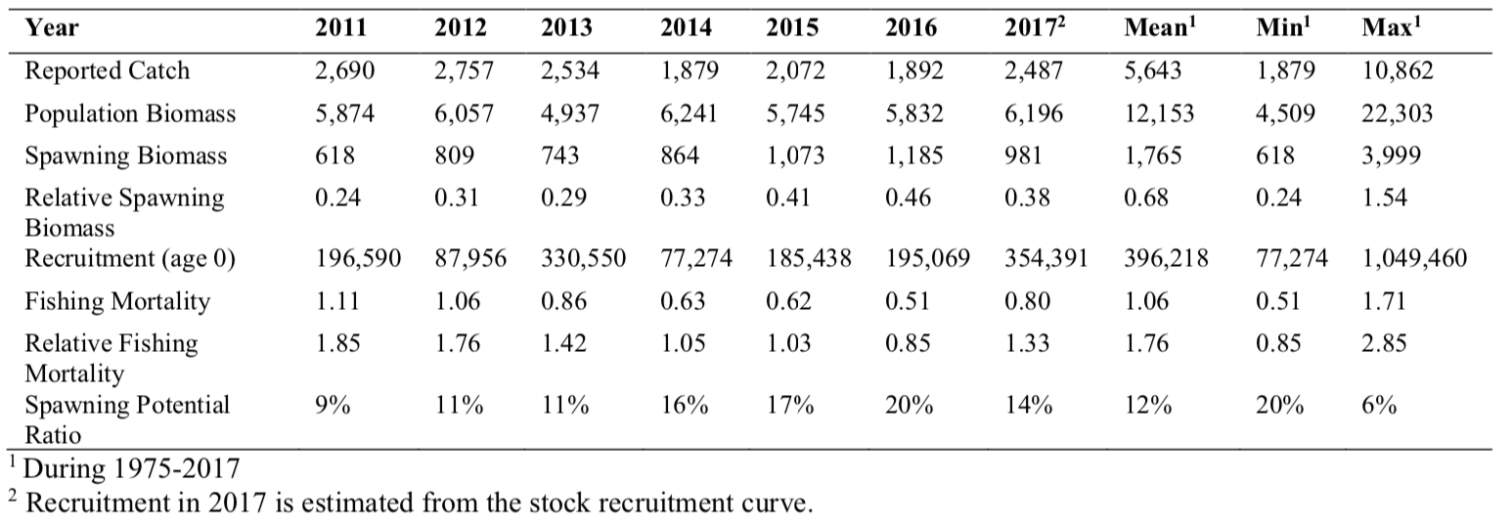**Table NMLS-01.** Reported catch (t) used in the stock assessment along with annual estimates of population biomass (age-1 and older, t), female spawning biomass (t), relative female spawning biomass (*SSB/SSBMSY*), recruitment (thousands of age-0 fish), fishing mortality (average F, ages-3 – 12), relative fishing mortality (*F/FMSY*), and spawning potential ratio of WCNPO striped marlin.

**Table NMLS-02.** Estimates of biological reference points along with estimates of fishing mortality (F), spawning stock biomass (SSB), recent average yield (C), and spawning potential ratio (SPR) of WCNPO MLS, derived from the base case model assessment model, where “MSY” indicates reference points based on maximum sustainable yield.

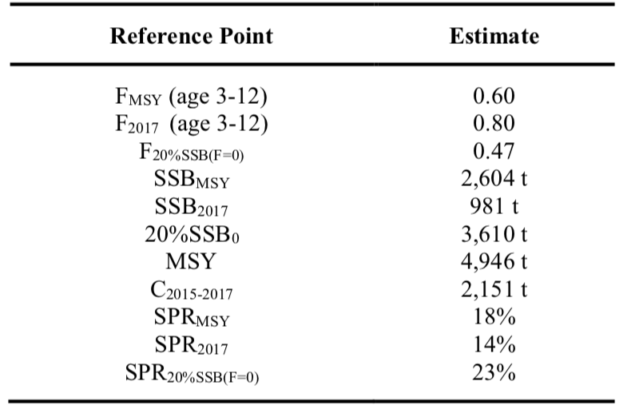

**Table NMLS-03.** Projected median values of WCNPO striped marlin spawning stock biomass (SSB, t), catch (t), and probability of reaching 20%SSB0 under five constant fishing mortality rate (F) and ten constant catch scenarios during 2018-2037. For scenarios which have a 60% probability of reaching the target of 20%SSBF=0, the year in which this occurs is provided; NA indicates projections that did not meet this criterion. Note that 20%SSBF=0 is 3,610 t and SSBMSY is 2,604 t.

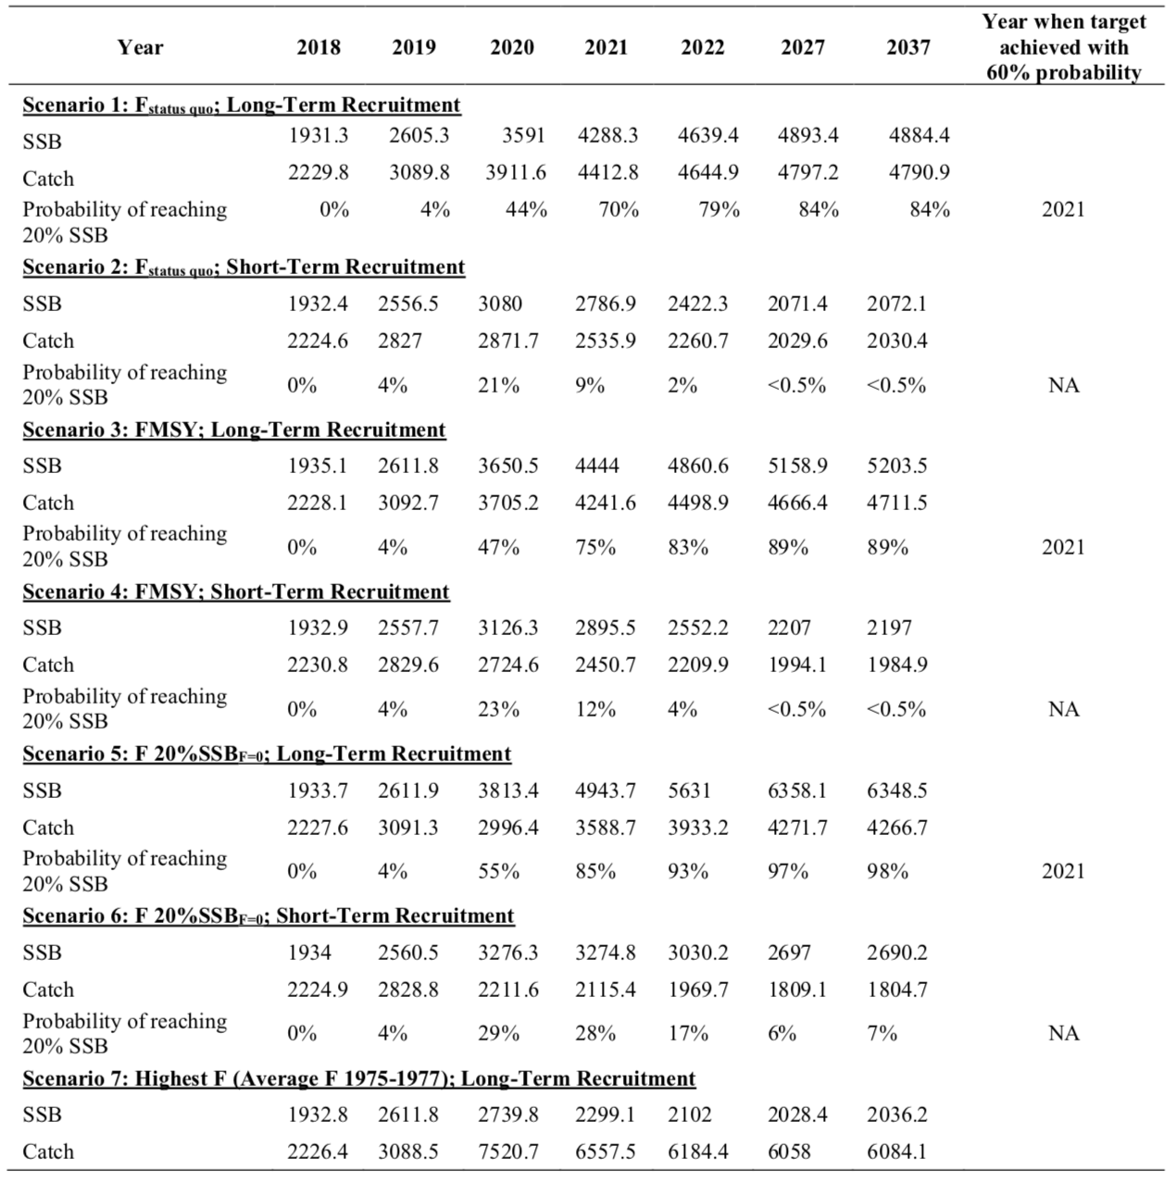

**Table NMLS-03. (Continued)**

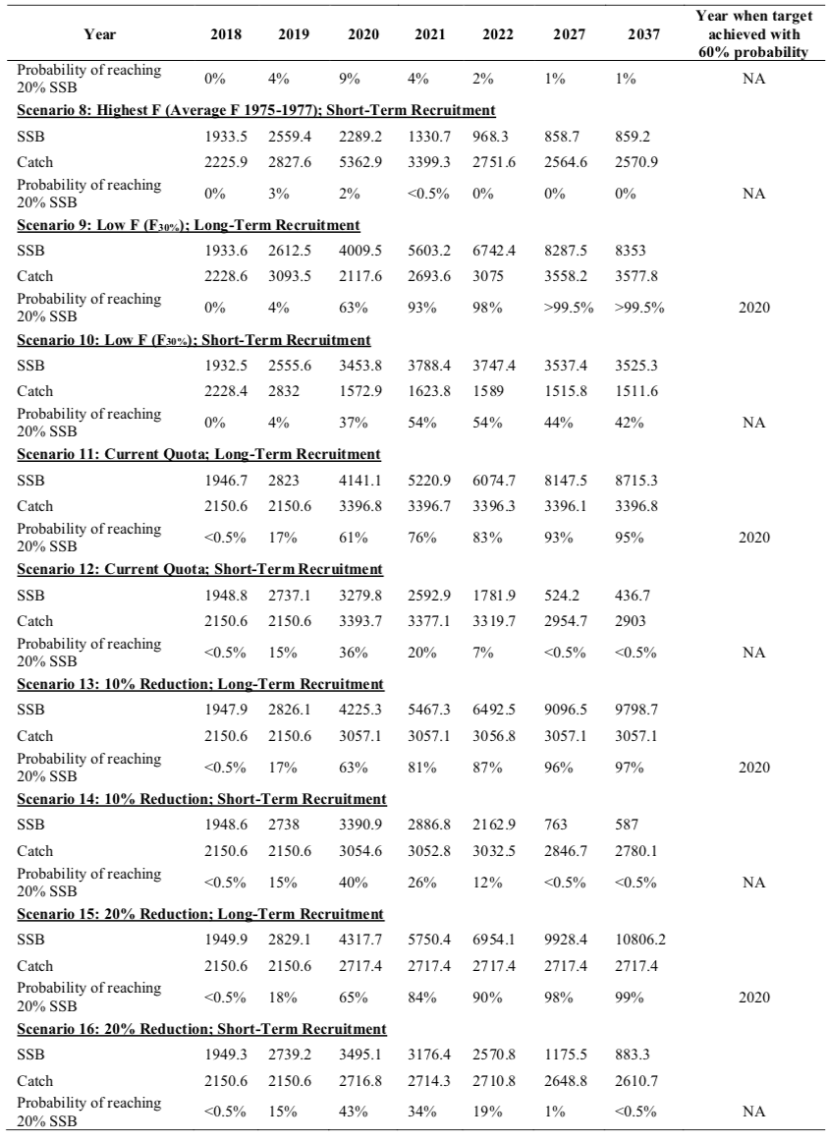

**Table NMLS-03. (Continued)**

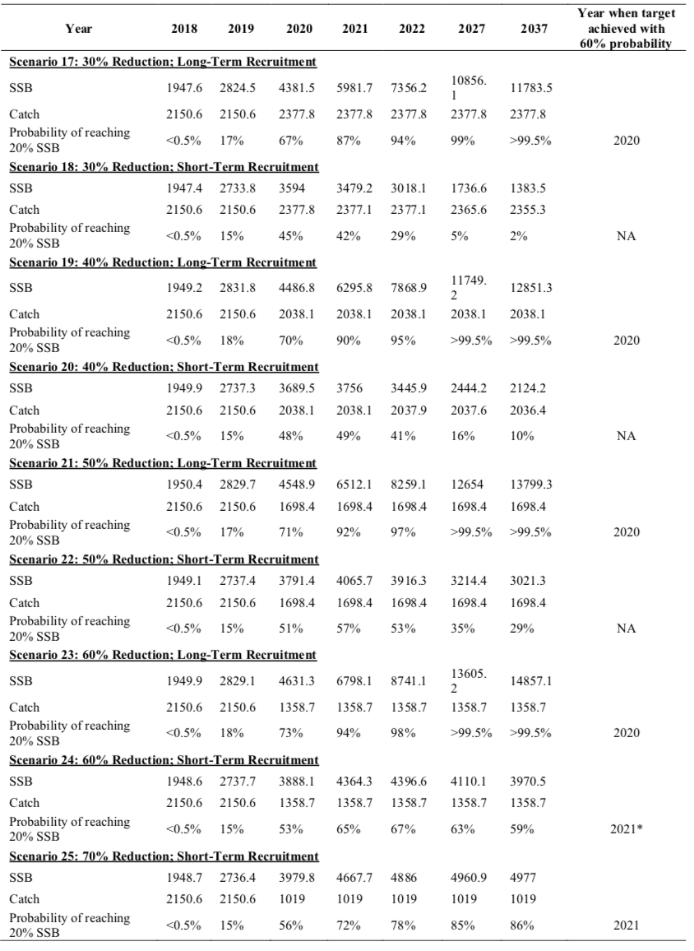

**Table NMLS-03. (Continued)**

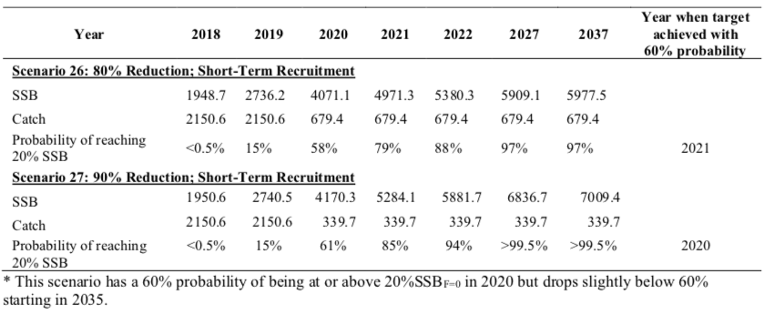

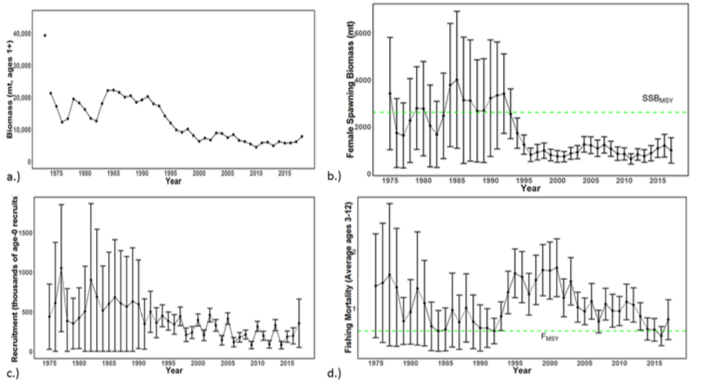

**Figure NMLS-01.** Time series of estimates of (a) population biomass (age 1+), (b) spawning biomass, (c) recruitment (age-0 fish), and (d) instantaneous fishing mortality (average for age 3-12, year-1) for WCNPO striped marlin (derived from the 2019 stock assessment. The circles represent the maximum likelihood estimates by year for each quantity and the error bars represent the uncertainty of the estimates (95% confidence intervals), green dashed lines indicate SSBMSY and FMSY.

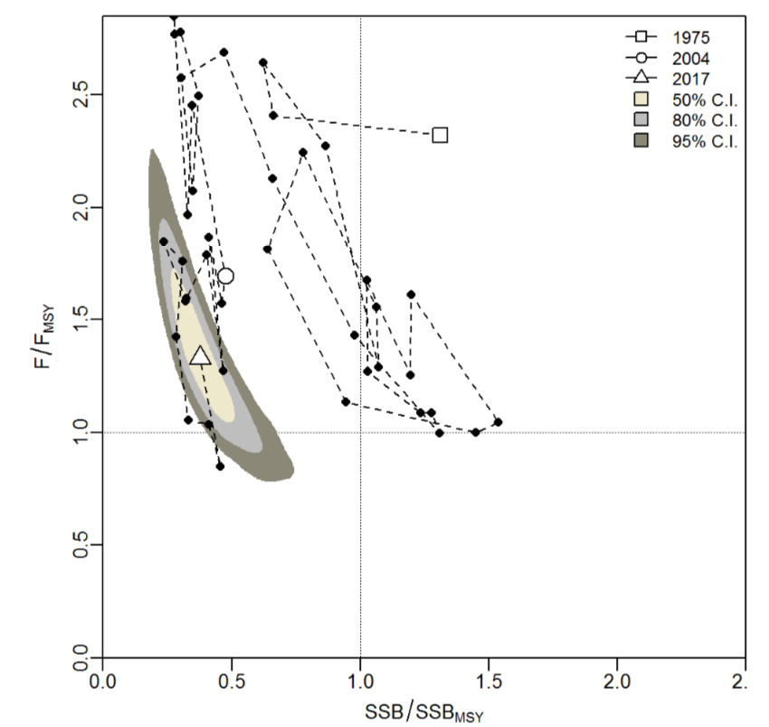

**Figure NMLS-02.** Kobe plot of the time series of estimates of relative fishing mortality (average of age 3-12) and relative spawning stock biomass of WCNPO striped marlin during 1975-2017. The white square denotes the first year (1975) of the assessment, the white circle denotes 2004, and the white triangle denotes the last year (2017) of the assessment.

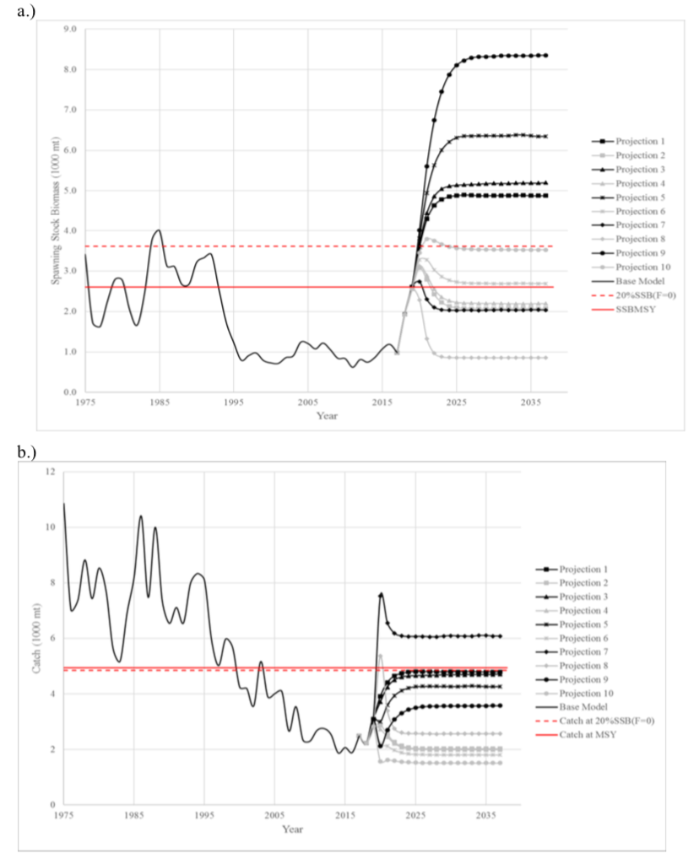

**Figure NMLS-03.** Historical and projected trajectories of spawning biomass and total catch from the WCNPO striped marlin base case model based upon F scenarios (projection 1-10): (a) projected spawning biomass and (b) projected catch.

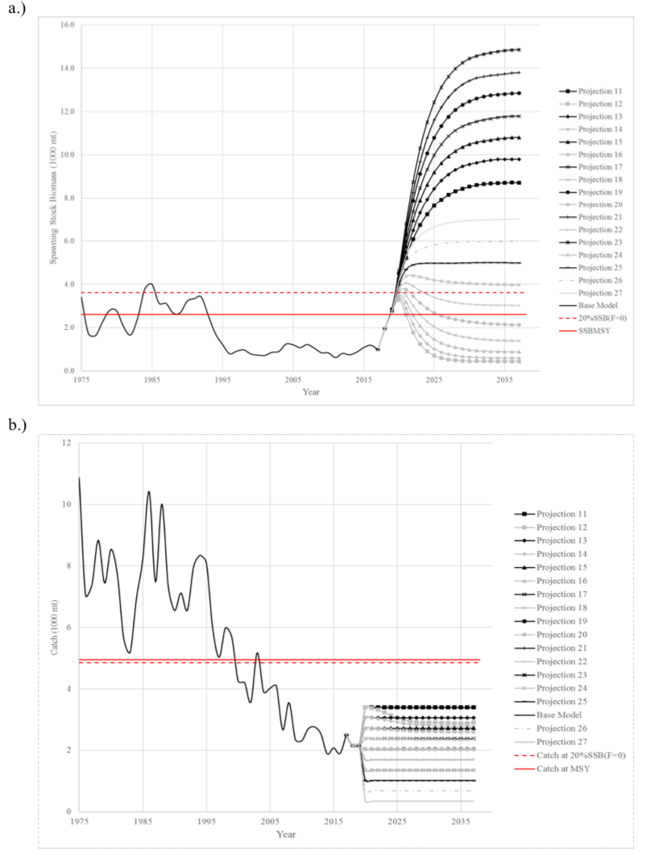

**Figure NMLS-04.** Historical and projected trajectories of spawning biomass and total catch from the WCNPO striped marlin base case model based upon constant catch scenarios (projections 11-15): (a) projected spawning biomass; and (b) projected catch.

Note on Figure NMLS-3 and Figure NMLS-4: Black lines are the long-term recruitment scenario results; grey lines show the short-term recruitment scenario results. The red dashed line shows the catch or spawning stock biomass at 20%SSBF=0 and the solid red line is the catch or spawning stock biomass at SSBMSY. The list of projection scenarios can be found in Table NMLS-03.

* + 1. **Pacific blue marlin (*Makaira nigricans*)** 
       1. **Research and information**
       2. **Provision of scientific information**

1. **Stock Status and trends**
2. SC15 noted that no stock assessments were conducted for Pacific blue marlin in 2019. Therefore, the stock status descriptions from SC12 are still current for Pacific blue marlin. For further information on the stock status and trends from SC12, please see <https://www.wcpfc.int/node/27769>. Updated information on catches was not compiled for and reviewed by SC15.
3. **Management Advice and implications**
4. SC15 noted that no management advice has been provided since SC12 for Pacific blue marlin. Therefore, previous advice should be maintained, pending a new assessment or other new information. For further information on the management advice and implications from SC12, please see <https://www.wcpfc.int/node/27769>

**AGENDA ITEM 5 — MANAGEMENT ISSUES THEME**

* 1. **Development of harvest strategy framework**

1. **Progress of the harvest strategy workplan**
2. **Target reference points**
   1. **Yellowfin and bigeye tuna**
3. SC15 reviewed information on what would be the minimum setting for a candidate spawning-biomass-depletion-based TRP (or maximum fishing-mortality-based TRP) for yellowfin and bigeye tuna that avoids breaching the LRP with a specified level of probability under the current uncertainty framework (SC15-MI-WP-01). While SC15 noted that the main biological consideration for a TRP is that it should be sufficiently above the LRP, SC15 also noted that the choice of a TRP can be based on a combination of biological, ecological and socioeconomic considerations. In this regard consideration of other factors (such as CPUE and the financial performance of typical vessels) in the selection of candidate TRPs would be welcome.
4. SC15 welcomed the consideration of multi-species impacts based on the selection of a minimum TRP based on a given risk of exceeding the LRP for a given species, and whilst desirable noted the difficulty in extending this analysis to include the impact on South Pacific albacore.
5. SC15 recommends that the Scientific Services Provider update the analysis to incorporate the updated assessment for skipjack, and that WCPFC16 take note of these results when identifying appropriate TRPs for yellowfin tuna and bigeye tuna in 2019 as scheduled in the Harvest Strategy Work Plan. In so doing WCPFC16 should clarify the management objectives for these species.
   1. **South Pacific albacore tuna**
6. SC15 reviewed information on alternative catch trajectories to achieve the South Pacific albacore interim TRP within no later than 20 years (SC15-MI-WP-02). SC15 noted the historical status and the projections have a greater uncertainty in spawning stock depletion for South Pacific albacore than observed for bigeye and yellowfin tuna because South Pacific albacore has a different grid which incorporates natural mortality and growth, and this gives a wider spread of uncertainty. SC15 noted that the recovery target can be achieved through many different approaches with the assumed long-term recruitments. However, catch (and effort) reductions from the 2014-16 average (of 60,000 mt) are required under all scenarios, and the resulting stock trajectories have different consequences for the associated fisheries. For example, if catch reductions are insufficient, or management action is delayed, the stock declines in the short term, with the consequence that management interventions may then need to be greater to achieve the interim TRP within 20 years, as stock recovery will be from a lower biomass level. Delays in the introduction of the reduction of catch may also increase the risk (12% in 2022 under 2014-2016 average catch levels) of breaching the LRP in the short term.
7. Several CCMs expressed a preference for a recovery time shorter than 20 years, while one CCM stated that the introduction of legally-binding catch quotas would be needed to order to implement a re-building strategy.
8. SC15 also noted that constant catch scenarios may mask declines in catch rates and associated economic conditions and requested that the Scientific Services Provider undertake a similar set of analyses based on fishing effort-based projections. SC15 recommends that WCPFC16 take note of both sets of results in consideration of rebuilding the South Pacific albacore stock to the interim TRP within 20 years.
   1. **Skipjack tuna**
9. As requested in the Harvest Strategy Work plan (SC to advise on required analyses to support TRP review), SC15 provided the following advice to the Scientific Services Provider on technical approaches and analyses which should be undertaken to assist WCPFC16 review the performance of the interim skipjack tuna TRP.

* Table 4 in SC15-MI-IP-09 (*Current and projected stock status of skipjack to inform consideration of target reference points*, MOW3-WP-03) be updated based on the updated skipjack tuna assessment agreed by SC15. This table should indicate changes in effort and biomass from 2012 and the recent levels and median equilibrium yield (as a proportion of MSY) associated with strategies that maintain a median of spawning biomass depletion (SB/SBF=0) of 40%, 45%, 50%, and 55%.
* The projection results for skipjack tuna reported in SC15-MI-WP-11 also be updated based on the updated skipjack tuna assessment agreed by SC15.

1. SC15 recommends that WCPFC16 take into consideration the information contained in these updated analyses when reviewing the performance of the interim skipjack tuna TRP.
2. SC15 also notes that WCPFC16 may identify a reference year, or set of years, which may be appropriate to use as a baseline for a skipjack TRP
3. **Progress on the development of Harvest Control Rules and Management Strategy Evaluation (MSE)**

1. **Review of harvest control rules for skipjack tuna**
2. SC15 reviewed several papers related to ongoing work which is being undertaken by the Scientific Services Provider as specified in the Harvest Strategy Work Plan on the management strategy evaluation (MSE) framework for skipjack.
3. First, SC15 reviewed information on the outputs for the skipjack harvest strategy and the work undertaken to test candidate MPs based upon the latest MSE framework (SC15-MI-WP-05), noting that the technical details of the evaluation framework that underpins the results are documented in a separate information paper (SC15-MI-IP-02). SC15 welcomed the progress on this issue and noted the following:

* The estimation model is model-based as the use of purse-seine CPUE as an index of abundance is problematic due to effort creep associated with technological developments (e.g. acoustic FADs);
* Further work is required so that Performance Indicator 5 (the impact of harvest strategies on Small Island Developing States) can be included;
* Work is progressing on identifying specific El-Nino and La-Nina distribution models so that non-stationary movement can be estimated and help account for possible climate change related impacts.

1. Second, SC15 reviewed information on the range of uncertainty which will need to be considered in the modelling framework when testing a management procedure (MP) (SC15-MI-WP-06). In particular, SC15 reviewed the Reference set of uncertainties (considered to reflect the most plausible hypotheses) which is the primary basis against which all candidate HCRs should be evaluated, and the Robustness set of uncertainties (comprising hypotheses that are considered less likely but still plausible) against which a final sub-set of candidate HCRs would be evaluated in order to determine the ‘best’ management strategy.
2. SC15 also noted that as part of the monitoring strategy it will be necessary to define ‘exceptional circumstances’ to identify those situations that fall outside of the range of scenarios against which the implemented MP has been tested. SC15 again welcomed the progress on these issues and in reviewing the Reference set of uncertainties used in the MSE noted that these expand on the set of uncertainties included in the structural grid used in the stock assessment. SC15 recommended that an expanded set of diagnostics be provided so that the plausibility of the fit of each operating model used in the Reference set could be investigated. SC15 also recommended that the Scientific Services Provider conduct appropriate inter-sessional consultation with CCMs on the conditioning of the operating model and other relevant issues to ensure greater inclusiveness for MSE process.
3. Third, noting that stakeholder engagement is a key component of the harvest strategy approach, SC15 reviewed information on a tool (Performance Indicators and Management Procedures Explorer, PIMPLE) for exploring and comparing the relative performance of alternative candidate MPs and the included HCRs (SC15-MI-WP-09). SC15 noted that PIMPLE was a useful tool and recommends it to mangers and WCPC16 so that they can understand the performance of various MPs for achieving management objectives. CCMs and participants were also encouraged to develop their own HCRs and make them available to the Scientific Services Provider for possible evaluation and inclusion in PIMPLE.
4. SC15 recommends that WCPFC16 note the progress on the development of the MSE being undertaken under the Harvest Strategy Work Plan for skipjack tuna and provide additional elements, if any, as specified in the Harvest Strategy Work Plan to further progress this work against the scheduled time-lines noted in this Work-Plan. SC15 also requested the Secretariat create a webpage under the current “Harvest Strategy” tab that compiles the latest information of MSE development so that stakeholders can find the relevant information easily.
5. **Review of harvest control rules for South Pacific albacore**
6. SC15 reviewed several papers related to ongoing work which is being undertaken by the Scientific Services Provider as specified in the Harvest Strategy Work Plan on the MSE framework for South Pacific albacore.
7. First, noting that the initial work on the development of harvest strategies for South Pacific albacore has focused on developing an empirical MP that uses standardised CPUE as the primary indicator of stock status, SC15 reviewed information on alternative sources of CPUE data and standardisation approaches to inform this process (SC15-MI-WP-07). SC15 endorsed the use of both the traditional GLM and the geostatistical modelling approaches for standardizing CPUE and their use in the Reference Set of uncertainties. Furthermore, noting difficulties associated with the use of the daily set-by-set data (currently used in the assessment) within the MSE framework, SC15 also endorsed the use of the aggregated catch/effort data set. However, SC15 also noted some small differences in the resulting biomass indicators based on these two different data sets, and requested that the Scientific Services Provider undertake some additional analyses to clarify any consequences on the performance of candidate HCRs which may be used to achieve management objectives.
8. Second, SC15 reviewed a demonstration set of southern longline fishery performance indicators (PIs, taken from the list of prioritized indicators identified at WCPFC14) for evaluating the relative performance of candidate MPs South Pacific albacore, noting that the lack of inclusion of a PI, at this stage, does not imply it has reduced priority in the framework (SC15-MI-WP-03). SC15 noted that the utility of many economic indicators is currently limited by the unavailability of specific fleet-based economic data with the consequence that less informative proxies have to be used. CCMs also noted that several of the PIs are similar and perhaps redundant. Several CCMs also noted that a number of important PIs are currently not included in the demonstration set (often due to a difficulty in calculation due to a lack of information) but expressed a willingness to work with the Scientific Services Provider and other CCMs on providing more information for improving the calculation of these proposed PIs. SC15 recommends that WCPFC16 take note of this demonstration set of PIs and provide feedback to the Scientific Services Provider as needed.
9. Third, SC15 reviewed the current status of the MSE framework for South Pacific albacore and the details of some illustrative analyses that have been completed (SC15-MI-WP-08). SC15 made a number of suggestions aimed at clarifying and improving aspects of the analyses, such as being able to see retrospective analysis of the CPUE generated from the operating model, incorporating the DWFN index in the HCR, and including a density dependence/hyperstability option and recruitment autocorrelation in the Reference Set of the uncertainty grid. One CCM also suggested inclusion of an additional flux of South Pacific albacore from the IATTC convention area as an additional axis of uncertainty, but it was noted that this would be difficult. CCMs were also invited to suggest possible HCRs for testing in this MSE framework for South Pacific albacore. SC15 recommends that WCPFC16 note the current status of the MSE framework for South Pacific albacore and provide feedback to the Scientific Services Provider as needed.
10. SC15 recommends that WCPFC16 note the progress on the development of the MSE being undertaken under the Harvest Strategy Work Plan for South Pacific albacore tuna and provide additional elements, if any, as specified in the Harvest Strategy Work Plan to further progress this work against the scheduled time-lines noted in this Work Plan.
11. **MSE for North Pacific albacore**
12. SC15 noted the work undertaken by ISC on the development of an MSE framework for North Pacific albacore (SC15-MI-IP-10) and brings this to the attention of WCPFC16.
13. **Multi-species modeling framework**
14. Given that the main target species in the WCPO are caught by an overlapping mix of fisheries, an important consideration when developing harvest strategies is how to account for mixed fishery interactions. Towards this end, SC15 reviewed two potential approaches for modeling mixed fisheries in the WCPO harvest strategy evaluations (SC15-MI-WP-04). Noting the challenges in developing a multi-species modeling framework, and the difficulties and time required to develop a fully integrated multispecies-based operating model, SC15 endorsed the use of a hierarchical approach based on single species operating models.
15. However, SC15 also noted the possible need for the inclusion of PIs from interacting fisheries/stocks in the development of MPs for any single species within such a hierarchical approach. Further consideration was also needed on the framework of MPs within this approach and what species may need to be given a priority, as MPs for healthy stocks may give unintended negative impacts on unhealthy stocks. One CCM suggested that priority may need to be given based on stock status relative to respective reference points. This CCM also emphasized that an MP for bigeye tuna should include control of purse seine fisheries, as currently almost half of the bigeye tuna catch is made by the fleet. One CCM also noted the need for management controls to be applied to all managed species due to the potential of target switching and resource substitution if one or more are left unregulated.
16. SC15 recommends that WCPFC16 note the approaches outlined in the above paper, and the possible implications of the challenges in developing a multi-species modelling framework on this item within the schedule of the Harvest Strategy Work Plan.
17. **Other matters: Science and management dialogue**
18. SC15 noted a final report which reviewed reference points, harvest control rules, management strategy evaluation development across each of the tuna-RFMOs (SC15-MI-WP-14). SC15 also noted the usefulness of following developments on MSE in other RFMOs and recommended that the WCPFC continues engaging in the work of the joint tuna-RFMO MSE working group.
19. Noting the decision made by WCPFC15 to hold a 6-day annual meeting in 2019 with additional time devoted for the Commission to discuss harvest strategies, SC15 re-iterated its support for a Science-Management Dialogue as outlined in the recommendation from SC14 (Paras. 469-473, SC14 Summary Report) for prompt development of harvest strategies. Noting the work on Harvest Strategies at SC15 and the increasing number of issues that require the attention of managers, some CCMs expressed the view that a Science-Management Dialogue session after SC15 meeting would have been useful, and supported such an approach after SC16.
    1. **Limit reference points for WCPFC sharks**
20. Noting the final report of the project “*Identifying appropriate reference points for elasmobranchs within the WCPFC*” (SC15-MI-IP-04), the outcomes of the stock assessments for oceanic whitetip sharks reviewed by this meeting, but an inability to fully consider this agenda item due to time constraints, SC15 deferred consideration of appropriate limit reference points for elasmobranchs for the WCPFC to SC16. SC15 recommends that the key conclusions of SC15-MI-IP-04 and previous reports are summarized and presented to SC16 together with any other relevant information. Nevertheless, SC15 recommends that WCPFC16 note the conclusions of the above report and the ongoing need to identify appropriate limit reference points for WCPO elasmobranchs.
    1. **Implementation of CMM 2018-01**
       1. **Effectiveness of CMM 2018-01**
21. As requested in paragraph 15 of CMM-2018-01 (The Commission at its 2019 annual session shall review and revise the aims set out in paragraphs 12 to 14 in light of advice from the Scientific Committee), SC15 reviewed information on the likely outcomes in relation to the stated objectives of this measure (SC15-MI-WP-11). Outcomes were evaluated using the 2016 WCPO skipjack assessment and reviewed under three different future catch and effort scenarios which are consistent with this measure: ‘2013-2015 avg’ as well as ‘pessimistic’ and ‘optimistic’ scenarios based on the current CMM.
22. The minor adjustments to the CMM 2017-01 text contained in CMM 2018-01, including the inclusion of paragraph 18, were found to not materially affect the management conditions assumed under this evaluation. SC15 noted, however, the difficulty in evaluating the impacts of paragraph 18 because of the need for clearer guidance on the interpretation of “small garbage”. SC15 recommends that the Commission revise paragraph 18 to include a more quantifiable and precise definition, so that a more meaningful evaluation of impacts may be undertaken.
23. SC15 noted that the results are comparable to the results previously presented for bigeye and yellowfin. For bigeye tuna the results are strongly influenced by the assumed future recruitment levels and the time period of the projections. If recent positive recruitments continue into the future, all scenarios examined achieve the aims of the CMM, in that median spawning biomass is projected to remain stable or increase relative to recent levels, and median fishing mortality is projected to decline slightly (the exception to the latter being the pessimistic CMM scenario, although median fishing mortality remains below FMSY). If less positive longer-term recruitments continue into the future, spawning biomass depletion worsens relative to recent levels under all scenarios, and the future risk of spawning biomass falling below the limit reference point (LRP) is around 20% or greater dependent on the scenario. In turn, all three future fishing scenarios imply increases in fishing mortality under those recruitment conditions more than doubling to median levels well above FMSY.
24. For yellowfin long-term recruitment patterns were assumed to hold into the future. Results under the 2013-2015 average and ‘optimistic’ scenarios are comparable, with the stock stabilising at 33% SB/SBF=0 (a 1% decrease from recent assessed levels) and F/FMSY reducing to 0.68 (a 7%-8% reduction). The ‘pessimistic’ scenario, which implies a 35% increase in longline yellowfin catch, had a greater impact, with yellowfin biomass falling to 30% SB/SBF=0 (an 8% reduction from recent levels), F/FMSY remaining stable at 0.73F/FMSY, and the risk of breaching the adopted limit reference point increasing to 16%.
25. Although results based on 2016 skipjack assessment were reviewed by SC15, the analysis of skipjack based on the 2019 assessment was not provided due to the timing of the assessment.
26. Several CCMs questioned how much emphasis should be placed on the pessimistic scenarios, given that these seem dependent on LL fisheries fishing at their maximum catch limits allowed under the CMM regardless of the biomass levels. Several CCMs also suggested that future revisions of CMM 2018-01 could include measures that are more precautionary with regard to possible variations in bigeye recruitment.
27. SC15 recommended that the working paper be updated based on the WCPO skipjack tuna assessment agreed by SC15, including the additional analyses requested by CCMs, and forwarded to WCPFC16.
    * 1. **Management issues related to FADs**
      2. **FAD tracking**
28. SC15 reviewed information on analyses of the PNA’s FAD tracking program (SC15-MI-WP-12). Consistent with previous meetings, SC15 expressed its strong support for this type of research and its continuation, noting that this program is adding substantial value to the scientific understanding of WCPO fisheries.
29. SC15 again noted the ongoing practice of SC not receiving full data (through practices such as geo-fencing) which undermines the scientific value of the information and prevents the SC from being able to provide comprehensive advice to the Commission on FAD dynamics, economics and management. However, SC15 was informed that PNA was finalising a new measure that will require full tracking data be made available that should fix this problem.
30. Based on analysis of the available data (estimated to cover 30%-40% of all FAD trajectories, including FADs completely absent and FADs with some portion of trajectories missing, within the WCPFC convention area) SC15 noted:

* the number of individual FAD buoys active has continually increased since 2016, with estimates of 10,918 buoys in 2016; 18,357 in 2017; and 20,319 in 2018, likely due to the increase in data provision.
* that over 90% of the FAD sets in the WCPO were made in PNA waters.
* the number of both associated and unassociated sets increases with FAD density, while skipjack, bigeye, and total CPUE show a slight decrease with increasing FAD density. Similarly, CPUE from all unassociated sets decreases slightly with increasing FAD densities. Additional work is needed to validate these initial findings.
* simulated FAD tracks based on ocean currents show the dispersion of FADs across a wide area of the equatorial WCPO.

1. Several CCMs expressed concern about the high FAD densities in some areas (400 to 500 FADs in a 1-degree square per month). Also, SC15 again expressed concern about the estimated high rate (6.7%) of tracked FAD beaching events, resulting in pollution and safety issues with respect to navigation, together with the estimated high rate of ‘lost’ FADs (up to 52%) (defined as when a FAD drifts outside the fishing ground of the company owning it). SC15 was informed that some pending analyses (these will be published soon) identify areas of FAD deployments that are more likely to result in beaching events.
2. SC15 recommends that this paper be forwarded to WCPFC16 who may wish to support the continuation of this work.
3. SC15 also recommends more comprehensive work at the Pacific-wide level as EPO FADs may drift into the WCPFC Convention area, and encourages CCMs to collect additional data on FAD beaching occurrences in their EEZs to enable the Scientific Services Provider to develop a database for further work.
   * 1. **Acoustic FAD analysis**
     2. Review of Project 77
4. SC15 reviewed information on preliminary analyses of acoustic data from echo-sounder buoys deployed on FADs (SC15-MI-WP-13 and SC15-EB-WP-08).
5. With regards to SC15-MI-WP-14, SC15 noted that:

* the deployment of echo-sounder buoys on FADs has increased in recent years, from around 76% in 2016 to 98% in 2019.
* the estimates of biomass were found to be influenced by i) the time of the day, with maximum biomass estimated before sunrise, and ii) the lunar phase, with a slight increase in biomass detected during and just after the full moon.
* biomass estimates showed a significant increase up to around 30 days drifting.
* while an increasing trend in estimated biomass was detected over the two to five days before a fishing set, in general, high variability was detected and no clear pattern could be identified between catch and echo-sounder biomass estimates.
* the acoustic buoys currently cannot differentiate species, although new buoys being used by some fleets can potentially estimate biomass per species which in future may be able to be used to reduce bycatch of bigeye.
* access to a larger dataset covering the whole WCPO would improve these analyses and the potential, over the longer-term, to derive an index of abundance from these data that could be used in stock assessments.

1. With regards to SC15-EB-WP-08, SC noted the following preliminary results:

* Juvenile bigeye tuna departures from FADs were higher when skipjack tuna biomass was low, as estimated from FAD-attached echo-sounder buoys.
* Lower SST and greater changes in sea surface height were associated with a lower probability of departure of bigeye tuna from a FAD.
* Quarter and full moon periods, lower sea surface temperatures, and higher local FAD density were all associated with a greater probability of presence of tagged bigeye tuna at the FAD during pre-dawn.

1. SC15 endorsed the continued cooperative relationship with the fishing community to obtain business confidential data for analysis by regional scientists, particularly with regard to FADs, and the fishing strategies involved in their use.
2. SC15 indicated strong support for these projects, identifying the need for improved information on skipjack abundance and that this work can also serve several other research purposes. SC15 recommends that WCPFC16 support the continuation of this work.

# AGENDA ITEM 6 — ECOSYSTEM AND BYCATCH MITIGATION THEME

* 1. **Ecosystem effects of fishing**
     1. **FAD impacts** 
        1. **Research on non-entangling FADs**
        2. **Joint Tuna RFMO FAD Working Group Meeting**
  2. **Sharks** 
     1. **Review of conservation and management measures for sharks**

1. Related to CMM 2010-07 (CMM for Sharks), SC15 recommends that:

TCC15 and WCPFC16 note that since the adoption of the CMM 2010-07, SC has been unable to confirm the validity of using a 5% fin-to-carcass ratio, that an evaluation of the 5% ratio is not currently possible due to insufficient or inconclusive information, and that there is still no mechanism for generating the data necessary to review the fin-to-carcass ratio if such a ratio is to be used as a tool for promoting the full utilization of sharks in the WCPFC.

* + 1. **Safe release guidelines**

1. SC15 suggests that WCPFC note that:

* Together, SC15-EB-WP-01 and SC15-EB-WP-04 provide more robust estimates of post release mortality within the longline fisheries and the shark handling and release factors that influence this.
* There is good evidence across the five shark species examined in SC15-EB-WP-01 and SC15-EB-WP-04 that minimising the trailing line (ideally leaving less than 0.5 meters of line attached to the animal) results in a significant reduction in post-release mortality, as noted in SC15-EB-IP-02.
* SC15-EB-WP-04 provides evidence that releasing by cutting the shark from the line while it is still in the water results in a lower mortality than bringing the shark on board and removing the gear.
* It is also important to take into account the safety of fishermen and flexibility for handling sharks and consider vessel size and operational fishing practices when the safe release guidelines are next updated.

1. SC15 recommends to WCPFC that:

* When the safe release guidelines are next updated they should properly reflect the findings in SC15-EB-WP-01 and SC15-EB-WP-04 and subsequent research on post release mortality mitigation, noting some CCMs expressed concerns that research mentioned in SC15-EB-WP-04 only applies to six fleets (New Zealand, Fiji, , Marshall Islands, New Caledonia, American Samoa, and Hawaii) and that there might be other choices of better safe release methods.
* The Monte Carlo analysis undertaken in 2015 (SC11-EB-WP-02) for oceanic whitetip and silky sharks be updated and amended as necessary using the latest results on post-release mortality under different handling and release practices. This analysis should explore and quantify the impact of different combinations of gear, mitigation and handling practices on fishing related mortality. The example R code to conduct this analysis is provided as an appendix to SC15-EB-WP-01.
  + 1. **Progress of Shark Research Plan**
    2. **Project 91 – A study on Operational Planning for Shark Biological Data Improvement;**
    3. **Shark post-release mortality tagging study (assigned as Project 95)**
    4. **Update of Shark Research Plan**

1. SC15 accepted the outputs of ISG-08 and the Shark Research Plan, which is in Attachment A.
   1. **Seabirds** 
      1. **Review of seabird researches**
2. SC15 notes the following in making its recommendations to WCPFC:

* the annual mortalities of seabirds in WCPFC longline and purse seine fisheries from 2015 to 2018 were estimated between 13,000 and 19,000 individuals (SC15-EB-WP-03). Longline fisheries north of 20°N accounted for approximately two-thirds of this total while longline fisheries south of 30°S accounted for approximately one-quarter of mortalities. Available data suggest that seabird mortalities in the purse seine fishery are negligible.
* that these are subject to large uncertainties because of limited data coverage, including the absence of some fleets from the analysis due to low coverage or missing observer data, and likely underestimated because cryptic seabird mortality is not considered.
* the concern over the very high estimated mortality of seabirds by longline fishing within a concentrated area of two 5x5 degree grids to the east of Tasmania and south of 40°S (Figure EB-01). This relatively small area is estimated to account for around 60% of the longline seabird bycatch south of 30°S and 15% of the total seabird bycatch in the WCPFC Convention Area, noting that this longline effort includes fleets targeting southern bluefin tuna managed by CCSBT or species managed by the WCPFC.
* the concern over the large number of seabirds incidentally caught in WCPFC fisheries in the northern WCPO and the need to understand the long-term impact of these mortalities on the sustainability of the populations concerned, noting that no clear evidence of decline in such populations has been observed in the recent period..
* the Southern hemisphere seabird species estimated to be most frequently captured are the white-capped albatross and Buller’s albatrosses with highly vulnerable species including Antipodean and Gibson’s albatrosses, Westland petrel and black petrel all in the top ten most frequently captured seabird species, noting that the level of identification of seabird catches varies between fleets.
* the low or absent observer coverage in key longline fleets in high latitude areas (both north and south) precludes accurate estimation of seabird bycatch inclusive of spatial and temporal trends. The estimation of annual trend of seabird mortality since the first WCPFC seabird CMM (CMM-2006-02) is not possible with the extent of currently available data.
* that some seabirds are captured and released alive, with higher chances of survival when safe handling procedures are implemented.
* the need for continued support for research on seabird bycatch mitigation methods in longline fisheries, noting successful accumulation of relevant information material in BMIS.
* The importance of improved observer coverage and the potential use of electronic monitoring in order to better estimate bycatch rates over time and over a wider geographic range.
* that longline fisheries operating in the area where the seabird CMM applies are one of the largest threats to some seabird populations, in particular albatrosses and petrels in the Southern hemisphere**.**

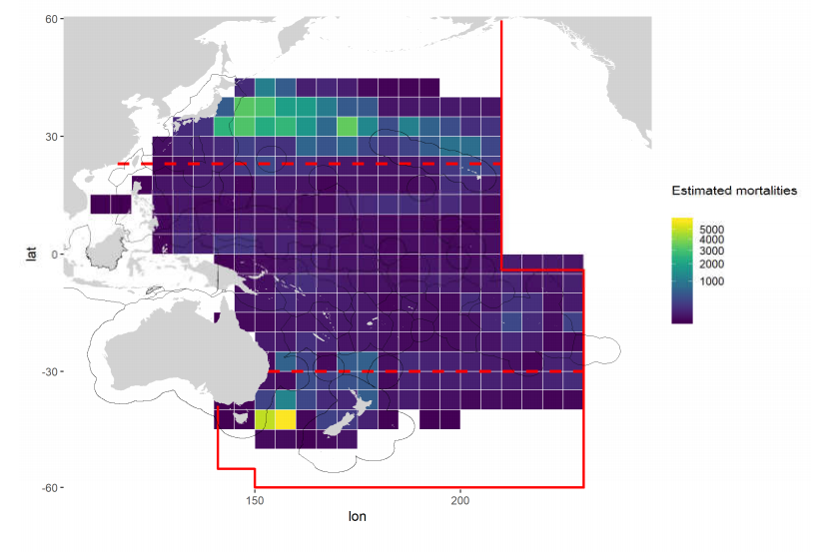

**Figure EB-01**. Estimated seabird mortalities at-vessel (individuals) by longline fisheries, 2015-2018. The red lines show the WCPFC convention boundaries and the red dashed lines show the 30°S and 23°N lines of longitude.

1. SC15 recommends that:

* TCC and WCPFC pay particular attention to assessing compliance against the requirements of the seabird mitigation measure CMM 2018-03.
* WCPFC adopt the ACAP best practice on hook removal from seabirds as a safe handling guideline across all WCPFC longline, and other hook fisheries (SC15-EB-WP-10).
* WCPFC notes that, in view of analyzing the effectiveness of night setting within the seabird bycatch mitigation measure, the Coordinated Universal Time (UTC) set time will need to be provided or obtainable from the WCPFC ROP longline data field.
* WCPFC consider supporting the analysis of overlap between fishing effort distribution and species-specific seabird distribution (as outlined in SP15-EB-WP-03) to both the WCPO Southern and Northern Hemispheres and to support an assessment of risk to populations resulting from fisheries- induced mortalities.
* WCPFC requests CCMs to meet their obligations with respect to the minimum levels of observer coverage required by CMM 2018-05**.** 
  + 1. **Review of CMM 2018-03 (**[**CMM to mitigate the impact of fishing for highly migratory fish stocks on seabirds**](https://www.wcpfc.int/doc/cmm-2018-03/conservation-and-management-measure-mitigate-impact-fishing-highly-migratory-fish)**)**
  1. **Sea turtles** 
     1. **Review of sea turtle researches**
     2. **Review of CMM 2008-03**
  2. **Bycatch management**
  3. **Other issues**

**6.6.1 Review of relevant reports from other tRFMOs**

# AGENDA ITEM 7 — OTHER RESEARCH PROJECTS

* 1. **West Pacific East Asia Project**
  2. **Pacific Tuna Tagging Project**

1. SC15 noted the successful 2018 CP13 tagging cruise, in which 1,133 tropical tunas, mainly bigeye and yellowfin tuna, were tagged with conventional and/or archival tags.
2. SC15 noted the importance of effective tag seeding to estimating reporting rates, supported increased deployment and fleet coverage of tag seeding experiments and noted the need for continued CCM participation and support in tag reporting.
3. SC15 supported additional tagging of tropical tuna marked with strontium chloride, to assist in validating otolith-based ageing methods, and requested the support of CCMs in enabling the collection of samples from such recaptured tagged fish.
4. SC15 supported the 2020 tagging programme, and associated budget ($645,000), the 2021-2022 tagging programmes and their associated indicative budgets ($730,000; $730,000), and the PTTP work plan in general for 2019-2022.
   1. **ABNJ (Common Oceans) Tuna Project-Shark and Bycatch Components**
   2. **WCPFC Tissue Bank (Project 35b)**
5. SC15 noted the reduction in sampling in 2018 and requested that SPC develop initiatives to reverse this trend if possible, and report these to SC16.
6. SC15 encouraged CCMs to visit the TTB web page [www.spc.int/ofp/PacificSpecimenBank](http://www.spc.int/ofp/PacificSpecimenBank) and provide feedback to SPC on its information content, usability and structure.
7. SC15 endorsed the TTB work plan for 2019-2020, as well as the proposed 2020 budget ($99,195) and 2021-22 indicative budgets ($101,180; $103,204).
   1. **Other Projects**

# AGENDA ITEM 8 — COOPERATION WITH OTHER ORGANISATIONS

The Secretariat tabled

# AGENDA ITEM 9 — SPECIAL REQUIREMENTS OF DEVELOPING STATES

# AND PARTICIPATING TERRITORIES

# AGENDA ITEM 10 — FUTURE WORK PROGRAM AND BUDGET

* 1. **Development of the 2020 work programme and budget, and projection of 2021-2022 provisional work programme and indicative budget**

1. SC15 adopted the proposed budget (Table 01) and forwarded it to the Commission. Detailed descriptions of the SC15 work programme, budget and terms of reference for each project are in Attachment B.

**Table 01.** Summary of SC work programme titles and budget for 2020, and indicative budget for 2021–2022, which requires funding from the Commission’s core budget (USD).

|  |  |  |  |  |  |
| --- | --- | --- | --- | --- | --- |
| **Project Title** | **Essential** | **Priority** | **2020** | **2021** | **2022** |
| SPC-OFP Scientific Services | Yes | ongoing | 924,524 | 943,015 | 961,875 |
| SPC Additional resourcing | Yes | ongoing | 166,480 | 168,145 | 169,827 |
| Project 35b - WCPFC Tuna Tissue Bank | Yes |  | 99,195 | 101,180 | 103,204 |
| Project 42 - Pacific Tuna Tagging Program | Yes |  | 645,000 | 730,000 | 730,000 |
| Project 60 – Purse Seine Species Composition | No | ongoing | 40,000 | 40,000 |  |
| Project 68 - Seabird mortality | No | ongoing |  |  | 75,000 |
| Project 88 - Acoustic FAD analyses | No | High 2 | 30,000 | 15,000 |  |
| Project 90 - Length weight conversion | No | ongoing | 30,000 | 20,000 |  |
| Project 97 – Shark Research Plan 2021-2025 |  | High 1 | 46,000 |  |  |
| Project 98 - Radiocarbon aging workshop |  | High 1 | 35,000 |  |  |
| Project 99 – Southwest Pacific striped marlin population biology |  | High 1 | 33,000 |  |  |
| Project 100 - Close-kin mark-recapture |  | High 1 | 7,500 |  |  |
| Project 101 – Monte Carlo simulations - shark mitigation |  | High 1 | 40,000 |  |  |
| Project 102 - Population projections for oceanic whitetip shark |  | High 1 | 35,000 |  |  |
| Project 103 – Limit reference points for WCPO elasmobranchs |  | High 1 | 25,000 |  |  |
| Project Budget (WCPFC budget only) |  |  | 1,232,175 | 1,074,325 | 1,078,030 |
| **Total budget with SPC services** |  |  | **2,156,700** | **2,017,340** | **2,039,905** |

1. SC15 agreed that SPC will conduct stock assessments for bigeye and yellowfin tuna in 2020 (Table 02).

**Table 02**. WCPFC provisional assessment schedule 2020-2024 as discussed in the Plenary session. The ISC will inform SC16 on the schedule for N Pacific blue shark and shortfin mako shark. In the above schedule, Tuna are scheduled for assessment every 3 years; swordfish every 4 years; and sharks and other billfish every 5 years.

| **Species** | **Stock** | **Last assessment** | **2020** | **2021** | **2022** | **2023** | **2024** |
| --- | --- | --- | --- | --- | --- | --- | --- |
| Bigeye tuna | WCPO | 2018 | X |  |  | X |  |
| Pacific | 2015 |  |  |  |  |  |
| Skipjack tuna | WCPO | 2019 |  |  | X |  |  |
| Yellowfin tuna | WCPO | 2017 | X |  |  | X |  |
| Albacore | S Pacific | 2018 |  | X |  |  | X |
| N Pacific |  | X |  |  | X |  |
| Pacific bluefin | N Pacific | 2018 | X |  | X |  | X |
| Striped marlin | SW Pacific | 2019 |  |  |  | X |  |
| NW Pacific | 2019 |  |  |  |  | X |
| Swordfish | SW Pacific | 2017 |  | X |  |  |  |
| N Pacific | 2018 |  |  | X |  |  |
| Silky Shark | WCPO | 2018 |  |  |  | X |  |
| Oceanic whitetip shark | WCPO | 2019 |  |  |  |  |  |
| Blue shark | S Pacific | 2016 |  | X |  |  |  |
| NW Pacific | 2017 |  |  | X |  |  |
| Mako | NW Pacific | 2018 |  |  |  | X |  |
|  | S Pacific |  |  |  | X |  |  |
| Bigeye thresher | Pacific | 2017 |  |  |  |  |  |
| Porbeagle | S Pacific | 2017 |  |  |  |  |  |

# AGENDA ITEM 11 — ADMINISTRATIVE MATTERS

* 1. **Future operation of the Scientific Committee**
  2. **Election of Officers of the Scientific Committee**

1. SC15 recommended the current SC Chair U. Faasili continue for his second term and T. Halafihi (Tonga) as a SC Vice Chair.
   1. **Next meeting**
2. SC15 recommended to the Commission that SC16 would be held in Apia, Samoa during 11– 20 August 2020. Tonga offered to host in 2021, and Palau offered to serve as host in 2021 should circumstances prevent Tonga from hosting.

# AGENDA ITEM 12 — OTHER MATTERS

# 

# AGENDA ITEM 13 — ADOPTION OF THE SUMMARY REPORT OF THE FOURTEENTH REGULAR SESSION OF THE SCIENTIFIC COMMITTEE

1. SC15 adopted the recommendations of the Fifteenth Regular Session of the Scientific Committee. The SC15 Summary Report will be adopted intersessionally according to the following schedule:

|  |  |
| --- | --- |
| **Tentative Schedule** | **Actions to be taken** |
| 20 August | Close of SC15  By 29 August, SC15 decisions will be distributed to all CCMs and Observers. (By Rules of Procedure, the *Outcomes Document* will be circulated within 7 working days). |
| 27 August – 10 September | The Secretariat will receive the Draft Summary Report from the rapporteur, review it, and distribute it to all Theme Conveners. |
| 10-17 September | Theme Convenors will review the Draft Report and send it back to the Secretariat by 17 September. |
| 17-24 September | The Secretariat will finalize Draft Summary Report and distribute/post the Draft Report for review by all CCMs and Observers. |
| 4 November | CCMs and Observers will submit their inputs in track-change to the Secretariat (Science Manager [sungkwon.soh@wcpfc.int](mailto:sungkwon.soh@wcpfc.int)) by 4 November 2019. |

# AGENDA ITEM 14 — CLOSE OF MEETING

1. The meeting closed at 16:15 on 20 August 2019.

**Attachment A**

**The Commission for the Conservation and Management of   
Highly Migratory Fish Stocks in the Western and Central Pacific Ocean**

**SCIENTIFIC COMMITTEE**

**FIFTEENTH REGULAR SESSION**

Pohnpei, Federated States of Micronesia

12 – 20 August 2019

|  |
| --- |
| **SHARK RESEARCH PLAN UPDATE – SUMMARY TABLE**  **Report of the ISG-08** |

The Informal Small Group on the Shark Research Plan (ISG-08) met in the margins of SC15. The updated Shark Research Plan is annexed in Table A1 and Table A2 below.

The group discussed the following key points to be included in the next Shark Research Plan:

1. Identify expectations of what needs to be reported in a shark stock assessment to improve budgeting (e.g. are projections required?);
2. Prepare an assessment schedule for all key species;
3. Map out the steps involved in undertaking a fully integrated assessment and alternative assessment methods for key shark species (e.g. Mobula spp*.*)
   1. Prepare a chart timeline to fill any data gaps identified in step 3. This will also inform step 2.

**Table A1.** WCPFC’s stock assessment schedule[1] for 2019-2023.

| **Species** | **Stock** | **Last assessment** | **2019** | **2020** | **2021** | **2022** | **2023** |
| --- | --- | --- | --- | --- | --- | --- | --- |
| Bigeye tuna | WCPO | 2018 |  | X |  |  | X |
| Pacific-wide | 2015 |  |  |  |  |  |
| Skipjack tuna | WCPO | 2016 | Stock assessment  (SC15-SA-WP-05) SPC |  |  | X |  |
| Yellowfin tuna | WCPO | 2017 |  | X |  |  | X |
| Albacore | S Pacific | 2018 |  |  | X |  |  |
| N Pacific | 2017 |  | X |  |  | X |
| Pacific bluefin | N Pacific | 2016 | ?? |  |  | X |  |
| Striped marlin | SW Pacific | 2012 | Stock assessment  (SC15-SA-WP-07) SPC |  |  |  | X |
| NW Pacific | 2012 | Stock assessment  (SC15-SA-WP- 09) ISC |  |  |  | X |
| Swordfish | SW Pacific | 2017 |  |  | X |  |  |
| N Pacific | 2018 |  |  |  | X |  |
| Silky Shark | WCPO | 2018 |  |  |  |  | X |
| Oceanic whitetip shark | WCPO | 2012 | Stock assessment  (SC15-SA-WP-06) SPC |  |  |  |  |
| Blue shark | S Pacific | 2016 |  |  | X |  |  |
| NW Pacific | 2017 |  |  |  | X |  |
| Mako | NW Pacific | 2018 |  |  |  |  | X |
| Bigeye thresher | Pacific-wide | 2017 |  |  |  | X |  |
| Porbeagle | S Pacific | 2017 |  |  |  | X |  |

**Table 2A.** WCPFC Shark Research Plan. Two new projects are proposed for 2020 (Project #5 and #9). The TOR for Project #5 is annexed to this table and the TOR for Project #9 is in Project 97, Attachment B of this document. For 2019, work submitted to SC15 with reports or project updates are indicated in red with the corresponding SC15 paper number for ease of reference. Projects listed in green were listed in 2018 but did not receive WCPFC funding for 2019 and were not undertaken. H, M and L are the research priorities assigned by ISG7 in 2018 (refer to SC15-EB-WP-02 for the details).

Note for ISG: this table could be split into two 1) WCPFC work; and 2) a table that notes other non-WCPFC work so that WCPFC does not duplicate work going on elsewhere.

|  |  |  |  |  |  |  |  |
| --- | --- | --- | --- | --- | --- | --- | --- |
| **Species** | **Stock** | **Last assessment** | **2019** | **2020** | **2021** | **2022** | **2023** |
| Research plan - Sharks | | | | | | | |
| Silky shark | WCPO - H | 2018 | Post release mortality update (SC15-EB-WP01) ABNJ/SPC |  |  |  |  |
| Pacific - H | 2018 | Stock discrimination  ? Note: Maybe better directed at another  species? PSAT tagging  underway in the Cook  Islands and Niue  (see also EBWP-09) | Stock discrimination? |  |  | Assessment |
| Oceanic whitetip shark | WCPO - H | 2012 | Stock assessment (SC15-SA-WP-06) SPC  (see general work below  SC15-SA-WP-13) |  |  |  |  |
| Blue shark | SE Pacific - H | - |  |  |  |  |  |
| SW Pacific - H | 2016 |  | Assessment data preparation | Assessment (if data supports) |  |  |
| S Pacific - H | - | Data preparation to support assessment  (SC15-SA-IP14) | Assessment | Assessment  (if data supports) |  |  |
| N Pacific - H | 2017 |  | Assessment  (ISC- tentative) |  |  |  |
| Mako shark  (shortfin) | SE Pacific -  H | - | Data preparation to support assessment  (SC15-SA-IP-14) |  |  |  |  |
| SW Pacific - H | - | Post release mortality  update (SC15-EB-WP01) ABNJ/SPC |  | Assessment  (if data supports) #2 |  |  |
| N Pacific - H | 2018 |  |  | Assessment  (tentative) |  |  |
| S Pacific - H | - | Data preparation to support assessment |  | Assessment  (if data supports) |  |  |
| Mako shark  (longfin) | Pacific - L | - |  |  |  |  |  |
| Porbeagle | S Pacific - L | 2017 |  |  |  | X |  |
| Thresher (bigeye) | Pacific - M | 2017 |  |  |  | X |  |
| Thresher (pelagic) | Pacific wide - L | - |  |  |  |  |  |
| Thresher (common) | Pacific wide - L | - |  |  |  |  |  |
| Hammerhead | WCPO - L |  |  |  |  | Biological research to  determine  species-specific  age, growth and reproductive  parameters? #3    Update catch history? Can be done as part of #4 SC13 #8 can be withdrawn if  rolled into #4    Both projects above should be discussed pending the  2021-2025 SRP  priorities | Stock discrimination?    Biological research to  determine species-  specific age, growth and  reproductive  parameters? #3 continued |
| Whale shark | WCPO - L | - |  | Stock discrimination (Project #5) | Stock discrimination? |  |  |
|  | Pacific wide - L | 2018  Risk assessment |  |  |  |  | X |
| Manta and mobulids | WCPO – M | - |  | Improve data collection and species  identification  Improved  LHP, post-release mortality (PRM)  estimates for LL and PS fisheries (EB- IP-04) |  |  |  |
| General shark work | WCPO | NA | Identifying (LRPs) for elasmobranchs (project 57) (SC15- MI-IP-04)    SRP mid-term review (project 84 – not done as covered in Project 78  SC14-EB-WP-02)    Testing the performance of alternative stock assessments approaches for oceanic whitetip shark. (project 92) (SC15-SA-WP-13)    Post-release mortality  (SC15-EB-WP-04)    Study on operational  planning for shark biological sampling  (Project 91) (SC15-EB-IP-04) - H    Graphics for Best Handling Practices for the Safe Release of Sharks (SC15-EB-WP-14)    Shark and ray ID guide (ongoing) SPC/ABNJ | Develop a  2021-2025 shark research plan to be  presented to  SC16 in 2020  Project #9 –LH    Develop future projections for OCS based on the 2019 stock  assessment.    Update 2015 Monte Carlo  simulations of CMMs for OCS & FAL using new PRM scenarios  presented in  2019 SC15-EB-WP-01, SC15-EB-WP-04 | Operational and management  histories #4 - L    Updated indicator  analysis?  (Pending outcome of Project 78 and SC14 deliberations  decide on scope and species to  be covered) - L    Shark modelling  Project #6 - L    Assess recruit relationships?  #8 - L |  |  |
| Review of shark  CMM(s) | WCPFC key sharks - ? | Not previously  undertaken | Potentially scheduled for 2023 if suggested review is retained in the CMM under development in 2019. However, some alternative suggestions in the text require review in 2021. This should be decided after any finalised shark CMM is agreed. | | | | |

|  |  |
| --- | --- |
| **Project #5** | **Whale shark stock discrimination** |
| **Objectives** | Develop an understanding of the stock structure of whale sharks in the Pacific Ocean. |
| **Rationale** | The stock structure of whale sharks in the Pacific Ocean is not well understood and developing an understanding of a population’s stock structure and connectivity is essential for effective management of any species, as it identifies the appropriate spatial context for management actions. Whale shark population connectivity have been assessed through photographic identification, however, whale sharks are observed only rarely throughout their range except for the few locations where seasonal aggregations of whale sharks occur. Satellite tags have been used in a few studies with either limited deployments or in discreet areas such as the Red Sea. Genetic analysis has indicated that whale sharks represent three major populations in the Pacific, Caribbean, and Indian Oceans. Within each ocean there is little genetic differentiation between animals, indicating historical gene flow between populations and well mixed populations within each Ocean. Both the tagging and genetic analyses have been based on low numbers of samples and have not covered the Pacific Ocean particularly well. |
| **Assumptions** | * Enough work has been undertaken elsewhere to evaluate effective tagging, genetic or other methods. * The personnel and budget are available to undertake this work. |
| **Scope** | This work should have two phases. Phase 1: determine the best and most cost-effective method to assess whale shark stock structure in the Pacific Ocean; and Phase 2: pending approval from SC15, undertake the biological sampling and analysis proposed under Phase 1.  Phase 1 of this project should be a desktop analysis to outline effective methods and design ways to undertake the analyses, provide full costings for each and identify potential difficulties with each method. This work should include potential costings of each method and be presented to SC15 for consideration of Phase 2.  Note: at SC12 a review of the data availability, data quality and data gaps for sharks was proposed, the results of that work presented in SC13-EB-WP-07 and SC14-EB-WP-02 should to be considered prior to considering this project. |
| **Budget** | 0.3 FTE |

**Attachment B**

**The Commission for the Conservation and Management of   
Highly Migratory Fish Stocks in the Western and Central Pacific Ocean**

**Scientific Committee**

**Fifteenth Regular Session**

Pohnpei, Federated States of Micronesia

12–20 August 2019

|  |
| --- |
| **SC15 Scientific Committee Work Programme**  **Terms of Reference** |

|  |  |
| --- | --- |
| Project 35b | WCPFC Tuna Tissue Bank |

The scope of ongoing work will include, but not limited to, the following:

* Maintain and develop:
  + the public SPC webpage informing interested parties of the tissue bank, including the rules of procedure to access samples from the tissue bank.
  + a web-accessed database holding non-public data
  + a relational database that catalogues the samples to include fishery/sampling metadata
  + the Brisbane (CSIRO) storage site, including sorting specimens on arrival and reconciling with quarantine data, entering data describing specimens received into BioDaSys, storing specimens systematically so that they can be retrieved when requested and the laboratory and storage materials needed to complete curation
* Tissue sample utilisation and a record of outcomes/outputs will also be detailed in the relational database.
* Subject to approval by the WCPFC Executive Director:
  + metadata will be made available to institutions or organizations responsible for providing scientific advice in fisheries through the web-accessible component of the database, and subsequently,
  + SPC-OFP will facilitate the transmission of requested samples to specified researchers/organisations, and the return of unused and/or processed samples to the relevant storage facility.
* Australia has provided access to their quarantine and sample storage infrastructure through CSIRO. Under current funding samples are curated at the Brisbane site on an ongoing basis. CSIRO have committed to the in-kind contribution of maintaining space and transfer of specimens. The specific work is to:
  + Sort specimens on arrival and reconcile with quarantine data
  + Enter data describing specimens received into BioDaSys
  + Store specimens systematically so that they can be retrieved when requested
  + Laboratory and storage materials to complete curation

As agreed at the annual project steering committee meeting (SC15-RP-P35b-01), in addition to maintaining and operating the WCPFC Tuna Tissue Bank in 2019-20, work will focus onTB samples, support initiatives to obtain super-cold storage capacity; and the work plan for 2019-20 in Section 3.4.3 a to m (see SC15-RP-P35b-02) should be pursued by the Scientific Services Provider.

|  |
| --- |
| WCPFC Tissue Bank Access Protocols (SC12 – Attachment I) |

**Background**

1. The WCPFC has established a tissue bank of biological samples collected from pelagic

species in the WCPO for the purposes of studies to advance fisheries management in the WCPO. The bank contains otoliths, fin spines, gonads, liver, muscle, stomach and blood from tuna, billfish and other pelagic species.

2. The purpose of this document is to specify the rules for scientific researchers to access these samples for the purpose of scientific study.

3. For projects approved and funded by the WCPFC, nominated researchers who have identified their need to access the WCPFC tissue bank to undertake the project do not have to follow the selection and approval process set out in paragraph 10 below. However, all the other access protocols will apply to such access.

4. In the planning stages of a project, applications by researchers to access the web-data tool for meta-data describing the WCPFC tissue bank’s samples should be sought from the WCPFC Scientific Services Provider. The Scientific Services Provider will only supply such a log-in to allow the project’s researchers appropriate access and for a limited period of time.

**Rules and Procedures**

5. Applications to access samples from the tissue bank should be addressed to the Executive Director, WCPFC Secretariat and must include:

1. WCPFC Scientific Committee Project Name, Project Number, Objectives, or recommendation if applicable
2. Specification of the samples to be withdrawn from the bank (number, type, species, size of sample and proportion of available sample to be used, any location/sex/date limits, etc.)
3. The methods for processing and analyses of the samples (in particular whether the method will destroy part or all of a sample, and what sample record will be retained, e.g. sectioned otolith slides)
4. Past contributions to the tissue bank by the researcher or CCM
5. Intended collaborations with other researchers or institutions
6. Timeline for the study and intended outcomes.

Additional information may be requested from the researcher by the WCPFC Research Sub-Committee or the WCPFC Secretariat to assist in considering the application.

6. It will be a requirement of access to the WCPFC tissue bank for the researcher or CCM to provide an annual report to the Executive Director, WCPFC Secretariat. This must include documentation of raw and analysed results, however this does not imply a requirement for this data to be publicly available. When data can be made publicly available a report to WCPFC’s Scientific Committee is required on progress of the study. The reports must follow WCPFC standards and must include method description and meta data. All data derived from WCPFC tissue bank samples will become publicly available 5 years after WCPFC Secretariat determines the project analyses are complete or at WCPFC’s discretion.

7. The WCPFC Research Sub-Committee will give consideration to the sequencing of analyses such that those which involve the samples being destroyed or modified are undertaken last when approving applications. For example, otolith weight and morphometric analyses may be prioritised before sectioning, which may be prioritised before chemical analyses.

8. Where the analyses involve the preparation of secondary products such as sectioned otoliths and histological slides these products are to be provided to the WCPFC tissue bank at the completion of the study for future curation, comparative reference and study.

9. Researchers or CCM’s must acknowledge the WCPFC tissue bank in any publication of results from the study undertaken.

10. The selection and approval of projects will be determined by the WCPFC Research Sub-Committee. This sub-committee may meet within the margins of WCPFC meetings or electronically. This sub-committee will prepare and submit a summary of its decision on each project proposal to the WCFPC Executive Director for final approval. Decisions should be taken within 30 days of the application being received. The project approval process will consider, inter alia, the following:

1. Preferential access to the tissue bank will be given to researchers or WCPFC CCM’s who have contributed to the collection of samples,
2. Preferential access to the tissue bank will be given to collaborative projects with priority to those where the collaboration includes the WCPFC Scientific Services Provider and more than one WCPFC CCM.
3. Priority will be given to requests that are part of the WCPFC Scientific Committee’s research and work plan and those projects whose spatial scale is regional in preference to local and
4. Past participation with those who acknowledge the source of the samples and provide secondary products as required above given priority.

11. Once approval for access to samples from the tissue bank has been provided by the WCPFC Research Sub-Committee the researcher/CCM will enter into a formal agreement with the Secretariat of the WCPFC that will specify access requirements, reporting and any data confidentiality that the WCPFC may require.

12. A reasonable fee may be charged for the cost associated with preparing the samples for shipping and cost recovery for freight or transport agent fees and freight (loss and damage) insurance. An additional fee will be charged to applications from researchers or institutions that are not associated with WCPFC CCMs. This fee will be based on the full cost recovery of the collection of samples requested (estimated at USD10 per sample in 2015). The total amount of this second fee that is collected in each year will be used to offset WCPFC’s costs of running the tissue bank in the following year.

|  |  |
| --- | --- |
| Project 42 | Pacific Tuna Tagging Programme (PTTP) |

| **Project title** | **Essential** | **Priority / Rank** | **2020** | **2021** | **2022** |
| --- | --- | --- | --- | --- | --- |
| **Project 42 Pacific Tuna Tagging Program (PTTP)** | Yes | High | 730,0001 | 730,000 | 730,000 |
| Budget with $170,000 p.a. from Republic of Korea (2019-2023) and PTTP personal costs and some publication costs from SPC |  |  | 730,000  170,000  285,000  1,185,000 | 730,000  170,000  285,000  1,185,000 | 730,000  170,000  285,000  1,185,000 |

1 Note that annual variations have occurred in recent years given carry-overs of specific funds (e.g. Korean government contributions) such that the 2020 CP cruise contribution by WCPFC is budgeted at $645,000.

It has been highlighted in SC12-SA-WP-04, SC12-MI-WP-05 and SC12-RP-PTTP-01 that regular tagging is required to support stock assessment and harvest strategy implementation for tropical tuna. SC12-RP-PTTP-01 proposed that skipjack and yellowfin focused tagging using pole-and-line fishing and bigeye tagging using handline fishing be conducted in alternate years. WCPFC 13 agreed to this approach and included a budget for 2017 and an indicative budget for out-years in its 2017 budget. SC13-RP-01 and SC-13-RP-02 highlight implementation of that approach and this project will support continuation in the medium term. In 2018 SC endorsed the PTTP work-plan for 2018-2021 included a revised budget and reiterated its support for the ongoing tagging programme as part of the high priority work of the SC. WCPFC15 in that year agreed to the recommendation, allocating additional funds for 2019 and indicated funding for 2020-21 to continue this work. Under this plan, a SKJ+YFT (PL) research voyage will occur in 2019 (currently ongoing) and 2021, and a BET (HL) research voyage will occur in 2020 and 2022.

The following funding support[2] is required to implement this work on an ongoing basis, which would target the release of 25,000 skipjack tuna and 5,000 yellowfin tuna in each pole-and-line (PL) two-month voyage, and 2,000 bigeye tuna in each handline (HL) five-week voyage (with 100 archivally tagged). The two budget columns below refer to the alternating years targeting SKJ/YFT and BET:

|  |  |  |
| --- | --- | --- |
| **Budget item** | **SKJ+YFT (PL)** | **BET (HL)** |
| Vessel charter | 965,000 | 360,0001 |
| Tags/equipment | 40,000 | 150,000 |
| Personnel at-sea  Personnel PTTP  Travel | 85,000  275,000  35,000 | 50,000  275,000  35,000 |
| Tag recovery rewards | 55,000 | 15,000 |
| Analysis/reporting/publications | 15,000 | 15,000 |
| **TOTAL** | **1,470,000** | **900,000** |

1 note 2018 CP cruise charter cost was USD 361,741.

These amounts averaged across two years give an annualised budget for the PTTP of $1,185,000. To date, SPC has met the PTTP personnel costs from a variety of sources, as well as a range of analysis, reporting and publications costs ($285,000 p.a.). Until at least 2021 this can continue, however in future that is dependent on the goodwill and priorities of SPC’s donors. The Republic of Korea has been a long-term direct supporter of the PTTP and during SC14 announced it would continue this funding for another five years from 2019-2023 ($170,000 p.a.; however recent discussions indicate that Korea will contribute US$166,000 to the program and an indirect contribution of $4,000 as a cooperative project with Korean scientists). With these two sources of external funding for the PTTP, the balance left to be met by WCPFC on an annualised budget basis is $730,000 per annum.

|  |  |
| --- | --- |
| Project 60 | Improving Purse Seine Species Composition |

This work continues to build upon work to date under Project 60 and reported in SC13-ST-WP-02 and SC13-ST-WP-03. SC13 recommended that the:

* future work proposed by the Scientific Service Provider under Project 60 (Improving purse seine species composition) continue over the coming year with a report to SC14 and agreed that this work should continue in the medium-term subject to annual review; and
* Scientific Services Provider explore opportunities to undertake comprehensive comparisons of corrected grab sample based species compositions with accurate composition estimates from in-port sampling with other CCMs who hold the required data.

The scope of work will include, but not limited to, the following items below:

1. Continue to identify key sources of sampling bias in the manner in which species composition data are currently collected from WCPO purse seine fisheries and investigate how such biases can be reduced
2. Review a broad range of sampling schemes at sea as well as onshore; develop appropriate sampling designs to obtain unbiased species composition data by evaluating the selected sampling procedures; extend sampling to include fleets, areas and set types where no representative sampling has taken place; verify, where possible, the results of the paired sampling against cannery, unloading and port sampling data
3. Review current stock assessment input data in relation to purse-seine species composition and investigate any other areas to be improved in species composition data, including the improvements of the accuracy of collected data,
4. Update standard spill sampling methodology if required.
5. Analyse additional data collected to evaluate the benefits of spill sampling compared to corrected grab-sampling.

|  |  |
| --- | --- |
| Project 68 | Estimation of Seabird Mortality across the WCPO Convention Area |

* Fulfil the requirement under the WCPFC seabird CMMs to estimate the total number of seabirds being killed per year in WCPFC fisheries.
* Assess mortality per year over the ten years since the first WCPFC seabird CMM, as requested under CMM2006-02, CMM 2007-04 and CMM 2012-07, and assess whether there is any detectable trend.
* Describe the methods used to estimate total mortality, including treatment of data gaps, and
* Identify the limitations in the data available, allowing the SC to generate advice to the Commission on what improvements are needed to enable better analyses to be made.
* Generate advice on what further level of seabird assessment at species or species-group level can be conducted, given the amount and quality of data currently available

|  |  |
| --- | --- |
| **Project 88** | **Acoustic FAD Analysis** |
| Background | SPC has been working with industry partners to undertake a preliminary analysis of acoustic buoy data from FADs in the WCPO. This study has shown that:   * The format of available data allows feasible analyses * Historical data are available from buoy suppliers * Acoustic FAD data and logsheet/observer set data can be related (although assumptions are required) * There are some signals in the data related to catch levels, but there is also notable variability. * Available data are from acoustic gear that do not have multi-frequency capability.   Further analysis is required to better understand the information and variability seen, and a larger data set would enable additional analyses into factors affecting variability. |
| Objectives | Project objectives are two-fold:   1. Identify whether acoustic buoys on drifting FADs could provide new fishery-independent data for stock assessments (e.g. indices of abundance).   Identify whether limiting sets to only those FADs that have a large biomass beneath them can reduce the levels of small bigeye and yellowfin caught. |
| Rationale | Objective 1:   * The primary index of skipjack abundance – the pole and line fishery – is declining in volume, and contracting in space. Identifying alternative sources of abundance information for skipjack in particular is of primary importance. * Acoustic data from echo-sounder buoys could provide information on the biomass of tuna under a FAD at a given time, which can be related to other variables such as location, soak time, time of day, FAD density effects and environmental conditions within potential analyses. These and other variables would need to be considered when understanding the patterns in acoustic biomass compared to the resulting catch of species. * The significant number of FADs indicated within the WCPO from existing tracking data suggests reasonable coverage of the tropical region (core skipjack habitat), a critical area for alternative abundance indices. * While acoustic information has shown promise for discriminating skipjack from other species, those buoys are not yet routinely used in commercial fishing equipment. However, initial analyses linked to archival tag information have indicated some temporal patterns in stock association with FADs that may offer a basis to evaluate this further. Identifying signals that discriminate other species within the WCPO, building on existing work by e.g. ISSF in this area, would be a focus of Phase 2 of the project (at sea trials).   Objective 2:   * Larger purse seine sets on FADs tend to have higher proportions of skipjack and commensurately lower proportions of yellowfin and bigeye (Lawson 2008, WCPFC-SC4-ST-WP3). * As for objective 1, the acquisition of acoustic FAD data has the potential to provide insight into dynamics of the interaction between tuna and FADs that might aid differentiation. * Information could inform FAD design options, FAD deployment, remote identification of size and abundance of tuna under echo-sounder- equipped FADs, and spatial management considerations. * Providing an incentive to limit sets to only FADs with large biomass could reduce the proportion of small bigeye and yellowfin caught. |
| Assumptions | * Tuna biomass can be assessed through acoustic buoys. * Catch is an unbiased representation of the acoustic tuna biomass and species composition under the FAD, so that catch species composition (e.g. from observers) and acoustic biomass estimates can be directly related. Initial analyses of available data indicates variable consistency between catch levels and estimated biomass, but further research and refinement of input values is required. * Existing acoustic information can be made available for analysis, combined with sufficient information to relate that information to a setting event. Historical time series of information from specific industry partners has been made available for the previous preliminary study that indicates acoustic information and setting events can be matched. A much more comprehensive set of data over space/time would be required to allow the influence of key factors to be examined statistically. * Although pre-processing of biomass estimates is frequently performed by providers, where raw acoustic data are available, target strength information from other studies must be sufficiently robust and comparable to that in the WCPO that it can be assumed to apply to data used within this study. * There is a consistent relationship between biomass levels on FADs and tuna species composition across the WCPO, as indicated in Lawson (2008), SC4-ST-WP3. |
| Scope | The scope of work is divided into two phases, a primarily desk-based Phase 1, and a fieldwork-based Phase 2. The value of undertaking Phase 2 will to an extent depend on the outcomes of Phase 1. We therefore describe and estimate costs involved with Phase 1 here, and provide summary details of Phase 2 for information.  **Phase 1: Identifying relationships between dFAD catch volumes, species composition, and acoustically-estimated biomass.**  Phase 1 is divided into two stages. The first continues analyses on FAD acoustic data already available to SPC. Phase 2 will rely on the provision of acoustic data from a wider range of fishing companies and will require the assistance of WCPFC members. While this Phase will begin on project start up, the preliminary analysis indicates we can anticipate a delay while data are made available.  *Stage 1. Examination of existing data to investigate the relationship between estimated total biomass, resulting catch, and species/length composition*  Based upon existing combined logsheet/observer data from FAD sets, investigate the relationship between total biomass/catch size and the degree of small bigeye/yellowfin, both spatially and temporally within the WCPO.  Review available information on the vertical behaviour of individuals of different sizes relative to e.g. thermoclines and/or times of day, to examine whether a specific depth layer and time could provide a better signal within acoustic data to discriminate between species/sizes.  Identify relationships between acoustic estimated total biomass or biomass in relevant depth band(s) and resulting catch. Noting that a high proportion of acoustic estimates are acquired around sunrise, evaluate whether acoustic estimates at a particular time of day better relate to total/species-specific catch levels achieved. Evaluate spatial patterns in acoustic biomass relative to identified key factors.  *Stage 2. Extension of analyses to a larger data set of (historical) FAD echo-sounder buoy data and observer-based FAD set data.*  For this stage of the project arrangements with key fishing companies will be needed for the supply of acoustic data. This will be a critical phase in the project and agreement of WCPFC to supply such information – which will remain confidential – is essential for its success.  Using an expanded data set, further analyses will be performed to confirm that relationships identified in Stage 1 remain consistent across space and time. The larger data set should also allow an expansion of the comparison of relationships to relevant operational factors (e.g. location, FAD and vessel information, regional FAD density, environmental factors etc.) that would be needed to develop a consistent index of abundance from acoustic data. Developed estimates will be compared to existing indices where overlaps occur. Potential reductions in bigeye/yellowfin catch that might be gained by limiting sets to those with larger biomass will be calculated.  Results of analyses will be presented to WCPFC SC for scientific review and where relevant for the consideration of advice to TCC and the Commission.  Phase 2: *Undertake at-sea experimental fishing trials to identify effective acoustic equipment and operational approaches (outside the scope of the current proposal)*  In collaboration with industry, and building on outputs from Phase 1, this phase would design and implement a limited fishing trial of current and alternative advanced acoustic gear/settings (e.g. multi-frequency) to obtain acoustic information on FAD-associated tuna biomass and species/size composition, and related fishing trials to ‘ground-truth’ that information based upon resulting catches. Gaining target strength measurements for single schools (in particular of yellowfin) will be particularly important. Trials should be sufficiently extensive to examine the influence of spatial and potentially oceanographic factors. Analyses of acoustic information from these advanced buoys will help identify their utility to support WCPO management options. |
| Timeframe | 18mths (Phase 1) + approx. 18 mths (Phase 2) |
| Indicative Budget | Phase 1:  1.5 year FTE at SPC €180,000  Associated travel and subsistence to relevant WCPFC and other meetings  €20,000  Potential costs of data acquisition  €20,000  NOTE: at SC15 the EU indicated it would fund this project through its 2019 voluntary contribution. WCPFC budget levels therefore reflect the 20% matching funding requirement.  Phase 2 (fieldwork + analysis):  Not costed at this time, as contingent on the outcomes of Phase 1 work. It is likely to be on the scale of €500,000, although cost savings might be made by incorporating some fieldwork into other voyages. |
| Additional considerations | If project proceeds to the Phase 2 fieldwork stage, additional input on the design of the at-sea component should include consideration of concurrent data collection in the context of tuna foraging and links to ecosystem modelling (e.g. SEAPODYM). |

|  |  |
| --- | --- |
| **PROJECT 90** | **Better Data on Fish Weights and Lengths for Scientific Analyses** |
| Objectives | This project has three objectives  The first component aims to identify gaps, address those gaps which can be resolved with existing information, and develop the sampling plan and protocol to resolve additional gaps, through the following activities (but not limited to):   * identify the priority gaps in conversion factor data for the WCPFC key tuna species, key shark species, and key billfish species * expand the conversion factors to cover the WCPFC key shark species for groups: mako, thresher and hammerhead shark, after gap analysis against existing conversion factors * produce a list of species of special interest (SSIs, excluding key shark species) that require conversion factor data * produce a list of commercially important bycatch species (not covered in the items above) * include more information on source of data for each conversion factor (e.g. reference of study, sample size, R2, minimum/maximum size of sample, etc.) in tables of conversion factors which will inform the need for more data collection * produce a list of the remaining bycatch species that require conversion factor data * produce standard protocols for conversion factor data collection to be collected by observers and port samplers, * prioritize this list so that the most important work is achieved, and * present the findings at SC15 for review, acknowledging that some observer providers will voluntarily collect conversion factor data prior to SC15.   The second component relates to investigating potential innovative methods to obtain length-length conversion factor data, including:   * explore the use of EM tools to capture multiple length measurements from fish e-measured by EM Analysts.   The third component relates to collecting the conversion factor data:   * systematically collect representative samples of length measurements of bycatch species support future estimation of fish bycatch in the WCPO; and * systematically collect length:length, length:weight and weight:weight data on all species to better inform future estimation of fish bycatch in the WCPO. |
| Note | Although these three objectives are distinct, they have been combined into a single project to avoid any possible duplication of effort and, as there will likely be combined tasking of Pacific Island observers and port-samplers, in future data collection arising from the project.  The project acknowledges that flag state CCMs with national port sampling and observer programmes may also want to collect conversion factor data using the standard protocols established under this project; these initiatives would be an invaluable contribution to the project.  The project will also involve the work in transferring the conversion factor information compiled from other sources, such as the information presented in Clarke et al. (2015) *Report of the Pacific Shark Life History Expert Panel Workshop, 28-30 April 2015; SC11-EB-IP-13*, and conversion factor data compiled from the Australia domestic longline fishery.  Project 90 implementation acknowledges that issues of observer safety, overall workload and work conditions are paramount. The development of the data collection protocols for conversion factor measurements through observers should take into account the challenges with on-board observer activities, including, but not limited to;   * Potential difficulty in measuring large specimens on small boats; * Evaluating the feasibility of weighing fish at sea.  For example, consideration of the following:   + Ensure any weighing equipment does not hinder the fishing operation.   + Simplifying the process of any onboard weight measurements;   + To what extent the assistance of the crew will be expected, and   + Avoiding duplicate weighing of specimens by keeping and weighing removals. * Note that any sharks which fishers are not allowed to retain will not be in the observer protocol for this project. |
| Rationale | Estimates of bycatch are currently collected through the ROP in units of number, weight or both. In order to convert from numbers to weight, and vice versa, it is necessary to have information on both the size of caught individuals, and appropriate length:weight relationships for the species in question. This conversion between numbers and weight allows analyses of bycatch data to use the full observer dataset, rather than a subset with a consistent unit of measurement, therefore maximising the utility of the bycatch data recorded by observers. Furthermore, bycatch length data allows for consideration of the life-stages of individuals. This information could be of particular interest when considering bycatches of SSIs. There are currently insufficient, or unrepresentative, length samples for species caught in purse seine and longline fisheries, with the exception of bigeye, yellowfin and bigeye in purse seine catches, which are sampled through observer grab samples. This project would fill this data gap.  At least SEVEN (7) Pacific Island member countries with observer programmes have expressed interest in participating in conversion factor data collection, as long as funding support is available to cover any reasonable request for the additional work required by observers and port samplers.    Accordingly, this project addresses objectives arising from discussions at SC13 about the results of regional estimates of purse seine and longline bycatch (Peatman et al., 2017; Peatman et al., 2018a; Peatman et al., 2018b). As a result of the discussions in 2017, SC13 recommended that the Scientific Services Provider be tasked with:   * designing and co-ordinating the systematic collection of representative samples of length measurements of bycatch species; and * a project to design and co-ordinate the systematic collection of length:length, length:weight and weight:weight data on all species to better inform bycatch estimation. |
| Assumptions | Achievement of the objectives is subject to the following assumptions:   * sufficient data are available to support the sampling design analyses; * sampling designs can be developed which are statistically robust and would support future estimation of fish bycatch in the WCPO; * current observer equipment (e.g. callipers) is suitable for the length sampling protocols; * suitable and cost-effective equipment can be sourced for robust weight data collection; * data collection can be integrated into existing sampling events in-port and at-sea;. * resources are available within selected countries to undertake this work; and * the sub-regional DCC observer conversion factors form will be the basis for data collection. |
| Scope | The proposed work programme comprises:   * data compilation activities; * subsequent statistical analysis activities to design future sampling approaches; * evaluation of designs for practical field application; * trials of selected sampling approaches in the field along with trials of equipment required to complete the sampling designs; * finalisation of future sampling protocols; * development of associated training standards; * incorporation of training into trainer trainings and biological sampling trainings as required; * ongoing co-ordination of sample collection and data submission; and * reporting on designs and progress with implementation and data collection.   It is intended that a preliminary report would be prepared for SC15 and a more comprehensive report for SC16 and a final report at SC17. |
| Timeframe | 33 months (from January 2019 through September 2021) |
| Budget | 2019 US$60,000  2020 US$30,000  2021 US$20,000  Note that this funding is intended to cover the work of the Scientific Services Provider in the design and co-ordination of this work. This will cover the analytical components identified in the scope of the project. It will also cover trials of methodologies identified at-sea and in-port.  The funding in 2019 includes the costs to cover the additional work for selected observers from some observer providers, which will inform the process for refining the budget for this project in subsequent years.    The 2019 funding also includes the costs to investigate and purchase 1-2 weighing devices in the initial implementation phase.  It does not cover the costs of CCMs in implementing the protocols or the purchase of related equipment. This will require co-funding or additional funding depending on the designs selected in the design and testing phase and may require additional requests for funding from SC15. |
| References | Peatman, T., Allain, V., Caillot, S., Williams, P., and Smith, N. 2017. Summary of purse seine fishery bycatch at a regional scale, 2003-2016. SC13-ST-WP-05. Thirteenth regular session of the Scientific Committee of the Western and Central Pacific Fisheries Commission. Rarotonga, Cook Islands, 9-17 August 2017.  Peatman, T., Bell, L., Allain, V., Caillot, S., Williams, P., Tuiloma, I., Panizza, A., Tremblay-Boyer, L., Fukofuka, S., and Smith, N. 2018a. Summary of longline fishery bycatch at a regional scale, 2003-2017. SC13-ST-WP-02. Fourteenth regular session of the Scientific Committee of the Western and Central Pacific Fisheries Commission. Busan, Republic of Korea, 8-16 August 2018.  Peatman, T., Allain, V., Caillot, S., Park, T., Williams, P., Tuiloma, I., Panizza, A., Fukofuka, S., and Smith, N. 2018b. Summary of purse seine fishery bycatch at a regional scale, 2003-2017. SC13-ST-IP-04. Fourteenth regular session of the Scientific Committee of the Western and Central Pacific Fisheries Commission. Busan, Republic of Korea, 8-16 August 2018. |

|  |  |
| --- | --- |
| **Project 97** | **Shark Research Plan 2021-2025** |
| **Objectives** | Develop the WCPFC Scientific Committee’s 2021-2025 shark research plan, and to evaluate progress against the 2016-2020 plan. |
| **Rationale** | The first Shark Research Plan (SRP) covered 2010-2014. At its Tenth Session the Scientific Committee (SC10) agreed on a programme of shark work for the Scientific Services Provider (SSP). This work was to be carried out in 2015, and included that the SSP draft a new SRP for consideration by SC11 to cover work of the SSP and wider WCPFC community over the period 2016-2020.  This project will evaluate progress against that 2016-2020 plan. It will also consider the necessary elasmobranch information requirements to support analyses and assessments relevant to WCPFC through the development of a plan for the years 2021-2025.  This work will evaluate the need for the original SRP components:   * Note the assessments to be undertaken within the existing Stock assessment schedule and review the available data; * Develop a workplan for the SSP (and wider WCPFC community) to ensure the data and information needs of the planned assessments are met prior to the assessment year; and * Note the recommendations from the 2019 shark research plan ISG, SC14-EB-WP-04 and SC15-EB-IP-04 and the SC14 and SC15 recommendations for future work directions required to inform the WCPFCs elasmobranch management needs. |
| **Assumptions** | SPC or another regional body has the personnel and budget available to undertake this work. |
| **Scope** | While this document will focus on the WCPFC key shark species, other elasmobranchs will be considered as required. |
| **Budget** | 0.4 FTE ($40,000)  Travel to SC16 ($6,000)  Total $46,000 |

|  |  |
| --- | --- |
| **Project 98** | **Bomb radiocarbon otolith age validation workshop** |
| Objectives | Assess the feasibility of applying the bomb radiocarbon technique to the validation of annual age counts on otoliths of tunas from the western and central Pacific Ocean (WCPO). |
| Rationale | As seen from the most recent assessment of WCPO bigeye tuna (McKechnie et al., 2017; Vincent et al., 2018), the specification of growth in integrated stock assessment models such as MULTIFAN-CL can have profound effects on stock status indicators. It is therefore essential that such assessments utilize the best growth data and/or growth model estimates possible within such assessments. To this end, WCPFC in recent years has commissioned extensive research efforts to collect and analyse bigeye tuna (Farley et al., 2018), and more recently yellowfin tuna (Farley et al., 2019a) otoliths to improve the assessments of those species in the WCPO. This work has relied mostly on counting presumed annual opaque zones on otoliths to provide the basis for determining annual age. Preliminary validation of this approach has been made through the analysis of a limited number of otoliths from tagged and recaptured tunas that had been injected with SrCl at release to essentially timestamp the otolith at the time of tagging. At a recent workshop held at IATTC on bigeye and yellowfin tuna growth (Farley et al., 2019b; IATTC, 2019), it was concluded that “Further direct age validation studies for bigeye and yellowfin daily and annual ageing methods, spanning the entire size range and expected range of longevity, are urgently needed in the Pacific”.  During a follow-up technical workshop to compare ageing methods, recent progress was noted in the use of bomb radiocarbon methods (Ishihara et al., 2017, Andrews et al., 2019) for the validation of tuna species including Pacific bluefin tuna, bigeye and yellowfin otolith-based annual ageing methods in the vicinity of Japan and the Gulf of Mexico. In this method, the 14C composition of the otolith core is compared to reference data, often from coral cores, for the region in question in order to determine the year of birth. This may then be compared to age determined from opaque-zone counts.  As a first step to a potential age-validation study in the WCPO, it is proposed to hold an expert workshop to examine the feasibility and research design for such a project. |
| Assumptions | * Suitable experts will be available to participate. The intention would be to identify and invite 2-3 experts in the field of bomb radiocarbon age validation, as well as a selection of 3-4 scientists involved in tuna age and growth research and tuna stock assessment. |
| Scope | The workshop will:   * Determine the overall feasibility of applying the bomb radiocarbon method to the validation of opaque-zone counts on bigeye and yellowfin tuna otoliths from the WCPO; * If feasible, specify a research design to undertake such a study; * Produce a workshop report, to be presented to SC16 in 2020. |
| Timeframe | The workshop would be held over 2-3 days as early as possible in 2020 at SPC Headquarters in Noumea, New Caledonia. |
| Budget | US$35,000 – travel for up to 6 participants to Noumea, per diem for 4 days, airport transport costs Noumea, catering, facilities charges, etc. |
| References | Andrews A.H., Pacicco A., Allman R., Falterman B.J., Lang E.T., and Golet W. (2019). Validated longevity of yellowfin (*Thunnus albacares*) and bigeye (*T. obesus*) tuna of the northwestern Atlantic Ocean. (abstract). Proceedings of the 70th Annual Tuna Conference, May 20-23, Lake Arrowhead, California.  Farley J., Eveson P., Krusic-Golub K., Clear N., Sanchez C., Roupsard F., Satoh K., Smith N., and Hampton J. (2018a). Update of bigeye age and growth in the WCPO. WCPFC Project 81. WCPFC-SC14-2018/SA-WP-01, Busan, Republic of Korea, 8-16 August 2018.  Farley J., Krusic-Golub K., Clear N., Eveson P., Roupsard, F., Sanchez, C. and Smith N. (2019a). Progress on yellowfin tuna age and growth in the WCPO. WCPFC Project 82. WCPFC-SC15-2019/SA-WP-03, Pohnpei, Federated States of Micronesia, 12-20 August 2019.  Farley J., Krusic-Golub K., Clear N., Eveson P., Smith N., and Hampton J. (2019b). Project 94: Workshop on yellowfin and bigeye age and growth. WCPFC-SC15-2019/SA-WP-02, Pohnpei, Federated States of Micronesia, 12-20 August 2019.  IATTC (2019). Report of the Workshop on Age and Growth of Bigeye and Yellowfin Tunas in the Pacific Ocean. WCPFC-SC15-2019/SA-IP-19, Pohnpei, Federated States of Micronesia, 12-20 August 2019.  Ishihara T., Abe O., Shimose T., Takeuchi Y., Aires-da-Silva A., (2017) Use of post-bomb radiocarbon dating to validate estimated ages of Pacific bluefin tuna, *Thunnus orientalis*, of the North Pacific Ocean. Fisheries Research, 189, 35-41.  McKechnie, S., Pilling, G. and Hampton, J. (2017). Stock assessment of bigeye tuna in the western and central Pacific Ocean. WCPFC-SC13-2017/SA-WP-05, Rarotonga, Cook Islands, 9-17 August 2017.  Vincent, M., Pilling, G. and Hampton, J. (2018). Incorporation of updated growth information within the 2017 WCPO bigeye stock assessment grid, and examination of the sensitivity of estimates to alternative model spatial structures. WCPFC-SC14-2018/SA-WP-03, Busan, Republic of Korea, 8-16 August 2018. |

|  |  |
| --- | --- |
| **Project 99** | **Southwest Pacific striped marlin population biology** |
| Objectives | Assess age, growth and maturity estimates for SW Pacific striped marlin. |
| Rationale | Accurate life history parameters are required for robust stock assessments and to develop management advice. Age, growth and maturity parameters were estimated for southwest Pacific (SWP) striped marlin in the late 2000s (Kopf et al. 2009; 2011). Age was estimated using counts of assumed annuli in sectioned dorsal fin spines (Kopf et al. 2011) and growth parameters were included in the 2012 stock assessment (Davies et al. 2012). A recent study, however, recommended that estimating age from otoliths should be investigated for billfish stocks as they are likely to be more reliable than spines, especially in larger/older fish (Farley et al. 2016). A preliminary assessment of 17 otoliths from fish 222 to 269 cm LJFL indicated that striped marlin may live longer than previously estimated based on fin spines (Farley et al. 2019).  An initial von Bertalanffy growth model was fit to the new otolith annual age data and daily age data from Kopf et al (2011) for use in the 2019 stock assessment (Ducharme-Barth et al. 2019). The stock status estimates had a high degree of uncertainty that was attributed to uncertainty in biological information, including growth parameters. It was recommended that additional work on age and growth be prioritized to reduce the uncertainty in future assessments (Ducharme-Barth et al. 2019).  The 2019 stock assessment also used an updated maturity ogive for striped marlin (Ducharme-Barth et al. 2019a, 2019 b). The maturity ogive was a product of the sex-ratio at length and the proportions of females mature-at-length from Kopf et al. (2012). The updated maturity ogive shifted the spawning potential to older individuals relative to the ogive used in the 2012 assessment. Concerns were raised that the estimate of proportions of females mature-at-length from Kopf et al. (2012) may be biased toward larger individuals if large mature-resting females were misidentified as immature.  The aim of this project is to (i) continue to evaluate the suitability of striped marlin otoliths to provide estimates of age and growth of SW Pacific striped marlin and (ii) determine if the estimate of proportion mature-at-length by Kopf et al (2009) is unbiased and precise. Additional unread otoliths from Kopf et al. (2012) and a small number of otoliths in the WCPFC tissue bank will be analysed. All ovary histology from Kopf et al. (2012) will be re-read and a small number of ovaries in the WCPFC tissue bank will be analysed. Additional histological criteria (such as ‘maturity markers’) will be used to confirm the maturity status of females. As most samples are from large mature fish, the project will investigate the potential to collect additional samples from immature fish; these will be analysed if collected early in the project.  Direct validation of ageing methods is not possible in this project, but bomb radiocarbon validation may be possible and could be explored in the “Bomb radiocarbon otolith age validation workshop”, proposed for WCPFC funding. |
| Assumptions | * The otoliths and ovary histology identified as available by project partners are provided in a timely manner. * Work to be completed by project partners is finished on time. * Otoliths from the WCPFC Tuna Tissue Bank will be released without needing to have the research proposal approved by the SC Research Committee. * CSIRO will undertake the core work and will actively collaborate with the Scientific Services Provider |
| Scope | This work will:   * Continue to evaluate the suitability of striped marlin otoliths for providing estimates of age and growth; * Evaluate the histological criteria used to determine maturity status of females by Kopf et al. (2009).   Specifically, the project will:   * Prepare and read ~200 otoliths using the annual increment method; * Compare increment counts from otoliths and spines; * Re-read 187 ovary histology slides from Kopf et al (2009) using additional histological criteria (such as ‘maturity markers’) to confirm the maturity status of each female; * Prepare and read ovary histology from tissue bank samples (n <20). * Determine if the otolith and ovary samples analysed are sufficient to provide robust estimates of growth and proportion mature-at-length; * If required, specify a research design to provide robust estimates of growth and proportion mature at length for use in stock assessments; * Produce a report, to be presented to SC16 in 2020. |
| Timeframe | 12 months |
| Budget | US$33,000 - preparing and reading otoliths, preparing and reading ovary histology, sampling, data analysis, preparing a report. |
| References | Ducharme-Barth, N., Pilling, G., Hampton, J. (2019a). Stock assessment of SW Pacific striped marlin in the WCPO. WCPFC-SC15-2019/SA-WP-07.  Ducharme-Barth, N., Pilling, G. (2019b) Background analyses for the 2019 stock assessment of SW Pacic striped marlin. WCPFC-SC15-2019/SA-IP-07.  Davies, N., Hoyle, S., and Hampton, J. (2012). Stock assessment of striped marlin (*Kajikia audax*) in the Southwest Pacificc Ocean. WCPFC-SC8-2012/SA-WP-05.  Farley, J., Clear, N., Kolody, D., Krusic-Golub, K., Eveson P. and Young, J. (2016). Determination of swordfish growth and maturity relevant to the southwest Pacific stock. WCPFC-SC12-2016/ SA-WP-11.  Farley J., Preliminary ageing of striped marlin in the southwest Pacific using otoliths. WCPFC-SC15-2019/SA-IP-18  Kopf, R. K., Davie, P. S., Bromhead, D., and Pepperell, J. G. (2011). Age and growth of striped marlin (Kajikia audax) in the Southwest Pacific Ocean. ICES Journal of Marine Science, 68(9):1884{1895. |

|  |  |
| --- | --- |
| **Project 100** | **Close-kin mark-recapture estimation of the population size within the WCPO** |
| **Objectives** | To hold a workshop to discuss the feasibility and costs of undertaking close-kin mark-recapture estimation of the population size of species caught within the WCPO. |
| **Rationale** | Close-kin mark-recapture estimation is a novel method recently developed by CSIRO scientists which can be used to provide an absolute measure of population size. Given the challenges assessing the status of shark populations in the WCPO, the application of the close-kin mark-recapture estimation method was identified by SC15 as an alternative method for assessing the size of shark populations. SC15 also endorsed holding a workshop to examine the feasibility and costs of applying this method to shark populations in the WCPO. However, as this method has also been applied to tuna populations, the scope of this project should be extended to also consider the suitability of this method for estimation of tuna populations within the WCPO. |
| **Objectives** | 1. To convene a small workshop of relevant experts to examine the feasibility and costs of applying the close-kin mark-recapture estimation of the population size to species caught within the WCPO. 2. To identify the scientific issues that conducting such a study would help address. 3. To identify those species in the WCPO for which it may be appropriate to conduct a close-kin mark-recapture study. 4. To outline the elements of a small project, identifying possible project investigators and associated costs, aimed at conducting a feasibility study in the WCPO. |
| **Method** | Hold a 2-day workshop at the SPC laboratories in Noumea in conjunction with the 2020 Pre-Assessment Workshop. |
| **Budget** | Flights, accommodation and meals for 3 days in Noumea for three CSIRO experts.  Total $7,500 |
| **References** | Bravington, M.V., Skaug, H.J., Anderson, E.C. (2016) Close-kin mark-recapture. Statistical Science, **31** (2) 259-274.  Bravington, M.V, Grewe, P., Dacies, C.R. (2016) Absolute abundance of southern-bluefin tuna estimated by close-kin mark-recapture. Nature Communication, DOI: 10.1038/ncomms1316.  Hillary, R, et. al. (2018) Genetic relatedness reveals total population size of white sharks in eastern Australia and New Zealand. Scientific Reports, 8:2661, DOI:10.1038/s41598-018-20593.  Bradford, R. W. et al. (2018) A close-kin mark-recapture estimate of the population size and trend of east coast grey nurse shark. Report to the National Environmental Science Program, Marine Biodiversity Hub. CSIRO Oceans & Atmosphere, Hobart, Tasmania. |

|  |  |
| --- | --- |
| **Project 101** | **Updated Monte Carlo simulations of the potential of longline shark mitigation approaches incorporating updated knowledge** |
| **Objectives** | Update of analyses undertaken in SC12-EB-WP-06 incorporating the latest information on shark post release mortality. |
| **Rationale** | SC12-EB-WP-06 evaluated the potential impact of several longline gear restrictions of fishing-related mortality on oceanic whitetip shark and silky shark, in particular the potential impacts of fleet choice that CMM 2014-05 “Conservation and Management Measure for sharks” allows on longline mitigation approaches for these two shark species. Monte Carlo simulations were used, which required assumptions on the likely gear configurations, catch rates, and post-release mortality levels.  Work presented at SC15 (SC15-EB-WP-04) provides improved information on the potential levels of post-release mortality levels for oceanic whitetip and silky sharks in pelagic longline fisheries.    This work will revisit the analysis of SC12-EB-WP-06 to:   * Update modelling code used in that paper; * Update the priors for post-release mortality levels for these two shark stocks; * Re-evaluate the potential impact of CMM 2014-05 on overall mortality rate compared to ‘status quo’ conditions; and * Prepare a working paper for SC16 presenting the results of the analyses. |
| **Assumptions** | SPC or another regional body has the personnel available to undertake this work or can sub-contract appropriately. |
| **Scope** | The work is focussed upon updating the analyses presented in SC12-EB-WP-06 relative to CMM 2014-05. |
| **Budget** | $40,000 including incurred travel costs. |

|  |  |
| --- | --- |
| **Project 102** | **Population projections for oceanic whitetip shark** |
| Objectives | Develop future projections for the 2019 WCPO oceanic whitetip stock assessment to assess the impacts of future fishing mortality on recovery timelines |
| Rationale | The updated stock assessment for oceanic whitetip shark presented to SC15 (SC15-SA-WP-06) showed that the stock was overfished and undergoing overfishing, but also highlighted a small reduction in stock depletion, and improvements in recruitment and F-based reference points under certain catch scenarios. However, since oceanic whitetip sharks are late-maturing and fishing mortality on juveniles is high, uncertainty remains as to the effectiveness of the non-retention measure active for the last 4 years of the assessment (CMM-2011-04) and the resulting timeline for recovery. In parallel, SC15-EB-WP-04 presented new results quantifying post-release mortality for oceanic whitetip shark that were not available at the time SC12-SA-WP-06 was completed.    Median (white bar) and inter-quartile bounds (box) for F /Fmsy in the final year of the assessment for each structural uncertainty axis. The whiskers extend to 1.5 times the interquartile range.  Under this project, Stock Synthesis population projections for 2016-2026 would be performed from. Generation time for oceanic whitetip shark are between 5 and 8 years. The 2016 projection horizon should allow the work to quantify the expected timeline for recovery for this stock, and could also inform short- to medium-term recovery plans. The projections would provide Markov Chain Monte Carlo (MCMC) projection probabilities given catch scenarios accounting for discard mortalities and candidate mitigation measures. They would be carried out using the Stock Synthesis forecast module and implemented with stochastic recruitment in the projection period (estimated recruitment deviations) by treating the future projection period as part of the estimation period. Stochastic recruitment uncertainty in the projection period will be implemented as an approximation of the recruitment uncertainty that would have been achieved by randomly selecting annual recruitment deviation from stock recruitment parameters with a statistical distribution, noting the oceanic whitetip shark stock assessment allowed for little variation of predicted recruitments around the predicted spawner-recruit relationship.  Uncertainty scenarios would cover that already presented in the assessment and also be expanded to include new information on PRM for oceanic whitetip shark, as well as additional scenarios useful to inform mitigation measure. The modelling framework should be developed so that projections incorporating new information on discard mortality scenarios can be easily updated.  This work would be completed in time for the 2020 meeting of the Scientific Committee (SC16). |
| Assumptions | * The 2019 stock assessment adequately represents population dynamics for oceanic whitetip shark * A 10-year projection window is enough to capture ongoing change of stock status following management measures and future changes in recruitment do not compromise the quality of the projections |
| Scope | This work will:   * Perform projections of population status from 2016 to 2026 under all uncertainty axes accounted for in the structural uncertainty grid from SC15-SA-WP-06 that were accepted by the Scientific Committee to describe the status of this stock. * Include additional scenarios of discard rates and discard mortality based on ongoing work on Post release mortality or candidate mitigation measure. * Present results to SC16 in 2020. |
| Timeframe | 4 months |
| Budget | US$35,000*  *Note that this includes 5000$USD for travel for the presentation of the results |
| References | Tremblay-Boyer, Laura; Felipe Carvalho; Philipp Neubauer; Graham Pilling (2019). Stock assessment for oceanic whitetip shark in the Western and Central Pacific Ocean, 98 pages. WCPFC-SC15-2019/SA-WP-06. Report to the WCPFC Scientific Committee. Fifteenth Regular Session, 12–20 August 2018, Pohnpei, Federated States of Micronesia. |

|  |  |
| --- | --- |
| **Project 103** | **Appropriate LRPs for WCPO elasmobranchs** |
| **Objective** | To facilitate a recommendation by SC16 to WCPFC17 on appropriate LRPs for elasmobranchs in the WCPO. |
| **Rationale** | SC15 noted the final report of the project “*Identifying appropriate reference points for elasmobranchs within the WCPFC*” (SC15-MI-IP-04) and the outcomes of the stock assessments for oceanic whitetip sharks. However, due to time constraints SC15 deferred consideration of appropriate limit reference points for elasmobranchs for the WCPFC until SC16. In order to facilitate this process SC15 recommended that the key conclusions of the above report and other reports presented to previous SCs are summarized and presented to SC16 together with any other relevant information. |
| **Method** | A shark expert/consultant to prepare a short report summarizing information relevant to identifying appropriate LRPs for elasmobranchs in the WCPO.  A 2-3 day workshop to be attended by the consultant and a small group of other interested scientists to further discuss issues relevant to this issue.  A final report to be prepared by the workshop and presented by the consultant to SC16. |
| **Budget** | Seven days for summarizing previous reports, collating other relevant information and preparing report for workshop ($7,000).  Attendance at workshop. (14,000)  Flights, accommodation and meals for consultant to attend SC16 in Samoa (4-days, $4000).  Total $25,000 |
| **References** | Zhou, S., Deng, R., Hoyle, S. and Dunn, M. (2019) Identifying appropriate reference points for elasmobranchs within the WCPFC. Information paper SC15-2019/MI-IP-04 to 15th meeting of the Scientific Committee for the WCPFC, held 12-20 August 2019, Pohnpei, Federated States of Micronesia.  Clarke, S. and Hoyle, S. (2016) Development of limit reference points for elasmobranchs. Information paper SC10-2014/MI-WP-07 to 10th meeting of the Scientific Committee for the WCPFC, held 6-14 August 2014, Majuro, Republic of the Marshall Islands. |

1. Tuna scheduled for assessment every 3 years, billfish, every 4 years and sharks every 5 years.
2. This budget has been updated based on costs in 2016, 2017 and 2018 to date.