

The Commission for the Conservation and Management of
Highly Migratory Fish Stocks in the Western and Central Pacific Ocean

Fourteenth Regular Session of the Scientific Committee

Busan, South Korea
8–16 August 2018

SUMMARY REPORT

TABLE OF CONTENTS

EXECUTIVE SUMMARY iv
AGENDA ITEM 1 — OPENING OF THE MEETING iv
AGENDA ITEM 2 — REVIEW OF FISHERIES v
AGENDA ITEM 3 — DATA AND STATISTICS THEME vi
AGENDA ITEM 4 — STOCK ASSESSMENT THEME vii
AGENDA ITEM 5 — MANAGEMENT ISSUES THEME xliii
AGENDA ITEM 6 — ECOSYSTEM AND BYCATCH MITIGATION THEME xlviii
AGENDA ITEM 7 — OTHER RESEARCH PROJECTS li
AGENDA ITEM 8 — COOPERATION WITH OTHER ORGANISATIONS lii
AGENDA ITEM 9 — SPECIAL REQUIREMENTS OF DEVELOPING STATES AND PARTICIPATING TERRITORIES lii
AGENDA ITEM 10 — FUTURE WORK PROGRAM AND BUDGET lii
AGENDA ITEM 11 — ADMINISTRATIVE MATTERS liv
AGENDA ITEM 12 — OTHER MATTERS liv
AGENDA ITEM 13 — ADOPTION OF THE SC14 REPORT lv
AGENDA ITEM 14 — CLOSE OF MEETING lv
SUMMARY REPORT 1
AGENDA ITEM 1 — OPENING OF THE MEETING 1
AGENDA ITEM 2 — REVIEW OF FISHERIES 4
AGENDA ITEM 3 — DATA AND STATISTICS THEME 11
AGENDA ITEM 4 — STOCK ASSESSMENT THEME 23
AGENDA ITEM 5 — MANAGEMENT ISSUES THEME 125
AGENDA ITEM 6 — ECOSYSTEM AND BYCATCH MITIGATION THEME 154
AGENDA ITEM 7— OTHER RESEARCH PROJECTS 174
AGENDA ITEM 8 — COOPERATION WITH OTHER ORGANISATIONS 179
AGENDA ITEM 9 — SPECIAL REQUIREMENTS OF DEVELOPING STATES 179
AGENDA ITEM 10 — FUTURE WORK PROGRAM AND BUDGET 180
AGENDA ITEM 11 — ADMINISTRATIVE MATTERS 182
AGENDA ITEM 12 — OTHER MATTERS 183
AGENDA ITEM 13 — ADOPTION OF THE SC14 REPORT 183
AGENDA ITEM 14 — CLOSE OF MEETING 184
ATTACHMENTS 185
ATTACHMENT A — LIST OF PARTICIPANTS 185
ATTACHMENT B — OPENING REMARKS BY DIRECTOR YANG DONG-YEOB 202
ATTACHMENT C — OPENING REMARKS BY THE WCPFC CHAIR 204
ATTACHMENT D — OPENING REMARKS BY THE WCPFC EXECUTIVE DIRECTOR 206
ATTACHMENT E — AGENDA 209
ATTACHMENT F — TORs FOR A WCPFC SCIENCE-MANAGEMENT DIALOGUE MEETING 214
ATTACHMENT G — SHARK SAFE RELEASE GUIDELINES 217
ATTACHMENT H — SHARK RESEARCH PLAN 219
ATTACHMENT I — WORK PROGRAMME AND BUDGET FOR 2019-2021 224
ATTACHMENT J — LIST OF ABBREVIATIONS 252

The Commission for the Conservation and Management of
Highly Migratory Fish Stocks in the Western and Central Pacific Ocean

Scientific Committee
Fourteenth Regular Session

Busan, Republic of Korea
8–16 August 2018

EXECUTIVE SUMMARY

AGENDA ITEM 1 — OPENING OF THE MEETING

- The Fourteenth Regular Session of the Scientific Committee of the Commission for the Conservation and Management of Highly Migratory Fish Stocks in the Western and Central Pacific Ocean took place from 8–16 August 2018 at the Lotte Hotel, Busan, Republic of Korea.
- The following WCPFC Members, Cooperating Non-members and Participating Territories (CCMs) attended SC14: Australia, China, Cook Islands, European Union (EU), Federated States of Micronesia (FSM), Fiji, French Polynesia, Indonesia, Japan, Kiribati, Republic of Korea, Republic of Marshall Islands (RMI), Nauru, New Caledonia, New Zealand, Palau, Philippines, Papua New Guinea (PNG), Samoa, Solomon Islands, Chinese Taipei, Tokelau, Tonga, Tuvalu, United States of America (USA), Vanuatu and Vietnam.

- Observers from the following IGOs and NGOs attended SC14: Pacific Islands Forum Fisheries Agency (FFA), Inter-American Tropical Tuna Commission (IATTC), Parties to the Nauru Agreement (PNA), the Pacific Community (SPC) and the Food and Agriculture Organization of the United Nations (FAO), Birdlife International, Environmental Defense Fund, International Seafood Sustainability Foundation (ISSF), Marine Stewardship Council, The Nature Conservancy, Pacific Islands Tuna Industry Association, The Pew Charitable Trusts (Pew), and the Worldwide Fund for Nature (WWF).

- The Director General Yang Dong-yeob (Korea’s Distant Water Fisheries and International Policy Bureau), Rhea Moss-Christian (Chair of the WCPFC), Feleti Teo (the Executive Director) and the SC Chair Ueta Jr. Faasili (Samoa) delivered opening and welcome speeches.

- The theme conveners and their assigned themes were:
Data and Statistics | V. Post (USA)
Stock Assessment | J. Brodziak (USA) and H. Minami (Japan)
Management Issues | R. Campbell (Australia)
Ecosystem and Bycatch Mitigation | J. Annala (New Zealand) and Y. Swimmer (USA)

- SC14 established eight informal small groups (ISGs) to facilitate the meeting process:
ISG ID. | Title | Facilitator
ISG-01 | North Pacific striped marlin and North Pacific blue shark – designation as northern stocks/ management advice | M. Kai
ISG-02 | Target reference point for South Pacific albacore tuna | Withdrawn
ISG-03 | Roadmap for South Pacific albacore | S. Williams
ISG-04 | Science/Management Dialogue | R. Campbell
ISG-05 | Comprehensive shark and ray measure | J. Annala
ISG-06 | Safe release guidelines for sharks and rays | Yonat Swimmer
ISG-07 | Shark Research Plan and future work plan | J. Larcombe
ISG-08 | SC Budget for 2019– 2021 | U. Faasili
ISG-09 | Seabird Mitigation Measures | Withdrawn
ISG-10 | ROP minimum standard data fields species of special interest | Withdrawn
ISG-11 | Conversion factor | F. Abascal
ISG-12 | Process for developing guidelines for the voluntary provision of economic data | Withdrawn

AGENDA ITEM 2 — REVIEW OF FISHERIES

- P. Williams (SPC-OFP) and C. Reid (FFA) introduced SC14-GN-WP-01 Overview of tuna fisheries in the western and central Pacific Ocean, including economic conditions – 2017, which provided an overview of the WCPO key fisheries, including billfish and trends in purse-seine fishery capacity. They noted that SC14-ST-IP-01 Estimates of annual catches in the WCPFC Statistical Area, and Annual Reports- Part 1 provided additional detail.

- The provisional total WCP–CA tuna catch for 2017 was estimated at 2,539,950 metric tons (mt), the lowest catch for six years, and around 340,000 mt below the record catch in 2014 (2,883,204 mt). The WCP–CA tuna catch (2,539,950 mt) for 2017 represented 78% of the total Pacific Ocean catch of 3,239,704 mt, and 54% of the global tuna catch (the provisional estimate for 2017 is 4,715,836 mt, at this stage, the fourth highest on record).

- The 2017 WCP–CA catch of skipjack (1,624,162 mt – 64% of the total catch) was the lowest since 2011, at nearly 375,000 mt less than the record in 2014 (2,000,608 mt). The WCP–CA yellowfin catch for 2017 (670,890 mt – 26%) was the highest recorded (more than 35,000 mt higher than the previous record catch of 2016), mainly due to increased catches in the purse seine fishery. The WCP–CA bigeye catch for 2017 (126,929 mt – 5%) was the lowest since 2016 and mainly due to continued low longline catches. The 2017 WCP–CA albacore catch (117,969 mt – 5%) was slightly lower than the average over the past decade and around 50,000 mt lower than the record catch in 2002 at 147,793 mt. The south Pacific albacore catch in 2017 (92,291 mt) was a record catch, primarily due to a record in the longline fishery (89,388 mt); the 2017 catch was around 4,000-5,000 mt more than the previous record catch in 2010 of 88,147 mt.

- The provisional 2017 purse-seine catch of 1,812,474 mt was slightly less than the most recent five-year average, and nearly 250,000 less than the record in 2014 (2,059,008 mt). While the total purse seine catch in 2017 was similar to the 2016 catch level, the species composition was clearly different. The 2017 purse-seine skipjack catch (1,280,311 mt; 71% of total catch) was the lowest since 2011 and nearly 350,000 mt lower than the record in 2014. In contrast, the 2017 purse-seine catch estimate for yellowfin tuna (472,279 mt; 26%) was the highest on record at nearly 50,000 mt higher than the previous record (423,788 mt in 2008); this record was mainly due to good catches of large yellowfin from unassociated-school set types in the west and central tropical WCP-CA areas (see Figure 3.4.8–right). The provisional catch estimate for bigeye tuna for 2017 (56,194 mt) was a decrease on the catch in 2016 and lower than the most recent five-year average.

- The provisional 2017 pole-and-line catch (151,232 mt) was the lowest annual catch since the mid-1960s, with reduced catches in both the Japanese and the Indonesian fisheries.

- The provisional WCP–CA longline catch (240,387 mt) for 2017 was lower than the average for the past five years. The WCP–CA albacore longline catch (96,280 mt – 40%) for 2017 was higher than the average catch over the past decade, and only 5,000 mt lower than the record of 101,816 mt attained in 2010. The provisional bigeye catch (58,164 mt – 25%) for 2017 was the lowest since 1996, presumably mainly due to continued reduction in effort in the main bigeye tuna fishery. The yellowfin catch for 2017 (83,399 mt – 35%) was lower than the average for the past decade and more than 20,000 mt less that the record for this fishery.

- The 2017 South Pacific troll albacore catch (2,508 mt) was similar to catch levels experienced over the past four years. The New Zealand troll fleet (111 vessels catching 1,952 mt in 2017) and the United States troll fleet (13 vessels catching 556 mt in 2017) accounted for all of the 2017 albacore troll catch.

Figure 1. Catch (mt) of albacore, bigeye, skipjack and yellowfin in the WCP–CA, by longline, pole-and-line, purse seine and other gear types | Figure 2. Catch (mt) of albacore, bigeye, skipjack and yellowfin in the WCP–CA

AGENDA ITEM 3 — DATA AND STATISTICS THEME

  - Data gaps

    - Data gaps of the Commission

- SC14 recommended that the Scientific Services Provider include a table listing the observer data collected by small island developing state (SIDS) observer providers in future versions of the ST Information Paper “Status of ROP Data Management”

    - Species composition of purse-seine catches

- SC14 recommended that the future work proposed by the Scientific Service Provider under Project 60 (Improving purse seine species composition) continue over the coming two years.

    - Potential use of cannery receipt data for the work of the WCPFC

- No recommendations were made.

    - Bycatch estimates of longline and purse seine

- SC14 recommended that the Scientific Services Provider continue the work on purse seine and longline bycatch estimates, and provide updates every 2-3 years.

- SC14 encouraged CCMs to provide catch estimates of all species at the species level (in addition to the binding provision of estimates for the WCPFC key species) as part of their annual data submission.

- SC14 recommended that the bycatch estimates (from SC14-ST-WP-03) also include the estimates of uncertainty (e.g. CVs) in the next iteration of this work, and consider alternative better estimates where appropriate.

- SC14 recommended that the Scientific Services Provider reconcile the names and codes of some species of sharks included in their databases.

- SC14 recommended that the differences in coverage of longline observer data presented in some SC14 papers be investigated by Scientific Services Provider and reported to SC15.

    - Better size data (length and weight) for scientific analyses (Project 90)

- SC14 recommends that the Scientific Services Provider be tasked with a project to design and coordinate the systematic collection of data for conversion factors on relevant species to better inform catch estimation, and agrees its inclusion in the SC future work programme and budget under Project 90.

  - FAD data management

- No recommendations were made.

  - Regional Observer Programme

- No recommendations were made.

  - Electronic Reporting and Electronic Monitoring

- SC14 recommends that FFA, PNA Office, the Scientific Services Provider and WCPFC Secretariat jointly work on a project to review the Commission’s data needs and collection programmes (Project 93).

  - Economic data

- SC14 recommended that future reports on economic conditions in WCPO fisheries (SC14-ST-WP-04) be delivered in the SC general reports under Agenda item 2.1.

AGENDA ITEM 4 — STOCK ASSESSMENT THEME

4.0 Improvement of MULTIFAN-CL software

  - WCPO tunas

    - WCPO bigeye tuna (Thunnus obesus)

a. Stock status and trends

- The median values of relative recent (2012-2015) spawning biomass depletion (SB_{recent}/ SB_{F=0}) and relative recent (2011-2014) fishing mortality (F_{recent}/F_{MSY}) over the uncertainty grid of 36 models (Table BET-1) were used to define stock status. The values of the upper 90th and lower 10th percentiles of the empirical distributions of relative spawning biomass and relative fishing mortality from the uncertainty grid were used to characterize the probable range of stock status.

- A description of the updated structural sensitivity grid used to characterize uncertainty in the assessment is set out in Table BET-1. Time series of total annual catch by fishing gear over the full assessment period is shown in Figure BET-1. Estimated trends in spawning biomass depletion for the 36 models in the structural uncertainty grid is shown in Figure BET-2, and juvenile and adult fishing mortality rates from the diagnostic case model is show in BET-3. Figure BET-4 displays Majuro plots summarising the results for each of the models in the structural uncertainty grid. Figures BET-5 show Kobe plots summarising the results for each of the models in the structural uncertainty grid. Table BET-2 provides a summary of reference points over the 36 models in the structural uncertainty grid.

- SC14 agreed to use the “updated new growth” model to describe the stock status of bigeye tuna because SC14 considered it to be the best available scientific information. By removing results using the old growth model, the stock status becomes considerably more optimistic. However, SC14 also notes that questions remain regarding the “updated new growth” model.

- Therefore, SC14 acknowledges that further study is warranted related to the new growth model, in particular as to the cause of the difference of growth between EPO and WCPO. An inter-laboratory ageing workshop is planned for late 2018 to review ageing approaches in the WCPO and EPO and to resolve differences, if they exist.

- In addition, SC14 acknowledges that further study is warranted to refine the tagging dataset in the WCPO to assist validating age estimates of bigeye in the WCPO. SC14 further notes that adopting the updated new growth curve generates new broader questions related to the bigeye tuna stock assessment and agreed that several aspects need to be investigated further to inform future assessments.

Table BET-1. Description of the updated structural sensitivity grid used to characterize uncertainty in the assessment.
Axis | Levels | Option
Steepness | 3 | 0.65, 0.80, 0.95
Growth | 1 | ‘Updated new growth’
Tagging over-dispersion | 2 | Default level (1), fixed (moderate) level
Size frequency weighting | 3 | Sample sizes divided by 10, 20, 50
Regional structure | 2 | 10°N regions, 20°N regions

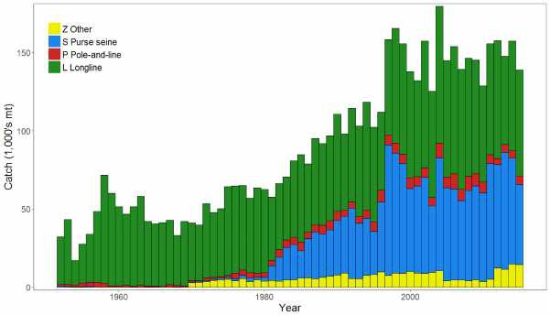 | 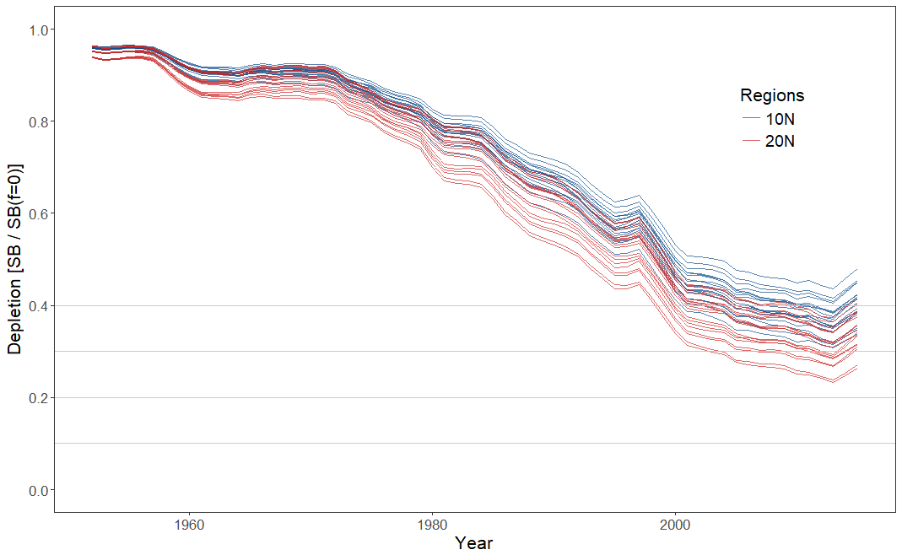
Figure BET-1. Time series of total annual catch (1000's mt) by fishing gear over the full assessment period. | Figure BET-2. Plot showing the trajectories of spawning biomass depletion for the 36 model runs included in the structural uncertainty grid. The colours depict the models in the grid with the 10°N and 20°N spatial structures.
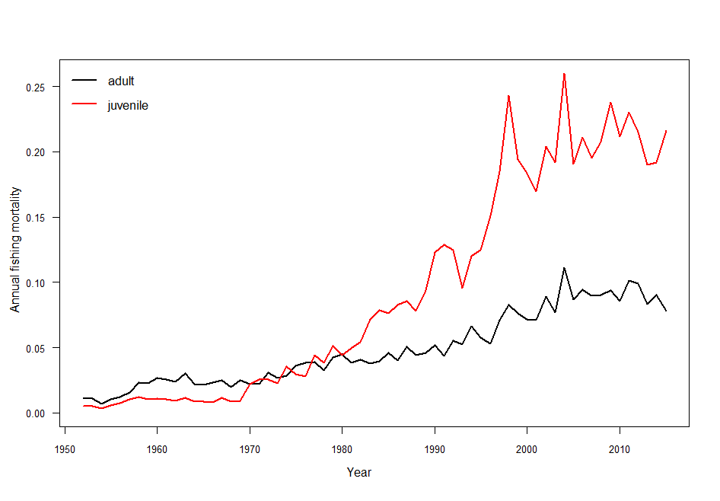
Figure BET-3. Estimated annual average juvenile and adult fishing mortality for the diagnostic case model.

SB_{recent} (2012-2015) / SB_{F=0} | SB_{latest} (2015) / SB_{F=0}
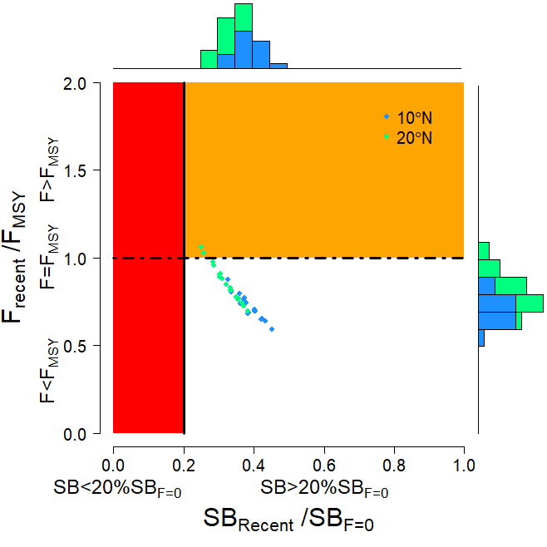 | 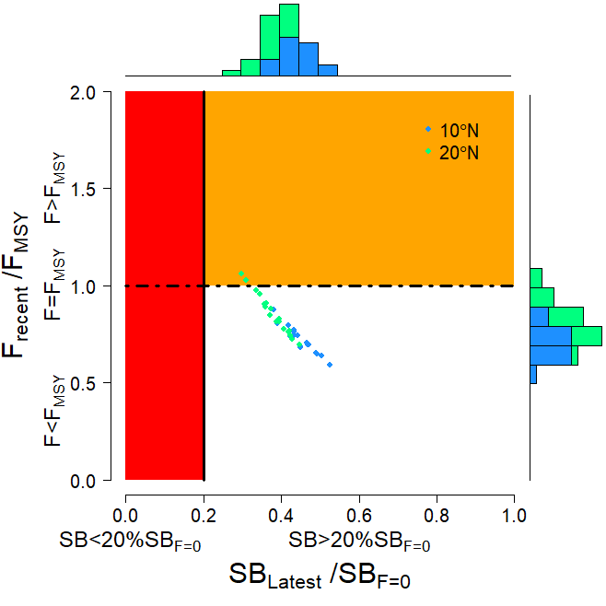
Figure BET-4. Majuro plot summarising the results for each of the models in the structural uncertainty grid. The plots represent estimates of stock status in terms of spawning biomass depletion and fishing mortality. The red zone represents spawning biomass levels lower than the agreed limit reference point, which is marked with the solid black line. The orange region is for fishing mortality greater than F_{MSY} (F_{MSY} is marked with the black dashed line). In the upper panel, the points represent SB_{recent}/SB_{F=0}, where SB_{recent} is the mean SB over 2012-2015. In the lower panel, the points represent SB_{latest}/SB_{F=0}, where SB_{latest} is from 2015. In both panels the colors depict the models in the grid with the 10°N and 20°N regional structures.

SB_{recent} (2012-2015) / SB_{MSY} | SB_{latest} (2015) / SB_{MSY}
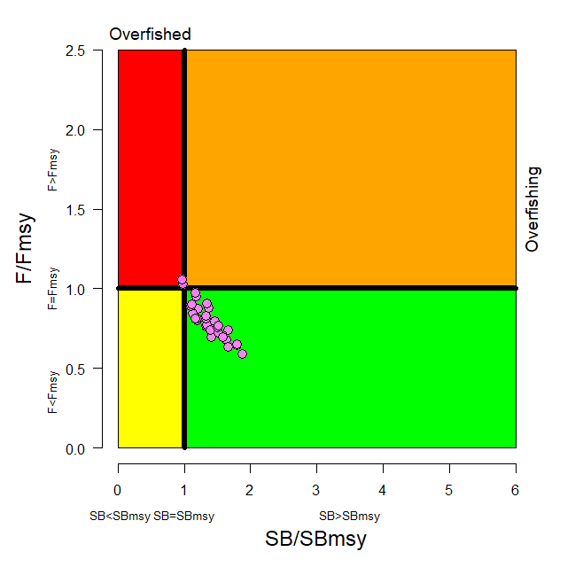 | 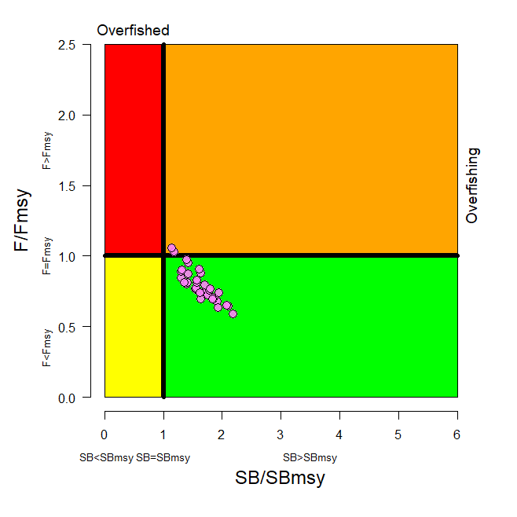
Figure BET-5. Kobe plot summarising the results for each of the models in the structural uncertainty grid. In the upper panel, the points represent SB_{recent}/SB_{MSY}, where SB_{recent} is the mean SB over 2012-2015. In the lower panel, the points represent SB_{latest}/SB_{MSY}, where SB_{latest} is from 2015.

Table BET-2. Summary of reference points over the 36 models in the structural uncertainty grid. Note that SB_{recent}/SB_{F=0} is calculated where SB_{recent} is the mean SB over 2012-2015 at the request of the Scientific Committee.
 | Mean | Median | Min | 10% | 90% | Max
C_{latest} | 152,148 | 151,846 | 148,888 | 148,936 | 154,971 | 155,577
YF_{recent} | 154,180 | 153,220 | 133,120 | 141,140 | 170,720 | 172,280
f_{mult} | 1.291 | 1.301 | 0.946 | 1.075 | 1.499 | 1.690
F_{MSY} | 0.050 | 0.049 | 0.044 | 0.045 | 0.054 | 0.056
MSY | 158,551 | 159,020 | 133,520 | 143,040 | 173,880 | 180,120
F_{recent}/F_{MSY} | 0.789 | 0.768 | 0.592 | 0.667 | 0.931 | 1.058
SB₀ | 1,674,833 | 1,675,500 | 1,261,000 | 1,415,500 | 1,941,000 | 2,085,000
SB_{F=0} | 1,841,609 | 1,858,775 | 1,509,007 | 1,632,014 | 2,043,108 | 2,139,644
SB_{MSY} | 471,956 | 476,050 | 340,700 | 386,600 | 577,400 | 614,200
SB_{MSY}/SB₀ | 0.281 | 0.280 | 0.260 | 0.262 | 0.300 | 0.302
SB_{MSY}/SB_{F=0} | 0.255 | 0.255 | 0.226 | 0.235 | 0.280 | 0.287
SB_{latest}/SB₀ | 0.456 | 0.456 | 0.346 | 0.392 | 0.523 | 0.568
SB_{latest}/SB_{F=0} | 0.414 | 0.420 | 0.298 | 0.351 | 0.480 | 0.526
SB_{latest}/SB_{MSY} | 1.633 | 1.624 | 1.146 | 1.306 | 1.933 | 2.187
SB_{recent}/SB_{F=0} | 0.353 | 0.358 | 0.251 | 0.295 | 0.412 | 0.452
SB_{recent}/SB_{MSY} | 1.394 | 1.377 | 0.963 | 1.117 | 1.659 | 1.879

- SC14 noted that there has been a long-term decrease in spawning biomass from the 1950s to the present for bigeye tuna and that this is consistent with previous assessments.

- SC14 also noted that the central tendency of relative recent (2012-2015) spawning biomass depletion was median (SB_{recent}/SB_{F=0}) = 0.36 with a range of 0.30 to 0.41 (80% probability interval).

- SC14 further noted that there was 0% probability (0 out of 36 models) that the recent spawning biomass had breached the adopted LRP.

- SC14 noted that there has been a long-term increase in fishing mortality for both juvenile and adult bigeye tuna (Figure BET-3), consistent with previous assessments.

- SC14 also noted that the central tendency of relative recent fishing mortality was median (F_{recent}/F_{MSY}) = 0.77 with an 80% probability interval of 0.67 to 0.93.

- SC14 further noted that there was a roughly 6% probability (2 out of 36 models) that the recent fishing mortality was above F_{MSY}.

- SC14 also noted that, regardless of the choice of uncertainty grid, the assessment results show that the stock has been continuously declining for about 60 years since the late 1950’s, except for the recent small increase.

- SC14 also noted the continued relatively higher levels of depletion in the equatorial and western Pacific (specifically Regions 3, 4, 7 and 8) and the associated higher levels of impact, especially on juvenile bigeye tuna, in these regions due to the associated purse-seine fisheries and the ‘other’ fisheries within the western Pacific (as shown in Figures 46 and 47 of SC13-SA-WP-03).

- Table BET-3 summarises the median values of SB/SB_{F=0} and F/F_{MSY} achieved in the long term, along with the potential risk of breaching the limit reference point (LRP) and exceeding F_{MSY}, under each of the future fishing and recruitment combinations. Figure BET-6 presents the corresponding distributions of long term SB/SB_{F=0} and Figure BET-7 those for F/F_{MSY}.

- Potential outcomes under the 2013-15 average and CMM scenario conditions were strongly influenced by the assumed future recruitment levels.

- Under the assumption that recent positive recruitments will continue into the future, spawning biomass relative to unfished levels is predicted to increase from recent levels under all examined future scenarios by 0-18% (SB₂₀₄₅/SB_{F=0} ranges from 0.36 to 0.42; Table BET-3, Figure BET-6). While future uncertainty in stock status increases due to stochastic future recruitment levels, the risk of future spawning biomass falling below the LRP falls to between 0 and 5%, due to the improved overall stock size. Fishing mortality falls slightly under both the status quo and optimistic scenarios, assuming recent recruitment. However, fishing mortality increases under the pessimistic scenario, but remains below F_{MSY} (30% risk of F > F_{MSY} Table BET-3, Figure BET-7).

- Under the assumption that less positive long-term recruitments are experienced in the future, spawning biomass relative to unfished levels will decline under all scenarios (SB₂₀₄₅/SB_{F=0} ranges from 0.25 to 0.30). The risk of spawning biomass falling below the LRP increases to between 17 and 32% (Table BET-3). In all fishing scenarios, fishing mortality increases relative to recent levels (by 109-138%) and is well above F_{MSY}. Risk of fishing mortality exceeding F_{MSY} ranges from 93 to 98%.

- It should be noted that even under assumption of long term recruitment levels, the risk of exceeding the LRP in the short term ranges between 2% and 7% (2020) and 12 and 26% (2025), with only the pessimistic scenario exceeding the 20% level of risk in 2025. (Table BET-4 and Figure BET-8)

Table BET-3. Including ‘2013-2015 average levels’
Median values of reference point levels (adopted limit reference point (LRP) of 20% SB_{F=0}; F_{MSY}) and risk¹ of breaching reference points from the 2018 bigeye stock assessment incorporating updated new growth information, and in 2045 under the three future harvest scenarios (2013-2015 average fishing levels, optimistic, and pessimistic) and alternative recruitment hypotheses. ‘Updated new growth’ runs only.
Scenario |  | Scalars relative to 2013-2015 |  | Median SB₂₀₄₅/SB_{F=0} | Median SB₂₀₄₅/SB_{F=0}  v  SB₂₀₁₂₋₁₅/SB_{F=0} | Median  F₂₀₄₁₋₂₀₄₄/  F_{MSY} | Median F₂₀₄₁₋₂₀₄₄/F_{MSY} v  F₂₀₁₁₋₁₄/F_{MSY} | Risk
Recruitment | Fishing level | Purse seine | Longline |  |  |  |  | SB₂₀₄₅ < LRP | F>F_{MSY}
Bigeye assessment (‘recent’ levels) |  |  |  | 0.36 | - | 0.77 | - | 0% | 6%
Recent | 2013-2015 average | 1 | 1 | 0.42 | 1.18 | 0.73 | 0.95 | 0% | 11%
Recent | Optimistic | 1.11 | 0.98 | 0.41 | 1.15 | 0.75 | 0.98 | 0% | 13%
Recent | Pessimistic | 1.12 | 1.35 | 0.36 | 1.00 | 0.89 | 1.15 | 5% | 30%
Long-term | 2013-2015 average | 1 | 1 | 0.30 | 0.84 | 1.60 | 2.09 | 17% | 93%
Long-term | Optimistic | 1.11 | 0.98 | 0.29 | 0.82 | 1.64 | 2.13 | 18% | 94%
Long-term | Pessimistic | 1.12 | 1.35 | 0.25 | 0.70 | 1.84 | 2.38 | 32% | 98%
¹ note risk within the stock assessment is calculated as the (weighted) number of models falling below the LRP (X / 36 models). Risk under a projection scenario is the number of projections across the grid that fall below the LRP (X / 3600 (36 models x 100 projections).

Table BET-4. Median values of SB/SB_{F=0} and associated risk of breaching the adopted limit reference point (LRP) of 20% SBF=0 in 2020, 2025 and 2045 under the three future harvest scenarios (2013-2015 average fishing levels, optimistic, and pessimistic) and alternative recruitment hypotheses. ‘Updated new growth’ runs only.

Scenario |  | Scalars relative to 2013-2015 |  | Median SB₂₀₂₀/SB_{F=0} | Median SB₂₀₂₅/SB_{F=0} | Median SB₂₀₄₅/SB_{F=0} | Risk SB₂₀₂₀ < LRP | Risk SB₂₀₂₅ < LRP | Risk SB₂₀₄₅ < LRP
Recruitment | Fishing level | Purse seine | Longline
Recent | 2013-2015 average | 1 | 1 | 0.42 | 0.41 | 0.42 | 0% | 1% | 0%
Recent | Optimistic | 1.11 | 0.98 | 0.41 | 0.40 | 0.41 | 0% | 1% | 0%
Recent | Pessimistic | 1.12 | 1.35 | 0.38 | 0.35 | 0.36 | 0% | 4% | 5%
Long-term | 2013-2015 average | 1 | 1 | 0.35 | 0.30 | 0.30 | 2% | 12% | 17%
Long-term | Optimistic | 1.11 | 0.98 | 0.35 | 0.30 | 0.29 | 2% | 13% | 18%
Long-term | Pessimistic | 1.12 | 1.35 | 0.32 | 0.26 | 0.25 | 7% | 26% | 32%

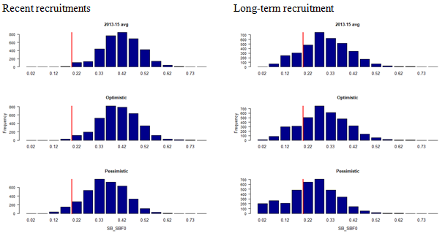 | 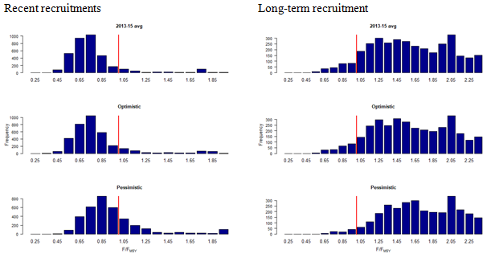
Figure BET-6. Distribution of SB₂₀₄₅/SB_{F=0} assuming recent and long term recruitment conditions (left and right columns, respectively), under the three future fishing scenarios: 2013-15 average (2013-15 average conditions, top row); optimistic conditions (middle row); and pessimistic conditions (bottom row). Projection results from ‘updated new growth’ models (3,600 projections) only where the red line indicates the LRP. | Figure BET-7. Distribution of F/F_{MSY} assuming recent and long term recruitment conditions (left and right columns, respectively), under the three future fishing scenarios: 2013-15 average (2013-15 average conditions, top row); optimistic conditions (middle row); and pessimistic conditions (bottom row). Projection results from ‘updated new growth’ models (3,600 projections) only.

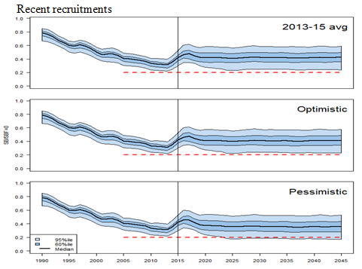 | 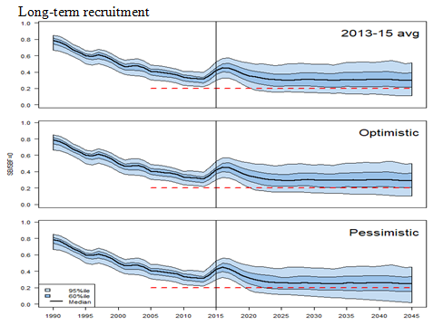
Figure BET-8. Time series of WCPO bigeye tuna spawning biomass (SB/SB_{F=0}) from the uncertainty grid of assessment model runs for the period 1990 to 2015 (the vertical line at 2015 represents the last year of the assessment), and stochastic projection results for the period 2016 to 2045 under the three future fishing scenarios (“2013-15 average”, “Optimistic” and “Pessimistic”; rows). During the projection period (2016-2045) levels of recruitment variability are assumed to match those over the “recent” time period (2005-2014; left panel) or the time period used to estimate the stock-recruitment relationship (1962-2014; right panel). The red dashed line represents the agreed limit reference point.

b. Management advice and implications

- SC14 noted that the preliminary estimate of total catch of WCPO bigeye tuna for 2017 was 126,929 mt, a 17% decrease from 2016 and a 19% decrease from the average 2012-2016. Longline catch in 2017 (58,164 mt) was an 8% decrease from 2016 and a 19% decrease from the 2012-2016 average. Purse seine catch in 2017 (56,194 mt) was a 12% decrease from 2016 and a 13% decrease from the 2012-2016 average. Pole and line catch (1,411 mt) was a 65% decrease from 2016 and a 70% decrease from the average 2012-2016 catch. Catch by other gear (11,160 mt) was a 48% decrease from 2016 and 28% decrease from the average catch in 2012-2016.

- Based on the uncertainty grid adopted by SC14, the WCPO bigeye tuna spawning biomass is above the biomass LRP and recent F is very likely below F_{MSY}. The stock is not experiencing overfishing (94% probability F<F_{MSY}) and it is not in an overfished condition (0% probability SB/SB_{F=0}<LRP).

- Although SC14 considers that the updated assessment is consistent with the previous assessment, SC14 also advises that the amount of uncertainty in the stock status results for the 2018 assessment update is lower than for the previous assessment due to the exclusion of old information on bigeye tuna growth.

- SC14 noted that levels of fishing mortality and depletion differ among regions, and that fishery impact was higher in the tropical region (Regions 3, 4, 7 and 8 in the stock assessment model), with particularly high fishing mortality on juvenile bigeye tuna in these regions. SC14 therefore recommends that WCPFC15 could continue to consider measures to reduce fishing mortality from fisheries that take juveniles, with the goal to increase bigeye fishery yields and reduce any further impacts on the spawning biomass for this stock in the tropical regions.

- SC14 noted that according to CMM 2017-01 bigeye tuna SB/SB_{F=0} is to be maintained above the 2012-2015 level (SB_{recent}/SB_{F=0} = 0.36; Table BET-3) pending the agreement on a TRP. SC14 also noted that the projection results based on scenarios estimating CMM 2017-01 indicated a high level of uncertainty on the levels of spawning stock biomass relative to the LRP and the objective of CMM 2017-01 in 2045. Under the scenario assuming long-term average recruitment continues into the future there was a high risk (18-32%) of breaching the LRPs and a zero probability of achieving the objective of CMM 2017-01, while under the scenario which assumes higher more recent recruitments continues into the future there was a low risk (0-5%) of breaching the LRPs and a 100% probability of achieving the objective of CMM 2017-01.

- However, SC14 also noted that the projections assume that longline catches would be maintained regardless of the decrease in biomass. This may result in unlikely high levels of effort. Therefore, the catch estimates under the long term recruitment scenario, especially in the longer term projections, are more uncertain.

- Based on these results, SC14 recommends that WCPFC15 takes note of the results of the projections in relation to achieving CMM 2017-01 and as a precautionary approach that the fishing mortality on bigeye tuna stock should not be increased from the recent average (2011-2014) level to maintain spawning biomass at or above the 2012-2015 average, until the Commission can articulate the management objectives and agree on an appropriate TRP for bigeye, although one CCM considers that SC14 could provide more options for the Commission to consider.

c. Research Recommendations

- SC14 noted that the acceptance of the updated new growth model for BET raises a number of issues in relation to patterns of growth and stock structure of BET across the Pacific Ocean and recommended that the following research issues need to be addressed:

- Two different growth models separated at 150˚W effectively means that Pacific BET should be assessed as a two-stock resource between the WCPO and EPO. However, catch information indicates that the fishing grounds near 150˚W are a core area of BET catch, thus influencing the assessments of both the WCPFC and IATTC. Also, tagging information suggests movement of BET between the WCPO and EPO. Therefore, the appropriateness off delineating the two stocks at 150˚W needs to be investigated.
- The updated new growth analysis suggests area variant growth across the Pacific. While the level of variation is seen to be relatively small within the WCPO (and possibly within the margins of observation error), there is a suggestion of substantial change in growth around the boundary between the WCPO and the EPO (c.f. Figure 14 in SC14-SA-WP-01). The reasons for this suggested change in growth remains unknown, but SC14 noted the utility of collecting more information from the regions either side of this boundary to inform a greater understanding of possible changes in growth around this area. While the incorporation of area-variant growth within the assessment model would also help explore this issue, SC14 noted the difficulty of this task.
- SC11 concluded that the stock status of WCPO BET from the Pan-Pacific assessment and the WCPO-only assessment were similar when the growth models were similar in the EPO and WCPO. This conclusion needs to be revisited in light of the different growth between EPO and WCPO by adopting the new growth.

- The following additional research activities were also recommended by SC14 in order to improve the understanding of the age and growth of BET across the Pacific:

- A WCPO growth model based on size composition and tagging data, as well as the use of additional modeling approaches (e.g., length-conditional), should also be evaluated.
- Collaboration with the IATTC to analyze bigeye growth from otolith and tagging data collected across the entire Pacific, to better characterize the apparent regional difference in growth between the WCPO and EPO, and possible environmental determinants of such differences.
- Analyzing the same otoliths by different laboratories, to build confidence in ageing estimates and to estimate ageing error.
- Continued development of a high-confidence tagging dataset for growth analysis, with particular focus on larger bigeye tuna and events with reliable measurements at release. Such data would assist with the validation of the age estimates of large bigeye in the WCPO, and could potentially be incorporated directly into the assessment model as an additional data set. However, a reliable measurement of both length at release and recapture are necessary to accurately estimate incremental growth.
- Collect otoliths of very small bigeye that are captured by the Indonesian, Vietnamese, and Philippines domestic fisheries in region 7 and estimate age through daily ring counts to aid in the estimation of the size at age-1 qtr⁻¹ parameter (L1) within the assessment model.

    - WCPO yellowfin tuna (Thunnus albacares)

a. Stock status and trends

- SC14 noted that no stock assessment was conducted for WCPO yellowfin tuna in 2018. Therefore, the stock status description from SC13 is still current. For further information on the stock status and trends from SC13, please see https://www.wcpfc.int/node/29904

- SC14 noted that the total yellowfin catch in 2017 was a record 670,890 mt, a 4% increase from 2016 and a 12% increase from the average 2012-2016.

- Purse seine catch in 2017 (472,279 mt) was a 22% increase from 2016 and a 33% increase from the 2012-2016 average. Longline catch in 2017 (83,399 mt) was a 6% decrease from 2016 and a 9% decrease from the 2012-2016 average. Pole and line catch (12,219 mt) was a 48% decrease from 2016 and a 56% decrease from the average 2012-2016 catch. Catch by other gear (102,993 mt) was a 28% decrease from 2016 and 17% decrease from the average catch in 2012-2016.

- SC14 noted that under recent fishery conditions, the yellowfin stock was initially projected to increase as recent estimated relatively high recruitments support adult stock biomass, and then decline slightly. Median F₂₀₁₉/F_{MSY} = 0.63; median SB₂₀₁₉/SB_{F=0} = 0.37; median SB₂₀₁₉/SB_{MSY} = 1.51. Risk that SB₂₀₁₉ < LRP = 6%.

b. Management advice and implications

- SC14 noted that no stock assessment has been conducted since SC13. Therefore, the advice from SC13 should be maintained to achieve the objectives set in CMM 2017-01, pending a new assessment or other new information. For further information on the management advice and implications from SC13, please see https://www.wcpfc.int/node/29904

c. Research recommendations

- SC14 reviewed the work on age and growth of yellowfin tuna presented in SC14-SA-WP-13 and noted that the final results of this projected will be presented to SC15. SC14 encouraged analysis of the same otoliths by different laboratories, to build confidence in ageing estimates through inter laboratory daily-annual age workshop.

    - WCPO skipjack tuna (Katsuwonus pelamis)

a. Stock status and trends

- SC14 noted that the total catch in 2017 was 1,624,162 mt, a 9% decrease from 2016 and comparable to the average from 2012-2016.

- Purse seine catch in 2017 (1,280,311 mt) was a 7% decrease from 2016 and a 12% decrease from the 2012-2016 average. Pole and line catch (123,132 mt) was a 21% decrease from 2016 and a 23% decrease from the average 2012-2016 catch. Catch by other gear (218,175 mt) was a 13% decrease from 2016 and 1% decrease from the average catch in 2012-2016.

- SC14 noted that under recent fishery conditions (2017 catch level for longline and other fisheries and effort level for purse seine), the skipjack stock was initially projected to decrease for a short period as recent relatively high recruitments move out of the stock. Median F₂₀₁₉/F_{MSY} = 0.47; median SB₂₀₁₉/SB_{F=0} = 0.45; median SB₂₀₁₉/SB_{MSY} = 1.67. In the longer term, assuming long term average recruitment, modest increases in the stock were projected.

b. Management advice and implications

- SC14 noted that no stock assessment has been conducted since SC12. Therefore, the advice from SC12 should be maintained to achieve the objectives set in CMM 2017-01, pending a new assessment or other new information. For further information on the management advice and implications from SC12, please see https://www.wcpfc.int/node/27769

c. Research Recommendations

- SC14 discussed a proposal for an alternative regional structure to be considered in the next skipjack stock assessment (SC14-SA-WP-04) and recommended that the pre-assessment workshop consider how this proposal might be included in the next assessment.

- SC14 supports an ongoing tagging program for skipjack tuna to ensure a reliable indicator of skipjack tuna abundance in the stock assessment.

- SC14 recommended that the Scientific Services Provider continue research on standardizing purse seine CPUE for use in the assessment.

    - South Pacific albacore tuna (Thunnus alalunga)

- SC14 accepted as SC14-SA-WP-05 as providing the best available scientific information for the purpose of stock assessment determination.

          - Stock status and trends

- The median, 10 percentile and 90 percentile values of recent (2013-2016) spawning biomass ratio (SB_{recent}/ SB_{F=0}) and recent fishing mortality in relation to F_{MSY} (F_{recent}/F_{MSY}) over the structural uncertainty grid were used to characterize uncertainty and describe the stock status.

- A description of the structural sensitivity grid used to characterize uncertainty in the assessment is set out in Table SPA-1. The regional structure used within the assessment is presented in Figure SPA-1, and the time series of total annual catch by fishing gear for the diagnostic case model over the full assessment period is shown in Figure SPA-2 for the total assessment region, and Figure SPA-3 by model region. Estimated annual average recruitment, spawning potential, juvenile and adult fishing mortality and fishing depletion for the diagnostic case model are shown in Figures SPA-4 – SPA-7. Figure SPA-8 displays Majuro plots summarising the results for each of the models in the structural uncertainty grid, while Figure SPA-9 shows equivalent Kobe plots for SB_{recent} and SB_{latest} across the structural uncertainty grid. Figure SPA-10 provides estimates of reduction in spawning potential due to fishing by region, and over all regions attributed to various fishery groups (gear-types) for the diagnostic case model. Table SPA-2 provides a summary of reference points over the 72 models in the structural uncertainty grid. Figure SPA-11 presents the history of the annual estimates of MSY for the diagnostic case model, compared with annual catch by the main gear types. Finally, Figure SPA-12 presents the estimated time-series (or ‘dynamic’) Kobe plots for four example models from the assessment (one from each of the combinations of growth types, and natural mortality M set to 0.3 or 0.4)

- SC14 noted that the median level of spawning biomass depletion from the uncertainty grid was SB_{recent}/SB_{F=0} = 0.52 with a probable range of 0.37 to 0.63 (80% probability interval). There were no individual models where (SB_{recent}/SB_{F=0}) < 0.2 which indicated that the probability that recent spawning biomass was below the LRP was zero. SC14 noted that the grid median F_{recent}/F_{MSY} was 0.20, with a range of 0.08 to 0.41 (80% probability interval) and that no values of F_{recent}/F_{MSY} in the grid exceeded 1.

- SC14 also noted that there was a 0% probability (0 out of 72 models) that the recent fishing mortality had exceeded F_{MSY}.

- SC14 noted that the structural uncertainty grid for the south Pacific albacore had changed since the 2015 assessment, with the 2018 assessment examining additional axes of uncertainty including assumptions on growth and CPUE standardization approach. As a consequence, the uncertainty identified is higher than in previous assessments.

- SC14 also noted that the assessment results show that while the stock depletion (SB/SB_{F=0}) has exhibited a long-term decline (Figure SPA-7) the stock is not in an overfished state and overfishing is not taking place.

b. Management Advice and implications

- SC14 noted that the preliminary estimate of total catch of south Pacific albacore (within the WCPFC Convention Area south of the equator) for 2017 was 75,707mt, which was a 33% increase from 2016 and a 13% increase over 2012-2016. (see SC14-SA-WP-02).

- Preliminary catch for longliners in 2017 (72,785mt) was 34% higher compared with 2016 and a 14% increase over 2012-2016. Preliminary other gear (primarily troll) catch in 2017 (2,896t) was 17% higher compared with 2016 but a 1% decrease over 2012-2016. (see SC14-SA-WP-02).

- Based on the uncertainty grid adopted by SC14, the South Pacific albacore tuna spawning biomass is very likely to be above the biomass LRP and recent F is very likely below F_{MSY}, and therefore the stock is not experiencing overfishing (100% probability F < F_{MSY}) and is not in an overfished condition (100% probability SB_{recent} > LRP).

- SC14 recalled its previous advice from SC11, SC12, and SC13 that longline fishing mortality and longline catch be reduced to avoid decline in the vulnerable biomass so that economically viable catch rates can be maintained, especially for longline catch of adult albacore. SC14 recommends that this advice be taken into consideration when the TRP for South Pacific albacore is discussed at WCPFC15.

Table SPA-1. Description of the structural sensitivity grid used to characterize uncertainty in the 2018 south Pacific albacore assessment. Levels used within the diagnostic case are starred.
Axis | Levels | Option
Steepness | 3 | 0.65, 0.80*, 0.95
Natural mortality | 2 | 0.3*, 0.4
Growth | 2 | Estimated* (K, L∞) or fixed (Chen-Wells)
Size frequency weighting | 3 | Sample sizes divided by 20, 50* or 80
CPUE | 2 | Geostatistical*, Traditional

Table SPA-2. Summary of reference points over all the 72 individual models in the structural uncertainty grid.
 | Mean | Median | Min | 10% | 90% | Max
C_{latest} | 61719 | 61635 | 60669 | 60833 | 62704 | 63180
MSY | 100074 | 98080 | 65040 | 70856 | 130220 | 162000
YF_{recentt} | 71579 | 71780 | 56680 | 62480 | 80432 | 89000
fmult | 6.2 | 4.96 | 1.89 | 2.44 | 12.05 | 17.18
F_{MSY} | 0.07 | 0.07 | 0.05 | 0.05 | 0.09 | 0.1
F_{recent}/F_{MSY} | 0.23 | 0.2 | 0.06 | 0.08 | 0.41 | 0.53
SB_{MSY} | 71407 | 68650 | 26760 | 39872 | 100773 | 134000
SB₀ | 443794 | 439800 | 308800 | 353870 | 510530 | 696200
SB_{MSY}/SB₀ | 0.16 | 0.17 | 0.07 | 0.1 | 0.21 | 0.23
SB_{F=0} | 469004 | 462633 | 380092 | 407792 | 534040 | 620000
SB_{MSY}/SB_{F=0} | 0.15 | 0.15 | 0.06 | 0.09 | 0.2 | 0.22
SB_{latest}/SB₀ | 0.55 | 0.56 | 0.33 | 0.42 | 0.69 | 0.74
SB_{latest}/SB_{F=0} | 0.53 | 0.52 | 0.3 | 0.37 | 0.69 | 0.77
SB_{latest}/SB_{MSY} | 4 | 3.42 | 1.45 | 1.96 | 7.07 | 10.74
SB_{recent}/SB_{F=0} | 0.51 | 0.52 | 0.32 | 0.37 | 0.63 | 0.72
SB_{recent}/SB_{MSY} | 3.88 | 3.3 | 1.58 | 1.96 | 6.56 | 9.67

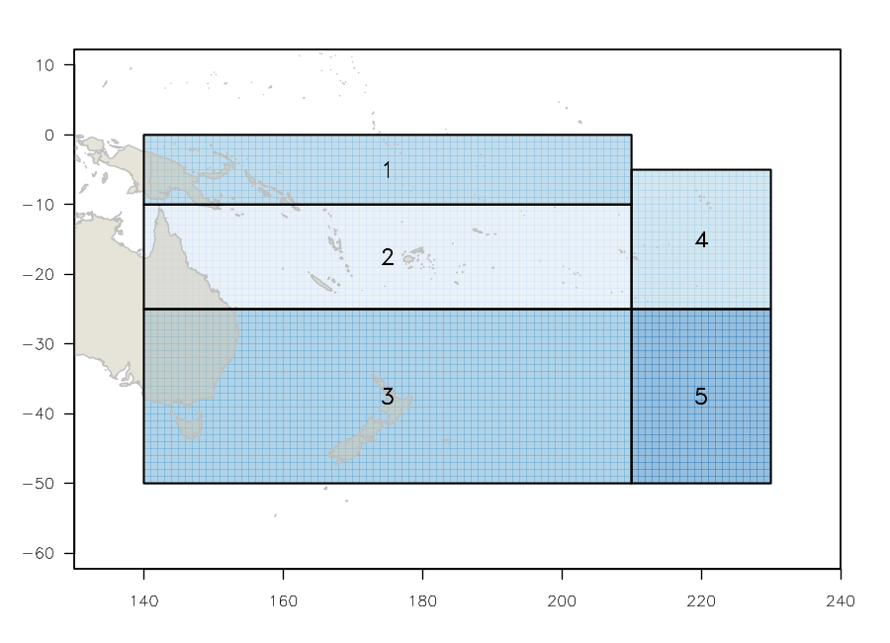 | 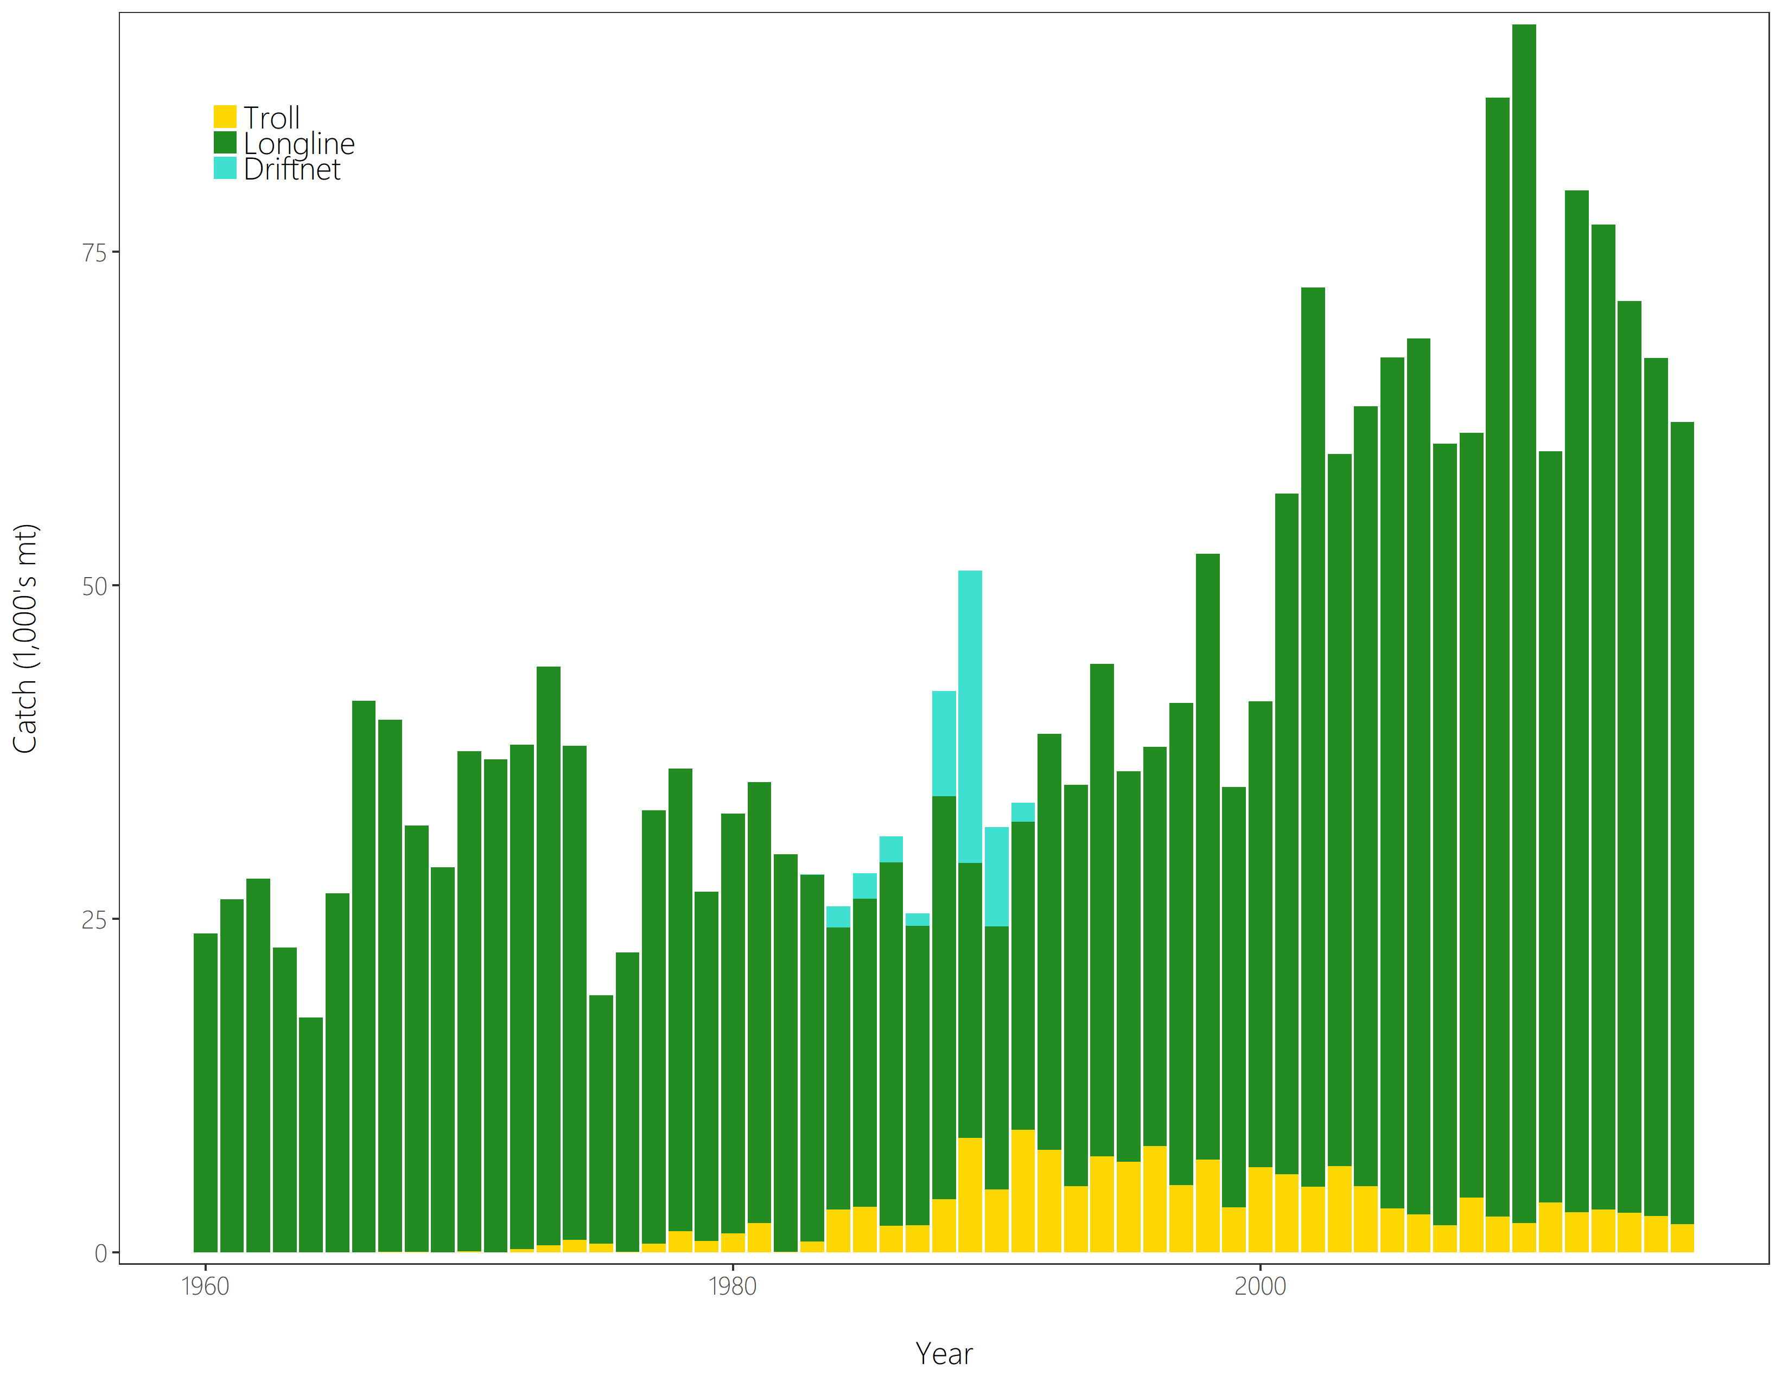
Figure SPA- 1. The geographical area covered by the stock assessment and the boundaries for the 5 regions under the “updated 2018 regional structure". | Figure SPA- 2. Time series of total annual catch (1000’s mt) by fishing gear for the diagnostic case model over the full assessment period. The different colours refer to longline (green), troll (yellow) and driftnet (turquoise). Note that the catch by longline gear has been converted into catch-in-weight from catch-in-numbers.

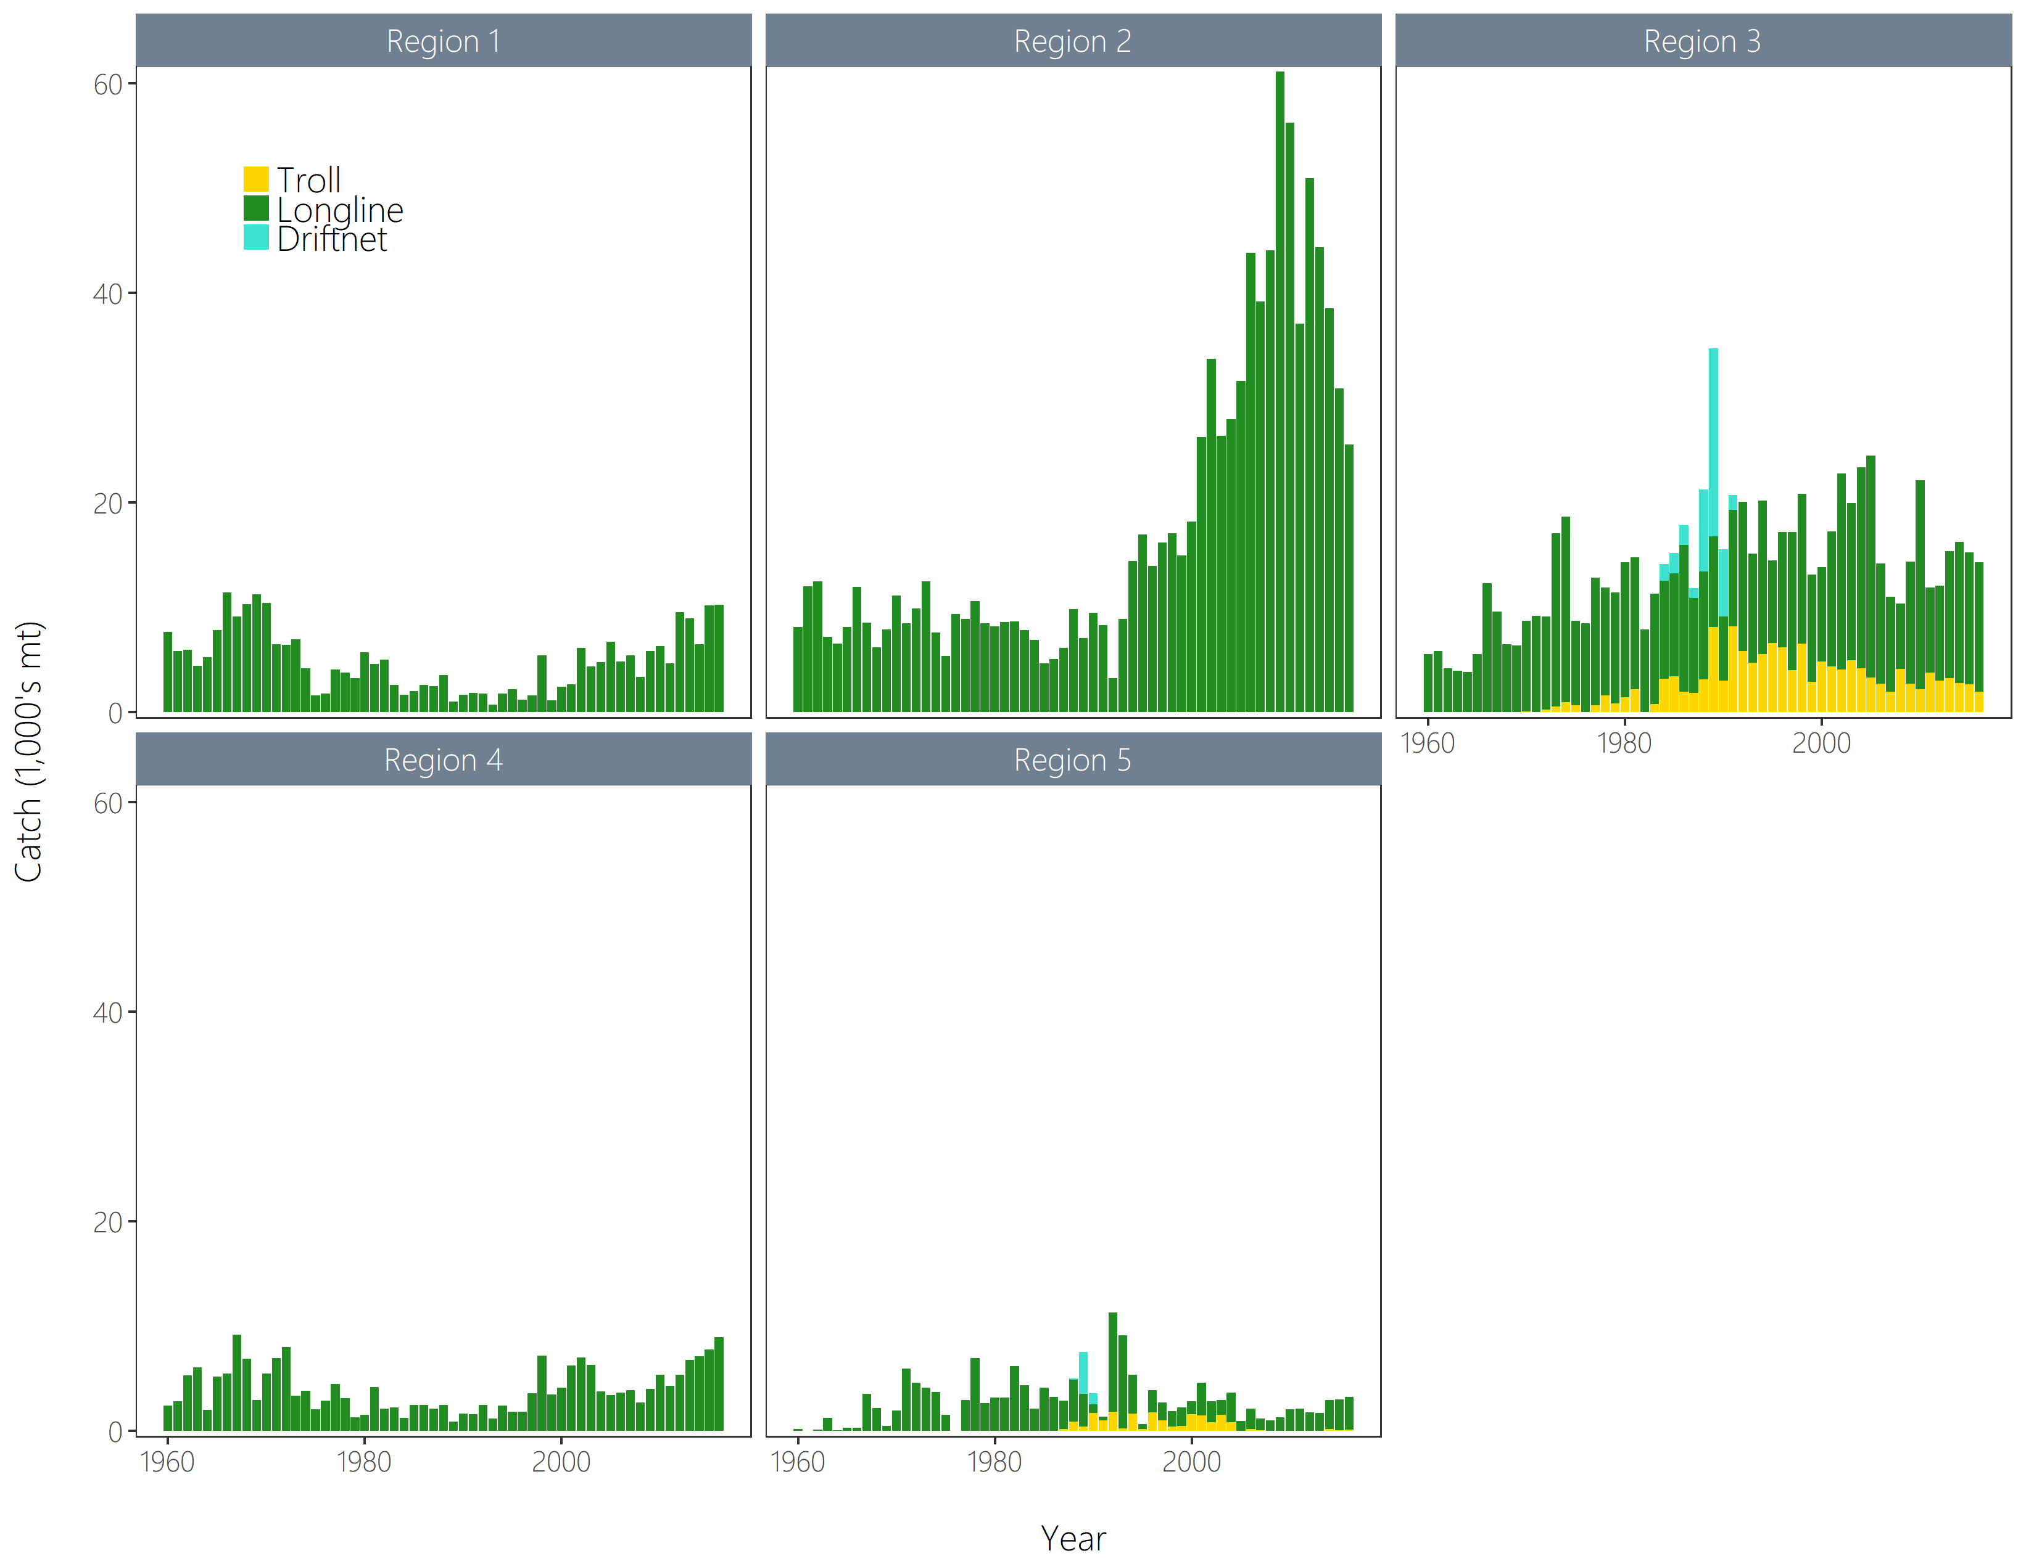 | 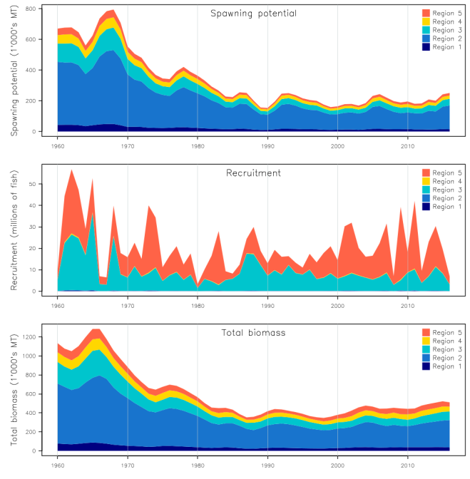
Figure SPA-3. Time series of total annual catch (1000’s mt) by fishing gear and assessment region from the diagnostic case model over the full assessment period. The different colours denote longline (green), driftnet (turquoise) and troll (yellow). | Figure SPA-4. Estimated annual average recruitment, spawning potential and total biomass by model region for the diagnostic case model, showing the relative sizes among regions.

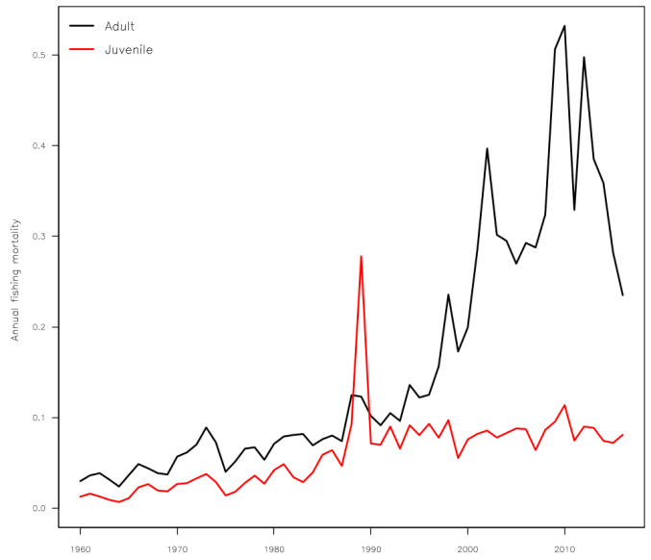 | 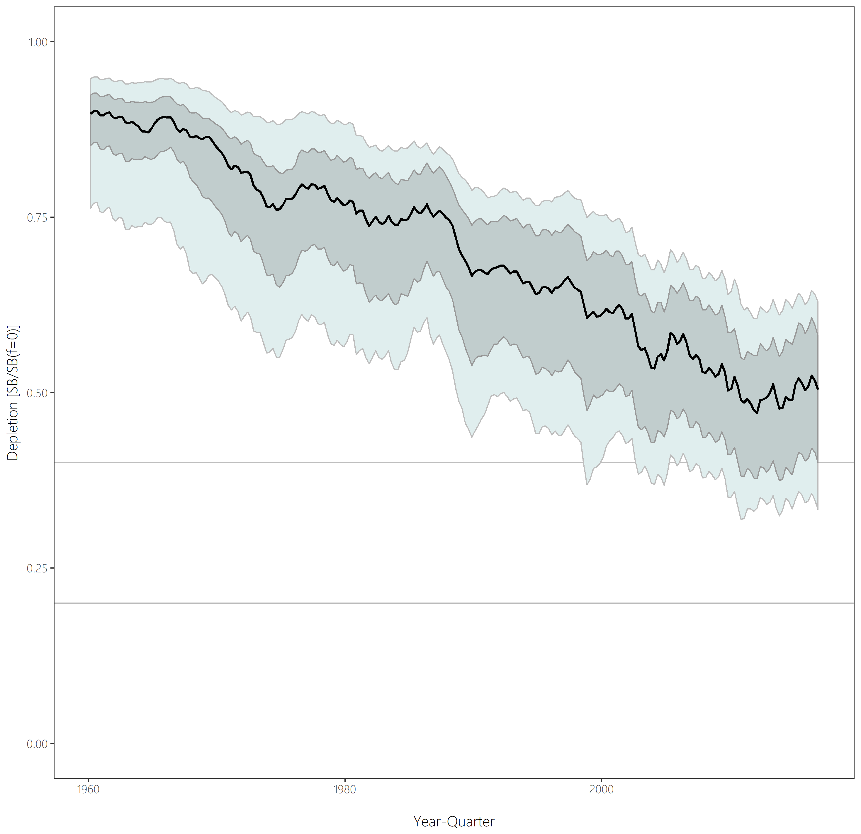
Figure SPA-5. Estimated annual average juvenile and adult fishing mortality for the diagnostic case model. | Figure SPA-6. Distribution of time series depletion estimates across the structural uncertainty grid. Black line represents the grid median trajectory, dark grey region represents the 50%ile range, light grey the 90%ile range.

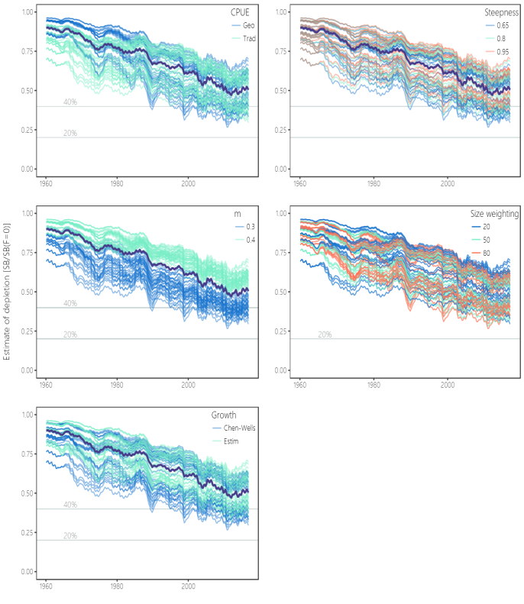 | 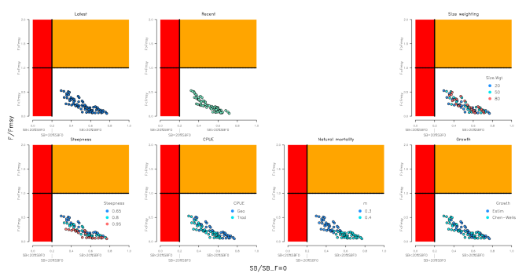
Figure SPA-7. Plots showing the trajectories of fishing depletion (of spawning potential) for the model runs included in the structural uncertainty grid. The five panels show the models separated on the basis of the five axes used in the grid, with the colour denoting the level within the axes for each model. | Figure SPA-8. Majuro plots summarising the results for each of the models in the structural uncertainty grid under the SB_{latest}/SB_{F=0} and the SB_{recent}/SB_{F=0} reference points (top left) and each axis of uncertainty.

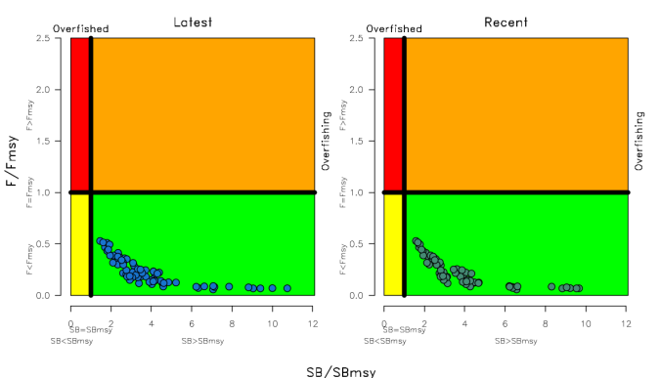 | 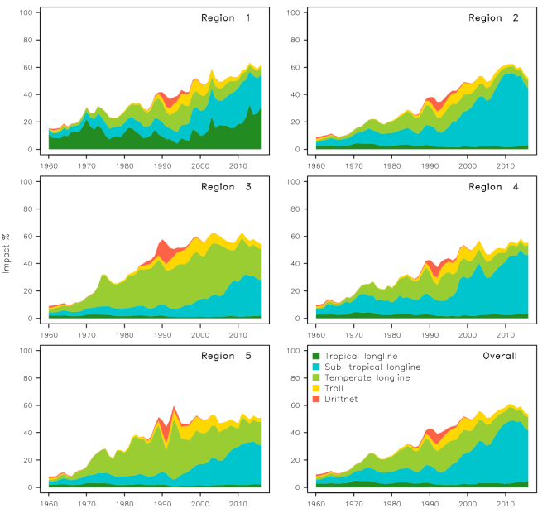
Figure SPA-9. Kobe plots summarising the results for each of the models in the structural uncertainty grid under the SB_{latest}/SB_{F=0} and the SB_{recent}/SB_{F=0} reference points. | Figure SPA-10. Estimates of reduction in spawning potential due to fishing (fishery impact = 1-SB _{latest}/SB _{F=0}) by region, and over all regions (lower right panel), attributed to various fishery groups for the diagnostic case model.

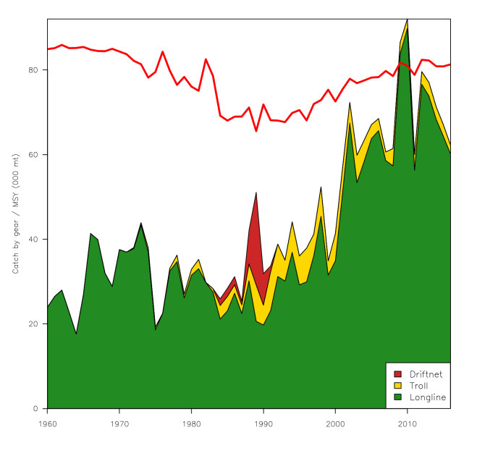 | 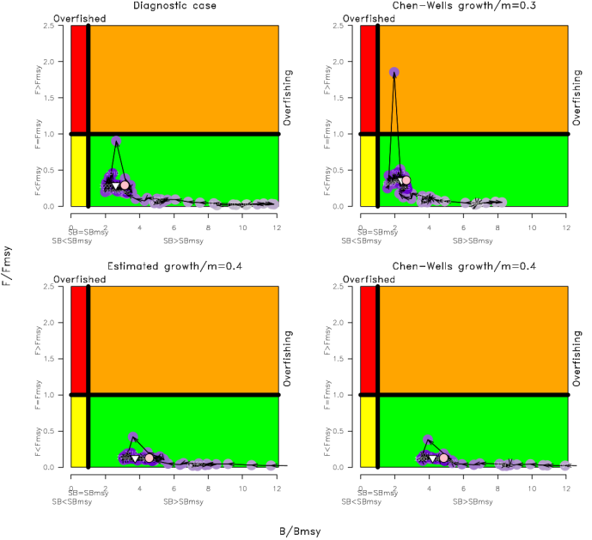
Figure SPA-11. History of the annual estimates of MSY (red line) for the diagnostic case model compared with annual catch by the main gear types. | Figure SPA-12. Estimated time-series (or ‘dynamic’) Kobe plots for four example models from the assessment (one from each of the combinations of growth types, and natural mortality M set to 0.3 or 0.4).

  - Northern stocks

    - North Pacific albacore (Thunnus alalunga)

a. Status and trends

- SC14 noted that no stock assessments were conducted for North Pacific albacore in 2018. Therefore, the stock status descriptions from SC13 are still current for North Pacific albacore. Updated information on catches was not compiled for and reviewed by SC14.

b. Management advice and implications

- SC14 noted that no management advice has been provided since SC13 for North Pacific albacore. Therefore, the advice from SC13 should be maintained, pending a new assessment or other new information. For further information on the management advice and implications from SC13, please see https://www.wcpfc.int/node/29904

    - Pacific bluefin tuna (Thunnus orientalis)

a. Stock status and trends

- SC14 noted that ISC provided the following conclusions on the stock status of Pacific bluefin tuna.

The base-case model results show that: (1) SSB fluctuated throughout the assessment period, (2) SSB steadily declined from 1996 to 2010; and (3) the slow increase of the stock continues since 2011 including the most recent two years (2015-2016). Based on the model diagnostics, the estimated biomass trend for the last 30 years is considered robust although SSB prior to the 1980s is uncertain due to data limitations. Using the base-case model, the 2016 SSB (terminal year) was estimated to be around 21,000 t in the 2018 assessment, which is an increase from 19,000 t in 2014 (Table PBF-1 and Figure PBF-11).

Historical recruitment estimates have fluctuated since 1952 without an apparent trend. The low recruitment levels estimated in 2010-2014 were a concern in the 2016 assessment. The 2015 recruitment estimate is lower than the historical average while the 2016 recruitment estimate (15.988 million fish) is higher than the historical average (13.402 million fish) (Figure PBF-4, Table PBF-1). The uncertainty of the 2016 recruitment estimate is higher than in previous years because it occurs in the terminal year of the assessment and is mainly informed by one observation from the troll age-0 CPUE index. The troll CPUE series has been shown to be a good predictor of recruitment, with no apparent retrospective error in the recruitment estimates of the terminal year given the current model construction. As the 2016 recruits grow and are observed by other fleets, the magnitude of this year class will be more precisely estimated in the next stock assessment. The above average recruitment estimated in 2016 had a positive impact on the projection results.

Estimated age-specific fishing mortalities (F) on the stock during the periods 2012-2014 and 2015-2016 compared with 2002-2004 estimates (the base period for the WCPFC Conservation and Management Measure) are presented in Figure PBF-2. A substantial decrease in estimated F is observed in ages 0-2 in 2015-2016 from the previous years. Note that stricter management measures in the WCPFC and IATTC have been in place since 2015.

The WCPFC adopted an initial rebuilding biomass target (the median SSB estimated for the period 1952 through 2014) and a second rebuilding biomass target (20%SSB_{F=0} under average recruitment), without specifying a fishing mortality reference level. The 2018 assessment estimated the initial rebuilding biomass target to be 6.7%SSB_{F=0} and the corresponding fishing mortality expressed as SPR of F_{6.7%SPR} (Table PBF-2). SPR is the ratio of the cumulative spawning biomass that an average recruit is expected to produce over its lifetime when the stock is fished at the current intensity to the cumulative spawning biomass that could be produced by an average recruit over its lifetime if the stock was unfished. Because the projections include catch limits, fishing mortality is expected to decline, i.e., F_{x%SPR} will increase, as biomass increases. The Kobe plot shows that the point estimate of the SSB₂₀₁₆ was 3.3%SSB_{F=0} and the 2016 fishing mortality corresponds to F_{6.7%SPR} (Figure PBF-3).

Table PBF-3 provides an evaluation of stock status against some common reference points. It shows that the PBF stock is overfished relative to biomass-based limit reference points adopted for other species in WCPFC (20%SSB_{F=0}) and is subject to overfishing relative to most of the common fishing intensity-based reference points.

Figure PBF-4 depicts the historical impacts of the fleets on the PBF stock, showing the estimated biomass when fishing mortality from respective fleets is zero. Historically, the WPO coastal fisheries group has had the greatest impact on the PBF stock, but since about the early 1990s the WPO purse seine fleets, in particular those targeting small fish (ages 0-1), have had a greater impact, and the effect of these fleets in 2016 was greater than any of the other fishery groups. The impact of the EPO fishery was large before the mid-1980s, decreasing significantly thereafter. The WPO longline fleet has had a limited effect on the stock throughout the analysis period, because the impact of a fishery on a stock depends on both the number and size of the fish caught by each fleet; i.e., catching a high number of smaller juvenile fish can have a greater impact on future spawning stock biomass than catching the same weight of larger mature fish.

- SC14 noted the following stock status from ISC:

Based on these findings, the following information on the status of the Pacific bluefin tuna stock is provided:
- No biomass-based limit or target reference points have been adopted to evaluate the overfished status for PBF. However, the PBF stock is overfished relative to the potential biomass-based reference points evaluated (SSB_{MED} and 20%SSB_{F=0}, Table PBF-3 and Figure PBF-3).
- No fishing intensity-based limit or target reference points have been adopted to evaluate overfishing for PBF. However, the PBF stock is subject to overfishing relative to most of potential fishing intensity-based reference points evaluated (Table PBF-3 and Figure PBF-3).

- SC14 noted that the total PBF catch in 2017 was 14,707 mt, 11% increase from 2016 and 9% increase from the average 2012-2016. PBF is caught by various fishing gears including purse seine, longline, set net, troll, pole-and-line, handline and recreational fisheries. The detailed catch information by fishery is available in ISC 2018 stock assessment (SC14-SA-WP-06).

b. Management advice and implications

- SC14 advises the Commission to note the current very low level of spawning biomass (3.3% B₀), the current level of overfishing, and that the projections are strongly influenced by the inclusion of a relatively high but uncertain recruitment in 2016. The majority of CCMs recommended a precautionary approach to the management of Pacific Bluefin tuna, especially in relation to the timing of increasing catch levels, until the rebuilding of the stock to higher biomass levels is achieved.

- SC14 noted the following conservation advice from ISC:

After the steady decline in SSB from 1995 to the historical low level in 2010, the PBF stock appears to have started recovering slowly. The 2016 stock biomass is below the two biomass rebuilding targets adopted by the WCPFC while the 2015-2016 fishing intensity (spawning potential ratio) is at a level corresponding to the initial rebuilding target.

The 2018 base case assessment results are consistent with the 2016 model results. However, the 2018 projection results are more optimistic than the 2016 projections, mainly due to the inclusion of the relatively good recruitment in 2016, which is above the historical average level (119%) and twice as high as the median of the low recruitment scenario (which occurred 1980-1989).

Based on these results, the following conservation information is provided:
          - The projection based on the base-case model mimicking the current management measures by the WCPFC (CMM 2017-08) and IATTC (C-16-08) under the low recruitment scenario resulted in an estimated 98% probability of achieving the initial biomass rebuilding target (6.7%SSBF=0) by 2024. This estimated probability is above the threshold (75% or above in 2024) prescribed by the WCPFC Harvest Strategy (Harvest Strategy 2017-02) (scenario 0 of Table PBF-4; see also Figure PBF-5 and Figure PBF-6). The low recruitment scenario is more precautionary than the recent 10 years recruitment scenario.
          - The Harvest Strategy specifies that recruitment switches from the low recruitment scenario to the average recruitment scenario beginning in the year after achieving the initial rebuilding target. The estimated probability of achieving the second biomass rebuilding target (20%SSBF=0) 10 years after the achievement of the initial rebuilding target or by 2034, whichever is earlier, is 96% (scenario 1 of Table PBF-3, Table PBF-4, and Table PBF-5; Figure PBF-5 and Figure PBF-6). This estimate is above the threshold (60% or above in 2034) prescribed by the WCPFC Harvest Strategy. However, it should be recognized that these projection results are strongly influenced by the inclusion of the relatively high, but uncertain recruitment estimate for 2016.

The Harvest Strategy adopted by WCPFC (Harvest Strategy 2017-02) guided projections conducted by ISC to provide catch reduction options if the projection results indicate that the initial rebuilding target will not be achieved or to provide relevant information for potential increase in catch if the probability of achieving the initial rebuilding target exceeds 75%. The projection results showed that the probability of achieving the initial rebuilding target was above the level (75% or above in 2024) prescribed in the WCPFC Harvest Strategy. Accordingly, the ISC examined some optional scenarios with higher catch limits, which can be found in Appendix 1 of the PBF 2018 stock assessment report (SC14-SA-WP-06).

Research needs

Given the low SSB, the uncertainty in future recruitment, and the influence of recruitment on stock biomass, monitoring of recruitment and SSB should be strengthened so that the recruitment trends can be understood in a timely manner.

Table PBF-1. Total biomass, spawning stock biomass and recruitment of Pacific bluefin tuna (Thunnus orientalis) estimated by the base-case model, where coefficient of variation (CV) measures relative variability defined as the ratio of the standard deviation to the mean.
Table PBF-2. Spawning stock biomass and fishing intensity of Pacific bluefin tuna (Thunnus orientalis) in 1995 (recent high biomass), 2002-2004 (WCPFC reference year biomass), 2011 (biomass 5 years ago), and 2016 (latest) to those of the adopted WCPFC biomass rebuilding targets. SPR is used as a measure of fishing intensity; the lower the number the higher the fishing intensity that year.
 | Initial rebuilding target | Second rebuilding target | 1995  (recent high) | 2002-2004 (reference year) | 2011  (5 years ago) | 2016  (latest)
Biomass (%SSBF=0) | SSB median1952-2014 = 6.7% | 20% | 10.4% | 7.1% | 2.1% | 3.3%
SPR | 6.7% | 20% | 5.1% | 3.4% | 4.9% | 6.7%

Table PBF-3. Ratios of the estimated fishing intensities mortalities (Fs and 1-SPRs for 2002-04, 2012-14, 2015-16) relative to potential fishing intensity-based reference points, and terminal year SSB (t) for each reference period, and depletion ratios for the terminal year of the reference period for Pacific bluefin tuna (Thunnus orientalis).

Table PBF-4. Future projection scenarios for Pacific bluefin tuna (Thunnus orientalis).
*1 F indicates the geometric mean values of quarterly age-specific fishing mortality during 2002-2004.
*2 The Japanese unilateral measure (transferring 250 mt of catch upper limit from that for small PBF to that for large PBF during 2017-2020) would be reflected.
*3 Fishing mortality for the EPO commercial fishery was assumed to be high enough to fulfill its catch upper limit (F multiplied by two). The fishing mortality for the EPO recreational fishery was assumed to be the F2009-11 average level.
*4 In scenario 0, the future recruitments were assumed to be the low recruitment (1980-1989) level forever. In other scenarios, recruitment was switched from low recruitment to average recruitment from the next year of achieving the initial rebuilding target.

Table PBF-5. Future projection scenarios for Pacific bluefin tuna (Thunnus orientalis) and their probability of achieving various target levels by various time schedules based on the base-case model.
*1 In scenario 0, the future recruitments were assumed to be the low recruitment (1980-1989) level forever. In other scenarios, recruitment was switched from low recruitment to average recruitment from the next year of achieving the initial rebuilding target.
Table PBF-6. Expected yield for Pacific bluefin tuna (Thunnus orientalis) under various harvesting scenarios based on the base-case model.

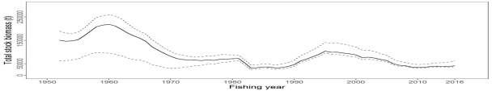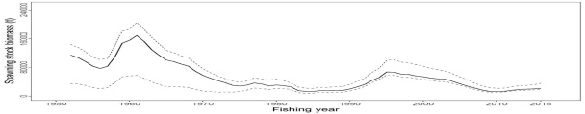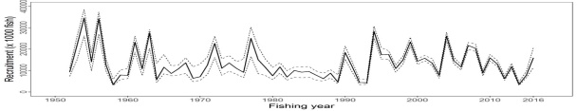 | 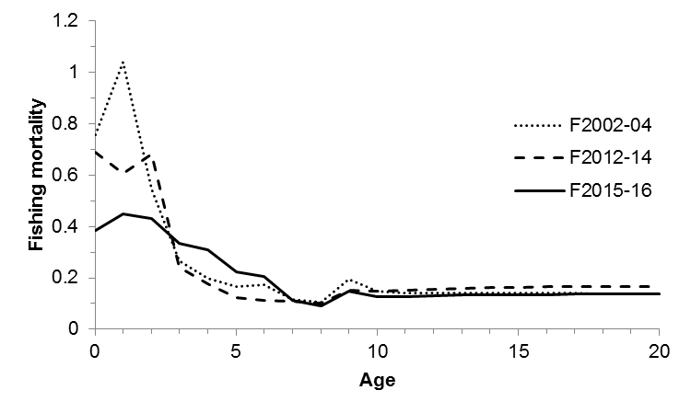
Figure PBF-1. Total stock biomass (top), spawning stock biomass (middle) and recruitment (bottom) of Pacific bluefin tuna (Thunnus orientalis) from the base-case model. The solid lines indicate point estimates and the dashed lines indicate the 90% confidence intervals. | Figure PBF-2. Geometric means of annual age-specific fishing mortalities of Pacific bluefin tuna (Thunnus orientalis) in 2002-2004 (dotted line), 2012-2014 (dashed line), and 2015-2016 (solid line).

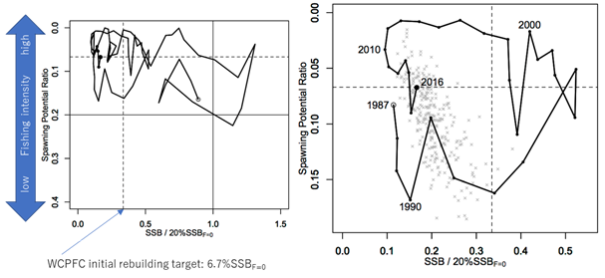  Figure PBF-3. Kobe plots for Pacific bluefin tuna (Thunnus orientalis). X axis shows the annual SSB relative to 20%SSB_{F=0} and the Y axis shows the spawning potential ratio as a measure of fishing intensity. Solid vertical and horizontal lines in the left figure show 20%SSB_{F=0} (which corresponds to the second biomass rebuilding target) and the corresponding fishing intensity, respectively. Dashed vertical and horizontal lines in both figures show the initial biomass rebuilding target (SSB_{MED} = 6.7%SSB_{F=0}) and the corresponding fishing intensity, respectively. SSB_{MED} is calculated as the median of estimated SSB over 1952-2014. The left figure shows the historical trajectory, where the open circle indicates the first year of the assessment (1952) while solid circles indicate the last five years of the assessment (2012-2016). The right figure shows the trajectory of the last 30 years, where grey dots indicate the uncertainty of the terminal year. | 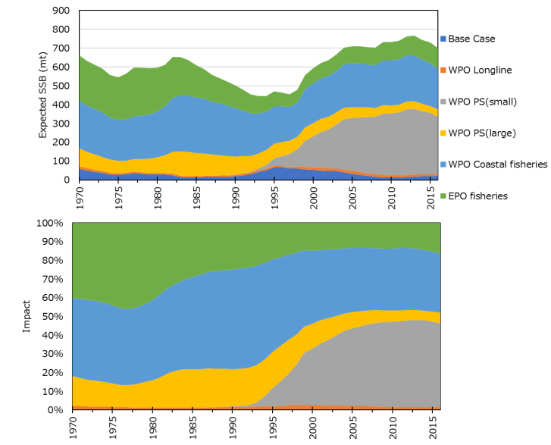
 | Figure PBF-4. Trajectory of the spawning stock biomass of a simulated population of Pacific bluefin tuna (Thunnus orientalis) when zero fishing mortality is assumed, estimated by the base-case model (top: absolute impact, bottom: relative impact). Fleet definition; WPO longline: F1, F12, F17. WPO purse seine for small fish: F2, F3, F18. WPO purse seine: F4, F5. WPO coastal fisheries: F6-11, F16, F19. EPO fisheries: F13, F14, F15.

 | 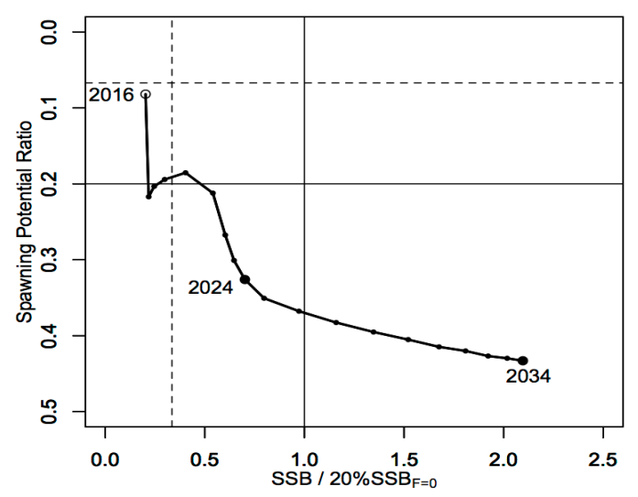
Figure PBF-5. Comparison of future SSB of Pacific bluefin tuna (Thunnus orientalis) under the current management measures assuming low recruitment using the 2016 assessment (scenario 2016 lowR), assuming low recruitment using the 2018 assessment (scenario 0), and assuming a shift of the recruitment scenario from low to average after achieving the initial rebuilding target using the 2018 assessment (scenario 1). | Figure PBF-6. A projection result (scenario 1 from Table PBF-4) for Pacific bluefin tuna (Thunnus orientalis) in a form of Kobe plot. The X axis shows the SSB value relative to 20%SSB_{F=0} (second rebuilding target) and the Y axis shows the spawning potential ratio as a measure of fishing intensity. Vertical and horizontal solid lines indicate the second rebuilding target (20%SSB_{F=0}) and the corresponding fishing intensity, respectively, while vertical and horizontal dashed lines indicate the initial rebuilding target (SSB_{MED} = 6.7%SSB_{F=0}) and the corresponding fishing intensity, respectively.

    - North Pacific swordfish (Xiphias gladius)

a. Status and trends

- SC14 noted that ISC provided the following conclusions on the stock status of Western and Central North Pacific Swordfish in the Pacific Ocean in 2017 presented in SC14-SA-WP-07 (Stock Assessment for Swordfish (Xiphias gladius) in the Western and Central North Pacific Ocean through 2016).

Estimates of total stock biomass show a relatively stable population, with a slight decline until the mid-1990s followed by a slight increase since 2000. Population biomass (age-1 and older) averaged roughly 97,919 t in 1974-1978, the first 5 years of the assessment time frame, and has declined by only 20% to 71,979 t in 2016 (Figure NPS-3). Female spawning stock biomass was estimated to be 29,403 t in 2016, or about 90% above SSB_{MSY} (Table NPS-1 and Table NPS-2). Fishing mortality on the stock (average F, ages 1 – 10) averaged roughly F = 0.08 yr⁻¹ during 2013-2015, or about 45% below F_{MSY}. The estimated SPR (the predicted spawning output at the current F as a fraction of unfished spawning output) is currently SPR₂₀₁₆ = 45%. Annual recruitment averaged about 717,000 recruits during 2012-2016, and no long-term trend in recruitment was apparent. Overall, the time series of spawning stock biomass and recruitment estimates indicate a stable spawning stock biomass and suggest a fluctuating pattern without trend for recruitment (Figure NPS-3). The Kobe plot depicts the stock status relative to MSY-based reference points for the base case model (Figure NPS-4) and shows that spawning stock biomass declined to almost the MSY level in the mid-1990s, but SSB has remained above SSB_{MSY} throughout the time series (Figure NPS-3B).

For this 2018 benchmark assessment, note that biomass status is based on female spawning stock biomass, whereas for the 2014 update assessment, biomass status was based on exploitable biomass (effectively age-2+ biomass). It is also important to note that there are no currently agreed upon reference points for the WCNPO swordfish stock and that retrospective analyses show that the assessment model appears to underestimate spawning stock biomass in recent years.

Based on these findings, the following information on the status of the WCNPO SWO stock is provided:
  - The WCNPO swordfish stock has produced annual yields of around 10,200 t per year since 2012, or about 2/3 of the MSY catch amount.
  - There is no evidence of excess fishing mortality above F_{MSY} (F₂₀₁₃₋₂₀₁₅ is 45% of F_{MSY}) or substantial depletion of spawning potential (SSB₂₀₁₆ is 87% above SSB_{MSY}).
  - Overall, the WCNPO swordfish stock is not likely overfished and is not likely experiencing overfishing relative to MSY-based or 20% of unfished spawning biomass-based reference points.

b. Management advice and implications

- SC14 noted the following conservation advice from ISC:
Stock projections were conducted using a two-gender projection model. The five stock projection scenarios were: (1) F status quo, (2) F_{MSY}, (3) F at 0.2*SSB_{F=0}, (4) F_{20%}, and (5) F_{50%} (Figure NPS-5). These projection scenarios were applied to the base case model results to evaluate the impact of alternative levels of fishing intensity on future spawning biomass and yield for swordfish in the Western and Central North Pacific Ocean. The projected recruitment pattern was generated by stochastically sampling the estimated stock-recruitment model from the base case model. The projection calculations employed model estimates for the multi-fleet, multi- season, size- and age-selectivity, and structural complexity in the assessment model to produce consistent results.

Based on these findings, the following conservation information is provided:
- The results show that projected female spawning biomass is expected to remain above SSB_{MSY} under all of the harvest scenarios (Table NPS-3 and Figure NPS-5), with increases in spawning biomass expected under lower fishing mortality rates.
- Similarly, projected catch is expected to increase under each of the five harvest scenarios, with greater increases expected under higher fishing mortality rates (Table NPS-3 and Figure NPS-5).

Research needs

The lack of sex-specific size composition data and the simplified treatment of the spatial structure of swordfish population dynamics remained as two important sources of uncertainty for this benchmark assessment

Table NPS-1. Reported catch (mt) used in the stock assessment along with annual estimates of population biomass (age-1 and older, mt), female spawning biomass (mt), relative female spawning biomass (SSB/SSB_{MSY}), recruitment (thousands of age-0 fish), fishing mortality (average F, ages 1 to 10), relative fishing mortality (F/F_{MSY}), and spawning potential ratio of Western and Central North Pacific Ocean swordfish.
Year | 2010 | 2011 | 2012 | 2013 | 2014 | 2015 | 2016 | Mean¹ | Min¹ | Max¹
Reported Catch | 12,716 | 9,971 | 10,608 | 9,241 | 9,211 | 11,672 | 10,068 | 12,863 | 9,211 | 17,793
Population Biomass | 66,417 | 66,087 | 68,117 | 67,885 | 69,560 | 71,951 | 71,979 | 67,487 | 51,856 | 97,919
Spawning Biomass | 26,136 | 26,448 | 26,569 | 27,546 | 28,580 | 28,865 | 29,404 | 24,442 | 17,191 | 44,100
Relative SB | 1.66 | 1.68 | 1.69 | 1.75 | 1.82 | 1.84 | 1.87 | 1.56 | 1.09 | 2.81
Recruitment (age 0) | 789 | 565 | 671 | 710 | 683 | 742 | 781 | 761 | 401 | 1241
Fishing mortality | 0.10 | 0.08 | 0.09 | 0.07 | 0.07 | 0.09 | 0.07 | 0.12 | 0.07 | 0.18
Relative F | 0.57 | 0.46 | 0.51 | 0.44 | 0.40 | 0.51 | 0.44 | 0.72 | 0.40 | 1.05
Spawning Potential Ratio | 38% | 41% | 39% | 45% | 47% | 39% | 45% | 29% | 17% | 47%
¹ During 1975-2016

Table NPS-2. Estimates of biological reference points along with estimates of fishing mortality (F), spawning stock biomass (SSB), recent average yield (C), and SPR of WCNPO swordfish, derived from the base case model assessment model, where “MSY” indicates reference points based on maximum sustainable yield.
Reference Point | Estimate
FMSY | 0.17 yr-1
F0.2*SSB(F=0) | 0.16 yr-1
F2013-2015 | 0.08 yr-1
SSBMSY | 15,702 mt
SSB2016 | 29,403 mt
SSBF=0 | 97,286 mt
MSY | 14,941 mt
C2012-2016 | 10,160 mt
SPRMSY | 18%
SPR2016 | 45%

Table NPS-3. Projected values of WCNPO swordfish spawning stock biomass (SSB, mt) and catch (mt) under five constant fishing mortality rate (F, yr⁻¹) scenarios during 2017-2026.
Year | 2017 | 2018 | 2019 | 2020 | 2021 | 2022 | 2023 | 2024 | 2025 | 2026
Scenario 1: F = F2013-2015
SSB | 32,118 | 33,207 | 34,599 | 35,476 | 36,270 | 37,082 | 37,951 | 38,967 | 40,083 | 41,087
Catch | 8,851 | 9,135 | 9,407 | 9,599 | 9,794 | 10,022 | 10,275 | 10,595 | 11,053 | 11,142
Scenario 2: F = FMSY
SSB | 28,267 | 23,963 | 21,443 | 19,458 | 18,303 | 17,618 | 17,293 | 17,197 | 17,253 | 17,263
Catch | 20,885 | 18,323 | 16,509 | 15,294 | 14,666 | 14,353 | 14,308 | 14,520 | 14,650 | 14,348
Scenario 3: F = F20%SSB(F=0)
SSB | 28,425 | 24,384 | 21,800 | 19,735 | 18,530 | 17,874 | 17,496 | 17,586 | 17,818 | 17,779
Catch | 20,691 | 18,122 | 16,454 | 15,261 | 14,653 | 14,361 | 14,319 | 14,554 | 14,665 | 14,384
Scenario 4: F = F20%
SSB | 29,007 | 25,431 | 23,527 | 21,763 | 20,736 | 20,131 | 19,893 | 19,883 | 19,981 | 20,066
Catch | 18,680 | 16,933 | 15,657 | 14,726 | 14,242 | 14,033 | 14,050 | 14,292 | 14,496 | 14,253
Scenario 5: F = F50%
SSB | 32,559 | 34,334 | 36,290 | 37,666 | 38,836 | 39,984 | 41,148 | 42,490 | 44,049 | 45,625
Catch | 7,556 | 7,973 | 8,343 | 8,605 | 8,847 | 9,101 | 9,366 | 9,692 | 10,087 | 10,223

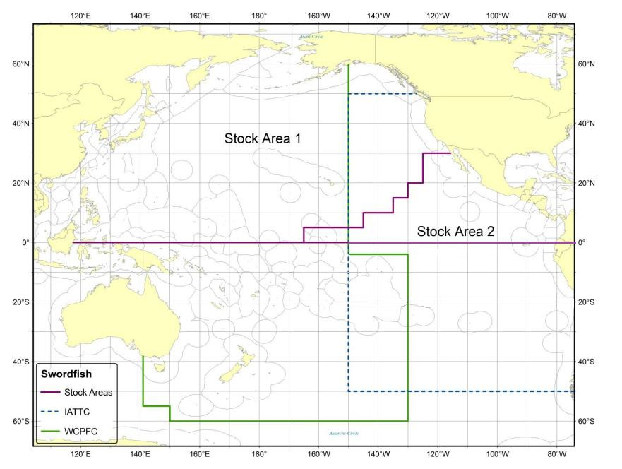 | 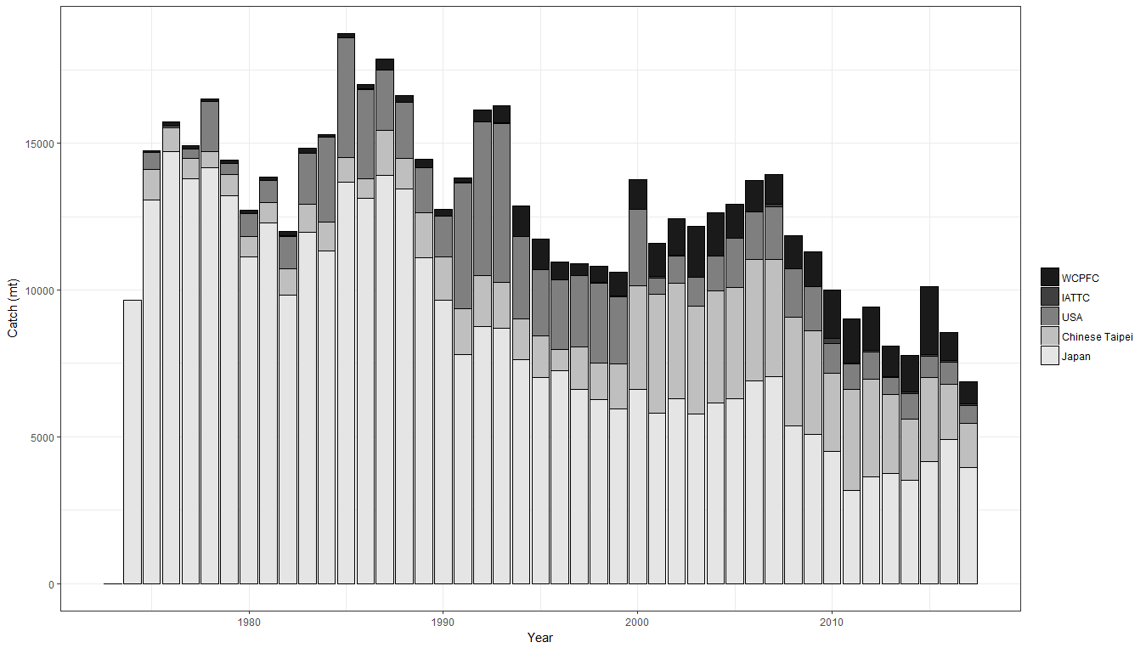
Figure NPS-1. Stock boundaries used for this assessment of North Pacific Ocean swordfish: purple lines indicate stock area divisions; stock area 1 was assessed as the WCNPO stock, stock area 2 contains the Eastern Pacific Ocean stock, the green line indicates Western Central Pacific Fisheries Commission convention area, blue dashed line indicates IATTC convention area. | Figure NPS-2. Annual catch biomass (t) of WCNPO swordfish (Xiphias gladius) by country for Japan, Chinese Taipei, the U.S.A., and all other countries during 1975-2016.

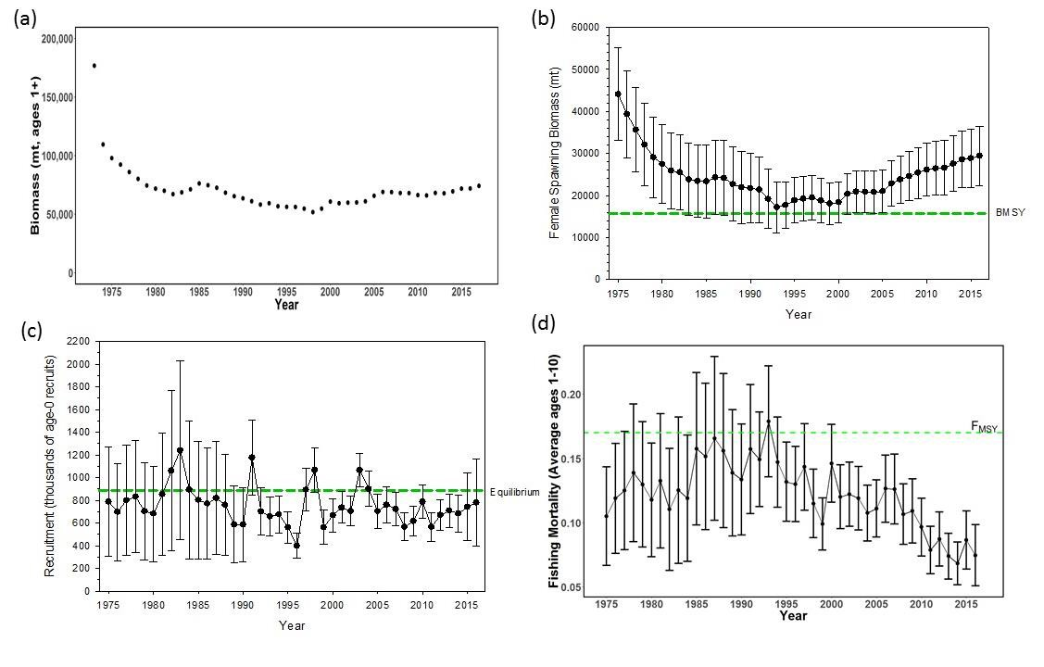 | 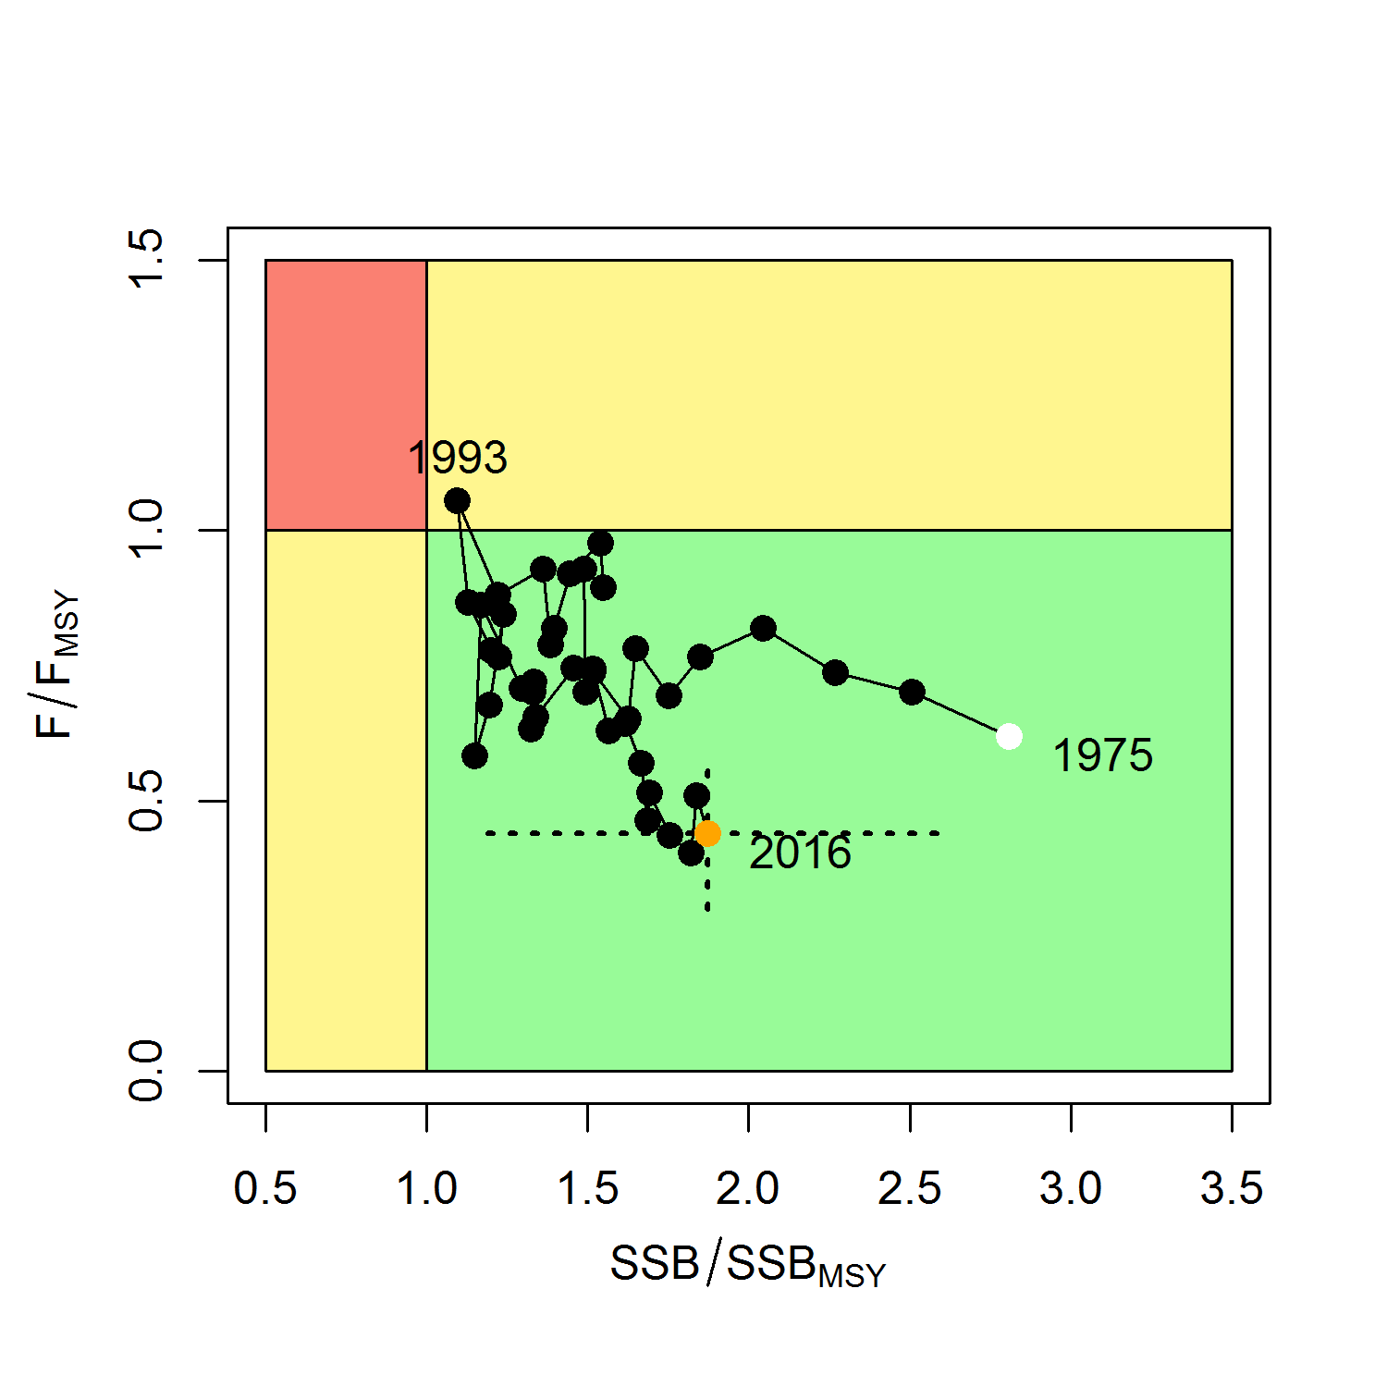
Figure NPS-3. Time series of estimates of (a) population biomass (age 1+) (first point in time series represents unfished biomass), (b) spawning biomass, (c) recruitment (age-0 fish), and (d) instantaneous fishing mortality (average for ages 1 to 10, yr⁻¹) for WCNPO swordfish (Xiphias gladius) derived from the 2018 stock assessment. The solid circles are the maximum likelihood estimates by year for each quantity and the error bars represent the uncertainty of the estimates (80% confidence intervals), green dashed lines indicate BMSY, equilibrium recruitment, and F_{MSY} except for the population biomass time series. | Figure NPS-4. Kobe plot of the time series of estimates of relative fishing mortality (average of ages 1-10) and relative spawning stock biomass of WCNPO swordfish (Xiphias gladius) during 1975-2016. The white circle denotes the first year (1975) and the yellow circle denotes the last year (2016) of the assessment time horizon. The dashed lines represent the 95% confidence intervals around the 2016 estimate.

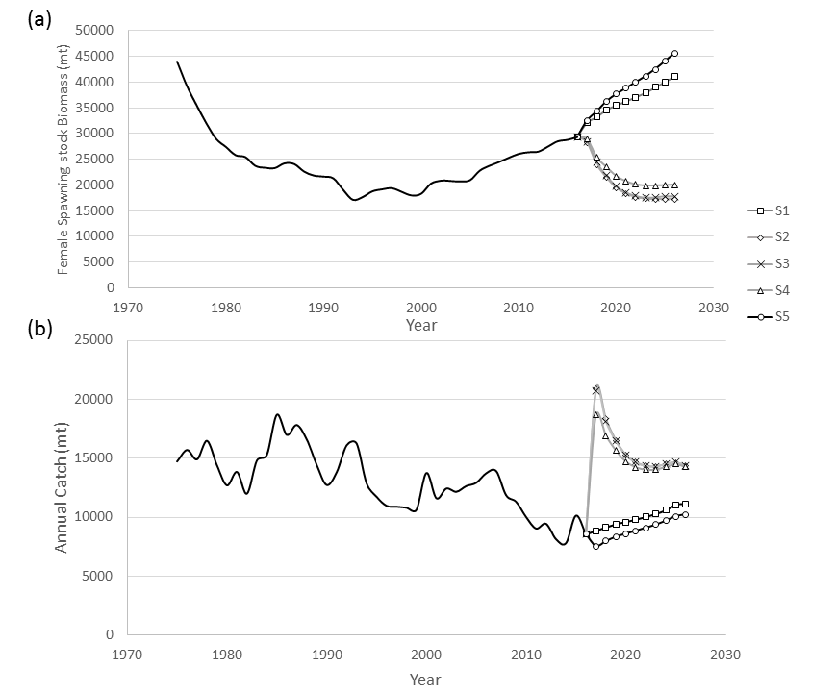 | Figure NPS-5. Historical and projected trajectories of (a) spawning stock biomass and (b) total catch from the WCNPO swordfish base case model. Stock projection results are shown for S1 = the status quo or average fishing intensity during 2013-2015 (𝐹₂₀₁₃₋₂₀₁₅= 𝐹_{43%}); S2 = F_{MSY} (𝐹_{18%}); S3 = F to produce 20% of unfished spawning stock biomass or F_{0.2}*SSB_{F=0} (𝐹_{22%}); S4 = the highest 3-year average F during 1975-2016 or High F (F_{20%}); S5 = Low F (F_{50%}).

  - WCPO sharks

    - Oceanic whitetip shark (Carcharhinus longimanus)

a. Status and trends

- SC14 noted that no stock assessments were conducted for oceanic whitetip shark in 2018. Therefore, the stock status descriptions from SC8 are still current for oceanic whitetip shark. Updated information on catches was not compiled for and reviewed by SC14.

b. Management advice and implications

- SC14 noted that no management advice has been provided since SC8 for oceanic whitetip shark. Therefore, previous advice should be maintained, pending a new assessment or other new information. For further information on the management advice and implications from SC8, please see https://www.wcpfc.int/node/3396

    - Silky shark (Carcharhinus falciformis)

- The SC accepts the WCPO silky shark stock assessment as best available science for this stock.

a. Stock status and trends

- SC14 noted given the inherent uncertainty in the current assessment the current estimates of stock status should be considered indicative only. Although these estimates are not considered a reliable basis for management decision-making they represent progress since the 2013 assessment and the best available science concerning the status of silky sharks in the WCPO. Therefore, as part of its ongoing review of the established conservation and management measure for silky sharks (CMM 2013-08), the Commission may wish to consider these indicative results until such time as better estimates become available.

- SC14 noted that indications from the 2018 WCPO model show that the stock declined steadily over the model period (1995-2016) (Figure FAL-1). The assessment model estimates spawning biomass in 2016 to have been at 47% of the unexploited level (SB₂₀₁₆/SB₀ = 0.469). Current biomass is estimated to be above the MSY reference biomass level; however, there is considerable uncertainty associated with the estimate of stock status (SB₂₀₁₆/SB_{MSY} = 1.178 95% CI 0.590-1.770) (Table FAL-1). On balance, the stock is not considered to be overfished, i.e. there is a 78% probability that SB₂₀₁₆ is greater than SB_{MSY} (Table FAL-1).

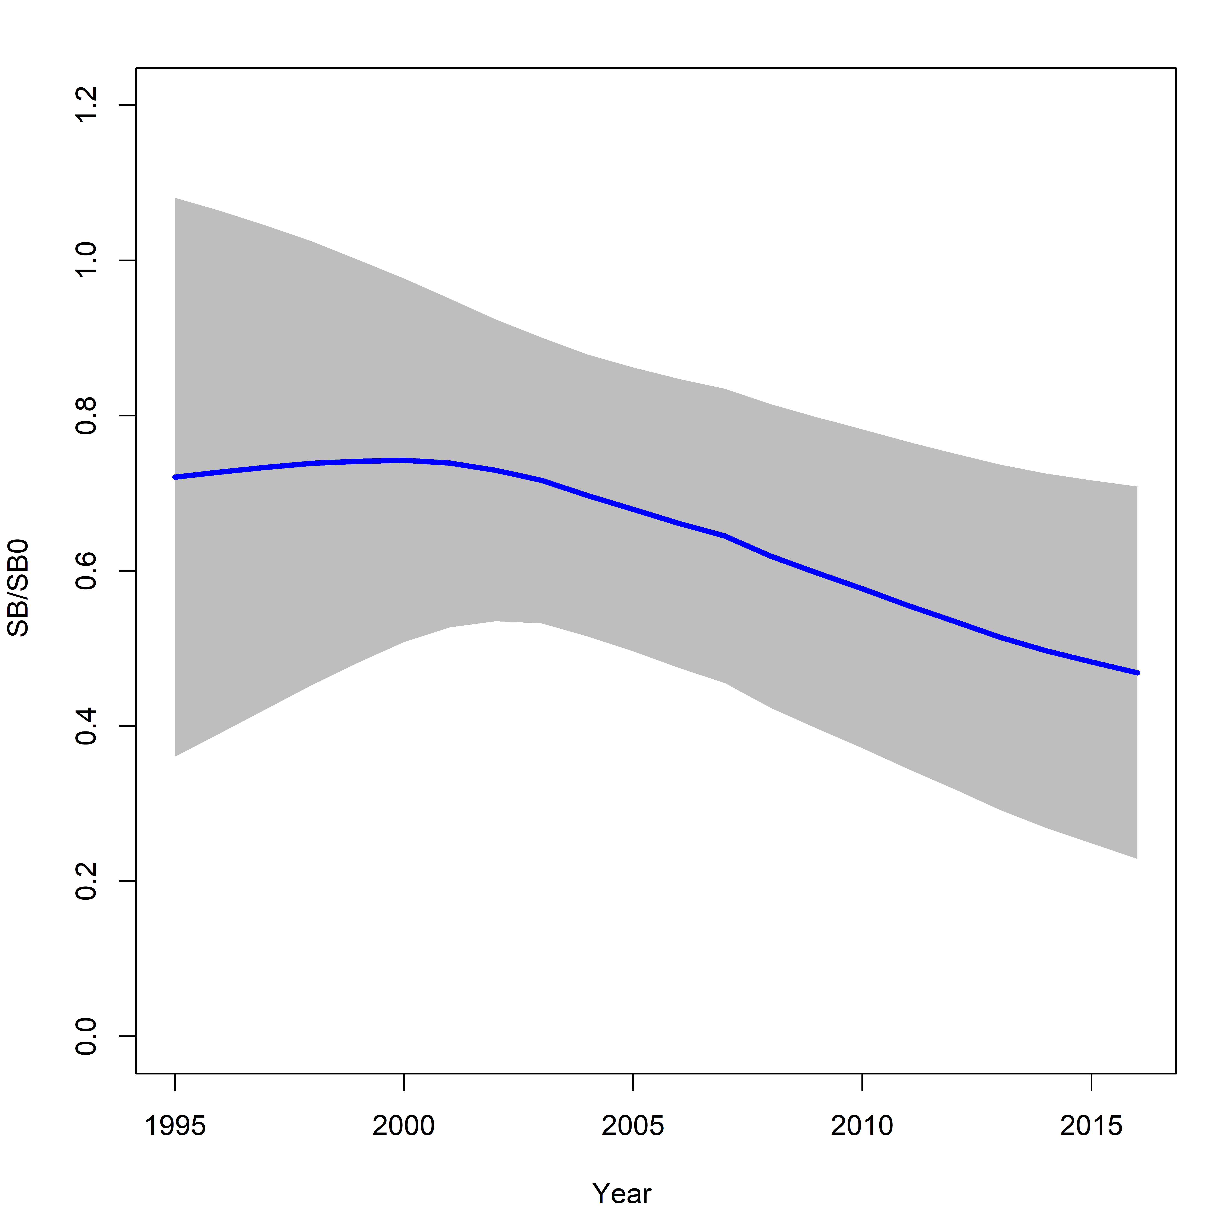 | Figure FAL-1: Estimated spawning biomass relative to unexploited biomass (SB₀) for the WCPO assessment model (CPUEqdev).

Table FAL-1: Management quantities (and 95% confidence intervals) for the WCPO assessment model (CPUEqdev).
Management quantity | Value | Confidence interval (95%)
SB₀ | 11,865 | 6,412-17,318
SB₁₉₉₅ | 8,552 | 2,590-14,513
SB_{MSY} | 4,721 | 2,560-6,882
SB_{MSY}/SB₀ | 0.398 | 0.397-0.399
SB₂₀₁₆ | 5,560 | 301-10,819
SB₂₀₁₆/SB₀ | 0.469 | 0.229-0.729
SB₂₀₁₆/SB_{MSY} | 1.178 | 0.590-1.77
Pr(SB₂₀₁₆ > SB_{MSY}) | 0.78
F₂₀₁₆/F_{MSY} | 1.607 | 0.316-2.810
Pr(F₂₀₁₆ > F_{MSY}) | 0.84
F₂₀₁₆ | 0.313
MSY | 12,162 | 6,711-17,615
Catch 2016 (mt) | 22,503

- Fishing mortality is estimated to be above F_{MSY} (F₂₀₁₆/F_{MSY} = 1.607, Pr(F₂₀₁₆ > F_{MSY}) = 84%). The current level of catch is substantially higher than the MSY. If catches remain at the current level there is a high probability that the biomass will decline to below the SB_{MSY} level in the foreseeable future (~ 5 years).

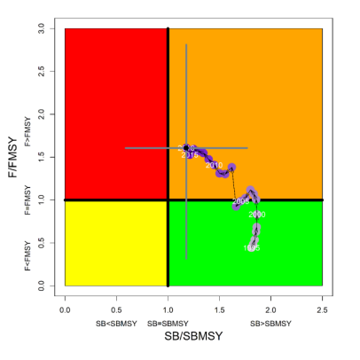 | Figure FAL-2: Kobe plot for the WCPO assessment model (CPUEqdev).

b. Management advice and implications

- SC14 concludes that on the basis of the best available science, and pending the availability of less uncertain stock status indicators, the stock is not overfished, but is subject to overfishing (Figure FAL-2).

- SC14 recommends, given that the WCPO silky shark stock continues to be subject to overfishing, that CMM 2013-08 be maintained as a precautionary measure.

    - South Pacific blue shark (Prionace glauca)

a. Status and trends

- SC14 noted that no stock assessments were conducted for South Pacific blue shark in 2018. Therefore, the stock status descriptions from SC13 are still current for South Pacific blue shark. Updated information on catches was not compiled for and reviewed by SC14.

b. Management advice and implications

- SC14 noted that no management advice has been provided for South Pacific blue shark.

    - North Pacific blue shark (Prionace glauca)

a. Status and trends

- SC14 noted that no stock assessments were conducted for north Pacific blue shark in 2018. Therefore, the stock status descriptions from SC13 are still current for north Pacific blue shark. Updated information on catches was not compiled for and reviewed by SC14.

b. Management advice and implications

- SC14 noted that no management advice has been provided since SC13 for north Pacific blue shark. Therefore, previous advice should be maintained, pending a new assessment or other new information. For further information on the management advice and implications from SC13, please see https://www.wcpfc.int/node/29904

c. Recommendations on the designation of North Pacific blue shark as a Northern Stock

- Regarding the issue of the designation of North Pacific blue shark as a Northern Stock (WCPFC14 Report, Para 378), SC14 provides the following recommendations:

- SC14 recommends that the Commission clarify and quantify what is meant by “mostly north of 20 degrees N”.
- In relation to paragraph 1, SC14 recommends that a check-list of benchmark scientific information for North Pacific blue shark be developed to support the Commission’s deliberations in determining the designation of a northern stock. As such, the following draft checklist is forwarded for the Commission’s consideration.

No | Criteria | Response | Comments
1 | What proportion of the total estimated stock biomass occurs on average north of 20ºN? | Unknown | Current assessment model does not include population spatial structure. Nominal CPUE may be biased and could be overestimated in the north unless the effects of fishing time, depth and depth distribution of blue sharks are accounted for.
2 | Does all of the breeding/spawning area(s) occur north of 20 ºN? | No | Breeding area is mainly north of 20 ºN but may overlap areas south of 20 ºN
3 | Does all of the nursery area(s) occur north of 20 ºN | Yes | Mostly in the area 30-40 ºN
4 | Do any other important life history stages occur south of 20 ºN? | Yes | Pregnant females are commonly found south of 20 ºN
5 | What proportion of the total annual estimated catch occurs north of 20 ºN? | 0.88 on average | Based on raised, aggregated (5x5 degree) longline data 2014-2017 submitted to WCPFC (Operational data would provide better resolution than aggregated data)
6 | Is fishery catch-per-unit-effort demonstrably higher north of 20 ºN for comparable fisheries? | (i) Similar CPUE observed north and south of 20 ºN in Chinese Taipei LSTLL fishery and Hawaii deep-set LL fishery  (ii) CPUE higher north of 20 ºN in Japan shallow set research survey | CPUE comparisons may be biased by different depth distribution of blue shark north and south of 20 ºN.
7 | Is there sufficient information about fish movement between the areas north and south of 20 ºN? | Yes | Conventional tagging data shows that the maximum range of movements suggests at least northern and southern sub-populations of blue shark, as demarked by the equator.

    - North Pacific shortfin mako shark (Isurus oxyrinchus)

a. Stock status and trends

- SC14 noted that ISC provided the following conclusions on the stock status of North Pacific Shortfin Mako Shark in the Pacific Ocean in 2017, as presented in SC14-SA-WP-11 (Stock Assessment of Shortfin Mako Shark in the North Pacific Ocean Through 2016).

Based on these findings, the following information on the status of the SFM stock is provided:
- Target and limit reference points have not been established for pelagic sharks in the Pacific Ocean. Stock status is reported in relation to MSY.
- The results from the base case model show that, relative to MSY, the North Pacific shortfin mako stock is likely (>50%) not in an overfished condition and overfishing is likely (>50%) not occurring relative to MSY-based abundance and fishing intensity reference points (Table SFM-4; Figure SFM-9A).

Stock status was also examined under six alternative states of nature that represented the most important sources of uncertainty in the assessment. Results of these models with alternative states of nature were consistent with the base case model and showed that, relative to MSY, the North Pacific shortfin mako shark stock is likely (>50%) not in an overfished condition and overfishing is likely (>50%) not occurring (Figure SFM-9B).

b. Management Advice and implications

- SC14 noted the following conservation advice from ISC:

Stock projections of biomass and catch of North Pacific shortfin mako from 2017 to 2026 were performed assuming three alternative constant fishing mortality scenarios: 1) status quo, average of 2013-2015 (F₂₀₁₃-₂₀₁₅); 2) F₂₀₁₃₋₂₀₁₅ + 20%; and 3) F₂₀₁₃₋₂₀₁₅ - 20% (Figure SFM-10).

Based on these future projections, the following conservation information is provided:
- If fishing mortality remains constant at F2013-15 or is decreased 20%, then the Stock Abundance is expected to increase gradually;
- If fishing mortality is increased 20% relative to F2013-2015, then the Stock Abundance is expected to decrease in the final years of the projection.
- It should be noted that, given the uncertainty in fishery data and key biological processes within the model, especially the stock recruitment relationship, the models’ ability to project into the future is highly uncertain.

Research Needs

There is uncertainty in the estimated historical catches of North Pacific shortfin mako shark. Substantial time and effort was spent on estimating historical catch and more work remains to be conducted. In particular, the SHARKWG identified two future improvements that are critical: 1) identify all fisheries that catch shortfin mako shark in the NPO, including fisheries that were not previously identified by the SHARKWG; and 2) methods to estimate shortfin mako shark catches should be improved, especially for the early period from 1975 to 1993.

Table SFM-4. Summary of reference points and management quantities for the shortfin mako shark (Isurus oxyrinchus) base case model. The percentages in brackets are the CV of the estimated quantity in the base case model.
Management Quantity | Symbol | Units | Base case
Spawning abundance (number of mature female sharks | SA0 | 1000s of sharks | 1465.8 (23%)
Maximum Sustainable Yield (MSY) | CMSY | Metric tons (t) | 3127.1 (22%)
Spawning Abundance at MSY | SAMSY | 1000s of sharks | 633.7 (23%)
Fishing Intensity at MSY | 1-SPRMSY | NA | 0.26
Current spawning abundance relative to MSY | SA2016/SAMSY | NA | 1.36
Current spawning abundance relative to unfished level | SA2016/SA0 | NA | 0.58
Recent fishing Intensity relative to MSY | (1-SPR2013-15)/(1- SPRMSY) | MSY | 0.62

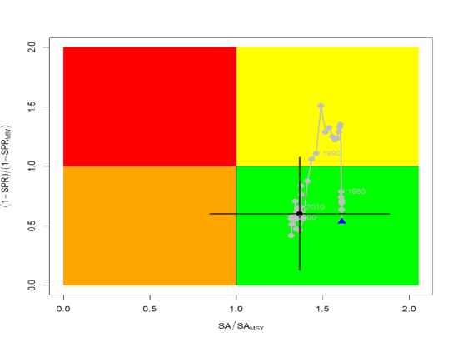
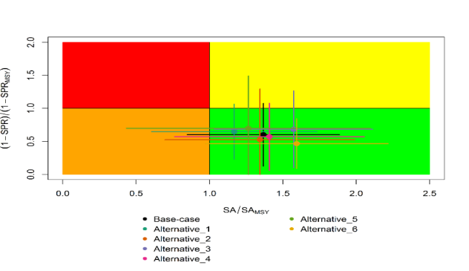
A
B
Figure SFM-9. Kobe plots of shortfin mako shark in the North Pacific Ocean showing. A) The time series of the ratio of SA to SA at MSY (SA_{MSY}) and fishing intensity to fishing intensity at MSY (1-SPR_{MSY}), and B) the same ratios for the terminal year (2016) for six alternative states of nature. SA is spawning abundance measured as the number of mature females. Fishing intensity is estimated as 1-SPR. Values for the start (1975) and end (2016) years in the time series (A) are indicated by the blue triangle and black circle, respectively. Gray numbers indicate selected years. Alternative states of nature in B) include: Alternative_1) higher catch, Alternative_2) lower catch; Alternative_3) higher uncertainty on Japan shallow-set CPUE index (1975-1993) (CV=0.3); Alternative_4) fit to Japan offshore distant water longline shallow-set fleet (JPN_SS_I; 1975-2016) and Hawaii longline shallow-set fleet (US_SS; 2005-2016), and no fit to initial equilibrium catch; Alternative_5) low steepness, h=0.26; and Alternative_6) high steepness, h=0.37. Solid lines indicate 95% confidence intervals.

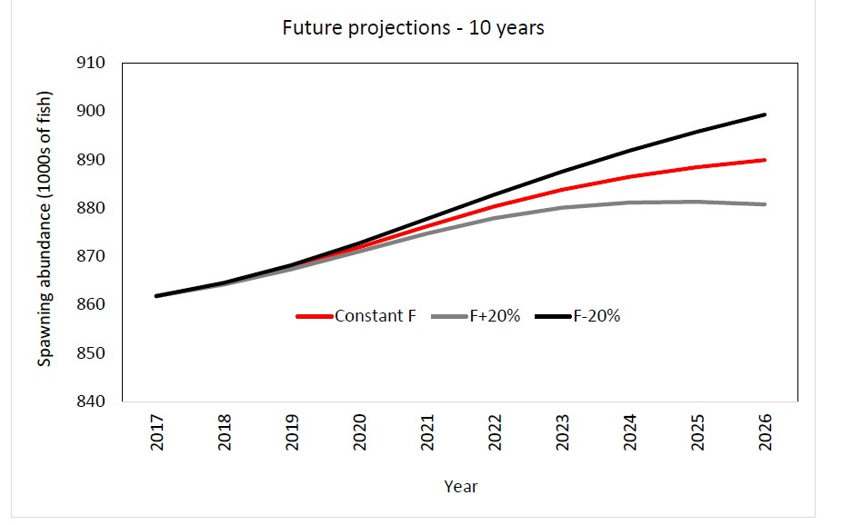
Figure SFM-10. Comparison of future projected North Pacific shortfin mako (Isurus oxyrinchus) spawning abundance under different F harvest policies (Constant F 2013-2015, +20%, -20%) using the base case model. Constant F was based on the average from 2013-2015.

    - Pacific bigeye thresher shark (Alopias superciliosus)

a. Status and trends

- SC14 noted that no stock assessments were conducted for Pacific bigeye thresher shark in 2018. Therefore, the stock status descriptions from SC13 are still current for Pacific bigeye thresher shark respectively. Updated information on catches was not compiled for and reviewed by SC14.

b. Management advice and implications

- SC14 noted that no management advice has been provided since SC13 for Pacific bigeye thresher shark. Therefore, previous advice should be maintained, pending a new assessment or other new information. For further information on the management advice and implications from SC13, please see https://www.wcpfc.int/node/29904

    - Porbeagle shark (Lamna nasus)

a. Status and trends

- SC14 noted that no stock assessments were conducted for southern porbeagle shark in 2018. Therefore, the stock status descriptions from SC13 are still current for southern porbeagle shark. Updated information on catches was not compiled for and reviewed by SC14.

b. Management advice and implications

- SC14 noted that no management advice has been provided since SC13 for southern porbeagle shark. Therefore, previous advice should be maintained, pending a new assessment or other new information. For further information on the management advice and implications from SC13, please see https://www.wcpfc.int/node/29904

    - Whale shark ( Rhincodon typus)

a. Stock status and trends

- A nominal trend of high interactions in 2006-2008, followed by lower rates thereafter was not altered by standardization (Figure RHN-1), and is consistent with trends found in the Eastern Pacific Ocean by Román et al. 2018. These decreasing annual trends in interactions do not appear to result from management measures as prohibitions on intentional setting of purse seines on whale sharks were adopted by the PNA in 2010, by the WCPFC in 2012 and by the IATTC in 2015. Furthermore, the trends may have been influenced by low WCPO purse seine observer coverage rates prior to 2010.

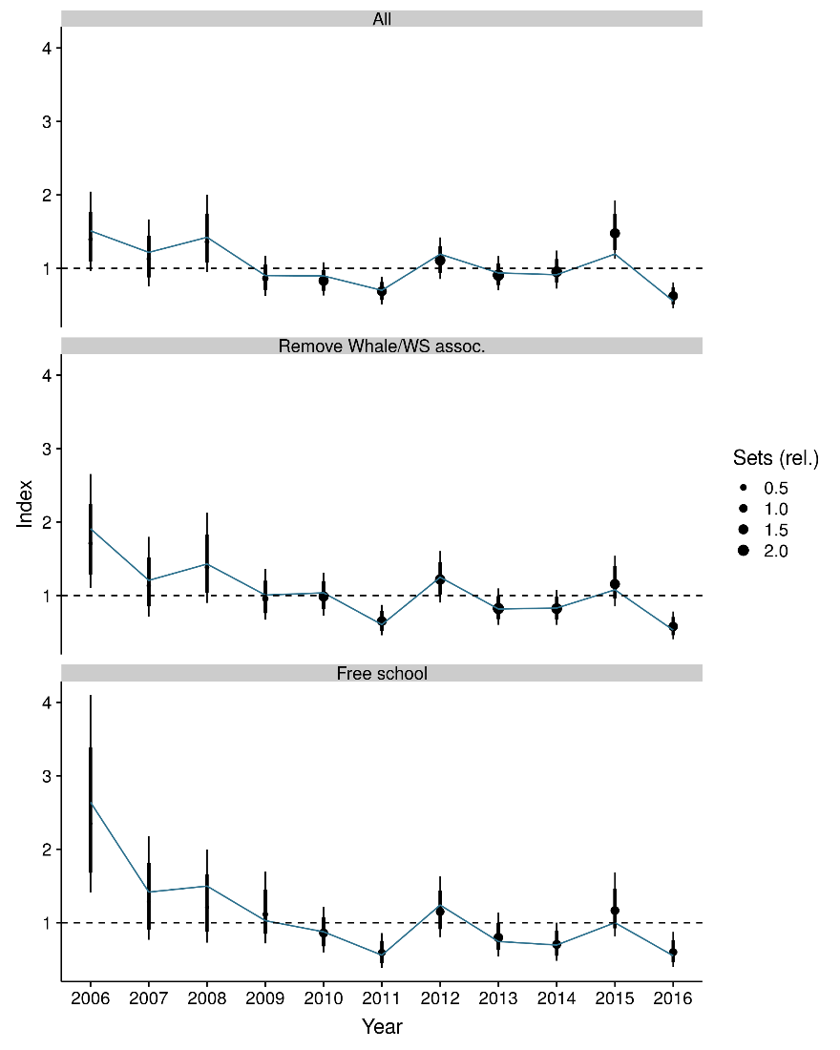 | Figure RHN-1. Estimated temporal index of interactions based on a) the full observer dataset, b) the full dataset without whale- and whale shark associated sets, and c) free-school sets only. The rationale behind the different effort subsets is given in section 2.2.2 of SC14-SA-WP-12. The index is centred to have a geometric mean of one and is therefore unit-less.

- SC14 noted that over a range of notional reference points, and in accordance with expert-elicited post-mortality rates of ~10%, median sustainability risk from Pacific Ocean fisheries alone for the 2006-2016 period ranged between (Figure RHN-2):
  - 3-12% of the limit risk level based on 0.5r_{max} (F_{msm}),
  - 2-8% of the limit risk level based on 0.75r_{max} (F_{lim}), and
  - 2-6% of the limit risk level based on r_{max} (F_{crash}), where r_{max} is the maximum population growth rate.

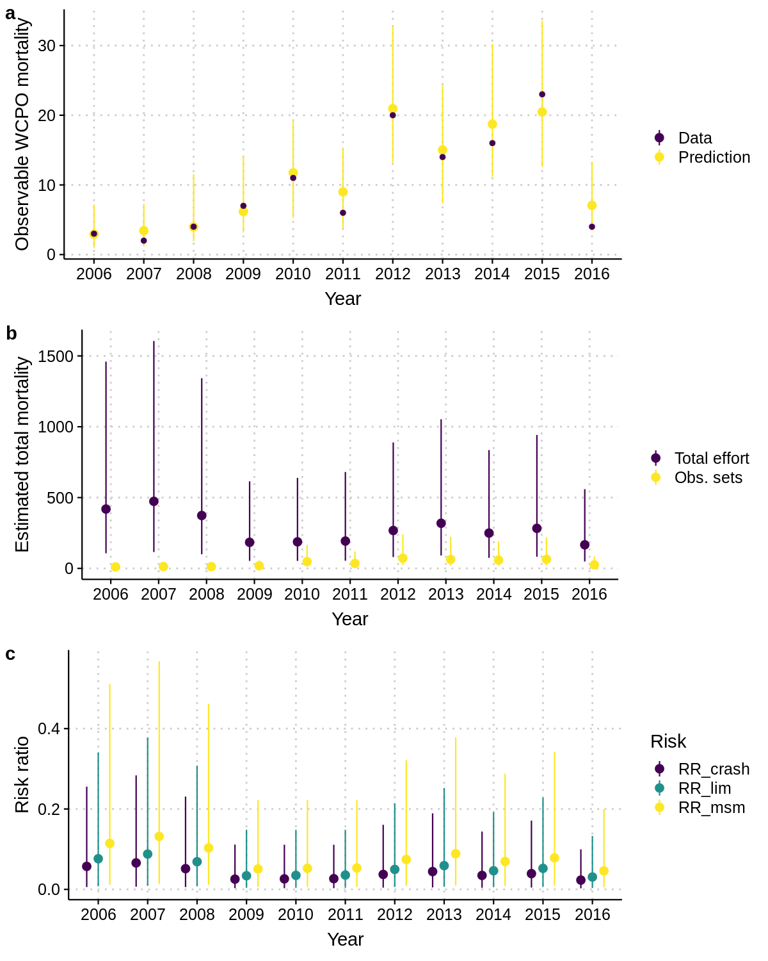 | Figure RHN-2. Risk that mortality exceeds either of three limit reference points (RR_crash (F_{MSM}: 0.5r_{max}), RR_lim (F_{Lim}: 0.75r_{max}), RR_crash (F_{crash}: r_{max})).

- SC14 noted the report’s findings that understanding and reducing post-release mortality is recommended as one of most effective approaches to maintaining acceptable risk levels.

- SC14 also noted the report’s findings that the total risk to the Indo-Pacific whale shark population may be higher if there are differential impacts to more vulnerable population segments within the Pacific and/or higher fishing mortalities outside of the region (e.g. the Indian Ocean).

- SC14 considered the use of precautionary risk assessment model inputs. It was noted that input parameters to the risk assessment were drawn from the best available data, but in some cases where the data were uninformative about the probability distributions of the parameters of interest the methodology put more weight on precautionary values.

b. Management advice and implications

- SC14 considers there is a low probability that the Indo-Pacific whale shark is at risk from Pacific purse seine fisheries (median probability of less than 8% that current risk levels exceed life history-based notional reference points F_{Lim} and F_{crash}).

- SC14 recommends that the WCPFC initiate concerted efforts to identify and promote best practice safe release methods for whale sharks.

- SC14 recommends that research be undertaken to quantify post-release mortality rates under a variety of release scenarios.

  - WCPO billfishes

    - South Pacific swordfish (Xiphias gladius)

a. Stock status and trends

- SC14 noted that no stock assessments were conducted for south Pacific swordfish in 2018. Therefore, the stock status descriptions from SC13 are still current for south Pacific swordfish. Updated information on catches was compiled but not reviewed by SC14.

b. Management advice and implications

- SC14 noted that no management advice has been provided since SC13 for south Pacific swordfish. Therefore, previous advice should be maintained, pending a new assessment or other new information. For further information on the management advice and implications from SC13, please see https://www.wcpfc.int/node/29904

    - Southwest Pacific striped marlin (Kajikia audax)

a. Stock status and trends

- SC14 noted that no stock assessments were conducted for southwest Pacific striped marlin in 2018. Therefore, the stock status descriptions from SC8 are still current for southwest Pacific striped marlin. Updated information on catches was compiled but not reviewed by SC14.

b. Management Advice and implications

- SC14 noted that no management advice has been provided since SC8 for southwest Pacific striped marlin. Therefore, previous advice should be maintained, pending a new assessment or other new information. For further information on the management advice and implications from SC8, please see https://www.wcpfc.int/node/3396

    - North Pacific striped marlin (Kajikia audax)

a. Status and trends

- SC14 noted that no stock assessments were conducted for North Pacific striped marlin in 2018. Therefore, the stock status descriptions from SC11 are still current for North Pacific striped marlin. Updated information on catches was not compiled for and reviewed by SC14.

- To emphasize the importance of developing a stock rebuilding plan for North Pacific striped marlin, SC14 reiterated the ISC15 stock status information, excerpted from SC11:

“Estimates of population biomass of the Western and Central North Pacific (WCNPO) striped marlin stock (Kajikia audax) exhibit a long-term decline (Table S1). Population biomass (age-1 and older) averaged roughly 20,513 mt, or 46% of unfished biomass during 1975-1979, the first 5 years of the assessment time frame, and declined to 6,819 mt, or 15% of unfished biomass in 2013. Spawning stock biomass is estimated to be 1,094 mt in 2013 (39% of SSB_{MSY}, the spawning stock biomass to produce MSY). Fishing mortality on the stock (average F on ages 3 and older) is currently high and averaged roughly F =0.94 during 2010-2012, or 49% above F_{MSY}. The predicted value of the spawning potential ratio (SPR, the predicted spawning output at current F as a fraction of unfished spawning output) is currently SPR₂₀₁₀₋₂₀₁₂ = 12% which is 33% below the level of SPR required to produce MSY. Recruitment averaged about 308 thousand recruits during 1994-2011, which was 25% below the 1975-2013 average. No target or limit reference points have been established for the WCNPO striped marlin stock under the auspices of the WCPFC.

The WCNPO striped marlin stock is expected to be highly productive due to its rapid growth and high resilience to reductions in spawning potential. The status of the stock is highly dependent on the magnitude of recruitment, which has been below its long-term average since 2007, with the exception of 2010 (Table S1). Changes in recent size composition data in comparison to the previous assessment resulted in changes in fishery selectivity estimates and also affected recruitment estimates. This, in turn, affected the scaling of biomass and fishing mortality to reference levels.

Table S1: Reported annual values of catch (mt), population biomass (mt), spawning stock biomass (mt), relative spawning stock biomass SSB/SSBMSY), recruitment (000s), fishing mortality, relative fishing mortality (F/F_{MSY}), exploitation rate, and spawning potential ration for the WCNPO striped marlin stock.
Year | 2007 | 2008 | 2009 | 2010 | 2011 | 2012 | 2013 | Mean1 | Min1 | Max1
Reported Catch | 3084 | 3503 | 2468 | 2852 | 3125 | 3521 | 2984 | 5822 | 2468 | 10594
Population Biomass | 6915 | 6773 | 6409 | 5156 | 7823 | 7349 | 6819 | 12758 | 5156 | 28440
Spawning Stock Biomass | 1192 | 1171 | 970 | 984 | 873 | 1013 | 1094 | 2025 | 815 | 6946
Relative Spawning Biomass | 0.42 | 0.42 | 0.34 | 0.35 | 0.31 | 0.36 | 0.39 | 0.75 | 0.29 | 2.46
Recruitment (age 0) | 240 | 242 | 63 | 496 | 155 | 224 | 352 | 410 | 63 | 1369
Fishing Mortality | 0.82 | 0.99 | 0.80 | 0.96 | 0.89 | 0.97 | 0.76 | 0.95 | 0.47 | 1.54
Relative Fishing Mortality | 1.29 | 1.57 | 1.27 | 1.51 | 1.41 | 1.53 | 1.20 | 1.50 | 0.74 | 2.44
Exploitation Rate | 45% | 52% | 39% | 55% | 40% | 48% | 44% | 48% | 32% | 65%
Spawning Potential Ratio | 15% | 12% | 16% | 13% | 12% | 12% | 14% | 13% | 7% | 24%
1 During 1975-2013

When the status of striped marlin is evaluated relative to MSY-based reference points, the 2013 spawning stock biomass is 61% below SSB_{MSY} (2819 t) and the 2010-2012 fishing mortality exceeds F_{MSY} by 49%. Therefore, overfishing is occurring relative to MSY-based reference points and the WCNPO striped marlin stock is overfished.”

b. Management advice and implications

- SC14 noted that no management advice has been provided since SC11 for North Pacific striped marlin. Therefore, previous advice should be maintained, pending a new assessment or other new information. For further information on the management advice and implications from SC11, please see https://www.wcpfc.int/node/26922

- To emphasize the importance of developing a stock rebuilding plan for North Pacific striped marlin, SC14 reiterated the following management advice and information, excerpted from SC11.

“SC11 noted the following conservation advice from ISC:

The stock has been in an overfished condition since 1977, with the exception of 1982 and 1983, and fishing appears to be impeding rebuilding especially if recent low recruitment levels persist.

Projection results show that fishing at F_{MSY} could lead to median spawning biomass increases of 25%, 55%, and 95% from 2015 to 2020 under the recent recruitment, medium- term recruitment, and stock recruitment-curve scenarios.

Fishing at a constant catch of 2,850 t could lead to potential increases in spawning biomass of 19% to over 191% by 2020, depending upon the recruitment scenario.

In comparison, fishing at the 2010-2012 fishing mortality rate, which is 49% above F_{MSY}, could lead to changes in spawning stock biomass of -18% to +18% by 2020, while fishing at the average 2001-2003 fishing mortality rate (F2001-2003=1.15), which is 82% above F_{MSY}, could lead to spawning stock biomass decreases of -32% to -9% by 2020, depending upon the recruitment scenario.

SC11 expressed concerns about the updated stock status of WCNPO striped marlin, noting that the stock was overfished (SSB₂₀₁₃ at 61% below SSB_{MSY}) and that overfishing was occurring (F₂₀₁₀₋₂₀₁₂ exceeds F_{MSY} by 49%). Although a LRP for billfish species has not been adopted by the WCPFC, SC11 noted that SSB_{current}/SSB_{current,F=0}=0.12 and is below the LRP adopted for tunas. SC11 also noted that projections indicate that Prob(SSB₂₀₂₀>SSB₂₀₁₅)<50% for all constant catch scenarios over 2,850 mt (under the three recruitment hypotheses modelled), which means that in order to allow the spawning biomass to rebuild then catches need to be reduced to less than 2,850mt. SC11 recommends that the Commission develop a rebuilding plan for North Pacific striped marlin with subsequent revision of CMM 2010-01 in order to improve stock status.”

c. Recommendations on the designation of North Pacific striped marlin as a Northern Stock

- Regarding the issue of the designation of North Pacific striped marlin as a Northern Stock (WCPFC14 Report, Para 378), SC14 provides the following recommendations:

- SC14 recommends that the Commission clarify and quantify what is meant by “mostly north of 20 degrees N”.
- In relation to paragraph 1, SC14 recommends that a check-list of benchmark scientific information for North Pacific striped marlin be developed to support the Commission’s deliberations in determining the designation of a northern stock. As such, the following table is forwarded for the Commission’s consideration.

No | Criteria | Response | Comments
1 | What proportion of the total estimated stock biomass occurs on average north of 20N? | *Proportion of biomass above 20 ºN is 2-4 times larger than the proportion of biomass south of 20 ºN in the North Pacific | SC14-SA-IP-011 This value was estimated by stock assessment result in 2007.
2 | Does all of the breeding/spawning area(s) occur north of 20 ºN? | Unknown
3 | Does all of the nursery area(s) occur north of 20 ºN | Unknown
4 | Do any other important life history stages occur south of 20N? | Unknown
5 | What proportion of the total estimated catch occurs north of 20 ºN? | **Range of annual percentages of 66%-96% above 20 ºN. During the 2000s the average percentage was 73% above 20 ºN | SC14-SA-IP-11 These values were estimated from stock assessment results in 2007, but were not endorsed by SC3.
6 | Is fishery catch-per-unit-effort demonstrably higher north of 20 ºN for comparable fisheries? | Unknown
7 | Is there sufficient information about fish movement between north and south of 20 ºN? | No
*Proportion of biomass was calculated in 1964 and 1969 that is near the initial condition.
**The average proportion of the total catch in numbers were calculated by decade (1950's-2000's).

    - Pacific blue marlin (Makaira nigricans)

a. Status and trends

- SC14 noted that no stock assessments were conducted for Pacific blue marlin in 2018. Therefore, the stock status descriptions from SC12 are still current for Pacific blue marlin. Updated information on catches was compiled but not reviewed by SC14.

b. Management advice and implications

- SC14 noted that no management advice has been provided since SC12 for Pacific blue marlin. Therefore, previous advice should be maintained, pending a new assessment or other new information. For further information on the management advice and implications from SC12, please see https://www.wcpfc.int/node/27769

AGENDA ITEM 5 — MANAGEMENT ISSUES THEME

  - Development of harvest strategy framework

    - Progress of the harvest strategy workplan

- No recommendations were made.
    - Target reference points

a. Yellowfin and bigeye tuna

- SC14 reviewed information on what would be the minimum setting for a candidate spawning-biomass-depletion-based TRP (or maximum fishing-mortality-based TRP) for yellowfin tuna that avoids breaching the LRP with a specified level of probability under the current uncertainty framework (SC14-MI-WP-01). While SC14 noted that the main biological consideration for a TRP is that it should be sufficiently above the LRP, SC14 also noted that the choice of a TRP can be based on a combination of biological, ecological and socioeconomic considerations. In this regard consideration in future of other economic and social objectives for yellowfin tuna in the selection of candidate TRPs would be welcome. Several CCMs also viewed management objectives and TRPs as economic decisions, and that in the context of a multi-species and multi-gear fishery they cannot be taken on a species by species basis in isolation. SC14 recommended that the analyses be repeated for bigeye tuna taking account of the updated 2018 bigeye stock assessment, and with both ‘recent’ and ‘long term’ recruitment assumptions. SC14 recommends that WCPFC15 take note of these results in consideration of management objectives upon which any candidate TRPs for yellowfin tuna and bigeye tuna should be based, and in so doing clarify the management objectives for these species (including the selection of risk levels) so that the additional work identified above can be undertaken.

b. South Pacific albacore tuna

- SC14 noted that WCPFC14 deferred the possible adoption of an interim TRP for the South Pacific albacore stock, which had originally been agreed to take place in 2015 under the Harvest Strategy Work Plan, until December 2018 at the latest. Recalling that it had previously reviewed a number of working papers and provided advice to the WCPFC over the past three years on this issue, SC14 reaffirms the previous recommendations made by SC13. In particular, SC14:
- notes that FFA CCMs have communicated their objectives for the south Pacific albacore stock as taken by the southern longline fishery at various times, and have proposed (in WCPFC14-DP13) a TRP that would maintain or restore average longline albacore CPUE to 10% above its 2013 value by 2028, and to 17% above its 2013 level by 2038.
- encourages other CCMs to describe their objectives for the fishery as specified in the Roadmap to implement the elements needed for the effective conservation and management for South Pacific albacore adopted by WCPFC14;
- draws the attention of WCPFC15 to the Limit Reference Point already adopted by the Commission for south Pacific albacore and the need to maintain the stock well above that limit; and,
- draws attention to the need to identify a TRP at a level which best achieves the fisheries management objectives of CCMs with a real interest in this stock.

- SC14 also draws the attention of WCPFC15 to the updated assessment for south Pacific albacore reviewed by SC14 (described in SC14-SA-WP-05) which indicates that the current status of this stock is well above the LRP (with the median value of SB_{latest}/SB_{F=0}=0.52). To assist CCMs in the identification and evaluation of an appropriate TRP for south Pacific albacore SC14 also recommends that the Scientific Services Provider provides to CCMs an updated analysis using an approach similar to working paper HSW-WP-05 as presented to the WCPFC Harvest Strategy Workshop held in late November 2015.

- In view of the decision by WCPFC14 that “CCMs will work together in advance of WCPFC15 to develop TRP proposals” this analysis may need to be provided and discussed at a meeting of the WCPFC South Pacific Albacore Roadmap Working Group in the margins of TCC14 or in conjunction with WCPFC15.

    - Performance indicators, monitoring strategies and harvest control rules

- In support of the development of a Roadmap for the management of south Pacific albacore tuna, SC14 reviewed potential elements of the harvest strategy for this species, primarily reference points, the estimation method, and harvest control rules (SC14-MI-WP-02). SC14 endorsed an initial focus on empirical-based estimation methods, using CPUE as the biomass signal, with a secondary focus on model-based approaches. It also endorsed the use of longline CPUE as the primary information source for the estimation method, noting that empirical measures such as CPUE may better align with economic objectives, and they may be easier for some stakeholders to understand. SC14 also reviewed the required criteria for selecting appropriate candidate ‘reference’ longline fleets that may provide the required CPUE series, and provided feedback to the Scientific Services Provider on additional issues which should be considered in progressing this work. SC14 recommends that WCPFC15 use this working paper to inform development of the Roadmap for improving south Pacific albacore management and requests guidance from WCPFC15 on 1) the south Pacific albacore fisheries to be included in the MSE (e.g. longline and troll) and 2) the potential management control method for the fisheries (e.g. through catch, fishing effort, etc.). SC14 also recommends that WCPFC15 note the need for ongoing review of monitoring strategy requirements as the harvest strategy develops, ongoing efforts to gather key economic data on the southern longline fishery, and endorse the proposed work plan for development of scientific aspects of a south Pacific albacore harvest strategy.

    - Management Strategy Evaluation (MSE)

- SC14 reviewed several papers related to ongoing work which is being undertaken by the Scientific Services Provider as specified in the Harvest Strategy Work Plan as updated by WCPFC14 (Attachment L in the WCPFC14 Summary Report). It noted that the MSE evaluation framework is constructed from two main components, an operating model (OM) and a management procedure (MP).

- First, SC14 reviewed information on the process of developing and parameterising an OM for the dynamics of the skipjack stock in the WCPO and the fishing fleets that exploit them (SC14-MI-WP-03). In particular, it reviewed and provided feedback on the sources of uncertainty (such as implementation error) that should be included to ensure that the OM covers all important sources of uncertainty, against which the performance of a MP should be evaluated. Several CCMs also expressed a view that the OMs being developed should allow the impacts on other species to be considered. SC14 noted that in the past the Scientific Services Provider have used some models to look at the impacts of CMMs on more than one species and such an approach, effectively running species-specific but similarly structured OMs in parallel, may be applicable in this case as part of future developments. SC14 also noted that the selection and refinement of OMs and other components of the MSE process will involve an extended iterative and consultative process and requested that the Scientific Services Provider incorporate the specific feedback of CCMs into future iterations.

- Second, SC14 reviewed information and provided clarification and feedback on the development and use of a range of performance indicators for evaluating the relative performance of a set of demonstration management procedures (SC14-MI-WP-04), in particular the list of 11 indicators identified for inclusion for the Tropical Purse Seine Fisheries from Attachment M in WCPFC13 Summary Report. Methods for comparing and synthesizing the relative performance of management procedures using the performance indicators (PI) were also reviewed. SC14 noted that several performance indicators that cannot be quantified in the OM can be moved to the monitoring strategy, though it expressed support for the retention of performance indicator PI-5 (to maximize SIDS revenue from resource rents) and recommended that further work be undertaken to identify options to better evaluate this objective. For PI-10 (avoid adverse impacts on small scale fisheries) several CCMs advocated that the estimation of MSY for the tropical tunas can be used as a proxy to assess downstream effects from the purse seine fishery and recommended that further work be undertaken. Some CCMs also supported the retention of PI-11 because of the multi-species nature of this fishery. SC14 also noted that the use of a smaller number of performance indicators will aid in comparing the relative performance of candidate management procedures. SC14 also agreed that, i) the distribution of the indicator values, not just a measure of the central tendency, should be considered, ii) that the time periods over which the indicators are calculated should be based on an appropriate number of management cycles, based on the life history of the stock, and iii) that the further development of potential indicators and how they are presented is an ongoing process and will benefit from the engagement with other stakeholder groups.

- Third, SC14 reviewed information on the key decisions that i) regional fishery managers and stakeholders, and ii) scientists (through the Scientific Committee) will need to consider under the work plan for adoption of harvest strategies for tuna stocks and fisheries in the WCPO (SC14-MI-WP-05). In noting the useful summary provided by this paper of the roles that each group plays in moving the harvest strategy workplan forward, SC14 also noted that discussion and negotiations would be required on a number of issues and that certain issues would need to be undertaken by both managers and scientists together.

- SC14 requested that revised versions of the above working papers be forwarded to WCPFC15 taking into account the suggestions to clarify, revise and update as appropriate, aspects of these papers. SC14 recommends that WCPFC15 note the progress on the development of the MSE being undertaken under the Harvest Strategy Work Plan and provide the necessary elements being requested from the Commission to further progress this work against the scheduled time-lines noted in this work-plan.

    - Other matters – Science and Management Dialogue

- Noting Paragraph 215 of the WCPFC14 Summary Report on the need for a Science-Management Dialogue, SC14 discussed the elements to consider when formulating such a dialogue and the consultative draft terms of reference (SC14-MI-WP-06). SC14 expressed strong support for such a Science-Management Dialogue to begin in 2019 in order to make expedited progress consistent with the agreed Harvest Strategy Work Plan and taking full advantage of the WCPFC14 recommendation to give sufficient time during SC to the work on harvest strategies.

- SC14 therefore recommends that WCPFC15 take the necessary steps to establish such a Dialogue in 2019 and consider the draft Terms of Reference provided in Attachment F.

- SC14 noted that it is important for this group to possess authority to enable them to make the appropriate recommendations to the Commission. SC14 therefore recommends the Commission define the appropriate format for this group.

- SC14 also discussed the timing of the meeting and various options were expressed. SC14 recognised that this is a decision for WCPFC15.

- SC14 recommends that WCPFC15 take the following elements into consideration when establishing this group:
- While the size of the meeting should remain manageable, at least 1 senior fishery manager per CCM and 1 scientist per CCM should be encouraged to attend. Additional scientific advisors to these managers may also attend. Also, the participation of stakeholders is important and encouraged.
- Given the need to have informal (capacity building) and formal (decision-making) elements to the meeting, particularly in the initial stages, a 2 day meeting was the minimum meeting length believed appropriate. However, the duration of the meeting would need to be flexible based upon the agenda, which should be linked closely to the harvest strategy workplan.
- Capacity building elements of the meeting should focus on a ‘learning by doing’ approach, whereby key tuna stock and fishery results are used within the process.
- The potential for input and facilitation by external experts was noted, and the cost implications of this should be considered.
- This group should specifically rely on information derived from SC or through SC requests, and should not change the scientific advice but may add to it from a management perspective.

- SC14 also recommends that WCPFC15 adopt an appropriate name for this dialogue, such as the Harvest Strategy Development Working Group.

  - Limit reference points for WCPFC sharks

    - Identifying appropriate limit reference points for elasmobranchs for the WCPFC

- SC14 reviewed the progress report of the project “Identifying appropriate reference points for elasmobranchs within the WCPFC” (SC14-MI-WP-07) noting that this project had only recently commenced and that further work will be undertaken before the project is completed later this year. SC14 provided comments and feedback as requested on the initial work completed and the future work program. SC14 supported the general approaches being developed as a way of avoiding the weaknesses of conventional stock assessment on data poor species and the general hierarchical approach to LRP setting, also noting that the risk-based approach which is different from traditional stock assessment approach may take time to be understood. However, several CCMs expressed some concern that some of the suggested LRPs may be too conservative, noting that the WCPFC convention prescribes different level of treatment for target stocks and non-target species with respect to the setting of reference points. SC14 therefore recommends that WCPFC note that the objective of the WCPFC convention for the management of non-target species is to maintain or restore populations of such species above levels at which their reproduction may become seriously threatened, and recommends that this be explicitly considered in the ongoing work.

  - Implementation of CMM 2017-01

    - Effectiveness of CMM 2017-01

- As requested in the Harvest Strategy Work Plan, as updated by WCPFC14, SC14 reviewed information on the likely outcomes of the revised tropical tuna measure (CMM 2017-01) in relation to bigeye tuna (SC14-MI-WP-08a; detailed analysis of the projections of BET is provided in Section 4.1.1.2 of this report). SC14 noted that outcomes are strongly influenced by the assumed future recruitment levels and the time period of the projections. SC14 recommended that the working paper be forwarded to WCPFC15. SC14 noted that projection analyses such as those detailed in the working paper should be presented in conjunction with the stock assessment results in future SC meetings.

    - Management issues related to FADs

a. FAD tracking

- SC14 reviewed information on analyses of the PNA’s fish aggregating device (FAD) tracking program (SC14-MI-WP-09). SC14 expressed strong support for this type of research and its continuation, noting that the PNA FAD tracking program is providing information and insight that is adding substantial value to the scientific understanding of WCPO fisheries. However, SC14 noted the ongoing practice of fleets not providing full data (estimates indicate that 60–70% of buoy transmissions are not forwarded to the PNA via practices such as geo-fencing) which substantially undermines the scientific value of the information and prevents the SC from being able to provide comprehensive advice to the Commission on FAD dynamics, economics and management. SC14 also expressed concern about the estimated high rate (5%) of beaching events in tracked FADs, with the vast majority of these being in PNA countries, together with the estimated high rate of ‘lost’ FADs (up to 27%).

- SC14 recommends that WCPFC15 note the importance of FAD marking and monitoring programs to better identify and follow individual FADs. To address the marine pollution issue, reduce the risk to coastal communities, reefs, and fish stocks SC14 recommends the use of biodegradable FADs, non-entangling, non-entrapping, and environmentally-friendly FAD designs, better measures for FAD control and retrieval, and fewer FAD deployments. SC14 also recommends that the Secretariat ensure this working paper is made available to inform the deliberations of the FAD Management IWG meeting to be held in October 2018 and that WCPFC15 take note of the concerns expressed above and support appropriate measures.

b. FAD management (FAD-limit per vessel)

- SC14 reviewed information on the estimation of the number of drifting Fish Aggregating Device (FAD) deployments and active FADs per vessel over the period 2011-2018 (SC14-MI-WP-10), noting that purse seine fishing on drifting FADs accounts for about 40% of the purse seine tuna catch in the WCPO. SC14 noted the limitations of the different sources of data used in the analysis but expressed strong support for and the utility of this research. Preliminary estimates of FAD deployments ranged between 30,700–56,900 in 2016 and 44,700–64,900 in 2017 (using combined fishery and PNA FAD tracking data). SC14 also noted that based upon the information provided in the paper, the present per vessel limit of 350 active FADs (at any one time) in the WCPO likely does not constrain or reduce the number of FADs in the water, given that the average vessel at the moment is estimated to have around 117 FADs in the water at any time (assuming the average life of an active FAD is 6 months). However, pointing to the uncertainty of the number of FADs deployed in the WCPO, the identified deficiencies in FAD tracking data, and the differences of the number of active FADs between estimates and the actual operations, some CCMs suggested that the SC continues to provide the further analysis on active FAD number with the additional available data such as improving the FAD data fields to be reported by observers and/or vessel operators.

- SC14 recommends that the Secretariat ensure this working paper is made available to inform the deliberations of the FAD Management IWG meeting to be held in October 2018. SC14 also recommends that the FAD Management IWG and WCPFC15 take into consideration the concerns expressed above and determine a more appropriate limit that (i) helps reduce the amount of marine debris, synthetic pollution and beaching events generated by FAD deployment, and (ii) helps to avoid any economic impacts on the purse seine fishery through reduced CPUE. SC14 also recommends that additional work on these issues be supported, noting that improved data collection in both the observer and logbook records would also assist this research.

AGENDA ITEM 6 — ECOSYSTEM AND BYCATCH MITIGATION THEME

  - Ecosystem effects of fishing

- No recommendations were made.

  - Sharks

    - Development of a Comprehensive Shark and Ray CMM

- SC endorsed that the outcomes of ISG-05 (SC14-EB-WP-05a) be forwarded to the IWG-SHARKs for their consideration.

    - Review of conservation and management measures for sharks

      - CMM 2010-07 (CMM for Sharks)

- SC14 recommends that:
- TCC14 and WCPFC15 note that since the adoption of the CMM 2010-07, SC has been unable to confirm the validity of using a 5% fin to carcass ratio and that an evaluation of the 5% ratio is not currently possible due to insufficient or inconclusive information.
- TCC14 and WCPFC15 elaborate a mechanism for generating the data necessary to review the fins to carcass ratio if such a ratio is to be used as a tool for promoting the full utilization of sharks in the WCPFC

      - CMM 2013-08 (CMM for silky sharks)

- SC14 recommends to WCPFC15 that:
  - The Scientific Services Provider be tasked with reviewing how observers record sharks that are cut free, and what data quality improvements might be achieved through improved observer training and/or protocols.
  - SC14 also recommends TCC14 and WCPFC15 to consider, through the comprehensive shark CMM, a requirement that non-retention and/or unwanted sharks be hauled alongside the vessel before being cut free in order to facilitate species identification. This requirement shall only apply when an observer or electronic monitoring camera is present, and should only be implemented taking into consideration the safety of the crew and observer. When adopted by the Commission, the guidelines for safe release of sharks and rays may be a useful guide for this activity.

    - Safe release guidelines

- SC 14 adopted the outcomes of ISG-06 regarding draft safe release guidelines for sharks and rays (Attachment G)

    - Progress of Shark Research Plan

- SC14 adopted the outputs of ISG-07 on the shark research plan, including provision of one research proposal Project 92 for the 2019 SC work program and budget (Attachment H).

  - Seabirds

- SC14 noted that hook-shielding devices are a novel seabird bycatch mitigation measure which encases the point and barb of baited hooks to prevent seabird attacks during line setting.

- SC14 noted that the evidence presented on hook-shielding device effectiveness was for Hookpods, one hook-shielding device which met the following performance characteristics:
  - the device encases the point and barb of the hook until it reaches a depth of at least 10 m or has been immersed for at least 10 minutes;
  - the device meets current minimum standards for branch line weighting as specified in the seabird bycatch CMM; and
  - the device is designed to be retained on the fishing gear rather than being lost.

- Some CCMs raised operational and cost-related concerns regarding the application of these devices to their fisheries.

- SC14 recommends:
- that TCC14 and WCPFC15 note that evidence is available to support the inclusion of hook-shielding devices, specifically Hookpods, on the list of seabird bycatch mitigation options, in addition to already existing mitigation options.
- the revision of CMM 2017-06 to add the use of hook-shielding devices, specifically Hookpods, as an optional stand-alone seabird bycatch mitigation measure in order to provide more choices and greater flexibility to the fishing industry to mitigate seabird bycatch in their fishing operations.
- that if hook-shielding options other than Hookpods, or any other innovative options, are proposed for use in WCPFC in the future, SC and TCC should review the evidence on effectiveness, efficiency, and practicality of the technology in mitigating seabird bycatch.
- that if the revision of CMM 2017-06 to include hook-shielding devices is accepted, SC should be tasked with reviewing information on the use of Hookpods in commercial fishing operations no later than 3 years from the implementation date.
- that while there was no proposal that hook-shielding devices be made mandatory, if this was proposed in future thorough review by SC and TCC would be required.

- SC 14 noted that:
- the most recent geolocation data on Antipodean wandering albatross, a priority population of conservation concern, indicates the extent of foraging up to and north of 25° S.
- substantial fishing effort occurs in waters of the WCPFC area between 30°S and 25°S which is within the Antipodean wandering albatross foraging range.
- as CMM 2017-06 does not require the use of seabird mitigation in the WCPFC area between 30°S and 25°S, this fishing effort poses a bycatch risk to Antipodean wandering albatross and other species foraging in the area.
- revision of CMM 2017-06 to extend the area of application up to 25°S will reduce the bycatch risks faced by Antipodean wandering albatross and other seabirds.

- SC 14 recommended that TCC14 and WCPFC15 consider a revision to the southern area of application of CMM 2017-06, including implementation considerations of SIDS and Territories.

  - Sea turtles

- SC14 noted that only limited information exists on direct comparison of catch rates of target and non-target species among J hook, Japanese tuna hook, and large circle hook, in particular for deep longline sets.

- SC14 encouraged CCMs to collect further information on catch rates of target and non-target species separated by hook types and hook sizes and to report them to the WCPFC.

- SC14 recommended that the Commission note that:
- less than 1% of Western and Central Pacific Ocean (WCPO) longline effort is subject to mitigation under CMM 2008-03, even though approximately 20% of the WCPO longline effort consists of shallow sets. This results because CMM 2008-03 only applies to longline vessels that fish for swordfish in a shallow-set manner.
- Noting that SC13 recommended that:
TCC and the Commission note the following findings of the Joint Analysis of Sea Turtle Mitigation Effectiveness Workshop when discussing sea turtle mitigation in the WCPF Convention Area:
- The WCPFC does not hold sufficient information to quantify the severity of the threat posed by longline fisheries to sea turtle populations;
- The effect of large circle hooks (size 16/0 or larger) in reducing interactions is generally greater than the effect of fish bait;
- The effect of fish bait in reducing both interactions and mortality is generally similar to that of removal of the first hook position closest to each float;
- The effect of large circle hooks (size 16/0 or larger) in reducing both interactions and mortality is generally similar to that of removal of the first two hook positions closest to each float;
- While approximately 20% of the WCPO longline effort is in shallow sets, analysis suggests that <1% of WCPO longline effort is currently subject to mitigation;
- Noting that the workshop separated shallow and deep sets at 10 hooks per basket, it found that although interaction rates are higher in shallow-set longlines, introducing mitigation to deep-set longlines would deliver greater reductions in total interactions as compared to shallow-set longlines due to the four-times greater effort in deep-set longline fisheries;
- Similarly, introducing mitigation to deep-set longlines would deliver greater reductions in at-vessel mortality as compared to shallow-set mitigation because sea turtles have a higher probability of asphyxiation in deep sets;
- The effects of these and other combinations of mitigation measures are quantified and discussed in the final workshop report “Joint Analysis of Sea Turtle Mitigation Effectiveness” which can serve as a reference for the Commission’s further consideration of CMM 2008-03.
- It be determined if sufficient data exist to conduct further analyses to evaluate the impacts of various mitigation measures on fisheries operations in WCPO and on populations of sea turtle species.

- In responding to the Commission’s request in WCPFC14 Summary Report, para 362, SC14 discussed two papers (WCPFC-2018-SC14/EB-WP-06 and SC14-EB-WP-08) examining the effects of circle hooks on target and other bycatch species, but did not reach consensus on the effectiveness of circle hooks compared to other hook types on catch rates of target and other bycatch species.

AGENDA ITEM 7 — OTHER RESEARCH PROJECTS

  - Pacific Tuna Tagging Project

- essential because of its importance in providing critical information for the assessments of tropical tuna stocks.

- SC14 acknowledged the voluntary contributions from the Republic of Korea, European Union, Papua New Guinea, Australia, New Zealand and ISSF. SC14 encouraged other CCMs and observer organisations to consider contributing to this important work. Further SC14 acknowledged the support of national fisheries administrations, observer programmes and the tuna fishing industry in assisting with the project, in particular in the recovery of recaptured tags.

- SC14 recommended that the Commission support the PTTP work plan and associated budget for 2019 and the work plan and associated indicative budget for 2020-2021, noting that it includes consideration of the recent voluntary contribution from the Republic of Korea.

- SC14 noted the advice of the Scientific Services Provider and the PTTP Steering Committee (SC14-RP-PTTP-01) that the availability and cost of suitable tuna fishing vessels to undertake tagging charters is subject to considerable uncertainty. SC14 recommended that should available budget be insufficient or if a suitable pole-and-line vessel makes it impossible to conduct WP5 in 2019 as scheduled in the work plan, the Executive Director may authorize an amendment to the schedule such that CP14 be conducted in 2019 and WP5 be conducted in 2020.

- SC14 also noted the advice of the Scientific Services Provider and the PTTP Steering Committee (SC14-RP-PTTP-01) that there is considerable uncertainty in the long-term sustainability of the tagging programme due to the escalating costs of vessel charter and limited availability of suitable vessels. SC14 therefore recommended that the Finance and Administration Committee and the Commission consider the proposed Project 83, in which it is proposed to assess the business case for the acquisition and operation of a dedicated research vessel for this purpose, with a view to realising cost-savings for the Commission over the long term. However one CCM did not consider that Project 83 was a scientific project and it should be possibly funded under another more appropriate budget line.

  - WCPFC Tissue Bank (Project 35b)

- The Scientific Committee reconfirmed that maintaining and enhancing the WCPFC Tuna Tissue Bank (P35b) is an essential project and recommended the Commission support the work plan and associated budget for 2019, and the work plan and associated indicative budget for 2020-2021.
- The Scientific Committee agreed to run the process of WCPFC Tuna Tissue Bank (P35b) reporting in a similar manner to the PTTP (P42) at SC15.
- The Scientific Committee agreed that that the Secretariat and the Scientific Services Provider should work together to investigate any issues arising from the Nagoya Protocol for the Tuna Tissue Bank and provide advice on this matter to the Commission as appropriate.

AGENDA ITEM 8 — COOPERATION WITH OTHER ORGANISATIONS

- No recommendations were made.

AGENDA ITEM 9 — SPECIAL REQUIREMENTS OF DEVELOPING STATES AND PARTICIPATING TERRITORIES

- No recommendations were made.

AGENDA ITEM 10 — FUTURE WORK PROGRAM AND BUDGET

- SC14 adopted the proposed budget (Table B-1) and forwarded it to the WCPFC15 FAC meeting.

Table B-1. Summary of SC work programme titles and budget for 2019, and indicative budget for 2020–2021, which requires funding from the Commission’s core budget (USD).
Project title | TORs | Essential | Priority rank | 2019 | 2020 | 2021
SPC Oceanic Fisheries Programme Budget | MOU | Yes | High 1 | 906,396 | 924,524 | 943,015
SPC – Additional resourcing for harvest strategy evaluation, including stock assessments (Rob Scott) | MOU | Yes | High 1 | 164,832 | 166,480 | 168,145
Project 35b. Maintenance and enhancement of the WCPFC Tissue Bank | Annexed | Yes | High 1 | 97,200 | 99,195 | 101,180
Project 42 Pacific Tuna Tagging Program (PTTP) Other: Approx. $170,000 from Korea | Annexed | Yes | High 1 | 645,000 | 645,000 | 730,000
Project 57. Limit Reference Points (LRPs) for elasmobranchs within the WCPFC | Annexed
Project 60: Improving purse seine species composition  * SPC will utilise funding from other sources in 2019 | Annexed |  |  | * | 40,000 | 40,000
Project 68. Estimation of seabird mortality across the WCPO Convention area | Annexed | No | High 2 | 17,500
Project 81. Further work on bigeye tuna age and growth | Annexed
Project 82. Yellowfin tuna age and growth | Annexed | Yes | High 1 | 85,000
Project 83. Investigating the potential for a WCPFC tag vessel (Co-funded to be sought) | Annexed | No | High 2 | 95,000
Project 88. Acoustic FAD analyses | Annexed |  |  |  | 120,000 | 72,000
Project 90. Better data on fish weights and lengths for scientific analyses | Annexed | No | High 2 | 60,000 | 30,000 | 20,000
Project 91. Operational planning for shark biological data improvement
*ABNJ-funded project ($30,000) – need to re-advertise
Project 92. Testing the performance of alternative stock assessments approaches for oceanic whitetip shark. | Annexed | No | High 2 | 75,000
Project 93. Review of the Commission’s data needs and collection programs | Annexed
Project 94. Workshop on yellowfin and bigeye tuna age and growth | Annexed | Yes | High 1 | 15,000
Unobligated (Contingency) Budget  Note: Any science-related projects requested by the Commission with no budget allocation |  |  |  |  | 83,000 | 83,000
SC14 TOTAL BUDGET |  |  |  | 2,160,928 | 2,108,199 | 2,157,340

- Detailed descriptions of the SC14 work programme, budget and terms of reference for each project are in Attachment I.

- SC14 agreed that SPC will conduct stock assessments for skipjack tuna and South Pacific striped marlin in 2019 (Table SA-1).

Table SA-1: Stock Assessment Schedule
Species | Region | Last assessment | 2018 | 2019 | 2020 | 2021 | 2022 | Notes
TUNA and BILLFISH
Bigeye tuna | WCPO | 2017 | SPC Update  (SC14-SA-WP-03) |  | SPC |  |  | 3 year cycle
Skipjack tuna | WCPO | 2016 |  | SPC |  |  | SPC | 3 year cycle
Yellowfin tuna | WCPO | 2017 |  |  | SPC |  |  | 3 year cycle
Albacore | South Pacific | 2015 | SPC  (SC14-SA-WP-05) |  |  | SPC |  | 3 year cycle
Pacific bluefin | North Pacific | 2016 | ISC  (SC14-SA-WP-06) ISC |  |  | ISC |  | To be confirmed by ISC
Striped marlin | Southwest Pacific | 2012 |  | SPC  (deferred from 2018) |  |  |  | 5 year cycle
Striped marlin | Northwest Pacific | 2012 |  | ISC |  |  |  | To be confirmed by ISC
Swordfish | Southwest Pacific | 2017 |  |  |  |  | ISC | 5 year cycle
Swordfish | North Pacific | 2014 | ISC  (SC14-SA-WP-07) |  |  |  |  | To be confirmed by ISC

AGENDA ITEM 11 — ADMINISTRATIVE MATTERS

Error! Bookmark not defined.

  - Election of Officers of the Scientific Committee

- The SC Chair requested nominations for SC Vice-Chair and a stock assessment theme co-convener. No nominations were made. Members were asked to further consider potential nominations in the intersessional period, with a view to naming a co-convener well before SC15.

  - Next meeting

- SC14 confirmed that SC15 would be held in Pohnpei, Federated States of Micronesia during 7-15 August 2019. Samoa offered to host for 2020.

AGENDA ITEM 12 — OTHER MATTERS

- No recommendations were made.

AGENDA ITEM 13 — ADOPTION OF THE SUMMARY REPORT

- SC14 adopted the recommendations of the Fourteenth Regular Session of the Scientific Committee. The SC14 Summary Report will be adopted intersessionally according to the following schedule:

Due by | Actions to be taken
16 August | Close of SC14  By 27 August, SC14 decisions will be distributed to all CCMs and observers (within 7 working days, Rules of Procedure).
23 August | Secretariat will receive Draft Summary Report from the rapporteur.
7 September | Secretariat will clear the Draft report, and distribute the cleaned report to all Theme Convenors for review.
14 September | Theme conveners will review the report and return it back to the Secretariat
17 September | The Secretariat will distribute/post the draft Summary Report for all CCMs’ and Observers’ review
29 October | Deadline for the submission of comments from CCMs and Observers

AGENDA ITEM 14 — CLOSE OF MEETING

- The meeting closed at 4:40 on 16 August 2018.

The Commission for the Conservation and Management of
Highly Migratory Fish Stocks in the Western and Central Pacific Ocean

Scientific Committee
Fourteenth Regular Session

Busan, Republic of Korea
8–16 August 2018

SUMMARY REPORT

AGENDA ITEM 1 — OPENING OF THE MEETING

- The Fourteenth Regular Session of the Scientific Committee of the Commission for the Conservation and Management of Highly Migratory Fish Stocks in the Western and Central Pacific Ocean took place from 8–16 August 2018 at the Lotte Hotel, Busan, Republic of Korea.

- The following WCPFC Members, Cooperating Non-members and Participating Territories (CCMs) attended SC14: Australia, China, Cook Islands, European Union (EU), Federated States of Micronesia (FSM), Fiji, French Polynesia, Indonesia, Japan, Kiribati, Republic of Korea, Republic of Marshall Islands (RMI), Nauru, New Caledonia, New Zealand, Palau, Philippines, Papua New Guinea (PNG), Samoa, Solomon Islands, Chinese Taipei, Tokelau, Tonga, Tuvalu, United States of America (USA), Vanuatu and Vietnam.

- Observers from the following inter-governmental organizations attended SC14: Pacific Islands Forum Fisheries Agency (FFA), Inter-American Tropical Tuna Commission (IATTC), Parties to the Nauru Agreement (PNA), the Pacific Community (SPC) and the Food and Agriculture Organization of the United Nations (FAO).

- Observers from the following non-governmental organizations attended SC14: Birdlife International, Environmental Defense Fund, International Seafood Sustainability Foundation (ISSF), Marine Stewardship Council, The Nature Conservancy, Pacific Islands Tuna Industry Association, The Pew Charitable Trusts (Pew), and the Worldwide Fund for Nature (WWF).

- The full list of participants can be found at Attachment A.

  - Welcome address

- Yang Dong-yeob, Korea’s Director General for Distant Water Fisheries and International Policy Bureau warmly welcomed participants to the 14th session of the Scientific Committee (SC) of the Western and Central Pacific Fisheries Commission (WCPFC) in Busan. He thanked the conveners, science providers and Secretariat for their efforts in preparing for the meeting. He recalled his participation in the Multilateral High-Level Conference that preceded formation of the Commission, when he and Dr. Soh (the Commission’s Science Manager) led the Korean delegation and joined the members-to-be in laying the foundation. He noted that the WCPFC has established itself as one of the most important tuna RFMOs in the world, and his conviction that the growth of the Commission was made possible by the robust support and best available scientific advice provided by the SC, which enabled the Commission to translate the precautionary approach and ecosystem management into actions. He noted the SC’s contribution to the recovery process for bigeye tuna that began in 2008. He also mentioned that the SC plays important roles in developing Harvest Control Rules (HCRs), and providing advice on the limit reference points (LRPs) for the three major tuna species and the interim target reference point (TRP) for skipjack, demonstrating the reliance of the WCPFC on science. He observed that sustainability has become a defining word of the 21st century and that WCPFC is a leader in sustainable fishery management, thanks to the contributions of the member scientists and science providers to the robust foundation of science-based conservation and management of the fishery resources and the related ecosystem in the Western and Central Pacific Ocean (WCPO). He expressed his hope that participants would share their ideas, insight, experience and knowledge to inform and advise the WCPFC and ensure it is on the right path. His full remarks are appended as Attachment B.

- Rhea Moss-Christian, Chair of the WCPFC, thanked Director General Yang for his opening remarks, and on behalf of the Commission, thanked him and the Korean government for hosting SC14 and providing the WCPFC with excellent support, beginning with the electronic reporting and electronic monitoring (ERandEM) Working Group that met prior to SC14. She recognized the delegates to SC14 for their important contributions to the Commission’s foundation, which is the knowledge that science gives us in order to make decisions that support our core objective. She noted the considerable intersessional work undertaken in 2018, observed that five of the six key tuna stocks managed by the WCPFC are in biologically stable condition, and the need to adopt a target reference point for South Pacific Albacore. She also noted the need to progress the WCPFC’s harvest strategy. She acknowledged the work of SPC in that regard, and that work underway on harvest strategies would enable SC to consider key elements of the harvest strategy, and support the progress by the Commission on its harvest strategy in December. She thanked the Secretariat and SPC for their preparations and contributions, and thanked the SC Chair and Theme Convenors for their facilitation of the SC’s discussions. Her full remarks are appended as Attachment C.

- Executive Director Feleti Teo thanked Director General Yang Dong-yeob, and conveyed the meeting’s collective appreciation and gratitude to his government and staff for their generous hospitality and meeting arrangements. He acknowledged the presence and attendance of the Commission Chair, the member and observer delegates, and representatives of international and regional organizations. He noted the Commission, as required by its Convention, must base its work and decisions on the best available scientific information and advice, meaning the SC’s work is at the core of the work of the Commission. He stated that SC’s tasks, as determined by the Commission, covered a broad range of issues on which the Commission awaited targeted advice and information. He acknowledged the Commission’s gratitude and appreciation to SPC-OFP for the quality scientific services rendered to the work of the WCPFC, and the contributions of member countries and organizations. He noted the works of the SC’s theme conveners who facilitate the main technical discussions, and observed that progress in a number of the key work areas of the Commission were contingent on the outcomes of the SC14’s work. He closed by wishing SC good and productive deliberations. His full remarks are appended as Attachment D.

- Delegates were welcomed by the SC Chair Ueta Jr. Faasili (Samoa). He thanked the government of Korea its help in hosting the meeting and supporting the work of the SC. He also thanked the Executive Director and the Secretariat, the theme conveners, SPC-OFP, and all those involved in preparing the papers to be discussed at the meeting. He also thanked all the WCPFC members for their work in progressing the work of the Commission through the SC. He stated that in Samoa, if you want to find shells, you walk on the beach, while if you seek a beautiful pearl, you dive in the deep blue sea. He encouraged participants to dive deep and produce the recommendations that SC14 needs, and declared the meeting open.

  - Meeting arrangements

- The Chair outlined procedural matters, including the meeting schedule, administrative arrangements, and the list of theme conveners. The theme conveners and their assigned items were:

Data and Statistics | V. Post (USA)
Stock Assessment | J. Brodziak (USA) and H. Minami (Japan)
Management Issues | R. Campbell (Australia)
Ecosystem and Bycatch Mitigation | J. Annala (New Zealand) and Y. Swimmer (USA)

- The informal small working groups were:

ISG ID. | Title | Facilitator
ISG-01 | North Pacific striped marlin and North Pacific blue shark – designation as northern stocks/ management advice | M. Kai
ISG-02 | Target reference point for South Pacific albacore tuna | Withdrawn
ISG-03 | Roadmap for South Pacific albacore | S. Williams
ISG-04 | Science/Management Dialogue | R. Campbell
ISG-05 | Comprehensive shark and ray measure | J. Annala
ISG-06 | Safe release guidelines for sharks and rays | Yonat Swimmer
ISG-07 | Shark Research Plan and future work plan | J. Larcombe
ISG-08 | SC Budget for 2019– 2021 | U. Faasili
ISG-09 | Seabird Mitigation Measures | Withdrawn
ISG-10 | ROP minimum standard data fields species of special interest | Withdrawn
ISG-11 | Conversion factor | F. Abascal
ISG-12 | Process for developing guidelines for the voluntary provision of economic data | Withdrawn

  - Issues arising from the Commission

- The Science Manager (S. Soh) introduced SC14-GN-WP-03 Issues arising from the Commission, noting that it compiled most of the key recommendations from SC13 and SC-related information and requests from WCPFC14, and that most of the issues were reflected in the SC14 agenda and meeting papers. He noted acknowledged the contribution of G. Pilling, who reviewed the paper.

- The EU noted that the document was very helpful, and acknowledged the work of SPC in following up on previous recommendations. In response to the EU’s comment that the follow-up plan or process was not entirely clear with respect to all recommendations, the SC Chair noted this would be addressed during the meeting as specific issues were raised.

  - Adoption of agenda

- The SC13 provisional agenda was adopted (Attachment E).

  - Reporting arrangements

- The SC Chair noted that SC14 would adopt its recommendations at the meeting, and develop a Summary Report with an Executive Summary that would be adopted intersessionally. The Executive Summary would include a synopsis of stock status and management advice and implications, research plans, findings or conclusions on the stock status, reports and recommendations, as directed by the Commission or at the initiative of the SC (Paragraph 2, Article 12 of the Convention). The recommendations would be adopted at the meeting and the Summary Report would be adopted intersessionally.

- The SC Chair introduced the rapporteur, Mark Smaalders, who would compile the Summary Report.

  - Intercessional activities of the Scientific Committee

- The Science Manager provided a brief introduction to SC14-GN-WP-04 Intersessional activities of the Scientific Committee. The paper summarizes scientific services provided by SPC, progress and status of ten SC work programmes (under agenda item 11), cooperation with other organizations where the Secretariat attended their meetings, and a summary of four research projects: ABNJ (Common Oceans) Tuna Project, the Japan Trust Fund (JTF) project, the WCPFC Tissue Bank project and the West Pacific East Asia project. Some details are presented under Agenda item 7. The paper also details voluntary contributions from members and observers.

AGENDA ITEM 2 — REVIEW OF FISHERIES

  - Overview of Western and Central Pacific Ocean fisheries

- P. Williams (SPC-OFP) and C. Reid (FFA) introduced SC14-GN-WP-01 Overview of tuna fisheries in the western and central Pacific Ocean, including economic conditions – 2017, which provided an overview of the WCPO key fisheries, including billfish and trends in purse-seine fishery capacity. They noted that SC14-ST-IP-01 Estimates of annual catches in the WCPFC Statistical Area, and Annual Reports- Part 1 provided additional detail.

- The provisional total WCP–CA tuna catch for 2017 was estimated at 2,539,950 metric tons (mt), the lowest catch for six years, and around 340,000 mt below the record catch in 2014 (2,883,204 mt). The WCP–CA tuna catch (2,539,950 mt) for 2017 represented 78% of the total Pacific Ocean catch of 3,239,704 mt, and 54% of the global tuna catch (the provisional estimate for 2017 is 4,715,836 mt, at this stage, the fourth highest on record).

- The 2017 WCP–CA catch of skipjack (1,624,162 mt – 64% of the total catch) was the lowest since 2011, at nearly 375,000 mt less than the record in 2014 (2,000,608 mt). The WCP–CA yellowfin catch for 2017 (670,890 mt – 26%) was the highest recorded (more than 35,000 mt higher than the previous record catch of 2016), mainly due to increased catches in the purse seine fishery. The WCP–CA bigeye catch for 2017 (126,929 mt – 5%) was the lowest since 2016 and mainly due to continued low longline catches. The 2017 WCP–CA albacore catch (117,969 mt – 5%) was slightly lower than the average over the past decade and around 50,000 mt lower than the record catch in 2002 at 147,793 mt. The south Pacific albacore catch in 2017 (92,291 mt) was a record catch, primarily due to a record in the longline fishery (89,388 mt); the 2017 catch was around 4,000-5,000 mt more than the previous record catch in 2010 of 88,147 mt.

- The provisional 2017 purse-seine catch of 1,812,474 mt was slightly less than the most recent five-year average, and nearly 250,000 less than the record in 2014 (2,059,008 mt). While the total purse seine catch in 2017 was similar to the 2016 catch level, the species composition was clearly different. The 2017 purse-seine skipjack catch (1,280,311 mt; 71% of total catch) was the lowest since 2011 and nearly 350,000 mt lower than the record in 2014. In contrast, the 2017 purse-seine catch estimate for yellowfin tuna (472,279 mt; 26%) was the highest on record at nearly 50,000 mt higher than the previous record (423,788 mt in 2008); this record was mainly due to good catches of large yellowfin from unassociated-school set types in the west and central tropical WCP-CA areas (see Figure 3.4.8–right). The provisional catch estimate for bigeye tuna for 2017 (56,194 mt) was a decrease on the catch in 2016 and lower than the most recent five-year average.

- The provisional 2017 pole-and-line catch (151,232 mt) was the lowest annual catch since the mid-1960s, with reduced catches in both the Japanese and the Indonesian fisheries.

- The provisional WCP–CA longline catch (240,387 mt) for 2017 was lower than the average for the past five years. The WCP–CA albacore longline catch (96,280 mt – 40%) for 2017 was higher than the average catch over the past decade, and only 5,000 mt lower than the record of 101,816 mt attained in 2010. The provisional bigeye catch (58,164 mt – 25%) for 2017 was the lowest since 1996, presumably mainly due to continued reduction in effort in the main bigeye tuna fishery. The yellowfin catch for 2017 (83,399 mt – 35%) was lower than the average for the past decade and more than 20,000 mt less that the record for this fishery.

- The 2017 South Pacific troll albacore catch (2,508 mt) was similar to catch levels experienced over the past four years. The New Zealand troll fleet (111 vessels catching 1,952 mt in 2017) and the United States troll fleet (13 vessels catching 556 mt in 2017) accounted for all of the 2017 albacore troll catch.

- Market prices in 2017 generally improved with significant increases in prices for purse seine caught skipjack and yellowfin, pole and line caught skipjack and longline caught yellowfin, swordfish and striped marlin while longline caught albacore prices remained steady and longline caught bigeye prices were either steady or declined.

- The total estimated delivered value of catch in the WCP-CA increased by 12% to US$5.84 billion during 2017. The value of the purse seine catch (US$3.40 billion) accounted for 58% of the value of the catch, the fishery’s 2nd highest contribution to total catch value. The value of the longline fishery in 2017 (US$1.46 billion) was the lowest since 2007 and accounted for 25% of the value of the catch, its 2nd lowest contribution to total catch value. The 2017 values of the pole and line, and other catch were US$348 and US$631 million respectively. The value of the 2017 WCP–CA skipjack catch (US$2.98 billion) was the equal to the third highest recorded and 13% higher than 2016. The 2017 value of the WCP–CA yellowfin catch (US$1.9 billion) was the second highest recorded and 17% higher than 2016. The value of the WCP–CA bigeye catch in 2017 (US$0.65 billion) was at its lowest level since 2005. The 2017 value of the WCP–CA albacore catch (US$0.34 billion) was around that averaged over the past 10 years.

- Economic conditions in the purse seine, tropical longline and southern longline fisheries of the WCP-CA showed mixed results. The southern longline fishery saw a further improvement in catch rates which drove the FFA economic conditions index to its highest level since 2009. Conversely, the tropical longline fishery index, which moved above its long term average in 2016 for the first time since 2010, fell back to below the long term average. In the purse seine fishery, despite significant falls in purse seine catch rates, higher prices resulted in the continuation of the good economic conditions in 2017, with the FFA purse seine fishery economic conditions index increasing marginally from 2016 to be at its third highest level since 1999.
Figure 1. Catch (mt) of albacore, bigeye, skipjack and yellowfin in the WCP–CA, by longline, pole-and-line, purse seine and other gear types
Figure 2. Catch (mt) of albacore, bigeye, skipjack and yellowfin in the WCP–CA.

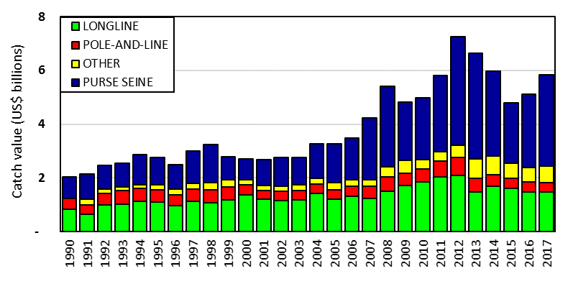
Figure 3. Catch value of albacore, bigeye, skipjack and yellowfin in the WCP–CA, by longline, pole-and-line, purse seine and other gear types.

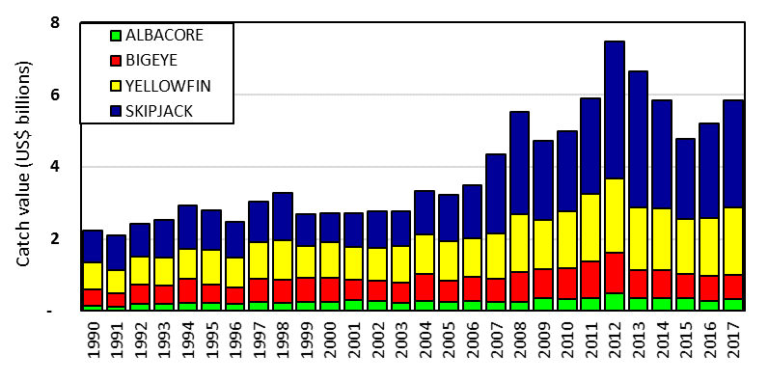
Figure 4. Catch value of albacore, bigeye, skipjack and yellowfin in the WCP–CA.

Discussion

- Samoa, on behalf of FFA members, stated the paper provided a useful and informative background to SC14’s discussions, and that South Pacific Albacore catches were the highest on record, driven by the longline catch. Noting the share attributed to China, Samoa inquired which CCMs were responsible for the increase, and what percentage was in EEZs vs. high-seas areas. P. Williams (SPC) affirmed that China was the highest contributor in 2017, but that in general catch rates were up for most fleets. He indicated that SPC could provide more details after reviewing the data, and referred to the map in the presentation that showed distribution of catch by species, with high catch levels in the east and west, and stated that additional maps in the paper provide some indication of catch distribution and some trends by EEZ (SC14-SA-IP-08, Trends in the South Pacific Albacore Longline and Troll Fisheries).

- Australia thanked the presenters, and inquired if the purse seine catch was driven by market conditions, and whether the limit of purse seine catches had been reached — whether the driver was market demand, or the availability of species in the area being fished. C. Reid (FFA) stated that the market was not saturated, but that limits, as imposed by the PNA’s VDS, have increased the price of a fishing day, which is serving to constrain effort. P. Williams (SPC) indicated that a strong El Nino period produced record skipjack catches; that has now changed, and while effort may be steady, catches are back at 2011 levels.

- Australia referred to SC14-ST-IP-01 SPC-OFP Estimates of Annual Catches in the WCPFC Statistical Area, Table 2 (Catches of target tunas in the WCPFC Statistical Area, by gear type), noting that troll catches for many years trended in the range of 10,000-20,000 mt, increased significantly during 2013-2016, and in 2017 were again less than 20,000 (9,648 mt in 2017). They asked what caused the increased troll catch. Australia also noted that in looking at bigeye tuna, stock assessments have previously concluded that bigeye tuna maybe overfished, but most recent estimates suggest stock condition is reasonable, while several indicators are not positive, with the catch at the lowest level since 1996, and the CPUE for the central and eastern longline fisheries the lowest in a number of years. P. Williams answered that the troll catch figures were driven by the Indonesian troll catch estimate. Work undertaken in annual catch data workshops resulted in reclassification of troll catch estimates, and thus the growth in the figures is driven by the changed data classification. The 2016 estimate was very high, and the large decrease for 2017 resulted from a change in how the data is compiled and estimated. 2017 was the first year under the new system.

- The EU asked for clarification regarding the number of purse seine vessels in 2017, as it appeared that some vessels are not included in the calculations in the paper, and regarding trends in effort, noting the 10%-15% decrease in the number of purse seine vessels, but the significant increase in total effort. They observed that there was an increase of over 300 days of effort in 2016-2017, and asked, given that effort varies across fleets, where the significant decrease in effort originated. P. Williams responded that vessel numbers depend on the source of data used. CCMs are required to report vessel numbers; SPC excludes both many small vessels in Indonesia and the Philippines (numbering in the hundreds or thousands), as the focus of interest is industrial-sized vessels. Small-scale vessels that operate in Japanese waters are also excluded, because they fish outside of tropical waters. Regarding the drop in numbers and concurrent increase in effort, P. Williams observed that the number of days per vessel had increased. If a vessel operated for just 1 month per year, it would still be counted as active; in 2017 most vessels probably fished for most months of year, and there was likely to be an increase in the average of number of days fished per vessel. This could be confirmed by examining the data.

- China noted their understanding that the albacore catch figures included the total Pacific catch, not just the WCPFC catch, and explained that the catch attributed to China had appeared to increase in part because China previously chartered many vessels to PICs, and thus their catch was attributed to PICs, but some charters had ceased and thus the catch was now attributed to China. In addition, he stated that China’s catch per vessel was high, in part because much of the fleet was new since 2012-2013.

- Nauru, on behalf of PNA members, noted the paper illustrated a clear pattern of effective control of the purse seine fishery, with stable purse seine effort and catch with a reduction in the purse seine fleet size, and continuing control of use of FADs, with most of the purse seine catch continuing to be taken in free schools, and an increase in the value of the purse seine catch. They drew attention to SC14-ST-IP-07 Purse seine fishing activity in PNA waters, which shows that since 2010, the number of vessels fishing in PNA waters has remained constant, despite a lack of vessel number limits in the VDS or WCPFC. Total effort has remained constant, or declined slightly, while CPUE has increased moderately; as a result, total catch (and catch of bigeye) is very constant. In contrast, the paper shows that effort, total catch and bigeye tuna catch outside of PNA waters all increased significantly in the same reference period. He noted that PNA members were highlighting these findings as they directly inform many discussions at SC14, including in the stock assessment and management issues themes.

- The EU inquired where the increased days of fishing effort in 2017 took place, if effort in EEZs was constant, and effort limits were in place in high seas areas. P. Williams noted that some was on the high seas. He referred to a paper under the management theme (SC14-MI-IP-04 SPC-OFP Catch and effort tables on tropical tuna CMMs) that provides data summaries prepared for the tropical tuna measure, and which may provide breakdowns, and that SPC could provide more detail.

- Palau inquired how much longline data was incomplete and provisional. P. Williams responded that SPC would talk to countries to determine if there were revisions to estimates, and provide the information.

  - Overview of Eastern Pacific Ocean fisheries

- K. Schaefer (IATTC) presented SC14-GN-WP-02 Tunas, billfishes and other pelagic species in the eastern Pacific Ocean in 2016, which addressed the fisheries, assessments and conservation measures for the major stocks of tropical tunas in the Eastern Pacific Ocean.

- The fishing capacity of the purse-seine fleet fishing in the eastern Pacific Ocean (EPO) increased rapidly from 1995 to 2005, and was fairly stable during 2006-2013, but increased to 254 vessels and a total well volume of 263,000 cubic meters in 2017. The reported nominal annual longline effort fluctuated between about 300 and 100 million hooks over the past 30 years. The peak of about 300 million hooks in 2002-2003 was followed by a distinct decline to about 100 million hooks, but in recent years increased to about 200 million hooks. Total tuna catches increased starting in 1999, peaked in 2003, and in 2017 were similar to the average of the previous 10 years.

- For yellowfin tuna, catches were fairly stable from 1986-1999 followed by a peak during 2001-2003, a substantial decline during 2006- 2008, and then a steady upward trend until 2016. The 2017 catch from dolphin- associated schools was substantially less than the previous 5-year average, for sets on floating objects there was a substantial increase, and for unassociated schools the catch was less than the previous 2 years. The yellowfin assessment used Stock Synthesis 3. Recent estimates indicate that the yellowfin spawning biomass in the EPO is above the target reference point (S>S_{MSY}), but that fishing mortality is slightly greater than the level corresponding to MSY (F>F_{MSY}). However, estimates of the current status of the stock are considerably more pessimistic if a stock-recruitment relationship is assumed, if a higher value is assumed for the average size of the older fish, or if lower rates of natural mortality are assumed for adults.

- The status of the skipjack stock was evaluated using eight different data- and model-based indicators. The purse-seine catch increased significantly since 1995, and in 2017 was slightly below the 2016 catch, which was highest ever recorded, and substantially above the upper reference level. Following a large peak in 1999, the catch per day fished on floating objects generally fluctuated between an average level and the upper reference level, but in 2016 was well above the upper reference level and slightly below in 2017. The catch per day fished on unassociated schools fluctuated at high levels since 2005, but in 2017 was higher than previous 2 years and well above the upper reference level. The average weight has been steadily decreasing over the past 15 years, and in 2016 was the lowest in the past four decades, and below the lower reference level, but substantially increased in 2017. The relative biomass and recruitment have been fairly high since 2002, but in 2017 substantially increased to well above their upper reference levels. The exploitation rate has remained close to average during this period. There is considerable uncertainty about the status of skipjack tuna in the EPO, and there may be differences in the status of the stock among regions.

- There have been substantial historical changes in the bigeye fishery in the EPO. Beginning in 1994, purse-seine catches increased substantially as a result of the expanded use of drifting fish-aggregating devices (FADs) in the equatorial EPO. The estimated total purse-seine catch of bigeye of 66,000 mt in 2017 is slightly above the average of the previous 5 years. The estimated longline catch of bigeye of 31,000 mt in 2017 was substantially less than the average of the previous 5 years. The results of the updated bigeye stock assessment conducted in 2018, using the same methodology as in previous years, revealed several uncertainties that led the staff to question its use as a basis for management advice. The staff has therefore developed a suite of stock status indicators for bigeye as an alternative basis for management advice and for monitoring the stock and the fishery until the uncertainties in the stock assessment have been resolved. All the indicators, except catch, show strong trends over time, indicating increasing fishing mortality and reduced abundance, and are at, or above, their reference levels. The increasing number of sets and the decreasing mean weight of the fish in the catch suggest that the bigeye stock in the EPO is under increasing fishing pressure, and measures additional to the current seasonal closures, such as limits on the number of floating-object sets, are required.

- IATTC Resolution C-17-02 on the conservation measures for tropical tunas in the EPO during 2018-2020, includes an annual EPO-wide 72-day closure for purse-seine vessels of carrying capacity greater than 182 mt, along with a 30-day closure of a core offshore FAD fishing area. For longline vessels greater than 24 m length overall, the resolution includes bigeye catch limits for China, Japan, Korea, Chinese Taipei, and the United States, and those countries can make a single transfer up to 30% of their catch limit to one another. Other members are limited to the greater of 500 mt or their respective catches in 2001. Taking into account the continuing increase in fishing effort in the purse-seine fishery, in terms of the number of sets, the staff is recommending that the purse-seine fishery limit the total annual number of floating-object and unassociated sets combined by Class-6 vessels in 2019 and 2020 to 15,723. Once the limit is reached, only dolphin-associated sets will be allowed during the rest of that year, and all vessels without a Dolphin Mortality Limit must return to port.

Discussion

- Tuvalu, on behalf of FFA members, thanked the IATTC Secretariat for their report and presentation, and noted the 8% decrease in tuna catches in the EPO. With the understanding figures presented were preliminary, and that additional catch information would become available through the year, FFA members sought clarification from the IATTC representative on possible contributing factors towards this decrease. FFA members noted the outcomes of the recent stock assessments for both yellowfin and bigeye tuna in the EPO, and that for both species the sensitivity runs at a stock-recruitment relationship (SRR) steepness value of 0.75, and estimate the spawning biomass ratio to be below MSY, and that projections to 2028 show a downward trend for both stocks. They sought clarification on the value of the SRR steepness used in both assessments, and noted the novel approach used for ecological risk assessment and spatial segregation for yellowfin and bigeye. K. Schaeffer clarified that the decrease in total EPO catch in 2017 was due to lower yellowfin and skipjack catch, which resulted from lower numbers of skipjack in aggregation with floating objects, and catch of yellowfin in association with dolphins. He observed that this probably reflected a change in the size composition of yellowfin in the EPO, as not many associate with dolphins until they are larger than about 90-100 cm in length. Regarding the steepness parameter of 1 used for the base case at IITTC, IATTC provides a sensitivity analysis with regards to the assessments done in Stock Synthesis, but the base case value of 1 is chosen in light of empirical data indicating there is a stock-recruitment relationship.

- The EU stated that, given the results of the last bigeye tuna assessment, a precautionary approach would involve decreasing the number of sets. For many years the fishery was managed on the basis of the number of days of closure, and looking at indicators, there was no real link in the number of sets and catch. If a precautionary approach is desired, and conservation needed, why use closure if a conservation benefit is not assured? K. Schaeffer responded that closure days have been ineffective in limiting fishing effort and mortality on bigeye tuna, which is evident from the increase in the number of sets and lower catch per days fishing. Although there is uncertainty with model results, these indicate that the number of closure days required would have been well above 100, which would be unreasonable to propose. To be precautionary, management measures (in addition to the 72 days of closure) are needed to address the constant increase in the number of sets and mortality. Consequently, the IATTC calculated what the number of sets should be for 2019 and 2020.

- Australia inquired regarding three productivity regime shifts identified by IATTC with respect to yellowfin, and whether this was in relation to varying recruitment, or linked to changes in environmental conditions over time. Regarding the steepness value of 1, they noted that it appeared to give an optimistic assessment, and inquired if that had allowed some overfishing to occur, and whether a lower level should be used. K. Schaeffer stated that the regime shifts were identified through time series (pre-1985, 1985-2005, and more recent), and were proposed to explain changes in the spawning biomass ratio (SBR). He stated that is was not directly linked to ENSO events. He stated that there were changes in recruitment indices only with major ENSO events, and that recruitment was not generally shown to be linked to either oceanographic factors or ENSO events. He noted that assessments are very sensitive to the steepness level, with assessments that use a steepness of less than 1 more “pessimistic”.

- SPC inquired about IATTC’s approach regarding standardized CPUE for the purse seine fishery, which SPC has found hard to standardize, and which they usually exclude as a result. K. Schaeffer indicated that IATTC uses a simple method, in recognition of the difficulty in standardizing purse seine catch data or catch per days fishing. He noted that the methodology was very simple and likely inadequate to enable its use as a CPUE input for a stock assessment model.

  - Annual Report – Part 1 from Members, Cooperating Non-Members, and Participating Territories

- The SC Chair noted that members’ Annual Reports Part 1 had been posted on the Commission website for the past month, and invited those members who wished for clarifications to inquire.

Discussion

- Birdlife International stated that they were very pleased to see many CCMs meeting the new requirement, in Paragraph 9 of CMM 2017-06, that observers list mitigation being used as observed. One CCM has stratified the mitigation use by area and it would be more useful if everyone did this, as different mitigation measures are required in different areas, including none in low latitudes. This would provide a more comprehensive understanding of how mitigation measures are being applied and to understand where effort is needed to improve mitigation implementation, or if additional mitigation options are required to reduce bycatch rates to acceptable levels. They noted bycatch rates for some CCMs remain alarmingly high, and suggested a separate table be added to the annual reports recording mitigation used for each area, as is done to record seabird bycatch.

  - Reports from regional fisheries bodies and other organizations

- No reports from regional fisheries bodies and other intergovernmental or non-governmental organizations observing SC14 were made.

AGENDA ITEM 3 — DATA AND STATISTICS THEME

  - Data gaps

    - Data gaps of the Commission

- P. Williams (SPC) presented SC14-ST-WP-01 Scientific data available to the Western and Central Pacific Fisheries Commission, and drew attention to SC14-ST-IP-02 Status of observer data management. All CCMs with fleets active in the WCPFC Convention Area (WCPFC-CA) provided 2017 annual catch estimates by the deadline of the 30th April 2018, and there were no major data gaps, a significant achievement. The issues previously reported in annual catch estimates were further reduced and the lack of any estimates for key shark species remained the main gap for some CCMs, particularly in years before 2017.

- Aggregate catch/effort data for 2017 were provided by the deadline of 30 April 2018 for all but one fleet, but this gap (2017 data for the US albacore troll fleet) was resolved in early August 2018 following submission of the paper. The quality of aggregate data provided has continued to improve with a reduction in the number of data-gap notes assigned to the aggregate data in recent years. The primary remaining issues include the reporting of key shark species catches for some CCMs. The main development in the resolution of operational data gaps over the past year was provision of full 2017 operational data for the Chinese Taipei longline and purse seine fleets. The continued provision of operational data for the Japanese, Chinese and Korean tuna fleets is also noteworthy. One gap in the provision of 2017 size data (EU-Spain longline fleet) was resolved prior to SC14, after the paper submission.

- P. Williams briefly outlined a project to enhance conversion factor data for the work of the Commission, noting that it is a data gap, and referring to SC14-ST-WP-05 Requirements for Enhancing Conversion Factor Information; SC14 was invited to consider the draft Project 90 proposal (in Annex 3), and review and prioritize the list of work items. In reference to SC14 ST IP-02 (Status of ROP data management), P. Williams noted the deterioration in the timeliness in the provision of purse seine observer data for 2017 activities compared to the previous year, and that this affected certain work for SC14 (e.g. the estimation of purse seine species composition). The SPC will be working with respective observer providers in the hope of resolving any issues that caused this delay in observer data provisions. Other matters raised in the presentation included a proposal for improving the coverage/quality of estimates of discards/releases in the longline fishery and an update of the potential uses of cannery data (referring to SC14-ST-IP-03 Update on the use of cannery receipt data for the scientific work of the WCPFC).

Discussion

- Japan thanked the presenters, and stated that the issue of estimating discards involves many aspects, some technical in nature. Japan asked whether reported discards would be counted as dead if data are used in stock assessments, and stated that distinguishing dead and live discards via logbooks would constitute an additional burden, especially in view of recent medications made in logbook recording. They observed it is sometimes difficult to report longline bycatch by weight, suggested that CCMs be allowed to report by either weight or number, and inquired what SPC meant by “suggestions” with regard to changes in reporting. P. Williams acknowledged that the supply of data had just been reviewed, and that the suggestions in the paper sought to inform CCMs that if the potential existed for them to modify their logbooks, that would be welcomed. He noted that they would return to the topic in the future, and that the paper acknowledges that there was no effort to make obligatory changes at present.

- Australia commented that condition information on bycatch releases was currently recorded by Australia with regard to some species (e.g., threatened, endangered and some other species for which special information is desired), but not for all discards. They observed that recording this for all discarded species would require a fish-by-fish accounting of all discards, which was impractical, but doing so for selected species might be possible, which seemed to be what the paper suggests. P. Williams confirmed that, although not explicitly stated in the paper, reporting would be for some priority species, which could be noted in a future paper.

- The EU confirmed that size data for the EU longline fleet were submitted on 16 May and that problems with the receipt of the data had been resolved. They requested that references in a few places in SC14-ST-IP-02 to Spain as the CCM should refer instead to the EU. P. Williams affirmed that SPC, on behalf of the WCPFC, had received the size data and would determine why receipt of the data was delayed, and acknowledged the need to confirm that references in the paper were to the EU.

- The USA noted that changes in logbook reporting to include condition would involve an arduous approval process, and that changes in e-data reporting were also complex. He stated the USA preferred to give condition of fish in observer data, and have good observer coverage. P. Williams acknowledged that the USA had high levels of observer coverage, and indicated that the concern was with those fleets with low coverage.

- Korea referred to SC14-ST-IP-02, and questioned the use of the term “non-standard” data. P. William indicated that term was used to refer to the format of the data, and not whether a CCM was or was not meeting requirements. “Non-standard” data referred to data that did not match ER data guidelines, and are thus more difficult for SPC to load to its database. He noted that SPC could use a different term to better describe the data, and would welcome the opportunity to work with CCMs to make it easier for them to supply data meets the ER data guidelines.

- RMI indicated that, as an observer provider and member, it would welcome assistance from SPC in resolving the 2017-2018 gap, and that a forum within FFA membership could address the issue. Regarding Tables 3 and 4 in SC14-ST-IP-02, RMI asked how SPC accounted for work done by coastal states that don’t have a longline fleet, but put observers on foreign vessels. P. Williams stated that SPC was ready to assist countries in addressing data gaps, with in-country visits if needed. He noted that the table did not reflect work done by coastal states in putting observers on foreign vessels, and that SPC would work to list the number of trips by observers in the future. RMI noted that this should include data submitted in ER and EM formats.

- China echoed RMI’s comment, noting that Table 4 of SC14-ST-IP-02 indicated China had 3.7% coverage, and addressed the metric used, which in China’s case was number of trips, but could have been higher if days fished was used instead. China raised the issue of who had the obligation to supply observers for domestically based DWFV operating in PNA/FFA waters, stating that if that issue were resolved China could increase it coverage. P. William indicated SPC could consider changing the metric used for 2019.

- Chinese-Taipei noted that fishermen know how to report information, are ingrained in their ways, and would be very resistant to any revisions to their logbooks. P. William noted that further information could be made available.

- Australia commented regarding the ROP coverage tables for 2016 and 2017, noting that coverage rates for most fleets were good, likely (on the basis of catch) approximately 5%-7% across the fishery. But in SC14-EB-WP-02 Report for Project 78: Analysis of Observer and Logbook Data Pertaining to Key Shark Species in the Western and Central Pacific Ocean, coverage rates appear much lower (around 2%). They noted the large apparent inconsistency between the two papers, especially for DWFNs, and that, as pointed out in SC14-EB-WP-02, coverage should be 5% (as of 2012). Australia observed that there were important consequences for bycatch and for the need to record discards in logbooks, given the inadequacy of observer data, and commented on the effect that the chosen metric (such as days fished or hooks set) could have on actual observer coverage, while stressing the need to better understand the reason for the discrepancy in reported observer coverage. P. Williams indicated that in Table 4 different metrics were used, and that CCMs typically use the metric that points to the highest coverage, which would account for some of the gap (from 2% to 5%+), while SC14-EB-WP-02 may use hooks or annual catch estimates. He indicated the discrepancy could also be the result of delays in loading data as a result of the need to resolve data errors, and stated that SPC would examine the issue.

- Japan inquired whether observers working in coastal states’ waters are part of the WCPFC observer program, and whether data are reported to WCPFC. P. Williams indicated that coastal states’ observer coverage data are available to SPC for scientific analysis, and his understanding that these address observer effort. He indicated that the data were largely informative, with a number of states beginning e-monitoring of trip numbers to get an idea of effort expended, rather than a measure of coverage.

Recommendation

- SC14 recommended that the Scientific Services Provider include a table listing the observer data collected by small island developing state (SIDS) observer providers in future versions of the ST Information Paper “Status of ROP Data Management”

    - Species composition of purse-seine catches

- T. Peatman (SPC) presented SC14-ST-WP-02 Better purse seine catch composition estimates: progress on the Project 60 work plan, summarising progress on the Project 60 work plan endorsed by the 2017 Scientific Committee. The main activities undertaken since SC13 were updating the availability model currently used to correct grab sample bias; updating a simple multinomial model initially proposed during external reviews of Project 60 in 2012; negotiations to recommence paired spill/grab sampling trips with in-port unload sampling; and revisiting models of species compositions used to estimate purse seine catch compositions when observer coverage is insufficient to use grab sampling based estimates directly. Multinomial model estimates of grab sample bias — referred to as ‘correction factors’ — were broadly consistent with estimates of ‘availability’: small individuals are underrepresented in grab samples, with large individuals overrepresented. The fit of the availability model was generally poor. The multinomial model approach to estimating grab sample bias is more intuitive, and tackles the issue of grab sample bias more directly. Comparison of corrected grab sample compositions against a corrected landings slip dataset for 776 Japanese purse seiner trips from 2010 to 2015 demonstrated that correction factors gave the least biased estimates of species composition at aggregated level. Exploratory analyses of correction factors provided some evidence of stronger bias of grab samples from associated sets, compared to sets on free schools. Further investigation through simulation modelling is warranted.

- Generalised additive models are currently used to estimate purse seine species compositions for strata with low observer coverage. The resulting estimates of catch compositions are used in stock assessments, along with other analyses. Preliminary models of species composition are implemented with an inflated beta response, and provide superior fits compared to existing models, particularly for bigeye tuna. A proposed work plan for Project 60 for 2019 and 2020 was presented to the Scientific Committee, along with a number of recommendations based on work to date, including:
- multinomial model-based correction factors be used to correct existing and future grab sample data, rather than the estimates of ‘availability’;
- simulation modelling be undertaken to explore: (a) the potential bias resulting from between brail variability; and, (b) whether correction factors should be estimated separately for species and/or set association;
- existing models of species compositions be replaced with beta-response models, building on the preliminary models presented; and
- stratification used to estimate species compositions directly from aggregated observer data be revisited – specifically the whether to stratify by flag.

Discussion

- FSM, on behalf of FFA members, thanked SPC for their efforts in producing the study and noted the potential benefits to stock assessment of better species composition data. They indicated they had no objections to the minor changes identified in the paper to observer spill sampling protocols and overall supported the proposed work plan. FFA members urged CCMs to support the project, where appropriate, to aid SPC in their work.

- The EU observed that data in Table 1 (Species composition) suggested that observer estimates appear to be the least biased for skipjack and yellowfin, but not for bigeye tuna, and asked for clarification regarding when species composition models are used to replace limited observer data. T. Peatman replied that species composition models are used when observer coverage is less than 20% at a stratified level, which typically applies before 2010, or when full data are not yet available; such models were typically not used for 2010-2016.

- Japan stated that their understanding of the purpose of the project was to improve estimates of bigeye, not necessarily skipjack, and that they support progress in light of this. Japan observed that the project had budget implications, and that it was important to consider what additional progress could be made. Regarding the work plan, they stated that Japan would support work to improve the bigeye model, but noted that small changes may have a large impact on historic bigeye catch estimates, and impact the bigeye stock assessment.

Recommendation

- SC14 recommended that the future work proposed by the Scientific Service Provider under Project 60 (Improving purse seine species composition) continue over the coming two years.

    - Potential use of cannery receipt data for the work of the WCPFC

- This was discussed under Data Gaps (Agenda Item 3.1.1).

    - Bycatch estimates of longline and purse seine

- T. Peatman (SPC) presented SC14-ST-WP-03, Summary of longline fishery bycatch at a regional scale, 2003-2017, which provides a regional summary of longline fishery bycatch in the WCPFC-CA. The report includes: summaries of longline observer data held in SPC’s master observer database related to bycatch, including information on fate (i.e. utilisation) and condition at release; statistical models of catch rates fitted to observer data; and, estimates of total catches for longline fisheries in the WCPFC-CA. Catches were estimated for 45 species or species groups, covering the full range of finfish, billfish, shark and ray, marine mammal and sea turtle species that have been recorded in longline observer data. SPC did not attempt to estimate catches for domestic longline fisheries in the west-tropical sector of the WCPFC-CA, as SPC holds little observer data for these fisheries. The presentation also covered relevant material from SC14-ST-IP-04, which updated estimates of purse seine bycatch to cover 2003 to 2017. Observer coverage in longline fisheries in the WCPFC-CA, based on SPC’s observer data holdings, was generally low from 2003 to 2017, with annual coverage rates ranging from 1% to 4.5% of total hooks set. Observer coverage varied both spatially and temporally, with a tendency for lower coverage in the high seas and higher coverage in EEZs. Observer coverage was particularly low in wide areas north of 10°N. Hooks between floats (HBF) was a key predictor for many of the catch rate models. SPC holds HBF-disaggregated longline aggregate catch and effort data, with coverage of total effort ranging from 25% in 2003 to 90% in 2016 and 2017. Available HBF-disaggregated effort data was used to estimate the proportions of longline aggregate effort for different numbers of hooks between floats, assuming that available HBF-disaggregated aggregate data are representative of the fisheries as a whole.

- Estimated catch rates from the statistical models had higher uncertainty for species that were less frequently caught by longliners. Coefficients of variation (CVs) ranged from 60% to 350% for sea turtles, 40% for marine mammals, 7% to 90% for key shark species, 9% to 65% for billfish and 7% to 66% for finfish. Estimates of total catches were presented for the WCPFC-CA as a whole, and disaggregated by region (south of 10°S, 10°S to 10°N, and north of 10°N) and deep and shallow set fisheries (> 10 HBF and ≤ 10 HBF respectively). Catch estimates for 2017 were based on observer data available in SPC’s master database on 10 July 2018 (some 2017 trip data had not been uploaded). Region-wide estimates north of 10°N are unlikely to be robust given the large areas in the region with limited observer data. Catch estimates were compared to other available estimates for a selection of species, including silky and oceanic whitetip shark.

- Recommendations were presented to SC14 related to bycatch in both longline and purse seine fisheries, including that the SC:
- note the difficulties in robust estimation of longline catches from observer data, given the very low levels of observer coverage, and for some years (2003-2008) the coverage of L_BEST_HBF data;
- note that longline observer coverage levels in the region have generally been less than 5%, though acknowledging that observer coverage can be expressed in a variety of units (e.g. trips with observers on board, hooks with observer onboard, hooks observed);
- note the regions of the WCPFC-CA with substantial longline effort and low levels of available observer coverage, and the implications this has on bycatch estimation at a regional level;
- consider whether historic L_BEST_HBF aggregate data can be derived by members (where necessary), to support future analysis of longline observer data;
- decide on whether the preliminary estimates of longline bycatch are suitable for public release in the context of the associated uncertainties;
- consider whether estimates of purse seine bycatch should be made publicly available in electronic format to facilitate extraction and use of data by CCMs, and potentially other stakeholders; and
- consider the utility of the longline and purse seine bycatch estimates presented, and whether annual and/or periodic future updates would be helpful.

Discussion

- Japan asked for clarification regarding the goal of using observer data, given that seabirds are already covered by Project 68, while finfish and billfish figures are known from logbook data. They also inquired whether the performance of the model could be tested through comparison with data derived from other sources. T. Peatman indicated this was the first attempt to compile an analysis of longline catch covering all species. He noted there were alternate data sources that may be better for some species, but for others no estimates exist, or they are old; these provide an important update for those. He noted that SPC had compared catch estimates against total reported longline catches, which revealed underestimation for bigeye and yellowfin, and overestimation for swordfish. A decision was made at the outset not to model catches for target species, so the model was designed to focus on non-target species.

- Fiji, on behalf of FFA members, thanked SPC for their summary of bycatch across the region as outlined in SC14-ST-WP-03, which they viewed as important in assisting the SC assess total levels of bycatch, identify species or species groups with high relative bycatch levels, and thereby enable assessment of bycatch risks and identification of where further management attention is needed. FFA members proposed that future bycatch data reporting at SC include an annual analysis; recommended that all CCMs provide observer data so that the SC can fully assess bycatch levels across the WCPO; and requested that CCMs who have provided aggregated data in the past also provide additional data on hooks between floats to help improve bycatch estimates. FFA members noted that the analysis lacked access to observer data across the entire WCPO, particularly in the high seas, and until these are included they stressed caution in considering the results as definitive total bycatch estimates. For species of special interest, a large proportion are reported as "condition unknown at release". FFA members recommended this be followed up with national observer coordinators to identify ways to improve reporting on condition at release.

- The USA noted that the species-specific coefficients of variation in relation to observer coverage were high in some cases, and the disconcerting decline in observer coverage during 2013-2016 using the hook metric. P. Williams (SPC) noted that the decline resulted in part because not all 2016-2017 data had been received, and other data were not yet loaded (even for 2015), which could account for some of the low coverage. For 2016-17 some considerable observer data sets were missing; an ROP data management paper to be presented to TCC14 will hopefully include updates to provide a better impression of coverage in recent years.

- Australia generally supported the analysis, but stated that care was needed in determining whether data were suitable for public release, especially if alternative data sources existed that were known to be superior. Australia noted the data should include an indication of reliability, with references to alternate sources of catch-time series if the data discussed were not regarded as authoritative; for those species where alternatives do not exist, the data would be recognized as the best available. The ensuing discussion addressed whether the data, which was available in the paper on the WCPFC website, should be released in a different form. SPC noted that a disclaimer had been included in the paper that permission was needed from WCPFC to use the data, to avoid problems with misuse of the data; they suggested options that could be used to make the data available: by adding columns to existing tables, or incorporating the data into the bycatch estimation system, with the caveats raised by Australia.

- The theme convener noted support for a recommendation that the report include a note referencing alternative data sources in cases where better estimates are available, and a recommendation by RMI that SC address the low levels of operational-level data being provided regarding bycatch.

- Indonesia inquired whether the difference in anchored FAD vs. drifting FAD interactions reflected a difference in actual interactions, or whether less data were available from anchored FADs. SPC stated that differences in estimated catch rates by FAD type probably did not reflect a lack of data, given the high observer levels in the purse seine fishery, and noted the influence of level of effort, rather than just catch rate. In response to a second query by Indonesia, he indicated the disclaimer in the paper sought to prevent use of bycatch estimates without consideration of the uncertainty in catch rate estimates.

- Australia noted that many factors influence longline CPUE other than hooks per basket, but that data were lacking. They asked whether SPC considered using flag of vessel, as there are differences in how they set lines, and whether repeating the method on a single fleet, such as the USA’s Hawaii fleet, would validate the method by estimating actual catches. SPC stated that they did look at replacing catch composition cluster with flag effect and fitted over 1000 models of varying configurations, but saw no reason to prefer over this model structure. SPC stated they would need to use flag plus some information on fishery strategy, accounting for deep and shallow sectors of a flag. They also compared model estimates for the USA deep-set fishery against reported catches in operational data. For some species alignment was very good (e.g., North Pacific albacore); for others there were still large discrepancies with operational data. Comparisons were expected to be much closer if using US observer data only, but the model was not configured to estimate target species. SPC also looked at correlations between explanatory variables, and using flag did increase collinearity between explanatory variables.

- FAO requested that SPC reconcile and correct common names of sharks in the database, and modify the codes so the correct name is used. FAO also asked what steps would be needed to convert estimates to a time series of total removal (i.e. mortality), and whether SPC had the necessary data to do this. SPC noted that total removals could be estimated using a model of catch conditions to address the state of individuals at vessel or at release, and information on what percentage is retained vs. discarded or released; ideally there would be a record of post-release mortality. SPC has good data coverage for catch condition at the vessel, with poorer coverage for condition at release, but there are likely sufficient data to develop a model of condition. SPC could use observer data to determine the proportion of retained vs. discarded bycatch, but have low observer coverage for fisheries and fleets, especially early in the time series, and the species being retained may differ from species for which there is observer coverage. Post-release mortality data are very limited, but available for some shark species. Thus, there would be some data constraints, but it should be possible to develop a better idea of total removal estimates. FAO stated that some previous studies had been incorrectly used as proxies of total removals, and encouraged SPC to develop such an estimate. FAO observed that the increase in unidentified sharks in 2013 and after was likely related to non-retention measures, with sharks released before being identified. FAO asked if it was likely there is underreporting of sharks in general, because observers are instructed not to record sharks unless they can visually verify it is a shark. SPC refrained from expressing a strong opinion on whether the no retention policy has impacted reporting, and noted there may be a need to increase observer training. The EU observed that this was important for underreported species.

- In response to a question from the EU, SPC noted that using a stratified ratio estimator to examine the ratio of bycatch to fishery production could be worth exploring. SPC indicated using a model-based approach had some advantages, but not over-fitting to available data was an issue, especially with low observer rates. There could be work done using some of these data to explore how to stratify data. The EU stated that observer vs. total effort could be used. SPC noted it would be happy to discuss the issue in the margins, there were likely to be issues with observer coverage and limits in some areas.

- The USA stated that the analyses (Table 4) were quite valuable, but that annual updates were not needed, perhaps every 2-3 years. They suggested that numbers of individuals could be better determined maybe from the log or Bycatch Mitigation Information System (BMIS) databases; tables could be supplemented by data from the BMIS database. Japan agreed with the USA, and noted the limits and benefits of observer data to estimate total catch. Japan compared the billfish estimate from this analysis with the catch estimate from logbook data, noting both had problems, with large discrepancies by species. Japan would like to see the sensitivity and credibility of the approach compared to other methods. They noted the observer program had always been limited by coverage. Japan stated that local catch and logbook reporting was a primary obligation of CCMs, and vessels, and encouraged further work on the method, but as research, not to replace current methods to derive total catch estimates.

Recommendations

- SC14 recommended that the Scientific Services Provider continue the work on purse seine and longline bycatch estimates, and provide updates every 2-3 years.

- SC14 encouraged CCMs to provide catch estimates of all species at the species level (in addition to the binding provision of estimates for the WCPFC key species) as part of their annual data submission.

- SC14 recommended that the bycatch estimates (from SC14-ST-WP-03) also include the estimates of uncertainty (e.g. CVs) in the next iteration of this work, and consider alternative better estimates where appropriate.

- SC14 recommended that the Scientific Services Provider reconcile the names and codes of some species of sharks included in their databases.

- SC14 recommended that the differences in coverage of longline observer data presented in some SC14 papers be investigated by Scientific Services Provider and reported to SC15.

    - Better size data (length and weight) for scientific analyses (Project 90)

- The theme convener asked for questions and comments on the project, noting that SC13 recommended that the Scientific Services Provider be tasked with a project to design and coordinate the systematic collection of length:length, length:weight and weight:weight data on all species to better inform bycatch estimation (WCPFCSC13, Paragraph 102). At SC13, a project proposal (to start in 2019) was submitted and included in the indicative budget. SC14 had been tasked with considering the project to collect data to determine length:weight and weight:weight conversion factors (Project 90), and to review any additional information with the intent of starting this research in 2019.

- Vanuatu on behalf of FFA members thanked SPC for responding to the SC13 recommendations, and for providing the draft project plan. While they recognized the merits of the work, they noted that much of the work proposed would likely be undertaken in FFA-member fisheries, and the plan did not account for resourcing support. They also noted the potential application and integration into other work streams such as traceability and catch documentation schemes, and supported the recommendation in the paper to further discuss the draft plan in ISG-11.

- Australia expressed support for the project, and agreed that an ISG would be useful to discuss details, including discussing the origin of the tuna data. Following some discussion the EU agreed to chair ISG-11.

Recommendation

- SC14 recommends that the Scientific Services Provider be tasked with a project to design and coordinate the systematic collection of data for conversion factors on relevant species to better inform catch estimation, and agrees its inclusion in the SC future work programme and budget under Project 90.

  - FAD data management

- There was no discussion on this agenda item.

  - Regional Observer Programme

    - ROP longline coverage.

- As agreed by WCPFC11 (Paragraphs 484-486, WCPFC11 Report), CCMs submitted their longline observer coverage in Annual Report Part 1 using their choice of coverage metric (Attachment L, WCPFC11 Report).

- There was no discussion on this agenda item.

    - Review of ROP minimum standards data fields

- The USA introduced SC14-ST-IP-09 USA ideas on "ROP minimum standard data fields species of special interest”, noting that WCPFC14 tasked SC14 to consider the recommendations of the recent Joint Analysis of Sea Turtle Mitigation Effectiveness workshops to modify the ROP Minimum Standard Data Fields with respect to improving the collection of data related to sea turtle interactions, taking into account capacity of observers and priority of data collection, and to recommend any modifications for the consideration of the ROP Coordinator, TCC14 and WCPFC15. The USA developed its proposal to amend the ROP Minimum Standard Data Fields (SC14-ST-IP-09), and specifically the SSI section.

Discussion

- Federated States of Micronesia, on behalf of PNA members, supported the workshop recommendations for improved data on sea turtle interactions, especially in the longline fishery, but noted that observer capacity was limited, and there was need to prioritize what observer collect. They noted reasonable alternatives to simple expansion of the ROP Minimum Data Fields. During the ERandEM working group, PNA and other FFA members were clear in their recommendations for a holistic review to better align each Commission data need with the most suitable and efficient data collection program, and stated this applied directly in this case. Many of the recommendations call for observers to provide detailed technical information, such as specifics on fishing gear. In the view of PNA members, such data are best provided by vessel operators, especially given the very low enduring observer coverage.

- In response to queries, the Secretariat confirmed that for sharks, the Species of Special Interest (SSI) section applied only to shark species that are considered SSIs by the Commission.

- The EU supported the proposed amendments, which would allow better use of data that are collected in relation to these species, and allow SPC and other scientists to undertake better analysis. The Secretariat noted that most of the fields proposed were already collected by observers under longline gear fields. The USA stated they understood members’ concerns about giving observers more to do, while providing an example from interactions in Hawaii’s fishery that suggested the burden on observers would be minimal. Following a request by Japan to consider the proposal further, the USA presented an edited draft with a third column added to the table to illustrate what they proposed.

- Japan noted that observers were already overloaded with work in measuring and recording all catches, and that it was difficult for them to record information on hook type and size. They stated that asking for too much information can negatively impact data quality, and there is thus a need to avoid overworking observers. Japan stated they could not accept the proposal, but were willing to discuss an arrangement to collect the data — e.g., should have an intercessional review of minimum standards and how to collect additional high-priority data. This view was supported by China. The EU supported the changes as proposed by the USA. With regard to data quality, the EU stated that collecting only fragmented or insufficient detail was also not useful, and requested clarification from Japan regarding their objections. Japan reiterated concerns about observers being overworked; while not opposing collecting the data, they suggested reconsidering the existing data requirements, so that new data collection could be made possible without jeopardising observers’ existing tasks.

- The USA indicated observers would need to record the bait/hook type and trailing gear, and that this would occur only occasionally — once every 2 days somewhere in the Pacific, for a total of about 180 instances per year. Solomon Islands reiterated the lack of support on the part of PNA members for the proposal. They appreciated the work by the USA to clarify what would be required, looked forward to ongoing discussions as supported by Japan and China to ensure data is collected through the most appropriate means. Japan further stated that they had concerns regarding the effectiveness of circle hook on total catch, and for the catch rates of other species.

- The USA proposed to undertake further intercessional discussions and bring a proposal to TCC.

  - Electronic Reporting and Electronic Monitoring

- K. Smith, Chair of the E-reporting and E-monitoring working group (ERandEM WG), provided a summary of outcomes from the 3rd meeting of the ERandEM WG, which met immediately before SC14.

Discussion

- In response to a query from Japan the presenter confirmed that that the outcomes document was available, and that the full paper would be shortly. They stated that they sought general advice about data needs analysis to inform which tools should be used for submission of data, and information regarding areas where e-monitoring could be used to supplement existing low data collection. In the ensuing discussion, Nauru, on behalf of PNA and FFA members, and supported by the Cook Islands and Fiji, noted their calls for a review of EM requirements, what data would be collected, and what it would be used for. They noted an Ad Hoc Task Group on Data might be the best way to complete the work. Fiji noted the proposed review would define how e-monitoring could be used in different fisheries, stating that because ERandEM objectives for monitoring are broader than scientific data needs and include safety considerations and compliance needs, a review should consider the full Commission monitoring needs and facilitate the refinement and development of Commission data collection methods, including consideration of EM, to ensure they are complementary and cost-effective.

- The USA endorsed the paper as written, and suggested PNA members fill out a project sheet to help clarify their request. The EU and Japan requested that a discussion of the recommendations be delayed until the full paper was available for review. RMI supported the need to review EM requirements and data fields, and noted that they would not support the replacement of human observers with EM. China noted its interest in the development of EM and ER to reduce manpower needs.

- Solomon Islands, on behalf of FFA members thanked the chair of the ERandEM WG for her excellent leadership and efforts supporting progress on e-reporting and e-monitoring. FFA members endorsed the recommendations and noted that FFA members had proposed further work to help progress the use of e-monitoring in the Commission. Nauru, on behalf of FFA members prepared working paper SC14-ST-WP-07 to better describe the work they considered necessary to make progress on the EM discussion. They stressed it was not a detailed review of existing data standards, such as the ROP minimum standards, but aimed to compare the Commission’s science and MCS information needs against the monitoring programs, including EM, that are best suited to collect and verify the required data. They suggested the work be undertaken by SPC, FFA Secretariat, and the PNA Office, with the assistance of the WCPFC Secretariat, if possible, so as not to impose additional costs on the Commission, while stressing that the review be recognized and supported by SC, given its critical role in informing further EM discussions. Following further discussions, Japan stated they were supportive of the process being proposed to prioritize data collection for observers, and review and reconsider data mechanisms and standards. They stated in their view the process should be a WCPFC process, open to all CCM, including DWFNs.

- The USA asked for clarification regarding the scope of the data standard review. In reply Nauru stated their view while they agreed larger data needs were not well articulated, they found it difficult to discuss specific objectives for ER and EM without knowing what data the WCPFC needed to manage stocks. They clarified they were not seeking a detailed review of data standards, but a higher-level review, focusing on what to collect, and how to verify the data. In reply to a query from Chinese Taipei, Nauru noted that although it was intended to contribute to the work of the ERandEM WG, the intended review was broader, and more in the purview of SC and the Commission.

- Following a query from the USA regarding the budgetary implications, and involvement by the Secretariat and SPC, Nauru noted the support for the process from PNA and FFA, and expressed the value in having the process endorsed by the SC. The Secretariat stated that the issues proposed for discussion linked to the work of SC, TCC and the datasets managed by the Secretariat, and that if the study would help in making sure that all datasets the Commission received were managed as effectively as possible, it would welcome being involved.

Recommendation

- SC14 recommends that FFA, PNA Office, the Scientific Services Provider and WCPFC Secretariat jointly work on a project to review the Commission’s data needs and collection programmes (Project 93).

  - Economic data

- M. Skirtun (FFA) introduced SC14-ST-WP-04, Analyses and projections of economic conditions in WCPO fisheries. Fish prices, fishing costs and catch rates are the three key determinants of economic conditions prevailing in a fishery. Changes in each can have significant impacts on the financial viability of vessels operating in a fishery and the returns generated from the exploitation of fish stocks. The paper examines relative economic conditions and makes simplistic projections over the next 10 years for the southern longline, tropical longline and purse seine fisheries of the Western and Central Pacific Ocean.

- In the southern longline fishery economic conditions followed a declining trend from 1999, reaching well below average levels by 2011 where they remained until 2014. Conditions have improved in recent years and in 2017 were above long-term average levels. Recent improvements were driven by falling costs and increases in catch rates. While in recent years catch rates have increased, historical data suggest that catch rates are peaking at lower levels owing to the overall declining trend. Given this and forecast increases in fuel costs, it appears that while economic conditions have improved in recent years and are now around their long-term average levels, this may be as good as it gets. In the tropical longline fishery economic conditions rapidly declined during 1999–2008 as costs increased and prices and catch rates fell. This was followed by a significant improvement in economic conditions in 2009 as costs fell as a result of reductions in the global fuel price and an increase in catch rates. During 2011–2014, the fishery saw persistent but stable below-average economic conditions. Conditions improved significantly in 2015 and 2016 due to declining fishing costs and increasing catch rates. However, conditions deteriorated again in 2017 as catch rates declined. The recent peak in economic conditions reflects past average conditions. Economic conditions are projected to remain below average and follow a declining trend, primarily driven by expected increases in fuel costs, with fish prices lingering around their long-term average, and catch rates persisting at below-average levels. In the purse seine fishery economic conditions in the purse seine fishery have been trending upward since 2006, after a sustained period (1999–2006) of relatively poor conditions. The key driver behind during 2006–2013 was significantly-above average fish prices, which more than offset increases in fuel costs. While declines in fish prices in 2014 resulted in a sharp fall in economic conditions, low fuel costs and increasing catch rates led to conditions staying well above the long-term average in 2015 and 2016. Despite significant falls in catch rates in 2017, higher prices resulted in the continuation of the good economic conditions. Conditions are projected to improve considerably to 2027, mainly because of higher projected catch rates and above-average fish prices.

Discussion

- Fiji thanked the FFA Secretariat for the paper and welcomed the improvement in economic conditions in the southern longline fishery since 2015, while expressing concern that effort appeared to have increased significantly in 2017, which will lead to declining catch rates. When combined with projected increased fuel costs, they expressed their fear that economic conditions would soon return to the poor conditions that prevailed during 2011–2015 (or perhaps worse), which would significantly impact the viability of their domestic fleets, that are least able to pursue other options in the face of poor conditions. In the southern longline fishery in recent years, as soon as catch rates recover, effort increases, leading in time to declining catch rates, then declines in effort followed by a recovery in catch rates, and so on. The cycle of recovery and downturn is not economically sustainable for domestic fleets and highlights the need to control effort in the fishery so that at least reasonable economic conditions can be sustained and do not simply translate into expansions in effort and a return to poor conditions.

- Australia commented that the index was relative to the average across a time series, and as new years are added that can change. They suggested it would be possible to identify a reference year when conditions were good, and make indices relative to that year.

- Cook Island noted that the paper highlighted the importance of economic information in fisheries management, especially for fisheries where sustainability was mainly an economic rather than a biological issue. For FFA members many of the objectives of managing the WCPO tuna fisheries are economic, and the ability of FFA members to achieve them is tied to the economic performance of the fishery. For those reasons they suggested the paper and discussion should be placed under the Management Issues theme for SC15.

- The EU inquired how management measures impact the fisheries’ profitability. M. Skirtun noted that longline fisheries are not constrained in effort. For purse seine fishery the analysis does not explicitly capture changes in technology or practices. It takes time for impacts to manifest economically, and was hard to say whether catch rate fluctuations were driven by environmental factors or management measures. Management measures have been in place since 2010, and some of their impact is likely captured.

- China queried what drives international prices in the various fisheries, as tuna prices are heavily based on the international market, and agreed that the information should be considered in the management theme. M. Skirtun noted that in the longline fishery fish prices may not be a key driver, and that longline prices have fluctuated around a long-term trend, with recent conditions driven by exceptionally low fuel prices. The cost and CPUE indices are the important drivers. The purse seine fishery does have management limits, and it may be helpful to inform the management discussion with economic information.

- In response to queries from Chinese Taipei and Australia, M. Skirtun noted that CPUE in the purse seine fishery was calculated as total catch divided by total days, and projected (to 2027) using known past value relationships that presumed any developments (e.g., technology) would continue. The theme convener noted discussions regarding voluntary guidelines for submission of data, and the need to develop proposals for how this would work.

- Tonga on behalf of FFA members welcomed the adoption by the Commission of a set of principles that would inform the development of guidelines for the voluntary submission of economic data and wished to see such guidelines developed in an expedient manner to ensure that economic data are available to inform the Commission’s work, including, the setting of target reference points and the development of harvest control rules. FFA members noted that the key issue for SC14 was deciding on a process through which draft guidelines could be developed for further consideration by the Commission or one of its subsidiary bodies. The stated that this necessitated a discussion on who would undertake the development of the draft guidelines and the associated timeframes, and welcomed suggestions.

- Fiji, on behalf of FFA members, stated that the availability of economic data was extremely important to the work of the Commission. Fiji offered to develop draft guidelines based on the principles agreed to by WCPFC14. Fiji proposed developing an initial draft for circulation to members and then preparing a revised draft based on comments received for consideration by SC15.

Recommendation

- SC14 recommended that future reports on economic conditions in WCPO fisheries (SC14-ST-WP-04) be delivered in the SC general reports under Agenda item 2.1.

AGENDA ITEM 4 — STOCK ASSESSMENT THEME

4.0 Improvement of MULTIFAN-CL software

- The theme convener noted SC14-SA-IP-02 Davies et al. Developments in the MULTIFAN-CL software 2017-2018.

- There was no discussion on this agenda item.

  - WCPO tunas

    - WCPO bigeye tuna (Thunnus obesus)

      - Research and information

a. Further work on bigeye tuna age and growth (Project 81)

- J. Farley (CSIRO) introduced SC14-SA-WP-01. Update on age and growth of bigeye tuna in the WCPO: WCPFC Project 81. The paper provided an update on a regional study of bigeye tuna age and growth in the WCPO presented in SC13-SA-WP-01. The objectives of this extension project were to (i) prepare and read an additional 125 otoliths from fish >130 cm fork length (FL) using the annual increment method identified in SC13-SA-WP-01; and (ii) revise and update the age and growth estimates provided in SC13-SA-WP-01 based on the additional new data.

- Validated annual age estimates were obtained for an additional 237 bigeye tuna in the WCPO to strengthen the growth analysis reported in SC13-SA-WP-01. Of these, 188 were from fish >130 cm FL and 49 from fish 90-129 cm FL. Daily age was also estimated for an additional 11 very small bigeye (31-39 cm FL). The new annual and daily age estimates were combined with those of Project 35 and historic SPC daily age estimates to obtain new von Bertalanffy growth parameters for bigeye tuna. Fish caught east of the assessment area and daily age estimates >1 year were excluded from the analysis. The resulting L∞ estimate was 156.9 cm FL, which is similar to that reported from Project 35 at SC13. The results of exploratory spatial analysis continue to indicate there are differences in the growth rates of bigeye tuna across the Pacific. The SPC pre-assessment workshop in April 2018 recommended inter-laboratory comparison work be undertaken to standardise daily ageing methods between the WCPO and EPO.

Discussion

- Japan stated its support for the collaborative work with IATTC, SPC, CSIRO and CCMs (including Japan) on bigeye otolith analysis to address remaining concerns, such as the discrepancy in growth between tagging experiments and otolith annual rings. Noting the shortage of samples from the core long line fishing area, east of 170° W in the northern hemisphere, Japan suggested it could be useful to add samples from this area, because previously bigeye otolith analysis indicated regional bigeye growth differences, and this would help fill out the growth analysis.

- The EU inquired about the differences between these estimates and those from IATTC, taking into account implications from the stock assessment workshop. They further inquired about the difference estimated using the gamma approach. Electronic tagging data at SPC with coverage of the entire tropical Pacific shows important differences in fish vertical behavior between the east and west, with vertical behavior linked to fish size. They suggested it was plausible that in some fisheries for example, fish at greater depths would be highly selected, which could bias sampling, and explain the differences observed.

- The EU asked whether additional sources of uncertainty such as this, or the effect of population age and structure in the growth estimation should be further investigated, noting it was partially considered during the stock assessment through the sensitivity run using the length-conditioning approach, and whether it should be done externally. J. Farley replied that issue had not been examined, but possibly could be if data were available on the depth at which fish were caught.

- The USA inquired regarding why tropical species display opaque and translucent zones, given that food availability and water temperature are relatively consistent. They also inquired regarding the bias in decimal ages, and supported the two recommendations from the summary slide regarding inter-agency collaboration on daily versus annual ageing methods, and further improvement of tagging data for the integrated growth curve. J. Farley noted that the cause of opaque and translucent zones is not well documented in most fish species, but probably results from a combination of temperature and feeding. It varies among tuna species: (i) in southern bluefin tuna it is thought to result from the N–S migration (from warm to cold water) and feeding; (ii) in bigeye tuna, it may also be temperature, as some bigeye tuna migrate (they are present around Tasmania and Australia’s east coast). Regarding the decimal age bias of 6 months, the growth curve from the data matches the daily age estimate for fish at age 1. But if January 1 was used the estimate would be shifted to the left, and would not match length-at-age from the daily age estimate. J. Farley expressed confidence that July 1 was on average a good estimate, with the curve matching the daily age estimates.

- Chinese Taipei queried the size of fish included in the growth study, noting that observer data (SC14-SA- WP-03, Figure 15) showed a number of 5° x 5° cells with average length of 190 cm, especially in areas 7 and 4, while this study included few fish with maximum length above 150 cm. Regarding age validation, they noted that current age validation is only for ages 2–9. In the current study maximum age determination is up to 15, with ages 9–15 not validated. They inquired regarding bomb radiocarbon aging, which has been conducted for bluefin tuna and blue marlin, and noted the possibility for age 1 fish of validating using the length composition mode progression. Noting that the age was not validated for ages 2–9, they asked if multiple readers had conducted age reading, given the importance of quantifying the age error matrix, with the aging error including in the estimation of the growth curve. J. Farley stated that in area 7, there were no otoliths available for fish of that size, but that sampling could be improved. Regarding age validation, for all tunas examined — including southern bluefin with validated ages using bomb radiocarbon in that species — there was no divergence from the pattern of one opaque zone per year for any tuna species. J. Farley was confident that tunas have annual opaque zones, with no awareness of any species that changed from annual to not annual. Bomb radiocarbon work on bigeye would require otolith from bigeye caught prior to presence of bomb radiocarbon within the ocean; she welcomed information about otolith collections that go back decades. Regarding validating length at age 1 from length composition data, there could be SPC work on this, but J. Farley expressed confidence with the rings of age 1 from daily aging work, noting that multiple readers were used for project 35; average percentages, estimates etc. were available but not included in the growth modelling. Instead actual error was shown to reflect the low error and high confidence.

- Indonesia thanked Japan for providing samples, noting that although results were similar, it added to confidence, and highlighted the importance of having information on growth for larger sizes of bigeye tuna. They noted that large bigeye tuna were sampled in Indonesian waters, through collaboration between Indonesia and Australia via the ICR, which may help fill the data gap. Regarding differences in growth rate of bigeye across the Pacific, with faster growth in the EPO relative to the WCPO, tagging indicated a lack of mixing between east and west, but some mixing in the CPO, and Indonesia inquired what factor accounted for the differing EPO and WPO growth rates. J. Farley indicated this could be due to productivity, with increased feeding resulting in better growth, but that she had not examined this. The USA noted that where a fish was caught was not necessarily where that fish developed, and therefore not a good representation of lifelong growth rates.

- Palau on behalf of FFA members noted the work responded to long-standing concerns with age and growth data used in past bigeye stock assessments, confirming the existence of spatial variation in growth of bigeye across the Pacific ocean, and pointing to the importance of directed studies on WCPO stocks to properly inform assessments and related analyses. They noted the additional ageing work was consistent with outputs from Project 35 clarifying bigeye growth, and highlighted the importance for the Commission and CCMs to invest in and maintain biological sampling programmes to address uncertainties in life history characteristics for all species. They supported the suggested work to determine whether readability issues and the exclusion of samples may impact the bigeye growth estimates, and comparison of techniques used between EPO and WCPO laboratories.

- Korea inquired whether EPO and WPO stocks should be considered distinct. J. Hampton (SPC) noted an interesting array of potential analyses were suggested in the pre-assessment workshop, and indicated SPC would examine these. The work done for SC14 was more restrictive, enhanced the data set with new samples, and used an enhanced growth curve for the assessment.

- RMI, on behalf of FFA members commented that the additional growth work undertaken under Project 81 had provided further evidence of spatial variability in EPO and WCPO bigeye growth rates, and provided greater certainty and confidence to use the “Updated New growth” data in WCPO stock assessments. They stated their view that adequate work had been undertaken to justify the removal of the “old growth” models. They looked forward to reviewing updated projections on this basis, although they expected to see continued declines in spawning biomass, although still above the LRP. However, they noted that simply avoiding LRPs fell well short of a well-managed fishery and underlined the need to develop appropriate TRPs to ensure fishing mortality was effectively managed to meet management objectives for the stock.

- Tonga asked for clarification of differences in the new and old curve. J. Farley indicated that old curve was not based on direct age data. The old curve was based on EPO fish, with no direct age study undertaken, while the new curve was an actual study directly based on ageing bigeye tuna in the WCPO.

- PNG, on behalf of FFA members noted that the 2017 model regions may not reflect the biological stock distribution. They expressed concerns that the optimistic stock status could result from a shift in the model boundary between 10°N and 20°N. Re-allocation of biomass to an area with lower exploitation levels raises depletion estimates as the boundary is moved from 20°N to 10°N, which seems more likely to be an artefact of model structure rather than stock characteristics. In addition, they expressed concern that high resolution analysis in regional structure is not possible because aggregated data is used in the stock assessment, and highlights the importance of ensuring that the Commission has access to operational level data to support these analyses. The current use of aggregated data limits further investigation in to structural bounds. As such, FFA members preferred to retain both the 2014 and 2017 model regions in the uncertainty grid.

b. Bigeye tuna stock assessment update

- Indicator analysis

- S. Brouwer (SPC) presented SC14-SA-WP-02 A compendium of fisheries indicators for tuna stocks, which provided empirical information on recent patterns in fisheries. While the paper provided indicators for four tuna species (bigeye, skipjack, yellowfin and south Pacific albacore) the presentation concentrated on the indicators for bigeye only. The indicators included: total catch by gear, nominal CPUE trends, spatial distribution of catch and associated trends, size composition of the catch and trends in average size. Stock projections were performed based upon the actual fishing levels by fleet in 2015 to 2019, based upon the assumption that levels of effort or catch would remain constant at 2015 levels. The bigeye stock was initially projected to decline as recent estimated recruitments move through the stock, and then to recover in the longer term. Median F₂₀₁₉/F_{MSY} = 0.96; median SB₂₀₁₉/SB_{F=0} = 0.4.

Discussion

- In response to a query from Japan, SPC clarified that the models were based on the 2018 re-estimated bigeye stock assessment, using the updated growth data.

- Australia noted the difficulty in interpreting some empirical indicators without a full assessment. They referred to low bigeye longline catch in 2017, and declines in bigeye purse seine CPUE, with the understanding that these may be impacted by management, and noted that taken collectively some indicators in 2017 may show a poor series of cohorts going through fisheries. SPC noted that the last data point should not be weighted too heavily, as more data would be included, and these were un-standardized CPUE data from the purse seine fishery. Thus it was preferable to carry out analysis in a stock assessment model, which looks at variables over time. The data presented were meant to detect any large shifts between SAs.

- In response to a query from the Philippines regarding purse seine CPUE, SPC noted that CPUE trends in fisheries related to size data were hard to interpret collectively, and were thus examined using Multifan CL, with some differences due to sampling.

- Bigeye tuna stock assessment update

- M Vincent (SPC) introduced SC14-SA-WP-03 Incorporation of updated growth information within the 2017 WCPO bigeye stock assessment grid, and examination of the sensitivity of estimates to alternative model spatial structures, with additional information in SC14-SA-IP-01 Pilling G. and S. Brouwer. Report from the SPC pre-assessment workshop, Noumea, April 2018. The paper describes the 2018 re-evaluation of bigeye tuna (Thunnus obesus) in the western and central Pacific Ocean, incorporating the updated new growth estimates resulting from analysis of an enhanced set of otolith data (Project 81), as requested by SC13. The re-evaluation followed the same methodologies as the full assessment conducted in 2017. Results of the updated uncertainty analysis (model grid) using the axes and weightings from SC13 were reported for consideration in developing management advice. In addition, the authors investigated the implications of alternative assessment model spatial structures by creating an additional model with the northern boundary of regions 3 and 4 at 15°N, as a one-off sensitivity from two models in the structural uncertainty grid.

- Across the range of models in the re-evaluation, the most important factor with respect to the estimated stock status was the choice of growth curve (“updated new” or “old” growth). The updated new growth model was very similar to the new growth model presented in 2017, and stock status estimates were again more optimistic than the old growth model. The second key axis in the structural uncertainty grid was the location of the northern boundary of regions 3 and 4 (at 10°N or 20°N). The former models estimated more optimistic stock status than the latter, although this assumption had less impact than the growth assumption. The 10°N model estimated a larger stock size and assigned a larger proportion of the stock to the less exploited temperate regions.

- The re-evaluation concluded that:
- Models that assume the “updated new growth” estimated depletion to be median(SB_{recent}/SB_{F=0}) =0.358 with an 80% probability interval of 0.295 to 0.412. All models estimated stock above the limit reference point, 20%SB_{F=0.}
- Only the “old growth” and 20°N boundary models estimated spawning potential to be below 20%SB_{F=0} for all models in the set, which is consistent with the structural uncertainty grid of the 2017 assessment.
- Using a weighting of 3:1 “updated new: old growth” as defined by SC13, the recent depletion estimates were median(SB_{recent}/SB_{F=0})=0.334 with an 80% probability interval of 0.157 to 0.403. Of the 144 weighted runs, 21 (15%) estimated SB_{recent}/SB_{F=0} below 20%SB_{F=0}.
- Across the weighted grid, median(F_{recent}/F_{MSY})=0.813 with an 80% probability interval of 0.682 to 1.245 and 32 of the 144 models estimated F_{recent}/F_{MSY}>1 (22%).

- Regarding the model spatial structure, in particular the northern boundary of regions 3 and 4, the spatial patterns in catch, CPUE and size structure were investigated across the key bigeye fisheries to inform discussions. The 10°N spatial structure encapsulates the spatial component of the amount and average size of harvest by the tropical purse seine fishery better than the 20°N model. Comparing results from a model that assumed a 15°N boundary for regions 3 and 4 to otherwise identical models from the structural uncertainty grid that assumed a boundary at either 10°N or 20°N, those from the 15°N model were comparable to the model that assumed a 10°N boundary. Given the similarity of these models, the increased complexity of including multiple spatial structures within a structural uncertainty grid, and concerns regarding data assumptions that may not be valid with the 15°N structure, the authors recommended that the models with the 10°N boundaries be used to develop management advice.

Discussion

- Japan stated that both growth models (the new otolith growth model and the old size data growth model) should remain part of the uncertainty grid analysis at present. SC14-SA-IP-01 suggested development of an integrated growth model using size and otolith data, and Japan inquired about progress in developing an integrated growth model using size frequency information and otolith data simultaneously. SPC replied that the request and thus focus for SC14 was on including an updated new growth curve, but that some preliminary analysis had been done on such an integrated model.

- Chinese Taipei inquired why the selectivity of the longline fishery changed from dome-shaped to asymptotic in the absence of changes in the fishery. M. Vincent indicated the change is due to the size at length; the dome-shaped selectivity of the old growth model is due to the L_{max} being set to a high value, which resulted in the model believing that the fisheries were not catching the largest fish, but generally longline fisheries are assumed to catch the largest sizes, so the use of the asymptotic selectivity is more realistic. Chinese Taipei noted apparent inconsistencies between presentations at SC14 regarding maximum age (15 vs. 10 years), and asked if a high growth rate had been explored; previous fishery data may show a slight shift in growth for species exploited over long periods. SPC noted that they explored size frequency data, and looked at the percentage of fish over L∞, but found no significant change in size frequency data. Chinese Taipei also inquired regarding model diagnostics, and the performance of the model between updated new and old growth models. SPC noted the full range of model diagnostics was not run, as this was not a full assessment, but rather an update to include the updated new growth model. Diagnostics were undertaken in the 2017 assessment. In 2018 all models were rerun, in some cases they saw better convergence than in 2017.

- USA observed that SPC had accomplished what was required by WCPFC14. They noted that this constituted an attempt to model 65 years of population dynamics, during which size composition had changed (e.g., in Hawaii size has decreased significantly), and asked whether it was appropriate to use this model for that range of time. SPC indicated a model with conditional length-at-age was investigated and the results were very similar to the updated new growth model.

- Cook Islands spoke on behalf of FFA members, noting the updated new growth model provided SC with a robust and reliable model of bigeye growth in the WCPO, addressing concerns raised by the scientific services provider for several years, noting significant resources and work had been undertaken to address the question of bigeye growth rates in the WCPO. FFA members supported the removal of the old growth data and recommended that they no longer be used in the uncertainty grid. In support of an earlier comment from RMI, although the stock appears to remain above the LRP, they emphasized the need to develop appropriate TRPs to ensure mortality was effectively managed through fishing, and enable objectives set out for the stock to be met.

- The EU commented that regional integration should not make such a difference assuming that regional weightings were based on the data, and asked whether the difference was an artifact of the data. SPC noted that the number of tag returns do affect the model. Many bigeye tuna move south — under a 20°N model they move to a new region, while with the 10°N model they don’t. CPUE data were standardized using a geostatistical model but the adequacy of assignment of data for dynamic fleets could be improved.

- New Zealand noted the old growth model ignored BSIA regarding bigeye tuna in the WCPO, and encouraged SPC to remove the old growth model. Tuvalu, on behalf of the PNA, supported the statements made by Palau on behalf of FFA members thanking CSIRO and all other involved parties for incorporating the additional otoliths into the results of project 35 and thanking SPC for the revised assessment. They supported removal of the old growth models from the uncertainty grid. They noted remaining questions regarding the 2017 regional structure, stating the PNA had sought additional biological justification of the connectivity or lack thereof around the different regional boundaries, and could not yet agree to removal of the 2014 regions from the uncertainty grid. They offered to work with SPC in the lead up to the next stock assessment to explore and better understand the issue.

- Korea noted that there were no significant changes between the 2017 new growth and 2018 updated new growth but the reproductive potential-at-age was very different, and requested clarification. SPC replied that the reproductive potential-at-age uses the natural mortality to estimate the curve. The standard deviation of the lengths impacts the natural mortality estimates, which changes the reproductive potential-at-age. The 2017 assessment used the 2014 length standard deviations but the 2018 assessment used the current length standard deviations.

- Japan, responding to suggestions from FFA and PNA to remove old growth weighting from previous years noted that this would result in more optimistic stocks size, and asked whether this was wise given some reduced CPUE data, further work to be done on the growth curve, and differences in the growth curve in the EPO and WPO. Japan advised caution in making such a drastic change, which should perhaps await more clarification, and commented that additional research was needed to better clarify the regional structure changes using the size composition data and CPUE trends.

- PNG, on behalf of FFA members noted that the 2017 model regions might not reflect the biological stock distribution, and expressed concern that an optimistic stock status would result from a shift between 10°N and 20°N. This results from a of reallocation of biomass to an area with lower exploitation levels, increasing depletion estimates as the boundary is moved from 20°N to 10°N, which seems more like an artefact of model structure rather than stock characteristics. In addition, they noted a high resolution analysis in regional structure was not possible because aggregated data is used in the stock assessment, highlighting the importance of ensuring that the Commission has access to operational-level data to support these analyses. The current use of aggregated data limits further investigation into structural boundaries, and thus FFA prefer to retain the 2014 and 2017 model regions in the uncertainty grid.

- Australia observed that the shift of selectivity from dome-shaped to asymptotic supports the use of the updated new growth model because the longline fleets are assumed to catch the biggest sizes. There may be growth overfishing occurring due to purse seine vessels catching small bigeye which may be a concern in the long term for the future of longline fleets.

- Chinese Taipei noted there were two major fisheries in region, and asked why these were not split into multiple regions. They also stated that catch in this area was quite large and inquired about data reliability and problems with species identification. SPC noted region 7 includes all fisheries in Indonesia and the Philippines, but separating these is very difficult given the data uncertainties. P Williams (SPC) indicated that SPC undertakes workshops to address species identification, with stringent training programs for in-port enumerators in the Philippines and Indonesia.

- The USA noted there were 5 axes in the uncertainty grid, and proposed keeping 3 of those, and using a 10° N boundary, which is supported by tagging data. The USA noted the need for caution in moving from the old to the updated new growth model. The EU supported the use of best available science and of the updated new growth model, and removal of the old model from the grid. The USA understood that some members did not agree, confirmed more work is needed, and observed the need to validate use of the new model. PNG supported removal of old growth in the grid.

- The theme convenor outlined three options that had been discussed by members and that the SC should consider: (i) move forward with the bigeye tuna update as forward by SPC in SC14-SA-WP-03; (ii) delete the old growth information; and (iii) include both old and updated new growth with weighting as used in SC13, with no change to the regional structure. The theme convener noted that there was new information on bigeye tuna regarding size at age of large fish and aging comparisons, but that this was the only information to justify changes from what the 2017 stock assessment did in terms of treating new vs. old growth. In addition, he noted new analyses for the spatial boundary indicated that 10° N had better results than 15° or 20° N. The theme convener commended SPC for their work in putting the material together, and asked that members discuss the options and decide how to proceed, while requesting they not propose alternative uncertainty grids.

- In response to a query from the EU, and based on clarifications from SPC, the theme convener noted that SPC would examine the projection for bigeye tuna for 2030, in addition to 2045, when recompiling bigeye tuna projections for submission to WCPFC15 based on weightings to be provided by SC14.

- In response to requests from CCMs, G. Pilling (SPC) presented an updated assessment of potential CMM 2017-01 performance for bigeye tuna (SC14-MI-WP-08a), following the decision of SC14 to exclude the ‘old growth’ model results from the 2018 re-evaluation of the bigeye stock assessment. Results of the re-assessment of the CMM, removing the outputs from ‘old growth’ model projections, were qualitatively comparable to those presented in SC14-MI-WP-08. The long-term performance of the CMM remained strongly influenced by the assumed future recruitment levels. CMM aims for bigeye were achieved if recent positive recruitments continue into the future, but if less optimistic longer-term recruitments continue, CMM aims were not achieved under any future scenario.

      - Provision of scientific information

a. Stock status and trends

- The median values of relative recent (2012-2015) spawning biomass depletion (SB_{recent}/ SB_{F=0}) and relative recent (2011-2014) fishing mortality (F_{recent}/F_{MSY}) over the uncertainty grid of 36 models (Table BET-1) were used to define stock status. The values of the upper 90th and lower 10th percentiles of the empirical distributions of relative spawning biomass and relative fishing mortality from the uncertainty grid were used to characterize the probable range of stock status.

- A description of the updated structural sensitivity grid used to characterize uncertainty in the assessment is set out in Table BET-1. Time series of total annual catch by fishing gear over the full assessment period is shown in Figure BET-1. Estimated trends in spawning biomass depletion for the 36 models in the structural uncertainty grid is shown in Figure BET-2, and juvenile and adult fishing mortality rates from the diagnostic case model is show in BET-3. Figure BET-4 displays Majuro plots summarising the results for each of the models in the structural uncertainty grid. Figures BET-5 show Kobe plots summarising the results for each of the models in the structural uncertainty grid. Table BET-2 provides a summary of reference points over the 36 models in the structural uncertainty grid.

- SC14 agreed to use the “updated new growth” model to describe the stock status of bigeye tuna because SC14 considered it to be the best available scientific information. By removing results using the old growth model, the stock status becomes considerably more optimistic. However, SC14 also notes that questions remain regarding the “updated new growth” model.

- Therefore, SC14 acknowledges that further study is warranted related to the new growth model, in particular as to the cause of the difference of growth between EPO and WCPO. An inter-laboratory ageing workshop is planned for late 2018 to review ageing approaches in the WCPO and EPO and to resolve differences, if they exist.

- In addition, SC14 acknowledges that further study is warranted to refine the tagging dataset in the WCPO to assist validating age estimates of bigeye in the WCPO. SC14 further notes that adopting the updated new growth curve generates new broader questions related to the bigeye tuna stock assessment and agreed that several aspects need to be investigated further to inform future assessments.

Table BET-1. Description of the updated structural sensitivity grid used to characterize uncertainty in the assessment.
Axis | Levels | Option
Steepness | 3 | 0.65, 0.80, 0.95
Growth | 1 | ‘Updated new growth’
Tagging over-dispersion | 2 | Default level (1), fixed (moderate) level
Size frequency weighting | 3 | Sample sizes divided by 10, 20, 50
Regional structure | 2 | 10°N regions, 20°N regions

Figure BET-1. Time series of total annual catch (1000's mt) by fishing gear over the full assessment period.

Figure BET-2. Plot showing the trajectories of spawning biomass depletion for the 36 model runs included in the structural uncertainty grid. The colours depict the models in the grid with the 10°N and 20°N spatial structures.

Figure BET-3. Estimated annual average juvenile and adult fishing mortality for the diagnostic case model.

SB_{recent} (2012-2015) / SB_{F=0}
SB_{latest} (2015) / SB_{F=0}
Figure BET-4. Majuro plot summarising the results for each of the models in the structural uncertainty grid. The plots represent estimates of stock status in terms of spawning biomass depletion and fishing mortality. The red zone represents spawning biomass levels lower than the agreed limit reference point, which is marked with the solid black line. The orange region is for fishing mortality greater than F_{MSY} (F_{MSY} is marked with the black dashed line). In the upper panel, the points represent SB_{recent}/SB_{F=0}, where SB_{recent} is the mean SB over 2012-2015. In the lower panel, the points represent SB_{latest}/SB_{F=0}, where SB_{latest} is from 2015. In both panels the colors depict the models in the grid with the 10°N and 20°N regional structures.

SB_{recent} (2012-2015) / SB_{MSY}
SB_{latest} (2015) / SB_{MSY}

Figure BET-5. Kobe plot summarising the results for each of the models in the structural uncertainty grid. In the upper panel, the points represent SB_{recent}/SB_{MSY}, where SB_{recent} is the mean SB over 2012-2015. In the lower panel, the points represent SB_{latest}/SB_{MSY}, where SB_{latest} is from 2015.

Table BET-2. Summary of reference points over the 36 models in the structural uncertainty grid. Note that SB_{recent}/SB_{F=0} is calculated where SB_{recent} is the mean SB over 2012-2015 at the request of the Scientific Committee.
 | Mean | Median | Min | 10% | 90% | Max
C_{latest} | 152,148 | 151,846 | 148,888 | 148,936 | 154,971 | 155,577
YF_{recent} | 154,180 | 153,220 | 133,120 | 141,140 | 170,720 | 172,280
f_{mult} | 1.291 | 1.301 | 0.946 | 1.075 | 1.499 | 1.690
F_{MSY} | 0.050 | 0.049 | 0.044 | 0.045 | 0.054 | 0.056
MSY | 158,551 | 159,020 | 133,520 | 143,040 | 173,880 | 180,120
F_{recent}/F_{MSY} | 0.789 | 0.768 | 0.592 | 0.667 | 0.931 | 1.058
SB₀ | 1,674,833 | 1,675,500 | 1,261,000 | 1,415,500 | 1,941,000 | 2,085,000
SB_{F=0} | 1,841,609 | 1,858,775 | 1,509,007 | 1,632,014 | 2,043,108 | 2,139,644
SB_{MSY} | 471,956 | 476,050 | 340,700 | 386,600 | 577,400 | 614,200
SB_{MSY}/SB₀ | 0.281 | 0.280 | 0.260 | 0.262 | 0.300 | 0.302
SB_{MSY}/SB_{F=0} | 0.255 | 0.255 | 0.226 | 0.235 | 0.280 | 0.287
SB_{latest}/SB₀ | 0.456 | 0.456 | 0.346 | 0.392 | 0.523 | 0.568
SB_{latest}/SB_{F=0} | 0.414 | 0.420 | 0.298 | 0.351 | 0.480 | 0.526
SB_{latest}/SB_{MSY} | 1.633 | 1.624 | 1.146 | 1.306 | 1.933 | 2.187
SB_{recent}/SB_{F=0} | 0.353 | 0.358 | 0.251 | 0.295 | 0.412 | 0.452
SB_{recent}/SB_{MSY} | 1.394 | 1.377 | 0.963 | 1.117 | 1.659 | 1.879

- SC14 noted that there has been a long-term decrease in spawning biomass from the 1950s to the present for bigeye tuna and that this is consistent with previous assessments.

- SC14 also noted that the central tendency of relative recent (2012-2015) spawning biomass depletion was median (SB_{recent}/SB_{F=0}) = 0.36 with a range of 0.30 to 0.41 (80% probability interval).

- SC14 further noted that there was 0% probability (0 out of 36 models) that the recent spawning biomass had breached the adopted LRP.

- SC14 noted that there has been a long-term increase in fishing mortality for both juvenile and adult bigeye tuna (Figure BET-3), consistent with previous assessments.

- SC14 also noted that the central tendency of relative recent fishing mortality was median (F_{recent}/F_{MSY}) = 0.77 with an 80% probability interval of 0.67 to 0.93.

- SC14 further noted that there was a roughly 6% probability (2 out of 36 models) that the recent fishing mortality was above F_{MSY}.

- SC14 also noted that, regardless of the choice of uncertainty grid, the assessment results show that the stock has been continuously declining for about 60 years since the late 1950’s, except for the recent small increase.

- SC14 also noted the continued relatively higher levels of depletion in the equatorial and western Pacific (specifically Regions 3, 4, 7 and 8) and the associated higher levels of impact, especially on juvenile bigeye tuna, in these regions due to the associated purse-seine fisheries and the ‘other’ fisheries within the western Pacific (as shown in Figures 46 and 47 of SC13-SA-WP-03).
- Table BET-3 summarises the median values of SB/SB_{F=0} and F/F_{MSY} achieved in the long term, along with the potential risk of breaching the limit reference point (LRP) and exceeding F_{MSY}, under each of the future fishing and recruitment combinations. Figure BET-6 presents the corresponding distributions of long term SB/SB_{F=0} and Figure BET-7 those for F/F_{MSY}.

- Potential outcomes under the 2013-15 average and CMM scenario conditions were strongly influenced by the assumed future recruitment levels.

- Under the assumption that recent positive recruitments will continue into the future, spawning biomass relative to unfished levels is predicted to increase from recent levels under all examined future scenarios by 0-18% (SB₂₀₄₅/SB_{F=0} ranges from 0.36 to 0.42; Table BET-3, Figure BET-6). While future uncertainty in stock status increases due to stochastic future recruitment levels, the risk of future spawning biomass falling below the LRP falls to between 0 and 5%, due to the improved overall stock size. Fishing mortality falls slightly under both the status quo and optimistic scenarios, assuming recent recruitment. However, fishing mortality increases under the pessimistic scenario, but remains below F_{MSY} (30% risk of F > F_{MSY} Table BET-3, Figure BET-7).

- Under the assumption that less positive long-term recruitments are experienced in the future, spawning biomass relative to unfished levels will decline under all scenarios (SB₂₀₄₅/SB_{F=0} ranges from 0.25 to 0.30). The risk of spawning biomass falling below the LRP increases to between 17 and 32% (Table BET-3). In all fishing scenarios, fishing mortality increases relative to recent levels (by 109-138%) and is well above F_{MSY}. Risk of fishing mortality exceeding F_{MSY} ranges from 93 to 98%.

- It should be noted that even under assumption of long term recruitment levels, the risk of exceeding the LRP in the short term ranges between 2% and 7% (2020) and 12 and 26% (2025), with only the pessimistic scenario exceeding the 20% level of risk in 2025. (Table BET-4 and Figure BET-8)

Table BET-3. Including ‘2013-2015 average levels’
Median values of reference point levels (adopted limit reference point (LRP) of 20% SB_{F=0}; F_{MSY}) and risk¹ of breaching reference points from the 2018 bigeye stock assessment incorporating updated new growth information, and in 2045 under the three future harvest scenarios (2013-2015 average fishing levels, optimistic, and pessimistic) and alternative recruitment hypotheses. ‘Updated new growth’ runs only.

Scenario |  | Scalars relative to 2013-2015 |  | Median SB₂₀₄₅/SB_{F=0} | Median SB₂₀₄₅/SB_{F=0}  v  SB₂₀₁₂₋₁₅/SB_{F=0} | Median  F₂₀₄₁₋₂₀₄₄/  F_{MSY} | Median F₂₀₄₁₋₂₀₄₄/F_{MSY} v  F₂₀₁₁₋₁₄/F_{MSY} | Risk
Recruitment | Fishing level | Purse seine | Longline |  |  |  |  | SB₂₀₄₅ < LRP | F>F_{MSY}
Bigeye assessment (‘recent’ levels) |  |  |  | 0.36 | - | 0.77 | - | 0% | 6%
Recent | 2013-2015 average | 1 | 1 | 0.42 | 1.18 | 0.73 | 0.95 | 0% | 11%
Recent | Optimistic | 1.11 | 0.98 | 0.41 | 1.15 | 0.75 | 0.98 | 0% | 13%
Recent | Pessimistic | 1.12 | 1.35 | 0.36 | 1.00 | 0.89 | 1.15 | 5% | 30%
Long-term | 2013-2015 average | 1 | 1 | 0.30 | 0.84 | 1.60 | 2.09 | 17% | 93%
Long-term | Optimistic | 1.11 | 0.98 | 0.29 | 0.82 | 1.64 | 2.13 | 18% | 94%
Long-term | Pessimistic | 1.12 | 1.35 | 0.25 | 0.70 | 1.84 | 2.38 | 32% | 98%
¹ note risk within the stock assessment is calculated as the (weighted) number of models falling below the LRP (X / 36 models). Risk under a projection scenario is the number of projections across the grid that fall below the LRP (X / 3600 (36 models x 100 projections).

Table BET-4. Median values of SB/SB_{F=0} and associated risk of breaching the adopted limit reference point (LRP) of 20% SBF=0 in 2020, 2025 and 2045 under the three future harvest scenarios (2013-2015 average fishing levels, optimistic, and pessimistic) and alternative recruitment hypotheses. ‘Updated new growth’ runs only.

Scenario |  | Scalars relative to 2013-2015 |  | Median SB₂₀₂₀/SB_{F=0} | Median SB₂₀₂₅/SB_{F=0} | Median SB₂₀₄₅/SB_{F=0} | Risk SB₂₀₂₀ < LRP | Risk SB₂₀₂₅ < LRP | Risk SB₂₀₄₅ < LRP
Recruitment | Fishing level | Purse seine | Longline
Recent | 2013-2015 average | 1 | 1 | 0.42 | 0.41 | 0.42 | 0% | 1% | 0%
Recent | Optimistic | 1.11 | 0.98 | 0.41 | 0.40 | 0.41 | 0% | 1% | 0%
Recent | Pessimistic | 1.12 | 1.35 | 0.38 | 0.35 | 0.36 | 0% | 4% | 5%
Long-term | 2013-2015 average | 1 | 1 | 0.35 | 0.30 | 0.30 | 2% | 12% | 17%
Long-term | Optimistic | 1.11 | 0.98 | 0.35 | 0.30 | 0.29 | 2% | 13% | 18%
Long-term | Pessimistic | 1.12 | 1.35 | 0.32 | 0.26 | 0.25 | 7% | 26% | 32%

Recent recruitments | Long-term recruitment
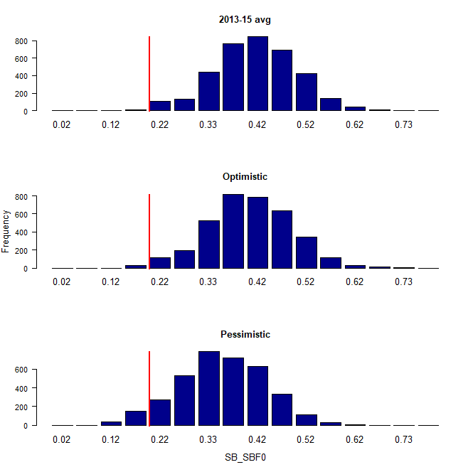 | 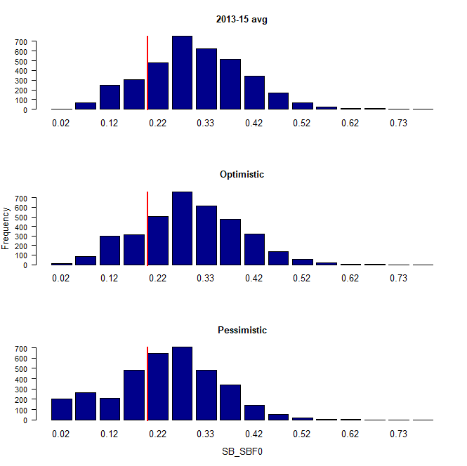
Figure BET-6. Distribution of SB₂₀₄₅/SB_{F=0} assuming recent and long term recruitment conditions (left and right columns, respectively), under the three future fishing scenarios: 2013-15 average (2013-15 average conditions, top row); optimistic conditions (middle row); and pessimistic conditions (bottom row). Projection results from ‘updated new growth’ models (3,600 projections) only where the red line indicates the LRP.

Recent recruitments | Long-term recruitment
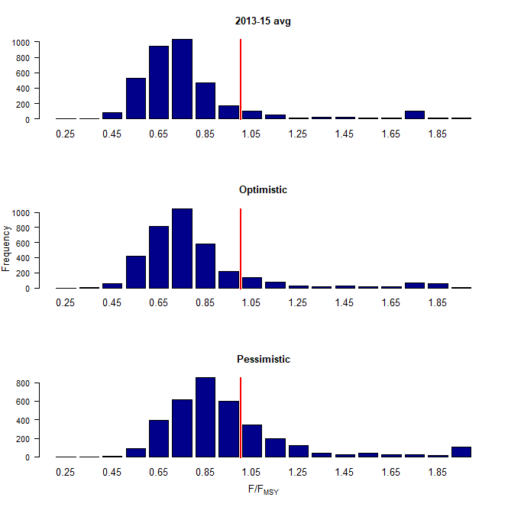 | 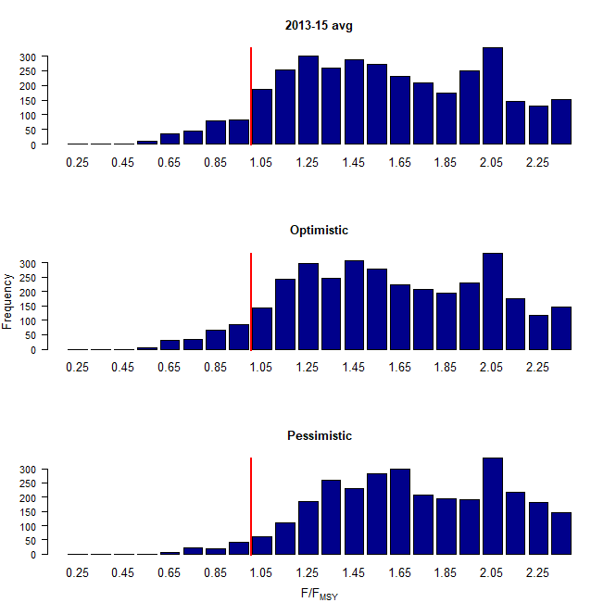
Figure BET-7. Distribution of F/F_{MSY} assuming recent and long term recruitment conditions (left and right columns, respectively), under the three future fishing scenarios: 2013-15 average (2013-15 average conditions, top row); optimistic conditions (middle row); and pessimistic conditions (bottom row). Projection results from ‘updated new growth’ models (3,600 projections) only.

Recent recruitments
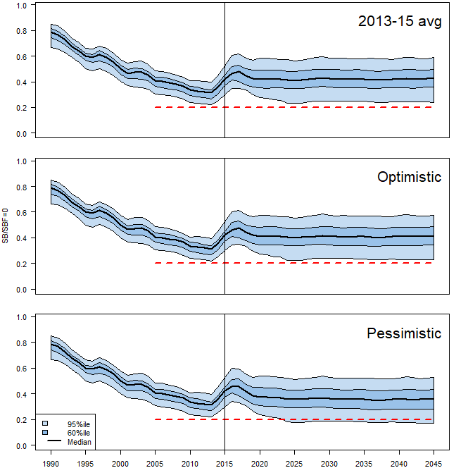
Long-term recruitment
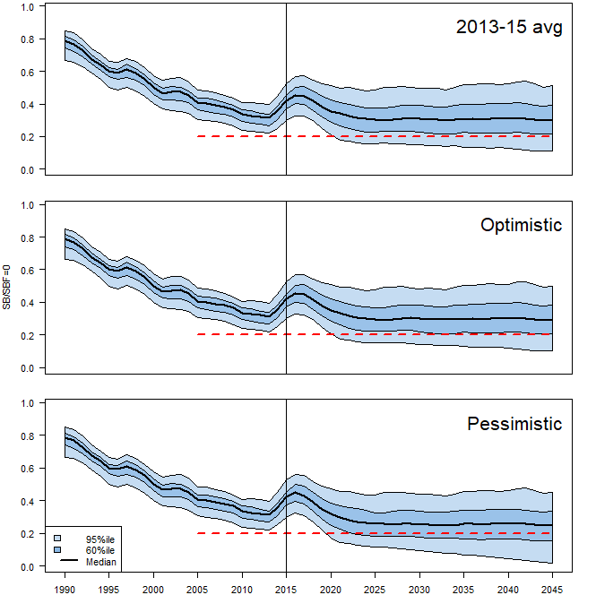

Figure BET-8. Time series of WCPO bigeye tuna spawning biomass (SB/SB_{F=0}) from the uncertainty grid of assessment model runs for the period 1990 to 2015 (the vertical line at 2015 represents the last year of the assessment), and stochastic projection results for the period 2016 to 2045 under the three future fishing scenarios (“2013-15 average”, “Optimistic” and “Pessimistic”; rows). During the projection period (2016-2045) levels of recruitment variability are assumed to match those over the “recent” time period (2005-2014; left panel) or the time period used to estimate the stock-recruitment relationship (1962-2014; right panel). The red dashed line represents the agreed limit reference point.

b. Management advice and implications

- SC14 noted that the preliminary estimate of total catch of WCPO bigeye tuna for 2017 was 126,929 mt, a 17% decrease from 2016 and a 19% decrease from the average 2012-2016. Longline catch in 2017 (58,164 mt) was an 8% decrease from 2016 and a 19% decrease from the 2012-2016 average. Purse seine catch in 2017 (56,194 mt) was a 12% decrease from 2016 and a 13% decrease from the 2012-2016 average. Pole and line catch (1,411 mt) was a 65% decrease from 2016 and a 70% decrease from the average 2012-2016 catch. Catch by other gear (11,160 mt) was a 48% decrease from 2016 and 28% decrease from the average catch in 2012-2016.

- Based on the uncertainty grid adopted by SC14, the WCPO bigeye tuna spawning biomass is above the biomass LRP and recent F is very likely below F_{MSY}. The stock is not experiencing overfishing (94% probability F<F_{MSY}) and it is not in an overfished condition (0% probability SB/SB_{F=0}<LRP).

- Although SC14 considers that the updated assessment is consistent with the previous assessment, SC14 also advises that the amount of uncertainty in the stock status results for the 2018 assessment update is lower than for the previous assessment due to the exclusion of old information on bigeye tuna growth.

- SC14 noted that levels of fishing mortality and depletion differ among regions, and that fishery impact was higher in the tropical region (Regions 3, 4, 7 and 8 in the stock assessment model), with particularly high fishing mortality on juvenile bigeye tuna in these regions. SC14 therefore recommends that WCPFC15 could continue to consider measures to reduce fishing mortality from fisheries that take juveniles, with the goal to increase bigeye fishery yields and reduce any further impacts on the spawning biomass for this stock in the tropical regions.

- SC14 noted that according to CMM 2017-01 bigeye tuna SB/SB_{F=0} is to be maintained above the 2012-2015 level (SB_{recent}/SB_{F=0} = 0.36; Table BET-3) pending the agreement on a TRP. SC14 also noted that the projection results based on scenarios estimating CMM 2017-01 indicated a high level of uncertainty on the levels of spawning stock biomass relative to the LRP and the objective of CMM 2017-01 in 2045. Under the scenario assuming long-term average recruitment continues into the future there was a high risk (18-32%) of breaching the LRPs and a zero probability of achieving the objective of CMM 2017-01, while under the scenario which assumes higher more recent recruitments continues into the future there was a low risk (0-5%) of breaching the LRPs and a 100% probability of achieving the objective of CMM 2017-01.

- However, SC14 also noted that the projections assume that longline catches would be maintained regardless of the decrease in biomass. This may result in unlikely high levels of effort. Therefore, the catch estimates under the long term recruitment scenario, especially in the longer term projections, are more uncertain.

- Based on these results, SC14 recommends that WCPFC15 takes note of the results of the projections in relation to achieving CMM 2017-01 and as a precautionary approach that the fishing mortality on bigeye tuna stock should not be increased from the recent average (2011-2014) level to maintain spawning biomass at or above the 2012-2015 average, until the Commission can articulate the management objectives and agree on an appropriate TRP for bigeye, although one CCM considers that SC14 could provide more options for the Commission to consider.

c. Research Recommendations

- SC14 noted that the acceptance of the updated new growth model for BET raises a number of issues in relation to patterns of growth and stock structure of BET across the Pacific Ocean and recommended that the following research issues need to be addressed:

- Two different growth models separated at 150˚W effectively means that Pacific BET should be assessed as a two-stock resource between the WCPO and EPO. However, catch information indicates that the fishing grounds near 150˚W are a core area of BET catch, thus influencing the assessments of both the WCPFC and IATTC. Also, tagging information suggests movement of BET between the WCPO and EPO. Therefore, the appropriateness off delineating the two stocks at 150˚W needs to be investigated.
- The updated new growth analysis suggests area variant growth across the Pacific. While the level of variation is seen to be relatively small within the WCPO (and possibly within the margins of observation error), there is a suggestion of substantial change in growth around the boundary between the WCPO and the EPO (c.f. Figure 14 in SC14-SA-WP-01). The reasons for this suggested change in growth remains unknown, but SC14 noted the utility of collecting more information from the regions either side of this boundary to inform a greater understanding of possible changes in growth around this area. While the incorporation of area-variant growth within the assessment model would also help explore this issue, SC14 noted the difficulty of this task.
- SC11 concluded that the stock status of WCPO BET from the Pan-Pacific assessment and the WCPO-only assessment were similar when the growth models were similar in the EPO and WCPO. This conclusion needs to be revisited in light of the different growth between EPO and WCPO by adopting the new growth.

- The following additional research activities were also recommended by SC14 in order to improve the understanding of the age and growth of BET across the Pacific:

- A WCPO growth model based on size composition and tagging data, as well as the use of additional modeling approaches (e.g., length-conditional), should also be evaluated.
- Collaboration with the IATTC to analyze bigeye growth from otolith and tagging data collected across the entire Pacific, to better characterize the apparent regional difference in growth between the WCPO and EPO, and possible environmental determinants of such differences.
- Analyzing the same otoliths by different laboratories, to build confidence in ageing estimates and to estimate ageing error.
- Continued development of a high-confidence tagging dataset for growth analysis, with particular focus on larger bigeye tuna and events with reliable measurements at release. Such data would assist with the validation of the age estimates of large bigeye in the WCPO, and could potentially be incorporated directly into the assessment model as an additional data set. However, a reliable measurement of both length at release and recapture are necessary to accurately estimate incremental growth.
- Collect otoliths of very small bigeye that are captured by the Indonesian, Vietnamese, and Philippines domestic fisheries in region 7 and estimate age through daily ring counts to aid in the estimation of the size at age-1 qtr⁻¹ parameter (L1) within the assessment model.

    - WCPO yellowfin tuna (Thunnus albacares)

      - Research and information

a. Yellowfin tuna age and growth in the WCPO

- J. Farley presented the progress on yellowfin tuna age and growth in the WCPO (SC14-SA-WP-13, WCPFC Project 82), which summarises the preliminary work undertaken to estimate the age and growth of yellowfin tuna in the WCPO (WCPFC Project 82). The project aims to develop ageing protocols for yellowfin tuna, create a reference otolith collection, and prepare and read 1500 otoliths for annual age estimation and 150 otoliths for daily age estimation. Forty yellowfin tuna were selected for preliminary analysis to determine if otoliths and/or dorsal fin spines were suitable for age estimation. Fish ranged in size from 30 to 172 cm fork length (FL). All otoliths were prepared and read by Fish Ageing Services (FAS). One otolith from each fish was prepared for annual ageing and the sister otoliths from 10 of the 40 fish was prepared for daily ageing. FAS also prepared 40 fin spines from the same fish for comparative ageing. The spines were examined by CSIRO.

- The results indicate that otoliths are a suitable structure for estimating annual age of yellowfin tuna with preliminary counts of opaque zones ranging from 0 to 13. The fin spines examined showed resorption and vascularisation leading to a “loss” of early increments, and were not suitable for annual age estimation beyond three years. However, they were useful to corroborate the location of the first three increments in sectioned otoliths. The daily ageing work found clear ‘daily’ zones could be detected along the ventral arm of otoliths out to the edge, even in very large fish. However, the areas with clear zone patterns were interspersed with areas that were difficult to interpret and did not show the “classic” daily zone structure, which is likely to lead to an underestimation of age. Therefore, we are not confident in age estimates beyond the first transition point (150-180 increments).

- A priority for the remainder of the project is to undertake an inter-lab daily ageing workshop to compare otolith preparation and reading methods between the eastern and western Pacific. This was also a recommendation of the SPC pre-assessment workshop in April 2018. A key activity will also be the analysis of two strontium marked otoliths and two otoliths from fish tagged (but not marked) for direct age validation. We will then finalise the selection, preparation and reading of otoliths (and some spines) for the project and undertake edge type and/or marginal increment analysis as indirect validation of age. It is anticipated that length at age data and preliminary growth parameters will be delivered to the SPC pre-assessment workshop in 2019.

Discussion

- RMI, on behalf of FFA members, thanked SPC for the update on Project 82, recognizing that more work was needed to improve age and growth estimates of WCPO yellowfin in different subregions. They supported the continuation of Project 82 in accordance the work plan set out in SC14-SA-WP-13, and the need for consistency of daily age estimation in laboratories across the WCPO. It is important, for purposes of spatial comparison and validation that SC support the inter-laboratory workshop agreed at the SPC Pre-assessment workshop, to compare otolith preparation and reading methods between the EPO and WPO. FFA members consider this project to be important because the results of new growth and age would improve new assessments, and help assess spatial differences in growth.

- The USA asked whether there were plans to validate the age reading methods by having multiple readers. J. Farley indicated she routinely read 10%; not many labs do annual aging, but she could investigate if recommended by SC.
- Federated States of Micronesia, on behalf of FFA members, thanked those who contributed to the collection and storage of samples in the Commission tissue bank, who made yellowfin otoliths available for use by the project, and who did the analyses.

- Korea inquired whether there was a plan to do age analysis between the EPO and WCPO as was done for bigeye. J. Farley replied that there were no plans to in the project to read otoliths from the EPO, but hoped they could compare the methods in the inter-lab aging workshop.

b. Indicator analysis

- S. Brouwer (SPC) presented SC14-SA-WP-02 A compendium of fisheries indicators for tuna stocks, which provided empirical information on recent patterns in fisheries. While the paper provided indicators for four tuna species (bigeye, skipjack, yellowfin and south Pacific albacore) the presentation concentrated on the indicators for yellowfin only. The indicators included: total catch by gear, nominal CPUE trends, spatial distribution of catch and associated trends, size composition of the catch and trends in average size. Stock projections were performed based upon the actual fishing levels by fleet in 2015 to 2019 based upon the assumption that levels of effort or catch would remain constant at 2015 levels. The yellowfin stock was initially projected to decline as recent estimated recruitments move through the stock, and then to recover in the longer term. Median F₂₀₁₉/F_{MSY} = 0.63; median SB₂₀₁₉/SB_{F=0} = 0.37.

      - Provision of scientific information

a. Stock status and trends

- SC14 noted that no stock assessment was conducted for WCPO yellowfin tuna in 2018. Therefore, the stock status description from SC13 is still current. For further information on the stock status and trends from SC13, please see https://www.wcpfc.int/node/29904

- SC14 noted that the total yellowfin catch in 2017 was a record 670,890 mt, a 4% increase from 2016 and a 12% increase from the average 2012-2016.

- Purse seine catch in 2017 (472,279 mt) was a 22% increase from 2016 and a 33% increase from the 2012-2016 average. Longline catch in 2017 (83,399 mt) was a 6% decrease from 2016 and a 9% decrease from the 2012-2016 average. Pole and line catch (12,219 mt) was a 48% decrease from 2016 and a 56% decrease from the average 2012-2016 catch. Catch by other gear (102,993 mt) was a 28% decrease from 2016 and 17% decrease from the average catch in 2012-2016.

- SC14 noted that under recent fishery conditions, the yellowfin stock was initially projected to increase as recent estimated relatively high recruitments support adult stock biomass, and then decline slightly. Median F₂₀₁₉/F_{MSY} = 0.63; median SB₂₀₁₉/SB_{F=0} = 0.37; median SB₂₀₁₉/SB_{MSY} = 1.51. Risk that SB₂₀₁₉ < LRP = 6%.

b. Management advice and implications

- SC14 noted that no stock assessment has been conducted since SC13. Therefore, the advice from SC13 should be maintained to achieve the objectives set in CMM 2017-01, pending a new assessment or other new information. For further information on the management advice and implications from SC13, please see https://www.wcpfc.int/node/29904

c. Research recommendations

- SC14 reviewed the work on age and growth of yellowfin tuna presented in SC14-SA-WP-13 and noted that the final results of this projected will be presented to SC15. SC14 encouraged analysis of the same otoliths by different laboratories, to build confidence in ageing estimates through inter laboratory daily-annual age workshop.

    - WCPO skipjack tuna (Katsuwonus pelamis)

      - Research and information

a. Update of skipjack tuna stock assessment information

- S. Brouwer (SPC) presented SC14-SA-WP-02 A compendium of fisheries indicators for tuna stocks, which provided empirical information on recent patterns in fisheries. While the paper provided indicators for four tuna species (bigeye, skipjack, yellowfin and south Pacific albacore) the presentation concentrated on the indicators for skipjack only. The indicators included: total catch by gear, nominal CPUE trends, spatial distribution of catch and associated trends, size composition of the catch and trends in average size. Stock projections were performed based upon the actual fishing levels by fleet in 2015 to 2019 based upon the assumption that levels of effort or catch would remain constant at 2015 levels. The skipjack stock was initially projected to decline as recent estimated recruitments move through the stock, and then to recover in the longer term. Median F₂₀₁₉/F_{MSY} = 0.47; median SB₂₀₁₉/SB_{F=0} = 0.45.

Discussion

- Indonesia asked whether CPUE data for skipjack and yellowfin tuna from the 1970s could be added to inform the catch history. SPC stated they would look at data quality and availability to see whether extending the analysis into the 1970s was feasible.

- Japan referenced CPUE, noting the link identified by SPC with ENSO, but observing that CPUEs for anchored FADs were declining, and asked whether SPC could present CPUE data over a longer (10 or 20 year) to allow comparison over a larger time span. SPC noted that this could be done, with the caveat that there were limits to how much was worthwhile exploring for this report.

- In response to an inquiry from Australia regarding changes in the Japanese pole and line fishery and use of data from that fishery for stock assessments, SPC noted it was increasingly relying on tagging as a data source. Solomon Islands, on behalf of FFA members, thanked SPC for the update on fisheries indicators for skipjack, noting that effort in the pole and line sector had continued to decline and accounted for just 6% of the total skipjack catch in 2017. Given that this was the main CPUE data series used as an indicator of abundance in the stock assessment, they strongly supported an ongoing tagging program for skipjack tuna. FFA members stated they consider it a priority for the Commission to ensure that a reliable index of abundance for skipjack tuna can be maintained, and recommended this be maintained in the research budget. In addition, FFA members supported ongoing research by SPC on standardising purse seine CPUE for use in the assessment. While it’s unlikely to be available for the 2019 assessment, purse seine CPUE analysis may at some stage in future provide a useful index for the assessment model.

- Nauru, on behalf of the PNA noted their management strategy in PNA and in the WCPFC through the TRP was based on maintaining high catch rates to support vessel profitability, with any decline in catch rates of concern. The 2017 nominal decline was largely masked by the increased catch and value of yellowfin, but bears close monitoring. PNA expressed concern about SPC’s continued warnings that the ongoing decline in the pole and line fishery is compromising the skipjack stock assessment. The response to date has been to rely more heavily on tagging information as an index of abundance and the PNA thanked SPC for their work on this. However, they noted that despite generous contributions from several CCMs and organisations, the future of this work was uncertain due to growing costs, inconsistent funding and availability of tagging vessels. PNA suggested these issues should be clearly spelled out in the management advice from SC14 to WCPFC15, in addition to supporting ongoing research on standardized purse seine CPUE.

- H. Kiyofuji presented SC14-SA-WP-04. Improvements in skipjack (Katsuwonus pelamis) abundance index based on the fish size data from Japanese pole-and-line logbook (1972–2017). Rev 1, which examines fisheries area definition of skipjack tuna in the western and central Pacific Ocean.

- To clarify area definition for CPUE standardization, the authors addressed model-based cluster analysis using average fish weight and CPUE recorded on Japanese pole-and-line logbook. The logbook data includes the daily skipjack catch per vessel by 1°×1° resolution from 1972 to 2017. Catch and mean body weight larger than 0 were aggregated into 5°×5° resolution, and then extracted in grids with more than 10 vessels-day operations. The model was constructed with the average body weight and nominal log CPUE as response variables and with year, quarter, and gross register tonnage of fishing vessel as explanatory variables. As a result of the model, five clusters were selected by the minimum Bayesian information criterion (BIC) and showed unique characteristics to the size composition and differences of operation mode on each cluster. One of the major achievements of our study is the result of area clustering analysis matches better the area definition suggested by Kiyofuji and Ochi (SC12-SA-IP-09) based on tagging and larvae survey than that of reference case. This result suggests that biological information such as body weight will provide useful evidence for determining the stock assessment fisheries definition. The authors recommended that SC14 consider a new area definition as proposed in the document as the reference case of spatial stratification in the next skipjack stock assessment.

Discussion

- Indonesia inquired whether a comparison had been made of the potential impact of regional classifications on stock status J. Kinoshita indicated the last stock assessment was largely similar. SPC indicated results had not been compared with tagging data. SPC queried whether tagging data were available to support estimates of movement among finer-scale northern regions. They noted that the skipjack stock assessment model was used to estimate regional - rather than local - stock status, and that tuna assessments need an appropriate spatial resolution to capture stock and fishery characteristics. SPC noted that if one region generated only 5% of catch further division of this region could cause problems in future assessments. J. Kinoshita noted they addressed skipjack movement and distribution based on size data, and acknowledged concerns regarding spatial structure and assessments. Australia noted it was useful to define spatial regions for stock assessments on biological grounds and not management grounds. He noted there was scope to do something with the skipjack assessment, and acknowledged SPC’s observations regarding the skipjack stock assessment.

- SPC queried the approach taken to the selection of clusters, and the resulting impact on proposed region structure. H. Kiyofuji confirmed that there were various ways to decide the number of clusters, and stated they would try to use other factors than BIC and consider these for future work. He confirmed the number of clusters impacted the area definition. In response to a query by Indonesia, the author stated environmental conditions (ocean current) could be considered when deciding on clusters.

- Japan noted that the proposed recommendation for SC was that a new regional structure be used for the next assessment, and proposed that the method be evaluated in the next assessment workshop. They noted that a graph of the number of clusters showed little difference, but BIC values were very different among groups, and suggested it was best to confirm that this was the best fit.

      - Provision of scientific information

          - Stock status and trends

- SC14 noted that the total catch in 2017 was 1,624,162 mt, a 9% decrease from 2016 and comparable to the average from 2012-2016.

- Purse seine catch in 2017 (1,280,311 mt) was a 7% decrease from 2016 and a 12% decrease from the 2012-2016 average. Pole and line catch (123,132 mt) was a 21% decrease from 2016 and a 23% decrease from the average 2012-2016 catch. Catch by other gear (218,175 mt) was a 13% decrease from 2016 and 1% decrease from the average catch in 2012-2016.

- SC14 noted that under recent fishery conditions (2017 catch level for longline and other fisheries and effort level for purse seine), the skipjack stock was initially projected to decrease for a short period as recent relatively high recruitments move out of the stock. Median F₂₀₁₉/F_{MSY} = 0.47; median SB₂₀₁₉/SB_{F=0} = 0.45; median SB₂₀₁₉/SB_{MSY} = 1.67. In the longer term, assuming long term average recruitment, modest increases in the stock were projected.

  - Management advice and implications

- SC14 noted that no stock assessment has been conducted since SC12. Therefore, the advice from SC12 should be maintained to achieve the objectives set in CMM 2017-01, pending a new assessment or other new information. For further information on the management advice and implications from SC12, please see https://www.wcpfc.int/node/27769

  - Research Recommendations

- SC14 discussed a proposal for an alternative regional structure to be considered in the next skipjack stock assessment (SC14-SA-WP-04) and recommended that the pre-assessment workshop consider how this proposal might be included in the next assessment.

- SC14 supports an ongoing tagging program for skipjack tuna to ensure a reliable indicator of skipjack tuna abundance in the stock assessment.

- SC14 recommended that the Scientific Services Provider continue research on standardizing purse seine CPUE for use in the assessment.

    - South Pacific albacore tuna (Thunnus alalunga)

      - Research and information

          - Trends in the South Pacific albacore longline and troll fisheries

- S. Brouwer (SPC) presented SC14-SA-WP-02 A compendium of fisheries indicators for tuna stocks, which provided empirical information on recent patterns in fisheries. While the paper provided indicators for four tuna species (bigeye, skipjack, yellowfin and south Pacific albacore) the presentation concentrated on the indicators for albacore only. The indicators included: total catch by gear, nominal CPUE trends, spatial distribution of catch and associated trends, size composition of the catch and trends in average size. Stock projections were not performed for albacore.

- The theme convener noted that there were no projections for South Pacific albacore. In response to a query from the USA, SPC stated that they could provide a composite CPUE time series for Pacific Island fleets in future compendiums of fisheries indicators.

- ISSF stated that in relation to the stock status of Southern Pacific albacore, it wanted to reiterate what was noted during the 2018 Pre-assessment Workshop: The workshop noted that considerable catch of albacore had been taken in the southern IATTC region (which may include the overlap area) in recent years. As this catch is outside the current model region, there is potential merit in returning to the south Pacific-wide model structure in the longer term. The workshop recommended that, in the future, expansion of (new) regions 4 and 5 into the EPO could be considered. In addition, ISSF noted that the document that the IATTC produces annually giving an overview of the EPO fisheries, under the South Pacific albacore section, describes the stock assessments conducted by SPC. This information could be misinterpreted, as only the WCPO area is considered in assessments since 2015. In summary, ISSF believes it is important to emphasize this issue and therefore suggest that the stock status section for South Pacific albacore in the SC14 report includes a clear reference to what proportion of EPO catches are currently included in the assessment.

- SPC noted that their publications clearly delineated the stock assessment was conducted for the WCPO, and that they had ceased doing pan-Pacific assessments to focus on advice regarding the WCPO.

    - South Pacific albacore tuna stock assessment
- L. Tremblay-Boyer (SPC) presented SC14-SA-WP-05 Stock assessment of South Pacific albacore tuna (Thunnus alalunga) with reference to SA-IP-07 Background analyses for the 2018 stock assessment of south Pacific albacore.

- An additional 3 years of data were available since the previous stock assessment was conducted in 2015, and the model time period extends to the end of 2016. Further developments to the stock assessment were undertaken to address the recommendations of the 2015 stock assessment report (SC11-SA-WP-06) and of the 2018 pre-assessment workshop (SC14-SA-IP-01). Additional uncertainties were explored in the assessment model, particularly in response to the inclusion of additional years of data, and to improve diagnostic weaknesses in previous assessments. The assessment is supported by the analysis of longline CPUE data, background analyses of other data inputs and definition of the regional and fisheries structures for the updated assessment (SC14-SA-IP-07).

- Key changes made in the progression from the 2015 reference case to the 2018 diagnostic case model include:
- Updating all data up to the end of 2016.
- Utilising standardised CPUE indices calculated from the recently collated operational longline CPUE data set, including historical Japanese longline data within the CPUE which were not available in 2015, and treating targeting cluster as a covariate (rather than filtering the data to only include albacore targeting clusters).
- Moving to a simplified regional structure (2018 region structure).
- Moving from the traditional CPUE standardized index to one based upon a geostatistical model.
- Applying the CPUE standardized index to an ‘index fishery’ in each region.

- In addition to the diagnostic case model, L. Tremblay-Boyer reported the results of one-off sensitivity models to explore the relative impacts of key data and model assumptions for the diagnostic case model on the stock assessment results and conclusions. A structural uncertainty analysis (model grid) for consideration in developing management advice was also undertaken, where all possible combinations of the most important axes of uncertainty from the one-off models were included. It was recommended that management advice should be formulated from the results of the structural uncertainty grid.

- Across the range of models run in this assessment, the most important factors when evaluating stock status were the assumed level of natural mortality, and growth. For natural mortality, age invariant M values of 0.3 yr⁻¹ (consistent with the 2015 assessment) and 0.4 yr⁻¹ were assumed, with the latter resulting in more optimistic assessment outcomes. Age-dependent M settings were also evaluated as one-off sensitivities. Natural mortality remains a key uncertainty in this assessment, and it is appropriate that such uncertainty continue to be reflected in the overall stock assessment results. For growth, the conditional age-at-length data from recent work was incorporated into the diagnostic case model, while an alternative scenario fixed at the parameter values of the sex combined ‘Chen-Wells’ growth model used within the 2017 North Pacific albacore reference case model run was also evaluated. Use of the latter resulted in more pessimistic assessment outcomes. There remains an unresolved inconsistency in the growth rates indicated by the VB curve fitted to the age-at-length data (approximately 20 cm per year for albacore 20-70 cm in length) and presumed annual modes with 10 cm spacing that consistently appear in the troll size composition data, and historically in the driftnet size composition data. It was noted that additional analysis of otoliths taken from 50-70 cm albacore in the troll fishery is required to identify the reason for this inconsistency.

- The general conclusions of this assessment are as follows:
- While biomass is estimated to have declined initially, estimates of spawning potential, and biomass vulnerable to the various longline fisheries, have been stable or possibly increasing slightly over the past 20 years. This has been influenced mainly by the estimated recruitment, which has generally been somewhat higher since 2000 than in the two decades previous.
- Most models also estimate an increase in spawning and longline vulnerable biomass since about 2011, driven by some high estimated recruitments, particularly around 2009.
- A steady increase in fishing mortality of adult age-classes is estimated to have occurred over most of the assessment period, accelerating since the 1990s but declining following the decline in longline catch seen since 2010. Juvenile fishing mortality increased until around 1990, and has remained stable at a low level since that time.
- Key stock assessment results across all models in the structural uncertainty grid show a wide
range of estimates.
- All models indicate that South Pacific albacore is above the limit reference point (of 0.2SB_{F =0}), with overall median depletion for 2016 (SB_{latest}/SB_{F=0}) estimated at 0.52 (80 percentile range 0.37-0.69).
- Recent average fishing mortality is estimated to be well below F_{MSY} (median F_{recent}/F_{MSY} =0.2, 80 percentile range 0.08-0.41).
- A number of key research needs have been identified in undertaking this assessment that should be investigated either internally or through directed research. These include: the analysis of otoliths from individuals within the presumed annual modes seen in the troll data; the exploration of alternatives to the Von Bertalanffy model when modelling albacore growth within MULTIFAN-CL; studies on albacore size-related vulnerability to longline fishing; further development of the geostatistical analysis of operational-level CPUE data; and further development of relevant MULTIFAN-CL functionalities.

Discussion

- In response to a query from New Zealand, L. Tremblay-Boyer stated that the Chen Wells growth curves in the Growth Curves/Data Points slide (#55) used data points from the South Pacific albacore, while the curve was an Age/Length curve based on data from North Pacific albacore. New Zealand state they would undertake to provide otolith samples from their fishery or archive to inform the model.

- Samoa, on behalf of FFA members noted the optimistic outcome of the assessment compared to the 2015 stock assessment, and emphasized the need to restore catch rates to a level that would ensure the viability of our domestic fleets. Vulnerable biomass can be viewed as a proxy for CPUE, and seems to have improved in the last few years of the assessment period. However, they acknowledged that data used in the assessment were updated through 2016, and in 2017 there was increased effort exerted in the fishery; as indicated in the presentation on economic conditions, periodic recovery appears to be followed by sustained reductions in catch rates. Peaks appear to be getting lower and troughs deeper. Samoa stated that to consider the outcomes of the stock assessment presented and formulate management advice for South Pacific albacore, additional information on the projected vulnerable biomass depletion level through 2038, using 2013 as a point of comparison, would be useful. They also stated that their preference was to use the full suite of the uncertainty grid (72 model runs) for unless a strong case could be made for dropping one of the grid options.

- The USA noted there were a number of fleets in each model region, with varying effort, targeting, etc., but the statistical model had just 1 or 2 covariates, and asked if this allowed for controlling effects other than change in stock size. L. Tremblay-Boyer noted that Pacific-wide data sets traded access to more covariates for greater spatial and temporal coverage. More covariates could be used if correlated with catchability, but that would mean CPUE is restricted to a few fleets or a few areas. SPC felt that good time and spatial coverage were most important to the assessment.

- China noted the last assessment was for 8 regions, while this used 5, and asked what the criterion was for defining regions, and whether 20° S was used. L. Tremblay-Boyer responded that the regions were based on availability of data regarding how fish move between regions. For the old structure, north-south movement was reasonably well defined, but little information was available regarding east–west movement. Multiple regions were not supported by the data. Regional configurations were chosen to be consistent with the biological and size/CPUE information, not a management boundary.

- Australia inquired regarding differences in region 2 between the two models. L. Tremblay-Boyer noted these were driven primarily by the model scope: the geostatistical model covers the entire model region, while the traditional model is region-specific. Patterns are driven by whichever region has the most information. The lack of good CPUE coverage in early years means the traditional CPUE has a lot of data discarded because of missing information, while the geostatistical model can use the trends observed in regions with more data to estimate the abundance in areas with less data. In response to a query from the EU regarding trends in biomass between regions being similar, L. Tremblay-Boyer indicated this was driven by the geostatistical model being for the entire area, and not region-specific. The EU noted that some patterns in growth appeared difficult to capture in the model, and that the likelihood profile displayed some influence of size data, and asked if the use of self-scaling of size data was explored. SPC indicated more work was needed to understand the growth of albacore; a big challenge is using regional growth instead of constant growth for all areas, while it is likely there are different growth rates by region for many species. The intention is to use self-scaling size data and the feature is under development for Multifan-CL. The assumption of high mixing is reflected in what is known about the data, and it seemed reasonable to use the region-wide geostatistical model, which does influence the similar trends by region.

- Chinese Taipei observed that for the CPUE analysis, all fleet data were combined but vessel ID wasn’t included, although it is known that joint CPUE differs from what is observed in individual fleet behavior. Given that the diagnostics of the geostatistical model are not fully explored, they asked why this was this used as the input of the assessment model diagnostic case. SPC replied that the geostatistical model results made sense because it is known that areas in proximity are more similar than areas further apart; this is not assumed in traditional CPUE standardizations. Some covariates had convergence issues, but the index used in the diagnostic case converged well. Geostatistical modelling allows modelling of the entire region, and can be analyzed by blocks if needed. The vessel ID was not included because of missing vessel information in the early years of the time series; including a missing vessel ID effect artificially inflated the CPUE for the early time series because the vessels also targeted bigeye tuna, yellowfin, and south Pacific albacore. The spatial and temporal coverage of the geostatistical approach was quite good.

- Japan noted that comparisons to the LRP and TRP needed to be careful to include total biomass and relative biomass.

- USA noted that the component likelihood profile suggested that the estimated population scale was informed by and largely corresponded to the abundance indices, meaning it was important to get these correct. There was a three-fold increase in the longline catch of SPALB in about 2000, especially in Region 2. Unless there was a corresponding increase in recruitment, one would expect a decline in the longline CPUE during this period. There are signs of the nominal CPUE decrease during this period — Figure 5 in SC14-SA-IP-08 (Chinese-Taipei nominal longline CPUE, which had the largest catch of SPALB until the advent of the China longline fleet), and Figure 60 & 61 in SC14-SA-IP-07 (Region 2), but the standardized index suggests a flat or increasing index during the period. This may be due to the way the index is being plotted (log-scale would have been better to show proportional declines at low levels). In Fig 18 of SC14-SA-WP-05, there is also some evidence of misfit to the Region 2 index after 2000, suggesting that the model expects a lower longline CPUE in Region 2 than is observed (Fig. 17 of SC14-SA-WP-05). Since there is no major decline in the adult indices after 2000, the model interpreted the increased catch as being due to increased recruitment during this period (Fig. 32 in SC14-SA-WP-05). The USA then asked whether there is evidence of increased recruitment based on the observations from the fisheries targeting juvenile SPALB in the temperate waters (Regions 3 & 5). The relative lack of fisheries targeting juvenile SPALB makes it difficult to answer this question. But the troll nominal CPUEs (Fig 7 in SC14-SA-IP-08) suggest that there has been no major increase in the recruitment of SPALB after 2000, although the New Zealand troll fishery only fishes in a limited area. In response, SPC noted that the standardization may not fully capture the true abundance trends. The New Zealand troll fishery is hard to standardize so it could not be used as a recruitment index.

- French Polynesia commented on the conclusions of the assessment, noting it was a good opportunity in the quite optimistic context of the new assessment to dedicate time during SC14 to long-term topics such as harvest strategy issues such as TRP. They stated SC should be mindful that people living in SIDS and territories rely on economically viable South Pacific albacore fisheries, and should be cautious about the optimistic current biological state when SC provides management advice.

- Australia noted there were many otoliths from small albacore from New Zealand and many had been aged, and thus additional samples could be included in the growth curve for the next assessment. They stated that a way to account for the deep-water and Pacific Islands vessels was including a flag covariate into the CPUE standardization. Also, the use of time-blocks in the CPUE standardization might allow for use of more covariates, when these are available.

      - Provision of scientific information

- SC14 accepted as SC14-SA-WP-05 as providing the best available scientific information for the purpose of stock assessment determination.

          - Stock status and trends

- The median, 10 percentile and 90 percentile values of recent (2013-2016) spawning biomass ratio (SB_{recent}/ SB_{F=0}) and recent fishing mortality in relation to F_{MSY} (F_{recent}/F_{MSY}) over the structural uncertainty grid were used to characterize uncertainty and describe the stock status.

- A description of the structural sensitivity grid used to characterize uncertainty in the assessment is set out in Table SPA-1. The regional structure used within the assessment is presented in Figure SPA-1, and the time series of total annual catch by fishing gear for the diagnostic case model over the full assessment period is shown in Figure SPA-2 for the total assessment region, and Figure SPA-3 by model region. Estimated annual average recruitment, spawning potential, juvenile and adult fishing mortality and fishing depletion for the diagnostic case model are shown in Figures SPA-4 – SPA-7. Figure SPA-8 displays Majuro plots summarising the results for each of the models in the structural uncertainty grid, while Figure SPA-9 shows equivalent Kobe plots for SB_{recent} and SB_{latest} across the structural uncertainty grid. Figure SPA-10 provides estimates of reduction in spawning potential due to fishing by region, and over all regions attributed to various fishery groups (gear-types) for the diagnostic case model. Table SPA-2 provides a summary of reference points over the 72 models in the structural uncertainty grid. Figure SPA-11 presents the history of the annual estimates of MSY for the diagnostic case model, compared with annual catch by the main gear types. Finally, Figure SPA-12 presents the estimated time-series (or ‘dynamic’) Kobe plots for four example models from the assessment (one from each of the combinations of growth types, and natural mortality M set to 0.3 or 0.4)

- SC14 noted that the median level of spawning biomass depletion from the uncertainty grid was SB_{recent}/SB_{F=0} = 0.52 with a probable range of 0.37 to 0.63 (80% probability interval). There were no individual models where (SB_{recent}/SB_{F=0}) < 0.2 which indicated that the probability that recent spawning biomass was below the LRP was zero. SC14 noted that the grid median F_{recent}/F_{MSY} was 0.20, with a range of 0.08 to 0.41 (80% probability interval) and that no values of F_{recent}/F_{MSY} in the grid exceeded 1.

- SC14 also noted that there was a 0% probability (0 out of 72 models) that the recent fishing mortality had exceeded F_{MSY}.

- SC14 noted that the structural uncertainty grid for the south Pacific albacore had changed since the 2015 assessment, with the 2018 assessment examining additional axes of uncertainty including assumptions on growth and CPUE standardization approach. As a consequence, the uncertainty identified is higher than in previous assessments.

- SC14 also noted that the assessment results show that while the stock depletion (SB/SB_{F=0}) has exhibited a long-term decline (Figure SPA-7) the stock is not in an overfished state and overfishing is not taking place.

    - Management Advice and implications

- SC14 noted that the preliminary estimate of total catch of south Pacific albacore (within the WCPFC Convention Area south of the equator) for 2017 was 75,707mt, which was a 33% increase from 2016 and a 13% increase over 2012-2016. (see SC14-SA-WP-02).

- Preliminary catch for longliners in 2017 (72,785mt) was 34% higher compared with 2016 and a 14% increase over 2012-2016. Preliminary other gear (primarily troll) catch in 2017 (2,896t) was 17% higher compared with 2016 but a 1% decrease over 2012-2016. (see SC14-SA-WP-02).

- Based on the uncertainty grid adopted by SC14, the South Pacific albacore tuna spawning biomass is very likely to be above the biomass LRP and recent F is very likely below F_{MSY}, and therefore the stock is not experiencing overfishing (100% probability F < F_{MSY}) and is not in an overfished condition (100% probability SB_{recent} > LRP).

- SC14 recalled its previous advice from SC11, SC12, and SC13 that longline fishing mortality and longline catch be reduced to avoid decline in the vulnerable biomass so that economically viable catch rates can be maintained, especially for longline catch of adult albacore. SC14 recommends that this advice be taken into consideration when the TRP for South Pacific albacore is discussed at WCPFC15.

Table SPA-1. Description of the structural sensitivity grid used to characterize uncertainty in the 2018 south Pacific albacore assessment. Levels used within the diagnostic case are starred.
Axis | Levels | Option
Steepness | 3 | 0.65, 0.80*, 0.95
Natural mortality | 2 | 0.3*, 0.4
Growth | 2 | Estimated* (K, L∞) or fixed (Chen-Wells)
Size frequency weighting | 3 | Sample sizes divided by 20, 50* or 80
CPUE | 2 | Geostatistical*, Traditional

Table SPA-2. Summary of reference points over all the 72 individual models in the structural uncertainty grid.
 | Mean | Median | Min | 10% | 90% | Max
C_{latest} | 61719 | 61635 | 60669 | 60833 | 62704 | 63180
MSY | 100074 | 98080 | 65040 | 70856 | 130220 | 162000
YF_{recentt} | 71579 | 71780 | 56680 | 62480 | 80432 | 89000
fmult | 6.2 | 4.96 | 1.89 | 2.44 | 12.05 | 17.18
F_{MSY} | 0.07 | 0.07 | 0.05 | 0.05 | 0.09 | 0.1
F_{recent}/F_{MSY} | 0.23 | 0.2 | 0.06 | 0.08 | 0.41 | 0.53
SB_{MSY} | 71407 | 68650 | 26760 | 39872 | 100773 | 134000
SB₀ | 443794 | 439800 | 308800 | 353870 | 510530 | 696200
SB_{MSY}/SB₀ | 0.16 | 0.17 | 0.07 | 0.1 | 0.21 | 0.23
SB_{F=0} | 469004 | 462633 | 380092 | 407792 | 534040 | 620000
SB_{MSY}/SB_{F=0} | 0.15 | 0.15 | 0.06 | 0.09 | 0.2 | 0.22
SB_{latest}/SB₀ | 0.55 | 0.56 | 0.33 | 0.42 | 0.69 | 0.74
SB_{latest}/SB_{F=0} | 0.53 | 0.52 | 0.3 | 0.37 | 0.69 | 0.77
SB_{latest}/SB_{MSY} | 4 | 3.42 | 1.45 | 1.96 | 7.07 | 10.74
SB_{recent}/SB_{F=0} | 0.51 | 0.52 | 0.32 | 0.37 | 0.63 | 0.72
SB_{recent}/SB_{MSY} | 3.88 | 3.3 | 1.58 | 1.96 | 6.56 | 9.67
Figure SPA- 13. The geographical area covered by the stock assessment and the boundaries for the 5 regions under the “updated 2018 regional structure".
Figure SPA- 14. Time series of total annual catch (1000’s mt) by fishing gear for the diagnostic case model over the full assessment period. The different colours refer to longline (green), troll (yellow) and driftnet (turquoise). Note that the catch by longline gear has been converted into catch-in-weight from catch-in-numbers.
Figure SPA-15. Time series of total annual catch (1000’s mt) by fishing gear and assessment region from the diagnostic case model over the full assessment period. The different colours denote longline (green), driftnet (turquoise) and troll (yellow).
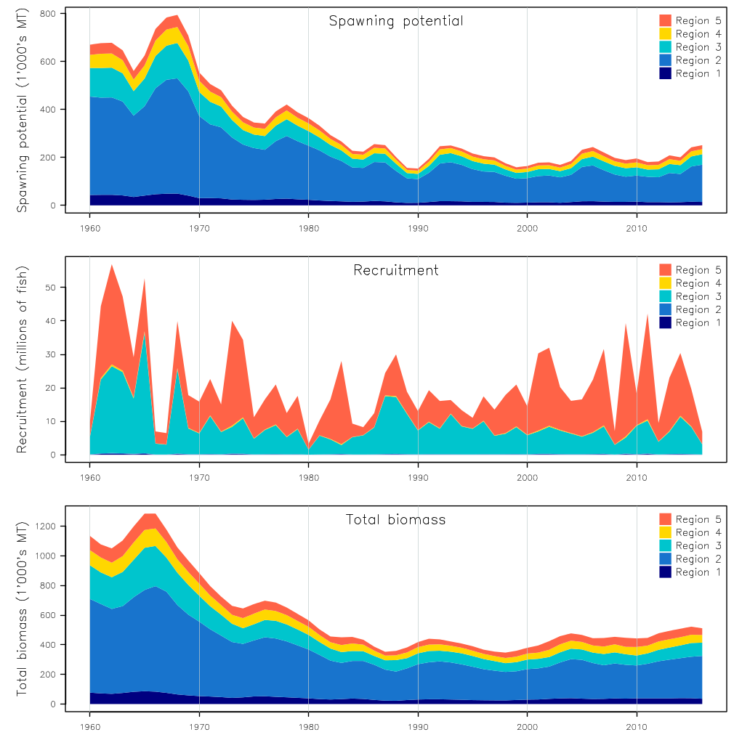
Figure SPA-16. Estimated annual average recruitment, spawning potential and total biomass by model region for the diagnostic case model, showing the relative sizes among regions.

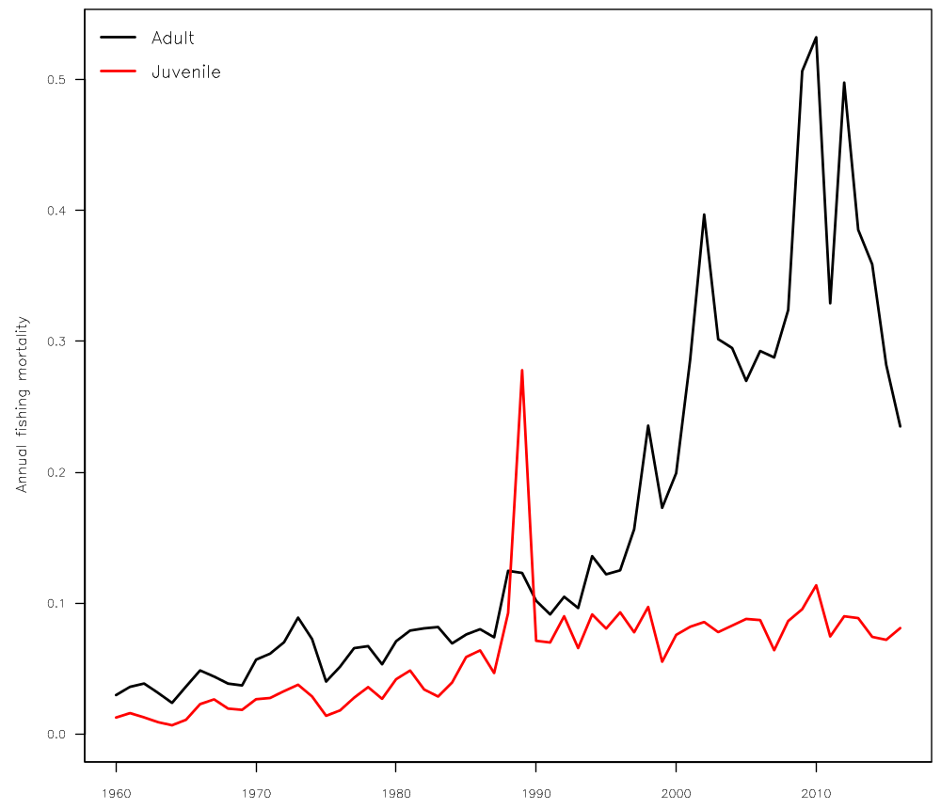
Figure SPA-17. Estimated annual average juvenile and adult fishing mortality for the diagnostic case model.

Figure SPA-18. Distribution of time series depletion estimates across the structural uncertainty grid. Black line represents the grid median trajectory, dark grey region represents the 50%ile range, light grey the 90%ile range.
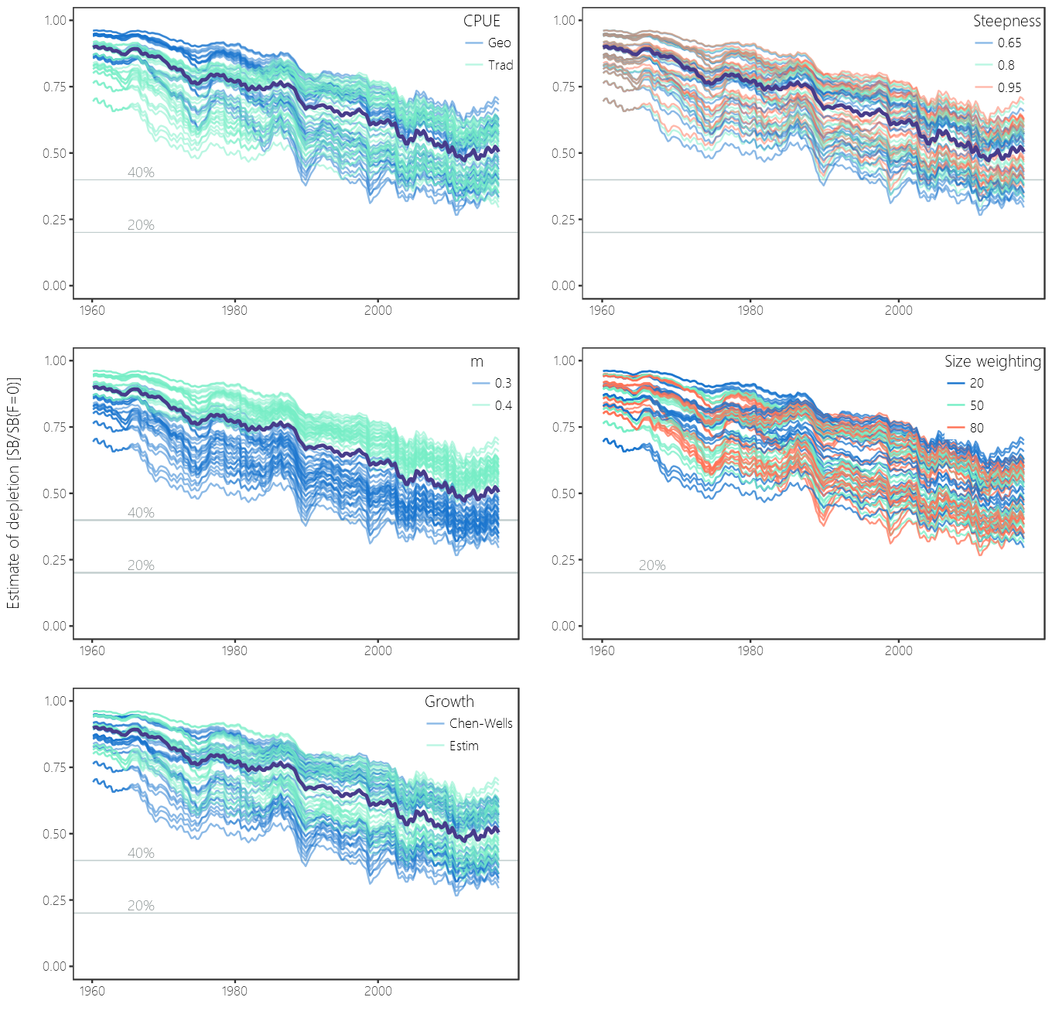
Figure SPA-19. Plots showing the trajectories of fishing depletion (of spawning potential) for the model runs included in the structural uncertainty grid. The five panels show the models separated on the basis of the five axes used in the grid, with the colour denoting the level within the axes for each model.

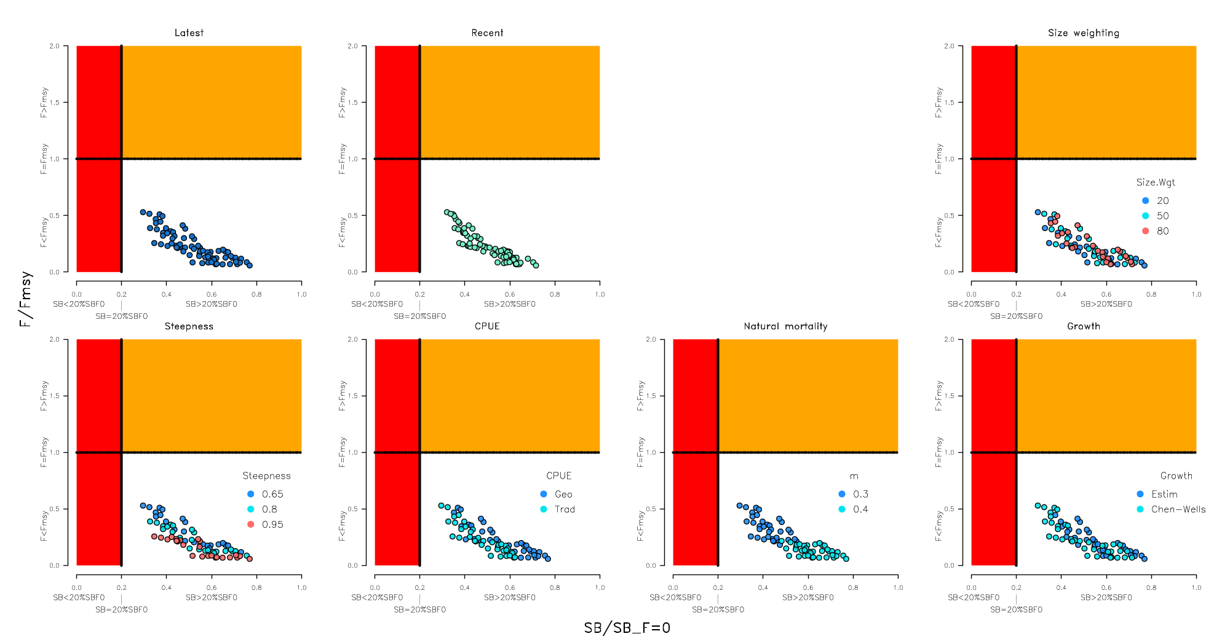
Figure SPA-20. Majuro plots summarising the results for each of the models in the structural uncertainty grid under the SB_{latest}/SB_{F=0} and the SB_{recent}/SB_{F=0} reference points (top left) and each axis of uncertainty.

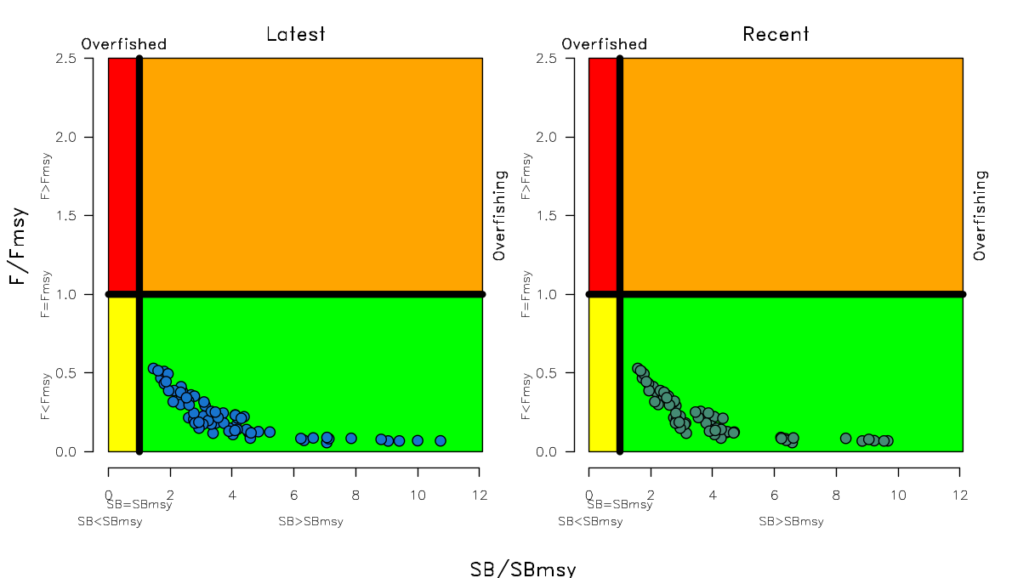
Figure SPA-21. Kobe plots summarising the results for each of the models in the structural uncertainty grid under the SB_{latest}/SB_{F=0} and the SB_{recent}/SB_{F=0} reference points.

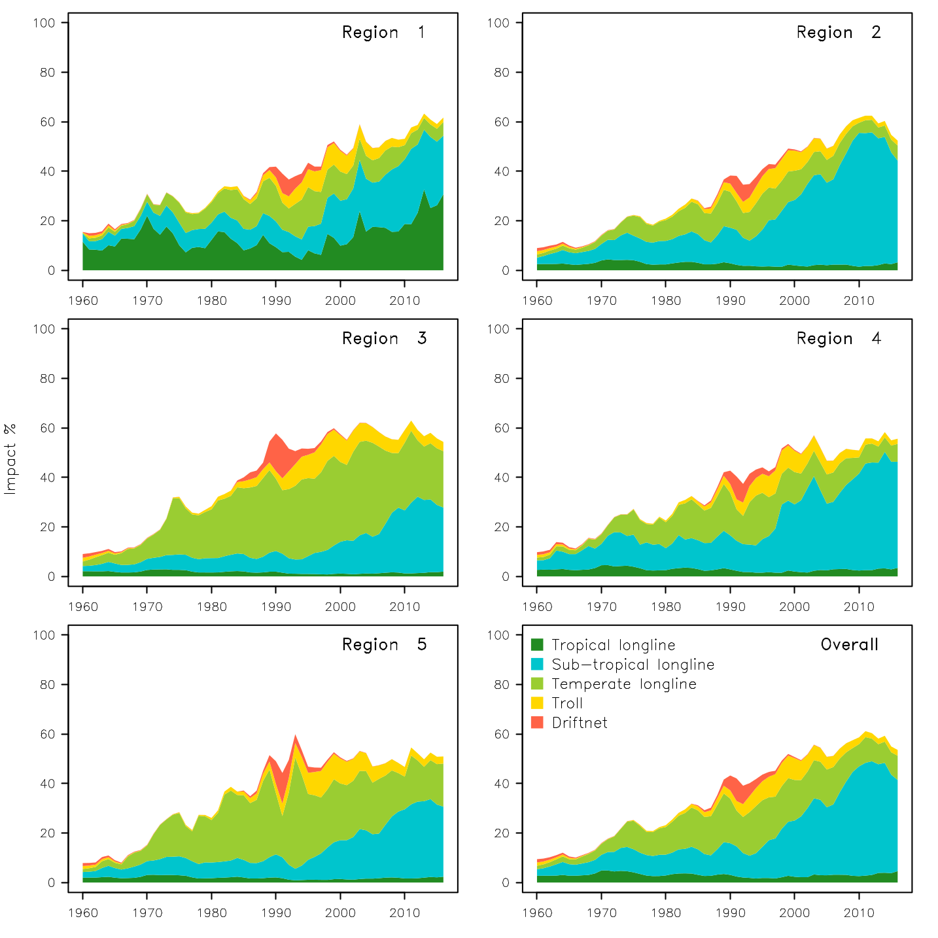
Figure SPA-22. Estimates of reduction in spawning potential due to fishing (fishery impact = 1-SB _{latest}/SB _{F=0}) by region, and over all regions (lower right panel), attributed to various fishery groups for the diagnostic case model.

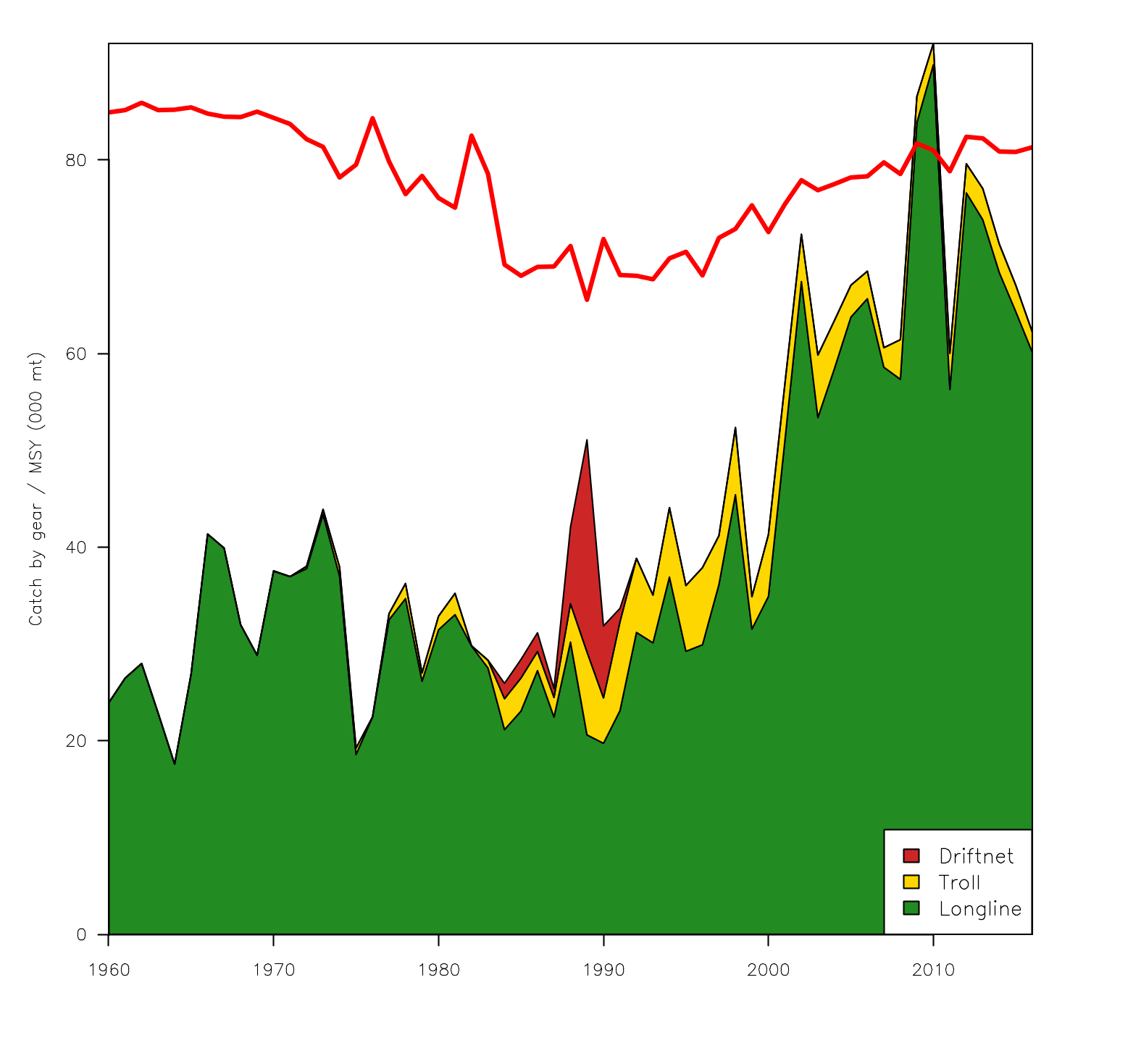Figure SPA-23. History of the annual estimates of MSY (red line) for the diagnostic case model compared with annual catch by the main gear types.

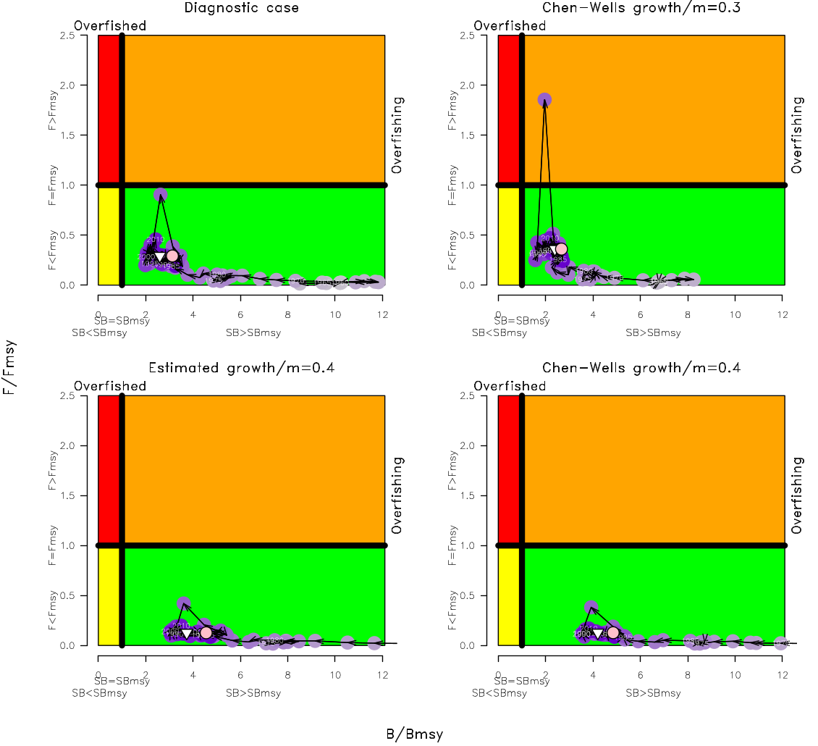
Figure SPA-24. Estimated time-series (or ‘dynamic’) Kobe plots for four example models from the assessment (one from each of the combinations of growth types, and natural mortality M set to 0.3 or 0.4).

  - Northern stocks

- On behalf of the ISC Chair, J. Brodziak presented SC13-GN-IP-02, the report of the Eighteenth Meeting of the International Scientific Committee for Tuna and Tuna-like Species in the North Pacific Ocean (ISC18). The 18th ISC Plenary, held in Yeosu, Republic of Korea from 11 to 16 July 2018 was attended by Members from Canada, Chinese Taipei, Japan, Korea, Mexico, and the United States as well as the Western and Central Pacific Fisheries Management Commission. The Plenary reviewed results, conclusions, new data, and updated analyses of the Billfish, Albacore, Shark and Pacific Bluefin tuna working groups. The ISC Plenary endorsed the findings that the North Pacific shortfin mako shark (SFM) stock is likely not in an overfished condition and overfishing is likely not occurring relative to MSY-based abundance and fishing intensity reference points, and considers the 2018 benchmark stock assessment to be the best available scientific information. The ISC Plenary also endorsed the findings that the Western and Central North Pacific (WNCPO) swordfish (SWO) stock is not likely overfished and is not likely experiencing overfishing relative to MSY-based or 20% of unfished spawning biomass-based reference points and considers the WNCPO SWO stock assessment to be best available scientific information. An update assessment of Pacific bluefin tuna (PBF) found that the stock is overfished and experiencing overfishing and that the probabilities of attaining the first and second rebuilding targets under current management measures were 98% and 96%, respectively. The ISC Plenary endorsed these findings and considers them to be the best available scientific information on PBF. The ISC Plenary re-iterated stock status and conservation information proffered at ISC17 for North Pacific albacore, Pacific blue shark, Eastern Pacific Ocean Swordfish, WNCPO striped marlin, and Pacific blue marlin. A science seminar on ecosystem-based fisheries assessment and management was held and the ISC Plenary agreed to a template to standardize stock status and conservation information to the extent possible. Meetings were scheduled for the Ad-hoc Working Group assessing the feasibility of developing a multinational PBF tagging program and the PBF Close-kin genetic project. Observers from Pew Charitable Trusts, World Wildlife Fund for Nature – Japan, Monterey Bay Aquarium, and the Western Pacific Fisheries Management Council attended. The ISC workplan for 2018-2019 includes completing WNCPO Striped Marlin assessment, updating information on biological reference points for ISC species of interest improving catch and CPUE time series and advancing biological information for shark species, conducing the second PBF MSE workshop, reviewing initial simulation results from the albacore MSE process, and enhancing database and website management. The next ISC Plenary will be held in Chinese-Taipei in July 2019.

    - North Pacific albacore (Thunnus alalunga)

      - Research and information

- SC14 noted that no stock assessment was conducted for North Pacific albacore in 2018, and no new information was presented.
      - Provision of scientific information

a. Status and trends

- SC14 noted that no stock assessments were conducted for North Pacific albacore in 2018. Therefore, the stock status descriptions from SC13 are still current for North Pacific albacore. Updated information on catches was not compiled for and reviewed by SC14.

b. Management advice and implications

- SC14 noted that no management advice has been provided since SC13 for North Pacific albacore. Therefore, the advice from SC13 should be maintained, pending a new assessment or other new information. For further information on the management advice and implications from SC13, please see https://www.wcpfc.int/node/29904

    - Pacific bluefin tuna (Thunnus orientalis)

      - Research and information

- S. Nakatsuka reported the results of the new stock assessment for Pacific bluefin tuna (PBF): SC14-SA-WP-06 ISC PBT WG Stock Assessment of Pacific Bluefin Tuna (Thunnus orientalis) in the Pacific Ocean in 2018. As the 2018 assessment was an update, the basic model construction was the same as that used for the 2016 assessment. Population dynamics were estimated using a fully integrated age-structured model (Stock Synthesis) fitted to catch, size-composition and CPUE data from 1952 to 2016 (fishing year). Life history parameters included a length-at-age relationship from otolith-derived ages, as well as natural mortality estimates from a tag-recapture study and empirical-life history methods. Nineteen fleets were defined for use in the stock assessment model based on country/gear/season/region stratification. Quarterly observations of catch and size compositions, when available, were used as inputs to the model to describe the removal processes. Annual estimates of standardized CPUE from the Japanese longline fleets, the Chinese Taipei longline fleets, and the Japanese troll fleets were used as measures of the relative abundance of the population. Based on the diagnostic analyses, the ISC concluded that the model represents the data sufficiently and results were consistent with the 2016 assessment. The 2018 assessment results are considered the best available science information.

- The 2018 projection results are more optimistic than the 2016 projections, mainly due to the inclusion of the relatively good recruitment in 2016, which is twice as high as the median of a low recruitment scenario (i.e. that which occurred during 1980-1989). Based on the performance analyses of the recruitment estimates using an age-structured production model and the retrospective diagnostics, terminal-year recruitment estimates were included in the projections. The projection results showed that the probability of achieving the initial rebuilding target under current measures taken by WCPFC and IATTC was above the level prescribed in the WCPFC Harvest Strategy (75% or above in 2024) to provide relevant information for potential increase in catch. Accordingly, the ISC examined some optional scenarios which have higher catch limits.

Discussion

- The EU noted that it often takes some years before a year class is determined with precision, and some past year classes have been overestimated. The EU queried whether there was an overemphasis on the 2016 year class estimation, and whether a reference point that differed significantly from those for other stocks in the area was appropriate. S. Nakatsuka noted that bluefin tuna did not have an agreed upon limit reference point yet, and that a rebuilding target was currently in place, with WCPFC considering the correct reference point. Generally, reference point need not be same everywhere, otherwise all would be set at 20% regardless of information or biology. In some cases (e.g., North Pacific albacore) B_{MSY} was estimated as 14% but the LRP used by the Commission is 20%. He agreed that the lack of confirmation from other sources introduced uncertainty. He noted lag differences between recruitment scenarios, and that including the 2016 recruitment was a judgement call.

- Australia shared the EU’s concerns, observing the current projection was very dependent on the good recruitment observed in 2016, and that the stock assessment used a steepness value of .999, which makes outcomes optimistic. They inquired whether the working group looked at other values, and noted that while the CMM allows increased catches given those probabilities, because the stock is thought to be in very critical condition, delaying an increase in the catch until there was a reasonable increase in the stock could be prudent. Regarding steepness, S. Nakatsuka stated that this was an assessment update so did not evaluate other possibilities, but these will be considered in the future. Inclusion of the 2016 recruitment would not be repeated; this stock assessment used a recruitment deviation estimate of 0.6, future projections would sample from the historical record and thereby account for declining recruitment. It is hard to estimate future recruitment, and thus some recruitment risk is included. Regarding increased fishing mortality, the CMM indicates that if some criteria are met, the Commission can consider it, although some countries are known to not favor this. He stated that allowing some reward to fishermen through a small increase in fishing may be beneficial.

- Korea noted that catch of small bluefin tuna on Korea’s east coast had gradually decreased, with the fishery closed in March, and small bluefin tuna discarded. Environmental changes could be impacting the fishery. Korea requested an analysis of the causes, so that appropriate management measures could be adopted. S. Nakatsuka indicated he would review ISC’s advice with Korea, bearing in mind the need to be cautious regarding inclusion of the 2016 recruitment.

- Indonesia inquired about data informing the ratio of fishing mortality and the impact of catching large vs. small fish, which is important for a harvest strategy. S. Nakatsuka noted that it was hard to compare fishing mortality when selectivity was changing. SPR is the ratio of the cumulative spawning biomass that an average recruit is expected to produce over its lifetime when the stock is fished at the current intensity to the cumulative spawning biomass that could be produced by an average recruit over its lifetime if the stock was unfished. SPR is often used as a measure of fishing intensity when selectivity changes substantially over time, as is the case with Pacific bluefin tuna. The stock assessment used SPR as a synonym for fishing mortality. The definition of small and large fish is determined by the CMM (less than 30 kg are small, over 30 kg are large). Regarding which fish to protect: currently SB is 3.3% of the estimated unfished level. Estimated BO was never observed historically. There is no established rule regarding how to restore a stock; allowing some fisheries will delay recovery. An analysis showed that a 10% reduction in the catch of small fish had a much larger benefit than a 10% reduction in the catch of large fish.

- SPC referenced the likelihood profile, noting that recruitment was estimated in an unconstrained manner, but that the likelihood profile suggested otherwise. The assumptions about recruitment variability are limiting the model results, especially in terms of the downside results. A review of the bigeye tuna stock assessment a few years ago recommended that sigma-r be set as high as possible (at least 1.5), while in SPC assessments sigma-r was set at 2.2, and produces stable estimates of asymptotic recruitment. SPC inquired whether the committee had considered how this may influence the results. Japan noted the subcommittee found the recruitment estimates to be very robust.

- SPC noted that the penalty in the deviation of initial recruitment from Log 0 that is driving the likelihood profile limits the lower end of population scaling with regard to projections and final estimates of recruitment. SPC inquired how representative the recruitment index based on Japan’s troll fishery (which is spatially constrained) was for a Pacific-wide stock. S. Nakatsuka noted it was not the only information source, with data on size indicating the stock assessment model is stable regardless of inclusion of the index. From a biological perspective, bluefin tuna has two spawning grounds, this index comes from one area around Japan, but recruitment is from both spawning grounds. He noted results are consistent, if not perfect. Labs are assessing information from other areas and will consider other recruitment indices in the future.

- SPC noted that regarding the probability of meeting the rebuilding target, it was important to have probabilities reflect reasonable characteristics of uncertainties in population dynamics overall. Recruitment is the only uncertainty in the model: there is no uncertainty in natural mortality, steepness, or growth, which SPC normally expresses as a grid of models. This is an inadequacy in that respect, especially when using these models to drive management action. S. Nakatsuka noted that Bootstrap was used to model uncertainty via variance in the CPUE and catch, and resampling of recruitment. Some uncertainty may not be fully incorporated. The current approach uses low recruitment, which he stated is one way of addressing the issue.

- New Zealand noted the bluefin stock was rebuilding, but still at a very low level, as pointed out by the EU and Australia. New Zealand stated CCSBT was instructive for deliberations — in 2011, CCSBT approved a management procedure, when stock size was SB = 3%-5% and recruitment uncertain. With a 70% probability of exceeding the initial rebuilding target, it indicated an increase in TAC was available from 2012-2014, but CCSBT advised a precautionary report, and the Commission increased in TAC a step-wise manner. New Zealand stated rebuilding PBF could benefit from similar precautionary approach, and urged WCPFC to take a precautionary approach when approving catch increases given the low stock size and uncertain recruitment size. S. Nakatsuka noted that recruitment was always uncertain, and the projection used a 30% decrease in the average to be precautionary.

- Vanuatu on behalf of FFA members thanked ISC for providing the update, noting the provision under the current harvest strategy to increase catch limits under certain stock rebuilding parameters. They sought an indication if increases were being considered, given the cautionary language in the paper regarding the high uncertainties around the 2016 recruitment and noting how far below any potential LRPs the stock remains. While noting that an increase is allowed within the rebuilding plan, FFA members recommend a precautionary approach to catch limit increases. Japan commented on recruitment estimates, noting ISG discussed recruitment index variability that inflated recruitment estimates. They noted they had confirmed consistency among the recruitment indices — 2016 had slightly larger estimation error, and that was incorporated in the projection. The management information only provided those projections that the Commission could consider (to limit catch or not).

- Marshall Islands, on behalf of PNA members, supported implementation of the harvest strategy for bluefin that was agreed to by WCPFC14. They encouraged the NC to exercise greater caution than the harvest strategy allows. In addition, PNA members noted the very different standards by which the stock was assessed and managed compared to the tropical stocks important for the PNA, noting their understanding of why this was important to various NC members; they sought a compatible level of understanding from those members when making management decisions making on tropical stocks.

      - Provision of scientific information

a. Stock status and trends

- SC14 noted that ISC provided the following conclusions on the stock status of Pacific bluefin tuna.

The base-case model results show that: (1) SSB fluctuated throughout the assessment period, (2) SSB steadily declined from 1996 to 2010; and (3) the slow increase of the stock continues since 2011 including the most recent two years (2015-2016). Based on the model diagnostics, the estimated biomass trend for the last 30 years is considered robust although SSB prior to the 1980s is uncertain due to data limitations. Using the base-case model, the 2016 SSB (terminal year) was estimated to be around 21,000 t in the 2018 assessment, which is an increase from 19,000 t in 2014 (Table PBF-1 and Figure PBF-11).

Historical recruitment estimates have fluctuated since 1952 without an apparent trend. The low recruitment levels estimated in 2010-2014 were a concern in the 2016 assessment. The 2015 recruitment estimate is lower than the historical average while the 2016 recruitment estimate (15.988 million fish) is higher than the historical average (13.402 million fish) (Figure PBF-4, Table PBF-1-1). The uncertainty of the 2016 recruitment estimate is higher than in previous years because it occurs in the terminal year of the assessment and is mainly informed by one observation from the troll age-0 CPUE index. The troll CPUE series has been shown to be a good predictor of recruitment, with no apparent retrospective error in the recruitment estimates of the terminal year given the current model construction. As the 2016 recruits grow and are observed by other fleets, the magnitude of this year class will be more precisely estimated in the next stock assessment. The above average recruitment estimated in 2016 had a positive impact on the projection results.

Estimated age-specific fishing mortalities (F) on the stock during the periods 2012-2014 and 2015-2016 compared with 2002-2004 estimates (the base period for the WCPFC Conservation and Management Measure) are presented in Figure PBF-2. A substantial decrease in estimated F is observed in ages 0-2 in 2015-2016 from the previous years. Note that stricter management measures in the WCPFC and IATTC have been in place since 2015.

The WCPFC adopted an initial rebuilding biomass target (the median SSB estimated for the period 1952 through 2014) and a second rebuilding biomass target (20%SSB_{F=0} under average recruitment), without specifying a fishing mortality reference level. The 2018 assessment estimated the initial rebuilding biomass target to be 6.7%SSB_{F=0} and the corresponding fishing mortality expressed as SPR of F_{6.7%SPR} (Table PBF-2). SPR is the ratio of the cumulative spawning biomass that an average recruit is expected to produce over its lifetime when the stock is fished at the current intensity to the cumulative spawning biomass that could be produced by an average recruit over its lifetime if the stock was unfished. Because the projections include catch limits, fishing mortality is expected to decline, i.e., F_{x%SPR} will increase, as biomass increases. The Kobe plot shows that the point estimate of the SSB₂₀₁₆ was 3.3%SSB_{F=0} and the 2016 fishing mortality corresponds to F_{6.7%SPR} (Figure PBF-3).

Table PBF-3 provides an evaluation of stock status against some common reference points. It shows that the PBF stock is overfished relative to biomass-based limit reference points adopted for other species in WCPFC (20%SSB_{F=0}) and is subject to overfishing relative to most of the common fishing intensity-based reference points.

Figure PBF-4 depicts the historical impacts of the fleets on the PBF stock, showing the estimated biomass when fishing mortality from respective fleets is zero. Historically, the WPO coastal fisheries group has had the greatest impact on the PBF stock, but since about the early 1990s the WPO purse seine fleets, in particular those targeting small fish (ages 0-1), have had a greater impact, and the effect of these fleets in 2016 was greater than any of the other fishery groups. The impact of the EPO fishery was large before the mid-1980s, decreasing significantly thereafter. The WPO longline fleet has had a limited effect on the stock throughout the analysis period, because the impact of a fishery on a stock depends on both the number and size of the fish caught by each fleet; i.e., catching a high number of smaller juvenile fish can have a greater impact on future spawning stock biomass than catching the same weight of larger mature fish.

- SC14 noted the following stock status from ISC:

Based on these findings, the following information on the status of the Pacific bluefin tuna stock is provided:

- No biomass-based limit or target reference points have been adopted to evaluate the overfished status for PBF. However, the PBF stock is overfished relative to the potential biomass-based reference points evaluated (SSB_{MED} and 20%SSB_{F=0}, Table PBF-3 and Figure PBF-3).
- No fishing intensity-based limit or target reference points have been adopted to evaluate overfishing for PBF. However, the PBF stock is subject to overfishing relative to most of potential fishing intensity-based reference points evaluated (Table PBF-3 and Figure PBF-3).

- SC14 noted that the total PBF catch in 2017 was 14,707 mt, 11% increase from 2016 and 9% increase from the average 2012-2016. PBF is caught by various fishing gears including purse seine, longline, set net, troll, pole-and-line, handline and recreational fisheries. The detailed catch information by fishery is available in ISC 2018 stock assessment (SC14-SA-WP-06).

b. Management advice and implications

- SC14 advises the Commission to note the current very low level of spawning biomass (3.3% B₀), the current level of overfishing, and that the projections are strongly influenced by the inclusion of a relatively high but uncertain recruitment in 2016. The majority of CCMs recommended a precautionary approach to the management of Pacific Bluefin tuna, especially in relation to the timing of increasing catch levels, until the rebuilding of the stock to higher biomass levels is achieved.

- SC14 noted the following conservation advice from ISC:

After the steady decline in SSB from 1995 to the historical low level in 2010, the PBF stock appears to have started recovering slowly. The 2016 stock biomass is below the two biomass rebuilding targets adopted by the WCPFC while the 2015-2016 fishing intensity (spawning potential ratio) is at a level corresponding to the initial rebuilding target.

The 2018 base case assessment results are consistent with the 2016 model results. However, the 2018 projection results are more optimistic than the 2016 projections, mainly due to the inclusion of the relatively good recruitment in 2016, which is above the historical average level (119%) and twice as high as the median of the low recruitment scenario (which occurred 1980-1989).

Based on these results, the following conservation information is provided:

1. The projection based on the base-case model mimicking the current management measures by the WCPFC (CMM 2017-08) and IATTC (C-16-08) under the low recruitment scenario resulted in an estimated 98% probability of achieving the initial biomass rebuilding target (6.7%SSBF=0) by 2024. This estimated probability is above the threshold (75% or above in 2024) prescribed by the WCPFC Harvest Strategy (Harvest Strategy 2017-02) (scenario 0 of Table PBF-4; see also Figure PBF-5 and Figure PBF-6). The low recruitment scenario is more precautionary than the recent 10 years recruitment scenario.

2. The Harvest Strategy specifies that recruitment switches from the low recruitment scenario to the average recruitment scenario beginning in the year after achieving the initial rebuilding target. The estimated probability of achieving the second biomass rebuilding target (20%SSBF=0) 10 years after the achievement of the initial rebuilding target or by 2034, whichever is earlier, is 96% (scenario 1 of Table PBF-3, Table PBF-4, and Table PBF-5; Figure PBF-5 and Figure PBF-6). This estimate is above the threshold (60% or above in 2034) prescribed by the WCPFC Harvest Strategy. However, it should be recognized that these projection results are strongly influenced by the inclusion of the relatively high, but uncertain recruitment estimate for 2016.

The Harvest Strategy adopted by WCPFC (Harvest Strategy 2017-02) guided projections conducted by ISC to provide catch reduction options if the projection results indicate that the initial rebuilding target will not be achieved or to provide relevant information for potential increase in catch if the probability of achieving the initial rebuilding target exceeds 75%. The projection results showed that the probability of achieving the initial rebuilding target was above the level (75% or above in 2024) prescribed in the WCPFC Harvest Strategy. Accordingly, the ISC examined some optional scenarios with higher catch limits, which can be found in Appendix 1 of the PBF 2018 stock assessment report (SC14-SA-WP-06).

Research needs

Given the low SSB, the uncertainty in future recruitment, and the influence of recruitment on stock biomass, monitoring of recruitment and SSB should be strengthened so that the recruitment trends can be understood in a timely manner.

Table PBF-1. Total biomass, spawning stock biomass and recruitment of Pacific bluefin tuna (Thunnus orientalis) estimated by the base-case model, where coefficient of variation (CV) measures relative variability defined as the ratio of the standard deviation to the mean.
Table PBF-2. Spawning stock biomass and fishing intensity of Pacific bluefin tuna (Thunnus orientalis) in 1995 (recent high biomass), 2002-2004 (WCPFC reference year biomass), 2011 (biomass 5 years ago), and 2016 (latest) to those of the adopted WCPFC biomass rebuilding targets. SPR is used as a measure of fishing intensity; the lower the number the higher the fishing intensity that year.
 | Initial rebuilding target | Second rebuilding target | 1995  (recent high) | 2002-2004 (reference year) | 2011  (5 years ago) | 2016  (latest)
Biomass (%SSBF=0) | SSB median1952-2014 = 6.7% | 20% | 10.4% | 7.1% | 2.1% | 3.3%
SPR | 6.7% | 20% | 5.1% | 3.4% | 4.9% | 6.7%

Table PBF-3. Ratios of the estimated fishing intensities mortalities (Fs and 1-SPRs for 2002-04, 2012-14, 2015-16) relative to potential fishing intensity-based reference points, and terminal year SSB (t) for each reference period, and depletion ratios for the terminal year of the reference period for Pacific bluefin tuna (Thunnus orientalis).

Table PBF-4. Future projection scenarios for Pacific bluefin tuna (Thunnus orientalis).
*1 F indicates the geometric mean values of quarterly age-specific fishing mortality during 2002-2004.
*2 The Japanese unilateral measure (transferring 250 mt of catch upper limit from that for small PBF to that for large PBF during 2017-2020) would be reflected.
*3 Fishing mortality for the EPO commercial fishery was assumed to be high enough to fulfill its catch upper limit (F multiplied by two). The fishing mortality for the EPO recreational fishery was assumed to be the F2009-11 average level.
*4 In scenario 0, the future recruitments were assumed to be the low recruitment (1980-1989) level forever. In other scenarios, recruitment was switched from low recruitment to average recruitment from the next year of achieving the initial rebuilding target.

Table PBF-5. Future projection scenarios for Pacific bluefin tuna (Thunnus orientalis) and their probability of achieving various target levels by various time schedules based on the base-case model.
*1 In scenario 0, the future recruitments were assumed to be the low recruitment (1980-1989) level forever. In other scenarios, recruitment was switched from low recruitment to average recruitment from the next year of achieving the initial rebuilding target.

Table PBF-6. Expected yield for Pacific bluefin tuna (Thunnus orientalis) under various harvesting scenarios based on the base-case model.

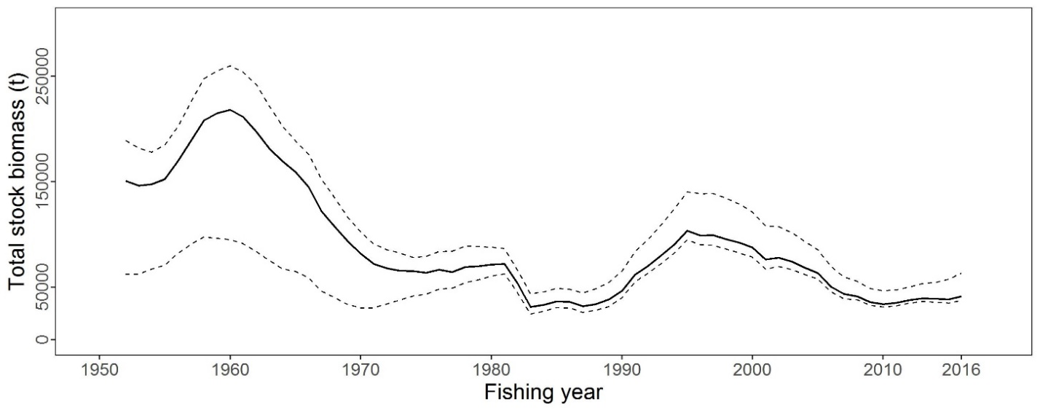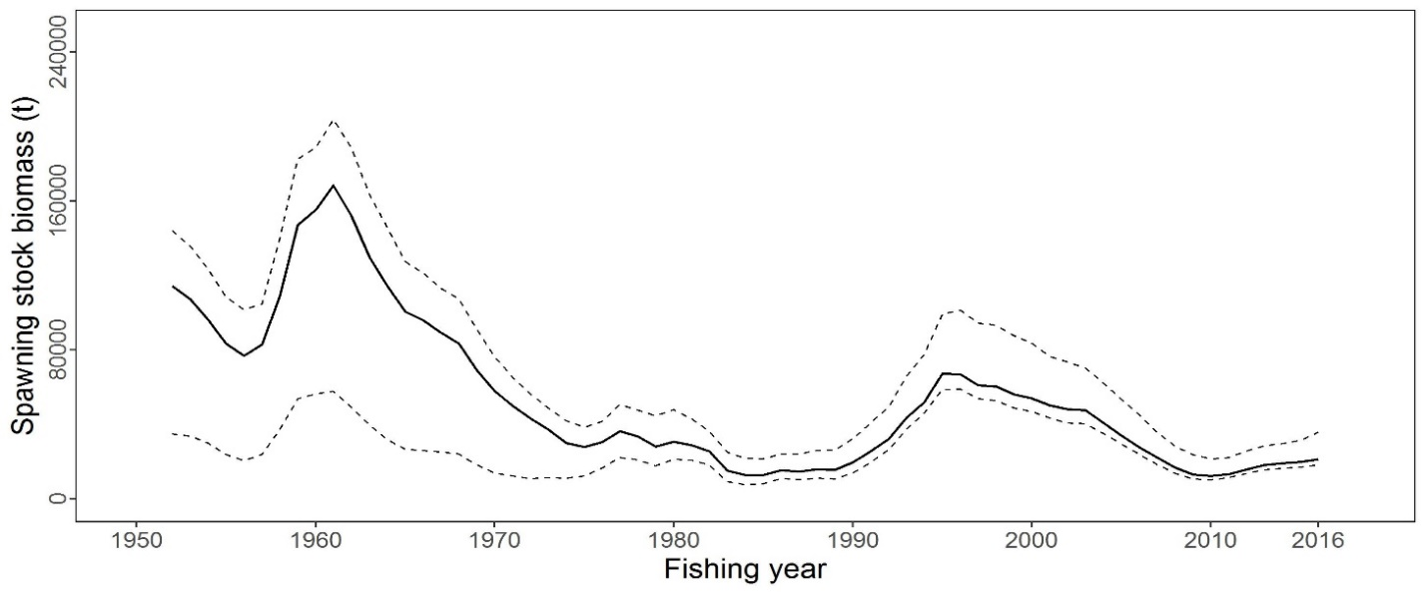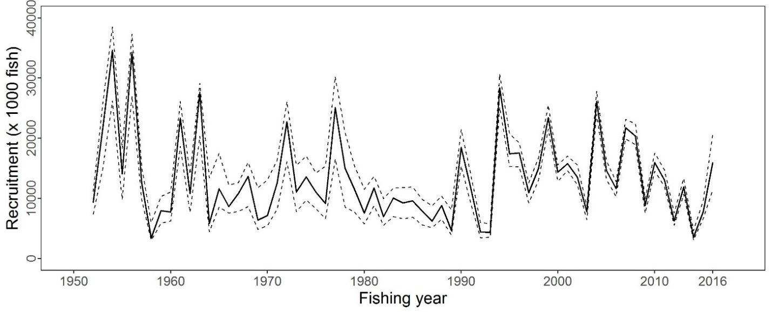
Figure PBF-1. Total stock biomass (top), spawning stock biomass (middle) and recruitment (bottom) of Pacific bluefin tuna (Thunnus orientalis) from the base-case model. The solid lines indicate point estimates and the dashed lines indicate the 90% confidence intervals.

Figure PBF-2. Geometric means of annual age-specific fishing mortalities of Pacific bluefin tuna (Thunnus orientalis) in 2002-2004 (dotted line), 2012-2014 (dashed line), and 2015-2016 (solid line).

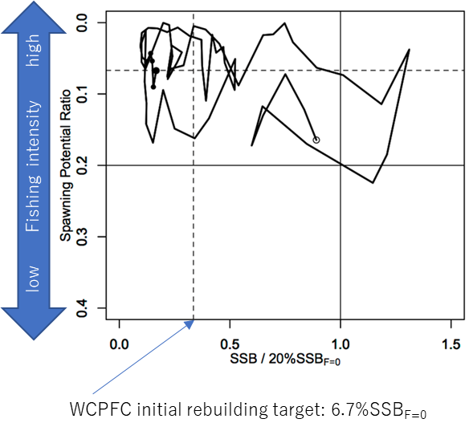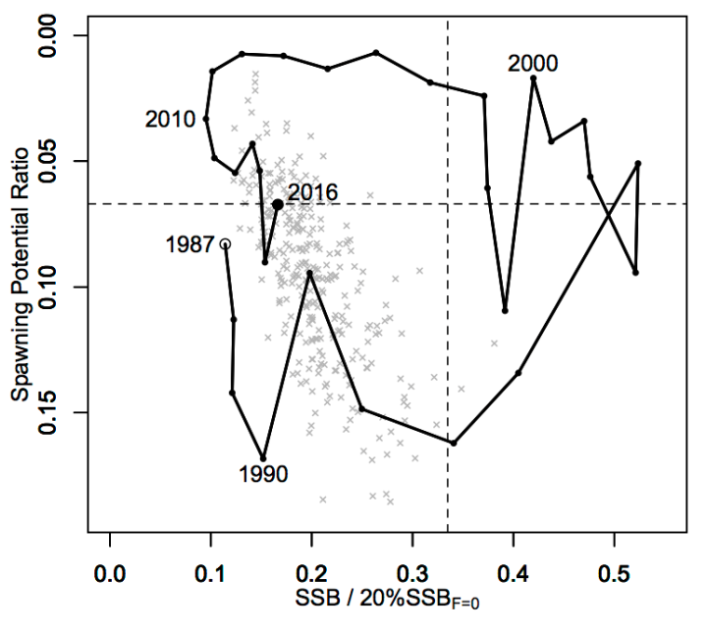

Figure PBF-3. Kobe plots for Pacific bluefin tuna (Thunnus orientalis). X axis shows the annual SSB relative to 20%SSB_{F=0} and the Y axis shows the spawning potential ratio as a measure of fishing intensity. Solid vertical and horizontal lines in the left figure show 20%SSB_{F=0} (which corresponds to the second biomass rebuilding target) and the corresponding fishing intensity, respectively. Dashed vertical and horizontal lines in both figures show the initial biomass rebuilding target (SSB_{MED} = 6.7%SSB_{F=0}) and the corresponding fishing intensity, respectively. SSB_{MED} is calculated as the median of estimated SSB over 1952-2014. The left figure shows the historical trajectory, where the open circle indicates the first year of the assessment (1952) while solid circles indicate the last five years of the assessment (2012-2016). The right figure shows the trajectory of the last 30 years, where grey dots indicate the uncertainty of the terminal year.
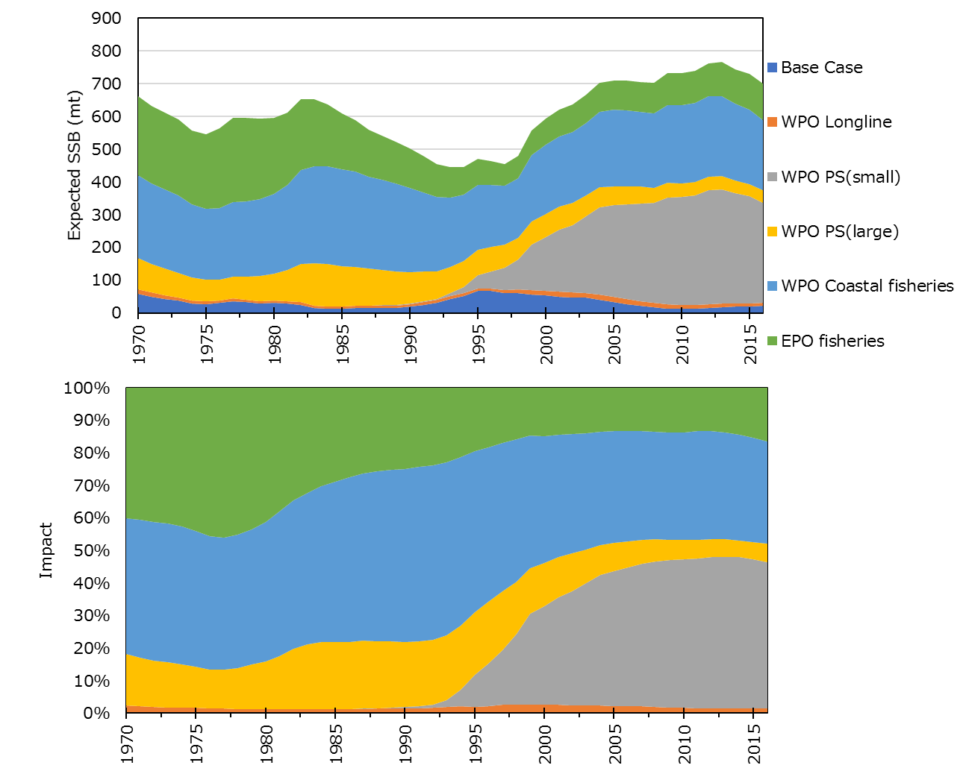
Figure PBF-4. Trajectory of the spawning stock biomass of a simulated population of Pacific bluefin tuna (Thunnus orientalis) when zero fishing mortality is assumed, estimated by the base-case model (top: absolute impact, bottom: relative impact). Fleet definition; WPO longline: F1, F12, F17. WPO purse seine for small fish: F2, F3, F18. WPO purse seine: F4, F5. WPO coastal fisheries: F6-11, F16, F19. EPO fisheries: F13, F14, F15.
Figure PBF-5. Comparison of future SSB of Pacific bluefin tuna (Thunnus orientalis) under the current management measures assuming low recruitment using the 2016 assessment (scenario 2016 lowR), assuming low recruitment using the 2018 assessment (scenario 0), and assuming a shift of the recruitment scenario from low to average after achieving the initial rebuilding target using the 2018 assessment (scenario 1).

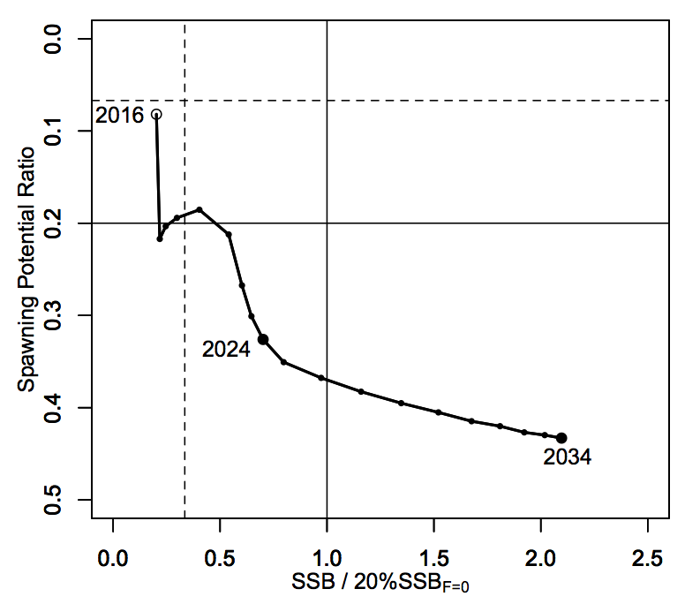
Figure PBF-6. A projection result (scenario 1 from Table PBF-4) for Pacific bluefin tuna (Thunnus orientalis) in a form of Kobe plot. The X axis shows the SSB value relative to 20%SSB_{F=0} (second rebuilding target) and the Y axis shows the spawning potential ratio as a measure of fishing intensity. Vertical and horizontal solid lines indicate the second rebuilding target (20%SSB_{F=0}) and the corresponding fishing intensity, respectively, while vertical and horizontal dashed lines indicate the initial rebuilding target (SSB_{MED} = 6.7%SSB_{F=0}) and the corresponding fishing intensity, respectively.

    - North Pacific swordfish (Xiphias gladius)

      - Research and information

- M. Sculley presented SC14-SA-WP-07 (Stock assessment for swordfish (Xiphias gladius) in the western and central north Pacific Ocean through 2016). The Western and Central North Pacific swordfish (Xiphias gladius) stock area consisted of waters of the North Pacific Ocean contained in the boundaries north of the equator and west of the diagonal purple line in Figure NPS-1 labeled stock area 1. All available fishery data from this area were used for the stock assessment. For the purpose of modeling observations of CPUE and size composition data, it was assumed that there was an instantaneous mixing of fish throughout the stock area on a quarterly basis.

- North Pacific swordfish catches exhibited a variable trend from the 1970s to the 1990s, was stable in the 2000s and thereafter decreased to the present. Overall, the catch by Japanese and Chinese Taipei fleets decreased while the catch by the USA and other WCPFC and IATTC countries increased (Figure S2). Longline gear has accounted for the vast majority of Western and Central North Pacific swordfish catches since the 1970’s.

- Catch and size composition data were collected from ISC countries (Japan, Taiwan, and USA), IATTC member countries, and the WCPFC (Table S-1 in SC14-SA-WP-07). Standardized CPUE data used to measure trends in relative abundance were provided by Japan, USA, and Chinese Taipei. The Western and Central North Pacific swordfish stock was assessed using an age-, length-, and sex-structured assessment Stock Synthesis model fit to time series of standardized CPUE and size-composition data. Sex-specific growth curves and natural mortality rates were used to account for the sexual dimorphism of adult swordfish. The value for stock-recruitment steepness used for the base case model was h = 0.9. The assessment model was fit to relative abundance indices and size composition data in a likelihood-based statistical framework. Maximum likelihood estimates of model parameters, derived outputs, and their variances were used to characterize stock status and to develop stock projections. Several sensitivity analyses were conducted to evaluate the effects of changes in model parameters, including the natural mortality rate, the stock-recruitment steepness, the growth curve parameters, and the female age at 50% maturity.

Discussion

- RMI, on behalf of FFA members, thanked ISC for the new stock assessment for swordfish in the North Pacific and noted that it was difficult to distinguish if the outcomes are more optimistic compared to the last stock assessment for swordfish in the North Pacific presented in 2014 because the advice is presented against different stock status indicators. They acknowledged and thanked the ISC for providing Table 11 for the swordfish assessment that allows some reference to depletion reference points adopted for other WCPFC stocks. FFA members noted that despite the recent drop in total catch, the swordfish stock in the North Pacific is at current estimates, at a depletion level of 0.3 SSB₂₀₁₆/SSB_{F=0}. FFA members noted that the stock assessment indicated that the WCNPO swordfish stock is not likely overfished and not likely experiencing overfishing. The sensitivity run for the 0.81 steepness value indicates a much more optimistic state than the base case value of 0.9, and they sought clarification from the ISC representative for a possible explanation. Given the recent increase in catch for swordfish in the North Pacific, the level of depletion estimated from the latest stock assessment and no formal reference points being agreed for swordfish in the North Pacific, they recommended no further increases in fishing pressure.

- Australia noted some inconsistencies in the 10 CPUE time series by fleet, and inquired whether some were given greater weight. M. Sculley stated that the discrepancies were recognized but inconsistencies between the Hawaii longline deep set and Japanese longline fleet in area 1 were mostly caused by differences in the time series. The working group included all possible CPUEs (equally weighted) because analysis showed no inconsistency between CPUEs and other data sources. There was no time to conduct a sensitivity analysis that excluded one of the CPUEs.

- SPC inquired regarding use of the Hawaii longline deep set index, whether it assumes selectivity of 1 and 0 for all other age classes. M. Sculley noted almost all catch was <100 cm, and it could be assumed this reflected actual recruitment. Selectivity for catch <100 cm was 1, all others 0. SPC noted different CPUE trends (declining vs. increasing), and asked how model addressed this given no spatial structure. M. Sculley responded these were mostly in different time periods, and those CPUEs not used. SPC referenced Fig 7.1 in the assessment report regarding likelihood profiles of CPUE and length, noting length composition has some influence on estimation of biomass scale that may be due to the effective sample size of length composition. M. Sculley responded that the working group tested several effective sample sizes, but they found found that estimated biomass and derived parameters were very consistent for all model runs. The working group set the effective sample size at 25, which is a very low effective sample size compared to the actual observations. The actual uncertainty of the stock may be larger than presented.

- In response to a comment by the EU the presenter noted MSY had been recognized as the default reference point, in accordance with the Convention.

      - Provision of scientific information

a. Status and trends

- SC14 noted that ISC provided the following conclusions on the stock status of Western and Central North Pacific Swordfish in the Pacific Ocean in 2017 presented in SC14-SA-WP-07 (Stock Assessment for Swordfish (Xiphias gladius) in the Western and Central North Pacific Ocean through 2016).

Estimates of total stock biomass show a relatively stable population, with a slight decline until the mid-1990s followed by a slight increase since 2000. Population biomass (age-1 and older) averaged roughly 97,919 t in 1974-1978, the first 5 years of the assessment time frame, and has declined by only 20% to 71,979 t in 2016 (Figure NPS-3). Female spawning stock biomass was estimated to be 29,403 t in 2016, or about 90% above SSB_{MSY} (Table NPS-1 and Table NPS-2). Fishing mortality on the stock (average F, ages 1 – 10) averaged roughly F = 0.08 yr⁻¹ during 2013-2015, or about 45% below F_{MSY}. The estimated SPR (the predicted spawning output at the current F as a fraction of unfished spawning output) is currently SPR₂₀₁₆ = 45%. Annual recruitment averaged about 717,000 recruits during 2012-2016, and no long-term trend in recruitment was apparent. Overall, the time series of spawning stock biomass and recruitment estimates indicate a stable spawning stock biomass and suggest a fluctuating pattern without trend for recruitment (Figure NPS-3). The Kobe plot depicts the stock status relative to MSY-based reference points for the base case model (Figure NPS-4) and shows that spawning stock biomass declined to almost the MSY level in the mid-1990s, but SSB has remained above SSB_{MSY} throughout the time series (Figure NPS-3B).

For this 2018 benchmark assessment, note that biomass status is based on female spawning stock biomass, whereas for the 2014 update assessment, biomass status was based on exploitable biomass (effectively age-2+ biomass). It is also important to note that there are no currently agreed upon reference points for the WCNPO swordfish stock and that retrospective analyses show that the assessment model appears to underestimate spawning stock biomass in recent years.

Based on these findings, the following information on the status of the WCNPO SWO stock is provided:

  - The WCNPO swordfish stock has produced annual yields of around 10,200 t per year since 2012, or about 2/3 of the MSY catch amount.
  - There is no evidence of excess fishing mortality above F_{MSY} (F₂₀₁₃₋₂₀₁₅ is 45% of F_{MSY}) or substantial depletion of spawning potential (SSB₂₀₁₆ is 87% above SSB_{MSY}).
  - Overall, the WCNPO swordfish stock is not likely overfished and is not likely experiencing overfishing relative to MSY-based or 20% of unfished spawning biomass-based reference points.

b. Management advice and implications

- SC14 noted the following conservation advice from ISC:

Stock projections were conducted using a two-gender projection model. The five stock projection scenarios were: (1) F status quo, (2) F_{MSY}, (3) F at 0.2*SSB_{F=0}, (4) F_{20%}, and (5) F_{50%} (Figure NPS-5). These projection scenarios were applied to the base case model results to evaluate the impact of alternative levels of fishing intensity on future spawning biomass and yield for swordfish in the Western and Central North Pacific Ocean. The projected recruitment pattern was generated by stochastically sampling the estimated stock-recruitment model from the base case model. The projection calculations employed model estimates for the multi-fleet, multi- season, size- and age-selectivity, and structural complexity in the assessment model to produce consistent results.

Based on these findings, the following conservation information is provided:
- The results show that projected female spawning biomass is expected to remain above SSB_{MSY} under all of the harvest scenarios (Table NPS-3 and Figure NPS-5), with increases in spawning biomass expected under lower fishing mortality rates.
- Similarly, projected catch is expected to increase under each of the five harvest scenarios, with greater increases expected under higher fishing mortality rates (Table NPS-3 and Figure NPS-5).

Research needs

The lack of sex-specific size composition data and the simplified treatment of the spatial structure of swordfish population dynamics remained as two important sources of uncertainty for this benchmark assessment

Table NPS-1. Reported catch (mt) used in the stock assessment along with annual estimates of population biomass (age-1 and older, mt), female spawning biomass (mt), relative female spawning biomass (SSB/SSB_{MSY}), recruitment (thousands of age-0 fish), fishing mortality (average F, ages 1 to 10), relative fishing mortality (F/F_{MSY}), and spawning potential ratio of Western and Central North Pacific Ocean swordfish.
Year | 2010 | 2011 | 2012 | 2013 | 2014 | 2015 | 2016 | Mean¹ | Min¹ | Max¹
Reported Catch | 12,716 | 9,971 | 10,608 | 9,241 | 9,211 | 11,672 | 10,068 | 12,863 | 9,211 | 17,793
Population Biomass | 66,417 | 66,087 | 68,117 | 67,885 | 69,560 | 71,951 | 71,979 | 67,487 | 51,856 | 97,919
Spawning Biomass | 26,136 | 26,448 | 26,569 | 27,546 | 28,580 | 28,865 | 29,404 | 24,442 | 17,191 | 44,100
Relative Spawning Biomass | 1.66 | 1.68 | 1.69 | 1.75 | 1.82 | 1.84 | 1.87 | 1.56 | 1.09 | 2.81
Recruitment (age 0) | 789 | 565 | 671 | 710 | 683 | 742 | 781 | 761 | 401 | 1241
Fishing Mortality | 0.10 | 0.08 | 0.09 | 0.07 | 0.07 | 0.09 | 0.07 | 0.12 | 0.07 | 0.18
Relative Fishing Mortality | 0.57 | 0.46 | 0.51 | 0.44 | 0.40 | 0.51 | 0.44 | 0.72 | 0.40 | 1.05
Spawning Potential Ratio | 38% | 41% | 39% | 45% | 47% | 39% | 45% | 29% | 17% | 47%
¹ During 1975-2016

Table NPS-2. Estimates of biological reference points along with estimates of fishing mortality (F), spawning stock biomass (SSB), recent average yield (C), and SPR of WCNPO swordfish, derived from the base case model assessment model, where “MSY” indicates reference points based on maximum sustainable yield.
Reference Point | Estimate
FMSY | 0.17 yr-1
F0.2*SSB(F=0) | 0.16 yr-1
F2013-2015 | 0.08 yr-1
SSBMSY | 15,702 mt
SSB2016 | 29,403 mt
SSBF=0 | 97,286 mt
MSY | 14,941 mt
C2012-2016 | 10,160 mt
SPRMSY | 18%
SPR2016 | 45%

Table NPS-3. Projected values of WCNPO swordfish spawning stock biomass (SSB, mt) and catch (mt) under five constant fishing mortality rate (F, yr-1) scenarios during 2017-2026.
Year | 2017 | 2018 | 2019 | 2020 | 2021 | 2022 | 2023 | 2024 | 2025 | 2026
Scenario 1: F = F2013-2015
SSB | 32,118 | 33,207 | 34,599 | 35,476 | 36,270 | 37,082 | 37,951 | 38,967 | 40,083 | 41,087
Catch | 8,851 | 9,135 | 9,407 | 9,599 | 9,794 | 10,022 | 10,275 | 10,595 | 11,053 | 11,142
Scenario 2: F = FMSY
SSB | 28,267 | 23,963 | 21,443 | 19,458 | 18,303 | 17,618 | 17,293 | 17,197 | 17,253 | 17,263
Catch | 20,885 | 18,323 | 16,509 | 15,294 | 14,666 | 14,353 | 14,308 | 14,520 | 14,650 | 14,348
Scenario 3: F = F20%SSB(F=0)
SSB | 28,425 | 24,384 | 21,800 | 19,735 | 18,530 | 17,874 | 17,496 | 17,586 | 17,818 | 17,779
Catch | 20,691 | 18,122 | 16,454 | 15,261 | 14,653 | 14,361 | 14,319 | 14,554 | 14,665 | 14,384
Scenario 4: F = F20%
SSB | 29,007 | 25,431 | 23,527 | 21,763 | 20,736 | 20,131 | 19,893 | 19,883 | 19,981 | 20,066
Catch | 18,680 | 16,933 | 15,657 | 14,726 | 14,242 | 14,033 | 14,050 | 14,292 | 14,496 | 14,253
Scenario 5: F = F50%
SSB | 32,559 | 34,334 | 36,290 | 37,666 | 38,836 | 39,984 | 41,148 | 42,490 | 44,049 | 45,625
Catch | 7,556 | 7,973 | 8,343 | 8,605 | 8,847 | 9,101 | 9,366 | 9,692 | 10,087 | 10,223

Figure NPS-1. Stock boundaries used for this assessment of North Pacific Ocean swordfish: purple lines indicate stock area divisions; stock area 1 was assessed as the WCNPO stock, stock area 2 contains the Eastern Pacific Ocean stock, the green line indicates Western Central Pacific Fisheries Commission convention area, blue dashed line indicates IATTC convention area.

Figure NPS-2. Annual catch biomass (t) of WCNPO swordfish (Xiphias gladius) by country for Japan, Chinese Taipei, the U.S.A., and all other countries during 1975-2016.

Figure NPS-3. Time series of estimates of (a) population biomass (age 1+) (first point in time series represents unfished biomass), (b) spawning biomass, (c) recruitment (age-0 fish), and (d) instantaneous fishing mortality (average for ages 1 to 10, yr-1) for WCNPO swordfish (Xiphias gladius) derived from the 2018 stock assessment. The solid circles are the maximum likelihood estimates by year for each quantity and the error bars represent the uncertainty of the estimates (80% confidence intervals), green dashed lines indicate BMSY, equilibrium recruitment, and F_{MSY} except for the population biomass time series.

Figure NPS-4. Kobe plot of the time series of estimates of relative fishing mortality (average of ages 1-10) and relative spawning stock biomass of WCNPO swordfish (Xiphias gladius) during 1975-2016. The white circle denotes the first year (1975) and the yellow circle denotes the last year (2016) of the assessment time horizon. The dashed lines represent the 95% confidence intervals around the 2016 estimate.

Figure NPS-5. Historical and projected trajectories of (a) spawning stock biomass and (b) total catch from the WCNPO swordfish base case model. Stock projection results are shown for S1 = the status quo or average fishing intensity during 2013-2015 (𝐹₂₀₁₃₋₂₀₁₅= 𝐹_{43%}); S2 = F_{MSY} (𝐹_{18%}); S3 = F to produce 20% of unfished spawning stock biomass or F_{0.2}*SSB_{F=0} (𝐹_{22%}); S4 = the highest 3-year average F during 1975-2016 or High F (F_{20%}); S5 = Low F (F_{50%}).

  - WCPO sharks

    - Oceanic whitetip shark (Carcharhinus longimanus)

      - Research and information

- The last stock assessment was conducted in 2012, no stock assessment has been conducted since and there was no new information.

      - Provision of scientific information

a. Status and trends

- SC14 noted that no stock assessments were conducted for oceanic whitetip shark in 2018. Therefore, the stock status descriptions from SC8 are still current for oceanic whitetip shark. Updated information on catches was not compiled for and reviewed by SC14.

b. Management advice and implications

- SC14 noted that no management advice has been provided since SC8 for oceanic whitetip shark. Therefore, previous advice should be maintained, pending a new assessment or other new information. For further information on the management advice and implications from SC8, please see https://www.wcpfc.int/node/3396

    - Silky shark (Carcharhinus falciformis)

      - Research and information

- S. Clarke (Common Oceans (ABNJ) Tuna Project) and A. Langley presented SC14-SA-WP-08 and its Addendum on Pacific-wide Silky Shark (Carcharhinus falciformis) Stock Status Assessment.

- Initially, the spatial domain of the model encompassed the entire Pacific Ocean, partitioned into two regions (EPO and WCPO). However, the model results were unsatisfactory as it was not possible to simultaneously fit the two sets of area-specific CPUE indices and, on that basis, the Pacific wide model was rejected. The stock assessment model was then configured for the WCPO region only. The assessment incorporated a new time-series of annual catches (1995-2016) and a primary CPUE index derived from observer data collected from the longline fishery (2003-2016). These data sets differ considerably from those included in the previous (2013) assessment. The main biological parameters included in the assessment were equivalent to those included in the reference model from the previous assessment. The longline CPUE indices were correlated with prevailing oceanographic conditions in the equatorial WCPO. To adequately fit the time series of CPUE indices in the assessment model it was necessary to incorporate temporal variation in longline catchability via an environmental covariate (model CPUEqdev). The current assessment is considered to represent an improvement on the previous (2013) assessment on the basis that the model incorporates the best available estimates of annual catch and provides a good fit to the longline CPUE indices. Nevertheless, as in the previous assessment, the model is unable to simultaneously fit other available sets of CPUE indices and temporal variation in the length composition data. The reliability of these other data sets is unknown. The WCPO-only CPUEqdev model estimates of current stock status show high uncertainty reflecting the low precision of estimates of key model parameters (overall recruitment, selectivity, initial fishing mortality, and the parameter linking catchability and the environmental variable). There are also additional sources of uncertainty that were not incorporated in the assessment. Potential sources of uncertainty relate to the reliability of the key input data (especially the overall magnitude of the annual catches) and structural assumptions of the model, including the nature of the stock-recruitment relationship, the spatial structure of the WCPO population, key biological parameters (growth, natural mortality), and the relationship between longline catchability and oceanographic conditions.

Discussion

- Japan stated that the life history parameter natural mortality was important and highly uncertain, and needed to be analyzed in sensitivity runs. The Ricker model for stock recruitment should be considered as it might be more appropriate (flexible) for sharks. They suggested using the Kai-Fujinami 2018 analysis method (published in Fisheries Research and accepted by SPC for other assessments of North Pacific stocks), which estimated steepness and examined a variety of stock recruitment relationships, and indicated high and low productivities. They inquired regarding concerns with the no-retention measure and the deterioration of the data available as a result. S. Clarke stated that the research team considered no-retention to be a good first option, which ideally would be retained, while working to improve species identification (and thus data quality) through revised guidelines. She noted the decision was a management issue and up to the Commission.

- The USA noted that the initial conditions in the WCPO model assumed catch as of 1995, and asked whether an effort was made to estimate the initial conditions inside the model. A. Langley noted that stock syntheses have a few factors that influence initial condition: assumed catch, assumed error, and fishing mortality. The fishing mortality of those fisheries for the initial model assumed a high level of error. The model estimates fishing mortality rates as fairly low at the outset. But this is not well informed by the data set, so is highly uncertain.

- Chinese Taipei noted that the CPUE indices were quite varied, and questioned why the relationships between the CPUE indices and the El Niño 3.4 SST were not consistent within the same region. A. Langley indicated he shared those concerns, and noted the two sets of CPUE are somewhat spatially distinct. There could be different supporting populations, or differing influences; one purse seine fishery and one longline fishery, or local environmental influences that differ in equatorial and subtropical areas. There is a need to resolve some of these issues if this is considered as a single region, which the model assumes. S. Clarke noted that the size of shark caught in the EPO differed from that in the WCPO, and was affected differently by environmental impacts. Within the WCPO, purse seine captured juveniles, and longline large adult, which may contribute to the difference in impacts. Japan asked whether the current CMM was adequate and based on best available information. S. Clarke replied that there were issues with data quality arising from the CMM, and maybe some post-release mortality, but the no-retention policy was reducing F. The CMM is supported by the new information, and its continuance is recommended by the study team.

- Australia expressed concern that the WCPO component had multiple CPUE indices and sample lengths, and couldn’t get a good fit with a number of the CPUE series and length samples, possibly because of changes in sampling regimes over time. They noted the potential benefit of having time history required by regulation, as analysts would then know how data was collected, and inquired if the authors saw utility in this approach. S. Clarke stated this would be a benefit, and would have aided the stock assessment for silky sharks. A Langley agreed, noting the overlay with observer coverage, which is quite variable over time; changes in geographic allocation of observers could have a large impact on data sets, which should be kept in mind when looking at non-commercial species. In response to further queries from Australia, S. Clarke noted that the South Pacific longline series was based on 6 countries’ observer data, all of which had data for each year of the series; some (unpublished) archival tag data exists for the EPO, but the WCPO lacks a dedicated archival tagging program.

- Indonesia asked how the significant movement between the WCPO and EPO is considered in the WCPO model that excludes EPO data. A Langley stated that the WCPO–EPO linkage is not well understood; model-estimated movement is high because this is how the how model fits the data, but it is not based on actual movement, and may not be accurate. Indonesia further asked about the status of tagging studies for silky sharks, length/composition data, and conversion factors (total length/fork length) for size distribution. S. Clarke replied that there are post-release mortality studies on silky sharks from tagging data but movement data relies on the IATTC tagging data; she encouraged collection of more length data by observers, and noted the length conversion factor published by Joung et al 2008 was used, which is specific to the WCPO.

- SPC inquired regarding the dynamics of the WCPO model, where catchability in a year is dependent on the environmental index in the next year. A Langley indicated a delay in the oceanographic process moving across the Pacific could cause a lag in the environmental impact on catchability. SPC stated that the hypothesis that movement is responsible for catchability was interesting and should be further explored, and suggested using a Pacific-wide model with separate stock recruitment dynamics in the EPO and WCPO regions could be worthwhile. A. Langley noted that the Pacific-wide model was too coarse, assuming two distinct homogenous populations linked across a single boundary, as there is likely a gradient. Hawaii longline CPUE data could help in resolving these issues.

- The EU inquired about consideration of the potentially negative and positive effects of the no-retention measure that applies to silky shark, noting problems with identification and reporting could negatively impact CPUE estimation, while there could be positive effects from the no-retention policy associated with survival of sharks released. S. Clarke stated these issues had been examined. Sharp declines in 2012-2015 occurred in conjunction with the onset of no-retention policies (including national policies), but this was correlated with environmental indices and CPUE trends over that period. Total removals were calculated based on the shark fin trade, which would account for silky sharks that survive post-release, but the no-retention policy is an issue from a data standpoint.

- The EU inquired regarding the influence of oceanographic elements, noting that the effect of ENSO may vary significantly. A strong El Nino may deepen the thermocline and reduce catchability in some areas, but produce a shallower thermocline in others (e.g., Hawaii). They queried whether using SST anomalies rather than the SOI would help in reconciling this. A. Langley noted that SST anomalies are an expression of the change in ENSO across the Pacific, and that ENSO affected not just temperature but oceanographic conditions more broadly, and this may affect catchability. To understand the process, it would be beneficial to know species’ temperature and habitat preferences. He noted ENSO impacts extend beyond the equatorial area, into the SW Pacific, with contraction of the warm pool to the western side, and affects on isotherms in the southern area.

- RMI on behalf of FFA members thanked the team for the Pacific-wide assessment, noting the advice in the paper that Pacific-wide new assessment results were unreliable, and the authors were therefore unable to reach conclusions on stock status and management advice. However, the WCPO-only 2018 assessment is less pessimistic regarding WCPO silky shark stock status compared to the 2013 assessments. They suggested the slight improvement in the stock status had little to do with the impact of CMM 2013-08. They noted the conclusion that silky shark is not overfished in the WCPO relative to MSY, and that overfishing is occurring, following SC14-SA-WP-08a. However, irrespective of the uncertainty and related challenges of the new Pacific-wide assessment, FFA members believe that an inconclusive new assessment did not necessarily mean that there should be no new advice. FFA members believe that the SC can advise the Commission on the basis of emerging trends in fishing effort and catch in the WCPO since the prior assessment, and advise on the benefits, if any, of the current silky shark CMM. Despite the results, WCPO silky shark remain in poor shape, and continues to be the one of the two dominant bycatch shark species in WCPO tuna fisheries, making up nearly 90% of shark bycatch in WCPFC purse seine fisheries in 2017, and apparently remaining dominant in the catch in 2018, according to Part 1 reports. FFA members agreed with the suggestion in the paper that precautionary management actions should be taken on the basis of the previous stock assessment, and noted that, because this assessment was inconclusive, the previous advice from SC9 should be maintained. In response, S. Clarke clarified that the assessment suggested the no-retention measure be maintained, and F be reduced, because fishing mortality is unsustainable.

- In response to a comment from the USA, S. Clarke noted the project examined but did not use data from Hawaii’s deepset fishery operating N of 15° N.

- The EU noted that the no-retention measure was passed in 2012, but the figures indicate significant silky shark landings are continuing. He inquired whether these sharks were from the WCPFC, or just traded in the area. S Clarke noted the figures were based on a species composition study from 2000, which does not account for the non-retention policy. However, catch is ongoing — one RFMO lacks a no-retention measure for silky shark, and implementation is imperfect. In addition, a paper published in 2017 used a slightly different method to estimate percentage composition of silky shark in the shark fin trade (during 2014-2016), and confirmed substantial numbers of silk shark are still being caught globally.

- Fiji supported the statement by RMI, noting the assessment indicated the situation across the broader Pacific was more complicated and uncertain than previously thought, based on the data available at the time for the WCPO. FFA members recognised several issues outlined in the paper, which were largely related to data inputs, and to a lesser extent to the model configuration and assumptions. This includes changes in silky shark CPUE being easier to correlate with oceanographic conditions but not with fishing; there are conflicts in regional catch rates between the WCPO and EPO; and the data are not sufficiently robust to estimate management quantities. These constraints are also experienced in the WCPO-only assessment, although to a lesser extent. SC14-EB-IP-04 notes there may be several different silky shark populations in the Pacific Ocean; while results are preliminary, these indicate that a Pacific-wide assessment may not be the best way to assess this stock or stocks. FFA members support further exploration of the uncertainties and improve data inputs into the model such as catch history and CPUE indices, and the treatment of the main CPUE index in the modelling framework accounting for environmental variation in catchability. They also suggested that, when starting a new assessment, it would be good to first try and replicate what was done before, to examine comparability of the assessment, and then add information about stock structure and monitor changes. This was not done, making it difficult to say why the model is not working, while the previous one did. Given the above, FFA members also support the continuation of tagging and genetic work and recommend that the next assessment be restricted to the WCPO. S. Clarke replied that the new assessment did try to replicate the previous assessment but was unable to do so.

- China recommended continuation of the current no-retention policy, and requested clarification on how shark species and harvest area were determined from fins, and how this was translated to the estimated proportion from the WCPFC area. S. Clarke noted that a study in the early 2000s used DNA and auction analysis using trade names. She stated the information was updated in 2017, and thus although customs data don’t record by species, the study’s findings were applied to determine the proportion of silky shark fins.

- Australia inquired if there was utility in doing estimates of sensitivity to uncertainty in the catch series. The authors commented that the assessment assumed the catch series was known, which comprises a significant uncertainty. The focus was on fitting the model to the CPUE; the fit is far better than for the previous assessment.

- The USA noted the work done, and reflected on the significant problems that were identified with the available data for silky shark. They stated the USA supported SC’s consideration of the assessment as the Best Scientific Information Available (BSIA) for silky shark, but that given the uncertainty in key life history parameters proposed SC consider silky shark status as “undetermined” rather than “overfishing is occurring”. Chinese Taipei noted that catch may be overestimated, could stock status be “overfished based on current assessment”.

- The SC accepts the WCPO silky shark stock assessment as best available science for this stock.

      - Provision of scientific information

- SC14 reviewed the report Pacific-wide Silky Shark (Carcharhinus falciformis) stock status assessment (SC14-SA-WP-08 and Addendum) presented by S. Clarke and A. Langley. The assessment presented the development of a Pacific-wide model as well as a WCPO-only model of stock status which updates and refines the previous assessment presented to SC8.

a. Stock status and trends

- SC14 noted given the inherent uncertainty in the current assessment the current estimates of stock status should be considered indicative only. Although these estimates are not considered a reliable basis for management decision-making they represent progress since the 2013 assessment and the best available science concerning the status of silky sharks in the WCPO. Therefore, as part of its ongoing review of the established conservation and management measure for silky sharks (CMM 2013-08), the Commission may wish to consider these indicative results until such time as better estimates become available.

- SC14 noted that indications from the 2018 WCPO model show that the stock declined steadily over the model period (1995-2016) (Figure FAL-1). The assessment model estimates spawning biomass in 2016 to have been at 47% of the unexploited level (SB₂₀₁₆/SB₀ = 0.469). Current biomass is estimated to be above the MSY reference biomass level; however, there is considerable uncertainty associated with the estimate of stock status (SB₂₀₁₆/SB_{MSY} = 1.178 95% CI 0.590-1.770) (Table FAL-1). On balance, the stock is not considered to be overfished, i.e. there is a 78% probability that SB₂₀₁₆ is greater than SB_{MSY} (Table FAL-1).

Figure FAL-1: Estimated spawning biomass relative to unexploited biomass (SB₀) for the WCPO assessment model (CPUEqdev).

Table FAL-1: Management quantities (and 95% confidence intervals) for the WCPO assessment model (CPUEqdev).
Management quantity | Value | Confidence interval (95%)
SB₀ | 11,865 | 6,412-17,318
SB₁₉₉₅ | 8,552 | 2,590-14,513
SB_{MSY} | 4,721 | 2,560-6,882
SB_{MSY}/SB₀ | 0.398 | 0.397-0.399
SB₂₀₁₆ | 5,560 | 301-10,819
SB₂₀₁₆/SB₀ | 0.469 | 0.229-0.729
SB₂₀₁₆/SB_{MSY} | 1.178 | 0.590-1.77
Pr(SB₂₀₁₆ > SB_{MSY}) | 0.78
F₂₀₁₆/F_{MSY} | 1.607 | 0.316-2.810
Pr(F₂₀₁₆ > F_{MSY}) | 0.84
F₂₀₁₆ | 0.313
MSY | 12,162 | 6,711-17,615
Catch 2016 (mt) | 22,503

- Fishing mortality is estimated to be above F_{MSY} (F₂₀₁₆/F_{MSY} = 1.607, Pr(F₂₀₁₆ > F_{MSY}) = 84%). The current level of catch is substantially higher than the MSY. If catches remain at the current level there is a high probability that the biomass will decline to below the SB_{MSY} level in the foreseeable future (~ 5 years).

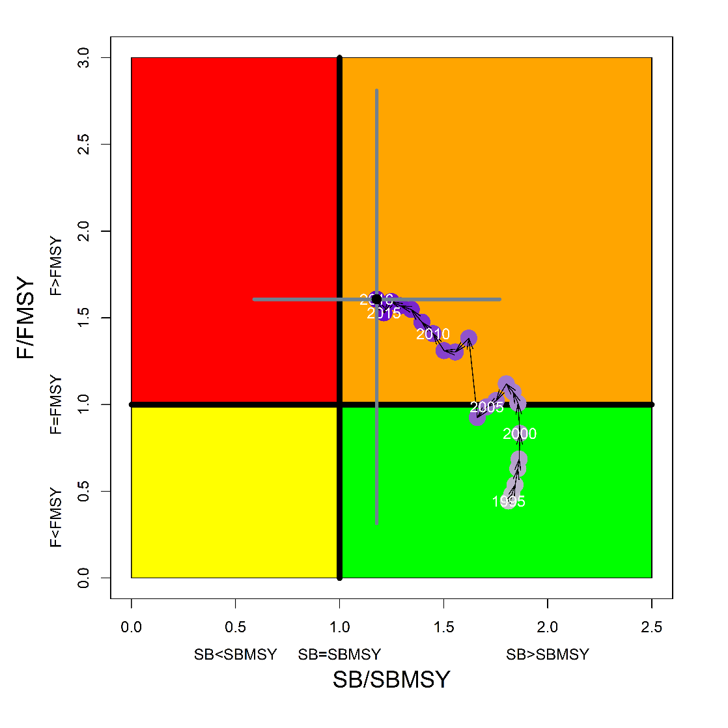
Figure FAL-2: Kobe plot for the WCPO assessment model (CPUEqdev).

b. Management advice and implications

- SC14 concludes that on the basis of the best available science, and pending the availability of less uncertain stock status indicators, the stock is not overfished, but is subject to overfishing (Figure FAL-2).

- SC14 recommends, given that the WCPO silky shark stock continues to be subject to overfishing, that CMM 2013-08 be maintained as a precautionary measure.

    - South Pacific blue shark (Prionace glauca)

      - Research and information

- The last stock assessment was conducted in 2016. SC14 did not receive any updated information.

      - Provision of scientific information

a. Status and trends

- SC14 noted that no stock assessments were conducted for South Pacific blue shark in 2018. Therefore, the stock status descriptions from SC13 are still current for South Pacific blue shark. Updated information on catches was not compiled for and reviewed by SC14.

b. Management advice and implications

- SC14 noted that no management advice has been provided for South Pacific blue shark.

    - North Pacific blue shark (Prionace glauca)

      - Research and information

a. Designation of North Pacific Blue Shark as a northern stock

- John Hampton (SPC) presented SC14-SA-WP-09, Indicators of the spatial distribution of blue shark (Prionace glauca) in the North Pacific, noting that WCPFC14 (paragraph 378, WCPFC14 Summary Report) requested the Scientific Committee to provide advice as to whether blue shark in the North Pacific should be designated as a “northern stock”, defined as those stocks “which occur mostly in the area north of the 20° north parallel”.

- Blue shark comprise a single stock in the North Pacific, and occur widely from the Equator to at least 57°N. They mate in subtropical and tropical waters during the summer, after which females migrate northwards, giving birth in the following year between 30°-40°N. The area south of 20°N is an important part of the blue shark distribution in the North Pacific, particularly for adults. Furthermore, the area may be part of the breeding ground, and/or post-breeding area for pregnant females.

- Catch and CPUE data from several fisheries and research cruises were examined for indications of relative distribution of blue shark north and south of 20°N. Japanese research cruise data indicated that blue shark CPUE is higher in the northern area. Other data sets examined – Chinese Taipei large-scale tuna longline and Hawaii-based deep-set longline – indicated similar levels of CPUE in both northern and southern areas. It is acknowledged that such spatial comparisons may be confounded by possibly different depth distributions that blue shark occupy in the northern temperate and southern tropical regions of the North Pacific, and the depths that longline gear fish in these regions. Nevertheless, it is clear from the available data that the tropical region of the North Pacific south of 20°N is an important component of the blue shark distribution. This is also supported by conventional and electronic tagging data.

- The question: do blue shark occur mostly north of 20°N? – is difficult to answer scientifically because of the qualitative nature of the question. Based on nominal CPUE spatial comparisons, we would judge that blue shark has a tropical component at 0-20°N similar to some already-designated northern stocks. Comparisons of swordfish, albacore and blue shark nominal CPUE in the Hawaii-based deep-set longline fishery show similar ratios north and south of 20°N for all three species, indicating that, at least in the area of this fishery, swordfish, albacore and blue shark all have significant parts of their distributions south of 20°N.

- In order to provide more specific advice, the Commission needs to clarify, and ideally quantify, what is meant by mostly north of 20°N. If this can be done, indicators of the spatial distribution of candidate northern stocks, or indeed existing northern stocks, could be more objectively evaluated.

- Recommendations for further research that could improve the indicators of spatial distribution of blue shark include:

- The further collection and analysis of observer data for longliners fishing in the North Pacific;
- The development of spatially-structured population models;
- The collection and analysis of electronic tagging data to estimate patterns of vertical habitat use in the North Pacific and;
- Analyses to estimate effective effort and standardised CPUE that simultaneously take into account patterns of blue shark habitat use, and the fishing depth and other characteristics of longline gear.

Discussion

- Japan supported the conclusion that the Commission needs to clarify what is meant by “mostly N of 20 degrees N”, stating this was a political matter, not a scientific issue, and asked for clarification from the Commission.

- FSM stated that FFA members have long regarded the population of blue sharks to comprise a single stock in the Pacific. They thanked SPC for providing SC14-SA-WP-09, which highlighted the difficulties in assessing CPUE trends for fisheries where gear differs spatially, and for species that may use the pelagic environment differently across the Pacific. These spatial differences cannot be resolved without good observer data and a detailed understanding of how blue sharks use the pelagic environment. However, it is clear from the available data blue sharks have a significant part of their distribution south of 20° N. They noted the lack of clarification for the definition of what constitutes “most of a stock” for the designation of a northern stock and stated that the Commission should clarify this prior to the SC making recommendations regarding the designation of this stock.

- China noted changes in fishing gear that affected shark survival, and inquired whether it was possible to analyze catch made before CMMs were in place? J. Hampton (SPC) noted that there are many issues that warrant more investigation with respect to mitigation, and using observer information, both the Hawaii and Chinese Taipei analyses in the paper were based on observer data, not logsheets. Thus these were verified catches recorded by observers.

- The EU noted the situation in the Atlantic and Indian oceans, where the blue shark occurs in both equatorial, tropical and temperate waters, with clear size segregation. In those oceans species such as blue shark clearly need all habitats for their life cycle. They fully agreed on the need for clarification from the Commission regarding the term “mostly”. This was echoed by Japan, who also stated the consideration that as a practical matter, the NC could more rapidly address the issue; most catch is taken in the north, and most countries affected are present in the NC. In looking at other northern species, Japan saw no reason why North Pacific blue shark could not be designated a northern species.

      - Provision of scientific information

a. Status and trends

- SC14 noted that no stock assessments were conducted for north Pacific blue shark in 2018. Therefore, the stock status descriptions from SC13 are still current for north Pacific blue shark. Updated information on catches was not compiled for and reviewed by SC14.

b. Management advice and implications

- SC14 noted that no management advice has been provided since SC13 for north Pacific blue shark. Therefore, previous advice should be maintained, pending a new assessment or other new information. For further information on the management advice and implications from SC13, please see https://www.wcpfc.int/node/29904

c. Recommendations on the designation of North Pacific blue shark as a Northern Stock

- Regarding the issue of the designation of North Pacific blue shark as a Northern Stock (WCPFC14 Report, Para 378), SC14 provides the following recommendations:

- SC14 recommends that the Commission clarify and quantify what is meant by “mostly north of 20 degrees N”.
- In relation to paragraph 1, SC14 recommends that a check-list of benchmark scientific information for North Pacific blue shark be developed to support the Commission’s deliberations in determining the designation of a northern stock. As such, the following draft checklist is forwarded for the Commission’s consideration.

No | Criteria | Response | Comments
1 | What proportion of the total estimated stock biomass occurs on average north of 20ºN? | Unknown | Current assessment model does not include population spatial structure. Nominal CPUE may be biased and could be overestimated in the north unless the effects of fishing time, depth and depth distribution of blue sharks are accounted for.
2 | Does all of the breeding/spawning area(s) occur north of 20 ºN? | No | Breeding area is mainly north of 20 ºN but may overlap areas south of 20 ºN
3 | Does all of the nursery area(s) occur north of 20 ºN | Yes | Mostly in the area 30-40 ºN
4 | Do any other important life history stages occur south of 20 ºN? | Yes | Pregnant females are commonly found south of 20 ºN
5 | What proportion of the total annual estimated catch occurs north of 20 ºN? | 0.88 on average | Based on raised, aggregated (5x5 degree) longline data 2014-2017 submitted to WCPFC (Operational data would provide better resolution than aggregated data)
6 | Is fishery catch-per-unit-effort demonstrably higher north of 20 ºN for comparable fisheries? | (i) Similar CPUE observed north and south of 20 ºN in Chinese Taipei LSTLL fishery and Hawaii deep-set LL fishery  (ii) CPUE higher north of 20 ºN in Japan shallow set research survey | CPUE comparisons may be biased by different depth distribution of blue shark north and south of 20 ºN.
7 | Is there sufficient information about fish movement between the areas north and south of 20 ºN? | Yes | Conventional tagging data shows that the maximum range of movements suggests at least northern and southern sub-populations of blue shark, as demarked by the equator.

    - North Pacific shortfin mako shark (Isurus oxyrinchus)

      - Research and information

a. Review of 2018 North Pacific shortfin mako shark stock assessment

- F. Carvalho presented SC14-SA-WP-11 ISC Shark Working Group. Stock Assessment of Shortfin Mako Shark in the North Pacific Ocean through 2016. The ISC SHARKWG’s first full stock assessment of shortfin mako shark (SFM, Isurus oxyrinchus) in the North Pacific Ocean (NPO) was conducted in 2018. Due to a lack of biological and fisheries information, an indicator-based analysis was conducted in 2015. For the present analysis, time-series of catch, relative abundance, and sex-specific length composition from multiple fisheries were developed for the modeling period (1975 – 2016). In addition, new biological information, and research into parameterization of the Beverton-Holt stock recruitment relationship enabled the development of a size-based, age-structured model using the Stock Synthesis modeling platform.

- SFMs are distributed throughout the pelagic, temperate NPO. Nursery areas are found along the continental margins in both the western and eastern Pacific Ocean (WPO and EPO), and larger subadults and adults are observed in greater proportions in the Central Pacific Ocean (CPO). A single stock of SFMs is assumed in the NPO based on evidence from genetics, tagging studies, and lower catch rates of SFM near the equator compared to temperate areas. However, within the NPO some regional substructure is apparent as the majority of tagged SFMs have been recaptured within the same region where they were originally tagged, and examination of catch records by size and sex demonstrates some regional and seasonal segregation across the NPO.

- Catch data for this stock could be divided into early (1975 – 1993) and late (1994 – 2016) periods. The catch for the early period (1975-1993) was highly uncertain because species-specific SFM catch was not reported for major fisheries, and were instead estimated from blue shark catch using blue shark to SFM ratios. On the other hand, species-specific SFM catch was available for all major fisheries after 1993. The total estimated catch of North Pacific SFMs reached a peak of 7,068 mt in 1981 and then declined in the early 1990s, with catches fluctuating between 1,948 mt and 2,395 mt since the early 1990s (Figure SFM-1). Drift gill nets accounted for the highest catches of SFM during the early period but the catches have been predominantly from longline fisheries since 1993.

- Annual catch estimates were derived for a variety of fisheries by nation and gear. Catch and size composition data were grouped into 17 fisheries. Standardized catch-per-unit-effort (CPUE) data used to represent trends in relative abundance were provided by Japan, USA, Taiwan, and Mexico. The North Pacific SFM stock was assessed using a length-based statistical catch-at-age Stock Synthesis model (SS Version 3.24U), that was fit to time series of standardized CPUE and sex-specific size composition data. Sex-specific growth curves and weight-at-length were used to account for the sexual dimorphism of SFMs. A Beverton-Holt stock recruitment relationship was used to characterize productivity of the stock based on plausible life history information available for North Pacific SFMs. Models were fit to relative abundance indices and size composition data in a likelihood-based statistical framework. Maximum likelihood estimates of model parameters, derived outputs, and their variances of the base case model were used to characterize stock status.

- Input parameter values and model structure for the base case model were chosen based on the best available information regarding the life history of SFMs, knowledge of the historical catch time series and existing fishery data, and model fit and diagnostic (Figure SFM-2). Due to uncertainty in the input data and life history parameters, multiple models were run with alternative data and/or parameters including the abundance indices used in the analyses, initial catch level, natural mortality schedule, and the stock recruitment relationship. Numerous models representing different combinations of input datasets and structural model hypotheses were used to assess the influence of these uncertainties on biomass trends and fishing intensity levels for the North Pacific SFM. The key uncertainties in this assessment were related to the catch time series, especially in the early period (1975-1993), the precision of the early Japan shallow-set CPUE index (1975-1993), initial conditions, and the stock recruitment relationship. Six models representing these key uncertainties were developed to examine the status of the North Pacific SFM stock under alternative states of nature:

- Higher catch: Total catch is 50% and 20% higher for the early (1975-1993) and late (1993-2016) periods, respectively;
- Lower catch: Total catch is 50% and 20% lower for the early (1975-1993) and late (1993-2016) periods, respectively;
- Higher uncertainty on index: Average CV of Japan shallow-set CPUE index (1975-1993) is 0.3;
- Initial conditions: Initial conditions were estimated without fitting to initial equilibrium catch estimated outside the model, and fit to S9_JPN_SS_I and S1_US_SS indices;
- Lower steepness: A lower value was assumed for the steepness parameter (0.260);
- Higher steepness: A higher value was assumed for the steepness parameter (0.372).

- The current assessment provides the best scientific information available on North Pacific shortfin mako shark stock status. Results from this assessment should be considered with respect to the management objectives of the Western and Central Pacific Fisheries Commission (WCPFC) and the Inter-American Tropical Tuna Commission (IATTC), the organizations responsible for management of pelagic sharks caught in international fisheries for tuna and tuna-like species in the Pacific Ocean. Target and limit reference points have not been established for pelagic sharks in the Pacific Ocean. In this assessment, stock status is reported in relation to maximum sustainable yield (MSY).

- In this assessment, the reproductive capacity of this population was calculated as spawning abundance (SA; i.e. number of mature female sharks) rather than spawning biomass, because the size of mature female sharks did not appear to affect the number of pups produced (i.e., larger female sharks did not produce more pups). Spawning potential ratio (SPR) was used to describe the impact of fishing on this stock. The SPR of this population is the ratio of SA per recruit under fishing to the SA per recruit under virgin (or unfished) conditions. Therefore, 1-SPR is the reduction in the SA per recruit due to fishing and can be used to describe the overall impact of fishing on a fish stock.

- Recruitment was estimated on average to be 1.1 million age-0 sharks during the modeling timeframe (1975-2016) (Figure SFM-3). During the same period, the SA was estimated, on average, to be 910,000 sharks (Figure SFM-4). The current SA (SA2016) was estimated to be 860,200 sharks (CV=46%) (Table SFM-1) and was 36% (CV=30%) higher than the estimated SA at MSY (SAMSY) (Table SFM-2, Figure SFM-4). The recent annual fishing intensity (1-SPR2013-2015) was estimated to be 0.16 (CV=38%) and was 62% (CV=38%) of fishing intensity at MSY (1-SPRMSY; 0.26) (Table SFM-2; Figure SFM-5). The results from the base case model show that, relative to MSY, the North Pacific shortfin mako stock is likely (>50%) not in an overfished condition (i.e. $\frac{{SA}_{2016}}{{SA}_{MSY}}$ > 1) and overfishing is likely (>50%) not occurring (i.e. $\frac{{1-SPR}_{2013-2015}}{{1-SPR}_{MSY}}$ < 1) (Figure SFM-6).

- Besides the base case model, stock status was also examined under the six alternative states of nature outlined above, which represent the most important sources of uncertainty in the assessment. Results of these models with alternative states of nature were consistent with the base case model and showed that, relative to MSY, the stock is likely (>50%) not in an overfished condition and overfishing is likely (>50%) not occurring (Figure SFM-7, Table SFM-3).

- Future projections over a 10-year period (2017-2026) were performed under three constant fishing intensity scenarios: 1) average of 2013-2015 (F₂₀₁₃₋₂₀₁₅); 2) F₂₀₁₃₋₂₀₁₅ + 20%; and 3) F₂₀₁₃₋₂₀₁₅ - 20%. Based on these future projections, the SA is expected to increase gradually under scenarios 1 and 3, however, in scenario 2, the SA drops in the final years of the projection (Figure SFM-8). Based on these results, the SA is expected to increase gradually if fishing intensity remains constant or is decreased moderately relative to 2013-2015 levels. However, given the uncertainty in fishery data and key biological processes within the model, especially the stock recruitment relationship, the models’ ability to project into the future is highly uncertain.

- There is substantial uncertainty in the estimated historical catches of SFMs. Substantial time and effort was spent on estimating historical catch and more work remains to be conducted. In particular, the SHARKWG identified two future improvements that are critical: 1) identify all fisheries that catch SFMs in the NPO, such as are there any fisheries that catch SFM that may not have been identified by the SHARKWG; and 2) methods to estimate SFM catches should be improved, especially for the early period from 1975 to 1993.

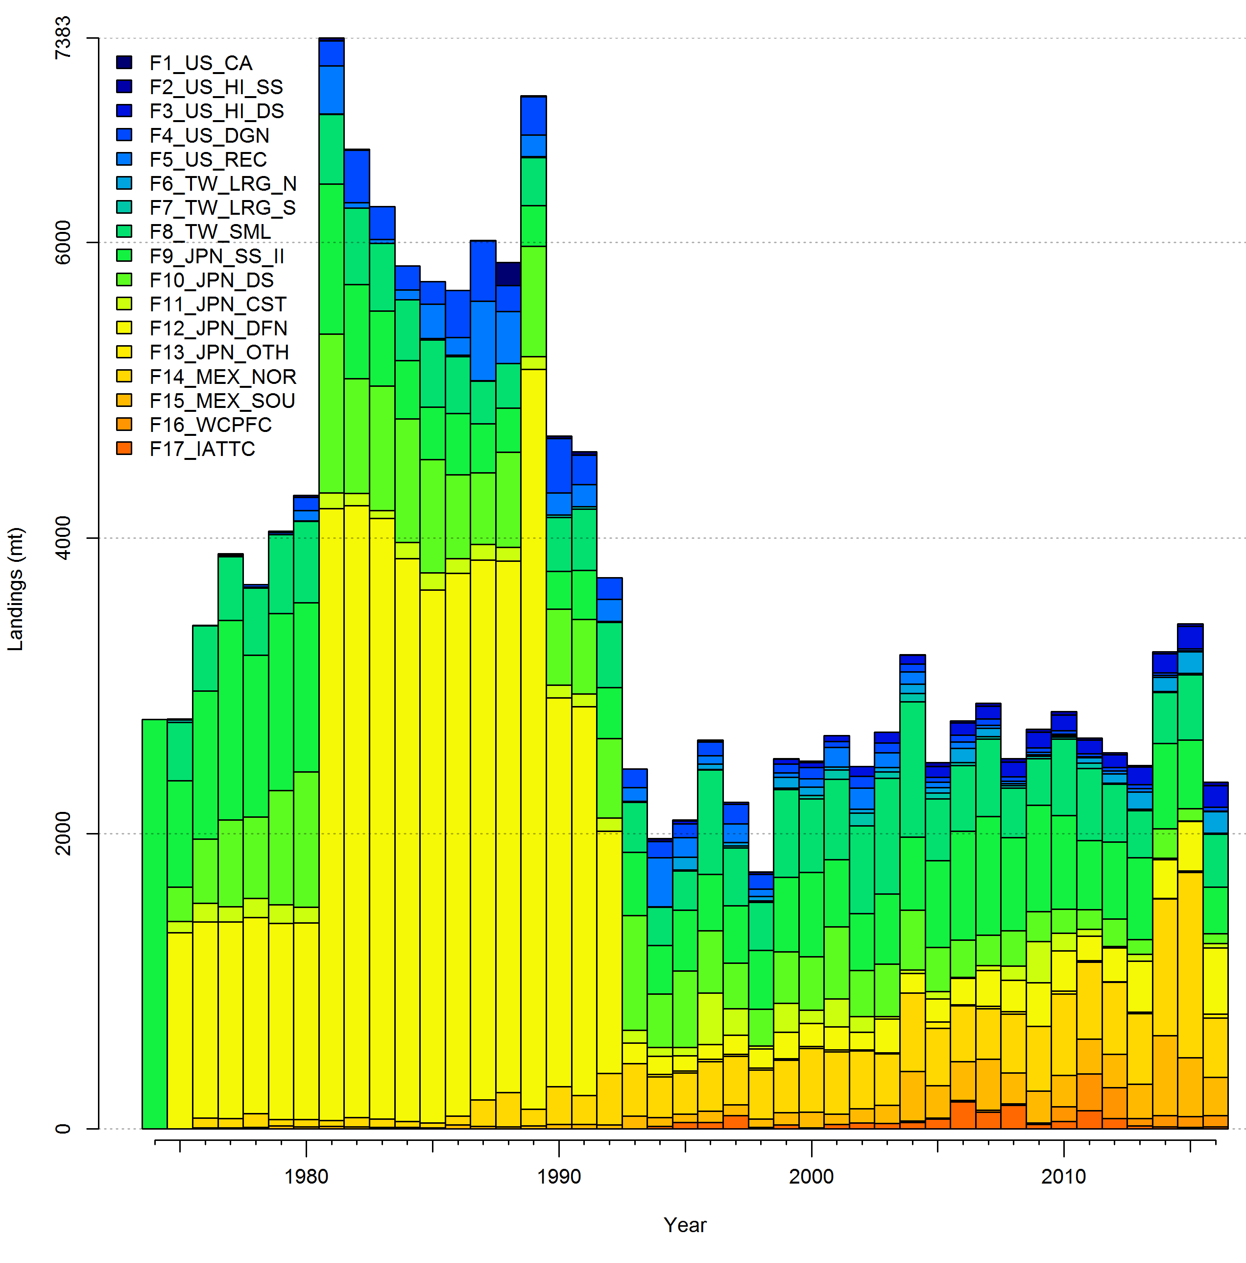Figure SFM-1. Total catch (total dead removals) of North Pacific shortfin mako shark by fishery (1975-2016).

Figure SFM-2. Yearly changes in standardized CPUE of North Pacific shortfin mako shark (1975-2016) used in the base case stock assessment model. All indices are normalized to a mean value of one (horizontal dotted line). S1_US_SS (Hawaii longline shallow-set fleet), S3_TWN_LRG (Taiwan large scale longline fleet), S5_JPN_RTV (Japan research and training vessels), S8_MEX (Mexico longline fleet), and S9_JPN_SS_I (Japan longline shallow-set fleet).

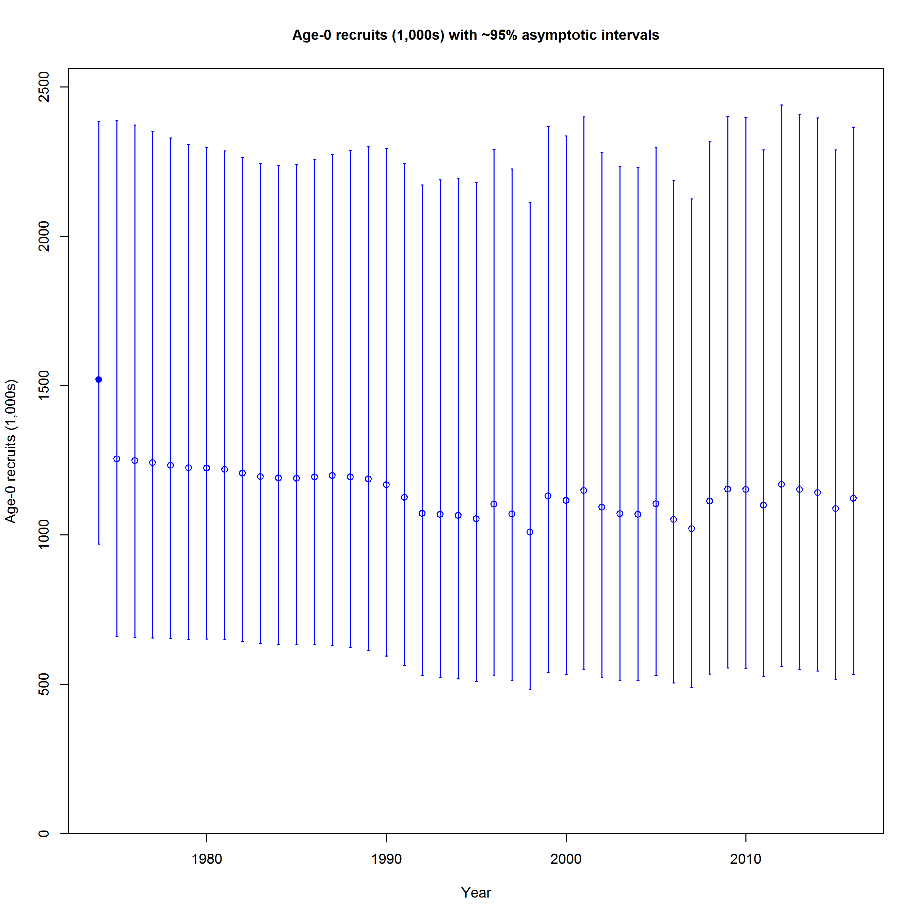
Figure SFM-3. Estimated age-0 recruitment in the base case model. Error bars indicate the 95% confidence intervals; the closed circle indicates recruitment under unfished conditions.

Figure SFM-4. Estimated spawning abundance (SA; number of mature female sharks) of shortfin mako sharks in the North Pacific Ocean during the modeling time frame (1975-2016). Dashed lines indicate 95% confidence intervals; and closed circle and error bars indicate the estimated SA and 95% confidence intervals under unfished conditions (SA₀). Blue solid line indicates the estimate of SA at maximum sustainable yield (MSY) (SA_{MSY}).

Figure SFM-5. Estimated fishing intensity (1-SPR) on the North Pacific shortfin mako shark stock. Dashed lines indicate 95% confidence intervals. Blue solid line indicates the estimate of (1-SPR) at maximum sustainable yield (MSY) (1-SPR_{MSY}).

Figure SFM-6. Kobe time series plot of shortfin mako sharks in the North Pacific Ocean indicating the ratio of spawning abundance (SA; number of mature female sharks) relative to SA at maximum sustainable yield (SA_{MSY}), and the ratio of fishing intensity (1-SPR) relative to fishing intensity at maximum sustainable yield (1-SPR_{MSY}) for the base case model. Values for the start (1975) and end (2016) years are indicated by the blue triangle and black circle, respectively. Black error bars indicate 95% confidence intervals. Gray numbers indicate selected years.

Figure SFM-7. Kobe plot of shortfin mako sharks in the North Pacific Ocean indicating the ratio of spawning abundance (SA; number of mature female sharks) relative to SA at maximum sustainable yield (MSY) (SA_{MSY}), and the ratio of fishing intensity (1-SPR) relative to fishing intensity at MSY (1-SPR_{MSY}) for the end year (2016) of the base case model and six alternative states of nature: Alternative_1) higher catch, Alternative_2) lower catch; Alternative_3) higher uncertainty on Japan shallow-set CPUE index (1975-1993) (CV=0.3); Alternative_4) fit to Japan offshore distant water longline shallow-set fleet (JPN_SS_I; 1975-2016) and Hawaii longline shallow-set fleet (US_SS; 2005-2016), and no fit to initial equilibrium catch; Alternative_5) low steepness, h=0.260; and Alternative_6) high steepness, h=0.372. Solid lines indicate 95% confidence intervals.

Figure SFM-8. Future projections of spawning abundance for shortfin mako sharks in the North Pacific Ocean from 2017 to 2026 under three constant fishing intensity (F) harvest scenarios (F₂₀₁₃₋₂₀₁₅, F₂₀₁₃₋₂₀₁₅+20%, F₂₀₁₃₋₂₀₁₅-20%) using the base case model.

Table SFM-1. Recent estimates of catch, biomass, and spawning abundance (SA; number of mature female sharks), recruitment estimated, and fishing intensity (1-SPR) in the base case model.
Year | Estimated catch (mt) | Spawning abundance (1000s) | Number of recruits (1000s) | 1-SPR
2007 | 2882.4 | 847.3 | 1020.6 | 0.17
2008 | 2506.5 | 850.4 | 1112.8 | 0.15
2009 | 2704.6 | 853.7 | 1153.6 | 0.16
2010 | 2824.6 | 856.8 | 1152.3 | 0.17
2011 | 2646.1 | 858.9 | 1099.0 | 0.16
2012 | 2545.0 | 860.0 | 1169.0 | 0.15
2013 | 2329.1 | 860.4 | 1151.8 | 0.13
2014 | 2460.3 | 860.3 | 1141.7 | 0.17
2015 | 2519.9 | 859.9 | 1087.9 | 0.19
2016 | 2346.8 | 860.2 | 1122.0 | 0.14

Table SFM-2. Estimated reference points for the base case model.
Reference points | Symbol | Estimate (CV) | Units
Unfished conditions
Spawning abundance (number of mature female sharks) | SA₀ | 1465.8 (23.3%) | 1000s of sharks
Recruitment at age-0 | R₀ | 1520.4 (23.3%) | 1000s of sharks
MSY-based reference points
Maximum Sustainable Yield (MSY) | C_{MSY} | 3127.1 (22.2%) | Metric tons
Spawning abundance at MSY | SA_{MSY} | 633.7 (23.3%) | 1000s of sharks
Fishing intensity at MSY | 1-SPR_{MSY} | 0.26 | NA

Table SFM-3. Summary of reference points and management quantities for the base case and six alternative states of nature: Alternative_1) higher catch, Alternative_2) lower catch; Alternative_3) higher uncertainty on Japan shallow-set CPUE index (1975-1993) (CV=0.3); Alternative_4) fit to Japan offshore distant water longline shallow-set fleet (JPN_SS_I; 1975-2016) and Hawaii longline shallow-set fleet (US_SS; 2005-2016), and no fit to initial equilibrium catch; Alternative_5) low steepness, h=0.260; and Alternative_6) high steepness, h=0.372. Values in parentheses represent the coefficient of variation (CV) when available.
Reference points | Symbol | Units | Base-case | Alternative_1 | Alternative_2 | Alternative_3 | Alternative_4 |  | Alternative_5 | Alternative_6
Spawning abundance (number of mature female sharks) | SA₀ | 1000s of sharks | 1465.8 (23.3%) | 1898.8  (14.6%) | 826.8  (27.5%) | 1240.6  (70%) | 1727.6  (32%) | 2366.5  (30%) |  | 1327.1  (32%)
Maximum Sustainable Yield (MSY) | C_{MSY} | Metric tons | 3127.1 (22.2%) | 3951.8  (13.0%) | 1725.4  (26%) | 2558.2  (68%) | 3175.3  (31%) | 2731  (29%) |  | 3759  (28%)
Spawning abundance at MSY | SA_{MSY} | 1000s of sharks | 633.7  (23.3%) | 821.3  (14.1%) | 371.5  (27%) | 536.6  (70%) | 759  (32%) | 1095  (30%) |  | 539.8  (30%)
Fishing intensity at MSY | 1-SPR_{MSY} | NA | 0.26 | 0.26 | 0.26 | 0.26 | 0.24 | 0.16 |  | 0.34
Current spawning abundance relative to MSY | SA₂₀₁₆/SA_{MSY} | NA | 1.36 | 1.16 | 1.34 | 1.57 | 1.40 | 1.26 |  | 1.59
Current spawning abundance relative to unfished level | SA₂₀₁₆/SA₀ | NA | 0.58 | 0.51 | 0.58 | 0.68 | 0.61 | 0.59 |  | 0.64
Recent fishing intensity  relative to MSY | $$\frac{{1-SPR}_{2013-2015}}{{1-SPR}_{MSY}}$$ | NA | 0.62 | 0.66 | 0.53 | 0.68 | 0.57 | 0.69 |  | 0.47

Discussion

- Cook Islands, on behalf of FFA members, supported the improvement of the collection of catch data for the fishery.

- Australia noted that there were inconsistencies in the indices and asked if sensitivity analysis of CPUE indices had been used to include or exclude indices. F. Carvalho stated that they first reviewed which indices were available, and ran individual sensitivity analyses without criteria to down weight or exclude any indices. The model was consistent under each, and all were retained.

- SPC noted that Fig 10 indicated exploitation for the largest sharks was very low, and thus some biomass effect was evident, and inquired if a selectivity analysis was used. The presenter found no differences in logistics curves.

- In response to a query from FAO regarding indications of reduction in fishing effort or environmental effect the presenter noted the ISC WG did not focus on Pacific-wide trends. There was some spatial structure evident in the data, but the stock assessment is a one-area model. There are plans to build a spatially structured model, and look at trends and the potential impact of environmental covariates in these indices.

      - Provision of Scientific Information

a. Stock status and trends

- SC14 noted that ISC provided the following conclusions on the stock status of North Pacific Shortfin Mako Shark in the Pacific Ocean in 2017, as presented in SC14-SA-WP-11 (Stock Assessment of Shortfin Mako Shark in the North Pacific Ocean Through 2016).

Based on these findings, the following information on the status of the SFM stock is provided:
- Target and limit reference points have not been established for pelagic sharks in the Pacific Ocean. Stock status is reported in relation to MSY.
- The results from the base case model show that, relative to MSY, the North Pacific shortfin mako stock is likely (>50%) not in an overfished condition and overfishing is likely (>50%) not occurring relative to MSY-based abundance and fishing intensity reference points (Table SFM-4; Figure SFM-9A).

Stock status was also examined under six alternative states of nature that represented the most important sources of uncertainty in the assessment. Results of these models with alternative states of nature were consistent with the base case model and showed that, relative to MSY, the North Pacific shortfin mako shark stock is likely (>50%) not in an overfished condition and overfishing is likely (>50%) not occurring (Figure SFM-9B).

b. Management Advice and implications

- SC14 noted the following conservation advice from ISC:

Stock projections of biomass and catch of North Pacific shortfin mako from 2017 to 2026 were performed assuming three alternative constant fishing mortality scenarios: 1) status quo, average of 2013-2015 (F₂₀₁₃-₂₀₁₅); 2) F₂₀₁₃₋₂₀₁₅ + 20%; and 3) F₂₀₁₃₋₂₀₁₅ - 20% (Figure SFM-10).

Based on these future projections, the following conservation information is provided:
- If fishing mortality remains constant at F2013-15 or is decreased 20%, then the Stock Abundance is expected to increase gradually;
- If fishing mortality is increased 20% relative to F2013-2015, then the Stock Abundance is expected to decrease in the final years of the projection.
- It should be noted that, given the uncertainty in fishery data and key biological processes within the model, especially the stock recruitment relationship, the models’ ability to project into the future is highly uncertain.

Research Needs

There is uncertainty in the estimated historical catches of North Pacific shortfin mako shark. Substantial time and effort was spent on estimating historical catch and more work remains to be conducted. In particular, the SHARKWG identified two future improvements that are critical: 1) identify all fisheries that catch shortfin mako shark in the NPO, including fisheries that were not previously identified by the SHARKWG; and 2) methods to estimate shortfin mako shark catches should be improved, especially for the early period from 1975 to 1993.

Table SFM-4. Summary of reference points and management quantities for the shortfin mako shark (Isurus oxyrinchus) base case model. The percentages in brackets are the CV of the estimated quantity in the base case model.
Management Quantity | Symbol | Units | Base case
Spawning abundance (number of mature female sharks | SA0 | 1000s of sharks | 1465.8 (23%)
Maximum Sustainable Yield (MSY) | CMSY | Metric tons (t) | 3127.1 (22%)
Spawning Abundance at MSY | SAMSY | 1000s of sharks | 633.7 (23%)
Fishing Intensity at MSY | 1-SPRMSY | NA | 0.26
Current spawning abundance relative to MSY | SA2016/SAMSY | NA | 1.36
Current spawning abundance relative to unfished level | SA2016/SA0 | NA | 0.58
Recent fishing Intensity relative to MSY | (1-SPR2013-15)/(1- SPRMSY) | MSY | 0.62

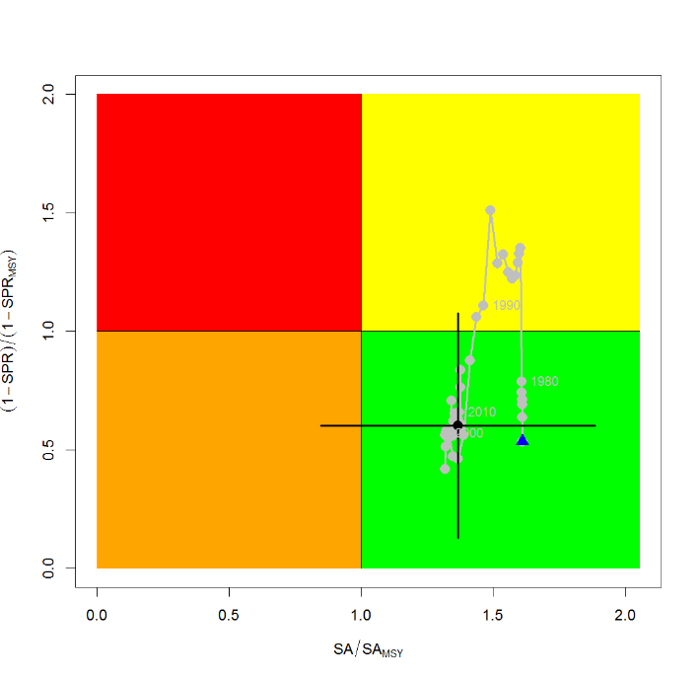
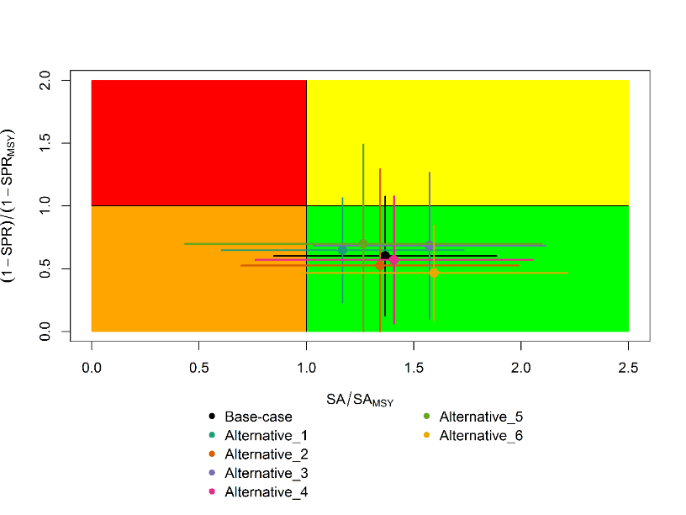
Figure SFM-9. Kobe plots of shortfin mako shark in the North Pacific Ocean showing. A) The time series of the ratio of SA to SA at MSY (SA_{MSY}) and fishing intensity to fishing intensity at MSY (1-SPR_{MSY}), and B) the same ratios for the terminal year (2016) for six alternative states of nature. SA is spawning abundance measured as the number of mature females. Fishing intensity is estimated as 1-SPR. Values for the start (1975) and end (2016) years in the time series (A) are indicated by the blue triangle and black circle, respectively. Gray numbers indicate selected years. Alternative states of nature in B) include: Alternative_1) higher catch, Alternative_2) lower catch; Alternative_3) higher uncertainty on Japan shallow-set CPUE index (1975-1993) (CV=0.3); Alternative_4) fit to Japan offshore distant water longline shallow-set fleet (JPN_SS_I; 1975-2016) and Hawaii longline shallow-set fleet (US_SS; 2005-2016), and no fit to initial equilibrium catch; Alternative_5) low steepness, h=0.26; and Alternative_6) high steepness, h=0.37. Solid lines indicate 95% confidence intervals.
A
B

Figure SFM-10. Comparison of future projected North Pacific shortfin mako (Isurus oxyrinchus) spawning abundance under different F harvest policies (Constant F 2013-2015, +20%, -20%) using the base case model. Constant F was based on the average from 2013-2015.

    - Pacific bigeye thresher shark (Alopias superciliosus)

      - Research and information

- A Pacific-wide sustainability risk assessment of bigeye thresher shark was conducted in 2017. SC14 received no new information.

      - Provision of scientific information

a. Status and trends

- SC14 noted that no stock assessments were conducted for Pacific bigeye thresher shark in 2018. Therefore, the stock status descriptions from SC13 are still current for Pacific bigeye thresher shark respectively. Updated information on catches was not compiled for and reviewed by SC14.

b. Management advice and implications

- SC14 noted that no management advice has been provided since SC13 for Pacific bigeye thresher shark. Therefore, previous advice should be maintained, pending a new assessment or other new information. For further information on the management advice and implications from SC13, please see https://www.wcpfc.int/node/29904

    - Porbeagle shark (Lamna nasus)

      - Research and information

- A Southern Hemisphere stock status assessment of porbeagle shark was undertaken in 2017. SC 14 received no new information.

      - Provision of scientific information

a. Status and trends

- SC14 noted that no stock assessments were conducted for southern porbeagle shark in 2018. Therefore, the stock status descriptions from SC13 are still current for southern porbeagle shark. Updated information on catches was not compiled for and reviewed by SC14.

b. Management advice and implications

- SC14 noted that no management advice has been provided since SC13 for southern porbeagle shark. Therefore, previous advice should be maintained, pending a new assessment or other new information. For further information on the management advice and implications from SC13, please see https://www.wcpfc.int/node/29904

    - Whale shark ( Rhincodon typus)

      - Review of research and information

- P. Neubauer (Dragonfly Data Science), Y. Richard (Dragonfly Data Science), and S. Clarke (Common Oceans (ABNJ) Tuna Project), presented SC14-SA-WP-12 (Rev 1) Risk to the Indo-Pacific whale shark (Rhincodon typus) population from interactions with Pacific purse seine fisheries.

- Western and Central Pacific Ocean tropical purse-seine fishery observer data was used to describe whale shark interactions and trends within that fishery. Fishery interaction data were standardized to investigate whether fluctuations in oceanographic conditions (described by sea surface temperature and chlorophyll a) can explain temporal patterns in interactions. Although changes in oceanic habitat variables could not account for the temporal shifts in interaction rates, estimated environmental effects on spatial interaction rates produced estimates of spatial habitat suitability that appeared consistent with available information. Maps of predicted habitat suitability were used to define the overlap between Pacific Ocean (WCPFC and IATTC) tuna fisheries and whale sharks, and to estimate total mortalities expected within these fisheries. The authors also used life-history information and life-history theory to estimate risk for the Indo-Pacific Ocean whale shark population from Pacific Ocean purse-seine fisheries. To estimate the unobservable post-release mortality, the authors conducted a Delphi survey of experts, and summarized the information using a statistical model. The risk assessment model suggested that the risk from Pacific Ocean fisheries alone is moderate to low, but not insignificant given potential other sources of mortality and uncertainty. In accordance with suggestions from the experts in the Delphi survey, it was suggested that development and strict application of best practice release protocols can significantly reduce post-release mortality and, therefore, risk for whale shark populations.

Discussion

- RMI, on behalf of PNA members thanked the presenters for their comprehensive work, stating it was encouraging to see innovative ways of assessing data-poor stocks. They supported providing a recommendation to the Commission based on the assessment’s findings, but requested that any such recommendation be accompanied by a clear description of the range of uncertainties around the work. They reiterated advice that PNA and FFA members have provided on shark reference points: that they could not agree to any stock advice for non-target sharks such as whale sharks that include an F_{MSM} reference point, as this is inconsistent with the Convention guidance for such stocks and therefore paints an inappropriately pessimistic picture. They noted the presentation stated the median probability across years and reference points was about 20%, and asked what the median probability would be if only the F-_{LIM} and F_{CRASH} reference points were used? P. Neubauer replied the median probability if excluding the F_{MSM} reference point was probably below 10% of the LRP; 6% for the F_{CRASH} by memory. Japan noted the comment from PNA members, and that the risk-based approach was new. They supported deletion of the reference to LRP using F_{MSM}. He noted the reference point was the key point for the risk assessment. F_{MSM} is equivalent to F_{MSY}, but the value differs by shark species and is difficult to estimate. The uncertainty of F_{MSM} should be included, and thus the LRP also has uncertainty.

- SPC commented that the presentation indicated precautionary assumptions were made, and observed this was not the approach taken in regular stock assessments, especially when trying to evaluate using a risk-based approach. SPC suggested this be made clear in the recommendations, and some consideration given to using best estimates, as the use of precautionary assumptions made it difficult to evaluate results (e.g., with regard to reference points).

- The Cook Islands commented that they welcomed the use of indicator-based analyses to characterize fishery impact, particularly where limited by data deficiencies. The risk analysis provides a useful basis to determine the impact of purse seine fisheries on the Pacific whale shark population, particularly in the WCPO, and to identify where additional work is needed to address knowledge gaps, and inform potential management options. They recognized that additional measures could be taken to improve post-release survival of whale sharks, as well as more work to improve estimates of survival rates. They stated they would like to see the Commission take more proactive measures to ensure that proscribed measures are avoided by all fleets. They noted the analysis concluded that there was a moderate to low probability of risk from tropical purse seine fisheries, and would generally agree with this based on some of the outputs within the analysis. However, they noted that the use of the reference points (F_{LIM}, F_{MSM}, F_{CRASH}) to characterise risk levels in the study were part of wider discussions and ongoing work that the SC was considering in relation to determining appropriate reference points for sharks, and therefore would prefer that any use of reference points be considered as part of that work.

- Palau noted that PNA members were prepared to support the following recommendation: there is a low probability that the Indo-Pacific whale shark is at risk from Pacific purse seine fisheries (median probability of less than 8% that current risk levels exceed life history-based notional reference points Flim and Fcrash)

- The EU asked for clarification regarding data indicating intentional sets on whale sharks. SPC noted that the data would have to be reviewed, but that what observers were asked to do is record the original set type when a school is detected. If it was subsequently found that a whale shark was present, the free school notation was retained, and the whale shark presence recorded. There is a specific category for whale shark associated sets when they are targeted.

- The EU also inquired regarding the need for development of best practice safe release guidelines for whale sharks, noting that guidelines exist, and asking if they need to be revised. S. Clarke indicated that existing safe release guidelines were strictly negative (“do nots”), with no recommendations for how to safely release, and thus work was needed. In response to a final query regarding quantification of post-release mortality, S. Clarke indicated that existing studies were done in other oceans, and that there was a need to understand how practices in the WCPO might relate to those in other ocean, and to quantify that relationship.

      - Provision of scientific information

- SC14 reviewed the report Risk to the Indo-Pacific whale shark (Rhincodon typus) population from interactions with Pacific purse seine fisheries (SC14-SA-WP-12). The analysis estimated the risk of overfishing the Indo-Pacific whale sharks by overlaying predicted spatial abundance of whale sharks with Pacific-wide fishing effort to estimate total fishing mortality relative to limit reference points.

a. Stock status and trends

- A nominal trend of high interactions in 2006-2008, followed by lower rates thereafter was not altered by standardization (Figure RHN-1), and is consistent with trends found in the Eastern Pacific Ocean by Román et al. 2018. These decreasing annual trends in interactions do not appear to result from management measures as prohibitions on intentional setting of purse seines on whale sharks were adopted by the PNA in 2010, by the WCPFC in 2012 and by the IATTC in 2015. Furthermore, the trends may have been influenced by low WCPO purse seine observer coverage rates prior to 2010.
Figure RHN-1. Estimated temporal index of interactions based on a) the full observer dataset, b) the full dataset without whale- and whale shark associated sets, and c) free-school sets only. The rationale behind the different effort subsets is given in section 2.2.2 of SC14-SA-WP-12. The index is centred to have a geometric mean of one and is therefore unit-less.

- SC14 noted that over a range of notional reference points, and in accordance with expert-elicited post-mortality rates of ~10%, median sustainability risk from Pacific Ocean fisheries alone for the 2006-2016 period ranged between (Figure RHN-2):
  - 3-12% of the limit risk level based on 0.5r_{max} (F_{msm}),
  - 2-8% of the limit risk level based on 0.75r_{max} (F_{lim}), and
  - 2-6% of the limit risk level based on r_{max} (F_{crash}), where r_{max} is the maximum population growth rate.

Figure RHN-2. Risk that mortality exceeds either of three limit reference points (RR_crash (F_{MSM}: 0.5r_{max}), RR_lim (F_{Lim}: 0.75r_{max}), RR_crash (F_{crash}: r_{max})).

- SC14 noted the report’s findings that understanding and reducing post-release mortality is recommended as one of most effective approaches to maintaining acceptable risk levels.

- SC14 also noted the report’s findings that the total risk to the Indo-Pacific whale shark population may be higher if there are differential impacts to more vulnerable population segments within the Pacific and/or higher fishing mortalities outside of the region (e.g. the Indian Ocean).

- SC14 considered the use of precautionary risk assessment model inputs. It was noted that input parameters to the risk assessment were drawn from the best available data, but in some cases where the data were uninformative about the probability distributions of the parameters of interest the methodology put more weight on precautionary values.

b. Management advice and implications

- SC14 considers there is a low probability that the Indo-Pacific whale shark is at risk from Pacific purse seine fisheries (median probability of less than 8% that current risk levels exceed life history-based notional reference points F_{Lim} and F_{crash}).

- SC14 recommends that the WCPFC initiate concerted efforts to identify and promote best practice safe release methods for whale sharks.

- SC14 recommends that research be undertaken to quantify post-release mortality rates under a variety of release scenarios.

  - WCPO billfishes

    - South Pacific swordfish (Xiphias gladius)

      - Research and information

- SC14 noted that the last South Pacific swordfish stock assessment was conducted in 2017.

- SC14 noted SC14-SA-IP-10 Testing MULTIFAN-CL developments for multispecies/ multi-sex assessments, using SW Pacific swordfish. The paper summarizes the current developments to the multi-species/multi-sex functionality of MULTIFAN-CL. These developments are used to implement a preliminary sex-disaggregated MULTIFAN-CL model for swordfish in the southwest Pacific Ocean. A specific subset of results from that evaluation are presented and compared to the diagnostic case model from the 2017 sex-aggregated assessment for this stock. Management quantities such as the depletion of female spawning biomass from the sex-disaggregated model are very similar to those developed for the sex-aggregated 2017 diagnostic case. Despite that overall similarity, there are model-specific differences. For example, the pattern of recruitment by model region is notably different in the two-sex model estimates, with the majority of recruits occurring in Region 2 (eastern region). Estimated selectivity of key fleets is also different in this region. Several potential future improvements for the model are suggested, and should be considered prior to the application of two-sex population dynamics within WCPO assessments.

- SPC indicated that work on this model was progressing and that their intention was to use the model described in SC14-SA-IP-10 for future assessments.

      - Provision of scientific information

a. Stock status and trends

- SC14 noted that no stock assessments were conducted for south Pacific swordfish in 2018. Therefore, the stock status descriptions from SC13 are still current for south Pacific swordfish. Updated information on catches was compiled but not reviewed by SC14.

b. Management advice and implications

- SC14 noted that no management advice has been provided since SC13 for south Pacific swordfish. Therefore, previous advice should be maintained, pending a new assessment or other new information. For further information on the management advice and implications from SC13, please see https://www.wcpfc.int/node/29904

    - Southwest Pacific striped marlin (Kajikia audax)

      - Research and information

- The last Southwest Pacific striped marlin stock assessment was conducted in 2011. SC14 received no new information.

      - Provision of scientific information

a. Stock status and trends

- SC14 noted that no stock assessments were conducted for southwest Pacific striped marlin in 2018. Therefore, the stock status descriptions from SC8 are still current for southwest Pacific striped marlin. Updated information on catches was compiled but not reviewed by SC14.

b. Management Advice and implications

- SC14 noted that no management advice has been provided since SC8 for southwest Pacific striped marlin. Therefore, previous advice should be maintained, pending a new assessment or other new information. For further information on the management advice and implications from SC8, please see https://www.wcpfc.int/node/3396

    - North Pacific striped marlin (Kajikia audax)

      - Research and information

- The theme convener noted that SC14 was to review relevant papers to evaluate the North Pacific striped marlin stock as a northern stock (Paragraph 378, WCPFC14 Summary Report). ISG-1, facilitated by Japan, considered the issue.

- The theme convener noted SC14-SA-IP-11 Estimation of the ratio of spawning biomass of striped marlin above 20°N in the Central and Western North Pacific Ocean using the Japanese Distant Water Longline Fleet and the 2007 Stock Assessment, which used results of the 2007 stock assessment of striped marlin to estimate the ratio of spawning biomass north of 20°N. Estimates of population number-at-age and selectivity patterns and CPUE catchability coefficients from the Japanese distant water longline fleet were used in the analysis. Results indicate that a majority of striped marlin in the western and central north Pacific occur north of 20°N, which is consistent with the distribution of fishery catches since the 1960s.

Discussion

- Japan stated that ISG-01 had developed two recommendations: (i) that the Commission more precisely define what constitutes a northern stock, and (ii) request the Commission use a checklist when evaluating whether to classify a stock as a northern stock.

- The theme convener inquired whether there was any indication of ambiguity regarding whether these were northern stocks. Vanuatu, on behalf of FFA members, stated that the Commission had tasked the SC with prioritising the determination of whether north Pacific striped marlin should be designated as a northern stock. They noted that the available information was in the form of SC14-SA-IP-11, which contained the same information that was presented and considered by SC4, which itself deemed this to be insufficient information. Furthermore, SC4 outlined additional work for north Pacific striped marlin that should have been undertaken, but which did not seem to have progressed. They noted this left the SC in the same position as it was in 10 years ago, where a lack of information hinders the ability to progress these discussions.

- Japan noted that in the absence of a new assessment, SC normally referred to the most recent recommendations. The stock assessment discussed by SC11 concluded the stock is overfished and overfishing is occurring. Japan proposed that SC repeat the recommendations from that assessment, referring specially to the summary that the stock is overfished and overfishing is occurring, and that SC11 recommended a rebuilding plan. The EU stated their understanding that WCPFC14 discussed the issue and that there was an expectation from the Commission that the SC would look at possibilities or options for a rebuilding plan. They inquired whether more information could be provided to the Commission while awaiting another stock assessment. The theme convener noted the components needed in a rebuilding plan and that ISC reports indicated the situation with the stock was consistent. The theme convener further stated that ISC would undertake a benchmark stock assessment of North Pacific striped marlin. Assuming a robust assessment (and results would likely be similar to the last assessment), the results could be used as inputs for stock rebuilding plan software.

- Kiribati, on behalf of FFA members, noted that SC14-SA-IP-11 was based on a 2007 assessment that was not designed to address the spatial distribution of biomass, or estimate regional stock dynamics. In addition, it was unclear what available data informed the work, with some figures suggesting data from as far back as 2003. The paper estimated higher catchability in the north relative to the south for the older age classes, in which different fisheries occur. There is a lack of recent information, no differential standardised CPUE analyses and no consideration of fish movement patterns. As a non-target species, reporting deficiencies would undoubtedly be a key issue impacting the ability to undertake comprehensive assessments for this stock. Notably in the last few years, improvements in Vietnamese catch and effort reporting indicate that they have significant catches of north Pacific striped marlin, presumably in their EEZ, which raises the question about how much underreporting takes place and raising uncertainty in the distribution of biomass across the north Pacific. The WCPFC tuna year book shows that Vietnamese catches accounted for approximately 15% of total striped marlin catches in the north Pacific between 2014-2016, with much of their EEZ based in the area south of 20°N. Furthermore, this raises questions about the potential magnitude of striped marlin catches taken in Indonesia and Philippine fisheries, where data collection programs still improving. In light of the situation, FFA members noted that further studies were needed before the SC could make a decision or recommendation to the Commission on the designation of striped marlin as a northern stock. It further highlights the need for CCMs to collect and provide operational-level data to inform assessments, as well as undertake studies to characterize stock structure, and ensure that the SC is provided with the needed information to provide reliable advice to the Commission.

- The theme convener confirmed that more information was available, and that the ISC stock assessment would examine catches by Vietnam and Indonesia, and includes these data in the stock assessment if present in the WCPO database.

- Palau, on behalf of FFA members, noted that a new assessment for northwest Pacific striped marlin was scheduled for 2019, and given the lack of more recent information, suggested that SC await the outcomes of that assessment. In addition, FFA members suggested that a spatially disaggregated model be used, and like the previous assessment use the regional structure from the 2007 assessment but omit region 5 when considering this stock as a northern stock, as there was some evidence that the stock structure in the east Pacific crosses the equator but it may not in the west.

      - Provision of scientific information

          - Status and trends

- SC14 noted that no stock assessments were conducted for North Pacific striped marlin in 2018. Therefore, the stock status descriptions from SC11 are still current for North Pacific striped marlin. Updated information on catches was not compiled for and reviewed by SC14.

- To emphasize the importance of developing a stock rebuilding plan for North Pacific striped marlin, SC14 reiterated the ISC15 stock status information, excerpted from SC11:

“Estimates of population biomass of the Western and Central North Pacific (WCNPO) striped marlin stock (Kajikia audax) exhibit a long-term decline (Table S1). Population biomass (age-1 and older) averaged roughly 20,513 mt, or 46% of unfished biomass during 1975-1979, the first 5 years of the assessment time frame, and declined to 6,819 mt, or 15% of unfished biomass in 2013. Spawning stock biomass is estimated to be 1,094 mt in 2013 (39% of SSB_{MSY}, the spawning stock biomass to produce MSY). Fishing mortality on the stock (average F on ages 3 and older) is currently high and averaged roughly F =0.94 during 2010-2012, or 49% above F_{MSY}. The predicted value of the spawning potential ratio (SPR, the predicted spawning output at current F as a fraction of unfished spawning output) is currently SPR₂₀₁₀₋₂₀₁₂ = 12% which is 33% below the level of SPR required to produce MSY. Recruitment averaged about 308 thousand recruits during 1994-2011, which was 25% below the 1975-2013 average. No target or limit reference points have been established for the WCNPO striped marlin stock under the auspices of the WCPFC.

The WCNPO striped marlin stock is expected to be highly productive due to its rapid growth and high resilience to reductions in spawning potential. The status of the stock is highly dependent on the magnitude of recruitment, which has been below its long-term average since 2007, with the exception of 2010 (Table S1). Changes in recent size composition data in comparison to the previous assessment resulted in changes in fishery selectivity estimates and also affected recruitment estimates. This, in turn, affected the scaling of biomass and fishing mortality to reference levels.

Table S1: Reported annual values of catch (mt), population biomass (mt), spawning stock biomass (mt), relative spawning stock biomass SSB/SSBMSY), recruitment (000s), fishing mortality, relative fishing mortality (F/F_{MSY}), exploitation rate, and spawning potential ration for the WCNPO striped marlin stock.
Year | 2007 | 2008 | 2009 | 2010 | 2011 | 2012 | 2013 | Mean1 | Min1 | Max1
Reported Catch | 3084 | 3503 | 2468 | 2852 | 3125 | 3521 | 2984 | 5822 | 2468 | 10594
Population Biomass | 6915 | 6773 | 6409 | 5156 | 7823 | 7349 | 6819 | 12758 | 5156 | 28440
Spawning Stock Biomass | 1192 | 1171 | 970 | 984 | 873 | 1013 | 1094 | 2025 | 815 | 6946
Relative Spawning Biomass | 0.42 | 0.42 | 0.34 | 0.35 | 0.31 | 0.36 | 0.39 | 0.75 | 0.29 | 2.46
Recruitment (age 0) | 240 | 242 | 63 | 496 | 155 | 224 | 352 | 410 | 63 | 1369
Fishing Mortality | 0.82 | 0.99 | 0.80 | 0.96 | 0.89 | 0.97 | 0.76 | 0.95 | 0.47 | 1.54
Relative Fishing Mortality | 1.29 | 1.57 | 1.27 | 1.51 | 1.41 | 1.53 | 1.20 | 1.50 | 0.74 | 2.44
Exploitation Rate | 45% | 52% | 39% | 55% | 40% | 48% | 44% | 48% | 32% | 65%
Spawning Potential Ratio | 15% | 12% | 16% | 13% | 12% | 12% | 14% | 13% | 7% | 24%
1 During 1975-2013

When the status of striped marlin is evaluated relative to MSY-based reference points, the 2013 spawning stock biomass is 61% below SSB_{MSY} (2819 t) and the 2010-2012 fishing mortality exceeds F_{MSY} by 49%. Therefore, overfishing is occurring relative to MSY-based reference points and the WCNPO striped marlin stock is overfished.”

- Management advice and implications
- SC14 noted that no management advice has been provided since SC11 for North Pacific striped marlin. Therefore, previous advice should be maintained, pending a new assessment or other new information. For further information on the management advice and implications from SC11, please see https://www.wcpfc.int/node/26922

- To emphasize the importance of developing a stock rebuilding plan for North Pacific striped marlin, SC14 reiterated the following management advice and information, excerpted from SC11.

“SC11 noted the following conservation advice from ISC.

The stock has been in an overfished condition since 1977, with the exception of 1982 and 1983, and fishing appears to be impeding rebuilding especially if recent low recruitment levels persist.

Projection results show that fishing at F_{MSY} could lead to median spawning biomass increases of 25%, 55%, and 95% from 2015 to 2020 under the recent recruitment, medium- term recruitment, and stock recruitment-curve scenarios.

Fishing at a constant catch of 2,850 t could lead to potential increases in spawning biomass of 19% to over 191% by 2020, depending upon the recruitment scenario.

In comparison, fishing at the 2010-2012 fishing mortality rate, which is 49% above F_{MSY}, could lead to changes in spawning stock biomass of -18% to +18% by 2020, while fishing at the average 2001-2003 fishing mortality rate (F2001-2003=1.15), which is 82% above F_{MSY}, could lead to spawning stock biomass decreases of -32% to -9% by 2020, depending upon the recruitment scenario.

SC11 expressed concerns about the updated stock status of WCNPO striped marlin, noting that the stock was overfished (SSB₂₀₁₃ at 61% below SSB_{MSY}) and that overfishing was occurring (F₂₀₁₀₋₂₀₁₂ exceeds F_{MSY} by 49%). Although a LRP for billfish species has not been adopted by the WCPFC, SC11 noted that SSB_{current}/SSB_{current,F=0}=0.12 and is below the LRP adopted for tunas. SC11 also noted that projections indicate that Prob(SSB₂₀₂₀>SSB₂₀₁₅)<50% for all constant catch scenarios over 2,850 mt (under the three recruitment hypotheses modelled), which means that in order to allow the spawning biomass to rebuild then catches need to be reduced to less than 2,850mt. SC11 recommends that the Commission develop a rebuilding plan for North Pacific striped marlin with subsequent revision of CMM 2010-01 in order to improve stock status.”

- Recommendations on the designation of North Pacific striped marlin as a Northern Stock

- Regarding the issue of the designation of North Pacific striped marlin as a Northern Stock (WCPFC14 Report, Para 378), SC14 provides the following recommendations:

- SC14 recommends that the Commission clarify and quantify what is meant by “mostly north of 20 degrees N”.
- In relation to paragraph 1, SC14 recommends that a check-list of benchmark scientific information for North Pacific striped marlin be developed to support the Commission’s deliberations in determining the designation of a northern stock. As such, the following table is forwarded for the Commission’s consideration.

No | Criteria | Response | Comments
1 | What proportion of the total estimated stock biomass occurs on average north of 20N? | *Proportion of biomass above 20 ºN is 2-4 times larger than the proportion of biomass south of 20 ºN in the North Pacific | SC14-SA-IP-011 This value was estimated by stock assessment result in 2007.
2 | Does all of the breeding/spawning area(s) occur north of 20 ºN? | Unknown
3 | Does all of the nursery area(s) occur north of 20 ºN | Unknown
4 | Do any other important life history stages occur south of 20N? | Unknown
5 | What proportion of the total estimated catch occurs north of 20 ºN? | **Range of annual percentages of 66%-96% above 20 ºN. During the 2000s the average percentage was 73% above 20 ºN | SC14-SA-IP-11 These values were estimated from stock assessment results in 2007, but were not endorsed by SC3.
6 | Is fishery catch-per-unit-effort demonstrably higher north of 20 ºN for comparable fisheries? | Unknown
7 | Is there sufficient information about fish movement between north and south of 20 ºN? | No
*Proportion of biomass was calculated in 1964 and 1969 that is near the initial condition.
**The average proportion of the total catch in numbers were calculated by decade (1950's-2000's).

    - Pacific blue marlin (Makaira nigricans)

      - Research and information

- The last Pacific blue marlin stock assessment was conducted in 2016.

      - Provision of scientific information

a. Status and trends

- SC14 noted that no stock assessments were conducted for Pacific blue marlin in 2018. Therefore, the stock status descriptions from SC12 are still current for Pacific blue marlin. Updated information on catches was compiled but not reviewed by SC14.

b. Management advice and implications

- SC14 noted that no management advice has been provided since SC12 for Pacific blue marlin. Therefore, previous advice should be maintained, pending a new assessment or other new information. For further information on the management advice and implications from SC12, please see https://www.wcpfc.int/node/27769

AGENDA ITEM 5 — MANAGEMENT ISSUES THEME

- The Management Issues theme was convened by R. Campbell (Australia). The theme convener informed the meeting that ten Working Papers would be presented during the seven sessions allocated to this Theme and that a further six Information Papers had also been prepared.

  - Development of harvest strategy framework

    - Progress of the harvest strategy workplan

- The theme convener provided a brief summary of progress-to-date the under the Work Plan for the Adoption of Harvest Strategies under CMM-2014-06 and informed the meeting of the updates to this work-plan agreed by WFCPF14 in December 2017 as outlined in Attached L of the WCPFC14 Summary Report (and provided as SC14-MI-IP-01). Also noting the outcomes from WCPFC14 that “The Commission agreed to reprioritise as needed the annual agenda of the Commission and Scientific Committee to allow sufficient additional time for consideration of harvest strategy issues. In addition, WCPFC recognised that there may also be a need for a dedicated science/management dialogue”, he informed the meeting that the Management-Issues Theme had been extended from four sessions at SC13 to seven sessions at SC14 and that draft Terms of Reference would be considered for a dedicated science/management dialogue under Working Paper SC14-MI-WP-06.

    - Target reference points

          - Yellowfin and bigeye tuna

- Y. Takeuchi (SPC) introduced SC14-MI-WP-01 Minimum TRPs for WCPFC yellowfin consistent with alternative LRP risk levels. The paper computes median levels of spawning biomass depletion (SB/SB_{F=0}) and fishing mortality relative to the fishing mortality at maximum sustainable yield (F/F_{MSY}) that are consistent with specified risk levels of breaching the limit reference point (LRP) of 0.2SB_{F=0}. To do this, the authors used the structural uncertainty grid of models used by SC13 for advice from the 2017 yellowfin tuna assessment to generate 30 year projections that included stochastic variability in future recruitment under a variety of fishing levels scaled to the 2013-2015 averages. The main results obtained are summarised in Table TRP-1:

Table TRP-1: Median levels of SB₂₀₄₅/SB_{F=0} and F₂₀₄₂₋₂₀₄₅/F_{MSY} for the four nominated levels of risk of breaching the LRP.
Risk level | Scalar relative to 2013-2015 | SB₂₀₄₅/SB_{F=0} | F₂₀₄₂₋₂₀₄₅/F_{MSY}
5% | 1.180 | 0.36 | 0.58
10% | 1.285 | 0.34 | 0.63
15% | 1.380 | 0.31 | 0.67
20% | 1.465 | 0.29 | 0.70

- The values of SB/SB_{F=0} and F/F_{MSY} if achieved on average are predicted to result in the specified levels of risk of breaching the LRP, and thus may be interpreted as minimum levels of SB/SB_{F=0} and maximum levels of F/F_{MSY} consistent with those risk levels, under the current uncertainty framework.

- There is a need for managers to agree on an acceptable level of risk of breaching LRP in order to define the minimum TRP in this fashion. In turn, other ecological and socio-economic factors that might be relevant in recommending a more conservative limiting TRP should also be considered.

Discussion

- Japan noted the approach of considering a TRP could be considered a buffer approach — how large a buffer was needed to avoid breaching the TRP. Other approaches for skipjack or South Pacific albacore were more operational rather than risk-based. Reporting must emphasize this was just one possible approach. Japan noted that using the stock-recruitment relationship with a 10-year deviation was not one they had used before, and asked for clarification regarding the appropriateness. Y. Takeuchi noted this was a minimum TRP approach, and other factors should be considered when establishing a TRP. Regarding recruitment, this is not a new method, and the algorithm was applied in 2017. Further details are presented in SC14-MI-WP-01. Japan noted that (following discussion) the same approach would be endorsed for bigeye tuna, so wanted clarity regarding what recruitment applies for bigeye tuna. There is little historical trend for yellowfin, but there is a trend for bigeye tuna. Some pessimistic recruitment scenarios should perhaps be taken into account. SPC noted that the yellowfin evaluation assumes future recruitment will follow the stock-recruitment relationship with future deviations around that relationship sampled from those estimated in the last 10 years of the stock assessment. This is equivalent to the 'recent recruitment' scenario in the tropical tuna CMM evaluations. Within that CMM evaluation, a long-term recruitment assumption was also evaluated for bigeye tuna, with future deviations sampled from the longer-term historical period over which the stock recruitment relationship was estimated. Japan requested that SPC conduct projections using both recent and long-term recruitment relationships for bigeye tuna; SPC noted that would involve 1000s of simulations which could be done once SC had agreed upon the uncertainty grid to be used.

- Cook Islands, on behalf of FFA members, thanked SPC for preparation of the paper which provides an informative overview of candidate target reference points and associated risk of breaching the LRP. They noted that this was the first time a TRP was being considered that would have implications for both the longline and purse seine fisheries and suggested future papers may need to consider how this is framed in respect to both these fisheries and also in relation to the risk level adopted for skipjack. They also noted that this presents a minimum TRP consistent with only an objective of stock sustainability, and welcomed future consideration of other economic and social objectives for yellowfin tuna in the selection of a TRP.

- The EU agreed with previous speakers in principle, noting that this was a useful working paper and that risk-based TRPs are one possible method or identifying TRPs. They noted a TRP is a metric to achieve a management objective that must be defined by the Commission; without such an objective, it is hard to propose an appropriate TRP. They expressed the view that the TRPs identified in the working paper are conservative, driven by a conservative LRP, and are well above MSY. Given that other considerations should be taken into account, they noted the Commission should provide guidance by adopting management objectives.

- The theme convener noted these were not the only considerations to take into account, but rather absolute minimums if the only objective is stock sustainability. He also noted that the Commission has not yet defined an acceptable level of risk. The SC looks forward to feedback from the Commission so it can take other factors into account as well.

- PNG, on behalf of PNA, noted that the task before the Commission in 2018 with respect to yellowfin and bigeye is to agree on management objectives. This will inform discussions on target reference points for adoption in 2019. PNA noted its members had reviewed the working paper which provides a good perspective on both objectives and TRPs, and that discussing objectives and reference points for these stocks was more complicated for PNA than similar discussions held several years ago for skipjack. However, PNA members have developed the following draft objectives for the consideration of the Committee:
- To maintain the stocks above levels where there is a very low risk of breaching the limit reference points consistent with the guidelines in the UN Fish Stocks Agreement; and
- To achieve modest increases to SB/SB_{F=0} compared to recent levels in order to support ongoing economic management of the purse seine fishery and facilitate development opportunities for SIDS longline fisheries.
Based on those proposed objectives and the information in the paper, PNA proposed a preliminary TRP of 36% of the spawning biomass in the absence of fishing. This would allow for a modest growth in catch or effort and ensure a very low probability of exceeding the LRP. Over time PNA would appreciate additional advice from SPC as to the implications of managing the stock at that level in terms of catch, effort and catch rates. They also looked forward to feedback from other CCMs on their suggestions and to receiving proposals from others.

- RMI, on behalf of PNA, stated they viewed management objectives and target reference points as economic decisions, which could not be taken on a species-by-species basis in isolation. As PNG has outlined, the proposed objectives and yellowfin target reference point are based on PNA’s economic objectives for tuna fisheries as a whole. To put this in context, they noted that the value of skipjack harvested in PNA waters is more than twice as high as the value of yellowfin. That doesn’t mean that yellowfin is not important, but it highlights the importance they assign to optimising skipjack. The proposed objective and TRP both need to ensure a high degree of sustainability, with only a 5% chance of breaching the LRP; should allow for rebuilding of the stock above current levels; create better economic fishing conditions for yellowfin harvest, including in the longline fishery; and avoid placing undue constraint on the skipjack harvest.

- The USA noted that actual TRP should be higher than the limiting TRP; and noted the various risk levels associated with breaching the LRP. The example TRPs noted in the working paper should be seen as just a minimum we could use as a trigger or warning so we don’t breach the LRP.

- The EU stressed the need to work towards a better understanding of basic concepts. Under any of the TRPs proposed, they queried whether it would be necessary to reduce fishing mortality, noting that the yellowfin stock was considered to be at a safe level biologically. They stated that if this was correct, it should be brought to the attention of the Commission. Y. Takeuchi noted the difficulty in relating the calculation to future status that needs to be defined for the TRP. Future catch can be defined, but it is hard to compare current stock status. They noted it was difficult to compare current stock status to terminal year stock status (future status). Under current levels of effort, the risk of breaching the LRP was less than 5%.

- Chinese Taipei queried as to why the median value for the SSB ratio was used in the summary table. Y. Takeuchi noted that other values could be used if desired by the SC, but noted the SC normally used the median value to present for stock status information.

- SC14 reviewed information on what would be the minimum setting for a candidate spawning-biomass-depletion-based TRP (or maximum fishing-mortality-based TRP) for yellowfin tuna that avoids breaching the LRP with a specified level of probability under the current uncertainty framework (SC14-MI-WP-01). While SC14 noted that the main biological consideration for a TRP is that it should be sufficiently above the LRP, SC14 also noted that the choice of a TRP can be based on a combination of biological, ecological and socioeconomic considerations. In this regard consideration in future of other economic and social objectives for yellowfin tuna in the selection of candidate TRPs would be welcome. Several CCMs also viewed management objectives and TRPs as economic decisions, and that in the context of a multi-species and multi-gear fishery they cannot be taken on a species by species basis in isolation. SC14 recommended that the analyses be repeated for bigeye tuna taking account of the updated 2018 bigeye stock assessment, and with both ‘recent’ and ‘long term’ recruitment assumptions. SC14 recommends that WCPFC15 take note of these results in consideration of management objectives upon which any candidate TRPs for yellowfin tuna and bigeye tuna should be based, and in so doing clarify the management objectives for these species (including the selection of risk levels) so that the additional work identified above can be undertaken.

  - South Pacific albacore tuna
- The convener noted the Commission’s decision related to the adoption of target reference points (Paragraph 188, WCPFC14 Summary Report), and the request that SC14 provide appropriate advice and recommendations to the Commission:
188. The Commission agreed to prioritise the development and adoption of a Target Reference Point for South Pacific albacore through the following actions:
- All CCMs with an interest in the Southern albacore fishery jointly commit to review available scientific and economic information to inform their position about appropriate goals for the fishery and corresponding candidate target reference points;
- Regardless of the results of the 2018 stock assessment and the management advice from SC14 to WCPFC15, SC14 shall dedicate sufficient time in the Management Issues Theme to develop advice for WCPFC15 on candidate target reference points
- CCMs will work together in advance of WCPFC15 to develop TRP proposals; and
- WCPFC15 shall adopt a Target Reference Point for South Pacific albacore.

Discussion

- New Zealand offered to take the lead on the South Pacific albacore roadmap, which they noted was on the Commission’s agenda in 2018. China suggested that the document presented at SC13 in 2017 (SC13-MI-WP-01) provided a good way to move forward; they suggested the issue was not scientific, but political, and suggested deferring adoption of TRPs at SC14 on the basis of SC13-MI-WP-01. The theme convener noted that the decision was up to the Commission, and that SC could refer to its previous scientific advice.

- Australia noted that HSW-WP-01 presented to the WCPFC Harvest Strategy Workshop held in 2015 was very useful, and evaluated TRPs from both scientific and economic points of view. They proposed that SPC perform a similar analysis based on the current stock assessment, and perhaps have CCMs engage on this and advise on the type of management strategy they would like to see. SPC indicated that this should be feasible, based on projection runs, if limited to a deterministic analysis that follows the approach used previously, and could be prepared in a few months. The theme convener confirmed that this could be provided by SPC to CCMs working on the issue.

- Fiji stated that FFA member countries were working on a TRP to accommodate some changes to the TRP put forward in 2017, and would like assistance from SPC on the details, with a view to developing a TRP linked to spawning biomass 10, 20 and 30 years in the future. Chinese Taipei noted that projections should consider the full range of uncertainty, and SPC confirmed this would be done.

Recommendations

- SC14 noted that WCPFC14 deferred the possible adoption of an interim TRP for the South Pacific albacore stock, which had originally been agreed to take place in 2015 under the Harvest Strategy Work Plan, until December 2018 at the latest. Recalling that it had previously reviewed a number of working papers and provided advice to the WCPFC over the past three years on this issue, SC14 reaffirms the previous recommendations made by SC13. In particular, SC14:
- notes that FFA CCMs have communicated their objectives for the south Pacific albacore stock as taken by the southern longline fishery at various times, and have proposed (in WCPFC14-DP13) a TRP that would maintain or restore average longline albacore CPUE to 10% above its 2013 value by 2028, and to 17% above its 2013 level by 2038.
- encourages other CCMs to describe their objectives for the fishery as specified in the Roadmap to implement the elements needed for the effective conservation and management for South Pacific albacore adopted by WCPFC14;
- draws the attention of WCPFC15 to the Limit Reference Point already adopted by the Commission for south Pacific albacore and the need to maintain the stock well above that limit; and,
- draws attention to the need to identify a TRP at a level which best achieves the fisheries management objectives of CCMs with a real interest in this stock.

- SC14 also draws the attention of WCPFC15 to the updated assessment for south Pacific albacore reviewed by SC14 (described in SC14-SA-WP-05) which indicates that the current status of this stock is well above the LRP (with the median value of SB_{latest}/SB_{F=0}=0.52). To assist CCMs in the identification and evaluation of an appropriate TRP for south Pacific albacore SC14 also recommends that the Scientific Services Provider provides to CCMs an updated analysis using an approach similar to working paper HSW-WP-05 as presented to the WCPFC Harvest Strategy Workshop held in late November 2015.

- In view of the decision by WCPFC14 that “CCMs will work together in advance of WCPFC15 to develop TRP proposals” this analysis may need to be provided and discussed at a meeting of the WCPFC South Pacific Albacore Roadmap Working Group in the margins of TCC14 or in conjunction with WCPFC15.

    - Performance indicators, monitoring strategies and harvest control rules

- With reference to the harvest strategy workplan the convenor noted that SC14 will provide advice on the performance of candidate harvest control rules for South Pacific albacore and skipjack tuna.

- G. Pilling (SPC) introduced SC14-MI-WP-02 Technical aspects of a potential South Pacific albacore harvest strategy. To support the Roadmap for south Pacific albacore management, SC14 was tasked to provide advice on technical aspects of the south Pacific albacore harvest strategy. This paper: reviews potential harvest strategy elements; details available information to inform selection of potential elements; and proposes SC14 recommendations for WCPFC15. A draft technical work plan for southern longline harvest strategy development is also presented for SC14 discussion.

- The harvest strategy ‘estimation method’ provides information on the level or trend in stock status to a harvest control rule (HCR). Both an empirical approach (the level or trend in CPUE) and model-based approach (e.g. a simple model) are recommended for evaluation, at least in the initial phases. Given the greater spatial and temporal coverage, longline CPUE is recommended as the primary source of information. Analyses are required to identify either a regional combined index, or a localised ‘reference’ fleet fishing a smaller spatial scale. The need to standardise the index to account for external drivers is discussed, as this would theoretically improve the signal for changes in underlying biomass, but potentially be less transparent for the wider stakeholder group.

- The estimation method informs the HCR, which pre-defines overall management action. Two key decisions are needed: 1) do managers wish all south Pacific albacore fisheries to be controlled; and 2) which mechanism (fishing effort or catch) should be used to control the fishery impact? These decisions will reduce the number of alternative forms of the HCR to be evaluated.

Discussion

- Japan noted noted that the terms Harvest Control Rules and Management Procedures were being used interchangeably, and that consistency was needed regarding the wording. They supported the recommendations, especially the use of an empirical harvest control rule using CPUE, but noted this would be new for many mangers. Regarding the choice of CPUE, they noted the need to consider residual patterns. SPC noted that this would be done, and that the overall focus was on a management procedure, with a harvest control rule as one element.

- Indonesia inquired how, when simulating the true dynamics of a fishery, the model took into account different gears or fisheries (e.g., pole and line or longline), and gear interaction. SPC noted this occurred through the fleet selectivity and catchability parameters. The models that simulate the underlying biology and the fishery are based on Multifan CL, which would capture these elements.

- China supported the recommendations, noting the need for guidelines from the Commission.

- Australia supported the overall approach and the recommendations. They supported the use of longline CPUE, and suggested some CPUE smoothing and maybe the use of an ensemble approach to derive a single CPUE from an ensemble of CPUEs. They noted the need to avoid large discontinuities in the harvest control function. Additional rules, such as maximum or minimum changes, would also need to be tested. A schedule for technical work would be very useful.

- The EU noted Japan’s comments regarding interaction between scientists and managers, and inquired how the plan could ensure that this takes place, and when it would happen. The convenor noted that there would be a paper and discussion on the proposed Science/Mangers dialogue meeting. In response to a query regarding choosing between empirical and modelling approaches, the convener indicated that simpler estimation methods were being used increasingly, especially where it is hard to do a full stock assessment, and noted that CCSBT was one Commission which had used an empirical CPUE control rule within its harvest strategy framework. The EU noted that this was not the case for yellowfin, so one would expect that a modelling approach would be more appropriate. Intuitively speaking an empirical approach would not seem to fit. The theme convener agreed that different approaches should be considered for different species as appropriate. SPC noted that this was a new area for the SC to examine, and that there were potential advantages (e.g., there were more direct links to economic factors, and they could be easier for managers to grasp). Stock assessments would continue to be conducted, and model-based approaches could be chosen. SPC further noted that testing of the empirical approach would be undertaken as part of the MSE.

- The convener noted that stock assessments would be conducted every 3 years to monitor stocks, even under an empirical HCR.

- USA noted its concerns regarding adoption of an empirical-based HCR, and queried whether Multifan CL software could be used to test for non-stationarity (for example, time variant growth and recruitment, or environmental forcing thru ENSO). SPC noted simulation testing would be part of the process and that SPC was already evaluating options for including non-stationary dynamics using Multifan CL.

- Chinese-Taipei noted that there were two main longline fleets fishing for south Pacific albacore (DWFNs and PICTs) and that if CPUE is used the variance between these fleets needed to be considered. They also asked if the reference to electronic reporting in the presentation was meant to reflect real time reporting by the fleets. SPC indicated that the reference to electronic reporting and electronic monitoring was to provide an indication of the fleets in which these approaches were being introduced, and thus where real time data may become available. In response, Chinese-Taipei indicated that its fleet had to report electronically and that this was a type of electronic reporting system. SPC noted that they would update the table to reflect this. In response to a further query from Chinese-Taipei regarding observer and unloading data, SPC stated that if a catch–based approach to fishery management was used unloading and observer data could provide an alternative source of information for use as part of the monitoring strategy.

- Chinese Taipei inquired if any specific economic objectives were being considered. SPC stated that managers have proposed objectives that include the economic performance of that fishery. To do so in the real world requires economic information from a fleet in the fishery. The voluntary submission of economic data was discussed at SC13 and WCPFC14. No specific level of profit was assumed at present. Previous analyses had examined TRPs and achieving a given level of fleet profitability, but economic targets have not yet been set.

- Japan questioned whether it was possible at this point to choose an empirical or model-based approach, and asked if it was possible to use both approaches. The Convenor noted that there was support for the recommendations, noting the need to not lose sight of the model-based approach.

Recommendations

- In support of the development of a Roadmap for the management of south Pacific albacore tuna, SC14 reviewed potential elements of the harvest strategy for this species, primarily reference points, the estimation method, and harvest control rules (SC14-MI-WP-02). SC14 endorsed an initial focus on empirical-based estimation methods, using CPUE as the biomass signal, with a secondary focus on model-based approaches. It also endorsed the use of longline CPUE as the primary information source for the estimation method, noting that empirical measures such as CPUE may better align with economic objectives, and they may be easier for some stakeholders to understand. SC14 also reviewed the required criteria for selecting appropriate candidate ‘reference’ longline fleets that may provide the required CPUE series, and provided feedback to the Scientific Services Provider on additional issues which should be considered in progressing this work. SC14 recommends that WCPFC15 use this working paper to inform development of the Roadmap for improving south Pacific albacore management and requests guidance from WCPFC15 on 1) the south Pacific albacore fisheries to be included in the MSE (e.g. longline and troll) and 2) the potential management control method for the fisheries (e.g. through catch, fishing effort, etc.). SC14 also recommends that WCPFC15 note the need for ongoing review of monitoring strategy requirements as the harvest strategy develops, ongoing efforts to gather key economic data on the southern longline fishery, and endorse the proposed work plan for development of scientific aspects of a south Pacific albacore harvest strategy.

    - Management Strategy Evaluation (MSE)

- The theme convenor informed the meeting that under this agenda item that the Scientific Services Provider (SPC-OFP) would update SC14 on the progress of WCPFC’s MSE development, focusing on MSE application to skipjack tuna.

- R. Scott (SPC) introduced SC14-MI-WP-03 Selecting and Conditioning Operating models for WCPO skipjack and noted SC14-MI-IP-02 Technical developments in the MSE modelling framework. The MSE evaluation framework is constructed from two main components, an operating model (OM) and a management procedure (MP). In this paper we are specifically concerned with the process of developing and parameterising the OMs that represent the behaviour and dynamics of the fish populations and the fishing fleets that exploit them, a process termed ’conditioning’. For the MSE framework, a range of OMs should be identified, each one representing a specific plausible hypothesis on stock biology (e.g. natural mortality, movement) or fishery dynamics (e.g. effort creep). The aim is to ensure that the OMs cover all important sources of uncertainty, against which the performance of a MP should be evaluated

- The authors outline the important sources of uncertainty that should be considered when conditioning OMs. With a focus on skipjack tuna and the tropical purse seine fishery, a candidate group of OMs is proposed which is split into reference sets (most plausible and consequential scenarios to be tested) and robustness sets (still plausible but considered as ’what if’ scenarios). The following uncertainty grid with a reference set comprising 72 scenarios (Table MSE-1) reflect key uncertainties that may influence future management performance.

TABLE MSE-1. Skipjack OM uncertainty grid. Scenarios shown in bold are proposed for the reference set.
Axis | Levels |  | Options
 | Reference | Robustness | 0 | 1 | 2
Process Error
Recruitment variability | 2 |  | 1982-2014 | 2005-2014
Observation Error
Catch and effort | 2 |  | 20% | 30%
Size composition | 1 |  | all models (see section 2.2.4)
Tag recaptures | 1 | 2 | status quo | low | none
Model Error
Steepness | 3 |  | 0.8 | 0.65 | 0.95
Mixing period (qtrs.) | 2 |  | 1 | 2
Tag overdispersion | 3 |  | 4 | 2.5 | 8
Movement | 1 | 1 | estimated | El Nino/La Nina
DD catchability (k) | 1 | 1 | 0 | -0.5
Implementation Error
Effort creep | 1 | 1 | 0% | 2% cont.

- The paper presents the first round of conditioning the OMs and should be periodically reviewed and updated to ensure that the range of OMs used in the analysis remains appropriate. Our considerations of OM scenarios that should be carried forward to the MSE evaluations can be broadly categorised into the following five groups:
- Changes to the model that apply to all scenarios: Natural mortality is modelled as a spline function (with 4 nodes) and the weighting of length composition data is fixed at 20 (the value used for the 2016 reference case assessment).
- Uncertainties from the stock assessment grid that have been retained for the MSE grid: Values for steepness, tag mixing rate and effort creep are carried over from previous studies without change. In addition the currently defined year ranges for recruitment variability are retained.
- New settings for the MSE grid: Additional sources of uncertainty include observation error in catch, effort and size composition data; density dependent catchability and revised values for tag overdispersion.
- Lower priority elements: Variability in the age at maturity, the regional distribution of recruitment and autocorrelation in recruitment have little impact on model quantities and are not included in either the reference or robustness sets.
- Areas for future work: Uncertainty in tag reporting rates and regional variation in growth and maturity have been highlighted for further investigation. Similarly procedures for applying alternative movement hypotheses and for including additional process error in projections through the effort deviations should be investigated.

Discussion

- Japan noted that the working paper states that in order to get enough tag-based information the number of tags needed would need to be specified, and asked SPC if the MSE would make an assumption about future tag recovery. R. Scott (SPC) indicated it was necessary to specify how many tags are released, where, and the level of observation error and uncertainty used for simulating tag recaptures. Japan also noted that SPC were using a single species OM based only on the skipjack assessment, and to generate catch for other fisheries (e.g. bigeye tuna) would require moving to a multi species population model. In response to whether the OM could generate catch by area, R. Scott noted that the model has 5 areas, and can estimate catch within each region. Based on these replies Japan noted their concern that the MSE for skipjack was being developed without an evaluation of the impact on other species. They noted that this was one of their most important objectives with regard to management of skipjack fisheries. Regarding the uncertainty grid, Japan stated it was hard to have a clear rule regarding what should be included, but noted that the SC may need to include tag recapture or effort creep and natural mortality as additional sources of uncertainty. SPC noted that, regarding multiple species, in developing SAs in recent years, they have tried to keep definitions of fisheries and regions as comparable as possible, then run models in parallel and obtain information on the 3 tropical tuna species. This has been done for CMM evaluations. On natural morality, SPC noted that skipjack is one species for which they have good estimates of natural mortality. Previous issues with the estimate of M that were highlighted at past SCs were addressed and documented in papers presented to SC13.

- New Zealand, on behalf of FFA members, thanked SPC for the presentation, and noted that the selection and refinement of operating models and other components of the MSE process would be an ambitious undertaking, and that the Commission was just commencing an extended iterative and consultative process. They also noted that FFA members are committed to assist the work of SPC by cooperating and actively engaging through such avenues as the proposed science-management dialogue.

- The EU noted that the current OM assumed a zero implementation error but that in reality they would expect to see implementation error happening in the management system. They also noted there was a pattern in the retrospective analysis shown in Figure 58 of the last skipjack assessment. SPC stated they hesitated to make any statements regarding retrospective patterns but indicated they would look at alternatives for the implementation error, noting that they were trying to keep things simple initially, and would endeavour to incorporate all issues raised as discussions proceeded.

- The theme convenor noted model development was an iterative process, and there would be more opportunities to provide input on all these issues.

- Tokelau noted that one of the sources of uncertainty, namely “implementation error” is identified in paper MI-WP-03, but the authors do not go into detail about how this could be incorporated in the MSE. They asked whether the authors viewed this as a significant issue and whether the OM could account for the Commission not fully implementing the advice of the SC. SPC replied that once the HCR is in place it effectively becomes the advice of the Commission, and that is what is used in the MSE. SPC further commented that on the positive side SC is deeply involved in the provision of advice to the Commission on the development of all aspects of the harvest strategy.

- Nauru noted that PNA members concurred with Tokelau’s statement indicating FFA members are supportive of the range of errors and uncertainties that SPC has identified to be included in the suite of operating models for skipjack MSE. PNA members have had the opportunity to give additional thought to some ways that implementation error might be included. Implementation error manifests itself in most WCPFC measures as:
- “intrinsic” error, which could come from factors around the operation of the fishery, such as effort creep, which is referenced in the working paper;
- “compliance” error, if vessels don’t comply with agreed measures; or
- “management” error, if the WCPFC agrees on a management measure that does not fully meet the HCR.
Nauru indicated that that experience within WCPFC indicated all three types of error were likely to occur in some form. There are a number of ways that these could be incorporated as either reference or robustness sets. One way is to treat them like an observation error – by simply assuming that catch or effort is a certain proportion higher than the agreed or recommended amount. Another way, which might be more complex, could be to simulate management error by developing a different HCR that is similar to, but less aggressive than the one being modelled. We hope these suggestions are useful, but would be very happy to discuss them further, especially noting the iterative nature of the process to develop the entire MSE framework. SPC thanked Nauru for their statement and said they would like to discuss these issues more outside of SC.

- In reply to a query from Indonesia, SPC noted that the MSE simulations take into account that the output of the HCR may not be exactly implemented in the fishery. This can happen in various ways in the real world, and is an important aspect of the MSE work.

- F. Scott (SPC) presented SC14-MI-WP-04 Performance indicators for comparing management procedures using the MSE modelling framework. Summary of his presentation is described below:

A key element of the harvest strategy approach is the development and use of a range of performance indicators for evaluating the relative performance of candidate management procedures. The WCPFC13 Summary Report Attachment M (WCPFC, 2017) includes an initial list of performance indicators for Tropical Purse Seine Fisheries for the purpose of the evaluation of HCRs. The original list included 20 proposed indicators, 11 of which were suggested for inclusion by the SWG. The indicators have four categories: Biological, Economic, Social and Ecosystem.

This paper calculates a demonstration set of performance indicators from Attachment M (WCPFC, 2017). The indicators are generated from the demonstration management strategy evaluation (MSE) framework for skipjack that is under development (SC14-MI-IP-02). The indicators are calculated over three time periods (short-, medium- and long-term). The length of the time periods are based on the number of management cycles, currently assumed to be three years. It is not possible to calculate all of the indicators in Attachment M (WCPFC, 2017) and it is noted that some indicators are challenging to interpret and therefore may not be appropriate.

The MSE framework considers multiple sources of uncertainty resulting in a distribution of values for each indicator. This distribution can offer additional information on the performance of a management procedure that is not captured by only considering a single summary value, e.g. the median.

Methods for comparing the relative performance of management procedures using the performance indicators are explored. In particular, there is often a trade-off in performance between different management procedures and it is important that this is captured by the values of indicators. This is made more challenging when there are a large number of indicators. It is therefore advantageous to reduce the number of performance indicators to those that capture the main results of interest and discard those that provide duplicate information. The key indicators to be considered will depend on the stock under analysis and the agreed objectives for the fishery. Comparing the relative performance of management procedures requires scaling or transforming the indicator values so that they can be easily compared across management procedures. Approaches include scaling to one of the candidate management procedures, to a ’status quo’ scenario or a historical period.

The indicators calculated here represent a provisional set of proposed performance indicators and more indicators can be developed during development of the harvest strategy if necessary. For example, an indicator based on the mean weight of an individual in the stock is presented here.

It is important to note that the values for the indicators presented here are preliminary and are not intended to be used for management purposes. Also, the harvest control rules used in the analysis were chosen to provide contrast in the indicators and are not necessarily candidates for the fishery.

Table MSE-2. Summary of proposed performance indicators for the purse seine skipjack tuna fishery (WCPFC, 2017). The Calculated column notes whether or not the indicator can be calculated using the current operating models.
 | Objective type | MOW4 objective | Performance indicator (WP14) | Calculated
1 | Biological | Maintain SKJ (and YFT and BET) biomass at or above levels that provide fishery sustainability throughout their range. | Probability of SB/SB_{F=0} > 0.2 as determined from MSE. | Y
2 | Economic | Maximise economic yield from the fishery | Predicted effort relative to EMEY (to take account of multi-species considerations, SKJ, BET and YFT may be calculated at the individual fishery level). BMEY and FMEY may also be considered at a single species level. | Y
3 | Economic | Maximise economic yield from the fishery | Average expected catch (may also be calculated at the assessment region level) | Y
4 | Economic | Maintain acceptable CPUE | Average deviation of predicted SKJ CPUE from reference period levels | Y
5 | Economic | Maximise SIDS revenues from resource rents | Proxy: average value of SIDS / non-SIDS catch | N
6 | Economic | Catch stability | Average annual variation in catch | Y
7 | Economic | Stability and continuity of market supply | Effort variation relative to reference period level (may also be calculated at the assessment region level) | Y
8 | Economic | Stability and continuity of market supply | Probability of and deviation from  SB/SB_{F=0} > 0.5 (SKJ) in the short-, medium- and long-term as determined from MSE (may also be calculated at the assessment region level) | Y
9 | Social | Food security in developing states (import replacement) | As a proxy: average proportion of CCMs catch to total catch for fisheries operating in specific regions | N
10 | Social | Avoid adverse impacts on small scale fishers | • MSY of SKJ, BET, YFT  • Possible information on other competing fisheries targeting SKJ (may also be calculated at the assessment region level)  • Any additional information on other fisheries / species as possible | N
11 | Ecosystem | Minimise bycatch | Number of FAD sets; Expected catch of other species | N

Discussion

- Chinese Taipei commented that to consider the economic objectives it was necessary to consider price. Referring to the “maximize SIDS revenue” parameter, they questioned whether this referred to domestic fishery revenues, or resource rent from DWFNs. SPC noted this wasn’t calculated using the proposed indicator but needed to be clarified.

- In response to clarification requested for PI-10 (to minimise adverse impacts on other fisheries), USA noted that their proposal for this objective presented to WCPFC13 was that it should be monitored through changes in MSY levels for the target tuna species. They noted that this had been included in Attached M of the WCPFC13 Summary Report.

- Japan referred to several indicators. Regarding PI-3, they noted that it would be important that catch can be calculated by area; SPC replied that this could be done. Regarding PI-7 (stability of market supply) Japan observed that while the indicator was related to effort variation, but stability of market supply actually related to catch, and that variability in catch would be more appropriate. However, noting that catch variability is the same as PI-6, perhaps P.I.-7 is not needed. Regarding PI-8, Japan noted that an indicator related to achieving the target level was needed, but that the present one was not ideal. Regarding PI-10, and noting that MSY can be influenced by selectivity, Japan expressed a strong preference for this PI to be evaluated and not simply be included in the monitoring strategy. Regarding PI-11, Japan considered this indicator to be most relevant to bigeye and expressed concern that the number of FAD sets is not currently covered by the operating model; while this may be controlled for in the future, such a measure could not be evaluated through this MSE. This is a very imperfect performance indicator. SPC noted that expected catches by area can be obtained using PI-8, and that suggestions were sought for alternate indicators. Regarding how performance indicators are presented, Japan noted the importance of getting feedback from stakeholders and commented that alternative visualisations capturing trajectories of performance through time would be informative. SPC noted that they could include a time series.

- The EU commented that PI-2 and PI-3 appeared to have the same objective, and queried why PI 2 was not recommended to be considered further (in contrast to PI 3). SPC stated that PI-2 was E_{MEY} which is difficult to estimate, and PI-3 is average expected catch which is easy to get from the model. They also noted that there are challenges to get a reliable value for E_{MEY}, and it is not clear to what extent comparisons of effort with E_{MEY} reflects economic yield, though maybe other indicators can be developed to get that objective. The EU also noted that the different indicators may not have the same importance when comparing candidate management procedures and that it may be important to assign each PI different weights or importance, as a management issue. SPC concurred that different groups would likely have different priorities.

- Tokelau on behalf of the PNA thanked SPC for its work in trying to convert the performance indicators and proxies agreed to in 2017 into metrics that can be used to assess the performance of different candidate harvest control rules. PNA generally supported the proposed approaches, with a few notable exceptions. They appreciated the potential benefits of reducing the number of performance indicators to simplify determination of the most desirable HCRs. While all PIs recommended by SC13 were useful, some are less important to PNA and could be removed or shifted to the monitoring strategy. PNA accepted the proposal in the paper to shift PIs 9 and 10 to the monitoring strategy, and suggested that PI-2 (MEY) and PI-3 (catch levels) could be dealt with similarly, thereby significantly reducing the “active” PIs. However, PNA members did not support shifting PI-5 to the monitoring strategy. While not particularly clear from the way it is conveyed, PI-5 relates to the issue of disproportionate burden on SIDS, which is explicitly covered in the harvest strategy CMM. This is a critical issue for PNA and will become even more important when addressing multi-species implications, which can have substantial trade-offs and distributional impacts. PNA accepted SPC’s reasoning as to why PI-5 does not work in its current form, and stated they were happy to better convey the idea so it can be incorporated in the assessment, rather than in the monitoring strategy. They noted this was not a scientific issue, but stated that PNA members have taken the Commission on trust before that disproportionate burden would be addressed at some point, and that has not eventuated, and thus maintained the importance of including it up front. As such, we suggest that PI5 be retained in the main list for now, along with an annotation that it cannot be modelled in its current form and that PNA will undertake further work so that the issue of disproportionate burden can be included as a PI.

- Australia, on the issue of presentation of results and to allow comparison between different MPs, suggested testing the approaches with broader stakeholder groups. In some example plots there is an emphasis on outcomes in the short, medium and long term, but will run short of plot space quickly.

- Japan asked whether effort creep scenarios were included in the operating model, given the effect this would have on MEY over time. SPC responded that they were not as they were only using the indicators presently identified, but were proposed for the OM uncertainty grid for skipjack.

- Indonesia stated that 7 of the 11 PIs were related to economics, and noted SC doesn’t really discuss economic issues. They inquired whether economic parameters should be included in the operating models, in addition to biological and fishery parameters. SPC noted that economic issues are currently calculated post-model, but could be included in the model if reconfigured, which would require liaising with economists.

- In response to an inquiry from Japan regarding the process, SPC noted the helpful comments, stated they would continue developing the indicators and working with stakeholders, and would have a refined set of performance indicators and options for their presentation for SC15.

- R. Scott presented SC14-MI-WP-05 Key decisions for managers and scientists under the harvest strategy approach for WCPO tuna stocks and fisheries. Development of the harvest strategy approach for WCPO fisheries and stocks will require managers and scientists to make decisions on specific harvest strategy elements and issues. The paper highlights key decisions that i) regional fishery managers and stakeholders, and ii) scientists (through the Scientific Committee) will need to consider during SC14 and in the near future.

- As drivers of the harvest strategy process, fishery managers and the wider stakeholder group will need to define key aspects of the process. These decisions would be supported through the ‘science-management dialogue’ process, the consultative draft Terms of Reference for which is presented in SC14-MI-WP-06. Key areas and activities for decision making will include the following, which are described within this paper:
- An agreed procedure for selection of the ‘best performing’ management procedure;
- Approach for implementing the agreed procedure;
- Adopting Target Reference Points (TRPs) that define desirable states of a stock and fishery;
- Definition of fisheries and fishery controls within the harvest strategy;
- Input into candidate harvest control rules (HCRs);
- Feedback on presentational approaches to enhance decision making;
- Development of the monitoring strategy; and
- Definition of exceptional circumstances.

- Key decisions for SC14 have been presented within the individual working papers on operating models (SC14-MI-WP-03), performance indicators (SC14-MI-WP-04) and development of harvest strategy elements for south Pacific albacore (SC14-MI-WP-02). The SC will also need to consider at future meetings:
- Operating model (OM) refinement and development;
- Define candidate estimation methods (EMs);
- Refine and evaluate performance indicators;
- Provide advice on scientific aspects of candidate HCRs;
- Support TRP definition;
- Review approaches to support the monitoring strategy;
- Evaluate economic indicators;
- Evaluate exceptional circumstances; and
- Develop multi-species approaches.

Discussion

- Japan noted the useful paper, which outlined needed tasks, and noted their view that it would not be possible to have a pre-agreed process to weight the best management procedure, as each CCM would have their own ideas, and discussion and negotiations would be required. They also noted that managers would select the MP following provision of advice from WCPFC. SPC noted the tradeoffs between indicators and objectives of CCMs.

- The EU agreed that the paper was a useful summary and inquired regarding multi-species approaches, and whether they would be handled differently than single species. SPC stated they were currently discussing the scientific approach, and noted the SC also had a role in the discussion.

- China noted that managers need to see the long-term estimated outputs before selecting a management procedure.

- Nauru, on behalf of PNA members, thanked SPC for the paper, stating that it did a good job of setting out different roles for scientists and managers in progressing the harvest strategy workplan forward. Specifically, they commented that regarding the “definition of fisheries and fishery control rules”, PNA understood this to mean agreeing on the metric that will be used to manage the fishery or stock in question, such as through catch or effort. While understanding the benefits of doing so, PNA suggested it is likely to be very difficult in many cases. For example, the management currency for bigeye tuna is a combination of catch in the WCPFC measure, effort in the longline VDS, and FAD closures in the purse seine fishery. Secondly, they noted that the consideration of multi-species elements needs to be undertaken by both managers and scientists, rather than scientists alone.

Recommendations

- SC14 reviewed several papers related to ongoing work which is being undertaken by the Scientific Services Provider as specified in the Harvest Strategy Work Plan as updated by WCPFC14 (Attachment L in the WCPFC14 Summary Report). It noted that the MSE evaluation framework is constructed from two main components, an operating model (OM) and a management procedure (MP).

- First, SC14 reviewed information on the process of developing and parameterising an OM for the dynamics of the skipjack stock in the WCPO and the fishing fleets that exploit them (SC14-MI-WP-03). In particular, it reviewed and provided feedback on the sources of uncertainty (such as implementation error) that should be included to ensure that the OM covers all important sources of uncertainty, against which the performance of a MP should be evaluated. Several CCMs also expressed a view that the OMs being developed should allow the impacts on other species to be considered. SC14 noted that in the past the Scientific Services Provider have used some models to look at the impacts of CMMs on more than one species and such an approach, effectively running species-specific but similarly structured OMs in parallel, may be applicable in this case as part of future developments. SC14 also noted that the selection and refinement of OMs and other components of the MSE process will involve an extended iterative and consultative process and requested that the Scientific Services Provider incorporate the specific feedback of CCMs into future iterations.

- Second, SC14 reviewed information and provided clarification and feedback on the development and use of a range of performance indicators for evaluating the relative performance of a set of demonstration management procedures (SC14-MI-WP-04), in particular the list of 11 indicators identified for inclusion for the Tropical Purse Seine Fisheries from Attachment M in WCPFC13 Summary Report. Methods for comparing and synthesizing the relative performance of management procedures using the performance indicators (PI) were also reviewed. SC14 noted that several performance indicators that cannot be quantified in the OM can be moved to the monitoring strategy, though it expressed support for the retention of performance indicator PI-5 (to maximize SIDS revenue from resource rents) and recommended that further work be undertaken to identify options to better evaluate this objective. For PI-10 (avoid adverse impacts on small scale fisheries) several CCMs advocated that the estimation of MSY for the tropical tunas can be used as a proxy to assess downstream effects from the purse seine fishery and recommended that further work be undertaken. Some CCMs also supported the retention of PI-11 because of the multi-species nature of this fishery. SC14 also noted that the use of a smaller number of performance indicators will aid in comparing the relative performance of candidate management procedures. SC14 also agreed that, i) the distribution of the indicator values, not just a measure of the central tendency, should be considered, ii) that the time periods over which the indicators are calculated should be based on an appropriate number of management cycles, based on the life history of the stock, and iii) that the further development of potential indicators and how they are presented is an ongoing process and will benefit from the engagement with other stakeholder groups.

- Third, SC14 reviewed information on the key decisions that i) regional fishery managers and stakeholders, and ii) scientists (through the Scientific Committee) will need to consider under the work plan for adoption of harvest strategies for tuna stocks and fisheries in the WCPO (SC14-MI-WP-05). In noting the useful summary provided by this paper of the roles that each group plays in moving the harvest strategy workplan forward, SC14 also noted that discussion and negotiations would be required on a number of issues and that certain issues would need to be undertaken by both managers and scientists together.

- SC14 requested that revised versions of the above working papers be forwarded to WCPFC15 taking into account the suggestions to clarify, revise and update as appropriate, aspects of these papers. SC14 recommends that WCPFC15 note the progress on the development of the MSE being undertaken under the Harvest Strategy Work Plan and provide the necessary elements being requested from the Commission to further progress this work against the scheduled time-lines noted in this work-plan.

    - Other matters

a. Science and management dialogue

- G. Pilling presented SC14-MI-WP-06 Consultative Draft Terms of Reference for a WCPFC Science-Management Dialogue meeting. WCPFC14 highlighted the need for sufficient additional time to be allocated to progress the development of WCPO harvest strategies, and recognised the potential need for a dedicated science-management dialogue. To allow SC14 to provide recommendations and any agreed process for the formulation of the science-management dialogue for consideration by WCPFC meetings in 2018, the paper provides two key sections: i) elements to consider when formulating the science-management dialogue; and ii) a consultative draft Terms of Reference for a ‘science-management dialogue’ meeting.

Discussion

- The convener opened the discussion, noting that the idea behind commencing a Science-Manager Dialogue was to develop a more efficient process for undertaking the agreed work plan on the development of harvest strategies for the WCPFC.

- The Solomon Islands, on behalf of FFA members, thanked SPC for their work in developing terms-of-reference and providing a good summary of the issues that would benefit from the establishment of the proposed dialogue. They noted that the ‘manager-driven’ approach offered through the dialogue series of workshops was needed to make timely progress against the comprehensive list of key decisions that will need to be made as part of the Harvest Strategy development process. FFA members stated that a dedicated meeting to improve dialogue and understanding between WCPFC scientists and managers was justified.

- The USA supported the idea of a dialog, and suggested it take place in conjunction with the Commission’s annual meeting to enable greater engagement w/ mangers.

- China noted that the idea was good, but that their experience with similar processes in two other RFMOs was not encouraging. They noted the need to establish a mechanism for supporting SIDs (e.g., travel costs for SIDs and scientists), and suggested that this be given to the budget committee to consider.

- The theme convener, noting China’s comment on their past experience, observed that the Commission had an agreed work-plan and schedule, and considered that this was likely to drive the process forward and keep delegations focused on meeting this proposed schedule.

- Japan noted the need for a driver of the MSE, stating that the process has to motivate everyone, and that a framework like the proposed Dialogue was needed to enable the MSE to be completed and implemented. Japan advocated making the group as strong as possible, with a clear mandate, and formal structure and authority, otherwise attendance to these meetings will be limited. New Zealand supported the comments from Japan, noting that CCSTB succeeded in implementing complex management procedures because of the authority of its fishery and management strategy group that advises its Commission on fishery management procedures. They encouraged the creation of a formal group that reports directly to the Commission, similar to what is done in SC and TCC.

- Cook Islands on behalf of FFA members stated a preference for the proposed workshop to be held immediately following future SC meetings, in order to allow sufficient time to incorporate any outcomes from the workshop into proposals to the subsequent Commission meeting

- EU also saw value in a formal forum for dialog, stating that a key objective in science/management dialog is improving the understanding of mangers regarding the complex issues addressed at SC. They noted the need for managers and others stakeholders to participate, and advocated for timing of meetings in association with the Commission meeting to allow sufficient time for consideration of the technical issues raised by the SC.

- PNG stated that, as Nauru stated on behalf of FFA members, they supported the trial of a science manager dialogue in 2019, and viewed it as a useful way for the Commission to mainstream harvest strategy development in the work of the Commission, and a good progression from the expanded SC Management Issues theme. PNA noted the questions posed in SC14-MI-WP-06, and indicated that their detailed views were probably best shared through the proposed informal working group. They noted that PNA support for the dialogue was contingent on meeting happening immediately after the SC, which they started would optimise efficiency and have the greatest chance of influencing decision-making at the following Commission meeting.

- China supported the decision to create a science and manager dialogue, and prior comments regarding holding it conjunction with the Commission meetings.

- RMI noted that while management options discussion were already held in the margins of the Commission, they provided insufficient time to consider harvest strategy development ahead of the Commission meeting. They therefore supported the proposal to have a link between scientists and mangers, and suggested that the meeting return to a manager workshop format, and be held well before the Commission meeting, in association with the SC meeting.

- The EU restated their view that the science/manager dialog was very important, with outputs not necessarily taken up immediately by the Commission, and reiterated their view that it take place in association with the Commission meeting. They noted that one day was likely insufficient, and that the length of the meeting needed to be flexible, in accordance with the agenda. They viewed the dialog as mainly a vehicle to inform the SC and SPC regarding options that needed to be made in working with MSE. Japan concurred, but suggested the timing would be worked out when finalizing the TORs. They saw no need for annual action at the Commission level based on the work of the group which would autonomously work on and drive the MSE process, but that this group would provide a short report annually to the Commission.

- The convener observed that members clearly desired a dialog, but the role and formality of the dialog needed to be defined. In the ensuing discussion, RMI again stressed the need to have the dialog, and schedule meetings immediately following SC. New Zealand indicated CCSBT managers, scientists, and commissioners met in advance of both their SC and Commission meetings to have a formal discussion. The EU, supported by Indonesia, noted the need to clarify the TORs for the group, which could affect the timing of the meeting. Palau, on behalf of PNA, stated they were only prepared to support the proposed dialogue if it was held immediately following SC, which was PNA’s position since the MOW/HSW process ceased in 2015. PNA saw no merit in a meeting held in conjunction with WCPFC because delegations arrive with their national positions already determined. They stated their experience that some key delegations did not even participate at a senior level in MOWs, rendering the discussions useless. Meetings scheduled late in the year and in conjunction with the Commission presents a serious disruption to FFA and PNA member preparation, which they cannot sustain. As such, PNA was adamant that the proposed dialogue could work only in conjunction with the SC. RMI noted the uniqueness of the WCPFC, and that the region’s fisheries managers supported a link between the meeting and SC outcomes.

Recommendations

- Noting Paragraph 215 of the WCPFC14 Summary Report on the need for a Science-Management Dialogue, SC14 discussed the elements to consider when formulating such a dialogue and the consultative draft terms of reference (SC14-MI-WP-06). SC14 expressed strong support for such a Science-Management Dialogue to begin in 2019 in order to make expedited progress consistent with the agreed Harvest Strategy Work Plan and taking full advantage of the WCPFC14 recommendation to give sufficient time during SC to the work on harvest strategies.

- SC14 therefore recommends that WCPFC15 take the necessary steps to establish such a Dialogue in 2019 and consider the draft Terms of Reference provided in Attachment F.

- SC14 noted that it is important for this group to possess authority to enable them to make the appropriate recommendations to the Commission. SC14 therefore recommends the Commission define the appropriate format for this group.

- SC14 also discussed the timing of the meeting and various options were expressed. SC14 recognised that this is a decision for WCPFC15.

- SC14 recommends that WCPFC15 take the following elements into consideration when establishing this group:
- While the size of the meeting should remain manageable, at least 1 senior fishery manager per CCM and 1 scientist per CCM should be encouraged to attend. Additional scientific advisors to these managers may also attend. Also, the participation of stakeholders is important and encouraged.
- Given the need to have informal (capacity building) and formal (decision-making) elements to the meeting, particularly in the initial stages, a 2 day meeting was the minimum meeting length believed appropriate. However, the duration of the meeting would need to be flexible based upon the agenda, which should be linked closely to the harvest strategy workplan.
- Capacity building elements of the meeting should focus on a ‘learning by doing’ approach, whereby key tuna stock and fishery results are used within the process.
- The potential for input and facilitation by external experts was noted, and the cost implications of this should be considered.
- This group should specifically rely on information derived from SC or through SC requests, and should not change the scientific advice but may add to it from a management perspective.

- SC14 also recommends that WCPFC15 adopt an appropriate name for this dialogue, such as the Harvest Strategy Development Working Group.

  - Limit reference points for WCPFC sharks

    - Identifying appropriate limit reference points for elasmobranchs for the WCPFC

- S. Zhou introduced SC14-MI-WP-07 Identifying appropriate reference points for elasmobranchs within the WCPFC. Elasmobranch species are bycatch in fisheries managed by WCPFC. These species have limited fishery-dependent data and biological information. Traditional stock assessment cannot be performed for most of the stocks. Assessment using alternative approaches has become a priority research project. SC10-MI-WP-07 reviewed appropriate LRPs for WCPFC elasmobranchs and provided a conceptual framework for selecting appropriate LRPs. In 2015 an expert panel held a workshop to identify the most appropriate life history data to be used in calculating the risk-based LRPs. The panel compiled and reviewed a worldwide database of over 270 studies on 16 WCPFC elasmobranch stocks.

- The current study continues the previous work. The report contains several components related to reference point development. In the first section, we apply a total of four methods and use the data in the expert panel report to estimate fishing mortality-based reference points (FRPs). As natural mortality M is a key variable in three of the four methods, we start with M estimation by using six M estimators as well as adopting M values from the literature. The four methods are: an empirical relationship between FRPs and life history parameters, demographic analysis, the intrinsic population growth rate from literature, and the spawning per recruit (SPR) approach. Comparison among the seven M estimators shows that the estimator based on maximum life span tmax and the estimator based on the von Bertalanffy growth function (VBGF, K and Linf) differ markedly from other estimators for most stocks. On average, M from tmax is 1.45 times higher than the mean value from all seven approaches. In contrast, M based on VBGF is only 0.73 times of the average. We provide three reference points, Fmsm, Flim, and Fcrash. As expected, the estimated values are similar between multiple methods (i.e. 2 to 4 methods depending on available data) in some stocks but vary considerably in other stocks. Because of a lack of selectivity and maturity information, the SPR approach is applied to only three stocks. It is difficult to determine what percentage of SPR is appropriate for elasmobranchs and how it corresponds to the three FRPs, so this approach has limited value. Given the fact that the WCPFC has adopted a benchmark 20% SBdynamic10, unfished as the limit biomass reference point for target species, we recommend using the FRPs combined from the three methods and adopted combined Flim (cFlim) as LRP for elasmobranchs.

- In the second section, we review some potential methods for estimating fishing mortality for data poor species, including formal stock assessment, area-based ERA methods, age-based methods, and length-based methods. We focus on the area-based methods, as varying versions, tailored for varying data availability, have been developed and have been applied to three WCPFC species. This group of methods can be flexibly modified to suit the available data. To be consistent, this method is recommended for other data-poor WCPFC species.

- Kiribati, on behalf of FFA members, thanked CSIRO and NIWA for providing the paper, and agreed with the authors that the work was incomplete, and the results should be considered preliminary. Regarding the initial work presented, they noted the report states that for bycatch species an LRP is essentially the acceptable level of risk to sustainability. FFA members considered that the reference points discussed in the paper were quite high, noting that in discussions since at least 2012, FFA members have drawn attention to Article 10(1)(c) of the Convention that provides guidance in the treatment of non-target species management. The management benchmark for non-target species and species dependent on or associated with the target stocks is with a view to maintaining or restoring populations of such species above levels at which their reproduction may become seriously threatened. This prescribes a different level of treatment for target stocks and non-target species with respect to setting of the reference points being discussed. FFA members were very disappointed that Article 10(1)(c) was not even referenced in the TOR for this work or in the report despite being raised consistently over the last 6 years. While FFA members were supportive of the general approach of as a way of avoiding the weaknesses of conventional stock assessment on data poor species and the general hierarchical approach to LRP setting, they disagreed with the specific recommended LRP levels. In particular they noted that F_{MSM} is essentially a proxy for F_{MSY}, which is well above the level prescribed in the Convention. FFA members support the continuation of this work to its completion and expect future iterations of this work to adequately reflect the Convention as our founding document.

- EU supported the work, noting longevity estimates for the sharks investigated have a maximum age over 20 years, which is a ‘flat zone’ in the longevity/M curve, and suggested other aspects of life history could be more important. S. Zhou stated that longevity is important, and can bias results if underestimated. An average from multiple studies was used. Considering all studies will make the estimate lower, so the study is using the maximum described, but it remains a very important parameter.

- Chinese Taipei noted the LRP is based on the stock reproductive potential curve, and that the plot assumes symmetrical production, while production may not be symmetrical given shark life history, and asked how this uncertainty would be accounted for. S Zhou noted there were limited data to evaluate the appropriateness for specific species, and that they were looking for support to evaluate this.

- The USA spoke regarding the estimation of M values, noting that throughout the paper there were references to the Then (2015) equation. They inquired whether the Then equation would be retained, noting that low sample sizes could bias the M upward. S. Zhou responded that this was an issue the authors had been facing, and were considering various options based on feedback.

- Japan agreed with the first suggestion on the tiered approach, but noted concern regarding the risk-based F, which seemed very conservative when F_{MSM} is used. S. Zhou noted the LRP is conservative, and recognised the uncertainty in the input parameters. They hoped to reduce the uncertainty and value, and noted no comparison had been made to stock assessment estimates from SS3, and were unsure whether the LRP was conservative or not. S Zhou also noted that ecosystem health was important and recognised by the United Nations Convention on Biological Diversity. These are top predators within the ecosystem structure, and the higher reference point may be more reasonable considering the carrying capacity has been reduced by fishing. He observed that management was not purely a scientific issue, and conservative higher reference points may be more reasonable for sharks in this light.

- S. Zhou introduced SC14-MI-WP-07a Potential Methods for Estimating Fishing Mortality, which briefly reviews other potential management procedures for WCPFC elasmobranchs. As a wide range of assessment methods and management procedures have been developed for data-poor fisheries, and several comprehensive reviews have already been completed, we only discuss three procedures that are potentially promising for WCPFC bycatch. These procedures include catch-rate approaches, length-based traffic-light approaches, and catch only methods. The authors suggest that before adopting a particular approach, it is essential to check the data inventory against the key assumptions required by the method, and keep in mind the merit of consistent methodology across multiple species.

- The USA suggested an outcome could be providing guidelines to assess species needing additional data, which could help in prioritizing various species. S. Zhou noted that estimates of F required catch data; historical data hasn’t been explored yet but there should be some given the previous assessments. The convener noted data presented by J. Rice, and data from expert workshop on life histories.

- Japan observed the project was undertaken in response to a Commission request, and was directly related to management, and that results would be presented to the Commissioners and stakeholders. The project used two new approaches: setting LRPs, and how to evaluate using fishing mortality. They suggested that explaining this to the Commissioners and stakeholders would be difficult, as it is a new approach. They observed that FFA countries had raised the point that ecologically related species should be managed differently, which is an important consideration. They queried how the LRPs were to be used and incorporated into management, given that these were bycatch species; and how the LRPs would be maintained. The convener noted the SAFE method has been used elsewhere and so perhaps some further instruction and reference to when and where it has been used would be helpful.

- M. Dunn presented SC14-MI-WP-07b Potential Estimation of Stock-Recruitment Steepness. Kai & Fujinami (2018) presented an approach based on the method of Mangel et al (2010), to estimate stock recruitment model steepness from life history data, and applied it to North Pacific blue shark. Stock-recruitment models assume individual productivity increases substantially and stock density declines. The Mangel et al. (2010) method requires estimates of individual productivity where stock size is close to zero, and in the absence of fishing. M. Dunn noted that when life history data are available, it is generally unknown at which point on the stock recruitment curve they were taken, and a single sample cannot represent individual productivity for both low and high stock densities. The assumed stock recruitment model was also influential on results. Preliminary conclusions were that the method was interesting, but required further testing was before it was used to determine reference points.

- Japan noted blue shark have very high productivity (annual breeding and large litters) compared to other species, and thus whether the steepness value in the paper for blue shark was plausible. They queried regarding the interpretation of steepness in different stock recruitment models. M. Dunn responded that it was not the absolute level of productivity but the extent to which productivity changed as density changed that was relevant, and that the form of the stock recruitment curve was unknown for sharks and that this uncertainty should be recognised. M. Dunn confirmed it would be beneficial to test the method for another shark species, and welcomed input, as well as information on how productivity and stock size have changed.

- The USA noted that North Pacific blue shark used a low productivity stock recruitment relationship, and inquired if alternative curves had been proposed or were under study. M. Dunn stated this would be tried if it proved possible.

Recommendation

- SC14 reviewed the progress report of the project “Identifying appropriate reference points for elasmobranchs within the WCPFC” (SC14-MI-WP-07) noting that this project had only recently commenced and that further work will be undertaken before the project is completed later this year. SC14 provided comments and feedback as requested on the initial work completed and the future work program. SC14 supported the general approaches being developed as a way of avoiding the weaknesses of conventional stock assessment on data poor species and the general hierarchical approach to LRP setting, also noting that the risk-based approach which is different from traditional stock assessment approach may take time to be understood. However, several CCMs expressed some concern that some of the suggested LRPs may be too conservative, noting that the WCPFC convention prescribes different level of treatment for target stocks and non-target species with respect to the setting of reference points. SC14 therefore recommends that WCPFC note that the objective of the WCPFC convention for the management of non-target species is to maintain or restore populations of such species above levels at which their reproduction may become seriously threatened, and recommends that this be explicitly considered in the ongoing work.

  - Implementation of CMM 2017-01

    - Effectiveness of CMM 2017-01

- G. Pilling introduced SC14-MI-WP-08 Evaluation of CMM 2017-01 for bigeye tuna, with reference to SC14-MI-IP-04 Catch and Effort tables on tropical tuna CMMs, and SC14-MI-IP-05 Updating indicators of effort creep in the WCPO purse seine fishery.

- The 2018 Harvest Strategy work plan, as updated by WCPFC14, requested that “SC and SPC provide advice to the Commission on the likely outcomes of the revised tropical tuna measure” (CMM 2017-01) against its aim for bigeye that “the spawning biomass depletion ratio (SB/SB_{F=0}) be maintained at or above the average SB/SB_{F=0} for 2012-2015”. We use the same detailed evaluation approach as used within previous tropical tuna CMM evaluations. Assumptions are made regarding the impact that changes to the FAD closure period and/or high seas effort limits will have on FAD-related effort, and the potential future catches of longline fleets. Under these assumptions, three scenarios of future purse seine effort and longline catch are defined, being ‘status quo’ (2013-15 average fishing levels), ‘optimistic’ (e.g. CCMs with longline limits take their 2017 catch limit or 2013-2015 average level if lower), and ‘pessimistic’ (every CCM fishes the maximum allowed under the Measure).

- Stochastic bigeye stock projections are used to evaluate potential long-term consequences of resulting future fishing levels under each scenario, in comparison to status quo conditions (2013-2015 average), across the 2017 bigeye assessment grid incorporating updated growth information, weighted as defined by SC13 for management advice. Results are strongly influenced by the assumed future recruitment levels. If recent positive recruitments continue into the future, all scenarios examined achieve the aims of the CMM, in that median spawning biomass is projected to increase relative to recent levels, and median fishing mortality is projected to decline (exception being the pessimistic CMM scenario, although fishing mortality remains below F_{MSY}). If less optimistic longer term recruitments continue into the future, spawning biomass depletion worsens relative to recent levels under all scenarios, and the future risk of spawning biomass falling below the limit reference point (LRP) increases to 24-40%, dependent on the scenario. In turn, all three future fishing scenarios imply notable increases in fishing mortality under those recruitment conditions, to median levels well above F_{MSY}.

Discussion

- Japan observed that projections for northern bluefin assumed recruitment to be 30% below the historical average, while this working paper for bigeye tuna used above-average historical recruitment. They also noted that if bigeye tuna had assumed average historical recruitment, the results would be quite different than modelled, and that presently the stock is supported only through good recent recruitment. The queried whether the status quo scenario reflected the current CMM, and as this was either optimistic or pessimistic, suggested it should not be included. In response, SPC explained that the status quo represented an average of 2013-2015 fishing levels, and was used in the 2017 stock assessment. It is a baseline that can be compared to other scenarios. Japan stated that it was fine to use the status quo as a baseline to consider optimistic or pessimistic scenarios, but reiterated that the projection based on the status quo did not reflect the current measure.

- China, commented on the assumed longline catches used in the projections, noting that they are higher than the actual catch (Table of longline bigeye catches assumed for CCMs, SC14-MI-WP-08, p. 14), and inquired why the assumed catch values were used? SPC stated that while recent catches are known, some fleets have defined levels of catch under the CMM while others don’t, and what levels of catch will occur in the future under the CMM are unknown, so varying scenarios are developed.

Recommendations

- As requested in the Harvest Strategy Work Plan, as updated by WCPFC14, SC14 reviewed information on the likely outcomes of the revised tropical tuna measure (CMM 2017-01) in relation to bigeye tuna (SC14-MI-WP-08a; detailed analysis of the projections of BET is provided in Section 4.1.1.2 of this report). SC14 noted that outcomes are strongly influenced by the assumed future recruitment levels and the time period of the projections. SC14 recommended that the working paper be forwarded to WCPFC15. SC14 noted that projection analyses such as those detailed in the working paper should be presented in conjunction with the stock assessment results in future SC meetings.

    - Management issues related to FADs

a. FAD tracking

- The theme convener noted that SC14 was tasked with reviewing the updated FAD tracking analysis implemented within the PNA FAD tracking programme and recommending any mechanisms to facilitate further analyses as needed.

- L. Escalle presented SC14-MI-WP-09, Report on analyses of the 2016/2018 PNA FAD tracking programme. This paper presents analyses of the PNA’s FAD tracking programme including: a description of the data processing required; estimated data submission rates to the PNA; a description of the spatio-temporal distribution of buoy deployments; FAD densities; FAD connectivity; and an analysis of the fate of FADs including a focus on FAD beaching. Using two methods, matching buoy tracks and observer or logsheet data, it was estimated that ~60–70% of buoy transmissions collected by fishing companies are not forwarded to the PNA. Some of the data received by PNA are also modified by fishing companies prior to submission (“geo-fencing”). The cleaned dataset used consisted of 14.8 million transmissions from 26,466 buoys and covered the period from 1st January 2016 to 18th March 2018. This corresponds to an estimated total of 36,831 deployments (from 193 vessels including), with main deployments areas in Kiribati South of the Gilberts Islands and East of the Phoenix Islands, Nauru, East of PNG. The number of transmissions from buoys almost doubled in 2017 and the number of individual buoys active in the available data was 10,915 in 2016 and 18,405 in 2017. Although influenced by the issues arising due to geo-fencing, the spatial distribution of buoy densities were investigated, with higher densities in Kiribati South of the Gilbert Islands and around the Phoenix Islands, Tuvalu, PNG and the Solomon Islands. Finally, at least 5% of the buoys ended up beached, with the connected FAD potentially damaging sensitive ecosystems such as coral reefs; and at least 26% of the buoys in our dataset could be considered lost, likely leading to marine pollution.

Discussion

- The World Tuna Purse seine Organization (WTPO) reiterated its request to the WCPFC, for a review of the definition of FAD. They stated that the current WCPFC FAD definition was overly broad, confusing and debatable, considering the limit of the number of FADs and limit of FAD-set fishing. They stated that a clearer definition of FAD and FAD fishing was needed. They noted that a piece of chopstick or rubbish was considered a FAD and this unclear situation disturbed legal fishing activity during the FAD closures, which were taking place. WTPO congratulated the improvement effort on bigeye stock, continued to support the precautionary measures on FADs protecting bigeye juvenile fish as well as mitigating bycatch, and supported the effective FAD management measures such as FAD registration, FAD marking, FAD closures and FAD limits. They reiterated that their view that the WCPFC’s FAD definition was questionable and impacted scientific research. The queried whether, with the improvement in bigeye status, the positive results and studies were based on the current FAD definition. WTPO encouraged adoption of a new FAD definition in WCPFC such as that used by other tuna RFMOs (e.g., IATTC defines a FAD to be an anchored, drifting, floating or submerged object deployed and/or tracked by vessels, including through the use of radio and/or satellite buoys, for the purpose of aggregating target tuna species for purse-seine fishing operations).

- The EU stated that the work would be a reference for similar work to be conducted elsewhere. They noted that caveats exist in terms of the data collected, and the data sets, but that the work and approach were excellent. They commented that one of the buoy brands mentioned would distinguish between a buoy at sea and on board a vessel through a sensor in the buoy. They inquired regarding a large decrease in the number of transmissions for December. L Escalle noted the reasons were unclear, but that this was followed by a peak in deployment in the first week of January. The EU commented on difficulties on interpreting data regarding lost buoys and whether there was a potential to overestimate lost buoys. L Escall noted they used effort from the main fishing areas over the last 10 years (from FAD sets and operational log sheet data) and some FADs represented as lost were on the boundary of what they consider to be the main fishing area. L. Escalle stated that many FADs do lose their buoys, and presentation could be updated if needed.

- Indonesia noted the study was very important, and lost FADs are an international concern, issues include environmental, safety at sea, and IUU fishing. They referenced FAO technical guidelines on marking fishing gear, including FADs. For the paper submitted, they noted that the practicality of marking FADs would be worth following up, because it is important to address the large percentage (25%-27%) being lost, and some beached; it is also important to address the abandonment of fishing gear at end of season, or when moving into prohibited areas. They noted they would look to the Commission to see how the work could be continued.

- French Polynesia welcomed that FAD loss and beaching were being addressed and quantified, noting that the results of this study are alarming. They stated that the conclusions and recommendations of the study should be taken into account in order to improve FAD management, and address the marine pollution issue, not only at the WCPFC level but in a comprehensive way in the Pacific. They stated that French Polynesia has no purse seine fleet and does not use FADs, but the number reported by their fishermen in their EZZ and coastal waters has increased considerably. Fishermen report safety issues for their boats, and increasing beaching on reefs. French Polynesia has designed a research project in collaboration with French organizations to better understand the FAD drifting paths in their waters, quantify them, and evaluate their impact as marine debris. They are currently looking for additional funding support to conduct the study, and hope to contribute more data on the subject.

- Nauru, on behalf of PNA members stated they were very happy to see this working paper and to note that the PNA FAD tracking program is providing information and insight that is adding substantial value to the scientific understanding of WCPO fisheries. PNA noted two important points raised in the paper that SC should take account of and report to the Commission. PNA noted their deep concern regarding the high rate of beaching events with tracked FADs: 5% of tracked FADs end up on beaches and reefs – with the vast majority of these being in PNA countries. They noted that a significant number more are “lost” because fishing companies deactivate the buoys when they drift out of the area of interest, and presumably a large number of these also end up damaging coastal habitats. They emphasized that this involved literally thousands of FADs. PNA stated their commitment to reducing the risk to coastal communities, reefs and fish stocks, that they and will advocate for biodegradable FADs, better measures for FAD control and retrieval, and fewer FAD deployments in the first place. The PNA also expressed deep concern about the ongoing practice of flag States and fleets not providing full data, including some fleets that provide no data, and others that manipulate data through geofencing to exclude information when FADs are in or out of certain areas. They stated that this was a compliance issue that PNA will take up through the TCC and Compliance Monitoring Scheme, but one that is also very important to the SC. Both SC14-MI-WP-09 and SC14-MI-WP-10 show that such behaviour substantially undermines the scientific value of the information, and will prevent the SC from being able to provide comprehensive advice to the Commission on FAD dynamics, economics and management. PNA members requested that the advice from the SC to the Commission specifically reference the value that FAD tracking data adds, as well as noting concerns about the high beaching rates and data manipulation through geo-fencing.

- PNG, on behalf of FFA members, thanked the authors of the paper and PNA members for providing the unique dataset to support the analysis. They noted the interesting and alarming results: 27% of total estimated FADs were ‘lost’ and another 5% beached, clearly indicating the need to manage the ecological impact of FADs, particularly on reefs, and the significant contribution to marine pollution. FFA members supported the need for improvements in vessel reporting of FADs and the work currently being undertaken by some CCMs to address that, improve tracking capability, and confront the issues with geo-fencing of FAD data. They noted the value of FAD tracking data to inform scientific analyses, stated they would support further research as suggested in the paper, and recommended that the Secretariat ensure it be available to inform deliberations of the FAD management IWG meeting in September 2018.

- The USA noted that the concerns regarding geofenced data, and would discuss provision of data by the USA purse seine fleet, with a lag of about 2 months.

- RMI noted that the working papers in this session clearly demonstrated the utility of FAD tracking data in contributing to understanding fishery dynamics. PNA members proposed the issues raised by Nauru be treated as important scientific considerations for the Commission.

- The EU noted the importance of complete FAD tracking data and stated they supported the delivery of this data. Other RFMOs have mandatory monthly buoy reporting requirements that include 1°x1° density and the number of active buoys monitored by each active vessel. The IATTC provides tracking data directly to ISC science staff. A recommendation will be proposed to the IATTC Commission that vessels provide daily raw buoy data as supplied to original users, under strict confidentiality rules, for scientific analysis. The EU stated that provision of this tracking data was essential. Regarding beaching, they noted that incorporation of biodegradable materials was very important, and is being trialled in the Indian Ocean. The IOTC is testing new materials, and WCPFC should adopt a similar approach to biodegradable FADs in this region.

- The PNA Office stated that while the issue of FAD Definitions was not on the agenda of SC14, because it was raised by the WTPO, they felt compelled to reply for the record. The PNA Office observed that WTPO described the definition as broad, confusing and debateable, but that this was actually the opposite of the real reason that some in the industry opposed it, stating that “the real reason is that it is specific, tightly defined and unambiguous as to what a FAD is”. They noted that the suggestion that WCPFC adopt the IATTC definition was equally inappropriate. They noted two very significant differences between IATTC and WCPFC: (i) there are no FAD closures or set limits in IATTC, so the definition and the distinction of set types is academic and scientific, while for the WCPFC it is a compliance issue; and (ii) the WCPO has a far greater history of fishing on logs than the EPO. Adopting the IATTC definition would allow fishing on logs during the FAD closure, with an undoubted significant increase in catch of juvenile bigeye and yellowfin. The PNA Office observed that the definition in the WCPFC was the PNA definition. They stated they had sought to accommodate concerns of WTPO and others in the past and received no support in return to find ways to prevent any flexibility from becoming a loophole, and thus the definition would be retained.

Recommendations

- SC14 reviewed information on analyses of the PNA’s fish aggregating device (FAD) tracking program (SC14-MI-WP-09). SC14 expressed strong support for this type of research and its continuation, noting that the PNA FAD tracking program is providing information and insight that is adding substantial value to the scientific understanding of WCPO fisheries. However, SC14 noted the ongoing practice of fleets not providing full data (estimates indicate that 60–70% of buoy transmissions are not forwarded to the PNA via practices such as geo-fencing) which substantially undermines the scientific value of the information and prevents the SC from being able to provide comprehensive advice to the Commission on FAD dynamics, economics and management. SC14 also expressed concern about the estimated high rate (5%) of beaching events in tracked FADs, with the vast majority of these being in PNA countries, together with the estimated high rate of ‘lost’ FADs (up to 27%).

- SC14 recommends that WCPFC15 note the importance of FAD marking and monitoring programs to better identify and follow individual FADs. To address the marine pollution issue, reduce the risk to coastal communities, reefs, and fish stocks SC14 recommends the use of biodegradable FADs, non-entangling, non-entrapping, and environmentally-friendly FAD designs, better measures for FAD control and retrieval, and fewer FAD deployments. SC14 also recommends that the Secretariat ensure this working paper is made available to inform the deliberations of the FAD Management IWG meeting to be held in October 2018 and that WCPFC15 take note of the concerns expressed above and support appropriate measures.

b. FAD management (FAD-limit per vessel)

- The theme convener noted that the Commission established a maximum number of drifting FADs per purse seine vessel deployed at sea, at any one time, and requested that SC review whether the number of FADs deployed as set out in paragraphs 23 and 24 of the CMM 2017-01 is appropriate.

- L. Escalle presented SC14-MI-WP-10 Estimates of the number of FADs active and FAD deployments per vessel in the WCPO, which attempts to estimate the number of deployments and active FADs per vessel over the last 7 years. Estimates were derived using two different approaches. Firstly, based on fishery data for 2011–2017, the number of deployments varied from 0 to 500 per vessel but few vessels deployed/redeployed more than 350 buoys per year. This corresponds to a total estimated number of deployments between 21,000 and 51,000 per year in the WCPO for the 2011–2014, but the numbers drop thereafter, likely due to delays in receiving observer data for recent years. The second approach combined fishery data and the PNA FAD tracking data and therefore only covered 2016 and 2017 with precise estimates only possible for some vessels. The estimated number of deployments per vessel varied between 1 and 550 in 2016 and 1 and 999 in 2017 and the estimated number of active FADs per vessel varied between 1 and 454 in 2016 and 1 and 955 in 2017. At the scale of the WCPO, this corresponds to 30,700–56,900 deployments in 2016 and 44,700–64,900 in 2017; and 26,200–37,300 active FADs in 2016 and 38,000–48,200 in 2017. The ratio between number of deployments/redeployments per year and number of active FADs per vessel and per year average at 1.48. Results from both methods correspond to estimates per vessel per year, and given this deployment/active ratio and an average active time of a FAD of 6 months found in the FAD tracking data, it is clear that at any given time, few/no vessels would have more than 350 active FADs in the water.

- The authors also investigated the influence of FAD density on the number of associated and unassociated sets, as well as catch and CPUE per species. The number of associated sets, and catch increased with FAD density. However, skipjack, bigeye, yellowfin and total CPUE from associated sets showed a slight decrease with increasing FAD density, with the analysis suggesting that CPUE decreases with FAD densities above 250 per 1° cell per month. No clear trend could be detected for unassociated sets.

Discussion

- Nauru, on behalf of FFA members, thanked the authors of the paper, and noted its utility in providing advice to the Commission as to whether the current deployment limit of 350 FADs in the CMM 2017-01 is an appropriate limit. They noted that trends in the total number of deployments were relatively stable during 2011–2014 (with more data needed in later years). Interestingly, the paper highlights that FAD density may potentially depress the CPUE of tropical tuna, and stated they would support work to further investigate this aspect. The analysis demonstrates that considering the life of a FAD, vessels are estimate to have an estimated maximum of 117 active FADs at any given time, the per-vessel FAD limit in the tropical tuna measure is far too high. Clearly 350 FADs is not actually limiting on vessels, and is more likely to encourage vessels to increase their current level of FAD use. They recommended that the SC provide advice to the Commission on the basis of this work, that FAD limits need significant reductions in the interim, and that additional work to further refine this analysis be supported. FFA members asked that the Secretariat ensure this paper be provided to the FAD-IWG to inform their deliberations and recommendations to the Commission.

- The EU noted the importance of the work, stating that while limits had been enacted, analysis was needed to assess whether the level was correct. They suggested a recommendation that addresses the numbers of active FADs followed by a vessel, and that density data (1 x1 degree per month) be provided. They inquired whether there was information on deployment by other vessels. L. Escalle replied that they had not considered this. The only potential data is the FAD origin; possibly the observer can record if a FAD belongs to a supply vessel. This was recorded only occasionally, and for domestic vessels.

- Tokelau commented that the number of FADs in the water was a global concern, and PNA noted that several RFMOs have now implemented limits. They thanked SPC for the paper that comprehensively shows that the limit of 350 active FADs is completely meaningless in terms of constraining or reducing the number of FADs in the water. In addition to the marine pollution and habitat destruction issues that such high FAD numbers could pose, PNA is deeply concerned about the possible relationship between FAD density and skipjack CPUE. They noted that providing definitive advice on a FAD limit was assigned to the FAD working group chaired by Federated States of Micronesia rather than to SC, but PNA members proposed that the advice from the SC should very clearly note that the current limit of 350 per vessel was clearly far too high and would allow for an increase of over 100% given the conclusion that the average vessel at the moment has around 117 FADs in the water at any time. PNA stated its objectives in determining a more appropriate limit are:
- to reduce the amount of marine debris, synthetic pollution and beaching events generated by FAD deployment; and
- to avoid any economic impacts on the purse seine fishery through reduced CPUE.

- Korea asked what type of FADs were used as the data source for the paper, and encouraged the use of data from anchored FADs, and separation of FAD types, and noted the benefits of continuing work on FAD definitions. L. Escalle noted that the research used data exclusively from drifting FADs.

- Indonesia inquired about results of analysis regarding influence of FAD density on CPUE of the FAD fishery, and the influence on longline and P&L fishery CPUE. L. Escalle stated this had not been analyzed. SPC indicated it would have to consider how to examine interactions w/ other fisheries.

- The Federated States of Micronesia commented that, as Tokelau had stated, the SC’s advice to the FAD WG and the Commission should be to note that this analysis reveals that the limit of 350 FADs in CMM 2017-01 is far too high and is therefore largely meaningless. FSM Stated they would be proposing a lower number to the FAD working group when it meets later this year. It is also important that the SC advice to the Commission notes the detected relationship in this paper between FAD density and CPUE in the purse seine fishery. This is an important relationship to understand better if the Commission is to move forward in the development of harvest strategies.

- The USA agreed that limiting FAD numbers needed to be pursued, but suggested it be looked at very carefully to take into consideration a number of operational realities. They made the following comments on counting FADs, which they stated represented a management issue:
- How should FADs planted in the eastern Pacific Ocean (EPO) that then drift into the WCPFC area be counted? Some FADs will often drift between the EPO and WCPO.
- For vessels operating on both sides, what happens if a vessel moves out of an area for an extended period of time, such as during the EPO closure or the FAD closure in the WCPFC? In order to save money on data transfers, some may elect to shut off the buoys, such as in a closure period, and then turn them on once the closure has ended. The costs could be substantial depending on the number of buoys if they continue reporting.
- For US vessels that have an EPO and a WCPFC permit, is the limit per convention area or is it for the entire Pacific Ocean? For single operators this is not a concern, but it may be for larger companies that have a substantial presence in both the ETP and WCPO.
- How do they take into account company owned FADs and what vessels would they be assigned to for the purposes of the limit?
- What happens when buoys are traded to other vessels? Sometimes this happens with individual buoys, and sometimes they are transferred in groups.

- Pew thanked the PNA for establishing the tracking program and SPC for their analyses, noting that the results presented in these papers have highlighted the value of FAD tracking to understanding the nature of aspects of the FAD fishery in a detail not previously available. It has also highlighted the need for improved data collection in both the observer and logbook records so that better data comparisons can be made. The analysis by SPC has provided evidence that current measures to limit the environmental impacts of FADs are likely inadequate. The buoy limitation paragraph in CMM 2017-01 is essentially ineffective with very few if any vessels being impacted. The suggested the decrease in CPUE with increasing FAD numbers would be of concern to many members. The analysis also highlighted the very large number of FADs that are lost every year — becoming marine debris, ghost fishing and washing up on members reef systems and coastlines. Pew stated that “we can’t manage what we don’t know”, as reflected in the levels of uncertainty in various stock assessments that have resulted from very low data coverage. The FAD tracking studies provided important knowledge on the dynamics of FADs in the WCPO; they urged a strong message from the SC to provide a basis for improved future FAD management.

Recommendations

- SC14 reviewed information on the estimation of the number of drifting Fish Aggregating Device (FAD) deployments and active FADs per vessel over the period 2011-2018 (SC14-MI-WP-10), noting that purse seine fishing on drifting FADs accounts for about 40% of the purse seine tuna catch in the WCPO. SC14 noted the limitations of the different sources of data used in the analysis but expressed strong support for and the utility of this research. Preliminary estimates of FAD deployments ranged between 30,700–56,900 in 2016 and 44,700–64,900 in 2017 (using combined fishery and PNA FAD tracking data). SC14 also noted that based upon the information provided in the paper, the present per vessel limit of 350 active FADs (at any one time) in the WCPO likely does not constrain or reduce the number of FADs in the water, given that the average vessel at the moment is estimated to have around 117 FADs in the water at any time (assuming the average life of an active FAD is 6 months). However, pointing to the uncertainty of the number of FADs deployed in the WCPO, the identified deficiencies in FAD tracking data, and the differences of the number of active FADs between estimates and the actual operations, some CCMs suggested that the SC continues to provide the further analysis on active FAD number with the additional available data such as improving the FAD data fields to be reported by observers and/or vessel operators.

- SC14 recommends that the Secretariat ensure this working paper is made available to inform the deliberations of the FAD Management IWG meeting to be held in October 2018. SC14 also recommends that the FAD Management IWG and WCPFC15 take into consideration the concerns expressed above and determine a more appropriate limit that (i) helps reduce the amount of marine debris, synthetic pollution and beaching events generated by FAD deployment, and (ii) helps to avoid any economic impacts on the purse seine fishery through reduced CPUE. SC14 also recommends that additional work on these issues be supported, noting that improved data collection in both the observer and logbook records would also assist this research.

AGENDA ITEM 6 — ECOSYSTEM AND BYCATCH MITIGATION THEME

  - Ecosystem effects of fishing

    - SEAPODYM

- N. Smith (SPC) introduced SC14-EB-WP-01 Projecting impact of climate change on tuna under RPCC8.5 (Project 62), which reports on an investigation into how climate change could affect the distribution and abundance of skipjack, yellowfin and bigeye tuna and South Pacific albacore, at the Pacific basin scale, and within the EEZs of PICTs. The study relied on the application of the model SEAPODYM to each tuna species, first with a model parameterization phase over the historical period (1980-2010) using a reanalysis of ocean conditions, and then with projections of an ensemble of simulations to explore key sources of uncertainties. Five different atmospheric forcing datasets from Earth System models projected under the (“business as usual”) IPCC RCP8.5 emissions scenario were used to drive a coupled physical-biogeochemical model (NEMO-PISCES) first, and then SEAPODYM, over the 21st Century. Additional scenarios were included to explore uncertainty associated with future primary production and dissolved oxygen concentration, as well as possible adaptation through phenotypic plasticity of these tuna species to warmer spawning grounds. The impact of ocean acidification was also included for yellowfin tuna based on results from laboratory experiments.

- The historical simulations reflect key features of the ecology and behaviour of the four tuna species, match the total historical catch in terms of both weight, and size frequency distributions. The projections confirm previous results, showing an eastern shift in the biomass of skipjack and yellowfin tuna over time, with a large and increasing uncertainty for the second half of the century, especially for skipjack tuna. The impact is weaker for bigeye tuna and albacore due to revised parameter estimates, which predict a wider and warmer range of favorable spawning habitat. For albacore, a strong sensitivity to sub-surface oxygen conditions resulted in a very large envelope of projections. Historical fishing pressure was estimated to have reduced the adult stocks of all four tuna species by 30-55 % by the end of 2010, depending on species and region. The effects of fishing on biomass strongly outweighed the decreases attributed to climate change. Thus, fishing pressure is expected to be the dominant driver of tuna population status until at least mid-century. The projected changes in abundance and redistribution of tuna species associated with climate change could have significant implications for the economic development of PICTs, and the management of tuna resources, at basin scale. In particular, larger proportions of the catch of each species is increasingly expected to be made in international waters.

- The paper provides the most comprehensive update of SEAPODYM to date, and covers four tuna populations. A complete ensemble approach was used to describe uncertainties for all four tuna for the first time. The updates in all models provide better estimates of model parameters with better fit to data, and improved and consistent distributions and dynamics of tuna. The convergence in biomass estimates with independent stock assessment studies provides further confidence in the utility of SEAPODYM to simulate the dynamics of tuna populations under both the fishing pressure and environmental variability that control the abundances and spatial distributions of the four tunas.

Discussion

- Fiji, on behalf of FFA members thanked the authors for their comprehensive update of the SEAPODYM modelling framework, which they noted was, for the first time, providing advice on all four key tuna stocks in a single paper. They recognised the increasing utility of the SEAPODYM model to project the impact of climate change on tuna. The latest model results in the paper demonstrate the usefulness of SEAPODYM. They stated that FFA members find the information on the abundance and distribution of target tuna species which will be impacted by climate change concerning. While recognising the uncertainties in the model outputs, FFA members stated the model projections are particularly useful to Pacific SIDS because of the importance of tuna to our domestic economies. The redistribution of tuna across the Pacific ocean due to the impact of climate change and oceanographic influences will be of benefit to some coastal states and detrimental to others, while its impact on distant water fishing vessels will be much lower. The projections are thus useful for strategic planning and management decisions in building resilience against the impact of climate change. FFA members reiterated their support for the SEAPODYM modelling and looked forward to further refinements; they requested that SC convey a summary of the model outputs to the Commission for the benefit of regional decision-makers.

- Tonga, on behalf of FFA members, noted the forecasts for climate and oceanography that underline the importance of ecosystem modelling to better understand combined effects of fishing, environment and climate change on tuna fisheries, stating that the SEAPODYM outputs were a useful input to future spatial management actions. Several FFA members have used SEAPODYM-generated biomass estimates for EEZ-level information in support of bio-economic analyses of domestic fisheries. FFA members supported the continued improvement of the SEAPODYM model.

- In reply to a query from Australia, N. Smith commented that the model accounted for how climate change impacts ocean conditions throughout the model layers, and thus models broader ecosystem changes that affect distribution of tuna; those latter elements could be improved.

- Cook Islands, on behalf of FFA members noted that SEAPODYM modelling work was not funded by the WCPFC, although part of the work was supported by the FFA/SPC OFMP2 project. They stated it would not have been possible without broader support, and thanked those who provided resources for the project. They supported the use of some Commission resources to support the work, if external funding was unavailable or limited. Similarly, FFA members encouraged SC to continue to prioritise ecosystem research projects in the SC work plan, including the continuation of targeted and relevant ecosystem research. FFA members also supported further development of the SEAPODYM model and its application (given adequate robust datasets) to other species, such as swordfish, wahoo and mahi mahi. FFA members requested that the SC make such a recommendations to the Commission. In reply to a request for clarification from the theme convener, Cook Islands confirmed their interest in applying the model to the three species mentioned, and ensuring funding support for the work.

- Japan inquired how changes in movement (e.g., swimming depth) through life stages were addressed, noting empirical data were available on swimming depth. SPC noted that the model was being tested against real world data through hind casting, and would look to do that with swimming depth of juvenile skipjack. N. Smith indicated the question would be passed on to the study’s principal authors.

- Korea inquired regarding treatment by the model of species interactions. SPC indicated skipjack was treated as prey and predator in the model. For other species, changes in biomass and distribution of tuna forage are considered, but species not examined individually.

    - Ecosystem indicators

- There were no papers presented and no discussion on this agenda item.

    - FAD impacts

      - Research on non-entangling FADs

- L. Escalle (SPC) introduced SC14-EB-IP-01 Evaluation of FAD construction materials in the WCPO, which reviewed the materials used to construct drifting Fish Aggregating Devices (dFADs), as recorded by observers over the last 8 years.

- Drifting FAD design was divided into i) the raft itself and ii) submerged appendages. Over the period 2011 to 2018, less than 2% of dFADs were made of completely natural materials and 20–35% were made of completely artificial materials. No temporal trend in material use was detected. All fleets primarily used rafts that were either i) completely artificial or ii) a mix of artificial and natural materials, with artificial submerged appendages, to construct their dFADs. Fleets using rafts with mostly natural materials were Indonesia, Philippines, and Solomon Islands, using bamboo, planks or logs in the raft. However, even for those fleets, the occurrence of natural rafts remained occasional, with the majority of their rafts made of floats. Appendages were, however, almost always artificial, with a combination of cord, net, sacking or sheeting and weights. The presence of nets used as appendages on dFADs was specifically investigated as an indication of the entangling potential of dFADs. Less than 12% of the dFADs had no netting, with no trend over time. However, the analysis detected a slight increase in the use of nets in both appendages and rafts over time. Philippines (42%), Tuvalu (31%) and Indonesia (26%) were fleets using the least netting within their dFADs construction.

- Pew commented that the synthetic materials in FADs and the high numbers in use resulted in significant environmental impacts, and that a move to a more biodegradable FAD design was more imperative than ever.

- The EU fully supported the work on biodegradable FADs, and asked whether consideration was given to analyzing FAD mesh size, which is an important criterion used to distinguish between entangling and non-entangling FADs. L. Escalle indicated that mesh size was reviewed, and though it was not always recorded, most was large (9.8 cm). The EU further noted that in recent years there was a shift of several fleets to non-entangling FADs, mostly involving changes in mesh size, and asked whether there was a trend over time to show such a shift. L. Escalle indicated the mesh as recorded was almost always large, with no trend to smaller mesh. Mesh size was not recorded a large percentage of the time.

- Nauru noted that the work gave an insight into what was happening in various fleets, and hoped that over time it would help the move to non-entangling and biodegradable FADs.

- Indonesia inquired regarding drifting FAD data for Indonesia, noting that the information in the paper was from the observer program, and that Indonesia’s FADs were drifting, not anchored. L. Escalle stated the need to consult with colleagues regarding details on Indonesia’s observer program data provision, and that figures could include detached anchored FADs. Indonesia also noted that its anchored FADs did not use netting, but primarily natural materials, making it unlikely that FADs reported in the paper were detached anchored FADs. L. Escalle stated that SPC would examine the data and provide input regarding the Indonesian FAD data used in the analysis.

- Federated States of Micronesia recommended that the study be shared with the FAD MO IWG3 meeting in Majuro in October 2018.

- N. B. Phillip (Chair, FAD Intercessional WG) introduced SC14-EB-WP-16 Draft FAD MO IWG3 Guidelines for Biodegradable and Non-Entangling FADs V2.

Discussion

- The PNA office thanked the presenters, noting they are undertaking a large research project related to the use of FADs that will contribute to the working group’s efforts. They noted the need to be realistic in terms of expectations, and expressed their view that guidelines for the construction of FADs be specific, so that they can be enforced.

- EU noted the PNA’s comments, and agreed on the need to have precise specifications that would allow for enforcement, while observing that this might take 10 more years at the operational level. They understood that existing guidelines contain some clear specifications in terms of mesh size, etc. The EU stated that it would be beneficial to implement exiting guidelines while working to finalize the specifications.

- Indonesia noted the need for more data on lost FADs and inquired whether the FAD working group was discussing the FAD identification and markings. N. Phillip indicated that the WG was tasked with looking at FAD marking and FAD tracking, and that this would be discussed at the FAD MO IWG3 meeting in Majuro in October 2018.

      - FAD Research Plan

- There were no papers presented and no discussion on this agenda item.

  - Sharks

    - Development of a Comprehensive Shark and Ray CMM

- W. Tanoue, on behalf of the Shark IWG-Chair, presented SC14-EB-WP-05 Development of a Comprehensive Shark and Ray CMM. WCPFC14 established an IWG-Sharks to progress the development of a Draft Comprehensive Shark and Ray CMM based on terms of reference (Attachment Q, WCPFC14 Summary Report). On behalf of the IWG Chair, W Tanoue (Japan) presented the current situation and explained that SC14 was expected to (i) review the 4th draft of Comprehensive Shark and Ray CMM and provide comments on it to the IWG Chair, focusing on scientific issues, and (ii) develop proposed guidelines for safe release of sharks and rays, with priority given to silky shark and oceanic whitetip sharks.

Discussion

- Palau, on behalf of, PNA thanked Japan for its excellent facilitation of this work. There have been a lot of different proposals and suggestions and they have all been faithfully incorporated and reflected. There are still a number of outstanding issues and they stated these could be discussed in the proposed informal working group. However, they noted that on some issues, and on finning in particular there are several competing proposals, including some that have not received support from CCMs other than the proponent. It would be useful if those could be highlighted so that they could be easily dispensed of in the small working group.

- The theme convener noted that ISG-05 would review the highlighted questions posed by the chair and other scientific issues that were proposed.

- SC endorsed that the outcomes of ISG-05 (SC14-EB-WP-05a) be forwarded to the IWG-SHARKs for their consideration.

    - Review of conservation and management measures for sharks

      - CMM 2010-07 (CMM for Sharks)

- In relation to Paragraphs 4, 8, and 13 of CMM 2010-07 with reference to data provision, fin to carcass ratios, and the need for a revised or new CMM, SC14 notes that no new information was submitted to SC14 to review the ratio of fin weight to shark carcass weight. Since the adoption of this CMM, SC has been unable to confirm the validity of using a 5% fin to carcass ratio and forwards this concern to TCC, noting that an evaluation of the 5% ratio is not currently possible due to insufficient or inconclusive information for all but one of the major fleets implementing these ratios (SC12, para. 714).

Discussion

- The EU noted that the CMM requires SC to review the effectiveness of the measure, but each SC notes this is not possible due to a lack of new information. They asked that the lack of information available to SC to make a review be highlighted to the Commission. The theme convener stated this would be discussed in the comprehensive shark CMM ISG (discussed under Agenda Item 6.2.1).

Recommendations

- SC14 recommends that:
- TCC14 and WCPFC15 note that since the adoption of the CMM 2010-07, SC has been unable to confirm the validity of using a 5% fin to carcass ratio and that an evaluation of the 5% ratio is not currently possible due to insufficient or inconclusive information.
- TCC14 and WCPFC15 elaborate a mechanism for generating the data necessary to review the fins to carcass ratio if such a ratio is to be used as a tool for promoting the full utilization of sharks in the WCPFC

      - CMM 2011-04 (CMM for oceanic whitetip shark)

- Information paper SC14-EB-IP-04 was submitted on biological sampling of silky sharks. There was no discussion on this agenda item.

      - CMM 2012-04 (CMM for protection of whale sharks from purse seine fishing operations)

- SC14 may consider additional mitigation measures based on CCMs’ reports through Annual Report Part 1 on any instances in which whale sharks have been encircled by the purse seine nets of their flagged vessels. There was no discussion on this agenda item.

      - CMM 2013-08 (CMM for silky sharks)

- SC14-EB-IP-02 An update on Western and Central Pacific Fisheries Commission shortfin mako and silky shark post-release mortality tagging studies and SC14-EB-IP-04 Pacific stock structure of the Silky shark (Carcharhinus falciformis) resolved with next generation sequencing were tabled without discussion. There were no comments received from the SC on this agenda item. As with 6.2.2.2, CMM 2011-04 (CMM for oceanic whitetip sharks), SC will continue to work to improve bycatch mitigation measures, and encourage CCMs to collect data on silky shark bycatch and discards. The theme co-convenor noted that draft safe release guidelines for the live release of sharks were being developed by ISG-06 during SC14 (Attachment G).

- SC14 noted that analysis of observer data by SPC shows that silky sharks in the WCPO are still being retained and silky shark products are still being traded at high levels in international markets, though the proportion among those from WCPO is unknown.

- SC14 also noted the clear increase in longline observers recording no sharks per set since 2013 in SC14-EB-WP-02 (Figure 32), as well as concerns expressed in SC14-EB-WP-08 about the influence of no-retention measures on the uncertainties associated with estimates of catch rates and catches in stock assessments.

Recommendations

- Therefore SC14 recommends to WCPFC15 that:
  - The Scientific Services Provider be tasked with reviewing how observers record sharks that are cut free, and what data quality improvements might be achieved through improved observer training and/or protocols.
  - SC14 also recommends TCC14 and WCPFC15 to consider, through the comprehensive shark CMM, a requirement that non-retention and/or unwanted sharks be hauled alongside the vessel before being cut free in order to facilitate species identification. This requirement shall only apply when an observer or electronic monitoring camera is present, and should only be implemented taking into consideration the safety of the crew and observer. When adopted by the Commission, the guidelines for safe release of sharks and rays may be a useful guide for this activity.

      - CMM 2014-05 (CMM for sharks)

- The theme convener noted that paragraph 2 of the CMM stipulates that CCMs targeting sharks in association with WCPFC longline fisheries must develop a management plan, including specific authorizations to fish and a TAC or other measure to limit the catch of shark to acceptable levels. He noted SC14-EB-IP-12. 2017 Implementation Report of the Management Plan for Longline Fisheries Targeting Sharks.

- There were no comments received on this agenda item.

    - Safe release guidelines

- The Commission has adopted Guidelines for the Safe Release of Encircled Whale Sharks and Best Handling Practices for the Safe Release of Manta and Mobulids. In developing guidelines for safe release of rays and sharks, taking into account existing standards or guidelines adopted on other fora, WCPFC14 agreed that priority should be given to the development of Guidelines for Safe Release of Silky Shark and Oceanic Whitetip Sharks (Paragraph 331, WCPFC14 Summary Report).

- S. Clarke presented SC14-EB-WP-12 ABNJ Tuna Project: Workshop on WCPFC Bycatch Mitigation Problem-Solving. A workshop on bycatch mitigation problem-solving using the Bycatch Management Information System (BMIS) was convened by the WCPFC with funding provided by the ABNJ Tuna Project from 28-30 May 2018. A total of 27 participants representing eleven WCPFC CCMs and seven inter-governmental and nongovernmental organizations with WCPFC observer status attended the workshop. The workshop was designed to introduce the BMIS and show how it can help address some of the bycatch issues facing the WCPFC. These objectives were addressed by activities and exercises exploring the scientific literature on circle hooks, operational changes, finfish bait and deterrents to reduce sea turtle interactions; and the use of bird scaring or tori lines, night setting, line weighting and bait sink rate, and hook shielding devices to reduce seabird interactions. Safe release techniques for sharks and seabirds were also reviewed and discussed. Finally, the workshop briefly discussed the current WCPFC Regional Observer Programme (ROP) minimum standard data fields (MSDF) and the data holdings available to describe bycatch mitigation use in the WCPFC.

Discussion

- New Zealand noted that introduction of guidelines for release of live-caught seabirds would be helpful to reduce impact, and would draft guidelines for consideration by SC15. They welcomed input from CCMs.

- China noted their interest in providing training that would enable longliners to apply for MSC certification.

- S. Clarke introduced SC14-EB-IP-03 Draft safe release guidelines for sharks and rays to facilitate discussion in ISG-06.

- Kiribati, on behalf of FFA members, stated their support for the development of guidelines for safe release of sharks and noted it is a practical and useful step to maximise the chance of post-release survival. However, these draft guidelines need considerable work to ensure both messaging and images are clear and that the safety of crew is prioritised. They proposed several points for further consideration:
- The use of ‘do’s’ and ‘do not’s’ is a clear and useful approach to focus the messages
- For each image we need to clearly review the accompanying message and ensure it is worded in clear and simple language for crew
- The guidelines should emphasize crew safety at all times when handling sharks.
- Images should all be consistent in presentation and it is worth getting an illustrator to develop custom designs to meet the WCPFC purpose and needs on longline and purse seine vessels
- There is some uncertainty around the benefits of bringing small sharks onto the deck of the boats for longliners, and if this practice is recommended, we would like to ensure there are clearer guidelines for handling the sharks safely on the deck.

- They looked forward to further discussion in ISG-06.

- SC 14 adopted the outcomes of ISG-06 regarding draft safe release guidelines for sharks and rays (Attachment G)

    - Progress of Shark Research Plan

a. Review of shark data and modeling framework to support stock assessments (Project 78)

- J. Rice introduced SC14-EB-WP-02 Report for Project 78: Analysis of Observer and Logbook Data Pertaining to Key Shark Species in the Western and Central Pacific Ocean. The paper presents an analysis of data for sharks caught in longline and purse seine fisheries in the Western and Central Pacific Ocean (WCPO) held by The Pacific Community – Oceanic Fisheries Programme (SPC-OFP). The study considered data between 1995 and 2015. Overall the quality, with respect to the key shark species, of logbook and observer data currently held by SPC has been improving over time. The logbook data has increasing levels of spatial coverage and higher levels of reporting sharks to species. For both the longline and purse seine fisheries the logbook data is useful to support analytical and indicator assessments for some of the key shark species. Observer data coverage has required to be 100% in the purse seine fishery since 2010, but the data available do not represent 100% coverage, similarly the available data do not reach the required 5% coverage level in the longline fishery. Coverage, as a percent of total effort, has been increasing over time and has also increased in spatial coverage. In general, these observer data can support analytical (or indicator) assessments for the more commonly caught species but would require significant extrapolation to assess the less common species.

- Reporting of logsheet data by fleet is highly variable, with many fleets reporting significantly less than 100%. It is difficult to identify whether logsheet data are provided for all key species given that non-reporting may be a result of a zero catch event (e.g. whale sharks in the longline fishery) or a lack of reporting. The largest gap in the data is within the longline fishery. The longline observer data covers a fraction of the overall effort, is biased towards those fleets which have strong observer programs and is spatially concentrated within the EEZs, with little coverage on the high seas. The key mechanism to address the current data gaps would be an increase in observer coverage to at least the mandated 5% coverage level, potentially supplemented by electronic monitoring approaches. Without representative coverage any reconstruction of shark catch and CPUE estimation will likely be biased. One of the difficulties with the data analysis is that there is no readily identifiable mechanism to link logbook and observer data to the same set. Initial conclusions (based on data from 2010 – 2015) regarding the impact of WCPFC shark related CMMs on data quality is that the lack of reporting specifications within these CMMs have resulted in non-reporting of shark catch within the purse seine fishery logsheets, despite observed shark catch by observers and high levels of observer coverage. Within the longline fishery the reported catch of silky and oceanic whitetip sharks is similar to that before and after the CMMs banning retention came into force, however recent data from 2016 and 2017 indicate that the retention of silky sharks has decreased. The general recommendation is for fishers to receive further identification training to improve the provision of shark interaction information to the species level. This is especially important for manta and mobulid rays which are commonly recorded only to the generic level.

Discussion

- The EU noted the interesting and comprehensive work and inquired why observer data coverage was 70%-90% for the period analyzed, rather than 100%. J. Rice indicated that on a set-by-set basis, not all sets were observed; the analysis used purse seine sets, coverage for which could differ from that for trips. P William (SPC) referenced coverage tables in SC14-ST-IP-02 showing purse seine data from recent years and stated that in some cases data were not provided, or may refer to trips. The EU queried whether information was available to undertake an analytical assessment of South Pacific blue shark. SPC noted that some type of analytical assessment was possible for South Pacific blue shark, although the appropriate modeling framework would need to be determined. The EU inquired about the benefits of undertaking a PSA, given that the key species are known, and what is needed is their conservation status in the WCPO. J. Rice stated that a PSA for key shark species would help prioritize research needs for some key species.

- Federated States of Micronesia, on behalf of FFA members, expressed their appreciation for the work done on sharks, which they stated was important in supporting WCPFC’s ongoing responsibility to manage these species and deserves the support of all CCMs. However, they noted with disappointment that little had changed with respect to observer coverage and catch reporting on key shark species since 2017. FFA members noted that the use of EM was again recommended as a possible augmentation to observer coverage and supported the ongoing work on EM. They acknowledged the need to reduce the impact of tuna fishing on biodiversity, and expressed appreciation for the contributions of SPC, New Zealand, Fiji, New Caledonia and RMI in the post-release mortality tagging studies.

- Australia noted the technical difficulties facing analysis in the absence of a mechanism to link logbook and observer data, and noted this could be facilitated through a requirement to log the date and time of sets. SPC clarified that this was required under the TUFMAN 2 observer component, with trip data auto-linked to trip log sets. Australia noted concerns regarding PSAs, and inquired regarding consideration of area-based methods that provide estimates of F, yet are relatively data poor. SPC noted the suggestion and indicated that a PSA would help identify species needing further work, and could be done relatively quickly.

- PNG stated they would like to see the stock assessment schedule removed from the shark research plan, and have it placed as a standing reference table in the SC’s work plan, as it was currently oddly placed.

- In response to a comment from China regarding varying observer coverage metrics, J. Rice noted that it was important to quantify effective observed effort vs. total effort. This could only be achieved through hooks, and was usually quantified as CPUE/hooks, with a recommendation that coverage reach 5% of hooks.

- Australia commented they were hesitant to support the recommendation for carrying out a PSA, noting the need to take into account issues raised by SC14-MI-WP-07. The EU concurred, and inquired regarding the purpose of the recommendation to increase coverage to 5% by hooks, while noting that even 5% was not enough. J. Rice discussed the fate of silky sharks caught by longline vessels, and the likely effect of the CMM, noting most kept were landed with fins attached. The FAO supported using a different approach than a PSA to prioritize species, and suggested looking at the key species for which an estimate of F or depletion could be established, noting a range of assessment types could be used.

b. Shark research plan update

- S. Brouwer (SPC-OFP) presented SC14-EB-WP-04 Progress on the WCPFC stock assessments and shark research plan (summary table), which provided an update and outlined previously agreed work and potential new work for 2019. SC14 was invited to review those projects and the stock assessment schedule, which included the shark research plan; recommend any changes to project list; and provide indicative budgets for each project.

Discussion

- In response to a query from Chinese Taipei, S. Brouwer noted that the intent was to review available information, and determine when and where to collect biological samples for hammerhead. Australia and the EU noted the need for ISG-07 to consider scheduling of assessments, what types of assessments were needed, and the budget implications.

- SC14 adopted the outputs of ISG-07 on the shark research plan, including provision of one research proposal Project 92 for the 2019 SC work program and budget (Attachment H).

  - Seabirds

    - Review of Seabird Researches

- A. Wolfaardt presented SC14-EB-WP-13 ACAP advice for reducing the impact of pelagic fishing operations on seabirds. The incidental mortality of seabirds, mostly albatrosses and petrels, in longline fisheries continues to be a serious global concern and was the major reason for the establishment of the Agreement on the Conservation of Albatrosses and Petrels (ACAP). ACAP routinely reviews the scientific literature regarding seabird bycatch mitigation in fisheries, and on the basis of these reviews updates its best practice advice. The most recent review was conducted in September 2017 during the Eighth Meeting of the ACAP Seabird Bycatch Working Group. ACAP’s advice is that the combined use of weighted branch lines, bird scaring lines and night setting remains the best practice approach to mitigate seabird bycatch in pelagic longline fisheries. In addition, ACAP has since 2016 also endorsed the inclusion of hook-shielding devices in the suite of best practice mitigation measures. These devices encase the point and barb of baited hooks until a prescribed depth or immersion time has been reached (set to correspond to a depth beyond the diving range of most seabirds) thus preventing seabirds gaining access to the hooks and becoming caught during line setting. A set of performance criteria have been developed to assess whether candidate hook-shielding devices are considered best practice. WCPFC CMM 2017-06 is based largely on ACAP’s advice from before 2016. Bird scaring line specifications for small (<35m) pelagic longline vessels operating South of 30°S were revised in 2017 (CMM 2017-06 Annex 1 1b) and are consistent with this aspect of ACAP best practice advice. However, CMM 2017-06 does not reflect updated ACAP advice on line-weighting specifications (introduced in 2016); bird-scaring line specifications for the North Pacific vary substantially from ACAP’s advice on best practice and the CMM does not include hook-shielding devices recommended by ACAP as a best practice option.

Discussion

- Japan noted that best practice recommendations had been revised, and inquired how much reduction could be achieved between just hook shielding and the three measures combined. A Wolfaardt stated there was no specific data on reduction between the 3 measures and the hook shields, instead looked at current measures vs hook shields. They looked at using two of the three measures in fisheries, but not hook shielding devices specifically.

- China inquired how small vessels were defined. A. Wolfaardt stated they had previously looked at vessels larger and smaller than 35 m, and felt that ACAP did not need a 3rd category.

- Japan noted that the current specs for tori lines deployed in the southern hemisphere were unsuitable for the northern hemisphere, but new specifications were under development. Japan noted it was undertaking research on tori lines for small-scale longline vessels, and would share details with ACAP and the SC when this was done. A Wolfaardt noted the challenges in using tori lines on small vessels, and commended efforts by New Zealand and Japan to design effective small-vessel tori lines.

- The EU welcomed continued cooperation with ACAP, and inquired regarding the process by which bycatch mitigation measures would be reviewed, and whether consultations with relevant RFMOs and other scientific bodies would be held to access data and benefit their scientific expertise. A Wolfaardt indicated that a working group with many members engaged in doing research meets every 18 months to review research. MOUs are in place with relevant RFMOs, and there is extensive collaboration with scientists. He invited CCMs to speak with him further on the issue.

    - Review of CMM 2017-06 (CMM on Seabirds)

- I. Debski (New Zealand) presented SC14-EB-WP-10 rev.1 Hook-shielding devices to mitigate seabird bycatch: review of effectiveness, a review of the effectiveness of hook-shielding devices to mitigate seabird bycatch.

- The review was undertaken in response to a tasking from WCPFC14. Debski focussed the review on Hookpods, the most widely tested hook-shielding device that meets the ACAP criteria for best practice seabird mitigation. Hookpods are a polycarbonate capsule that closes around the barb of the baited hook on setting, and releases the hook once it has reached a depth of 10 m, beyond the foraging range of most seabirds. As such, the Hookpod represents a stand-alone mitigation measure, and can be an alternative option to current requirements under CMM 2017-06 which requires the combined use of two existing mitigation measures. The review covered evidence from trials across a wide geographic range, including trials in the WCPFC area. Key evidence on the bycatch mitigation effectiveness of Hookpods was presented, including a reduction in seabird bycatch rate from 0.8 to 0.04 birds/1000 hooks across trials in Brazil, Australia and South Africa with a control of no mitigation, and a reduction from 0.248 to 0.079 birds/1000 hooks in trials in New Zealand, where the control was the use of status-quo mitigation as required by CMM 2017-06. This demonstrated that Hookpods are as effective, or more effective, in mitigating seabird bycatch than the use of mitigation options currently provided for under CMM 2017-06. All trials have confirmed there was no effect on target fish rate. It was noted that trials had not been conducted on all fleets operating across the WCPFC area, so whilst the full extent of applicability of this mitigation method could not be confirmed, the multiple trials to date did show they were widely compatible, for smaller-vessel fleets at least.

- Vanuatu, on behalf of FFA members, noted that CMM 2017-06 demonstrated continued efforts to strengthen measures that reduce bycatch of seabirds in WCPFC fisheries. They noted, however, there are issues with CCMs not providing reports as required under Annex 2. SC14 has been presented with information in SC14-EB-WP-11 and SC14-EB-WP-03 suggesting that actions under current and recent measures are not adequate to manage seabird interactions and reduce the risk of excessive seabird mortality from longline fishing in the WCPO. FFA members noted the successful trials on hook shielding devices that have been carried out in several locations in the WCPO, and in other oceans, with the devices now used in several major longline fleets in the WCPO. The results of the trials support the effectiveness of hook shielding devices, including their use on small vessels (< 35m). They noted the experimental results in SC14-EB-WP-11 concluded that the use of hook shielding devices did not impact catch rates of tuna species. The experimental evidence also suggests the hook shielding devices are effective and can be beneficial in areas with high seabird abundance. FFA members supported SC recommending that the Commission adopt hook shielding devices as a non-mandatory option to complement current mitigation options provided under CMM 2017-06.

- Japan stated that it did not oppose that this could be a mitigation measure, but noted the need to consider practical factors of costs, operationality, and practicality. Japan was happy to allow members to try hook shielding devices, but stressed they must be voluntary. If SC recommended this as an option, it first would need to review the applicability. It was doubtful that it would be applied by all Japanese vessels. China also indicated they were happy with hook shielding as an option. Japan asked which devices were recommended under the measure. I. Debski stated it included hook shielding devices generically, which encase the point and barb of baited hooks to prevent seabird attacks during line setting until a prescribed depth is reached (e.g. 10 m), or until after a minimum period of immersion has occurred (e.g. 10 minutes) that ensures that baited hooks are released beyond the foraging depth of most seabirds. This was more sensible than restricting devices to a hook pod only. New products would have to demonstrate they met those criteria.

- Indonesia commented that its longline fisheries had very low interactions with seabirds, and expressed concerns about cost. I. Debski indicated the paper provided some cost information, and that more could be provided. He acknowledged that some operators would not find the cost feasible, but had no data on this.

- RMI expressed support for the recommendations, noting differences in application in different areas. He wondered if application could be more focussed in areas of high seabird abundance, and whether it could be voluntary. I. Debski indicated that the intent was that the measure has the same spatial application as existing measures.

- In response to a query from Chinese Taipei. I. Debski clarified that trials were run using small longline vessels (under 24 m), as they have more difficulty with current measures.

- In response to a comment from Chinese Taipei regarding specification of a single measure, I. Debski noted the intent was that all hooks set needed to use either a shielding device or existing measures. Some vessels may use different techniques during varying sets (e.g., day-night differences); to allow maximum flexibility to fishermen the measure should not specify use of one mitigation measure or another.

- The EU agreed this type of gear should be available as an additional option, but stated that inclusion of these types of gear could violate the CMM adopted to address marine litter. They stated the need to ensure that the Commission would receive full information on the issues that had been discussed, including collateral environmental effects. I. Debski noted a possible need to specify that hook shielding devices are retained, and suggested wording could be added.

- SC14 noted that hook-shielding devices are a novel seabird bycatch mitigation measure which encases the point and barb of baited hooks to prevent seabird attacks during line setting.

- SC14 noted that the evidence presented on hook-shielding device effectiveness was for Hookpods, one hook-shielding device which met the following performance characteristics:
  - the device encases the point and barb of the hook until it reaches a depth of at least 10 m or has been immersed for at least 10 minutes;
  - the device meets current minimum standards for branch line weighting as specified in the seabird bycatch CMM; and
  - the device is designed to be retained on the fishing gear rather than being lost.

- Some CCMs raised operational and cost-related concerns regarding the application of these devices to their fisheries.

Recommendations

- SC14 recommends:
      - that TCC14 and WCPFC15 note that evidence is available to support the inclusion of hook-shielding devices, specifically Hookpods, on the list of seabird bycatch mitigation options, in addition to already existing mitigation options.
      - the revision of CMM 2017-06 to add the use of hook-shielding devices, specifically Hookpods, as an optional stand-alone seabird bycatch mitigation measure in order to provide more choices and greater flexibility to the fishing industry to mitigate seabird bycatch in their fishing operations.
      - that if hook-shielding options other than Hookpods, or any other innovative options, are proposed for use in WCPFC in the future, SC and TCC should review the evidence on effectiveness, efficiency, and practicality of the technology in mitigating seabird bycatch.
      - that if the revision of CMM 2017-06 to include hook-shielding devices is accepted, SC should be tasked with reviewing information on the use of Hookpods in commercial fishing operations no later than 3 years from the implementation date.
      - that while there was no proposal that hook-shielding devices be made mandatory, if this was proposed in future thorough review by SC and TCC would be required.

- Tom Peatman introduced SC14-EB-WP-03, A short note on the development of WCPFC seabird bycatch estimates for Project 68. Project 68 includes, but is not limited to: estimation of total annual seabird mortality in WCPFC fisheries; assessment of whether there are any detectable trends in seabird mortality; identification of limitations in available data to allow SC to generate advice to the Commission on what improvements are needed to enable better future analyses; and, generation of advice on what further seabird analyses can be conducted given the amount and quality of currently available data. The final report for Project 68 is to be submitted to SC15. SC14-EB-WP-03 focussed on seabird interactions in longline fisheries, given the low level of observed seabird interactions in the purse seine fishery. A high-level summary of SPC’s longline observer data holdings was provided, including the coverage of total effort, the total number of seabirds observed caught, and the condition of these individuals at-vessel. Preliminary bycatch rate models were fitted to observer data to inform what precision in estimated bycatch rates might be expected with the levels of available observer data. A work plan was developed, based on the work undertaken to date. Observer coverage was limited across large areas of the north Pacific, particularly north of 25°N and west of 180°E. There are also domestic longline fisheries towards the western extent of the WCPFC Convention Area for which SPC holds little or no observer data, and no observer data from other fisheries that are likely to provide representative seabird bycatch rate estimates. Coefficients of variation (CVs) for bycatch rate estimates were 30 % for the albatross model and 60 % for the petrel and shearwater model. The catch rate models could readily be improved, but estimated seabird bycatch and mortality through Project 68 will likely be imprecise regardless of the methodology used.

- The report concluded with the following recommendations to SC14:
- consider the work undertaken to date;
- take note of the high latitude areas with substantial fishing effort and limited or no available observer coverage in SPC data holdings;
- take note of fleets for which SPC holds no observer data (and no observer data that is likely to be representative of seabird bycatch for the fleets concerned), and for which seabird bycatch estimation is thus unlikely to be achievable; and
- consider the work plan for Project 68 in the context of work undertaken to date.

Discussion

- Japan noted they were cooperating with New Zealand on a project, which was mentioned in the presentation, and would be happy to share information to support the work discussed. They suggested the model would benefit from being divided into northern and southern hemispheres. As presented in past meetings, seabirds behave very differently in the northern and southern hemispheres, and fishing customs differ as well. T. Peatman confirmed that the hemispheres would be modeled separately for albacore species, but stated that petrel and shearwater bycatch is far lower, and that it had not yet been determined how best to proceed for these species. He thanked Japan for their offer of assistance.

- Palau, on behalf of FFA members, thanked the authors for paper SC14-EB-WP-03, stating they hoped the results of the project, which began in April 2018, would provide reliable estimate of seabird mortality in the WCPO. They noted its importance, because of increasing concerns regarding the lack of sufficient evidence to support adoption of effective mitigation measures in WCPO fisheries. FFA members commended SPC for the promising start to Project 68, recognising major data gaps present challenges to SPC scientists. As the paper indicates, the coverage on the longline observer and logsheet catch and effort data is relatively low or non-existent. FFA members encouraged that better access be made available to observer data from longliners in the northwest of the WCPFC Convention Area, as the missing datasets are needed to support Project 68 and generate reliable WCPO-wide estimates of seabird mortality.

- Tonga, on behalf of FFA members, noted that Project 68 provides an opportunity for the SPC to provide annual updates to the SC on seabird bycatch, which could reduce reporting requirements in Part 1 reports and ensure SC can consider available data. FFA members recommended that seabird bycatch summaries be presented at the species level and by area.

- The EU noted that it was important to see what could be extracted from the data. Looking at the list of potential work, they stated their belief that it was important to try to understand trends in populations of seabirds of different species, and do better work on indicators (e.g., catch rates) to develop trends. They noted that total mortality numbers would not necessarily be meaningful, and it would be better to focus on an appreciation of the population trends. That would be an important area for future work, if possible in conjunction with an indication of the effect of existing CMMs for seabirds. They inquired about designing a multi-factorial experiment to examine the effectiveness of current measures, suggesting that new approaches be considered (as have been used for shark species) that could inform members regarding the conservation status of species despite the limited amount of data. SPC noted that the scope of work for the project included developing an estimate of total mortality, looking at data limitations, and what level of assessment could be made at the species level; thus some of these issues were being addressed.

- New Zealand noted their view that bycatch studies of this type were not the best measure of population trends, which required studies independent of fisheries, and requested clarification regarding the EU’s statement. EU noted the importance of both types of studies to get an understanding of bycatch and population trends.

- BirdLife stated that they and other NGOs such as Pew had been strongly supportive of progressing Project 68, as there had never been an assessment of the bycatch data holdings for the WCPFC to enable a total mortality estimate for seabirds in the WCPO. They thanked SPC for continuing to progress the project while recognising that results were very preliminary. They noted data issues had already been identified, including extremely low levels of observer coverage, even in areas with relatively high effort. They encouraged CCMs to submit all observer data on bycatch to assist with the project. They stated that achieving adequate temporal and spatial coverage for bycatch of rare events required a much higher level of observer coverage than was currently the target for longline, and encouraged CCMs to look for ways to enhance this, such as through EM. They noted a number of other issues will be useful to highlight at the end of the project to help inform the Commission on how to facilitate better data capture methods to develop a better estimate of total mortality across years, and eventually an understanding the effectiveness of mitigation.

- D. Ochi presented SC14-EB-WP-09 Preliminary assessment of the risk of albatrosses by longline fisheries, which presents the preliminary results of applying the Spatially Explicit Fisheries Risk Assessment framework (SEFRA) developed by New Zealand to assess the total mortality of great albatross caused by tuna longline operations in the southern hemisphere. The impacts of these mortalities on the sustainability of these albatross species are also considered. Seabird bycatch was modeled as a multiplier of a temporal and spatial overlap between fishing and seabird distributions. Seabird catchability, defined as a combination of seabird-specific vulnerability to fishing gears and gear specific seabird catchability, was first estimated using the Japanese and New Zealand onboard observer data, and then applied to the total fishing efforts in the southern hemisphere for assessment of total annual bycatch mortality (ABM). High ABMs and high expected risks of longline bycatch to seabird population were identified in particular for wandering albatross, among seven species examined, even though the results were considered preliminary. The analysis demonstrated the capacity of SEFRA to deliver robust estimates of ABM and their impacts to seabird population from limited observer bycatch data, although some constraints and uncertainties, in particular for rarely caught species, remained. The authors intend to further develop the methodology and invited interested WCPFC members to join the collaboration.

Discussion

- BirdLife thanked Japan and New Zealand for their hard work in developing a global, spatially explicit fisheries risk assessment for albatrosses. They acknowledged the authors recognised some potential limitations of the model, and noted their concerns include such issues as cryptic mortality (e.g. 70% of albatrosses are returned dead, suggesting a high potential loss factor), identification of albatrosses, and bird distribution data would be enhanced by use of tracking data rather than range data. They also suggested that a recovery factor be included in the model to allow more threatened species to recover. They supported continued work to further develop and refine the model and looked forward to future iterations at SC. D. Ochi stated that this was a preliminary analysis for improvement of the model, and that they were working to reduce the data gaps.

- I. Debski (New Zealand) presented SC14-EB-WB-11 Rev.1, Update on bycatch risks to seabirds in the Western Pacific. The Antipodes Island population of the Antipodean wandering albatross has been identified as one of just nine global priority populations for conservation management by the Agreement on Conservation of Albatrosses and Petrels, and it was uplisted on IUCN Redlist to Endangered. At current rates of decline, this population will be functionally extinct in 20 years (SC13-EB-IP-11 Rev 1). Debski highlighted previous advice to SC on seabird distribution and their overlap with fishing effort, including information provided to SC12 on various New Zealand-breeding albatross and petrel species (SC12-EB-WP-09 Rev 1). The earlier information included data on the bycatch of banded Antipodean wandering albatross bycaught in WCPFC longline fisheries in the area between 25°S and 30°S. Debski highlighted that the decline of Antipodean wandering albatross was coincident with a shift in foraging distribution further to the north and east into the Pacific, where they overlap additional longline fishing effort. New information, collected in 2018, on their foraging distribution was presented. While limited in sample size (nine birds), and using geolocation tracking devices (which have an inherent level of uncertainty in the distributional information collected), the distribution pattern presented supported earlier data, showing the range extended up to and north of 25°S. In this area between 25°S and 30°S there is overlap with considerable WCPFC longline fishing effort, primarily in international waters, that pose bycatch risk as seabird mitigation use is not currently required by CMM 2017-06 in this area.

Discussion

- Chinese Taipei inquired how the kernel was derived. I. Debski replied that the kernel was used to derive estimated locations using the light data from the Global Location Sensing (GSL) tags.

- Australia commented that clustering was to be expected near nesting grounds, and it would be helpful to include some tracked data plots. Japan indicated that although the paper premised it was based on new data, it recorded just 9 birds, and it was difficult to assess the actual data given the presentation. I. Debski explained the nature of GLS data, in which each day’s value or location are not recorded, and thus precise tracks could not be generated. He explained that the common practice was to present data kernels, and offered to share the data for those who wanted to do an alternate analysis.

- The EU noted that it was very interesting to see this technology applied for conservation purposes, and asked about the data error. I. Debski indicated the error was +/- 200 km for any estimated point, and that they would be deploying GPS and GLS tags for each bird to better assess location around equinoxes, when it was almost impossible to get estimates. FFA acknowledged the small sample size, but noted that a precautionary approach was needed, and indicated they would bring a CMM to WCPFC to adjust the boundary line. Australia noted the few individuals in the population, and commented that additional tagging might best be avoided.

- Japan noted that the largest question in past discussions had been the extent to which the species was present north of 30° S. They noted they were still somewhat uncomfortable with how the data was presented, and would consult further with the New Zealand delegation to better understand the issue.

- Following further discussion from CCMs, the theme convener noted the proposed recommendations would be posted for consideration of CCMs, and the discussion would be continued.

Recommendations

- SC 14 noted that:
- the most recent geolocation data on Antipodean wandering albatross, a priority population of conservation concern, indicates the extent of foraging up to and north of 25° S.
- substantial fishing effort occurs in waters of the WCPFC area between 30°S and 25°S which is within the Antipodean wandering albatross foraging range.
- as CMM 2017-06 does not require the use of seabird mitigation in the WCPFC area between 30°S and 25°S, this fishing effort poses a bycatch risk to Antipodean wandering albatross and other species foraging in the area.
- revision of CMM 2017-06 to extend the area of application up to 25°S will reduce the bycatch risks faced by Antipodean wandering albatross and other seabirds.

- SC 14 recommended that TCC14 and WCPFC15 consider a revision to the southern area of application of CMM 2017-06, including implementation considerations of SIDS and Territories.

- A. Wolfaardt presented SC14-EB-WP-14 conservation status and priorities for albatrosses and large petrels distributed in the WCPFC area on the conservation status conservation status and priorities for albatrosses and large petrels distributed in the WCPFC area. Seabirds are amongst the most globally-threatened of all groups of birds, and conservation issues speciﬁc to albatrosses (Diomedeidae) and large petrels (Procellaria spp. and giant petrels Macronectes spp.) led to drafting of the multilateral Agreement on the Conservation of Albatrosses and Petrels (ACAP). Of the 22 ACAP species distributed in the WCPFC area, eight (c. 36%) are currently showing overall population declines over the last 20 years. Six species (c. 27%) appear to have been stable over that timeframe, and five species have increased in number. For three species (c. 14%), the trend is unknown. The confidence of the assigned trend reflects both the accuracy and extent of the population data. In most cases, the primary threat to ACAP species remains incidental bycatch associated with fishing operations. There is an urgent need to better understand the nature and extent of bycatch in all fisheries overlapping with albatrosses and large petrels, and importantly to adopt and implement effective bycatch mitigation measures to reduce this threat. Of particular concern in respect of WCPFC is the Antipodean Albatross, which, based on rapid population declines since 2004, has recently (2017) been uplisted from ‘Vulnerable’ to ‘Endangered’ by BirdLife International and the IUCN, and included in the list of nine ACAP high priority populations.

- There was no discussion on this paper.

- A. Wolfaardt presented SC14-EB-WP-15: The development of ACAP seabird bycatch indicators, data needs, methodological approaches and reporting requirements. ACAP is a multilateral environmental agreement that seeks to achieve and maintain a favourable conservation status for albatrosses and petrels; the agreement is currently ratified by 13 countries. In addition, a number of non-Party Range States and international organisations actively participate in the work of the agreement. The agreement provides a framework for coordinating and undertaking international activity to mitigate known threats to populations of affected species, including fisheries bycatch. In order to monitor and report on the performance of the agreement, a system of indicators following the pressure-state-response framework is being developed and implemented by ACAP. The primary pressure indicator for bycatch comprises two linked components: (i) the seabird bycatch rate across each of the fisheries of member Parties, and (ii) the total number of birds killed (bycaught) per year of ACAP species (per species where possible). ACAP’s Seabird Bycatch Working Group is currently undertaking work to develop guidelines on issues that need to be considered in estimating and reporting against these bycatch indicators and, considering the estimation methods currently in use, to propose guidance and recommendations to achieve consistent reporting. SC14-EB-WP-15 provides an outline of the recommendations and guidelines that have been developed to date. It was noted the paper represents a work in progress, and was presented to help inform discussions regarding seabird bycatch estimation and reporting within the WCPFC and other RFMOs.

- There was no discussion on this paper.

  - Sea turtles

    - Review of sea turtle researches

- This agenda is partially covered under Agenda Item 6.3.2.

    - Review of CMM 2008-03

- Y. Swimmer presented SC14-EB-WP-06 Catchability of target and non-target species by circle hook size in the Hawaii and American Samoa tuna longline fisheries. Models were used to compare catchability (catch rate, number of fish per 1,000 hooks) as a function of hook size for several retained (target and non-target) and bycatch (discarded) species in two longline fisheries.

- Observer data from tuna longline fisheries in Hawaii and American Samoa were used to investigate catchability for 22 species in the Hawaii fishery and 16 species for the A. Samoa fishery. Generalized linear models (GLMs) were used to estimate catchability based on circle hook sizes, with comparisons for sizes 14/0 vs 15/0, 14/0 vs 16/0, and 15/0 vs 16/0 for the Hawaii fishery, and 13/0 vs 14/0 for the A. Samoa fishery. The results from the Hawaii fishery are more robust than the A. Samoa fishery as the Hawaii fishery monitored ~8 times (25.8 million) more hooks than the A. Samoa fishery (3.3 million hooks). In Hawaii, there was a significant increase in catchability with larger hook size for 11 of 13 retained species, including bigeye tuna (Thunnus obesus), the primary target species. There were numerous species that were not affected by hook sizes, including two bycatch shark species, oceanic whitetip shark (Carcharhinus longimanus) and silky shark (C. falciformis). Of the eight species of bycatch, catchability was higher on larger hooks only for blue shark (Prionace glauca). There was a significant decrease in catchability between 14/0 and larger hooks for five bycatch species, including shortfin mako shark (Isurus oxyrinchus), bigeye thresher (Alopias superciliosus), and pelagic stingray (Pteroplatytrygon violacea). In A. Samoa, there was a significant increase in catchability for the target species, albacore (T. alalunga), as well as for five of eight retained species between hook sizes 13/0 and 14/0. No catchability effects were found for three of the eight retained species. Catchability in a number of retained species had no effect with hook size. Regarding to bycatch species, larger (14/0) hooks were associated with higher catchability of pelagic stingray, blue shark, oceanic whitetip shark, silky shark, as well as a lower catchability for snake mackerel (Gempylus serpens). This study provides empirical evidence which suggests that for a tuna fishery in the Pacific Ocean, adoption of a larger hook could provide increased catchability of retained species while simultaneously serving as a conservation tool by decreasing catchability of a majority of bycatch species. With the exception of higher catchability of blue shark, the primary elasmobranch species caught, larger hook size implementation could reduce overall discards.

Discussion

- Korea noted that many of the vessels in its fishery use circle hooks to minimize sea turtle bycatch, with no significant negative effect on the longline fishery, and commented that it would be useful to provide the information provided in the paper during training of fishing vessel captains. Korea inquired about the relationship between hook size and fish size selectivity; Y Swimmer noted the data are in the working paper.

- Indonesia inquired about the equation for predicting mean catch, and what “mean local abundance” referred to. K. Bigelow noted that it referred to the average catch rate, modified by the other parameters.

- In response to a query from Australia about the variability of the setting practices in the two fleets, and the potential availability of observer gear setting data, K. Bigelow stated that they looked at two fleets but did not consider set parameters. Australia noted that minimum hook size varies between manufacturers, and they are now clearly defining what those sizes are, and recommended that SC do the same so when making recommendations.

- Solomon Islands, on behalf of FFA members, thanked the USA for presenting the studies, noting they helped resolve some outstanding questions on the use of circle hooks, perhaps offering some pathway to resolving one of the weaknesses in the CMM of undefined “large circle hook’. The queried whether it would be possible, based on the study, to include a reference to a specific hook size in any future draft amendments to the CMM. They noted the study was confined to two fisheries, and asked if it would be necessary or desirable to expand the spatial scope of the large circle hook tests beyond the two fisheries in the study to more conclusively demonstrate that they will not result in reductions in target species catch rates.

- The USA noted they were defining large circle hooks as 16/0, having a minimum 4.4 cm width. They noted there have been numerous studies (e.g., Curran and Beverly (2012) in the Bulletin of Marine Science 88 (3)) that document the correlation between hook size and reduction in sea turtle interactions. They stated that smaller hooks would result in more interactions than larger hooks.

- The EU noted the study focused on two fisheries, but should be done on a fishery-specific basis. In response to a query regarding the use of a polynomial vs. a spline in the GLM model, the USA noted the approach reflected that used in an earlier (2011) study and that it likely made little difference. In response to a query from the EU regarding whether further work would be undertaken on shallow setting longlines, as referenced in the CMM, the USA referred to the comprehensive ABNJ report that lists examples on both deep and shallow sets.

- K Okamoto introduced SC14-EB-WP-08. Review of studies on catch rates of commercial and bycatch species by hook type using in pelagic tuna longline fisheries. Japan presented study review of existing literature that reports the difference in catch rates of target and non-target species among J-hooks, Japanese tuna hooks, and large circle hooks. It was found that the comparison in the shallow sets systematically indicated an increase of catch rates in tunas and shark species and reduction of catch rates for sea turtles, when significant statistical differences were obtained. However, there were extremely limited information available for deep-set on direct comparison of catch rates between hook types and it concluded that there is insufficient information for deep-set to evaluate the catch rates of target and non-target species among hook types at the current point.

Discussion

- The USA noted the importance when comparing hook type to also look at hook size. They suggested a reason studies may find no significant relationships is low sample size, which prevents detection of significant differences, especially when many variables are being tested simultaneously. They noted statistical differences in hook interaction in Hawaii, but observed current interactions are too low to support this research. They noted the ABNJ report as a good reference as it has a database that identifies levels of interaction rates by hook and bait types, looks at shallow and deep sets, with a clear signal for circle hooks. K. Okamoto noted that only a few studies examined target and non-target species, especially with deep sets, thus there is a need to include hook type, size and bait type.

- S. Clarke (ABNJ) commented that that the ABNJ workshop report reported on data collected on deep sets of circle hooks in the WCPO, and was not extrapolated from shallow sets, and suggested that although circle hooks may increase catch rates for some non-target species, this should be weighed against benefits of reduced mortality for other species groups, and considered in conjunction with other measures such as shark non-retention measures and safe release guidelines. K Okamoto noted that catch rates were higher with circle hooks, and mortality lower. A paper presented at the 2018 ICCAT meeting documented a higher number of sharks were caught, although the mortality was reduced. He noted the need to estimate the catch of both sea turtles and sharks.

- The USA noted a number of WCPO fleets (USA, Australia and Korea) are using circle hooks and still catching fish. Japan indicated that the catch rate and mortality of sharks was increasing w/ circle hooks, raising concerns for a number of shark species, and pointing to a need to collect additional information on effects on other species. They noted that the ABNJ workshop results were linked to fleets, and noted the difficulty in getting fleet-specific results, and their preference to have a direct comparison of the catch rate, especially with regard to impacts on deep set longline. The USA noted that results for sharks were variable, sometime the CPUE was higher, but sharks were hooked by mouth, and could be released. A USA study in 2011 monitored 2 million hooks 18/0 hooks, and recorded a 30% decline in shark catches, and in some marlin species, while maintaining target species catch.

- In response to a query by the convener whether SC was recommending further research or evaluating the existing results, Japan noted it would encourage research on the topic by individual CCMs, not necessarily through a dedicated WCPFC project. ABNJ appreciated the interventions from Japan, and discussed a recent very robust meta-analysis of over 50 studies that showed reduced bycatch associated with use of circle hooks. The ABNJ report analysis included data for 6 fleets using deep setting, so the results were not fleet-specific; fleet was dropped as a variable in the GAM model used to estimate effects.

- Chinese Taipei supported further research trial in the deepset longline fleet, while China inquired regarding the need for additional research regarding hook size and type and the use of J hooks. The USA indicated it would not be undertaking such research because they had already implemented the use of circle hooks. Japan noted that shape was the critical factor, and that they did not support specification of hook size, but that large hooks were preferable when using circle hooks. Korea supported the recommendation by Japan for additional research.

- SC14 noted that only limited information exists on direct comparison of catch rates of target and non-target species among J hook, Japanese tuna hook, and large circle hook, in particular for deep longline sets.

- SC14 encouraged CCMs to collect further information on catch rates of target and non-target species separated by hook types and hook sizes and to report them to the WCPFC.

Recommendation

- SC14 recommended that the Commission note that:
- less than 1% of Western and Central Pacific Ocean (WCPO) longline effort is subject to mitigation under CMM 2008-03, even though approximately 20% of the WCPO longline effort consists of shallow sets. This results because CMM 2008-03 only applies to longline vessels that fish for swordfish in a shallow-set manner.
- Noting that SC13 recommended that:
TCC and the Commission note the following findings of the Joint Analysis of Sea Turtle Mitigation Effectiveness Workshop when discussing sea turtle mitigation in the WCPF Convention Area:
- The WCPFC does not hold sufficient information to quantify the severity of the threat posed by longline fisheries to sea turtle populations;
- The effect of large circle hooks (size 16/0 or larger) in reducing interactions is generally greater than the effect of fish bait;
- The effect of fish bait in reducing both interactions and mortality is generally similar to that of removal of the first hook position closest to each float;
- The effect of large circle hooks (size 16/0 or larger) in reducing both interactions and mortality is generally similar to that of removal of the first two hook positions closest to each float;
- While approximately 20% of the WCPO longline effort is in shallow sets, analysis suggests that <1% of WCPO longline effort is currently subject to mitigation;
- Noting that the workshop separated shallow and deep sets at 10 hooks per basket, it found that although interaction rates are higher in shallow-set longlines, introducing mitigation to deep-set longlines would deliver greater reductions in total interactions as compared to shallow-set longlines due to the four-times greater effort in deep-set longline fisheries;
- Similarly, introducing mitigation to deep-set longlines would deliver greater reductions in at-vessel mortality as compared to shallow-set mitigation because sea turtles have a higher probability of asphyxiation in deep sets;
- The effects of these and other combinations of mitigation measures are quantified and discussed in the final workshop report “Joint Analysis of Sea Turtle Mitigation Effectiveness” which can serve as a reference for the Commission’s further consideration of CMM 2008-03.
- It be determined if sufficient data exist to conduct further analyses to evaluate the impacts of various mitigation measures on fisheries operations in WCPO and on populations of sea turtle species.

- In responding to the Commission’s request in WCPFC14 Summary Report, para 362, SC14 discussed two papers (WCPFC-2018-SC14/EB-WP-06 and SC14-EB-WP-08) examining the effects of circle hooks on target and other bycatch species, but did not reach consensus on the effectiveness of circle hooks compared to other hook types on catch rates of target and other bycatch species.

  - Bycatch management

- SC-14 noted SC14-EB-IP-10 Bycatch Management Information System (BMIS): redevelopment update. There was no discussion on this agenda item.

  - Other issues

- No other issues were raised.

AGENDA ITEM 7 — OTHER RESEARCH PROJECTS

  - West Pacific East Asia Project

- S. Soh (Secretariat) introduced SC14-WPEA-01 WPEA Project Progress Report. The project will be terminated in April 2019, and terminal evaluation of the project is scheduled to start later this year. Key project activities include:
- Tuna catch data collection and estimation of national annual tuna catch by species and by gear;
- Capacity building in science;
- Development of guidelines on adaptive management and monitoring of HMS to address climate change;
- Market-based sustainability, including characterizing tuna supply chain in each country and establishing certification/eco-labeling system;
- Development of reference points and harvest control rules at national level;
- Application of an EAFM to selected tuna fisheries;
- Updating National Tuna Management Plan, and National Tuna Fishery Profile;
- Review of legal, policy and institutional arrangements in line with WCPFC’s requirements; etc.

Discussion

- Japan noted the ongoing efforts to improve data collection in WCPFC and IOTC, and the importance of ensuring data procedures are harmonized to avoid ending up with two systems for the Pacific and Indian oceans.

- China noted that some areas (Indonesian and Philippine territorial waters, and waters in the South China Sea) where data was collected were not part of the Convention area, but that they appreciated the efforts made to collect scientific data. They stated that the catch in these areas was very high, and asked if there was a mechanism to verify the catch level from the South China Sea, and whether trade data was included. The Secretariat noted that the catch estimates were developed through stock assessment workshops that produced estimates of catch by type and gear, with outcomes approved by the respective governments, and that trading data was included.

- Indonesia described that the work they were undertaking to improve data collection, and thanked the Secretariat and UNDP for their assistance, including in terms of capacity building, and in developing a national tuna management plan (their first) and harvest strategy. They also thanked the Philippines and Vietnam for their collaboration, noted the MOU between WCPFC and Indonesia, and the thanked the New Zealand government for their support.

- The Philippines thanked the Commission for their support, and in particular the Science Manager and Secretariat staff; and P. Williams and SPC staff. They acknowledged the concerns of Japan and China, and expressed their commitment to continue supporting port sampling activities after the project ends as one of their obligations as a CCM.

  - Pacific Tuna Tagging Project

- J. Hampton (SPC) introduced SC14-RP-PTTP-01. Report of the PTTP Steering Committee. The Pacific Tuna Tagging Programme (PTTP) is a joint research project being implemented by SPC. The goal of the PTTP is to improve stock assessment and management of skipjack, yellowfin and bigeye tuna in the Pacific Ocean. Information collected includes age‐specific rates of movement and mixing, movement between this region and other adjacent regions of the Pacific basin, species‐specific vertical habitat utilization by tunas, and the impacts of FADs on behavior.

- The PTTP Steering Committee recommended to SC that it
- note the successful 2017 research voyage, including participation from local science staff in PNG waters, and that the 2018 voyage is currently underway;
- request members to actively support the tag recovery network;
- support the 2019 tagging programme, and associated budget;
- support the 2020-2021 tagging programme, and associated indicative budget;
- support the PTTP workplan for 2019-2021, noting that should available budget and pole-and-line vessel availability dictate, that the research voyage schedule be modified to conduct CP14 in 2019 and defer WP5 to 2020 if necessary; and support the project to address the increasingly urgent issue of cost-effectiveness of vessel charter in relation to acquiring a dedicated tagging vessel by increasing its priority from medium to high.

Discussion

- Solomon Islands on behalf of FFA members noted the value of the PTTP and supported the continued inclusion of a dedicated tagging program for tropical tuna species in the WCPFC-CA. Noting the importance of understanding stock movements and connectivity, and maintaining a reliable measure of abundance for skipjack, they stated that tuna tagging data are likely to become increasingly important to support work on MSE and harvest strategies.

- Korea indicated they would provide additional financial support (through 2023), and thanked the project participants for their work. The EU agreed that the program is essential and needs to be sufficiently funded. They noted the EU had provided support (€700,000) in 2017, and expressed their full support for the workplan. They stated they understood the rationale for acquisition of a vessel, and the link with the work of the SC, but suggested the SC was not the correct forum for assessing the cost-effectiveness of vessel acquisition vs. other options. RMI stated that PNA supported funding a new vessel for the tagging project. Chinese Taipei agreed with the EU, noting the need to consider future costs of all aspects of the program. Palau stated that while they sympathized with the EU, they noted the importance of data gathering for stock assessment, and voiced their support for all the recommendations. New Zealand supported the comments from RMI and Palau, especially regarding vessel acquisition, and supported efforts by the project to make a determination of the best way to move proceed. Japan stated that while they understood the differing perspectives, they supported EU’s statement. Japan suggested the matter should be referred to the Commission to make a decision. PNG noted its long experience with the project and supported its continuation.

- Palau thanked Korea for their continuing support for the program. The EU thanked Korea for their contribution, and noted the need to look at the cost-effectiveness of this and other projects that were proposed. They inquired whether the work was commensurate with the money spent. SPC noted that all SC projects proposed were assessed by the FAC, with decisions ultimately made by the Commission. They stated that no divergence from that approach was being suggested for this project.

- The USA asked whether the project had been reviewed in an ISG. The SC Chair stated that ISG-08 had decided to retain the project, but not agreed on a ranking. RMI on behalf of the PNA stated that at least two projects in the draft workplan were less important to the PNA than the PTTP. The EU noted that CCMs agreed about the importance of the tagging program, the need to continue it, and were pleased to see there was a financial commitment by CCMs. However, they stated that how the tagging should be done — in terms of cost-effectiveness and resourcing — was not a topic that should be decided by the SC, and should possibly be proposed to the FAC. New Zealand, supported by Palau, stated its view that the SC, through the Commission, should contract a consultant to undertake a study based on TORs provided. One issue would be to assess the cost–effectiveness of the proposal. This would then be passed to the Commission.

Recommendations

- SC14 agreed that continuing the tagging work is essential because of its importance in providing critical information for the assessments of tropical tuna stocks.

- SC14 acknowledged the voluntary contributions from the Republic of Korea, European Union, Papua New Guinea, Australia, New Zealand and ISSF. SC14 encouraged other CCMs and observer organisations to consider contributing to this important work. Further SC14 acknowledged the support of national fisheries administrations, observer programmes and the tuna fishing industry in assisting with the project, in particular in the recovery of recaptured tags.

- SC14 recommended that the Commission support the PTTP work plan and associated budget for 2019 and the work plan and associated indicative budget for 2020-2021, noting that it includes consideration of the recent voluntary contribution from the Republic of Korea.

- SC14 noted the advice of the Scientific Services Provider and the PTTP Steering Committee (SC14-RP-PTTP-01) that the availability and cost of suitable tuna fishing vessels to undertake tagging charters is subject to considerable uncertainty. SC14 recommended that should available budget be insufficient or if a suitable pole-and-line vessel makes it impossible to conduct WP5 in 2019 as scheduled in the work plan, the Executive Director may authorize an amendment to the schedule such that CP14 be conducted in 2019 and WP5 be conducted in 2020.

- SC14 also noted the advice of the Scientific Services Provider and the PTTP Steering Committee (SC14-RP-PTTP-01) that there is considerable uncertainty in the long-term sustainability of the tagging programme due to the escalating costs of vessel charter and limited availability of suitable vessels. SC14 therefore recommended that the Finance and Administration Committee and the Commission consider the proposed Project 83, in which it is proposed to assess the business case for the acquisition and operation of a dedicated research vessel for this purpose, with a view to realising cost-savings for the Commission over the long term. However one CCM did not consider that Project 83 was a scientific project and it should be possibly funded under another more appropriate budget line.

  - ABNJ (Common Oceans) Tuna Project-Shark and Bycatch Components

- S. Clarke introduced SC-14 RP-ABNJ-01 Update on the ABNJ (Common Oceans) Tuna Project’s Shark and Bycatch Components, and provided a brief overview of the Tuna Project activities being led by the WCPFC Secretariat with scientific support from SPC. The activities comprised shark data improvement and harmonization, shark stock status assessment, and bycatch information and management. In 2017-2018 the Pacific shark post-release mortality tagging study continued with completion of tagging in New Zealand and work underway in Fiji, New Caledonia and the Marshall Islands. Final stock status assessments were completed for Pacific-wide bigeye thresher shark and Southern Hemisphere porbeagle shark, and new assessments were presented to SC14 for Pacific-wide silky shark and Pacific-wide whale shark. The Bycatch Mitigation Problem-Solving Workshop using BMIS was held in Nouméa in May 2018, attended by 11 WCPFC CCMs and 7 IGOs/NGOs. Under a no-cost extension project work must be completed by August 2019; a second phase is under consideration.

Discussion

- Japan noted that they appreciated the assistance from the project. Regarding future projects, they stated that most shark species were now covered by non-retention measures, meaning less information is being collected, but that stock status appeared OK. They highlighted the need for funding of tuna projects (e.g., bigeye tuna assessment and tagging needs). ABNJ stated that the majority of the project funding was directed to tuna, and that there would be a presentation on the tuna aspects of the project at WCPFC15.

- The EU acknowledged the contributions of the project in supporting WCPFC’s work in addressing and mitigating impacts to bycatch species. They commended the work of the project coordinator. They expressed concern that, should the project end, resources available for bycatch species would be reduced, noting that many assessments had been made possible only through this funding. The EU observed that ongoing tagging post-release mortality research was also supported, and inquired how would be continued after the close of the project. The EU also noted that the Commission should be informed that when the project ended there could be shortage of funding to cover some of the key tasks of the Commission. Australia acknowledged the contributions of the project and the coordinator, noting WCPFC had been a major beneficiary in some years. They asked about the timing of consideration of a second phase of the project. ABNJ indicated there would be a consultation at WCPFC15. The USA thanked the project and the coordinator, and looked forward to additional bycatch work and ecosystem-related research in WCPFC and other tuna RFMOs.

  - WCPFC Tissue Bank (Project 35b)

- N. Smith (SPC) introduced SC14-RP-P35b-01 Project 35b: WCPFC Tuna Tissue Bank, which reported on the work of the WCPFC Tuna Tissue Bank (TTB) in 2017-2019 as outlined in detail in RP-P35b-01. The efforts of people of the region contributing to the TTB were recognised as core to maintaining the TTB. Over the period 01 July 2017 through 30 June 2018 an additional 1,112 specimens were deposited, the storage in Noumea expanded by 11%, the sampling effort per year was similar to 2016-17, and three new requests for third party use of specimens were processed. The TTB also supported the extended bigeye tuna age and growth analysis (SC14-SA-WP-01) and the commencement of the yellowfin tuna age and growth analysis (SC14-SA-WP-13). The online and database components of the TTB continue to be enhanced, with the multi-level log-in to the web portal for researchers now implemented. The TTB is an important supporting component of the WCPFC science system and continues to be developed and enhanced. Recommendations arising from the Tuna Tissue Bank project include:
- So that regular age and growth analyses for future stock assessments can be scheduled and budgeted for, develop a plan for age and growth sample collection for tuna and tuna-like stocks aligned with the stock assessment schedule
- Incorporate the identified budget into the 2019 budget and 2020-21 indicative budgets
- SC participants visit the TTB web-portal and provide feedback intersessionally to SPC
- In addition to maintaining and operating the TTB in 2018-19, the identified work plan should be undertaken by the Scientific Services Provider
- Support the proposal to begin to manage the process of TTB reporting during SC in a similar manner to the PTTP
- Support proposal to seek technical advice on the implications of the Nagoya Protocol for the TTB, noting this may need additional resourcing, and
- To ensure longevity of TTB samples, support initiatives to obtain super-cold storage capacity.

Discussion

- Samoa noted its support for the tissue bank project, including the areas of future work, stating the benefits of the project were being realized in improved analysis of life history characteristics and stock assessments

- RMI stated that they contributed to the project through provision of biological and observer samples, and supported the project, in particular work to enhance training standards, ID guidelines. They suggested the work of the TTB be reviewed in SC meetings in a manner similar to how the PTTP is reviewed.

- The EU inquired whether the budget of the tissue bank included sample collection and analysis. N. Smith stated the bank did full curation of samples (e.g., including cleaning, weighing and storage) but not full analysis.

- Cook Islands and FSM concurred with the comments offered by Samoa and RMI, and voiced their support for the tissue bank.

- The Scientific Committee reconfirmed that maintaining and enhancing the WCPFC Tuna Tissue Bank (P35b) is an essential project and recommended the Commission support the work plan and associated budget for 2019, and the work plan and associated indicative budget for 2020-2021.
- The Scientific Committee agreed to run the process of WCPFC Tuna Tissue Bank (P35b) reporting in a similar manner to the PTTP (P42) at SC15.
- The Scientific Committee agreed that that the Secretariat and the Scientific Services Provider should work together to investigate any issues arising from the Nagoya Protocol for the Tuna Tissue Bank and provide advice on this matter to the Commission as appropriate.

  - Other Projects

- S. Soh (Secretariat) referenced SC142018/GN-WP-04, which outlines the voluntary support Members and Observers of the Commission voluntarily provided for the scientific work of the Commission. The European Union made available to WCPFC in 2016/17 approximately $1 million for various research projects (e.g., simulation testing of reference points, estimation of post-release shark and ray survival in longline and purse seine fisheries, and bigeye/yellowfin juvenile bycatch mitigation). The second 5-year programme of the Korean government to support the SPC’s Pacific Tuna Tagging Project began in 2014, providing about $175,000 per year. During SC14, the Korean delegation confirmed that they will continue to provide funding support for the Pacific Tuna Tagging Project for another 5 years (2019-2023).

Discussion

- The EU requested that information regarding funding be provided by project.

AGENDA ITEM 8 — COOPERATION WITH OTHER ORGANISATIONS

- GN-IP-01, Cooperation with other Organizations. There was no discussion under this agenda item.

AGENDA ITEM 9 — SPECIAL REQUIREMENTS OF DEVELOPING STATES

AND PARTICIPATING TERRITORIES

- T. Beeching (Secretariat) presented SC14-RP-JTF-01 Japan Trust Fund Status Report (2018); and SC14-RP-JTF-02 Japan Trust Fund Steering Committee Report.

- WCPFC Assistant Science Manager, T. Beeching, mentioned that 2018 was the second extension year of the second phase of the JTF; and WCPFC disbursed USD128,849.73 in support of five projects Tonga (x3), Tuvalu and Vietnam. A JTF steering committee meeting held in the margins of SC14 discussed the status and any challenges of current projects and projects carried over from earlier years. The current projects are all on course to finish by the end of 2018. Three projects carried over from earlier years, one each from 2015, 2016 and 2017, submitted refreshed proposals and requests for extensions, and were granted further extensions into 2019. It is anticipated that there will be call for proposals for a third extensions of the JTF, and members were encouraged to prepare their applications as soon as possible in advance of the call.

Discussion

- Tuvalu noted that FFA members are appreciative of genuine efforts made by certain CCMs to support the special requirements of SIDS. They noted the Chinese-Taipei Trust Fund is in its second year of implementation, and thanked Chinese-Taipei for their commitment to supporting SIDS capacity development needs. They requested however, that an annual report be provided by Chinese-Taipei on the projects supported under this fund to help coordinate various capacity assistance efforts. They noted the important work being undertaken by the virtual special requirements fund IWG in the development of a strategic investment plan, but also that opportunities to enhance the scientific capacity of individuals and fisheries administrations of SIDS should continue to be supported beyond this. The ability for SIDS to participate in the SC and consider the highly technical nature and content of its deliberations has improved over time, but requires further commitment by all CCMs and stakeholders of the Commission to ensure that the provisions in CMM 2013-07, particularly paragraphs 4–7, are proactively implemented.

- Tonga, on behalf of FFA members, thanked the government of Japan regarding the Japanese Trust Fund, which they stated had been very helpful in supporting some of their activities.

- Japan thanked CCMs using the JTF, and the Secretariat for its support of the fund. Japan noted that the WCPFC was unique among RFMOs in that most of the fishing grounds are in within the EEZs of developing states, noting it was essential to help SIDS develop their fisheries management capacity. They encouraged CCMs to apply for and fully use JTF funds.
.

AGENDA ITEM 10 — FUTURE WORK PROGRAM AND BUDGET

  - Review of the Scientific Committee Work Programme

- T. Beeching (Secretariat) provided an update of services provided to the WCPFC by the Scientific Services Provider.

- Regarding GN-WP-04 Intersessional Activities of the Scientific Committee, SC14 was briefed on the status of the SC13 work programme. In addition to the ongoing data management and other advisory services provided by SPC, the Assistant Science Manager highlighted as specific outputs, the stock assessment update for bigeye and the south pacific albacore stock assessment, plus the supporting science, notably on the biology and growth of bigeye and yellowfin tuna. SPC authored or co-authored 49 papers submitted to SC14, (24 of which were working papers). Attention of the SC was drawn to the substantial work done by SPC-OFP in support of Management Issues Theme, with the submission of 9 working papers and 4 information papers. It was noted that an unobligated budget was not provided for 2017/18. Finally, three science projects supported by EU supplementary funding were detailed.

Discussion

- The EU commended SPC for their work and continued support for the work of the SC.

  - Development of the 2019 work programme and budget, and projection of 2020-2021 provisional work programme and indicative budget

- SC14 noted the recommendation from the Finance and Administration Committee to the Commission (Para 71, FAC9 Summary Report) that “WCPFC12 task SC with carefully considering proposed scientific projects in the context of the indicative budget agreed for the coming year.”

- The SC Chair noted that ISG-08 held four meetings to discuss the Scientific Committee Work Programme and Budget for 2019-2021. The Secretariat noted that the proposed budget for 2019 was an increase of about 15% over the allocated budget for 2018.

- SC14 adopted the proposed budget (Table B-1) and forwarded it to the WCPFC15 FAC meeting.

Table B-1. Summary of SC work programme titles and budget for 2019, and indicative budget for 2020–2021, which requires funding from the Commission’s core budget (USD).
Project title | TORs | Essential | Priority rank | 2019 | 2020 | 2021
SPC Oceanic Fisheries Programme Budget | MOU | Yes | High 1 | 906,396 | 924,524 | 943,015
SPC – Additional resourcing for harvest strategy evaluation, including stock assessments (Rob Scott) | MOU | Yes | High 1 | 164,832 | 166,480 | 168,145
Project 35b. Maintenance and enhancement of the WCPFC Tissue Bank | Annexed | Yes | High 1 | 97,200 | 99,195 | 101,180
Project 42 Pacific Tuna Tagging Program (PTTP) Other: Approx. $170,000 from Korea | Annexed | Yes | High 1 | 645,000 | 645,000 | 730,000
Project 57. Limit Reference Points (LRPs) for elasmobranchs within the WCPFC | Annexed
Project 60: Improving purse seine species composition  * SPC will utilise funding from other sources in 2019 | Annexed |  |  | * | 40,000 | 40,000
Project 68. Estimation of seabird mortality across the WCPO Convention area | Annexed | No | High 2 | 17,500
Project 81. Further work on bigeye tuna age and growth | Annexed
Project 82. Yellowfin tuna age and growth | Annexed | Yes | High 1 | 85,000
Project 83. Investigating the potential for a WCPFC tag vessel (Co-funded to be sought) | Annexed | No | High 2 | 95,000
Project 88. Acoustic FAD analyses | Annexed |  |  |  | 120,000 | 72,000
Project 90. Better data on fish weights and lengths for scientific analyses | Annexed | No | High 2 | 60,000 | 30,000 | 20,000
Project 91. Operational planning for shark biological data improvement
*ABNJ-funded project ($30,000) – need to re-advertise
Project 92. Testing the performance of alternative stock assessments approaches for oceanic whitetip shark. | Annexed | No | High 2 | 75,000
Project 93. Review of the Commission’s data needs and collection programs | Annexed
Project 94. Workshop on yellowfin and bigeye tuna age and growth | Annexed | Yes | High 1 | 15,000
Unobligated (Contingency) Budget  Note: Any science-related projects requested by the Commission with no budget allocation |  |  |  |  | 83,000 | 83,000
SC14 TOTAL BUDGET |  |  |  | 2,160,928 | 2,108,199 | 2,157,340

- Detailed descriptions of the SC14 work programme, budget and terms of reference for each project are in Attachment I.

- SC14 agreed that SPC will conduct stock assessments for skipjack tuna and South Pacific striped marlin in 2019 (Table SA-1).

Table SA-1: Stock Assessment Schedule
Species | Region | Last assessment | 2018 | 2019 | 2020 | 2021 | 2022 | Notes
TUNA and BILLFISH
Bigeye tuna | WCPO | 2017 | SPC Update  (SC14-SA-WP-03) |  | SPC |  |  | 3 year cycle
Skipjack tuna | WCPO | 2016 |  | SPC |  |  | SPC | 3 year cycle
Yellowfin tuna | WCPO | 2017 |  |  | SPC |  |  | 3 year cycle
Albacore | South Pacific | 2015 | SPC  (SC14-SA-WP-05) |  |  | SPC |  | 3 year cycle
Pacific bluefin | North Pacific | 2016 | ISC  (SC14-SA-WP-06) ISC |  |  | ISC |  | To be confirmed by ISC
Striped marlin | Southwest Pacific | 2012 |  | SPC  (deferred from 2018) |  |  |  | 5 year cycle
Striped marlin | Northwest Pacific | 2012 |  | ISC |  |  |  | To be confirmed by ISC
Swordfish | Southwest Pacific | 2017 |  |  |  |  | ISC | 5 year cycle
Swordfish | North Pacific | 2014 | ISC  (SC14-SA-WP-07) |  |  |  |  | To be confirmed by ISC

AGENDA ITEM 11 — ADMINISTRATIVE MATTERS

  - Future operation of the Scientific Committee

- New Zealand, on behalf of FFA made the following comments on the management of the SC. As we all know, this meeting is a fairly lengthy one, and has a substantial volume of material to consider. Several years ago the SC was restructured, which has helped to streamline its functions and focus how it undertakes its work. However, we continue to look for ways in which this can be improved. This consideration is important given the volume of work over the next several years and the potential for the science management dialogue to be added on to the end of this meeting, making it even longer. One area we consider needs to be addressed is the timeframe in which papers are submitted to the SC for consideration. There are a significant number of papers to digest before the SC can develop recommendations and advice to the Commission. The provision of papers 2 weeks prior to the meeting provides insufficient notice and we suggest that the Committee look to conditionally extending this deadline. We fully appreciate that seeking an earlier paper submission date may prove difficult for some papers from the scientific services provider, given the existing deadlines for provision of data, but consider that for other contributors papers should be provided at least 1 month in advance of the SC. Alternatively a stricter application of deadlines for paper submission could also be considered.

- Finally Chair, we see progress on harvest strategies as essential to the long term health of tuna stocks and of our fisheries. To make progress we consider the science management dialogue to be critical but recognize that adding days to an already long meeting is difficult. Therefore, to make the total number of days more manageable we suggest the SC agenda for next year be looked at critically and suggest that the number of items considered under the EB theme be shortened to help manage the total number of days next year

- The EU stated they were broadly supportive of the proposal to submit papers more than 2 weeks ahead of the meeting, and Japan also expressed support.

- The Ecosystem and Bycatch theme convener noted that the draft agenda they received from the Secretariat included 90 issues with directions from the Commission that SC “shall or will consider” those topics, and 19 that it “may” consider them; thus over 100 different requests. The theme convener suggested reviewing the issue with the Commission a view to rationalizing the demands on the SC.

- New Zealand agreed to develop a proposal for consideration by SC15.

  - Election of Officers of the Scientific Committee

- The SC Chair requested nominations for SC Vice-Chair and a stock assessment theme co-convener. No nominations were made. Members were asked to further consider potential nominations in the intersessional period, with a view to naming a co-convener well before SC15.

  - Next meeting

- SC14 confirmed that SC15 would be held in Pohnpei, Federated States of Micronesia during 7-15 August 2019. Samoa offered to host for 2020.

AGENDA ITEM 12 — OTHER MATTERS

- Indonesia invited all SC14 participants to attend the 2018 Ocean Conference in Bali, during 29-30 October, which will focus on key ocean issues and involve a wide range of stakeholders.

AGENDA ITEM 13 — ADOPTION OF THE SUMMARY REPORT OF THE FOURTEENTH REGULAR SESSION OF THE SCIENTIFIC COMMITTEE

- SC14 adopted the recommendations of the Fourteenth Regular Session of the Scientific Committee. The SC14 Summary Report will be adopted intersessionally according to the following schedule:

Due by | Actions to be taken
16 August | Close of SC14  By 27 August, SC14 decisions will be distributed to all CCMs and observers (within 7 working days, Rules of Procedure).
23 August | Secretariat will receive Draft Summary Report from the rapporteur.
7 September | Secretariat will clear the Draft report, and distribute the cleaned report to all Theme Convenors for review.
14 September | Theme conveners will review the report and return it back to the Secretariat
17 September | The Secretariat will distribute/post the draft Summary Report for all CCMs’ and Observers’ review
29 October | Deadline for the submission of comments from CCMs and Observers

AGENDA ITEM 14 — CLOSE OF MEETING

- On behalf of Korea, D. Kim thanked the CCMs delegates, observers and Secretariat for their contributions. The SC Chair gave his closing remarks, thanking the Korean head of delegation and Korean government for their generous hosting arrangements, and all those involved in the meeting for making it a success. On behalf of all CCMs, New Zealand thanked the SC Chair for his leadership.

- The meeting closed at 4:40 on 16 August 2018.

Attachment A

The Commission for the Conservation and Management of
Highly Migratory Fish Stocks in the Western and Central Pacific Ocean
Scientific Committee
Fourteenth Regular Session
Busan, Republic of Korea
8 - 16 August 2018

LIST OF PARTICIPANTS

Chair

Ueta Jr. Faasili
Principal Fisheries Officer
Ministry of Agriculture and Fisheries
Samoaueta.faasili@maf.gov.ws

Australia

James Larcombe
Senior Scientist
Australian Department of Agriculture
GPO Box 858
Canberra City ACT 2601 Australia
+01415084514
jwp.larcombe@gmail.com

Robert Campbell
Senior Fisheries Scientist
CSIRO
Private Bag No. 1
Aspendale VIC 3195 Australia
+61 3 9239 4681
Robert.Campbell@csiro.au

Kerry Smith
Senior Manager, Foreign Compliance
Australian Fisheries Management
Authority (AFMA)
c/ Australian Fisheries Management
Authority
PO Box 7051 Canberra BC, ACT
AUSTRALIA 2601
kerry.smith@afma.gov.au

Timothy Emery
Fisheries Scientist
Department of Agriculture and Water Resources
timothy.emery@agriculture.gov.au

Jessica Farley
Senior Experimental Scientist
CSIRO
GPO Box 1538, Hobart, Tasmania
7001, Australia
+61 3623 25189
jessica.farley@csiro.au

China

Xiaojie Dai
Shanghai Ocean University
999 Hucheng Huan Road,201306,Shanghai,
86-15692165351
xjdai@shou.edu.cn

Xiaobing Liu
Adviser
China Oversess Fisheries Association
Room 3-1101, Biulding Jia 9，No，12
Zhongguancun Nandajie, Beijing,
China, 100081
86-13501359986
xiaobing.liu@hotmail.com

Chen Yong
Professor
Shanghai Ocean University
cheny@shou.edu.cn

Xu Liuxiong
Professor
Shanghai Ocean University
lxxu@shou.edu.cn

Yanan Li
Student
SHANGHAI OCEAN UNIVERSITY
liyananxiada@yeah.net

Lin Qinqin
Student
Shanghai Ocean University
qinqinlin_lucky@yeah.net

Cook Islands

Marino Wichman
Data Manager
Ministry of Marine Resources
m.wichman@mmr.gov.ck

European Union

Stamatios Varsamos
International relations officer/Scientific Officer
Directorate General for Fisheries & Maritime Affairs
stamatios.varsamos@ec.europa.eu

Javier De La Cal
Electronic Monitoring Project Manager
Satlink, Spain
672281590
jdc@satlink.es

Gonzalo Legorburu
Director
Digital Observer Services
Ribera de Axpe 50, 48950 Erandio,
Bizkaia. Spain
0034 944 361 710
glm@digitalobserver.org

Francisco J. Abascal
Fisheries Scientist
Spanish Institute of Oceanography
Centro Oceanografico de Canarias Via Espaldon.
Dársena Pesquera PCL 8
38180 Santa Cruz de Tenerife. Spain
francisco.abascal@ieo.es

Josu Santiago
Head of the Tuna Research Area
AZTI
Txatxarramendi Ugartea z/g. E-48395
Sukarrieta – BIZKAIA, Spain
+34 664303631
jsantiago@azti.es

Massimiliano Cardinale
Scientist
EU/SLU
Nyponvägen, 27, 45338, Lysekil, Sweden
+46761268005
massimiliano.cardinale@slu.se

Federated States of Micronesia

Naiten Bradley Phillip Jr
Chief of Research
National Oceanic Resource Management Authority
bradley.phillip@norma.fm

Mathew Y. Chigiyal
Deputy Director
National Oceanic Resource Management Authority
P.O. Box PS122, Plaikir, Pohnpei FM 96941
320-2700
mchigiyal@norma.fm

Mavrick Adolf
Electronic Reporting Officer
National Oceanic Resource Management Authority
madfmav1987@gmail.com

Okean Ehmes
Project Coordinator
FSM National Oceanic Resources Management Authority
P.O. Box PS-122
Pohnpei, FSM 96941
691-320-2700
okean.ehmes@norma.fm

Jamel T James
Assistant Fisheries Biologist
National Oceanic Resource Management Authority (NORMA)
P.O. Box PS-122
Palikir, Pohnpei FSM 96941
691-320-2700 | 5181
jamel.james@norma.fm

Fiji

Aisake Batibasaga
Director Fisheries
Ministry of Fisheries
Takayawa Building Levle 1
Toorak, Suva, Fiji Islands
(679) 3301611
abatibasaga@gmail.com

Vakaoca Kedrayate
Senior Foreign Service Officer
Ministry of Foreign Affairs Fiji
vakaoca.kedrayate@gmail.com

Jyanti Singh
Fisheries Technical Officer [Data Managment ]
Ministry of Fisheries
Takayawa Building Levle 1
Toorak, Suva
(679) 3301611
singhjyanti13@gmail.com

Shelvin Sudesh Chand
Fisheries Officer [ Data Management]
Ministry of Fisheries
Takayawa Building Levle 1
Toorak, Suva
(679) 3301611
chand13.shelvin@gmail.com

Netani Tevaga
ABNJ-TP Coordinator [FIJI]
Ministry of Fisheries
Po Box 2214
Government Buildings
Ministry of Fisheries
Suva, Fiji
3301611
tavaga.netani@gmail.com

Indonesia

Fayakun Satria
Head of RIMF
Research Institute for Marine Fisheries (RIMF)
JL Rava Bogor KM 47
Nanggewer, Cibintong Bogor
Jawa Barat 16912
fsatria70@gmail.com

Ismayanti
Head of Division for Statistic Data, Center for Data, Information, and Statistic
Ministry of Marine Affairs and Fisheries
Gedung Mina Bahari II. Jl. Medan Merdeka Timur No. 16 Jakarta Pusat
(+62-21) 3519070
ismayanti@kkp.go.id

Putuh Suadela
Fisheries Inspector
Ministry of Marine Affairs and Fisheries
Gedung Mina Bahari II Lt. 14, Jl. Medan Merdeka Timur No. 16, Jakarta Pusat
(+62-21) 3453008
sdi.djpt@yahoo.com

Muhammad Anas
Head Sub Division of Data
Ministry of Marine Affairs and Fisheries
Gedung Mina Bahari II Lt. 12, Jl. Medan Merdeka Timur No. 16, Jakarta Pusat
(+62-21) 3519070
mymoghane@gmail.com

Lilis Sadiyah
Researcher Center for Fisheries Research (CFA)
Ministry of Marine Affairs and Fisheries
Gedung Balitbang KP II. Jl. Pasir Putih II, Ancol Timur, Jakarta Utara 14430
(+62-21) 64700928
lilis_sadiyah@yahoo.com

Syahril Abd. Rauf
Head of Monitoring and Analysis for Fish Resources Management
Ministry of Marine Affairs and Fisheries
Gedung Mina Bahari II Lt. 14, Jl. Medan Merdeka Timur No. 16, Jakarta Pusat
(+62-21) 3453008
chaliarrauf@yahoo.com

Japan

Shuya Nakatsuka
Head, Pacific Bluefin Tuna Resources Group
National Research Institute of Far Seas Fisheries
5-7-1, Orido, Shimizu, Shizuoka, JAPAN
-543365954
snakatsuka@affrc.go.jp

Hiroshi Minami
Director, Department
National Research Institute of Far Seas Fisheries
5-7-1, Orido, Shimizu, Shizuoka 424-8633, Japan
hminami@affrc.go.jp

Nobuhiro Katsumata
Associate Scientist
Ecologically Related Species Group,
National Research Institute of Far Seas Fisheries
5-7-1, Orido, Shimizu, Shizuoka, 424-8633, Japan
81-54-336-6046
katsumta@affrc.go.jp

Hiroaki Okamoto
Bluefin Tuna Resources Department
National Research Institute of Far Seas Fisheries
5-7-1 Orido, Shimizu-Ku, Shizuoka-Shi, Shizuoka 4248633, Japan
okamoto@affrc.go.jp

Hidetada Kiyofuji
Skipjack and Albacore Group, Tuna and Skipjack Resource Department
National Research Institute of Far Seas Fisheries
5-7-1 Orido, Shimizu, Shizuoka, Shizuoka
424-8611 JAPAN
hkiyofuj@affrc.go.jp

Kei Okamoto
Associate Scientist
National Research Institute of Far Seas Fisheries
5-7-1, Orido, Shimizu, Shizuoka, 424-8633, Japan
keiokamoto@affrc.go.jp

Keisuke Satoh
Tuna Fisheries Resources Group
National Research Institute of Far Seas Fisheries
5-7-1 Orido, Shimizu-ku, Shizuoka, Shizuoka, 424-8633, JAPAN
kstu21@fra.affrc.go.jp

Mikihiko Kai
Tuna and Skipjack Resources Department
National Research Institute of Far Seas Fisheries
5-7-1, Orido, Shimizu, Shizuoka 424-8633
kaim@affrc.go.jp

Yoshinori Aoki
Skipjack and albacore group,
National Research Institute of Far Sea Fisheries,
Japan Fisheries Research and Education Agency
5-7-1, Orido, Shimizu, Shizuoka, 424-8611, Japan
aokiyoshinori@affrc.go.jp

Daisuke Ochi
Tuna and Skipjack Resources Section
National Research Institute of Far Seas Fisheries
5-7-1 Orido, Shimizu, Shizuoka, 4248633, Japan
81543366047
otthii@affrc.go.jp

Hirotaka Ijima
Tuna Fisheries Resources Group
National Research Institute of Far Seas Fisheries,
5-21, Orido, Shimizu, Shizuoka 424-8633
81543365835
ijima@affrc.go.jp

Hiromu Fukuda
Bluefin Tuna Resources Group
Japan Fisheries Research and Education Agency,
National Research Institute of Far Seas Fisheries
5-7-1 Orido, Shimizu-ku, Shizuoka, SHIZUOKA 424-8633 JAPAN
fukudahiromu@affrc.go.jp

Wataru Tanoue
Assistant Director, International Affairs Division
Fisheries Agency of Japan
1-2-1 Kasumigaseki, Chiyoda-ku, Tokyo
wataru_tanoe630@maff.go.jp

Koji Uosaki
Tuna and Skipjack Resources Division
National Research Institute of Far Seas Fisheries
Orido 5-7-1, Shimizu-ku, Shizuoka-shi, Shizuoka, Japan
424-8633
uosaki@affrc.go.jp

Ziro Suzuki
Visiting Scientist
National Research Institute of Far Seas Fisheries
sszuzukizziro@gmail.com

Yuji Uozumi
Visiting Scientist
National Research Institute of Far Seas Fisheries
5-7-1 orido shimizu shizuoka city 424 8633
uozumi@affrc.go.jp

Sachiko Tsuji
Technical Advisor
National Institute of Far Seas Fisheries
5-7-1 Orido, Shimizu, Shizuoka
423-8633 Japan
+81 45 788 7511
sachiko27tsuji@gmail.com

Michio Shimizu
Executive Secretary
National Ocean Tuna Fishery Association
Co-op Bldg 7F, 1-1-12 Uchikanda, Chiyoda-ku, Tokyo 101-0047
81-3-3294-9633
mic-shimizu@zengyoren.jf-net.ne.jp

Reiko Ohashi
Japan Tuna Fisheries Co-operative Association
135-0034 31-1 2-chome Eitai Koto-ku Tokyo Japan
ohashi@japantuna.or.jp

Yumi Okochi
Staff
Japan NUS CO., LTD.
7-5-25 Nishi-Shinjuku, Shinjuku-ku, Tokyo 160-0023 Japan
81-3-5925-6770
okochi-y@janus.co.jp

Naohisa Kanda
Consultant
Japan NUS Co., Ltd.
Environmental Management Unit
Japan NUS Co., Ltd.
Nishi-Shinjuku Prime Square Bldg 5F
7-5-25, Nishi-Shinjuku, Shinjuku-ku,Tokyo 160-0023 Japan
81-3-5925-6845
kanda-n@janus.co.jp

Notomi Yoshihiro
Managing Director
National Offshore Tuna Fisheries Association of Japan
notomi@kinkatsukyo.or.jp

Akihito Fukuyama
Executive Secretary
Japan Far Seas Purse Seine Fishing Association
14-10, 1 Cohme Ginza, Chuo-ku, Tokyo
-5801
fukuyama@kaimaki.or.jp

Kiribati

Kaon Tiamere
Fisheries Officer
Ministry of Fisheries & Marine Resource Development
Betio, Tarawa, Kiribati
73041183
kaont@mfmrd.gov.ki

Teeteu Moriti
Data Control
Ministry of Fisheries & Marine Resource
Bairiki, Tarawa, Republic of Kiribati
68673009633
kaont@mfmrd.gov.ki

Republic of Korea

Doo Nam Kim
Senior Scientist
National Institute of Fisheries Science
216, Gijanghaean-ro, Gijang-eup, Gijang-gun, Busan, 46083, Rep. of Korea
82-51-720-2330
doonam@korea.kr

Sung Il Lee
Scientist
National Institute of Fisheries Science
216, Gijanghaean-ro, Gijang-eup, Gijang-gun, Busan, 46083, Rep. of Korea
82-51-720-2331
k.sungillee@gmail.com

Mi Kyung Lee
Scientist
National Institute of Fisheries Science
216, Gijanghaean-ro, Gijang-eup, Gijang-gun, Busan, 46083, Rep. of Korea
82-51-720-2332
ccmklee@korea.kr

Zang Geun Kim
Invited Scientist
National Institute of fisheries Science
216, Gijanghaean-ro, Gijang-eup, Gijang-gun, Busan, 46083, Rep. of Korea
82-51-720-2333
zgkim5676@gmail.com

Heon Ju Jo
Researcher
National Institute of Fisheries Science
216, Gijanghaean-ro, Gijang-eup, Gijang-gun, Busan, 46083, Rep. of Korea
82-51-720-2334
ddgjswn@naver.com

Su Yeon Kim
Advisor
Fisheries Monitoring Center
638, Gijanghaean-ro, Gijang-eup, Gijang-gun, Busan, 46079, Rep. of Korea
fmc2014@korea.kr

Chan Won Jo
Staff
SAJO Industries Co., Ltd.
107-39, Tongil-no, Seodaemun-gu, Seoul, 03740, Rep. of Korea
cwjo@sajo.co.kr

Ho Woon Kim
Executive Director
SILLA Co., Ltd.
362, Baekjegobun-ro, Songpa-gu, Seoul, 13065, Rep. of Korea
kimhoon@sla.co.kr

Kyung Pill Kim
Staff
Dongwon Industries Co., Ltd.
68, Mabang-ro, Seocho-gu, Seoul, 06775, Rep. of Korea
kp2714@dongwon.com

Yu Gyu Lee
Associate
Dongwon Industries Co., Ltd.
70, Jungangdae-ro, Jung-gu, Busan, 48941, Rep. of Korea
82-10-3217-1316
lyg1316@dongwon.com

Take Young Kim
Assistant manager
Dongwon Industries Co., Ltd.
70, Jungangdae-ro, jung-gu, Busan, 48941, Rep. of Korea
82-10-9396-8946
kty0922@dongwon.com

Sun Ho Lee
Assistant manager
Dongwon Industries Co., Ltd.
70, Jungangdae-ro, Jung-gu, Busan, 48941, Rep. of Korea
82-10-4908-6498
lsh6498@dongwon.com

Nam Hee Kim
Staff
SILLA Co., Ltd.
362, Baekjegobun-ro, Songpa-gu, Seoul, 19064, Rep. of Korea
nhkim815@gmail.com

Gun Hoon Kwak
SILLA Co., Ltd.
362, Baekjegobun-ro, Songpa-gu, Seoul, 19064, Rep. of Korea
ghkwak@sla.co.kr

Sandy Park
Assistant Manager
Dongwon Industries Co., Ltd.
68, Mabang-ro, Seocho-gu, Seoul, 06775, Rep. of Korea
82-2-589-3563
psh0103@dongwon.com

Duck Lim Kim
Assistant Manager
Sajo Industries Co., Ltd.
107-39, Tongil-ro, Seodaemun-gu, Seoul, 03740, Rep. of Korea
k1855111@naver.com

Jae Hoon (Joseph) Choi
Manager
Dongwon Industries Co., Ltd.
68, Mabang-ro, Seocho-gu, Seoul, 06775, Rep. of Korea
82-2-589-3108
joseph.choi@dongwon.com

Jae Hua (Jay) Lee
Assistant Manager
Dongwon Industries Co., Ltd.
68, Mabang-ro, Seocho-gu, Seoul, 06775, Rep. of Korea
82-2-589-3562
jhlee33@dongwon.com

Ju Hyeong Lee
Staff
Korea Overseas Fisheries Association
83, Nonhyeon-ro, Seocho-gu, Seoul, 06775, Rep. of Korea
82-10-7231-4757
jhlee@kosfa.org

Paul Park
Staff
Hansung Enterprise Co. Ltd.
63, Taejongro, Yeongdo-gu, Busan, 49037, Rep. of Korea
paul.park@hsep.com

Mitch Ma
Staff
SILLA Co., Ltd.
362, Baekjegobun-ro, Songpa-gu, Seoul, 19064, Rep. of Korea
hjma@sla.co.kr

Bong Jun Choi
Assistant Manager
Korea Overseas Fisheries Association
83, Nonhyeon-ro, Seocho-gu, Seoul, 06775, Rep. of Korea
bj@kosfa.org

Yong Hyun (Kei) Kim
Assistant Manager
SILLA Co., Ltd.
362, Baekjegobun-ro, Songpa-gu, Seoul, 19064, Rep. of Korea
82-10-9293-9099
yhkim@sla.co.kr

Jake Choi
Staff
Hansung Enterprise Co. Ltd.
63, Taejong-ro, Yeongdo-gu, Busan, 49037, Rep. of Korea
jake.choi@hsep.com

Chan Ho Park
Manager
Hansung Enterprise Co. Ltd.
63, Taejong-ro, Yeongdo-gu, Busan, 49037, Rep. of Korea
pch30642@hsep.com

Jae Un Park
Deputy General Manager
Hansung Enterprise Co. Ltd.
63, Taejong-ro, Yeongdo-gu, Busan, 49037, Rep. of Korea
jupark1024@hsep.com

Kwan Su Chae
Staff
SILLA Co., Ltd.
362, Baekjegobun-ro, Songpa-gu, Seoul, 19064, Rep. of Korea
kschae@sla.co.kr

Sung Chul Kim
Operation Manager
SILLA Co., Ltd.
362, Baekjegobun-ro, Songpa-gu, Seoul, 19064, Rep. of Korea
sancho@sla.co.kr

Jong Il (Nick) Jung
Assistant manager
Sajo Industries Co., Ltd.
107-39, Tongil-ro, Seodaemun-gu, Seoul, 03740, Rep. of Korea
nick@sajo.co.kr
Jong Hyun Choi
Senior Staff
Sajo Industries Co., Ltd.
107-39, Tongil-ro, Seodaemun-gu, Seoul, 03740, Rep. of Korea
82-2-3277-1665
cjh@sajo.co.kr

Eui Sup Shin
Staff
Sajo Industries Co., Ltd.
107-39, Tongil-ro, Seodaemun-gu, Seoul, 03740, Rep. of Korea
82-2-3277-1667
eui@sajo.co.kr

Min Sung Lee
Assistant manager
Sajo Industries Co., Ltd.
107-39, Tongil-ro, Seodaemun-gu, Seoul, 03740, Rep. of Korea
sajops@sajo.co.kr

Jin Seok Park
Manager
Sajo Industries Co., Ltd.
107-39, Tongil-ro, Seodaemun-gu, Seoul, 03740, Rep. of Korea
82-10-2857-1786
goodtime9@sajo.co.kr

Kyung Yung Lee
Deputy Genenral Manager
Sajo Industries Co., Ltd.
107-39, Tongil-ro, Seodaemun-gu, Seoul, 03740, Rep. of Korea
dada1000@sajo.co.kr

Republic of Marshall Islands

Glen Joseph
Director
Marshall Islands Marine Resources Authority
gjoseph@mimra.com

Mark Beau Bigler
Fisheries Officer
Marshall Islands Marine Resources Authority
bbigler@mimra.com

Nauru

Murin Jeremiah
Oceanic Fisheries Manager
NFMRA
Meneng District, Republic of Nauru
+674 557 3733
mhzjere@gmail.com

Gabriel Ika
Director of Board
NFMRA
Baitsi District, Republic of Nauru
naurufish@gmail.com

Ace Capelle
Senior Observer Coordinator
NFMRA
Denig District, Republic of Nauru
+674 557 3911
acecapelle@gmail.com

Karlick Agir
Catch Data Officer
Nauru Fisheries and Marine Resources Authority
Yaren District, Republic of Nauru
6745573733
k.agir1957@gmail.com

Camalus Ambrose Reiyetsi
Senior Oceanic Fisheries Officer
Nauru Fisheries and Marine Resources Authority
Uaboe District, Republic of Nauru
6745573733
camalus.reiyetsi@gmail.com

New Zealand

John H Annala
Principal Scientist
New Zealand Ministry for Primary Industries
Pastoral House
25 The Terrace. Wellington 6011
644-819-4718
john.annala@mpi.govt.nz

Aimeee Komugabe-Dixson
Pacific Fisheries Advisor
Ministry for Primary Industries
17 Maurice Wilson Ave,
Mangere, Auckland, New Zealand
Aimee.komugabe-dixson@mpi.govt.nz

Sarah Williams
Senior International Advisor
Ministry for Primary Industries
Pastoral House, 25 The Terrace, Wellington, NZ, 6011
6448940644
Sarah.williams@mpi.govt.mz

Igor Debski
Science Advisor
Department of Conservation
idebski@doc.govt.nz

Palau

Kathleen Sisior
Fisheries Licensing/Revenue Officer II
Ministry of Natural Resources Environment and Tourism
P.O.BOX 117, Malakal Street
Koror, Republic of Palau 96940
6804884394
utau.sisior@gmail.com

Zilah D. Oiterong
Data Entry Clerk
Ministry of Natural Resources Environment and Tourism
P.O. Box 117, Malakal Street
Koror, Palau 96940
(680) 488-4394
dirremeang@gmail.com

Papua New Guinea

Benthly Sabub
Fisheries Management Officer - Tuna Fishery
PNG National Fisheries Authority
P.O.Box 2016, Port Moresby, NCD 0121. Papua New Guinea
+675 3090444
bsabub@fisheries.gov.pg

Gisa Komangin
Executive Manager MCS
PNG NFA
PO Box 2016, Port Moresby, PNG
+675 3090444
skomangin@gmail.com

Adrian J. Nanguromo
Acting Observer Manager
National Fisheries Authority
P.O. Box 2016, Port Moresby NCD
6753090400
ajnanguromo@gmail.com

Joseph Kendou
Senior Compliance Officer - MCS
PNG National Fisheries Authority
P.O.Box 2016, Port Moresby, NCD 0121. Papua New Guinea
+675 3090444
jkendou@fisheries.gov.pg

Philippines

Rafael Ramiscal
Chief, Capture Fisheries Division
Bureau of Fisheries and Aquatic Resources
3F PCA Building, Eliptical Road,
Diliman, Quezon City, Philippines 1103
6329559493
rv_ram55@yahoo.com

Elaine G. Garvilles
Aquaculturist
Bureau of Fisheries and Aquatic Resources
3F PCA Building, Elliptical Road, Diliman, Quezon City, Philippines 1103
6329559493
egarvilles@yahoo.com

Rafael L. Lapitan
Senior Operations Manager
RD Fishing PNG Ltd.
Portion 1352 Vidar NCR
Madang, Papua New Guinea
67571900006
rllapitan@rdfishing-png.com

Rosanna Bernadette Contreras
Executive Director
Socksargen Federation of Fishing and Allied Industries Inc.
Market 3 Hall, General Santos Fish Port Complex
Tambler, General Santos City, Philippines
fishing.federation@gmail.com

Samoa

Lui Apela Johannes Junior Bell
Senior Fisheries Officer
Ministry of Agriculture and Fisheries, Samoa
PO BOX 1874, Apia, Samoa
6857634579
lui.bell.jnr@gmail.com

Solomon Islands

Francis Tofuakalo
Deputy Director Offshore Fisheries
Ministry of Fisheries and Marine Resources
Ministry of Fisheries and Marine Resources
P.O.Box G2, Kukum High way
Honiara, Solomon Islands
+677 39143
ftofuakalo@fisheries.gov.sb

Derrick Tagosia
ER EM Coordinator
MFMR, P.O. Box G2
Honiara, Solomon Islands
+677 39143
dtagosia@fisheries.gov.sb

Leon Starford Hickie
Principle Fisheries Officer
Ministry of Fisheries and Marine Resources
MFMR, P.O Box G2, Honiara Solomon Islands
677 39139
lhickie@fisheries.gov.sb

Lily Wheatley
Fisheries Economist
Solomon Islands Ministry of Fisheries and Marine Resources
P. O. Box G2, Prince Phillip Kukum Highway,
Honiara, Solomon Islands.
+677 8800481
LWheatley@fisheries.gov.sb

Chinese Taipei

Hsiang-Yi Yu
Secretary
Fisheries Agency, Council of Agriculture
hsiangyi@ms1.fa.gov.tw

Teresa Hsu
Manager
Fong Kuo Fishery Co. Ltd.
twthsu@fongkuo.com.tw

Harry Chen
Senior specialized assistant
F.C.F Fishery Co., Ltd
harry@fcf.com.tw

Tzu-Yu Sun
Specialized Assistant
F.C.F Fishery Co., Ltd
jubby@fcf.com.tw

Yi-Jay Chang
Assistant Professor
National Taiwan University
yjchang@ntu.edu.tw

Hung-I Liu
Fisheries Statistician
Overseas Fisheries Development Council
luoe@ofdc.org.tw

Ren-Fen Wu
Director of Information Division
Overseas Fisheries Development Council
fan@ofdc.org.tw

Tonga

Tuikolongahau Halafihi
CEO
Ministry of Fisheries
PO.Box 871, Nuku'alofa. Tonga
676 21 399
ceo@tongafish.gov.to

Lavinia Vaipuna
Fisheries Officer
Ministry of Fisheries
P.O.Box 871, Nuku'alofa. Tonga
676 21 399
laviniav@tongafish.gov.to

Siola'a Malimali
Deputy CEO - Science Division
Ministry of Fisheries
PO.Box 871, Nuku'alofa. Tonga
676 21 399
siolaamalimali@gmail.com

Tuvalu

Samasoni A Finikaso
Director of Fisheries
Tuvalu Fiheries
Department of Fisheries
Teone, Funafuti, TUVALU
(688) 20344
samfinikaso70@gmail.com

Uni Liufau
Compliance Officer
Tuvalu Fisheries Department
Teone, Funafuti, Tuvalu
(688)20343
punatau89@gmail.com

Siouala Malua
Senior Fisheries Officer - Licensing & Data
Tuvalu Fisheries Department
Ministry of Natural Resources
Teone, Funafuti, TUVALU
68820343
vaitulu.tupz@gmail.com

United States of America

Keith Bigelow
Fisheries Biologist
NOAA PIFSC
keith.bigelow@noaa.gov

Valerie Post
Fishery Policy Analyst
NOAA PIRO
1845 Wasp Blvd, Bldg 176
Honolulu, HI 96818
valerie.post@noaa.gov

Jon Kenton Tarsus Brodziak
Senior Stock Assessment Scientist
NOAA Fisheries/Pacific Islands Fisheries Science Center
8087255617
jon.brodziak@noaa.gov

Yonat Swimmer
Fisheries Biologist
NOAA PIFSC
501 W. Ocean Blvd #4200
Long Beach, CA 90802, USA
yonat.swimmer@noaa.gov

Daniel Curran
Fisheries Biologist
NOAA PIFSC
daniel.curran@noaa.gov

Mark Fitchett
Pelagic Ecosystem Fisheries Scientist
WPRFMC
1164 Bishop Street
Suite 1400
Honolulu, HI 96813
mark.fitchett@wpcouncil.org

Eric Kingma
Intl. Fisheries, NEPA, Enforcement Coord.
WPRFMC
1164 Bishop Street
Suite 1400
Honolulu, HI 96813
eric.kingma@wpcouncil.org

Felipe Carvalho
Research Mathematical Statistician
NOAA PIFSC
felipe.carvalho@noaa.gov

Matthew Owens
Director, Sustainability
Trimarine
mowens@trimarinegroup.com

Stuart Chikami
Manager
Western Pacific Fisheries, Inc.
schikami@westpacfish.com

Randi Thomas
Consultant
ATA
One Tuna Lane
San Diego CA 92101
rthomas@rptadvisors.com

Michelle Sculley
Stock Assessment Scientist
JIMAR
1845 WASP Blvd Building 176
Honolulu, HI 96818
michelle.sculley@noaa.gov

Vanuatu

Tony Taleo
Principal Data Officer
Vanuatu Fisheries Department
PMB 9045
Port Vila, Vanuatu
ttaleo@vanuatu.gov.vu

Guan Oon
Technical Advisor / Service Provider
c/- Vanuatu Fisheries Department
PO BOX 42. SOUTH YARRA
VICTORIA 3141, AUSTRALIA
guan.oon@gmail.com

PARTICIPATING TERRITORIES

French Polynesia

Marie Soehnlen
Fisheries Officer
Direction des ressources marines et minières (marine resources and mining department)
P.O box 20 - 98713 Papeete
French Polynesia
+ 689 40 50 25 50
marie.soehnlen@drm.gov.pf

New Caledonia

Christophe Fonfreyde
Head of fisheries
New Caledonia Government
BP 36
98845 NOUMEA, NEW CALEDONIA
687272626
christophe.fonf'reyde@gouv.nc

Tokelau

Luisa Naseri-Sale
Manager, Policy & Planning
Fisheries Management Agency
Atafu, Tokelau
naserisale@gmail.com

Feleti Tulafono
Director
Fisheries Management Agency
Fakaofo, Tokelau
+690 23113
ftulafono@gmail.com

Solomua Ionatana
Access Manager
Fisheries Management Agency
Fakaofo, TOKELAU
+690 23113
tualen@gmail.com

COOPERATING NON MEMBER

Vietnam

Nguyen Phu Quoc
Deputy Director
Ministry of Agriculture and Rural Development, Directorate of Fisheries
Department of Capture Fisheries
Room 209, Building B1
10 Nguyen Cong Hoan, Ba Dinh, Ha Noi, Viet Nam
quocnp.tcts@mard.gov.vn

OBSERVERS

Agreement for the Conservation of Albatross and Petrels (ACAP)

Anton Wolfaardt
Co-convenor, Seabird Bycatch Working Group
Agreement on the Conservation of Albatrosses and Petrels (ACAP)
Secretariat, Agreement on the Conservation of Albatrosses and Petrels, Level 2, 119 Macquarie Street, Hobart, 7000, Tasmania, Australia
+27 716229678
acwolfaardt@gmail.com

Birdlife International

Karen Anne Baird
Regional Coordinator Oceania BirdLife Marine Programme
BirdLife International
400 Leigh Road RD 5, Warkworth, New Zealand
6494226868
k.baird@forestandbird.org.nz

Environmental Defense Fund (EDF)

Lars Olsen
Consultant
Environmental Defense Fund
PO Box 283299
Honolulu, HI 96828
+1 808 265 6519
Olsenpacific@gmail.com

Food and Agriculture Organisation of the United Nations (FAO)

Kim A. Stobberup
MCS Consultant
UNFAO Room F322
Common Oceans (ABNJ) Tuna Project
Viale delle Terme di Caracalla, Rome, Italy 00153
+39 06 570 55740
kim.stobberup@fao.org

Shelley Clarke
Senior Fishery Officer
UNFAO Room F322
Common Oceans (ABNJ) Tuna Project
Viale delle Terme di Caracalla, Rome, Italy 00153
+39 06 570 55740
shelley.clarke@fao.org

Inter-American Tropical Tuna Commission (IATTC)

Kurt Schaefer
Senior Scientist
Inter-American Tropical Tuna Commission
8901 La Jolla Shores Drive
La Jolla, CA 92037
USA
858 546 7159
kschaefer@iattc.org

International Seafood Sustainability Foundation (ISSF)

Ana Justel
Scientific assistant
International Seafood Sustainability Foundation (ISSF)
+34 696557530
ajustel@iss-foundation.org

Marine Stewardship Council

Adrian Gutteridge
Fishery Assessment Manager
Marine Stewardship Council
61202 Nicholson Parade
Cronulla, NSW, 2230
61405390660
adrian.gutteridge@msc.org

Pacific Islands Forum Fisheries Agency (FFA)

Viv Fernandes
Compliance Policy Adviser
FFA
Fisheries Development
1 FFA road PO box 629
Honiara, Solomon Islands
vivian.fernandes@ffa.int

Matthew Hooper
Deputy Director General
FFA
Fisheries Development
1 FFA road PO box 629
Honiara, Solomon Islands
matt.hooper@ffa.int

Manu Tupou-Roosen
Legal Counsel
FFA
1 FFA Road, Honiara, Solomon Islands
+677 21124
manu.tupou-roosen@ffa.int

Samasoni Sauni
Fisheries Management Advisor
Pacific Islands Forum Fisheries Agency
1 FFA Road
PO Box 629, Honiara, Solomon Islands
21124
samasoni.sauni@ffa.int

Maggie Skirtun
Fisheries Economist
Forum Fisheries Agency
Honiara, Solomon Islands
Fisheries Development
1 FFA road PO box 629 Honiara
Solomon Islands
maggie.skirtun@ffa.int

Brian Kumasi
Fisheries Management Adviser
Pacific Islands Forum Fisheries Agency
PO Box 629,
1 FFA Road, Kolale,
Honiara, Solomon Islands
brian.kumasi@ffa.int

David Power
Management Adviser
Forum Fisheries Agency (FFA)
1 FFA Road
Honiara. Solomon Islands
david.power@ffa.int

Christopher Reid
Chief Economist
FFA
PO Box 629, Honiara, Solomon Islands
+677 21124
chris.reid@ffa.int

Wetjens Dimmlich
Fishery Management Advisor
FFA
Honiara, Solomon Islands
+677 8998 600
wetjens@ffa.int

Tim Adams
Director of Fisheries Management
Pacific Islands Forum Fisheries Agency
1 FFA Road
Honiara, Solomon Islands
+677 21124
tim.adams@ffa.int

Joyce Samuelu Ah Leong
Fisheries Managment Adviser
Pacific Island Forum Fisheries Agency
Fisheries Development
1 FFA road PO box 629
Honiara, Solomon Islands
joyce.samuelu-ahleong@ffa.int

Taro Kawamoto
Honiara, Solomon Is.
Fisheries Development
1 FFA road PO box 629 Honiara Solomon Islands
taro.kawamoto@ffa.int

Pamela Maru
Fisheries Management Adviser
Pacific Islands Forum Fisheries Agency
PO Box 629
1 FFA Road
West Kola'a Ridge
Honiara, Solomon Islands
Email:info@ffa.int
67721124
pamela.maru@ffa.int

Pacific Islands Tuna Industry Association

John Maefiti
Executive Officer
PITIA
46 Gordon St, Suva, Fiji Islands
jmaefiti@pacifictuna.org

Joshua S. Rivera
Assistant Operations Head
RD Fishing Industry Inc.
1st Road Calumpang
joshuarivera77@gmail.com

Parties to the Nauru Agreement (PNA)

John Kelimana
IT/MSC Officer
Parties to the Nauru Agreement
P.O box 3992, 6924565148
john@pnatuna.com

Penihulo Lopati
VDS/ VMS Officer
PNAO
penihulo@pnatuna.com

Wez Norris
Adviser
Parties to the Nauru Agreement Office
PNAO, Majuro
Republic of Marshall Islands
61411885566
wez.norris@pontus.com.au

Pew Charitable TrustS

Glen Holmes
Officer
The Pew Charitable Trusts
gholmes@pewtrusts.org

Secretariat of the Pacific Community (SPC)

John Hampton
Chief Scientist
The Pacific Community (SPC)
B.P D5 98848 Noumea Cedex
New Caledonia
262000
johnh@spc.int

Graham Pilling
Principal Fisheries Scientist (Stock assessment and modelling), OFP
The Pacific Community (SPC)
grahamp@spc.int

Peter Williams
Principal Fisheries Scientist (Data Management)
The Pacific Community (SPC)
Peterw@spc.int

Neville Smith
Principal Fisheries Scientist (Fisheries and Ecosystems Monitoring and Analysis)
The Pacific Community (SPC)
nevilles@spc.int

Laura Tremblay-Boyer
Stock assessment scientist
The Pacific Community (SPC)
lauratb@spc.int

Tom Peatman
Senior Fisheries Scientist
The Pacific Community (SPC)
thomasp@spc.int

Robert Scott
Senior Fisheries Scientist
The Pacific Community (SPC)
robertsc@spc.int

Finlay Scott
Senior Fisheries Scientist
The Pacific Community (SPC)
finlays@spc.int

Matthew Vincent
Fisheries Scientist (Stock Assessment)
The Pacific Community (SPC)
matthewv@spc.int

Stephen Brouwer
Senior Fisheries Scientist
The Pacific Community (SPC)
stephenb@spc.int

Yukio Takeuchi
Senior Fisheries Scientist (Stock Assessment)
The Pacific Community (SPC)
yukiot@spc.int

Lauriane Escalle
Fishery Scientist
The Pacific Community (SPC)
laurianee@spc.int

Andrew Hunt
Data Analyst/Trainer
The Pacific Community (SPC)
andrewh@spc.int

Joel Rice
Principal
Joel Rice Consulting
joelrice@uw.edu

The Nature Conservancy (TNC)

Craig Franklin Heberer
Deputy Director, Indo-Pacific Tuna Program
The Nature Conservancy (TNC)
402 W. Broadway, Suite 1350, San Diego, California, USA
1 760 805-5984
craig.heberer@tnc.org

David George Itano
Fisheries advisor
The Nature Conservancy
689 Kaumakani Street
Honolulu, Hawaii 96825 USA
1 808 3875430
daveitano@gmail.com

N.Barbara Hanchard
Consultant
The Nature Conservancy (TNC)
P.O Box 2132
Arorangi, Rarotonga
COOK ISLANDS
+682 81020
barbara@hanchard.net

World Tuna Purse Seine Organisation (WTPO)

Anthony Kim
Vice Chairman
World Tuna Purse Seine Organization
17 Floor Frabelle Business
Centre, 111 Rada Street, Legaspi Village, Makati City, Metro Manila, Philippines
+63 9179469370
wtpo.secretariat.manila@gmail.com

Minho Kim
Seoul
Dongwon Industries
Dongwon industries building 5floor, yangjae-dong, seocho-gu. Seoul
minho888@dongwom.com

World Wide Fund for Nature (WWF)

Anare Rawalui
Executive Officer
Fiji Fishing Industry Association
46 Gordon Street, Suva, Fiji
+679 7112244
raiwalui.anare@gmail.com

Bubba Cook
Western and Central Pacific Tuna Programme Manager
World Wide Fund for Nature
PO Box 6237, Marion Square
+64 (0)27 833 0537
acook@wwf.panda.org

Doohun Park
Ocean Programme Officer
WWF Korea
Seoul Global Center, 38, Jong-ro, Jongno-gu, Seoul, Republic of Korea
+82 (0)10 7327 3478
dpark@wwfkorea.or.kr

Ian Campbell
Shark and Ray Programme Manager
WWF
4 Ma'afu Street
6797661955
icampbell@wwfpacific.org

Duncan Williams
Program Manager, Sustainable Fisheries and Seafood
WWF
4 Ma'afu Street, Suva, Fiji|
+679 331 5533
dwilliams@wwfpacific.org

WCPFC Secretariat

Rhea Moss-Christian
WCPFC Commission Chair
rhea.moss@gmail.com

Feleti P. Teo
Executive Director
WCPFC Secretariat
PO Box 2356
Kolonia, Pohnpei 96941
Federated States of Micronesia
+691 3201992
feleti.teo@wcpfc.int

SungKwon Soh
Science Manager
WCPFC Secretariat
sungkwon.soh@wcpfc.int

Lara Manarangi-Trott
Compliance Manager
WCPFC Secretariat
Lara.Manarangi-Trott@wcpfc.int

Aaron Nighswander
Finance and Administrative Manager
WCPFC Secretariat
Aaron.Nighswander@wcpfc.int

Karl Staisch
ROP Manager
WCPFC Secretariat
Karl.Staisch@wcpfc.int

Sam Taufao
ICT Manager
WCPFC Secretariat
Samuelu.Taufao@wcpfc.int

Anthony Beeching
Assistant Science Manager
WCPFC Secretariat
Anthony.Beeching@wcpfc.int

Ana Taholo
Compliance Assistant Manager
WCPFC Secretariat
Ana.Taholo@wcpfc.int

Arlene Takesy
Executive Assistant
WCPFC Secretariat
Arlene.Takesy@wcpfc.int

Merisa Delcampo
Finance Officer
WCPFC Secretariat
Merisa.Delcampo@wcpfc.int

Adam Langley
Consultant

Matthew Dunn
Principal scientist
NIWA

Shijie Zhou
Senior Principal Research Scientist
CSIRO

Philipp Neubauer
Consultant - whale shark assessment
Dragonfly Data Science
Level 4, 158 Victoria St
Stephenson & Turner House
Te Aro, Wellington 6011
New Zealand
6421963923

Mark Smaalders
Meeting Rapporteur
Western and Central Pacific Fisheries Commission
P.O. Box 1626
Eastsound WA, USA 98245
(360) 298-2295
marksmaalders@gmail.com

Attachment B

The Commission for the Conservation and Management of
Highly Migratory Fish Stocks in the Western and Central Pacific Ocean
Scientific Committee
Fourteenth Regular Session
Busan, Republic of Korea
8–16 August 2018
Opening Remarks by the
Director General for Distant Water Fisheries and International Policy Bureau
Mr. Yang Dong-yeob

Ms. Rhea Moss-Christian, the Chair of the Western and Central Pacific Fisheries Commission;

Mr. Ueta Jr. Fassili, the Chair of the Scientific Committee;

Mr. Feleti Teo, the Executive Director of the WCPFC;

Distinguished Guests, ladies and gentlemen;

I would like to extend my warm welcome to all of you to the 14th session of the Scientific Committee of the WCPFC here in Busan.

I also would like to take this opportunity to thank the Working Group conveners, science providers and the Secretariat for your efforts leading up to this meeting.

I still have vivid memories from the days of participating in the Multilateral High-Level Conference that gave birth to the Commission. Back then in the early 2000s, Dr. Soh, the current Science Manager, and I led the Korean delegation and joined the to-be-Members in laying the foundation.

In addition, Busan happens to be the place where I was born and raised, and this makes this occasion all the more meaningful and closer to home for me.

It has been almost 15 years since the inaugural session of the WCPFC took place in Pohnpei in 2004. For this decade and a half, the WCPFC has established itself as one of the most important tuna RFMOs in the world.

I am convinced that behind this stellar growth of the Commission lies the robust support and best available scientific advice from the Scientific Committee that enabled the Commission to translate the precautionary approach and ecosystem management into actions.

The Scientific Committee has greatly contributed to the recovery process for bigeye tuna that started in 2008, which resulted in good news last year that the bigeye resource had been turned for the better from their overexploited status in 10 years.

The SC also plays important roles in the Commission’s journey to the Harvest Control Rules, providing advice on the limit reference points for the three major tuna species and the interim target reference point for skipjack.

This demonstrates that the Commission relies on Science more than ever. I saw that the agenda for this year’s SC filled as many as five pages, which simply shows how tall and important the tasks for the SC are.

The 14th session of the SC will be addressing the stock assessment results for the albacore, North Pacific swordfish, North Pacific mako shark and updated assessment for the bigeye, yellowfin and skipjack tuna to come up with robust recommendations and advice to the Commission. The SC will also take a closer look at its 2017 recommendation on the stock status of the bigeye to see if the stock is still stable or the Commission will need to change its course.

Distinguished guests, ladies and gentlemen,

Sustainability has become one of the words that define the 21st century, and this was underscored by the United Nations in 2015, when the Organization adopted the Sustainable Development Goals, 14th of which is about Life below Water.

In this regard, I believe that the WCPFC is leading the journey of sustainable fishery management, thanks to the dedication and contribution of the Member scientists and science providers to the robust foundation of science-based conservation and management of the fishery resources and the related ecosystem in the Western and Central Pacific Ocean.

I hope that all of you here today will share your ideas, insight, experience and knowledge to inform and advise the Commission so that we can ensure that we are on the right path.

This year, the Korean peninsula is going through the hottest summer in a century. I assume that your enthusiasm and heated discussions will only bring up the temperature a notch.

And please don’t forget to find some time despite your busy schedule to take a look around Busan and enjoy what this exciting city has to offer, so that you can bring back home wonderful memories.

Before closing, I would like to once again welcome all of you to Busan and wish every one of you the best.

Thank you.

Attachment C

The Commission for the Conservation and Management of
Highly Migratory Fish Stocks in the Western and Central Pacific Ocean
Scientific Committee
Fourteenth Regular Session
Busan, Republic of Korea
8–16 August 2018
Opening Remarks by WCPFC Chair Ms. Rhea Moss-Christian

Good morning, I will be brief in my remarks this morning.

I’m honored to address the 14th Regular Session of the Scientific Committee and am grateful to Director General Yang for being with us this morning and for your opening remarks. On behalf of the Commission, I wish to thank you and your government for hosting SC14, this year, and for providing the Commission with excellent support to kick off its series of 2018 meetings, beginning with the ERandEM Working Group that met over the last two days, and this meeting of the Commission’s Scientific Committee.

I want to first recognize the work of delegates for your important contributions to the Commission’s foundation, which is the knowledge that science gives us in order to make decisions that support our core objective.

The Commission at its 14th Annual Meeting in Manila last year, tasked itself with considerable intersessional work for 2018. Intersessional Working Groups were established for ERandEM, CMS, South Pacific Albacore, ROP, and Sharks/Rays. This work is critical to keeping the Commission moving forward and making progress on key issues.

With the adoption of a new tropical tuna measure in 2017, the Commission has some breathing space for its annual meeting in 2018. Five of the six key tuna stocks managed by the Commission are in biologically stable condition. Although I recognize that this is subject to a certain degree of context, it is fair to say that we are not now faced with the biological sustainability issues that we have experienced in the recent past with bigeye tuna. Bluefin tuna remains a concern and this will be addressed by the Northern Committee next month. Key tuna management work for the Commission this year is to adopt a Target Reference Point for South Pacific Albacore. For Yellowfin, Bigeye, and Skipjack, the Commission will review the measures that applied only for 2018, and will consider measures for 2019 and 2020.

The Commission needs to make progress on its harvest strategy, this year. I want to acknowledge the work of SPC, in this regard, and appreciate that most of their resources were devoted in 2017 to supporting the work required for the tropical tuna measure negotiations. I am aware that since the beginning of this year, some work on harvest strategies is underway at SPC and that SC will have extra time this year to consider key elements of the harvest strategy, as a result. I look forward to outcomes of this meeting that support the Commission making progress on its harvest strategy in December.

With that, I want to thank the WCPFC Executive Director Feleti Teo and Commission Science Manager SungKwon Soh, and your support team, for the preparations for this meeting. I want to thank Dr. John Hampton of SPC as the Commission’s Science Service Provider for your essential contributions to the work of the Scientific Committee, as well.

I also congratulate the new SC Chair, Ueta Faasili, Jr, and thank you in advance for your guidance over the SC’s work. You are well supported by your Theme Convenors and I thank them in advance, as well, for your facilitation of SC’s discussions.

I wish you all the best over the next few days and thank you, again, for the opportunity to address you this morning.

Attachment D

The Commission for the Conservation and Management of
Highly Migratory Fish Stocks in the Western and Central Pacific Ocean
Scientific Committee
Fourteenth Regular Session
Busan, Republic of Korea
8–16 August 2018
Opening Remarks by WCPFC Executive Director Mr. Feleti P Teo

Chair of the Scientific Committee of the WCPFC Mr Ueta Faasili, congratulations on your assumption of your new role. The Secretariat looks forward to supporting you and working with you in your new capacity.

And thank you for affording me this opportunity to make some brief remarks at this opening session of the 14th regular session of the SC here in Bussan, South Korea.

The WCPFC seems to have some unique relationship (or attraction) with this city of Bussan. As earlier mentioned this is the fourth time that the Commission has had its meeting here in Bussan. Initially it had its annual Commission meeting in 2008, a session of the Scientific Committee meeting in 2012, the Northern Committee meeting was held here last year in 2017, and now another session of the Scientific Committee.

As the Executive Director of the Commission, I can now appreciate the attraction and beauty of Bussan that seem to attract meetings of the Commission to Bussan. With such magnificent facility and generous meeting arrangements they certainly provide for a conducive environment for productive deliberations.

So, to our Gracious Host Yang Dong-yeob Director General for the Overseas Fisheries and International Policy Bureau of the government of the Republic of South Korea, please convey the meeting’s collective appreciation and gratitude to your government and your staff for their generous hospitality and for these elaborate and eloquent meeting arrangements.

Before I proceed with my remarks let me acknowledge the presence and attendance of the Commission Chair Madam Rhea Moss-Christian; and I also acknowledge distinguished member delegates and observer delegates; and representative of international and regional organizations and non-government organizations.

Mr Chairman.

I will keep my comments brief as I know the agenda for this meeting as in previous meetings is very substantial. It is in a way reflective of the extensive and critical role entrusted to this Committee by the Commission and its Establishment Convention.

The Commission, as required by its Convention, must base its work and decisions on the best available scientific information and advice. So, the work of this Committee is at the very core of the work of the Commission.

Distinguished Delegates.

The Commission Chair has provided an overview of some of the key tasks that the Commission specifically tasked this session of the Scientific Committee to consider and advice the Commission on.

Those tasks cover a broad range of issues that the Commission awaits targeted advice and information to consider when deliberating on significant Commission priorities at its annual meeting later in the year in Honolulu in December. Those issues are embedded in your meeting agenda for the next 8 days.

To facilitate the discussion of those issues, your Secretariat with the enormous support of the Commission Scientific Services provider the Oceanic Fisheries Programme of the Pacific Community (SPC-OFP) has prepared a voluminous number of documents to inform your deliberations. So, I will like to again publicly acknowledge the Commission’s gratitude and appreciation to Dr John Hampton and his team at SPC-OFP for the quality scientific services rendered to the work of this Committee and ultimately to the Commission.

In the same vein, I likewise acknowledge with appreciation the contribution of meeting materials by member countries, regional and international organizations and non-government organizations. This has made the combine documentation for the Scientific Committee quite a sizable mountain of documentation to get through in 8 days.

Despite the extensive agenda and the mountain of meeting material and documentation, the Scientific Committee has been served well by its Theme Conveners who facilitate the main technical discussions under the four thematic areas that the Committee organized its work around and I want to single out their efforts and contributions which in most cases go unnoticed. To Jon Brodziak and Valerie Post of the USA; John Annala of New Zealand; Robert Campbell of Australia and Hiroshi Minami of Japan I express the Commission’s collective appreciation and gratitude for your invaluable contribution to the work of the Scientific Committee.

Chair, you have expressed the desire to coopt some new co-conveners for a number of thematic areas and I expressed the hope that we are able to find some volunteers and suitable candidates for those important roles.

Distinguished delegates.

This meeting of the Scientific Committee of the Commission usually announces the start of what I have come to term the Commission’s meetings season.

Follow on from this meeting will be the meeting of the Northern Committee and the Technical and Compliance Committee in September and October and then the annual Commission meeting in December.

In addition to those regular meetings, the intersessional work programme of the Commission for this year is particularly intense and heavy with face to face meetings of two intersessional working groups. The Electronic Reporting and Electronic Monitoring working group which met over the last two days here in Busan and the FAD Management Options working group which will meet in the margins of the TCC in Majuro, Marshall Islands in October.

There are also other virtual working groups tasked to work electronically to progress other key Commission priorities including the development of a comprehensive shark management framework and a measure for the Compliance Monitoring Scheme that takes into account the recent independent review report of the compliance monitoring scheme.

Mr Chairman, Distinguished delegates

I mentioned this outstanding work to give you a snapshot of the extent of the work for the Commission for the remainder of the year. And the progress of a number of those key work areas of the Commission is contingent on the outcomes of your work over the next 8 days. So, I will like to wish the Committee and all delegates and yourself Mr Chairman well and good and productive deliberations.

You have the full compliment of your Secretariat staff and staff of the SPC-OFP to assist and support your deliberations.

Thank you.

Attachment E

The Commission for the Conservation and Management of
Highly Migratory Fish Stocks in the Western and Central Pacific Ocean
Scientific Committee
Fourteenth Regular Session
Busan, Republic of Korea
8–16 August 2018
AGENDA

AGENDA ITEM 1 — OPENING OF THE MEETING

  - Welcome address
  - Meeting arrangements
  - Issues arising from the Commission
  - Adoption of agenda
  - Reporting arrangements
  - Intersessional activities of the Scientific Committee

AGENDA ITEM 2 — REVIEW OF FISHERIES

  - Overview of Western and Central Pacific Ocean (WCPO) fisheries
  - Overview of Eastern Pacific Ocean (EPO) fisheries
  - Annual Report – Part 1 from Members, Cooperating Non-Members, and Participating Territories
  - Reports from regional fisheries bodies and other organizations

AGENDA ITEM 3 — DATA AND STATISTICS THEME

  - Data gaps
    - Data gaps of the Commission
    - Species composition of purse-seine catches
    - Potential use of cannery receipt data for the work of the WCPFC
    - Bycatch estimates of longline and purse seine
    - Project 90 (Better size data (length and weight) for scientific analyses)
  - FAD data management
  - Regional Observer Programme
    - ROP longline coverage
    - Review of ROP minimum standards data fields
  - Electronic Reporting and Electronic Monitoring
  - Economic data

AGENDA ITEM 4 — STOCK ASSESSMENT THEME

  - Improvement of MULTIFAN-CL software
  - WCPO tunas
    - WCPO bigeye tuna (Thunnus obesus)
      - Research and information
    - Project 81 (Further work on bigeye tuna age and growth)
    - Bigeye tuna stock assessment update
      - Provision of scientific information
- Stock status and trends
- Management advice and implications
    - WCPO yellowfin tuna (Thunnus albacares)
      - Research and information
    - Project 82 (Yellowfin tuna age and growth)
    - Update of yellowfin tuna stock assessment information
      - Provision of scientific information
- Status and trends
- Management advice and implications
    - WCPO skipjack tuna (Katsuwonus pelamis)
      - Research and information
- Update of skipjack tuna stock assessment information
      - Provision of scientific information
- Status and trends
- Management advice and implications
    - South Pacific albacore tuna (Thunnus alalunga)
      - Research and information
  - South Pacific albacore tuna stock assessment
  - Trends in the South Pacific albacore longline and troll fisheries
      - Provision of scientific information
- Status and trends
- Management advice and implications
  - Northern stocks
    - North Pacific albacore (Thunnus alalunga)
      - Research and information
      - Provision of scientific information
- Status and trends
- Management advice and implications
    - Pacific bluefin tuna (Thunnus orientalis)
      - Research and information
      - Provision of scientific information
- Status and trends
- Management advice and implications
    - North Pacific swordfish (Xiphias gladius)
      - Research and information
      - Provision of scientific information
- Status and trends
- Management advice and implications
  - WCPO sharks

    - Oceanic whitetip shark (Carcharhinus longimanus)
      - Research and information
      - Provision of scientific information
- Status and trends
- Management advice and implications
    - Silky shark (Carcharhinus falciformis)
      - Research and information
      - Provision of scientific information
- Status and trends
- Management advice and implications
    - South Pacific blue shark (Prionace glauca)
      - Research and information
      - Provision of scientific information
- Status and trends
- Management advice and implications
    - North Pacific blue shark (Prionace glauca)
      - Research and information
      - Provision of scientific information
- Status and trends
- Management advice and implications
    - North Pacific shortfin mako (Isurus oxyrinchus)
      - Research and information
  - Review of 2018 North Pacific shortfin mako stock assessment
    - Pacific bigeye thresher shark (Alopias superciliosus)
      - Research and information
      - Provision of scientific information
- Status and trends
- Management advice and implications
    - Porbeagle shark (Lamna nasus)
      - Research and information
      - Provision of scientific information
- Status and trends
- Management advice and implications
    - whale shark ( Rhincodon typus)
      - Review of research and information
      - Provision of scientific information
- Status and trends
- Management advice and implications
  - WCPO billfishes
    - South Pacific swordfish (Xiphias gladius)
      - Research and information
      - Provision of scientific information
- Status and trends
- Management advice and implications
    - Southwest Pacific striped marlin (Kajikia audax)
      - Research and information
      - Provision of scientific information
- Status and trends
- Management advice and implications
    - North Pacific striped marlin (Kajikia audax)
      - Research and information
      - Provision of scientific information
- Status and trends
- Management advice and implications
    - Pacific blue marlin (Makaira nigricans)
      - Research and information
      - Provision of scientific information
- Status and trends
- Management advice and implications

AGENDA ITEM 5 — MANAGEMENT ISSUES THEME

  - Development of harvest strategy framework
- Progress of the harvest strategy workplan
- Target reference points
- Performance indicators, monitoring strategies and harvest control rules
- Management Strategy Evaluation (MSE)
- Other matters
  - Science and management dialogue
  - Limit reference points for WCPFC sharks

    - Identifying appropriate limit reference points for elasmobranchs for the WCPFC

  - Implementation of CMM 2017-01
    - Effectiveness of CMM 2017-01
    - Management issues related to FADs
    - FAD tracking
    - FAD management (FAD-limit per vessel)

AGENDA ITEM 6 —ECOSYSTEM AND BYCATCH MITIGATION THEME

  - Ecosystem effects of fishing
    - SEAPODYM
    - Ecosystem indicators
    - FAD impacts
      - Research on non-entangling FADs
      - FAD Research Plan
  - Sharks
    - Development of a Comprehensive Shark and Ray CMM
    - Review of conservation and management measures for sharks
      - CMM 2010-07 (CMM for Sharks)
      - CMM 2011-04 (CMM for oceanic whitetip shark)
      - CMM 2012-04 (CMM for protection of whale sharks from purse seine fishing operations)
      - CMM 2013-08 (CMM for silky sharks)
      - CMM 2014-05 (CMM for sharks)
    - Safe release guidelines
    - Progress of Shark Research Plan
    - Operational Planning for Shark Biological Data Improvement (SRP Project Sheet Number 5, Attachment I, SC13 Summary Report);
    - Project 78 (Review of shark data and modelling framework to support stock assessments); and
    - WCPFC shark post-release mortality tagging studies

  - Seabirds

    - Review of seabird researches
    - Review of CMM 2017-03
  - Sea turtles

    - Review of sea turtle researches
    - Review of CMM 2008-03
  - Bycatch management
  - Other issues

AGENDA ITEM 7 — OTHER RESEARCH PROJECTS

  - West Pacific East Asia Project
  - Pacific Tuna Tagging Project
  - ABNJ (Common Oceans) Tuna Project-Shark and Bycatch Components
  - WCPFC Tissue Bank (Project 35b)
  - Other Projects

AGENDA ITEM 8 — COOPERATION WITH OTHER ORGANISATIONS

AGENDA ITEM 9 — SPECIAL REQUIREMENTS OF DEVELOPING STATES AND PARTICIPATING TERRITORIES

AGENDA ITEM 10 — FUTURE WORK PROGRAM AND BUDGET

  - Review of the Scientific Committee Work Programme
  - Development of the 2019 work programme and budget, and projection of 2020-2021 provisional work programme and indicative budget

AGENDA ITEM 11 — ADMINISTRATIVE MATTERS

  - Future operation of the Scientific Committee
  - Election of Officers of the Scientific Committee
  - Next meeting

AGENDA ITEM 12 — OTHER MATTERS

AGENDA ITEM 13 — ADOPTION OF THE SUMMARY REPORT OF THE FOURTEENTH REGULAR SESSION OF THE SCIENTIFIC COMMITTEE

AGENDA ITEM 14 — CLOSE OF MEETING

Attachment F

The Commission for the Conservation and Management of
Highly Migratory Fish Stocks in the Western and Central Pacific Ocean
Scientific Committee
Fourteenth Regular Session
Busan, Republic of Korea
8–16 August 2018
Terms of Reference for a WCPFC Science- Management Dialogue Meeting

Consultative Draft Terms of Reference for a WCPFC Science-Management Dialogue meeting

- Consideration elements

The proposed science-management dialogue would be distinct from, but combine features of, Scientific Committee and Commission meetings. To facilitate further discussion on the ‘science-management dialogue’ meeting, a non-exhaustive list of key elements and issues is provided below, which would benefit from SC14 consideration. It is noted that SC14 did not reach consensus on some of these issues:

- The science-management dialogue needs to make formal recommendations to the Commission (and also requests of other Commission bodies and groups). Should the dialogue be established as a formal subsidiary body of the Commission, established by Paragraph 6, Article 11?
- If the science-management dialogue holds formal meetings, does the SC see benefit in including an informal discussion element to the meeting, to ensure all stakeholders (science, management, industry, NGOs) are able to engage in the process?
- Should the structure of the science-management dialogue meeting therefore include both formal and informal sessions?
  - The informal session could provide opportunity for capacity building for all attendees with (minimal) presentation, and interactive discussion of available analytical results. The informal nature of this session would facilitate involvement by the wider stakeholder group. This may have implications for meeting length but this element is expected to decrease over time.
  - The formal session can cover substantial issues, which may include developing and reviewing relevant CMMs and clearing meeting recommendations (assuming the remainder of the report could be cleared electronically).
- What elements should be considered to structure and organise a science-management dialogue, noting that a large, formal Commission-style meeting has become the norm? Should as a minimum a scientist and manager from each CCM, where possible, be recommended to attend?
- Under the assumption that a Harvest Control Rule will be implemented through fishery/stock-specific CMMs, will the science-management dialogue meeting have any direct role in the development or review of those CMMs and provide recommendations to the Commission?
- Should it be required that all technical/analytical information be first reviewed by the Scientific Committee before it is made available to the science-management dialogue and to the Commission? If so, should there be an exception made for new information that the Scientific Committee has specifically recommended to be made available?
- How should a Science-Management Dialogue be chaired? One option that reflects the management/science balance of the meeting could be for it to be co-chaired by the Chair of the Commission and the Chair of the Scientific Committee.
- Should the use of external experts to provide input to and potentially facilitate the meeting be considered?
- Should the [inaugural?] science-management dialogue be proposed as a [one/two]-day meeting that incorporates both capacity building and the progression of substantial issues, including adoption of recommendations?
- Are there ways that the SC agenda could be reprioritised to allow sufficient time for consideration of harvest strategy issues?

- Consultative draft Terms of Reference for the Working Group on harvest strategy development (WGHSD)

To facilitate further discussion on the ‘Working Group on Harvest Strategy Development’, a consultative draft Terms of Reference is presented here, encompassing the input and advice of SC14. The harvest strategy work of this Working Group would focus specifically on those tuna fisheries and stocks detailed within the harvest strategy workplan and any other stocks the Commission might decide while noting that this does not apply to Northern stocks.

Objectives

The Working Group on Harvest Strategy Development would have the following objectives:
- To enhance mutual, consistent understanding and capacity building through focused interactions and communications among managers, scientists and other stakeholders on the objectives and outcomes relating to harvest strategies for key tuna fisheries and stocks in the western and central Pacific Ocean, thereby aiding:
  - the ability of managers to drive the process of harvest strategy development and guide further scientific work, by promoting full and consistent technical understanding on harvest strategy concepts and the functions of its elements; and
  - the ability of scientists to efficiently deliver relevant technical outputs by promoting full and consistent understanding of the WCPO management and policy environment.
- To facilitate the iterative process of decision making in relation to WCPO harvest strategies by the Commission and its Committees.
- To refine candidate harvest strategy options through review of analyses of the performance of candidate harvest strategies against noted management objectives, then forward a reduced number of acceptable candidates to the Commission, allowing the Commission to concentrate its decision making role on a reduced number of acceptable candidate options, thereby increasing efficiency.

Tasks
The activities of this Working Group will be guided by the WCPFC harvest strategy workplan.

- The Working Group on Harvest Strategy Development would have the following tasks, which are split into formal and informal meeting components:

Meeting components:
  - Iterative development and refinement of the key elements of harvest strategies as described in CMM 2014-06 and other associated ingredients.
  - Reviewing and refining the detailed Scientific Committee outputs on Management Strategy Evaluation (MSE).
  - When appropriate, recommending to the Commission appropriate candidate harvest strategies that adequately meet noted management objectives for the fishery/stock, highlighting key trade-offs and risks.
  - Requesting through the Commission of the Scientific Services Provider, additional analyses and new/refined harvest strategy elements (e.g. candidate harvest control rules, calculation and weighting of performance indicators) for re-evaluation, which may better achieve objectives and desired trade-offs.
  - Requesting through the Commission of the Scientific Services Provider, improved approaches to presenting results to increase clarity and enhance decision making.
  - Considering the implications of developing harvest strategies in relation to data collection and fishery monitoring systems and implementation mechanisms to ensure the future effectiveness of strategies, and making recommendations to the Commission.
  - Review and update the WCPFC harvest strategy work plan for recommendation to the Commission.
  - Review the performance and implementation of any agreed harvest strategy, including through the monitoring strategy.
  - Enhancing the understanding of managers, scientists and the wider stakeholder group through review and discussion of detailed Scientific Committee outputs.

Meeting

- For the Working Group on Harvest Strategy Development to efficiently facilitate the development of harvest strategies, physical meetings will be convened consistent with Paragraph 6 of the Convention Article 11, for the production of formal recommendations to the Commission. All Commission rules will be applied to CCMs and observers, including provision of funding for participation by developing CCMs.
- The Chair(s) of the meeting shall be determined by the Commission and the Chair will develop the agenda for the meeting, consistent with the harvest strategy workplan.
- To facilitate appropriate dialogue, CCMs are encouraged to ensure attendance by both scientific and management personnel on their delegation. The participation of stakeholders is also encouraged.
- The structure and size of the meeting, including informal and formal sessions, will be agreed by the Commission.
- The meeting shall adopt a summary report detailing advice and recommendations for consideration by the Commission, and requests of its relevant Committees and Scientific Services Provider, as described above.

Timeframe

- The meeting will be held for [one/two] days at a time determined by the Commission, as appropriate to maximise the attendance of CCM scientists and managers and facilitate the functioning of those other meetings.
- The first meeting will be held in 2019. WCPFC16 will review the effectiveness of the meeting and determine its future.

Attachment G

The Commission for the Conservation and Management of
Highly Migratory Fish Stocks in the Western and Central Pacific Ocean
Scientific Committee
Fourteenth Regular Session
Busan, Republic of Korea
8–16 August 2018
SHARK SAFE RELEASE GUIDELINES

BEST HANDLING PRACTICES FOR THE SAFE RELEASE OF SHARKS (OTHER THAN WHALE SHARKS AND MANTAS/MOBULIDS)

The following are recommended non-binding guidelines of best handling practices of sharks for both purse seine and longline fisheries:

Safety First: These guidelines should be considered in light of safety and practicability for crew. Crew safety should always come first. Crew should wear suitable gloves and avoid working around the jaws of sharks.

For all gear types, keep animals in the water if possible. If necessary to land on deck, minimize time and release shark to the water as soon as possible.

Purse Seine

Do’s (make sure that “do” graphics are clearly labelled as examples only):
If in purse seine net:
- Release sharks while they are still free-swimming whenever possible (e.g. back down procedure, submerging corks, cutting net)
- For sharks that cannot be released from the purse seine net, consider removing them using a hook and line.

If in brail or on deck:
- For sharks that are too large to be lifted safely by hand out of the brailer, it is preferable they are released using a purpose-built large-mesh cargo net or canvas sling or similar device. If the vessel layout allows, these sharks could also be released by emptying the brail directly on a ramp held up at an angle that connects to an opening on the top deck railing, without need to be lifted or handled by the crew.
- Generally, small sharks are fragile and need to be handled very carefully. If this can be done safely, it is best to handle and release them with two people, or one person using both hands.
- When entangled in netting, if safe to do so carefully cut the net away from the animal and release to the sea as quickly as possible with no netting attached.

Don’ts (graphics are useful here):
- Do not wait until hauling is finished to release sharks. Return them to the sea as soon as possible.
- Do not cut or punch holes through the shark’s body.
- Do not gaffor kick a shark and do not insert hands into the gill slits.

Longline

Do’s (make sure that “do” graphics are clearly labelled as examples only):

- The preference is to release all sharks while they are still in the water, if possible. Use a dehooker to remove the hook or a long-handled line cutter to cut the gear as close to the hook as possible (ideally leaving less than 0.5 meters of line attached to the animal).
- If de-hooking in the water proves to be difficult, and the shark is small enough to be accommodated in a dip net, bring it on board and remove as much gear as possible by using a dehooker. If hooks are embedded, either cut the hook with bolt cutters or cut the line at the hook and gently return the animal to the sea.
- For all sharks that are brought on deck, minimize time before releasing to the water.

Don’ts (graphics are useful here):
- Do not strike a shark against any surface to remove the animal from the line.
- Do not attempt to dislodge a hook that is deeply ingested and not visible.
- Do not try to remove a hook by pulling sharply on the branchline.
- Do not cut the tail or any other body part.
- Do not gaff or drag, kick or pull a shark, and do not insert hands into the gill slits.

Additional recommendation:
Knowing that any fishing operation may catch sharks, several tools can be prepared in advance (e.g. canvas or net slings or stretchers for carrying or lifting, large mesh net or grid to cover hatches/hoppers in purse seine fisheries, long handled cutters and de-hookers in longline fisheries).

Attachment H

The Commission for the Conservation and Management of
Highly Migratory Fish Stocks in the Western and Central Pacific Ocean
Scientific Committee
Fourteenth Regular Session
Busan, Republic of Korea
8–16 August 2018
SHARK RESEARCH PLAN

SC14 – ISG7 – Review of the Shark Research Plan

ISG7 reviewed progress under the Shark Research Plan and recommended changes and updates that are reflected in Table 1 below.

ISG-7 considered the range of potential projects under the Shark Research Plan contained in SC14-EB-WP-04. ISG-7 also considered the final report of Project 78 on data available for sharks which included potential assessment approaches supported by these data SC14-EB-WP-02. In the light of this, ISG-7 developed an additional project proposal entitled Testing the performance of alternative stock assessments approaches for oceanic whitetip shark (SRP Sheet 9, attached below) and gave this new project the highest priority for completion in 2018/19.

Table 1. ISG7 Schedule of analyses under the WCPFC Shark Research Plan. New proposed project outlines for 2019 are identified with # and the project details are provided in SC14-EB-WP-04 except for project #9 which is attached below. For 2018, work submitted to SC14 with reports or project updates are indicated in red with the corresponding SC14 paper number for ease of reference.
Species | Region | Last assessment | 2018 | 2019 | 2020 | 2021 | 2022 | Priority | Potential assessment approach | Notes
Silky shark | WCPO | 2013 (SC9-SA-WP-03) (SPC) | Assessment (SC14-SA-WP-08 addendum) (ABNJ) |  |  |  | Assessment? | High | Integrated age-structured (F+B) | no need for assessment in 2019; SC14-SA-WP-08 recommends re-visiting the assessment no later than 2021
Silky shark | Pacific-wide |  | Assessment (SC14-SA-WP-08) (ABNJ) |  |  |  | Assessment? | High | Integrated age-structured (F+B) | SC14-SA-WP-08 recommends re-assessment no later than 2021
Oceanic whitetip shark | WCPO | 2012 (SC8-SA-WP-06) (SPC) |  | Testing the performance of alternative OWT stock assessments approaches. #9 |  |  |  | High | Integrated age-structured (F+B) | Re-assessment with an integrated model should be possible as it was done in 2012
Blue shark | SW, SE or full South Pacific | 2016 |  | SE Data preparation #1 (ABNJ) | SW Data preparation (SPC)  Assessment (move to avoid tuna work overlap?) |  |  | High | Integrated or surplus production stock assessment (F+B) | As BSH is the most common species, if other sharks can be assessed BSH can probably be assessed too; SW Pacific data prep by SPC is required regardless of assessment region. Whole of Pacific assessment will require SE Pacific data are prepared (ABNJ funding).
Blue shark | North Pacific | 2017 | Stock Assessment and Future Projections |  | Assessment (ISC) |  |  | High | Integrated age-structured (F+B) | There was no decision on whether WCPFC should fund SPC participation
Shortfin Mako | SW, SE or full South Pacific | - |  | SE Data preparation #1 (ABNJ) | SW Data preparation (SPC) | Assessment (if data supports) #2 |  | High | Integrated or surplus production stock assessment (F+B) | SW Pacific data prep by SPC is required regardless of assessment region.  South Pacific wide is an option only if SE Pacific data are prepared. ABNJ cannot fund the assessment.
Shortfin Mako | North Pacific | 2015 (Indicator analysis) | Assessment (ISC) (SC14-SA-WP-11) |  |  | Assessment (ISC) |  | High | Integrated age-structured (F+B) | There was no decision on whether WCPFC should fund SPC participation
Longfin Mako |  |  |  |  |  |  |  | Low | EASI-Fish, SAFE or similar
Porbeagle | Pacific-wide (southern hemisphere) | 2017 (ABNJ) |  |  |  |  |  | Low | Spatially-explicit risk assessment (F only) | 2017 assessment showed low risk
Bigeye thresher | Pacific-wide | 2017 (ABNJ) |  |  |  |  |  | Medium | Spatially-explicit risk assessment (F only) | 2017 assessment showed F exceeds notional limit reference points in some areas
Common thresher |  |  |  |  |  |  |  | low | EASI-Fish, SAFE or similar
Pelagic thresher |  |  |  |  |  |  |  | low | EASI-Fish, SAFE or similar
Hammerhead  (4 species) | WCPO | - |  |  |  |  |  | Low | EASI-Fish, SAFE or similar | only ~1200 hammerhead records since the start of observer programme (recently ~100 per year) and ~half are not species-specific
Whale Shark | Pacific-wide | - | Risk assessment (SC14-SA-WP-12) |  |  |  |  | Low | Spatially-explicit risk assessment (time series of F only) | 2018 assessment showed low risk
Manta and mobulids  (8 species) | WCPO | - | Develop manta and mobulid - observer training and identification guides (SC14-EB-IP-03) (ABNJ+SPC) |  |  |  |  | Medium | EASI-Fish, SAFE or similar | Focus on data improvement (high priority) but it will take time before any kind of quantitative assessment (indicators) can be done
General shark work | WCPO | N/A | Review of shark data and modelling framework to support stock assessments (proj 78) (SC14-EB-WP-02) WCPFC/SPC | Operational and management histories (#4) | Develop a 20121-2025 shark research plan to be presented to SC16 in 2020? |  |  | Low
General shark work | WCPO | N/A | SRP mid-term review? SC13#7 but now rolled into proj 78. | Updated indicator analysis? |  |  |  | Low
General shark work | WCPO | N/A | Post-release mortality of silky and oceanic whitetip sharks in longline and purse seine fisheries (SC13-EB-IP-06 and SC14-EB-IP-06) (ABNJ/SPC) | Shark modelling project (#6) |  |  |  | Low
General shark work | WCPO | N/A | Identifying LRPs for elasmobranchs (SC14-MI-WP-07) (WCPFC/ABNJ) | Operational planning for shark biological data improvement (#7) |  |  |  | High
General shark work | WCPO | N/A | Longline Bycatch Estimate (SC14-ST-WP-03) (SPC) | Assess spawner recruit relationships? (#8) |  |  |  | Low
General shark work | WCPO | N/A | Purse seine bycatch estimation (SC14-ST-IP-04) (SPC) | Testing the performance of alternative shark stock assessments approaches. (#9) |  |  |  | High
General shark work | WCPO | N/A | Silky shark tagging movement and FAD entanglement (ISSF-ongoing)
Review of shark CMM(s) | WCPFC key sharks | Not previously undertaken: | Potential scientific or technical work for SC pending finalised consolidated shark CMM. |  |  |  |  | Pending

Sheet Number | SRP sheet 9 (draft)
Project 92 title | Testing the performance of alternative stock assessments approaches for oceanic whitetip shark.
Objectives | Undertake quantitative stock assessments of WCPO oceanic whitetip shark to evaluate the performance of a variety of less data-demanding assessments approaches in comparison to a full, integrated, age-structured assessment model (such as MFCL or SS3). The project will provide:  - A stock assessment of WCPO oceanic whitetip shark for the purposes of generating management advice.  - An evaluation of alternative assessment approaches that have potential application to other key shark species with less data.
Rationale | The Western and Central Pacific Fisheries Commission Scientific Committee has had a number of low information assessments of sharks but is has been difficult for members to interpret these results without a comparison to a known baseline. Undertaking both high and low-information assessments simultaneously on the same species may provide members with a better understanding of how full integrated age-structured assessment results can be compared to the results of less data-demanding assessments.
Assumptions | - Much of the existing fisheries and biological data are readily available.  - Assessment personnel are available to undertake this work
Scope | Reviewing the previous shark assessments in the WCPO and North Pacific to assess and improve on methods to increase the understanding of data strengths and weaknesses, and update stock status. Update WCPO longline and purse seine catch estimates and abundance indices using recent observer data.  Undertake a quantitative stock assessment on WCPO oceanic whitetip shark to assess the level of F (fishing mortality) and B (biomass) trends for this species. The analysis should present the stock status in terms of common WCPFC quantities of management interest such as F/F_{MSY}, SB/SB_{MSY} and SB/SB_{F=0} ratios, fishing mortality, (SPR) spawner per recruit, yield and biomass.  Undertake less data-demanding assessments of WCPO oceanic whitetip shark to assess the level of similar common WCPFC quantities of management interest including the above (where applicable). Candidate assessment approaches can include:  - Surplus production model  - Catch only methods  - Area-based assessment approaches with a range of decreasing data inputs (such as stock density, gear efficiency, and post-discard survival).  - Spatially-explicit risk assessment  - EASI-Fish model  - Sustainability assessment for fishing effects (SAFE);  Input data must be consistent between assessment methods where the same data are an input. Separate analysis teams may be involved.  The focus of these analyses is the estimate of management quantities rather than the development of reference points (shark limit reference points are the subject of a separate (Project 57)).  Consideration should be given to the suitability of assessment approaches for regular application across a large number of key shark species (simultaneously) or, alternatively, for separate one-off assessments of a species.  Prepare a report containing the above results for SC15.
Budget | 1.5 FTE  $75,000

Attachment I

The Commission for the Conservation and Management of
Highly Migratory Fish Stocks in the Western and Central Pacific Ocean
Scientific Committee
Fourteenth Regular Session
Busan, Republic of Korea
8–16 August 2018
REPORT OF THE ISG-08
SCIENTIFIC COMMITTEE WORK PROGRAMME AND BUDGET FOR 2019-2021

Table 1. List of SC work programme titles and budget for 2019, and indicative budget for 2020–2021, which require funding from the Commission’s core budget.
Project title | TORs | Essential | Priority rank for FAC | 2019 | 2020 | 2021
SPC Oceanic Fisheries Programme Budget | MOU | Yes | High 1 | 906,396 | 924,524 | 943,015
SPC – Additional resourcing for harvest strategy evaluation, including stock assessments (Rob Scott) | MOU | Yes | High 1 | 164,832 | 166,480 | 168,145
Project 35b. Maintenance and enhancement of the WCPFC Tissue Bank | Annexed | Yes | High 1 | 97,200 | 99,195 | 101,180
Project 42 Pacific Tuna Tagging Program (PTTP)  Other budget: Approx. $170,000 from Korea | Annexed | Yes | High 1 | 645,000 | 645,000 | 730,000
Project 57. Limit Reference Points (LRPs) for elasmobranchs within the WCPFC | Annexed
Project 60: Improving purse seine species composition  * SPC will utilise funding from other sources in 2019 | Annexed |  |  | * | 40,000 | 40,000
Project 68. Estimation of seabird mortality across the WCPO Convention area | Annexed | No | High 2 | 17,500
Project 81. Further work on bigeye tuna age and growth | Annexed
Project 82. Yellowfin tuna age and growth | Annexed | Yes | High 1 | 85,000
Project 83. Investigating the potential for a WCPFC tag vessel (Co-funded to be sought) | Annexed | No | High 2 | 95,000
Project 88. Acoustic FAD analyses | Annexed |  |  |  | 120,000 | 72,000
Project 90. Better data on fish weights and lengths for scientific analyses | Annexed | No | High 2 | 60,000 | 30,000 | 20,000
Project 91. Operational planning for shark biological data improvement
*ABNJ-funded project ($30,000) – need to re-advertise
Project 92. Testing the performance of alternative stock assessments approaches for oceanic whitetip shark. | Annexed | No | High 2 | 75,000
Project 93. Review of the Commission’s data needs and collection programs | Annexed
Project 94. Workshop on yellowfin and bigeye tuna age and growth | Annexed | Yes | High 1 | 15,000
Unobligated (Contingency) Budget  Note: Any science-related projects requested by the Commission with no budget allocation |  |  |  |  | 83,000 | 83,000
SC14 TOTAL BUDGET |  |  |  | 2,160,928 | 2,108,199 | 2,157,340

TERMS OF REFERENCE / SCOPE OF WORK

project 35b

WCPFC Tuna Tissue Bank

The scope of work will include, but not limited to, the following:
- Maintain and develop:
  - the public SPC webpage informing interested parties of the tissue bank, including the rules of procedure to access samples from the tissue bank.
  - a web-accessed database holding non-public data
  - a relational database that catalogues the samples to include fishery/sampling metadata
  - the Brisbane (CSIRO) storage site, including sorting specimens on arrival and reconciling with quarantine data, entering data describing specimens received into BioDaSys, storing specimens systematically so that they can be retrieved when requested and the laboratory and storage materials needed to complete curation. Australia has provided access to their quarantine and sample storage infrastructure through CSIRO. CSIRO has committed to the in-kind contribution of maintaining space and transfer of specimens on an ongoing basis with the sorting and curation funded through Project 35b. The specific work funded under Project 35b is to:
    - Sort specimens on arrival and reconcile with quarantine data
    - Enter data describing specimens received into BioDaSys
    - Store specimens systematically so that they can be retrieved when requested
    - Laboratory and storage materials to complete curation
- Tissue sample utilisation and a record of outcomes/outputs will also be detailed in the relational database.
- Subject to approval by the WCPFC Executive Director:
  - metadata will be made available to institutions or organizations responsible for providing scientific advice in fisheries through the web-accessible component of the database, and subsequently,
  - SPC-OFP will facilitate the transmission of requested samples to specified researchers/organisations, and the return of unused and/or processed samples to the relevant storage facility.
- Specifically in 2019 to work with the WCPFC Secretariat to investigate and propose options to address the implications of the Nagoya protocol in the ongoing work of the tissue bank.

Project 42 (REVISED PROPOSAL)
Pacific Tuna Tagging Programme (PTTP)

Project title | TORs | Essential | Priority / Rank | 2019 | 2020 | 2021
Project 42 Pacific Tuna Tagging Program (PTTP) | Annexed | Yes | High | 730,000 | 730,000 | 730,000
Budget with $170,000 p.a. from Republic of Korea (2019-2023) and PTTP personal costs and some publication costs from SPC |  |  |  | 730,000  170,000  285,000  1,185,000 | 730,000  170,000  285,000  1,185,000 | 730,000  170,000  285,000  1,185,000

It has been highlighted in SC12-SA-WP-04, SC12-MI-WP-05 and SC12-RP-PTTP-01 that regular tagging is required to support stock assessment and harvest strategy implementation for tropical tuna. SC12-RP-PTTP-01 proposed that skipjack and yellowfin focused tagging using pole-and-line fishing and bigeye tagging using handline fishing be conducted in alternate years. WCPFC 13 agreed to this approach and included a budget for 2017 and an indicative budget for out-years in its 2017 budget. SC13-RP-PTTP-01 and SC-13-RP-PTTP-02 highlighted implementation of that approach. SC14-RP-PTTP-01 and SC-14-RP-PTTP-02 highlight further implementation of this approach and this project will support continuation in the medium term. Under this plan, a SKJ+YFT (PL) research voyage will occur in 2019 and 2021, and a BET (HL) research voyage will occur in 2020 and 2022.

The following funding support is required to implement this work on an ongoing basis, which would target the release of 25,000 skipjack tuna and 5,000 yellowfin tuna in each pole-and-line (PL) two-month voyage, and 2,000 bigeye tuna in each handline (HL) five-week voyage (with 100 archivally tagged). The two budget columns below refer to the alternating years targeting SKJ/YFT and BET:

Budget item | SKJ+YFT (PL) | BET (HL)
Vessel charter | 965,000 | 360,000
Tags/equipment | 40,000 | 150,000
Personnel at-sea  Personnel PTTP  Travel | 85,000  275,000  35,000 | 50,000  275,000  35,000
Tag recovery rewards | 55,000 | 15,000
Analysis/reporting/publications | 15,000 | 15,000
TOTAL | 1,470,000 | 900,000

These amounts averaged across two years give an annualised budget for the PTTP of $1,185,000. To date, SPC has met the PTTP personnel costs from a variety of sources, as well as a range of analysis, reporting and publications costs ($285,000 p.a.). Until at least 2021 this can continue, however in future that is dependent on the goodwill and priorities of SPC’s donors. The Republic of Korea has been a long-term direct supporter of the PTTP and during SC14 announced it would continue this funding for another five years from 2019-2023 ($170,000 p.a.). With these two sources of external funding for the PTTP, the balance left to be met by WCPFC on an annualised budget basis is $730,000 per annum.
Note that it is assumed that a dedicated research vessel would reduce the costs in vessel charter for pole and line research in future (see Project 83), however the detailed study needs to be completed to confirm this.

- PROJECT 57
Identifying appropriate Limit Reference Points (LRPs) for elasmobranchs within the WCPFC

Background:
The Commission endorsed SC11’s request of USD 25,000 for the continued development of limit reference points for elasmobranchs. The Commission tasked SC12 to develop a scope of work to progress this work within the budget allocated for 2016 (Paras 69-70, FAC9 Summary Report). SC12-ISG-2 also supported the project collaborating with the work presently being undertaken by ISC on the development of stock-recruitment relationships and their parameter estimates, such as stock-recruitment steepness for North Pacific blue shark.

Aim:
This project is to complete the work initiated by S. Clarke and S. Hoyle and presented to SC10 (as described in SC10-MI-07), and the subsequent work undertaken by the Pacific Shark Life History Expert Panel (as described in SC11-EB-13), to identify and quantify appropriate limit reference points for key shark species in the WCPO.

Scope of Work:
This project will facilitate a small workshop, or similar, of shark and stock assessment experts to undertake the following tasks:

- For those elasmobranchs which have been evaluated using a stock assessment model, recalculate the risk-based limit reference points (as described in Table 5, SC10-MI-07) using the updated life history information produced by the Shark Life History Expert Panel.

- For those elasmobranchs which have not been evaluated using a stock assessment model advise on alternative ways to estimate of current fishing mortality (F). Risk-based LRPs (as described in SC10-MI-07) should then be developed for all WCPFC key shark species.
- Where the stock-recruitment relationship is highly uncertain, compare F_{current} to SPR-based LRP such as F_{60%SPRunfished} and discuss any new insights into the recommended estimated LRPs so that the WCPFC Scientific Committee can decided on a case-by-case basis which LRP is most appropriate.

- Review the use or otherwise of other potential LRPs based on, for example, SPR, reduction of recruitment or empirical measures (e.g. catch rate or length values designed to signal unacceptable population states).

- Advise on any changes or updates to the recommended LRPs in SC10-MI-07 based on new developments, including any suggestions for further technical work before consideration of adoption of LRPs by fishery managers.

- Review the work presently being undertaken by ISC on the development of stock-recruitment relationships and their parameter estimates, such as stock-recruitment steepness for North Pacific blue shark and assess the applicability of extending this work to other key shark species, especially South Pacific blue shark.

Output:
The project will produce a final report which shall be presented to and reviewed by SC13.

Secretariat Support:
The Principal Investigator for the project should liaise with the WCPFC Secretariat to help facilitate and coordinate arrangements for the workshop (e.g. arranging travel for the participants).

- Project 60
- Improving purse seine species composition

This work continues to build upon work to date under Project 60 and reported in SC14-ST-WP-02. SC14 recommended that the:
- Future work proposed by the Scientific Services Provider under Project 60 (Improving purse seine species composition) continue over the coming two years.

The scope of work will include, but not limited to, the following items below:
- Continue to identify key sources of sampling bias in the manner in which species composition data are currently collected from WCPO purse seine fisheries and investigate how such biases can be reduced
- Review a broad range of sampling schemes at sea as well as onshore; develop appropriate sampling designs to obtain unbiased species composition data by evaluating the selected sampling procedures; extend sampling to include fleets, areas and set types where no representative sampling has taken place; verify, where possible, the results of the paired sampling against cannery, unloading and port sampling data
- Review current stock assessment input data in relation to purse-seine species composition and investigate any other areas to be improved in species composition data, including the improvements of the accuracy of collected data,
- Update standard spill sampling methodology if required.
- Analyse additional data collected to evaluate the benefits of spill sampling compared to corrected grab-sampling.

2018 Tasks
This work should be progressed by the following activities:
- Where possible and logistically feasible, observer programmes should continue to undertake paired sampling trials on a limited basis (up to 6 trips per year) to continue to refine estimates of selectivity bias and to support additional simulation modelling (see also Table 1 below).
- Where possible, paired sampling trials should be undertaken on trips for which high quality unloadings and port-sampling data are likely to be available, to allow additional observer sampling / unloading comparisons.
- Undertake additional simulation modelling to estimate precision and bias of using corrected grab sampling data as the basis for estimating purse seine species composition at various levels of resolution, including consideration of within-brail variability in size compositions.
- Revise the models of species compositions that are used to estimate species-specific catches.
- Review, and if necessary revise the approach used to estimate catch compositions directly from observer samples.
- Report alternative species composition estimates to SC15 with stepwise changes from the existing approach, including: correction of bias using multinomial-model based correction factors; revised models of species compositions; and if necessary, stratification by flag when obtaining catch compositions directly from observer samples.
- Consider other work in progress to assess the accuracy of cannery records with respect to estimates of species composition at the trip level. If accurate data could be obtained from canneries, it would be an invaluable additional source of information for the estimation of species composition of the purse seine catch.

Table 1: Paired spill/grab sampling trips completed to date, and future sampling targets for Project 60.
Flag | Paired trips completed | Target fleets
FM | 3
JP | 6 | *
KR | 7
PG | 14
PH | 10
SB | 12 | *
TW | 4
US | 7 | *
Total | 63# | 4-6 per year
* These fleets are targeted due to the access to high quality in-port catch sampling and/or unloadings data.
# Target is now at least 75 trips, with an additional 4-6 trips per year over the next three years to achieve that target.

PROJECT 68
Estimation of seabird mortality across the WCPO Convention area

To:
- Fulfil the requirement under the WCPFC seabird CMMs to estimate the total number of seabirds being killed per year in WCPFC fisheries,
- Assess mortality per year over the ten years since the first WCPFC seabird CMM, as requested under CMM 2006-02, CMM 2007-04 and CMM 2012-07, and assess whether there is any detectable trend,
- Describe the methods used to estimate total mortality, including treatment of data gaps,
- Identify the limitations in the data available, allowing the SC to generate advice to the Commission on what improvements are needed to enable better analyses to be made, and
- Generate advice on what further level of seabird assessment at species or species-group level can be conducted, given the amount and quality of data currently available.

PROJECT 81 | Further work on bigeye tuna age and growth
Objectives | To further improve age and growth estimates for bigeye tuna in the WCPO to inform future stock assessments and related analyses.
Rationale | This project builds upon work to date under Project 35 and reported in Farley et al. 2017 (SC13-SA-WP01).  During review of Farley et al. (2017) during SC13, it was noted that the analyses could be strengthened through the inclusion of additional otoliths from larger fish.  Japan and SPC (for the WCPFC Tuna Tissue Bank) have identified additional bigeye otoliths, as yet unread, from fish >130cm in length from the WCPO and CPO just outside the WCPFC area. They are plotted below along with the size distribution of fish already aged in Project 35. The 130-140 cm and 140-150 cm groups are considerably enhanced, but the >150 cm groups only moderately so. The larger sized bigeye appear uncommon in the catch in the WCPO. Additional otoliths may be available from Chinese Taipei from larger fish in the WCPO and from USA from the CPO.  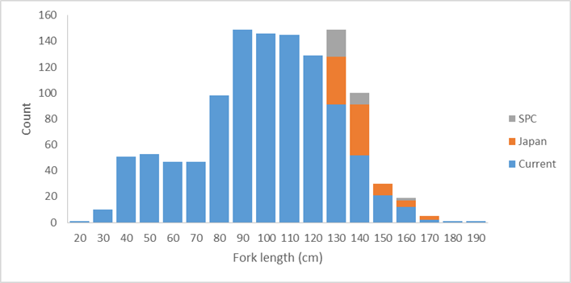  Some of the additional otolith samples are single otoliths and some are pairs. The project would have all of the singles and one of each pair sent to CSIRO for processing and analysis. The 2nd otoliths of the paired samples would be processed and analysed by project partners, and then the results for the same individual bigeye compared. This would likely involved collaborative work at the CSIRO laboratories.  Note that if additional otoliths from the >150 cm groups were provided by other project partners, the number of otoliths in the 130-139 and 140-149cm groups read would be reduced as statistically appropriate to keep the analyses to 125 otolith readings.  The resulting analyses would be reported to SC14.
Assumptions | - The otoliths identified as available by project partners are provided in a timely manner.  - The otoliths provided by project partners, and those from the WCPFC Tuna Tissue Bank are of sufficient quality to be produce readable slides.  - Work to be completed by project partners is finished on time.  - Otoliths from the WCPFC Tuna Tissue Bank will be released without needing to have the research proposal approved by the SC Research Committee.  - CSIRO will undertake the core work and will actively collaborate with the Scientific Services Provider and Japan in the conduct of the analyses.
Scope | This work will:  - Prepare and read an additional 125 otoliths using the annual increment method identified in Farley et al. (2017);  - Revise and update the Farley et al. (2017) age and growth estimates based on the additional data.
Timeframe | 12 months
Budget | US$30,000*  *Note that this covers the CSIRO component of the work, including reading 125 otoliths, preparing a report and travelling to WCPFC SC14 to present the results.
References | Farley, J., Eveson, P., Krusic-Golub, Sanchez, C., Roupsard, F., McKechnie, S., Nicol, S., Leroy, B., Smith, N., and Chang, S-K. 2017. Project 35: Age, growth and maturity of bigeye tuna in the Western and Central Pacific Ocean. SC13-SA-WP-01. Thirteenth regular session of the Scientific Committee of the Western and Central Pacific Fisheries Commission. Rarotonga, Cook Islands, 9-17 August 2017.

PROJECT 82 | Yellowfin tuna age and growth
Objectives | To provide robust age and growth estimates for yellowfin tuna in the WCPO to inform future stock assessments and related analyses.
Rationale | The 2017 yellowfin tuna stock assessment (Tremblay-Boyer et al. 2017) identified that new estimates of age and growth be developed for yellowfin tuna in the WCPO. This recommendation arose given how influential updated growth estimates for bigeye tuna (Farley et al. 2017) proved on that assessment in 2017, noting similarities in the fisheries for those two species. In addition the current assessment model for yellowfin predicts a decline in the selectivity of large fish for longline fisheries, a counter-intuitive result which can occur if the growth is incorrectly specified within the assessment model.  This project would undertake the first comprehensive age and growth study for yellowfin tuna in the WCPO using otoliths. This project represents an area of work not yet pursued in the WCPO. Through Project 35 and 35b, the Tuna Tissue Bank, a range of yellowfin otolith samples have been collected to date (>4000). As for bigeye the limitation is otoliths for very small fish (<30 cm) and for large fish (>140 cm).  SPC (for the WCPFC Tuna Tissue Bank) have identified the available yellowfin tuna otoliths, by size class sampled after 01 January 2014. These unread otoliths, along with additional yellowfin otoliths which Japan has indicated are available for this research, are plotted below with numbers of available otoliths per 10cm size bin. These samples should be adequate to complete a comprehensive and robust study of yellowfin tuna age and growth. It may be useful to seek additional otoliths from larger fish in the WCPO from other project partners.  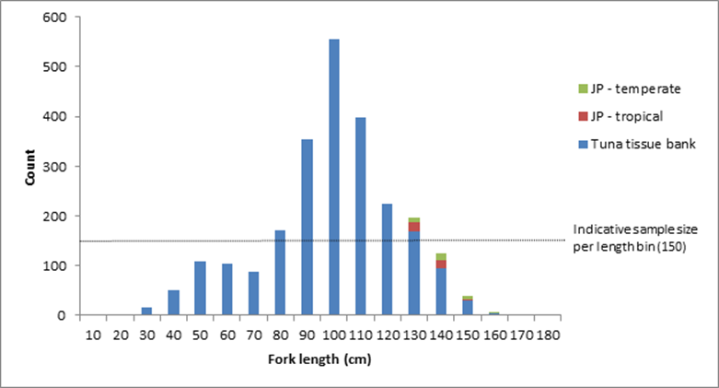  Some of the additional otolith samples from Japan are single otoliths and some are pairs. The project would have all of the singles and one of each pair sent to CSIRO for processing and analysis. The 2nd otoliths of the paired samples would be processed and analysed by Japan, and then the results for the same individual yellowfin compared. This would likely involved collaborative work at the CSIRO laboratories.  Note that if additional otoliths from the >140 cm groups were provided by other project partners they would be incorporated into the analyses in a similar manner, subject to funding.  The project would begin with a preliminary analysis of WCPO yellowfin conducted by CSIRO to determine if the otoliths are suitable for annual age estimation. This study would include an initial reading of otoliths using daily increments to establish annual check marks, followed by an examination of otoliths across the available size range to assess readability. This work would establish a reference otolith set for the rest of the study. At this time no otoliths with chemical check marks for validating age estimates are available. CSIRO and the Scientific Services Provider will collaborate to try and obtain strontium chloride marked otoliths within the life of the project, however it is more likely that these will not be available until after the project is complete. Accordingly, should the preliminary work determine yellowfin otoliths are suitable for a large-scale study (a target of 1500 otoliths across the size range read using the annual method, and 150 using the daily growth increment method, these targets including otoliths read in the preliminary study), a marginal increment analysis will be conducted to support the estimates of age and growth arising from that work.  The project would conduct a preliminary work early in 2018. A small workshop would be conducted during the 2018 PAWS to finalise the approach for the large-scale study. A preliminary report would be provided to SC14. The remaining work would be completed during the remainder of 2018, with a final presentation to SC15 in 2019.
Assumptions | - The otoliths identified as available by project partners are provided in a timely manner.  - The otoliths provided by project partners, and those from the WCPFC Tuna Tissue Bank are of sufficient quality to be produce readable slides.  - Work to be completed by project partners is finished on time.  - Otoliths from the WCPFC Tuna Tissue Bank will be released without needing to have the research proposal approved by the SC Research Committee.  - CSIRO will undertake the core work and will actively collaborate with the Scientific Services Provider and Japan in the conduct of the analyses.
Scope | This work will:  - Conduct a preliminary analysis of the suitability of yellowfin tuna otoliths for providing robust estimates of age and growth;  - Develop a reference collection and protocols for reading daily and annual growth checks in yellowfin tuna otoliths;  - Prepare and read 1500 otoliths using the annual increment method;  - Prepare and reading 150 otoliths using the daily growth increment method;  - Undertake a marginal increment analysis to support the age and growth estimates;  - Report estimates of age and growth for yellowfin tuna to WCPFC SC15.
Risks | Note that due to the generally tropical distribution of yellowfin tuna, and the available otoliths, this study may need to be halted after the preliminary investigations. Should that occur, the report to SC14 will provide an opportunity to review next steps for developing robust estimates of age and growth for yellowfin tuna in the WCPO.
Timeframe | 24 months
Budget | 2018 USD$100,000  2019 USD$85,000  *Note that this covers the CSIRO component of the work, including reading 1650 otoliths, preparing two reports, travelling to the PAWS in 2018 and to WCPFC SC14 and SC15 to present the preliminary and final results. It does not cover costs of any project partners.
References | Tremblay-Boyer, L., McKechnie, S., Pilling, G., and Hampton, J. 2017. Stock assessment of yellowfin tuna in the Western and Central Pacific Ocean. SC13-SA-WP-06. Thirteenth regular session of the Scientific Committee of the Western and Central Pacific Fisheries Commission. Rarotonga, Cook Islands, 9-17 August 2017.  Farley, J., Eveson, P., Krusic-Golub, Sanchez, C., Roupsard, F., McKechnie, S., Nicol, S., Leroy, B., Smith, N., and Chang, S-K. 2017. Project 35: Age, growth and maturity of bigeye tuna in the Western and Central Pacific Ocean. SC13-SA-WP-01. Thirteenth regular session of the Scientific Committee of the Western and Central Pacific Fisheries Commission. Rarotonga, Cook Islands, 9-17 August 2017.

PROJECT 83 | Investigating the potential for a WCPFC tag research vessel
Objectives | To explore the costs and benefits of the permanent use of an adaptable research vessel dedicated to the collection of the data used in tuna stock assessment in the WCPO.
Rationale | - Rationale for project  - General  More than 70% of the global tuna catch are fished in the Pacific Ocean for an estimated value of over US$6 billion. The harvesting level of tuna resources and the efficiency of the involved industrial fleet henceforth impose a very responsive management mode. The management measures need to be supported by strong evidence based on high quality data allowing stock assessment containing a minimum of uncertainty. The data obtained independently from the fishing fleets have become essential and the science based management bodies have the responsibility to support their analysis with the best scientific evidence available. This requires a continuous acquiring of mortality rates for the impacted species, a detailed knowledge of their biology, along with their behaviour in response to fishing gears and in response to the variations in their environment. Assessing the fishing impact on the whole ecosystem requires collecting data on all the species living in association with tuna and tuna-like species, data about their prey and the pelagic ecosystem. The collection of all this information requires the permanent use of an adaptable research vessel properly designed for the purpose. There are currently no suitable tuna research vessels available in the region (or beyond).  Concurrently the fleet of vessels available to charter for research, especially in pole and line fisheries, are becoming increasingly difficult to procure or no longer meet standards necessary for the conduct of research (PTTP Steering Committee, 2018).  Accordingly it is increasingly urgent to carefully explore the permanent use of an adaptable research vessel dedicated to the collection of the data used in tuna stock assessment.  - SC 13 and SC 14  At SC13 the PTTP Steering Committee considered the issue of the availability of suitable tagging vessels, especially for pole and line based research, at its 11th meeting during SC13. The PTTP Steering Committee endorsed the proposal outlined in SC13-RP-P42-02 Appendix II and recommended that SC13 support an assessment of the cost-effectiveness of acquiring a dedicated tagging vessel (SC13-RP-P42-01). The 2018 report of the PTTP highlights the increased urgency of conducting this work (SPC-OFP 2018), especially given not only the increasing costs, but also the difficulty in securing a suitable vessel for charter in the region. At SC14 the PTTP Steering Committee recommended to SC14 that the priority of this work be increased to high.  - Current availability of suitable research platforms  - For tagging experiments  Tagging studies are commonly used in fisheries research to improve estimation of animal population size, mortality, movement (spatial stock structure) and growth. Until now, large scale tuna tagging campaigns for skipjack tuna have chartered medium-size commercial fishing boats around 200 GT tonnage (199 GT for last PTTP, 237 GT for IOTP) for cost reasons, and also due to size restrictions on bait ground access and restricted suitable anchorage in some areas. Releasing a large number of conventionally tagged tuna implies the use of a pole-and-line vessel, but suitable such tagging platforms are becoming increasingly scarce worldwide. In most countries, pole-and-line fleets have been replaced by purse-seine fleets.  Research cruises more orientated towards electronic tagging and targeting all size tuna and their associated species need a more polyvalent tagging platform that could deploy a large variety of fishing gears (e.g. horizontal and vertical longlines, troll lines, danglers, and rod and reel). Catching and handling large size fish requires a working deck with easy access to the sea and a boat with high manoeuvrability facilitated by steering commands located at the working deck level. For example, the design of a standard Japanese pole and line vessel is not suitable for the purpose.  In the Pacific, some longline type fishing boats have been used to target the tuna schools that are associated with floating objects, mainly the oceanographic buoys (TAOs) that are anchored along the equator and the drifting FADs used by the purse seine fleet. The distances involved between floating objects and from ports with appropriate facilities for deploying a research voyage require the use of long-range (> 6,000 nm) platforms which are not common in the region for the necessary size of fishing vessels for successful research.  - For collecting ecosystem biological and physical data  This necessitates the use of gears that are usually not found on a commercial tuna fishing vessel, including : trawling nets to catch tuna prey and plankton size organisms, CTDs to collect sea water temp/depth profiles, and multi-beam echo-sounders that can manage continuous records of highly detailed bio-acoustic data.  Boats used in this type of research are typically from the oceanographic vessel category. They are usually linked to governmental scientific institutes. To operate the different types of gears used at an ocean wide scale, those vessels need to be large (>400 GT). To cover important operational and maintenance costs, their use is often shared between multidisciplinary research projects. Their availability is therefore limited, subjected to utilisation applications that need to be planned years in advance.  - Arguments for the construction of a new multipurpose platform dedicated to tuna research:  - Practicality:  - Tuna tagging data are likely to become increasingly important and need to be collected continuously rather than episodically. Other types of data need to be continuously collected to monitor the ecosystem changes.  - The pole and line vessels that can currently still be chartered are disappearing along with the associated fisher knowledge on operations and bait grounds. These platforms cannot cover all the different data collection needs.  - The global applicability of continuous data collection is likely to facilitate collaboration between the different tuna commissions (RFMOs). The cumulated needs at the Pacific scale could probably cover most parts of the yearly schedule of a single boat.  - A crew specifically recruited and trained to the specific research methods and strategies will be more capable than a commercial fishing boat crew that often need a long training period before they become fully efficient.  - Cost:  - Continuous research would avoid the substantial establishment costs needed each time a new programme is started.  - Some examples:  - Previous recent charter costs, including fuel, for a long range tuna tagging platform (about 200GRT) were situated between 150,000 and 200,000 USD/month. The WP4 charter cost jumped to over 420,000 USD/month. Recent enquiries to utilise vessels from the north Pacific suggest considerably higher costs.  - The total tagging platform charter costs spent during each of the last large tagging projects (PTTP and IOTP) is over the current estimated cost for building a new boat of around 35 metres/200GRT (Between 5 and 8 USD millions, IOTP vessels were built at about 4 USD millions in 2000). Last estimation for the currently running (2017) AOPT total charter cost is 9.1 million Euro (ICCAT, SCRS/2014/092).  - A pre-assessment of some of the operational costs of an appropriate platform that could be built to address all the tuna research needs for the Pacific Ocean has been provided to SPC by F&S, a consultancy office specialized in the fisheries sector. That work would be available to this project.
Scope | The project would assess the full range of operational costs, including options on governance, inter-RFMO vessel sharing, multiple research modes, and future vessel replacement. These costs should be compared with the costs and benefits of the current approach. However, the current approach is not sustainable so the cost benefit analysis will need to consider alternate benchmarks in combination with the current approach.  The scope of work includes undertaking this assessment utilising suitable external experts. A report will be prepared and provided to SC15 for its consideration.
Timeframe | Start early 2019, completed by late 2019
Budget | 2019 USD$95,000  *Note that this covers the cost of the external consultancy/consultancies (60 days) and reporting of the project outcomes to SC. It is also includes travel to the various locations that will be required to review some of the available vessels. The Scientific Services Providers input to the project will be provided as in-kind support.
References | PTTP Steering Committee. 2017. Report of the Pacific Tuna Tagging Programme Steering Committee. SC13-RP-PTTP-01. Thirteenth regular session of the Scientific Committee of the Western and Central Pacific Fisheries Commission. Rarotonga, Cook Islands, 9-17 August 2017.  PTTP Steering Committee. 2018. Report of the Pacific Tuna Tagging Programme Steering Committee. SC14-RP-PTTP-01. Fourteenth regular session of the Scientific Committee of the Western and Central Pacific Fisheries Commission. Busan, Korea, 8-17 August 2018.  SPC-OFP. 2017. Project 42: Pacific Tuna Tagging Project Report and Workplan for 2017-2020. SC13-RP-PTTP-02. Thirteenth regular session of the Scientific Committee of the Western and Central Pacific Fisheries Commission. Rarotonga, Cook Islands, 9-17 August 2017.  SPC-OFP. 2018. Project 42: Pacific Tuna Tagging Project Report and Workplan for 2018-2021. SC14-RP-PTTP-02. Fourteenth regular session of the Scientific Committee of the Western and Central Pacific Fisheries Commission. Busan, Korea, 8-17 August 2018.

PROJECT 84 | Shark Research Plan mid-term review
Objectives | Review the WCPFC Scientific Committee’s 2016-2020 shark research plan, to evaluate progress against the plan and assess future needs for shark research relevant to management of the WCPO shark stocks.
Rationale | The first Shark Research Plan (SRP) covered 2010-2014. At its Tenth Session the Scientific Committee (SC10) agreed in 2014 on a programme of shark work for the Scientific Service Provider (SSP). This work was to be carried out in 2015, and included that the SSP draft a new SRP for consideration by SC11 to cover work in 2016-2020. This project will evaluate progress against that plan and consider the future shark information needs of the WCPFC.  This work will also evaluate the progress against and need for the original SRP components:  - Phase 1: assessments to be undertaken with existing and available data;  - Phase 2: coordination of research efforts to supplement biological and other assessment related information; and  - Phase 3: improvement of data from commercial fisheries.
Assumptions | SPC or another regional body has the personnel and budget available to undertake this work.
Scope | While this document will focus on the WCPFC key shark species, other elasmobranchs will be considered as required.
Budget | 0.3 FTE

PROJECT 85 | Participation in ISC North Pacific shortfin mako shark stock assessment activities
Objectives | Contribute to and learn from ISC work toward revising the North Pacific shortfin mako shark stock assessment, thereby aiding methods development for other WCPO shark stocks.
Rationale | - The ISC will be working toward an assessment of the North Pacific shortfin mako in 2017-2018 with an aim to complete it by July 2018  - The ISC assessment would benefit from the contribution of additional shortfin mako observer data (catch rates and total removals) in the North Pacific  - Participation in this collaborative stock assessment may lead to the development of new methods and/or new data insights for a future South Pacific shortfin mako assessment  - Cooperation between the WCPFC and its Northern Committee could be strengthened
Assumptions | - If SPC were available to participate, it would contribute its shortfin mako data holdings  - If the Secretariat or ABNJ participates, fewer data can be contributed due to data confidentiality rules  - ISC is able and willing to incorporate these contributions to its work  - ISC meetings avoid scheduling conflicts with other work
Scope | Available WCPO data would be compiled, formatted and analysed to produce data products that could be contributed to ISC Shark Working Group (SWG) meetings (no raw data would be contributed; this is similar to the contributions of ISC member countries). Data to be prepared would depend on needs identified by the ISC SWG but would be expected to include catch rate indices, catch estimates, effort statistics and/or biological data. It is assumed that participation in two ISC SWG meetings would be required (the FTE estimate is intended to account for both time and travel costs). These have tentatively been scheduled for November 2017 in Japan (data preparation meeting) and March-April 2018 in La Jolla (assessment meeting). Total time input including data handling and analysis, ISC SWG meetings and other tasks, and report review is estimated at ~2.5 months.
Budget | 0.2 FTE

PROJECT 86 FAD Project #1 | FAD designs to reduce unwanted interactions with Species of Special Interest (SSIs; sharks, turtles)
Objectives | Identify FAD design features that lead to lower interaction rates with key SSIs, while minimising the impact on catches of target tuna species
Rationale | - Builds upon work in all other Oceans on the design of lower- and non- entangling FADs (e.g. WCPFC-2016-FADMgmtOptionsIWG02-OP02; SC13-EB-WP-02).  - Builds upon work by organisations such as ISSF in the development of SSI-friendly designs.  - Provides region-specific information on the efficacy of SSI reduction and impacts on tuna catch levels in the WCPO.  - Provides a scientific basis for potential CMMs in this area.  - Given concerns of FAD beaching on reefs and shorelines, could also contribute to studies of appropriate biodegradable FAD materials.
Assumptions | - The information provided in SC13-EB-WP-02 is considered by SC13 to provide insufficient evidence of the potential effectiveness of non- entangling designs in the WCPO, and hence local trials are needed. Note that if SC13-EB-WP-02 is considered by SC13 to provide sufficient evidence, this project should be revised to focus on extension, to ensure rapid uptake and deployment of non-entangling FAD designs, and to ensure the cost effectiveness of those designs for all WCPO fleets, in particular those domestic fleets of PICTs.  - The relationship between design and SSI interactions can be gained through tracking FADs from construction, through deployment, to setting activity by any fleet, and SSI interactions.  - If tracking is not possible, the regular removal of a set-upon FAD from the water can be undertaken so observations of its sub-surface structures and the occurrence of captured SSIs can be made.  - Periodic removal of tracked designs may also be necessary to identify changes over time (e.g. unravelling of bound netting, degradation of components).  - A coordinated trial of designs, in collaboration with industry, is suggested as the most efficient approach. Cost, material availability and environmental impact would be key factors in assessing the merit of various designs.  - Sufficient data are available across different designs and locations to allow statistical analyses to be effective.  - Where specific field trials are undertaken, they might be able to be performed at the same time as trials required under FAD project #2 to create cost efficiencies.
Scope | Through review of existing studies and best practices in other oceans (see SC13-EB-WP-02) identify plausible non-entangling FAD designs, in collaboration with industry. This should include sub-FAD structure depth and mesh size, removal of netting on the surface of FADs and alternative platform widths.  Implement at-sea FAD trials across the WCPO [deployment and fishing activity] to be completed within 18 months. This will most effectively be performed in partnership with observers and industry to ensure marking, deployment and monitoring of FADs in a coordinated way. Two levels of industry participation are anticipated: (1) the fleets that deploy the FADs and are actively engaged in the research. (2) All other fleets that find the FADs from (1) and set upon them. Information from (2) will be critical to the success of the research.  Using ISSF Technical Report 2016-18A as a guide:  - Fleets deploy a given number of FADs per vessel (e.g. 10-20 FADs per vessel to reach a significant large number of FADs).  - Maximum 4 standardized designs tested, constructed in port and deployed in the same area as traditional FADs, so their effectiveness could be compared with that of the traditional FADs for the same spatial and temporal strata.  - Deployment site, design and the code of the geo-locating buoy should be registered. Every FAD should be well identified so that data can be retrieved and followed if ownership changes.  - If a trial FAD is encountered at sea register: the catch (if any), interactions with SSI, the condition of the FAD and the new code for the buoy if the original has been replaced.  - Where possible, use trajectories and sounder of attached buoys to assess ability of alternative designs to aggregate tuna even if they are not visited or fished by purse seiners, as well as following their lifetime if they are not retrieved.  - Collaboration between industry, related parties, and the scientific services provider to collect and analyse data.  - Collaborate with industry to identify the cost of alternative FAD designs relative to ‘standard’ designs.  Analysis of results should be presented to WCPFC SC (approximately 2 years after the trial begins). SC and TCC of that year to provide recommendations for a draft CMM on appropriate FAD designs.
Links to other work | The IATTC and ISSF have done considerable work on the design of non- entangling FADs (see SC13-EB-WP-02).
Timeframe | 24 months
Budget  Note: Costed on a fieldwork required basis. If project is extension related (i.e. Trials of designs not  required on the basis of SC13-EB-WP-02 findings), project budget will need to be revised | 1 year FTE at SPC (data analysis)  1.5 year FTE at SPC (technical and fieldwork, travel) Project management  Observer training  Approximate total budget: US$446,000*  Note overlap with Project #2 – if both are undertaken concurrently then some personnel costs can be ‘shared’ across the two projects. (Approximate total budget if Projects 1 and 2 undertaken simultaneously:  $871,000)  *Final costings will depend on the approach undertaken within at-sea trials, including the level of practical and financial contribution by industry. Note this will need to include the purchase of necessary FAD materials, including marking and tracking components, facilitation of liaison with industry representatives, and any related travel.
Additional considerations | This project will necessitate additional data collection by fisheries observers, irrespective of whether it relates to additional trials, or, extension. This has consequence for forms, data management and observer training.  If FADs are not able to be tracked from markings or similar, this research will require fishers to lift all FADs for descriptions to be made (there are other technical solutions such as camera ROVs and/or research divers however they are likely overly costly).  Understanding the vertical behaviour of silky sharks at FADs within the WCPO would help inform how deep the FAD underwater structure should be checked.  This project if it proceeds to extension/implementation will have direct costs for fishers with the lifting of existing FADs require to update them with non- tangling designs. Obviously the period of implementation will determine if this occurs faster or slower than the normal frequency of lifting, and hence the incurred cost.

PROJECT 87  FAD Project #2 | FAD designs to reduce unwanted catches of juvenile bigeye and yellowfin tuna
Objectives | Identify any FAD design features that lead to lower catch rates of undersized/juvenile bigeye and yellowfin tuna, while minimising the impact on catches of larger target tuna species.
Rationale | - Builds upon trials underway in the IATTC area in collaboration with ISSF, but given oceanographic differences between regions WCPO trials may be required if designs in IATTC area focus on depths shallower than the WCPO thermocline depth.  - Represents an area of work not yet pursued in the WCPO that could provide a simple management intervention to reduce FAD impacts.  - Builds upon EU-funded work identifying factors influencing BET hotspots.  - Provides a scientific basis for potential CMMs in this area.  - Two key and related FAD design features may influence undersized/juvenile bigeye and yellowfin mortality: depth of the FAD, and its speed of drift.
Assumptions | - BET hotspot analyses provide some indication of potential FAD characteristics that can be examined within this project.  - Can relate the design of FADs noted by observers and/or others directly to subsequent fishing sets that have reliable catch composition estimates.  - A coordinated trial of designs, in collaboration with industry, is suggested as the most efficient approach. Cost and environmental impact would be key factors in assessing the merit of various designs.  - Periodic removal of tracked designs may also be necessary to identify changes over time (e.g. change in the depth of the structure or unravelling of bound netting, degradation of components that might modify drift speed).  - Sufficient data are available across different designs and locations to allow a statistical analysis to be performed.  - Where field trials are required, they could possibly be performed at the same time as trials required under FAD project #1 to create cost efficiencies.
Scope | While Project #1 benefits from existing activities and research in other oceans, the background on FAD designs to reduce juvenile tuna catch is less mature. However, the proposed scope is comparable to that proposed for Project #1.  Use relevant results from the BET hotspot analyses and from information available from ISSF studies in the IATTC area, and in collaboration with industry, identify plausible FAD designs to trial.  Implement at-sea FAD trials across the WCPO [deployment and fishing activity] to be completed within 18 months. This will most effectively be performed in partnership with industry and observers to ensure marking, deployment and monitoring of FADs in a coordinated way. Two levels of industry participation are anticipated: (1) the fleets that deploy the FADs and are actively engaged in the research. (2) All other fleets that find the FADs from (1) and set upon them. Information from (2) will be critical to the success of the research.  Understanding how the real working depth of sub-surface FAD structures interacts with oceanographic features during the period of the drift, and the resulting influence on species biomass and catch will be important. Equipping FAD sub-surface structures with depth/temperature sensors, which are tracked for the duration of a scientific trip and retrieved, regularly feed-back information, or pop off the FAD after a given period, should be used.  Using ISSF Technical Report 2016-18A as a guide:  - Fleets deploy a given number of FADs per vessel (e.g. 10-20 FADs per vessel to reach a significant large number of FADs).  - Maximum 4 standardized designs tested, constructed in port and deployed in the same area as traditional FADs, so their effectiveness could be compared with that of traditional FADs for the same spatial and temporal strata.  - Deployment site, design and code of the geo-locating buoy should be registered. Every FAD should be well identified so that data can be retrieved and followed id ownership changes.  - If a trial FAD is encountered at sea, register: the catch (if any), the condition of the FAD and the new code for the buoy if the original has been replaced.  - Where possible, use trajectories and sounder of attached buoys to assess ability of alternative designs to aggregate tuna even if they are not visited or fished by purse seiners, as well as following their lifetime if they are not retrieved.  - Collaboration between industry, e.g. ISSF and the scientific services provider to collect and analyse data.  - Collaborate with industry to identify the cost of alternative FAD designs relative to ‘standard’ designs.  Analysis of results should be presented to WCPFC SC (approximately 2 years after the trial begins). SC and TCC of that year to provide recommendations for a draft CMM on appropriate FAD designs.
Links to other work | Note that due to the nature of the thermocline in the WCPO and the impact of the thermocline on tuna behaviour, in particular for bigeye tuna, results from the EPO may not be of specific use in the western or central WCPO.
Timeframe | 24 months
Budget | 1 year FTE at SPC (data analysis)  1.5 year FTE at SPC (technical and fieldwork)  Associated travel and subsistence to relevant WCPFC meetings Project management  Observer training  Approximate total budget: US$526,000*  Note overlap with Project #1 – if both are undertaken then some personnel costs can be ‘shared’ across the two projects. (Approximate total budget if Projects 1 and 2 undertaken simultaneously:  $871,000)  * Final costings will depend on the approach undertaken within at-sea trials, including the level of practical and financial contribution by industry. Note this will need to include the purchase of necessary FAD materials, including marking and tracking components, temperature/depth sensors, facilitation of liaison with industry representatives, and any related travel.
Additional considerations | This project will necessitate additional data collection by fisheries observers, irrespective of whether it relates to additional trials, or, extension. This has consequence for forms, data management and observer training.
The field work component of this research may require additional data collection on catch composition for specific sets from a trip (with the catch kept separated and subject to a census in port).

There may be the potential to geo-fence FADs used in these trials with special requirements around reporting and access to enhance the data collected.

PROJECT 88  FAD Project #3 | Acoustic FAD analyses
Objectives | Identify whether limiting sets to only those FADs that have a large biomass beneath them can reduce the proportion of ‘non-target’ species caught.
Rationale | - Larger purse seine sets on FADs tend to have higher proportions of skipjack and commensurately lower proportions of yellowfin and bigeye (Lawson 2008, WCPFC-SC-4-ST-WP3).  - Acoustic data from echo-sounder buoys can provide, given sufficient equipment, environmental conditions and interpretation skills, sufficient information on the biomass of tuna under a FAD.  - Acoustic information has shown promise for discriminating skipjack from other species, if not yet routinely using commercial fishing equipment. However, there is a need to identify signals that discriminate other species within the WCPO, building on existing work by ISSF in this area.  - Acoustic information has also suggested some ability to differentiate fish sizes.  - The acquisition of acoustic FAD data has the potential to provide insight into dynamics of the interaction between tuna and FADs.  - Information could inform FAD design options, FAD deployment, remote identification of size and abundance of tuna under echo-sounder- equipped FADs, and spatial management considerations.  - Incentivising limiting setting activity to only FADs with large biomass could reduce the proportion of non-target species caught.  - In addition, acoustic FAD data could provide ‘ground truthing’ for the effective soak time of FADs, stock assessment biomass estimates (see SC12-SA-IP-14), FAD density effects on movement and catch rates of target spp.
Assumptions | - There is a consistent relationship between biomass levels on FADs and tuna species composition across the WCPO, as indicated in Lawson (2008), SC14-ST-WP3.  - Biomass can be accurately assessed through acoustic buoys, noting that it depends on the equipment used, environmental conditions and the interpretational skills of the user.  - Existing acoustic information can be made available for analysis, combined with sufficient information to relate that information to a setting event.  - Target strength information from other studies is sufficiently robust and comparable to that in the WCPO that it can be used directly.  - The analysis can be undertaken over sufficient space/time to ensure any influences of those factors can be examined statistically.
Scope | The scope of work is divided into three stages. The ability to undertake the second stage will depend on access to existing data, in particular acoustic biomass estimates, and the ability to relate set-level events to FAD-specific acoustic data.  Stage 1. Examination of existing data to investigate the relationship between total biomass/catch and the proportion of small bigeye/yellowfin Based upon existing combined logsheet/observer data from FAD sets, investigate the relationship between total biomass/catch size and the degree of small bigeye/yellowfin, both spatially and temporally within the WCPO. Based upon these analyses, identify the level of definition required by echo-sounder buoys to render this strategy effective.  In addition, review available information on the vertical behaviour of individuals of different sizes relative to e.g. thermoclines, to examine whether a depth layer can be used to discriminate between species/sizes.  Stage 2. Examination of existing (historical) observer-based FAD set data and echo-sounder buoy data  Where data are available to link an observed FAD set event to acoustic information, compare the most appropriate set-level overall catch and corresponding species composition to available acoustic information. Where data allow, further compare to relevant operational factors (e.g. location, FAD and vessel information, regional FAD density, etc.) to identify potential relationships.  Stage 2. Undertake at-sea experimental fishing trials to identify effective acoustic equipment and operational approaches  In collaboration with industry, and building on outputs from Stages 1 and 2, design and implement a limited fishing trial of current and alternative cutting-edge acoustic gear/settings (e.g. multi-frequency) to obtain acoustic information on FAD-associated tuna biomass and species/size composition, and related fishing trials to ‘ground-truth’ that information based upon resulting catches. Gaining target strength measurements for single schools (in particular of yellowfin) will be particularly important. Trials should be sufficiently extensive to examine the influence of spatial and potentially oceanographic factors.  Analyses of results from each stage should be presented to WCPFC SC for scientific review and where relevant for the consideration of advice to TCC and the Commission.
Timeframe | Approximately 36 months (see below)
Budget | Stage 1  1.5 year FTE at SPC USD$182,000  Associated travel and subsistence to relevant WCPFC meetings USD$10,000  Stage 2  Not costed at this time. It is likely to be on the scale of project one or two, but there may be some other cost savings to be made by incorporating some fieldwork into the 2018 or 2020 tag research voyages.
Additional considerations | If this proceeds to a fieldwork stage, additional input on the design of the at-sea component should include consideration of concurrent data collection in the context of tuna foraging and links to ecosystem modelling (e.g. SEAPODYM).

PROJECT 89  FAD Project #4 | Fleet behaviour
Objectives | Characterisation of effort creep due to FAD use and fleet specific factors resulting in large catches of ‘non-target’ species.
Rationale | - Understanding how rapid developments in FAD technology and their use within the WCPO can influence FAD-related catch rates will provide additional information for key stock assessments and the harvest strategy approach, and scientific advice that can inform discussions under future tropical tuna CMMs.  - Analyses will complement activities currently underway on PNA FAD tracking and those undertaken through the EU-funded ‘BET hotspot’ analysis presented to SC13.
Assumptions | - Sufficient data on FAD design and technology are available for analysis.  - Sufficient time series of data are available to support analyses.  - Information is sufficiently detailed and accurate to allow analyses to be performed.  - Fishing sets can be related to specific FADs and associated FAD/vessel technological information.  - Fleet behaviours that influence fishing performance can be understood.  - The effort creep component of improved FAD technologies can be separated from other elements (schooling behaviour of fish, overall fleet behaviour, stock size, oceanography, other technological advances etc.).
Scope | The proposed work programme comprises a data compilation activity, subsequent statistical analysis activities and a data review activity. These are briefly outlined below:  Evaluate and combine available logsheet, observer and VMS data to develop a comprehensive purse seine associated fishing data set. This data set should also include available (time series of) vessel and technical FAD characteristics, where possible.  Analyse patterns of fleet activity relative to FAD setting based upon VMS/logsheet data, to assess changes in vessel searching activity, as well as trip length. This may also be compared within and outside the FAD closure period, and be related to location (e.g. distance from port), time of the year/day, the period of the trip, etc.  Examine changes in the ‘reliance’ on FAD fishing over time, at the fleet or vessel level. Relate the reliance on FADs to geographic location.  Analyse using appropriate statistical techniques factors that could influence time series or relative patterns in purse seine associated set CPUE (catch per set, but catch per day or trip may also be examined), including fleet, location, oceanography, FAD set density (as a proxy for FAD density), observed FAD design, vessel characteristics, stock abundance, etc. This may evaluate the probability of a successful set, as well as the level of catch if a set were successful.
Identify data gaps and provide advice on potential areas of additional data collection to improve future analyses.

Where observer information is sufficient, work will also examine the number and activities of supply vessels, including identifying which particular purse seine vessels each support, and the number of FADs being deployed and serviced by such vessels.
Timeframe | 18 months
Budget | 1.5 year FTE at SPC USD$182,000  Associated travel and subsistence to relevant WCPFC meetings USD$20,000

PROJECT 90 | Better data on fish weights and lengths for scientific analyses
Objectives | This project has three objectives  The first component aims to identify gaps, address those gaps which can be resolved with existing information, and develop the sampling plan and protocol to resolve additional gaps, through the following activities (but not limited to):  - identify the priority gaps in conversion factor data for the WCPFC key tuna species, key shark species, and key billfish species  - expand the conversion factors to cover the WCPFC key shark species for groups: mako, thresher and hammerhead shark, after gap analysis against existing conversion factors  - produce a list of species of special interest (SSIs, excluding key shark species) that require conversion factor data  - produce a list of commercially important bycatch species (not covered in the items above)  - include more information on source of data for each conversion factor (e.g. reference of study, sample size, R2, minimum/maximum size of sample, etc.) in tables of conversion factors which will inform the need for more data collection  - produce a list of the remaining bycatch species that require conversion factor data  - produce standard protocols for conversion factor data collection to be collected by observers and port samplers,  - prioritize this list so that the most important work is achieved, and  - present the findings at SC15 for review, acknowledging that some observer providers will voluntarily collect conversion factor data prior to SC15.  The second component relates to investigating potential innovative methods to obtain length-length conversion factor data, including:  - explore the use of EM tools to capture multiple length measurements from fish e-measured by EM Analysts.  The third component relates to collecting the conversion factor data:  - systematically collect representative samples of length measurements of bycatch species support future estimation of fish bycatch in the WCPO; and  - systematically collect length:length, length:weight and weight:weight data on all species to better inform future estimation of fish bycatch in the WCPO.
Note | Although these three objectives are distinct, they have been combined into a single project to avoid any possible duplication of effort and, as there will likely be combined tasking of Pacific Island observers and port-samplers, in future data collection arising from the project.  The project acknowledges that flag state CCMs with national port sampling and observer programmes may also want to collect conversion factor data using the standard protocols established under this project; these initiatives would be an invaluable contribution to the project.  The project will also involve the work in transferring the conversion factor information compiled from other sources, such as the information presented in Clarke et al. (2015) Report of the Pacific Shark Life History Expert Panel Workshop, 28-30 April 2015; SC11-EB-IP-13, and conversion factor data compiled from the Australia domestic longline fishery.  Project 90 implementation acknowledges that issues of observer safety, overall workload and work conditions are paramount. The development of the data collection protocols for conversion factor measurements through observers should take into account the challenges with on-board observer activities, including, but not limited to;  - Potential difficulty in measuring large specimens on small boats;  - Evaluating the feasibility of weighing fish at sea. For example, consideration of the following:  - Ensure any weighing equipment does not hinder the fishing operation.  - Simplifying the process of any onboard weight measurements;  - To what extent the assistance of the crew will be expected, and  - Avoiding duplicate weighing of specimens by keeping and weighing removals.  - Note that any sharks which fishers are not allowed to retain will not be in the observer protocol for this project.
Rationale | Estimates of bycatch are currently collected through the ROP in units of number, weight or both. In order to convert from numbers to weight, and vice versa, it is necessary to have information on both the size of caught individuals, and appropriate length:weight relationships for the species in question. This conversion between numbers and weight allows analyses of bycatch data to use the full observer dataset, rather than a subset with a consistent unit of measurement, therefore maximising the utility of the bycatch data recorded by observers. Furthermore, bycatch length data allows for consideration of the life-stages of individuals. This information could be of particular interest when considering bycatches of SSIs. There are currently insufficient, or unrepresentative, length samples for species caught in purse seine and longline fisheries, with the exception of bigeye, yellowfin and bigeye in purse seine catches, which are sampled through observer grab samples. This project would fill this data gap.  At least SEVEN (7) Pacific Island member countries with observer programmes have expressed interest in participating in conversion factor data collection, as long as funding support is available to cover any reasonable request for the additional work required by observers and port samplers.  Accordingly, this project addresses objectives arising from discussions at SC13 about the results of regional estimates of purse seine and longline bycatch (Peatman et al., 2017; Peatman et al., 2018a; Peatman et al., 2018b). As a result of the discussions in 2017, SC13 recommended that the Scientific Services Provider be tasked with:  - designing and co-ordinating the systematic collection of representative samples of length measurements of bycatch species; and  - a project to design and co-ordinate the systematic collection of length:length, length:weight and weight:weight data on all species to better inform bycatch estimation.
Assumptions | Achievement of the objectives is subject to the following assumptions:  - sufficient data are available to support the sampling design analyses;  - sampling designs can be developed which are statistically robust and would support future estimation of fish bycatch in the WCPO;  - current observer equipment (e.g. callipers) is suitable for the length sampling protocols;  - suitable and cost-effective equipment can be sourced for robust weight data collection;  - data collection can be integrated into existing sampling events in-port and at-sea;.  - resources are available within selected countries to undertake this work; and  - the sub-regional DCC observer conversion factors form will be the basis for data collection.
Scope | The proposed work programme comprises:  - data compilation activities;  - subsequent statistical analysis activities to design future sampling approaches;  - evaluation of designs for practical field application;  - trials of selected sampling approaches in the field along with trials of equipment required to complete the sampling designs;  - finalisation of future sampling protocols;  - development of associated training standards;  - incorporation of training into trainer trainings and biological sampling trainings as required;  - ongoing co-ordination of sample collection and data submission; and  - reporting on designs and progress with implementation and data collection.  It is intended that a preliminary report would be prepared for SC15 and a more comprehensive report for SC16 and a final report at SC17.
Timeframe | 33 months (from January 2019 through September 2021)
Budget | 2019 US$60,000  2020 US$30,000  2021 US$20,000  Note that this funding is intended to cover the work of the Scientific Services Provider in the design and co-ordination of this work. This will cover the analytical components identified in the scope of the project. It will also cover trials of methodologies identified at-sea and in-port.  The funding in 2019 includes the costs to cover the additional work for selected observers from some observer providers, which will inform the process for refining the budget for this project in subsequent years.  The 2019 funding also includes the costs to investigate and purchase 1-2 weighing devices in the initial implementation phase.  It does not cover the costs of CCMs in implementing the protocols or the purchase of related equipment. This will require co-funding or additional funding depending on the designs selected in the design and testing phase and may require additional requests for funding from SC15.
References | Peatman, T., Allain, V., Caillot, S., Williams, P., and Smith, N. 2017. Summary of purse seine fishery bycatch at a regional scale, 2003-2016. SC13-ST-WP-05. Thirteenth regular session of the Scientific Committee of the Western and Central Pacific Fisheries Commission. Rarotonga, Cook Islands, 9-17 August 2017.  Peatman, T., Bell, L., Allain, V., Caillot, S., Williams, P., Tuiloma, I., Panizza, A., Tremblay-Boyer, L., Fukofuka, S., and Smith, N. 2018a. Summary of longline fishery bycatch at a regional scale, 2003-2017. SC13-ST-WP-02. Fourteenth regular session of the Scientific Committee of the Western and Central Pacific Fisheries Commission. Busan, Republic of Korea, 8-16 August 2018.  Peatman, T., Allain, V., Caillot, S., Park, T., Williams, P., Tuiloma, I., Panizza, A., Fukofuka, S., and Smith, N. 2018b. Summary of purse seine fishery bycatch at a regional scale, 2003-2017. SC13-ST-IP-04. Fourteenth regular session of the Scientific Committee of the Western and Central Pacific Fisheries Commission. Busan, Republic of Korea, 8-16 August 2018.

PROJECT 92 | Testing the performance of alternative stock assessments approaches for oceanic whitetip shark.
Objectives | Undertake quantitative stock assessments of WCPO oceanic whitetip shark to evaluate the performance of a variety of less data-demanding assessments approaches in comparison to a full, integrated, age-structured assessment model (such as MFCL or SS3). The project will provide:  - A stock assessment of WCPO oceanic whitetip shark for the purposes of generating management advice.  - An evaluation of alternative assessment approaches that have potential application to other key shark species with less data.
Rationale | The Western and Central Pacific Fisheries Commission Scientific Committee has had a number of low information assessments of sharks but is has been difficult for members to interpret these results without a comparison to a known baseline. Undertaking both high and low-information assessments simultaneously on the same species may provide members with a better understanding of how full integrated age-structured assessment results can be compared to the results of less data-demanding assessments.
Assumptions | - Much of the existing fisheries and biological data are readily available.  - Assessment personnel are available to undertake this work
Scope | Reviewing the previous shark assessments in the WCPO and North Pacific to assess and improve on methods to increase the understanding of data strengths and weaknesses, and update stock status. Update WCPO longline and purse seine catch estimates and abundance indices using recent observer data.  Undertake a quantitative stock assessment on WCPO oceanic whitetip shark to assess the level of F (fishing mortality) and B (biomass) trends for this species. The analysis should present the stock status in terms of common WCPFC quantities of management interest such as F/F_{MSY}, SB/SB_{MSY} and SB/SB_{F=0} ratios, fishing mortality, (SPR) spawner per recruit, yield and biomass.  Undertake less data-demanding assessments of WCPO oceanic whitetip shark to assess the level of similar common WCPFC quantities of management interest including the above (where applicable). Candidate assessment approaches can include:  - Surplus production model  - Catch only methods  - Area-based assessment approaches with a range of decreasing data inputs (such as stock density, gear efficiency, and post-discard survival).  - Spatially-explicit risk assessment  - EASI-Fish model  - Sustainability assessment for fishing effects (SAFE);  Input data must be consistent between assessment methods where the same data are an input. Separate analysis teams may be involved.  The focus of these analyses is the estimate of management quantities rather than the development of reference points (shark limit reference points are the subject of a separate (Project 57)).  Consideration should be given to the suitability of assessment approaches for regular application across a large number of key shark species (simultaneously) or, alternatively, for separate one-off assessments of a species.  Prepare a report containing the above results for SC15.
Budget | 1.5 FTE  $75,000

PROJECT 93 | Review of the Commission’s data needs and collection programs
Objectives | To compare the Commission’s data needs against the programs and tools available to the Commission (including the potential for a WCPFC EM program).
Rationale | There are several reasons for this review:  - In the context of EM specifically, it is about answering the fundamental question “what data does EM need to collect and what will that data be used for?”. The ERandEM working group was not able to answer this question, and as a result did not make too much progress on specific objectives for a WCPFC EM program.  - The review will also create efficiency in the Commission’s data programs by ensuring that there is no unnecessary duplication between data collection programs and that data is collected through the most appropriate program.  - Improving the collection and verification of data will enhance the work of both the SC and the TCC.  - It will promote synergy between the different programs by linking them so that there is a common understanding of the collection of primary data through one program and verification through another.  - Lastly, it will be useful first step to review and reconsider monitoring programs required by the Commission, to allow additional data collection with high priority, with a proper balance of observers’ workload and safety,
Assumptions | - WCPFC is committed to continue development of a WCPFC EM program  - This review is essentially an extension of the work described in the following two documents:  - Emery et al. (2018) The use of Electronic Monitoring within tuna longline fisheries win the WCPO – implications for international data collection, analysis and reporting. WCPFC-2018-ERandEMWG3-IP04.  - SPC-OFP (2018). Outcomes from the Second Regional EM Process Standards Workshop (REMPS-2). WCPFC-2018-ERandEMWG3-IP02.
Scope | The scope and activities included in the review are:  - Summarise existing data and information needs of the Commission including scientific data and information to support compliance functions.  - Describe how current monitoring programs required by the Commission (e.g. logsheets, observers, VMS, transshipment and other vessel generated reports) are used to collect and/or verify the data and information needed by the Commission.  - Specify data and monitoring gaps and identify priority areas where fishery monitoring requires improvement.  - Define areas and roles where e-monitoring can be used to collect scientific data and verify data and information needed by the Commission, including whether there could/should be different areas of application.  The focus of the mapping exercise will not be to undertake a detailed review of the adequacy or otherwise of specific data fields that have been developed for various WCPFC programs.
Links to other work | - This is an essential contribution to the consideration of a WCPFC EM program as it will assist to define the objective and data needs.  - Outputs from this work will help the Commission to identify where electronic reporting could be implemented to support timely access to and use of data. May help to identify areas where Commission policies and procedures relating to monitoring programs and data may need refinement  - It also has relevance to other WCPFC processes such as considering issues of transhipment management, CDS development and evolution of ER standards.
Timeframe | - Draft distributed intersessionally to all CCMs for their inputs before SC  - Presented to SC15 and TCC15  - Final version and recommendations to WCPFC16
Budget | NIL. Work to be undertaken by SPC, FFA Secretariat and PNA Office and presented to SC and TCC by FFA members.
Additional considerations | Assistance from the WCPFC Secretariat would also be welcome and very useful, but will obviously be subject to existing workloads and availability.

PROJECT 94 | Workshop on yellowfin and bigeye tuna age and growth
Objectives | To further improve age estimates for bigeye and yellowfin tuna in the WCPO to inform future stock assessments and related analyses through an inter-lab ageing workshop designed to specifically consider annual and daily ageing approaches between WCPFC and IATTC
Rationale | This project builds upon work to date under Project 35 and reported in Farley et al. (2017; SC13-SA-WP-01), work under Project 81 and reported in Farley et al. (2018a SC14-SA-WP-01), and work under Project 82 reported in Farley et al. (2018b; SC14-SA-WP-13).  During review of Farley et al. (2018a) and Farley et al. (2018b) during SC14, and based on recommendations from the SPC Pre-Assessment Workshop (PAW) in April 2018, it was noted that the differences in ageing approaches between WCPFC and IATTC needed further investigation.  Inter-laboratory ageing workshops have proven to be a useful approach in such situations for tunas including albacore, southern bluefin, Pacific bluefin, Atlantic bluefin (see Anon 2002; Anon 2004; Rodriguez-Marin et al. 2007).  The 2018 SPC PAW (Pilling and Brouwer 2018) recommended:  - A workshop should be arranged to compare techniques and age estimates between otolith reading labs, to standardise the approaches for daily increment counts. If possible IATTC and FAS should read sister otoliths for daily counts, based upon SrCl marked otoliths.  The 2018 bigeye reassessment paper (Vincent et al. 2018) recommended:  - Analyzing the same otoliths by different laboratories, to build con  dence in ageing estimates and to estimate ageing error.  - Collect otoliths of very small bigeye that are captured by the Indonesian, Vietnamese, and Philippines domestic  fisheries in region 7 and estimate age through daily ring counts to aid the estimation of the L1 parameter within the assessment model.”  The project will begin with the analyses of strontium chloride (SrCl₂) marked otoliths from WCPO bigeye and yellowfin by CSIRO, Fish Ageing Services (FAS) and IATTC. In addition, YFT otoliths from the EPO will be prepared and read by FAS using annual ageing methods (sister otoliths to those read by IATTC using daily ageing methods). BET and YFT otoliths from the WCPO will also be also prepared and read by IATTC using daily ageing methods (sister otoliths to those read by FAS using annual ageing methods). An inter-laboratory workshop will then be held to discuss ageing methods among specialists to resolve differences in ageing methods. A report will be presented in 2019 at SC15.
Assumptions | - The strontium chloride marks on bigeye and yellowfin otoliths currently held in storage at CSIRO are still visible for validation purposes.  - Otoliths can be collected from bigeye stock assessment region 7 in August/September 2018, and there is sufficient time available to age these otoliths in advance of the inter-lab workshop.  - Otoliths are exchanged (CSIRO and IATTC) prior to the inter-lab ageing workshop.  - IATTC and CSIRO complete the pre-workshop readings in advance of the workshop.  - All necessary data are made avail be by both labs prior to the workshop.  - Otoliths from the WCPFC Tuna Tissue Bank will be released without needing to have the research proposal approved by the SC Research Committee.  - CSIRO will undertake the core work (and Fish Ageing Services (FAS) P/L, Australia) will undertake the primary aging work) and will actively collaborate with the Scientific Services Provider and IATTC in the conduct of the analyses.  - SPC will provide its time through other projects.  - CSIRO will provide in-kind funding of US$20,000 for the project.
Scope | Prior to the workshop, the project will:  - Analyse three SrCl₂ marked bigeye otoliths and three SrCl₂ marked yellowfin otoliths from the WCPO using the daily ageing method by IATTC and annual ageing methods by FAS using sister otoliths from the same fish.  - Analyse an additional three bigeye and three yellowfin tuna otoliths from the WCPO using the daily ageing method by IATTC and FAS to resolve differences in ageing methods (using sister otoliths from the same fish).Analyse 50 bigeye otoliths from small fish region 7 using the daily increment method by FAS;  During the workshop, the participants will:  - Jointly read/examine WCPO and EPO otoliths prepared for the project;  - Jointly read/examine EPO otoliths previously prepared by IATTC (i.e., otoliths used in the IATTC age validation work, and additional otoliths from the full size range available);  - Jointly read/examine WCPO otoliths previously prepared by FAS for annual ageing.  - Discuss and share ageing methods to improve skill and resolve differences in ageing methods.
Timeframe | 12 months
Budget | US$15,000*  *Note that this covers the CSIRO component of the work (including use of FAS pre-workshop), SPC work in advance of the workshop, and CSIRO, FAS and SPC travel to the workshop. This budget includes SEM reading of strontium chloride marked otoliths, reading bigeye otoliths using the daily method for smaller fish in stock assessment area seven, preparation and reading of yellowfin and bigeye WCPFC otoliths for the workshop, and preparing a report for WCPFC15.
References | Anonymous (2002) A manual for age determination of southern bluefin tuna Thunnus maccoyii – otolith sampling, preparation and interpretation. The direct age estimation workshop of the CCSBT, 11–14 June, 2002, Queenscliff, Australia.  Anonymous (2014) Pacific bluefin tuna and albacore tuna ageing workshop. International Scientific Committee for tuna and tuna-like species in the North Pacific Ocean, 13–16 November, Shimizu, Japan  Farley, J., Eveson, P., Krusic-Golub, Sanchez, C., Roupsard, F., McKechnie, S., Nicol, S., Leroy, B., Smith, N., and Chang, S-K. 2017. Project 35: Age, growth and maturity of bigeye tuna in the Western and Central Pacific Ocean. SC13-SA-WP-01. Thirteenth regular session of the Scientific Committee of the Western and Central Pacific Fisheries Commission. Rarotonga, Cook Islands, 9-17 August 2017.  Farley J, Eveson P, Krusic-Golub K, Clear N, Sanchez C, Roupsard F, Satoh K, Smith N, Hampton J. 2018. Update on age and growth of bigeye tuna in the WCPO WCPFC Project 81. SC14-SA-WP-01. Fourteenth regular session of the Scientific Committee of the Western and Central Pacific Fisheries Commission. Busan, Republic of Korea, 8-16 August 2018.  Farley J, Krusic-Golub K, Clear N, Eveson P, Smith N. 2018. Progress on yellowfin tuna age and growth in the WCPO WCPFC Project 82. SC14-SA-WP-13. Fourteenth regular session of the Scientific Committee of the Western and Central Pacific Fisheries Commission, Busan, Republic of Korea, 8-16 August 2018.  Vincent MT, Pilling GM, Hampton J 2018. Incorporation of updated growth information within the 2017 WCPO bigeye stock assessment grid, and examination of the sensitivity of estimates to alternative model spatial structures. SC14-SA-WP-03. Fourteenth regular session of the Scientific Committee of the Western and Central Pacific Fisheries Commission. Busan, Republic of Korea, 8-16 August 2018.  Pilling G, Brouwer S, 2018. Report from the SPC pre-assessment workshop, Noumea, April 2018. WCPFC-SC14-2018/ SA IP-01. Fourteenth regular session of the Scientific Committee of the Western and Central Pacific Fisheries Commission. Busan, Republic of Korea, 8-16 August 2018.  Rodriguez-Marin E, Clear N, Cort JL, Megafonou P, Neilson JD, Neves dos Santos M, Olafsdottir D, Rodrı´guez-Cabello C, Ruiz M, Valeiras J (2007) Report of the 2006 ICCAT Workshop for bluefin tuna direct ageing. Coll Vol Sci Pap ICCAT 60(4):1349–1392.

Attachment J

The Commission for the Conservation and Management of
Highly Migratory Fish Stocks in the Western and Central Pacific Ocean
Scientific Committee
Fourteenth Regular Session
Busan, Republic of Korea
8–16 August 2018
LIST OF ABBREVIATIONS

ACAP | Agreement for the Conservation of Albatrosses and Petrels
BIC | Bayesian information criterion
BMIS | Bycatch Mitigation Information System
B_{MSY} | biomass that will support the maximum sustainable yield
CCMs | Members, Cooperating Non-members and participating Territories
CCSBT | Commission for the Conservation of Southern Bluefin Tuna
CMM | Conservation and management measure
the Convention | The Convention for the Conservation and Management of Highly Migratory Fish Stocks in the Western and Central Pacific Ocean
CSIRO | Commonwealth Scientific and Industrial Research Organization (Australia)
CV | coefficient of variation
ERandEM | electronic reporting and electronic monitoring
ENSO | El Niño-Southern Oscillation
ERA | ecological risk assessment
FAD | fish aggregating device
FFA | Pacific Islands Forum Fisheries Agency
FL | fork length
F_{MSY} | fishing mortality that will support the maximum sustainable yield
FRP | fishing mortality-based reference point
GAM | generalized additive model
GLM | generalized linear model
GT | gross registered tonnage
HBF | hooks between floats
HCR | harvest control rule
IATTC | Inter-American Tropical Tuna Commission
ICCAT | International Commission for the Conservation of Atlantic Tunas
IOTC | Indian Ocean Tuna Commission
ISC | International Scientific Committee for Tuna and Tuna-like Species in the North Pacific Ocean
ISG | Informal Small Group
ISSF | International Seafood Sustainability Foundation
IWG | Intersessional working group
JTF | Japan Trust Fund
LSTLL | Large scale tuna longline
LRP | limit reference point
M | mortality
MOU | memorandum of understanding
MSE | management strategy evaluation
MSY | maximum sustainable yield
mt | metric tons
PEW | The Pew Charitable Trusts
PNA | Parties to the Nauru Agreement
PNG | Papua New Guinea
PTTP | Pacific Tuna Tagging Programme
ROP | Regional Observer Programme
RFMO | regional fisheries management organization
RMI | Republic of the Marshall Islands
SB | spawning biomass
SC | Scientific Committee of the WCPFC
SEAPODYM | spatial ecosystem and population dynamics model
SIDS | small island developing state
SPC-OFP | Oceanic Fisheries Programme of the Pacific Community
SPR | spawning potential ratio
SRR | stock-recruitment relationship
SSB | spawning stock biomass
SSI | species of special interest
TCC | Technical and Compliance Committee of the WCPFC
TOR | terms of reference
TRP | target reference point
TUFMAN | Tuna Fisheries Database Management System
VBGF | von Bertalanffy growth function
VDS | vessel day scheme
VMS | vessel monitoring system
WCPFC | Western and Central Pacific Fisheries Commission
WCPFC Convention Area | The area of competence of the Commission for the Conservation and Management of Highly Migratory Fish Stocks in the Western and Central Pacific Ocean
WCPFC Statistical Area | The WCPFC Statistical Area is defined in para. 8 of the document “Scientific data to be provided to the Commission”
WCPO | western and central Pacific Ocean
WG | working group

The IATTC has adopted the first rebuilding target, the second target is to be discussed at a future IATTC meeting.
Revised terms of reference for this resourcing includes: - further development of MULTIFAN-CL to support the Management Strategy Evaluation and the Harvest Strategy development process; - further enhancement of MULTIFAN-CL and its use in stock assessment to implement SC recommendations; - maintenance and further development of the MULTIFAN-CL website to facilitate access to software and support; and - implementation of a formal framework for management of MULTIFAN-CL code updates, testing of new developments, and updating of the users’ guide.
The IATTC has adopted the first rebuilding target, the second target is to be discussed at a future IATTC meeting.
Joung, S.J., Chen, C.T., Lee, H.H. & Liu, K.M. 2008. Age, growth, and reproduction of silky sharks, Carcharhinus falciformis, in northeastern Taiwan waters. Fisheries Research, 90(1–3): 78–85.
Then, A. Y., Hoenig, J. M., Hall, N. G., and Hewitt, D. A. 2015. Evaluating the predictive performance of empirical estimators of natural mortality rate using information on over 200 fish species. ICES Journal of Marine Science, 72: 82–92.
Kai, M., Fujinami, Y. 2018. Stock-recruitment relationships in elasmobranchs: Application to the North Pacific blue shark. Fish Res Mangel, M. et al. 2010. A perspective on steepness, reference points, and stock assessment. CJFAS
Spatial Ecosystem And POpulation DYnamics Model (SEAPODYM)
Revised terms of reference for this resourcing includes: - further development of MULTIFAN-CL to support the Management Strategy Evaluation and the Harvest Strategy development process; - further enhancement of MULTIFAN-CL and its use in stock assessment to implement SC recommendations; - maintenance and further development of the MULTIFAN-CL website to facilitate access to software and support; and - implementation of a formal framework for management of MULTIFAN-CL code updates, testing of new developments, and updating of the users’ guide.
The draft workplan was outlined in WCPFC12-2015-DP09_rev1 and is reviewed and updated annually by the Commission as a permanent agenda item.
The Commission may establish such other subsidiary bodies as it deems necessary for the exercise of its functions, including working groups for the purpose of examining technical issues relating to particular species or stocks and reporting thereon to the Commission.
These guidelines are appropriate for live individuals of shark species to be released under no-retention policies as well as any other live sharks to be released voluntarily.
As recommended in document SC8-EB-IP-12 (Poisson et al. 2012)
Revised terms of reference for this resourcing includes: - Further development of MULTIFAN-CL to support Management Strategy Evaluation and the Harvest Strategy development process - Further enhancement of MULTIFAN-CL and its use in stock assessment to implement SC recommendations - Maintain and further develop the MULTIFAN-CL website to facilitate access to software and support - Implement a formal framework for management of MULTIFAN-CL code updates, testing new developments, updating the users’ guide
This budget has been updated based on costs in 2016, 2017 and 2018 to date.
Note that it is intended that paired spill/grab sampling trips will only continue for the next 2-3 years at a rate of 4-6 trips per year. The additional data would give a much better understanding of between-brail variability in size, and whether it does vary between different set types - the smaller bin size and more frequent sampling adopoted at SC14 should give a much more informative dataset. Further, if there are differences in between-brail variability between free schools and associated sets, the additional data are needed to get more robust estimates of association-specific grab sample bias.

