JOINT IATTC AND WCPFC-NC WORKING GROUP MEETING ON THE MANAGEMENT OF PACIFIC BLUEFIN TUNA
FOURTH SESSION

Portland, Oregon, United States of America 3 – 5 September 2019

CANDIDATE REFERENCE POINTS AND HARVEST CONTROL RULES FOR PACIFIC BLUEFIN TUNA

IATTC-NC-JWG04-2019/04Rev1

Proposal by the United States of America

The Western and Central Pacific Fisheries Commission (WCPFC) harvest strategy for Pacific bluefin tuna fisheries states that “The Joint WG will start to discuss in 2018, and aim to finalize no later than 2019, guidelines for the MSE, including at least one candidate long-term target reference point (TRP), two candidate limit reference points (LRPs) and candidate harvest control rules (HCRs), which will be provided to the ISC.”
The following candidate HCRs and reference points will be considered in the management strategy evaluation (MSE) for Pacific bluefin tuna fisheries. Additional HCRs and reference points may be submitted and considered.

Harvest Control Rules

Candidate HCRs 1a and 1b are illustrated in Figure 1 where fishing mortality is controlled depending on stock status relative to the defined reference points. The Ftarget rate applies when the stock is larger than SSBthreshold, while Fmin rate applies when the stock is smaller than SSBlimit, and there is either a linear or sigmoidal transition in F for stock sizes between SSBlimit and SSBthreshold. Fmin would be defined as an F rate that is less than the F rate corresponding to the SSBlimit. Candidate HCR 1a has a linear transition between SSBlimit and SSBthreshold whereas Candidate HCR 1b has a sigmoidal transition between SSBlimit and SSBthreshold and could be viewed as more conservative with respect to uncertainty in underlying biomass/abundance estimates when approaching SSBlimit, as well as avoiding abrupt management breakpoints.

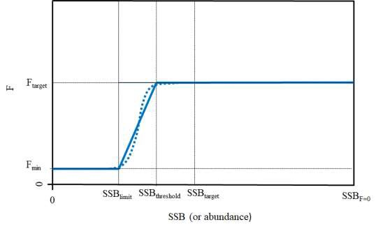
Figure 1. Candidate HCRs 1a (solid line) and 1b (dashed line)

Candidate HCR 2 is illustrated in Figure 2 and is similar to Candidate HCRs 1a and 1b in that F declines once the SSBlimit is breached, but unlike Candidate HCRs 1a and 1b, there is no SSBthreshold between SSBlimit and SSBtarget.

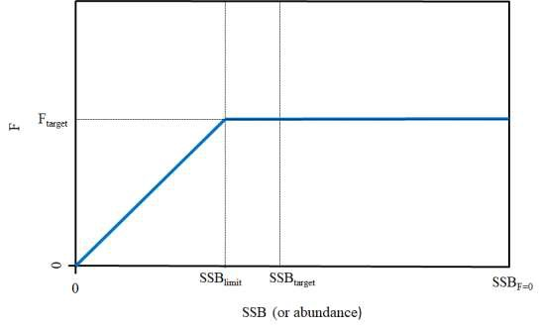

Figure 2. Candidate HCR 2

Candidate HCR 3 specifies two HCRs, one for old-fish fisheries and one for young-fish fisheries. For fisheries that harvest primarily mature Pacific bluefin tuna (e.g., longline fisheries), the HCR could be either Candidate HCRs 1a, 1b or 2 (i.e., fishing mortality is controlled as a function of the size of the spawning stock), and for fisheries harvest primarily immature Pacific bluefin tuna, the HCR would control fishing mortality as a function of
recruitment, such as using an index of recruitment based on CPUE in age 0 or 1 fisheries. This approach is similar to that used in Maunder 2014.1
All of the above candidate HCRs are general in concept and require further work to address issues such as regional distribution, fishery selectivity and fleet allocation.

Candidate Reference Points

The following candidate reference points for the Pacific bluefin tuna MSE are based in part on the hierarchical approach that the WCPFC adopted for identifying limit reference points for key target species as well as the approach taken by the IATTC in identifying interim LRPs for tropical tunas. Under the hierarchical approach adopted by the WCPFC, and as indicated in the harvest strategy for Pacific bluefin tuna fisheries, Pacific bluefin tuna is a Level 2 stock, as the stock recruitment relationship for Pacific bluefin tuna is not well known, but key biological and fishery variables are reasonably well estimated. LRPs for Level 2 stocks are identified as either FX%SPRo and either X%SBo or X%SBcurrent,F=0. In the IATTC, the interim LRP for tropical tuna stocks is the SSB associated with 50% of the unfished recruitment with assuming a stock-recruitment relationship steepness of 0.75. In addition to an LRP and a TRP, each of Candidate HCRs 1a and 1b require identification of a threshold reference point (SSBthreshold) and an Fmin. The combinations of LRPs, threshold reference points and TRPs will depend on which of the Candidate HCRs are evaluated. Further consideration is needed for the reference points associated with the recruitment-based HCR in HCR 3.
Candidate Limit Reference Points: 5%SSB_{F=0}, SSB0.5Ro, 15%SSBF=0, 20%SSBF=0
Candidate Threshold Reference Points (for candidate HCRs 1a and 1b): 15%SSBF=0, 20%SSBF=0, 25%SSBF=0
Candidate Target Reference Points: FSPR10%, FSPR15%, FSPR20%, FSPR30%, FSPR40%

Candidate F_{min}: 0, 10%F_{target}

1 Maunder, Mark. (2014). MANAGEMENT STRATEGY EVALUATION (MSE) IMPLEMENTATION IN STOCK SYNTHESIS: APPLICATION TO PACIFIC BLUEFIN TUNA. IATTC Stock Assessment Report. 15. 100-117.

