SCIENTIFIC COMMITTEE
FIFTEENTH REGULAR SESSION

Pohnpei, Federated States of Micronesia

12-20 August 2019

Report of the Tuna Tissue Bank Steering Committee

WCPFC-SC15-2019/RP-P35b-02

TTB Steering Committee

Preliminaries

Background
The WCPFC Tuna Tissue Bank (TTB) has been established over several years (SPC-OFP, 2017) and its ongoing operation is now funded by WCPFC through Project 35b. WCPFC established its TTB so that national and international fisheries research institutes could access the collections to undertake the necessary research to enhance understanding of the dynamics of tuna and related species in the WCPFC region (including analyses to estimate spatial and temporal explicit age, growth and reproductive parameters, and genetics for stock structure for use in stock assessments). In a broader ecosystem context, the collections are also used for trophic and system studies including diet analyses, stable isotopes, mercury and other biochemical elements for trophic structure and movements and taxonomic studies.
The objective of Project 35b is to maintain the WCPFC TTB with particular emphasis on WCPO bigeye, yellowfin, albacore and skipjack tunas, and swordfish, and, to facilitate transmission of samples to specified researchers with due cognizance of the WCPFC TTB Access Protocols (Anon., 2016). SPC as the Scientific Services Provider is tasked to maintain and develop the WCPFC TTB and through the biological sampling programme expand the inventory of samples held. This project currently runs to 31 December 2019 with funding for 2020 and 2021 subject to the decisions of WCPFC 16 and WCPFC 17.
In 2018, it was agreed to run the process of WCPFC TTB reporting in a similar manner to the PTTP (Project 42) at SC15, with a brief report of the TTB Steering Committee presented to the SC Plenary by its chair so as to expedite the work of the Scientific Committee whilst giving adequate time to discuss details of the TTB during the steering committee meeting.

Review and adoption of agenda
The provisional agenda (Attachment 1) was adopted.

TTB Progress Report (SC15-RP-35B-01)

Sample collection and storage
Samples are collected by national at-sea and in-port observers across the WCPO. Observers and port samplers collect to a strategy that optimizes the number of samples per set and maximizes sampling across sets and trips to create the greatest temporal spatial coverage possible. Opportunistic sampling on scientific cruises has also been undertaken (SPC-OFP, 2019a), and continues on the WP5 skipjack cruise which is underway. The rate of sampling of various species in key areas is monitored, and to the extent possible, observer and port sampler tasking is directed to maximise the spatial, species and temporal spread across the WCPO. Observers are issued with biological sampling kits that include pre-numbered sample tags. The Biological Data System (BioDaSys) database tracks the distribution of kits and sample tags.
Training for debriefers in biological sampling has been developed and is awaiting the next PIRFO standards meeting to be accepted into the PIRFO training standards. Senior active observers continue to be identified and provided with training and refresher training in biological sampling. An additional 12 observers were trained in 2018-19, with total of 492 observers trained to date. Materials and standards for training of debriefers in biological sampling have been updated, and two debriefers were trained in 2018-19 with a total of 14 trained to date.
In 2018-19, an additional 2,688 samples were collected from 600 fish and deposited in the TTB. Samples were taken from 253 yellowfin, 79 skipjack, 104 bigeye, 88 albacore, 6 wahoo, 35 mahi mahi, 8 striped marlin, 17 rainbow runner, and 10 other species of fish. The provisional total SPC Marine Specimen Bank incorporating the WCPFC TTB sample holdings to 30 June 2019 include 73,880 available samples from 26,206 individual specimens. These data do not include samples awaiting cataloguing.
In 2018, 347 fish were collected by observers at-sea which represents 58% of all the fish sampled. The number of observer trips on which sampling occurred dramatically decreased from 2017 to 2018, and the collection of samples consequently declined by 54% on the previous year. This was noted as an issue of concern.
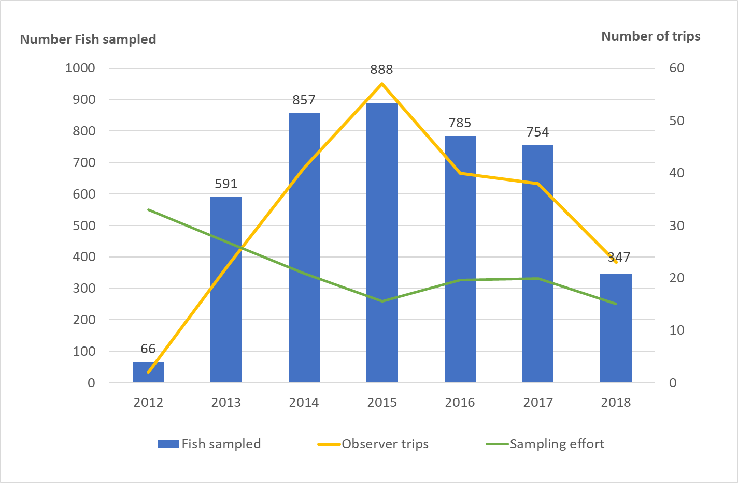
Figure 1. Number of fish sampled by observers, and number of trips at sea where biological samples were collected 2012-2019 (at 10 July 2019).

A variety of approaches have been used to recognise and incentivise the efforts of those involved in biological sampling, including sampling appreciation certificates and more recently giving specially designed t-shirts to observers who contributed most to the sampling collection at a national level (see SPC-OFP, 2018). This initiative was well received by the sampling network, but was discontinued this year due to the lack of samples collected in 2018 by the observers. Noting the relatively low numbers of samples collected in 2018, alternative approaches to incentivise sampling effort are needed and will be investigated and pursued for 2019-2020. Opportunities arising from Project 90 sampling will also be utilised where possible (SPC-OFP, 2019b). To incentivise collection of biological samples from archival tagged fish and fish with chemically marked otoliths (white tagged fish) caught by longline and purse seine vessels, a new reward is now in place and new posters have been created and are currently under translation.
The TTB has long-term storage facilities at SPC Headquarters in Noumea, New Caledonia and at CSIRO, Brisbane, Australia. Storage at the CSIRO facility in Brisbane has been upgraded with smaller single plastic containers that can accommodate samples from a single sampling event rather than multiple sampling events. Samples have been inventoried and reorganised with the new storage system, allowing future fast sample retrievals. The storage in Noumea has been expanded again this year by an additional 10% to cope with demand. Most of these facilities are currently provided in kind to the project by both organisations. The project also contributes to costs for several of the short-term/staging storage facilities’ infrastructure. Samples extracted in mid-2018 from the early years of the SPC Marine Specimen Bank (early 2000s) highlight the quality loss for samples used in genetic analyses (H. Kusche, Thünen Institute of Fisheries Ecology, pers. comm.), reinforcing the need for long-term super-cold storage becoming increasingly urgent for the WCPFC TTB.

Tuna Tissue Bank database
A central feature of the TTB repository is the Biological Data System (BioDaSys), a relational database that catalogues the samples. Specific information includes: sample number; all tissues that were collected from that individual fish; the condition of these samples; species and its measurements; all information on where each sample comes from and how and when it was collected; who collected the sample; the location(s) where it is currently stored; and, how it was transported and who transported it to its current location. A dedicated web-based portal allows WCPFC members to track the collection of samples (www.spc.int/ofp/PacificSpecimenBank).
New data processes have been added to BioDaSys to keep track of: samples that have been returned after analysis; single otolith status; debriefing quality control; contractual information; and, resulting publications. Efforts have also been made in tracking pending analyses to give better and quicker feedback to affected staff and thus promote a higher chance of retrieving missing information. Sampling targets per member country, as agreed in implementing arrangements, are monitored. The database catalogues the analysis of the samples and now includes links to the associated contract and the publications resulting from the analyses.
A section for recording biological sampling collection is now included in the Electronic Reporting application OnShore, used by port samplers to collect size and catch composition at landing, linking samples with the vessel’s details and logsheet data. The data is directly uploaded to TUFMAN2, with efforts ongoing to automate the transfer of information from TUFMAN2 to BioDaSys. The biological sampling section of the application is still under testing and is presently only being used in New Caledonia for improvement before being tested in other locations. Inclusion of this section in the application OLLO (Offline Longline Observer) for effort and catch data by at-sea observers is under development, and will be tested with observers embarking in New Caledonia who undertake biological sampling at-sea.

Tuna Tissue Bank Access
The Scientific Committee may decide to make TTB samples available to third party organisations to fast track certain analyses, and has established a protocol for third party access to the TTB. Apart from pre-approved WCPFC projects (e.g. CSIRO work on yellowfin tuna under Project 82, ongoing work by the Scientific Services Provider), there has been one new request to withdraw samples from the TTB in 2018-19. The request was sent to the WCPFC Research Sub-Committee for approval, but remains pending consideration of WCPFCs strategic research approach to tuna population structure (see Macdonald et al., 2019). Sample extraction for two previously approved projects and Project 82 were completed in 2018-19.
All researchers with current projects withdrawing specimens from the TTB (five) have provided annual progress reports to the WCPFC Secretariat. A further paper has been submitted to the scientific committee of the WCPFC to report the results of Project 82 (Farley et al., 2019). Two projects have resulted in primary literature publications (Anderson et al., 2019; Houssard et al., 2019). Several of the other projects have papers in review for publication.

Other work to maintain and enhance the tuna tissue bank
In the second half of 2019 a range of refinements to the laboratory are occurring – wet lab data-entry and online access to identification materials, new microscopes and cameras, and a fish x-ray machine – which will all improve curation of specimens and data quality.
An analysis of data collected to date is planned for 2019-20. The planned review of material for genetic studies (Macdonald et al., 2019) will contribute in the context of a closer examination of age and quality issues.
In 2017, SC noted that cost recovery for TTB samples should begin to be explored, especially for third-party applications. To date, many applications have met most of the direct freight costs (e.g. freight from storage location to their lab). As discussed in SPC-OFP (2018), additional costs were also recovered for a third party application. Although a significant step forward for the TTB, this process also highlighted many issues with engaging in cost recovery. Some of the recent and ongoing enhancements in BioDaSys are designed to support more precise costing.

2019-2020 Work Plan

General workplan
This project is intended to be ongoing. The efforts of people of the region contributing to the TTB are core to maintaining the TTB. Given the success of the TTB to date, consideration should be given to incorporating the budget into the 2020 budget and 2021-22 indicative budgets, especially as Scientific Committee endorsed this as a high priority ongoing project in 2018 (Anon., 2018). The following additional work arises from this report on the TTB in 2019-20. Note that this work should be completed within the existing proposed budget.
In addition to maintaining and operating the TTB, in 2019-20 proposed enhancement work includes:
- Further investment in training standards and in observer and observer-trainer training to enhance biological sampling as an ROP observer core duty, ensuring that the repository continues to develop – note that this requires support from Project 42, and may also integrate with Project 90 sample collection where possible;
- Investigate incentives to increase the number of samples collected by observers. Additional rewards could be provided to the observers when reaching a certain amount of fish sampled and/or after a certain number of trips involving collection of biological samples;
- Developing Electronic Reporting tools for biological sample collection to facilitate data collection and improve data quality;
- Developing approaches to better ensuring marlin are correctly identified at time of sample collection, including better species identification guides and ensuring those working at sea and in port have species identification guides available;
- Ongoing development of protocols for standard TTB extraction approaches and having such protocols stored on BioDaSys (e.g. for otoliths for sectioning);
- Ongoing BioDaSys tracking developments including the physical size of a specimen on arrival (e.g. volume or mass for a muscle sample), and changes to the sample size as a result of any use through approved access to the TTB;
- Ongoing development of protocols for managing the longevity of specimens in the bank;
- With the WCPFC Secretariat and input from the Research Sub-Committee, ongoing refinement of the procedures for granting access to the WCPFC Tuna Tissue Bank by third parties for consideration at SC;
- With the WCPFC Secretariat, continue to consider and develop cost recovery approaches for third party applications;
- Continue work with the WCPFC Secretariat to inform the development of protocols and procedures to ensure that the WCPFC TTB remains aligned with the key elements of the Nagoya Protocol;
- Doubling the capacity of standard cold storage capacity in Noumea, and the associated reorganisation of sample storage; and
- Continuing work on designing and seeking funding for strategic investment in a super-cold storage facility, required to ensure the longevity and relevance of the WCPFC TTB, noting the cost of initial design work has been met by New Zealand.

Increasing biological sampling rates
The number of samples collected by observers in 2018 represented a substantial decline from 2017 levels, dropping by approximately 50%. Alternative approaches to incentivise sampling effort will continue to be investigated, and revitalised member support is needed, in order to provide sufficient samples to support the work of WCPFC.

Tuna stock structure strategic research
As a move towards a better understanding of tuna stock structure in the region, an international workshop ‘Identifying the spatial structure of Pacific tuna stocks’ was convened at the Pacific Community (SPC) in Nouméa, New Caledonia, in October 2018 (see Macdonald et al. 2019). The workshop recommended that, as a first step, a systematic review of existing biological datasets, sample archives and fishery-observer databases be undertaken to expose spatial and temporal trends in sampling coverage and identify rich data sources and critical data gaps. BioDaSys will facilitate the review of the TTB in this context, and will help direct the future sampling requirements in order to support future research targeted at key uncertainties surrounding stock structure of Pacific tuna resources.

Administrative Matters
The support of all current and past donors was gratefully acknowledged, as was the support and efforts of the many contributors throughout the region.

Discussion
The Steering Committee reiterated the critical contribution of the Tuna Tissue Bank to the work of WCPFC, through the provision of samples for growth studies that support assessments. It was also noted that Tuna Tissue Bank resources are available to all WCPFC members, and should be considered in the context of national research plans. The Steering Committee discussed the process for requesting access to the Tuna Tissue Bank and the preparation and transportation of samples. There is an agreed protocol for requesting access protocols regarding data available on the WCPFC website (https://www.wcpfc.int/doc/sc-12/wcpfc-tissue-bank-access-protocols).
The logistical challenges of transportation of samples in the region were noted. The current approach is for storage of samples in staging storage facilities with subsequent opportunistic transportation to long-term storage facilities by staff travelling in the region. There currently do not appear to be any alternatives to this approach. It was noted that staging storage facilities in the region can be vulnerable to external factors, e.g. including power outages. Members were encouraged to notify SPC if they did not have available and reliable facilities in-country to support the work. The steering committee noted that facilitation of communication between personnel involved in the Tuna Tissue Bank would be helpful, e.g. a dedicated ‘Slack’ channel or social media platforms as used for the TRO network.
The Steering Committee noted the recent work to identify key uncertainties regarding stock structure of the main tuna species in the Pacific, including spawning locations, the degree of fidelity to natal spawning grounds and origins of post-juvenile assemblages (SA-IP-03). The Steering Committee noted that the Tuna Tissue Bank would underpin future research targeted at reducing these uncertainties, including genetic analyses. Related to the genetic analyses, the long-term degradation in quality of samples for genetic analyses has been identified in recent work using samples collected during the early years of SPC’s Marine Specimen Bank, as well as issues of cross-contamination of samples. The Steering Committee welcomed the planned efforts to enhance training of observers in sample collection to reduce cross-contamination and sample labelling issues, as well as the plans for implementing super-cold storage facilities, to address these issues.

Recommendations for SC15
The Steering Committee therefore recommended that:
- SC15 task the Scientific Services Provider to develop initiatives to increase rates of observer biological sampling and report this to SC16, noting that this contribution is essential to the ongoing success of WCPFC’s work;
- SC15 participants should visit www.spc.int/ofp/PacificSpecimenBank and provide feedback inter-sessionally to SPC-OFP;
- SC15 incorporate the identified budget into the 2020 budget and the 2021-22 indicative budgets, given that the WCPFC Tuna Tissue bank is intended to be ongoing, is considered essential, and given its success and measured quality to date;
- In addition to maintaining and operating the WCPFC Tuna Tissue Bank in 2019-20, the work plan for 2019-20 (see above) should be pursued by the Scientific Services Provider.

References

Anderson, G., Lal, M., Hampton, J., Smith, N., and Rico, C. 2019. Close kin proximity in yellowfin tuna (Thunnus albacares) as a driver of population genetic structure in the tropical Western and Central Pacific Ocean. Frontiers in Marine Science, 6: 341. doi: 10.3389/fmars.2019.00341
Anonymous. 2016. Report of the Twelfth Regular Session of the Scientific Committee of the Commission for the Conservation and Management of Highly Migratory Fish Stocks in the Western and Central Pacific Ocean. 3-11 August 2017, Bali, Indonesia. WCPFC, Pohnpei, Federated States of Micronesia.
Anonymous. 2018. Report of the Fourteenth Regular Session of the Scientific Committee of the Commission for the Conservation and Management of Highly Migratory Fish Stocks in the Western and Central Pacific Ocean. 8-16 August 2018, Busan, Republic of Korea. WCPFC, Pohnpei, Federated States of Micronesia.
Farley, J., et al. 2019. Analysis of age and growth of yellowfin tuna in the Pacific: Project 82. WCPFC-SC15-2019/SA-WP-03. Fifteenth Regular Session of the Scientific Committee of the Western and Central Pacific Fisheries Commission. Pohnpei, federated States of Micronesia, 12-20 August 2019.
Houssard, P., Point, D., Tremblay-Boyer, L., Allain, V., Pethybridge, H., Masbou, J., Ferriss, B.E., Baya, P.A., Lagane, C., Menkes, C.E., Letourneur, Y., Lorrain, A., 2019. A Model of Mercury Distribution in Tuna from the Western and Central Pacific Ocean: Influence of Physiology, Ecology and Environmental Factors. Environ. Sci. Technol. 53, 1422–1431. https://doi.org/10.1021/acs.est.8b06058
Macdonald, J., Moore, B., and Smith, N. 2019. Stock structure considerations for Pacific Ocean tunas. WCPFC-SC15-2019/SA-IP-03. Fifteenth Regular Session of the Scientific Committee of the Western and Central Pacific Fisheries Commission. Pohnpei, federated States of Micronesia, 12-20 August 2019.
The Pacific Community – Oceanic Fisheries Programme (SPC-OFP). 2017. Project 35: Bigeye biology, and Project 35b: WCPFC Tuna Tissue Bank. WCPFC-SC13-2017/RP-P35-01. Thirteenth Regular Session of the Scientific Committee of the Western and Central Pacific Fisheries Commission. Rarotonga, Cook Islands, 9-17 August 2017.
The Pacific Community – Oceanic Fisheries Programme (SPC-OFP). 2018. Project 35b: WCPFC Tuna Tissue Bank. WCPFC-SC14-2018/RP-35b-01. Fourteenth Regular Session of the Scientific Committee of the Western and Central Pacific Fisheries Commission. Busan, Republic of Korea, 8-17 August 2018.
The Pacific Community – Oceanic Fisheries Programme (SPC-OFP). 2019a. Project 42: Pacific Tuna Tagging Project Report and Workplan for 2019-2022. WCPFC-SC15-2019/RP-PTTP-02. Fifteenth Regular Session of the Scientific Committee of the Western and Central Pacific Fisheries Commission. Pohnpei, federated States of Micronesia, 12-20 August 2019.
The Pacific Community – Oceanic Fisheries Programme (SPC-OFP). 2019b. Project 90 Update: Better data on fish weights and lengths for scientific analyses. WCPFC-SC15-2019/ST-WP-03. Fifteenth Regular Session of the Scientific Committee of the Western and Central Pacific Fisheries Commission. Pohnpei, federated States of Micronesia, 12-20 August 2019.

