

The Commission for the Conservation and Management of
Highly Migratory Fish Stocks in the Western and Central Pacific Ocean

Fourteenth Regular Session of the Scientific Committee

Busan, South Korea
8–16 August 2018

OUTCOMES DOCUMENT

The Commission for the Conservation and Management of
Highly Migratory Fish Stocks in the Western and Central Pacific Ocean

Scientific Committee
Fourteenth Regular Session

Busan, Republic of Korea
8–16 August 2018

OUTCOMES DOCUMENT

AGENDA ITEM 1 — OPENING OF THE MEETING

  - Welcome address

  - Meeting arrangements

  - Issues arising from the Commission

  - Adoption of agenda

  - Reporting arrangements

  - Intercessional activities of the Scientific Committee

AGENDA ITEM 2 — REVIEW OF FISHERIES

  - Overview of Western and Central Pacific Ocean fisheries

  - Overview of Eastern Pacific Ocean fisheries

  - Annual Report – Part 1 from Members, Cooperating Non-Members, and Participating Territories

  - Reports from regional fisheries bodies and other organizations

AGENDA ITEM 3 — DATA AND STATISTICS THEME

  - Data gaps

    - Data gaps of the Commission

- SC14 recommended that the Scientific Services Provider include a table listing the observer data collected by small island developing state (SIDS) observer providers in future versions of the ST Information Paper “Status of ROP Data Management”

    - Species composition of purse-seine catches

- SC14 recommended that the future work proposed by the Scientific Service Provider under Project 60 (Improving purse seine species composition) continue over the coming two years.

    - Potential use of cannery receipt data for the work of the WCPFC

    - Bycatch estimates of longline and purse seine

- SC14 recommended that the Scientific Services Provider continue the work on purse seine and longline bycatch estimates, and provide updates every 2-3 years.

- SC14 encouraged CCMs to provide catch estimates of all species at the species level (in addition to the binding provision of estimates for the WCPFC key species) as part of their annual data submission.

- SC14 recommended that the bycatch estimates (from SC14-ST-WP-03) also include the estimates of uncertainty (e.g. CVs) in the next iteration of this work, and consider alternative better estimates where appropriate.

- SC14 recommended that the Scientific Services Provider reconcile the names and codes of some species of sharks included in their databases.

- SC14 recommended that the differences in coverage of longline observer data presented in some SC14 papers be investigated by Scientific Services Provider and reported to SC15.

    - Better size data (length and weight) for scientific analyses (Project 90)

- SC14 recommends that the Scientific Services Provider be tasked with a project to design and coordinate the systematic collection of data for conversion factors on relevant species to better inform catch estimation, and agrees its inclusion in the SC future work programme and budget under Project 90.

  - FAD data management

  - Regional Observer Programme

    - ROP longline coverage.

    - Review of ROP minimum standards data fields

  - Electronic Reporting and Electronic Monitoring

- SC14 recommends that FFA, PNA Office, the Scientific Services Provider and WCPFC Secretariat jointly work on a project to review the Commission’s data needs and collection programmes (Project 93).

  - Economic data

- SC14 recommended that future reports on economic conditions in WCPO fisheries (SC14-ST-WP-04) be delivered in the SC general reports under Agenda item 2.1.

AGENDA ITEM 4 — STOCK ASSESSMENT THEME

4.0 Improvement of MULTIFAN-CL software

  - WCPO tunas

    - WCPO bigeye tuna (Thunnus obesus)

      - Research and information

      - Provision of scientific information

a. Stock status and trends

- The median values of relative recent (2012-2015) spawning biomass depletion (SB_{recent}/ SB_{F=0}) and relative recent (2011-2014) fishing mortality (F_{recent}/F_{MSY}) over the uncertainty grid of 36 models (Table BET-1) were used to define stock status. The values of the upper 90th and lower 10th percentiles of the empirical distributions of relative spawning biomass and relative fishing mortality from the uncertainty grid were used to characterize the probable range of stock status.

- A description of the updated structural sensitivity grid used to characterize uncertainty in the assessment is set out in Table BET-1. Time series of total annual catch by fishing gear over the full assessment period is shown in Figure BET-1. Estimated trends in spawning biomass depletion for the 36 models in the structural uncertainty grid is shown in Figure BET-2, and juvenile and adult fishing mortality rates from the diagnostic case model is show in BET-3. Figure BET-4 displays Majuro plots summarising the results for each of the models in the structural uncertainty grid. Figures BET-5 show Kobe plots summarising the results for each of the models in the structural uncertainty grid. Table BET-2 provides a summary of reference points over the 36 models in the structural uncertainty grid.

- SC14 agreed to use the “updated new growth” model to describe the stock status of bigeye tuna because SC14 considered it to be the best available scientific information. By removing results using the old growth model, the stock status becomes considerably more optimistic. However, SC14 also notes that questions remain regarding the “updated new growth” model.

- Therefore, SC14 acknowledges that further study is warranted related to the new growth model, in particular as to the cause of the difference of growth between EPO and WCPO. An inter-laboratory ageing workshop is planned for late 2018 to review ageing approaches in the WCPO and EPO and to resolve differences, if they exist.

- In addition, SC14 acknowledges that further study is warranted to refine the tagging dataset in the WCPO to assist validating age estimates of bigeye in the WCPO. SC14 further notes that adopting the updated new growth curve generates new broader questions related to the bigeye tuna stock assessment and agreed that several aspects need to be investigated further to inform future assessments.

3Table BET-1. Description of the updated structural sensitivity grid used to characterize uncertainty in the assessment.
Axis | Levels | Option
Steepness | 3 | 0.65, 0.80, 0.95
Growth | 1 | ‘Updated new growth’
Tagging over-dispersion | 2 | Default level (1), fixed (moderate) level
Size frequency weighting | 3 | Sample sizes divided by 10, 20, 50
Regional structure | 2 | 10°N regions, 20°N regions

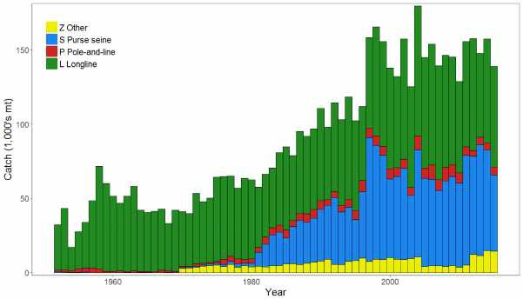
Figure BET-1. Time series of total annual catch (1000's mt) by fishing gear over the full assessment period.

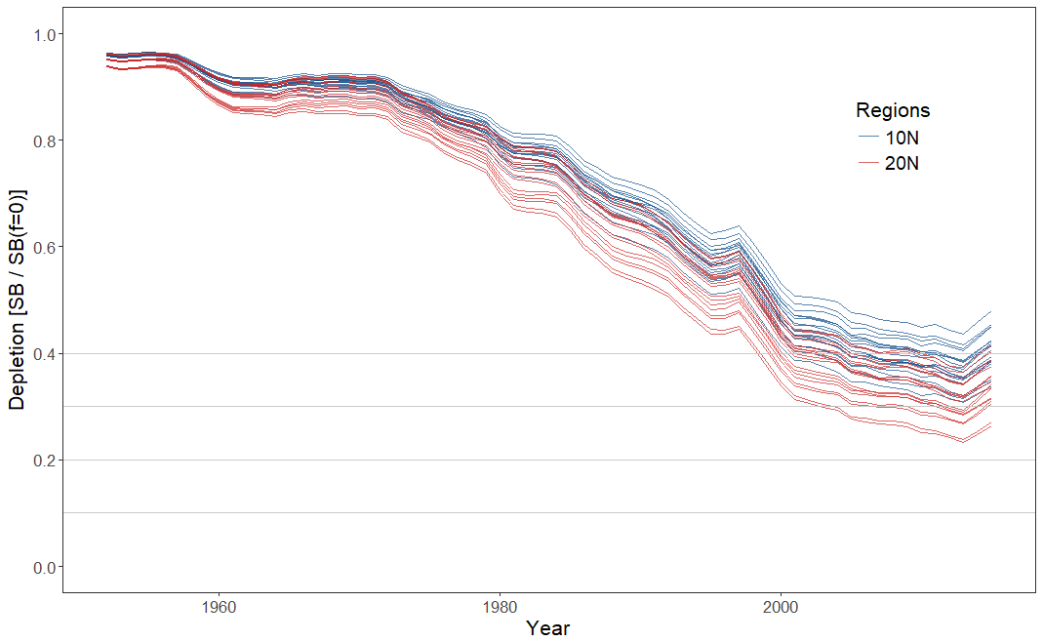
Figure BET-2. Plot showing the trajectories of spawning biomass depletion for the 36 model runs included in the structural uncertainty grid. The colours depict the models in the grid with the 10°N and 20°N spatial structures.

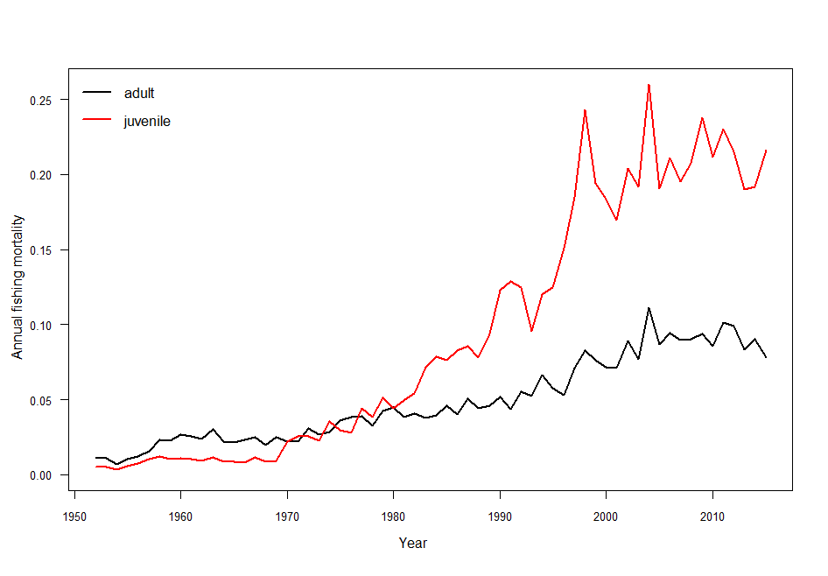Figure BET-3. Estimated annual average juvenile and adult fishing mortality for the diagnostic case model.

SB_{recent} (2012-2015) / SB_{F=0}
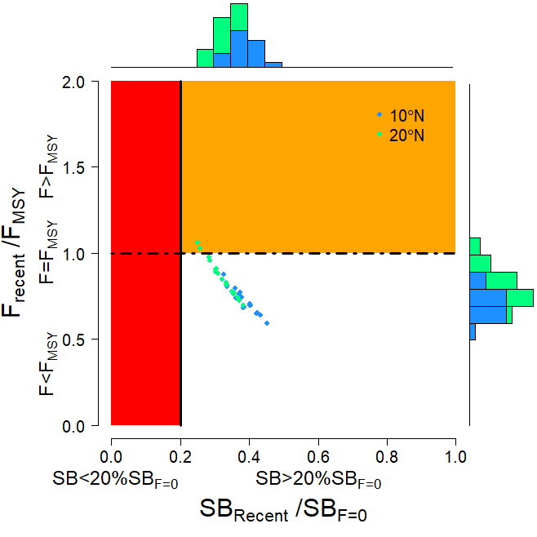
SB_{latest} (2015) / SB_{F=0}
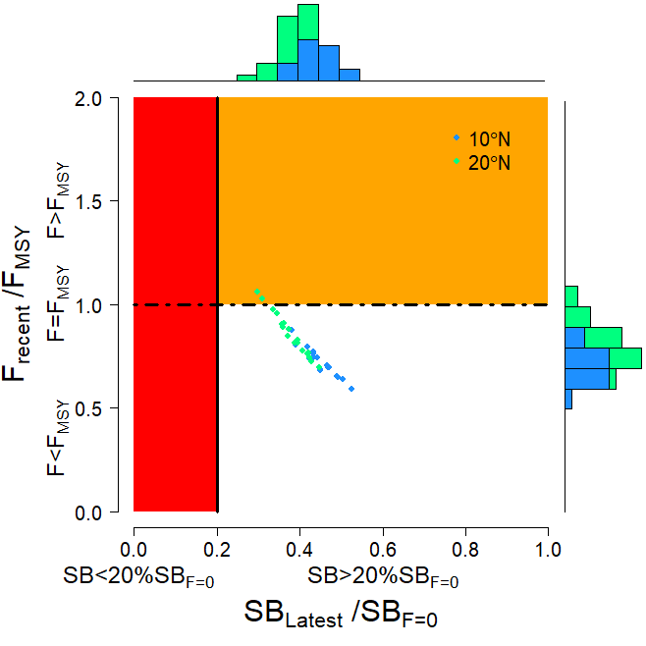
Figure BET-4. Majuro plot summarising the results for each of the models in the structural uncertainty grid. The plots represent estimates of stock status in terms of spawning biomass depletion and fishing mortality. The red zone represents spawning biomass levels lower than the agreed limit reference point, which is marked with the solid black line. The orange region is for fishing mortality greater than F_{MSY} (F_{MSY} is marked with the black dashed line). In the upper panel, the points represent SB_{recent}/SB_{F=0}, where SB_{recent} is the mean SB over 2012-2015. In the lower panel, the points represent SB_{latest}/SB_{F=0}, where SB_{latest} is from 2015. In both panels the colors depict the models in the grid with the 10°N and 20°N regional structures.

SB_{recent} (2012-2015) / SB_{MSY}
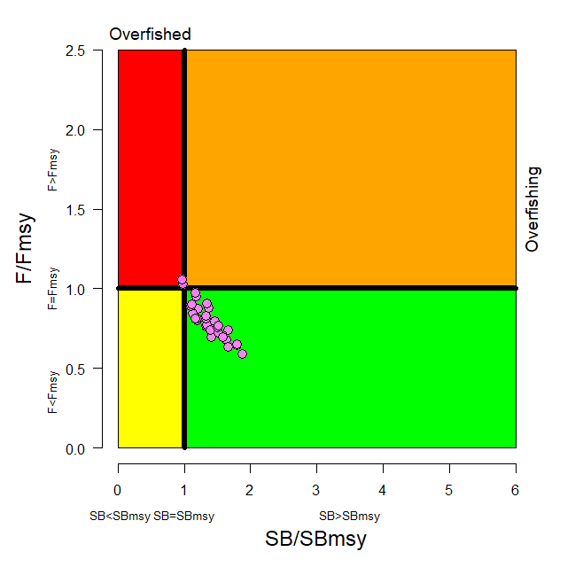
SB_{latest} (2015) / SB_{MSY}
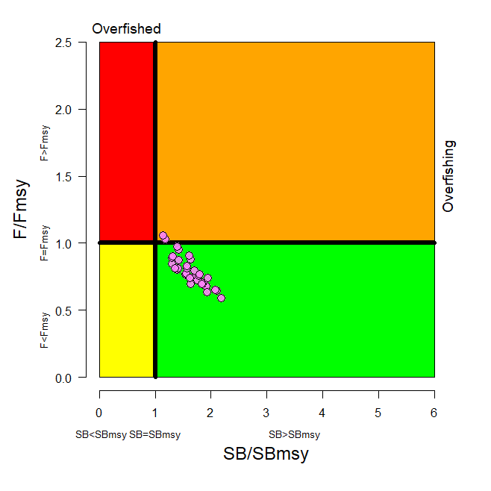

Figure BET-5. Kobe plot summarising the results for each of the models in the structural uncertainty grid. In the upper panel, the points represent SB_{recent}/SB_{MSY}, where SB_{recent} is the mean SB over 2012-2015. In the lower panel, the points represent SB_{latest}/SB_{MSY}, where SB_{latest} is from 2015.

Table BET-2. Summary of reference points over the 36 models in the structural uncertainty grid. Note that SB_{recent}/SB_{F=0} is calculated where SB_{recent} is the mean SB over 2012-2015 at the request of the Scientific Committee.
 | Mean | Median | Min | 10% | 90% | Max
C_{latest} | 152,148 | 151,846 | 148,888 | 148,936 | 154,971 | 155,577
YF_{recent} | 154,180 | 153,220 | 133,120 | 141,140 | 170,720 | 172,280
f_{mult} | 1.291 | 1.301 | 0.946 | 1.075 | 1.499 | 1.690
F_{MSY} | 0.050 | 0.049 | 0.044 | 0.045 | 0.054 | 0.056
MSY | 158,551 | 159,020 | 133,520 | 143,040 | 173,880 | 180,120
F_{recent}/F_{MSY} | 0.789 | 0.768 | 0.592 | 0.667 | 0.931 | 1.058
SB₀ | 1,674,833 | 1,675,500 | 1,261,000 | 1,415,500 | 1,941,000 | 2,085,000
SB_{F=0} | 1,841,609 | 1,858,775 | 1,509,007 | 1,632,014 | 2,043,108 | 2,139,644
SB_{MSY} | 471,956 | 476,050 | 340,700 | 386,600 | 577,400 | 614,200
SB_{MSY}/SB₀ | 0.281 | 0.280 | 0.260 | 0.262 | 0.300 | 0.302
SB_{MSY}/SB_{F=0} | 0.255 | 0.255 | 0.226 | 0.235 | 0.280 | 0.287
SB_{latest}/SB₀ | 0.456 | 0.456 | 0.346 | 0.392 | 0.523 | 0.568
SB_{latest}/SB_{F=0} | 0.414 | 0.420 | 0.298 | 0.351 | 0.480 | 0.526
SB_{latest}/SB_{MSY} | 1.633 | 1.624 | 1.146 | 1.306 | 1.933 | 2.187
SB_{recent}/SB_{F=0} | 0.353 | 0.358 | 0.251 | 0.295 | 0.412 | 0.452
SB_{recent}/SB_{MSY} | 1.394 | 1.377 | 0.963 | 1.117 | 1.659 | 1.879

- SC14 noted that there has been a long-term decrease in spawning biomass from the 1950s to the present for bigeye tuna and that this is consistent with previous assessments.

- SC14 also noted that the central tendency of relative recent (2012-2015) spawning biomass depletion was median (SB_{recent}/SB_{F=0}) = 0.36 with a range of 0.30 to 0.41 (80% probability interval).

- SC14 further noted that there was 0% probability (0 out of 36 models) that the recent spawning biomass had breached the adopted LRP.

- SC14 noted that there has been a long-term increase in fishing mortality for both juvenile and adult bigeye tuna (Figure BET-3), consistent with previous assessments.

- SC14 also noted that the central tendency of relative recent fishing mortality was median (F_{recent}/F_{MSY}) = 0.77 with an 80% probability interval of 0.67 to 0.93.

- SC14 further noted that there was a roughly 6% probability (2 out of 36 models) that the recent fishing mortality was above F_{MSY}.

- SC14 also noted that, regardless of the choice of uncertainty grid, the assessment results show that the stock has been continuously declining for about 60 years since the late 1950’s, except for the recent small increase.

- SC14 also noted the continued relatively higher levels of depletion in the equatorial and western Pacific (specifically Regions 3, 4, 7 and 8) and the associated higher levels of impact, especially on juvenile bigeye tuna, in these regions due to the associated purse-seine fisheries and the ‘other’ fisheries within the western Pacific (as shown in Figures 46 and 47 of SC13-SA-WP-03).
- Table BET-3 summarises the median values of SB/SB_{F=0} and F/F_{MSY} achieved in the long term, along with the potential risk of breaching the limit reference point (LRP) and exceeding F_{MSY}, under each of the future fishing and recruitment combinations. Figure BET-6 presents the corresponding distributions of long term SB/SB_{F=0} and Figure BET-7 those for F/F_{MSY}.

- Potential outcomes under the 2013-15 average and CMM scenario conditions were strongly influenced by the assumed future recruitment levels.

- Under the assumption that recent positive recruitments will continue into the future, spawning biomass relative to unfished levels is predicted to increase from recent levels under all examined future scenarios by 0-18% (SB₂₀₄₅/SB_{F=0} ranges from 0.36 to 0.42; Table BET-3, Figure BET-6). While future uncertainty in stock status increases due to stochastic future recruitment levels, the risk of future spawning biomass falling below the LRP falls to between 0 and 5%, due to the improved overall stock size. Fishing mortality falls slightly under both the status quo and optimistic scenarios, assuming recent recruitment. However, fishing mortality increases under the pessimistic scenario, but remains below F_{MSY} (30% risk of F > F_{MSY} Table BET-3, Figure BET-7).

- Under the assumption that less positive long-term recruitments are experienced in the future, spawning biomass relative to unfished levels will decline under all scenarios (SB₂₀₄₅/SB_{F=0} ranges from 0.25 to 0.30). The risk of spawning biomass falling below the LRP increases to between 17 and 32% (Table BET-3). In all fishing scenarios, fishing mortality increases relative to recent levels (by 109-138%) and is well above F_{MSY}. Risk of fishing mortality exceeding F_{MSY} ranges from 93 to 98%.

- It should be noted that even under assumption of long term recruitment levels, the risk of exceeding the LRP in the short term ranges between 2% and 7% (2020) and 12 and 26% (2025), with only the pessimistic scenario exceeding the 20% level of risk in 2025. (Table BET-4 and Figure BET-8)

Table BET-3. Including ‘2013-2015 average levels’
Median values of reference point levels (adopted limit reference point (LRP) of 20% SB_{F=0}; F_{MSY}) and risk¹ of breaching reference points from the 2018 bigeye stock assessment incorporating updated new growth information, and in 2045 under the three future harvest scenarios (2013-2015 average fishing levels, optimistic, and pessimistic) and alternative recruitment hypotheses. ‘Updated new growth’ runs only.

Scenario |  | Scalars relative to 2013-2015 |  | Median SB₂₀₄₅/SB_{F=0} | Median SB₂₀₄₅/SB_{F=0}  v  SB₂₀₁₂₋₁₅/SB_{F=0} | Median  F₂₀₄₁₋₂₀₄₄/  F_{MSY} | Median F₂₀₄₁₋₂₀₄₄/F_{MSY} v  F₂₀₁₁₋₁₄/F_{MSY} | Risk
Recruitment | Fishing level | Purse seine | Longline |  |  |  |  | SB₂₀₄₅ < LRP | F>F_{MSY}
Bigeye assessment (‘recent’ levels) |  |  |  | 0.36 | - | 0.77 | - | 0% | 6%
Recent | 2013-2015 average | 1 | 1 | 0.42 | 1.18 | 0.73 | 0.95 | 0% | 11%
Recent | Optimistic | 1.11 | 0.98 | 0.41 | 1.15 | 0.75 | 0.98 | 0% | 13%
Recent | Pessimistic | 1.12 | 1.35 | 0.36 | 1.00 | 0.89 | 1.15 | 5% | 30%
Long-term | 2013-2015 average | 1 | 1 | 0.30 | 0.84 | 1.60 | 2.09 | 17% | 93%
Long-term | Optimistic | 1.11 | 0.98 | 0.29 | 0.82 | 1.64 | 2.13 | 18% | 94%
Long-term | Pessimistic | 1.12 | 1.35 | 0.25 | 0.70 | 1.84 | 2.38 | 32% | 98%
¹ note risk within the stock assessment is calculated as the (weighted) number of models falling below the LRP (X / 36 models). Risk under a projection scenario is the number of projections across the grid that fall below the LRP (X / 3600 (36 models x 100 projections).

Table BET-4. Median values of SB/SB_{F=0} and associated risk of breaching the adopted limit reference point (LRP) of 20% SBF=0 in 2020, 2025 and 2045 under the three future harvest scenarios (2013-2015 average fishing levels, optimistic, and pessimistic) and alternative recruitment hypotheses. ‘Updated new growth’ runs only.

Scenario |  | Scalars relative to 2013-2015 |  | Median SB₂₀₂₀/SB_{F=0} | Median SB₂₀₂₅/SB_{F=0} | Median SB₂₀₄₅/SB_{F=0} | Risk SB₂₀₂₀ < LRP | Risk SB₂₀₂₅ < LRP | Risk SB₂₀₄₅ < LRP
Recruitment | Fishing level | Purse seine | Longline
Recent | 2013-2015 average | 1 | 1 | 0.42 | 0.41 | 0.42 | 0% | 1% | 0%
Recent | Optimistic | 1.11 | 0.98 | 0.41 | 0.40 | 0.41 | 0% | 1% | 0%
Recent | Pessimistic | 1.12 | 1.35 | 0.38 | 0.35 | 0.36 | 0% | 4% | 5%
Long-term | 2013-2015 average | 1 | 1 | 0.35 | 0.30 | 0.30 | 2% | 12% | 17%
Long-term | Optimistic | 1.11 | 0.98 | 0.35 | 0.30 | 0.29 | 2% | 13% | 18%
Long-term | Pessimistic | 1.12 | 1.35 | 0.32 | 0.26 | 0.25 | 7% | 26% | 32%

Recent recruitments | Long-term recruitment
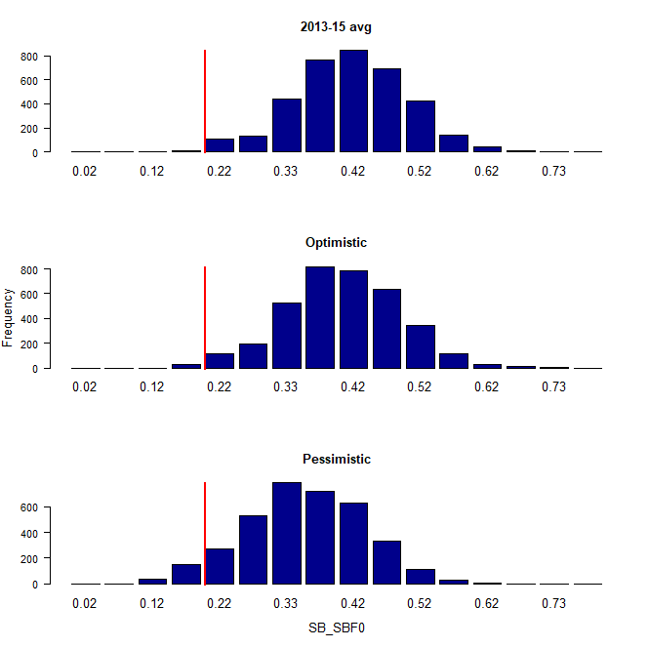 | 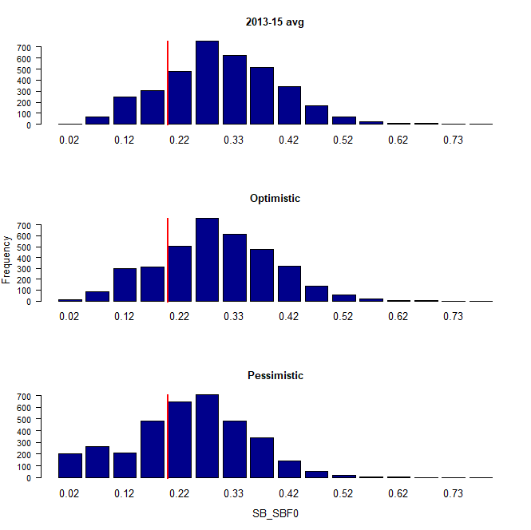
Figure BET-6. Distribution of SB₂₀₄₅/SB_{F=0} assuming recent and long term recruitment conditions (left and right columns, respectively), under the three future fishing scenarios: 2013-15 average (2013-15 average conditions, top row); optimistic conditions (middle row); and pessimistic conditions (bottom row). Projection results from ‘updated new growth’ models (3,600 projections) only where the red line indicates the LRP.

Recent recruitments | Long-term recruitment
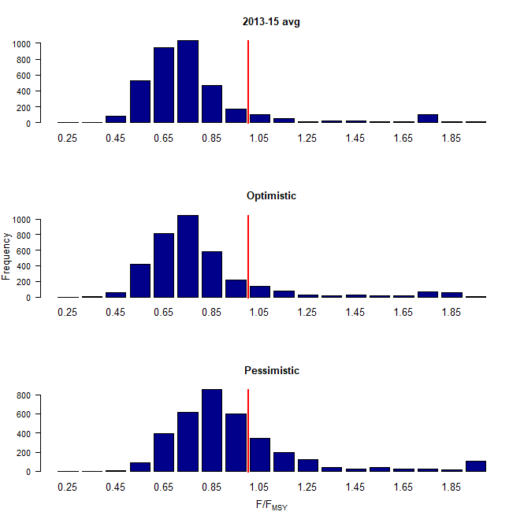 | 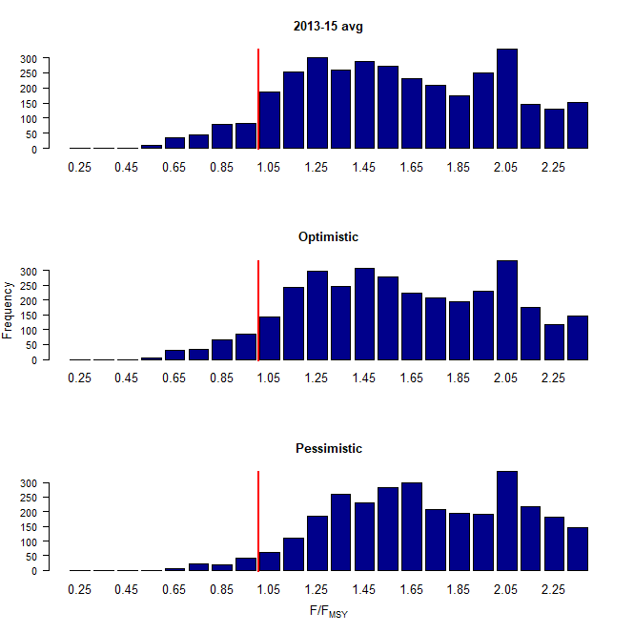
Figure BET-7. Distribution of F/F_{MSY} assuming recent and long term recruitment conditions (left and right columns, respectively), under the three future fishing scenarios: 2013-15 average (2013-15 average conditions, top row); optimistic conditions (middle row); and pessimistic conditions (bottom row). Projection results from ‘updated new growth’ models (3,600 projections) only.

Recent recruitments
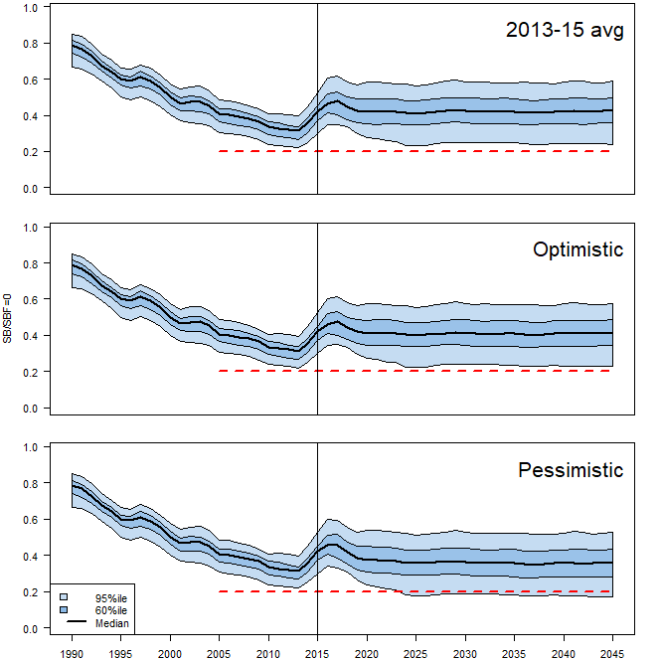
Long-term recruitment
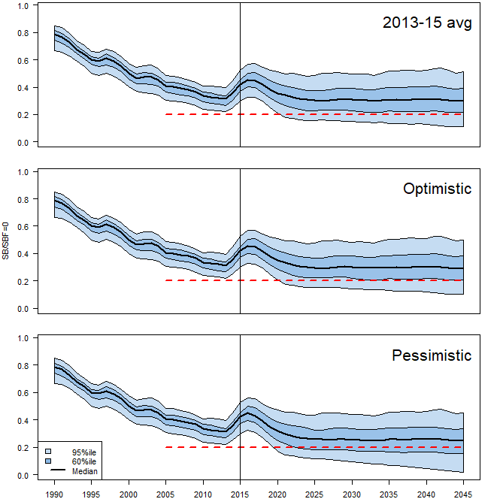

Figure BET-8. Time series of WCPO bigeye tuna spawning biomass (SB/SB_{F=0}) from the uncertainty grid of assessment model runs for the period 1990 to 2015 (the vertical line at 2015 represents the last year of the assessment), and stochastic projection results for the period 2016 to 2045 under the three future fishing scenarios (“2013-15 average”, “Optimistic” and “Pessimistic”; rows). During the projection period (2016-2045) levels of recruitment variability are assumed to match those over the “recent” time period (2005-2014; left panel) or the time period used to estimate the stock-recruitment relationship (1962-2014; right panel). The red dashed line represents the agreed limit reference point.

b. Management advice and implications

- SC14 noted that the preliminary estimate of total catch of WCPO bigeye tuna for 2017 was 126,929 mt, a 17% decrease from 2016 and a 19% decrease from the average 2012-2016. Longline catch in 2017 (58,164 mt) was an 8% decrease from 2016 and a 19% decrease from the 2012-2016 average. Purse seine catch in 2017 (56,194 mt) was a 12% decrease from 2016 and a 13% decrease from the 2012-2016 average. Pole and line catch (1,411 mt) was a 65% decrease from 2016 and a 70% decrease from the average 2012-2016 catch. Catch by other gear (11,160 mt) was a 48% decrease from 2016 and 28% decrease from the average catch in 2012-2016.

- Based on the uncertainty grid adopted by SC14, the WCPO bigeye tuna spawning biomass is above the biomass LRP and recent F is very likely below F_{MSY}. The stock is not experiencing overfishing (94% probability F<F_{MSY}) and it is not in an overfished condition (0% probability SB/SB_{F=0}<LRP).

- Although SC14 considers that the updated assessment is consistent with the previous assessment, SC14 also advises that the amount of uncertainty in the stock status results for the 2018 assessment update is lower than for the previous assessment due to the exclusion of old information on bigeye tuna growth.

- SC14 noted that levels of fishing mortality and depletion differ among regions, and that fishery impact was higher in the tropical region (Regions 3, 4, 7 and 8 in the stock assessment model), with particularly high fishing mortality on juvenile bigeye tuna in these regions. SC14 therefore recommends that WCPFC15 could continue to consider measures to reduce fishing mortality from fisheries that take juveniles, with the goal to increase bigeye fishery yields and reduce any further impacts on the spawning biomass for this stock in the tropical regions.

- SC14 noted that according to CMM 2017-01 bigeye tuna SB/SB_{F=0} is to be maintained above the 2012-2015 level (SB_{recent}/SB_{F=0} = 0.36; Table BET-3) pending the agreement on a TRP. SC14 also noted that the projection results based on scenarios estimating CMM 2017-01 indicated a high level of uncertainty on the levels of spawning stock biomass relative to the LRP and the objective of CMM 2017-01 in 2045. Under the scenario assuming long-term average recruitment continues into the future there was a high risk (18-32%) of breaching the LRPs and a zero probability of achieving the objective of CMM 2017-01, while under the scenario which assumes higher more recent recruitments continues into the future there was a low risk (0-5%) of breaching the LRPs and a 100% probability of achieving the objective of CMM 2017-01.

- However, SC14 also noted that the projections assume that longline catches would be maintained regardless of the decrease in biomass. This may result in unlikely high levels of effort. Therefore, the catch estimates under the long term recruitment scenario, especially in the longer term projections, are more uncertain.

- Based on these results, SC14 recommends that WCPFC15 takes note of the results of the projections in relation to achieving CMM 2017-01 and as a precautionary approach that the fishing mortality on bigeye tuna stock should not be increased from the recent average (2011-2014) level to maintain spawning biomass at or above the 2012-2015 average, until the Commission can articulate the management objectives and agree on an appropriate TRP for bigeye, although one CCM considers that SC14 could provide more options for the Commission to consider.

c. Research Recommendations

- SC14 noted that the acceptance of the updated new growth model for BET raises a number of issues in relation to patterns of growth and stock structure of BET across the Pacific Ocean and recommended that the following research issues need to be addressed:

- Two different growth models separated at 150˚W effectively means that Pacific BET should be assessed as a two-stock resource between the WCPO and EPO. However, catch information indicates that the fishing grounds near 150˚W are a core area of BET catch, thus influencing the assessments of both the WCPFC and IATTC. Also, tagging information suggests movement of BET between the WCPO and EPO. Therefore, the appropriateness off delineating the two stocks at 150˚W needs to be investigated.
- The updated new growth analysis suggests area variant growth across the Pacific. While the level of variation is seen to be relatively small within the WCPO (and possibly within the margins of observation error), there is a suggestion of substantial change in growth around the boundary between the WCPO and the EPO (c.f. Figure 14 in SC14-SA-WP-01). The reasons for this suggested change in growth remains unknown, but SC14 noted the utility of collecting more information from the regions either side of this boundary to inform a greater understanding of possible changes in growth around this area. While the incorporation of area-variant growth within the assessment model would also help explore this issue, SC14 noted the difficulty of this task.
- SC11 concluded that the stock status of WCPO BET from the Pan-Pacific assessment and the WCPO-only assessment were similar when the growth models were similar in the EPO and WCPO. This conclusion needs to be revisited in light of the different growth between EPO and WCPO by adopting the new growth.

- The following additional research activities were also recommended by SC14 in order to improve the understanding of the age and growth of BET across the Pacific:

- A WCPO growth model based on size composition and tagging data, as well as the use of additional modeling approaches (e.g., length-conditional), should also be evaluated.
- Collaboration with the IATTC to analyze bigeye growth from otolith and tagging data collected across the entire Pacific, to better characterize the apparent regional difference in growth between the WCPO and EPO, and possible environmental determinants of such differences.
- Analyzing the same otoliths by different laboratories, to build confidence in ageing estimates and to estimate ageing error.
- Continued development of a high-confidence tagging dataset for growth analysis, with particular focus on larger bigeye tuna and events with reliable measurements at release. Such data would assist with the validation of the age estimates of large bigeye in the WCPO, and could potentially be incorporated directly into the assessment model as an additional data set. However, a reliable measurement of both length at release and recapture are necessary to accurately estimate incremental growth.
- Collect otoliths of very small bigeye that are captured by the Indonesian, Vietnamese, and Philippines domestic fisheries in region 7 and estimate age through daily ring counts to aid in the estimation of the size at age-1 qtr⁻¹ parameter (L1) within the assessment model.

    - WCPO yellowfin tuna (Thunnus albacares)

      - Research and information

      - Provision of scientific information

a. Stock status and trends

- SC14 noted that no stock assessment was conducted for WCPO yellowfin tuna in 2018. Therefore, the stock status description from SC13 is still current. For further information on the stock status and trends from SC13, please see https://www.wcpfc.int/node/29904

- SC14 noted that the total yellowfin catch in 2017 was a record 670,890 mt, a 4% increase from 2016 and a 12% increase from the average 2012-2016.

- Purse seine catch in 2017 (472,279 mt) was a 22% increase from 2016 and a 33% increase from the 2012-2016 average. Longline catch in 2017 (83,399 mt) was a 6% decrease from 2016 and a 9% decrease from the 2012-2016 average. Pole and line catch (12,219 mt) was a 48% decrease from 2016 and a 56% decrease from the average 2012-2016 catch. Catch by other gear (102,993 mt) was a 28% decrease from 2016 and 17% decrease from the average catch in 2012-2016.

- SC14 noted that under recent fishery conditions, the yellowfin stock was initially projected to increase as recent estimated relatively high recruitments support adult stock biomass, and then decline slightly. Median F₂₀₁₉/F_{MSY} = 0.63; median SB₂₀₁₉/SB_{F=0} = 0.37; median SB₂₀₁₉/SB_{MSY} = 1.51. Risk that SB₂₀₁₉ < LRP = 6%.

b. Management advice and implications

- SC14 noted that no stock assessment has been conducted since SC13. Therefore, the advice from SC13 should be maintained to achieve the objectives set in CMM 2017-01, pending a new assessment or other new information. For further information on the management advice and implications from SC13, please see https://www.wcpfc.int/node/29904

c. Research recommendations

- SC14 reviewed the work on age and growth of yellowfin tuna presented in SC14-SA-WP-13 and noted that the final results of this projected will be presented to SC15. SC14 encouraged analysis of the same otoliths by different laboratories, to build confidence in ageing estimates through inter laboratory daily-annual age workshop.

    - WCPO skipjack tuna (Katsuwonus pelamis)

      - Research and information

      - Provision of scientific information

a. Stock status and trends

- SC14 noted that the total catch in 2017 was 1,624,162 mt, a 9% decrease from 2016 and comparable to the average from 2012-2016.

- Purse seine catch in 2017 (1,280,311 mt) was a 7% decrease from 2016 and a 12% decrease from the 2012-2016 average. Pole and line catch (123,132 mt) was a 21% decrease from 2016 and a 23% decrease from the average 2012-2016 catch. Catch by other gear (218,175 mt) was a 13% decrease from 2016 and 1% decrease from the average catch in 2012-2016.

- SC14 noted that under recent fishery conditions (2017 catch level for longline and other fisheries and effort level for purse seine), the skipjack stock was initially projected to decrease for a short period as recent relatively high recruitments move out of the stock. Median F₂₀₁₉/F_{MSY} = 0.47; median SB₂₀₁₉/SB_{F=0} = 0.45; median SB₂₀₁₉/SB_{MSY} = 1.67. In the longer term, assuming long term average recruitment, modest increases in the stock were projected.

b. Management advice and implications

- SC14 noted that no stock assessment has been conducted since SC12. Therefore, the advice from SC12 should be maintained to achieve the objectives set in CMM 2017-01, pending a new assessment or other new information. For further information on the management advice and implications from SC12, please see https://www.wcpfc.int/node/27769

c. Research Recommendations

- SC14 discussed a proposal for an alternative regional structure to be considered in the next skipjack stock assessment (SC14-SA-WP-04) and recommended that the pre-assessment workshop consider how this proposal might be included in the next assessment.

- SC14 supports an ongoing tagging program for skipjack tuna to ensure a reliable indicator of skipjack tuna abundance in the stock assessment.

- SC14 recommended that the Scientific Services Provider continue research on standardizing purse seine CPUE for use in the assessment.

    - South Pacific albacore tuna (Thunnus alalunga)

      - Research and information

      - Provision of scientific information

- SC14 accepted as SC14-SA-WP-05 as providing the best available scientific information for the purpose of stock assessment determination.

a. Stock status and trends

- The median, 10 percentile and 90 percentile values of recent (2013-2016) spawning biomass ratio (SB_{recent}/ SB_{F=0}) and recent fishing mortality in relation to F_{MSY} (F_{recent}/F_{MSY}) over the structural uncertainty grid were used to characterize uncertainty and describe the stock status.

- A description of the structural sensitivity grid used to characterize uncertainty in the assessment is set out in Table SPA-1. The regional structure used within the assessment is presented in Figure SPA-1, and the time series of total annual catch by fishing gear for the diagnostic case model over the full assessment period is shown in Figure SPA-2 for the total assessment region, and Figure SPA-3 by model region. Estimated annual average recruitment, spawning potential, juvenile and adult fishing mortality and fishing depletion for the diagnostic case model are shown in Figures SPA-4 – SPA-7. Figure SPA-8 displays Majuro plots summarising the results for each of the models in the structural uncertainty grid, while Figure SPA-9 shows equivalent Kobe plots for SB_{recent} and SB_{latest} across the structural uncertainty grid. Figure SPA-10 provides estimates of reduction in spawning potential due to fishing by region, and over all regions attributed to various fishery groups (gear-types) for the diagnostic case model. Table SPA-2 provides a summary of reference points over the 72 models in the structural uncertainty grid. Figure SPA-11 presents the history of the annual estimates of MSY for the diagnostic case model, compared with annual catch by the main gear types. Finally, Figure SPA-12 presents the estimated time-series (or ‘dynamic’) Kobe plots for four example models from the assessment (one from each of the combinations of growth types, and natural mortality M set to 0.3 or 0.4)

- SC14 noted that the median level of spawning biomass depletion from the uncertainty grid was SB_{recent}/SB_{F=0} = 0.52 with a probable range of 0.37 to 0.63 (80% probability interval). There were no individual models where (SB_{recent}/SB_{F=0}) < 0.2 which indicated that the probability that recent spawning biomass was below the LRP was zero. SC14 noted that the grid median F_{recent}/F_{MSY} was 0.20, with a range of 0.08 to 0.41 (80% probability interval) and that no values of F_{recent}/F_{MSY} in the grid exceeded 1.

- SC14 also noted that there was a 0% probability (0 out of 72 models) that the recent fishing mortality had exceeded F_{MSY}.

- SC14 noted that the structural uncertainty grid for the south Pacific albacore had changed since the 2015 assessment, with the 2018 assessment examining additional axes of uncertainty including assumptions on growth and CPUE standardization approach. As a consequence, the uncertainty identified is higher than in previous assessments.

- SC14 also noted that the assessment results show that while the stock depletion (SB/SB_{F=0}) has exhibited a long-term decline (Figure SPA-7) the stock is not in an overfished state and overfishing is not taking place.

b. Management Advice and implications

- SC14 noted that the preliminary estimate of total catch of south Pacific albacore (within the WCPFC Convention Area south of the equator) for 2017 was 75,707mt, which was a 33% increase from 2016 and a 13% increase over 2012-2016. (see SC14-SA-WP-02).

- Preliminary catch for longliners in 2017 (72,785mt) was 34% higher compared with 2016 and a 14% increase over 2012-2016. Preliminary other gear (primarily troll) catch in 2017 (2,896t) was 17% higher compared with 2016 but a 1% decrease over 2012-2016. (see SC14-SA-WP-02).

- Based on the uncertainty grid adopted by SC14, the South Pacific albacore tuna spawning biomass is very likely to be above the biomass LRP and recent F is very likely below F_{MSY}, and therefore the stock is not experiencing overfishing (100% probability F < F_{MSY}) and is not in an overfished condition (100% probability SB_{recent} > LRP).

- SC14 recalled its previous advice from SC11, SC12, and SC13 that longline fishing mortality and longline catch be reduced to avoid decline in the vulnerable biomass so that economically viable catch rates can be maintained, especially for longline catch of adult albacore. SC14 recommends that this advice be taken into consideration when the TRP for South Pacific albacore is discussed at WCPFC15.

Table SPA-1. Description of the structural sensitivity grid used to characterize uncertainty in the 2018 south Pacific albacore assessment. Levels used within the diagnostic case are starred.
Axis | Levels | Option
Steepness | 3 | 0.65, 0.80*, 0.95
Natural mortality | 2 | 0.3*, 0.4
Growth | 2 | Estimated* (K, L∞) or fixed (Chen-Wells)
Size frequency weighting | 3 | Sample sizes divided by 20, 50* or 80
CPUE | 2 | Geostatistical*, Traditional

Table SPA-2. Summary of reference points over all the 72 individual models in the structural uncertainty grid.
 | Mean | Median | Min | 10% | 90% | Max
C_{latest} | 61719 | 61635 | 60669 | 60833 | 62704 | 63180
MSY | 100074 | 98080 | 65040 | 70856 | 130220 | 162000
YF_{recentt} | 71579 | 71780 | 56680 | 62480 | 80432 | 89000
fmult | 6.2 | 4.96 | 1.89 | 2.44 | 12.05 | 17.18
F_{MSY} | 0.07 | 0.07 | 0.05 | 0.05 | 0.09 | 0.1
F_{recent}/F_{MSY} | 0.23 | 0.2 | 0.06 | 0.08 | 0.41 | 0.53
SB_{MSY} | 71407 | 68650 | 26760 | 39872 | 100773 | 134000
SB₀ | 443794 | 439800 | 308800 | 353870 | 510530 | 696200
SB_{MSY}/SB₀ | 0.16 | 0.17 | 0.07 | 0.1 | 0.21 | 0.23
SB_{F=0} | 469004 | 462633 | 380092 | 407792 | 534040 | 620000
SB_{MSY}/SB_{F=0} | 0.15 | 0.15 | 0.06 | 0.09 | 0.2 | 0.22
SB_{latest}/SB₀ | 0.55 | 0.56 | 0.33 | 0.42 | 0.69 | 0.74
SB_{latest}/SB_{F=0} | 0.53 | 0.52 | 0.3 | 0.37 | 0.69 | 0.77
SB_{latest}/SB_{MSY} | 4 | 3.42 | 1.45 | 1.96 | 7.07 | 10.74
SB_{recent}/SB_{F=0} | 0.51 | 0.52 | 0.32 | 0.37 | 0.63 | 0.72
SB_{recent}/SB_{MSY} | 3.88 | 3.3 | 1.58 | 1.96 | 6.56 | 9.67
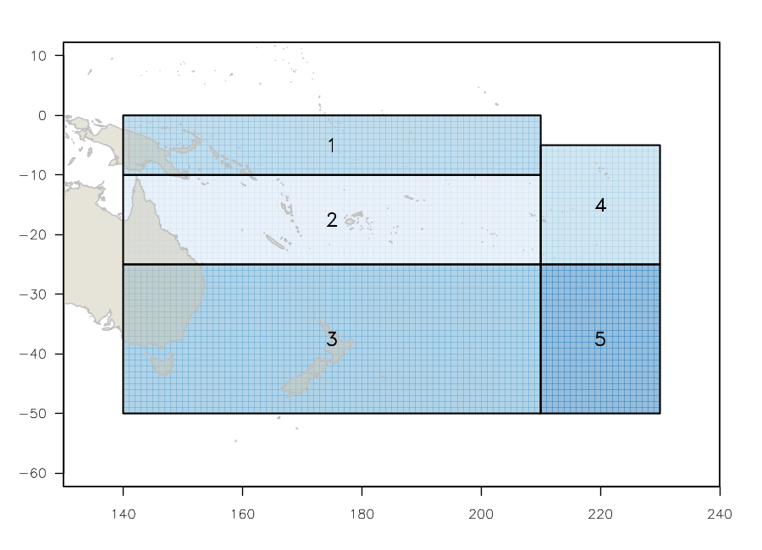
Figure SPA- 1. The geographical area covered by the stock assessment and the boundaries for the 5 regions under the “updated 2018 regional structure".

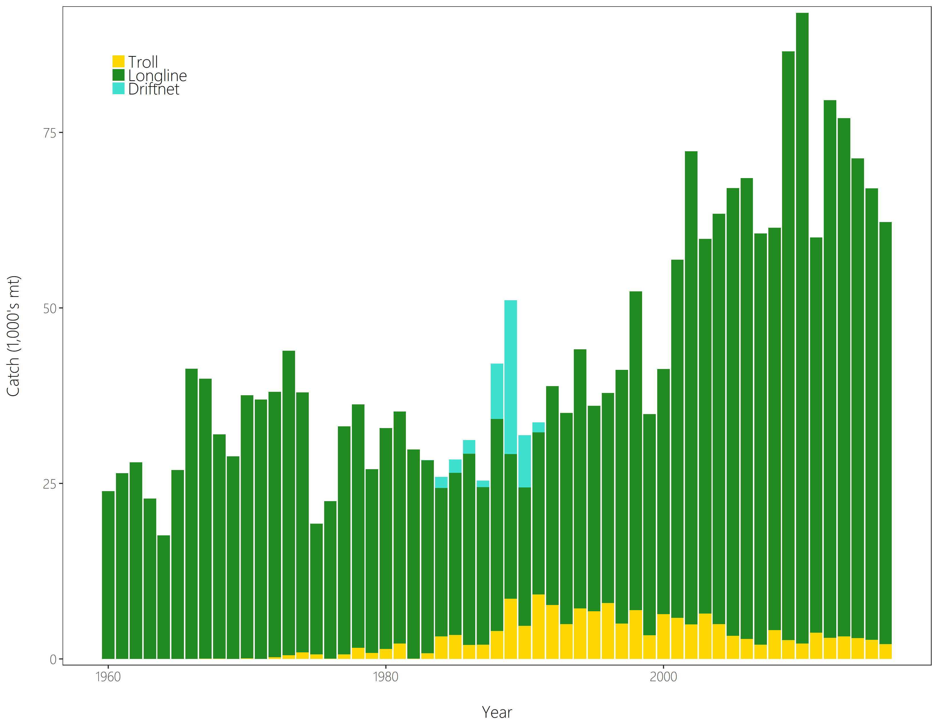
Figure SPA- 2. Time series of total annual catch (1000’s mt) by fishing gear for the diagnostic case model over the full assessment period. The different colours refer to longline (green), troll (yellow) and driftnet (turquoise). Note that the catch by longline gear has been converted into catch-in-weight from catch-in-numbers.
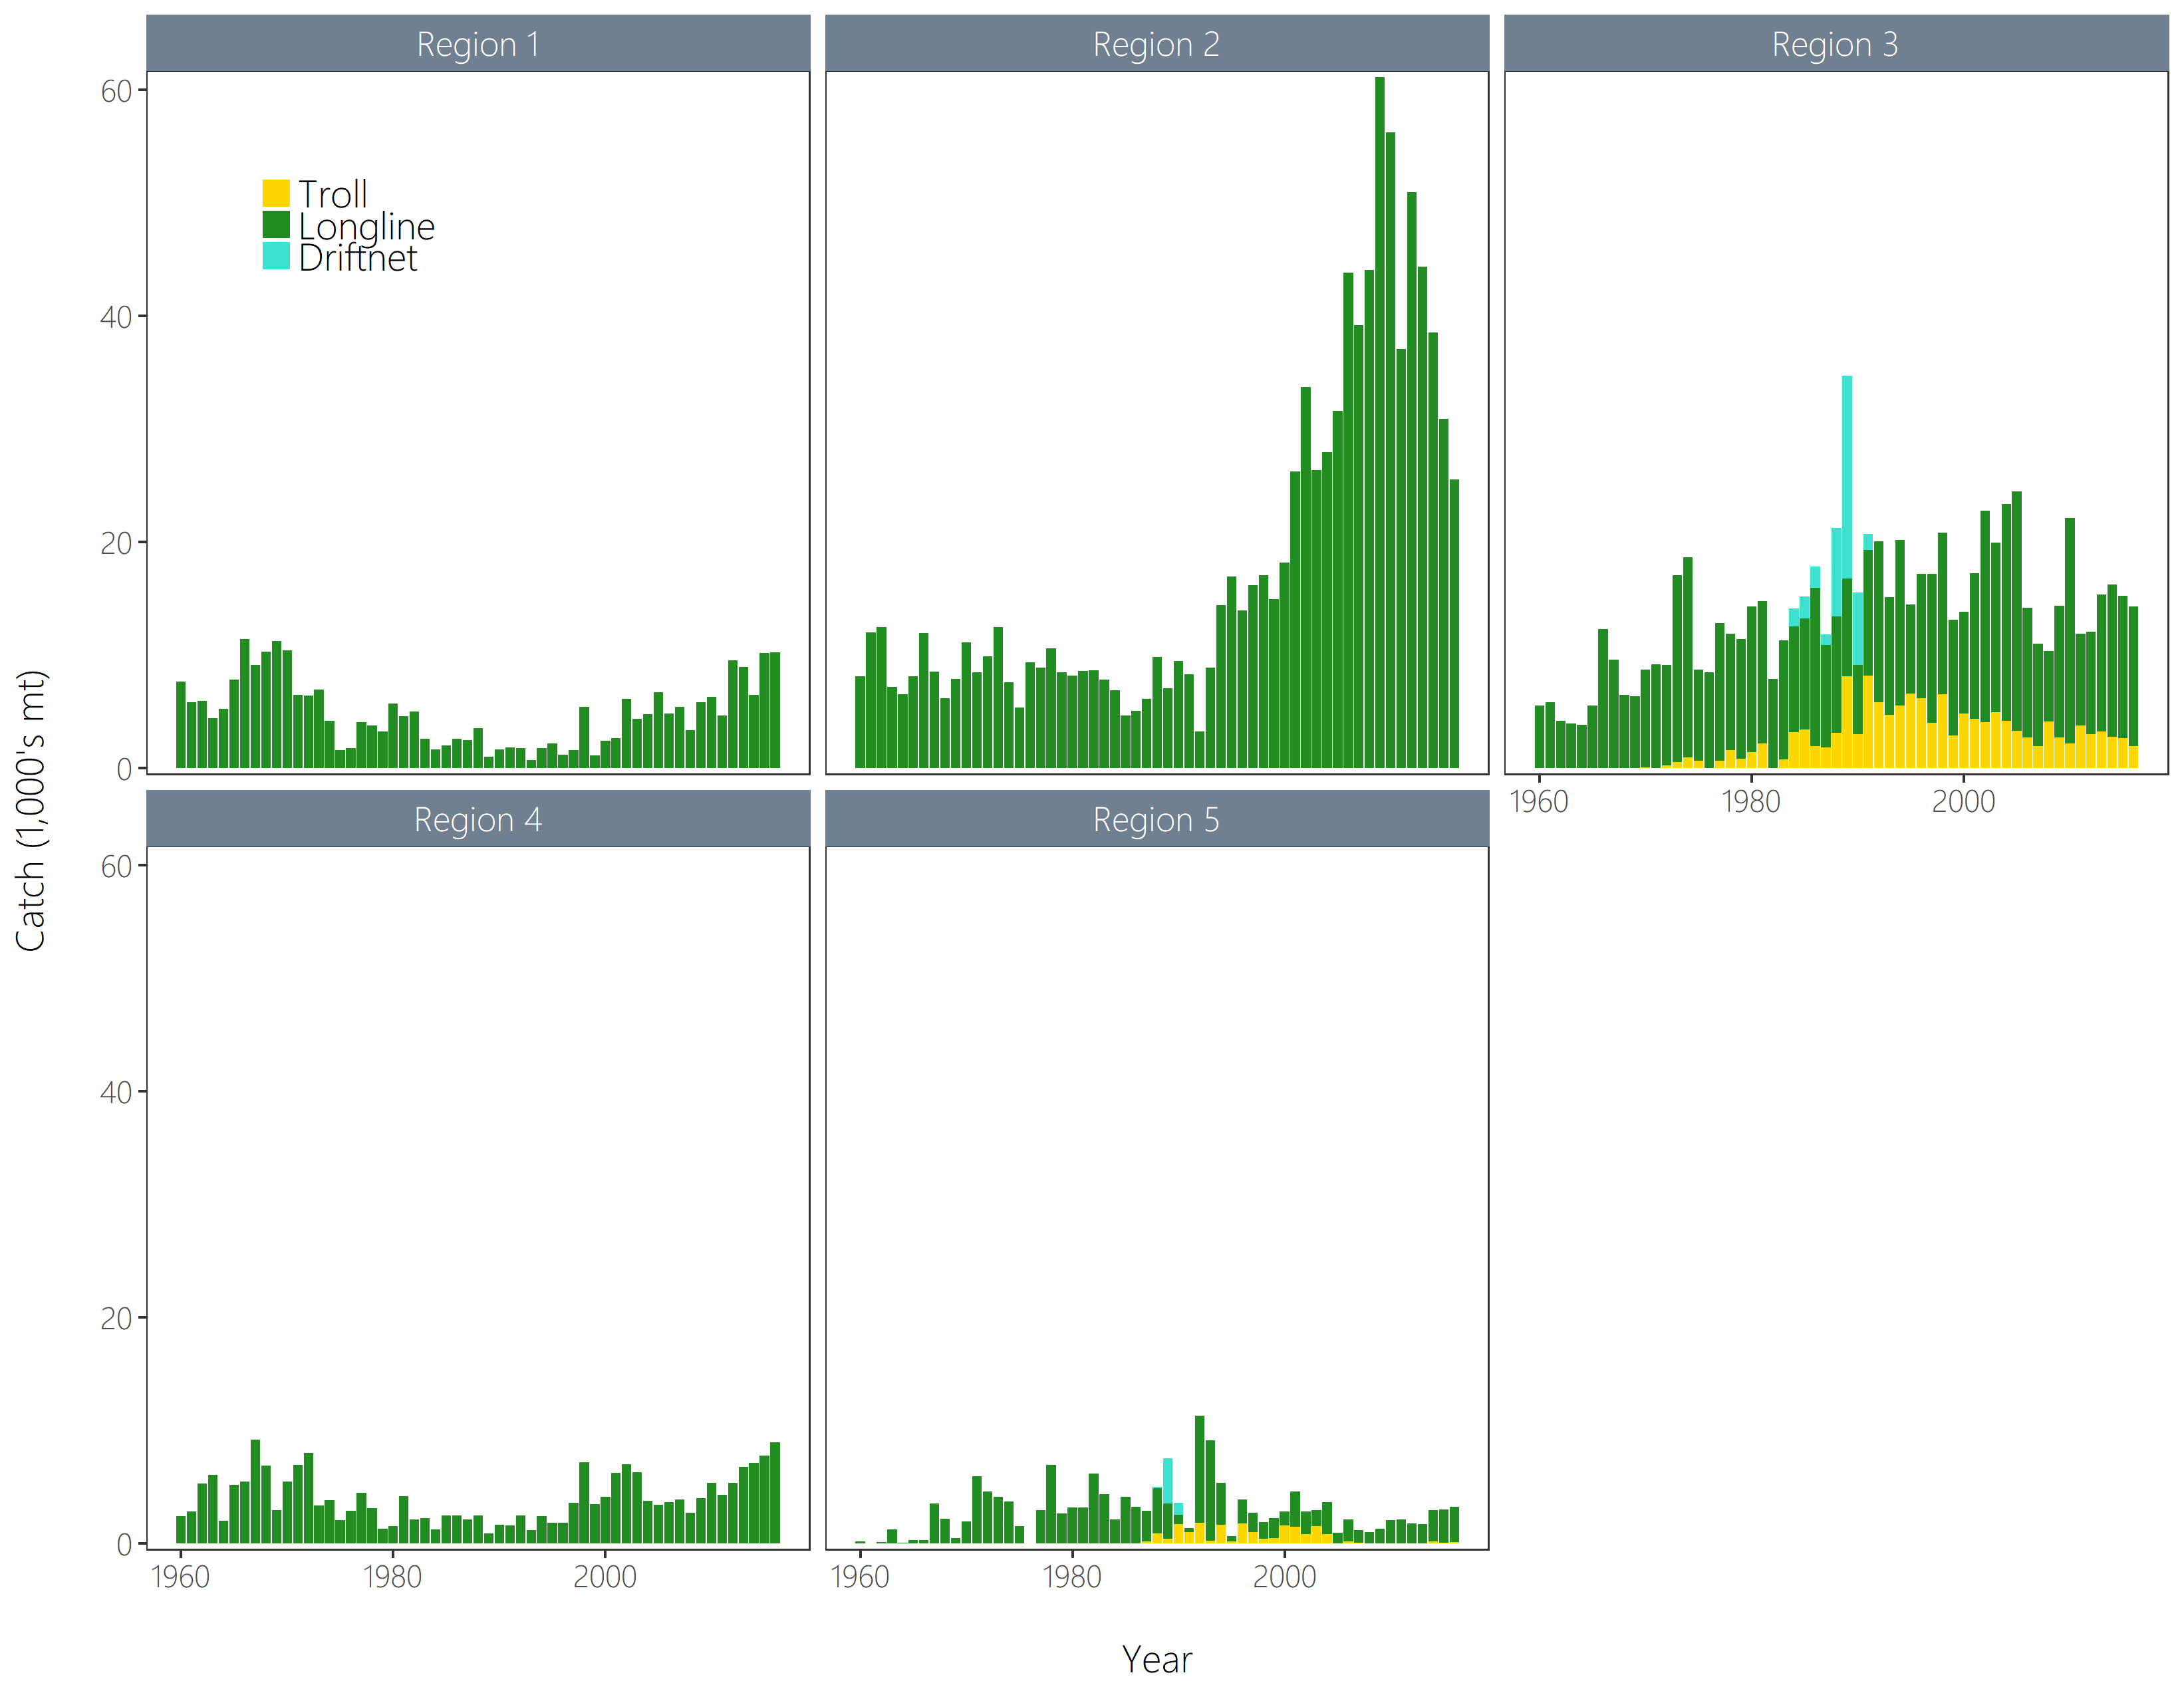
Figure SPA-3. Time series of total annual catch (1000’s mt) by fishing gear and assessment region from the diagnostic case model over the full assessment period. The different colours denote longline (green), driftnet (turquoise) and troll (yellow).
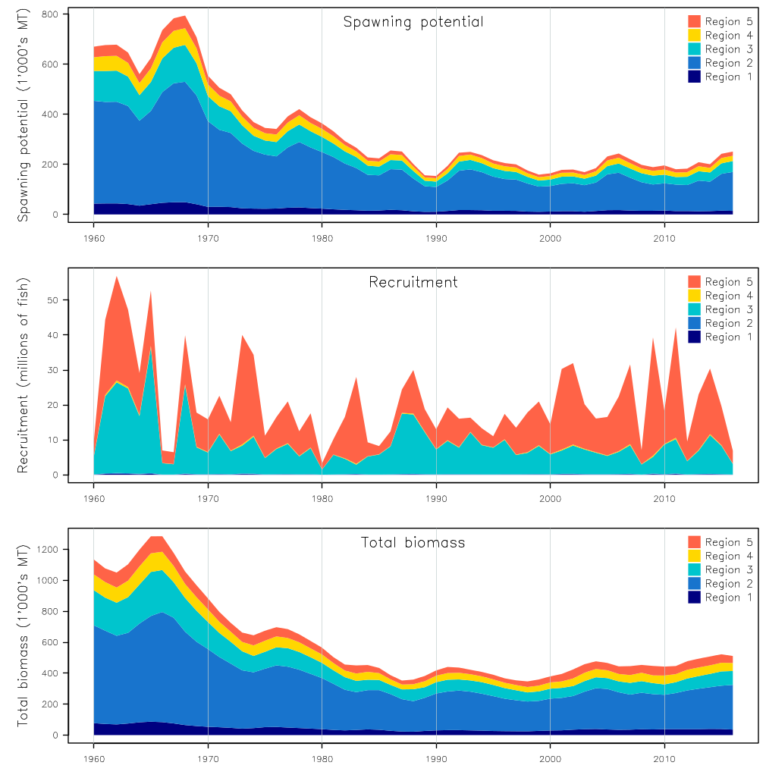
Figure SPA-4. Estimated annual average recruitment, spawning potential and total biomass by model region for the diagnostic case model, showing the relative sizes among regions.

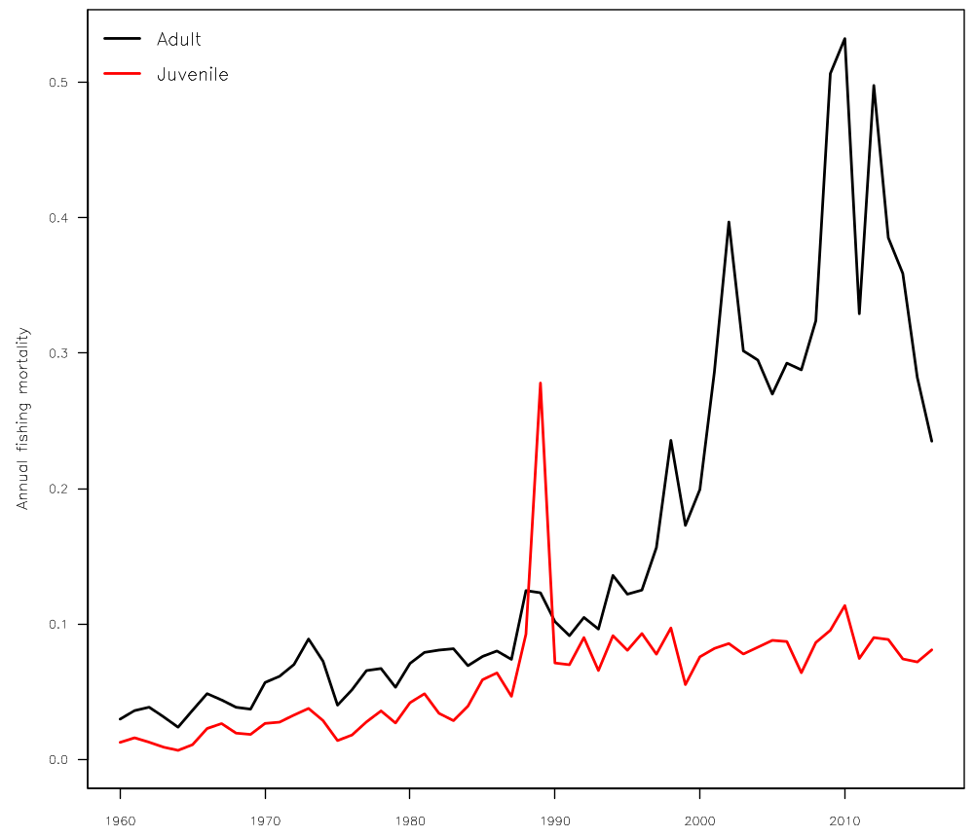
Figure SPA-5. Estimated annual average juvenile and adult fishing mortality for the diagnostic case model.

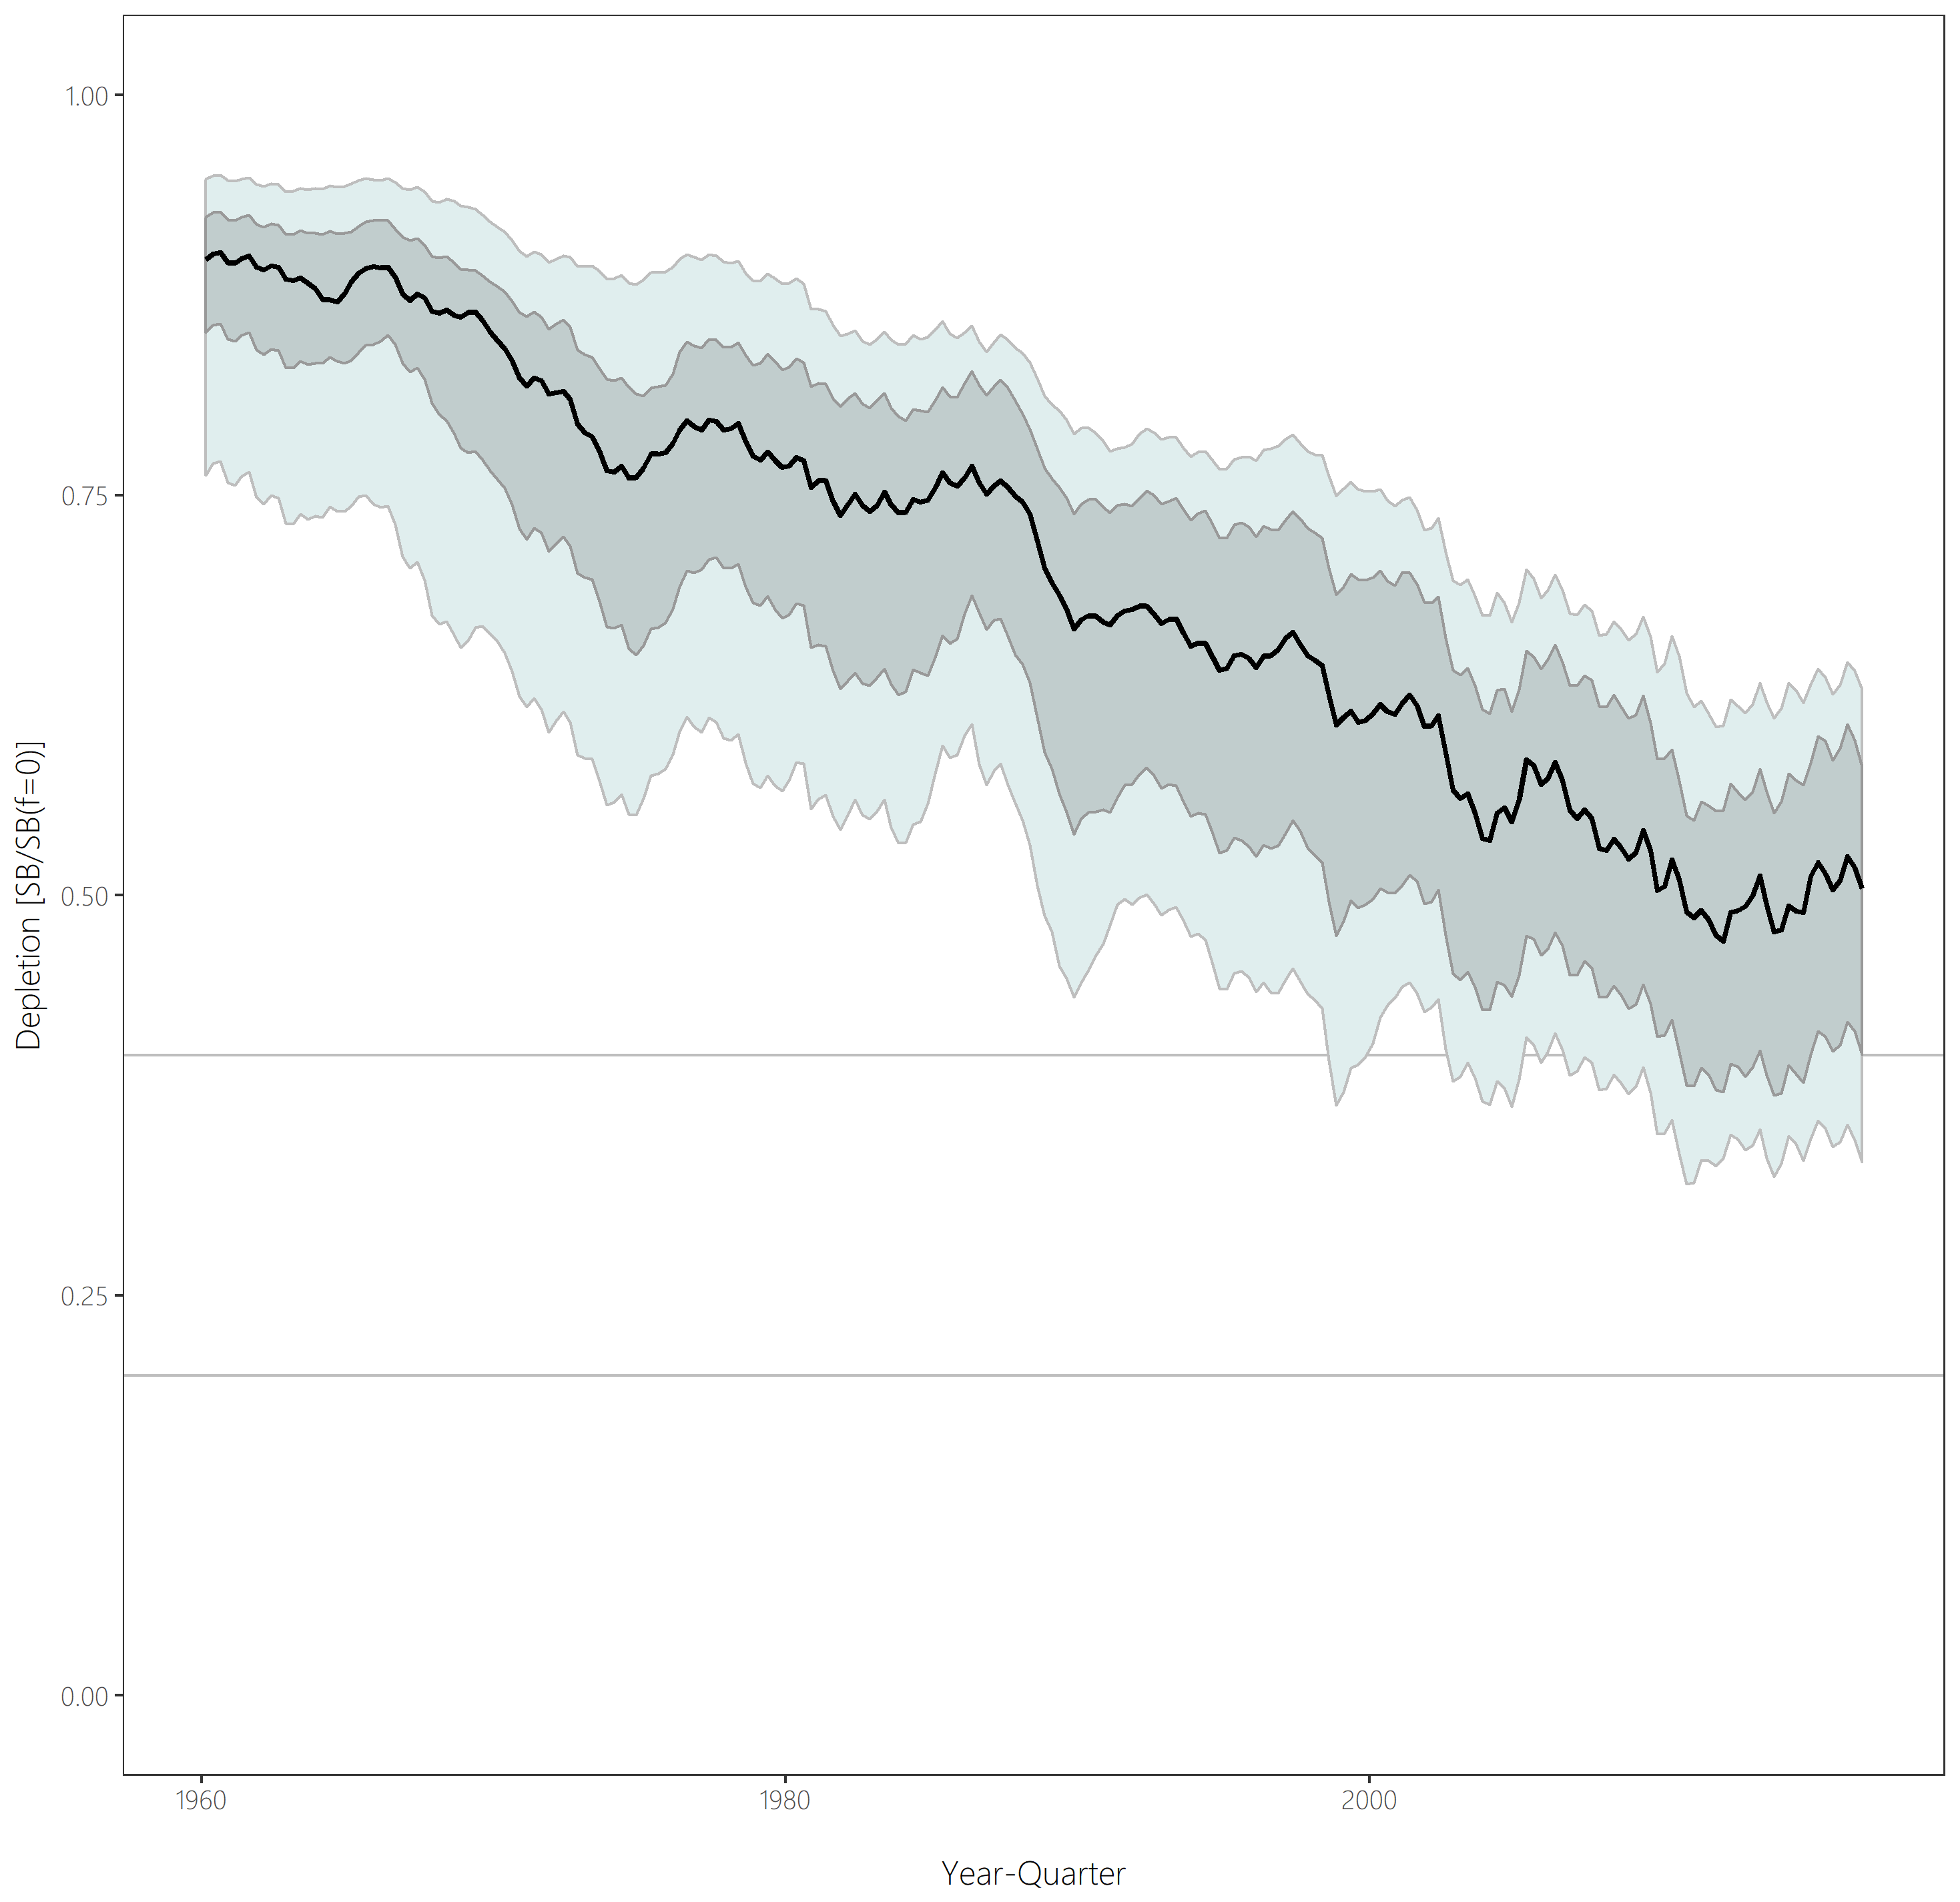
Figure SPA-6. Distribution of time series depletion estimates across the structural uncertainty grid. Black line represents the grid median trajectory, dark grey region represents the 50%ile range, light grey the 90%ile range.
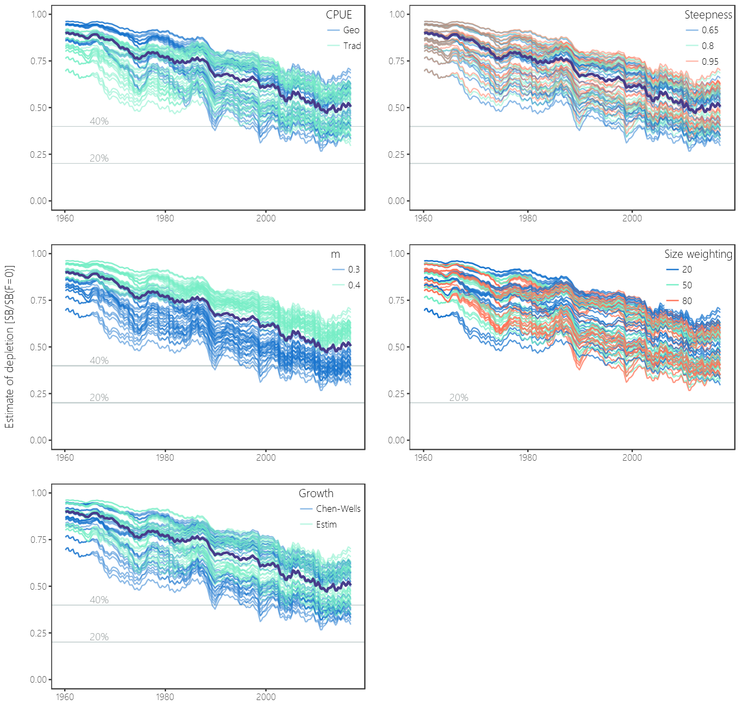
Figure SPA-7. Plots showing the trajectories of fishing depletion (of spawning potential) for the model runs included in the structural uncertainty grid. The five panels show the models separated on the basis of the five axes used in the grid, with the colour denoting the level within the axes for each model.

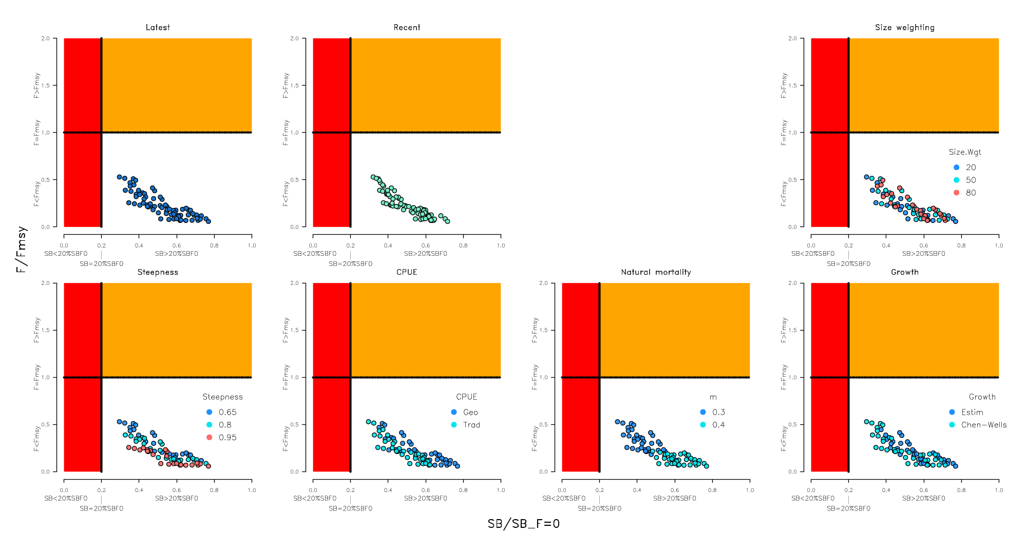
Figure SPA-8. Majuro plots summarising the results for each of the models in the structural uncertainty grid under the SB_{latest}/SB_{F=0} and the SB_{recent}/SB_{F=0} reference points (top left) and each axis of uncertainty.

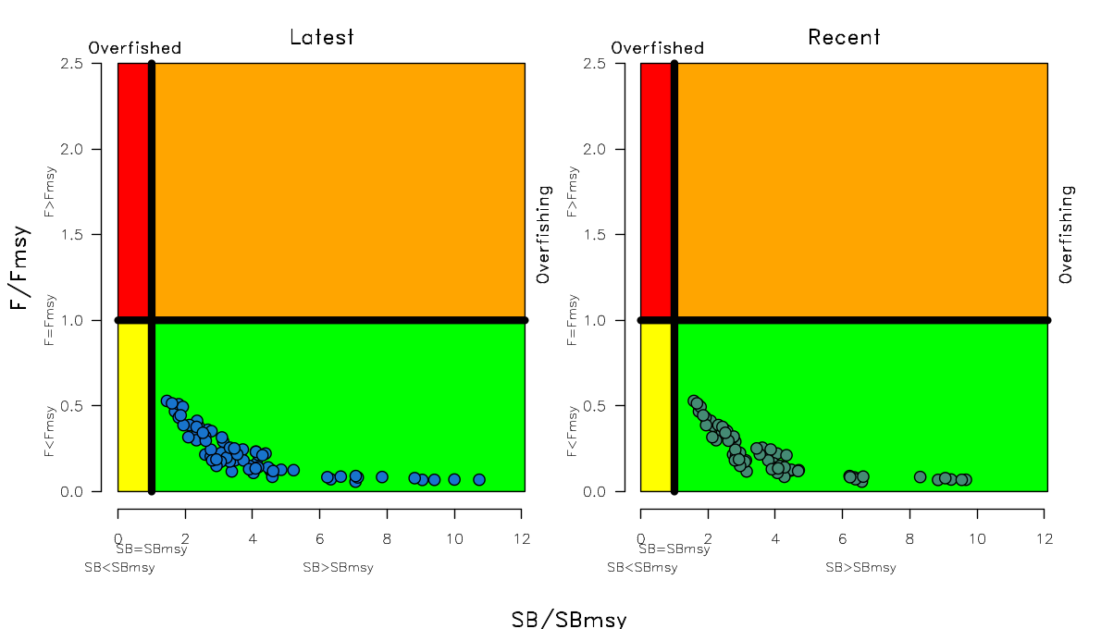
Figure SPA-9. Kobe plots summarising the results for each of the models in the structural uncertainty grid under the SB_{latest}/SB_{F=0} and the SB_{recent}/SB_{F=0} reference points.

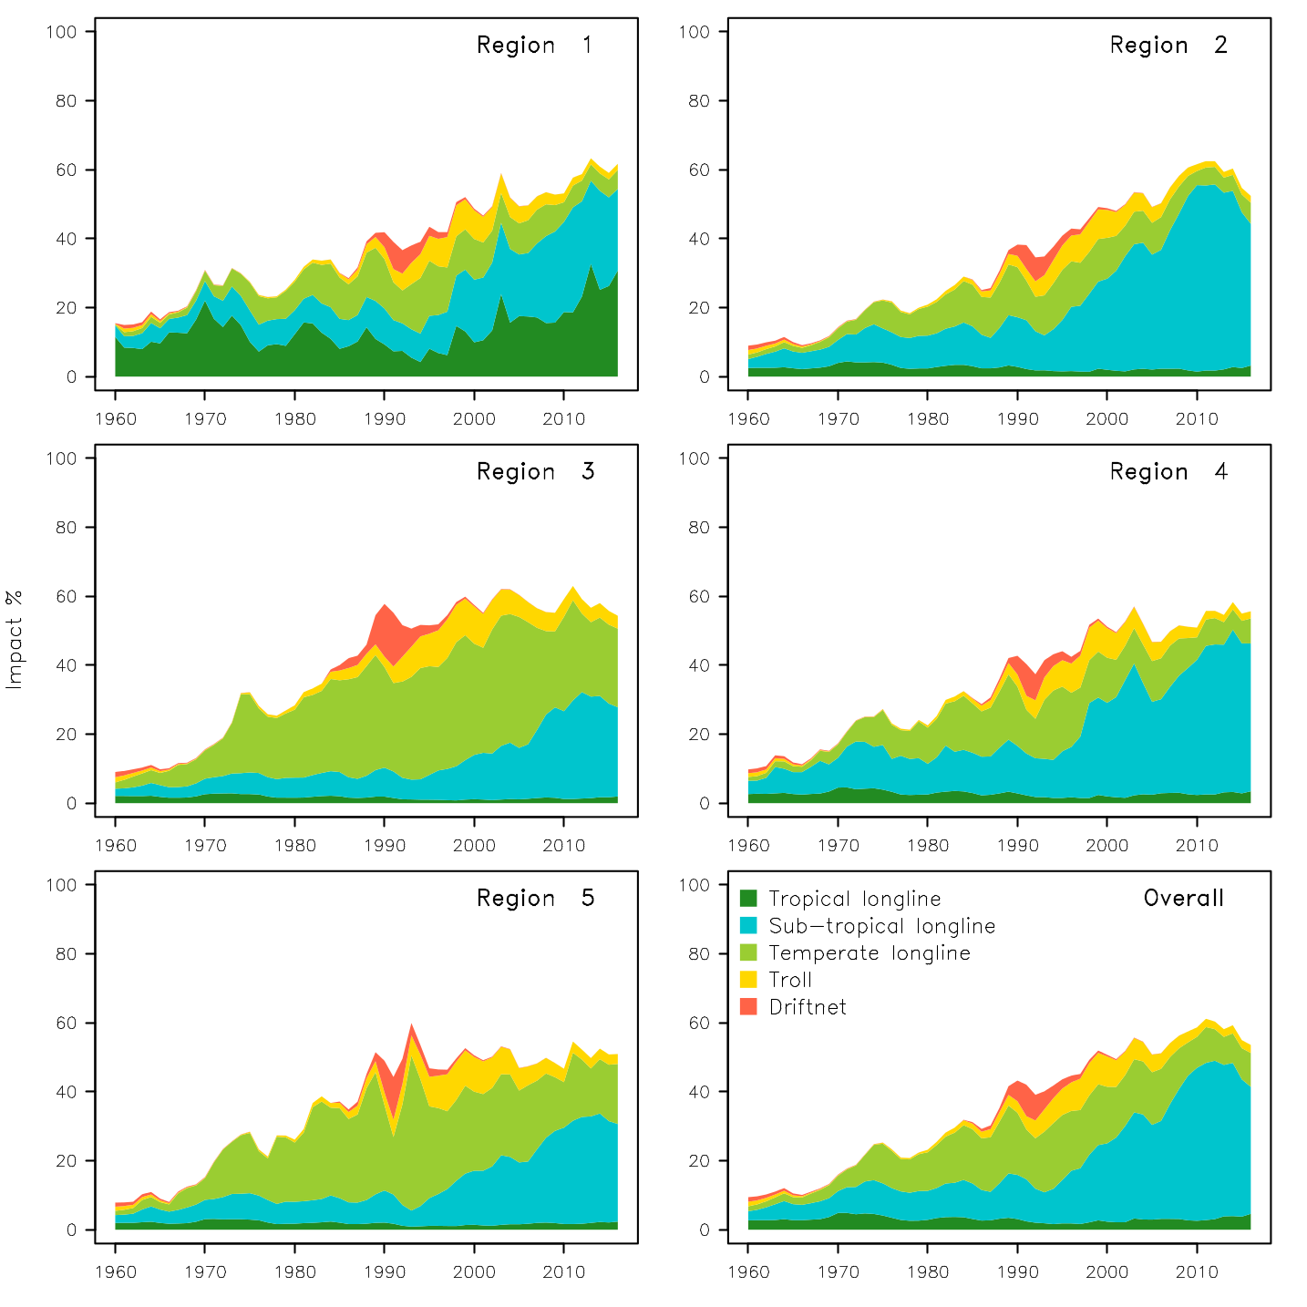
Figure SPA-10. Estimates of reduction in spawning potential due to fishing (fishery impact = 1-SB _{latest}/SB _{F=0}) by region, and over all regions (lower right panel), attributed to various fishery groups for the diagnostic case model.

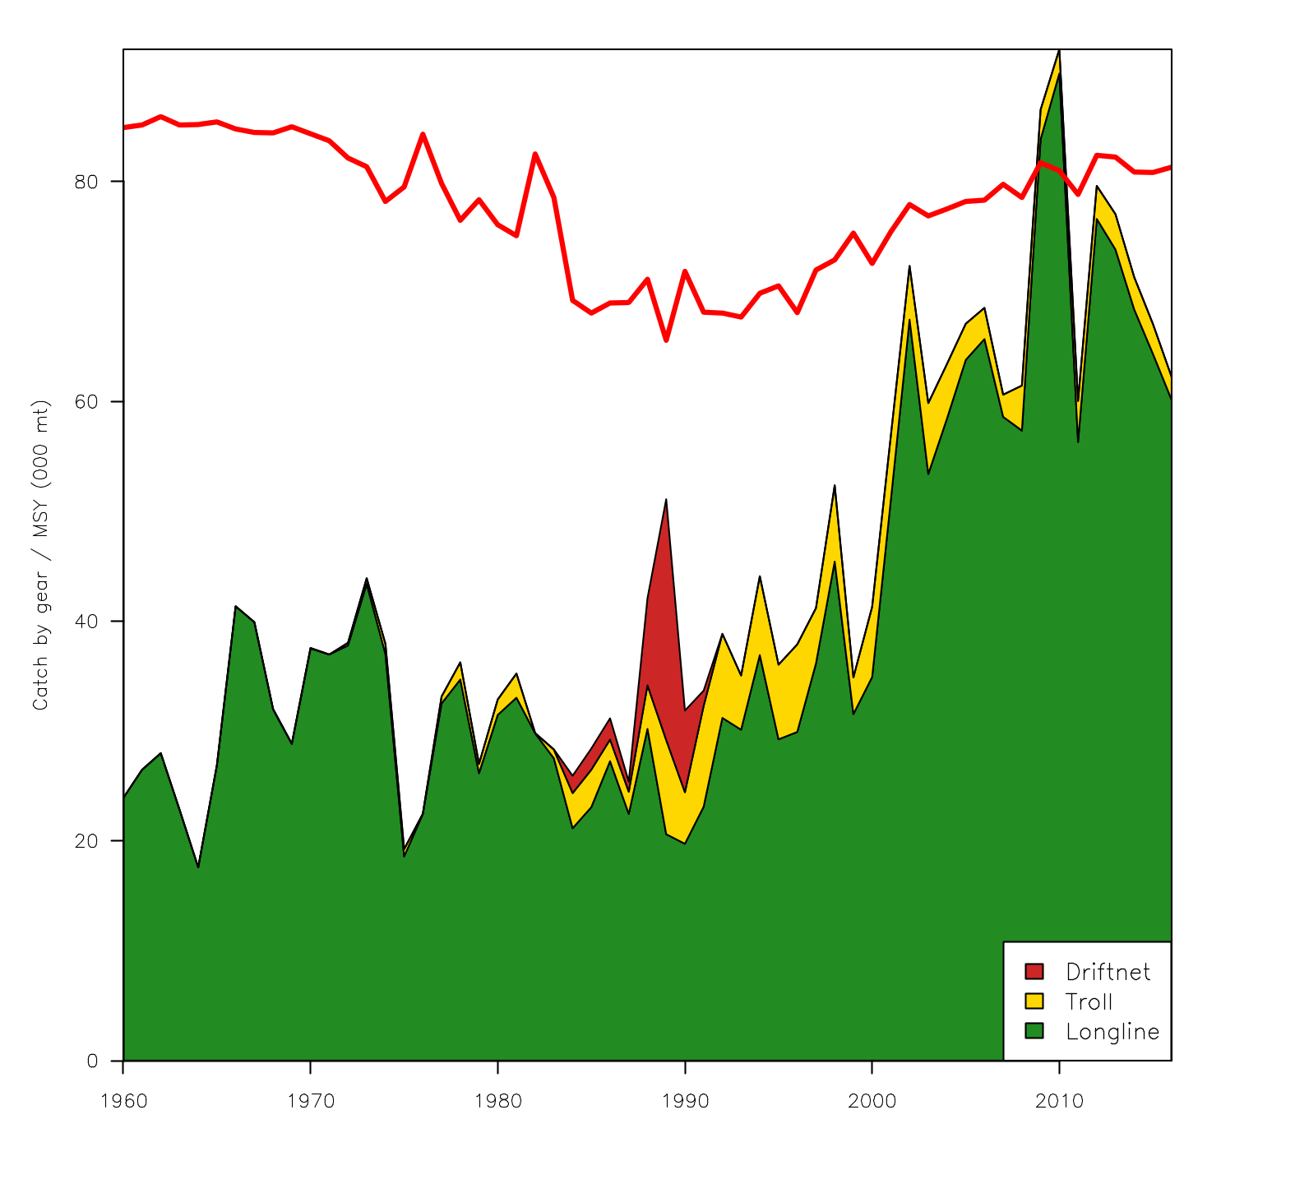Figure SPA-11. History of the annual estimates of MSY (red line) for the diagnostic case model compared with annual catch by the main gear types.

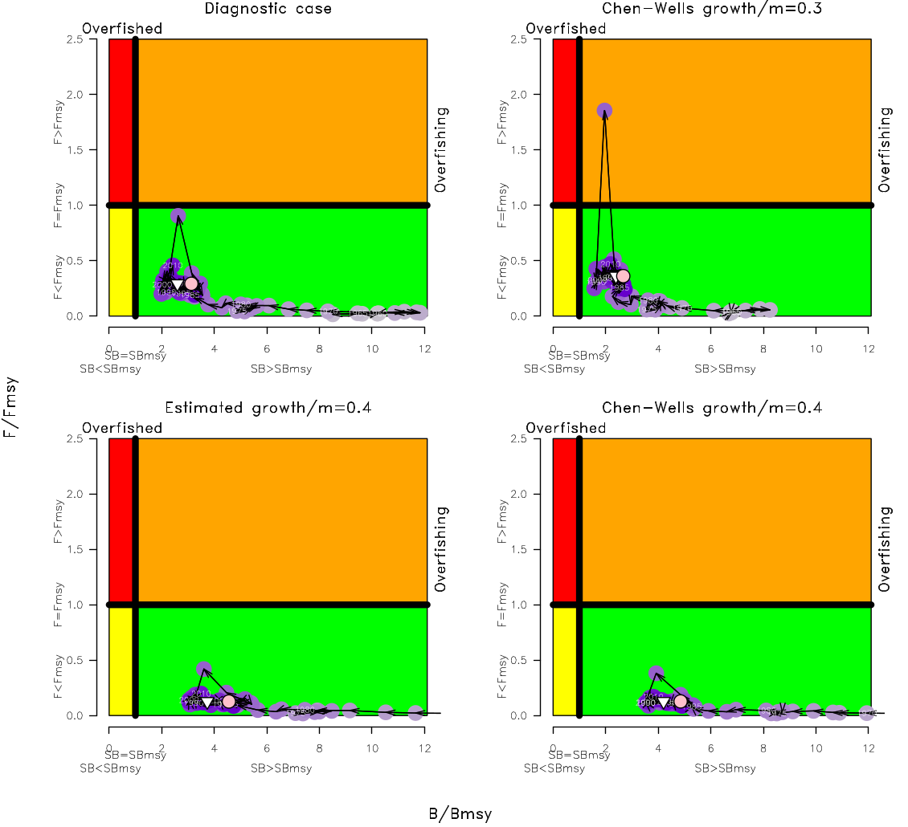
Figure SPA-12. Estimated time-series (or ‘dynamic’) Kobe plots for four example models from the assessment (one from each of the combinations of growth types, and natural mortality M set to 0.3 or 0.4).

  - Northern stocks

    - North Pacific albacore (Thunnus alalunga)

      - Research and information

      - Provision of scientific information

a. Status and trends

- SC14 noted that no stock assessments were conducted for North Pacific albacore in 2018. Therefore, the stock status descriptions from SC13 are still current for North Pacific albacore. Updated information on catches was not compiled for and reviewed by SC14.

b. Management advice and implications

- SC14 noted that no management advice has been provided since SC13 for North Pacific albacore. Therefore, the advice from SC13 should be maintained, pending a new assessment or other new information. For further information on the management advice and implications from SC13, please see https://www.wcpfc.int/node/29904

    - Pacific bluefin tuna (Thunnus orientalis)

      - Research and information

      - Provision of scientific information

a. Stock status and trends

- SC14 noted that ISC provided the following conclusions on the stock status of Pacific bluefin tuna.

The base-case model results show that: (1) SSB fluctuated throughout the assessment period, (2) SSB steadily declined from 1996 to 2010; and (3) the slow increase of the stock continues since 2011 including the most recent two years (2015-2016). Based on the model diagnostics, the estimated biomass trend for the last 30 years is considered robust although SSB prior to the 1980s is uncertain due to data limitations. Using the base-case model, the 2016 SSB (terminal year) was estimated to be around 21,000 t in the 2018 assessment, which is an increase from 19,000 t in 2014 (Table PBF-1 and Figure PBF-11).

Historical recruitment estimates have fluctuated since 1952 without an apparent trend. The low recruitment levels estimated in 2010-2014 were a concern in the 2016 assessment. The 2015 recruitment estimate is lower than the historical average while the 2016 recruitment estimate (15.988 million fish) is higher than the historical average (13.402 million fish) (Figure PBF-4, Table PBF-1-1). The uncertainty of the 2016 recruitment estimate is higher than in previous years because it occurs in the terminal year of the assessment and is mainly informed by one observation from the troll age-0 CPUE index. The troll CPUE series has been shown to be a good predictor of recruitment, with no apparent retrospective error in the recruitment estimates of the terminal year given the current model construction. As the 2016 recruits grow and are observed by other fleets, the magnitude of this year class will be more precisely estimated in the next stock assessment. The above average recruitment estimated in 2016 had a positive impact on the projection results.

Estimated age-specific fishing mortalities (F) on the stock during the periods 2012-2014 and 2015-2016 compared with 2002-2004 estimates (the base period for the WCPFC Conservation and Management Measure) are presented in Figure PBF-2. A substantial decrease in estimated F is observed in ages 0-2 in 2015-2016 from the previous years. Note that stricter management measures in the WCPFC and IATTC have been in place since 2015.

The WCPFC adopted an initial rebuilding biomass target (the median SSB estimated for the period 1952 through 2014) and a second rebuilding biomass target (20%SSB_{F=0} under average recruitment), without specifying a fishing mortality reference level. The 2018 assessment estimated the initial rebuilding biomass target to be 6.7%SSB_{F=0} and the corresponding fishing mortality expressed as SPR of F_{6.7%SPR} (Table PBF-2). SPR is the ratio of the cumulative spawning biomass that an average recruit is expected to produce over its lifetime when the stock is fished at the current intensity to the cumulative spawning biomass that could be produced by an average recruit over its lifetime if the stock was unfished. Because the projections include catch limits, fishing mortality is expected to decline, i.e., F_{x%SPR} will increase, as biomass increases. The Kobe plot shows that the point estimate of the SSB₂₀₁₆ was 3.3%SSB_{F=0} and the 2016 fishing mortality corresponds to F_{6.7%SPR} (Figure PBF-3).

Table PBF-3 provides an evaluation of stock status against some common reference points. It shows that the PBF stock is overfished relative to biomass-based limit reference points adopted for other species in WCPFC (20%SSB_{F=0}) and is subject to overfishing relative to most of the common fishing intensity-based reference points.

Figure PBF-4 depicts the historical impacts of the fleets on the PBF stock, showing the estimated biomass when fishing mortality from respective fleets is zero. Historically, the WPO coastal fisheries group has had the greatest impact on the PBF stock, but since about the early 1990s the WPO purse seine fleets, in particular those targeting small fish (ages 0-1), have had a greater impact, and the effect of these fleets in 2016 was greater than any of the other fishery groups. The impact of the EPO fishery was large before the mid-1980s, decreasing significantly thereafter. The WPO longline fleet has had a limited effect on the stock throughout the analysis period, because the impact of a fishery on a stock depends on both the number and size of the fish caught by each fleet; i.e., catching a high number of smaller juvenile fish can have a greater impact on future spawning stock biomass than catching the same weight of larger mature fish.

- SC14 noted the following stock status from ISC:

Based on these findings, the following information on the status of the Pacific bluefin tuna stock is provided:

- No biomass-based limit or target reference points have been adopted to evaluate the overfished status for PBF. However, the PBF stock is overfished relative to the potential biomass-based reference points evaluated (SSB_{MED} and 20%SSB_{F=0}, Table PBF-3 and Figure PBF-3).
- No fishing intensity-based limit or target reference points have been adopted to evaluate overfishing for PBF. However, the PBF stock is subject to overfishing relative to most of potential fishing intensity-based reference points evaluated (Table PBF-3 and Figure PBF-3).

- SC14 noted that the total PBF catch in 2017 was 14,707 mt, 11% increase from 2016 and 9% increase from the average 2012-2016. PBF is caught by various fishing gears including purse seine, longline, set net, troll, pole-and-line, handline and recreational fisheries. The detailed catch information by fishery is available in ISC 2018 stock assessment (SC14-SA-WP-06).

b. Management advice and implications

- SC14 advises the Commission to note the current very low level of spawning biomass (3.3% B₀), the current level of overfishing, and that the projections are strongly influenced by the inclusion of a relatively high but uncertain recruitment in 2016. The majority of CCMs recommended a precautionary approach to the management of Pacific Bluefin tuna, especially in relation to the timing of increasing catch levels, until the rebuilding of the stock to higher biomass levels is achieved.

- SC14 noted the following conservation advice from ISC:

After the steady decline in SSB from 1995 to the historical low level in 2010, the PBF stock appears to have started recovering slowly. The 2016 stock biomass is below the two biomass rebuilding targets adopted by the WCPFC while the 2015-2016 fishing intensity (spawning potential ratio) is at a level corresponding to the initial rebuilding target.

The 2018 base case assessment results are consistent with the 2016 model results. However, the 2018 projection results are more optimistic than the 2016 projections, mainly due to the inclusion of the relatively good recruitment in 2016, which is above the historical average level (119%) and twice as high as the median of the low recruitment scenario (which occurred 1980-1989).

Based on these results, the following conservation information is provided:

1. The projection based on the base-case model mimicking the current management measures by the WCPFC (CMM 2017-08) and IATTC (C-16-08) under the low recruitment scenario resulted in an estimated 98% probability of achieving the initial biomass rebuilding target (6.7%SSBF=0) by 2024. This estimated probability is above the threshold (75% or above in 2024) prescribed by the WCPFC Harvest Strategy (Harvest Strategy 2017-02) (scenario 0 of Table PBF-4; see also Figure PBF-5 and Figure PBF-6). The low recruitment scenario is more precautionary than the recent 10 years recruitment scenario.

2. The Harvest Strategy specifies that recruitment switches from the low recruitment scenario to the average recruitment scenario beginning in the year after achieving the initial rebuilding target. The estimated probability of achieving the second biomass rebuilding target (20%SSBF=0) 10 years after the achievement of the initial rebuilding target or by 2034, whichever is earlier, is 96% (scenario 1 of Table PBF-3, Table PBF-4, and Table PBF-5; Figure PBF-5 and Figure PBF-6). This estimate is above the threshold (60% or above in 2034) prescribed by the WCPFC Harvest Strategy. However, it should be recognized that these projection results are strongly influenced by the inclusion of the relatively high, but uncertain recruitment estimate for 2016.

The Harvest Strategy adopted by WCPFC (Harvest Strategy 2017-02) guided projections conducted by ISC to provide catch reduction options if the projection results indicate that the initial rebuilding target will not be achieved or to provide relevant information for potential increase in catch if the probability of achieving the initial rebuilding target exceeds 75%. The projection results showed that the probability of achieving the initial rebuilding target was above the level (75% or above in 2024) prescribed in the WCPFC Harvest Strategy. Accordingly, the ISC examined some optional scenarios with higher catch limits, which can be found in Appendix 1 of the PBF 2018 stock assessment report (SC14-SA-WP-06).

Research needs

Given the low SSB, the uncertainty in future recruitment, and the influence of recruitment on stock biomass, monitoring of recruitment and SSB should be strengthened so that the recruitment trends can be understood in a timely manner.

Table PBF-1. Total biomass, spawning stock biomass and recruitment of Pacific bluefin tuna (Thunnus orientalis) estimated by the base-case model, where coefficient of variation (CV) measures relative variability defined as the ratio of the standard deviation to the mean.
Table PBF-2. Spawning stock biomass and fishing intensity of Pacific bluefin tuna (Thunnus orientalis) in 1995 (recent high biomass), 2002-2004 (WCPFC reference year biomass), 2011 (biomass 5 years ago), and 2016 (latest) to those of the adopted WCPFC biomass rebuilding targets. SPR is used as a measure of fishing intensity; the lower the number the higher the fishing intensity that year.
 | Initial rebuilding target | Second rebuilding target | 1995  (recent high) | 2002-2004 (reference year) | 2011  (5 years ago) | 2016  (latest)
Biomass (%SSBF=0) | SSB median1952-2014 = 6.7% | 20% | 10.4% | 7.1% | 2.1% | 3.3%
SPR | 6.7% | 20% | 5.1% | 3.4% | 4.9% | 6.7%

Table PBF-3. Ratios of the estimated fishing intensities mortalities (Fs and 1-SPRs for 2002-04, 2012-14, 2015-16) relative to potential fishing intensity-based reference points, and terminal year SSB (t) for each reference period, and depletion ratios for the terminal year of the reference period for Pacific bluefin tuna (Thunnus orientalis).

Table PBF-4. Future projection scenarios for Pacific bluefin tuna (Thunnus orientalis).
*1 F indicates the geometric mean values of quarterly age-specific fishing mortality during 2002-2004.
*2 The Japanese unilateral measure (transferring 250 mt of catch upper limit from that for small PBF to that for large PBF during 2017-2020) would be reflected.
*3 Fishing mortality for the EPO commercial fishery was assumed to be high enough to fulfill its catch upper limit (F multiplied by two). The fishing mortality for the EPO recreational fishery was assumed to be the F2009-11 average level.
*4 In scenario 0, the future recruitments were assumed to be the low recruitment (1980-1989) level forever. In other scenarios, recruitment was switched from low recruitment to average recruitment from the next year of achieving the initial rebuilding target.

Table PBF-5. Future projection scenarios for Pacific bluefin tuna (Thunnus orientalis) and their probability of achieving various target levels by various time schedules based on the base-case model.
*1 In scenario 0, the future recruitments were assumed to be the low recruitment (1980-1989) level forever. In other scenarios, recruitment was switched from low recruitment to average recruitment from the next year of achieving the initial rebuilding target.

Table PBF-6. Expected yield for Pacific bluefin tuna (Thunnus orientalis) under various harvesting scenarios based on the base-case model.

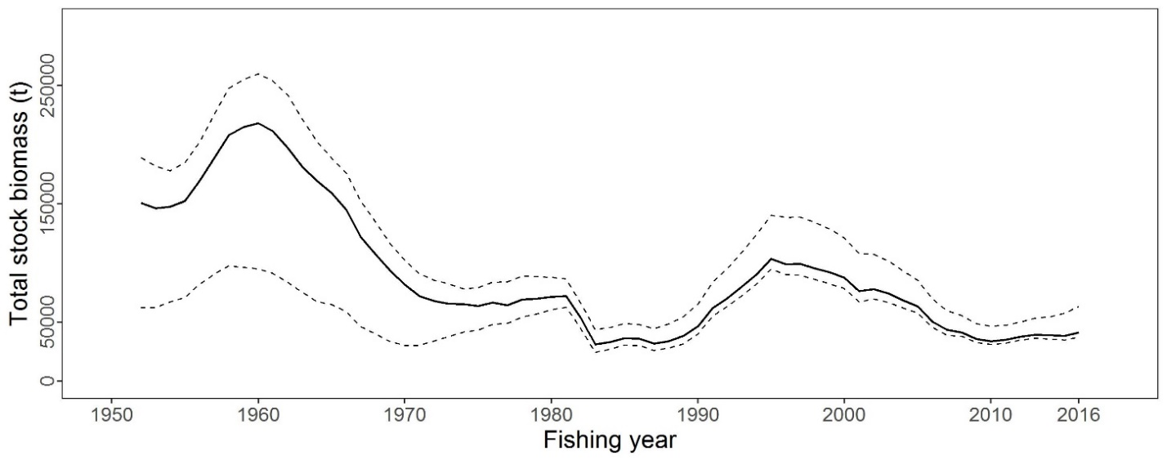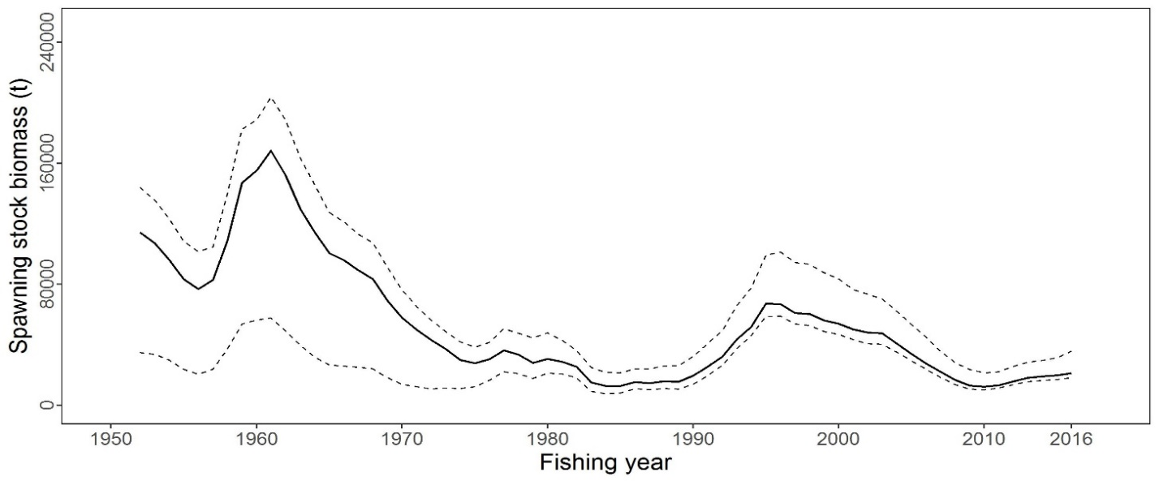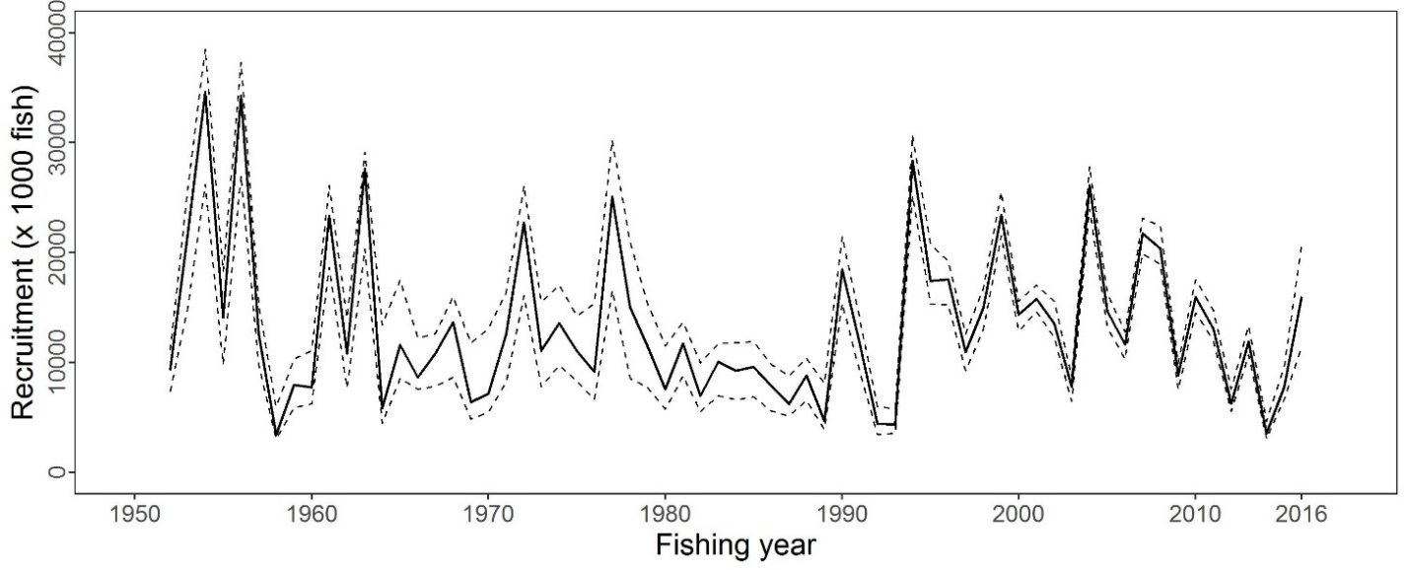
Figure PBF-1. Total stock biomass (top), spawning stock biomass (middle) and recruitment (bottom) of Pacific bluefin tuna (Thunnus orientalis) from the base-case model. The solid lines indicate point estimates and the dashed lines indicate the 90% confidence intervals.

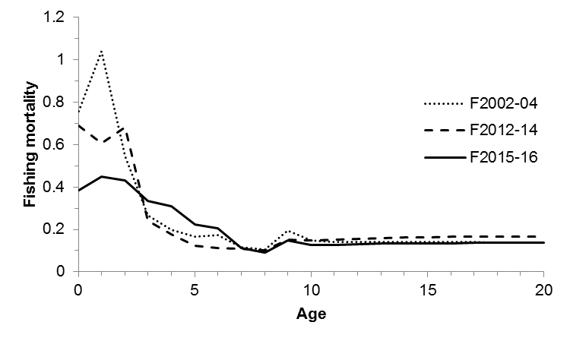
Figure PBF-2. Geometric means of annual age-specific fishing mortalities of Pacific bluefin tuna (Thunnus orientalis) in 2002-2004 (dotted line), 2012-2014 (dashed line), and 2015-2016 (solid line).

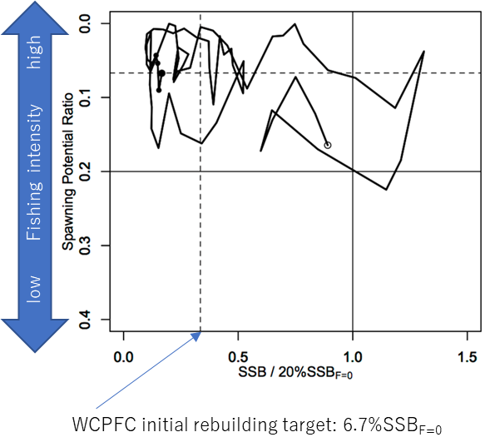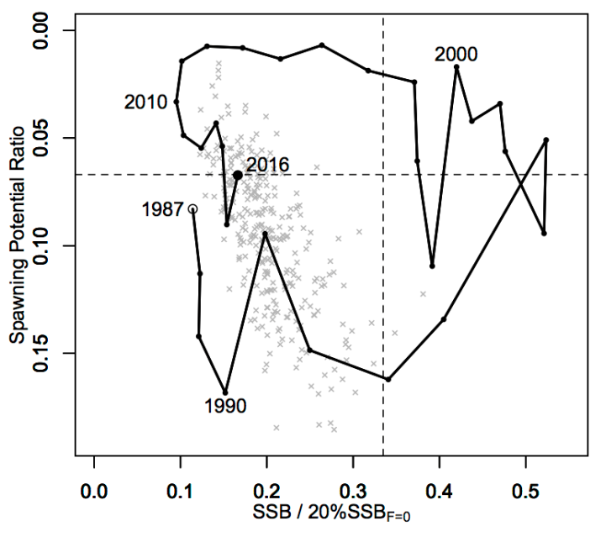

Figure PBF-3. Kobe plots for Pacific bluefin tuna (Thunnus orientalis). X axis shows the annual SSB relative to 20%SSB_{F=0} and the Y axis shows the spawning potential ratio as a measure of fishing intensity. Solid vertical and horizontal lines in the left figure show 20%SSB_{F=0} (which corresponds to the second biomass rebuilding target) and the corresponding fishing intensity, respectively. Dashed vertical and horizontal lines in both figures show the initial biomass rebuilding target (SSB_{MED} = 6.7%SSB_{F=0}) and the corresponding fishing intensity, respectively. SSB_{MED} is calculated as the median of estimated SSB over 1952-2014. The left figure shows the historical trajectory, where the open circle indicates the first year of the assessment (1952) while solid circles indicate the last five years of the assessment (2012-2016). The right figure shows the trajectory of the last 30 years, where grey dots indicate the uncertainty of the terminal year.
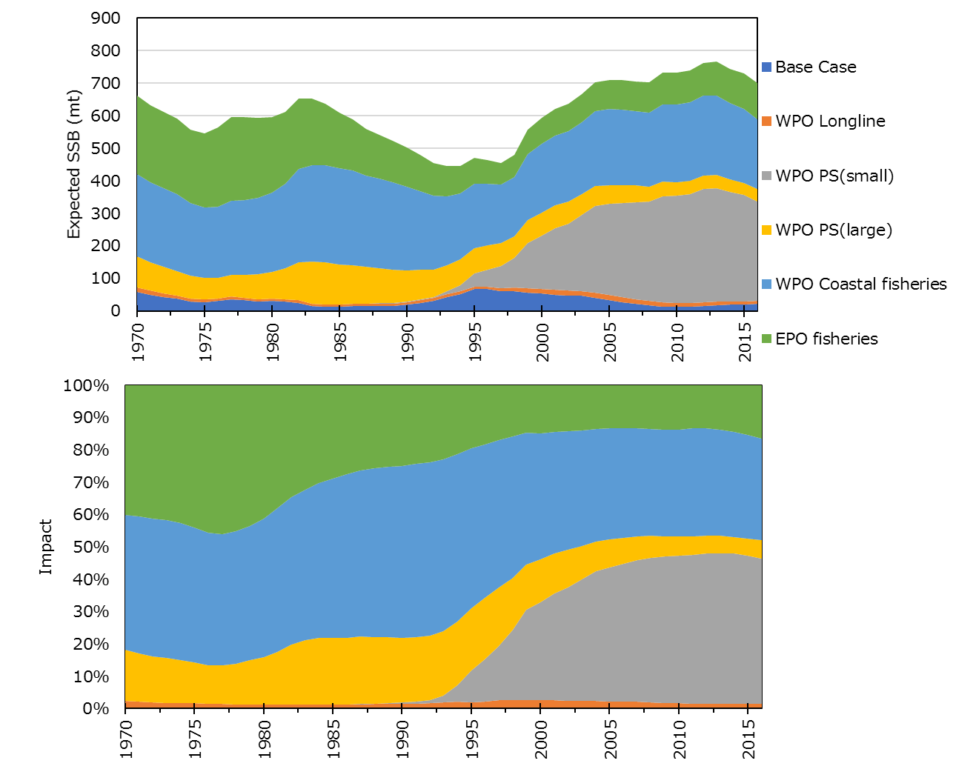
Figure PBF-4. Trajectory of the spawning stock biomass of a simulated population of Pacific bluefin tuna (Thunnus orientalis) when zero fishing mortality is assumed, estimated by the base-case model (top: absolute impact, bottom: relative impact). Fleet definition; WPO longline: F1, F12, F17. WPO purse seine for small fish: F2, F3, F18. WPO purse seine: F4, F5. WPO coastal fisheries: F6-11, F16, F19. EPO fisheries: F13, F14, F15.
Figure PBF-5. Comparison of future SSB of Pacific bluefin tuna (Thunnus orientalis) under the current management measures assuming low recruitment using the 2016 assessment (scenario 2016 lowR), assuming low recruitment using the 2018 assessment (scenario 0), and assuming a shift of the recruitment scenario from low to average after achieving the initial rebuilding target using the 2018 assessment (scenario 1).

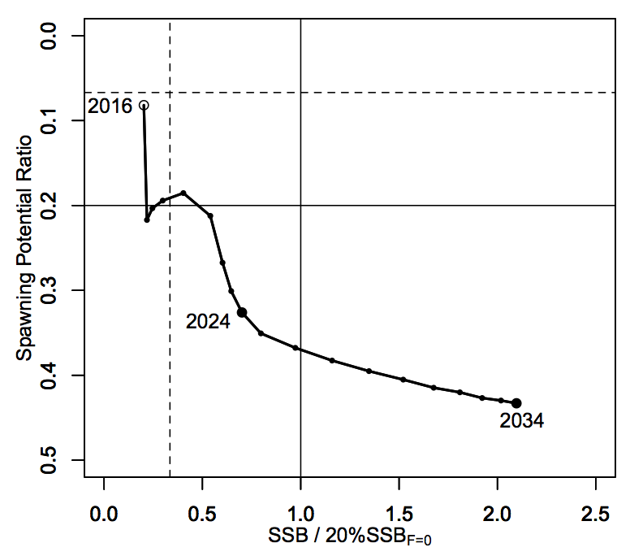
Figure PBF-6. A projection result (scenario 1 from Table PBF-4) for Pacific bluefin tuna (Thunnus orientalis) in a form of Kobe plot. The X axis shows the SSB value relative to 20%SSB_{F=0} (second rebuilding target) and the Y axis shows the spawning potential ratio as a measure of fishing intensity. Vertical and horizontal solid lines indicate the second rebuilding target (20%SSB_{F=0}) and the corresponding fishing intensity, respectively, while vertical and horizontal dashed lines indicate the initial rebuilding target (SSB_{MED} = 6.7%SSB_{F=0}) and the corresponding fishing intensity, respectively.

    - North Pacific swordfish (Xiphias gladius)

      - Research and information

      - Provision of scientific information

a. Status and trends

- SC14 noted that ISC provided the following conclusions on the stock status of Western and Central North Pacific Swordfish in the Pacific Ocean in 2017 presented in SC14-SA-WP-07 (Stock Assessment for Swordfish (Xiphias gladius) in the Western and Central North Pacific Ocean through 2016).

Estimates of total stock biomass show a relatively stable population, with a slight decline until the mid-1990s followed by a slight increase since 2000. Population biomass (age-1 and older) averaged roughly 97,919 t in 1974-1978, the first 5 years of the assessment time frame, and has declined by only 20% to 71,979 t in 2016 (Figure NPS-3). Female spawning stock biomass was estimated to be 29,403 t in 2016, or about 90% above SSB_{MSY} (Table NPS-1 and Table NPS-2). Fishing mortality on the stock (average F, ages 1 – 10) averaged roughly F = 0.08 yr⁻¹ during 2013-2015, or about 45% below F_{MSY}. The estimated SPR (the predicted spawning output at the current F as a fraction of unfished spawning output) is currently SPR₂₀₁₆ = 45%. Annual recruitment averaged about 717,000 recruits during 2012-2016, and no long-term trend in recruitment was apparent. Overall, the time series of spawning stock biomass and recruitment estimates indicate a stable spawning stock biomass and suggest a fluctuating pattern without trend for recruitment (Figure NPS-3). The Kobe plot depicts the stock status relative to MSY-based reference points for the base case model (Figure NPS-4) and shows that spawning stock biomass declined to almost the MSY level in the mid-1990s, but SSB has remained above SSB_{MSY} throughout the time series (Figure NPS-3B).

For this 2018 benchmark assessment, note that biomass status is based on female spawning stock biomass, whereas for the 2014 update assessment, biomass status was based on exploitable biomass (effectively age-2+ biomass). It is also important to note that there are no currently agreed upon reference points for the WCNPO swordfish stock and that retrospective analyses show that the assessment model appears to underestimate spawning stock biomass in recent years.

Based on these findings, the following information on the status of the WCNPO SWO stock is provided:

  - The WCNPO swordfish stock has produced annual yields of around 10,200 t per year since 2012, or about 2/3 of the MSY catch amount.
  - There is no evidence of excess fishing mortality above F_{MSY} (F₂₀₁₃₋₂₀₁₅ is 45% of F_{MSY}) or substantial depletion of spawning potential (SSB₂₀₁₆ is 87% above SSB_{MSY}).
  - Overall, the WCNPO swordfish stock is not likely overfished and is not likely experiencing overfishing relative to MSY-based or 20% of unfished spawning biomass-based reference points.

b. Management advice and implications

- SC14 noted the following conservation advice from ISC:

Stock projections were conducted using a two-gender projection model. The five stock projection scenarios were: (1) F status quo, (2) F_{MSY}, (3) F at 0.2*SSB_{F=0}, (4) F_{20%}, and (5) F_{50%} (Figure NPS-5). These projection scenarios were applied to the base case model results to evaluate the impact of alternative levels of fishing intensity on future spawning biomass and yield for swordfish in the Western and Central North Pacific Ocean. The projected recruitment pattern was generated by stochastically sampling the estimated stock-recruitment model from the base case model. The projection calculations employed model estimates for the multi-fleet, multi- season, size- and age-selectivity, and structural complexity in the assessment model to produce consistent results.

Based on these findings, the following conservation information is provided:
- The results show that projected female spawning biomass is expected to remain above SSB_{MSY} under all of the harvest scenarios (Table NPS-3 and Figure NPS-5), with increases in spawning biomass expected under lower fishing mortality rates.
- Similarly, projected catch is expected to increase under each of the five harvest scenarios, with greater increases expected under higher fishing mortality rates (Table NPS-3 and Figure NPS-5).

Research needs
The lack of sex-specific size composition data and the simplified treatment of the spatial structure of swordfish population dynamics remained as two important sources of uncertainty for this benchmark assessment

Table NPS-1. Reported catch (mt) used in the stock assessment along with annual estimates of population biomass (age-1 and older, mt), female spawning biomass (mt), relative female spawning biomass (SSB/SSB_{MSY}), recruitment (thousands of age-0 fish), fishing mortality (average F, ages 1 to 10), relative fishing mortality (F/F_{MSY}), and spawning potential ratio of Western and Central North Pacific Ocean swordfish.
Year | 2010 | 2011 | 2012 | 2013 | 2014 | 2015 | 2016 | Mean¹ | Min¹ | Max¹
Reported Catch | 12,716 | 9,971 | 10,608 | 9,241 | 9,211 | 11,672 | 10,068 | 12,863 | 9,211 | 17,793
Population Biomass | 66,417 | 66,087 | 68,117 | 67,885 | 69,560 | 71,951 | 71,979 | 67,487 | 51,856 | 97,919
Spawning Biomass | 26,136 | 26,448 | 26,569 | 27,546 | 28,580 | 28,865 | 29,404 | 24,442 | 17,191 | 44,100
Relative Spawning Biomass | 1.66 | 1.68 | 1.69 | 1.75 | 1.82 | 1.84 | 1.87 | 1.56 | 1.09 | 2.81
Recruitment (age 0) | 789 | 565 | 671 | 710 | 683 | 742 | 781 | 761 | 401 | 1241
Fishing Mortality | 0.10 | 0.08 | 0.09 | 0.07 | 0.07 | 0.09 | 0.07 | 0.12 | 0.07 | 0.18
Relative Fishing Mortality | 0.57 | 0.46 | 0.51 | 0.44 | 0.40 | 0.51 | 0.44 | 0.72 | 0.40 | 1.05
Spawning Potential Ratio | 38% | 41% | 39% | 45% | 47% | 39% | 45% | 29% | 17% | 47%
¹ During 1975-2016

Table NPS-2. Estimates of biological reference points along with estimates of fishing mortality (F), spawning stock biomass (SSB), recent average yield (C), and SPR of WCNPO swordfish, derived from the base case model assessment model, where “MSY” indicates reference points based on maximum sustainable yield.
Reference Point | Estimate
FMSY | 0.17 yr-1
F0.2*SSB(F=0) | 0.16 yr-1
F2013-2015 | 0.08 yr-1
SSBMSY | 15,702 mt
SSB2016 | 29,403 mt
SSBF=0 | 97,286 mt
MSY | 14,941 mt
C2012-2016 | 10,160 mt
SPRMSY | 18%
SPR2016 | 45%

Table NPS-3. Projected values of WCNPO swordfish spawning stock biomass (SSB, mt) and catch (mt) under five constant fishing mortality rate (F, yr-1) scenarios during 2017-2026.
Year | 2017 | 2018 | 2019 | 2020 | 2021 | 2022 | 2023 | 2024 | 2025 | 2026
Scenario 1: F = F2013-2015
SSB | 32,118 | 33,207 | 34,599 | 35,476 | 36,270 | 37,082 | 37,951 | 38,967 | 40,083 | 41,087
Catch | 8,851 | 9,135 | 9,407 | 9,599 | 9,794 | 10,022 | 10,275 | 10,595 | 11,053 | 11,142
Scenario 2: F = FMSY
SSB | 28,267 | 23,963 | 21,443 | 19,458 | 18,303 | 17,618 | 17,293 | 17,197 | 17,253 | 17,263
Catch | 20,885 | 18,323 | 16,509 | 15,294 | 14,666 | 14,353 | 14,308 | 14,520 | 14,650 | 14,348
Scenario 3: F = F20%SSB(F=0)
SSB | 28,425 | 24,384 | 21,800 | 19,735 | 18,530 | 17,874 | 17,496 | 17,586 | 17,818 | 17,779
Catch | 20,691 | 18,122 | 16,454 | 15,261 | 14,653 | 14,361 | 14,319 | 14,554 | 14,665 | 14,384
Scenario 4: F = F20%
SSB | 29,007 | 25,431 | 23,527 | 21,763 | 20,736 | 20,131 | 19,893 | 19,883 | 19,981 | 20,066
Catch | 18,680 | 16,933 | 15,657 | 14,726 | 14,242 | 14,033 | 14,050 | 14,292 | 14,496 | 14,253
Scenario 5: F = F50%
SSB | 32,559 | 34,334 | 36,290 | 37,666 | 38,836 | 39,984 | 41,148 | 42,490 | 44,049 | 45,625
Catch | 7,556 | 7,973 | 8,343 | 8,605 | 8,847 | 9,101 | 9,366 | 9,692 | 10,087 | 10,223

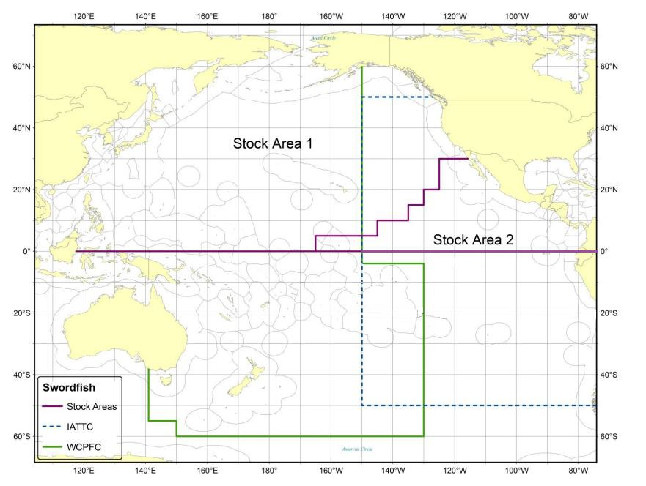
Figure NPS-1. Stock boundaries used for this assessment of North Pacific Ocean swordfish: purple lines indicate stock area divisions; stock area 1 was assessed as the WCNPO stock, stock area 2 contains the Eastern Pacific Ocean stock, the green line indicates Western Central Pacific Fisheries Commission convention area, blue dashed line indicates IATTC convention area.

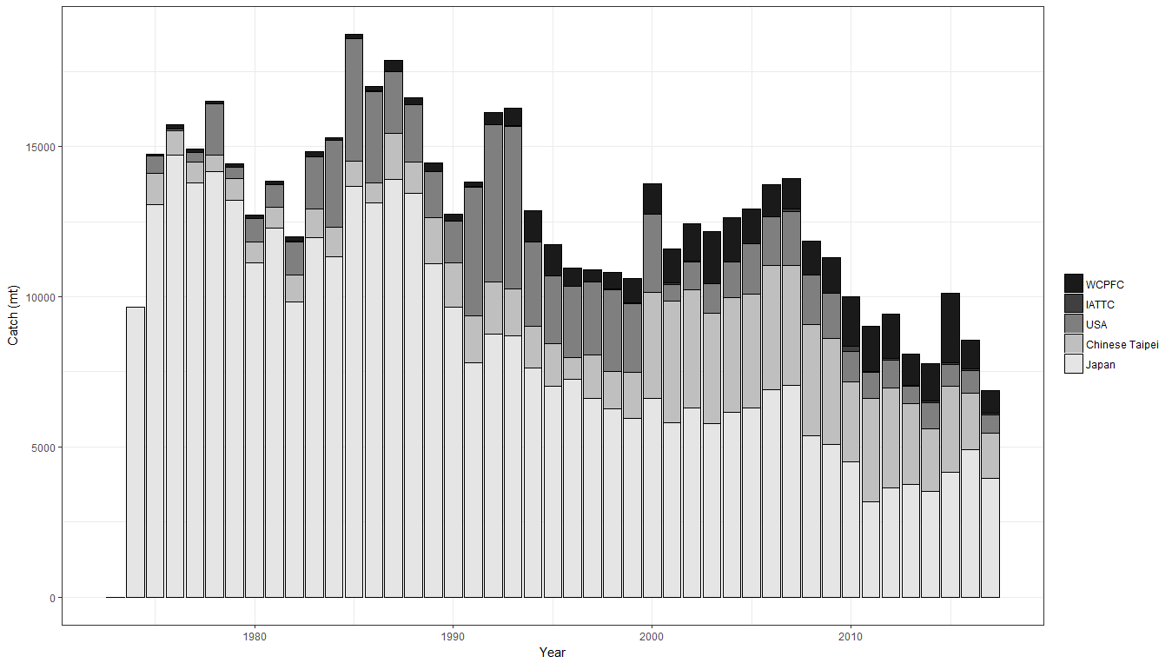
Figure NPS-2. Annual catch biomass (t) of WCNPO swordfish (Xiphias gladius) by country for Japan, Chinese Taipei, the U.S.A., and all other countries during 1975-2016.

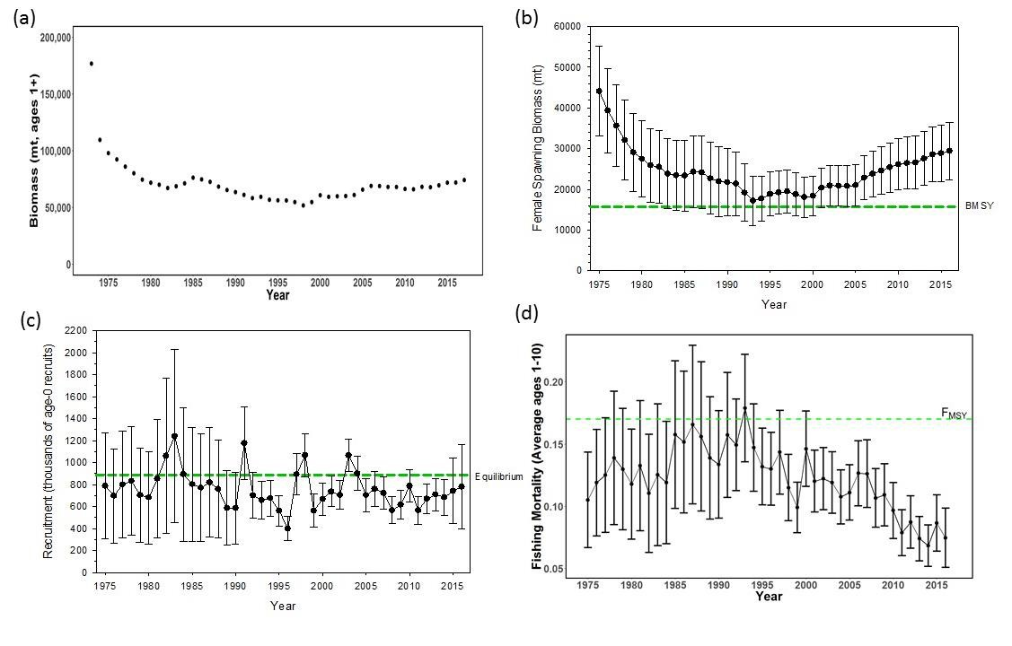
Figure NPS-3. Time series of estimates of (a) population biomass (age 1+) (first point in time series represents unfished biomass), (b) spawning biomass, (c) recruitment (age-0 fish), and (d) instantaneous fishing mortality (average for ages 1 to 10, yr-1) for WCNPO swordfish (Xiphias gladius) derived from the 2018 stock assessment. The solid circles are the maximum likelihood estimates by year for each quantity and the error bars represent the uncertainty of the estimates (80% confidence intervals), green dashed lines indicate BMSY, equilibrium recruitment, and F_{MSY} except for the population biomass time series.

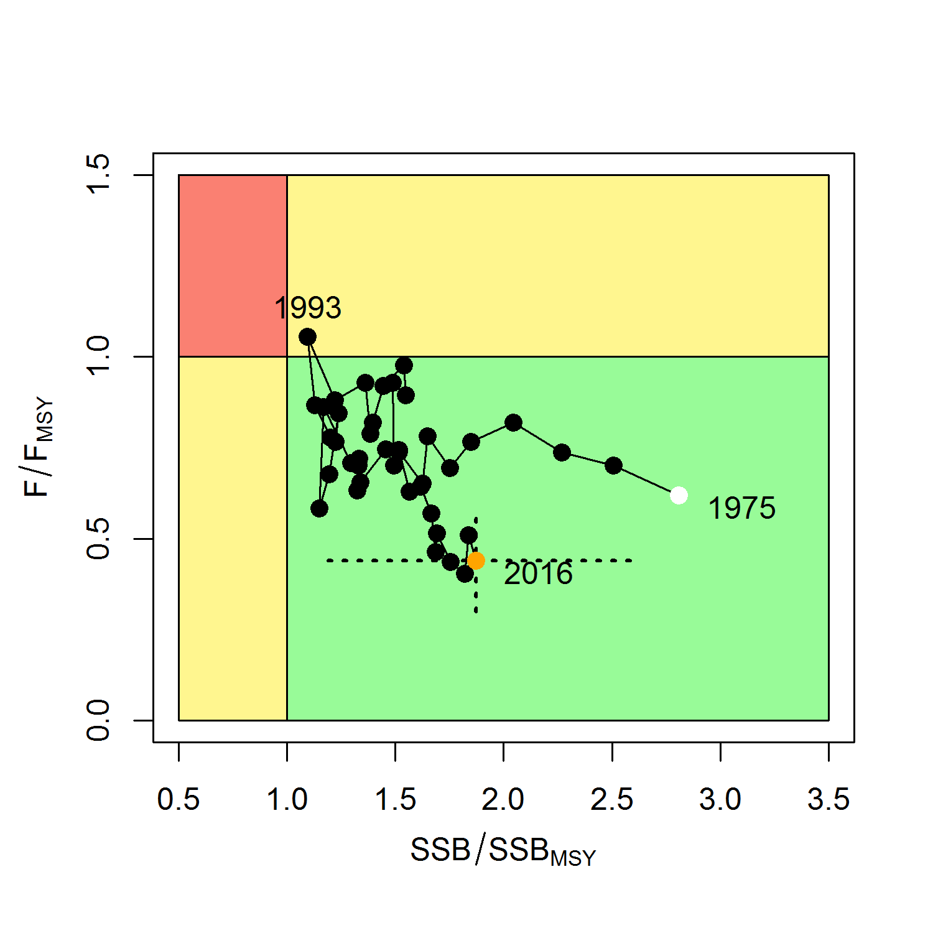

Figure NPS-4. Kobe plot of the time series of estimates of relative fishing mortality (average of ages 1-10) and relative spawning stock biomass of WCNPO swordfish (Xiphias gladius) during 1975-2016. The white circle denotes the first year (1975) and the yellow circle denotes the last year (2016) of the assessment time horizon. The dashed lines represent the 95% confidence intervals around the 2016 estimate.

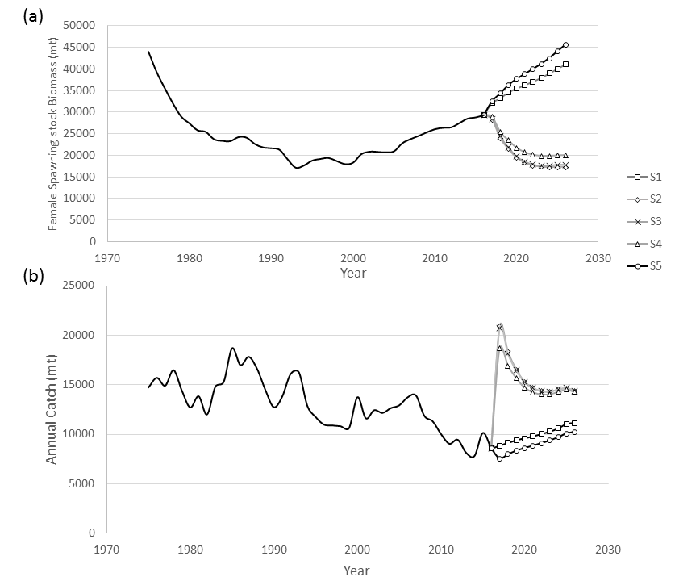
Figure NPS-5. Historical and projected trajectories of (a) spawning stock biomass and (b) total catch from the WCNPO swordfish base case model. Stock projection results are shown for S1 = the status quo or average fishing intensity during 2013-2015 (𝐹₂₀₁₃₋₂₀₁₅= 𝐹_{43%}); S2 = F_{MSY} (𝐹_{18%}); S3 = F to produce 20% of unfished spawning stock biomass or F_{0.2}*SSB_{F=0} (𝐹_{22%}); S4 = the highest 3-year average F during 1975-2016 or High F (F_{20%}); S5 = Low F (F_{50%}).

  - WCPO sharks

    - Oceanic whitetip shark (Carcharhinus longimanus

      - Research and information

      - Provision of scientific information

a. Status and trends

- SC14 noted that no stock assessments were conducted for oceanic whitetip shark in 2018. Therefore, the stock status descriptions from SC8 are still current for oceanic whitetip shark. Updated information on catches was not compiled for and reviewed by SC14.

b. Management advice and implications

- SC14 noted that no management advice has been provided since SC8 for oceanic whitetip shark. Therefore, previous advice should be maintained, pending a new assessment or other new information. For further information on the management advice and implications from SC8, please see https://www.wcpfc.int/node/3396

    - Silky shark (Carcharhinus falciformis)

      - Research and information

- The SC accepts the WCPO silky shark stock assessment as best available science for this stock.

      - Provision of scientific information

a. Stock status and trends

- SC14 noted given the inherent uncertainty in the current assessment the current estimates of stock status should be considered indicative only. Although these estimates are not considered a reliable basis for management decision-making they represent progress since the 2013 assessment and the best available science concerning the status of silky sharks in the WCPO. Therefore, as part of its ongoing review of the established conservation and management measure for silky sharks (CMM 2013-08), the Commission may wish to consider these indicative results until such time as better estimates become available.

- SC14 noted that indications from the 2018 WCPO model show that the stock declined steadily over the model period (1995-2016) (Figure FAL-1). The assessment model estimates spawning biomass in 2016 to have been at 47% of the unexploited level (SB₂₀₁₆/SB₀ = 0.469). Current biomass is estimated to be above the MSY reference biomass level; however, there is considerable uncertainty associated with the estimate of stock status (SB₂₀₁₆/SB_{MSY} = 1.178 95% CI 0.590-1.770) (Table FAL-1). On balance, the stock is not considered to be overfished, i.e. there is a 78% probability that SB₂₀₁₆ is greater than SB_{MSY} (Table FAL-1).

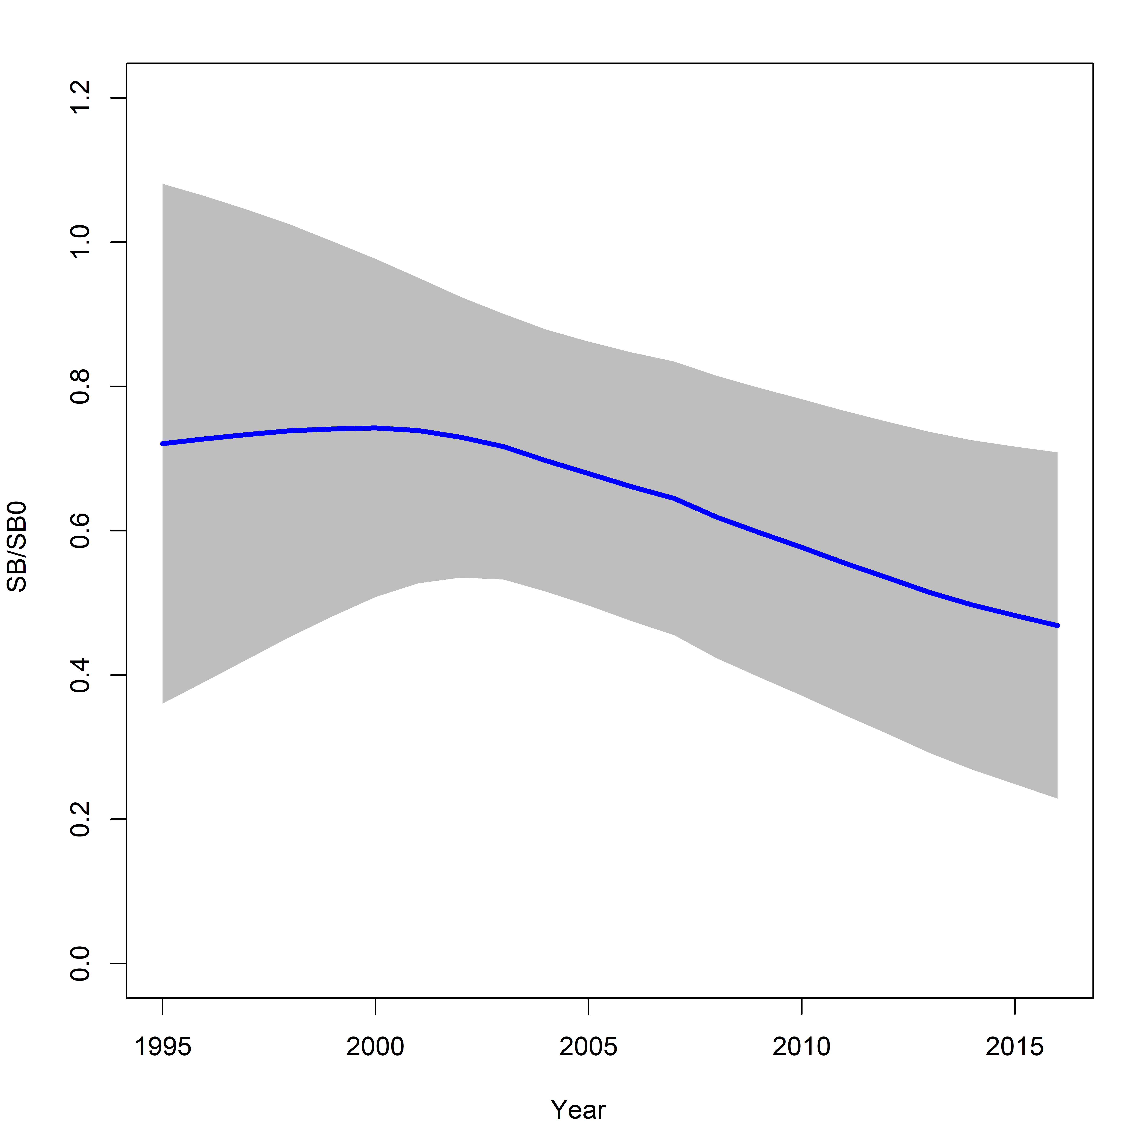
Figure FAL-1: Estimated spawning biomass relative to unexploited biomass (SB₀) for the WCPO assessment model (CPUEqdev).

Table FAL-1: Management quantities (and 95% confidence intervals) for the WCPO assessment model (CPUEqdev).
Management quantity | Value | Confidence interval (95%)
SB₀ | 11,865 | 6,412-17,318
SB₁₉₉₅ | 8,552 | 2,590-14,513
SB_{MSY} | 4,721 | 2,560-6,882
SB_{MSY}/SB₀ | 0.398 | 0.397-0.399
SB₂₀₁₆ | 5,560 | 301-10,819
SB₂₀₁₆/SB₀ | 0.469 | 0.229-0.729
SB₂₀₁₆/SB_{MSY} | 1.178 | 0.590-1.77
Pr(SB₂₀₁₆ > SB_{MSY}) | 0.78
F₂₀₁₆/F_{MSY} | 1.607 | 0.316-2.810
Pr(F₂₀₁₆ > F_{MSY}) | 0.84
F₂₀₁₆ | 0.313
MSY | 12,162 | 6,711-17,615
Catch 2016 (mt) | 22,503

- Fishing mortality is estimated to be above F_{MSY} (F₂₀₁₆/F_{MSY} = 1.607, Pr(F₂₀₁₆ > F_{MSY}) = 84%). The current level of catch is substantially higher than the MSY. If catches remain at the current level there is a high probability that the biomass will decline to below the SB_{MSY} level in the foreseeable future (~ 5 years).

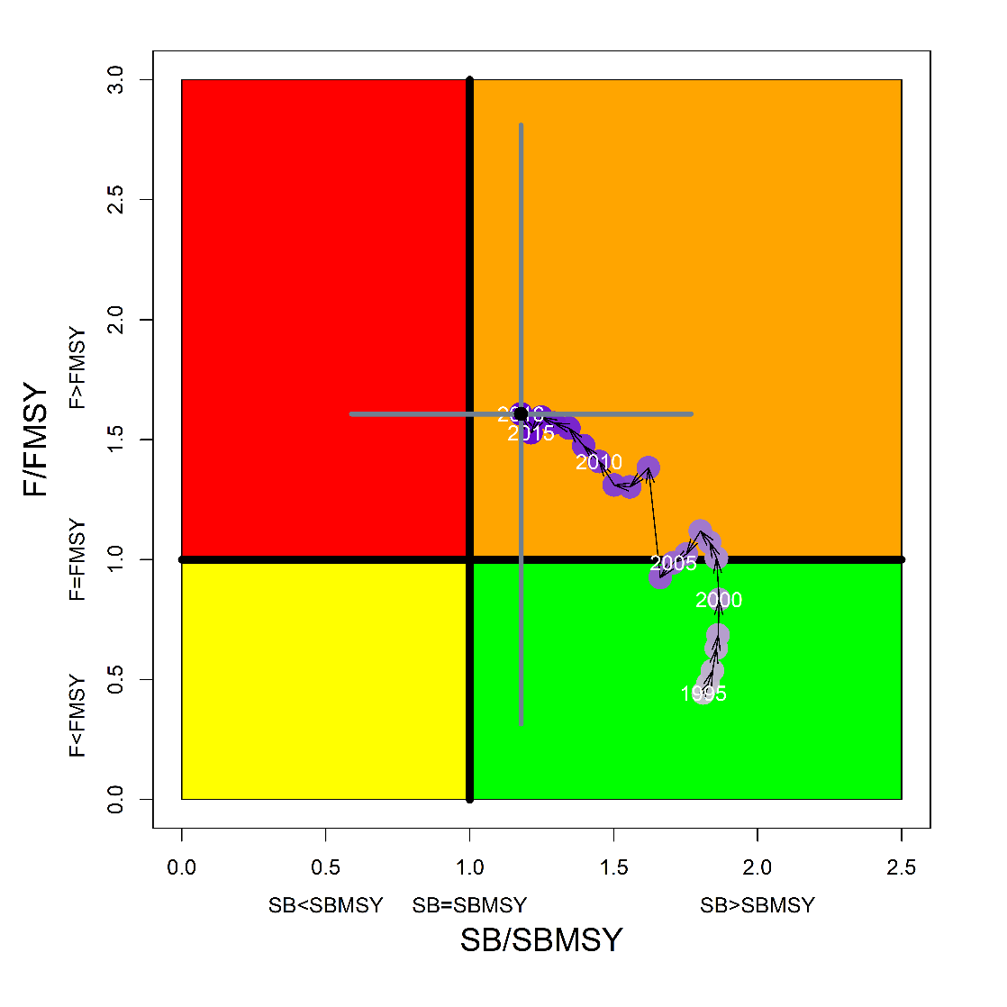
Figure FAL-2: Kobe plot for the WCPO assessment model (CPUEqdev).

b. Management advice and implications

- SC14 concludes that on the basis of the best available science, and pending the availability of less uncertain stock status indicators, the stock is not overfished, but is subject to overfishing (Figure FAL-2).

- SC14 recommends, given that the WCPO silky shark stock continues to be subject to overfishing, that CMM 2013-08 be maintained as a precautionary measure.

    - South Pacific blue shark (Prionace glauca)

      - Research and information

      - Provision of scientific information

a. Status and trends

- SC14 noted that no stock assessments were conducted for South Pacific blue shark in 2018. Therefore, the stock status descriptions from SC13 are still current for South Pacific blue shark. Updated information on catches was not compiled for and reviewed by SC14.

b. Management advice and implications

- SC14 noted that no management advice has been provided for South Pacific blue shark.

    - North Pacific blue shark (Prionace glauca)

      - Research and information

      - Provision of scientific information

a. Status and trends

- SC14 noted that no stock assessments were conducted for north Pacific blue shark in 2018. Therefore, the stock status descriptions from SC13 are still current for north Pacific blue shark. Updated information on catches was not compiled for and reviewed by SC14.

b. Management advice and implications

- SC14 noted that no management advice has been provided since SC13 for north Pacific blue shark. Therefore, previous advice should be maintained, pending a new assessment or other new information. For further information on the management advice and implications from SC13, please see https://www.wcpfc.int/node/29904

c. Recommendations on the designation of North Pacific blue shark as a Northern Stock

- Regarding the issue of the designation of North Pacific blue shark as a Northern Stock (WCPFC14 Report, Para 378), SC14 provides the following recommendations:

- SC14 recommends that the Commission clarify and quantify what is meant by “mostly north of 20 degrees N”.
- In relation to paragraph 1, SC14 recommends that a check-list of benchmark scientific information for North Pacific blue shark be developed to support the Commission’s deliberations in determining the designation of a northern stock. As such, the following draft checklist is forwarded for the Commission’s consideration.

No | Criteria | Response | Comments
1 | What proportion of the total estimated stock biomass occurs on average north of 20ºN? | Unknown | Current assessment model does not include population spatial structure. Nominal CPUE may be biased and could be overestimated in the north unless the effects of fishing time, depth and depth distribution of blue sharks are accounted for.
2 | Does all of the breeding/spawning area(s) occur north of 20 ºN? | No | Breeding area is mainly north of 20 ºN but may overlap areas south of 20 ºN
3 | Does all of the nursery area(s) occur north of 20 ºN | Yes | Mostly in the area 30-40 ºN
4 | Do any other important life history stages occur south of 20 ºN? | Yes | Pregnant females are commonly found south of 20 ºN
5 | What proportion of the total annual estimated catch occurs north of 20 ºN? | 0.88 on average | Based on raised, aggregated (5x5 degree) longline data 2014-2017 submitted to WCPFC (Operational data would provide better resolution than aggregated data)
6 | Is fishery catch-per-unit-effort demonstrably higher north of 20 ºN for comparable fisheries? | (i) Similar CPUE observed north and south of 20 ºN in Chinese Taipei LSTLL fishery and Hawaii deep-set LL fishery  (ii) CPUE higher north of 20 ºN in Japan shallow set research survey | CPUE comparisons may be biased by different depth distribution of blue shark north and south of 20 ºN.
7 | Is there sufficient information about fish movement between the areas north and south of 20 ºN? | Yes | Conventional tagging data shows that the maximum range of movements suggests at least northern and southern sub-populations of blue shark, as demarked by the equator.

    - North Pacific shortfin mako shark (Isurus oxyrinchus)

      - Research and information

      - Provision of Scientific Information

a. Stock status and trends

- SC14 noted that ISC provided the following conclusions on the stock status of North Pacific Shortfin Mako Shark in the Pacific Ocean in 2017, as presented in SC14-SA-WP-11 (Stock Assessment of Shortfin Mako Shark in the North Pacific Ocean Through 2016).

Based on these findings, the following information on the status of the SFM stock is provided:
- Target and limit reference points have not been established for pelagic sharks in the Pacific Ocean. Stock status is reported in relation to MSY.
- The results from the base case model show that, relative to MSY, the North Pacific shortfin mako stock is likely (>50%) not in an overfished condition and overfishing is likely (>50%) not occurring relative to MSY-based abundance and fishing intensity reference points (Table SFM-4; Figure SFM-9A).

Stock status was also examined under six alternative states of nature that represented the most important sources of uncertainty in the assessment. Results of these models with alternative states of nature were consistent with the base case model and showed that, relative to MSY, the North Pacific shortfin mako shark stock is likely (>50%) not in an overfished condition and overfishing is likely (>50%) not occurring (Figure SFM-9B).

b. Management Advice and implications

- SC14 noted the following conservation advice from ISC:

Stock projections of biomass and catch of North Pacific shortfin mako from 2017 to 2026 were performed assuming three alternative constant fishing mortality scenarios: 1) status quo, average of 2013-2015 (F₂₀₁₃-₂₀₁₅); 2) F₂₀₁₃₋₂₀₁₅ + 20%; and 3) F₂₀₁₃₋₂₀₁₅ - 20% (Figure SFM-10).

Based on these future projections, the following conservation information is provided:
- If fishing mortality remains constant at F2013-15 or is decreased 20%, then the Stock Abundance is expected to increase gradually;
- If fishing mortality is increased 20% relative to F2013-2015, then the Stock Abundance is expected to decrease in the final years of the projection.
- It should be noted that, given the uncertainty in fishery data and key biological processes within the model, especially the stock recruitment relationship, the models’ ability to project into the future is highly uncertain.

Research Needs

There is uncertainty in the estimated historical catches of North Pacific shortfin mako shark. Substantial time and effort was spent on estimating historical catch and more work remains to be conducted. In particular, the SHARKWG identified two future improvements that are critical: 1) identify all fisheries that catch shortfin mako shark in the NPO, including fisheries that were not previously identified by the SHARKWG; and 2) methods to estimate shortfin mako shark catches should be improved, especially for the early period from 1975 to 1993.

Table SFM-4. Summary of reference points and management quantities for the shortfin mako shark (Isurus oxyrinchus) base case model. The percentages in brackets are the CV of the estimated quantity in the base case model.
Management Quantity | Symbol | Units | Base case
Spawning abundance (number of mature female sharks | SA0 | 1000s of sharks | 1465.8 (23%)
Maximum Sustainable Yield (MSY) | CMSY | Metric tons (t) | 3127.1 (22%)
Spawning Abundance at MSY | SAMSY | 1000s of sharks | 633.7 (23%)
Fishing Intensity at MSY | 1-SPRMSY | NA | 0.26
Current spawning abundance relative to MSY | SA2016/SAMSY | NA | 1.36
Current spawning abundance relative to unfished level | SA2016/SA0 | NA | 0.58
Recent fishing Intensity relative to MSY | (1-SPR2013-15)/(1- SPRMSY) | MSY | 0.62

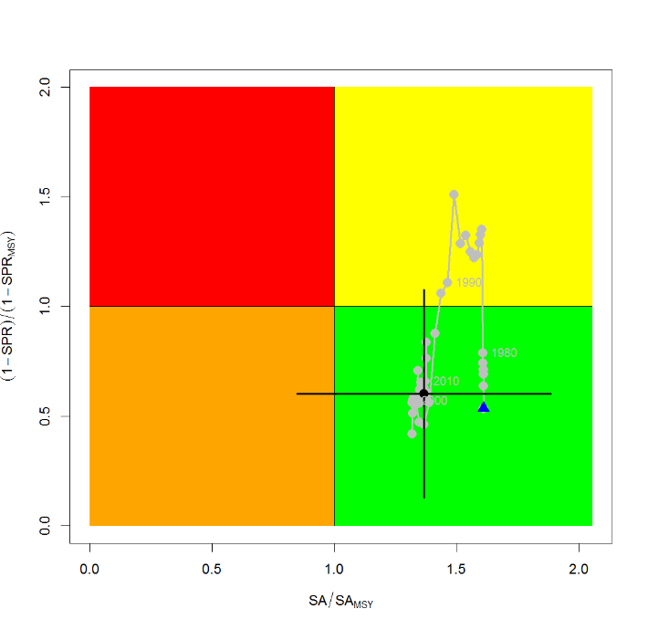
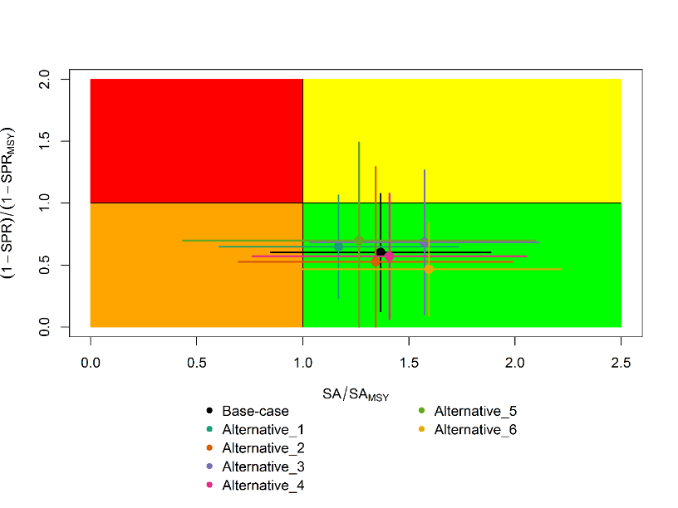
Figure SFM-9. Kobe plots of shortfin mako shark in the North Pacific Ocean showing. A) The time series of the ratio of SA to SA at MSY (SA_{MSY}) and fishing intensity to fishing intensity at MSY (1-SPR_{MSY}), and B) the same ratios for the terminal year (2016) for six alternative states of nature. SA is spawning abundance measured as the number of mature females. Fishing intensity is estimated as 1-SPR. Values for the start (1975) and end (2016) years in the time series (A) are indicated by the blue triangle and black circle, respectively. Gray numbers indicate selected years. Alternative states of nature in B) include: Alternative_1) higher catch, Alternative_2) lower catch; Alternative_3) higher uncertainty on Japan shallow-set CPUE index (1975-1993) (CV=0.3); Alternative_4) fit to Japan offshore distant water longline shallow-set fleet (JPN_SS_I; 1975-2016) and Hawaii longline shallow-set fleet (US_SS; 2005-2016), and no fit to initial equilibrium catch; Alternative_5) low steepness, h=0.26; and Alternative_6) high steepness, h=0.37. Solid lines indicate 95% confidence intervals.
A
B

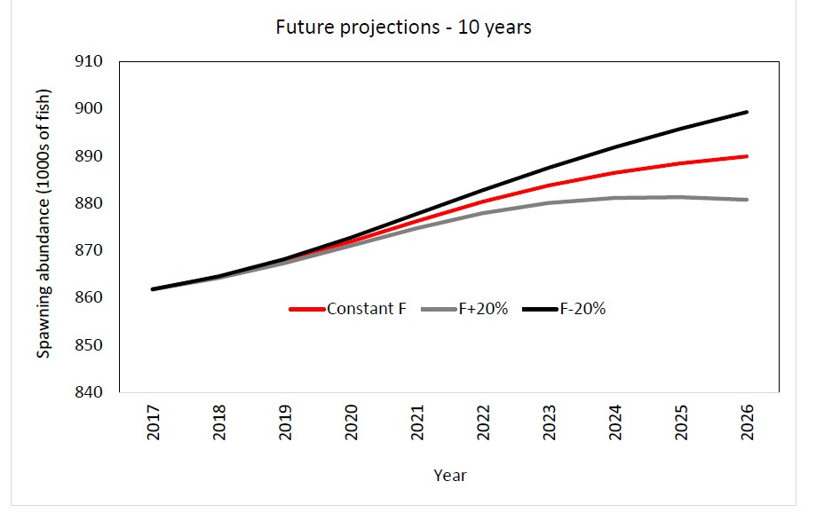

Figure SFM-10. Comparison of future projected North Pacific shortfin mako (Isurus oxyrinchus) spawning abundance under different F harvest policies (Constant F 2013-2015, +20%, -20%) using the base case model. Constant F was based on the average from 2013-2015.

    - Pacific bigeye thresher shark (Alopias superciliosus)

      - Research and information

      - Provision of scientific information

a. Status and trends

- SC14 noted that no stock assessments were conducted for Pacific bigeye thresher shark in 2018. Therefore, the stock status descriptions from SC13 are still current for Pacific bigeye thresher shark respectively. Updated information on catches was not compiled for and reviewed by SC14.
b. Management advice and implications

- SC14 noted that no management advice has been provided since SC13 for Pacific bigeye thresher shark. Therefore, previous advice should be maintained, pending a new assessment or other new information. For further information on the management advice and implications from SC13, please see https://www.wcpfc.int/node/29904

    - Porbeagle shark (Lamna nasus)

      - Research and information

      - Provision of scientific information

a. Status and trends

- SC14 noted that no stock assessments were conducted for southern porbeagle shark in 2018. Therefore, the stock status descriptions from SC13 are still current for southern porbeagle shark. Updated information on catches was not compiled for and reviewed by SC14.

b. Management advice and implications

- SC14 noted that no management advice has been provided since SC13 for southern porbeagle shark. Therefore, previous advice should be maintained, pending a new assessment or other new information. For further information on the management advice and implications from SC13, please see https://www.wcpfc.int/node/29904

    - Whale shark ( Rhincodon typus)

      - Review of research and information

      - Provision of scientific information

a. Stock status and trends

- A nominal trend of high interactions in 2006-2008, followed by lower rates thereafter was not altered by standardization (Figure RHN-1), and is consistent with trends found in the Eastern Pacific Ocean by Román et al. 2018. These decreasing annual trends in interactions do not appear to result from management measures as prohibitions on intentional setting of purse seines on whale sharks were adopted by the PNA in 2010, by the WCPFC in 2012 and by the IATTC in 2015. Furthermore, the trends may have been influenced by low WCPO purse seine observer coverage rates prior to 2010.
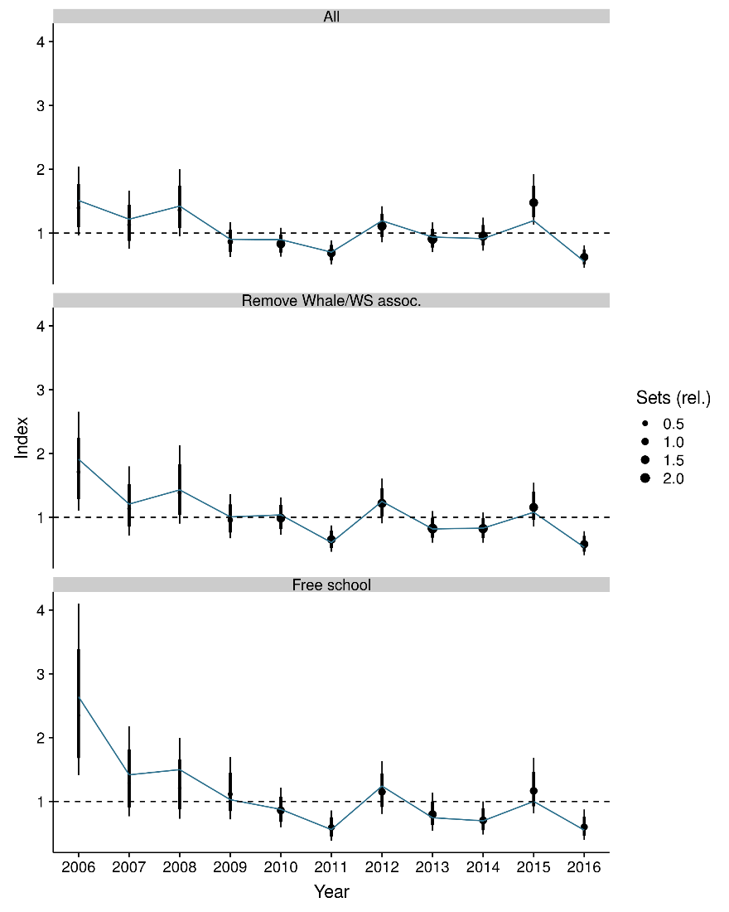
Figure RHN-1. Estimated temporal index of interactions based on a) the full observer dataset, b) the full dataset without whale- and whale shark associated sets, and c) free-school sets only. The rationale behind the different effort subsets is given in section 2.2.2 of SC14-SA-WP-12. The index is centred to have a geometric mean of one and is therefore unit-less.

- SC14 noted that over a range of notional reference points, and in accordance with expert-elicited post-mortality rates of ~10%, median sustainability risk from Pacific Ocean fisheries alone for the 2006-2016 period ranged between (Figure RHN-2):
  - 3-12% of the limit risk level based on 0.5r_{max} (F_{msm}),
  - 2-8% of the limit risk level based on 0.75r_{max} (F_{lim}), and
  - 2-6% of the limit risk level based on r_{max} (F_{crash}), where r_{max} is the maximum population growth rate.

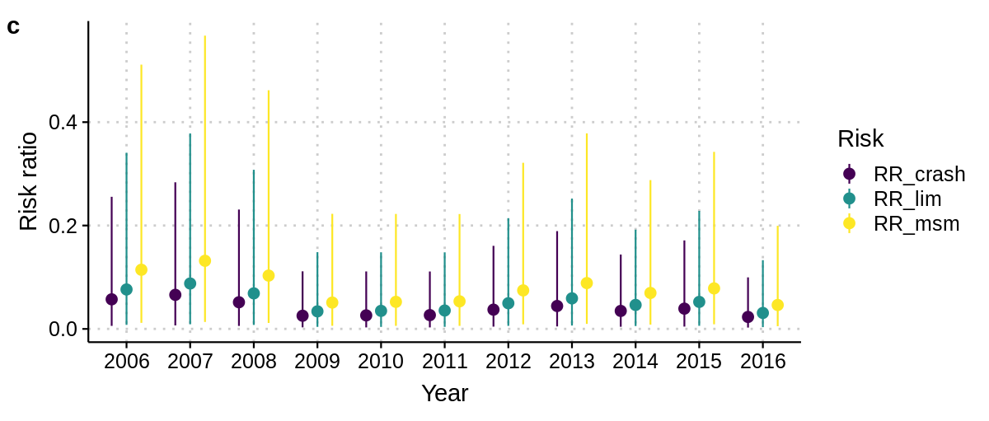
Figure RHN-2. Risk that mortality exceeds either of three limit reference points (RR_crash (F_{MSM}: 0.5r_{max}), RR_lim (F_{Lim}: 0.75r_{max}), RR_crash (F_{crash}: r_{max})).

- SC14 noted the report’s findings that understanding and reducing post-release mortality is recommended as one of most effective approaches to maintaining acceptable risk levels.

- SC14 also noted the report’s findings that the total risk to the Indo-Pacific whale shark population may be higher if there are differential impacts to more vulnerable population segments within the Pacific and/or higher fishing mortalities outside of the region (e.g. the Indian Ocean).

- SC14 considered the use of precautionary risk assessment model inputs. It was noted that input parameters to the risk assessment were drawn from the best available data, but in some cases where the data were uninformative about the probability distributions of the parameters of interest the methodology put more weight on precautionary values.

b. Management advice and implications

- SC14 considers there is a low probability that the Indo-Pacific whale shark is at risk from Pacific purse seine fisheries (median probability of less than 8% that current risk levels exceed life history-based notional reference points F_{Lim} and F_{crash}).

- SC14 recommends that the WCPFC initiate concerted efforts to identify and promote best practice safe release methods for whale sharks.

- SC14 recommends that research be undertaken to quantify post-release mortality rates under a variety of release scenarios.

  - WCPO billfishes

    - South Pacific swordfish (Xiphias gladius)

      - Research and information

      - Provision of scientific information

a. Stock status and trends

- SC14 noted that no stock assessments were conducted for south Pacific swordfish in 2018. Therefore, the stock status descriptions from SC13 are still current for south Pacific swordfish. Updated information on catches was compiled but not reviewed by SC14.

b. Management advice and implications

- SC14 noted that no management advice has been provided since SC13 for south Pacific swordfish. Therefore, previous advice should be maintained, pending a new assessment or other new information. For further information on the management advice and implications from SC13, please see https://www.wcpfc.int/node/29904

    - Southwest Pacific striped marlin (Kajikia audax)

      - Research and information

      - Provision of scientific information

a. Stock status and trends

- SC14 noted that no stock assessments were conducted for southwest Pacific striped marlin in 2018. Therefore, the stock status descriptions from SC8 are still current for southwest Pacific striped marlin. Updated information on catches was compiled but not reviewed by SC14.

b. Management Advice and implications

- SC14 noted that no management advice has been provided since SC8 for southwest Pacific striped marlin. Therefore, previous advice should be maintained, pending a new assessment or other new information. For further information on the management advice and implications from SC8, please see https://www.wcpfc.int/node/3396

    - North Pacific striped marlin (Kajikia audax)

      - Research and information

      - Provision of scientific information

a. Status and trends

- SC14 noted that no stock assessments were conducted for North Pacific striped marlin in 2018. Therefore, the stock status descriptions from SC11 are still current for North Pacific striped marlin. Updated information on catches was not compiled for and reviewed by SC14.

- To emphasize the importance of developing a stock rebuilding plan for North Pacific striped marlin, SC14 reiterated the ISC15 stock status information, excerpted from SC11:

“Estimates of population biomass of the Western and Central North Pacific (WCNPO) striped marlin stock (Kajikia audax) exhibit a long-term decline (Table S1). Population biomass (age-1 and older) averaged roughly 20,513 mt, or 46% of unfished biomass during 1975-1979, the first 5 years of the assessment time frame, and declined to 6,819 mt, or 15% of unfished biomass in 2013. Spawning stock biomass is estimated to be 1,094 mt in 2013 (39% of SSB_{MSY}, the spawning stock biomass to produce MSY). Fishing mortality on the stock (average F on ages 3 and older) is currently high and averaged roughly F =0.94 during 2010-2012, or 49% above F_{MSY}. The predicted value of the spawning potential ratio (SPR, the predicted spawning output at current F as a fraction of unfished spawning output) is currently SPR₂₀₁₀₋₂₀₁₂ = 12% which is 33% below the level of SPR required to produce MSY. Recruitment averaged about 308 thousand recruits during 1994-2011, which was 25% below the 1975-2013 average. No target or limit reference points have been established for the WCNPO striped marlin stock under the auspices of the WCPFC.

The WCNPO striped marlin stock is expected to be highly productive due to its rapid growth and high resilience to reductions in spawning potential. The status of the stock is highly dependent on the magnitude of recruitment, which has been below its long-term average since 2007, with the exception of 2010 (Table S1). Changes in recent size composition data in comparison to the previous assessment resulted in changes in fishery selectivity estimates and also affected recruitment estimates. This, in turn, affected the scaling of biomass and fishing mortality to reference levels.

Table S1: Reported annual values of catch (mt), population biomass (mt), spawning stock biomass (mt), relative spawning stock biomass SSB/SSBMSY), recruitment (000s), fishing mortality, relative fishing mortality (F/F_{MSY}), exploitation rate, and spawning potential ration for the WCNPO striped marlin stock.
Year | 2007 | 2008 | 2009 | 2010 | 2011 | 2012 | 2013 | Mean1 | Min1 | Max1
Reported Catch | 3084 | 3503 | 2468 | 2852 | 3125 | 3521 | 2984 | 5822 | 2468 | 10594
Population Biomass | 6915 | 6773 | 6409 | 5156 | 7823 | 7349 | 6819 | 12758 | 5156 | 28440
Spawning Stock Biomass | 1192 | 1171 | 970 | 984 | 873 | 1013 | 1094 | 2025 | 815 | 6946
Relative Spawning Biomass | 0.42 | 0.42 | 0.34 | 0.35 | 0.31 | 0.36 | 0.39 | 0.75 | 0.29 | 2.46
Recruitment (age 0) | 240 | 242 | 63 | 496 | 155 | 224 | 352 | 410 | 63 | 1369
Fishing Mortality | 0.82 | 0.99 | 0.80 | 0.96 | 0.89 | 0.97 | 0.76 | 0.95 | 0.47 | 1.54
Relative Fishing Mortality | 1.29 | 1.57 | 1.27 | 1.51 | 1.41 | 1.53 | 1.20 | 1.50 | 0.74 | 2.44
Exploitation Rate | 45% | 52% | 39% | 55% | 40% | 48% | 44% | 48% | 32% | 65%
Spawning Potential Ratio | 15% | 12% | 16% | 13% | 12% | 12% | 14% | 13% | 7% | 24%
1 During 1975-2013

When the status of striped marlin is evaluated relative to MSY-based reference points, the 2013 spawning stock biomass is 61% below SSB_{MSY} (2819 t) and the 2010-2012 fishing mortality exceeds F_{MSY} by 49%. Therefore, overfishing is occurring relative to MSY-based reference points and the WCNPO striped marlin stock is overfished.”

b. Management advice and implications

- SC14 noted that no management advice has been provided since SC11 for North Pacific striped marlin. Therefore, previous advice should be maintained, pending a new assessment or other new information. For further information on the management advice and implications from SC11, please see https://www.wcpfc.int/node/26922

- To emphasize the importance of developing a stock rebuilding plan for North Pacific striped marlin, SC14 reiterated the following management advice and information, excerpted from SC11.

“SC11 noted the following conservation advice from ISC.

The stock has been in an overfished condition since 1977, with the exception of 1982 and 1983, and fishing appears to be impeding rebuilding especially if recent low recruitment levels persist.

Projection results show that fishing at F_{MSY} could lead to median spawning biomass increases of 25%, 55%, and 95% from 2015 to 2020 under the recent recruitment, medium- term recruitment, and stock recruitment-curve scenarios.

Fishing at a constant catch of 2,850 t could lead to potential increases in spawning biomass of 19% to over 191% by 2020, depending upon the recruitment scenario.

In comparison, fishing at the 2010-2012 fishing mortality rate, which is 49% above F_{MSY}, could lead to changes in spawning stock biomass of -18% to +18% by 2020, while fishing at the average 2001-2003 fishing mortality rate (F2001-2003=1.15), which is 82% above F_{MSY}, could lead to spawning stock biomass decreases of -32% to -9% by 2020, depending upon the recruitment scenario.

SC11 expressed concerns about the updated stock status of WCNPO striped marlin, noting that the stock was overfished (SSB₂₀₁₃ at 61% below SSB_{MSY}) and that overfishing was occurring (F₂₀₁₀₋₂₀₁₂ exceeds F_{MSY} by 49%). Although a LRP for billfish species has not been adopted by the WCPFC, SC11 noted that SSB_{current}/SSB_{current,F=0}=0.12 and is below the LRP adopted for tunas. SC11 also noted that projections indicate that Prob(SSB₂₀₂₀>SSB₂₀₁₅)<50% for all constant catch scenarios over 2,850 mt (under the three recruitment hypotheses modelled), which means that in order to allow the spawning biomass to rebuild then catches need to be reduced to less than 2,850mt. SC11 recommends that the Commission develop a rebuilding plan for North Pacific striped marlin with subsequent revision of CMM 2010-01 in order to improve stock status.”

c. Recommendations on the designation of North Pacific striped marlin as a Northern Stock

- Regarding the issue of the designation of North Pacific striped marlin as a Northern Stock (WCPFC14 Report, Para 378), SC14 provides the following recommendations:

- SC14 recommends that the Commission clarify and quantify what is meant by “mostly north of 20 degrees N”.
- In relation to paragraph 1, SC14 recommends that a check-list of benchmark scientific information for North Pacific striped marlin be developed to support the Commission’s deliberations in determining the designation of a northern stock. As such, the following table is forwarded for the Commission’s consideration.

No | Criteria | Response | Comments
1 | What proportion of the total estimated stock biomass occurs on average north of 20N? | *Proportion of biomass above 20 ºN is 2-4 times larger than the proportion of biomass south of 20 ºN in the North Pacific | SC14-SA-IP-011 This value was estimated by stock assessment result in 2007.
2 | Does all of the breeding/spawning area(s) occur north of 20 ºN? | Unknown
3 | Does all of the nursery area(s) occur north of 20 ºN | Unknown
4 | Do any other important life history stages occur south of 20N? | Unknown
5 | What proportion of the total estimated catch occurs north of 20 ºN? | **Range of annual percentages of 66%-96% above 20 ºN. During the 2000s the average percentage was 73% above 20 ºN | SC14-SA-IP-11 These values were estimated from stock assessment results in 2007, but were not endorsed by SC3.
6 | Is fishery catch-per-unit-effort demonstrably higher north of 20 ºN for comparable fisheries? | Unknown
7 | Is there sufficient information about fish movement between north and south of 20 ºN? | No
*Proportion of biomass was calculated in 1964 and 1969 that is near the initial condition.
**The average proportion of the total catch in numbers were calculated by decade (1950's-2000's).

    - Pacific blue marlin (Makaira nigricans)

      - Research and information

      - Provision of scientific information

a. Status and trends

- SC14 noted that no stock assessments were conducted for Pacific blue marlin in 2018. Therefore, the stock status descriptions from SC12 are still current for Pacific blue marlin. Updated information on catches was compiled but not reviewed by SC14.

b. Management advice and implications

- SC14 noted that no management advice has been provided since SC12 for Pacific blue marlin. Therefore, previous advice should be maintained, pending a new assessment or other new information. For further information on the management advice and implications from SC12, please see https://www.wcpfc.int/node/27769

AGENDA ITEM 5 — MANAGEMENT ISSUES THEME

  - Development of harvest strategy framework

    - Progress of the harvest strategy workplan

    - Target reference points

a. Yellowfin and bigeye tuna

- SC14 reviewed information on what would be the minimum setting for a candidate spawning-biomass-depletion-based TRP (or maximum fishing-mortality-based TRP) for yellowfin tuna that avoids breaching the LRP with a specified level of probability under the current uncertainty framework (SC14-MI-WP-01). While SC14 noted that the main biological consideration for a TRP is that it should be sufficiently above the LRP, SC14 also noted that the choice of a TRP can be based on a combination of biological, ecological and socioeconomic considerations. In this regard consideration in future of other economic and social objectives for yellowfin tuna in the selection of candidate TRPs would be welcome. Several CCMs also viewed management objectives and TRPs as economic decisions, and that in the context of a multi-species and multi-gear fishery they cannot be taken on a species by species basis in isolation. SC14 recommended that the analyses be repeated for bigeye tuna taking account of the updated 2018 bigeye stock assessment, and with both ‘recent’ and ‘long term’ recruitment assumptions. SC14 recommends that WCPFC15 take note of these results in consideration of management objectives upon which any candidate TRPs for yellowfin tuna and bigeye tuna should be based, and in so doing clarify the management objectives for these species (including the selection of risk levels) so that the additional work identified above can be undertaken.

b. South Pacific albacore tuna

- SC14 noted that WCPFC14 deferred the possible adoption of an interim TRP for the South Pacific albacore stock, which had originally been agreed to take place in 2015 under the Harvest Strategy Work Plan, until December 2018 at the latest. Recalling that it had previously reviewed a number of working papers and provided advice to the WCPFC over the past three years on this issue, SC14 reaffirms the previous recommendations made by SC13. In particular, SC14:
- notes that FFA CCMs have communicated their objectives for the south Pacific albacore stock as taken by the southern longline fishery at various times, and have proposed (in WCPFC14-DP13) a TRP that would maintain or restore average longline albacore CPUE to 10% above its 2013 value by 2028, and to 17% above its 2013 level by 2038.
- encourages other CCMs to describe their objectives for the fishery as specified in the Roadmap to implement the elements needed for the effective conservation and management for South Pacific albacore adopted by WCPFC14;
- draws the attention of WCPFC15 to the Limit Reference Point already adopted by the Commission for south Pacific albacore and the need to maintain the stock well above that limit; and,
- draws attention to the need to identify a TRP at a level which best achieves the fisheries management objectives of CCMs with a real interest in this stock.

- SC14 also draws the attention of WCPFC15 to the updated assessment for south Pacific albacore reviewed by SC14 (described in SC14-SA-WP-05) which indicates that the current status of this stock is well above the LRP (with the median value of SB_{latest}/SB_{F=0}=0.52). To assist CCMs in the identification and evaluation of an appropriate TRP for south Pacific albacore SC14 also recommends that the Scientific Services Provider provides to CCMs an updated analysis using an approach similar to working paper HSW-WP-05 as presented to the WCPFC Harvest Strategy Workshop held in late November 2015.

- In view of the decision by WCPFC14 that “CCMs will work together in advance of WCPFC15 to develop TRP proposals” this analysis may need to be provided and discussed at a meeting of the WCPFC South Pacific Albacore Roadmap Working Group in the margins of TCC14 or in conjunction with WCPFC15.

    - Performance indicators, monitoring strategies and harvest control rules

- In support of the development of a Roadmap for the management of south Pacific albacore tuna, SC14 reviewed potential elements of the harvest strategy for this species, primarily reference points, the estimation method, and harvest control rules (SC14-MI-WP-02). SC14 endorsed an initial focus on empirical-based estimation methods, using CPUE as the biomass signal, with a secondary focus on model-based approaches. It also endorsed the use of longline CPUE as the primary information source for the estimation method, noting that empirical measures such as CPUE may better align with economic objectives, and they may be easier for some stakeholders to understand. SC14 also reviewed the required criteria for selecting appropriate candidate ‘reference’ longline fleets that may provide the required CPUE series, and provided feedback to the Scientific Services Provider on additional issues which should be considered in progressing this work. SC14 recommends that WCPFC15 use this working paper to inform development of the Roadmap for improving south Pacific albacore management and requests guidance from WCPFC15 on 1) the south Pacific albacore fisheries to be included in the MSE (e.g. longline and troll) and 2) the potential management control method for the fisheries (e.g. through catch, fishing effort, etc.). SC14 also recommends that WCPFC15 note the need for ongoing review of monitoring strategy requirements as the harvest strategy develops, ongoing efforts to gather key economic data on the southern longline fishery, and endorse the proposed work plan for development of scientific aspects of a south Pacific albacore harvest strategy.

    - Management Strategy Evaluation (MSE)

- SC14 reviewed several papers related to ongoing work which is being undertaken by the Scientific Services Provider as specified in the Harvest Strategy Work Plan as updated by WCPFC14 (Attachment L in the WCPFC14 Summary Report). It noted that the MSE evaluation framework is constructed from two main components, an operating model (OM) and a management procedure (MP).

- First, SC14 reviewed information on the process of developing and parameterising an OM for the dynamics of the skipjack stock in the WCPO and the fishing fleets that exploit them (SC14-MI-WP-03). In particular, it reviewed and provided feedback on the sources of uncertainty (such as implementation error) that should be included to ensure that the OM covers all important sources of uncertainty, against which the performance of a MP should be evaluated. Several CCMs also expressed a view that the OMs being developed should allow the impacts on other species to be considered. SC14 noted that in the past the Scientific Services Provider have used some models to look at the impacts of CMMs on more than one species and such an approach, effectively running species-specific but similarly structured OMs in parallel, may be applicable in this case as part of future developments. SC14 also noted that the selection and refinement of OMs and other components of the MSE process will involve an extended iterative and consultative process and requested that the Scientific Services Provider incorporate the specific feedback of CCMs into future iterations.

- Second, SC14 reviewed information and provided clarification and feedback on the development and use of a range of performance indicators for evaluating the relative performance of a set of demonstration management procedures (SC14-MI-WP-04), in particular the list of 11 indicators identified for inclusion for the Tropical Purse Seine Fisheries from Attachment M in WCPFC13 Summary Report. Methods for comparing and synthesizing the relative performance of management procedures using the performance indicators (PI) were also reviewed. SC14 noted that several performance indicators that cannot be quantified in the OM can be moved to the monitoring strategy, though it expressed support for the retention of performance indicator PI-5 (to maximize SIDS revenue from resource rents) and recommended that further work be undertaken to identify options to better evaluate this objective. For PI-10 (avoid adverse impacts on small scale fisheries) several CCMs advocated that the estimation of MSY for the tropical tunas can be used as a proxy to assess downstream effects from the purse seine fishery and recommended that further work be undertaken. Some CCMs also supported the retention of PI-11 because of the multi-species nature of this fishery. SC14 also noted that the use of a smaller number of performance indicators will aid in comparing the relative performance of candidate management procedures. SC14 also agreed that, i) the distribution of the indicator values, not just a measure of the central tendency, should be considered, ii) that the time periods over which the indicators are calculated should be based on an appropriate number of management cycles, based on the life history of the stock, and iii) that the further development of potential indicators and how they are presented is an ongoing process and will benefit from the engagement with other stakeholder groups.

- Third, SC14 reviewed information on the key decisions that i) regional fishery managers and stakeholders, and ii) scientists (through the Scientific Committee) will need to consider under the work plan for adoption of harvest strategies for tuna stocks and fisheries in the WCPO (SC14-MI-WP-05). In noting the useful summary provided by this paper of the roles that each group plays in moving the harvest strategy workplan forward, SC14 also noted that discussion and negotiations would be required on a number of issues and that certain issues would need to be undertaken by both managers and scientists together.

- SC14 requested that revised versions of the above working papers be forwarded to WCPFC15 taking into account the suggestions to clarify, revise and update as appropriate, aspects of these papers. SC14 recommends that WCPFC15 note the progress on the development of the MSE being undertaken under the Harvest Strategy Work Plan and provide the necessary elements being requested from the Commission to further progress this work against the scheduled time-lines noted in this work-plan.

    - Other matters

a. Science and management dialogue

- Noting Paragraph 215 of the WCPFC14 Summary Report on the need for a Science-Management Dialogue, SC14 discussed the elements to consider when formulating such a dialogue and the consultative draft terms of reference (SC14-MI-WP-06). SC14 expressed strong support for such a Science-Management Dialogue to begin in 2019 in order to make expedited progress consistent with the agreed Harvest Strategy Work Plan and taking full advantage of the WCPFC14 recommendation to give sufficient time during SC to the work on harvest strategies.

- SC14 therefore recommends that WCPFC15 take the necessary steps to establish such a Dialogue in 2019 and consider the draft Terms of Reference provided in Attachment F.

- SC14 noted that it is important for this group to possess authority to enable them to make the appropriate recommendations to the Commission. SC14 therefore recommends the Commission define the appropriate format for this group.

- SC14 also discussed the timing of the meeting and various options were expressed. SC14 recognised that this is a decision for WCPFC15.

- SC14 recommends that WCPFC15 take the following elements into consideration when establishing this group:
- While the size of the meeting should remain manageable, at least 1 senior fishery manager per CCM and 1 scientist per CCM should be encouraged to attend. Additional scientific advisors to these managers may also attend. Also, the participation of stakeholders is important and encouraged.
- Given the need to have informal (capacity building) and formal (decision-making) elements to the meeting, particularly in the initial stages, a 2 day meeting was the minimum meeting length believed appropriate. However, the duration of the meeting would need to be flexible based upon the agenda, which should be linked closely to the harvest strategy workplan.
- Capacity building elements of the meeting should focus on a ‘learning by doing’ approach, whereby key tuna stock and fishery results are used within the process.
- The potential for input and facilitation by external experts was noted, and the cost implications of this should be considered.
- This group should specifically rely on information derived from SC or through SC requests, and should not change the scientific advice but may add to it from a management perspective.

- SC14 also recommends that WCPFC15 adopt an appropriate name for this dialogue, such as the Harvest Strategy Development Working Group.

  - Limit reference points for WCPFC sharks

    - Identifying appropriate limit reference points for elasmobranchs for the WCPFC

- SC14 reviewed the progress report of the project “Identifying appropriate reference points for elasmobranchs within the WCPFC” (SC14-MI-WP-07) noting that this project had only recently commenced and that further work will be undertaken before the project is completed later this year. SC14 provided comments and feedback as requested on the initial work completed and the future work program. SC14 supported the general approaches being developed as a way of avoiding the weaknesses of conventional stock assessment on data poor species and the general hierarchical approach to LRP setting, also noting that the risk-based approach which is different from traditional stock assessment approach may take time to be understood. However, several CCMs expressed some concern that some of the suggested LRPs may be too conservative, noting that the WCPFC convention prescribes different level of treatment for target stocks and non-target species with respect to the setting of reference points. SC14 therefore recommends that WCPFC note that the objective of the WCPFC convention for the management of non-target species is to maintain or restore populations of such species above levels at which their reproduction may become seriously threatened, and recommends that this be explicitly considered in the ongoing work.

  - Implementation of CMM 2017-01

    - Effectiveness of CMM 2017-01

- As requested in the Harvest Strategy Work Plan, as updated by WCPFC14, SC14 reviewed information on the likely outcomes of the revised tropical tuna measure (CMM 2017-01) in relation to bigeye tuna (SC14-MI-WP-08a; detailed analysis of the projections of BET is provided in Section 4.1.1.2 of this report). SC14 noted that outcomes are strongly influenced by the assumed future recruitment levels and the time period of the projections. SC14 recommended that the working paper be forwarded to WCPFC15. SC14 noted that projection analyses such as those detailed in the working paper should be presented in conjunction with the stock assessment results in future SC meetings.

    - Management issues related to FADs

a. FAD tracking

- SC14 reviewed information on analyses of the PNA’s fish aggregating device (FAD) tracking program (SC14-MI-WP-09). SC14 expressed strong support for this type of research and its continuation, noting that the PNA FAD tracking program is providing information and insight that is adding substantial value to the scientific understanding of WCPO fisheries. However, SC14 noted the ongoing practice of fleets not providing full data (estimates indicate that 60–70% of buoy transmissions are not forwarded to the PNA via practices such as geo-fencing) which substantially undermines the scientific value of the information and prevents the SC from being able to provide comprehensive advice to the Commission on FAD dynamics, economics and management. SC14 also expressed concern about the estimated high rate (5%) of beaching events in tracked FADs, with the vast majority of these being in PNA countries, together with the estimated high rate of ‘lost’ FADs (up to 27%).

- SC14 recommends that WCPFC15 note the importance of FAD marking and monitoring programs to better identify and follow individual FADs. To address the marine pollution issue, reduce the risk to coastal communities, reefs, and fish stocks SC14 recommends the use of biodegradable FADs, non-entangling, non-entrapping, and environmentally-friendly FAD designs, better measures for FAD control and retrieval, and fewer FAD deployments. SC14 also recommends that the Secretariat ensure this working paper is made available to inform the deliberations of the FAD Management IWG meeting to be held in October 2018 and that WCPFC15 take note of the concerns expressed above and support appropriate measures.

b. FAD management (FAD-limit per vessel)

- SC14 reviewed information on the estimation of the number of drifting Fish Aggregating Device (FAD) deployments and active FADs per vessel over the period 2011-2018 (SC14-MI-WP-10), noting that purse seine fishing on drifting FADs accounts for about 40% of the purse seine tuna catch in the WCPO. SC14 noted the limitations of the different sources of data used in the analysis but expressed strong support for and the utility of this research. Preliminary estimates of FAD deployments ranged between 30,700–56,900 in 2016 and 44,700–64,900 in 2017 (using combined fishery and PNA FAD tracking data). SC14 also noted that based upon the information provided in the paper, the present per vessel limit of 350 active FADs (at any one time) in the WCPO likely does not constrain or reduce the number of FADs in the water, given that the average vessel at the moment is estimated to have around 117 FADs in the water at any time (assuming the average life of an active FAD is 6 months). However, pointing to the uncertainty of the number of FADs deployed in the WCPO, the identified deficiencies in FAD tracking data, and the differences of the number of active FADs between estimates and the actual operations, some CCMs suggested that the SC continues to provide the further analysis on active FAD number with the additional available data such as improving the FAD data fields to be reported by observers and/or vessel operators.

- SC14 recommends that the Secretariat ensure this working paper is made available to inform the deliberations of the FAD Management IWG meeting to be held in October 2018. SC14 also recommends that the FAD Management IWG and WCPFC15 take into consideration the concerns expressed above and determine a more appropriate limit that (i) helps reduce the amount of marine debris, synthetic pollution and beaching events generated by FAD deployment, and (ii) helps to avoid any economic impacts on the purse seine fishery through reduced CPUE. SC14 also recommends that additional work on these issues be supported, noting that improved data collection in both the observer and logbook records would also assist this research.

AGENDA ITEM 6 — ECOSYSTEM AND BYCATCH MITIGATION THEME

  - Ecosystem effects of fishing

    - SEAPODYM

    - Ecosystem indicators

    - FAD impacts

      - Research on non-entangling FADs

      - FAD Research Plan

  - Sharks

    - Development of a Comprehensive Shark and Ray CMM

- SC endorsed that the outcomes of ISG-05 (SC14-EB-WP-05a) be forwarded to the IWG-SHARKs for their consideration.

    - Review of conservation and management measures for sharks

      - CMM 2010-07 (CMM for Sharks)

- SC14 recommends that:
- TCC14 and WCPFC15 note that since the adoption of the CMM 2010-07, SC has been unable to confirm the validity of using a 5% fin to carcass ratio and that an evaluation of the 5% ratio is not currently possible due to insufficient or inconclusive information.
- TCC14 and WCPFC15 elaborate a mechanism for generating the data necessary to review the fins to carcass ratio if such a ratio is to be used as a tool for promoting the full utilization of sharks in the WCPFC

      - CMM 2011-04 (CMM for oceanic whitetip shark)

      - CMM 2012-04 (CMM for protection of whale sharks from purse seine fishing operations)

      - CMM 2013-08 (CMM for silky sharks)

- SC14 recommends to WCPFC15 that:
  - The Scientific Services Provider be tasked with reviewing how observers record sharks that are cut free, and what data quality improvements might be achieved through improved observer training and/or protocols.
  - SC14 also recommends TCC14 and WCPFC15 to consider, through the comprehensive shark CMM, a requirement that non-retention and/or unwanted sharks be hauled alongside the vessel before being cut free in order to facilitate species identification. This requirement shall only apply when an observer or electronic monitoring camera is present, and should only be implemented taking into consideration the safety of the crew and observer. When adopted by the Commission, the guidelines for safe release of sharks and rays may be a useful guide for this activity.

      - CMM 2014-05 (CMM for sharks)

    - Safe release guidelines

- SC 14 adopted the outcomes of ISG-06 regarding draft safe release guidelines for sharks and rays (Attachment G)

    - Progress of Shark Research Plan

a. Review of shark data and modeling framework to support stock assessments (Project 78)

b. Shark research plan update

- SC14 adopted the outputs of ISG-07 on the shark research plan, including provision of one research proposal Project 92 for the 2019 SC work program and budget (Attachment H).

  - Seabirds

    - Review of Seabird Researches

    - Review of CMM 2017-06 (CMM on Seabirds)

- SC14 noted that hook-shielding devices are a novel seabird bycatch mitigation measure which encases the point and barb of baited hooks to prevent seabird attacks during line setting.

- SC14 noted that the evidence presented on hook-shielding device effectiveness was for Hookpods, one hook-shielding device which met the following performance characteristics:
  - the device encases the point and barb of the hook until it reaches a depth of at least 10 m or has been immersed for at least 10 minutes;
  - the device meets current minimum standards for branch line weighting as specified in the seabird bycatch CMM; and
  - the device is designed to be retained on the fishing gear rather than being lost.

- Some CCMs raised operational and cost-related concerns regarding the application of these devices to their fisheries.

- SC14 recommends:
- that TCC14 and WCPFC15 note that evidence is available to support the inclusion of hook-shielding devices, specifically Hookpods, on the list of seabird bycatch mitigation options, in addition to already existing mitigation options.
- the revision of CMM 2017-06 to add the use of hook-shielding devices, specifically Hookpods, as an optional stand-alone seabird bycatch mitigation measure in order to provide more choices and greater flexibility to the fishing industry to mitigate seabird bycatch in their fishing operations.
- that if hook-shielding options other than Hookpods, or any other innovative options, are proposed for use in WCPFC in the future, SC and TCC should review the evidence on effectiveness, efficiency, and practicality of the technology in mitigating seabird bycatch.
- that if the revision of CMM 2017-06 to include hook-shielding devices is accepted, SC should be tasked with reviewing information on the use of Hookpods in commercial fishing operations no later than 3 years from the implementation date.
- that while there was no proposal that hook-shielding devices be made mandatory, if this was proposed in future thorough review by SC and TCC would be required.

- SC 14 noted that:
- the most recent geolocation data on Antipodean wandering albatross, a priority population of conservation concern, indicates the extent of foraging up to and north of 25° S.
- substantial fishing effort occurs in waters of the WCPFC area between 30°S and 25°S which is within the Antipodean wandering albatross foraging range.
- as CMM 2017-06 does not require the use of seabird mitigation in the WCPFC area between 30°S and 25°S, this fishing effort poses a bycatch risk to Antipodean wandering albatross and other species foraging in the area.
- revision of CMM 2017-06 to extend the area of application up to 25°S will reduce the bycatch risks faced by Antipodean wandering albatross and other seabirds.

- SC 14 recommended that TCC14 and WCPFC15 consider a revision to the southern area of application of CMM 2017-06, including implementation considerations of SIDS and Territories.

  - Sea turtles

    - Review of sea turtle researches

    - Review of CMM 2008-03

- SC14 noted that only limited information exists on direct comparison of catch rates of target and non-target species among J hook, Japanese tuna hook, and large circle hook, in particular for deep longline sets.

- SC14 encouraged CCMs to collect further information on catch rates of target and non-target species separated by hook types and hook sizes and to report them to the WCPFC.

- SC14 recommended that the Commission note that:
- less than 1% of Western and Central Pacific Ocean (WCPO) longline effort is subject to mitigation under CMM 2008-03, even though approximately 20% of the WCPO longline effort consists of shallow sets. This results because CMM 2008-03 only applies to longline vessels that fish for swordfish in a shallow-set manner.
- Noting that SC13 recommended that:
TCC and the Commission note the following findings of the Joint Analysis of Sea Turtle Mitigation Effectiveness Workshop when discussing sea turtle mitigation in the WCPF Convention Area:
- The WCPFC does not hold sufficient information to quantify the severity of the threat posed by longline fisheries to sea turtle populations;
- The effect of large circle hooks (size 16/0 or larger) in reducing interactions is generally greater than the effect of fish bait;
- The effect of fish bait in reducing both interactions and mortality is generally similar to that of removal of the first hook position closest to each float;
- The effect of large circle hooks (size 16/0 or larger) in reducing both interactions and mortality is generally similar to that of removal of the first two hook positions closest to each float;
- While approximately 20% of the WCPO longline effort is in shallow sets, analysis suggests that <1% of WCPO longline effort is currently subject to mitigation;
- Noting that the workshop separated shallow and deep sets at 10 hooks per basket, it found that although interaction rates are higher in shallow-set longlines, introducing mitigation to deep-set longlines would deliver greater reductions in total interactions as compared to shallow-set longlines due to the four-times greater effort in deep-set longline fisheries;
- Similarly, introducing mitigation to deep-set longlines would deliver greater reductions in at-vessel mortality as compared to shallow-set mitigation because sea turtles have a higher probability of asphyxiation in deep sets;
- The effects of these and other combinations of mitigation measures are quantified and discussed in the final workshop report “Joint Analysis of Sea Turtle Mitigation Effectiveness” which can serve as a reference for the Commission’s further consideration of CMM 2008-03.
- It be determined if sufficient data exist to conduct further analyses to evaluate the impacts of various mitigation measures on fisheries operations in WCPO and on populations of sea turtle species.

- In responding to the Commission’s request in WCPFC14 Summary Report, para 362, SC14 discussed two papers (WCPFC-2018-SC14/EB-WP-06 and SC14-EB-WP-08) examining the effects of circle hooks on target and other bycatch species, but did not reach consensus on the effectiveness of circle hooks compared to other hook types on catch rates of target and other bycatch species.

  - Bycatch management

  - Other issues

AGENDA ITEM 7 — OTHER RESEARCH PROJECTS

  - West Pacific East Asia Project

  - Pacific Tuna Tagging Project

- SC14 agreed that continuing the tagging work is essential because of its importance in providing critical information for the assessments of tropical tuna stocks.

- SC14 acknowledged the voluntary contributions from the Republic of Korea, European Union, Papua New Guinea, Australia, New Zealand and ISSF. SC14 encouraged other CCMs and observer organisations to consider contributing to this important work. Further SC14 acknowledged the support of national fisheries administrations, observer programmes and the tuna fishing industry in assisting with the project, in particular in the recovery of recaptured tags.

- SC14 recommended that the Commission support the PTTP work plan and associated budget for 2019 and the work plan and associated indicative budget for 2020-2021, noting that it includes consideration of the recent voluntary contribution from the Republic of Korea.

- SC14 noted the advice of the Scientific Services Provider and the PTTP Steering Committee (SC14-RP-PTTP-01) that the availability and cost of suitable tuna fishing vessels to undertake tagging charters is subject to considerable uncertainty. SC14 recommended that should available budget be insufficient or if a suitable pole-and-line vessel makes it impossible to conduct WP5 in 2019 as scheduled in the work plan, the Executive Director may authorize an amendment to the schedule such that CP14 be conducted in 2019 and WP5 be conducted in 2020.

- SC14 also noted the advice of the Scientific Services Provider and the PTTP Steering Committee (SC14-RP-PTTP-01) that there is considerable uncertainty in the long-term sustainability of the tagging programme due to the escalating costs of vessel charter and limited availability of suitable vessels. SC14 therefore recommended that the Finance and Administration Committee and the Commission consider the proposed Project 83, in which it is proposed to assess the business case for the acquisition and operation of a dedicated research vessel for this purpose, with a view to realising cost-savings for the Commission over the long term. However one CCM did not consider that Project 83 was a scientific project and it should be possibly funded under another more appropriate budget line.

  - ABNJ (Common Oceans) Tuna Project-Shark and Bycatch Components

  - WCPFC Tissue Bank (Project 35b)

- The Scientific Committee reconfirmed that maintaining and enhancing the WCPFC Tuna Tissue Bank (P35b) is an essential project and recommended the Commission support the work plan and associated budget for 2019, and the work plan and associated indicative budget for 2020-2021.
- The Scientific Committee agreed to run the process of WCPFC Tuna Tissue Bank (P35b) reporting in a similar manner to the PTTP (P42) at SC15.
- The Scientific Committee agreed that that the Secretariat and the Scientific Services Provider should work together to investigate any issues arising from the Nagoya Protocol for the Tuna Tissue Bank and provide advice on this matter to the Commission as appropriate.

  - Other Projects

AGENDA ITEM 8 — COOPERATION WITH OTHER ORGANISATIONS

AGENDA ITEM 9 — SPECIAL REQUIREMENTS OF DEVELOPING STATES

AND PARTICIPATING TERRITORIES

AGENDA ITEM 10 — FUTURE WORK PROGRAM AND BUDGET

  - Review of the Scientific Committee Work Programme

  - Development of the 2019 work programme and budget, and projection of 2020-2021 provisional work programme and indicative budget

- SC14 adopted the proposed budget (Table B-1) and forwarded it to the WCPFC15 FAC meeting.

Table B-1. Summary of SC work programme titles and budget for 2019, and indicative budget for 2020–2021, which requires funding from the Commission’s core budget (USD).
Project title | TORs | Essential | Priority rank | 2019 | 2020 | 2021
SPC Oceanic Fisheries Programme Budget | MOU | Yes | High 1 | 906,396 | 924,524 | 943,015
SPC – Additional resourcing for harvest strategy evaluation, including stock assessments (Rob Scott) | MOU | Yes | High 1 | 164,832 | 166,480 | 168,145
Project 35b. Maintenance and enhancement of the WCPFC Tissue Bank | Annexed | Yes | High 1 | 97,200 | 99,195 | 101,180
Project 42 Pacific Tuna Tagging Program (PTTP) Other: Approx. $170,000 from Korea | Annexed | Yes | High 1 | 645,000 | 645,000 | 730,000
Project 57. Limit Reference Points (LRPs) for elasmobranchs within the WCPFC | Annexed
Project 60: Improving purse seine species composition  * SPC will utilise funding from other sources in 2019 | Annexed |  |  | * | 40,000 | 40,000
Project 68. Estimation of seabird mortality across the WCPO Convention area | Annexed | No | High 2 | 17,500
Project 81. Further work on bigeye tuna age and growth | Annexed
Project 82. Yellowfin tuna age and growth | Annexed | Yes | High 1 | 85,000
Project 83. Investigating the potential for a WCPFC tag vessel (Co-funded to be sought) | Annexed | No | High 2 | 95,000
Project 88. Acoustic FAD analyses | Annexed |  |  |  | 120,000 | 72,000
Project 90. Better data on fish weights and lengths for scientific analyses | Annexed | No | High 2 | 60,000 | 30,000 | 20,000
Project 91. Operational planning for shark biological data improvement
*ABNJ-funded project ($30,000) – need to re-advertise
Project 92. Testing the performance of alternative stock assessments approaches for oceanic whitetip shark. | Annexed | No | High 2 | 75,000
Project 93. Review of the Commission’s data needs and collection programs | Annexed
Project 94. Workshop on yellowfin and bigeye tuna age and growth | Annexed | Yes | High 1 | 15,000
Unobligated (Contingency) Budget  Note: Any science-related projects requested by the Commission with no budget allocation |  |  |  |  | 83,000 | 83,000
SC14 TOTAL BUDGET |  |  |  | 2,160,928 | 2,108,199 | 2,157,340

- Detailed descriptions of the SC14 work programme, budget and terms of reference for each project are in Attachment I.

- SC14 agreed that SPC will conduct stock assessments for skipjack tuna and South Pacific striped marlin in 2019 (Table SA-1).

Table SA-1: Stock Assessment Schedule
Species | Region | Last assessment | 2018 | 2019 | 2020 | 2021 | 2022 | Notes
TUNA and BILLFISH
Bigeye tuna | WCPO | 2017 | SPC Update  (SC14-SA-WP-03) |  | SPC |  |  | 3 year cycle
Skipjack tuna | WCPO | 2016 |  | SPC |  |  | SPC | 3 year cycle
Yellowfin tuna | WCPO | 2017 |  |  | SPC |  |  | 3 year cycle
Albacore | South Pacific | 2015 | SPC  (SC14-SA-WP-05) |  |  | SPC |  | 3 year cycle
Pacific bluefin | North Pacific | 2016 | ISC  (SC14-SA-WP-06) ISC |  |  | ISC |  | To be confirmed by ISC
Striped marlin | Southwest Pacific | 2012 |  | SPC  (deferred from 2018) |  |  |  | 5 year cycle
Striped marlin | Northwest Pacific | 2012 |  | ISC |  |  |  | To be confirmed by ISC
Swordfish | Southwest Pacific | 2017 |  |  |  |  | ISC | 5 year cycle
Swordfish | North Pacific | 2014 | ISC  (SC14-SA-WP-07) |  |  |  |  | To be confirmed by ISC

AGENDA ITEM 11 — ADMINISTRATIVE MATTERS

  - Future operation of the Scientific Committee

  - Election of Officers of the Scientific Committee

  - Next meeting

- SC14 confirmed that SC15 would be held in Pohnpei, Federated States of Micronesia during 7-15 August 2019. Samoa offered to host for 2020.

AGENDA ITEM 12 — OTHER MATTERS

AGENDA ITEM 13 — ADOPTION OF THE SUMMARY REPORT OF THE FOURTEENTH REGULAR SESSION OF THE SCIENTIFIC COMMITTEE

- SC14 adopted the recommendations of the Fourteenth Regular Session of the Scientific Committee. The SC14 Summary Report will be adopted intersessionally according to the following schedule:

Due by | Actions to be taken
16 August | Close of SC14  By 27 August, SC14 decisions will be distributed to all CCMs and observers (within 7 working days, Rules of Procedure).
23 August | Secretariat will receive Draft Summary Report from the rapporteur.
7 September | Secretariat will clear the Draft report, and distribute the cleaned report to all Theme Convenors for review.
14 September | Theme conveners will review the report and return it back to the Secretariat
17 September | The Secretariat will distribute/post the draft Summary Report for all CCMs’ and Observers’ review
29 October | Deadline for the submission of comments from CCMs and Observers

AGENDA ITEM 14 — CLOSE OF MEETING

- The meeting closed at 4:40 on 16 August 2018.

Attachment F

The Commission for the Conservation and Management of
Highly Migratory Fish Stocks in the Western and Central Pacific Ocean
Scientific Committee
Fourteenth Regular Session
Busan, Republic of Korea
8–16 August 2018
Terms of Reference for a WCPFC Science- Management Dialogue Meeting

Consultative Draft Terms of Reference for a WCPFC Science-Management Dialogue meeting

- Consideration elements

The proposed science-management dialogue would be distinct from, but combine features of, Scientific Committee and Commission meetings. To facilitate further discussion on the ‘science-management dialogue’ meeting, a non-exhaustive list of key elements and issues is provided below, which would benefit from SC14 consideration. It is noted that SC14 did not reach consensus on some of these issues:

- The science-management dialogue needs to make formal recommendations to the Commission (and also requests of other Commission bodies and groups). Should the dialogue be established as a formal subsidiary body of the Commission, established by Paragraph 6, Article 11?
- If the science-management dialogue holds formal meetings, does the SC see benefit in including an informal discussion element to the meeting, to ensure all stakeholders (science, management, industry, NGOs) are able to engage in the process?
- Should the structure of the science-management dialogue meeting therefore include both formal and informal sessions?
  - The informal session could provide opportunity for capacity building for all attendees with (minimal) presentation, and interactive discussion of available analytical results. The informal nature of this session would facilitate involvement by the wider stakeholder group. This may have implications for meeting length but this element is expected to decrease over time.
  - The formal session can cover substantial issues, which may include developing and reviewing relevant CMMs and clearing meeting recommendations (assuming the remainder of the report could be cleared electronically).
- What elements should be considered to structure and organise a science-management dialogue, noting that a large, formal Commission-style meeting has become the norm? Should as a minimum a scientist and manager from each CCM, where possible, be recommended to attend?
- Under the assumption that a Harvest Control Rule will be implemented through fishery/stock-specific CMMs, will the science-management dialogue meeting have any direct role in the development or review of those CMMs and provide recommendations to the Commission?
- Should it be required that all technical/analytical information be first reviewed by the Scientific Committee before it is made available to the science-management dialogue and to the Commission? If so, should there be an exception made for new information that the Scientific Committee has specifically recommended to be made available?
- How should a Science-Management Dialogue be chaired? One option that reflects the management/science balance of the meeting could be for it to be co-chaired by the Chair of the Commission and the Chair of the Scientific Committee.
- Should the use of external experts to provide input to and potentially facilitate the meeting be considered?
- Should the [inaugural?] science-management dialogue be proposed as a [one/two]-day meeting that incorporates both capacity building and the progression of substantial issues, including adoption of recommendations?
- Are there ways that the SC agenda could be reprioritised to allow sufficient time for consideration of harvest strategy issues?

- Consultative draft Terms of Reference for the Working Group on harvest strategy development (WGHSD)

To facilitate further discussion on the ‘Working Group on Harvest Strategy Development’, a consultative draft Terms of Reference is presented here, encompassing the input and advice of SC14. The harvest strategy work of this Working Group would focus specifically on those tuna fisheries and stocks detailed within the harvest strategy workplan and any other stocks the Commission might decide while noting that this does not apply to Northern stocks.

Objectives

The Working Group on Harvest Strategy Development would have the following objectives:
- To enhance mutual, consistent understanding and capacity building through focused interactions and communications among managers, scientists and other stakeholders on the objectives and outcomes relating to harvest strategies for key tuna fisheries and stocks in the western and central Pacific Ocean, thereby aiding:
  - the ability of managers to drive the process of harvest strategy development and guide further scientific work, by promoting full and consistent technical understanding on harvest strategy concepts and the functions of its elements; and
  - the ability of scientists to efficiently deliver relevant technical outputs by promoting full and consistent understanding of the WCPO management and policy environment.
- To facilitate the iterative process of decision making in relation to WCPO harvest strategies by the Commission and its Committees.
- To refine candidate harvest strategy options through review of analyses of the performance of candidate harvest strategies against noted management objectives, then forward a reduced number of acceptable candidates to the Commission, allowing the Commission to concentrate its decision making role on a reduced number of acceptable candidate options, thereby increasing efficiency.

Tasks
The activities of this Working Group will be guided by the WCPFC harvest strategy workplan.

- The Working Group on Harvest Strategy Development would have the following tasks, which are split into formal and informal meeting components:

Meeting components:
  - Iterative development and refinement of the key elements of harvest strategies as described in CMM 2014-06 and other associated ingredients.
  - Reviewing and refining the detailed Scientific Committee outputs on Management Strategy Evaluation (MSE).
  - When appropriate, recommending to the Commission appropriate candidate harvest strategies that adequately meet noted management objectives for the fishery/stock, highlighting key trade-offs and risks.
  - Requesting through the Commission of the Scientific Services Provider, additional analyses and new/refined harvest strategy elements (e.g. candidate harvest control rules, calculation and weighting of performance indicators) for re-evaluation, which may better achieve objectives and desired trade-offs.
  - Requesting through the Commission of the Scientific Services Provider, improved approaches to presenting results to increase clarity and enhance decision making.
  - Considering the implications of developing harvest strategies in relation to data collection and fishery monitoring systems and implementation mechanisms to ensure the future effectiveness of strategies, and making recommendations to the Commission.
  - Review and update the WCPFC harvest strategy work plan for recommendation to the Commission.
  - Review the performance and implementation of any agreed harvest strategy, including through the monitoring strategy.
  - Enhancing the understanding of managers, scientists and the wider stakeholder group through review and discussion of detailed Scientific Committee outputs.

Meeting

- For the Working Group on Harvest Strategy Development to efficiently facilitate the development of harvest strategies, physical meetings will be convened consistent with Paragraph 6 of the Convention Article 11, for the production of formal recommendations to the Commission. All Commission rules will be applied to CCMs and observers, including provision of funding for participation by developing CCMs.
- The Chair(s) of the meeting shall be determined by the Commission and the Chair will develop the agenda for the meeting, consistent with the harvest strategy workplan.
- To facilitate appropriate dialogue, CCMs are encouraged to ensure attendance by both scientific and management personnel on their delegation. The participation of stakeholders is also encouraged.
- The structure and size of the meeting, including informal and formal sessions, will be agreed by the Commission.
- The meeting shall adopt a summary report detailing advice and recommendations for consideration by the Commission, and requests of its relevant Committees and Scientific Services Provider, as described above.

Timeframe

- The meeting will be held for [one/two] days at a time determined by the Commission, as appropriate to maximise the attendance of CCM scientists and managers and facilitate the functioning of those other meetings.
- The first meeting will be held in 2019. WCPFC16 will review the effectiveness of the meeting and determine its future.

Attachment G

The Commission for the Conservation and Management of
Highly Migratory Fish Stocks in the Western and Central Pacific Ocean
Scientific Committee
Fourteenth Regular Session
Busan, Republic of Korea
8–16 August 2018
SHARK SAFE RELEASE GUIDELINES

BEST HANDLING PRACTICES FOR THE SAFE RELEASE OF SHARKS (OTHER THAN WHALE SHARKS AND MANTAS/MOBULIDS)

The following are recommended non-binding guidelines of best handling practices of sharks for both purse seine and longline fisheries:

Safety First: These guidelines should be considered in light of safety and practicability for crew. Crew safety should always come first. Crew should wear suitable gloves and avoid working around the jaws of sharks.

For all gear types, keep animals in the water if possible. If necessary to land on deck, minimize time and release shark to the water as soon as possible.

Purse Seine

Do’s (make sure that “do” graphics are clearly labelled as examples only):
If in purse seine net:
- Release sharks while they are still free-swimming whenever possible (e.g. back down procedure, submerging corks, cutting net)
- For sharks that cannot be released from the purse seine net, consider removing them using a hook and line.

If in brail or on deck:
- For sharks that are too large to be lifted safely by hand out of the brailer, it is preferable they are released using a purpose-built large-mesh cargo net or canvas sling or similar device. If the vessel layout allows, these sharks could also be released by emptying the brail directly on a ramp held up at an angle that connects to an opening on the top deck railing, without need to be lifted or handled by the crew.
- Generally, small sharks are fragile and need to be handled very carefully. If this can be done safely, it is best to handle and release them with two people, or one person using both hands.
- When entangled in netting, if safe to do so carefully cut the net away from the animal and release to the sea as quickly as possible with no netting attached.

Don’ts (graphics are useful here):
- Do not wait until hauling is finished to release sharks. Return them to the sea as soon as possible.
- Do not cut or punch holes through the shark’s body.
- Do not gaffor kick a shark and do not insert hands into the gill slits.

Longline

Do’s (make sure that “do” graphics are clearly labelled as examples only):

- The preference is to release all sharks while they are still in the water, if possible. Use a dehooker to remove the hook or a long-handled line cutter to cut the gear as close to the hook as possible (ideally leaving less than 0.5 meters of line attached to the animal).
- If de-hooking in the water proves to be difficult, and the shark is small enough to be accommodated in a dip net, bring it on board and remove as much gear as possible by using a dehooker. If hooks are embedded, either cut the hook with bolt cutters or cut the line at the hook and gently return the animal to the sea.
- For all sharks that are brought on deck, minimize time before releasing to the water.

Don’ts (graphics are useful here):
- Do not strike a shark against any surface to remove the animal from the line.
- Do not attempt to dislodge a hook that is deeply ingested and not visible.
- Do not try to remove a hook by pulling sharply on the branchline.
- Do not cut the tail or any other body part.
- Do not gaff or drag, kick or pull a shark, and do not insert hands into the gill slits.

Additional recommendation:
Knowing that any fishing operation may catch sharks, several tools can be prepared in advance (e.g. canvas or net slings or stretchers for carrying or lifting, large mesh net or grid to cover hatches/hoppers in purse seine fisheries, long handled cutters and de-hookers in longline fisheries).

Attachment H

The Commission for the Conservation and Management of
Highly Migratory Fish Stocks in the Western and Central Pacific Ocean
Scientific Committee
Fourteenth Regular Session
Busan, Republic of Korea
8–16 August 2018
SHARK RESEARCH PLAN

SC14 – ISG7 – Review of the Shark Research Plan

ISG7 reviewed progress under the Shark Research Plan and recommended changes and updates that are reflected in Table 1 below.

ISG-7 considered the range of potential projects under the Shark Research Plan contained in SC14-EB-WP-04. ISG-7 also considered the final report of Project 78 on data available for sharks which included potential assessment approaches supported by these data SC14-EB-WP-02. In the light of this, ISG-7 developed an additional project proposal entitled Testing the performance of alternative stock assessments approaches for oceanic whitetip shark (SRP Sheet 9, attached below) and gave this new project the highest priority for completion in 2018/19.

Table 1. ISG7 Schedule of analyses under the WCPFC Shark Research Plan. New proposed project outlines for 2019 are identified with # and the project details are provided in SC14-EB-WP-04 except for project #9 which is attached below. For 2018, work submitted to SC14 with reports or project updates are indicated in red with the corresponding SC14 paper number for ease of reference.
Species | Region | Last assessment | 2018 | 2019 | 2020 | 2021 | 2022 | Priority | Potential assessment approach | Notes
Silky shark | WCPO | 2013 (SC9-SA-WP-03) (SPC) | Assessment (SC14-SA-WP-08 addendum) (ABNJ) |  |  |  | Assessment? | High | Integrated age-structured (F+B) | no need for assessment in 2019; SC14-SA-WP-08 recommends re-visiting the assessment no later than 2021
Silky shark | Pacific-wide |  | Assessment (SC14-SA-WP-08) (ABNJ) |  |  |  | Assessment? | High | Integrated age-structured (F+B) | SC14-SA-WP-08 recommends re-assessment no later than 2021
Oceanic whitetip shark | WCPO | 2012 (SC8-SA-WP-06) (SPC) |  | Testing the performance of alternative OWT stock assessments approaches. #9 |  |  |  | High | Integrated age-structured (F+B) | Re-assessment with an integrated model should be possible as it was done in 2012
Blue shark | SW, SE or full South Pacific | 2016 |  | SE Data preparation #1 (ABNJ) | SW Data preparation (SPC)  Assessment (move to avoid tuna work overlap?) |  |  | High | Integrated or surplus production stock assessment (F+B) | As BSH is the most common species, if other sharks can be assessed BSH can probably be assessed too; SW Pacific data prep by SPC is required regardless of assessment region. Whole of Pacific assessment will require SE Pacific data are prepared (ABNJ funding).
Blue shark | North Pacific | 2017 | Stock Assessment and Future Projections |  | Assessment (ISC) |  |  | High | Integrated age-structured (F+B) | There was no decision on whether WCPFC should fund SPC participation
Shortfin Mako | SW, SE or full South Pacific | - |  | SE Data preparation #1 (ABNJ) | SW Data preparation (SPC) | Assessment (if data supports) #2 |  | High | Integrated or surplus production stock assessment (F+B) | SW Pacific data prep by SPC is required regardless of assessment region.  South Pacific wide is an option only if SE Pacific data are prepared. ABNJ cannot fund the assessment.
Shortfin Mako | North Pacific | 2015 (Indicator analysis) | Assessment (ISC) (SC14-SA-WP-11) |  |  | Assessment (ISC) |  | High | Integrated age-structured (F+B) | There was no decision on whether WCPFC should fund SPC participation
Longfin Mako |  |  |  |  |  |  |  | Low | EASI-Fish, SAFE or similar
Porbeagle | Pacific-wide (southern hemisphere) | 2017 (ABNJ) |  |  |  |  |  | Low | Spatially-explicit risk assessment (F only) | 2017 assessment showed low risk
Bigeye thresher | Pacific-wide | 2017 (ABNJ) |  |  |  |  |  | Medium | Spatially-explicit risk assessment (F only) | 2017 assessment showed F exceeds notional limit reference points in some areas
Common thresher |  |  |  |  |  |  |  | low | EASI-Fish, SAFE or similar
Pelagic thresher |  |  |  |  |  |  |  | low | EASI-Fish, SAFE or similar
Hammerhead  (4 species) | WCPO | - |  |  |  |  |  | Low | EASI-Fish, SAFE or similar | only ~1200 hammerhead records since the start of observer programme (recently ~100 per year) and ~half are not species-specific
Whale Shark | Pacific-wide | - | Risk assessment (SC14-SA-WP-12) |  |  |  |  | Low | Spatially-explicit risk assessment (time series of F only) | 2018 assessment showed low risk
Manta and mobulids  (8 species) | WCPO | - | Develop manta and mobulid - observer training and identification guides (SC14-EB-IP-03) (ABNJ+SPC) |  |  |  |  | Medium | EASI-Fish, SAFE or similar | Focus on data improvement (high priority) but it will take time before any kind of quantitative assessment (indicators) can be done
General shark work | WCPO | N/A | Review of shark data and modelling framework to support stock assessments (proj 78) (SC14-EB-WP-02) WCPFC/SPC | Operational and management histories (#4) | Develop a 20121-2025 shark research plan to be presented to SC16 in 2020? |  |  | Low
General shark work | WCPO | N/A | SRP mid-term review? SC13#7 but now rolled into proj 78. | Updated indicator analysis? |  |  |  | Low
General shark work | WCPO | N/A | Post-release mortality of silky and oceanic whitetip sharks in longline and purse seine fisheries (SC13-EB-IP-06 and SC14-EB-IP-06) (ABNJ/SPC) | Shark modelling project (#6) |  |  |  | Low
General shark work | WCPO | N/A | Identifying LRPs for elasmobranchs (SC14-MI-WP-07) (WCPFC/ABNJ) | Operational planning for shark biological data improvement (#7) |  |  |  | High
General shark work | WCPO | N/A | Longline Bycatch Estimate (SC14-ST-WP-03) (SPC) | Assess spawner recruit relationships? (#8) |  |  |  | Low
General shark work | WCPO | N/A | Purse seine bycatch estimation (SC14-ST-IP-04) (SPC) | Testing the performance of alternative shark stock assessments approaches. (#9) |  |  |  | High
General shark work | WCPO | N/A | Silky shark tagging movement and FAD entanglement (ISSF-ongoing)
Review of shark CMM(s) | WCPFC key sharks | Not previously undertaken: | Potential scientific or technical work for SC pending finalised consolidated shark CMM. |  |  |  |  | Pending

Sheet Number | SRP sheet 9 (draft)
Project 92 title | Testing the performance of alternative stock assessments approaches for oceanic whitetip shark.
Objectives | Undertake quantitative stock assessments of WCPO oceanic whitetip shark to evaluate the performance of a variety of less data-demanding assessments approaches in comparison to a full, integrated, age-structured assessment model (such as MFCL or SS3). The project will provide:  - A stock assessment of WCPO oceanic whitetip shark for the purposes of generating management advice.  - An evaluation of alternative assessment approaches that have potential application to other key shark species with less data.
Rationale | The Western and Central Pacific Fisheries Commission Scientific Committee has had a number of low information assessments of sharks but is has been difficult for members to interpret these results without a comparison to a known baseline. Undertaking both high and low-information assessments simultaneously on the same species may provide members with a better understanding of how full integrated age-structured assessment results can be compared to the results of less data-demanding assessments.
Assumptions | - Much of the existing fisheries and biological data are readily available.  - Assessment personnel are available to undertake this work
Scope | Reviewing the previous shark assessments in the WCPO and North Pacific to assess and improve on methods to increase the understanding of data strengths and weaknesses, and update stock status. Update WCPO longline and purse seine catch estimates and abundance indices using recent observer data.  Undertake a quantitative stock assessment on WCPO oceanic whitetip shark to assess the level of F (fishing mortality) and B (biomass) trends for this species. The analysis should present the stock status in terms of common WCPFC quantities of management interest such as F/F_{MSY}, SB/SB_{MSY} and SB/SB_{F=0} ratios, fishing mortality, (SPR) spawner per recruit, yield and biomass.  Undertake less data-demanding assessments of WCPO oceanic whitetip shark to assess the level of similar common WCPFC quantities of management interest including the above (where applicable). Candidate assessment approaches can include:  - Surplus production model  - Catch only methods  - Area-based assessment approaches with a range of decreasing data inputs (such as stock density, gear efficiency, and post-discard survival).  - Spatially-explicit risk assessment  - EASI-Fish model  - Sustainability assessment for fishing effects (SAFE);  Input data must be consistent between assessment methods where the same data are an input. Separate analysis teams may be involved.  The focus of these analyses is the estimate of management quantities rather than the development of reference points (shark limit reference points are the subject of a separate (Project 57)).  Consideration should be given to the suitability of assessment approaches for regular application across a large number of key shark species (simultaneously) or, alternatively, for separate one-off assessments of a species.  Prepare a report containing the above results for SC15.
Budget | 1.5 FTE  $75,000

Attachment I

The Commission for the Conservation and Management of
Highly Migratory Fish Stocks in the Western and Central Pacific Ocean
Scientific Committee
Fourteenth Regular Session
Busan, Republic of Korea
8–16 August 2018
REPORT OF THE ISG-08
SCIENTIFIC COMMITTEE WORK PROGRAMME AND BUDGET FOR 2019-2021

Table 1. List of SC work programme titles and budget for 2019, and indicative budget for 2020–2021, which require funding from the Commission’s core budget.
Project title | TORs | Essential | Priority rank for FAC | 2019 | 2020 | 2021
SPC Oceanic Fisheries Programme Budget | MOU | Yes | High 1 | 906,396 | 924,524 | 943,015
SPC – Additional resourcing for harvest strategy evaluation, including stock assessments (Rob Scott) | MOU | Yes | High 1 | 164,832 | 166,480 | 168,145
Project 35b. Maintenance and enhancement of the WCPFC Tissue Bank | Annexed | Yes | High 1 | 97,200 | 99,195 | 101,180
Project 42 Pacific Tuna Tagging Program (PTTP)  Other budget: Approx. $170,000 from Korea | Annexed | Yes | High 1 | 645,000 | 645,000 | 730,000
Project 57. Limit Reference Points (LRPs) for elasmobranchs within the WCPFC | Annexed
Project 60: Improving purse seine species composition  * SPC will utilise funding from other sources in 2019 | Annexed |  |  | * | 40,000 | 40,000
Project 68. Estimation of seabird mortality across the WCPO Convention area | Annexed | No | High 2 | 17,500
Project 81. Further work on bigeye tuna age and growth | Annexed
Project 82. Yellowfin tuna age and growth | Annexed | Yes | High 1 | 85,000
Project 83. Investigating the potential for a WCPFC tag vessel (Co-funded to be sought) | Annexed | No | High 2 | 95,000
Project 88. Acoustic FAD analyses | Annexed |  |  |  | 120,000 | 72,000
Project 90. Better data on fish weights and lengths for scientific analyses | Annexed | No | High 2 | 60,000 | 30,000 | 20,000
Project 91. Operational planning for shark biological data improvement
*ABNJ-funded project ($30,000) – need to re-advertise
Project 92. Testing the performance of alternative stock assessments approaches for oceanic whitetip shark. | Annexed | No | High 2 | 75,000
Project 93. Review of the Commission’s data needs and collection programs | Annexed
Project 94. Workshop on yellowfin and bigeye tuna age and growth | Annexed | Yes | High 1 | 15,000
Unobligated (Contingency) Budget  Note: Any science-related projects requested by the Commission with no budget allocation |  |  |  |  | 83,000 | 83,000
SC14 TOTAL BUDGET |  |  |  | 2,160,928 | 2,108,199 | 2,157,340

TERMS OF REFERENCE / SCOPE OF WORK

project 35b

WCPFC Tuna Tissue Bank

The scope of work will include, but not limited to, the following:
- Maintain and develop:
  - the public SPC webpage informing interested parties of the tissue bank, including the rules of procedure to access samples from the tissue bank.
  - a web-accessed database holding non-public data
  - a relational database that catalogues the samples to include fishery/sampling metadata
  - the Brisbane (CSIRO) storage site, including sorting specimens on arrival and reconciling with quarantine data, entering data describing specimens received into BioDaSys, storing specimens systematically so that they can be retrieved when requested and the laboratory and storage materials needed to complete curation. Australia has provided access to their quarantine and sample storage infrastructure through CSIRO. CSIRO has committed to the in-kind contribution of maintaining space and transfer of specimens on an ongoing basis with the sorting and curation funded through Project 35b. The specific work funded under Project 35b is to:
    - Sort specimens on arrival and reconcile with quarantine data
    - Enter data describing specimens received into BioDaSys
    - Store specimens systematically so that they can be retrieved when requested
    - Laboratory and storage materials to complete curation
- Tissue sample utilisation and a record of outcomes/outputs will also be detailed in the relational database.
- Subject to approval by the WCPFC Executive Director:
  - metadata will be made available to institutions or organizations responsible for providing scientific advice in fisheries through the web-accessible component of the database, and subsequently,
  - SPC-OFP will facilitate the transmission of requested samples to specified researchers/organisations, and the return of unused and/or processed samples to the relevant storage facility.
- Specifically in 2019 to work with the WCPFC Secretariat to investigate and propose options to address the implications of the Nagoya protocol in the ongoing work of the tissue bank.

Project 42 (REVISED PROPOSAL)
Pacific Tuna Tagging Programme (PTTP)

Project title | TORs | Essential | Priority / Rank | 2019 | 2020 | 2021
Project 42 Pacific Tuna Tagging Program (PTTP) | Annexed | Yes | High | 730,000 | 730,000 | 730,000
Budget with $170,000 p.a. from Republic of Korea (2019-2023) and PTTP personal costs and some publication costs from SPC |  |  |  | 730,000  170,000  285,000  1,185,000 | 730,000  170,000  285,000  1,185,000 | 730,000  170,000  285,000  1,185,000

It has been highlighted in SC12-SA-WP-04, SC12-MI-WP-05 and SC12-RP-PTTP-01 that regular tagging is required to support stock assessment and harvest strategy implementation for tropical tuna. SC12-RP-PTTP-01 proposed that skipjack and yellowfin focused tagging using pole-and-line fishing and bigeye tagging using handline fishing be conducted in alternate years. WCPFC 13 agreed to this approach and included a budget for 2017 and an indicative budget for out-years in its 2017 budget. SC13-RP-PTTP-01 and SC-13-RP-PTTP-02 highlighted implementation of that approach. SC14-RP-PTTP-01 and SC-14-RP-PTTP-02 highlight further implementation of this apparoach and this project will support continuation in the medium term. Under this plan, a SKJ+YFT (PL) research voyage will occur in 2019 and 2021, and a BET (HL) research voyage will occur in 2020 and 2022.

The following funding support is required to implement this work on an ongoing basis, which would target the release of 25,000 skipjack tuna and 5,000 yellowfin tuna in each pole-and-line (PL) two-month voyage, and 2,000 bigeye tuna in each handline (HL) five-week voyage (with 100 archivally tagged). The two budget columns below refer to the alternating years targeting SKJ/YFT and BET:

Budget item | SKJ+YFT (PL) | BET (HL)
Vessel charter | 965,000 | 360,000
Tags/equipment | 40,000 | 150,000
Personnel at-sea  Personnel PTTP  Travel | 85,000  275,000  35,000 | 50,000  275,000  35,000
Tag recovery rewards | 55,000 | 15,000
Analysis/reporting/publications | 15,000 | 15,000
TOTAL | 1,470,000 | 900,000

These amounts averaged across two years give an annualised budget for the PTTP of $1,185,000. To date, SPC has met the PTTP personnel costs from a variety of sources, as well as a range of analysis, reporting and publications costs ($285,000 p.a.). Until at least 2021 this can continue, however in future that is dependent on the goodwill and priorities of SPC’s donors. The Republic of Korea has been a long-term direct supporter of the PTTP and during SC14 announced it would continue this funding for another five years from 2019-2023 ($170,000 p.a.). With these two sources of external funding for the PTTP, the balance left to be met by WCPFC on an annualised budget basis is $730,000 per annum.
Note that it is assumed that a dedicated research vessel would reduce the costs in vessel charter for pole and line research in future (see Project 83), however the detailed study needs to be completed to confirm this.

- PROJECT 57
Identifying appropriate Limit Reference Points (LRPs) for elasmobranchs within the WCPFC

Background:
The Commission endorsed SC11’s request of USD 25,000 for the continued development of limit reference points for elasmobranchs. The Commission tasked SC12 to develop a scope of work to progress this work within the budget allocated for 2016 (Paras 69-70, FAC9 Summary Report). SC12-ISG-2 also supported the project collaborating with the work presently being undertaken by ISC on the development of stock-recruitment relationships and their parameter estimates, such as stock-recruitment steepness for North Pacific blue shark.

Aim:
This project is to complete the work initiated by S. Clarke and S. Hoyle and presented to SC10 (as described in SC10-MI-07), and the subsequent work undertaken by the Pacific Shark Life History Expert Panel (as described in SC11-EB-13), to identify and quantify appropriate limit reference points for key shark species in the WCPO.

Scope of Work:
This project will facilitate a small workshop, or similar, of shark and stock assessment experts to undertake the following tasks:

- For those elasmobranchs which have been evaluated using a stock assessment model, recalculate the risk-based limit reference points (as described in Table 5, SC10-MI-07) using the updated life history information produced by the Shark Life History Expert Panel.

- For those elasmobranchs which have not been evaluated using a stock assessment model advise on alternative ways to estimate of current fishing mortality (F). Risk-based LRPs (as described in SC10-MI-07) should then be developed for all WCPFC key shark species.
- Where the stock-recruitment relationship is highly uncertain, compare F_{current} to SPR-based LRP such as F_{60%SPRunfished} and discuss any new insights into the recommended estimated LRPs so that the WCPFC Scientific Committee can decided on a case-by-case basis which LRP is most appropriate.

- Review the use or otherwise of other potential LRPs based on, for example, SPR, reduction of recruitment or empirical measures (e.g. catch rate or length values designed to signal unacceptable population states).

- Advise on any changes or updates to the recommended LRPs in SC10-MI-07 based on new developments, including any suggestions for further technical work before consideration of adoption of LRPs by fishery managers.

- Review the work presently being undertaken by ISC on the development of stock-recruitment relationships and their parameter estimates, such as stock-recruitment steepness for North Pacific blue shark and assess the applicability of extending this work to other key shark species, especially South Pacific blue shark.

Output:
The project will produce a final report which shall be presented to and reviewed by SC13.

Secretariat Support:
The Principal Investigator for the project should liaise with the WCPFC Secretariat to help facilitate and coordinate arrangements for the workshop (e.g. arranging travel for the participants).

- Project 60
- Improving purse seine species composition

This work continues to build upon work to date under Project 60 and reported in SC14-ST-WP-02. SC14 recommended that the:
- Future work proposed by the Scientific Services Provider under Project 60 (Improving purse seine species composition) continue over the coming two years.

The scope of work will include, but not limited to, the following items below:
- Continue to identify key sources of sampling bias in the manner in which species composition data are currently collected from WCPO purse seine fisheries and investigate how such biases can be reduced
- Review a broad range of sampling schemes at sea as well as onshore; develop appropriate sampling designs to obtain unbiased species composition data by evaluating the selected sampling procedures; extend sampling to include fleets, areas and set types where no representative sampling has taken place; verify, where possible, the results of the paired sampling against cannery, unloading and port sampling data
- Review current stock assessment input data in relation to purse-seine species composition and investigate any other areas to be improved in species composition data, including the improvements of the accuracy of collected data,
- Update standard spill sampling methodology if required.
- Analyse additional data collected to evaluate the benefits of spill sampling compared to corrected grab-sampling.

2018 Tasks
This work should be progressed by the following activities:
- Where possible and logistically feasible, observer programmes should continue to undertake paired sampling trials on a limited basis (up to 6 trips per year) to continue to refine estimates of selectivity bias and to support additional simulation modelling (see also Table 1 below).
- Where possible, paired sampling trials should be undertaken on trips for which high quality unloadings and port-sampling data are likely to be available, to allow additional observer sampling / unloading comparisons.
- Undertake additional simulation modelling to estimate precision and bias of using corrected grab sampling data as the basis for estimating purse seine species composition at various levels of resolution, including consideration of within-brail variability in size compositions.
- Revise the models of species compositions that are used to estimate species-specific catches.
- Review, and if necessary revise the approach used to estimate catch compositions directly from observer samples.
- Report alternative species composition estimates to SC15 with stepwise changes from the existing approach, including: correction of bias using multinomial-model based correction factors; revised models of species compositions; and if necessary, stratification by flag when obtaining catch compositions directly from observer samples.
- Consider other work in progress to assess the accuracy of cannery records with respect to estimates of species composition at the trip level. If accurate data could be obtained from canneries, it would be an invaluable additional source of information for the estimation of species composition of the purse seine catch.

Table 1: Paired spill/grab sampling trips completed to date, and future sampling targets for Project 60.
Flag | Paired trips completed | Target fleets
FM | 3
JP | 6 | *
KR | 7
PG | 14
PH | 10
SB | 12 | *
TW | 4
US | 7 | *
Total | 63# | 4-6 per year
* These fleets are targeted due to the access to high quality in-port catch sampling and/or unloadings data.
# Target is now at least 75 trips, with an additional 4-6 trips per year over the next three years to achieve that target.

PROJECT 68
Estimation of seabird mortality across the WCPO Convention area

To:
- Fulfil the requirement under the WCPFC seabird CMMs to estimate the total number of seabirds being killed per year in WCPFC fisheries,
- Assess mortality per year over the ten years since the first WCPFC seabird CMM, as requested under CMM 2006-02, CMM 2007-04 and CMM 2012-07, and assess whether there is any detectable trend,
- Describe the methods used to estimate total mortality, including treatment of data gaps,
- Identify the limitations in the data available, allowing the SC to generate advice to the Commission on what improvements are needed to enable better analyses to be made, and
- Generate advice on what further level of seabird assessment at species or species-group level can be conducted, given the amount and quality of data currently available.

PROJECT 81 | Further work on bigeye tuna age and growth
Objectives | To further improve age and growth estimates for bigeye tuna in the WCPO to inform future stock assessments and related analyses.
Rationale | This project builds upon work to date under Project 35 and reported in Farley et al. 2017 (SC13-SA-WP01).  During review of Farley et al. (2017) during SC13, it was noted that the analyses could be strengthened through the inclusion of additional otoliths from larger fish.  Japan and SPC (for the WCPFC Tuna Tissue Bank) have identified additional bigeye otoliths, as yet unread, from fish >130cm in length from the WCPO and CPO just outside the WCPFC area. They are plotted below along with the size distribution of fish already aged in Project 35. The 130-140 cm and 140-150 cm groups are considerably enhanced, but the >150 cm groups only moderately so. The larger sized bigeye appear uncommon in the catch in the WCPO. Additional otoliths may be available from Chinese Taipei from larger fish in the WCPO and from USA from the CPO.  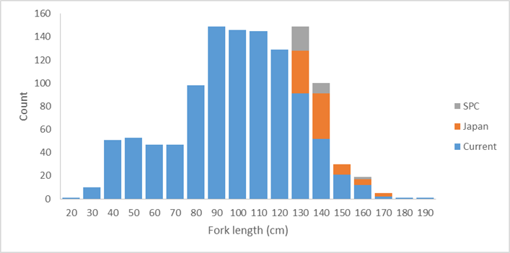  Some of the additional otolith samples are single otoliths and some are pairs. The project would have all of the singles and one of each pair sent to CSIRO for processing and analysis. The 2nd otoliths of the paired samples would be processed and analysed by project partners, and then the results for the same individual bigeye compared. This would likely involved collaborative work at the CSIRO laboratories.  Note that if additional otoliths from the >150 cm groups were provided by other project partners, the number of otoliths in the 130-139 and 140-149cm groups read would be reduced as statistically appropriate to keep the analyses to 125 otolith readings.  The resulting analyses would be reported to SC14.
Assumptions | - The otoliths identified as available by project partners are provided in a timely manner.  - The otoliths provided by project partners, and those from the WCPFC Tuna Tissue Bank are of sufficient quality to be produce readable slides.  - Work to be completed by project partners is finished on time.  - Otoliths from the WCPFC Tuna Tissue Bank will be released without needing to have the research proposal approved by the SC Research Committee.  - CSIRO will undertake the core work and will actively collaborate with the Scientific Services Provider and Japan in the conduct of the analyses.
Scope | This work will:  - Prepare and read an additional 125 otoliths using the annual increment method identified in Farley et al. (2017);  - Revise and update the Farley et al. (2017) age and growth estimates based on the additional data.
Timeframe | 12 months
Budget | US$30,000*  *Note that this covers the CSIRO component of the work, including reading 125 otoliths, preparing a report and travelling to WCPFC SC14 to present the results.
References | Farley, J., Eveson, P., Krusic-Golub, Sanchez, C., Roupsard, F., McKechnie, S., Nicol, S., Leroy, B., Smith, N., and Chang, S-K. 2017. Project 35: Age, growth and maturity of bigeye tuna in the Western and Central Pacific Ocean. SC13-SA-WP-01. Thirteenth regular session of the Scientific Committee of the Western and Central Pacific Fisheries Commission. Rarotonga, Cook Islands, 9-17 August 2017.

PROJECT 82 | Yellowfin tuna age and growth
Objectives | To provide robust age and growth estimates for yellowfin tuna in the WCPO to inform future stock assessments and related analyses.
Rationale | The 2017 yellowfin tuna stock assessment (Tremblay-Boyer et al. 2017) identified that new estimates of age and growth be developed for yellowfin tuna in the WCPO. This recommendation arose given how influential updated growth estimates for bigeye tuna (Farley et al. 2017) proved on that assessment in 2017, noting similarities in the fisheries for those two species. In addition the current assessment model for yellowfin predicts a decline in the selectivity of large fish for longline fisheries, a counter-intuitive result which can occur if the growth is incorrectly specified within the assessment model.  This project would undertake the first comprehensive age and growth study for yellowfin tuna in the WCPO using otoliths. This project represents an area of work not yet pursued in the WCPO. Through Project 35 and 35b, the Tuna Tissue Bank, a range of yellowfin otolith samples have been collected to date (>4000). As for bigeye the limitation is otoliths for very small fish (<30 cm) and for large fish (>140 cm).  SPC (for the WCPFC Tuna Tissue Bank) have identified the available yellowfin tuna otoliths, by size class sampled after 01 January 2014. These unread otoliths, along with additional yellowfin otoliths which Japan has indicated are available for this research, are plotted below with numbers of available otoliths per 10cm size bin. These samples should be adequate to complete a comprehensive and robust study of yellowfin tuna age and growth. It may be useful to seek additional otoliths from larger fish in the WCPO from other project partners.  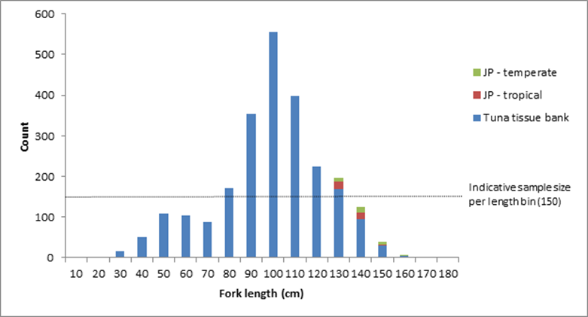  Some of the additional otolith samples from Japan are single otoliths and some are pairs. The project would have all of the singles and one of each pair sent to CSIRO for processing and analysis. The 2nd otoliths of the paired samples would be processed and analysed by Japan, and then the results for the same individual yellowfin compared. This would likely involved collaborative work at the CSIRO laboratories.  Note that if additional otoliths from the >140 cm groups were provided by other project partners they would be incorporated into the analyses in a similar manner, subject to funding.  The project would begin with a preliminary analysis of WCPO yellowfin conducted by CSIRO to determine if the otoliths are suitable for annual age estimation. This study would include an initial reading of otoliths using daily increments to establish annual check marks, followed by an examination of otoliths across the available size range to assess readability. This work would establish a reference otolith set for the rest of the study. At this time no otoliths with chemical check marks for validating age estimates are available. CSIRO and the Scientific Services Provider will collaborate to try and obtain strontium chloride marked otoliths within the life of the project, however it is more likely that these will not be available until after the project is complete. Accordingly, should the preliminary work determine yellowfin otoliths are suitable for a large-scale study (a target of 1500 otoliths across the size range read using the annual method, and 150 using the daily growth increment method, these targets including otoliths read in the preliminary study), a marginal increment analysis will be conducted to support the estimates of age and growth arising from that work.  The project would conduct a preliminary work early in 2018. A small workshop would be conducted during the 2018 PAWS to finalise the approach for the large-scale study. A preliminary report would be provided to SC14. The remaining work would be completed during the remainder of 2018, with a final presentation to SC15 in 2019.
Assumptions | - The otoliths identified as available by project partners are provided in a timely manner.  - The otoliths provided by project partners, and those from the WCPFC Tuna Tissue Bank are of sufficient quality to be produce readable slides.  - Work to be completed by project partners is finished on time.  - Otoliths from the WCPFC Tuna Tissue Bank will be released without needing to have the research proposal approved by the SC Research Committee.  - CSIRO will undertake the core work and will actively collaborate with the Scientific Services Provider and Japan in the conduct of the analyses.
Scope | This work will:  - Conduct a preliminary analysis of the suitability of yellowfin tuna otoliths for providing robust estimates of age and growth;  - Develop a reference collection and protocols for reading daily and annual growth checks in yellowfin tuna otoliths;  - Prepare and read 1500 otoliths using the annual increment method;  - Prepare and reading 150 otoliths using the daily growth increment method;  - Undertake a marginal increment analysis to support the age and growth estimates;  - Report estimates of age and growth for yellowfin tuna to WCPFC SC15.
Risks | Note that due to the generally tropical distribution of yellowfin tuna, and the available otoliths, this study may need to be halted after the preliminary investigations. Should that occur, the report to SC14 will provide an opportunity to review next steps for developing robust estimates of age and growth for yellowfin tuna in the WCPO.
Timeframe | 24 months
Budget | 2018 USD$100,000  2019 USD$85,000  *Note that this covers the CSIRO component of the work, including reading 1650 otoliths, preparing two reports, travelling to the PAWS in 2018 and to WCPFC SC14 and SC15 to present the preliminary and final results. It does not cover costs of any project partners.
References | Tremblay-Boyer, L., McKechnie, S., Pilling, G., and Hampton, J. 2017. Stock assessment of yellowfin tuna in the Western and Central Pacific Ocean. SC13-SA-WP-06. Thirteenth regular session of the Scientific Committee of the Western and Central Pacific Fisheries Commission. Rarotonga, Cook Islands, 9-17 August 2017.  Farley, J., Eveson, P., Krusic-Golub, Sanchez, C., Roupsard, F., McKechnie, S., Nicol, S., Leroy, B., Smith, N., and Chang, S-K. 2017. Project 35: Age, growth and maturity of bigeye tuna in the Western and Central Pacific Ocean. SC13-SA-WP-01. Thirteenth regular session of the Scientific Committee of the Western and Central Pacific Fisheries Commission. Rarotonga, Cook Islands, 9-17 August 2017.

PROJECT 83 | Investigating the potential for a WCPFC tag research vessel
Objectives | To explore the costs and benefits of the permanent use of an adaptable research vessel dedicated to the collection of the data used in tuna stock assessment in the WCPO.
Rationale | - Rationale for project  - General  More than 70% of the global tuna catch are fished in the Pacific Ocean for an estimated value of over US$6 billion. The harvesting level of tuna resources and the efficiency of the involved industrial fleet henceforth impose a very responsive management mode. The management measures need to be supported by strong evidence based on high quality data allowing stock assessment containing a minimum of uncertainty. The data obtained independently from the fishing fleets have become essential and the science based management bodies have the responsibility to support their analysis with the best scientific evidence available. This requires a continuous acquiring of mortality rates for the impacted species, a detailed knowledge of their biology, along with their behaviour in response to fishing gears and in response to the variations in their environment. Assessing the fishing impact on the whole ecosystem requires collecting data on all the species living in association with tuna and tuna-like species, data about their prey and the pelagic ecosystem. The collection of all this information requires the permanent use of an adaptable research vessel properly designed for the purpose. There are currently no suitable tuna research vessels available in the region (or beyond).  Concurrently the fleet of vessels available to charter for research, especially in pole and line fisheries, are becoming increasingly difficult to procure or no longer meet standards necessary for the conduct of research (PTTP Steering Committee, 2018).  Accordingly it is increasingly urgent to carefully explore the permanent use of an adaptable research vessel dedicated to the collection of the data used in tuna stock assessment.  - SC 13 and SC 14  At SC13 the PTTP Steering Committee considered the issue of the availability of suitable tagging vessels, especially for pole and line based research, at its 11th meeting during SC13. The PTTP Steering Committee endorsed the proposal outlined in SC13-RP-P42-02 Appendix II and recommended that SC13 support an assessment of the cost-effectiveness of acquiring a dedicated tagging vessel (SC13-RP-P42-01). The 2018 report of the PTTP highlights the increased urgency of conducting this work (SPC-OFP 2018), especially given not only the increasing costs, but also the difficulty in securing a suitable vessel for charter in the region. At SC14 the PTTP Steering Committee recommended to SC14 that the priority of this work be increased to high.  - Current availability of suitable research platforms  - For tagging experiments  Tagging studies are commonly used in fisheries research to improve estimation of animal population size, mortality, movement (spatial stock structure) and growth. Until now, large scale tuna tagging campaigns for skipjack tuna have chartered medium-size commercial fishing boats around 200 GT tonnage (199 GT for last PTTP, 237 GT for IOTP) for cost reasons, and also due to size restrictions on bait ground access and restricted suitable anchorage in some areas. Releasing a large number of conventionally tagged tuna implies the use of a pole-and-line vessel, but suitable such tagging platforms are becoming increasingly scarce worldwide. In most countries, pole-and-line fleets have been replaced by purse-seine fleets.  Research cruises more orientated towards electronic tagging and targeting all size tuna and their associated species need a more polyvalent tagging platform that could deploy a large variety of fishing gears (e.g. horizontal and vertical longlines, troll lines, danglers, and rod and reel). Catching and handling large size fish requires a working deck with easy access to the sea and a boat with high manoeuvrability facilitated by steering commands located at the working deck level. For example, the design of a standard Japanese pole and line vessel is not suitable for the purpose.  In the Pacific, some longline type fishing boats have been used to target the tuna schools that are associated with floating objects, mainly the oceanographic buoys (TAOs) that are anchored along the equator and the drifting FADs used by the purse seine fleet. The distances involved between floating objects and from ports with appropriate facilities for deploying a research voyage require the use of long-range (> 6,000 nm) platforms which are not common in the region for the necessary size of fishing vessels for successful research.  - For collecting ecosystem biological and physical data  This necessitates the use of gears that are usually not found on a commercial tuna fishing vessel, including : trawling nets to catch tuna prey and plankton size organisms, CTDs to collect sea water temp/depth profiles, and multi-beam echo-sounders that can manage continuous records of highly detailed bio-acoustic data.  Boats used in this type of research are typically from the oceanographic vessel category. They are usually linked to governmental scientific institutes. To operate the different types of gears used at an ocean wide scale, those vessels need to be large (>400 GT). To cover important operational and maintenance costs, their use is often shared between multidisciplinary research projects. Their availability is therefore limited, subjected to utilisation applications that need to be planned years in advance.  - Arguments for the construction of a new multipurpose platform dedicated to tuna research:  - Practicality:  - Tuna tagging data are likely to become increasingly important and need to be collected continuously rather than episodically. Other types of data need to be continuously collected to monitor the ecosystem changes.  - The pole and line vessels that can currently still be chartered are disappearing along with the associated fisher knowledge on operations and bait grounds. These platforms cannot cover all the different data collection needs.  - The global applicability of continuous data collection is likely to facilitate collaboration between the different tuna commissions (RFMOs). The cumulated needs at the Pacific scale could probably cover most parts of the yearly schedule of a single boat.  - A crew specifically recruited and trained to the specific research methods and strategies will be more capable than a commercial fishing boat crew that often need a long training period before they become fully efficient.  - Cost:  - Continuous research would avoid the substantial establishment costs needed each time a new programme is started.  - Some examples:  - Previous recent charter costs, including fuel, for a long range tuna tagging platform (about 200GRT) were situated between 150,000 and 200,000 USD/month. The WP4 charter cost jumped to over 420,000 USD/month. Recent enquiries to utilise vessels from the north Pacific suggest considerably higher costs.  - The total tagging platform charter costs spent during each of the last large tagging projects (PTTP and IOTP) is over the current estimated cost for building a new boat of around 35 metres/200GRT (Between 5 and 8 USD millions, IOTP vessels were built at about 4 USD millions in 2000). Last estimation for the currently running (2017) AOPT total charter cost is 9.1 million Euro (ICCAT, SCRS/2014/092).  - A pre-assessment of some of the operational costs of an appropriate platform that could be built to address all the tuna research needs for the Pacific Ocean has been provided to SPC by F&S, a consultancy office specialized in the fisheries sector. That work would be available to this project.
Scope | The project would assess the full range of operational costs, including options on governance, inter-RFMO vessel sharing, multiple research modes, and future vessel replacement. These costs should be compared with the costs and benefits of the current approach. However, the current approach is not sustainable so the cost benefit analysis will need to consider alternate benchmarks in combination with the current approach.  The scope of work includes undertaking this assessment utilising suitable external experts. A report will be prepared and provided to SC15 for its consideration.
Timeframe | Start early 2019, completed by late 2019
Budget | 2019 USD$95,000  *Note that this covers the cost of the external consultancy/consultancies (60 days) and reporting of the project outcomes to SC. It is also includes travel to the various locations that will be required to review some of the available vessels. The Scientific Services Providers input to the project will be provided as in-kind support.
References | PTTP Steering Committee. 2017. Report of the Pacific Tuna Tagging Programme Steering Committee. SC13-RP-PTTP-01. Thirteenth regular session of the Scientific Committee of the Western and Central Pacific Fisheries Commission. Rarotonga, Cook Islands, 9-17 August 2017.  PTTP Steering Committee. 2018. Report of the Pacific Tuna Tagging Programme Steering Committee. SC14-RP-PTTP-01. Fourteenth regular session of the Scientific Committee of the Western and Central Pacific Fisheries Commission. Busan, Korea, 8-17 August 2018.  SPC-OFP. 2017. Project 42: Pacific Tuna Tagging Project Report and Workplan for 2017-2020. SC13-RP-PTTP-02. Thirteenth regular session of the Scientific Committee of the Western and Central Pacific Fisheries Commission. Rarotonga, Cook Islands, 9-17 August 2017.  SPC-OFP. 2018. Project 42: Pacific Tuna Tagging Project Report and Workplan for 2018-2021. SC14-RP-PTTP-02. Fourteenth regular session of the Scientific Committee of the Western and Central Pacific Fisheries Commission. Busan, Korea, 8-17 August 2018.

PROJECT 84 | Shark Research Plan mid-term review
Objectives | Review the WCPFC Scientific Committee’s 2016-2020 shark research plan, to evaluate progress against the plan and assess future needs for shark research relevant to management of the WCPO shark stocks.
Rationale | The first Shark Research Plan (SRP) covered 2010-2014. At its Tenth Session the Scientific Committee (SC10) agreed in 2014 on a programme of shark work for the Scientific Service Provider (SSP). This work was to be carried out in 2015, and included that the SSP draft a new SRP for consideration by SC11 to cover work in 2016-2020. This project will evaluate progress against that plan and consider the future shark information needs of the WCPFC.  This work will also evaluate the progress against and need for the original SRP components:  - Phase 1: assessments to be undertaken with existing and available data;  - Phase 2: coordination of research efforts to supplement biological and other assessment related information; and  - Phase 3: improvement of data from commercial fisheries.
Assumptions | SPC or another regional body has the personnel and budget available to undertake this work.
Scope | While this document will focus on the WCPFC key shark species, other elasmobranchs will be considered as required.
Budget | 0.3 FTE

PROJECT 85 | Participation in ISC North Pacific shortfin mako shark stock assessment activities
Objectives | Contribute to and learn from ISC work toward revising the North Pacific shortfin mako shark stock assessment, thereby aiding methods development for other WCPO shark stocks.
Rationale | - The ISC will be working toward an assessment of the North Pacific shortfin mako in 2017-2018 with an aim to complete it by July 2018  - The ISC assessment would benefit from the contribution of additional shortfin mako observer data (catch rates and total removals) in the North Pacific  - Participation in this collaborative stock assessment may lead to the development of new methods and/or new data insights for a future South Pacific shortfin mako assessment  - Cooperation between the WCPFC and its Northern Committee could be strengthened
Assumptions | - If SPC were available to participate, it would contribute its shortfin mako data holdings  - If the Secretariat or ABNJ participates, fewer data can be contributed due to data confidentiality rules  - ISC is able and willing to incorporate these contributions to its work  - ISC meetings avoid scheduling conflicts with other work
Scope | Available WCPO data would be compiled, formatted and analysed to produce data products that could be contributed to ISC Shark Working Group (SWG) meetings (no raw data would be contributed; this is similar to the contributions of ISC member countries). Data to be prepared would depend on needs identified by the ISC SWG but would be expected to include catch rate indices, catch estimates, effort statistics and/or biological data. It is assumed that participation in two ISC SWG meetings would be required (the FTE estimate is intended to account for both time and travel costs). These have tentatively been scheduled for November 2017 in Japan (data preparation meeting) and March-April 2018 in La Jolla (assessment meeting). Total time input including data handling and analysis, ISC SWG meetings and other tasks, and report review is estimated at ~2.5 months.
Budget | 0.2 FTE

PROJECT 86 FAD Project #1 | FAD designs to reduce unwanted interactions with Species of Special Interest (SSIs; sharks, turtles)
Objectives | Identify FAD design features that lead to lower interaction rates with key SSIs, while minimising the impact on catches of target tuna species
Rationale | - Builds upon work in all other Oceans on the design of lower- and non- entangling FADs (e.g. WCPFC-2016-FADMgmtOptionsIWG02-OP02; SC13-EB-WP-02).  - Builds upon work by organisations such as ISSF in the development of SSI-friendly designs.  - Provides region-specific information on the efficacy of SSI reduction and impacts on tuna catch levels in the WCPO.  - Provides a scientific basis for potential CMMs in this area.  - Given concerns of FAD beaching on reefs and shorelines, could also contribute to studies of appropriate biodegradable FAD materials.
Assumptions | - The information provided in SC13-EB-WP-02 is considered by SC13 to provide insufficient evidence of the potential effectiveness of non- entangling designs in the WCPO, and hence local trials are needed. Note that if SC13-EB-WP-02 is considered by SC13 to provide sufficient evidence, this project should be revised to focus on extension, to ensure rapid uptake and deployment of non-entangling FAD designs, and to ensure the cost effectiveness of those designs for all WCPO fleets, in particular those domestic fleets of PICTs.  - The relationship between design and SSI interactions can be gained through tracking FADs from construction, through deployment, to setting activity by any fleet, and SSI interactions.  - If tracking is not possible, the regular removal of a set-upon FAD from the water can be undertaken so observations of its sub-surface structures and the occurrence of captured SSIs can be made.  - Periodic removal of tracked designs may also be necessary to identify changes over time (e.g. unravelling of bound netting, degradation of components).  - A coordinated trial of designs, in collaboration with industry, is suggested as the most efficient approach. Cost, material availability and environmental impact would be key factors in assessing the merit of various designs.  - Sufficient data are available across different designs and locations to allow statistical analyses to be effective.  - Where specific field trials are undertaken, they might be able to be performed at the same time as trials required under FAD project #2 to create cost efficiencies.
Scope | Through review of existing studies and best practices in other oceans (see SC13-EB-WP-02) identify plausible non-entangling FAD designs, in collaboration with industry. This should include sub-FAD structure depth and mesh size, removal of netting on the surface of FADs and alternative platform widths.  Implement at-sea FAD trials across the WCPO [deployment and fishing activity] to be completed within 18 months. This will most effectively be performed in partnership with observers and industry to ensure marking, deployment and monitoring of FADs in a coordinated way. Two levels of industry participation are anticipated: (1) the fleets that deploy the FADs and are actively engaged in the research. (2) All other fleets that find the FADs from (1) and set upon them. Information from (2) will be critical to the success of the research.  Using ISSF Technical Report 2016-18A as a guide:  - Fleets deploy a given number of FADs per vessel (e.g. 10-20 FADs per vessel to reach a significant large number of FADs).  - Maximum 4 standardized designs tested, constructed in port and deployed in the same area as traditional FADs, so their effectiveness could be compared with that of the traditional FADs for the same spatial and temporal strata.  - Deployment site, design and the code of the geo-locating buoy should be registered. Every FAD should be well identified so that data can be retrieved and followed if ownership changes.  - If a trial FAD is encountered at sea register: the catch (if any), interactions with SSI, the condition of the FAD and the new code for the buoy if the original has been replaced.  - Where possible, use trajectories and sounder of attached buoys to assess ability of alternative designs to aggregate tuna even if they are not visited or fished by purse seiners, as well as following their lifetime if they are not retrieved.  - Collaboration between industry, related parties, and the scientific services provider to collect and analyse data.  - Collaborate with industry to identify the cost of alternative FAD designs relative to ‘standard’ designs.  Analysis of results should be presented to WCPFC SC (approximately 2 years after the trial begins). SC and TCC of that year to provide recommendations for a draft CMM on appropriate FAD designs.
Links to other work | The IATTC and ISSF have done considerable work on the design of non- entangling FADs (see SC13-EB-WP-02).
Timeframe | 24 months
Budget  Note: Costed on a fieldwork required basis. If project is extension related (i.e. Trials of designs not  required on the basis of SC13-EB-WP-02 findings), project budget will need to be revised | 1 year FTE at SPC (data analysis)  1.5 year FTE at SPC (technical and fieldwork, travel) Project management  Observer training  Approximate total budget: US$446,000*  Note overlap with Project #2 – if both are undertaken concurrently then some personnel costs can be ‘shared’ across the two projects. (Approximate total budget if Projects 1 and 2 undertaken simultaneously:  $871,000)  *Final costings will depend on the approach undertaken within at-sea trials, including the level of practical and financial contribution by industry. Note this will need to include the purchase of necessary FAD materials, including marking and tracking components, facilitation of liaison with industry representatives, and any related travel.
Additional considerations | This project will necessitate additional data collection by fisheries observers, irrespective of whether it relates to additional trials, or, extension. This has consequence for forms, data management and observer training.  If FADs are not able to be tracked from markings or similar, this research will require fishers to lift all FADs for descriptions to be made (there are other technical solutions such as camera ROVs and/or research divers however they are likely overly costly).  Understanding the vertical behaviour of silky sharks at FADs within the WCPO would help inform how deep the FAD underwater structure should be checked.  This project if it proceeds to extension/implementation will have direct costs for fishers with the lifting of existing FADs require to update them with non- tangling designs. Obviously the period of implementation will determine if this occurs faster or slower than the normal frequency of lifting, and hence the incurred cost.

PROJECT 87  FAD Project #2 | FAD designs to reduce unwanted catches of juvenile bigeye and yellowfin tuna
Objectives | Identify any FAD design features that lead to lower catch rates of undersized/juvenile bigeye and yellowfin tuna, while minimising the impact on catches of larger target tuna species.
Rationale | - Builds upon trials underway in the IATTC area in collaboration with ISSF, but given oceanographic differences between regions WCPO trials may be required if designs in IATTC area focus on depths shallower than the WCPO thermocline depth.  - Represents an area of work not yet pursued in the WCPO that could provide a simple management intervention to reduce FAD impacts.  - Builds upon EU-funded work identifying factors influencing BET hotspots.  - Provides a scientific basis for potential CMMs in this area.  - Two key and related FAD design features may influence undersized/juvenile bigeye and yellowfin mortality: depth of the FAD, and its speed of drift.
Assumptions | - BET hotspot analyses provide some indication of potential FAD characteristics that can be examined within this project.  - Can relate the design of FADs noted by observers and/or others directly to subsequent fishing sets that have reliable catch composition estimates.  - A coordinated trial of designs, in collaboration with industry, is suggested as the most efficient approach. Cost and environmental impact would be key factors in assessing the merit of various designs.  - Periodic removal of tracked designs may also be necessary to identify changes over time (e.g. change in the depth of the structure or unravelling of bound netting, degradation of components that might modify drift speed).  - Sufficient data are available across different designs and locations to allow a statistical analysis to be performed.  - Where field trials are required, they could possibly be performed at the same time as trials required under FAD project #1 to create cost efficiencies.
Scope | While Project #1 benefits from existing activities and research in other oceans, the background on FAD designs to reduce juvenile tuna catch is less mature. However, the proposed scope is comparable to that proposed for Project #1.  Use relevant results from the BET hotspot analyses and from information available from ISSF studies in the IATTC area, and in collaboration with industry, identify plausible FAD designs to trial.  Implement at-sea FAD trials across the WCPO [deployment and fishing activity] to be completed within 18 months. This will most effectively be performed in partnership with industry and observers to ensure marking, deployment and monitoring of FADs in a coordinated way. Two levels of industry participation are anticipated: (1) the fleets that deploy the FADs and are actively engaged in the research. (2) All other fleets that find the FADs from (1) and set upon them. Information from (2) will be critical to the success of the research.  Understanding how the real working depth of sub-surface FAD structures interacts with oceanographic features during the period of the drift, and the resulting influence on species biomass and catch will be important. Equipping FAD sub-surface structures with depth/temperature sensors, which are tracked for the duration of a scientific trip and retrieved, regularly feed-back information, or pop off the FAD after a given period, should be used.  Using ISSF Technical Report 2016-18A as a guide:  - Fleets deploy a given number of FADs per vessel (e.g. 10-20 FADs per vessel to reach a significant large number of FADs).  - Maximum 4 standardized designs tested, constructed in port and deployed in the same area as traditional FADs, so their effectiveness could be compared with that of traditional FADs for the same spatial and temporal strata.  - Deployment site, design and code of the geo-locating buoy should be registered. Every FAD should be well identified so that data can be retrieved and followed id ownership changes.  - If a trial FAD is encountered at sea, register: the catch (if any), the condition of the FAD and the new code for the buoy if the original has been replaced.  - Where possible, use trajectories and sounder of attached buoys to assess ability of alternative designs to aggregate tuna even if they are not visited or fished by purse seiners, as well as following their lifetime if they are not retrieved.  - Collaboration between industry, e.g. ISSF and the scientific services provider to collect and analyse data.  - Collaborate with industry to identify the cost of alternative FAD designs relative to ‘standard’ designs.  Analysis of results should be presented to WCPFC SC (approximately 2 years after the trial begins). SC and TCC of that year to provide recommendations for a draft CMM on appropriate FAD designs.
Links to other work | Note that due to the nature of the thermocline in the WCPO and the impact of the thermocline on tuna behaviour, in particular for bigeye tuna, results from the EPO may not be of specific use in the western or central WCPO.
Timeframe | 24 months
Budget | 1 year FTE at SPC (data analysis)  1.5 year FTE at SPC (technical and fieldwork)  Associated travel and subsistence to relevant WCPFC meetings Project management  Observer training  Approximate total budget: US$526,000*  Note overlap with Project #1 – if both are undertaken then some personnel costs can be ‘shared’ across the two projects. (Approximate total budget if Projects 1 and 2 undertaken simultaneously:  $871,000)  * Final costings will depend on the approach undertaken within at-sea trials, including the level of practical and financial contribution by industry. Note this will need to include the purchase of necessary FAD materials, including marking and tracking components, temperature/depth sensors, facilitation of liaison with industry representatives, and any related travel.
Additional considerations | This project will necessitate additional data collection by fisheries observers, irrespective of whether it relates to additional trials, or, extension. This has consequence for forms, data management and observer training.
The field work component of this research may require additional data collection on catch composition for specific sets from a trip (with the catch kept separated and subject to a census in port).

There may be the potential to geo-fence FADs used in these trials with special requirements around reporting and access to enhance the data collected.

PROJECT 88  FAD Project #3 | Acoustic FAD analyses
Objectives | Identify whether limiting sets to only those FADs that have a large biomass beneath them can reduce the proportion of ‘non-target’ species caught.
Rationale | - Larger purse seine sets on FADs tend to have higher proportions of skipjack and commensurately lower proportions of yellowfin and bigeye (Lawson 2008, WCPFC-SC-4-ST-WP3).  - Acoustic data from echo-sounder buoys can provide, given sufficient equipment, environmental conditions and interpretation skills, sufficient information on the biomass of tuna under a FAD.  - Acoustic information has shown promise for discriminating skipjack from other species, if not yet routinely using commercial fishing equipment. However, there is a need to identify signals that discriminate other species within the WCPO, building on existing work by ISSF in this area.  - Acoustic information has also suggested some ability to differentiate fish sizes.  - The acquisition of acoustic FAD data has the potential to provide insight into dynamics of the interaction between tuna and FADs.  - Information could inform FAD design options, FAD deployment, remote identification of size and abundance of tuna under echo-sounder- equipped FADs, and spatial management considerations.  - Incentivising limiting setting activity to only FADs with large biomass could reduce the proportion of non-target species caught.  - In addition, acoustic FAD data could provide ‘ground truthing’ for the effective soak time of FADs, stock assessment biomass estimates (see SC12-SA-IP-14), FAD density effects on movement and catch rates of target spp.
Assumptions | - There is a consistent relationship between biomass levels on FADs and tuna species composition across the WCPO, as indicated in Lawson (2008), SC14-ST-WP3.  - Biomass can be accurately assessed through acoustic buoys, noting that it depends on the equipment used, environmental conditions and the interpretational skills of the user.  - Existing acoustic information can be made available for analysis, combined with sufficient information to relate that information to a setting event.  - Target strength information from other studies is sufficiently robust and comparable to that in the WCPO that it can be used directly.  - The analysis can be undertaken over sufficient space/time to ensure any influences of those factors can be examined statistically.
Scope | The scope of work is divided into three stages. The ability to undertake the second stage will depend on access to existing data, in particular acoustic biomass estimates, and the ability to relate set-level events to FAD-specific acoustic data.  Stage 1. Examination of existing data to investigate the relationship between total biomass/catch and the proportion of small bigeye/yellowfin Based upon existing combined logsheet/observer data from FAD sets, investigate the relationship between total biomass/catch size and the degree of small bigeye/yellowfin, both spatially and temporally within the WCPO. Based upon these analyses, identify the level of definition required by echo-sounder buoys to render this strategy effective.  In addition, review available information on the vertical behaviour of individuals of different sizes relative to e.g. thermoclines, to examine whether a depth layer can be used to discriminate between species/sizes.  Stage 2. Examination of existing (historical) observer-based FAD set data and echo-sounder buoy data  Where data are available to link an observed FAD set event to acoustic information, compare the most appropriate set-level overall catch and corresponding species composition to available acoustic information. Where data allow, further compare to relevant operational factors (e.g. location, FAD and vessel information, regional FAD density, etc.) to identify potential relationships.  Stage 2. Undertake at-sea experimental fishing trials to identify effective acoustic equipment and operational approaches  In collaboration with industry, and building on outputs from Stages 1 and 2, design and implement a limited fishing trial of current and alternative cutting-edge acoustic gear/settings (e.g. multi-frequency) to obtain acoustic information on FAD-associated tuna biomass and species/size composition, and related fishing trials to ‘ground-truth’ that information based upon resulting catches. Gaining target strength measurements for single schools (in particular of yellowfin) will be particularly important. Trials should be sufficiently extensive to examine the influence of spatial and potentially oceanographic factors.  Analyses of results from each stage should be presented to WCPFC SC for scientific review and where relevant for the consideration of advice to TCC and the Commission.
Timeframe | Approximately 36 months (see below)
Budget | Stage 1  1.5 year FTE at SPC USD$182,000  Associated travel and subsistence to relevant WCPFC meetings USD$10,000  Stage 2  Not costed at this time. It is likely to be on the scale of project one or two, but there may be some other cost savings to be made by incorporating some fieldwork into the 2018 or 2020 tag research voyages.
Additional considerations | If this proceeds to a fieldwork stage, additional input on the design of the at-sea component should include consideration of concurrent data collection in the context of tuna foraging and links to ecosystem modelling (e.g. SEAPODYM).

PROJECT 89  FAD Project #4 | Fleet behaviour
Objectives | Characterisation of effort creep due to FAD use and fleet specific factors resulting in large catches of ‘non-target’ species.
Rationale | - Understanding how rapid developments in FAD technology and their use within the WCPO can influence FAD-related catch rates will provide additional information for key stock assessments and the harvest strategy approach, and scientific advice that can inform discussions under future tropical tuna CMMs.  - Analyses will complement activities currently underway on PNA FAD tracking and those undertaken through the EU-funded ‘BET hotspot’ analysis presented to SC13.
Assumptions | - Sufficient data on FAD design and technology are available for analysis.  - Sufficient time series of data are available to support analyses.  - Information is sufficiently detailed and accurate to allow analyses to be performed.  - Fishing sets can be related to specific FADs and associated FAD/vessel technological information.  - Fleet behaviours that influence fishing performance can be understood.  - The effort creep component of improved FAD technologies can be separated from other elements (schooling behaviour of fish, overall fleet behaviour, stock size, oceanography, other technological advances etc.).
Scope | The proposed work programme comprises a data compilation activity, subsequent statistical analysis activities and a data review activity. These are briefly outlined below:  Evaluate and combine available logsheet, observer and VMS data to develop a comprehensive purse seine associated fishing data set. This data set should also include available (time series of) vessel and technical FAD characteristics, where possible.  Analyse patterns of fleet activity relative to FAD setting based upon VMS/logsheet data, to assess changes in vessel searching activity, as well as trip length. This may also be compared within and outside the FAD closure period, and be related to location (e.g. distance from port), time of the year/day, the period of the trip, etc.  Examine changes in the ‘reliance’ on FAD fishing over time, at the fleet or vessel level. Relate the reliance on FADs to geographic location.  Analyse using appropriate statistical techniques factors that could influence time series or relative patterns in purse seine associated set CPUE (catch per set, but catch per day or trip may also be examined), including fleet, location, oceanography, FAD set density (as a proxy for FAD density), observed FAD design, vessel characteristics, stock abundance, etc. This may evaluate the probability of a successful set, as well as the level of catch if a set were successful.
Identify data gaps and provide advice on potential areas of additional data collection to improve future analyses.

Where observer information is sufficient, work will also examine the number and activities of supply vessels, including identifying which particular purse seine vessels each support, and the number of FADs being deployed and serviced by such vessels.
Timeframe | 18 months
Budget | 1.5 year FTE at SPC USD$182,000  Associated travel and subsistence to relevant WCPFC meetings USD$20,000

PROJECT 90 | Better data on fish weights and lengths for scientific analyses
Objectives | This project has three objectives  The first component aims to identify gaps, address those gaps which can be resolved with existing information, and develop the sampling plan and protocol to resolve additional gaps, through the following activities (but not limited to):  - identify the priority gaps in conversion factor data for the WCPFC key tuna species, key shark species, and key billfish species  - expand the conversion factors to cover the WCPFC key shark species for groups: mako, thresher and hammerhead shark, after gap analysis against existing conversion factors  - produce a list of species of special interest (SSIs, excluding key shark species) that require conversion factor data  - produce a list of commercially important bycatch species (not covered in the items above)  - include more information on source of data for each conversion factor (e.g. reference of study, sample size, R2, minimum/maximum size of sample, etc.) in tables of conversion factors which will inform the need for more data collection  - produce a list of the remaining bycatch species that require conversion factor data  - produce standard protocols for conversion factor data collection to be collected by observers and port samplers,  - prioritize this list so that the most important work is achieved, and  - present the findings at SC15 for review, acknowledging that some observer providers will voluntarily collect conversion factor data prior to SC15.  The second component relates to investigating potential innovative methods to obtain length-length conversion factor data, including:  - explore the use of EM tools to capture multiple length measurements from fish e-measured by EM Analysts.  The third component relates to collecting the conversion factor data:  - systematically collect representative samples of length measurements of bycatch species support future estimation of fish bycatch in the WCPO; and  - systematically collect length:length, length:weight and weight:weight data on all species to better inform future estimation of fish bycatch in the WCPO.
Note | Although these three objectives are distinct, they have been combined into a single project to avoid any possible duplication of effort and, as there will likely be combined tasking of Pacific Island observers and port-samplers, in future data collection arising from the project.  The project acknowledges that flag state CCMs with national port sampling and observer programmes may also want to collect conversion factor data using the standard protocols established under this project; these initiatives would be an invaluable contribution to the project.  The project will also involve the work in transferring the conversion factor information compiled from other sources, such as the information presented in Clarke et al. (2015) Report of the Pacific Shark Life History Expert Panel Workshop, 28-30 April 2015; SC11-EB-IP-13, and conversion factor data compiled from the Australia domestic longline fishery.  Project 90 implementation acknowledges that issues of observer safety, overall workload and work conditions are paramount. The development of the data collection protocols for conversion factor measurements through observers should take into account the challenges with on-board observer activities, including, but not limited to;  - Potential difficulty in measuring large specimens on small boats;  - Evaluating the feasibility of weighing fish at sea. For example, consideration of the following:  - Ensure any weighing equipment does not hinder the fishing operation.  - Simplifying the process of any onboard weight measurements;  - To what extent the assistance of the crew will be expected, and  - Avoiding duplicate weighing of specimens by keeping and weighing removals.  - Note that any sharks which fishers are not allowed to retain will not be in the observer protocol for this project.
Rationale | Estimates of bycatch are currently collected through the ROP in units of number, weight or both. In order to convert from numbers to weight, and vice versa, it is necessary to have information on both the size of caught individuals, and appropriate length:weight relationships for the species in question. This conversion between numbers and weight allows analyses of bycatch data to use the full observer dataset, rather than a subset with a consistent unit of measurement, therefore maximising the utility of the bycatch data recorded by observers. Furthermore, bycatch length data allows for consideration of the life-stages of individuals. This information could be of particular interest when considering bycatches of SSIs. There are currently insufficient, or unrepresentative, length samples for species caught in purse seine and longline fisheries, with the exception of bigeye, yellowfin and bigeye in purse seine catches, which are sampled through observer grab samples. This project would fill this data gap.  At least SEVEN (7) Pacific Island member countries with observer programmes have expressed interest in participating in conversion factor data collection, as long as funding support is available to cover any reasonable request for the additional work required by observers and port samplers.  Accordingly, this project addresses objectives arising from discussions at SC13 about the results of regional estimates of purse seine and longline bycatch (Peatman et al., 2017; Peatman et al., 2018a; Peatman et al., 2018b). As a result of the discussions in 2017, SC13 recommended that the Scientific Services Provider be tasked with:  - designing and co-ordinating the systematic collection of representative samples of length measurements of bycatch species; and  - a project to design and co-ordinate the systematic collection of length:length, length:weight and weight:weight data on all species to better inform bycatch estimation.
Assumptions | Achievement of the objectives is subject to the following assumptions:  - sufficient data are available to support the sampling design analyses;  - sampling designs can be developed which are statistically robust and would support future estimation of fish bycatch in the WCPO;  - current observer equipment (e.g. callipers) is suitable for the length sampling protocols;  - suitable and cost-effective equipment can be sourced for robust weight data collection;  - data collection can be integrated into existing sampling events in-port and at-sea;.  - resources are available within selected countries to undertake this work; and  - the sub-regional DCC observer conversion factors form will be the basis for data collection.
Scope | The proposed work programme comprises:  - data compilation activities;  - subsequent statistical analysis activities to design future sampling approaches;  - evaluation of designs for practical field application;  - trials of selected sampling approaches in the field along with trials of equipment required to complete the sampling designs;  - finalisation of future sampling protocols;  - development of associated training standards;  - incorporation of training into trainer trainings and biological sampling trainings as required;  - ongoing co-ordination of sample collection and data submission; and  - reporting on designs and progress with implementation and data collection.  It is intended that a preliminary report would be prepared for SC15 and a more comprehensive report for SC16 and a final report at SC17.
Timeframe | 33 months (from January 2019 through September 2021)
Budget | 2019 US$60,000  2020 US$30,000  2021 US$20,000  Note that this funding is intended to cover the work of the Scientific Services Provider in the design and co-ordination of this work. This will cover the analytical components identified in the scope of the project. It will also cover trials of methodologies identified at-sea and in-port.  The funding in 2019 includes the costs to cover the additional work for selected observers from some observer providers, which will inform the process for refining the budget for this project in subsequent years.  The 2019 funding also includes the costs to investigate and purchase 1-2 weighing devices in the initial implementation phase.  It does not cover the costs of CCMs in implementing the protocols or the purchase of related equipment. This will require co-funding or additional funding depending on the designs selected in the design and testing phase and may require additional requests for funding from SC15.
References | Peatman, T., Allain, V., Caillot, S., Williams, P., and Smith, N. 2017. Summary of purse seine fishery bycatch at a regional scale, 2003-2016. SC13-ST-WP-05. Thirteenth regular session of the Scientific Committee of the Western and Central Pacific Fisheries Commission. Rarotonga, Cook Islands, 9-17 August 2017.  Peatman, T., Bell, L., Allain, V., Caillot, S., Williams, P., Tuiloma, I., Panizza, A., Tremblay-Boyer, L., Fukofuka, S., and Smith, N. 2018a. Summary of longline fishery bycatch at a regional scale, 2003-2017. SC13-ST-WP-02. Fourteenth regular session of the Scientific Committee of the Western and Central Pacific Fisheries Commission. Busan, Republic of Korea, 8-16 August 2018.  Peatman, T., Allain, V., Caillot, S., Park, T., Williams, P., Tuiloma, I., Panizza, A., Fukofuka, S., and Smith, N. 2018b. Summary of purse seine fishery bycatch at a regional scale, 2003-2017. SC13-ST-IP-04. Fourteenth regular session of the Scientific Committee of the Western and Central Pacific Fisheries Commission. Busan, Republic of Korea, 8-16 August 2018.

PROJECT 92 | Testing the performance of alternative stock assessments approaches for oceanic whitetip shark.
Objectives | Undertake quantitative stock assessments of WCPO oceanic whitetip shark to evaluate the performance of a variety of less data-demanding assessments approaches in comparison to a full, integrated, age-structured assessment model (such as MFCL or SS3). The project will provide:  - A stock assessment of WCPO oceanic whitetip shark for the purposes of generating management advice.  - An evaluation of alternative assessment approaches that have potential application to other key shark species with less data.
Rationale | The Western and Central Pacific Fisheries Commission Scientific Committee has had a number of low information assessments of sharks but is has been difficult for members to interpret these results without a comparison to a known baseline. Undertaking both high and low-information assessments simultaneously on the same species may provide members with a better understanding of how full integrated age-structured assessment results can be compared to the results of less data-demanding assessments.
Assumptions | - Much of the existing fisheries and biological data are readily available.  - Assessment personnel are available to undertake this work
Scope | Reviewing the previous shark assessments in the WCPO and North Pacific to assess and improve on methods to increase the understanding of data strengths and weaknesses, and update stock status. Update WCPO longline and purse seine catch estimates and abundance indices using recent observer data.  Undertake a quantitative stock assessment on WCPO oceanic whitetip shark to assess the level of F (fishing mortality) and B (biomass) trends for this species. The analysis should present the stock status in terms of common WCPFC quantities of management interest such as F/F_{MSY}, SB/SB_{MSY} and SB/SB_{F=0} ratios, fishing mortality, (SPR) spawner per recruit, yield and biomass.  Undertake less data-demanding assessments of WCPO oceanic whitetip shark to assess the level of similar common WCPFC quantities of management interest including the above (where applicable). Candidate assessment approaches can include:  - Surplus production model  - Catch only methods  - Area-based assessment approaches with a range of decreasing data inputs (such as stock density, gear efficiency, and post-discard survival).  - Spatially-explicit risk assessment  - EASI-Fish model  - Sustainability assessment for fishing effects (SAFE);  Input data must be consistent between assessment methods where the same data are an input. Separate analysis teams may be involved.  The focus of these analyses is the estimate of management quantities rather than the development of reference points (shark limit reference points are the subject of a separate (Project 57)).  Consideration should be given to the suitability of assessment approaches for regular application across a large number of key shark species (simultaneously) or, alternatively, for separate one-off assessments of a species.  Prepare a report containing the above results for SC15.
Budget | 1.5 FTE  $75,000

PROJECT 93 | Review of the Commission’s data needs and collection programs
Objectives | To compare the Commission’s data needs against the programs and tools available to the Commission (including the potential for a WCPFC EM program).
Rationale | There are several reasons for this review:  - In the context of EM specifically, it is about answering the fundamental question “what data does EM need to collect and what will that data be used for?”. The ERandEM working group was not able to answer this question, and as a result did not make too much progress on specific objectives for a WCPFC EM program.  - The review will also create efficiency in the Commission’s data programs by ensuring that there is no unnecessary duplication between data collection programs and that data is collected through the most appropriate program.  - Improving the collection and verification of data will enhance the work of both the SC and the TCC.  - It will promote synergy between the different programs by linking them so that there is a common understanding of the collection of primary data through one program and verification through another.  - Lastly, it will be useful first step to review and reconsider monitoring programs required by the Commission, to allow additional data collection with high priority, with a proper balance of observers’ workload and safety,
Assumptions | - WCPFC is committed to continue development of a WCPFC EM program  - This review is essentially an extension of the work described in the following two documents:  - Emery et al. (2018) The use of Electronic Monitoring within tuna longline fisheries win the WCPO – implications for international data collection, analysis and reporting. WCPFC-2018-ERandEMWG3-IP04.  - SPC-OFP (2018). Outcomes from the Second Regional EM Process Standards Workshop (REMPS-2). WCPFC-2018-ERandEMWG3-IP02.
Scope | The scope and activities included in the review are:  - Summarise existing data and information needs of the Commission including scientific data and information to support compliance functions.  - Describe how current monitoring programs required by the Commission (e.g. logsheets, observers, VMS, transshipment and other vessel generated reports) are used to collect and/or verify the data and information needed by the Commission.  - Specify data and monitoring gaps and identify priority areas where fishery monitoring requires improvement.  - Define areas and roles where e-monitoring can be used to collect scientific data and verify data and information needed by the Commission, including whether there could/should be different areas of application.  The focus of the mapping exercise will not be to undertake a detailed review of the adequacy or otherwise of specific data fields that have been developed for various WCPFC programs.
Links to other work | - This is an essential contribution to the consideration of a WCPFC EM program as it will assist to define the objective and data needs.  - Outputs from this work will help the Commission to identify where electronic reporting could be implemented to support timely access to and use of data. May help to identify areas where Commission policies and procedures relating to monitoring programs and data may need refinement  - It also has relevance to other WCPFC processes such as considering issues of transhipment management, CDS development and evolution of ER standards.
Timeframe | - Draft distributed intersessionally to all CCMs for their inputs before SC  - Presented to SC15 and TCC15  - Final version and recommendations to WCPFC16
Budget | NIL. Work to be undertaken by SPC, FFA Secretariat and PNA Office and presented to SC and TCC by FFA members.
Additional considerations | Assistance from the WCPFC Secretariat would also be welcome and very useful, but will obviously be subject to existing workloads and availability.

PROJECT 94 | Workshop on yellowfin and bigeye tuna age and growth
Objectives | To further improve age estimates for bigeye and yellowfin tuna in the WCPO to inform future stock assessments and related analyses through an inter-lab ageing workshop designed to specifically consider annual and daily ageing approaches between WCPFC and IATTC
Rationale | This project builds upon work to date under Project 35 and reported in Farley et al. (2017; SC13-SA-WP-01), work under Project 81 and reported in Farley et al. (2018a SC14-SA-WP-01), and work under Project 82 reported in Farley et al. (2018b; SC14-SA-WP-13).  During review of Farley et al. (2018a) and Farley et al. (2018b) during SC14, and based on recommendations from the SPC Pre-Assessment Workshop (PAW) in April 2018, it was noted that the differences in ageing approaches between WCPFC and IATTC needed further investigation.  Inter-laboratory ageing workshops have proven to be a useful approach in such situations for tunas including albacore, southern bluefin, Pacific bluefin, Atlantic bluefin (see Anon 2002; Anon 2004; Rodriguez-Marin et al. 2007).  The 2018 SPC PAW (Pilling and Brouwer 2018) recommended:  - A workshop should be arranged to compare techniques and age estimates between otolith reading labs, to standardise the approaches for daily increment counts. If possible IATTC and FAS should read sister otoliths for daily counts, based upon SrCl marked otoliths.  The 2018 bigeye reassessment paper (Vincent et al. 2018) recommended:  - Analyzing the same otoliths by different laboratories, to build con  dence in ageing estimates and to estimate ageing error.  - Collect otoliths of very small bigeye that are captured by the Indonesian, Vietnamese, and Philippines domestic  fisheries in region 7 and estimate age through daily ring counts to aid the estimation of the L1 parameter within the assessment model.”  The project will begin with the analyses of strontium chloride (SrCl₂) marked otoliths from WCPO bigeye and yellowfin by CSIRO, Fish Ageing Services (FAS) and IATTC. In addition, YFT otoliths from the EPO will be prepared and read by FAS using annual ageing methods (sister otoliths to those read by IATTC using daily ageing methods). BET and YFT otoliths from the WCPO will also be also prepared and read by IATTC using daily ageing methods (sister otoliths to those read by FAS using annual ageing methods). An inter-laboratory workshop will then be held to discuss ageing methods among specialists to resolve differences in ageing methods. A report will be presented in 2019 at SC15.
Assumptions | - The strontium chloride marks on bigeye and yellowfin otoliths currently held in storage at CSIRO are still visible for validation purposes.  - Otoliths can be collected from bigeye stock assessment region 7 in August/September 2018, and there is sufficient time available to age these otoliths in advance of the inter-lab workshop.  - Otoliths are exchanged (CSIRO and IATTC) prior to the inter-lab ageing workshop.  - IATTC and CSIRO complete the pre-workshop readings in advance of the workshop.  - All necessary data are made avail be by both labs prior to the workshop.  - Otoliths from the WCPFC Tuna Tissue Bank will be released without needing to have the research proposal approved by the SC Research Committee.  - CSIRO will undertake the core work (and Fish Ageing Services (FAS) P/L, Australia) will undertake the primary aging work) and will actively collaborate with the Scientific Services Provider and IATTC in the conduct of the analyses.  - SPC will provide its time through other projects.  - CSIRO will provide in-kind funding of US$20,000 for the project.
Scope | Prior to the workshop, the project will:  - Analyse three SrCl₂ marked bigeye otoliths and three SrCl₂ marked yellowfin otoliths from the WCPO using the daily ageing method by IATTC and annual ageing methods by FAS using sister otoliths from the same fish.  - Analyse an additional three bigeye and three yellowfin tuna otoliths from the WCPO using the daily ageing method by IATTC and FAS to resolve differences in ageing methods (using sister otoliths from the same fish).Analyse 50 bigeye otoliths from small fish region 7 using the daily increment method by FAS;  During the workshop, the participants will:  - Jointly read/examine WCPO and EPO otoliths prepared for the project;  - Jointly read/examine EPO otoliths previously prepared by IATTC (i.e., otoliths used in the IATTC age validation work, and additional otoliths from the full size range available);  - Jointly read/examine WCPO otoliths previously prepared by FAS for annual ageing.  - Discuss and share ageing methods to improve skill and resolve differences in ageing methods.
Timeframe | 12 months
Budget | US$15,000*  *Note that this covers the CSIRO component of the work (including use of FAS pre-workshop), SPC work in advance of the workshop, and CSIRO, FAS and SPC travel to the workshop. This budget includes SEM reading of strontium chloride marked otoliths, reading bigeye otoliths using the daily method for smaller fish in stock assessment area seven, preparation and reading of yellowfin and bigeye WCPFC otoliths for the workshop, and preparing a report for WCPFC15.
References | Anonymous (2002) A manual for age determination of southern bluefin tuna Thunnus maccoyii – otolith sampling, preparation and interpretation. The direct age estimation workshop of the CCSBT, 11–14 June, 2002, Queenscliff, Australia.  Anonymous (2014) Pacific bluefin tuna and albacore tuna ageing workshop. International Scientific Committee for tuna and tuna-like species in the North Pacific Ocean, 13–16 November, Shimizu, Japan  Farley, J., Eveson, P., Krusic-Golub, Sanchez, C., Roupsard, F., McKechnie, S., Nicol, S., Leroy, B., Smith, N., and Chang, S-K. 2017. Project 35: Age, growth and maturity of bigeye tuna in the Western and Central Pacific Ocean. SC13-SA-WP-01. Thirteenth regular session of the Scientific Committee of the Western and Central Pacific Fisheries Commission. Rarotonga, Cook Islands, 9-17 August 2017.  Farley J, Eveson P, Krusic-Golub K, Clear N, Sanchez C, Roupsard F, Satoh K, Smith N, Hampton J. 2018. Update on age and growth of bigeye tuna in the WCPO WCPFC Project 81. SC14-SA-WP-01. Fourteenth regular session of the Scientific Committee of the Western and Central Pacific Fisheries Commission. Busan, Republic of Korea, 8-16 August 2018.  Farley J, Krusic-Golub K, Clear N, Eveson P, Smith N. 2018. Progress on yellowfin tuna age and growth in the WCPO WCPFC Project 82. SC14-SA-WP-13. Fourteenth regular session of the Scientific Committee of the Western and Central Pacific Fisheries Commission, Busan, Republic of Korea, 8-16 August 2018.  Vincent MT, Pilling GM, Hampton J 2018. Incorporation of updated growth information within the 2017 WCPO bigeye stock assessment grid, and examination of the sensitivity of estimates to alternative model spatial structures. SC14-SA-WP-03. Fourteenth regular session of the Scientific Committee of the Western and Central Pacific Fisheries Commission. Busan, Republic of Korea, 8-16 August 2018.  Pilling G, Brouwer S, 2018. Report from the SPC pre-assessment workshop, Noumea, April 2018. WCPFC-SC14-2018/ SA IP-01. Fourteenth regular session of the Scientific Committee of the Western and Central Pacific Fisheries Commission. Busan, Republic of Korea, 8-16 August 2018.  Rodriguez-Marin E, Clear N, Cort JL, Megafonou P, Neilson JD, Neves dos Santos M, Olafsdottir D, Rodrı´guez-Cabello C, Ruiz M, Valeiras J (2007) Report of the 2006 ICCAT Workshop for bluefin tuna direct ageing. Coll Vol Sci Pap ICCAT 60(4):1349–1392.

The IATTC has adopted the first rebuilding target, the second target is to be discussed at a future IATTC meeting.
Revised terms of reference for this resourcing includes: - further development of MULTIFAN-CL to support the Management Strategy Evaluation and the Harvest Strategy development process; - further enhancement of MULTIFAN-CL and its use in stock assessment to implement SC recommendations; - maintenance and further development of the MULTIFAN-CL website to facilitate access to software and support; and - implementation of a formal framework for management of MULTIFAN-CL code updates, testing of new developments, and updating of the users’ guide.
The draft workplan was outlined in WCPFC12-2015-DP09_rev1 and is reviewed and updated annually by the Commission as a permanent agenda item.
The Commission may establish such other subsidiary bodies as it deems necessary for the exercise of its functions, including working groups for the purpose of examining technical issues relating to particular species or stocks and reporting thereon to the Commission.
These guidelines are appropriate for live individuals of shark species to be released under no-retention policies as well as any other live sharks to be released voluntarily.
As recommended in document SC8-EB-IP-12 (Poisson et al. 2012)
Revised terms of reference for this resourcing includes: - Further development of MULTIFAN-CL to support Management Strategy Evaluation and the Harvest Strategy development process - Further enhancement of MULTIFAN-CL and its use in stock assessment to implement SC recommendations - Maintain and further develop the MULTIFAN-CL website to facilitate access to software and support - Implement a formal framework for management of MULTIFAN-CL code updates, testing new developments, updating the users’ guide
This budget has been updated based on costs in 2016, 2017 and 2018 to date.
Note that it is intended that paired spill/grab sampling trips will only continue for the next 2-3 years at a rate of 4-6 trips per year. The additional data would give a much better understanding of between-brail variability in size, and whether it does vary between different set types - the smaller bin size and more frequent sampling adopoted at SC14 should give a much more informative dataset. Further, if there are differences in between-brail variability between free schools and associated sets, the additional data are needed to get more robust estimates of association-specific grab sample bias.

