FADMO-IWG-03 Adopted Recommendations
FAD Construction – Biodegradable and Non-Entangling
- The IWG recognised the need to continually review guidelines and approaches applied and adopted elsewhere with a view to ensuring best practice in the WCPO.

- The IWG also recognised the need to consider the experiences from relevant ongoing initiatives in other tRFMOs.

- The IWG recommends to WCPFC15 a phased approach to implementing best practice for biodegradable and non-entangling FAD designs, noting that guidelines for non-entangling designs exist whilst research into biodegradable materials is ongoing.

- The IWG noted that petroleum based plastics can be non-biodegradable and damaging to the marine environment and should be avoided, to the extent possible, in the construction of FADs.

- The IWG noted the need for the guidelines to be more prescriptive to facilitate better compliance monitoring, but not so prescriptive as to restrict innovation.

- Based on existing guidelines and best practice the IWG recommends to WCPFC15 the following minimum guidelines, described as (lower entanglement risk FADs as detailed in the ISSF Guide for Non-Entangling FADs, see the diagram below); and when designing FADs the use of non-plastic and biodegradable materials should be prioritised.

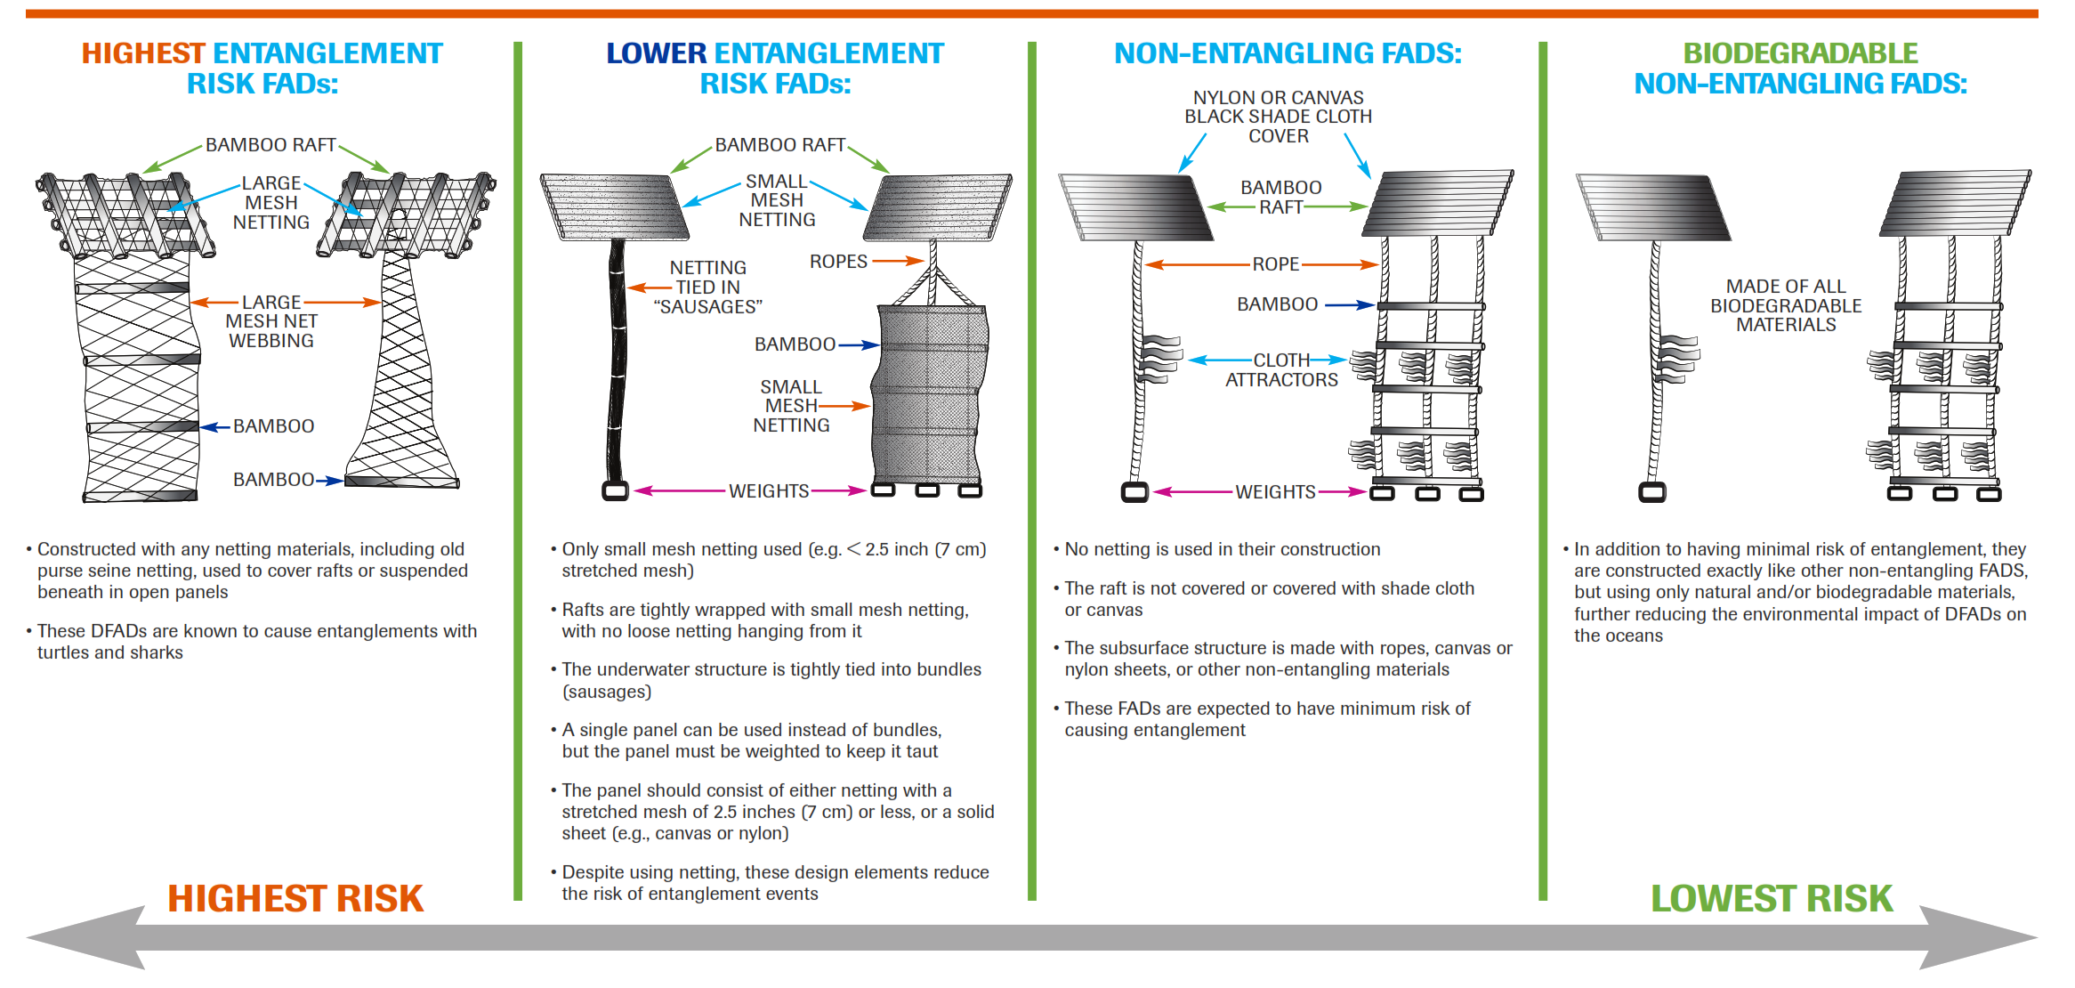
- It was further recognised by the IWG that there is an additional eco-friendly category of FAD construction i.e. the utilisation of reusable materials.

- The IWG recommends that the Commission should prioritise appropriate research for bio-degradable and non-entangling FAD designs.
FAD Numbers
- The IWG recommends that the Commission considers adopting objectives for FAD management with respect to defining an appropriate number of FADs per purse seine vessel or category [e.g. size] of vessel limiting FAD numbers; the IWG discussed potential objectives, i.e. reducing marine debris, limiting economic impact [through reduced CPUE] and reducing the impact of FAD fishing on juvenile tuna, but there was no agreement on all of them.

Marking and Monitoring of FADs

- The IWG reiterates the following recommendations from SC14 Draft Summary Report:
Recommendations

- SC14 reviewed information on analyses of the PNA’s fish aggregating device (FAD) tracking program (SC14-MI-WP-09). SC14 expressed strong support for this type of research and its continuation, noting that the PNA FAD tracking program is providing information and insight that is adding substantial value to the scientific understanding of WCPO fisheries. However, SC14 noted the ongoing practice of fleets not providing full data (estimates indicate that 60–70% of buoy transmissions are not forwarded to the PNA via practices such as geo-fencing) which substantially undermines the scientific value of the information and prevents the SC from being able to provide comprehensive advice to the Commission on FAD dynamics, economics and management. SC14 also expressed concern about the estimated high rate (5%) of beaching events in tracked FADs, with the vast majority of these being in PNA countries, together with the estimated high rate of ‘lost’ FADs (up to 27%).

- SC14 recommends that WCPFC15 note the importance of FAD marking and monitoring programs to better identify and follow individual FADs. To address the marine pollution issue, reduce the risk to coastal communities, reefs, and fish stocks SC14 recommends the use of biodegradable FADs, non-entangling, non-entrapping, and environmentally-friendly FAD designs, better measures for FAD control and retrieval, and fewer FAD deployments. SC14 also recommends that the Secretariat ensure this working paper is made available to inform the deliberations of the FAD Management IWG meeting to be held in October 2018 and that WCPFC15 take note of the concerns expressed above and support appropriate measures.

