WCPO BET Stock Status
The median values of relative recent (2012-2015) spawning biomass depletion (SB_{recent}/ SB_{F=0}) and relative recent (2011-2014) fishing mortality (F_{recent}/F_{MSY}) over the uncertainty grid of 36 models (Table BET-1) were used to define stock status. The values of the upper 90th and lower 10th percentiles of the empirical distributions of relative spawning biomass and relative fishing mortality from the uncertainty grid were used to characterize the probable range of stock status. [adopted]

A description of the updated structural sensitivity grid used to characterize uncertainty in the assessment is set out in Table BET-1. Time series of total annual catch by fishing gear over the full assessment period is shown in Figure BET-1. Estimated trends in spawning biomass depletion for the 36 models in the structural uncertainty grid is shown in Figure BET-2, and juvenile and adult fishing mortality rates from the diagnostic case model is show in BET-3. Figure BET-4 displays Majuro plots summarising the results for each of the models in the structural uncertainty grid. Figures BET-5 show Kobe plots summarising the results for each of the models in the structural uncertainty grid. Table BET-2 provides a summary of reference points over the 36 models in the structural uncertainty grid. [adopted]

SC14 agreed to use the “updated new growth” model to describe the stock status of BET because SC14 considered it to be the best available scientific information. By removing results using the old growth model, the stock status becomes considerably more optimistic. However, SC14 also notes that questions remain regarding the “updated new growth” model. [adopted]

Therefore, SC14 acknowledges that further study is warranted related to the new growth model, in particular as to the cause of the difference of growth between EPO and WCPO. An inter-laboratory ageing workshop is planned for late 2018 to review ageing approaches in the WCPO and EPO and to resolve differences, if they exist. [adopted]

In addition, SC14 acknowledges that further study is warranted to refine the tagging dataset in the WCPO to assist validating age estimates of bigeye in the WCPO. SC14 further notes that adopting the new growth curve generates new broader questions related to the BET stock assessment and agreed that several aspects need to be investigated further to inform future assessments. [adopted]

Table BET-1. Description of the updated structural sensitivity grid used to characterize uncertainty in the assessment.
Axis | Levels | Option
Steepness | 3 | 0.65, 0.80, 0.95
Growth | 1 | ‘Updated new growth’
Tagging over-dispersion | 2 | Default level (1), fixed (moderate) level
Size frequency weighting | 3 | Sample sizes divided by 10, 20, 50
Regional structure | 2 | 10°N regions, 20°N regions

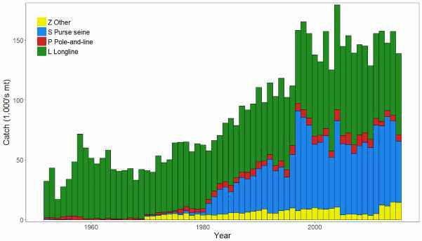
Figure BET-1. Time series of total annual catch (1000's mt) by fishing gear over the full assessment period.

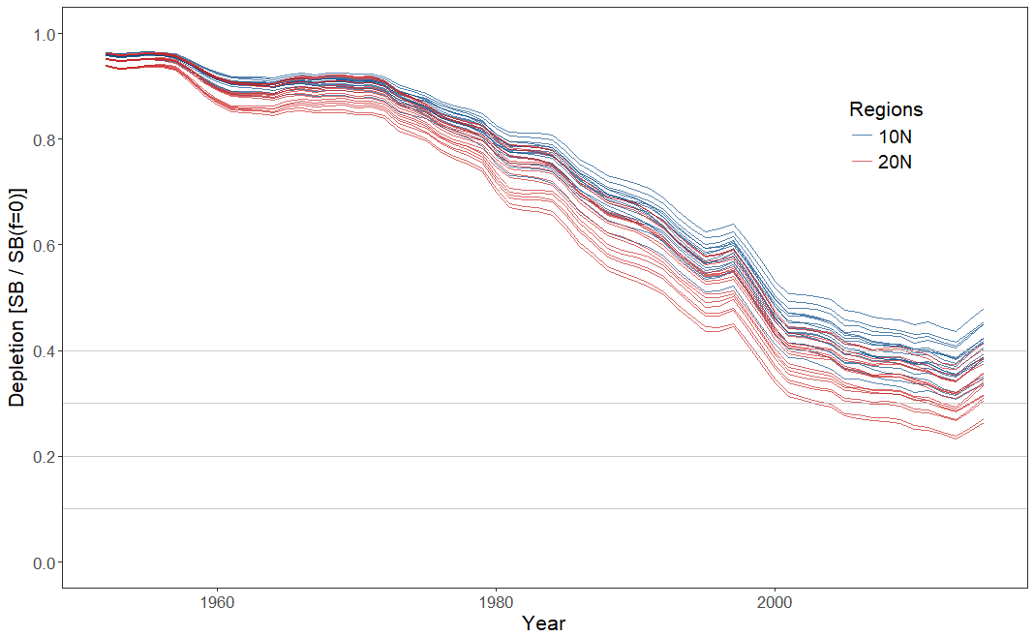
Figure BET-2. Plot showing the trajectories of spawning biomass depletion for the 36 model runs included in the structural uncertainty grid. The colours depict the models in the grid with the 10°N and 20°N spatial structures.

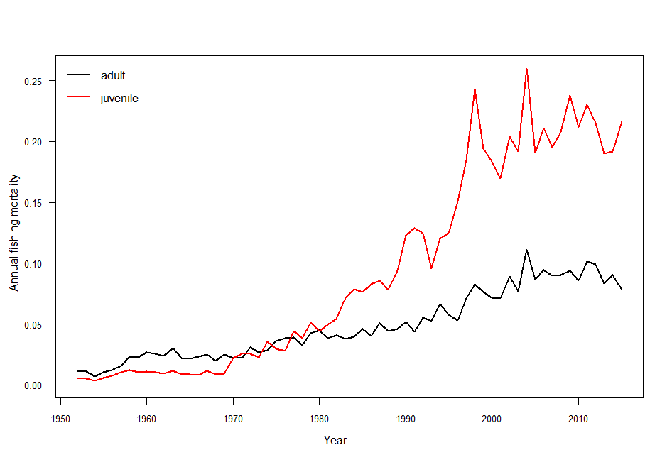
Figure BET-3. Estimated annual average juvenile and adult fishing mortality for the diagnostic case model.
SB_{recent} (2012-2015) / SB_{F=0}
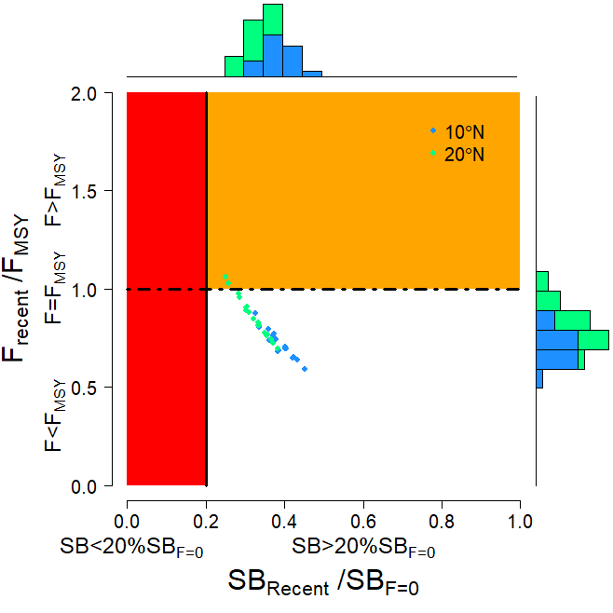
SB_{latest} (2015) / SB_{F=0}
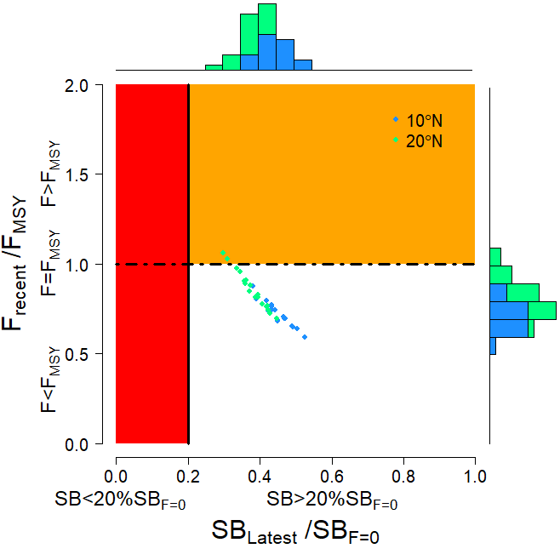

Figure BET-4. Majuro plot summarising the results for each of the models in the structural uncertainty grid. The plots represent estimates of stock status in terms of spawning biomass depletion and fishing mortality. The red zone represents spawning biomass levels lower than the agreed limit reference point, which is marked with the solid black line. The orange region is for fishing mortality greater than FMSY (FMSY is marked with the black dashed line). In the upper panel, the points represent SBrecent/SBF=0, where SBrecent is the mean SB over 2012-2015. In the lower panel, the points represent SB_{latest}/SB_{F=0}, where SB_{latest} is from 2015. In both panels the colours depict the models in the grid with the 10°N and 20°N regional structures.

SB_{recent} (2012-2015) / SB_{MSY}
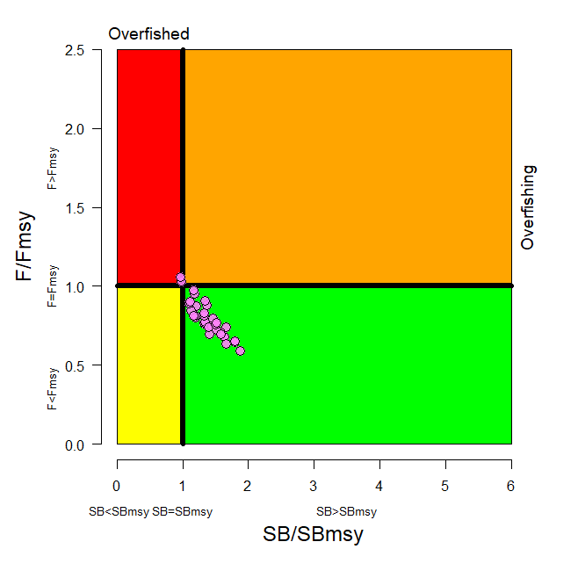
SB_{latest} (2015) / SB_{MSY}
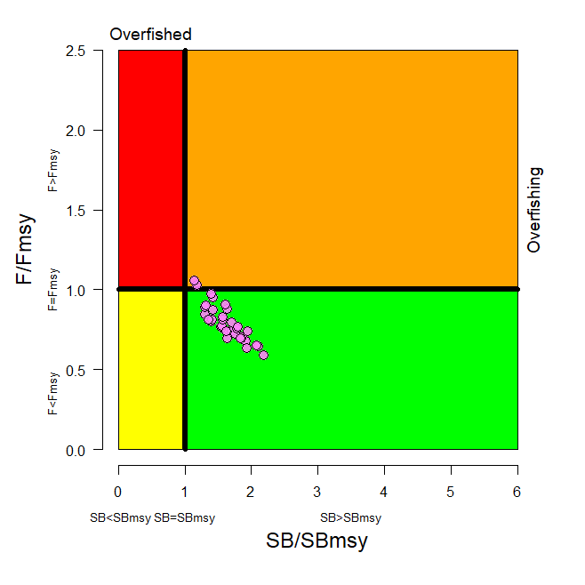

Figure BET-5. Kobe plot summarising the results for each of the models in the structural uncertainty grid. In the upper panel, the points represent SBrecent/SBMSY, where SBrecent is the mean SB over 2012-2015. In the lower panel, the points represent SB_{latest}/SB_{MSY}, where SB_{latest} is from 2015.

Table BET-2. Summary of reference points over the 36 models in the structural uncertainty grid. Note that SBrecent/SBF=0 is calculated where SBrecent is the mean SB over 2012-2015 at the request of the Scientific Committee.

 | Mean | Median | Min | 10% | 90% | Max
C_{latest} | 152,148 | 151,846 | 148,888 | 148,936 | 154,971 | 155,577
YF_{recent} | 154,180 | 153,220 | 133,120 | 141,140 | 170,720 | 172,280
f_{mult} | 1.291 | 1.301 | 0.946 | 1.075 | 1.499 | 1.690
F_{MSY} | 0.050 | 0.049 | 0.044 | 0.045 | 0.054 | 0.056
MSY | 158,551 | 159,020 | 133,520 | 143,040 | 173,880 | 180,120
F_{recent}/F_{MSY} | 0.789 | 0.768 | 0.592 | 0.667 | 0.931 | 1.058
SB₀ | 1,674,833 | 1,675,500 | 1,261,000 | 1,415,500 | 1,941,000 | 2,085,000
SB_{F=0} | 1,841,609 | 1,858,775 | 1,509,007 | 1,632,014 | 2,043,108 | 2,139,644
SB_{MSY} | 471,956 | 476,050 | 340,700 | 386,600 | 577,400 | 614,200
SB_{MSY}/SB₀ | 0.281 | 0.280 | 0.260 | 0.262 | 0.300 | 0.302
SB_{MSY}/SB_{F=0} | 0.255 | 0.255 | 0.226 | 0.235 | 0.280 | 0.287
SB_{latest}/SB₀ | 0.456 | 0.456 | 0.346 | 0.392 | 0.523 | 0.568
SB_{latest}/SB_{F=0} | 0.414 | 0.420 | 0.298 | 0.351 | 0.480 | 0.526
SB_{latest}/SB_{MSY} | 1.633 | 1.624 | 1.146 | 1.306 | 1.933 | 2.187
SB_{recent}/SB_{F=0} | 0.353 | 0.358 | 0.251 | 0.295 | 0.412 | 0.452
SB_{recent}/SB_{MSY} | 1.394 | 1.377 | 0.963 | 1.117 | 1.659 | 1.879

SC14 noted that there has been a long-term decrease in spawning biomass from the 1950s to the present for bigeye tuna and that this is consistent with previous assessments. [adopted]

SC14 also noted that the central tendency of relative recent (2012-2015) spawning biomass depletion was median (SB_{recent}/SB_{F=0}) = 0.36 with a range of 0.30 to 0.41 (80% probability interval). [adopted]

SC14 further noted that there was 0% probability (0 out of 36 models) that the recent spawning biomass had breached the adopted LRP. [adopted]

SC14 noted that there has been a long-term increase in fishing mortality for both juvenile and adult bigeye tuna, consistent with previous assessments. (add figure of fishing mortality) [adopted]

SC14 also noted that the central tendency of relative recent fishing mortality was median (Frecent/FMSY) = 0.77 with an 80% probability interval of 0.67 to 0.93. [adopted]

SC14 further noted that there was a roughly 6% probability (2 out of 36 models) that the recent fishing mortality was above FMSY. [adopted]

SC14 also noted that, regardless of the choice of uncertainty grid, the assessment results show that the stock has been continuously declining for about 60 years since the late 1950’s, except for the recent small increase. [adopted]

SC14 also noted the continued relatively higher levels of depletion in the equatorial and western Pacific (specifically Regions 3, 4, 7 and 8) and the associated higher levels of impact, especially on juvenile bigeye tuna, in these regions due to the associated purse-seine fisheries and the ‘other’ fisheries within the western Pacific (as shown in Figures 46 and 47 of SC13-SA-WP-03). [adopted]

Table BET-3 summarises the median values of SB/SB_{F=0} and F/F_{MSY} achieved in the long term,
along with the potential risk of breaching the limit reference point (LRP) and exceeding F_{MSY},
under each of the future fishing and recruitment combinations. Figure 1 presents the
corresponding distributions of long term SB/SB_{F=0} and Figure 2 those for F/F_{MSY}.
Potential outcomes under the 2013-15 average and CMM scenario conditions were
strongly influenced by the assumed future recruitment levels. [adopted]

Under the assumption that recent positive recruitments will continue into the future, spawning
biomass relative to unfished levels is predicted to increase from recent levels under all
examined future scenarios by 0-18% (SB₂₀₄₅/SB_{F=0} ranges from 0.36 to 0.42; Table BET-3, Figure
BET-6). While future uncertainty in stock status increases due to stochastic future recruitment levels,
the risk of future spawning biomass falling below the LRP falls to between 0 and 5%, due to
the improved overall stock size. Fishing mortality falls slightly under both the status quo and
optimistic scenarios, assuming recent recruitment. However, fishing mortality increases under
the pessimistic scenario, but remains below F_{MSY} (30% risk of F > F_{MSY} Table BET-3, Figure BET-7). [adopted]

Under the assumption that less positive long-term recruitments are experienced in the future,
spawning biomass relative to unfished levels will decline under all scenarios (SB₂₀₄₅/SB_{F=0}
ranges from 0.25 to 0.30). The risk of spawning biomass falling below the LRP increases to
between 17 and 32% (Table BET-3). In all fishing scenarios, fishing mortality increases relative to
recent levels (by 109-138%) and is well above F_{MSY}. Risk of fishing mortality exceeding F_{MSY}
ranges from 93 to 98%. [adopted]

It should be noted that even under assumption of long term recruitment levels, the risk of exceeding the LRP in the short term ranges between 2% and 7% (2020) and 12 and 26% (2025), with only the pessimistic scenario exceeding the 20% level of risk in 2025. (Table BET-4) [adopted]

Table BET-3 Including ‘2013-15 average levels’

Median values of reference point levels (adopted limit reference point (LRP) of 20% SB_{F=0}; F_{MSY}) and risk¹ of breaching reference points from the 2017 bigeye stock assessment incorporating updated growth information, and in 2045 under the three future harvest scenarios (2013-15 average fishing levels, optimistic and pessimistic) and alternative recruitment hypotheses. ‘Updated new growth’ runs only.

Scenario |  | Scalars relative to 2013-2015 |  | Median SB₂₀₄₅/SB_{F=0} | Median SB₂₀₄₅/SB_{F=0}  v  SB₂₀₁₂₋₁₅/SB_{F=0} | Median  F₂₀₄₁₋₂₀₄₄/F_{MSY} | Median F₂₀₄₁₋₂₀₄₄/F_{MSY} v  F₂₀₁₁₋₁₄/F_{MSY} | Risk
Recruitment | Fishing level | Purse seine | Longline |  |  |  |  | SB₂₀₄₅ < LRP | F>F_{MSY}
Bigeye assessment (‘recent’ levels) |  |  |  | 0.36 | - | 0.77 | - | 0% | 6%
Recent | 2013-15 avg | 1 | 1 | 0.42 | 1.18 | 0.73 | 0.95 | 0% | 11%
 | Optimistic | 1.11 | 0.98 | 0.41 | 1.15 | 0.75 | 0.98 | 0% | 13%
 | Pessimistic | 1.12 | 1.35 | 0.36 | 1.00 | 0.89 | 1.15 | 5% | 30%
Long-term | 2013-15 avg | 1 | 1 | 0.30 | 0.84 | 1.60 | 2.09 | 17% | 93%
 | Optimistic | 1.11 | 0.98 | 0.29 | 0.82 | 1.64 | 2.13 | 18% | 94%
 | Pessimistic | 1.12 | 1.35 | 0.25 | 0.70 | 1.84 | 2.38 | 32% | 98%
¹ note risk within the stock assessment is calculated as the (weighted) number of models falling below the LRP (X / 36 models). Risk under a projection scenario is the number of projections across the grid that fall below the LRP (X / 3600 (36 models x 100 projections).

Table BET-4. Median values of SB/SB_{F=0} and associated risk of breaching the adopted limit reference point (LRP) of 20% SBF=0 in 2020, 2025 and 2045 under the three future harvest scenarios (2013-15 average fishing levels, optimistic and pessimistic) and alternative recruitment hypotheses. ‘Updated new growth’ runs only.

Scenario |  | Scalars relative to 2013-2015 |  | Median SB₂₀₂₀/SB_{F=0} | Median SB₂₀₂₅/SB_{F=0} | Median SB₂₀₄₅/SB_{F=0} | Risk SB₂₀₂₀ < LRP | Risk SB₂₀₂₅ < LRP | Risk SB₂₀₄₅ < LRP
Recruitment | Fishing level | Purse seine | Longline
Recent | 2013-15 avg | 1 | 1 | 0.42 | 0.41 | 0.42 | 0% | 1% | 0%
 | Optimistic | 1.11 | 0.98 | 0.41 | 0.40 | 0.41 | 0% | 1% | 0%
 | Pessimistic | 1.12 | 1.35 | 0.38 | 0.35 | 0.36 | 0% | 4% | 5%
Long-term | 2013-15 avg | 1 | 1 | 0.35 | 0.30 | 0.30 | 2% | 12% | 17%
 | Optimistic | 1.11 | 0.98 | 0.35 | 0.30 | 0.29 | 2% | 13% | 18%
 | Pessimistic | 1.12 | 1.35 | 0.32 | 0.26 | 0.25 | 7% | 26% | 32%

Recent recruitments | Long-term recruitment
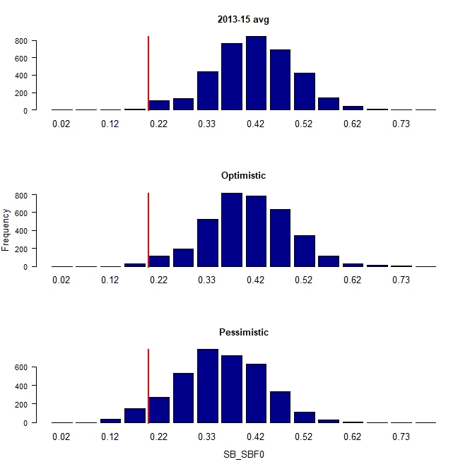 | 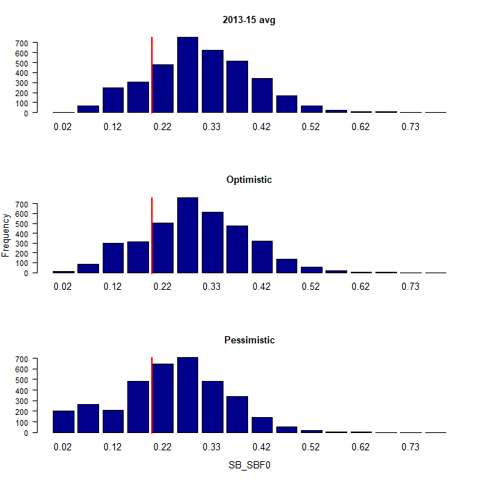

Figure BET-6. Distribution of SB₂₀₄₅/SB_{F=0} assuming recent and long term recruitment conditions (left and right columns, respectively), under the three future fishing scenarios: 2013-15 avg (2013-15 average conditions, top row); optimistic conditions (middle row); and pessimistic conditions (bottom row). Projection results from ‘updated new growth’ models (3,600 projections) only where the red line indicates the LRP.

Recent recruitments | Long-term recruitment
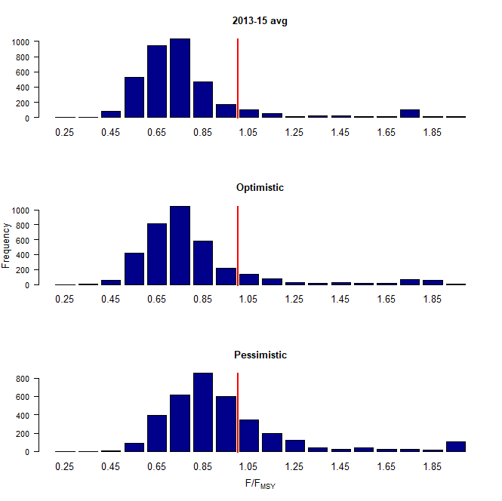 | 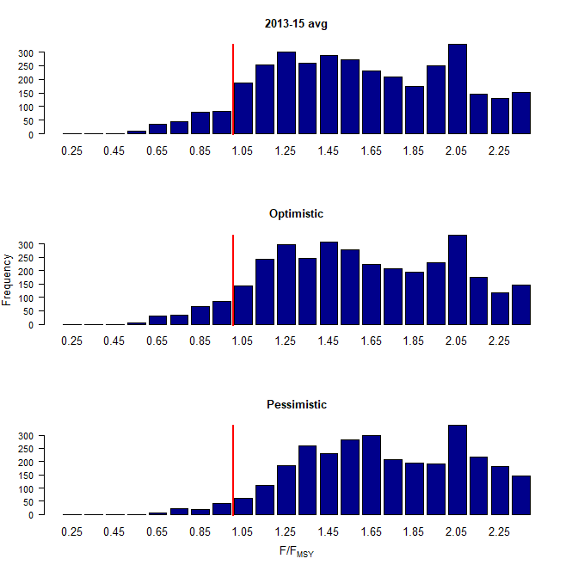

Figure BET-7. Distribution of F/F_{MSY} assuming recent and long term recruitment conditions (left and right columns, respectively), under the three future fishing scenarios: 2013-15 avg (2013-15 average conditions, top row); optimistic conditions (middle row); and pessimistic conditions (bottom row). Projection results from ‘updated new growth’ models (3,600 projections) only.

Recent recruitments | Long-term recruitment
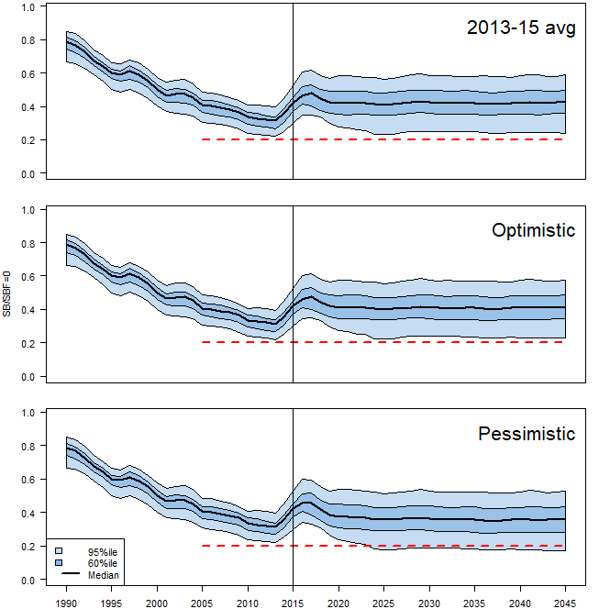 | 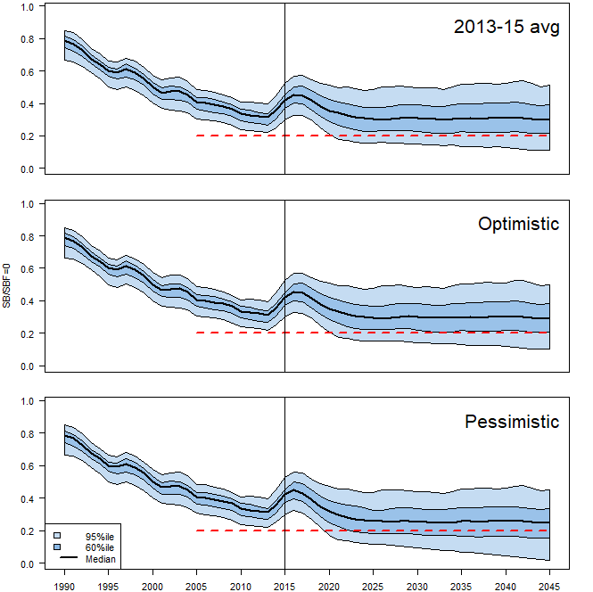
Figure BET-8. Time series of WCPO bigeye tuna spawning biomass (SB/SB_{F=0}) from the uncertainty grid of assessment model runs for the period 1990 to 2015 (the vertical line at 2015 represents the last year of the assessment), and stochastic projection results for the period 2016 to 2045 under the three future fishing scenarios (“2013-15 avg”, “Optimistic” and “Pessimistic”; rows). During the projection period (2016-2045) levels of recruitment variability are assumed to match those over the “recent” time period (2005-2014; left panel) or the time period used to estimate the stock-recruitment relationship (1962-2014; right panel). The red dashed line represents the agreed limit reference point.

WCPO BET Management advice
SC14 noted that the preliminary estimate of total catch of WCPO bigeye tuna for 2017 was 126,929t, a 17% decrease from 2016 and a 19% decrease from the average 2012-2016. Longline catch in
2017 (58,164t) was an 8% decrease from 2016 and a 19% decrease from the 2012-2016 average. Purse seine catch in 2017 (56,194t) was a 12% decrease from 2016 and a 13% decrease from the 2012-2016 average. Pole and line catch (1,411t) was a 65% decrease from 2016 and a 70% decrease from the average 2012-2016 catch. Catch by other gear (11,160t) was a 48% decrease from 2016 and 28% decrease from the average catch in 2012-2016. [adopted]

Based on the uncertainty grid adopted by SC14, the WCPO bigeye tuna spawning biomass is above the biomass LRP and recent F is very likely below FMSY. The stock is not experiencing overfishing (94% probability F<F_{MSY}) and it is not in an overfished condition (0% probability SB/SB_{F=0}<LRP). [adopted]

Although SC14 considers that the updated assessment is consistent with the previous assessment, SC14 also advises that the amount of uncertainty in the stock status results for the 2018 assessment update is lower than for the previous assessment due to the exclusion of old information on bigeye tuna growth. [adopted]

SC14 noted that levels of fishing mortality and depletion differ among regions, and that fishery impact was higher in the tropical region (Regions 3, 4, 7 and 8 in the stock assessment model), with particularly high fishing mortality on juvenile bigeye tuna in these regions. SC14 therefore recommends that WCPFC15 could continue to consider measures to reduce fishing mortality from fisheries that take juveniles, with the goal to increase bigeye fishery yields and reduce any further impacts on the spawning biomass for this stock in the tropical regions. [adopted]

SC14 noted that according to CMM-17-01 bigeye tuna SB/SB_{F=0} is to be maintained above the 2012-2015 level (SB_{recent}/SB_{F=0} = 0.36; Table BET-3) pending the agreement on a TRP. SC14 also noted that the projection results based on scenarios estimating CMM2017-01 indicated a high level of uncertainty on the levels of spawning stock biomass relative to the LRP and the objective of CMM-2017-01 in 2045. Under the scenario assuming long-term average recruitment continues into the future there was a high risk (add value) of breaching the LRPs and a zero probability of achieving the objective of CMM-2017-01, while under the scenario which assumes higher more recent recruitments continues into the future there was a low risk (add value) of breaching the LRPs and a 100% probability of achieving the objective of CMM-2017-01. [adopted]

However, SC14 also noted that the projections assume that longline catches would be maintained regardless of the decrease in biomass. This may result in unlikely high levels of effort. Therefore, the catch estimates under the long term recruitment scenario, especially in the longer term projections, are more uncertain. [adopted]

Based on these results, SC14 recommends that WCPFC15 takes note of the results of the projections in relation achieving CMM-2017-01 and as a precautionary approach that the fishing mortality on bigeye tuna stock should not be increased from the recent average (2011-2014) level to maintain spawning biomass at or above the 2012-2015 average, until the Commission can articulate the management objectives and agree on an appropriate target reference point (TRP) for BET, although one CCM considers that SC14 could provide more options for the commission to consider. [adopted]

Research Recommendations

SC14 noted that the acceptance of the new growth model for BET raises a number of issues in relation to patterns of growth and stock structure of BET across the Pacific Ocean and recommended that the following research issues need to be addressed:
- Two different growth models separated at 150˚W effectively means that Pacific BET should be assessed as a two-stock resource between the WCPO and EPO. However, catch information indicates that the fishing grounds near 150˚W are a core area of BET catch, thus influencing the assessments of both the WCPFC and IATTC. Also, tagging information suggests movement of BET between the WCPO and EPO. Therefore, the appropriateness off delineating the two stocks at 150˚W needs to be investigated.
- The new growth analysis suggests area variant growth across the Pacific. While the level of variation is seen to be relatively small within the WCPO (and possibly within the margins of observation error), there is a suggestion of substantial change in growth around the boundary between the WCPO and the EPO (c.f. Figure 14 in SA-WP-01). The reasons for this suggested change in growth remains unknown, but SC14 noted the utility of collecting more information from the regions either side of this boundary to inform a greater understanding of possible changes in growth around this area. While the incorporation of area-variant growth within the assessment model would also help explore this issue, SC14 noted the difficulty of this task.
- SC11 concluded that the stock status of WCPO BET from the Pan-Pacific assessment and the WCPO-only assessment were similar when the growth models were similar in the EPO and WCPO. This conclusion needs to be revisited in light of the different growth between EPO and WCPO by adopting the new growth.

The following additional research activities were also recommended by SC14 in order to improve the understanding of the age and growth of BET across the Pacific:
A WCPO growth model based on size composition and tagging data, as well as the use of additional modeling approaches (e.g., length-conditional), should also be evaluated.

Collaboration with the IATTC to analyze bigeye growth from otolith and tagging data collected across the entire Pacific, to better characterize the apparent regional difference in growth between the WCPO and EPO, and possible environmental determinants of such differences.

Analyzing the same otoliths by different laboratories, to build confidence in ageing estimates and to estimate ageing error.

Continued development of a high-confidence tagging dataset for growth analysis, with particular focus on larger bigeye tuna and events with reliable measurements at release. Such data would assist with the validation of the age estimates of large bigeye in the WCPO, and could potentially be incorporated directly into the assessment model as an additional data set. However, a reliable measurement of both length at release and recapture are necessary to accurately estimate incremental growth.

Collect otoliths of very small bigeye that are captured by the Indonesian, Vietnamese, and Philippines domestic fisheries in region 7 and estimate age through daily ring counts to aid in the estimation of the size at age-1 qtr⁻¹ parameter (L1) within the assessment model. [adopted]

