Silky shark

Provision of scientific information

- SC14 reviewed the report Pacific-wide Silky Shark (Carcharhinus falciformis) stock status assessment (WCPFC-2018-SC14/SA-WP-08 and Addendum) presented by S. Clarke and A. Langley. The assessment presented the development of Pacific-wide model as well as a WCPO-only model of stock status which updates and refines the previous assessment presented to SC8. [adopted]

Stock status and trends

- SC14 noted given the inherent uncertainty in the current assessment the current estimates of stock status should be considered indicative only. Although these estimates are not considered a reliable basis for management decision-making they represent progress since the 2013 assessment and the best available science concerning the status of silky sharks in the WCPO. Therefore, as part of its ongoing review of the established conservation and management measure for silky sharks (CMM 2013-08), the Commission may wish to consider these indicative results until such time as better estimates become available. [adopted]

- SC14 noted that indications from the 2018 WCPO model show that the stock declined steadily over the model period (1995-2016) (Figure FAL-1). The assessment model estimates spawning biomass in 2016 to have been at 47% of the unexploited level (SB₂₀₁₆/SB₀ = 0.47). Current biomass is estimated to be above the MSY reference biomass level; however, there is considerable uncertainty associated with the estimate of stock status (SB₂₀₁₆/SB_{MSY} = 1.18, 95% CI 0.59-1.77) (Table FAL-1). Based on these results it is likely that the stock is not overfished, i.e. there is a 78% probability that SB₂₀₁₆ is greater than SB_{MSY} (Table FAL-1). [adopted]

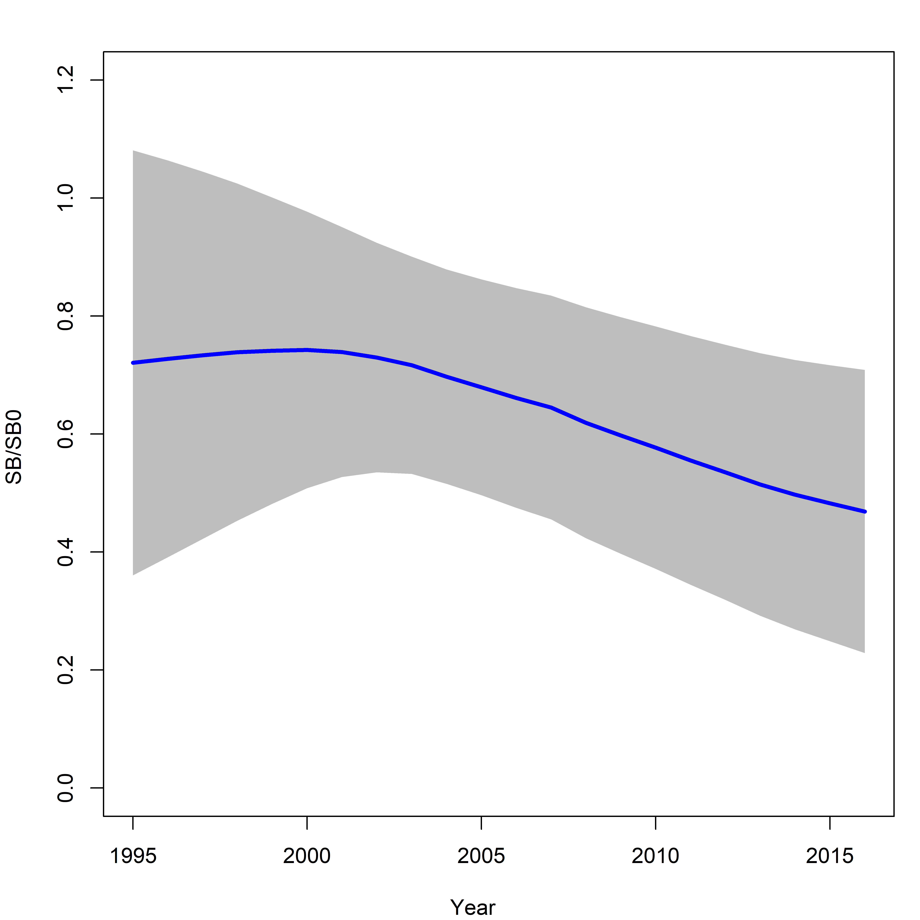
Figure FAL-1: Estimated spawning biomass relative to unexploited biomass (SB₀) for the WCPO assessment model (CPUEqdev).

Table FAL-1: Management quantities (and 95% confidence intervals) for the WCPO assessment model (CPUEqdev).
Management quantity | Value | Confidence interval (95%)
SB₀ | 11,865 | 6,412-17,318
SB₁₉₉₅ | 8,552 | 2,590-14,513
SB_{MSY} | 4,721 | 2,560-6,882
SB_{MSY}/SB₀ | 0.398 | 0.397-0.399
SB₂₀₁₆ | 5,560 | 301-10,819
SB₂₀₁₆/SB₀ | 0.469 | 0.229-0.729
SB₂₀₁₆/SB_{MSY} | 1.178 | 0.590-1.77
Pr(SB₂₀₁₆ > SB_{MSY}) | 0.78
F₂₀₁₆/F_{MSY} | 1.607 | 0.316-2.810
Pr(F₂₀₁₆ > F_{MSY}) | 0.84
F₂₀₁₆ | 0.313
MSY | 12,162 | 6,711-17,615
Catch 2016 (mt) | 22,503

- Noting the uncertainty related to the assessment Fishing mortality appears to be above F_{MSY}. The current level of catch appears to be substantially higher than the MSY. [adopted]

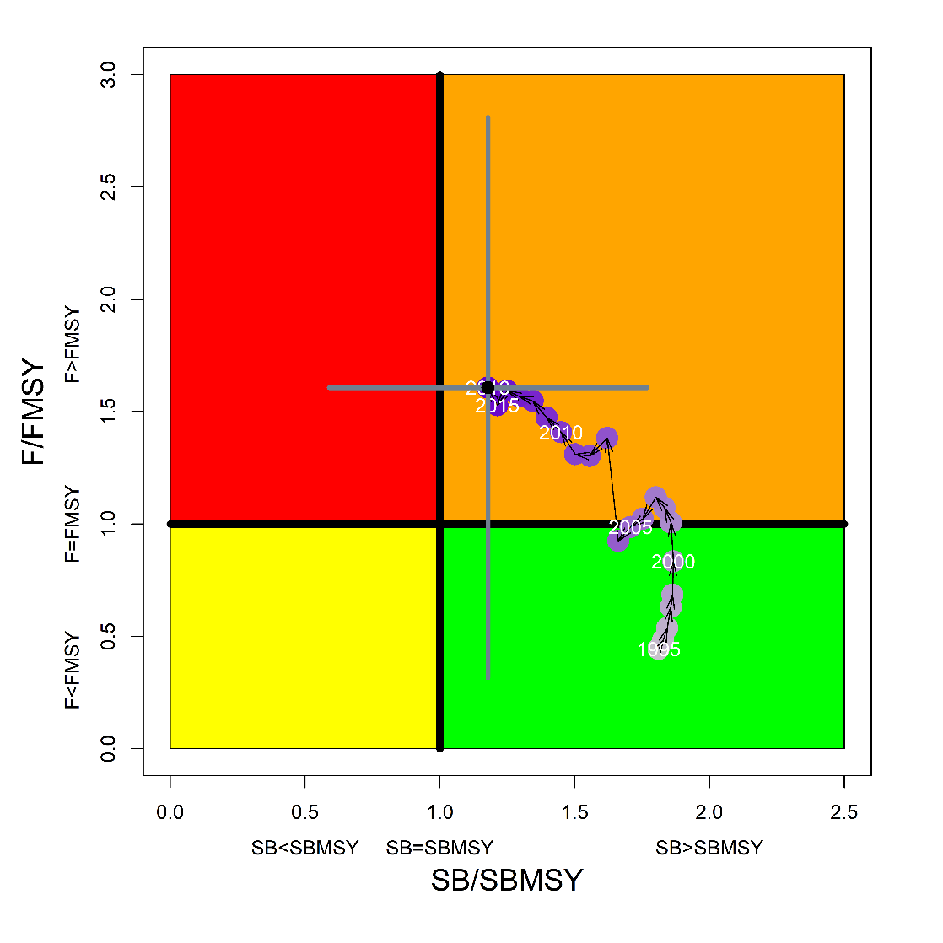
Figure FAL-2: Kobe plot for the WCPO assessment model (CPUEqdev).

- Management advice and implications

- SC14 concluded that on the basis of the best available science, and pending the availability of less uncertain stock status indicators, it appears that the WCPO stock is not overfished but is subject to overfishing (Figure FAL-2). [adopted]

- Noting the uncertainty in the stock status of silky shark in the WCPO, SC14 recognized the need for ongoing conservation measures and recommends that CMM-2013-08 be maintained as a precautionary measure pending the availability of less uncertain stock indicators. [adopted]

