NPSFM Stock Status
SC14 noted that ISC provided the following conclusions on the stock status of North Pacific Shortfin Mako Shark in the Pacific Ocean in 2017 presented in SC14-SA-WP-11 (Stock Assessment of Shortfin Mako Shark in the North Pacific Ocean Through 2016):
Based on these findings, the following information on the status of the SMA stock is provided:
- Target and limit reference points have not been established for pelagic sharks in the Pacific Ocean. Stock status is reported in relation to MSY.
- The results from the base case model show that, relative to MSY, the North Pacific shortfin mako stock is likely (>50%) not in an overfished condition and overfishing is likely (>50%) not occurring relative to MSY-based abundance and fishing intensity reference points (Table 6-1; Figure 6-3A).
Stock status was also examined under six alternative states of nature that represented the most important sources of uncertainty in the assessment. Results of these models with alternative states of nature were consistent with the base case model and showed that, relative to MSY, the North Pacific shortfin mako shark stock is likely (>50%) not in an overfished condition and overfishing is likely (>50%) not occurring (Figure 6-3B).
NPSFM Management Advice
SC14 noted the following conservation advice from ISC:
Stock projections of biomass and catch of North Pacific shortfin mako from 2017 to 2026 were performed assuming three alternative constant fishing mortality scenarios: 1) status quo, average of 2013-2015 (F₂₀₁₃-₂₀₁₅); 2) F₂₀₁₃₋₂₀₁₅ + 20%; and 3) F₂₀₁₃₋₂₀₁₅ - 20% (Figure 6-4).
Based on these future projections, the following conservation information is provided:
- If fishing mortality remains constant at F2013-15 or is decreased 20%, then the Stock Abundance is expected to increase gradually;
- If fishing mortality is increased 20% relative to F2013-2015, then the Stock Abundance is expected to decrease in the final years of the projection.
- It should be noted that, given the uncertainty in fishery data and key biological processes within the model, especially the stock recruitment relationship, the models’ ability to project into the future is highly uncertain.
Research Needs
There is uncertainty in the estimated historical catches of North Pacific shortfin mako shark. Substantial time and effort was spent on estimating historical catch and more work remains to be conducted. In particular, the SHARKWG identified two future improvements that are critical: 1) identify all fisheries that catch shortfin mako shark in the NPO, including fisheries that were not previously identified by the SHARKWG; and 2) methods to estimate shortfin mako shark catches should be improved, especially for the early period from 1975 to 1993. [adopted]
Table 6-1. Summary of reference points and management quantities for the shortfin mako shark (Isurus oxyrinchus) base case model. The percentages in brackets are the CV of the estimated quantity in the base case model.
Management Quantity | Symbol | Units | Basecase
Spawning abundance (number of mature female sharks | SA0 | 1000s of sharks | 1465.8 (23%)
Maximum Sustainable Yield (MSY) | CMSY | Metric tonnes (t) | 3127.1 (22%)
Spawning Abundance at MSY | SAMSY | 1000s of sharks | 633.7 (23%)
Fishing Intensity at MSY | 1-SPRMSY | NA | 0.26
Current spawning abundance relative to MSY | SA2016/SAMSY | NA | 1.36
Current spawning abundance relative to unfished level | SA2016/SA0 | NA | 0.58
Recent fishing Intensity relative to MSY | (1-SPR2013-15)/(1- SPRMSY) | MSY | 0.62

Figure 6-3. Kobe plots of shortfin mako shark in the North Pacific Ocean showing. A) The time series of the ratio of SA to SA at MSY (SA_{MSY}) and fishing intensity to fishing intensity at MSY (1-SPR_{MSY}), and B) the same ratios for the terminal year (2016) for six alternative states of nature. SA is spawning abundance measured as the number of mature females. Fishing intensity is estimated as 1-SPR. Values for the start (1975) and end (2016) years in the time series (A) are indicated by the blue triangle and black circle, respectively. Gray numbers indicate selected years. Alternative states of nature in B) include: Alternative_1) higher catch, Alternative_2) lower catch; Alternative_3) higher uncertainty on Japan shallow-set CPUE index (1975-1993) (CV=0.3); Alternative_4) fit to Japan offshore distant water longline shallow-set fleet (JPN_SS_I; 1975-2016) and Hawaii longline shallow-set fleet (US_SS; 2005-2016), and no fit to initial equilibrium catch; Alternative_5) low steepness, h=0.26; and Alternative_6) high steepness, h=0.37. Solid lines indicate 95% confidence intervals.
A
B

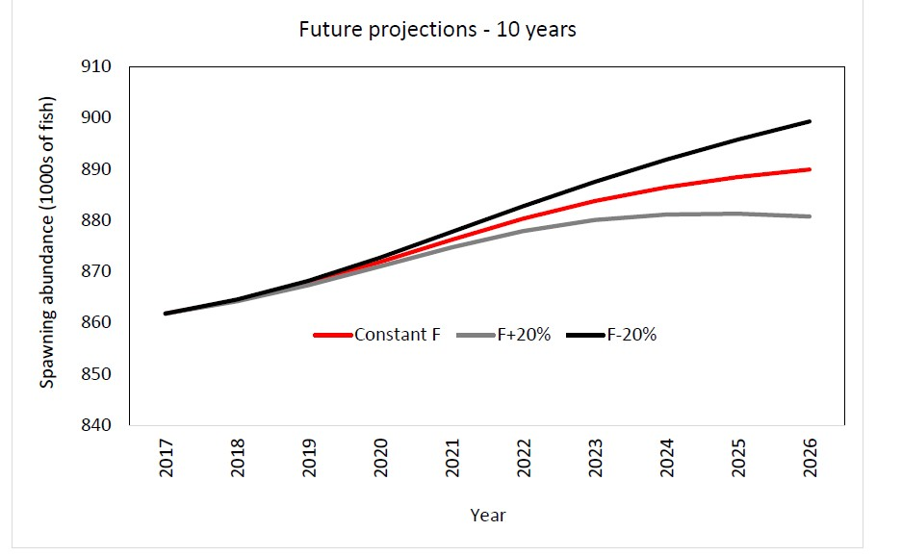

Figure 6-4. Comparison of future projected North Pacific shortfin mako (Isurus oxyrinchus) spawning abundance under different F harvest policies (Constant F 2013-2015, +20%, -20%) using the base case model. Constant F was based on the average from 2013-2015.

