NPSWO Stock Status

SC14 noted that ISC provided the following conclusions on the stock status of Western and Central North Pacific Swordfish in the Pacific Ocean in 2017 presented in SC14-SA-WP-07 (Stock Assessment for Swordfish (Xiphias gladius) in the Western and Central North Pacific Ocean through 2016):

Estimates of total stock biomass show a relatively stable population, with a slight decline until the mid-1990s followed by a slight increase since 2000. Population biomass (age-1 and older) averaged roughly 97,919 t in 1974-1978, the first 5 years of the assessment time frame, and has declined by only 20% to 71,979 t in 2016 (Figure 6-7). Female spawning stock biomass was estimated to be 29,403 t in 2016, or about 90% above SSBMSY (Table 6-2 and Table 6-3).
Fishing mortality on the stock (average F, ages 1 – 10) averaged roughly F = 0.08 yr-1 during 2013-2015, or about 45% below FMSY. The estimated SPR (the predicted spawning output at the current F as a fraction of unfished spawning output) is currently SPR2016 = 45%. Annual recruitment averaged about 717,000 recruits during 2012-2016, and no long-term trend in recruitment was apparent. Overall, the time series of spawning stock biomass and recruitment estimates indicate a stable spawning stock biomass and suggest a fluctuating pattern without trend for recruitment (Figure 6-7). The Kobe plot depicts the stock status relative to MSY-based reference points for the base case model (Figure 6-8) and shows that spawning stock biomass declined to almost the MSY level in the mid-1990s, but SSB has remained above SSBMSY throughout the time series (Figure 6-7B).

For this 2018 benchmark assessment, note that biomass status is based on female spawning stock biomass, whereas for the 2014 update assessment, biomass status was based on exploitable biomass (effectively age-2+ biomass). It is also important to note that there are no currently agreed upon reference points for the WCNPO swordfish stock and that retrospective analyses show that the assessment model appears to underestimate spawning stock biomass in recent years.

Based on these findings, the following information on the status of the WCNPO SWO stock is provided:

The WCNPO swordfish stock has produced annual yields of around 10,200 t per year since 2012, or about 2/3 of the MSY catch amount.
  - There is no evidence of excess fishing mortality above FMSY (F2013-2015 is 45% of FMSY) or substantial depletion of spawning potential (SSB2016 is 87% above SSBMSY).
  - Overall, the WCNPO swordfish stock is not likely overfished and is not likely experiencing overfishing relative to MSY-based or 20% of unfished spawning biomass-based reference points.

NPSWO Management Advice

SC14 noted the following conservation advice from ISC:
Stock projections were conducted using a two-gender projection model. The five stock projection scenarios were: (1) F status quo, (2) FMSY, (3) F at 0.2*SSB(F=0), (4) F20%, and (5) F50% (Figure 6-9). These projection scenarios were applied to the base case model results to evaluate the impact of alternative levels of fishing intensity on future spawning biomass and yield for swordfish in the Western and Central North Pacific Ocean. The projected recruitment pattern was generated by stochastically sampling the estimated stock-recruitment model from the base case model. The projection calculations employed model estimates for the multi-fleet, multi- season, size- and age-selectivity, and structural complexity in the assessment model to produce consistent results.

Based on these findings, the following conservation information is provided:
- The results show that projected female spawning biomass is expected to remain above SSB_{MSY} under all of the harvest scenarios (Table 6-4 and Figure 6-9), with increases in spawning biomass expected under lower fishing mortality rates.
- Similarly, projected catch is expected to increase under each of the five harvest scenarios, with greater increases expected under higher fishing mortality rates (Table 6-4 and Figure 6-9).

Research Needs
The lack of sex-specific size composition data and the simplified treatment of the spatial structure of swordfish population dynamics remained as two important sources of uncertainty for this benchmark assessment.

Table 6-2. Reported catch (t) used in the stock assessment along with annual estimates of population biomass (age-1 and older, mt), female spawning biomass (mt), relative female spawning biomass (SSB/SSBMSY), recruitment (thousands of age-0 fish), fishing mortality (average F, ages 1 to 10, yr-1), relative fishing mortality (F/FMSY), and spawning potential ratio of WCNPO swordfish.

Year | 2010 | 2011 | 2012 | 2013 | 2014 | 2015 | 2016 | Mean1 | Min1 | Max1
Reported Catch | 12,716 | 9,971 | 10,608 | 9,241 | 9,211 | 11,672 | 10,068 | 12,863 | 9,211 | 17,793
Population Biomass | 66,417 | 66,087 | 68,117 | 67,885 | 69,560 | 71,951 | 71,979 | 67,487 | 51,856 | 97,919
Spawning Biomass | 26,136 | 26,448 | 26,569 | 27,546 | 28,580 | 28,865 | 29,404 | 24,442 | 17,191 | 44,100
Relative Spawning Biomass | 1.66 | 1.68 | 1.69 | 1.75 | 1.82 | 1.84 | 1.87 | 1.56 | 1.09 | 2.81
Recruitment (age 0) | 789 | 565 | 671 | 710 | 683 | 742 | 781 | 761 | 401 | 1241
Fishing Mortality | 0.10 | 0.08 | 0.09 | 0.07 | 0.07 | 0.09 | 0.07 | 0.12 | 0.07 | 0.18
Relative Fishing Mortality | 0.57 | 0.46 | 0.51 | 0.44 | 0.40 | 0.51 | 0.44 | 0.72 | 0.40 | 1.05
Spawning Potential Ratio | 38% | 41% | 39% | 45% | 47% | 39% | 45% | 29% | 17% | 47%
1 During 1975-2016

Table 6-3. Estimates of biological reference points along with estimates of fishing mortality (F), spawning stock biomass (SSB), recent average yield (C), and SPR of WCNPO swordfish, derived from the base case model assessment model, where “MSY” indicates reference points based on maximum sustainable yield.

Reference Point | Estimate
FMSY | 0.17 yr-1
F0.2*SSB(F=0) | 0.16 yr-1
F2013-2015 | 0.08 yr-1
SSBMSY | 15,702 mt
SSB2016 | 29,403 mt
SSBF=0 | 97,286 mt
MSY | 14,941 mt
C2012-2016 | 10,160 mt
SPRMSY | 18%
SPR2016 | 45%

Table 6-4 Projected values of WCNPO swordfish spawning stock biomass (SSB, mt) and catch (mt) under five constant fishing mortality rate (F, yr-1) scenarios during 2017-2026.

Year | 2017 | 2018 | 2019 | 2020 | 2021 | 2022 | 2023 | 2024 | 2025 | 2026
Scenario 1: F = F2013-2015
SSB | 32,118 | 33,207 | 34,599 | 35,476 | 36,270 | 37,082 | 37,951 | 38,967 | 40,083 | 41,087
Catch | 8,851 | 9,135 | 9,407 | 9,599 | 9,794 | 10,022 | 10,275 | 10,595 | 11,053 | 11,142
Scenario 2: F = FMSY
SSB | 28,267 | 23,963 | 21,443 | 19,458 | 18,303 | 17,618 | 17,293 | 17,197 | 17,253 | 17,263
Catch | 20,885 | 18,323 | 16,509 | 15,294 | 14,666 | 14,353 | 14,308 | 14,520 | 14,650 | 14,348
Scenario 3: F = F20%SSB(F=0)
SSB | 28,425 | 24,384 | 21,800 | 19,735 | 18,530 | 17,874 | 17,496 | 17,586 | 17,818 | 17,779
Catch | 20,691 | 18,122 | 16,454 | 15,261 | 14,653 | 14,361 | 14,319 | 14,554 | 14,665 | 14,384
Scenario 4: F = F20%
SSB | 29,007 | 25,431 | 23,527 | 21,763 | 20,736 | 20,131 | 19,893 | 19,883 | 19,981 | 20,066
Catch | 18,680 | 16,933 | 15,657 | 14,726 | 14,242 | 14,033 | 14,050 | 14,292 | 14,496 | 14,253
Scenario 5: F = F50%
SSB | 32,559 | 34,334 | 36,290 | 37,666 | 38,836 | 39,984 | 41,148 | 42,490 | 44,049 | 45,625
Catch | 7,556 | 7,973 | 8,343 | 8,605 | 8,847 | 9,101 | 9,366 | 9,692 | 10,087 | 10,223

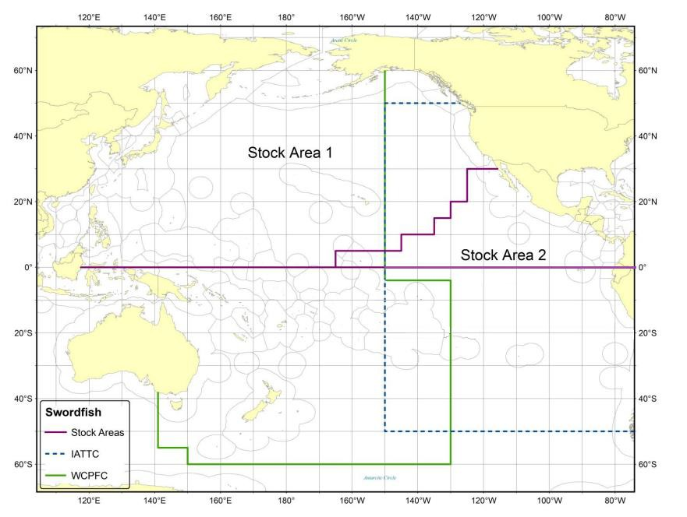
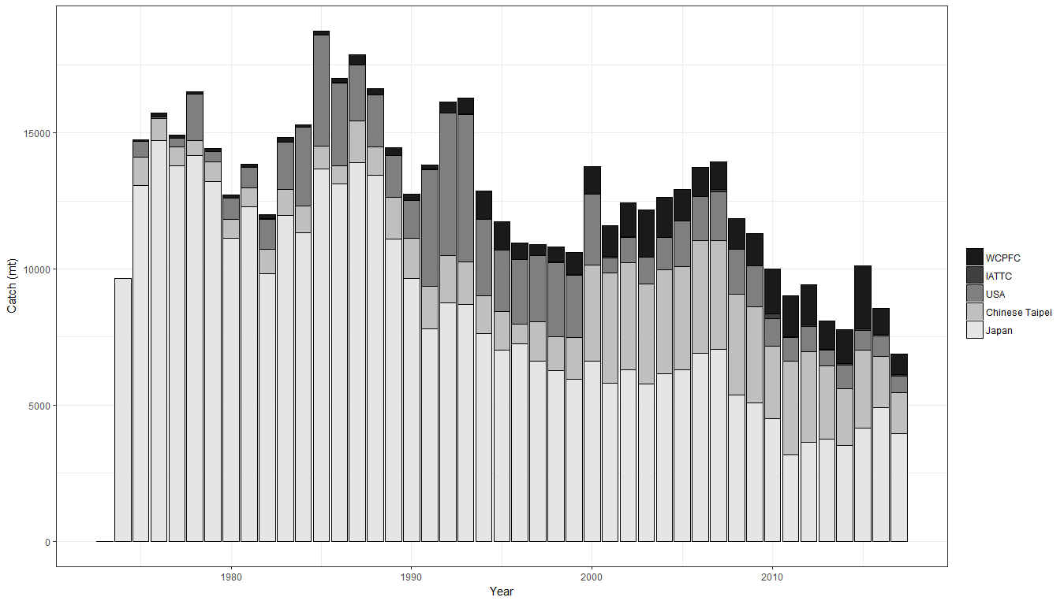
Figure 6-5. Stock boundaries used for this assessment of North Pacific Ocean swordfish: purple lines indicate stock area divisions; stock area 1 was assessed as the WCNPO stock, stock area 2 contains the Eastern Pacific Ocean stock, the green line indicates Western Central Pacific Fisheries Commission convention area, blue dashed line indicates IATTC convention area.
Figure 6-6. Annual catch biomass (t) of WCNPO swordfish (Xiphias gladius) by country for Japan, Chinese Taipei, the U.S.A., and all other countries during 1975-2016.

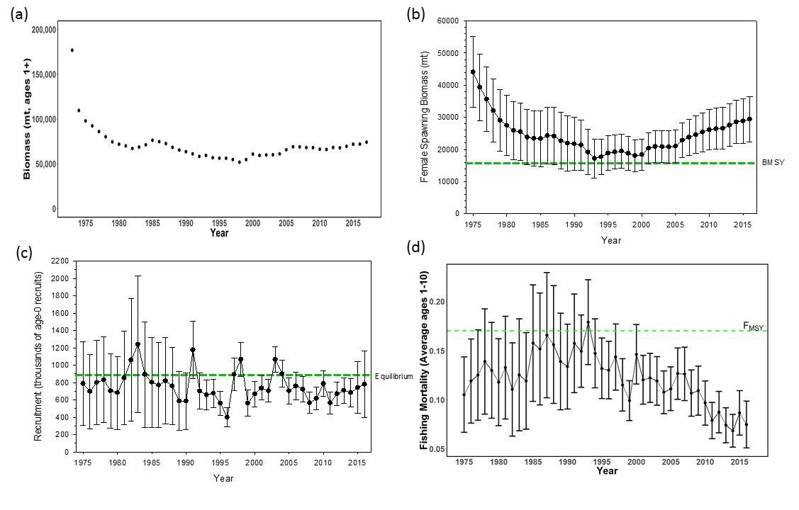

Figure 6-7. Time series of estimates of (a) population biomass (age 1+) (first point in time series represents unfished biomass), (b) spawning biomass, (c) recruitment (age-0 fish), and (d) instantaneous fishing mortality (average for ages 1 to 10, yr-1) for WCNPO swordfish (Xiphias gladius) derived from the 2018 stock assessment. The solid circles are the maximum likelihood estimates by year for each quantity and the error bars represent the uncertainty of the estimates (80% confidence intervals), green dashed lines indicate BMSY, equilibrium recruitment, and FMSY except for the population biomass time series.

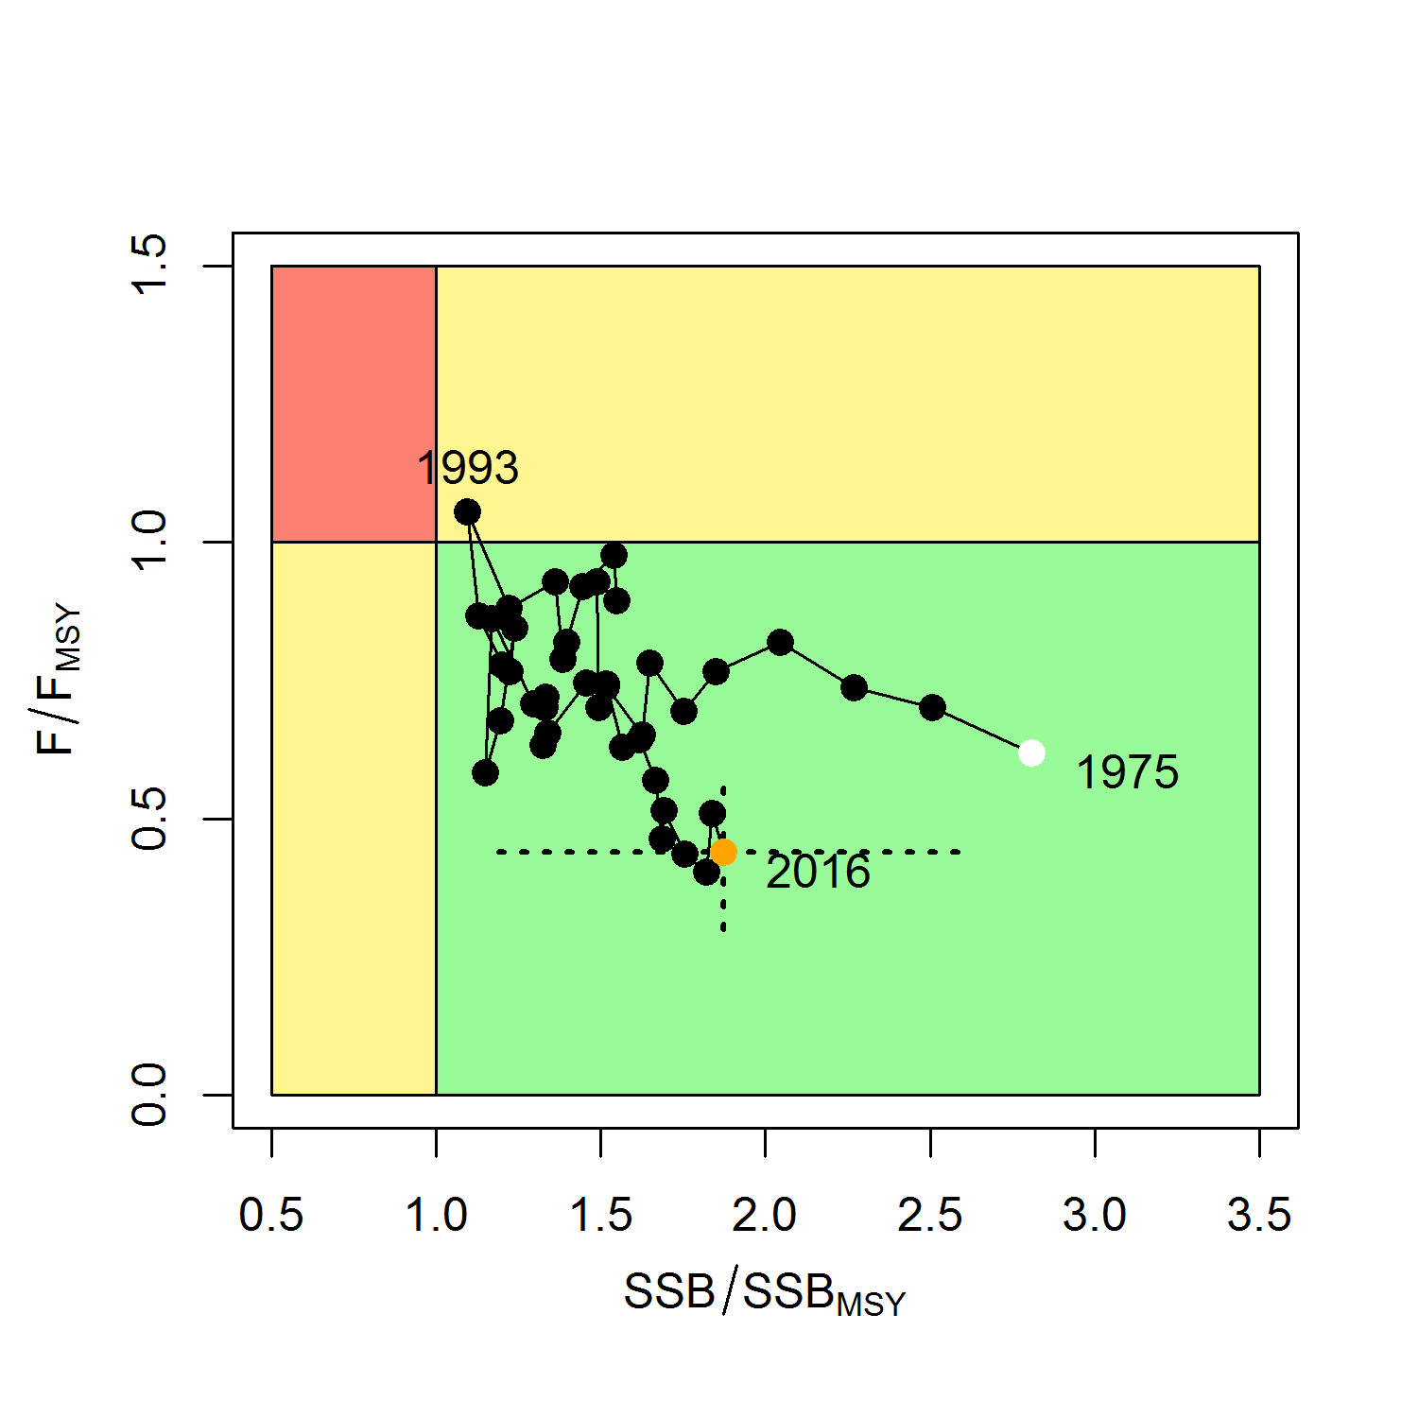

Figure 6-8. Kobe plot of the time series of estimates of relative fishing mortality (average of ages 1-10) and relative spawning stock biomass of WCNPO swordfish (Xiphias gladius) during 1975-2016. The white circle denotes the first year (1975) and the yellow circle denotes the last year (2016) of the assessment time horizon. The dashed lines represent the 95% confidence intervals around the 2016 estimate.

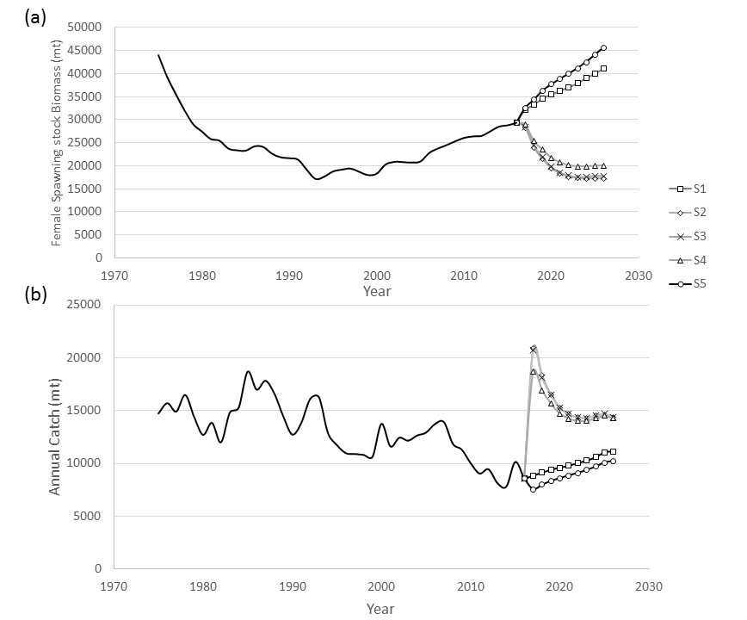

Figure 6-9. Historical and projected trajectories of (a) spawning stock biomass and (b) total catch from the WCNPO swordfish base case model. Stock projection results are shown for S1 = the status quo or average fishing intensity during 2013-2015 (𝐹2013−2015= 𝐹43%); S2 = FMSY (𝐹18%); S3 = F to produce 20% of unfished spawning stock biomass or F0.2*SSB(F=0) (𝐹22%); S4 = the highest 3-year average F during 1975-2016 or High F (F20%); S5 = Low F (F50%).

