Weighted median values of reference point levels (adopted limit reference point (LRP) of 20% SB_{F=0}; F_{MSY}) and risk¹ of breaching reference points from the 2017 bigeye stock assessment incorporating updated growth information, and in 2045 under the three future harvest scenarios (status quo, optimistic and pessimistic) and alternative recruitment hypotheses. ‘Updated new growth’ runs only.

Scenario |  | Scalars relative to 2013-2015 |  | Median SB₂₀₄₅/SB_{F=0} | Median SB₂₀₄₅/SB_{F=0}  v  SB₂₀₁₂₋₁₅/SB_{F=0} | Median  F₂₀₄₁₋₂₀₄₄/F_{MSY} | Median F₂₀₄₁₋₂₀₄₄/F_{MSY} v  F₂₀₁₁₋₁₄/F_{MSY} | Risk
Recruitment | Fishing level | Purse seine | Longline |  |  |  |  | SB₂₀₄₅ < LRP | F>F_{MSY}
Bigeye assessment (‘recent’ levels) |  |  |  | 0.36 | - | 0.77 | - | 0% | 6%
Recent | Status quo | 1 | 1 | 0.42 | 1.18 | 0.73 | 0.95 | 0% | 11%
 | Optimistic | 1.11 | 0.98 | 0.41 | 1.15 | 0.75 | 0.98 | 0% | 13%
 | Pessimistic | 1.12 | 1.35 | 0.36 | 1.00 | 0.89 | 1.15 | 5% | 30%
Long-term | Status quo | 1 | 1 | 0.30 | 0.84 | 1.60 | 2.09 | 17% | 93%
 | Optimistic | 1.11 | 0.98 | 0.29 | 0.82 | 1.64 | 2.13 | 18% | 94%
 | Pessimistic | 1.12 | 1.35 | 0.25 | 0.70 | 1.84 | 2.38 | 32% | 98%

1 note risk within the stock assessment is calculated as the (weighted) number of models falling below the LRP (X / 36 models). Risk under a projection scenario is the number of projections across the grid that fall below the LRP (X / 3600 (36 models x 100 projections)
Recent recruitments | Long-term recruitment
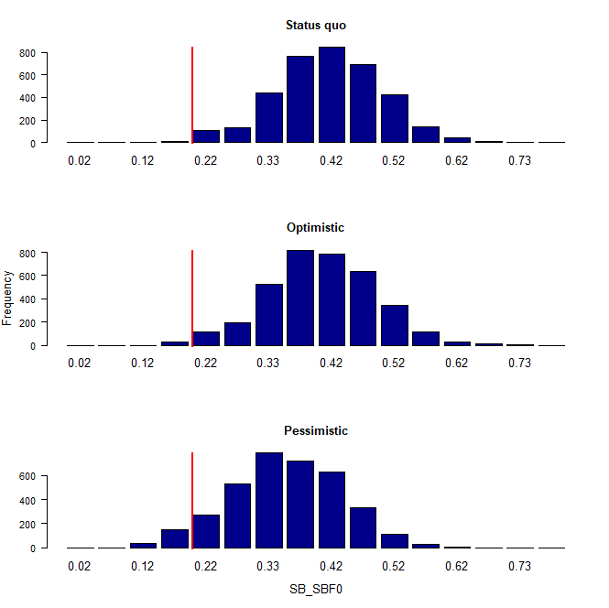 | 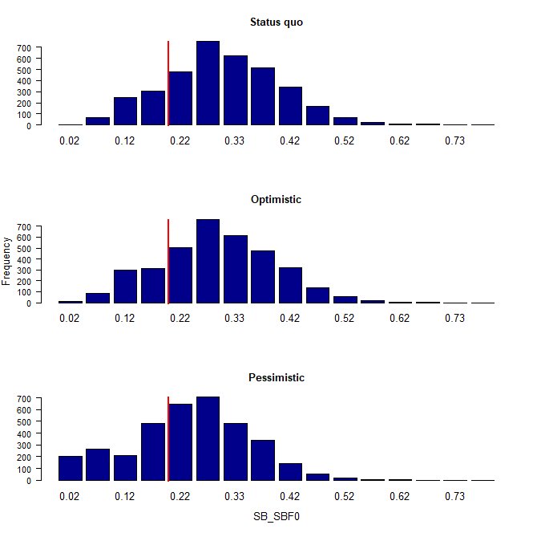

Figure 1. Distribution of SB₂₀₄₅/SB_{F=0} assuming recent and long term recruitment conditions (left and right columns, respectively), under the three future fishing scenarios: status quo (2013-15 average conditions, top row); optimistic conditions (middle row); and pessimistic conditions (bottom row). Projection results from ‘updated new growth’ models (3,600 projections) only.

Recent recruitments | Long-term recruitment
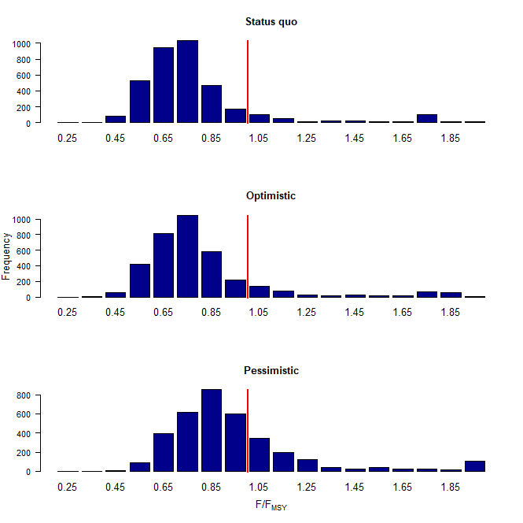 | 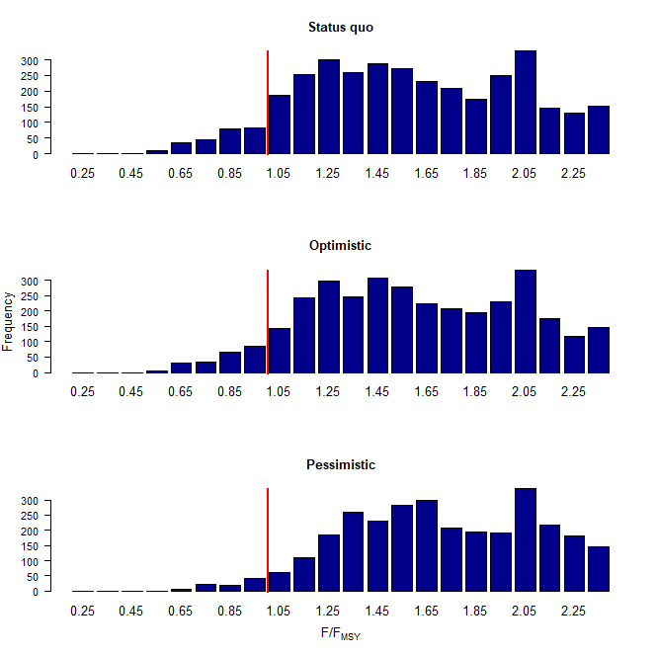

Figure 2. Distribution of F/F_{MSY} assuming recent and long term recruitment conditions (left and right columns, respectively), under the three future fishing scenarios: status quo (2013-15 average conditions, top row); optimistic conditions (middle row); and pessimistic conditions (bottom row). Projection results from ‘updated new growth’ models (3,600 projections) only.

Recent recruitments | Long-term recruitment
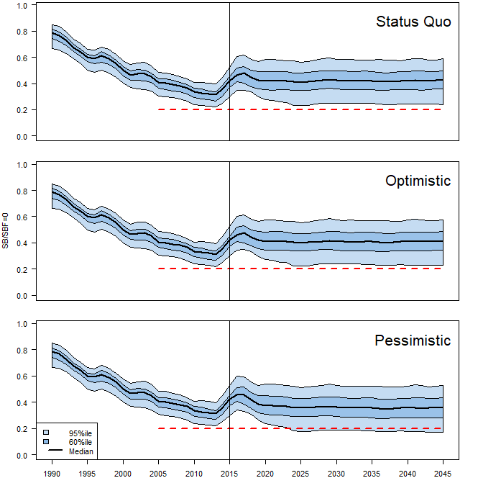 | 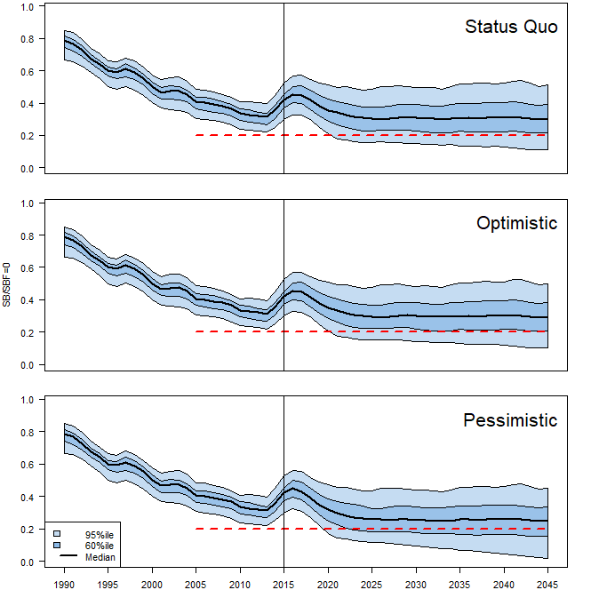
Figure 3. Time series of WCPO bigeye tuna spawning biomass (SB/SBF=0) from the uncertainty grid of assessment model runs for the period 1990 to 2015 (the vertical line at 2015 represents the last year of the assessment), and stochastic projection results for the period 2016 to 2045 under the three future fishing scenarios (“Status Quo”, “Optimistic” and “Pessimistic”; rows). During the projection period (2016-2045) levels of recruitment variability are assumed to match those over the “recent” time period (2005-2014; left panel) or the time period used to estimate the stock-recruitment relationship (1962-2014; right panel). The red dashed line represents the agreed limit reference point.

