NORTHERN COMMITTEE
FOURTEENTH REGULAR SESSION
4 – 7 September 2018
Fukuoka, Japan
NOTICE OF MEETING AND MEETING ARRANGEMENTS
WCPFC-NC14-2018/01

In accordance with the Commission Rules of Procedure, Members, cooperating non-Members and Participating Territories (CCMs) are invited to attend the Fourteenth Regular Session of the Northern Committee (NC14) of the Commission for the Conservation and Management of Highly Migratory Fish Stocks in the Western and Central Pacific Ocean. NC14 meeting will take place at Hilton Fukuoka Sea Hawk, Fukuoka, Japan, 4 – 7 September 2018. The 3rd Joint IATTC-WCPFC NC Working Group Meeting on the Management of Pacific Bluefin Tuna will be held during NC14. A CDS Technical Meeting will be held at the same place on 3 September 2018.

NC14 Meeting Documents

Provisional agenda will be posted by 5 June 2018.

Additional meeting documents will be available on the WCPFC Meeting page: https://wcpfc.int/meetings/14th-regular-session-northern-committee. All participants will be individually responsible for downloading their meeting documents and printing them. Please contact the Secretariat (sungkwon.soh@wcpfc.int) if you experience any difficulties.

Registration

All participants are requested to register electronically on the WCPFC website, NC14 meeting page. All registrations should be completed by 15 August 2018.

Meeting Venue

The meeting venue will be Hilton Fukuoka Sea Hawk,
2-2-3 Jigyouhama, Chuo-ku, Fukuoka 810-8650, Japan.
TEL:+81-92-844-8111, FAX:+81-92-844-7887

English site:
http://www3.hilton.com/en/hotels/japan/hilton-fukuoka-sea-hawk-FUKHIHI/index.html
Japanese site:
http://www.hiltonfukuokaseahawk.jp/

Wireless Internet will be available at the meeting room.

Visas for Japan

Participants are required to ask their governments on the status of visa requirements to Japan. There are many websites for the visa information for Japan.

Climate

It will be late summer in Fukuoka so the climate is expected to be hot.

Funding for Developing Countries and Territories

According to the decision made by WCPFC9, six small island developing States would be funded for travel to the NC meeting, with priority given to RMI, FSM and Palau. These are in addition to the Cook Islands, Fiji and Vanuatu who are members of the Northern Committee. Formal nominations for participants to receive this support should be submitted to the Secretariat (aaron.nighswander@wcpfc.int) by 1 August 2018 under the signature of their WCPFC Official Contact for eligible developing countries and participating territories.

The absolute latest travel for nominees should be finalized is two weeks prior to commencing travel.

Accommodation options

Accommodations for participants have been secured in the Hilton Fukuoka Sea Hawk at the special rate of 2 to 6 September 12,000 JPY & 7 September 18,700 JPY (for single-use, without tax (8%) and service charge (13%), breakfast inclusive). Dedicated website for the reservation by August 10, 2018 is:

http://www.hilton.com/en/hi/groups/personalized/F/FUKHIHI-GSUIA-20180902/index.jhtml

Other accommodations are also available in Tenjin area or Hakata area.

Transportation from the Fukuoka Airport to the hotels

Transport from the Fukuoka Airport to Hilton Fukuoka Sea Hawk is available by:
- Taxi – approximately 20-minute drive from the airport (approximately 4,000 JPY).
- Bus – get on the bus bound for “Fukuoka Tower TNC (#139)” and get off at “Hilton Fukuoka Sea Hawk-mae” bus stop (430 JPY). The hotel is one minute walk from the bus stop. Approximately 40-minute ride from the airport.
- Subway – take the Fukuoka City Subway, getting off at “Tojin-machi” station (300 JPY). Hilton Fukuoka Sea Hawk is 20-minute walk from the station. Approximately 15-minute ride from the airport.

Direction from Fukuoka Airport to Hakata or Tenjin (By subway)

・Fukuoka Airport-Hakata: 5min by Kuko Line
・Fukuoka Airport-Tenjin : 11min by Kuko Line
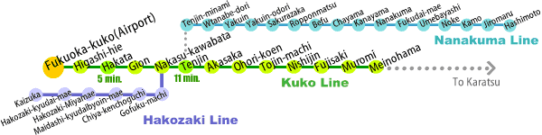
Direction from Tenjin to Hilton Fukuoka Sea Hawk

By Bus: From Tenjin, get on the bus bound for “Fukuoka Tower TNC (#W1)” at “Tenjin Bus Center” bus stop and get off at “Hilton Fukuoka Sea Hawk-mae” bus stop. The hotel is a one minute walk from the bus stop. Approximately 17 minute ride from the bus stop.

By subway: Take the Fukuoka City Subway, getting off at “Tojin-machi” station (200 JPY). Hilton Fukuoka Sea Hawk is 20-minute walk from the station.
Bus stop;
Tenjin Bus Center-mae

Direction from Hakata to Hilton Fukuoka Sea Hawk

By Bus: From Hakata, get on the bus bound for “Fukuoka Tower TNC (#306)” or to “Fujisaki (#306)” at “Hakata bus terminal” bus stop (1F, #6) and get off at “Hilton Fukuoka Sea Hawk-mae” bus stop. The hotel is a one minute walk from the bus stop. Approximately 17-minute ride from the bus stop.

By Subway: take the Fukuoka City Subway, getting off at “Tojin-machi” station (260 JPY). Hilton Fukuoka Sea Hawk is 20-minute walk from the station.
Bus stop;
Hakata bus terminal

・There are many hotels in Hakata and Tenjin Area (over 60 hotels).
・You could search the hotel in search site by yourself.
(Booking.com (www.booking.com) is useful site (“Fukuoka” or “Hakata” in Destination/hotel name)).

The map of the meeting venue, Hakata and Tenjin area

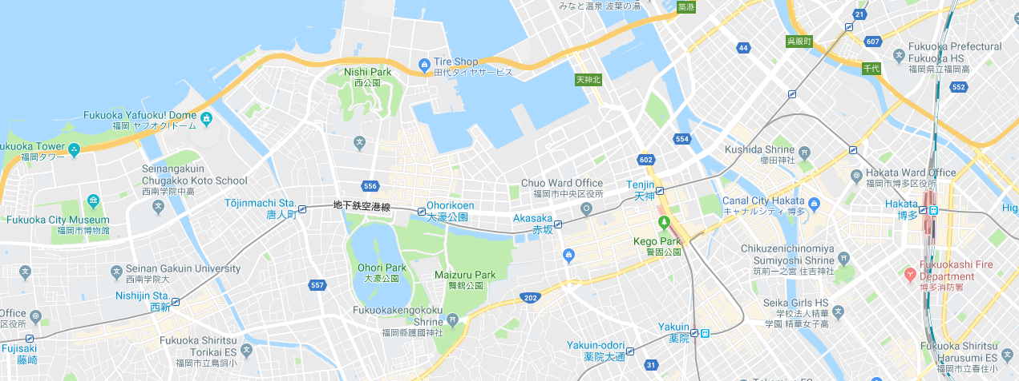
Tenjin Area
Hakata Area
Hilton Fukuoka Sea Hawk

