

The Commission for the Conservation and Management of
Highly Migratory Fish Stocks in the Western and Central Pacific Ocean

Thirteenth Regular Session of the Scientific Committee

Rarotonga, Cook Islands
9 - 17 August 2017

SUMMARY REPORT

Table of Contents

EXECUTIVE SUMMARY ...iv
summary report 1
Agenda Item 1 — Opening of Meeting 1
Agenda Item 2 — review of fisheries 4
Agenda Item 3 — Data and Statistics Theme 12
Agenda Item 4 — Stock Assessment Theme 24
Agenda Item 5 — Management Issues Theme 109
Agenda Item 6 — Ecosystem and Bycatch Mitigation Theme 123
Agenda Item 7 — Other Research Projects 137
Agenda Item 8 — cooperation With Other Organizations 142
Agenda Item 9 — special Requirements of Developing States and Participating Territories 143
Agenda Item 10— future Work Programme and Budget 144
Agenda Item 11 — administrative matters 145
Agenda Item 12 —Other matters 146
Agenda Item 13— adoption of sc10 report 146
Agenda Item 14 — close of meeting 146

ATTACHMENTS

Attachment A — LIST OF PARTICIPANTS 147
Attachment B — Opening Statement by the Honourable Mark Brown Minister of Finance and Acting Minister of Marine Resources Government of the Cook Islands 162
Attachment C — Opening Remarks by WCPFC Executive Director 164
Attachment D — AGENDA 167
Attachment E — FAD data fields and FAD Research Plan 172
Attachment F — Performance Indicators and Monitoring Strategies 183
Attachment G — Options for the development of a comprehensive approach to shark and ray conservation and management 188
Attachment H — Best Handling Practices for the Safe Release of Mantas & Mobulids 194
Attachment I — SHARK RESEARCH PLAN 196
Attachment J — SC WORK PROGRAMME AND BUDGET FOR 2018 – 2020…………...208

The Commission for the Conservation and Management of
Highly Migratory Fish Stocks in the Western and Central Pacific Ocean

Scientific Committee
Thirteenth Regular Session

Rarotonga, Cook Islands
9 - 17 August 2017

EXECUTIVE SUMMARY

AGENDA ITEM 1 – Opening of the Meeting

- The Thirteenth Regular Session of the Scientific Committee of the Commission for the Conservation and Management of Highly Migratory Fish Stocks in the Western and Central Pacific Ocean took place from 9 - 17 August 2017 at the National Auditorium, Marairenga, Rarotonga, Cook Islands.

- The following WCPFC Members, Cooperating Non-members and Participating Territories (CCMs) attended SC13: American Samoa, Australia, China, Cook Islands, European Union (EU), Federated States of Micronesia (FSM), Fiji, French Polynesia, Indonesia, Japan, Kiribati, Republic of Korea, Republic of Marshall Islands (RMI), Nauru, New Caledonia, New Zealand, Niue, Palau, Philippines, Papua New Guinea (PNG), Samoa, Solomon Islands, Chinese Taipei, Tokelau, Tonga, Tuvalu, United States of America (USA), Vanuatu and Vietnam.

- Observers from the following IGOs and NGOs attended SC13: Pacific Islands Forum Fisheries Agency (FFA), Inter-American Tropical Tuna Commission (IATTC), Parties to the Nauru Agreement (PNA), the Pacific Community (SPC) and the Food and Agriculture Organization of the United Nations (FAO), American Tunaboat Association, Birdlife International, Greenpeace, International Seafood Sustainability Foundation (ISSF), Marine Stewardship Council (MSC), The Nature Conservancy, The Pew Charitable Trusts (Pew), Sustainable Fisheries Partnership (SFP), and Worldwide Fund for Nature (WWF).

- The Honourable Minister M. Brown, the SC Chair, B. Muller (RMI) and the Executive Director delivered opening and welcome speeches.

- The theme conveners and their assigned themes were:
Data and Statistics theme | V. Post (USA)
Stock Assessment theme | J. Brodziak (USA) and H. Nishida (Japan)
Management Issues theme | R. Campbell (Australia)
Ecosystem and Bycatch Mitigation theme | J. Annala (NZ) and A. Batibasaga (Fiji)

- SC13 established seven informal small groups (ISGs) to facilitate the meeting process:
ISG-ID | Title | Facilitator
ISG-1 | Guidelines for submission of economic data | A. Batibasaga
ISG-2 | FAD data fields and FAD Research Plan | J. Santiago
ISG-3 | Target reference point for SP albacore | Cancelled
ISG-4 | Shark Research Plan and future work plan | J. Larcombe
ISG-5 | Safe release guidelines for manta and mobula rays | M. Hutchinson
ISG-6 | Comprehensive shark and ray measure | S. Varsamos
ISG-7 | Development of SC Budget for 2017 – 2019 | B. Muller
ISG-8 | Performance Indicators and Monitoring Strategies | R. Campbell

AGENDA ITEM 2 – Review of Fisheries

2.1 Overview of Western and Central Pacific Ocean (WCPO) fisheries

- P. Williams (SPC-OFP) and C. Reid (FFA) introduced SC13-GN-WP-01 Overview of tuna fisheries in the western and central Pacific Ocean, including economic conditions – 2016, which provided an overview of the WCPO key fisheries, including billfish and trends in purse-seine fishery capacity. They noted that SC13-ST-IP-01 Estimates of annual catches in the WCPFC Statistical Area, and Annual Reports- Part 1 provided additional detail.

- The provisional total WCP–CA tuna catch for 2016 was estimated at 2,717,850 mt, the second highest on record and nearly 120,000 mt below the previous record catch in 2014 (2,851,087 mt); this catch represented 79% of the total Pacific Ocean catch of 3,406,269 mt, and 56% of the global tuna catch (the provisional estimate for 2016 is 4,795,867 mt, and when finalised was expected to be the second highest on record).

- The 2016 WCP–CA catch of skipjack (1,816,650 mt – 67% of the total catch) was the fourth highest recorded, nearly 160,000 mt less than the record in 2014 (1,977,019 mt). The WCP–CA yellowfin catch for 2016 (650,491 mt – 24%) was the highest recorded (more than 40,000 mt higher than the previous record catch of 2008 – 609,458 mt); the increase in yellowfin tuna catch from 2015 levels was mainly due to increased catches in the purse seine fishery and the Indonesia and Philippines domestic fisheries. The WCP–CA bigeye catch for 2016 (152,806 mt – 6%) was an increase on 2015 catch and around average for the past ten years. The 2016 WCP–CA albacore catch (97,822 mt – 4%) was the lowest since 1996 and around 50,000 mt lower than the record catch in 2002 at 147,793 mt. The south Pacific albacore catch in 2016 (68,601 mt) was about 13,000 mt lower than in 2015 and nearly 20,000 mt lower than the record catch in 2010 of 87,292 mt (although the 2016 estimates for some fleets are provisional).

- The provisional 2016 purse seine catch of 1,858,198 mt was the third highest catch on record, higher than in 2016, but more than 160,000 mt lower than the record in 2014 (2,028,630 mt); the main reasons for the increase in catch compared to 2015 are related to increased effort and improved conditions (catch rates) in the fishery. The 2016 purse-seine skipjack catch (1,408,110 mt; 75% of total catch) was about 200,000 mt lower than the record in 2014, but almost identical to the 2015 catch level. The 2016 purse-seine catch estimate for yellowfin tuna (394,756 mt; 21%) was the second highest on record (423,788 mt in 2008) coming after a poor catch year in 2015 and appeared to be due to increased catches of large yellowfin from unassociated-school set types. The provisional catch estimate for bigeye tuna for 2016 (63,304 mt) was an increase from the relatively low catch level in 2015.

- The provisional 2016 pole and line catch (199,457 mt) was the lowest annual catch since the late-1960s, although estimates were typically revised upwards by the start of SC meetings each year. Japanese distant-water and offshore fleets (90,343 mt in 2016), and the Indonesian fleets (108,327 mt in 2016), accounted for nearly all of the WCP–CA pole and line catch (99% in 2016).

- The provisional WCP–CA longline catch (231,860 mt) for 2016 was lower than the average for the past five years. The WCP–CA albacore longline catch (71,571 mt – 31%) for 2016 was the lowest since 2000, 30,000 mt lower that the record of 101,816 mt attained in 2010. The provisional bigeye catch (64,131 mt – 28%) for 2016 was the lowest since 1996, mainly due to continued reduction in effort in the main bigeye tuna fishery (refer to Pilling et al., 2017 for more detail). The yellowfin catch for 2016 (90,539 mt – 39%) was around the average for the past five years.

- The 2016 South Pacific troll albacore catch (2,097 mt) was the lowest catch since 2009. The New Zealand troll fleet (137 vessels catching 1,952 mt in 2016) and the United States troll fleet (6 vessels catching 151 mt in 2016) accounted for all the 2016 albacore troll catch.

Figure 1. Catch (mt) of albacore, bigeye, skipjack and yellowfin in the WCP–CA, by longline, pole and line, purse seine and other gear types. | Figure 2. Catch (mt) of albacore, bigeye, skipjack and yellowfin in the WCP–CA

AGENDA ITEM 3 – Data and Statistics

3.1 Data gaps

3.1.1 Data gaps of the Commission

- SC13 recommended that the Scientific Services Provider conduct a gaps analysis and compile the requirements for enhancing conversion factor information required for future WCPFC work and present this information to SC14, including a proposal for how the gaps can be addressed.

- SC13 recommended that the Scientific Service Provider review the importance and practicalities for including the provision of estimates of longline discards in number of individuals discarded/released in the “Scientific Data to be provided to the Commission”, with a definition for discards/releases, and report to SC14.

- SC13 acknowledged the necessary assistance that the SPC-facilitated “Regional Tuna Data Workshop (TDW)” provides in building technical capacity for SIDS, territories and developing states to produce annual catch estimates and Part 1 reports. SC13 recommended that the Commission continue to support SIDS, territories and developing states participation at future TDWs through the “Regional Capacity Building Workshops” fund.

- SC13 recommended that the Scientific Services Provider proceed to enhance the set of WCPFC public domain data available on the WCPFC web site, with the assurance that the WCPFC rules for public domain data will be applied.

3.1.2 Species composition of purse seine catches (Project 60)

- SC13 recommended that the future work proposed by the Scientific Service Provider under Project 60 (Improving purse seine species composition) continue over the coming year with a report to SC14 and agreed that this work should continue in the medium-term subject to annual review.

- SC13 recommended that the Scientific Services Provider explore opportunities to undertake comprehensive comparisons of corrected grab sample based species compositions with accurate composition estimates from in-port sampling with other CCMs who hold the required data.

- SC13 recommended that trials of electronic monitoring based approaches to species composition estimation be undertaken in a separate project.

- SC13 recommended that the Scientific Services Provider include the original purse seine tuna species catch estimates provided by CCMs in the WCPFC Tuna Fishery Yearbook.

- SC13 recommended that the Scientific Services Provider be tasked with designing and co-ordinating the systematic collection of representative samples of length measurements of bycatch species.

- SC13 recommended that the Scientific Services Provider be tasked with a project to design and co-ordinate the systematic collection of length:length, length:weight and weight:weight data on all species to better inform bycatch estimation.

3.1.3 Potential use of cannery receipt data for the work of the WCPFC

- No recommendations were provided.

3.1.4 Estimates of purse seine fishery bycatch at a regional scale, 2003 – 2016

- SC13 recommended that the Scientific Services Providers continue the work on purse seine bycatch estimates and extend this work to producing estimates of bycatch in the longline fisheries for presentation at SC14, acknowledging the issues related to the 5% observer coverage in these fisheries.

- SC13 recommended that the Scientific Services Provider produce WCPFC-area estimates of longline bycatch on a regional fishery basis.

3.2 FAD data management

3.2.1 Additional FAD data fields to be provided by vessel operators

- SC13 recommended that the operators of all vessels involved in FAD fishery, including support vessels, provide as a minimum the fields of information identified in Attachment C of the report of the 2nd meeting of the FAD management options intersessional Working Group (WCPFC-2016-FADMgmtOptionsIWG021_rev2).

- SC13 further recommended that the WCPFC Secretariat, together with SPC and other interest parties prepare the set of data fields to be provided by vessel operators and coordinate with the IATTC staff to try to harmonize the minimum standards to be required across the Pacific Ocean. Special attention should be paid to avoid duplications of information by vessel operators and/or an increase of unnecessary paperwork.

- SC13 recommended that the proposed fields to be collected by vessel operators be forwarded to TCC13 for review and WCPFC14 for adoption.

3.2.2 FAD marking and monitoring
- SC13 recommended as a first step the Commission should consider introducing a buoy ID scheme which requires the registration of all buoys attached to FADs deployed. Field tests in conjunction with industry and observers should be undertaken to determine the optimal configuration of future developments of a fully marking system that also includes the FADs themselves.

3.3 Regional Observer Programme

- SC13 recommended the following revisions to the ROP Minimum Standard Data Fields:
- Addition of a new section “FAD Information” that will include inventories of the FAD buoys on board at the start and end of each trip.
- Addition of a new field for FAD Identification.
- Deletion of FAD Data fields related to a) materials FAD is made from and b) estimated size of FAD.

- SC13 noted that the revisions of the ROP minimum standards will require careful planning and implementation to ensure that the value of WCPFC data on FADs is maintained. In particular, there may need to be a period of overlap in reporting of FAD data where observers continue to report on FAD design and construction while the new reporting requirements for vessel operators are introduced.

- SC13 recommended that the revisions to the ROP Minimum Standard Data Fields standards be forwarded to TCC13 for review and WCPFC14 for adoption.

- SC13 recommended that the Scientific Services Provider, CCMs and the WCPFC Secretariat through the ROP provide guidance to improve observer training related to visual estimation of bycatch numbers and weight, and that the Scientific Services Provider and CCM observer programmes improve the observer debriefing process related to bycatch, including the Scientific Services Provider incorporating appropriate data quality flags within the ROP master database to facilitate use in analyses. This recommendation applies to both purse seine and longline fisheries.

- SC13 recommended that the currently implemented procedure to convert from weight to numbers, and vice versa, should be reviewed by the Scientific Services Provider to ensure that resulting estimates are appropriate and report to SC14.

- SC13 recommends that the Commission adopt a formal definition of SSIs, e.g. “species of special interest are those species for which the Commission has requested additional data collection under the ROP, either because they are protected under one or more WCPFC conservation and management measures, or for other reasons articulated by the Commission”. SC13 notes that at present under this definition SSIs would comprise manta and mobulid (devil) rays on the basis of a Commission decision requiring a greater degree of observer data collection, and silky, oceanic whitetip and whale shark on the basis of no-retention conservation and management measures (CMMs 2011-04, 2012-04 and 2013-08). In responding to WCPFC13’s specific request, SC13 confirms that as SSIs, manta and devil rays will have all required data collected under the Regional Observer Programme Minimum Standard Data Fields.

3.4 Electronic Reporting outcomes from WCPFC13

- SC13 recommended that the WCPFC ERandEM Working Group convene prior to SC14 to continue work in this area, including consideration of how observer data obtained through E-Monitoring is to be dealt with in the WCPFC context.

- SC13 recommended that the latest draft version of the WCPFC E-Reporting observer data standards be forwarded to WCPFC14 for adoption.

3.5 Economic Data

- SC13 considered the development of guidelines for the voluntary provision of economic data to the Commission by CCMs and recommended that intersessional work be undertaken on the principles that will inform the development of such guidelines. CCMs wishing to participate in this intersessional work should provide a contact point for inclusion in this intersessional working group which will be facilitated by Fiji and the FFA Secretariat.

- SC13 further recommended that the outcomes of this intersessional work be considered by TCC13.

AGENDA ITEM 4 – Stock Assessment

4.1 WCPO Tunas

4.1.1 WCPO bigeye tuna (Thunnus obesus)

- SC13 endorsed the 2017 WCPO bigeye tuna stock assessment as the most advanced and comprehensive assessment yet conducted for this species.

- SC13 also endorsed the use of the assessment model uncertainty grid to characterize stock status and management advice and implications but noted the large variance in the assessment results, mainly due to the inclusion of the old and new regional structures and growth curves, for which some CCMs considered further investigation is necessary.

- SC13 reached consensus on the weighting of assessment models in the uncertainty grid for bigeye tuna. The consensus weighting considered all options within the four axes of uncertainty for steepness, tagging dispersion, size frequency and regional structure to be equally likely. For the growth axis of uncertainty, the new growth curve models (n=36 models, weight=3, 108 model weight units) were weighted three times more than the old growth curve models (n=36 models, weight=1, 36 model weight units). In total there were 144 model weight units. The resulting uncertainty grid was used to characterize stock status, to summarize reference points as provided in the assessment document SC13-SA-WP-05, and to calculate the probability of breaching the adopted spawning biomass limit reference point (0.2*SB_{F=0}) and the probability of F_{recent} being greater than F_{MSY}. It should be noted that the results would vary depending on the choice and/or weighting of grids, in particular the growth curve model, thus those characterizations of central tendency of stock status need to be interpreted with caution.

- Stock status and trends

- The median values of relative recent (2012-2015) spawning biomass (SB_{recent}/ SB_{F=0}) and relative recent fishing mortality (F_{recent}/F_{MSY}) over the uncertainty grid were used to measure the central tendency of stock status. The values of the upper 90th and lower 10th percentiles of the empirical distributions of relative spawning biomass and relative fishing mortality from the uncertainty grid were used to characterize the probable range of stock status.

- A description of the updated structural sensitivity grid used to characterize uncertainty in the assessment was set out in Table BET-1. Time series of total annual catch by fishing gear for the diagnostic case model over the full assessment period is shown in Figure BET-1. Estimated annual average recruitment, spawning potential, juvenile and adult fishing mortality and fishing depletion for the diagnostic case model are shown in Figures BET-2 – BET-5. Figures BET-6 and BET-7 display Majuro plots summarising the results for each of the models in the structural uncertainty grid. Figures BET-8 and BET-9 show Kobe plots summarising the results for each of the models in the structural uncertainty grid. Figure BET-10 provides estimated time-series (or “dynamic”) Majuro and Kobe plots from the bigeye ‘diagnostic case’ model run. Figure BET-11 provides estimates of reduction in spawning potential due to fishing by region, and over all regions attributed to various fishery groups (gear-types) for the diagnostic case model. Table BET-2 provides a summary of reference points over the 72 models in the structural uncertainty grid.

Table BET-1. Description of the updated structural sensitivity grid used to characterize uncertainty in the assessment.
Axis | Levels | Option
Steepness | 3 | 0.65, 0.80, 0.95
Growth | 2 | ‘Old growth’, ‘New growth’
Tagging over-dispersion | 2 | Default level (1), fixed (moderate) level
Size frequency weighting | 3 | Sample sizes divided by 10, 20, 50
Regional structure | 2 | 2017 regions, 2014 regions

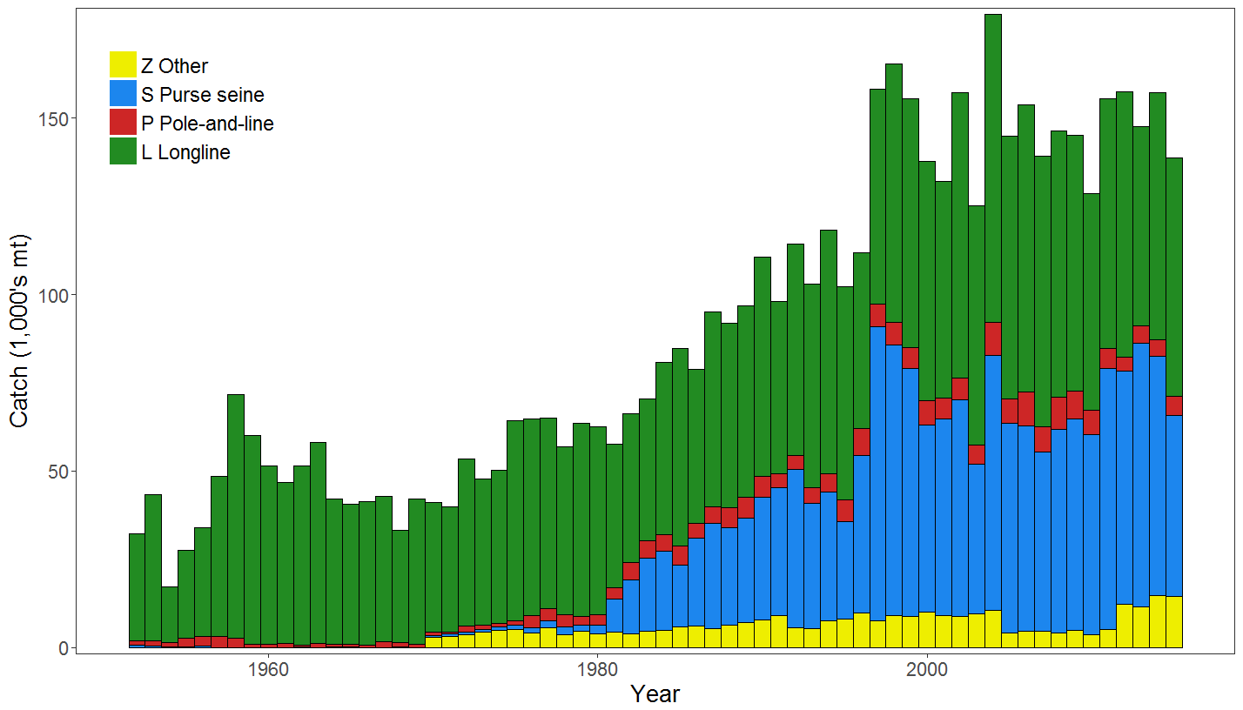 | 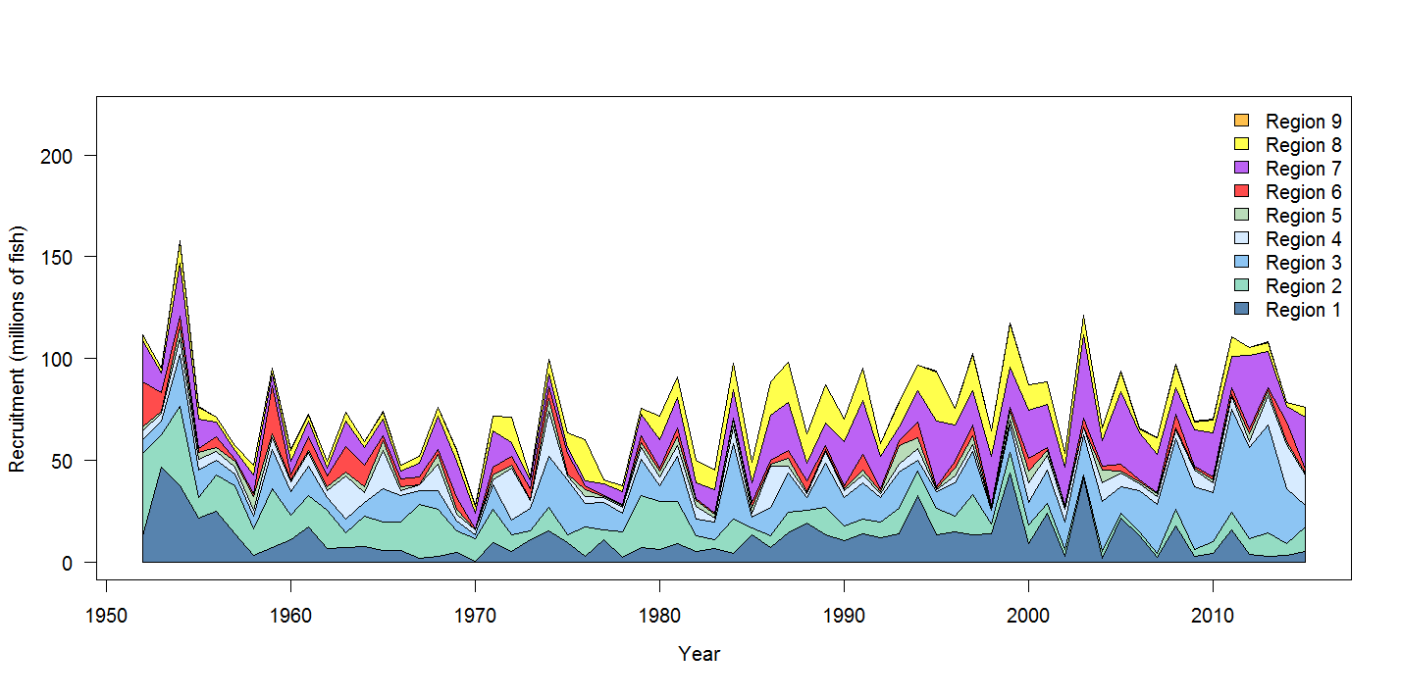
Figure BET-1. Time series of total annual catch (1000's mt) by fishing gear for the diagnostic case model over the full assessment period. | Figure BET-2. Estimated annual average recruitment by model region for the diagnostic case model, showing the relative sizes among regions.

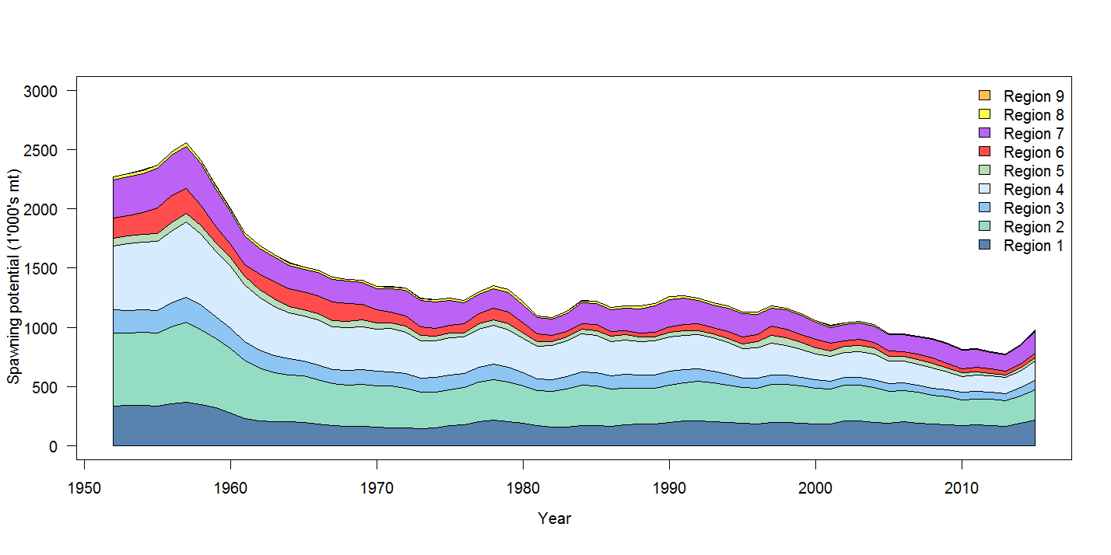 | 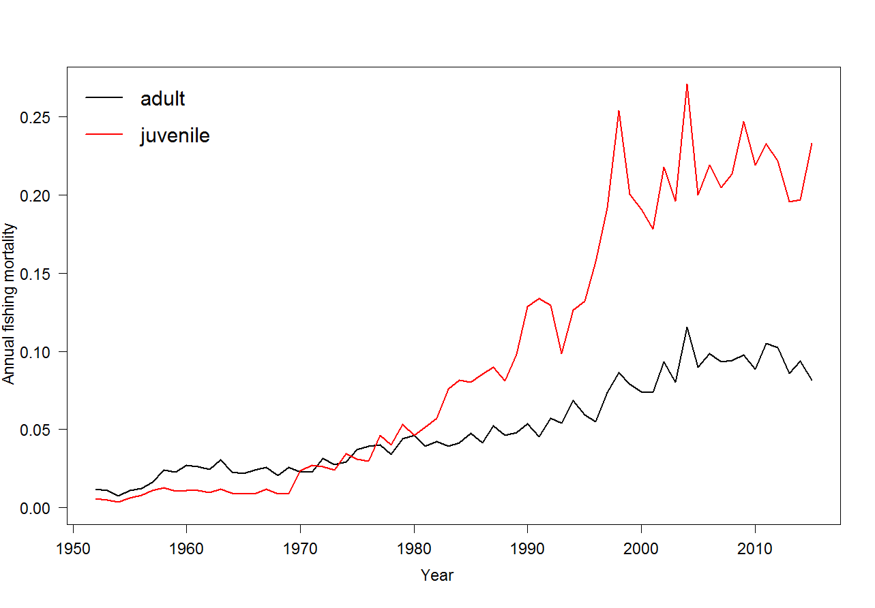
Figure BET-3. Estimated annual average spawning potential by model region for diagnostic case model, showing the relative sizes among regions | Figure BET-4. Estimated annual average juvenile and adult fishing mortality for the diagnostic case model.
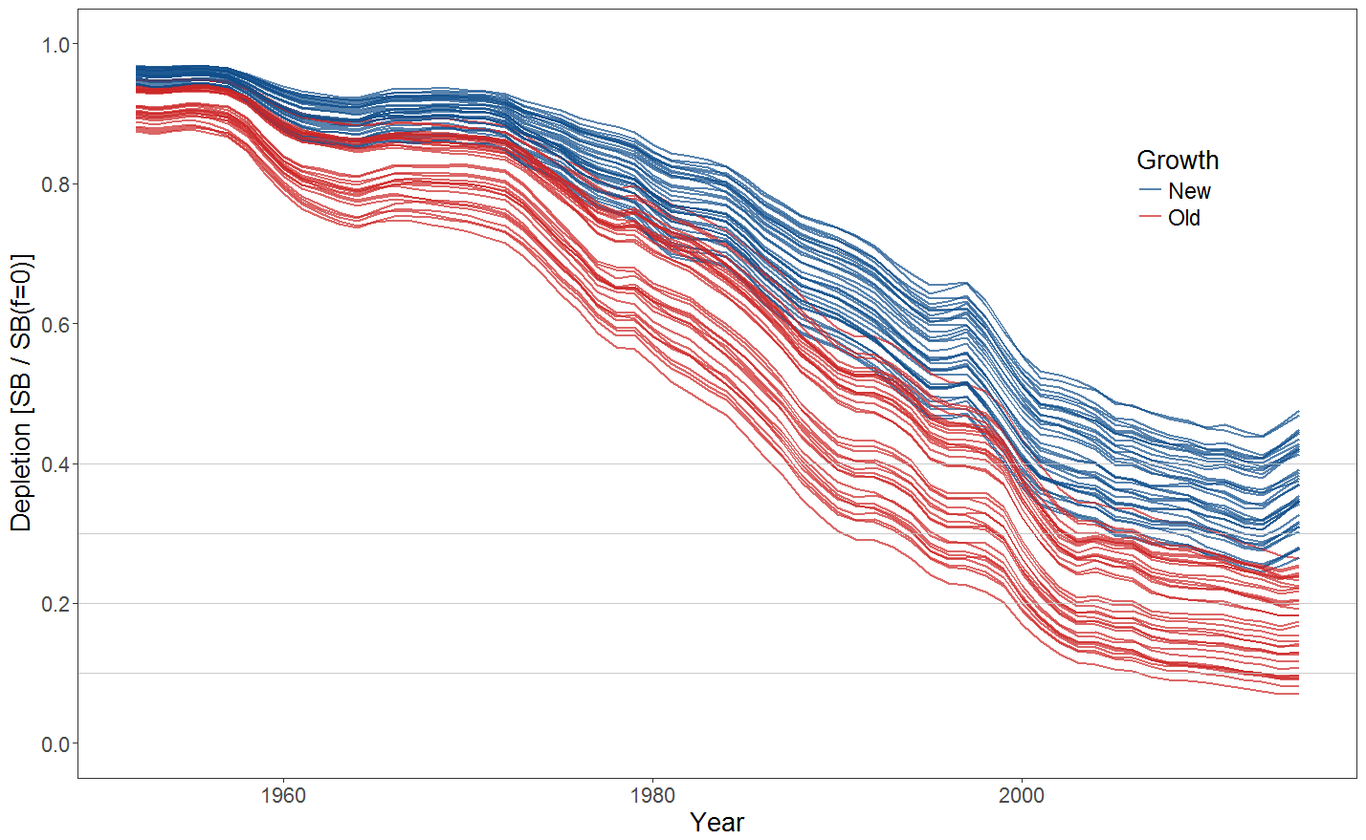
Figure BET-5. Plot showing the trajectories of fishing depletion (of spawning potential) for the 72 model runs included in the structural uncertainty grid. The colours depict the models in the grid with the new and old growth functions.

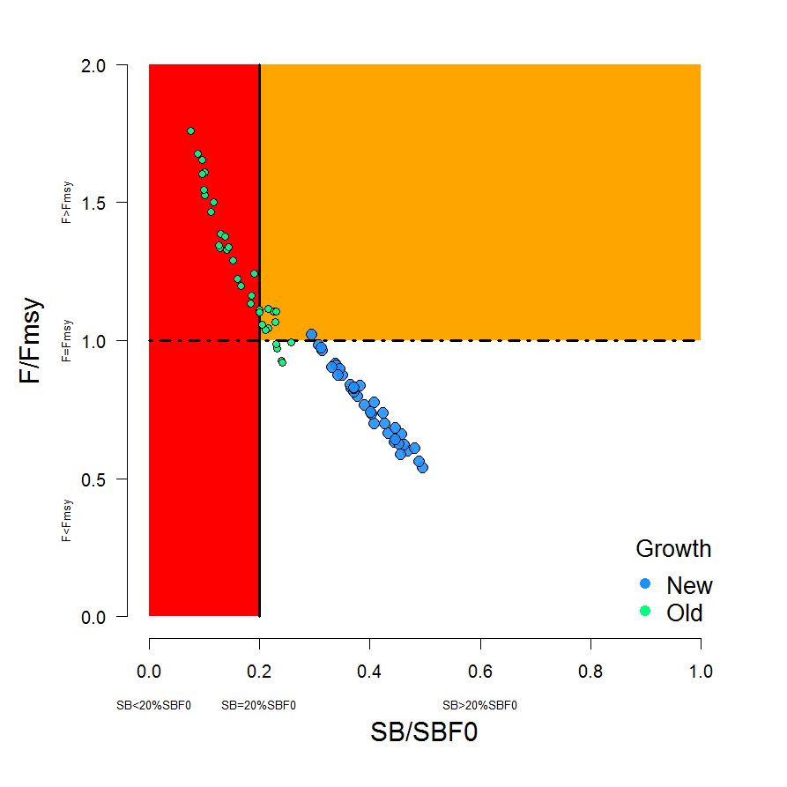 | 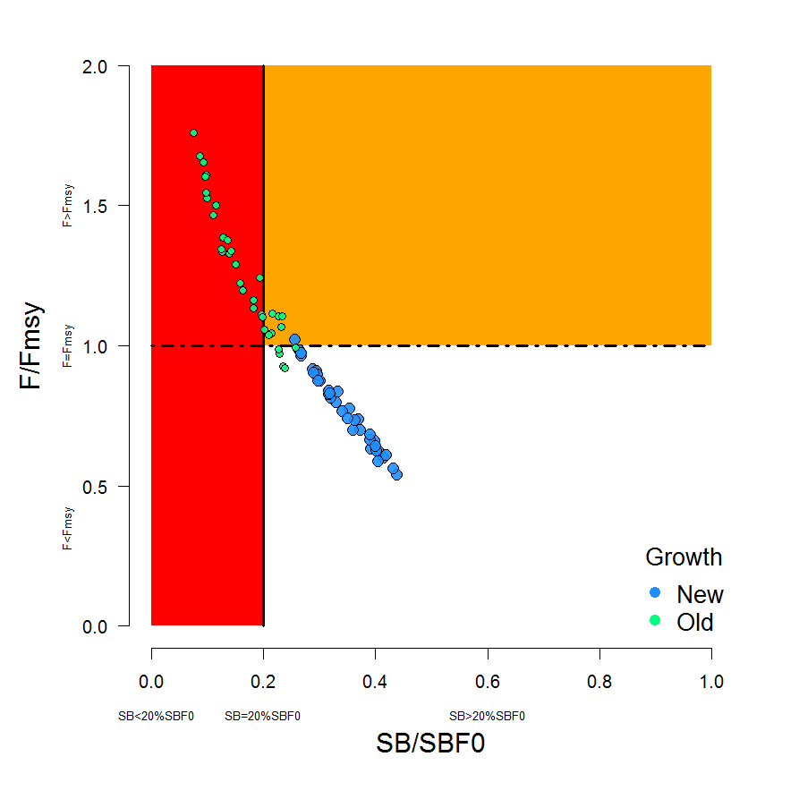
Figure BET-6. Majuro plot summarising the results for each of the models in the structural uncertainty grid. The plots represent estimates of stock status in terms of spawning potential depletion and fishing mortality. The red zone represents spawning potential levels lower than the agreed limit reference point which is marked with the solid black line. The orange region is for fishing mortality greater than F_{MSY} (F_{MSY} is marked with the black dashed line). The points represent SB_{latest}/SB_{F=0} (labelled as SB/SB_{F=0} above), and the colours depict the models in the grid with the new and old growth functions with the size of the points representing the decision of the SC to weight the new growth models three times higher than the old growth models. | Figure BET-7. Majuro plot summarising the results for each of the models in the structural uncertainty grid. The plots represent estimates of stock status in terms of spawning potential depletion and fishing mortality. The red zone represents spawning potential levels lower than the agreed limit reference point which is marked with the solid black line. The orange region is for fishing mortality greater than F_{MSY} (F_{MSY} is marked with the black dashed line). The points represent SB_{recent}/SB_{F=0} (labelled as SB/SB_{F=0} above), where SB_{recent} is the mean SB over 2012-2015 instead of 2011-2014 (used in the stock assessment report), at the request of the Scientific Committee. The colours depict the models in the grid with the new and old growth functions with the size of the points representing the decision of the SC to weight the new growth models three times higher than the old growth models.

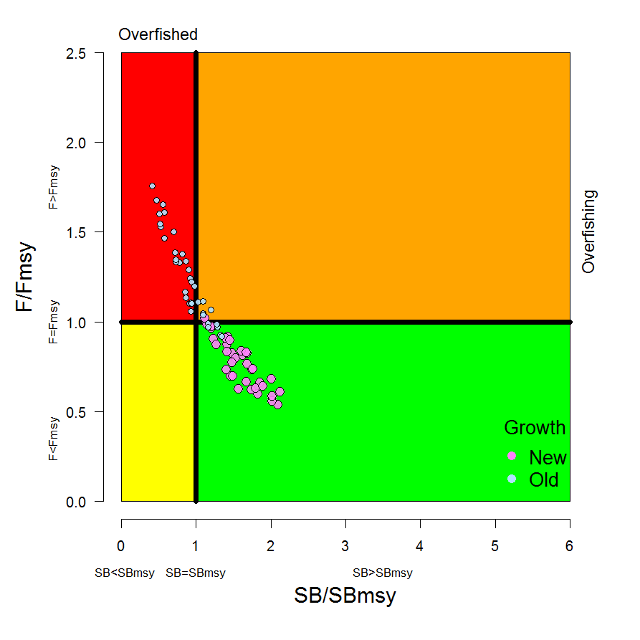 | 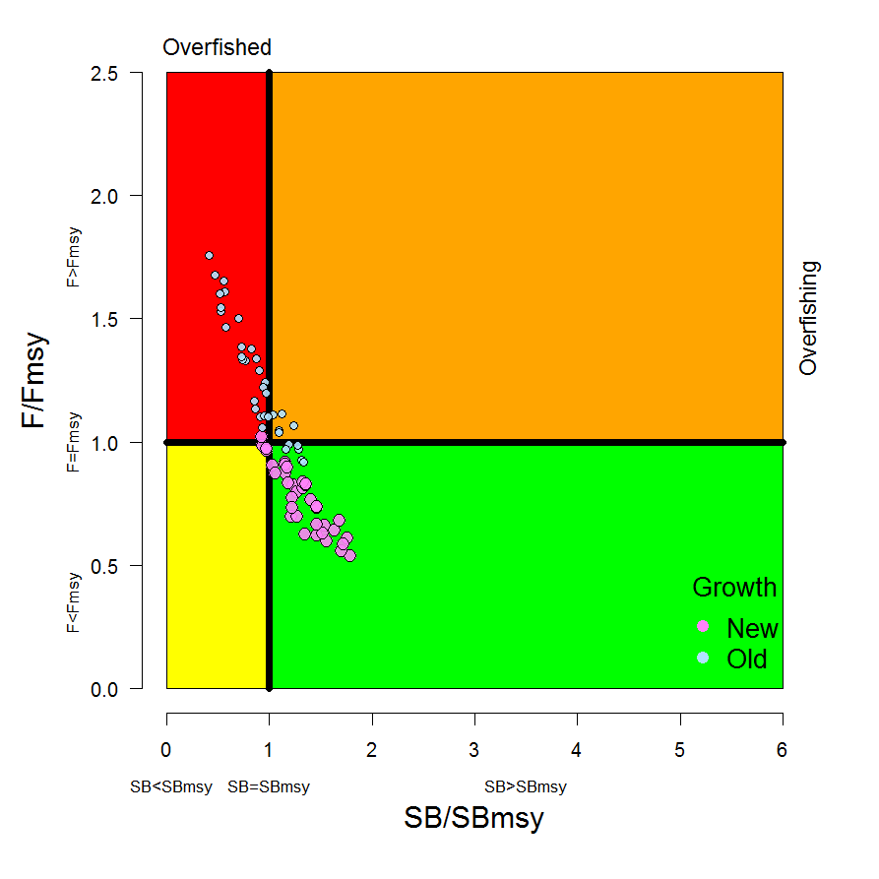
Figure BET8. Kobe plot summarising the results for each of the models in the structural uncertainty grid. The points represent SB_{latest} /SB_{MSY} , with the colours depicting the models in the grid with the new and old growth functions, and the size of the points representing the decision of the SC to weight the new growth models three times higher than the old growth models. | Figure BET-9. Kobe plot summarising the results for each of the models in the structural uncertainty grid. The points represent SB_{recent}/SB_{MSY}, with the colours depicting the models in the grid with the new and old growth functions, and the size of the points representing the decision of the SC to weight the new growth models three times higher than the old growth models.
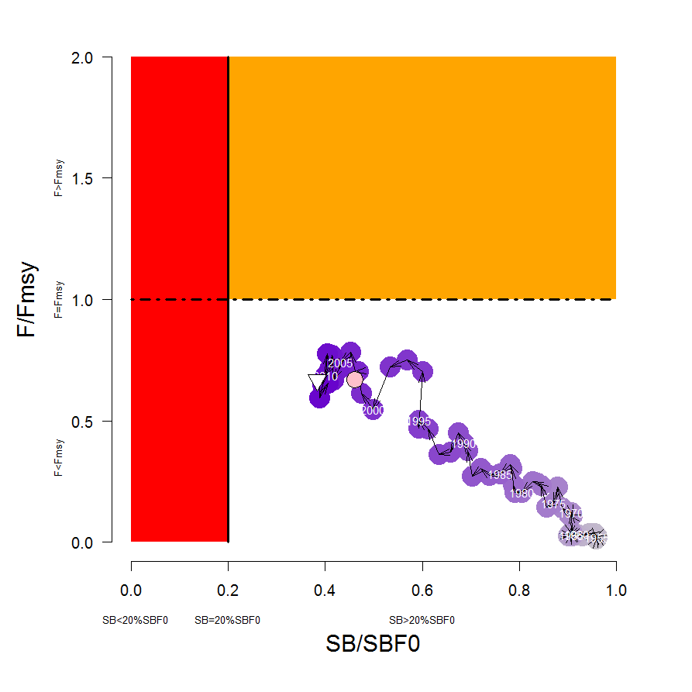 | 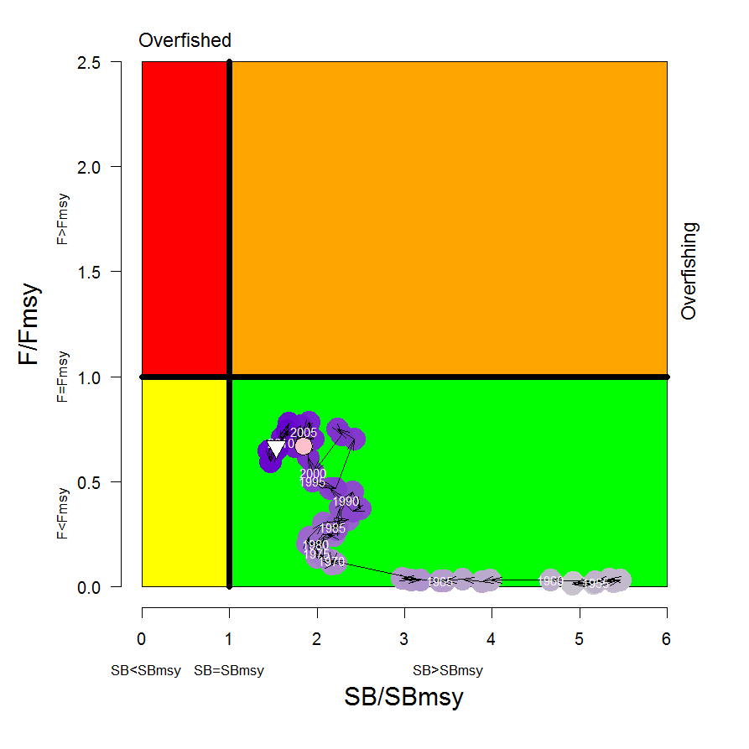
Figure BET-10. Estimated time-series (or “dynamic”) Majuro and Kobe plots from the bigeye ‘diagnostic case’ model run.

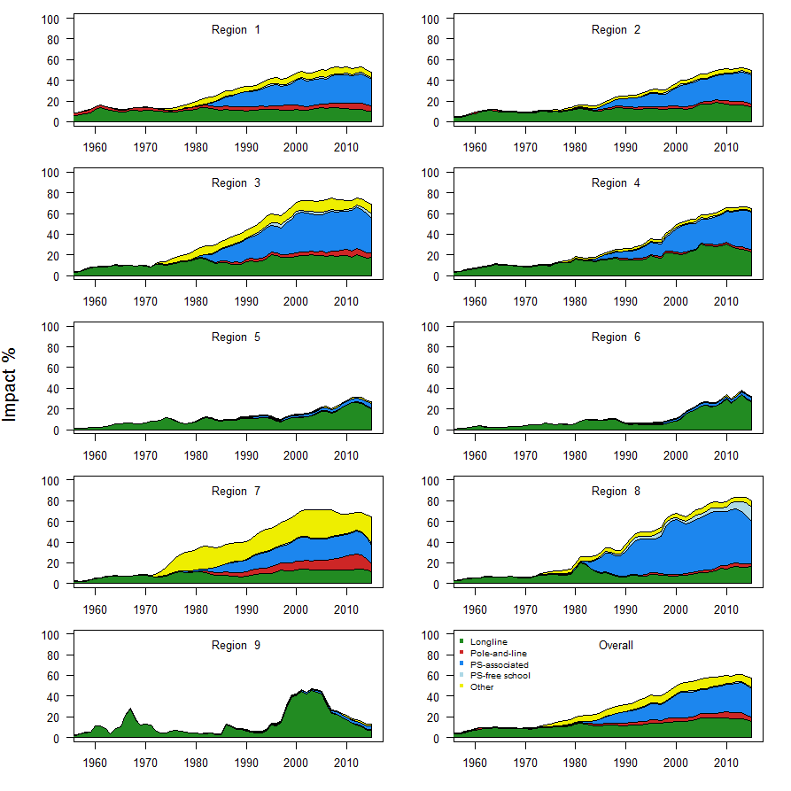
Figure BET-11. Estimates of reduction in spawning potential due to fishing by region, and over all regions (lower right panel), attributed to various fishery groups (gear-types) for the diagnostic case model.

Table BET-2. Summary of reference points over the 72 models in the structural uncertainty grid where the models using the new growth function are given three times the weighting of the models using the old growth function. Note that SB_{recent}/SB_{F=0} is calculated where SB_{recent} is the mean SB over 2012-2015 instead of 2011-2014 (used in the stock assessment report), at the request of the Scientific Committee.
 | Mean | Median | Min | 10% | 90% | Max
C_{latest} | 149,178 | 153,137 | 130,903 | 131,597 | 156,113 | 157,725
MSY | 156,765 | 158,040 | 124,120 | 137,644 | 180,656 | 204,040
Y_{Frecent} | 150,382 | 148,920 | 118,000 | 133,400 | 168,656 | 187,240
F_{mult} | 1.21 | 1.20 | 0.57 | 0.76 | 1.63 | 1.85
F_{MSY} | 0.05 | 0.05 | 0.04 | 0.04 | 0.05 | 0.06
F_{recent}/F_{MSY} | 0.89 | 0.83 | 0.54 | 0.61 | 1.32 | 1.76
SB_{MSY} | 457,162 | 454,100 | 219,500 | 285,530 | 598,210 | 710,000
SB₀ | 1,730,410 | 1,763,000 | 1,009,000 | 1,279,300 | 2,148,200 | 2,509,000
SB_{MSY}/SB₀ | 0.26 | 0.26 | 0.22 | 0.24 | 0.29 | 0.29
SB_{F=0} | 1,915,184 | 1,953,841 | 1,317,336 | 1,584,593 | 2,170,899 | 2,460,411
SB_{MSY}/SB_{F=0} | 0.24 | 0.24 | 0.17 | 0.18 | 0.27 | 0.29
SB_{latest} /SB₀ | 0.37 | 0.40 | 0.11 | 0.19 | 0.49 | 0.53
SB_{latest} /SB_{F=0} | 0.34 | 0.37 | 0.08 | 0.15 | 0.46 | 0.49
SB_{latest} /SB_{MSY} | 1.42 | 1.45 | 0.42 | 0.86 | 1.97 | 2.12
SB_{recent}/SB_{F=0} | 0.30 | 0.32 | 0.08 | 0.15 | 0.41 | 0.44
SB_{recent}/SB_{MSY} | 1.21 | 1.23 | 0.32 | 0.63 | 1.66 | 1.86

- SC13 noted that the central tendency of relative recent spawning biomass under the selected new and old growth curve model weightings was median (SB_{recent}/SB_{F=0}) = 0.32 with a probable range of 0.15 to 0.41 (80% probability interval). This suggested that there was likely a buffer between recent spawning biomass and the LRP but that there was also some probability that recent spawning biomass was below the LRP.

- SC13 also noted that there was a roughly 16% probability (23 out of 144 model weight units) that the recent spawning biomass had breached the adopted LRP with Prob((SB_{recent}/SB_{F=0}) < 0.2) = 0.16. This suggested that there was a high probability (roughly 5 out of 6) that recent bigeye tuna spawning biomass had not breached the adopted spawning biomass limit reference point of 0.2*SB_{F=0}.

- SC13 noted that the central tendency of relative recent fishing mortality under the selected new and old growth curve model weightings was median(F_{recent}/F_{MSY}) = 0.83 with an 80% probability interval of 0.61 to 1.31. While this suggested that there was likely a buffer between recent fishing mortality and F_{MSY}, it also showed that there was some probability that recent fishing mortality was above F_{MSY}.

- SC13 also noted that there was a roughly 23% probability (33 out of 144 model weight units as described in para. 6) that the recent fishing mortality was above F_{MSY} with Prob((F_{recent}/F_{MSY}) > 1) = 0.23. While this suggested that recent fishing mortality was likely below F_{MSY}, there was also a moderate probability (~ 1 out of 4) that recent fishing mortality has exceeded F_{MSY}.

- SC13 noted that the best available information on the stock status of WCPO bigeye tuna has changed in two ways from the previous assessment under the selected weighting of the 2017 assessment uncertainty grid. First, the stock status condition is more positive with a higher central tendency for SB_{recent}/SB_{F=0} in the 2017 assessment (median(SB_{recent}/SB_{F=0}) = 0.32) in comparison to the 2014 assessment ( (SB_{current}/SB_{F=0}) = 0.20) and a lower ratio of relative recent F in the 2017 assessment ( median(F_{recent}/F_{MSY}) = 0.83 ) in comparison to the 2014 assessment ( F_{current}/F_{MSY} = 1.57 ). Second, there is much greater uncertainty in the stock status of bigeye tuna in 2017 due to the fuller technical treatment of structural uncertainty through the use of the model uncertainty grid.

- SC13 noted that the positive changes for bigeye tuna stock status in the 2017 assessment are primarily due to three factors: the inclusion of the new growth curve information, the inclusion of the new regional assessment structure, and the estimated increases in recruitment in recent years. In terms of the cause of the recent increases in recruitment, SC13 commented that it was unclear whether the recent improvement was due to positive oceanographic conditions, effective management measures to conserve spawning biomass, some combination of both, or other factors. SC13 also noted the recent recruitment improvements for yellowfin and skipjack tunas. SC13 also noted recent recruitment improvements for bigeye tuna in the Eastern Pacific Ocean.

- SC13 also noted that, regardless of the choice of uncertainty grid, the assessment results show that the stock has been continuously declining for about 60 years since the late 1950’s, except for the recent small increase suggested in the new growth curve model grid.

- SC13 also noted the continued higher levels of depletion in the equatorial and western Pacific (specifically Regions 3, 4, 7 and 8 of the stock assessment) and the associated higher levels of impact, especially on juvenile bigeye tuna, in these regions due to the associated purse-seine fisheries and the ‘other’ fisheries within the western Pacific (as shown in Figures 35 and 46 of SC13-SA-WP-05).

- SC13 noted that there has been a long-term increase in fishing mortality for both juvenile and adult bigeye tuna, consistent with previous assessments.

- SC13 noted that there has been a long-term decrease in spawning biomass from the 1950s to the present for bigeye tuna and that this is consistent with previous assessments.

- Management advice and implications

- Based on the uncertainty grid adopted by SC13, the WCPO bigeye tuna spawning biomass is likely above the biomass LRP and recent F is likely below F_{MSY}, and therefore noting the level of uncertainties in the current assessment it appears that the stock is not experiencing overfishing (77% probability) and it appears that the stock is not in an overfished condition (84% probability).

- Although SC13 considers that the new assessment is a significant improvement in relation to the previous one, SC13 advises that the amount of uncertainty in the stock status results for the 2017 assessment is higher than for the previous assessment due to the inclusion of new information on bigeye tuna growth and regional structures.

- SC13 also noted that levels of fishing mortality and depletion differ between regions, and that fishery impact was higher in the tropical region (Regions 3, 4, 7 and 8 in the stock assessment model), with particularly high fishing mortality on juvenile bigeye tuna in these regions. SC13 therefore recommends that WCPFC14 could continue to consider measures to reduce fishing mortality from fisheries that take juveniles, with the goal to increase bigeye fishery yields and reduce any further impacts on the spawning potential for this stock in the tropical regions.

- Based on those results, SC13 recommends as a precautionary approach that the fishing mortality on bigeye tuna stock should not be increased from current level to maintain current or increased spawning biomass until the Commission can agree on an appropriate target reference point (TRP).

Research Recommendations

- SC13 recognized that future work is required to improve the assessment and to reduce uncertainty. Future research should concentrate on the two axes (e.g. growth, regional structure) of uncertainty which are the most influential. The growth analysis should continue with the emphasis on providing length at age estimates for larger fish between 130 and 180 cm FL. Additional research is also required for the regional structure uncertainty to consider options in addition to the structures used in the 2014 and 2017 assessments, for example, by using statistical approaches (e.g. tree models).

- In addition, SC13 considers that the model ensemble or weighting will be increasingly important as SC moves to uncertainty grid approaches in stock assessments and requests the Scientific Services Provider to study those methods further.

- SC13 requested that SPC undertake projections of potential changes in spawning biomass in the future under current levels of fishing mortality. This would be similar to the projections delivered in SC13-SA-IP-22, but would be based on the weighted uncertainty grid as described above.

4.1.2 WCPO yellowfin tuna (Thunnus albacares)

- SC13 endorsed the 2017 WCPO yellowfin tuna stock assessment as the most advanced and comprehensive assessment yet conducted for this species.

- SC13 also endorsed the use of the assessment model uncertainty grid to characterize stock status and management advice and implications.

- SC13 reached consensus on the weighting of assessment models in the uncertainty grid for yellowfin tuna. The consensus weighting considered all options within five axes of uncertainty for steepness, tagging dispersion, tag mixing, size frequency (with two levels), and regional structure to be equally likely. The resulting uncertainty grid was used to characterize stock status, to summarize reference points as provided in the assessment document SC13-SA-WP-06, and to calculate the probability of breaching the adopted spawning biomass limit reference point (0.2*SB_{F=0}) and the probability of F_{recent} being greater than F_{MSY}.

- Stock status and trends

- The median values of relative recent spawning biomass (2012-2015) (SB_{recent}/SB_{F=0}) and relative recent fishing mortality (F_{recent}/F_{MSY}) over the uncertainty grid were used to measure the central tendency of stock status. The values of the upper 90th and lower 10th percentiles of the empirical distributions of relative spawning biomass and relative fishing mortality from the uncertainty grid were used to characterize the probable range of stock status.

- Descriptions of the updated structural sensitivity grid used to characterize uncertainty in the assessment are provided in Table YFT-1. Catch trend data is presented in Figure YFT-1. Estimated annual average recruitment, biomass, fishing mortality and depletion are shown in Figures YFT-2 – YFT-5. Majuro plots summarizing the results for each of the models in the structural uncertainty grid retained for management advice are represented in Figures YFT-6 and YFT-7. Figure YFT-8 and YFT-9 present Kobe plots summarizing the results for each of the models in the structural uncertainty grid. Figure YFT-10 provides estimated time-series (or “dynamic”) Majuro and Kobe plots from the yellowfin ‘diagnostic case’ model run. Figure YFT-11 shows estimates of reduction in spawning potential due to fishing by region, and over all regions attributed to various fishery groups (gear-types) for the diagnostic case model. Table YFT-2 provides a summary of reference points over the 48 models in the structural uncertainty grid (based on the SC decision to include size frequency weighting levels 20 and 50 only).

Table YFT-1: Description of the updated structural sensitivity grid used to characterize uncertainty in the assessment
Axis | Levels | Option
Steepness | 3 | 0.65, 0.80, 0.95
Tagging overdispersion | 2 | Default level (1), fixed (moderate) level
Tag mixing | 2 | 1 or 2 quarters
Size frequency weighting | 3 | Sample sizes divided by 10, 20, 50
Regional structure | 2 | 2017 regions, 2014 regions

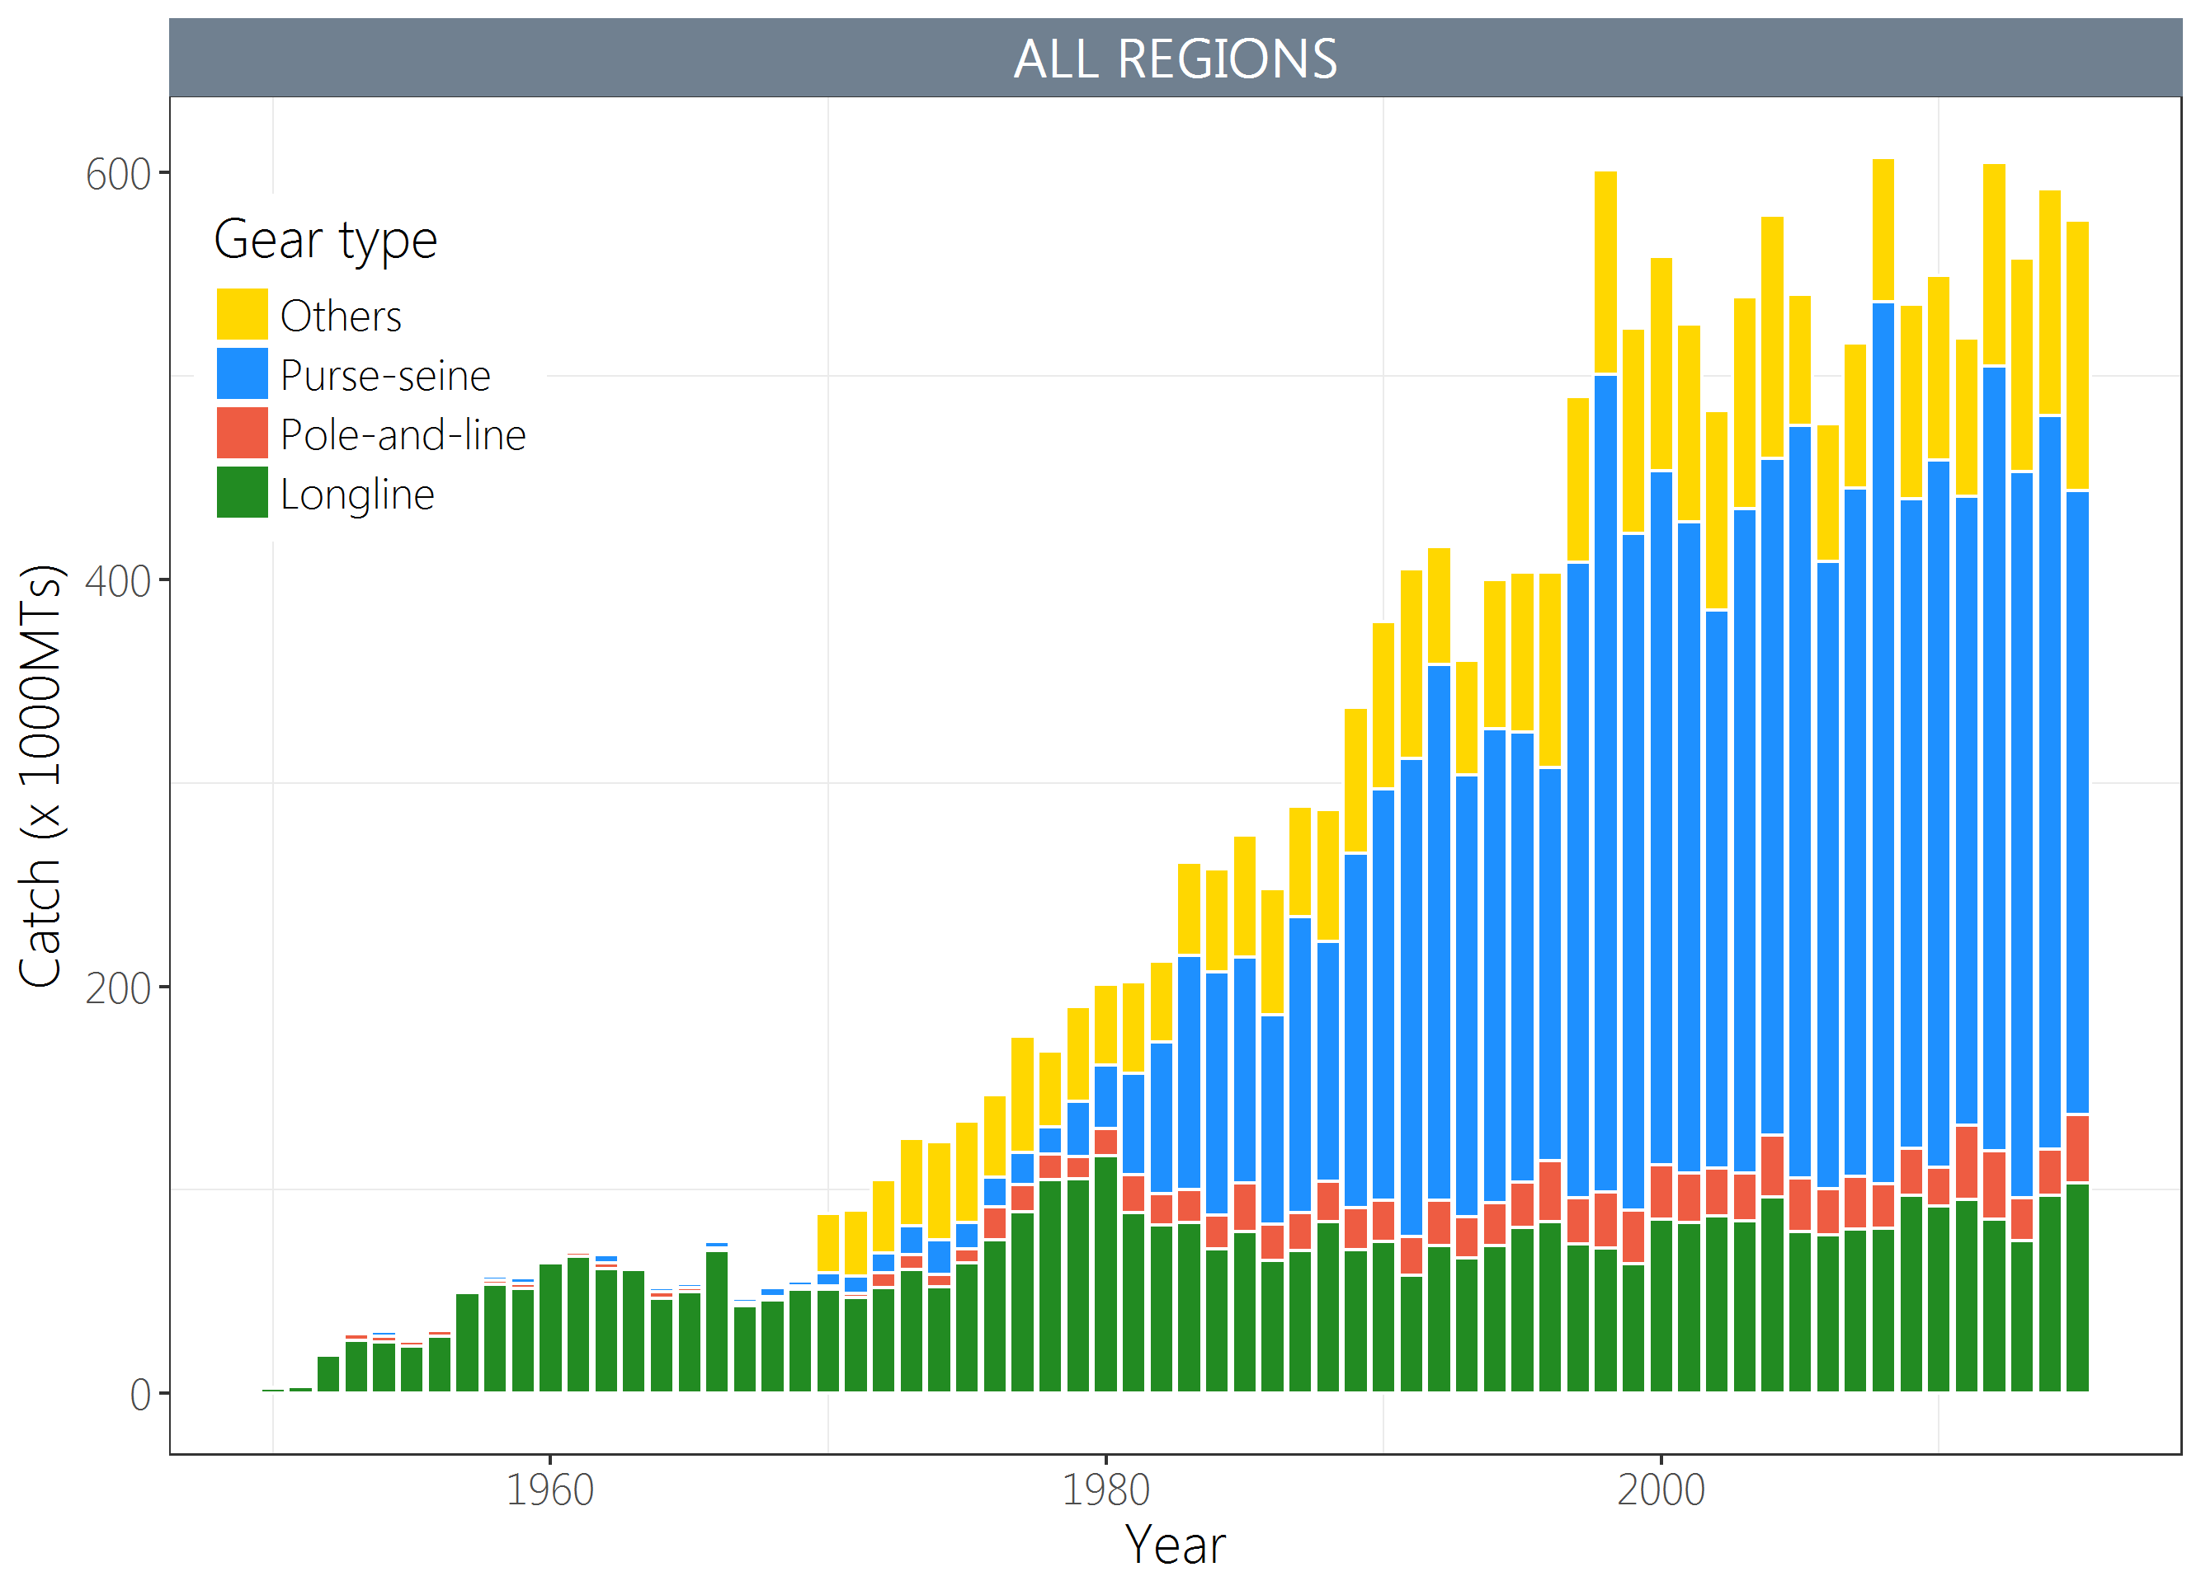 | 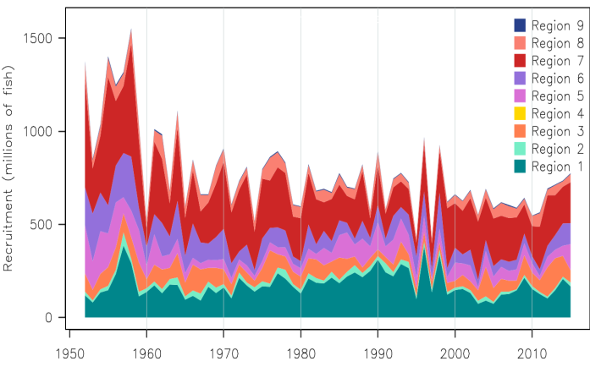
Figure YFT-1. Time series of total annual catch (1000's mt) by fishing gear for the diagnostic case model over the full assessment period. | Figure YFT-2. Estimated annual average recruitment by model region for the diagnostic case model, showing the relative sizes among regions.
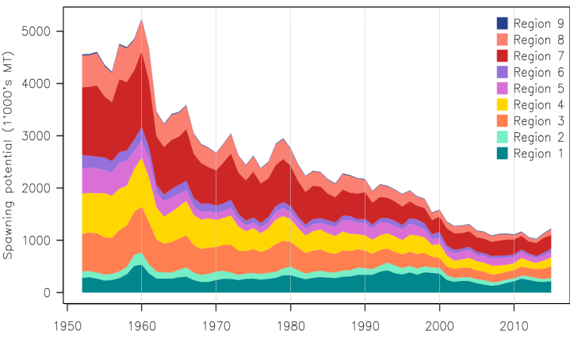 | 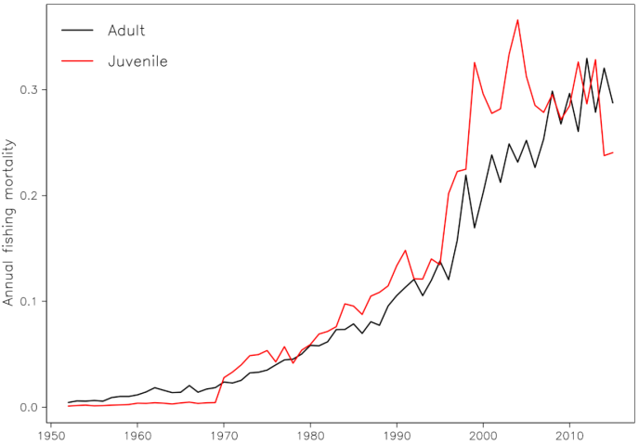
Figure YFT-3. Estimated annual average spawning potential by model region for the diagnostic case model, showing the relative sizes among regions. | Figure YFT-4. Estimated annual average juvenile and adult fishing mortality for the diagnostic case model.

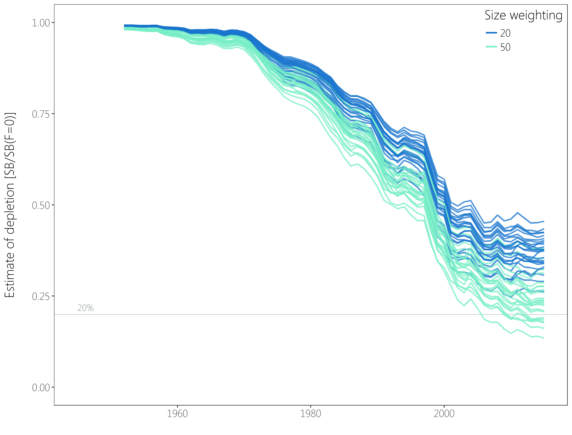
Figure YFT-5：Plot showing the trajectories of fishing depletion (of spawning potential) for the 48 model runs retained for the structural uncertainty grid used for management advice. The colours depict the models in the grid with the size composition weighting using divisors of 20 and 50.

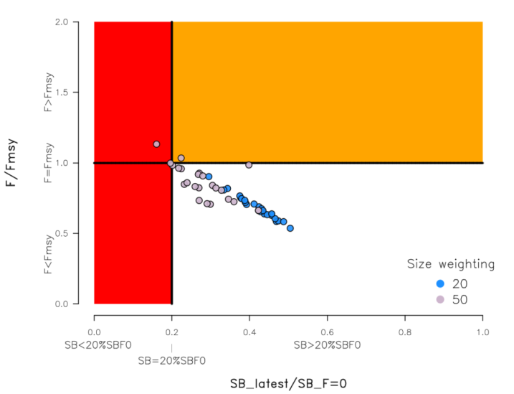 |  | 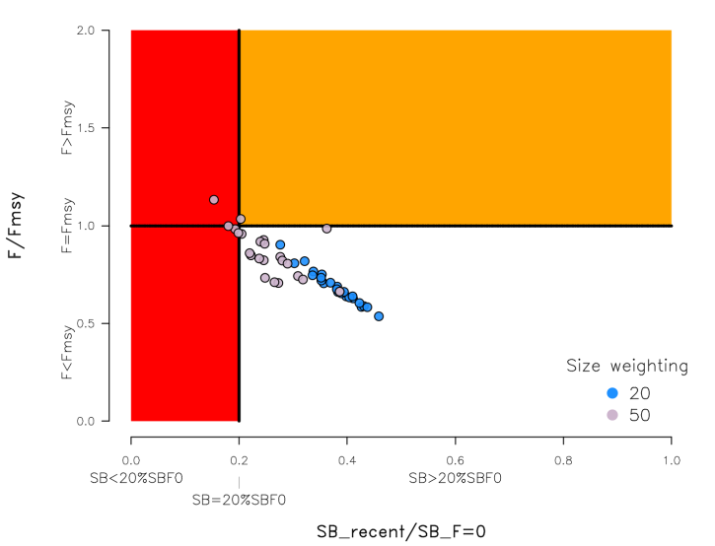
Figure YFT-6. Majuro plot summarising the results for each of the models in the structural uncertainty grid retained for management advice. The plots represent estimates of stock status in terms of spawning potential depletion and fishing mortality. The red zone represents spawning potential levels lower than the agreed limit reference point which is marked with the solid black line. The orange region is for fishing mortality greater than F_{MSY} (F_{MSY} is marked with the black horizontal line). The points represent SB_{latest}/SB_{F=0}, and the colours depict the models in the grid with the size composition weighting using divisors of 20 and 50. |  | Figure YFT-7: Majuro plot summarising the results for each of the models in the structural uncertainty grid retained for management advice. The plots represent estimates of stock status in terms of spawning potential depletion and fishing mortality. The red zone represents spawning potential levels lower than the agreed limit reference point which is marked with the solid black line. The orange region is for fishing mortality greater than F_{MSY} (F_{MSY} is marked with the black horizontal line). The points represent SB_{recent}/SB_{F=0}, and the colours depict the models in the grid with the size composition weighting using divisors of 20 and 50.
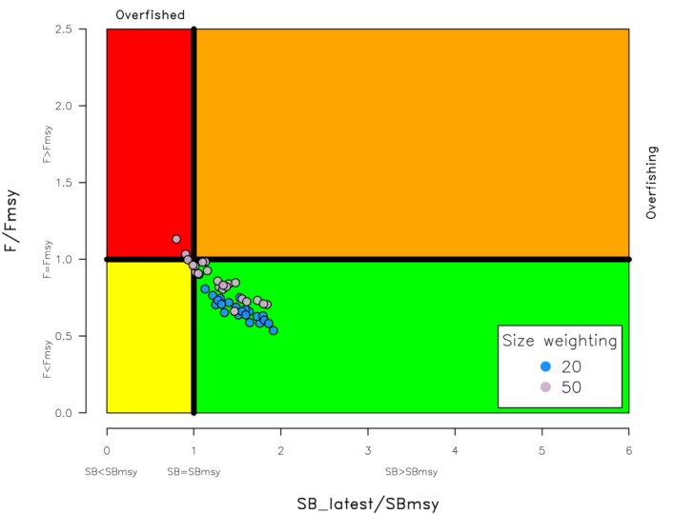 | - 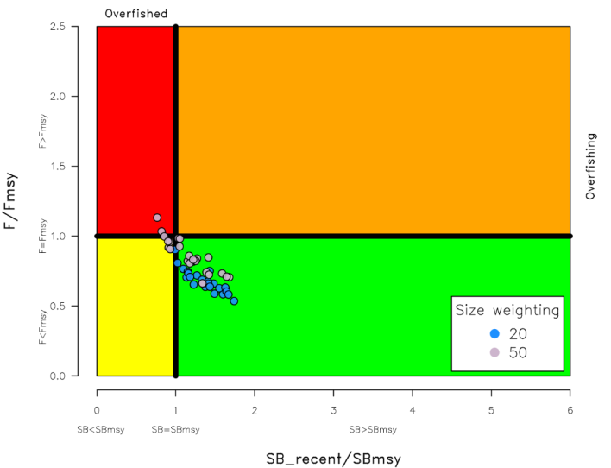
Figure YFT-8. Kobe plot summarising the results for each of the models in the structural uncertainty grid. The points represent SB_{latest}/SB_{MSY}, the colours depict the models in the grid with the size composition weighting using divisors of 20 and 50. | Figure YFT-9. Kobe plot summarising the results for each of the models in the structural uncertainty grid. The points represent SB_{recent}/SB_{MSY}, the colours depict the models in the grid with the size composition weighting using divisors of 20 and 50.
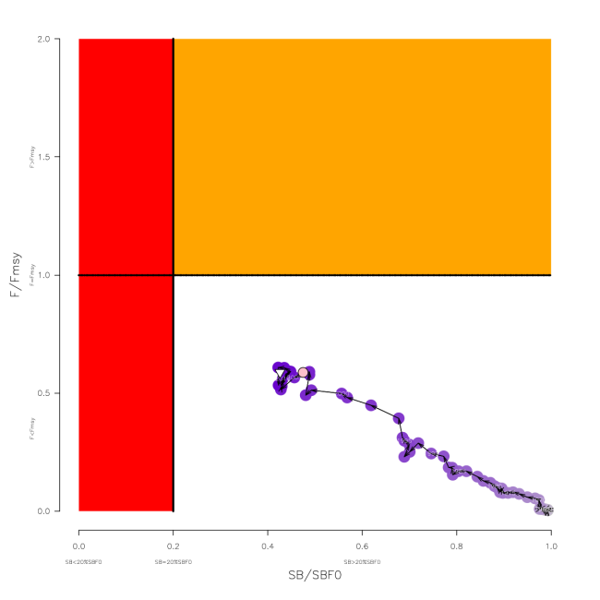 | 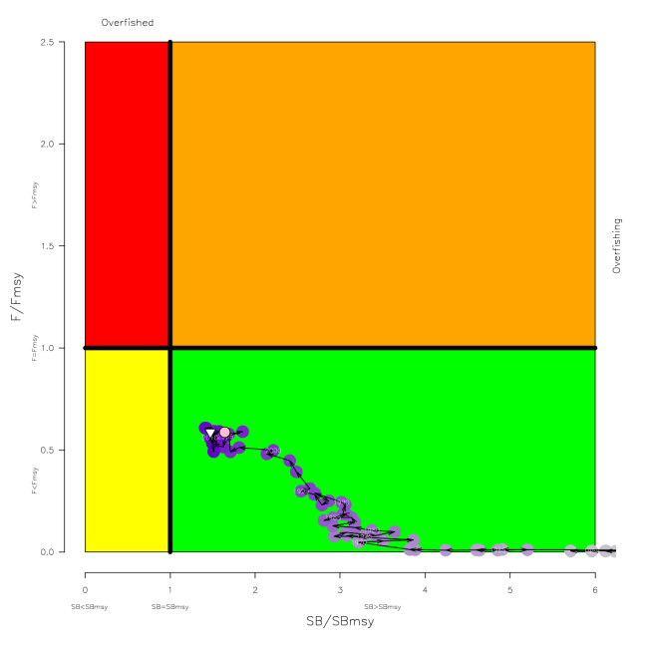
Figure YFT-10. Estimated time-series (or “dynamic”) Majuro and Kobe plots from the yellowfin ‘diagnostic case’ model run.

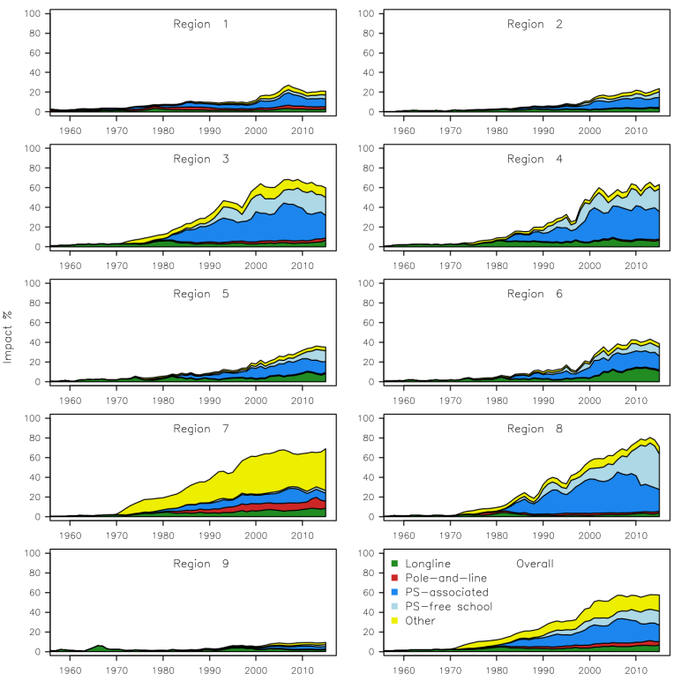
Figure YFT-11. Estimates of reduction in spawning potential due to fishing by region, and over all regions (lower right panel), attributed to various fishery groups (gear-types) for the diagnostic case model.

Table YFT-2. Summary of reference points over the 48 models in the structural uncertainty grid retained for management advice using divisors of 20 and 50 for the weighting on the size composition data. Note that SB_{recent}/SB_{F=0} is calculated where SB_{recent} is the mean SB over 2012-2015 instead of 2011-2014 (used in the stock assessment report), at the request of the Scientific Committee.
 | Mean | Median | Min | 10% | 90% | Max
C_{latest} | 611,982 | 612,592 | 606,762 | 607,517 | 614,237 | 614,801
MSY | 670,658 | 670,800 | 539,200 | 601,480 | 735,280 | 795,200
Y_{Frecent} | 646,075 | 643,400 | 534,400 | 586,120 | 717,880 | 739,600
F_{mult} | 1.34 | 1.36 | 0.88 | 1.03 | 1.61 | 1.86
F_{MSY} | 0.12 | 0.12 | 0.07 | 0.10 | 0.14 | 0.16
F_{recent}/F_{MSY} | 0.77 | 0.74 | 0.54 | 0.62 | 0.97 | 1.13
SB_{MSY} | 544,762 | 581,400 | 186,800 | 253,320 | 786,260 | 946,800
SB₀ | 2,199,750 | 2,290,000 | 1,197,000 | 1,366,600 | 2,784,500 | 3,256,000
SB_{MSY}/SB₀ | 0.24 | 0.24 | 0.15 | 0.18 | 0.28 | 0.34
SB_{F=0} | 2,083,477 | 2,178,220 | 1,193,336 | 1,351,946 | 2,643,390 | 2,845,244
SB_{MSY}/SB_{F=0} | 0.25 | 0.26 | 0.16 | 0.19 | 0.30 | 0.35
SB_{latest} /SB₀ | 0.33 | 0.34 | 0.18 | 0.23 | 0.42 | 0.45
SB_{latest} /SB_{F=0} | 0.35 | 0.37 | 0.16 | 0.22 | 0.46 | 0.50
SB_{latest} /SB_{MSY} | 1.40 | 1.39 | 0.80 | 1.02 | 1.80 | 1.91
SB_{recent}/SB_{F=0} | 0.32 | 0.33 | 0.15 | 0.20 | 0.41 | 0.46
SB_{recent}/SB_{MSY} | 1.40 | 1.41 | 0.81 | 1.05 | 1.71 | 1.93

- SC13 noted that the central tendency of relative recent spawning biomass was median (SB_{recent}/SB_{F=0}) = 0.33 with a probable range of 0.20 to 0.41 (80% probable range), and there was a roughly 8% probability (4 out of 48 models) that the recent spawning biomass had breached the adopted LRP with Prob((SB_{recent}/SB_{F=0})<0.2) = 0.08. The median estimate (0.33) is below that estimated from the 2014 assessment grid ((SB_{current}/SB_{F=0}) = 0.41, see SC10-SA-WP-04), noting the differences in grid uncertainty axes used in that assessment.

- SC13 noted that the central tendency of relative recent fishing mortality was median (F_{recent}/F_{MSY}) = 0.74 with an 80% probability interval of 0.62 to 0.97, and there was a roughly 4% probability (2 out of 48 models) that the recent fishing mortality was above F_{MSY} with Prob((F_{recent}/F_{MSY})>1) = 0.04. The median estimate (0.74) is also comparable to that estimated from the 2014 assessment grid (F_{current}/F_{MSY} = 0.76, see SC10-SA-WP-04).

- SC13 noted that the assessment results show that the stock has been continuously declining for about 50 years since the late 1960’s.

- SC13 also noted that levels of fishing mortality and depletion differ between regions, and that fishery impact was highest in the tropical region (Regions 3, 4, 7 and 8 in the stock assessment model), mainly due to the purse seine fisheries in the equatorial Pacific and the “other” fisheries within the Western Pacific (as shown in Figure 44 of SC13-SA-WP-06).

- Management advice and implications

- Based on the uncertainty grid adopted by SC13 the spawning biomass is highly likely above the biomass LRP and recent F is highly likely below F_{MSY}, and therefore noting the level of uncertainties in the current assessment it appears that the stock is not experiencing overfishing 96% probability) and it appears that the stock is not in an overfished condition (92% probability).

- Based on the diagnostic case, both juvenile and adult fishing mortality show a steady increase since the 1970s. Adult fishing mortality has increased continuously over most of the time series, while juvenile fishing mortality has stabilized since the late 1990s at a level similar to that now estimated for adult yellowfin.

- SC13 reiterates its previous advice from SC10 that WCPFC could consider measures to reduce fishing mortality from fisheries that take juveniles, with the goal to increase to maximum fishery yields and reduce any further impacts on the spawning potential for this stock in the tropical regions.

- SC13 also reiterates its previous advice from SC10 that measures should be implemented to maintain current spawning biomass levels until the Commission can agree on an appropriate target reference point (TRP).

Research Recommendations

- SC13 recognized that reviewing yellowfin growth through a study of yellowfin otoliths collected from the WCPO and incorporating this into future assessments should be encouraged.

4.1.3 WCPO skipjack tuna (Katsuwonus pelamis)

- Stock status and trends

- SC13 noted that the total catch in 2016 (1,816,762 mt) was comparable to that in 2015 and a 2% increase over 2011-2015. (see SC13-SA-WP-02)

- Purse seine catch (1,408,110 mt) was comparable to both 2015 and the 2011-2015 average. Pole and line catch (151,441 mt) was a 1% decrease from 2015 and an 11% decrease from 2011-2015 average. Catches by other fisheries (251,470 mt) were 2% higher than in 2015 and 26% higher than 2011-2015 average.

- SC13 noted that under recent fishery conditions (2016 catch level for LL and other fisheries and effort level for purse seine), the skipjack stock was initially projected to decrease for a short period and then to increase as recent relatively high recruitments move through the stock. Median F₂₀₁₈/F_{MSY} = 0.37; median SB₂₀₁₈/SB_{F=0} = 0.47.

- Management advice and implications

- SC13 noted that no stock assessment has been conducted since SC12. Therefore, the advice from SC12 should be maintained, pending a new assessment or other new information. For further information on the management advice and implications from SC12, please see https://www.wcpfc.int/node/27769

4.1.4 South Pacific albacore tuna (Thunnus alalunga)

- Stock status and trends

- SC13 noted that no stock assessment was conducted for South Pacific albacore tuna in 2017. Therefore, the stock status description from SC11 is still current. For further information on the stock status and trends from SC11, please see http://www.wcpfc.int/node/26922

- SC13 considered an update of trends in South Pacific albacore fisheries (SC13-SA-WP-08) and noted that there had been reductions in longline effort in the WCPF Convention Area south of 10^{ᴼ}S through 2014-2016 (declining from about 300 million hooks in 2013 to around 254 million in 2015, and 200 million hooks in 2016 – with the 2016 value being provisional) and that effort distributions vary a little and show an area of highly concentrated fishing effort. SC13 noted an issue of transhipment that needs to be clarified at TCC13. Status quo projections were calculated, assuming current southern longline and troll fishery effort would continue into the future at levels equal to those seen in 2015 (Figure SPA-1). If 2015 fishing effort levels continue into the future, the stock is predicted to continue to decline on average, falling to SB_{current}/SB_{F=0} = 0.35 in 2033 with a 7% predicted probability of being below the LRP. Overall vulnerable biomass (a CPUE proxy) in longline fisheries is estimated to decrease by 7% from 2013-2033.
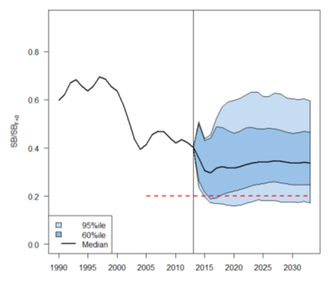
Figure SPA-1. Stochastic projections of adult stock status under 2014 longline and troll effort levels. The limit reference point (20% SB_{F=0}) is indicated by the horizontal dashed red line. Note: from 1960 up to 2013 inclusive the line represents the median across the 9 assessment model runs (structural uncertainty only); uncertainty after 2013 represents both structural uncertainty and stochastic recruitment (1800 simulation runs).

- Management advice and implications

- SC13 noted that no stock assessment was conducted for South Pacific albacore tuna in 2017. Therefore, the advice from SC11 should be maintained. For further information on the stock status and trends from SC11, please see https://www.wcpfc.int/node/26922

- SC13 noted that the preliminary estimate of total catch of south Pacific albacore (within the WCPF Convention Area south of the equator) for 2016 was 58,033 mt which was an 8% decrease from 2015 and a 13% decrease over 2011-2015. (see SC13-SA-WP-02).

- Preliminary longline catch in 2016 (55,635 mt) was 8% lower compared with 2015 and a 13% decrease over 2011-2015. Preliminary troll catch in 2016 (2,372 mt) was 17% lower compared with 2015 and a 24% decrease over 2011-2015. (see SC13- SA-WP-02).

- SC13 considered an update of trends in South Pacific albacore fisheries (SC13-SA-WP-08) and noted that there had been reductions in longline effort in the WCPF Convention Area south of 10ᴼS through 2014-2016 (by approximately 15%) and that effort distributions vary a little and show an area of highly concentrated fishing effort. SC13 noted an issue of transhipment that needs to be clarified at TCC13. Status quo projections were calculated, assuming current southern longline and troll fishery effort would continue into the future at levels equal to those seen in 2015 (Figure SPA-1). If 2015 fishing effort levels continue into the future, the stock is predicted to continue to decline on average, falling to SB_{current}/SB_{F=0} = 0.35 in 2033 with a 7% predicted probability of being below the LRP. Overall vulnerable biomass (a CPUE proxy) in longline fisheries is estimated to decrease by 7% from 2013-2033.

- Pending a new assessment in 2018, SC13 recalls its previous advice from SC11 and SC12 that longline fishing mortality and longline catch be reduced to avoid further decline in the vulnerable biomass so that economically viable catch rates can be maintained, especially for longline catches of adult albacore. SC13 recommends that this advice be taken into consideration when the TRP for South Pacific albacore is discussed at WCPFC14.

4.2 Northern stocks

4.2.1 North Pacific albacore (Thunnus alalunga)

- Stcok status and trends

- SC13 noted that the ISC provided the following conclusions on the stock status of North Pacific albacore.

- Stock status is depicted in relation to the limit reference point (LRP; 20%SSB_{current, F=0}) for the stock and the equivalent fishing intensity (F_{20%}; calculated as 1-SPR_{20%}) (Figure NPALB-1). Fishing intensity (F, calculated as 1-SPR) is a measure of fishing mortality expressed as the decline in the proportion of the spawning biomass produced by each recruit relative to the unfished state. For example, a fishing intensity of 0.8 will result in a SSB of approximately 20% of SSB₀ over the long run. Fishing intensity is considered a proxy of fishing mortality.

- The Kobe plot shows that the estimated female SSB has never fallen below the LRP since 1993, albeit with large uncertainty in the terminal year (2015) estimates. Even when alternative hypotheses about key model uncertainties such as natural mortality and growth were evaluated, the point estimate of female SSB in 2015 (SSB₂₀₁₅) did not fall below the LRP, although the risk increases with these more extreme assumptions (Figure NPALB-1). The SSB₂₀₁₅ was estimated to be 80,618 mt and was 2.47 times greater than the LRP threshold of 32,614 mt (Table NPALB-1). Current fishing intensity, F₂₀₁₂₋₂₀₁₄ (calculated as 1- SPR₂₀₁₂₋₂₀₁₄), was lower than potential F-based reference points identified for the north Pacific albacore stock, except F_{50%} (calculated as 1-SPR_{50%}) (Table NPALB-1). Based on these findings, the following information on the status of the North Pacific albacore stock is provided:
- The stock is likely not overfished relative to the limit reference point adopted by the WCPFC (20%SSB_{current, F=0}), and
- No F-based reference points have been adopted to evaluate overfishing. Stock status was evaluated against seven potential reference points. Current fishing intensity (F₂₀₁₂₋₂₀₁₄) is below six of the seven reference points (see ratios in Table NPALB-1), except for F_{50%}.

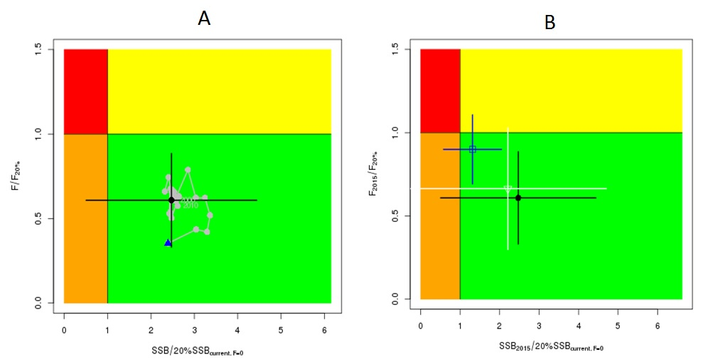
Figure NPALB-1. (A) Kobe plot showing the status of the north Pacific albacore (Thunnus alalunga) stock relative to the 20%SSB_{current, F=0} biomass-based limit reference point, and equivalent fishing intensity (F_{20%}; calculated as 1-SPR_{20%}) over the base case modelling period (1993-2015). Blue triangle indicates the start year (1993) and black circle with 95% confidence intervals indicates the terminal year (2015). (B) Kobe plot showing stock status and 95% confidence intervals in the terminal year (2015) of the base case model (black; closed circle) and important sensitivity runs with M = 0.3 y⁻¹ for both sexes (blue; open square), and CV = 0.06 for L_{inf} in the growth model (white; open triangle). Fs in this figure are not based on instantaneous fishing mortality. Instead, the Fs are indicators of fishing intensity based on SPR and calculated as 1-SPR so that the Fs reflect changes in fishing mortality. SPR is the equilibrium SSB per recruit that would result from the current year’s pattern and intensity of fishing mortality.

Table NPALB-1. Estimates of maximum sustainable yield (MSY), female spawning biomass (SSB) quantities, and fishing intensity (F) based reference point ratios for north Pacific albacore tuna for the base case assessment and important sensitivity analyses. SSB₀ and SSB_{MSY} are the unfished biomass of mature female fish and at MSY, respectively. The Fs in this table are not based on instantaneous fishing mortality. Instead, the Fs are indicators of fishing intensity based on SPR and calculated as 1-SPR so that the Fs reflect changes in fishing mortality. SPR is the equilibrium SSB per recruit that would result from the current year’s pattern and intensity of fishing mortality. Current fishing intensity is based on the average fishing intensity during 2012-2014 (F₂₀₁₂₋₂₀₁₄).
Quantity | Base Case | M = 0.3 y⁻¹ | Growth  CV = 0.06 for L_{inf}
MSY (t) ^{A} | 132,072 | 92,027 | 118,836
SSB_{MSY} (t) ^{B} | 24,770 | 42,098 | 22,351
SSB₀ (t) ^{B} | 171,869 | 270,879 | 156,336
SSB₂₀₁₅ (t) ^{B} | 80,618 | 68,169 | 63,719
SSB₂₀₁₅/20%SSB_{current, F=0} ^{B} | 2.47 | 1.31 | 2.15
F₂₀₁₂₋₂₀₁₄ | 0.51 | 0.74 | 0.57
F₂₀₁₂₋₂₀₁₄/F_{MSY} | 0.61 | 0.89 | 0.68
F₂₀₁₂₋₂₀₁₄/F_{0.1} | 0.58 | 0.90 | 0.65
F₂₀₁₂₋₂₀₁₄/F_{10%} | 0.56 | 0.81 | 0.63
F₂₀₁₂₋₂₀₁₄/F_{20%} | 0.63 | 0.91 | 0.71
F₂₀₁₂₋₂₀₁₄/F_{30%} | 0.72 | 1.04 | 0.81
F₂₀₁₂₋₂₀₁₄/F_{40%} | 0.85 | 1.21 | 0.96
F₂₀₁₂₋₂₀₁₄/F_{50%} | 1.01 | 1.47 | 1.16
A – MSY includes male and female juvenile and adult fish
B – Spawning stock biomass (SSB) in this assessment refers to mature female biomass only.

- Management advice and implications

- SC13 noted the following conservation information from the ISC.

- Two harvest scenarios were projected to evaluate impacts on future female SSB: F at the 2012-2014 rate over 10 years (F₂₀₁₂₋₂₀₁₄) and constant catch (average of 2010-2014 = 82,432 mt) over 10 years. Median female SSB is expected to decline to 63,483 mt (95% CI: 36,046 - 90,921 mt) by 2025, with a 0.2 and <0.01 % probability of being below the LRP by 2020 and 2025, respectively, if fishing intensity remains at the 2012-2014 level (Figure NPALB-2). In contrast, employing the constant catch harvest scenario is expected to reduce female SSB to 47,591 t (95% CI: 5,223 - 89,958 t) by 2025 and increases the probability that female SSB will be below the LRP to about 3.5 and 30 % in 2020 and 2025, respectively (Figure NPALB-3). In addition, as biomass declines during the projection period the fishing intensity approximately doubles by 2025. The probabilities of declining below the LRP in both harvest scenarios are likely higher in the future because projection results did not capture the full envelope of uncertainty. The ALBWG notes that the lack of sex-specific size data, uncertainty in growth and natural mortality, and the simplified treatment of the spatial structure of North Pacific albacore population dynamics are important sources of uncertainty in the assessment. Based on these findings, the following information is provided:
- If a constant fishing intensity (F₂₀₁₂₋₂₀₁₄) is applied to the stock, then median female spawning biomass is expected to undergo a moderate decline, with a < 0.01% probability of falling below the limit reference point established by the WCPFC by 2025. However, expected catches in this scenario will be below the recent average catch level for this stock.
- If a constant average catch (C₂₀₁₀₋₂₀₁₄ = 82,432 mt) is removed from the stock in the future, then the decline in median female spawning biomass will be greater than in the constant F intensity scenario and the probability that SSB falls below the LRP will be greater by 2025 (30%). Additionally, the estimated fishing intensity will double relative to the current level (F₂₀₁₂₋₂₀₁₄) by 2025 as spawning biomass declines.

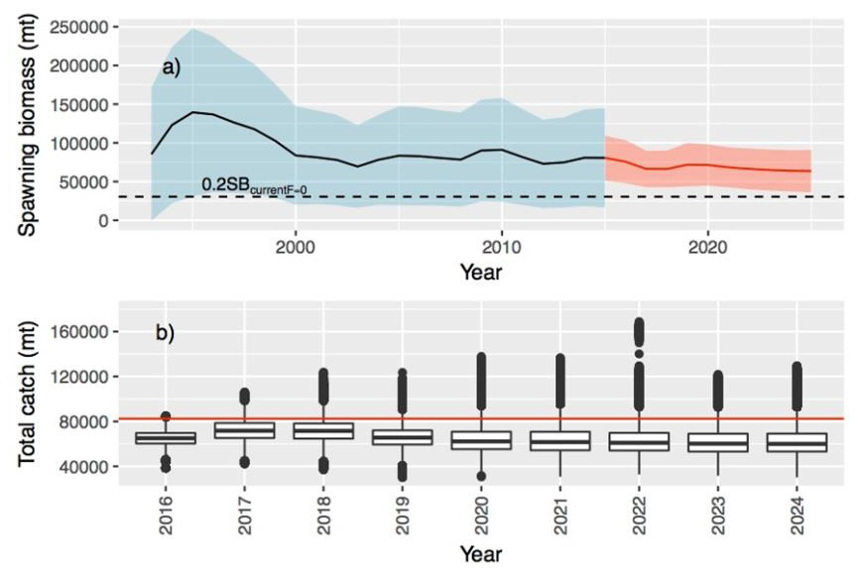
Figure NPALB-2. (A) Historical and future trajectory of North Pacific albacore (Thunnus alalunga) female spawning biomass (SSB) under a constant fishing intensity (F₂₀₁₂₋₂₀₁₄) harvest scenario. Future recruitment was based on the expected recruitment variability and autocorrelation. Black line and blue area indicates maximum likelihood estimates and 95% confidence intervals (CI), respectively, of historical female SSB, which includes parameter uncertainty. Red line and red area indicates mean value and 95% CI of projected female SSB, which only includes future recruitment variability and SSB uncertainty in the terminal year. (B) Expected annual catch under a constant fishing intensity (F₂₀₁₂₋₂₀₁₄) harvest scenario (2016-2025). The red line is the current average catch (2010-2014 = 82,432 mt).

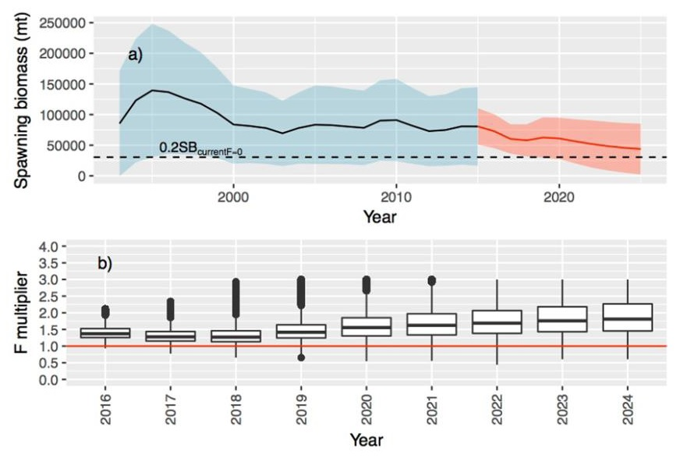
Figure NPALB-3. (A) Historical and future trajectory of North Pacific albacore (Thunnus alalunga) female spawning biomass (SSB) under a constant catch (average 2010-2014 = 82,432 mt) harvest scenario. Future recruitment was based on the expected recruitment variability and autocorrelation. Dashed line indicates the average limit reference point threshold for 2012-2014. Black line and blue area indicates maximum likelihood estimates and 95% confidence intervals (CI), respectively, of historical female SSB, which includes parameter uncertainty. Red line and red area indicates mean value and 95% CI of projected female SSB, which only includes future recruitment variability and SSB uncertainty in the terminal year. (B) Projected fishing intensity relative to the current fishing intensity (2012-2014) (red line) under a constant catch scenario (average 2010-2014).

4.2.2 Pacific bluefin tuna (Thunnus orientalis)

- The last stock assessment was conducted in 2016. No updated information was presented on the status of Pacific bluefin tuna.

- Stock status and trends

- SC13 noted that no stock assessments were conducted for Pacific bluefin tuna in 2017. Therefore, the stock status descriptions from SC12 are still current. For further information on the stock status and trends from SC12, please see https://www.wcpfc.int/node/27769

- Management advice and implications

- SC13 noted that no management advice has been provided since SC12. Therefore, the advice from SC12 should be maintained, pending a new assessment or other new information. For further information on the management advice and implications from SC12, please see https://www.wcpfc.int/node/27769

4.2.3 North Pacific swordfish (Xiphias gladius)

- The last stock assessment was conducted in 2014. No updated information was presented on the status of North Pacific swordfish.

Stock status and trends

- SC13 noted that no stock assessments were conducted for these species in 2017. Therefore, the stock status descriptions from SC10 are still current. Updated information on North Pacific swordfish catches is available in the ISC Plenary Report but was not compiled for and reviewed by SC13. For further information on the stock status and trends from SC10, please see http://www.wcpfc.int/node/19472

Management advice and implications

- SC13 noted that no management advice has been provided since SC10. Therefore, the advice from SC10 should be maintained, pending a new assessment or other new information. For further information on the management advice and implications from SC10, please see http://www.wcpfc.int/node/19472

WCPO Sharks

4.3.1 Oceanic whitetip shark (Carcharhinus longimanus)

- The last stock assessment was conducted in 2012, no stock assessment has been conducted since and there was no new information.

- Stock status and trends

- SC13 noted that no stock assessments were conducted for these shark species in 2017. Therefore, the stock status descriptions from SC8 are still current for oceanic whitetip shark respectively. Updated information on catches was not compiled for and reviewed by SC13.

- Management advice and implications

- SC13 noted that no management advice has been provided since SC8 for oceanic whitetip shark. Therefore, previous advice should be maintained, pending a new assessment or other new information.

4.3.2 Silky shark (Carcharhinus falciformis)

- The last stock assessment was conducted in 2013 and no stock assessment has been conducted since then. There was no new information. One information paper (SC13-SA-IP-12) was submitted under this item.

- Stock status and trends

- SC13 noted that no stock assessments were conducted for these shark species in 2017. Therefore, the stock status descriptions from SC9 are still current for silky shark. Updated information on catches was not compiled for and reviewed by SC13.

- Management advice and implications

- SC13 noted that no management advice has been provided since SC9 for silky shark. Therefore, previous advice should be maintained, pending a new assessment or other new information.

4.3.3 South Pacific blue shark (Prionace glauca)

- The last stock assessment was conducted in 2016. SC did not receive any updated information. One paper, SC13-SA-IP-13 Updated abundance indicators for New Zealand blue, porbeagle and shortfin mako shark, was submitted under this item.

- Stock status and trends

- SC13 noted that no stock assessments were conducted for this shark species in 2017. Therefore, the stock status descriptions from SC12 are still current for South Pacific blue shark. Updated information on catches was not compiled for and reviewed by SC13.

Management advice and implications

- SC13 noted that no management advice has been provided for South Pacific blue shark.

4.3.4 North Pacific blue shark (Prionace glauca)

- Stock status and trends

- SC13 noted that ISC provided the following conclusions on the stock status of North Pacific blue shark.

- The assessment uses a fully integrated approach in Stock Synthesis with model inputs that have been greatly improved since the previous assessment. The main differences between the present assessment and the 2014 assessment are: 1) use of SS with a thorough examination of the size composition data and the relative weighting of CPUE and composition data; 2) improved life history information, such as growth and reproductive biology, and their contribution to productivity assumptions; 3) an improved understanding and parametrization of the low fecundity stock recruit relationship (LFSR); 4) catch, CPUE and size time series updated through 2015; 5) a suite of model diagnostics including implementation of an Age Structured Production Model implemented in SS. There remain some uncertainties in the time series based on the quality (observer vs. logbook) and timespans of catch and relative abundance indices, limited size composition data for several fisheries, the potential for additional catch not accounted for in the assessment, and regarding life history parameters.

- Extensive model explorations showed that the reference run had the best model performance and showed fits most consistent with the data. The CPUE indices used in the reference case were considered most representative of the North Pacific blue shark stock due to their broader spatial temporal coverage in the core distribution of the stock and the statistical soundness of the standardizations. Alternate CPUE series for the latter part of the time series produced different stock trajectories depending upon the index used, but in each case, median SSB during the last three years exceeded SSBMSY. Using alternate assumptions on stock productivity (i.e., form of the stock recruitment relationship) also resulted in variation in the stock trajectories; assuming stock productivity lower than supported by current biological studies, resulted in lowered spawning stock biomass relative to MSY.

- Results of the reference case model showed that the spawning stock biomass was near a time-series high in the late 1970s, fell to its lowest level between 1990 to 1995, subsequently increased gradually to reach the time-series high again in 2005, and has since shown small fluctuations with no apparent trend (Figure NPBSH- 1B) close to the time-series high. Recruitment has fluctuated around 37,000,000 age-0 sharks annually with no apparent trend (Figure NPBSH-1A). Stock status is reported in relation to MSY based reference points.

- Based on these findings, the following information on the status of the North Pacific blue shark stock is provided:
- Female spawning biomass in 2015 (SSB₂₀₁₅) was 69% higher than at MSY and estimated to be 295,774 mt (Table NPBSH-1; Figure NPBSH-1B).
- The recent annual fishing mortality (F₂₀₁₂₋₂₀₁₄) was estimated to be well below F_{MSY} at approximately 38% of F_{MSY} (Table NPBSH-1; Figure NPBSH-1C).
- The reference run produced terminal conditions that were predominately in the lower right quadrant of the Kobe plot (not overfished and overfishing not occurring) (Figure NPBSH-2).

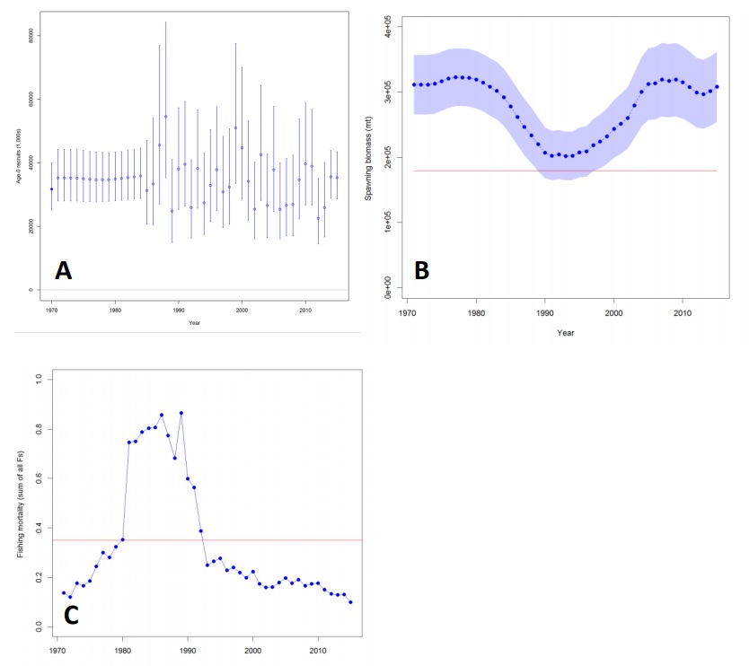

Figure NPBSH- 1. Results of the SS stock assessment reference case model: (A) estimated age-0 recruits (circles) and 95% confidence intervals (vertical bars); (B) estimated female spawning biomass and 95% confidence intervals (blue shaded area); (C) estimated fishing mortality (sum of F’s across all fishing fleets). Red solid lines indicate the estimates of SB_{MSY} and F_{MSY} in (B) and (C), respectively.

Table NPBSH-1. Estimates of key management quantities for the North Pacific blue shark SS stock assessment reference case model and the range of values for 13 sensitivity runs.

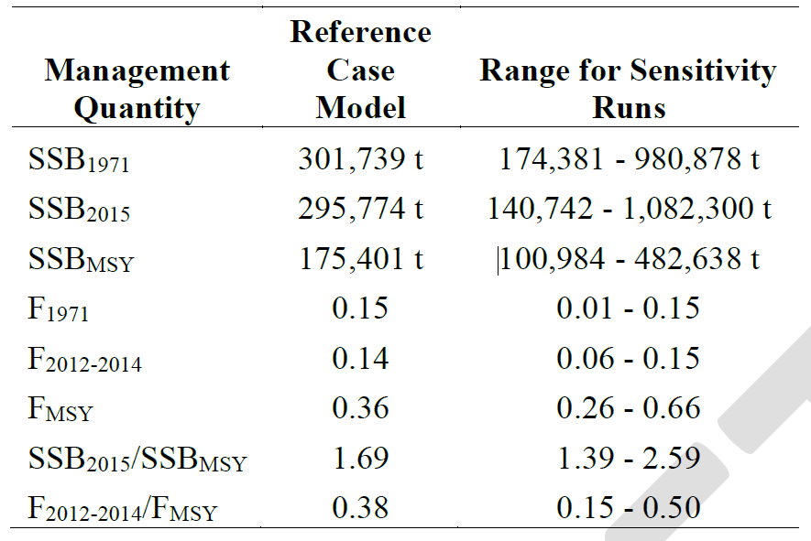

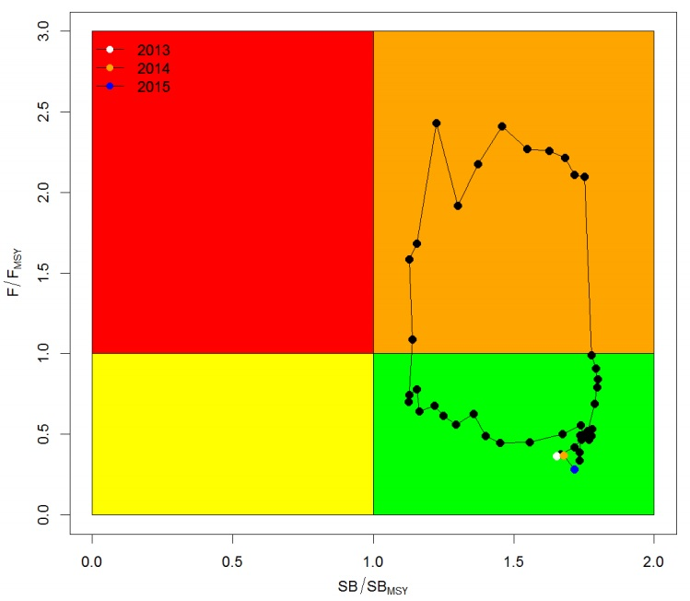
Figure NPBSH- 2. Kobe plot of the trends in estimates of relative fishing mortality and spawning biomass of North Pacific blue shark between 1971‐2015 for the reference case of the SS stock assessment model.

- Management advice and implications

- SC13 noted the following conservation information from ISC.

- Target and limit reference points have not yet been established for pelagic sharks by the WCPFC or the IATTC, the organizations responsible for management of pelagic sharks caught in international fisheries for tuna and tuna-like species in the Pacific Ocean.

- The 2015 SSB exceeds SSB_{MSY} and F₂₀₁₂₋₂₀₁₄ is below F_{MSY}. Future projections under different fishing mortality (F) harvest policies (status quo, +20%, -20%, F_{MSY}) show that median BSH biomass in the North Pacific will likely remain above B_{MSY} in the foreseeable future (Table NPBSH-2; Figure NPBSH-3). Other potential reference points were not considered in these evaluations.

Table NPBSH-2. Projected trajectory of spawning biomass (in metric tons) for alternative harvest scenarios.
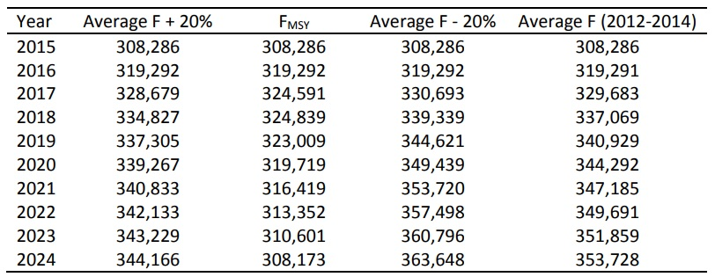

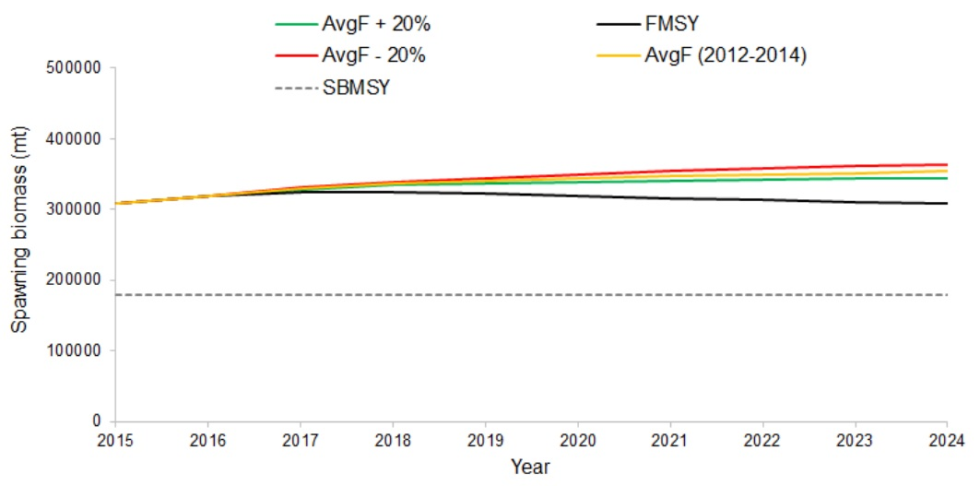
Figure NPBSH-3. Comparison of future projected blue shark spawning biomass under different F harvest policies (status quo, +20%, -20%, and F_{MSY}) using the SS reference case model. Status quo fishing mortality was based on the average from 2012-2014.

4.3.5 North Pacific shortfin mako (Isurus oxyrinchus)

- The ISC conducted an indicator analysis in 2015 and a full assessment is planned in 2018. There was no new information.

- Stock status and trends

- SC13 noted that there is no existing stock assessment for North Pacific shortfin mako shark.

- Management advice and implications

- SC13 noted that no management advice has been provided for North Pacific shortfin mako shark.

4.3.6 Pacific bigeye thresher shark (Alopias superciliosus)

- Stock status and trends

- SC13 noted that the results of the assessment indicate that assuming a range of longline post-capture survival rates of 30-70%, which likely reflects current fishing operations, median sustainability risk for the 2000-2014 period ranged between:
- 20% below to 60% above the MIST based on 0.5r,
- 50% below to 10% above the MIST based on 0.75r, and
- 60% to 20% below the MIST based on r.

- SC13 also noted that CPUE increased in the calibration area (the Hawaii-based fleet) in the last year of the assessment. This may suggest an increase in biomass, but the reason for the CPUE increase is not understood.

- Management advice and implications
- SC13 noted that although the stock status of this species is currently unknown, the bigeye thresher assessment showed that, estimating for current fishing operations (with 30-70% post-capture mortality) across a range of scenarios, some of the median F estimates exceeded two of the three indicative reference points (0.5r and 0.75r) (Table BTH-1). Across all 30-70% post-capture scenarios, there is a >50% probability in most years that F > MIST based on 0.5r and a >20% probability in most years that F > MIST based on 0.75r. (Table BTH-2).

TABLE BTH-1. Sustainability risk (ratio of impact to MIST, at three levels of the MIST, with values >1 considered to be unsustainable) (median values and 95% quantile range) for bigeye thresher in the Pacific. Estimates are for the Core Area and the Assessment Area assuming the occurrence of post-capture survival (random occurrence between 30% and 70%) in impact estimation and three initial population status assumptions (low (0.3), medium (0.5), and high (0.7)). Results are contrasted for the fifteen-year period (2000-2014) and the recent period (2011-2014). Fcrash = r, Flim = 0.75r, and Fmsm = r/2.
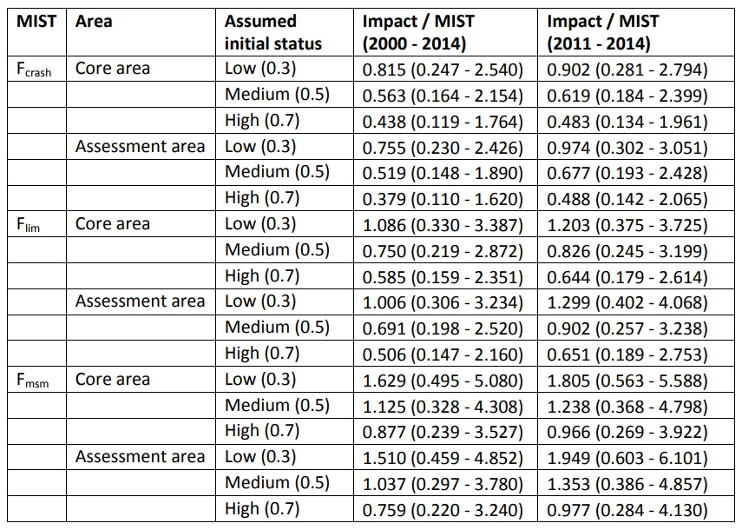

TABLE BTH-2. Sustainability risk probabilities (Pr(Impact > MIST), for 3 levels of MIST: Fcrash, Flim, and Fmsm) for bigeye thresher in the Pacific, 2000-2014, assuming 100% capture mortality (left) and the occurrence of post-capture survival (right) over the Core Area and the Assessment Area (combined values across three initial population status assumptions). Fcrash = r, Flim = 0.75r, and Fmsm = r/2.
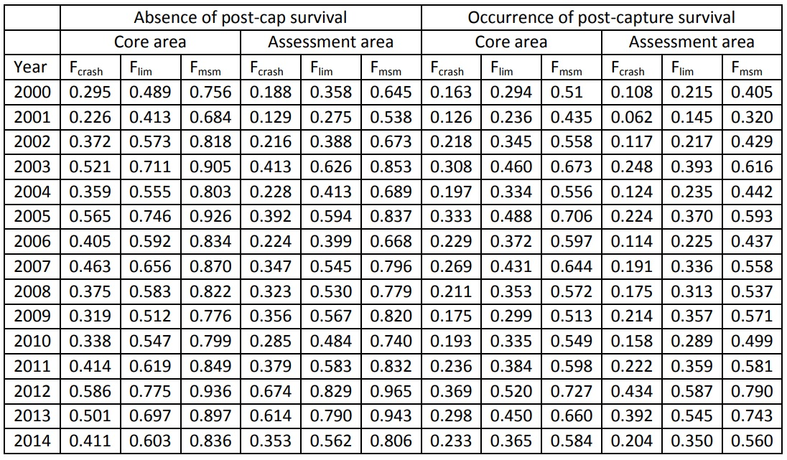

- SC13 noted that the modelled scenario of 30-70% post-capture survival reduced F estimates by approximately one third and reduced the risk that the MIST based on r will be exceeded by 50% compared to the scenario assuming no post-catch survival. A “no-retention” measure was not modelled but would be expected to reduce F even further.

- SC13 noted that the area of highest estimated fishing mortality overlapped with the region of higher relative abundance for the species, corresponding to a narrow band between approximately 10-15°N and 150°E-140°W. Fishing operations targeting bigeye tuna and operating during the April-June period had the highest mortality over the recent period (2011-2014).

- SC13 noted that the Commission needs to further consider appropriate limit reference points and risk tolerances for exceeding LRPs for sharks.

- SC13 recommends that WCPFC14 take the results of this assessment into consideration when framing a management measure for bigeye thresher sharks in the WCPO.

4.3.7 Porbeagle shark (Lamna nasus)

- Stock status and trends

- SC13 noted that although the stock status of the species is currently unknown the results of the assessment show that fishing mortality on the Southern Hemisphere stock is very low, and that it decreases eastward from the waters off South Africa to the waters off New Zealand. In the assessment area (Eastern Atlantic to Western Pacific Ocean) in the last decade (2005 to 2014), median F values ranged from 0.0008 to 0.0015 (mean 0.0010). This fishing mortality was less than 9% of the MIST based on r in all years assessed (1992-2014) and fell to half that level in more recent years (Figure POR-1), with at most a 3% probability of exceeding the MIST based on r in 2010-2014 (Figure POR-2). For the same scenarios, fishing mortality is less than 12% of the MIST based on 0.75r and less than 18% of the MIST based on 0.5r.

- These scenarios are based on 100% capture mortality, and assuming that some porbeagles survive their encounter with the fishery would reduce the estimated risk levels even further.

Figure POR-1. F-ratio plots showing the median values of F / MIST by year, for the three versions of the MIST (Fmsm, Flim, and Fcrash) for each of the three regions and for the three regions combined (the assessment area). Note that the F-ratio is almost always below 1, indicated by the horizontal dotted line. | Figure POR-2. Risk plots showing the probability that F exceeds the MIST by year, for the three versions of the MIST (Fcrash, Flim, and Fcrash) for each of the three regions and for the three regions combined (the assessment area).

- Management advice and implications

- SC13 advises WCPFC14 that although the stock status of the species is currently unknown there is a very low risk that the Southern Hemisphere porbeagle shark is subject to overfishing anywhere within its range.

- SC13 recommends that WCPFC14 request the Common Oceans (ABNJ) Tuna Project to explore options for data improvements through liaison with other regional fishery bodies managing fisheries catching Southern Hemisphere porbeagle shark.

4.4 WCPO billfishes

4.4.1 South Pacific swordfish (Xiphias gladius)

- SC13 endorsed the 2017 SWO stock assessment as the best and most up to date scientific information available for this species.

- SC13 also endorsed the use of the SWO assessment model uncertainty grid to characterize stock status and management advice and implications.

- Stock status and trends

- The median values of relative recent (2012-2015) spawning biomass (SB_{recent}/SB_{MSY}) and relative recent fishing mortality (F_{recent}/F_{MSY}) over the uncertainty grid were used to measure the central tendency of stock status. The values of the upper 90th and lower 10th percentiles of the empirical distributions of relative spawning biomass and relative fishing mortality from the uncertainty grid were used to characterize the probable range of stock status.

- Description of the updated structural sensitivity grid used to characterize uncertainty in the assessment is provided in Table SWO-1. Time trends in estimated catch, recruitment, biomass, fishing mortality and depletion are shown in Figures SWO-1 – 5. Figures SWO-6 and SWO-7 show Majuro plot summarising the results for each of the models in the structural uncertainty grid retained for management advice. Kobe plots are shown in Figures SWO-8 and SWO-9. Figure SWO-10 provides estimated time-series (or “dynamic”) Majuro and Kobe plots from the SW Pacific swordfish ‘diagnostic case’ model run. Figure SWO-11 shows Estimates of reduction in spawning potential due to fishing by region, and over all regions (lower left panel), attributed to various fishery groups (distant water ‘north’, ‘central’ and ‘south’, corresponding to the model regions, and a combined domestic fleet) for the diagnostic case model. Summary of reference points over all 72 individual models in the structural uncertainty grid are shown in Table SWO-2.

Table SWO-1: Description of the structural sensitivity grid used to characterize uncertainty in the assessment
Axis | Levels | Option
Steepness | 3 | 0.65, 0.80, 0.95
Diffusion rate | 3 | 0, 0.11, 0.25
Size frequency weighting | 2 | Sample size divided by 20,40
Natural mortality vectors | 4 | M1,M2,M3, M4

 | 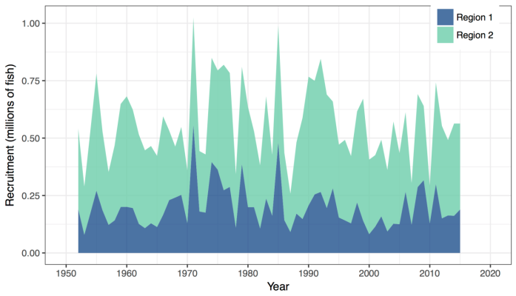
Figure SWO-1. Total swordfish catches in weight grouped by major longline-method fisheries in the model regions, 1952–2011. (DW1 - distant water fleet region 1; AUS – Australian region 1; Other1 - Other fisheries region 1; DW2 - distant water fleet region 2; NZ2 - New Zealand region 2; EU2 – EU (Spanish) region 2; Other2 - other fisheries region 2) | Figure SWO2. Estimated annual average recruitment by model region for the diagnostic case model, showing the relative sizes among regions.
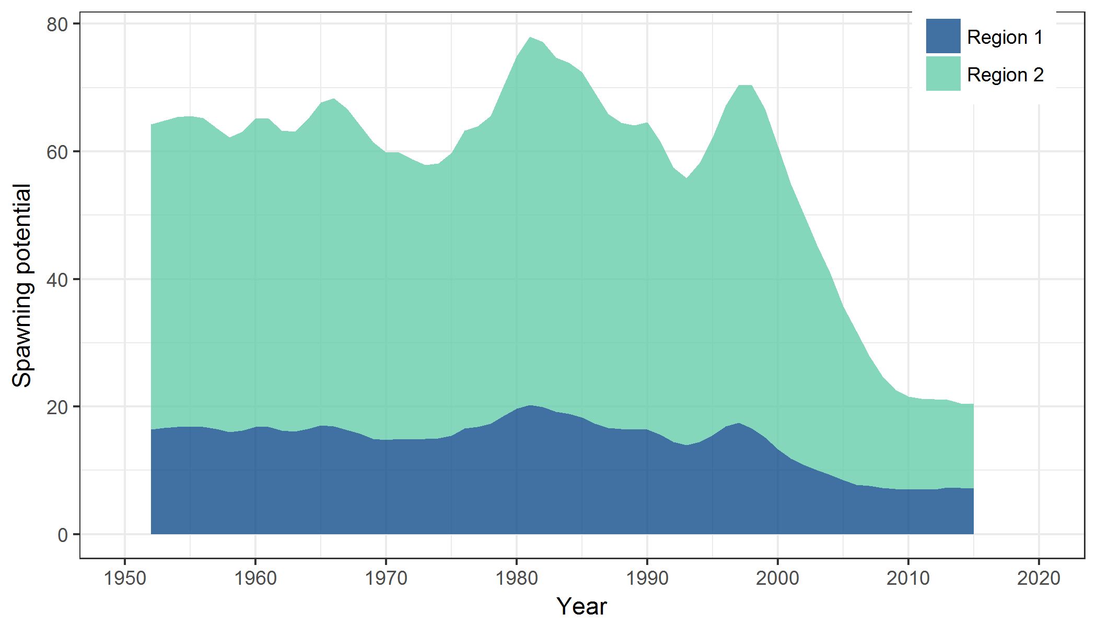 | 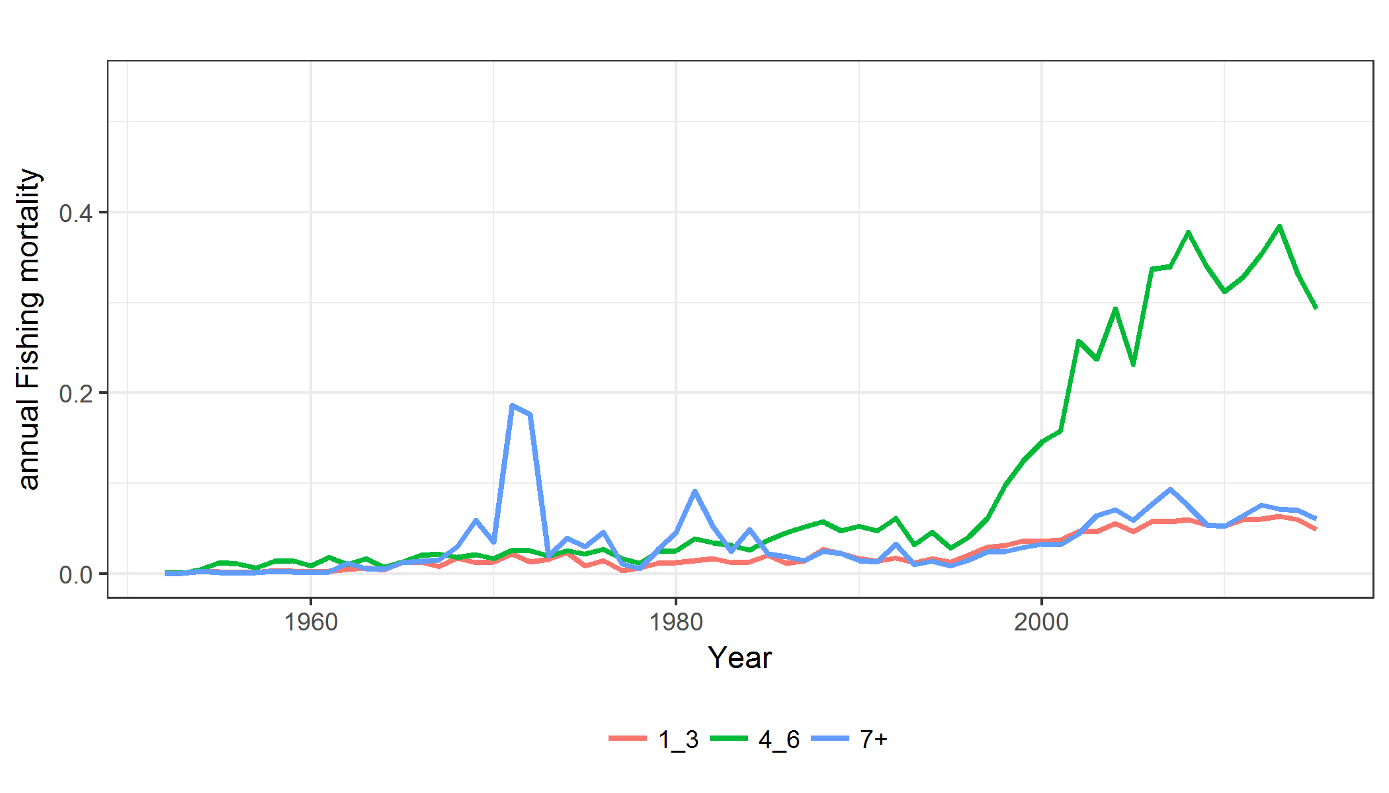
Figure SWO3. Estimated annual average spawning potential by model region for the diagnostic case model, showing the relative sizes among regions. | Figure SWO-4. Estimated annual average juvenile (age classes 1-3), maturing adult (4-6) and adult (7+) fishing mortality for the diagnostic case model.

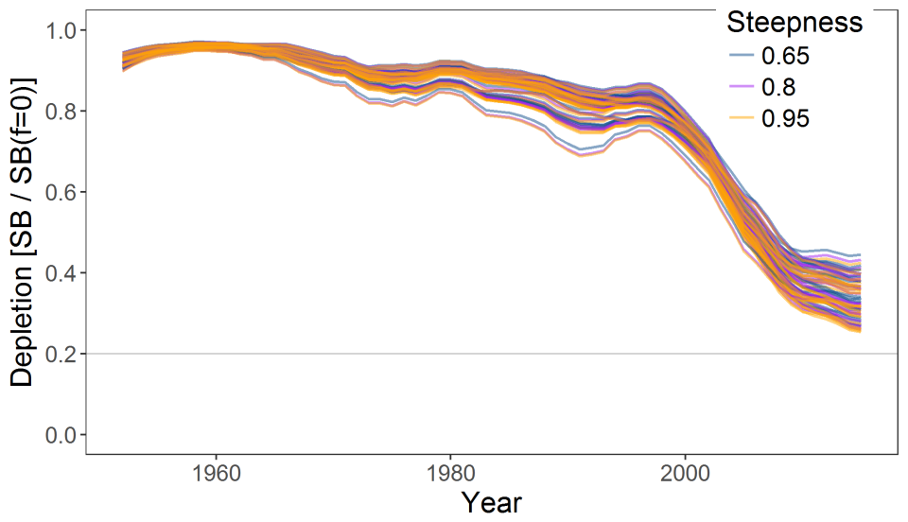
Figure SWO-5. Plot showing the trajectories of fishing depletion (of spawning potential) for the 72 model runs retained for the structural uncertainty grid used for management advice. The colours depict the models in the grid with three levels of steepness (0.65, 0.8 and 0.95).

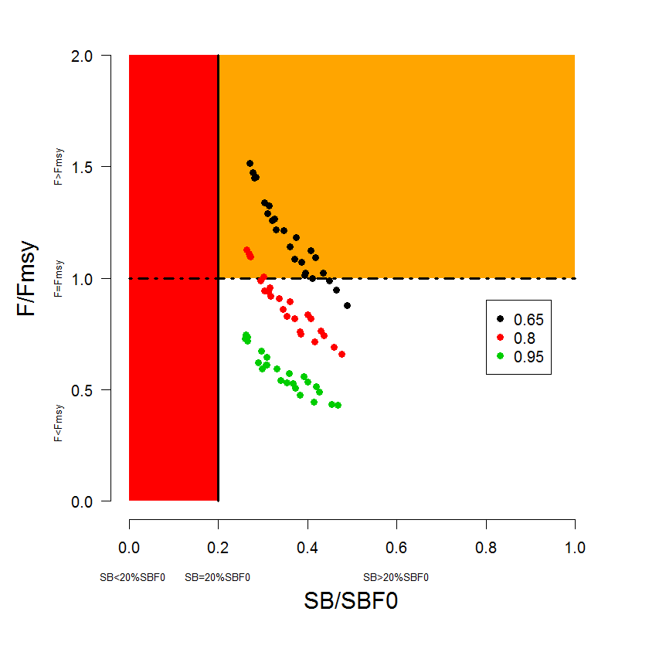 | 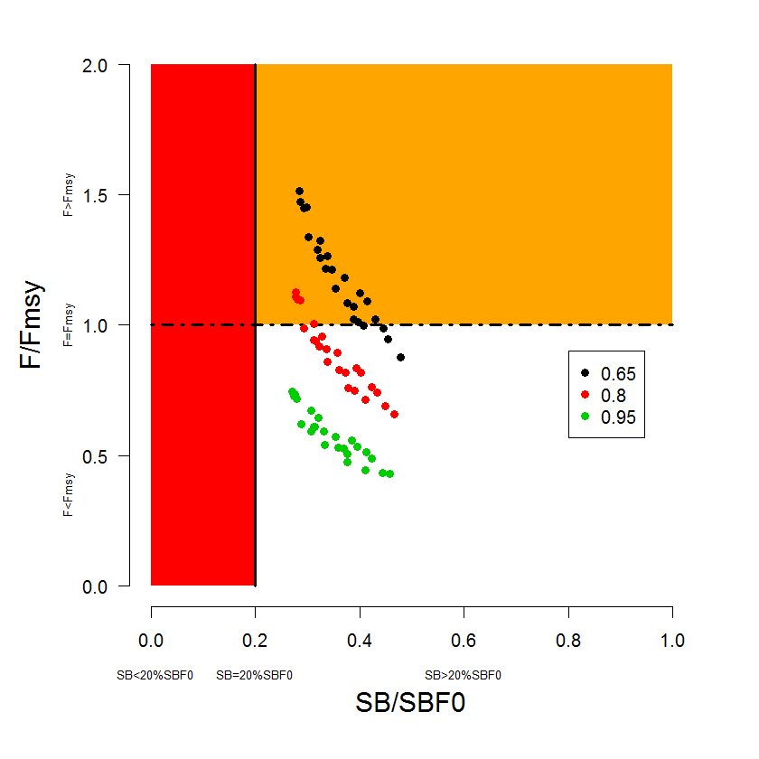
Figure SWO-6. Majuro plot summarising the results for each of the models in the structural uncertainty grid retained for management advice. The plots represent estimates of stock status in terms of spawning potential depletion and fishing mortality. The red zone represents spawning potential levels lower than the agreed limit reference point which is marked with the solid black line. The orange region is for fishing mortality greater than F_{MSY} (F_{MSY} is marked with the black dashed line). The points represent SB_{latest} /SB_{F=0}, and the colours depict the models in the grid with three levels of steepness (0.65, 0.8 and 0.95). | Figure SWO-7. Majuro plot summarising the results for each of the models in the structural uncertainty grid retained for management advice. The plots represent estimates of stock status in terms of spawning potential depletion and fishing mortality. The red zone represents spawning potential levels lower than the agreed limit reference point which is marked with the solid black line. The orange region is for fishing mortality greater than F_{MSY} (F_{MSY} is marked with the black dashed line). The points represent SB_{recent}/SB_{F=0}, and the colours depict the models in the grid with three levels of steepness (0.65, 0.8 and 0.95). Note, SB_{recent} is defined as the mean of SB over 2012-2015.
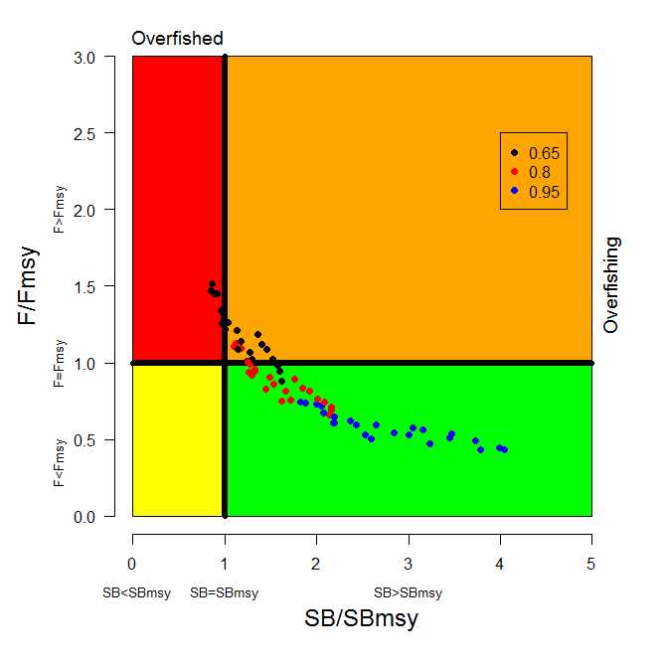 | 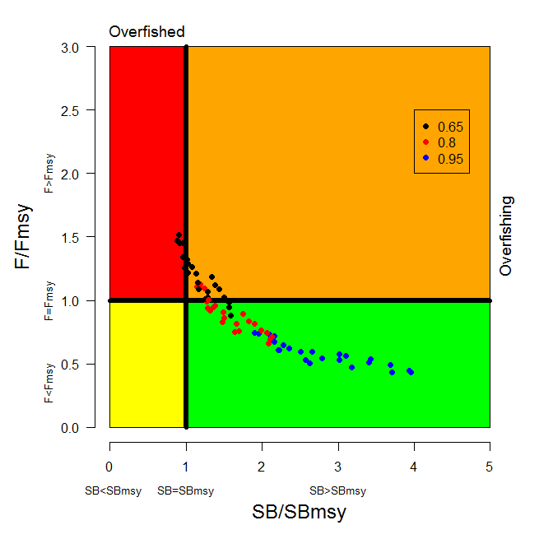
Figure SWO-8. Kobe plot summarising the results for each of the models in the structural uncertainty grid, where the x-axis represents SB_{latest} /SB_{MSY}. The colours depict the models in the grid with three levels of steepness (0.65, 0.8 and 0.95). | Figure SWO-9. Kobe plot summarising the results for each of the models in the structural uncertainty grid. The colours depict the models in the grid with three levels of steepness (0.65, 0.8 and 0.95). As in Figure SWO7, SB_{recent} was used instead of SB_{latest}.
Figure SWO-10. Estimated time-series (or “dynamic”) Majuro and Kobe plots from the SW Pacific swordfish ‘diagnostic case’ model run.

Figure SWO-11. Estimates of reduction in spawning potential due to fishing by region, and over all regions (lower left panel), attributed to various fishery groups (distant water ‘north’, ‘central’ and ‘south’, corresponding to the model regions, and a combined domestic fleet) for the diagnostic case model.

Table SWO-2. Summary of reference points over the 72 models in the structural uncertainty grid for management advice. Note that SB_{recent}/SB_{F=0} is calculated where SB_{recent} is the mean SB over 2012-2015 instead of 2011-2014 (used in the stock assessment report), at the request of the Scientific Committee.
 | Mean | Median | Min | 10% | 90% | Max
C_{latest} | 9,884 | 9,884 | 9,318 | 9,343 | 10,157 | 10,287
MSY | 8,172 | 7,913 | 5,905 | 6,396 | 10,150 | 11,360
Y_{Frecent} | 7,628 | 7,775 | 4,998 | 6,062 | 8,948 | 9,684
f_{mult} | 1.27 | 1.15 | 0.66 | 0.79 | 1.89 | 2.32
F_{MSY} | 0.16 | 0.14 | 0.10 | 0.10 | 0.22 | 0.23
F_{recent}/F_{MSY} | 0.88 | 0.87 | 0.43 | 0.53 | 1.26 | 1.51
SB_{MSY} | 17,314 | 17,740 | 7,278 | 8,943 | 26,661 | 30,460
SB₀ | 84,173 | 84,075 | 57,070 | 71,199 | 98,039 | 111,000
SB_{MSY}/SB₀ | 0.20 | 0.21 | 0.11 | 0.12 | 0.28 | 0.28
SB_{F=0} | 78,619 | 78,301 | 61,996 | 64,342 | 92,120 | 100,691
SB_{MSY}/SB_{F=0} | 0.22 | 0.23 | 0.10 | 0.12 | 0.32 | 0.33
SB_{latest} /SB₀ | 0.33 | 0.32 | 0.24 | 0.25 | 0.44 | 0.46
SB_{latest} /SB_{F=0} | 0.35 | 0.35 | 0.26 | 0.27 | 0.44 | 0.49
SB_{latest} /SB_{MSY} | 1.85 | 1.61 | 0.85 | 0.99 | 3.14 | 4.05
SB_{recent}/SB_{F=0} | 0.36 | 0.35 | 0.27 | 0.29 | 0.43 | 0.48
SB_{recent}/SB_{MSY} | 1.86 | 1.58 | 0.88 | 1.02 | 3.10 | 3.96

- SC13 noted that the central tendency of relative recent spawning biomass was median (SB_{recent}/SB_{F=0}) = 0.35 with a probable range of 0.29 to 0.43 (80% probability interval). The median estimate (0.35) is below that estimated from the 2014 assessment grid((SB_{current}/SB_{F=0}) = 0.49, see SC9-SA-WP-05), noting the differences in grid uncertainty axes used in that assessment, due to the inclusion of two representations of growth and maturity. SC13 also noted that in the previous assessment this central tendency was not considered for the provision of management advice given the uncertainties in growth assumptions. The median estimate for SB_{recent}/SB_{MSY} is 1.23, which is below that estimated from the 2014 assessment grid ((SB_{current}/SB_{MSY}) = 2.07, see SC9-SA-WP-05).

- SC13 noted that the central tendency of relative recent fishing mortality was median (F_{recent}/F_{MSY}) = 0.86 with an 80% probability interval of 0.51 to 1.23. While this suggested that there was likely a buffer between recent fishing mortality and F_{MSY}, it also showed that there was some probability that recent fishing mortality was above F_{MSY}.

- SC13 also noted that there was a roughly 32% probability (23 out of 72 models) that the recent fishing mortality was above F_{MSY} with Prob((F_{recent}/F_{MSY})>1) = 0.32. The median estimate (0.86) is above that estimated from the 2014 assessment grid (F_{current}/F_{MSY} = 0.74, see SC9-SA-WP-05).

- Fishing mortality rate increased notably from the mid-1990s in both model regions, on maturing swordfish aged 4-6 fish in particular.

- Across all models in the uncertainty grid the spawning biomass declines steeply between the late 1990s and 2010 but since then the rate of decline has been less. Those declines are found in both model regions, but are higher in the eastern Region 2 (equator to 50°S, 165°E to 130°W).

- SC13 noted that in comparison with the bigeye and yellowfin assessments, evidence for an increase in recent recruitment for southwest Pacific swordfish was not found in either the CPUE time series or estimates of recruitment. SC13 noted that the longline only nature of the fishery catching mainly larger, older swordfish, is not strongly informative with regards to recruitment dynamics.

- Management advice and implications

- Based on the uncertainty grid adopted by SC13, the south west Pacific swordfish spawning biomass is likely above the 20%SB_{F=0}, biomass LRP adopted for tunas and the SB_{MSY} level (noting that the Commission has yet to adopted an LRP for south Pacific swordfish) and it is highly likely that the stock is not in an overfished condition (0% probability). Recent F is likely below F_{MSY}, and it appears that the stock is not experiencing overfishing (32% probability of overfishing).

- SC13 noted that there has been an increase in fishing mortality notably from the mid-1990s, and that the biomass relative to unfished levels is estimated to have declined rapidly during the period late-1990s to 2010 followed by a more gradual but continued decline after 2010, across the uncertainty grid. It was noted the fishing mortality was likely below F_{MSY}.

- Consistent with its previous advice (from SC9), SC13 recommends that the Commission consider developing appropriate management measures for the area north of 20°S to the equator which is not covered by CMM 2009-03, noting that:
- recent catches between the equator and 20°S continue to represent the largest component of the catch in Region 2 (equator to 50°S, 165°E to 130°W) and represent half the total catches from the stock, and,
- catches in that area contribute substantially to fishing mortality and spawning biomass depletion levels in eastern Region 2 that are substantially higher than in the western region (Region 1).

- Further, SC13 recommends that current restrictions on catches south of 20°S also be maintained.

4.4.2 Southwest Pacific striped marlin (Kajikia audax)

- The last stock assessment for Southwest Pacific striped marlin was conducted in 2011. SC13 received no updated information.

- Stock status and trends

- SC13 noted that no stock assessment was conducted for this species in 2017. Therefore, the stock status descriptions from SC8 for Southwest Pacific striped marlin are still current. Updated information on catches was not compiled for and reviewed by SC13.

- Management advice and implications

- SC13 noted that no management advice has been provided since SC8 for South Pacific striped marlin. Therefore, previous advice should be maintained, pending a new assessment or other new information.

4.4.3 North Pacific striped marlin (Kajikia audax)

- The last stock assessment for North Pacific striped marlin was conducted in 2015. SC13 received no updated information.

- Stock status and trends

- SC13 noted that no stock assessment was conducted for this species in 2017. Therefore, the stock status descriptions from SC11 for North Pacific striped marlin are still current. Updated information on North Pacific striped marlin catches may be available in the ISC Plenary Report, but was not compiled for and reviewed by SC13.

- Management advice and implications

- SC13 noted that no conservation advice has been provided since SC11 for North Pacific striped marlin. Therefore, previous advice should be maintained, pending a new assessment or other new information.

4.4.4 Pacific blue marlin (Makaira nigricans)

- The last stock assessment on Pacific blue marlin was conducted by ISC in 2016. No new information was provided to SC13.

- Stock status and trends

- SC13 noted that no stock assessment was conducted for this species in 2017. Therefore, the stock status descriptions from SC12 for Pacific blue marlin are still current. Updated information on Pacific blue marlin catches may be available in the ISC Plenary Report, but was not compiled for and reviewed by SC13.

- Management advice and implications

- SC13 noted that no conservation advice has been provided since SC12 for Pacific blue marlin. Therefore, previous advice should be maintained, pending a new assessment or other new information.

AGENDA ITEM 5 - Management Issues Theme

5.1 Development of harvest strategy framework

5.1.1 Reference points (South Pacific albacore)

- SC13 reviewed information related to the implications of a range of candidate target reference points for south Pacific albacore (SC13-MI-WP-01) and provided a number of suggestions to clarify aspects of the paper before a revised version is forwarded to WCPFC14. Noting that WCPFC13 agreed to defer the possible adoption of an interim target reference point for the South Pacific albacore stock, which had originally been agreed to take place in 2015 under the Harvest Strategy Work Plan, until December 2017 at the latest (para. 314 WCPFC13 Summary Report), SC13 encourages CCMs to describe their objectives for the fishery and recommends that WCPFC14 note the biological and economic consequences of the options modelled in this paper. In particular, SC13 draws the attention of WCPFC14 to the Limit Reference Point (LRP) already adopted by the Commission for south Pacific albacore and the need to identify a TRP which maintains the stock well above this limit, while noting that following the last assessment (SC11-SA-WP-06) the LRP is above SB_{MSY}.

5.1.2 Performance indicators and monitoring strategies

- As requested by the Harvest Strategies Workplan (Attachment N, WCPFC13 Summary Report) and the Small Working Group on Management Objectives at WCPFC13, SC13 reviewed candidate performance indicators and monitoring strategies for i) South Pacific albacore commensurate with candidate management objectives for the Southern Longline Fishery (SC13-MI-WP-02) and ii) bigeye and yellowfin tuna commensurate with candidate management objectives for the Tropical Longline Fishery (SC13-MI-WP-03). SC13 provided a number of suggestions to clarify, and update as appropriate, aspects of these papers and requested that revised versions of both be forwarded to WCPFC14. In reviewing these papers SC13 noted that while the number of key performance indicators should be kept to a tractable level as they will influence the Management Strategy Evaluation (MSE) modelling framework currently being developed, they should also be sufficient to monitor the key long-term management objectives for these fisheries. It was also noted that the list of indicators and monitoring strategies can be reviewed throughout the current MSE work. SC13 recommends that WCPFC14 note the candidate performance indicators and monitoring strategies for each of these fisheries as listed in these revised papers, and provide advice on what performance indicators and monitoring strategies should be included for the development of harvest strategies under CMM 2014-06.

5.1.3 Harvest control rules and management strategy evaluation

- SC13 noted that WCPFC12 had adopted a work-plan for the adoption of Harvest Strategies under CMM 2014-06 and that the development of Harvest Control Rules and Management Strategy Evaluation frameworks had commenced in 2016 and is scheduled to continue through until 2018. SC13 noted the importance of this ongoing work and reviewed the progress outlined in SC13-MI-WP-04. Noting that the initial focus of this work has been on WCPO skipjack, and that other stocks and fisheries will need to be considered as the work proceeds, SC13 provided feedback on the work undertaken to date and made a number of suggestions to help progress this work over the next year. SC13 also noted that additional resources (based on funding provided by New Zealand) are being provided to help expedite this work and appreciated the support for workshops and consultations to improve the capacity of fishery managers to become meaningfully engaged in the development of management strategy evaluation frameworks. SC13 recommends that WCPFC14 note the approach being taken to develop an MSE framework for WCPFC stocks and fisheries, noting that the results presented in this progress report are preliminary and that development of the framework is ongoing with the expectation that preliminary results would possibly be provided in 2018. SC13 also noted that:
  - the importance of ongoing stakeholder involvement and consultation in this work (e.g. via in-country stakeholder engagement with the Scientific Service Provider and/or through a higher-level meeting or workshop for broader stakeholder engagement) and recommends that WCPFC14 explore mechanisms and options for facilitating and funding these arrangements.
  - the harvest strategy work needs to be integrated into the work of the Commission and given a greater priority.
  - the concerns of some CCMs about the discontinuation of the management objectives workshop process.

5.2 Management issues related to FADs

5.2.1 FAD tracking

- SC13 reviewed preliminary data analyses from the PNA’s FAD tracking programme, investigating research areas such as FAD densities in time and space, beaching events, dynamics around the WCPO FAD closure and some initial FAD life-history information (SC13-MI-WP-05). While acknowledging the confidentiality associated with FAD-tracking data, SC13 was supportive of these new data being made available to the Scientific Services Provider for analysis, and noting the scope for further analyses and the importance of complete FAD tracking data to support these analyses, encouraged additional data being made available by fishing companies to continue this research. SC13 also noted the importance of FAD marking and monitoring to better identify and follow individual FADs required to facilitate this research, and the on-going WCPFC considerations on FAD marking and monitoring. SC13 recommends that WCPFC14 note these preliminary analyses and identify mechanisms to help facilitate further analyses, if the Commission requires improved information for decision-making on this subject.

5.2.2 FAD management

- SC13 reviewed the report of the Global FAD Science Symposium, March 20-23, 2017, in Santa Monica, California (What does well-managed FAD use look like within a tropical purse seine fishery? SC13-MI-WP-06). SC13 noted the ‘best-practices’ recommended in this paper under the three broad categories: (1) managing impacts on target species; (2) managing impacts on non-target species, coastal habitats, and the pelagic marine ecosystem; and, (3) the management framework, including monitoring, compliance and surveillance. SC13 also noted that impacts of FADs and FAD management cannot be considered entirely independently of harvest strategies, issues related to fishing capacity, ecosystem structure, or management of all other fishing gears in tropical tuna fisheries. SC13 also noted the report from the Joint T-RFMOs FAD Working Group (SC13-MI-IP-03). SC13 recommends that WCPFC14 take into consideration the examples of best practice made within these reports when developing a framework for the management of FADs within the WCPO.

5.3 Implementation of CMM 2016-01

- SC13 reviewed the draft final report from Project 77: Development of potential measures to reduce interactions with bigeye tuna in the purse seine fishery in the western and central Pacific Ocean (‘bigeye hotspots analysis’) (SC13-MI-WP-07 Rev.02) funded by the EU. The aims of this study were i) to identify factors linked to high purse seine bigeye catch; ii) to identify top bigeye tuna catching purse seiners; and iii) to examine spatial management considerations. As highlighted in previous studies it is clear that many factors influence bigeye catch by the purse seine fishery, which therefore makes it challenging to gauge the effect of each factor separately. SC13 noted several factors influencing bigeye catches, such as vessel size and thermocline depth, and that top vessel lists were different between areas, likely linked to the fact that many fleets mostly operate in one of the three areas analysed during a specific year. SC13 also noted the presence of two types of ‘bigeye hotspot’ areas: i) an area of high overall bigeye tuna catch, with small bigeye catch per set but high effort on associated sets; and ii) an area of high bigeye CPUE, but with lower average catches. SC13 made a number of suggestions to clarify aspects of the report (e.g. enumerating the proportion of the identified hot-spots within each national jurisdiction, providing similar estimates based on those used in the stock assessment to check for potential biases in the observers’ visual estimations, noting the concerns expressed by some CCMs regarding potential difficulties of applying time/area closures in areas of national jurisdiction) and these will be incorporated into the final report to be provided to the WCPFC Secretariat, and subsequently to be made generally available. SC13 also noted the need for improved information on FAD designs, deployments and type of buoy use within the WCPO, together with the importance of detailed information on the characteristics of vessels fishing in the WCPO, to improve future analyses. SC13 recommends that the upcoming Intersessional Meeting to progress the Draft Bridging CCM on Tropical Tuna and both TCC13 and WCPFC14 takes note, among other elements, of the preliminary results contained in this report when framing the ‘bridging’ CMM to replace CMM-2016-01 and that mechanisms be considered to help facilitate further analyses as indicated above.

AGENDA ITEM 6 – Ecosystem and Bycatch Theme

6.1 Ecosystem effects of fishing

6.1.1 SEAPODYM

- No recommendation was provided.

6.1.2 Ecosystem indicators

- No discussion was made.

6.1.3 FAD impacts

6.1.3.1 Case studies on FADs

- Based on the results and recommendations of SC13-EB-WP-02, which reviewed the scientific information on drifting FAD designs that have a high risk of entangling sharks, turtles and other species, such as designs that use open net panels with (stretched) mesh sizes of 7cm or greater, SC13 requests that the Commission notes:
- That bycatch was more frequently observed on sets on drifting FADs, anchored FADs and logs than for sets on unassociated schools, and schools associated with whales and whale sharks. However, species-specific bycatch rates do not always follow this pattern; and
- The available scientific information on non-entangling dFAD designs.

6.1.3.2 FAD research plan

- With SC13-EB-WP-05, consider potential research activities on and at-sea trials of designs for reducing small bigeye/yellowfin tuna catch rates and trials of non-entangling and biodegradable design options in the WCPO to fill key knowledge gaps provided in the report of SC13 ISG-2 on FAD data fields and FAD research plans (Attachment E).

- SC13 adopted the report of ISG-2 on the FAD data fields and FAD Research Plan (Attachment E).

6.2 Sharks

6.2.1 Review of conservation and management measures for sharks

- In relation to Paragraphs 4, 8, and 13 of CMM 2010-07 with reference to data provision, fin to carcass ratios, and the need for a revised or new CMM, SC13 notes that no new information was submitted to SC13 to review the ratio of fin weight to shark carcass weight. Since the adoption of this CMM, SC was unable to confirm the validity of using a 5% fin to carcass ratio and forwards this concern to TCC, noting that an evaluation of the 5% ratio is not currently possible due to insufficient or inconclusive information for all but one of the major fleets implementing these ratios (SC12, para 714).

- SC13 recommends that:
- TCC13 and WCPFC14 note that no new information was submitted to SC13 to review the ratio of fin weight to shark carcass weight.
- TCC13 and WCPFC14 elaborate a mechanism for generating the data necessary to review the fins to carcass ratio if such a ratio is to be used as a tool for promoting the full utilization of sharks in the WCPFC.

6.2.2 Development of a comprehensive shark and ray measure

- SC13 adopted the report of ISG-6 on the comprehensive shark CMM (Attachment G).

6.2.3 Safe release guidelines

- SC13 adopted the report of ISG-5 on the safe release guidelines for manta and mobulid rays (Attachment H).

- SC13 recommends TCC13 and WCPFC14 note that SC has not yet adopted guidelines for safe release for silky and oceanic whitetip sharks.

6.2.4 Shark research plan

- SC13 adopted the report of ISG-04 on the Shark Research Plan and future work plan (Attachment I).

6.3 Seabirds

- SC13 noted from a number of CCM Part 1 Reports that high bycatch rates of seabirds, and in particular albatross, continue to be reported by some CCMs fishing in waters south of 30ºS. Therefore, SC13, taking note that SPC is about to initiate a project to assess seabird interactions with WCPFC fisheries and will report the results to SC14, recommends that TCC and the Commission review both observer coverage rates (used to estimate total seabird interactions) and the application of mitigation by fleets operating in this area, to inform what further action, if any, may be required by the Commission to address this issue.

6.4 Sea Turtles

- SC13 recommends that TCC and the Commission note the following findings of the Workshop when discussing sea turtle mitigation in the WCPF Convention Area:
- The WCPFC does not hold sufficient information to quantify the severity of the threat posed by longline fisheries to sea turtle populations;
- The effect of large circle hooks (size 16/0 or larger) in reducing interactions is generally greater than the effect of fish bait;
- The effect of fish bait in reducing both interactions and mortality is generally similar to that of removal of the first hook position closest to each float;
- The effect of large circle hooks (size 16/0 or larger) in reducing both interactions and mortality is generally similar to that of removal of the first two hook positions closest to each float;
- While approximately 20% of the WCPO longline effort is in shallow sets, analysis suggests that <1% of WCPO longline effort is currently subject to mitigation;
- Noting that the workshop separated shallow and deep sets at 10 hooks per basket, it found that although interaction rates are higher in shallow-set longlines, introducing mitigation to deep-set longlines would deliver greater reductions in total interactions as compared to shallow-set longlines due to the four-times greater effort in deep-set longline fisheries;
- Similarly, introducing mitigation to deep-set longlines would deliver greater reductions in at-vessel mortality as compared to shallow-set mitigation because sea turtles have a higher probability of asphyxiation in deep sets;
- The effects of these and other combinations of mitigation measures are quantified and discussed in the final workshop report “Joint Analysis of Sea Turtle Mitigation Effectiveness” which can serve as a reference for the Commission’s further consideration of CMM 2008-03.
- It be determined if sufficient data exist to conduct further analyses to evaluate the impacts of various mitigation measures on fisheries operations in WCPO and on populations of sea turtle species.

AGENDA ITEM 7 - Other Research Projects

7.1 West Pacific East Asia Project

- S. Soh (Secretariat) introduced SC13-RP-WPEA-01 Project Progress Report (WPEA) and SC13-RP-WPEA-02 Midterm review report on WEA-SM Project (UNDP). Due to delays in implementing the project in Indonesia and Viet Nam, the fourth Project Board meeting held on 5th of May 2017 in Yogyakarta, Indonesia, agreed to a no-cost extension of the project for 15 months (by the end of April 2019).

7.2 Pacific Tuna Tagging Project

- P. Williams (SPC-OFP) presented SC13-RP-PTTP-02 Pacific Tuna Tagging Project Report and Workplan for 2017-2021. This report provides background on the PTTP to date, and covers the tagging activities undertaken in 2016-17 under the banner of the PTTP including research voyages, tag recoveries, tag recovery and tag seeding activities, and tagging related analyses. Issues arising in 2017 for PTTP steering committee consideration are highlighted. The PTTP work planned for 2017-2020 is outlined and an agenda for the 2017 meeting of the PTTP steering committee is provided.

- The Scientific Committee endorsed the PTTP work plan for 2017-2020, and supported:
- the PTTP as part of the ongoing work of the SC;
- efforts to identify sustainable financing of the PTTP, through a combination of WCPFC budget support to the extent possible and voluntary contributions from WCPFC members or other stakeholders; and
- an assessment of the cost-effectiveness of acquiring and running a dedicated tagging vessel.

7.3 ABNJ (Common Oceans) Tuna Project – Shark and Bycatch Components

- S. Clarke presented SC13- RP-ABNJ-01 Update on the Common Oceans (ABNJ) Tuna Project’s Shark and Bycatch Components 2016-2017. She also referred delegates to SC13-EB-IP-14 which reported on the outcomes of two Regional Seabird Bycatch Pre-assessment Workshops held in early 2017, and planned a data preparation workshop.

7.4 WCPFC Tissue Bank (Project 35b)

- N. Smith presented SC13-RP-P35-01 Project 35: Bigeye biology, Project 35b: WCPFC Tuna Tissue Bank and SC13-RP-P35b-02 Development of a Pacific Community Marine Specimen Bank. N. Smith noted that a key result in a busy and productive year was the completion of the bigeye tuna age and growth analyses as reported in Farley et al. (2017), an important new input to the stock assessment for bigeye in 2017. The Tuna Tissue Bank (TTB) was an important supporting component of the WCPFC science system and continues to be developed and enhanced. A substantive development in 2017 has been the redevelopment of the Biological Data System underpinning the TTB, and the relaunch of the associated web portal (www.spc.int/ofp/PacificSpecimenBank). An important activity in 2016-17 was a quality assurance test for use of samples in modern genetic analyses, the result of which was positive. The outstanding support from the people of PICTs in collecting, storing and transporting specimens for the TTB – at-sea and onshore – is at the core of its success.

- Recommendations arising from the Tuna Tissue Bank project this last year include:
  - regular age, growth and maturity analyses of specimens for all tuna and tuna-like stocks for future stock assessments should be budgeted for and aligned with the stock assessment schedule, noting that additional resources would be required, and that yellowfin tuna would be the next priority species;
  - as the WCPFC Tuna Tissue bank is intended to be ongoing, and given its success and measured quality to date, incorporate the identified budget into the 2019-20 indicative budgets;
  - that interested CCMs visit the Tuna Tissue Bank web-portal and provide any feedback intersessionally to SPC; and
  - the development and implementation of a multi-level login to the web portal to enhance access for those planning research.

- The Scientific Committee confirmed that maintaining and enhancing the WCPFC Tuna Tissue Bank (P35b) remains an essential part of the WCPFC science system and supported its inclusion in the proposed budget for 2018.

- The Scientific Committee agreed to include the WCPFC Tuna Tissue Bank (P35b) in its indicative budget for 2019-20.

- The Scientific Committee agreed the development and implementation of a multi-level login to the web portal which would allow greater access to Tuna Tissue Bank data for those planning research.

- SC13 supported the recommendations.

7.5 Other Projects

- S. Soh (Secretariat) referred delegates to SC13-GN-WP-04 Intersessional activities of the SC Rev 1 for a report on other science projects undertaken since SC12, including projects with funding supports from EU, Korea, the International Seafood Sustainability Foundation and the Western Pacific Regional Fishery Management Council.

AGENDA ITEM 8 - Cooperation with Other Organisations

- SC13-GN-IP-01 provided updated information on existing and new arrangements with other organizations, including the signing of two new memoranda with the Commission for the Conservation of Southern Bluefin Tuna (CCSBT).

AGENDA ITEM 9 - Special Requirements of Developing States and Participating Territories

- WCPFC Assistant Science Manager, T. Beeching presented SC13-RP-JTF-01 Japan Trust Fund Status Report (2017); and SC13-RP-JTF-02 Japan Trust Fund Steering Committee Report.

- It was noted that the Special Requirements of Developing States and Participating Territories was an important platform on which this Commission must consider the development and delivery of its functions and work.

AGENDA ITEM 10 - Future Work Program and Budget

10.1 Development of the 2018 Work Programme and budget, and projection of 2019-2020 provisional Work Programme and indicative budget

- SC13 adopted the proposed budget (Table 1) and forwarded it to the FAC at the December WCPFC meeting.

Table 1. Summary of SC work programme titles and budget for 2018, and indicative budget for 2019–2020, which requires funding from the Commission’s core budget (USD).
Project title | TORs | Essential | Priority / Rank | 2018 | 2019 | 2020
SPC Oceanic Fisheries Programme Budget |  | Yes |  | 888,624 | 906,396 | 924,524
SPC – Additional resourcing |  | Yes |  | 163,200 | 164,832 | 166,480
Project 35b. Maintenance and enhancement of the WCPFC Tissue Bank | Annexed | Yes | High | 97,200 | 97,200 | 97,200
Project 42 Pacific Tuna Tagging Program | Annexed | Yes | High | 500,000 | 650,000 | 690,000
Project 57. Identifying appropriate LRPs for elasmobranchs within the WCPFC | Annexed |  | High | 25,000 | 0 | 0
Project 60: Improving purse seine species composition | Annexed |  | Medium / 1 |  | 40,000 | 40,000
Project 68. Estimation of seabird mortality across the WCPO Convention area | Annexed |  | High | 22,500 | 17,500
Project 81. Further work on bigeye tuna age and growth | Annexed | Yes | High/1 | 30,000
Project 82. Yellowfin tuna age and growth | Annexed | ? | High/2 | 100,000 | 85,000
Project 83. Investigating the potential for a WCPFC tag vessel | Annexed | No | Medium | 62,500
Project 88. Acoustic FAD analyses | Annexed | No | Medium |  | 120,000 | 72,000
Project 90. Better data on fish weights and lengths for scientific analyses | Annexed |  | High |  | 40,000 | 20,000
Unobligated (Contingency) Budget |  |  |  | 0 | 83,000 | 83,000
SC13 TOTAL BUDGET |  |  |  | 1,889,024 | 2,203,928 | 2,093,205

- Detailed description of SC13 work programme, budget and terms of reference for each project are in Attachment J.

AGENDA ITEM 11 - Administrative Matters

11.1 Election of Officers of the Scientific Committee

- SC13 considered nominations for SC Chair, SC Vice-Chair, but no nominations were made. Members were asked to further consider potential nominations in the intersessional period.

11.3 Next meeting

- SC13 confirmed that SC14 would be held in Busan, Korea, during 8 – 16 August 2018, and proposed that SC15 in 2019 be held in Samoa.

AGENDA ITEM 12 - Other Matters

- No issues were raised under this agenda item.

AGENDA ITEM 13 - Adoption of the Summary Report of the Thirteenth Regular Session Of The Scientific Committee

- SC13 adopted the recommendations of the Thirteenth Regular Session of the Scientific Committee. The SC13 Summary Report will be adopted intersessionally according to the following schedule:

Due by | Activity
28 August | Receive draft report from rapporteurs
4 September | Secretariat clean and send the draft report to theme conveners
11 September | Theme convenors return the report back to the Secretariat
13 September | The Secretariat distributes the draft report to all CCMs and Observers by email (DRAFT version post on SC13 website)
25 October | Deadline for the submission of comments from CCMs and Observers

AGENDA ITEM 14 – Close of the Meeting

- The meeting closed at 6.00pm on Thursday 17 August 2017.

The Commission for the Conservation and Management of
Highly Migratory Fish Stocks in the Western and Central Pacific Ocean

Scientific Committee
Thirteenth Regular Session

Rarotonga, Cook Islands
9 - 17 August 2017

SUMMARY REPORT

AGENDA ITEM 1 – Opening of the Meeting

- The Thirteenth Regular Session of the Scientific Committee of the Commission for the Conservation and Management of Highly Migratory Fish Stocks in the Western and Central Pacific Ocean took place from 9 - 17 August 2017 at the National Auditorium, Marairenga, Rarotonga, Cook Islands.

- The following WCPFC Members, Cooperating Non-members and Participating Territories (CCMs) attended SC13: American Samoa, Australia, China, Cook Islands, European Union (EU), Federated States of Micronesia (FSM), Fiji, French Polynesia, Indonesia, Japan, Kiribati, Republic of Korea, Republic of Marshall Islands (RMI), Nauru, New Caledonia, New Zealand, Niue, Palau, Philippines, Papua New Guinea (PNG), Samoa, Solomon Islands, Chinese Taipei, Tokelau, Tonga, Tuvalu, United States of America (USA), Vanuatu and Vietnam.

- Observers from the following inter-governmental organizations attended SC13: Pacific Islands Forum Fisheries Agency (FFA), Inter-American Tropical Tuna Commission (IATTC), Parties to the Nauru Agreement (PNA), the Pacific Community (SPC) and the Food and Agriculture Organization of the United Nations (FAO).

- Observers from the following non-governmental organizations attended SC13: American Tunaboat Association, Birdlife International, Greenpeace, International Seafood Sustainability Foundation (ISSF), Marine Stewardship Council (MSC), The Nature Conservancy, The Pew Charitable Trusts (Pew), Sustainable Fisheries Partnership (SFP), and Worldwide Fund for Nature (WWF).

- The full list of participants can be found at Attachment A.

1.1 Welcome address

- Delegates were welcomed by a formal traditional touru, followed by a prayer led by the Reverend Vaka Ngaro.

- The Honourable Minister M. Brown, Minister for Finance and acting Prime Minister, Cook Islands, acknowledged the Aronga Mana of this land of Tupapa Maraerenga and warmly welcomed delegates to the Cook Islands. He acknowledged the efforts of scientists, managers and organisations in moving the WCPFC forward since it last met in the 2003 Preparatory Conference in the Cook Islands. He highlighted critical issues before the SC, including the status of key fisheries, stock assessments, data and statistics, harvest strategies, ecosystem and bycatch mitigation and future research priorities. The Hon Minister noted that the outcomes of these discussions would provide the scientific advice upon which conservation and management measures will be developed, and that these measures will impact twenty percent of the world’s area, many stocks of fisheries and marine species, a multi-billion-dollar industry and the livelihoods of thousands if not millions of peoples. He stated that the Cook Islands was proud of being stewards of its marine heritage and large ocean state status and highlighted the recent adoption of the Marae Moana (Marine Park) legislation as an indication of the Cook Islands’ commitment to sustainable fisheries management. He congratulated the Western and Central Pacific Fisheries Commission (WCPFC) for becoming a role model for other Regional Fisheries Management Organisations. The full remarks of the Hon Minister Brown can be found at Attachment B.

- The SC Chair, B. Muller (RMI), thanked the acting Prime Minister for his kind words of welcome, and expressed appreciation to the government of the Cook Islands for hosting the meeting. She highlighted several key issues for deliberation at this year’s meeting, including consideration of data gaps, review of the results of several key stock assessments, development of scientific advice for the development of the Commission’s harvest strategy framework, review of FAD research plan and shark research plans, development of a comprehensive shark and ray measure, and development of the future SC work programmes and budget. She introduced the four theme convenors who would be assisting her and Vice Chair Aisake Batibasaga to synthesise the outcomes of the discussions. She thanked the Oceanic Fisheries Programme of the Pacific Community (SPC-OFP), the scientific services provider, who prepared more than 40 papers and reports for the meeting, and the many contributions from CCMs and Observers.

- In his opening remarks, the Executive Director F. Teo expressed his profound gratitude for the work of SC Chair B. Muller, who would be stepping down as of the end of this meeting, and acknowledged the presence of delegates and representatives from CCMs and observer organisations. He noted that the meeting’s substantive agenda was reflective of the critical role of the Scientific Committee in providing advice to the Commission. He also noted that the Commission Chair R. Moss-Christian had asked him to convey SC13’s advice and recommendations on the stock assessment outcomes for bigeye and yellowfin tuna for the development of topical tuna measure in time for adoption at WCPFC14. While noting there were several key issues under consideration, he highlighted the need for clear guidance on the development of harvest strategies, and the development of a comprehensive measure for sharks, including mantra and mobula rays. Finally, he expressed appreciation of the high-quality work of the SPC-OFP, the theme Convenors and scientists from members and observers who have made valuable contributions to assist the work of the meeting (Attachment C).

1.2 Meeting arrangements

- The SC Chair ran through meeting arrangements including session and break times and side events. She introduced the Vice Chair A. Batibasaga, the theme convenors and the informal small working groups (ICGs). The theme conveners and their assigned themes were:
Data and Statistics theme | V. Post (USA)
Stock Assessment theme | J. Brodziak (USA) and H. Nishida (Japan)
Management Issues theme | R. Campbell (Australia)
Ecosystem and Bycatch Mitigation theme | J. Annala (NZ) and A. Batibasaga (Fiji)

The informal small working groups were:
ISG-ID | Title | Facilitator
ISG-1 | Guidelines for submission of economic data | A. Batibasaga
ISG-2 | FAD data fields and FAD Research Plan | J. Santiago
ISG-3 | Target reference point for SP albacore | Cancelled
ISG-4 | Shark Research Plan and future work plan | J. Larcombe
ISG-5 | Safe release guidelines for manta and mobula rays | M. Hutchinson
ISG-6 | Comprehensive shark and ray measure | S. Varsamos
ISG-7 | Development of SC Budget for 2017 – 2019 | B. Muller
ISG-8 | Performance Indicators and Monitoring Strategies | R. Campbell

- In response to a query from EU relating to progress on the Shark limit reference point (LRP) Project, New Zealand noted that both the Project and its scope of work had been approved, but the available funding was not enough to secure any tender bids. Discussions were now underway to consider a reduction of scope or means to increase the funding.

1.3 Issues arising from the Commission

- The Science Manager S. Soh introduced SC13-GN-WP-03 Issues arising from the Commission, noting that it covered recommendations from SC12 and SC-related information and requests from WCPFC13. Most of these issues were reflected in the SC13 agenda and meeting papers.

1.4 Adoption of the agenda

- The SC13 provisional agenda was adopted (Attachment D).

- The SC Chair also noted that both the Chair’s and Vice Chair’s positions would become vacant as of the end SC13 and replacements would need to be recommended for the next two years, which will be discussed under Agenda 11.2

1.5 Reporting arrangements

- The SC Chair noted that SC13 would adopt its recommendations at the meeting, and develop a Summary Report with an Executive Summary which would be adopted intersessionally. The Executive Summary would include a synopsis of stock status and management advice and implications, research plans, findings or conclusions on the stock status, reports and recommendations, as directed by the Commission or at the initiative of the SC (Paragraph 2, Article 12 of the Convention). The recommendations will be adopted at the meeting and the Summary Report will be adopted intersessionally.

- The SC Chair introduced the two lead rapporteurs, Melissa Idiens and Lyn Goldsworthy who would compile the Summary Report.

1.6 Intersessional activities of the Scientific Committee

- The Science Manager provided a brief introduction to SC13-GN-WP-04 Intersessional activities of the Scientific Committee. The paper provided summaries of scientific services from the SPC-OFP, progress and status of eleven SC work programmes, cooperation with other organizations where the Secretariat attended their meetings, and a summary of four research projects (ABNJ (Common Oceans) Tuna Project, the Japan Trust Fund (JTF) project, the WCPFC Tissue Bank project and the West Pacific East Asia project).

AGENDA ITEM 2 – Review of Fisheries

2.1 Overview of Western and Central Pacific Ocean (WCPO) fisheries

- P. Williams (SPC-OFP) and C. Reid (FFA) introduced SC13-GN-WP-01 Overview of tuna fisheries in the western and central Pacific Ocean, including economic conditions – 2016, which provided an overview of the WCPO key fisheries, including billfish and trends in purse-seine fishery capacity. They noted that SC13-ST-IP-01 Estimates of annual catches in the WCPFC Statistical Area, and Annual Reports- Part 1 provided additional detail.

- The provisional total WCP–CA tuna catch for 2016 was estimated at 2,717,850 mt, the second highest on record and nearly 120,000 mt below the previous record catch in 2014 (2,851,087 mt); this catch represented 79% of the total Pacific Ocean catch of 3,406,269 mt, and 56% of the global tuna catch (the provisional estimate for 2016 is 4,795,867 mt, and when finalised was expected to be the second highest on record).

- The 2016 WCP–CA catch of skipjack (1,816,650 mt – 67% of the total catch) was the fourth highest recorded, nearly 160,000 mt less than the record in 2014 (1,977,019 mt). The WCP–CA yellowfin catch for 2016 (650,491 mt – 24%) was the highest recorded (more than 40,000 mt higher than the previous record catch of 2008 – 609,458 mt); the increase in yellowfin tuna catch from 2015 levels was mainly due to increased catches in the purse seine fishery and the Indonesia and Philippines domestic fisheries. The WCP–CA bigeye catch for 2016 (152,806 mt – 6%) was an increase on 2015 catch and around average for the past ten years. The 2016 WCP–CA albacore catch (97,822 mt – 4%) was the lowest since 1996 and around 50,000 mt lower than the record catch in 2002 at 147,793 mt. The south Pacific albacore catch in 2016 (68,601 mt) was about 13,000 mt lower than in 2015 and nearly 20,000 mt lower than the record catch in 2010 of 87,292 mt (although the 2016 estimates for some fleets are provisional).

- The provisional 2016 purse seine catch of 1,858,198 mt was the third highest catch on record, higher than in 2016, but more than 160,000 mt lower than the record in 2014 (2,028,630 mt); the main reasons for the increase in catch compared to 2015 are related to increased effort and improved conditions (catch rates) in the fishery. The 2016 purse-seine skipjack catch (1,408,110 mt; 75% of total catch) was about 200,000 mt lower than the record in 2014, but almost identical to the 2015 catch level. The 2016 purse-seine catch estimate for yellowfin tuna (394,756 mt; 21%) was the second highest on record (423,788 mt in 2008) coming after a poor catch year in 2015 and appeared to be due to increased catches of large yellowfin from unassociated-school set types. The provisional catch estimate for bigeye tuna for 2016 (63,304 mt) was an increase from the relatively low catch level in 2015.

- The provisional 2016 pole and line catch (199,457 mt) was the lowest annual catch since the late-1960s, although estimates were typically revised upwards by the start of SC meetings each year. Japanese distant-water and offshore fleets (90,343 mt in 2016), and the Indonesian fleets (108,327 mt in 2016), accounted for nearly all of the WCP–CA pole and line catch (99% in 2016).

- The provisional WCP–CA longline catch (231,860 mt) for 2016 was lower than the average for the past five years. The WCP–CA albacore longline catch (71,571 mt – 31%) for 2016 was the lowest since 2000, 30,000 mt lower that the record of 101,816 mt attained in 2010. The provisional bigeye catch (64,131 mt – 28%) for 2016 was the lowest since 1996, mainly due to continued reduction in effort in the main bigeye tuna fishery (refer to Pilling et al., 2017 for more detail). The yellowfin catch for 2016 (90,539 mt – 39%) was around the average for the past five years.

- The 2016 South Pacific troll albacore catch (2,097 mt) was the lowest catch since 2009. The New Zealand troll fleet (137 vessels catching 1,952 mt in 2016) and the United States troll fleet (6 vessels catching 151 mt in 2016) accounted for all the 2016 albacore troll catch.

- Market conditions for the tuna raw materials of the WCP-CA during 2016 saw improvements in prices for canning lightmeat raw material (skipjack and yellowfin) and sashimi grade products but some deterioration in the price for albacore for canning.

- Prices in the major markets for WCP-CA skipjack were higher in 2016 compared with 2015, underpinned by low supplies of raw material and despite continuing poor demand at end markets. The Bangkok benchmark (4-7.5lb) and Thai import prices were higher by 23% ($1,395/mt) and 19% respectively. Similar trends occurred in other markets with prices in General Santos 17% higher while prices at Yaizu Port in Japan increased 21% in USD terms (9% in JPY terms). Yellowfin prices on canning markets in 2016 reversed recent declines, albeit moderately with Thai import prices increasing by 2% to US$1,605/mt and Yaizu prices by 11% to US$2,309/mt.

- Japan fresh yellowfin import prices (c.i.f., USD) in 2016, from all sources, rose 9% (-2% in JPY terms) while Yaizu port fresh and frozen prices (ex-vessel) increased by 7% (-4%) reversing the previous year’s respective declines of 11% and 18%. US fresh yellowfin import prices (f.a.s.) in 2016 declined 3% relative to 2015 following a 2% decline in 2015.

- Japan fresh bigeye import prices (c.i.f., USD) in 2016, from all sources, improved by 12% in USD terms (up 1% in JPY terms) while Japan selected ports frozen longline prices (ex-vessel) improved 21% (9%) which reversed the previous year’s 14% decline partly as a result of the substantial strengthening of the Yen. US fresh bigeye import prices (f.a.s.) in 2016 registered a decline of 3% relative to 2015.

- The total estimated delivered value of catch in the WCP-CA increased by 11% to $5.3 billion during 2016. This reversed the declining trend evident since the 2012 peak when the value reached $7.5 billion. The value of the purse seine tuna catch for 2016 is $2.8 billion (54% of total value) compared with $2.3 billion in 2015. The value of the longline tuna catch in the WCPFC area for 2016 was $1.5 billion (24% of total), a decrease of 5% on 2015. In terms of value by species, all species increased in value except for albacore which declined 13% to $293 million (6% of total catch value). The value of the bigeye catch increased by 8% to $697 million (13%). The value of the skipjack catch increased 19% to $2.7 billion (51%). The value of yellowfin catch increased by 7% to $1.6 billion (31%).

- There was overall improvement in 2016 compared with 2015 with respect to economic conditions in the purse seine, tropical longline and southern longline fisheries of the WCP-CA. For the purse seine fishery, there was deterioration in catch rates but the declines in costs and improvements in prices more than offset this deterioration. For the tropical longline fishery conditions improved noticeably since 2014 owing to significant declines in cost reflecting falls in fuel prices. For the southern longline fishery economic conditions improved significantly since 2014 due to falling fuel costs with the fish price remaining around its long-term average. The economic conditions index in 2016 was at its highest level since 2008 with the improvement driven by low fuel prices but being hampered by persistent low catch rates.

Figure 1. Catch (mt) of albacore, bigeye, skipjack and yellowfin in the WCP–CA, by longline, pole and line, purse seine and other gear types.
Figure 2. Catch (mt) of albacore, bigeye, skipjack and yellowfin in the WCP–CA

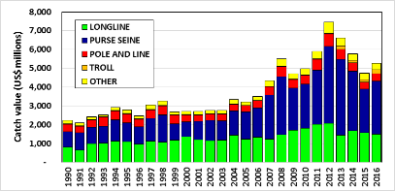
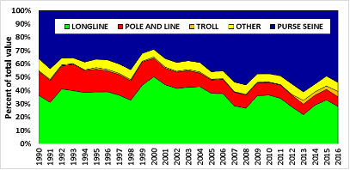
Figures 3 and 4: Catch value by gear type and relative value share of gear type in the estimated delivered values of WCP-CA catch, 1990–2016

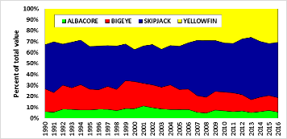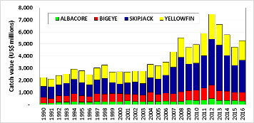
Figures 5 and 6: Catch value by species and relative share of species type in the estimated delivered values of WCP-CA catch, 1990–2016

Discussion

- Vanuatu, on behalf of FFA members, expressed concern over the large numbers of small yellowfin and skipjack tuna being taken by some fisheries, and proposed that some form of management restraint be considered as part of the tropical tuna bridging measure, including provisions for appropriate levels of data from these fisheries to be collected and reported to support the management of these stocks. They further noted the increased catches of yellowfin from unassociated schools and asked if these changes might be due to a change in reporting or increased effort.

- Australia also queried how much of the increased catches of yellowfin were related to improved reporting or increased effort, noting recent efforts by Indonesia to improve their reporting.

- P. Williams clarified that there had been an increase in availability of tunas and that this might be related to environmental conditions. He agreed that the increased catch from Indonesia might be the result of improved reporting, and further noted that this may have implications for the accuracy of estimates from previous years.

- PNA members noted the positive features in the overview. For example, in the tropical purse seine fishery fleet size and effort was relatively stable, catch rates high, and stock status indications were positive. A major question now was the extent to which these developments were a result of management measures or environmental conditions. PNA suggested that a systematic analysis of this question would be useful.

- China queried the reasons behind the changes in purse seine catch rates in recent years, and suggested that changes in fishing effort may have had an impact. P. Williams noted that, to some extent, changes in effort may be related to more searching and transit days during the recent strong El Niño conditions, with fleets fishing further away from ports of transhipment or unloading.

- China also asked for clarification on why the skipjack size composition appeared to vary significantly over the last 6-7 years. SPC indicated that this would require further elaboration on the question and then investigation to provide a comprehensive response, and that discussion in the margins of the SC could be more appropriate on this question.

- Australia asked what might be driving the oscillation in skipjack prices over the last decade. C. Reid replied that some of the fluctuation may be related to periods of strong growth in supply and adjustment to processing capacity but that skipjack prices over the long term have generally followed a similar pattern to global food commodity prices as reflected in the FAO food price index.

2.2 Overview of Eastern and Pacific Ocean fisheries (EPO)

- K. Schaefer (IATTC) presented SC13-GN-WP-02 Tunas, billfishes and other pelagic species in the eastern Pacific Ocean in 2016, which addressed the fisheries, assessments and conservation measures for the major stocks of tropical tunas in the Eastern Pacific Ocean.

- The fishing capacity of the purse-seine fleet fishing in the eastern Pacific Ocean (EPO) had increased rapidly from 1995 to 2005, was fairly stable during 2006-2014, but again increased in 2016 to 249 vessels and a total well volume of 262,000 cubic meters. The reported nominal annual longline effort had fluctuated between about 300 and 100 million hooks over the past thirty years. The peak of about 300 million hooks in 2002 - 2003 was followed by a distinct decline to about 100 million hooks, but in recent years this had increased to about 200 million hooks. Total tuna catches increased starting in 1999, peaked in 2003, and in 2016 were slightly above the average of the previous ten years.

- For yellowfin tuna, catches were fairly stable from 1986 - 1999 followed by a peak during 2001-2003, a substantial decline during 2006 - 2008, and then a steady upward trend. The 2016 catch from dolphin-associated schools was less than the previous three years, for sets on floating objects there was a substantial increase, and for unassociated schools the catch was similar to 2015 at about double the average of the previous four years. The current stock assessment method used for yellowfin is Stock Synthesis 3. Recent estimates indicated that the yellowfin spawning biomass in the EPO was below the target reference point (S<S_{MSY}), but that fishing mortality was less than the level corresponding to the MSY (F<F_{MSY}). However, the estimates of the current status of the stock were considerably more pessimistic if a stock-recruitment relationship was assumed, if a higher value was assumed for the average size of the older fish, or if lower rates of natural mortality were assumed for adults.

- The status of the skipjack stock was evaluated using eight different data- and model-based indicators. The purse-seine catch had been increasing significantly since 1995, and in 2016 was the highest ever recorded, and substantially above the upper reference level. Following a large peak in 1999, the catch per day fished on floating objects had generally fluctuated between an average level and the upper reference level, but in 2016 was well above the upper reference level. The catch per day fished on unassociated schools had fluctuated at high levels since 2005, and in 2016 was similar to 2015 and well above the upper reference level. The average weight had been steadily decreasing over the past fifteen years, and in 2016 was the lowest in the past four decades, and below the lower reference level. The relative biomass and recruitment had been fairly high since 2002, but in 2016 substantially increased to well above their upper reference levels. The exploitation rate had remained close to average during this same period. There was uncertainty about the status of skipjack tuna in the EPO, and there may be differences in the status of the stock among regions. However, there was no evidence that indicated a credible risk to overexploitation of the skipjack stock(s).

- There had been substantial historical changes in the bigeye fishery in the EPO. Beginning in 1994, purse seine catches increased substantially, due to the expanded use of drifting fish-aggregating devices (FADs) in the equatorial EPO. The estimated total purse seine catch of bigeye of 56,000 mt in 2016 was slightly less than the average of the previous six years. The estimated longline catch of bigeye of 35,000 mt in 2016 was comparable to that of the previous six years. The current stock assessment method used for bigeye is Stock Synthesis 3. Recent estimates indicate that the spawning biomass of bigeye in the EPO was above the target reference point (S>S_{MSY}), and fishing mortality was less than the level corresponding to the MSY (F<F_{MSY}). As for yellowfin, the estimates of the current status of the stock was considerably more pessimistic if a stock-recruitment relationship was assumed, if a higher value was assumed for the average size of the older fish, or if lower rates of natural mortality were assumed for adults.

- At the 2017 IATTC annual meeting Resolution C-17-02 was adopted on the conservation measures for tropical tunas in the EPO during 2018-2020, and amendment to resolution C-17-01. It included an annual EPO-wide 72-day closure for purse-seine vessels of carrying capacity greater than 182 mt, along with a 30-day closure of a core offshore FAD fishing area. For longline vessels greater than 24 m length overall, the resolution included bigeye catch limits for China, Japan, Korea, Chinese Taipei, and the United States, and those countries could make a single transfer up to 30% of their catch limit to one another. Other members were limited to the greater of 500 mt or their respective catches in 2001. FAD management measures were also adopted, including limits on the numbers of FADs individual purse seine vessels could actively monitor at any one time, restriction on FAD deployments and requirement to be picking up some FADs preceding vessel closure periods, and as of 1 January 2019, only FADs designed to be of low-risk of entanglement for sharks and turtles are to be deployed.

Discussion

- Australia, on behalf of FFA, noted that the number of sets upon FADs had significantly increased between 2015 and 2016, building on a number of years of increasing FAD use in the EPO, and asked if this was the result of a more general shift in fishing behaviour by the fleets operating in the IATTC or if there were simply more FADs in the water available to those fleets. Australia also noted the outcomes of the 2015 stock assessment for both yellowfin and bigeye in the eastern Pacific Ocean suggested both stocks were close to the interim target reference points that had been agreed at IATTC. However, the standards and reference points adopted by IATTC were lower than the WCPFC standards for the Western Pacific Ocean.

- IATTC clarified that the increase in the number of sets on floating objects was due to both an increase in capacity and a change in fishing strategy for some of the top performing vessels in multiple FAD sets per day. With respect to the question about differences between WCPFC and IATTC reference points used within stock assessments there were definitely some fundamental differences, and it would be good to seek some harmony between the two commissions.

- Australia noted the growth work for bigeye that was presented by Maunder et al. at the May 2017 IATTC SAC8 meeting - a growth curve designed for species, such as some tropical tunas, that had an apparent linear relationship between length and age, followed by a marked reduction of growth after the onset of sexual maturity, and asked for IATTC’s view on the utility of this approach and whether it was incorporated into the IATTC 2016 bigeye assessment. IATTC responded that this work had not yet been incorporated into the IATTC bigeye tuna assessment, but was being considered for the next assessment.

- Kiribati and Tonga both expressed their concern of any cross over effects that may occur with respect to the management of shared stocks. Kiribati noted that a target reference point of SB_{MSY} had been selected by IATTC for bigeye tuna, yet the IATTC assessment of the Pacific-wide bigeye stock suggested that SB_{MSY} for bigeye was not much different from the limit reference point agreed in the western and central Pacific for the same stock. FFA members were concerned that if different conclusions about the same stock continued to be reached by WCPFC and IATTC, this might result in efforts to reduce fishing effort in the west in order to keep the stock above its limit reference point with a reasonable degree of certainty, while there was increasing effort in the east in order to drive the stock down to SB_{MSY} so it could achieve its maximum sustainable yield.

- IATTC noted that tagging data across the equatorial Pacific did not support a single bigeye stock across the Pacific, as there were several putative stocks, but with considerable mixing between the WCPFC and IATTC regions.

- In response to a question from SPC regarding sensitivity analysis for the bigeye and yellowfin assessment reports, IATTC noted that the primary sensitivity analyses presented in those stock assessment reports was for the steepness parameter, although there were other sensitivities looked at within assessments.

- The EU inquired about the skipjack tuna catch distribution in 2016 and pointed out a significant difference in the amount of skipjack tuna at the boundary between IATTC and WCPFC, between slide 16 of the IATTC presentation and figure 25 of SC13-GN-WP-01. (In the WCPFC the skipjack tuna catch distribution moved from central towards western regions, whereas in IATTC it moved towards the boundary with WCPFC.) They asked what could explain such a difference along boundary between the two organisations. K. Schaefer noted his confidence in the accuracy of the data presented by IATTC on 2016 skipjack tuna catch distributions and suggested the differences related to the PS fishing effort of vessels potentially restricted to fishing within the IATTC region. There had also been very high CPUE of skipjack tuna on drifting fish aggregating device (dFAD) sets in the equatorial central Pacific between 140-160ᴼW in recent years.

- China queried whether the use of different stock assessment models, specifically MULTIFAN-CL and Stock Synthesis version 3, generated inconsistency. IATTC responded that SPC and IATTC had determined that the models generated similar results, and that IATTC stock assessment scientists chose to use the stock synthesis model because it provided more flexibility for their needs.

- IATTC noted that strong recruitment levels had been recorded in both 2015 and 2016 in the East Pacific Ocean, associated with a major El Niño event.

2.3 Annual Report Part 1 from Members, Cooperating Non-Members, and Participating Territories

- The SC Chair noted that members’ Annual Reports Part 1 had been posted on the Commission website for the past month, and invited those members who wished to do so to provide brief updates on their fisheries.

- BirdLife noted that a rough calculation from this year’s annual reports suggested that more than 5,000 birds were caught in 2016 south of 30ᴼS and more than 20,000 were caught north of 23ᴼN. BirdLife welcomed improvements in reporting of seabird bycatch by some parties, and urged all parties to use the tables in CMM 2015-03 to assist accurate assessment. BirdLife also noted the disturbing increase in bycatch rates in some CCMs, and asked if some indication of measures to mitigate such increases might be provided, particularly by New Zealand and Japan.

- New Zealand acknowledged that in 2016 several factors had combined to result in a high seabird bycatch in its surface longline fishery. A significant contribution to this increased bycatch came from a single vessel which had not complied with regulated seabird mitigation requirements. The vessel master was successfully prosecuted. Further actions taken included a) an increased focus on ensuring compliance with seabird measures, b) an expansion of an existing program to include the surface longline fishery in the development of vessel specific management plans, and support provided to refresh tori lines as the primary seabird mitigation tool, c) further research to evaluation alternative seabird mitigation tools, and d) consideration of a mandatory (rather than optional) requirement for line weighting as the primary mitigation tool.

- FSM reported that it was now offloading for purse seine and longline fishing in Kosrae as well Pohnpei.

- Indonesia reported that it was developing a tuna harvest strategy to apply to Indonesian Archipelagic waters, to implement Indonesian Fishery Act No. 31/ 2004 as amended to Indonesian Fishery Act No 45/2009. While these waters were not managed by any RFMO, they contributed an estimated 40% of the total Indonesian tuna catches, necessitating the development of a tuna harvest strategy that was compatible with relevant RFMOs. Indonesia had conducted a number of workshops since 2015 to progress the development of the strategy and had involved a broad range of stakeholders. A new fisheries national data collection system called “One Data Policy” and coordinated by the Ministry of Marine and fisheries Affairs (MMAF) was also implemented in January 2017. While adjustment to the new system could take some time, it was expected to impact Indonesia’s Annual catch estimate from 2017.

- On behalf of FFA members, Cook Islands noted that the WCPFC’s public domain tuna fishery yearbook was a useful source of information about CCM annual flag catch statistics, and suggested that information on catch and other statistics compiled by zone could also be included.

- The Philippines reported provisional catch estimates for 2016 of around 214,951 mt (skipjack -129,952 mt, yellowfin - 81,035 mt and bigeye - 3,963 mt), which represented a decrease of around 32,000 mt from their 2015 catch. The decrease was attributed to low CPUE in the artisanal small hook-and-line fishery and the inability of small purse seine/ringnet vessels to operate throughout the fishing season due to unfavorable fishing conditions. It was also noted that while yellowfin tuna catches in WCPO for 2016 was the highest on record, yellowfin tuna catches from its domestic fleet decreased by around 3,500 mt or 4% in 2016. Philippines noted that catch from Philippine-flagged vessels which operated in High Seas Pocket 1 in 2016 was around 24,424 mt, around 2,000 mt less than the 2015 catch due to low CPUE in the 2nd quarter.

- Philippines also informed the SC of their submission of SC13-ST-IP-10 on Group Seine Operations of Philippine Flagged Vessels in High Seas Pocket 1; SC13-ST-IP-11, which related to Test of MARLIN (Electronic Logsheet) in Philippine-flagged Vessels in High Seas Pocket 1; SC13-SA-IP-07 on the Relative abundance of yellowfin tuna for the purse seine and handline fisheries operating in the Philippines Moro Gulf (Region 12) and High Seas Pocket #1; and SC13-EB-IP-04 on the Effects of Ringnet and Purse Seine Net Depth Reduction on the Catch of Bigeye Tuna (Thunnus obesus). They highlighted that SC13-EB-IP-04 related to the Philippine Fisheries Administrative Order 236 (Rules and Regulations on the Operations of Purse Seine and Ring Net Vessels Using Fish Aggregating Devices (FADs) locally known as Payaos during the FAD Closure Period) as a compatible measure for WCPFC-CMM on tropical tuna measure (CMM 2014-01, 2015-01, 2016-01). It was requested that the SC13 considered the paper and make recommendations as may be necessary.

2.4 Reports from regional fisheries bodies and other organizations

- No reports were made under this agenda item.

AGENDA ITEM 3 – Data and Statistics

3.1 Data gaps

3.1.1 Data gaps of the Commission

- SC13 considered, commented, and where relevant, recommended actions on how to address any identified data gaps in the data holdings of the Commission.

- P. Williams (SPC) presented SC13-ST-WP-01 Scientific data available to the Western and Central Pacific Fisheries Commission. Regarding the submission of 2016 fishery data, all CCMs with fleets active in the WCPFC Convention Area provided 2016 annual catch estimates by deadline of the 30th April 2017, a significant achievement. The issues previously reported in annual catch estimates had further reduced and the lack of any estimates for key shark species remained the main gap for certain CCMs. The timeliness of the provision of aggregate catch/effort data continued to improve and for the first time, all CCMs provided their 2016 data by the deadline of 30th April 2017. The quality of aggregate data provided also continued to improve with a reduction in the number of data-gap notes assigned to the aggregate data in recent years. Remaining issues included the reporting of key shark species catches for some CCMs and the reporting of longline catch in number for one CCM. Main developments in the resolution of operational data gaps over the past year were the provision of 2016 operational data for the Indonesia tuna fleets (longline, pole and line and purse seine) for the first time, and the provision of operational data for the Chinese Taipei longline fleet, with advice that their domestic legal constraints which prevented them from submitting in the past have been resolved. The continued provision of operational data for the Japanese, Chinese and Korean tuna fleets was also noteworthy. The UNDP-funded Sustainable Management of Highly Migratory Fish Stocks in the West Pacific and East Asian Seas (WPEA–SM) project would terminate this year, with a new WPEA project supported by New Zealand scheduled to commence later this year. These projects contributed WCPFC technical assistance to the Philippines, Indonesia and Vietnam to, inter alia, improve monitoring and data management of their domestic fisheries. There had been good progress in the collection and provision of data from each of these countries in recent years.

Discussion

- SC13 was invited to consider and comment on the following four points:
- Establishing a project with a targeted approach to addressing the current gaps in conversion factor data;
- Enhancing the scientific data provision guidelines to include the provision of discard estimates in number of individuals for the longline fishery;
- How E-Monitoring data should be dealt with in the WCPFC context, specifically in regards to ROP longline coverage;
- A plan to enhance the set of WCPFC public domain data available on the WCPFC web site.

- P. Williams further noted that in response to an SC12 recommendation that the Scientific Services Provider calculate annual coefficients of variation (CVs) for various taxa collected from longline observer data for 2013, 2014 and 2015, and present this information to SC13, the information presented showed that observer data coverage was currently not sufficient to accurately determine catch estimates of species not adequately reported on logbooks.

- P. Williams further noted that CCMs would be required to submit the estimates of discards/releases from 2018 onwards, but that from a practical perspective, discards in number was more appropriate than in weight for the longline fishery, and was also consistent with relevant CMM reporting obligations.

- Japan welcomed this presentation and noted it was pleased to provide detailed information, however, it did not have logbook data for pole and line vessels prior to 1972 and coastal longline prior to 1974, so did not consider that was a data gap for the purpose of this report. Japan requested this gap be removed from the report for next year.

- The United States thanked members for reducing gaps and for submitting data on time, noting that gaps have also been reduced due to flag state resolution of domestic legal constraints. In response to a question regarding the methodology used to model the operational and aggregate longline data gap average, SPC clarified that annual catch estimates were compared with operational data provided to calculate the percentage coverage. The United States suggested that future work to calculate annual coefficients of variation for the CPUE data for taxa collected from longline observer data should consider sampling without replacement and the use of absolute error instead of relative error particularly for rare species.

- Kiribati on behalf of FFA members thanked SPC for the useful and insightful update of the Commission’s data holdings. FFA members were pleased with the continued commitment by CCMs on steps taken to improve the provision of operational data to the Commission. In particular, they commended Indonesia for providing its available data, and also Chinese-Taipei for addressing their domestic legal constraints for operational data provision. Regarding the proposed work to establish a dedicated project to improve conversion factors for bycatch and shark species, in principle FFA members were supportive of this work. However, they note several streams of work that could potentially be aligned with this need. The trial port coordinators programme could have provided the necessary resources to bolster national programmes and contribute to this need, and elements of Project 35b through the biological sampling undertaken through observer providers may also be used to improve this data gap. It would be useful to further discuss where existing, and other potential WCPFC initiatives could address this gap.

- China noted that the report found China’s operational data coverage had improved from 2015 – but that the coverage for 2016 was recorded at about 90% and asked the Science Service Provider to verify that figure as they did not believe their coverage was that high.

- Fiji on behalf of FFA members drew attention to the development of annual catch estimates and Part 1 reports by FFA members which were supported through activities like the SPC facilitated ‘Tuna Data Workshop’. It provided the necessary assistance and training to build and improve technical capacity for data management and analysis within their national administrations. They thanked the Commission for its financial support through the ‘Regional Capacity Building Workshops’ fund, and requested that the SC recommend to the Commission that it continue to provide this support to the SIDS.

- Regarding discards, Australia asked if the Commission was using a general definition for discards and a guide for CCMs when reporting this information as it was likely that some ‘no discards’ reporting was not quite accurate. P. Williams agreed and was not aware of any clear definition and further noted that the definition of release was also relevant.

- In relation to section 2.4 of ST-WP-01, Tonga on behalf of FFA members supported the standardisation of discard/release estimates by reporting in metric tons, and for the longline fishery to also include estimates by number of individuals discarded or released. Tonga suggested that the SC recommend that this be included in an update of the ‘Scientific data to be provided to the Commission’.

- Federated States of Micronesia noted that several FFA members were undertaking electronic monitoring trials, and were keen to see this contribute to, and improve the minimum ROP longline coverage requirements. However, a lot of work remains to be done nationally and sub-regionally to consider the application of EM for both scientific and compliance purposes. EM data cannot simply be translated to meet the ROP minimum data standards, but required a complete review of what data can be collected, and what other programmes may be used, or developed to complement scientific and ROP data needs. FSM noted its support for an EREM-IWG in 2018. FFA members fully support the use of emerging technologies to advance data and research needs, and continue to consider the work that human observers undertake in monitoring and collecting vital data invaluable.

- The EU noted that a part of its longline fleet had not provided data related to numbers, only to weight but it was in the process of updating its electronic logbook to allow for that data. It also noted that this gap was unlikely to affect the stock assessment work.

- Australia recognised the role that E-monitoring could play in counting towards ROP coverage, and also the comments from FSM. There was potential for E-Monitoring to fill data gaps, but there were also strengths and weaknesses compared to human observers. Australia strongly supported the reconvening of the WCPFC ERandEM Working Group (EREM-IWG) next year as it would help fulfil data needs of the Commission.

- Japan expressed practical difficulties in collecting discard weights, noted that estimating discards for longliners is challenging, and noted that estimating discards might require further study.

- S. Clarke (Secretariat) thanked the SPC for work undertaken to summarise the data gaps on sharks. Length-weight conversion factors were already available for all key shark species but further work could be done to refine weight-weight conversions. SPC further clarified that weight to weight conversions had in the past been determined by observers that collected and kept processed parts of fish and taken them to shore for a full weight calculation. The idea was to extend this practice to other species if possible, which would require a more detailed discussion about how this could be done.

- Australia noted that conversation factors were important, and cautioned that in developing these conversion factors that every fleet has different processing practices so, and that this was an important project to support.

- Korea was supportive of coastal states and observer providers submitting observer data to the Secretariat.

- SC13 recommended that the Scientific Services Provider conduct a gaps analysis and compile the requirements for enhancing conversion factor information required for future WCPFC work and present this information to SC14, including a proposal for how the gaps can be addressed.

- SC13 recommended that the Scientific Service Provider review the importance and practicalities for including the provision of estimates of longline discards in number of individuals discarded/released in the “Scientific Data to be provided to the Commission”, with a definition for discards/releases, and report to SC14.

- SC13 acknowledged the necessary assistance that the SPC-facilitated “Regional Tuna Data Workshop (TDW)” provides in building technical capacity for SIDS, territories and developing states to produce annual catch estimates and Part 1 reports. SC13 recommended that the Commission continue to support SIDS, territories and developing states participation at future TDWs through the “Regional Capacity Building Workshops” fund.

- SC13 recommended that the Scientific Services Provider proceed to enhance the set of WCPFC public domain data available on the WCPFC web site, with the assurance that the WCPFC rules for public domain data will be applied.

3.1.2 Species composition of purse seine catches (Project 60)

- T. Peatman and N. Smith (SPC) presented SC13-ST WP-02, Better purse seine catch composition estimates: recent progress and future work plan for Project 60, which summarised progress against the workplan for Project 60 endorsed by SC12, and a proposed workplan for 2017/18. The main activities undertaken between SC12 and SC13 were: comparisons of species composition estimates for paired grab/spill trips; an investigation of inter-brail layering by size; and, collaborative work between SPC and the Japanese National Research Institute of Far Seas Fisheries (reported in SC13-ST-WP-03). Comparisons of species compositions demonstrated that, at aggregate levels, spill sample derived estimates of species compositions were closest to estimates from in-port sampling or landings data. However, corrected grab sample derived estimates of species compositions were consistent with those from spill sampling, if both grab and spill samples were taken from the same sets. No clear evidence of systematic inter-brail layering by size was detected, with the exception of a weak increasing trend in bigeye size late in the brailing process of associated sets. However, spill samples demonstrated strong variation in size between sampled brails, which could introduce bias in observer-sampling based species composition estimates. A workplan and activities for 2017/18 were outlined, with reporting to SC14.

Discussion

- Chinese Taipei sought clarification on how SPC intended to trial E-monitoring for species composition analysis. SPC responded that there were a range of techniques, but cameras could be used to take images of fish as they move down conveyor belts. Assuming fish are observed on the conveyor belt in a single layer, an analysis could be done to determine species composition.

- The United States noted the 11 potential projects after August 2017, and suggested prioritising these projects and identifying areas for collaboration. For example, the United States had a long history of port sampling in Pago Pago, American Samoa and it proposed collaboration with SPC to examine these data. SPC welcomed that collaboration, further noting that there were four prioritised projects in the presentation that would fit into additional analysis of existing data.

- Japan recognized that Project 60 was an important project for WCPO and SPC for estimating catch of the biggest fishery in the region, but noted that this project had been ongoing for a long time. Japan asked if the 2016/17 research would provide more clarity on how much longer the project would need to last, given that the catch composition had already been estimated, and how would on-going work be used to improve that.

- RMI, on behalf of FFA members thanked all those involved in Project 60 to date for their work and for the preparation of the reports on recent progress. They noted the value of better species composition data to support ongoing stock assessment work. However, they sought to understand whether the rationale for the study in 2009, when the project began, was still valid and if it remained a priority for funding, noting that project was initially planned for a 1-year duration and that in recent years there has been increasing utility of landings data and improvements in e-monitoring for verification. As such, they questioned whether there was sufficient additional benefit from continuing the work, or whether the resources could be better spent on other priorities. FFA members supported proposed trials of e-monitoring approaches in improving and validating species catch composition estimates but highlighted the need to ensure that trials were cost effective and ensured integration where possible with other E-monitoring initiatives in order to reduce costs.

- SPC responded that one of the general findings from this year’s research was the need for ongoing paired grab/spill sampling trips to allow more detailed analyses to be undertaken, for example looking at temporal and spatial issues. With the current levels of sampling, it is difficult to give a definitive time frame for the project.

- EU asked if any comparisons had been made with visual estimates of species compositions by observers. SPC noted that these comparisons had not been undertaken in the work presented to SC13, but had been looked at previously, and could be included in future work. The EU further noted it would be helpful to have this information to see if observers were getting correct estimates.

- The United States considered Project 60 a very important project, despite going on for several years. They suggested establishing a separate standalone project for E-Monitoring of the purse seine fishery as the technology was in its infancy and the project may require a number of years to fulfil.

- China noted that purse-seine CCMs already provided operational data from this fishery, and asked if those data sets were examined for species composition. In response, T. Peatman clarified that part of the study involved comparisons of species composition estimates on 21 paired grab spill trips based on a range of sources, which allowed direct comparison of estimates from vessel logbook data with those from observer sampling, landings data and in-port sampling. China also asked whether data from paired grab/spill sampling trips could be used to look at overall purse seine catch compositions, including bycatch. SPC noted that the objective of Project 60 is to support estimates of purse seine catches of tropical tuna species, i.e. skipjack, yellowfin and bigeye. Furthermore, bycatch species are not covered by the grab sampling protocol, though bycatch species may be covered by spill sampling if present in the spill sampling bin. As such, bycatch has not been explored through Project 60.

- Chinese Taipei considered E-monitoring to be very important, but noted the Commission should develop minimum standards first which could be incorporated into future projects.

- Tom Peatman (SPC) and T. Matsumoto (Japan) presented SC13-ST-WP-03, Improving the quality of Japanese purse seine catch composition estimates: a Project 60 collaboration, which compared estimates of species and size compositions of catches by Japanese purse seiners, based on a range of data sources. For Japanese purse seiners, the fully enumerated landings slips dataset, corrected for misclassification of yellowfin and bigeye based on port sampling data (corrected landings data), likely gave the most accurate estimate of purse seine species compositions. At aggregated levels, grab sample-derived species compositions under-estimated skipjack by 2% and over-estimated yellowfin and bigeye by 16 and 8%, respectively. Correction of grab samples for grab selection bias increased the accuracy of species composition estimates, with bigeye overestimated by 3% and yellowfin underestimated by 3%. However, considerable variability in the accuracy of grab-sample based catch compositions was observed at the trip-level.

- The United States had several questions regarding whether corrected grabs and corrected landings were fleet specific, and whether it was possible to undertake an annual resolution to see if results would be similar across the two methodologies. SPC noted that a comparison was possible at an annual resolution.

- Chinese Taipei asked whether SPC used the corrected grab sampling estimates in the estimates provided in the Tuna Yearbook, and noted that the Tuna Yearbook does not reflect the catch estimates provided by the countries themselves. SPC confirmed that the estimates in the Tuna Yearbook were corrected grab sampling estimates, and that SPC could provide separate information in the yearbook to differentiate catch provided by the members, as SPC stored the original estimates provided by countries.

- SC13 recommended that the future work proposed by the Scientific Service Provider under Project 60 (Improving purse seine species composition) continue over the coming year with a report to SC14 and agreed that this work should continue in the medium-term subject to annual review.

- SC13 recommended that the Scientific Services Provider explore opportunities to undertake comprehensive comparisons of corrected grab sample based species compositions with accurate composition estimates from in-port sampling with other CCMs who hold the required data.

- SC13 recommended that trials of electronic monitoring based approaches to species composition estimation be undertaken in a separate project.

- SC13 recommended that the Scientific Services Provider include the original purse seine tuna species catch estimates provided by CCMs in the WCPFC Tuna Fishery Yearbook.

- SC13 recommended that the Scientific Services Provider be tasked with designing and co-ordinating the systematic collection of representative samples of length measurements of bycatch species.

- SC13 recommended that the Scientific Services Provider be tasked with a project to design and co-ordinate the systematic collection of length:length, length:weight and weight:weight data on all species to better inform bycatch estimation.

3.1.3 Potential use of cannery receipt data for the work of the WCPFC

- K. Bigelow (USA) presented SC13-ST-WP-04, Species composition in the USA purse seine fishery as estimated by Regional Purse Seine logsheets and Cannery Receipts, which provided a preliminary analysis on the potential use of cannery receipt data for estimating species composition in the USA western Pacific purse seine fishery. Total tuna catches recorded on logsheets by year were very close (0.5% more in 2014 and 2.8% more in 2015) to those shown by cannery receipts indicating that vessel operators accurately record total catches on daily logsheets. Species composition differed with cannery receipts having a lower percentage of skipjack and higher percentages of both yellowfin and bigeye tuna than reported on logsheets. Cannery data provide catch by species and size categories, and annual trends are illustrated for 2014 and 2015 for size categories of <3 lb (<1.4 kg), 3.0-7.5 lb (1.4-1.8 kg), 4.0-7.5 lb (1.8-3.4 kg), 7.5-20 lb (3.4-9.1 kg), and 20 lb and up (9 or 10 kg and up). Cannery catches for the USA western Pacific purse seine fleet were compared to SPC-OFP (2016) catch estimates which are conducted with a full species adjustment using observer sampling data corrected for grab sample selection. The SPC-OFP (2016) estimates were lower for skipjack and higher for yellowfin and bigeye tuna. Recommendations were provided to continue analyses with logsheet, observer, cannery, and port sampling data to provide robust estimates of purse catches of key tuna species in the western Pacific.

3.1.4 Estimates of purse seine fishery bycatch at a regional scale, 2003 – 2016

- T. Peatman (SPC) presented SC13-ST-WP-05, Summary of purse seine fishery bycatch at a regional scale, 2003-2016, which provided an overview of purse seine bycatch data held by SPC, and estimates of bycatch for the large-scale purse seine fleet for 2003 to 2016. Bycatch estimates were not made for purse seine fleets with no available SPC-held observer data, including smaller-scale purse seiners operating in the west of WCPFC’s convention area and purse seiners operating in temperate waters which account for less than 20% of reported purse seine catches. Bycatch estimates covered finfish, billfish, sharks, marine mammals and sea turtles. Bycatch rates for unobserved sets were estimated using statistical models and non-parametric bootstrap procedures. Rainbow runner, silky shark, oceanic triggerfish, mackerel scad and mahi-mahi were the most frequently observed bycatch species. Set association type had a strong effect on bycatch rates and compositions. The median estimated bycatch for large-scale purse seine fleets in 2016 were 5,600 mt of finfish, 5,900 specimens of billfish, 67,900 specimens of sharks, 330 specimens of marine mammals and 212 specimens of turtles. Several issues were encountered with the bycatch data held by SPC which complicated the interpretation and use of these data in bycatch estimation. A number of recommendations were made to address these issues, through improvements in data collection, processing and quality checks.

Discussion

- Palau thanked SPC for producing a high-quality report. They asked if the results were consistent with information provided in the respective WCPFC Part 1 reports; which was more accurate; and whether a similar analysis could be applied to the longline fishery. In response, SPC responded that it would be difficult to make direct comparison because of difficulties in disaggregating WCPFC Convention Area estimates in the study by flag, as well as potential difficulties in reconciling estimates in weight and number. SPC noted that a similar analysis is planned for the longline fishery in the future, though with some added complications with the comparatively low level of observer coverage compared to the purse-seine fishery.

- The United States thanked the SPC for this rigorous study and noted it was appreciative of the analysis.

- S. Clarke (Secretariat) thanked SPC for this study, noted the importance of having high quality data for data analysis. She asked if there were any specific plans to progress the useful recommendations on data acquisition, processing and quality checks contained in the paper and if so whether any of these had cost implications. T. Peatman noted some of the recommendations did have cost implications, whilst others related to continued improvement to how bycatch data are collected by observers and processed.

- S. Clarke (Secretariat) drew attention to differences in silky shark catch estimates between this study and a previous study by Lawson (SC7-EB-IP-02) that had been based on same data sets but produced quite different estimates, and asked if the SPC had any comments on methodology. SPC responded that the analyses in SC13-ST-WP-05 benefited from the large increase in observer coverage in recent years. SPC noted that a consistent modelling approach was used for all species in the current analysis, and that species specific modifications could improve the current estimates.

- Australia thanked the co-authors and SPC for this work and drew attention to catch estimates from blue marlin which illustrated that 60% were discarded and only 40% retained. There was no information recorded on mortalities on discarded marlin, and this could affect catch estimates by a factor of two due to total mortalities. Having mortality information could provide better estimates.

- EU thanked SPC for the work and asked whether the analysis had considered a more thorough analysis of the data available on shark finning and whether an estimate of the scale and trends of shark finning could be provided at the meeting. T. Peatman noted that temporal trends in finning and discarding of sharks could be undertaken, but it was not something explored in the study. The EU further noted that as shark finning was banned in WCPFC and all other tuna RFMOs, they thought it would be helpful for other subsidiary bodies of this Commission to know more precisely the actual scale of this practice.

- The United States noted that if a similar bycatch analysis is done for longline fishery, that it would recommend separate analyses for the tropical, southern longline and temperate longline fisheries since regionally disaggregated information would likely be more valuable than if they were all combined together.

- SC13 recommended that the Scientific Services Providers continue the work on purse seine bycatch estimates and extend this work to producing estimates of bycatch in the longline fisheries for presentation at SC14, acknowledging the issues related to the 5% observer coverage in these fisheries.

- SC13 recommended that the Scientific Services Provider produce WCPFC-area estimates of longline bycatch on a regional fishery basis.

3.2 FAD data management

- The Convener noted that no working papers had been submitted under this agenda item, and referred delegates to relevant information papers from the FAD MgmtOptions IWG. SC13 agreed to form ISG-2 to cover FAD related issues including FAD data fields and the FAD research plan. The report of ISG-2 can be found at Attachment E.

3.2.1 Additional FAD data fields to be provided by vessel operators

- SC13 recommended that the operators of all vessels involved in FAD fishery, including support vessels, provide as a minimum the fields of information identified in Attachment C of the report of the 2nd meeting of the FAD management options intersessional Working Group (WCPFC-2016-FADMgmtOptionsIWG021_rev2).

- SC13 further recommended that the WCPFC Secretariat, together with SPC and other interest parties prepare the set of data fields to be provided by vessel operators and coordinate with the IATTC staff to try to harmonize the minimum standards to be required across the Pacific Ocean. Special attention should be paid to avoid duplications of information by vessel operators and/or an increase of unnecessary paperwork.

- SC13 recommended that the proposed fields to be collected by vessel operators be forwarded to TCC13 for review and WCPFC14 for adoption.

3.2.2 FAD marking and monitoring
- SC13 recommended as a first step the Commission should consider introducing a buoy ID scheme which requires the registration of all buoys attached to FADs deployed. Field tests in conjunction with industry and observers should be undertaken to determine the optimal configuration of future developments of a fully marking system that also includes the FADs themselves.

3.3 Regional Observer Programme

3.2.1 ROP longline coverage

- This was discussed under Data gaps of the Commission.

3.2.2 Review of ROP minimum standards data fields

- L. Clark (PNA) presented SC13-ST-WP-06, PNA FAD Data To Be Provided By Observers, which proposed revisions to the WCPFC ROP Minimum Standard Data Fields to reflect the decision of WCPFC12 that vessel operators should provide data on FAD design and construction and FAD activity (deploying, retrieving, setting, visiting, loss etc.), and the FAD Management Options – Intersessional Working Group recommendation that data collected by observers on FADs can be used for verification of FAD activities of vessels. The major changes proposed were the inclusion of FAD inventories and FAD identifiers, and the removal of fields that would be redundant such as the FAD design and construction data.

Discussion

- Vanuatu on behalf of FFA members supported the proposal to revise the ROP minimum data fields so that the role of observers in FAD data collection shifts to verification. They noted that it will be important to ensure that the implementation of the new reporting arrangements is carefully planned to ensure that there is no loss of quality of data on FADs when responsibilities are transferred from observers to the vessel operators.

- The United States noted that purse-seine operators in WCPFC were not required to submit any data on FADs. IATTC required purse seine operators to provide information on FAD data provision, and the WCPFC should consider any lessons learned in the IATTC context. Avoiding data collection duplication was considered important.

- SC13 recommended the following revisions to the ROP Minimum Standard Data Fields:
- Addition of a new section “FAD Information” that will include inventories of the FAD buoys on board at the start and end of each trip.
- Addition of a new field for FAD Identification.
- Deletion of FAD Data fields related to a) materials FAD is made from and b) estimated size of FAD.

- SC13 noted that the revisions of the ROP minimum standards will require careful planning and implementation to ensure that the value of WCPFC data on FADs is maintained. In particular, there may need to be a period of overlap in reporting of FAD data where observers continue to report on FAD design and construction while the new reporting requirements for vessel operators are introduced.

- SC13 recommended that the revisions to the ROP Minimum Standard Data Fields standards be forwarded to TCC13 for review and WCPFC14 for adoption.

- SC13 recommended that the Scientific Services Provider, CCMs and the WCPFC Secretariat through the ROP provide guidance to improve observer training related to visual estimation of bycatch numbers and weight, and that the Scientific Services Provider and CCM observer programmes improve the observer debriefing process related to bycatch, including the Scientific Services Provider incorporating appropriate data quality flags within the ROP master database to facilitate use in analyses. This recommendation applies to both purse seine and longline fisheries.

- SC13 recommended that the currently implemented procedure to convert from weight to numbers, and vice versa, should be reviewed by the Scientific Services Provider to ensure that resulting estimates are appropriate and report to SC14.

- S. Clarke (Secretariat) presented SC13-ST-WP-07, Clarification of WCPFC Shark Designations in Response to WCPFC13 Decisions regarding Manta and Mobulid (Devil) Rays. Manta and mobulid (devil) rays were designated as key shark species for assessment by WCPFC13 in December 2016. At the same time, WCPFC13 called for changes in observer data collection for these species and asked SC13 to implement these changes. With a view to both clarifying the situation with regard to the specific tasks for SC13 regarding manta and mobulid (devil) rays, and more broadly for potential future decision-making on other species, the presentation explored the definitions and implications of various WCPFC shark designations such as “key shark species”, “species of special interest” and “designated shark species”. It also considered various options for SC13 to reconcile the new observer data collection requirements for manta and mobulid (devil) rays with the existing framework. A simple and straightforward approach of designating manta and mobulid (devil) rays as SSI under the WCPFC ROP MSDF was recommended as follows.
  - Clarify that under the WCPFC ROP MSDF that for sharks the terms SSI and DSS are equivalent and the term DSS should be avoided in future;
  - Adopt a definition of SSI, e.g. “species of special interest are those species for which the Commission has requested additional data collection under the ROP, either because they are protected under one or more WCPFC conservation and management measures, or for other reasons articulated by the Commission”; and
  - Specify which shark species are SSI and why; in particular, silky, oceanic whitetip and whale shark on the basis of no-retention conservation and management measures (CMMs 2011-04, 2012-04 and 2013-08), and manta and mobulid (devil) rays on the basis of a Commission decision requiring a greater degree of observer data collection.

Discussion

- Japan thanked S. Clarke for the presentation and sought clarification on whether the SC has the authority to change the minimum standards of ROP data fields. In response, S. Clarke noted the SC does not have this authority on its own, however, it was tasked by WCPFC13 to review and make recommendations which could then be sent to TCC and then adopted by the Commission at WCPFC14.

- The EU further outlined the reasons why WCPFC tasked this to the SC, and supported the recommendations in the paper. It asked whether all sharks should be considered SSIs instead of some specific shark species. In response, S. Clarke noted that this would be a considerable expansion and would be a matter for the SC to discuss. The specifically defined SSI species in this paper were selected to precisely reflect which species fall within the proposed new definition of SSIs at this point in time. The species proposed reflect mainly, but not exclusively, those that already have CMMs in place.

- FFA members supported the recommendations in the paper to clarify the definition of the term ‘Species of special interest’, the development of a definition and its application for data collection purposes, and the use of this term for species such as those with non-retention management measures.

- United States supported the three recommendations in the paper.

- SC13 recommends that the Commission adopt a formal definition of SSIs, e.g. “species of special interest are those species for which the Commission has requested additional data collection under the ROP, either because they are protected under one or more WCPFC conservation and management measures, or for other reasons articulated by the Commission”. SC13 notes that at present under this definition SSIs would comprise manta and mobulid (devil) rays on the basis of a Commission decision requiring a greater degree of observer data collection, and silky, oceanic whitetip and whale shark on the basis of no-retention conservation and management measures (CMMs 2011-04, 2012-04 and 2013-08). In responding to WCPFC13’s specific request, SC13 confirms that as SSIs, manta and devil rays will have all required data collected under the Regional Observer Programme Minimum Standard Data Fields.

3.4 Electronic Reporting outcomes from WCPFC13

- SC13 was invited to note decisions taken by the Commission at WCPFC13 (Paragraphs 583 – 585), and review any progress and developments related to ERandEM, including the status of WCPFC E-reporting standards. Noting that no working papers had been submitted for consideration under agenda item, the SC was invited to make general comments.

- FFA members were pleased that standards for operational logsheet data were adopted at WCPFC13 and thanked both SPC and the EMandER Working Group for supporting this process. However, it was noted that standards had not yet been adopted for observer data fields and other CCMs were asked if they could advise the Scientific Committee if they were ready to support the proposed observer standards. FFA members further supported the adoption of the observer standards at WCPFC14 and encouraged other CCMs to continue working with SPC and the Secretariat to address any concerns.

- In response, SPC clarified that significant work was done at TCC12 and WCPFC13 last year, all other CCMs were happy with observer standards and issues that were addressed at WCPFC13. The intention was to submit the latest draft EM observer data standards for consideration at TCC13, and then on to WCPFC14 for adoption.

- SC13 recommended that the WCPFC ERandEM Working Group convene prior to SC14 to continue work in this area, including consideration of how observer data obtained through E-Monitoring is to be dealt with in the WCPFC context.

- SC13 recommended that the latest draft version of the WCPFC E-Reporting observer data standards be forwarded to WCPFC14 for adoption.

3.5 Economic Data

- M. Skirtun (FFA) presented paper SC13-ST-WP-08, FFA Analyses and projections of economic conditions in WCPO fisheries. Using fish prices, fishing costs and catch rates, economic conditions indices were constructed for the southern longline, tropical longline and purse seine fisheries of the WCPO. The indices provided an illustration of the prevailing environment for the generation of economic returns, without addressing the absolute level of returns generated or how they are distributed. A historical overview for the reference period from 1998-2016, and simplistic ARIMA projections to 2026 were presented. For the southern longline fishery, conditions have fluctuated over the reference period but the general trend is one of decline owing to declines in catch rates and increases in fishing costs. Projections based on past trends suggested persistent below average catch rates, as well as a stronger growth trend in fuel price as revised by the US Energy Information Administration, would be the key drivers behind the continuation of relatively poor economic conditions for the fishery. For the tropical longline fishery, a similar trend of decline was present for the economic condition index, driven by the same factors as that for the southern longline fishery. Going forward, economic conditions were projected to deteriorate as a result of projected declines in the catch rate index and the stronger growth trend forecasted for fuel price. In contrast, economic conditions in the purse seine fishery had been on an upward trend since 2006. The key driver behind this was above average fish prices and increasing skipjack catch rates. Conditions were projected to improve over the next 10 years on the account of higher projected catch rates and above average fish prices.

Discussion

- Fiji thanked the FFA Secretariat for the paper; it was a very informative piece of work that highlighted the importance of economic information in fisheries management, especially for fisheries where sustainability was mainly an economic issue rather than a biological one. Indicators of declining conditions in the southern longline fishery, and the significant impact that low catch rates were impacting the economic viability of domestic fleets, continued to be a concern for Fiji. Fiji had already implemented national measures to manage its longline fishery, based on economic performance, however, declining catch rates for the regional albacore stock continued to impact the effectiveness of those national management measures. With fish prices around their long-term average and fuel prices the lowest in over a decade, low catch rates were the main factor negatively impacting the profitability of Fijian longliners. The paper clearly showed that if the same conditions continue, CPUE will continue to decline and uneconomic conditions will force its vessels to exit the fishery. The same trend seemed to be inevitably coming for the tropical longline fishery, where, over time, economic conditions were projected to fall below the long-term average. Fiji recommended that economic analyses be considered in the development of Commission management measures, including target reference points and the evaluation of potential management strategies. Fiji also supported the collection of economic data to further enhance economic modelling.

- In response to several queries from Chinese Taipei, M. Skirtun confirmed that the ARIMA model was used in producing the price and catch forecast, and that the purpose of the indexes was to show tends in economic conditions in the fishery and the ability of it to generate profits and was not concerned with who captured the profits generated. Chinese Taipei noted that it had requested that access fees be included in the analysis last year, but this was not addressed in this year’s analysis. Additionally, Chinese Taipei reiterated its comments from last year that the time series model was not suitable to do a long-term forecast since that latest data points would have a strong effect on the trend of the forecast. M. Skirtun noted that all data points in the historical series had an influence on the forecasts.

- C. Reid (FFA) presented paper SC13-ST-WP-09, FFA Development of Guidelines for the Voluntary Submission of Economic data to the Commission. SC12 recommended that “SC13 considers guidelines for the voluntary submission of economic data to the Commission by CCMs, recognizing the value of economic data to the work of the Commission”. This paper provided SC13 with a discussion on issues related to the establishment of a process under which CCMs can voluntarily submit economic data to the Commission. First and primarily, it addressed issues related to content by examining the current work of the Commission requiring economic data and the type of economic data required to facilitate this work. Second, it noted some process issues that the SC may wish to consider. Finally, to initiate discussion amongst members of the SC, a basic framework for the submission of economic data was proposed.

- The following basic framework was proposed for the submission of economic data:
- Any submission is voluntary, but all CCMs with fishing vessels, or who license fishing vessels that are required to provide some form of economic data as part of the license application process, are encouraged to provide some level of information, and to update that information periodically.
- Submissions will provide the information detailed in the four categories described above.
- Templates for voluntary submissions will be agreed to ensure as much consistency as possible.
- Data will be considered non-public domain and the Commission will agree risk levels for the different categories.
- Data will be held by WCPFC (either directly or through its contracted data management provider)
- Over time the Commission will amend the Scientific Data Rules to also cover this voluntary information.

Discussion

- Japan noted that economic data were often considered as sensitive information, recognized that economic data could be useful in MSE processes and developing harvest control rules, and asked whether CCMs would be expected to provide data or an aggregated level or representative or if type of data to be provided would be chosen by each CCM. SPC clarified that based on its own discussions on performance indicators, it seemed quite important for the economic indicators to be integrated into the modelling and performance evaluations, and for some fisheries this information was already available.

- While China was of the view that this kind of work was helpful, the WCPFC had not specified any performance indicators, so it was premature to collect this information.

- Australia, Tuvalu, Palau supported further discussions in an ISG. It was further noted that WCPFC had already approved an interim target reference point based on economic reasons in the skipjack fishery, so WCPFC was already making progress in this area.

- Chinese Taipei noted that these proposed guidelines would be voluntary and suggested that more work needed to occur to identify the types of data needed.

- SC13 agreed to form ISG-1 to discuss the Guidelines in the margins of SC13 and report back to the plenary. Fiji agreed to chair this ISG.

- SC13 considered the development of guidelines for the voluntary provision of economic data to the Commission by CCMs and recommended that intersessional work be undertaken on the principles that will inform the development of such guidelines. CCMs wishing to participate in this intersessional work should provide a contact point for inclusion in this intersessional working group which will be facilitated by Fiji and the FFA Secretariat.

- SC13 further recommended that the outcomes of this intersessional work be considered by TCC13.

AGENDA ITEM 4 – Stock Assessment

4.1 WCPO Tunas

4.1.1 WCPO bigeye tuna (Thunnus obesus)

4.1.1.1 Review of research and information

    - Project 35 and relevant research

- The convenor noted that several IP papers were also relevant to the discussions: SC13-SA-IP-01 Report of the workshop on analysis of CPUE for stock assessments, Noumea, April 2017; SC13-SA-IP-02 Report from the SPC pre-assessment workshop, Noumea, April 2017; SC13-SA-IP-03 Connectivity of tuna and billfish species targeted by the Australian Eastern Tuna and Billfish Fishery with the broader Western Pacific Ocean; and SC13-SA-IP-04 Summary report of tag data for yellowfin and bigeye tuna by Japanese tagging programs.

- J. Farley (CSIRO) presented SC13-SA-WP-01 Project 35: Age, growth and maturity of bigeye tuna in the western and central Pacific Ocean, which described a regional study of bigeye tuna population biology. The objectives of this study were to estimate the growth of bigeye in the western and central Pacific Ocean (WCPO) and examine spatial variation in growth, for application in regional stock assessment models. In addition, the project aimed to determine the reproductive status and maturity-at-length/age of bigeye in the WCPO.

- Validated annual ageing protocols for otoliths were followed in this study, and counts of opaque zones were obtained for 1,039 fish caught between 2013 and 2016. A decimal age was estimated using the count of opaque zones, birth date, capture date and the state of completion of the marginal increment (edge classification) of the otolith. Annual ages ranged from 0.25 to 13.67 years. In addition, (presumed) daily age estimates were obtained for 100 fish ranging from 153-857 days (transverse and longitudinal sections combined), although sectioned otoliths were difficult to interpret beyond 300 zones.

- The results from fitting VB models to the age data suggested that growth did not vary substantially between males and females, or between regions 3 and 4 of the stock assessment (western equatorial Pacific). However, exploratory work using length-at-age estimates from all regions suggested that growth of bigeye varied spatially in the WCPO. In general, length-at-age was above average at the westernmost (205°E) longitudes, and below average within the central longitudes (140-205°E). Analysis of additional otoliths from all areas and from the full-size range of fish over a larger number of years was required to fully explore spatial variation in growth of bigeye across the Pacific.

- Standard reproductive classification criteria for tuna reproductive biology was used to assess the development phase of 343 females caught between 2011 and 2016. Spawning capable females were only found between 12°N and 12°S and between 137°E and 130°W. Spawning occurred year round with indicative peaks in activity in May and October. Spawning capable females occurred in waters with sea surface temperatures (SSTs) between 27.7 and 30.3°C, but were in highest relative abundance at SSTs between 28 and 29°C. A large number regressing and regenerating females were caught in SSTs ≥27°C demonstrating that not all females were reproductively active at these temperatures.

- Logistic models fit to the maturity data suggested that maturity-at-length/age differed slightly between Regions 3 and 4 of the stock assessment. Similar to the growth results, exploratory work using maturity data from all regions suggested that maturity of bigeye varied spatially in the WCPO. The proportion of females that were mature at a given length or age tended to increase from the southwest to the northeast of the study region. However, analysis of additional ovaries was required to more comprehensively investigate regional variation in maturity and account for inter-annual variation.

Discussion

- The Solomon Islands, on behalf of FFA members, thanked the presenter, and her co-authors, for their work in determining the WCPO bigeye growth rates, age and maturity and indicated their confidence in the study. They noted that it addressed a FFA concern with previous stock assessments regarding the use of growth estimates derived from EPO work and that the results were consistent with the 2011 pilot study. FFA members suggested that the inclusion of samples of large fish from the longline fisheries in the WCPO and possibly the EPO could further strengthen the age and growth estimates for the WCPO bigeye stock.

- EU also commended the robust methodology of the study. They noted the spatial differences in growth patterns, given that tagging returns north of the equatorial area were low. They asked if dis-aggregating the growth analyses and applying a weighting by area might improve overall estimates of bigeye tuna growth. J. Farley replied that most of the data came from areas 3 and 4, and that more data would be required from other areas to include an appropriate weighting.

- Japan expressed concern that there might be bias in the estimated growth curve given that large fish were not adequately represented in the samples and there were significant regional differences in sizes. The L_infinity of the new growth curve for the whole area was 152 cm, which is very close to the lowest L_infinity across the regions. Japan noted that they had collected bigeye otolith specimens through their longline observer program, and could provide several otolith samples for larger fish if this was deemed useful.

- In response to a query from the USA regarding the criteria for selection of the number of samples, and the differing numbers of samples drawn from each region, J. Farley responded that they were funded to read 1,000 samples and used all otoliths available outside Regions 3 and 4, and then selected otoliths from Regions 3 and 4 by fish length.

- China also observed that there were a limited number of samples in several areas. They noted the relationship between k and L_infinity, and queried whether the difference in growth was related to the methodology or temporal differences. J. Farley responded that this was a preliminary report that explored if it was possible to detect differences, and the sample size was insufficient for regional analyses.

- China asked if there were temporal differences among studies and if so, did that reflect fishing pressure over time or differences in methodology. J. Farley replied that there are currently few studies using otoliths for ageing but comparisons may be possible in the future.

- Chinese Taipei noted the need for caution in adopting a new growth curve given its impact on stock assessment analysis. They also supported the need for additional samples of larger fish to generate a more accurate growth curve, noting only six large fish samples were included for Region 4. They hoped to contribute further samples from their observer programme in region 4. Chinese Taipei asked how many samples from larger fish might be sufficient, queried the biological rationale behind setting the western-eastern boundary at 150ᴼW and asked for clarification of the impact of the growth curve on temporal changes. J. Farley noted that further work would be required to investigate sample sizes but also clarified that ~90 of the samples read were over 140 cm, that fish move across the assessment boundary and that the boundary was a question for the stock assessment, and that the current sample size was not sufficient to investigate differences at a temporal scale.

- Korea queried what influence might be expected from the different areas used for the growth analysis compared with the stock assessment. J. Farley responded that all areas were combined for the growth analysis.

- Indonesia also expressed concern that most samples were from areas 3 and 4 and few samples were collected from area 7. They offered to collaborate in work to collect samples from area 7. They also asked why most samples came from the longline fishery. SPC noted that most large fish were collected through the longline fishery while the smaller samples were collected via the purse seine fishery.

- USA questioned the influence of the decimal age on the stock assessment results compared with the annual age. It was noted that the usage of the data in stock assessment models was beyond the scope of this document.

- Tonga asked why male fish were not included in the reproductive study. J. Farley noted that it was difficult to determine if a male was mature or immature after the spawning season, and female reproduction and fecundity was the limiting factor.

- RMI noted that PNA members supported recommendations for further biological studies, but considered there should be more priority on further work on the regional structures for the assessments of all three major tropical tunas. PNA suggested that SPC undertake a systematic analysis of reasonable alternative regional structures for both the northern and southern regions across all 3 stocks to a) understand how assessment outcomes are affected by assumptions about regional structure; and b) ensure that we aren’t using regional structures that just happen to provide extreme outcomes in terms of the assessment results.

- USA asked why the daily ageing did not extend to the four-year age group and why there would be a difference in daily ageing between the WCPO and EPO. USA also suggested that estimation of growth based on selecting by length underestimated length-at-age for long-lived species. J. Farley responded that differences in growth have been found for other tuna species across the Pacific, and that the faster growth of bigeye in the EPO could make it easier to detect the daily increments in otoliths, but that daily ageing was not possible past one year in the otoliths from fish in the WCPO.

- China questioned the influence of setting a July 1st birth date given that fish spawn throughout the year. J. Farley responded that testing various birth dates was undertaken and July 1st resulted in a growth curve that did not appear to split cohorts or result in negative ages, and was similar to length at daily age for the young age classes.

- Australia noted that the SC had requested a study to consider a representative growth curve across the WCPO on the basis that there was perceived concern about differences in growth. A lack of large fish in the sample does not imply bias; increased samples would just reduce uncertainty. Australia expressed its support for the study as the best and most comprehensive available and supported its use for the stock assessment.

    - Improvement of MULTIFAN-CL software for stock assessments

- A paper SC13-SA-IP-05 (Developments in the MULTIFAN-CL software 2016-2017) was noted without discussion.

    - Review of 2017 bigeye tuna stock assessment

- G. Pilling (SPC) presented SC13-SA-IP-20 Summary of major changes in the 2017 tropical tuna assessments. The major changes from the 2014 stock assessments for bigeye and yellowfin tunas to those undertaken in 2017 were summarised, in particular those changes to assessment data and model structure. Those changes, which were discussed during the 2017 Pre-Assessment Workshop held in April in Noumea, included those related to remaining recommendations from the 2011 Independent Review of the Bigeye Assessment, which had also been applied to the yellowfin assessment where appropriate. The approach to develop the ‘diagnostic case’ model, used to present key model fit diagnostics and as the basis for ‘one-off sensitivity’ model runs and the development of the ‘structural uncertainty grid’ as a basis for management advice was summarised.

- L. Tremblay-Boyer (SPC) presented SC13-SA-WP-03 Geo-statistical analyses of operational longline CPUE data, which explored the potential of applying geo-statistical approaches to WCPO longline operational data, including benefits and some of the challenges. A key feature of CPUE data was that catch rates tended to be uneven in space. This could be due to actual trends in abundance, which could be related to local environmental conditions, fishing fleets in specific locales using gear that increased catchability, low fishing effort in areas which gave inaccurate average catch rates, oceanography conditions that increase catchability by, for instance, making fish more vulnerable to fishing gear (thermocline), or simply chance. Geostatistical approaches to CPUE standardization had become more prevalent in recent years, due in part to improvements in algorithms which had made them more computationally efficient and the increased exposure in the fisheries literature. Geostatistics explicitly modeled the spatial structure in the response variable, that is, the fact that observations that occur closer in space were more likely to be similar.

- These analyses generated time series of standardised CPUE used as one-off CPUE sensitivities for the yellowfin and bigeye assessments, and also the regional weights used in other model runs of those assessments.

- Basin-scale oceanographic information could be included within these models. When oceanography was included as part of the standardized indices, there was little difference in the index over time by region, though the regional weights did vary slightly by shifting some of the abundance towards Region 1 where there was a clear thermocline feature. Comparison of the influence of oceanography variables on bigeye versus yellowfin catch rates also underscored the challenges of disentangling the impacts of oceanography on catchability versus impacts on abundance that emerged with the inclusion of this type of covariates in CPUE standardization.

- There were a number of logistical advantages to the development of geostatistical approaches to standardize CPUE data in the WCPO. The Pacific-wide scale of the analysis made it straightforward to generate standardized indices and measures of variations for different region configurations, unlike current standardization approaches which ran on a discrete and isolated regional subset of the data and needed to be relaunched when new regional structures were explored. The previously required extra step of calculating regional weights in a separate analysis could also be avoided since the model implicitly scaled relative abundance among regions over time. The work presented was an overview of ongoing research on this topic, which would be pursued collaboratively in the inter-sessional season.

- Moving forward, the authors identified four priority areas for development:
  - Modelling of the relationship between oceanography covariates and catch rates needed to be refined to ensure the model properly captured the spatio-temporal effect implied by oceanography cycles impacting the distribution of thermal layers differently across stock assessment regions.
  - Current diagnostics for this algorithm were limited and challenging to interpret at finer resolutions. The development of improved diagnostics which summarized model performance over covariate combinations should be prioritized, with a special attention to optimizing mesh configuration.
  - The indices required for WCPO assessments were required at the year-quarter scale, and the algorithm was currently configured such that the spatio-temporal interaction on the geostatistical surface matched that of the overall time effect used in the analysis. This might yield a geostatistical surface that captured too much of the variation in the data, and dampened the abundance signal instead of clarifying it. Exploration of alternative approaches to parameterize the time interaction was needed, for instance by constraining the knot × effect via an AR1 at the annual scale.
  - Continued exploration of alternative mesh configuration was considered a priority, especially given edge effects in the WCPO for both the modelled variable and sampling intensity. Approaches to account for biased sampling intensity across the range of the response variable were also considered necessary.

Discussion

- In response to a query from EU regarding the main differences between this and the previous assessment, L. Tremblay-Boyer noted that the key difference was that oceanography covariates were included within a geostatistical framework instead of a thin-plate-regression-spline within a GAM. The addition of oceanography factors caused a reduction in the relative abundance for area 4 and an increase in the relative abundance for area 1.

- China asked about the differences between the geo-statistical model and the GLM method used to generate the usual indices, the scale of the data and how the mesh structure was formulated. Laura Tremblay-Boyer responded that the main difference between the models was that the GLM model did not include oceanographic covariates and that, conversely, the geostatistical model did not include targeting or vessel effects. It was also noted that the dataset was provided at the resolution of the fishing set, and that further analysis was required to improve the mesh structure, especially at the boundaries. As such, the year-quarter abundance indices from the geostatistical model were preliminary and were only used as one-off sensitivity analyses in the yellowfin and bigeye models.

- Australia commented that the effect of the number of knots in the mesh did not appear important, and noted that it would have liked to have seen some comparison across previous methodologies.

- USA noted its plan to hold a CAPAM workshop in La Jolla during February 2018 on the topic of spatio-temporal models.

- L. Tremblay-Boyer introduced SC13-SA-WP-04 Use of operational vessel proxies to account for vessels with missing identifiers in the development of standardised CPUE time series. CPUE standardization involved modelling CPUE over time to account for additional variables that could impact CPUE but which were not reflective of abundance trends. One variable that had consistently been found to be influential in standardization was the vessel identifier, that is, a variable that identified which fishing sets were performed by a given vessel. For the 2017 assessments, an extensive operational LL dataset had been amalgamated from the SPC-held data together with the data held by all the important distant water fishing nations. This provided a significantly extended temporal span for longline indices and as such, the assessments for bigeye and yellowfin in 2017 had series that extended back in time for more than 25 years in some regions compared to previous assessments for this species. A challenge was that in many assessment model regions, the bulk of the historical effort (e.g. 1950 to the 1980s) did not have unique vessel identifier information. This was a common issue across tuna RFMOs. The de facto solution was to estimate a generic missing vessel ID for that historical period, combined with vessel effects for a core fleet. However, as vessel IDs only became available later in the time series, this caused an abrupt change in the value for this variable when the vessel ID was identified over time, thereby introducing a temporal bias in the standardization for the variable.

- The idea for this paper was initially presented at the 2017 Pre-assessment workshop in Noumea and consisted of a proof-of-concept rather than a comprehensive development of the new methodology. As such, the generated indices were not used as the basis for the diagnostic case for this year’s bigeye and yellowfin assessment, but used instead as a one-off sensitivity (referred to under CPUE-Proxy in McKechnie et al. 2017a and Tremblay-Boyer et al. 2017).

- The authors used the term vessel proxy to refer to a new variable that grouped individual fishing sets via clustering based on a set of explanatory variables. These variables were present in the dataset on a longer timespan than the vessel IDs were, even in very early years, and would have been expected to be roughly similar (i.e. distributed around an average) for a given vessel. The aim of the authors was not to exactly recreate vessel IDs but to create groupings that would be representative of sets of operational characteristics present within a fleet, hence the term ‘proxy’. The potential efficacy of the approach was examined primarily through correlation between the true and proxy vessel effects, using the extensive Japanese fleet data as a basis because (1) this fleet represented the bulk of the early longline effort; and, as such, (2) had the highest proportion of historical fishing operations with missing vessel identifiers.

- The approach appeared to work well in particular model regions for both bigeye and yellowfin, potentially due to the history of fishing effort by various fleets within a region, and the fact that Japanese effort reduced to very low levels in some WCPO regions after the 1980s, which meant that even the vessel standardised index was highly variable. In addition, the approach appeared to have performed worst in Region 5, where effort was highly seasonal; this suggested that some form of seasonality in the classification might improve results. Finally, there was currently no clear indication of the optimal number of clusters to provide to the algorithm. An experimental approach had been used here, where the approach was fitted to a training dataset with vessel IDs, and the assumption made that the same rule could apply to earlier years. This was a strong assumption, in particular because vessel operational characteristics such as hooks between floats appeared to be less variable earlier in the data set. However, there was the potential to examine the performance of the approach through simulation, where these factors could be defined and controlled.

- The method as is appeared to show promise, but there were several aspects that needed to be further explored and could be optimized:
  - Current validation had focused on mapping the estimated proxy effects against true vessel effects and extrapolating from there to select an optimal vessel proxy number for the prediction dataset. This assumed that the testing dataset was representative of the prediction dataset in the way the operational covariates mapped out to vessel effects, and also that the optimal cluster number was related to effort. The importance of the relative change in time in the value of covariates on standardized indices suggested that this aspect could also be explored as a way of assessing performance.
  - Given the trend in lognormal proxy effects performing better than binomial ones, other error distributions that only require one effect, such as the negative binomial, were worthy of further exploration.
  - The inclusion of additional covariates should be considered, such as set start time, although some reconstruction work might also be needed. National scientists might also suggest other non-standard covariates which were available when vessel IDs were missing, and might give further information on vessel ID clusters.
  - The definition for the testing dataset needed to be expanded, as in the current case, the Japanese core fleet became quite small in some regions such that it was unclear if the poor performance of the method was due to the method itself or the testing dataset being very variable.
  - Performance was sensitive to the number of clusters assumed, in some instances in unpredictable ways. Given its potential influence, this part of the methodology needed to be refined as a priority. Hierarchical clustering might be a more practical approach as the algorithm only needed to be run once to generate a range of cluster numbers. Supervised classification methods should also be explored.

- Overall, it was suggested that additional investigation could improve performance, and would greatly benefit from collaboration with other national agencies with better intrinsic understanding of the drivers of fleet performance across the region.

- The authors invited SC13 to:
    - discuss the approach used here, the areas of potential development, and its potential for future stock assessments within the WCPO;
    - note the importance of vessel and gear information as inputs into CPUE standardisation;
    - discuss collaborative work between the scientific services provider and national scientists to enhance the analyses.

Discussion

- Japan commented that they had started compiling information on vessel ID and hoped to report on this in the future.

- Australia noted that if a given vessel displayed significant variation for the explanatory variables used to construct the proxies, they were unlikely to be useful. L. Tremblay-Boyer agreed, noting that each vessel tended to be assigned to more than one proxy variable, and that many had consistent patterns in their operational features such as the number of hooks in the set and the fishing grounds where they operate. She did note however that there were differences between regions and fleet types.

- Indonesia asked whether vessel proxies would be used even if vessel ID was available and why the effect of vessel ID for CPUE was significantly different in area 5 to other areas. L. Tremblay-Boyer responded that if Japan were able to provide the vessel ID variable, the use of this variable would be preferable over vessel proxies. It was also noted that the seasonality of the fisheries for both bigeye and yellowfin in Region 5 tended to generate variable indices when vessel effects were included in the standardization.

- S. McKechnie (SPC) presented SC-13-SA-WP-05 Stock assessment of bigeye tuna in the western and central Pacific Ocean. This paper described the 2017 stock assessment of bigeye tuna (Thunnus obesus) in the western and central Pacific Ocean. A further three years of data were available since the last stock assessment was conducted in 2014, and the model time period extended to the end of 2015. New developments to the stock assessment included addressing the recommendations of the 2014 stock assessment report (Harley et al. 2014), incorporation of new data such as a recent ageing of otoliths to estimate age-at-length for WCPO fish, investigation of an alternative regional structure, exploration of uncertainties in the assessment model, particularly in response to the inclusion of additional years of data, and improvement of diagnostic weaknesses of previous assessments. This assessment was supported by the analysis of recently collected biological data (Farley et al. 2017, McKechnie et al. 2017), catch-per-unit-effort data for longline fisheries (Tremblay-Boyer et al. 2017), tagging data (McKechnie et al. 2017) and the data summaries for fisheries definitions used in the stock assessment (McKechnie et al. 2017).

- Changes made in the progression from the 2014 reference case to 2017 diagnostic case models included:
- Updating all data up to the end of 2015.
- Utilizing standardized CPUE indices calculated from the recently collated operational longline CPUE dataset.
- Investigating an alternative spatial structure with the boundaries between the tropical and northern temperate regions shifted from 20⁰N to 10⁰N.
- Investigating the use of a new growth curve based on the recently processed otoliths of Farley et al. (2017), which suggested a much lower asymptotic size for old fish.
- Implementation of new features developed in MULTIFAN-CL, including an annual stock recruitment relationship.

- In addition to the diagnostic case model, the authors reported on the results of one-off sensitivity models that explored the relative impacts of key data and model assumptions for the diagnostic case model on the stock assessment results and conclusions. They also undertook a structural uncertainty analysis (model grid) for consideration in developing management advice where all possible combinations of the most important axes of uncertainty from the one-off models were included. In comparison to previous assessments, little emphasis was placed on the diagnostic case model. Instead it was recommended that management advice be formulated from the results of the structural uncertainty grid.

- Across the range of models run in this assessment, the most important factors with respect to estimates of stock status were the choice of the new (lower asymptotic size) versus old (higher asymptotic size) growth curves. The former estimated considerably more optimistic results than the latter, and this was also the case when compared to the results of the 2014 assessment. The second key axis explored in the structural uncertainty grid was whether the 2014 or 2017 regional structures were assumed. Again, the latter estimated significantly more optimistic stock status (though the effect of this assumption was less than for growth). The models assuming the 2017 regions essentially assigned more of the stock to the less exploited temperate regions from the highly exploited equatorial regions where fishing depletion was estimated to be higher.

- Based on these results, the main conclusions of the current assessment were more difficult to construct than in previous bigeye assessments. The Scientific Committee had to assess the plausibility of the different models in the structural uncertainty grid, particularly four groups of models resulting from different combinations of new and old growth/maturity, and the 2017 and 2014 regional structure.

- The authors summarized the general conclusions of this assessment as follows:
  - All models that assume the new growth function estimated significantly more optimistic stock status than the 2014 assessment, with the stock above the limit reference point in all cases.
  - All models with the new growth estimated a significant recent recruitment event that had increased spawning potential in the last several years, and it was expected that for the old growth models these recruits would soon progress into the spawning potential and increase stock status, at least in the short-term.
  - Of the four sets of models in the structural uncertainty grid (the combinations of old/new growth and 2017/2014 regions), only the old growth/2014 regions models estimated spawning potential to be below limit reference point for all models in the set. These models estimated SB_{latest}/SB_{F=0} to be between 0.08 and 0.17 which was slightly more pessimistic than the structural uncertainty grid of the 2014 assessment (between 0.1 and 0.2).
  - A substantial decline in bigeye abundance was estimated by all models in the assessment and recent estimates of depletion with respect to estimates earlier in the assessment period, and with respect to estimates in the absence of fishing, were significant and appeared to be ongoing, at least on a multi-year scale.
  - The significance of the recent high recruitment events and the progression of these fish to the spawning potential component of the stock were encouraging, although whether this was a result of management measures for the fishery or beneficial environmental conditions were currently unclear. It was noteworthy, however, that recent positive recruitment events had also been estimated for skipjack (McKechnie et al. 2016) and yellowfin (Tremblay-Boyer et al. 2017) in the WCPO, and bigeye in the EPO (Aires-da-silva et al. 2017), which might give weight to the favourable environmental conditions hypothesis. Whether these trends were maintained in coming years would help tease these factors apart and would likely provide more certainty about the future trajectories of the stock.

Discussion

- Cook Islands suggested additional axes for the uncertainty grid. SPC felt that it was undesirable to search for additional axes of uncertainty without evidence to suggest that they would have substantial effects on estimates of stock status.

- EU indicated their preference for the inclusion of both the new and the old spatial boundaries in the grid analysis. They noted concerns about the impact of boundary changes [over the stock and fishery status], and that tagging data alone are not a rational for boundary changes, given the low number of tag returns out of the purse seine fishing grounds. S. McKechnie noted that the new structure did change the relative biomass between regions and noted that some additional spatial analysis might be beneficial but was challenging to do.

- Australia questioned the influence of an apparent variability in catchability patterns even within similar fleets, and the purse seine fishery showed a significant decline. In reply, it was noted that this did not impact the assessment substantially and there were different trends for different fisheries.

- China indicated support for the use of the new growth model in combination with 2017 boundaries as representing the best available information. They asked how the assessment addressed retrospective pattern errors and what implications this might have for projections, how best to select steepness and natural mortality, and what level of confidence was held in the projection. S. McKechnie noted that the assessment had not explicitly addressed retrospective error, that retrospective pattern error was not uncommon in tuna models, and that this should improve as more data was added. With respect to steepness and natural mortality, he indicated that this might be best addressed through an independent tagging study. He noted that projections were difficult with complex models, observing for example that since the big recruitment a few years ago, the stocks had experienced extreme environmental conditions.

- Chinese Taipei asked if L_infinity of the growth model based on current size frequency data was reliable, and, noting that the growth model differed among regions, whether it was possible to incorporate a multiple area-specific growth curves. S. McKechnie responded that L_infinity was unstable when estimated given the current data set available, and that multiple growth curves could not be utilized in MULTIFAN-CL or other age-structured models such as SS3. Additionally, an investigation of whether the growth differences were genetic or environmental would be required. This would be a very big undertaking.

- USA suggested that while the overall likelihood profile showed a good fit (global minimum achieved), there were implications arising from the new regional structure on the weighting of the indices that needed to be considered.

- Japan observed that as the data sets for the new and old growth curves were different, a direct comparison of the two models would be useful to facilitate a discussion of the merits and disadvantages of each model type prior to deciding on which one to use for the stock assessment. They asked for further explanation of the large differences in L_infinity, noting that the long time series available for the growth model using size frequency was advantageous. SPC responded that it was very difficult to accurately estimate L_infinity, and that other diagnostic tools indicated the absence of large fish.

- Japan referred to the increasing trend of LL CPUE in the current stock assessment and suggested this could be biased as the assessment model did not include a covariate relating to oceanographic conditions, which was important given the relationship between the recent strong El Niño conditions and catchability. S. McKechnie noted that this might be possible but the changes were evident across a large area and appeared to be at least partly related to abundance rather than catchability. Japan noted that the likelihood profile did not provide information on which stock size was appropriate and suggested the application of an ASPM analysis, a recently developed diagnostic tool applied to tuna stock assessment in the EPO, to better understand the stock size.

- PNG pointed out a consistent trend in annual spawning potential across areas and questioned if this was based on the environment, or based on management. SPC replied that it was difficult to distinguish specific reasons at this time. Influence from environmental factors may not last long while management influence would be expected to be more persistent.

- RMI stated that PNA members supported recommendations for further biological studies, but considered there should be more priority on further work on the regional structures for the assessments of all three major tropical tunas. PNA suggested that SPC undertake a systematic analysis of reasonable alternative regional structures for both the northern and southern regions across all three stocks with two purposes: to understand how assessment outcomes are affected by assumptions about regional structure; and b) to ensure that we are not using regional structures that just happen to provide extreme outcomes in terms of the assessment results.

- Noting the efforts of SPC, CSIRO and others in producing the 2017 assessment, Korea indicated its willingness to review the information provided positively. They also supported the proposal for further analysis on ageing.

- Australia noted that the fit-to-size data was overall improved in this assessment but highlighted the model predictions of stable fish sizes for areas 1, 2 and 7 which contrast with observed declines in fish size for some fisheries. SPC agreed that additional work was required to ascertain the reasons behind the differences, and noted the absence of data in some areas, the conflict between CPUE and size data and between different fisheries in the northern regions. Australia pointed out that F_{MSY} dropped sharply before the PS fishery started and asked if estimates of F_{MSY} changed as the gears changed. SPC noted that the impact of the initiating purse seine fisheries and provision of data for the miscellaneous small-fish fisheries in Region 7, where the catch consisted of very large numbers of small fish, changed the age-specific fishing mortality and thus the estimated MSY.

- China commented that the new regional structure essentially assigned more stock to the less exploited tropical waters while significant numbers of bigeye are still found in the region between 10ᴼN and 20ᴼN. China also asked how standardized CPUE data were used in the model, and noted that fishing effort was often relatively difficult to quantify in the PS fishery. S. McKechnie noted that stock synthesis and MULTIFAN-CL used different approaches to modelling standardised CPUE indices. The latter used the effort deviations approach where these allowed for error in the relationship between fishing effort and fishing mortality.

- USA proposed that otolith data be reanalysed for L_infinity to check for bias associated with the absence of samples of large fish. They also suggested that steepness be added to the current five axes of uncertainty included in the assessment.

- Solomon Islands noted that PNA members expressed their concern at a recent report which estimated that 30% of the bigeye catch in the tropical longline fishery was not reported. PNA thanked SPC for including a sensitivity test on catch misreporting in this assessment, and asked whether the sensitivity test took into account the possible effect of misreporting on the CPUE indices used in the assessment or whether it was just taken into account in the catch series. SPC responded that only the change in catch was included (although effort was also changed to maintain the estimated CPUE ratio), that most data comes from fleets with low under-reporting, and that sensitivity analysis was preliminary at this stage due to a lack of reliable estimates of misreporting for the range of longline fisheries included in the model.

- Japan expressed the view that while the likelihood profile differed between tag data and others, the absolute biomass estimation seemed appropriate.

- Palau asked for some further explanation of the previous experience with changing the regional structure. SPC responded that previous changes to regional structure were slightly different. In 2005 an extra region was added in the northern temperate area, which led to more pessimistic estimates of stock status.

- USA also suggested that an estimate of the standard error for L_infinity would be needed for fitting size composition data using the new growth curve.

- Referring to China's suggestion to use steepness of 1, RMI recalled from previous work on appropriate levels of steepness, that 0.8 was considered to be an appropriate level for these assessments and has been tested and broadly agreed. A value of 1 was unrealistic and not biologically plausible. China also noted that the absolute value of SB was significantly different from that for the last assessment, and that the validity of the assumptions made in the model should be addressed through further sensitivity analysis.

4.1.1.2 Provision of scientific information

- SC13 noted that the preliminary total bigeye tuna catch in 2016 (154,045 mt) was a 9% increase over 2015 but a 2% decrease over 2011-2015. Longline catch (65,371 mt) was 5% lower than in 2015 and 11% lower than the 2011-2015 average. Pole and line catch (3,700 mt) was 35% lower than in 2015 and 26% lower than 2011-2015 average. Purse seine catch (63,304 mt) was 22% higher than in 2015, but 5% lower than 2011-2015 average. Catches from other gears (21,670 mt) were 44 % higher than in 2015 and 76% higher than the 2011-2015 average (see SC13-SA-WP-02).

- SC13 endorsed the 2017 WCPO bigeye tuna stock assessment as the most advanced and comprehensive assessment yet conducted for this species.

- SC13 also endorsed the use of the assessment model uncertainty grid to characterize stock status and management advice and implications but noted the large variance in the assessment results, mainly due to the inclusion of the old and new regional structures and growth curves, for which some CCMs considered further investigation is necessary.

- SC13 reached consensus on the weighting of assessment models in the uncertainty grid for bigeye tuna. The consensus weighting considered all options within the four axes of uncertainty for steepness, tagging dispersion, size frequency and regional structure to be equally likely. For the growth axis of uncertainty, the new growth curve models (n=36 models, weight=3, 108 model weight units) were weighted three times more than the old growth curve models (n=36 models, weight=1, 36 model weight units). In total there were 144 model weight units. The resulting uncertainty grid was used to characterize stock status, to summarize reference points as provided in the assessment document SC13-SA-WP-05, and to calculate the probability of breaching the adopted spawning biomass limit reference point (0.2*SB_{F=0}) and the probability of F_{recent} being greater than F_{MSY}. It should be noted that the results would vary depending on the choice and/or weighting of grids, in particular the growth curve model, thus those characterizations of central tendency of stock status need to be interpreted with caution.

- Stock status and trends

- The median values of relative recent (2012-2015) spawning biomass (SB_{recent}/ SB_{F=0}) and relative recent fishing mortality (F_{recent}/F_{MSY}) over the uncertainty grid were used to measure the central tendency of stock status. The values of the upper 90th and lower 10th percentiles of the empirical distributions of relative spawning biomass and relative fishing mortality from the uncertainty grid were used to characterize the probable range of stock status.

- A description of the updated structural sensitivity grid used to characterize uncertainty in the assessment was set out in Table BET-1. Time series of total annual catch by fishing gear for the diagnostic case model over the full assessment period is shown in Figure BET-1. Estimated annual average recruitment, spawning potential, juvenile and adult fishing mortality and fishing depletion for the diagnostic case model are shown in Figures BET-2 – BET-5. Figures BET-6 and BET-7 display Majuro plots summarising the results for each of the models in the structural uncertainty grid. Figures BET-8 and BET-9 show Kobe plots summarising the results for each of the models in the structural uncertainty grid. Figure BET-10 provides estimated time-series (or “dynamic”) Majuro and Kobe plots from the bigeye ‘diagnostic case’ model run. Figure BET-11 provides estimates of reduction in spawning potential due to fishing by region, and over all regions attributed to various fishery groups (gear-types) for the diagnostic case model. Table BET-2 provides a summary of reference points over the 72 models in the structural uncertainty grid.

Table BET-1. Description of the updated structural sensitivity grid used to characterize uncertainty in the assessment.
Axis | Levels | Option
Steepness | 3 | 0.65, 0.80, 0.95
Growth | 2 | ‘Old growth’, ‘New growth’
Tagging over-dispersion | 2 | Default level (1), fixed (moderate) level
Size frequency weighting | 3 | Sample sizes divided by 10, 20, 50
Regional structure | 2 | 2017 regions, 2014 regions

Figure BET-1. Time series of total annual catch (1000's mt) by fishing gear for the diagnostic case model over the full assessment period.

Figure BET-2. Estimated annual average recruitment by model region for the diagnostic case model, showing the relative sizes among regions.

Figure BET-3. Estimated annual average spawning potential by model region for diagnostic case model, showing the relative sizes among regions

Figure BET-4. Estimated annual average juvenile and adult fishing mortality for the diagnostic case model.

Figure BET-5. Plot showing the trajectories of fishing depletion (of spawning potential) for the 72 model runs included in the structural uncertainty grid. The colours depict the models in the grid with the new and old growth functions.

Figure BET-6. Majuro plot summarising the results for each of the models in the structural uncertainty grid. The plots represent estimates of stock status in terms of spawning potential depletion and fishing mortality. The red zone represents spawning potential levels lower than the agreed limit reference point which is marked with the solid black line. The orange region is for fishing mortality greater than F_{MSY} (F_{MSY} is marked with the black dashed line). The points represent SB_{latest}/SB_{F=0} (labelled as SB/SB_{F=0} above), and the colours depict the models in the grid with the new and old growth functions with the size of the points representing the decision of the SC to weight the new growth models three times higher than the old growth models.

Figure BET-7. Majuro plot summarising the results for each of the models in the structural uncertainty grid. The plots represent estimates of stock status in terms of spawning potential depletion and fishing mortality. The red zone represents spawning potential levels lower than the agreed limit reference point which is marked with the solid black line. The orange region is for fishing mortality greater than F_{MSY} (F_{MSY} is marked with the black dashed line). The points represent SB_{recent}/SB_{F=0} (labelled as SB/SB_{F=0} above), where SB_{recent} is the mean SB over 2012-2015 instead of 2011-2014 (used in the stock assessment report), at the request of the Scientific Committee. The colours depict the models in the grid with the new and old growth functions with the size of the points representing the decision of the SC to weight the new growth models three times higher than the old growth models.

Figure BET8. Kobe plot summarising the results for each of the models in the structural uncertainty grid. The points represent SB_{latest} /SB_{MSY} , with the colours depicting the models in the grid with the new and old growth functions, and the size of the points representing the decision of the SC to weight the new growth models three times higher than the old growth models.

Figure BET-9. Kobe plot summarising the results for each of the models in the structural uncertainty grid. The points represent SB_{recent}/SB_{MSY}, with the colours depicting the models in the grid with the new and old growth functions, and the size of the points representing the decision of the SC to weight the new growth models three times higher than the old growth models.

Figure BET-10. Estimated time-series (or “dynamic”) Majuro and Kobe plots from the bigeye ‘diagnostic case’ model run.
Figure BET-11. Estimates of reduction in spawning potential due to fishing by region, and over all regions (lower right panel), attributed to various fishery groups (gear-types) for the diagnostic case model.

Table BET-2. Summary of reference points over the 72 models in the structural uncertainty grid where the models using the new growth function are given three times the weighting of the models using the old growth function. Note that SB_{recent}/SB_{F=0} is calculated where SB_{recent} is the mean SB over 2012-2015 instead of 2011-2014 (used in the stock assessment report), at the request of the Scientific Committee.
 | Mean | Median | Min | 10% | 90% | Max
C_{latest} | 149,178 | 153,137 | 130,903 | 131,597 | 156,113 | 157,725
MSY | 156,765 | 158,040 | 124,120 | 137,644 | 180,656 | 204,040
Y_{Frecent} | 150,382 | 148,920 | 118,000 | 133,400 | 168,656 | 187,240
F_{mult} | 1.21 | 1.20 | 0.57 | 0.76 | 1.63 | 1.85
F_{MSY} | 0.05 | 0.05 | 0.04 | 0.04 | 0.05 | 0.06
F_{recent}/F_{MSY} | 0.89 | 0.83 | 0.54 | 0.61 | 1.32 | 1.76
SB_{MSY} | 457,162 | 454,100 | 219,500 | 285,530 | 598,210 | 710,000
SB₀ | 1,730,410 | 1,763,000 | 1,009,000 | 1,279,300 | 2,148,200 | 2,509,000
SB_{MSY}/SB₀ | 0.26 | 0.26 | 0.22 | 0.24 | 0.29 | 0.29
SB_{F=0} | 1,915,184 | 1,953,841 | 1,317,336 | 1,584,593 | 2,170,899 | 2,460,411
SB_{MSY}/SB_{F=0} | 0.24 | 0.24 | 0.17 | 0.18 | 0.27 | 0.29
SB_{latest} /SB₀ | 0.37 | 0.40 | 0.11 | 0.19 | 0.49 | 0.53
SB_{latest} /SB_{F=0} | 0.34 | 0.37 | 0.08 | 0.15 | 0.46 | 0.49
SB_{latest} /SB_{MSY} | 1.42 | 1.45 | 0.42 | 0.86 | 1.97 | 2.12
SB_{recent}/SB_{F=0} | 0.30 | 0.32 | 0.08 | 0.15 | 0.41 | 0.44
SB_{recent}/SB_{MSY} | 1.21 | 1.23 | 0.32 | 0.63 | 1.66 | 1.86

- SC13 noted that the central tendency of relative recent spawning biomass under the selected new and old growth curve model weightings was median (SB_{recent}/SB_{F=0}) = 0.32 with a probable range of 0.15 to 0.41 (80% probability interval). This suggested that there was likely a buffer between recent spawning biomass and the LRP but that there was also some probability that recent spawning biomass was below the LRP.

- SC13 also noted that there was a roughly 16% probability (23 out of 144 model weight units) that the recent spawning biomass had breached the adopted LRP with Prob((SB_{recent}/SB_{F=0}) < 0.2) = 0.16. This suggested that there was a high probability (roughly 5 out of 6) that recent bigeye tuna spawning biomass had not breached the adopted spawning biomass limit reference point of 0.2*SB_{F=0}.

- SC13 noted that the central tendency of relative recent fishing mortality under the selected new and old growth curve model weightings was median(F_{recent}/F_{MSY}) = 0.83 with an 80% probability interval of 0.61 to 1.31. While this suggested that there was likely a buffer between recent fishing mortality and F_{MSY}, it also showed that there was some probability that recent fishing mortality was above F_{MSY}.

- SC13 also noted that there was a roughly 23% probability (33 out of 144 model weight units as described in para. 6) that the recent fishing mortality was above F_{MSY} with Prob((F_{recent}/F_{MSY}) > 1) = 0.23. While this suggested that recent fishing mortality was likely below F_{MSY}, there was also a moderate probability (~ 1 out of 4) that recent fishing mortality has exceeded F_{MSY}.

- SC13 noted that the best available information on the stock status of WCPO bigeye tuna has changed in two ways from the previous assessment under the selected weighting of the 2017 assessment uncertainty grid. First, the stock status condition is more positive with a higher central tendency for SB_{recent}/SB_{F=0} in the 2017 assessment (median(SB_{recent}/SB_{F=0}) = 0.32) in comparison to the 2014 assessment ( (SB_{current}/SB_{F=0}) = 0.20) and a lower ratio of relative recent F in the 2017 assessment ( median(F_{recent}/F_{MSY}) = 0.83 ) in comparison to the 2014 assessment ( F_{current}/F_{MSY} = 1.57 ). Second, there is much greater uncertainty in the stock status of bigeye tuna in 2017 due to the fuller technical treatment of structural uncertainty through the use of the model uncertainty grid.

- SC13 noted that the positive changes for bigeye tuna stock status in the 2017 assessment are primarily due to three factors: the inclusion of the new growth curve information, the inclusion of the new regional assessment structure, and the estimated increases in recruitment in recent years. In terms of the cause of the recent increases in recruitment, SC13 commented that it was unclear whether the recent improvement was due to positive oceanographic conditions, effective management measures to conserve spawning biomass, some combination of both, or other factors. SC13 also noted the recent recruitment improvements for yellowfin and skipjack tunas. SC13 also noted recent recruitment improvements for bigeye tuna in the Eastern Pacific Ocean.

- SC13 also noted that, regardless of the choice of uncertainty grid, the assessment results show that the stock has been continuously declining for about 60 years since the late 1950’s, except for the recent small increase suggested in the new growth curve model grid.

- SC13 also noted the continued higher levels of depletion in the equatorial and western Pacific (specifically Regions 3, 4, 7 and 8 of the stock assessment) and the associated higher levels of impact, especially on juvenile bigeye tuna, in these regions due to the associated purse-seine fisheries and the ‘other’ fisheries within the western Pacific (as shown in Figures 35 and 46 of SC13-SA-WP-05).

- SC13 noted that there has been a long-term increase in fishing mortality for both juvenile and adult bigeye tuna, consistent with previous assessments.

- SC13 noted that there has been a long-term decrease in spawning biomass from the 1950s to the present for bigeye tuna and that this is consistent with previous assessments.

- Management advice and implications

- Based on the uncertainty grid adopted by SC13, the WCPO bigeye tuna spawning biomass is likely above the biomass LRP and recent F is likely below F_{MSY}, and therefore noting the level of uncertainties in the current assessment it appears that the stock is not experiencing overfishing (77% probability) and it appears that the stock is not in an overfished condition (84% probability).

- Although SC13 considers that the new assessment is a significant improvement in relation to the previous one, SC13 advises that the amount of uncertainty in the stock status results for the 2017 assessment is higher than for the previous assessment due to the inclusion of new information on bigeye tuna growth and regional structures.

- SC13 also noted that levels of fishing mortality and depletion differ between regions, and that fishery impact was higher in the tropical region (Regions 3, 4, 7 and 8 in the stock assessment model), with particularly high fishing mortality on juvenile bigeye tuna in these regions. SC13 therefore recommends that WCPFC14 could continue to consider measures to reduce fishing mortality from fisheries that take juveniles, with the goal to increase bigeye fishery yields and reduce any further impacts on the spawning potential for this stock in the tropical regions.

- Based on those results, SC13 recommends as a precautionary approach that the fishing mortality on bigeye tuna stock should not be increased from current level to maintain current or increased spawning biomass until the Commission can agree on an appropriate target reference point (TRP).

Research Recommendations

- SC13 recognized that future work is required to improve the assessment and to reduce uncertainty. Future research should concentrate on the two axes (e.g. growth, regional structure) of uncertainty which are the most influential. The growth analysis should continue with the emphasis on providing length at age estimates for larger fish between 130 and 180 cm FL. Additional research is also required for the regional structure uncertainty to consider options in addition to the structures used in the 2014 and 2017 assessments, for example, by using statistical approaches (e.g. tree models).

- In addition, SC13 considers that the model ensemble or weighting will be increasingly important as SC moves to uncertainty grid approaches in stock assessments and requests the Scientific Services Provider to study those methods further.

- SC13 requested that SPC undertake projections of potential changes in spawning biomass in the future under current levels of fishing mortality. This would be similar to the projections delivered in SC13-SA-IP-22, but would be based on the weighted uncertainty grid as described above.

4.1.2 WCPO yellowfin tuna (Thunnus albacares)

4.1.2.1 Review of research and information

a. Review of 2017 yellowfin tuna stock assessment

- L. Tremblay-Boyer presented SC13-SA-WP-06 Stock assessment of yellowfin tuna in the western and central Pacific Ocean. This assessment and presentation also relied on analyses described in papers SC13-SA-WP-03 Exploratory geostatistical analyses of Pacific-wide operational longline CPUE data for WCPO tuna assessments and SC13-SA-WP-04 Use of operational vessel proxies to account for vessels with missing identifiers in the development of standardised CPUE time series.

- The paper described the 2017 stock assessment of yellowfin tuna Thunnus albacares in the western and central Pacific Ocean. The model time period now extends to the end of 2015, adding a further three years of data since the last stock assessment was conducted in 2014. New developments to the stock assessment include addressing relevant recommendations of the 2014 yellowfin stock assessment report (Davies et al., 2014), investigation of an alternative regional structure, exploration of uncertainties in the assessment model, particularly in response to the inclusion of additional years of data, and improving diagnostic weaknesses of previous assessments.

- The assessment was supported by additional analyses of catch-per-unit-effort data for longline fisheries (Tremblay-Boyer and Pilling, 2017a, b), tagging data (McKechnie et al., 2017b), and the data summaries for fisheries definitions used in the stock assessment (McKechnie et al., 2017b).

- Changes made in the progression from the 2014 reference case to 2017 diagnostic case models included:
- The 2014 reference case model.
- The 2014 reference case model with the new MULTIFAN-CL executable.
- A complete update of the 2014 reference case model - all inputs extended from 2012 to 2015 using identical methodology for CPUE, tagging, size frequencies etc., and the same MULTIFAN-CL model settings.
- The previous model with the same structure and MULTIFAN-CL settings but CPUE indices using the GLM approaches with the updated Pacific-wide operational LL database (McKechnie et al., 2017b).
- The previous model with the same MULTIFAN-CL settings but with the new regional structure and consequently all fisheries, and input data (including CPUE standardisations), reconfigured based on these new regional definitions.
- The previous model with two modifications to the recruitment estimates; the change from quarterly to annual recruitments when estimating the spawner-recruit relationship, and the fixed terminal six recruits set at the arithmetic rather than geometric mean of recruitments for the remaining period.

- In addition to the diagnostic case model, the authors reported the results of one-off sensitivity models to explore the relative impacts of key data and model assumptions for the diagnostic case model on the stock assessment results and conclusions. A structural uncertainty analysis (model grid) was also undertaken for consideration in developing management advice where all possible combinations of the most important axes of uncertainty from the one-off models were included. In comparison to previous assessments, little emphasis was placed on the diagnostic case model. Instead it was recommended that management advice was formulated from the results of the structural uncertainty grid.

- Across the range of model runs in this assessment, the key factor influencing estimates of stock status was the size data weighting value. Downweighing the influence of the size data by a divisor of 50 led to more pessimistic stock status estimates.
Based on the results of the model grid, the general conclusions of this assessment were as follows:
- The grid contained a wide range of models with some variation in estimates of stock status, trends in abundance and reference points. However, biomass was estimated to have declined throughout the model period for all models in the grid. Those declines were found across most tropical and temperate regions of the model.
- Subsequent to the report deadline, an extra level for the size weighting of the grid was completed with an extra level (divisor of 20; the level used in the diagnostic case model) and so the stock assessment report was modified (Rev1) to incorporate summaries that included these extra runs. The additional 24 model runs had a small effect on the summaries of the grid as, even though the extra level of the size weighting axis fell between the more extreme divisors of 10 and 50, the resulting model runs behaved similarly to that of the divisor of 10, thus making reference points more optimistic by 2-4 points.
- Across the updated model grid, the terminal depletion estimated for the majority of runs estimated stock status levels to be above the 20%SB F =0. The range of SB_{latest} =SB_{F =0} values was 0.16 to 0.5. Only two runs (<5%) fell below the LRP of 20%SB_{F =0}. The median estimate (0.39) was higher than that estimated from the 2014 assessment grid, noting the differences in grid uncertainty axes used in the two assessments.
- Corresponding estimates of F_{recent}=F_{MSY} ranged from 0.54 to 1.13, with 2 out of the 72 runs (<5%) indicating that F_{recent}=F_{MSY} > 1. The median estimate (0.73) was comparable to that estimated from the 2014 assessment grid.
- Fishing mortality for adult and juvenile yellowfin tuna was estimated to have increased continuously since the beginning of industrial tuna fishing (seen in the diagnostic case model). In general these had been on average higher for juveniles, but in recent years adult fishing mortality had also increased. A significant component of the increase in juvenile fishing mortality was attributable to the Philippines, Indonesian and Vietnamese surface fisheries, which had the most uncertain catch, effort and size data. The work of the WPEA project to assist in enhancing the current fishery monitoring programme and improving estimates of historical and current catch from these fisheries remained important given the contribution of these fisheries in the overall fishing impact analyses from this assessment.
- The significance of the recent increased recruitment events and the progression of these fish to the spawning potential component of the stock were encouraging, although whether this was a result of management measures for the fishery or beneficial environmental conditions was currently unclear. It was noteworthy, however, that recent favourable recruitment events had also been estimated for skipjack (McKechnie et al., 2016a) and bigeye (McKechnie et al., 2017a) in the WCPO, and bigeye in the EPO (Aires-da Silva et al., 2017), which might give weight to the favourable environmental conditions hypothesis. Whether these trends were maintained in coming years would help separate these factors and would likely provide more certainty about the future trajectories of the stock.
- It was noted that there remained a range of other model assumptions that should be investigated either internally or through directed research. Briefly, the apparent non-linear impact of the weighing on the size composition data on population estimates, and the conflict between the abundance indices and the tagging data for Region 8 were worthy of note. Also, biological studies to improve our estimates of growth of yellowfin within the WCPO, for instance through direct ageing of otoliths as was done in bigeye, was considered a high priority.

Discussion

- Australia commented that there was still a dome-shaped selectivity for yellowfin, seen in past assessments for bigeye tuna. As the new bigeye growth data had changed this pattern to a more plausible selectivity, this improvement provides support for further growth work on yellowfin. The SPC noted that the data sets for growth data were much better for yellowfin than bigeye, although it could be worth conducting further growth studies for yellowfin given much of these data come from studies dating from the 1990s.

- Japan questioned the potential reason for differences in the impact of changes to regional structure between yellowfin and bigeye. The SPC suggested that the explanation was likely to be similar to that for bigeye tuna, where changes to the regional structure resulted in a shift of the spawning potential toward regions with a lower depletion due to fishing (assessment for Regions 1 and 2). The impact of this was likely to be lower for yellowfin than for bigeye because bigeye was more depleted in tropical regions than yellowfin.

- China questioned the impact of retrospective analysis on the regional structure. SPC noted that these differences could be due to changes in both catch and CPUE trends since 2012. Up to 2012, catches declined along with CPUE, but had since then increased. Adding three extra years of higher catch and CPUE would thus account for these patterns in the retrospective analysis. China acknowledged that the scale of this potential error was smaller in yellowfin tuna compared to other tuna species.

- China asked whether recruitment could have been underestimated given the fit of the stock recruitment relationship. SPC noted there was high confidence (as was reasonably possible) in supporting the proposed stock recruitment relationship in the model. China expressed concern that this potentially conservative relationship could impact future projections. SPC noted that future projections did not draw on early historical recruitment for stochastic projections as they were considered to be highly uncertain.

- Australia commented that there was no inclusion of CPUE as an axis in the structural uncertainty grid, and suggested that CPUE could be included as an axis of uncertainty in the future given it is a critical factor in the assessment. SPC acknowledged that this would be beneficial but that one axis may then need to be removed to enable the inclusion of CPUE. Australia suggested that the region structure axis could be removed, if the SC13 accepted the proposal to use the 2017 region structure in the assessment.

- China reiterated its concern around the efficacy of estimation of range of recruitment given that the earlier estimates were not included, and asked how spawning potential was calculated. SPC noted that recruitment relationship included in the model was based on quarterly estimates, which included greater variability. There were also estimates of auto-correlation included in the time-series for stochastic projections.

- Japan noted that using the structural uncertainty grid to generate reference points and management advice was a new approach, and that it required further deliberation by the SC.

- Australia made a series of proposals for the framing of advice from the stock assessment using the uncertainty grid, with applicability to fully integrated assessments such as for yellowfin, bigeye and swordfish. First, that the grid should comprise model runs that are reasonably of equally plausibility. Where some sets of runs are less plausible then the grid should be weighted (noting the precedent for this with the SC agreeing weighting for projections). . Australia proposed using the median of the median of the grid to represent stock status and suggested characterizing uncertainty in two ways:
- Through the structural uncertainty grid, including the 5th and 95th percentiles, and
- If necessary, reference to one-off sensitivity runs outside of the grid, including very influential changes to the model (such as for bigeye tuna growth), or where the model was highly sensitive.

- Australia also noted the need to choose the key biomass depletion and fishing mortality management quantities, and suggested that it would be preferable to have just one of each to avoid confusion. Australia proposed the following key measures for fisheries status:
- Biomass: SB_{recent}/SB_{F=0} (a change from the previous practice of using SB_{latest}/SB_{F=0}).
- Fishing mortality: F_{recent}/F_{MSY} (same us usual)

- Australia acknowledged that framing of advice from the stock assessment using the uncertainty grid was a significant change, and that it had implications for the construction of Majuro plots and the definitions of the agreed LRPs and TRPs.

- Japan noted that the terminal year may have been left out due to greater uncertainty, and questioned the need to average dynamic biomass.

- SPC noted that as there were no issues with uncertainty in the estimates of spawning biomass in the terminal year it could be included in the calculation of SB_{recent}. They further noted that the recent ten-year average for SB_{F=0} smoothed out some of the impacts of environmental variation. However, this had unintended consequences in cases with high recruitment variability and the time period might be worth reconsidering.

- PNG supported Australia's statement and made some further comments on behalf of all FFA members. They noted the management advice for this year was formulated from the results of the structural uncertainty grid and proposed that the SC advice should take into account the entire range of 72 models in the grid. FFA members suggested that the management advice be based on the median of the grid, using the recent spawning biomass as the statistic to identify the yellowfin stock status for comparison against the limit reference point. The reasons were similar to that provided for bigeye. FFA supported using the 5th and 95th quantiles of the grid in framing the SC advice. Noting the improvements in estimation of growth and selectivity for bigeye tuna, they also suggested reviewing yellowfin growth rates through a study of yellowfin otoliths collected from the WCPO and incorporating this into future assessments.

- Indonesia requested further explanation of the distribution of total biomass and recruitment by region. SPC noted that the model suggested increased residency in some regions, while it was predicted that there was more between-region movement in the tropics. However, SPC expressed caution in interpreting these results as the model was not optimized to precisely evaluate movement between regions.

- China questioned the logic behind replacing SB_{current} with SB_{latest} and asked why F_{latest} was not included. SPC noted that the terminal year estimate (F_{latest}) was not considered reliable, and therefore an average of the preceding four years was used.

- RMI delivered a statement on behalf of PNA members suggesting that SPC undertake a systematic analysis of reasonable alternative regional structures for both the northern and southern regions for yellowfin as well as bigeye and skipjack. The aim would be to understand how assessment outcomes were affected by assumptions about regional structure; and to ensure that regional structures that happened to provide extreme outcomes in terms of the assessment results were not used.

- Indonesia asked if it was possible to have stock status presented by region. SPC noted that MULTIFAN-CL was weighted and fitted in a way that provided reliable overall estimates, and had not been developed to provide reliable regional estimates for all quantities. SPC further noted that Figure 42 in SC13-SA-WP-06 gave information of the depletion by region but suggested that it is not possible at this stage to provide full Majuro plots per region, but that they could provide clearer measures of depletion by region if that was useful.

4.1.2.2 Provision of scientific information

- SC13 noted that preliminary total yellowfin tuna catch in 2016 (651,575 mt) was a 12% increase over 2015 and a 14% increase over 2011-2015. Longline catch (91,635 mt) was 10% lower than in 2015 and 1% lower than the 2011-2015 average. Pole and line catch (23,074 mt) was 36% lower than in 2015 and 25% lower than 2011-2015 average. Purse seine catch (394,756 mt) was 29% higher than in 2015, and 17% higher than 2011-2015 average. Catches from other gears (142,110 mt) were 2% higher than in 2015 and 26% higher than the 2011-2015 average. (see SC13-SA-WP-02).

- SC13 endorsed the 2017 WCPO yellowfin tuna stock assessment as the most advanced and comprehensive assessment yet conducted for this species.

- SC13 also endorsed the use of the assessment model uncertainty grid to characterize stock status and management advice and implications.

- SC13 reached consensus on the weighting of assessment models in the uncertainty grid for yellowfin tuna. The consensus weighting considered all options within five axes of uncertainty for steepness, tagging dispersion, tag mixing, size frequency (with two levels), and regional structure to be equally likely. The resulting uncertainty grid was used to characterize stock status, to summarize reference points as provided in the assessment document SC13-SA-WP-06, and to calculate the probability of breaching the adopted spawning biomass limit reference point (0.2*SB_{F=0}) and the probability of F_{recent} being greater than F_{MSY}.

- Stock status and trends

- The median values of relative recent spawning biomass (2012-2015) (SB_{recent}/SB_{F=0}) and relative recent fishing mortality (F_{recent}/F_{MSY}) over the uncertainty grid were used to measure the central tendency of stock status. The values of the upper 90th and lower 10th percentiles of the empirical distributions of relative spawning biomass and relative fishing mortality from the uncertainty grid were used to characterize the probable range of stock status.

- Descriptions of the updated structural sensitivity grid used to characterize uncertainty in the assessment are provided in Table YFT-1. Catch trend data is presented in Figure YFT-1. Estimated annual average recruitment, biomass, fishing mortality and depletion are shown in Figures YFT-2 – YFT-5. Majuro plots summarizing the results for each of the models in the structural uncertainty grid retained for management advice are represented in Figures YFT-6 and YFT-7. Figure YFT-8 and YFT-9 present Kobe plots summarizing the results for each of the models in the structural uncertainty grid. Figure YFT-10 provides estimated time-series (or “dynamic”) Majuro and Kobe plots from the yellowfin ‘diagnostic case’ model run. Figure YFT-11 shows estimates of reduction in spawning potential due to fishing by region, and over all regions attributed to various fishery groups (gear-types) for the diagnostic case model. Table YFT-2 provides a summary of reference points over the 48 models in the structural uncertainty grid (based on the SC decision to include size frequency weighting levels 20 and 50 only).

Table YFT-1: Description of the updated structural sensitivity grid used to characterize uncertainty in the assessment
Axis | Levels | Option
Steepness | 3 | 0.65, 0.80, 0.95
Tagging overdispersion | 2 | Default level (1), fixed (moderate) level
Tag mixing | 2 | 1 or 2 quarters
Size frequency weighting | 3 | Sample sizes divided by 10, 20, 50
Regional structure | 2 | 2017 regions, 2014 regions

Figure YFT-1. Time series of total annual catch (1000's mt) by fishing gear for the diagnostic case model over the full assessment period.

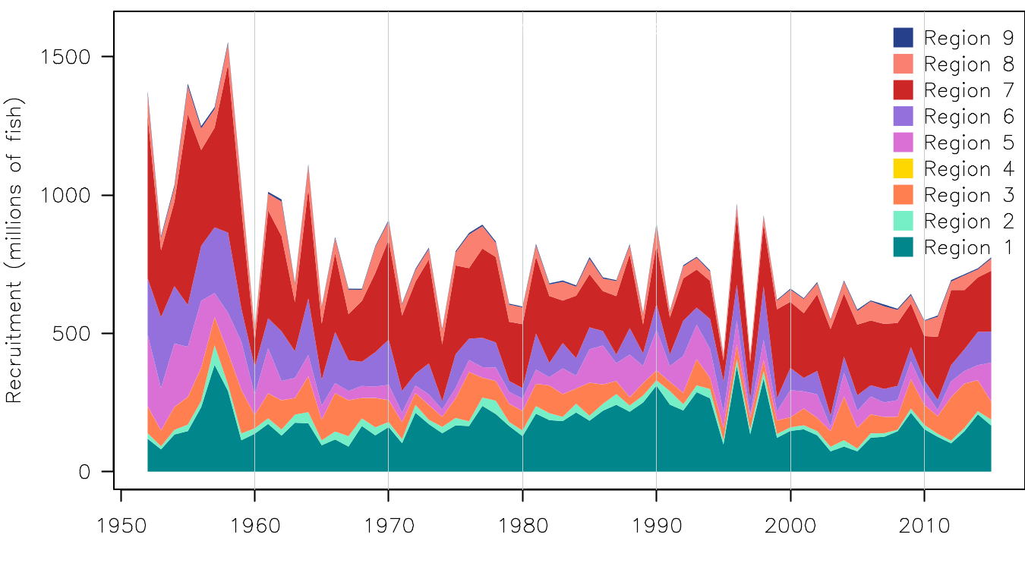
Figure YFT-2. Estimated annual average recruitment by model region for the diagnostic case model, showing the relative sizes among regions.

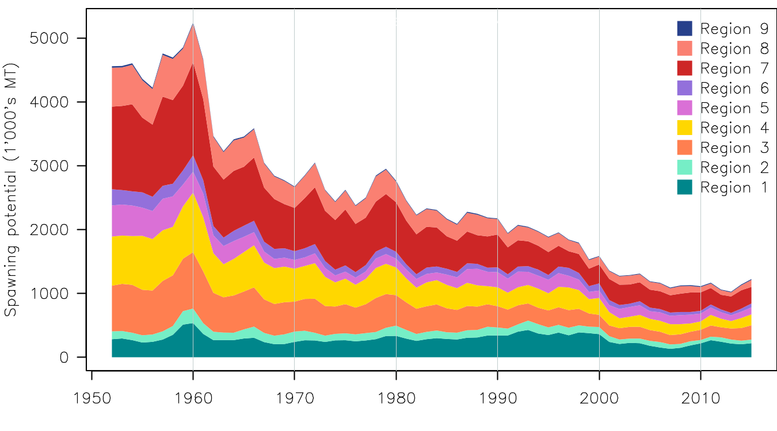
Figure YFT-3. Estimated annual average spawning potential by model region for the diagnostic case model, showing the relative sizes among regions.
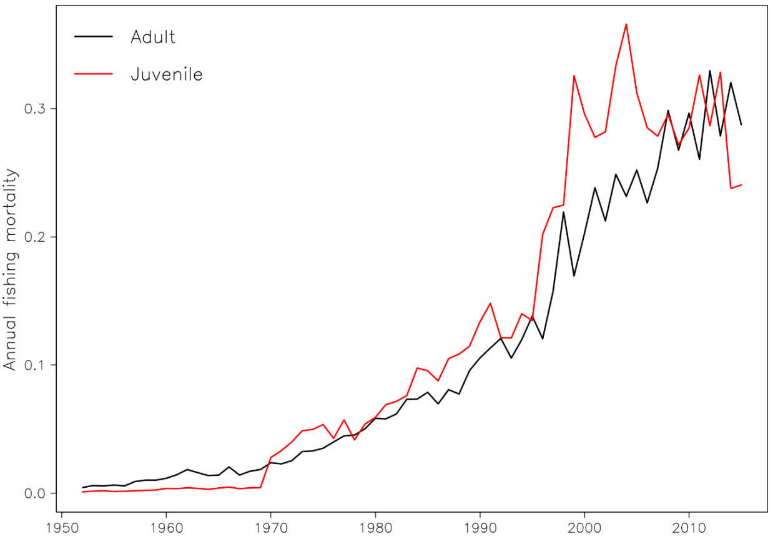
Figure YFT-4. Estimated annual average juvenile and adult fishing mortality for the diagnostic case model.

Figure YFT-5：Plot showing the trajectories of fishing depletion (of spawning potential) for the 48 model runs retained for the structural uncertainty grid used for management advice. The colours depict the models in the grid with the size composition weighting using divisors of 20 and 50.
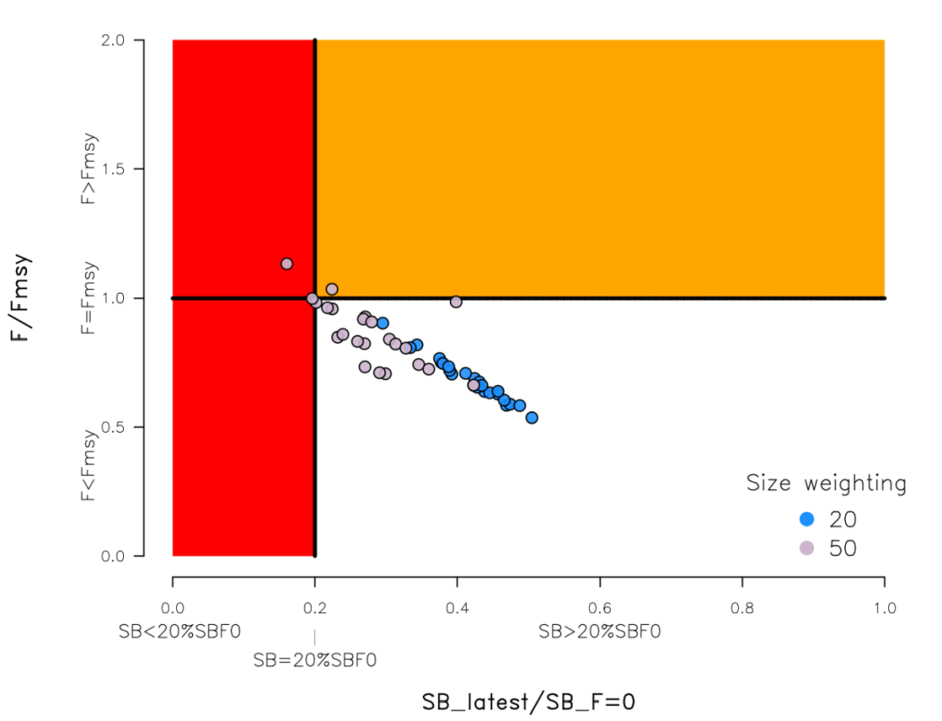
Figure YFT-6. Majuro plot summarising the results for each of the models in the structural uncertainty grid retained for management advice. The plots represent estimates of stock status in terms of spawning potential depletion and fishing mortality. The red zone represents spawning potential levels lower than the agreed limit reference point which is marked with the solid black line. The orange region is for fishing mortality greater than F_{MSY} (F_{MSY} is marked with the black horizontal line). The points represent SB_{latest}/SB_{F=0}, and the colours depict the models in the grid with the size composition weighting using divisors of 20 and 50.
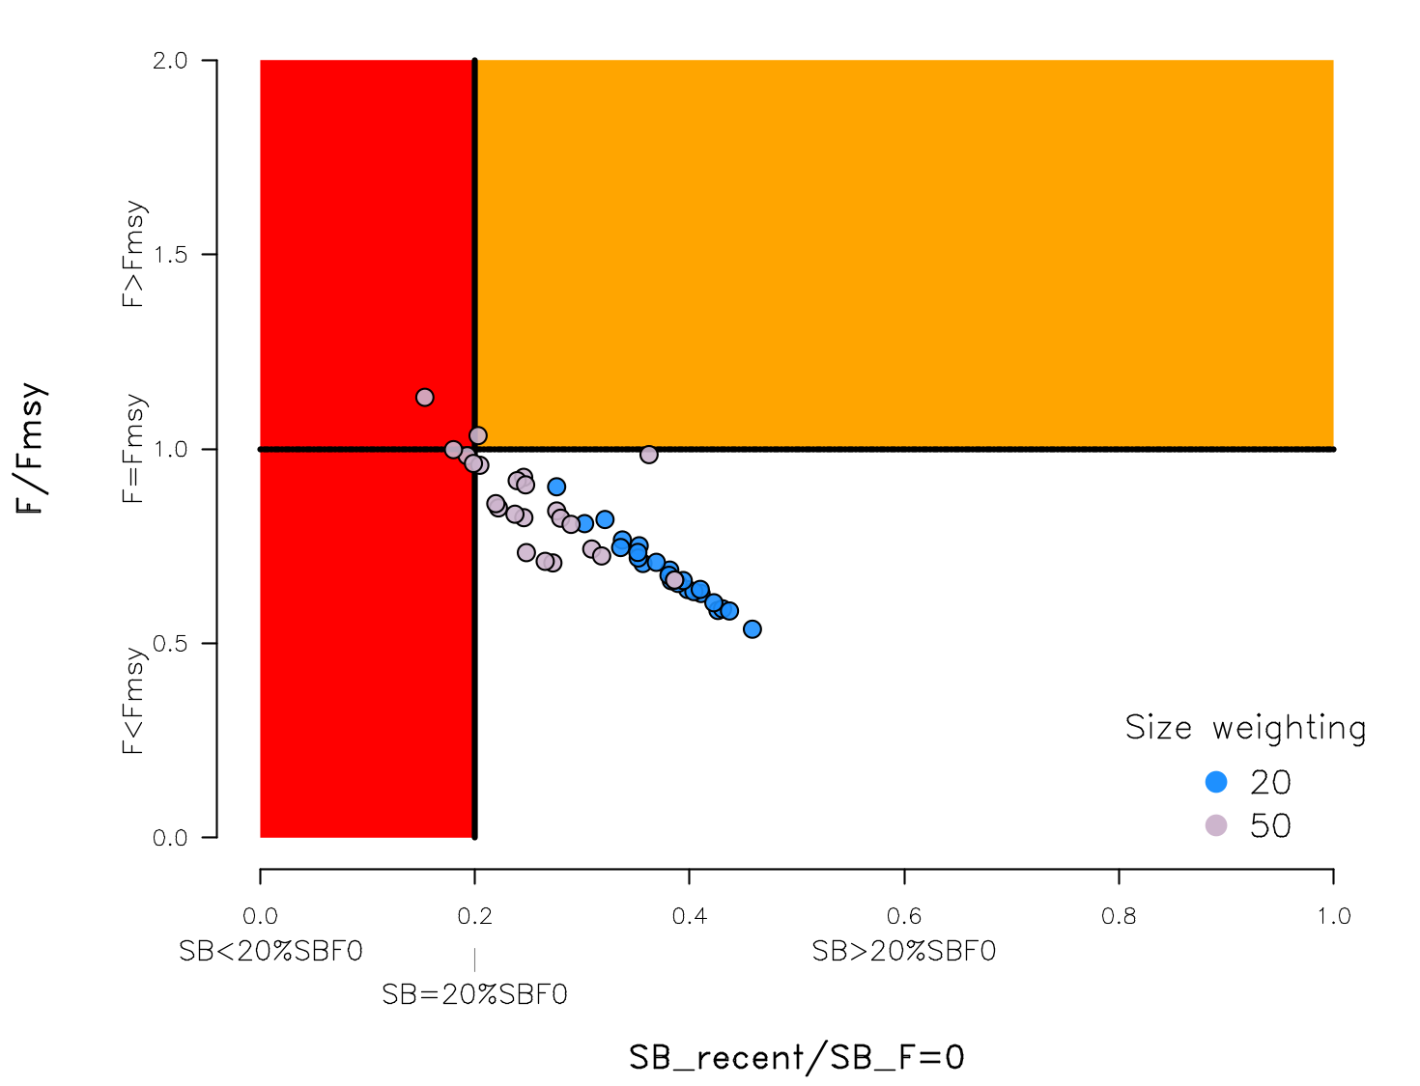
Figure YFT-7: Majuro plot summarising the results for each of the models in the structural uncertainty grid retained for management advice. The plots represent estimates of stock status in terms of spawning potential depletion and fishing mortality. The red zone represents spawning potential levels lower than the agreed limit reference point which is marked with the solid black line. The orange region is for fishing mortality greater than F_{MSY} (F_{MSY} is marked with the black horizontal line). The points represent SB_{recent}/SB_{F=0}, and the colours depict the models in the grid with the size composition weighting using divisors of 20 and 50.

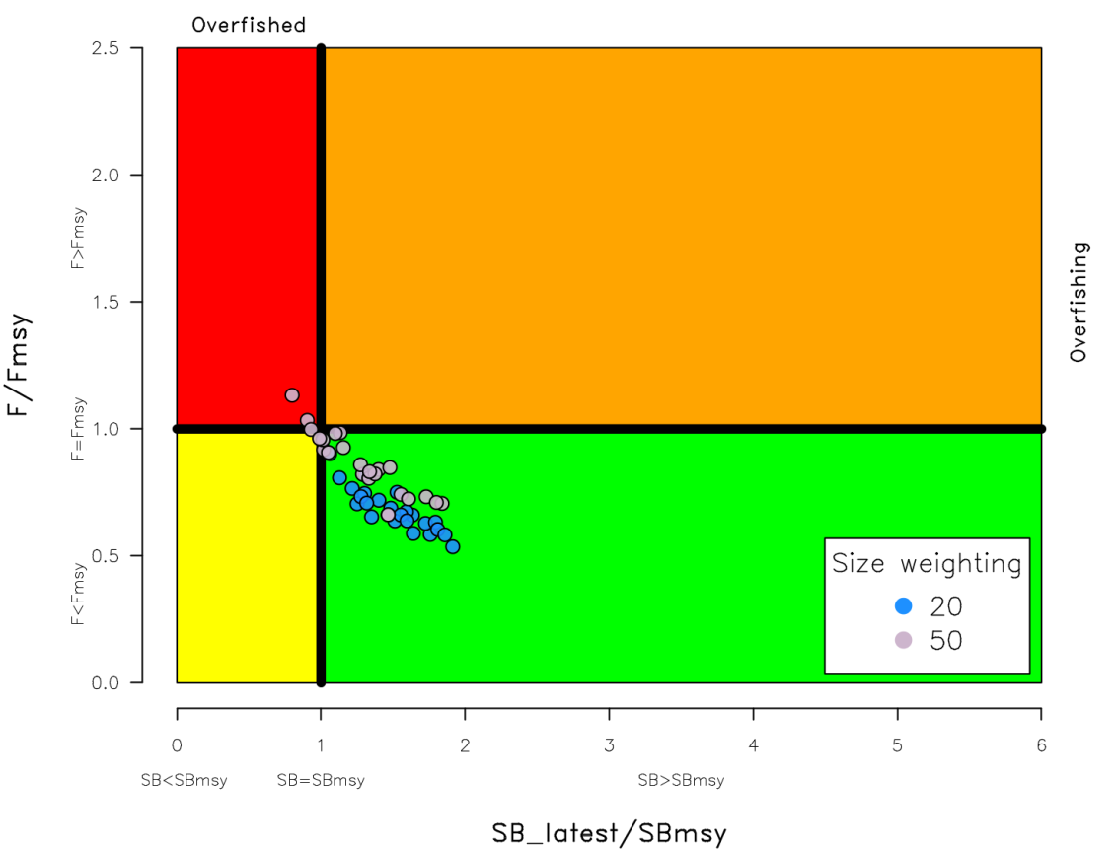
Figure YFT-8. Kobe plot summarising the results for each of the models in the structural uncertainty grid. The points represent SB_{latest}/SB_{MSY}, the colours depict the models in the grid with the size composition weighting using divisors of 20 and 50.
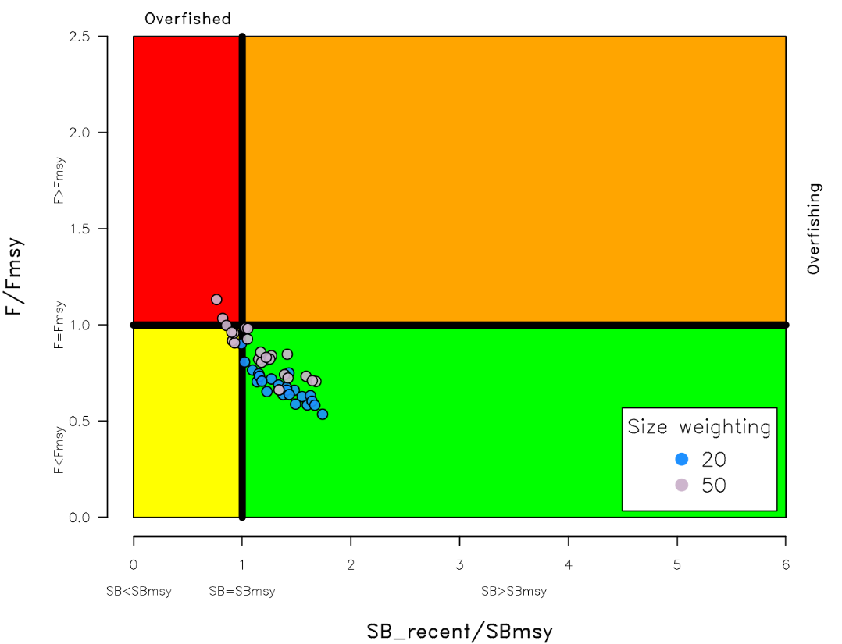
Figure YFT-9. Kobe plot summarising the results for each of the models in the structural uncertainty grid. The points represent SB_{recent}/SB_{MSY}, the colours depict the models in the grid with the size composition weighting using divisors of 20 and 50.

Figure YFT-10. Estimated time-series (or “dynamic”) Majuro and Kobe plots from the yellowfin ‘diagnostic case’ model run.

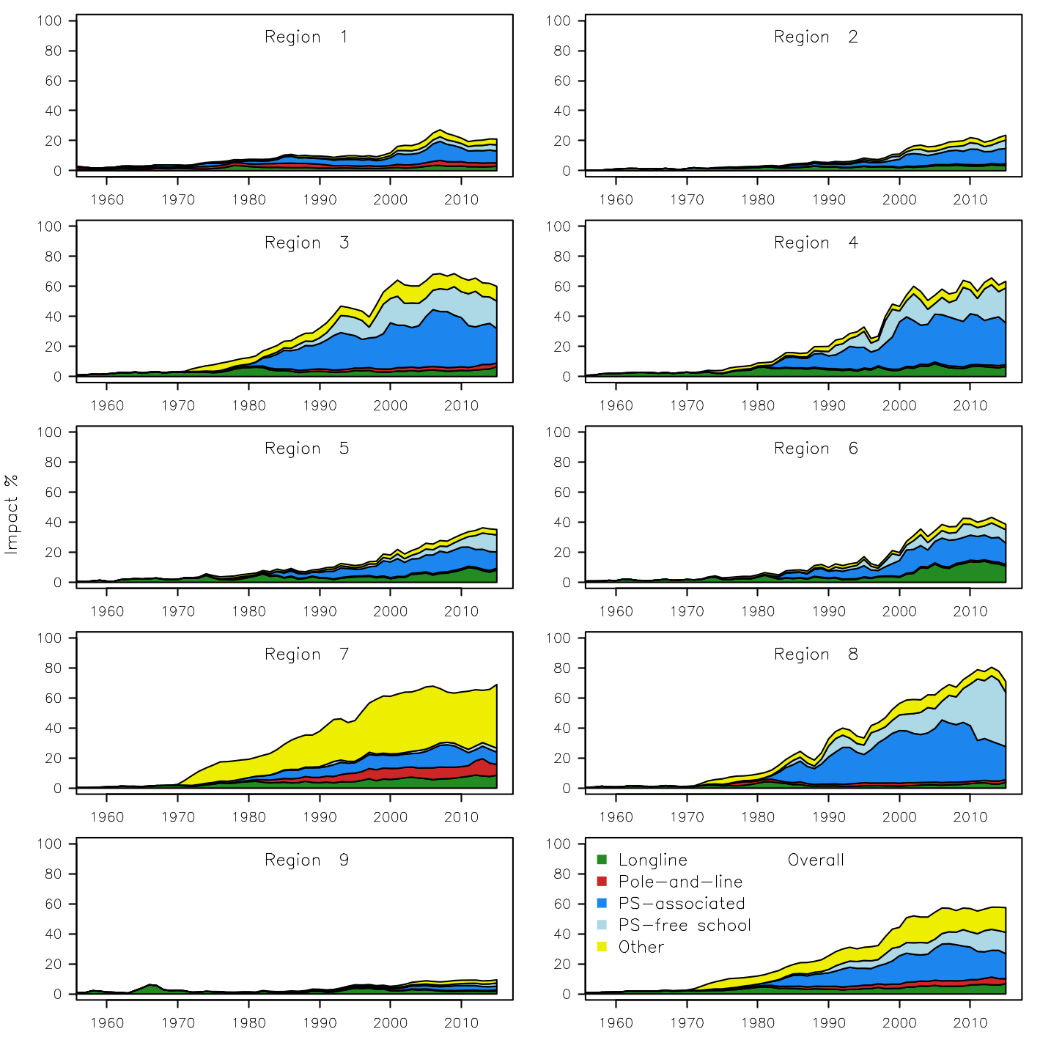
Figure YFT-11. Estimates of reduction in spawning potential due to fishing by region, and over all regions (lower right panel), attributed to various fishery groups (gear-types) for the diagnostic case model.

Table YFT-2. Summary of reference points over the 48 models in the structural uncertainty grid retained for management advice using divisors of 20 and 50 for the weighting on the size composition data. Note that SB_{recent}/SB_{F=0} is calculated where SB_{recent} is the mean SB over 2012-2015 instead of 2011-2014 (used in the stock assessment report), at the request of the Scientific Committee.
 | Mean | Median | Min | 10% | 90% | Max
C_{latest} | 611,982 | 612,592 | 606,762 | 607,517 | 614,237 | 614,801
MSY | 670,658 | 670,800 | 539,200 | 601,480 | 735,280 | 795,200
Y_{Frecent} | 646,075 | 643,400 | 534,400 | 586,120 | 717,880 | 739,600
F_{mult} | 1.34 | 1.36 | 0.88 | 1.03 | 1.61 | 1.86
F_{MSY} | 0.12 | 0.12 | 0.07 | 0.10 | 0.14 | 0.16
F_{recent}/F_{MSY} | 0.77 | 0.74 | 0.54 | 0.62 | 0.97 | 1.13
SB_{MSY} | 544,762 | 581,400 | 186,800 | 253,320 | 786,260 | 946,800
SB₀ | 2,199,750 | 2,290,000 | 1,197,000 | 1,366,600 | 2,784,500 | 3,256,000
SB_{MSY}/SB₀ | 0.24 | 0.24 | 0.15 | 0.18 | 0.28 | 0.34
SB_{F=0} | 2,083,477 | 2,178,220 | 1,193,336 | 1,351,946 | 2,643,390 | 2,845,244
SB_{MSY}/SB_{F=0} | 0.25 | 0.26 | 0.16 | 0.19 | 0.30 | 0.35
SB_{latest} /SB₀ | 0.33 | 0.34 | 0.18 | 0.23 | 0.42 | 0.45
SB_{latest} /SB_{F=0} | 0.35 | 0.37 | 0.16 | 0.22 | 0.46 | 0.50
SB_{latest} /SB_{MSY} | 1.40 | 1.39 | 0.80 | 1.02 | 1.80 | 1.91
SB_{recent}/SB_{F=0} | 0.32 | 0.33 | 0.15 | 0.20 | 0.41 | 0.46
SB_{recent}/SB_{MSY} | 1.40 | 1.41 | 0.81 | 1.05 | 1.71 | 1.93

- SC13 noted that the central tendency of relative recent spawning biomass was median (SB_{recent}/SB_{F=0}) = 0.33 with a probable range of 0.20 to 0.41 (80% probable range), and there was a roughly 8% probability (4 out of 48 models) that the recent spawning biomass had breached the adopted LRP with Prob((SB_{recent}/SB_{F=0})<0.2) = 0.08. The median estimate (0.33) is below that estimated from the 2014 assessment grid ((SB_{current}/SB_{F=0}) = 0.41, see SC10-SA-WP-04), noting the differences in grid uncertainty axes used in that assessment.

- SC13 noted that the central tendency of relative recent fishing mortality was median (F_{recent}/F_{MSY}) = 0.74 with an 80% probability interval of 0.62 to 0.97, and there was a roughly 4% probability (2 out of 48 models) that the recent fishing mortality was above F_{MSY} with Prob((F_{recent}/F_{MSY})>1) = 0.04. The median estimate (0.74) is also comparable to that estimated from the 2014 assessment grid (F_{current}/F_{MSY} = 0.76, see SC10-SA-WP-04)

- SC13 noted that the assessment results show that the stock has been continuously declining for about 50 years since the late 1960’s.

- SC13 also noted that levels of fishing mortality and depletion differ between regions, and that fishery impact was highest in the tropical region (Regions 3, 4, 7 and 8 in the stock assessment model), mainly due to the purse seine fisheries in the equatorial Pacific and the “other” fisheries within the Western Pacific (as shown in Figure 44 of SC13-SA-WP-06).

- Management advice and implications

- Based on the uncertainty grid adopted by SC13 the spawning biomass is highly likely above the biomass LRP and recent F is highly likely below F_{MSY}, and therefore noting the level of uncertainties in the current assessment it appears that the stock is not experiencing overfishing 96% probability) and it appears that the stock is not in an overfished condition (92% probability).

- Based on the diagnostic case, both juvenile and adult fishing mortality show a steady increase since the 1970s. Adult fishing mortality has increased continuously over most of the time series, while juvenile fishing mortality has stabilized since the late 1990s at a level similar to that now estimated for adult yellowfin.

- SC13 reiterates its previous advice from SC10 that WCPFC could consider measures to reduce fishing mortality from fisheries that take juveniles, with the goal to increase to maximum fishery yields and reduce any further impacts on the spawning potential for this stock in the tropical regions.

- SC13 also reiterates its previous advice from SC10 that measures should be implemented to maintain current spawning biomass levels until the Commission can agree on an appropriate target reference point (TRP).

Research Recommendations

- SC13 recognized that reviewing yellowfin growth through a study of yellowfin otoliths collected from the WCPO and incorporating this into future assessments should be encouraged.

4.1.3 WCPO skipjack tuna (Katsuwonus pelamis)

4.1.3.1 Review of research and information

a. Update of skipjack tuna stock assessment information

- In opening the discussion, the convenor noted that the last stock assessment was conducted in 2016, and the SC13 would review information on indicators for this species. SC13-SA-IP-09 would be referred to as needed.

- G. Pilling (SPC) presented SC13-SA-WP-02 A compendium of fisheries indicators for tuna stocks, which provided empirical information on recent patterns in fisheries. While the paper provided indicators for four tuna species (bigeye, skipjack, yellowfin and south Pacific albacore) the presentation concentrated on the indicators for skipjack only. The indicators included: total catch by gear, nominal CPUE trends, spatial distribution of catch and associated trends, size composition of the catch and trends in average size. Also, skipjack stock projections were performed based upon the actual fishing levels by fleet in 2016, through 2017 to 2018 based upon the assumption that levels of effort or catch would remain constant at 2016 levels. The skipjack stock was initially projected to decline as recent estimated recruitments move through the stock, and then to recover in the longer term. Median F₂₀₁₈/F_{MSY} = 0.37; median SB₂₀₁₈/SB_{F=0} = 0.47.

Discussion

- Japan asked what new information was included in the projections and how the fishing mortality was included without a stock assessment. G. Pilling responded that purse-seine effort data and pole and line catch data from 2016 were now available, and that future conditions (2016 onwards) were projected based upon those levels of effort and catch.

- China queried the level of confidence held in the new projection. G. Pilling replied that the project encapsulated currently feasible modelling of future uncertainty, and including both model uncertainty (structural uncertainty grid) and future recruitment levels (sampled from the historical period over which the stock recruitment relationship was estimated).

- PNG stated that FFA members noted that the indicators analysis included in SC13-SA-WP-02 did not identify any significant changes in the fishery. However, to support ongoing management, it is vital that we have a reliable index of abundance for the assessment. Currently the assessment relied heavily on Japanese pole and line CPUE as a long-term index of abundance but this sector only represented 10% of the catch and had been declining. Because of this increasing gap, the tagging project was becoming even more critical to the work of the Commission and the authors hoped that SC would highlight the importance of continuing the tagging work as planned for 2017, 2018 and 2019, and continuing the work on alternative indices of abundance.

4.1.3.2 Project 67 (Skipjack fishery impacts on the margins of the Convention Area)
- The SC reviewed the results of Project 67 (skipjack fishery impacts on the margins of the Convention Area). The Convenor noted that SC13-SA-IP-08 and SC13-SA-09 would be referred to if needed.

- P. Lehodey (CLS) presented SC13-SA-WP-07 Impacts of Recent High Catches of Skipjack on Fisheries on the Margins of the WCPFC Convention Area. Since several years, there had been raising concern that high purse seine catches in the equatorial region might be causing a range contraction of WCPO skipjack tuna, thus reducing skipjack tuna availability to fisheries in higher latitudes, e.g., the domestic and off-shore Japanese boats who fished seasonally in the sub-tropical and temperate home waters. Alternatively, change in environmental conditions might also generate variability in tuna recruitment, movement and catch.

- The northwest Pacific region was strongly influenced by mesoscale activity associated to the warm Kuroshio Current and its extension east off Japan where it encountered the cold Oyashio Current. Kuroshio extension had been shown to shift between extended and contracted regimes at interannual time scale. A change from elongated to contracted regime, characterized with less energetic conditions, was described following a transition period in 2005-2006. The contracted regime changed to an elongated regime in 2010 and then remained in neutral conditions. Recent progress in application of SEAPODYM to skipjack included new environmental forcing, revision of fishing data set and parameter optimisation including conventional tagging data in addition to fishing data. This report provided the results of simulations conducted with this new reference configuration at coarse and high resolutions to test the strength of connectivity between adjacent and distant regions, and to measure the impact of equatorial purse seine fisheries on Japanese domestic fisheries.

- The new reference run at coarse resolution showed improved fit to data and realistic parameterization of biological parameters (thermal habitat, movement, oxygen tolerance, vertical habitat, and spawning conditions) in good agreement with current knowledge. Predicted skipjack density was distributed mostly in the warmpool. Variability in recruitment and adult distribution due to ENSO were well predicted. Total stock estimates in WCPO were close between SEAPODYM and Multifan-CL, i.e. 3.4Mt of adult and about 4Mt of total biomass in 2010, but with a discrepancy in the northwest Pacific region, where MULTIFAN-CL skipjack biomass estimate was much higher and more variable than SEAPODYM estimate. This had not prevented SEAPODYM from correctly predicting the catch of the subtropical Japanese pole and line north of 20°N based on the observed effort. On the other hand SEAPODYM predicted higher biomass in the two core tropical regions known to be the main fishing grounds for skipjack.

- The average fishing impact at basin scale reached 20-25% of reduction in spawning biomass by the end of 2010, but approached 50% in the most intensively exploited region north of PNG. After downscaling on high resolution configuration, a very good match at fine resolution was observed between high catch and high density of (exploitable) skipjack in the equatorial purse seine fishing ground including the Solomon Is. and PNG regions, and the fit was high for the Japanese subtropical pole and line fishery as well. Connectivity study was conducted between regions proposed by H. Kiyofuji (SC12-SA-WP-05) with both coarse and high resolution configurations. There were only small differences between the two simulations, except in Region 7 which suggested a strong sensitivity to mesoscale circulation in this region.

- In Region 1 (East off Taiwan, Okinawa Is.) adult biomass would be supported by recruitment produced in its own area (~30-35%), then by recruitment produced in Region 3 (~24- 38%), Region 6 (~10-25%), Region 7 (~5-13%) and Region 2 (~5-10%). Region 1 was well connected to Regions 3 and 6 for adult exchanges (movements). In Region 7 (North Central Pacific), density of recruited larvae was predicted to be lower by high resolution simulation. Biomass of immature and adult cohorts followed the same trends with delayed effect. When removing equatorial purse seine fishing mortality, the increase in adult biomass and catch of Regions 1 and 7 were limited (< 6% in both). Though the study suggested a significant connectivity between equatorial and higher latitudes, the high biomass predicted in the equatorial regions limited the impact of the equatorial purse seine fishery on the northern stock. It remained possible that an improved representation of skipjack distribution in the main equatorial fishing grounds could allow the model to predict the catch correctly with a lower biomass in tropical regions. In that case, the impact of purse seine fishing on the adjacent regions could become stronger. There were also some indications that interannual environmental variability could be responsible of a decrease in immature and adult stocks in the recent years while higher recruitment would have occurred very recently in concordance with favorable conditions associated to 2014-15 El Niño events. This should be analyzed when updated physical forcings will become available.

Discussion

- Japan asked if the change in area definition or any other sensitivity such as growth might have had an impact on the results, noting that different sensitivity analyses with a different growth model and maturity at age would also change the results. P. Lehodey replied that it was possible to run various sensitivities to check the results.

- China asked if the work had been independently reviewed given the complexity of the model and its potentially significant impact on management advice. P. Lehodey replied that the SEAPODYM model was not significantly more complex than the MULTIFAN-CL model, that work had been regularly presented to SC meetings since 1995 and there had been several associated peer-reviewed publications. China noted that while some elements of the work had been published an independent analysis of the entire framework would increase their level of confidence in it.

- SPC questioned whether it was realistic to predict the observed tropical skipjack catch if the stock biomass was lower than assumed in these analyses, given that substantial depletion has been identified in this area. P. Lehodey noted that biomass estimates in area 3 were still higher than the estimates of MULTIFAN-CL by ~35%, and that more reliable estimates might be possible with a higher spatial resolution. P. Lehodey noted that this was more relevant in the central region and that it would be useful to run a sensitivity analysis to check.

- China noted the inclusion of a thermal field predicted by oceanographic models and queried whether these data have been verified. P. Lehodey responded that the environmental conditions data had been checked thoroughly and was reliable. China also suggested improved representation of the quantification of the percentage differences between the observed catch and predicted exploitable biomass.

- In response to a query from Indonesia, the author noted that the simulation was regularly updated. Indonesia asked about the relationship between recruitment between Region 1 and 3. P. Lehodey noted that the recent El Niño conditions had positively impacted recruitment in Region 3 which he expected would flow on to Region 1.

- Indonesia asked how the area definition was determined. H. Kiyofuji (Japan) responded that the area definition was based on the studies undertaken by Matsumoto et al. (1985; NOAA Tech. Rep. NMFS Circ., 451: 1-92.), a recent tagging project in Japan and larvae and juvenile distribution from the research cruise.

- New Zealand made a statement on behalf of FFA members, noting that the results of the study provided compelling evidence that catches of skipjack in the tropics had negligible impact on skipjack biomass near Japan, and it was not evident that catches in the equatorial region were impacting skipjack availability north of 20°N. The study evaluated the impact of removing varying levels of skipjack fishing mortality in the equatorial region and found that, even if all historical purse seine effort was removed from the tropics, the biomass in regions near Japan, only increased by 2 to 4 percent. It was the opinion of FFA members that this study comprehensively answered the questions on connectivity and range contraction raised by Japan at past SC meetings, and it appeared that any abundance changes were likely to be locally driven. New Zealand noted that this work was commissioned with the sole purpose of addressing the validity of Japan’s concerns and was the second working paper considered by the SC that reached the same conclusion. Given the results were now clear, FFA members requested that work scheduled for 2018 to assess skipjack in the margins of WCPO be given a low priority and that funding be diverted elsewhere.

- Tuvalu noted PNA members considered that this kind of work showed the value of SEAPODYM. The SEAPODYM analysis provided support for the results on skipjack stock status from the skipjack assessment last year, and indicated that there had been no drastic decline in the tropical skipjack biomass, showing that this was not the cause of any decline in skipjack availability in Japan’s waters. PNA suggested looking at limiting or even banning purse seine fishing north of 20ᴼN to protect the livelihoods of coastal fishers of Japan.

- Tokelau stated that PNA members also noted that there had been a number of good pieces of work on this issue in recent years. PNA believed that any additional work on the reduction in skipjack catch rates in the north should focus on the depletion effects from purse seining in northern waters including looking at a ban on purse seining for skipjack north of 20ᴼN.

4.1.3.3 Provision of scientific information

- SC13 reviewed the progress of Project 67 on the impacts of recent catches of skipjack tuna on fisheries on the margins of the WCPFC Convention Area. Recent progress in application of SEAPODYM to skipjack included new environmental forcing, revision of fishing data set and parameter optimisation including conventional tagging data in addition to fishing data (SC13-SA-WP-07). In this study, though a significant connectivity between equatorial and higher latitudes is suggested, the high biomass predicted in the equatorial regions limits the impact of the equatorial purse seine fishery on the stock at northern latitudes. The connectivity among the areas and the impact to the stock in the northern area may be sensitive to model setting.

- Stock status and trends

- SC13 noted that no stock assessment was conducted for WCPO skipjack tuna in 2017. Therefore, the stock status description from SC12 is still current. For further information on the stock status and trends from SC12, please see https://www.wcpfc.int/node/27769

- SC13 noted that the total catch in 2016 (1,816,762 mt) was comparable to that in 2015 and a 2% increase over 2011-2015. (see SC13-SA-WP-02)

- Purse seine catch (1,408,110 mt) was comparable to both 2015 and the 2011-2015 average. Pole and line catch (151,441 mt) was a 1% decrease from 2015 and an 11% decrease from 2011-2015 average. Catches by other fisheries (251,470 mt) were 2% higher than in 2015 and 26% higher than 2011-2015 average.

- SC13 noted that under recent fishery conditions (2016 catch level for LL and other fisheries and effort level for purse seine), the skipjack stock was initially projected to decrease for a short period and then to increase as recent relatively high recruitments move through the stock. Median F₂₀₁₈/F_{MSY} = 0.37; median SB₂₀₁₈/SB_{F=0} = 0.47.

- FFA members noted that skipjack tagging activities should be prioritized for the future stock assessment purpose as the pole and line fisheries which provided a major abundance index continues to shrink geographically.

- Management advice and implications

- SC13 noted that no stock assessment has been conducted since SC12. Therefore, the advice from SC12 should be maintained, pending a new assessment or other new information. For further information on the management advice and implications from SC12, please see https://www.wcpfc.int/node/27769

4.1.4 South Pacific albacore tuna (Thunnus alalunga)

4.1.4.1 Review of research and information

a. Update of South Pacific albacore tuna stock assessment information

- SC13-SA-WP-08 Trends in the south pacific albacore longline and troll fisheries, and the south Pacific albacore components of SC13-SA-WP-02 A compendium of fisheries indicators for tuna stocks were presented by S. Brouwer (SPC-OFP). The analysis provided a compendium of fishery indicators for south Pacific albacore tuna. These indicators included: total catch; catch by gear; and longline effort and nominal troll and longline CPUE trends, along with their spatial patterns. Commentary provided included comparisons of 2016 values to 2015 and to the average over 2011-2015. Information provided included data loaded into databases as of 5th June 2017. S. Brouwer noted that catch levels and their distribution amongst areas may change as more data become available.

- Transhipment data were available over the period from the inception of transhipment reporting (July 2010) to March 2017. Data presented represented high seas transhipments only; they did not include in-port or in-zone transhipments. Monthly reported transhipment levels fluctuated notably, and may reflect logistical/operational factors rather than fishing activity. There was a notable peak in transhipment activity in August 2016 (3,668 mt) of which 56% was reported by China (2,046 mt), and 26% by Vanuatu (937 mt) fleets. It should be noted that transhipment levels were unlikely to be fully reported for the most recent 18 months.

- Due to the complex interactions between the major species-specific fisheries, it was difficult to correctly interpret the stock status-related implications from the trends in any indicators in isolation from other data sets and a population dynamics model. Therefore, the authors had summarized the stock status from the most recent assessment (2015), and updated an analysis of the potential long-term stock consequences of recent fishing patterns on the south Pacific albacore stock relative to the agreed biomass limit reference point assuming 2014 status quo effort. This analysis used stochastic stock projections and incorporated the recommendations on inclusion of uncertainty from WCPFC-SC9. Based upon the 2015 stock assessment, assuming 2015 effort levels through 2015-2033, the main difference from previous reports were that provisional effort in 2015 was lower than levels seen in 2013 and 2014. The projected stock status was estimated to have improved slightly where the stock still declines from the 2013 level (SB_{latest}/SB_{F=0} = 0.40) to approximately SB₂₀₃₃/SB_{F=0} = 0.35 but when compared to the biomass Limit Reference Point (SB_{LRP}) risk SB₂₀₃₃/SB_{F=0} < SB_{LRP} = 7% rather than 20% seen in previous projections. Overall vulnerable biomass (a CPUE proxy) in longline fisheries was also estimated to decrease by 7% over that period.

Discussion

- China asked what level of fishing mortality or fishing removal was used in the projection. S. Brouwer responded that the projection was run off the 2015 stock assessment, with effort fixed at the 2015 levels.

- USA noted that last year’s projections appeared to be more pessimistic. In response S. Brouwer noted that the change was the result of inclusion of effort from the terminal year.

- Australia asked if it was possible to include nominal CPUE data from some of the key Pacific fishing fleets as albacore was very important for these nations. It was noted that while this was possible the time series would be shorter than those presented.

- On behalf of FFA countries, Samoa noted that the provisional catch data suggested a significant reduction in catch between 2015 and 2016, and a continued reduction in effort in the albacore fishery. While the reduction in catch and effort should provide some relief to the pressure on this stock, FFA members were concerned that this reduction was economically driven rather than management driven, particularly given the lack of a robust management regime across the breadth of the albacore stock. This was a problem, because it meant that external factors, such as an increase in albacore price or a decrease in fuel price may result in effort flooding back in to the fishery, resulting in a continued depression of the stock.

- Samoa also noted that the paper showed that over the past two years the fishery had been harvesting albacore from an increasingly limited size range. While this may be due to natural variations or shifts in the location or behaviour of fishers, it may also be driven by more concerning factors. As such, FFA members asked that the SC continued to monitor the length of harvested albacore throughout its range over the next few years, to assess the reason for this trend.

- China noted the need to consider the larger uncertainty reflected in the work resulting from structural variability and stochastic error. In response, SPC noted that the same methodology was used for the skipjack projections.

- New Caledonia reminded delegates that their fisheries were highly dependent on albacore, and expressed concern about the significant increase in transhipment from the area.

- Fiji, on behalf of FFA members, expressed concern about the amount of albacore reported to have been transhipped in the high seas in 2016; almost double that seen in previous years, according to SC13-SA-WP-08. This was despite a substantial reduction in the amount of albacore caught in the high seas. The WCPFC Secretariat clarified that the increase was primarily due to improved reporting rather than an actual increase in transhipment and stressed that the report covered albacore catch across the convention area not just SPALB.

4.1.4.2 Provision of scientific information

- Stock status and trends

- SC13 noted that no stock assessment was conducted for South Pacific albacore tuna in 2017. Therefore, the stock status description from SC11 is still current. For further information on the stock status and trends from SC11, please see http://www.wcpfc.int/node/26922

- SC13 noted that the preliminary estimate of total catch of south Pacific albacore (within the WCPF Convention Area south of the equator) for 2016 was 58,033 mt which was an 8% decrease from 2015 and a 13% decrease over 2011-2015 (see SC13-SA-WP-02).

- Preliminary longline catch in 2016 (55,635 mt) was 8% lower compared with 2015 and a 13% decrease over 2011-2015. Preliminary troll catch in 2016 (2,372 mt) was 17% lower compared with 2015 and a 24% decrease over 2011-2015 (see SC13-SA-WP-02).

- SC13 considered an update of trends in South Pacific albacore fisheries (SC13-SA-WP-08) and noted that there had been reductions in longline effort in the WCPF Convention Area south of 10^{ᴼ}S through 2014-2016 (declining from about 300 million hooks in 2013 to around 254 million in 2015, and 200 million hooks in 2016 – with the 2016 value being provisional) and that effort distributions vary a little and show an area of highly concentrated fishing effort. SC13 noted an issue of transhipment that needs to be clarified at TCC13. Status quo projections were calculated, assuming current southern longline and troll fishery effort would continue into the future at levels equal to those seen in 2015 (Figure SPA-1). If 2015 fishing effort levels continue into the future, the stock is predicted to continue to decline on average, falling to SB_{current}/SB_{F=0} = 0.35 in 2033 with a 7% predicted probability of being below the LRP. Overall vulnerable biomass (a CPUE proxy) in longline fisheries is estimated to decrease by 7% from 2013-2033.
Figure SPA-1. Stochastic projections of adult stock status under 2014 longline and troll effort levels. The limit reference point (20% SB_{F=0}) is indicated by the horizontal dashed red line. Note: from 1960 up to 2013 inclusive the line represents the median across the 9 assessment model runs (structural uncertainty only); uncertainty after 2013 represents both structural uncertainty and stochastic recruitment (1800 simulation runs).

- Management advice and implications

- SC13 noted that no stock assessment was conducted for South Pacific albacore tuna in 2017. Therefore, the advice from SC11 should be maintained. For further information on the stock status and trends from SC11, please see https://www.wcpfc.int/node/26922
- SC13 noted that the preliminary estimate of total catch of south Pacific albacore (within the WCPF Convention Area south of the equator) for 2016 was 58,033 mt which was an 8% decrease from 2015 and a 13% decrease over 2011-2015. (see SC13-SA-WP-02).

- Preliminary longline catch in 2016 (55,635 mt) was 8% lower compared with 2015 and a 13% decrease over 2011-2015. Preliminary troll catch in 2016 (2,372 mt) was 17% lower compared with 2015 and a 24% decrease over 2011-2015. (see SC13- SA-WP-02).

- SC13 considered an update of trends in South Pacific albacore fisheries (SC13-SA-WP-08) and noted that there had been reductions in longline effort in the WCPF Convention Area south of 10ᴼS through 2014-2016 (by approximately 15%) and that effort distributions vary a little and show an area of highly concentrated fishing effort. SC13 noted an issue of transhipment that needs to be clarified at TCC13. Status quo projections were calculated, assuming current southern longline and troll fishery effort would continue into the future at levels equal to those seen in 2015 (Figure SPA-1). If 2015 fishing effort levels continue into the future, the stock is predicted to continue to decline on average, falling to SB_{current}/SB_{F=0} = 0.35 in 2033 with a 7% predicted probability of being below the LRP. Overall vulnerable biomass (a CPUE proxy) in longline fisheries is estimated to decrease by 7% from 2013-2033.

- The EU noted that according to the last assessment the value of SB_{MSY} was below the adopted LRP, which questioned the biological relevance of this LRP for this species.

- Pending a new assessment in 2018, SC13 recalls its previous advice from SC11 and SC12 that longline fishing mortality and longline catch be reduced to avoid further decline in the vulnerable biomass so that economically viable catch rates can be maintained, especially for longline catches of adult albacore. SC13 recommends that this advice be taken into consideration when the TRP for South Pacific albacore is discussed at WCPFC14.

4.2 Northern stocks

- On behalf of the ISC Chair, J. Brodziak presented SC13-GN-IP-02, the report of the Seventeenth Meeting of the International Scientific Committee for Tuna and Tuna-like Species in the North Pacific Ocean (ISC17). The ISC17 was convened in Vancouver, British Columbia, Canada, from 12 to 17 July 2017 by the ISC Chairman, G. DiNardo. In 2017, the ISC Albacore WG and Shark WG conducted stock assessments for North Pacific albacore tuna and North Pacific blue shark, which were reviewed at the ISC Plenary meeting. There were no assessments for NP swordfish, NP striped marlin, Pacific blue marlin, Pacific bluefin tuna and shortfin mako shark in 2017. The ISC17 stock assessment information and conservation advice for North Pacific albacore tuna and North Pacific blue shark are presented at SC13 for consideration by the WCPFC.

4.2.1 North Pacific albacore (Thunnus alalunga)

4.2.1.1 Review of research and information

- Review of 2017 North Pacific albacore stock assessment

- S. Teo (USA) presented SC13-SA-WP-09 (Rev 1) Stock Assessment of Albacore in the North Pacific Ocean in 2017, on behalf of the Albacore Working Group.

- Australia noted that the value used for natural mortality (M) as used in the previous assessment (0.3) had changed (to 0.4) based on new research cited in the assessment report. Australia welcomed this new research, but noted that the most recent assessment for South Pacific Albacore had instead changed M from 0.4 to 0.3 to be consistent with albacore assessments undertaken elsewhere. Noting that this latter change had resulted in a substantial change in the assessed stock status of south Pacific Albacore, it was suggested that application of a natural mortality of 0.4 would likely generate another substantial change in the stock assessment results. They suggested that the next SPALB stock assessment should investigate the need to change back to a value of M=0.4.

- Australia also queried the impact of using dome-shaped selectivities which appeared to indicate, for example, selection of only one age class of fish for the Japanese longline fleets, which seems implausible. S. Teo responded that although they appeared to be dome-shaped, the flat top part for the same fleets extended beyond L_infinity. For example, the dome-shaped selectivity for the US longline was actually acting as asymptotic selectivities. A sensitivity run using an asymptotic selectivity for the US longline showed negligible differences.

- Australia suggested that shifting the start date for the assessment from 1966 to 1993 created a problem with an accurate estimation of the initial population size, particularly given the potential impact from the large gillnet fishery which had operated for more than a decade up until that time. Although the assessment assumed a depletion of around 50% in 1993 they noted that the CPUE index (increasing) conflicts with biomass trends estimated by the model (decreasing) up until the early 2000s and queried whether the former might suggest a recovering trend in the biomass from a more heavily depleted state before the mid-1990s. S. Teo replied that the ISC NPALBWG found a conflict between CPUE index and size composition data in that period, and applied down-weighting to size composition until the fit to the size composition data degraded to an unacceptable level.

- SPC noted that, given the long history of the catch time series, and the high variability in the catch during this time, use of the catch data prior to 1993 as the variation in the catch might be highly informative about stock size. S. Teo responded that the Japanese longline fishery data from 1970-1992 was removed to eliminate the influence of poorly fit size composition data, noting that they were not confident that the samples represented the entire catch area, and that further work was planned to attempt to extend the time series.

- Australia asked for further information on why the sensitivities undertaken for different values of the stock-recruitment steepness parameter showed no change to the base case model, as this result was quite different to that seen for other tuna assessments. S. Teo noted they were also surprised with this result; further consideration showed that the stock was in a less depleted state, and recruitment had not reached a point where it started to decline.

- China queried the impact of the exclusion of juvenile fish indices and asked how recruitment was estimated. S. Teo responded that recruitment estimates were based on relative changes in size drawn from multiple observations over many years.

- Palau stated that FFA members strongly supported the adoption of a limit reference point at 20% of unfished spawning biomass as adopted by the Northern Committee for North Pacific albacore, consistent with other key tuna stocks of the Commission. They thanked the ISC for the positive development in the use of FSPR reference points rather than F_{MSY}, but noted that there was further debate needed as to where that FSPR limit reference point should be set.

- Cook Islands, on behalf of FFA members, noted the very informative and useful information on catch trends that illustrated the impact of fishing over a long time. The data showed that current catches of NP albacore were at the same level as they were in early days of the Commission when this stock was declared overfished and overfishing was occurring. However, they expressed concern that in Figure 2.1 and Figure 2.2 of the report, non-ISC members, including Tonga, Vanuatu and Cook Islands flag vessels were included under the “Others” category, along with “other longline vessels flying flags of convenience”. They requested that the paper be amended and re-issued to remove the imputation that these flag vessels were involved in IUU fishing.

- FSM stated that FFA members felt that further exploratory work was required to strengthen justification of the choices made about removal of data from earlier in the time series (1966-1992), natural mortality estimates, and the new procedure to standardise the Japanese longline data. An improved understanding of the relative impact of these changes on the result would increase confidence in the assessment, and the stock status and conservation advice provided in the paper.

- In response to a suggestion from Australia to apply a similar model-ensemble approach to represent uncertainties in the assessment as used in bigeye tuna assessment to the NPALBC assessment, S. Teo replied that this should wait until the base model was substantially improved and an appropriate model-based weighting scheme developed.

- Provision of scientific information

- ISC presented working paper SC13-SA-WP-09 Stock assessment of albacore tuna in the North Pacific Ocean in 2017.

- Stock status and trends

- SC13 noted that the ISC provided the following conclusions on the stock status of North Pacific albacore.

- Stock status is depicted in relation to the limit reference point (LRP; 20%SSB_{current, F=0}) for the stock and the equivalent fishing intensity (F_{20%}; calculated as 1-SPR_{20%}) (Figure NPALB-1). Fishing intensity (F, calculated as 1-SPR) is a measure of fishing mortality expressed as the decline in the proportion of the spawning biomass produced by each recruit relative to the unfished state. For example, a fishing intensity of 0.8 will result in a SSB of approximately 20% of SSB₀ over the long run. Fishing intensity is considered a proxy of fishing mortality.

- The Kobe plot shows that the estimated female SSB has never fallen below the LRP since 1993, albeit with large uncertainty in the terminal year (2015) estimates. Even when alternative hypotheses about key model uncertainties such as natural mortality and growth were evaluated, the point estimate of female SSB in 2015 (SSB₂₀₁₅) did not fall below the LRP, although the risk increases with these more extreme assumptions (Figure NPALB-1). The SSB₂₀₁₅ was estimated to be 80,618 mt and was 2.47 times greater than the LRP threshold of 32,614 mt (Table NPALB-1). Current fishing intensity, F₂₀₁₂₋₂₀₁₄ (calculated as 1- SPR₂₀₁₂₋₂₀₁₄), was lower than potential F-based reference points identified for the north Pacific albacore stock, except F_{50%} (calculated as 1-SPR_{50%}) (Table NPALB-1).

Based on these findings, the following information on the status of the north Pacific albacore stock is provided:
- The stock is likely not overfished relative to the limit reference point adopted by the WCPFC (20%SSB_{current, F=0}), and
- No F-based reference points have been adopted to evaluate overfishing. Stock status was evaluated against seven potential reference points. Current fishing intensity (F₂₀₁₂₋₂₀₁₄) is below six of the seven reference points (see ratios in Table NPALB-1), except for F_{50%}.
Figure NPALB-1. (A) Kobe plot showing the status of the north Pacific albacore (Thunnus alalunga) stock relative to the 20%SSB_{current, F=0} biomass-based limit reference point, and equivalent fishing intensity (F_{20%}; calculated as 1-SPR_{20%}) over the base case modelling period (1993-2015). Blue triangle indicates the start year (1993) and black circle with 95% confidence intervals indicates the terminal year (2015). (B) Kobe plot showing stock status and 95% confidence intervals in the terminal year (2015) of the base case model (black; closed circle) and important sensitivity runs with M = 0.3 y⁻¹ for both sexes (blue; open square), and CV = 0.06 for L_{inf} in the growth model (white; open triangle). Fs in this figure are not based on instantaneous fishing mortality. Instead, the Fs are indicators of fishing intensity based on SPR and calculated as 1-SPR so that the Fs reflect changes in fishing mortality. SPR is the equilibrium SSB per recruit that would result from the current year’s pattern and intensity of fishing mortality.

Table NPALB-1. Estimates of maximum sustainable yield (MSY), female spawning biomass (SSB) quantities, and fishing intensity (F) based reference point ratios for north Pacific albacore tuna for the base case assessment and important sensitivity analyses. SSB₀ and SSB_{MSY} are the unfished biomass of mature female fish and at MSY, respectively. The Fs in this table are not based on instantaneous fishing mortality. Instead, the Fs are indicators of fishing intensity based on SPR and calculated as 1-SPR so that the Fs reflect changes in fishing mortality. SPR is the equilibrium SSB per recruit that would result from the current year’s pattern and intensity of fishing mortality. Current fishing intensity is based on the average fishing intensity during 2012-2014 (F₂₀₁₂₋₂₀₁₄).

Quantity | Base Case | M = 0.3 y⁻¹ | Growth  CV = 0.06 for L_{inf}
MSY (t) ^{A} | 132,072 | 92,027 | 118,836
SSB_{MSY} (t) ^{B} | 24,770 | 42,098 | 22,351
SSB₀ (t) ^{B} | 171,869 | 270,879 | 156,336
SSB₂₀₁₅ (t) ^{B} | 80,618 | 68,169 | 63,719
SSB₂₀₁₅/20%SSB_{current, F=0} ^{B} | 2.47 | 1.31 | 2.15
F₂₀₁₂₋₂₀₁₄ | 0.51 | 0.74 | 0.57
F₂₀₁₂₋₂₀₁₄/F_{MSY} | 0.61 | 0.89 | 0.68
F₂₀₁₂₋₂₀₁₄/F_{0.1} | 0.58 | 0.90 | 0.65
F₂₀₁₂₋₂₀₁₄/F_{10%} | 0.56 | 0.81 | 0.63
F₂₀₁₂₋₂₀₁₄/F_{20%} | 0.63 | 0.91 | 0.71
F₂₀₁₂₋₂₀₁₄/F_{30%} | 0.72 | 1.04 | 0.81
F₂₀₁₂₋₂₀₁₄/F_{40%} | 0.85 | 1.21 | 0.96
F₂₀₁₂₋₂₀₁₄/F_{50%} | 1.01 | 1.47 | 1.16
A – MSY includes male and female juvenile and adult fish
B – Spawning stock biomass (SSB) in this assessment refers to mature female biomass only.

- Management advice and implications

- SC13 noted the following conservation information from the ISC.

- Two harvest scenarios were projected to evaluate impacts on future female SSB: F at the 2012-2014 rate over 10 years (F₂₀₁₂₋₂₀₁₄) and constant catch (average of 2010-2014 = 82,432 mt) over 10 years. Median female SSB is expected to decline to 63,483 mt (95% CI: 36,046 - 90,921 mt) by 2025, with a 0.2 and <0.01 % probability of being below the LRP by 2020 and 2025, respectively, if fishing intensity remains at the 2012-2014 level (Figure NPALB-2). In contrast, employing the constant catch harvest scenario is expected to reduce female SSB to 47,591 t (95% CI: 5,223 - 89,958 t) by 2025 and increases the probability that female SSB will be below the LRP to about 3.5 and 30 % in 2020 and 2025, respectively (Figure NPALB-3). In addition, as biomass declines during the projection period the fishing intensity approximately doubles by 2025. The probabilities of declining below the LRP in both harvest scenarios are likely higher in the future because projection results did not capture the full envelope of uncertainty. The ALBWG notes that the lack of sex-specific size data, uncertainty in growth and natural mortality, and the simplified treatment of the spatial structure of North Pacific albacore population dynamics are important sources of uncertainty in the assessment. Based on these findings, the following information is provided:
- If a constant fishing intensity (F₂₀₁₂₋₂₀₁₄) is applied to the stock, then median female spawning biomass is expected to undergo a moderate decline, with a < 0.01% probability of falling below the limit reference point established by the WCPFC by 2025. However, expected catches in this scenario will be below the recent average catch level for this stock.
- If a constant average catch (C₂₀₁₀₋₂₀₁₄ = 82,432 mt) is removed from the stock in the future, then the decline in median female spawning biomass will be greater than in the constant F intensity scenario and the probability that SSB falls below the LRP will be greater by 2025 (30%). Additionally, the estimated fishing intensity will double relative to the current level (F₂₀₁₂₋₂₀₁₄) by 2025 as spawning biomass declines.

Figure NPALB-2. (A) Historical and future trajectory of North Pacific albacore (Thunnus alalunga) female spawning biomass (SSB) under a constant fishing intensity (F₂₀₁₂₋₂₀₁₄) harvest scenario. Future recruitment was based on the expected recruitment variability and autocorrelation. Black line and blue area indicates maximum likelihood estimates and 95% confidence intervals (CI), respectively, of historical female SSB, which includes parameter uncertainty. Red line and red area indicates mean value and 95% CI of projected female SSB, which only includes future recruitment variability and SSB uncertainty in the terminal year. (B) Expected annual catch under a constant fishing intensity (F₂₀₁₂₋₂₀₁₄) harvest scenario (2016-2025). The red line is the current average catch (2010-2014 = 82,432 mt).

Figure NPALB-3. (A) Historical and future trajectory of North Pacific albacore (Thunnus alalunga) female spawning biomass (SSB) under a constant catch (average 2010-2014 = 82,432 mt) harvest scenario. Future recruitment was based on the expected recruitment variability and autocorrelation. Dashed line indicates the average limit reference point threshold for 2012-2014. Black line and blue area indicates maximum likelihood estimates and 95% confidence intervals (CI), respectively, of historical female SSB, which includes parameter uncertainty. Red line and red area indicates mean value and 95% CI of projected female SSB, which only includes future recruitment variability and SSB uncertainty in the terminal year. (B) Projected fishing intensity relative to the current fishing intensity (2012-2014) (red line) under a constant catch scenario (average 2010-2014).

4.2.2 Pacific bluefin tuna (Thunnus orientalis)

4.2.2.1 Review of research and information

- The last stock assessment was conducted in 2016. No updated information was presented on the status of Pacific bluefin tuna.

- New Zealand noted that FFA members remained extremely concerned about the status of the Pacific bluefin tuna stock, noting the 2016 assessment concluded the spawning biomass was at just 2.6% of unfished levels, and that no updated information has been tabled at SC13. Given the very low status of the stock, there was a pressing need to formally implement a long-term rebuilding strategy. New Zealand noted that WCPFC 13 had requested that the Northern Committee develop a conservation and management measure for adoption at WCPFC 14 to rebuild the stock to 20% of unfished levels at the latest by 2034. It would be appropriate for the SC to provide advice to WCPFC on whether a proposed CMM was likely to achieve the necessary rebuilding of the stock, but in the absence of any updated information or an outline of the draft rebuilding plan, the SC would be unable to provide such advice. As such, FFA members asked that the scientific committee be provided with a report on the current status of the stock by a representative of the Northern committee such that updated scientific advice could be provided to the Commission under this agenda item. WCPFC13 had also requested the ISC to define the meaning of a “drastic drop in recruitment” and the associated risks. FFA members wondered if this definition was available yet, and how it might inform discussion of the emergency rule at NC13 later this month. More broadly FFA members noted their concern that the Northern Committee had not provided updated information about this critically overfished stock to the SC. While ISC was the scientific provider to the NC, the WCPFC Scientific Committee was responsible for providing scientific advice to the Commission on all of the stocks that are managed by the Commission. To support the functions of the SC, FFA members suggested that the Northern Committee should contract ISC to provide a brief annual indicator report to SC for all species it conducts assessments for. It would be valuable if this was presented in a similar format to the indicators report provided by SPC in SC13-SA-WP-02.

- EU also expressed its regrets that SC13 had not received any information about Pacific bluefin tuna given the extensive discussion at SC12 and the work undertaken since then, and requested that a progress report from ISC would be available for discussion at SC14.

- Japan clarified that ISC did not conduct an assessment of PBF in 2017 but reviewed indicators. Adult abundance indices by Japanese and Taiwanese longline showed slow but continuous increasing trend while juvenile abundance index by Japanese troll showed a slight increase from 2014, which was one of the lowest. In addition, recent monitoring by Japan suggested a further increase in recruitment in 2016, which indicated that recruitment collapse was not occurring. ISC also discussed the definition of "drastic drop of recruitment" as requested by the Commission but did not come up with any good scientific advice. Furthermore, ISC considered that the emergency rule might not be critical given that assessment was planned to be conducted every two years, incorporating good recruitment index. However, ISC could consider a framework of emergency rule if requested by the Commission. Those results, including the results of ISC PBF stakeholder meeting in April would be reported to NC13 for discussion.

- EU noted that at the last IATTC SAG meeting more comprehensive information was provided and also requested that the comprehensive report to Northern Committee provided by Japan on their PBF work be made available to SC14.

- USA noted that SC13-GN-IP-02 provided a draft report from ISC.

- The Pew Charitable Trusts encouraged SC13 to make a clear statement on the status of these stocks. Despite the reassurances by Japan, they noted there was no evidence yet of the promised recovery. They noted that both Japan and Mexico overran their quotas in 2016, making it even more important that clear action be taken. Pew stated that it was critical that that WCPFC make it clear that it is committed to a 20% recovery target by 2034 at the upcoming meeting of the IATTC and prior to the Northern Committee meeting. Pew supported the statements made by the EU and by New Zealand on behalf of FFA on this matter.

4.2.2.2 Provision of scientific information

- Stock status and trends

- SC13 noted that no stock assessments were conducted for Pacific bluefin tuna in 2017. Therefore, the stock status descriptions from SC12 are still current. For further information on the stock status and trends from SC12, please see https://www.wcpfc.int/node/27769

- Management advice and implications

- SC13 noted that no management advice has been provided since SC12. Therefore, the advice from SC12 should be maintained, pending a new assessment or other new information. For further information on the management advice and implications from SC12, please see https://www.wcpfc.int/node/27769

4.2.3 North Pacific swordfish (Xiphias gladius)

4.2.3.1 Review of research and information

- The last stock assessment was conducted in 2014. No updated information was presented on the status of North Pacific swordfish.

4.2.3.2 Provision of scientific information

Stock status and trends

- SC13 noted that no stock assessments were conducted for these species in 2017. Therefore, the stock status descriptions from SC10 are still current. Updated information on North Pacific swordfish catches is available in the ISC Plenary Report but was not compiled for and reviewed by SC13. For further information on the stock status and trends from SC10, please see http://www.wcpfc.int/node/19472

Management advice and implications

- SC13 noted that no management advice has been provided since SC10. Therefore, the advice from SC10 should be maintained, pending a new assessment or other new information. For further information on the management advice and implications from SC10, please see http://www.wcpfc.int/node/19472

WCPO Sharks

4.3.1 Oceanic whitetip shark (Carcharhinus longimanus)

4.3.1.1 Review of research and information

- The last stock assessment was conducted in 2012, no stock assessment has been conducted since and there was no new information.

4.3.1.2 Provision of scientific information

- Stock status and trends

- SC13 noted that no stock assessments were conducted for these shark species in 2017. Therefore, the stock status descriptions from SC8 are still current for oceanic whitetip shark respectively. Updated information on catches was not compiled for and reviewed by SC13.

- Management advice and implications

- SC13 noted that no management advice has been provided since SC8 for oceanic whitetip shark. Therefore, previous advice should be maintained, pending a new assessment or other new information.

4.3.2 Silky shark (Carcharhinus falciformis)

4.3.2.1 Review of research and information

- The last stock assessment was conducted in 2013 and no stock assessment has been conducted since then. There was no new information. One information paper (SC13-SA-IP-12) was submitted under this item.

4.3.2.2 Provision of scientific information

- Stock status and trends

- SC13 noted that no stock assessments were conducted for these shark species in 2017. Therefore, the stock status descriptions from SC9 are still current for silky shark. Updated information on catches was not compiled for and reviewed by SC13.

- Management advice and implications

- SC13 noted that no management advice has been provided since SC9 for silky shark. Therefore, previous advice should be maintained, pending a new assessment or other new information.

4.3.3 South Pacific blue shark (Prionace glauca)

4.3.3.1 Review of research and information

- The last stock assessment was conducted in 2016. SC did not receive any updated information. One paper, SC13-SA-IP-13 Updated abundance indicators for New Zealand blue, porbeagle and shortfin mako shark, was submitted under this item.

4.3.3.2 Provision of scientific information

- Stock status and trends

- SC13 noted that no stock assessments were conducted for this shark species in 2017. Therefore, the stock status descriptions from SC12 are still current for South Pacific blue shark. Updated information on catches was not compiled for and reviewed by SC13.

Management advice and implications

- SC13 noted that no management advice has been provided for South Pacific blue shark.

4.3.4 North Pacific blue shark (Prionace glauca)

4.3.4.1 Review of research and information

- Review of 2017 North Pacific blue shark stock assessment

- On behalf of the ISC Shark Working Group, F. Carvalho (USA) presented SC13-SA-WP-10 Stock Assessment and Future Projections of Blue Shark in the North Pacific Ocean through 2015.

- The North Pacific blue shark stock was assessed using an age-based statistical catch-at-length model, Stock Synthesis (SS), fit to time series of standardized CPUE and sex-specific size composition data. Sex-specific growth curves and natural mortality rates were used to account for the sexual dimorphism of adult blue sharks. A low fecundity stock recruitment (LFSR) relationship was used to characterize productivity of the stock based on plausible life history information available for North Pacific blue sharks. Models were fit to relative abundance indices and size composition data in a likelihood-based statistical framework. Maximum likelihood estimates of model parameters, derived outputs, and their variances were used to characterize stock status based on a reference case and to develop stock projections.

- Input parameter values for the reference case run was chosen based on the best available information regarding the life history of Pacific blue sharks, and knowledge of the historical catch time series and existing fishery data. For example, for the reference case, initial catch was set at 40,000 mt because Japan’s longline fishing effort increased and spread rapidly in the 1950s with effort stabilizing by the late 1950s into the 1960s. Standardized CPUE from the Japanese shallow longline fleet that operates out of Hokkaido and Tohoku ports for the periods 1976-1993 and 1994-2015 were used as measures of relative population abundance in the reference case assessment. Parametrization of the LFSR was based on the most plausible life history information available for North Pacific blue sharks with $s_{Frac}$ = 0.391 and $β$ = 2.

- Stock projections of biomass and catch of blue shark in the North Pacific from 2015 to 2024 were conducted assuming alternative harvest scenarios. Status quo F was based on the average over the most recent 3 years (2012-2014).

- Due to uncertainty in the input data and life history parameters, multiple models were run with alternative data/parameters including the abundance indices used in the analyses, initial catch level, natural mortality schedule, and the stock recruitment relationship and shape. In addition, a Bayesian State-Space Surplus Production model (BSSPM) based on the SS reference case was conducted to facilitate comparison with the 2014 assessment. In total, 14 SS models representing different combinations of input datasets and structural model hypotheses were used to assess the influence of these uncertainties on biomass trends and fishing mortality levels for North Pacific blue shark.

Discussion

- Australia queried why the SPC and Hawaii longline abundance indices for north Pacific blue shark were a poor fit, given the data were derived from observer data and therefore expected to be of high quality. F. Carvalho responded that the group first ranked each of the candidate indices based on several criteria, including diagnostics of standardization models, fits to the assessment model, major changes in fishery operations, data quality and location of fishery operations. It was noted that for the SPC and Hawaii longline indices, the underlying observer data came primarily from relatively tropical waters which were not the primary areas for blue shark and were not consistent with the other data. In addition, there were substantial regulatory changes affecting the Hawaii longline fishery that likely had important impacts on the fishery operations.

- USA noted that the R0 likelihood profile and other diagnostics for the assessment model were very good and asked what model processes were used to get a model that performs so well and what process was used to facilitate model improvement over time. F. Carvalho noted that the development of the assessment was a very participatory process. Initial models did not perform well and showed poor fits to the size composition data. The working group first looked at all the data that were most consistent with each other, and developed a model that was as consistent as possible for these data. This process identified that the Japanese longline indices should be the primary indices for this assessment and the working group then tried to develop a consistent model based around these data. After this, the working group added model processes, where appropriate, like time-varying selectivity to the model to improve the model fits. Overall, this additive process resulted in a model with good model diagnostics.

- In response to a query from Australia regarding the sensitivity of the initial depletion levels, F. Carvalho noted that while he could not recall the exact initial depletion level, sensitivity analysis were done under different assumptions for the assumed initial equilibrium catch and the results showed no substantial impact of those assumptions on estimated reference points.

4.3.4.2 Provision of scientific information

- ISC presented working paper SC12-SA-WP-10 Stock Assessment and Future Projections of Blue Shark in the North Pacific Ocean through 2015.

- ISC considered that the current assessment provides the best available scientific information on North Pacific Blue shark stock status.

- Stock status and trends

- SC13 noted that ISC provided the following conclusions on the stock status of North Pacific blue shark.

- The assessment uses a fully integrated approach in Stock Synthesis with model inputs that have been greatly improved since the previous assessment. The main differences between the present assessment and the 2014 assessment are: 1) use of SS with a thorough examination of the size composition data and the relative weighting of CPUE and composition data; 2) improved life history information, such as growth and reproductive biology, and their contribution to productivity assumptions; 3) an improved understanding and parametrization of the low fecundity stock recruit relationship (LFSR); 4) catch, CPUE and size time series updated through 2015; 5) a suite of model diagnostics including implementation of an Age Structured Production Model implemented in SS. There remain some uncertainties in the time series based on the quality (observer vs. logbook) and timespans of catch and relative abundance indices, limited size composition data for several fisheries, the potential for additional catch not accounted for in the assessment, and regarding life history parameters.

- Extensive model explorations showed that the reference run had the best model performance and showed fits most consistent with the data. The CPUE indices used in the reference case were considered most representative of the North Pacific blue shark stock due to their broader spatial temporal coverage in the core distribution of the stock and the statistical soundness of the standardizations. Alternate CPUE series for the latter part of the time series produced different stock trajectories depending upon the index used, but in each case, median SSB during the last three years exceeded SSBMSY. Using alternate assumptions on stock productivity (i.e., form of the stock recruitment relationship) also resulted in variation in the stock trajectories; assuming stock productivity lower than supported by current biological studies, resulted in lowered spawning stock biomass relative to MSY.

- Results of the reference case model showed that the spawning stock biomass was near a time-series high in the late 1970s, fell to its lowest level between 1990 to 1995, subsequently increased gradually to reach the time-series high again in 2005, and has since shown small fluctuations with no apparent trend (Figure NPBSH- 1B) close to the time-series high. Recruitment has fluctuated around 37,000,000 age-0 sharks annually with no apparent trend (Figure NPBSH-1A). Stock status is reported in relation to MSY based reference points.

- Based on these findings, the following information on the status of the North Pacific blue shark stock is provided:
- Female spawning biomass in 2015 (SSB₂₀₁₅) was 69% higher than at MSY and estimated to be 295,774 mt (Table NPBSH-1; Figure NPBSH-1B).
- The recent annual fishing mortality (F₂₀₁₂₋₂₀₁₄) was estimated to be well below F_{MSY} at approximately 38% of F_{MSY} (Table NPBSH-1; Figure NPBSH-1C).
- The reference run produced terminal conditions that were predominately in the lower right quadrant of the Kobe plot (not overfished and overfishing not occurring) (Figure NPBSH-2).

Figure NPBSH- 1. Results of the SS stock assessment reference case model: (A) estimated age-0 recruits (circles) and 95% confidence intervals (vertical bars); (B) estimated female spawning biomass and 95% confidence intervals (blue shaded area); (C) estimated fishing mortality (sum of F’s across all fishing fleets). Red solid lines indicate the estimates of SB_{MSY} and F_{MSY} in (B) and (C), respectively.

Table NPBSH-1. Estimates of key management quantities for the North Pacific blue shark SS stock assessment reference case model and the range of values for 13 sensitivity runs.
Management Quantity | Reference Case Model | Range for Sensitivity Runs
SSB₁₉₇₁ | 301,739 mt | 174,381 - 980,878 mt
SSB₂₀₁₅ | 295,774 mt | 140,742 - 1,082,300 mt
SSB_{MSY} | 175,401 mt | 100,984 - 482,638 mt
F₁₉₇₁ | 0.15 | 0.01 - 0.15
F₂₀₁₂₋₂₀₁₄ | 0.14 | 0.06 - 0.15
F_{MSY} | 0.36 | 0.26 - 0.66
SSB₂₀₁₅/SSB_{MSY} | 1.69 | 1.39 - 2.59
F₂₀₁₂₋₂₀₁₄/F_{MSY} | 0.38 | 0.15 - 0.50

Figure NPBSH- 2. Kobe plot of the trends in estimates of relative fishing mortality and spawning biomass of North Pacific blue shark between 1971‐2015 for the reference case of the SS stock assessment model.

- Management advice and implications

- SC13 noted the following conservation information from ISC.

- Target and limit reference points have not yet been established for pelagic sharks by the WCPFC and IATTC, the organizations responsible for management of pelagic sharks caught in international fisheries for tuna and tuna-like species in the Pacific Ocean.

- The 2015 SSB exceeds SSB_{MSY} and F₂₀₁₂₋₂₀₁₄ is below F_{MSY}. Future projections under different fishing mortality (F) harvest policies (status quo, +20%, -20%, F_{MSY}) show that median BSH biomass in the North Pacific will likely remain above B_{MSY} in the foreseeable future (Table NPBSH-2; Figure NPBSH-3). Other potential reference points were not considered in these evaluations.

Table NPBSH-2. Projected trajectory of spawning biomass (in metric tons) for alternative harvest scenarios.

Figure NPBSH-3. Comparison of future projected blue shark spawning biomass under different F harvest policies (status quo, +20%, -20%, and F_{MSY}) using the SS reference case model. Status quo fishing mortality was based on the average from 2012-2014.

4.3.5 North Pacific shortfin mako (Isurus oxyrinchus)

4.3.5.1 Review of research and information

- The ISC conducted an indicator analysis in 2015 and a full assessment is planned in 2018. There was no new information.

4.3.5.2 Provision of scientific information

- Stock status and trends

- SC13 noted that there is no existing stock assessment for North Pacific shortfin mako shark.

- Management advice and implications

- SC13 noted that no management advice has been provided for North Pacific shortfin mako shark.

4.3.6 Pacific bigeye thresher shark (Alopias superciliosus)

4.3.6.1 Review of research and information

- S. Clarke (Common Oceans (ABNJ) Tuna Project), S. Hoyle (NIWA) and C. Edwards (NIWA) presented SC13-SA-WP-11 (Rev 2) Pacific-wide sustainability risk assessment of bigeye thresher shark (Alopias superciliosus).

- The Pacific bigeye thresher stock was assessed using a new approach for data-poor species, which evaluates overfishing and whether the population's ability to withstand fishing pressure is exceeded, without evaluating biomass and whether the population is overfished. Key components included estimating species distribution, calibrating catchability, and estimating the maximum intrinsic population growth rate r using available life history data. The first two components were combined with commercial effort (log sheet) data to quantify fishing impact. The third was used to define the limit reference points (LRP). Scenarios represented different species distributions, initial population statuses, maximum densities and post-capture survival assumptions. Observer data were standardized to derive spatial indices of abundance. Population catchability (q) was calibrated using a Bayesian state-space biomass dynamic model (BDM). Fishing mortality was calculated as the sum product of total effort and fishery-group specific catchability in 5x5 degree cells, weighted by the relative density of bigeye thresher shark in each cell, as obtained from the spatial standardization. The maximum population growth rate r had a median value of 0.03, and was used to define alternative levels of the LRP at Fmsm (analogous to F_{MSY} with a value of r/2), Flim (0.75r) and Fcrash (r). Assuming 100% capture mortality, for Fcrash median sustainability risk ranged from 40% below to 20% above the LRP, for Flim from 20% below to 60% above the LRP, and for Fmsm from 10% to 140% above the LRP. Assuming a range of post-capture survival rates, median sustainability risk for the 2000-2014 period for Fcrash was from 60% below to 20% below the LRP, for Flim was between 50% below to 10% above the LRP, and for Fmsm from 20% below to 60% above the LRP. Considering all scenarios, the mean annual risk for 2000-2014 that the fishing impact exceeded the LRP was 20% to 41% for Fcrash, 33% to 60% for Flim, and 54% to 83% for Fmsm.

- The Maximum Impact Sustainable Threshold (MIST) risk assessment assumed the following r equivalents:
- r - The estimated intrinsic rate of increase of the species. Fishing mortalities that exceed this reference point risk driving the population to extinction
- 0.75r - Fishing mortalities that exceed this reference point may drive populations to very low levels in longer term
- 0.5r – Fishing mortalities that exceed this reference point are likely exceeding F_{MSY}.

Discussion

- While noting its appreciation for the risk assessment Japan stated that without a full stock assessment it was not possible to provide clear advice. It further noted that the SC should limit itself to providing scientific advice that would assist the Commission in considering appropriate management measures, rather than recommending management action.

- Tonga reported that FFA members were encouraged to see the results of the assessment bur noted concern about the high fishing mortality levels evidenced in some areas in recent years, particularly in waters to the South West of Hawaii. FFA members felt the assessment indicated a clear need to continue improving data reporting and independent monitoring on all shark species. Tonga noted that FFA members were strengthening independent monitoring with a focus on both observer coverage and e-monitoring but encouraged all fishing operators to report everything they catch and release in their daily fishing log sheets. Tonga further noted that productivity based reference points, such as the maximum impact sustainable threshold approach used in this assessment, offered a practical alternative to biomass based assessments for bycatch species. For many bycatch species, especially sharks, the goal was to minimise catch to levels that do not harm the ongoing viability of that species or population. As such the MIST approach could be a useful indicator and FFA members asked that the SC review the effectiveness of using this approach for other bycatch species.

- In response to a query from New Zealand, regarding the units on the y-axis of plots indicating fishing impacts, C. Edwards noted that harvest rate was used as a proxy for fishing mortality and is formulated as the ratio of catch to total biomass.

- USA asked whether the Fletcher-Schaefer shape parameter was estimated in the biomass dynamic model. The consultant noted that this was impossible to estimate so it was fixed at 0.4 and checked for sensitivity.

- Referring to the fact that the core area was much smaller than the full assessment area, covering only 53% of the high catch areas, Australia asked if this might be an artefact of a lack of observer coverage. They suggested that additional observer data might identify other high catch areas. Australia also questioned the use of such a fine scale grid when some longline sets are over 60 km long. Further, Australia stated that in their view this assessment was a comprehensive stock assessment and sufficient to provide advice to the Commission, and that integrated models such as those applied to tuna stocks would probably fail to produce a result given the level of available information for most shark stocks.

- Chinese-Taipei suggested that future stock assessment work could include a study of the effectiveness of existing CMMs that are already in place such as CMM 2014-05’s ban on either monofilament leaders or shark lines.

- EU supported Australia’s view of the comprehensiveness of the risk assessment, noting that while they supported a full quantitative assessment for all shark species, they acknowledged this was not possible without an expansion of observer coverage across the longline fishery. However, it indicated that the methodology was relatively and would require further benchmarking.

- USA also recommended the use of the risk assessment approach given the data limitations for this fishery.

- Japan noted that an evaluation against a limit reference point was difficult in the absence of guidance from the Commission. Japan stressed its preference for the use of maximum population growth rate (r) and its requirement for a full explanation of F values (Fmsm, Flim and Fcrash) in relation to (r) values. Without further information and discussion of these reference points Japan did not support management advice being provided to the Commission.

- The Cook Islands acknowledged the low fecundity of the bigeye thresher, the decrease in CPUE, and increase in effort, and urged CMMs to improve reporting and to support efforts to decrease the probability of approaching Fcrash.

- China noted that biological information for this species was still lacking, especially age and growth information, and that additional research would be useful for future assessments.

- Fiji supported the Cook Islands’ suggestion to improve observer data collection for this species, noting that other organisations such as CITES had expressed conservation concerns for the thresher shark.

- Australia noted that the reference points Flim (0.75r) and Fcrash (r) provided additional information relating to the probabilities of exceeding r and should be included in the management advice.

- Japan suggested that the results of the assessment be reported in a clear manner to the Commission, using objective criteria without necessarily endorsing the reference points used in the assessment.

- In response to comments, S. Clarke (Secretariat) clarified that the paper did not intend to recommend management action, rather it aimed to provide clear answers to questions that can reasonably be anticipated from managers (e.g. regarding the effectiveness of a no-retention measure). Furthermore, while she acknowledged there was an upturn in bigeye thresher CPUE in the Hawaii longline fishery in 2014, she pointed out that the confidence intervals suggested that values for 2014 were within the range of previous years.

4.3.6.2 Provision of scientific information

- SC13 reviewed the report for Pacific-wide sustainability risk assessment of bigeye thresher shark (Alopias superciliosus) presented by S. Clarke, S. Hoyle and C. Edwards (SC13-SA-WP-11). The team assessed the fishing mortality status by comparing estimates of fishing mortality against three maximum impact sustainable threshold (MIST) reference points equivalent to r, 0.75r and 0.5r, where r refers to the estimated intrinsic growth rate of increase of the species.

- Stock status and trends

- SC13 noted that the results of the assessment indicate that assuming a range of longline post-capture survival rates of 30-70%, which likely reflects current fishing operations, median sustainability risk for the 2000-2014 period ranged between:
- 20% below to 60% above the MIST based on 0.5r,
- 50% below to 10% above the MIST based on 0.75r, and
- 60% to 20% below the MIST based on r.

- SC13 also noted that CPUE increased in the calibration area (the Hawaii-based fleet) in the last year of the assessment. This may suggest an increase in biomass, but the reason for the CPUE increase is not understood.

- Management advice and implications
- SC13 noted that although the stock status of this species is currently unknown, the bigeye thresher assessment showed that, estimating for current fishing operations (with 30-70% post-capture mortality) across a range of scenarios, some of the median F estimates exceeded two of the three indicative reference points (0.5r and 0.75r) (Table BTH-1). Across all 30-70% post-capture scenarios, there is a >50% probability in most years that F > MIST based on 0.5r and a >20% probability in most years that F > MIST based on 0.75r. (Table BTH-2).

TABLE BTH-1. Sustainability risk (ratio of impact to MIST, at three levels of the MIST, with values >1 considered to be unsustainable) (median values and 95% quantile range) for bigeye thresher in the Pacific. Estimates are for the Core Area and the Assessment Area assuming the occurrence of post-capture survival (random occurrence between 30% and 70%) in impact estimation and three initial population status assumptions (low (0.3), medium (0.5), and high (0.7)). Results are contrasted for the fifteen-year period (2000-2014) and the recent period (2011-2014). Fcrash = r, Flim = 0.75r, and Fmsm = r/2.

TABLE BTH-2. Sustainability risk probabilities (Pr(Impact > MIST), for 3 levels of MIST: Fcrash, Flim, and Fmsm) for bigeye thresher in the Pacific, 2000-2014, assuming 100% capture mortality (left) and the occurrence of post-capture survival (right) over the Core Area and the Assessment Area (combined values across three initial population status assumptions). Fcrash = r, Flim = 0.75r, and Fmsm = r/2.

- SC13 noted that the modelled scenario of 30-70% post-capture survival reduced F estimates by approximately one third and reduced the risk that the MIST based on r will be exceeded by 50% compared to the scenario assuming no post-catch survival. A “no-retention” measure was not modelled but would be expected to reduce F even further.

- SC13 noted that the area of highest estimated fishing mortality overlapped with the region of higher relative abundance for the species, corresponding to a narrow band between approximately 10-15°N and 150°E-140°W. Fishing operations targeting bigeye tuna and operating during the April-June period had the highest mortality over the recent period (2011-2014).

- SC13 noted that the Commission needs to further consider appropriate limit reference points and risk tolerances for exceeding LRPs for sharks.

- SC13 recommends that WCPFC14 take the results of this assessment into consideration when framing a management measure for bigeye thresher sharks in the WCPO.

4.3.7 Porbeagle shark (Lamna nasus)

4.3.7.1 Review of research and information

- S. Clarke (Common Oceans (ABNJ) Tuna Project), S. Hoyle (NIWA) and C. Edwards (NIWA) presented SC13-SA-WP-12 Southern Hemisphere porbeagle shark (Lamna nasus) stock status assessment. It was noted that SC13-SA-IP13, SC13-SA-IP14, SC13-SA-IP15, SC13-SA-IP-16, SC13-SA-IP17 and SC13-SA-IP18 were also relevant to the discussion.

- The Southern hemisphere porbeagle shark status assessment was a collaborative study involving many countries, with New Zealand, Japan, Argentina, Uruguay, and Chile providing standardized CPUE and other types of indicators. The population structure, considered unlikely to comprise a well-mixed stock, was subdivided into five subpopulations or regions by longitude. The Western Indian/Eastern Atlantic, Eastern Indian, and Western Pacific regions were assessed using indicators and a spatially explicit sustainability risk assessment. The Eastern Pacific and Western Atlantic regions were assessed with indicators only. Catch rate indicators were short, variable, and uncertain, with most either stable or increasing. Only the Argentinian size and sex indicators showed trends, with a small decline in sizes for both sexes, and a slight trend towards less female bias. The quantitative risk assessment estimated the highest fishing mortalities in the Western Indian/East Atlantic Oceans, and lowest in the Western Pacific Ocean. Risk was determined from the relationship between F estimates and the LRP, for three alternative values of the LRP, Fmsm = r/2, Flim = 0.75r, and Fcrash = r. For all assessed regions and in all years assessed (1992-2014), combined F was less than 9% of the Fcrash, less than 12% of Flim, and less than 18% of Fmsm, and fell to half those levels in more recent years. There was at most a 6% probability of exceeding the Fmsm in 2010-2014. This scenario is based on 100% capture mortality, and if some porbeagles survive their encounter with the fishery this would reduce the estimated risk levels even further.

- The MIST assessment assumed the following r equivalents:
- r - The estimated intrinsic rate of increase of the species. Fishing mortalities that exceed this reference point risk driving the population to extinction
- 0.75r - Fishing mortalities that exceed this reference point may drive population to very low levels in longer term
- 0.5r – Fishing mortalities that exceed this reference point are likely exceeding F_{MSY}.

Discussion

- Japan found the MIST analysis very useful, but queried the use of Flim and Fcrash without clarification to F_{MSY}. C. Edwards explained that F_{MSY} represented Fmsm, the maximum sustainable fishing mortality, Flim corresponded to Blim where Blim = Bmsm/2 and Fcrash represented r. If F was greater than Fmsm it could generally be concluded that overfishing was occurring. Flim was considered to be high risk and Fcrash was considered to be extremely high and unsustainable F.

- The consultants explained that the reference points were drawn from a paper by Zhou et al. (2011) which was reviewed and presented to the SC as SC10-MI-WP-07.

- Australia reported that it applied these reference points for risk assessment in its domestic fisheries, found it provided a good treatment of uncertainty, and that management actions where required when F exceeded Flim. Australia welcomed the risk-based assessment as especially relevant for data poor fisheries and asked that the probabilities of exceeding the Fmsm and Flim reference points be provided in addition to the Fcrash reference point. They supported further development of limit reference points for sharks by the Commission. They further suggested that a comparison be conducted by using the risk-based methodology in parallel with a more complex stock assessment.

- Australia asked for clarification on the data coverage from the Japanese fishery. S. Hoyle noted that the data derived from Japan’s longline fishery for southern blue tuna which had the best observer coverage among Japanese fisheries. Australia also asked if it might be useful to use a different calibration area to check for sensitivity of the results to selection of the calibration area. S. Hoyle responded that they had not done a sensitivity analysis for a different calibration area but had applied different CPUE series to the calibration exercise and that this showed little difference to the result.

- The EU supported Australia’s suggestion for benchmarking the risk assessment methodology against a more complex and data-intensive stock assessment model. In response to a query from EU regarding the application of this methodology to other data poor species, the authors noted that one of their objectives was to develop new methodologies for sharks and thus they are seeking feedback from the SC on its applicability to other sharks

4.3.7.2 Provision of scientific information

- SC13 reviewed the report for Southern Hemisphere porbeagle shark (Lamna nasus) stock status assessment presented by S. Clarke, S. Hoyle and C. Edwards (SC13-SA-WP-12). The Pacific-wide sustainability risk assessment of Southern Hemisphere porbeagle shark assessed status by comparing estimates of fishing mortality against three maximum impact sustainable threshold reference points equivalent to r, 0.75r and 0.5r, where r refers to the estimated intrinsic rate of increase of the species.

- Stock status and trends

- SC13 noted that although the stock status of the species is currently unknown the results of the assessment show that fishing mortality on the Southern Hemisphere stock is very low, and that it decreases eastward from the waters off South Africa to the waters off New Zealand. In the assessment area (Eastern Atlantic to Western Pacific Ocean) in the last decade (2005 to 2014), median F values ranged from 0.0008 to 0.0015 (mean 0.0010). This fishing mortality was less than 9% of the MIST based on r in all years assessed (1992-2014) and fell to half that level in more recent years (Figure POR-1), with at most a 3% probability of exceeding the MIST based on r in 2010-2014 (Figure POR-2). For the same scenarios, fishing mortality is less than 12% of the MIST based on 0.75r and less than 18% of the MIST based on 0.5r.

- These scenarios are based on 100% capture mortality, and assuming that some porbeagles survive their encounter with the fishery would reduce the estimated risk levels even further.

Figure POR-1. F-ratio plots showing the median values of F / MIST by year, for the three versions of the MIST (Fmsm, Flim, and Fcrash) for each of the three regions and for the three regions combined (the assessment area). Note that the F-ratio is almost always below 1, indicated by the horizontal dotted line.

Figure POR-2. Risk plots showing the probability that F exceeds the MIST by year, for the three versions of the MIST (Fcrash, Flim, and Fcrash) for each of the three regions and for the three regions combined (the assessment area).

- Management advice and implications

- SC13 advises WCPFC14 that although the stock status of the species is currently unknown there is a very low risk that the Southern Hemisphere porbeagle shark is subject to overfishing anywhere within its range.

- SC13 recommends that WCPFC14 request the Common Oceans (ABNJ) Tuna Project to explore options for data improvements through liaison with other regional fishery bodies managing fisheries catching Southern Hemisphere porbeagle shark.

4.4 WCPO billfishes

4.4.1 South Pacific swordfish (Xiphias gladius)

4.4.1.1 Review of research and information

- Review of 2017 South Pacific swordfish stock assessment

- Y. Takeuchi (SPC) introduced SC13-SA-WP-13 Stock assessment of swordfish (Xiphias gladius) in the southwest Pacific Ocean. This paper presented the 2017 stock assessment of swordfish covering the southern hemisphere component of the Western and Central Pacific Fisheries Commission Convention Area (WCPFC-CA). The time period had been extended to the end of 2015, adding an additional four years of data since the last stock assessment was conducted in 2013. The new growth curve presented at SC12 was used for this assessment, reducing the number of axes included the uncertainty grid. The grid contained a wide range of models with some variation in estimates of stock status, trends in abundance and reference points. Biomass was estimated to have declined throughout the model period for all models in the grid, but the decline was particularly steep in the last 15 years. Those declines were found in both model regions (west region 1 and east region 2, delineated at 165°E), but were particularly notable in Region 2 (the eastern region). Fishing mortality for juvenile (ages 1-3), maturing (ages 4-6) and adult (ages 7+) swordfish was estimated to have increased since the 1950s. Fishing mortality rate increased notably from the mid-1990s in both model regions, on maturing aged fish in particular (seen in the diagnostic case model), to levels approximately four times that of juveniles and adults.

Discussion

- Japan commented that the most effective factor for estimation of likelihood profile by fishery appeared to be effort deviation penalty, and also sought clarification of the inclusion of sex structure information. Y. Takeuchi agreed that effort deviation was related to CPUE and noted that the MULTIFAN-CL model needed to be modified for sex-specific effort deviation.

- In response to a query from Australia on why distant water longline CPUE (DWC1) did not fit well before the 1990s, SPC noted the spatial lack of data and seasonal operational changes. Australia also asked why catch and effort data from the EU longline fishery before 2000 was not used for the stock assessment. Y. Takeuchi reported that the EU logbook data before 2000 did not include catch numbers, hooks, and hooks between floats, and thus SPC could not standardize CPUE for that longline fishery. EU stated that data such as hooks and hooks between floats from a surface fishery would have no effect on CPUE standardization. EU requested that the SPC document is updated in view to eliminating inaccurate statements on the availability of EU data that might be misleading.

- China asked whether SPC had compared the 2013 future projection results with the 2017 estimates, given that an increase in spawning potential had been observed in the estimation. Y. Takeuchi noted that estimation differences were likely related to new growth and a higher weighting for size composition data. China proposed the use of the estimated effective sample size for this assessment because the effective sample size was the critical value for such a model. They suggested using the SS3 model for the next South Pacific swordfish assessment which would allow for inclusion of sex-specific population dynamics. China also asked how the CV of CPUE was estimated. Y. Takeuchi replied that this was estimated by the GLM analysis.

- Noting the decreasing trend in South Pacific swordfish biomass while fishing mortality is reported below F_{MSY}, Japan asked if this indicated that fishing had been above recruitment level throughout its history, noting that without a projection it was difficult to feel confident about current catch levels. Y. Takeuchi reported that projection analysis was not yet completed, but that the stock may continue to decline given the current catch was close to F_{MSY}.

- Korea noted that swordfish was not a target species for its South Pacific longline fishery.

- Australia questioned the large differences in the selectivity values of distant water longline between the 2013 and 2017 stock assessment and asked if this was primarily due to the impact of a concentration of data from a specific age class. Y. Takeuchi noted that the available size data was limited and the 2017 assessment showed an improved fit. Australia suggested running a simulation to assess the effect of the sex-disaggregation.

- China asked why the assessments prepared by the SPC used the same steepness for all species despite biological differences. The Convenor noted the necessity for a review of steepness.

4.4.1.2 Provision of scientific information

- SC13 noted that the preliminary total south Pacific swordfish tuna catch by longliners in the WCPFC area south of the equator in 2016 (6,300 mt) was a 20% decrease over 2015 and a 25% decrease over 2011-15 (SC13-GN-WP-01).

- Y. Takeuchi (SPC) presented SC13-SA-WP-13 Stock Assessment of Swordfish (Xiphias gladius) in the southwest Pacific Ocean. The stock assessment was based on a structural uncertainty grid comprised of 72 models, each of which was considered to be a plausible representation of South Pacific swordfish (SWO) stock dynamics. The four structural uncertainties represented in the grid were: the three stock-recruitment steepnesses, the two weightings of the size data, the three weightings of the diffusion rate and the four values of natural mortality. Each individual model consisted of a unique combination of settings from the uncertainty axes. As a result, the uncertainty grid was comprised of 72 related but different models, each of which made a distinct claim about the dynamics of SWO fishery system to best explain and predict stock status. The major uncertainty related to growth and maturity noted in the previous assessment has now been resolved due to the results of new research which were presented to and endorsed by SC12 (SC12-SA-WP-11).

- SC13 endorsed the 2017 SWO stock assessment as the best and most up to date scientific information available for this species.

- SC13 also endorsed the use of the SWO assessment model uncertainty grid to characterize stock status and management advice and implications.

- SC13 reached consensus on the weighting of assessment models in the uncertainty grid for SWO. The consensus weighting considered all options within the four axes of uncertainty for steepness, size data, diffusion rate and natural mortality to be equally likely. The resulting uncertainty grid was used to characterize stock status, to summarize reference points as provided in the assessment document SC13-SA-WP-13, and to calculate the probability of breaching SB_{MSY} and the probability of F_{recent} being greater than F_{MSY}.

- Stock status and trends

- The median values of relative recent (2012-2015) spawning biomass (SB_{recent}/SB_{MSY}) and relative recent fishing mortality (F_{recent}/F_{MSY}) over the uncertainty grid were used to measure the central tendency of stock status. The values of the upper 90th and lower 10th percentiles of the empirical distributions of relative spawning biomass and relative fishing mortality from the uncertainty grid were used to characterize the probable range of stock status.

- Description of the updated structural sensitivity grid used to characterize uncertainty in the assessment is provided in Table SWO-1. Time trends in estimated catch, recruitment, biomass, fishing mortality and depletion are shown in Figures SWO-1 – 5. Figures SWO-6 and SWO-7 show Majuro plot summarising the results for each of the models in the structural uncertainty grid retained for management advice. Kobe plots are shown in Figures SWO-8 and SWO-9. Figure SWO-10 provides estimated time-series (or “dynamic”) Majuro and Kobe plots from the SW Pacific swordfish ‘diagnostic case’ model run. Figure SWO-11 shows Estimates of reduction in spawning potential due to fishing by region, and over all regions (lower left panel), attributed to various fishery groups (distant water ‘north’, ‘central’ and ‘south’, corresponding to the model regions, and a combined domestic fleet) for the diagnostic case model. Summary of reference points over all 72 individual models in the structural uncertainty grid are shown in Table SWO-2.

Table SWO-1: Description of the structural sensitivity grid used to characterize uncertainty in the assessment
Axis | Levels | Option
Steepness | 3 | 0.65, 0.80, 0.95
Diffusion rate | 3 | 0, 0.11, 0.25
Size frequency weighting | 2 | Sample size divided by 20,40
Natural mortality vectors | 4 | M1,M2,M3, M4

Figure SWO-1. Total swordfish catches in weight grouped by major longline-method fisheries in the model regions, 1952–2011. (DW1 - distant water fleet region 1; AUS – Australian region 1; Other1 - Other fisheries region 1; DW2 - distant water fleet region 2; NZ2 - New Zealand region 2; EU2 – EU (Spanish) region 2; Other2 - other fisheries region 2)

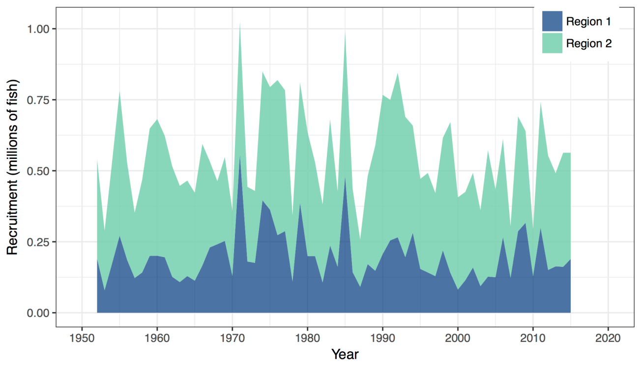
Figure SWO2. Estimated annual average recruitment by model region for the diagnostic case model, showing the relative sizes among regions.

Figure SWO3. Estimated annual average spawning potential by model region for the diagnostic case model, showing the relative sizes among regions.

Figure SWO-4. Estimated annual average juvenile (age classes 1-3), maturing adult (4-6) and adult (7+) fishing mortality for the diagnostic case model.

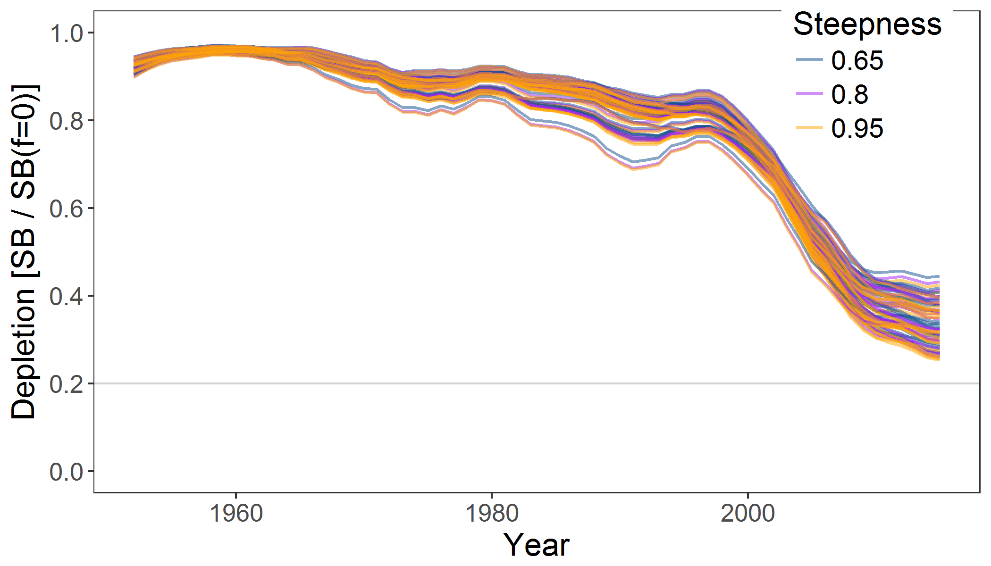
Figure SWO-5. Plot showing the trajectories of fishing depletion (of spawning potential) for the 72 model runs retained for the structural uncertainty grid used for management advice. The colours depict the models in the grid with three levels of steepness (0.65, 0.8 and 0.95).

Figure SWO-6. Majuro plot summarising the results for each of the models in the structural uncertainty grid retained for management advice. The plots represent estimates of stock status in terms of spawning potential depletion and fishing mortality. The red zone represents spawning potential levels lower than the agreed limit reference point which is marked with the solid black line. The orange region is for fishing mortality greater than F_{MSY} (F_{MSY} is marked with the black dashed line). The points represent SB_{latest} /SB_{F=0}, and the colours depict the models in the grid with three levels of steepness (0.65, 0.8 and 0.95).
Figure SWO-7. Majuro plot summarising the results for each of the models in the structural uncertainty grid retained for management advice. The plots represent estimates of stock status in terms of spawning potential depletion and fishing mortality. The red zone represents spawning potential levels lower than the agreed limit reference point which is marked with the solid black line. The orange region is for fishing mortality greater than F_{MSY} (F_{MSY} is marked with the black dashed line). The points represent SB_{recent}/SB_{F=0}, and the colours depict the models in the grid with three levels of steepness (0.65, 0.8 and 0.95). Note, SB_{recent} is defined as the mean of SB over 2012-2015.

Figure SWO-8. Kobe plot summarising the results for each of the models in the structural uncertainty grid, where the x-axis represents SB_{latest} /SB_{MSY}. The colours depict the models in the grid with three levels of steepness (0.65, 0.8 and 0.95).

Figure SWO-9. Kobe plot summarising the results for each of the models in the structural uncertainty grid. The colours depict the models in the grid with three levels of steepness (0.65, 0.8 and 0.95). As in Figure SWO7, SB_{recent} was used instead of SB_{latest}.

Figure SWO-10. Estimated time-series (or “dynamic”) Majuro and Kobe plots from the SW Pacific swordfish ‘diagnostic case’ model run.

Figure SWO-11. Estimates of reduction in spawning potential due to fishing by region, and over all regions (lower left panel), attributed to various fishery groups (distant water ‘north’, ‘central’ and ‘south’, corresponding to the model regions, and a combined domestic fleet) for the diagnostic case model.
Table SWO-2. Summary of reference points over the 72 models in the structural uncertainty grid for management advice. Note that SB_{recent}/SB_{F=0} is calculated where SB_{recent} is the mean SB over 2012-2015 instead of 2011-2014 (used in the stock assessment report), at the request of the Scientific Committee.
 | Mean | Median | Min | 10% | 90% | Max
C_{latest} | 9,884 | 9,884 | 9,318 | 9,343 | 10,157 | 10,287
MSY | 8,172 | 7,913 | 5,905 | 6,396 | 10,150 | 11,360
Y_{Frecent} | 7,628 | 7,775 | 4,998 | 6,062 | 8,948 | 9,684
f_{mult} | 1.27 | 1.15 | 0.66 | 0.79 | 1.89 | 2.32
F_{MSY} | 0.16 | 0.14 | 0.10 | 0.10 | 0.22 | 0.23
F_{recent}/F_{MSY} | 0.88 | 0.87 | 0.43 | 0.53 | 1.26 | 1.51
SB_{MSY} | 17,314 | 17,740 | 7,278 | 8,943 | 26,661 | 30,460
SB₀ | 84,173 | 84,075 | 57,070 | 71,199 | 98,039 | 111,000
SB_{MSY}/SB₀ | 0.20 | 0.21 | 0.11 | 0.12 | 0.28 | 0.28
SB_{F=0} | 78,619 | 78,301 | 61,996 | 64,342 | 92,120 | 100,691
SB_{MSY}/SB_{F=0} | 0.22 | 0.23 | 0.10 | 0.12 | 0.32 | 0.33
SB_{latest} /SB₀ | 0.33 | 0.32 | 0.24 | 0.25 | 0.44 | 0.46
SB_{latest} /SB_{F=0} | 0.35 | 0.35 | 0.26 | 0.27 | 0.44 | 0.49
SB_{latest} /SB_{MSY} | 1.85 | 1.61 | 0.85 | 0.99 | 3.14 | 4.05
SB_{recent}/SB_{F=0} | 0.36 | 0.35 | 0.27 | 0.29 | 0.43 | 0.48
SB_{recent}/SB_{MSY} | 1.86 | 1.58 | 0.88 | 1.02 | 3.10 | 3.96

- SC13 noted that the central tendency of relative recent spawning biomass was median (SB_{recent}/SB_{F=0}) = 0.35 with a probable range of 0.29 to 0.43 (80% probability interval). The median estimate (0.35) is below that estimated from the 2014 assessment grid((SB_{current}/SB_{F=0}) = 0.49, see SC9-SA-WP-05), noting the differences in grid uncertainty axes used in that assessment, due to the inclusion of two representations of growth and maturity. SC13 also noted that in the previous assessment this central tendency was not considered for the provision of management advice given the uncertainties in growth assumptions. The median estimate for SB_{recent}/SB_{MSY} is 1.23, which is below that estimated from the 2014 assessment grid ((SB_{current}/SB_{MSY}) = 2.07, see SC9-SA-WP-05).

- SC13 noted that the central tendency of relative recent fishing mortality was median (F_{recent}/F_{MSY}) = 0.86 with an 80% probability interval of 0.51 to 1.23. While this suggested that there was likely a buffer between recent fishing mortality and F_{MSY}, it also showed that there was some probability that recent fishing mortality was above F_{MSY}.

- SC13 also noted that there was a roughly 32% probability (23 out of 72 models) that the recent fishing mortality was above F_{MSY} with Prob((F_{recent}/F_{MSY})>1) = 0.32. The median estimate (0.86) is above that estimated from the 2014 assessment grid (F_{current}/F_{MSY} = 0.74, see SC9-SA-WP-05).

- Fishing mortality rate increased notably from the mid-1990s in both model regions, on maturing swordfish aged 4-6 fish in particular.

- Across all models in the uncertainty grid the spawning biomass declines steeply between the late 1990s and 2010 but since then the rate of decline has been less. Those declines are found in both model regions, but are higher in the eastern Region 2 (equator to 50°S, 165°E to 130°W).

- SC13 noted that in comparison with the bigeye and yellowfin assessments, evidence for an increase in recent recruitment for southwest Pacific swordfish was not found in either the CPUE time series or estimates of recruitment. SC13 noted that the longline only nature of the fishery catching mainly larger, older swordfish, is not strongly informative with regards to recruitment dynamics.

- Management advice and implications

- Based on the uncertainty grid adopted by SC13, the south west Pacific swordfish spawning biomass is likely above the 20%SB_{F=0}, biomass LRP adopted for tunas and the SB_{MSY} level (noting that the Commission has yet to adopted an LRP for south Pacific swordfish) and it is highly likely that the stock is not in an overfished condition (0% probability). Recent F is likely below F_{MSY}, and it appears that the stock is not experiencing overfishing (32% probability of overfishing).

- SC13 noted that there has been an increase in fishing mortality notably from the mid-1990s, and that the biomass relative to unfished levels is estimated to have declined rapidly during the period late-1990s to 2010 followed by a more gradual but continued decline after 2010, across the uncertainty grid. It was noted the fishing mortality was likely below F_{MSY}.

- Consistent with its previous advice (from SC9), SC13 recommends that the Commission consider developing appropriate management measures for the area north of 20°S to the equator which is not covered by CMM 2009-03, noting that:
- recent catches between the equator and 20°S continue to represent the largest component of the catch in Region 2 (equator to 50°S, 165°E to 130°W) and represent half the total catches from the stock, and,
- catches in that area contribute substantially to fishing mortality and spawning biomass depletion levels in eastern Region 2 that are substantially higher than in the western region (Region 1).

- Further, SC13 recommends that current restrictions on catches south of 20°S also be maintained.

4.4.2 Southwest Pacific striped marlin (Kajikia audax)

4.4.2.1 Review of research and information

- The last stock assessment for Southwest Pacific striped marlin was conducted in 2011. SC13 received no updated information.

4.4.2.2 Provision of scientific information

- Stock status and trends

- SC13 noted that no stock assessment was conducted for this species in 2017. Therefore, the stock status descriptions from SC8 for Southwest Pacific striped marlin are still current. Updated information on catches was not compiled for and reviewed by SC13.

- Management advice and implications

- SC13 noted that no management advice has been provided since SC8 for South Pacific striped marlin. Therefore, previous advice should be maintained, pending a new assessment or other new information.

4.4.3 North Pacific striped marlin (Kajikia audax)

4.4.3.1 Review of research and information

- The last stock assessment for North Pacific striped marlin was conducted in 2015. SC13 received no updated information.

4.4.3.2 Provision of scientific information

- Stock status and trends

- SC13 noted that no stock assessment was conducted for this species in 2017. Therefore, the stock status descriptions from SC11 for North Pacific striped marlin are still current. Updated information on North Pacific striped marlin catches may be available in the ISC Plenary Report, but was not compiled for and reviewed by SC13.

- Management advice and implications

- SC13 noted that no conservation advice has been provided since SC11 for North Pacific striped marlin. Therefore, previous advice should be maintained, pending a new assessment or other new information.

4.4.4 Pacific blue marlin (Makaira nigricans)

4.4.4.1 Review of research and information

- The last stock assessment on Pacific blue marlin was conducted by ISC in 2016. No new information was provided to SC13.

4.4.3.2 Provision of scientific information

- Stock status and trends

- SC13 noted that no stock assessment was conducted for this species in 2017. Therefore, the stock status descriptions from SC12 for Pacific blue marlin are still current. Updated information on Pacific blue marlin catches may be available in the ISC Plenary Report, but was not compiled for and reviewed by SC13.

- Management advice and implications

- SC13 noted that no conservation advice has been provided since SC12 for Pacific blue marlin. Therefore, previous advice should be maintained, pending a new assessment or other new information.

AGENDA ITEM 5 - Management Issues Theme

5.1 Development of harvest strategy framework

5.1.1 Reference points

- South Pacific albacore

- Under this agenda item, SC13 had the opportunity to review a report on intersessional progress to develop a TRP for SP albacore.

- The Convenor reminded delegates that ‘The Commission had directed that further discussion of the TRP should take place over the course of 2017 as part of the ongoing consultative process for the development of a Bridging Measure for the Conservation and Management of the South Pacific Albacore stock, and should include a report on progress by the Convenor of that process to the 13th WCPFC Scientific Committee’ (WCPFC 13 Summary Report Paragraph 315).

- On behalf of the FFA Secretariat A. McDonald presented SC13-MI-WP-01: Analysis of potential South Pacific Albacore Trigger Reference Points. The presenter noted that WCPFC13 had deferred a decision on a TRP for south Pacific albacore until December 2017 at the latest. The WCPFC Harvest Strategy workplan asked the SC to provide advice on implications of range of Target Reference Points for south Pacific albacore. To inform this advice from SC, the paper presented the results of modelling undertaken by SPC and FFA on the expected changes in catch rates, effort, catch and economic viability in the fishery over a 20 year timeframe for candidate reference points ranging from MSY (14%SB_{F=0}) to MEY (59%SB_{F=0}). Given the importance of a TRP being a reflection of management objectives, the paper recommended that CCMs describe their objectives for the fishery and using the information in the paper, discuss which TRPs broadly reflect those objectives.

Discussion

- Samoa, on behalf of FFA members noted their proposal for the adoption of a Target Reference Point of 45% SB_{F=0} for south Pacific albacore at the past two annual meetings of the Commission. They believed this represented a bioeconomically-based TRP that would avoid breaching the LRP with a very low degree of risk, and expect it would return the catch rates to a level that was profitable for Pacific Island domestic fleets. This TRP had been adopted as an interim TRP by the 11 CCMs that are Participants to the Tokelau Arrangement, a group that has committed to the effective control and management of the south Pacific albacore fishery. A TRP of 45% SB_{F=0} for south Pacific albacore was consistent with our objectives for this fishery. However, they noted that while all CCMs agreed on the objective of a biologically healthy stock, member’s economic objectives varied and FFA members therefore accepted that some compromise on the TRP might be necessary to achieve acceptance and adoption of a TRP by all CCMs at WCPFC14. The lack of adoption of a TRP for this stock was preventing progress on the development of a harvest strategy, and was allowing the fishery to further decline both biologically and economically. FFA members looked forward to genuine engagement by all interested CCMs, so the SC can provide clear advice on the TRP options presented for the South Pacific albacore.

- China queried the level of confidence in the 20 year deterministic projections on economic and biological parameters. The presenter noted that it reflected the best science available to estimate future expected consequences, and SPC clarified that it was recognised that there are uncertainties in such stochastic projections of future equilibrium states, the modelling is most likely to result in an underestimate of future consequences for the stock rather than an overestimate.

- The US suggested that the cost per hook estimates of $0.90 to $1.30 were higher than their estimates for costs in the American Samoa fleet of around $0.70 per hook. The presenter and FFA economist clarified that these cost estimates used within the analysis incorporated data on all operating and capital costs that were available at the time of the analysis. Any additional economic information on costs in the longline fishery, including the American Samoa fleet was welcome to inform future economic analyses such as these.

- Chinese Taipei asked for more detail on the costs included in the economic model. The FFA Secretariat clarified that costs include all operating and fixed capital costs, as well as a reasonable rate of return for the vessels to justify being in the fishery.

- Japan noted that the TRP proposed by FFA was based on the fishery status in 2008, but suggested that given the dynamic nature of a fishery that the exact biological and economic consequences of a TRP of 45% SB_{F=0} may change over the 20 year time period modelled. The presenter clarified that the consequences were estimated as change from 2013 levels, the last year of the stock assessment, and noted that the consequences of a TRP will differ depending on the timeframe over which they are achieved, and the management action taken to achieve them. These projections assumed an equilibrium state after a 20 year period for the indicative estimates. It was also recognised that a fishery is not a static system, so the actual consequences of a TRP may end up differing from those estimated by the model. The TRP is used as a reference not a rule, and in a dynamic system monitoring would indicate whether the objectives of the fishery, and the TRP, are being achieved over time and management be amended accordingly.

- China expressed concern with the potential of the model predictions to fail and the estimated consequences in 20 years time being incorrect. SPC advised that retrospective forecasting on bigeye showed that there is reasonable confidence in the model results. China further queried the lack of feedback in the model to capture stock dynamics and biological and economic changes in the future fishery. The presenter responded that the projections reflect the average estimated future consequences but it was recognised that reality may end up being different. Target reference points reflect the objectives for the fishery but they are only one element of the harvest strategy approach. Other necessary elements, in particular performance indicators and monitoring strategies, monitor performance on a regular basis to ensure that management is adapted to achieve those objectives over time if reality differs from the projections. Noting that the TRP will be interim, that can also be changed over time in response to changing management objectives.

- Australia asked that FFA refine the economic information presented to WCPFC14 to include future projections of the economic conditions index to assist CCMs to get a better understanding of the economic implications of the different TRPs proposed.

- China stated that the economic feasibility of albacore fisheries is very important to them and that this feasibility is influenced by the future price of albacore which is beyond the control of the SC. They also noted that the prices of the Chinese fleet may differ from the prices analysed in the paper. The presenter clarified that the economic analysis included all information available for fleets fishing for albacore in the WCPO, including vessels fishing in both EEZs and the high seas, and reiterated that any additional information on the costs of different fleets would be welcome to inform this and other future economic analyses.

- French Polynesia expressed their support for the FFA statement and their proposed TRP, noting it was consistent with their objectives for a precautionary TRP for the south Pacific albacore fishery. They asked that the SC made a strong recommendation to the Commission to adopt a precautionary TRP for this fishery this year.

- New Caledonia expressed their concern with the sustainability of the south Pacific albacore fishery and supported the statement of French Polynesia and the FFA proposal.

- China asked for further clarification on how the FFA proposed TRP related to the LRP. The presenter clarified that the FFA proposed TRP was 45% SB_{F=0}, which has a very low probability of breaching the agree LRP of 20% SB_{F=0}, as agreed by the Commission for the four key tuna species.

- SC13 reviewed information related to the implications of a range of candidate target reference points for south Pacific albacore (SC13-MI-WP-01) and provided a number of suggestions to clarify aspects of the paper before a revised version is forwarded to WCPFC14. Noting that WCPFC13 agreed to defer the possible adoption of an interim target reference point for the South Pacific albacore stock, which had originally been agreed to take place in 2015 under the Harvest Strategy Work Plan, until December 2017 at the latest (para. 314 WCPFC13 Summary Report), SC13 encourages CCMs to describe their objectives for the fishery and recommends that WCPFC14 note the biological and economic consequences of the options modelled in this paper. In particular, SC13 draws the attention of WCPFC14 to the Limit Reference Point (LRP) already adopted by the Commission for south Pacific albacore and the need to identify a TRP which maintains the stock well above this limit, while noting that following the last assessment (SC11-SA-WP-06) the LRP is above SB_{MSY}.

5.1.2 Performance indicators and monitoring strategies

- The Convenor noted that the Harvest Strategy Workplan (Attachment N, WCPFC13 Summary Report), requested that SC13 provide advice on a range of performance indicators to evaluate performance of harvest control rules for bigeye and yellowfin tuna fisheries. The Small Working Group on Management Objectives at WCPFC13 also requested that SC13 provide advice on refined candidate performance indicators for south Pacific albacore fisheries.

- Following discussions in the SWG on management objectives at WCPFC13, and commensurate with the candidate performance indicators for the relevant fisheries, SC13 was specifically requested to provide advice on the corresponding monitoring strategy to assess performance of harvest strategies.

- R. Scott (SPC) presented SC13-MI-WP-02 Performance indicators and monitoring strategies for South Pacific albacore compatible with candidate management objectives for the Southern Longline Fishery. In accordance with the timetable for the development of a harvest strategy approach for WCPFC stocks and fisheries, SC12 provided advice to the Commission in 2016 on candidate performance indicators and monitoring strategies for the tropical purse seine fishery and the southern longline fishery. During that Commission meeting the proposals for the tropical purse seine fishery were further considered by an informal WCPFC13 small working group to produce a refined list of prioritised indicators for the various biological, economic, social and ecosystem objectives for that fishery. The small working group suggested that the WCPFC Science Services Provider undertake a similar process for the southern longline fishery, for consideration by SC13. In this respect, SC13-MI-WP-02 presented a similar prioritisation of the list of management objectives and associated performance indicators for the southern longline fishery. This list was constructed to be as close as possible to that produced for the tropical purse seine fishery.

Discussion

- Japan was of the view that the list of indicators seemed to be too long, that some were redundant and some were difficult to monitor, and that constructing a management strategy evaluation based on a long list of performance indicators might be too complicated for a first attempt. R. Scott agreed it was complicated, but it was important to try with a longer list of indicators in the beginning which could be shortened as indicators were evaluated. The presenter was hesitant to shorten the list of indicators without undertaking adequate evaluations.

- Nauru on behalf of FFA members, noted the development of performance indicators and monitoring strategies to evaluate the effectiveness of management and the expected performance of harvest strategies was important work for the SC, because it will ensure that the right information was being collected and analysed to allow strategic and adaptive management of WCPO fisheries. They were pleased to see progress and that WCPFC13 adopted a list of performance indicators for the purposes of evaluating harvest control rules for the tropical purse seine fishery. FFA members thanked SPC for progressing this work for the southern longline and the tropical longline fisheries, and consider the list of potential performance indicators and monitoring strategies in working papers 2 and 3 an excellent start. FFA members were committed to building upon this work and have a number of suggestions for amendments and additions to the tables. FFA members also noted their concern that insufficient prioritisation was being given by the SC and the Commission to progress this important work, noting that an ISG meeting during breaks was unlikely to provide the necessary time and resources that this work deserved. They asked for this work and that of the other elements of the harvest strategy to be better integrated into the work of the Commission and given a higher priority by the Secretariat, the Chair and CCMs alike.

- China voiced the same concern raised by Japan, regarding the long list of performance indicators as the cost might be too great to monitor all those indicators with so many CCMs. It sought further clarification on the process that would be used to refine that list. R. Scott noted that it was important to view this as an iterative process where the problem was defined, the MSE framework would be developed, then information learned would be incorporated back into the original question, which would in turn feed into the development of the management and harvest strategy for the fishery. This process was important to show what indicators might be useful at this stage, and then a secondary decision could be made on whether the information was informative for the process. China was of the view that starting with simple list of indicators with data available was the best approach, rather than a long complicated list of indicators that data were not available for.

- The Convener reflected on several comments regarding the long list of performance indicators. Noting that CCMs had different objectives in building the harvest control rules, the list might be ambitious, but it was part of a longer term goal of how to build a sustainable fishery that would take a number of years to achieve. He asked members to not lose sight of the long term goal and the need to gather data for indicators that will be helpful well into the future.

- R. Scott (SPC) introduced SC13-MI-WP-03 Performance indicators and monitoring strategies for Bigeye and Yellowfin Tuna compatible with candidate management objectives for the Tropical Longline Fishery. In accordance with the timetable for the development of a harvest strategy approach for WCPFC stocks and fisheries (WCPFC-13 Summary Report Attachment N), SC13 was scheduled to provide advice to the Commission on a range of performance indicators for bigeye and yellowfin tuna that can be used to evaluate the performance of harvest control rules. SC13-MI-WP-03 presented a list of proposed performance indicators based on the candidate management objectives for the tropical longline fishery provided in the MOW2 report (WCPFC10-2013-15b) as well as the considerations of the 2016 WCPFC13 small working group on management objectives. The paper highlighted the multi-species nature of the tropical longline fishery which catches a range of target species and noted that achieving MSY simultaneously for each individual stock (or species) may not be possible. In such cases the concept of pretty good yield or pretty good multi-species yield can be employed to define appropriate management targets that will achieve acceptably high yields across a range of different species. Given the lack of any existing target reference points for the stocks most relevant to the tropical longline fishery, it was suggested that a provisional TRP might be identified at this stage but this may be modified in future subject to further analyses and discussions on the trade-off between yield and the risk of falling below the limit reference point across the range of target species. It was noted that a complete set of performance indicators would be difficult to identify at this stage but that a partial and provisional set could be drafted and modified as additional information becomes available.

Discussion

- Japan noted this was a complicated issue with multi species and different gear. They agreed that at this stage it was not possible to have a complete set of indicators. Japan further noted the MSY was about half of the purse-seine fishery. And if the new growth curve of bigeye was to be believed, then the stock yield was almost double that of yellowfin.

- The USA thanked SPC-OFP for the presentation and the paper, appreciated that this analysis followed the MOW strawman document, and recommended that performance indicators continue to be structured around fisheries rather than stocks. The paper does note that if objectives are about the tropical LL fishery and not stocks, then there ought to be some indicators for the ecosystem and social indicators, and this should be addressed by the Commission in due course. The USA noted that the paper describes the difficulty in tracking ecosystem indicators without a multi-species or ecosystem operating model, and asked besides developing a model whether there was a way to track trade-offs among species. The USA did not think that the SC needed to recommend specific indicators but that the SC should recommend the Commission consider the indicators to track objectives listed in the strawman and in last year’s exercise for the purse seine fishery.

- In relation to the multi-species aspects, FSM on behalf of PNA members expressed concern at the apparent differences in approach between the interim performance indicators adopted by the Commission for the purse seine fishery and those proposed for the tropical longline fishery. In PNA’s view, the analysis of multi-species aspects was a two-way process and similar approaches to multi-species elements should be adopted in both sets of indicators.

- China asked if the presenters had considered an alternative approach, for example using an ecosystem dynamic model such as Atlantis that also accounts for oceanographic processes and multiple species. R. Scott responded that it would be a significant undertaking to get Atlantis up and running for tuna stocks. It would be more feasible to get a single species model up and running and then approximate a mixed species fishery.

- PNG of behalf of PNA members expressed appreciation for the SPC papers on elements of the harvest strategy, which were very helpful in working through a complex area. PNA members emphasised that the WCPO tropical tuna stocks occur and were fished largely in the waters of developing coastal states, especially SIDS. The harvest strategy process, including the adoption of harvest control rules, could benefit all participants in these fisheries. However, for this process to be effective it was important that the objectives, indicators and monitoring strategies relating to tropical tunas clearly reflect the rights and interests of those developing coastal state CCMs who are primarily responsible for the management of those stocks.

- The Convener drew attention to useful information contained in SC13-MI-IP-01 Operationalising the monitoring strategies for tropical purse seine and southern longline fisheries: Information requirements and data availability.

- Taking note of the issues raised during this session, an Informal Small Group (ISG-08: Performance indicators and monitoring strategy) was convened to further discuss and refine the list of performance indicators and monitoring strategies outlined in Working papers MI-WP-02 and MI-WP-03 and to help frame SC13’s advice to the Commission. The outcomes of this ISG are provided in Attachment F.

- As requested by the Harvest Strategies Workplan (Attachment N, WCPFC13 Summary Report) and the Small Working Group on Management Objectives at WCPFC13, SC13 reviewed candidate performance indicators and monitoring strategies for i) South Pacific albacore commensurate with candidate management objectives for the Southern Longline Fishery (SC13-MI-WP-02) and ii) bigeye and yellowfin tuna commensurate with candidate management objectives for the Tropical Longline Fishery (SC13-MI-WP-03). SC13 provided a number of suggestions to clarify, and update as appropriate, aspects of these papers and requested that revised versions of both be forwarded to WCPFC14. In reviewing these papers SC13 noted that while the number of key performance indicators should be kept to a tractable level as they will influence the Management Strategy Evaluation (MSE) modelling framework currently being developed, they should also be sufficient to monitor the key long-term management objectives for these fisheries. It was also noted that the list of indicators and monitoring strategies can be reviewed throughout the current MSE work. SC13 recommends that WCPFC14 note the candidate performance indicators and monitoring strategies for each of these fisheries as listed in these revised papers, and provide advice on what performance indicators and monitoring strategies should be included for the development of harvest strategies under CMM 2014-06.

5.1.3 Harvest control rules and management strategy evaluation

- The Convenor noted that the Harvest Strategies Workplan (Attachment N, WCPFC13 Summary Report), requested that the SC13 provide advice on progress toward the evaluation of candidate harvest control rules for South Pacific albacore and skipjack tuna.

- R. Scott (SPC) presented SC13-MI-WP-04 Developments in the MSE modelling framework, which presented an account of recent developments in the construction of the MSE framework for WCPFC stocks and fisheries and focused primarily on some of the technical issues related to the development of the modelling framework. In many cases, the results presented in this paper represent the current state of ongoing analyses and are not considered to be final. The paper specifically considers two issues, the generation of pseudo data from the operating model, and the development of an estimation model for skipjack that can be used within the management procedure to estimate stock status. In addition, the paper briefly identified a number of tools and software approaches that may be used for building the evaluation framework.

Discussion

- China thanked the presenter for a very important piece of work that would play a significant role in the future. It noted that MSE was important and should realistically reflect what happens in the fishery. China especially liked that researchers compared generated data with observed fisheries data. R. Scott agreed with China’s view that the MSE should realistically reflect the fishery and that the generated model should account for the frequency of stock assessments, which were only conducted every 3 - 4 years. It was noted that the modelling had been using a three-year management run. Regarding model assumptions, R. Scott noted it was key not to use exactly the same model for the operating model and the estimation model so that the stock dynamics and sources of uncertainty that are incorporated into the operating model are not perfectly accounted for by the management procedure. MULTIFAN-CL is considered an appropriate model to use for the operating model and has been developed to generate pseudo data for use in the simulation analyses. The use of MULTIFAN-CL within the management procedure, however, is less desirable but currently represents the most viable approach. Although the structure and details of the model differ from that used for the operating model the time taken for the model to converge to a solution is still quite long.

- Japan suggested trialling a simplified MULTIFAN-CL model to develop the management procedure to ensure that it is rigorously tested. Japan also noted if tagging data was needed for the management procedure to run, the cost implication of tagging indefinitely or for quite some time would need to be explained to managers. In response, New Zealand noted that the need for tagging data was an issue that was highlighted for expert panel review and that such data helped overcome some of the concerns of relying on CPUE as abundance indices. Without tagging data it would be very difficult to affect a sound management procedure.

- EU sought clarification regarding the paper presented by SPC using simplified models in the context of MSE. Considering that the evaluation model and the harvest control rules were linked, if a harvest control rule was adopted, would SPC need to move to a simpler assessment model or not? R. Scott noted that the estimation model was a simplified procedure for generating information on stock status that could be used by the harvest control rule to determine future management actions. This procedure could be run annually or multi-annually and may be based on models of different complexity. The operating model used within the simulations, however, is based on the current MULTIFAN-CL stock assessment. Periodically the whole simulation framework will need to be re-evaluated including the appropriateness of the model settings used for the operating model. The period of time between such re-evaluations may be as little as three years in the initial stages, until confidence in the operating model has been established.

- Kiribati on behalf of FFA members, thanked SPC for progressing the important technical work involved in developing the modelling tools for the Management Strategy Evaluation framework. They noted the findings to date and look forward to ongoing updates as this work progressed. Kiribati further noted the additional resources that were being brought in to the SPC team to progress this work and thanked New Zealand for providing support to allow this to happen and looked forward to the commencement of an SPC position responsible for capacity building, education and consultation on this work. FFA members considered it critically important that stakeholders, in particular coastal state fisheries managers, were not only engaged in the development of the management strategy evaluation framework but were the primary drivers of inputs to the MSE model, including performance indicators, monitoring strategies, candidate harvest control rules and implementation mechanisms. In order to engage in this process FFA members needed to understand it, and they looked forward to an increase in capacity building and education activities to assist them with building the necessary understanding so FFA members could fully engage in this process.

- China made comments related to the overall design of the MSE framework, noting modellers had used skipjack but wanted to develop an MSE that could be applied to all tuna stocks, and that needed to be kept in mind when considering overall design of the assessment model. China further noted there was an open access data poor application tool called DLM-2 developed to model data limited stocks, which had over 150 harvest control rules readily available that could be interesting to apply to skipjack fisheries in the WCPO. China had already applied DML-2 to data rich fisheries in the Yellow Sea and was surprised how well the model worked. They especially liked how flexible and readily accessible it was, and free. The presenter had heard of DML-2 but had not looked into the app in much details, as the thrust of their research had been to focus on using tools currently at their disposal and build a framework on that. WCPO was not necessarily a data limited fishery, and those types of models tended to be quite conservative. In response to a further question on performance indicator diagrams in the presentation not reflecting the actual model, the presenter clarified that these diagrams were only used to illustrate the conceptual framework and where each of the component fit in a general sense.

- USA mentioned that the DLM tool might be a useful means forward in a data limited context, but it would not be useful to apply that integrated analysis to skipjack as the DML was not set up to do that and would require the designer of the tool to specify the application to skipjack, which may not be worth the time. China appreciated the views of the USA but the DML tool was an open source code, so the original designer would not need to be involved. China had experienced success in using this tool to model fisheries in Mexico and the Yellow Sea.

- Indonesia supported having a simple operating model that supported data poor fisheries. Noting that the operating model tried to capture all purse-seine fisheries and pole and line, it asked how this model would account for FADs. The presenter responded that how the purse-seine fishery would be represented in the operating model would depend on fleet components being built into the model. Each region would have purse-seine components representative of different fleets. Regarding FAD effects, those would also be captured within the associated effects of the model. Regarding unusual fluctuations in the pseudo and pole and line fleets in the modelling, this was a technical issue that related to the way researchers were using MULTIFAN-CL, and highlighted areas where more work would be needed to address fluctuations.

- Fiji supported the statement from Kiribati regarding the importance of coastal state fisheries managers being meaningfully engaged in the development of management strategy evaluation frameworks. While recognising that there were technical elements of the development of this framework that were best progressed by scientists, members needed to build their understanding of the MSE frameworks, the inputs and outputs, and exactly how this tool will be used, so that they could engage appropriately in this process. This year it had seen how changes to stock assessment models and the understanding of species life history and biology could significantly alter the results of stock assessments and therefore the estimation of a species stock status. This was a timely reminder of the potential issue of harvest strategies relying on biomass estimates, particularly harvest control rules, and FFA members would therefore like to ask that the SC continue to explore the potential role of empirical indicators in the various elements of the harvest strategies.

- Tonga on behalf of FFA members noted that they will not be making progress this year on the development of harvest control rules for key tuna fisheries. While this was partly due to the additional workload of the bridging measures discussions, FFA members were concerned that the Commission’s lack of adoption of a target reference point for albacore was compromising the ability to make progress on candidate harvest control rules for albacore. CCMs were urged to come to the table and actively work with FFA members to discuss the options for an albacore TRP, so that the development of harvest control rules could move forward. Noting that the WCPFC14 was due to adopt a TRP for albacore, and the tropical tuna and albacore bridging CMMs discussions should be finalised this year, it was expected that the workload related to the development of harvest control rules and the management strategy evaluation framework would ramp up next year. The Commission was urged to ensure that appropriate prioritisation was given to the harvest strategy agenda so that sufficient time and resources were available to progress work next year.

- Chinese Taipei noted that the performance of the model appeared to be good, but it sought clarification on the consistency problems with the tuning index and whether MULTIFAN-CL would be better as it did not have a tuning index. R. Scott noted that the internal consistency issue was specifically limited to the A4A model and how they had tried to apply it, which was set up with a different modelling structure. It was not really a consideration for MULTIFAN-CL.

- SC13 noted that WCPFC12 had adopted a work-plan for the adoption of Harvest Strategies under CMM 2014-06 and that the development of Harvest Control Rules and Management Strategy Evaluation frameworks had commenced in 2016 and is scheduled to continue through until 2018. SC13 noted the importance of this ongoing work and reviewed the progress outlined in SC13-MI-WP-04. Noting that the initial focus of this work has been on WCPO skipjack, and that other stocks and fisheries will need to be considered as the work proceeds, SC13 provided feedback on the work undertaken to date and made a number of suggestions to help progress this work over the next year. SC13 also noted that additional resources (based on funding provided by New Zealand) are being provided to help expedite this work and appreciated the support for workshops and consultations to improve the capacity of fishery managers to become meaningfully engaged in the development of management strategy evaluation frameworks. SC13 recommends that WCPFC14 note the approach being taken to develop an MSE framework for WCPFC stocks and fisheries, noting that the results presented in this progress report are preliminary and that development of the framework is ongoing with the expectation that preliminary results would possibly be provided in 2018. SC13 also noted that:
  - the importance of ongoing stakeholder involvement and consultation in this work (e.g. via in-country stakeholder engagement with the Scientific Service Provider and/or through a higher-level meeting or workshop for broader stakeholder engagement) and recommends that WCPFC14 explore mechanisms and options for facilitating and funding these arrangements.
  - the harvest strategy work needs to be integrated into the work of the Commission and given a greater priority.
  - the concerns of some CCMs about the discontinuation of the management objectives workshop process.

5.2 Management issues related to FADs

- The Convenor drew attention to a request from the Commission to consider the outcomes of the 2nd FADMgmtOptions-IWG (WCPFC13 Summary Report Paragraph 601.)
601. The Commission adopted the Report of the 2nd meeting of the FADMgmtOptions-IWG (WCPFC13-2016-FADMgmtOptions-IWG02_rev2), and agreed that the outcomes therein should be further considered at SC13 and TCC13.

- The Convenor noted that the FADMgmtOptions-IWG had recommended to WCPFC13 that the consultant’s report on options and considerations of implementing a marking and identification system for FADs in the WCPO (FADMgmtOptionsIWG-02-04) be forwarded to SC13 and TCC13 for further consideration (Paragraph 51, FADMgmtOptions-IWG02 Report).

- SC13 was invited to consider the consultancy report and provide recommendations as appropriate.

5.2.1 FAD tracking

- L. Escalle (SPC) presented SC13-MI-WP-05 Preliminary analyses of PNA FAD tracking data from 2016 and 2017, which provided information on the characteristics of the tracking data of satellite buoys deployed on FADs reported by fishing companies to PNA, and the results of follow-up investigations based on these data were presented. This included FAD densities in time and space, beaching events, dynamics around the WCPO FAD closure and some initial FAD life-history information. The need for additional processing of the data was highlighted, in particular separating at-sea and on-board transmissions and precise FAD deployment locations. Finally, suggestions for several further analyses using this dataset were made.

- Niue was very interested in the work undertaken on FADs, especially FAD design, as it was increasingly concerned about the sheer number of FADs showing up on its shores, their drifting behaviour, and how many may be passing by Niue due to strong currents moving floating material that way.

- EU noted the great potential of this work. It was surprised at the difficulties researchers had in the WCPO regarding locating the precise location of deployment, as the work the EU was conducting in other areas demonstrated it was quite evident from tracking the history of the buoy. In response to whether researchers had estimated the number of FADs deployed at sea in the WCPO compared with observer data, researchers noted the challenges in determining the precise location and number of deployments for the 17,000 FADs so it wasn’t possible to track them all individually. However, they were trying to build procedures to identify precise locations whilst at sea and on board. They also only knew the number of active buoys, but did not know how many fishing companies had been deploying them.

- EU asked about the relationship between CPUE and FAD density, including whether the metric for CPUE was catch per set or catch per day, and whether the research can make any estimate of FAD loss or buoy loss due to those that have drifted out of the fishing grounds. L. Escalle responded that they only had access to the raw dataset and have not looked into CPUE comparison with FAD density into much detailed. So far they only looked at catch per set, but once a classification system to identify FADs at sea had been developed, this would be looked into. Regarding FAD loss, it is hard to identify those events, because in the data the end of a track could correspond to beaching event, FAD being picked up by other vessel or just deactivation.

- China commented that it would like to see the work continued through the financial support from the Commission, and would like to ask that the Commission develop measures to regulate FAD marking so we have better information on the potential implementation of such measures in the future.

- PNG on behalf of PNA members advised that the FAD Tracking Programme being described was designed primarily for management purposes but provided valuable data for analysis. The program was a work in progress and the necessary legal arrangements were being strengthened to ensure the programme was fully effective.

- SC13 reviewed preliminary data analyses from the PNA’s FAD tracking programme, investigating research areas such as FAD densities in time and space, beaching events, dynamics around the WCPO FAD closure and some initial FAD life-history information (SC13-MI-WP-05). While acknowledging the confidentiality associated with FAD-tracking data, SC13 was supportive of these new data being made available to the Scientific Services Provider for analysis, and noting the scope for further analyses and the importance of complete FAD tracking data to support these analyses, encouraged additional data being made available by fishing companies to continue this research. SC13 also noted the importance of FAD marking and monitoring to better identify and follow individual FADs required to facilitate this research, and the on-going WCPFC considerations on FAD marking and monitoring. SC13 recommends that WCPFC14 note these preliminary analyses and identify mechanisms to help facilitate further analyses, if the Commission requires improved information for decision-making on this subject.

5.2.2 FAD management

- J. Hampton (SPC) presented SC13-MI-WP-06 Global FAD Science Symposium (2017): “What does well-managed FAD use look like within a tropical purse seine fishery?” which was attended by scientists, managers and industry representatives involved in purse seine FAD fisheries in all oceans. The Symposium documented general points and ‘best-practices’ under the three broad categories: (1) managing impacts on target species; (2) managing impacts on non-target species, coastal habitats, and the pelagic marine ecosystem; and, (3) the management framework, including monitoring, compliance and surveillance (MCS). The Symposium concluded that (i) that impacts of FADs and FAD management should be considered within the overall fisheries management framework and be guided by clear management objectives; (ii) shifting purse seine effort from drifting FAD to free-school sets would be effective to reduce impacts on target species subject to overfishing and non-target species generally; (iii) there is a need for improved data on FAD deployments and movements, to quantify impacts on species and the ecosystem; (iv) non-entangling FAD designs would be effective in avoiding interactions with some non-target species; and (v) 100% observer coverage of purse seine fishing and support vessels is necessary to fully document FAD use and impacts.

- China welcomed the comprehensive report. Regarding reported tuna catch and bycatch, China asked if SPC and/or the WCPFC Commission were provided with financial support, and could it fund such work in the WCFPC area. The presenter noted another presentation at this meeting would discuss bigeye hotspots, and SPC had also presented a fairly comprehensive report on purse-seine bycatch at SC13. Regarding non-entangling FADs, the type of thing that should be avoided was coils of purse-seine netting that becomes uncompressed overtime and hangs in the water, which risked entangling sharks and turtles etc. There were modern FAD designs in Europe and significant information available now on how to address this issue.

- Korea sought clarification on the role of support vessels mentioned in the presentation. J. Hampton responded that purse-seiners these days operated with increasing support from other vessels, which had a primary role of deploying and retrieving FADs.

- Chinese Taipei asked several questions including if the presenter had a general idea for what the management objective should be for this issue. J. Hampton noted that the main point was that there needed to be a management plan informed by research that could address issues such as FADs impact on endangered, threatened, and protected species. Regarding the definition of FAD, there needed to be more work to tighten up the general understanding of what a FAD was. Regarding the symposium focused on drifting FADs, and whether anchored FADs were having the same issues, J. Hampton noted that although anchored FADs are very uncommon now, they can be important for coastal communities’ access to fish rather than being of benefit to commercial fisheries, and the symposium did not focus on anchored FADs.

- EU highlighted the importance of the Global FADs Science Symposium as a unique opportunity that allowed for scientific information to feed into the Joint T-RFMO FAD Working Group Meeting that took place in Madrid in April this year. WPCFC decided not to participate in this working group, but the EU thought it was important to send participants to future meetings as that working group could benefit from the experience of the WCPO.

- Solomon Islands on behalf of PNA members, advised that they continued to support the position expressed by PNA and other FFA members at the Commission meeting last year that the WCPFC should not participate in the Joint T-RFMO FAD Working Group. PNA pointed out that they were working to develop high standards of FAD management in the tropical WCPO area, and were concerned that a global dialogue would result in lower standards that will assist FAD-dependent distant-water fishing fleets to push for lower standards. In addition, PNA members considered that the Kobe process started as a collaborative process to share experiences and lift standards but it became a process of lowest common denominators, providing a forum for global fishing states to push measures that had been rejected in WCPFC.

- Palau, on behalf of PNA members pointed out that the WCPFC already had a very clear definition of a FAD, set out in paragraph 3 of CMM 2009-02. The same definition had already been incorporated into the national legislation of PNA members. Palau further noted it had banned all FAD fishing within its EEZ, but it was still finding FADs within its EEZ and it did not know where they were coming from.

- Pew Charitable Trusts welcomed this presentation and paper, as it was one of five papers produced by the symposium, and clarified the symposium was not part of the Kobe process. It was an independent symposium with an independent steering group, and the findings incorporate inputs from Pacific experts. Clearly, FADs are a critical gear in WCPO fisheries, and Pew is supportive of the discussions on FADs at SC13. However, Pew urged the SC to consider the points in this paper and recommend the Commission task the FAD working group with creating a clear process and workplan to lead to substantive outcomes that improve the management of the FAD fishery.

- SC13 reviewed the report of the Global FAD Science Symposium, March 20-23, 2017, in Santa Monica, California (What does well-managed FAD use look like within a tropical purse seine fishery? SC13-MI-WP-06). SC13 noted the ‘best-practices’ recommended in this paper under the three broad categories: (1) managing impacts on target species; (2) managing impacts on non-target species, coastal habitats, and the pelagic marine ecosystem; and, (3) the management framework, including monitoring, compliance and surveillance. SC13 also noted that impacts of FADs and FAD management cannot be considered entirely independently of harvest strategies, issues related to fishing capacity, ecosystem structure, or management of all other fishing gears in tropical tuna fisheries. SC13 also noted the report from the Joint T-RFMOs FAD Working Group (SC13-MI-IP-03). SC13 recommends that WCPFC14 take into consideration the examples of best practice made within these reports when developing a framework for the management of FADs within the WCPO.

- The outcome of ISG-02 (FAD data fields and FAD Research Plan) is in Attachment E.

5.3 Implementation of CMM 2016-01

- The Convention noted that SC13 had been requested to review any updated information related to CMM 2016-01, including bigeye tuna hotspot analysis and the footnote 5 of Paragraph 18 relating to eligibility for exemption from the high seas FAD closure, and provide recommendations to the Commission as appropriate.

- L. Escalle (SPC) presented SC13-MI-WP-07 Rev.02 Report from Project 77: Development of potential measures to reduce interactions with bigeye tuna in the purse seine fishery in the western and central Pacific Ocean (‘bigeye hotspots analysis’), which outlined the analysis performed during this project to identify the influence of some vessel and FAD characteristics and environmental variables on bigeye tuna catch by the purse seine fishery. Vessel size, net depth and length and FAD design (e.g. depth), as well as thermocline depth appear to influence bigeye catch, but researchers could not statistically separate the effects of key areas and vessel/FAD types. Top bigeye tuna catching vessels were identified. Two main hotspots of high bigeye interactions (bigeye catch and bigeye CPUE hotspot) were also identified, which could be considered for spatial management. SC was invited to note the final report of Project 77 would be delivered in October 2017.

- China highly appreciated the effort of the SPC; it was a timely provision of information of this forum given the consideration of the tropical tuna measure, of the FAD management issues. China asked if SPC could identify in which countries’ jurisdictions the hotpots occurred or identify the percentage of which hotpots fell within EEZs, as there might be an additional burden for those States in terms of implementing any proposed conservation measures. SPC noted that it was possible to produce this information by October.

- The Philippines requested clarification on the result presented. They noted that the cluster analysis indicated increasing bigeye catch with increasing vessel size but no clear pattern with increasing depth and length of net. However, in the statistical model, results showed that bigeye catch increased with increased vessel length, but also depth and length of net. So they wonder, what could explain that difference. In addition the Philippines informed the SC of their study on the effects of net depth on the catch of bigeye (submitted as SC13-EB-IP-04) which showed significantly higher bigeye catch in deeper nets when compared to shallow nets. L. Escalle noted that the main difference between both analyses was that in the clustering analysis, a vessel could perform sets in various clusters, therefore potentially not showing some patterns. While the GAM directly highlight the characteristics (e.g. vessel size, net length, depth) leading to higher bigeye catches at the set level (independently of the cluster).

- Indonesia thanked the presenter for the very informative and useful information, and posed similar questions to the Philippines. They were especially interested in clarifying how the researchers classified large purse-seine vessels. L. Escalle clarified that these vessels were categorised by simply dividing all purse-seine vessels available between in size categories, between 55 and 117 meters – the larger vessels therefore corresponded to the very large ones available in the data set, the top 5 large vessels.

- Tuvalu on behalf of FFA members thanked SPC for the paper, as it provided a useful analysis of contributing factors to purse seine associated catches and CPUE of bigeye across the region. The paper usefully highlighted the vessel and FAD attributes that could potentially be used in the development of measures to manage bigeye catches. In the same vein, they noted the gaps and large amount of additional data needed to determine with certainty the vessel characteristics, FAD design and use, technological capacity and area effects on the distribution of bigeye catch in the tropical fishery. Because of this, using the analysis for any discussion on potential management measures is premature. It was further noted the linkages with agenda item 5.2.2 on FAD management and that any future work would be more appropriately focused on FAD management.

- Japan thanked SPC for a very important piece of work with significance to the WCPFC’s discussions on the interim tropical tuna measures. Japan sought confirmation on whether the final product would be provided in October, as it would be an important piece of information for the upcoming Honolulu meeting. SPC clarified the work and paper would be available for whichever way members wanted to consider it.

- Regarding the data source, based on visual estimates of the observers, EU asked if the final document could see how these figures compared with the best estimates available, such as the ones used in the stock assessment. The figure on the catch distribution contrasts with the figures presented at SC6 in a previous document on the catch and CPUE distribution of bigeye, based on best estimates for the period 2000-2009. It showed the core catch took place much more to the west. Has there been a significant shift of the catch to the east or could there be a spatial bias in the visual estimates of the observers? L. Escalle confirmed that there has been a shift in effort and catch to the east, potentially due to the strong El Niño event included in the period considered. She also agreed to add the figures regarding bigeye catch and CPUE hotspots using the best estimates data in the final report.

- In response to a question from Indonesia, the presenter clarified that there was a mistake in the colour shading for vessel #17 in 2014. In addition she confirmed that in 2015 and 2016 no vessels appeared to have a catch of bigeye over 500 mt (observer data). Those with no catch were either not operating in WCPO fisheries or were not catching bigeye.

- Nauru on behalf of PNA members, thanked SPC for the work and the EU for funding for this project. PNA found the work on vessel characteristics and overall spatial patterns of fishing in relation to bigeye very useful. The work on bigeye hotspots had been interesting but had limited application in the WCPO because of the likely adverse effects of time/area closures related to bigeye hotspots on some SIDS.

- The Convener summarised by noting that discussions on FADs were spread over three themes at this meeting which highlighted the importance of this issue for the work of this forum.

- SC13 reviewed the draft final report from Project 77: Development of potential measures to reduce interactions with bigeye tuna in the purse seine fishery in the western and central Pacific Ocean (‘bigeye hotspots analysis’) (SC13-MI-WP-07 Rev.02) funded by the EU. The aims of this study were i) to identify factors linked to high purse seine bigeye catch; ii) to identify top bigeye tuna catching purse seiners; and iii) to examine spatial management considerations. As highlighted in previous studies it is clear that many factors influence bigeye catch by the purse seine fishery, which therefore makes it challenging to gauge the effect of each factor separately. SC13 noted several factors influencing bigeye catches, such as vessel size and thermocline depth, and that top vessel lists were different between areas, likely linked to the fact that many fleets mostly operate in one of the three areas analysed during a specific year. SC13 also noted the presence of two types of ‘bigeye hotspot’ areas: i) an area of high overall bigeye tuna catch, with small bigeye catch per set but high effort on associated sets; and ii) an area of high bigeye CPUE, but with lower average catches. SC13 made a number of suggestions to clarify aspects of the report (e.g. enumerating the proportion of the identified hot-spots within each national jurisdiction, providing similar estimates based on those used in the stock assessment to check for potential biases in the observers’ visual estimations, noting the concerns expressed by some CCMs regarding potential difficulties of applying time/area closures in areas of national jurisdiction) and these will be incorporated into the final report to be provided to the WCPFC Secretariat, and subsequently to be made generally available. SC13 also noted the need for improved information on FAD designs, deployments and type of buoy use within the WCPO, together with the importance of detailed information on the characteristics of vessels fishing in the WCPO, to improve future analyses. SC13 recommends that the upcoming Intersessional Meeting to progress the Draft Bridging CCM on Tropical Tuna and both TCC13 and WCPFC14 takes note, among other elements, of the preliminary results contained in this report when framing the ‘bridging’ CMM to replace CMM-2016-01 and that mechanisms be considered to help facilitate further analyses as indicated above.

AGENDA ITEM 6 – Ecosystem and Bycatch Theme

6.1 Ecosystem effects of fishing

6.1.1 SEAPODYM

- Under this agenda item, SC13 considered updates to the SEAPODYM modelling framework; reviewed recent model runs; and provided comments and/or recommendations on SEAPODYM, including the process and methodology of the modelling framework.

- P. Lehodey presented SC13-EB-WP-01 Modelling the impact of climate change including ocean acidification on Pacific yellowfin tuna. The effects of ocean acidification and climate change on the ocean pelagic ecosystem, especially tuna resources, were poorly known. This research presented an update of the previous yellowfin tuna SEAPODYM model (the last reference SEAPODYM model for Pacific yellowfin tuna was presented in 2015). Critically for managers this paper presented novel projections of potential impacts arising from a range of ocean warming scenarios, and the likely compounding effects of concurrent ocean acidification.

- The predicted impact of climate change on this yellowfin tuna population is mainly driven by the change in the spawning habitat (temperature and productivity) and subsequent larval recruitment with a decrease in the WCPO and increase in the EPO. The additional impact of ocean acidification is minor. There is no discernible impact when considering the low sensitivity scenario, very small effects (>5%) by the end of the century in the eastern equatorial Pacific Ocean with the intermediate scenario S1 and a stronger negative impact reaching locally -10% in 2050 and -15% in 2100 with the high sensitivity scenario. The temporal trends in larval biomass predicted by all simulations are relatively stable in the WCPO until 2050 and start to decrease in the second half of the century, while the range of model responses widens after the 2060s.

Discussion

- Australia thanked the researchers for this useful study, which was a good example of using biological information. While there are significant uncertainties regarding what researchers know about ocean acidification, such as the adaptation potential of fish overtime which may mean the impact is lessened, the study also did not test any interaction between temperature of the ocean and acidification. If temperature stresses larvae, then potentially they become more sensitive to ocean acidification.

- Solomon Islands on behalf of FFA members thanked the authors of the paper, as SEAPODYM was increasingly useful in improving their understanding of the interactions between fishing and climate change at a fine spatial scale. They asked three questions about some of the modelling results, to help their understanding:
    - The SEAPODYM results suggested that climate change and acidification had relatively weak impacts on yellowfin tuna populations. In response to the question how confident were the authors in this prediction, and was it likely that these impacts would be relatively weak on skipjack as well, P. Lehodey noted that the ocean data was well known and had greater impacts at higher latitudes, so it was not surprising to see minor impact in tropical areas to date. Modelling against the IPCCs 8.5 scenario, maximum impact was expected in 2200-2300. Regarding ocean acidification, at this stage the research was considered robust.
    - The paper suggested fishing alone provided the main impact on the yellowfin spawning biomass in the equatorial eastern and western Pacific. The presenter explained this was not happening in the equatorial central Pacific because fishing impact was largely driven by the fishing distribution.
    - They further noted the impact due to fishing was mainly driven by the change in spawning habitat (temperature and productivity) and larval recruitment – with a decrease in the WCPO and increase in the EPO. In response to the query – was it likely that the recent recruitment pulses seen in the latest Multifan- CL assessments of skipjack, bigeye and yellowfin can be explained by the environmental effects suggested by SEAPODYM, P. Lehodey clarified that climate variability had strongly impacted the recruitment of yellowfin and skipjack, and natural variability was different from the long term climate change prediction.

- China thanked the presenter and asked several technical questions. Regarding whether there were any close validations to check the quality assurance of the project to have confidence in the mode (quantitatively or qualitatively), it was noted that this was something the researchers regularly undertook, by running the model outside of the specified time (both in the past and in the modern period). Another type of validation used was testing the model in another ocean to see if that would return reasonable results. The validation results were considered to be good as researchers were able to achieve the same statistical feedback as the catch data. Regarding validation of the model, the researchers did not use any biomass estimates in model, they used their own approach to get their own biomass estimate. Regarding advice on how to incorporate information from this study into the stock assessments, P. Lehodey noted it was still an exploratory study, but it could be used to test different fishing scenarios to see how the status of the stock could be developed and maintained at a sustainable level, taking into account both climate change and fishing impacts.

- EU noted that both potential effects of tuna population growth and changes in the plankton were extremely difficult factors to forecast the collective impact of, and asked the presenter if this would have more impact than what had been presented at this meeting. In response, the presenter noted the effects of ocean acidification on the marine environment were a relatively new area of research, but there was a consensus the main impact could be on larvae.

- Australia asked if the models also took into account predicted changes in oxygen levels. P. Lehodey noted that yes it formed the basis of the model, alongside temperature, currents, productivity, oxygen concentration and the pH for yellowfin.

- PNG stated that as predicted by all simulations, the yellowfin larval biomass in the WCPO was likely to be stable until 2050, but was predicted to decrease in the second half of the century. In 2015 the most obvious change relative to the first decade of the century was a large increase of unfished biomass in the ETPO and a moderate decrease in the WTPO. P. Lehodey explained the main drivers of the changes in the model were from changes in larval recruitment and temperature increases and this could change with the new generation of IPCC climate models.

- RMI on behalf of PNA members asked if SEAPODYM could help in providing information on the bigeye biomass outside 10ᴼN and 10ᴼS where there were difficulties with MULTIFAN because there was not so much fishing of bigeye in those areas. P. Lehodey noted that the SEAPODYM model was driven by environmental data, which could predict fish in all habitats even if there was no data from fishing. There would be no evidence to test its accuracy, since there would be no observation or catch data, but new observations could be taken to validate the distribution of the model.

- In response to a request for any suggestions for P. Lehodey’s modelling, Australia suggested that candidate harvest control rules could be used in the projection of future catch or effort levels, however, these were still a year or two away from being available.

6.1.2 Ecosystem indicators

- No discussion was made on this agenda item.

6.1.3 FAD impacts

6.1.3.1 Case studies on FADs

- G. Pilling presented SC13-EB-WP-02 Review of research into drifting FAD designs to reduce bycatch entanglement and bigeye / yellowfin interactions, as requested by the FAD research plan adopted by WCPFC13. Unintended mortality of sharks and turtles can occur through entanglement in dFAD sub-surface and surface structure netting. Events observed during WCPO purse seine fishing are likely underestimates, particularly for sub-surface entanglements where mortalities will only be identified in the rare event that a dFAD is lifted from the water and the individual has not become detached post-mortem. Trials of ‘non-entangling’ or ‘reduced entanglement risk’ dFAD designs have occurred in other tropical oceans, with no significant impact on the target tuna catch seen, and best practice guidelines developed. Trials have not been undertaken within the WCPO, but the effectiveness of designs across other oceans suggests similar performance can be expected, suggesting they could be adopted within the WCPFC to reduce impacts. Subsequent monitoring of target species catch rates and interaction rates should occur to ensure no unanticipated effects, and implications for smaller domestic PICT fleets should be considered. By comparison, evaluation of dFAD designs for reducing juvenile bigeye and yellowfin catch rates is in its early stages. Given the potential impact of oceanographic influences on bigeye catches in the WCPO, inferring the performance of candidate designs from trials in other oceans may be limited, and hence this may be a focus for at-sea trials in the WCPO. Adoption of biodegradable dFAD designs would reduce marine debris and the impact of beaching events. However, the efficacy of alternative bio-degradable designs has not been confirmed, although trials of submerged structure material provide some information. To mitigate the risk on habitat of beaching in vulnerable areas (e.g. on coral reefs), dFAD retrieval programmes may be needed.

Discussion

- Japan thanked SPC and ISSF for the important and interesting research, but noted that the Committee should not lose focus on the bycatch which is high in the purse-seine fishery and was ecologically the most important issue while most of this research had focused on non-biodegradable FADs and entanglement. Japan noted that regarding the recommendations in the paper, SC13 should note that FADs have the highest bycatch. G. Pilling noted that in the Indian Ocean the level of entanglement assessment in FADs was greater than the level of bycatch in their fishery, and it was not yet clear if this was also true for the WCPO fishery. The ISSF further noted that the reliability of observer data on entanglement underwater was very different to the data available from those entangled and brought on board, as the body was not always lifted out of the water. It was considered highly unlikely that observers could therefore see all entangled sharks, and therefore the reported numbers were hugely underestimated.

- Chinese Taipei noted this was very important research, but as there was limited research in WCPO, they asked if researchers had any ideas on how to prioritise the recommendations and research programmes. G. Pilling noted that question was dependent on whether the SC thought the data available from other RFMOs was suitable for setting measures on entanglement etc, which might lessen the need to conduct research specific to WCPO.

- Korea noted it had tested the use of a non-entanglement FADs in the Indian Ocean, and the successful test meant they would change the types of FADs its fleets used in the Pacific Ocean too.

- In response to a question from China, G. Pilling clarified that mesh sizes of about 7cm or larger increased the risk of entanglement of the FAD, and therefore the recommendation was to have a mesh size smaller than this size to reduce entanglement. China’s use of mesh size of 9cm was considered to be in the at-risk size range.

- Based on the results and recommendations of SC13-EB-WP-02, which reviewed the scientific information on drifting FAD designs that have a high risk of entangling sharks, turtles and other species, such as designs that use open net panels with (stretched) mesh sizes of 7cm or greater, SC13 requests that the Commission notes:
- That bycatch was more frequently observed on sets on drifting FADs, anchored FADs and logs than for sets on unassociated schools, and schools associated with whales and whale sharks. However, species-specific bycatch rates do not always follow this pattern; and
- The available scientific information on non-entangling dFAD designs.

- C. Lee from Korea presented SC13-EB-WP-03, Projection of shooting trajectory of purse-seine fishery, which proposed two purse seine shooting methods according to the speed of the target fish school. The shooting methods could be applied to both unassociated and associated fish schools. Shooting trajectories were presented according to specific scenarios, with example calculations shown. In addition, a shooting method based on the sinking depth of the leadline was presented, which relies on determining the sinking depth of the leadline with elapsed time through numerical calculations or experiments.

Discussion

- In response to a question from the United States on how much interaction the researchers had with the fishing industry and were they interested in this information, C. Lee noted the education tool was in the early developmental stage and the simulator and shooting circle was not yet used in the field.

- J. Santiago (EU) presented SC13-EB-WP-04 Initiatives to reduce tropical tuna FAD fishery ecological impacts: from traditional to non-entangling and biodegradable FADs. Two ecological impacts historically linked with traditional FADs were ghost fishing of sensitive species and marine pollution. Both issues were directly related to FAD design and construction materials, in which in general wide mesh size nylon netting is the principal component. Modifying FAD designs to avoid open large mesh and using non-synthetic degradable materials could help solve these problems. In the early 2010’s the Spanish purse seine fleet began to replace entangling FADs by non-entangling FADs. This process occurred within the frame of the Code of Good Practices, a self-imposed voluntary agreement to adopt best available sustainable fishing practices by the Spanish fleet covering over 65 super-seiners operating in the Indian, Atlantic, Western and Central Pacific and Eastern Pacific Oceans. Compliance had been monitored since late 2014 by interviews first and by observers and data revised by an independent scientific body, AZTI. In the first two years of the program, over 600 fishing trips and 37879 FADs were examined showing that the majority of FADs were completely non-entangling (NEFADs). This document also provided an update on the use of NEFADs by other fleets across the world. The next step was to find suitable biodegradable FAD materials to prevent marine pollution caused by lost FADs. For this purpose, the EU funded BIOFAD project soon would embark in an Indian Ocean trial where 1000 biodegradable FADs will be deployed and monitored over the next two-years by the Spanish and French fleet.

Discussion

- Chinese Taipei thanked the presenter for the paper, but noted a small point of clarification in his presentation regarding the number of fishing vessels in the table on large scale tuna purse seiner - No.54 should actually be 34. In response to a further question on whether non-entangling FADs were in commercial production, the presenter stated that materials had been delivered, but commercial production had yet to begin.

- Birdlife International noted their appreciation for a very good presentation and work done to reduce impact of FADs. In response to their query on whether there were there any plans to look at other big issue of juvenile bigeye catch issue given the relatively high bycatch rate including from the EU fleet, the presenter confirmed that there were other projects currently running funded by ISSF and there was other planned research regarding other aspects of FAD impacts and the recovery of FADs. The EU further reminded the Committee that the EU had allocated almost one million Euro of funding for this issue and it was waiting on the WCPFC to decide what kind of research should be undertaken to spend this funding before it was lost.

6.1.3.2 FAD research plan

- As recommended by the FADMgmtOptions-IWG, SC13 will review the proposed priority researches in the revised draft FAD research plan proposal (Paragraph 71 and Attachment D, FADMgmtOptions-IWG02 Report), especially related to Implementation of FAD trials within the WCPO.

- G. Pilling (SPC) presented SC13-EB-WP-05 SPC Project proposals related to purse seine FAD use within the WCPO, as requested by the WCPFC FAD Intersessional Working Group, as requested by the FAD research plan adopted by WCPFC13. The four research topics were titled by the IWG as: FAD designs to reduce unwanted interactions with Species of Special Interest (SSIs; sharks, turtles); FAD designs to reduce unwanted catches of juvenile bigeye and yellowfin tuna; Acoustic FAD analyses; and Fleet behaviour. The paper provided a draft project proposal for each research topic, for discussion. Where feasible, indicative costs for the work were included, noting that those involving sea trials and associated activities will require more detailed costings if the projects were to be taken forward. At-sea trials were expensive, and required the collaboration and support of industry to be effective. Collaborative funding between WCPFC/CCMs, NGOs and in-kind support by industry should be considered.

- Japan advised the Committee to remain mindful of the need to not only decide but prioritise, and those four projects would need to be prioritised against the whole SC budget.

- PNA members expressed appreciation for the work of the FAD Working Group, and advised that they supported in principle the proposed research plan set out in Attachment D of the Working Group Report. PNA asked whether there was still a need for the research proposed on FAD design to mitigate non-target species bycatch, noting that some working papers suggested that there was no clear reason for any differences in approaching this issue in the WCPO to other oceans, and that substantial work had been undertaken on this issue in other oceans.

- Palau thanked SPC for the presentation and informative paper.

- With SC13-EB-WP-05, consider potential research activities on and at-sea trials of designs for reducing small bigeye/yellowfin tuna catch rates and trials of non-entangling and biodegradable design options in the WCPO to fill key knowledge gaps provided in the report of SC13 ISG-2 on FAD data fields and FAD research plans (Attachment E).

- SC13 adopted the report of ISG-2 on the FAD data fields and FAD Research Plan (Attachment E).

6.2 Sharks

6.2.1 Review of conservation and management measures for sharks

- In relation to Paragraphs 4, 8, and 13 of CMM 2010-07 with reference to data provision, fin to carcass ratios, and the need for a revised or new CMM, SC13 notes that no new information was submitted to SC13 to review the ratio of fin weight to shark carcass weight. Since the adoption of this CMM, SC was unable to confirm the validity of using a 5% fin to carcass ratio and forwards this concern to TCC, noting that an evaluation of the 5% ratio is not currently possible due to insufficient or inconclusive information for all but one of the major fleets implementing these ratios (SC12, para 714).

- SC13 recommends that:
- TCC13 and WCPFC14 note that no new information was submitted to SC13 to review the ratio of fin weight to shark carcass weight.
- TCC13 and WCPFC14 elaborate a mechanism for generating the data necessary to review the fins to carcass ratio if such a ratio is to be used as a tool for promoting the full utilization of sharks in the WCPFC.

6.2.2 Development of a comprehensive shark and ray measure

- S. Clarke presented SC13-EB-WP-06 Development of a comprehensive shark conservation and management measure for the WCPFC, which responded to WCPFC13’s tasking of the Scientific Committee and the Technical and Compliance Committee, with the support of the Secretariat, to work towards the development of a comprehensive approach to shark and ray conservation and management for adoption at WCPFC15. To assist with consideration of the range of issues involved, a summary of the WCPFC’s progress with regard to utilization and finning, no-retention, safe release, mitigation, management plans, assessment, limit reference points and data reporting requirements was provided. Recognizing that recent discussions of shark-related issues had been contentious, a “bottom-up” approach based on “nationally-determined contributions (NDC’s)” was proposed. This type of approach would allow for basic points of agreement to be articulated and widely embraced, and for specific national actions to be counted as contributions toward the collective goal. SC13 was invited to consider whether this or another approach should be followed in responding to WCPFC13’s tasking and to recommend a process under which work can progress.

- Japan thanked Secretariat for this paper, and as noted in the presentation the tasking was vague and broad. Acknowledging the innovative ideas in the paper, Japan was of the view that this discussion would be more suitable at the Commission as it was the body that should be taking a decision on a comprehensive framework. The United States agreed with Japan, there was only a small science component to this discussion and the managers in the Commission should deal with this issue initially.

- In response, the EU reiterated that the Scientific Committee was tasked by the Commission to develop a comprehensive framework for sharks and rays, so it was appropriate for SC13 to consider key elements and propose a way forward for the Commission. This was a very good starting point and SC13 should elaborate as much as it could. Ultimately the decision to adopt a new model (as outlined in Section 3 of the paper) was the role of the Commission, so SC13 should facilitate further discussion at WCPFC14.

- Palau on behalf of FFA members thanked the WCPFC Secretariat for their paper on the proposal for a comprehensive shark and ray measure. It highlighted the challenges experienced by many members when dealing with duplication and complex reporting requirements across the five current measures. They noted that the original intent was to simplify existing measures by compiling shark management and mitigation measures into one CMM, but the Secretariat's paper went beyond this approach and proposed that members develop new objectives and a new framework for how sharks are managed. FFA members welcomed new ideas on how the Commission could establish a simpler and more effective shark management framework, but felt this was a longer-term goal that needed further consideration. However, in the short term they supported improvements as proposed in the recommendations, specifically, combining all existing shark measures into one CMM; and simplifying reporting requirements for sharks by including them in scientific data provided to the Commission.

- Australia supported comments from Palau. Australia were still considering this concept noting that it was a potential compromise from their preferred position of across-the-board stronger measures. Regarding the “Paris type” approach, from a scientific viewpoint it would be important to ensure that the set of common goals could be meaningfully assessed and reported on at the national level. Even more critical would be a transparent accounting method for taking the national actions and assessing progress across the WCPO. For example, it seemed likely that at least some of the goals would be framed around the fishing mortality (an obvious common currency). However, there would need to be a process to quantify nationally determined contributions to overall F reduction and then sum across the WCPFC members—there were very substantial technical challenges with this. The measure would also need to be assessable from a compliance monitoring perspective. There would also need to be some clear guidance on the nature and structure of ‘nationally determined contributions’ so there was a process that clearly showed the gains made over and above the minimum baseline management so the process did not simply legitimise zero gain NDC’s.

- China was of the view that there should be further discussion at the Commission level regarding development of a comprehensive CMM on sharks and there should be some research conducted on survival rates of released sharks. The SC should be focused on the survival data of the released shark.

- Discussion continued in an informal small group (ISG-6) facilitated by the EU.

- SC13 adopted the report of ISG-6 on the comprehensive shark CMM (Attachment G).

6.2.3 Safe release guidelines

- SC13 was tasked by WCPFC13 with reviewing safe release guidelines for manta and mobula ray (WCPFC13 Summary Report para 550). M. Hutchinson presented SC13-EB-IP-08 Developing best handling practice guidelines for the safe release of mantas and mobulids captured in commercial fisheries, which served as a framework for discussions at SC13 to develop safe release guidelines for these key ray and shark species, as was tasked by WCPFC13.

Discussion

- Noting the lack of progress on previous work on safe release guidelines for shark species at SC11 (Attachment G SC11 Summary Report), CCMs made a number of general comments relating to the scope of ISG-5 and whether that group should also discuss safe release guidelines for species other than mantas and mobulids. Objections were raised by some CCMs to including sharks in the guidelines as well. The Chair was clear that the remit from the Commission for this agenda item was limited to mantas and mobulids, but could be expanded to include other rays as well. Members opted to keep the discussion focused on mantas and mobulids.

- PNA members supported the guidelines proposed by ISG-5 in principle, but noted that the details in the text needed more consideration because some elements of the guidelines for the purse seine fishery seemed to apply to the longline fishery and not the purse seine fishery.

- SC13 adopted the report of ISG-5 on the safe release guidelines for manta and mobulid rays (Attachment H).

- SC13 recommends TCC13 and WCPFC14 note that SC has not yet adopted guidelines for safe release for silky and oceanic whitetip sharks.

6.2.4 Shark research plan

- Under this agenda item, SC13 reviewed the progress of the Shark Research Plan and updated the information as needed. The Convener reminded delegates that WCPFC13 agreed that manta and mobula rays shall be considered WCPFC key shark species for assessment and thus listed under the Shark Research Plan, noting that data gaps may preclude a traditional stock assessment approach.

- Joel Rice presented SC13-EB-WP-07, SPC Review of shark data and modelling framework to support stock assessments (Project 78), which presented an analysis of data for sharks caught in longline and purse seine fisheries in the Western and Central Pacific Ocean (WCPO) held by The Pacific Community – Oceanic Fisheries Programme (SPC-OFP). It represented an interim report from Project 78 to SC13, and concentrated on detailing the results to date on key sections of the project terms of reference. Feedback for steps to be incorporated within the final report to WCPFC Secretariat due 31 December 2017 was requested. The presenter noted that overall the quality, with respect the key shark species, of logbook data and observer data submitted to SPC had been improving over time but that observer data coverage (by sets) was not 100% in the purse seine fishery nor did it reach the 5% coverage (by hooks observed/hooks fished) level in the longline fishery. In general, the data could support analytical (or indicator) assessments for the more commonly caught species, but would require significant extrapolation to assess the less common species. The author also noted that reporting of logsheet data by fleet was highly variable, with many fleets reporting significantly less than 100%. It was difficult to identify whether logsheet data was provided for all key species given than non-reporting may be a result of a zero catch event (i.e. whale sharks in the longline fishery) or a lack of reporting. The largest gap in the currently held data was within the longline datasets; the observer data covers a fraction of the overall effort, was biased towards those fleets which have strong observer programs and was also spatially concentrated within the EEZs with little coverage on the high seas.

Discussion

- Samoa on behalf of FFA members thanked the SPC for providing an analysis of observer and logbook data pertaining to key shark species in the WCPO. There are four main CMMs that deal with shark management in the WCPFC. WCPFC13 requested that SC13 and TCC13, with support from the Secretariat, work towards the development of a comprehensive approach to shark and ray conservation and management with a view to adopting a new CMM at WCPFC15. As part of these efforts, a comprehensive review of the data available to the WCPFC to undertake assessments of the stock and implementation of the CMMs was undertaken in 2017. Analysis has shown that generally, there had been an increase in logsheet reporting to species level for sharks, while the increase may be in part attributable to the implementation of CMM 2010-07, species specific reporting also increased in the 2000’s relative to the 1990s. The impact of the retention bans (CMM 2011-04 and 2013-08) had seen an absence of reporting in the purse seine fishery for the years 2014 and 2015, despite observed catch rates that were similar to the years 2012-2013. Reporting of silky sharks and oceanic whitetip sharks in the longline fishery occurred in 2014 and 2015 at a similar rate to 2013, indicating that the CMM was not adopted over the entire fleet. CMM 2014-05 entered into force on July 1st 2015 so there was not enough data to quantify the effect of the bycatch mitigation effect of that CMM. As CMMs specifying non-retention for oceanic white tip and silky shark continued to be implemented, getting observer data, particularly from longline fisheries was considered crucial for evaluating the effects of these CMMs. The report also highlighted that observer data availability was not yet 100% in the purse seine fishery, perhaps partly because of lags in observer logbook data entry, and data did not reach the required minimum 5% coverage level in the longline fishery. FFA members reiterated their view that electronic monitoring approaches be implemented to assist and augment observer coverage for fisheries targeting sharks or where sharks comprise a significant proportion of their catch.

- S. Clarke (Secretariat) noted that similar shark data reviews have been conducted in the past and asked J. Rice what he considered to be the most important new insights he had gained from this study. J. Rice replied that increasing observer coverage in the longline fishery is the highest priority issue.

- Several CCMs thanked the presenter for the overall updated approach and its intended use for management planning and analysis, but noted inaccuracies in the data contained in the paper and asked it be withdrawn so figures could be correctly amended. The paper was withdrawn and a revised draft will be provided in due course, followed thereafter by the final report.

- Steve Brouwer (SPC-OFP) presented SC13-EB-IP-09 SPC Progress on the WPCFC stock assessments and shark research plan (summary table), which provided an update and outlined previously agreed work and potential new work for 2018. SC13 was invited to review those projects and the stock assessment schedule, which included the shark research plan; recommend any changes to project list; and provide indicative budgets for each project.

- Niue on behalf of FFA members, expressed their appreciation for all the work that had been done on sharks. This work was important in supporting WCPFC’s ongoing responsibility to manage these species and deserved the support of all CCMs. However, they noted that the list of shark research projects was rather lengthy and it was unclear which were WCPFC funded projects and which were externally funded. It was asked for this to be more clearly differentiated in future updates and work plans, including whether a particular project was intended to support a specific scheduled assessment.

- SC13 adopted the report of ISG-04 on the Shark Research Plan and future work plan (Attachment I).

6.3 Seabirds

- As requested by CMM 2015-03, SC13 will review the progress of Project 68 (Estimation of seabird mortality across the WCPO Convention Area) and provide comments/recommendations as needed.
(CMM 2015-03) 9. CCMs shall annually provide to the Commission, in Part 1 of their annual reports, all available information on interactions with seabirds reported or collected by observers, including mitigation used, observed and reported species specific seabird bycatch rates and numbers, to enable the Scientific Committee to estimate seabird mortality in all fisheries to which the Convention applies. (see Annex 2 for Part 1 reporting template guideline). Alternatively, statistically rigorous estimates of species-specific seabird interaction rates (for longline, interactions per 1,000 hooks) and total numbers should be reported.

- SC13 may also review any other updated information on seabird interactions with longline fisheries in the Convention Area in relation to the application of CMM 2015-03 (CMM for mitigating impacts of fishing on seabirds).

- A. Hore (NZ) presented SC13-EB-WP-08 Tori line designs and specifications for small pelagic longline vessels. Tori lines were one of the most thoroughly tested seabird bycatch reduction measures available, and have been proven effective in reducing seabird bycatch in both trawl and longline fisheries. However, most of the work to date has been carried out on vessels over 20 m in length. This presentation and report described further work producing tori line designs suitable for use under normal commercial fishing conditions in the New Zealand pelagic longline fleet, comprising small vessels 12 - 25m in length. The project also sought to address any concerns raised by fishers. In particular, designs were developed that addressed safety concerns, minimised tangling, and allowed deployment at night and in poor weather conditions. Advice was provided on how to optimise each of these elements for deployment on small vessels.

- From this study, SC13 was asked to:
- recognise that 75 m of aerial extent of tori lines can be achieved with long streamers for all vessel size classes >12 m in length, in broad alignment with ACAP best practice minimum standards for pelagic vessels <35 m in length and CMM 2015-03 Annex 1, 1b) (specifications for tori line use south of 30° S).
- note that for the smallest of pelagic longline vessels, approx. 20 m in length or smaller, modification to the streamer configurations currently specified in ACAP best practice advice, and in CMM 2015-03 Annex 1 (parts 1 and 2), may be required to allow for operational achievement of 75 m of aerial extent. In particular, long streamers at 5 m intervals reaching the water level over the length of 75 m of aerial extent are feasible, but may require no streamers at 5 and 10 m and a shorter streamer at 15 m to avoid tangling with gear and weighing down the line.
- recognise that sufficient drag to achieve 75 m of aerial extent can be created in numerous ways to best suit the vessel’s operations and minimise tangling with gear, which includes long lengths of monofilament, shorter lengths of braided ropes, or other configurations or devices designed to generate drag.

- The presenter also drew attention to SC13-EB-IP-11 (Rev 1) Conservation concern for antipodean albatross, which highlighted the expansion of the foraging range of Antipodean wandering albatross further north and east into the WCPFC area and highlighted the importance of actions to minimise bycatch in WCPFC fisheries to address this conservation concern. Further understanding the causes of and solutions to the high female mortality was urgently required as the high and sustained rate of decline has put this species into New Zealand’s “Nationally Critical” conservation status category.

Discussion

- Japan sought to clarify that the information provided in the presentation was intended to be used to for a future review and improvement of the design of tori lines for use on longliners in the sea area that CMM2015-03 applied to, south of 30ᴼS and not the northern hemisphere. It was confirmed the focus of this work was for the area south of 30ºS.

- Australia on behalf of FFA members, thanked the authors for the new research findings which was useful in determining the effectiveness of current seabird mitigation measures. Australia found this research of especially great value from the perspective in its own fisheries. FFA members were concerned with the high risks posed by surface longline fisheries to particularly vulnerable seabirds, particularly on black petrels and several albatross species. They noted the apparent increase in seabird captures and interactions by vessels under several flags despite the introduction of new mitigation measures in 2014. They were also concerned with the low or complete lack of observer coverage as reported in Part 1 reports for some CCMs active in areas south of 30°S. This was a big issue because it affects or underestimates levels of seabird mortality in regions south of 30°S. FFA members therefore sought support of the rest of SC in bringing attention of the Commission to the fact that the current seabird CMM 2015-03 was not effective in managing seabird interactions and mortality in waters south of 30ᴼS. FFA members supported the implementation of the new Project 68 that will commence later in the year and looked forward to studying the full report at SC14 next year.

- Fiji on behalf of FFA members commented that following the Part 1 reports and related seabird papers, it was also not immediately clear to them, whether CCMs fishing on the high seas area south of 30 degrees south were complying with the current obligations and what mitigations measures they had elected to use, due to the low or absent observer coverage in this area. They asked members that had reported seabird bycatch south of 30ᴼS advise the SC on what mitigation measures they have elected to use.

- SC13 noted from a number of CCM Part 1 Reports that high bycatch rates of seabirds, and in particular albatross, continue to be reported by some CCMs fishing in waters south of 30ºS. Therefore, SC13, taking note that SPC is about to initiate a project to assess seabird interactions with WCPFC fisheries and will report the results to SC14, recommends that TCC and the Commission review both observer coverage rates (used to estimate total seabird interactions) and the application of mitigation by fleets operating in this area, to inform what further action, if any, may be required by the Commission to address this issue.

6.4 Sea Turtles

- S. Clarke (Secretariat) presented SC13-EB-WP-10 ABNJ Joint Analysis of Sea Turtle Mitigation Effectiveness – Final Report. To support the WCPFCs ongoing sea turtle conservation and management, the Common Oceans (ABNJ) Tuna Project provided funding for an analysis of the effectiveness of sea turtle mitigation in 2016. The analysis was conducted jointly by the Pacific Community (SPC) and WCPFC members (CCMs) from 13 countries as well as IGOs and NGOs in the form of two four-day workshops. The workshops were focused on estimating current interactions and mortalities in Pacific longline fisheries and examining how these estimates could be reduced through improved mitigation. The primary outputs were an evaluation of the effectiveness of various packages of mitigation measures. One of the ancillary findings of the workshops is that currently under the WCPFC’s sea turtle conservation and management measure (CMM 2008-03) less than 1% of Western and Central Pacific Ocean (WCPO) longline effort is subject to mitigation, even though approximately 20% of the WCPO longline effort consists of shallow sets.

Discussion

- Japan thanked the presenter and the ABNJ, and appreciated the comprehensive study of shallow set and deep set of longliners. The results had the potential to be guidelines to apply to sea turtle bycatch mitigation techniques, and as a next step the total composition of bycatch number by populations by species could be estimated.

- The Cook Islands on behalf of FFA members, expressed their appreciation for support from the Common Oceans (ABNJ) Tuna Project for the two Honolulu workshops and for those who took part in the two very productive meetings. They noted that lack of new research and data had been a constraint on the SC’s ability to provide science-based advice on mitigation measures for sea turtles and they welcomed the outputs and contribution of those workshops along with information contained in SC13-EB-IP-01 Review of effects of pelagic longline hook and bait type on sea turtle catch rate, anatomical hooking position and at-vessel mortality rate, which explored how differences in longline hook shape and bait-type affected turtle mortality rates. FFA members supported the recommendations for further work, particularly in standardising the data collection protocols and the integration of such efforts with any ongoing development of observer e-reporting tools. They especially welcomed further work on:
  - Assessing the financial and economic impacts of implementing any sea turtle mitigation measures in non-swordfish fisheries to demonstrate that mitigation methods are viable; and
  - Expanding the spatial scope of large circle hook tests to demonstrate that they will not result in significant target catch reductions.

- S. Clarke (Secretariat) noted that this research confirmed that mitigation measures such as circle hooks and other mitigation techniques can work, and that there are positive examples of that, including economic viability, within the WCPO fishery.

- The EU expressed appreciation for the role of the Common Oceans Tuna Project, and the role of this Commission in mitigating bycatch species. The EU asked if researchers considered exploring trade-offs on the methods used on the non-target species, for example could these mitigation measures actually increase the bycatch of sharks or other species, or affect the catch of other target species such as swordfish. They further enquired if there was a plan to compare the impact of other fishing gears on the bycatch, such as gillnets etc., to see what the relative importance of addressing bycatch could be. S. Clarke noted those issues were important but there may not be the data available to support a robust analysis of those issues, though this could be kept in mind for ambitious future research when better data was available.

- Chinese Taipei thought this research was very important. It noted that the mitigation in the table was calculated directly from observer data, and that because sea turtles had a specific season and sea route, which may not have linked in with the hotspots of observer data. S. Clarke noted that the use of observer data may have meant some hotspots of turtles were missed, but the research did attempt to account for this.

- The United States acknowledged the extensive quantitative skills used for the success of the workshop. The US was contemplating tabling a CMM on sea turtles at the upcoming Commission meeting in December, and noted it should be able to share more information at the upcoming TCC meeting.

- In response to several questions regarding the status of the recommendations to come out of the Workshop and those reflected in the paper presented to this meeting, S. Clarke clarified that the findings of the Workshop had been condensed, but not changed, so they could be more easily considered by SC13. Regarding the recommendations for changes in observer data collection, she noted that revisions to the ROP minimum data standards and fields, which are similar to some of the recommendations from the workshop not been adopted at previous sessions of the Commission so they had not been tabled for further consideration at this meeting, though this did not prevent the SC from discussing them if they wished.

- China and Japan were of the view that the SC should note the Workshop’s recommendations, but that it was premature to endorse them for adoption at the Commission.

- Birdlife International, WWF, Pew, Greenpeace, and Sustainable Fisheries Partnership supported the valuable research that S. Clarke and the ABNJ Tuna Project had developed. The work represented the best available scientific information for mitigating the fisheries impacts on sea turtles. Moreover, it reinforced a prior assessment that CMM 2008-03 for the Conservation and Management of Sea Turtles had been ineffective. They were of the view that there existed a strong basis for revising CMM 2008-03 to: (1) ensure more suitable requirements for the determination of optimal bycatch mitigation packages (i.e. circle hooks and/or other measures, such as whole finfish bait) for individual fisheries; (2) reduce the ambiguity in language; and (3) improve the definition of the desired outcomes of the CMM based on the evidence that was just presented. They recommended the SC forward the research and recommendations to the TCC and Commission to take action to review, revise, and improve the current application of CMM 2008-03. They also strongly supported the USA's effort to develop a new CMM.

- SC13 recommends that TCC and the Commission note the following findings of the Workshop when discussing sea turtle mitigation in the WCPF Convention Area:
- The WCPFC does not hold sufficient information to quantify the severity of the threat posed by longline fisheries to sea turtle populations;
- The effect of large circle hooks (size 16/0 or larger) in reducing interactions is generally greater than the effect of fish bait;
- The effect of fish bait in reducing both interactions and mortality is generally similar to that of removal of the first hook position closest to each float;
- The effect of large circle hooks (size 16/0 or larger) in reducing both interactions and mortality is generally similar to that of removal of the first two hook positions closest to each float;
- While approximately 20% of the WCPO longline effort is in shallow sets, analysis suggests that <1% of WCPO longline effort is currently subject to mitigation;
- Noting that the workshop separated shallow and deep sets at 10 hooks per basket, it found that although interaction rates are higher in shallow-set longlines, introducing mitigation to deep-set longlines would deliver greater reductions in total interactions as compared to shallow-set longlines due to the four-times greater effort in deep-set longline fisheries;
- Similarly, introducing mitigation to deep-set longlines would deliver greater reductions in at-vessel mortality as compared to shallow-set mitigation because sea turtles have a higher probability of asphyxiation in deep sets;
- The effects of these and other combinations of mitigation measures are quantified and discussed in the final workshop report “Joint Analysis of Sea Turtle Mitigation Effectiveness” which can serve as a reference for the Commission’s further consideration of CMM 2008-03.
- It be determined if sufficient data exist to conduct further analyses to evaluate the impacts of various mitigation measures on fisheries operations in WCPO and on populations of sea turtle species.

6.5 Data exchange

- N. Smith (SPC) presented SC13-EB-WP-09 The redevelopment of the Bycatch Management Information System and future work including integrating regional bycatch data summaries. The WCPFC Bycatch Management Information System (BMIS) was recently redeveloped as a global resource with funding provided by the FAO Common Oceans (Areas Beyond National Jurisdiction - ABNJ) Tuna Project. The new BMIS offers a broader range of curated material, retaining an emphasis on mitigation techniques and their efficacy, while expanding management topics to issues such as progress on data harmonisation, bycatch interaction rates, population-level assessments and fisheries management performance. It included information on species identification, given its role in data quality and compliance, and on safe handling and release, which affected post-release survival rates. A logo, social media (Twitter) and a ‘Bycatch Bytes’ blog were added. A new database platform improved data entry, real-time update and flexibility for future development. Additional content would be coming online through late 2018 including databases, maps and shark tagging meta-data. The upgrade enhanced the role of the BMIS in increasing and expanding knowledge of bycatch mitigation and management among those involved in tuna and billfish fisheries, thereby supporting the adoption and implementation of science-based management measures so that bycatch could be managed comprehensively and sustainably.

Discussion

- Japan commented that SC12 discussed the bycatch data exchange protocol (BDEP), and was interested to know whether BIMIS was the same process as BDEP. N. Smith clarified that they were different; BDEP was a tabular summary of public domain bycatch data, while BMIS was an information system providing access to reports and documents containing bycatch information. It specifically contained curated reference material such as journal articles and papers presented to this forum. Part of the future workplan for BMIS was to incorporate BDEP summaries.

- EUacknowledged this work and development and contribution of the ABNJ Tuna Project. It sought clarification on the scale of resources needed for BMIS. It was noted that approximately USD1,500-2,000 was required per year to hold and maintain the site, then another USD20,000 per year was needed to maintain the curation of other additional information added, which would not just be a WCPFC incurred cost if other tuna RFMOs were to be included.

- SC13 was invited to:
- note BMIS was launched with a new interface May 2017 and portal providing access to >1000 documents
- visit the new site at www.bmis-bycatch.org and give feedback info@bmis-bycatch.org
- discuss proposed future developments for BMIS, and consider post-ABNJ resourcing of BMIS
- support posting public domain bycatch summaries on BMIS
- encourage Twitter users to follow @bmis_bycatch on Twitter

6.6 Other issues

- An information paper SC13-EB-IP-04 (Effects of ringnet and purse seine net depth reduction on the catch of bigeye tuna) was noted. No discussion was made on this agenda item.

AGENDA ITEM 7 - Other Research Projects

7.1 West Pacific East Asia Project

- S. Soh (Secretariat) presented SC13-RP-WPEA-01 Project Progress Report (WPEA) and introduced SC13-RP-WPEA-02 Midterm review report on WEA-SM Project (UNDP). The second GEF-funded, a 3-year UNDP project, called Sustainable Management of Highly Migratory Fish Stocks in the West Pacific and East Asian Seas, commenced on 28 October 2014, and continued during 2016-2017. The project participating countries include Indonesia, Philippines and Viet Nam. Due to delays in implementing the project in Indonesia and Viet Nam, the fourth Project Board meeting held on 5th of May 2017 in Yogyakarta, Indonesia, agreed to a no-cost extension of the project for 15 months (by the end of April 2019).

- Philippines expressed their sincere appreciation for the support provided by the Commission, SPC (P. Williams) and WCPFC Secretariat. Capacity building activities funded by this project had greatly helped Philippines to actively participate in the work of the Commission, as well as the three-country stock assessment workshop, tuna data workshops and the Scientific Committee meeting. The project has also assisted the Philippines to improve their observer and port sampling data collection activities. They reported that their analysis of the bigeye tuna catch across net depth class/interval had shown significantly higher bigeye catch in deeper nets compared to shallow nets. Detailed results of this study had been submitted to SC13 as SC13-EB-IP-04, and Philippines hoped that the results of this study would be considered by the SC, TCC and Commission in the future.

- Indonesia also thanked the project manager of WPEA and the Commission for its assistance and looked forward to the fruitful achievement of future plans. They noted the project support for the continuance of their port sampling programs, the compilations of time series of annual catches by gear by species, and seven year size series data. Indonesia has also received training that has supported its progress toward becoming an authorised ROP provider. They noted their intention to develop a harvest strategy for tuna in Indonesian archipelagic waters, in line with the National Tuna management plan, with the assistance of WCPFC, ACIAR, CSIRO Australia, MDPI (a local NGO) and other relevant experts.

- Viet Nam thanked WCPFC secretariat and especially the Science Manager for their ongoing support in implementation of the WPEA project in Viet Nam. The project has significantly contributed to an understanding of the Commission’s work and to improving tuna fisheries management in Viet Nam, particularly for tuna data collection and capacity building. Viet Nam now has data collection systems at most landing sites of tuna fisheries, and a strong collaboration among project implementation countries.

- US noted the importance of the project in building capacity and collating data in the three countries and asked what would happen when the project is completed. S. Soh reported that New Zealand had offered to fund the continuation of key elements of the project.

- Palau, for PNA, thanked Philippines for the report on the effect of different net depths. PNA would like to record that it does not consider that IP-04 establishes that the net depth limit applied by Philippines has the equivalent effect of a 3 month FAD closure in reducing bigeye catches and fishing mortality as a compatible measure to the FAD closure and we look forward to further discussion on this work.

7.2 Pacific Tuna Tagging Project

- P. Williams (SPC-OFP) presented SC13-RP-PTTP-02 Pacific Tuna Tagging Project Report and Workplan for 2017-2021. This report provides background on the PTTP to date, and covers the tagging activities undertaken in 2016-17 under the banner of the PTTP including research voyages, tag recoveries, tag recovery and tag seeding activities, and tagging related analyses. Issues arising in 2017 for PTTP steering committee consideration are highlighted. The PTTP work planned for 2017-2020 is outlined and an agenda for the 2017 meeting of the PTTP steering committee is provided.

- Since SC12 (SPC-OFP, 2016), PTTP activities have included two troll/handline cruises, CP12 in the Western Pacific, and a tagging trial cruise in PNG waters, continued implementation and refinement of tag recovery processes and tag seeding, data preparation for use in the post-SC additional analyses conducted on the skipjack stock assessment, and data preparation for use in the yellowfin and bigeye tuna stock assessments in 2017.

- The Pacific areas covered by the different tagging cruises implemented since 2006 are shown in Figure PTTP-1. Although there are noticeable gaps in coverage in the extreme east and west of the area, and in the southern latitudes, these are a direct result of the PTTP focus on the tropical tunas, and undertaking research voyages in areas and with methods with appropriate catch rates for research purposes.

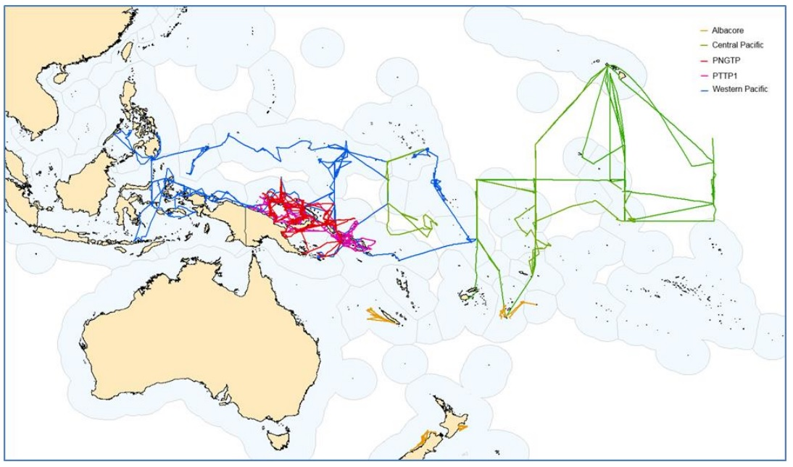
Figure PTTP-1. Tagging vessel tracks for all cruises for all PTTP research voyages to date. Legend relates to the operational areas described in Table 1 in SC13-RP-PTTP-02.

- This Pacific Tuna Tagging Programme (PTTP) report provides background on the PTTP to date, and covers the tagging activities undertaken in 2016-17 under the banner of the PTTP including research voyages, tag recoveries and tag seeding activities, and tagging related analyses. Issues arising in 2017 for PTTP steering committee consideration are highlighted. The PTTP work planned for 2017-2020 is outlined and an agenda for the 2017 meeting of the PTTP steering committee is provided.

- On behalf of FFA members, PNG acknowledged the valuable data provided through Pacific Tuna Tagging Programmes, and noted that tuna tagging data were likely to become even more important as WCPFC begins to tackle questions of connectivity and migration between different areas. Therefore, FFA members supported the PTTP and the SPC-recommended workplan for 2017-2020, which was recommended to the Commission by SC12. They urged that opportunities continue to be made available for the participation of local scientists when possible to benefit from such tagging work (from tagging fish, data processing & analyses and reporting) as part of the important work of regional capacity building. In recognizing the importance of the tagging work and increasing difficulties of securing appropriate commercial vessels from which to conduct the work, FFA members also supported, in principle, the proposed study to evaluate the cost of acquiring a dedicated tuna research vessel versus the continued use of charter vessels for this tagging work.

- Australia noted that there had been a decrease in funding for the PTTP in recent years and asked for further information on the level of tagging release numbers in recent years compared to the release numbers when funding has been higher. They also asked about whether there was a spatial design on where tag releases occurred. P. Williams noted that since the large scale pole and line tagging release program that ended in 2013, releases of around 34,400, primarily via the bigeye tuna longliner had continued. 10,000-20000 tagging release was planned for the forthcoming cruise for pole and line. With respect to spatial releases, SPC said that due to logistical reasons it attempted to maintain some consistency in tag release areas within funding available, but advised that there was a research project currently underway using simulation analyses which will provide some evaluation of the effectiveness of the current spatial design and guidance for improving the spatial design, if needed, in future years.

- Korea reported that it had willingly supported this very important project over the past years and hoped to continue some support beyond 2018.

- J. Hampton reported on the outcomes of the Pacific Tuna Tagging Programme (PTTP) Steering Committee meeting, held on 10 August 2017 (SC13-RP-PTTP-01). Over the past year, the PTTP has conducted a successful tagging cruise, CP12, tagging primarily bigeye tuna in the vicinity of drifting FADs in and around the high seas pocket bordering FSM, RMI, Nauru, Kiribati, Tuvalu, Solomon Islands and PNG and continued to acquire, process and analyse tag-return data, including their incorporation into recent stock assessments of skipjack, bigeye and yellowfin tuna.

- The PTTP Steering Committee adopted a work plan for 2017-2010, which consists of two tagging cruises targeting skipjack and yellowfin (in 2017 and 2019) and bigeye tuna (in 2018 and 2020). The work plan also includes continued tag recovery, tag-return data verification, analysis and modelling (including use of a new simulator to test tag-release designs) and, subject to funding, conducting a study to assess the cost-effectiveness of acquiring and running a dedicated tagging vessel.

- The Scientific Committee endorsed the PTTP work plan for 2017-2020, and supported:
- the PTTP as part of the ongoing work of the SC;
- efforts to identify sustainable financing of the PTTP, through a combination of WCPFC budget support to the extent possible and voluntary contributions from WCPFC members or other stakeholders; and
- an assessment of the cost-effectiveness of acquiring and running a dedicated tagging vessel.

7.3 ABNJ (Common Oceans) Tuna Project – Shark and Bycatch Components

- S. Clarke presented SC13- RP-ABNJ-01 Update on the Common Oceans (ABNJ) Tuna Project’s Shark and Bycatch Components 2016-2017. S. Clarke also referred delegates to SC13-EB-IP-14 which reported on the outcomes of two Regional Seabird Bycatch Pre-assessment Workshops held in early 2017, and planned a data preparation workshop.

- Australia thanked the presenter and the WCPFC and FAO team involved in the ABNJ Tuna Project for their work on sharks and sea turtles, and appreciated the opportunity to understand that the project also contained governance and illegal fishing components not led by the WCPFC.

- The EU echoed these comments and thanked the project for its contributions to bycatch issues.

- The USA noted that the ABNJ Tuna Project had had a productive year, highlighting in particular the sea turtle workshop which compiled what is probably the largest dataset of its kind in the world, as well as the good results of the bigeye thresher and porbeagle shark assessments.

- Fiji also thanked the ABNJ Tuna Project team and looked forward to initiation of the shark post-release mortality tagging program planned to be launched in Fiji soon.

- New Caledonia noted that sharks are top predators that the ocean needs to regulate the health of fish stock we fish all together. Moreover, shark is a very important component of the ancestral Melanesian, Oceanian and Micronesian culture. We need maintain a healthy population of shark in our waters, it is our responsibility, and it is the responsibility for all of us. On these considerations, in 2008 New Caledonia fishermen took their responsibility by stopping shark fishing, followed by the government of New Caledonia that officially banned shark fishing in its EEZ in 2013. At present time, shark fishing and trading is definitely banned in New Caledonia, including territorial and inside lagoon waters. By the creation of the natural park of the coral sea, New Caledonia stakeholders, population of New Caledonia and NGO work together to maintain the exceptional level of biodiversity of this vast area. Data’s collected by the observer programme show that the main shark species caught by our longline fisheries is the blue shark and that about 85% of shark catches are released alive. However, the level of mortality of post released shark stand as an issue. It is the reason why New Caledonia would like to express its interest to participate and to contribute to the post release shark mortality programme. The ABNJ Tuna Project, in its report of the expert workshop on shark release mortality tagging studies, encourages the implementation of complementary studies regarding blue shark. On this consideration, the NC fishery department would like to engage discussions with the programme manager and SPC technical staffs to study on how to implement a tagging campaign in 2019 in the EEZ of NC.

- WWF, Birdlife International, the Sustainable Fisheries Partnership and Greenpeace expressed appreciation to those engaged in the delivery of the Common Oceans (ABNJ) Tuna Project, a project that is providing vital support to the Commission in the provision of much needed technical expertise and advice. They noted that it was evident that the Commission greatly benefited from the input from the ABNJ project, which both supplements and incorporates the excellent work of SPC while simultaneously sharing the burden of providing high quality scientific advice. The ABNJ project has provided the Commission with opportunities to lead on issues that are their responsibility, such as bycatch issues on sharks, rays, turtles and birds, but the outputs of the project will also allow CCM’s to fulfil national and international conservation and management objectives for bycatch species, such as certification of fisheries within the MSC process or complying with existing CITES obligations. WWF urged the Scientific Committee to recommend that the Commission consider options in how to effectively continue the excellent groundwork on bycatch issues that have been a direct result of the Common Oceans project.

7.4 WCPFC Tissue Bank (Project 35b)

- N. Smith presented SC13-RP-P35-01 Project 35: Bigeye biology, Project 35b: WCPFC Tuna Tissue Bank and SC13-RP-P35b-02 Development of a Pacific Community Marine Specimen Bank. N. Smith noted that a key result in a busy and productive year was the completion of the bigeye tuna age and growth analyses as reported in Farley et al. (2017), an important new input to the stock assessment for bigeye in 2017. The Tuna Tissue Bank (TTB) was an important supporting component of the WCPFC science system and continues to be developed and enhanced. A substantive development in 2017 has been the redevelopment of the Biological Data System underpinning the TTB, and the relaunch of the associated web portal (www.spc.int/ofp/PacificSpecimenBank). An important activity in 2016-17 was a quality assurance test for use of samples in modern genetic analyses, the result of which was positive. The outstanding support from the people of PICTs in collecting, storing and transporting specimens for the TTB – at-sea and onshore – is at the core of its success.

- Recommendations arising from the Tuna Tissue Bank project this last year include:
  - regular age, growth and maturity analyses of specimens for all tuna and tuna-like stocks for future stock assessments should be budgeted for and aligned with the stock assessment schedule, noting that additional resources would be required, and that yellowfin tuna would be the next priority species;
  - as the WCPFC Tuna Tissue bank is intended to be ongoing, and given its success and measured quality to date, incorporate the identified budget into the 2019-20 indicative budgets;
  - that interested CCMs visit the Tuna Tissue Bank web-portal and provide any feedback intersessionally to SPC; and
  - the development and implementation of a multi-level login to the web portal to enhance access for those planning research.

- The Scientific Committee confirmed that maintaining and enhancing the WCPFC Tuna Tissue Bank (P35b) remains an essential part of the WCPFC science system and supported its inclusion in the proposed budget for 2018.

- The Scientific Committee agreed to include the WCPFC Tuna Tissue Bank (P35b) in its indicative budget for 2019-20.

- The Scientific Committee agreed the development and implementation of a multi-level login to the web portal which would allow greater access to Tuna Tissue Bank data for those planning research.

- On behalf of FFA members, Tonga thanked SPC for the paper, and acknowledged the invaluable contribution that observers and port samplers provide to the tissue bank. FFA members fully support the continued operation and maintenance of Project 35b, and the advancements it has made in addressing key biological uncertainties in stock assessments, notably bigeye. FFA members support having regular age and growth analyses and aligning these with the stock assessment schedule, a logical approach for prioritising this work. This must also be kept in mind when the WCPFC Research Sub-Committee considers requests for withdrawal of samples from the tissue bank. The suggested inclusion of USD 97,250 in the indicative budget for 2019 and 2020 to maintain the tissue bank is supported by FFA members. This is important in the context of the investment that has gone in to establishing and maintaining sampling regimes, transport and storage of samples, but also in the benefits derived from this project and improvements to the scientific outputs from related work. However, while we note that some charging is included in the protocols for extraction, we request that the Secretariat investigate further mechanisms for cost-recovery and long term sustainability of this project.

- China noted that this work was extremely important and hoped that the development of the data observation protocols would allow China to share tuna biology studies currently only published in Chinese.

- SC13 supported the recommendations.

7.5 Other Projects

- S. Soh (Secretariat) referred delegates to SC13-GN-WP-04 Intersessional activities of the SC Rev 1 for a report on other science projects undertaken since SC12. S. Soh noted that members and observers of the Commission had also voluntarily provided funding support for scientific work of the Commission. EU had made available approx. USD 1 million for various research projects including simulation testing of reference points, estimation of post-release mortality of sharks in longline fisheries and bigeye/yellowfin juvenile bycatch mitigation. The second 5-year programme of the Korean government to support the SPC’s Pacific Tuna Tagging Project started in 2014, providing about USD 170,000 per year. Over the last year, the International Seafood Sustainability Foundation and the Western Pacific Regional Fishery Management Council have supported the Expert Consultation Workshop on Management Strategy Evaluation and the spatial longline analyses.

AGENDA ITEM 8 - Cooperation with Other Organisations

- SC13 reviewed the status of cooperation with other organizations.

- The WCPFC Science Manager presented SC13-GN-IP-01 Cooperation with Other Organizations which provided an update on existing and new arrangements. Attention was drawn to the signing of two new memoranda on 5 June 2017 with the Commission for the Conservation of Southern Bluefin Tuna (CCSBT): a Memorandum of Cooperation on the Exchange and Release of Data; and a Memorandum of Cooperation on the Endorsement of WCPFC ROP Observers for Observing Transhipments of Southern Bluefin Tuna on the High Seas of the WCPFC Convention Area with CCSBT.

- The Tuna Compliance Network, an informal network of officers responsible for compliance from the five tuna RFMOs, was established in March 2017 and hosted under the International Monitoring, Control and Surveillance Network (IMCSN) with support from the FAO Common Oceans (ABNJ) Tuna Project. The Tuna Compliance Network provided opportunities for regular dialogue amongst the five tuna RFMO Secretariats on MCS and Compliance matters, and with other MCS/Compliance experts.

AGENDA ITEM 9 - Special Requirements of Developing States and Participating Territories

- WCPFC Assistant Science Manager, T. Beeching presented SC13-RP-JTF-01 Japan Trust Fund Status Report (2017); and SC13-RP-JTF-02 Japan Trust Fund Steering Committee Report; and advised that the JTF fund had appointed W. Tanoue as the Coordinator, and this year the JTF was represented by T. Fujiwara. 2017 was the first extension year of the second phase of the JTF; and WCPFC disbursed USD128,843 to each of four JTF projects in the Cook Islands, Kiribati, and two in Tonga. Compliance and data collection were particular foci of the funding. A JTF steering committee meeting held in the margins of SC13 discussed the status and any challenges of current projects and projects carried over from earlier years. WCPFC circulated a call for project proposals for a second extension year into 2018 with a submission deadline of 30th September 2017. There was a vacancy for a new JTF Committee Island Members, and any SIDS representatives interested in the position were encouraged contact P. Maru (FFA).

- RMI noted the Special Requirements of Developing States and Participating Territories was an important platform on which this Commission must consider the development and delivery of its functions and work. This agenda item provides the opportune moment to reflect on the scientific work that has been considered and undertaken and how this Committee could help to increase the participation of developing States, in particular Small Island Developing States and Territories, in the scientific landscape of WCPO fisheries. It was grateful to CCMs and observer delegations to WCPFC, for supporting SIDS through the various mechanisms under the Commission that provided SIDS the opportunity to improve their scientific capabilities, such as through the Japanese Trust Fund, Chinese-Taipei Trust Fund, the Special Requirements Fund and the ‘Regional Capacity Building Workshops’ budget item. CCMs were encouraged to read CMM 2013-07 the Conservation and Management Measure on the Special Requirements of Small Island Developing States and Territories, and investigate avenues to further assist SIDs, especially for building technical capacity and resources that would support the strengthening of national programmes that feed in to the work of this Committee.

- Samoa, on behalf of FFA members further provided examples of such assistance. Australia, through SPC, funded the Junior Professionals Programme which provided dedicated resourcing to enable Pacific Island scientists the opportunity to study and work on specific research topics relevant to their countries, to learn and be mentored by SPC scientists over the period of a year. The Programme was a great example of providing dedicated resources to up-skill Pacific Islanders allowing them to undertake work to contribute to the scientific capacity of coastal States. In addition, the annual SPC Stock Assessment Workshops and Tuna Data Workshops, continued to support FFA members to understand and interpret some of the more technical details of work presented in this forum. The Commission lacks the framework to facilitate the delivery of support for more effective participation in scientific processes. While FFA members were pleased with the genuine efforts made by some CCMs to enable capacity building across scientific programmes, they noted that CCMs should not pick and choose between which SIDS Special Requirements they want to support through conditional project funding. FFA members again urged CCMs to review CMM 2013-07, and the provisions that highlighted the specific areas of assistance that should be contributed to.

AGENDA ITEM 10 - Future Work Program and Budget

10.1 Review of the Scientific Committee Work Programme

- T. Beeching (Assistant Science Manager) presented SC13-GN-WP-04 Intersessional Activities of the Scientific Committee, which briefed SC13 on the status of the SC12 work programme. In addition to the ongoing data management and other advisory services provided by SPC, the Assistant Science Manager highlighted as specific outputs, the stock assessments for bigeye and yellowfin tuna, and supporting science, notably on the biology and growth of bigeye tuna (Projects 35 and 35b). There was also a stock assessment for swordfish in the southwest pacific. SPC participated in workshops for FAD Management and Joint T-RFMO MSE work. SPC authored or co-authored 49 papers submitted to SC12, (23 of which were working papers), and an additional 4 papers related to ongoing project work for PTTP and Projects 35 and 35b. This work was completed via two main funding routes: the core Service Agreement with SPC and individual project contracts. It was noted that an unobligated budget was not provided for 2016/17. Finally, three science projects supported by EU supplementary funding were detailed.

10.2 Development of the 2018 Work Programme and budget, and projection of 2019-2020 provisional Work Programme and indicative budget

- SC13 noted a recommendation from the Finance and Administration Committee to the Commission (Para 71, FAC9 Summary Report) that “WCPFC12 task SC with carefully considering proposed scientific projects in the context of the indicative budget agreed for the coming year.”

- The Secretariat noted that the proposed SC budget for 2018 represents a 7% increase compared to the 2018 indicative budget and 21% increase compared to the current 2017 SC budget, noting that a large portion of the increase is related to the increase in funding for the tagging project.

- SC13 adopted the proposed budget (Table 1) and forwarded it to the FAC at the December WCPFC meeting.

Table 1. Summary of SC work programme titles and budget for 2018, and indicative budget for 2019–2020, which requires funding from the Commission’s core budget (USD).
Project title | TORs | Essential | Priority / Rank | 2018 | 2019 | 2020
SPC Oceanic Fisheries Programme Budget |  | Yes |  | 888,624 | 906,396 | 924,524
SPC – Additional resourcing |  | Yes |  | 163,200 | 164,832 | 166,480
Project 35b. Maintenance and enhancement of the WCPFC Tissue Bank | Annexed | Yes | High | 97,200 | 97,200 | 97,200
Project 42 Pacific Tuna Tagging Program | Annexed | Yes | High | 500,000 | 650,000 | 690,000
Project 57. Identifying appropriate LRPs for elasmobranchs within the WCPFC | Annexed |  | High | 25,000 | 0 | 0
Project 60: Improving purse seine species composition | Annexed |  | Medium / 1 |  | 40,000 | 40,000
Project 68. Estimation of seabird mortality across the WCPO Convention area | Annexed |  | High | 22,500 | 17,500
Project 81. Further work on bigeye tuna age and growth | Annexed | Yes | High/1 | 30,000
Project 82. Yellowfin tuna age and growth | Annexed | ? | High/2 | 100,000 | 85,000
Project 83. Investigating the potential for a WCPFC tag vessel | Annexed | No | Medium | 62,500
Project 88. Acoustic FAD analyses | Annexed | No | Medium |  | 120,000 | 72,000
Project 90. Better data on fish weights and lengths for scientific analyses | Annexed |  | High |  | 40,000 | 20,000
Unobligated (Contingency) Budget |  |  |  | 0 | 83,000 | 83,000
SC13 TOTAL BUDGET |  |  |  | 1,889,024 | 2,203,928 | 2,093,205

- Detailed description of SC13 work programme, budget and terms of reference for each project are in Attachment J.

AGENDA ITEM 11 - Administrative Matters

11.1 Future operation of the Scientific Committee

- SC13 adopted a revised version of the Guidelines for the SC Chair and Theme Conveners (SC13-GN-IP-03), which was originally adopted at SC8.

11.2 Election of Officers of the Scientific Committee

- SC13 considered nominations for SC Chair, SC Vice-Chair and theme conveners, noting that the SC Chair and Vice-Chair at SC13 would not be available to assume those roles again at SC14. The theme convenors and co-convenors reconfirmed their availability for SC14, but no nominations were made for the SC Chair and SC Vice-Chair roles. Members were asked to further consider potential nominations in the intersessional period.

11.3 Next meeting

- SC13 confirmed that SC14 would be held in Busan, Korea, during 8 – 16 August 2018, and proposed that SC15 in 2019 be held in Samoa.

AGENDA ITEM 12 - Other Matters

- No issues were raised under this agenda item.

AGENDA ITEM 13 - Adoption of the Summary Report of the Thirteenth Regular Session Of The Scientific Committee

- SC13 adopted the recommendations of the Thirteenth Regular Session of the Scientific Committee. The SC13 Summary Report will be adopted intersessionally according to the following schedule:

Due by | Activity
28 August | Receive draft report from rapporteurs
4 September | Secretariat clean and send the draft report to theme conveners
11 September | Theme convenors return the report back to the Secretariat
13 September | The Secretariat distributes the draft report to all CCMs and Observers by email (DRAFT version post on SC13 website)
25 October | Deadline for the submission of comments from CCMs and Observers

- Responding to Japan’s queries, the Executive Director noted that relevant recommendations from SC13 would be provided to the upcoming Intersessional Meeting to progress the draft Bridging CMM on Tropical Tuna (22 – 24 August 2017, Honolulu).

AGENDA ITEM 14 – Close of the Meeting

- On behalf of the Government of the Cook Islands, Secretary of MMR B. Ponia provided his closing remarks. On behalf of the meeting, EU appreciated all hospitalities of the Cook Islands, SC Chair for her leadership and the Secretariat for meeting arrangements. The SC Chair B. Muller gave her final remarks as SC Chair and Fiji offered a closing prayer.

- The meeting closed at 6.00pm on Thursday 17 August 2017.

Attachment A

The Commission for the Conservation and Management of
Highly Migratory Fish Stocks in the Western and Central Pacific Ocean
Scientific Committee
Thirteenth Regular Session
Rarotonga, Cook Islands
9 - 17 August 2017
List of Participants

CHAIRMAN

Berry Muller
SC Chair
Marshall Islands Marine Resources Authority (MIMRA)
P.O. Box 860 Marshall Islands, Majuro MH 96960
bmuller@mimra.com

AUSTRALIA

James Larcombe
Senior Scientist
Department of Agriculture and Water
+61 415084514
james.larcombe@agriculture.gov.au

Robert Campbell
Senior Fisheries Scientist
CSIRO
Private Bag No. 1
Aspendale, VIC, Australia
+61 3 9239 4681
Robert.Campbell@csiro.au

Jessica Farley
Fisheries Scientist
CSIRO
GPO Box 1538, Hobart, Tasmania 7001 Australia
+61 407255524
jessica.farley@csiro.au

Karen Evans
Senior Research Scientist
CSIRO Oceans and Atmosphere
GPO Box 1538, Hobart, Tasmania 7001, Australia
karen.evans@csiro.au

Don Bromhead
Manager - Tropical Tuna Fisheries
Australian Fisheries Management Authority
Don.Bromhead@afma.gov.au

CHINA

Xiaojie Dai
Professor
Shanghai Ocean University
8615692165351
xjdai@shou.edu.cn

Xiaobing Liu
Professor
Shanghai Ocean University
xiaobing.liu@hotmail.com

Jiangfeng Zhu
Associate Professor
Shanghai Ocean University
jfzhu@shou.edu.cn

Jintao Wang
Lecturer
Shanghai Ocean University
jtwang@shou.edu.cn

Liuxiong Xu
Professor
Shanghai Ocean University
lxxu@shou.edu.cn

Yong Chen
Professor
Shanghai Ocean University
y chen @shou.edu.cn

Wang Shigang
Overseas Project Manager
Ping Tai Rong Ocean Fishery Group Co.,Ltd.
matthewwang@ptrcn.com

COOK ISLANDS

Marino Wichman
Senior Fisheries Officer
Ministry of Marine Resources
PO Box 85 Avarua, Rarotonga
+682 28721
M.Wichman@mmr.gov.ck

Lara Ainley
Senior Ecologist
Ministry of Marine Resources
PO Box 85 Avarua, Rarotonga
+682 28721

Ben Ponia
Secretary
Ministry of Marine Resources
PO Box 85 Avarua, Rarotonga
+682 28721
b.ponia@mmr.gov.ck

Timothy Costelloe
Director of Offshore Division
Ministry of Marine Resources
PO Box 85 Avarua, Rarotonga
+682 28721
t.costelloe@mmr.gov.ck

Sonny Tatuava
Senior Fisheries Officer
Ministry of Marine Resources
PO Box 85 Avarua, Rarotonga
+682 28721
statuava@mmr.gov.ck

Alex Herman
Crown Counsel
Crown Law Office

Varanisese Bulabalavu
Policy & Legal Officer

Jacqui Evans
Marae Moana Project Manager
Office of the Prime Minister
Avarua, Rarotonga, Cook Islands
+68225494
m.wichman@mmr.gov.ck

Jessica Cramp
Shark Researcher
James Cook University
m.wichman@mmr.gov.ck

Helen Greig
Communications Officer
Ministry of Marine Resources
m.wichman@mmr.gov.ck

Jim Armistead
Director Pacific
Ministry of Foreign Affairs
m.wichman@mmr.gov.ck

Josh Mitchell
Director UN and Treaties
Ministry of Foreign Affairs
m.wichman@mmr.gov.ck

Latishia Maui
Ministry of Marine Resources
L.Maui@mmr.gov.ck

Uirangi Bishop
Ministry of Marine Resources
U.Bishop@mmr.gov.ck

David James
Solicitor-General

Vaitoti Tupa
Consultant
vaitoti@oyster.net.ck

George Matutu
Director
Corporate Services Division
Ministry of Marine Resources, Government of the Cook Islands
+682 28 721
G.Matutu@mmr.gov.ck

Koroa Raumea
Director - Inshore & Fisheries
Ministry of Marine Resources
Avarua, Rarotonga, Cook Islands
682-28730
k.raumea@mmr.gov.ck

John Tini
Chartered Accountant
John Tini & Associates
Titikaveka
+682-20875
whiz@johntini.co.ck

Alex Napa
Consultant
Alexander Napa Consultancy
Tupapa, Rarotonga
77515
alexn@alexandernapa.com

EUROPEAN UNION

Stamatios Varsamos
Scientific officer
European Commission
stamatios.varsamos@ec.europa.eu

Francisco J. Abascal
Fisheries Scientist
Spanish Institute of Oceanography
Dársena Pesquera PCL 8. Santa Cruz de Tenerife. Spain
+34 922549400
francisco.abascal@ca.ieo.es

Josu Santiago
Head of Tuna Research Area
AZTI
Txatxarramendi ugartea, 48395 Sukarrieta, Spain
+34 664303631
jsantiago@azti.es

Miguel Herrera
Deputy Manager
C/ Ayala 54 2A
OPAGAC (Producers' Organization of Large Tuna Freezers, Spain)
914314857
Miguel.herrera@opagac.org

Helena Delgado Nordmann
Scientific Advisor
Satlink S.L.
Avenida de la Industria, 53. Alcobendas - Madrid- Spain
34913272131
hdn@satlink.es

Javier de la Cal
Regional Sales Manager
Satlink S.L.
Avenida de la Industria, 53. Alcobendas - Madrid- Spain
34913272131
jdc@satlink.es

FEDERATED STATES OF MICRONESIA

Naiten Bradley Phillip Jr.
Chief, Research Division
National Oceanic Resource Management Authority
bradley.phillip@norma.fm

Derek Pelep
EMER Coordinator
NORMA
PS 122 Palikir, Pohnpei FM 96941
691-320-2768
derek.pelep@norma.fm

FIJI

Aisake Batibasaga
Director Fisheries
Ministry of Fisheries
PO Box 2218 Suva, Fiji
abatibasaga@gmail.com

Leba Dranivesi
Fisheries Officer
Ministry of Fisheries
PO Box 2218 Suva, Fiji
dranivesi.leba@gmail.com

INDONESIA

Fayakun Satria
Head of Research Institute for Marine Fisheries
Ministry of Marine Affairs and Fisheries
fsatria70@gmail.com

Lilis Sadiyah
Center for Fisheries Research
Ministry of Marine Affairs and Fisheries
sadiyah.lilis2@gmail.com

JAPAN

Shuya Nakatsuka
Head, Pacific Bluefin Resources Group
National Research Institute of Far Seas Fisheries
snakatsuka@affrc.go.jp

Kazuhiro Oshima
Head, Ecologically Related Species Group
National Research Institute of Far Seas Fisheries
5-7-1 Orido, Shimizu, Shizuoka, Japan
+81-54-336-6047
oshimaka@affrc.go.jp

Daisuke Ochi
Researcher
National Research Institute of Far Seas Fisheries
5-7-1 Orido, Shimizu, Shizuoka, 424-8633
+81-59-336-6047
otthii@affrc.go.jp

Hidetada Kiyofuji
Skipjack and Albacore Group
National Research Institute of Far Seas Fisheries
5-7-1 Orido Shimizu Shizuoka JAPAN
+81-54-336-6043
hkiyofuj@affrc.go.jp

Hiroaki Okamoto
Director, Bluefin Tuna Resources Department
National Research Institute of Far Seas Fisheries
5-7-1 Orido, Shimizu, Sizuoka 4248633, Japan
+81-54-336-6000
okamoto@affrc.go.jp

Hiroshi Nishida
Director, Tuna and Skipjack Resources Department
National Research Institute of Far Seas Fisheries, Fisheries Research and Education Agency
5-7-1 Orido, Shimizu, Shizuoka, JAPAN
+81-54-336-6042
hnishi@fra.affrc.go.jp

Hirotaka Ijima
Researcher
National Research Institute of Far Seas Fisheries
ijima@affrc.go.jp

Keisuke Satoh
Head, Tuna Fisheries Resources Group
National Research Institute of Far Seas Fisheries
5-7-1 Orido, Shimizu, Shizuoka, 424-8638, Japan
+81-543-36-6044
kstu21@fra.affrc.go.jp

Koji Uosaki
Skipjack and Tuna Resources Devision
National Research Institute of Far Seas Fisheries
5-7-1, Orido, Shimizu-ku, Shizuoka, 4248633 Japan
+81-54-336-6052
uosaki@affrc.go.jp

Mikihiko Kai
Tuna resource group
national research institute of far seas fisheries
5-7-1 orido shimizu shizuoka Japan
kaim@affrc.go.jp

Takahiro Fujiwara
Section Chief, International Affairs Division
Fisheries Agency of Japan
1-2-1 Kasumigaseki, Chiyoda-ku, Tokyo, JAPAN
+81-3-3502-8459
takahiro_fujiwara550@maff.go.jp

Takayuki Matsumoto
Research Coordinator for Oceanography and Resources
National Research Institute of Far Seas Fisheries
5-7-1, Orido Shimizu, Shizuoka, 424-8633, JAPAN
81-54-336-6000
matumot@affrc.go.jp

Toru Kitamura
Sub Leader
Japan Nus Co., LTD.
Nishi-Shinjuku Kimuraya Building 5F 7-5-25 Nishi-Shinjuku, Shinjuku-ku, Tokyo 160-0023 JAPAN
81-3-5925-6806
tkitamura@janus.co.jp

Yohei Tsukahara
Researcher
National Research Institute of Far Seas Fisheries
5-7-1 Orido, Shimizu ward, Shizuoka city, Shizuoka prefecture
+81-54-336-6000
tsukahara_y@affrc.go.jp

Yoshihiro Notomi
Managing Director
National Offshore Tuna Fisheries Association of Japan
1-3-1, uchikanda, chiyoda-ku, tokyo, japan
+81-3-3295-3721
notomi@kinkatsukyo.or.jp

Yuji Uozumi
visiting scientist
National Research Institute of Far Seas Fisheries FRA Japan
5-7-1 Orido Shimizu Shizuoka Japan
81-54-336-6000
uozumi@japantuna.or.jp

Yumi Okochi
Staff
Japan Nus Co., LTD.
Nishi-Shinjuku Kimuraya Building 5F 7-5-25 Nishi-Shinjuku, Shinjuku-ku, Tokyo 160-0023 JAPAN
81-3-5925-6806
okochi-y@janus.co.jp

Yoshinori Aoki
Researcher
Japan Fisheries Research and Education Agency
5-7-1, Orido, Shimizu, Shizuoka, 424-8633 Japan
81-54-336-6044
aokiyoshinori@affrc.go.jp

Akihito Fukuyama
Executive Secretary
Japan Far Seas Purse Seine Fishing Association
14-10 Ginza 1 Chome, Chuo-ku, Tokyo 104-0061, JAPAN
+81-3-3564-2315
fukuyama@kaimaki.or.jp

KIRIBATI

Kaon Tiamere
Licence Officer
Ministry of Fisheries & Marine Resource Development
P.O. Box 64 Bairiki, Tarawa, Republic of Kiribati
(686) 21099
kaont@mfmrd.gov.ki

Patrick Itara
Assistance Compliance officer
LCD (Licence & Compliance Division) MFMRD
Bairiki Tarawa
73002821/21099
maplov12@gmail.com

REPUBLIC OF KOREA

Doo Nam Kim
Researcher
National Institute of Fisheries Science
216, Gijanghaean-ro, Gijang-eup, Gijang-gun, Busan, 46083
+82-51-720-2330
doonamkim1@gmail.com

Sung Il Lee
Researcher
National Institute of Fisheries Science
216, Gijanghaean-ro, Gijang-eup, Gijang-gun, Busan, 46083
+82-51-720-2331
k.sungillee@gmail.com

Bongjun Choi
Assistant Manger
Korea Overseas Fisheries Association
bj@kosfa.org

Chun Woo Lee
Professor
Pkyong National University
Division of Marine Production System Management, Pukyong National University, 45 Yongso-ro, Busan 48513, Korea.
+82 10 7399 9743
cwlee@pknu.ac.kr

Jay Lee
jhlee33@dongwon.com

Joseph Choi
joseph.choi@dongwon.co

Sung Chul Kim
sancho@sla.co.kr

Ducklim Kim
Senior Staff
Sajo Industries Co., Ltd
+8210-4057-2052
liam@sajo.co.kr

REPUBLIC OF THE MARSHALL ISLANDS

Mark Beau Bigler
Assistant MCS Officer
MIMRA
P.O Box 860 Delap, Majuro MH 96960
692-625-8262
bbigler@mimra.com

NAURU

Karlick Agir
Catch Data Officer
Nauru Fisheries and Marine Resources Authority
Anibare District, Republic of Nauru
+674 557 3733
k.agir1957@gmail.com

Ace Capelle
Senior Observer Coordinator
Nauru Fisheries and Marine Resources Authority
Fisheries Complex, Anibare District, Nauru
+674-557-3911
AIDA_11@hotmail.com

Camalus Reiyetsi
Senior Oceanic Fisheries Officer
Nauru Fisheries and Marine Resources Authority (NFMRA)
Uaboe District
+674 557 3733
camalus.reiyetsi@gmail.com

Jonas Calvin Star
Technical Services Officer
NFMRA
Meneng District, Nauru
+6745568505
jonas.star@hotmail.com

Gabriel Ika
Board Director
Nauru Fisheries and Marine Resources Authority
Anibare District, Nauru
+6745573350
sdreiyetsi@gmail.com

NEW ZEALAND

John Annala
Principal Scientist
New Zealand Ministry for Primary Industries
25 The Terrace, Wellington, New Zealand
644-819-4718
John.Annala@mpi.govt.nz

Andy Smith
Operations Manager
Talleys Group Nelson
267 Akersten st maitai wharf port Nelson New Zealand
+ 64 21337756
andy.smith@talleys.co.nz

Arthur Hore
Manager Offshore Fisheries
New Zealand Ministry for Primary Industries
608 Rosebank Road, Auckland, New Zealand
649-829-7686
Arthur.Hore@mpi.govt.nz

Joanna Anderson
Development Manager - Fisheries
New Zealand Ministry of Foreign Affairs and Trade
Private Bag 18-901, Wellington 6160, NZ
+64 4 439 7153
Joanna.Anderson@mfat.govt.nz

NIUE

Brendon Pasisi
brendon.pasisi@mail.gov.nu

PALAU

Kathleen Sisior
Fisheries Licensing/Revenue Officer II
Ministry of Natural Resources, Environment and Tourism
No.1 Street Peched
4884938
utau.sisior@gmail.com

Craig Heberer
Deputy Director - IndoPacific Tuna Program
The Nature Conservancy
502 W Broadway, Suite 1350, San Diego, California, USA, 92101
011-760-805-5984
craig.heberer@tnc.org

David Itano
Fisheries Consultant
689 Kaumakani St, Honoluul, Hawaii, USA 96825
+1 808 387 5430
daveitano@gmail.com

PAPUA NEW GUINEA

Leban Gisawa
Executive Manager - Fisheries Management
PNG National Fisheries Authority
11th Floor Deloitte Tower, Douglas Street P.O.ox 2016, Port Moresby, NCD. Papua New Guinea
+675 3090444
lgisawa@fisheries.gov.pg

Thomas Usu
Scientific Officer - Tuna Fishery
PNG National Fisheries Authority
11th Floor Deloitte Tower, Douglas Street P.O. Box 2016, Port Moresby, NCD Papua New Guinea
+675 3090444
tusu@fisheries.gov.pg

Philip Polon
Deputy Managing Director
PNG National Fisheries Authority
11th Floor Deloitte Tower, Douglas Street P.O. Box 2016, Port Moresby, NCD Papua New Guinea
+675 3090444
ppolon@fisheries.gov.pg

PHILIPPINES

Rafael Ramiscal
Superivsing Aquaculturist and OIC, Capture Fisheries Division
Bureau of Fisheries and Aquatic Resources (BFAR)
PCA Compound, Elliptical Road, Diliman, Quezon City
929-9597
rv_ram55@yahoo.com

Elaine Garvilles
Aquaculturist II
Bureau of Fisheries and Aquatic Resources (BFAR)
PCA Compound, Elliptical Road, Diliman, Quezon City
929-9597
egarvilles@yahoo.com

Rosanna Bernadette Contreras
Executive Director
Socsksargen Federation of Fishing and Allied Industries, Inc.
Mezzanine Floor Market 3 Hall, General Santos Fish Port Complex, Tambler, General Santos City, Philippines
+63 83 5529736
fishing.federation@gmail.com

SAMOA

Ueta Faasili Jr.
Principal Fisheries Officer
Ministry of Agriculture and Fisheries
'ueta.faasili@maf.gov.ws'

SOLOMON ISLANDS

Francis Tofuakalo
Deputy Director Offshore Fisheries
Solomon Islands Ministry of Fisheries and Marine Resources
P.O.Box G2, Kukum Highway, Honiara, Solomon Islands
(677) 39143
ftofuakalo@fisheries.gov.sb

Leon Hickie
Principle Fisheries Officer
Ministry of Fisheries and Marine Resources
P.O Box G2, Honiara, Solomon Islands
677 39139
lhickie@fisheries.gov.sb

Ellison Mason
Chief Desk Officer
Ministry of Foreign Affairs and External Trade, Regional Economic Cooperation Branch
P.O. Box G10 865
677 21250, 21251
ellisonmason1@gmail.com; ellison.mason@mfaet.gov.sb

CHINESE TAIPEI

Hsiang-Yi Yu
Associate Specialist
Fisheries Agency, Council of Agriculture
8F., No.100, Sec. 2, Heping W. Rd., Zhongzheng Dist., Taipei City 10070, Taiwan
886-2-23835879
hsiangyi@ms1.fa.gov.tw

Hung-I Liu
Fisheries Statistician
Overseas Fisheries Development Council
3F., No. 14, Wenzhou St., Taipei 10648, Taiwan
+886-2-23680889 ext. 124
luoe@ofdc.org.tw

Ren-Fen Wu
Director of Information Division
Overseas Fisheries Development Council
3F., No. 14, Wenzhou St., Taipei 10648, Taiwan
+886-2-23680889 ext. 118
fan@ofdc.org.tw

Shui-Kai Chang
Professor
National Sun Yat-sen University
No. 70, Lienhai Rd., Kaohsiung 80424, Taiwan
+886-7-5252000 ext. 5303
skchang@faculty.nsysu.edu.tw

TONGA

Tuikolongahau Halafihi
CEO, Ministry of Fisheries
Ministry of Fisheries
Nuku'alofa, Tonga
21-399
supi64t@gmail.com

Siola'a Malimali
Deputy CEO - Fisheries Science Division
Ministry of Fisheries
Ministry of Fisheries, P.O.Box 871, Nuku'alofa, Tonga
676 21399
s.malimali@tongafish.gov.to

Lavinia Vaipuna
Computer Progrmmer/Incharge of Offshore Section
Ministry of Fisheries
Ministry of Fisheries, P.O.Box 871, Nuku'alofa, Tonga
676 21399
laviniav@tongafish.gov.to

TUVALU

Siouala Malua
Senior Fisheries Officer - Licensing & Data
vaitulu.tupz@gmail.com; sioualam@tuvalufisheries.tv

UNITED STATES OF AMERICA

Keith Bigelow
Fisheries Biologist
NOAA PIFSC
NOAA IRC NMFS/ PIFSC, 1845 Wasp Blvd., Bldg 176, Honolulu, HI 96818
808 725 5388
keith.bigelow@noaa.gov

Jon Brodziak
Fisheries Biologist
NOAA PIFSC
NOAA IRC NMFS/ PIFSC, 1845 Wasp Blvd., Bldg 176, Honolulu, HI 96818
808 725 5617
jon.brodziak@noaa.gov

Felipe Carvalho
Research Mathematical Statistician
NOAA PIFSC
NOAA IRC NMFS/ PIFSC, 1845 Wasp Blvd., Bldg 176, Honolulu, HI 96818
808 725 5605
felipe.carvalho@noaa.gov

Valerie Post
Fishery Policy Analyst
NOAA PIRO
NOAA IRC NMFS/ PIRO, 1845 Wasp Blvd., Bldg 176, Honolulu, HI 96818
808 725 5034
valerie.post@noaa.gov

Daniel Curran
Fisheries Biologist
NOAA PIFSC
NOAA IRC NMFS/ PIFSC, 1845 Wasp Blvd., Bldg 176, Honolulu, HI 96818
808 725 5382
daniel.curran@noaa.gov

Melanie Hutchinson
Marine Researcher
JIMAR UH
NOAA IRC NMFS/ PIFSC, 1845 Wasp Blvd., Bldg 176, Honolulu, HI 96818
808 725 5362
melanie.hutchinson@noaa.gov

Eric Kingma
Intl. Fisheries, NEPA, Enforcement Coord.
WPFMC
1164 Bishop St., Ste. 1400, Honolulu, HI 96813
808 522 8141
eric.kingma@wpcouncil.org

Steven Teo
Fisheries Biologist
NOAA SWFSC
8901 La Jolla Shores Drive, La Jolla, CA 92037, USA
858 546 7179
steve.teo@noaa.gov

Randi Thomas
Consultant
American Tunaboat Association
One Tuna Lane, San Diego, CA 92101
410 303 6048
rthomas@rptadvisors.com

VANUATU

Tony Taleo
Principal Data Officer
Vanuatu Fisheries
PMB 9045 Port Vila, Vanuatu
Mob: (678) 5463595; Work (678) 23119
ttaleo@vanuatu.gov.vu

PARTICIPATING TERRITORIES

AMERICAN SAMOA

Domingo Ochavillo
ochavill@gmail.com

FRENCH POLYNESIA

Soehnlen Marie
Fisheries Officer
Direction des ressources marines et minières (Marine and Mining Resources Authority)
BP 20 - 98713 Papeete Tahiti French Polynesia
+689 40 502550
marie.soehnlen@drm.gov.pf

NEW CALEDONIA

Manuel Ducrocq
Deputy Head
Fishery and Environment Department Maritime Affairs
2 bis rue felix russeil 98845 Noumea,
New Caledonia
+687 270693
manuel.ducrocq@gouv.nc

TOKELAU

Feleti Tulafono
Offshore Fisheries Officer
EDNRE
Fakaofo, Tokelau
+690 23113 / 23134
ftulafono@gmail.com

COOPERATING NON MEMBER

VIETNAM

Pham Viet Anh
Directorate of Fisheries
Ministry of Agriculture and Rural Development
+84 4377 5082
phvietanh2003@gmail.com

Vu Viet Ha
Research Institute for Marine Fisheries (RIMF)
Ministry of Agriculture and Rural Development
+84 2253 500885
havuviet@gmail.com

OBSERVERS

AMERICAN TUNABOAT ASSOCIATION (ATA)

Raymond Clarke
Vice President
South Pacific Tuna cORP
808-722-0486
rclarke@sopactuna.com

BIRD LIFE INTERNATIONAL

Karen Baird
Regional Coordinator Oceania, BirdLife International Marine Programme
BirdLife International
400 Leigh Road, RD 5
+64 9 4226868
k.baird@forestandbird.org.nz

Liam Kokaua
Project Officer
BirdLife
PO Box 649, Avarua, Rarotonga, Cook Islands
+682 21144
l.kokaua@tiscookislands.org

Kelvin Passfield
Technical Director
Te Ipukarea Society (Birdlife International Cook Islands partner)
PO Box 649, Rarotonga, Cook Islands
682 21144
k.passfield@tiscookislands.org

Alanna Smith
Project Officer
Te Ipukarea Society
PO Box 649 Rarotonga Cook Islands
+(682)21144
a.smith@tiscookislands.org

PACIFIC ISLANDS FORUM FISHERIES AGENCY (FFA)

Wez Norris
Deputy Director-General
Pacific Islands Forum Fisheries Agency
1 FFA Road, West Kola'a Ridge, PO Box 629, Honiara, Solomon Islands
+677 21124
wez.norris@ffa.int

Tim Adams
Director Fisheries Management
Pacific Islands Forum Fisheries Agency
1 FFA Road, West Kola'a Ridge, PO Box 629, Honiara, Solomon Islands
+677 21124
tim.adams@ffa.int

Alice McDonald
Fisheries Management Advisor
Pacific Islands Forum Fisheries Agency
1 FFA Road, West Kola'a Ridge, PO Box 629, Honiara, Solomon Islands
+677 21124
alice.mcdonald@ffa.int

Brian Kumasi
Fisheries Management Advisor
Pacific Islands Forum Fisheries Agency
1 FFA Road, West Kola'a Ridge, PO Box 629, Honiara, Solomon Islands
+677 21124
brian.kumasi@ffa.int

David Power
Fisheries Management Adviser
Pacific Islands Forum Fisheries Agency
1 FFA Road, West Kola'a Ridge, PO Box 629, Honiara, Solomon Islands
+677 21124
david.power@ffa.int

Pamela Maru
Fisheries Management Adviser
Pacific Islands Forum Fisheries Agency
1 FFA Road, West Kola'a Ridge, PO Box 629, Honiara, Solomon Islands
+677 21124
pamela.maru@ffa.int

Shunji Fujiwara
Tuna Industrial Advisor
Pacific Islands Forum Fisheries Agency
1 FFA Road, West Kola'a Ridge, PO Box 629, Honiara, Solomon Islands
+677 21124
shunji.fujiwara@ffa.int

Samasoni Sauni
Fisheries Management Adviser
Pacific Islands Forum Fisheries Agency
1 FFA Road, West Kola'a Ridge, PO Box 629, Honiara, Solomon Islands
+677 21124
samasoni.sauni@ffa.int

Wetjens Dimmlich
Fisheries Management Adviser
Pacific Islands Forum Fisheries Agency
1 FFA Road, West Kola'a Ridge, PO Box 629, Honiara, Solomon Islands
+677 21124
wetjens.dimmlich@ffa.int

Chris Reid
Chief Economist
Pacific Islands Forum Fisheries Agency
1 FFA Road, West Kola'a Ridge, PO Box 629, Honiara, Solomon Islands
+677 21124
chris.reid@ffa.int

Maggie Skirtun
Fisheries Economist
Pacific Islands Forum Fisheries Agency
1 FFA Road, West Kola'a Ridge, PO Box 629, Honiara, Solomon Islands
+677 21124
maggie.skirtun@ffa.int

FOOD AND AGRICULTURAL ORGANIZATION OF THE UNITED NATION (FAO)

Nicolas Gutierrez
Fishery Resources Officer
Food and Agricultural Organization of the United Nation (FAO)
VIale delle Terme di Caracalla, Rome 00153 Italy
nicolas.gutierrez@fao.org

GREENPEACE

Cat Dorey
Science Adviser & Campaigner – Tuna Project
Greenpeace
Greenpeace Australia-Pacific, Level 2, 33 Mountain St, Ultimo, Sydney, NSW 2007, Australia.
+61 (0) 2 9263 0359 M1: +61 (0) 425 368 323
cat.dorey@greenpeace.org

Vince Aureflor A. Cinches
Oceans Campaigner
Greenpeace
rm 201 JGS Building, Scout Tuazon, cor. Scout Lazcano, Brgy. Laging Handa, Quezon City, Philippines, 1103
+639498891336
vcinches@greenpeace.org

INTER-AMERICAN TROPICAL TUNA COMMISSION (IATTC)

Kurt Schaefer
Senior Scientist
Inter-American Tropical Tuna Commission
8901 La Jolla Shores Drive, La Jolla, CA 92037, USA
858 546 7159
kschaefer@iattc.org

INTERNATIONAL SEAFOOD SUSTAINABILITY FOUNDATION (ISSF)

Victor Restrepo
Vice-President for Science
International Seafood Sustainability Foundation (ISSF)
1440 G Street NW, Washington D.C. 20005, USA
1 703-226-8101
vrestrepo@iss-foundation.org

MARINE STEWARDSHIP COUNCIL (MSC)

Adrian Gutteridge
Fisheries Assessment Manager
Marine Stewardship Council
6/202 Nicholson Pde, Cronulla, 2230, NSW, Australia
+ 61 2 9527 6883
adrian.gutteridge@msc.org

THE PEW CHARITABLE TRUSTS (PEW)

Amanda Nickson
Director-Global Tuna Conservation
The Pew Charitable Trusts
901 E Street NW
202.674.9829
anickson@pewtrusts.org

Dave Gershman
Officer
The Pew Charitable Trusts
901 E Street NW, Washington DC 20004, United States
202-540-6406
dgershman@pewtrusts.org

Glen Holmes
Officer
The Pew Charitable Trusts
+61419791532
gholmes@pewtrusts.org

PARTIES TO THE NAURU AGREEMENT (PNA)

Les Clark
Advisor
PNA
85 Innes Road, Christchurch, 8052, New Zealand
64 3 3562892
les@rayfishresearch.com

Penihulo Lopati
VMS/VDS Officer
PNA
Majuro, RMI
penihulo@pnatuna.com

THE PACIFIC COMMUNITY (SPC)

John Hampton
Chief Scientist & Deputy Director FAME (Oceanic Fisheries)
OFP, SPC
SPC, B.P. D5, 98848 Noumea Cedex, New Caledonia
+687 262000
johnh@spc.int

Graham Pilling
Principal Fisheries Scientist, Stock Assessment and Modelling section
OFP, SPC
SPC, B.P. D5, 98848 Noumea Cedex, New Caledonia
+687 262000
grahamp@spc.int

Neville Smith
Principal Fisheries Scientist, Fisheries & Ecosystem Monitoring & Analysis section
OFP, SPC
SPC, B.P. D5, 98848 Noumea Cedex, New Caledonia
+687 262000
nevilles@spc.int

Peter Williams
Principal Fisheries Scientist, Data Management section
OFP, SPC
SPC, B.P. D5, 98848 Noumea Cedex, New Caledonia
+687 262000
peterw@spc.int

Yukio Takeuchi
Senior Fisheries Scientist (Stock Assessment)
OFP, SPC
SPC, B.P. D5, 98848 Noumea Cedex, New Caledonia
+687 262000
yukiot@spc.int

Laura Tremblay Boyer
Fisheries Scientist (Stock Assessment)
OFP, SPC
SPC, B.P. D5, 98848 Noumea Cedex, New Caledonia
+687 262000
lauratb@spc.int

Stephen Brouwer
Senior Fisheries scientist (National and Sub-Regional Team Leader)
OFP, SPC
SPC, B.P. D5, 98848 Noumea Cedex, New Caledonia
+687 262000
stephenb@spc.int

Sam McKechnie
Fisheries Scientist (Stock Assessment)
OFP, SPC
SPC, B.P. D5, 98848 Noumea Cedex, New Caledonia
+687 262000
samm@spc.int

Robert Scott
Senior Fisheries Scientist (Stock Assessment)
OFP, SPC
SPC, B.P. D5, 98848 Noumea Cedex, New Caledonia
+687 262000
robertsc@spc.int

Joel Rice
Consultant
Consultant
Joel Rice Consulting, Saint Paul, Minnesota, USA
+687 262000
joelrice@uw.edu

Lauriane Escalle
Fisheries Scientist
SPC
SPC, B.P. D5, 98848 Noumea Cedex, New Caledonia
+687 262000
laurianee@spc.int

Tom Peatman
Senior Fisheries Scientist
Pacific Community (SPC)
95 Promenade Roger Laroque, BP D5, 98848 Noumea, New Caledonia
+ 687 26 20 00
thomasp@spc.int

SUSTAINABLE FISHERIES PARTNERSHIP (SFP)

Geoff Tingley
Fishery Technical Director
Sustainable Fisheries Partnership
New Zealand
+64 21 047 8587
geoff.tingley@sustainablefish.org

WORLD WIDE FUND FOR NATURE (WWF)

Bubba Cook
WWF WCP Tuna Programme Manager
World Wide Fund for Nature
PO Box 6237, Marion Square, Wellington, New Zealand
+64278330537
acook@wwf.panda.org

Ian Campbell
Global Shark and Ray Progamme Manager
WWF
4 Ma'afu Street
7661955
icampbell@wwf.panda.org

Nicole Lowrey
Tuna Fisheries Officer, Solomon Islands
WWF
WWF-Pacific Solomon Islands, Honiara Hotel Building, Honiara, Solomon Islands
+6777225007
nlowrey@wwfpacific.org

WCPFC SECRETARIAT

Feleti P. Teo
Executive Director
Western and Central Pacific Fisheries Commission
Kaselehlie Street, Pohnpei FM 96941
691 320-1993
feleti.teo@wcpfc.int

SungKwon Soh
Science Manager
Western and Central Pacific Fisheries Commission
Kaselehlie Street, Pohnpei FM 96941
691 320-1993
sungkwon.soh@wcpfc.int

Aaron Nighswander
Finance and Administrative Manager
Western and Central Pacific Fisheries Commission
Kaselehlie Street, Pohnpei FM 96941
691 320-1993
aaron.nighswander@wcpfc.int

Lara Manarangi-Trott
Compliance Manager
Western and Central Pacific Fisheries Commission
Kaselehlie Street, Pohnpei FM 96941
691 320-1993
lara.manarangi-trott@wcpfc.int

Sam Taufao
IT Manager
Western and Central Pacific Fisheries Commission
Kaselehlie Street, Pohnpei FM 96941
691 320-1993
sam.taufao@wcpfc.int

Anthony Beeching
Assistant Science Manager
Western and Central Pacific Fisheries Commission
Kaselehlie Street, Pohnpei FM 96941
691 320-1993
anthony.beeching@wcpfc.int

Karl Staisch
Observer Programme Coordinator
Western and Central Pacific Fisheries Commission
Kaselehlie Street, Pohnpei FM 96941
691 320-1993
karl.staisch@wcpfc.int

‘Ana Taholo
Assistant Compliance Manager
Western and Central Pacific Fisheries Commission
Kaselehlie Street, Pohnpei FM 96941
691 320-1993
ana.taholo@wcpfc.int

Shelley Clarke
ABNJ Project Technical Coordinator - Sharks & Bycatch
Western and Central Pacific Fisheries Commission
Kaselehlie Street, Pohnpei FM 96941
691 320-1993
shelley.clarke@wcpfc.int

Lucille Martinez
Adminstrative Officer
Western and Central Pacific Fisheries Commission
Kaselehlie Street, Pohnpei FM 96941
691 320-1993
lucille.martinez@wcpfc.int

Arlene Takesy
Executive Assistant
Western and Central Pacific Fisheries Commission
Kaselehlie Street, Pohnpei FM 96941
691 320-1993
arlene.takesy@wcpfc.int

Penelope Ridings
Legal Advisor
pennyridings@yahoo.com

CONSULTANTS

Lyn Goldsworthy
Rapporteur
lyngolds@icloud.com

Melissa Idiens
Rapporteur
melissa.Idiens@maritimez.govt.nz

Patrick Lehodey
Head of Marine Ecosystem Department
Collecte Localisation Satellites
11 rue Hermes 31520 Ramonville St Agne France
+33 561 393 770
plehodey@cls.fr

Dale Withington
Consultant
Kota Kina balu, Soba Malaysia
+60 3 759 6141
drwithing@yahoo.com

Antony Lewis
Consultant
WCPFC
37/22 Riverview Terrace Indooroopilly Brisbane Q 4068 Australia
+617 38787126
al069175@bigpond.net.au

Simon Hoyle
Consultant
NIWA
217 Akersten St, Port Nelson, Nelson 7010, New Zealand
+64 225 998846
simon.hoyle@niwa.co.nz

Charles T.T Edwards
Consultant
NIWA
30 Evans Bay Parade, Wellington New Zealand
charles.edwards@niwa.co.nz

COOK ISLANDS SUPPORT TEAM

Dione Wigmore
Ministry of Marine Resources
d.wigmore@mmr.gov.ck

Ruiruia David
Ministry of Marine Resources
r.david@mmr.gov.ck

Johanna Taripo
Ministry of Marine Resources
j.taripo@mmr.gov.ck

Teina Tuatai
Ministry of Marine Resources
t.tuatai@mmr.gov.ck

Alice Mitchell
Ministry of Marine Resources
a.mitchell@mmr.gov.ck

Tuane Turua
Ministry of Marine Resources
t.turua@mmr.gov.ck

Preslea Pokino
Ministry of Marine Resources
p.pokino@mmr.gov.ck

Attachment B

The Commission for the Conservation and Management of
Highly Migratory Fish Stocks in the Western and Central Pacific Ocean
Scientific Committee
Thirteenth Regular Session
Rarotonga, Cook Islands
9 - 17 August 2017
Opening Statement by the Honourable Mark Brown
Minister of Finance and Acting Minister of Marine Resources
Government of the Cook Islands

Mr Feleti Teo, Executive Director for the Western and Central Pacific Fisheries Commission, Ms Berry, Chairperson for the Scientific Committee, Representatives of the WCPFC Member Countries, Representatives of Regional and International organisations, Representatives of Observer Organisations, The WCPFC Secretariat, I also acknowledge the Aronga Mana of this land of Tupapa Maraerenga, and Ladies and Gentlemen a warm Kia Orana to you all,

On behalf of the Government of the Cook Islands, it is my sincere honour to welcome you all to the Cook Islands.
Our Prime Minister, the Hon. Henry Puna and Minister for Marine Resources is unable to be with us today and so on his behalf I also extend to you all his best wishes and a warm Cook Islands welcome.
If I recall correctly, the last occasion to which the Cook Islands hosted the WCPFC was during the preparatory meetings for the Convention in 2003.
Therefore, standing before you today, in itself, is a milestone for the Cook Islands, as we mark the first occasion for our small nation to formally host a gathering of the WCPFC.
And may I briefly acknowledge also the efforts of those managers and scientists whom have gone before us in preparing the way forward,and various organisations whom today are lead our gathering here at this meeting.

Today begins the Thirteenth Regular Session of the Scientific Committee for the WCPFC.
Today, you will continue the pursuit of understanding the complex array of biological and technological factors that underpin the migratory fisheries of the Western and Central Pacific Ocean.
Over the course of the next week and a half, you will also debate critical matters such as the status of the key fisheries, stock assessments, data and statistics, harvest strategies, ecosystems and by-catch mitigation and future research priorities.
Your deliberations will provide the scientific advice upon which conservation and management measures are layered and provide the beacons that will guide the Regular Session of the Commission.
The significance of your mission cannot be understated:
Twenty per cent of the area of the world is under your domain, encompassing colossal stocks of fisheries and marine species. Annually, billions of dollars of international trade, revenue and economy will be affected. At stake are thousands if not millions of peoples for whom their livelihoods and subsistence are intertwined.
Fortunately you can take solace in the collective backing of the global community. At the United Nation’s Oceans Conference in June this year, our Leaders put out a Call to Action in support of your mission.
Each of us has an opportunity to contribute in our own way.

Here in the Cook Islands we are steadfastly proud of being stewards of our marine heritage and large ocean state status. We are determined to demonstrate that even the smallest of island states should not shy away from its responsibilities of stewardship in this space.
This we have demonstrated through our commitment in Marae Moana (Marine Park) legislation recently adopted in Parliament. This enactment is a commitment in ensuring the integration of all of our ocean related policies and governance mechanisms to conserve the resources for future generations, protecting the integrity of our environment and striving to meet best international practices where-ever possible.
This underlying commitment to sustainable fisheries management has been a longstanding mantra of our own Government and today this is being successfully discharged in our EEZ fisheries through efforts such as our albacore tuna longline Quota Management System.
As the Minister for Finance, I am also pleased to note that our investments in sustainable fisheries have been well rewarded through substantial income to the Government and the people of the Cook Islands.
Though I am mindful that none of these enduring achievements would have been possible without good science. And we recognise that this morning, gathered amongst us are some of the world’s most eminent fisheries scientists. To you, your peers and understudies; may I say how grateful we are for your life’s dedication and quest for knowledge.
This bring us to the Western and Central Pacific Fisheries Commission, which has now become a model for other Regional Fisheries Management Organisations to emulate.
The necessary interplay of scientific advice with compliance and management bodies of the organisation have led to an agency that has set the bar high for decision making processes.
I congratulate you all for this achievement.

As you go about your deliberations please also take the time out to enjoy our small island paradise. Our Tourism Corporation have kindly provided visitor packs from which we invite you to discover our beaches and lagoon snorkelling, indulge in culinary delights and café lifestyles, best sunset views and vibrant nightlife spots, and learn about our rich culture and history.
Thank you also to the WCPFC secretariat, the ministries of culture and marine resources and all whom contributed to making this event possible.

In conclusion, I am mindful that our people are also your constituents, your efforts through the Scientific Committee will sustain us in protecting our special way of life for generations to come
Thank you, God Bless and Meitaki Maata

Attachment C

The Commission for the Conservation and Management of
Highly Migratory Fish Stocks in the Western and Central Pacific Ocean
Scientific Committee
Thirteenth Regular Session
Rarotonga, Cook Islands
9 - 17 August 2017
Opening Remarks by WCPFC Executive Director
Mr Feleti P Teo

Kia orana and a very good morning to you all.

Thank you for the honor to make a few brief remarks at this opening session.

To our Gracious Host Hon Minister Mark Brown and the government and good people of the Cook Islands, thank you for your warm and generous hospitality.

The last meeting associated with the Western and Central Pacific Fisheries Commission (WCPFC) that the Cook Islands hosted in this very venue was in September, 2003. I refer to that meeting as “associated with the Commission” because it preceded the established of the Commission in 2004. It was a preparatory meeting, the fifth in a series of meetings preparing for the establishment of the Commission. The Commission, of course, came into being (legally) on 19th June, 2004 and its inaugural annual meeting was in December, that same year.

Hon Minister Brown thank you for availing your time from your heavy schedule to be here this morning and to officiate and open this 13th session of the Scientific Committee. I know you have just returned the other day from your other commitments offshore. And thank you particularly for your inspiring remarks and for sharing your perspectives on the work of this Committee and the Commission in general.

Madam Chair of the Scientific Committee Ms Berry Muller thank you for your leadership and your services. You have already indicated to the meeting of Heads of Delegations yesterday that you will be unable to continue in this role after this meeting, so in advance of your leaving this role at the end of this meeting I commend you and wish to register with you the Commission’s profound gratitude and appreciation.

I acknowledge the presence of distinguished delegates, representatives of Commission members, cooperating non-members, participating territories and observers.

And ladies and gentlemen.

Much has been said already, so I will keep my comments brief.

The agenda for this meeting as in previous meetings of this Committee is very substantial. It in a way reflective of the extensive and critical role entrusted to this Committee.

As dictated by the Convention establishing the Commission, the Commission must base its work and decisions on the best scientific information and advice available. So the work of this body is at the core of the work of the Commission. The Commission looks to this Committee to give it the targeted scientific advice that will enable it to inform its decisions on the necessary management measures that will accomplish its fundamental which is “ to ensure through effective management the long-term conservation and sustainable use of the fish stocks that fall under the management competence of the Commission”.

In that context, some of the work you will undertake this week and next will be key to progressing some of the key outstanding priorities of the Commission.

As delegates know, the Commission is convening a dedicated negotiation session the week after this Committee meeting in Honolulu to progress the draft Bridging Management Measure on Tropical Tuna from 22 – 24 of this month. This is a apriority as the current measure on tropical tunas is expiring at the end of this year, and a replacement measure is required.

Your deliberations and recommendations on the outcomes of the stock assessments for bigeye tuna and yellowfin tuna stocks will be key to the work of the Commission in developing and adopting the replacement or successor measure for the management of the tropical tunas. So, the Commission Chair Madam Rhea Moss-Christian asked me to convey to this Committee the need for your advice and recommendations on those stock assessment outcomes to be clear and helpful in informing the discussions necessary to the further development of the draft Bridging Measure on Tropical Tunas. The plan is to progress the development of the draft measure on tropical tuna with the view to have it adopted at the annual Commission meeting in manila, Philippines in December of this year.

May I take this opportunity to ask Commission members who have not yet inform the Secretariat of their delegation to the Honolulu meeting to do so as a matter of urgency.

The work of the Commission in developing harvest strategies for the key tuna stocks remains a Commission priority. And this is evident in the way the different elements of those strategies are embedded into your agenda. The Commission will look to this Committee’s advice and clear guidance on how to progress the development of those elements and the advancement of those harvest strategies. Harvest strategy has been acknowledged by the Commission as the most viable and robust approach to fisheries management tool but it will take time and intense resources to develop.

It is with the harvest strategy in mind that the draft measure for tropical tuna to be negotiated in Honolulu in two week time is framed as a bridging measure, providing that bridge between the current tropical tuna measure and the harvest strategy framework to be developed to manage those stocks in the future.

The other priority the Commission identified that I wish to draw attention to is the development of a comprehensive management measure for sharks, including manta and mobula rays. Although this work is intended to culminate in the adoption of a comprehensive measure in 2018 the work must commence well in advance of that target timeline. I am glad that this Committee will start considering this matter at this meeting and I wish to recognize the ground work undertaken by Dr Shelley Clarke on this matter and I hope that the Committee will be able to provide firm guidance in progressing this body of work.

As I mentioned earlier, your agenda for this week and next is substantial and there are many other key issues for your consideration. But I thought I should highlight those three Commission priorities that so depend critically on your clear scientific advice and recommendations.

In closing I wish to acknowledge the tireless work and the high-quality services of the Commission science services provider; the SPC Oceanic Fisheries Programme ably led by Dr John Hampton. I also thank the Theme Conveners and the scientists from Commission members and observers who contributed so ably to the work of this Committee and the Commission.

I wish you well in your deliberations.

Thank you.

Attachment D

The Commission for the Conservation and Management of
Highly Migratory Fish Stocks in the Western and Central Pacific Ocean
Scientific Committee
Thirteenth Regular Session
Rarotonga, Cook Islands
9 - 17 August 2017
Agenda

- OPENING OF THE MEETING

  - Welcome address
  - Meeting arrangements
  - Issues arising from the Commission
  - Adoption of agenda
  - Reporting arrangements
  - Intersessional activities of the Scientific Committee

- REVIEW OF FISHERIES

  - Overview of Western and Central Pacific Ocean (WCPO) fisheries
  - Overview of Eastern Pacific Ocean (EPO) fisheries
  - Annual Report – Part 1 from Members, Cooperating Non-Members, and Participating Territories
  - Reports from regional fisheries bodies and other organizations

- DATA AND STATISTICS THEME

  - Data gaps
    - Data gaps of the Commission
    - Species composition of purse-seine catches (Project 60)
    - Potential use of cannery receipt data for the work of the WCPFC
    - Estimates of purse seine bycatch
  - FAD data management
    - Additional FAD data fields to be provided by vessel operators
    - FAD marking and monitoring
  - Regional Observer Programme
    - ROP longline coverage
    - Review of ROP minimum standards data fields
  - Electronic Reporting outcomes from WCPFC13
  - Economic data

- STOCK ASSESSMENT THEME

  - WCPO tunas
    - WCPO bigeye tuna (Thunnus obesus)
      - Review of research and information
    - Project 35 and relevant research
    - Improvement of MULTIFAN-CL software for stock assessments
    - Review of 2017 bigeye tuna stock assessment
      - Provision of scientific information
- Stock status and trends
- Management advice and implications
    - WCPO yellowfin tuna (Thunnus albacares)
      - Review of research and information
- Review of 2017 yellowfin tuna stock assessment
      - Provision of scientific information
- Status and trends
- Management advice and implications
    - WCPO skipjack tuna (Katsuwonus pelamis)
      - Review of research and information
- Update of skipjack tuna stock assessment information
      - Project 67 (Skipjack fishery impacts on the margins of the Convention Area)
      - Provision of scientific information
- Status and trends
- Management advice and implications
    - South Pacific albacore tuna (Thunnus alalunga)
      - Review of research and information
  - Update of South Pacific albacore tuna stock assessment information
      - Review of research and information
- Status and trends
- Management advice and implications
  - Northern stocks
    - North Pacific albacore (Thunnus alalunga)
      - Review of research and information
- Review of 2017 North Pacific albacore stock assessment
      - Provision of scientific information
- Status and trends
- Management advice and implications
    - Pacific bluefin tuna (Thunnus orientalis)
      - Review of research and information
      - Provision of scientific information
- Status and trends
- Management advice and implications
    - North Pacific swordfish (Xiphias gladius)
      - Review of research and information
      - Provision of scientific information
- Status and trends
- Management advice and implications
  - WCPO sharks

    - Review of shark researches
    - Oceanic whitetip shark (Carcharhinus longimanus)
      - Review of research and information
      - Provision of scientific information
- Status and trends
- Management advice and implications
    - Silky shark (Carcharhinus falciformis)
      - Review of research and information
      - Provision of scientific information
- Status and trends
- Management advice and implications
    - South Pacific blue shark (Prionace glauca)
      - Review of research and information
      - Provision of scientific information
- Status and trends
- Management advice and implications
    - North Pacific blue shark (Prionace glauca)
      - Review of research and information
- Review of 2017 North Pacific blue shark stock assessment
      - Provision of scientific information
- Status and trends
- Management advice and implications
    - North Pacific shortfin mako (Isurus oxyrinchus)
      - Review of research and information
    - Pacific bigeye thresher shark (Alopias superciliosus)
      - Review of research and information
      - Provision of scientific information
- Status and trends
- Management advice and implications
    - Porbeagle shark (Lamna nasus)
      - Review of research and information
      - Provision of scientific information
- Status and trends
- Management advice and implications
  - WCPO billfishes
    - South Pacific swordfish (Xiphias gladius)
      - Review of research and information
  - Review of 2017 South Pacific swordfish stock assessment
      - Provision of scientific information
- Status and trends
- Management advice and implications
    - Southwest Pacific striped marlin (Kajikia audax)
      - Review of research and information
      - Provision of scientific information
- Status and trends
- Management advice and implications
    - North Pacific striped marlin (Kajikia audax)
      - Review of research and information
      - Provision of scientific information
- Status and trends
- Management advice and implications
    - Pacific blue marlin (Makaira nigricans)
      - Review of research and information
      - Provision of scientific information
- Status and trends
- Management advice and implications

- MANAGEMENT ISSUES THEME

  - Development of harvest strategy framework
- Reference points
- South Pacific albacore
- Performance indicators and monitoring strategies
- Harvest control rules and Management Strategy Evaluation
  - Management issues related to FADs
    - FAD tracking
    - FAD management
  - Implementation of CMM 2016-01

- ECOSYSTEM AND BYCATCH MITIGATION THEME

  - Ecosystem effects of fishing
    - SEAPODYM
    - Ecosystem indicators
    - FAD impacts
      - Case studies on FADs
      - FAD Research Plan
  - Sharks
    - Review of conservation and management measures for sharks
      - CMM 2010-07 (CMM for Sharks)
      - CMM 2011-04 (CMM for oceanic whitetip shark)
      - CMM 2012-04 (CMM for protection of whale sharks from purse seine fishing operations)
      - CMM 2013-08 (CMM for silky sharks)
      - CMM 2014-05 (CMM for sharks)
    - Development of a comprehensive shark and ray measure
    - Safe release guidelines
    - Shark Research Plan
    - Progress of shark research plan

  - Seabirds
  - Sea turtles
  - Data exchange
  - Other issues

- OTHER RESEARCH PROJECTS

  - West Pacific East Asia Project
  - Pacific Tuna Tagging Project
  - ABNJ (Common Oceans) Tuna Project-Shark and Bycatch Components
  - WCPFC Tissue Bank (Project 35b)
  - Other Projects

- COOPERATION WITH OTHER ORGANISATIONS

- SPECIAL REQUIREMENTS OF DEVELOPING STATES AND PARTICIPATING TERRITORIES

- FUTURE WORK PROGRAM AND BUDGET

  - Review of the Scientific Committee Work Programme
  - Development of the 2018 Work Programme and budget, and projection of 2019-2020 provisional Work Programme and indicative budget

- ADMINISTRATIVE MATTERS

  - Future operation of the Scientific Committee
  - Election of Officers of the Scientific Committee
  - Next meeting

- OTHER MATTERS

- ADOPTION OF THE SUMMARY REPORT OF THE THIRTEENTH REGULAR SESSION OF THE SCIENTIFIC COMMITTEE

- CLOSE OF MEETING

Attachment E

The Commission for the Conservation and Management of
Highly Migratory Fish Stocks in the Western and Central Pacific Ocean
Scientific Committee
Thirteenth Regular Session
Rarotonga, Cook Islands
9 - 17 August 2017
Report of the ISG-02
FAD data fields and FAD Research Plan

Terms of Reference:

- Additional FAD data fields to be provided by vessel operators [3.2.1]
- FAD marking and monitoring [3.2.2]
- Review of ROP minimum standards data fields [3.3.2]
- FAD Research Plan [6.1.3.2]

Relevant papers:

- SC13-FADMgmtOptionsIWG-01 ‘Monitoring of FADs Deployed and Encountered in the WCPO’
- SC13-FADMgmtOptionsIWG-02 ‘2nd Meeting of the FAD Management Options Intersessional Working Group Summary Report’
- SC13-ST-WP-06 ‘FAD Data To Be Provided By Observers’
- SC13-EB-WP-02 ‘Review of research into drifting FAD designs to reduce bycatch entanglement and bigeye/yellowfin interactions’
- SC13-EB-WP-05: Project proposals related to purse seine FAD use within the WCPO, as requested by the WCPFC FAD Intersessional Working Group

Agenda 3.2.1 Additional FAD data fields to be provided by vessel operators

The Commission requested SC13 to consider the outcomes of the 2nd FADMgmtOptions-IWG, in particular to the FAD data fields to be provided by vessel operators, taking into account the data fields for provision of FAD data by vessel operators by the IATTC.

SC13 recommended that the operators of all vessels involved in FAD fishery, including support vessels, provide as a minimum the fields of information identified in Attachment C of the report of the 2nd meeting of the FAD management options intersessional Working Group (WCPFC-2016-FADMgmtOptionsIWG021_rev2).

SC13 further recommended that the WCPFC Secretariat, together with SPC and other interest parties prepare the set of data fields to be provided by vessel operators and coordinate with the IATTC staff to try to harmonize the minimum standards to be required across the Pacific Ocean. Special attention should be paid to avoid duplications of information by vessel operators and/or an increase of unnecessary paperwork.

SC13 recommended that the proposed fields to be collected by vessel operators be forwarded to TCC13 for review and WCPFC14 for adoption.

Agenda 3.2.2 FAD marking and monitoring

SC13 has been requested to consider the consultancy report on options of implementing a marking and identification system for FADs in the WCPO (SC13-FADMgmtOptionsIWG-01) and provide recommendations as appropriate.

SC13 recommended as a first step the COM should consider introducing a buoy ID scheme which requires the registration of all buoys attached to FADs deployed. Field tests in conjunction with industry and observers should be undertaken to determine the optimal configuration of future developments of a fully marking system that also includes the FADs themselves.

Agenda 3.3.2 Review of ROP minimum standards data fields

The FADMgmtOptions-IWG recommended that the issue of data to be provided by observers be referred to SC13 and TCC13, and CCMs were encouraged to provide delegation papers on this aspect. Document ST-WP-06 ‘FAD Data To Be Provided By Observers’ proposed revisions to the WCPFC ROP Minimum Standard data Fields to reflect the decision of WCPFC12 that vessel operators should provide data on FAD design and construction and FAD activity.

SC13 recommended the following revisions to the ROP Minimum Standard Data Fields:
- Addition of a new section “FAD Information” that will include inventories of the FAD buoys on board at the start and end of each trip.
- Addition of a new field for FAD Identification.
- Deletion of FAD Data fields related to a) materials FAD is made from and b) estimated size of FAD

SC13 noted that the revisions of the ROP minimum standards will require careful planning and implementation to ensure that the value of WCPFC data on FADs is maintained. In particular, there may need to be a period of overlap in reporting of FAD data where observers continue to report on FAD design and construction while the new reporting requirements for vessel operators are introduced.

SC13 recommended that the revisions to the ROP Minimum Standard Data Fields standards be forwarded to TCC13 for review and WCPFC14 for adoption.

Agenda 6.1.3.2 FAD Research Plan

ISG-2 reviewed the proposed priority researches identified in the revised draft FAD research plan proposal. ISG-2 also considered the joint work conducted by the FAD-IWG Chair, SPC, and the WCPFC Secretariat to further develop a costed project proposal for each of four identified research topics [SC13-EB-WP-05]. The four research topics were:
- FAD designs to reduce unwanted interactions with Species of Special Interest;
- FAD designs to reduce unwanted catches of juvenile bigeye and yellowfin tuna;
- Acoustic FAD analyses;
- Fleet behaviour.

The duration and indicative costs are shown below.
Project | Duration | Budget (US$)
1- FAD designs – SSIs | 24 mm | 446,000 | 871,000
2- FAD designs – juvenile YFT/BET | 24 mm | 526,000 | 871,000
3- Acoustic FAD analyses | 18 mm [1] + 18 mm [2] | 192,000 [1] + 500,000 [2]
4- Fleet behaviour | 18 mm | 192,000

It was noted that those projects involving sea trials and associated activities will require more detailed costings if the projects are taken forward. At-sea trials are expensive, and require the collaboration and support of industry to be effective. For this purpose, collaborative funding between WCPFC/CCMs, NGOs and in-kind support by industry should be considered. This collaborative funding schemes have demonstrated their utility in other RFMO Convention areas.

ISG-2 considered the proposed projects as extremely relevant giving the highest priority to projects involving sea trials (Projects #1 and #2) and the Project #4 on the analysis of the effect of fleet behavior in large catches of ‘non-target’ species. Project #3, although highly important, it was given less priority linked to the possibility of accessing to existing data, in particular acoustic biomass estimates, and the ability to relate set-level events to FAD-specific acoustic data.

Even if the type of acoustic data analysis proposed was given less priority in the context of the SC work program and budget, ISG-2 believes that acoustic technology on FAD buoys offers a real basis for species discrimination prior to the fishing activity. It is one of the few clear options for reducing juvenile bigeye catches in the FAD purse seine fishery. Several technological institutes, ISSF and buoy manufacturers are already investing in this area of research and for this reason it was given less priority in the context of the SC work program and budget of this year.

As for Project #1, two different options were discussed:
- Not to incorporate Project #1 in the SC work program and budget because the current scientific information on alternative dFAD designs for reducing entanglement risk was considered sufficient to provide scientific recommendations to the Commission on appropriate WCPO dFAD designs. The effectiveness of designs across other oceans suggests similar performance can be expected.
- Incorporate Project #1 in the SC work program and budget because there is still a need to define first clear standards for non-entangling and biodegradable FADs adapted to the particularities of the region. And there is a need to strengthen linkages with the industry to cooperate in the effective implementation of any new design.

ISG-2 agreed to incorporate in the SC work program and budget the 4 research proposals provided in SC13-EB-WP-05, including Project #1.

Annex: Project proposal for each of four identified research topics [SC13-EB-WP-05]
FAD Project #1
Project | FAD designs to reduce unwanted interactions with Species of Special Interest (SSIs; sharks, turtles)
Objectives | Identify FAD design features that lead to lower interaction rates with key SSIs, while minimising the impact on catches of target tuna species.
Rationale | - Builds upon work in all other Oceans on the design of lower- and non- entangling FADs (e.g. WCPFC-2016-FADMgmtOptionsIWG02-OP02; SC13-EB-WP-02).  - Builds upon work by organisations such as ISSF in the development of SSI-friendly designs.  - Provides region-specific information on the efficacy of SSI reduction and impacts on tuna catch levels in the WCPO.  - Provides a scientific basis for potential CMMs in this area.  - Given concerns of FAD beaching on reefs and shorelines, could also contribute to studies of appropriate biodegradable FAD materials.
Assumptions | - The information provided in SC13-EB-WP-02 is considered by SC13 to provide insufficient evidence of the potential effectiveness of non- entangling designs in the WCPO, and hence local trials are needed. Note that if SC13-EB-WP-02 is considered by SC13 to provide sufficient evidence, this project should be revised to focus on extension, to ensure rapid uptake and deployment of non-entangling FAD designs, and to ensure the cost effectiveness of those designs for all WCPO fleets, in particular those domestic fleets of PICTs.  - The relationship between design and SSI interactions can be gained through tracking FADs from construction, through deployment, to setting activity by any fleet, and SSI interactions.  - If tracking is not possible, the regular removal of a set-upon FAD from the water can be undertaken so observations of its sub-surface structures and the occurrence of captured SSIs can be made.  - Periodic removal of tracked designs may also be necessary to identify changes over time (e.g. unravelling of bound netting, degradation of components).  - A coordinated trial of designs, in collaboration with industry, is suggested as the most efficient approach. Cost, material availability and environmental impact would be key factors in assessing the merit of various designs.  - Sufficient data are available across different designs and locations to allow statistical analyses to be effective.  - Where specific field trials are undertaken, they might be able to be performed at the same time as trials required under FAD project #2 to create cost efficiencies.
Scope | Through review of existing studies and best practices in other oceans (see SC13-EB-WP-02) identify plausible non-entangling FAD designs, in collaboration with industry. This should include sub-FAD structure depth and mesh size, removal of netting on the surface of FADs and alternative platform widths.  Implement at-sea FAD trials across the WCPO [deployment and fishing activity] to be completed within 18 months. This will most effectively be  performed in partnership with observers and industry to ensure marking, deployment and monitoring of FADs in a coordinated way. Two levels of industry participation are anticipated: (1) the fleets that deploy the FADs and are actively engaged in the research. (2) All other fleets that find the FADs from (1) and set upon them. Information from (2) will be critical to the success of the research.  Using ISSF Technical Report 2016-18A as a guide:  - Fleets deploy a given number of FADs per vessel (e.g. 10-20 FADs per vessel to reach a significant large number of FADs).  - Maximum 4 standardized designs tested, constructed in port and deployed in the same area as traditional FADs, so their effectiveness could be compared with that of the traditional FADs for the same spatial and temporal strata.  - Deployment site, design and the code of the geo-locating buoy should be registered. Every FAD should be well identified so that data can be retrieved and followed if ownership changes.  - If a trial FAD is encountered at sea register: the catch (if any), interactions with SSI, the condition of the FAD and the new code for the buoy if the original has been replaced.  - Where possible, use trajectories and sounder of attached buoys to assess ability of alternative designs to aggregate tuna even if they are not visited or fished by purse seiners, as well as following their lifetime if they are not retrieved.  - Collaboration between industry, related parties, and the science services provider to collect and analyse data.  - Collaborate with industry to identify the cost of alternative FAD designs  relative to ‘standard’ designs.  Analysis of results should be presented to WCPFC SC (approximately 2 years after the trial begins). SC and TCC of that year to provide recommendations for a draft CMM on appropriate FAD designs.
Links to other work | The IATTC and ISSF have done considerable work on the design of non- entangling FADs (see SC13-EB-WP-02).
Timeframe | 24 months
Budget  Note: Costed on a fieldwork required basis. If project is extension related (i.e.  trials of  designs not  required on the basis of SC13-EB-WP-  02 findings), project budget | 1 year FTE at SPC (data analysis)  1.5 year FTE at SPC (technical and fieldwork, travel) Project management  Observer training  Approximate total budget: US$446,000*  Note overlap with Project #2 – if both are undertaken concurrently then some personnel costs can be ‘shared’ across the two projects. (Approximate total budget if Projects 1 and 2 undertaken simultaneously:  $871,000)  *Final costings will depend on the approach undertaken within at-sea trials, including the level of practical and financial contribution by industry. Note this will need to include the purchase of necessary FAD materials, including marking and tracking components, facilitation of liaison with industry representatives, and any related travel.
will need to be revised
Additional considerations | This project will necessitate additional data collection by fisheries observers, irrespective of whether it relates to additional trials, or, extension. This has consequence for forms, data management and observer training.  If FADs are not able to be tracked from markings or similar, this research will require fishers to lift all FADs for descriptions to be made (there are other technical solutions such as camera ROVs and/or research divers however they are likely overly costly).  Understanding the vertical behaviour of silky sharks at FADs within the WCPO would help inform how deep the FAD underwater structure should be checked.  This project if it proceeds to extension/implementation will have direct costs for fishers with the lifting of existing FADs require to update them with non- tangling designs. Obviously the period of implementation will determine if this occurs faster or slower than the normal frequency of lifting, and hence the incurred cost.

FAD Project #2
Project | FAD designs to reduce unwanted catches of juvenile bigeye and yellowfin tuna
Objectives | Identify any FAD design features that lead to lower catch rates of undersized/juvenile bigeye and yellowfin tuna, while minimising the impact on catches of larger target tuna species.
Rationale | - Builds upon trials underway in the IATTC area in collaboration with ISSF, but given oceanographic differences between regions WCPO trials may be required if designs in IATTC area focus on depths shallower than the WCPO thermocline depth.  - Represents an area of work not yet pursued in the WCPO that could provide a simple management intervention to reduce FAD impacts.  - Builds upon EU-funded work identifying factors influencing bigeye tuna hotspots.  - Provides a scientific basis for potential CMMs in this area.  - Two key and related FAD design features may influence undersized/juvenile bigeye and yellowfin mortality: depth of the FAD, and its speed of drift.
Assumptions | - Bigeye tuna hotspot analyses provide some indication of potential FAD characteristics that can be examined within this project.  - Can relate the design of FADs noted by observers and/or others directly to subsequent fishing sets that have reliable catch composition estimates.  - A coordinated trial of designs, in collaboration with industry, is suggested as the most efficient approach. Cost and environmental impact would be key factors in assessing the merit of various designs.  - Periodic removal of tracked designs may also be necessary to identify changes over time (e.g. change in the depth of the structure or unravelling of bound netting, degradation of components that might modify drift speed).  - Sufficient data are available across different designs and locations to allow a statistical analysis to be performed.  - Where field trials are required, they could possibly be performed at the same time as trials required under FAD project #1 to create cost efficiencies.
Scope | While Project #1 benefits from existing activities and research in other oceans, the  background on FAD designs to reduce juvenile tuna catch is less mature. However, the proposed scope is comparable to that proposed for Project #1.  Use relevant results from the bigeye tuna hotspot analyses and from information available from ISSF studies in the IATTC area, and in collaboration with industry, identify plausible FAD designs to trial.  Implement at-sea FAD trials across the WCPO [deployment and fishing activity] to be completed within 18 months. This will most effectively be performed in partnership with industry and observers to ensure marking, deployment and monitoring of FADs in a coordinated way. Two levels of industry participation are anticipated: (1) the fleets that deploy the FADs and are actively engaged in the research. (2) All other fleets that find the FADs from (1) and set upon them. Information from (2) will be critical to the success of the research.  Understanding how the real working depth of sub-surface FAD structures interacts with oceanographic features during the period of the drift, and the resulting influence on species biomass and catch will be important. Equipping FAD sub- surface structures with depth/temperature sensors, which are tracked for the
duration of a scientific trip and retrieved, regularly feed-back information, or pop off the FAD after a given period, should be used.

Using ISSF Technical Report 2016-18A as a guide:
- Fleets deploy a given number of FADs per vessel (e.g. 10-20 FADs per vessel to reach a significant large number of FADs).
- Maximum 4 standardized designs tested, constructed in port and deployed in the same area as traditional FADs, so their effectiveness could be compared with that of traditional FADs for the same spatial and temporal strata.
- Deployment site, design and code of the geo-locating buoy should be registered. Every FAD should be well identified so that data can be retrieved and followed id ownership changes.
- If a trial FAD is encountered at sea, register: the catch (if any), the condition of the FAD and the new code for the buoy if the original has been replaced.
- Where possible, use trajectories and sounder of attached buoys to assess ability of alternative designs to aggregate tuna even if they are not visited or fished by purse seiners, as well as following their lifetime if they are not retrieved.
- Collaboration between industry, e.g. ISSF and the science services provider to collect and analyse data.
- Collaborate with industry to identify the cost of alternative FAD designs
relative to ‘standard’ designs.

Analysis of results should be presented to WCPFC SC (approximately 2 years after the trial begins). SC and TCC of that year to provide recommendations for a draft CMM on appropriate FAD designs.
Links to other work | Note that due to the nature of the thermocline in the WCPO and the impact of the thermocline on tuna behaviour, in particular for bigeye tuna, results from the EPO may not be of specific use in the western or central WCPO.
Timeframe | 24 months
Budget | 1 year FTE at SPC (data analysis)  1.5 year FTE at SPC (technical and fieldwork)  Associated travel and subsistence to relevant WCPFC meetings Project management  Observer training  Approximate total budget: US$526,000*  Note overlap with Project #1 – if both are undertaken then some personnel costs can be ‘shared’ across the two projects. (Approximate total budget if Projects 1 and 2 undertaken simultaneously:  $871,000)  * Final costings will depend on the approach undertaken within at-sea trials, including the level of practical and financial contribution by industry. Note this will need to include the purchase of necessary FAD materials, including marking and tracking components, temperature/depth sensors, facilitation of liaison with industry representatives, and any related travel.
Additional considerations | This project will necessitate additional data collection by fisheries observers, irrespective of whether it relates to additional trials, or, extension. This has consequence for forms, data management and observer training.
The field work component of this research may require additional data collection on catch composition for specific sets from a trip (with the catch kept separated and subject to a census in port).

There may be the potential to geo-fence FADs used in these trials with special requirements around reporting and access to enhance the data collected.

FAD Project #3
Project | Acoustic FAD analyses
Objectives | Identify whether limiting sets to only those FADs that have a large biomass  beneath them can reduce the proportion of ‘non-target’ species caught.
Rationale | - Larger purse seine sets on FADs tend to have higher proportions of skipjack and commensurately lower proportions of yellowfin and bigeye (Lawson 2008, SC04-ST-WP-03).  - Acoustic data from echo-sounder buoys can provide, given sufficient equipment, environmental conditions and interpretation skills, sufficient information on the biomass of tuna under a FAD.  - Acoustic information has shown promise for discriminating skipjack from other species, if not yet routinely using commercial fishing equipment. However, there is a need to identify signals that discriminate other species within the WCPO, building on existing work by ISSF in this area.  - Acoustic information has also suggested some ability to differentiate fish sizes.  - The acquisition of acoustic FAD data has the potential to provide insight into dynamics of the interaction between tuna and FADs.  - Information could inform FAD design options, FAD deployment, remote identification of size and abundance of tuna under echo-sounder- equipped FADs, and spatial management considerations.  - Incentivising limiting setting activity to only FADs with large biomass could reduce the proportion of non-target species caught.  - In addition, acoustic FAD data could provide ‘ground truthing’ for the effective soak time of FADs, stock assessment biomass estimates (see SC12-SA-IP-14), FAD density effects on movement and catch rates of target spp.
Assumptions | - There is a consistent relationship between biomass levels on FADs and tuna species composition across the WCPO, as indicated in Lawson (2008), SC04-ST-WP-03.  - Biomass can be accurately assessed through acoustic buoys, noting that it depends on the equipment used, environmental conditions and the interpretational skills of the user.  - Existing acoustic information can be made available for analysis, combined with sufficient information to relate that information to a setting event.  - Target strength information from other studies is sufficiently robust and comparable to that in the WCPO that it can be used directly.  - The analysis can be undertaken over sufficient space/time to ensure any influences of those factors can be examined statistically.
Scope | The scope of work is divided into three stages. The ability to undertake the second stage will depend on access to existing data, in particular acoustic biomass estimates, and the ability to relate set-level events to FAD-specific acoustic data.  Stage 1. Examination of existing data to investigate the relationship between total biomass/catch and the proportion of small bigeye/yellowfin Based upon existing combined logsheet/observer data from FAD sets, investigate the relationship between total biomass/catch size and the
degree of small bigeye/yellowfin, both spatially and temporally within the WCPO. Based upon these analyses, identify the level of definition required by echo-sounder buoys to render this strategy effective.

In addition, review available information on the vertical behaviour of individuals of different sizes relative to e.g. thermoclines, to examine whether a depth layer can be used to discriminate between species/sizes.

Stage 2. Examination of existing (historical) observer-based FAD set data and
echo-sounder buoy data
Where data are available to link an observed FAD set event to acoustic information, compare the most appropriate set-level overall catch and corresponding species composition to available acoustic information. Where data allow, further compare to relevant operational factors (e.g. location, FAD and vessel information, regional FAD density, etc.) to identify potential relationships.

Stage 2. Undertake at-sea experimental fishing trials to identify effective acoustic equipment and operational approaches
In collaboration with industry, and building on outputs from Stages 1 and 2, design and implement a limited fishing trial of current and alternative cutting-edge acoustic gear/settings (e.g. multi-frequency) to obtain acoustic information on FAD-associated tuna biomass and species/size composition, and related fishing trials to ‘ground-truth’ that information based upon resulting catches. Gaining target strength measurements for single schools (in particular of yellowfin) will be particularly important. Trials should be sufficiently extensive to examine the influence of spatial and potentially oceanographic factors.

Analyses of results from each stage should be presented to WCPFC SC for scientific review and where relevant for the consideration of advice to TCC and the Commission.
Timeframe | Approximately 36 months (see below)
Budget | Stage 1  1.5 year FTE at SPC USD$182,000  Associated travel and subsistence to relevant WCPFC meetings USD$10,000  Stage 2  Not costed at this time. It is likely to be on the scale of project one or two, but there may be some other cost savings to be made by incorporating some fieldwork into the 2018 or 2020 tag research voyages.
Additional considerations | If this proceeds to a fieldwork stage, additional input on the design of the at-sea component should include consideration of concurrent data collection in the context of tuna foraging and links to ecosystem modelling (e.g. SEAPODYM).

FAD Project #4
Project | Fleet behaviour
Objectives | Characterisation of effort creep due to FAD use and fleet specific factors resulting in large catches of ‘non-target’ species.
Rationale | - Understanding how rapid developments in FAD technology and their use within the WCPO can influence FAD-related catch rates will provide additional information for key stock assessments and the harvest strategy approach, and scientific advice that can inform discussions under future tropical tuna CMMs.  - Analyses will complement activities currently underway on PNA FAD tracking and those undertaken through the EU-funded ‘bigeye tuna hotspot’ analysis presented to SC13.
Assumptions | - Sufficient data on FAD design and technology are available for analysis.  - Sufficient time series of data are available to support analyses.  - Information is sufficiently detailed and accurate to allow analyses to be performed.  - Fishing sets can be related to specific FADs and associated FAD/vessel technological information.  - Fleet behaviours that influence fishing performance can be understood.  - The effort creep component of improved FAD technologies can be separated from other elements (schooling behaviour of fish, overall fleet behaviour, stock size, oceanography, other technological advances etc.).
Scope | The proposed work programme comprises a data compilation activity, subsequent statistical analysis activities and a data review activity. These are briefly outlined below:  Evaluate and combine available logsheet, observer and VMS data to develop a comprehensive purse seine associated fishing data set. This data set should also include available (time series of) vessel and technical FAD characteristics, where possible.  Analyse patterns of fleet activity relative to FAD setting based upon VMS/logsheet data, to assess changes in vessel searching activity, as well as trip length. This may also be compared within and outside the FAD closure period, and be related to location (e.g. distance from port), time of the year/day, the period of the trip, etc.  Examine changes in the ‘reliance’ on FAD fishing over time, at the fleet or  vessel level. Relate the reliance on FADs to geographic location.  Analyse using appropriate statistical techniques factors that could influence time series or relative patterns in purse seine associated set CPUE (catch per set, but catch per day or trip may also be examined), including fleet, location, oceanography, FAD set density (as a proxy for FAD density), observed FAD design, vessel characteristics, stock abundance, etc. This may evaluate the probability of a successful set, as well as the level of catch if a set were successful.  Identify data gaps and provide advice on potential areas of additional data collection to improve future analyses.  Where observer information is sufficient, work will also examine the number and activities of supply vessels, including identifying which particular purse seine vessels each support, and the number of FADs being deployed and serviced by such vessels.
Timeframe | 18 months
Budget | 1.5 year FTE at SPC USD$182,000  Associated travel and subsistence to relevant WCPFC meetings USD$20,000

Attachment F

The Commission for the Conservation and Management of
Highly Migratory Fish Stocks in the Western and Central Pacific Ocean
Scientific Committee
Thirteenth Regular Session
Rarotonga, Cook Islands
9 - 17 August 2017
Report of the ISG-08
Performance Indicators and Monitoring Strategies

ISG-8 met twice during SC13 (on Saturday 13th August during the lunch break and Monday 15th August during the afternoon-tea break). Robert Campbell (Australia) acted as facilitator and R. Scott was rapporteur.

The Terms of Reference for ISW-8 were to discuss and review the performance indicators and monitoring strategies proposed in working papers MI-WP-02 (Performance indicators and monitoring strategies for South Pacific Albacore compatible with candidate management objectives for the Southern Longline Fishery ) and MI-WP-03 (Performance indicators and monitoring strategies for Bigeye and Yellowfin Tuna compatible with candidate management objectives for the Tropical Longline Fishery) and agree on a final list of candidate performance indicators and monitoring strategies for inclusion in the revisions of these working papers to be submitted to WCPFC14.

The finalised lists of performance indicators and associated monitoring strategies supported by ISG-8 for the Southern Longline Fishery are displayed in Table 1 and for the Tropical Longline Fishery in Table 2.

In reviewing and discussing the above working papers, ISW-8 also noted the following:
- Due to the finer-scale data requirements of some performance indicators (e.g. catch at the level of individual CCMs), and/or a dependency on information which will not be modelled within the MSE operating model (e.g. multi-species interactions for ecosystem effects), ISW-8 recognised that some performance indicators will not be included in the outputs of the Harvest Strategy Work Plan (at least in the short-term). Nevertheless, it may be possible to evaluate these objectives independently of the outputs of the MSE operating model (e.g. using data collected by individual CCMs), as part of the monitoring strategy.
- While it may not be possible to evaluate all performance indicators in the short-term (especially via the outcomes of the MSE operating model), the Commission should nevertheless not lose sight of the monitoring strategies required to support the management framework to achieve the Commission’s longer term management objectives.
- In the short-term it was seen as best practice to support a broad range of performance indicators in support of the multiple management objectives already identified by the Commission. However, ISW-8 noted that there will be scope to iteratively refine both the management objectives and related performance indicators and monitoring strategies in light of the outcomes of the current Harvest Strategy Work Plan and the development of the management framework within the WCPFC.

Table 1. Revised candidate management objectives for the southern longline fishery and proposed performance indicators and monitoring strategies for the purpose of the evaluation of harvest control rules.
Objective Type | Objective Description | Performance Indicators | Monitoring Strategy | ISW-8 Comment
Biological | Maintain albacore (and SWO, YFT & BET) biomass at or above levels that provide stock sustainability throughout their range. | Probability of SB_{recent} /SB_{F=0}> 20% as determined from the MSE. | Probability of SB_{recent}/SB_{F=0}> 20% in the long-term as determined from the reference set of MSE operating models (updated and reconditioned periodically, as appropriate). | Supported:  ISG-8 noted the new definition of ‘recent’ to now include the last 4 years in the definition. Some discussion as to exactly how this will be calculated, e.g. final year of the model time-frame or over some time period.
Economic | Maximise economic yield from the fishery. | Predicted effort relative to E_{MEY} (to take account of multi-species considerations, BET and other spp; may be calculated at the individual fishery level).  B_{MEY} and F_{MEY} may also be considered at a single species level. | Observed effort in the fishery relative to E_{MEY}. | Supported  ISG8 noted that MEY can be difficult to calculate and will be dependent on availability of economic data. As such, the PI will likely be modelled in a similar manner as the economic indicators described in working paper ST-WP-08. In turn, relative economic performance, rather than maximising economic yields, may be appropriate.
Economic | Maximise catch | Average expected catch. (may also be calculated at the assessment region level) | Observed catch information | Supported  ISG-8 noted that catch will be modelled by the ‘fleet’ and region structure included in the MSE operating model.
Economic | Maintain acceptable CPUE. | Average deviation of predicted CPUE from reference period levels. | Observed CPUE data from the longline fishery | Supported  ISG-8 noted that CPUE will be modelled by the ‘fleet’ and region structure included in the MSE operating model
Economic | Maximise SIDS revenues from resource rents. | Average value of SIDS/non-SIDS catch | Observed proportion of SIDS-effort/catch to total effort/catch in SIDS waters from log-sheet or VMS data. | Supported  ISG8 noted that implementation of this PI will be dependent on the ability to separate SIDS and non-SIDS fleets in the MSE operating model.
Economic | Catch stability. | Average annual variation in catch. | Observed variation in catch as estimated  from logsheet and other data | Supported  ISG-8 again noted that catch will be modelled by the ‘fleet’ and region structure included in the MSE operating model
Economic | Effort predictability | Effort variation relative to reference period level (may also be calculated at the assessment region level). | Observed effort levels  from log-sheet or VMS data | Supported  Based on effort from the harvest strategy model for the modelled fleets.
Economic | Maintain ALB, BET, YFT, SWO stock sizes around the TRP (where adopted) | Probability of and deviation from SB_{recent} /SB_{F=0}> X in the short- medium- long-term as determined from MSE (may also be calculated at the assessment region level). | Current median adult biomass, as determined from the reference set of operating models. | Supported  ISG-8 noted that this will be a direct outcome of the Harvest Strategy Work Plan
Social | Food security in developing states (import replacement) | As a proxy: Average proportion of CCMs-catch to total catch for fisheries operating in specific regions. | Ratio of locally marketed fish to imported fish products. | Supported  ISG8 noted that due to the often fine-spatial scale of these PIs as opposed to the broader scale of fishery impacts being modelled in the MSE operating model that it would be difficult to implement these PIs at the required region scale for some CCMS at this stage.
Social | Avoid adverse impacts on small scale fishers. | As a proxy: Average catch for small-scale fisheries. | Monitoring of fisheries in CCMs
Social | Maintain/develop domestic fishery | Levels of effort and catch in domestic fishery. | Monitoring of fisheries catch and effort in CCMs
Social | Human resource development | Employment – though use catch of domestic catch as proxy. | Employment in the fishing sector monitored via number of domestic vessels and resulting catch in domestic fishery.
Ecosystem | Minimise catch of non-target species. | Expected catch of other species | Ratio of target species catch to catch of non-target species based on bycatch data from observer program | Supported  Noted use of proxy bycatch ratio information.
Note:
The Management Objective “Optimise Capacity” (and related performance indicators and monitoring strategies) which had been included in Table 2 of SC13-MI-WP-02 was considered to be encompassed by the Management Objective “Optimise Economic Yield from the Fishery” which was already included in the Economic Section of Table 1.

Table 2. Candidate management objectives for the tropical longline fishery and proposed performance indicators and monitoring strategies for bigeye and yellowfin tuna for the purpose of evaluation of HCRs.
Objective Type | Objective Description | Performance Indicators | Monitoring Strategy | ISW-8 Comment
Biological | Maintain YFT and BET (and SWO) biomass at or above levels that provide stock sustainability throughout their range. | Probability of SB_{recent} /SB_{F=0}> 20% as determined from the MSE. | Probability of SB_{recent}/SB_{F=0}> 20% in the long-term as determined from the reference set of MSE operating models (updated and reconditioned periodically, as appropriate). | Supported:  ISG-8 noted the new definition of ‘recent’ to now include the last 4 years in the definition. Some discussion as to exactly how this will be calculated, e.g. final year of the model time-frame or over some time period.
Economic | Maximise economic yield from the fishery. | Predicted effort relative to E_{MEY} (to take account of multi-species considerations including impacts on PS fisheries; may be calculated at the individual fishery level).  B_{MEY} and F_{MEY} may also be considered at a single species level. | Observed effort in the fishery relative to E_{MEY}. | Supported  ISG8 noted that MEY can be difficult to calculate and will be dependent on availability of economic data. As such, the PI will likely be modelled in a similar manner as the economic indicators described in working paper ST-WP-08
Economic | Maintain acceptable CPUE. | Average deviation of predicted CPUE from reference period levels. | Observed CPUE maintained at or greater than specified levels. | Supported  ISG-8 noted that CPUE will be modelled by the ‘fleet’ and region structure included in the MSE operating model.
Economic | Increase fisheries-based development within developing states economies | Amount and proportional contribution of SIDS fleet catch/catch in SIDS waters | Amount and value of product (exported or catches) from SIDS | Supported  ISG8 noted that implementation of this PI will be dependent on the ability to separate SIDS and non-SIDS fleets in the MSE operating model.
Economic | Optimize fishing effort | E_{MEY} (as for Maximise economic yield) or some other economic measure  Effort consistent with specified level. | Annual monitoring through logbooks and VMS | Supported  ISG-8 noted that effort will be modelled by the ‘fleet’ and region structure included in the MSE operating model
Economic | Maximise SIDS revenues from resource rents. | Average value of SIDS/non-SIDS catch | Observed proportion of SIDS-effort/catch to total effort/catch in SIDS waters from log-sheet or VMS data. | Supported  ISG8 noted that implementation of this PI will be dependent on the ability to separate SIDS and non-SIDS fleets in the MSE operating model.
Economic | Catch stability  [Stability and continuity of market supply] | Average annual variation in catch. | Observed variation in catch from log-sheet data | Supported  ISG-8 again noted that catch will be modelled by the ‘fleet’ and region structure included in the MSE operating model
Economic | Effort predictability | Effort variation relative to reference period level (may also be calculated at the assessment region level). | Observed effort levels  from log-sheet or VMS data | Supported  Based on effort from the harvest strategy model for the modelled fleets
Economic | Maintain BET, YFT (and ALB &SWO) stock sizes around the TRP (where adopted) | Probability of and deviation from SB/SB_{F=0}> X in the short- medium- long-term as determined from MSE (may also be calculated at the assessment region level). | Current median adult biomass, as determined from the reference set of operating models. | Supported  ISG-8 noted that this will be a direct outcome of the Harvest Strategy Work Plan
Social | Food security in developing states (import replacement) [affordable protein for coastal communities] | As a proxy: Average proportion of CCMs-catch to total catch for fisheries operating in specific regions. | Ratio of locally marketed fish to imported fish products. | Supported  ISG8 noted that due to the often fine-spatial scale of these PIs as opposed to the broader scale of fishery impacts being modelled in the MSE operating model that it would be difficult to implement these PIs at the required region scale for some CCMS at this stage.
Social | Employment opportunities | As a proxy: Average proportion of CCMs-catch to total catch for fisheries operating in specific regions | Numbers employed in fishing and processing sector relative to some target
Social | Maintain/develop domestic fishery | Ratio of domestic catch to total catch | Monitoring of fisheries in CCMs
Social | Human resource development | As a proxy: Ratio of domestic catch to total catch | Monitoring of fisheries in CCMs
Social | Avoid adverse impacts on small scale fishers. |  | Monitoring of fisheries in CCMs
Ecosystem | Minimise catch of non-target species. | Expected catch of other species based on observer data | Ratio of target species catch to catch of non-target species from observer program | Supported  Noted use of proxy bycatch ratio information
Ecosystem | Minimise fishery impact on the ecosystem | Similar to previous PI. As a proxy use the expected catch of other species based on observer data | Ratio of target species catch to catch of non-target species | Supported  Noted use of proxy bycatch ratio information

Attachment G

The Commission for the Conservation and Management of
Highly Migratory Fish Stocks in the Western and Central Pacific Ocean
Scientific Committee
Thirteenth Regular Session
Rarotonga, Cook Islands
9 - 17 August 2017
Report of the ISG-06
Options for the development of a comprehensive approach to
shark and ray conservation and management

WCPFC13 requested that SC13 and TCC13, with support from the Secretariat, work towards the development of a comprehensive approach to shark and ray conservation and management with a view to adopting a new CMM at the Commission’s annual meeting in 2018.

The new CMM should seek to:
- unify the WCPFC’s existing shark CMMs;
- take account of relevant national and international policies and measures; and
- provide a framework for adopting new components as needs and datasets evolve. Elements that could be considered for the new CMM include:
- policies on full utilization/prohibition on finning;
- no retention policies;
- safe release and handling practices;
- gear mitigation, size limits or closures;
- management plans/catch limits;
- key species and their assessment schedules;
- species-specific limit reference points; and
- any data reporting requirements beyond those contained in “Scientific Data to be Provided to the Commission.”
ISG discussions and outcomes:

SC13 has considered two possible options in view of responding to WCPFC13 request:
- The first option would be to simply collate the existing CMMs. It would involve a limited role for the SC.
- The second would consist in developing a framework for a comprehensive approach to shark conservation and management along the general lines presented in the preliminary template displayed in Annex XX. The content of the table is indicative; it was discussed at SC13 but not necessarily agreed. SC would have a significant role under this option.
SC13 recommends that TCC13 and WCPFC14 note the two options considered by the SC for the development of a comprehensive approach and/or CMM for the conservation and management of sharks in the WCPFC and that WCPFC14 provides advice to SC14 and TCC14 on the way forward.

Attachment G, Annex

Draft framework for the development of a comprehensive approach and/or CMM for sharks in the WCPFC

  - Policies on full utilization/prohibition on finning
Issues | References/species covered already | SC role as per CMM | Status | Needs for data and/or adequate methodologies /coverage under SRP | Possible SC Recommendation | TCC role /Recommendation
Ensure full utilization of retained sharks  Ensure effective implementation of the finning ban  Minimise discards and waste | CMM 2010-07, para. 13  All species | SC is required to review the implementation and effectiveness of CMM 2010-07 |  |  | To be developed for SC14
 | CMM 2010-07, para. 7  All species | SC shall periodically review the specification of the ratio of fin weight to shark weight and recommend any appropriate revisions to the Commission | SC12, para. 117  “an evaluation of the 5% ratio is not currently possible due to insufficient information for all but one of the major fleets implementing these ratios” | Observer data recording condition and fate of sharks and  Weight sampling of fins and carcasses at port and on vessel for CCMs implementing fin-carcass ratio | To be developed for SC14
 | National/international policies

  - No retention policies and bycatch mitigation (gear adaptation/modification, spatial closures, size limits etc))
Issues | References/species covered todate | SC role as per CMM | Status | Data/methodology needs/coverage under SRP | Possible SC Recommendation | TCC role/ Recommendation
Ensure protection/conservation of endangered species  Defining eligible species  Effectiveness in reducing shark mortality  Assessing post release mortality  Minimising unwanted catches | CMM 2013-08, para. 6 – Silky shark | The Scientific Committee shall continue to evaluate the effectiveness of bycatch mitigation measures | Progress limited due to limitation of data, funding for analysis, and confounding effects of diverse operational practices |  | To be developed for SC14
 | CMM 2011-04 Oceanic white tip | Should be as above |  | As above | To be developed for SC14
 | CMM 2012-04 whale shark | Should be as above |  | As above | To be developed for SC14
 | National/international policies (sanctuaries etc) | Should be as above |  |  | To be developed for SC14

  - Safe release and handling practices
Issues | References/species covered to date | SC role as per CMM | Status | Data/methodology needs/coverage under SRP | Possible SC Recommendation | TCC Recommendation?
Give effect to the key objectives of the retention policies and by-catch mitigation efforts  Define and ensure "safe release"  Maximising post release survival | CMM 2013-08, para. 6 Silky shark | The Scientific Committee shall continue work on live release guidelines | Approved guidelines hampered by lack of information and/or lack of robust scientific evidence | Observed fate and condition of sharks prior to release and deploying mortality tags on fish released using different release mechanisms | To be developed for SC14
 | CMM 2011-04 Oceanic white tip | Should be as above |  | As above | To be developed for SC14
 | CMM 2012-04 whale shark |  | Guidelines adopted | As above | To be developed for SC14
 | WCPFC13 decision on Mantas and Mobulas |  | SC13 to develop | As above | To be developed for SC14
 | National/international policies

  - Management plans/catch limits
Issues | References/species covered to date | SC role | Status | Data/methodology needs/coverage under SRP | Possible SC Recommendation | TCC Recommendation?
Ensuring the sustainable management of commercial shark species | CMM 2014-05, para. 2  All targeted species | Shark management plans […] shall be provided to the SC for review | Todate two CCMs have submitted Sharks Management Plans.  Standards for the content of shark management plans and criteria for their review have not been agreed | Long-term catch and effort data (best from observed effort >10% hooks set) | To be developed for SC14. Example:  Commission should agree the definition of “fisheries that target sharks” and standards and criteria so that shark management plans can be evaluated for effectiveness
 | National/international policies

  - Key species and their assessment schedules
Issues | References/species covered to date | SC role | Status | Data/methodology needs/coverage under SRP | Possible SC Recommendation | TCC Recommendation?
Defining key shark species  Assessing the conservation status for key shark species | Process for designating key shark species , p. 4  WCPFC key sharks | SC shall discuss and evaluate proposals for key shark species designations | 20 species now considered “key”; assessment for some key species is challenging | Observed catch proportions of key shark species and other elasmobranches caught as by catch in WCPFC fisheries | To be developed for SC14. Example:  Commission should articulate goals for assessing species as well as management goals (including a statement on ecosystem-based fisheries management) to guide the SC’s work
 | Process for designating key shark species, p. 6 | The SC may wish to consider whether it should adopt procedures for periodic review of the list and for removing species if their population status or conservation priority changes | As above | As above | As above
 | CMM 2010 07 p. 14  All species | In 2010, the SC, and if possible in conjunction with the Inter-American Tropical Tuna Commission, provide preliminary advice on the stock status of key shark species and propose a research plan for the assessment of the status of these stocks | As above |  | As above

  - Shark reference points
Issues | References/species covered | SC role | Status | Data/methodology needs/coverage under SRP | Possible SC Recommendation | TCC Recommendation?
Providing management advice for key shark species  Paving the way towards the establishment of harvest strategies for relevant shark species | FAC9, FAC10 | Prioritize and review scientific work.  The Commission has approved budget line items for the further development of shark limit reference points in 2015 and 2016. | Studies have not yet gone ahead | Accurate catch and effort data | To be developed for SC14. Example:  The Commission should articulate management goals for sharks to guide the selection of appropriate reference points. SC can advise on technical issues once these are in place.

  - Data reporting requirements (beyond those contained in “Scientific Data to be Provided to the Commission”)
Issues | References/species covered | SC role | Status | Data/methodology needs/coverage under SRP | Possible SC Recommendation | TCC Recommendation?
Ensuring the collection, availability and reliability of relevant data | Scientific Data to be reported to the Commission (2016), para. 9 | The Commission, through its Scientific Committee, shall periodically review the requirements for scientific data and shall provide the Commission with revised versions of this recommendation, as appropriate. | Scientific Services Provider has highlighted continuing data gaps for sharks | Compare data reporting with the requirements of the “Scientific Data to be Provided to the Commission” | To be developed for SC14. Example:  Commission should consider if it is necessary to strengthen shark reporting requirements, observer coverage standards, task SC specifically with identifying non- and under-reporting

  - Market related tools for sharks conservation and management
Issues | References/species covered | SC role | Status | Data/methodology needs/coverage under SRP | Possible SC Recommendation | TCC Recommendation?
Combating IUU fishing related to sharks  Identification of sharks species and commodities  Development of CDS for shark species | CMM 2010 07 para 9 (trading fins) | Analysing economic and trade data and trends for sharks commodities | Pending due to lack of data |  | ???
 |  | Providing technical advice for the development of CDS for shark species

Attachment H

The Commission for the Conservation and Management of
Highly Migratory Fish Stocks in the Western and Central Pacific Ocean
Scientific Committee
Thirteenth Regular Session
Rarotonga, Cook Islands
9 - 17 August 2017
Report of the ISG-05
Best Handling Practices for the Safe Release of Mantas & Mobulids

The WCPFC13 designated six species of manta and mobulid rays as key shark species for assessment in December 2016 and called for the development of safe release guidelines for manta and mobulid rays during SC13 (WCPFC13 Summary Report, para. 550 (3)). SC13 recommends the following non-binding guidelines of best handling practices of manta and mobulid rays for both purse seine and longline fisheries:

Purse Seine

Do’s:
- Release rays while they are still free-swimming whenever possible (e.g. back down procedure, submerging corks, cutting net).
- It is preferable that larger rays (>60 kg), that are too large to be lifted safely by hand are brailed out of the net and released using a purpose built large-mesh cargo net or canvas sling or similar device as recommended in document SC08-EB-IP-12 (Poisson et al. 2012, Good practices to reduce the mortality of sharks and rays caught incidentally by the tropical tuna purse seiners). [Note: It is preferable that release nets or devices are prepared prior to each set.]
- It is preferable that small (< 30 kg) and medium rays (30-60 kg) are handled by 2 or 3 people and carried by the sides of its wings or preferably using a purpose-built cradle/stretcher while ensuring the safety of the crew.
- When entangled in netting, carefully cut the net away from the animal and release to the sea as quickly as possible while ensuring the safety of the crew.

Don’ts:
- Do not leave a ray on deck until hauling is finished before returning it to the sea.
- Do not punch holes through the bodies of rays (e.g. to pass a cable or line through for lifting the ray).
- Do not gaff, drag, carry, lift or pull a ray by its “cephalic lobes” or tail or by inserting hooks or hands into the gill slits or the spiracles.

Longline

Do’s:
- For small rays, gently bring on board and remove as much gear as possible by backing the hook out. If hooks are embedded, either cut the hook with bolt cutters or cut the line at the hook and gently return the animal to the sea.
- For medium to large rays (>30 kg), leave the animal in the water and use a dehooker to remove the hook or a long-handled line cutter to cut the gear as close to the hook as possible (ideally leaving < 0.5 meters of line attached to the animal).

Don’ts:
- Do not hit or slam a ray against any surface to remove the animal from the line.
- Do not attempt to dislodge a deeply hooked or ingested hook by pulling on the branch line or using a dehooker.
- Do not attempt to lift medium to large (>30 kg) rays aboard vessel.
- Do not cut the tail.
- Do not gaff, drag, carry, lift or pull a ray by its “cephalic lobes” or tail or by inserting hooks or hands into the gill slits or the spiracles.

SC13 adopted the following additional Recommendation:
- Knowing that any fishing operation may catch rays, several tools can be prepared in advance (e.g. canvas or net slings or stretchers for carrying or lifting, large mesh net or grid to cover hatches/hoppers in purse seine fisheries, long handled cutters and de-hookers in longline fisheries).

Attachment I

The Commission for the Conservation and Management of
Highly Migratory Fish Stocks in the Western and Central Pacific Ocean
Scientific Committee
Thirteenth Regular Session
Rarotonga, Cook Islands
9 - 17 August 2017
Report of the ISG-04
Shark Research Plan

Terms of Reference

- Review the Shark Research Plan progress
- Update as needed
  - Deletions or additions (considering sequencing)
  - Projects to put forward for WCPFC funding in 2018?
  - Consider budgets for Commission proposed projects.

Relevant papers

- SC13 EB-IP-09 ‘Progress on the WCPFC stock assessments and shark research plan (summary table)’
- SC13 EB-WP-07 ‘Progress Report for Project 78: Analysis of Observer and Logbook Data Pertaining to Key Shark Species in the Western and Central Pacific Ocean’
- SC13 RP-ABNJ-01 ‘Update on the Common Oceans (ABNJ) Tuna Project’s Shark and Bycatch Components’

Shark research plan progress

In the 2016 review of the shark research plan, SC12 identified a range of work items for completion in 2017 two of which were identified for funding by the Commission. Progress is summarized below in Table 1 below with paper references in Table 3.

ISG-4 Table 1: Progress of SRP projects identified by SC12.
Project | Status
Review of shark data and modelling framework to support stock assessments. (WCPFC funding) | In progress
Identifying appropriate Limit Reference Points (LRPs) for elasmobranchs within the WCPFC (WCPFC funding) | Did not proceed
Update of silky shark status as a Pacific-wide assessment | In progress
Post-release mortality tagging study | In progress
Participation in ISC North Pacific blue shark stock assessment activities | Complete
Operational and management histories for WCPO longline fleets | Did not proceed
Operational planning for shark biological data improvement | Did not proceed
North Pacific blue shark assessment | Complete
Southern Hemisphere Porbeagle shark assessment | Complete
Pacific-wide Bigeye thresher shark assessment | Complete
Shark research plan Updates – Projects for 2018

ISG-4 considered the set of projects provided in SC13 EB-IP-09 with the addition of Project 57 (shark LRPs) that was again considered because it was not undertaken in 2017. Table 2 provides commentary on each of these projects with an indication of potential funding sources or whether the project should be deferred to allow for sequencing of other projects.
ISG-4 Table 2: Commentary by ISG-4 on potential projects for 2018.
No. | Proposed project | ISG-4 comment | Funding?
57 | Project 57: Identifying appropriate Limit Reference Points (LRPs) for elasmobranchs within the WCPFC | Re-submit with updated budget figure. | WCPFC  (SC13)
#5 | Operational planning for shark biological data improvement | Required. Should precede any biological work e.g. hammerhead | ABNJ
#6 | Shark Modelling Project (modelling developments to account for the bias in the spatial distribution of observer data…) | Possibly required. Should precede CPUE and assessment work | Pending SRP review
#11 | Assess stock recruit relationships | Required before some assessments go ahead (excluding MIST). Note Pacific wide silky assessment will continue. | Pending SRP review
#7 | SRP mid-term review | Required. Can help prioritise future work. Will take the results of PROJECT 78. | WCPFC  (SC13)
#2 | Southeast Pacific data preparation to support south Pacific blue and shortfin mako assessments | ABNJ could fund but depends on assessment schedule for SP mako (see #12) | ABNJ
#12 | South Pacific mako and Blue shark assessments | Dependant on CPUE and catch history work above so should postpone. Note these are a priority and commercial species for some CCMs. | Defer 2019
#3 | Participation in ISC North Pacific shortfin mako shark stock assessment activities. | Would need $ for SPC contributions.  Work would need to commence prior to Commission approval. | WCPFC  (SC13)
#8 | Hammerhead shark catch histories | Required prior to assessments (if they are possible/necessary) but may be part of a larger catch histories methods work. Postpone pending results of PROJECT 78. | Defer
#9 | Hammerhead shark biology | Postpone until the above biology gaps project #5 complete | Defer
#1 | Pacific-wide analysis of whale shark-purse seine interactions – Potential assessment | ABNJ funding | ABNJ
#10 | Whale shark stock discrimination | Tagging could go ahead using observers. Dependant on Project #5. | Pending SRP review
#4 | Operational and management histories for WCPO longline fleets | Project relevant to sharks and tuna.  NC work in progress. | ABNJ
ISG-4 Table 3: Schedule of analyses under the WCPFC Shark Research Plan and proposed future tuna and billfish stock assessments. New potential project outlines for 2018 are identified with # and the project details are provided in the subsequent tables for 2018 proposed work. For 2017, work submitted to SC13 with reports or project updates are indicated in red with the corresponding SC13 paper number for ease of reference.
Species |  | Stock |  | Last assessment |  | 2017 |  | 2018 |  | 2019 |  | 2020 | 2021
Bigeye tuna |  | WCPO |  | 2017 |  | X (SC13-SA-WP-05) |  |  |  |  |  | X
 |  | Pacific-wide |  | -
Skipjack tuna |  | WCPO |  | 2016 |  |  |  |  |  | X
Yellowfin tuna |  | WCPO |  | 2017 |  | X (SC13-SA-WP-06) |  |  |  |  |  | X
Albacore |  | South Pacific |  | 2015 |  |  |  | X |  |  |  |  | X
Striped marlin |  | Southwest Pacific |  | 2012 |  |  |  | X
 |  | Northwest Pacific |  | 2012 |  |  |  | X?
Swordfish |  | Southwest Pacific |  | 2017 |  | X (SC13-SA-WP-13)
Silky shark |  | WCPO |  | 2013
 |  | Pacific-wide |  | - |  | Assessment (ongoing) (SC13-SA-IP-12) |  | Assessment |  | Stock discrimination? |  | Stock discrimination?
Oceanic whitetip shark |  | WCPO |  | 2012 |  |  |  |  |  | Assessment  (if data supports)  (WCPFC)
Blue shark |  | Southeast Pacific |  | - |  |  |  | Data preparation to support assessment #2
 |  | Southwest Pacific |  | 2016
 |  | South Pacific-wide |  |  |  |  |  |  |  | Assessment??
 |  | North Pacific |  | 2014 |  | Assessment (ISC) (SC13-SA-WP-10)
Mako shark  (shortfin) |  | Southeast Pacific |  | - |  |  |  | Data preparation to support assessment #2
 |  | South Pacific-wide |  | - |  |  |  |  |  | Assessment  (if data supports) #12
 |  | NorthPacific |  | 2015 (Indicator analysis) |  |  |  | Assessment  (ISC) and #3
Porbeagle |  | Pacific-wide (southern hemisphere) |  | - |  | Assessment (ABNJ) (SC13-SA-WP-12)
Bigeye thresher |  | Pacific-wide |  | - |  | Assessment (SC13-SA-WP-11)
Hammerhead |  | WCPO |  | - |  |  |  |  |  | ? Update catch history #8  ? Biology #9  Stock discrimination?  Biological research to determine species specific age, growth and reproductive parameters? |  | Stock discrimination?  Biological research to determine species specific age, growth and reproductive parameters?
 |  | Pacific-wide |  | -
Whaleshark |  | WCPO |  | - |  |  |  |  |  | ? Stock discrimination #10
 |  | Pacific-wide |  | - |  |  |  | Purse seine interactions # 1
Manta and mobulids |  | WCPO |  |  |  | Best handling practices (SC-EB-IP-08)  Mitigation (SC13-EB-IP-12)  Develop manta and mobulid - observer training and identification guides (ongoing) (ABNJ+SPC)
General shark work | WCPO |  | - |  | Review of shark data and modelling framework to support stock assessments (WCPFC) (SC13-EB-WP-07)  Post-release mortality of silky and shortfin mako sharks in longline and purse seine fisheries  (ABNJ + EU) (ongoing) (SC13-EB-IP-06)  Operational planning for shark biological data improvement (unfunded) (TBD) |  | Fleet histories #4  SRP mid-term review?#7  Biological data improvement #5 |  | Updated indicator analysis?  ? Shark modelling Project #6  ? Assess stock recruit relationships? #11 |  | Develop a 2021-2025 shark research plan to be presented to SC16 in 2020?

Potential 2018 Projects (SRP)
Sheet Number | Project 57
Project | Identifying appropriate Limit Reference Points (LRPs) for elasmobranchs within the WCPFC
Background: | The Commission endorsed SC11’s request of USD 25,000 for the continued development of limit reference points for elasmobranchs. The Commission tasked SC12 to develop a scope of work to progress this work within the budget allocated for 2016 (Paras 69-70, FAC9 Summary Report). SC12-ISG-2 also supported the project collaborating with the work presently being undertaken by ISC on the development of stock-recruitment relationships and their parameter estimates, such as stock-recruitment steepness for North Pacific blue shark.
Aim: | This project is to complete the work initiated by S. Clarke and S. Hoyle and presented to SC10 (as described in SC10-MI-07), and the subsequent work undertaken by the Pacific Shark Life History Expert Panel (as described in SC11-EB-13), to identify and quantify appropriate limit reference points for key shark species in the WCPO.
Scope of Work: | This project will facilitate a small workshop, or similar, of shark and stock assessment experts to undertake the following tasks:  - For those elasmobranchs which have been evaluated using a stock assessment model, recalculate the risk-based limit reference points (as described in Table 5, SC10-MI-07) using the updated life history information produced by the Shark Life History Expert Panel.  - For those elasmobranchs which have not been evaluated using a stock assessment model advise on alternative ways to estimate of current fishing mortality (F). Risk-based LRPs (as described in SC10-MI-07) should then be developed for all WCPFC key shark species.  - Where the stock-recruitment relationship is highly uncertain, compare F_{current} to SPR-based LRP such as F_{60%SPRunfished} and discuss any new insights into the recommended estimated LRPs so that the WCPFC Scientific Committee can decided on a case-by-case basis which LRP is most appropriate.  - Review the use or otherwise of other potential LRPs based on, for example, SPR, reduction of recruitment or empirical measures (e.g. catch rate or length values designed to signal unacceptable population states).  - Advise on any changes or updates to the recommended LRPs in SC10-MI-07 based on new developments, including any suggestions for further technical work before consideration of adoption of LRPs by fishery managers.  - Review the work presently being undertaken by ISC on the development of stock-recruitment relationships and their parameter estimates, such as stock-recruitment steepness for North Pacific blue shark and assess the applicability of extending this work to other key shark species, especially South Pacific blue shark.
Output: | The project will produce a final report which shall be presented to and reviewed by SC14.
Secretariat Support: | The Principal Investigator for the project should liaise with the WCPFC Secretariat to help facilitate and coordinate arrangements for the workshop (e.g. arranging travel for the participants).
Budget | US$55k

Sheet Number | #1
Project | Pacific-wide analysis of whale shark-purse seine interactions
Objectives | Apply innovative methods to whale shark interaction rates with purse seine fisheries across the Pacific to provide further insights to conservation and management.
Rationale | - Both WCPFC and IATTC have adopted protective measures for this species (it is also listed on both CITES and CMS international conservation treaties)  - With very high coverage rates in both western and eastern Pacific purse seine fisheries, these observer datasets may represent the best sources of information on this species anywhere in the world  - A previous SPC analysis of whale shark data from the purse seine fishery suggested some ideas for developing an index of abundance  - The whale shark is a WCPFC key shark species but thus far the lack of focused attention to methods development has resulted in mainly qualitative analysis of stock status  - The proposed analysis would leverage ABNJ funds and potentially provide additional information for conservation and management
Assumptions | - Purse seine observer data are available for analysis under the WCPFC Regional Observer Programme from 2006 to the present (up to 90%, in recent years, of the total purse seine observer data)  - Similar data may be made available by the IATTC under its recent provision of public domain shark data  - Borrowing from methods used to derive seabird or marine mammal indices of abundance or minimum population estimates may provide a useful way forward for whale sharks  - A suitable consultant can be identified to conduct the work
Scope | Working with purse seine observer data across the Pacific, the analysis should first review the existing data quantity and quality to determine what types of analyses can be supported. Ideally the analysis would seek to draw conclusions about whale shark stock status and/or whether interaction rates with the purse seine fishery are influencing that status. For example, it has been suggested that it may be possible to derive indices of abundance. If this proves infeasible, fallback goals may be pursued such as establishing a minimum population estimate for ongoing monitoring or a baseline interaction rate with an assessment of the sustainability associated with that level of interaction. The analysis should be phased so that the data review leads to a detailed exploration of potential methods, and then in combination with budgetary considerations, an analytical plan is agreed (i.e. budget may depend on what is technically feasible given the available data). A final report should be prepared and submitted to SC14 describing the results of the analysis and presenting recommendations for data improvement and/or future studies.
Budget | 0.5-1.0 FTE

Sheet Number | #2
Project | Southeast Pacific data preparation to support blue and shortfin mako assessments
Objectives | Collaborate with the Chilean Instituto de Fomento Pesquero (IFOP) to prepare data inputs for use in future Pacific-wide assessments of blue and shortfin mako sharks.
Rationale | - Builds upon the momentum of collaboration established under the ABNJ porbeagle stock status assessment  - Chile has expressed a strong interest in future joint analyses  - Leverages ABNJ funds to incorporate Eastern Pacific data  - Future blue and shortfin mako assessments will be more realistic and robust if EPO catches are considered  - Will complement the North Pacific-wide assessments by ISC
Assumptions | - Chile maintains its interest in working on this topic  - Future assessments of blue and shortfin mako sharks are planned  - Either a study visit could be arranged to bring a Chilean scientist to SPC (or other location) or a consultant would visit Chile  - ABNJ funds are available to support this data preparatory work
Scope | Utilizing data from Chile’s industrial longline fleet (which has 85% observer coverage since 2006), as well as from its artisanal longline and driftnet fleets, all of which are targeting swordfish, the study would work toward a number of data products relevant to blue and shortfin mako sharks in the Southeast Pacific including:  - developing indices of abundance  - compiling biological data (e.g. length frequencies by sex)  - gathering relevant parameters (e.g. size at maturity, reproductive periodicity) from regional published and unpublished studies  - accessing or estimating catch and effort data from available sources  - describing operational characteristics including hook depth, soak time, leader material, hook type, bait type, targeting strategies etc., as well as any changes in these over time, to assist with interpreting selectivity or catchability trends  - producing a stand-alone report for submission to the WCPFC Scientific Committee and/or a scientific journal describing the findings of the study.
Budget | 0.5 FTE

Sheet Number | #3
Project | Participation in ISC North Pacific shortfin mako shark stock assessment activities
Objectives | Contribute to and learn from ISC work toward revising the North Pacific shortfin mako shark stock assessment, thereby aiding methods development for other WCPO shark stocks.
Rationale | - The ISC will be working toward an assessment of the North Pacific shortfin mako in 2017-2018 with an aim to complete it by July 2018  - The ISC assessment would benefit from the contribution of additional shortfin mako observer data (catch rates and total removals) in the North Pacific  - Participation in this collaborative stock assessment may lead to the development of new methods and/or new data insights for a future South Pacific shortfin mako assessment  - Cooperation between the WCPFC and its Northern Committee could be strengthened
Assumptions | - If SPC were available to participate, it would contribute its shortfin mako data holdings  - If the Secretariat or ABNJ participates, fewer data can be contributed due to data confidentiality rules  - ISC is able and willing to incorporate these contributions to its work  - ISC meetings avoid scheduling conflicts with other work
Scope | Available WCPO data would be compiled, formatted and analysed to produce data products that could be contributed to ISC Shark Working Group (SWG) meetings (no raw data would be contributed; this is similar to the contributions of ISC member countries). Data to be prepared would depend on needs identified by the ISC SWG but would be expected to include catch rate indices, catch estimates, effort statistics and/or biological data. It is assumed that participation in two ISC SWG meetings would be required (the FTE estimate is intended to account for both time and travel costs). These have tentatively been scheduled for November 2017 in Japan (data preparation meeting) and March-April 2018 in La Jolla (assessment meeting). Total time input including data handling and analysis, ISC SWG meetings and other tasks, and report review is estimated at ~2.5 months.
Budget | 0.2 FTE, US$25,000

Sheet Number | #4
Project | Operational and management histories for WCPO longline fleets
Objectives | Compile timelines and brief descriptions for major longline fleets detailing the history of management measures and operational practices
Rationale | - This project addresses an SC11 (and prior) discussion about how to interpret changes in CPUE indices and the potential biases in constructing indices of stock abundance based on standardised CPUE from various fleets’ data without knowing and adequately accounting for operational and management changes over time.  - As indices of stock abundance are one of the key inputs to stock assessment models, adequately accounting for changes in operational practices that may influence CPUE is a high priority.  - Australia has produced a simple fleet history that can serve as a template for other CCMs (SC12-SA-IP-11).  - These histories would serve as a resource not only for WCPFC analyses but for any analyses of Pacific shark data
Assumptions | - The information exists and can be located in a reasonable timeframe  - CCMs are willing to assist with producing their own fleet histories  - Funding is available to assist CCMs in producing their summaries (if they wish)
Scope | The fleet histories should, in the first instance, focus on longline fleets as it is these data that are often used as indices of stock abundance. Separate fleet histories for purse seine fleets could also be prepared as resources allow. The fleet histories should include details on management measures, fishing strategies, gears and sampling regimes over time. It is anticipated that each history would be up to 3 pages of text with key events described in sequence, with a few key figures and an excel spreadsheet version of the timeline.  A coordinator should be appointed to compile and assist with the fleet histories. For those CCMs that are willing to produce their own fleet histories, the coordinator would just be involved in editing, formatting and ensuring consistency between different histories. For those CCMs that are willing to have a fleet history produced but cannot undertake it themselves, the coordinator could assist in writing up information or interviews facilitated by the CCM for approval by the CCM. At a minimum, the coordinator could research and pull together public domain information for each fleet.  A collection of fleet histories would be presented by the coordinator to SC13, with the potential for CCMs to update or replace them over time.
Budget | 0.3 FTE (scalable depending on national participation)

Sheet Number | #5
Project | Operational planning for shark biological data improvement
Objectives | Collect, review and prioritize a list of biological data gaps for the WCPFC key shark species and propose a scalable and practical plan for filling them
Rationale | - The Pacific Shark Life History Expert Panel Workshop urged the t-RFMOs to be more proactive in setting a research agenda for life history and stock structure research  - ISC and ICCAT have developed mechanisms for this type of work, but there is little shark biological work being done by the WCPFC  - Various recommendations for further studies have been made by the Shark Research Plan, various stock assessments and the Expert Panel  - The regional observer programme and SPC tissue bank provide opportunities for sample collection and access  - It is difficult to begin filling data gaps without a focused, practical plan that can be proposed and costed  - This project will develop such a plan, thereby spinning-off implementable projects that can proceed if funded
Assumptions | - There are cost-effective ways of gathering the necessary data and conducting the appropriate analyses  - CCMs, or other national entities, will assist with sample collection and/or research coordination  - SPC or another regional body is willing to act as the focal point for implementation of the future biological data improvement plan  - At least some of the projects developed can be funded through WCPFC or other sources
Scope | Review the Shark Research Plan, shark stock assessments in the WCPO and elsewhere, the report of the Pacific Shark Life History Expert Panel Workshop and the review of shark data and modelling framework report (SC13) to develop a list of biological studies necessary to support conservation and management for WCPFC key shark species, potentially including:  - Stock discrimination  - Age and growth sampling  - Inter-laboratory calibration of ageing methods  - Validation/verification of ageing methods  - Reproductive sampling  - Length-length and length-weight relationships  - Movement/migration  Prioritize these studies based on the usefulness of the information, ease of sample access and cost, and develop practical plans (including a budget) such that priority studies can proceed as soon as funding is sourced. A minimum of three studies should be fully developed, organized and costed and tabled at SC14.
Budget | 0.2 FTE

Sheet Number | #6
Project title | Shark Modelling Project
Objectives | Modelling to account for the bias in the spatial distribution of observer data, total effort, size of the fishery, distribution of effort, catch and bycatch, and spatial stratification of the fishery in key stock assessment inputs.
Rationale | Inconsistencies in the distribution of the observed data and distribution of the fishery can impact estimates of CPUE and catch. This project will produce alternative catch and CPUE time series estimates that can be used as alternative states of nature in future stock assessments. It builds upon the findings of analyses performed under WCPFC SC project 78.
Assumptions | - The information exists and can be located in a reasonable timeframe  - The regional observer data and logsheet data can be accessed by the analyst.  - The observer data and logsheet data can be linked at the level of the set.
Scope | Shark stock assessments in the past have suffered from a lack of data leading to large amounts of uncertainty in the assessment outputs. The assessments have not only suffered from a lack of catch data, but where data exist changes in targeting through time have impacted the reliability of the CPUE as an index of abundance.  This work will assess the effect of the spatial coverage of longline and purse seine observer effort in relation to the spatial coverage of the fishing effort, and the influence of match/mismatch of these two metrics on the estimation of catch and CPUE for each of the selected key shark species in these fisheries.  To examine the potential interactions between shark species with different geographic distributions and interacting fisheries:  - as a minimum for longline there should be one run for silky, oceanic whitetip, hammerhead and thresher sharks that uses the best understanding of these species’ distribution, the fleet effort distribution and potential observer coverage distributions; one for mako and blue shark in the northern hemisphere; and one for porbeagle in the south. The results will be compared between the known and the uniform distribution of sampling effort and then used to quantify the gaps.  - This will then be repeated for FAL and OCS using the purse seine data.  The outputs will then be run through SS3 models to assess whether the data are sufficient to allow the model to assess alternative levels of depletion, such as 5%, 40% and 75% depletion.
Budget | 0.5 FTE

Sheet Number | #7
Project title | SRP mid-term review
Objectives | Review the WCPFC Scientific Committee’s 2016-2020 shark research plan, to evaluate progress against the plan and assess future needs for shark research relevant to management of the WCPO shark stocks.
Rationale | The first Shark Research Plan (SRP) covered 2010-2014. At its Tenth Session the Scientific Committee (SC10) agreed in 2014 on a programme of shark work for the Scientific Service Provider (SSP). This work was to be carried out in 2015, and included that the SSP draft a new SRP for consideration by SC11 to cover work in 2016-2020. This project will evaluate progress against that plan and consider the future shark information needs of the WCPFC.  This work will also evaluate the progress against and need for the original SRP components:  - Phase 1: assessments to be undertaken with existing and available data;  - Phase 2: coordination of research efforts to supplement biological and other assessment related information; and  - Phase 3: improvement of data from commercial fisheries.
Assumptions | SPC or another regional body has the personnel and budget available to undertake this work.
Scope | While this document will focus on the WCPFC key shark species, other elasmobranchs will be considered as required.
Budget | 0.3 FTE , US$45,000

Sheet Number | #8
Project title | Hammerhead shark catch histories
Objectives | In order to account for the bias or lack of catch reporting, catch histories will need to be developed prior to any form of assessment. This work will attempt to develop methods for estimation of catch using recent observer data for hammerhead sharks in the WCPO. Using commercial logsheet data, the catch proportions (or other relevant quanta) will then be used to back-calculate catch of hammerhead sharks the WCPO fisheries.
Rationale | Lack of catch reporting form sharks has resulted in poor or absent catch histories for most species. This work will build on relevant findings of SC13-EB-WP-07 to estimate historic catch based on recent catch effort and fishery distribution data. These data can then be used as official catch history estimates for future assessment work.
Assumptions | - The information exists and can be located in a reasonable timeframe  - The regional observer data and logsheet data can be accessed by the analyst.  - The observer data and logsheet data can be linked at the level of the set.  - Outputs of SC13-EB-WP-07 indicate that an analysis is potentially feasible for hammerhead shark.
Scope | Shark stock assessments in the past have suffered from a lack of data leading to large amounts of uncertainty in the assessment outputs. The assessments have not only suffered from a lack of catch data, but where data exist changes in targeting through time have impacted the reliability of the CPUE as an index of abundance. One of the most time consuming aspects of shark assessments is the development of reliable catch histories, and for future assessments this should be done prior to considering an assessment attempt.  This work will assess the effect of the spatial coverage of longline and purse seine observer effort in relation to the spatial coverage of the fishing effort, and the influence of match/mismatch of these two metrics on the estimation of catch and CPUE for each of the selected key shark species in these fisheries.  Following an analysis of the level and appropriateness of species-specific hammerhead shark data in space, time and fishery, catch history estimates will be generated at appropriate species and species group levels.  Note: 1) at SC12 a review of the data availability, data quality and data gaps for sharks was proposed, the results of that work may need to be considered prior to considering this work; 2) there may be substantial overlap with project 6 above and this work may benefit from being combined with that project.
Budget | 0.5 FTE

Sheet Number | #9
Project title | Hammerhead shark biology
Objectives | Review the findings and references from the WCPFC Pacific shark life-history expert panel workshop to identify which species, and for which regions the age and growth uncertainties are highest. Then undertake biological sampling and age and growth reproductive analyses to fill those gaps.
Rationale | Data on hammerhead sharks are extremely sparse; these species are both oceanic and coastal and data for these species are very patchy in time and space (Rice et al. 2015). As a result an age-structured modelling approach is unlikely to result in a reliable estimate of stock status.  Prior to any form of quantitative assessment, be it a per-recruit analysis or a fully integrated assessment, understanding of the fishes biology is essential. Furthermore, in the absence of an assessment, an understanding of the biology of a species can provide some insights into the productivity of a stock and its susceptibility to fishing pressure.
Assumptions | - Samples can be sourced within the timeframes required.  - Sufficient samples from across the species distribution can be collected.
Scope | Phase 1: conduct a review of the findings from the WCPFC Pacific shark life-history expert panel workshop to identify which hammerhead shark species, and for which regions the age and growth uncertainties are highest. Then undertake an assessment of the likelihood of collecting samples for these species in sufficient quantities to undertake meaningful analyses.  Phase 2: using the results of phase 1, undertake biological sampling and age and growth reproductive analysis to identify the productivity, longevity and reproductive capacity of these species.  Note: 1) at SC12 a project to review the operational planning for shark biological data improvement was proposed but did not go ahead and is tabled again in project Sheet 3 above, the results of that work may need to be considered prior to considering this project, which could be postponed for one year if project #3 is approved.
Budget | 0.5 FTE (first year) 1 FTE (once all the samples have been collected)

Sheet Number | #10
Project title | Whale shark stock discrimination
Objectives | Develop an understanding of the stock structure of whale sharks in the Pacific Ocean.
Rationale | The stock structure of whale sharks in the Pacific Ocean is not well understood and developing an understanding of a population’s stock structure and connectivity is essential for effective management of any species, as it identifies the appropriate spatial context for management actions. Whale shark population connectivity have been assessed through photographic identification, however, whale sharks are observed only rarely throughout their range except for the few locations where seasonal aggregations of whale sharks occur. Satellite tags have been used in a few studies with either limited deployments or in discreet areas such as the Red Sea. Genetic analysis has indicated that whale sharks represent three major populations in the Pacific, Caribbean, and Indian Oceans. Within each ocean there is little genetic differentiation between animals, indicating historical gene flow between populations and well mixed populations within each Ocean. Both the tagging and genetic analyses have been based on low numbers of samples and have not covered the Pacific Ocean particularly well.
Assumptions | - Enough work has been undertaken elsewhere to evaluate effective tagging, genetic or other methods.  - The personnel and budget are available to undertake this work.
Scope | This work should have two phases. Phase 1: determine the best and most cost effective method to assess whale shark stock structure in the Pacific Ocean; and Phase 2: pending approval from SC14, undertake the biological sampling and analysis proposed under Phase 1.  Phase 1 of this project should be a desktop analysis to outline effective methods and design ways to undertake the analyses, provide full costings for each and identify potential difficulties with each method. This work should include potential costings of each method and be presented to SC14 for consideration of Phase 2.  Note: at SC12 a review of the data availability, data quality and data gaps for sharks was proposed, the results of that work presented in this EB-WP-07 should to be considered prior to considering this project.
Budget | 0.3 FTE

Sheet Number | #11
Project title | Assess stock recruit relationships
Objectives | Assess methods to determine the stock recruit relationships for WCPO key shark species and propose methods to be used for future stock assessments.
Rationale | Shark stock assessments in the WCPO have historically been particularly challenging and the results are often uncertain and considered works in progress. One major uncertainty is the ambiguity in the estimated stock recruitment relationship. This project will develop methods to assess the stock recruit relationships for elasmobranchs and propose methods and quanta (e.g. an appropriate range of steepness values) to be considered in future assessments.
Assumptions | - The data are available to undertake this work.  - The personnel and budget are available to undertake this work.
Scope | The stock recruitment relationship for elasmobranchs is particularly opaque and difficult to estimate in assessments. This opacity resulted in particular problems in some previous assessments, particularly for the blue shark assessment in the North Pacific model that used the low fecundity spawner recruitment relationship, where the resulting stock status conclusions were extremely sensitive to the shape of the curve. An assessment of the appropriate way to model elasmobranch stock recruitment relationships should be undertaken. Note the ISC SHARKWG has undertaken a meta-analysis to assess shark stock recruitment relationships in general and this will need to be taken into consideration when undertaking this work.
Budget | 0.5 FTE

Sheet Number | #12
Project title | South Pacific mako shark assessment
Objectives | Undertake a quantitative assessment of south Pacific Ocean mako sharks.
Rationale | This species is unproductive and susceptible to overfishing, but has never had a formal stock assessment undertaken to assess the impact of fishing. Furthermore shortfin mako sharks are listed as vulnerable on the IUCN’s Red List due to a decline in their abundance.
Assumptions | - Much of the existing fisheries and biological data are readily available.  - Assessment personal are available to undertaking this work
Scope | Reviewing the previous shark assessment in the WCPO to assess and improve on methods to increase the understanding of data strengths and weaknesses, and update stock status. Update WCPO LL catch estimates and abundance indices using recent observer data. The analysis should consider what might be appropriate limit reference points for this species, but in the absence of any agreed reference points present the stock status in terms of F/F_{MSY} and SB/SB_{F=0} ratios. Prepare a report containing the above results for SC14.  If the data are too poor to undertake a full quantitative assessment then an indicator analysis may be appropriate.  Note: The ISC is undertaking an assessment of mako sharks in the north Pacific in 2018, and collaboration with these scientists to progress methods and data preparation procedures would be useful for both assessments.
Budget | 1 FTE

Attachment J

The Commission for the Conservation and Management of
Highly Migratory Fish Stocks in the Western and Central Pacific Ocean
Scientific Committee
Thirteenth Regular Session
Rarotonga, Cook Islands
9 - 17 August 2017
Report of the ISG-07
SC Work Programme and Budget for 2018-2020

Table 1: List of SC work programme titles and budget for 2018, and indicative budget for 2019–2020, which require funding from the Commission’s core budget.
Project title | TORs | Essential | Priority / Rank | 2018 | 2019 | 2020
SPC Oceanic Fisheries Programme Budget |  | Yes |  | 888,624 | 906,396 | 924,524
SPC – Additional resourcing for harvest strategy evaluation, including stock assessments |  | Yes |  | 163,200 | 164,832 | 166,480
Project 35b. Maintenance and enhancement of the WCPFC Tissue Bank | Annexed | Yes | High | 97,200 | 97,200 | 97,200
Project 42 Pacific Tuna Tagging Program (PTTP)  Other budget: Approx. $170,000 from Korea | Annexed | Yes | High | 500,000 | 650,000 | 690,000
Project 57. Identifying appropriate Limit Reference Points (LRPs) for elasmobranchs within the WCPFC  Other budget: Approx. $30,000 from New Zealand. Possible to use $25,000 presently unspent in 2017 | Annexed |  | High | 25,000 | 0 | 0
Project 60: Improving purse seine species composition  Possible to use EU funding to SPC for 2018 | Annexed |  | Medium / 1 |  | 40,000 | 40,000
Project 67: Review of impacts of recent high catches of skipjack on fisheries on the margins of the WCPFC Convention Area |  |  | Low
Project 68. Estimation of seabird mortality across the WCPO Convention area  Other budget: $52,500 from FAO/ABNJ. Contract is underway. | Annexed |  | High | 22,500 | 17,500
Project 81. Further work on bigeye tuna age and growth | Annexed | Yes | High/1 | 30,000
Project 82. Yellowfin tuna age and growth | Annexed | ? | High/2 | 100,000 | 85,000
Project 83. Investigating the potential for a WCPFC tag vessel  Co-funded to be sought | Annexed | No | Medium | 62,500
Project 84. Shark Research Plan mid-term review | Annexed |  | Low
Project 85. Participation in ISC North Pacific shortfin mako shark stock assessment activities.  Funding needed in 2017 | Annexed |  | Low
Project 86 FAD designs to reduce unwanted interactions with Species of Special Interest (SSIs; sharks, turtles) | Annexed | Yes | High/1
Project 87. FAD designs to reduce unwanted catches of juvenile bigeye tuna & yellowfin tuna | Annexed | Yes | High/2
Project 88. Acoustic FAD analyses | Annexed | No | Medium |  | 120,000 | 72,000
Project 89. Fleet behaviour  Data limited at present time | Annexed | Yes | High/3
Project 90. Better data on fish weights and lengths for scientific analyses | Annexed |  | High |  | 40,000 | 20,000
Unobligated (Contingency) Budget  Note: Any science-related projects requested by the Commission with no budget allocation |  |  |  | 0 | 83,000 | 83,000
SC13 TOTAL BUDGET |  |  |  | 1,889,024 | 2,203,928 | 2,093,205

TERMS OF REFERENCE / SCOPE OF WORK

project 35b

WCPFC Tuna Tissue Bank

The scope of work will include, but not limited to, the following:
- Maintain and develop:
  - the public SPC webpage informing interested parties of the tissue bank, including the rules of procedure to access samples from the tissue bank.
  - a web-accessed database holding non-public data
  - a relational database that catalogues the samples to include fishery/sampling metadata
  - the Brisbane (CSIRO) storage site, including sorting specimens on arrival and reconciling with quarantine data, entering data describing specimens received into BioDaSys, storing specimens systematically so that they can be retrieved when requested and the laboratory and storage materials needed to complete curation
- Tissue sample utilisation and a record of outcomes/outputs will also be detailed in the relational database.
- Subject to approval by the WCPFC Executive Director:
  - metadata will be made available to institutions or organizations responsible for providing scientific advice in fisheries through the web-accessible component of the database, and subsequently,
  - SPC-OFP will facilitate the transmission of requested samples to specified researchers/organisations, and the return of unused and/or processed samples to the relevant storage facility.

Additional $15,000 to Project 35B
Australia has provided access to their quarantine and sample storage infrastructure through CSIRO. To date this has been an in-kind contribution to the operation of the tuna tissue bank. The challenge is that although the samples are stored, they are not curated which makes access when needed very difficult and time consuming. It is also creating problems with quarantine data. This work would see the samples curated at the Brisbane site on an ongoing basis and eliminate the quarantine issues. CSIRO can commit to the in-kind contribution of maintaining space and transfer of specimens on an ongoing basis with this funding for sorting and curation.)

This proposal is to extend aspects of the existing WCPFC tissue bank. The funding is additional to the existing ongoing budget for Project 35b. The scope of this extension work is to curate and store specimens at an additional site.

The specific work is to:
- Sort specimens on arrival and reconcile with quarantine data
- Enter data describing specimens received into BioDaSys
- Store specimens systematically so that they can be retrieved when requested
Laboratory and storage materials to complete curation

Project 42 (REVISED PROPOSAL)
Pacific Tuna Tagging Programme (PTTP)

It has been highlighted in SC12-SA-WP-04, SC12-MI-WP-05 and SC12-RP-PTTP-01 that regular tagging is required to support stock assessment and harvest strategy implementation for tropical tuna. SC12-RP-PTTP-01 proposed that skipjack and yellowfin focused tagging using pole-and-line fishing and bigeye tagging using handline fishing be conducted in alternate years. WCPFC 13 agreed to this approach and included a budget for 2017 and an indicative budget for out-years in its 2017 budget. SC13-RP-01 and SC-13-RP-02 highlight implementation of that approach and this project will support continuation in the medium term. Under this plan, a SKJ+YFT (PL) research voyage will occur in 2017 and 2019, and a BET (HL) research voyage will occur in 2018 and 2020.

The following funding support would be required to implement this work, which would target the release of 20,000 skipjack tuna and 5,000 yellowfin tuna in each pole-and-line cruise and 2,000 bigeye tuna in each handline fishing cruise. The two budget columns below refer to the alternating years targeting SKJ/YFT and BET:

Budget item | SKJ+YFT (PL) | BET (HL)
Vessel charter | 600,000 | 300,000
Tags/equipment | 150,000 | 100,000
Personnel | 150,000 | 100,000
Tag recovery | 300,000 | 100,000
Admin/reporting | 180,000 | 90,000
TOTAL | 1,380,000 | 690,000

PROJECT 57
Identifying appropriate Limit Reference Points (LRPs) for elasmobranchs within the WCPFC

Background:
The Commission endorsed SC11’s request of USD 25,000 for the continued development of limit reference points for elasmobranchs. The Commission tasked SC12 to develop a scope of work to progress this work within the budget allocated for 2016 (Paras 69-70, FAC9 Summary Report). SC12-ISG-2 also supported the project collaborating with the work presently being undertaken by ISC on the development of stock-recruitment relationships and their parameter estimates, such as stock-recruitment steepness for North Pacific blue shark.

Aim:
This project is to complete the work initiated by S. Clarke and S. Hoyle and presented to SC10 (as described in SC10-MI-07), and the subsequent work undertaken by the Pacific Shark Life History Expert Panel (as described in SC11-EB-13), to identify and quantify appropriate limit reference points for key shark species in the WCPO.

Scope of Work:
This project will facilitate a small workshop, or similar, of shark and stock assessment experts to undertake the following tasks:

- For those elasmobranchs which have been evaluated using a stock assessment model, recalculate the risk-based limit reference points (as described in Table 5, SC10-MI-07) using the updated life history information produced by the Shark Life History Expert Panel.

- For those elasmobranchs which have not been evaluated using a stock assessment model advise on alternative ways to estimate of current fishing mortality (F). Risk-based LRPs (as described in SC10-MI-07) should then be developed for all WCPFC key shark species.
- Where the stock-recruitment relationship is highly uncertain, compare F_{current} to SPR-based LRP such as F_{60%SPRunfished} and discuss any new insights into the recommended estimated LRPs so that the WCPFC Scientific Committee can decided on a case-by-case basis which LRP is most appropriate.

- Review the use or otherwise of other potential LRPs based on, for example, SPR, reduction of recruitment or empirical measures (e.g. catch rate or length values designed to signal unacceptable population states).

- Advise on any changes or updates to the recommended LRPs in SC10-MI-07 based on new developments, including any suggestions for further technical work before consideration of adoption of LRPs by fishery managers.

- Review the work presently being undertaken by ISC on the development of stock-recruitment relationships and their parameter estimates, such as stock-recruitment steepness for North Pacific blue shark and assess the applicability of extending this work to other key shark species, especially South Pacific blue shark.

Output:
The project will produce a final report which shall be presented to and reviewed by SC13.

Secretariat Support:
The Principal Investigator for the project should liaise with the WCPFC Secretariat to help facilitate and coordinate arrangements for the workshop (e.g. arranging travel for the participants).

Project 60

Improving purse seine species composition

This work continues to build upon work to date under Project 60 and reported in SC13-ST-WP-02 and SC13-ST-WP-03. SC13 recommended that the:
- future work proposed by the Scientific Service Provider under Project 60 (Improving purse seine species composition) continue over the coming year with a report to SC14 and agreed that this work should continue in the medium-term subject to annual review; and
- Scientific Services Provider explore opportunities to undertake comprehensive comparisons of corrected grab sample based species compositions with accurate composition estimates from in-port sampling with other CCMs who hold the required data.

The scope of work will include, but not limited to, the following items below:
- Continue to identify key sources of sampling bias in the manner in which species composition data are currently collected from WCPO purse seine fisheries and investigate how such biases can be reduced
- Review a broad range of sampling schemes at sea as well as onshore; develop appropriate sampling designs to obtain unbiased species composition data by evaluating the selected sampling procedures; extend sampling to include fleets, areas and set types where no representative sampling has taken place; verify, where possible, the results of the paired sampling against cannery, unloading and port sampling data
- Review current stock assessment input data in relation to purse-seine species composition and investigate any other areas to be improved in species composition data, including the improvements of the accuracy of collected data,
- Update standard spill sampling methodology if required.
- Analyse additional data collected to evaluate the benefits of spill sampling compared to corrected grab-sampling.

2017 Tasks
This work should be progressed by the following activities:
- Undertake additional observer sampling / unloading comparisons where it is possible to conduct paired sampling trials and obtain accurate estimates of catch by species for the same trips from unloadings.
- Extend the comparisons of grab- and spill-sampling-based species composition with accurate unloadings data to include the comparison of grab samples corrected for selectivity bias with the unloadings data.
- Where possible and logistically feasible, observer programmes should continue to undertake paired sampling trials on a limited basis (say 6 trips per year) to continue to refine estimates of selectivity bias and to support additional simulation modelling.
- Undertake additional simulation modelling to estimate precision and bias of using corrected spill sampling data as the basis for estimating purse seine species composition at various levels of resolution.
- Consider other work in progress to assess the accuracy of cannery records with respect to estimates of species composition at the trip level. If accurate data could be obtained from canneries, it would be an invaluable additional source of information for the estimation of species composition of the purse seine catch.

PROJECT 68
Estimation of seabird mortality across the WCPO Convention area

- Fulfil the requirement under the WCPFC seabird CMMs to estimate the total number of seabirds being killed per year in WCPFC fisheries.
- Assess mortality per year over the ten years since the first WCPFC seabird CMM, as requested under CMM2006-02, CMM 2007-04 and CMM 2012-07, and assess whether there is any detectable trend.
- Describe the methods used to estimate total mortality, including treatment of data gaps, and
- Identify the limitations in the data available, allowing the SC to generate advice to the Commission on what improvements are needed to enable better analyses to be made.
- Generate advice on what further level of seabird assessment at species or species-group level can be conducted, given the amount and quality of data currently available

project 81

Further work on bigeye tuna age and growth
#35c
Project | Further work on bigeye tuna age and growth
Objectives | To further improve age and growth estimates for bigeye tuna in the WCPO to inform future stock assessments and related analyses.
Rationale | This project builds upon work to date under Project 35 and reported in Farley et al. 2017 (SC13-SA-WP01).  During review of Farley et al. (2017) during SC13, it was noted that the analyses could be strengthened through the inclusion of additional otoliths from larger fish.  Japan and SPC (for the WCPFC Tuna Tissue Bank) have identified additional bigeye otoliths, as yet unread, from fish >130cm in length from the WCPO and CPO just outside the WCPFC area. They are plotted below along with the size distribution of fish already aged in Project 35. The 130-140 cm and 140-150 cm groups are considerably enhanced, but the >150 cm groups only moderately so. The larger sized bigeye appear uncommon in the catch in the WCPO. Additional otoliths may be available from Chinese Taipei from larger fish in the WCPO and from USA from the CPO.  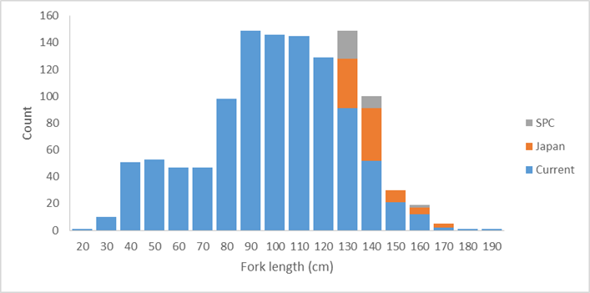  Some of the additional otolith sample are single otoliths and some are pairs. The project would have all of the singles and one of each pair sent to CSIRO for processing and analysis. The 2nd otoliths of the paired samples would be processed and analysed by project partners, and then the results for the same individual bigeye compared. This would likely involved collaborative work at the CSIRO laboratories.  Note that if additional otoliths from the >150 cm groups were provided by other project partners, the number of otoliths in the 130-139 and 140-149cm groups read would be reduced as statistically appropriate to keep the analyses to 125 otolith readings.  The resulting analyses would be reported to SC14.
Assumptions | - The otoliths identified as available by project partners are provided in a timely manner.  - The otoliths provided by project partners, and those from the WCPFC Tuna Tissue Bank are of sufficient quality to be produce readable slides.  - Work to be completed by project partners is finished on time.  - Otoliths from the WCPFC Tuna Tissue Bank will be released without needing to have the research proposal approved by the SC Research Committee.  - CSIRO will undertake the core work and will actively collaborate with the Scientific Services Provider and Japan in the conduct of the analyses.
Scope | This work will:  - Prepare and read an additional 125 otoliths using the annual increment method identified in Farley et al. (2017);  - Revise and update the Farley et al. (2017) age and growth estimates based on the additional data.
Timeframe | 12 months
Budget | US$30,000*  *Note that this covers the CSIRO component of the work, including reading 125 otoliths, preparing a report and travelling to WCPFC SC14 to present the results.
References | Farley, J., Eveson, P., Krusic-Golub, Sanchez, C., Roupsard, F., McKechnie, S., Nicol, S., Leroy, B., Smith, N., and Chang, S-K. 2017. Project 35: Age, growth and maturity of bigeye tuna in the Western and Central Pacific Ocean. SC13-SA-WP-01. Thirteenth regular session of the Scientific Committee of the Western and Central Pacific Fisheries Commission. Rarotonga, Cook Islands, 9-17 August 2017.

project 82

Yellowfin tuna age and growth
#35d
Project | Yellowfin tuna age and growth
Objectives | To provide robust age and growth estimates for yellowfin tuna in the WCPO to inform future stock assessments and related analyses.
Rationale | The 2017 yellowfin tuna stock assessment (Tremblay-Boyer et al. 2017) identified that new estimates of age and growth be developed for yellowfin tuna in the WCPO. This recommendation arose given how influential updated growth estimates for bigeye tuna (Farley et al. 2017) proved on that assessment in 2017, noting similarities in the fisheries for those two species. In addition the current assessment model for yellowfin predicts a decline in the selectivity of large fish for longline fisheries, a counter-intuitive result which can occur if the growth is incorrectly specified within the assessment model.  This project would undertake the first comprehensive age and growth study for yellowfin tuna in the WCPO using otoliths. This project represents an area of work not yet pursued in the WCPO. Through Project 35 and 35b, the Tuna Tissue Bank, a range of yellowfin otolith samples have been collected to date (>4000). As for bigeye the limitation is otoliths for very small fish (<30 cm) and for large fish (>140 cm).  SPC (for the WCPFC Tuna Tissue Bank) have identified the available yellowfin tuna otoliths, by size class sampled after 01 January 2014. These unread otoliths, along with additional yellowfin otoliths which Japan has indicated are available for this research, are plotted below with numbers of available otoliths per 10cm size bin. These samples should be adequate to complete a comprehensive and robust study of yellowfin tuna age and growth. It may be useful to seek additional otoliths from larger fish in the WCPO from other project partners.  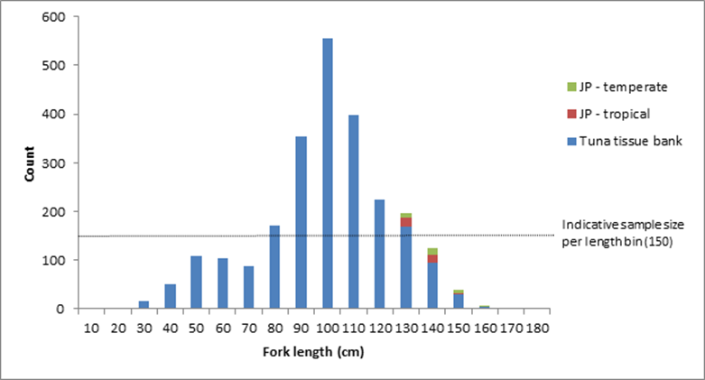  Some of the additional otolith samples from Japan are single otoliths and some are pairs. The project would have all of the singles and one of each pair sent to CSIRO for processing and analysis. The 2nd otoliths of the paired samples would be processed and analysed by Japan, and then the results for the same individual yellowfin compared. This would likely involved collaborative work at the CSIRO laboratories.  Note that if additional otoliths from the >140 cm groups were provided by other project partners they would be incorporated into the analyses in a similar manner, subject to funding.  The project would begin with a preliminary analyses of WCPO yellowfin conducted by CSIRO to determine if the otoliths are suitable for annual age estimation. This study would include an initial reading of otoliths using daily increments to establish annual check marks, followed by an examination of otoliths across the available size range to assess readability. This work would establish a reference otolith set for the rest of the study. At this time no otoliths with chemical check marks for validating age estimates are available. CSIRO and the Scientific Services Provider will collaborate to try and obtain strontium chloride marked otoliths within the life of the project, however it is more likely that these will not be available until after the project is complete. Accordingly, should the preliminary work determine yellowfin otoliths are suitable for a large-scale study (a target of 1500 otoliths across the size range read using the annual method, and 150 using the daily growth increment method, these targets including otoliths read in the preliminary study), a marginal increment analysis will be conducted to support the estimates of age and growth arising from that work.  The project would conducted preliminary work early in 2018. A small workshop would be conducted during the 2018 PAWS to finalise the approach for the large-scale study. A preliminary report would be provided to SC14. The remaining work would be completed during the remainder of 2018, with a final presentation to SC15 in 2019.
Assumptions | - The otoliths identified as available by project partners are provided in a timely manner.  - The otoliths provided by project partners, and those from the WCPFC Tuna Tissue Bank are of sufficient quality to be produce readable slides.  - Work to be completed by project partners is finished on time.  - Otoliths from the WCPFC Tuna Tissue Bank will be released without needing to have the research proposal approved by the SC Research Committee.  - CSIRO will undertake the core work and will actively collaborate with the Scientific Services Provider and Japan in the conduct of the analyses.
Scope | This work will:  - Conduct a preliminary analysis of the suitability of yellowfin tuna otoliths for providing robust estimates of age and growth;  - Develop a reference collection and protocols for reading daily and annual growth checks in yellowfin tuna otoliths;  - Prepare and read 1500 otoliths using the annual increment method;  - Prepare and reading 150 otoliths using the daily growth increment method;  - Undertake a marginal increment analysis to support the age and growth estimates;  - Report estimates of age and growth for yellowfin tuna to WCPFC SC15.
Risks | Note that due to the generally tropical distribution of yellowfin tuna, and the available otoliths, this study may need to be halted after the preliminary investigations. Should that occur, the report to SC14 will provide an opportunity to review next steps for developing robust estimates of age and growth for yellowfin tuna in the WCPO.
Timeframe | 24 months
Budget | 2018 USD$100,000  2019 USD$85,000  *Note that this covers the CSIRO component of the work, including reading 1650 otoliths, preparing two reports, travelling to the PAWS in 2018 and to WCPFC SC14 and SC15 to present the preliminary and final results. It does not cover costs of any project partners.
References | Tremblay-Boyer, L., McKechnie, S., Pilling, G., and Hampton, J. 2017. Stock assessment of yellowfin tuna in the Western and Central Pacific Ocean. SC13-SA-WP-06. Thirteenth regular session of the Scientific Committee of the Western and Central Pacific Fisheries Commission. Rarotonga, Cook Islands, 9-17 August 2017.  Farley, J., Eveson, P., Krusic-Golub, Sanchez, C., Roupsard, F., McKechnie, S., Nicol, S., Leroy, B., Smith, N., and Chang, S-K. 2017. Project 35: Age, growth and maturity of bigeye tuna in the Western and Central Pacific Ocean. SC13-SA-WP-01. Thirteenth regular session of the Scientific Committee of the Western and Central Pacific Fisheries Commission. Rarotonga, Cook Islands, 9-17 August 2017.

Project 83
Investigating the potential for a WCPFC tag vessel
#42b
Project | Investigating the potential for a WCPFC tag vessel
Objectives | To explore the costs and benefits of the permanent use of an adaptable research vessel dedicated to the collection of the data used in tuna stock assessment in the WCPO.
Rationale | - Rationale for project  - General  More than 70% of the global tuna catch are fished in the Pacific Ocean for an estimated value of over US$6 billion. The harvesting level of tuna resources and the efficiency of the involved industrial fleet henceforth impose a very responsive management mode. The management measures need to be supported by strong evidence based on high quality data allowing stock assessment containing a minimum of uncertainty. The data obtained independently from the fishing fleets have become essential and the science based management bodies have the responsibility to support their analysis with the best scientific evidence available. This requires a continuous acquiring of mortality rates for the impacted species, a detailed knowledge of their biology, along with their behaviour in response to fishing gears and in response to the variations in their environment. Assessing the fishing impact on the whole ecosystem requires collecting data on all the species living in association with tuna and tuna-like species, data about their prey and the pelagic ecosystem. The collection of all this information requires the permanent use of an adaptable research vessel properly designed for the purpose. There are currently no suitable tuna research vessels available in the region (or beyond).  Accordingly it seems to be the appropriate timing to carefully explore the permanent use of an adaptable research vessel dedicated to the collection of the data used in tuna stock assessment.  - SC 13  At SC13 the PTTP Steering Committee considered the issue of the availability of suitable tagging vessels, especially for pole and line based research, at its 11th meeting during SC13. The PTTP Steering Commiteee endorsed the proposal outlined in SC13-RP-P42-02 Appendix II and recommended that SC13 support an assessment of the cost-effectiveness of acquiring a dedicated tagging vessel (SC13-RP-P42-01).  - Current availability of suitable research platforms  - For tagging experiments  Tagging studies are commonly used in fisheries research to improve estimation of animal population size, mortality, movement (spatial stock structure) and growth. Until now, large scale tuna tagging campaigns for skipjack tuna have chartered medium-size commercial fishing boats around 200 GT tonnage (199 GT for last PTTP, 237 GT for IOTP) for cost reasons, and also due to size restrictions on bait ground access and restricted suitable anchorage in some areas. Releasing a large number of conventionally tagged tuna implies the use of a pole-and-line vessel, but suitable such tagging platforms are becoming increasingly scarce worldwide. In most countries, pole-and-line fleets have been replaced by purse-seine fleets.  Research cruises more orientated towards electronic tagging and targeting all size tuna and their associated species need a more polyvalent tagging platform that could deploy a large variety of fishing gears (horizontal and vertical longlines, troll lines, danglers, rod and reel etc…). Catching and handling large size fish requires a working deck with easy access to the sea and a boat with high manoeuvrability facilitated by steering commands located at the working deck level. For example the design of a standard Japanese pole and line vessel is not suitable for the purpose. In the Pacific, some longline type fishing boats have been used to target the tuna schools that are associated with floating objects, mainly the oceanographic buoys (TAOs) that are anchored along the equator and the drifting FADs used by the purse seine fleet. The distances involved between floating objects and from ports with appropriate facilities for deploying a research voyage require the use of long range (> 6,000 nm) platforms which are not common in the region for the necessary size of fishing vessels for successful research.  - For collecting ecosystem biological and physical data  This necessitate the use of gears that are usually not found on a commercial tuna fishing vessel, including : trawling nets to catch tuna prey and plankton size organisms, CTDs to collect sea water temp/depth profiles, and multi-beam echo-sounders that can manage continuous records of highly detailed bio-acoustic data.  Boats used in this type of research are typically from the oceanographic vessel category. They are usually linked to governmental scientific institutes. To operate the different types of gears used at an ocean wide scale, those vessels need to be large (>400 GT). To cover important operational and maintenance costs, their use is often shared between multidisciplinary research projects. Their availability is therefore limited, subjected to utilisation applications that need to be planned years in advance.  - Arguments for the construction of a new multipurpose platform dedicated to tuna research:  - Practicality:  - Tuna tagging data are likely to become increasingly important and need to be collected continuously rather than episodically. Other types of data need to be continuously collected to monitor the ecosystem changes.  - The pole and line vessels that can currently still be chartered are disappearing along with the associated fisher knowledge on operations and bait grounds. These platforms cannot cover all the different data collection needs.  - The global applicability of continuous data collection is likely to facilitate collaboration between the different tuna commissions (RFMOs). The cumulated needs at the Pacific scale could probably cover most parts of the yearly schedule of a single boat.  - A crew specifically recruited and trained to the specific research methods and strategies will be more capable than a commercial fishing boat crew that often need a long training period before they become fully efficient.  - Cost:  - Continuous research would avoid the substantial establishment costs needed each time a new programme is started.  - Some examples:  - Previous recent charter costs, including fuel, for a long range tuna tagging platform (about 200GRT) were situated between 150,000 and 200,000 USD/month. Last offer (March 2017) was more than the double of these figures.  - The total tagging platform charter costs spent during each of the last large tagging projects (PTTP and IOTP) is over the current estimated cost for building a new boat of around 35 metres/200GRT (Between 5 and 8 USD millions, IOTP vessels were built at about 4 USD millions in 2000). Last estimation for the currently running (2017) AOPT total charter cost is 9.1 million Euro (ICCAT, SCRS/2014/092).
Scope | The project would assess the full range of operational costs, including options on governance, inter-RFMO vessel sharing, multiple research modes, and future vessel replacement. These costs should be compared with the costs and benefits of the current approach.  The scope of work includes undertaking this assessment utilising suitable external experts. A report will be prepared and provided to SC14 for its consideration.
Timeframe | Start early 2018, completed by late 2018
Budget | 2018 USD$125,000  *Note that this covers the Scientific Services Providers input to the project, the cost of the external consultancy and reporting of the project outcomes to SC.
References | PTTP Steering Committee. 2017. Report of the Pacific Tuna Tagging Programme Steering Committee. SC13-RP-PTTP-01. Thirteenth regular session of the Scientific Committee of the Western and Central Pacific Fisheries Commission. Rarotonga, Cook Islands, 9-17 August 2017.  SPC-OFP. 2017. Project 42: Pacific Tuna Tagging Project Report and Workplan for 2017-2020. SC13-RP-PTTP-02. Thirteenth regular session of the Scientific Committee of the Western and Central Pacific Fisheries Commission. Rarotonga, Cook Islands, 9-17 August 2017.

PROJECT 84.
Shark Research Plan mid-term review
Sheet Number | #7
Project title | SRP mid-term review
Objectives | Review the WCPFC Scientific Committee’s 2016-2020 shark research plan, to evaluate progress against the plan and assess future needs for shark research relevant to management of the WCPO shark stocks.
Rationale | The first Shark Research Plan (SRP) covered 2010-2014. At its Tenth Session the Scientific Committee (SC10) agreed in 2014 on a programme of shark work for the Scientific Service Provider (SSP). This work was to be carried out in 2015, and included that the SSP draft a new SRP for consideration by SC11 to cover work in 2016-2020. This project will evaluate progress against that plan and consider the future shark information needs of the WCPFC.  This work will also evaluate the progress against and need for the original SRP components:  - Phase 1: assessments to be undertaken with existing and available data;  - Phase 2: coordination of research efforts to supplement biological and other assessment related information; and  - Phase 3: improvement of data from commercial fisheries.
Assumptions | SPC or another regional body has the personnel and budget available to undertake this work.
Scope | While this document will focus on the WCPFC key shark species, other elasmobranchs will be considered as required.
Budget | 0.3 FTE

pROJECT 85.
Participation in ISC North Pacific shortfin mako shark stock assessment activities
Sheet Number | #3
Project | Participation in ISC North Pacific shortfin mako shark stock assessment activities
Objectives | Contribute to and learn from ISC work toward revising the North Pacific shortfin mako shark stock assessment, thereby aiding methods development for other WCPO shark stocks.
Rationale | - The ISC will be working toward an assessment of the North Pacific shortfin mako in 2017-2018 with an aim to complete it by July 2018  - The ISC assessment would benefit from the contribution of additional shortfin mako observer data (catch rates and total removals) in the North Pacific  - Participation in this collaborative stock assessment may lead to the development of new methods and/or new data insights for a future South Pacific shortfin mako assessment  - Cooperation between the WCPFC and its Northern Committee could be strengthened
Assumptions | - If SPC were available to participate, it would contribute its shortfin mako data holdings  - If the Secretariat or ABNJ participates, fewer data can be contributed due to data confidentiality rules  - ISC is able and willing to incorporate these contributions to its work  - ISC meetings avoid scheduling conflicts with other work
Scope | Available WCPO data would be compiled, formatted and analysed to produce data products that could be contributed to ISC Shark Working Group (SWG) meetings (no raw data would be contributed; this is similar to the contributions of ISC member countries). Data to be prepared would depend on needs identified by the ISC SWG but would be expected to include catch rate indices, catch estimates, effort statistics and/or biological data. It is assumed that participation in two ISC SWG meetings would be required (the FTE estimate is intended to account for both time and travel costs). These have tentatively been scheduled for November 2017 in Japan (data preparation meeting) and March-April 2018 in La Jolla (assessment meeting). Total time input including data handling and analysis, ISC SWG meetings and other tasks, and report review is estimated at ~2.5 months.
Budget | 0.2 FTE

PROJECT 86.
FAD designs to reduce unwanted interactions with Species of Special Interest (SSIs; sharks, turtles)
FAD Project #1
Project | FAD designs to reduce unwanted interactions with Species of Special Interest (SSIs; sharks, turtles)
Objectives | Identify FAD design features that lead to lower interaction rates with key SSIs, while minimising the impact on catches of target tuna species.
Rationale | - Builds upon work in all other Oceans on the design of lower- and non- entangling FADs (e.g. WCPFC-2016-FADMgmtOptionsIWG02-OP02; SC13-EB-WP-02).  - Builds upon work by organisations such as ISSF in the development of SSI-friendly designs.  - Provides region-specific information on the efficacy of SSI reduction and impacts on tuna catch levels in the WCPO.  - Provides a scientific basis for potential CMMs in this area.  - Given concerns of FAD beaching on reefs and shorelines, could also contribute to studies of appropriate biodegradable FAD materials.
Assumptions | - The information provided in SC13-EB-WP-02 is considered by SC13 to provide insufficient evidence of the potential effectiveness of non- entangling designs in the WCPO, and hence local trials are needed. Note that if SC13-EB-WP-02 is considered by SC13 to provide sufficient evidence, this project should be revised to focus on extension, to ensure rapid uptake and deployment of non-entangling FAD designs, and to ensure the cost effectiveness of those designs for all WCPO fleets, in particular those domestic fleets of PICTs.  - The relationship between design and SSI interactions can be gained through tracking FADs from construction, through deployment, to setting activity by any fleet, and SSI interactions.  - If tracking is not possible, the regular removal of a set-upon FAD from the water can be undertaken so observations of its sub-surface structures and the occurrence of captured SSIs can be made.  - Periodic removal of tracked designs may also be necessary to identify changes over time (e.g. unravelling of bound netting, degradation of components).  - A coordinated trial of designs, in collaboration with industry, is suggested as the most efficient approach. Cost, material availability and environmental impact would be key factors in assessing the merit of various designs.  - Sufficient data are available across different designs and locations to allow statistical analyses to be effective.  - Where specific field trials are undertaken, they might be able to be performed at the same time as trials required under FAD project #2 to create cost efficiencies.
Scope | Through review of existing studies and best practices in other oceans (see SC13-EB-WP-02) identify plausible non-entangling FAD designs, in collaboration with industry. This should include sub-FAD structure depth and mesh size, removal of netting on the surface of FADs and alternative platform widths.  Implement at-sea FAD trials across the WCPO [deployment and fishing activity] to be completed within 18 months. This will most effectively be
performed in partnership with observers and industry to ensure marking, deployment and monitoring of FADs in a coordinated way. Two levels of industry participation are anticipated: (1) the fleets that deploy the FADs and are actively engaged in the research. (2) All other fleets that find the FADs from (1) and set upon them. Information from (2) will be critical to the success of the research.

Using ISSF Technical Report 2016-18A as a guide:
- Fleets deploy a given number of FADs per vessel (e.g. 10-20 FADs per vessel to reach a significant large number of FADs).
- Maximum 4 standardized designs tested, constructed in port and deployed in the same area as traditional FADs, so their effectiveness could be compared with that of the traditional FADs for the same spatial and temporal strata.
- Deployment site, design and the code of the geo-locating buoy should be registered. Every FAD should be well identified so that data can be retrieved and followed if ownership changes.
- If a trial FAD is encountered at sea register: the catch (if any), interactions with SSI, the condition of the FAD and the new code for the buoy if the original has been replaced.
- Where possible, use trajectories and sounder of attached buoys to assess ability of alternative designs to aggregate tuna even if they are not visited or fished by purse seiners, as well as following their lifetime if they are not retrieved.
- Collaboration between industry, related parties, and the science services provider to collect and analyse data.
- Collaborate with industry to identify the cost of alternative FAD designs
relative to ‘standard’ designs.

Analysis of results should be presented to WCPFC SC (approximately 2 years after the trial begins). SC and TCC of that year to provide recommendations for a draft CMM on appropriate FAD designs.
Links to other work | The IATTC and ISSF have done considerable work on the design of non- entangling FADs (see SC13-EB-WP-02).
Timeframe | 24 months
Budget  Note: Costed on a fieldwork required basis. If project is extension related (i.e.  trials of  designs not  required on the basis of SC13-EB-WP-  02 findings), project budget | 1 year FTE at SPC (data analysis)  1.5 year FTE at SPC (technical and fieldwork, travel) Project management  Observer training  Approximate total budget: US$446,000*  Note overlap with Project #2 – if both are undertaken concurrently then some personnel costs can be ‘shared’ across the two projects. (Approximate total budget if Projects 1 and 2 undertaken simultaneously:  $871,000)  *Final costings will depend on the approach undertaken within at-sea trials, including the level of practical and financial contribution by industry. Note this will need to include the purchase of necessary FAD materials, including marking and tracking components, facilitation of liaison with industry representatives, and any related travel.
will need to be revised
Additional considerations | This project will necessitate additional data collection by fisheries observers, irrespective of whether it relates to additional trials, or, extension. This has consequence for forms, data management and observer training.  If FADs are not able to be tracked from markings or similar, this research will require fishers to lift all FADs for descriptions to be made (there are other technical solutions such as camera ROVs and/or research divers however they are likely overly costly).  Understanding the vertical behaviour of silky sharks at FADs within the WCPO would help inform how deep the FAD underwater structure should be checked.  This project if it proceeds to extension/implementation will have direct costs for fishers with the lifting of existing FADs require to update them with non- tangling designs. Obviously the period of implementation will determine if this occurs faster or slower than the normal frequency of lifting, and hence the incurred cost.

PROJECT 87.
FAD designs to reduce unwanted catches of juvenile bigeye and yellowfin tuna
FAD Project #2
Project | FAD designs to reduce unwanted catches of juvenile bigeye and yellowfin tuna
Objectives | Identify any FAD design features that lead to lower catch rates of undersized/juvenile bigeye and yellowfin tuna, while minimising the impact on catches of larger target tuna species.
Rationale | - Builds upon trials underway in the IATTC area in collaboration with ISSF, but given oceanographic differences between regions WCPO trials may be required if designs in IATTC area focus on depths shallower than the WCPO thermocline depth.  - Represents an area of work not yet pursued in the WCPO that could provide a simple management intervention to reduce FAD impacts.  - Builds upon EU-funded work identifying factors influencing bigeye tuna hotspots.  - Provides a scientific basis for potential CMMs in this area.  - Two key and related FAD design features may influence undersized/juvenile bigeye and yellowfin mortality: depth of the FAD, and its speed of drift.
Assumptions | - Bigeye tuna hotspot analyses provide some indication of potential FAD characteristics that can be examined within this project.  - Can relate the design of FADs noted by observers and/or others directly to subsequent fishing sets that have reliable catch composition estimates.  - A coordinated trial of designs, in collaboration with industry, is suggested as the most efficient approach. Cost and environmental impact would be key factors in assessing the merit of various designs.  - Periodic removal of tracked designs may also be necessary to identify changes over time (e.g. change in the depth of the structure or unravelling of bound netting, degradation of components that might modify drift speed).  - Sufficient data are available across different designs and locations to allow a statistical analysis to be performed.  - Where field trials are required, they could possibly be performed at the same time as trials required under FAD project #1 to create cost efficiencies.
Scope | While Project #1 benefits from existing activities and research in other oceans, the background on FAD designs to reduce juvenile tuna catch is less mature. However, the proposed scope is comparable to that proposed for Project #1.  Use relevant results from the bigeye tuna hotspot analyses and from information available from ISSF studies in the IATTC area, and in collaboration with industry, identify plausible FAD designs to trial.  Implement at-sea FAD trials across the WCPO [deployment and fishing activity] to be completed within 18 months. This will most effectively be performed in partnership with industry and observers to ensure marking, deployment and monitoring of FADs in a coordinated way. Two levels of industry participation are anticipated: (1) the fleets that deploy the FADs and are actively engaged in the research. (2) All other fleets that find the FADs from (1) and set upon them. Information from (2) will be critical to the success of the research.  Understanding how the real working depth of sub-surface FAD structures interacts with oceanographic features during the period of the drift, and the resulting influence on species biomass and catch will be important. Equipping FAD sub- surface structures with depth/temperature sensors, which are tracked for the duration of a scientific trip and retrieved, regularly feed-back information, or pop off the FAD after a given period, should be used.  Using ISSF Technical Report 2016-18A as a guide:  - Fleets deploy a given number of FADs per vessel (e.g. 10-20 FADs per vessel to reach a significant large number of FADs).  - Maximum 4 standardized designs tested, constructed in port and deployed in the same area as traditional FADs, so their effectiveness could be compared with that of traditional FADs for the same spatial and temporal strata.  - Deployment site, design and code of the geo-locating buoy should be registered. Every FAD should be well identified so that data can be retrieved and followed id ownership changes.  - If a trial FAD is encountered at sea, register: the catch (if any), the condition of the FAD and the new code for the buoy if the original has been replaced.  - Where possible, use trajectories and sounder of attached buoys to assess ability of alternative designs to aggregate tuna even if they are not visited or fished by purse seiners, as well as following their lifetime if they are not retrieved.  - Collaboration between industry, e.g. ISSF and the science services provider to collect and analyse data.  - Collaborate with industry to identify the cost of alternative FAD designs  relative to ‘standard’ designs.  Analysis of results should be presented to WCPFC SC (approximately 2 years after the trial begins). SC and TCC of that year to provide recommendations for a draft CMM on appropriate FAD designs.
Links to other work | Note that due to the nature of the thermocline in the WCPO and the impact of the thermocline on tuna behaviour, in particular for bigeye tuna, results from the EPO may not be of specific use in the western or central WCPO.
Timeframe | 24 months
Budget | 1 year FTE at SPC (data analysis)  1.5 year FTE at SPC (technical and fieldwork)  Associated travel and subsistence to relevant WCPFC meetings Project management  Observer training  Approximate total budget: US$526,000*  Note overlap with Project #1 – if both are undertaken then some personnel costs can be ‘shared’ across the two projects. (Approximate total budget if Projects 1 and 2 undertaken simultaneously:  $871,000)  * Final costings will depend on the approach undertaken within at-sea trials, including the level of practical and financial contribution by industry. Note this will need to include the purchase of necessary FAD materials, including marking and tracking components, temperature/depth sensors, facilitation of liaison with industry representatives, and any related travel.
Additional considerations | This project will necessitate additional data collection by fisheries observers, irrespective of whether it relates to additional trials, or, extension. This has consequence for forms, data management and observer training.
The field work component of this research may require additional data collection on catch composition for specific sets from a trip (with the catch kept separated and subject to a census in port).

There may be the potential to geo-fence FADs used in these trials with special requirements around reporting and access to enhance the data collected.

PROJECT 88.
Acoustic FAD analyses
FAD Project #3
Project | Acoustic FAD analyses
Objectives | Identify whether limiting sets to only those FADs that have a large biomass beneath them can reduce the proportion of ‘non-target’ species caught.
Rationale | - Larger purse seine sets on FADs tend to have higher proportions of skipjack and commensurately lower proportions of yellowfin and bigeye (Lawson 2008, SC04-ST-WP-03).  - Acoustic data from echo-sounder buoys can provide, given sufficient equipment, environmental conditions and interpretation skills, sufficient information on the biomass of tuna under a FAD.  - Acoustic information has shown promise for discriminating skipjack from other species, if not yet routinely using commercial fishing equipment. However, there is a need to identify signals that discriminate other species within the WCPO, building on existing work by ISSF in this area.  - Acoustic information has also suggested some ability to differentiate fish sizes.  - The acquisition of acoustic FAD data has the potential to provide insight into dynamics of the interaction between tuna and FADs.  - Information could inform FAD design options, FAD deployment, remote identification of size and abundance of tuna under echo-sounder- equipped FADs, and spatial management considerations.  - Incentivising limiting setting activity to only FADs with large biomass could reduce the proportion of non-target species caught.  - In addition, acoustic FAD data could provide ‘ground truthing’ for the effective soak time of FADs, stock assessment biomass estimates (see SC12-SA-IP-14), FAD density effects on movement and catch rates of target spp.
Assumptions | - There is a consistent relationship between biomass levels on FADs and tuna species composition across the WCPO, as indicated in Lawson (2008), SC04-ST-WP-03.  - Biomass can be accurately assessed through acoustic buoys, noting that it depends on the equipment used, environmental conditions and the interpretational skills of the user.  - Existing acoustic information can be made available for analysis, combined with sufficient information to relate that information to a setting event.  - Target strength information from other studies is sufficiently robust and comparable to that in the WCPO that it can be used directly.  - The analysis can be undertaken over sufficient space/time to ensure any influences of those factors can be examined statistically.
Scope | The scope of work is divided into three stages. The ability to undertake the second stage will depend on access to existing data, in particular acoustic biomass estimates, and the ability to relate set-level events to FAD-specific acoustic data.  Stage 1. Examination of existing data to investigate the relationship between total biomass/catch and the proportion of small bigeye/yellowfin Based upon existing combined logsheet/observer data from FAD sets, investigate the relationship between total biomass/catch size and the
degree of small bigeye/yellowfin, both spatially and temporally within the WCPO. Based upon these analyses, identify the level of definition required by echo-sounder buoys to render this strategy effective.

In addition, review available information on the vertical behaviour of individuals of different sizes relative to e.g. thermoclines, to examine whether a depth layer can be used to discriminate between species/sizes.

Stage 2. Examination of existing (historical) observer-based FAD set data and echo-sounder buoy data
Where data are available to link an observed FAD set event to acoustic information, compare the most appropriate set-level overall catch and corresponding species composition to available acoustic information. Where data allow, further compare to relevant operational factors (e.g. location, FAD and vessel information, regional FAD density, etc.) to identify potential relationships.

Stage 2. Undertake at-sea experimental fishing trials to identify effective acoustic equipment and operational approaches
In collaboration with industry, and building on outputs from Stages 1 and 2, design and implement a limited fishing trial of current and alternative cutting-edge acoustic gear/settings (e.g. multi-frequency) to obtain acoustic information on FAD-associated tuna biomass and species/size composition, and related fishing trials to ‘ground-truth’ that information based upon resulting catches. Gaining target strength measurements for single schools (in particular of yellowfin) will be particularly important. Trials should be sufficiently extensive to examine the influence of spatial and potentially oceanographic factors.

Analyses of results from each stage should be presented to WCPFC SC for scientific review and where relevant for the consideration of advice to TCC and the Commission.
Timeframe | Approximately 36 months (see below)
Budget | Stage 1  1.5 year FTE at SPC USD$182,000  Associated travel and subsistence to relevant WCPFC meetings USD$10,000  Stage 2  Not costed at this time. It is likely to be on the scale of project one or two, but there may be some other cost savings to be made by incorporating some fieldwork into the 2018 or 2020 tag research voyages.
Additional considerations | If this proceeds to a fieldwork stage, additional input on the design of the at-sea component should include consideration of concurrent data collection in the context of tuna foraging and links to ecosystem modelling (e.g. SEAPODYM).

PROJECT 89.
Fleet behaviour
FAD Project #4
Project | Fleet behaviour
Objectives | Characterisation of effort creep due to FAD use and fleet specific factors resulting in large catches of ‘non-target’ species.
Rationale | - Understanding how rapid developments in FAD technology and their use within the WCPO can influence FAD-related catch rates will provide additional information for key stock assessments and the harvest strategy approach, and scientific advice that can inform discussions under future tropical tuna CMMs.  - Analyses will complement activities currently underway on PNA FAD tracking and those undertaken through the EU-funded ‘bigeye tuna hotspot’ analysis presented to SC13.
Assumptions | - Sufficient data on FAD design and technology are available for analysis.  - Sufficient time series of data are available to support analyses.  - Information is sufficiently detailed and accurate to allow analyses to be performed.  - Fishing sets can be related to specific FADs and associated FAD/vessel technological information.  - Fleet behaviours that influence fishing performance can be understood.  - The effort creep component of improved FAD technologies can be separated from other elements (schooling behaviour of fish, overall fleet behaviour, stock size, oceanography, other technological advances etc.).
Scope | The proposed work programme comprises a data compilation activity, subsequent statistical analysis activities and a data review activity. These are briefly outlined below:  Evaluate and combine available logsheet, observer and VMS data to develop a comprehensive purse seine associated fishing data set. This data set should also include available (time series of) vessel and technical FAD characteristics, where possible.  Analyse patterns of fleet activity relative to FAD setting based upon VMS/logsheet data, to assess changes in vessel searching activity, as well as trip length. This may also be compared within and outside the FAD closure period, and be related to location (e.g. distance from port), time of the year/day, the period of the trip, etc.  Examine changes in the ‘reliance’ on FAD fishing over time, at the fleet or  vessel level. Relate the reliance on FADs to geographic location.  Analyse using appropriate statistical techniques factors that could influence time series or relative patterns in purse seine associated set CPUE (catch per set, but catch per day or trip may also be examined), including fleet, location, oceanography, FAD set density (as a proxy for FAD density), observed FAD design, vessel characteristics, stock abundance, etc. This may evaluate the probability of a successful set, as well as the level of catch if a set were successful.
Identify data gaps and provide advice on potential areas of additional data collection to improve future analyses.

Where observer information is sufficient, work will also examine the number and activities of supply vessels, including identifying which particular purse seine vessels each support, and the number of FADs being deployed and serviced by such vessels.
Timeframe | 18 months
Budget | 1.5 year FTE at SPC USD$182,000  Associated travel and subsistence to relevant WCPFC meetings USD$20,000

PROJECT 90.
Better data on fish weights and lengths for scientific analyses
#XX
Project | Better data on fish weights and lengths for scientific analyses
Objectives | This project has two objectives:  - to systematically collect representative samples of length measurements of bycatch species to support future estimation of fish bycatch in the WCPO; and  - to systematically collect length:length, length:weight and weight:weight data on all species to better inform future estimation of fish bycatch in the WCPO.
Note | Although these two objectives are distinct, they have been combined into a single project to avoid any possible duplication of effort, and, as there will likely be combined tasking of observers and port-samplers in future data collection arising from the project.
Rationale | Estimates of bycatch are currently collected through the ROP in units of number, weight or both. In order to convert from numbers to weight, and vice versa, it is necessary to have information on both the size of caught individuals, and appropriate length:weight relationships for the species in question. This conversion between numbers and weight allows analyses of bycatch data to use the full observer dataset, rather than a subset with a consistent unit of measurement, therefore maximising the utility of the bycatch data recorded by observers. Furthermore, bycatch length data allows for consideration of the life-stages of individuals. This information could be of particular interest when considering bycatches of species of special interest. There are currently insufficient, or unrepresentative, length samples for species caught in purse seine fisheries, with the exception of bigeye, yellowfin and bigeye which are sampled through observer grab samples. This project would fill this data gap.  Accordingly, this project addresses two objectives arising from discussion at SC13 about the results of regional estimates of purse seine bycatch (Peatman et al., 2017). As a result of those discussions SC13 recommended that the Scientific Service Provider be tasked with:  - designing and co-ordinating the systematic collection of representative samples of length measurements of bycatch species; and  - a project to design and co-ordinate the systematic collection of length:length, length:weight and weight:weight data on all species to better inform bycatch estimation.
Assumptions | Achievement of the objectives is subject to the following assumptions:  - sufficient data are available to support the sampling design analyses;  - sampling designs can be developed which are statistically robust and would support future estimation of fish bycatch in the WCPO;  - current observer equipment (e.g. callipers) is suitable for the length sampling protocols;  - suitable and cost-effective equipment can be sourced for robust weight data collection  - data collection can be integrated into existing sampling events in-port and at-sea.
Scope | The proposed work programme comprises:  - data compilation activities;  - subsequent statistical analysis activities to design future sampling approaches;  - evaluation of designs for practical field application;  - trials of selected sampling approaches in the field along with trials of equipment required to complete the sampling designs;  - finalisation of future sampling protocols;  - development of associated training standards;  - incorporation of training into trainer trainings and biological sampling trainings as required;  - ongoing co-ordination of sample collection and data submission; and  - reporting on designs and progress with implementation and data collection.  It is intended that a preliminary report would be prepared for SC14 and a more comprehensive report for SC15.
Timeframe | 33 months (from January 2018 through September 2020)
Budget | 2018 USD$40,000  2019 USD$20,000  2020 USD$15,000  Note that this funding is intended to cover the work of the Scientific Services Provider in the design and co-ordination of this work. This will cover the analytical components identified in the scope of the project. It will also cover trials of methodologies identified at-sea and in-port. It does not cover the costs of CCMs in implementing the protocols of the purchase of related equipment. This will require co-funding or additional funding depending on the designs selected in the design and testing phase any may require additional requests for funding from SC14.
References | Peatman, T., Allain, V., Caillot, S., Williams, P., and Smith, N. 2017. Summary of purse seine fishery bycatch at a regional scale, 2003-2016. SC13-ST-WP-05. Thirteenth regular session of the Scientific Committee of the Western and Central Pacific Fisheries Commission. Rarotonga, Cook Islands, 9-17 August 2017.

It should be noted that the constant catch scenario is inconsistent with current management approaches for NPALB adopted by the IATTC and the WCPFC.
Median future catch for the constant F scenario is expected to be below the average catch level for 2010-2014 (82,432 t – red line in Figure 7-6). This result is likely due to low estimated recruitment in 2011, which is expected to reduce female SSB beginning in 2015, the first year of the projection period.
Revised terms of reference for this resourcing includes: - Further development of MULTIFAN-CL to support Management Strategy Evaluation and the Harvest Strategy development process - Further enhancement of MULTIFAN-CL and its use in stock assessment to implement SC recommendations - Maintain and further develop the MULTIFAN-CL website to facilitate access to software and support - Implement a formal framework for management of MULTIFAN-CL code updates, testing new developments, updating the users’ guide
It should be noted that the constant catch scenario is inconsistent with current management approaches for NPALB adopted by the IATTC and the WCPFC.
Median future catch for the constant F scenario is expected to be below the average catch level for 2010-2014 (82,432 t – red line in Figure 7-6). This result is likely due to low estimated recruitment in 2011, which is expected to reduce female SSB beginning in 2015, the first year of the projection period.
The final report SC13-MI-WP-07 Rev.02 was posted on SC13 website on 31 October 2017.
Revised terms of reference for this resourcing includes: - Further development of MULTIFAN-CL to support Management Strategy Evaluation and the Harvest Strategy development process - Further enhancement of MULTIFAN-CL and its use in stock assessment to implement SC recommendations - Maintain and further develop the MULTIFAN-CL website to facilitate access to software and support - Implement a formal framework for management of MULTIFAN-CL code updates, testing new developments, updating the users’ guide
Revised terms of reference for this resourcing includes: - Further development of MULTIFAN-CL to support Management Strategy Evaluation and the Harvest Strategy development process - Further enhancement of MULTIFAN-CL and its use in stock assessment to implement SC recommendations - Maintain and further develop the MULTIFAN-CL website to facilitate access to software and support - Implement a formal framework for management of MULTIFAN-CL code updates, testing new developments, updating the users’ guide

