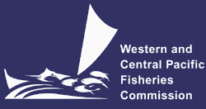
NORTHERN COMMITTEE
THIRTEENTH REGULAR SESSION
28 August – 1 September 2017
Busan, Republic of Korea
Joint IATTC-WCPFC NC Working Group Meeting on the Management of Pacific Bluefin Tuna

PROVISIONAL AGENDA
WCPFC-NC3-2017/02-1 [Joint IATTC-WCPFC NC WG]

- Opening of the Meeting

- Designation of Co-chair

- Adoption of Agenda

- Review of updated information on Pacific bluefin tuna provided by the ISC17 and recommendations from IATTC

- Consideration and development of rebuilding strategy (second rebuilding target and timeline, etc.) and long-term precautionary management framework (management objectives, limit and target reference points, harvest control rules, etc.)

- Review of current management measures in both IATTC and WCPFC

- Emergency rule

- Catch document scheme

- Next meeting

- Other business

- Close of Meeting

