#### South Pacific albacore tuna

#### Provision of scientific information

##### Draft Status and trends

* SC12 noted that no stock assessment was conducted for South Pacific albacore tuna in 2016. Therefore, the stock status description from SC11 is still current. For further information on the stock status and trends from SC11, please see INSERT URL FOR SC11 REPORT HERE

OR USE STOCK STATUS FROM WP-SA-06 BELOW

* SC12 noted that the 2015 assessment for South Pacific albacore (Harley et al., 2015) estimated the stock status averaged over the period 2009-2012 (‘current’) and 2013 (‘latest’), relative to agreed reference points. This assessment contained significant improvements to the previous (2012) assessment including: improvements to the MULTIFAN-CL modelling framework, a regional disaggregated spatial structure, access to operational data for construction of CPUE indices and regional weights, age-length data to improve growth estimation, and additional tagging data. Further, the regional structure of the model was changed to cover the southern Convention area only, and therefore was better aligned with the other tuna assessments. Natural mortality was set at 0.3 in the reference case for consistency with the value used in assessments performed in other RFMOs.
* SC12 noted that the advice to the Commission was based upon the ‘reference case’ assessment model, and characterized uncertainty based upon 18 model runs describing dynamics under different levels of natural mortality, stock recruitment relationship steepness, and weighting of the input length data. Estimates are presented in Table 5, and the Majuro plot in Figure 9.

### Table 5. Estimates of reference points and stock status from the last (2015) south Pacific albacore tuna stock assessment (southern WCPFC region only), based upon the single reference case run, and the 18 runs used to capture uncertainty (5th percentile, median and 95th percentile).

|  |  |  |  |  |
| --- | --- | --- | --- | --- |
| **Management Quantity** | **2015 reference case** | **5%** | **Grid Median** | **95%** |
| MSY (mt) | 76,800 | 62,260 | 84,980 | 129,814 |
| Sblatest/SBF=0 | 0.40 | 0.30 | 0.44 | 0.60 |
| Fcurrent/FMSY | 0.39 | 0.13 | 0.34 | 0.62 |
| Sblatest/SBMSY | 2.86 | 1.74 | 3.20 | 7.03 |
| SBMSY | 57,430 | 35,762 | 59,180 | 90,778 |
| SBF=0 | 408,361 | 392,358 | 442,163 | 486,146 |

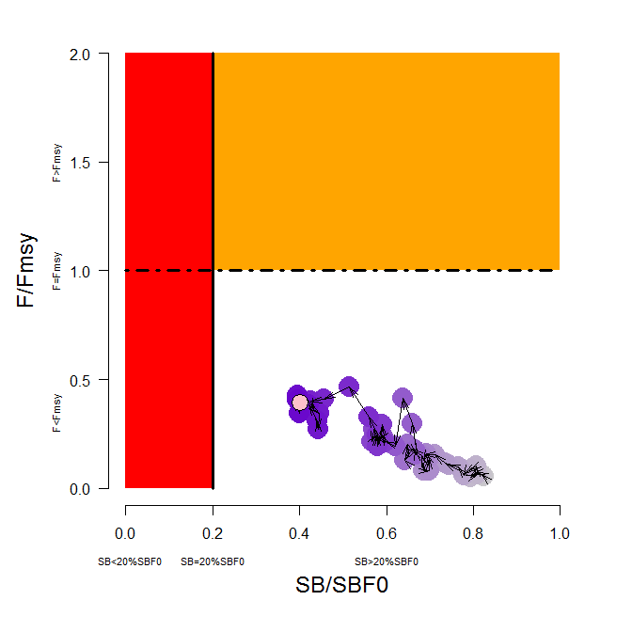

**Figure 9. Temporal trend for the reference case model in stock status relative to SBF=0 (x-axis) and FMSY (y-axis). The red zone represents spawning potential levels lower than the agreed LRP which is marked with the solid black line (0.2SBF=0). The orange region is for fishing mortality greater than FMSY (F=FMSY; marked with the black dashed line). The pink circle is SB2013/SBF=0 (where SBF=0 was the average over the period 2003-2012).**

* SC12 noted that, as in previous indicators papers (e.g. Harley and Williams, 2013), it is difficult to correctly interpret the stock status-related implications of trends in any indicators in isolation of other data sets and a population dynamics model. To examine the potential consequences of recent fishing levels relative to the agreed biomass limit reference point for south Pacific albacore (20%SB2003-2012, F=0), stochastic 20-year effort-based projections were performed under different assumptions of population dynamics (defined by nine stock assessment runs from the 2015 Multifan-CL stock assessment, a subset of those selected by SC11 to present key uncertainties within SC11 advice and capturing uncertainty in stock recruitment steepness and natural mortality), and future conditions (variability in future recruitment around the stock-recruitment relationship), consistent with the recommendations on inclusion of uncertainty within projections from WCPFC-SC9 and in Berger et al. (2013).
* SC12 noted that there had been some small reductions in southern longline effort in 2014 compared to 2013 (Figure 3), but 2015 effort levels are currently considered uncertain. We therefore update the status quo projection analysis presented in SPC-OFP and WCPFC Secretariat (2015), assuming future southern longline and troll fishery effort would continue into the future at levels equal to those seen in 2014 (based on the information available to SPC as at 2nd June 2016). Potential future adult (spawning) biomass levels relative to unfished levels were examined, and the probability that the south Pacific albacore stock may fall below the biomass Limit Reference Point was calculated (Figure 10).
* Sc12 also noted that, across the nine stock assessment models used within the analysis, the average stock status in 2013 (the last year of the assessment) was SB/SBF=0 = 0.41. If 2014 fishing effort levels continue into the future, however, the stock is predicted to continue to decline on average, falling to SB/SBF=0 = 0.32 in 2033, identical to the level seen under 2013 effort conditions. The risk of falling below the LRP was reduced very slightly to 19% (approximately a 1 in 5 chance). Furthermore, the CPUE was still estimated to decline by 14% from 2013 levels. While effort overall has shown a small decline between 2013 and 2014 therefore, the amount of that decline, combined with changes in the distribution of effort across the fleets within the south Pacific albacore assessment, resulted in little overall change in the status quo projection results.

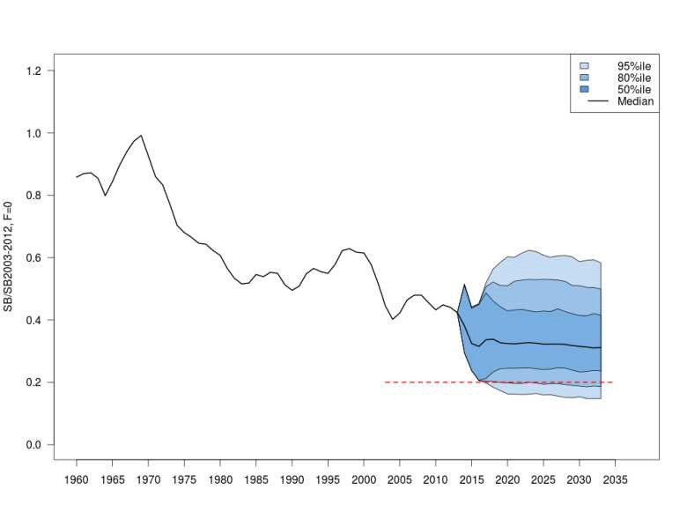

### Figure 10. Stochastic projections of adult stock status under 2014 longline and troll effort levels. The limit reference point (20% SBF=0) is indicated by horizontal dashed red line. Note: from 1960 up to 2013 inclusive the line represents the median across the 9 assessment model runs (structural uncertainty only); uncertainty after 2013 represents both structural uncertainty and stochastic recruitment.

Draft Management advice and implications

* SC12 noted that no management advice has been provided since SC11. Therefore, the advice from SC11 should be maintained, noting that the results of the indicator analyses supported the stock status results for South Pacific albacore that were obtained from the 2015 assessment.