SCIENTIFIC COMMITTEE ELEVENTH REGULAR SESSION

Pohnpei, Federated States of Micronesia

5-13 August 2015

DEVELOPMENTS IN THE MULTIFAN-CL SOFTWARE 2014-15

WCPFC-SC11-2015/SA-IP-01
Rev 1 (30 July 2015)

Nick Davies3, Dave Fournier2, Fabrice Bouyé1, John Hampton1, and Shelton Harley1

1 Oceanic Fisheries Programme, Secretariat of the Pacific Community, Noumea, New Caledonia

2 Otter Research Ltd, North Saanich, British Columbia, Canada

3 Te Takina Ltd, Whangarei, New Zealand
Table of Contents

Executive summary ....................................................................................................................................................................... 4

1 Introduction ....................................................................................................................................................................... 5

2 Development overview ................................................................................................................................................. 5

2.1 Team .................................................................................................................................................................. 5

2.2 Calendar ........................................................................................................................................................... 5

2.3 Collaboration and versioning .................................................................................................................. 6

2.4 Merging the development branch to the trunk................................................................................ 6

2.5 Compilation framework............................................................................................................................. 7

2.6 Developer’s workshops ............................................................................................................................. 7

2.7 Postings to website...................................................................................................................................... 7

2.7.1 4 September 2014 – version 1.1.5.7............................................................................................... 7

2.7.2 15 September 2014 – version 1.1.5.8 ............................................................................................ 8

2.7.3 17 February 2015 – version 1.1.5.9 ............................................................................................... 8

2.8 Independent Peer Review of the 2011 bigeye tuna stock assessment .................................. 8

2.9 Tool development ........................................................................................................................................ 8

2.9.1 R4MFCL...................................................................................................................................................... 8

2.9.2 Testing framework................................................................................................................................ 8

2.9.3 Viewer......................................................................................................................................................... 9

2.9.4 Condor parallel processing facility .............................................................................................. 10

2.10 User’s guide............................................................................................................................................. 10

3 New features................................................................................................................................................................... 10

3.1 Time-variant selectivities ...................................................................................................................... 10

3.1.1 Rationale................................................................................................................................................. 10

3.1.2 Methods and testing .......................................................................................................................... 10

3.2 Normal likelihood with a student-t probability density function ......................................... 13

3.2.1 Rationale................................................................................................................................................. 13

3.2.2 Methods and testing .......................................................................................................................... 13

3.3 Fit to conditional age-length data....................................................................................................... 13

3.3.1 Rationale................................................................................................................................................. 13

3.3.2 Methods and Testing ......................................................................................................................... 13

3.4 Zero selectivity at age .............................................................................................................................. 14

3.4.1 Rationale................................................................................................................................................. 14

3.4.2 Methods and Testing ......................................................................................................................... 14

3.5 Tagging likelihood relative weighting .............................................................................................. 14

3.5.1 Rationale................................................................................................................................................. 14

3.5.2 Methods and Testing ......................................................................................................................... 14

3.6 Fitting the BH-SRR to annual recruitments.................................................................................... 15

ii
3.6.1 Rationale................................................................................................................................................. 15

3.6.2 Methods and Testing ......................................................................................................................... 15

3.7 Tail compression ....................................................................................................................................... 16

3.7.1 Rationale................................................................................................................................................. 16

3.7.2 Methods and Testing ......................................................................................................................... 16

3.8 Fitting during the control phases with fixed growth.................................................................. 16

3.8.1 Rationale................................................................................................................................................. 16

3.8.2 Methods and Testing ......................................................................................................................... 16

3.9 Composition data likelihood function – the self-scaling multinomial with random effects
(SSM-RE) 17

3.9.1 Rationale................................................................................................................................................. 17

3.9.2 Methods and Testing ......................................................................................................................... 17

4 Other enhancements and bug fixes ....................................................................................................................... 17

4.1 Zero effort in projection years ............................................................................................................. 17

4.2 Projections with no fishing mortality ............................................................................................... 17

4.3 Multi-sex model input flags ................................................................................................................... 17

4.4 Tag diagnostics report............................................................................................................................. 17

4.5 Multi-sex yield report .............................................................................................................................. 18

4.6 Constants for normal size composition likelihood ...................................................................... 18

4.7 Phase 1 operation with time-variant selectivities ....................................................................... 18

4.8 Diagnostic report for derivatives........................................................................................................ 18

4.9 Likelihood components report ............................................................................................................ 18

4.10 Switch files having Microsoft characters .................................................................................... 18

4.11 Check of the number of estimated parameters ........................................................................ 18

4.12 Increased independent variables................................................................................................... 18

4.13 Cobb-Douglas biomass-related effect on catchability ........................................................... 19

4.14 Logistic-normal likelihood for composition data .................................................................... 19

5 Application of new features ..................................................................................................................................... 19

5.1 Time-variant selectivities ...................................................................................................................... 20

5.2 Zero selectivity at age .............................................................................................................................. 20

5.3 Fit to conditional age-length data....................................................................................................... 20

5.4 Fitting the BH-SRR to annual recruitments.................................................................................... 20

5.5 Tagging likelihood relative weighting .............................................................................................. 20

6 Future work .................................................................................................................................................................... 20

7 Discussion ........................................................................................................................................................................ 20

8 References ....................................................................................................................................................................... 22

9 Annex ................................................................................................................................................................................. 34

9.1 Benchmark testing .................................................................................................................................... 34
EXECUTIVE SUMMARY

This paper summarises the developments made to the MULTIFAN-CL software project as carried out by the team at SPC-OFP from August 2014 to July 2015. Ianelli et al. (2012) reported thirteen recommendations from an independent peer review panel specifically relating to MULTIFAN-CL. These have been central to MULTIFAN-CL developments in the past 2-3 years. The rationale for these recommendations is to address the key areas of uncertainty for the tuna assessments reported to the Scientific Committee of the Western and Central Pacific Fisheries Commission (SC), through improving the biological description of population processes, better estimation of observation error, and the improved modelling of fishing mortality. The status of the developments made in respect of these recommendations during 2014-15 (marked with *) and earlier (marked with †) are listed below. Developments for several other new features are also listed.

Peer review recommendation | Status of completion
a. Time-variant selectivities*† | Development 100%; Testing 100%
e. Fit to conditional age-length data*† | Development 100%; Testing 100%
f. Sex-disaggregation† | Development 100%; Testing 100%
g. Likelihood component table*† | Development 100%; Testing 100%
h. Selectivity ogives that allow zeroes* | Development 100%; Testing 100%
i. Tail compression* | Development 100%; Testing 50%
j. Multinomial distribution for size composition data† | Development 100%; Testing 60%
l. Tag likelihood relative weighting* | Development 100%; Testing 50%
m. Fit the BH-SRR to annual recruitments*† | Development 100%; Testing 100%
Other new features | Status of completion
Logistic-normal size composition likelihood*† | Development 100%; Testing 100%
Self-scaling multinomial with random effects* | Development 100%; Testing 50%

This represents substantial progress towards implementing the set of recommendations (developments for nine out of 13 completed), with the testing required for particular new features scheduled for Aug. – Dec. 2015. In addition to these, two other substantial new features were added.

It is suggested that the priority development tasks for the forthcoming 2015-16 year include the remaining four recommendations. Other tasks are to complete the testing of new features added in the past
2-3 years. These are outlined in the following list.

Peer review recommendation | Implementation
b. Non-uniform size bins | Development - 2015-16
c. Long-term tag loss | Development – 2015-16
d. Tags inform movement | Development - 2015-16
i. Tail compression | Testing - 2015-16
j. Multinomial distribution for size composition data | Testing - 2015-16
k. Maturity-at-length | Development - 2015-16
l. Tag likelihood relative weighting | Testing - 2015-16
Other new features | Implementation
Cobb-Douglas scalar | Testing - 2015-16
Self-scaling multinomial with random effects | Testing - 2015-16
Initial biomass approximates the equilibrium unexploited biomass | Testing - 2015-16

Exclude reporting rates from tag predictions during mixing period | Testing - 2015-16
Region-specific yield estimation | Testing - 2015-16
Tags inform growth | Development - 2015-16

In addition to the development and testing of new features, the following were achieved during
2014-15:

Progress was made in merging the development version to the trunk repository in preparation for posting it as the new release version. It is recommended this be of highest priority for early 2015-16, and once completed, this will make available the new features of MULTIFAN-CL to users.
Benchmark tests were completed for the release and development version that ensures the integrity of existing features and parity among the versions.
The release versions 1.1.5.7 to 1.1.5.9 were posted on the website.
A substantial number of bug fixes were made, mostly associated with the new features. The compilation framework was upgraded on a new dedicated platform, and automated build and code-checking software (Jenkins) was installed.

1 INTRODUCTION
MULTIFAN-CL is a statistical, age-structured, length-based model routinely used for stock assessments of tuna and other pelagic species. The model was originally developed by Dave Fournier of Otter Research Ltd for application to south Pacific albacore tuna (Fournier et al. 1998).

MULTIFAN-CL is typically fitted to total catch, catch rate, size-frequency and tagging data stratified by fishery, region and time period. For example, recent tropical tuna assessments (e.g. Davies et al. 2014; Harley et al. 2014, and Rice et al. 2014) encompass a time period of 1952 or 1972 to 2012 in quarterly time steps, and model multiple separate fisheries occurring in 5 to 9 spatial regions. The main parameters estimated by the model include initial numbers-at-age in each region (usually constrained by an equilibrium age-structure assumption), the number in age class 1 for each quarter in each region (the recruitment), growth parameters, natural mortality-at-age (if estimated), selectivity-at-age by fishery (constrained by smoothing penalties or splines), catch (unless using the catch-conditioned catch equation), effort deviations (random variations in the effort-fishing mortality relationship) for each fishery, initial catchability, and catchability deviations (cumulative changes in catchability with time) for each fishery (if estimated). Parameters are estimated by fitting to a composite likelihood comprised of the fits to the data and penalized likelihood distributions for various parameters.

Each year the MULTIFAN-CL development team works to improve the model to accommodate changes in understanding of the fishery, to fix software errors, and to improve model features and usability. This document records changes made since August 2014 to the model and other components of the MULTIFAN-CL project both for the current release version (1.1.5.9), and the current unreleased development version, and updates the report for the previous period, 2013-14, (Davies et al. 2014).

2 DEVELOPMENT OVERVIEW

2.1 Team

The senior developer of MULTIFAN-CL is Dr Dave Fournier, of Otter Software in Canada. Assisting with programming is Nick Davies, with occasional programming carried out by John Hampton (SPC, New Caledonia), and Pierre Kleiber (NMFS Hawaii). Other tasks include testing and debugging (ND, JH, and Fabrice Bouye (SPC)); documentation (PK, ND); and planning and coordination (DF, ND, JH, and Shelton J Harley). Related project software are developed or managed by FB (MULTIFAN-CL Viewer, Condor, Gforge), PK (R scripts), ND, Robert Scott, and SJH (R4MFCL, Condor).

2.2 Calendar

August – November: Testing, planning and ongoing code development, Developer’s workshop
December – February: Testing and ongoing code development

March: Developer’s workshop

April-July: Testing, ongoing code development and support for stock assessments

2.3 Collaboration and versioning

The project management website based on the open source GForge software was established in
2008-09 has been maintained and provides the nucleus for source code management and versioning. The repository for MULTIFAN-CL source code development is held on the website and uses the open source
software SVN (http://tortoisesvn.net/). Code developments are consecutively committed to the repository
while tracing the different versions chronologically. The repository and overall development are coordinated via the GForge website http://gforge2.spc.int/, which is administered by Fabrice Bouye fabriceb@spc.int.

Problems with MULTIFAN-CL operation or compilation have been reported to the project management website so as to maintain a list of desired enhancements, and to allocate tasks among the project team. Some of the tasks identified during the previous reporting period (2013-14) have been addressed in the current period in the way of model developments. A main trunk exists for the MULTIFAN- CL source code, and a development branch has been created to hold recent developments to the source currently being developed and tested. A formal testing procedure has been designed before source code is committed from the development branch to the trunk, and a manual for the testing of new compilations, standardizing the source code compilation procedure, and posting of executables has been drafted.

A version of the source code for ADMB (http://admb-project.org/) has been added to the project management website in a separate repository. Minor modifications were required to the ADMB source (currently held in a development branch) to facilitate the recent MULTIFAN-CL developments.

2.4 Merging the development branch to the trunk

A specific sub-project was developed during 2014-15 that manages the merging of the development version of MULTIFAN-CL source code to the repository trunk, and subsequently tansforms this into the release version for posting on the website for public access. As most of the new features developed in the past 2-3 years are available only in the development version, it is essential and urgent to restore this development branch into the trunk. Progress made to date includes:

An Ubuntu Virtual Machine (VM) has been established and dedicated only to the MULTIFAN-CL project for compilations and testing. This integrates the Linux and Windows compilations, and local working copies of the SVN repository, onto a single platform.
A series of 5 benchmark tests have been done, ensuring the integrity of the development version after adding numerous new features in the past 2-3 years.
A new Windows compilation has been developed. Advancements made on the development version are compiled in Linux (gcc). For posting a release version, Windows executables have previously been compiled using MS Visual Studio (cl), but problems have been experienced. Successful prototype compilations of Windows executables have been achieved using the MinGW-64 cross-compiler (g++-mingw-w64-x86-64), in both 32- and
64-bit. This offers a streamlined approach for compiling directly from the Linux-based development version. This compilation approach remains developmental, and further
refinements are needed to attain a level suitable for routine and automated compilations.

The next stages to this project are:

Complete the MinGW-64 cross-compilations
Performance testing
Benchmark tests among Linux and Windows compilations Update the User's Guide to include all new features Posting

Completing the merge is considered to be the highest priority for first part of 2015-16 as it will simplify the administrative process for future developments.
2.5 Compilation framework

Starting in the second quarter of 2015, we have setup a continuous integration facility that allows us to do automatic nightly compilations of MULTIFAN-CL. This automation is done using the software called Jenkins (https://jenkins-ci.org/): an Open Source continuous integration tool that comes bundled with a web server used for administration. This software is now installed on the Virtual Machine (VM) that is dedicated to MULTIFAN-CL development.

In this tool, we’ve added a custom scheduled task that automatically retrieves the MULTIFAN-CL source code out of the SVN code repository; it also retrieves required libraries for the compilation. When done, our task compiles both debug and optimized versions of the software. We’ve also configured this task to produce code documentation out of the source code and to run some C++ code quality checking.

Doing a nightly compilation allows us to find out more quickly issues have been included in the source code repository without being solved by the developer. It also helps us identify issues in the Makefile configurations that may prevent from compiling MULTIFAN-CL on some more neutral environment (i.e.: on a machine that is different from the one of the developer’s). So far, our nightly builds have a 99% compilation success rate.

We hope that, in the future, we will be able to extend this facility to support automated builds of the Windows release as well as running automated tests and unit tests for the software.

A directory structure on the dedicated VM was used that is mirrored on all the developer’s platforms in respect of source code Projects/, associated libraries libs/, and Testing/. This ensure portability of source and makefiles among the developers and the automated build software.

2.6 Developer’s workshops

Developer’s workshops were held at North Saanich, British Columbia, Canada, 16 – 26 November
2014, and at Whangarei, New Zealand, 24 April to 3 May 2015. The participants were the primary developer Dr Dave Fournier and Mr Nick Davies, with Dr John Hampton attending the second workshop.

The main areas of development during the first workshop were:

- Time-variant selectivity (Peer review recommendation “a”)
- Normal likelihood with a student-t probability density functions

The main areas of development during the second workshop were:

- Zero selectivity at age for specified age classes (Peer review recommendation “h”)
- Review of the tagging likelihood negative binomial
- Tagging likelihood weighting. Peer review recommendation “l”
- BH-SRR is fitted to annual recruits. Peer review recommendation “m”
- Age-length likelihood. Peer review recommendation “e”
- Control phase that ensures growth parameters (mean, sd) can be fixed
- Size composition likelihood – simulation testing of SSM-RE
- Cobb-Douglas biomass effect on catchability

The specific details of these developments are provided in Section 3.0.

2.7 Postings to website

There have been three postings of the MULTIFAN-CL release version to the website since August
2014.

2.7.1 4 September 2014 – version 1.1.5.7

Developments made to a branch of the release version (1.1.5.6) used for the 2014 stock assessments were tested and posted in a new release version 1.1.5.7. The number of independent variables was increased to 10,000. A new feature was added that permits excluding specified terminal recruitments from the vector of recruitments estimated. Replaced the tagging reports in: fish-rep-rate2.dat and fish-rep- rate.dat, and placed them into plot.rep, with the new function get_rep_rate_correction that identifies the
correct reporting rate to be used (fishery-specific or both fishery- and release group-specific). New source code was added for making the “ctrl-q interrupt” facility to work for the Windows executable.

2.7.2 15 September 2014 – version 1.1.5.8

Includes the fix for a reference that was being taken of a temporary object. Instead the address of the catchability was taken instead because this returns a reference.

2.7.3 17 February 2015 – version 1.1.5.9

Includes the fix for stochastic projections under BH-SRR predicted recruitments and zero fishing mortality.

2.8 Independent Peer Review of the 2011 bigeye tuna stock assessment

An outcome of an independent peer review of the 2011 bigeye tuna stock assessment (Ianelli et al.
2012) was a set of recommendations for improvements and developments to the MULTIFAN-CL software. These aim not only to improve the software’s application in the context of the bigeye assessment
specifically, but also its stock assessment application more generally.

From this list, a subset of the recommendations were identified for the developments to be undertaken for 2014-15:

Time-varying selectivities (recommendation "a")
Conditional age-at-length data included in the likelihood function. (recommendation "e") More general selectivity options included. (recommendation “h”)
Tail compression (recommendation "i")
Tag likelihood relative weighting (recommendation "l")
Fit the BH-SRR to annual recruitments (recommendation "m")

Completing these developments has comprised the majority of work done between August 2014 and July 2015 (Table 2). Substantial progress has been made towards these tasks and is reported in Section
3.0 of this report. Work towards the recommendations proposed for 2015-16 is outlined in Section 6.

2.9 Tool development

2.9.1 R4MFCL

The R scripts for working with MULTIFAN-CL, developed and released on the internet (http://code.google.com/p/r4mfcl/), have been partially updated to adapt to the recent MULTIFAN-CL release version file formats. These scripts are used to manipulate the input files, so that submitting model runs can be automated from R. Other scripts can be used to read in the output files, analyze the results, and generate plots and tables. Further refinements of these tools were undertaken as part of the 2015 stock assessments that consolidated new features to the utilities package. The repository was updated in 2015 for the current and development versions of the package.

2.9.2 Testing framework

The testing framework for MULTIFAN-CL compilations first developed in 2011-12, was applied extensively during 2014-15. This framework ensures the repeatability and traceability of testing by streamlining the process for new source code developments through a system of model testing procedures and folder locations. The testing criterion is based upon pair-wise comparisons of model run results obtained using an existing MULTIFAN-CL compilation (usually the current release version) versus those from a development version compilation. Tests are undertaken over multiple processor platforms and architectures, with application to multiple input testing data sets, and with various options for the MULTIFAN-CL operation, viz. single or multiple model evaluations, or full doitall model fits to convergence. This ensures a thorough integrity-check of model quantities and components of the objective function prior to the distribution of new versions.

Since March 2013 MULTIFAN-CL source code has undergone substantial developments for multi- threading of the tagged population calculations, combined tagging observations for multiple species/sexes,
multi-sex equilibrium yield calculation, time-variant selectivities for individual fisheries, and adding a likelihood term for age-length composition data. These developments are described further in Section 3.0.

In adding these new features to the development version, regular testing of this versus the release version was undertaken to ensure the integrity of existing operations. Known as “benchmark tests” these are summarized in Annex 9.1. The development version was last tested in September 2014 versus the release version, which defines the development version as the benchmark source code. Subsequent development versions were then tested relative to the benchmark to establish their integrity, after which they are defined as the new benchmark development version. The recent developments were validated using two levels of tests.

1. Establish the accepted development version

The first level of testing ensures the integrity of existing model features by undertaking tests using single-species data for ALB2012, BET2011, YFT2011, SKJ2011, STM2012, SWO2013, BET2014, YFT2014 and SKJ2014 to conclude that single model evaluations and the fitted solutions were sufficiently close to regard the development version estimates essentially similar to the benchmark version. This indicates integrity of the development version for undertaking single-species model evaluations. The benchmark tests undertaken in 2014-15 are summarized in Annex 9.1, with the most recent being done in February
2015. These tests included: two for the development version versus the release version 1.1.5.8, and three tests of the development version at successive stages of development. Within architectures and operating
systems, the development and release versions produced identical solutions. Differences among
architectures and operating systems were found, but are attributable to the test model not being fully converged, and are small enough to be unimportant.

Tests using multi-species data disaggregated among species were done which entails comparing the fitted solutions of the development version code versus those solutions obtained using the corresponding data for each species fitted individually (Figure 1). These tests concluded that the operations applying to each population in the disaggregated model have integrity and effectively emulate the solutions obtained when each population is modelled individually.

All benchmark testing during 2014-15 concluded that the development version has integrity for single and multi-species operations where disaggregated data are used, and can therefore be used as the benchmark development version of the MULTIFAN-CL source code.

2. Establishing integrity of new features

This second level of testing entails a detailed examination of new features. The inputs and model configuration are customized for the new features and the operation of the new algorithms are evaluated in respect of the original formulations. During 2014-15 extensive testing was done for the time-variant selectivity feature ensuring correct calculations and produced the expected results. Further details of these tests are provided in Section 3.0 in respect of each new feature.

2.9.3 Viewer

A development version of the MULTIFAN-CL viewer that can display the results of a multi-species or multi-sex application was updated as new output was added to the report files. Development of this version is ongoing since the final output format of the multi-species/sex application is not yet complete.

The following updatea were made:

- Beta version enables opening of TUMAS template and result files
- Projection period is shown on charts that support this feature
- Displays time-variant selectivities in respect of time-blocks and seasons (new plot.rep format)

Immediate priority should be given to displaying the two sections relating to the exploitable population to be accommodate fisheries with time-variant selectivities as the format for this has changed since this feature was added to MULTIFAN-CL. There are also issues yet to be addressed for the BETA version, e.g. the memory consumption for some charts is much larger than in the “release” version.
2.9.4 Condor parallel processing facility

The Condor (www.condor.wisc.edu) facility has been used routinely for managing multiple MULTIFAN-CL model runs on a grid currently numbering over 100 processors; being windows or linux platforms, and either 32- or 64-bit architecture. This grid enables intensive model runs for: testing MULTIFAN-CL development versions prior to release; undertaking stock assessments that entail multiple model runs (e.g. sensitivity analyses), structural uncertainty analyses, and management strategy evaluation. Additional Linux Virtual Machines were added to the grid to increase the number of model runs possible using the Linux development version executable. The Condor version used by SPC-OFP was recently updated in 2014.

2.10 User’s guide

A revision has been completed that documents the developments in version 1.1.5.8 and this has been posted on the http://www.multifan-cl.org/ website.

3 NEW FEATURES
All new features that have been implemented in the MULTIFAN-CL source code have been added firstly to the development version. Once these features have been tested for their integrity, with no impacts on existing features, then the development version is merged into the release version of the code. The current release version is 1.1.5.6 and it is proposed to merge many of the new features described below into this version during 2014-15. The new features added to the development version during 2014-
15 are listed in respect of the status of completion in Table and are described in the following sub-sections.

3.1 Time-variant selectivities

3.1.1 Rationale

Ianelli et al. (2012) recommendation a. was to “Test the options for time-varying selectivity – allowing for time-varying selectivity may address some of the issues related to the sometimes poor fits to the length- and weight-frequency data”. The intention of this is for fishery-specific selectivity to vary through time in a manner which may be termed as “time-blocks”, having shifts in the selectivity patterns due to changes in fishing practice, perhaps due to altered target species. Also, selectivities may vary among seasons. The current kludge used for this is to split the time period within a fishery to create two, or more, new fisheries. For each of the “time-split” and “seasonal” fisheries, individual selectivities must be estimated. This is unduly complex as it results in a large number of fisheries being defined in the model, and the improvement as recommended is to estimate time-variant selectivities for any given fishery.

Progress was made in completing this development during 2013-14, with the proof of concept code checked and the selectivities were found to be equal among grouped fisheries and shared correctly among time-blocks. Further development was completed in 2014-15 adding the capability of estimating combined time-block + seasonal selectivities. This formed a substantial component of the work undertaken in the MULTIFAN-CL project during 2014-15.

3.1.2 Methods and testing

Starting from the basis with time-blocked selectivities, the goal was to extend time-variant selectivity estimation to allow for seasonal coefficients that would be constant among years comprising a specified time-block; where this block may be all or part of the fishery’s history. This would allow for three possible assumptions for time-variant selectivity in a fishery:

a) Multiple time-blocks,
b) Single time-block with seasonal coefficients, and
c) Multiple time-blocks with unique seasonal coefficients in each time block (time-block +
season interaction).

This complexity entailed reviewing the existing structures of the variables used for modelling selectivity in the source code. The existing approach was undesirable due to the unwieldy source code required with a high potential for errors and possible future limitations. Numerous and complex pointers
were needed to deal with the various parameter structures. The data structures being used were considered inappropriate for application to the various cases a. through c.

A complete restructuring of the selectivity parameters was required that also impacted on the method by which they were implemented to generate age-specific selectivity for each region, period and fishing incident. This required a substantial rebuild of many routines and the manner by which the parameters were included into the x-vector of estimated variables.

The new structure developed for the selectivity coefficients was: bs_selcoff(fishery, season, time- block, npars)

This structure was partially allocated to allow for single elements in the first three dimensions and a ragged fourth dimension that depended upon the selectivity formulation selected by the user for the fishery. The new structure bs_selcoff completely replaced the old fishery-specific selcoff. Given this structure, it could be applied generically for all the cases possible and selectivity formulations, greatly simplifying the code and .par file structure. In other words, constant fishery-specific selectivity parameters could be accommodated by having only one element in each of the second and third dimensions, and all other cases entail more than one element.

The routine incident_selectivity_calc was completely overhauled to remove the redundant code that used the old structures, and to place into separate routines (spline.cpp and no_spline.cpp) the code that assigned to incident_sel according to the formulation. This routine was called: new_incident_selectivity_calc.

Given the new structure bs_selcoff, the coding in new_incident_selectivity_calc was greatly simplified and only a single structure bstempsel was needed for the temporary storage of the selectivities- at-age specific to fishery, season and time-block that were to be assigned to incident_sel, and this could be used for all the possible selectivity formulations.

Previously the parameters for the logistic and double-normal formulations were stored in fish_pars(9, 10 and 11), with zeroes being placed in the old selcoff structure. The first thing was to shift these parameters into the new generic structure bs_selcoff. Then a new routine was constructed to calculate the bs_tempsel for the logistic and double-normal formulations called logistic_sel_calc().

In developing this aspect, it was noticed that fish_flags(3) was not being applied to the logistic and double-normal cases, i.e. assigning common selectivity to all ages equal to and greater than the age specified in fish_flags(3). This was an error and was corrected in the new routine.

In testing the application of logistic and double-normal selectivities for seasonality and time- blocks, it was apparent that non-feasible parameter values were causing the evaluations to crash. A new routine was drafted conditional upon parest_flags(74) > 0, that added a penalty in respect of the bs_selcoff parameters. This appeared to constrain the parameters to a more sensible space. It was also necessary to scale the logistic and double-normal parameters to be of similar magnitude as the spline parameters to ensure that bad derivatives weren’t being generated. A new variable bl_sel_scaling was added that performs the scaling conditional upon the .par file version (to ensure backward compatibility). The calculation of age-specific selectivities (having no functional form, fish_flags(57)==0) was corrected to be consistent with the new data structure bstempsel. For these functional forms it was necessary to reinstate the fishery selectivity normal and curvature penalties. These were updated from using the redundant fsh.selcoff parameters in routine call_pen, to using the new fsh.bs_selcoff parameters.

An adjustment was required to the logistic selectivity jmid parameter. In previous versions this parameter was always nage/2 which was since altered to an improved form: fish_flags(3)/2, so that it applies only to the effective ages over which selectivity is being estimated. This change prevented backward compatibility with solutions obtained from earlier versions. A transformation was formulated by solving simultaneous equations to obtain the original selectivity-at-age from the old parameters (old
.par version) when using the latest development version. This was conditional upon the input .par version
< 1048. It was tested upon old and new .par versions and found to perform well.

It was also necessary to address the possibility of an analyst altering the fish_flag settings for a fishery directly in the .par file, e.g.:

- a user estimates time-blocked sel_dev_coffs for a fishery
- in the solution .par file obtained from the estimation, the user changes the fish_flag settings directly in the .par for the fishery to include either more time-blocks or seasonality in the selectivity.
- the user then re-submits the jobs for more evaluations.

In this case, the structure of the parameters in the .par from the first estimation will not match the modified set of fish_flags. This is also the case following a –makepar operation where no existing specifications exist for the selectivity formulations are available. An algorithm was therefore developed such that the .par file contains both the existing flags (as obtained from the last estimation and possibly modified by the user) and historical flags (as obtained from the last estimation). A new routine, search_for_string(), was added for an algorithm that searches for the historical_flags in the .par file. A comparison of the two determines the level of differences in the selectivity parameter structures so that the correct allocations can be made for the next evaluation. It was also necessary for this algorithm to accommodate the multi-sex historical flags. The new .par version number is 1048.

It was necessary to reconstruct the output reports of the selectivity-at-age estimates for all possible cases of the time-block, seasonal, or time-block + seasonal options. This proved to be simplified due to the generic data structures being used, such that bstempsel subscripted by fishery, season and time-block could be accessed from the routine ests_write1. However, other variables being reported that depended upon selectivity structures now redundant, needed to be revised. The variable sel was extended to a d4_array to account for time-blocks and seasons, and the contents of bstempsel were allocated to it. A new pointer was needed to inform which time-block was associated with a particular fishery and year: yearblock. At this point, housekeeping was done to remove unnecessary pointers from the old structure and new pointers were built (better_sbb, bblock) to make translations from fisheries+years to regions+periods+realisations. These were used in updating the reports for: exploitable biomass and Exploitable population in same units as catch. It was noted that where seasonal selectivities are applied, the output must be extended to this dimension, otherwise it doesn’t make sense. Whereas, previously the output was only annual.

For testing this new feature was done using the ALB2012 model because it defines numerous fisheries disaggregated according to time-splits and seasons. The 148 fisheries were transformed by recombining the data for those that had been disaggregated into time-blocks and seasons, resulting in 30 fisheries: 8 having both timeblock and seasonal selectivities (which recombined 72 time-split fisheries);
18 having seasonal selectivities only (which recombined 72 time-split fisheries); and, 4 having constant selectivities (Table 1). Pair-wise comparisons were made of the selectivity-at-age estimates from the
original model for the respective time-split fisheries, against those corresponding estimates for the re- combined fisheries in the model for which time-variant selectivities were estimated. Consistency was
assessed by visual inspection among the estimates, and if sufficient similarity was found, this was considered an indication that the time-variant selectivities feature generated essentially similar parameter
estimates, and was working as intended. Other model quantities were compared including: spawning stock biomass and growth, as well as the total objective function, so as to detect if the new feature affected other
parameter estimates.

Comparisons of selectivities for the original time-split fisheries versus those using the time-variant selectivity feature are shown for a subset of the fisheries in Figures 2 and 3. While some of the selectivities were similar and the overall pattern of the selectivities within a fishery were resembled in the time-variant case, the original ALB2012 model estimates were not replicated exactly by the model using the time- variant feature. A major reason for this is that the original model defined unique catchabilities for each split component of a fishery, whereas the recombined fisheries in the tmblkseas model assumed a single catchability with the random walk. Consequently, the eff_dev penalty is substantially higher with a negligible impact on the fit to the size data. This will have altered the model fit to the overall likelihood and will have affected the selectivity estimates. However, the features was shown to be working correctly with time-variant selectivities being estimated for individual fisheries.

This completed the substantial development for adding time-block and seasonal selectivity coefficients which allows for fully time-variant selectivities to be modelled.
3.2 Normal likelihood with a student-t probability density function

3.2.1 Rationale

The normal likelihood function for size composition data has been the “standard” approach used for the tuna assessments employing MULTIFAN-CL. There has been discussion about alternative likelihoods for size composition data, and with no clear conclusions for the most suitable assumed error distribution. Problems are apparent with the current approach used in routine stock assessments (normal with added constants) and the alternatives that have been considered (logistic-normal and multinomial- student-t, inter-alia) have failed to illustrate substantial improvements. There was merit in taking the recent developments of size-composition likelihoods a little further by exploring the normal likelihood with a student-t probability density function. The aim of using this approach was that it may accomodate zero observations and maybe self-scaling (i.e. the degrees of freedom may be estimated).

3.2.2 Methods and testing

The existing normal likelihood with added constants was reviewed. The parest_flags(193) facility was added to specify the normal likelihood added constant ɛ = (parest_flags(193)/100)/nint, where nint is the number of length-class intervals. The second added constant = 0.001, is at a suitable value. New routines were drafted: square_fit_t (length frequencies) and square_fit_t_wght (weight frequencies) that extend the normal likelihood to use the student-t. A new case was added to parest_flags(141, 139) = 8, that will select this likelihood option for the length and weight data, respectively.

The new likelihood was trialled with example data, and the parest_flags used for activating and estimating the student-t parameters were employed:

- 300, 310: weight_tot_exp, length_tot_exp for heteroscedastic variance

- 280, 290: log_weight_variance, log_length_variance for variance estimation

- 282, 292: log_weight_dof, log_length_dof for the degrees of freedom (self-scaling)

Certain of these parameters required re-scaling before being added to the estimated parameter vector so as to avoid bad derivatives.

The 2014 yellowfin stock assessment was used as an example because it included a large amount of weight frequency data. Fine tuning of the bounds for the weight_tot_exp and length_tot_exp parameters were necessary to achieve stability in the minimisation. Further testing of this approach is required.

3.3 Fit to conditional age-length data

3.3.1 Rationale

Ianelli et al. (2012) recommendation e. was to “Allow conditional age-at-length data to be included in the likelihood function. This will allow the ageing data from current sampling (e.g. WCPFC-SC6-2010/GN IP-04) to be formally included in the assessment”. Observations of fish age-at-length provides direct information to the model for estimating the growth function parameters describing mean length-at-age. Growth estimates, e.g. length at maximum age are uncertain in some tuna assessments, e.g. bigeye (Harley et al. 2014), and this has significance for the model’s productivity estimates.

Progress was made during 2013-14 that implemented the likelihood, and this was completed in
2014-15 by including: a report of the fit diagnostics, assigning a relative weight to this term, and adding the age-length likelihood component to the objective function report “test_plot_output”.

3.3.2 Methods and Testing

The input of observed conditional age-length data is a matrix of frequencies of fish ages observed in each length class, with the rows being the length classes and the columns being the age classes. The matrix dimensions correspond to those in the *.ini for the number of age classes, and the *.frq for the number of length classes and length-class intervals. A single matrix represents the observations from a given sample taken from the population, e.g. from a particular fishery, region, year and season. Multiple samples can be input, with each being stratified according to the spatial, fishery and temporal structures in the model.
The format of the input file of age-at-length observations was modified to include a header being a vector scalar, (the effective_sample_sizes – a non-integer), having a length equal to the number of observed samples. If non-zero values are entered, the observed age-at-length frequencies are normalised in respect of each length interval, and the length-specific total sample sizes obtained. The multiplicative scalar is applied to the observed sample sizes during the likelihood calculation, assigning an assumed effective sample size specific to each sample. Should a vector of effective_sample_size = 1 be input, this assumes the observed sample sizes are equivalent to the effective sample size, while values < 1 down-weights the effective sample size.

A standardised Pearson residual was formulated using the multinomial variance expression and the calculation of this was added into the fit_age_length_data routine. If the global flag “generate_report” is active, the residuals are reported to a new output file called: “agelengthresids.dat”. A new member was added to the plotstuff class: ppstf->age_length_like, so as to report the total likelihood for each sample to the likelihood components output report “test_plot_output”.

This feature was tested initially using observations from south Pacific albacore (Farley et al. 2013), and was subsequently employed for the model used in the 2015 assessment for this stock, (see Section
###).

3.4 Zero selectivity at age

3.4.1 Rationale

Ianelli et al. (2012) recommendation h. was to “Allow for more general selectivity options, including selectivity patterns where the first age for which selectivity is non-zero is pre-specified. This should help to avoid selectivity being non-zero owing to the functional form for selectivity rather than data.” This artefact is sometimes encountered when developing models where spuriously high selectivity estimates are obtained for the young ages classes for which no data is available. This can also be a result of confounding with other parameters.

3.4.2 Methods and Testing

The fish_flags(i,75) were assigned to activate this feature having the value of the number of age classes starting from 1 for which selectivity is assumed to be zero. In other words the minimum age class at which selectivity is non-zero is fish_flags(75)+1. This feature affected the fourth dimension of the bstempsel parameters (age) because the “effective” age classes are from fish_flags(75) to fish_flags(3), and it was allocated accordingly in the constructor. A “catch” was drafted to ensure the number of effective age classes was at least less than the number of spline parameters being estimated. Another “catch” was drafted using a new routine grouped_flag_sanity_check() that ensures the selectivity grouping in fish_flags(24) is consistent with fish_flags(75). This feature was first applied and tested for the spline formulation, and then extended to the logistic, double-normal and age-specific (no functional form) options. These were tested using the YFT2014 and SWO2013 data sets and found to be working correctly. The feature was then applied in the model developed for the south Pacific albacore stock assessment in
2015, (see Section ###).

3.5 Tagging likelihood relative weighting

3.5.1 Rationale

Ianelli et al. (2012) recommendation l. was “An option to add a likelihood weight to the tagging data component should be added”. This is a powerful diagnostic tool for model development that facilitates the examination of the effects of alternative relative weightings for the tagging data type that may display conflicts among the various data included in fitting the model.

3.5.2 Methods and Testing

As part of this development the existing negative-binomial tagging likelihoods implemented in MULTIFAN-CL (parest_flags(111)= 3 and 4) were reviewed and the formulations as coded were drafted relative to the standard negative binomial formulation. It was apparent that the difference between option
3 and 4 related to the latter having over-dispersion that is independent of the mean recaptures, and this was considered to be the preferred option in that it allows over-dispersion to vary among the recapture
groups. The formulation for this option in the code was reviewed and improved such that the parameter being estimated was expressed in terms of the negative binomial parameter “tau” instead of simply an overdispersion parameter: fish_pars(4). The parest_flags(305) was assigned for activating the new formulation. This was tested using YFT2014 data and found to be working well with reasonable over- dispersion estimates being obtained.

Given the revised negative binomial formulation for over-dispersion, the relative weight of the likelihood could be made relative to the degree of over-dispersion, where if the tau value > 1 this will extend the likelihood beyond that of the Poisson and the relative weight will be low. For the analyst to adjust this, would most easily achieved by setting the lower bound of the over-dispersion parameter using parest_flags(306) such that a value of 400 will create a lower bound for tau=3.0. This was tested initially using the YFT2014 data and found to produce “tau” estimates for some fisheries that exceeded 4, i.e. having negligible weight. The featurs was working in proof-of-concept, and was later applied as part of the model development for the 2015 south Pacific albacore stock assessment, (see Section ###).

3.6 Fitting the BH-SRR to annual recruitments

3.6.1 Rationale

Ianelli et al. (2012) recommendation m. was for “Annual recruits for BH-SRR. Consider fitting the stock-recruitment relationship to the annual rather than seasonal recruitments”. Many tuna models assume a quarterly temporal stratification which frequently results in high variability in the estimated recruitments, most likely due to the seasonality in the underlying pattern of recruitments. This high variability may unduly affect the fit of the BH-SRR, especially if seasonality results in distributional assumptions being violated, and it may be preferable to fit the relationship to the annual recruitments.

Progress was made towards this feature in 2013-14 as part of developing a feature that constrained the initial biomass (Binit) to approximate the unexploited equilibrium biomass (B0). However, the task remained to make separate the component for fitting the BH-SRR to annualised recruitments as a generic, stand-alone feature applicable to any model.

3.6.2 Methods and Testing

The routine for fitting the BH-SRR was adapted for the option of assigning average annual biomass to the x-variable and total annual recruitments to the y-variable. Consequently, whereas multiple recruitments are estimated during a calendar year, the BH-SRR parameters are estimated in respect of the average annual values. These assigments are made conditional upon age_flags(182)==1. This facility is generic to all model configurations, and allows the annual BH-SRR relationship to be used in calculating equilibrium yield quantities.

Special consideration was needed in developing this feature for the following:

The correct interpretation of the “phi” parameter in the annualised context.
Transforming the seasonal to annual periods when a subset of the model estimation period was used for fitting the BH-SRR, as occurs when using age_flags(199, 200).
Applying the BH-SRR multiplier for zero-fishing model evaluations needed for fishing impact analysis, using age_flags(171). A new routine was drafted (get_bh_annual_recruitment_multiplier) which takes account of the lag (age_flags(147)) and returns the multiplier in respect of the annualised rather than for quarterly recruitments.
An iterative approach was needed for solving for the annual biomass required for calculating the get_bh_annual_recruitment_multiplier, because in the first time period of a year, the biomasses of the subsequent 3 quarters are not yet known. The routine get_numbers_at_age was therefore iterated until convergence was obtained under zero fishing, and the resulting annual biomasses were then used for calculating the multiplier.

This was tested initially using the YFT2014 data under zero-fishing, and found to produce total biomasses consistent with those obtained under the quarterly recruitment assumption. This feature was employed for the model used in the south Pacific albacore stock assessment in 2015 (see Section ###).
3.7 Tail compression

3.7.1 Rationale

Ianelli et al. (2012) recommendation i. was to “Include a ‘tail compression’ option, which would pool all length- and weight-data for large and small sizes based on a specified percentage (e.g. all lengths would be pooled so that the “plus” length-class contained 0.1% of the length-frequency).” A weakness of using the log-normal distribution for a composition data likelihood is its inability to deal with observed proportions equal to zero. The usual approach for dealing with this is to add an arbitrary constant value, such as 0.001. However, tests have shown that model parameters can be sensitive to this value, and therefore it is preferable to reduce its impact. One approach is to “compress” the distribution, such that the length-intervals having scant observations, such as at the tails (small and large sizes), are aggregated into a single interval comprising a specified total proportion of the observed frequencies. This reduces the incidence of zero observations in the composition data.

3.7.2 Methods and Testing

Tail compression was developed firstly for the size composition fit using the logistic-normal heteroscedastic distribution. Estimation of the variance proportionality parameters for this option was implemented. In order to allow separate assumptions for length and weight data, this was made possible by using switch (fsh.parest_flags(139)) for specifying the likelihood option for weight-frequency data. Adjustments were made to ensure backward compatibility of the input of the .par file that accounts for the new parameters listed.

A criterion was added for excluding small size samples: if parest_flags(312)>0 all length samples < parest_flags(312) in size are excluded. If parest_flags(302)>0 all weight samples < parest_flags(302) in size are excluded. This could be used to avoid small size samples having a high number of internal zeroes.

The tail compression algorithm has been refined with implementation of a new routine: make_tail_compressed_samples. This now applies a new threshold proportion of the area of the distribution to be included in the lower and upper plus-groups using parest_flags(303, 313) for specifying the proportion in each tail for the weight and length frequency samples respectively. This was refined further for application to either the normal or logistic-normal likelihoods with the implementation of the generic normal routine: square_fita. New source code file added to project: test_squareft.cpp. The algorithm was tested during the experiments done using the logistic-normal likelihood (see Section 5.1) and found to be working as intended.

3.8 Fitting during the control phases with fixed growth

3.8.1 Rationale

When insufficient information is available to estimate growth, it may be necessary to fix all growth parameters during the initial control phases of model evaluations towards estimating a solution. Although such a control phase option was available (set_shark_no_vonb_control_switches), the growth variance parameters were not fixed.

3.8.2 Methods and Testing

The existing control phases were reviewed to ensure the potential for growth parameters (mean, sd) to be fixed at the values input from the .ini file. When parest_flags(32) = 6 the control phase set_shark_no_vonb_control_switches is activated. This control phase holds parest_flags(12, 13, 14, 16) = 0, thereby de-activating estimation of the growth parameters, however it was identified that parest_flags(15) was set to 1 which allows estimation of the generic standard deviation of length-at-age. A new routine was drafted, set_shark_no_vonb_var_control_switches, that includes parest_flags(15)=0, therefore fixing all growth parameters at the values input from the .ini file. This option is activated when parest_flags(32) = 7. It was tested using the ALB2012 test data and all growth parameters in the phase 1 .par files (after the control phases) had remained at the fixed values taken from the .ini file.
3.9 Composition data likelihood function – the self-scaling multinomial with random effects (SSM-RE)

3.9.1 Rationale

Ianelli et al. (2012) recommendation “j” was to “Add an option which allows the analyst to assume a multinomial likelihood for the compositional data in the first phases and only transition to the robust normal likelihood in the later phases.” This feature was implemented during 2013-14 and testing of this feature was in progress during 2014-15. There are three known weaknesses in the multinomial likelihood:

- It assumes the variance is proportional to the sample size, which is usually violated because variances are often larger,
- It doesn't adequately account for positive correlations, and,
- It doesn't adequately account for process error such that effective sample sizes often under- estimate the true error.

Size composition data is pivotal to the tuna stock assessments that use MULTIFAN-CL for estimating growth and recruitments. Improvements that might offset these weaknesses would improve the use of these data.

3.9.2 Methods and Testing

Innovative work has been done by the primary developer of MULTIFAN-CL, Dr Dave Fournier, to improve the existing multinomial likelihood used for fitting the model to size composition data. The developments made address the three weaknesses by modifying the multinomial to have self-scaling properties, maintaining overdispersion, and to estimate autocorrelated random effects (SSM-RE). Simulation experiments done during 2014-15 have shown it to perform well in these respects. The SSM- RE likelihood has been implemented in the MULTIFAN-CL software, with a preliminary application to an example stock assessment model completed. This represents a substantial advance in the use of size composition data in population models. The reporting of this new likelihood in the scientific literature is in progress.

4 OTHER ENHANCEMENTS AND BUG FIXES

4.1 Zero effort in projection years

Including zeroes in the fishing effort data for projection years were found to cause arithmetic exception errors: fsh.true_effort_by_fishery(i,nt)/=avgeff. This was modified to add 1.e-10 to the effort for projection years in the instance of zero effort values.

4.2 Projections with no fishing mortality

A fix was made to stochastic projections under zero fishing mortality (F0). The deallocation and allocation of BH-SRR variables was made conditional upon the F0 flag. A new routine was added to obtain BH-SRR predicted recruitments using the unfished population numbers. The use of the BH-SRR multiplier was differentiated between estimation and projection periods.

4.3 Multi-sex model input flags

The –makepar operation for the model option having multiple sexes was adjusted. The multi-sex implementation entails the input of the new flags: region_flags[3] and species_flags[i] which are reported in the .par file. These flags were added to the .ini so that they are read in during the –makepar option. This incremented the .ini version number to 1002. The multi-sex test data was used to trial the –makepar operation and this was found to be correct and ran correctly through to the first doitall phase.

4.4 Tag diagnostics report

A segmentation fault was found for two situations where: no tagging data available, e.g. SWO2013;
and no tag grouping, e.g. ALB2012. In these two cases, ppstf->grouped_tag_like is not being assigned as this
is done as part of the likelihood calculations, but only has reasonable values when tmp_grouped_tag_like has been calculated. The corrections made were to: apply a condition for the tagging likelihood report to "test_plot_output" subject to ppstf->grouped_tag_like having been allocated, and removed the now redundant report to "test_by_tag_by_group".

4.5 Multi-sex yield report

For multi-sex run the effort multiplier elements have a length of 152, but the equilibrium biomass elements have a length of 155. A correction was made where an uninitialised variable was being assigned during the calculation of multi-sex yields.

4.6 Constants for normal size composition likelihood

In order to accommodate alternative constants used in the normal distribution size-composition likelihood, parest_flags(193) was allocated as a means for assigning a user-specified value to the constant term "eps". This is an alternative to the default constant value for the denominator variance term of: 1/nint, where nint is the number of size intervals in the samples (Kleiber et al. 2014). This can now be adjusted using: eps=parest_flags(193)/(100.*nint). A correction was also made to the calculation of the total sample size for multi-species models where size data is combined among species.

4.7 Phase 1 operation with time-variant selectivities

Bug fix for phase 1 operation with time-variant selectivities. A new routine: read_fish_flags() has been created from existing code in newmult.cpp that is now called twice in sub_main() so as to avoid the fish_flags being over-written during a phase 1 model fit where the 00.par has no current entries for the fish_flags.

4.8 Diagnostic report for derivatives

A new report was generated holding the sorted derivatives: “sorted_gradient.rpt”. This easily facilitates identification of bad derivatives or redundant parameters. Using an example, redundant selcoff parameters were excluded from the X-vector.

4.9 Likelihood components report

A correction was made to the output report “test_plot_output” for the total catch likelihood component for fisheries with catches in weight rather than numbers. Another correction was made to reporting the age-length negative log-likelihood to the screen and the output report, to ensure it had the correct sign.

4.10 Switch files having Microsoft characters

A common problem is the incompatibility of Microsoft text files in linux applications, e.g. files containing “^M” line endings. This is a problem when supplying flag settings as switches in a –file argument. A new routine, strip_microsoft_junk(), was added to deal with this.

4.11 Check of the number of estimated parameters

New source "size.cpp" was added to the project, having a routine that checks for illegal size_count values in case of conflicting flags or miscounts of the number of parameters. A fix was done because this was being calculated incorrectly for models that include non-spline selectivities. A redundancy was found in the call to routine fishing_selectivity_interface because this is now superceded by the new bs_selcoff parameter structure.

4.12 Increased independent variables

For a tropical tuna model developed during the 2015 assessments having greater spatial disaggregation and more complex fishery definitions (Pacific-wide bigeye), the estimation of in excess of
10,000 parameters was required. Consequently, the maximum dimension of the parameter vector was increased to 12,000 for the development version, and a special executable produced for the Pacific-wide
bigeye tuna model. An improvement noted here would be a facility that obtains the maximum number of parameters from the “mfcl.cfg” file to make this an object-oriented specification of the executable.

4.13 Cobb-Douglas biomass-related effect on catchability

An existing feature in MULTIFAN-CL is the biomass-dependent effect on catchability that may be used to depict hyper-stability in catch rates, and is called the “Cobb-Douglas” effect. Although not yet employed in any MULTIFAN-CL model to date, this feature is significant to the 2015 stock assessments, particularly for the deterministic projections used for management strategy evaluations. A simple example was used to test the operation of the existing feature as currently in the code, and it was found to be faulty. It was resolved to revise the standard catch equation algorithm to add the Cobb-Douglas effect when the age_flags(125) = 1.

This entails firstly calculating the biomass to obtain the ratios relative to the biomass in the first year, and then deriving the fishing mortalities that include the effect based upon the ratios. In routine get_numbers_at_age, a new switch “cobb_douglas_flag” directs this algorithm, and firstly re-initialises the total mortality in the call to routine get_fishing_and_total_mortality_for_this_period which enables them to be over-written with the mortalities that include the scalar. A simple test using YFT2014 data with a simple fishery grouping (group 1 = Purse seine, group 2 = Other) indicated that the relative biomass ratios were calculated correctly and that fish_pars(8) were being estimated with plausible values. Another test with fish_flags(53)=0 indicated that these parameters could be deterministically supplied to the model at fixed values. This suggests that, in proof-of-concept, the feature was working as intended for the estimation period calculations. However, it was later found that including the effect caused the initial population calculations to become unstable, and refinements to the algorithm were necessary to make it robust for when applying the Cobb-Douglas effect to estimate catchabilities.

Subsequent attempts to apply this feature in projections under alternative fixed levels of effort using the SKJ2014 data produced counter-intuitive outcomes. Under future effort levels less than the status-quo, lower catches were obtained for fisheries having a greater Cobb-Douglas effect than for fisheries having a lesser effect. Further refinement of this feature is urgently needed in 2015-16 to ensure the effect is operating as intended.

4.14 Logistic-normal likelihood for composition data

This feature was implemented in MULTIFAN-CL during 2013-14, with testing of its application to an example data set (the 2014 skipjack reference case model) undertaken during 2014-15. The aim of the tests were to apply logistic-normal likelihood to size composition data using a typical stock assessment example and examine the sensitivity to the heteroscedastic variance formulation, and to assumed values for epsilon and tail compression. Refinements were made to the implementation code in MULTIFAN-CL as were required. The key results were:

The effect of the pe variance formulation seems to produce negative estimates of e at only the lowest values of epsilon and low levels of tail compression, but at the higher levels e seems to be constrained (around 0.29).
The estimated degrees of freedom seem insensitive to the tail compression assumed, but is sensitive to the epsilon value assumed. Over the alternative formulations for the variance, a change occurs of up to 74% on the estimated degrees of freedom depending upon the assumed epsilon value.
Rho was consistently at the upper bound 0.95
Management quantities are affected when using the logistic-normal and are sensitive to the variance formulation used.

5 APPLICATION OF NEW FEATURES
The following new features were employed for the 2015 south Pacific albacore tuna assessments (Harley et al. 2015). Certain features were explored during the developmental stages of these assessments but were not incorporated in the reference case model because of insufficient data for their estimation or
they failed to reduce process error. However, they were of value in exploring particular potential assumptions for the reference case models and are presented here as examples of how the new features can be applied.

5.1 Time-variant selectivities

As part of the model developments, seasonal selectivities were estimated for the longline fisheries in each of the 8 regions defined in the spatial structure. While these estimates exhibited seasonal variation, (Figure 4), the final reference case model assumed constant selectivity-at-age for these fisheries.

5.2 Zero selectivity at age

For some of the development models, spuriously high selectivity-at-age estimates were obtained for the youngest age classes for particular fisheries. This was avoided by applying the feature that constrains selectivity to be zero for specified age classes, and assigned to specified fisheries. The effects of this are shown in Figure 5 where the implausibly high selectivities for the youngest age classes are removed.

5.3 Fit to conditional age-length data

The ALB2015 assessment included 12 conditional age-length samples collected from the longline fisheries in the overall model fit to various data types. Model predictions of mean length-at-age from the estimated growth function are generally consistent with the observations from conditional age-length data for the ages best represented, i.e. 15 to 25 quarters (Figure 6). Model predictions are somewhat higher than that observed for age-classes less than 15 quarters, and lower for age-classes greater than 30 quarters. The apparent lack of fit of the predicted mean length-at-age over these age-classes most likely reflects the effects of other data types included in the overall model fit that impact upon the growth estimates, in particular size composition data.

5.4 Fitting the BH-SRR to annual recruitments

A substantial proportion of the estimated quarterly recruitments of the ALB2015 model were low which reflected the strong seasonal pattern known for this sub-tropical tuna (Figure 7, top panel). In applying the new feature that fitted to annualized recruitments, the distribution of the estimates was more consistent with the assumed normal distribution for this likelihood term of the model (Figure 7, bottom panel).

5.5 Tagging likelihood relative weighting

Development models were explored using the original formulation for the tagging negative bionomial (fish_pars(i,4) is the estimated or assumed overdispersion parameter), and using the new “tau” formulation (tau = 1+efish_pars(i,4)). Options were also considered for applying the down-weighting of the tagging likelihood term. The overdispersion estimates obtained using the “tau” formulation were all located at the bounds for this parameter (either -5 or +5), indicating insufficient information was available for its estimation. Therefore, although the new feature offered insights to the tagging data term in the model, the original formulation was used with the overdispersion parameter at fixed values in the mid- range.

6 FUTURE WORK
A future work plan for the development of new features in MULTIFAN-CL is suggested in Table 3 with those having high priority being undertaken in 2015-16, while others may be addressed in subsequent years. Tasks of immediate priority and relating to the new features recently added (Section
3.0) are discussed in the following section.

7 DISCUSSION
Currently the most prominent feature of the MULTIFAN-CL project is the large dichotomy between the release version 1.1.5.8 and the development version of the source code. The development branch was separated from the trunk in 2011 to isolate the substantial and inevitable restructuring needed for
implementing multi-sex/multi-species capability. Since then, the new features, as recommended by the Peer Review panel (Ianelli et al. 2012) and others, have been implemented in the development version only. Due to the rapid pace of these developments, it has been difficult to find the resources needed to merge the development version back into the trunk. This step entails the compilations, performance testing, benchmark testing among architectures and platforms, updating the User’s Guide, updating the Viewer, and finally, posting.

Parity of the development version with the release version has been maintained since 2011 for two reasons: the expert care taken when implementing new features such that existing calculations are not compromised; and, the regular benchmark testing that compares among the versions highlighting differences which are subsequently and immediately addressed. Ensuring this parity has enabled use of the development version to model the south Pacific albacore tuna stock for the 2015 assessment (Harley et al. 2015), incorporating five of the new features (see Section 5). One of which was the key achievement in 2014-15: time-variant selectivities, that was the focus of the first developer’s workshop and the subsequent testing.

There are clearly two aspects to the MULTIFAN-CL project: the advancement of new features (entailing implementation and testing); and, maintaining the compilations, project management, and support tools for issuing release versions. Given the large dichotomy between the release and development versions, it is recommended to assign high priority to the project’s second aspect for the first part of 2015-
16. Doing this would enable the merging of the development version to the trunk which would substantially reduce the overhead required to maintain two versions of source code, and would better facilitate and
streamline the next set of features to be implemented in MULTIFAN-CL.

Most of the substantive features recently implemented in MULTIFAN-CL, (including the Peer Review recommendations), have been tested, e.g. sex-disaggregation and time-variant selectivities. However, Table 3 lists a back-log for testing further eight important new features, some of which will be used in forthcoming assessments or for management strategy evaluations. Testing of new features achieves two results: it verifies the implementation as intended; and, demonstrates to users how to employ the feature, analogous to a tutorial. In the second respect, tutorials have previously been drafted as an outcome of testing and were posted on the website to improve “usability” of the features, e.g. stochastic simulations. It is most likely a consequence of this back-log that many of these new features have not yet been applied in stock assessment models, because the testing reports have not been completed, and so the release version User’s Guide has not been updated to include descriptions of the new features. These new features have great latent potential to reduce model process error, reduce the number of parameters, and most likely improve stock assessments and the advice able to be provided, e.g. Cobb-Douglas scalar, tail compression, tag likelihood relative weighting, and self-scaling multinomial with random effects. Other significant features yet to be tested that share this potential include: orthogonal recruitments, and length- based selectivities. High priority should be assigned to addressing this back-log to make these new features fully available to users of MULTIFAN-CL.

Three postings of the MULTIFAN-CL release version were made in 2014-15, the first included major revisions due to new features used for the 2014 tropical tuna stock assessment models. Latter postings were for minor revisions due to corrections in the code. As such, limited attention was paid to the release version during 2014-15 because the majority of progress made in this time was with the development version. Therefore, the low number of postings does not reflect the overall productivity of the project.

With the major focus in 2014-15 given to the implementation of new features to the development version, good progress was made in respect of the thirteen Peer Review recommendations, nine of which have been implemented, and two of which entailed extensive restructuring of the source code. It is intended that the remaining four recommendations be addressed during 2015-16, together with completing the testing that is outstanding for three of the features implemented in 2014-15. Relative to those features completed to date, implementing the remaining four recommendations poses less of a challenge, and it is anticipated they will be completed during 2015-16.

Many of the new features result in format changes to the input and output files, or in entirely new reports being produced, e.g. age-length data diagnostics. A lag in the support tool development required to accommodate these format changes or additional reports has been created. Although some advances have
been made with the Viewer’s capability for multi-sex model reports and time-variant selectivities, substantial further development is needed for this to be fully operational in applying this model structure in an assessment context. Other examples are: the region-specific yield report which must be added to the Viewer; and, functions to be added to the R4MFCL package that summarise the new reports. It is suggested that priority be assigned to these advances in the support tools for MULTIFAN-CL to ensure the new features in the soon-to-be posted release version can be fully and effectively used by analysts.

8 REFERENCES
Davies, N., Fournier, D., Hampton, J., Harley, S. and Bouyé, F. 2014. Developments in the MULTIFAN- CL software 2013-14. WCPFC-SC10-2014/SA -IP-08

Davies, N., Harley, S., Hampton, J. and McKechnie, S. 2014. Stock assessment of yellowfin tuna in the western and central Pacific Ocean. WCPFC-SC10-2014/SA- WP-04

Farley, J.J., Williams, A.J., Clear, N.P., Davies, C.R., Nicol, S.J. 2013. Age estimation and validation for
South Pacific albacore, Thunnus alalunga. Journal of Fish Biology 82: 1523-1544

Fournier, D.A., Hampton, J., and Sibert, J.R. 1998. MULTIFAN-CL: a length-based, age-structured model for fisheries stock assessment, with application to South Pacific albacore, Thunnus alalunga. Can. J. Fish. Aquat. Sci. 55:2105-2116

Francis, R.I.C.C. 2014. Replacing the multinomial in stock assessment models: a first step. Fisheries
Research 151: 70-84

Harley, S., Davies, N., Hampton, J., and McKechnie, S. 2014. Stock assessment of bigeye tuna in the western and central Pacific Ocean. WCPFC-SC10-2014/SA- WP-01

Harley, S., Davies, N., Tremblay-Boyer, L., Hampton, J., and McKechnie, S. 2015. Stock assessment for south Pacific albacore tuna. WCPFC-SC11-2015/SA- WP-07

Ianelli, J., Maunder, M., and Punt, A. 2012. Independent review of 2011 WCPO bigeye tuna assessment. WCPFC-SC8-SA-WP-01

Rice, J., Harley, S., Davies, N., and Hampton, J 2014. Stock assessment of skipjack tuna in the western and central Pacific Ocean. WCPFC-SC10-2014/SA- WP-05
Table 1. The 148 defined fisheries in the ALB2012 model (tmsplit) having time-splits and seasons, and those which were re-combined into their original complete period of realisations, making up the 30 fisheries defined in the tmblkseas model, of which 26 employed time-variant selectivity for time-blocks and seasons being the number of selectivities (nsel) in each fishery making up the 148 selectivities estimated.

Fishery (tmsplit) | Fleet | Fishery  (tmblkseas) | Seasons | First time  break | Second  time break | nsel
1,2,3,4 | JP-1 | 1 | 1 to 4 |  |  | 4
5, 6, 7, 8, 9, 10, 11, 12 | KR-1 | 2 | 1 to 4 | 1983 |  | 8
13, 14, 15, 16, 17, 18, 19, 20 | TW-1 | 3 | 1 to 4 | 1977 |  | 8
21, 22, 23, 24 | AU-1 | 4 | 1 to 4 |  |  | 4
25, 26, 27, 28 | NC-1 | 5 | 1 to 4 |  |  | 4
29, 30, 31, 32 | FJ-1 | 6 | 1 to 4 |  |  | 4
33, 34, 35, 36 | OT-1 | 7 | 1 to 4 |  |  | 4
37, 38, 39, 40 | JP-2 | 8 | 1 to 4 |  |  | 4
41, 42, 43, 44, 45, 46, 47, 48, 49, 50, 51, 52 | KR-2 | 9 | 1 to 4 | 1977 | 1983 | 12
53, 54, 55, 56, 57, 58, 59, 60, 61, 62, 63, 64 | TW-2 | 10 | 1 to 4 | 1977 | 1983 | 12
65, 66, 67, 68 | AS-2 | 11 | 1 to 4 |  |  | 4
69, 70, 71, 72 | TO-2 | 12 | 1 to 4 |  |  | 4
50, 51, 52 | PF-2 | 13 | 1 to 4 |  |  | 4
53, 54, 55 | OT-2 | 14 | 1 to 4 |  |  | 4
81, 82, 83, 84, 85, 86, 87 88 | JP-3 | 15 | 1 to 4 | 1977 |  | 8
89, 90, 91, 92 | KR-3 | 16 | 1 to 4 |  |  | 4
93, 94, 95, 96 | TW-3 | 17 | 1 to 4 |  |  | 4
97, 98, 99, 100 | AU-3 | 18 | 1 to 4 |  |  | 4
101, 102, 103, 104 | NZ-3 | 19 | 1 to 4 |  |  | 4
105, 106, 107, 108 | OT-3 | 20 | 1 to 4 |  |  | 4
109, 110, 111, 112, 113, 114, 115, 116 | JP-4 | 21 | 1 to 4 | 1977 |  | 8
117, 118, 119, 120, 121, 122, 123, 124 | KR-4 | 22 | 1 to 4 | 1977 |  | 8
125, 126, 127, 128, 129, 130, 131, 132 | TW-4 | 23 | 1 to 4 | 1983 |  | 8
133, 134, 135, 136 | OT-4 | 24 | 1 to 4 |  |  | 4
137 | AL-3 | 25 | 1 |  |  | 1
138 | AL-4 | 26 | 1 |  |  | 1
139 | AL-3 | 27 | 1 |  |  | 1
140 | AL-4 | 28 | 1 |  |  | 1
141, 142, 143, 144 | AL-5 | 29 | 1 to 4 |  |  | 4
145, 146, 147, 148 | AL-6 | 30 | 1 to 4 |  |  | 4

Table 2. New features added to MULTIFAN-CL with respect to their state of completion as of August 2015.

Peer review recommendations
Task | Description | Status of completion
a. Time-variant selectivities | Test the options for time-varying selectivity  – allowing for time-varying selectivity may address some of the issues related to the sometimes poor fits to the length- and weight-frequency data. | Development 100%; Testing 100%
e. Fit to conditional age-  length data | Allow conditional age-at-length data to be included in the likelihood function. | Development 100%; Testing 100%
f. Sex- disaggregation | Extend MULTIFAN-CL to allow gender to be explicitly represented. | Development 100%; Testing 100%
g. Likelihood component table | Create an output table which lists all of the likelihood components by fleet and automates the process of computing effective samples sizes | Development 100%; Testing 100%
h. Selectivity ogives | Allow for more general selectivity options, including selectivity patterns where the first age for which selectivity is non-zero is pre- specified. This should help to avoid  selectivity being non-zero owing to the  functional form for selectivity rather than data. | Development 100%; Testing 100%
i. Tail compression | Include a “tail compression” option, which would pool all length- and weight-data for large and small sizes based on a specified percentage. | Development 100%; Testing 50%
j. Multinomial distribution for size composition data | Add an option which allows the analyst to assume a multinomial likelihood for the compositional data in the first phases | Development 100%; Testing 60%
l. Tag likelihood relative weighting | An option to add a likelihood weight to the tagging data component should be added | Development 100%; Testing 50%
m. Fit the BH-SRR  to annual recruitments | Annual recruits for BH-SRR. Consider fitting the stock-recruitment relationship to the  annual rather than seasonal recruitments. | Development 100%; Testing 100%
Other developments
Task | Description | Status of completion
Initial biomass approximates the  equilibrium  unexploited biomass | Abundance in the first model period is equivalent to that estimated using the  estimated BH-SRR in an unexploited  equilibrium state | Development 90%; Testing 20%
Region-specific yield estimation | Calculate the equilibrium productivity and biomass from each region in a spatially disaggregated model | Development 100%; Testing 20%
Fixed terminal recruitment  deviates | Exclude the estimation of the terminal temporal recruitment deviates in the most  recent model time periods | Development 100%; Testing 100%
Logistic-normal size composition  likelihood | Add the logistic-normal likelihood as parameterized by Francis (2014) | Development 100%; Testing 100%
Self-scaling multinomial with random effects | Add a multinomial likelihood for composition data that is modified to be self- scaling and estimates auto-correlated  random effects. | Development 100%; Testing 50%

24
Exclude reporting rates from tag predictions
during mixing
period
Do not to account for the estimated tag reporting rate when solving the Newton- Raphson catch algorithm for tags recaptured during the mixing period

Development 100%; Testing 20%

Table 3. New features to be added to MULTIFAN-CL in 2015-16 and those for which testing is to be completed.

Peer review recommendations
Task | Description | Implementation
b. Non-uniform size bins | Allow the length bins to be of different widths. One might, for example, want many narrow  length bins for the smaller  lengths, but fewer but wider length bins for the larger lengths. | 2015-16
c. Long-term tag loss | Allow for long-term and initial tag-loss. Currently initial tag- loss is implemented by reducing  the number of animals tagged  when inputting data to the model and no account can be taken of long-term tag-loss. | 2015-16
d. Tags inform movement | Include an option which allows the tagging data to inform movement only rather than movement and mortality | 2015-16
i. Tail compression | Include a “tail compression” option, which would pool all length- and weight-data for  large and small sizes based on a  specified percentage. | Complete testing 2015-16
j. Multinomial distribution for  size composition  data | Add an option which allows the analyst to assume a multinomial  likelihood for the compositional  data in the first phases | Complete testing 2015-16
k. Maturity at length | When maturity data are based on length, converting to ages  should be done within the  model. | 2015-16
l. Tag likelihood relative weighting | An option to add a likelihood weight to the tagging data  component should be added | Complete testing 2015-16
Other developments
Task | Description | Implementation
Cobb-Douglas scalar | A biomass-related effect on catchability implying hyper-  stability in catch rates. | Complete testing 2015-16
Self-scaling multinomial with random effects | Add a multinomial likelihood for composition data that is  modified to be self-scaling and  estimates auto-correlated random effects. | Complete testing 2015-16
Initial biomass approximates the equilibrium | Calculate the equilibrium productivity and biomass from  each region in a spatially disaggregated model | Complete testing 2015-16

25

unexploited biomass
Exclude reporting rates from tag predictions  during mixing period | Do not to account for the estimated tag reporting rate  when solving the Newton- Raphson catch algorithm for tags recaptured during the  mixing period | Complete testing 2015-16
Region-specific yield estimation |  | Complete testing 2015-16
Tags inform growth | Add length increments of tag recaptures to inform growth estimation. | 2015-16

26
Flow diagram – multi-sex model testing

Data for sex 1
MTHRD fit to sex 1 data
Results for sex 1

Data for sex 2
MTHRD fit to sex 2 data

Pair-wise
Sex 1
Results for sex 2

Combined data for sexes 1 and 2

MTHRD fit to sexes 1 and 2 data

Results for sexes
1 and 2

Results for sex 1
Pair-wise
Sex 2

Results for sex 2

Figure 1. Flow diagram for testing the integrity of sex-disaggregated and sex-aggregated models.

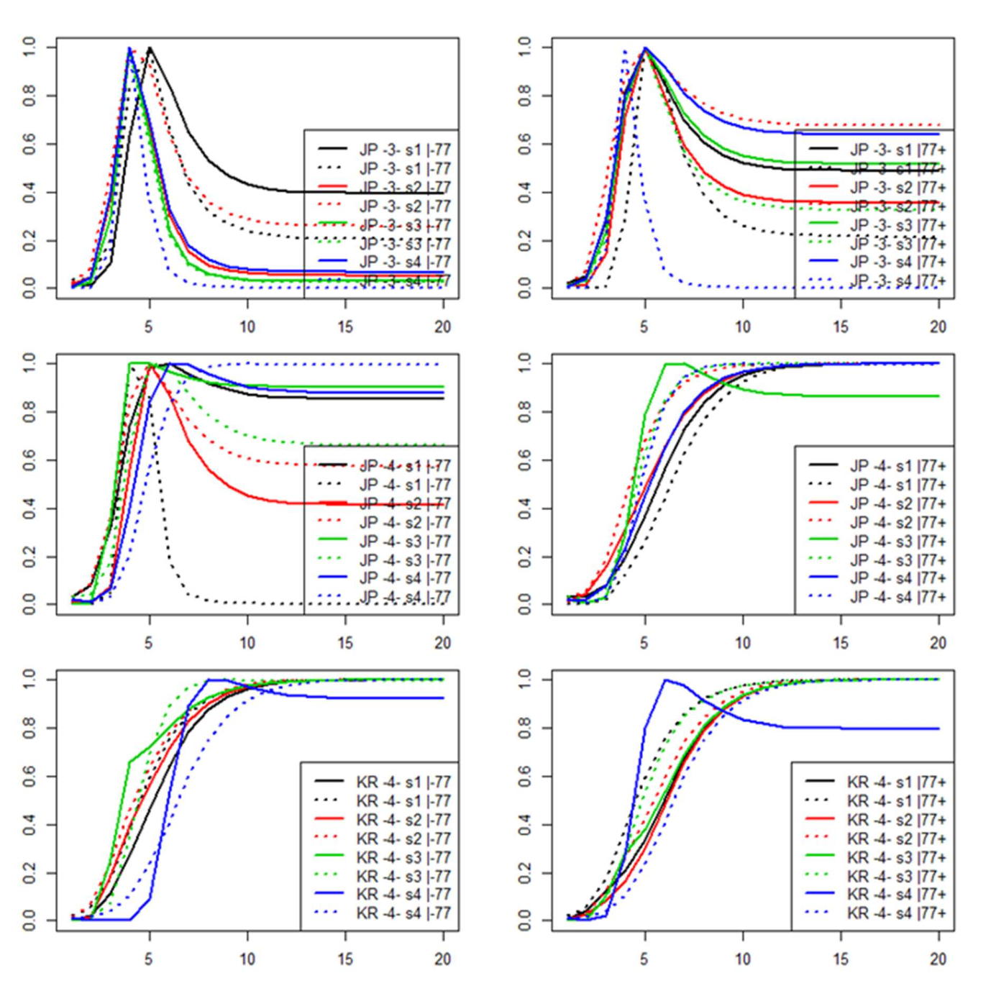

Figure 2. Comparisons of the selectivity-at-age estimates from the tmsplit model (dotted lines) for a subset of the respective time-block plus season-split fisheries against the corresponding time-block+seasonal estimates for the re- combined fishery of the tmblkseas model (solid lines). Each panel relates to an individual fishery’s time-block, and a unique colour identifies each season within the fishery.

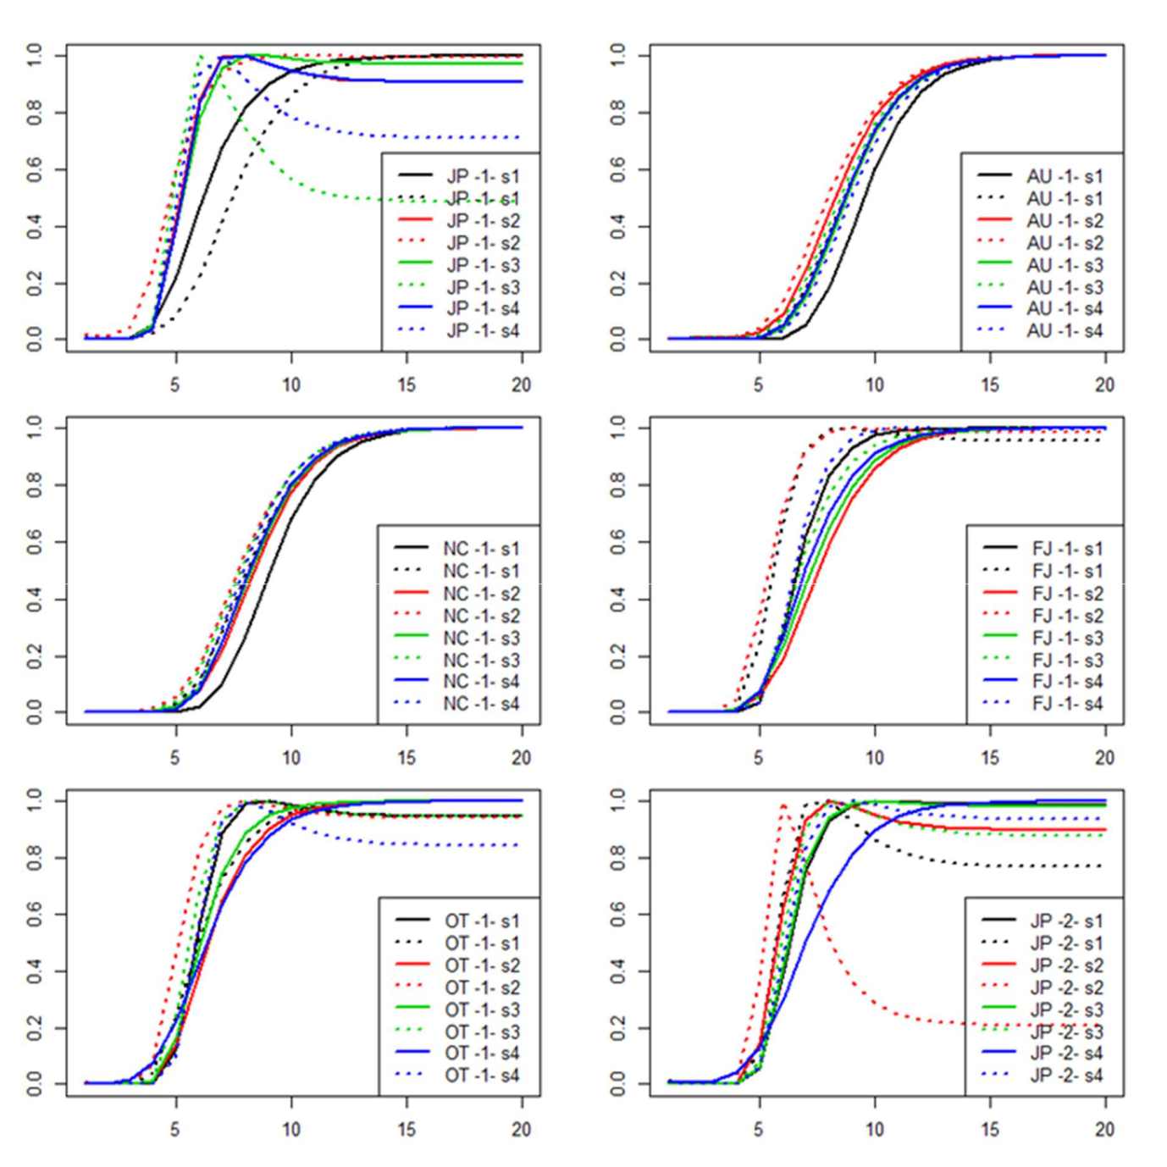

Figure 3. Comparisons of the selectivity-at-age estimates from the tmsplit model (dotted lines) for a subset of the respective season-split fisheries against the corresponding seasonal estimates for the re-combined fishery of the tmblkseas model (solid lines). Each panel relates to an individual fishery and a unique colour identifies each season within the fishery.
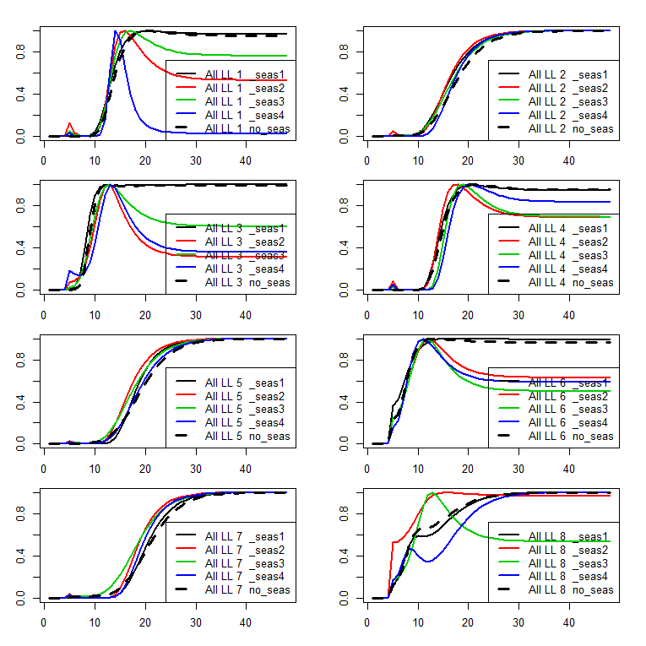

Figure 4. Comparison of constant selectivities (thick dashed lines) versus time-variant (seasonal ) selectivities (solid lines) estimated for two development models of the ALB2015 stock assessment, for the 8 longline fisheries defined.
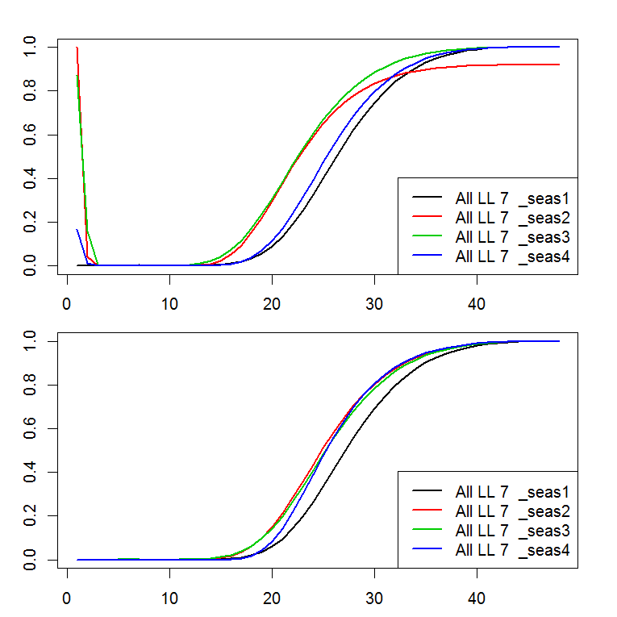

Figure 5. Comparison of selectivities estimated without (top panel) and with (bottom panel) a feature that constrains selectivity-at-age to be zero for specified age classes (1 to 4 quarters), as estimated for two development models of the ALB2015 stock assessment, for the longline fishery defined in region 7.
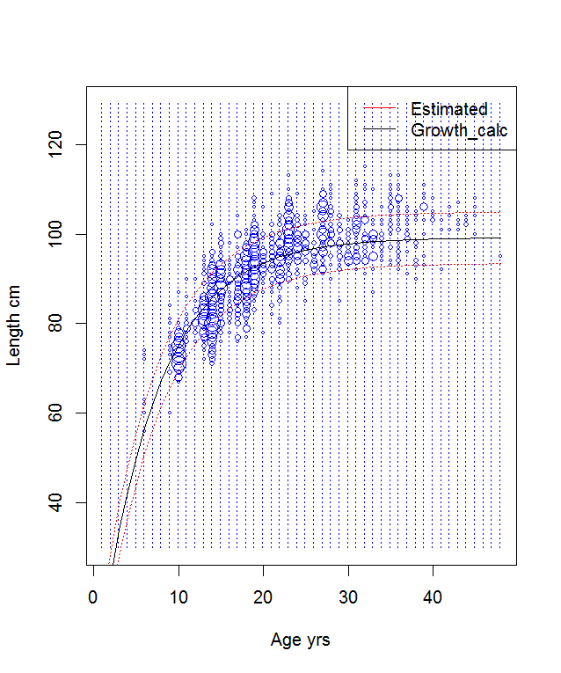

Figure 6. The fit of mean length-at-age estimates (taken from the growth function, black line) to observations of conditional age-at-length from otolith samples (circles) for a development model of the ALB2015 assessment.
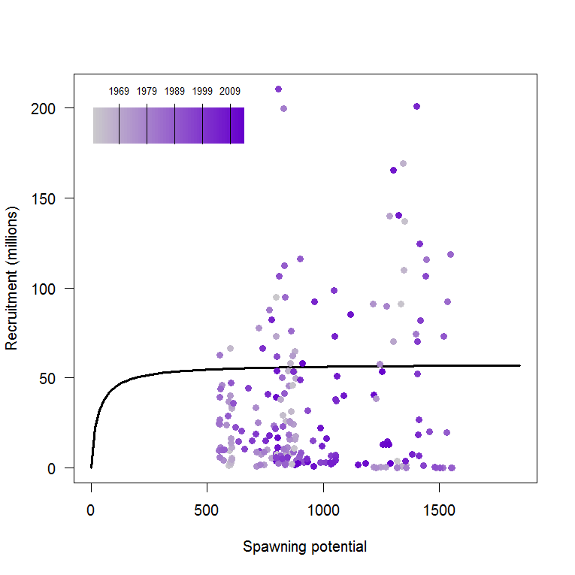

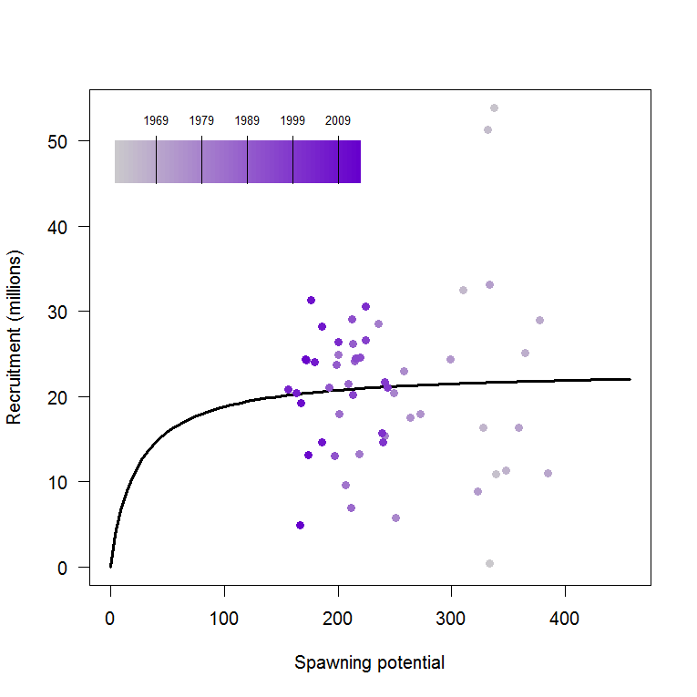

Figure 7. BH-SRR predictions and estimated recruitments for two development models of the ALB2015 stock assessment when fitted to quarterly estimated recruitments (top panel), and when using the feature that fits to annualised recruitments (bottom panel).

9 ANNEX

9.1 Benchmark testing

Table 9.1.1. Summary of benchmark tests of the development version using single species data undertaken August 2013 to July 2014.

Compilation name | Compilation folder & Exec.name | Compilation date | Test folder | Test date | Test configurations | Results folder | Key results
Benchmark testing 16 September 2014
MTHRD_2014_05_13 | multi_spp_2014_05_13;  exec_txf/mfclo64_2014_05_13 | May.2014 | 2014-09-12_fit_bet | 16/09/2014 | af145 = -3; penwt=10.0**af145 | 2014-09-12_fit_bet | penwt=0.001; Obj.=1068534.244292082731; MSY=3.047e+06; B0=2.217e+08
MTHRD_2014_05_17 | multi_spp_2014_05_17;  exec_txf/mfclo64_2014_05_17 | Sep.2014 | 2014-09-12_fit_bet | 16/09/2014 | af145 = -3; penwt=10.0**af145 | 2014-09-12_fit_bet | penwt=0.001; Obj.=1068556.974073923426; MSY=3.422e+06; B0=2.514e+08
Benchmark and Release version testing 22 September 2014
MTHRD_2014_05_17 | multi_spp_2014_05_17;  exec_txf/mfclo64_2014_05_17 | Sep.2014 | 2014-09-22_fit_bet | 22/09/2014 | af145 = 1; pen_wt=af145 | 2014-09-22_fit_bet | pen_wt=1; Obj.=1068477.068569175899; MSY=1.894e+04; B0=1.410e+06
Release_vsn.1.1.5.8 | C:\Nick\MFCL\2011-10-07\mfcl\; C:\Nick\I_Assessments\MFCL\2014_09_12 | Sep.2014 | 2014-09-22_fit_bet | 22/09/2014 | af145 = 1; pen_wt=af145 | 2014-09-22_fit_bet | pen_wt=1; Obj.=1068457.480964803835; MSY=1.913e+04; B0=1.420e+06
Development version and Release version testing 20 October 2014
MTHRD_2014_09_16 | multi_spp_2014_06_19;  exec_txf/mfclo64_2014_06_19 | 8 Oct.2014 | 2014-09-22_fit_bet | 20/10/2014 | af145 = 1; pen_wt=af145 | 2014-09-22_fit_bet | pen_wt=1; Obj.=1068477.068569175899; MSY=1.894e+04; B0=1.410e+06
Release_vsn.1.1.5.8 | C:\Nick\MFCL\2011-10-07\mfcl\; C:\Nick\I_Assessments\MFCL\2014_09_12 | Sep.2014 | 2014-09-22_fit_bet | 20/10/2014 | af145 = 1; pen_wt=af145 | 2014-09-22_fit_bet | pen_wt=1; Obj.=1068457.480964803835; MSY=1.913e+04; B0=1.420e+06
Benchmark and Development version testing 6 November 2014
MTHRD_2014_05_17 | multi_spp_2014_05_17;  exec_txf/mfclo64_2014_05_17 | Sep.2014 | 2014-11-06_fit_bet | 6/11/2014 | af145 = 1; pen_wt=af145 | 2014-11-06_fit_bet | pen_wt=1; Obj.=1068474.325769255171; MSY=1.884e+04; B0=1.397e+06
MTHRD_2014_09_16 | multi_spp_2014_06_19;  exec_txf/mfclo64_2014_06_19 | 5 Nov.2014 | 2014-11-06_fit_bet | 6/11/2014 | af145 = 1; pen_wt=af145 | 2014-11-06_fit_bet | pen_wt=1; Obj.=1068511.045675329166; MSY=1.899e+04; B0=1.405e+06
Benchmark and Development version testing 19-27 February 2015
MTHRD_2014_09_16 | multi_spp_2014_06_19;  exec_txf/mfclo64_2014_06_19 | 5 Nov.2014 | 2015-02-27_fit_bet/  bnchmrk_bet2011_fit | 27/02/2015 | af145 = 1; pen_wt=af145 | 2015-02-27_fit_bet | pen_wt=1; Obj.=1068511.045675329166; MSY=1.899e+04; B0=1.405e+06
MTHRD_2014_11_07 | multi_spp_2014_11_07;  exec_txf/mfclo64_2014_11_07 | 26 Feb.2015 | 2015-02-27_fit_bet/  devvsn_bet2011_fit | 27/02/2015 | af145 = 1; pen_wt=af145 | 2015-02-27_fit_bet | pen_wt=1; Obj.=1068553.274013987277; MSY=1.854e+04; B0=1.386e+06

34

35

