

Commission for the Conservation and Management of
Highly Migratory Fish Stocks in the Western and Central Pacific Ocean

Scientific Committee
Tenth Regular Session

Majuro, Republic of the Marshall Islands
6–14 August 2014

SUMMARY REPORT

© Western and Central Pacific Fisheries Commission 2014

The Western and Central Pacific Fisheries Commission authorizes the reproduction of this material, in whole or in part, provided that appropriate acknowledgement is given.

USP Library Cataloguing-in-Publication Data

Commission for the Conservation and Management of Highly Migratory
Fish Stocks in the Western and Central Pacific Ocean. Scientific Committee.
Regular Session (10th : 2014 : Majuro, Marshall Islands).
Tenth regular session, Majuro, Marshall Islands,
6-14 August 2014 : summary report. -- Majuro, Marshall Islands :
Western and Central Pacific Fisheries Commission, 2014.

229 p. ; 28 cm.

ISBN 978-982-9103-31-4

1. Fishery management, International--Oceania--Congresses.
2. Fishes--Conservation--Oceania--Congresses. 3. Fish stock assessment--
Oceania--Congresses. 4. Tuna fisheries--Oceania--Congresses.
5. Commission for the Conservation and Management of Highly Migratory
Fish Stocks in the Western and Central Pacific Ocean--Congresses.
I. Western and Central Pacific Fisheries Commission.

SH214.9.C779 2014 333.95609648--dc23

Publisher | Western and Central Pacific Fisheries Commission  PO Box 2356  Kolonia, Pohnpei 96941  Federated States of Micronesia
Typesetting | Times New Roman 11
Production | Western and Central Pacific Fisheries Commission, Pohnpei, Federated States of Micronesia

Acknowledgements

The financial, logistical and administrative support provided by the Government of the Federated States of Micronesia and the Western and Central Pacific Fisheries Commission Secretariat are gratefully acknowledged. The Secretariat of the Pacific Community’s Oceanic Fisheries Programme provided much of the technical material for the session. Dr. Jane Broweleit served as lead rapporteur for the meeting. The efforts of the support rapporteurs are acknowledged with appreciation.

TABLE OF CONTENTS

EXECUTIVE SUMMARY iv
summary report 1
Agenda Item 1 — Opening of Meeting 1
Agenda Item 2 — review of fisheries 2
Agenda Item 3 — Data and Statistics Theme 9
Agenda Item 4 — Stock Assessment Theme 21
Agenda Item 5 — Management Issues Theme 116
Agenda Item 6 — Ecosystem and Bycatch Mitigation Theme 134
Agenda Item 7 — Other Research Projects 147
Agenda Item 8 — cooperation With Other Organizations 149
Agenda Item 9 — special Requirements of Developing States and Participating Territories 149
Agenda Item 10— future Work Programme and Budget 150
Agenda Item 11 — administrative matters 153
Agenda Item 12 —Other matters 155
Agenda Item 13— adoption of sc10 report 155
Agenda Item 14 — close of meeting 155
Attachments 156
Attachment A — Opening Remarks 156
Attachment B — List of Participants 158
Attachment C — Agenda 173
Attachment D — Acronyms and Abbreviations Used by WCPFC 178
Attachment E — A Longline Observer Coverage Metric Under the ROP 181
Attachment F — Report Text Concerning Commitments to Support the Pacific-wide Bigeye Assessment with Provision of Operational-Level Data 182
Attachment G — IDENTIFICATION OF AXES OF UNCERTAINTIES AND RELATIVE WEIGHTINGS REQUIRED FOR EVALUATING RISKS OF EXCEEDING LIMIT REFERENCE POINTS 184
Attachment H — OUTCOME OF INFORMAL SMALL GROUP MEETING ON SHARK RESEARCH PLAN 185
Attachment I — DRAFT GUIDELINES FOR THE SAFE RELEASE OF ENCIRCLED ANIMALS, INCLUDING WHALE SHARKS 187
Attachment J — DEVELOPMENT OF NEW GUIDELINES FOR THE SURVIVAL OF SHARKS (OTHER THAN WHALE SHARKS) TO BE RELEASED FROM LONGLINE AND PURSE SEINE GEAR 191

The Commission for the Conservation and Management of Highly Migratory Fish Stocks in the Western and Central Pacific Ocean

Scientific Committee
Tenth Regular Session

Majuro, Republic of the Marshall Islands
6–14 August 2014

EXECUTIVE SUMMARY

AGENDA ITEM 1 — Opening of the Meeting

  - Welcome address

- The Tenth Regular Session of the Scientific Committee (SC10) was held in Majuro, Republic of the Marshall Islands from 6–14 August 2014. Ludwig Kumoru chaired the meeting. The Hon. Michael Konelios, Minister of Resources and Development, Republic of the Marshall Islands, delivered opening remarks.

- The theme conveners and their assigned themes are:
Data and Statistics theme | Ludwig Kumoru
Stock Assessment theme | Jon Brodziak (USA) and Miki Ogura (Japan)
Management Issues theme | Robert Campbell (Australia)
Ecosystem and Bycatch Mitigation theme | Aisake Batibasaga (Fiji) and John Annala (New Zealand)

AGENDA ITEM 2 — REVIEW OF FISHERIES

2.1 Overview of the western and central Pacific Ocean fisheries

- The provisional total tuna catch for the Western and Central Pacific Fisheries Commission (WCPFC) Statistical Area in 2013 was estimated at 2,621,511 mt, the second highest ever and only 30,000 mt below the record catch in 2012 (2,652,322 mt). This catch represents 80% of the total Pacific Ocean catch of 3,213,733 mt, and 57% of the global tuna catch (the provisional estimate for 2013 is 4,511,238 mt, which was the second highest on record).

- The 2013 WCPFC Statistical Area skipjack tuna catch (1,784,091 mt – 68% of the total catch) was the highest recorded, eclipsing the previous record of catch in 2009 (1,779,307 mt) by 5,000 mt. The WCPFC Statistical Area yellowfin tuna catch for 2013 (535,656 mt – 21%) was more than 75,000 mt less than the record catch of 2012 (612,797 mt) due to relatively poor catches in both the longline and purse-seine fisheries. The WCPFC Statistical Area bigeye tuna catch for 2013 (158,662 mt – 6%) was less than that in 2012, but relatively stable compared with the average over the past 10 years. The 2013 WCPFC Statistical Area albacore catch (143,102 mt – 5%) was slightly higher than that in 2012 and the second highest on record (after 2002 at 147,793 mt). The WCPFC Statistical Area albacore catch includes catches of North and South Pacific albacore in the WCPFC Statistical Area, which comprised 81% of the total Pacific Ocean albacore catch of 177,568 mt in 2013. The South Pacific albacore catch in 2013 (84,698 mt) was the third highest on record.

- The provisional 2013 purse-seine catch of 1,898,090 mt was the highest catch on record and more than 60,000 mt more than the previous record in 2012 (1,836,295 mt). The 2013 pole-and-line catch (221,022 mt) was the lowest annual catch since the late 1960s and is continuing the trend in declining catches for the past three decades. The provisional WCPFC Statistical Area longline catch (230,073 mt) for 2013 was the lowest catch since 1999. The 2013 South Pacific troll albacore catch (3,226 mt) was the highest during the last five years. The number of active purse-seine vessels in 2013 (excluding artisanal vessels in the Philippines, Indonesia and the Japanese coastal fisheries) was an all-time high (297 vessels) and total effort (in terms of fishing days estimated from logbook data and vessel monitoring system,data) was also the highest on record.

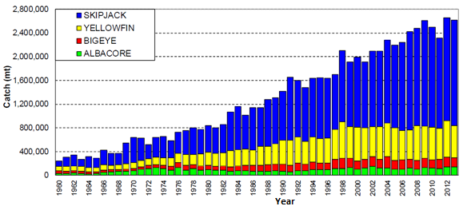 | 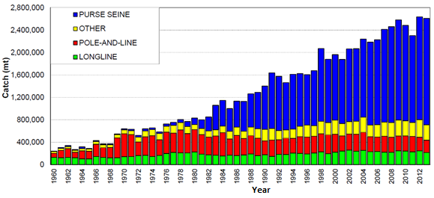
Figure 1: Catch (mt) of albacore, bigeye, skipjack and yellowfin tunas in the WCPFC Statistical Area. | Figure 2: Catch (mt) of albacore, bigeye, skipjack and yellowfin tunas in the WCPFC Statistical Area, by longline, pole-and-line, purse-seine and other gear types.

AGENDA ITEM 3 — DATA AND STATISTICS THEME

3.1 Data gaps

- SC10 recommended that:
  - the paper SC10-ST-WP-01 is forwarded to the Tenth Regular Session of the Technical and Compliance Committee (TCC10), highlighting the main data gap related to the non-provision of operational catch and effort data for 10 years by some Members, Cooperating Non-members and participating Territories (CCMs);
  - in regard to data issues related to the attribution of catch under charter arrangements, any revision to conservation and management measure (CMM) 2012-05 should include a reference to section 6 of “Scientific Data to be provided to the Commission”;
  - TCC10 consider establishing a tier and scoring system to better reflect the magnitude and severity of the non-provision of scientific data;
  - the data gap of the Chinese Taipei purse-seine fleet — related to the estimation of species catches in their aggregate data (Data Gap Note 13) — be removed from Table 4 of SC10-ST-WP-01 and that Chinese Taipei provide a paper to SC11, describing the methodology used to estimate tuna species catches in their aggregate purse-seine data provided to WCPFC; and
  - as a response to the requirements stated in paragraph 46 of CMM 2013-01, the summary of “other” gear catches of the tropical tuna species in the paper SC9-ST-WP-01 (Table 1) be updated to reflect:
    - the exclusion of those fisheries that take less than 2,000 mt of bigeye, yellowfin and skipjack tunas, and
    - the inclusion of any available information CCMs have provided on the estimates of fishing effort of these fisheries (refer to paragraphs 47 and 48 of CMM 2013-01).

- SC10 recommended that:
- the scientific services provider update the Plan for the Improvement of the Availability and Use of Purse-seine Catch Composition Data set out in SC8-WCPFC8-08 for consideration by SC11 and TCC11, noting the need for the Commission to adopt an integrated approach to improving purse-seine species composition data, including both scientific and compliance aspects. The update should take into account the outcomes of the work undertaken in Project 60, including the information in SC10-ST-WP-02;
- the information in SC10-ST-IP-02 regarding purse-seine species composition sampling protocols, spill bin size, and expectations of crew usage be forwarded to industry by CCMs to assess implications and operational constraints of wider use of spill sampling and report the feedback to SC11 and TCC11.
- as a carry-over from an SC9 recommendation, the scientific services provider provide to SC11 annual estimates of purse-seine catches based on: i) logbook-reported species composition, ii) observer grab samples (previous approach), and iii) observer grab samples corrected for selectivity bias from spill sampling. Catch series from any variants on these should also be included. This will allow SC to follow changes in purse-seine catch estimates from historical methods. The work should also include any guidance on the implications of future estimates if only grab sampling occurs (e.g. Can the selectivity bias correction be used into the future?).

3.2 Regional Observer Programme

- SC10 recommended that:
- the output from the informal small group on the longline observer coverage (Attachment E) be forwarded to TCC10 to progress this work; and
- the Regional Observer Programme (ROP)-defined observer data, summarized in past and present SC papers that have not been provided to WCFPC, be provided to the WCPFC Secretariat as soon as possible. The observer data summarized in SC10-ST-IP-10 are an example of data that should be provided to the WCFPC Secretariat.

3.3 Electronic monitoring and electronic reporting

- SC10 recommended that:
- the outcomes from the WCPFC e-reporting and e-monitoring workshop (March 2014) are taken to TCC10, in particular, the urgent need for developing standards for formats and validation checks of the potential e-reporting and e-monitoring data to be submitted to WCPFC that ensure accordance with agreed WCPFC data standards and take into consideration existing standards; and
- the e-reporting and e-monitoring trials continue to be supported and expanded, leading to large-scale implementation, where appropriate

AGENDA ITEM 4 — Stock assessment THEME

4.1 WCPO tunas

4.1.1 WCPO bigeye tuna

- SPC presented SC10-SA-IP-01 (Summary of major changes in the 2014 tropical tuna assessments) and SC10-SA-WP-01 (Stock assessment of bigeye tuna in the WCPO). The updated assessment addresses many of the recommendations provided in SC8-SA-WP-01 (Independent review of the 2011 bigeye tuna stock assessment). Other key papers document: i) the methods used in producing the purse-seine size data (Abascal et al. 2014) and catch estimates (Lawson 2013); ii) longline size data (McKechnie 2014), longline catch per unit of effort (CPUE) data (McKechnie et al. 2014b), and tagging data (Berger et al. 2014); iii) revisions to the fisheries and spatial definitions (McKechnie et al. 2014a); and iv) the guidance of the Pre-Assessment Workshop (PAW) held in April 2014 (SPC 2014).

a. Stock status and trends

- There have been significant improvements to the 2014 stock assessment resulting from the implementation of the 2012 bigeye tuna review recommendations. Improvements were made to regional and fisheries structures, CPUE, size, and tagging data inputs, and the MULTIFAN-CL modeling framework. This assessment is also the first since the adoption of an LRP based on the spawning biomass in the absence of fishing (0.2SB_{F=0}).

- SC10 selected the reference case model as the base case to represent the stock status of bigeye tuna. To characterize uncertainty, SC10 chose three additional models based on alternative values of steepness and a shorter tag-mixing period. Details of the base case and other models are provided in Table BET1.

Table BET1: Description of the base case and key model chosen for the provision of management advice.

Name | Description
Base case | JP CPUE for Regions 1, 2, and 4, all flags for Regions 3, 7, 8, 5, and 6, and nominal for Region 9. Size data weighted as the weighted number of samples divided by 20, steepness fixed at 0.8, M fixed, tag mixing at 2 quarters, and the mean length of fish in the oldest age class (L2) fixed at 184 cm.
h_0.65 | Steepness=0.65
h_0.95 | Steepness=0.95
Mix_1qtr | Tag-mixing period=1 quarter

- Time trends in estimated recruitment, biomass, fishing mortality and depletion are shown in Figures BET 1–4.

- The estimated MSY of 108,520 mt is higher than previous assessments. This is for three key reasons: i) the improved assessment has higher average recruitment; ii) application of the lognormal bias correction to the spawner-recruitment relationship; and iii) increased catches used in the new assessment.

- Fishing mortality has generally been increasing through time, and for the reference case F_{current} (2008–2011 average) is estimated to be 1.57 times the fishing mortality that will support MSY. Across the four models (base case and three sensitivity models), F_{current}/F_{MSY} ranged from 1.27 to 1.95. This indicates that overfishing is occurring in the WCPO bigeye tuna stock and that in order to reduce fishing mortality to F_{MSY} levels, the base case indicates that a 36% reduction in fishing mortality is required from 2008–2011 levels (Table BET2 and Fig. BET5). This is similar to the 32% reduction from 2006–2009 levels recommended from the 2011 assessment.

- The latest (2012) estimates of spawning stock biomass are below both the level that will support MSY (SB_{latest}/SB_{MSY} = 0.77 for the base case and range from 0.62 to 0.96 across the four models) and the newly adopted LRP of 0.2SB_{F=0} (SB_{latest}/SB_{F=0} = 0.16 for the base case and range from 0.14 to 0.18.

- An analysis of historical patterns in the mix of fishing gear types indicates that MSY has been reduced to less than half its level prior to 1970 through the increased harvesting of juveniles (Fig. BET6).

Table BET2: Estimates of management quantities for selected stock assessment models (see Table BET1 for details). For the purpose of this assessment, “current” is the average over the period 2008–2011 and “latest” is 2012.
 | Base case | h=0.65 | h=0.95 | Mix_1qtr
$MSY$(mt) | 108,520 | 101,880 | 116,240 | 107,880
$$C_{latest}/MSY$$ | 1.45 | 1.55 | 1.36 | 1.45
$$F_{current}/F_{MSY}$$ | 1.57 | 1.95 | 1.27 | 1.73
$$B_{0}$$ | 2,286,000 | 2,497,000 | 2,166,000 | 2,183,000
$$B_{current}$$ | 742,967 | 744,596 | 741,549 | 640,645
$${SB}_{0}$$ | 1,207,000 | 1,318,000 | 1,143,000 | 1,153,000
$${SB}_{MSY}$$ | 345,400 | 429,900 | 275,200 | 328,700
$${SB}_{F=0}$$ | 1,613,855 | 1,848,385 | 1,483,216 | 1,585,331
$${SB}_{curr}$$ | 325,063 | 326,007 | 324,283 | 269,820
$${SB}_{latest}$$ | 265,599 | 266,290 | 264,937 | 218,679
$${SB}_{curr}/{SB}_{F=0}$$ | 0.20 | 0.18 | 0.22 | 0.17
$${SB}_{latest}/{SB}_{F=0}$$ | 0.16 | 0.14 | 0.18 | 0.14
$${SB}_{curr}/{SB}_{MSY}$$ | 0.94 | 0.76 | 1.18 | 0.82
$${SB}_{latest}/{SB}_{MSY}$$ | 0.77 | 0.62 | 0.96 | 0.67

Table BET3: Comparison of selected WCPO bigeye tuna reference points from the 2010, 2011 and 2012 base case models.

Management quantity | Base case 2010 | Base case 2011 | Base case 2014
MSY(mt) | 73,840 | 76,760 | 108,520
F_{current}/F_{MSY} | 1.41 | 1.46 | 1.57
SB_{latest}/SB_{F=0} | 0.16 | 0.21 | 0.16

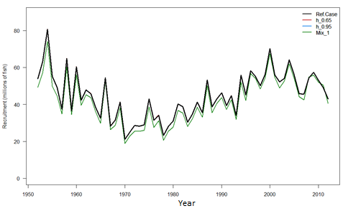 | 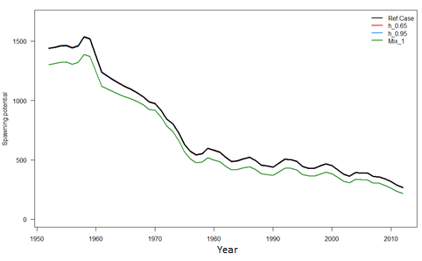 | 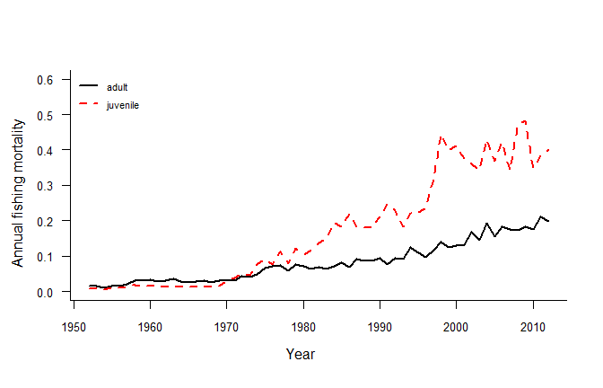
Figure BET1: Estimated annual recruitment (millions of fish) for the WCPO obtained from the base case model and three additional runs described in Table BET1. The model runs with alternative steepness values give the same recruitment estimates. | Figure BET2: Estimated annual average spawning potential for the WCPO obtained from the base case model and three additional runs described in Table BET1. The model runs with alternative steepness values give the same spawning potential trajectory estimates as the reference case. | Figure BET3: Estimated annual average juvenile and adult fishing mortality for the WCPO obtained from the base case model.

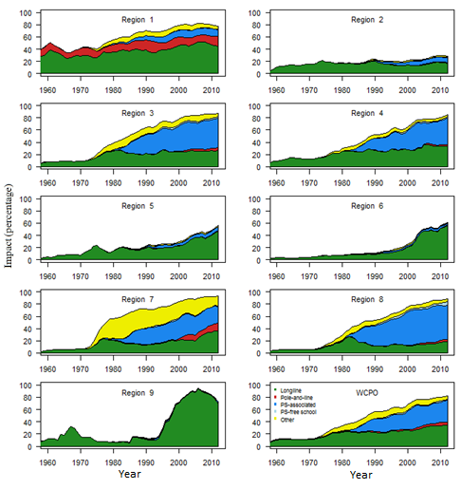 | 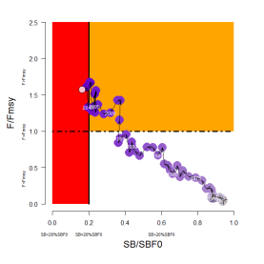  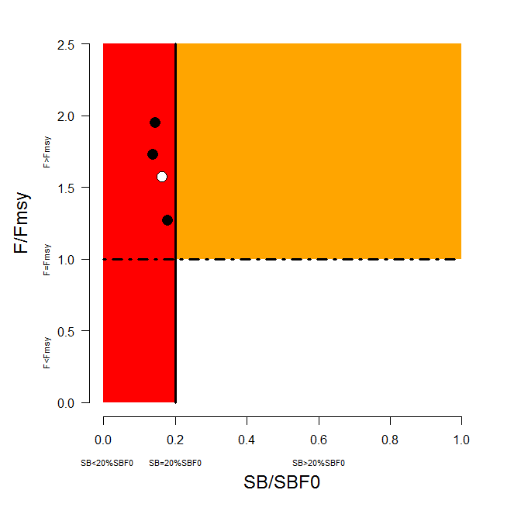 | 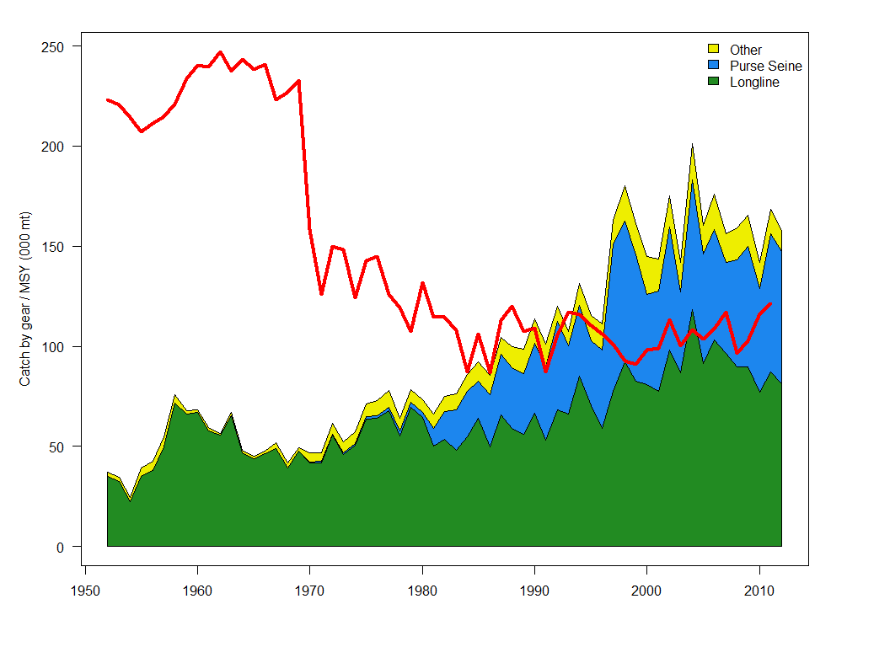
Figure BET4: Estimates of reduction in spawning potential due to fishing (fishery impact = 1-SB_{t}/SB_{t,F=0}) by region and for the WCPO attributed to various fishery groups for the base case model. | Figure BET5: Temporal trend for the base case model (top) and terminal condition for the base case and other sensitivity runs (bottom) in stock status relative to SB_{F=0} (x-axis) and F_{MSY} (y-axis). The red zone represents spawning potential levels lower than the agreed LRP, which is marked with the solid black line (0.2SB_{F=0}). The orange region is for fishing mortality greater than F_{MSY} (F=F_{MSY}; marked with the black dashed line). The pink circle (top panel) is SB₂₀₁₂/SB_{F=0} (where SB_{F=0} was the average over the period 2002–2011). The bottom panel includes the base case (white dot) and sensitivity analyses described in Table BET1. | Figure BET6: History of annual estimates of MSY compared with catches of three major fisheries for the base case model.

b. Management advice and implications

- SC10 noted that the spawning biomass of WCPO bigeye tuna breached the biomass LRP in 2012 and that the stock was overfished. Rebuilding spawning biomass to be above the biomass LRP will require a reduction in fishing mortality.

- SC10 recommended that fishing mortality on WCPO bigeye tuna be reduced. A 36% reduction in fishing mortality from the average levels for 2008–2011 would be expected to return the fishing mortality rate to F_{MSY}. This reduction of at least 36% should also allow the stock to rebuild above the LRP over a period of time. This recommended level of reduction in fishing mortality could also be stated as a minimum 33% reduction from the 2004 level of fishing mortality, or a minimum 26% reduction from the average 2001–2004 level of fishing mortality.

- Future status quo projections (assuming 2012 conditions) depend on assumptions on future recruitment. When spawner-recruitment relationship conditions are assumed, spawning biomass continues to decline and the stock is very likely (94%) to remain below the LRP based on projections through 2032 (SB₂₀₃₂<0.2SB_{F=0}). If recent (2002–2011) actual recruitments are assumed, spawning biomass increases and it is unlikely (13%) to remain below the LRP. Under both recruitment assumptions, it was virtually certain (100%) that the stock would remain subject to overfishing (F>F_{MSY}).

- Overfishing and the increase in juvenile bigeye tuna catches have resulted in a considerable reduction in the potential yield of the WCPO bigeye tuna stock. The loss in yield per recruit due to excess harvesting of juvenile fish is substantial. SC10 concluded that MSY levels would increase if the mortality of juvenile bigeye tuna was reduced.

- Fishing mortality varies spatially within the Convention Area, with high mortality in the tropical Pacific Ocean. WCPFC could consider a spatial management approach in reducing fishing mortality for bigeye tuna.

- Considering the unavailability of operational longline data for the assessment from some key fleets, SC10 recommended that all operational data, including high seas data, should be available for future stock assessments. The current lack of operational data for some fleets, and in particular the lack of operational longline data on the high seas, has hampered the 2014 assessment in a number of ways (e.g. the construction of abundance indices), and consequently, has hindered SC from achieving “best practice” in the 2014 stock assessment.

- SC10 noted that arrangements are being developed between CCMs and SPC to facilitate the availability of operational data for the Pacific-wide bigeye tuna stock assessment scheduled for 2015 (Attachment F).

- SC10 recommended that the Commission consider the results of updated projections at WCPFC11, including an evaluation of the potential impacts of CMM 2013-01, to determine whether the CMM will achieve its objectives and allow the bigeye tuna stock to rebuild above the LRP.

4.1.2 WCPO yellowfin tuna

- N. Davies (SPC) presented SC10-SA-WP-04 (Stock assessment of yellowfin tuna in the WCPO). The updated assessment addresses many of the recommendations provided in SC8-SA-WP-01 (Independent review of the 2011 bigeye tuna stock assessment), which apply equally to yellowfin tuna. Other key papers document: the methods used in producing the purse-seine size data (Abascal et al. 2014), longline size data (McKechnie 2014), longline CPUE data (McKechnie et al. 2014b), and tagging data (Berger et al. 2014); revisions to the fisheries and spatial definitions (McKechnie et al. 2014a); the guidance of the PAW held in April 2014 (SPC 2014).

a. Stock status and trends

- There have been significant improvements to the 2014 stock assessment resulting from the implementation of the 2012 bigeye tuna review recommendations, which apply equally to yellowfin tuna. Improvements were made to regional and fisheries structures, catch estimates, CPUE, tagging data inputs, and the MULTIFAN-CL modeling framework. This assessment is also the first since the adoption of an LRP based on the spawning biomass in the absence of fishing (0.2SB_{F=0}).

- SC10 selected the reference case model, which had an assumed steepness of 0.8 to represent the stock status of yellowfin tuna. To characterize uncertainty in the assessment, SC10 chose three additional models based on alternate values of steepness and tagging-mixing period. More detail of the base case and other models are provided in Table YFT1.

Table YFT1: Description of the base case and key model chosen for the provision of management advice.

Name | Description
Base case | JP longline CPUE for Regions 1 and 2, all flags longline for Regions 3 to 7, and all flags longline nominal for Regions 8 and 9; with purse-seine CPUE for PH-ID in Region 7 and all flags in Region 8. Size data weighted as the number of samples divided by 20, steepness fixed at 0.8, M fixed, tag-mixing period of 2 quarters, and fixed natural mortality.
h_0.65 | Steepness=0.65
h_0.95 | Steepness=0.95
Mix_1qtr | Tag-mixing period=1 quarter

- Time trends in estimated recruitment, biomass, fishing mortality and depletion are shown in Figures YFT 1–4.

- High levels of fishing mortality on juveniles have been recorded in Region 7 (Fig. YFT6). Stock depletion levels are higher in the equatorial regions than elsewhere (refer to Fig. YFT4).

- The estimated MSY of 586,400 mt is within the range of previous assessments, and model quantities are generally similar with these earlier assessments. This is due largely to the consistent information on declining relative abundance provided by the longline CPUE indices and the large amount of tagging data input to the model.

- The dramatic decline in MSY in the 1970s follows the increased development of those fisheries that catch younger yellowfin tuna, principally the small-fish fisheries in the western equatorial region (Fig. YFT7).

- Fishing mortality has generally been increasing through time, and for the reference case F_{current} (2008–2011 average) is estimated to be 0.72 times the fishing mortality that will support MSY. Across the four models (base case and three sensitivity models) F_{current}/F_{MSY} ranged from 0.58 to 0.90. This indicates that overfishing is not occurring in the WCPO yellowfin tuna stock, however latest catches are close to or exceed MSY by up to 13% (Table YFT2 and Fig. YFT5).

- The latest (2012) estimates of spawning biomass are above both the level that will support MSY (SB_{latest}/SB_{MSY} = 1.24 for the base case and range from 1.05 to 1.51 across the four models) and the newly adopted LRP of 0.2SB_{F=0} (SB_{latest}/SB_{F=0} = 0.38) for the base case model and range from 0.35 to 0.40.

Table YFT2: Estimates of management quantities for selected stock assessment models (see Table YFT1 for details). For the purpose of this assessment, “current” is the average over the period 2008–2011 and “latest” is 2012.

 | Ref.Case | Mix_1 | h_0.65 | h_0.95
$$MSY(mt)$$ | 586400 | 526400 | 527200 | 642800
$$C_{latest}/MSY$$ | 1.02 | 1.12 | 1.13 | 0.93
$$F_{current}/F_{MSY}$$ | 0.72 | 0.87 | 0.9 | 0.58
$$B_{0}$$ | 4319000 | 3862000 | 4475000 | 4221000
$$B_{current}$$ | 1994655 | 1597536 | 1996179 | 1995224
$${SB}_{0}$$ | 2467000 | 2202000 | 2557000 | 2411000
$${SB}_{MSY}$$ | 728300 | 648000 | 859600 | 594500
$${SB}_{F=0}$$ | 2368557 | 2206510 | 2556733 | 2255523
$${SB}_{current}$$ | 998622 | 746743 | 999474 | 998914
$${SB}_{latest}$$ | 899496 | 770210 | 899362 | 898389
$${SB}_{current}/{SB}_{F=0}$$ | 0.42 | 0.34 | 0.39 | 0.44
$${SB}_{latest}/{SB}_{F=0}$$ | 0.38 | 0.35 | 0.35 | 0.4
$${SB}_{current}/{SB}_{MSY}$$ | 1.37 | 1.15 | 1.16 | 1.68
$${SB}_{latest}/{SB}_{MSY}$$ | 1.24 | 1.19 | 1.05 | 1.51

Table YFT3: Comparison of selected WCPO yellowfin tuna reference points from the 2009, 2011 and 2014 base case models.

Management quantity | Ref.case-2009 | Ref.case-2011 | Ref.case-2014
MSY | 636,800 | 538,800 | 586,400
F_{current}/F_{MSY} | 0.58 | 0.77 | 0.72
SB_{latest}/SB_{F=0} | 0.50 | 0.44 | 0.38

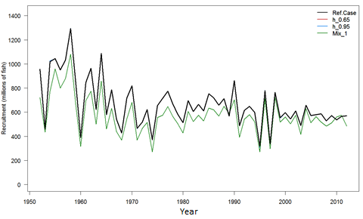 | 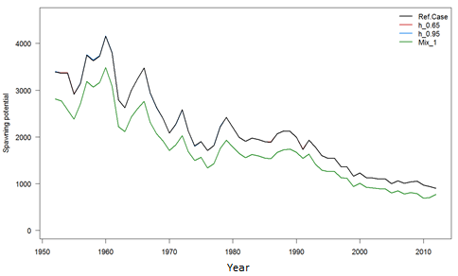 | 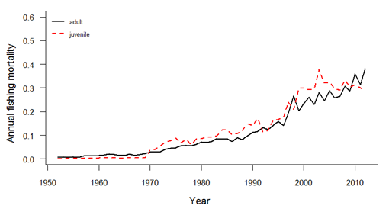
Figure YFT1: Estimated annual average recruitment for the WCPO obtained from the base case model and three additional runs described in Table YFT1. The model runs with alternative steepness values give the same recruitment estimates. | Figure YFT2: Estimated annual average spawning potential for the WCPO obtained from the base case model and three additional runs described in Table YFT1. The model runs with alternative steepness values give the same recruitment estimates. | Figure YFT3: Estimated annual average juvenile and adult fishing mortality for the WCPO obtained from the base case model.
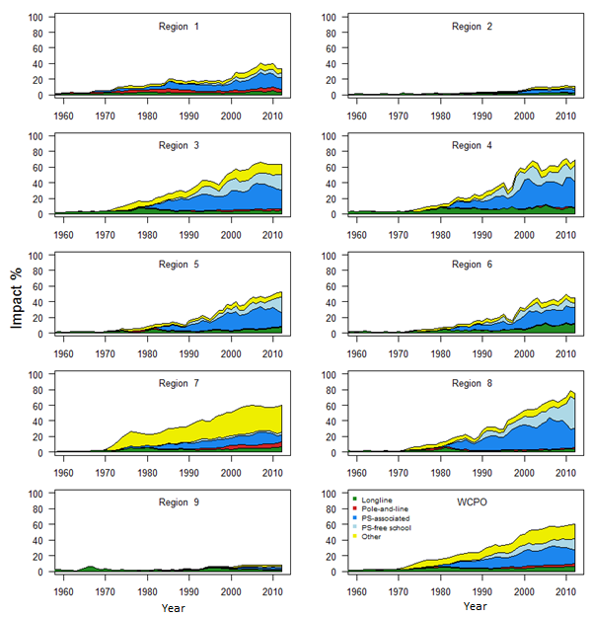 | 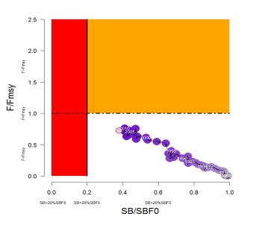  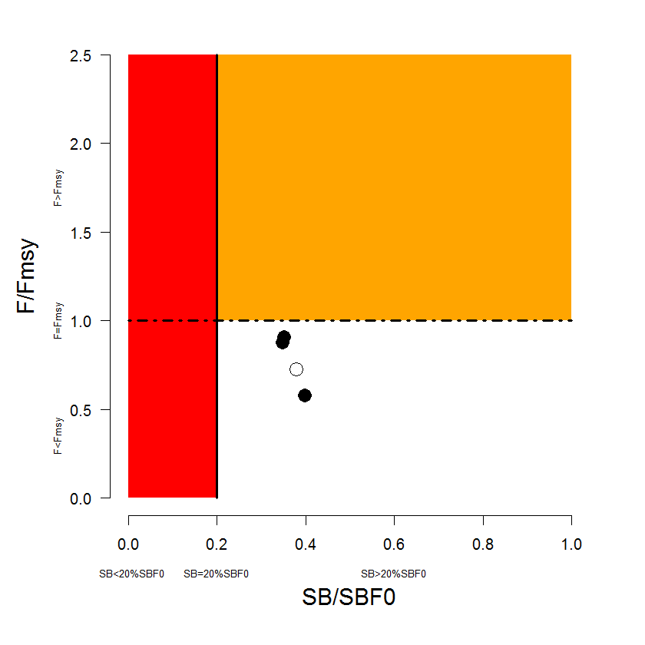 | 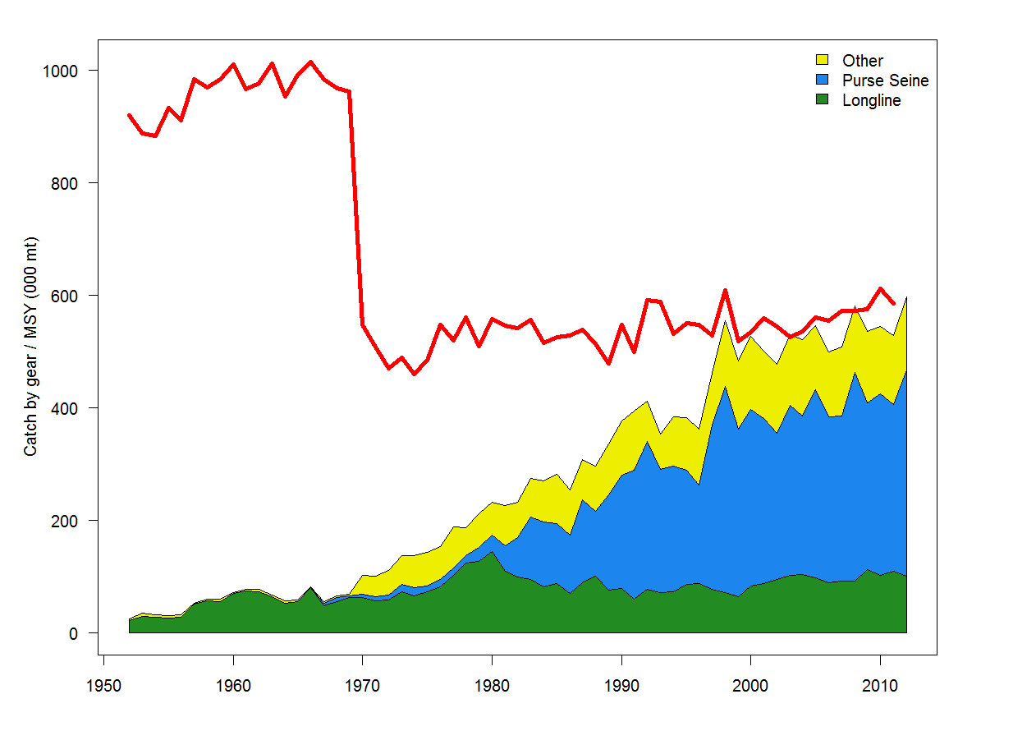
Figure YFT4: Estimates of reduction in spawning potential due to fishing (fishery impact = 1-SB_{t}/SB_{t,F=0}) by region and for the WCPO attributed to various fishery groups for the base case model. | Figure YFT5: Temporal trend for the base case model (top) and terminal condition for the base case and other sensitivity runs (bottom) in stock status relative to SBF=0 (x-axis) and F_{MSY} (y-axis). The red zone represents spawning potential levels lower than the agreed LRP, which is marked with the solid black line (0.2SB_{F=0}). The orange region is for fishing mortality greater than F_{MSY} (F=F_{MSY}; marked with the black dashed line). The pink circle (top panel) is SB₂₀₁₂/SB_{F=0} (where SB_{F=0} was the average over the period 2002–2011). The bottom panel includes the base case (white dot) and sensitivity analyses described Table YFT1. | Figure YFT7: History of annual estimates of MSY compared with catches of three major fisheries for the base case model.

b. Management advice and implications

- The WCPO yellowfin tuna spawning biomass is above the biomass-based LRP that WCPFC adopted, 0.2SB_{F=0}, and overall fishing mortality appears to be below F_{MSY}. It is highly likely that the stock is not experiencing overfishing and is not in an overfished state.

- Latest (2012) catches (612,797 mt [SC10-GW-WP-01]) of WCPO yellowfin tuna marginally exceed MSY (586,400 mt).

- Future status under status quo projections (assuming 2012 conditions) depends on assumptions on future recruitment. When spawner-recruitment relationship conditions are assumed, spawning biomass is predicted to increase and the stock is exceptionally unlikely (0%) to become overfished (SB₂₀₃₂<0.2SB_{F=0}) or to fall below SB_{MSY}, or to become subject to overfishing (F>F_{MSY}). If recent (2002–2011) actual recruitments are assumed, spawning biomass will remain relatively constant, and the stock is exceptionally unlikely (0%) to become overfished or to become subject to overfishing, and it was very unlikely (2%) that the spawning biomass would fall below SB_{MSY}.

- SC also noted that levels of fishing mortality and depletion differ between regions, and that fishery impact was highest in the tropical region (Regions 3, 4, 7 and 8 in the stock assessment model). WCPFC could consider measures to reduce fishing mortality from fisheries that take juveniles, with the goal to increase to maximum fishery yields and reduce any further impacts on the spawning potential for this stock in the tropical regions.

- WCPFC could consider a spatial management approach in reducing fishing mortality for yellowfin tuna.

- SC recommended that the catch of WCPO yellowfin tuna should not be increased from 2012 levels, which exceeded MSY, and measures should be implemented to maintain current spawning biomass levels until the Commission can agree on an appropriate target reference point (TRP).

4.1.3 WCPO skipjack tuna

- J. Rice presented SC10-SA-WP-05 (Stock assessment of skipjack tuna in the WCPO). The updated assessment addresses many of the recommendations provided in SC8-SA-WP-01 (Independent review of the 2011 bigeye tuna stock assessment) that pertain to skipjack tuna. Other key papers document: the methods used in producing the purse-seine size data (Abascal et al. 2014),and tagging data (Berger et al. 2014); revisions to the fisheries and spatial definitions (McKechnie et al. 2014); and the guidance of PAW held in April 2014 (SPC 2014).

a. Status and trends

- There have been significant improvements to the 2014 stock assessment resulting from the implementation of the 2012 bigeye tuna review recommendations. Improvements were made to regional and fisheries structures, CPUE, size, and tagging data inputs, and the MULTIFAN-CL modeling framework. This assessment is also the first since the adoption of an LRP based on the spawning biomass in the absence of fishing (0.2SB_{F=0}).

- SC10 selected the reference case model as the base case to represent the stock status of skipjack tuna. To characterize uncertainty, SC10 chose three additional models based on alternative values of steepness and a longer tag-mixing period. Details of the base case and other models are provided in Table SKJ1.

Table SKJ1: Description of the base case and key model chosen for the provision of management advice.

Name | Description
Base case | JPN PL CPUE for Regions 1,2,3, PH PS-Associated CPUE for Region 4, PNG PS-Associated CPUE for Region 5. Size data weighted as sample number/20, steepness fixed at 0.8, growth fixed, mixing period of 1 quarter, terminal 4 recruitments not estimated
h_0.65 | Steepness=0.65
h_0.95 | Steepness=0.95
Mix_2qtr | Tag-mixing period=2 quarters

- Time trends in estimated recruitment, biomass, fishing mortality and depletion are shown in Figures SKJ 1–4.

- The estimated MSY is 1,618,800 mt, which is slightly lower than recent catches.

- Fishing mortality has generally been increasing through time, and for the base case F_{current} (2008–2011 average) is estimated to be 0.61 times the fishing mortality that will support MSY. Across the base case and three sensitivity models F_{current}/F_{MSY} ranged from 0.45 to 0.82. This indicates that overfishing is not occurring for the WCPO skipjack tuna stock.

- The latest (2011) estimates of spawning biomass are above both the level that will support MSY (SB_{latest}/SB_{MSY} = 1.74 for the base case and range from 1.45 to 2.10 across the four models) and the newly adopted LRP of 0.2SB_{F=0} (SB_{latest}/SB_{F=0} = 0.48 for the base case and range from 0.46 to 0.5). These biomass estimates are within the range (0.4–0.6) of depletion levels currently under consideration for a possible TRP.

- Future status under status quo projections (assuming 2012 conditions) was robust to assumptions on future recruitment. Under either assumption, spawning biomass remained relatively constant and it is exceptionally unlikely (0%) for the stock to become overfished (SB₂₀₃₂<0.2SB_{F=0}) or for the spawning biomass to fall below SB_{MSY}, and it is exceptionally unlikely (0%) for the stock to become subject to overfishing (F>F_{MSY}).

- Abundance indices of coastal fisheries in the Pacific coastal waters of Japan show a declining trend, and the level between 2006 and 2013 was half of the level between 1996 and 2005. The migration of the skipjack tuna stock to coastal areas around Japan, one of the edge areas of skipjack tuna distribution, has diminished since around 2006, possibly due to a range contraction of this species in the WCPO, although other reasons cannot be ruled out.

- It is noted higher catch of skipjack tuna existed for recent years.

- SC10 recommended that PAW consider the inclusion of fisheries data into the skipjack tuna assessment for the northern and southern margins of the Convention Area.

- SC10 recommended that further research on range contraction of skipjack tuna be conducted in the framework of Project 67.

Table SKJ2: Estimates of management quantities for selected stock assessment models (see Table SKJ1 for details). For the purpose of this assessment, “current” is the average over the period 2008–2011 and “latest” is 2011.

 | Base case | h=0.65 | h=0.95 | Mix_2qtr
MSY | 1,618,800 | 1,426,800 | 1,806,800 | ,784,000
C_{latest}/MSY | 1.02 | 1.16 | 0.92 | 0.93
F_{current/}F_{MSY} | 0.61 | 0.82 | 0.45 | 0.52
B₀ | 6,587,000 | 6,913,000 | 6,404,000 | 7,419,000
B_{current} | 3,615,213 | 3,613,290 | 3,612,585 | 4,374,786
SB₀ | 6,229,000 | 6,538,000 | 6,056,000 | 6,989,000
SB_{MSY} | 1,753,000 | 2,111,000 | 1,453,000 | 1,999,000
SB_{F=0} | 6,303,358 | 6,690,474 | 6,082,301 | 7,085,699
SB_{current} | 3,260,579 | 3,258,721 | 3,258,170 | 3,971,998
SB_{latest} | 3,052,995 | 3,050,692 | 3,049,508 | 3,548,468
SB_{current}/SB_{F=0} | 0.52 | 0.49 | 0.54 | 0.56
SB_{latest}/SB_{F=0} | 0.48 | 0.46 | 0.50 | 0.50
SB_{current}/SB_{MSY} | 1.86 | 1.54 | 2.24 | 1.99
SB_{latest}/SB_{MSY} | 1.74 | 1.45 | 2.10 | 1.78

Table SKJ3: Comparison of selected WCPO skipjack tuna reference points from the 2010, 2011 and 2014 base case models.

Management quantity | Base Case 2010 | Base Case 2011 | Base Case 2014
MSY | 1,375,600 | 1,503,600 | 1,618,800
F_{current}/F_{MSY} | 0.34 | 0.37 | 0.61
SB_{latest}/SB_{F=0} | 0.48 | 0.55 | 0.48

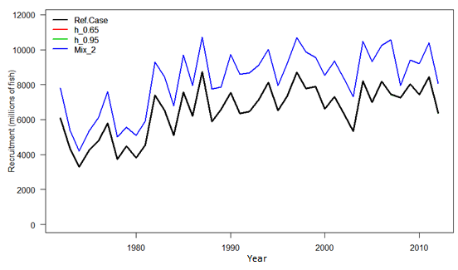 | 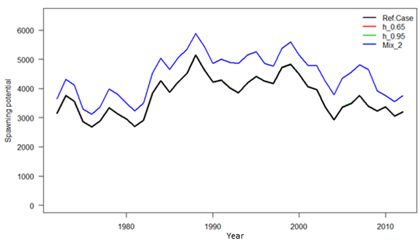 | 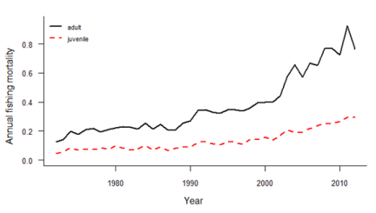
Figure SKJ1: Estimated annual recruitment (millions of fish) for the WCPO obtained from the base case model and three additional runs described in Table SKJ1. The model runs with alternative steepness values give the same recruitment estimates. | Figure SKJ2: Estimated annual average spawning potential for the WCPO obtained from the base case model and three additional runs described in Table SKJ1. The model runs with alternative steepness values give the same spawning potential estimates. | Figure SKJ3: Estimated annual average juvenile and adult fishing mortality for the WCPO obtained from the base case model.
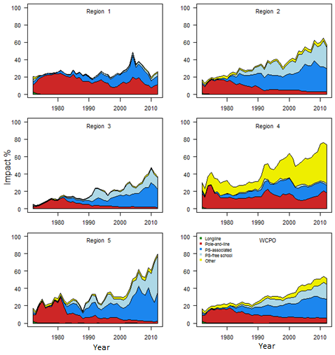 | 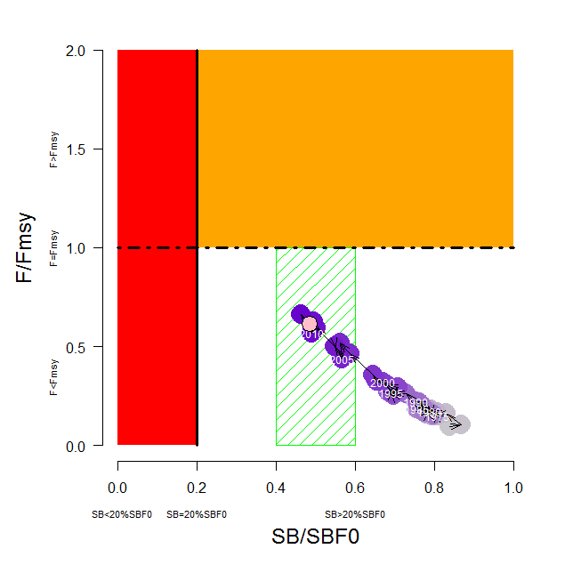  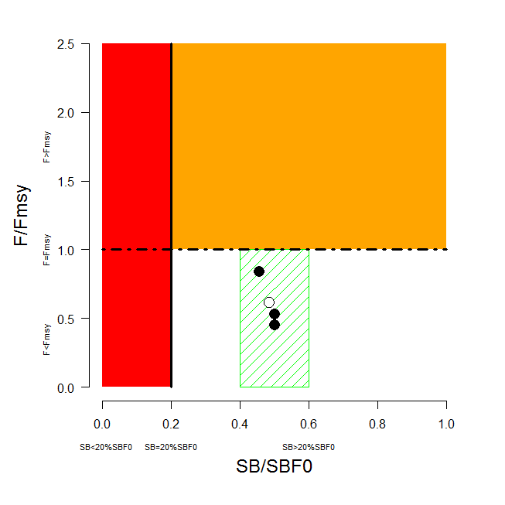 | 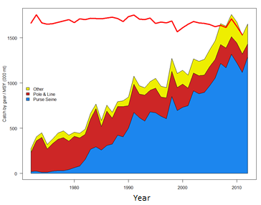
Figure SKJ4: Estimates of reduction in spawning potential due to fishing (fishery impact = 1-SB_{t}/SB_{t,F=0}) by region and for the WCPO attributed to various fishery groups for the base case model. Note: Region 1 Japanese purse-seine fishery was grouped as an associated set fishery in this analysis. | Figure SKJ5: Temporal trend for the base case model (top) and terminal condition for the base case and other sensitivity runs (bottom) in stock status relative to SB_{F=0} (x-axis) and F_{MSY} (y-axis). The red zone represents spawning potential levels lower than the agreed LRP, which is marked with the solid black line (0.2SB_{F=0}). The orange region is for fishing mortality greater than F_{MSY} (F=F_{MSY}; marked with the black dashed line). The lightly shaded green rectangle covering 0.4–0.6SB_{F=0} are the candidate TRPs of 40%, 50% and 60% of unfished spawning stock biomass that WCPFC10 has asked for consideration of a TRP for skipjack tuna. The pink circle (top panel) is SB₂₀₁₂/SB_{F=0} (where SB_{F=0} was the average over the period 2002–2011). The bottom panel includes the base case (white dot) and sensitivity analyses described Table SKJ1. | Figure SKJ6: History of annual estimates of MSY compared with catches of three major fisheries for the base case model.

b. Management advice and implications

- Recent catches are slightly above the estimated MSY of 1,618,800 mt. The assessment continues to show that the stock is currently only moderately exploited (F_{current}/F_{MSY} = 0.61) and fishing mortality levels are sustainable. However, the continuing increase in fishing mortality and decline in stock size are recognized.

- SC10 advised the WCPFC that there is concern that high catches in the equatorial region could result in range contractions of the stocks, thus reducing skipjack tuna availability to high latitude fisheries.

- Fishing is having a significant impact on stock size, especially in the western equatorial region and can be expected to affect catch rates. The stock distribution is also influenced by changes in oceanographic conditions associated with El Niño and La Niña events, which impact on catch rates and stock size. Additional purse-seine effort will yield only modest gains in long-term skipjack tuna catches and may result in a corresponding increase in fishing mortality for bigeye and yellowfin tunas. The management of total effort in the WCPO should recognize this.

- The spawning biomass is now around the mid-point of the range of candidate TRPs of 40%, 50% and 60% of unfished spawning stock biomass that WCPFC10 has asked SC10 to consider for skipjack tuna. SC10 recommends that the Commission take action to avoid further increases in fishing mortality and to keep the skipjack tuna stock around the current levels, with tighter purse-seine control rules and advocates for the adoption of TRPs and harvest control rules.

- SC10 recommended that the Commission consider the results of updated projections at WCPFC11, including the evaluation of the potential impacts of CMM 2013-01 in order to determine whether the CMM will achieve its objectives, including impacts of the skipjack tuna fishery on bigeye and yellowfin tunas.

4.1.4 South Pacific albacore tuna

- SPC presented SC10-SA-WP-07 (Trends in the South Pacific albacore longline and troll fisheries), a compendium of fishery indicators for South Pacific albacore tuna. Documented indicators included: total catch; catch by gear, longline effort and nominal longline CPUE trends, along with their spatial patterns; catch size composition; and trends in average fish weight.

a. Status and trends

- SC10 noted that no stock assessment was conducted for South Pacific albacore tuna in 2014. Therefore, the stock status description and management recommendations from SC8 are still current.

- However, recent trends for South Pacific albacore tuna are also important for describing the stock status.
- The total South Pacific albacore catch in 2013 was 84,698 mt, which was the third highest on record, and was 3% lower than the catch in 2012, but 9% higher than the average over 2008–2012.
- Total VMS effort information south of 10°S, which is considered to be more up to date than logsheet data, indicated that total effort had increased by 9% from 2012 to 2013. The rate of effort increase has been greater in the high seas area.
- On the basis of stochastic stock projections using 18 assessment model runs there is a 30% chance that spawning biomass is exceeding the biological LRP. However, further analyses at SC10, based on a reduced range of 9 assessment model runs, indicated zero risk of falling below the LRP level, but decreases in median spawning biomass levels over 20 years to 65%SB_{F=0} and 59%SB_{F=0} for 2010 and 2012 conditions, respectively.

b. Management advice and implications

- SC10 noted that no stock assessment has been undertaken since SC8.

- SC10 noted the increasing catch and effort on South Pacific albacore south of the equator in both the WCPFC and IATTC convention areas which, under 2012 conditions, is projected to result in a 16% reduction on average (range of 6% to 30% reduction) in vulnerable biomass by 2030 (the biomass available to longline fleets, as a proxy for CPUE, thus particularly impacting on the vulnerable biomass available to small island developing states domestic fleets and their profitability.

- SC10 recommends that longline fishing mortality and longline catches be reduced to avoid further decline in the vulnerable biomass and possibly exceeding the biomass LRP, and so that economically viable catch rates can be maintained.

4.2 Northern stocks

- The chair of the International Scientific Committee for Tuna and Tuna-like Species in the North Pacific Ocean (ISC) presented SC10-GN-IP-02, which outlined highlights of the 14th meeting of the International Scientific Committee for Tuna and Tuna-like Species in the North Pacific Ocean held in Taipei, Taiwan from 16 to 21 July 2014.

4.2.1 North Pacific albacore tuna

- ISC presented working paper SC10-SA-WP-12 (Stock assessment of albacore tuna in the North Pacific Ocean in 2014).

a. Status and trends

- SC10 noted that the ISC provided the following conclusions on the stock status of North Pacific albacore.

Because the F for 2010–2012 relative to most candidate reference points, except F_{MED} and F_{50%}, are below 1.0, NPALB is not experiencing overfishing (Table NP-ALB1). Although no biomass-based reference points have been developed for this stock, there is little evidence from this assessment that fishing has reduced SSB below reasonable candidate biomass-based reference points, so the ALBWG concludes that the stock is likely not in an overfished condition at present. The ISC concludes that the North Pacific albacore stock is healthy and that current productivity is sufficient to sustain recent exploitation, assuming average historical recruitment continues.

Table NP-ALB1: Potential reference points and estimated F-ratios using current F (F_{2010–2012}) and F_{2002–2004} (reference years for North Pacific albacore CMMs adopted by IATTC and WCPFC) to assess current stock status, associated spawning biomass and equilibrium yield for North Pacific albacore when exploited at F_{2010–2012}. Median SSB and yield are shown for F_{SSB–ATHL} as this simulation-based reference point is based on a non-equilibrium concept.
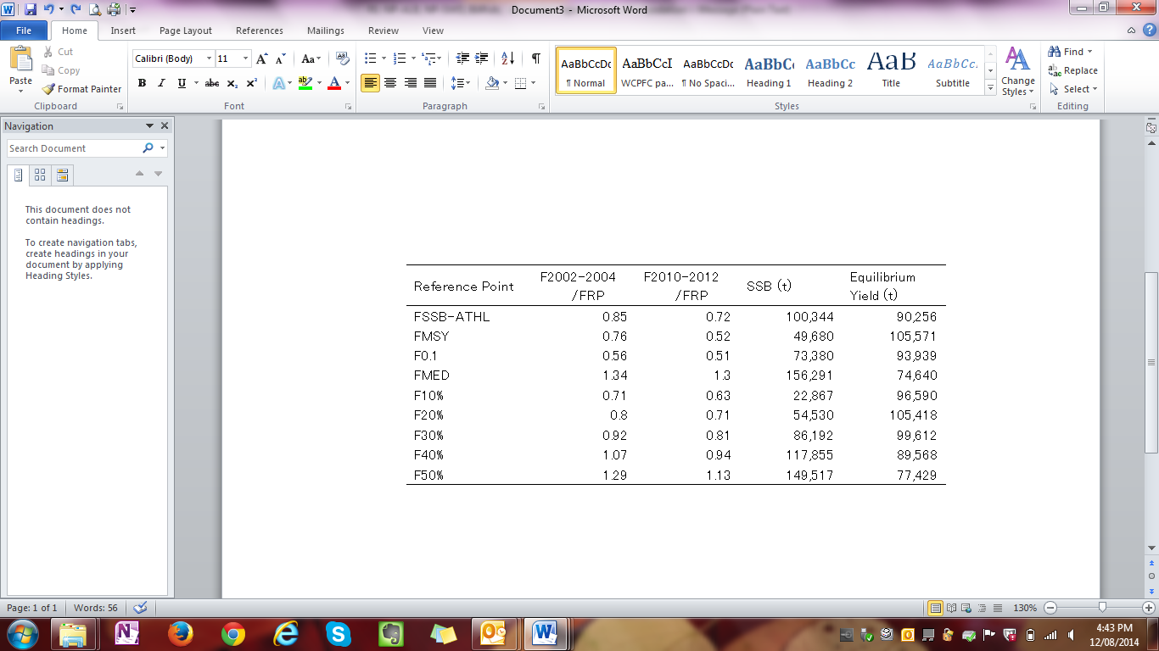

b. Management advice and implications

- SC10 noted the following conservation advice from the ISC.

The current exploitation level (F_{2010–2012}) is estimated to be below that of F_{2002–2004}, which led to the implementation of conservation and management measures (CMMs) for the North Pacific albacore stock in the EPO (IATTC Resolution C-05-02 supplemented by Resolution C-13-03) and the WCNPO (WCPFC CMM 2005-03). Assuming average historical recruitment and fishing at a constant current F, median female SSB is expected to remain relatively stable between the 25th and median historical percentiles over both the short- and long-term, with a 13% probability that female SSB falls below the SSB-ATHL threshold during a 25-year projection period. In contrast, if a low recruitment scenario is assumed, then median female SSB declines under both harvest scenarios (constant F_{2010–2012}, constant F_{2002–2004}) and the probability that it falls below the SSB-ATHL threshold in the 25-year projection period increases to 65% as calculated by the ALBWG and noted above. The high recruitment scenario is more optimistic, with median future SSB increasing above the historical median SSB and the estimated probability of falling below the SSB-ATHL threshold is correspondingly low at 3%.

- SC members continue to encourage the development of reference points for northern stocks, including the North Pacific albacore fishery, that are consistent with the reference points being developed for other WCPFC fisheries.

4.2.2 Pacific bluefin tuna

- ISC presented SC10-SA-WP-11 (Stock assessment of bluefin tuna in the Pacific Ocean in 2014).

a. Status and trends

- SC10 noted that ISC provided the following conclusions on the stock status of Pacific bluefin tuna in the Pacific Ocean in 2014.

Using the updated stock assessment, the 2012 SSB was 26,324 mt and slightly higher than that estimated for 2010 (25,476 mt).

Across sensitivity runs in the update stock assessment, estimates of recruitment were considered robust. The recruitment level in 2012 was estimated to be relatively low (the 8th lowest in 61 years), and the average recruitment level for the last five years may have been below the historical average level (Figure B1). Estimated age-specific fishing mortalities on the stock in the period 2009–2011 relative to 2002–2004 (the base period for WCPFC Conservation and Management Measure 2010-04) increased by 19%, 4%, 12%, 31%, 60%, 51% and 21% for ages 0-6, respectively, and decreased by 35% for age-7+ (Figure B2).

Although no target or LRPs have been established for the PBF stock under the auspices of WCPFC and IATTC, the current F average over 2009–2011 exceeds all target and limit biological reference points (BRPs) commonly used by fisheries managers except for F_{loss}, and the ratio of SSB in 2012 relative to unfished SSB (depletion ratio) is less than 6%. In summary, based on reference point ratios, overfishing is occurring and the stock is overfished (Table B1).

Table B1: Ratio of the estimated fishing mortalities F_{2002–2004}, F_{2007–2009} and F_{2009–2011} relative to computed F-based biological reference points for Pacific bluefin tuna (Thunnus orientalis), depletion ratio (ratio of SSB in 2012 relative to unfished SSB), and estimated SSB (mt) in year 2012. Values in the first eight columns above 1.0 indicate overfishing.

 | F_{Max} | F_{0.1} | F_{Med} | F_{loss} | F_{10%} | F_{20%} | F_{30%} | F_{40%}
F_{2002–2004} | 1.70 | 2.44 | 1.09 | 0.84 | 1.16 | 1.68 | 2.26 | 2.98
F_{2007–2009} | 2.09 | 2.96 | 1.40 | 1.08 | 1.48 | 2.14 | 2.87 | 3.79
F_{2009–2011} | 1.79 | 2.54 | 1.25 | 0.97 | 1.32 | 1.90 | 2.55 | 3.36

For illustrative purposes, two examples of Kobe plots (plot A based on SSB_{MED} and F_{MED}, plot B based on SSB20% and SPR20%, Figure B3) are presented. Because no reference points for PBF have yet been agreed to, these versions of the Kobe plot represent alternative interpretations of stock status in an effort to prompt further discussion.

Historically, the WPO coastal fisheries group has had the greatest impact on the PBF stock, but since about the early 1990s the WPO purse seine-fleet has increased its impact, and the effect of this fleet is currently greater than any of the other fishery groups. The impact of the EPO fishery was large before the mid-1980s, thereafter decreasing significantly. The WPO longline fleet has had a limited effect on the stock throughout the analysis period. The impact of a fishery on a stock depends on both the number and size of the fish caught by each fleet; i.e., catching a high number of smaller juvenile fish can have a greater impact on future spawning stock biomass than catching the same weight of larger mature fish (Figures B4 and B5).

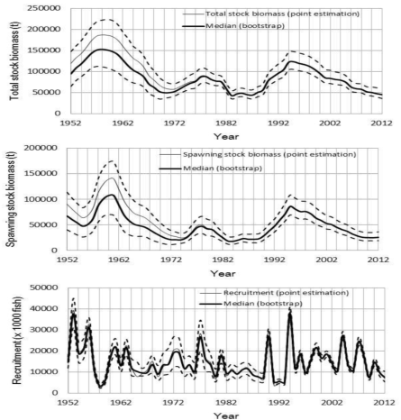 | 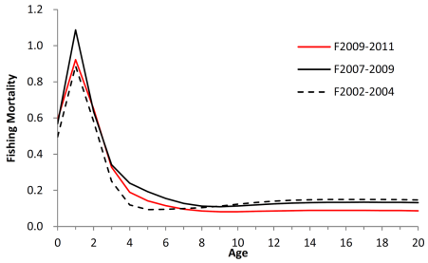 | 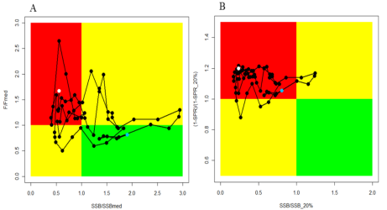
Figure B1: Pacific bluefin tuna (Thunnus orientalis) total stock biomass (upper panel), spawning stock biomass (middle panel) and recruitment (lower panel) of PBF from the base case run. Thick line indicates median, thin line indicates point estimate, and dashed lines indicate the 90% confidence interval | Figure B2: Geometric mean annual age-specific Pacific bluefin tuna (Thunnus orientalis) fishing mortalities for 2002–2004 (dashed line), 2007–2009 (solid line) and 2009–2011 (red line) | Figure B3: Alternative Kobe plots for Pacific bluefin tuna (Thunnus orientalis). A. SSB_{MED} and F_{MED}; B. SSB20% and SPR20%. Citation of these Kobe plots should include clarifying comments in the text. The blue and white points on the plot show the start (1952) and end (2012) year of the period modeled in the stock assessment, respectively.
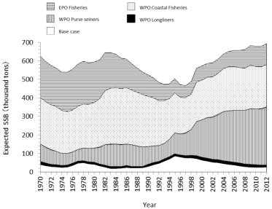 | 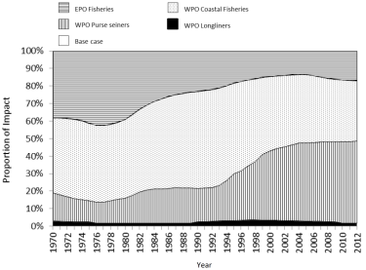
Figure B4: Trajectory of the spawning stock biomass of a simulated population of Pacific bluefin tuna (Thunnus orientalis) that was unexploited (topmost line) and that predicted by the base case (white area). The shaded areas between the two lines show the proportions of impact of each fishery. | Figure B5: The proportion of the impact on the Pacific bluefin tuna (Thunnus orientalis) spawning stock biomass by each group of fisheries.

b. Management advice and implications

- SC10 noted the following conservation advice from ISC:

The current (2012) PBF biomass level is near historically low levels and experiencing high exploitation rates above all biological reference points except for F_{loss}. Based on projection results, the recently adopted WCPFC CMM (2013-09) and IATTC resolution for 2014 (C-13-02), if continued into the future, are not expected to increase SSB if recent low recruitment continues.

In relation to the projections requested by NC9, only scenario 6, the strictest one, results in an increase in SSB even if the current low recruitment continues (see Figures). Given the result of scenario 6, further substantial reductions in fishing mortality and juvenile catch over the whole range of juvenile ages should be considered to reduce the risk of SSB falling below its historically lowest level.

If the low recruitment of recent years continues the risk of SSB falling below its historically lowest level observed would increase. This risk can be reduced with implementation of more conservative management measures.

Based on the results of future projections requested at NC9, unless the historical average level (1952–2011) of recruitment is realized, an increase of SSB cannot be expected under the current WCPFC and IATTC conservation and management measures, even under full implementation (scenario 1).

If the specifications of the harvest control rules used in the projections were modified to include a definition of juveniles that is more consistent with the maturity ogive used in the stock assessment, projection results could be different; for example, rebuilding may be faster. While no projection with a consistent definition of juvenile in any harvest scenario was conducted, any proposed reductions in juvenile catch should consider all non-mature individuals.

Given the low level of SSB, uncertainty in future recruitment, and importance of recruitment in influencing stock biomass, monitoring of recruitment should be strengthened to allow the trend of recruitment to be understood in a timely manner.

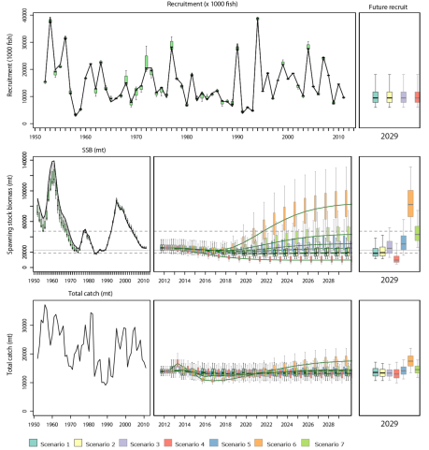 | 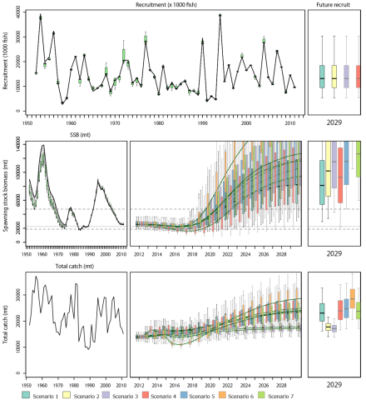 | 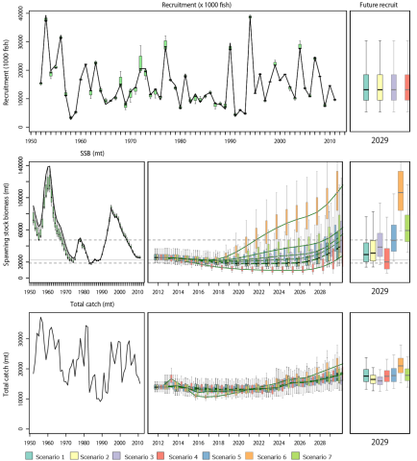
Figure B6-1: Comparison of future Pacific bluefin tuna (Thunnus orientalis) SSB trajectories in seven harvest scenarios (see full text for scenario definitions of SC10-SA-WP-11) under low recruitment conditions. Error bars represent 90% confidence limits. | Figure B6-2: Comparison of future Pacific bluefin tuna (Thunnus orientalis) SSB trajectories in seven harvest scenarios (see full text for scenario definitions of SC10-SA-WP-11) under average recruitment conditions (resampling from recruitment in 1952–2011). Error bars represent 90% confidence limits. | Figure B6-3: Comparison of future Pacific bluefin tuna (Thunnus orientalis) SSB trajectories in seven harvest scenarios (see full text for scenario definitions of SA-WP-11) assuming 10 years (2014–2023) of low recruitment followed by average recruitment after 2024 (resampling from recruitment in 1952–2011). Error bars represent 90% confidence limits.

4.2.3 North Pacific swordfish

- ISC presented SC10-SA-WP-13 (North Pacific swordfish [Xipiaus gladius] stock assessment in 2014). In the North Pacific, the swordfish (Xiphias gladius) population comprises of two stocks, separated by a diagonal boundary extending from Baja, California, to the equator. These are the western and central North Pacific Ocean stock (WCNPO), distributed in the western and central Pacific, and the eastern Pacific Ocean stock (EPO), distributed in the eastern Pacific (Fig. S1).

a. Stock status and trends

- SC10 noted that ISC provided the following conclusions on the stock status of North Pacific swordfish.

Exploitable biomass of WCNPO swordfish fluctuated at or above B_{MSY} throughout the assessment time horizon and has remained high in recent years and harvest rate fluctuated at or below H_{MSY}. Trends in exploitable biomass and harvest rate from the current assessment are very similar to those from the 2009 assessment. In recent years, catches and harvest rates of WCNPO swordfish have had a declining trend, with exploitable biomass fluctuating around 70,000 mt, since 2007. The Kobe plot showed that the WCNPO swordfish stock does not appear to have been overfished or to have experienced overfishing throughout most of the assessment time horizon of 1951–2012. For the current status, results indicated it was very unlikely that the WCNPO swordfish population biomass was below B_{MSY} in 2012 (Pr(B₂₀₁₂ < B_{MSY})=14%). Similarly, it was extremely unlikely that the swordfish population was being fished in excess of H_{MSY} in 2012 ( Pr(H₂₀₁₂ > H_{MSY}) < 1% ). Retrospective analyses indicated that there was no retrospective pattern in the estimates of exploitable biomass and harvest rate.

For the EPO stock, time series of estimates of exploitable biomass and harvest rate over the assessment time horizon differed from the previous assessment in recent years but have remained high in recent years (Table S2 and Figure S4). Exploitable biomass had a declining trend during 1969–1995 and has increased from 31,000 mt in 1995 to over 60,000 mt in 2010, generally remaining above B_{MSY}. Harvest rates were initially low, have had a long-term increasing trend, and likely exceeded H_{MSY} in 1998, 2002, 2003, and also the most recent year, 2012 (Figure S4). The Kobe plot showed that overfishing likely occurred in only a few years, but may be occurring in recent years (Figure S5). In 2012, there was a 55% probability that overfishing was occurring in 2012, but there was a less than 1% probability that the stock was overfished. Retrospective analyses indicated that there was a clear retrospective pattern of underestimating exploitable biomass and overestimating harvest rate.

Table S2: Reported annual values of catch (mt) and posterior mean values of exploitable biomass (B, mt), relative biomass (B/B_{MSY}), harvest rate (percent of exploitable biomass), relative harvest rate (H/H_{MSY}), and probability of annual harvest rate exceeding H_{MSY} for the EPO swordfish stock.

Year | 2006 | 2007 | 2008 | 2009 | 2010 | 2011 | 2012 | Mean¹ | Min¹ | Max¹
Reported catch | 3,235 | 3,701 | 4,262 | 7,473 | 9,631 | 9,586 | 9,910 | 3,561 | 1 | 9,910
Exploitable biomass | 43,100 | 47,980 | 53,840 | 60,570 | 62,120 | 60,810 | 58,590 | 48,875 | 31,510 | 67,070
Relative biomass | 1.38 | 1.54 | 1.73 | 1.95 | 2.00 | 1.95 | 1.87 | 1.58 | 1.02 | 2.16
Harvest rate | 8% | 9% | 9% | 14% | 17% | 18% | 19% | 8% | <1% | 22%
Relative harvest rate | 0.49 | 0.50 | 0.51 | 0.80 | 1.00 | 1.03 | 1.11 | 0.49 | 0.00 | 1.30
Pr( H > H_{MSY} ) | 0.01 | 0.02 | 0.02 | 0.20 | 0.44 | 0.47 | 0.55 | 0.11 | 0.00 | 0.71
¹ During 1951–2012.

 | 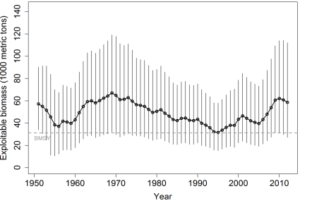  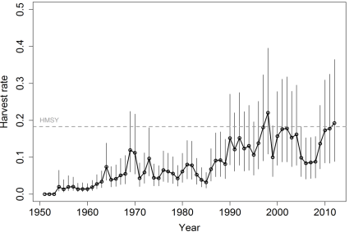 | 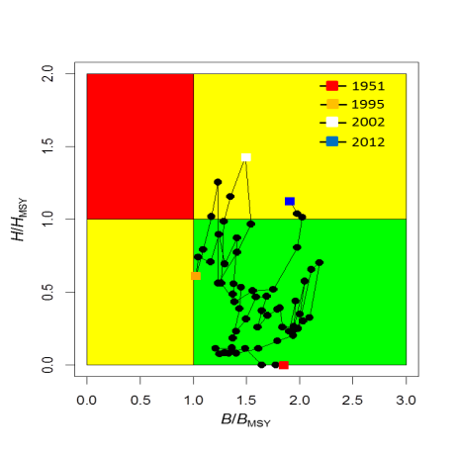
Figure S1: A two-stock structure for swordfish in the North Pacific Ocean, indicating separate stocks in the WCPO and the EPO. | Figure S4: Trends in exploitable biomass (top) and harvest rate (bottom) of swordfish (Xiphias gladius) in the EPO stock area. Estimated mean values from the posterior distribution (black circles and solid line), 95% confidence interval bars (solid vertical lines), and estimated biological reference points (B_{MSY} and H_{MSY}, horizontal dashed lines) are presented | Figure S5: Kobe diagram showing the estimated trajectories of relative exploitable biomass (B/B_{MSY}) and relative harvest rate (H/H_{MSY}) for swordfish (Xiphias gladius) in the EPO stock area during 1951–2012.

b. Stock projections and risk analyses

- SC10 noted that ISC provided the following conclusions on the stock projections and risk analysis of North Pacific swordfish.

For the WCNPO stock, stochastic projections for eight harvest scenarios were conducted through 2016 (Figure S6). Results relative to MSY-based reference points indicated that exploitable biomass would likely remain above B_{MSY} through 2016 under the status quo catch or status quo harvest rate scenarios (Figure S6). For the high harvest rate scenarios (i.e. maximum observed harvest rate, 150% of H_{MSY}, 125% of H_{MSY}), exploitable biomass was projected to decline below B_{MSY} by 2016 (Figure S6) with harvest rates exceeding H_{MSY}. In comparison, the stock would not be expected to experience any overfishing during 2014–2016 under the status quo catch and status quo harvest rate scenarios (Figure S6).

For the EPO stock, stochastic projections showed that exploitable biomass will likely have a decreasing trajectory during 2014–2016 under all eight of the harvest scenarios examined (Figure S7). Under the high harvest rate scenarios (status quo catch, maximum observed harvest rate, 150% of H_{MSY}), exploitable biomass was projected to decline to be roughly equal to B_{MSY} in 2016 (Figure S7) and maintain harvest rates above H_{MSY}. In comparison, under the status quo harvest rate scenario, exploitable biomass was projected to decline to only 40,000 mt by 2016, well above the B_{MSY} level. Overall, the projections showed that if recent high catch levels persist, exploitable biomass will very likely decrease and a moderate risk of overfishing will likely continue to occur.
The risk analyses of harvesting a constant annual catch of WCNPO swordfish during 2014–2016 showed that there would be virtually no chance of the stock being overfished or experiencing overfishing in 2016 (Figure S8) if current annual catches of about 10,000 mt were maintained.

The risk analyses for harvesting a constant catch of EPO swordfish during 2014–2016 showed that the probabilities of overfishing and becoming overfished increased as projected catch increased in the future (Figure S8). Maintaining the current catch of EPO swordfish of approximately 9,700 mt would lead to a moderate risk of overfishing in 2016 but would lead to less than 1% probability of the stock being overfished in 2016.

 |  | 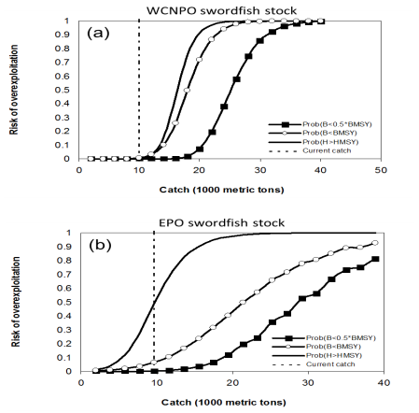
Figure S6: Stochastic projections of expected exploitable biomass (1000 metric tons) of swordfish (Xiphias gladius) in the WCPO stock area during 2013–2016 under alternative harvest rates. Upper panel shows projection results of applying a harvest rate set to be 50%, 75%, 100%, 125%, and 150% of the value of estimate of H_{MSY} (denoted as F_{MSY} in the Figure). Lower panel shows projection results of applying a status quo harvest rate based on the 2010–2012 average estimates, a status quo catch based on the 2010–2012 average catch, and the maximum observed harvest rate in the 1951–2012 time series. | Figure S7: Stochastic projections of expected exploitable biomass (1000 metric tons) of swordfish (Xiphias gladius) in the EPO stock area during 2013–2016 under alternative harvest rates. Upper panel shows projection results of applying a harvest rate set to be 50%, 75%, 100%, 125%, and 150% of the value of estimate of H_{MSY} (denoted as F_{MSY} in the Figure). Lower panel shows projection results of applying a status quo harvest rate based on the 2010–2012 average estimates, a status quo catch based on the 2010–2012 average catch, and the maximum observed harvest rate in the 1951–2012 time series. | Figure S8: Probabilities of experiencing overfishing (H > H_{MSY}, solid line), of exploitable biomass falling below B_{MSY} (B < 0.5*B_{MSY}, open circles), and of being overfished relative to a reference level of ½B_{MSY} (B < 0.5*B_{MSY}, solid squares) in 2016 for swordfish in the WCPO stock area (a) and EPO stock area (b) based on applying a constant catch biomass (x-axis, thousand mt) in the stock projections.

c. Management advice and implications

- SC10 noted the following conservation advice from ISC.

Based on the assessment update, the WCNPO stock is not currently overfished and is not experiencing overfishing. The WCNPO stock is not fully exploited.

For the EPO swordfish stock, overfishing may be occurring in recent years. The recent average yield of roughly 10,000 mt, or almost two times higher than the estimated MSY, is not likely to be sustainable in the long term. While biomass of the EPO stock appears to be nearly twice B_{MSY}, any increases in catch above recent levels should consider the uncertainty in stock structure and unreported catch

4.3 WCPO sharks

4.3.1 Oceanic whitetip shark

a. Status and trends

- SC10 noted that no stock assessment was conducted for this species in 2014.

b. Management advice and implications

- Because there was no stock assessment for this species, advice from SC8 should be maintained, pending a new assessment or other new information.

4.3.2 Silky shark

a. Status and trends

- SC10 noted that no stock assessment was conducted for this species in 2014.

b. Management advice and implications

- There was no stock assessment for this species, therefore advice from SC9 should be maintained, pending a new assessment or other new information.

4.3.3 South Pacific blue shark

a. Status and trends

- SC10 noted that no stock assessment was conducted for this species in 2014.

b. Management advice and implications

- There was no stock assessment for this species, therefore advice from SC9 should be maintained, pending a new assessment or other new information.

4.3.4 North Pacific blue shark

- ISC and SPC conducted a stock assessment for North Pacific blue shark in 2014. The ISC Shark Working Group used two stock assessment approaches to examine the status of blue shark (Prionace glauca) in the North Pacific Ocean: a Bayesian surplus production (BSP) model; and an age-based statistical catch-at-length model. These efforts provide an updated assessment of North Pacific blue shark based on the 2013 Shark Working Group assessment.

a. Stock status and trends

- SC10 chose reference case models from the BSP (JEJL_Ref), and the Stock Synthesis-based analyses to represent the stock status of North Pacific blue shark. Brief details of these two models are provided in Table NPBSH0.

Table NPBSH0: Brief description of the BSP and Stock Synthesis reference case models chosen for the provision of management advice.

Name | Description
BSP ref case | JE and JL indices were used. Priors: uniform log(K) (100, 20000 kT); lognormal r (0.34 ± 0.5 SD); lognormal B_{init}/K (0.8 ± 0.5); Fixed B_{MSY}/K = 0.47; Process error SD = 0.07; CVs for JE and JL indices (0.100 and 0.074 respectively).
SS ref case | JE and JL indices were used. Age and sex specific natural mortality (Peterson and Wroblewski (1984) method with data from Nakano (1994). Sample size weighting of 0.2, stock recruitment parameterization Beta=2, S_Frac=0.3. Sigma R= 0.3. Initial equilibrium catch= 40,000 mt.

- Biomass trends from the reference case models are shown in Figures NPBSH 1 and 2.

- Based on the trajectory of the reference case of the BSP model (BSP), the ratio of B₂₀₁₁/B_{MSY} was estimated to be 1.65. Stock biomass of blue shark in 2011 (B₂₀₁₁) was estimated to be 622,000 mt. Median annual fishing mortality in 2011 (F₂₀₁₁) was approximately 32% of F_{MSY} (Table NPBSH1 and Fig. NPBSH3).

- Based on the trajectory of the Stock Synthesis reference case model, female spawning stock biomass of blue shark in 2011 (SSB₂₀₁₁) was estimated to be 449,930 mt the ratio of SSB₂₀₁₁/SSB_{MSY} was estimated to be 1.621. The estimate of F₂₀₁₁ was approximately 34% of F_{MSY} (Table NPBSH2 and Fig. NPBSH3).

- TRPs and LRPs have not yet been established for pelagic sharks in the Pacific. Relative to MSY, the reference case and the majority of models run with input parameter values considered most probable based on the biology of blue sharks support the conclusion that the North Pacific blue shark stock is likely not overfished (B₂₀₁₁>B_{MSY}) and overfishing is likely not occurring (F₂₀₁₁<F_{MSY}).

- While the results of the sensitivity runs varied depending on the input assumptions (Figs. NPBSH 4 and 5), a few parameters were most influential on the results. These included the CPUE series selected as well as the shape parameters for the BSP models and the equilibrium initial catch and form of the LFSR relationship for the Stock Synthesis models.

- SC10 noted that there are substantial uncertainties in a number of inputs to the assessments, such as the time series for estimated catch, the quality (observer versus logbook) and time spans of abundance indices, the size composition data and many life history parameters such as growth and maturity schedules. These uncertainties are considered to be considerably greater than those for the main tuna target species. However, SC10 notes that this is the best available scientific information.

b. Management advice and implications

- Future projections of the reference case models show that median BSH biomass in the North Pacific will remain above B_{MSY} under the catch harvest policies examined (status quo, +20%, -20%) (Figs. NPBSH 6 and 7). Similarly, future projections under different fishing mortality (F) harvest policies (status quo, +20%, -20%) show that median BSH biomass in the North Pacific will likely remain above B_{MSY} (Figs. NPBSH 6 and 7).

- The North Pacific blue shark stock is likely not experiencing overfishing and likely not to be in an overfished condition. For a range of sensitivity runs (such as the lower range of productivity assumptions, which were considered less plausible) the probability of the stock being overfished or undergoing overfishing was increased. Based on the future projections, the stock is likely above the level required to sustain recent catches. However, SC10 noted that there is substantial uncertainty in the model results and the Commission should be cautious in interpreting the results.

- SC10 noted that there is significant and substantial uncertainty associated with the level of current fishing mortality from the target fishery for blue shark and the ongoing sustainability of this stock. SC10, therefore, recommends that all targeted shark fisheries be required to submit management plans with robust catch limits to the Commission by WCPFC12.

- Given the uncertainties regarding the estimated catch and choice of input parameters for the assessment, SC10 recommended that the catch and fishing effort on blue shark should be carefully monitored. Attaining the required 5% longline observer coverage, as well as continued research into the fisheries, biology and ecology of blue shark in the North Pacific are recommended to make improvements prior to the next assessment.

- SC10 encourages WCPFC to adopt appropriate reference points.

Table NPBSH1: Reference case BSP model results (BSP ref case) for North Pacific blue shark. Mean, standard deviation, coefficient of variation, median and 90% confidence intervals of important biological parameters and reference points.

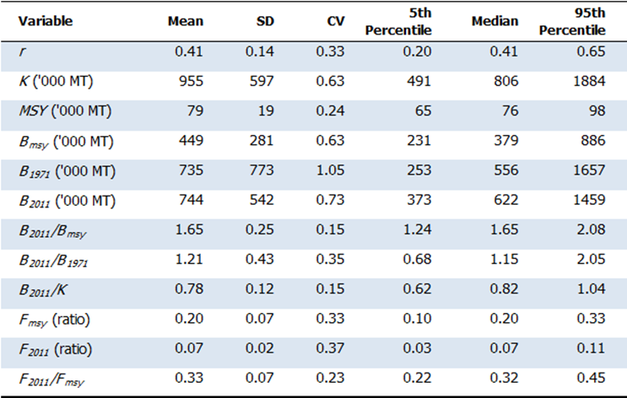

Table NPBSH2: Reference case Stock Synthesis model results for North Pacific blue shark (SS ref case). Mean, standard deviation, coefficient of variation, and 90% confidence intervals of important biological parameters and reference points.

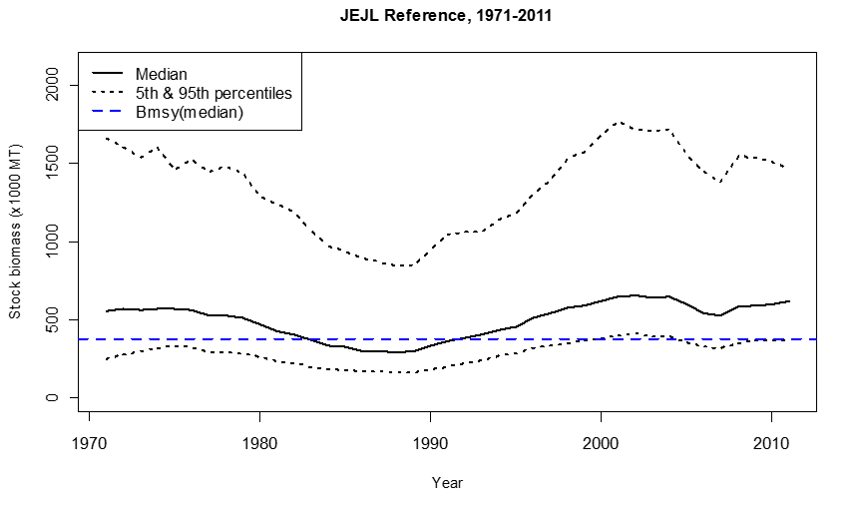 | 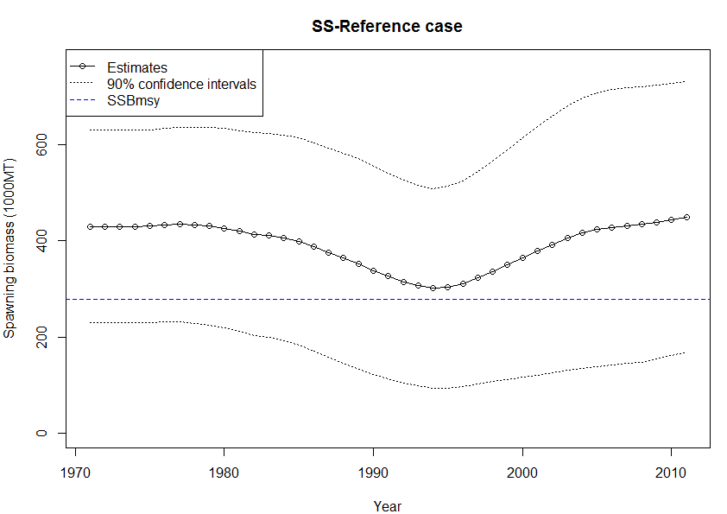
Figure NPBSH1: Median and 90% confidence intervals for the estimated historical stock dynamics of North Pacific blue shark from the BSP reference case run (BSP ref case). | Figure NPBSH2: Estimated female spawning biomass and 90% confidence intervals of North Pacific blue shark from the Stock Synthesis reference case run (SS ref case).
(A)  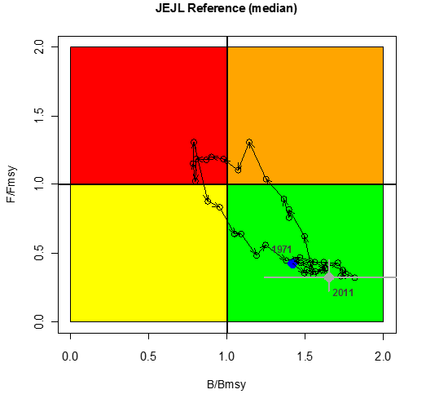 | (B)  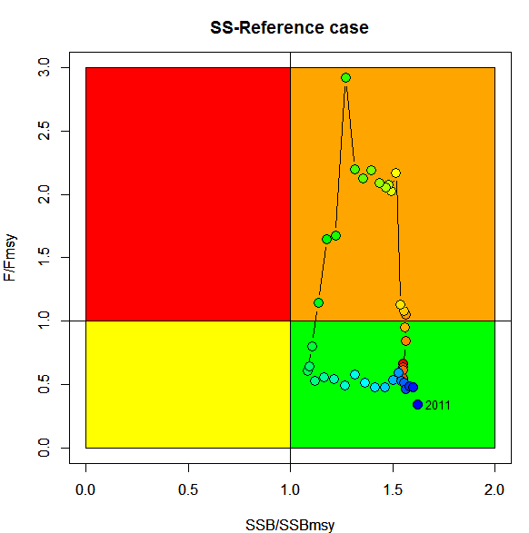
Figure NPBSH3: (A) Kobe plot showing median biomass and fishing mortality trajectories for the reference case Bayesian surplus production model for North Pacific blue shark. Solid blue circle indicates the median estimate in 1971 (initial year of the model). Solid gray circle and its horizontal and vertical bars indicate the median and 90% confidence limits in 2011. Open black circles and black arrows indicate the historical trajectory of stock status between 1971 and 2011. (B) Kobe plot showing estimated spawning biomass and fishing mortality trajectories for the reference case Stock Synthesis model for North Pacific blue shark. The circles indicate the historical trajectory from 1971 to 2011 colored from red (first year) to blue (terminal year).

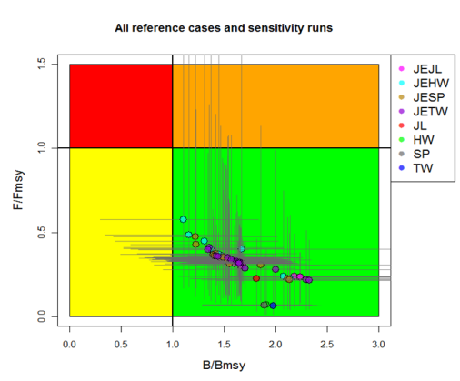 | 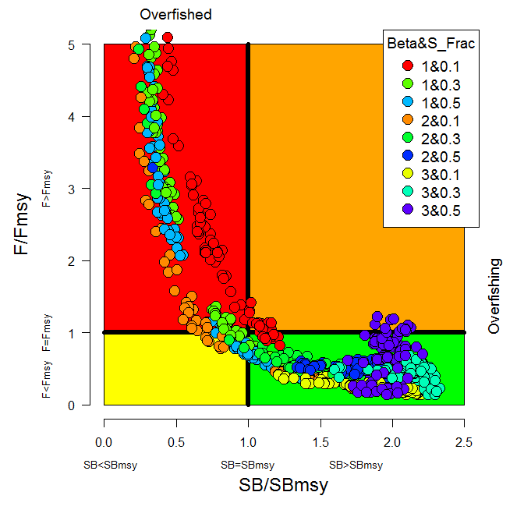
Figure NPBSH4: Kobe plot showing the 2011 median estimates of F/F_{MSY} and B/B_{MSY} for all the BSP model runs for North Pacific blue shark. The horizontal and vertical bars indicate the 90% confidence limits of the 2011 estimates. | Figure NPBSH5: Kobe plot showing the range of terminal year reference points (F/F_{MSY} on the y axis and SB/SB_{MSY} on the x-axis) for the entire grid of Stock Synthesis runs. The total number of runs was 1,080, not all runs are shown on the plot due to extremely high (>5) F/F_{MSY} values. The points are color coded by the main axis of uncertainty, the parameterization of LSFR, using the combined Beta & S_Frac parameterization.
 | 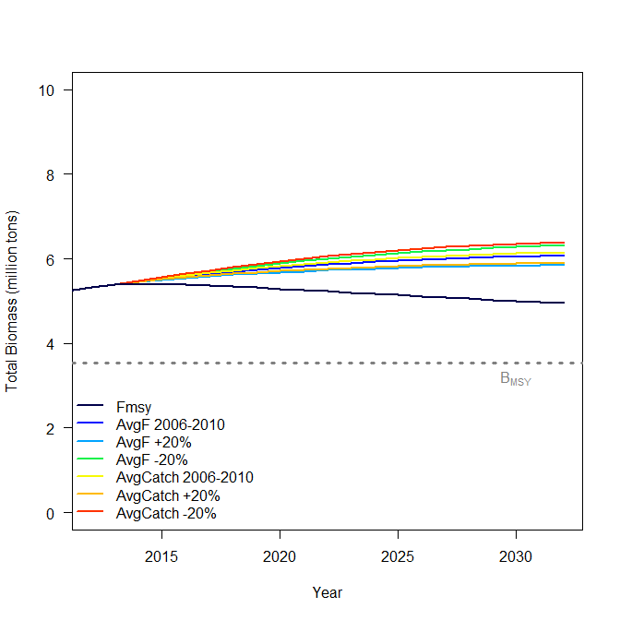
Figure NPBSH6: Comparison of future projected North Pacific blue shark stock biomass (medians) under different constant catch (status quo, +20%, -20%) and constant F harvest policies (status quo, +20%, -20%, and F_{MSY}) using the BSP reference case model. Status quo catch and fishing mortality was based on the average from 2006 to 2010. | Figure NPBSH7: Comparison of future projected North Pacific blue shark stock biomass under different constant catch (status quo, +20%, -20%) and constant F harvest policies (status quo, +20%, -20%, and F_{MSY}) using the Stock Synthesis reference case model. Status quo catch and fishing mortality was based on the average from 2006 to 2010.

4.4 WCPO billfish

4.4.1 South Pacific swordfish

a. Status and trends

- SC10 noted that no stock assessment was conducted for South Pacific swordfish in 2014. Therefore, the stock status description from SC9 is still current.

b. Management advice and implications

- SC10 noted that no management advice had been provided since SC9. Therefore, the advice from SC9 should be maintained.

4.4.2 Southwest Pacific striped marlin

a. Status and trends

- SC10 noted that no stock assessment was conducted for southwest Pacific striped marlin in 2014. Therefore, the stock status description from SC9 is still current.

b. Management advice and implications

- SC10 noted that no management advice had been provided since SC9. Therefore, the advice from SC9 should be maintained.

4.4.3 North Pacific striped marlin

a. Status and trends

- SC10 noted that no stock assessment was conducted for North Pacific striped marlin in 2014. Therefore, the stock status description from SC8 is still current.

b. Management advice and implications

- SC10 noted that no management advice had been provided since SC8. Therefore, the advice from SC8 should be maintained.

4.4.4 Pacific blue marlin

a. Status and trends

- SC10 noted that no stock assessment was conducted for Pacific blue marlin in 2014. Therefore, the stock status description from SC9 is still current.

b. Management advice and implications

- SC10 noted that no management advice had been provided since SC9. Therefore, the advice from SC9 should be maintained, pending a new assessment or other new information.

AGENDA ITEM 5 — MANAGEMENT ISSUES THEME

5.1 Limit reference points for the WCPFC

- Noting the adoption by WCPFC10 of the 10-year time-window (t₁-t₂) for estimating the average unfished biomass in the LRP 20%SB_{(t1-t2),F=0}, and the request to SC10 for further clarification of the implications of accepting various alternative levels of acceptable risk, which should be applied to breaching an LRP, SC10 considered the work described in working paper SC10-MI-WP-01 and recommended that:
- the approach described in this paper be adopted for evaluating the implications of alternative levels of permissible risk of falling below an agreed biomass LRP;
- the axes of uncertainties and associated weighting to be included in the structural grid of assessment runs be incorporated into these analyses be based on those shown in Attachment G; and
- further analyses be undertaken for bigeye tuna, yellowfin tuna, skipjack tuna and South Pacific albacore, and the results presented to the Management Objectives Workshop 3 (if it takes place) and WCPFC11.

- SC10 also noted that working paper SC10-MI-WP-01 had considered risk levels associated with breaching the LRP within the range 5–20%. Further noting that the identification of acceptable risk is a management issue, and that many CCMs have already expressed a firm preference for 5% risk to be used for skipjack tuna and South Pacific albacore stocks, SC10 recommended that WCPFC11 identify the level of acceptable risk that should be applied to breaching an LRP for the key target species. SC10 notes that the UN Fish Stocks Agreement states that the risk of exceeding LRPs should be very low.

- SC10 also considered working paper SC10-MI-WP-07, which reviewed options for identifying appropriate LRPs for elasmobranchs within the WCPFC and made the following recommendations:
- That the Commission support the tiered, species-specific approach that is similar to that adopted for target species but noted that more work would be required to specify the values of the LRPs for key shark species, and to ensure consistency with article 10.1 (c) of the Convention;
- That the Commission support the proposal to hold an expert working group to compile and review life history data for use in LRPs for sharks; and
- That other work necessary to support the development of LRPs for sharks should be identified (not only for F-based LRPs but also for biomass-based LRPs as data are limited for most shark species) and included in the updated shark research plan. SC10 suggested that the Commission monitor the work of IATTC through the GEF-ABNJ Technical Coordinator – Sharks and Bycatch on the development of empirical LRPs (or indicators) for sharks. Liaising with other international organizations conducting shark assessments was encouraged to improve data and assessment methods. This work can assist and guide the identification of LRPs in WCPFC.

5.2 Target reference points and harvest control rules for the WCPFC

- Noting the request from the Commission for the scientific services provider to provide the third meeting of the Management Objectives Workshop (MOW3) with further analyses required to inform the Commission’s consideration and adoption of a TRPs and harvest control rules (HCR) at WCPFC 11, SC10 reviewed working paper SC10-MI-WP-09. SC10 also reviewed three working papers (SC10-MI-WP-02, SC10-MI-WP-03 and SC10-MI-WP-04) which had previously been presented to MOW2 together with a new analysis of the possibility of range contraction in the WCPO provided in working paper SC10-MI-WP-06. SC10 supported these analyses and recommends that WCPFC11 take the results of these papers into consideration when considering the adoption of any TRPs and HCRs for the key target species.

- SC10 considered the draft CMM being proposed by Australia in working paper SC10-MI-WP-08. SC10 supported the initiative by Australia to have the Commission develop processes for adopting harvest strategies for key target species (to be clarified in the draft CMM). SC10 recommended that Australia continue to develop this CMM in consultation with other CCMs and that the updated CMM be presented to TCC10 and WCPFC11. To this end, SC recommended that MOW3 be organized before the next annual meeting.

5.3 Implementation of CMM 2013-01

- Noting the request in para 29 of CMM 2013-01 for SC10 to provide advice to the Commission on the relative impact of FAD set measures, and any increases of yellowfin tuna purse-seine catch in unassociated schools, on fishing mortality for yellowfin tuna, SC10 reviewed working paper SC10-MI-WP-05. Based on the results of the analyses described in this paper SC10 advises WCPFC11 that the yellowfin tuna stock status in the WCPO is relatively insensitive to whether purse-seine effort comprises mainly associated sets or unassociated sets. SC10 also noted that slightly better stock status (higher spawning biomass indicators and lower fishing mortality), higher average catch and higher MSY occurred for purse-seine effort compositions favoring unassociated sets and recommended that the Commission take note of these conclusions. SC10 also recommended that the same impact analysis should be conducted for skipjack tuna.

- Also noting the request in para 38 of CMM 2013-01, SC10 considered information paper SC10-MI-IP-06 on additional FAD management options prepared by the Commission Secretariat and SC10-ST-IP-09 on FAD design and activities. SC10 supported the establishment of a working group and recommended that TCC comment on the constituency of the working group. The working group should address the following three main issues:
  - FAD marking, and identification, and use of electronic signatures;
  - FAD monitoring, tracking and control; and
  - FAD management options including appropriate limits to FAD deployment based on scientific advice and the precautionary approach.

- SC10 noted that that the provisional catch estimate of bigeye tuna taken by the WCPFC Statistical Area purse-seine fishery during 2013 was the highest on record and the number of associated sets made in the WCPO tropical purse-seine fishery during 2013, which while on a downward trend, still clearly exceeds the number of such sets undertaken in 2010 (Fig. A4 in working paper SC10-GN-WP-01). Also noting that previous CMMs have failed to reduce the fishing mortality of bigeye tuna to the level intended, SC10 reaffirms the recommendations made at previous SC meetings (para 351 of the SC8 Summary Report and para 409 from the SC9 Summary Report) supporting the need for additional or alternative targeted measures to reduce the fishing mortality on bigeye tuna, as seen as appropriate by the Commission.

AGENDA ITEM 6 — ECOSYSTEM AND BYCATCH MITIGATION THEME

6.1 Ecosystem effects of fishing

- SC10 recommends that the Commission encourage an external review of the spatial ecosystem and population dynamics model (SEAPODYM) project to assist with guiding the Commission in evaluating potential applications and future directions.

6.2 Sharks

- SC10 recommends that the Commission:
- Consider the analysis of longline shark mitigation methods (e.g. hook type, leader material, non-deployment of shallow hooks, and a prohibition on shark lines) presented in EB-WP-01, as well as additional modeling of combinations of these measures and post-release mortality if available, in order to inform WCPFC11’s further consideration of revising shark CMMs to incorporate shark mitigation requirements that reduce catch rates and at-vessel mortality.
- Task TCC with identifying barriers to implementing the mitigation methods raised in SC10-EB-WP-05 (e.g. costs, operational issues and safety), along with any considerations raised by WCPFC11, and develop solutions, where appropriate
- Note that SC will not be able to review the specification of the ratio of fin weight to shark weight as described in para 8 of CCM 2010-07 because of the lack of reliable data and of appropriate species- and fleet-specific methodology.
- Request that for CCMs that applying fin-to-carcass weight ratios, these CCMs report to the Commission the details of the methods used to estimate the ratio of shark fin-to-carcass weight and CCMs should encourage its purse-seine and longline observers to collect data related to shark fin-to-carcass ratios. This information should be included in Part 2 of the Annual Reports to WCPFC.

- SC10 recommends that WCPFC continue to support the Bycatch Mitigation Information System (BMIS) through the GEF-ABNJ project and seek external funding until GEF-ABNJ funds are available in late 2015/early 2016.

- SC10 recommends the following priority order for funding research projects in 2015:
  - Monte Carlo simulation of mitigation options (see SC10-EB-WP-01 for details).
  - Expert panel work on the identification of appropriate life history parameters for use in developing shark LRPs.
  - Desktop examination of fin-to-carcass ratios (building on work underway by New Zealand).

- SC10 recommends that:
- Guidelines for the safe release of whale sharks (Attachment I) be considered by SC11.
- A table summarizing the development of safe guidelines to maximize survival of sharks to be released from longline or purse-seine gear (Attachment J) should be reviewed by SC11 and forwarded to TCC for its consideration.

6.3 Seabirds

- SC10 recommends that relevant members present:
- the analysis of the different bycatch interaction rates between exempted small longline vessels (<24 m) and of larger non-exempt vessels north of 23°N in CMM 2012-07 at SC11; and
- seabird bycatch interaction rates for longline vessels in the area between 25 and 30 South at SC11.

- SC10 recommends that the Commission:
- support the implementation of e-monitoring trials throughout the WCPFC in order to compare interaction rates between at-sea and dry observers, noting recommendations a and b under Agenda Item 3.3 “Electronic monitoring and electronic reporting”;
- encourages CCMs to collect robust seabird bycatch data, taking into account seasonal and spatial distribution and submit these to WCPFC.
- take note that CMM 2012-07, which came into effect on 1 July 2014, includes requirements for annual reporting of interactions in Part 1 of Annual Reports and encourages CCMs to use the template in the CMM 2012-07 for completing details about their bycatch species and numbers;
- supports the distribution and use of the Agreement for the Conservation of Albatrosses and Petrels (ACAP)/Japanese seabird identification guide, which will come out in late 2014;.
- support the collection of DNA samples from seabirds taken as bycatch in the Southern Hemisphere to aid species identification. Protocols are in the ACAP/Japanese seabird identification guide.

6.4 Sea turtles

- No papers were presented and there was no discussion on this agenda item.

6.5 Other species and issues

- There were presentations on SC10-EB-WP-09 (Catch, Effort, and eCOsystem impacts of FAD-fishing, CECOFAD), SC10-EB-WP-08 (the International Sustainable Seafood Foundation’s third bycatch mitigation research cruise in the WCPO), and SC10-EB-IP-05 (Issues for t-RFMOs in relation to the listing of shark and ray species by the Convention on the International Trade in Endangered Species). No recommendations were made under this agenda item.

agenda item 7 — OTHER RESEARCH PROJECTS

7.1 West Pacific East Asia Project

- The WCPFC Secretariat reported on the progress of the West Pacific East Asia Project and introduced a new Global Environment Facility-funded project (Sustainable Management of Highly Migratory Fish Stocks in the West Pacific and East Asian Seas), which includes Indonesia, Philippines and Vietnam as project partners.

7.2 Pacific Tuna Tagging Project

- The 8th Pacific Tuna Tagging Project (PTTP) Steering Committee meeting was held on 7 August 2014. The meeting considered the work programme planned for 2014–2015, which is primarily focused on managing the tag recovery process and incorporating analysis of tagging data in various work programmes. PTTP data are now being used routinely in stock assessments, including the current tropical tuna stock assessments, which benefited greatly from the project.

agenda item 8 — COOPERATION WITH OTHER ORGANISATIONS

- SC10 reviewed the status of WCPFC’s cooperation with other organizations.

agenda item 9 — Special Requirements of Developing States and Participating Territories

- The Secretariat briefly described the operations of the Japan Trust Fund (JTF) in 2014, which is the third year of the second phase of the JTF project. The Secretariat urged participants to be ready for the call for next year’s funding, which would likely have a closing date of 31 December 2014.

agenda item 10 — Future Work Program and Budget

10.1 Review of the Scientific Committee work programme

- The Secretariat reported on the progress of the 2013–2014 SC work programme since SC9.

10.2 Development of the 2015 work programme and budget, and projection of the 2016–2017 provisional work programme and indicative budget

- SC10 adopted the work programme and budget as shown in Table 1.

Table 1: List of SC work programme titles and budget for 2015, and indicative budget for 2016–2017, which require funding from the Commission’s core budget (in USD).

Research activity / Project with priority | 2015 | 2016 | 2017
Project 14. West Pacific East Asia (WPEA) Project  - Scope: port sampling and capacity building of WPEA countries | 25,000 | 25,000 | 25,000
Project 35. Refinement of bigeye tuna parameters  - Scope: 2015 is the last year of the project; sampling data and analysis of otoliths/gonads for assessment | 125,000 | 50,000
Project 42. Pacific-wide tagging project | 10,000 | 10,000 | 10,000
Project 57. Limit reference points (LRPs): Expert panel work on the identification of appropriate life history parameters for use in developing shark LRPs | 25,000
Project 66. Target reference points
Project 63. Harvest control rules
Project 70. Additional resourcing SPC for the improvement of stock assessment along with 2011 bigeye tuna peer review recommendations | 160,000
Project 74. Pacific-wide bigeye tuna stock assessment (additional cost)  - Travel and associated costs for two workshops (USD 52,600)  - MULTIFAN-CL software development (USD 26,300)  - Computer hardware (USD 13,100) | 92,000
New project – Monte Carlo simulation of mitigation options for longline shark bycatch  - See SC10-EB-WP-01 for details | 25,000
Project 67 – Review of impacts of recent high catches of skipjack tuna on fisheries on the margins of the WCPFC Convention Area | 40,000
Unobligated Budget | 83,000 | 83,000 | 83,000
SPC Oceanic Fisheries Programme Budget  (This includes USD 130,000 for shark research.) | 871,200 | 1,031,200 | 1031,200
GRAND TOTAL | 1,456,200 | 1,199,200 | 1,149,200

- SC10 advised that Project 57 in Table 1 will be implemented by the WCPFC Secretariat and other projects will be conducted by the scientific services provider. SC10 and the scientific services provider agreed that the 2015 service agreement will include the following assessments and shark research programme activities:
- Pacific-wide bigeye tuna stock assessment
- South Pacific albacore stock assessment
- Indicator analyses for key shark species
- Development of a Shark Research Plan
- Update of stock assessment for WCPO bigeye tuna, incorporating 2013 data in projection mode.

- SC10 also ranked the projects listed in Table 2 that were considered for funding under the Unobligated Budget. If there is no other priority demand on these funds by WCPFC11, then calls for proposals will be advertised for the three highest ranked projects.
Table 2: List of candidate projects and priorities for consideration under the Unobligated Budget.

List of projects with high priority | Priority Level
1. Analysis of archival tag data held by SPC, in particular the relationship between fish movement and oceanography. | High
2. Regional Observer Programme data fields. Identification and description of operational characteristics of the major WCPO fleets and identification of important technical parameters for data collection (SC Project 19). | High
3. Further development of methods and analysis to account for changes in targeting practices on the catch of non-target species in particular shark species. | High
4. Electronic tagging of whale sharks released from purse-seine nets (to examine survival). | Low
5. Determination of North Pacific blue shark to be designated as a northern stock. | Low

agenda item 11 — Administrative Matters

11.1 Peer review of stock assessments

- There were no comments on this agenda item.

11.2 Future operation of the Scientific Committee

- SC10 considered that SC meeting should be supported by professional rapporteurs, freeing the conveners to concentrate on their primary roles of a) facilitating the theme session, and b) drafting their theme recommendations. A recommendation related to this issue may be drafted intersessionally for the Commission’s consideration.

11.3 Election of officers of the Scientific Committee

- No nominations were forthcoming for the positions of SC Chair and Vice Chair; the Chair announced that nominations may be submitted for selection during WCPFC11 in December 2014.

11.4 Next meeting

- FSM kindly offered to host SC11 in Pohnpei, FSM. The meeting is provisionally scheduled for Wednesday, 5 August to Thursday 13 August 2015. Indonesia kindly offered to host SC12 in 2016.

The Commission for the Conservation and Management of Highly Migratory Fish Stocks in the Western and Central Pacific Ocean

Scientific Committee
Tenth Regular Session

Majuro, Republic of the Marshall Islands
6–14 August 2014

SUMMARY REPORT

AGENDA ITEM 1 — Opening of the Meeting
  - Welcome address
- The Tenth Regular Session of the Scientific Committee (SC10) was held in Majuro, Republic of the Marshall Islands from 6–14 August 2014. Ludwig Kumoru chaired the meeting.
- The Chair welcomed delegations of the Western and Central Pacific Fisheries Commission (WCPFC) Members, Cooperating Non-members and Participating Territories (CCMs) and Observers to SC10.
- The Hon. Michael Konelios, Minister of Resources and Development, Republic of the Marshall Islands, delivered opening remarks (Attachment A).
- The Chair thanked the Minister and reminded CCMs that their role was to provide the best scientific advice they can.
- The following WCPFC CCMs attended SC10: Australia, China, Cook Islands, European Union (EU), Federated States of Micronesia (FSM), Fiji, French Polynesia, Indonesia, Japan, Kiribati, Korea, Marshall Islands, Nauru, New Caledonia, New Zealand, Palau, Papua New Guinea (PNG), Philippines, Samoa, Solomon Islands, Chinese Taipei, Tokelau, Tonga, Tuvalu, United States of America (USA), and Vanuatu.
- The Agreement on the Conservation of Albatrosses and Petrels, Birdlife International, Conservation International, Pacific Islands Forum Fisheries Agency (FFA), Greenpeace, Inter-American Tropical Tuna Commission (IATTC), International Scientific Committee for the Tuna and Tuna-Like Species in the Northern Pacific Ocean (ISC), International Seafood Sustainability Foundation, Pew Charitable Trusts, Parties to the Nauru Agreement (PNA), Secretariat of the Pacific Community (SPC), World Wide Fund for Nature (WWF) and the World Bank attended as observers. The list of participants is Attachment B.
  - Meeting arrangements
- The Chair outlined procedural matters, including the meeting schedule, administrative arrangements, and the list of conveners and their assigned themes as follows:
Data and Statistics theme | Ludwig Kumoru
Stock Assessment theme | Jon Brodziak (USA) and Miki Ogura (Japan)
Management Issues theme | Robert Campbell (Australia)
Ecosystem and Bycatch Mitigation theme | Aisake Batibasaga (Fiji) and John Annala (New Zealand)

  - Issues arising from the Commission
- The Chair introduced the Secretariat paper SC10-GN-WP-03, which lists issues arising from SC9 and WCPFC10. It was noted that most of the issues will be covered throughout SC10.
  - Adoption of agenda
- The provisional agenda was adopted with minor changes (Attachment C).
  - Reporting arrangements
- The Chair advised that SC10 will adopt a Summary Report. An Executive Summary will be drafted by the Secretariat and circulated for adoption intersessionally. The Executive Summary will include a synopsis of stock status and management advice and implications, research plans, findings or conclusions on the stock status, reports and recommendations as directed by the Commission or at SC’s initiative. The WCPFC list of acronyms and abbreviations is included as Attachment D. The list of SC10 meeting documents can be found at http://www.wcpfc.int/meetings/10th-regular-session-scientific-committee.
- The Chair advised that the WCPFC Secretariat had engaged a lead rapporteur, J. Broweleit, then detailed the process of reporting and adoption of the SC10 Summary Report, including recommendations.
  - Intersessional activities of the Scientific Committee
- The Secretariat reported on intersessional SC activities, and referred delegates to SC10-GN-WP-04, which outlined key activities conducted by the Secretariat, science services provided by the scientific services provider (the Secretariat of the Pacific Community – Oceanic Fisheries Programme, referred to as “SPC” in this report), and the progress of the SC work programme, cooperation with other organizations, the West–Pacific East Asia (WPEA) and the Japan Trust Fund (JTF) projects.

AGENDA ITEM 2 — Review of Fisheries

2.1 Overview of western and central Pacific Ocean fisheries
- P. Williams (SPC) and C. Reid (FFA) presented working paper SC10-GN-WP-01, which contains a broad description of the major fisheries in the WCPFC Statistical Area, and highlights activities during the most recent calendar year (2013). This paper covers the most recent version of catch estimates by gear type and species and economic conditions of the WCPFC Statistical Area fishery. It was noted that more detail would be provided at the fleet level in national reports.
- The provisional total tuna catch for the WCPFC Statistical Area tuna in 2013 was estimated at 2,621,511 mt, the second highest ever and only 30,000 mt less than the record catch in 2012 (2,652,322 mt). This catch represents 80% of the total Pacific Ocean catch of 3,213,733 mt, and 57% of the global tuna catch (the provisional estimate for 2013 is 4,511,238 mt, which was the second highest on record).
- The 2013 WCPFC Statistical Area skipjack tuna catch (1,784,091 mt – 68% of the total catch) was the highest recorded, eclipsing the previous record catch in 2009 (1,779,307 mt) by 5,000 mt. The WCPFC Statistical Area yellowfin tuna catch for 2013 (535,656 mt – 21%) was more than 75,000 mt less than the record catch of 2012 (612,797 mt) due to relatively poor catches in both the longline and the purse-seine fisheries. The WCPFC Statistical Area bigeye tuna catch for 2013 (158,662 mt – 6%) was less than in 2012, but relatively stable compared with the average over the past 10 years. The 2013 WCPFC Statistical Area albacore catch (143,102 mt – 5%) was slightly higher than that in 2012 and the second highest on record (after 2002 at 147,793 mt). The WCPFC Statistical Area albacore catch includes catches of North and South Pacific albacore in the WCPFC Statistical Area, which comprised 81% of the total Pacific Ocean albacore catch of 177,568 mt in 2013. The South Pacific albacore catch in 2013 (84,698 mt) was the third highest on record.
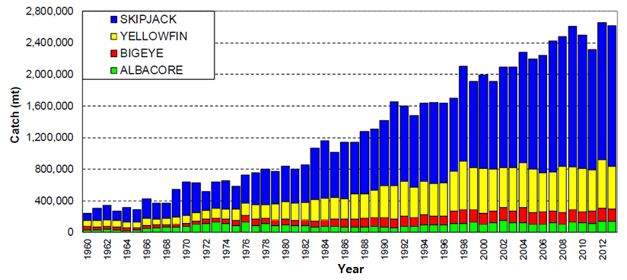
Figure 1: Catch (mt) of albacore, bigeye, skipjack and yellowfin tunas in the WCPFC Statistical Area.
- The provisional 2013 purse-seine catch of 1,898,090 mt was the highest catch on record and more than 60,000 mt more than the previous record in 2012 (1,836,295 mt). The 2013 purse-seine skipjack tuna catch (1,455,786 mt; 77% of total catch) was also the highest on record (about 50,000 mt more than the previous record in 2009). The 2013 purse-seine catch estimate for yellowfin tuna (355,960 mt) was the fifth highest on record and estimated at only 19% of the total catch, was considered a relatively poor catch year. The provisional catch estimate for bigeye tuna for 2013 (82,151 mt) was clearly the highest on record and will be refined because additional observer data for 2013 have been received and processed. The number of active purse-seine vessels in 2013 (excluding artisanal vessels in the Philippines, Indonesia and the Japanese coastal fisheries) was an all-time high (297 vessels) and total effort (in terms of fishing days estimated from logbook data and vessel monitoring system [VMS] data) was also the highest on record.
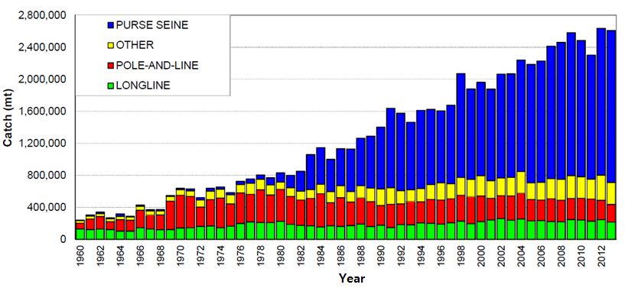
Figure 2: Catch (mt) of albacore, bigeye, skipjack and yellowfin tuna in the WCPFC Statistical Area, by longline, pole-and-line, purse-seine and other gear types
- The 2013 pole-and-line catch (221,022 mt) was the lowest annual catch since the late 1960s and is continuing the trend in declining catches for the past three decades.
- The provisional WCPFC Statistical Area longline catch (230,073 mt) for 2013 was the lowest catch since 1999. The WCPFC Statistical Area albacore longline catch (100,666 mt – 47%) for 2013 was the second highest on record, only 2,000 mt lower than the record (103,466 mt in 2010). The provisional bigeye tuna catch (62,641 mt – 29%) for 2013 was the lowest since 1996. The yellowfin tuna catch for 2013 (65,499 mt – 30%) was the lowest since 1991.
- The 2013 South Pacific troll albacore catch (3,226 mt) was the highest during the last five years. The New Zealand troll fleet (168 vessels catching 2,836 mt in 2013) and the USA troll fleet (6 vessels catching 390 mt in 2013) accounted for nearly all of the 2013 South Pacific albacore troll catch.
- Economic conditions in the tuna fisheries of the WCPFC Statistical Area during 2013 deteriorated compared with 2012. USD prices for canning raw materials (both light meat and white meat) and sashimi products declined while fuel costs remained at elevated levels. These declines in prices combined with the fact that the total catch by the purse-seine fishery increased only marginally and the longline catch fell significantly, resulting in the value of the tuna catch in the WCPFC Statistical Area falling by around USD 1 billion to USD 6.2 billion in 2013.
- The estimated delivered value of the purse-seine catch in the WCPFC Statistical Area for 2013 is USD 3,947 million, a decrease of USD 82 million (2%) from 2012. This decrease was driven by a USD 139 million (14%) decrease in the delivered value of the yellowfin tuna catch to USD 829 million, resulting from declines in catches and pricse of 8% and 7%, respectively. The delivered value of the skipjack tuna catch increased by USD 43 million to USD 2,946 million, with catches increasing 6% and prices declining 4%.
- The estimated delivered value of the longline tuna catch in the WCPFC Statistical Area for 2013 is USD 1,276 million, a decline of USD 592 million (32%) from 2012. The value of the albacore catch declined by USD 102 million (29%) to USD 253 million as a result of a 29% decline in price. The value of the bigeye tuna catch declined by USD 346 million (38%) to USD 560 million as a result of declines in catch and price of 21% and 22%, respectively. The yellowfin tuna catch declined by USD 187 million (27%) to USD 512 million as a result of declines in catch and price of 18% and 11% respectively.

Discussion
- FFA members expressed concern about three issues identified in the paper: i) the further increase in purse-seine effort and vessels in 2013, which pointed to the need to apply more effective limits to purse-seine effort and adopt a target reference point (TRP) for skipjack tuna quickly; ii) the increase in the provisional purse-seine bigeye tuna catch estimate despite WCPFC efforts to manage control and reduce fishing mortality on this stock through CMM 2013-01 and previous management measures, indicating the need to further improve this measure at WCPFC11; iii) high South Pacific albacore catch and longline effort expansion. FFA noted that this requires a cooperative management response and proposals for revised CMMs on tropical tuna and albacore management will be tabled at WCPFC11.
- Japan shared FFA’s concerns about the high bigeye tuna catch by the purse-seine fishery, in spite of improving management measures for tropical tunas. Japan questioned whether CMM 2013-01 was working effectively and expressed the view that the issue should be discussed under the Management Issues theme.
- Expressing concern about the continued increase in purse-seine effort, Australia noted that the “number of vessels per year” metric did not properly reflect the fact that as older vessels are retired, they are replaced by larger vessels. Australia asked if SC could reflect the capacity of vessels rather than the number coming into the WCPFC Statistical Area fisheries each year. SPC responded that the primary issue was whether that information is available, noting that the WCPFC record of fishing vessels does not go back very far in time and queried how far into past data SC would want to go to analyze gross registered tons multiplied by the number of vessels as a measure of capacity. SPC suggested it could be considered as an SC recommendation.
- The EU asked for an explanation of the trends in the number of associated sets in recent years in relation to relevant CMMs in place.
- P. Williams (SPC) responded that fish aggregating device (FAD) closure restrictions were a primary cause of that reduction. The EU supported Australia’s suggestion to express capacity trends in terms of tonnage in addition to the number of boats.
- Australia observed that there were fairly strong price signals in the fishery but that over the long term a steady increase in the price being received for landed fish was apparent, because the market continues to expand. Australia queried whether the market would continue to expand, or if there are market limits.
- C. Reid (FFA) responded that the sashimi market was stagnant; that the increase was in purse-seine-caught fish. Predicting long-term trends was difficult but there appeared to be significant room for expansion, with both China and India having low penetration of product and prices for raw canning material continuing to increase.
- Chinese Taipei also expressed concern about increasing purse-seine fishing effort and suggested comparing the catch rate by set type for the fleet. The Chinese and Pacific Island countries’ purse-seine effort was significant and should be included in the analysis by set types. Chinese Taipei suggested that the charter vessel catch information should be included in SC10-ST-IP-01 from next year.
- China expressed concern about the size of the purse-seine bigeye tuna catch and noted that in order to restore bigeye tuna stocks, reductions in the juvenile bigeye tuna catch was necessary.
- PNG asked for clarification of why the provisional catch estimate for yellowfin tuna appeared lower than previous years while the bigeye tuna catch by the purse-seine fishery increased.
- SPC responded that the estimate is based on observer data, the availability of which is not as good as hoped for. He explained that the decrease in the purse-seine yellowfin tuna catch is due to the absence of large yellowfin tuna in the catch.
- Kiribati announced that PNA members supported the statement by FFA, and appreciated the inclusion of data on the distribution of swordfish catches. Noting that many high swordfish catch areas are on the high seas, Kiribati queried whether a clearer breakdown of catches was possible between high seas areas and a country’s exclusive economic zone (EEZ).
- SPC responded that it does not have complete longline operational data, which is required for doing a proper analysis
- Korea observed that SPC’s estimated tuna catches for 2013 — the species composition of which was based on observer data, was higher than those provided by Korea but with high fluctuations by species. Noting that the purse-seine species composition relied heavily on observer data, and that they are used for various works for data preparation, Korea expressed the importance of observer data, and expressed that these issues be further discussed under the Data and Statistics theme.
- Chinese Taipei expressed support for Korea’s statement.
- USA asked about the catch differences in Table 3 and Table 8 (SC10-GN-WP-01).
- SPC clarified that Table 3 contained data relating to the WCPFC Statistical Area, whereas data in Table 8 did not include the overlap area. IATTC assessments include fishing in the overlap area, whereas SPC assessments cover the western and central Pacific Ocean (WCPO) area.
- Nauru observed the lack of data that have been requested on swordfish fishing, and noted that this was an example of the Commission’s work being hampered, with states not forwarding information about the operation of their vessels on the high seas.
- Indonesia asked about prices, observing that even though the catches of some tuna species had decreased, this was not followed by an increase in prices. In addition, the closure season was not followed by an increase in prices in the selected market.
- C. Reid noted that there had been a decrease in the longline catch but no increase in price. The recent decrease in the US dollar price was driven by appreciation in the value of the dollar. Prices in yen were relatively stagnant. There was likely a reduction in demand for a variety of reasons, including the preference for eating sashimi seems to have declined among the younger generation.
- Australia raised the question of the number of FAD sets during FAD closures and the very low yellowfin tuna catch per unit of effort (CPUE) by Japanese purse-seine vessels during 2013, especially on drifting FADs. SPC noted that there were a number of exemptions such as the PNG anchored FAD fishery and vessels fishing in domestic waters.
- In response to an Australian question, Japan stated that the very low yellowfin tuna CPUE by Japanese purse-seine vessels was the difference in fishing grounds for other fleets.
- Palau expressed the concerns of PNA members regarding data that indicated the effect of FAD closures may be decreasing, and wanted SC10 to draw this to the Commission’s attention. Measures may need to be considered that will improve the effectiveness of the measure, such as banning pre-dawn sets, FAD identification and electronic tracking, and stopping the operation of tender vessels during the FAD closure period.

2.2 Overview of eastern Pacific Ocean fisheries
- K. Schaefer (IATTC) presented working paper SC10-GN-WP-02, which contains a summary of the fishery for tunas in the eastern Pacific Ocean (EPO) region, summary assessments of the major stocks of tunas and billfishes exploited in the fishery, and an evaluation of the EPO pelagic ecosystem in 2013. The working paper is also the IATTC fisheries status report published in 2014.
- The fishing capacity of the purse-seine fleet in the EPO increased rapidly from 1995 to 2005, but has been fairly steady since about 2006, at slightly above 200,000 cubic meters of well volume. The reported nominal longline effort has fluctuated between about 100 million hooks and 300 million hooks set annually over the past 30 years. Since the highest peak in 2002–2003 of about 300 million hooks, there was a distinct decline to about 100 million hooks, but in recent years has increased to about 150 million hooks. Total tuna catches increased starting in 1996, peaked in 2003, and in 2013 were close to the average of the past 10 years.
- Yellowfin tuna catches have remained fairly stable since the mid-1980s, except for a peak in 2001 through 2003, followed by a substantial decline in 2006 through 2008, a slight increase in 2009 and 2010, and again a decline in 2011 through 2013. The 2013 catch on dolphin associated schools was greater than 2011 and 2012, but less than 2009 and 2010. Catches of yellowfin tuna in unassociated schools in 2013 remained low, similar to the past seven years. The current stock assessment method being used for yellowfin tuna is Stock Synthesis III. Since 2004, recruitment has been relatively low, although not quite as low as it was during 1979 through 1981. Recent estimates indicate that the yellowfin tuna stock in the EPO is slightly overexploited (S<S_{MSY}), but that overfishing is not taking place (F<F_{MSY}). The current status of the stock is considerably more pessimistic if a stock recruitment relationship is assumed, if a higher value is assumed for the average size of the older fish, and if lower rates of natural mortality are assumed for adults.
- The status of the skipjack tuna stock has been evaluated using eight different data- and model-based indicators. The purse-seine catch has been significantly increasing since 1994, and in 2013 was similar to the other peak years over the past decade, and near the upper reference level. Following a large peak in 1999, the catch per days fished on floating objects has generally fluctuated between an average level and the upper reference level. The value for 2013 was below the 2011 value, which was the highest since the peak in 1999. Except for 2010, biomass and recruitment have been relatively high over the past decade, including for 2013, and the exploitation rate has remained relatively high during this same period. There is uncertainty about the status of skipjack tuna in the EPO, and there may be differences in the status of the stock among regions. However, there is no evidence that indicates a credible risk to the skipjack tuna stock(s).
- There have been substantial historical changes in the bigeye tuna fishery in the EPO. Beginning in 1994, purse-seine catches increased substantially by targeting tunas associated with drifting FADs in the equatorial EPO. Longline catches have been relatively low during the past eight years, versus the previous 22-year period, and the preliminary estimate in 2013 was only 29,175 mt. The current stock assessment method being used for bigeye tuna is Stock Synthesis III. A full assessment was conducted in 2012, which included some major changes in methodology to the previous full assessment in 2010. Recruitment estimates have been variable since 1975. There were very high peaks in recruitment indices corresponding with the major El Niño events in 1983 and 1998. Recruitment indices over the past five years have been close to the average value. Recent estimates indicate that the bigeye tuna stock in the EPO is slightly overexploited (S<S_{MSY}), but that overfishing is not taking place (F<F_{MSY}), although the upper confidence interval is greater than F_{MSY}. The current status of the stock is considerably more pessimistic if a stock recruitment relationship is assumed, if a higher value is assumed for the average size of older fish, and if lower rates of natural mortality are assumed for adults.
- A tuna conservation resolution was adopted by IATTC in June 2013, for the three-year period 2014–2016. This includes an EPO-wide closure for purse-seine (>182 mt) fishing of 62 days in each of those years, along with a 30-day closure of a core offshore FAD fishing area. There is a special provision for class 4 vessels (182–272 mt) which permits 30 days of fishing during the EPO closure provided an observer is onboard. For longline vessels (>24 m) the resolution includes fixed bigeye tuna catch limits for China, Japan, Korea, and Chinese Taipei, and other CPCs, including the USA, not to exceed 500 mt or their respective catches in 2001, whichever is greater.

Discussion
- FFA members thanked IATTC for the presentation and noted that they continue to support and encourage the timely exchange of relevant tuna fishery and ecosystem information between the WCPFC and the IATTC to improve understanding on the state of potentially shared tuna stocks and develop effective management arrangements for the overlap area. FFA members support the region-wide bigeye tuna stock assessment being carried out in 2015, stating that this assessment should use the most appropriate methodology. FFA encouraged data sharing between IATTC and WCPFC to that end.
- USA enquired whether or not limit reference points (LRPs) were adopted by plenary at IATTC’s recent annual general meeting in Lima, Peru.
- IATTC responded that they were not. Referring to the 2014 Scientific Advisory Committee meeting in May 2014, IATTC directed delegations to the organization’s website for a paper on proposed target and LRPs, adding that unless they are placed within a management framework and subject to management strategy evaluation they do not mean much. Staff at the organization will hopefully be working on harvest control rules next year.
- FFA members recognized that IATTC and WCPFC use different stock assessment methodologies, approaches and reference points to determine stock status. FFA noted that the IATTC candidate TRPs and LRPs being proposed for yellowfin and bigeye tuna in the EPO are represented by S_{MSY} and F_{MSY}. Finally, FFA expressed concerns about the proposals, referring delegates to the United Nations Fish Stocks Agreement Appendix II precautionary reference points.

2.3 Annual Report – Part 1 from Members, Cooperating Non-Members, and Participating Territories
- The Chair invited CCMs to briefly highlight aspects of their Part 1 Annual Report, including specific changes related to their tuna fisheries since last year. The Chair advised that some CCMs did not follow the Part 1 template. CCMs were encouraged to strictly follow the agreed template when submitting their Annual Report Part 1.
- Japan announced that the Japanese coastal troll fishery for skipjack tuna in coastal western Japan operated twice a year, in spring and autumn, with most of the catch taken in spring. The vessels in this fishery are small — mostly less than 10 gross registered tonnes — and they generally make one-day trips. Japan offered preliminary catch statistics of 133 mt for the fishery in two prefectures between January and June 2014 in the major fishing grounds. Japan noted that skipjack tuna accounts for 18% of the five-year average during 2009–2013. Other than the skipjack tuna troll fishery there is another coastal skipjack tuna fishery — coastal pole and line. Japan expressed concern that there has been a sharp decline in skipjack tuna catches in their coastal fisheries, despite the stock assessment which indicates catches are up.
- The Philippines notified SC10 that 36 vessels were authorized to fish in high seas pocket number 1 (HSP1); however, only 27 vessels entered HSP1 and of those, only 22 fished in that area in 2013. The Philippines directed delegations to its information paper, which presents data for its 2013 activities in this area. Noting that its fleet fishes in HSP1, the Indian Ocean and in the waters of Pacific Island countries, the Philippines supports the Commission’s objectives, especially under CMM 2013-01, by its compliance with WCPFC vessel monitoring system (VMS) requirements and a number of administrative orders it has enacted to implement WCPFC measures. The Philippines noted that the next phase of the West Pacific East Asia (WPEA) project is due to start in the last quarter of 2014.
- PNG announced that it no longer has a dedicated shark fishery – those vessels are now being used in the tuna longline fishery.
- Fiji announced that its 8,977 mt catch of tuna and tuna-like species was its lowest in recent years. The Fisheries Minister had taken a decision to increase observer coverage numbers and, therefore, observer trainings, for which Fiji is appreciative of SPC/FFA support. Fiji noted that, with respect to section 6 of “Scientific Data to be Provided to the Commission”, its data reflects Fiji’s catches in its EEZ and the high seas only, as it does not yet have memorandums of understanding with neighboring countries to analyze the catch data of Fiji’ national fleet in other EEZs. Fiji is working on this. Fiji indicated that it sends TUFMAN (Tuna Fisheries Database Management System) backups to SPC to assist in regional assessments. The decision to increase observer coverage means Fiji has increased reporting on seabird catches since 2010, and has released a number of live sea turtles last year.

2.4 Reports from regional fisheries bodies and other organizations
- The Chair invited other organizations and agencies to briefly present key issues relevant to SC’s work and noted that WWF, Pew Charitable Trusts and Greenpeace had submitted papers against this agenda item. No reports were given.

AGENDA ITEM 3 — DATA AND STATISTICS THEME

3.1 Data gaps

3.1.1 Data gaps of the Commission
- The Data and Statistics theme was convened by L. Kumoru (PNG).
- P. Williams presented working paper SC10-ST-WP-01, which reported on developments over the past year with regard to filling gaps in the provision of scientific data to the Commission. SC10 was invited to consider and recommend actions to address the identified gaps in the data holdings of the Commission.
- All CCMs with fleets active in the WCPFC Convention Area provided 2013 annual catch estimates before the deadline of 30 April 2014. Estimates for key shark species, which is in accordance with the change in the requirements to include key shark species catches, continue to improve and the implementation of new extended longline logsheets, which have the provision for reporting sharks at the species level, is gradually progressing.
- In general, the timeliness of the provision of aggregate catch and effort data continues to improve with nearly all CCMs providing data by the deadline of 30 April 2014. The quality of aggregate data provided has also improved, with a reduction in the number of notes assigned to aggregate data in recent years.
- Aggregate data for the Japanese coastal longline fleet (1994–2013) and operational data from the Vietnam longline fleet (2012–2013) were made available for the first time. Annual catch estimates by EEZ and high seas areas were provided by Japan (2008–2013) and Chinese Taipei (2011–2013) for the first time. Japan also provided vessel numbers in their aggregate data (2008–2013), covering their longline (distant-water), pole-and-line, and purse-seine fleets for the first time.
- The main data gaps listed in the paper are the non-submission of a) operational data for several key fleets (refer to section 2.5 of the paper), and b) annual catch estimates by EEZ/high seas for two key fleets (refer to section 2.4 of the paper).
- The WPEA project, which provides support to the Philippines, Indonesia and Vietnam with respect to establishing tuna fishery data collection and management systems, has now terminated, but a new three-year project will commence in late 2014. There remains significant work to improve the coverage and quality of logsheet, port sampling and observer data, and the reliability of annual catch estimates for certain gear types. For Indonesia, the main data gaps continue to be the lack of aggregate catch and effort data and the uncertainty of the estimates for their small-scale tuna fisheries. For the Philippines, the main data gap is the reliability of the historical estimates for their small-scale artisanal hook-and-line fisheries. For Vietnam, the main data gap is the complete lack of historical annual catch estimates prior to 2000, and the need to improve the coverage of logbook data.

Discussion
- Chinese Taipei raised a query regarding Table 4 of the report, which related to purse-seine fishery data where it listed a data gap for the estimation of purse-seine bigeye and yellowfin tunas in their aggregate data. Chinese Taipei indicated that bigeye and yellowfin tuna data are taken from cannery reports and were used to estimate catch composition. In subsequent discussions, it was agreed that this data gap will subsequently be removed and Chinese Taipei will prepare a paper for SC11, describing the methodology for producing the estimates of species catches in Chinese Taipei’s aggregate purse-seine catch data provided to the WCFPC.
- FFA members expressed concern that some CCMs continue to evade the fundamental obligation of providing operational data to the Commission. It was also noted that these same CCMs — China, Japan, Korea and Chinese Taipei — also refuse to provide such operational data in other regional fisheries management organizations that they are parties to. They encouraged SC to recommend that the Commission consider the non-provision of operational data as a serious violation. FFA members are providing such operational data and the real gap is the lack in the provision of operational data from the high seas and from non-FFA EEZs.
- EU questioned the extent to which the data are missing and how these would affect the reliability of the stock assessments recently performed. The EU suggested that SC provide a tier of the scientific reporting requirements to facilitate the work of the Technical and Compliance Committee (TCC). It was pointed out that all data are essential for stock assessment purposes and that TCC is required to go through the data gaps provided in the report. The EU representative requested that EU fleets in the future be referred to as “EU Spain or “EU Portugal” in all WCPFC documents.
- Korea advised SC10 that annual catch estimates by EEZs and the high seas will be provided in October. As agreed on last year, Korean scientists planned to visit SPC in Noumea for cross-checking data gaps and a collaborative work on operational data, but unfortunately this was postponed. They plan to pursue this in the coming year. Observer data are important for validation of data by cross-checking the reported nominal catch and the catch and effort data in logbooks, but Korea has never seen the observer data from Korean flagged fleets operating in the jurisdictional waters of coastal states and, as such, requested the Secretariat to provide Regional Observer Programme (ROP) observer data. In the margins of the meeting, it was confirmed that the request has been approved and the scientific services provider will provide these data (on behalf of the WCPFC) in the coming month.
- PNA members voiced thanks to: Chinese Taipei for the provision of aggregated data for the high seas longline fleet, Japan for its provision of data through collaborative efforts, and Korea for continuing to make such data available. PNA members noted that SC9 spelled out the consequences of withholding operational data to the Commission’s scientific work. The bigeye tuna assessment report makes it clear that the partial access to operational data has substantially improved the quality of the bigeye tuna assessment. However, incomplete operational data remained a key constraint in the bigeye tuna assessment. It was stressed that PNA would apply strict measures to those CCMs for not providing operational data in the future.
- Chinese Taipei clarified that this year they provided complete operational level data, in cooperation with SPC, to help conduct and complete the tropical tuna stock assessment.
- FFA members acknowledged the provision of additional aggregated data from Japan and Chinese Taipei, but stressed the fact that 10 years had passed and yet these CCMs have not fully satisfied their obligation of providing operational data. The Pacific-wide bigeye tuna stock assessment planned next year needs operational data in order to produce a reliable and robust stock assessment.
- Japan indicated that the data gap in section 2.7 of the working paper SC10-ST-WP-01, referring to the number of vessels in the aggregated data for Japan’s coastal fisheries fleets, has now been resolved with a recent updated provision of these data to the WCPFC.
- The Marshall Islands, on behalf of PNA members, reiterated that 10 years of operational data not being provided is a big problem. The implications for Small Island Developing States (SIDS) relate to food security and ensuring sustainability of the stock for their survival. The bigeye tuna conservation failure of longline fishing in the high seas was further exacerbated by the non-provision of such crucial data. The tropical tuna CMM will be revised to address this and the illegal, unreported and unregulated nature of the non-provision of data, with an option for penalties to be imposed.
- In relation to catch attribution, FFA members stressed that some CCMs should remove their chartered catch. They also stated that double counting of chartered vessels should be removed, and future iterations of CMM 2012-05 should include a reference to section 6 of “Scientific Data to be Provided to the Commission”.
- In response to the statement on catch attribution, Chinese Taipei indicated that it has removed the catches of charter vessels from its data submissions to the WCPFC. (The WCFPC scientific services provider will liaise with Chinese Taipei in regards to the years and vessels for which catch has been removed as a part of reconciliation process required within the WCPFC data.)
- FFA members noted that in relation to “other commercial fisheries”, SC9 had already considered this issue and SC10 should forward Table 1 of SC9-ST-WP-01 to WCPFC11, in response to CMM 2013-01, para 46 in the development of measures for other commercial fisheries.
- Fiji sought a standardized means of assessing observer coverage (i.e. hooks observed or national fleet trips observed) and suggested that the integrity of the datasets presented by SIDS to SPC be audited at the national level by SPC, and that SPC “stamp it” and have it approved for use in stock assessments, thereby reducing Commission-level criticism of the datasets provided.

Recommendations
- SC10 recommended that:
  - the paper SC10-ST-WP-01 be forwarded to TCC10, highlighting the main data gap related to the non-provision of operational catch and effort data for 10 years by some CCMs;
  - in regard to data issues related to the attribution of catch under charter arrangements, any revision to CMM 2012-05 should include a reference to section 6 of “Scientific Data to be provided to the Commission”;
  - TCC10 consider establishing a tier and scoring system to better reflect the magnitude and severity of the non-provision of scientific data;
  - the data gap of the Chinese Taipei purse-seine fleet — related to the estimation of species catches in their aggregate data (Data Gap Note 13) — be removed from Table 4 of SC10-ST-WP-01, and that Chinese Taipei provide a paper to SC11 describing the methodology used to estimate the tuna species catches in their aggregate purse-seine data provided to WCPFC; and
  - as a response to the requirements stated in paragraph 46 of CMM 2013-01, the summary of “other” gear catches of the tropical tuna species in the paper SC9-ST-WP-01 (Table 1) be updated to reflect:
- the exclusion of those fisheries that take less than 2,000 mt of bigeye, yellowfin and skipjack tunas; and
- the inclusion of any available information CCMs have provided on the estimates of fishing effort of these fisheries (refer to paragraphs 47 and 48 of CMM 2013-01).

3.1.2 Species composition of purse-seine catches
- J. Hampton (SPC) presented SC10-ST-WP-02, which outlined the results of logsheet, spill sampling, grab sampling and unloading-based estimates of purse-seine species composition for vessels unloading in Solomon Islands and Japan. A second part of the project — a comparison of observer sampling with port sampling estimates for vessels unloading in Madang, PNG — is awaiting final data processing before analysis can begin. The main conclusions of the work to date are:
- Logsheets tend to overestimate the skipjack tuna percentage in comparison to other estimates that are based on samplings and unloadings;
- Spill samples provide more accurate estimates of size and species composition than grab samples because there is no selection of individual fish, and sample sizes are larger;
- Species composition determined from spill samples are consistent with cannery container receipts in the Solomon Islands and from unloadings data in Japan;
- While unloadings data in Solomon Islands and Japan are likely to provide accurate trip-based estimates of species composition, this will not be the case in all unloading situations;
- Sampling at sea provides additional information on species and size composition by set type and fine-scale area and time strata, which are not available from trip-based cannery or unloadings data.

Discussion
- In response to a query from Japan on a) species composition, b) the accuracy of the total catch figures, and c) the estimation of total catches taken in logbooks, SPC advised that comparisons by total catch, estimates made of total catch of all tuna species derived from logsheets and unloading data are definitive of the total catch. Sample-based estimates are close in their estimation despite the low number of samples.
- Japan noted the findings of SC10-ST-IP-06, which provides a preliminary analysis for the accuracy of catch amount by species caught by purse-seine vessels, and compares observer data and landings data from Japanese purse-seine vessels. The information paper concludes that the catch amounts of skipjack tuna estimated by observer spill and grab samplings were 1.2 times greater than that of landings, and that further investigation is required (only four trips were analyzed and the results were very preliminary).
- FFA members supported the continuation of the project and the use of spill sampling across the wider Convention Area. Given the bias prevalent in grab sampling, it is important for stock assessment work to use data collected from spill sampling instead. Information from SC10-ST-WP-02 provided a good basis to update the plan for improving purse-seine species composition data. An integrated approach that includes scientific and compliance aspects should be taken, and this plan should be forwarded to TCC for its consideration.
- USA noted that species composition in logbooks, observer reports and data collected through spill sampling are important for stock assessment work. Before spill sampling can be widely adopted by the Commission as a means of collecting data by observers on purse-seine vessels, it is important that SPC develop guidelines on the procedure to collect data through spill sampling.
- SPC advised that producing a guideline on the spill sampling procedure is already included in Appendix of SC10-ST-IP-02. It was suggested that a cost–benefit analysis of the universal use of spill sampling is required, noting the feasibility of spill sampling for one observer with a cooperative crew to assist in the brailing operation to fill the bin and clear the deck for the sampling work.
- SC10 was asked to consider a recommendation to transition all at-sea observer sampling to spill sampling. Experience has shown that, with the cooperation of vessel crew, such sampling can be undertaken by one observer in a non-disruptive fashion to the vessel’s operation. Currently certified observers can be easily trained to undertake spill sampling, the current observer forms are suitable for recording the results of spill sampling, and SC10-ST-IP-02 provides a spill sampling protocol. The main additional requirement would be that every purse-seine vessel carry and maintain a spill sample bin, a design for which is also provided in SC10-ST-IP-02.
- SC10 reviewed supplementary information related with paragraph 90a in the SC9 Summary Report that was provided by the scientific services provider (SC10-ST-WP-02a and b).
- USA remarked that there was a Centre for International Experts (CIE) review of the spill sampling methodology in 2012. SPC completed most of the reviewer’s recommendations and it was thought that there needed to be better documentation on how the estimates in the paper were obtained. SPC noted that this has been provided in previous working papers to SC and further explained that species composition data were used where observer coverage was above the threshold, and data provided by fishing nations that provide reliable species catch data were also used.
- As a carry-over from an SC9 recommendation, the scientific services provider will provide to SC11 annual estimates of purse-seine catches based on: a) logbook-reported species composition, b) observer grab samples (previous approach), and c) observer grab samples corrected for selectivity bias from spill sampling. Catch series from any variants on these should also be included. This will allow SC to follow changes in purse-seine catch estimates from historical methods. The work should also include any guidance on the implications of future estimates if grab sampling only is used (e.g. whether the selectivity bias correction can be used into the future).

Identifying purse-seine, FAD-associated catches based on catch sampling
- S. Hare (SPC) presented SC10-ST-WP-04, which investigates the potential of accurately identifying whether individual purse-seine sets can be identified as captured in association with a FAD or as an unassociated (FAD-free) set, on the basis of catch sampling. The target tuna catch and length compositions and bycatch amounts were analyzed from more than 50,000 purse-seine sets sampled by onboard observers who had, in addition to collecting the sampling data, also identified the sets as either “associated” or “unassociated”. The tuna data are derived from observer “grab samples”. These number, on average, about 65 fish per purse-seine set. Bycatch data are estimated total amounts per set and are not determined by standard sampling.
- Methods from the general category of Classification and Regression Tree (CART) modeling were determined most appropriate for the analysis and intended use of results. An attraction of the simplest of the CART methods is that it lends itself to establishing a set of clearly labelled rules that can be routinely used to estimate whether a sampled purse-seine set was likely to be an associated or unassociated set type. Classification models were developed based on 2007–2011 observer data and tested for misclassification error rates on 2012 data. Models were developed for the full dataset as well as seasonal and regional breakdowns. Two sets of models were developed for each analysis — “tuna-only” and “with bycatch” — the difference being the allowance of bycatch species as potential classification variables.
- Two types of misclassification errors (MCE) are possible: unassociated sets misidentified as associated (termed false positive or Type I), and associated sets identified as associated sets (false negative or Type-II error). A third error measure, overall MCE, is a weighted average of Type I and Type II errors. While all three error types are of interest, the Type II error rate is of most concern in a conservation context. The initial tuna-only CART models had MCE rates of 17–29% with an average of 23%. The inclusion of bycatch lowered error rates by 4–12% to around 14–20% with an average of 16.5%. The appearance of a spatial pattern in MCE rates, with higher Type I error rates in the west, motivated exploration of MCE rate improvement by analyzing seasonal and regional data subsets. Disaggregating the data by season or region generally yielded modest improvement in classification accuracy, decreasing relative MCE rates to 2–10%. An exceptional classification result was achieved in an eastern region bycatch model where MCE rates of less than 10% were achieved.
- An extension to the CART methodology, termed “Bagging Predictors”, which employs bootstrap sampling to create multiple classification tree models, was investigated to see if MCE rates could be furthered lowered. The downside to this method is that it is not “field applicable” and requires the use of an interactive computer program. The computer-intensive bagging method provided an overall 8–18% decrease in MCE rates, a marginal level of improvement over much simpler methods. Further, the decrease in MCE rates was not uniform across seasons or regions.
- Analysis was conducted on a particular subset of the purse-seine data: sets classified as unassociated during the FAD-closure periods of 2009–2012. The intent was to determine if MCE rates of these particular sets were greater than the MCE rates found in the more general analysis. Reassuringly, MCE rates of unassociated sets during the FAD closure period were found to be equal to, or even a bit lower than, MCE rates in the broader analyses.
- The paper concluded with a general discussion of potential operational practices that would help achieve, or make especially challenging, classification results equal or better than those obtained. Specifically, the removal of bycatch and the onboard consumption of bycatch and/or mixing of sets prior to sampling would contaminate individual sets, which formed the basis of our model classification rules. Treatment of bycatch varies across time, fleets, and unloading ports. The classification rules that included bycatch indicated that perhaps as little as a single fish in a set (that might contain over 30 mt of total tuna and bycatch) would be sufficient to have a set assigned as associated. This has implications for any independent sampling scheme.
Discussion
- In response to a question on the presentation of SC10-ST-WP-04, SPC noted that there are currently insufficient data available for 2013 to include this year in the analyses.

Recommendations
- SC10 recommended that:
- the scientific services provider update the Plan for the Improvement of the Availability and Use of Purse-seine Catch Composition Data set out in SC8-WCPFC8-08 for consideration by SC11 and TCC11, noting the need for the Commission to adopt an integrated approach to improving purse-seine species composition data, including both scientific and compliance aspects. The update should take into account the outcomes of the work undertaken in Project 60, including the information in SC10-ST-WP-02.
- the information in SC10-ST-IP-02 regarding purse-seine species composition sampling protocols, spill bin size, and expectations of crew usage be forwarded to industry by CCMs to assess implications and operational constraints of wider use of spill sampling and report the feedback to SC11 and TCC11.
- as a carry-over from an SC9 recommendation, the scientific services provider provide to SC11 annual estimates of purse-seine catches based on: i) logbook-reported species composition, ii) observer grab samples (previous approach), and iii) observer grab samples corrected for selectivity bias from spill sampling. Catch series from any variants on these should also be included. This will allow SC to follow changes in purse-seine catch estimates from historical methods. The work should also include any guidance on the implications of future estimates if only grab sampling occurs (e.g. Can the selectivity bias correction be used into the future?).

3.1.3 Data issues with ISC
- There are currently no issues to report under this agenda item and the ISC Statistics Working Group chair reported that they have a good working relationship with the WCPFC-designated Data Manager.

3.2 Regional Observer Programme
- To assist SC10 with considering any issues related to scientific data collection or data to be collected, as well as data gaps from ROP, the Chair invited the authors of two working papers associated with this agenda item to present them.

Philippine-flagged vessels in High Seas Pocket 1
- R. Ramiscal presented SC10-ST-WP-05 on Group Seine Operations of Philippine Flagged Vessels in High Seas Pocket (HSP) 1, which detailed operations of Philippine group seine operations in HSP1 based on observer reports during the period January–June and November–December 2013. The group seine fleet comprised 20 purse-seine and 2 ring net vessels. Another five vessels were able to reach HSP1 in the same year, but were not able to fish due to major mechanical trouble that required them to return to port, and some were deployed late and able to fish only the following year.
- The catch in 2013 of the Philippine group seine fleet in HSP1 totaled 13,326 mt, comprising skipjack tuna (67.7%), yellowfin tuna (20.8%), bigeye tuna (3.6%) and other species (7.86%). The average CPUE was 9.86 mt/vessel/set, or 3.85 mt/vessel/day in HSP1. It was also noted that the average length of skipjack, yellowfin and bigeye tunas caught in HSP1 were relatively bigger than tunas caught from the Philippines’ EEZ. The catch of bigeye tuna was also examined according to depth of nets and was found to be less in shallower nets.

Philippine EEZ net fishing
- R. Ramiscal presented SC10-ST-WP-06 on analysis of purse-seine and ring net fishing operations in the Philippines’ EEZ. The paper covered catch of purse-seine and ring nets within the Philippines’ EEZ from July to September for the years 2010–2013. The paper was based on the adoption of Fisheries Administration Order (FAO) 236/236-1/2, which requires, among other things, deployment of observers to collect information as a basis for implementing compatible measures during FAD closures under CMM 2008-01, 2011-01 and 2012-01.
- Total catch covered by observer reports was 9.895 mt, comprising skipjack tuna (49.6%), yellowfin tuna (18.2%), bigeye tuna (1.9%), mackerel scad (18.4%) and other species (11.8%). The overall average catch rate for the four-year period was 7.26 mt/fishing day, with the highest catch occurring in 2012 at 9.2 mt/fishing day. The report is consistent with earlier reports in that: a) the proportion of bigeye tuna in fleet catches was around 2%; b) the size of skipjack, yellowfin and bigeye tunas are comparatively smaller than fish caught beyond the EEZ, particularly HSP1; c) the size composition varies by fishing ground, with the Celebes Sea having the smallest average size of the three oceanic tunas; and d) the reduction of net depth reduces catches of bigeye tuna by 31% when a 121–140 fathom net is reduced to 101–120 fathoms, and there was a further reduction with shallower nets. The total catch is also reduced.

Discussion
- In response to a query raised by Chinese Taipei, the Philippines clarified that those 20 days of observer deployment in the EEZ on each vessel was predetermined to cover all vessels although the number of available observers was limited; while the observer programme covers 100% of the number of fishing vessel days spent in HSP1.
- FFA members congratulated the Philippines for the provision of 100% logsheet data and for observer coverage on their vessels fishing in HSP1. It was not clear, however, if the net depth used for fishing was greater than 115 fathoms outside the closure period. If so, it was proposed that sampling be undertaken beyond the closure period in order to take this into account when extrapolating catches taken by shallower nets.
- The Philippines explained that after the FAD closure period, their vessels fishing in EEZs still use the same depth of purse-seine nets. There is no regulation on net depth to cover fishing in the high seas areas.
- The EU sought further clarification on the figure describing the length of tunas taken by vessels fishing in HSP1, noting that the figure seemed to be below maturation sizes, and asked if there were any risks that would jeopardize the conservation of these tuna stocks.
- The Philippines confirmed that they are attempting to determine the “hot spot” for small tunas in order to address the management of such species.
- FFA members noted that the net depth limit of 115 fathoms is only applied during the three-month FAD closure period and reduces mortality by 31% over that period. However, this would equate to an 8% reduction over the years compared with a 25% reduction in PNA EEZs from a three-month FAD closure. Therefore, SC cannot establish from the information provided that the net depth limit has the equivalent effect of a three-month FAD closure to reduce bigeye tuna catches and uncertainty.
- SPC advised that for species composition comparison purposes, it would be more relevant to ignore mackerel scad and only to report the oceanic tuna species in order to allow a comparison with other purse-seine fleets. SPC noted that with some purse-seine fishing operations conducted by Philippine vessels, FADs are normally joined together. SPC asked if this method is also used in the high seas. The Philippines advised that it will prepare a report on fishing with FADs that are joined together for the consideration of participants at SC11.
- In response to a query on SC10-ST-IP-03, the Secretariat’s information paper SC10-ST-IP-11, which was relevant to discussions on observer coverage, was added to the agenda. In response to a request from the floor, the convener suggested an informal small group to review issues with longline observer coverage data and provide suggestions for consideration at other WCPFC meetings (e.g. TCC10).
- F. Wu presented a report on the scientific observer programme for China’s longline fishery (SC10-ST-IP-10).
- SPC noted that during the Compliance Monitoring Report (CMR) review process, CCMs nominated which metric they would use in order to calculate longline vessel observer coverage. While some have identified this metric, a number of CCMs have not. It would be useful information to take forward in discussions on observer coverage. The Chair confirmed that SC10 would form an informal small group to look at metrics of the observer programme longline data (ISG-7).
- In response to a query from USA regarding a lag in key punching of observer data from certain forms, SPC clarified that during the development of the database system, forms were not developed in the database to enter the information in Form Gen5,, and this created a backlog of Gen5 forms.
- USA, noting the difficulties in processing observer data, and that some observer data were held up by national programmes but other data were usable for analysis, queried whether there was any possibility of improving on the current 70% or 80% of data entered.
- SPC responded that it probably could, but they have had a shortage of technical staff and will review the situation again in the coming year.

Recommendations
- SC10 recommended that:
- the output from the informal small group on the longline observer coverage (Attachment E) be forwarded to TCC10 to progress this work; and
- the ROP-defined observer data, summarized in past and present SC papers that have not been provided to WCFPC, be provided to the WCPFC Secretariat as soon as possible. The observer data summarized in SC10-ST-IP-10 are an example of data that should be provided to the WCFPC Secretariat.

3.3 Electronic monitoring and electronic reporting
- The WCPFC Compliance Manager presented SC10-GN-IP-03, the WCPFC Report of the WCPFC E-monitoring and E-reporting Workshop (EmandEr Workshop) held in Honiara, Solomon Islands from 31 March to 1 April 2014. She conveyed apologies from the EmandEr workshop chair, R. Clarke, for not being able to attend SC10 to present the report. The workshop chair described the workshop as an informal meeting of stakeholders with an interest in the potential application of E-technologies in WCPO highly migratory species fisheries.
- Workshop outcomes were:
- e-reporting is now operational, both globally and within WCPO tuna fisheries, and is being supported and enhanced by technological developments.
- e-monitoring systems are in early stages of development in tuna fisheries in the WCPO. With E-monitoring the current focus is on approaches for longline fisheries, and one member (Australia) is moving toward implementation, and many members have completed trials or have trials underway.
- The EmandEr Workshop recognized that a key risk for WCPFC is the lack of documented policies and standards for e-reporting. The workshop also identified a number of challenges to implementing both e-monitoring and e-reporting technologies, including equipment and administration costs, and real-time versus end-of-trip considerations and differing communication capabilities across the WCPFC membership. The workshop proposed that the highest priority was the establishment of an E-R and E-M working group by the Commission, with a priority task of developing draft standards, specifications and procedures for the use of e-monitoring and e-reporting technologies in Commission-managed fisheries, and that the work of the working group should not dictate the technologies to be used. On behalf of the workshop chair, the views of SC10 participants were sought on the workshop report and the proposed way forward.

Discussion
- Australia elaborated on its e-monitoring initiative of domestic longline fishing fleets using the latest technology in video cameras. The e-monitoring process should provide substantial benefits to the quality of logbook data and resolve potential observer bias. This initiative will be reported on at SC11.
- Japan commented on three main aspects of the e-monitoring and e-reporting, which are as follows: i) the working group and technical group need to involve end-users because they will be required to adopt such technologies; ii) data validation is very important; and iii) to further assess the utility of collecting e-monitoring and e-reporting data as the responsibility of the flag State.
- The Marshall Islands felt that e-monitoring has potential, but has implications for the future. They are very supportive of the programme, but have concerns mainly pertaining to collusions of: i) responsibility, ii) technology, and iii) interests between players and other regional institutions (e.g. PNA and FFA).

Solomon Islands e-monitoring
- P. Williams presented SC10-ST-WP-03, a report on the Solomon Islands longline e-monitoring project, which contained the preliminary results of a video electronic monitoring trial on tuna longline fishing vessels operating in Solomon Islands waters. The project collaborators are Tri Marine, National Fisheries Developments, Yi Man Fishing Company, Satlink (the service provider), SPC, FFA, and the Solomon Islands Ministry of Fisheries and Marine Resources. The International Seafood Sustainability Foundation is also a major contributor through its support of the Regional Electronic Reporting Coordinator position contracted by SPC.
- The project was launched in March 2014 and is expected to be completed in October 2014.The trial involved two CT-4 freezer longline tuna vessels equipped with video electronic monitoring systems, each conducting two trips in the Solomon Islands’ EEZ for around 80 days. The video e-monitoring equipment installed onboard each vessel uses high-definition video cameras, GPS and a central computer to record all events and video footage.
- The main aim of the project is to investigate how e-monitoring works for collecting ROP-defined data on the fishing activities of tuna longline vessels. “Dry observers” refer to onshore observers who analyze the video and record all aspects of the fishing activity, including identifying fishing locations, catch composition, and the fate of any bycatch taken, as an onboard observer would normally cover. Two independent experienced fisheries observers were assigned to each vessel to carry out their regular task of observing and recording the catch. A preliminary comparative analysis between onboard observer data and e-monitoring data was undertaken and presented. Preliminary findings suggest that this type of e-monitoring is viable and could resolve specific instances where it is difficult to deploy an onboard observer. There are some issues to resolve in the e-monitoring video analysis, but these are mainly procedural and can be resolved in the short term.
- SPC’s knowledge and experience in managing observer data, and FFA’s expertise in fisheries legislative mechanisms mean that an SPC/FFA partnership will be important in taking these types of initiatives further, together with collaboration with national fisheries authorities and the fishing industry.

Discussion
- Australia noted that there was considerable scope for developing software solutions to the processing of e-monitoring data to improve the efficiency and scope of the data acquired.
- Japan commented on the anticipated cost-efficiency of e-monitoring carried out in Japan, wherein it concluded that observer monitoring is currently more efficient but will likely change over time.
- Marshall Islands thanked WWF for assisting with trials using tablets for observer data collection. Following the presentation on Solomon Islands’ e-monitoring project, Australia commented that the type of information that can be collected is highly dependent on the camera’s viewpoint.
- In response to a query concerning the differences between the number of fish recorded by the two types of observers, the presenter responded that “dry observers” viewing the video camera footage were sometimes more accurate than onboard observers for some observer fields.

E-reporting in PNG
- D. Karis and M. Oates (PNG) presented SC10-ST-WP-07, which described the use of electronic reporting for regional purse-seine logbook and regional observer workbook data, and noted that e-reporting is here to stay and that everyone can use it by working with bilateral partners. More than 700 trip reports are continuously transmitted from more than 220 vessels using e-reporting.
- PNG’s fisheries information management system development has progressed well over the last five years. Development has focused on the vessel monitoring system and the vessel day scheme (VDS), monitoring, control and surveillance databases, observer management, fishing industry access and integration and port sampling data. These developments have led to improved efficiencies and timeliness of data for fisheries and VDS management. Benefits of the system include the versatility of the Android application for tabletware, near real-time logsheet reporting in the regional format, successful trial of an observer e-reporting application that reports in the regional format and the independent two-way communication for observers and observer managers. Large-scale acceptance and use of the system by industry to monitor the activities of their vessels goes a long way towards voluntary self-compliance and combating illegal, unreported and unregulated fishing.

Discussion
- Japan commented on the e-reporting and encouraged PNA members to adopt standardized procedures and format by all stakeholders operating in PNA EEZs.
- The Marshall Islands registered its appreciation of the support of trials in its country, especially with regards to the e-log reporting for position reporting and r-reporting for observers.

Recommendations
- SC10 recommended that:
- the outcomes from the WCPFC e-reporting and e-monitoring workshop (March 2014) are taken to TCC10, in particular, the urgent need for developing standards for formats and validation checks of potential e-reporting and e-monitoring data to be submitted to WCPFC that ensure accordance with agreed WCPFC data standards and taking into consideration existing standards; and
- the e-reporting and e-monitoring trials continue to be supported and expanded, leading to large-scale implementation, where appropriate.

AGENDA ITEM 4 — Stock assessment THEME
- The Stock Assessment theme was convened by J. Brodziak (USA) and M. Ogura (Japan).

4.1 WCPO tunas

4.1.1 WCPO bigeye tuna

4.1.1.1 Review of research and information

a. Review of 2014 bigeye tuna stock assessment
- S. Harley (SPC) introduced SC10-SA-IP-01, which summarized some major changes in tropical tuna stock assessments, by noting that for the first time in three years, SC was deliberating on tropical tuna stock assessments. Major changes were the new spatial structures and approaches for determining longline CPUE indices. These were the first tropical tuna assessments undertaken since the adoption of an LRP, and a new Kobe-style plot was provided for discussion. As was agreed on at SC9, S. Harley noted that 2013 data were not included, so concerns about recent data quality in the final year of the assessment are not as significant as they have typically been in tropical tuna assessments.
- S. Harley (SPC) presented SC10-SA-WP-01 (Stock assessment of bigeye tuna in the WCPO). Excerpts from the executive summary of this paper are provided below, as are several figures and tables regarding stock status that reflect the model runs selected by SC for determining the current stock status and the provision of management advice.
- This paper presents the 2014 assessment of bigeye tuna in the WCPO. This assessment is supported by several other analyses that are documented separately, but should be considered when reading this assessment because they underpin many of the fundamental inputs to the models. The updated assessment addresses many of the recommendations provided in SC8-SA-WP-01 (Independent review of the 2011 bigeye tuna stock assessment). Other key papers document: i) the methods used in producing purse-seine size data (Abascal et al. 2014) and catch estimates (Lawson 2013); ii) longline size data (McKechnie 2014), longline CPUE data (McKechnie et al., 2014b) and tagging data (Berger et al. 2014); iii) revisions to the fisheries and spatial definitions (McKechnie et al. 2014a); and iv) the guidance of the Pre-Assessment Workshop (PAW) held in April 2014 (SPC 2014).

- Some of the main improvements in the 2014 assessment are:
- increases in the number of spatial regions to better model the tagging and size data;
- inclusion of catch estimates from Vietnam and some Japanese coastal longline data previously not included;
- the use of operational longline data for multiple fleets to better address the contraction of the Japanese fleet and general changes over time in targeting practices;
- improved modeling of recruitment to ensure that uncertain estimates do not influence key stock status outcomes; and
- a large amount of new tagging data corrected for differential post-release mortality and other tag losses.
- The large number of changes since the 2011 assessment (some of which are described above), and the nature of some of those changes, means that full consideration of the impacts of individual changes is not possible. Nevertheless, the report details some of the key steps from the 2011 reference case (Run3j – Ref.case) to the 2014 reference case (037_L0W0T0M0H0). Distinguishing features of the 2014 reference case model include:
- the steepness parameter of the stock recruitment relationship is fixed at 0.8;
- the mean length of the oldest age class in the model is fixed at 184 cm;
- natural mortality-at-age is fixed according to an external analysis in which it is assumed that the natural mortality rate of females increases with the onset of reproductive maturity;
- the likelihood function weighting of the size data is determined using an effective sample size for each fishing observation of one-twentieth of the actual sample size, with a maximum effective sample size of 50;
- for modeling the tagging data, a mixing period of two-quarters (including the quarter of release) is applied; and
- the last six quarterly recruitments aggregated over regions are assumed to lie on the stock recruitment curve.
- The rationale for these choices, which comprise the key areas of uncertainty for the assessment, is described in detail in the report. We report the results of “one-off” sensitivity models to explore the impact of these choices for the reference case model on the stock assessment results. A subset of key, plausible model runs was taken from these sensitivities to include in a structural uncertainty analysis (grid) for consideration in developing management advice.
- The main conclusions of the current assessment are consistent with recent assessments presented in 2010 and 2011. The main conclusions based on the results from the reference case model and with consideration of results from performed sensitivity model runs, are as follows:
- The new regional structure, modeling and data improvements appear to have improved the current assessment, with the previously observed increasing trend in recruitment much reduced and the fit to Coral Sea tagging data greatly improved.
- Nevertheless there is some confounding between estimated growth, regional recruitment distributions and movement which, while having minimal impact on stock status conclusions, lead to a complex solution surface and the presence of local minima.
- Current catches exceed maximum sustainable yield (MSY).
- Recent levels of fishing mortality exceed the level that will support MSY.
- Recent levels of spawning potential are most likely at (based on 2008–2011 average) or below (based on 2012) the level that will support the MSY.
- Recent levels of spawning potential are most likely at (based on 2008–2011 average) or below (based on 2012) the LRP of 20%SB_{F=0} agreed on by WCPFC.
- Recent levels of spawning potential are lower than candidate biomass-related TRPs currently under consideration for skipjack tuna (i.e. 40–60% SB_{F=0}).
- Stock status conclusions were most sensitive to alternative assumptions regarding the modeling of tagging data and the longline CPUE series included, identifying these as important areas for continued research. However, the main conclusions of the assessment are robust to the range of uncertainty that was explored.
- The report also includes recommendations for future stock assessments of bigeye tuna, including research activities to improve model inputs.

Discussion
- Some CCMs thanked SPC scientists for completing the bigeye tuna assessment, which required a substantial amount of effort.
- Vanuatu, on behalf of FFA members and concurring with previous speakers, congratulated the SPC scientists for their tireless efforts and delivery of the 2014 bigeye tuna stock assessment. The assessment was comprehensive, and it was reassuring to see that it addresses most of the recommendations of the bigeye tuna peer review reports.
- It was noted that this current assessment has incorporated many of the recommendations suggested by the review panel, and it is clear that this assessment has been considerably improved by that. There was consensus to accept and endorse the reference case proposed in the assessment document, and that SB_{20%,F=0} be used as the LRP for stock status purposes. There was further discussion about whether to use SB_{latest} or SB_{current} as the terminal spawning biomass for management purposes. SC agreed to use the most recent information on bigeye tuna spawning biomass, SB_{latest} corresponding to 2012, given recent trends of increasing catch, high fishing mortality, and decreasing CPUE.
- Some CCMs expressed concern about the stock status of bigeye tuna, noting that the stock was overfished and experiencing overfishing. There was additional concern that the F_{current}/F_{MSY} in this assessment have increased relative to the previous assessment, which indicates that improved CMMs may be required and should be highlighted in the conservation and management advice provided by SC. Japan also recommended that SC consider asking SPC’s scientists to conduct an updated assessment of bigeye tuna next year, given the stock status.
- Australia, on behalf of FFA members, noted that fishing mortality had further increased since 2011 to an F/F_{MSY} value of 1.57, and consequently bigeye tuna is experiencing even greater overfishing. This assessment suggests that the bigeye tuna measures under the Commission’s tropical tuna CMMs are not going to be effective in achieving the objective of ending overfishing of the bigeye tuna stock.
- While it was understood that the measures would take several years to achieve their objectives, there should at least be some incremental improvements. In relation to the Commission’s LRP of 20% SB_{F=0}, the reference case and sensitivity runs indicate that the latest estimate of bigeye tuna spawning biomass has breached the LRP, and consequently, the stock was likely to have been overfished in 2012.
- Given that the evidence suggests that the recent average bigeye tuna spawning biomass is likely at or below the LRP, FFA members commented that they will be proposing more stringent measures at WCPFC11 for strengthening the current CMM 2013-01. Based on the results of the impact analysis in Figure 32 (p. 81) of the assessment report, it was noted that longline and purse-seine fishing continue to have equivalent impacts on the stock. When it comes to management responses, FFA said they will continue to take the approach that each gear type should contribute equivalently to reducing excess bigeye tuna fishing mortality.
- USA suggested that SC use the new Kobe plot when expressing management advice, and stated that the suggested TRP be removed from the illustration.
- A common concern of many SC members is the failure of many distant-water CCMs to provide operational level logbook data from longline sets on the WCPFC high seas. Noting that this failure has adversely affected the current assessment, it was suggested that a figure indicating that the spatial coverage of the CPUE data used in the assessment relative to the total area fished in each region and year would be useful.
- The theme convener stressed the advantages that operational data provide for stock assessment analyses. Marshall Islands noted that the stock is below the biomass LRP and well below the level of any TRP that the Commission might be expected to adopt, but some flag States still refuse to provide operational data in accordance with the WCPFC data rules. Australia expressed the view that all operational data for all fleets not yet being made available continue to hinder SC best practices.
- Given the overfished stock status of bigeye tuna, many CCMs recommended that action be taken as soon as possible to remedy this situation.
- PNA members proposed that SC advise the Commission in its report that the effectiveness of the current measures should be improved and that additional measures to reduce bigeye tuna fishing mortality by both the longline and purse-seine fisheries should be explored and adopted.
- Australia expressed concern that the bigeye tuna stock had benefitted from an apparent higher-than-average productivity regime over the past 20 years (that is, increased recruitment) and that the stock remains vulnerable if there is a future decrease in recruitment associated with a return to more average, or lower, productivity conditions.
- Japan pointed out that longline operational data used in this stock assessment were derived from logbook data that SPC collected from longline vessels operating in the EEZs of Pacific Island countries. Because these data are not endorsed by each country, and do not include data from the high seas, their reliability and representativeness are not clear.
- SPC responded that the analyses included all data held by SPC and data from Chinese Taipei for Regions 4 and 6. SPC indicated that the data coverage for fishing in Regions 3, 5, 6 and 7 and 8 was improved in the current assessment, but coverage in Regions 1, 2 and 4 was not as good due to the lack of access to high seas data from Japan.
- It was noted that scientists from Chinese Taipei visited SPC in order to collaborate on the development of an index that includes operational level logbook data from Chinese Taipei for this assessment. Chinese Taipei informed SC that using operational level data without a good understanding of fleet operations might result in poorly standardized indices. For example, problems with Chinese Taipei logbook data for Region 4 in this assessment may reflect a change in targeting from yellowfin tuna (with high bigeye tuna bycatch) to albacore tuna during the early period. Chinese Taipei recommended that its scientists and SPC’s scientists collaborate to resolve issues with the abundance indices.
- Japan stated that an analysis of operational data requires a knowledge of the fishery. It also stated that the collaboration work with SPC is necessary for sharing knowledge with SPC.
- Japan and Korea also expressed a willingness to collaborate with SPC scientists to develop indices that included operational level data.
- Although this willingness to collaborate was appreciated by SPC, it was nevertheless considered by SPC scientists to be a poor use of limited funds and available manpower. Given experience with past collaborations, SPC scientists suggested that it may take over a month of this kind of collaborative work to develop adequate indices. Furthermore, if problems with the indices were discovered after the collaborative visit ended, re-analysis of the data is only possible by arranging another meeting. In light of this, SPC and many SC members recommended that all CCMs provide operational level logbook data from high seas longline vessels to SPC in order to improve future stock assessments.
- On behalf of FFA members Fiji expressed sincere appreciation for this important project and noted the importance of collecting such additional information in addition to that collected through logbooks and observer reports. It will go a long way towards minimizing uncertainties that are rife in stock assessments. FFA members supported the recommendations raised in SC10-SA-IP-15, and in particular supported:
- the continued collection of biological parameters for the remaining months of 2014 and throughout 2015;
- a commitment by the Commission to provide USD 100,000 annually to cover sufficient resources for the WCPFC scientific services provider, including other CCMs that have well-established facilities for undertaking analyses of bigeye tuna growth and maturity samples; and
- SC10 recommending to the Commission a budget of USD 75,000 for the continued collection of samples for the project and subsequent continuation into 2015.
- SC asked several questions about the quality and sources of data used for the bigeye tuna stock assessment. SPC responded with the following:
- For the longline indices based on SPC data holdings, Region 4 was considered to be less reliable for bigeye tuna because there are substantially more high seas areas there than in Region 3.
- Size composition data were obtained by various observer sampling and port sampling programmes.
- South China Sea data are available in the SPC database. It was noted that Japan had longline activities in the South China Sea in the past, and Vietnam has reported current fishing activities in this area as well.
- It was suggested that one way to have more correspondent data would be to employ e-reporting and e-monitoring technologies. However, there was no information on how the application of e-monitoring would affect the dates of data provision and assessment meetings, or how it could potentially decrease the time lag between the last year of assessment data and management actions.
- Purse-seine CPUE indices are not used in the bigeye tuna assessment, but are used in the yellowfin and skipjack tuna assessments for two regions where fleets are thought to have been operating in a consistent way for several years. SPC scientists expressed some skepticism about the utility of purse-seine indices from the broader purse-seine fishery due to rapid and ongoing improvements in purse-seine technology and the difficulty of accounting for search time with current industry FAD monitoring practices. Therefore, SPC scientists are more likely to depend on tagging data as indicators of population trends and fishing mortality of juvenile bigeye tuna in the future.
- SPC scientists had fewer concerns about the accuracy of tag reporting rates compared with previous bigeye tuna assessments.
- SC had several questions about the assessment model diagnostics and the fishery impact analysis. In response, SPC scientists provided the following answers:
- Longline length data for later years used in Regions 5 and 6 were somewhat inconsistent with the fits of the weight composition for the earlier years in these fisheries. However, this did not affect model results and these data were included in the reference case model. There were some ill-fitting size composition data for the pole-and-line fisheries but these patterns were considered unimportant given that the pole-and-line catches were minor relative to purse-seine and longline fleet catches. Further analyses on the selectivity patterns of these fisheries were recommended in order to improve the model fit in future assessments.
- It was suggested that SPC work closely with IATTC if a future Pacific-wide bigeye tuna assessment was conducted. SPC noted that the IATTC assessment model (Stock Synthesis) and the WCPFC assessment model (MULTIFAN-CL) were both based on the same general population dynamics model. Consequently, both models would be expected to produce similar results using the same data, although MULTIFAN-CL would likely be faster as it is specialized for spatially structured tuna stock assessments.
- SC noted that the fishery impact plots by region were not based solely on the impacts of the fishery in that region because fisheries in other regions will impact fish in a given region. It was, therefore, difficult to interpret the region-specific fishery impact plots. SPC suggested that it was more appropriate for SC to focus on the overall fishery impact analysis plot for all regions.
- Several tag reporting rates were noted to be at their upper limits, including for the large purse-seine fisheries in Regions 4 and 8, and it was queried whether this may still be causing problems, as was found for the previous assessment.
- SPC indicated that only two reporting rates were at the upper bound and that the fit to the tagging data were much improved compared with the 2011 assessment.
- Australia noted that in the CPUE analyses, sets were pooled by trips and asked whether there is evidence that targeting is homogeneous within a trip and if not, whether it would be feasible to undertake the analyses at the set level, or explore this issue on a data subset. It was also suggested that because the spatial regions in the assessment are very large, there may be some merit in incorporating spatial–temporal interactions in the models to explore possible changes in the spatial distribution of the resource between years and all quarters.
- SPC indicated that while recognizing that changes in targeting can occur during a set, undertaking analysis at the set level is not desirable and would also be computationally difficult.
- Japan and Indonesia expressed concern about the increase in the estimate of MSY in this assessment relative to those conducted previously. SPC scientists explained that the increase in the MSY estimate was likely due to three factors: i) the improved assessment has less non-equilibrium behavior and higher average recruitment; ii) application of the lognormal bias correction for recruitment applied in the current assessment; and iii) increased catches.
- Korea commended SPC for having undertaken the most complete stock assessment for bigeye tuna. It requested, however, that the PAW be held as a formal meeting of the WCPFC Scientific Committee with full participation of scientists from CCMs, including Korean scientists, in the process of stock assessment. Japan echoed this process and New Zealand supported it, using the technical working group of the Commission for the Conservation of Southern Bluefin Tuna Extended Scientific Committee as an example of improving efficiency and transparency.
- The EU expressed the view that while the rationale for not using 2013 data was clearly explained by SPC, it creates a gap between the year used to establish stock status and any decisions that might be made to better manage the stock, as well as the time period in which the decision might be implemented. The EU indicated that altering due dates for reporting requirements, or even changing the time of year that SC meets, could allow the most recent data to be included in stock assessments, thus reducing uncertainties.
- SPC indicated that it would not comment on changing dates of meetings or reporting deadlines but said that improvements should come from progress in the e-reporting process and the more timely provision of data.

b. Status quo projections for bigeye tuna
- G. Pilling presented SC10-SA-WP-06, which describes status quo stochastic projections for bigeye, skipjack and yellowfin tunas. The paper outlined an assessment of the potential consequences of recent (2012) fishing conditions on the future biological status of the three tropical tuna stocks, based on the 2014 tropical tuna stock assessments. Projected status in 2032 was reported relative to spawning biomass and fishing mortality reference levels in absolute terms (as a median of the projection outcomes) and in probabilistic terms.
- A single assessment model run (the reference case model for each tropical tuna stock) was used as the basis for projecting future stock status. Only uncertainty arising from future recruitment conditions was, therefore, captured in the results, using two alternative hypotheses: where recruitment was assumed to follow the estimated stock recruitment relationship on average with randomly selected deviates from the period used to estimate the relationship in each stock assessment; or was assumed to be consistent with actual recruitments estimated over the period 2002–2011.
- Under 2012 conditions, stochastic projection results indicate for each species the following.
- Bigeye tuna: Depending on the recruitment assumption, the stock was either very likely (>90%; long-term recruitment deviate assumption) or unlikely (<25%; recent recruitment assumption) to fall below both the LRP and SB_{MSY} levels by 2032. Under both recruitment assumptions, it was virtually certain (>99%) that fishing mortality would be above the F_{MSY} level in 2032.
- Skipjack tuna: It was exceptionally unlikely (<1%) that the skipjack tuna stock would fall below either the LRP level or SB_{MSY} level by 2032, or that fishing mortality would increase above F_{MSY} levels, under either future recruitment assumption.
- Yellowfin tuna: It was exceptionally unlikely (<1%) that the yellowfin tuna stock would fall below the LRP level or that fishing mortality would increase above the F_{MSY} level by 2032, and depending on the future recruitment assumption, it was exceptionally unlikely (<1%; long-term recruitment deviate assumption) or very unlikely (<10%; recent recruitment assumption) to fall below SB_{MSY}.

Discussion
- It was noted that catchability is assumed constant within the projection period, and hence the effects of processes such as effort creep will not be captured and the projection results may be considered optimistic.
- One CCM requested that SPC provide TCC10 and WCPFC11 with the results of the projection, evaluating the potential impact of 100% implementation of CMM 2013-01.

c. Implementing recommendations from the bigeye tuna assessment review
- S. Harley (SPC) introduced working paper SC10-SA-WP-02 on implementing the recommendations of the bigeye tuna assessment review. It provides an overview of the progress made in implementing the recommendations from the 2012 bigeye tuna assessment review. WCPFC has funded one position for three years to help implement the review recommendations and provided USD 40,000 in funding for MULTIFAN-CL developments for one year (2013); 2014 represented the second of the three years of funding.
- Recommendations relating to best practice, analyses of data available to SPC, and specifications for the next assessment were almost entirely implemented in the bigeye tuna assessment, and also for yellowfin and skipjack tuna assessment where they were appropriate. Highest priority MULTIFAN-CL developments have been implemented and further work is planned for 2014 and 2015.
- It was announced that Chinese Taipei, Japan and Korea will allow the use of their longline operational data for a stock assessment of the pan-Pacific bigeye tuna in collaboration with SPC (as was done in the past) and will provide its expertise on the longline fishery.

4.1.1.2 Provision of scientific information

a. Stock status and trends
- There have been significant improvements to the 2014 stock assessment resulting from the implementation of the 2012 bigeye tuna review recommendations. Improvements were made to regional and fisheries structures, CPUE, size, and tagging data inputs, and the MULTIFAN-CL modeling framework. This assessment is also the first since the adoption of an LRP based on the spawning biomass in the absence of fishing (0.2SB_{F=0}).
- SC10 selected the reference case model as the base case to represent the stock status of bigeye tuna. To characterize uncertainty, SC10 chose three additional models based on alternative values of steepness and a shorter tag-mixing period. Details of the base case and other models are provided in Table BET1.
Table BET1: Description of the base case and key model chosen for the provision of management advice.
Name | Description
Base case | JP CPUE for Regions 1, 2, and 4, all flags for Regions 3, 7, 8, 5, and 6, and nominal for Region 9. Size data weighted as the weighted number of samples divided by 20, steepness fixed at 0.8, M fixed, tag-mixing at 2 quarters, and the mean length of fish in the oldest age class (L2) fixed at 184 cm.
h_0.65 | Steepness=0.65
h_0.95 | Steepness=0.95
Mix_1qtr | Tag-mixing period=1 quarter

- Time trends in estimated recruitment, biomass, fishing mortality and depletion are shown in Figures BET 1–4.
- The estimated MSY of 108,520 mt is higher than previous assessments. This is for three key reasons i) the improved assessment has higher average recruitment; ii) application of the lognormal bias correction to the spawner-recruitment relationship; and iii) increased catches used in the new assessment.
- Fishing mortality has generally been increasing through time, and for the reference case F_{current} (2008–2011 average) is estimated to be 1.57 times the fishing mortality that will support MSY. Across the four models (base case and three sensitivity models) F_{current}/F_{MSY} ranged from 1.27 to 1.95. This indicates that overfishing is occurring in the WCPO bigeye tuna stock and that in order to reduce fishing mortality to F_{MSY} levels, the base case indicates that a 36% reduction in fishing mortality is required from 2008–2011 levels (Table BET2 and Fig. BET5). This is similar to the 32% reduction from 2006–2009 levels recommended from the 2011 assessment.
- The latest (2012) estimates of spawning biomass are below both the level that will support MSY (SB_{latest}/SB_{MSY} = 0.77 for the base case and range from 0.62 to 0.96 across the four models) and the newly adopted LRP of 0.2SB_{F=0} (SB_{latest}/SB_{F=0} = 0.16 for the base case and range from 0.14 to 0.18).
- An analysis of historical patterns in the mix of fishing gear types indicates that MSY has been reduced to less than half its level prior to 1970 through the increased harvesting of juveniles (Fig. BET6).
Table BET2: Estimates of management quantities for selected stock assessment models (see Table BET1 for details). For the purpose of this assessment, “current” is the average over the period 2008–2011 and “latest” is 2012.
 | Base case | h=0.65 | h=0.95 | Mix_1qtr
$MSY$(mt) | 108,520 | 101,880 | 116,240 | 107,880
$$C_{latest}/MSY$$ | 1.45 | 1.55 | 1.36 | 1.45
$$F_{current}/F_{MSY}$$ | 1.57 | 1.95 | 1.27 | 1.73
$$B_{0}$$ | 2,286,000 | 2,497,000 | 2,166,000 | 2,183,000
$$B_{current}$$ | 742,967 | 744,596 | 741,549 | 640,645
$${SB}_{0}$$ | 1,207,000 | 1,318,000 | 1,143,000 | 1,153,000
$${SB}_{MSY}$$ | 345,400 | 429,900 | 275,200 | 328,700
$${SB}_{F=0}$$ | 1,613,855 | 1,848,385 | 1,483,216 | 1,585,331
$${SB}_{curr}$$ | 325,063 | 326,007 | 324,283 | 269,820
$${SB}_{latest}$$ | 265,599 | 266,290 | 264,937 | 218,679
$${SB}_{curr}/{SB}_{F=0}$$ | 0.20 | 0.18 | 0.22 | 0.17
$${SB}_{latest}/{SB}_{F=0}$$ | 0.16 | 0.14 | 0.18 | 0.14
$${SB}_{curr}/{SB}_{MSY}$$ | 0.94 | 0.76 | 1.18 | 0.82
$${SB}_{latest}/{SB}_{MSY}$$ | 0.77 | 0.62 | 0.96 | 0.67

Table BET3: Comparison of selected WCPO bigeye tuna reference points from the 2010, 2011 and 2012 base case models.
Management quantity | Base case 2010 | Base case 2011 |  | Base case 2014
MSY (mt) | 73,840 | 76,760 | 108,520
F_{current}/F_{MSY} | 1.41 | 1.46 | 1.57
SB_{latest}/SB_{F=0} | 0.16 | 0.21 | 0.16

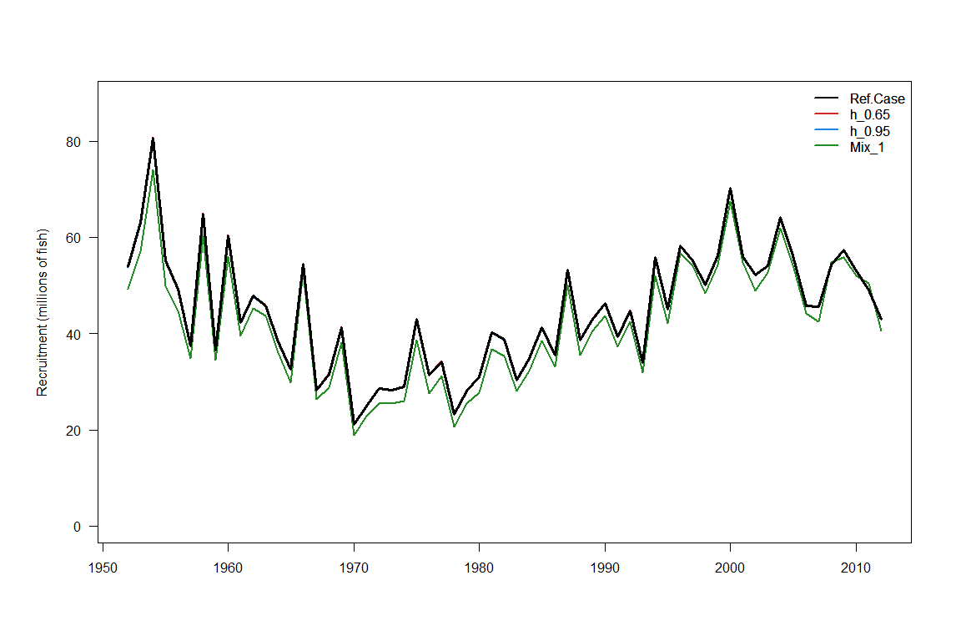
Figure BET1: Estimated annual recruitment (millions of fish) for the WCPO obtained from the base case model and three additional runs described in Table BET1. The model runs with alternative steepness values give the same recruitment estimates.

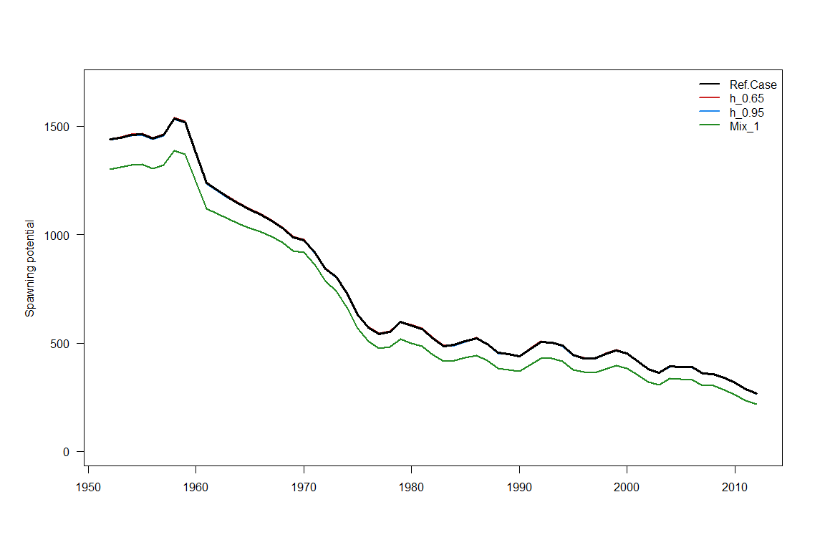
Figure BET2: Estimated annual average spawning potential for the WCPO obtained from the base case model and three additional runs described in Table BET1. The model runs with alternative steepness values give the same spawning potential trajectory estimates as the reference case.

Figure BET3: Estimated annual average juvenile and adult fishing mortality for the WCPO obtained from the base case model.

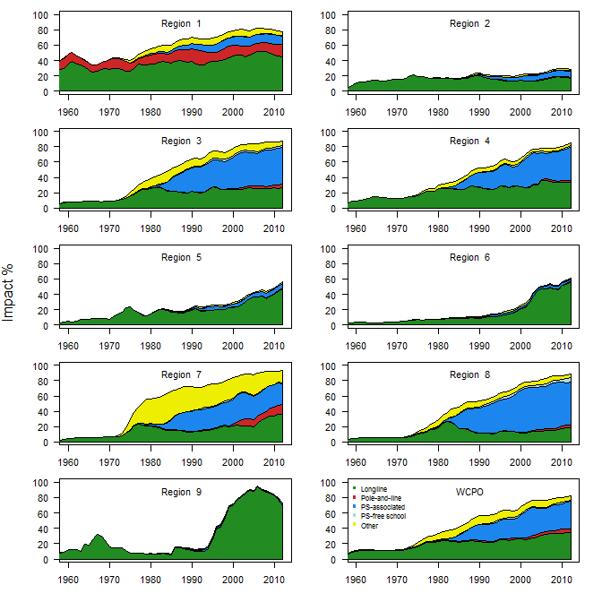
Figure BET4: Estimates of reduction in spawning potential due to fishing (fishery impact = 1-SB_{t}/SB_{t,F=0}) by region and for the WCPO attributed to various fishery groups for the base case model.

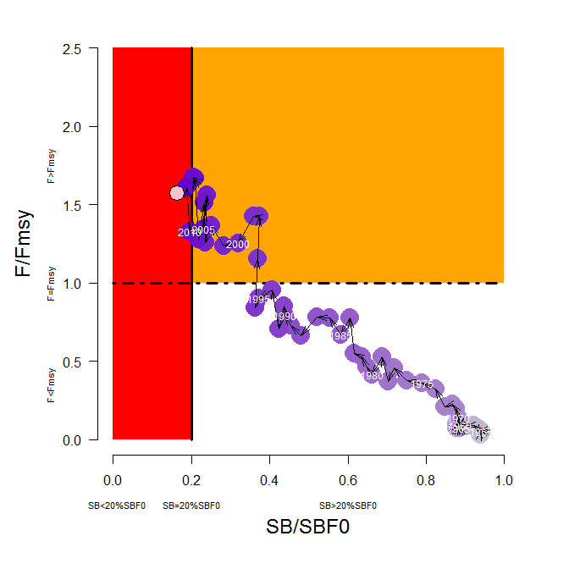
Figure BET5: Temporal trend for the base case model (top) and terminal condition for the base case and other sensitivity runs (bottom) in stock status relative to SB_{F=0} (x-axis) and F_{MSY} (y-axis). The red zone represents spawning potential levels lower than the agreed LRP, which is marked with the solid black line (0.2SB_{F=0}). The orange region is for fishing mortality greater than F_{MSY} (F=F_{MSY}; marked with the black dashed line). The pink circle (top panel) is SB₂₀₁₂/SB_{F=0} (where SB_{F=0} was the average over the period 2002–2011). The bottom panel includes the base case (white dot) and sensitivity analyses described in Table BET1.
Figure BET6: History of annual estimates of MSY compared with catches of three major fisheries for the base case model.

b. Management advice and implications
- SC10 noted that the spawning biomass of WCPO bigeye tuna breached the biomass LRP in 2012 and that the stock was overfished. Rebuilding spawning biomass to be above the biomass LRP will require a reduction in fishing mortality.
- SC10 recommended that fishing mortality on WCPO bigeye tuna be reduced. A 36% reduction in fishing mortality from the average levels for 2008–2011 would be expected to return the fishing mortality rate to F_{MSY}. This reduction of at least 36% should also allow the stock to rebuild above the LRP over a period of time. This recommended level of reduction in fishing mortality could also be stated as a minimum 33% reduction from the 2004 level of fishing mortality, or a minimum 26% reduction from the average 2001–2004 level of fishing mortality.
- Future status quo projections (assuming 2012 conditions) depend on assumptions on future recruitment. When spawner-recruitment relationship conditions are assumed, spawning biomass continues to decline and the stock is very likely (94%) to remain below the LRP based on projections through 2032 (SB₂₀₃₂<0.2SB_{F=0}). If recent (2002–2011) actual recruitments are assumed, spawning biomass increases and it is unlikely (13%) to remain below the LRP. Under both recruitment assumptions, it was virtually certain (100%) that the stock would remain subject to overfishing (F>F_{MSY}).
- Overfishing and the increase in juvenile bigeye tuna catches have resulted in a considerable reduction in the potential yield of the WCPO bigeye tuna stock. The loss in yield per recruit due to excess harvesting of juvenile fish is substantial. SC10 concluded that MSY levels would increase if the mortality of juvenile bigeye tuna was reduced.
- Fishing mortality varies spatially within the Convention Area, with high mortality in the tropical Pacific Ocean. WCPFC could consider a spatial management approach in reducing fishing mortality for bigeye tuna.
- Considering the unavailability of operational longline data for the assessment from some key fleets, SC10 recommended that all operational data, including high seas data, should be available for future stock assessments. The current lack of operational data for some fleets, and in particular the lack of operational longline data on the high seas, has hampered the 2014 assessment in a number of ways (e.g. the construction of abundance indices), and consequently, has hindered SC from achieving “best practice” in the 2014 stock assessment.
- SC10 noted that arrangements are being developed between CCMs and SPC to facilitate the availability of operational data for the Pacific-wide bigeye tuna stock assessment scheduled for 2015 (Attachment F).
- SC10 recommended that the Commission consider the results of updated projections at WCPFC11, including an evaluation of the potential impacts of CMM 2013-01, to determine whether the CMM will achieve its objectives and allow the bigeye tuna stock to rebuild above the LRP.

4.1.2 WCPO yellowfin tuna

4.1.2.1 Review of research and information

a. Purse-seine CPUE analyses for skipjack and yellowfin tunas
- G. Pilling (SPC) presented SC10-SA-WP-03, which described purse-seine CPUE for skipjack and yellowfin tunas in the PNG purse-seine fishery.
- The decline in skipjack tuna pole-and-line fishing activity in recent years means that the continuity of this key CPUE time series for the skipjack tuna stock assessment is becoming uncertain. For yellowfin tuna there are also limitations in the longline data for particular assessment model regions. The designation of a new region in both the skipjack tuna (S5) and yellowfin tuna (Y8) stock assessments also highlights the need for a standardized CPUE time series in that region. Domestic purse-seine vessels have operated within PNG archipelagic waters for many years, focusing on skipjack and yellowfin tunas. The fishing pattern of those vessels has remained relatively consistent over time, concentrating on sets associated with anchored FADs and other floating objects. It was, therefore, felt feasible to develop a standardized CPUE series for the two species in this region, using a delta-lognormal approach for the period 1997–2012.
- Resulting standardized skipjack tuna CPUE for the period showed a general decreasing trend over time. The model indicated that the primary driver of that decline was reductions in the probability of a successful set.
- Resulting yellowfin tuna standardized CPUE for the period showed a slight decline over time, attributed by the model to reductions in the probability of a successful set. CPUE was much more variable over time when compared with skipjack tuna.
- The presenter noted that there are uncertainties in the use of purse-seine CPUE as an index of abundance, given the schooling of fish, particularly near FADs. Further, while the fishing method has been relatively “constant” over time, there has been an increase in the number of sets per day (one associated and one unassociated set on the same day becoming slightly more common), a shift towards unassociated sets for some vessels (the model being developed on associated-set data only to minimize the impacts of these changes), and changes in the number of anchored FADs deployed over time (although there was no clear signal found in the standardized series that related to those trends).

Discussion
- Australia asked about the binomial nature of the purse-seine standardization model. Given that purse-seine vessels moor overnight at FADs, having the greatest catch potential, the binomial model would appear to be a measure of the vessel’s skill in pursing a catch rather than the probability of finding fish. It was also noted that the number of FADs in this fishery had increased over time. Australia wondered if the decreases in CPUE corresponded to an increase in the number of FADs (i.e. the more FADs available, the more likely the aggregations would be smaller as they are distributed across more FADs) of if the size of the catch was more related to the proficiency of the skipper.
- SPC agreed that it was difficult to ascertain if the increase in FADs was having a positive or negative effect on CPUE, and that both were possible.
- Japan asked about the use of catches of other species as explanatory variables. SPC replied that it did not look specifically at the interactions between other species and time. Both species and time were significant in the generalized linear model (GLM).
- SPC noted that it plans to look at the observer data to see if FADs were being joined together (similar to what is seen in the Philippines) because that could impact diagnostics used in the analysis as well as the derivation of the overall CPUE.
- Australia noted that while vessels in this fishery largely set on FADs, there were a growing number of sets on free schools. PNG commented that the increase in FADs was related to the increase in licensed vessels associated with onshore development that are authorized to deploy FADs. Additionally, there has been an increase in demand for free school catch, prompting vessels to recruit skippers with experience in targeting free schools.

b. Fishery trends in the Philippines
- K. Bigelow (USA) presented SC10-SA-WP-09 on the relative abundance of skipjack and yellowfin tunas in the Moro Gulf (Philippine Region 12). The objective of this study was to utilize the Philippine’s National Stock Assessment Program data to estimate relative abundance or standardized CPUE for tuna species in the southern Philippines (Region 12, SOCCSKSARGEN) for use in the 2014 WCPFC skipjack and yellowfin tuna assessments. Monthly relative abundance indices were produced for yellowfin tuna in the handline fishery (2004–2012) and for skipjack and yellowfin tunas in the purse-seine fishery (2005–2012). Standardized CPUE were estimated by GLMs by removing effects due to vessel, seasonality (i.e. month) and area. There were some problems noted in the yellowfin tuna handline CPUE index as the increasing CPUE from 2004 to 2008 may not be related to abundance, but rather increasing vessel efficiency with more pakura, or small pump boats, per handline vessel. Bigeye tuna indices were not incorporated into the WCPFC assessment because they are non-informative due to relatively low catch levels in the Philippines.

Discussion
- Australia noted that much of the deviance in the yellowfin tuna model was explained by the vessel effect, and wondered what was driving the differences at the end of the time series. The presenter explained that some of the vessels changed fishing areas. Divergences observed in 2012 and 2013 were likely an artefact of data reporting and not a difference of reporting area. Additionally, one of the runs did not include vessel effects

c. Review of 2014 yellowfin tuna stock assessment
- N. Davies (SPC) presented SC10-SA-WP-04, which described the stock assessment of yellowfin tuna in the WCPO. Excerpts from the executive summary of this paper are provided below as are several figures and tables regarding stock status that reflect the model runs selected by SC for the determination of current stock status and the provision of management advice.
- This paper presents the 2014 assessment of yellowfin tuna in the WCPO. This assessment is supported by several other analyses that are documented separately but should be considered as part of this assessment because they underpin many of the fundamental inputs to the models. The updated assessment addresses many of the recommendations provided in SC8-SA-WP-01 (Independent review of the 2011 bigeye tuna stock assessment), which apply equally to yellowfin tuna. Other key papers document: the methods used in producing the purse-seine size data (Abascal et al. 2014), longline size data (McKechnie 2014), longline CPUE data (McKechnie et al. 2014b), and tagging data (Berger et al. 2014); revisions to the fisheries and spatial definitions (McKechnie et al. 2014a); the guidance of the PAW held in April 2014 (SPC 2014).
- Some of the main improvements in the 2014 assessment are:
- increases in the number of spatial regions to better model the tagging and size data;
- the inclusion of catch estimates from Vietnam and some Japanese coastal longline data previously not included;
- the use of operational longline data for multiple fleets to better address the contraction of the Japanese fleet and general changes over time in targeting practices;
- improved modeling of recruitment to ensure that uncertain estimates do not influence key stock status outcomes; and
- a large amount of new tagging data corrected for differential post-release mortality and other tag loss.
- The large number of changes since the 2011 assessment (some of which are described above), and the nature of some of these changes, means that a full consideration of the impacts of individual changes is not possible. Nevertheless, the report details some of the steps from the 2011 reference case (LLcpueOP_TWcpueR6_PTTP) to the 2014 reference case (run37 – Ref.Case). Distinguishing features of the 2014 reference case model include:
- the steepness parameter of the stock recruitment relationship is fixed at 0.8;
- long-term average recruitment is defined for the period 1965–2011;
- natural mortality at age is fixed according to an external analysis in which it is assumed that the natural mortality rate of females increases with the onset of reproductive maturity;
- the likelihood function weighting of the size data is determined using an effective sample size for each fishing observation of one-twentieth of the actual sample size, with a maximum effective sample size of 50;
- for modeling the tagging data, a mixing period of two-quarters (including the quarter of release) is applied; and
- the last four quarterly recruitments aggregated over regions are assumed to lie on the stock recruitment curve.
- The rationale for these choices, which comprise the key areas of uncertainty for the assessment, is described in detail in the report. We report the results of “one off” sensitivity models to explore the impact of these choices for the reference case model on the stock assessment results. A subset of key, plausible model runs was taken from these sensitivities to include in a structural uncertainty analysis (grid) for consideration in developing management advice.
- The main conclusions of the current assessment are consistent with recent assessments presented in 2009 and 2011. The main conclusions are as follows.
- The new regional structure appears to work well for yellowfin tuna, and in combination with other modeling and data improvements, provides a more informative assessment than in the past.
- Spatially-aggregated recruitment is estimated to decline in the early part of the assessment, but there is no persistent trend post-1965.
- There appears to be confounding between the estimates of regional recruitment distribution and movement such that certain regions have very low recruitments. While adding complexity to the recruitment process of age-1 fish, this did not add to the uncertainty over the range of runs considered in this assessment.
- Latest catches marginally exceed MSY.
- Recent levels of fishing mortality are most likely below the level that will support MSY.
- Recent levels of spawning potential are most likely above (based on 2008–2011 average and based on 2012) the level that will support MSY.
- Recent levels of spawning potential are most likely above (based on 2008–2011 average and based on 2012) the LRP of 20%SB_{F=0} agreed on by WCPFC.
- Recent levels of spawning potential are most likely higher (by 1%, based on 2008–2011 average) and lower than (by 2% based on 2012) the candidate biomass-related TRPs currently under consideration for skipjack tuna (i.e. 40–60%SB_{F=0}).
- Stock status conclusions were most sensitive to alternative assumptions regarding the modeling of tagging data, assumed steepness and natural mortality. However, the main conclusions of the assessment are robust to the range of uncertainty that was explored.
- The report also includes recommendations for future stock assessments of yellowfin tuna, including research activities to improve model inputs.

Discussion
- Several CCMs expressed support for the use of the reference case as the base case, and noted that the fishing mortality was below the fishing mortality level at MSY and the spawning biomass was above the spawning biomass level at MSY. CCMs also noted that the spawning stock biomass level was above the LRP adopted by the Commission.
- Japan noted that the recruitment level was high in Region 1, a non-equatorial area, and wondered how this might have impacted spawning biomass. SPC noted that tagging data were strongly influential on movement between the regions, and that the model provided a good fit of the observed movement of tagged fish between the regions. Tagging data indicated very strong mixing among the equatorial regions, and because no tags have been released in Region 1, the model had no information on which to estimate movement from Region 1. The 2011 assessment grouped all fish in the western equatorial area into one region and the 2014 model split the western equatorial areas into three regions. There did seem to be some confounding information between recruitment and spawning biomass, but SPC did not feel that this added much uncertainty because the confounding factors affect juveniles and not adults. Recruitment estimates in the 2014 model are believed to result in a much better fit to the purse-seine size composition data over the model used in 2011.
- On behalf of FFA members, Tuvalu extended its appreciation and thanks to SPC for the new yellowfin tuna assessment, noting the improvements to the assessment are due in large part to the implementation of recommendations from the independent review in 2011, in particular the model structure and data improvements undertaken for this assessment. The reference case represents a good balance between the various assumptions required in the assessment, and to the extent that the results of a single model need to be referred to, it supports the reference case as denoted in the assessment for this purpose. However, for the purpose of formulating management advice, it is felt that it is appropriate to consider all the alternative models presented in order to fully capture the uncertainty in the assessment.
- FFA members noted the use of Figure 40 in the assessment as a useful representation of the Commission’s agreed LRP and range of possible TRP levels. FFA takes the view that SC should support the use of this plot in future assessments. FFA members recommended that SC’s advice reflect the fact that:
- the assessment depicts the yellowfin tuna stock to be in a healthy state, and that the assessment indicates that 2012 spawning biomass is well above the spawning biomass LRP;
- the latest (2012) spawning stock levels are in the vicinity of a potential TRP; and
- the assessment illustrates that the latest catches are above MSY (1.04), and with declining trends in spawning biomass over time, there is a requirement to cap or reduce catches to maintain the stock at its latest (2012) levels, to minimize the risk of breaching the Commission-adopted LRP.
- FFA members expressed the view that SC should highlight the significant impacts of the fisheries in the western equatorial regions, in particular associated purse-seine and other fisheries in Region 7, have on the stock.
- Australia made the following recommendations for framing management advice to WCPFC:
- that it be based on the reference case;
- that the uncertainty be represented by the tag-mixing (mix_1) and the two steepness sensitivity model;
- that SC refer to the “latest” figures for biomass and “current” figures for fishing mortality;
- that SB_{latest} is above the LRP of SB_{20 f=0} (as well as SB_{MSY}) in the reference case and in all sensitivities; and that yellowfin tuna is not considered to be overfished; and
- that F_{current} is below F_{MSY} in the reference case and in all sensitivities; and that yellowfin tuna is not considered to be subject to overfishing.
- USA concurred with Australia’s description of the stock status and management advice.
- Japan noted that the yellowfin tuna stock assessment showed a decline in biomass based on the impact of the associated fishery, but that a similar decline was not seen in the bigeye tuna stock assessment. SPC noted that there have been increases in unassociated catch in some regions and the figures are reflective of what is seen in the data for those fisheries.
- The EU noted that some fisheries catch very small juvenile fish, and wondered how this might impact conservation of this species. SPC noted that while the small fish fisheries catch is much smaller than those of longline fisheries, the impact is much greater because the number of individuals per ton is much higher, such that the ratio is 1:26 (longline : miscellaneous small fish fisheries). SPC noted that the historical yellowfin tuna MSY was much higher when the predominant fishery was longline, and dropped with the advent of the associated purse-seine fishery and small fish fisheries.
- Australia noted that recruitment since 1980 was relatively flat in the recruitment time series, which was unlike the recruitment shown in the bigeye tuna stock assessment. This indicated that the decline in yellowfin tuna biomass since 1980 was being mainly driven by fishing mortality. Australia also noted that in some areas, the tagging reporting rates were near the limits, and wondered if this created an issue for the assessment.
- SPC confirmed that it excluded the standardized CPUE for the longline all-fleets fisheries in Region 8, and that instead it used nominal catch rates.
- A CCM noted that the bigeye tuna stock assessment used information from the Japanese fleet and not all fleets due to difficulties early in the time series.
- USA also noted that in the previous stock assessment the estimated steepness was much lower whereas estimated steepness in the current stock assessment was around 1.
- SPC note that the assumptions used were consistent between the bigeye and yellowfin tuna stock assessment and confirmed that the Region 2 CPUE used the Japanese indices previously developed for the 2011 assessment with data for the most recent time period spliced on. SPC also explained that this stock assessment excluded the high stock recruitment points (they were included in the 2011 assessment) as well as applied lower relative weighting (recruitment was given a greater weighting in the 2011 assessment) and this resulted in a different stock recruitment estimate for this assessment.
- Japan noted that SC10-MI-WP-06, which would be presented later in the meeting, discusses range contraction, and that this stock assessment might be optimistic if range contraction were occurring. This adds uncertainty to the stock status based on the present stock assessment. This uncertainty should be considered in any potential management measures for yellowfin tuna.
- Indonesia asked if fishing mortality on juveniles and adults could be separated between the various model regions, and SPC stated that the stock assessment currently shows fishing pressure across all regions in the WCPO, but that it would be possible to generate them for each region.
- Australia felt that the recommendation for management advice should be based on the reference case and use the two steepness runs to characterize uncertainty plus the tag-mixing period=1 quarter scenario.
- USA asked about the sensitivity of natural mortality where it was estimated by the model and SPC explained that there was a difference between the natural mortality estimated by the model and when natural mortality was constrained. SPC did not believe the model gave the most reliable estimate of natural mortality, and stated that there was reasonable consistency between the size data and CPUE data, and that down-weighting the size data did not impact on stock status estimates substantially.
- PNG asked if the improved data from Region 7 had resulted in higher levels of estimated recent recruitment. SPC replied that in general, recruitment has not had a clear trend in most regions but was more variable in Region 7 than in the other equatorial regions.
- China was concerned about uncertainty in the stock assessment and urged members to apply the precautionary approach to reducing fishing mortality in the purse-seine fishery.
- Japan noted that there was considerable emphasis on impacts from FAD sets, and felt that impacts from sets on free schools should also be examined.
- USA noted that SC has previously noted that some regions have higher fishing mortality than others, and requested that this be noted in its management advice in case the Commission wished to take a spatial management approach for yellowfin tuna rather than apply measures to the entire Commission area.
- Nauru made a comment on behalf of FFA members, stressing that yellowfin tuna plays an important role in the livelihoods of Pacific Island people, particularly food security for remote island communities. It is imperative that this stock be maintained at healthy levels, and requested that SC recommend to WCPFC11:
- that there be no further increases in catch from the latest (2012) levels, and to implement measures that maintain latest spawning biomass levels (38% of SB_{F=0}) to avoid diminishing the current productivity of this stock, and to minimize the risk of breaching the Commission agreed LRP until such time as when the Commission determines an appropriate TRP for this stock;
- To implement measures to reduce fishing mortality from fisheries that take small sized fish, particularly purse-seine FAD fisheries and other fisheries in parts of the western equatorial region, in order to increase fishery yields and reduce any further impacts on the spawning potential for this stock; and
- noting the impacts of “other fisheries” on this stock, including those identified by SC9, ensure that management measures are formulated to maintain fishing mortality at 2012 levels for these fisheries.

d. Status quo projects for yellowfin tuna
- G. Pilling presented the status quo projections for yellowfin tuna (SC10-SA-WP-06), the results of which are outlined in section 4.1.1.1.b.

4.1.2.2 Provision of scientific information

a. Stock status and trends
- There have been significant improvements to the 2014 stock assessment resulting from the implementation of the 2012 bigeye tuna review recommendations, which apply equally to yellowfin tuna. Improvements were made to regional and fisheries structures, catch estimates, CPUE, and tagging data inputs, and the MULTIFAN-CL modeling framework. This assessment is also the first since the adoption of an LRP based on the spawning biomass in the absence of fishing (0.2SB_{F=0}).
- SC10 selected the reference case model, which had an assumed steepness of 0.8 to represent the stock status of yellowfin tuna. To characterize uncertainty in the assessment, SC10 chose three additional models based on alternate values of steepness and tagging-mixing period. More detail of the base case and other models are provided in Table YFT1.
Table YFT1: Description of the base case and key model chosen for the provision of management advice.
Name | Description
Base case | JP longline CPUE for Regions 1 and 2, all flags longline for Regions 3 to 7, and all flags longline nominal for Regions 8 and 9; with purse-seine CPUE for PH-ID in Region 7 and all flags in Region 8. Size data weighted as the number of samples divided by 20, steepness fixed at 0.8, M fixed, tag-mixing period of 2 quarters, and fixed natural mortality.
h_0.65 | Steepness=0.65
h_0.95 | Steepness=0.95
Mix_1qtr | Tag-mixing period=1 quarter

- Time trends in estimated recruitment, biomass, fishing mortality and depletion are shown in Figures YFT 1–4.
- High levels of fishing mortality on juveniles have been recorded in Region 7 (Fig. YFT6). Stock depletion levels are higher in the equatorial regions than elsewhere (refer to Fig. YFT4).
- The estimated MSY of 586,400 mt is within the range of previous assessments, and model quantities are generally similar with these earlier assessments. This is due largely to the consistent information on declining relative abundance provided by the longline CPUE indices and the large amount of tagging data input to the model.
- The dramatic decline in MSY in the 1970s follows the increased development of those fisheries that catch younger yellowfin tuna, principally the small-fish fisheries in the western equatorial region (Fig. YFT7).
- Fishing mortality has generally been increasing through time, and for the reference case F_{current} (2008–2011 average) is estimated to be 0.72 times the fishing mortality that will support MSY. Across the four models (base case and three sensitivity models) F_{current}/F_{MSY} ranged from 0.58 to 0.90. This indicates that overfishing is not occurring in the WCPO yellowfin tuna stock, however latest catches are close to or exceed MSY by up to 13% (Table YFT2 and Fig. YFT5).
- The latest (2012) estimates of spawning biomass are above both the level that will support MSY (SB_{latest}/SB_{MSY} = 1.24 for the base case and range from 1.05 to 1.51 across the four models) and the newly adopted LRP of 0.2SB_{F=0} (SB_{latest}/SB_{F=0} = 0.38) for the base case model and range from 0.35 to 0.40.

Table YFT2: Estimates of management quantities for selected stock assessment models (see Table YFT1 for details). For the purpose of this assessment, “current” is the average over the period 2008–2011 and “latest” is 2012.
 | Ref.Case | Mix_1 | h_0.65 | h_0.95
$$MSY (mt)$$ | 586400 | 526400 | 527200 | 642800
$$C_{latest}/MSY$$ | 1.02 | 1.12 | 1.13 | 0.93
$$F_{current}/F_{MSY}$$ | 0.72 | 0.87 | 0.9 | 0.58
$$B_{0}$$ | 4319000 | 3862000 | 4475000 | 4221000
$$B_{current}$$ | 1994655 | 1597536 | 1996179 | 1995224
$${SB}_{0}$$ | 2467000 | 2202000 | 2557000 | 2411000
$${SB}_{MSY}$$ | 728300 | 648000 | 859600 | 594500
$${SB}_{F=0}$$ | 2368557 | 2206510 | 2556733 | 2255523
$${SB}_{current}$$ | 998622 | 746743 | 999474 | 998914
$${SB}_{latest}$$ | 899496 | 770210 | 899362 | 898389
$${SB}_{current}/{SB}_{F=0}$$ | 0.42 | 0.34 | 0.39 | 0.44
$${SB}_{latest}/{SB}_{F=0}$$ | 0.38 | 0.35 | 0.35 | 0.4
$${SB}_{current}/{SB}_{MSY}$$ | 1.37 | 1.15 | 1.16 | 1.68
$${SB}_{latest}/{SB}_{MSY}$$ | 1.24 | 1.19 | 1.05 | 1.51

Table YFT3: Comparison of selected WCPO yellowfin tuna reference points from the 2009, 2011 and 2014 base case models.

Management quantity | Ref.case-2009 | Ref.case-2011 | Ref.case-2014
MSY | 636,800 | 538,800 | 586,400
F_{current}/F_{MSY} | 0.58 | 0.77 | 0.72
SB_{latest}/SB_{F=0} | 0.50 | 0.44 | 0.38
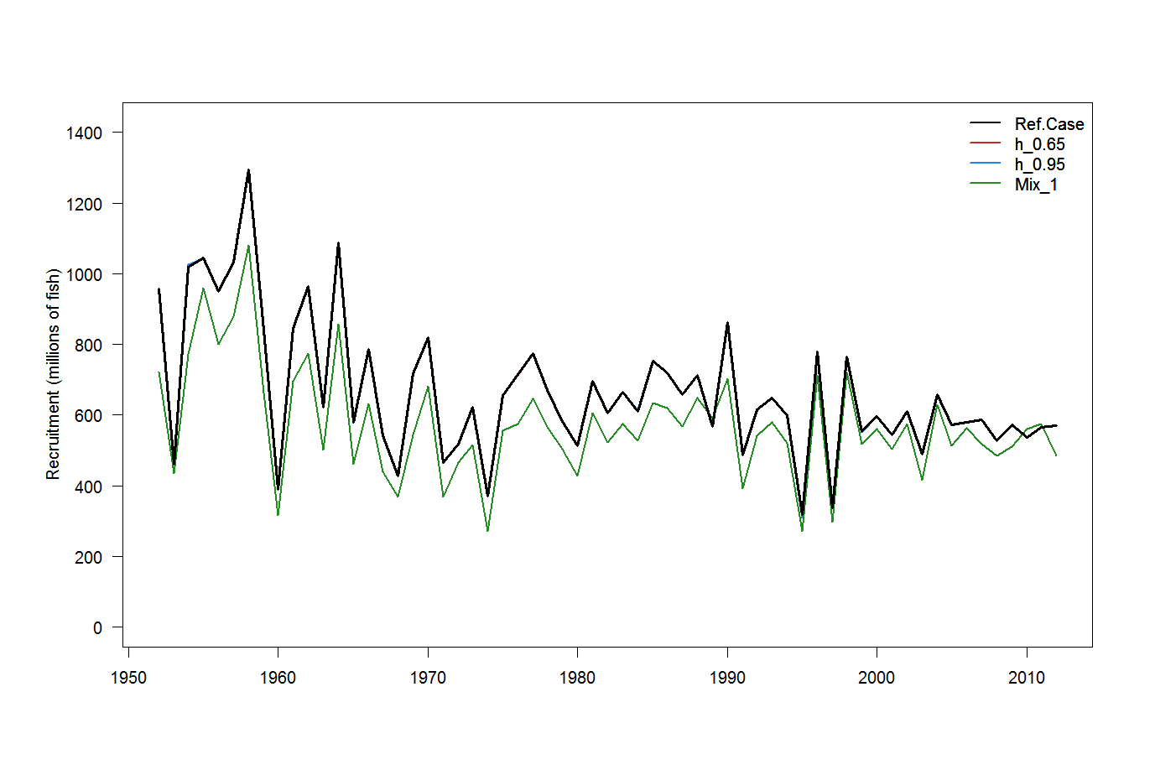
Figure YFT1: Estimated annual average recruitment for the WCPO obtained from the base case model and three additional runs described in Table YFT1. The model runs with alternative steepness values give the same recruitment estimates.
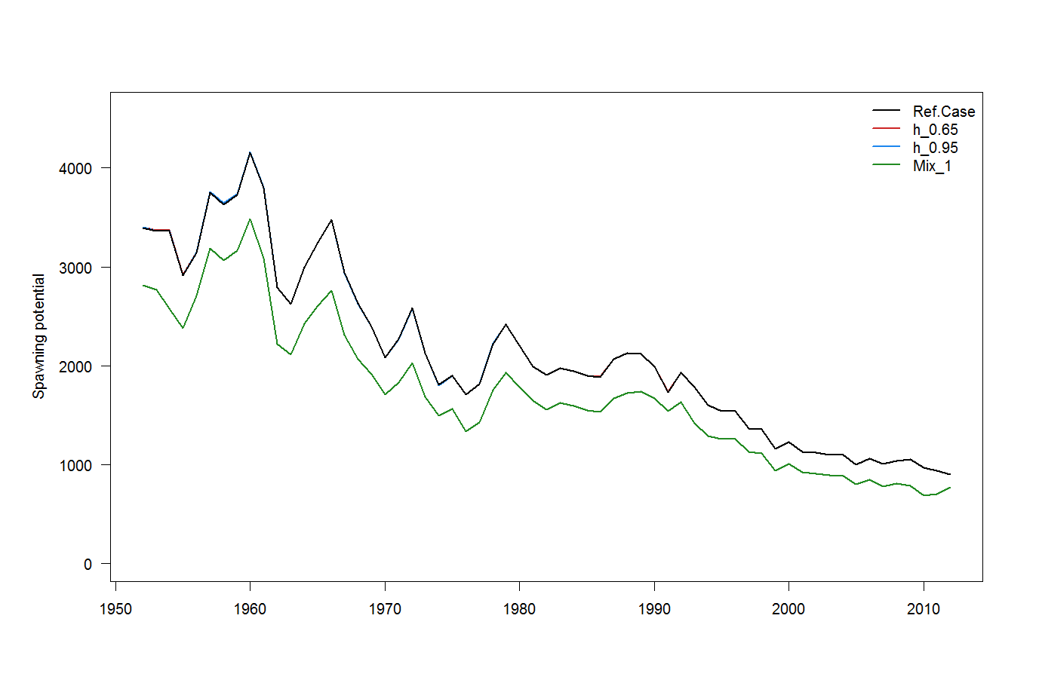
Figure YFT2: Estimated annual average spawning potential for the WCPO obtained from the base case model and three additional runs described in Table YFT1. The model runs with alternative steepness values give the same recruitment estimates.

Figure YFT3: Estimated annual average juvenile and adult fishing mortality for the WCPO obtained from the base case model.

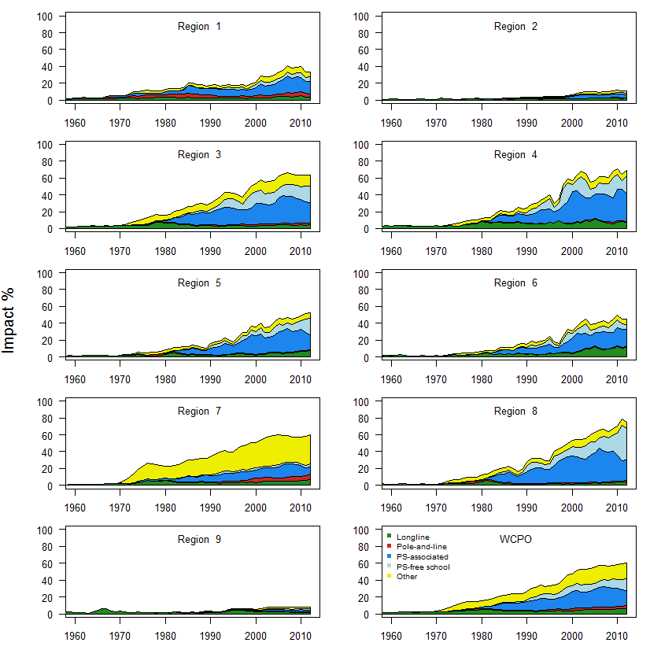
Figure YFT4: Estimates of reduction in spawning potential due to fishing (fishery impact = 1-SB_{t}/SB_{t,F=0}) by region and for the WCPO attributed to various fishery groups for the base case model.

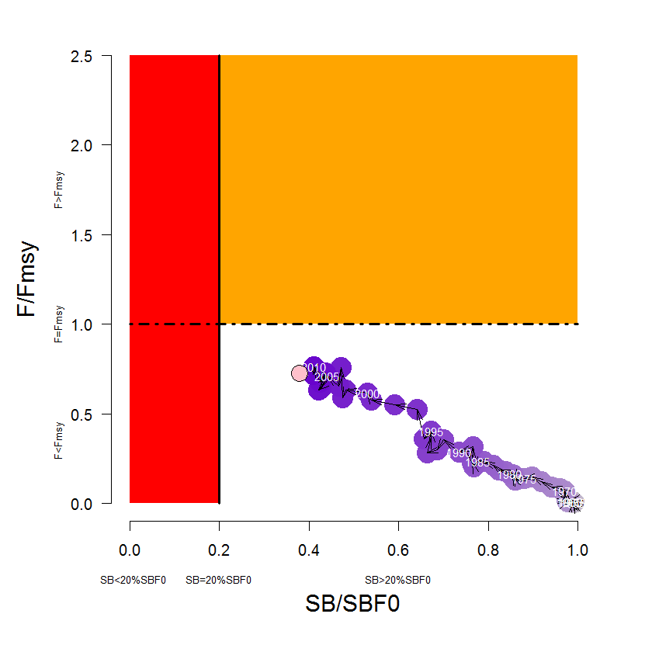
Figure YFT5: Temporal trend for the base case model (top) and terminal condition for the base case and other sensitivity runs (bottom) in stock status relative to SB_{F=0} (x-axis) and F_{MSY} (y-axis). The red zone represents spawning potential levels lower than the agreed LRP, which is marked with the solid black line (0.2SB_{F=0}). The orange region is for fishing mortality greater than F_{MSY} (F=F_{MSY}; marked with the black dashed line). The pink circle (top panel) is SB₂₀₁₂/SB_{F=0} (where SB_{F=0} was the average over the period 2002–2011). The bottom panel includes the base case (white dot) and sensitivity analyses described Table YFT1.
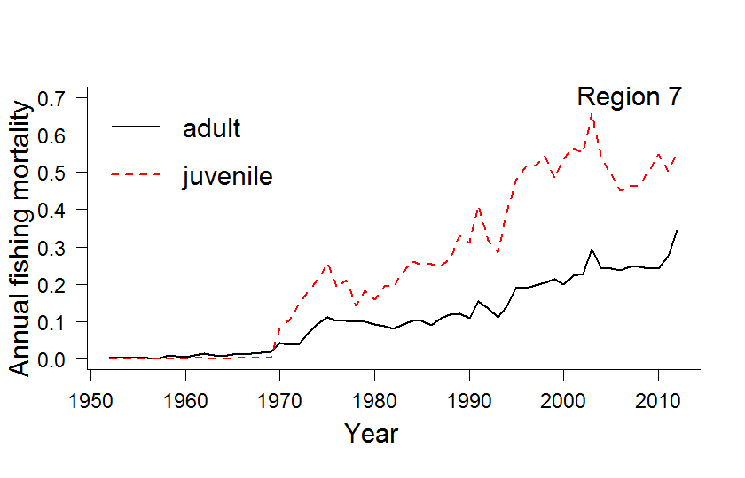
Figure YFT6: Estimated annual average juvenile and adult fishing mortality for Region 7 of the assessment obtained from the base case model.
Figure YFT7: History of annual estimates of MSY compared with catches of three major fisheries for the base case model.

b. Management advice and implications
- The WCPO yellowfin tuna spawning biomass is above the biomass-based LRP that WCPFC adopted (0.2SB_{F=0}), and overall fishing mortality appears to be below F_{MSY}. It is highly likely that the stock is not experiencing overfishing and is not in an overfished state.
- Latest (2012) catches (612,797 mt [SC10-GW-WP-01]) of WCPO yellowfin tuna marginally exceed MSY (586,400 mt).
- Future status under status quo projections (assuming 2012 conditions) depends on assumptions on future recruitment. When spawner-recruitment relationship conditions are assumed, spawning biomass is predicted to increase and the stock is exceptionally unlikely (0%) to become overfished (SB₂₀₃₂<0.2SB_{F=0}) or to fall below SB_{MSY}, or to become subject to overfishing (F>F_{MSY}). If recent (2002–2011) actual recruitments are assumed, spawning biomass will remain relatively constant, and the stock is exceptionally unlikely (0%) to become overfished or to become subject to overfishing, and it was very unlikely (2%) that the spawning biomass would fall below SB_{MSY}.
- SC also noted that levels of fishing mortality and depletion differ between regions, and that fishery impact was highest in the tropical region (Regions 3, 4, 7 and 8 in the stock assessment model). WCPFC could consider measures to reduce fishing mortality from fisheries that take juveniles, with the goal to increase to maximum fishery yields and reduce any further impacts on the spawning potential for this stock in the tropical regions.
- WCPFC could consider a spatial management approach in reducing fishing mortality for yellowfin tuna.
- SC recommended that the catch of WCPO yellowfin tuna should not be increased from 2012 levels, which exceeded MSY, and measures should be implemented to maintain current spawning biomass levels until the Commission can agree on an appropriate TRP.

4.1.3 WCPO skipjack tuna

4.1.3.1 Review of research and information

a. Review of 2014 skipjack tuna stock assessment
- J. Rice presented SC10-SA-WP-05 (Stock assessment of skipjack tuna in the WCPO). Excerpts from the executive summary of this paper are provided below as are several figures and tables regarding stock status that reflect the model runs selected by SC for determination of current stock status and the provision of management advice.
- This paper presents the 2014 assessment of skipjack tuna in the WCPO. This assessment is supported by several other analyses that are documented separately, but should be considered as part of this assessment because they underpin many of the fundamental inputs to the models. The updated assessment addresses many of the recommendations provided in SC8-SA-WP-01 (Independent review of the 2011 bigeye tuna stock assessment) that pertain to skipjack tuna. Other key papers document: the methods used in producing the purse-seine size data (Abascal et al. 2014) and tagging data (Berger et al. 2014); revisions to the fisheries and spatial definitions (McKechnie et al. 2014); and the guidance of PAW held in April 2014 (SPC 2014).
- Some of the main improvements in the 2014 assessment are:
- increases in the number of spatial regions to better model the tagging and size data;
- improved modeling of recruitment to ensure that uncertain estimates do not influence key stock status outcomes; and
- a large amount of new tagging data corrected for differential post-release mortality and other tag loss.
- The large number of changes since the 2011 assessment (some of which are described above), and the nature of some of these changes, means that a full consideration of the impacts of individual changes is not possible. Nevertheless, the report details some of the steps from the 2011 reference case to the 2014 reference case (Run 012_L0W0T0M0). Distinguishing features of the 2014 reference case model include:
- the steepness parameter of the stock recruitment relationship is fixed at 0.8;
- growth fixed according to 2010 estimates used in the last two assessments;
- the likelihood function weighting of the size data is determined using an effective sample size for each fishing observation of one-twentieth of the actual sample size, with a maximum effective sample size of 50;
- for modeling the tagging data, a mixing period of one-quarter (including the quarter of release) is applied; and
- the last four quarterly recruitments aggregated over regions are assumed to lie on the stock recruitment curve.
- The rationale for these choices, which comprise the key areas of uncertainty for the assessment, is described in detail in the report. We report the results of “one off” sensitivity models to explore the impact of these choices for the reference case model on the stock assessment results. A subset of key, plausible model runs was taken from these sensitivities to include in a structural uncertainty analysis (grid) for consideration in developing management advice.
- The main conclusions of the current assessment are consistent with recent assessments presented in 2010 and 2011. The main conclusions are as follows:
- A fluctuating but consistently high level of recruitment since the early 1970s has supported a robust fishery in all regions. The analysis suggests that the regional declines in spawning potential, in all regions except Region 1, are being driven primarily by the fishing impacts.
- Although the ratio of exploited to unexploited spawning potential is estimated to have declined, with some fluctuations, throughout the model period, the average total biomass of the last five years is estimated to be above the average total biomass of the first five years of the model.
- Latest catches slightly exceed MSY.
- Fishing mortality for adult and juvenile skipjack tuna is estimated to have increased continuously since the beginning of industrial tuna fishing, but fishing mortality still remains below the level that would result in MSY.
- Recent levels of spawning potential are well above the level that will support MSY.
- The estimated 2011 level of spawning potential represents approximately 52% of the unfished level, and is well above the LRP of 20%SB_{F=0} agreed on by WCPFC.
- Recent levels of spawning potential are in the middle of the range of candidate biomass-related TRPs currently under consideration for skipjack tuna (i.e. 40–60% SB_{F=0}).
- Stock status conclusions were most sensitive to alternative assumptions regarding steepness and growth. However, the main conclusions of the assessment are robust to the range of uncertainty that was explored.
- The report also includes recommendations for future stock assessments of skipjack tuna, including research activities to improve model inputs.

Discussion
- FFA members appreciated the range of uncertainties modeled in the 2014 assessment and endorsed the reference case as denoted in the assessment. It represented a good balance between the various assumptions required in the assessment. FFA members would usually support a single model being used for the purpose for determining stock status; however, for the purpose of formulating management advice, they considered it appropriate to consider all the alternative models presented in order to fully capture the uncertainty in the assessment. FFA supported SPC recommendations to further improve skipjack tuna stock assessments, in particular the continued evaluation and implementation of e-reporting initiatives.
- Further, FFA members strongly support the move by SPC to report stock assessment results against the WCPFC agreed LRP of 20% SB_{F=0}, and welcome the update to the Kobe plot, which displays the status of the stock against the agreed LRP and the proposed range of TRPs. FFA members strongly encourage SC to respect the decision of WCPFC to use 20% SB_{F=0} rather than SB_{MSY} in our communications and advice on stock status.
- In response to a question from Indonesia about migration rate among regions, SPC responded that the quarterly movement pattern and overall summary of stock composition by region of origin are presented in Figures 21 and 22 in the stock assessment report, respectively. Indonesia also asked why skipjack tuna is divided by five regions, where bigeye and yellowfin tunas were divided into nine regions and what effect this would have on the analysis because there is a relationship among the three species. SPC responded that there is a difference in spatial extent and gear types that exploit them.
- SPC also clarified that while Figure 1 in the paper suggests that Region 4 encompasses part of the Indian Ocean (an area south of Indonesia, and northwest of Australia), no catch for that area was incorporated into this assessment.
- Japan noted the declining trend in the PNG CPUE while the overall purse-seine CPUE described in working paper SC10-GN-WP-01 indicated an increasing trend. Japan also noted that it is the first attempt to use purse-seine CPUE as a stock abundance index to the stock assessment. It is well known that the standardization of CPUE in purse-seine fishery is difficult; including the purse-seine index to the reference case of the stock assessment is pre-mature.
- In response, SPC said it recognized the difficulty for developing reliable index for purse-seine fishery in general. However, the model was able to fit it very well, and it was consistent with the catch and tagging data and so it was appropriate to incorporate it in the stock assessment. SPC also noted that the approach used has been consistent — it does not allow the CPUE for the large international purse-seine fishery to have a significant influence on the estimates of stock size in these assessments. The rationale for including standardized CPUE for the PNG based purse-seine fleet as an abundance index in the assessment was that the operations of this fleet, which are based on anchored FAD sets, have not changed much over time, at least until very recently. Additionally, the dataset is fairly consistent with other data in the model. SPC acknowledged that there is a need to develop standardized CPUE indices for the purse-seine fishery in general. There are complications with this, including the lack of detailed information on the use of FADs, but further efforts will be made in this direction.
- PNA members noted that the major features of the assessment are the continuing increase in fishing mortality and the decline in stock size. The assessment shows that the spawning biomass is now around the mid-point of the range that WCPFC11 identified for consideration of a TRP for skipjack tuna. The Commission needs to take action to avoid further increases in fishing mortality and keep the skipjack tuna stock around the current levels, including adoption of a TRPs and tighter purse-seine effort limits.
- Australia noted that the level of depletion in Region 5 was high (approximately 80%) and was nearing the adopted LRP in that region. Australia followed up on Japan’s query regarding the CPUE and noted that the recruitment trends in Regions 4 and 5 were different, and wondered about a sensitivity analysis to look at splitting Region 2 from Region 5 using the old pole-and-line CPUE. In response, SPC did not feel it would be appropriate to use the Region 2 pole-and-line CPUE for Region 5 because the catch data and other characteristics of the fisheries in these regions are different. Australia noted that the natural mortality estimated by the model for very young fish (one to two quarters) was less than the natural mortality for slightly older fish (three to four quarters), and was unsure of what the biological reason for that would be. Australia queried the necessity for testing other initial values for the natural mortality.
- SPC noted that the model is estimating tag reporting rates that are higher than the prior means for a few fisheries and referred participants to SC10-SA-IP-06 for more information on how these priors were estimated. SPC explained that the high estimates may reflect violations of the mixing assumption and that they had done a sensitivity analysis allowing for two quarters of mixing. The tag-mixing rate and tag reporting rate can be somewhat confounded.
- Korea noted that the status of this stock in the last three stock assessments has been similar, but the catch has exceeded MSY since the mid-2000s. In recent years the catch continued to increase and the 2013 catch is a record. Korea sought clarification on the analysis, suggesting that regional declines in spawning potential in all regions except Region 1, against apparent increasing in Regions 2 and 3. SPC noted that the spawning potential has decreased in the last two decades.
- In response to questions by Japan, about the fishing impact on stock by fishery, and specifically whether the impacts shown in Region 1 were from the associated tropical purse-seine fishery, SPC responded that impact plots integrate movement and recruitment as well as fishing so that fishing in other areas can cause impacts. SPC also indicated that the Japanese coastal purse-seine fishery was treated as an associated purse-seine fishery for the purpose of the impact analysis. Therefore, it is not possible to determine the relative impacts of the tropical purse-seine fishery versus the Japanese coastal purse-seine fishery from the analysis undertaken. SPC said it needed operational data from Japan to confirm school association. Japan asked about the small impacts shown by the longline fishery, and SPC commented that longline catches in the model are nominal and represent a very small impact on the stock.
- Japan asked about the spawning biomass level in the 2014 assessment, noting that it was lower than the spawning biomass estimated in the 2011 assessment, while MSY reference points showed a similar level and asked if there were any major factors contributing to this difference. In response, SPC noted that a number of changes occurred between the 2011 and 2014 assessments and that several factors have contributed to the difference as noted by Japan.
- FFA members noted that while the skipjack tuna spawning stock biomass is well above the agreed LRP of 20% SB_{F=0} with no significant risk that the LRP is being breached, the spawning biomass currently sits within the range of candidate TRP values to be considered by WCPFC11. Fishing mortality remains below levels producing MSY. However, fishing mortality has been increasing and the spawning biomass is declining. Although the projections suggest that the stock will remain above the agreed reference point through to 2032 at 2012 effort levels, if new technology continues to increase the effectiveness of purse-seine effort then fishing mortality will increase and the stock will decline to some extent.
- The EU thanked SPC for the quality of its work and the huge amount of data processed for the stock assessment, and asked whether there are data available to illustrate the trends in mean size (length or weight) of catches over the years by region as additional indicators of stock status. SPC responded that it produces indicator papers with this information in the years that they do not provide stock assessments (e.g. SC9-SA-WP-06). SPC would consider including this information in future stock assessments.
- FFA members noted the rapid increase in fishing mortality in the skipjack tuna fishery, and they requested that SC recommend to the Commission to act promptly in order to maintain the spawning biomass within the potential TRP range of 40–60% of unfished SB, through the adoption of measures to avoid increasing fishing mortality, adopting a TRP for skipjack tuna at WCPFC11 as agreed on at WCPFC10, and supporting further work on a harvest control rule for skipjack tuna.
- FFA members supported further work being undertaken by SPC and PNA in their endeavor to develop a robust and responsible TRP for the skipjack tuna fishery.
- Japan asked about the high spawning potential in Region 1, in which fish migrate seasonally. Japan noted that it is curious that the region has such high spawning potential especially when compared with other regions in the equatorial area. SPC responded that the high level of spawning potential in Region 1 may relate to the large size of its geographical area, which is four to five times the size of Region 5. Japan sought confirmation on the use of information on skipjack tuna spawning in Region 1.
- SPC responded that no information on spawning distribution is explicitly incorporated into the assessment.
- Japan asked about Figure 43 in SC10-SA-WP-05, which depicts estimated biomass from the spatial ecosystem and population dynamics model (SEAPODYM). SPC clarified that this figure shows MULTIFAN-CL output using fixed movement estimates from SEAPODYM rather than movement rates estimated from MULTIFAN-CL. SPC did not advocate using these estimates from this particular SEAPODYM model at this time, but would continue to consider this in the future.
- In response to questions by Indonesia about Figures 26 and 3 in the working paper, SPC responded that it does not include data outside the model region boundaries (e.g. from the EPO and New Zealand). SPC provided a supplementary figure to Figure 26, time series of regional fishery mortality rates for juveniles and adults during SC10.
- Indonesia suggested that data from high latitude areas in the southern hemisphere (around New Zealand) be included in the next stock assessment for this species. Some CCMs supported this suggestion, including data for the fish distributed in the edge area of its distribution.
- The convener requested that figures displaying multiple lines incorporate symbols rather than differing colors to make them easier to distinguish especially when printing in black and white.
- Japan stated that the Kobe plot with the potential TRP range of 40–60% SB_{F=0} is not appropriate for the SC report.
- New Zealand supported the retention of the green hashed area and noted it can be discussed during the Management Issues theme.
- PNG stated that it found the green hashed area a very useful tool and supported its continued use. Australia supported New Zealand’s comment and agreed that framing of management advice for skipjack tuna be based on the reference case and that the uncertainty be represented by the two steepness sensitivity models and the two quarter tag-mixing model.
- Australia supported referring to the 2011 figures for biomass and the “current” figures for fishing mortality.
- Japan appreciated SPC’s effort in developing the stock assessment using purse-seine CPUE data, adding that SPC should continue to improve the stock assessment.
- The convener made the observation that the general view is that the hashed area candidate for TRP be retained, with one opinion to remove it. There were concerns about rapid increases in fishing mortality and continuing high catch of this species.
- SC10 endorsed the use of the reference case for the base case and to characterize uncertainty using the two steepness runs as well as the two quarter tag-mixing models.

b. Status quo projects for skipjack tuna
- G. Pilling presented the status quo projections for skipjack tuna (SC10-SA-WP-06), the results of which are outlined in section 4.1.1.1.b.

Discussion
- Japan stated that it looks forward to seeing the results of future projections using more improved stock assessment models, including the edge area in the next stock assessment.

c. Japan’s coastal CPUE trends
- H. Kiyofuji (Japan) presented SC10-SA-WP-10, which outlines the abundance of skipjack tuna migrating to Pacific coastal waters of Japan, as indicated by Japanese coastal troll and pole-and-line CPUE.
- To investigate skipjack tuna stock status in the Pacific coastal waters of Japan separately from the skipjack tuna stock assessment at the WCPFC-SC, skipjack tuna CPUE of coastal pole-and-lines fisheries around Kochi (KO) from 2003 to 2012 was standardized using GLM, and compared with those derived from coastal troll fisheries around the southern part of Wakayama (WK) and Hachijo-Islands of Tokyo (TKH). CPUE by the pole-and-line fisheries around KO decreased after 2005, remained at a low level until 2009, and then slightly increased. This declining trend was similar to that observed in WK troll fisheries. Abundance indices of TKH also show a declining trend and level between 2006 and 2013 were half of its level between 1996 and 2005. These results suggest that migration of skipjack tuna stock to coastal areas around Japan has been diminished since around 2006, possibly due to range contraction of this species in the WCPO. Available data for estimating standardized CPUE in this study was available up to 2012, while recent data for estimating standardized CPUE was not included in this study, in KO and WK, recent catch in 2014 in KO and WK were extremely lower than the recent five-year average (19%) and recorded the historical lowest, indicating that coastal skipjack tuna abundance remains at a low level in recent years.

Discussion
- Australia noted that there are several areas where coastal fisheries in Japan that catch skipjack tuna, but this analysis only looked at one area. It suggested that it would be useful to present the analyses for all areas, especially Area 2 where the majority of fishing took place. The presenter responded that it might be useful to incorporate data from all fisheries; however, the fishing patterns are quite different in these fisheries. The coastal pole-and-line in Area 1 operated seasonally and the fishery in the other areas operated year round. The combine data, therefore, might not be appropriate. Australia also noted that some differences in the standardized indices shown in Figure 5 suggested that sea surface temperature had a significant effect. The presenter noted that the differences resulted from the shortage of information regarding fishing gear. The CCM also noted that the oceanographic conditions, such as Kuroshio Current, could affect the migration from the equatorial area to the area around Japan. The presenter noted that the impact of the Kuroshio Current for the migration of this species should be further investigated, and in response to a question from Australia the presenter noted that they may have to think about another way to understand the data in Region 1. Climate change may have an impact on migration of skipjack tuna in coastal area but not much analysis has been done for skipjack tuna around Japan.
- Japan advised on two aspects of its fishery: i) Japan is a long distance fishing nation with large longline, purse-seine and pole-and-line vessels operating in commercial fisheries all over the world; and ii) Japan is as a coastal State that has many local artisanal fisheries depending on this stock. Japan stated that the latter fishery has experienced quite a low catch of skipjack tuna in recent years — this year’s seasonal catch in 2013 was reduced to 80% of recent catches; as a result, many local fishing communities are in danger of “breaking down”. Japan expressed serious concern about the situation and added that local fishing communities in other CCMs will never face the same situation. Japan stated that one of the reasons for the small catch in the edge area (high latitudinal region) is the range contraction of the stock as presented in the CPUE standardization analysis, and proposed that the investigation of the range contraction should be continued by SC. The Commission should consider developing measures to reduce skipjack tuna catches in order to limit the declines in catch rates associated with further declines in biomass with consideration for the possibility of range contraction, taking into account the state and structure of regional fisheries.
- SPC noted that catch declines might be related to declines in effort and wondered if there was an economic reason that could explain the declines in effort. The presenter replied that, at present, they did not have enough information to explain the declines in effort, but they were collecting economic data. It may be related to a rise in the cost of oil. The presenter added that existing fishermen may be ageing.
- Korea noted that the study on the coastal fishery CPUE should be continued and asked what the relationship was between the skipjack tuna assessment for the whole of Region 1 and coastal areas, noting that the stock level in Region 1 from the 1970s to the 1990s (and in recent years) is similar. The presenter noted that it was difficult to discuss the relationship between Region 1 and the coastal area, adding that they did not include information from the coastal area in the stock assessment and will continue to work on that.
- USA noted that there are several small fisheries in high latitude areas (e.g. the Hawaiian pole-and-line fishery, which has three vessels and annual catches of only 200–400 mt per year) and so it is difficult to identify statistical evidence for range contraction with such limited data. USA also stated that these localized fisheries may have reduced availability of skipjack tuna and shared Japan’s concern about range contraction.

4.1.3.2 Provision of scientific information

a. Status and trends
- There have been significant improvements to the 2014 stock assessment resulting from the implementation of the 2012 bigeye tuna review recommendations. Improvements were made to regional and fisheries structures, CPUE, size, and tagging data inputs, and the MULTIFAN-CL modeling framework. This assessment is also the first since the adoption of an LRP based on the spawning biomass in the absence of fishing (0.2SB_{F=0}).
- SC10 selected the reference case model as the base case to represent the stock status of skipjack tuna. To characterize uncertainty, SC10 chose three additional models based on alternative values of steepness and a longer tag-mixing period. Details of the base case and other models are provided in Table SKJ1.
Table SKJ1: Description of the base case and key model chosen for the provision of management advice.

Name | Description
Base case | JPN PL CPUE for Regions 1,2,3, PH PS-Associated CPUE for Region 4, PNG PS-Associated CPUE for Region 5. Size data weighted as sample number/20, steepness fixed at 0.8, growth fixed, mixing period of 1 quarter, terminal 4 recruitments not estimated
h_0.65 | Steepness=0.65
h_0.95 | Steepness=0.95
Mix_2qtr | Tag-mixing period=2 quarters

- Time trends in estimated recruitment, biomass, fishing mortality and depletion are shown in Figures SKJ 1–4.
- The estimated MSY is 1,618,800 mt, which is slightly lower than recent catches.
- Fishing mortality has generally been increasing through time, and for the base case F_{current} (2008–2011 average) is estimated to be 0.61 times the fishing mortality that will support MSY. Across the base case and three sensitivity models F_{current}/F_{MSY} ranged from 0.45 to 0.82. This indicates that overfishing is not occurring for the WCPO skipjack tuna stock.
- The latest (2011) estimates of spawning biomass are above both the level that will support MSY (SB_{latest}/SB_{MSY} = 1.74 for the base case and range from 1.45 to 2.10 across the four models) and the newly adopted LRP of 0.2SB_{F=0} (SB_{latest}/SB_{F=0} = 0.48 for the base case and range from 0.46 to 0.5). These biomass estimates are within the range (0.4–0.6) of depletion levels currently under consideration for a possible TRP.
- Future status under status quo projections (assuming 2012 conditions) was robust to assumptions on future recruitment. Under either assumption, spawning biomass remained relatively constant and it is exceptionally unlikely (0%) for the stock to become overfished (SB₂₀₃₂<0.2SB_{F=0}) or for the spawning biomass to fall below SB_{MSY}, and it is exceptionally unlikely (0%) for the stock to become subject to overfishing (F>F_{MSY}).
- Abundance indices of coastal fisheries in the Pacific coastal waters of Japan show a declining trend, and the level between 2006 and 2013 was half of the level between 1996 and 2005. The migration of the skipjack tuna stock to coastal areas around Japan, one of the edge areas of skipjack tuna distribution, has diminished since around 2006, possibly due to a range contraction of this species in the WCPO, although other reasons cannot be ruled out.
- It is noted higher catches of skipjack tuna occurred in recent years.
- SC10 recommended that PAW consider the inclusion of fisheries data into the skipjack tuna assessment for the northern and southern margins of the Convention Area.
- SC10 recommended that further research on the range contraction of skipjack tuna be conducted in the framework of Project 67.
Table SKJ2: Estimates of management quantities for selected stock assessment models (see Table SKJ1 for details). For the purpose of this assessment, “current” is the average over the period 2008–2011 and “latest” is 2011.

 | Base case | h=0.65 | h=0.95 | Mix_2qtr
MSY | 1,618,800 | 1,426,800 | 1,806,800 | ,784,000
C_{latest}/MSY | 1.02 | 1.16 | 0.92 | 0.93
F_{current/}F_{MSY} | 0.61 | 0.82 | 0.45 | 0.52
B₀ | 6,587,000 | 6,913,000 | 6,404,000 | 7,419,000
B_{current} | 3,615,213 | 3,613,290 | 3,612,585 | 4,374,786
SB₀ | 6,229,000 | 6,538,000 | 6,056,000 | 6,989,000
SB_{MSY} | 1,753,000 | 2,111,000 | 1,453,000 | 1,999,000
SB_{F=0} | 6,303,358 | 6,690,474 | 6,082,301 | 7,085,699
SB_{current} | 3,260,579 | 3,258,721 | 3,258,170 | 3,971,998
SB_{latest} | 3,052,995 | 3,050,692 | 3,049,508 | 3,548,468
SB_{current}/SB_{F=0} | 0.52 | 0.49 | 0.54 | 0.56
SB_{latest}/SB_{F=0} | 0.48 | 0.46 | 0.50 | 0.50
SB_{current}/SB_{MSY} | 1.86 | 1.54 | 2.24 | 1.99
SB_{latest}/SB_{MSY} | 1.74 | 1.45 | 2.10 | 1.78

Table SKJ3: Comparison of selected WCPO skipjack tuna reference points from the 2010, 2011 and 2014 base case models.

Management quantity | Base case 2010 | Base case 2011 | Base case 2014
MSY | 1,375,600 | 1,503,600 | 1,618,800
F_{current}/F_{MSY} | 0.34 | 0.37 | 0.61
SB_{latest}/SB_{F=0} | 0.48 | 0.55 | 0.48
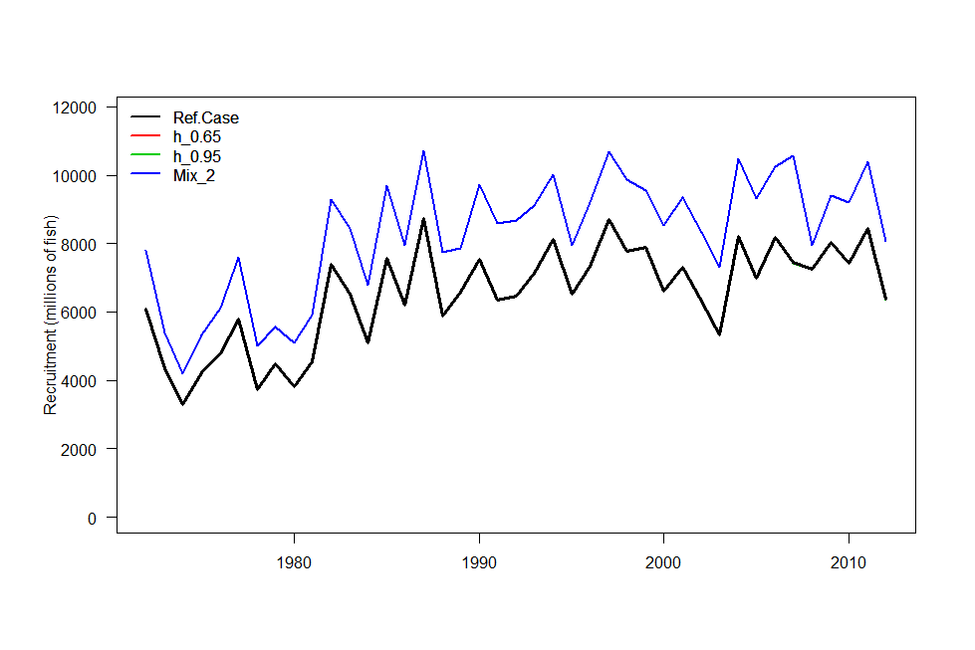
Figure SKJ1: Estimated annual recruitment (millions of fish) for the WCPO obtained from the base case model and three additional runs described in Table SKJ1. The model runs with alternative steepness values give the same recruitment estimates.

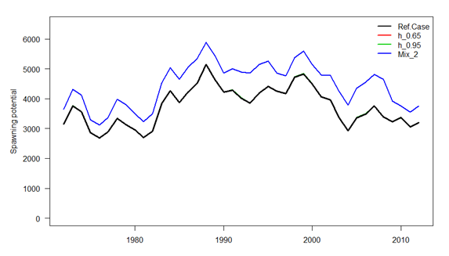
Figure SKJ2: Estimated annual average spawning potential for the WCPO obtained from the base case model and three additional runs described in Table SKJ1. The model runs with alternative steepness values give the same spawning potential estimates.
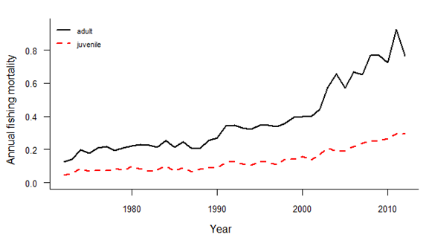
Figure SKJ3: Estimated annual average juvenile and adult fishing mortality for the WCPO obtained from the base case model.

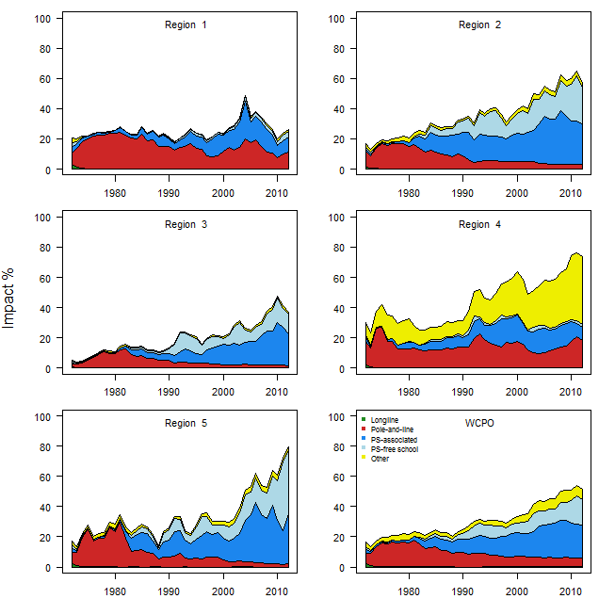
Figure SKJ4: Estimates of reduction in spawning potential due to fishing (fishery impact = 1-SB_{t}/SB_{t,F=0}) by region and for the WCPO attributed to various fishery groups for the base case model. Note: Region 1 Japanese purse-seine fishery was grouped as an associated set fishery in this analysis.

Figure SKJ5: Temporal trend for the base case model (top) and terminal condition for the base case and other sensitivity runs (bottom) in stock status relative to SB_{F=0} (x-axis) and F_{MSY} (y-axis). The red zone represents spawning potential levels lower than the agreed LRP, which is marked with the solid black line (0.2SB_{F=0}). The orange region is for fishing mortality greater than F_{MSY} (F=F_{MSY}; marked with the black dashed line). The lightly shaded green rectangle covering 0.4–0.6SB_{F=0} are the candidate TRPs of 40%, 50% and 60% of unfished spawning stock biomass that WCPFC10 has asked for consideration of a TRP for skipjack tuna. The pink circle (top panel) is SB₂₀₁₂/SB_{F=0} (where SB_{F=0} was the average over the period 2002–2011). The bottom panel includes the base case (white dot) and sensitivity analyses described Table SKJ1.

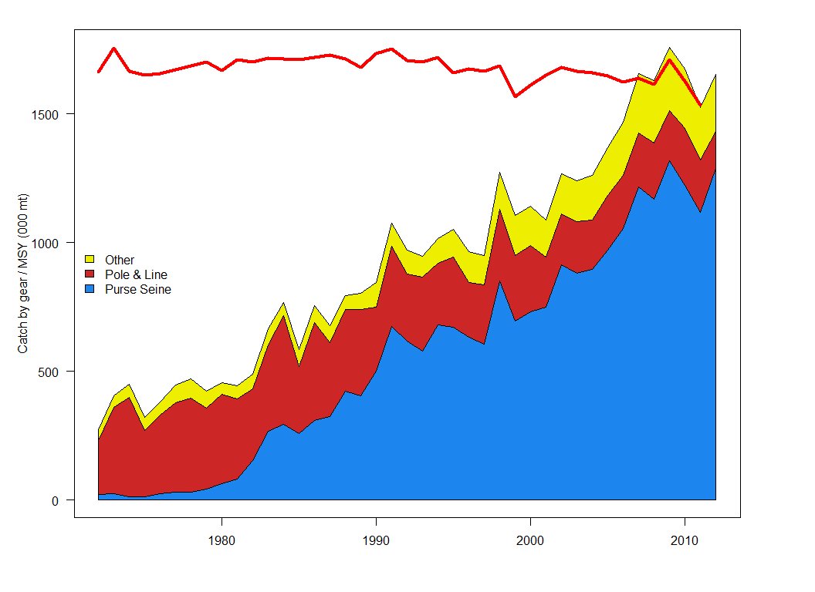
Figure SKJ6: History of annual estimates of MSY compared with catches of three major fisheries for the base case model.

b. Management advice and implications
- Recent catches are slightly above the estimated MSY of 1,618,800 mt. The assessment continues to show that the stock is currently only moderately exploited (F_{current}/F_{MSY} = 0.61) and fishing mortality levels are sustainable. However, the continuing increase in fishing mortality and decline in stock size are recognized.
- SC10 advised WCPFC that there is concern that high catches in the equatorial region could result in range contractions of the stocks, thus reducing skipjack tuna availability to high latitude fisheries.
- Fishing is having a significant impact on stock size, especially in the western equatorial region and can be expected to affect catch rates. The stock distribution is also influenced by changes in oceanographic conditions associated with El Niño and La Niña events, which impact on catch rates and stock size. Additional purse-seine effort will yield only modest gains in long-term skipjack tuna catches and may result in a corresponding increase in fishing mortality for bigeye and yellowfin tunas. The management of total effort in the WCPO should recognize this.
- The spawning biomass is now around the mid-point of the range of candidate TRPs of 40%, 50% and 60% of unfished spawning stock biomass that WCPFC10 has asked SC10 to consider for skipjack tuna. SC10 recommends that the Commission take action to avoid further increases in fishing mortality and to keep the skipjack tuna stock around current levels, with tighter purse-seine control rules and advocates for the adoption of TRPs and harvest control rules.
- SC10 recommended that the Commission consider the results of updated projections at WCPFC11, including the evaluation of the potential impacts of CMM 2013-01 in order to determine whether the CMM will achieve its objectives, including impacts of the skipjack tuna fishery on bigeye and yellowfin tunas.

4.1.4 South Pacific albacore tuna

4.1.4.1 Review of research and information
- SC10 noted that no stock assessment for South Pacific albacore tuna was conducted in 2014.
- G. Pilling presented SC10-SA-WP-07, which describes recent trends in the South Pacific albacore longline fishery. The paper presented a compendium of fishery indicators for South Pacific albacore tuna, the only principal target tuna species not subject to a full stock assessment in 2014. Documented indicators included total catch; catch by gear, longline effort and nominal longline CPUE trends, along with their spatial patterns; catch size composition; and trends in average fish weight. The information requested for South Pacific albacore as provided within previous papers to meetings of the Commission (e.g. SC9-GN-IP-04) was also presented.
- Annual catch estimates for albacore in the South Pacific (south of the equator) as a whole peaked in 2010 at just under 89,000 mt. Provisional data for 2013 indicated that it was the fourth highest catch on record, 3% lower than the catch in 2012, but 9% higher than the average over 2008–2012. Catch by longline vessels represented 96% of the total catch weight. Raised logsheet (and aggregated) data for the southern part of the WCPFC Statistical Area (south of 10°S) in number of deployed hooks in 2013 was 13% lower than in 2012, but up 3% on the average over the last five years. VMS effort information for the same area, considered to be more up to date, indicated total effort had increased by 9% from 2012 to 2013. The rate of effort increase has been greater in the high seas zone. High seas transshipment information available to the WCPFC Secretariat available from July 2010 to the present was also presented.
- Due to the complex interactions between species-specific fisheries, it is difficult to correctly interpret stock status-related implications from trends in indicators in isolation of other datasets and a population dynamics model. Therefore, stock status from the most recent South Pacific albacore assessment (2012) was summarized, and the potential stock consequences of recent fishing patterns relative to the agreed biomass LRP was examined using stochastic stock projections. Level of risk was strongly influenced by the range of assessment runs included (structural uncertainty).
- Based on the 2012 stock assessment and level of uncertainty included within the projection analysis reported within the paper, there was a greater than 30% chance that the South Pacific albacore stock will fall below the LRP by 2030 under recent fishing effort levels. However, further analyses based on a reduced range of assessment model runs more consistent with discussions of the SC10 informal small group on Project 57 (see SC10-MI-WP-01) were presented to the SC10 meeting (not included within the paper). Those runs indicated zero risk of falling below the LRP level, but decreases in median biomass levels over 20 years to 65%SB_{F=0} and 59%SB_{F=0} for 2010 and 2012 conditions respectively, and decreases in vulnerable biomass (a CPUE proxy) of 16% on average (from 6% to 30%) in longline fisheries (2012 conditions).

Discussion
- It was noted that, in the future, it could be useful to break down the effort histogram in Figure 3 by main fleets because there may be differences in what species they are targeting. The CCM also noted that the analysis suggests there is an urgent need to do more research on sex- and region-specific growth for South Pacific albacore. In response, SPC noted that considerable effort has been put towards looking at growth rates using otoliths and both sex- and region-specific growth patterns have been found. Uncertainty in growth in the context of the assessment should reflect the uncertainty in growth patterns for the aggregate population, rather than reflecting sex- or region-specific differences.
- FFA members noted the fourth highest record of South Pacific albacore catch in 2013, which represents a 3% decrease from 2012 but a 9% increase over the average 2008–2012. FFA members also noted that longline catches increased, resulting largely from a significant increase in longline CPUE of the major longline fleets of China, Chinese Taipei and Japan in 2013 relative to 2012 and 2008–2012. The long term nominal CPUEs show a decrease in more dominant fleets, and there was a decrease in the mean weight of individual longline-caught fish.
- FFA members noted that SC10-SA-WP-07 refers to the potential stock consequences of recent fishing patterns on the south Pacific albacore stock relative to the agreed biomass LRP, and stated that while they see the risk of falling below the LRP is strongly influenced by the range of assessment runs included in the analysis, the projections indicate a continued decline in albacore biomass on average, and up to a 16% decrease in vulnerable biomass (a CPUE proxy). This is a great concern to FFA members who depend on this resource to sustain the profitability of their EEZ fisheries and resource rents.
- FFA members had a pessimistic view of these ongoing trends and, in particular, the possible implications of a significant increase in effort and resulting increased catch of South Pacific albacore. FFA’s domestic fleets, which are dependent on albacore, continue to experience diminishing CPUE, thereby affecting profitability, trends that need to be reversed. FFA suggested doing this through strengthening SC9’s advice that included controlling catches of South Pacific albacore.
- FFA members shared concerns about the ongoing trends raised by Vanuatu. There has been an expansion of the South Pacific albacore fishery, shown by the increasing catch and effort on South Pacific albacore, and a decline in exploitable biomass (on average) in recent years, which has resulted in falling CPUEs and vessel profitability, particularly for the domestic fleets of SIDS. It was noted that these scientific concerns were captured in SC9’s advice, and remain valid for SC10. FFA members wanted to reiterate SC9’s recommendation for SC10, advising that longline fishing mortality and longline catch need to be reduced if the Commission wishes to maintain economically viable catch rates.
- USA expressed its concern about the economic viability of the American Samoa longline fishery, which had low catch rates in 2013.
- It was suggested that SPC may want to consider increasing longline catchability (effort creep) within projections because the trend would be important for results. SPC agreed that increasing catchability would affect the results, and noted that projections in the analysis were based on scaling longline effort rather than catch.
- Japan shared the concerns of FFA members regarding the situation of their domestic albacore fleets, stating that the decline in skipjack tuna migration seriously impacts on its artisanal fleet. Japan noted the importance of a growth study in order to improve stock assessments. It advised that in November 2013, Japan and ISC hosted a joint workshop on age determination of North Pacific albacore and bluefin tuna in the North Pacific. Information from that workshop will be available on ISC’s website in the near future.
- A CCM noted that the stock status of stock assessment in 2012 was above the related reference levels, and asked whether the decreasing CPUE and spawning potential is related to the historical changes of productivity or not. SPC responded that as biomass declines, productivity would also decline, but there is considerable variability around the mean level defined by the stock recruitment relationship.
- FFA members noted that the Commission has already adopted the LRP for South Pacific albacore at 20%SB_{F=0}. The UN Fish Stocks Agreement requires that the risk of exceeding LRPs be very low, and SC9 recommended the acceptable levels of risk associated with breaching LRPs not be more than 5–10%. FFA members have expressed a strong preference for a risk of not more than 5%.
- New Caledonia expressed concern about the critical situation of SIDS longline fleets targeting the South Pacific albacore, recalling that arguments used within the Commission to postpone action to improve the management measure on this species do not give due consideration to the serious socioeconomic difficulties that SIDS domestic fleets are currently facing. It was pointed out that the projected reductions in the vulnerable biomass available to SIDS fleets would be higher than for other fleets — French Polynesia, New Caledonia and Tonga being the most impacted. New Caledonia noted that SIDS, therefore, have a legitimate interest in the adoption of new measures to strengthen the management of the South Pacific albacore stock by the Commission so as to take account of the actual impact by the various fleets fishing for this species.
- French Polynesia noted that its EEZ is large and extends into both the EPO and the WCPO. French Polynesia is concerned with recent trends in the catch of South Pacific albacore in both the IATTC and the WCPFC convention areas. As New Caledonia mentioned, French Polynesia would be the most impacted, according to projection results in Table 7 in SC10-SA-WP-07. French Polynesia would face a 32% reduction in the 2030 vulnerable biomass available to its fleet under 2012 levels of effort. The updated analysis indicated that French Polynesia would face a 30% reduction. French Polynesia drew the meeting’s attention to Table A6b in SC10-GN-WP-02, which was delivered by IATTC during SC10. Between 2008 and 2012, the South Pacific albacore catch in the IATTC Convention Area increased from 8,000 mt to 17,400 mt — an increase of over 100%. In contrast, the catch in the WCPFC Convention Area in the same period increased from 54,700 mt to 70,000 mt, or about 30%. French Polynesia is disturbed by the combined catch trends of albacore across the entire South Pacific region as shown in Table A-6b of SC10-GN-WP-02. If this increase has continued to occur at the same rate since 2012, the catch will be greater than MSY by the end of this year. These alarming trends suggest not only a problem with the economic state of the fishery, as highlighted by FFA members and New Caledonia, but also with its biological state in the near future. If we take into account the problems that the Commission is facing with obtaining catch and effort data from high seas albacore longline vessels, we see that possible risks to profitability of the fleets and stock into the future are too great for the Commission to ignore. French Polynesia stated it will again be calling for reductions in total South Pacific albacore longline effort and catch at WCPFC11, and suggests this should be part of the management advice that SC10 provides to the Commission.
- Chinese Taipei indicated that the 93% increase in nominal CPUE of the fleet from 2012–2013 mentioned in the working paper is misleading, and clarified that 2013 data are very preliminary and the nominal CPUE of the comparison base year of 2012 was the lowest record for the fleet. Regarding the implications of separating South Pacific albacore catch by EEZ and high seas in the stock assessment, SPC replied that it does not have any implications, given that the assessment model is currently one region only. SPC confirmed it had been asked to provide the information broken down by EEZ and high seas areas each year by the WCPFC Secretariat.
- Samoa advised the meeting that its domestic fleets are largely made up of small catamarans, and Samoa continues to feel the direct impact of low CPUEs and, therefore, vessel profitability. In the beginning of this year, this fleet was largely tied up, which in itself is a signal of direct impact on domestic fleets. Samoa stressed that this is not consistent with the SIDS’ special requirement and aspiration provisions under the Convention. Samoa strongly supports SC advising a reduction in fishing effort and catches. Samoa will continue to support the South Pacific albacore harvest strategy that FFA members have agreed on to manage this fishery within their respective EEZs.

4.1.4.2 Provision of scientific information

a. Status and trends
- SC10 noted that no stock assessment was conducted for South Pacific albacore tuna in 2014. Therefore, the stock status description and management recommendations from SC8 are still current.
- However, recent trends for South Pacific albacore tuna are also important for describing the stock status.
- The total South Pacific albacore catch in 2013 was 84,698 mt, which was the third highest on record, and was 3% lower than the catch in 2012, but 9% higher than the average over 2008–2012.
- Total VMS effort information south of 10°S, which is considered to be more up to date than logsheet data, indicated that total effort had increased by 9% from 2012 to 2013. The rate of effort increase has been greater in the high seas area.
- On the basis of stochastic stock projections using 18 assessment model runs there is a 30% chance that spawning biomass is exceeding the biological LRP. However, further analyses at SC10, based on a reduced range of 9 assessment model runs, indicated zero risk of falling below the LRP level, but decreases in median spawning biomass levels over 20 years to 65% SB_{F=0} and 59%SB_{F=0} for 2010 and 2012 conditions, respectively.

b. Management advice and implications
- SC10 noted that no stock assessment has been undertaken since SC8.
- SC10 noted the increasing catch and effort on South Pacific albacore south of the equator in both the WCPFC and IATTC convention areas which, under 2012 conditions, is projected to result in a 16% reduction on average (range of 6% to 30% reduction) in vulnerable biomass by 2030 (the biomass available to longline fleets, as a proxy of CPUE), and particularly impacting on the vulnerable biomass available to SIDS domestic fleets and their profitability.
- SC10 recommends that longline fishing mortality and longline catches be reduced to avoid further decline in the vulnerable biomass and possibly exceeding the biomass LRP, and so that economically viable catch rates can be maintained.

4.2 Northern stocks
- ISC’s chair G. DiNardo presented SC10-GN-IP-02, which outlined highlights of ISC’s 14th meeting (ISC14) held in Taipei, Taiwan from 16 to 21 July 2014, and attended by members from Canada, Chinese Taipei, Japan, Korea and the USA, as well as WCPFC and the North Pacific Marine Science Organization (PICES). The plenary reviewed results and conclusions, which were based on new data and updated analyses of the billfish, albacore, shark, and Pacific bluefin tuna working groups. The plenary endorsed the findings that the North Pacific blue shark, albacore tuna, and swordfish stocks are not overfished nor experiencing overfishing, and reiterated that Pacific bluefin tuna are overfished and experiencing overfishing. ISC provided projections for managers to consider when crafting management measures for Pacific bluefin tuna, as well as North Pacific albacore tuna, swordfish, and blue shark, and updated the conservation advice from ISC13 based on these projections.
- The plenary reviewed the progress of the working groups and endorsed their work plans. The ISC work plan for 2014–2015 includes completing a new stock assessment for North Pacific striped marlin and shortfin mako shark in time for ISC15. A special seminar on impacts of climate change on fisheries was held. Plenary discussed formalizing ISC’s structure and administration, and began researching means of doing both. Plenary also noted the strides that working groups had made in incorporating best available scientific information into stock assessment work, enhanced stock assessment reports, and the increased transparency in working group efforts. Observers from the Pew Charitable Trusts, International Seafood Sustainability Foundation, and WWF attended. The plenary re-elected C. Sun for a second term as ISC vice-chair, as well as J. Brodziak, S. Kohin, and R. Wu for a second term as chair of the Billfish Working Group, Shark Working Group and Statistics Working Group, respectively. The next plenary will be held in the USA in July 2015.
- Collaborations between Pacific regional fishery management organizations (RFMOs), regional fishery organizations (RFOs), and other scientific organizations are essential to advancing the science in the region and providing timely scientific advice to decision-makers. ISC conducted data exchanges with data managers from WCPFC and IATTC, and presented stock assessment results at the scientific meetings of these RFMOs. The emergence of a new collaboration between PICES and ISC to assess the impact of climate change on pelagic species in the North Pacific Ocean was reported.

Discussion
- There were no comments on this paper.

4.2.1 North Pacific albacore tuna

4.2.1.1 Review of research and information
- S. Teo presented working paper SC10-SA-WP-12, which outlines the stock assessment of North Pacific albacore tuna in 2014.
- The North Pacific albacore tuna (Thunnus alalunga) stock area consists of all waters in the Pacific Ocean north of the equator, and all available fishery data from this area were used for the stock assessment. It is assumed that there is instantaneous mixing of albacore throughout the stock area on a quarterly basis (i.e. a single well-mixed stock).
- The total reported catch of North Pacific albacore was relatively low in the 1950s and 1960s and increased to a peak of 126,175 mt in the mid-1970s before declining and reaching a secondary peak by the late 1990s. Following a second decline in the early 2000s, the catch has recovered slightly to fluctuate between 69,000 mt and 92,000 mt in recent years (2006–2012). Since the early 1950s, surface gear types (troll, pole-and-line) have accounted for approximately twice as much of the albacore catch as longline gear.
- Catch and size composition data were collected from ISC countries (Canada, Chinese Taipei, Japan, Korea and USA) and some IATTC and WCPFCmember countries, including China (Table 1). Standardized CPUE data for eight indices used to measure trends in relative abundance were provided by Japan, USA, Canada and Chinese Taipei. However, based on a closer examination of these abundance indices, the Albacore Working Group concluded that the Japanese pole-and-line (PL) and longline (LL) indices were the indices that best represented the trends in juvenile and adult albacore abundance, respectively, and the base case model was therefore fitted to these indices only. The North Pacific albacore tuna stock was assessed using an age-, length-, and sex-structured Stock Synthesis (Version 3.24f) model fitted to time series of standardized CPUE and size composition data using a 1966 to 2012 time frame. Sex-specific growth curves were used because there is evidence of sexually dimorphic growth, with adult male albacore attaining a larger size and age than female albacore. The value for steepness in the stock recruitment relationship was h = 0.9, based on two separate external estimates of this parameter. The assessment model was fitted to four relative abundance indices (early and late period Japanese PL and LL) and size composition data in a likelihood-based statistical framework. Maximum likelihood estimates of model parameters, derived outputs, and their variances were used to characterize stock status. Several sensitivity analyses were conducted to evaluate changes in model performance or the range of uncertainty resulting from changes in model parameters, including some of the data series used in the analyses, growth curve parameters, natural mortality, stock recruitment steepness, starting year, selectivity estimation, and weighting of size composition data.
- Estimates of total stock biomass (age-1 and older) show a long-term decline from the early 1970s to 1990 followed by a recovery through the 1990s and subsequent fluctuations without trend in the 2000s. Female SSB exhibits similar long-term changes, with a decline from the early 1970s to the early 1990s, a recovery in the late 1990s and a leveling off in the late 2000s. Female SSB was estimated to be approximately 110,101 mt in the terminal year of the assessment (2012) and stock depletion is estimated to be 35.8% of unfished SSB. The estimated SPR (spawners per recruit relative to the unfished population) in the terminal year of the assessment is 0.41, which corresponds to a relatively low exploitation level (i.e. 1-SPR = 0.59). While current F-at-age on juvenile fish is lower in the base case model than in 2002–2004, F on adult ages (50% of age-5 and all fish age-6 and older) is higher on average than during 2002–2004. Juvenile albacore age-2 and age-3 are the largest component of the catch as reflected by the larger impact of the surface fisheries (primarily troll, pole-and-line, but including several minor gear types) relative to longline fisheries, which remove adult fish. Average historical recruitment is approximately 42.8 x 10⁶ recruits annually, but there are periods where the average recruitment is above or below this at the beginning of the assessment time frame followed by fluctuations around the average since the 1990s. The Albacore Working Group believes that North Pacific albacore recruitment, as with other tuna species, is influenced by changes in environmental conditions and the stock recruitment relationship. Kobe plots depict stock status in relation to MSY-based and MSY proxy reference points (see below) from the base case model. The Kobe plots are presented for illustrative purposes because biological reference points have not been established for the north Pacific albacore stock, with the exception of the F_{SSB-ATHL} interim reference point used by the WCPFC’s Northern Committee. F_{SSB-ATHL} is the fishing mortality that results in future SSB, over a 25-year projection period, falling below the average of the 10 historical lowest estimated SSBs (SSB-ATHL) with 50% probability. Based on an evaluation of the estimated current F (F_{2010–2012}) against various F-based reference points, including F_{SSB-ATHL}, the North Pacific albacore stock is not currently experiencing overfishing (Table NPALB1) because the ratios for most candidate reference points, except F_{MED} and F_{50%}, are below 1.0. Although no biomass-based reference points have been developed for this stock, there is little evidence from this assessment that fishing has reduced SSB below reasonable candidate biomass-based reference points, so the Albacore Working Group concludes that the stock is likely not overfished at present.
- Stochastic stock projections were conducted externally to the Stock Synthesis base case model to evaluate the impact of various levels of fishing intensity on future female SSB for North Pacific albacore. Future recruitment was based on random resampling of historical recruitment for three periods: i) low recruitment (29.1 x 106 recruits), 1983–1989; ii) average recruitment (42.8 x 106 recruits), 1966–2010; and high recruitment (54.8 x 106 recruits), 1966–1975. These calculations incorporate the structure of the assessment model (e.g. multi-fleet, multi-season, size- and age-selectivity) to produce results consistent with the assessment model. Projections started in 2011 and continued through 2041 under two levels of fishing mortality (constant F_{2010–2012}, constant F_{2002–2004}, constant catch averaged for 2010–2012) and three levels of recruitment (low, average, and high as defined above). Results show projected female SSB for each of the three harvest and recruitment scenarios. Based on these projections, the stock performs better under the constant F_{2010–2012} harvest scenario than under the constant F_{2002–2004} harvest scenario. Assuming average historical recruitment and fishing at a constant current F, median female SSB is expected to remain relatively stable between the 25th and median historical percentiles over both the short- and long-term, with a 13% probability that SSB falls below the SSB-ATHL threshold during a 25-year projection period (2011–2036). In contrast, if a low recruitment scenario is assumed, then median female SSB declines under both harvest scenarios and the probability that it falls below the SSB-ATHL threshold in the 25-year projection period increases to 65%. The high recruitment scenario is more optimistic, with median SSB increasing above the historical median SSB and the estimated probability of breaching the SSB-ATHL threshold is correspondingly low at 3%. The constant catch scenario is inconsistent with current management approaches and it may be unrealistic for this stock because catches of North Pacific albacore are largely dependent on recruitment.
- Biological reference points were computed with the base case model (Table 1). The point estimate (± SD) of MSY is 105,571 ± 14,759 mt and the point estimate of spawning biomass to produce MSY (SSB_{MSY}, adult female biomass) is 49,680 ± 6,739 mt. The SSB-ATHL threshold (i.e. the average of the 10 historically lowest SSB estimates) is estimated to be 117,835 mt, which is more than twice the SSB_{MSY} level. The ratio of F_{2010–2012}/F_{MSY} is estimated to be 0.52 and the ratio of F_{2010–2012}/F_{SSB–ATHL} is estimated to be 0.72. F_{2010–2012} (F_{current}) is below F_{MSY} and all MSY-proxy reference points except F_{MED} and F_{50%} (Table 1) and these ratios are lower than ratios estimated using F_{2002–2004}, consistent with the intent of previous Albacore Working Group recommendations for conservation.
- The F_{SSB-ATHL} reference point is currently the interim default reference point chosen by the Northern Committee. The ALBWG notes that improvements to the assessment model have altered the biomass trajectory in the current assessment relative to the 2011 model, with a low biomass period occurring at the end of the modeled time frame. Because of these changes, the estimated SSB–ATHL threshold differs from the previous assessment and now includes several recent years (2007–2010) in its calculation. Consideration should be given to determining whether it is appropriate to include recent years in the calculation of this threshold because the threshold is used to evaluate the current status of the stock based on recent years.
- Based on the results of the stock assessment, the North Pacific albacore stock is not experiencing overfishing and is probably not in an overfished condition. The current exploitation level (F_{2010–2012}) is estimated to be below that of F_{2002–2004}, which had led previously to the implementation of CMMs for the North Pacific albacore stock in the EPO (IATTC Resolution C-05-02 supplemented by Resolution C-13-03) and the WCPO (WCPFC CMM 2005-03). The probability that current F will lead to SSB falling below the SSB-ATHL threshold is well below 50% under both average and high historical recruitment scenarios, but rises to 65% if a low recruitment scenario is assumed. The Albacore Working Group notes that there is no evidence that fishing has reduced SSB below thresholds associated with the majority of biomass-based reference points that might be chosen, and that population dynamics in the North Pacific albacore stock are largely driven by recruitment, which is affected by both environmental changes and the stock recruitment relationship. The Albacore Working Group concludes that the North Pacific albacore stock is healthy and that current productivity is sufficient to sustain recent exploitation levels, assuming average historical recruitment in both the short term and long term.
- The Albacore Working Group notes that the lack of sex-specific size data, the absence of updated estimates of important life history parameters (natural mortality, maturity), and the simplified treatment of the spatial structure of North Pacific albacore population dynamics are important sources of uncertainty in the assessment.

Discussion
- Australia pointed out that in the reference case model there was a big increase in recruitment in the early 1990s causing a big increase in spawning biomass and total biomass, and suggested that the model might be sensitive to how the CPUE time series is cut. The model seems to have interpreted a big jump in CPUE in the first couple of years as an increase in recruitment. It was suggested that the year used in the stock assessment might not be the most appropriate place to cut the CPUE series.
- The presenter responded that they had not specifically explored this, but the reasons for splitting the time series were that it made the model more flexible in the catchability of these indices and there was a shift over three or four years in operations by those fleets at that time. The two indices have different scales, resulting in a more flexible model.
- SPC asked why tagging was not included in the assessment. The presenter responded that the working group had not thoroughly examined the available tagging data for use in the assessment but preliminary examination of limited tagging data indicate that tagging data for albacore is heterogeneous, with no sampling design and ad hoc, opportunistic tagging. It was difficult to make well-supported inferences from such information. Nevertheless, the working group will likely further examine the utility of tagging data for future assessments.
- Australia noted that the presenter’s concluding statements regarding the status of the stock were sometimes put in absolute terms, suggesting that if ISC had conducted a structural uncertainty analysis, it may have been more appropriate to state, for example, that there is a “small likelihood that the stock is overfished”. That is used in the SPC assessments and Australia suggested that ISC could adopt the same approach.
- The presenter clarified that the phraseology used in the assessment is “it is likely not overfished” and explained that the ISC North Pacific Albacore Working Group was of the opinion that the best way to present advice to managers was in terms of structural uncertainties rather than probabilities. He noted that they wanted to look at other data first to get the model into better shape. The working group might propose a future change in the way management advice is presented, subject to improvements in the model.

4.2.1.2 Provision of scientific information

a. Status and trends
- SC10 noted that ISC provided the following conclusions on the stock status of North Pacific albacore.
Because the F for 2010–2012 relative to most candidate reference points, except F_{MED} and F_{50%}, are below 1.0, NPALB is not experiencing overfishing (Table NP-ALB1). Although no biomass-based reference points have been developed for this stock, there is little evidence from this assessment that fishing has reduced SSB below reasonable candidate biomass-based reference points, so the ALBWG concludes that the stock is likely not in an overfished condition at present. The ISC concludes that the North Pacific albacore stock is healthy and that current productivity is sufficient to sustain recent exploitation, assuming average historical recruitment continues.

Table NP-ALB1: Potential reference points and estimated F-ratios using current F (F_{2010–2012}) and F_{2002–2004} (reference years for North Pacific albacore CMMs adopted by IATTC and WCPFC) to assess current stock status, associated spawning biomass and equilibrium yield for North Pacific albacore when exploited at F_{2010–2012}. Median SSB and yield are shown for F_{SSB–ATHL} as this simulation-based reference point is based on a non-equilibrium concept.

b. Management advice and implications
- SC10 noted the following conservation advice from ISC.
The current exploitation level (F_{2010–2012}) is estimated to be below that of F_{2002–2004}, which led to the implementation of conservation and management measures (CMMs) for the North Pacific albacore stock in the EPO (IATTC Resolution C-05-02 supplemented by Resolution C-13-03) and the WCNPO (WCPFC CMM 2005-03). Assuming average historical recruitment and fishing at a constant current F, median female SSB is expected to remain relatively stable between the 25th and median historical percentiles over both the short- and long-term, with a 13% probability that female SSB falls below the SSB-ATHL threshold during a 25-year projection period. In contrast, if a low recruitment scenario is assumed, then median female SSB declines under both harvest scenarios (constant F_{2010–2012}, constant F_{2002–2004}) and the probability that it falls below the SSB-ATHL threshold in the 25-year projection period increases to 65% as calculated by the ALBWG and noted above. The high recruitment scenario is more optimistic, with median future SSB increasing above the historical median SSB and the estimated probability of falling below the SSB-ATHL threshold is correspondingly low at 3%.
- SC members continue to encourage the development of reference points for northern stocks, including North Pacific albacore fishery, that are consistent with the reference points being developed for other WCPFC fisheries.

4.2.2 Pacific bluefin tuna

4.2.2.1 Review of research and information
- K. Oshima presented SC10-SA-WP-11, which outlines the update of the stock assessment of Pacific bluefin tuna. Results of the 2014 stock assessment are summarized as follows. The update of the stock assessment was completed in February 2014 at the Southwest Fisheries Science Center in La Jolla, USA through updates of fishery data up to June 2013, according to a request from the 2013 ISC plenary. The fishery data (quarterly catch, size composition) from 1952 to 2010 (July 1952–June 2011) used in the 2012 stock assessment were not changed. In the case of the CPUE time series, due to the nature of the CPUE standardizations method, the whole time series will need to be restandardized with the additional two years of data. Stock Synthesis v3.23b was used as the stock assessment model. Future projections were conducted under the seven harvesting scenarios assigned by NC9. The software used for future projections is distributed as an R-package named “ssfuture”.
- The current (2012) spawning stock biomass was 26,324 mt and slightly higher than that estimated for 2010 (25,476 mt). Mean recruitment for the last five years may have been below the historical average. Although no TRPs or LRPs have been established for the Pacific bluefin tuna stock, the current F average over 2009–2011 exceeds all TRPs and limit biological reference points (BRPs) commonly used by fisheries managers except for F_{loss}, and the ratio of SSB in 2012 relative to unfished SSB (depletion ratio) is less than 6%. Based on reference point ratios, overfishing is occurring and the stock is overfished. Based on projection results, adopted WCPFC CMM (2013-09) and IATTC resolution for 2014 (C-13-02), if continued, are not expected to increase SSB if recent low recruitment continues. In relation to the projections “requested” by NC9, only scenario 6, the strictest one, results in an increase in SSB even if the current low recruitment continues. If the low recruitment of recent years continues, the risk of SSB falling below its historically lowest level observed would increase. This risk can be reduced with implementation of more conservative management measures.

Discussion
- Marshall Islands made the following statement on behalf of FFA, noting the conservation advice in the paper is based on run 1, which is the base case assessment model for the Pacific bluefin tuna updated stock assessment. Based on that run, overfishing of Pacific bluefin tuna is occurring and the stock is in an overfished state. Given the model estimates of 2012 spawning stock biomass (SSB) of 26,324 mt is approximately 4.2% of the stock’s estimated unfished SSB level. Moreover, the estimated age-specific fishing mortalities on the stock were higher in “juveniles” potentially the age 5–6, however decreased catches by 35% for age-7+. FFA members and their leaders expressed concern at their recent meeting in Palau over the current state of Pacific bluefin tuna stock. The spawning biomass has been declining for over a decade. FFA members note that the recruitment level in 2012 was the 8th lowest in 61 years, and the average recruitment level for the last five years may have been below the historical average level. Given the results of scenario 6, FFA members support the recommendation in the paper for further substantial reductions in fishing mortality and juvenile catch over the whole range of juvenile ages in order to reduce the risk of stock spawning biomass falling below its historically lowest level. Such reductions would also reduce the risk of recruitment collapse, and reduce the risk of spawning stock unable to rebuild under current conditions.
- FSM supported the statement from the Marshall Islands and made the following statement on behalf of FFA. FFA members seek an update on two outcomes that emerged from SC9, and captured in the Summary Report. The first is an update on a peer review of the Pacific bluefin tuna assessment requested at SC9. At that meeting, most CCMs argued that such a review follow the same process as was used for the 2011 bigeye tuna assessment rather than conducting desktop reviews. Secondly, FFA members seek an explanation of work on candidate LRPs and TRPs for Pacific bluefin tuna consistent with the Commission’s adopted or default reference points.
- In addition, FFA members requested: a) that a peer review be undertaken as requested at SC9, following a similar process to that of the independent review of the 2011 bigeye tuna stock assessment, with detailed presentation of results; and b) an explanation of work progress on candidate LRPs and TRPs for Pacific bluefin tuna consistent with the Commission's adopted or default reference points, in line with the majority view at SC9.
- SPC noted that the Pacific bluefin model results show that the stock was already depleted at the start of the model period in 1952. Therefore SPC posed the question of how virgin biomass was determined. In addition, SPC made a request for clarification about initial depletion in 1952. Initial depletion was based on reported catches prior to 1952. In particular, SPC requested that Japan provide the details of the catch data and the documentation about the estimation methods of initial biomass level.
- USA explained how the model calculated initial depletion in 1952. The initial fishing mortality rates at age and the early recruitment deviations were freely estimated to match the size composition data and abundance indices in the model. However, the model was not fit to the initial catches and the average annual catch during the first five of the assessment time horizon was used to gauge whether the model estimates of initial fishing mortality rates were reasonable. In addition, a likelihood profile analysis on unfished recruitment was conducted by the Working Group, and this provided a characterization of the information sources that influenced the scale of unfished spawning biomass.

Pacific bluefin tuna stock assessment — review of research
- K. Oshima (Japan) reported back to SC10 in response to queries about virgin biomass initial depletion, and utilization of the stock prior to the assessment periods. A summary of his presentation is as follows: The virgin stock biomass is simply calculated as the product of estimated R0 (age-0 at virgin population) and SPR at virgin population. SPR at virgin population is calculated from M at age, maturity ogive and mean weight at age. Because of steepness of 0.999 ≈ 1, R0 is almost identical to average R. Uncertainty of virgin biomass is difficult to evaluate through the model. Uncertainty of virgin biomass is difficult to evaluate through the model. However, dynamic B0 fluctuated from 0.4 million through 1 million mt in the light of historical recruitment.
- Initial age structure in 1952 of ages 0-10 is estimated as parameters. SSB in 1952 is calculated from initial population size.
- The presenter’s description of catch history included in the executive summary of SC10-SA-WP-11 was made available to explain the catch trend prior to 1952. Japan only collected aggregated tuna catch before World War II. Historical Pacific bluefin tuna catches by Japan were estimated through picking up coastal gear catch, while they may still include the other tuna catch. USA also collected their Pacific bluefin tuna catch statistics from the early 20th century. There are Pacific bluefin tuna landing estimates by Japan dating back to the late 19th century from coastal Japan and to the early 20th century for USA fisheries operating in the EPO. Estimated catches of Pacific bluefin tuna were high from 1929 to 1940, with a peak catch of approximately 48,000 mt (36,000 mt in the WCPO and 11,000 mt in the EPO) in 1935. Thereafter, catches of Pacific bluefin tuna dropped precipitously due to World War II. From 1952 onward, ISC developed the more comprehensive Pacific bluefin tuna catch data made available by most fishing nations. ISC indicates that annual catches of Pacific bluefin tuna fluctuated widely from 1952 to 2012. During this period, reported catches peaked at 40,383 mt in 1956 and reached a low of 8,653 mt in 1990.

Discussion
- There were no comments on this presentation.
- The EU noted that the steepness value used for the assessment of this stock is among the least conservative of those presented at this meeting, and asked the presenter to explain the rationale for using such a high steepness value.
- The presenter explained that the stock assessment model did not converge under a lower steepness. Additionally, if steepness is estimated by the model, the value is estimated to be one close to 0.999.
- FFA members noted that the base case indicates that Pacific bluefin tuna is overfished and experiencing overfishing. Model estimates for 2012 were that SSB would be 4.2% of unfished levels, and that the fishing mortality would be higher in juvenile age classes, potentially at age 5–6. Continued declines in SSB have occurred for more than a decade. FFA members note that recent recruitment is the 8th lowest observed in 61 years, and average recruitment levels for the last five years have been below the historical average level. Pacific Islands Forum Leaders remain very concerned over the current state of this stock, and as such FFA members support the recommendation for substantial reductions in fishing mortality and juvenile catches over the whole range of juvenile ages.

4.2.2.2 Provision of scientific information

a. Status and trends
- SC10 noted that ISC provided the following conclusions on the stock status of Pacific bluefin tuna in the Pacific Ocean in 2014.
Using the updated stock assessment, the 2012 SSB was 26,324 mt and slightly higher than that estimated for 2010 (25,476 mt).
Across sensitivity runs in the update stock assessment, estimates of recruitment were considered robust. The recruitment level in 2012 was estimated to be relatively low (the 8th lowest in 61 years), and the average recruitment level for the last five years may have been below the historical average level (Figure B1). Estimated age-specific fishing mortalities on the stock in the period 2009–2011 relative to 2002–2004 (the base period for WCPFC Conservation and Management Measure 2010-04) increased by 19%, 4%, 12%, 31%, 60%, 51% and 21% for ages 0–6, respectively, and decreased by 35% for age-7+ (Figure B2).
Although no target or LRPs have been established for the PBF stock under the auspices of WCPFC and IATTC, the current F average over 2009–2011 exceeds all target and limit biological reference points (BRPs) commonly used by fisheries managers except for F_{loss}, and the ratio of SSB in 2012 relative to unfished SSB (depletion ratio) is less than 6%. In summary, based on reference point ratios, overfishing is occurring and the stock is overfished (Table B1).

Table B1: Ratio of the estimated fishing mortalities F_{2002–2004}, F_{2007–2009} and F_{2009–2011} relative to computed F-based biological reference points for Pacific bluefin tuna (Thunnus orientalis), depletion ratio (ratio of SSB in 2012 relative to unfished SSB), and estimated SSB (mt) in year 2012. Values in the first eight columns above 1.0 indicate overfishing.
 | F_{Max} | F_{0.1} | F_{Med} | F_{loss} | F_{10%} | F_{20%} | F_{30%} | F_{40%}
F_{2002–2004} | 1.70 | 2.44 | 1.09 | 0.84 | 1.16 | 1.68 | 2.26 | 2.98
F_{2007–2009} | 2.09 | 2.96 | 1.40 | 1.08 | 1.48 | 2.14 | 2.87 | 3.79
F_{2009–2011} | 1.79 | 2.54 | 1.25 | 0.97 | 1.32 | 1.90 | 2.55 | 3.36

For illustrative purposes, two examples of Kobe plots (plot A based on SSB_{MED} and F_{MED}, plot B based on SSB20% and SPR20%, Figure B3) are presented. Because no reference points for PBF have yet been agreed to, these versions of the Kobe plot represent alternative interpretations of stock status in an effort to prompt further discussion.
Historically, the WPO coastal fisheries group has had the greatest impact on the PBF stock, but since about the early 1990s the WPO purse-seine fleet has increased its impact, and the effect of this fleet is currently greater than any of the other fishery groups. The impact of the EPO fishery was large before the mid-1980s, thereafter decreasing significantly. The WPO longline fleet has had a limited effect on the stock throughout the analysis period. The impact of a fishery on a stock depends on both the number and size of the fish caught by each fleet; i.e., catching a high number of smaller juvenile fish can have a greater impact on future spawning stock biomass than catching the same weight of larger mature fish (Figures B4 and B5).
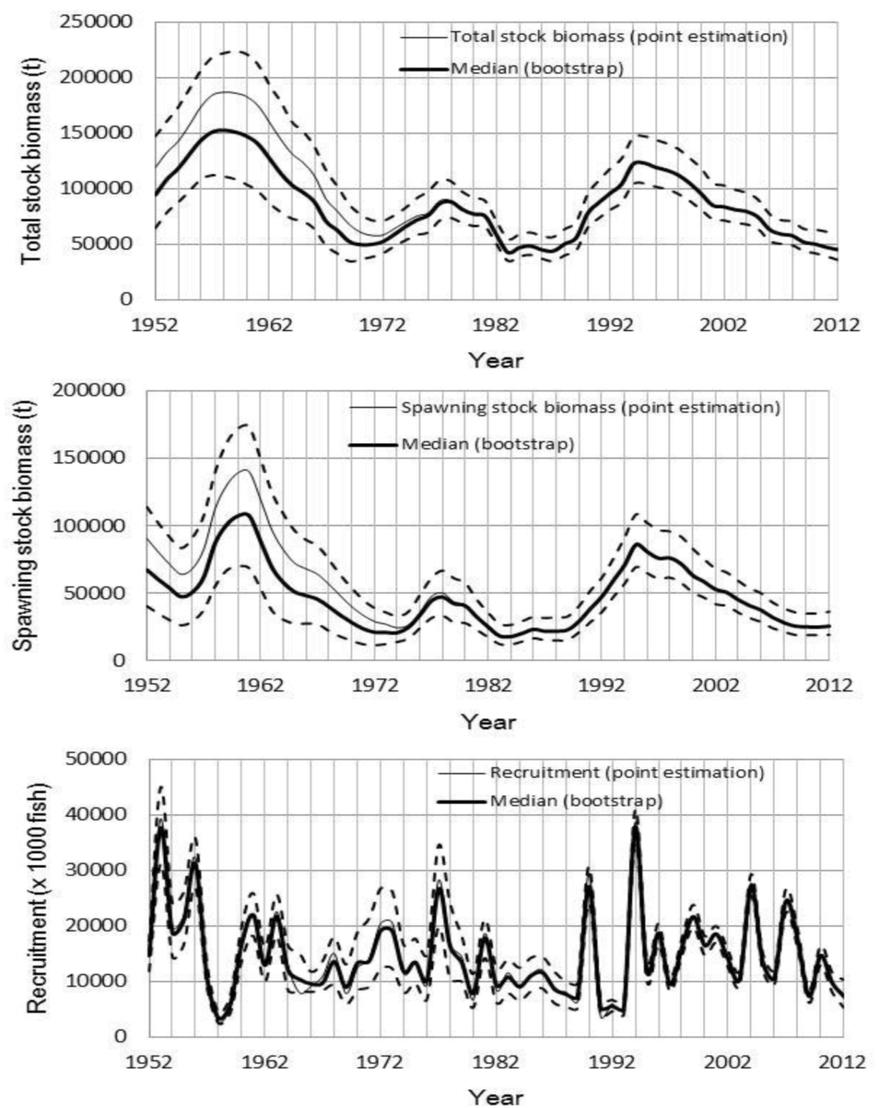
Figure B1: Pacific bluefin tuna (Thunnus orientalis) total stock biomass (upper panel), spawning stock biomass (middle panel) and recruitment (lower panel) of Pacific bluefin tuna from the base case run. Thick line indicates median, thin line indicates point estimate, and dashed lines indicate the 90% confidence interval.

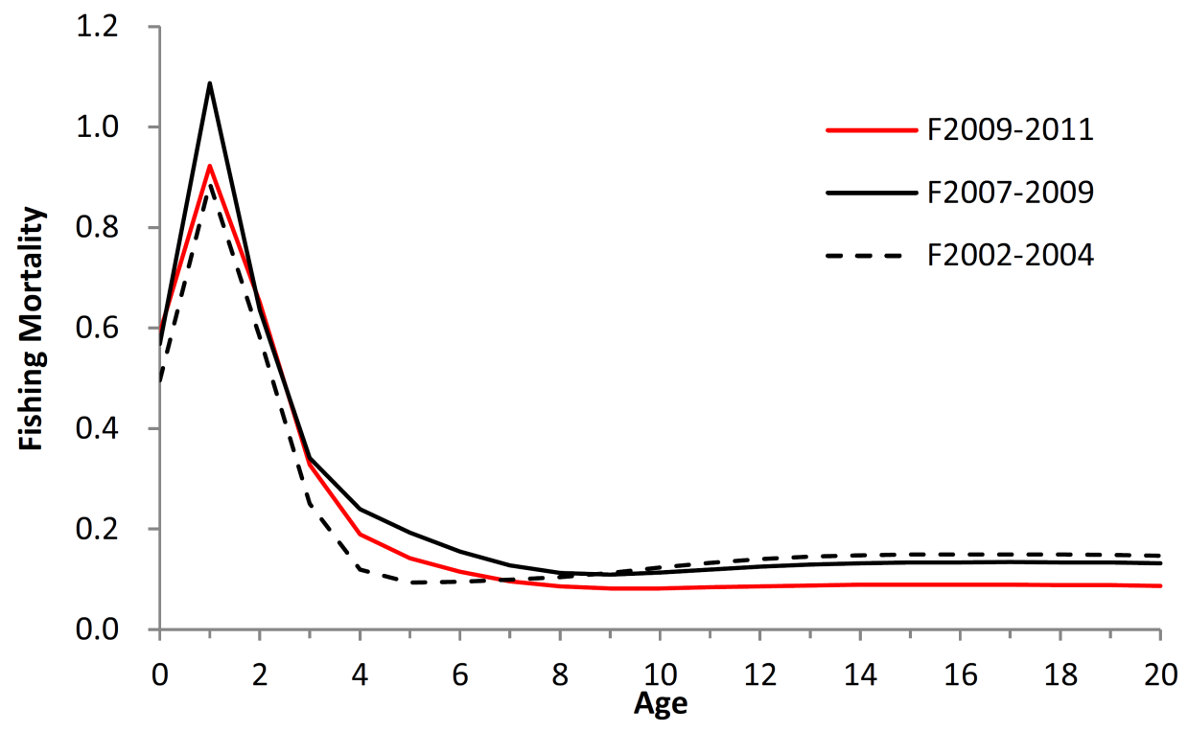
Figure B2: Geometric mean annual age-specific Pacific bluefin tuna (Thunnus orientalis) fishing mortalities for 2002–2004 (dashed line), 2007–2009 (solid line) and 2009–2011 (red line).
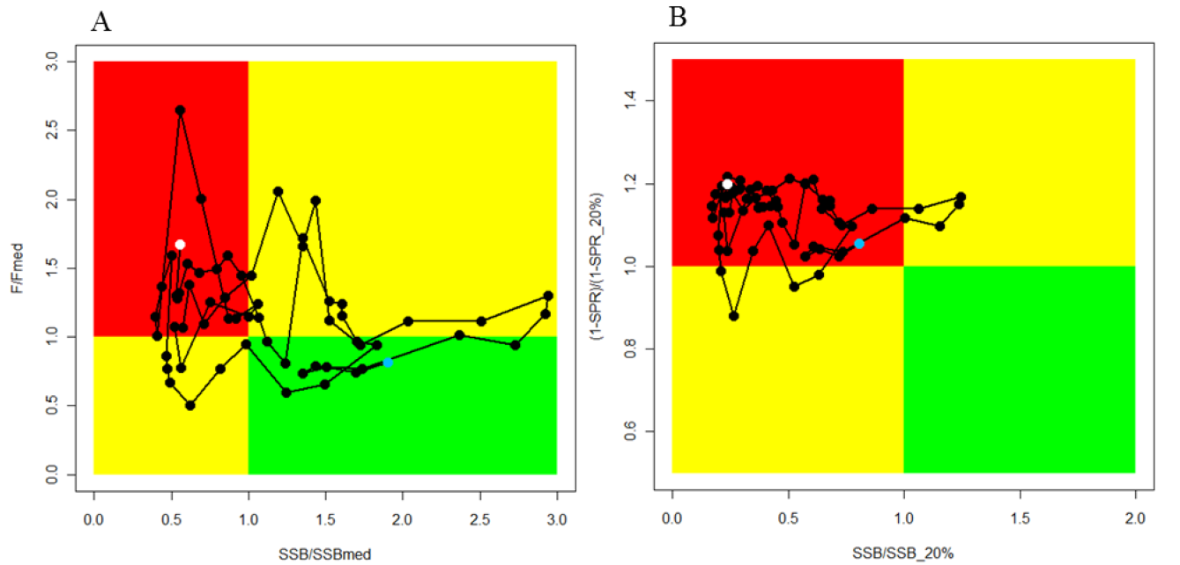
Figure B3: Alternative Kobe plots for Pacific bluefin tuna (Thunnus orientalis). A. SSB_{MED} and F_{MED}; B. SSB20% and SPR20%. Citation of these Kobe plots should include clarifying comments in the text. The blue and white points on the plot show the start (1952) and end (2012) year of the period modeled in the stock assessment, respectively.

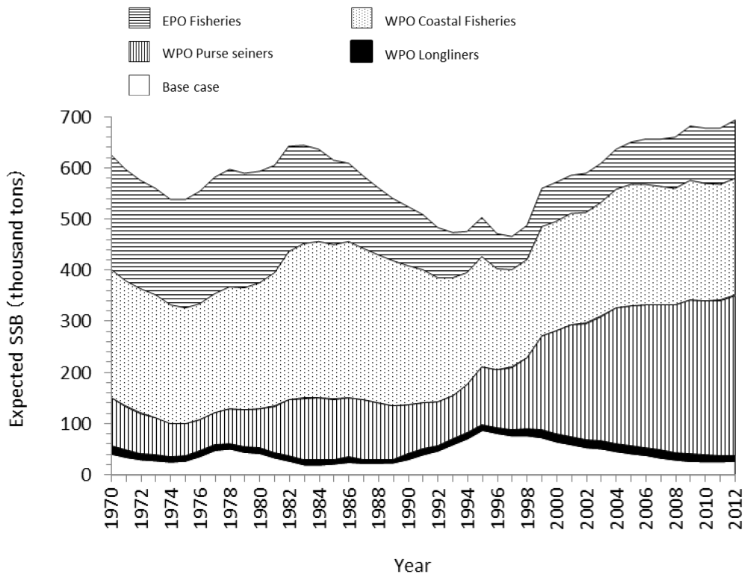
Figure B4: Trajectory of the spawning stock biomass of a simulated population of Pacific bluefin tuna (Thunnus orientalis) that was unexploited (topmost line) and that predicted by the base case (white area). The shaded areas between the two lines show the proportions of impact of each fishery.

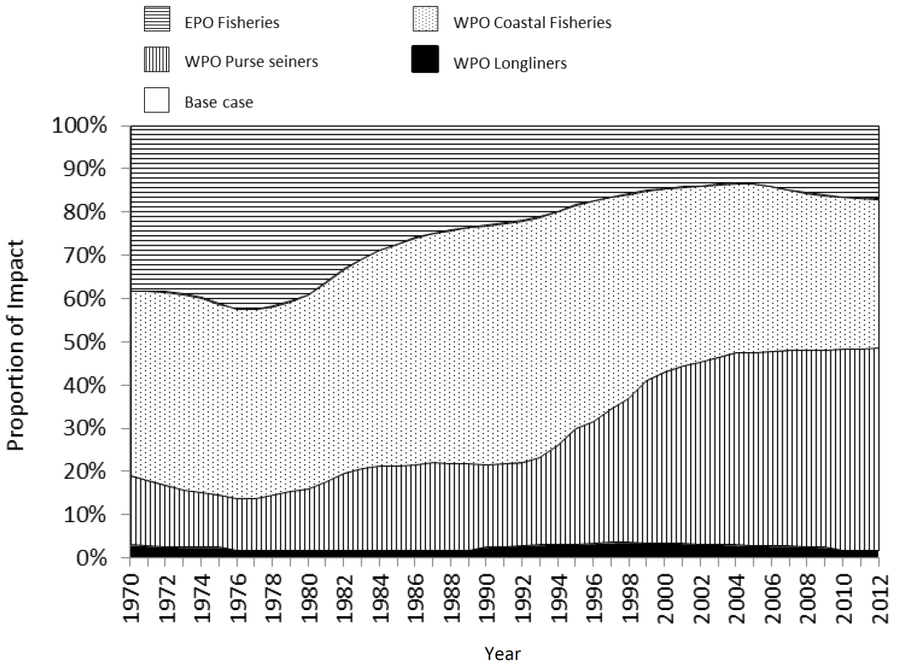
Figure B5: The proportion of the impact on the Pacific bluefin tuna (Thunnus orientalis) spawning stock biomass by each group of fisheries.

b. Management advice and implications
- SC10 noted the following conservation advice from ISC.
The current (2012) PBF biomass level is near historically low levels and experiencing high exploitation rates above all biological reference points except for F_{loss}. Based on projection results, the recently adopted WCPFC CMM (2013-09) and IATTC resolution for 2014 (C-13-02), if continued into the future, are not expected to increase SSB if recent low recruitment continues.
In relation to the projections requested by NC9, only scenario 6, the strictest one, results in an increase in SSB even if the current low recruitment continues (see Figures). Given the result of scenario 6, further substantial reductions in fishing mortality and juvenile catch over the whole range of juvenile ages should be considered to reduce the risk of SSB falling below its historically lowest level.
If the low recruitment of recent years continues the risk of SSB falling below its historically lowest level observed would increase. This risk can be reduced with implementation of more conservative management measures.
Based on the results of future projections requested at NC9, unless the historical average level (1952–2011) of recruitment is realized, an increase of SSB cannot be expected under the current WCPFC and IATTC conservation and management measures, even under full implementation (scenario 1).
If the specifications of the harvest control rules used in the projections were modified to include a definition of juveniles that is more consistent with the maturity ogive used in the stock assessment, projection results could be different; for example, rebuilding may be faster. While no projection with a consistent definition of juvenile in any harvest scenario was conducted, any proposed reductions in juvenile catch should consider all non-mature individuals.
Given the low level of SSB, uncertainty in future recruitment, and importance of recruitment in influencing stock biomass, monitoring of recruitment should be strengthened to allow the trend of recruitment to be understood in a timely manner.

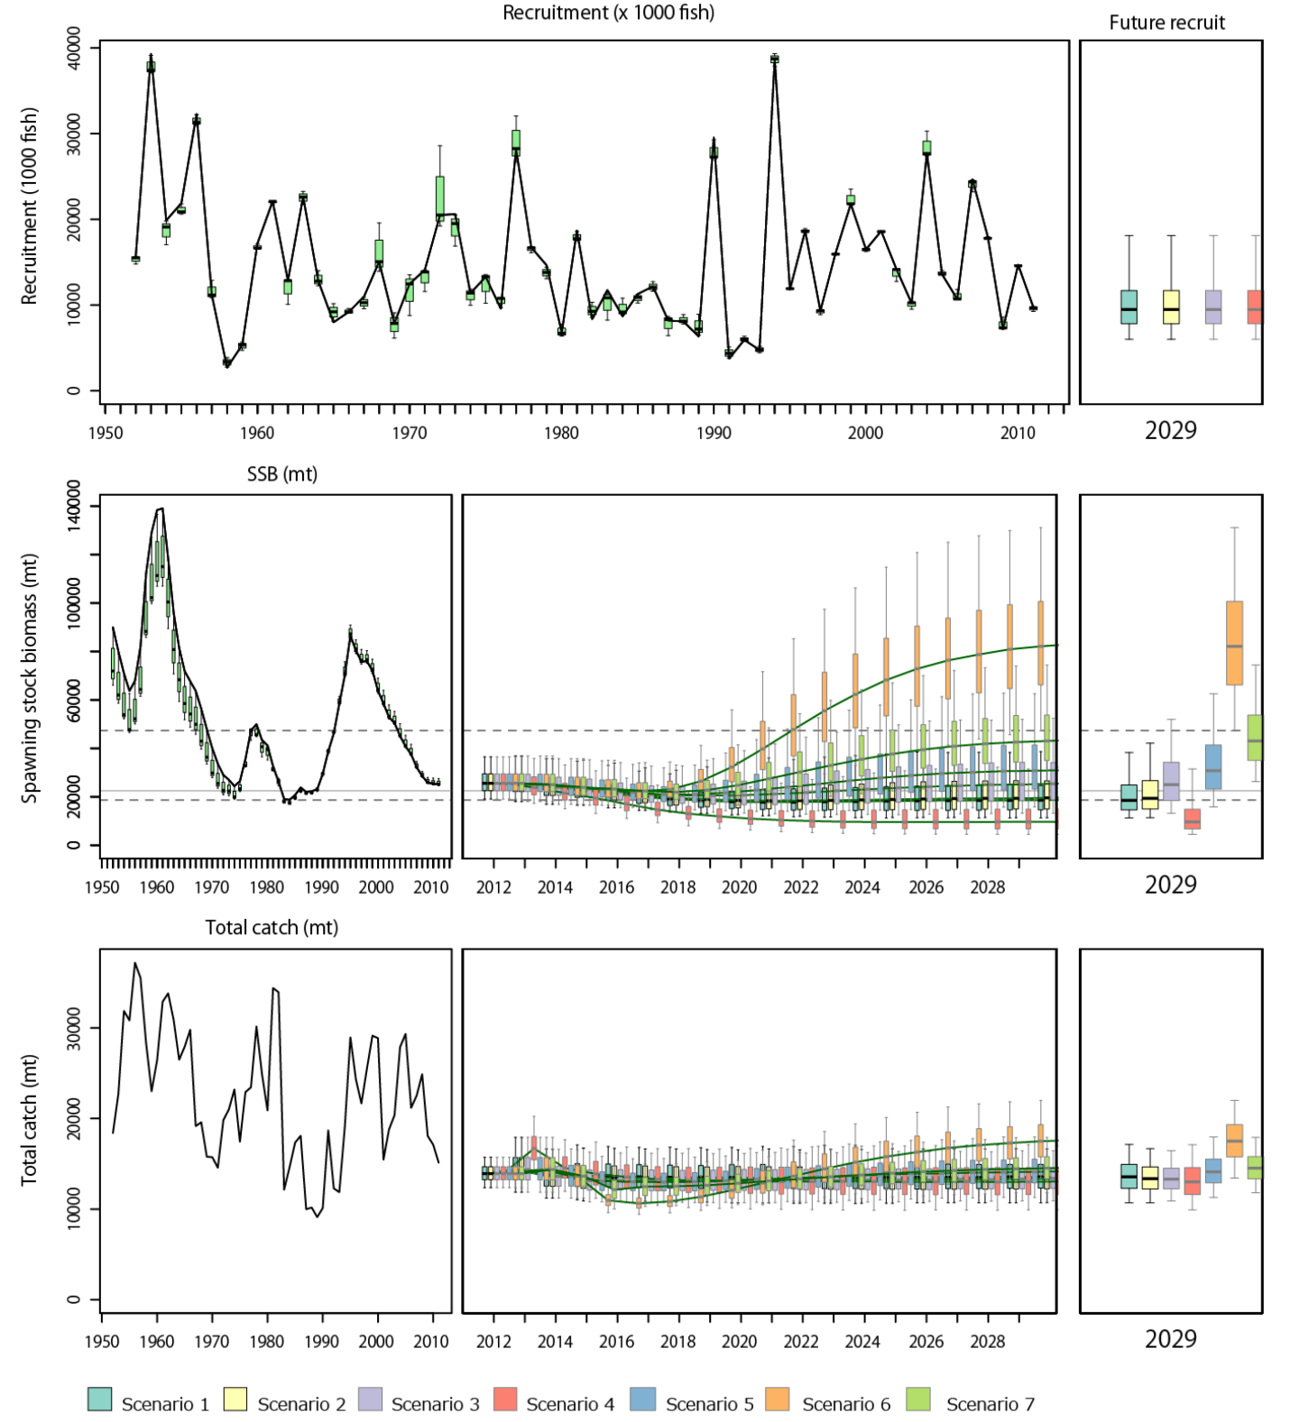
Figure B6-1: Comparison of future Pacific bluefin tuna (Thunnus orientalis) SSB trajectories in seven harvest scenarios (see full text for scenario definitions of SC10-SA-WP-11) under low recruitment conditions. Error bars represent 90% confidence limits.

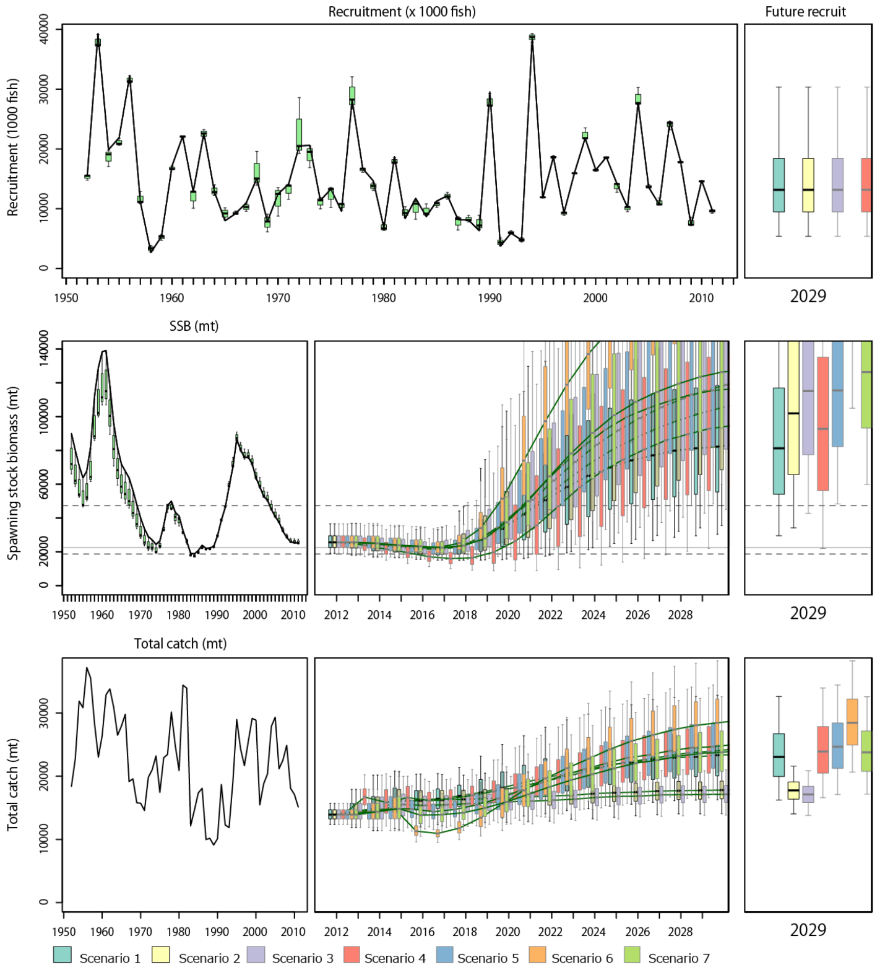
Figure B6-2: Comparison of future Pacific bluefin tuna (Thunnus orientalis) SSB trajectories in seven harvest scenarios (see full text for scenario definitions of SC10-SA-WP-11) under average recruitment conditions (resampling from recruitment in 1952–2011). Error bars represent 90% confidence limits.

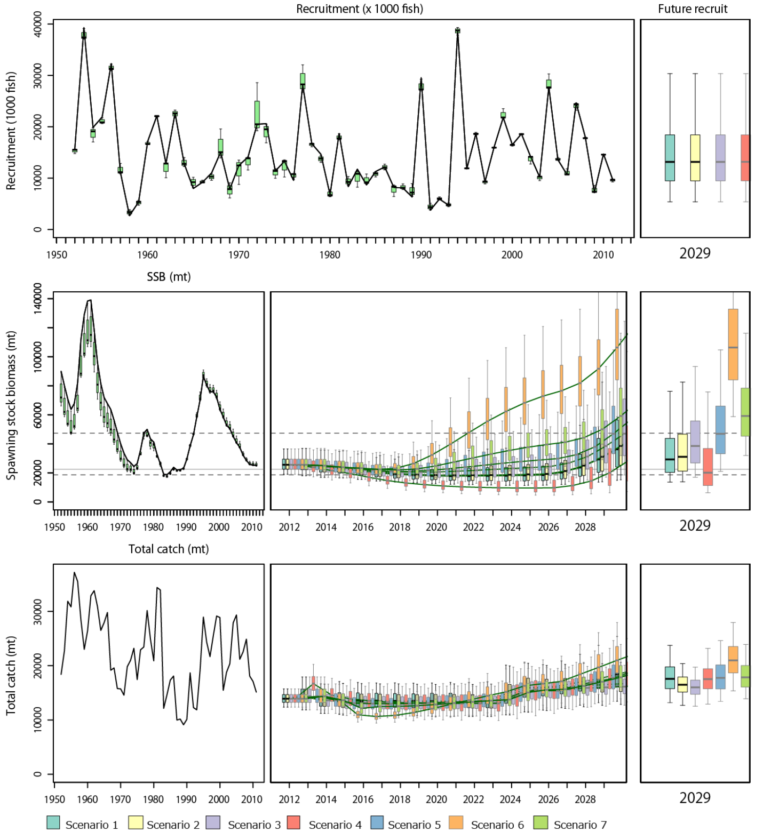
Figure B6-3: Comparison of future Pacific bluefin tuna (Thunnus orientalis) SSB trajectories in seven harvest scenarios (see full text for scenario definitions of SA-WP-11) assuming 10 years (2014–2023) of low recruitment followed by average recruitment after 2024 (resampling from recruitment in 1952–2011). Error bars represent 90% confidence limits.

4.2.3 North Pacific swordfish

4.2.3.1 Review of research and information
- J. Brodziak (USA) presented working paper SC10-SA-WP-13, detailing the North Pacific swordfish stock assessment.
- In the North Pacific, the swordfish (Xiphias gladius) population comprises two stocks, separated by a diagonal boundary extending from Baja, California, to the equator. These are the western and central North Pacific Ocean stock (WCNPO), distributed in the western and central Pacific, and the EPO stock, distributed in the eastern Pacific (Fig. S1).

Figure S1: A two-stock structure for swordfish (Xiphias gladius) in the North Pacific Ocean, indicating separate stocks in the WCPO and the EPO.
- All available catch data and CPUE information from ISC member countries and all other sources were gathered for conducting the swordfish stock assessment updates. For the WCNPO swordfish stock, catch data were updated for this assessment, leading to an increase of about 10% and 30% in reported catch biomass during 1960–1999 and 2000–2009, respectively. Fishery catch data were taken from all available fishery-dependent data by Japan, Taiwan, Korea, USA, and other countries in the WCNPO stock area (Table 1). Standardized fishery-dependent CPUE for swordfish were estimated for Japanese distant-water and offshore longline fisheries, Taiwanese distant-water longline fisheries, and the shallow-set sector of the Hawaii-based pelagic longline fishery.
- Total catches of EPO swordfish from all countries and sources were updated during 1951–2012 (Table S2) and recent catch data from 2007–2012 were recompiled using updated data provided by IATTC, WCPFC, and the individual countries of Japan, Taiwan, Korea, Mexico and Chile. Estimates of standardized commercial fishery CPUE for EPO swordfish were provided by Japan and Taiwan through 2012.
- Generalized surplus production models used for updating the WCNPO and EPO swordfish assessments had a very similar structure to the previous assessment and were formulated as Bayesian state space models with explicit observation and process error terms. Exploitable biomass time series were estimated from the observed relative CPUE abundance indices and from catches using observation error likelihood function and prior distributions for model parameters. Parameter estimation was based on Markov Chain Monte Carlo simulation using Gibbs sampling was applied to numerically sample the posterior distribution of quantities of interest (e.g. exploitable biomass.)

Table S1: Reported annual values of catch (mt) and posterior mean values of exploitable biomass (B, mt), relative biomass (B/B_{MSY}), harvest rate (percent of exploitable biomass), relative harvest rate (H/H_{MSY}), and probability of annual harvest rate exceeding H_{MSY} for the WCNPO swordfish stock
Year | 2006 | 2007 | 2008 | 2009 | 2010 | 2011 | 2012 | Mean¹ | Min¹ | Max¹
Reported catch | 15,051 | 15,799 | 13,631 | 12,375 | 10,670 | 9,456 | 9,863 | 12,962 | 6,753 | 21,972
Exploitable biomass | 76,320 | 72,290 | 68,620 | 68,770 | 68,970 | 68,560 | 72,500 | 81,860 | 60,200 | 121,300
Relative biomass | 1.26 | 1.19 | 1.13 | 1.13 | 1.14 | 1.13 | 1.20 | 1.35 | 0.99 | 2.00
Harvest rate | 21% | 23% | 21% | 19% | 16% | 15% | 14% | 17% | 10% | 31%
Relative harvest rate | 0.84 | 0.93 | 0.84 | 0.76 | 0.66 | 0.59 | 0.58 | 0.69 | 0.39 | 1.23
Pr( H > H_{MSY} ) | 0.18 | 0.34 | 0.19 | 0.09 | 0.02 | 0.00 | 0.00 | 0.12 | 0.00 | 0.80
¹ During 1951–2012.

Table S2: Reported annual values of catch (mt) and posterior mean values of exploitable biomass (B, mt), relative biomass (B/B_{MSY}), harvest rate (percent of exploitable biomass), relative harvest rate (H/H_{MSY}), and probability of annual harvest rate exceeding H_{MSY} for the EPO swordfish stock.
Year | 2006 | 2007 | 2008 | 2009 | 2010 | 2011 | 2012 | Mean¹ | Min¹ | Max¹
Reported catch | 3,235 | 3,701 | 4,262 | 7,473 | 9,631 | 9,586 | 9,910 | 3,561 | 1 | 9,910
Exploitable biomass | 43,100 | 47,980 | 53,840 | 60,570 | 62,120 | 60,810 | 58,590 | 48,875 | 31,510 | 67,070
Relative biomass | 1.38 | 1.54 | 1.73 | 1.95 | 2.00 | 1.95 | 1.87 | 1.58 | 1.02 | 2.16
Harvest rate | 8% | 9% | 9% | 14% | 17% | 18% | 19% | 8% | <1% | 22%
Relative harvest rate | 0.49 | 0.50 | 0.51 | 0.80 | 1.00 | 1.03 | 1.11 | 0.49 | 0.00 | 1.30
Pr( H > H_{MSY} ) | 0.01 | 0.02 | 0.02 | 0.20 | 0.44 | 0.47 | 0.55 | 0.11 | 0.00 | 0.71
¹ During 1951–2012.
- Biological reference points based on MSY were calculated from the generalized surplus production model results for the WCNPO and EPO swordfish stocks (Table S3). For WCNPO swordfish (Table S3), the point estimate and coefficient of variation (CV) of MSY, exploitable biomass to produce MSY, and harvest rate to produce MSY were: MSY = 14.92 thousand mt with CV = 12%, B_{MSY} = 60.72 thousand mt with CV =19%, and H_{MSY} = 0.25 with CV = 22%. For EPO swordfish (Table S3), the point estimate and CV of MSY, exploitable biomass to produce MSY, and harvest rate to produce MSY were: MSY = 5.49 thousand mt with CV = 30%, B_{MSY} = 31.17 thousand mt with CV = 22%, and H_{MSY} = 0.18 with CV = 34%. Overall, the biological reference points indicated that the WCNPO stock was larger and more productive than the EPO stock.
Table S3: Estimates of current levels of exploitable biomass (B₂₀₁₂, thousand mt), average harvest rate (H_{2010–2012}, percent of exploitable biomass), and recent average yield (C_{2010–2012}, thousand mt) along with estimated MSY-based biological reference points for the WCNPO and EPO swordfish stocks.
Reference point | WCNPO stock estimate | EPO stock estimate
B₂₀₁₂ | 72,500 mt | 58,590 mt
H_{2010–2012} | 15% | 18%
C_{2010–2012} | 9,996 mt | 9,709 mt
B_{MSY} | 60,720 mt | 31,170 mt
H_{MSY} | 25% | 18%
MSY | 14,920 mt | 5,490 mt

Discussion
- Australia noted that, for the EPO stock, both catch and CPUE trends have been increasing over the assessed time period, which would seem to be implausible, and asked whether the catchability was assumed to be the same for all decades. The presenter responded that the CPUEs are separated by some decades.
- SPC suggested that the diagnostics and sensitivity analysis of the changes in the mean prior to each key parameter should be examined. The presenter responded that the results indicated that the conclusions were robust for the WCPO and slightly sensitive for the EPO. It was noted that these analyses were completed and are included in the stock assessment report.
- SPC requested clarification as to why 0.5B_{MSY} was used as the LRP, and asked the presenter why this LRP was used by the ISC working group. Further, why was the Kobe plot using B_{MSY} and not 0.5B_{MSY}. The presenter responded that the working group wanted to provide the Northern Committee with information to assist them in the consideration of LRPs used in the USA.

4.2.3.2 Provision of scientific information

a. Stock status and trends
- SC10 noted that ISC provided the following conclusions on the stock status of North Pacific swordfish.
Exploitable biomass of WCNPO swordfish fluctuated at or above B_{MSY} throughout the assessment time horizon and has remained high in recent years and harvest rate fluctuated at or below H_{MSY}. Trends in exploitable biomass and harvest rate from the current assessment are very similar to those from the 2009 assessment. In recent years, catches and harvest rates of WCNPO swordfish have had a declining trend, with exploitable biomass fluctuating around 70,000 mt, since 2007. The Kobe plot showed that the WCNPO swordfish stock does not appear to have been overfished or to have experienced overfishing throughout most of the assessment time horizon of 1951–2012. For the current status, results indicated it was very unlikely that the WCNPO swordfish population biomass was below B_{MSY} in 2012 (Pr(B₂₀₁₂ < B_{MSY})=14%). Similarly, it was extremely unlikely that the swordfish population was being fished in excess of H_{MSY} in 2012 (Pr(H₂₀₁₂ > H_{MSY}) < 1%). Retrospective analyses indicated that there was no retrospective pattern in the estimates of exploitable biomass and harvest rate.
For the EPO stock, time series of estimates of exploitable biomass and harvest rate over the assessment time horizon differed from the previous assessment in recent years but have remained high in recent years (Table S2 and Figure S4). Exploitable biomass had a declining trend during 1969–1995 and has increased from 31,000 mt in 1995 to over 60,000 mt in 2010, generally remaining above B_{MSY}. Harvest rates were initially low, have had a long-term increasing trend, and likely exceeded H_{MSY} in 1998, 2002, 2003, and also the most recent year, 2012 (Figure S4). The Kobe plot showed that overfishing likely occurred in only a few years, but may be occurring in recent years (Figure S5). In 2012, there was a 55% probability that overfishing was occurring in 2012, but there was a less than 1% probability that the stock was overfished. Retrospective analyses indicated that there was a clear retrospective pattern of underestimating exploitable biomass and overestimating harvest rate.

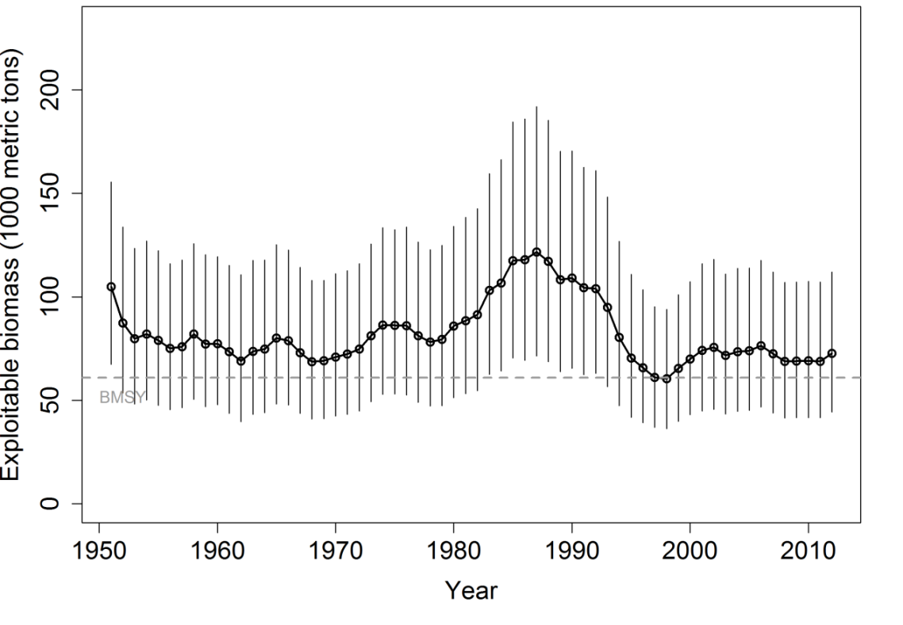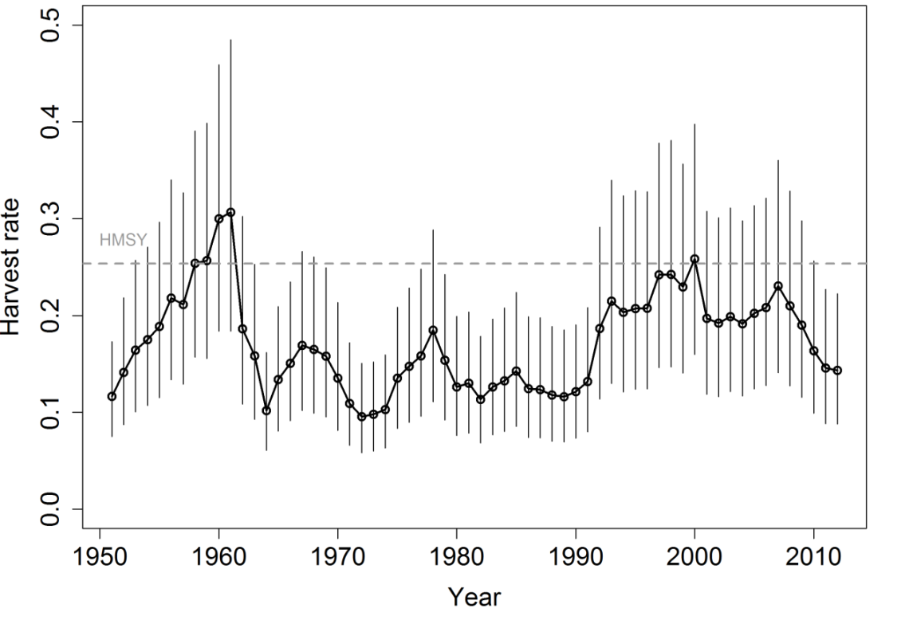
Figure S2: Trends in exploitable biomass (top) and harvest rate (bottom) of swordfish (Xiphias gladius) in the Western and Central North Pacific Ocean stock area. Estimated mean values from the posterior distribution (black circles and solid line), 95% confidence interval bars (solid vertical lines), and estimated biological reference points (B_{MSY} and H_{MSY}, horizontal dashed lines) are presented.
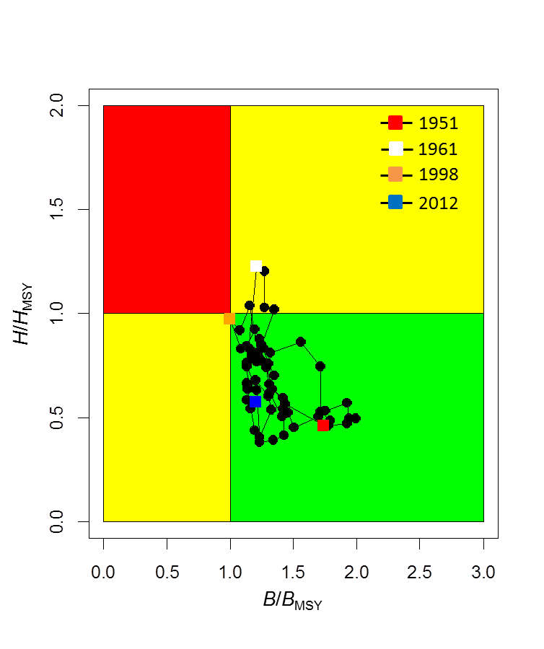
Figure S3: Kobe diagram showing the estimated trajectories of relative exploitable biomass (B/B_{MSY}) and relative harvest rate (H/H_{MSY}) for swordfish (Xiphias gladius) in the WCNPO stock area during 1951–2012.
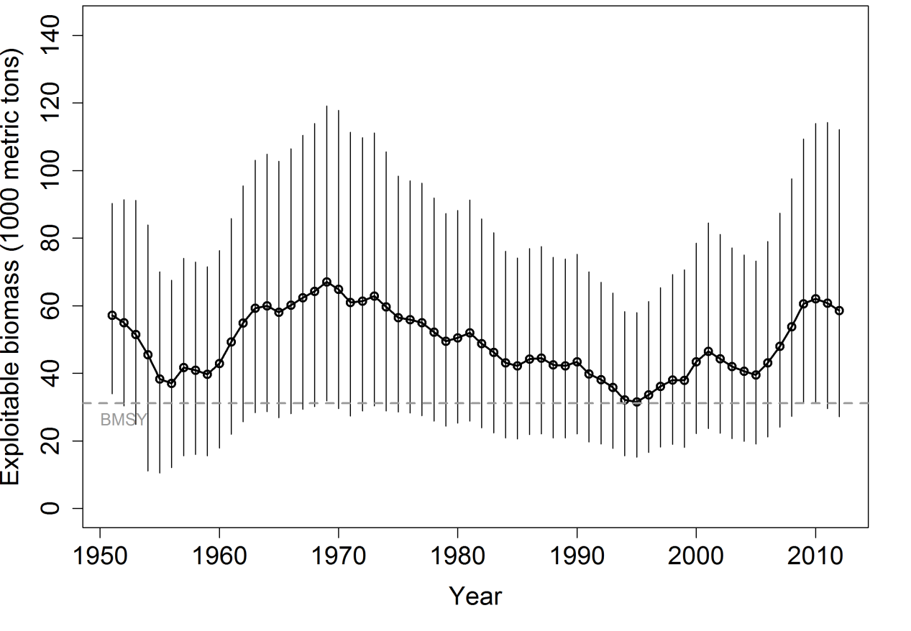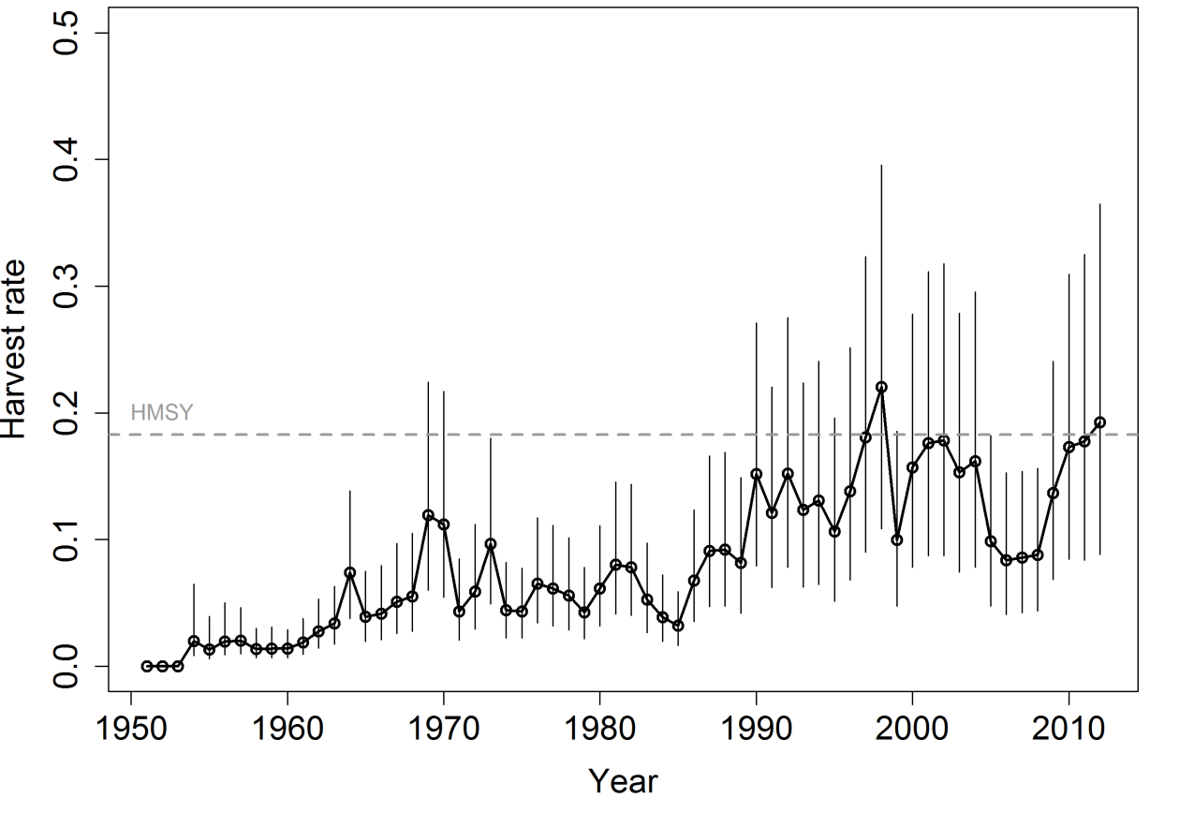
Figure S4: Trends in exploitable biomass (top) and harvest rate (bottom) of swordfish (Xiphias gladius) in the EPO stock area. Estimated mean values from the posterior distribution (black circles and solid line), 95% confidence interval bars (solid vertical lines), and estimated biological reference points (B_{MSY} and H_{MSY}, horizontal dashed lines) are presented.

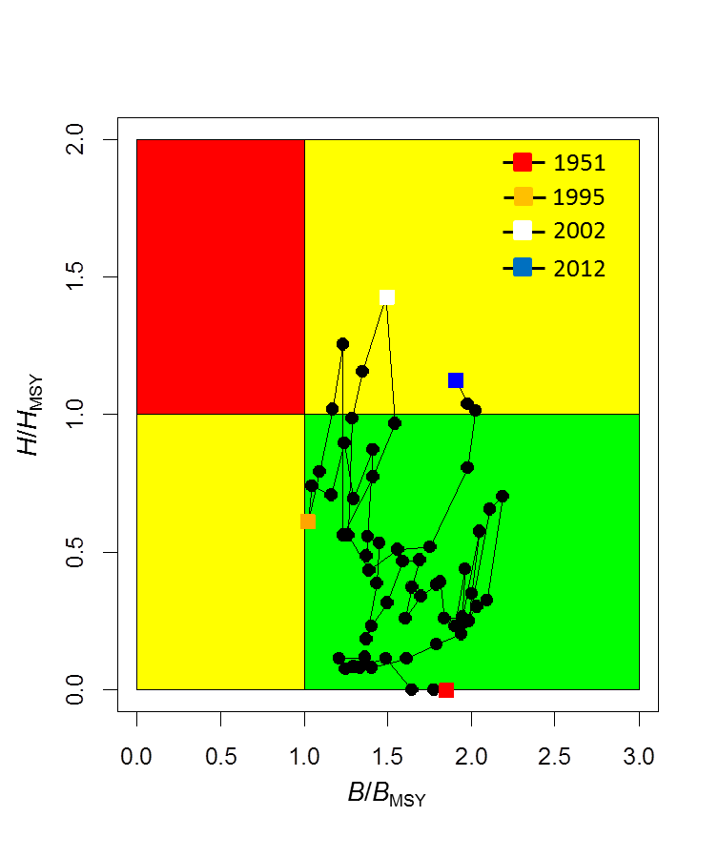
Figure S5: Kobe diagram showing the estimated trajectories of relative exploitable biomass (B/B_{MSY}) and relative harvest rate (H/H_{MSY}) for swordfish (Xiphias gladius) in the EPO stock area during 1951–2012.

b. Stock projections and risk analyses
- SC10 noted that ISC provided the following conclusions on the stock projections and risk analysis of North Pacific swordfish.
For the WCNPO stock, stochastic projections for eight harvest scenarios were conducted through 2016 (Figure S6). Results relative to MSY-based reference points indicated that exploitable biomass would likely remain above B_{MSY} through 2016 under the status quo catch or status quo harvest rate scenarios (Figure S6). For the high harvest rate scenarios (i.e. maximum observed harvest rate, 150% of H_{MSY}, 125% of H_{MSY}), exploitable biomass was projected to decline below B_{MSY} by 2016 (Figure S6) with harvest rates exceeding H_{MSY}. In comparison, the stock would not be expected to experience any overfishing during 2014–2016 under the status quo catch and status quo harvest rate scenarios (Figure S6).
For the EPO stock, stochastic projections showed that exploitable biomass will likely have a decreasing trajectory during 2014–2016 under all eight of the harvest scenarios examined (Figure S7). Under the high harvest rate scenarios (status quo catch, maximum observed harvest rate, 150% of H_{MSY}), exploitable biomass was projected to decline to be roughly equal to B_{MSY} in 2016 (Figure S7) and maintain harvest rates above H_{MSY}. In comparison, under the status quo harvest rate scenario, exploitable biomass was projected to decline to only 40,000 mt by 2016, well above the B_{MSY} level. Overall, the projections showed that if recent high catch levels persist, exploitable biomass will very likely decrease and a moderate risk of overfishing will likely continue to occur.
The risk analyses of harvesting a constant annual catch of WCNPO swordfish during 2014–2016 showed that there would be virtually no chance of the stock being overfished or experiencing overfishing in 2016 (Figure S8) if current annual catches of about 10,000 mt were maintained.
The risk analyses for harvesting a constant catch of EPO swordfish during 2014–2016 showed that the probabilities of overfishing and becoming overfished increased as projected catch increased in the future (Figure S8). Maintaining the current catch of EPO swordfish of approximately 9,700 mt would lead to a moderate risk of overfishing in 2016 but would lead to less than 1% probability of the stock being overfished in 2016.

Figure S6: Stochastic projections of expected exploitable biomass (1000 metric tons) of swordfish (Xiphias gladius) in the WCPO stock area during 2013–2016 under alternative harvest rates. Upper panel shows projection results of applying a harvest rate set to be 50%, 75%, 100%, 125%, and 150% of the value of estimate of H_{MSY} (denoted as F_{MSY} in the figure). Lower panel shows projection results of applying a status quo harvest rate based on the 2010–2012 average estimates, a status quo catch based on the 2010–2012 average catch, and the maximum observed harvest rate in the 1951–2012 time series.

Figure S7: Stochastic projections of expected exploitable biomass (1000 metric tons) of swordfish (Xiphias gladius) in the EPO stock area during 2013–2016 under alternative harvest rates. Upper panel shows projection results of applying a harvest rate set to be 50%, 75%, 100%, 125%, and 150% of the value of estimate of H_{MSY} (denoted as F_{MSY} in the figure). Lower panel shows projection results of applying a status quo harvest rate based on the 2010–2012 average estimates, a status quo catch based on the 2010–2012 average catch, and the maximum observed harvest rate in the 1951–2012 time series.

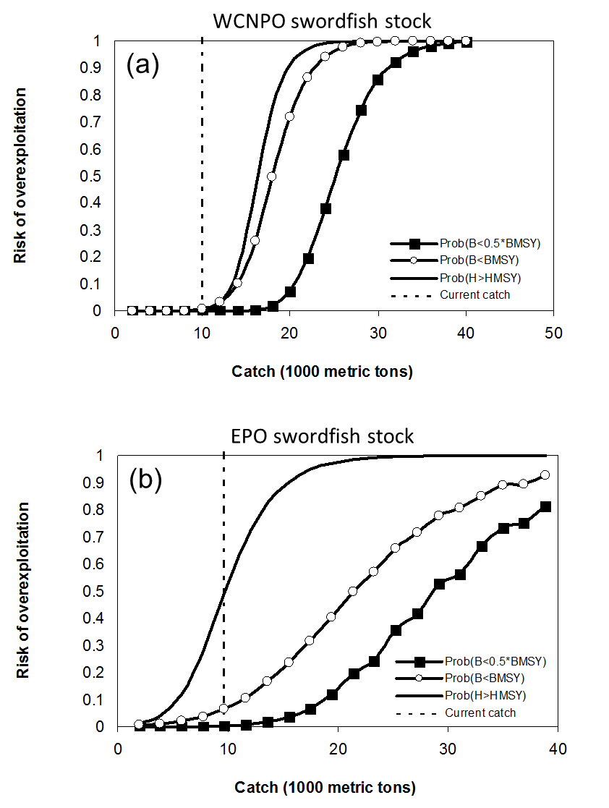
Figure S8: Probabilities of experiencing overfishing (H > H_{MSY}, solid line), of exploitable biomass falling below B_{MSY} (B < 0.5*B_{MSY}, open circles), and of being overfished relative to a reference level of ½B_{MSY} (B < 0.5*B_{MSY}, solid squares) in 2016 for swordfish in the WCPO stock area (a) and EPO stock area (b) based on applying a constant catch biomass (x-axis, thousand mt) in the stock projections.

c. Management advice and implications
- SC10 noted the following conservation advice from the ISC.

Based on the assessment update, the WCNPO stock is not currently overfished and is not experiencing overfishing. The WCNPO stock is not fully exploited.
For the EPO swordfish stock, overfishing may be occurring in recent years. The recent average yield of roughly 10,000 mt, or almost two times higher than the estimated MSY, is not likely to be sustainable in the long term. While biomass of the EPO stock appears to be nearly twice B_{MSY}, any increases in catch above recent levels should consider the uncertainty in stock structure and unreported catch

4.3 WCPO sharks

4.3.1 Oceanic whitetip shark

4.3.1.1 Review of research and information
- SC10 noted that no stock assessment was conducted for oceanic whitetip shark in 2014 and there was no new information to present on oceanic whitetip shark.

Discussion
- The convener directed SC to consider the previous information and advice from SC9 in its provision of new management advice on oceanic whitetip shark.
- USA observed that when bigeye tuna was assessed as being subject to overfishing, SC provided advice on what it would take to return to F_{MSY}; in other words, what sort of reduction in fishing mortality was required. USA pointed out that oceanic whitetip shark has had an assessment that overfishing is occurring and it is overfished. An 85% reduction in F would be required to return to F_{MSY} and in USA’s view it would be informative for fisheries managers to know what reductions are required.

4.3.1.2 Provision of scientific information

a. Status and trends
- SC10 noted that no stock assessment was conducted for this species in 2014.

b. Management advice and implications
- Because there was no stock assessment for this species, advice from SC8 should be maintained, pending a new assessment or other new information.

4.3.2 Silky shark

4.3.2.1 Review of research and information
- SC10 noted that no stock assessment was conducted for silky shark in 2014 and there was no new information to present on silky shark.
Discussion
- For silky shark, USA stated that a 77% reduction in F is required to return to F_{MSY}.

4.3.2.2 Provision of scientific information

a. Status and trends
- SC10 noted that no stock assessment was conducted for this species in 2014.

b. Management advice and implications
- There was no stock assessment for this species, therefore advice from SC9 should be maintained, pending a new assessment or other new information.

4.3.3 South Pacific blue shark

4.3.3.1 Review of research and information
- SC10 noted that no stock assessment was conducted for South Pacific blue shark in 2014 and there was no new information to present on South Pacific blue shark.

Discussion
- The EU asked whether, for any of the three species under discussion, data had been identified that would be relevant to advise SC on the fin-to-carcass ratio.
- Given no responses to this, the convener stated that, in general, having information on fin-to-carcass ratio by weight would be positive to collect for all three species, especially South Pacific blue shark.

4.3.3.2 Provision of scientific information

a. Status and trends
- SC10 noted that no stock assessment was conducted for this species in 2014.

b. Management advice and implications
- There was no stock assessment for this species, therefore advice from SC9 should be maintained, pending a new assessment or other new information.

4.3.4 North Pacific blue shark

4.3.4.1 Review of research and information

a. Review of 2014 North Pacific blue shark stock assessment
- ISC and SPC conducted a stock assessment for North Pacific blue shark in 2014. The ISC Shark Working Group used two stock assessment approaches to examine the status of blue shark (Prionace glauca) in the North Pacific Ocean: a Bayesian surplus production (BSP) model; and an age-based statistical catch-at-length model. These efforts provide an updated assessment of North Pacific blue shark based on the 2013 Shark Working Group assessment.
Assessment by Bayesian surplus production model
- S. Teo (ISC) presented SC10-SA-WP-14 (Stock assessment and future projections of blue shark in the North Pacific Ocean). Blue shark (BSH) is widely distributed throughout temperate and tropical waters of the Pacific Ocean. The ISC Shark Working Group recognizes two stocks in the North and South Pacific, respectively, based on biological and fishery evidence. Relatively few BSH are encountered in the tropical equatorial waters that separate the two stocks. Tagging data demonstrate long-distance movements and a high degree of mixing of BSH across the North Pacific, although there is evidence of spatial and temporal structure by size and sex.
- Catch records for BSH in the North Pacific are limited and, where lacking, have been estimated using statistical models and information from a combination of historical landings data, fishery logbooks, observer records and research surveys. In these analyses, estimated BSH catch data refer to total dead removals, which include retained catch and dead discards. Estimated catch data in the North Pacific date back to 1971, although longline and drift net fisheries targeting tunas and billfish earlier in the 20th century likely caught BSH. The nations catching BSH in the North Pacific include Japan, Chinese Taipei, Mexico and USA, which account for more than 95% of the estimated catch. Estimated catches of BSH were highest from 1976 to 1989, with a peak estimated catch of approximately 113,000 mt in 1981. Over the past decade, estimated catches of BSH in the North Pacific have remained relatively steady at an average of 46,000 mt annually. While a variety of fishing gear types catch BSH, most are caught by longline fisheries and fewer are taken in gill net fisheries. The total catch in 2011 decreased from 2010 by close to 25% due to a decrease in Japanese effort associated with damage from the March 2011 Great East Japan Earthquake.
- Annual catch estimates by nation were derived for a variety of fisheries. Catch, effort and size composition data were grouped into 18 fisheries for the period 1971–2012. Historical catch time series for Japan were improved for the current assessment by the use of more accurate processed-to-whole-weight conversion factors. Data for the Taiwanese large longline fishery were also updated by removal of erroneous catch. The BSH catch in 2012, although estimated for many fleets, represents a large amount (about 60%) of substituted catch carried over from 2011, and is, thus, considered more uncertain than that prior to 2012. Models were run using data for both the 1971–2011 and 1971–2012 time periods.
- The Shark Working Group developed both new and revised standardized CPUE time series and used criteria to select representative indices for the assessment. Data for the recent (post-1994) Japanese shallow longline fleet that operates out of Hokkaido and Tohoku ports was separated into two periods for standardization before and after 2011 because the fleet behavior greatly changed as a result of the March 2011 Great East Japan Earthquake. The two-year standardized CPUE index for the Japan longline fishery post-2011 was not used in the current assessment.
- Due to low observer coverage rates in the Hawaii deep-set longline fishery prior to 2000, the Hawaii index was shortened relative to that used in the prior assessment to incorporate only the higher quality data. Similarly, observer coverage decreased in the SPC longline fishery after 2009, thus the SPC index was standardized using data through 2009.
- Due to uncertainty in the input data and life history parameters, multiple models were run with alternative data and/or parameters. In addition, two types of population dynamics models were used, a state-space BSP and an age-based statistical catch-at length model, Stock Synthesis. These models were designed to capture the maximum range of uncertainty in the input information. In total, 84 BSP models and 1080 Stock Synthesis models representing different combinations of input datasets and structural model hypotheses were used to assess the influence of these uncertainties on biomass trends and fishing mortality levels for North Pacific BSH. Though fewer BSP models were run, a far greater number of parameters were specified in the Stock Synthesis models to estimate sex-specific dynamics and take advantage of a novel stock recruitment function; the BSP runs used both the Bayesian approach and an appropriate range of input parameters to assess uncertainties given the model.
- Reference case model runs were selected for the purpose of assessing the current stock status. Input parameter values for the reference case runs were chosen based on the best available information regarding the life history of Pacific blue sharks and knowledge of the historical catch time series and fishery data. For example, for the reference case, initial catch was set at 40,000 mt because Japanese longline fishing effort increased and spread rapidly in the 1950s with effort stabilizing by the late 1950s into the 1960s. Standardized CPUE from the Japanese shallow longline fleet that operates out of Hokkaido and Tohoku ports for the periods 1976–1993 and 1994–2010 were used as measures of relative population abundance in the reference case assessments.
- For the BSP models, a single catch time series was used with a variety of CPUE time series and priors assigned to several parameters, including the intrinsic rate of population increase (r) and the ratio of initial biomass to carrying capacity (Binit/K) to fit a Fletcher-Schaefer production model in a Bayesian statistical framework to address uncertainty regarding these parameters. For the Stock Synthesis models, a two-sex, size-based model was used that explicitly modeled the different sizes of BSH taken in 18 fisheries and utilized a survival based spawner-recruit function, referred to as the low fecundity spawner recruitment relationship (LFSR). Historical information regarding exploitation levels prior to the start time of the model were examined to derive plausible input values, and sex-specific estimates of natural mortality-at-age were based on two independent growth studies from the North Pacific. The Stock Synthesis code searches for the set of parameter values that maximize the goodness-of-fit, and then calculates the variance of these parameters using inverse Hessian matrices. In both modeling approaches, estimated model parameters and derived outputs were used to characterize stock status and explore the range of uncertainty under different scenarios.
- Stock projections of biomass and catch of BSH in the North Pacific from 2012 to 2031 were conducted assuming alternative harvest scenarios and starting biomass levels. Status quo catch and F were based on the average over the recent five years (2006–2010). Estimated catch from 2011 was not used for projections due to the impact of the March 2011 Great East Japan Earthquake on Japanese fishing effort. A simulation model was used for annual projections, and included uncertainty in the population size at the starting year of stock projection, fishing mortality and productivity parameters.
- Model inputs for this assessment have been improved since the previous assessment and provide the best available scientific information. The main differences between the present assessment and the 2013 assessment are: a) the inclusion of revised CPUE series; b) some time series data updated through 2012; c) further examination of the effect of the Bayesian priors on the BSP model outcomes; and d) use of the Stock Synthesis model to provide an alternative approach that could be compared to the production modeling. However, there are uncertainties in the time series for estimated catch, the quality (observer vs. logbook) and time spans of abundance indices, the size composition data and many life history parameters such as growth and maturity schedules. Improvements in the monitoring of BSH catches, including recording the size and sex of sharks retained and discarded for all fisheries, as well as continued research into the biology and ecology of BSH in the North Pacific are recommended.
- Results of the reference case model showed similar trends for the two modeling approaches. Both showed that the stock biomass was near a time-series high in 1971, fell to its lowest level between the late 1980s and early 1990s, and subsequently increased gradually and has leveled off at a biomass similar to that at the beginning of the time series. Stock status is reported in relation to MSY. Benchmark results are shown based on biomass (BSP runs) or female spawning stock biomass (Stock Synthesis runs). Stock biomass and spawning biomass in 2011 (B₂₀₁₁ and SSB₂₀₁₁) were 65% and 62% higher than at MSY, respectively, and the annual fishing mortality in 2011 (F₂₀₁₁) was estimated to be well below F_{MSY}.
- Based on the trajectory of the BSP reference case model, median stock biomass of blue shark in 2011 (B₂₀₁₁) was estimated to be 622,000 mt. Median annual fishing mortality in 2011 (F₂₀₁₁) was approximately 32% of F_{MSY}. Based on the trajectory of the Stock Synthesis reference case model, female spawning stock biomass of blue shark in 2011 (SSB₂₀₁₁) was estimated to be 449,930 mt. The estimate of F₂₀₁₁ was approximately 34% of F_{MSY}.
- While the results varied depending upon the input assumptions, a few parameters were most influential on the results. These included the CPUE series selected as well as the shape parameters for the BSP models and the equilibrium initial catch and form of the LFSR relationship for the Stock Synthesis models. For the BSP modeling, the shape parameters had the greatest effects on biomass trends, estimated fishing mortality rates, and current status relative to MSY.
- For the Stock Synthesis modeling, the form of the LFSR relationship overwhelmed other sources of uncertainty. Results were more pessimistic when SFrac (one of the parameters controlling the shape of the spawner-recruit curve) was fixed at 0.1, whereas the majority of runs with SFrac fixed at 0.3 and 0.5 resulted in terminal stock status where F<F_{MSY} and B>B_{MSY}. The Shark Working Group felt that the intermediate value of the parameter SFrac, 0.3, was most probable. The low value produced lower levels of compensation which the Shark Working Group felt were less plausible. Further, the higher value for SFrac gave rapidly decreasing trends in recruitment with increasing spawner biomass, which was considered unlikely. Stock trends were also sensitive to changes in Beta (another parameter controlling the shape of the spawner-recruit curve) although the differences were less extreme. Stock status improved considerably with higher initial equilibrium catches, as this increased mean recruitment levels relative to the observed catch history over the modeled period.
- Across both models, the parameter values considered most plausible produced terminal conditions that were predominantly in the green quadrant (not overfished and overfishing not occurring) of the Kobe plot. At the lower range of the productivity assumptions, which were considered less plausible, both models indicated some probability of the stock being overfished or undergoing overfishing.
- These results should be considered with respect to the management objectives of WCPFC and IATTC, the organizations responsible for management of pelagic sharks caught in international fisheries for tuna and tuna-like species in the Pacific Ocean. TRPs and LRPs have not yet been established for pelagic sharks in the Pacific. Relative to MSY, the reference case and the majority of models run with input parameter values considered more probable suggest that the North Pacific blue shark stock is not overfished and overfishing is not occurring.
- Future projections of the reference case models show that median BSH biomass in the North Pacific will remain above B_{MSY} under the catch harvest policies examined (status quo, +20%, -20%). Similarly, future projections under different fishing mortality (F) harvest policies (status quo, +20%, -0%) show that median BSH biomass in the North Pacific will likely remain above B_{MSY}.
- Due to data uncertainties, improvements in the monitoring of blue shark catches and discards, through carefully designed observer programs and species-specific logbooks, as well as continued research into the fisheries, biology and ecology of blue shark in the North Pacific are recommended.

Assessment by stock synthesis model
- J. Rice presented SC10-SA-WP-08 (Stock assessment of blue shark in the North Pacific Ocean using Stock Synthesis), an updated age-based statistical catch-at-length stock assessment of blue shark in the North Pacific Ocean. The assessment uses the stock assessment model and computer software known as Stock Synthesis (version 3.24F http://nft.nefsc.noaa.gov/Download.html).
- This is one of the two stock assessment approaches being applied to blue sharks in the North Pacific. The ISC Shark Working Group has agreed to use both a BSP model and the age-based statistical catch-at-length stock assessment, presented here, to examine the status of this stock. This paper should be read with the full assessment report of the working group, which provides greater details of the data sources and how they were derived as well as pertinent summaries of biological knowledge and the papers describing each CPUE series.
- The updated assessment represents the efforts of the working group to address concerns raised by SC. Generally speaking the major concerns were:
- both assessments: the key Japanese late CPUE series could be biased due to inadequate accounting of targeting practices; and
- Stock Synthesis model: a) the basis for the weighting applied to the length frequency data; and b) why the model had the greater level of initial depletion compared to the BSP.
- The main differences between the present assessment and that presented to SC9 are: i) the inclusion of revised CPUE series; ii) changing the time period of the model to 1971–2012 to utilize earlier catch estimates and more recent indices of abundance; iii) more structured examination of exploitation levels prior to the start time of the model; and iv) sex-specific estimates of natural mortality-at-age based on growth studies from the North Pacific.
- The primary reasons to use Stock Synthesis were to: a) explicitly model the different sizes of blue sharks taken in each fishery; b) utilize the LFSR functionality; c) incorporate the strong sex-specific patterns that are seen in many of the biological and fishery datasets; and d) provide an alternative approach that could be compared to the production modeling.
- This is an integrated stock assessment using estimated catch, several standardized CPUE time series, catch-at-length, and published life history information. The model is age (30 years) structured; spatially aggregated (one region); and sex specific. The catch, effort and size composition of catch are grouped into 18 fisheries from 1971 to 2012. The fisheries within the assessment cover a range of fleets, bycatch and target fisheries, and both longline and gill net gear.
- Due to uncertainty in the input data and life history parameters, multiple models were run with alternative data/parameters. These models with different combinations of input datasets and structural model hypotheses (axes of uncertainty) were used to assess the plausible range of stock status for blue shark. Reference case models are presented here for the purpose of assessing model performance. It is expected that the most appropriate model runs on which to base management advice will be determined by SC considering the recommendations from the ISC plenary.
- Five axes of uncertainty that were considered are CPUE (five options), natural mortality (two options), length composition (two options), the form of LFSR (nine options), recruitment variation (two), and initial catch (three options). A full factorial grid of all options was run (this gave a total of 1,080 model runs), and full results for any run are available on request. The major axes of uncertainty were CPUE (five options) and the form of LFSR (nine options).
- There are other sources of uncertainty that have not been considered here, in particular, stock structure, total catch and the shape of the catch trajectory.
- We have reported stock status in relation to MSY-based reference points, but note that WCPFC has not yet made decisions regarding limit (or target) reference points for sharks.
- The key conclusions of the assessment described in the following paragraphs.
- The outcomes of the Stock Synthesis modeling for blue shark in the North Pacific provide three key areas of concern regarding the reliability of the stock assessments:
  - Insufficient information to estimate initial depletion: approaches at estimating initial fishing mortality or catches proved to be unsuccessful and, therefore, there is not sufficient information in the size data (a typical source of information on depletion) or other model inputs to reliably estimate the level of depletion at the start of the model;
  - Lack of a CPUE series that extends through the temporal model domain: no CPUE series spans the entire period of the model and, therefore, there is nothing to link relative abundance across the model period. This is demonstrated by the very different biomass trajectories that were obtained with the same CPUE series; and
  - Variety of spawner-recruitment relationships with similar “productivity (SB/SB_{MSY})”: through the use of LFSR in Stock Synthesis we were able to consider a wide range of LFSR shapes, which gave similar productivity to that assumed in the production model. The resulting stock status conclusions were extremely sensitive to the shape of the LFSR function.
- The results from using alternative CPUE series in the current assessment are less different, in terms of their implied changes in abundance, than the individual CPUE series are. There are only minor differences in stock status across the CPUE series with model runs using the Japanese early and late indices producing slightly more optimistic stock status than model runs using the SPC model series.
- The LFSR parameterization has the most influence on the assessment. Across the LFSR options tested, stock status can range from heavily overfished and rapidly declining to lightly exploited and strongly increasing, and almost everything in between. Moderate to good fit to the CPUE series can be obtained across the total spectrum of stock status outcomes (i.e. you can fit the data equally well and have a very optimistic or very pessimistic stock status). We believe that it is possible that the LFSR relationship is not performing as expected at higher values of S_Frac and Beta (i.e. the model indicates that you can have strongly declining recruitment with increasing stock size).
- When considering which model(s) to use for the provision of management advice, the presenters recommend that advice be based upon multiple model runs that consider the major axes of uncertainty.

Discussion
- Several CCMs expressed appreciation to the ISC Shark Working Group for the new assessment and noted that because reference points have not been adopted for this stock that management advice should be framed appropriately.
- FFA members expressed their continued discomfort with the CPUE series used as not being representative of current target fishery catch rates. The presentations clearly demonstrate the challenges caused by the lack of robust data sources in the fishery and the effect that this can have in understanding the status of the stock and the fishery-specific impacts on this species. FFA members asked that all WCPFC CCMs continue to ensure that shark species reporting be improved across all their fleets to ensure there is a more robust basis on which to assess and manage all shark species. FFA members noted that both assessments conclude that relative to MSY, the reference case and the majority of models run with the most probable input parameter values, suggest that the North Pacific blue shark stock is not overfished and overfishing is not occurring. However, these results should be considered with respect to the management objectives of the WCPFC and IATTC, noting that TRPs and LRPs have not yet been established for pelagic sharks in the Pacific, and that MSY may not be an appropriate reference point.
- FFA members suggested that SC recommend that countries with targeted shark fisheries be required to submit management plans with robust catch limits. FFA members recommended that the development of a comprehensive measure to mitigate and reduce the bycatch of all sharks, including blue shark.
- The EU asked whether any data had been identified that would be relevant to advise SC on the fin-to-carcass ratio.
- SPC replied that there may have been a relatively recent paper from the ISC shark working group about the EPO, which related to this topic.
- USA noted that there were three recommendations in working paper SC10-SA-WP-08 that they believed should be included in the meeting report. The CCM suggested that the recommendation to further develop the CPUE series as well as simulation models to test alternative approaches to remove targeting effects could be advertised as a project with SC’s request for proposals. Those paragraphs are as follows.
  - Detailed consideration of how the biology of blue sharks can be modeled within the Stock Synthesis modeling framework (including LFSR).
  - Determine if there are plausible alternative catch series; in particular, ones with different trends through time. This should include a detailed analysis of observer reports to estimate discards.
  - Further development of the CPUE series, including consideration of alternative approaches to model changes in targeting, approaches to develop longer time series or constrain catchability differences across CPUE series. The development of simulation models to test alternative approaches is recommended.
- Australia noted the lack of continuity in the time series used, and asked how the time series were scaled in order to display them on one graph. The presenters replied that the time series on the figure in question were divided by the median values. Australia also asked for the presenter’s opinion on how to progress the development of the CPUE series, and the presenter replied that the long-term development of CPUE series is critical for this as well as all stock assessments, suggesting that simulation testing or analytic work would need to be devised.
- S. Clarke (Secretariat) noted that the scientific conclusions in the working paper were less clear than those in the presentation, which said “stock status can range from heavily overfished and rapidly declining to lightly exploited and strongly increasing, and almost everything in between” (p. 5, point 3, SC10-SA-WP-08) and asked for a clarification. She also asked about the confidence in the conclusions with respect to the other shark stock assessments (specifically oceanic whitetip and silky sharks) completed by SPC.
- SPC stated that it had less confidence in the conclusions in this assessment compared to that of the oceanic whitetip assessment because of the CPUE series. In response to the query about stock status conclusions made in the SPC paper, SPC noted that the declines for oceanic whitetip sharks had been very clear and consistent, but that this was not the case for North Pacific blue shark. SPC also noted that the working paper that was posted was the version submitted to the ISC Shark Working Group. Between the submission of the working paper and the time this presentation was given, the ISC Shark Working Group had reviewed the model runs and selected reference case models used for developing management advice. The conclusions given in the presentation reflect the recommendations of the ISC Shark Working Group after the review.
- Japan shared concerns over the reliability of some of the assumptions used in the model and believed that SC should recommend improving data through collection of better catch and effort information in its management advice to TCC and the Commission.
- An observer, Greenpeace, stated that two shark stocks assessed in the Commission area so far — oceanic whitetip shark and silky shark — are both overfished and overfishing is occurring, despite not being targeted. In contrast North Pacific blue sharks are targeted. Greenpeace stated that the results of the full assessment were ambiguous and until a more robust and definitive stock assessment is produced, SC10 should advise the Commission that the state of North Pacific blue shark is highly uncertain and in no way can this be described as healthy or sustainable.
- Japan followed this up, stating that when saying a stock is “healthy” does not mean that management is not needed. Japan endorsed using a precautionary approach.
- The convener asked if CCMs were willing to endorse the use of the reference case for this stock in characterizing stock status. Two CCMs (Australia and Fiji) stated that they were willing to endorse the use of the reference case so long as the advice included appropriate caveats to frame the uncertainty in the assessment.

b. Evaluation of North Pacific blue shark as a northern stock

Report of Informal Small Group 1 (ISG-1)
- As requested by WCPFC10, an informal small group provided the following summary. Related paragraphs were extracted from the WCPFC10 Summary Report, Agenda Item 9.1, Report of the Ninth Regular Session of the Northern Committee.
- Para. 206. “… Also, NC9 requested that WCPFC10 task SC with considering whether North Pacific blue shark should be designated as a northern stock.”
- Para. 217. “WCPFC10 adopted the report of NC9 and asked SC to evaluate whether North Pacific blue shark would qualify as a northern stock.”
- Based on this request of WCPFC10, SC10 was invited to discuss the designation of North Pacific blue shark as a northern stock. No document was available on this topic. In order to remedy the current situation and provide some material for discussion to SC10, ISG-1 was convened twice during SC10, under Agenda Item 4.3.4.1.b, by the facilitator H. Honda (Japan). ISG-1 participants exchanged background information and discussed how to proceed with the given task. As the quality and availability of shark data in the WCPO varies significantly, participants recognized the difficulties in designating North Pacific blue shark as a northern stock using established designation criteria — that the majority of the stock in the WCPO is found north of 20°N.
- ISG-1 concluded the following.

Common recognition
The established criterion for designating the stock of North Pacific blue shark as a northern stock specifies that the “the majority” of the stock in the WCPO is found north of 20°N.

Proposal of action plans
- Option A: Short-term plan — Analysis of existing data
Conduct analyses using existing abundance indices and stock assessment results, as well as any other available ancillary data. The result will be presented at SC11 for its consideration. There are several needs and difficulties to be overcome with Option A, including:
- Requisite data (e.g. catch and CPUE) to conduct the analysis spans the WCPO north of the equator and the paucity of data may limit analyses to recent years or a single year (snapshot).
- Assembling the input data is not trivial and requires scientific support from WCPFC countries and WCPFC’s scientific services provider, SPC. Scientists from Japan, SPC, Chinese Taipei and USA have expressed a willingness to participate. If the workload requires substantial involvement from SPC, additional funds are required or a reallocation of existing funds.
- If sharing of non-public data is needed to answer the question, how do we proceed?
- What mechanism is available if additional funding is required?
- Is an agreed on analytical approach methodology required or will it be left to the scientists to determine?
- Option B: Medium-term plan — Analysis of existing data and implementation of future research
Conduct analyses using existing abundance indices and stock assessment results, as well as any other available ancillary data. Additionally, implement research (short-term) to support the SC decision process. Updates will be presented at SC11 with final results presented at SC12 or SC13. There are several needs and difficulties to overcome with Option B. In addition to those outlined in Option A, they include:
- Who will conduct the required research?
- Is funding available to conduct the additional research?
- What type of research is needed for evaluation (e.g. morphometric analysis, genetics, distribution and migration patterns [by tagging methods])?
- Option C: Combination of options A and B.

Discussion
- There was no discussion or any comments on the presentation of ISG-1.

4.3.4.2 Provision of scientific information
a. Stock status and trends
- SC10 chose reference case models from the BSP (JEJL_Ref), and the Stock Synthesis-based analyses to represent the stock status of North Pacific blue shark. Brief details of these two models are provided in Table NPBSH1.
Table NPBSH1: A brief description of the BSP and Stock Syntheis reference case models chosen for the provision of management advice.
Name | Description
BSP ref case | JE and JL indices were used. Priors: uniform log(K) (100, 20000 kT); lognormal r (0.34 ± 0.5 SD); lognormal B_{init}/K (0.8 ± 0.5); Fixed B_{MSY}/K = 0.47; Process error SD = 0.07; CVs for JE and JL indices (0.100 and 0.074, respectively).
SS ref case | JE and JL indices were used. Age- and sex-specific natural mortality (Peterson and Wroblewski (1984) method with data from Nakano (1994). Sample size weighting of 0.2, stock recruitment parameterization Beta=2, S_Frac=0.3. Sigma R= 0.3. Initial equilibrium catch= 40,000 mt.

- Biomass trends from the reference case models are shown in Figures NPBSH 1 and 2.
- Based on the trajectory of the reference case of the BSP model, the ratio of B₂₀₁₁/B_{MSY} was estimated to be 1.65. Stock biomass of blue shark in 2011 (B₂₀₁₁) was estimated to be 622,000 mt. Median annual fishing mortality in 2011 (F₂₀₁₁) was approximately 32% of F_{MSY} (Table NPBSH1 and Fig. NPBSH3).
- Based on the trajectory of the Stock Synthesis reference case model, female spawning stock biomass of blue shark in 2011 (SSB₂₀₁₁) was estimated to be 449,930 mt the ratio of SSB₂₀₁₁/SSB_{MSY} was estimated to be 1.621. The estimate of F₂₀₁₁ was approximately 34% of F_{MSY} (Table NPBSH2 and Fig. NPBSH3).
- TRPs and LRPs have not yet been established for pelagic sharks in the Pacific. Relative to MSY, the reference case and the majority of models run with input parameter values considered most probable based on the biology of blue sharks support the conclusion that the North Pacific blue shark stock is likely not overfished (B₂₀₁₁>B_{MSY}) and overfishing is likely not occurring (F₂₀₁₁<F_{MSY}).
- While the results of the sensitivity runs varied depending on the input assumptions (Figs. NPBSH 4 and 5), a few parameters were most influential on the results. These included the CPUE series selected as well as the shape parameters for the BSP models and the equilibrium initial catch and form of the LFSR relationship for the Stock Synthesis models.
- SC10 noted that there are substantial uncertainties in a number of inputs to the assessments, such as the time series for estimated catch, the quality (observer versus logbook) and time spans of abundance indices, the size composition data and many life history parameters such as growth and maturity schedules. These uncertainties are considered to be considerably greater than those for the main tuna target species. However, SC10 noted that this is the best available scientific information.
b. Management advice and implications
- Future projections of the reference case models show that median BSH biomass in the North Pacific will remain above B_{MSY} under the catch harvest policies examined (status quo, +20%, -20%) (Figs. NPBSH 6 and 7). Similarly, future projections under different fishing mortality (F) harvest policies (status quo, +20%, -20%) show that median BSH biomass in the North Pacific will likely remain above B_{MSY} (Figs. NPBSH 6 and 7).
- The North Pacific blue shark stock is likely not experiencing overfishing and likely not to be in an overfished condition. For a range of sensitivity runs (such as the lower range of productivity assumptions, which were considered less plausible) the probability of the stock being overfished or undergoing overfishing was increased. Based on the future projections, the stock is likely above the level required to sustain recent catches. However, SC10 noted that there is substantial uncertainty in the model results and the Commission should be cautious in interpreting the results.
- SC10 noted that there is significant and substantial uncertainty associated with the level of current fishing mortality from the target fishery for blue shark and the ongoing sustainability of this stock. SC10, therefore, recommends that all targeted shark fisheries be required to submit management plans with robust catch limits to the Commission by WCPFC12.
- Given the uncertainties regarding the estimated catch and choice of input parameters for the assessment, SC10 recommended that the catch and fishing effort on blue shark be carefully monitored. Attaining the required 5% longline observer coverage, as well as continued research into the fisheries, biology and ecology of blue shark in the North Pacific are recommended to make improvements prior to the next assessment.
- SC10 encourages WCPFC to adopt appropriate reference points.

Table NPBSH1: Reference case BSP model results (BSP ref case) for North Pacific blue shark. Mean, standard deviation, coefficient of variation, median and 90% confidence intervals of important biological parameters and reference points.
Table NPBSH2: Reference case Stock Synthesis model results for North Pacific blue shark (SS ref case). Mean, standard deviation, coefficient of variation, and 90% confidence intervals of important biological parameters and reference points.

Figure NPBSH1: Median and 90% confidence intervals for the estimated historical stock dynamics of North Pacific blue shark from the BSP reference case run (BSP ref case).
Figure NPBSH2: Estimated female spawning biomass and 90% confidence intervals of North Pacific blue shark from the Stock Synthesis reference case run (SS ref case).
(A) | (B)
Figure NPBSH3: (A) Kobe plot showing median biomass and fishing mortality trajectories for the reference case BSP model for North Pacific blue shark. Solid blue circle indicates the median estimate in 1971 (initial year of the model). Solid gray circle and its horizontal and vertical bars indicate the median and 90% confidence limits in 2011. Open black circles and black arrows indicate the historical trajectory of the stock status between 1971 and 2011. (B) Kobe plot showing estimated spawning biomass and fishing mortality trajectories for the reference case SS model for North Pacific blue shark. Circles indicate the historical trajectory from 1971 to 2011 colored from red (first year) to blue (terminal year).

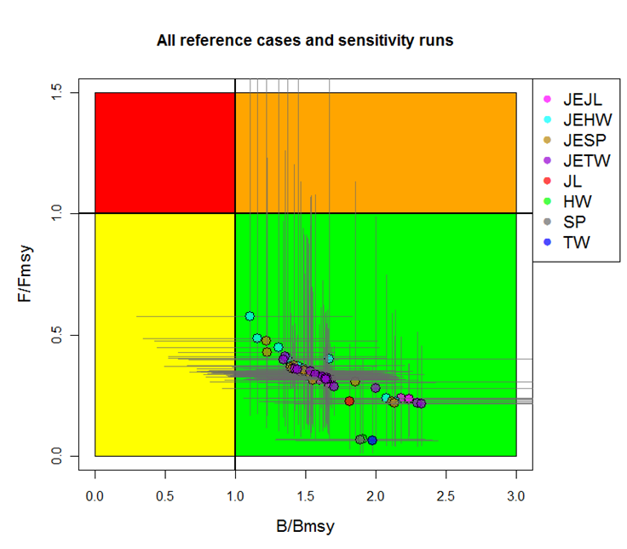
Figure NPBSH4: Kobe plot showing the 2011 median estimates of F/F_{MSY} and B/B_{MSY} for all BSP model runs for North Pacific blue shark. The horizontal and vertical bars indicate the 90% confidence limits of the 2011 estimates.

Figure NPBSH5: Kobe plot showing the range of terminal year reference points (F/F_{MSY} on the y axis and SB/SB_{MSY} on the x axis) for the entire grid of Stock Syntheisis runs. The total number of runs was 1,080, not all runs are shown on the plot due to extremely high (>5) F/F_{MSY} values. The points are color coded by the main axis of uncertainty, the parameterization of LSFR, using the combined Beta & S_Frac parameterization.

Figure NPBSH6: Comparison of future projected North Pacific blue shark stock biomass (medians) under different constant catch (status quo, +20%, -20%) and constant F harvest policies (status quo, +20%, -20%, and F_{MSY}) using the BSP reference case model. Status quo catch and fishing mortality was based on the average from 2006 to 2010.
Figure NPBSH7: Comparison of future projected North Pacific blue shark stock biomass under different constant catch (status quo, +20%, -20%) and constant F harvest policies (status quo, +20%, -20%, and F_{MSY}) using the Stock Synthesis reference case model. Status quo catch and fishing mortality was based on the average from 2006 to 2010.

4.4 WCPO billfish

4.4.1 South Pacific swordfish

4.4.1.1 Review of research and information
- J. Farley presented SC10-SA-IP-17, which describes a new project to re-examine the age, growth and maturity of broadbill swordfish in the southwest Pacific. The project was established after concerns were raised at SC9 regarding biological aspects of the 2013 South Pacific swordfish stock assessment. The stock assessment had a high degree of uncertainty that was attributed to uncertainty in the accuracy of growth and maturity parameters. SC9 recommended that additional work on age, growth and age validation be undertaken.
- In response to this, and a call for research proposals by the Australian Fisheries Management Authority Research Committee, the Commonwealth Scientific and Industrial Research Organisation submitted a proposal to re-examine swordfish age, growth and maturity in the southwest Pacific. The WCPFC Secretariat supported this proposal financially and suggested an expansion of the research in collaboration with the National Oceanic and Atmospheric Administration’s Pacific Islands Fisheries Science Center to include Hawaiian swordfish data in the study, in order to meet the needs of WCPFC. The research will clarify the degree to which differences in life-history parameters between Hawaiian and Australian studies are methodological or real (i.e. spatial variation in life history). The project will also provide a description of any unresolved uncertainties and an indication of the stock status implications in the context of the 2013 stock assessment.

Discussion
- Some CCMs expressed support for the research into southwest Pacific swordfish growth and maturity.

4.4.1.2 Provision of scientific information

a. Status and trends
- SC10 noted that no stock assessment was conducted for South Pacific swordfish in 2014. Therefore, the stock status description from SC9 is still current.

b. Management advice and implications
- SC10 noted that no management advice had been provided since SC9. Therefore, the advice from SC9 should be maintained.

4.4.2 Southwest Pacific striped marlin

4.4.2.1 Review of research and information
- SC10 noted that no new information was presented for southwest Pacific striped marlin in 2014.

4.4.2.2 Provision of scientific information

a. Status and trends
- SC10 noted that no stock assessment was conducted for southwest Pacific striped marlin in 2014. Therefore, the stock status description from SC9 is still current.

b. Management advice and implications
- SC10 noted that no management advice had been provided since SC9. Therefore, the advice from SC9 should be maintained.

4.4.3 North Pacific striped marlin

4.4.3.1 Review of research and information
- SC10 noted that no new information was presented for North Pacific striped marlin in 2014.
- The chair of the ISC Billfish Working Group, J. Brodziak (USA), spoke briefly about ISC’s activity regarding stock status of this species. He noted that an updated stock assessment would be conducted by the working group in 2015.

4.4.3.2 Provision of scientific information

a. Status and trends
- SC10 noted that no stock assessment was conducted for North Pacific striped marlin in 2014. Therefore, the stock status description from SC8 is still current.

b. Management advice and implications
- SC10 noted that no management advice had been provided since SC8. Therefore, the advice from SC8 should be maintained.

4.4.4 Pacific blue marlin

4.4.4.1 Review of research and information
- SC10 noted that no new information was presented for Pacific blue marlin in 2014.

4.4.4.2 Provision of scientific information

a. Status and trends
- SC10 noted that no stock assessment was conducted for Pacific blue marlin in 2014. Therefore, the stock status description from SC9 is still current.

b. Management advice and implications
- SC10 noted that no management advice had been provided since SC9. Therefore, the advice from SC9 should be maintained, pending a new assessment or other new information.

AGENDA ITEM 5 — MANAGEMENT ISSUES THEME
- The Management Issues theme was convened by R. Campbell (Australia). The rapporteurs for this theme were P. Maru (FFA), S. Bishop (New Zealand), T. Beeching (Secretariat), J. Bell (New Zealand), S. Sauni (FFA), C. Reid (FFA), G. Langdon (Cook Islands) and J. Farley (Australia). The convener informed the meeting that nine working papers would be presented during this session and that a further six information papers had also been prepared.

5.1 Limit reference points for the WCPFC
- The convener reminded SC that the Commission had adopted SC9’s recommendation that the time-window to be used in the LRP 20% SB(t1-t2),F=0 satisfy the following criteria:
    - have a length of 10 years, from t₁ to t₂;
    - be based on the years t₁₌y_{last-10} to t_{2=ylast-1} where y_{last} is the last year used in the assessment; and
    - the approach used for calculating the unfished biomass levels be based on scaled estimates of recruitment according to the stock recruitment relationship. It was also note that the Commission had not seen the need to adopt an equivalent F-based reference point as this was seen as redundant given the adoption of a biomass-based LRP.
- The convener informed SC10 that the Commission had decided to refer the acceptable level of risk to SC for further clarification of the implications of accepting various alternative proposals. SC was requested to provide its recommendations to WCPFC10 in sufficient detail and a format easily understood by managers.

5.1.1 Review of Project 57 — Research related to the development of limit reference points
- G. Pilling presented working paper SC10-MI-WP-01, which provided an evaluation of risks of exceeding LRPs for South Pacific albacore, bigeye, yellowfin and skipjack tunas using South Pacific albacore as a case study.
- This work was related to Project 57. The aim of this work was to evaluate, as a proof of concept, the implications of alternative levels of permissible risk of falling below the agreed biomass LRP for South Pacific albacore (20%SB_{F=0}, 2001–2010). The ultimate aim is to provide analyses of the implications of alternative risk levels in a format easily understood by managers, as requested by WCPFC10. Stochastic projections were performed for South Pacific albacore, capturing structural uncertainty by using 18 alternative assessment runs from the 2012 South Pacific albacore stock assessment, and future stochasticity in recruitment. Future longline fishing levels were identified so that the proportion of future projections that fell below the LRP matched four different levels of risk, being 5%, 10%, 15% and 20% of runs. Resulting median stock conditions were examined.
- Results showed that under the level of uncertainty examined, the lower the permissible level of risk of falling below the LRP, the further the stock biomass must be on average from that LRP and the lower the median level of fishing mortality permissible. The calculated median SB₂₀₃₀/SB_{F=0}, 2001–2010 levels — 0.59 (5% risk) to 0.46 (20% risk) — can be considered as the “minimum distance” between the LRP and any TRP consistent with a given level of risk. For south Pacific albacore, these levels implied median permissible fishing mortality levels well below F_{MSY}, and spawning biomass levels over double those at SB_{MSY}. They also related to longline vulnerable biomass (CPUE) levels similar to or notably greater than levels estimated for 2010, dependent on the permissible risk level. The risk and corresponding median levels were strongly impacted by the stock assessment runs selected for the analysis; for south Pacific albacore a key influence on the calculated risk level was the uncertainty in growth. When selecting model runs for use for each tuna species, or when considering the weighting to be placed on each run, the biological plausibility of those runs should be considered. The number of selected runs also needs to be computationally realistic. For this analysis we have interpreted “very low” as a range of risks between 5% and 20%. As noted by SC9, the permissible risk is a decision to be made by managers. However, some discussion on this issue by SC10 would be beneficial. Particular guidance was sought from SC10 on:
- the proposed approach and any improvements;
- the appropriate assessment runs to be used within evaluations of the tropical tunas (and South Pacific albacore if required);
- any relative weighting of those runs when calculating risk; and
- confirmation that the range of risks presented in this paper is consistent with the recommendation that the level of risk should be “very low”.
- Following the provision of SC10 guidance, the analysis will be repeated for the tropical tuna stocks (skipjack, yellowfin and bigeye) and the consequences of a range of levels of risk of exceeding the LRPs will be presented to WCPFC11 and/or the associated Management Objectives Workshop 3.

Discussion
- FFA members thanked SPC for the paper, which they saw as helping SC to respond to the WCPFC10 request. While seeing the decision on the appropriate level of risk to allow for the possibility of exceeding LRPs as a decision that needs to be taken by managers, they were hopeful that this decision would be made this year, particularly for those fisheries where a decision on TRPs had not been made. They supported the general approach in SC10-MI-WP-01 as applied to the latest South Pacific albacore stock assessment, and recommended that it also be applied to the latest bigeye, yellowfin and skipjack tuna stock assessments. They stated that the immediate priority was skipjack tuna because this work is needed to inform the commission’s intention to adopt a TRP for skipjack tuna at WCPFC11. However, they hoped that the analyses could also be done for bigeye tuna so as to inform the development of a rebuilding programme for that stock, and yellowfin tuna.
- FFA members also reiterated their previously expressed views at SC9 and WCPFC10 that when defining a “very low” level of risk, as required by the UN Fish Stocks Agreement, a 5% level of risk of breaching LRPs should be applied, at least to two stocks of economic importance in the region – South Pacific albacore and skipjack tunas. While accepting that different stocks have different dynamics, and that slightly higher or lower levels of risk might be acceptable for different stocks, FFA stated that the most important things to bear in mind are the consequences, and that they would not support a recommendation that is likely to allow the spawning biomass of the stocks to be fished to even lower levels. They argued that a lower level of risk of breaching LRPs is consistent with maintaining a good target species biomass, and is consistent with maintaining high catch rates and the value of their EEZ resources.
- USA noted that SPC was asking SC10 to confirm that the range of risks presented in this paper (5–20%) is consistent with the recommendation that the level of risk should be “very low”. While agreeing that the decision is one for managers to make, SPC needs to know what ranges to evaluate in these sorts of analyses. Risks of greater than 20% may not be considered “very low”, and there may be value in expanding the range, possibly to 40%. At 5% risk, F would have to be 36% of F_{MSY}, and at 20%, 57% of F_{MSY}. The paper apparently implies that ultimately, there would be a biomass target, and the results are expressed in terms of biomass as much as they are in terms of F, fishing mortality.
- USA, as articulated at WCPFC10, does not anticipate a biomass target; it recommends a biomass limit and an F-target. In practice, WCPFC would operationalize the application of risk in terms of acceptable or desired levels of F, even though one could calculate expected median biomass associated with those Fs, those biomass levels do not seem pertinent in this kind of analysis. The idea of the risk analysis is that biomass might be much lower than the expected long-term median biomass. USA concluded that the analysis is required by the Commission, but the results should be expressed foremost in terms of F and/or effort, with analysis of a broader range of risk.
- In response, the presenter stated that 40% seemed quite high. He noted that the risk level in the South Pacific albacore analysis is driven to a large extent by the alternative growth assumption and that if one went with the estimated growth options only the results would be quite different.
- Regarding the use of a fishing mortality reference level as a TRP, SPC noted that while the analysis presents the results for F/F_{MSY} that the estimation of F in the last year of the assessment is quite uncertain. Also, to best calculate how well an F-target would operate would require a management strategy evaluation of the fishery system, including harvest control rules.
- Australia noted that as the projection is at constant F harvesting, there is no feedback between stock biomass and fishing effort. If there was feedback then the risk profile would change and that this is something to note. SPC agreed, noting that if F changed over time then there would be a moving target. Projection of effort means catches would change under the constant fishing effort level if the stock declines or increases.
- The convener reminded SC of the issues seeking endorsement:
    - the approach used in SC10-MI-WP-01;
    - the selection of the axes of uncertainties to be included in the analyses and the related values; and
    - comments on the level of risk that should apply to breaching an LRP. On the first issue, the convener noted that there was acceptance by SC of the methodology adopted in SC10-MI-WP-01 and that this approach should be applied to the other target species in the WCPO.
In relation to item b), the convener noted that an informal small group (ISG) had been convened to consider this issue and that it may be best that this group reconvene to finalize the selection. This process was accepted by SC. In relation to item c), the convener noted that SC had heard two views expressed: one that 5% was appropriate for South Pacific albacore and skipjack tunas, and another that consideration should be given to extending the range of 5–40%. The convener noted that this is an important issue.
- USA noted that only the range 5–10% had been considered at SC9 and asked SPC what number of levels would be still computationally efficient. In response, SPC informed SC that around 25,000 model runs were required to cover each of the four levels of risk considered. USA also asked whether the analyses were to consider only the three tropical tunas or also include South Pacific albacore. In response, SPC confirmed that it was requested to look at the four key tuna species: the three tropical tunas and South Pacific albacore.

5.1.2 Limit reference points for elasmobranchs
- S. Clarke presented SC10-MI-WP-07, which outlines research on the development of LRPs for elasmobranchs. This paper aims to review and recommend appropriate LRPs for WCPFC elasmobranchs, taking into consideration the WCPFC’s LRP framework for target species. Three broad types of LRPs are defined:
    - estimated LRPs, which are derived from population models;
    - empirical LRPs that can be directly observed in the field; and
    - risk-based LRPs that are based on life history parameters alone.
- This paper recommends a paired (pressure-state) and tiered (based on availability of information) framework similar to that adapted for target species. For those elasmobranchs evaluated using a stock assessment model, a fishing mortality-based LRP of F_{MSY} is recommended on the basis that it is appropriately conservative and commonly applied as a best practice LRP. However, in cases where the stock-recruitment relationship is highly uncertain, it is recommended that F_{current} also be compared to an SPR-based LRP such as F_{60%SPR}, unfished so that SC can decide on a case-by-case basis which LRP is most appropriate. A biomass-based LRP of SB_{current}/30% SB_{dyanmic,unfished} is recommended, which is similar to the WCPFC-adopted biomass-based LRP for target species except it incorporates additional precaution for elasmobranchs by setting the denominator to 30% rather than 20%. When stock assessments are not available, or when the results are not considered robust by SC, risk-based fishing mortality LRP benchmarks (F_{msm}, Fl_{im} and F_{crash}) used in Australia are recommended. An expert working group should be convened to confirm or recalculate these based on a full review of the most appropriate life history data. In parallel it will be necessary to develop methods for estimating fishing mortality using a productivity–susceptibility approach in order to derive the numerator for the risk-based LRPs in the absence of a full stock assessment. Because the development of LRPs is just one element of a comprehensive conservation and management plan for WCPFC elasmobranchs, further work on assessment methodologies, mitigation measures, improved monitoring, and pre-agreed harvest control rules is also recommended.

Discussion
- Japan thanked the presenter for the comprehensive presentation. It asked whether the approach being recommended was consistent with the hierarchical approach adopted at WCPFC8 and the recommendation of SC9 (para. 465) that the Commission develop reference points for key shark species only — not all sharks and rays. Japan also enquired about what would happen if an LRP is trigged. In response, S. Clarke noted that the recommended hierarchical/tiered approach is consistent but use of the triggered first level is based on having the stock assessments. The proposed LRPs are slightly different in order to acknowledge the greater vulnerability of sharks. Risk-based LRPs have been included because stock assessments do not exist for all sharks as they do for tuna species. S. Clarke also noted that the request from the Commission was for the review of elasmobranchs and so that is what was undertaken. Consideration of what management response is required once an LRP has been breached was for the Commission to decide; perhaps, for example, through adopting a harvest control rule.
- Japan also asked how the values were obtained for the risk-based LRPs, noting that in many cases available biological parameters are coming from limited samples and the results may be questionable, which may lead to problems with a demographic approach. It also noted that while a variety of problems still exist with shark data, quality of current data appears to be relatively better than those in the past and is expected to improve in the future. Japan stated that improvements in data quality should be considered for the development of LRPs, and asked how to account for this in discussions on strategies for management.
- The presenter noted that the methods used for estimating the risk-based LRPs are explained in the paper. She explained that there are six different methods used and all data were accessed from Fish Base. She agreed that the data were unbalanced and that is why the paper recommends the establishment of an expert panel to go through life history data. She noted that this would also help in the stock assessments. She also noted the amount of time required to compile the required data on key shark species and to conduct stock assessments. In the interim there would be a need for some kind of fallback method to assess whether stock status is acceptable or not.
- New Zealand stated that FFA members support the formation of an advisory group of shark specialists to identify the most appropriate life history data to be used in calculating the risk-based LRPs for WCPFC key shark species. It noted that the paper suggests that this group might also be useful in developing additional management elements beyond LRPs. However, New Zealand also noted that this task — particularly setting management objectives — would require input at several levels, and not just involve elasmobranch scientists. A working group for that particular task would need clearly defined responsibilities and reporting channels, and broader membership.
- The presenter clarified that the paper recommends the expert panel only to review life history parameters, not management strategies.
- The EU expressed support for LRPs for key shark species, noting that there may be value in liaising with the scientific committees of other environmental conventions (e.g. Convention on the International Trade in Endangered Species or Convention on Conservation of Migratory Species) that are undertaking assessments on shark species. This may also make access to data easier and would be useful in such an undertaking of developing LRPs. S. Clarke stated that she could undertake to do this in her new role with the WCPFC Secretariat as Global Environment Facility’s Areas Beyond National Jurisdiction (GEF-ABNJ) Tuna Project Technical Coordinator – Sharks and Bycatch.
- Chinese Taipei agreed that it is difficult to do stock assessments for sharks because much information is lacking, and agreed that the second-tiered approach based on life history is appropriate. However, it noted that the value of F_{60% SPRunfished} may be too high, even for a very low productivity stock. S. Clarke explained that she followed Sainsbury (2008) who recommended a value of at least 50% for low productivity stocks and 60% for those with low steepness or low natural mortality. In response to a further question she also noted that it is unlikely that this recommendation has been applied anywhere as there is very little application of SPR-based LRPs to shark stocks.
- USA noted that it had some concerns about the results because it argued for using risk-based reference points over empirical LRPs when it should be the other way around — risk-based approaches should be used only when stock information is not available. USA stated it is not good to rely on parameters that are poorly known, and also stated its preference for biomass-based reference points instead of F-based reference point for limits.
- S. Clarke explained that the report’s conclusion was to use estimated indicators from stock assessments where possible. However, they had tried using the empirical reference point approach but this approach required a substantial amount of work and may be difficult to use, and for this reason the risk-based approach had seemed better. She noted that IATTC is trialing this approach and that if it is successful that is something that the WCPFC may also be able to use, but both are included in the review as it is up to the Commission to decide on this.
- Japan stated that different information is needed for different strategies. For example, if one uses the empirical approach there is a need for a reliable fishery indicator, while with the demographic approach there is a need for information on biological parameters. This suggests that any research plan for sharks should be carefully investigated and include a review of the available information.

Recommendations
- Noting the adoption by WCPFC10 of the 10-year time-window (t₁-t₂) for estimating the average unfished biomass in the LRP 20%SB_{(t1-t2),F=0}, and the request to SC10 for further clarification of the implications of accepting various alternative levels of acceptable risk, which should be applied to breaching an LRP, SC10 considered the work described in working paper SC10-MI-WP-01 and recommended that:
- the approach described in this paper be adopted for evaluating the implications of alternative levels of permissible risk of falling below an agreed biomass LRP;
- the axes of uncertainties and associated weighting to be included in the structural grid of assessment runs be incorporated into these analyses be based on those shown in Attachment G; and
- further analyses be undertaken for bigeye tuna, yellowfin tuna, skipjack tuna and South Pacific albacore, and the results presented to the Management Objectives Workshop 3 (if it takes place) and WCPFC11.
- SC10 also noted that working paper SC10-MI-WP-01 had considered risk levels associated with breaching the LRP within the range 5–20%. Further noting that the identification of acceptable risk is a management issue, and that many CCMs have already expressed a firm preference for 5% risk to be used for skipjack tuna and South Pacific albacore stocks, SC10 recommends that WCPFC11 identify the level of acceptable risk that should be applied to breaching an LRP for the key target species. SC10 notes that the UN Fish Stocks Agreement states that the risk of exceeding LRPs should be very low.
- SC10 also considered working paper SC10-MI-WP-07, which reviewed options for identifying appropriate LRPs for elasmobranchs within the WCPFC and made the following recommendations:
- That the Commission support the tiered, species-specific approach that is similar to that adopted for target species but noted that more work would be required to specify the values of the LRPs for key shark species, and to ensure consistency with article 10.1 (c) of the Convention;
- That the Commission support the proposal to hold an expert working group to compile and review life history data for use in LRPs for sharks; and
- That other work necessary to support the development of LRPs for sharks should be identified (not only for F-based LRPs but also for biomass-based LRPs as data are limited for most shark species) and included in the updated shark research plan. SC10 suggested that the Commission monitor the work of IATTC through the GEF-ABNJ Technical Coordinator, Sharks and Bycatch on the development of empirical LRPs (or indicators) for sharks. Liaising with other international organizations conducting shark assessments was encouraged to improve data and assessment methods. This work can assist and guide the identification of LRPs in WCPFC.

5.2 Target reference points and harvest control rules for the WCPFC

5.2.1 Target reference points and harvest control rules for skipjack tuna

a. Assessing a candidate target reference point
- G. Pilling (SPC) presented working paper SC10-MI-WP-09, which evaluates a candidate TRP for the WCPO skipjack tuna stock and fishery, based on management objectives developed by PNA members and consistent with PNA’s stated intentions to limit the tropical purse-seine fishery to 2010 effort levels. Using stochastic stock projections, and the 2011 skipjack tuna stock assessment, it examines the implications of maintaining 2010 effort levels within the fishery. A TRP was estimated, taking account of uncertainty in the biology of skipjack tuna, its current status, and future fishery conditions. The TRP was estimated on the same basis as the agreed biomass LRP — as a percentage of recent average unfished adult (spawning stock) biomass levels. The potential consequences of that TRP for the PNA management objectives were evaluated. Key findings are listed below:
- A TRP consistent with the average impact of 2010 effort levels on the WCPO skipjack tuna stock was ~0.52SB_{F=0,2000–2009}. Given the uncertainties within the system, a level of 0.5SB_{F=0,2000–2009} would, therefore, appear consistent.
- This TRP was calculated as the median outcome across the 200 stochastic projections undertaken for six selected sensitivity runs from the 2011 skipjack tuna stock assessment. Across these projections, the main range of SB/SB_{F=0,2000–2009} was 0.34–0.70.
- None of the simulations fell below the WCPFC agreed 20% SB_{F=0,2000–2009} LRP. The TRP is, therefore, sufficiently distant from the LRP to ensure the population does not fall below the LRP given the uncertainty examined here.
- Both the estimated catch value per day and catch value per ton consistent with this TRP were comparable to those estimated in 2010.
- There was little difference in the overall mean length of the purse-seine catch in 2040 compared with that modeled in 2010.
- Vulnerable biomass within the purse-seine fishery (a CPUE proxy) was estimated to increase slightly in the western equatorial Pacific. This assumes that CPUE will change proportionally with abundance.
- The 2014 skipjack tuna stock assessment became available in time to examine the sensitivity of the candidate TRP to changes in the assessment. The consequences of 2010 effort within the purse-seine fishery were examined for the candidate base case assessment run only, due to time constraints. The TRP, consistent with the average impact of 2010 effort levels on the WCPO skipjack tuna stock, remained comparable at 0.52SB_{F=0,2002–2011}. The next step is to perform the analysis across the range of model runs defined by the informal small group on SC10-MI-WP-01 at SC10 (Attachment G), as well as multispecies inputs.

Discussion
- The EU asked how the economic performance was assessed given that tuna prices can vary substantially. The presenter explained that MULTIFAN-CL calculates catch-at-age for each year’s fishery, which can be converted to weight classes that correspond with the different weight bins used to price tuna; therefore, variation in price could be built into the analysis. However, the economic analysis in the paper presented assumed constant price per weight bin over time. This is a strong assumption given price fluctuations. SC10 was referred to SC10-MI-IP-04, which examines price elasticity, something that may be applied to the model in the future.
- Japan expressed support for the development of a TRP for skipjack tuna but noted that many aspects need to be taken into consideration (e.g. biological, economic, social). For example, there is a need to consider trade-offs between the returns for the skipjack tuna fishery and the effects on other species. Japan endorses the work on a TRP based on consideration of all the necessary factors. Japan also stated that it shared the concern of FFA and PNA members that fishing mortality on South Pacific skipjack tuna is increasing and spawning biomass is decreasing. They requested that a recommendation be made that catch levels should not be increased.
- PNA members noted that this work was conducted by SPC with PNA members, and supported by the World Bank, Pew Environment Group and the Global Environment Facility; and was undertaken under the last two years’ work programme related to the Marine Stewardship Council certification of the free school skipjack tuna fishery. The Commission undertook to consider a TRP and harvest control rule (HCR) for skipjack tuna at WCPFC 11; this is more important, given that the assessment results show a continuing increase in fishing mortality and a further decline in spawning biomass of skipjack tuna. The spawning biomass is now estimated to be around the middle of the range for a TRP indicated by the Commission, hence action is needed now.
- G. Pilling provided the following responses to questions asked by the USA.
    - USA: Is the TRP under consideration for the entire WCPO skipjack tuna stock or just the skipjack stock under PNA jurisdiction?
SPC: The analysis is for the entire WCPO included within the skipjack tuna assessment model.
    - USA: There may be a fundamental problem because this paper is based on the premise that the overall management objective is to maintain a particular level of effort; therefore, there is little rationale for establishing a biomass-based target. In other words, it starts with a particular management strategy or measure (maintain effort at the 2010 level); whereas the target level of effort would generally be the output of a HCR rather than the input, as in this case.
SPC: Converting the TRP to an HCR is the next step but is beyond the scope of this paper. In particular, there is a need to identify the HCR that would maintain the stock around the TRP on average based on changes in purse-seine effort.
    - USA: As USA articulated at WCPFC10, why not have the adopted biomass-based LRP and an F-based TRP? PNA in particular has the vessel day scheme (VDS) that manages fishing days. The VDS could be argued as directly controlling the management of F rather than the management of biomass.
SPC: This was beyond the scope of this paper, but would be examined during work on candidate HCRs.
    - USA: It is not clear how the other (non-PNA) fisheries are treated in the projections. If they are assumed to remain constant, is that a reasonable assumption from the WCPFC point of view? Should additional alternatives of non-PNA fisheries such as those in the Philippines, Indonesia and Vietnam be considered to test the robustness?
SPC: We have not tested the robustness of the TRP for other fisheries outside the PNA, but that would be examined in future work, and the approach to achieving the TRP is a management issue. It was noted that PNA members had considerable “leverage” over the skipjack tuna fishery.
    - USA: What about the constant catchability assumption? Is it reasonable?
SPC: Yes, catchability is assumed to be constant in the analysis and as such the TRP based on 2010 effort levels will be missed if there is significant effort creep. In such an instance effort would need to decrease to maintain biomass at the TRP.
    - USA: Will the performance indicators in Para 151 of WCPFC10 Summary Report relating to fish sizes, impact on yellowfin tuna and bigeye tuna, and will the magnitude of changes in fishing effort be included?
SPC: Yes, work is planned to evaluate the consequences of a candidate skipjack tuna TRP on yellowfin and bigeye tuna stock status. We also note that technical measures to control FAD-related effort can influence the impact of a given overall purse-seine effort level on the bigeye tuna stock, for example. Regarding the magnitude of changes in fishing effort, as constant effort at the 2010 level is used in the analysis to develop the target reference point, there is no information on changes to present from the TRP work. However, the magnitude of changes in fishing effort will be important when using a TRP within a management framework; for example, within harvest control rules. An example of this, including implications for the variability in fishing effort and catch value (which incorporates information on the size of fish), is presented in SC10-MI-WP-02, and these will be used as performance indicators within future work as appropriate.
    - USA: While we realize the difficulties, it would be better to consider economic performance per vessel in addition to a per-fishing day basis? Without a restriction on fishing capacity, the number of vessels is likely to increase, and their efficiency as well, so the economic outlook per vessel is likely to be less optimistic than that of per fishing day.
SPC: Regarding the economic performance per vessel, if management is based on restricting capacity through the total number of vessel days allowed, as in the PNA VDS, the number of vessels is less relevant. Increasing efficiency should be taken into account to ensure management achieves its target.
- USA also asked whether the implications of the TRP for skipjack tuna for other species had been considered. Would the ratio of associated-to-unassociated sets make a difference? G. Pilling explained that the sampled variability of relative effort on FADs and free schools sampled over the period 2010–2012 was within the projections.
- FSM agreed on the point about number of days being important, noting that while the TRP is being developed for the EEZs of PNA members, PNA members wanted to see a similar TRP of 50% of unfished biomass used for the WCPO generally, including high seas areas.
- FFA members as a group expressed support for the points raised by PNA CCMs, and in particular supported the concept of having a TRP that maintains the skipjack tuna stock at 50% of unfished biomass — something that will keep the fishery close to where it is now, which is compatible with the zone-based effort limits that they have set themselves, and which carries very little risk of transgressing the agreed LRP for the stock. They expressed the hope that the additional scientific work that will be needed can be completed in time for consideration of this proposal at WCPFC11 in Apia, Samoa.
- In noting this previous statement, PNG stated that PNA is continuing work to support the adoption of a TRP for skipjack tuna at WCPFC11, and explained that the proposal to adopt a TRP of 50% of unfished spawning biomass reflects the stock and fishery sustainability objectives laid out for skipjack tuna for WCPFC at the first meeting of the Management Objectives Workshop (MOW1). It also reflects the industry’s interest in stability because it aims to keep fishery conditions not too far from where they are now. This TRP is nearly double SB_{MSY}. It represents a highly responsible approach to managing this stock, which is so important to many WCPFC members and especially to PNA members and other SIDS. However, they also noted that they are conscious that additional work is needed for the Commission to be sufficiently well informed to adopt a TRP for skipjack tuna at WCPFC11. The work that was presented in SC10-MI-WP-09 included an analysis of the sensitivity of the performance of the proposed TRP to the new skipjack tuna assessment structure and data. The next step is for the analysis to be extended to cover the range of assessment runs agreed on by SC for the analysis of uncertainty in the skipjack tuna assessment. We encourage SC to express support for this work to be presented to WCPFC11, along with the work on alternative risk levels for a skipjack tuna LRP that were discussed earlier.
- In response to a query from the EU about the use of constant effort in the projections and consideration of recent increases in capacity (new and larger vessels in the WCPO) and efficiency due to new technologies, G. Pilling explained that if such a TRP was adopted, it would not be achieved on average because current fishing levels are higher than 2010 levels and so there would need to be a reduction in fishing effort to achieve the target. In turn, even if 2010 effort were maintained, projections show technology creep would mean that the TRP would again not be achieved on average.
- Japan supported FFA and PNA regarding the need for the Commission to agree on a measure to stop any increase in total catches of skipjack tuna.

b. Management strategies in the equatorial skipjack tuna purse-seine fishery
- S. Harley presented working paper SC10-MI-WP-02. In conjunction with TRPs and LRPs, HCRs form a critical part of a management strategy. An HCR defines a “pre-agreed management action that should be taken when the stock and/or fishery are at different positions relative to the limit and target reference points”. Simply stated they can be defined as “some rules for managing the fishery so that we stay away from the LRPs and keep the stock and fishery near the target level that should result in us meeting our management objectives.”
- The purpose of this paper is to provide an example of how fisheries management relative to LRPs and TRPs can be put into practice through an HCR. The authors use the tropical skipjack tuna purse-seine fishery as an example, taking the WCPFC-adopted LRP, and an arbitrary TRP of 50% of the unfished biomass level, to examine the performance of two simple HCRs. They use these HCRs to illustrate the concepts of “trade-offs” and “robustness”, which are critical to developing management strategies. The paper should stimulate discussion on a range of matters, including trade-offs between maximizing catches and minimizing catch variability; what features would be important in HCRs for skipjack tuna; how we might design rules for yellowfin and bigeye tunas, which involve major gear interactions; and how HCRs could assist WCPFC decision-making processes.

Discussion
- There were no questions on this paper.

5.2.2 Other fisheries managed by WCPFC

a. Potential TRPs that consider the profitability of fleets
- C. Reid (FFA) presented working paper SC10-MI-WP-04. The purpose of this paper is to take one of the most commonly mentioned management objectives from MOW1 — maximizing the economic yields from the fishery (i.e. MEY) — and providing an example of how it could be made operational to help inform discussion of candidate TRPs for a fishery.
- In this example, the authors use the net present value (NPV) of resource rents as one potential economic quantity that one could be used as an indicator, maximized as a TRP and applied to the southern longline albacore fishery. Using the NPV approach, potential TRPs consistent with maximizing economic returns (e.g. MEY) can be calculated and compared with those under current stock status. The economic loss that is associated with harvesting at rates greater than MEY can also be calculated. The paper seeks to stimulate discussion on a range of matters — from the overall objective to the appropriate economic quantities to consider to the potential implications of management options for the southern longline fishery — using the results presented in the example. It is suggested that emphasis be placed on the principles and broad strategic approach outlined in the paper rather that the specifics of the costs and assumptions used in the analysis.

Discussion
- FFA members reiterated they have already expressed a preference for an MEY-based TRP for South Pacific albacore to ensure adequate vessel profitability and resource rents. The results of such modeling provided in SC10-MI-WP-04 for South Pacific albacore suggests that across the range of price structures and fishing costs considered, the MEY catch ranges from 39,000–76,000 mt or 40–77% of MSY. Furthermore, the biomass that supports the MEY catch is much higher than that which is necessary to provide MSY (2.5–3.22 times higher). This increased biomass would be associated with increased catch rates.
- The meeting noted that increased levels of resource rents and profitability would be achieved with reductions in longline fishing effort from current levels. The largest increases would be gained from the initial reductions in effort. For example, attaining 30% more of the maximum NPV from the fishery is expected to require only a 20% reduction in 2012 fishing effort.
- FFA members pointed out that results in the paper illustrate recent trends in the South Pacific albacore fishery and support SC9’s advice to reduce effort and catch levels in order to sustain resource rents and profitability.
- A point was made on the price variability being influenced by supply and demand, which can be best explained by elasticity. Change in price will lead to a shift in the level of effort and catch associated with MEY. At a lower level of effort, vessel profitability can be improved and the ability to impose charges such as resource rent taxes increased.
- Japan noted it was looking forward to continued research in this area. The next step might be to investigate the trade-off between longline and troll, which target the same species. The presenter noted that information paper SC10-MI-IP-04 detailed a more comprehensive bioeconomic model that is based on the projection model for all four tuna species and can examine interactions between gear types.
- Most CCMs considered the bioeconomic analyses were useful to better understand the implication of certain management objectives. CCMs encouraged such work to continue and to include economic trade-offs between gear types catching the same species. The meeting noted that such analyses are provided under SC10-MI-IP-04 with respect to modeling different level of efforts to generate economic outputs in a fishery, and including trade-offs.
- The meeting noted comprehensive comments from USA, which will be forwarded to the authors of the paper. The meeting further noted that: i) the analysis based on current data and effort settings for South Pacific albacore suggests that there is considerable potential economic loss. Reductions of 14–70% of 2010 effort levels are required, depending on economic conditions; and ii) resource rent at MEY or %MEY is one potential economic indicator that can help define TRPs (others include employment or other onshore economic benefits), but all require access to industry and market data.

b. Potential TRPs that consider fisheries across the extent of the stock
- G. Pilling presented working paper SC10-MI-WP-03. The purpose of this paper is to take one of the biological management objectives suggested at MOW1 for the tropical longline and purse-seine fisheries — maintaining yellowfin and bigeye tuna biomass above levels that provide fishery sustainability throughout their range — and provide an example of how it could be made operational to help negotiate and determine TRPs for a stock.
- In this example the authors identify the yellowfin tuna stock sizes associated with “good” CPUE in longline fisheries in temperate regions of the WCPO. They used these stock sizes to act as potential target TRPs consistent with a management objective of “maintaining the fisheries across the historical geographic range of the stock”. Noting that the “straw man” document states that “range contractions of yellowfin and bigeye tunas would have serious implications, particularly for SIDS based fleets”, the paper identifies the conditions within relevant fisheries that would rebuild stock sizes to those target levels within relatively short timescales, and examine the potential consequences for tropical and temperate fisheries. The paper should stimulate discussion on a range of matters, including the overall management objective, the appropriate timescales for stock rebuild, and consideration of the potential implications for the different fisheries exploiting yellowfin tuna.

Discussion
- On the question of multigear impact on yellowfin tuna, the presenter explained that the analysis applies equal amount of effort and catch reduction within the purse-seine and longline fisheries.

c. Relationship between abundance and range size
- L. Tremblay-Boyer (SPC) presented working paper SC10-MI-IP-06, which outlined the relationship between abundance and range size in longline target species.
- Changes in the spatial distribution of fish stocks are often ignored when considering the health of a population or examining the impacts of alternative fishery management strategies. Yet, reductions in the distribution of species with declines in abundance are evident across a diverse range of species, including birds, insects, mammals and fish. This phenomenon is particularly important for fisheries management where some stakeholders have limited ability to adapt to such effects, and would be acutely relevant to western and central Pacific tuna fisheries, locally based domestic fleets and the many artisanal and small-scale fishers.
- This paper first takes an empirical approach to determine how abundance and spatial distribution of seven key tunas and billfish are related over a period of more than 50 years. The authors then create a simulation model of a spatially structured population to investigate the mechanisms that could drive the patterns observed in the empirical data. They found that there was a positive relationship between abundance and range for all of the studied species, and that this relationship became more pronounced when focusing on areas of high local density.
- Simulation modeling highlighted that local densities of exploited mobile populations may not be related to local fishing mortalities when habitat quality varies within the stock range. In addition, the link between population abundance and range size is accentuated when individuals preferentially migrate to regions of high habitat quality within the range, especially if those areas are under heavier fishing pressure than habitats of lesser quality. These findings reinforce the need for the inclusion of spatial dynamics in the consideration of TRPs and LRPs for mobile pelagic fish. Future work should more formally quantify the long-term population consequences of ignoring spatial population dynamics in fisheries management, as well as determine the potential of non-CPUE data sources to further elucidate the ecological mechanisms at play in the redistribution of population abundance under uneven spatial fishing mortality.

Discussion
- FFA members appreciated the importance of considering range contraction, particularly for countries on the margins of the range. These coastal States will be more vulnerable to reductions in biomass than zones at the heart of the range. Small locally based domestic fleets will not have the same ability to track shifting or contracting stocks as distant-water fleets. It was pointed out that these research findings provide some very useful first steps in our understanding of the potential relationship between range and abundance for the target species, and highlight the growing likelihood of being able to include spatial dynamics factors into fisheries management responses.
- The meeting supported the continuation of such studies to better understand range contraction and other important aspects. Japan also noted that the approach was interesting and would like to see it continue. However, it also expressed concern for skipjack tuna.
- Chinese Taipei noted that the analysis only used longline CPUE and that purse-seine vessels may begin to operate “later” (i.e. compete and take advantage of traditional longline fishing grounds). They asked if this had been considered (i.e. would the range shrink due to purse-seine vessels?). The presenter noted that oceanography was used to predict abundance in areas not fished and that this would account for it.
- In response to a question from PNG about whether or not vessels that switch from targeting yellowfin tuna to albacore tuna had been taken into account in the analysis, the presenter noted that they used three fishing fleets (Japan, Chinese Taipei and Korea) and standardized these. Targeting is accounted for via the different fishing practices by these fleets.
- FFA members support further research in this area, and in particular to quantify long-term risks if these spatial dynamics are not adequately factored into the models that inform the fisheries management process.

5.2.3 Development of a Conservation and Management Measure
- J. Larcombe (Australia) presented working paper SC10-MI-IP-08, which comprises a draft CMM on establishing a harvest strategy approach for key tuna species to the WCPFC.
- The draft CMM will seek the Commission’s agreement to formally develop a harvest strategy approach to fisheries for the major tuna stocks under the Commission’s purview. It is envisaged that individual harvest strategies for specific fisheries would subsequently be developed in accordance with this CMM and these will set out the management actions necessary to achieve defined biological, economic, and social objectives for the fishery.
- The draft CMM proposes that individual harvest strategies will contain a process for monitoring and conducting independent assessments of the biological and economic conditions of the fishery and pre‐defined rules that control the intensity of fishing activity according to these assessments. The draft CMM sets out the broad principles of the approach, including decision rules, proposed indicative timelines for the development of a harvest strategy for albacore, and the provision for allocating resources to achieve these timelines. Australia is seeking SC’s comments and recommendations, from a scientific perspective, on the priorities to be accorded to each species, the feasibility of the indicative timeframe proposed for albacore, and the resourcing requirements for science provision (including for modeling and management strategy evaluations).

Discussion
- FFA members welcomed the proposal by Australia (in SC10-MI-WP-08) for a draft CMM on establishing a harvest strategy for key tuna species in the WCPO. The idea was introduced by Australia at the Forum Fisheries Committee meeting in Tokelau last month and warmly supported by ministers. They noted that the paper is being tabled here not for decision, because that decision will be up to the Commission in December, but for the purpose of consultation and obtaining feedback that will go into further iterations of the draft. FFA members have already begun discussing the draft among themselves and with Australia, the leader of the process, which is taking their comments into account. They expect that this proposal will be developed to the stage where it can go to WCPFC with much broader CCM sponsorship.
- Chinese Taipei stated that it is important to have a process to obtain the resources needed to rebuild stocks. The presenter responded that stock rebuilding was not part of the CMM as currently drafted but was considered to be part of harvest strategies that would be developed under the CMM. However, Australia would certainly consider this.
- The EU expressed its support to the Australian proposal for the development of harvest strategies for key tuna species in the WCPO. In this context, the EU considers that it is important that MOW3 is organized before the next Commission meeting to further elaborate on the Australian proposal, taking into account other relevant initiatives.
- In response to a question from Japan as to whether the draft CMM was to apply to shark species, the presenter explained that the draft CMM is a plan for key target species. The intention is not to apply the process to bycatch species.
- Japan also stated that it agrees with the need to develop harvest strategies. While Japan has concern about the status of stocks it wants to separate the discussion on harvest strategies and the development of CMMs. Japan endorses the work on HCRs, based on consideration of all the necessary factors.
- Indonesia expressed its appreciation to Australia for proposing harvest strategies for key tuna species and sought clarification about whether the proposal will also include detailed guidance for practical use and implementation of harvest strategies in particular fisheries.
- In response, the presenter explained that the draft CMM does not have details of harvest strategies and the objectives for all species need to be clearly defined.
- Korea asked whether the proposed process could be brought into line with a similar process in the Indian Ocean. The presenter replied that while he was aware of the different approach used in the Indian Ocean, the approach proposed for the WCPO is best practice. The importance of the Commission reaching a decision on objectives that could then inform the subsequent process was emphasized.
- PNA members indicated support for the initiative by Australia to have the Commission adopt a CMM on harvest strategies and the comments made on behalf of FFA members. They appreciate that the working paper is putting forward an early draft, and will be further developed. One major issue for PNA members is to ensure that the CMM takes into account the intention of the Commission to adopt a TRP for skipjack tuna at WCPFC11 in Apia, Samoa. They also appreciate that the CMM reflects best practice in the development of harvest strategies. However, they stated that more flexibility may be needed in some elements of the draft in order for it to be workable in the WCPFC context.
- USA stated that it considers the timeline for albacore in the draft CMM to be reasonable but thought that the nature of the text is not really a CMM, but could still be incorporated into the Commission work plan. Even so, procedures should be followed to ensure that this activity receives budget consideration from WCPFC.

Recommendations
- Noting the request from the Commission for the scientific services provider to provide the third meeting of the Management Objectives Workshop (MOW3) with further analyses required to inform the Commission’s consideration and adoption of TRPs and HCRs at WCPFC 11, SC10 reviewed working paper SC10-MI-WP-09. SC10 also reviewed three other working papers (SC10-MI-WP-02, SC10-MI-WP-03 and SC10-MI-WP-04) that had previously been presented to MOW2 together with a new analysis of the possibility of range contraction in the WCPO provided in working paper SC10-MI-WP-06. SC10 supported these analyses and recommends that WCPFC11 take the results of these papers into consideration when considering the adoption of any TRPs and HCRs for key target species.
- SC10 considered the draft CMM being proposed by Australia in working paper SC10-MI-WP-08. SC10 supported the initiative by Australia to have the Commission develop processes for adopting harvest strategies for key target species (to be clarified in the draft CMM). SC10 recommended that Australia continue to develop this CMM in consultation with other CCMs and that the updated CMM be presented to TCC10 and WCPFC11. To this end, SC recommended that MOW3 be organized before the next annual meeting.

5.3 Implementation of CMM 2013-01
5.3.1 Relative impacts of FAD set measures on fishing mortality for yellowfin tuna

- J. Hampton presented working paper SC10-MI-WP-05 on the relative impacts of FAD and free-school fishing on yellowfin tuna. Para 29 of CMM2013-01 requires that SC (in 2014) provide advice to the Commission on the relative impact on yellowfin tuna stock status of different ratios of purse-seine set types (i.e. FAD, or associated sets versus free-school or unassociated sets).
- The authors undertook deterministic stock projections using the 2014 yellowfin tuna assessment assuming 2010–2012 average purse-seine effort and catch by non-purse-seine gear types. Separate projections were run using different percentages (0%, 20%, 40%, 60%, 80% and 100%) of the total purse-seine effort being attributed to associated sets and the complementary percentage to unassociated sets. The equilibrium purse-seine catch of yellowfin tuna decreases with increasing percentages of associated sets in the purse-seine fishery.
- Three stock status indicators were examined:
- spawning biomass at the end of the projection period in relation to the average unexploited spawning biomass in 2002–2011;
- the spawning biomass at the end of the projection period in relation to the spawning biomass at MSY; and
- the fishing mortality at the end of the projection period in relation to the fishing mortality at MSY.
- These were all relatively insensitive to changes in the set type composition of purse-seine effort. Slightly better stock status — higher spawning biomass indicators and lower fishing mortality — and higher maximum sustainable yield occurred for purse-seine effort compositions favoring unassociated sets.

Discussion
- FFA members expressed their appreciation to SPC for the work described in MI-WP-05, which responds very directly to a task prescribed by the latest tropical tuna CMM. They stated that the paper provides useful information in a very clear fashion that will assist WCPFC with tightening up the measure — both in the management of FAD fishing generally and in developing appropriate limits for yellowfin tuna. In particular, they noted that the paper provides an indication that the FAD limits prescribed elsewhere in the CMM will not unfavorably impact the yellowfin tuna stock, and are actually likely to improve yellowfin tuna stock status. In particular, FFA members noted that these findings suggest that the current approach in specifying hard limits on effort in the purse-seine fishery overall, along with the existing FAD measures, are likely to be sufficient to manage the purse-seine fishery’s impact on yellowfin tuna without needing additional yellowfin tuna-specific measures.
- Japan stated that the results indicated that increasing the proportion of free-school sets gives larger total yellowfin tuna catch, larger yellowfin tuna stock (SB/SB_{F=0 2002–2011}) and larger MSY due to larger average size of fish caught. Noting that half the impact on the bigeye tuna stock was from the purse-seine FAD fishery, Japan stated that the Commission should seriously consider shifting FAD effort to unassociated effort. It noted that the same results could be expected for skipjack tuna and asked SPC to conduct the same analysis for skipjack tuna. SPC noted that it has not yet done this analysis for skipjack tuna, noting that it had been only asked to look at yellowfin tuna. SPC also noted that it was not necessarily the case that such an analysis would produce the same outcomes as for yellowfin tuna because these would be depend on a number of factors, including differences in natural mortality rates.
- Japan noted that shifting to unassociated sets contributes to an increase of yellowfin tuna stock, and requested SC to recommend encouraging a shift from associated sets to unassociated sets on the basis of this scientific evidence.
- PNG noted that paragraph 28 of CMM 2013-01 stated that catches of yellowfin tuna were not to increase, and requested that the analysis of the effectiveness of the measure also incorporate longline yellowfin tuna catch reductions.

5.3.2. FAD management plans
- The convener briefly highlighted the two information papers (SC10-MI-IP-01 and SC10-MI-IP-06) under agenda item 5.3.2 and asked the WCPFC Secretariat what type of feedback was being sought from SC. The Secretariat noted that the paper was provided in accordance with paragraph 38 for consideration of SC, and that SC could comment as it chooses, noting that the paper will also go to TCC and WCPFC11 in Apia, Samoa in 2015.
Discussion
- The EU asked what the scientific basis was behind the proposal to limit the number of FADs per vessel to 100. The chair noted that it is likely an attempt to put some limit on the number of FADs used by each vessel due to concerns related to the number of FADs in use (currently estimated to be over 30,000 in the WCPO, or on average 100 per vessel) and that many of them are lost and add to the marine debris in the region.
- The EU indicated that it considers FAD management to be a very important issue, cross-cutting through the sessions of SC. The EU considers information paper SC10-ST-IP-09 on FAD design and activities to be of particular interest. Based on an analysis of ROP data it seems that it is not possible to estimate the number of FADs used by each vessel. Additionally, the lack of information on the data transmission capabilities of the buoys attached to the FAD makes it difficult, if not impossible, to assess the FAD associated effort, and to track single FADs, which would allow estimating the influence of some factors (time at sea, fishery capability of each FAD, FAD sharing among vessels). The EU indicated that an effective solution to these problems exists and has already been implemented by ICCAT in recommendation 11-01 and IATTC resolution C13-04. The solution is the establishment of a FAD logbook, to be filled in by the operators of the vessel and a FAD identification scheme. This would greatly improve our understanding on the impact of FADs over the ecosystem and could contribute on the work related to the standardization of purse-seine, which ultimately could contribute in establishing management options with a better measure of the fishing capacity. The EU stated that the adoption of a related CMM would be a significant step forward. This would also contribute in enhancing FAD data collection and ultimately would facilitate any related research activities. Therefore, the EU proposed that SC recommend the establishment of such a FAD logbook and FAD identification scheme for WCPFC.
- PNA members expressed support for the working group proposed in SC10-MI-IP-06 and proposed that SC should also support it. They stated that it is clear that this Commission must do more on FAD management, and this seems a useful way of approaching it. This is an area that PNA has done some work on with the Pew Environment Group. PNA members can provide a PNA office staff member to chair the group. PNA members have some suggestions on the terms of reference; primarily that the terms of reference should include the collection of additional data on FADs for scientific purposes. In addition, PNA members proposed to delete the words “to prevent FADs becoming marine debris” from para. b of the terms of reference and asked for clarification of the purpose of the proposed consultancy on “analyses of the commercial implications of FAD usage”. If the purpose was to look at the comparative value of catches from FAD and free-school sets, taking into account the relative prices of fish by size class, PNA members understood that work has already been undertaken by SPC, and the proposed consultancy is not needed. Finally, PNA members agree that options such as limiting the number of FADs deployed and the FAD set limit alternatives needed further consideration. However, they did not think SC had sufficient information available to make any specific recommendations on these proposals in the paper
- Japan thanked the WCPFC Secretariat for preparing the paper in response to the CMM, and asked why the paper was an information paper and not a working paper. The WCPFC Secretariat noted that the Executive Director requested that it be an information paper.
- Japan noted that it would like to make some sort of recommendation in response to the paper and needed more time to do so. USA concurred, noting that there are curiosities within the information paper and requested the deferment of the agenda item. The convener agreed to defer the agenda item to allow participants the time to read the paper and develop recommendations.

5.3.3. Other considerations
- The convener noted that during the presentation of the WCPFC fisheries overview paper SC10-GN-WP-01 Japan had requested some time during the Management Issues session to discuss one of the figures in this paper.
- Japan thanked the convener for noting this request and noted that the figure it wished to discuss was Figure A4 of SC10-GN-WP-01, which shows that the number of FAD sets in 2013 was more than in 2010, noting that SC8 had recommended that the number of FAD sets not exceed that of 2010. Japan requested that SC10 reaffirm that recommendation. The convener noted that there was no disagreement to this and the recommendation was accepted.
- Japan also noted that in 2013 the number of associated sets was about the same as before 2010, that unassociated sets were at very high levels, and that in 2013 the purse-seine bigeye tuna catch was the highest on record, meaning that the effect of management of bigeye tuna catch by FAD set regulation might be weakened by the increased bigeye tuna catch by unassociated sets. The convener noted that a number of variables influenced total bigeye tuna purse-seine catch levels and these needed to be taken into account but that limiting FAD sets is one way to reduce bigeye tuna catch by purse-seine vessels.

Recommendations
- Noting the request in para 29 of CMM 2013-01 for SC10 to provide advice to the Commission on the relative impact of FAD set measures, and any increases of yellowfin tuna purse-seine catch in unassociated schools, on fishing mortality for yellowfin tuna, SC10 reviewed working paper SC10-MI-WP-05. Based on the results of the analyses described in this paper, SC10 advises WCPFC11 that the yellowfin tuna stock status in the WCPO is relatively insensitive to whether purse-seine effort comprises mainly associated sets or unassociated sets. SC10 also noted that slightly better stock status (higher spawning biomass indicators and lower fishing mortality), higher average catch, and higher MSY occurred for purse-seine effort compositions favoring unassociated sets, and recommended that the Commission take note of these conclusions. SC10 also recommends that the same impact analysis should be conducted for skipjack tuna.
- Also noting the request in para 38 of CMM 2013-01, SC10 considered information paper SC10-MI-IP-06 on additional FAD management options prepared by the Commission Secretariat and SC10-ST-IP-09 on FAD design and activities. SC10 supported the establishment of a working group and recommended that TCC comment on the constituency of the working group. The working group should address the following three main issues:
  - FAD marking, and identification, and use of electronic signatures;
  - FAD monitoring, tracking and control; and
  - FAD management options, including appropriate limits to FAD deployment based on scientific advice and the precautionary approach.
- SC10 noted that that the provisional catch estimate of bigeye tuna taken by the WCPFC Statistical Area purse-seine fishery during 2013 was the highest on record and the number of associated sets made in the WCPO tropical purse-seine fishery during 2013, which while on a downward trend, still clearly exceeds the number of such sets undertaken in 2010 (Fig. A4 in working paper SC10-GN-WP-01). Also noting that previous CMMs have failed to reduce the fishing mortality of bigeye tuna to the level intended, SC10 reaffirms the recommendations made at previous SC meetings (para 351 of the SC8 Summary Report and para 409 from the SC9 Summary Report) supporting the need for additional or alternative targeted measures to reduce fishing mortality on bigeye tuna, as seen as appropriate by the Commission.

AGENDA ITEM 6 — ECOSYSTEM AND BYCATCH MITIGATION THEME
- The Ecosystem and Bycatch Mitigation theme was convened by Aisake Batibasaga (Fiji) and John Annala (New Zealand).

6.1 Ecosystem effects of fishing

6.1.1 Review of research and information
- At WCPFC10 the Commission accepted four recommendations in para 419 of the SC9 Summary Report, which include i) supporting a Bycatch Mitigation Information System (BMIS); ii) supporting development of SEAPODYM; iii) members’ provision of fine-scale data to support SEAPODYM; and iv) an external review of the SEAPODYM model.
- S. Nicol presented SC10-EB-WP-02 (SEAPODYM applications in WCPO — progress report), which covered the key issues for SC10 arising from working papers SC10-EB-WP-02, SC10-EB-IP-02 and SC10-EB-IP-03. SC10 was invited to note optimizations of the SEAPODYM model for skipjack tuna for the period 2003–2012 and bigeye tuna for the period 1998–2012 have been completed that incorporate catch, effort, length and tagging data. The resolution for both models is one degree by month resolution. These optimizations have resulted in more realistic estimates of movement parameters by SEAPODYM. The combination of new oceanography; more recent catch, effort and length data; and tagging data resulted in weaker model fits in comparison to models previously presented to SC.
- SC10 was invited to note the first optimization of yellowfin tuna using SEAPODYM. This optimization uses catch, effort and length data for the period 1980 to 2004 at two degrees by month resolution. This model provides the basis for developing higher resolution models of yellowfin tuna using physics that extend to the current day.
- SC10 was advised of the construction of a new physical forcing for climate change, which is an ensemble of the five best IPCC-CMIP5 (Intergovernmental Panel on Climate Change–Coupled Model Intercomparison Project Phase 5) models for describing El Niño Southern Oscillation and SC10 was requested to include optimization of skipjack, bigeye, albacore and yellowfin tunas with this new physical forcing in the work plan of Project 62 in order to continue work on climate change.
- SC10 was informed that a sister model to SEAPODYM, APECOSM-E (apex predator ecosystem model estimation), has been developed to the extent that it could be now used to simulate climate change impacts on tuna in the Pacific Ocean. This model, although similar to SEAPODYM, has important structural differences and would provide a test on the sensitivity of such differences for simulating future climate scenarios.
- SC10 was requested to establish a new “no cost” project to optimize APECOSM-E for this purpose. SC10 was also requested to include continued improvement of optimization of the four tuna species in the future work plan of Project 62, continued development of downscaled models (1/4 degree by week and 1/16 degree by day resolutions), and conduct a peer review of the existing SEAPODYM optimizations. The third task would assist with prioritizing the development and application of SEAPODYM.

Discussion
- SC10 acknowledged SPC and its collaborators for the progress made on SEAPODYM, including more up-to-date environmental forcing models. Improved understanding of ecosystem effects, including climate change, is important for the application of an ecosystem approach to fisheries management in the WCPO. CCMs supported the need for a review that would prioritize future work and establish a work plan for future years.
- FFA members supported the ongoing development of SEAPODYM and APECOSM-E and their application, as this allows improved understanding of the combined effects of fishing and non-fishing activities. They welcomed the utility of the model to investigate specific questions, including climate variability and range contraction issues, and the model’s application to Pacific tuna and billfish populations and fisheries. FFA members requested that this project continue with external funding and at no cost to WCPFC, and that a schedule for the external peer review of the models for each species be conducted over the next year.
- The EU is supportive of the implementation of an ecosystem approach to fisheries management and is actively promoting it also in the WCPO, through the European Development Fund. In this context and considering the scale and cost of related research activities, it is critical to ensure compatibility between relevant ongoing initiatives and projects while reducing as much as possible any duplication of effort. Given that projects with similar objectives (assessment of climate change effects on key tuna species in the WCPO) are currently ongoing, the EU asked how its own work can complement existing activities and how to avoid overlap with other projects.
- SPC noted that models such as SEAPODYM also have potential application to complement stock assessment results, especially in areas where fisheries data are poor. In addition, such models could be used to better understand the potential use of spatially structured conservation and management measures. SPC also noted that work on SEAPODYM and other similar projects are being conducted in an effort to minimize duplication of work and in a complementary fashion.

Recommendations
- SC10 recommends that the Commission encourage an external review of the SEAPODYM project to assist with guiding the Commission in evaluating potential applications and future directions.

6.2 Sharks

6.2.1 GEF-ABNJ Shark and BMIS project

Joint Tuna RFMO Bycatch Technical Working Group
- S. Nicol presented SC10-EB-WP-03 (Annual WCPFC report: Joint Tuna RFMO Bycatch Technical Working Group). SC10 was advised that there has been little activity undertaken in 2014 to complete the work plan of the Bycatch Technical Working Group (BTWG), and this has been because of a lack of funding. The BMIS and its population with new analyses were included in the newly formed Global Environment Facility-Areas Beyond National Jurisdiction Tuna Project (GEF-ABNJ), and did not receive WCPFC funds for 2014. Resources from within the GEF-ABNJ project will not begin until 2015 for these tasks.
- The BTWG work plan included risk assessments on shark species, and for the Pacific this has also been included within the GEF-ABNJ. A description of the incorporation of WCPFC aspects of the BTWG work plan into the GEF-ABNJ is described.
- SC10 was advised that a workshop to provide each tuna RFMO with advice on harmonizing longline observer data fields was scheduled for January 2015. The venue for this workshop has yet to be determined
- SC10 is requested to note:
- the progress made towards completing the work plan of the Joint Tuna-RFMO BTWG as outlined in the report;
- the incorporation of the future work schedule of this Technical Working Group into the GEF-ABNJ Tuna Project (see Table 1, Appendix 1); and
- the revised project reporting arrangements specified in “Other Matters” of the report.

Discussion
- FFA members thanked the authors for their presentation and offered support for this important role that ultimately should result in better coordination of shark management arrangements and data sharing across tuna-RFMOs and relevant stakeholders. They also endorsed the revised project reporting requirements that remove duplication of activities and help to maximize efficiency of WCPFC members.
- It was noted that BMIS work under the GEF-ABNJ project will not begin until the end of 2015 and that funding is not available to populate the database during the intervening period of time. ISSF offered to continue to fund the project as it has in the past for the USD 25,000 needed.
- SC10 noted that BMIS and related activities had been slow during the first half of 2014. SPC commented that these activities should be implemented again in the near future, as the GEF-ABNJ project begins to be implemented.
- SC10 acknowledged the plan for a 2015 workshop to harmonize data fields collected by longline observer programmes in different CCMs and other RFMOs. The Chair recommended that CCMs interested in hosting this workshop contact SPC.
- The Agreement on the Conservation of Albatrosses and Petrels (ACAP) announced that it has completed a seabird identification guide that will be made available to all RFMOs in the immediate future.
Factors impacting the catch rates and condition of several key shark species

- S. Harley presented SC10-EB-WP-01, which examined factors affecting shark catch rates and shark condition at the time of retrieval for four shark species in four defined longline fisheries where there were sufficient data to examine the impacts of relevant gear factors. This work was an extension of that of Bromhead et al. (SC9-EB-WP-02).
- The analysis found that catch rates for silky sharks and oceanic whitetip sharks were significantly higher on shallow-set hooks and sharklines (when they were used); thresher shark catch rates were higher on deeper-set hooks; and blue shark catch rates were generally higher on intermediate depth hooks. Higher catch rates were generally found with wire traces and circle hooks (presumably because of reduced opportunities for “bite offs”). The condition analyses produced much fewer significant findings. There was generally a higher probability of a shark being dead when wire traces were used, and a lower probability of being dead when circle hooks were used.
- The paper suggested that the next steps would be to undertake a Monte Carlo simulation analysis, integrating coefficients from these analyses with ranges of estimates of release mortality and that shark lines, wire traces, circle hooks, and shallow hooks be the key variables to consider.

Discussion
- SC10 acknowledged SPC and its collaborators for the progress made on the analyses of observer data and shark catch rates. These initial analyses suggest several potential mitigation options for silky shark and oceanic whitetip shark.
- Regarding the potential usefulness of adding new fields to be collected by observers, SPC noted that one of the biggest difficulties in the analyses was the unbalanced nature of the data, rather than missing fields. This was due, for example, to different fleets using different gear configurations such that a gear effect could not be separated from a fleet effect.
- SC10 considered the list of proposed scenarios to be considered in the next phase of the analyses via Monte Carlo Simulation, including: a) shark lines, b) wire traces, c) circle hooks, and d) shallow-set hooks. CCMs identified other potential scenarios to improve survival, such as the length of the hook lines, the distance between hook lines, and the material that the lines were made of.
- S. Clarke (Secretariat) asked: a) whether there were any improvements in data collection that the analysts would recommend improving future analysis of mitigation options; and b) how SPC planned to integrate all the results into CMMs that cover all fleets, given the analyses were conducted for only some fleets and some fleets were analyzed separately.
- In responding to the first question, the presenter noted that aside from the lack of balance in the data for making good statistical comparisons, and the low observer coverage, the data were fairly good. For the second question, the presenter responded that these fleets were used because they had the best data to estimate the potential effects of key mitigation options that could then be used in the Monte Carlo analysis across the broader longline fishery.
- Japan indicated that it believed that there were three important factors that influence the bycatch of sharks in longline fisheries: i) the distance between the branchline and the mainline, ii) the material of the longline gear is made of, and iii) the length of the branch line.

Shark bycatch mitigation in tuna longline fisheries
- J. Larcombe presented SC10-EB-WP-05, which was a review of shark bycatch mitigation in tuna longline fisheries.
- A pelagic longline is a multispecies gear that has limited capacity for species selection, which presents difficulties in reducing excessive fishing mortality for a single species (such as oceanic whitetip shark and silky shark). A review of shark mortality mitigation methods was undertaken and research and data gaps were identified. While not exhaustive, the review identified several key factors detailed in the following paragraphs.
- The three most promising approaches to mitigating the mortality of sharks from pelagic longlines are hook type (circle), leader type (monofilament), and best practices handling of the vessel. There is generally sufficient information in the literature to allow reasonably informed decisions on reducing shark mortality using these approaches and these approaches should be considered for implementation as a matter of urgency.
- The review identified a number of issues that have hampered studies of mitigation and make it difficult to form a synthesis.
  - Lack of statistical power, often due to inadequate sample size (low power).
  - Problems with experimental design that lead to confounding between multiple mitigation measures and inability to resolve all treatments and their combinations.
  - Poor coverage of experimental or observer-based research encompassing the main equatorial Pacific fleets that undertake the majority of the WCPO longlining.
- Quantifying the magnitude of a likely reduction in mortality from combinations of mitigation measures is critical for determining whether proposed approaches are likely to lead to a decrease in overfishing. Recommendations for future research and data collection were as follows.
  - There are two main alternative approaches for collecting data to understand catchability, and both would require some directed fishing:
    - Observer data at the required minimum levels with appropriate detail in reporting supplemented by directed fishing to fill data gaps. Recommendations are made to the fields recorded by observers.
    - Large-scale directed fishing designed to fill research gaps.
  - Assessment of post-release mortality under different mitigation regimes is a priority.
  - Studies of shark interactions with the hook and leader (“bite off”, using video technology) are a priority.
- There is a need to better understand the barriers to the uptake of measures that have demonstrated technical efficacy.
- FFA members noted that analyses to date have confirmed that data collected through the implementation of observer programmes can be poorly suited to address some key questions regarding mitigation and, therefore, specific mitigation experiments are likely to be more appropriate. Such experiments may also provide opportunities to estimate post-release mortality, which will be a critical area of uncertainty in future silky shark and oceanic whitetip shark assessments. It was proposed to continue research to develop a comprehensive set of best practice mitigation approaches based on sound science, reiterating that the lack of data from some fleets is an impediment to this occurring.
- Korea expressed support for the shark bycatch mitigation research, noting that there are many CMMs requesting data collection and bycatch mitigation. Korea was of the view that there is a need to conduct sea trials with fishers in order to facilitate data collection and practicing bycatch mitigation methods, including operational efficiency and crew safety in relation to implementing the bycatch mitigation.
- SC10 recommends that the Commission:
- Consider the analysis of longline shark mitigation methods (e.g. hook type, leader material, non-deployment of shallow hooks, and a prohibition on shark lines) presented in EB-WP-01, as well as additional modeling of combinations of these measures and post-release mortality if available, in order to inform WCPFC11’s further consideration of revising shark CMMs to incorporate shark mitigation requirements that reduce catch rates and at-vessel mortality.
- Task TCC with identifying barriers to implementing the mitigation methods raised in SC10-EB-WP-05 (e.g. costs, operational issues and safety), along with any considerations raised by WCPFC11, and develop solutions, where appropriate
- Note that SC will not be able to review the specification of the ratio of fin weight to shark weight as described in para 8 of CCM 2010-07 because of the lack of reliable data and of appropriate species- and fleet-specific methodology.
- Request that for CCMs applying fin-to-carcass weight ratios, these CCMs report to the Commission the details of the methods used to estimate the ratio of shark fin-to-carcass weight and CCMs should encourage its purse-seine and longline observers to collect data related to shark fin-to-carcass ratios. This information should be included in Part 2 of the Annual Reports to WCPFC.

6.2.2 Shark Research Plan
- SC10 reviewed the progress of the Shark Research Plan and, in particular, the achievements in this work since SC9, and recommendations made in the progress report. SC9 requested that the scientific services provider conduct analysis of potential mitigation options for silky shark and oceanic whitetip shark, which SC10 reviewed.
- S. Harley presented SC10-EB-WP-04, describing SPC’s progress in implementing the WCPFC Shark Research Plan (SRP). The first SRP covered the years 2010–2014 and included an indicator analysis, stock status profiles, and stock assessments for the original five key shark species and species groups. Five stock assessments were conducted for three key shark stocks, and several auxiliary analyses (e.g. mitigation analyses) were conducted in support of the SRP. WCPFC funding was not sufficient to deliver all of the work in the SRP and annual WCPFC-SPC work plan, or all of the work accomplished above and across the four years. About 30–40% of resources devoted to WCPFC shark-related services were from other SPC donors. A major lesson of the work was that shark stock assessments require at least the same resources as tuna assessments.

Discussion
- FFA members were supportive of the idea of a small intersessional working group to consider how shark research should be progressed in 2015 and beyond. FFA members noted SPC’s recommendation that an integrated approach covering all aspects of research and shark management is desirable and, ideally, should be the approach SC10 endorses. However, this represents a level of commitment and investment that WCPFC does not award to the most valuable of target species. Considering the resources typically available to fund shark activities by WCPFC, FFA members support SPC’s suggestion that an indicator analysis for all key shark species — and an assessment for blue shark in the South Pacific Ocean (in collaboration with IATTC if possible) — be the highest priorities for 2015.
- A number of CCMs indicated that they would like to continue to collaborate on the research plan. The EU brought SC10’s attention to the fact that thresher, hammerhead and silky sharks have been proposed for listing under the Convention on the Conservation of Migratory Species of Wild Animals (CMS) Appendix II in view of the forthcoming CMS Conference of the Parties (COP) meeting (November 2014). EU asked if the work performed by SC for CMS on these species has provided any inspiration for the development of the Shark Research Plan.
- S. Clarke stated that shortfin mako shark is already a CMS-listed species and Australia has done preliminary work on the species, so it should be a priority over South Pacific blue shark.
- Australia supported the points raised by FFA members regarding having clear goals in place for a Shark Research Plan and to be flexible around the timeline for the delivery of work under the plan rather than change end goals.
- SPC indicated that there is tagging data for the shortfin mako shark and there is also a fairly good amount of other data potentially available that could make it feasible to do an assessment on that species, versus the proposal for South Pacific blue shark assessment.
- Japan noted that the uncertainty in the estimates of fin-to-carcass ratios is one of the points in the discussion of shark management, and stated that there is a need to review the Shark Research Plan to determine fin-to-carcass ratios for WCPFC key shark species.
- In considering the potential form of the next SRP, SPC proposed three initial options:
- A work plan for the scientific services provider that SC can revise, depending on priorities and available budget allocations; or
- A research plan that covers all research that SC anticipates is needed on sharks; or
- A research plan for sharks that includes the research plan above, plus monitoring, mitigation, data provision, and assessment of the efficiency of CMMs. This should include targets against which progress can be assessed.
- ISG-5 was convened in the margins of SC10 to discuss shark research priorities. The outcomes of these discussions are provided in Attachment H.

6.2.3 Review of conservation and management measures for sharks

a. CMM 2010-07 (CMM for sharks)
- Noting that there were no specific documents to address the efficacy or effectiveness of the above CMM, and that there was a general concern that there has been no attempt to investigate this, SC proposed that this should be addressed. This could possibly be incorporated into the upcoming revised Shark Research Plan (proposed to be developed within SC10/ISG-5) to improve shark catch mitigation measures and to incorporate other recommended actions proposed in each of the other shark conservation measures.
- S. Clarke (Secretariat) asked the SC to clarify the intent of having a list of key species which includes groups such as makos and threshers. She asked whether it was the intent that these should be reported to the species level, because some CCMs are not doing so, while some are. Without species-specific catch data it is nearly impossible to assess stock status particularly in the case of the threshers where the life history parameters are so different.
- The EU expressed concern that four years after the establishment of CMM 2010-07, SC has not been able to assess the specification of the ratio of fin-to-carcass weight, in line with the provision of para 8 of CMM 2010-07, and asked if there were data available for that. In the absence of a clear answer the EU proposed that SC recommend to the Commission the revision of para 7 of CMM 2010-07, moving away from the fin-to-carcass ratio. This would greatly facilitate the review task of SC and would guarantee the full utilisation of any (non-prohibited) shark catches and the elimination of shark finning practices in the WCPO.
- In relation to para 8 of CMM 2010-07, the EU brought SC10’s attention to working paper SC9-EB-WP-08, which was presented on behalf of USA with the aim of proposing an integrated shark CMM. Based on the analysis of the 2012 Annual Reports Part 2, working paper SC9-EB-WP-08 shows that only 44% of CCMs comply with shark data provision. In particular, when it comes to the full utilization and the finning control rules, the working paper shows that ~30% of CCMs did not address the issue. Considering that the main objectives of the CMM is to promote full utilization and control finning while increasing the number of sharks released alive, SC should be able to evaluate them by examining finning rates before and after the adoption of this measure. This can only be achieved on the basis of available observer data, in particular for longline vessels, for which, unfortunately, the coverage rate is too low and considered not representative. WCPFC’s ROP data show that finning rates in the period 2006–2011 do not appear to fall below 15–20% in the purse-seine fishery and below 30–40% in the longline fishery. Following these observations, the EU referred to the provision listed in para 8 of CMM 2010-07 and concluded that it is probably unlikely that SC will be able, in the short- or mid-term at least, to satisfy the provision of para 8 of CMM 2010-07. Therefore, considering the high rates of finning still occurring in the WCPO, and with the aim of allowing a new significant step towards the elimination of finning practices in the WCPO area, the EU called on SC to recommend to the Commission to abolish the “fin-to-carcass ratio” measure in para 7 of CMM 2010-07.
- Japan indicated that the abolition of the fin-to-carcass ratio measure will not contribute to the management of sharks because the measure is needed for monitoring full utilization of sharks as stated in para 6 CMM 2010-07.
- Korea informed the meeting that it is a practice of some of its fishers to bring shark bycatch on board and separate fins at that time before the shark is placed in the well of the vessel. The 5% fin-to-carcass ratio is a tool for monitoring shark bycatch regardless of scientific justification.

b. CMM 2011-04 (CMM for oceanic whitetip shark)
- No papers were presented and there was no discussion on this.

c. CMM 2012-04 (CMM for protection of whale sharks from purse-seine fishing operations)
- An informal small group (ISG-3) facilitated by Japan met in the margins of the meeting and formulated recommendations to be considered by SC10.

d. CMM 2013-08 (CMM for silky shark)
- This measure came into force on 1 July 2014. Mitigation studies would largely be undertaken by CCMs, and the report on bycatch incidences and mitigation actions will be provided with each CCM’s annual report to the Commission.

e. Safe release guidelines
- ISG-3 discussed draft guidelines for the safe release of whale sharks and the development of new guidelines for the survival of sharks (other than whale sharks) to be released from longline and purse-seine gear. ISG-3 produced two draft guidelines, noting that further work would be required before either can be proposed for adoption by the Commission.
    - Guidelines for the safe release of encircled animals, including whale sharks (Attachment I).
    - Development of (new) safe release guidelines to maximize shark survival (Attachment J).

Recommendations for sharks and bycatch
- SC10 recommends that WCPFC continue to support BMIS through the GEF-ABNJ project and to seek external funding until GEF-ABNJ funds are available in late 2015/early 2016.
- SC10 recommends the following priority order for funding research projects in 2015:
- Monte Carlo simulation of mitigation options (see SC10-EB-WP-01 for details).
- Expert panel work on the identification of appropriate life history parameters for use in developing shark LRPs.
- Desktop examination of fin-to-carcass ratios (building on work underway by New Zealand).
- SC10 recommends that:
- Guidelines for the safe release of whale sharks (Attachment I) be considered by SC11.
- A table summarizing the development of safe guidelines to maximize survival of sharks to be released from longline or purse-seine gear (Attachment J) should be reviewed by SC11 and forwarded to TCC for its consideration.

6.3 Seabirds

Bycatch in tuna longline fleets
- K. Liu presented SC10-EB-WP-06 (Seabirds and sea turtles bycatch of Taiwanese tuna longline fleets in the Pacific Ocean).
- Sea turtle and seabird bycatch from Taiwanese distant-water longline fleets were estimated based on observers’ data between 2008 and 2013. The seabird bycatch was mostly from albacore large-scale tuna longline vessels, followed by bigeye large-scale tuna longline vessels. Seabird bycatch from the small-scale tuna longline vessels was very low. The highest bycatch rate was 0.318 birds per thousand hooks in the southwest Pacific Ocean in the first quarter. Estimated annual seabird bycatch ranged from 175 to 381 seabirds between 2008 and 2013 for large-scale tuna longline vessels.
- The bycatch rate of sea turtles by small-scale tuna longline vessels was higher than that of large-scale tuna longline vessels. The sea turtle bycatch rate peaked in the second quarter in the western tropical Pacific Ocean at 0.011 turtles per thousand hooks. The estimated annual sea turtle bycatch ranged from 131 to 249 per year between 2008 and 2013 for large-scale tuna longline vessels.

Discussion
- Australia indicated that it was impressed with the volume and extent of Chinese Taipei’s longline observer data and looked forward to seeing it provided to SPC and WCPFC. Australia asked if data were also available on the fate of sea turtles that were released. Chinese Taipei responded that this was available in Table 6 of the working paper.
- In response to a question from USA on the lack of seabird and sea turtle interaction data for small-scale longline vessels, Chinese Taipei responded that observer coverage for this fleet only started in 2012.

Japanese small-scale longline vessel seabird mitigation
- D. Ochi (Japan) presented the results of interviews of 17 fishing masters of Japanese small-sized longline vessels operating in the North Pacific (SC10-EB-WP-07). The survey showed that tori lines are commonly used as a seabird bycatch mitigation technique and 41% of vessels used weighted branchlines. Additionally, some vessels used fluorocarbon monofilament for branchlines in order to make branchlines sink faster. The fishing masters had concerns when using streamers that were too long, double tori lines and towing devices because of gear entanglement.
- The presenter recommended that caution should be used in designing tori lines for small-sized longline vessels and that lighter materials and short streamers (or none at all) are preferred for tori lines on small longline vessels. The presenter also suggested that the effectiveness of fluorocarbon material for branchlines for bycatch mitigation should be evaluated scientifically. The presenter concluded that it is worthwhile continuing to collect information from fishermen and that those novel ideas of mitigation techniques should be evaluated for their effectiveness.

Discussion
- New Zealand thanked the presenter for the research presented and the recognition of an issue regarding bycatch on small vessels to the north of 23°N.
- New Zealand referenced USA’s information paper SC10-EB-IP-10, which provided observed seabird interactions and interaction rates in the Hawaii-based longline fisheries from 2004 to 2013. One of the conclusions from this paper was that there were no appreciable differences by vessel size (>=24 m and <24 m) in either the shallow-set or deep-set fishery.
- New Zealand understands the relative infancy of the seabird measure CMM 2012-07 and appreciates the difficulty in removing the exemption for small vessels at this stage but would recommend that this exemption be reviewed next year because research available to SC shows that there is little support for such an exemption. It stated that it was promising to see the survey results from the Japanese work and encouraged further research to look at specifications of mitigation measures that would be effective and practical for small vessels.
- Birdlife International stated that previous papers presented to SC (e.g. SC9-EB-WP-11) have shown that the lack of mitigation where there is overlap with albatross distribution can result in high bycatch rates. Birdlife International also referenced SC10-EB-IP-10, which shows there is little difference in bycatch rates between small and large vessels, information that was requested by this committee at SC9. Birdlife International noted that no evidence has been presented to show that small vessels catch fewer birds and, therefore, suggested the small vessel exemption be removed in order to protect the three species of North Pacific albatrosses. Birdlife International also raised their concerns about the bycatch risks in the area between 25°S and 30°S, which is not currently covered by the bird measure. Paper SC10-EB-WP-06 also shows this is an area of bycatch risk and Birdlife International suggests that SC might seek further information on this risk area.
- ACAP stated that the advice available to SC is that there are no appreciable differences between the bycatch rates of seabirds between small and large vessels, and that SC should consider providing a recommendation to the Commission that the exemption for small vessels be removed from CMM 2012-07. In addition, the Commission has requested TCC to review the suitability of current mitigation measures for small boats.

Recommendations
- SC10 recommends that relevant members:
- the analysis of the different bycatch interaction rates between exempted small longline vessels (<24 m) and larger non-exempt vessels north of 23°N in CMM 2012-07 at SC11; and
- seabird bycatch interaction rates for longline vessels in the area between 25°S and 30°S at SC11.
- SC10 recommends that the Commission:
- support the implementation of e-monitoring trials throughout the WCPFC in order to compare interaction rates between at-sea and dry observers, noting recommendations a and b under Agenda Item 3.3 “Electronic monitoring and electronic reporting”;
- encourages CCMs to collect robust seabird bycatch data, taking into account seasonal and spatial distribution and submit these to WCPFC;
- take note that CMM 2012-07, which came into effect on 1 July 2014, includes requirements for annual reporting of interactions in Part 1 of Annual Reports and encourages CCMs to use the template in the CMM 2012-07 for completing details about their bycatch species and numbers;
- support the distribution and use of the ACAP/Japanese seabird identification guide, which will come out in late 2014; and
- support the collection of DNA samples from seabirds taken as bycatch in the southern hemisphere to aid species identification. Protocols are in the ACAP/Japanese seabird identification guide.
6.4 Sea turtles
- No papers were presented and there was no discussion on this agenda item.

6.5 Other species and issues

6.5.1 Bycatch mitigation

FAD fishing on the epipelagic ecosystem
- J. Ariz (EU) presented SC10-EB-WP-09, which was a summary of the CECOFAD (Catch, Effort and eCOsystem impacts of FAD-fishing) project. The overall objective of the project is to provide insights into fishing effort units for FAD and free-school fishing modes to be used in the calculation of purse-seine CPUEs in the Atlantic, Indian and Pacific Oceans, where European vessels operate, in order to obtain standardized indices of abundance for juvenile and adult tropical tunas. Relating to the ecosystem approach to fisheries management, the CECOFAD project will provide new knowledge on the impact of FAD fishing on the epipelagic ecosystem, which will inform decision-makers in implementing future regulations of tuna and bycatch resources.
- Bearing in mind the multispecies nature of the tropical tuna purse-seine fishery, and the regular requests expressed by tuna RFMOs to European tuna scientists to provide reliable estimates of abundance indices and accurate indicators on the impact of FAD-fishing on juveniles of bigeye and yellowfin tunas and on bycatch species, the main objectives of the project are to:
- define a unit of fishing effort for purse-seine vessels using FADs that accounts for different factors influencing catchability;
- standardize CPUE series of the EU purse-seine fleet, for juveniles and adults of the three tropical tuna species; and
- provide information on catch composition around FADs and estimate impacts on other marine organisms (e.g. bycatch of sharks).
- Participants included scientists from AZTI, IEO and IRD, and stakeholders were ANABAC, OPAGAC and ORTHONGEL. This project is funded by the EU.
- Australia noted that it was good to see this type of study and suggested that it might be worth considering an additional work package after Work Package 1 (i.e. first define the unit of fishing effort for purse-seine vessels, and then determine the impact of FADs and the increase in their numbers on the aggregation dynamics of fish and related school sizes, especially those around FADs). The presenter noted that there was information on yellowfin tuna for the Indian and Atlantic oceans, which may be useful.

ISSF research cruise
- V. Restrepo (ISSF) presented a summary (SC10-EB-WP-08) of a third WCPO research cruise conducted on an EU (Spain) flag purse-seine vessel as part of the ISSF Bycatch Project that facilitates industry collaboration in the development and scientific testing of technical options to minimize undesirable catch in tuna fisheries. The cruise started at Christmas Island (Kiribati) on 3 May 2014 and ended in Tarawa (Kiribati) on 31 May 2014. Research objectives included attaching four different brands of echo sounder buoys to FADs to compare signals; using a scientific acoustic echo sounder with frequencies of 38, 120 and 200 kHz onboard the work boat, followed by intensive spill sampling to compare acoustic data and species composition; studying fish behavior inside the net; and using an escape panel to release sharks. Preliminary results were presented to SC10. A new report will be produced when the analyses are finalized.
- The species composition in the sets made during the cruise had wide contrast, with nearly mono-specific sets (mainly skipjack tuna or mainly bigeye tuna) as well as sets with mixed composition. Preliminary results suggest that the acoustic echo sounder data recorded will be very useful to improve knowledge on differences in target strengths between bigeye and skipjack tunas. In terms of sharks, the majority of the bycatch consisted of silky sharks, which were released by the crew when they were detected, usually from the lower deck. Unfortunately, it was not possible to test the escape panel during this cruise.

Discussion
- Australia asked whether it was common to have single species schools of bigeye tuna. The presenter explained that it was common in that area and at certain times of the year and that specific frequencies could be used to detect certain tuna species.
- FFA members encouraged others to conduct similar types of research and invest more resources in this kind of work. The results in working papers SC10-EB-WP-08 and SC10-EB-WP-09 may be considered inconclusive and preliminary; however, such research efforts would continue to enhance the understanding of the impact of FAD fishing on small tunas. The findings would no doubt increase confidence in the scientific advice to the Commission, thereby informing policy decisions to minimize bycatch, including juvenile bigeye and yellowfin tunas associated with FADs.

6.5.2 Food security issues with bycatch
- No papers were presented and there was no discussion on this agenda item.

6.5.3 Other issues
- S. Clarke presented SC10-EB-IP-05 (Issues for t-RFMOs in relation to the listing of shark and ray species by the Convention on the International Trade in Endangered Species (CITES). These Appendix II listings (oceanic whitetip, porbeagle, smooth hammerhead, scalloped hammerhead and great hammerhead sharks, and all species of manta rays) will come into effect on 14 September 2014. After this time, all exports of these species, including landings in non-flag State ports, will require permits to be issued by the flag State CITES Management Authority. If an export permit is to be issued, legal acquisition and non-detriment findings (NDFs) must also be issued. An NDF represents a certification by an authorized CITES Scientific Authority that the proposed export is not detrimental to the survival of the species. Catches on the high seas that are landed in flag State ports do not require export permits but will require “Introduction from the Sea” certificates that also require NDFs. Flag States and range States catching CITES-listed shark and ray species were compiled from WCPFC data holdings for 2010–2012 in order to identify which States may need to action CITES documentation procedures. CCMs were referred to the paper for a summary of existing WCPFC stock status assessments and management tools that may be useful to national CITES authorities when considering NDFs.

Discussion
- FFA members support the identification of a scientific body in the region to undertake broad based NDF work for the newly listed CITES species that can be underpinned by scientific bodies at the national level. They also support the provision of specific advice from SPC on the status of these listed sharks in the WCPO, and additional advice on how to assess whether such exports will be detrimental to the survival of the species at the national level.
- Indonesia sought an explanation on the difference between CITES and tRFMOs. The presenter noted that there was no formal relationship between CITES and tRFMOs, noting that national CITES scientific management authorities implement the CITES requirements but may call on WCPFC to assist with information to meet those requirements. With regard to the possibility of regional NDFs, this is provided for in the text of the CITES convention, but it seems it has not yet been applied in practice; therefore, if CCMs wish to pursue this it will be breaking new ground for CITES. WCPFC may have data that help individual countries. If national authorities are interested, then a dialogue can start.

agenda item 7 — OTHER RESEARCH PROJECTS

7.1 West Pacific East Asia Project
- The WCPFC Secretariat reported on the progress of the GEF-funded West Pacific East Asia (WPEA) Project (SC10-RP-WPEA-01), noting that it is the extension of the former Indonesia and Philippines Data Collection Project (IPDCP) funded by WCPFC members on a voluntary basis. Its purpose is to provide technical assistance and partial financial support to the participating countries (Indonesia, Philippines and Vietnam) for tuna data collection, annual tuna catch estimation, and capacity building to refine legal, institutional and policy arrangements. The five-year IPDCP and three-year WPEA projects were successfully finalized. However, WPEA activities continue to address data gaps in regional stock assessments and increase the countries’ capacity in complying with WCPFC requirements.
- The Secretariat has been preparing a new GEF-funding project through the United Nations Development Programme for implementation in late 2014, called “Sustainable Management of Highly Migratory Fish Stocks in the West Pacific and East Asian Seas”. It includes activities related to capacity building i: coping with climate changes impacting tuna resources; ecosystem approach to fisheries management; and market-based approaches to sustainable harvest of tunas, in addition to existing data collection and related activities. The Secretariat expressed appreciation to all project partners who contributed to past projects as noted in SC10-GN-WP-04 and SC10-RP-WPEA-01.

Discussion
- The Philippines acknowledged, with thanks, the support of Peter Williams (SPC), WCPFC, FFA, the National Oceanic and Atmospheric Administration, AusAID, Japan, Korea and all the members of the Commission for the implementation of WPEA1. The project met its objectives by supporting:
- the attendance of the Philippines to participate in the annual tuna data workshop, stock assessment training workshop, and other capacity building workshops and trainings provided by WCPFC;
- the expansion of the sampling sites and the hiring of additional tuna data enumerators;
- the development and publication of the Philippine Tuna Fisheries Profile and the development of the Philippines’s FAD Management Plan; and
- the formulation of Fisheries Administrative Orders for the conservation and management of tunas, among other fish species.
- The Philippines expressed the hope that the Commission will provide the same or additional support to the WPEA2 project.
- Indonesia highlighted that the WPEA-Oceanic Fisheries Management project has had a positive impact in strengthening Indonesia’s capacity and data collection for tuna (yellowfin, bigeye and skipjack tunas) and other highly migratory fish species. Several achievements were noted, such as strengthening management capacity by developing a national Tuna Management Plan, Tuna Fisheries Profile, National Tuna Association and a review of policy, legal and institutional arrangements for ensuring compliance with WCPFC requirements. Indonesia noted the development of a port sampling programme in selected sites as well as database development, with the results of the port sampling used in Indonesia annual catch estimates by gear and by species in certain fisheries management areas. Indonesia, under guidance from SPC, recently conducted its fifth annual tuna catch estimates, now with better estimation through time. Activities are continuing with funding from WCPFC while waiting for the final process of the second phase of the WPEA project for 2014–2016. Indonesia thanked WCPFC and others for supporting the project. The Chair observed that the project went a long way towards assisting WCPFC meet its objectives.

7.2 Pacific Tuna Tagging Project
- The 8th Pacific Tuna Tagging Project (PTTP) Steering Committee meeting was held on 7 August 2014. J. Hampton spoke briefly on the outcomes of the meeting, which heard presentations on work by the programme over the last year, including with PNG and in the central Pacific collaboratively with IATTC. The meeting considered the work programme planned for 2014–2015, which is primarily focused on managing the tag recovery process and incorporating analysis of tagging data in various work programmes. PTTP data are now being used routinely in stock assessments, including tropical tuna stock assessments, which benefited greatly from the project, and this will continue to in the future. There is currently no future funding for field work, but continuing this time series — which is now impressive, because it was established in 2006 — would be very valuable, particularly given the changing environmental conditions in the Pacific. SPC stated it was open to offers for funding and proposed that the Steering Committee report be noted and adopted by SC as the 2014 report of the Pacific tagging program. The PTTP report will be posted on WCPFC’s website.

Discussion
- There were no comments on this agenda item.

agenda item 8 — COOPERATION WITH OTHER ORGANIZATIONS
- SC10 reviewed the status of WCPFC’s cooperation with other organizations.
- Referring SC10 to working paper SC10-GN-IP-01, the Secretariat briefed SC10 on the main developments: the revision of the memorandum of understanding between the Commission for the Conservation of Antarctic Marine Living Resources signed by WCPFC in March 2013, and ongoing collaboration with that organization. The Chair referred delegates to information paper SC10-GN-IP-01 for details.

agenda item 9 — Special Requirements of Developing States and Participating Territories
- WCPFC’s Assistant Science Manager, T. Beeching, who is the Administrator of the Japan Trust Fund (JTF), briefly described the operations of the fund in 2014, which is the third year of the second phase of the JTF project. Nearly USD 330,000 was available this year to support 13 projects. Special mention was made of the Marshall Islands demonstration to the plenary of a 2013 FSM/Marshall Islands Information Management System project funded under JTF, elements of which were being taken up by FFA members. The Secretariat urged participants to be ready for the call for next year’s funding, which would likely have a closing date of 31 December 2014.

Discussion
- The Chair invited participants to give brief reports in relation to the scope of Article 30 (Recognition of the special requirements of developing States) of the Convention.
- FFA members noted the importance of the Special Requirements Fund and advised SC on recent work it had assisted with, including developments in monitoring projects such as national tuna data collection programmes, observer debriefer training and data collection, and integrated fisheries information management systems. FFA members extended appreciation to the contributors to the fund and encouraged all CMMs to contribute to the fund. They noted, however, that this was a fairly ad hoc process and it would be desirable to move forward to a more structured process for supporting SIDS and territories through the mechanism of CMM 2013-07, specifically in the areas of scientific and technical capacity building. FFA members thanked Japan for its ongoing support and assistance through the JTF, in particular for the many projects funded this year. It is this kind of direct assistance and support to FFA’s fisheries administrations that help to improve its capacity and enable greater participation in WCPO fisheries and the work of the Commission.

agenda item 10 — Future Work ProgramME and Budget

10.1 Review of the Scientific Committee Work Programme
- Noting that the progress of the 2013–2014 work programme since SC9 was briefly reported under Agenda Item 1.6 (Intersessional Activities of the Scientific Committee), the Chair invited the Secretariat to briefly describe the progress of SC’s work programme. In addition to the ongoing data management and other advisory services provided by SPC, T. Beeching highlighted some specific outputs: the three tropical tuna stock assessments for bigeye, yellowfin and skipjack tunas; 46 papers (24 of which were working papers) authored or co-authored by SPC and submitted to SC10; work completed under the three main funding routes (the core Service Agreement with SPC, individual project contracts, and the use of unobligated budgets for 2013 and 2014). The SC work programme also funded J. Farley’s project on swordfish biology and ageing, as referred to under Agenda Item 4.4.1.1 — Review of research and information and travel for Laura Tremblay-Boyer to the Marshall Islands to give a presentation on range contraction at SC10.

10.2 Development of the 2015 work programme and budget, and projection of the 2016–2017 provisional work programme and indicative budget
- Informal Small Group 4 (ISG-4) discussed the SC work programme and budget for 2015 and indicative budget for 2016–2017, and reported on the outcome of the ISG to the plenary. SC10 adopted the work programme and budget as shown in Table 1.
Table 1: List of SC work programme titles and budget for 2015, and indicative budget for 2016–2017, which require funding from the Commission’s core budget (in USD).
Research activity / Project with priority | 2015 | 2016 | 2017
Project 14. West Pacific East Asia (WPEA) Project  - Scope: port sampling and capacity building of WPEA countries | 25,000 | 25,000 | 25,000
Project 35. Refinement of bigeye tuna parameters  - Scope: 2015 is the last year of the project; sampling data and analysis of otoliths/gonads for assessment | 125,000 | 50,000
Project 42. Pacific-wide tagging project | 10,000 | 10,000 | 10,000
Project 57. Limit reference points (LRPs): Expert panel work on the identification of appropriate life history parameters for use in developing shark LRPs | 25,000
Project 66. Target reference points
Project 63. Harvest control rules
Project 70. Additional resourcing SPC for the improvement of stock assessment along with 2011 bigeye tuna peer review recommendations | 160,000
Project 74. Pacific-wide bigeye tuna stock assessment (additional cost)  - Travel and associated costs for two workshops (USD 52,600)  - MULTIFAN-CL software development (USD 26,300)  - Computer hardware (USD 13,100) | 92,000
New project – Monte Carlo simulation of mitigation options for longline shark bycatch  - See SC10-EB-WP-01 for details | 25,000
Project 67 – Review of impacts of recent high catches of skipjack tuna on fisheries on the margins of the WCPFC Convention Area | 40,000
Unobligated Budget | 83,000 | 83,000 | 83,000
SPC Oceanic Fisheries Programme Budget  (This includes USD 130,000 for shark research.) | 871,200 | 1,031,200 | 1031,200
GRAND TOTAL | 1,456,200 | 1,199,200 | 1,149,200

- SC10 advised that Project 57 in Table 1 will be implemented by the WCPFC Secretariat and other projects will be conducted by the scientific services provider. SC10 and the scientific services provider agreed that the 2015 service agreement will include the following assessments and shark research programme activities:
- Pacific-wide bigeye tuna stock assessment
- South Pacific albacore stock assessment
- Indicator analyses for key shark species
- Development of a Shark Research Plan
- Update of stock assessment for WCPO bigeye tuna, incorporating 2013 data in projection mode.
- SC10 also ranked the projects listed in Table 2 that were considered for funding under the Unobligated Budget. If there is no other priority demand on these funds by WCPFC11, then calls for proposals will be advertised for the three highest ranked projects.
Table 2: List of candidate projects and priorities for consideration under the Unobligated Budget.
List of projects with high priority | Priority Level
1. Analysis of archival tag data held by SPC, in particular the relationship between fish movement and oceanography. | High
2. Regional Observer Programme data fields. Identification and description of operational characteristics of the major WCPO fleets and identification of important technical parameters for data collection (SC Project 19). | High
3. Further development of methods and analysis to account for changes in targeting practices on the catch of non-target species in particular shark species. | High
4. Electronic tagging of whale sharks released from purse-seine nets (to examine survival). | Low
5. Determination of North Pacific blue shark to be designated as a northern stock. | Low

Discussion
- In response to some questions from Australia, the Secretariat noted that the Commission meeting in December will be considering the Australian CMM on harvest strategies and also possible TRPs on skipjack tuna. It was explained that if the Commission requests further research to be undertaken on these issues without allocating any additional budget, then the Unobligated Budget would need to be used to fund these requests. Furthermore, the Unobligated Budget may also need to be used to fund projects listed in Table 1 that do not receive their requested budget from WCPFC11. However, if there are sufficient funds in the Unobligated Budget, then the call for research proposals can be held off until after WCPFC11 (when the final 2015 science budget will be known) because the science 2015 budget does not need to be fully utilized until the end of 2015.
- Japan proposed that SPC should conduct an updated WCPO bigeye tuna assessment in 2015, noting that SC members were concerned about the status of this species.
- USA suggested that Project 4 be a low priority because the USA has contributed USD 40,000 for tagging whale sharks, and although tagging will be a challenge, less than 1% of purse-seine sets encounter a whale shark.
- Japan asked for clarification about whether SC will be provided updated information on stock status in the WCPO, specifically from the Pacific-wide stock assessment.
- SPC responded that the nature of information on WCPO stock status from the Pacific-wide assessment would depend on the spatial structure assumed for the Pacific-wide assessment. The spatial structure would be developed in collaboration with IATTC, but could include options that have separate regions for the WCPO and EPO or a spatial structure informed by an analysis of Pacific-wide bigeye tuna tagging data, which could have regions that straddle the 150°W boundary. Nevertheless, updated advice on WCPO bigeye tuna would be available in 2015 through projection analyses that would integrate fishery data from 2013. It was expected that these would occur as part of the work to examine management options.
- Marshall Islands expressed the view that research to determine whether North Pacific blue shark can be designated as a northern stock was a low priority.
- Australia requested that the Secretariat confirm that only the high priority projects listed in Table 2 go out for a call for research proposals. Australia’s understanding is that this year, five projects were prioritized and only three received a high priority and only those go out for funding under the Unobligated Budget.
- Japan queried whether SC could get reliable results next year. In the fifth meeting of the Scientific Advisory Committee, IATTC scientific staff suggested that the bigeye tuna assessment will take some years to complete because of analysis of tagging data.
- The EU noted that SC has made a recommendation under the Management Issues theme to organize a working group or workshop on FADs that will probably take place in 2015, and queried whether SC needs to budget this into the proposed budget.
- USA noted that within the recommendation there was going to be some further discussion at TCC and that the issue can be discussed there.
- In response to a question from USA, SPC confirmed that the additional resourcing of USD 160,000 for 2013–2015 was earmarked to enhance the assessments based on the recommendations of the bigeye tuna review. SPC noted that if it lost that level of resourcing from 2016, it would not be in a position to provide the number and quality of assessments that it currently provides. The amount of work being asked of SPC increases every year.

agenda item 11 — Administrative Matters

11.1 Peer review of stock assessments
- The Chair invited comments from SC10 about a schedule for future reviews, including a detailed plan, if required, for an external review of the SEAPODYM model as recommended by SC9 (para 419, SC9 Summary Report).
- There were no comments on this agenda item.

11.2 Future operation of the Scientific Committee

11.2.1 Future structure and administration of the Scientific Committee
- The Chair invited SC10 to consider reviewing the proposed draft process of developing the SC report, which had been prepared by the Secretariat and was presented both to heads of delegation prior to SC10 and to participants during SC10. The Secretariat noted that it had produced some general guidelines as an information paper (SC10-2014-GN-IP-04 (Rev.1), “Process of developing the WCPFC Scientific Committee report”. The Secretariat sought comments from participants on whether it was a useful document to continue to develop and to clarify standards about how the SC report is developed each year.

Discussion
- Australia noted that it was a huge amount of work to compile the SC report and placed a large burden on conveners. They were not only working with the support rapporteurs to produce a lengthy report of discussions but also the critical work of SC, which is to formulate recommendations. Australia proposed a recommendation for a new approach to how the scientific report is compiled. Having been a convener for 10 years, the participant observed there was an increasing burden on conveners. They should be doing preparatory work, facilitating the sessions, and concentrating on getting their recommendations done in a confident and efficient manner. Working with the rapporteurs was time consuming. Australia proposed that SC10 recommend that its Summary Report be completed by two or more professional rapporteurs, observing that none of the delegates were professional rapporteurs and the production of the report would be facilitated much more efficiently and competently by professionals. It would make the running of the meeting much smoother and would allow conveners to get on with the really important task, which is to facilitate the running of their sessions and allow them more time to participate in the review of the science presented at SC.
- A delegate from New Zealand, noting that he was acting as a convener at his first WCPFC meeting, strongly supported Australia’s intervention for the same reasons. He observed that it was very difficult to convene the session as well as take note of the discussion. It would be much more effective to have a couple of rapporteurs take the detailed notes and the conveners could then finalize them.
- In response to a question from the Secretariat about the best methodology to progress the issue, Australia proposed working with the conveners intersessionally to come up with guidelines for how they see the report being compiled in the most effective and efficient way. There would be a small additional cost. They would recommend that professional rapporteurs would be in place before SC11. Australia offered to come up with some guidelines before the Commission meets in December and hoped that SC10 would support this proposal.
- The lead rapporteur made the observation that there are other organizations with models that the WCPFC may wish to consider, including the Antarctic Treaty Consultative Meeting (ATCM) and the Commission for the Conservation of Antarctic Marine Living Resources. Both had different styles of operating; ATCM hired a number of interns and a lead rapporteur who mainly managed and coordinated the recording and submission of information, rather than note-taking.
- S. Clarke, who had performed the rapporteur role for many WCPFC-related meetings, commented that it was not possible or reasonable for the lead rapporteur to be making his or her own notes at the same time as compiling the report. She also suggested that someone during each session needs to record the order of interventions — not the content but a list, so that participants and the Secretariat know what interventions were made and can easily clarify if their intervention was inadvertently missed. S. Clarke made the observation that SC has its report professionally edited after the meeting and, given that TCC and Commission meetings do not do this, it may be an unnecessary expense. In addition, sometimes the editor changes content, which should not happen after SC10 adopts the report.
- The Secretariat responded that professional editing has been performed on the finalized report for all Commission meeting reports — SC, NC, TCC and Commission reports — for years; SC for eight years so far (SC2–SC9), TCC2–TCC6 and TCC8, NC2–NC9 and WCPFC2–WCPFC7.
- FSM observed that it was a useful proposal, and added that rapporteuring creates considerable burden for some delegations. It was stated that FSM and some FFA members would like to support the theme rapporteur process, but their delegations are too small, and rapporteuring work would render them unable to participate effectively in the SC meeting itself. FSM supported Australia’s proposal for professional rapporteurs, including for theme rapporteuring. It was suggested that restricting delegations to five lines might be difficult for those who speak on behalf of 16 other members and suggested that the guidelines be amended to be more flexible in capturing the views expressed. It was proposed that CCMs could be required to ensure they provided concise written reports for inclusion in the report.
- Australia suggested that the whole document SC10-GN-IP-04 needs to be rewritten and suggested that the conveners work with the SC Chair, the lead rapporteur and the Secretariat intersessionally. He noted S. Clarke’s last point — that if the meeting had more rapporteurs the SC Summary Report may not need to be professionally edited, with some associated cost savings.
- The Chair stated that the meeting would leave drafting of SC10-GN-IP-04 for now but suggested that SC recommend to the Commission that SC have professional rapporteurs to help with its meetings, because rapporteuring is a lot of work for the conveners and they need to concentrate on framing wording for management advice. Someone else capturing the notes will help. The Chair asked if there were any comments against that proposal.
- The USA said it was a decent intervention and a way to proceed. The main WCPFC funding line in 2015 would need to be increased to accommodate the proposal.
- The Chair asked whether a recommendation for two rapporteurs for future SC meetings should be progressed.
- Australia suggested not agreeing to a process at this SC but that SC10 should just agree that SC report should be professionally rapporteured. Australia indicated that it would work intersessionally with the conveners, the lead rapporteur, and the Secretariat to draft a recommendation to go to the Commission later in the year.

11.2.2 Scientific aspects of the Commission’s performance review
- The Secretariat introduced meeting paper SC10-GN-WP-05, noting that the Commission requested the Secretariat to revise the performance review matrix to remove all recommendations that have been addressed and completed, and present the revised matrix to WCPFC11. SC9 reviewed all science-related recommendations thoroughly. The review was performed in 2011, and some of the recommendations were already addressed and others will be addressed in the future. A large portion of the recommendations under review were removed, as shown in the paper for consideration by SC10.

Discussion
- There were no comments on the Secretariat version.

11.3 Election of officers of the Scientific Committee
- No nominations were forthcoming for the positions of SC Chair and Vice Chair; the Chair announced that nominations may be submitted for selection during WCPFC11 in December 2014.

11.4 Next meeting
- FSM kindly offered to host SC11 in Pohnpei, FSM. The meeting is provisionally scheduled for Wednesday, 5 August to Thursday, 13 August 2015. Indonesia kindly offered to host SC12 in 2016.

agenda item 12 — Other Matters
- There were no other matters raised for discussion.

agenda item 13 — ADOPTION OF THE SUMMARY REPORT OF THE TENTH REGULAR SESSION OF THE SCIENTIFIC COMMITTEE
- The SC10 Summary Report was adopted.

agenda item 14 — Close of the Meeting
- The Chair thanked the Marshall Islands for its hospitality and thanked participants for a successful meeting. SC10 closed at 19:00 on Thursday, 14 August 2014.

Attachment A

The Commission for the Conservation and Management of
Highly Migratory Fish Stocks in the Western and Central Pacific Ocean

Scientific Committee
Tenth Regular Session

Majuro, Republic of Marshall Islands
6–14 August 2014

Opening Remarks
by Hon. Michael Konelios
Minister of Resources & Development / Chairman, MIMRA Board of Directors

Traditional Leaders, H.E. President Loeak, Members of the Cabinet, Members of the Nitijela, Members of the Judiciary, Church Leaders, Esteemed Members of the Diplomatic Corps.

WCPFC Chairman Mr. Charles Karnella, WCPFC Science Manager Mr. Sung Kwon Soh, WCPFC Compliance Manager Ms. Lara Manarangi-Trott, WCPFC SC Chairman Mr. Ludwig Kumoru, WCPFC Secretariat Staff, FFA Secretariat Staff, SPC representatives, Esteemed Heads of Delegations, SC Delegates, Observers, Distinguished Guests, Friends, Ladies and Gentlemen:

Yokwe once again and Welcome to the Marshall Islands!

On behalf of His Excellency President Christopher J. Loeak, the People, and the Government of the Republic of the Marshall Islands, please allow me make some brief opening remarks on this momentous occasion of our hosting of the 10th Regular Session of the WCPFC Scientific Committee. It is indeed an opportune time for all of us to gather here to discuss and come up with tangible solutions seeking to address the urgency of the current status of our tuna stocks, most notably bigeye tuna.

The scientific advice for some time has called for considerable reduction in fishing mortality and being that this meeting here in Majuro will be presented with the latest stock assessments for the three key tropical tuna species, the prevailing common sense should dictate to all of us the immediate need to seriously heed to such advice.

As well, we must continue our efforts to address and resolve the outstanding data gaps, particularly with regards to the provision of operational-level data. Again, the prevailing common sense dictates the urgent need for complete and accurate scientific data provision on the part of all CCMs in order to allow for sound decision-making not just here and now but well into the future as we continue our respective roles as custodians and beneficiaries of these last remaining healthy tuna stocks in the world. Even then, the binding requirement for all CCMs to provide operational data is in accordance with the very same WCPFC Data Rules for which we all agreed to when the Convention entered into force some ten years ago.

This ongoing issue of data gaps in the WCPFC must be resolved immediately. While it has taken some time for some of us to slowly come around to fulfill such important obligation, it still signals very little progress. Nevertheless, we are confident that it will continue to improve in the next few years starting at this Majuro meeting.

As we are all in this together for the long term sustainability and economic viability of our shared tuna resources here in the Western and Central Pacific, it would be remiss of me not to touch upon another critical area of concern which is the pressing need to begin work towards target reference points and harvest control rules for skipjack tuna as a start. I will resist the urge to delve further into the complex and often times heavily technical and scientific details of such work and leave it all for you our scientific experts to tackle as that is part of the reason you are gathered here in the first place.

I trust that all of you have been and will continue to be well taken care of by MIMRA and everyone involved with the planning and coordination of your meeting during your stay here in our humble little capital of Majuro. Please if there is anything we can do to help make your short stay with us better, feel free to let us know. Rest assured, we are doing the best we can with what we have where we are.

With these few words of welcome, I thank you all very much for your kind attention and attendance at this important 10th Regular Session of the WCPFC Scientific Committee. Once again, on behalf of H.E. President Loeak, the People, and Government of the RMI, I wish each and every one of you success in your deliberations. I hereby declare the 10th Regular Session of the WCPFC Scientific Committee open.

Kommol Tata & Jerammon!

Attachment B
The Commission for the Conservation and Management of
Highly Migratory Fish Stocks in the Western and Central Pacific Ocean

Scientific Committee
Tenth Regular Session

Majuro, Republic of Marshall Islands
6–14 August 2014

LIST OF PARTICIPANTS

CHAIR

Ludwig Kumoru
Executive Manager, Fisheries Management
National Fisheries Authority
PO Box 2016
Port Moresby NCD
Papua New Guinea
+675-3090424
lkumoru@fisheries.gov.pg
lkumoru@gmail.com

AUSTRALIA

James Larcombe
Senior Fisheries Scientist
Department of Agriculture
GPO Box 858
Canberra ACT 2601
Australia
61-2-6272 3388
james.larcombe@daff.gov.au

Robert Campbell
Senior Fisheries Scientist
Commonwealth Scientific Industrial Research Organisation
Private Bag No. 1
Aspendale VIC 3195
61-3-9239 4681
Robert.Campbell@csiro.au

CHINA

Feng Wu
Shanghai Ocean University
No. 999, Huchenghuan Rd.
201306, Shanghai
86-21-61900696
fwu@shou.edu.cn

Xiaojie Dai
Shanghai Ocean University
No. 999, Hucheng Huan Rd.
201306, Shanghai
86-21-61900325
xjdai@shou.edu.cn

Xuefang Wang
Shanghai Ocean University
No. 999 Hucheng Huan Rd.
201306, Shanghai
xfwang@shou.edu.cn

COOK ISLANDS

Georgia Langdon
Senior Fisheries Officer; Data Manager
Ministry of Marine Resources
+682 28721/Fax: +682-29721
G.Langdon@mmr.gov.ck

EUROPEAN UNION

Javier Ariz, PhD
Marine Biologist
Instituto Español de Oceanografía
Centro Oceanográfico de Canarias
38180 Santa Cruz de Tenerife
Canary Islands, Spain
+34 922 549400
javier.ariz@ca.ieo.es

Stamatios Varsamos
International Relations Officer
European Commission, DG Maritime Affairs and Fisheries
Rue Joseph II 99,
1000 Brussels, Belgium
0032-229 89465
stamatios.varsamos@ec.europa.eu

FEDERATED STATES OF MICRONESIA

Eugene R. Pangelinan
Deputy Director
National Oceanic Resource Management Authority(NORMA)
PO Box PS122
Palikir, Pohnpei FM 96941
691 320-2700
eugene.pangelinan@norma.fm

Naiten Bradley Phillip Jr.
Chief of Research
National Oceanic Resource Management
Authority (NORMA)
PO Box PS122
691-320-2700
bradley.phillip@norma.fm

FIJI

Aisake Batibasaga
Principal Fisheries Officer-Research
Government of Fiji
PO Box 2218 Government Building
Suva
330-1011
abatibasaga@gmail.com

Asinate Ritova
Fisheries Officer - Data
Government of Fiji
PO Box 2218 Government Building
Suva
330-1011
ritova.asinate@gmail.com

Netani Tavaga
Senior Fisheries Officer - Services
P.O. Box 2218 Government Building
Suva, Fiji
330-1011
tavaga.netani@gmail.com

Rupeni Dranivesi
Fisheries Officer – Monitoring
P.O. Box 2218 Government Building
Suva, Fiji
330-1011
dranivesi.rupeni@gmail.com

INDONESIA

Fayakun Satria
Director, Research Institute for Fisheries Enhancement and Conservation
Jl Cilalawi 1 Jatiluhur
Purwakarta
fsatria70@gmail.com

JAPAN

Yuujirou Akatsuka
Assistant Director
Fisheries Agency Government of Japan
1-2-1 Kasumigaseki, Chiyoda-ku
Tokyo
81-3-3502-8459
yuujirou_akatsuka@nm.maff.go.jp

Hitoshi Honda
Scientist
National Research Institute of Far Seas Fisheries
5-7-1 Orido, Shimizu-ku
Shizuoka
424-8633
81-54-336-6000
hhonda@fra.affrc.go.jp

Miki Ogura
Scientist
National Research Institute of Far Seas Fisheries
5-7-1 Orido, Shimizu-ku
Shizuoka
424-8633
81-54-336-6000
ogura@fra.affrc.go.jp

Hiroaki Okamoto
Scientist
National Research Institute of Far Seas Fisheries
5-7-1 Orido, Shimizu-ku
Shizuoka
424-8633
81-54-336-6000
okamoto@fra.affrc.go.jp

Keisuke Satoh
Scientist
National Research Institute of Far Seas Fisheries
5-7-1 Orido, Shimizu-ku
Shizuoka
424-8633
81-54-336-6000
kstu21@fra.affrc.go.jp

Hidetada Kiyofuji
Scientist
National Research Institute of Far Seas Fisheries
5-7-1 Orido, Shimizu-ku
Shizuoka
424-8633
81-54-336-6000
hkiyofuj@fra.affrc.go.jp

Hirotaka Ijima
Scientist
National Research Institute of Far Seas Fisheries
5-7-1 Orido, Shimizu-ku
Shizuoka
424-8633
81-54-336-6000
ijima@fra.affrc.go.jp

Koji Uosaki
Scientist
National Research Institute of Far Seas Fisheries
5-7-1 Orido, Shimizu-ku
Shizuoka
424-8633
81-54-336-6000
uosaki@fra.affrc.go.jp

Seiji Oshimo
Scientist
National Research Institute of Far Seas Fisheries
5-7-1 Orido, Shimizu-ku
Shizuoka
424-8633
81-54-336-6000
oshimo@fra.affrc.go.jp

Mikio Kai
Scientist
National Research Institute of Far Seas Fisheries
5-7-1 Orido, Shimizu-ku
Shizuoka
424-8633
81-54-336-6000
kaim@fra.affrc.go.jp

Kotaro Yokawa
Scientist
National Research Institute of Far Seas Fisheries
5-7-1 Orido, Shimizu-ku
Shizuoka
424-8633
81-54-336-6000
yokawa@fra.affrc.go.jp

Hiroshi Minami
Scientist
National Research Institute of Far Seas Fisheries
5-7-1 Orido, Shimizu-ku
Shizuoka
424-8633
81-54-336-6000
hminami@fra.affrc.go.jp

Daisuke Ochi
Scientist
National Research Institute of Far Seas Fisheries
5-7-1 Orido, Shimizu-ku
Shizuoka
424-8633
81-54-336-6000
otthii@fra.affrc.go.jp

Nobuhiro Katsumata
Scientist
National Research Institute of Far Seas Fisheries
5-7-1 Orido, Shimizu-ku
Shizuoka
424-8633
81-54-336-6000
katsumata@fra.affrc.go.jp

Kazuhiro Oshima
Scientist
National Research Institute of Far Seas Fisheries
5-7-1 Orido, Shimizu-ku
Shizuoka
424-8633
81-54-336-6000
oshimaka@fra.affrc.go.jp

Yuji Uozumi
Visiting Scientist
National Research Institute of Far Seas Fisheries
5-7-1 Orido, Shimizu-ku
Shizuoka
424-8633
81-54-336-6000
uozumi@japantuna.or.jp

Minoru Kanaiwa
Associate Professor
Tokyo University of Agriculture
196 Yasaka, Abashiri
Hokkaido 099-2493
81-152-48-3906
m3kanaiw@bioindustry.nodai.ac.jp

Akihiko Yatsuzuka
Manager, Kinkatsukyo
1-3-2 Uchikan-da, Otemachi
Tokyo
81-3-3295-3721
yatsuzuka@kinkatsukyo.co.jp

Sakae Terao
Executive Secretary
Japan Far Seas Purse-Seine Fishing Association
6F Shonan Building
14-10 Ginza 1 Chome, Chuo-ku
Tokyo

Nobuyuki Sugimoto
Associate General Manager
Ajinomoto Co., Inc.
15-1 Kyobashi 1-Chome, Chuo-ku
Tokyo 104-8315
81-3-5250-8169
nobuyuki-sugimoto@ajinomoto.com

KIRIBATI

Tuake Teema
Senior Fisheries Officer in Charge
Research Unit
Ministry of Fisheries Marine Resource Development
PO Box 64
Bairiki, Tarawa
686-21099
tuaket@fisheries.gov.ki
tuake.teema@gmail.com

Karibanang Tamuera
Principal Fisheries Officer
Ministry of Fisheries
Bairiki, Tarawa
686-28061
karibanang@fisheries.gov.ki
aramkt@gmail.com

REPUBLIC OF KOREA

Zang Geun Kim
Senior Scientist
National Fisheries Research and
Development Institute
216 Gijang-Haeanro, Gijang-eup, Gijang-gun, Busan 619-705
82-51-720-2310
zgkim@korea.kr

Sung Il Lee
Researcher
National Fisheries Research and
Development Institute
216 Gijang-Haeanro, Gijang-eup, Gijang-gun, Busan 619-705
82-51-720-2325
k.sungillee@gmail.com

Sang Chul Yoon
Researcher
National Fisheries Research and
Development Institute
216 Gijang-Haeanro, Gijang-eup, Gijang-gun, Busan 619-705
82-51-720-2334
yoonsc75@gmail.com

Ilkang Na
Assistant Manager
Korean Overseas Fisheries Association
Seoul
82-10-4344-8468
ikna@kosfa.org

Sang Bum Lee
Dongwon Industries Co., Ltd.
275, Yangjae-dong, Seocho Gu
Seoul
82-2-589 3901
gabbalee@dongwon.com

Anthony Kim
Silla Co. Ltd
Baeckjegobunno #362, Seokchon-dong,
Songpa-gu, Seoul
jhkim@sla.co.kr

REPUBLIC OF THE
MARSHALL ISLANDS

Glen Joseph
Director
Marshall Islands Marine Resources Authority
PO 860
Majuro MH 96960
692-625-8262
gjoseph101@gmail.com

Samuel Lanwi Jr.
Deputy Director
Marshall Islands Marine Resources Authority
PO 860
Majuro MH 96960
692-625-8262
skljr@mimra.com

Berry Muller
Chief Fisheries Officer - Oceanic
Marshall Islands Marine Resources Authority
PO 860
Majuro MH 96960
692-625-8262
bmuller@mimra.com

Marcella Tarkwon
Compliance Officer
Marshall Islands Marine Resources Authority
PO 860
Majuro MH 96960
692-625-8262
mtarkwon05@gmail.com

Dike Poznanski
IMS Supervisor
Marshall Islands Marine Resources Authority
PO 860
Majuro MH 96960
692-625-8262
dikep@mimra.com

Maria Sahib
International Fisheries Policy Analyst
Marshall Islands Marine Resources Authority
PO 860
Majuro MH 96960
692-625-8262
sahib.maria@gmail.com

Caleb Joseph
Intern
Marshall Islands Marine Resources Authority
PO 860
Majuro MH 96960
692-625-8262
Gjoseph101@mimra.net

Robert Taylor
Director
College of the Marshall Islands
PO.Box 649
Majuro, MH 96960
456-3472
Taylor.rob20@gmail.com

Bedi Joylyn Barbosa
Intern
Marshall Islands Marine Resources Authority
PO 860
Majuro MH 96960
692-625-8262

Emelyn Simon
Marketing
Marshall Islands Visitors Authority
PO Box 5
Majuro MH 96960
692-625-6482
tourism@ntamar.net

Yvetta Aliven
Marketing
Marshall Islands Visitors Authority
PO Box 5
Majuro MH 96960
692-625-6482
tourism@ntamar.net

Anfernee Kaminaga
Information Officer
Marshall Islands Visitors Authority (MIVA)
PO Box 5
Majuro MH 96960
692-625-6482
nenolkaminaga@yahoo.com

Riyad M. Mucadam
Senior Advisor, Office of Environmental Policy, Planning & Coordination (EPPC)
Majuro, MH 96960
islandeco@gmail.com

Charles Abraham Jr.
Deputy Commissioner of Maritime Affairs
Office of the Maritime Administrator
Ajeltake, MH
692-247-3018
tcmi3@ntamar.net
Orlando Paul
Assistant Manager
Koo’s Fishing Company Ltd.
PO Box 321
Majuro MH 96960
692-625-5310
opaul29@gmail.com

NAURU

Being Yeeting
Fisheries Advisor, Nauru Fisheries and Marine Resources Authority
Anibare District
+674-557-3733
byeeting@gmail.com

Camalus Reiyetsi
MCS Officer
Nauru Fisheries and Marine Resources Authority
Anibare District
+674-557-3733
camalus.reiyetsi@gmail.com

Karlick Agir
Catch Data Officer
Nauru Fisheries
k.agir1957@gmail.com

Murin Hazlit Jeremiah
Oceanic Fisheries Manager
Nauru Fisheries and Marine Resources Authority
Anibare District
+674-557-3733
mhzjere@gmail.com

NEW ZEALAND

John Annala
Principal Scientist
Ministry for Primary Industries
25 The Terrace
Wellington, New Zealand
644-894-0756
John.Annala@mpi.govt.nz

Silver Bishop
Fisheries Analyst
Ministry for Primary Industries
608 Rosebank Road
Avondale, Auckland
649-820-1980
silver.bishop@mpi.govt.nz

PALAU

Kathleen Sisior
Bureau of Oceanic Fisheries Management
Ministry of Natural Resources, Environment and Tourism
680-488-4394 / Mobile: 680-779-8561
utau.sisior@gmail.com

PAPUA NEW GUINEA

Brian Kumasi
Fisheries Management Officer – Tuna
National Fisheries Authority
11th Floor Deloitte Tower, Douglas Street
Port Moresby
+675-3090444
bkumasi@fisheries.gov.pg

David Karis
Manager Vessel Monitoring System
National Fisheries Authority
PO Box 2016
Port Moresby, National Capital District
675-3090444
dxkaris@gmail.com

Leontine Baje
Fisheries Management Officer – Tuna
PNG National Fisheries Authority
PO Box 2016
Port Moresby, NCD
675-3090443
lbaje@fisheries.gov.pg

Mark Oates
Manager
Quick Access Computing Pty Ltd
257 Whian Road
Eureka Australia 2480
61-450604037
mark@ifims.com

Philip Lens
Manager – Observer Programme
National Fisheries Authority
PO Box 2016
Port Moresby
plens@fisheries.gov.pg

PHILIPPINES

Noel C. Barut
Interim Deputy Executive Director
National Fisheries Research and Development Institute
632-3725063
necbarut@gmail.com

Alma C. Dickson
Agricultural Center Chief IV
Bureau of Fisheries and Aquatic Resources – National Marine Fisheries Development Center (BFAR-NMFDC)
Elliptical Road, Diliman
Quezon City
+63-02-929-6668
alma_dickson@yahoo.com

Elaine C. Garvilles
Aquaculturist II/Asst. National Tuna Coordinator
Bureau of Fisheries and Aquatic Resources/Nat'l Fisheries Research & Dev't Institute (BFAR-NFRDI)
63-2-372-5063
egarvilles@yahoo.com

Mateo C. Doyola Jr.
Aquaculturist I/Asst. Project Leader N8AP6
BFAR Regional Office No.6
m_doyola@yahoo.com

Rafael Ramiscal
Supervising Aquaculturist / Chief Scientist
MV DA-BFAR
BFAR/NMFDC
rv_ram55@yahoo.com

Rosanna Bernadette B. Contreras
Executive Director
Socsksargen Federation of Fishing and Allied Industries, Inc.
Second Floor SAFI 4 Building, Magsasay Ave. General Santos City, Philippines
fishing.federation@gmail.com

SAMOA

Dimary Ulberg – Stowers
Offshore Fisheries Officer
Fisheries Division, Ministry of Agriculture and Fisheries, Apia
+685-7726219, +685-20369
stowers.dimary@gmail.com

Maria Fiasoso Sapatu
Offshore Senior Fisheries Officer
Ministry of Agriculture and Fisheries
PO Box 1874
685-20369
maria.sapatu@maf.gov.ws
mfsapatu@gmail.com

SOLOMON ISLANDS

Sylvester Diake
sdiake@fisheries.gov.sb

Edward Honiwala
Deputy Director of Fisheries
Solomon Islands Government
Ministry of Fisheries & Marine Resources
PO Box G02
Honiara
677-39143/742-8098
ehoniwala@fisheries.gov.sb

June Kwanairara
Data Manager
National Fisheries Development
PO Box 717
Honiara
677-61131
jkwanairara@trimarinegroup.com

CHINESE TAIPEI

Hung-I Liu
Fisheries Statistician
Overseas Fisheries Development Council
19, Lane 113, Roosevelt Rd., S4
Taipei, Taiwan
+886-2-27381522 ext. 124
luoe@ofdc.org.tw

Kwang-Ming Liu
Professor
National Taiwan Ocean University
2 Pei-Ning Rd.
Keelung 202
+886-2-24622192 ext. 5018
kmliu@mail.ntou.edu.tw

Ren-Fen Wu
Director of Information Division
Overseas Fisheries Development Council
19, Lane 113, Roosevelt Road, Sec.4
Taipei
886-2-27381522 ext. 118
fan@ofdc.org.tw

Shui-Kai Chang
Associate Professor
National Sun Yat-sen University
No. 70, Lienhai Rd., Kaohsiung 80424
Taiwan
886-7-5252000 ext. 5303
skchang@faculty.nsysu.edu.tw

Wen-Ying Wang
Specialist
100, Sec.2, Heping E. Rd.
Taipei
Fisheries Agency, Council of Agriculture
886-2-23835884
wenying@ms1.fa.gov.tw

TONGA

Siola'a Malimali
Deputy Secretary for Fishery
Ministry of Agriculture and Food, Forests and Fishery (MAFFF)
Fishery Division, Nukuálofa, Tongatapu, Tonga
21399
siolaamalimali@gmail.com
Martin Finau
Fisheries Officer – National Tuna Data Coordinator
Ministry of Agriculture and Food, Forestry and Fisheries
Fisheries Division
Nukuálofa, Tongatapu, Tonga
676-21399, 27-799 /Mobile 676-8732353
finau.martin@gmail.com

TUVALU

'Efoti Koula Lea 'Ala
Senior Fisheries Officer – Licensing
Fisheries Department, Government of Tuvalu
Teone
688-20814
efo.ala@gmail.com

Samasoni Finikaso
Director of Fisheries
Fisheries Department
MNRD, Vaikaku
Funafuti, Tuvalu
(688) 20836
samfinikaso70@gmail.com

UNITED STATES OF AMERICA

Keith Bigelow
Fisheries Biologist
Pacific Islands Fisheries Science Center (PIFSC)
NOAA IRC NMFS/ PIFSC, 1845 Wasp Blvd., Bldg 176, Honolulu, HI 96818
1-808-725-5388
Keith.Bigelow@noaa.gov

Darryl Tagami
Fisheries Biologist
PIFSC
NOAA IRC NMFS/ PIFSC, 1845 Wasp Blvd., Bldg 176, Honolulu, HI 96818
1-808-725-5745
darryl.tagami@noaa.gov

Jon Brodziak
Fisheries Biologist
PIFSC
NOAA IRC NMFS/ PIFSC, 1845 Wasp Blvd., Bldg 176, Honolulu, HI 96818
1-808-725-5617
Jon.Brodziak@noaa.gov

Matthew Owens
Director, Environmental Policy
Trimarine
10500 NE 8th Street #1888
Bellevue WA 98004
1-425-647-7531
mowens@trimarinegroup.com

Randi Thomas
Consultant
American Tunaboat Association
One Tuna Lane
San Diego, CA 92101
1-410-303-6048
rthomas@rptadvisors.com

Steve Teo
Fisheries Biologist
Southwest Fisheries Science Center
8901 La Jolla Shores Drive
La Jolla, CA 92037-1509
1-858 546 7179
steve.teo@noaa.gov

Valerie Chan
Fishery Policy Analyst
PIRO
NOAA IRC NMFS/ PIRO, 1845 Wasp Blvd., Bldg 176
Honolulu, HI 96818
1-808-725-5034
valerie.chan@noaa.gov

Greg Zegas
Intern
US Embassy
Majuro, Republic of the Marshall Islands
455-6691
zegasgm@state.gov

VANUATU

Tony Taleo
Principal Data Officer
Vanuatu Fisheries Department
VMB 9045
678-23194
ttaleo@gmail.com

PARTICIPATING TERRITORIES

FRENCH POLYNESIA

Marie Soehnlen
Technical Adviser
Ministry of Marine Resources
BP 25 52 98713 Papeete Tahiti
+689-4050-4419
marie.soehnlen@marines.min.gov.pf

NEW CALEDONIA

Régis Etaix-Bonnin
Deputy Head of the Fishery and Environment Service
New Caledonia Department of Maritime Affairs
BP 36
98845 NOUMEA CEDEX
+687-27-06-93
regis.etaix-bonnin@gouv.nc

TOKELAU

Tulotoomeatiga (Tiga) Galo
Offshore Fisheries Officer
EDNRE
Fakaofo
690-3126
tiga.galo@live.com

OBSERVERS

AGREEMENT ON THE CONSERVATION OF ALBATROSSES AND PETRELS
Warren Papworth
Executive Secretary
27 Salamanca Square
Battery Point 7004
Tasmania, Australia
61-0-439 323 505
warren.papworth@acap.aq
PACIFIC ISLANDS FORUM FISHERIES AGENCY (FFA)

Alice McDonald
Fisheries Management Advisor
Pacific Islands Forum Fisheries Agency
1 FFA Road
PO Box 629
Honiara, Solomon Islands
+677-21124
alice.mcdonald@ffa.int

Chris Reid
Fisheries Economic Adviser
Pacific Islands Forum Fisheries Agency
1 FFA Road
PO Box 629
Honiara, Solomon Islands
+677-21124
chris.reid@ffa.int

Ian Freeman
Fisheries Management Adviser
Pacific Islands Forum Fisheries Agency
1 FFA Road
PO Box 629
Honiara, Solomon Islands
677-7525259
ian.freeman@ffa.int

Maruia Kamatie
Fisheries Management Adviser
Pacific Islands Forum Fisheries Agency
1 FFA Road
PO Box 629
Honiara, Solomon Islands
+677-21124
maruia.kamatie@ffa.int

Pamela Maru
Fisheries Management Adviser
Pacific Islands Forum Fisheries Agency
1 FFA Road
PO Box 62
Honiara, Solomon Islands
+677-21124
Pamela.Maru@ffa.int

Samasoni Sauni
Fisheries Management Adviser
Pacific Islands Forum Fisheries Agency
1 FFA Road
PO Box 629
Honiara, Solomon Islands
+677-21124
samasoni.sauni@ffa.int

Tim Adams
Director of Fisheries Management
Pacific Islands Forum Fisheries Agency
1 FFA Road
PO Box 629
Honiara, Solomon Islands
+677-21124
tim.adams@ffa.int

INTER-AMERICAN TROPICAL TUNA COMMISSION (IATTC)

Kurt M. Schaefer
Senior Scientist, IATTC
8604 La Jolla Shores Drive
La Jolla, CA 92037 USA
1-858-546-7159
kschaefer@iattc.org

INTERNATIONAL SCIENTIFIC COMMITTEE FOR TUNA AND TUNA-LIKE SPECIES IN THE NORTH PACIFIC OCEAN (ISC)

Gerard DiNardo
Chairman
NOAA IRC NMFS/ PIFSC, 1845 Wasp Blvd., Bldg 176
Honolulu, HI 96818 USA
1-808-725 5397
Gerard.DiNardo@noaa.gov

PARTIES TO THE NAURU AGREEMENT (PNA)

Transform Aqorau
Chief Executive Officer
PNA Office
PO Box 3992
Majuro, Marshall Islands (MH) 96960
692-625-7626/7627/Fax: 692-625-7628
transform@pnatuna.com
Les Clark
Consultant, PNA Office
PO Box 3992
Majuro, Marshall Islands (MH) 96960
692-625-7626/7627/Fax: 692-625-7628
les@rayfishresearch.com

Sangaalofa Clark
Policy Development Adviser
PNA Office
PO Box 3992
Majuro, Marshall Islands (MH) 96960
692-625-7626/7627/Fax: 692-625-7628
sangaa@pnatuna.com

Maurice Brownjohn
Commercial Manager
PNA Office
PO Box 3992
Majuro, Marshall Islands (MH) 96960
692-625-7626/7627/Fax: 692-625-7628
maurice@pnatuna.com

Patricia Jack
VDS Manager
PNA Office
PO Box 3992
Majuro, Marshall Islands (MH) 96960
692-625-7626/7627/Fax: 692-625-7628
patricia@pnatuna.com

Herman Kisokau
VDS/VMS Data Manager
PNA Office
PO Box 3992
Majuro, Marshall Islands (MH) 96960
692-625-7626/7627/Fax: 692-625-7628
herman@pnatuna.com

SECRETARIAT OF THE PACIFIC COMMUNITY (SPC)

John Hampton
Oceanic Fisheries Programme Manager
BP D5
Noumea, New Caledonia
+687-262000
johnh@spc.int

Shelton Harley
Principal Fisheries Scientist
BP D5
Noumea, New Caledonia
+687-262000
sheltonh@spc.int

Peter Williams
Principal Fisheries Scientist
BP D5
Noumea, New Caledonia
+687-262000
peterw@spc.int

Simon Nicol
Principal Fisheries Scientist
BP D5
Noumea, New Caledonia
+687-262000
simonn@spc.int

Joel Rice
Senior Fisheries Scientist
BP D5
Noumea, New Caledonia
+687-262000
joelr@spc.int

Graham Pilling
Senior Fisheries Scientist
BP D5
Noumea, New Caledonia
+687-262000
Grahamp@spc.int

Nick Davies
SPC-OFP Consultant Senior Scientist
BP D5
Noumea, New Caledonia
+687-262000
Nd200806@gmail.com
Sam McKechnie
Fisheries Scientist
BP D5
Noumea, New Caledonia
+687-262000

Steven Hare
National Scientist
BP D5
Noumea, New Caledonia
+687-262000
stevenh@spc.int

THE WORLD BANK

John Virdin
Sr. Natural Resource Management Specialist
The World Bank
1818 H str NW
Washington DC, 20433
+1-610-43100278
jvirdin@worldbank.org

BIRDLIFE INTERNATIONAL

Karen Baird
Observer
BirdLife International
400 Leigh Road, Rd 5
Warkworth, New Zealand 0985
+64-9-4226868
k.baird@forestandbird.org.nz

CONSERVATION INTERNATIONAL

Johann Bell
Global Tuna Initiative
Conservation International
6 Buller St.
Turramurra NSW 2074
61-412657319
b.johann9@gmail.com

Kevin Stokes
Global tuna Initiative
Conservation International
59 Jubilee Rd.
Wellington 6035
New Zealand
64212220926
kevin.stokes.net.nz

GREENPEACE

Cat Dorey
Campaigner
Level 2, 33 Mountain Street
Ultimo, Sydney, NSW 2007, Australia
+61-425-368-323
cat.dorey@greenpeace.org

Karli Thomas
Campaigner
11 Akiraho Street
Mt Eden, Auckland, New Zealand
+64-21-905-582
karli.thomas@greenpeace.org

INTERNATIONAL SEAFOOD SUSTAINABILITY FOUNDATION (ISSF)

Victor Restrepo
VP Science, ISSF
805 15th St. NW, Suite 650
Washington DC 20005 USA
1-305-450-2575
vrestrepo@iss-foundation.org

PEW CHARITABLE TRUSTS

Dave Gershman
Senior Associate, Global Tuna Conservation
The Pew Charitable Trusts
901 E Street, NW
Washington, DC 20004
202-540-6406
dgershman@pewtrusts.org

Shana Miller
Program Manager, Global Tuna Conservation
The Pew Charitable Trusts
901 E Street, NW
Washington, DC 20004
631-671-1530
smiller@oceanfdn.org

WCPFC SECRETARIAT

Charles Karnella
WCPFC Chairman
International Fisheries Administrator
NOAA - National Marine Fisheries Service
1601 Kapiolani Blvd., Suite 1110
Honolulu, HI 96814 USA
1-808-944-2206
charles.karnella@noaa.gov

SungKwon Soh
Science Manager
WCPFC
PO Box 2356 Kaselehlie Street
Kolonia, Pohnpei 96941
Federated States of Micronesia
691-320-1992/1993
sungkwon.soh@wcpfc.int

Aaron Nighswander
Finance and Administration Manager
WCPFC
PO Box 2356 Kaselehlie Street
Kolonia, Pohnpei 96941
Federated States of Micronesia
691-320-1992/1993
aaron.nighswander@wcpfc.int

Lara Manarangi-Trott
Compliance Manager
WCPFC
PO Box 2356 Kaselehlie Street
Kolonia, Pohnpei 96941
Federated States of Micronesia
691-320-1992/1993
lara.manarangi-trott@wcpfc.int

Samuelu Taufao
ICT Manager, WCPFC
PO Box 2356 Kaselehlie Street
Kolonia, Pohnpei 96941
Federated States of Micronesia
691-320-1992/1993
sam.taufao@wcpfc.int

Anthony Beeching
Assistant Manager Science
WCPFC
PO Box 2356 Kaselehlie Street
Kolonia, Pohnpei 96941
Federated States of Micronesia
691-20-1992/1993
anthony.beeching@wcpfc.int

Shelley Clarke
ABNJ Tuna Project Technical Coordinator – Sharks and Bycatch
PO Box 2356 Kaselehlie Street
Kolonia, Pohnpei 96941
Federated States of Micronesia
691-320-1992/1993
shelley.clarke@wcpfc.int

Lucille Abello Martinez
Administrative Officer
WCPFC
PO Box 2356 Kaselehlie Street
Kolonia, Pohnpei 96941
Federated States of Micronesia
691-320-1992/1993
lucille.martinez@wcpfc.int

Jane Broweleit
Rapporteur
Jane.broweleit@daff.gov.au

Jessica Farley
Fisheries Scientist
CSIRO Oceans and Atmosphere Flagship
Castray Esp,
Hobart Tasmania 7000 Australia
61-3-6232-5189
Jessica.farley@csiro.au

Laura Tremblay-Boyer
PhD Candidate
SPC/University of British Columbia
Laura.t.boyer@gmail.com

RMI SUPPORT STAFF

Roland Allan Dolorosa
MIMRA IT/RMI Support Staff
Marshall Islands Marine Resources Authority
PO 860, Majuro MH 96960
692-625-8262
Casmil Simon
Data Entry/RMI Support Staff
Marshall Islands Marine Resources Authority
PO 860, Majuro MH 96960
692-625-8262
saimon_c04@hotmail.com

Edgar Morales
Data Entry/RMI Support Staff
Marshall Islands Marine Resources Authority
PO 860, Majuro MH 96960
692-625-8262
eddymorales2530@gmail.com

Tatiana Alik
Data Entry/RMI Support Staff
Marshall Islands Marine Resources Authority
PO 860, Majuro MH 96960
692-625-8262
missalik29@gmail.com

Kyle Aliven
MCS Officer/RMI Support Staff
Marshall Islands Marine Resources Authority
PO 860, Majuro MH 96960
692-625-8262
k_aliven@yahoo.com

Bernard Fiubala
Observer Program Advisor/RMI Support Staff
Marshall Islands Marine Resources Authority
PO 860, Majuro MH 96960
692-625-8262
bernardfiubala249@gmail.com

Mark Bigler
Intern/RMI Support Staff
Marshall Islands Marine Resources Authority
PO 860, Majuro MH 96960
692-625-8262

Melvin Silk
Intern/RMI Support Staff
Marshall Islands Marine Resources Authority
PO 860, Majuro MH 96960
692-625-8262

Broderick Menke
Intern/RMI Support Staff
Marshall Islands Marine Resources Authority
PO 860, Majuro MH 96960
692-625-8262

Remina Andrike
Intern/RMI Support Staff
Marshall Islands Marine Resources Authority
PO 860, Majuro MH 96960
692-625-8262

Styner Ittu
Intern/RMI Support Staff
Marshall Islands Marine Resources Authority
PO 860, Majuro MH 96960
692-625-8262

Molani Pedro
Intern/RMI Support Staff
Marshall Islands Marine Resources Authority
PO 860, Majuro MH 96960
692-625-8262

Lyla Lemari
RMI Support Staff
Marshall Islands Marine Resources Authority
PO 860, Majuro MH 96960
692-625-8262

Candice M. Guavis
RMI Support Marshall Islands Marine Resources Authority
PO 860, Majuro MH 96960
692-625-8262

Ziggy Duffy Stinnett
RMI Support Marshall Islands Marine Resources Authority
PO 860, Majuro MH 96960
692-625-8262

Kiko Andrike
RMI Support Marshall Islands Marine Resources Authority
PO 860, Majuro MH 96960
692-625-8262

Nerisa Kotton
RMI Support Marshall Islands Marine Resources Authority
PO 860, Majuro MH 96960
692-625-8262

Graceleen Beio
RMI Support Marshall Islands Marine Resources Authority
PO 860, Majuro MH 96960
692-625-8262

Tony Wase
ICC Technician/RMI Support Staff
International Convention Center
Majuro, MH 96960

Attachment C
The Commission for the Conservation and Management of
Highly Migratory Fish Stocks in the Western and Central Pacific Ocean

Scientific Committee
Tenth Regular Session

Majuro, Republic of Marshall Islands
6–14 August 2014

AGENDA

AGENDA ITEM 1 — Opening of the Meeting

  - Welcome address
  - Meeting arrangements
  - Issues arising from the Commission
  - Adoption of agenda
  - Reporting arrangements
  - Intersessional activities of the Scientific Committee

AGENDA ITEM 2 — Review of Fisheries

2.1 Overview of Western and Central Pacific Ocean (WCPO) fisheries

2.2 Overview of Eastern Pacific Ocean (EPO) fisheries

2.3 Annual Report – Part 1 from Members, Cooperating Non-Members, and Participating Territories

2.4 Reports from regional fisheries bodies and other organizations

AGENDA ITEM 3 — DATA AND STATISTICS THEME

3.1 Data gaps

3.1.1 Data gaps of the Commission

3.1.2 Species composition of purse-seine catches

3.1.3 Data issues with the ISC

3.2 Regional Observer Programme

3.3 Electronic monitoring and electronic reporting

AGENDA ITEM 4 — Stock assessment THEME

4.1 WCPO tunas

4.1.1 WCPO bigeye tuna

4.1.1.1 Review of research and information

a. Review of 2014 bigeye tuna stock assessment

b. Status quo projections for bigeye tuna

c. Implementing recommendations from the bigeye tuna assessment review

4.1.1.2 Provision of scientific information

a. Stock status and trends

b. Management advice and implications

4.1.2 WCPO yellowfin tuna

4.1.2.1 Review of research and information

a. Purse-seine CPUE analyses for skipjack and yellowfin tunas

b. Fishery trends in the Philippines

c. Review of 2014 yellowfin tuna stock assessment

d. Status quo projects for yellowfin tuna

4.1.2.2 Provision of scientific information

a. Stock status and trends

b. Management Advice and Implications

4.1.3 WCPO skipjack tuna

4.1.3.1 Review of research and information

a. Review of 2014 skipjack tuna stock assessment

b. Status quo projects for skipjack tuna

c. Japan’s coastal CPUE trends

4.1.3.2 Provision of scientific information

a. Status and trends

b. Management advice and implications

4.1.4 South Pacific albacore tuna

4.1.4.1 Review of research and information

4.1.4.2 Provision of scientific information

a. Status and trends

b. Management advice and implications

4.2 Northern stocks

4.2.1 North Pacific albacore tuna

4.2.1.1 Review of research and information

4.2.1.2 Provision of scientific information

a. Status and trends

b. Management advice and implications

4.2.2 Pacific bluefin tuna

4.2.2.1 Review of research and information

4.2.2.2 Provision of scientific information

a. Status and trends

b. Management advice and implications

4.2.3 North Pacific swordfish

4.2.3.1 Review of research and information

4.2.3.2 Provision of scientific information

a. Stock status and trends

b. Stock projections and risk analyses

c. Management advice and implications

4.3 WCPO sharks

4.3.1 Oceanic whitetip shark

4.3.1.1 Review of research and information

4.3.1.2 Provision of scientific information

a. Status and trends

b. Management advice and implications

4.3.2 Silky shark

4.3.2.1 Review of research and information

4.3.2.2 Provision of scientific information

a. Status and trends

b. Management advice and implications

4.3.3 South Pacific blue shark

4.3.3.1 Review of research and information

4.3.3.2 Provision of scientific information

a. Status and trends

b. Management advice and implications

4.3.4 North Pacific blue shark

4.3.4.1 Review of research and information

a. Review of 2014 North Pacific blue shark stock assessment

4.3.4.2 Provision of scientific information
a. Stock Status and Trends
b. Management advice and implications

4.4 WCPO billfishes

4.4.1 South Pacific swordfish

4.4.1.1 Review of research and information

4.4.1.2 Provision of scientific information

a. Status and trends

b. Management advice and implications

4.4.2 Southwest Pacific striped marlin

4.4.2.1 Review of research and information
4.4.2.2 Provision of scientific information

a. Status and trends

b. Management advice and implications

4.4.3 North Pacific striped marlin

4.4.3.1 Review of research and information

4.4.3.2 Provision of scientific information

a. Status and trends

b. Management advice and implications

4.4.4 Pacific blue marlin

4.4.4.1 Review of research and information

4.4.4.2 Provision of scientific information

a. Status and trends

b. Management advice and implications

AGENDA ITEM 5 — MANAGEMENT ISSUES THEME

5.1 Limit reference points for the WCPFC

5.1.1 Review of Project 57 — Research related to the development of limit reference points

5.1.2 Limit reference points for elasmobranchs

5.2 Target reference points and harvest control rules for the WCPFC

5.2.1 Target Reference Points and Harvest Control Rules for Skipjack Tuna

a. Assessing a candidate target reference point

b. Management strategies in the equatorial skipjack tuna purse-seine fishery

5.2.2 Other fisheries managed by the WCPFC

a. Potential TRPs that consider profitability of fleets

b. Potential TRPs that consider fisheries across the extent of the stock

c. Relationship between abundance and range size

5.2.3 Development of a Conservation and Management Measure

5.3 Implementation of CMM 2013-01
5.3.1 Relative impacts of FAD set measures on fishing mortality for yellowfin tuna

5.3.2. FAD Management Plans

AGENDA ITEM 6 — ECOSYSTEM AND BYCATCH MITIGATION THEME

6.1 Ecosystem effects of fishing

6.1.1 Review of research and information

6.2 Sharks

6.2.1 GEF-ABNJ Shark and BMIS project

6.2.2 Shark Research Plan

6.2.3 Review of conservation and management measures for sharks

a. CMM 2010-07 (CMM for Sharks)

b. CMM 2011-04 (CMM for oceanic whitetip shark)

c. CMM 2012-04 (CMM for protection of whale sharks from purse-seine fishing operations)

d. CMM 2013-08 (CMM for silky sharks)

e. Safe release guidelines

6.3 Seabirds
6.4 Sea turtles

6.5 Other species and issues

6.5.1 Bycatch mitigation

6.5.2 Food security issues with bycatch

6.5.3 Other issues

agenda item 7 — OTHER RESEARCH PROJECTS

7.1 West Pacific East Asia Project

7.2 Pacific Tuna Tagging Project

agenda item 8 — COOPERATION WITH OTHER ORGANISATIONS

agenda item 9 — Special Requirements of Developing States and Participating Territories

agenda item 10 — Future Work Program and Budget

10.1 Review of the Scientific Committee Work Programme

10.2 Development of the 2015 Work Programme and budget, and projection of 2016-2017 provisional Work Programme and indicative budget

10.2.1 2015 budget

10.2.2 Indicative budget for 2016-2017

agenda item 11 — Administrative Matters

11.1 Peer review of stock assessments

11.2 Future operation of the Scientific Committee

11.2.1 Future structure and administration of SC

11.2.2 Scientific aspects of the Commission’s performance review

11.3 Election of Officers of the Scientific Committee

11.4 Next meeting

agenda item 12 — Other Matters

agenda item 13 — ADOPTION OF THE SUMMARY REPORT OF THE TENTH REGULAR SESSION OF THE SCIENTIFIC COMMITTEE

agenda item 14 — Close of the Meeting

Attachment D

The Commission for the Conservation and Management of
Highly Migratory Fish Stocks in the Western and Central Pacific Ocean

Scientific Committee
Tenth Regular Session

Majuro, Republic of the Marshall Islands
6–14 August 2014

ACRONYMS AND ABBREVIATIONS USED BY WCPFC

ACAP | Agreement for the Conservation of Albatrosses and Petrels
ALB | albacore (Thunnus alalunga)
B_{current} | average biomass over the period 2006–2009
BET | bigeye tuna (Thunnus obesus)
BFAR  BMIS | Bureau of Fisheries and Aquatic Resources (Philippines)  Bycatch mitigation Information System
B_{MSY} | biomass that will support the maximum sustainable yield
CCAMLR | Commission for the Conservation of Antarctic Marine Living Resources
CCM | Members, Cooperating Non-members and participating Territories
CCSBT | Commission for the Conservation of Bluefin Tuna
CMM | Conservation and management measure
the Convention | The Convention for the Conservation and Management of Highly Migratory Fish Stocks in the Western and Central Pacific Ocean
CPUE | catch per unit effort
CSIRO | Commonwealth Scientific and Industrial Research Organization (Australia)
DFLL | deep frozen tuna longline
EB-theme | Ecosystem and Bycatch Mitigation theme
EEZ | exclusive economic zone
ENSO | El Niño-Southern Oscillation
EPO | eastern Pacific Ocean
ERA | ecological risk assessment
ETBF | Eastern Tuna and Billfish Fishery (Australia)
EU | European Union
F | fishing mortality rate
FAD | fish aggregating/aggregation device
FAO | Food and Agriculture Organization of the United Nations
F_{current} | average fishing mortality rate over the period xxxx–xxxx
FFA | Pacific Islands Forum Fisheries Agency
F_{MSY} | fishing mortality that will support the maximum sustainable yield
FSM | Federated States of Micronesia
F_{SSB-ATHL} | fishing mortality that maintains spawning stock biomass (SSB) above the average level of its ten historically lowest points (ATHL)
GAM | generalized additive model
GEF | Global Environment Facility
GLM | generalized linear model
GT | gross registered tonnage
IATTC | Inter-American Tropical Tuna Commission
ICCAT | International Commission for the Conservation of Atlantic Tunas
IFLL | ice fresh (tuna) longline
IOTC | Indian Ocean Tuna Commission
ISC | International Scientific Committee for Tuna and Tuna-like Species in the North Pacific Ocean
ISG | Informal Small Group
ISSF | International Sustainable Seafood Foundation
IWG | Intersessional working group
JPY | Japanese yen
JTF | Japan Trust Fund
LL | longline
LRP | limit reference point
m | meters
MCMC | Markov chain Monte Carlo (a random sampling method)
MFCL | MULTIFAN-CL (a stock assessment modeling approach)
M_{FMT} | maximum fishing mortality threshold
MOU | memorandum of understanding
MSE | management strategy evaluation
M_{SST} | minimum stock size threshold
MSY | maximum sustainable yield
mt  NDF | metric tonnes  non-detriment findings
NPAFC | North Pacific Anadromous Fisheries Commission
PFRP | Pelagic Fisheries Research Program (Hawaii, USA)
PNA | Parties to the Nauru Agreement
PNG | Papua New Guinea
PTTP | Pacific Tuna Tagging Programme
ROP | Regional Observer Programme
RFMO | regional fisheries management organization
RMI | Republic of the Marshall Islands
SB | spawning biomass
SC | Scientific Committee of the WCPFC
SEAFDEC | Southeast Asian Fisheries Development Center
SEAPODYM | spatial ecosystem and population dynamics model
SIDS | small island developing state
SKJ | skipjack tuna (Katsuwonus pelamis)
SPC-OFP | Secretariat of the Pacific Community- Oceanic Fisheries Programme
SPR | spawning potential ratio
SSB | spawning stock biomass
TCC | Technical and Compliance Committee of the WCPFC
TOR  TUFMAN | terms of reference  Tuna Fisheries Database Management System
USA | United States of America
USD  VMS | US dollars  vessel monitoring system
WCPFC | Western and Central Pacific Fisheries Commission
WCPFC Convention Area | The area of competence of the Commission for the Conservation and Management of Highly Migratory Fish Stocks in the Western and Central Pacific Ocean
WCPFC Statistical Area | The WCPFC Statistical Area is defined in para. 8 of the document “Scientific data to be provided to the Commission”
WCPO | western and central Pacific Ocean
WG | working group
WPEAOFM | Western Pacific East Asia Oceanic Fisheries Management Project

Attachment E

The Commission for the Conservation and Management of
Highly Migratory Fish Stocks in the Western and Central Pacific Ocean

Scientific Committee
Tenth Regular Session

Majuro, Republic of the Marshall Islands
6–14 August 2014

A Longline observer coverage metric under the ROP

ISG7 meet during the afternoon tea break on Friday 8 August 2014 to discuss identifying an appropriate metric for measuring observer coverage rates on longline vessels fishing under the ROP in the WCPFC. The following principles were agreed:

- Observer coverage needs to be representative across the different fisheries under the WCPFC Convention Area.

- Fisheries need to be defined as used in the stock assessments to help differentiate the different types of fishing activities undertaken by several CCMs. An example of the various fisheries defined for this purpose is given in Table 1 of TCC9-2013-09, though the group noted that this table may need to be modified where appropriate.

- There are a variety of metrics that can be used to measure observer coverage in longline fisheries. The group identified the following hierarchy of four metrics (from best downwards):
- number of hooks deployed
- number of days fished
- number of days-at-sea
- number of trips

- While ISG7 agreed that CCMs should be encouraged to achieve a coverage rate which accords with the best metric in the above hierarchy (or the second best), ISG7 recommends that SC10 request TCC10 identify the metric of observer coverage to be used for compliance purposes.

- ISG7 also agreed that when reporting coverage rates for each CCM that the Scientific Services Provider list coverage rates against each of the four types of coverage rates listed above. This list can be used to identify how coverage rates compare across each of the different metrics.

Attachment F

The Commission for the Conservation and Management of
Highly Migratory Fish Stocks in the Western and Central Pacific Ocean

Scientific Committee
Tenth Regular Session

Majuro, Republic of the Marshall Islands
6–14 August 2014

REPORT TEXT CONCERNING COMMITMENTS TO SUPPORT THE PACIFIC-WIDE BIGEYE ASSESSMENT WITH PROVISION OF OPERATIONAL-LEVEL DATA

Representatives from Japan, Korea, Chinese Taipei and SPC (and subsequently China and United States) discussed outside the meeting the assembly and collaborative analysis of operational-level longline data for the 2015 Pacific-wide bigeye assessment, and agreed that the following process would be the most effective and efficient way forward.

- Korea and SPC will consult to reconcile their respective operational-level data holdings, with a view to the creation of a common data set for this fleet that includes all available data. (Japan hold all available data for their fleet, and this task was largely completed with Chinese Taipei in 2014, so this reconciliation is not required for Japan or Chinese Taipei.) These consultations will take place initially electronically, with follow-up as required at SPC headquarters in Noumea, New Caledonia at a mutually convenient time to be decided.

- China, Japan, Korea, Chinese Taipei, United States and SPC (hereafter referred to as the Parties) shall agree on a format for operational-level data to be provided and integrated into a common data set for subsequent collaborative analysis. The format shall include, inter alia:
  - Set-by-set data for individual vessels, with vessel identity protected by a vessel code applied consistently through the time series;
  - Effort in number of hooks;
  - Hooks between floats (where available);
  - Catch in number of bigeye, yellowfin, albacore tuna and swordfish;
  - Date of set;
  - Start time of set in local time (where available);
  - Position specified to the nearest 1 degree square.

- The scope of the data will be 1952 – 2013, and for the entire Pacific Ocean.

- A data preparation and analysis workshop will be held at SPC headquarters involving the Parties at a time to be decided, but as early as possible in 2015. The objectives of the workshop will be to review the operational-level longline data held by the Parties and to make provisional analyses of CPUE standardization for the Pan-Pacific bigeye stock assessment, which will be conducted in 2015. The data prepared in the agreed format shall be integrated into a single data set which will be used for exploratory analyses of the data and preliminary estimation of standardized CPUE indices.

- For the purpose of collaboration on tuna research, SPC can exceptionally use data under the following conditions. Each Party may monitor the analysis.
- SPC shall maintain the data in a secure fashion. The security arrangements include the following:
  - The data shall be held in a secure server location that is accessible via login credentials only to the SPC staff who are directly involved in the analysis. These staff are:
    - Dr John Hampton, Chief Scientist & Deputy Director FAME (Oceanic Fisheries Programme)
    - Dr Shelton Harley, Principal Fisheries Scientist, OFP
    - Mr Peter Williams, Principal Fisheries Scientist, OFP
    - Dr Sam McKechnie, Fisheries Scientist, OFP
    - Dr Laura Tremblay-Boyer, Fisheries Scientist, OFP
    - Mr Fabrice Bouyé, Fisheries IT Specialist, OFP
    - Emmanuel Schneiter, Fisheries IT Specialist, OFP
  - Once finalised, one single backup copy of the data will be made to another identically-restricted server location. The purpose of this backup copy is limited to allow the data to be restored in the event of data loss or corruption (e.g. through computer hardware failure).
  - Apart from this single backup, the data shall not be copied or backed up to any other server location or to any portable file storage media.
  - The data shall not be disseminated or uploaded to any internet or email address.
  - All SPC staff have strict contractual obligations in their terms of employment to maintain the confidentiality of information. Severe disciplinary action shall be taken for any breaches of these contractual obligations.
- The usage of the data is strictly limited to the collaborative work for the purpose of the 2015 Pacific-wide bigeye assessment.
- Access to and use of the data is strictly limited to the SPC scientists named above.
- The data can be used only until the end of SC11. All data, including intermediate products which can restore the data, shall be deleted by the end of the last day of SC11, unless agree otherwise by the Parties.
- Any report or presentation that documents the results of this collaborative work shall be provided to the Fishery Agency of each Party prior to release, allowing reasonable time for comments.

- Other countries may be invited to join this collaboration, as appropriate, with the agreement of the Parties.

Attachment G

The Commission for the Conservation and Management of
Highly Migratory Fish Stocks in the Western and Central Pacific Ocean

Scientific Committee
Tenth Regular Session

Majuro, Republic of the Marshall Islands
6–14 August 2014

Identification of axes of uncertainties and relative weightings required for evaluating risks of exceeding limit reference points

An informal small group (ISG-2) met on two occasions (Thursday 7th August and Monday 11th August) to discuss identification of the axes of uncertainties and relative weightings of parameter values to be included in the stochastic projections which are to be used for evaluating risks of exceeding limit reference points. These analyses will be undertaken for the bigeye tuna, yellowfin tuna, skipjack tuna and south Pacific albacore and the results provided to WCPFC11.

The following axes of uncertainties and relative weightings were agreed (with the reference model parameters highlighted):

Axis of Uncertainty Relative Weighting
BIGEYE
Steepness 0.65 0.80 0.95 0.8 1.0 0.8
Mixing 1Qtr 2Qtr 2Qtr+28QtrCS 0.8 1.0 1.0
YELLOWFIN
Steepness 0.65 0.80 0.95 0.8 1.0 0.8
Mixing 1Qtr 2Qtr 0.8 1.0
SKIPJACK
Steepness 0.65 0.80 0.95 0.8 1.0 0.8
Mixing 1Qtr 2Qtr 1.0 1.0
SOUTH PACIFIC ALBACORE
Steepness 0.65 0.80 0.95 0.8 1.0 0.8
M 0.3 0.4 0.5 0.8 1.0 0.8

Attachment H

The Commission for the Conservation and Management of
Highly Migratory Fish Stocks in the Western and Central Pacific Ocean

Scientific Committee
Tenth Regular Session

Majuro, Republic of the Marshall Islands
6–14 August 2014

Outcome of informal small group meeting on shark research plan
Facilitator’s Brief

There was consensus among attendees on the following points regarding a new shark research plan:

- A new shark research plan should be prepared, using the existing shark research plan as a guide (i.e. it should provide the background to the proposals, a description of the current state of data/knowledge, and the rationale for the research proposals).

- The plan should aim to cover a 5-year period (and subject to annual/biennial review at SC).

- The plan will be regional in scope and include all research deemed to be necessary to support management of sharks, especially WCPFC key shark species, in the region (i.e. not simply a work plan for the WCPFC’s Scientific Services Provider based on existing budget constraints).

- The plan should be flexible enough to respond to WCPFC requests and will refer to and inform management objectives.

- The updated shark research plan should be prepared by WCPFC’s Scientific Services Provider and provided for discussion at SC11 and potential endorsement at WCPFC 12.

- The ISG-5 then considered the work plan for the WCPFC and its Scientific Services Provider with regard to sharks for 2014-2015. ISG-5 considered that the priority tasks for the Scientific Services Provider for 2014-2015 would include i) drafting a new regional WCPFC shark research plan for discussion at SC11, and ii) an indicator analysis (using all available observer and logsheet data) for the WCPFC key shark species and recommendations regarding the feasibility of conducting stock assessments for these species. No shark stock assessment will be conducted by SPC in 2014-2015. SPC confirmed that these tasks can be conducted under their usual annual budget allocation.

- If additional funding can be provided, the following tasks were identified in order of priority:
  - Monte Carlo simulation of mitigation options (see EB-WP-01 for details) (USD 25K)
  - Expert panel work on the identification of appropriate life history parameters for use in developing shark LRPs (USD 25K)
  - Desktop examination of fin to carcass ratios (USD 10K, building on work underway by New Zealand)

Attachment I

The Commission for the Conservation and Management of
Highly Migratory Fish Stocks in the Western and Central Pacific Ocean

Scientific Committee
Tenth Regular Session

Majuro, Republic of the Marshall Islands
6–14 August 2014

Draft Guidelines for the safe release of encircled animals, including whale sharks

General principles

- Safety of the crew is a paramount consideration.
- When releasing encircled whale sharks, the stress the animal receives should be minimized to the extent possible.
- The following possible release methods should be used as general guidelines.
- The effectiveness of the following possible release methods has not been fully evaluated. Further scientific research is necessary in order to investigate survival after the release by various release methods. Therefore, CCMs are encouraged to conduct analysis on methods used by their purse seine vessels. In addition, the WCPFC could initiate a program of satellite tag deployments by experienced observers to assess survival of encircles animals associated with various release techniques.
- The appropriate release method should be chosen in a flexible manner depending on the circumstances and condition of the particular purse seine set, e.g. the size and orientation of the encircled animal, amount of fish in the purse seine set, weather conditions and brailing operation style.

Possible release methods

As noted in the TCC9 Summary Report, Para 318, the PNA requires that when a whale shark is encountered in a purse seine net in PNA waters the net roll must be immediately stopped and the whale shark released. In other areas of the WCPFC Convention Area the following possible release methods may be used:

1. Cutting net
  - Experience indicates that cutting the net vertically (about 3-5 meters) is quick and efficient.
  - Caveat: Possible uncontrolled ripping of the net if under load from catch or currents, loss of entire catches and time to repair the net.

2. Passive removal or letting sharks go over corkline (ref. Japan proposal in WCPFC8- 2011-DP-17, see Appendix 1)
  - Would be easy particularly for vessels sacking up with a skiff.
  - The manipulation of cork line is possible only if the vessel concentrates and loads catch using a brailing boom.
  - Very situation dependent and based on size and orientation of the animal.
  - Caveat: If it takes a long time to roll a shark out of the net which may expose the sharks to excessive stress, some loss of catch is possible during the operation.

3. Horizontally pulling sharks by the tail or a Sling Method, see Appendix 2)
  - Encircling the caudal peduncle of the shark with a smooth sling (non-abrasive material) that is attached to a heavy line and towboat. A second line is run from the skiff through the sling and back to the skiff. The skiff slowly moves the shark’s tail/body next to the cork line and is gently led over the cork line. Lowering corks from brailing boom or releasing some corks from attachment to net skiff. Slowly towing shark horizontally by the tail until clear of corks when rope is released and sling falls away.
  - Caveat: This procedure could be traumatic although likely less traumatic for small and medium sharks (5-6 m maximum). Probably inappropriate for fish >6 m.

Note, animals should be kept in water at all times when using release methods 1-3.

- Brailing sharks
  - Could be very easy and quick. Appropriate length is probably less than 3 m.
  - Exposure time out of the water should be minimized
  - Caveat: sharks must be small enough to be scooped by brailing without stress

Release methods not recommended:
- Vertically lifting sharks by tail because internal organs may be damaged.
- Pulling sharks by a loop hooked around its gill or holes bored into a fin.
ACCEPTED AS DRAFT
[Appendix 1] Proposed by Japan at SC7 (Guidelines for safe and live release of encircled non-target animals during purse-seine fishing operations)

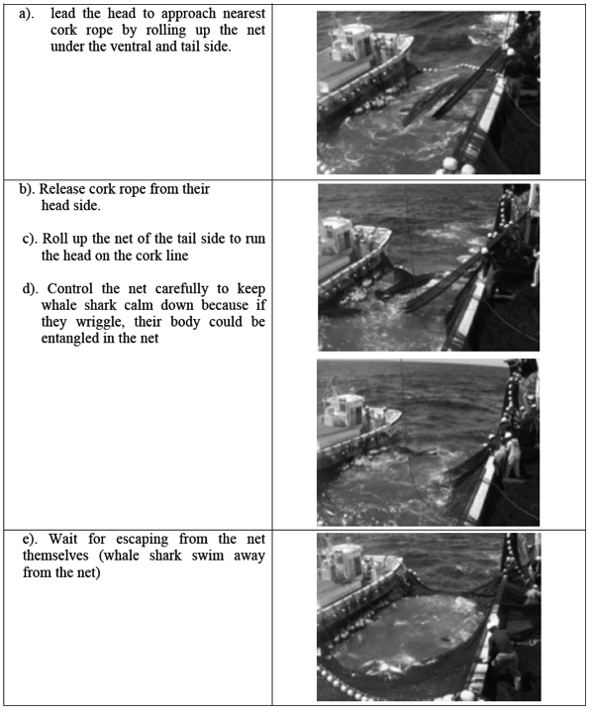

[Appendix 2]
Design and deployment of a release mechanism for mid- to small-sized whale sharks

Attachment J

The Commission for the Conservation and Management of
Highly Migratory Fish Stocks in the Western and Central Pacific Ocean

Scientific Committee
Tenth Regular Session

Majuro, Republic of the Marshall Islands
6–14 August 2014

Development of new guidelines for the survival of sharks (other than whale sharks) to be released from longline and purse seine gear

ISG3 discussed the need to collect information on any available methods for releasing sharks to maximize their survival after interaction with longline and purse seine gear. ISG3 participants were requested to investigate reliable methods for releasing sharks during longline and purse seine operations, and to report on any information at SC11. The following three documents were also presented for information. ISG3 developed a summary table for possible harm minimizing techniques and release techniques to be avoided based on these documents.
- Methods for longline fishers to safely release unwanted sharks and rays. (Draft document provided by Dr. Eric Gilman)
- Good Practices to Reduce the Mortality of Sharks and Rays Caught Incidentally by Tropical Tuna Purse Seiners (Poisson et al. WCPFC-SC8-2012/ EB-IP-12; http://www.wcpfc.int/system/files/EB-IP-12-Good-practices-reduce-mortality-sharks-and-rays-caught-incidentally-tropical-tuna-purse-sei.pdf and Poisson, F., Séret, B., Vernet, A. L., Goujon, M., & Dagorn, L. (2014). Collaborative research: Development of a manual on elasmobranch handling and release best practices in tropical tuna purse-seine fisheries. Marine Policy, 44, 312-320.
- Shark and Ray Handling Practices: A guide for commercial fishers in southern Australia (draft document received from Australia, not for circulation)

The following table summarizes possible harm minimizing techniques and release techniques to be avoided.

Harm minimizing techniques: | Release techniques to be avoided:
- Minimize time spent handling sharks and rays to prevent stress | - Do not attempt to dislodge a deeply hooked hook by de-hooking or pulling on the branch line
- Have a lifting device, bolt cutters, dehooker and line-cutter readily available | - Don’t wrap your fingers, hands or arms in the line when bringing a shark or ray to the boat
- Try lightly flicking the branchline to dislodge the hook | - Don’t lift sharks using the branchline, especially if hooked
- Try to remove the hook using a de-hooker while the shark is still in the water (if sluggish) | - Don’t use a gaff or other pointed object other than in the underside of the jaw
- Use a long-handled line cutter to cut the line as close to the fish as safely possible; remove as much line as possible | - Don’t lift sharks by the head or tail when out of the water, gravity can damage internal organs and the spine;
- Bring small sharks onboard using a dipnet; if gaffing is necessary only gaff in the mouth (underside of jaw) | - Don’t lift or draft them by inserting your fingers into its gills
- Immobilize the shark’s mouth with a small object; insert a hose with flowing water if the shark is on deck more than 5 min; place a dark, wet cloth over its eyes | - Don’t lift or drag a manta ray only by its cephalic lobes or tail or gill slits
- If the hook is visible use a bolt cutter to remove the barb, then remove the hook | - Don’t tie or insert a rope or wire around them to lift or drag them
- Release the shark with both hands (or use two people: one at pectoral fins, one at caudal fin); carry small rays by the spiracles, and large rays by the wings--avoid the tail in all rays | - Don’t restrain them for a long time alongside the vessel (some species can suffocate if they can’t freely move in the water).
- When releasing the shark slow or stop the vessel and gently drop head first, do not throw the shark (if releasing through a belt or chute, ensure the flow of water is strong enough for the shark to reach the sea) | - Don’t use a ‘lazy line’ and tow the shark or ray astern
- Very large sharks and rays can be directly released from a purse seine brailer | - Don’t put a lot of pressure on their body –don’t push or squeeze when carrying and don’t throw, kick or hit
- Remove entangled animals before they reach the net block or de-hooking machines; use clippers to cut the net if necessary. | - Don’t put them on deck where there is direct sun exposure
 | - Don’t bring large sharks or rays on deck.
 | - Don’t bring stingrays on deck
 | - Don’t put them on deck where they could physically contact hard objects, including hard parts of other fish.
 | - Don’t keep them out of the water too long.
 | - Don’t de-hook through forced pulling as this could dislocate the jaw

For the WCPO, a 50% reduction of juvenile catches from the 2002–2004 average level and F no greater than F_{2002–2004}. For the EPO, a 50% reduction of catches from 5,500 t. From the scientific point of view, juvenile catches were not completely represented in the reductions modeled under scenario 6 for some fisheries although these reductions comply with the definition applied by the NC9.
WCPFC: Reduce all catches of juveniles (age-0 to 3 [less than 30 kg]) by at least 15% below the 2002–2004 annual average levels, and maintain the total fishing effort below the 2002–2004 annual average levels. IATTC: Catch limit of 5000 t with an additional 500 t for commercial fisheries for countries with catch history. (1. In the IATTC Convention Area, the commercial catches of bluefin tuna by all the CPCs during 2014 shall not exceed 5,000 metric tons. 2. Notwithstanding paragraph 1, any CPC with a historical record of eastern Pacific bluefin catches may take a commercial catch of up to 500 metric tons of eastern Pacific bluefin tuna annually. (C-13-02), see https://www.iattc.org/PDFFiles2/Resolutions/C-13-02-Pacific-bluefin-tuna.pdf)
Although these measures assume F be kept below F2002–2004, F2009–2011 was higher than F2002–2004.
20% at age 3; 50% at age 4; 100% at age-5 and older.
IATTC Party, cooperating non-Party, fishing entity or regional economic integration organizations are collectively called “CPCs”.
For the WCPO, a 50% reduction of juvenile catches from the 2002–2004 average level and F no greater than F_{2002–2004}. For the eastern Pacific Ocean, a 50% reduction of catches from 5,500 mt.
For the WCPO, a 50% reduction of juvenile catches from the 2002–2004 average level and F no greater than F_{2002–2004}. For the EPO, a 50% reduction of catches from 5,500 t. From the scientific point of view, juvenile catches were not completely represented in the reductions modeled under scenario 6 for some fisheries although these reductions comply with the definition applied by NC9.
WCPFC: Reduce all catches of juveniles (age-0 to 3 (less than 30 kg)) by at least 15% below the 2002–2004 annual average levels, and maintain the total fishing effort below the 2002–2004 annual average levels. IATTC: Catch limit of 5000 t with an additional 500 t for commercial fisheries for countries with catch history. (1. In the IATTC Convention Area, the commercial catches of bluefin tuna by all CPCs during 2014 shall not exceed 5,000 metric tons. 2. Notwithstanding paragraph 1, any CPC with a historical record of eastern Pacific bluefin catches may take a commercial catch of up to 500 mt of eastern Pacific bluefin tuna annually. (C-13-02), see https://www.iattc.org/PDFFiles2/Resolutions/C-13-02-Pacific-bluefin-tuna.pdf)
Although these measures assume F be kept below F2002–2004, F2009–2011 was higher than F2002–2004.
20% at age 3; 50% at age 4; 100% at age-5 and older.
The actual levels of effort that are required in the future to manage the fishery and to achieve a given TRP may differ from 2010 levels (i.e. it is unlikely that future effort can purely be maintained at 2010 levels, due to recruitment variation.
The term shark refers to sharks, skates and rays
Sources of funding for tasks which cannot be funded by the WCPFC can be sought from inter alia the GEF ABNJ Project and other national, international and non-governmental sources.
The term shark refers to sharks, skates and rays

