

SCIENTIFIC COMMITTEE
TENTH REGULAR SESSION

Majuro, Republic of the Marshall Islands
6-14 August 2014

MEETING NOTICE AND INFORMATION
WCPFC-SC10-2014/01 Rev 6
Updated 31 July 2014

In accordance with the Commission Rules of Procedure, the tenth regular session of the Scientific Committee (SC) of the Commission for the Conservation and Management of Highly Migratory Fish stocks in the Western and Central Pacific Ocean (WCPFC-SC10) will be held in Majuro, Republic of the Marshall Islands, 6 (Wed) – 14 (Thu) August 2014. The venue of the meeting will be the RMI Conference Centre, Majuro, Marshall Islands. Heads of Delegation Meeting will be held on Tuesday, 5 August 2014.

The following documents will be posted on the SC10 website on 08 May 2014:
- Provisional agenda for the meeting (WPCFC-SC10-2014/02);
- Provisional annotated agenda for the meeting (WPCFC-SC10-2014/03);
- Indicative schedule for the meeting (WPCFC-SC10-2013/04); and
- Registration form (WPCFC-SC10-2014/05).

SC10 meeting structure

As decided at SC8, SC has four theme sessions only during the plenary (Data and Statistics, Ecosystem and Bycatch, Management Issues, and Stock Assessments). During SC10, two steering committee meetings will be held: Japan Trust Fund and Pacific Tuna Tagging Project. Informal small group meetings may be held in the margins of the plenary.

Registration

CCMs and observers who wish to participate are requested to provide the Secretariat with contact details for official contacts, designated representatives, alternate representatives and advisers by Tuesday, 15 July 2014.

Participants are encouraged to use web registration (See ). In the event the web access is not available, the completed registration form should be submitted to the Secretariat by email (wcpfc@wcpfc.int or fax +691 320 1108). All participants’ registration is requested by Tuesday, 15 July 2014. For those delegations with more than one delegate, we would prefer registrations to be submitted in batches by a key contact for each Member/Observer.

Heads of delegation (HOD) and convenors meeting

Heads of Delegation meeting will be held at Melele Room, Marshall Islands Resort, at 16:00 hours on Tuesday, 5 August 2014, convened by the SC Chair Ludwig Kumoru. All SC officers including theme conveners are expected to attend. The agenda for the HOD meeting will be posted in due course.

Convener’s Meeting with SC Chair will be held at Jakaro Room by the restaurant downstairs, Marshall Islands Resort, at 14:00 hours on Tuesday, 5 August 2014. SC Chair and the Conveners will finalize their theme session arrangements and meeting procedure.

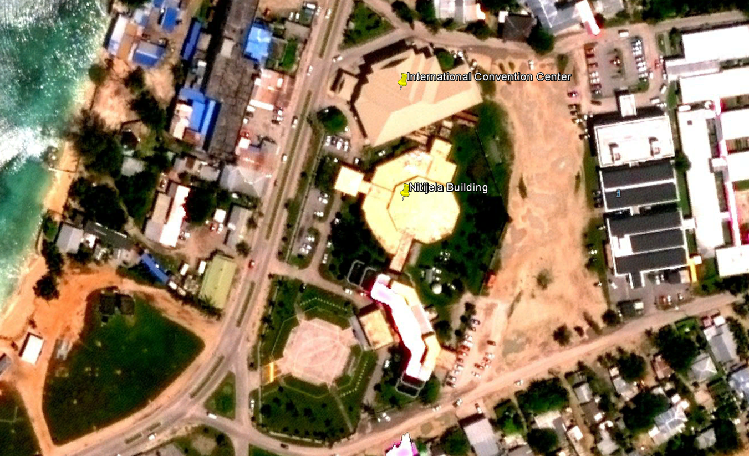

Guidelines for submitting meeting papers

The procedure for submission of papers for SC10, as determined at SC2, is as follows:

Annual Report – Part 1: check changes of Part 1 template

Annual Report to the Commission – Part 1 (available at http://www.wcpfc.int/guidelines-procedures-and-regulations with Addendum) shall be submitted to the WCPFC Secretariat (BOTH tony.beeching@wcpfc.int and contact.ar@wcpfc.int) by Monday, 7 July 2014.

    - Meeting documents

The SC10 participants and researchers who want to submit papers should submit titles and abstracts as early as possible but no later than Wednesday, 02 July 2014 (five weeks in advance of the start of SC10), and full papers by Saturday, 19 July 2014 (18 days in advance of the start of SC10). Author(s) should advise which theme their paper has been prepared for. Please submit titles, abstracts and full papers to:
- SC Chair (Ludwig Kumoru, lkumoru@gmail.com),
- relevant Theme Convenors below, and
- the Secretariat (tony.beeching@wcpfc.int)

Theme | Convener | Email
Data and Statistics | Ludwig Kumoru | lkumoru@gmail.com
Stock Assessment | Jon Brodziak (USA)  Miki Ogura (Japan) | Jon.Brodziak@noaa.gov  ogura@fra.affrc.go.jp
Management Issues | Robert Campbell (Australia) | Robert.Campbell@csiro.au
Ecosystem and Bycatch Mitigation | Aisake Batibasaga (Fiji)  John Annala (NZ) | abatibasaga@gmail.com  John.Annala@mpi.govt.nz

All papers received will be posted on the SC10 website by Wednesday, 23 July 2014 (two weeks in advance of the start of SC10). All participants will be responsible for downloading their papers and printing them out, should that be desired. Limited printing and photocopying services will be available at the meeting venue.

    - Working Paper and Information Paper

The Chair and Theme Conveners will be responsible for accepting or rejecting a paper, and if accepted, directing the Secretariat to post the paper as either a working paper or an information paper.

Working Paper (WP): Papers considered by Theme Conveners and the Chair as a working paper should be directly relevant to a specific agenda item, and will support substantive discussion. Relevant conveners should attach a cover page, assign a unique number and send it to the Secretariat (WCPFC-SC9-2013/EB-WP-XX).

Information Paper (IP): Papers considered by Theme Group Conveners and the Chair as an information paper should be of general interest – a supplementary paper circulated for information only – not requiring presentation in the plenary but may be referred to in discussion. Relevant conveners should attach a cover page, assign a unique number and send it to the Secretariat (WCPFC-SC9-2013/EB-IP-XX)

Funding for Developing Countries and Participating Territories

The Commission will fund the participation (a daily allowance and most direct economical airfare) of one representative from each developing country and participating territory that is a member of the Commission. Formal nominations for participants to receive this support should be submitted to the Secretariat (aaron.nighswander@wcpfc.int) under the signature of their WCPFC Official Contact for qualifying developing countries and participating territories as early as possible.

Considering the 2014 Micro Games in Pohnpei and busy airline schedule in July 2014, your earlier notification, no later than mid-May for airline arrangements, will be much appreciated.

Visa to visit the Republic of the Marshall Islands

Participants transiting through Honolulu or Guam airports, will be require a US transit visa.

Notice from the Republic of the Marshall Islands Immigration:
1. Generally, an application for a visa should consist of the following:
- Completed application form (with two recent passport size photos)
- Passport (valid for at least 6 months)
- Supporting documents:
- Letter from applicant – stating the purpose and duration of visit
- Police record – must be dated within last 3 months
- Health clearance – must show person is free from HIV/AIDS and TB; dated within last 3 months
- Receipt – to show payment of application fee

2. Complete applications and supporting documents should be sent to:
The Director of Immigration
PO Box 890
Majuro, Republic of the Marshall Islands, 96960
Tel: (692) 625-8633 / 4572
Fax: (692) 625-4246
Email: rmiimmig@ntamar.net This email address is being protected from spambots. You need JavaScript enabled to view it.
3. An application with all requested documents may take up to 14 days to process. If an application is incomplete or further supporting documentation is requested, the application may take up to 21 days to process.
(i) PERSONS EXEMPTED FROM VISA REQUIREMENTS

Citizens of the United States, Palau, and FSM. Also Diplomats, Members of International Organizations are granted exemption from entry procedures by the Republic (under the International Organizations Act), Member of a visiting force, including civilian component, member of the crew or passenger on any cruise ship or private vessel that will remain in the Republic for less than 7 days, member of the crew of any commercial aircraft that will remain in the Republic for less than 14 days, member of the official staff or household of a Diplomat, spouse or dependent child of any exempted person referred to the above.
These citizens may enter the Republic and remain in the Republic for the duration of time indicated on their visa issued upon arrival. A person may apply for an extension of a visa. The documents required will depend on the type of visa that the person is applying for.

(ii) CITIZENS WHO ARE ELIGIBLE TO BE ISSUED WITH VISITORS VISAS UPON ARRIVAL:

Citizens of the Pacific Islands Forum countries, including Australia and New Zealand, Canada, European Union (includes United Kingdom), South Korea, Japan, Taiwan, and the Philippines who intend to visit the Republic (as tourists) may be issued with visitors visas UPON ARRIVAL in the Republic however, are not exempted from applying and providing Immigration with required documents to support their visa application and pay necessary processing fees.
A tourist visa is only valid for 30 days. However, a person may apply for an extension of a visitor’s visa upon application to the Director of the Immigration Division. An extension of a visitor’s visa may only be for a further 60 days with a fee of $10.00 USD.

(iii) CITIZENS WHO MUST APPLY FOR VISAS PRIOR TO ARRIVAL:

Citizens from ALL OTHER countries not listed in B (i) or B (ii) above must apply for visa PRIOR TO traveling to the Republic. Visitors Visa (V-1) requires a non-refundable application processing fee of $100.00 USD. The Business Visa (B-1) is for individuals with approved FIBL (Foreign Investment Business License) and requires a non-refundable application processing fee of $300.00 USD.
All visitors must have a passport valid for at least six months, must have sufficient funds for stay, and have an onward/return air or sea ticket. A departure fee of $20.00 U.S. is required.

Source: www.visitmarshallislands.com

Airlines and airport Transfers

United Airlines fly via Guam or Honolulu every other day to the Republic of the Marshall Islands (Guam-Chuuk-Pohnpei-Kosrae-Kwajalein-Majuro-Honolulu) and Our Airline via Nadi or Tarawa every other week (Brisbane, Nauru, Majuro, Nadi, and other week is Brisbane, Nauru, Tarawa, Majuro – see the attached schedule below). Because of the 8th Micro Games in Pohnpei, 19-29 July 2014, and very many people are traveling to and from Pohnpei, your early reservation and ticketing is highly recommended. Please refer to the United Airlines website for more details. Attach is also a flight schedule for our airline for your ease of reference or you may email Our Airline Agent in Majuro at putrmi@ntamar.net.

Transport from the Majuro Airport to the hotels in Majuro is available by hotel airport transport. Please contact your hotels for transportation arrangement.

Currency in the Republic of the Marshall Islands

The currency used in the Republic of the Marshall Islands is in U.S. dollar. There are two ATM cash machines available in Majuro. One is located downstairs from RRE Hotel and other one is located outside of Bank of Guam.

Majuro, Republic of the Marshall Islands

Background information on the Republic of the Marshall Islands is available at the Marshall Islands Visitors Authority websites: www.visitmarshallislands.com.

Accommodation

Available accommodation is listed in Table 1 below. Those participants needing accommodation should book directly with the hotel of their choice as soon as possible. All rates noted below are tax inclusive. Some alternative accommodation options may also be available.

Please note that Long Island Hotel closed its door for business last Saturday 31 May. At the time of this revision (2nd June 2014), there are still rooms available at Marshall Islands Resort (MIR) block booked to MIMRA. SC10 participants should include MIMRA or SC10 in the subject line and message when making reservations.

Table 1. Accommodation in the Republic of the Marshall Islands
Hotel | Room Rates  (tax included) | Amenities | No. of Rooms
HOTEL ROBERT REIMERS  Ph: (692)625-3250 ext 391  Fax: (692)625-3783  Website:  www.hotelrobertreimers.com  Hotel Manager:  Mrs. Colette Reimer  Email: colettereimers@gmail.com  Accepting VISA,MC,AMEX & DINERS | Bungalow:  Suite: Single-$250/Double-$265  Standard: Single-$135/Double-$145  Lanai Room:  Single-$100/Double-$115  Economy Rooms(Ground Level):  Single-$89/Double-$99  *Special rate if include car rental*  Single-$79/Double-$89  Inside Economy (Upstairs):  Single-$89/Double-$99  *Special rate if include car rental*  Single-$79/Double-$89 | All rooms are air-conditioned, Cable TV, and has small refrigerator. | 8 Standard Bungalows(2 has queen beds)  3 Suite Bungalow  10 Economy  Ground Level  1 Suite  Located upstairs  10 Lanai Located upstairs
MARSHALL ISLANDS RESORT  Ph: (692)625-6871/6878  Fax: (692)625-2500  Website:  www.marshallislandsresort.com  Email: mirrooms@ntamar.net | Suite Rooms-$250per night  Two rooms with a connecting door in between  Single Bed-$90 per night  Double Bed-$105 per night | All rooms are equip with air-conditioned; Cable TV, shower/tub; small refrigerator; long distance phone service; laundry service; Internet Service; restaurant room service; swimming pool, Beachfront barbeque area; Fitness Center and Complimentary Shuttle to and from Airport. | 150 Standard lagoon view  1 Suite  6 Junior Suite
Pacific International Inc.  Ph: (692)625-3122  Fax: (692)625-3348  Website:  www.piimajuro.com  Email:  Lorraine Kramer - lkramer@piimajuro.com | Lojkar Hotel - $250 per night  Airport Hotel - $150 per night | 2 bedrooms, bath, living/dining, kitchen, wifi hotspot  1 bedroom, bath, living/dining, kitchen. | 8 rooms  9 rooms

