NORTHERN COMMITTEE
NINTH REGULAR SESSION

2-5 September 2013
Fukuoka, Japan

[Draft] Executive Summary of SC9 Summary Report
WCPFC-NC9-2013/IP-02

Secretariat

The Commission for the Conservation and Management of Highly Migratory Fish Stocks in the Western and Central Pacific Ocean

Scientific Committee
Ninth Regular Session

Pohnpei, Federated States of Micronesia
6–14 August 2013

EXECUTIVE SUMMARY

AGENDA ITEM 1 – Opening of the Meeting

- The Ninth Regular Session of the Scientific Committee (SC9) was held in Pohnpei, Federated States of Micronesia from 6–14 August 2013. L. Kumoru chaired the meeting.

AGENDA ITEM 2 – Review of WCPO Fisheries

- The provisional total western and central Pacific Convention area (WCP–CA) tuna catch for 2012 was estimated at 2,613,528 mt, the highest on record, eclipsing the previous record in 2009 (2,603,346 mt) by 12,000 mt; this catch represents 82% of the total Pacific Ocean catch of 3,205,980 mt, and 59% of the global tuna catch (the provisional estimate for 2012 is 4,456,605 mt, which was the second highest on record).

- The 2012 WCP–CA catch of skipjack (1,664,309 mt – 64% of the total catch) was the third highest recorded and around 110,000 mt less than the record catch of 2009 (1,775,462 mt). The WCP–CA yellowfin catch for 2012 (655,668 mt – 25%) was a clear record and more than 70,000 mt higher than the previous record catch taken in 2008 (581,948 mt) primarily due to relatively high catches in the purse seine fishery and the artisanal fisheries in Indonesia. The WCP–CA bigeye catch for 2012 (161,679 mt – 6%) was the highest since 2004, the record catch year at 183,355 mt. The 2012 WCP–CA albacore catch (131,872 mt - 5%) was the second highest on record (after 2009 at 135,476 mt), and relatively stable compared to the previous three years. The 2012 WCP–CA albacore catch includes catches of north and south Pacific albacore in the WCP–CA, which comprised 78% of the total Pacific Ocean albacore catch of 168,537 mt in 2012. The south Pacific albacore catch in 2012 was 87,012 mt, the second highest on record. (Figure 1).
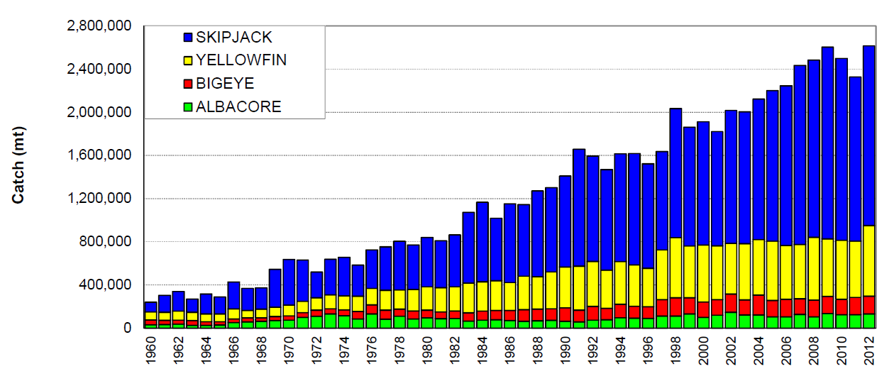
Figure 1: Catch (mt) of albacore, bigeye, skipjack and yellowfin in the Convention Area.

- The provisional 2012 purse-seine catch of 1,816,503 mt was the highest catch on record and more than 30,000 mt higher than the previous record in 2009 (1,785,626 mt) (Figure 2). The number of purse seine vessels in the tropical fishery was an all-time high (294 vessels) and effort (both in terms of days fishing and number of sets) was the second highest (to that expended in the fishery during 2011). The 2012 pole-and-line catch (224,207 mt) was the lowest annual catch since the late-1960s and continuing the trend in declining catches for three decades. The Japanese distant-water and offshore fleets (78,838 mt in 2012), and the Indonesian fleets (133,306 mt in 2012), account for most of the WCP–CA pole-and-line catch. The provisional WCP–CA longline catch (262,076 mt) for 2012 was the fifth highest on record, at around 15,000 mt lower than the highest on record attained in 2009 (279,012 mt). The 2012 South Pacific troll albacore catch (2,925 mt) was similar to the 2011 catch level, mostly by the New Zealand troll fleet (168 vessels catching 2,727) and the United States troll fleet (9 vessels catching 198 mt).

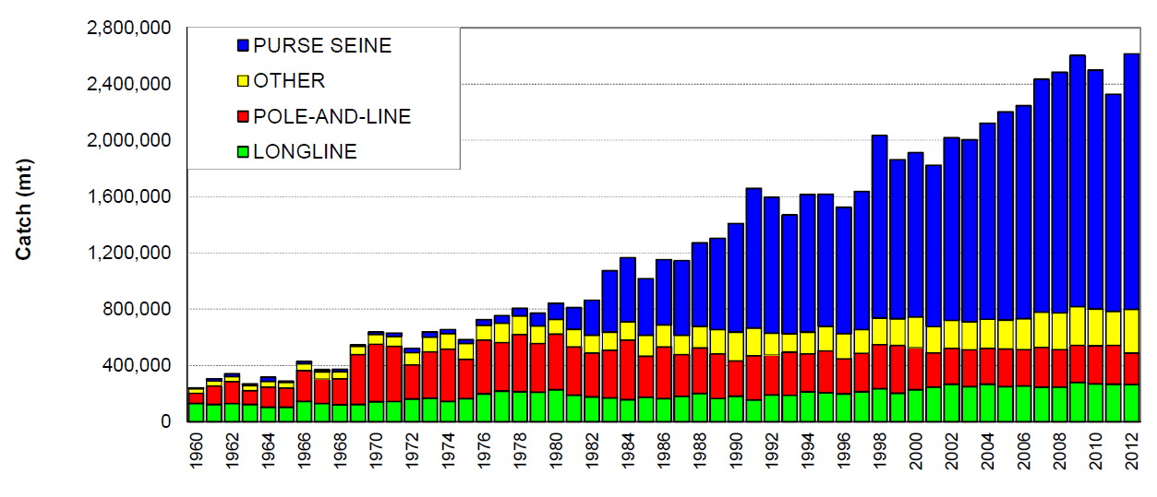
Figure 2: Catch (mt) of albacore, bigeye, skipjack and yellowfin in the Convention Area, by longline, pole-and-line, purse seine and other gear types.

AGENDA ITEM 3 Data and Statistics Theme

  - Data gaps

Data gaps of the Commission

- SPC reported on the major developments over the past year with regard to filling gaps in the provision of scientific data to the Commission (SC9-ST-WP-01).

- SC9 recommended that:
- The paper SC9-ST-WP-01 be forwarded to TCC9, recommending specific action in regards to each of the following important data gap issues:
- The CCMs that have yet to provide operational level catch and effort data should provide, as soon as possible:
  - Annual catch estimates by gear and species for waters of national jurisdiction and high seas areas separately, as per the Scientific Data to be Provided to the Commission;
  - The number of vessels for each spatial unit in their aggregate data provisions, as per the Scientific Data to be Provided to the Commission;
  - Operational data improvement plans, as agreed in WCPFC7.
- The need for improvement in the submission of annual catch estimates for the key shark species and the reporting of discard estimates.

- TCC9 should consider alternative measures for collecting operational data such as increases in the observer coverage for fleets of CCMs for which the Commission holds little or no operational level data.
- The Commission note the advice set out in Para. 34 of SC9-ST-WP-01 on the implications for the Commission’s science programme of the failure to provide operational data that was requested by WCPFC9.
- The WCPFC Secretariat formally contact each of the CCMs identified as (i) not providing operational data and/or (ii) not providing the number of vessels for each spatial unit in their aggregate data, and request the following:
  - That they provide these data to the Commission in order to meet their obligations of Scientific Data to be Provided to the Commission;
  - That information is provided on what constraints hinder their ability to provide operational data to the Commission, and actions being taken to address this issue
  - That the CCMs confirm whether their aggregate data, as provided, can be included into the WCPFC public domain data.
- A summary of ‘other’ gear catches of the tropical tuna species (Table 1 in SC9-ST-WP-01) should be forwarded to TCC9 for their consideration in relation to paragraph 29 of CMM 2012-01 with a modification to the Table to reflect the exclusion of those fisheries that take less than 2000 tonnes of bigeye, yellowfin and skipjack, as identified in paragraph 30 of the measure.
- As proposed in SC9-ST WP-06, stock assessments to be undertaken and presented for SC10 use catch and effort data up to and including 2012 data only, but that the projections use data up to and including 2013.

Species composition of purse-seine catches

- SPC presented working papers SC9-ST-WP-02 and SC9-ST-WP-03 on results of the Project 60 to improve the collection and representative nature of species composition data caught by purse-seine fisheries in the WCPO in order to improve the stock assessments of key target species in the WCPO.

- SC9 recommended that:
- The SC9 recommended that the Scientific Services Provider continue with the analyses and simulations related to the consultancy reports on species composition in the purse seine fishery. SC9 requests that the Scientific Services Provider provide to SC10 annual estimates of purse seine catch based on: a) logbook reported species composition, b) observer grab samples (previous approach), and c) observer grab samples corrected for selectivity bias from spill sampling. Catch series from any variants on these should also be included. This will allow the SC to follow changes in purse seine catch estimates from historical methods. The work should also include any guidance on the implications of future estimates if only grab sampling occurs, e.g., can the selectivity bias correction be used into the future.
- The Science Service Provider update the “Plan for Improvement of the Availability and Use of Purse-Seine Catch Composition Data” (presented to TCC8) according to the recent work described in SC9-ST-WP-02, highlighting (i) there are no budget implications for the WCPFC for work in 2014 and (ii) consider the following specific work areas identified at SC9:
- Complete the analyses comparing different sources of data collected at Noro, Solomon Islands (SPC);
- Undertake a comparison of Japan unloading data with observer data (Japan and SPC);
- Undertake a comparison of port sampling data collected in PNG with observer data (PNG/NFA and SPC);
- Continue the simulation modeling to assess the effectiveness of different approaches to addressing biases in the estimates of catch composition (SPC);
- Evaluate the scope for the use pooled observer data, and the possible scope for super-sampling to address layering in brails (SPC and observer providers).

3.2 Regional Observer Programme (ROP)

- SC9 recommended that:
      - The WCPFC Secretariat and science services provider prepare guidelines for review by TCC9 to develop a clear indication of the coverage level required for each CCM fishery, especially with regard to fishery sectors (e.g. distant waters, offshore, coastal longline fisheries), to satisfy the required level of WCFPC longline observer coverage (5%).
      - TCC9 endorse the indicative budget for ROP data management which now includes the positions of observer data manager, observer data audit officer in addition to the ROP data entry positions.

Review of FAD data fields

- SC9 agreed that the following recommendations be forwarded to the TCC9 for further consideration:
- The WCPFC Minimum Standard Data Fields on FADs collected by observers are adequate and no deletions were required;
- An observer should try and estimate or measure where possible, the size of mesh used in the construction of the FAD, or any extension hanging under the FAD. It was pointed out that this may be difficult to estimate if the FAD is in the water, but an estimate of size could be measured if the FAD was on deck or was retrieved by the vessel for servicing;
- Developing a WCPFC “Vessel FAD Data Reporting Log” to be submitted by “Purse-seine” and “Tender Vessels” was worthwhile. However it was noted that the development of a reporting log on FADs by vessels or reporting format may be facilitated by the development of electronic reporting protocols;
- When developing a “Vessel FAD Data Reporting Log” a number of fields were identified that should be included in the Log, such as the type and design of the FAD with highlighted identification marks; whether the FAD deployed was drifting or anchored; if the FAD had Electronics associated with it when deployed; and condition of FAD when retrieved;
- There should be no prioritizing of the data entry from Observer FAD Data Forms when received, and the observer FAD data should be entered along with the rest of the observer information collected during their trip. The data collected in other observer forms are required to help explain some of the information collected on the Observer FAD data forms.

AGENDA ITEM 4 – STOCK ASSESSMENT Theme

4.1 WCPO Tunas

4.1.1 WCPO bigeye tuna

- SPC presented SC9-SA-WP-08 (Improvement of stock assessments in line with recommendations from the Peer Review for the 2011 bigeye tuna stock assessment), SC9-SA-WP-01 (Bigeye tuna age and reproductive biology progress report) and SC9-SA-WP-06 (Indicator analysis for key tuna species) as requested by the Commission.

- Most CCMs noted that in order for SPC to complete the enhancements in time for the bigeye stock assessment scheduled for next year, it is critically important for the Scientific Committee to provide support in the following key areas:
- encourage Japan to work closely with SPC on ensuring that the work already jointly undertaken in analysing the Japanese operational longline data is completed well in advance of the stock assessment for SC10.
- in the event that the above work is not completed as planned, enable SPC to convene a workshop in late 2013 or very early 2014 to analyse all available operational catch and effort data for longline vessels;
- ensure the 2014 Pre-Assessment Workshop play a significant part in providing feedback on new modelling approaches and data inputs; and
- given the delay in the submission of required data for next year’s stock assessment by CCMs, allow SPC to use data through the end of 2012 for the 2014 bigeye assessment and only including the 2013 data later in the year (when it is more complete) for projection analyses.

Status and trends

- SC9 noted that no stock assessment was conducted for WCPO bigeye tuna in 2013. Therefore, the stock status description and management recommendations from SC8 are still current.

Management advice and implications

- SC9 noted that no stock assessment and management advice was provided since SC8. Therefore the advice from SC8 should be maintained pending a new assessment or other new information.

- SC noted that the total catch of bigeye in 2012 was 161,679mt which was a 2% increase over 2011 and 7% increase over the average of 2007‐2011.

4.1.2 WCPO yellowfin tuna

Status and trends

- SC9 noted that no stock assessment was conducted for WCPO yellowfin tuna in 2013. Therefore, the stock status description and management recommendations from SC8 are still current.

Management advice and implications

- SC9 noted that no stock assessment and management advice was provided since SC8. Therefore the advice from SC8 should be maintained pending a new assessment or other new information.

- The SC noted that the total yellowfin catch in 2012 was 655,668t which was a significant (26%) increase over 2011 and a 22% increase over 2007‐11.

    - WCPO skipjack tuna

Status and trends

- SC9 noted that no stock assessment was conducted for WCPO skipjack tuna in 2013. Therefore, the stock status description and management recommendations from SC8 are still current

Management advice and implications

- SC9 noted that no stock assessment and management advice was provided since SC8. Therefore the advice from SC8 should be maintained pending a new assessment or other new information.

- The SC noted that the total skipjack catch in 2012 was 1,664,309mt which was a significant (9%) increase over 2011 but the same as the average over 2007‐11.

    - South Pacific Albacore Tuna

Status and trends

- SC9 noted that no stock assessment was conducted for South Pacific albacore tuna in 2013. Therefore, the stock status description and management recommendations from SC8 are still current.

Management advice and implications

- SC9 noted that no stock assessment and management advice was provided since SC8.

- Total south Pacific catch in 2012 was 89,258t which was 5% increase over 2011 and a 7% increase over the average of 2007‐2011.

- It should be emphasized that increasing catch and effort on SP albacore has occurred from 2009 to 2012 which is a concern. The current CMM 2010-05 appears not to be effective in constraining effort in the subtropics (south of 20⁰S). Given the recent expansion of the fishery and recent declines in exploitable biomass available to longline fisheries in Small Island Developing States and Territories, and the importance of maintaining catch rates, particularly for the domestic fleets that are highly dependent on this resource, SC9 recommends that longline fishing mortality and longline catch be reduced if the Commission wishes to maintain economically viable catch rates.

4.2. Northern stocks

4.2.1 North Pacific albacore tuna

Status and trends

- SC9 noted that no stock assessment was conducted for North Pacific albacore in 2013. Therefore, the stock status description and management recommendations from SC8 are still current.

Management advice and implications

- SC9 noted that no stock assessment and management advice was provided since SC8. Therefore the advice from SC8 should be maintained pending a new assessment or other new information.

4.2.2 Pacific Bluefin tuna

- ISC scientist presented the 2012 Pacific bluefin tuna stock assessment conducted by ISC (SC9-SA-WP-10) and information available after the 2012 stock assessment.

Status and trends

- SC9 noted that the ISC PBTWG provided the following conclusions on the stock status of North Pacific bluefin tuna:
Based on the reference point ratios, overfishing is occurring and the stock is heavily overfished. Model estimates of 2010 SSB are at or near their lowest level and SSB has been declining for over a decade; however, the 2012 stock assessment, which used data through the first half of 2011, did not find evidence of reduced recruitment. Recently implemented WCPFC (CMM 2010-04, entered into force in 2011) and IATTC (Resolution C-12-09, entered into force in 2012) conservation and management measures, combined with additional Japanese voluntary domestic regulations aimed at reducing mortality , if properly implemented and enforced, are expected to contribute to the recovery of the stock assuming historical average recruitment conditions.
Fishery impact analysis suggests that historically, the Japan coastal fishery group has had the greatest impact (i.e., expected spawning stock biomass) on the Pacific bluefin tuna stock, but since about 1999 the impact of the WPO purse seine fleet has increased, and the effect of this fleet is currently greater than any of the other fishery groups. The impact of the EPO fishery was large before the mid-1980s, but decreased after the 1990s. The WPO longline fleet has had a limited effect on the stock throughout the analysis period.
Based on newly available fishery data, concerns about stock status were reinforced. The potential risk of decline of the spawning stock may be higher than previously thought. When recruitment is low, the risk of SSB falling below the historically lowest SSB level will increase under F 2007-2009 harvesting conditions while the risk under F 2002-2004 conditions will remain small in the long term, although some short-term risk remains.

Management advice and implications

- SC9 noted the following conservation advice from the ISC:
The current (2010) Pacific bluefin tuna biomass level is near historically low levels and experiencing high exploitation rates above all biological reference points (BRPs) commonly used by fisheries managers. Based on projection results, extending the status quo (2007-2009) fishing levels is unlikely to improve stock status. Continued monitoring of abundance indices is recommended to track SSB.
Preliminary WPO data indicate an unusually low catch of age-0 Pacific bluefin tuna in 2012; this may imply low recruitment, which would adversely affect projected stock rebuilding and increase the risk of SSB falling below its historical lowest level observed. Further reduction of fishing mortality, especially for juvenile fish, is needed to reduce the risk of SSB falling below its historically lowest level.
Strengthening the monitoring of recruitment is highly recommended to comprehend the trend of recruitment in a timely manner.

- SC9 could not reach consensus on management advice to the Commission. In lieu of this the following two statements are provided:

Majority View:
Noting the current very low level of spawning biomass (4% B₀), which is far below the common reference levels, and the low levels of recruitment observed in 2012, SC9 recommends that the fishing mortality on Pacific bluefin tuna be urgently reduced, especially on juveniles, in order to reduce the risk of recruitment collapse and allow the spawning stock to rebuild. The SC9 recommends that candidate limit and target reference points be advanced for Pacific bluefin tuna that are consistent with the Commission’s adopted or default reference points.

Minority View:
SC9 endorses the Conservation Advice put forward by ISC13 calling for further reductions in fishing mortality, especially for juvenile fish, to reduce the risk of further declines in SSB and strengthening the monitoring of recruitment to comprehend the trend of recruitment in a timely manner.

4.2.3 North Pacific swordfish

Status and trends

- SC9 noted that no stock assessment was conducted for North Pacific swordfish in 2013. Therefore, the stock status description and management recommendations from SC6 are still current. The SC noted that stock projections based on WCNPO swordfish catch through 2012 indicate that the stock is currently not likely to be overfished and is not likely to be experiencing overfishing.

Management advice and implications

- SC9 noted that no stock assessment and management advice was provided since SC6. Therefore the advice from SC6 should be maintained pending a new assessment or other new information.

4.3 WCPO sharks

4.3.1 Oceanic Whitetip shark

Status and trends

- SC9 noted that no stock assessment was conducted for WCPO Oceanic whitetip shark in 2013. Therefore, the stock status description and management recommendations from SC8 are still current.

Management advice and implications

- SC9 noted that no stock assessment and management advice was provided since SC8. Therefore the advice from SC8 should be maintained pending a new assessment or other new information.

4.3.2 Silky shark

- SPC presented SC9-SA-WP-03 (Updated stock assessment of silky sharks in the western and central Pacific Ocean).

Status and trends

- Silky shark is a low productivity species and this low productivity is reflected in the low estimated value for F_{MSY} (F_{MSY}=0.08) and high estimated value for SB_{MSY}/SB₀=0.39. These directly impact on conclusions about overfishing and the overfished status of the stock. Estimated fishing mortality has increased to levels far in excess of F_{MSY} (F_{Current}/F_{MSY} = 4.32) and across nearly all plausible model runs undertaken estimated F values were much higher than F_{MSY} (the 5th and 95th quantiles are 2.49 and 7.45). Based on these results SC9 concluded that overfishing is occurring. Estimated spawning biomass has declined to levels below SB_{MSY} (SB_{Current}/SB_{MSY}= 0.72) and for the majority of the model runs undertaken, SB_{Current} is less than SB_{MSY} (the 5th and 95th quantiles are 0.51 and 1.02). Based on the distribution of the relative current spawning biomass SC9 conclude that it is highly likely that the stock is in an overfished state.

Management advice and implications

- Current catches are higher than the MSY (7,123 mt versus MSY=2,937 mt), further catch at current levels of fishing mortality would continue to deplete the stock below SB_{MSY}. Current (2005-2008 average) and latest (2009) catches are significantly greater than the forecast catch in 2010 under F_{MSY} conditions (approximately 600 mt).

- The greatest impact on the stock is attributed to bycatch from the longline fishery in the tropical and subtropical areas, but there are also significant impacts from the associated purse seine fishery which catches predominantly juvenile sharks. The Commission should consider measures directed at bycatch mitigation as well as measures directed at targeted catch, such as from shark lines (Attachment F), to improve the status of the silky shark population. Existing observer data may provide some information on which measures would be the most effective.

4.3.3. South Pacific Blue Shark

- SPC presented SC9-SA-WP-04 (Potential catch and CPUE series to support a stock assessment of Blue Shark in the South Pacific Ocean) responding to the Pre-Assessment Workshop recommendation regarding blue shark data.

Status and trends

- SC9 noted that no stock assessment was conducted for South Pacific blue shark in 2013.

Management advice and implications

- In lieu of there being no stock assessment for this species, SC9 is unable to provide management advice on this stock.

4.3.4. North Pacific Blue Shark

- ISC and SPC presented SC9-SA-WP-11 and SC9-SA-WP-02 for the NP blue shark stock assessment using a Bayesian Production Modeling platform by ISC and Stock Synthesis 3 Modeling platform by SPC and IATTC.

Status and trends

- SC9 noted that two stock assessments for North Pacific blue shark were undertaken by the ISC using different modeling frameworks. The conclusions and resulting stock status and management advice depend heavily on the CPUE series assumed to describe stock abundance.

- Based on the CPUE series selected by the ISC SHARKWG for inclusion in the base case models, both assessment models predict that biomass is increasing and fishing mortality decreasing in recent years. The models show similar trajectories but differ in terms of their estimated status with respect to B_{MSY}: one model estimated that the stock has been overfished since 1970s, but is rebuilding; the other estimated that biomass has been greater than B_{MSY} since the 1990s. However, using an alternative CPUE series for sensitivity run, both modeling frameworks estimated the stock to be in an overfished state with overfishing occurring.

Management advice and implications

- SC9 could not reach consensus on which CPUE series best reflected changes in the relative abundance and therefore recommends that a revised assessment be presented to SC10.

- In the interim, SC9 recommends that the Commission consider this uncertainty and adopt a precautionary approach when considering any potential management measures for blue shark in the North Pacific Ocean.

4.4 WCPO Billfishes

4.4.1 South Pacific Swordfish

- SPC presented the 2013 stock assessment for swordfish (Xiphias gladius) in the Southwest Pacific (SC9-SA-WP-05).

- Noting the inconsistencies in the Australian and Hawaii growth schedules, the SC9 recommended that additional work on age, growth and age validation be undertaken.

Status and trends

- The South Pacific swordfish assessment was highly sensitive to growth assumptions. Two different growth models, one from Australia (GA) and the other from Hawaii (GH), were included in alternative model runs. The Scientific Committee could not decide which of these two assumptions was more reliable. Assessment runs using the GA growth data indicated that overfishing was occurring but that the stock was not in an overfished state. Assessment runs using the GH growth data indicate that no overfishing is occurring and that the stock is not in an overfished state.

- Although the median of the uncertainty grid indicates that overfishing (F_{current}/F_{MSY} = 0.74) was not occurring those sensitivity runs that used the GA growth and maturity schedule indicate that overfishing may be occurring (grid range 5th–95th percentiles: 0.51-2.02). Recent preliminary findings from tagging data indicate that this alternative growth schedule (GA) warrants further consideration. Estimates of stock status are highly uncertain with respect to this assumption. The equivalent grid range of F_{current}/F_{MSY} for the Hawaii schedule (GH) is 0.25 – 0.97. Across the uncertainty grid of 378 runs, where the Hawaii schedule was assumed, the probability of F_{current}/F_{MSY} being greater than 1.0 was less than 3%, while when the slower Australian schedule was assumed, 54% of runs estimated the stock to be experiencing overfishing (Table SWO2, Figure SWO4).

Table SWO2. Estimates of management quantities from the median of the selected uncertainty grid (excluding runs with the NZ CPUE time series), from the 2013 stock assessment. For the purpose of this assessment, “current” is the average over the period 2007–2010 and “latest” is 2011.
 | Median of the selected grid runs | Range
 |  | 5%ile | 95%ile
C_{current} | 10,456 | 10,041 | 11,368
C_{latest} | 10,020 | 9,636 | 10,549
MSY | 8,175 | 5,100 | 14,006
C_{current}/MSY | 1.29 | 0.74 | 2.11
C_{lastest}/MSY | 1.23 | 0.72 | 1.99
F_{mult} | 1.36 | 0.56 | 3.39
F_{current}/F_{MSY} | 0.74 | 0.30 | 1.77
SB₀ | 90,535 | 70,849 | 122,190
SB_{MSY}/SB₀ | 0.23 | 0.12 | 0.30
SB_{current}/ SB₀ | 0.47 | 0.32 | 0.59
SB_{current}/SB_{MSY} | 2.07 | 1.18 | 4.50
SB_{latest}/SB_{MSY} | 1.70 | 0.89 | 3.75
SB_{curr}/SB_{currF=0} | 0.49 | 0.32 | 0.60
SB_{latest}/SB_{latestF=0} | 0.43 | 0.23 | 0.56

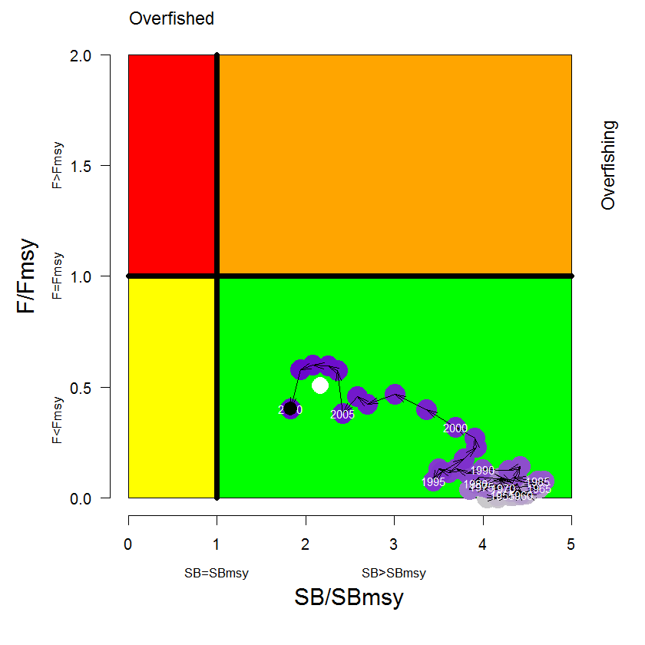
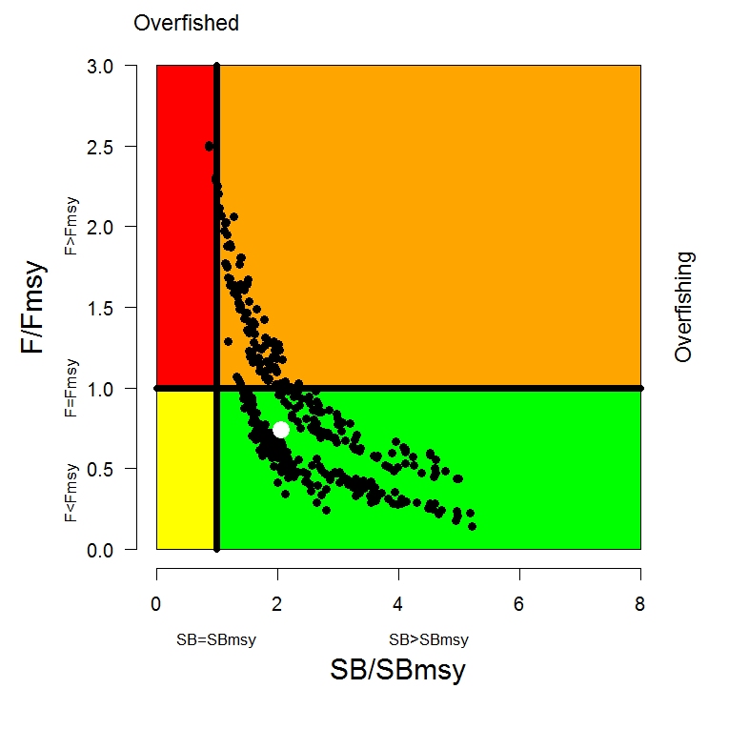
Figure SWO4: Temporal trend in annual stock status, relative to SB_{MSY} (x-axis) and F_{MSY} (y-axis) reference points for the Ref.case (top); and F_{current}/F_{MSY} and SB_{current}/SB_{MSY} for the median of the selected uncertainty grid (white circle) and the individual uncertainty grid runs (excluding runs where the New Zealand CPUE series was used; bottom).

Management advice and implications

- SC9 recommends that given the current uncertainty in the assessment that the Commission adopt a precautionary approach when considering future management arrangements. Given this, SC9 recommends that there be no increase in fishing mortality over current (2007-2010) levels.

- Noting that recent catches between the equator and 20⁰S now represent the largest component of the catch in Region 2 (equator to 50⁰S, 165⁰E to 130⁰W), SC9 recommends that the Commission consider developing appropriate management measures for this Region which is not covered by CMM 2009-03.

4.4.2. Southwest Pacific Striped Marlin

Status and trends

- SC9 noted that no stock assessment was conducted for Southwest Pacific striped marlin in 2013. Therefore, the stock status description and management recommendations from SC8 are still current.

Management advice and implications

- SC9 noted that no stock assessment and management advice was provided since SC8. Therefore the advice from SC8 should be maintained pending a new assessment or other new information.

4.4.3. North Pacific Striped Marlin

Status and trends

- SC9 noted that no stock assessment was conducted for North Pacific striped marlin in 2013. Therefore, the stock status description and management recommendations from SC8 are still current.

Management advice and implications

- SC9 noted that no stock assessment and management advice was provided since SC8. Therefore the advice from SC8 should be maintained pending a new assessment or other new information.

4.4.4. Pacific blue marlin

- ISC scientist presented the stock assessment of Pacific blue marlin to SC9 (SC9-SA-WP-09: Report of the billfish working group workshop – Assessment of the Pacific blue marlin stock in 2013).

Status and trends

- Based on the finding of the ISC blue marlin stock assessment, the following information on stock status and trends is provided
- Estimates of total stock biomass show a long term decline.
- Current fishing mortality on the stock (average F, ages 2 and older) averaged F = 0.26 during 2009-2011 and was below F_{MSY}. (F_{MSY} (age 2+)=0.32)
- The predicted value of the spawning potential ratio (SPR, the predicted spawning output at current F as a fraction of unfished spawning output) is currently SPR₂₀₀₉₋₂₀₁₁ = 23%.
- The overall trends in spawning stock biomass and recruitment indicate a long-term decline in spawning stock biomass and suggest a fluctuating pattern without trend for recruitment.
- Pacific blue marlin spawning stock biomass decreased to the MSY level in the mid-2000’s, and since then has increased slightly.
- The base case assessment model indicates that the Pacific blue marlin stock is currently not overfished and is not subject to overfishing relative to MSY-based reference points.

Management advice and implications

- SC9 noted ISC’s conservation advice for the Commission’s consideration as follows:
Based on the results of the stock assessment, the stock is not currently overfished and is not experiencing overfishing. The stock is nearly fully exploited. Stock biomass has declined since the 1970’s and has been stable since the mid- 2000’s with a slight recent increase. The fishing mortality rate should not be increased from the 2009-2011 level to avoid overfishing.

AGENDA ITEM 5 – MANAGEMENT ISSUES THEME

  - Limit reference points (LRPs)

- SPC presented SC9-MI-WP-02 (Determination of appropriate time-windows for calculation of depletion-based limit reference points) and SC9-MI-WP-03(Proposed F-based limit reference points for bigeye, yellowfin and south Pacific albacore tuna) which responded to SC8 requests.

- SC9 noted the hierarchical approach and the associated key limit reference points (LRPs) for the key target species in the WCPFC adopted by the Commission and the request made by WCPFC9 for SC9 to identify i) the appropriate time-window (t₁-t₂) for estimating the average unfished biomass in the LRP 20%SB_{F=0,t1-t2}, and ii) the appropriate values of X for each species in the LRP F_{X%SPR0}.

- SC9 noted the work described in working paper SC9-MI-WP-02 and recommends that the time-window to be used in the LRP 20%SB_{F=0,t1-t2} satisfy the following criteria:
  - have a length of 10 years,
  - be based on the years t1=y_{last}-10 to t2=y_{last}-1 where y_{last} is the last year used in the assessment, and
  - the approach used for calculating the unfished biomass levels be based on scaled estimates of recruitment according to the stock recruitment relationship.

- SC9 also recommends that the selection of this time-window be subject to periodic review to ensure this approach is appropriately representing future conditions for the individual stocks.

- SC9 noted the work described in working paper SC9-MI-WP-03 and recommends that the identification of the appropriate values of X for each species in the LRP F_{X%SPR0} be based on an iterative search to ‘match’ the F_{X%SPR0} with 20%SB_{F=0,t1-t2} as described in this working paper.

- SC9 also noted that working paper SC9-MI-WP-03 had considered two levels of risk (5% and 10%) associated with breaching the LRP. Further noting that the identification of acceptable risk is a management issue, SC9 recommends that WCPFC10 make an undertaking to identify what level of acceptable risk should be applied to breaching a LRP. Once this level of risk has been identified, SC9 recommends that the appropriate values of X for each species in the LRP F_{X%SPR0} be calculated using the updated assessments to be presented to SC10.

- For stocks for which the Commission has adopted LRPs, SC9 recommends that future assessment summaries (e.g. tables, Kobe-like plots) include stock status relative to those LRPs.

- SC9 also recommends that SC10 and the Commission give consideration for the need to identify associated early warning or ‘trigger’ reference points which would alert the Commission that a stock may be approaching a LRP and that appropriate management action may be required. When possible, future consideration should also be given to testing the fishing mortality LRPs within the framework of potential harvest control rules.

5.2 Development of management objectives in the WCPFC

- SC9 noted the report by the Expert Working Group on management objectives, performance indicators and reference points for the WCPFC (SC9-MI-WP-05) and recommends that the 2nd Management Objectives Workshop to be held in November 2013 take note of the comments made on this report by SC9 (Attachment G).

5.3 Reference points and the characterization of uncertainty

- SC9 considered working paper SC9-MI-WP-04 on approaches to describe uncertainty in current and future stock status. SC9 recommends that the following hierarchical approach to describe uncertainty:
    - select a representative subset (5-10) from the structural uncertainty grid of assessment model runs to capture the extent of model uncertainty;
    - apply stochastic projections across the chosen subset of models required to integrate across the key uncertainties; and
    - the selection of the representative subset be undertaken by the SC after reviewing the associated stock assessment.

- SC9 also recommends that:
- SC10 give further consideration to the need to assign plausibility weights for each model run, and if needed how these weights may be developed, to further assist in reducing uncertainty in the description of stock status.
- the work to describe uncertainty described above should be undertaken to the extent possible by the assessment scientists, included in the assessment reports, and reviewed at the SC.

5.4 Implementation of CMM 2012-01

- SC9 recommends that the WCPFC Working Group on Tropical Tunas (to be held in Tokyo in late August 2013), TCC and the Commission note the following conclusions based on the analyses presented in working paper SC8-MI-WP-01 when reviewing the effectiveness of past management measures CMM 2008-01 (and its extension under CMM 2011-01) and in consideration of any revision of CMM 2012-01:
- the limits placed on purse seine operations have not adequately constrained total purse-seine effort with total effort (excluding domestic Indonesian and Philippines) in 2011 being a record high and estimated to be 10% higher compared to effort in 2010. Effort in 2012 was similar to 2011 and 8% higher than in 2010;
- stock assessment results indicate that the effectiveness of purse effort has typically increased on top of the increase in total effort (i.e. effort creep is occurring);
- comparison of effort between logsheet fishing days and sets and VMS sources also suggest that for some fleets there has been a change in how days are reported; specifically, days that would have previously been reported as days searching (which are counted as fishing days) are now reported as days in transit (which are considered as non-fishing days), which is inconsistent with effort reported in previous years;
- reported activity related to the use of drifting FADs during the FAD closures was considerably lower in the period 2010-2012 (5.6%, 9.6% and 3.2% respectively) compared to 2009 (19.2%). The observed incidence of vessels drifting at night with fish aggregation lights on increased from 2.4% in 2009 to 4.7% in 2010 but was 2.3% in 2011 and 1.2% in 2012;
- despite the FAD closure the total estimated number of FAD sets made in 2011 was a record high, largely due to the increased purse seine effort overall, with a slight decline in 2012. Nevertheless, several fleets (notably Japan, Philippines, New Zealand) have substantially changed their fishing operations, focusing more on unassociated set fishing in 2010-2012 than they had in the past, while other fleets (e.g. Kiribati, Korea) show notable declines in the 2012 data available .
- skipjack, yellowfin and total catches were slightly below average during the 2009 and 2010 closures. Sustained high total catches (particularly skipjack and bigeye) occurred between the 2010 and 2011 closures; however total (and skipjack) catches during the 2011 closure were almost half those seen during the previous closure months. Catches recovered somewhat following the 2011 closure, but did not reach the levels experienced earlier in that year, primarily due to continued relatively low skipjack catches. Catches of skipjack and overall catch levels recovered in 2012, and catches during the closure period were similar to those seen during 2009 and 2010 closures;
- bigeye tuna catches were strongly reduced during closure periods compared to the other months of those years
- the total average bigeye longline catch for 2001-2004 was 83,923 tonnes. In recent years, total bigeye longline catch has increased slightly from 66,441 tonnes in 2010 through 67,557 tonnes in 2011 to 71,148 tonnes in 2012 (79%, 81% and 85% of the average catch for 2001-2004, respectively) while some CCMs achieved 30% reduction from 2001-2004 level. However, in the core area of the tropical longline fishery (130º E to 150º W, 20º N to 10⁰ S),, the reduced catches have been paralleled by a decline in nominal CPUE (and a ~30% increase in longline effort from the low in 2010 to 2012) These declines in nominal CPUE require further investigation and SC10 will review analyses that provide standardized CPUE (relative abundance) estimates for bigeye tuna that remove effects due to: latitude, longitude, targeting (e.g. yellowfin, albacore), fleet and vessel.
- for yellowfin tuna, the longline catch in 2001-2004 averaged 75,712 tonnes. In 2010 and 2011, the catches were 75,582 tonnes and 75,393 tonnes respectively, and fell below the 2001-2004 average level in 2012 to 65,582 tonnes;
- stock projections undertaken using the reference case models for the 2011 assessments for bigeye tuna and effort levels observed in the fishery in 2011 results in F/F_{MSY} stabilising around 1.29 in 2021. However, for the scenario best approximating the reported catch and effort in the fishery in 2010, F/F_{MSY} declines and is at a projected level of 0.96 in 2021. This is driven by several factors; lower than usual FAD use in 2010, lower longline catches, and a large (30%) reduction in reported catches from the domestic fisheries of Indonesia and the Philippines. The difference between 2010 and 2011 fishery outcomes is mainly due to the return to higher levels of FAD-based purse seine effort in 2011;
- a series of projections, specifically for the bigeye tuna stock under a range of future of purse seine associated set effort and longline fishery bigeye catch level combinations, would be beneficial to identify the conditions in these fisheries that remove 50% and 100% of overfishing in bigeye tuna in the WCPO by 2018.
- Use the information provided in Tables 3 and 4 of working paper SC9-MI-WP-01 (Rev2) to help design an appropriate package of measures to remove bigeye overfishing.

- Based on the above observations and analyses, and noting that previous CMMs have failed to reduce the fishing mortality for bigeye to the level intended, SC9 supported the need for additional or alternative targeted measures to reduce the fishing mortality on bigeye. In this regard, SC9 reaffirms the recommendations made by SC8 (Para 351 of SC8 Summary Report) when considering revisions to the current CMM for bigeye, yellowfin and skipjack tuna stocks and recommends that the WCPFC Working Group on Tropical Tunas and the Commission take these into consideration.

Agenda Item 6 – Ecosystem and Bycatch mitigation theme

6.1 Ecosystem effects of fishing

- SPC presented SC9-EB-WP-04 (Progress on Kobe III bycatch Technical Working Group) and SC9-EB-WP-03 (Project 62: SEAPODYM applications in WCPO).

- SC9 recommends that
- The WCPFC support BMIS by working to harmonise data collection across tuna RFMOs.
- The Commission support the ongoing work and development of SEAPODYM.
- Members support the SEAPODYM work through the provision of fine scale data.
- The Commission consider an external review of the SEAPODYM model.

6.2 Sharks

- The following papers were presented on shark issues:
- SC9-EB-WP-06: A progress report on the Shark Research Plan;
- SC9-EB-WB-12: Fishery interactions and post-release survival rates of silky sharks caught in purse seine fishing gear;
- SC9-EB-WP-08: Towards an integrated shark conservation and management measure for the western and central Pacific Ocean;
- SC9-EB-WP-02: Analyses of the potential influence of four gear factors (leader type, hook type, “shark” lines and bait type) on shark catch rates in WCPO tuna longline fisheries; and
- SC9-EB-WP-01: Spatial and temporal distribution of whale sharks in the western and central Pacific Ocean based on observer data and other data sources.

- SC9 considered the issue of draft guidelines for the safe release of encircled animals, including whale sharks, and are attached as Attachment H. This draft will be forwarded to TCC9 for further consideration.

- SC9 recommends:
- The Commission develop reference points for key shark species.
- That safe release guidelines be developed to maximise shark survival for species of concern, such as for oceanic whitetip sharks and silky sharks for longline and purse seine fisheries. Draft guidelines for whale sharks in the purse seine fishery should be updated in light of any new information.
- Remind CCMs that it is a requirement to report (CMM 2010-07) retained and discarded shark catch by key shark species. CCMs are encouraged to implement a consistent logsheet to estimate the retained and discarded key shark species. The SC recommends this item be prioritized by the TCC.
- Develop an integrated and comprehensive shark Conservation and Management Measure to reduce the catch of overexploited shark species.
- If the Commission wishes to reduce mortality on overfished (silky shark and oceanic whitetip) sharks they should consider measures directed at bycatch mitigation as well as measures for targeted shark catch (such as shark lines).

6.3 Seabirds

- ACAP presented SC9- EB-WP-05 (Progress on the development of a seabird identification guide) and SC9- EB-WP-09 (Electronic monitoring of seabird bycatch).:

- SC9 examined implications of the North Pacific small vessel exemption on seabird interaction rates as requested by CMM 2012-07. :

- SC9 recommends
- In order to address the impacts of vessels less than 24m fishing in the North Pacific (north of 23N) without seabird mitigation; SC9 recommends that seabird bycatch rates for vessels less than 24m and equal to or greater than 24m fishing with longline gear need to be investigated. The investigation is required due to the high overlap between the longline fishery in the north Pacific (north of 23N) and North Pacific albatrosses, and paucity of bycatch data; and that nearly 60% of longline vessels in the North Pacific are less than 24m in length.
- That the ACAP forward the seabird ID guide to the WCPFC Secretariat for circulation to all relevant national and regional observer programmes for their advice and input.
- A pilot project assessing the utility of electronic monitoring be undertaken in the WCPFC longline fishery.

  - Sea turtles

- No papers were tabled on sea turtles and there was no discussion.

6.5 FAD bycatch and mitigation

- ISSF presented SC9-EB-WP-07 (Summary of research activities and results of the International Seafood Sustainability Foundation’s second bycatch project cruise WCPO-2 in the western central Pacific Ocean).

- SC9 supports the research objectives of the ISSF bycatch research cruises and encourages further work by ISSF and all CCMs to develop and test purse seine mitigation. Priority should be given to work that investigates: 1) mitigation of small bigeye and yellowfin tuna; 2) avoidance or selective release of bycatch species from the net to that maximise chance of survival of released animals; and 3) investigations that scientifically verify the post-release condition of bycatch species using pop-up archival tags and other technology.

AGENDA ITEM 7 – OTHER RESEARCH PROJECTS

7.1 West Pacific East Asia Oceanic Fisheries Management Project

- The Secretariat noted that the WPEA OFM Project was completed in March 2013 and the second phase WPEA Project, called Sustainable Management of Highly Migratory Fish Stocks in the West Pacific and East Asian Seas, is in progress.

7.2 Pacific Tuna Tagging Project

- The Pacific Tuna Tagging Project Steering Committee meeting report is contained in SC9-RP-PTTP-02.

AGENDA ITEM 8 – COOPERATION WITH OTHER ORGANISATIONS

- SC9 noted SC9-GN-IP-01 and the SEAFDEC was invited to introduce the work of SEAFDEC and its intention to cooperation with the WCPFC.

AGENDA ITEM 9 – SPECIAL REQUIREMENTS OF DEVELOPING STATES AND PARTICIPATING TERRITORIES

- The Secretariat reported the current status and progress of Japan Trust Fund related matters and urged participants to be ready for the call for next year’s funding which would likely have a closing date of the 31st December. While appreciating Japan for their generosity, it was also acknowledged that the Special Requirement Fund (SRF) has also enabled some FFA SIDS to implement projects. FFA Members encouraged those CCMs that have yet to contribute to the Commission’s SRF to comply with their obligations as stipulated in Article 30 of the Convention to support SIDS and Territories to implement activities in the following key areas:
- Scientific research and improved technological capacity in-countries that would contribute to the implementation of national priorities;
- Increased and efficient human resources to help building capacity in-countries, in both technical (including science, MCS, management, policy and legal fields) and administrative roles
- the development of new initiatives based on best practice; and
- Improved and expanded collection and analysis of data in-countries, as well as additional monitoring and evaluation strategies.

AGENDA ITEM 10 – FUTURE WORK PROGRAMME AND BUDGET

Review of the 2013 Scientific Committee Work Programme

- SC9 endorsed the following recommendations on database improvements:
  - Where necessary, research the history of the WCPFC SC projects that have been implemented to fill any missing fields, including missing information in Delivering Agency and Outputs.
  - All project deliverables should be listed, if any additional, in addition to project papers.
  - Separate fields for "Projected Outputs" and "Delivered Outputs" should be included.
  - "Relevant CCMs" and "Links to other Projects" are useful fields and need to be entered.
  - Criteria for designating High, Medium and Low priority need to be developed.
  - Include a column for the allocated budget to be entered if known.
  - The numbering should include a start year as part of the number to avoid duplication.
  - The database should include End Year - last year of funding for the project (the year can be extended if further funding is approved).

- In order to select high priority projects for funding support using 2013 unobligated budget, the first three projects will be advertised to seek research proposals.
Title | Score
1) Desktop analysis to develop Reference Points for elasmobranchs and other bycatch species | 4
2) Development of a best practice approach to standardise CPUE indices for use in stock assessments | 3.8
3) Review of Project 60 update – desktop analysis for carrying forward Project 60 | 3.5
4) Electronic tagging of whale sharks released from purse seine (to examine survival) | 3.1
5) Development of a Library of Commission Documents | 3.1
6) Project 19 - Regional Observer Program (ROP) data fields. Identification and description of operational characteristics of the major WCPO fleets and identification of important technical parameters for data collection. | 3
7) Project 68 - Seabird interaction and bycatch mortality | 3

- SC9 reviewed draft revisions on the Guidelines outlining the process for formulating the work programme and budget of the Scientific Committee (Attachment P, SC5 Summary Report) and endorsed the revision (Attachment K).

Development of the 2014 Work Programme and budget, and projection of 2015-2016 provisional Work Programme and indicative budget

- SC9 adopted work programme and budget for 2014 and indicative budget for 2015-2016 as shown in Table WP1. The science services provider (SPC-OFP) will conduct stock assessment for bigeye tuna, yellowfin tuna and skipjack tuna in 2014 under the current service agreement for scientific services. SC9 also requested the provider to conduct shark analysis as follows for presentation at SC10 (assuming a stock assessment for blue shark in the South Pacific in 2015) :
- A stock assessment for blue shark in the North Pacific conducted through the ISC process; and
- Analysis of potential mitigation options for silky and oceanic whitetip sharks.

Table WP1: SC work programme and budget for 2014-2016
List of Scientific Committee work programme titles and budget for 2014, and indicative budget for 2015–2016, which require funding from the Commission’s core budget (in USD).
Research Activity / Project with priority | 2014 | 2015 | 2016
Project 14. WPEA Project | 25,000 | 25,000 | 25,000
Project 35. Refinement of bigeye parameters | 75,000 | 75,000 | -
Project 42. Pacific-wide tagging project | 10,000 | 10,000 | 10,000
Project 57. Limit reference points | 30,000 | - | -
Project 66. Target reference points | - | - | -
Project 63. Harvest control rules | - | - | -
Project 60. Purse-seine species composition | - | - | -
Additional resourcing SPC | 160,000 | 160,000 | -
UNOBLIGATED BUDGET | 83,000 | 83,000 | 83,000
SPC-OFP BUDGET | 871,200 | 871,200 | 871,200
GRAND TOTAL | 1,254,200 | 1,224,200 | 989,200

AGENDA ITEM 11 – ADMINISTRATIVE MATTERS

Review of scientific aspects of the Commission’s Independent Performance Review

- As requested by the Commission (Para 429 of WCPFC9 Summary Report), SC9 reviewed recommendations from the Performance Review and responded in Attachment L.

Election of Officers of the Scientific Committee

- There were no nominations for the position of vice-Chair of the Scientific Committee.

Next meeting

- Marshall Islands kindly offered to host SC10 in Majuro, Marshall Islands, which is provisionally scheduled for 5-13 August 2014. FSM confirmed that they would host SC11 according to the arrangement to host SC meeting in Pohnpei every other year.

Discard includes live and dead release.

