

The Commission for the Conservation and Management of
Highly Migratory Fish Stocks in the Western and Central Pacific Ocean

Twenty-Second Regular Session of the Scientific Committee

11–19 August 2026
Apia, Samoa (Hybrid)

OUTCOMES DOCUMENT

The Commission for the Conservation and Management of
Highly Migratory Fish Stocks in the Western and Central Pacific Ocean
SCIENTIFIC COMMITTEE
TWENTY-SECOND REGULAR SESSION
11–19 August 2026
Apia, Samoa (Hybrid)
OUTCOMES DOCUMENT

AGENDA ITEM 1 — OPENING OF THE MEETING

  - Welcome address

  - Meeting arrangements

  - Issues arising from the Commission

  - Adoption of the agenda

  - Reporting arrangements

  - Intersessional activities of the Scientific Committee

AGENDA ITEM 2 — REVIEW OF FISHERIES

  - Overview of Western and Central Pacific Ocean (WCPO) fisheries

  - Overview of Eastern Pacific Ocean (EPO) fisheries

  - Annual Report – Part 1 from Members, Cooperating Non-Members, and Participating Territories

  - Reports from regional fisheries bodies and other organizations

AGENDA ITEM 3 — DATA AND STATISTICS THEME

  - Data gaps of the Commission
    - Report on the WCPFC scientific data
- SC22 requested SPC to review criteria for public domain data and explore options for aggregating data that could reduce the amount of data being excluded.

- SC22 noted significant improvements in the timeliness and quality of data provided to the Commission, and that current data gaps are long-standing issues. SC22 requested that the SSP provide future updates on timeliness and completeness of data submitted as an information paper and encouraged the SSP to continue to address long-standing data gaps.

- SC22 supported presenting routine updates on scientific data submissions related to this agenda item as an information paper in the future and focusing SC discussion on persistent and emerging data gaps.

    - Reconciliation of size composition data for stock assessments (Project 127 and 127a)
- SC22 recommended WCPFC23 include the size data submission information proforma as part of the scientific data submission process, and recommended WCPFC23 revise the “Scientific Data to be Provided by the Commission (SciData)” as detailed in Attachment A of the ISG02 Report (Attachment 1) on Scientific Data Provisions under size composition data.

- SC22 requested the SSP to develop flag or fishery specific size data sampling targets by species, gears and fishery areas, using a traffic light framework to facilitate identification of future opportunities for targeted size sampling, taking into account catch levels, data quality and representativeness, and ensuring that any illustrative thresholds are not used for compliance purposes.

    - Improved coverage of cannery receipt data (Project 114)
- SC22 agreed to adopt the following recommendations put forward by ISG11 (Attachment 2).
- SC22 recommended that the SSP convene a virtual workshop later in 2026 to discuss availability and status of cannery receipt data, develop methodologies to adjust logbook data using cannery receipt data, and discuss the possible pathways to integrate cannery data to support the scientific work of the Commission.
- SC22 recommended that the SSP work with relevant CCMs to summarise existing methodologies to apply cannery receipts to logbook data in advance of the virtual workshop.
- SC22 supported a no-cost extension of Project 114 to the end of 2027, with final project reporting to SC23.

    - Scientific data (SciData) submission standardization and data management improvements
- SC22 acknowledged the significant work by the SSP and certain CCMs to implement the adopted standardized data submission templates. SC22 recognized that use of these templates reduces data gaps and will facilitate the availability of the data, and data analytics, for future analysis. SC22 requested the SSP to continue to work with CCMs to further improve the data submission process, to work with CCMs on developing a standardized data submission template for EM data, and to provide an update on progress to SC23.

    - Minimum data reporting requirements
- ISG02 met on two occasions to consider the proposed revisions to the scientific data provisions in WCPFC-SC22-2026-ST-WP05_Rev02. The full ISG02 report can be found in Attachment 1.

- SC22 recommended that TCC22 review and that WCPFC23 revise the “Scientific Data to be Provided by the Commission (SciData)” as detailed in Attachment A of the Summary Report of ISG02 on Scientific Data Provisions to provide greater alignment with the standardized data templates. SC22 requested the SSP to identify additional fields for revision for TCC22’s consideration.

- SC22 requested the SSP incorporate feedback from SC22 and submit a revised paper on unloading data to TCC22.

      - FAD data reporting (FAD logbook and satellite buoy data transmission)
- SC22 encouraged continued refinement of the satellite buoy data transmission requirements and limited technical refinement of the FAD logbook through the FAD MO IWG. SC22 supported focusing on the satellite buoy data transmission fields to those that can be automatically reported from buoy providers and suggested the FADMO IWG consider a separate reporting system for manually and/or automatically reported events.

  - Evaluation of purse seine fishing activities
  - Regional Observer Program
- SC22 acknowledged efforts by the ROP IWG to progress work on the compliance case file system, supported the removal of nonbinding obligations from the list of obligations for monitoring the implementation of CMMs, and recommended the ROP IWG consider observer workload when discussing modifications to the ROP minimum standard data fields. SC22 suggested the ROP IWG consider further review of the unresolved proposed fields relating to marine pollution, seabirds, SSI fields, and shark monitoring, taking into account their consistency with relevant CMM obligations, their applicability to relevant fisheries and fishing gears, the sufficiency and verifiability of supporting information, the safety, practicability, and objectivity of observer data collection, the appropriate roles of other monitoring and inspection mechanisms, and the distinction between inclusion of a field in the MSDF and evidentiary bias required for a CCFS case, improvements to FAD fields in the minimum standard data fields, and guidance on classifying purse seine activity. SC22 supported continued focus of the ROP IWG to review the minimum standard data fields for monitoring transshipments.

  - Electronic Reporting and Electronic Monitoring
- SC22 recommended that the TCC and Commission consider options to expand monitoring coverage on longline vessels through human and electronic approaches in the WCPO to improve reporting and so that SC can provide better estimates of bycatch levels and other metrics from these fleets. SC22 noted that coverage of at least 10% of effort would allow for reasonably good estimates of bycatch for frequently caught species, and that higher levels would be necessary for reasonably good estimates for less frequently caught species, especially sea turtles and cetaceans.

- SC22 recommended that TCC and the Commission progress the work on electronic monitoring, including a draft CMM for the development of a WCPFC Electronic Monitoring Program, noting that a number of CCMs may choose to implement EM as a way of meeting the increased coverage requirements associated with increased longline bigeye tuna limit under the current CMM 2025-02. This work shall take into account the priorities identified in the ER&EM IWG adopted workplan.

  - Other ST Theme issues

AGENDA ITEM 4 — STOCK ASSESSMENT THEME

  - Improvement of MULTIFAN-CL software
    - Update of MULTIFAN-CL software
    - Scoping the next generation of tuna stock assessment software (Project 123)
- ISG03 met on Wednesday, 12 August 2026, to discuss the budget and governance approach for Project 123, scoping the next generation of tuna stock assessment software. The full report for ISG03 can be found in Attachment 3.

- SC22 recognizes that the scale of this strategic project requires dedicated multi-year funding beyond what can reasonably be accommodated within the existing SC science project budget, and recommended that WCPFC, IATTC, SPC, and interested CCMs work collaboratively to identify financial, external and in-kind support, including through CCM governments and relevant agencies, with the aim of developing a coordinated funding approach for consideration at WCPFC23. SC22 further recognizes Project 123 would be applicable for science providers to address needs common to all tuna RFMOs.

  - Tagging data and research for stock assessment
- SC22 recommended the SSP undertake further analysis to weigh research efforts against potential gains to ensure the best use of existing data. Future working papers should clearly explain the scientific and management value of each project against associated costs.

  - WCPO Tunas
    - WCPO yellowfin tuna (Thunnus albacares)
4.3.1.1 Research and information

- Due to the late submission of the yellowfin tuna stock assessment to SC22, SC22 agreed to defer adoption of the yellowfin tuna assessment until SC23. SC22 provided some suggestions for further analysis by the SSP in order to address concerns from some CCMs about the model to be presented at SC23. SC22 recommended these suggestions be discussed at the 2027 Pre-Assessment Workshop and be prioritized based upon the SSPs capacity and feedback from participants. These suggestions included:

- Evaluating if the current spatial structure is appropriate by:
  - further developing a spatially implicit, fleets-as-area model for yellowfin with the composition data converted to age using spatial age-length keys (following WCPFC-SC22-2026- SA-IP11);
  - exploring an equatorial-only model as a potential sensitivity run;
  - evaluating if the current spatial structure is influencing the growth estimates;
  - develop analytical methods that use only tag data to construct and estimate models, such as ASPM and catch-curve analyses;
- provide additional information on:
  - how parameters such as tau and natural mortality affect the model results;
  - how treatment of reporting rates during the pre-mixing period affects model results;
  - what might be driving the retrospective pattern in the diagnostic model;
  - how parameter constraints impact population scaling;
  - when constructing the uncertainty grid, if more than half of the candidate grid combinations fail to converge, check whether there is any bias in the parameter combinations for which the models converge;
- And consider how the recommendations for improvement in the bigeye tuna assessment discussion can be applied to the yellowfin tuna assessment.

4.3.1.2 Provision of scientific information to the Commission

- SC22 agreed to defer review of the yellowfin tuna assessment until 2027 and will provide scientific information to the Commission on yellowfin tuna at SC23.

    - WCPO bigeye tuna (Thunnus obesus)
4.3.2.1 Research and information

- SC22 thanked the SSP for the considerable effort undertaken in developing the 2026 bigeye tuna assessment (WCPFC-SC22-2026-SA-WP06) and acknowledged the extensive work to address concerns raised with the previous assessment, incorporate feedback from the pre-PAW and pre-assessment workshop, and investigate alternative model configurations and key sources of uncertainty.

- SC22 commended the SSP for the openness, transparency and reproducibility of the assessment development process, which facilitated meaningful engagement by CCMs’ scientists throughout the assessment process and enabled the Scientific Committee to undertake a comprehensive scientific review of the assessment. SC22 considered that these improvements represented an important advancement in the development and review of WCPFC stock assessments.

- SC22 agreed there are a number of key outstanding uncertainties in the assessment, including tag mixing and the degree of potential overdispersion in the distribution of tag recaptures, which will need to be addressed before consensus can be reached and the assessment can be accepted.

- SC22 recognized the 2026 WCPO bigeye stock assessment as the most scientifically advanced assessment of the stock developed to date. However, SC22 was unable to reach consensus on the appropriate ensemble grid for characterizing stock status and associated management risks and two grids were proposed. Some CCMs preferred the first (grid 1) which incorporated both options of the ‘mixing period reporting rate’ uncertainty axis and represented 80 models. These CCMs consider the suite of diagnostics and the convergence criteria used by SPC this year, meets this objective diagnostic criteria advised by SC17 and as the SSP considered convergence, goodness-of-fit, retrospective consistency, prediction skill, before proposing the 80 model runs. Some other CCMs considered a second grid more scientifically defensible, the second (grid 2) incorporated only the ‘inclusion’ option of the ‘mixing period reporting rate’ uncertainty axis and represented 34 models.

- Both grids considered by SC22 indicated that on average, the stock was not overfished nor subject to overfishing (the median value of F is below FMSY and SB is above 20%SBF=0). In turn, both grids indicated that recent biomass was slightly below the average level over the period 2012-2015 (CMM 2025-02 objective). However, they resulted in different levels of risk of exceeding reference points (20% SBF=0 and FMSY).

- Some CCMs noted that these grids should not receive equal weighting and considered that it would be more appropriate to apply a 60% weighting to grid 1 (80 runs) and a 40% weighting to grid 2 (34 runs). These CCMs suggested that grid 2 is based on a single selection criterion and the SPP noted it would require more time and consideration to understand the impacts of only using select runs in the grid. Other CCMs noted weighting based on diagnostics should be only used for scenarios that are deemed plausible.

- For grid 1, SBrecent/SB2012-2015 was 0.97. Median depletion (SBrecent/SBF=0) was 0.28 (95%ile 0.14-0.44), with a 18.6% risk of the stock being below the LRP. Median fishing mortality relative to FMSY was 0.84 (95%ile 0.46-1.35), with a 24.1% risk of fishing mortality being above FMSY.

- For grid 2, SBrecent/SB2012-2015 was 0.97. Median depletion (SBrecent/SBF=0) was 0.25 (95%ile 0.13-0.49), with a 23.6% risk of the stock being below the LRP. Median fishing mortality relative to FMSY was 0.92 (95%ile 0.34-1.44), with a 29.2% risk of fishing mortality being above FMSY.

- SC22 recommended that the SSP convene a technical workshop in 2027 to review and explore approaches to improve the utilization of tagging data within regional stock assessments.

- SC22 recommended that the outcomes of the workshop be considered for incorporation into the next bigeye tuna assessment scheduled for 2029.

- SC22 recommended that the SSP utilize the Pre-Assessment Workshops in 2027, 2028, and 2029 as an opportunity to discuss and prioritize further research recommendations for the 2029 BET stock assessment, including the following suggestions from SC22:

- the weakly-determined recruitment and movement parameters identified through jitter analysis be further investigated, including whether recruitment deviations could be represented as random effects in next-generation assessment software, noting that the large number of fixed-effect recruitment deviations in MULTIFAN-CL remains a recurring source of over-parameterisation;
- the sensitivity of regional recruitment estimates to the amount and spatial coverage of length-frequency data be tested, particularly for Regions 1 and 5, together with an examination of how information is transferred through the joint regional-allocation process;
- the eight Dirichlet-multinomial (DM) groups and Nmax be re-evaluated using composition-level predictive checks or a finer hierarchical structure, so that persistent spatial and temporal heterogeneity is not forced into a single group-level relationship;
- evaluation of the regional CPUE-scaling penalty and its sensitivity to the global-index reference period be continued;
- the historical Indonesian handline catch allocation be reconstructed before the next assessment, in coordination with the West Pacific East Asia (WPEA) Project;
- self-tests be extended to structural cross-tests and alternative tag-likelihood formulations, and that fixed-movement likelihood profiles be repeated to distinguish the direct scaling effect of tag data from indirect effects transmitted through movement; and
- a separate MULTIFAN-CL continuous-integration project be established to exercise assessment-critical flags and their interactions — including tau, the treatment of reporting rates prior to mixing, and mixing-period controls — on small, verified models, with automated checks of expected likelihood components, fitted outputs, and numerical failures, in order to reduce the risk that complex or poorly documented settings affect an assessment unnoticed.
- Further consider the use of spatially-implicit, fleets-as-areas stock assessment models within future uncertainty grids given the uncertainties related to the treatment and use of tagging data; and the documented estimability challenges which continue to indicate that the current structure is too complex and over-parametrized.
- SC22 recommended an independent peer review of the bigeye tuna assessment be undertaken in 2030, using the 2029 assessment as a basis for the review.

- SC22 agreed that the lack of consensus on the 2026 stock assessment should not impede progress on the bigeye management procedure, noting that Commission consideration of a management procedure depends on the estimation method rather than directly on acceptance of the most recent stock assessment.

- SC22 noted that, within the harvest strategy framework, management advice should be generated through adopted management procedures, while stock assessments should primarily support the monitoring, evaluation, and potential review of those procedures.

4.3.2.2 Provision of scientific information to the Commission

- SC22 reiterated the most recent stock status advice from SC19 that “the stock is very likely not experiencing overfishing (100% probability Frecent<FMSY) and is not in an overfished condition (0% probability SBrecent/SBF=0<LRP).”

- SC22 noted the most recent accepted assessment at SC19 had an error in model specification and accordingly recommended interpreting the previous results with caution.

- SC22 recommended ensuring that catch and/or effort levels remain consistent with the evaluations of the bigeye management procedure and recommended the Commission adopt a bigeye management procedure, noting that the evaluations have yet to be finalized.

    - Fisheries indicators for target tuna stocks
- SC22 recommended that the catch and effort summary component of WCPFC-SC22-2026-SA-WP07, recognizing the limitations of the non-standardized CPUE and size data be consolidated into the WCPFC-SC22-2026-GN-WP01 from SC23 onward.

- SC22 recognized the value of positioning indicator monitoring as a standing element of its work and requested SPC to continue monitoring fisheries indicators for the SC, including changes observed in 2025, to determine whether they represent short-term fluctuations or form part of longer-term trends that may require further consideration.

  - Northern stocks
    - Provision of scientific information from the International Scientific Committee for Tuna and Tuna-like Species in the North Pacific Ocean
- SC22 expressed concern that western and central North Pacific striped marlin remains in an overfished condition and called for continued scientific and management attention to this stock, while also supporting efforts to maintain the sustainability of other North Pacific stocks.

- SC22 encouraged further scientific collaboration and joint work between the ISC and WCPFC, extending beyond North Pacific stocks to support the conservation and management of other stocks throughout the Convention Area.

    - North Pacific albacore (Thunnus alalunga)
4.4.2.1 Research and information

4.4.2.2 Provision of scientific information to the Commission

- SC22 noted that the ISC provided the following conclusions on the stock status of North Pacific albacore:

- North Pacific albacore (Thunnus alalunga) is considered a single, well-mixed stock distributed throughout the North Pacific Ocean north of the equator (Table A-01, Figure A-01). For the 2026 stock assessment, all available fishery data from International Scientific Committee (ISC) members and contributing fleets were incorporated, including data from both Western and Central Pacific Fisheries Commission (WCPFC) and Inter-American Tropical Tuna Commission (IATTC) regions. The stock was modeled under the assumption of instantaneous mixing across the stock area on a quarterly time step using a fleets-as-areas approach, with no explicit spatial structure.

- Catch, standardized catch-per-unit-effort (CPUE), and size composition data were compiled from ISC member countries (Canada, China, Chinese Taipei, Japan, Korea, Mexico, and the USA) and cooperating non-member countries. The primary abundance index used in the base model was the Japanese longline CPUE index (F10; 1996–2024), which was considered the most representative indicator of adult female albacore abundance. Length composition data were available for the majority of fleets, representing surface (troll and pole-and-line) and longline fisheries. Sex composition data were also available for a subset of samples but were not included in the base model.

- Biological parameters, including sex-specific growth, natural mortality, and maturity, were based on the best available scientific information from previous studies and were fixed in the base case model. The Beverton-Holt stock recruitment relationship was assumed with a steepness parameter (h) of 0.9. The assessment was conducted using an integrated statistical, age-, length-, and sex-structured Stock Synthesis (SS3) model fitted to the CPUE and size composition data within a likelihood-based framework.

- A series of sensitivity analyses were conducted to evaluate the influence of model assumptions and data inputs on estimates of biomass and fishing intensity. Model configurations explored uncertainty in key biological parameters (e.g., growth, natural mortality, steepness), fishery processes (e.g., selectivity and fleet structure), and input data (e.g., abundance indices, data weighting, and size composition). Additional model runs evaluated alternative assumptions regarding initial conditions, selectivity patterns, and alternative abundance indices (e.g., inclusion of juvenile indices). Key sources of uncertainty considered in the assessment are summarized in Table A-02.

- Total reported catch of North Pacific albacore increased from the beginning of the assessment period to a maximum of approximately 119,000 t in 1999 (Figure NPALB-02). Since the early 2000s, catches have declined and stabilized, with recent catches averaging approximately 45,000 t since 2021. Surface gears, which primarily target juvenile albacore, have historically accounted for the majority of the catch (~51%), while longline fisheries, which target older age classes, account for approximately 45% of removals. Japanese fleets have dominated the catch in recent years, followed by USA and Chinese Taipei fleets.

- Trends in the primary CPUE index (F10) indicate moderate fluctuations in relative abundance over time, with declines in the early 2000s followed by more stable or increasing trends in recent years (Figure A-03). Because this index reflects adult female abundance during the spawning season, it was considered informative for both population trends and population scale. However, CPUE trends may also reflect changes in availability, spatial distribution, or fishery behavior, and therefore contribute to uncertainty in the assessment.

- Estimated recruitment showed substantial interannual variability throughout the assessment period (Figure A-04c), with several strong year classes in recent years (e.g., 2017, 2019, and 2022). These strong recruitment events contributed to increases in total biomass estimates after 2018 (Figure A-04a/b). However, recruitment estimates in the terminal years (2020–2024) are highly uncertain and should be interpreted with caution.

- Fishing intensity, expressed as spawning potential ratio (SPR), has declined in recent years (Figure A-05b). The average fishing intensity for 2021–2023 was estimated at F66%SPR, which is below the target reference point (F45%SPR), indicating relatively moderate exploitation levels. Historically, fishing intensity exceeded the target reference point during the late 1990s through the mid-2010s but has remained below the target since approximately 2019.

- Estimates of total biomass (age-1+) declined from the beginning of the assessment period through the early 2000s, remained relatively stable until the late 2010s, and increased thereafter due to strong recruitment (Figure A-04). Female spawning stock biomass (SSB) followed a similar trajectory, with an initial decline until approximately 2007, followed by fluctuations without a clear long-term trend through 2020, and increases in the most recent years. The estimated SSB in 2024 represents approximately 60% of the unfished spawning biomass (SSB_{current,F=0}) and has remained well above both the threshold and limit reference points throughout the assessment period.

- The 2026 assessment builds on previous assessments (2017, 2020, and 2023) and incorporates several updates to model structure and data inputs, including revisions to the primary CPUE index, updates to fleet structure, implementation of time-varying selectivity using a two-dimensional autoregressive approach, and inclusion of additional size composition data from China and Vanuatu fleets. These changes improved model fit and stability but did not fundamentally alter the overall trends in biomass and fishing intensity observed in previous assessments.

- Overall, the results of the 2026 stock assessment indicate that the North Pacific albacore stock has experienced moderate exploitation, with recent increases in biomass driven by strong recruitment, and current fishing intensity levels below the target reference point (Table A-03).

Stock status

- Estimated summary biomass (males and females at age-1+) declined at the beginning of the time series until 2004. Subsequently, the summary biomass fluctuated without a clear trend until 2018, after which the biomass increased to values higher than those at the beginning of the model time period. It should be noted that the high summary biomass estimates since 2018 also had increasing uncertainty. These high summary biomass estimates can be largely attributed to several strong recruitment estimates in 2017 (~297 million fish; 95% CI: 215– 381million fish), 2019 (~292 million fish; 95% CI: 187 to 396 million fish), and 2022 (~314 million fish; 95% CI: 93-536 million fish). However, it should be noted that the recruitment estimates in the last 5 years (2020-2024) were highly uncertain and should be treated with caution. Estimated female SSB exhibited a similar trend to the summary biomass, albeit with a lag of several years, and showed an initial decline until 2007 followed by fluctuations without a clear trend through 2020 (Figure A-04).

- The average fishing intensity during 2021 – 2023 was estimated to be F66_{%SPR} (95% CI: F74_{%SPR} – F57_{%SPR}), which was relatively moderate and resulted in a population with an SPR of approximately 66%. Instantaneous fishing mortality at age (F-at-age) was similar in both sexes through age-5, peaking at age-4 and declining to a low at age-6, after which males experienced higher F-at-age than females up to age 14 (Figure A-06). Juvenile albacore aged 2 to 4 years comprised approximately 76% of the annual catch-at-age in numbers between 1994 and 2024 (Figure A-07) due to the larger fishery impact of surface fisheries (primarily troll, pole-and-line), which remove juvenile fish, relative to longline fisheries, which primarily remove adult fish (Figure A-08).

- Stock status is depicted in relation to the target (F45_{%SPR}), threshold (30%SSB_{current,F=0}), and limit (14%SSB_{current,F=0}) reference points (Figure A-05; Table A-03). The estimated female SSB has never fallen below the threshold and limit reference points since 1994, albeit with large uncertainty in the terminal year (2024) estimates. The historical fishing intensity was estimated to have exceeded the target reference point for most years between 1997-2018. However, the estimated fishing intensity has been declining since 2019 and has been below the target reference point for the last six years. Even when alternative hypotheses about key model uncertainties such as growth were evaluated, the point estimate of female SSB in 2024 (SSB2024) did not fall below the threshold and limit reference points (Figure A-09). Estimated average fishing intensity during 2021-2023 (F2021-2023) did not exceed the target reference point under the alternative hypotheses (Figure A-09; Table A-03). Average fishing intensity from 2021-2023 also did not exceed the average fishing intensity during 2002-2004 (Table A-03).

- The SSB2024 was estimated to be approximately 60% (95% CI: 38 – 83%) of SSB_{current,F=0} and 2.01 (95% CI: 1.26 – 2.76) times greater than the estimated threshold reference point (Table A-03). The estimated current fishing intensity (F2021-2023) was estimated to be F66_{%SPR} (95% CI: F74_{%SPR} – F57_{%SPR}) and was lower than both the F45_{%SPR} target reference point and the average fishing intensity during 2002 – 2004 (Table A-03).

- Based on these findings, the following information on the status of the north Pacific albacore stock is provided:
1. The stock is virtually certain (>99%) not to be overfished relative to the threshold (30%SSB_{current,F=0}) and limit (14%SSB_{current,F=0}) reference points adopted by the WCPFC and IATTC, and
2. The stock is virtually certain (>99%) to be not experiencing overfishing relative to the target reference point (F45_{%SPR}).

Conservation Information

- The constant fishing intensity scenario showed that the current fishing intensity (F2021-2023) is expected to result in female SSB increasing to 109,384 t (95% CI: 82,915 – 136,573 t) and a SSB/SSB_{current,F=0} ratio of 0.83 by 2034. Over the next 10 years, there was: 1) a 100.0% probability of the female SSB remaining above the 14%SSB_{current,F=0} LRP for all 10 years; 2) a 86.5% probability of the total biomass (age-1+) depletion being above the average of 2006 – 2015 for any year; and 3) a 95.3% probability of the fishing intensity remaining at or below the F45_{%SPR} TRP for any year (Figure A-10). For the second scenario, the period 2005–2019 was chosen because IATTC and WCPFC implemented the current management measures (WCPFC CMM 2019-03; IATTC Resolution C-05-02) that maintains albacore fishing effort at or below the average effort levels during 2002–2004 but before recent declines in F after 2020. If future fishing intensity is similar to the 2005 – 2019 period, it is expected to result in female SSB increasing to 67,340 t (95% CI: 47,082 – 87,597 t) and a SSB/SSB_{current,F=0} ratio of 0.52 by 2034. Over the next 10 years, there was: 1) a 99.1 % probability of the female SSB remaining above the 14%SSB_{current,F=0} LRP for all 10 years; 2) a 79.9 % probability of the total biomass (age-1+) depletion being above the average of 2006 – 2015 for any year; and 3) a 48.8% probability of the fishing intensity remaining at or below the F45_{%SPR} TRP for any year (Figure A-11).

- Based on these findings, the following conservation information is provided:
1. If fishing intensity over the next 10 years is maintained at the current fishing intensity (F2021-2023), then female SSB is expected to increase to around 83% of SSB_{current,F=0} (109,384 t) by 2034, with a 100.0% probability that female SSB will remain above the 14%SSB_{current,F=0} LRP for all 10 years and the harvest strategy management objectives of the IATTC and WCPFC (IATTC Resolution C-23-02; WCPFC Harvest Strategy 2023-01) will likely be met; and

2. If fishing intensity over the next 10 years is similar to the 2005 – 2019 period, then female SSB is expected to decrease to around 52% of SSB_{current,F=0} (67,340 t), with a 99.1 % probability that female SSB will remain above the 14%SSB_{current,F=0} LRP for all 10 years and the harvest strategy management objectives of the IATTC and WCPFC (IATTC Resolution C-23-02; WCPFC Harvest Strategy 2023-01) will likely be met.

Table A-01. Stock assessment model structure for the 2026 North Pacific Albacore benchmark stock assessment.
Species | North Pacific albacore (Thunnus alalunga)
Stock Area | North Pacific Ocean (0°N–55°N; single, well-mixed stock)
Assessment Model | Stock Synthesis (SS3), length-, age-, and sex-structured
Data Period | 1994–2024 (quarterly time step); CPUE index from 1996–2024
Primary Fisheries | Surface fisheries (troll, pole-and-line; major source of juvenile mortality) and longline fisheries (targeting adults)
Key data | Catch, standardized CPUE (F10 JPLL index), length composition, sex composition (limited)

Table A-02. Key sources of uncertainty considered in the 2026 North Pacific Albacore benchmark stock assessment.
Source | Type | Rationale | Uncertainty | Impact | Confidence
Data | Catch | Best available information | Some uncertainty in reported catches, including potential unreported removals and historical differences across fleets | Misreporting or missing catch can bias total removals and affect biomass estimates | Medium
Data | Initial Conditions | Estimated from early catch and equilibrium assumptions | Pre-1994 stock conditions uncertain due to missing or unreliable earlier data (e.g., drift net fisheries) | Initial population size and depletion depend on assumptions about early stock status | Medium
Data | CPUE | Best available information (primarily F10 JPLL index) | CPUE may reflect changes in availability, spatial distribution, or fishing practices rather than abundance alone | Misinterpretation of abundance trends and population scale | Medium
Data | Size data | Extensive but variable across fleets | High variability in size composition (especially for juvenile-dominated surface fisheries); some fleets have incomplete or uncertain sampling | Influences selectivity estimates, age structure, and recruitment estimation | Medium
Spatial Assumptions | Single-stock (well-mixed) model | Simplified representation of spatial dynamics | Does not explicitly model seasonal and ontogenetic movement of juveniles and adults | May bias estimates of selectivity, availability, and fishing impacts across regions | Medium
Key Parameters | Growth | Fixed from external studies (sex-specific von Bertalanffy) | Uncertainty in growth parameters, especially variability (CV of length-at-age) | Strong influence on biomass scaling and reference point estimates | High
Key Parameters | Maturity | Fixed maturity ogive from literature | Limited updated information on maturity-at-age or length | Affects spawning stock biomass (SSB) estimates | High
Key Parameters | Natural Mortality | Estimated from meta-analysis and life-history relationships | Uncertainty in age- and sex-specific natural mortality rates | Affects productivity, recruitment, and stock status metrics | High
Key Parameters | Length-weight | Estimated from empirical relationships | May not represent all fleets or temporal variability | Conversion between length and weight may introduce bias in biomass estimates | Medium
Other Sources of Uncertainty | Recruitment variability | Estimated within model (Beverton-Holt SRR) | Recent recruitment (last ~5 years) highly uncertain and influential | Drives recent biomass increases and projection outcomes | Medium
 | Climate and environmental effects | Not explicitly included in model | Environmental variability affects distribution, recruitment, and CPUE | Long-term changes in productivity and spatial structure uncertain | Low

Table A-03. Estimates of maximum sustainable yield (MSY), female spawning stock biomass (SSB), fishing intensity (F), and reference point ratios for north Pacific albacore tuna for: 1) the base case model; 2) one important sensitivity model due to uncertainty in growth parameters; 3) a model representing an update of the 2023 base case model to 2026 data; and 4) a model representing uncertainty in the specification of initial fishing mortality.SSB₀, SSB_{current,F=0}, and SSB_{MSY} are the expected female SSB of a population in the equilibrium, unfished state; in the current, dynamic, unfished state; and at MSY, respectively. The Fs in this table are indicators of fishing intensity based on spawning potential ratio (SPR) and calculated as %SPR. SPR is the ratio of the equilibrium SSB per recruit that would result from the estimated F-at-age relative to that of an unfished population. Depletion is calculated as the proportion of the age-1+ biomass during the specified period relative to an unfished age-1+ equilibrium biomass. The model representing an update of the 2023 base case model is similar to but not identical to the 2026 base case model due to changes in data preparation and model structure. †A value of >1 for the depletion ratio indicates higher age-1+ biomass in 2024 relative to the 2006–2015 period. §Higher %SPR values indicate lower fishing intensity levels. ¶Values of >1 for ratios of F_{%SPR} to F_{%SPR}-based reference points indicate fishing intensity levels lower than the reference points. Table 10.14 in stock assessment report.
Quantity | Base Case | Growth  CVold=0.06 | Update of 2023  base case model  to 2026 data* | Initial Conditions  initF F20 F24
MSY (t) | 106,578 | 86,675 | 113,793 | 100,322
SSB_{MSY} (t) | 19,360 | 15,878 | 20,524 | 18,316
SSB₀ (t) | 139,466 | 113,685 | 147,874 | 131,221
SSB₂₀₂₄ (t) | 84,209 | 49,547 | 96,362 | 73,236
SSB_{current, F=0} (2024 estimate) | 139,777 | 107,072 | 151,193 | 129,224
SSB₂₀₂₄/SSB_{current, F=0} | 0.60 | 0.46 | 0.64 | 0.57
SSB₂₀₂₄/30%SSB_{current, F=0} | 2.01 | 1.54 | 2.12 | 1.89
SSB₂₀₂₄/14%SSB_{current, F=0} | 4.30 | 3.31 | 4.55 | 4.05
† Depletion₂₀₂₄/Depletion₂₀₀₆₋₂₀₁₅ | 1.45 | 1.40 | 1.61 | 1.45
§ F_{%SPR, 2021-2023} (%SPR) | 65.6 | 51.9 | 68.0 | 62.2
§ F_{%SPR, 2013-2023} (%SPR) | 50.3 | 36.7 | 53.6 | 46.6
¶ F_{%SPR, 2021-2023}/F_{%SPR, MSY} | 4.03 | 3.17 | 4.18 | 3.80
¶ F_{%SPR, 2013-2023}/F45_{%SPR} | 1.12 | 0.82 | 1.19 | 1.04
¶ F_{%SPR, 2021-2023}/F45_{%SPR} | 1.46 | 1.15 | 1.51 | 1.38
¶ F_{%SPR, 2021-2023}/F_{%SPR, 2002-2004} | 1.87 | 2.13 | 1.78 | 1.95

Table A-04. Summary of reference points for the 2026 north Pacific albacore tuna (Thunnus alalunga) stock assessment.
Terminal Year: 2024 | Biomass | Virtually Certain (>99%) to be above target | Stock is not overfished
 | Fishing Mortality | Virtually Certain (>99%) to be above target | Overfishing is not occurring
 | Projections | SSB virtually certain (>99%) to remain above limit reference point | Stock unlikely (<40%) to be overfished at current catch levels
 | Recommendation | No action required to maintain stock above limit reference point
Reference Points/Management Procedure | Reference point | Estimate [5%-95%] | Comment
Biomass | 30%SSB_{current,F=0} | 41,933 mt [33,967-49,899] | Threshold reference point
Biomass | 14%SSB_{current,F=0} | 19,569 mt [15,851-23,286] | Limit reference point
Catch | MSY | 106,578 mt [86,192-127,027]
Fishing Mortality  (Fishing Intensity) | F45%SPR | 45%SPR | Defined SPR-based reference point; Fishing intensity
Recent Estimates |  |  | Recent Trend/projection
Biomass | SSB₂₀₂₄ | 84,209 mt [49,547 – 96,362] | SSB_{recent} increasing
Depletion | SSB₂₀₂₄/SSB_{current,F=0} | 0.60 [0.38 – 0.83] | Moderate depletion
Depletion | SSB₂₀₂₄/30%SSB_{current,F=0} | 2.01 [1.26 – 2.76] | Well above threshold
Depletion | SSB₂₀₂₄/14%SSB_{current,F=0} | 4.30 [3.31 – 4.55] | Well above limit
Fishing Mortality  (Fishing Intensity) | F₂₀₂₁₋₂₀₂₃ | F66%SPR [F74–F57%SPR] | F_{recent} Decreasing
Fishing Mortality  (Fishing Intensity) | F₂₀₂₄ | F72%SPR [66%SPR – 78%SPR] | F_{recent} Decreasing
Catch | C₂₀₂₁₋₂₀₂₄ | 45,091 mt | Catch decreasing
Catch | C₂₀₂₄ | 42,403 mt | Catch decreasing
Status |  |  | Likelihood
Biomass | SSB₂₀₂₄/30%SSB_{current,F=0} | 2.01 [1.26 – 2.76] | Virtually certain (>99% probability) to be above threshold
Biomass | SSB₂₀₂₄/14%SSB_{current,F=0} | 4.30 [3.31 – 4.55] | Virtually certain (>99% probability) to be above limit
Fishing Mortality (Fishing Intensity) | F₂₀₂₁₋₂₀₂₃/F45%SPR | 1.46 [1.62-1.30] | Virtually certain (>99% probability) to be below target
Projections
Constant F (F₂₀₂₁₋₂₀₂₃)
Biomass | SSB₂₀₃₄ | 109,384 mt [82,915 - 136,573] | Likely (>60% probability) to be above target
 | SSB₂₀₃₄/ SSB_{current,F=0} | 1.37 [0.78 - 1.95] | 100.0% probability of the female SSB remaining above the 14%SSB_{current,F=0} LRP for all 10 years
Catch | C₂₀₃₄ | 50,710 mt [35,338 t - 76,111]
Random F (sampled from F in 2005–2019)
Biomass | SSB₂₀₃₄ | 67,340 mt [47,082 – 87,597] | Very likely (>90% probability) to be above target
 | SSB₂₀₃₄/ SSB_{current,F=0} | 1.15 [0.60-1.70] | 99.1 % probability of the female SSB remaining above the 14%SSB_{current,F=0} LRP for all 10 years
Catch | C₂₀₃₄ | 78,016 t [46,974 - 126,542]

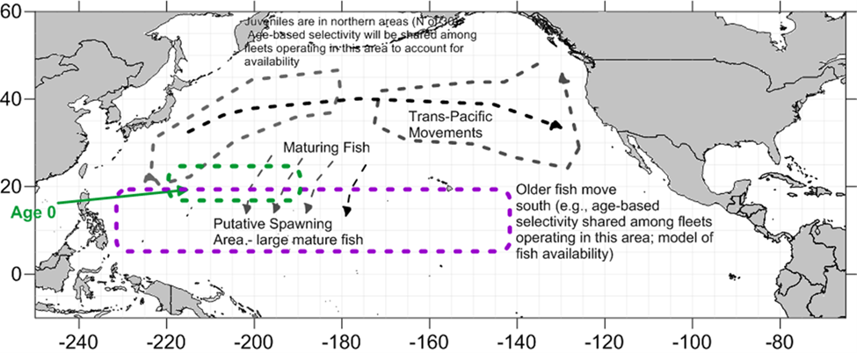
Figure A-01. Conceptual model of north Pacific albacore biology and population dynamics. Figure 11.3 in stock assessment report.

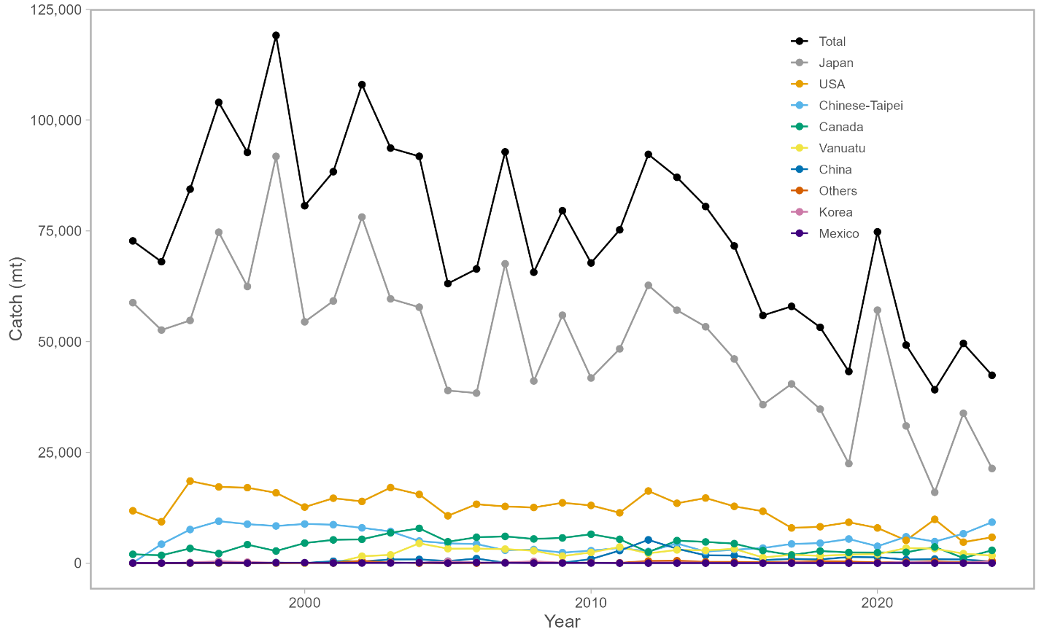
Figure A-02: Estimated total annual catch of north Pacific albacore (Thunnus alalunga) by all members harvesting the stock, 1994-2024. Catches in the “Others” categories includes small amount of catch by other countries such as Kiribati, Belize, Panama, and Marshall Islands. Figure 11.1 in stock assessment report.

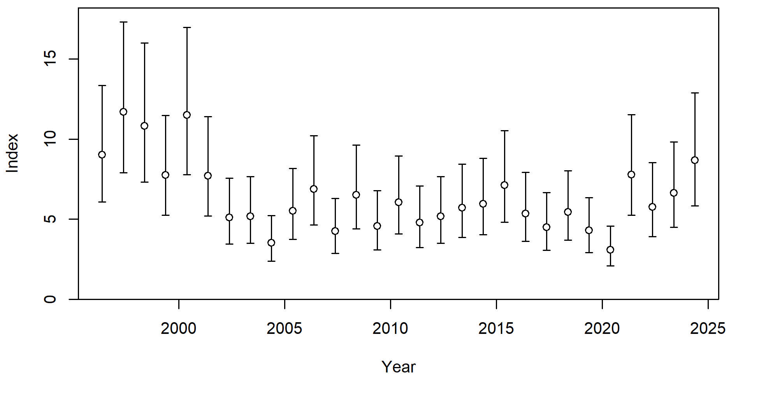
Figure A-03: Trends and 95% confidence intervals of the adult index (F10) used in the base case model. Note that the 95% confidence intervals are based on the model assumption of lognormal error, and include both input and additional coefficients of variation (CVs). Figure 11.38 in stock assessment report. Figure 11.8 in stock assessment report.

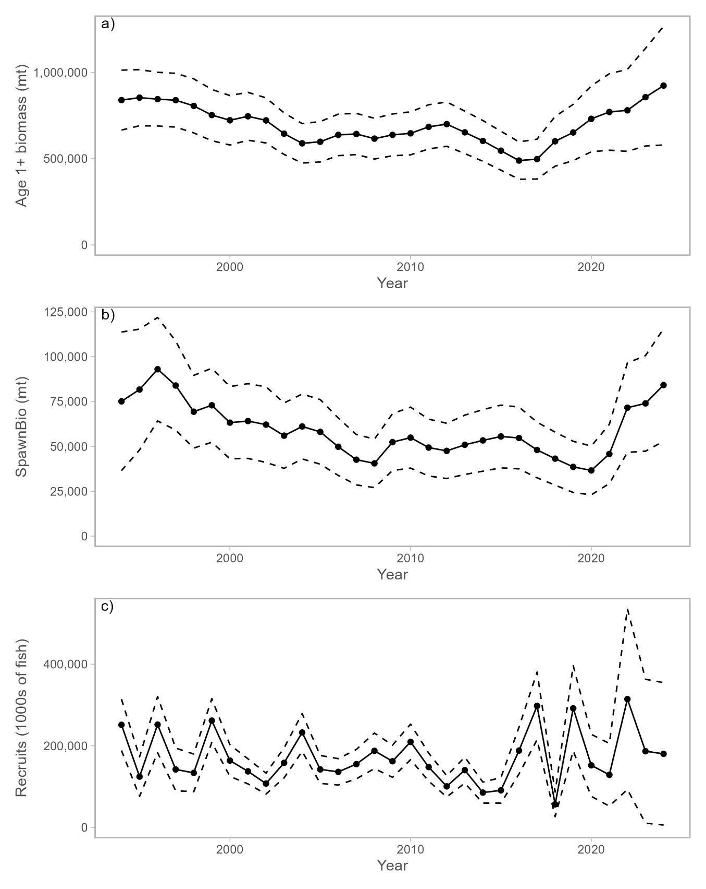
Figure A-04: Maximum likelihood estimates of (a) age-1+ biomass, (b) female spawning biomass (SSB), and (c) age-0 recruitment of north Pacific albacore tuna (Thunnus alalunga). Dashed lines indicate 95% confidence intervals. Figure 11.34 in stock assessment report.
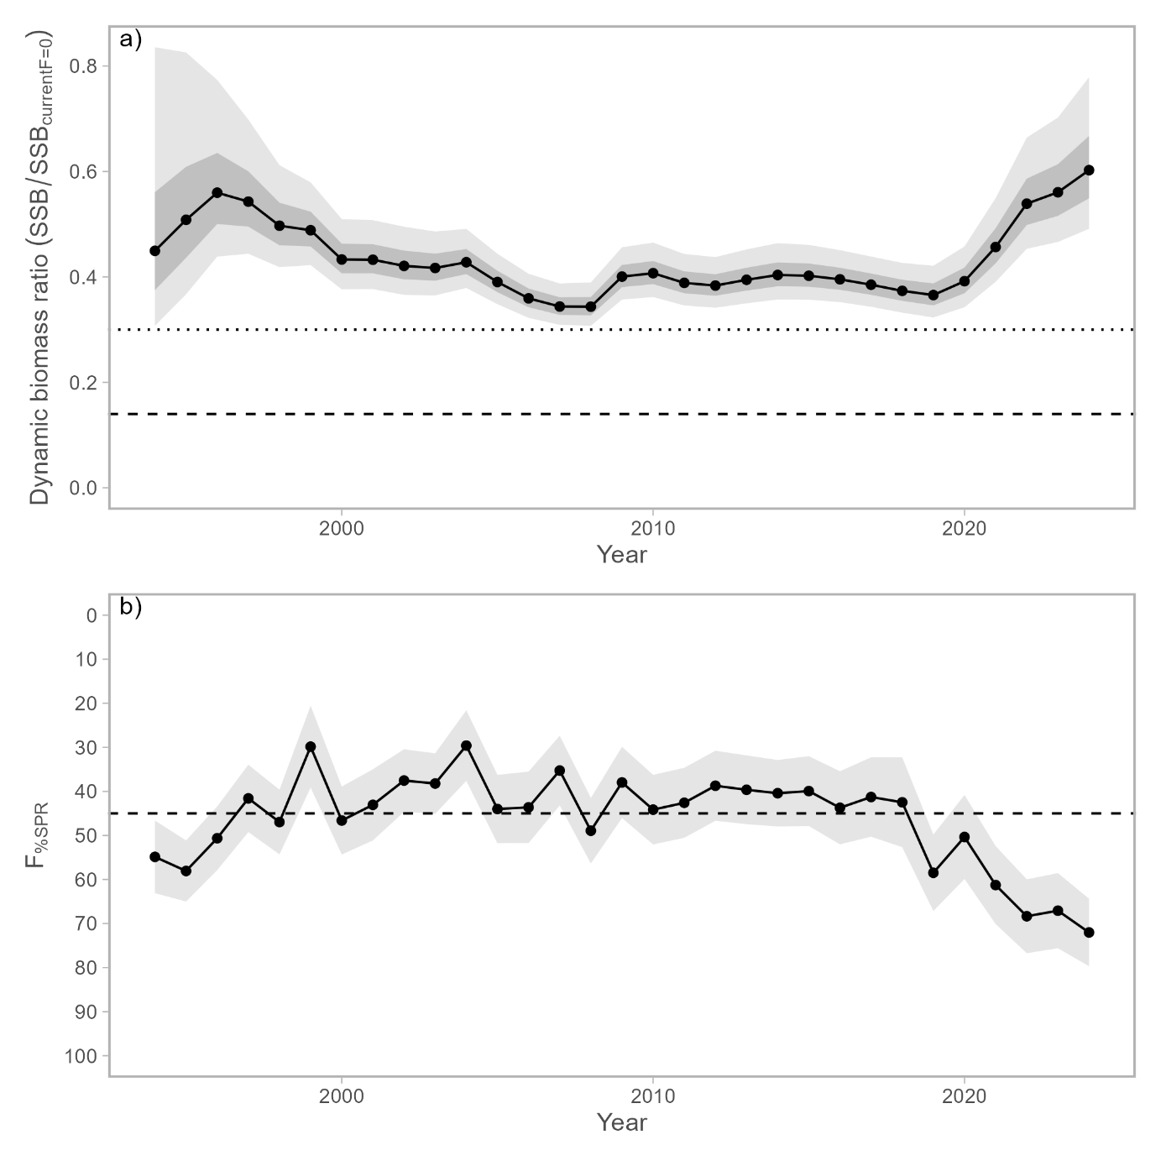
Figure A-05: (A) Estimated dynamic biomass ratio (SSB/SSB_{current, F=0}) of north Pacific albacore relative to biomass-based threshold (30%SSB_{current, F=0}; dotted line) and limit (14%SSB_{current, F=0}; dashed line) reference points over the modeling period (1994 – 2024). 95% confidence intervals are indicated by the lighter gray bands and 60% confidence intervals are indicated by the darker gray bands. (B) Estimated fishing intensity relative to the fishing intensity-based target reference point (F45%SPR) over the modeling period (1994 – 2024). The gray area indicates the 95% confidence intervals. The limit reference point is considered to be breached if the lower bound of the 60% confidence intervals overlaps the limit reference point. Figure 11.38 in stock assessment report.

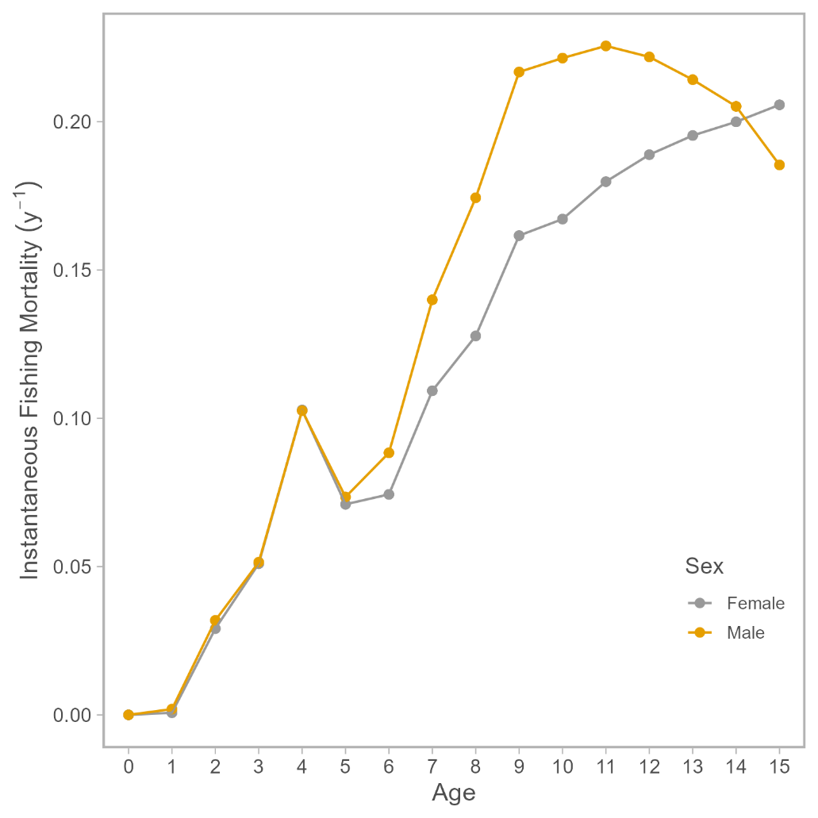
Figure A-06. Estimated sex-specific instantaneous fishing mortality at age (F-at-age) for the 2026 base case model, averaged across 2021-2023. Figure 11.35 in stock assessment report.
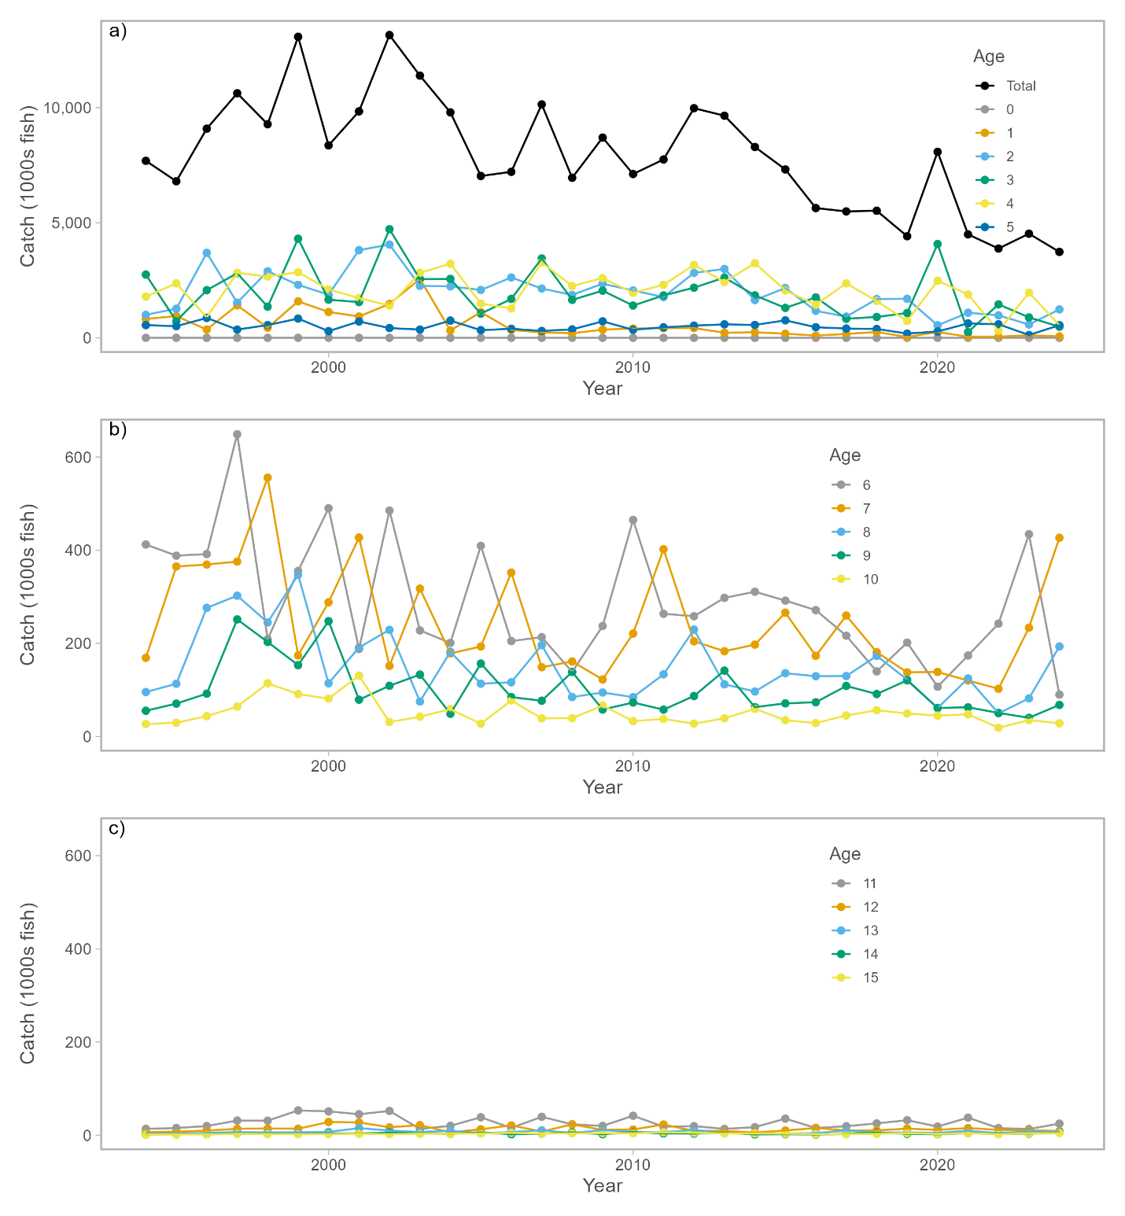
Figure A-07. Historical catch at age of north Pacific albacore estimated by the 2026 base case model. Panels are arranged for the total catch and ages 0-5 (top), 6-10 (middle), and 11-15 (bottom). Note the difference in y-axis scale between the top panel and middle and bottom panels. Figure 11.31 in stock assessment report.
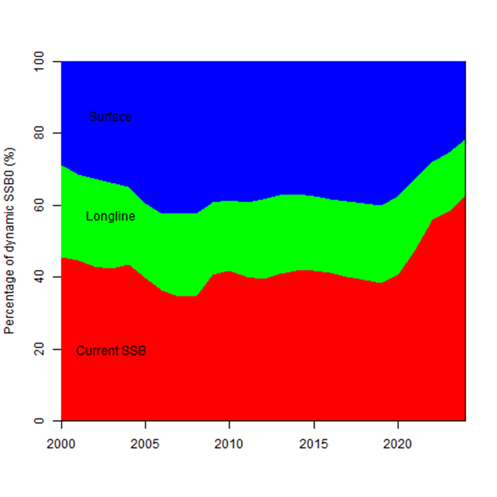
Figure A-08. Fishery impact analysis on north Pacific albacore showing female spawning biomass (SSB; red) estimated by the 2026 base case model as a percentage of dynamic, unfished female SSB (SSB_(current,F=0)). Colored areas show the relative proportion of fishing impact attributed to longline (green) and surface (blue) fisheries (primarily troll and pole-and-line gear, but including all other gears except longline). Figure 11.36 in stock assessment report.

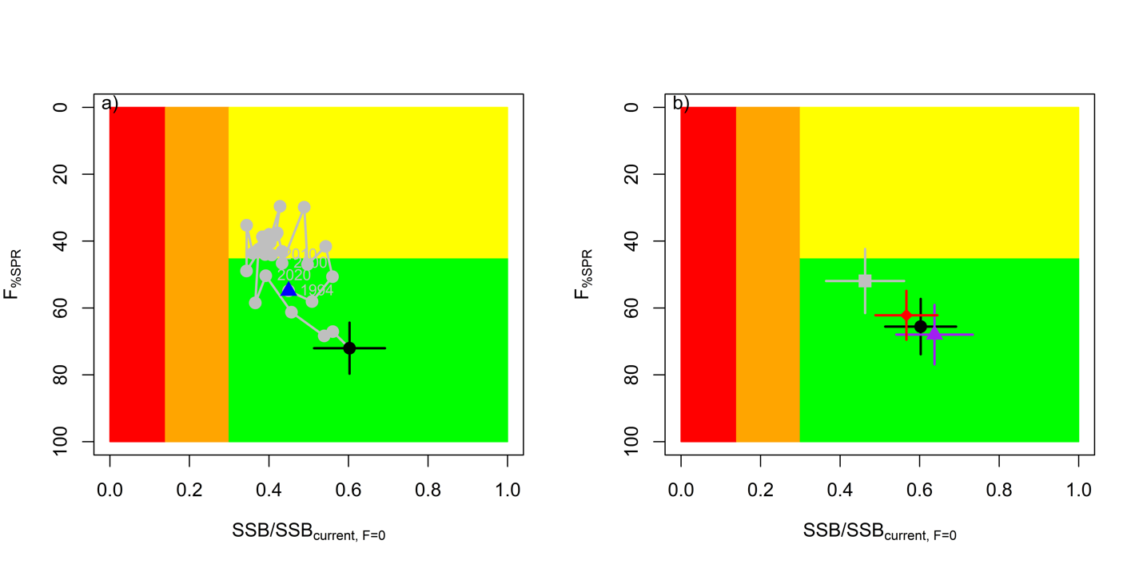
Figure A-09. (a) Stock status phase plot showing the status of the north Pacific albacore (Thunnus alalunga) stock relative to the biomass-based threshold (30%SSB_{current,F=0}) and limit (14%SSB_{current,F=0}) reference points, and fishing intensity-based target reference point (F45%SPR) over the modeling period (1994 – 2024). Blue triangle indicates the start year (1994) and black circle with 95% confidence intervals indicates the terminal year (2024). (B) Stock status plot showing current stock status and 95% confidence intervals of the base case model (black circle), a sensitivity run an important sensitivity run of CV = 0.06 for Linf in the growth model (gray), an important sensitivity run with two initial fishing mortality parameters (red), and a model representing an update of the 2023 base case model to 2026 data (purple). Red zones in both panels indicate female SSBs falling below the limit reference point while the orange zones indicate female SSBs between the threshold and limit reference points. Green zones indicate female SSBs above the threshold reference point and fishing intensity levels below the target reference point. Yellow areas indicate female SSBs above the threshold reference point and fishing intensity levels above the target reference point. The Fs in this figure are indicators of fishing intensity based on spawning potential ratio (SPR) and calculated as %SPR. SPR is the ratio of the equilibrium SSB per recruit that would result from the estimated F-at-age relative to that of an unfished population. A higher %SPR indicates lower fishing intensity. Current fishing intensity values and SSB/SSBcurrent,F=0 ratios in (B) were calculated as the average during 2021-2023 (F%SPR, 2021-2023) and 2024 (SSB2024/SSBcurrent, F=0), respectively. The model representing an update of the 2023 base case model is similar to but not identical to the 2023 base case model due to changes in data preparation and model structure. Figure 11.37 in stock assessment report.
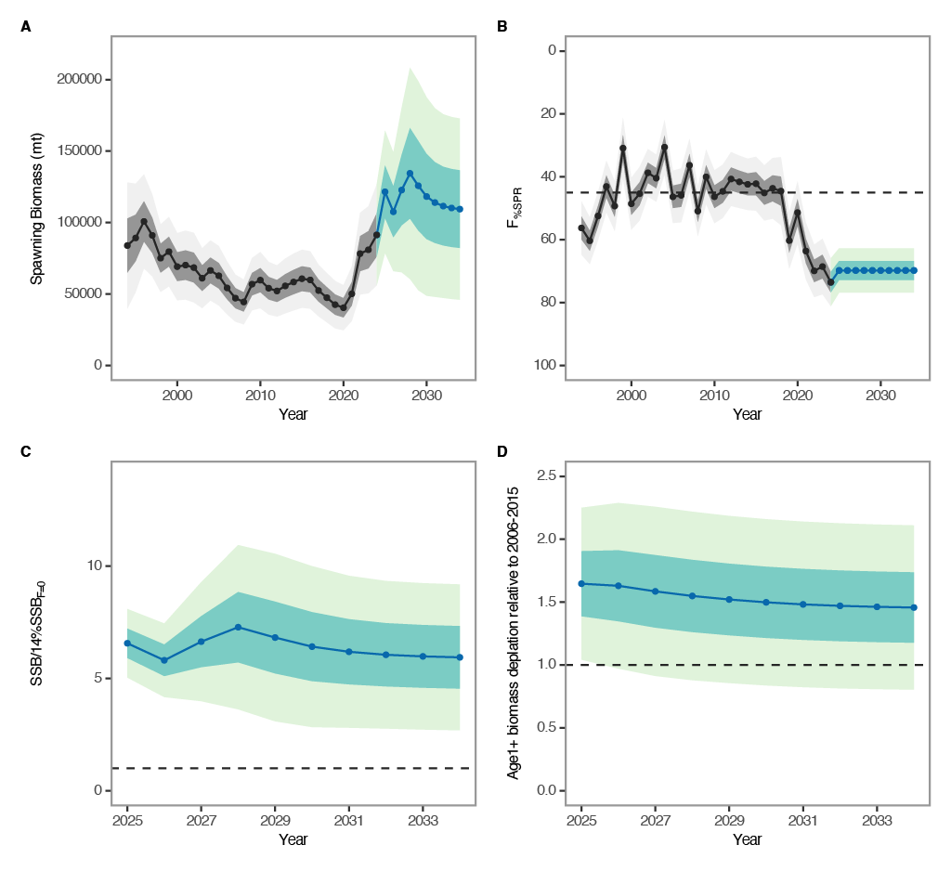
Figure A-10. Future projection results under a constant fishing intensity (F2021-2023) harvest scenario. Solid lines indicate mean values, uncertainty ranges indicate 60% and 95% confidence intervals, and the dashed line is the reference point, respectively. (A) Annual changes in spawning biomass; (B) Interannual changes in fishing mortality (F%SPR); (C) Projected ratios to the limit reference point thresholds; and (D) Projected ratios to management targets for the total biomass. Figure 11.50 in stock assessment report.
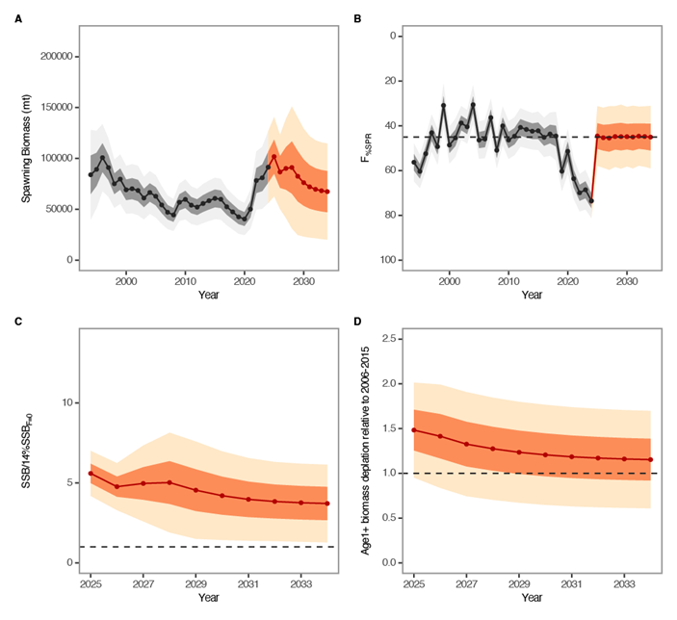
Figure A-11. Future projection results under a randomly F (2005-2019) scenario. Solid lines indicate mean values, and uncertainty ranges indicate 60% and 95% confidence intervals, and the dashed line is the reference point, respectively. (A) Annual changes in spawning biomass; (B) Interannual changes in fishing mortality (F%SPR); (C) Projected ratios to the limit reference point thresholds; and (D) Projected ratios to management targets for the total biomass. Figure 11.51 in stock assessment report.

    - Pacific bluefin tuna (Thunnus orientalis)
4.4.3.1 Research on migratory patterns

4.4.3.2 Pacific bluefin tuna stock assessment peer review

- SC22 thanked the ISC and the independent Review Panel for the successful completion of the peer review of the 2024 Pacific bluefin tuna stock assessment, noting the Panel’s conclusion that the assessment represents a methodological improvement while recognizing that further work is needed to reduce uncertainty.

- SC22 recommended that the ISC Pacific Bluefin Tuna Working Group (PBFWG) respond to the recommendations of the peer review and provide advice to SC23 on how these recommendations can be addressed, including a timeline of work completed and planned leading up to the next and future assessments.

  - Billfish
    - Pacific blue marlin (Makaira nigricans)
4.5.1.1 Review of the Pacific blue marlin stock assessment

4.5.1.2 Provision of scientific information to the Commission

a. Stock assessment and trends

- The Pacific blue marlin (Makaira nigricans) is considered a pan-Pacific stock caught primarily in tropical and sub-tropical waters (Figure BUM-01, Table BUM-01). All available fishery data from ISC Members, the Inter-American Tropical Tuna Commission (IATTC), and the Western and Central Pacific Fisheries Commission (WCPFC) were used for this stock assessment. For modeling observations of catch-per-unit-effort (CPUE) and size composition data, it was assumed that there was instantaneous mixing of fish throughout the stock area on a quarterly basis. Catch and size composition data were compiled from the ISC members (Chinese Taipei, Japan, and USA), other WCPFC members, and other IATTC members. Standardized CPUE data used to measure trends in relative abundance were provided by Chinese Taipei, Japan, and USA. The size composition of Pacific blue marlin catches was included in the model for several fishing fleets, including data compiled from longline, driftnet, and purse seine gear. Life history parameters for sex-specific growth, longevity, and natural mortality were updated for this stock assessment. The value for the Beverton-Holt stock-recruitment steepness (h) in the base case model was 0.87. An age-structured assessment model was fit to relative abundance indices (CPUE) and size composition data in the likelihood-based integrated statistical modeling framework Stock Synthesis (SS3). A large number of sensitivity analyses were conducted to evaluate the influence of the model specification and data streams on population biomass and fishing mortality trajectories. Model specifications and input parameters investigated in the sensitivity analyses included natural mortality, stock-recruitment steepness, growth, maturity, uncertainty in the input data (e.g., spatial definitions of CPUE indices, additional error added to input CPUE data, the first year of catch estimates, over- or under-estimation of catch, or the inclusion of size composition data in terms of either weight or length), and variations in model structure (e.g., fleet selectivity and catchability, initial catch and fishing mortality, and estimation of recruitment deviations from the stock-recruitment relationship).

- Eight major sources of uncertainty were identified and considered for sensitivity analyses (Table 2). These included sensitivity to alternative catch estimates: starting the model in 1950 with input estimated catches back to that year; include estimated additional catch for the Chinese Taipei large tonnage longline fleet to account for underreported catch from foreign ports; and modify catch by 10% (increase and decrease) for all years/fleets to account for possible discards and species misidentification. The sensitivity to alternative data inputs and error assumptions were considered: splitting the Japan and Chinese Taipei late longline survey indices and size composition data into separate “East” and “West” components, divided by 170°W longitude, to account for expected differences in the size selectivities of the longline fleets in these two areas; using weight composition data for the Chinese Taipei longline fishing fleets (F5 and F6) instead of the length composition data for fleet F5 in the base model; using time-varying catchability in the Chinese Taipei late longline index; and estimating additional error for all CPUE indices. The sensitivity to various biological parameters were considered, including natural mortality, steepness, growth, maturity, and the length-weight relationship. Finally, a series of sensitivity runs were performed to evaluate the model sensitivity to assumptions for initial conditions, including estimating initial F and alternative equilibrium catch estimates.

- Pacific blue marlin catches increased from 9,345 mt in the first year of the assessment (1971) to a maximum of 27,161 mt in 1995 (Figure BUM-02). Catches were highly variable from 1996–2015, ranging from 18,287 to 27,073 mt and averaging about 22,150 mt. Since 2016, catches of Pacific blue marlin declined by almost half to less than 13,000 mt in 2023, and catch increased to an estimated 17,738 mt in 2024. Overall, longline gear has accounted for the vast majority of Pacific blue marlin catches (>80%) with Japanese fleets dominating the catch before 2000, and Chinese Taipei and other longline fleets dominating thereafter.

- Visual inspection of the CPUE timeseries indicates both S5_TWN_LTLL_Mid and S9_JPN_LL_Late show strong decreasing trends over time, whereas other indices, particularly S8_US_LLdeep show less contrast (Figure BUM-03). All 3 indices from the recent time period show a variable or decreasing trend in the last 10 years, with S10_TWN_LTLL_Late indicating sudden increase in CPUE in 2024. Both the Japan and Chinese Taipei indices show a rapid increase in the 1970s–1980s, followed by decline into 1990. It is also notable that both Japan and Chinese Taipei late indices (S9 and S10) showed a sharp increase in CPUE in the final year (2024). This is consistent with a large increase in the CPUE indices and the reported catch of small BUM throughout the Pacific, which the BILLWG believes indicates a strong recruitment pulse that may have occurred during the 2020s COVID period.

- Estimated annual recruitment (age-0 fish) averaged approximately 935,900 individuals during 1971–2024 and showed interannual variability averaging 2.7% change but otherwise did not exhibit an overall trend (Figure BUM-04). There were several years with notably lower recruitment, including 1994–1997, and some particularly strong recruitment years in 1976, 1991, and 2023. However, estimated recruitment in 2023, which was the second highest value of the timeseries and only 1 year before the terminal year of the assessment, is not well estimated in the model. Estimated fishing mortality rate (F, expressed as exploitation rate of biomass) increased through the 1970s–1990s, and fluctuated around 0.20 before declining to 0.12 in 2023 and 0.14 in 2024. Fishing mortality rates have been below F_{MSY} for the entire assessment period (Figure BUM-04).

- All estimated parameters in the base case model were within the set bounds, the final gradient of the model was 8.6 × 10⁻⁵, and the Hessian matrix for the parameter estimates was positive definite, indicating the model converged to a minimum. The jitter analysis indicates a global minimum was obtained (i.e., there was no evidence of a lack of convergence), however, alternate local minimums within the negative loglikelihood surface exist with very different (albeit unreasonable) values estimated for initial F, indicating that initial F estimation is a source of some uncertainty in the base model. Root-mean-square-errors (RMSE) was smaller than 0.3, suggesting good fit, for all indices except for S5_TWN_LTLL_Mid. Comparisons between the timeseries aggregated size composition data and the base model indicate general agreement of modes, but suggest some misfitting, particularly in the JPN LL fleets that tend to underestimate the smallest and largest sizes. The CPUE indices for four of six fleets passed the runs test. Index fits for the TWN Late and USA LL fleets did not pass the runs test, and showed several strong runs of positive or negative residuals to the model fit. The size composition time series by season for two of the six fleets with size data passed the runs test. Profiles of change in total loglikelihood for values of ln(R₀) ranging from approximately 6.28 to 7.68 indicate length composition provides the majority of the information for population scale, whereas the index component contributes less, yet the maximum likelihood estimates of ln(R₀) generally agree.

- Estimates of population biomass (age 1 and older) for the Pacific blue marlin stock declined from 183,150 mt in 1993 to 123,300 mt in 1999, with a steady further decline to average 102,490 mt in 2021–2023, and a terminal year increase to an estimated 127,300 mt in 2024. Initial estimates of BUM female SSB were 133,100 mt in 1971, and then steadily declined to an average of 39,600 mt from 2007–2020, followed by a 19% increase to 47,240 mt in 2024, which is the highest SSB since 2001. SSB has been relatively stable and the median value has been above SSB_{MSY} for the entirety of the assessment period (Figure BUM-04).

- Pacific blue marlin was last assessed in 2021. The stock status indicated that it was not overfished and was not undergoing overfishing. The 2021 assessment was a model ensemble of two possible growth models, the 2016 growth curve and a new preliminary growth curve (2021 growth). The 2026 assessment uses the published growth curve based on the 2021 new growth curve, which are fairly similar. The 2026 growth curve has a larger L_{inf}, and the maximum age of the 2026 model was larger due to the bomb-radiocarbon dating of a large female BUM giving an age of around 27 years. Due to the update in the growth curve, the 2026 assessment also updated the estimate of natural mortality, moving from the meta-analysis used in 2021 to a longevity based Lorenzen growth curve. These changes resulted in a change to the overall scale of the population, largely driven by the change in the growth curve. The 2026 model suggests the BUM stock is larger, with an SSB_{MSY} of 31,651 mt (compared to 20,667 mt in 2021), although the overall trend in biomass and fishing mortality rate are the same.

Table BUM-01. Stock assessment model structure for the 2026 Pacific blue marlin stock assessment.

Species | Pacific blue marlin (Makaira nigricans)
Stock Area | Pacific Ocean (basin-wide stock)
Assessment Model | Stock Synthesis (SS3)
Data Period | 1971-2024, with sensitivity run starting in 1950
Primary Fisheries | Longline (major source of mortality), purse seine and other gears
Key data | Catch, standardized CPUE, length and weight compositions

Table BUM-02. Key sources of uncertainty considered in the 2026 Pacific blue marlin stock assessment.
Source | Type | Rationale | Uncertainty | Impact | Confidence
Data | Catch | Best available information | Some evidence of mis-identification, potentially underestimated discards, and unreported catch from the TWN LTLL early fleet landed in foreign ports | Mis-identification of MLS for BUM results in overestimated catch, discards and unreported catch results in underestimated catch. | Medium
Data | Initial Conditions | Estimated from early catch | Pre-1970 catch is highly uncertain but potentially substantial | Initial population size estimates are closely linked to assumptions about initial conditions | Medium
Data | CPUE | Best available information | Reduction of effort of longline fleets in the eastern Pacific Ocean | CPUE trends attributed to abundance not operational covariates | Medium
Data | Size data | Sex-specific data unavailable for most fleets | Substantial sexual dimorphism and assumed spatial segregation by size and sex | Large female BUM not correctly accounted for in the model | Low
Spatial Assumptions | 1 region model | 2 region model resulted in data conflict | Evidence of size-based spatial structure | Adult and Juvenile abundance trends may be masked by a single region model | Medium
Key Parameters | Growth | Fixed from literature | Data from IBBS program, but not estimated in the model | Accounting for selectivity from the fisheries the data are derived from may better represent BUM growth | High
Key Parameters | Maturity | Fixed from literature | Updated maturity ogive not available yet | Affects estimates of SSB | High
Key Parameters | Natural Mortality | Lorenzen M | Estimated from longevity, age- and sex- specific according to growth. | Affects productivity | High
Key Parameters | Length-weight | Estimated from meta-analysis | Estimated from meta-analysis, may not be representative of the fisheries evaluated | Conversion of length data to weight data may be biased | Medium
Other Sources of Uncertainty | Climate impacts | Spatial distribution and reproductive success may be impacted by increasing water temperatures | Not Considered | Long-term impacts unknown | Low

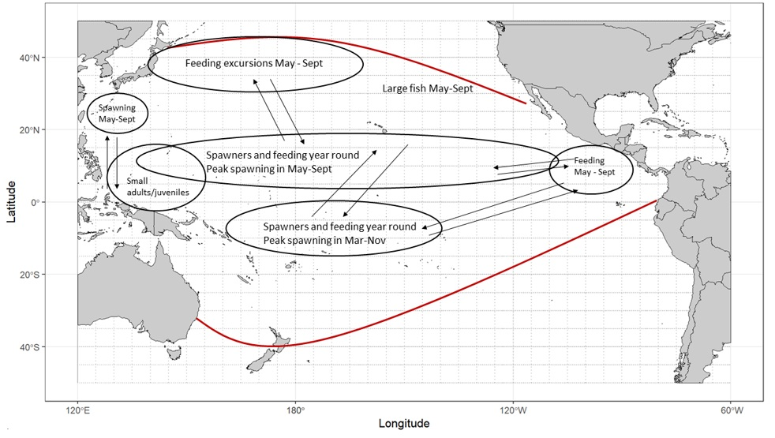
Figure BUM-01. A diagram of the conceptual model developed by the ISC Billfish Working Group for female Pacific blue marlin (Makaira nigricans). Arrows show general exchange of fish, not directed movement. The red boundary represents approximate habitat range of Pacific blue marlin.
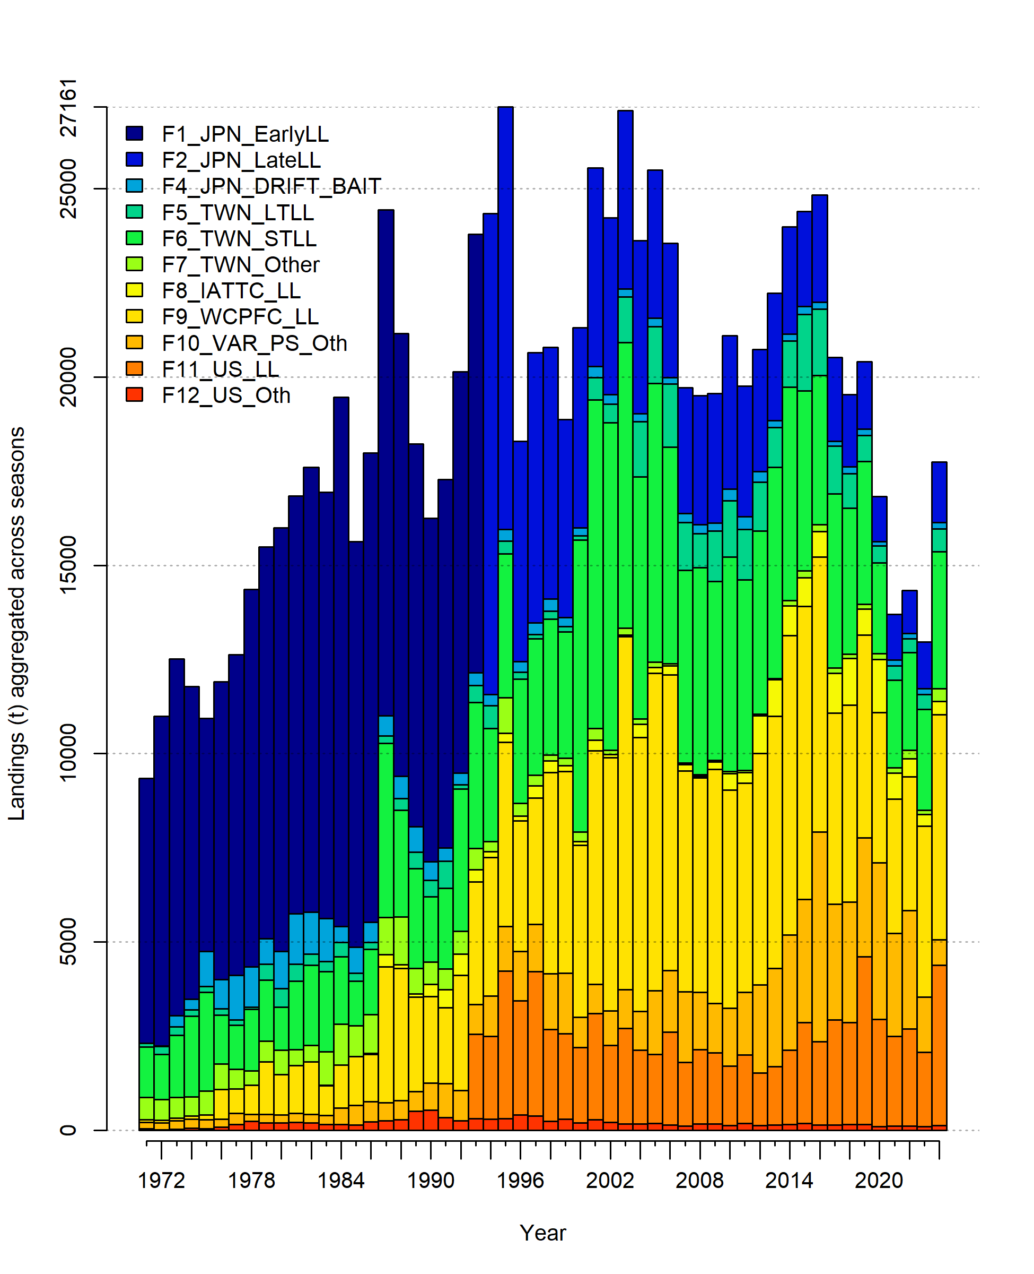
Figure BUM-02. Total annual catch of Pacific blue marlin (Makaria nigricans) 1971–2024 by fleet in the 2026 stock assessment. See Table 1 in WCPFC-SC22-2026- SA-WP10 for descriptions of each fishing fleet.
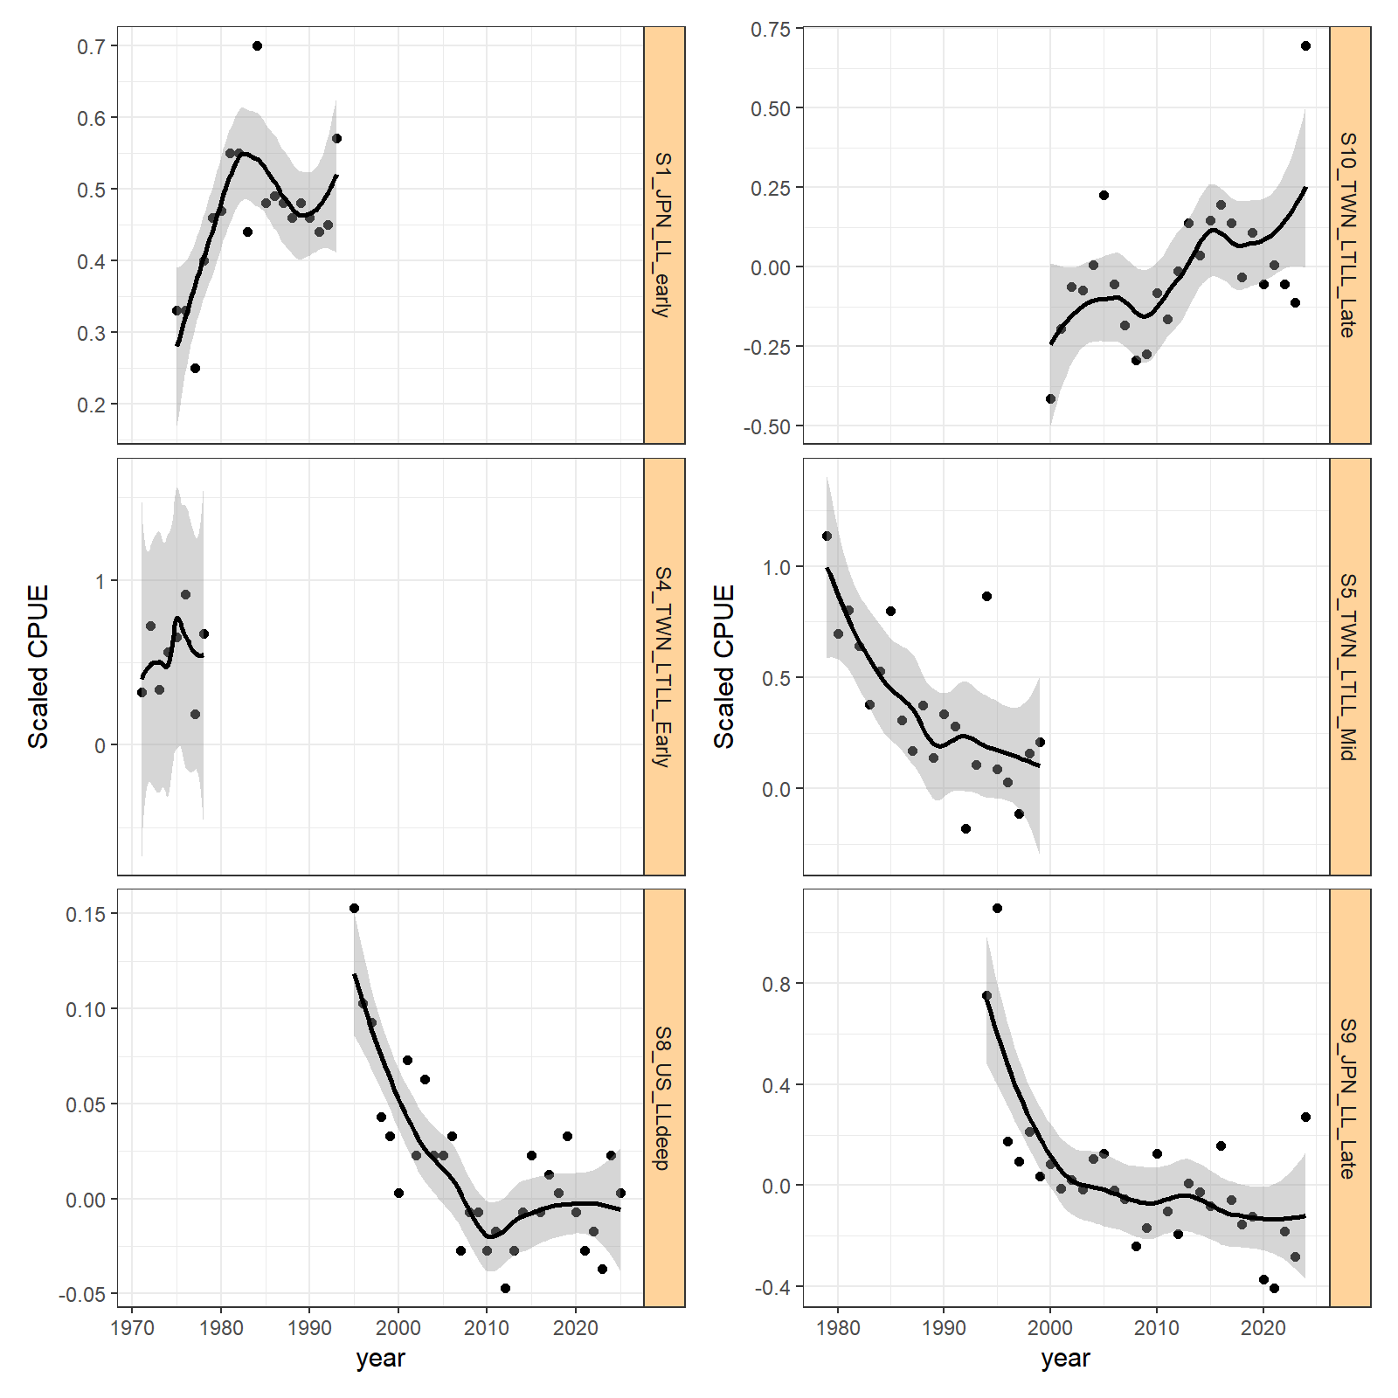
Figure BUM-03. Plot of CPUE index by fleet with a simple LOESS smoother fit to each time series.

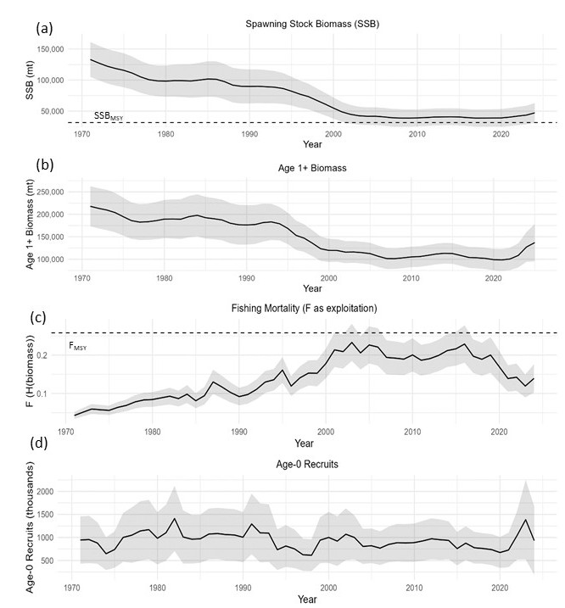
Figure BUM-04. Annual estimates of (a) female spawning stock biomass, SSB; (b) population biomass (age 1+); (c) fishing mortality rate (F) as exploitation of biomass; and (d) recruitment (age-0 fish) for Pacific blue marlin (Makaria nigricans). The solid line represents the maximum likelihood estimates by year for each quantity, the shaded areas are 95% confidence intervals, and dashed lines indicate the static SSB_{MSY} and F_{MSY} reference points.

b. Stock status

- There are no agreed-upon reference points for BUM, so stock status is provided using the default MSY-based reference points for a Tier 1 stock. The recent spawning stock biomass of 44,438 mt (average for 2022–2024) was greater than SSB_{MSY} (SSB_{MSY} = 31,651 mt) and the recent F of 0.13 (average for 2021–2023) was 50% below F_{MSY} (Figure BUM-05).

- SC22 noted the following information on the status of the BUM stock provided to the ISC26 Plenary:
- No target or limit reference points have been established for BUM by the IATTC and the WCPFC;
- Spawning stock biomass was estimated to be 42,038 mt in 2021-2023, or about 33% above SSB_{MSY} and 9% above 20%SSB₀;
- Fishing mortality on the stock averaged roughly F = 0.13 during 2021-2023, or about 50% below F_{MSY} and 56% below F20%SSB₀; and
- Blue marlin stock status relative to MSY-based reference points indicates that overfishing was virtually certain to be not occurring (>99% probability) and BUM is virtually certain to be not overfished (>99% probability).

- Future projections for Pacific blue marlin were conducted using SS3, without incorporating recruitment deviations or applying a log-bias adjustment in the projections. Projections are reported as the median value from 100 bootstrapped input dataset model runs for each scenario. Projections started in 2025 and continued through 2034 under fishing mortality levels corresponding to four harvest scenarios: (1) F_{High} = F₂₀₀₃, the highest fishing mortality rate estimated for the entire time series (1971-2024); (2) F_{MSY}; (3) F_{Recent} = F_{(2021–2023),} corresponding to the average fishing intensity (SPR) over 2021–2023; and (4) F_{30%SPR,} corresponding to SPR = 30% (Figures BUM-06 and BUM-07). For the F_{Recent} scenario, which is based on the relatively low catch years of 2021–2023, projected catch would be below 2024 levels for the first three years (range 16,158 to 17,505 mt) and would increase to only 80% of MSY by the last projection year. Projected catches below MSY in this F_{Recent} scenario would be concurrent with an increase of biomass to well over SSB_{MSY} by 2034. The projections suggest fishing the stock at F_{MSY} would be associated with an immediate increase to well over the historical maximum catch, followed by a decrease to MSY by 2034 as the SSB is depleted. The other two projection scenarios exhibited SSB and catch trends intermediate between the F_{Recent} and F_{MSY} scenarios, because even the peak F estimate of 2003 was less than F_{MSY}, and catch is expected to initially increase, then drop, over the projection period as the SSB becomes depleted. The most consistent catch scenario over the next 10 years was F_{30%SPR}, where annual catches for 2025–2034 would be essentially constant at approximately 23,000 mt per year.

Table BUM-03. Summary of reference points for the 2026 Pacific blue marlin (Makaira nigricans) stock assessment.
Terminal Year: 2024 | Biomass | Virtually Certain (>99%) to be above target | Stock is not overfished
 | Fishing Mortality | Virtually Certain (>99%) to be below target | Overfishing is not occurring
 | Projections | SSB likely (>60%) to remain above target | Stock unlikely (<40%) to be overfished at current catch levels
 | Recommendation | No action required to reach target biomass
Reference Points/MP |  | Estimate [5%-95%] | Comment
Biomass | SSB_{MSY} | 31,651 mt [29,216 mt - 34,085 mt]
Biomass | 20%SSB_{F=0} | 38,506 mt [35,055 mt - 40,956 mt]
Catch | MSY | 24,306 mt [ 22,805 mt - 25,806 mt]
Fishing Mortality | F_{MSY} | 0.26 [0.25-0.27]
Fishing Mortality | F_{20%SSBF=0} | 0.23 [0.22 - 0.24]
Recent Estimates |  |  | Recent Trend/projection
Biomass | SSB₂₀₂₂₋₂₀₂₄ | 44,331 mt [36,863 mt - 51,798 mt] | SSB_{recent} stable/increasing
Biomass | SSB₂₀₂₄ | 47, 244 mt [34,012 mt - 60,475 mt] | SSB_{current} Increasing
Depletion | SSB₂₀₂₂₋₂₀₂₄/SSB_{F=0} | 0.23 [0.20 - 0.25]
Depletion | SSB₂₀₂₄/SSB_{F=0} | 0.24 [0.18-0.30]
Fishing Mortality | F₂₀₂₁₋₂₀₂₃ | 0.13 [0.11 - 0.15] | F_{recent} decreasing
Fishing Mortality | F₂₀₂₄ | 0.14 [0.10 - 0.18] | F_{current} Stable
Catch | C₂₀₂₂₋₂₀₂₄ | 15,011 mt | Catch stable/increased in 2024
Catch | C₂₀₂₄ | 17,738 mt | Catch stable/increased in 2024
Status |  |  | Likelihood
Biomass | SSB₂₀₂₂₋₂₀₂₄/SSB_{MSY} | 1.39 [1.16 - 1.61] | Virtually certain (>99% probability) to be above target
Biomass | SSB₂₀₂₂₋₂₀₂₄/SSB_{20%SSBF=0} | 1.14 [0.95 - 1.33] | Very likely (>90% probability) to be above target
Fishing Mortality | F₂₀₂₁₋₂₀₂₃/F_{MSY} | 0.52 [0.45 - 0.59] | Virtually certain (>99% probability) to be below target
Fishing Mortality | F₂₀₂₁₋₂₀₂₃/F_{20%SSBF=0} | 0.59 [0.50 - 0.68] | Virtually certain (>99% probability) to be below target
Projections
F₂₀₀₃ (F_{high}) = 0.23
Biomass | SSB₂₀₃₄/SSB_{MSY} | 1.23 [0.86 – 1.66] | Likely (>60% probability) to be above target
Catch | C₂₀₃₄ | 24,001 mt [22,782 mt – 25,158 mt]
F_{MSY} = 0.25
Biomass | SSB₂₀₃₄/SSB_{MSY} | 1.09 [0.99 – 1.15] | Very likely (>90% probability) to be above target
Catch | C₂₀₃₄ | 24,705 mt [23,129 mt – 27,448 mt]
F_{recent} = 0.13
Biomass | SSB₂₀₃₄/SSB_{MSY} | 2.23 [1.68 – 2.69] | Virtually certain (>99% probability) to be above target
Catch | C₂₀₃₄ | 19,514 mt [18,509 mt – 20,949 mt]
F_{30%SPR}
Biomass | SSB₂₀₃₄/SSB_{MSY} | 1.01 [0.98 – 1.04] | Likely (>60% probability) to be above target
Catch | C₂₀₃₄ | 22,874 mt [21,217 mt – 25,493 mt]

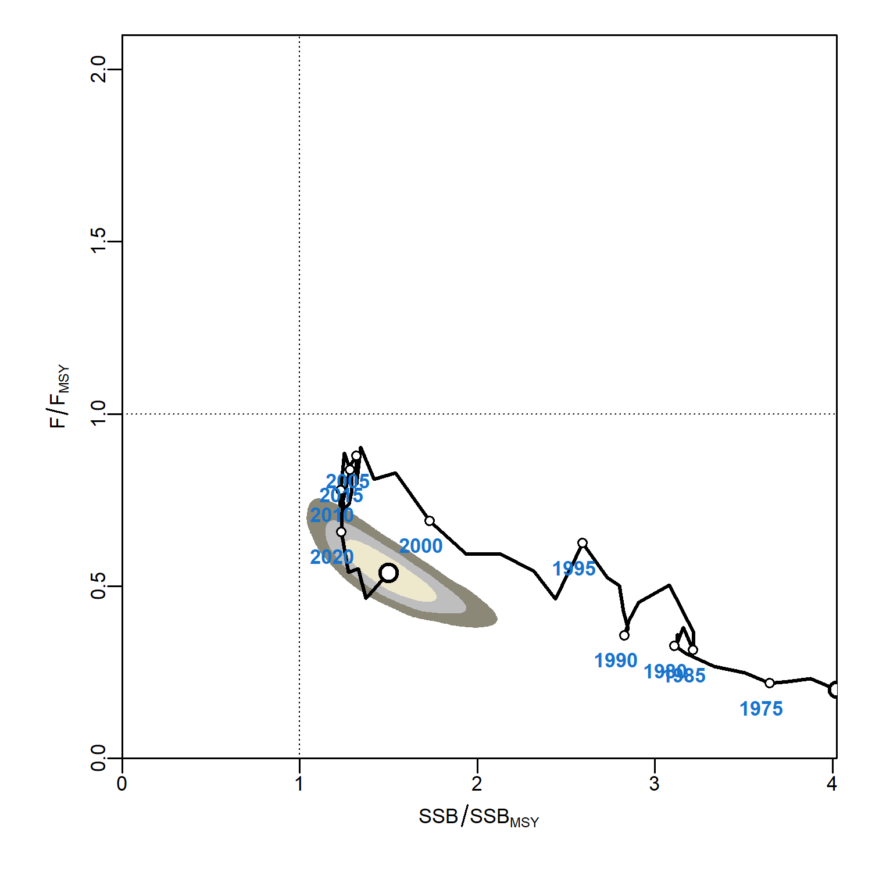
Figure BUM-05. Kobe plot of the timeseries of estimates of mature female spawning stock biomass (SSB) and fishing mortality rate (as exploitation of biomass) relative to MSY values (SSB_{MSY} and F_{MSY}, respectively) of Pacific blue marlin (Makaira nigricans) during 1971–2024. The earliest white symbol indicates 1971, subsequent years are labeled in 5-year increments. Shading indicates 50% (innermost), 80%, and 95% confidence intervals of terminal year (2024) stock status.

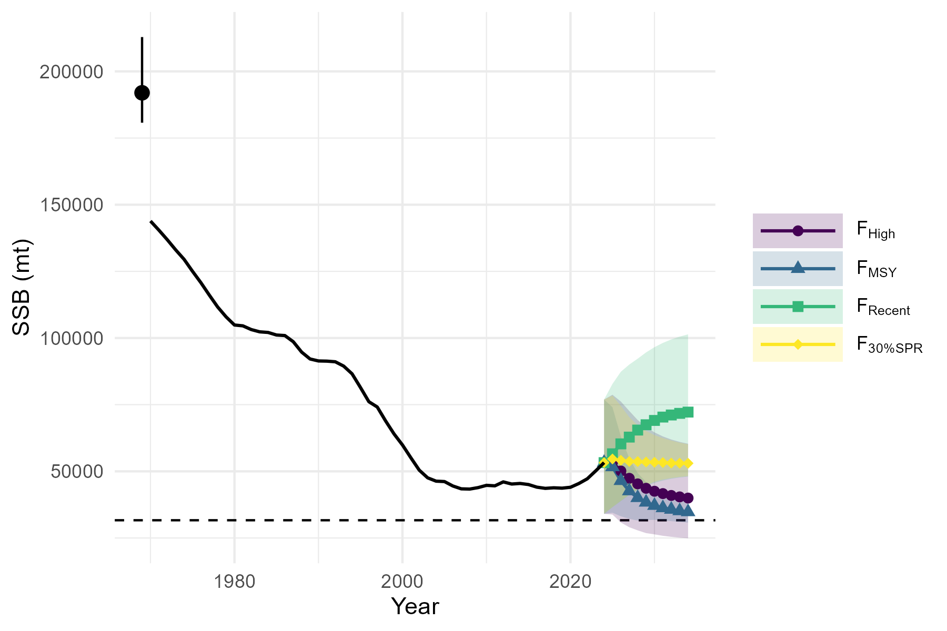
Figure BUM-06. Historical and projected trajectories of mature female spawning stock biomass (SSB) from the Pacific blue marlin (Makaira nigricans) base case model based on 4 constant fishing mortality rate (F) scenarios: (1) F_{High} = F₂₀₀₃, which is the highest F estimated for the model time series; (2) F_{MSY}; (3) F_{Recent} = F_{(2021–2023)} which is the F corresponding to the average fishing intensity (SPR) from 2021–2023; and (4) F_{30%SPR} which is the F corresponding to SPR = 30%. The solid lines and symbols are the median value of the 100 bootstrap model runs and the shaded ribbon is the 95% confidence interval. The dashed line indicates the spawning stock biomass at MSY.
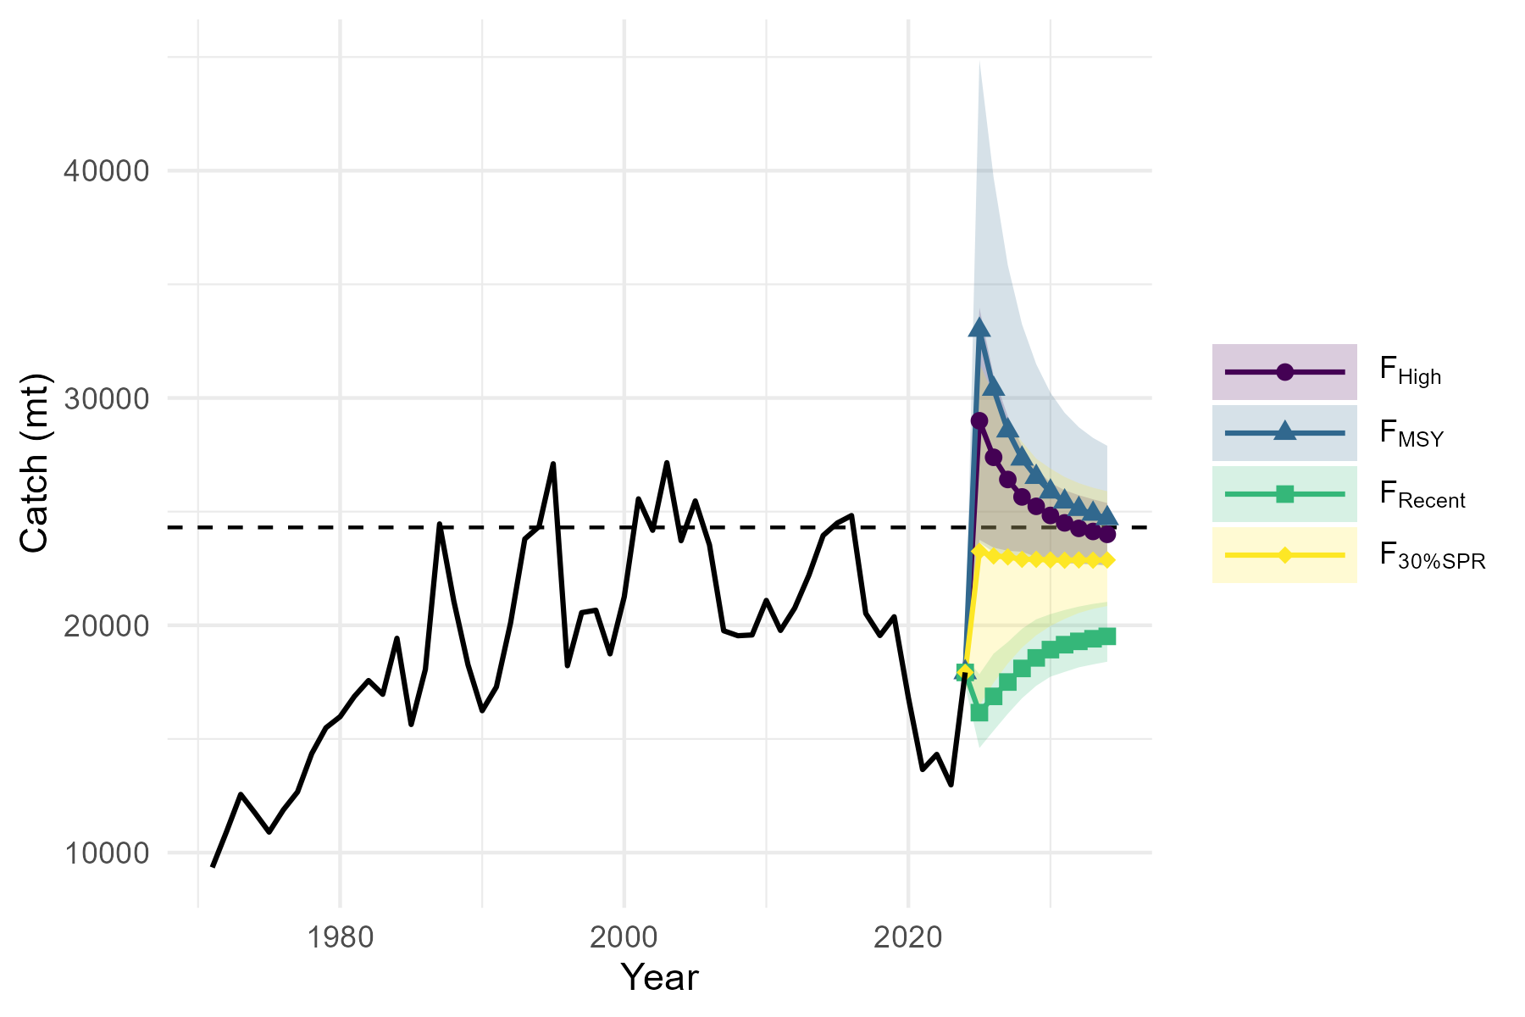
Figure BUM-07. Historical and projected trajectories of catch from the Pacific blue marlin base (Makaira nigricans) case model based on 4 constant fishing mortality rate (F) scenarios: (1) F_{High} = F₂₀₀₃, which is the highest F estimated for the model time series; (2) F_{MSY}; (3) F_{Recent} = F_{(2021–2023)} which is the F corresponding to the average fishing intensity (SPR) from 2021–2023; and (4) F_{30%SPR} which is the F corresponding to SPR = 30%. The solid lines and symbols are the median value of the 100 bootstrap model runs and the shaded ribbon is the 95% confidence interval. The dashed line indicates MSY.

c. Management advice

- Based on these findings, the following information on the conservation of the BUM stock was provided by the ISC26 Plenary:
- There is no evidence of fishing mortality exceeding F_{MSY} or substantial depletion in spawning potential or spawning stock biomass relative to MSY level;
- The Pacific blue marlin annual removals have been between 13,690–20,400 mt since 2019, corresponding to approximately 53–84% of the MSY catch. The stock may be able to support somewhat higher removals; and
- The results show that projected female spawning biomass is expected to increase or remain stable under the F and F_{30%SPR} and decline toward SSB_{MSY} under the High F and F_{MSY} harvest scenarios. The probability that the stock is overfished or overfishing is occurring by 2034 under each harvest scenario is low.

- SC22 noted the management advice provided to the ISC26 plenary, but recognized the importance of Pacific blue marlin to coastal longline and sport fisheries, including for Pacific SIDS, and, noting that terminal-year stock status is less well determined than the reported probabilities alone convey, recommended that any future catch increase be approached cautiously.

d. Research recommendations

- SC22 noted that the assessment remains highly sensitive to fixed biological parameters (growth, natural mortality, maturity) derived predominantly from North Pacific sampling, despite blue marlin being assessed as a pan-Pacific stock. SC22 noted that expanded spatial and sex-specific biological sampling, including addressing the near-zero sample holdings for the southwest Pacific identified in WCPFC-SC22-2026-SA-IP20, would better inform parameter estimation across the full assessment area.

- SC22 recommended that BILLWG continue developing a joint, combined CPUE standardization across the assessment area; consider a quarters-as-years model structure; consider incorporating spatial structure into the model; and strengthen North–South Pacific and IATTC collaboration, given the stock’s pan-Pacific nature.

- SC22 encouraged CCMs catching blue marlin to collect and report sex-specific size and biological data where possible, to support future refinement of selectivity and growth assumptions in the assessment.

  - Projects and Requests
    - Application of Close-Kin-Mark-Recapture methods (Project 100d)
- SC22 encouraged CCMs to collect otoliths to support continued epigenetic aging work in consultation with the SSP.

    - Updated reproductive biology of tropical tunas (Project 120)
    - Global tuna RFMO technical workshop on longline CPUE analysis to support best available science (Project 122a)
    - Biology from billfish in longline fisheries (Project 125)
    - Developing a sampling strategy for sharks (Projects 117, 118 and 126)
    - Age-length data stream for tuna stock assessments (Project 129)
- SC22 welcomed the progress achieved under Phase 1 of Project 129 in developing rapid ageing methodologies and reference age datasets for yellowfin and bigeye tuna, noting that similar work is underway for South Pacific albacore and skipjack tuna.

- SC22 recommended the project continue into Phase 2, with priorities including: expanded otolith sampling and reference datasets (particularly South Pacific albacore and older age classes); standardized regional sampling/ageing protocols; completion of key validation studies; improved spatial representativeness of sampling; incorporation of ageing uncertainty into stock assessments; and a Tuna Ageing Workshop and capacity building for members.

    - Joint bycatch assessment workshop for billfish and sharks (Project 130)
    - Research Plan Update
4.6.8.1 Tuna Assessment Research Plan (TARP) for Key tuna species assessment in the WCPO, 2026-2029

- The ISG04 (Tuna Assessment Research Plan) met on Friday August 14. One new project was proposed, Project P22X09 Technical workshop on approaches to utilising tagging data within regional stock assessments to support best available science. There was general agreement that this would be a good project to be included for priority ranking. The ISG reviewed the stock assessment schedule, and noted that the yellowfin tuna assessment should be updated to be completed in 2027. The ISG recommended that the table be revised after the completion of ISG01 on the SC prioritization process to reflect the schedule of update and benchmark assessment. It was suggested that B be used to indicate a benchmark assessment and U be used for an update assessment.

- SC22 endorsed the recommendation from the ISG and will update the assessment schedule for tuna, billfish, and sharks pending the outcomes of SC22.

4.6.8.2 Billfish Research Plan (2023-2030) annual update

- ISG05 (BRP) met on Friday, 14 August 2026, to review progress against the 2023-2030 Billfish Research Plan and related matters, including WCPFC-SC22-2026-SA-IP23. The full ISG05 report can be found in Attachment 4.

4.6.8.3 Shark Research Plan 2021- 2030 annual update

- ISG06 (SRP) met on Friday, 14 August 2026, to discuss WCPFC-SC22-2026-SA-IP24. The full ISG06 report can be found in Attachment 5.

- SC22 noted the importance of providing stock assessments for sharks to ensure sustainably managed species, but raised concerns about the lack of a process for identifying projects as essential which effectively removes them from the prioritization process. It was clarified that the suggestion from the ISG was for the SC to determine, on a case-by-case basis, which shark assessments would be considered essential. Noting the concerns from some CCMs about the process and potential for lack of transparency, SC22 agreed to rank the proposal for a one-year assessment for southwest Pacific blue shark to be delivered to SC23 as essential. SC22 also recommended that a process for identifying projects as essential be established during SC23.

  - Application of Convention language to stock assessment advice
- SC22 agreed to defer discussion of this agenda item to SC23.

  - Other SA Theme issues

AGENDA ITEM 5 — MANAGEMENT ISSUES THEME

  - Development of the WCPFC harvest strategy framework
    - Bigeye tuna harvest strategy
5.1.1.1 Bigeye operating models

- SC22 noted that SC21 supported the use of the initial OM set for BET MSE, which is based on the 2023 assessment, while requesting further revisions. SC22 further acknowledged with gratitude to SSP that the revised BET OM presented to SC22 was substantially updated to address wider uncertainties responding to the SC21 requests.

- However, SC22 noted that the 2026 BET stock assessment which was also available to SC22 showed differences from the revised OM set even after additional work by SSP to expand the distribution of OM. Most notably, the new stock assessment suggested, while the overall trajectory and status relative to the 2012-2015 target is similar to those in the OMs, a more depleted stock status than currently captured within the OM set, with a greater risk of the stock being below the LRP.

- Although SC22 was not able to achieve a consensus on the acceptance of the 2026 stock assessment SC22 considered that the performance of MPs needs to be MSE tested using an OM grid that spans the range of plausible low-depletion scenarios informed by the 2026 assessment analyses. This is particularly important given that the probability of breaching LRP is one of the performance metrics used to evaluate candidate MPs in the BET MSE.

- Based on these observations, SC22 therefore, while supporting the overall BET MSE framework to proceed, requested the SSP to further explore options to expand the uncertainty range of the OM grid, in particular to cover the lower depletion range as suggested by the 2026 BET stock assessment. SC22 requested the SSP to revise the OM grid accordingly and where feasible use this revision for work to be provided to the BMW02 (and definitely prior to WCPFC23).

- SC22 advised BMW02 to provide feedback on the revised OM for final approval by SC. Mindful of the WCPFC Harvest Strategy Workplan, SC22 advised convening of a two-day special SC session (in hybrid format) for further review and formal approval of the BET OM grid by the SC, taking place adjacent to the WCPFC23 in Port Vila, Vanuatu, subject to intersessional confirmation.

5.1.1.2 Bigeye estimation method

- SC22 acknowledged that the EM submitted to SC22 had been revised in response to the SC21 requests and that its performance was improved as intended. SC22 supported the use of the revised EM for the BET MSE in principle, while noting that its performance needs to be re-evaluated once the OM grid is revised as suggested above.

5.1.1.3 Bigeye management procedure - design and implementation considerations

- SC22 acknowledged that the SSP intended to develop a range of candidate MPs based on the instruction from BMW01. The critical aspect of the approach is the use of a “nuclear grid” which provides possible combinations of longline catch and FADs closure periods that achieve a certain level of long-term biomass depletion, i.e., the TRP. Although SSP provided “longline favored” and “purse-seine favored” MPs within the range of combinations defined by WCPFC22, it is possible to select any other combination using the grid to achieve the same target. SC22 noted that the specific shape of each HCR was not discussed at BMW01.

- SC22 thanked the SSP and generally welcomed the development of the BET management procedure framework, while making many suggestions. Some CCMs, in particular, noted that the fisheries application in the candidate MPs is not in line with their understanding of the decision at BMW01, and therefore the evaluations were incomplete. In their understanding, the catch limit as well as FADs closure period in the Convention-area-wide application option should be managed consistently with the Tropical Tuna CMM, taking into account the exemptions in place in CMM 2025-02.

- SC22 requested the SSP to update MPs, in particular the “nuclear grid” and HCR designs, based on the revised OMs as the first priority. In addition, while noting that providing specific advice on MP design is not SC’s role, SC22 advised SSP to evaluate requests by CCMs and to endeavor to address them to the extent practicable to be presented at BMW02 to facilitate the discussion on BET MSE, thereby facilitating consideration of all proposed options before a decision is taken by the Commission.

5.1.1.4 Bigeye management procedure - evaluations

- SC22 welcomed the presentation of the BET MSE results and made a number of suggestions for improvements. SC22 noted the large volume of results even with the current MP list. It was noted that the results need to be updated once the OM reference set is revised. SC22 requested that SSP further develop the MSE presentation taking into account the comments from SC22 and present it at BMW02.

- SC22 noted the importance of keeping the number of candidate MPs manageable, both to minimize the workload for the SSP and to facilitate effective decision-making by the Commission, and advised BMW02 consider reducing the number of the candidate MPs. As one approach to reducing the number of candidate MPs, SC22 advised the SSP to consider excluding one of the candidate MPs that perform similarly across indicators, while clearly documenting and reporting properly the rationale for their exclusion to BMW02 or the Commission.

5.1.1.5 Bigeye tuna management workshop

- SC22 requested that BMW02 consider the results of the revised BET OM evaluation and provide feedback to the SC and the Commission. SC22 also advised BMW02 review the results of BET as well as YFT MSE and provide feedback to the SC and the Commission.

    - Yellowfin tuna harvest strategy
5.1.2.1 Yellowfin operating models

- SC22 noted that the YFT OM grid, which is based on the 2023 stock assessment, was revised in response to the request of SC21 and now covers a wider range of uncertainty in depletion levels. It was also noted that, while the 2026 YFT stock assessment was not reviewed at SC22, the uncertainty range of the 2026 YFT stock assessment was generally within the range of the updated OM grid. Many areas of further work were suggested. However, SC22 agreed to adopt the YFT OM grid as presented, while additional uncertainties could be identified through the monitoring strategy where necessary, and further evaluation should continue as part of sensitivity or robustness testing, also taking into account the discussion on the 2026 BET stock assessment.

5.1.2.2 Yellowfin outcome evaluations

- SC22 noted that there is no specific MP for YFT and that, under the mixed fishery approach, YFT will be managed implicitly through the MPs of SKJ, BET, and SPA. However, it is still required to test outcomes for YFT to ensure the stock remains sustainable and management objectives for YFT are achieved. The YFT MSE is simulated using the YFT OM and output from SKJ, BET, and SPALB MPs. It was noted that the PS effort level is assumed constant because the impact of PS on the YFT stock is almost the same between FADs set and free-school set and overall effort is defined through the SKJ MP and currently assumed to be constant in YFT MSE testings.

- SC22 noted that the BET MP output will change both the tropical LL effort level and the ratio of PS effort allocated between associated and free-school sets which can impact the YFT stock level. It was also noted that no current BET candidate MP will achieve the interim target of YFT (SB/SB_{F=0, 2012-2015}), as was reported to the Commission previously. SC22 supported the YFT MSE framework as presented by the SSP and advised them presenting the results to BMW02. As the choice of BET MP affects the YFT stock level and vice versa, SC22 advised BMW02 to take the YFT MSE results into consideration when discussing BET MSE.

    - South Pacific albacore harvest strategy
5.1.3.1 South Pacific albacore management procedure - run

- SC22 reviewed the results of the first SPALB MP run provided by SSP. SC22 noted that the EM of the SPALB MP has successfully run. In accordance with CMM 2025-01, SC22 advised the Commission that the output of the adopted SPALB MP was 56,096 mt, applicable to longline and troll fisheries operating south of 10°S in the WCPFC-CA, excluding the EEZs of Tokelau and Tuvalu.

- SC22 also noted that some operational data were not available in the IATTC area for the MP run. SC22 encouraged those members who have not made data available to do so as soon as practical and requested that the SSP evaluate the impact of the missing data and to report back to SC once these data become available.

5.1.3.2 South Pacific albacore monitoring strategy

- SC22 reviewed information available to SC22 relevant to the SPALB monitoring strategy. SC22 agreed that there is no information preventing the implementation of the SPALB MP and that no modification is necessary to the South Pacific albacore monitoring strategy table at this time.

5.1.3.3 Joint WCPFC/IATTC Working Group for South Pacific albacore

- SC22 welcomed the results of the first Joint WCPFC/IATTC Working Group for South Pacific Albacore and encouraged continued collaboration with IATTC and its CPCs and requested that SPC explicitly include close-kin mark-recapture (CKMR) data when updating the MOU with IATTC.

5.1.3.4 Updates on South Pacific albacore Roadmap IWG

    - Skipjack tuna harvest strategy
- SC22 reviewed the preliminary results of the development of a joint CPUE index of Japanese pole-and-line and purse seine free-school sets. SC22 noted that it had been agreed that the existing Japanese pole-and-line CPUE will be used at least for the next MP iteration in 2027, while the continued contraction of operational area of Japanese pole-and-line fisheries is an ongoing concern for the operation of the SKJ MP. SC22 therefore welcomed the collaborative work by Japan and SSP to develop a joint CPUE index for possible use in the SKJ MP in future. SC22 made a number of suggestions for further analysis in many areas including the impact of climate change, sample size differences between gears, targeting effects, etc., noting that the SSP had already started to address some of these. SC22 further noted that any future modification to the abundance index used by the Estimation Method should be subject to comprehensive Management Procedure testing to ensure the robustness, stability, and intended performance of the adopted skipjack MP are maintained.

5.1.4.1 Skipjack monitoring strategy

- SC22 reviewed information available to SC22 on SKJ. SC22 agreed that there is no information preventing the implementation of the SKJ MP. SC22 requested that pending development of a mixed fishery monitoring strategy, stock status of BET and YFT should be reported in relation to the interim management objective to maintain those stocks at or above the average spawning biomass depletion for the period 2012-2015.

- SC22 requested SSP evaluate exceptional circumstances for each MP when evaluating monitoring strategy and provide update to SC.

- SC22 recommended SSP convert the monitoring table into an action log with owners, due dates, evident, and clear triggers.

    - Mixed fishery monitoring strategy
- SC22 reviewed the framework of the mixed fishery monitoring strategy provided by the SSP. Noting that the mixed fishery monitoring strategy (BET and YFT) is to be developed and adopted in 2027, SC22 recommended to the Commission that the monitoring strategy process be a standing agenda item on Commission and subsidiary body meeting agendas. SC22 also supported the proposal to consolidate the regular papers provided to meetings into a format designed to specifically inform monitoring strategies once all the MPs are adopted, as well as to consider an online approach dedicated to delivering the monitoring strategy.

    - Progress of the WCPFC Harvest Strategy Work Plan
- SC22 reviewed the WCPFC Harvest Strategy Work Plan and considered no revision is required at SC22.

    - Pacific bluefin tuna - Long-term harvest strategy
- ISC provided updated information on PBF MSE including TAC1 calculation of newly requested HCRs by JWG in March 2026 and re-introduced the method to calculate conversion factors among different management categories. It was noted that the full PBF MSE results were presented at SC21, while the newly proposed HCRs were not yet fully simulated due to time constraints. However, ISC noted that, as they fall in between the HCRs already tested, their performance can be generally inferred and the risk to the PBF stock would not be problematic. Once an MP is adopted, it will be fully simulation tested by ISC.

- SC22 welcomed the progress made by the ISC PBFWG and the Informal Joint Working Group on Pacific bluefin tuna between WCPFC-NC and IATTC (PBFJWG) on the development of a long-term harvest strategy for Pacific bluefin tuna and encouraged the continued application of science-based decision-making in the development of the harvest control rule, consistent with the WCPFC harvest strategy approach.

- SC22 considered that in principle any management procedure to be adopted by the Commission should be fully simulation tested through MSE and reviewed by the SC before its adoption. SC22 noted that, despite the considerable progress made by the Joint Working Group, no agreement was reached before SC22 on a Management Procedure recommendation, and no proposal from NC22 was tabled to SC22 for recommendation to the Commission. SC22 further noted that the ISC explained that the performance of PBF MSE is mainly dictated by its target level and that the newly proposed HCR falls in between the candidate HCRs, both of which do not pose substantial risk to the stock. However, it was noted that the newly proposed HCRs were not tested through MSE. SC22 noted that some CCMs proposed to revisit this and any progress made intersessionally at the special SC taking place adjacent to WCPFC23 (subject to intersessional confirmation). Given that there is no consensus, SC22 agreed to revisit this item in the special SC.

    - Southwest Pacific swordfish management procedure
- SC22 thanked Australia for leading the discussion on the Southwest Pacific swordfish MSE. Given the number of questions and comments provided by CCMs, SC22 encouraged interested members to further discuss intersessionally based on the proposal from Australia, which includes the formation of an informal steering committee.

- Some of the priorities identified by SC22 in the development of the harvest strategy for SWP swordfish included the balance between bycatch and target fisheries, the consideration of discard survival under catch-limit scenarios in bycatch fisheries, the importance of including stock and regional structure as one important uncertainty, and the need to separate scientific and management discussions.

  - Review of effectiveness of CMM 2025-02 (Tropical Tunas)
- SC22 acknowledged that the information contained in this long-standing analysis is no longer critical for the operations of the Commission once stocks begin to be managed through MPs and their performance monitored through the monitoring strategies. Therefore, SC22 recommended that the Commission approve discontinuing this analysis, which will reduce the workload of SSP.

  - Other MI Theme issues
Global blue shark MSE workshop

- SC22 received a brief presentation on the FAO global blue shark MSE workshop and acknowledged that future MSE, such as of swordfish or sharks, may benefit from the outcome and resources therein.

Effort data analysis

- Noting that TCC21 requested the SSP to continue monitoring the trends between effort and catch in the purse seine fishery, including effort creep, and to report those trends to TCC22, SC22 agreed to forward WCPFC-SC22-2026-MI-IP01 and WCPFC-SC22-2026-MI-IP05 to TCC22.

AGENDA ITEM 6 —ECOSYSTEM AND BYCATCH MITIGATION THEME

  - Ecosystem and Climate Indicators
    - Progress of Project 121 (Ecosystem and Climate Indicators)
- SC22 noted with concern the continuing trend of ocean warming across the WCPO, including record global ocean heat content in 2025 and the past eleven years being the warmest on record.

- SC22 acknowledged the progress made within Project 121, including the addition of three new regions covering the West Pacific East Asia (WPEA) region.

- Some members requested that the ecosystem and climate indicators developed under Project 121 be presented to WCPFC23.

    - Development of early warning tools and expanded climate impact assessment
- SC22 encouraged the SSP to ensure that reporting of ecosystem and climate indicators to WCPFC23 distinguishes between short-term climate variability, longer-term climate trends, and changes that may instead reflect stock abundance or fishing behaviour.

- SC22 requested that the SSP strengthen the links between Project 121 and the fishery indicators considered under Agenda Item 4.3.3, so that observed changes in catch rates, fishing distributions, and fish size might be better interpreted in the context of oceanographic variability and longer-term climate change.

    - Climate Change Workplan
  - Updates on the 2019 SEAPODYM Review
- SC22 acknowledged the analyses and diagnostics presented in WCPFC-SC22-2026-EB-WP01 and recommended that, where appropriate, these diagnostics be included in future reporting of new reference models to the SC to facilitate review.

- SC22 encouraged the SSP to present future SEAPODYM results, where feasible, as a median estimate with combined uncertainty, since results were shown to depend on the underlying biogeochemical forcing and key model assumptions.

- SC22 requested that the SSP explore the possibility of conducting hindcast cross-validation for the four SEAPODYM tuna models, and of extending the albacore cross-basin validation to a tropical tuna model, and report on this work to SC23.

  - FAD Impacts
    - Research on non-entangling biodegradable FADs
- ISG07 met to consider the progress and proposed future directions of the FAD Research Workplan for 2027-2029, with particular focus on biodegradable and non-entangling dFADs, monitoring and data needs, mitigation measures, and dFAD recovery options. The full ISG07 report is included as Attachment 6.

- SC22 acknowledged the important work carried out under Projects 110 and 110a, including the increased industry participation, and noted that the final project report will be available in 2027.

- SC22 recommended that the SSP, in the final project report, compare vessel-reported catch with observer data where available, and if possible, examine the relationship between biomass estimates from echosounder buoys and actual catch.

- SC22 noted that results of WCPFC Projects 110 and 110a indicate the availability of biodegradable materials and that a transition to non-entangling and biodegradable dFADs in the WCPO is feasible to some extent while recognising that limited material availability and supply chains may make this transition disproportionately costly and challenging for remote island and atoll Members, as well as SIDS.

- SC22 agreed, in relation to paragraph 19 of the Tropical Tuna Measure (CMM 2025-02), that a stepwise introduction of biodegradable dFADs is technically feasible, and recommended it be accompanied by continued scientific monitoring and the development of standards and a monitoring framework. SC22 recommended the SSP continue to report to the FADMO-IWG and SC23, particularly regarding a framework to monitor the transition to biodegradable materials and designs, a review of definitions and international standards, and further assessment of bioFAD performance.

    - Research on dFAD loss and abandonments
- SC22 welcomed the assessment of the feasibility, effectiveness and costs of different dFAD loss and abandonment mitigation options. It was noted that meaningful recovery levels will require complementary measures, supported by appropriate incentives, blending spatial management, offshore recovery by fishing or dedicated vessels, and shore-based recovery programmes such as FAD Watch.

- SC22 noted the concerns of Pacific Island countries, territories, and SIDS regarding the impacts of dFAD loss, abandonment, and strandings. SC22 noted that many dFAD strandings originate from outside the WCPO and called for improved collaboration at the Pacific-scale. Several CCMs stressed that the burden of dFAD recovery should be borne by actors benefiting from the dFAD fishery.

- SC22 recommended that priority be given to preventing dFAD loss and abandonment and to shore-based recovery options.

- SC22 recommended that further work should be conducted, including refining feasibility and economic assessment of dFAD recovery options, including arrangements for dFAD position sharing, options for reusing/recycling dFADs and buoys, and comparison between conventional and biodegradable FADs.

    - Updates on FAD Management Options IWG
- SC22 noted the update from the FADMO-IWG and supported the proposed workplan.

- SC22 noted that further analysis of the effectiveness of the current limit of 350 active dFAD buoys per purse seine vessel is a low priority and supported revisiting the issue once updated SPC analysis of dFAD deployments and trends is available, as part of the scheduled 2027 review of the Tropical Tuna Measure.

- SC22 recommended that the SSP develop, for consideration by SC23, a set of FAD fishery indicators to support ongoing monitoring of trends in active dFAD buoys monitored per vessel in the WCPO FAD fishery, including, as appropriate, FAD catches and sets, dFAD buoy deployments and activity, apparent losses and strandings, and relevant observer data, including entanglements, and FAD logsheet data.

  - Bycatch management
    - Bycatch Management Information System (BMIS)
- SC22 noted the increasing use of AI-assisted access to WCPFC scientific information, and the concerns raised by the SSP that, in the absence of a robust, accurate and well-curated data source, information sourced through these tools may include spurious or incorrect content.

- SC22 recommended that WCPFC23 discuss whether the WCPFC Secretariat, in collaboration with the SSP, should develop a Commission-wide policy on AI access to WCPFC information for consideration by WCPFC24, and whether such a policy should apply consistently across all WCPFC scientific workstreams.

    - Review of CMM for seabirds (CMM 2025-05)
    - Review of CMM for sea turtles (CMM 2018-04)
- ISG08 met to discuss WCPFC-SC22-2026-EB-WP08 on sea turtles. The full ISG08 report can be found in Attachment 7.

- SC22 noted that, to date, there have been only a limited number of studies on the impact of using large circle hooks and bait in deep-set longline fisheries on the bycatch rate of leatherback turtles.

- SC22 noted that effects of the mitigation measures on not only sea turtles but also other bycatch species such as sharks and stingrays should be evaluated when the bycatch mitigation measures are considered.

- SC22 noted preliminary results in WCPFC-SC22-2026-EB-WP08, modeled probability of leatherback interaction was higher using 16/0 large circle hooks and monofilament leaders, than by using 15/0 large circle hooks and wire leaders, respectively.

- SC22 noted that it is premature at this time to recommend additional bycatch mitigation measures specifically aimed to reduce bycatch of leatherback turtles.

- SC22 noted that the impact of bycatch in the tuna fishery on the leatherback turtle population remains unclear, yet mortality in longline fishing was determined to be a primary threat.

- SC22 recommended a joint bycatch risk analysis of leatherback sea turtle in longline fisheries in the WCPO led by the United States in collaboration with participating CCMs using joint ROP data, with results to be presented at SC23.

- SC22 also recommended another bycatch risk analysis in longline fisheries in the WCPO led by Japan, in collaboration with participating CCMs using joint ROP data with lower resolution (5ºx5º aggregated).

- SC22 encourages CCMs to share ROP data in support of these analyses.

- SC22 noted that some CCMs recommend further development and piloting of modifications to the ROP MSDF to, where possible, collect hook type and hook size, bait type, branch line material, and estimated amount of remaining gear for sea turtles brought on board and released in the water.

- Some CCMs noted that reports on sea turtle bycatch by species in SciData can involve issues such as species identification accuracy, underreporting, and variability in reporting content.

- SC22 noted that some CCMs recommend that hook type and hook size be added to the SciData as a voluntary/non-binding element, similar to bait type.

- SC22 recommended further work to explore ways to collect information regarding the type and amount of gear remaining attached to a sea turtle released alive following an interaction with longline gear, including when an animal is not brought on board.

- SC22 noted that similar information on the amount of gear remaining on an animal released to sea (alive) may have potential relevance to understand post release survival to other species.

  - Marine pollution
- SC22 recommended that the TCC and Commission consider strengthening observer monitoring of abandoned, lost, or discarded pelagic fishing gear (ALDFG) across relevant WCPFC longline observer programmes, as appropriate and practicable, including through electronic reporting systems and associated observer training.

- SC22 noted that some CCMs suggested data monitoring should use standardised fields instead of “comments” to record whether gear was abandoned, lost or discarded, the reasons for the event, and estimated quantities of gear involved, including mainline and branchline length or weight and numbers of floats and beacons.

- SC22 recommended that the TCC and Commission encourage CCMs to expand monitoring of longline ALDFG beyond the 13 CCMs with current monitoring and also encourage CCMs to expand monitoring of additional WCPFC fleets.

- SC22 advised that the scientific value of additional ALDFG reporting will remain limited while observer coverage in longline fisheries remains low, and supported increasing independent monitoring, whether human or electronic, of longline fishing operations.

- SC22 noted that several CCMs considered that further scientific discussion is required before underwater noise and greenhouse gas emissions could be included in the measure, and that the proposed amendments have management implications more appropriately considered by TCC.

- SC22 recommended that the Commission consider scheduling a three-year review period following the adoption of the new marine pollution measure, which aligns with the SC’s workplan.

- SC22 noted that it did not have the necessary information to advise on what ALDFG pose a “significant risk of ghost fishing and/or navigational safety.”

  - Deep-sea mining
- SC22 noted the Secretariat’s participation in the International Seabed Authority (ISA) Regional Environmental Management Plan (REMP) workshop and its contribution of WCPFC fisheries information to the REMP development process.

- SC22 recommended that the Commission continue to work closely with relevant research institutions, scientific organisations, regional agencies, development partners and the ISA to provide information to improve understanding of the potential impacts of seabed mining on pelagic fisheries.

  - Other EB Theme issues
- SC22 noted the emerging use of traplines (meka-rings) in pelagic longline swordfish fisheries (SC22-EB-IP15), and that their increasing use may represent a data gap for stock assessment.

- SC22 noted that some members requested that the potential impact of traplines (meka-rings) on CPUE of both target species and species of special interest be discussed at SC23, with CCMs whose fleets use these devices encouraged to submit a working paper based on ongoing trials.

AGENDA ITEM 7— OTHER RESEARCH PROJECTS

  - Pacific Marine Specimen Bank (Project 35b)
- SC22 endorsed the following recommendations from the PMSB Steering Committee:
- Continue to support initiatives to increase rates of biological sampling, especially by fisheries observers at sea, noting that this contribution is essential to the ongoing success of the WCPFC’s work;
- Incorporate the identified budget into the WCPFC 2027 budget and the 2028-29 indicative budgets, as development of the WCPFC PMSB is intended to be ongoing and is considered essential; and
- Endorse that the work plan in Section 5 of WCPFC-SC22-2026-RP-P35b01_Rev01 should be pursued by the Scientific Services Provider, in addition to standard duties associated with maintenance and operation of the WCPFC PMSB.

7.1.1 Updates on pollutant studies in WCPO tuna

- SC22 noted the findings in WCPFC-SC22-2026-RP-P35b03.

  - Pacific Tuna Tagging Project (Project 42)
- SC22 noted the critical importance of effective tag seeding for informing stock assessment and support the increased deployment and fleet coverage of tag seeding experiments through regional and national observer programmes, while also recognizing the need for member participation in tag reporting as both wild and seeded tags continue to be found throughout the fishery. SC22 also noted the revised Terms of Reference endorsed by the PTTP Steering Committee (WCPFC-SC22-2026-SA-WP04).

- SC22 requested that the SSP strengthen the paper (WCPFC-SC22-2026-SA-WP04) for consideration at FAC20 and WCPFC23 clearly linking each project to a priority management issue and explaining its research direction, expected scientific outputs, relevance to management needs, and overall value for money, to provide FAC20 and WCPFC23 with a stronger basis for considering the PTTP’s long-term sustainability.

- SC22 endorsed the PTTP work-plan for 2026-2029, and the indicative budget.

  - West Pacific East Asia Project
  - Japan Trust Fund activities
  - Other Projects

AGENDA ITEM 8 — COOPERATION WITH OTHER ORGANISATIONS

AGENDA ITEM 9 — SPECIAL REQUIREMENTS OF DEVELOPING STATES AND PARTICIPATING TERRITORIES

- SC22 emphasised the importance of ensuring that the SC work programme, processes and scientific requirements be prioritised and implemented consistent with Article 30 of the WCPF Convention, taking into account the constraints and special requirements of Small Islands Developing States and Territories.

AGENDA ITEM 10 — FUTURE WORK PROGRAM AND BUDGET

  - Development of the 2027 work program and budget, and projection of 2028-2029 provisional work program and indicative budget
- The SPC-OFP provided the following specific list as 2027 priority work:

- South Pacific albacore tuna stock assessment;
- Refinement of the 2026 yellowfin tuna stock assessment;
- Ongoing development work on WCPO tuna stock assessments;
- Development, support, and consolidation work on MULTIFAN-CL and related software;
- Ongoing work on improving the workflow and systems for efficient repeatability of stock assessments and supporting analyses;
- Analytical support for management needs, such as TRPs and harvest strategies, CMM evaluations, that lie outside of existing externally funded work;
- Improvements to standardized data submission templates and web-based submission process;
- Ongoing work to enhance CCM access to Commission-managed data assets;
- Technical and analytical support to WCPFC meetings called in 2027, in particular for the tropical tuna CMM re-negotiation;
- Ongoing work on assessment diagnostics based on SC discussions;
- Organisation, technical input and logistical support for the billfish and sharks assessment methods workshop, and other relevant workshops that are supported by WCPFC23 (e.g. tag modelling workshop, pending funding agreement);
- Delivery of 2027 pre-assessment Workshop;
- Technical support and analysis for the FADMO-IWG.

- SC22 recommended that the proposed work program and budget for 2027–2029 in Table WP01, together with CCM’s priority scores for the budgeted projects, be forwarded to FAC20 and WCPFC23 for consideration.

Table WP01. Recommended future work program and budget table for 2027 – 2029 with CCMs’ priority scores.

SC Work Program and Budget for 2027 - 2029
(WCPFC-SC22-2026-GN-WP04a)
No. | Project Title | 2026 | 2027 | 2028 | 2029 | Notes | Tasks | Data  needs | AVG. Score
 | Sub-item 1. Scientific services
 | SPC-OFP scientific services | 1,041,164 | 1,061,987 | 1,083,227 | 1,104,892 | Budget: 2% annual increase | Essential
 | Sub-item 2. Scientific research
 | SPC Additional resourcing | 187,484 | 191,234 | 195,058 | 198,960 | Budget: 2% annual increase  TOR: MFCL work | Essential
 | SPC FIRST additional stock assessment scientist | 171,666 | 175,099 | 178,601 | 182,173 | Budget: 2% annual increase | Essential
I. PROJECT PRIORITY RANKING - NOT REQUIRED
1 | P35b. WCPFC Pacific Marine Specimen Bank | 111,711 | 113,945 | 116,224 | 118,549 | Responsibility: SPC  Budget: 2% annual increase | Essential
2 | P42. Pacific Tuna Tagging Program | 950,000 | 950,000 | 950,000 | 950,000 | Responsibility: SPC | Essential
3 | P22X01. Stock assessment of southwest Pacific blue shark |  | 85,000 |  |  | Responsibility: SPC-OFP  (New project) | Essential | SPC data
II. PRIORITY RANKING - REQUIRED
1 | P22X04. Technical workshop on approaches to utilising tagging data within regional stock assessments to support best available science |  | 135,000 |  |  | Responsibility: SPC-OFP  (New project) | Priority ranking | SPC data | 7.4
2 | P129. Building an age-length data stream for tuna assessments |  | 90,000 | 60,000 | 60,000 | Responsibility: SPC-OFP  (Ongoing) | Priority ranking | Additional data from CCMs | 7.3
3 | P100d. Application of CKMR methods to SP albacore and cost-benefit evaluation and prioritisation of CKMR to WCPFC stocks (tuna, billfish, sharks) |  | 115,000 |  |  | Responsibility: SPC-OFP  (Ongoing) | Priority ranking | SPC data | 6.8
4 | P22X11. WCPO skipjack external tagging analysis: phases 2 and 3 analyses for abundance indices and biomass estimation |  | 110,000 | 110,000 |  | Responsibility: SPC-OFP  (New project) | Priority ranking | SPC data | 6.4
5 | P120. Updated reproductive biology of tropical tunas |  | 70,000 |  |  | Responsibility: SPC-OFP  (Ongoing) | Priority ranking | SPC data | 5.9
6 | P22X02. Data characterisation of low information sharks and mobulids |  | 40,000 |  |  | Responsibility: SRP (SPC-OFP)  (New project) | Priority ranking | SPC data | 5.6
7 | P128a. Initial analyses to support investigations of the connectivity of key tuna species between the Western Pacific and East Asia (WPEA) region and the broader WCPFC-CA |  | 125,000 |  |  | Responsibility: CSIRO, Indonesia, Philippines, Vietnam, SPC  (Ongoing) | Priority ranking | Existing data and samples (refer to TOR for details) | 5.5
8 | P121. Ecosystem and Climate Indicators |  | 15,000 |  |  | Responsibility: SPC-OFP  (Ongoing) | Priority ranking | N/A | 5.4
9 | P22X07. Monitoring of the dFAD fishery to guide management |  | 86,000 |  |  | Responsibility: SPC-OFP  (New project) | Priority ranking | N/A | 5.4
10 | P22X06. Mitigation of the adverse environmental effects of FADs in the WCPO |  | 133,000 | 133,000 | 133,000 | Responsibility: SPC-OFP  (New project) | Priority ranking | N/A | 5.2
11 | P22X08. Mitigating the environmental impacts of industrial aFAD loss |  | 47,000 | 47,000 | 47,000 | Responsibility: SPC-OFP  (New project) | Priority ranking | N/A | 4.5
12 | P22X05. Data characterisation of black marlin, sailfish and shortbilled spearfish |  | 40,000 |  |  | Responsibility: BRP (SPC-OFP)  (New project) | Priority ranking | SPC data | 4.4
13 | P22X03. Bycatch Mitigation Information System |  | 32,000 |  |  | Responsibility: SPC-OFP  (New project) | Priority ranking | SPC data | 3.3
 | Total Sub-item 2. | 1,770,861 | 2,553,278 | 1,789,884 | 1,689,681
 | Total SC budget (Sub-items 1+2) | 2,812,025 | 3,615,266 | 2,873,111 | 2,794,573

AGENDA ITEM 11 — ADMINISTRATIVE MATTERS

  - Future Operation of the Scientific Committee
    - Activities addressing challenges in the delivery of stock assessments in time for member’s peer review
    - Prioritizing the Work of the Scientific Committee
- ISG01 deliberated WCPFC-SC22-2026-GN-WP05, discussing proposed approaches to prioritizing the Scientific Committee’s stock assessment schedule.

- SC22 agreed to a three-year process to conduct prioritisation of the Scientific Committee’s work, beginning with the stock assessment schedule at SC22, then the harvest strategy workplan at SC23, and reviews of CMMs related to the EB theme at SC24.

- SC22 agreed the tuna assessment schedule may be amended to alternate between benchmark and update assessments for those stocks that have completed an SC-approved peer review.

- SC22 agreed to defer consideration of the billfish and shark assessment schedule until after the billfish and shark assessment methods workshop.

- SC22 agreed to revise the EB theme schedule to discuss sea turtles and seabirds at SC23 and cetaceans and elasmobranchs at SC24. As a result, SC22 recommended the Commission consider deferring the scheduled review of CMM 2025-06 for sharks until 2028 to support the Scientific Committee prioritising its work.

- SC22 requested the Secretariat provide a paper to SC23 on CMM review obligations requiring SC advice to enable the SC to identify Commission dependencies and make relevant adjustments to the SC work program to support prioritisation.

- SC22 advised the Commission that swapping the timing of Commission and Scientific Committee meetings may be one approach to support timely completion of assessments for Scientific Committee review. SC22 requested the Secretariat to provide information to WCPFC23 to support the Commission’s consideration of this issue.

    - Framework for the independent review of WCPFC Stock Assessments (WCPFC-SC22-2026-GN-WP06)
- SC22 agreed to defer the agreement on the proposed draft criteria for scheduling stock assessment reviews until SC23. SC further agreed to refer the proposed draft criteria to the ISC for their consideration and feedback.

- SC22 agreed to the following stock assessment review schedule:

- SKJ independent peer review of the 2028 assessment completed for SC25 in 2029
- BET independent peer review of the 2029 assessment completed for SC26 in 2030

- SC22 agreed to consider the timing of an SPA independent peer review following the 2030 assessment.

- SC22 agreed to consider the necessity of peer review of MSEs in future SC meetings.

  - Next meeting
- SC22 recommended the Commission convene a two-day special session of the Scientific Committee for further review and formal approval of the BET OM grid among other issues, with a preference to be held in-person (hybrid) adjacent to WCFPC23 in Port Vila, Vanuatu, subject to intersessional confirmation and funding availability. SC22 agreed that eligible participants that would be funded to attend the Commission meeting would be the same as those participants attending the SC special session. SC22 requested the Secretariat to explore whether Commission funding sources may be available to be used to support this special session. In the event that funding is not available to support an in-person meeting, a virtual meeting should be considered as an alternative.

- Confirmed by the FSM, SC22 agreed that SC23 in 2027 be held in Pohnpei, with proposed dates of 10-18 August 2027. Solomon Islands offered to host SC24 in 2028.

AGENDA ITEM 12 — OTHER MATTERS

AGENDA ITEM 13 — ADOPTION OF THE REPORT OF THE TWENTY-SECOND REGULAR SESSION OF THE SCIENTIFIC COMMITTEE

AGEDNA ITEM 14 — CLOSE OF MEETING

Attachment 1
The Commission for the Conservation and Management of
Highly Migratory Fish Stocks in the Western and Central Pacific Ocean
SCIENTIFIC COMMITTEE
TWENTY-SECOND REGULAR SESSION
11–19 August 2026
Apia, Samoa (Hybrid)
Report from ISG02

ISG02 (Scientific Data Provisions) reviewed the recommendations included in WCPFC-SC22-2026-ST-WP05_Rev02, in order to provide advice and recommendations to SC22.
ISG02 was generally supportive of the overall direction of the revisions, however, participants identified several areas which may require further clarification or consideration. Some participants noted that some of the proposed changes could require modifications to existing operations and electronic reporting systems and suggested additional time for consideration prior to TCC22.
Based on initial discussions in ISG02, SPC attempted to separate out the proposed SciData revisions to include only those that either simplified the existing SciData provisions or are already implemented via the standardized data templates and remove those that might require operational changes to the logbook data collection process. The following proposed revisions were removed from the discussion:
- Removed suggestions to add a field for archipelagic waters from the ACE. Although this initial suggestion was removed, additional text about the provision of ACE by EEZ (where the archipelagic distinction is applicable) was included. This provision currently applies to two CCMs, and that information is already being provided; however, the SSP will prepare a dedicated data submission template for this data source, an identified gap in the existing templates.
- Removed IMO from vessel info in the trip level operational data submissions. This proposed revision is considered to be important, and will likely require minimal additional effort, but was removed in the interest of time.
- Removed changing noon position for non-fishing days to mandatory (retained at optional
where that is the status in the current SciData).
- Removed suggestion to change mainline units from km to nm, as there was no support from
the SC.
- Removed the suggestions around adding hook size and type, as the justification for those
fields will be discussed during the EB theme relative to the review of the sea turtle measure.
- Removed redundant text about size data metadata in the ACE section of the document (this
is repeated in the size data section).
ISG02 also discussed potential revisions to the SciData that were related to project 127/127a (WCPFC-SC22-2026-SA-WP02 - Review and reconciliation of size data for stock assessment purposes), which recommended that SciData size data submission information proforma to be added to the standardized data submission process adopted at WCPFC22. Since there was general agreement on this recommendation during plenary, ISG02 also briefly discussed these changes.
ISG02 recommended adoption of the proposed changes to SciData included in Annex 1.

Attachment A

SCIENTIFIC DATA TO BE PROVIDED TO THE COMMISSION

1. Estimates of annual catches

The following estimates of catches during each calendar year shall be provided to the Commission for each gear type:

- Catches for all key species to be reported to the Commission (see full list in Annex 2.1.3) shall be provided for the WCPFC Statistical Area see paragraph 9).

- catches of bigeye tuna (Thunnus obesus), skipjack tuna (Katsuwonus pelamis), yellowfin tuna (Thunnus albacares), blue marlin (Makaira mazara), black marlin (Makaira indica), shortbill spearfish (Tetrapturus angustirostris) and sailfish (Istiophorus platypterus) in the portion of the WCPFC Statistical Area east of the 150° meridian of west longitude (i.e., the overlap area); and

- catches of albacore (Thunnus alalunga), striped marlin (Tetrapturus audax), swordfish (Xiphias gladius), Pacific bluefin tuna (Thunnus orientalis), thresher sharks (Alopias spp.), blue shark (Prionace glauca) and mako sharks (Isurus spp.) in: 1) the Pacific Ocean south of the Equator, 2) the Pacific Ocean north of the Equator, 3) the WCPFC Statistical Area north of the Equator, 4) the WCPFC Statistical Area south of the Equator, and 5) the portion of the WCPFC Statistical Area east of the 150° meridian of west longitude.

Table 1. Visualization of the reporting requirements by species and area. It should be noted that where reporting areas represent sub-areas of broader reporting areas (e.g., the WCPFC Statistical Area north of the equator (NX) and the WCPFC Statistical Area south of the equator (SX), the sum of the two should equal the catches for the WCPFC Statistical Area (WX).

For trollers targeting albacore in the Pacific Ocean south of the Equator, the following catch estimates during the fishing season (July to June) shall also be provided:

- catches of albacore in the Pacific Ocean south of the Equator

Estimates of discards/releases shall also be provided for each species listed above.

Catch estimates shall also be provided for other species as determined by the Commission.

Longline catch estimates shall be for whole weight, rather than processed weight.

All catch estimates shall be reported in metric tonnes.

The statistical methods used to estimate the annual and seasonal catches shall be reported to the Commission, with reference to the coverage rates for each type of data (e.g. operational catch and effort data, records of unloadings, species composition sampling data) that is used to estimate the catches and to the conversion factors that are used to convert the processed weight of longline-caught fish to whole weight.

In cases where 100% reporting of operational data is not available, CCMs are encouraged to provide a submission of annual catch and effort by EEZ/high seas area (referred to as ACE by EEZ), including an indication of catches inside and outside archipelagic waters.

2. Number of vessels active

The number of vessels active in the WCPFC Statistical Area during each calendar year shall be provided to the Commission for each gear type.

For longliners, pole-and-line vessels, and purse seiners, the number of vessels active shall be provided by gross registered tonnage (GRT) class. The GRT classes are defined as follows:

- Longline: 0–50, 51–200, 201–500, 500+

- Pole-and-line: 0–50, 51–150, 150+

- Purse seine: 0–500, 501–1000, 1001–1500, 1500+

For trollers targeting albacore, the number of vessels active during each calendar year shall be provided for 1) the WCPFC Statistical Area south of the Equator and 2) the WCPFC Statistical Area north of the Equator. For trollers targeting albacore in the Pacific Ocean south of the Equator, the number of vessels active during the fishing season (July to June) shall be provided for 1) the WCPFC Statistical Area south of the Equator and 2) the Pacific Ocean south of the Equator.

3. Operational level catch and effort data

Operational level catch and effort data (e.g. individual sets by longliners and purse seiners, and individual days fished by pole-and-line vessels and trollers shall be provided to the Commission, in accordance with the standards adopted by the Commission at its Second Regular Session. These are listed in Annex 1.

It is recognized that certain members and cooperating non-members of the Commission may be subject to domestic legal constraints, such that they may not be able to provide operational data to the Commission until such constraints are overcome. Until such constraints are overcome, aggregated catch and effort data and size composition data, as described in (4) and (5) below, shall be provided.

It is also recognized that certain members and cooperating non-members of the Commission may have practical difficulties in compiling operational data for fleets comprised of small vessels, such as certain sectors of the fisheries of Indonesia, the Philippines and small island developing states.

Information on operational changes in the fishery that are not an attribute in the data provided is to be listed and reported with the data provision.

Annex 2 provides tables of the guidelines of operational level catch and effort data fields for longline, purse seine and pole-and-line gears in order to clarify and assist members in understanding the requirements of each data field and thereby facilitate the submission of data to the WCPFC.

4. Catch and effort data aggregated by time period and geographic area

If the coverage rate of the operational catch and effort data that are provided to the Commission is less than 100%, then catch and effort data aggregated by time period and geographic area that have been raised to represent the total catch and effort shall be provided. If operational catch and effort data provided to the Commission represents 100% of the activity of a fishery, then raised aggregated catch and effort is not required to be submitted.

Longline catch and effort data shall be aggregated by periods of month, areas of 5° longitude and 5° latitude, and number of hooks between floats. Purse-seine and ringnet catch and effort data shall be aggregated by periods of month, areas of 1° longitude and 1° latitude, and type of school association. Catch and effort data for other surface fisheries targeting tuna shall be aggregated by periods of month and areas of 1° longitude and 1° latitude.

If the coverage rate of the operational catch and effort data that are provided to the Commission is less than 100%, then catch and effort data that have been raised to represent the total catch and effort shall also be aggregated by periods of year and areas of national jurisdiction and high seas within the WCPFC Statistical Area.

The statistical methods that are used to derive the aggregated catch and effort data shall be reported to the Commission, with reference to the coverage rates of the operational catch and effort data, and the types of data and method used to raise the catch and effort data.

CCMs are to provide, to the extent possible, the number of individual vessels per stratum and area covered by their operational data with the aggregated catch and effort data they submit to the Commission.

Information on operational changes in the fishery that are not an attribute in the data provided is to be listed and reported with the data provision.

5. Size composition data

Length and/or weight composition data that are representative of catches by the fisheries shall be provided to the Commission at the finest possible resolution of time period and geographic area and at least as fine as periods of quarter and areas of 20° longitude and 10° latitude.

The length size class intervals are defined as follows:

- Skipjack tuna – 1cm
- Albacore tuna – 1cm
- Yellowfin tuna – ideally 1cm, but not more than 2 cm
- Bigeye tuna – ideally 1cm, but not more than 2 cm
- Billfish – ideally 1cm, but not more than 5 cm

The weight size class intervals are defined as follows:

- Tuna and Billfish species - 1kg

CCMs shall indicate whether lengths and/or weights are rounded up or rounded down to the unit specified.

The statistical and sampling methods that are used to derive the size composition data shall be reported to the Commission, including reference to whether sampling was at the level of fishing operation or during unloading, details of the protocol used, and the methods and reasons for any adjustments to the size data. Where feasible, this shall also be applied to all historical data.

Information on operational changes in the fishery that are not an attribute in the data provided is to be reported with the data provision. This information pertains to:

- The type of platform/location where fish were measured;
- The role/position of the individual(s) responsible for data collection;
- Whether or not the catch was pre-sorted or graded prior to sampling;
- Whether or not a measurement device was used to measure all fish sampled, and if so, details about the measurement device(s) used;
- Whether or not the size data sampling follows an establish protocol;
- Details about training or quality control measures in place;
- Whether or not standard SPC measurement codes have been used in the data provision;
- Whether or not size data are reported in their raw measured form (i.e., no conversion factors applied), and if not, what conversion factors have been applied to the size data; and
- The contact information for the preferred individual to follow up on.

6. Data submission process

Data provisions outlined in paras 1-5 of this document shall be submitted using the standardized data submission forms (unless reported through an integrated electronic reporting system; e.g., Tufman2, iFIMS) and the data submission portal available through the WCPFC website.
Data submission template repository is available at: https://pacificcommunity.github.io/scidata-standard/.

7. The roles of flag states and coastal states

Flag CCMs shall be responsible for providing to the Commission scientific data covering vessels they have flagged, except for vessels operating under joint-venture or charter arrangements with another state such that the vessels operate, for all intents and purposes, as local vessels of the other state, in which case the other state shall be responsible for the provision of data to the Commission.

It is recognized that the ability of flag States or entities to provide scientific data to the Commission may be constrained by the terms of bilateral or regional arrangements, such as the Treaty on Fisheries Between the Governments of Certain Pacific Island States and the Government of the United States of America.

Scientific data compiled by coastal states shall also be provided to the Commission.

8. Time periods covered and schedule for the provision of data

Estimates of annual or seasonal catches should be provided to the Commission from 1950 onwards or, if the fleet began operating after 1950, from the year in which the fleet began operating.

Operational catch and effort data, and size composition data, should be provided for all years, starting with the first year for which the data are available.

For all gear types, except trollers targeting albacore in the Pacific Ocean south of the Equator, estimates of annual catches, the number of vessels active, catch and effort data, and size composition data, covering a calendar year shall be provided by April 30 of the year following the calendar year (e.g. data covering calendar year “x” shall be provided by 30 April of year “x+1”).

For trollers targeting albacore in the Pacific Ocean south of the Equator, estimates of annual catches, the number of vessels active, catch and effort data, and size composition data, covering a fishing season (July to June) shall be provided by April 30 of the year following the year in which the season ends (e.g. data covering the season from July of year “x” to June of year “x+1” shall be provided by 30 April of year “x+2”).

Estimates of annual catches, the number of vessels active, catch and effort data, and size composition data should be revised, and the revisions provided to the Commission, as additional data become available.

9. Definition of the WCPFC Statistical Area

The WCPFC Statistical Area is defined as follows: from the south coast of Australia due south along the 141° meridian of east longitude to its intersection with the 55° parallel of south latitude; thence, due east along the 55° parallel of south latitude to its intersection with the 150° meridian of east longitude; thence, due south along the 150° meridian of east longitude to its intersection with the 60° parallel of south latitude; thence, due east along the 60° parallel of south latitude to its intersection with the 130° meridian of west longitude; thence, due north along the 130° meridian of west longitude to its intersection with the 4° parallel of south latitude; thence, due west along the 4° parallel of south latitude to its intersection with the 150° meridian of west longitude; thence, due north along the 150° meridian of west longitude; and from the north coast of Australia due north along the 129° meridian of east longitude to its intersection with the 8° parallel of south latitude, thence due west along the 8° parallel of south latitude to the Indonesian archipelago; and from the Indonesian peninsula due east along the 2°30′ parallel of north latitude to the Malaysian peninsula.

10. Periodic reviews of the requirements for scientific data

The Commission, through its Scientific Committee, shall periodically review the requirements for scientific data and shall provide the Commission with revised versions of this recommendation, as appropriate.

Annex 1. Standards for the Provision of Operational Level Catch and Effort Data

1. Data items that shall be reported to the Commission

1.1 Vessel identifiers, for all gear types

Name of the vessel, country of registration, registration number, and international radio call sign: The registration number is the number assigned to the vessel by the state that has flagged the vessel. A code may be used as a vessel identifier instead of the name of the vessel, registration number and call sign for vessels that have fished and that intend to fish only in the waters of national jurisdiction of the State that has flagged the vessel.

1.2 Trip information, for all gear types

The vessel flag and fleet associated with a given trip should be submitted with the operational data for verification. The flag-state of a vessel is primarily managed through the Record of Fishing Vessels (RFV) and the charter notification scheme but including it with the trip data is important for verification. The fleet code is used to distinguish vessels that fish in a similar manner and has historically been used to inform assessment models.

The start of a trip is defined to occur when a vessel (a) leaves port after unloading part or all of the catch to transit to a fishing area or (b) recommences fishing operations or transits to a fishing area after transshipping part or all of the catch at sea (when this occurs in accordance with the terms and conditions of article 4 of Annex III of the Convention, subject to specific exemptions as per article 29 of the Convention).

Port or place of departure, date of departure, port or place of unloading, date of arrival in port: If the start of a trip coincides with recommencing fishing operations or transiting to a fishing area after transshipping part or all of the catch at sea, then “Transshipment at sea” shall be reported in lieu of the port of departure, and if the end of a trip coincides with transshipping part or all of the catch at sea, then “Transshipment at sea” shall be reported in lieu of the port of unloading. If a trip is ongoing at the time of the data submissions, the place of unloading should be reported as ‘ongoing’.

1.3 Information on operations by longliners

Activity: This item shall be reported for each set and should be reported for days on which no sets were made, from the start of the trip to the end of the trip. Activities should include “a set”; “searching”, “no fishing — in transit”; “no fishing — gear breakdown”; “no fishing — bad weather”; “no fishing — in port”; and “no fishing – other”.

Date of start of set and time of start of set: The date and start of set time should be GMT/UTC. If no sets are made, the date and main activity should be reported.

Position of start of set: The position of start of set should be reported in units of at least minutes of latitude and longitude. If no sets are made for the day, the noon position should be reported.

Target species for the set: Record the primary target species, or group of species, for this set.

Mainline length: Record the mainline length (in kilometers) used in the trip or set, as appropriate.

Number of hooks per set

Primary bait type used in set: Record the FAO code(s) for type of bait(s) used for the set.
Secondary bait type used in set: Record the FAO code(s) for type of bait(s) used for the set.
Tertiary bait type used in set: Record the FAO code(s) for type of bait(s) used for the set.

Length of branch line: Record the average length in meters of the branch lines in the trip or set. (The total length from the mainline to the hook).

Number of branch lines between floats. The number of branch lines between floats shall be reported for each set.

Length of float line: Record the average length in meters of the float lines in the set. (The total length from the float to the mainline).

Number of lightsticks used in set*: Record the total number of lightsticks used in the set.

Vessel speed during setting: Record the average speed in knots of a vessel during line setting.

Speed of the line setter: Record the speed in knots of the line setter (i.e., the line shooter speed).

Number of fish/animals caught per set, for the key WCPFC species to be reported, and other species as determined by the Commission.

Weight (kg) of fish caught per set. Weights should represent whole weights rather than processed weights.

Is discarded, is used to indicate whether the associated catch weight and numbers are associated with retained catch (0) or released/discarded catch (1).

If the total weight or average weight of fish caught per set has been recorded, then the total weight or average weight of fish caught per set, by species, shall also be reported. If the total weight or average weight of fish caught per set has not been recorded, then the total weight or average weight of fish caught per set, by species, should be estimated and the estimates reported. The total weight or average weight shall refer to whole weights, rather than processed weights.

1.4 Information on operations by pole-and-line vessels and related gear types
Activity: This item shall be reported for each day, from the start of the trip to the end of the trip. Activities should include “a day fishing or searching with bait onboard”; “no fishing — collecting bait”; “a day searching”; “no fishing — in transit”; “no fishing — gear breakdown”; “no fishing — bad weather”; “no fishing — in port”; and “no fishing – other”.

Date: The date should be GMT/UTC.

Noon position: The noon position should be reported in units of at least minutes of latitude and longitude.

Weight of fish caught per day (mt), for key WCPFC species to be reported and other species as determined by the Commission.

Number of fish/individuals caught per day, to capture discarded/released individuals for which an estimated weight cannot be obtained.

Is discarded, is used to indicate whether the associated catch weight and numbers are associated with retained catch (0) or released/discarded catch (1).

1.5 Information on operations by purse seiners and related gear types

Activity: This item shall be reported for each set and for days on which no sets were made, from the start of the trip to the end of the trip. Activities should include “a set”; “a day searched, but no sets made”; “no fishing — in transit”; “no fishing — gear breakdown”; “no fishing — bad weather”; “no fishing — in port”; and “no fishing – other”.

Date of start of set, time of start of set and time of end of set: The date and time of the start of set and the time of end of set should be GMT/UTC. If no sets are made, the date and main activity should be reported.

Position of set or noon position: If a set is made, then the position of the set shall be reported. If searching occurs, but no sets are made, then the noon position shall be reported. The position should be reported in units of at least minutes of latitude and longitude.

School association: All common types of school association shall be reported, while uncommon types of associations shall be reported as “other”, including other explanation as appropriate. Common types of school association are “free-swimming” or “unassociated”; “feeding on baitfish”; “drifting log, debris or dead animal”; “drifting raft, FAD or payao”; “anchored raft, FAD or payao”; “live whale”; “live whale shark”; and “unknown”.

Weight of fish caught per set (mt), for key WCPFC species to be reported and other species as determined by the Commission.

Number of fish/animals caught per set, to capture discarded/released individuals, including cetaceans, for which an estimated weight cannot be obtained

Is discarded, is used to indicate whether the associated catch weight and numbers are associated with retained catch (0) or released/discarded catch (1).

1.6 Information on operations by trollers and related gear types

Activity: This item shall be reported for each day, from the start of the trip to the end of the trip. Activities should include “a day fished”; “a day searching”; “no fishing — in transit”; “no fishing — gear breakdown”; “no fishing — bad weather”; “no fishing — in port”; and “no fishing – other”.

Date: The date should be GMT/UTC.

Noon position: The noon position should be reported in units of at least minutes of latitude and longitude.

Number of fish caught per day, for the key WCPFC species to be reported and other species as determined by the Commission.

Weight of fish caught per day (mt), for the key WCPFC species to be reported and other species as determined by the Commission. Weights should represent whole weights rather than processed weights.

Is discarded, is used to indicate whether the associated catch weight and numbers are associated with retained catch (0) or released/discarded catch (1).

2. Geographic area to be covered by operational catch and effort data to be provided to the Commission

The geographic area to be covered by operational catch and effort data to be provided to the Commission shall be the WCPFC Statistical Area, except for fisheries targeting albacore in the Pacific Ocean south of the Equator, for which the geographic area should be the Pacific Ocean south of the Equator.

3. Target coverage rate for operational catch and effort data to be provided to the Commission

The target coverage rate for operational catch and effort data to be provided to the Commission is 100%.

4. Procedures for the verification of operational catch and effort data

Operational catch and effort data should be verified as follows:

- The amount of the retained catch should be verified with records of unloading obtained from a source other than the crew or owner or operator of the fishing vessel, such as an agent of the company responsible for unloading or onward shipping or purchasing of the catch.

- Positions of latitude and longitude should be verified with information obtained from vessel monitoring systems.

- The species composition of the catch should be verified with sampling conducted by observers during fishing operations or by port samplers during unloading.

Annex 2. Guidelines of operational level catch and effort data fields for longline, purse seine and pole-and-line gears

A2.1.1 Longline operational data – TRIP INFORMATION
FIELD | Reference text in Annex 1. | Binding | Notes on recommended submission requirements
TRIP IDENTIFIER |  | YES | Internally generated. Can be NATURAL KEY or unique integer. NATURAL KEY would be VESSEL + DEPARTURE DATE
VESSEL FLAG | 2-letter code of the flag-state the vessel is operating under for a given trip | YES
VESSEL FLEET | 2-letter fleet code the vessel is associated with for a given trip | NO
VESSEL IDENTIFIER | Name of the vessel, country of registration, registration number, and international radio call sign:  The registration number is the number assigned to the vessel by the state that has flagged the vessel. A code may be used as a vessel identifier instead of the name of the vessel, registration number and call sign for vessels that have fished and that intend to fish only in the waters of national jurisdiction of the State that has flagged the vessel. | YES | Using a vessel identifier field (ideally the WCPFC VID) removes the redundancy of including all vessel attributes with each trip record and ensures standardisation and consistency through referencing the WCPFC Vessel Registry database.  Please provide a separate list of Vessel attributes linked to the Vessel identifier field.
PORT/PLACE OF DEPARTURE | The start of a trip is defined to occur when a vessel (a) leaves port after unloading part or all of the catch to transit to a fishing area or (b) recommences fishing operations or transits to a fishing area after transshipping part or all of the catch at sea (when this occurs in accordance with the terms and conditions of article 4 of Annex III of the Convention, subject to specific exemptions as per article 29 of the Convention).  If the start of a trip coincides with recommencing fishing operations or transiting to a fishing area after transshipping part or all of the catch at sea, then “Transshipment at sea” shall be reported in lieu of the port of departure. | YES | Where possible, please provide the exact port code (POR_code) from the WCPFC reference list (https://data.wcpfc.int/reference-list/port). The addition of new ports into this reference, can requests by email to: support@wcpfc.freshdesk.com. Alternatively, provide a standardised Port location code through the following facility  https://unece.org/trade/cefact/unlocode-code-list-country-and-territory  The WCPFC will consider the establishment of WCPFC LOCATION CODEs in the future.
PORT/PLACE OF UNLOADING | If the end of a trip coincides with transhipping part or all of the catch at sea, then “ATSEA” code shall be reported in lieu of the port of unloading. | YES | Where possible, please provide the exact port code (POR_code) from the WCPFC reference list (https://data.wcpfc.int/reference-list/port). The addition of new ports into this reference, can requests by email to: support@wcpfc.freshdesk.com. Alternatively, provide a standardised Port location code through the following facility https://unece.org/trade/cefact/unlocode-code-list-country-and-territory  Use 'ongoing' to flag trips that have not yet been completed  The WCPFC will consider the establishment of WCPFC LOCATION CODEs in the future.
DATE OF  DEPARTURE | Date of departure from Port. If the start of a trip coincides with recommencing fishing operations or transiting to a fishing area after transhipping part or all of the catch at sea, then date for the transhipment at sea shall be indicated. The date of departure should be GMT/UTC. | YES | Recommend using ISO 8601 – Date only format
DATE OF  UNLOADING  /TRANSHIPMENT | Date of return to Port If the end of a trip coincides with transhipping part or all of the catch at sea, then date for the transhipment at sea shall be indicated. The date of unloading/transhipment should be GMT/UTC. | NO | Recommend using ISO 8601 – Date only format  Date of unloading IS MANDATORY if a trip has concluded. If a trip is ONGOING at the time of submission, this field may be left blank.

A2.1.2 Longline operational data – ACTIVITY INFORMATION
FIELD | Reference text in Annex 1. | Binding | Notes on recommended submission requirements
TRIP IDENTIFIER |  | YES | Internally generated. Can be NATURAL KEY or unique integer. NATURAL KEY would be VESSEL + DEPARTURE DATE
ACTIVITY IDENTIFIER |  | YES | Internally generated. Can be NATURAL KEY or unique integer. NATURAL KEY would be DATE + START TIME OF ACTIVITY
ACTIVITY | Activity: This item shall be reported for each set. Activities should include “a set”. | YES | Suggest using a standardised numeric code for each activity consistent with the WCFPC E-Reporting data field standards.  1 – “a set”;  2 – “searching”;  3 –“no fishing — in transit”;  4– “no fishing — gear breakdown”;  5 – “no fishing — bad weather”;  6 – “no fishing — in port”;  7– “no fishing – other”
ACTIVITY | Activity: This item … should be reported for days on which no sets were made, from the start of the trip to the end of the trip.  Activities should include “searching” “no fishing — in transit”; “no fishing — gear breakdown”; “no fishing — bad weather”;“no fishing — in port”; and “no fishing – other”. | NO
DATE/TIME SET ACTIVITY | Date of start of set and time of start of set. The date and start of set time should be GMT/UTC. | YES
DATE/TIME SET ACTIVITY | If no sets are made, the date and main activity should be reported. | NO | Please provide the NOON DATE/TIME for each day that the vessel is at sea when a set was not made on that day.
POSITION OF  START OF SET | Position of start of set: | YES | Please provide position according to ISO 6709 – Positions in degrees and minutes (to 3 decimal places where relevant).
POSITION OF  START OF SET | The position of start of set should be reported in units of at least minutes of latitude and longitude. If no sets are made for the day, the noon position should be reported. | NO
TARGET SPECIES | Record the primary target species, or group of species, for this set. | NO | This should be a single 3-letter FAO species code. In the case of reporting species groups, use the appropriate FAO code, e.g., TUN for tunas.
MAINLINE LENGTH | Record the mainline length (in kilometers) used in the trip or set, as appropriate. | NO
PRIMARY BAIT TYPE | Record the FAO code(s) for type of bait(s) used for the set. | NO | Example types:
PRIMARY BAIT TYPE | Record the FAO code(s) for type of bait(s) used for the set. | NO |  | FAO Code | Taxa/species categories
 |  |  |  | CLP | HERRINGS, SARDINES, NEI
 |  |  |  | DPT | DECAPTHURUS SP. - MUROAJI
 |  |  |  | MAX | MACKERELS NEI
 |  |  |  | MIL | MILKFISH
 |  |  |  | MSD | MACKEREL SCAD
 |  |  |  | PIL | EUROPEAN PILCHARD (=SARDINE)
 |  |  |  | SAP | PACIFIC SAURY
 |  |  |  | SQU | VARIOUS SQUIDS NEI
 |  |  |  | TUN | TUNAS NEI
 |  |  |  | OTH | Comment on bait type
SECONDARY BAIT TYPE | Record the FAO code(s) for type of bait(s) used for the set. | NO | See PRIMARY BAIT TYPE notes
TERTIARY BAIT TYPE | Record the FAO code(s) for type of bait(s) used for the set. | NO | See PRIMARY BAIT TYPE notes
NUMBER OF  HOOKS PER SET | Number of hooks per set | YES
BRANCHLINE LENGTH | Record the average length in meters of the branch lines in the trip or set. (The total length from the mainline to the hook). | NO
NUMBER OF BRANCHLINES | Number of branch lines between floats. The number of branch lines between floats shall be reported for each set. | YES | The “Number of Branchlines” are also commonly referred to as “Hooks between floats” or “Branchlines between FLOATS” for some fleets. Use '-1' to flag missing number of branchline in case of non-fishing activities or if unknown.
FLOAT LINE LENGTH | Record the average length in meters of the float lines in the set. (The total length from the float to the mainline). | NO
LIGHTSTICKS USED | Record the total number of lightsticks used in the set. | NO
VESSEL SETTING SPEED | Record the average speed in knots of a vessel during line setting. | NO
LINE SETTER SPEED | Record the speed in knots of the line setter (i.e., the line shooter speed). | NO

A2.1.3 Longline operational data – CATCH INFORMATION
FIELD | Reference text in Annex 1. | Binding | Notes on recommended submission requirements
TRIP IDENTIFIER |  | YES | Internally generated. Can be NATURAL KEY or unique integer. NATURAL KEY would be VESSEL + DEPARTURE DATE
ACTIVITY IDENTIFIER |  | YES | Internally generated. Can be NATURAL KEY or unique integer. NATURAL KEY would be DATE + START TIME OF ACTIVITY
SPECIES CODE | The following species: | YES | Key WCPFC Species.  For each species taken in the set, PROVIDE the SPECIES CODE according to the FAO standard species code list.
  Species name | FAO Code
  albacore (Thunnus alalunga), | ALB
  bigeye (Thunnus obesus), | BET
  skipjack (Katsuwonus pelamis), | SKJ
  yellowfin (Thunnus albacares), | YFT
  striped marlin (Tetrapturus audax), | MLS
  blue marlin (Makaira mazara), | BUM
  black marlin (Makaira indica) | BLM
  swordfish (Xiphias gladius), | SWO
  shortbill spearfish (Tetrapturus angustirostris) | SSP
  sailfish (Istiophorus platypterus) | SFA
  blue shark, | BSH
  silky shark, | FAL
  oceanic whitetip shark, | OCS
  mako sharks, | MAK, SMA, LMA
  thresher sharks, | THR, ALV, PTH, BTH
  porbeagle shark, | POR
  hammerhead sharks (winghead, scalloped, great, and smooth) | SPN, SPK, SPL, SPZ, SPQ, EUB
  whale shark, | RHN
  other species as determined by the Commission.
SPECIES CODE | Species that are not WCPFC key species. | NO | Other species not included in list of Key WCPFC species.
CATCH NUMBER | Number of fish/animals caught per set for each of the key WCPFC species and other species as determined by the Commission | YES | For each of the key WCPFC species and others determined by the Commission, including for cetaceans (CMM 2024-07) and sea turtles (CMM 2018-04). Reporting of non-key species, when encountered, is encouraged.
CATCH WEIGHT | Weight of fish caught per set (kg) for each key WCPFC species and other species as determined by the Commission. Weight should represent whole weight rather than processed weight. | NO | For each of the key WCPFC species and others determined by the Commission. Reporting of non-key species, when encountered, is encouraged. If catch is discarded and no weight is obtained, use '-1' to flag this case.
IS DISCARDED | A binary (0 or 1) to indicate whether the catch record (number and weight) was retained (0) or discarded (1). | YES | Discard information is required through other CMMs for certain key WCPFC species, including cetaceans and sea turtles, consistent with CMMs 2024-07 and 2018-04, with information on fate and life status.

A2.2.1 Purse seine operational data – TRIP INFORMATION
FIELD | Reference text in Annex 1. | Binding | Notes on recommended submission requirements
TRIP IDENTIFIER |  | YES | Internally generated. Can be NATURAL KEY or unique integer. NATURAL KEY would be VESSEL + DEPARTURE DATE
VESSEL FLAG | 2-letter code of the flag-state under which the vessel is operating on a given trip | YES
VESSEL FLEET | 2-letter fleet code the vessel is associated with for a given trip | NO
VESSEL IDENTIFIER | Name of the vessel, country of registration, registration number, and international radio call sign:  The registration number is the number assigned to the vessel by the state that has flagged the vessel. A code may be used as a vessel identifier instead of the name of the vessel, registration number and call sign for vessels that have fished and that intend to fish only in the waters of national jurisdiction of the State that has flagged the vessel. | YES | Using a vessel identifier field (ideally the WCPFC VID) removes the redundancy of including all vessel attributes with each trip record and ensures standardisation and consistency through referencing the WCPFC Vessel Registry database.  Please provide a separate list of Vessel attributes linked to the Vessel identifier field.
PORT/PLACE OF DEPARTURE | The start of a trip is defined to occur when a vessel (a) leaves port after unloading part or all of the catch to transit to a fishing area or (b) recommences fishing operations or transits to a fishing area after transshipping part or all of the catch at sea (when this occurs in accordance with the terms and conditions of article 4 of Annex III of the Convention, subject to specific exemptions as per article 29 of the Convention).  If the start of a trip coincides with recommencing fishing operations or transiting to a fishing area after transshipping part or all of the catch at sea, then “Transshipment at sea” shall be reported in lieu of the port of departure. | YES | Where possible, please provide the exact port code (POR_code) from the WCPFC reference list (https://data.wcpfc.int/reference-list/port). The addition of new ports into this reference, can requests by email to: support@wcpfc.freshdesk.com. Alternatively, provide a standardised Port location code through the following facility https://unece.org/trade/cefact/unlocode-code-list-country-and-territory  The WCPFC will consider the establishment of WCPFC LOCATION CODEs in the future.
PORT/PLACE OF UNLOADING | If the end of a trip coincides with transhipping part or all of the catch at sea, then “ATSEA” code shall be reported in lieu of the port of unloading. | YES | Where possible, please provide the exact port code (POR_code) from the WCPFC reference list (https://data.wcpfc.int/reference-list/port). The addition of new ports into this reference, can requests by email to: support@wcpfc.freshdesk.com. Alternatively, provide a standardised Port location code through the following facility https://unece.org/trade/cefact/unlocode-code-list-country-and-territory  Use 'ongoing' to flag trips that have not yet been completed  The WCPFC will consider the establishment of WCPFC LOCATION CODEs in the future.
DATE OF  DEPARTURE | Date of departure from Port. If the start of a trip coincides with recommencing fishing operations or transiting to a fishing area after transhipping part or all of the catch at sea, then date for the transhipment at sea shall be indicated. The date of departure should be GMT/UTC. | YES | Recommend using ISO 8601 – Date only format
DATE OF  UNLOADING /  TRANSHIPMENT | Date of return to Port If the end of a trip coincides with transhipping part or all of the catch at sea, then date for the transhipment at sea shall be indicated. The date of unloading/transhipment should be GMT/UTC. | NO | Recommend using ISO 8601 – Date only format  Date of unloading IS MANDATORY if a trip has concluded. If a trip is ONGOING at the time of submission, this field may be left blank.

A2.2.2 Purse seine operational data – ACTIVITY INFORMATION
FIELD | Reference text in Annex 1. | Binding | Notes on recommended submission requirements
TRIP IDENTIFIER |  | YES | Internally generated. Can be NATURAL KEY or unique integer. NATURAL KEY would be VESSEL + DEPARTURE DATE
ACTIVITY IDENTIFIER |  | YES | Internally generated. Can be NATURAL KEY or unique integer. NATURAL KEY would be DATE + START TIME OF ACTIVITY
ACTIVITY | Activity: This item shall be reported for each set and for days on which no sets were made, from the start of the trip to the end of the trip. Activities should include “a set”; “a day searched, but no sets made”; “no fishing — in transit”; “no fishing — gear breakdown”; “no fishing — bad weather”; “no fishing — in port”; and “no fishing – other”. | YES | Suggest using a standardised numeric code for each activity consistent with the WCFPC E-Reporting data field standards.  1– “a set”;  2– “a day searched, but no sets made”;  3– “no fishing — in transit”;  4– “no fishing — gear breakdown”;  5 – “no fishing — bad weather”;  6 – “no fishing — in port”;  7 – “no fishing — other”.  The purse seine SET INFORMATION and CATCH INFORMATION should be used for every SET event.
ACTIVITY | Activity:  The current definition for a purse seine day in transit (‘a day in transit’) should only cover the following cases:  - Transiting from port to the tropical WCPFC area (10°N - 10°S); or  - Transiting back to port; or  - Transiting from one fishing zone to another in the Convention Area.  Where vessels are transiting as described above, the conditions of transit are that the gear is stowed, with the boom lowered and tied down, and the net covered (subject to any further clarification). | NO
DATE/TIME ACTIVITY | Date/Time of Activity. DATE/TIME shall be reported for each set and for days on which no sets were made in GMT/UTC. If searching occurs, but no sets are made, then NOON shall be reported as the TIME. | YES | If the activity is ‘a set’ record DATE/TIME when the set started.  Please provide the NOON DATE/TIME for each day that the vessel is at sea when a set was not made on that day.
POSITION OF  ACTIVITY | Position of set or noon position: | YES | Please provide position according to ISO 6709 – Positions in degrees and minutes (to 3 decimal places where relevant).
POSITION OF  ACTIVITY | If a set is made, then the position of the set shall be reported. If searching occurs, but no sets are made, then the noon position shall be reported. The position should be reported in units of at least minutes of latitude and longitude. | NO

A2.2.3 Purse seine operational data – SET INFORMATION
FIELD | Reference text in Annex 1. | Binding | Notes on recommended submission requirements
TRIP IDENTIFIER |  | YES | Internally generated. Can be NATURAL KEY or unique integer. NATURAL KEY would be VESSEL + DEPARTURE DATE
ACTIVITY IDENTIFIER |  | YES | Internally generated. Can be NATURAL KEY or unique integer. NATURAL KEY would be DATE + START TIME OF ACTIVITY
DATE/TIME OF SET START | Date of start of set and time of start of set. CCMs shall provide information on how their vessels report time zone/format. The date and start of set time should be GMT/UTC. | YES
DATE/TIME OF END SET | Date of end of set and time of end of set. CCMs shall provide information on how their vessels report time zone/format. The date and end of set time should be GMT/UTC. | YES
SCHOOL  ASSOCIATION | All common types of school association shall be reported, while uncommon types of associations shall be reported as “other”, including other explanation as appropriate.  Common types of school association are “free-swimming” or “unassociated”; “feeding on baitfish”; “drifting log, debris or dead animal”; “drifting raft, FAD or payao”; “anchored raft,FAD or payao”; “live whale”; and “live whale shark”. | YES | Suggest using a standardised numeric code for each school type consistent with the WCFPC E-Reporting data field standards.  0 No school type – searching activities only  - Unassociated (free school)  - Feeding on Baitfish (free school)  - Drifting log, debris or dead animal  - Drifting raft, FAD or payao  - Anchored raft, FAD or payao  - Live whale  - Live whale shark  -1 Unknown

A2.2.4 Purse seine operational data – CATCH INFORMATION
FIELD | Reference text in Annex 1. |  |  |  | Binding | Notes on recommended submission requirements
TRIP IDENTIFIER |  |  |  |  | YES | Internally generated. Can be NATURAL KEY or unique integer. NATURAL KEY would be VESSEL + DEPARTURE DATE
ACTIVITY IDENTIFIER |  |  |  |  | YES | Internally generated. Can be NATURAL KEY or unique integer. NATURAL KEY would be DATE + START TIME OF ACTIVITY
SPECIES CODE | The following species: |  |  |  | YES | Key WCPFC Species.  For each species taken in the set, PROVIDE the SPECIES CODE  according to the FAO standard species code list, including  cetaceans in accordance with CMM 2024-07, and other  species as determined by the Commission.
SPECIES CODE |  | Species name | FAO Code |  | YES
SPECIES CODE |  | albacore (Thunnus alalunga), | ALB |  | YES
SPECIES CODE |  | bigeye (Thunnus obesus), | BET |  | YES
SPECIES CODE |  | skipjack (Katsuwonus pelamis), | SKJ |  | YES
SPECIES CODE |  | yellowfin (Thunnus albacares), | YFT |  | YES
SPECIES CODE |  | striped marlin (Tetrapturus audax), | MLS |  | YES
SPECIES CODE |  | blue marlin (Makaira mazara), | BUM |  | YES
SPECIES CODE |  | black marlin (Makaira indica) | BLM |  | YES
SPECIES CODE |  | swordfish (Xiphias gladius), | SWO |  | YES
SPECIES CODE |  | shortbill spearfish (Tetrapturus angustirostris) | SSP |  | YES
SPECIES CODE |  | sailfish (Istiophorus platypterus) | SFA |  | YES
SPECIES CODE |  | blue shark, | BSH |  | YES
SPECIES CODE |  | silky shark, | FAL |  | YES
SPECIES CODE |  | oceanic whitetip shark, | OCS |  | YES
SPECIES CODE |  | mako sharks, | MAK, SMA, LMA |  | YES
SPECIES CODE |  | thresher sharks, | THR, ALV, PTH, BTH |  | YES
SPECIES CODE |  | porbeagle shark, | POR |  | YES
SPECIES CODE |  | hammerhead sharks (winghead, scalloped, great, and smooth) | SPN, SPK, SPL, SPZ, SPQ, EUB |  | YES
SPECIES CODE |  | whale shark, | RHN |  | YES
SPECIES CODE |  | other species as determined by the Commission. |  |  | YES
SPECIES CODE | Species that are not WCPFC key species. |  |  |  | NO | Other species not included in list of Key WCPFC species.
CATCH WEIGHT | Weight of fish caught per set (mt), for the key species to be reported to the WCPFC and other species as determined by the Commission. |  |  |  | YES | For each of the key WCPFC species. Reporting of non-key species, when encountered, is encouraged. A -1 should be used for discards if a weight cannot be obtained.
CATCH NUMBER | Number of fish/animals caught per set for the key species to be reported to the WCPFC , and other species as determined by the Commission. |  |  |  | NO | For each of the key WCPFC species, and other species as determined by the Commission. Catch in number is intended to capture discarded individuals that cannot be weighted. All retained catch and catch that can be brought onboard and weight should also have an associated weight estimate.
IS DISCARDED | A binary flag (0/1) to indicate whether the catch record (weight and/or number) was retained (0) or discarded (1) |  |  |  | YES | Discard information is required through other CMMs for certain key WCPFC species, including cetaceans and sea turtles, consistent with CMMs 2024-07 and 2018-04, with information on fate and life status.

A2.3.1 Pole-and-line operational data – TRIP INFORMATION
FIELD | Reference text in Annex 1. | Binding | Notes on recommended submission requirements
TRIP IDENTIFIER |  | YES | Internally generated. Can be NATURAL KEY or unique integer. NATURAL KEY would be VESSEL + DEPARTURE DATE
VESSEL FLAG | 2-letter code of the flag-state the vessel is flying while operating on a given trip | YES
VESSEL FLEET | 2-letter fleet code the vessel is associated with for a given trip | NO
VESSEL IDENTIFIER | Name of the vessel, country of registration, registration number, and international radio call sign:  The registration number is the number assigned to the vessel by the state that has flagged the vessel. A code may be used as a vessel identifier instead of the name of the vessel, registration number and call sign for vessels that have fished and that intend to fish only in the waters of national jurisdiction of the State that has flagged the vessel. | YES | Using a vessel identifier field (ideally the WCPFC VID) removes the redundancy of including all vessel attributes with each trip record and ensures standardisation and consistency through referencing the WCPFC Vessel Registry database.  Please provide a separate list of Vessel attributes linked to the Vessel identifier field.
PORT/PLACE OF DEPARTURE | The start of a trip is defined to occur when a vessel (a) leaves port after unloading part or all of the catch to transit to a fishing area or (b) recommences fishing operations or transits to a fishing area after transshipping part or all of the catch at sea (when this occurs in accordance with the terms and conditions of article 4 of Annex III of the Convention, subject to specific exemptions as per article 29 of the Convention).  If the start of a trip coincides with recommencing fishing operations or transiting to a fishing area after transshipping part or all of the catch at sea, then “Transshipment at sea” shall be reported in lieu of the port of departure. | YES | Where possible, please provide the exact port code (POR_code) from the WCPFC reference list (https://data.wcpfc.int/reference-list/port). The addition of new ports into this reference, can requests by email to: support@wcpfc.freshdesk.com. Alternatively, provide a standardised Port location code through the following facility https://unece.org/trade/cefact/unlocode-code-list-country-and-territory  The WCPFC will consider the establishment of WCPFC LOCATION CODEs in the future.
PORT/PLACE OF UNLOADING | If the end of a trip coincides with transhipping part or all of the catch at sea, then “ATSEA” code shall be reported in lieu of the port of unloading. | YES | Where possible, please provide the exact port code (POR_code) from the WCPFC reference list (https://data.wcpfc.int/reference-list/port). The addition of new ports into this reference, can requests by email to: support@wcpfc.freshdesk.com. Alternatively, provide a standardised Port location code through the following facility https://unece.org/trade/cefact/unlocode-code-list-country-and-territory  Use 'ongoing' to flag trips that have not yet been completed  The WCPFC will consider the establishment of WCPFC LOCATION CODEs in the future.
DATE OF  DEPARTURE | Date of departure from Port. If the start of a trip coincides with recommencing fishing operations or transiting to a fishing area after transhipping part or all of the catch at sea, then date for the transhipment at sea shall be indicated. The date of departure should be GMT/UTC. | YES | Recommend using ISO 8601 – Date only format
DATE OF  UNLOADING /  TRANSHIPMENT | Date of return to Port If the end of a trip coincides with transhipping part or all of the catch at sea, then date for the transhipment at sea shall be indicated. The date of unloading/transhipment should be GMT/UTC. | NO | Recommend using ISO 8601 – Date only format  Date of unloading IS MANDATORY if a trip has concluded. If a trip is ONGOING at the time of submission, this field may be left blank.

A2.3.2 Pole-and-line operational data – DAILY INFORMATION
FIELD | Reference text in Annex 1. | Binding | Notes on recommended submission requirements
TRIP IDENTIFIER |  | YES | Internally generated. Can be NATURAL KEY or unique integer. NATURAL KEY would be VESSEL + DEPARTURE DATE
ACTIVITY IDENTIFIER |  | YES | Internally generated. Can be NATURAL KEY or unique integer. NATURAL KEY would be DATE + START TIME OF ACTIVITY
ACTIVITY | Activity: This item shall be reported for each day, from the start of the trip to the end of the trip.  Activities should include “a day fishing or searching with bait onboard”; “no fishing — collecting bait”; “no fishing — in transit”; “no fishing — gear breakdown”; “no fishing — bad weather”; and “no fishing — in port”. | YES | Suggest using a standardised numeric code for each activity.  1– “a day fishing or searching with bait onboard”;  2 – “a day searching”  3– “no fishing — collecting bait”;  4– “no fishing — in transit”;  5– “no fishing — gear breakdown”;  6 – “no fishing — bad weather”;  7 – “no fishing — in port”;  8 – “no fishing — other”.
DATE | Date (at sea). The date should be GMT/UTC. Please provide the NOON DATE/TIME for each day that the vessel is at sea when a set was not made on that day. | YES
NOON POSITION | Noon position: The noon position should be reported in units of at least minutes of latitude and longitude. | YES | Please provide position according to ISO 6709 – Positions in degrees and minutes (to 3 decimal places where relevant).

A2.3.3 Pole-and-line operational data – CATCH INFORMATION
FIELD | Reference text in Annex 1. |  |  |  | Binding | Notes on recommended submission requirements
TRIP IDENTIFIER |  |  |  |  | YES | Internally generated. Can be NATURAL KEY or unique integer. NATURAL KEY would be VESSEL + DEPARTURE DATE
ACTIVITY IDENTIFIER |  |  |  |  | YES | Internally generated. Can be NATURAL KEY or unique integer. NATURAL KEY would be DATE + START TIME OF ACTIVITY
SPECIES CODE | The following species: |  |  |  | YES | Key WCPFC Species.  For each species taken in the set, PROVIDE the SPECIES CODE according to the FAO standard species code list.
SPECIES CODE |  | Species name | FAO Code |  | YES
SPECIES CODE |  | albacore (Thunnus alalunga), | ALB |  | YES
SPECIES CODE |  | bigeye (Thunnus obesus), | BET |  | YES
SPECIES CODE |  | skipjack (Katsuwonus pelamis), | SKJ |  | YES
SPECIES CODE |  | yellowfin (Thunnus albacares), | YFT |  | YES
SPECIES CODE |  | striped marlin (Tetrapturus audax), | MLS |  | YES
SPECIES CODE |  | blue marlin (Makaira mazara), | BUM |  | YES
SPECIES CODE |  | black marlin (Makaira indica) | BLM |  | YES
SPECIES CODE |  | swordfish (Xiphias gladius), | SWO |  | YES
SPECIES CODE |  | shortbill spearfish (Tetrapturus angustirostris) | SSP |  | YES
SPECIES CODE |  | sailfish (Istiophorus platypterus) | SFA |  | YES
SPECIES CODE |  | blue shark, | BSH |  | YES
SPECIES CODE |  | silky shark, | FAL |  | YES
SPECIES CODE |  | oceanic whitetip shark, | OCS |  | YES
SPECIES CODE |  | mako sharks, | MAK, SMA, LMA |  | YES
SPECIES CODE |  | thresher sharks, | THR, ALV, PTH, BTH |  | YES
SPECIES CODE |  | porbeagle shark, | POR |  | YES
SPECIES CODE |  | hammerhead sharks (winghead, scalloped, great, and smooth) | SPN, SPK, SPL, SPZ, SPQ, EUB |  | YES
SPECIES CODE |  | whale shark, | RHN |  | YES
SPECIES CODE |  | other species as determined by the Commission. |  |  | YES
SPECIES CODE | Species that are not WCPFC key species. |  |  |  | NO | Other species not included in list of Key WCPFC species.
CATCH WEIGHT | Weight of fish caught per day (mt), for the key species to be reported to the WCPFC , and other species as determined by the Commission. |  |  |  | YES | For each of the key WCPFC species and other species as determined by the Commission. Reporting non-key species, when encountered, is encouraged. A -1 should be used for discards if a weight cannot be obtained.
CATCH NUMBER | Number of fish/animals caught per day, for the key species to be reported to the WCPFC and other species as determined by the Commission. |  |  |  | NO | For each of the key WCPFC species and other species as determined by the Commission. Catch in number is intended to capture discarded individuals that cannot be weighted. All retained catch and catch that can be brought onboard and weight should also have an associated weight estimate.
IS DISCARDED | Binary flag (0/1) to indicate whether the catch record was retained (0) or discarded (0). |  |  |  | YES

SIZE COMPOSITION DATA

A3
FIELD | Reference text in Annex 1. |  | Binding | Notes on recommended submission requirements
CCM | 2-letter CCM code
YEAR | 4-digit code for the year associated with the sampling information provided
CONTACT NAME | Name of the individual who submitted this information.
CONTACT POSITION | Position/role of the individual who submitted this information.
CONTACT EMAIL | Email address of the individual who submitted this information.
SAMPLING LOCATION | Report on the sampling location/platform where the size data were collected. |  |  | 1 = Port/landing location  2 = Fish market/auction  3 = Onboard fishing vessel  4 =Processing plant  5 = Research vessel  6 = Unknown, but may be provided upon request  7 = Unknown, may not be available
SAMPLER POSITION | Is the role of the sampler(s) known? |  |  | 1 = Skipper/crew  2 = Trained port sampler  3 = Fishing company staff  4 = Research staff/student  5 = Fisheries compliance officer  6 = Other, please note in comments  7 = Unknown, but may be provided upon request  8 = Unknown, may not be available
CATCH SORTED | Was the sampled catch pre-sorted or graded in any manner before size sampling occurred? |  |  | 0 = No  1 = Yes  9 = Unknown
SORTING DETAILS | Please briefly describe in free text how the catch was pre sorted is CATCH SORTED = 1 (Yes).
DEVICE USED | The type of measurement device used to obtain the size data |  |  | 1 = Adjustable caliper  2 = Straight measuring stick/rule  3 = Fish measuring board  4 = Tape measure  5 = Measuring mat  6 = Electronic (digital) scale (for weights)  7 = Analog scale (for weights)  8 = Multiple devices (list corresponding numbers in the field DEVICE COMBO)  9 = Other, detail in comments field  10 = Unknown
DEVICE COMBO | If the response for DEVICE USED was 8 (multiple devices used), please detail the corresponding numbers in this field, comma separated. |  |  | Example:  1,3,6
REMOVE DATA | Can size data records that were obtained without the use of a measurement device be identified and removed? |  |  | 0 = No  1 = Yes  9 = Unknown
DEVICE PHOTOS | Can photos of the sampling device(s) be provisioned, upon request? |  |  | 0=No  1 = Yes  9 = Unknown
PROTOCOL USED | Was an established sampling protocol used to guide the size data collection? |  |  | 0=No  1 = Yes  9 = Unknown
PROTOCOL LINK | If an established protocol was used, please provide the link to that document, if available.
PROTOCOL APPLIED | Was the sampling protocol applied, if PROTOCOL USED = 1 (Yes) |  |  | 0=No  1 = Yes  9 = Unknown  -1: Not applicable
DQ PROCESSES | Was refresher training provided to samplers and/or data quality processes applied to the collected data? |  |  | 0=No  1 = Yes  9 = Unknown
DQ DETAILS | Can details of the data quality processes or refresher training materials be provisioned upon request? |  |  | 0=No  1 = Yes  9 = Unknown
STANDARD CODES | Were standard SPC measurement codes used? |  |  | 0=No  1 = Yes  9 = Unknown
CODE REFERENCE | If the response to STANDARD CODES = 0 (No), can reference lists for the codes used be provided? |  |  | 0=No  1 = Yes  9 = Unknown
RAW SIZE | Are all size data provided in their raw (measured) form (i.e., no conversion applied)? |  |  | 0=No  1 = Yes  9 = Unknown
CONVERSION FACTORS | If the answer to RAW SIZE = 0 (No), can the conversion factors, if used, be provided to the SSP? |  |  | 0=No  1 = Yes  9 = Unknown
WHO TO CONTACT | Please provide the preferred contact person’s email address to follow up on any questions arising from this information or the size data themselves. |  |  | Email address
COMMENTS | If additional comments are required, please use the following format:  FIELD NAME: comments…; FIELD NAME: separate comments; … |  |  | Comments should follow the field name as indicated in the data template followed by a colon (:) and then the free text comment. Please use a semi-colon (;) to separate multiple comments.

Attachment 2

The Commission for the Conservation and Management of
Highly Migratory Fish Stocks in the Western and Central Pacific Ocean
SCIENTIFIC COMMITTEE
TWENTY-SECOND REGULAR SESSION
11–19 August 2026
Apia, Samoa (Hybrid)
Report from ISG11

Recommendations from ISG11 - Project 114 (Cannery Data)

ISG11 (Project 114 - Cannery Data) reviewed the recommendations included in WCPFC-SC22-2026-ST-IP06 Progressing the use of cannery receipt data for scientific work, in order to provide advice and recommendations to SC22.

The following recommendations are provided for SC22 consideration based on discussions in ISG11.
- SC22 recommended that the SSP convene a virtual workshop later in 2026 to discuss availability and status of cannery receipt data, develop methodologies to adjust logbook data using cannery receipt data, and discuss the possible pathways to integrate cannery data to support the scientific work of the Commission.
- SC22 recommended that the SSP work with relevant CCMs to summarise existing methodologies to apply cannery receipts to logbook data in advance of the virtual workshop.
- SC22 supported a no-cost extension of Project 114 to the end of 2027, with final project reporting to SC23.

Attachment 3

The Commission for the Conservation and Management of
Highly Migratory Fish Stocks in the Western and Central Pacific Ocean
SCIENTIFIC COMMITTEE
TWENTY-SECOND REGULAR SESSION
11–19 August 2026
Apia, Samoa (Hybrid)
Report from ISG03

ISG03 - Project 123: Scoping the next generation of tuna stock assessment software

SPC staff provided a budget and workplan on Project 123 as indicated in WCPFC-SC22-2026-SA-WP01. The proposed budget for continuing Project 123 included two components: 1) Core Software Development over three years (~$1,030,000 USD); and 2) external tagging analysis with the Technical University of Denmark (DTU) ($220,000) over two years, concurrent with the core development. Project 123 would ultimately aim to provide successor software for MFCL, which has catered for WCPFC tuna stock assessments with spatial structure and the incorporation of tagging data for many years. MFCL would continue be used in the near future and through the transition phase to any new developed software. Similar to the development of MFCL, the advantages of a Pacific led, tuna focused development were noted. The IATTC supported SPC to develop the project through discussion and co-organizing expert technical workshop on the next generation tuna stock assessment models. SPC noted the value of a software development phase being a collaboration between WCPFC (SPC, CCMs, suitable consultants) and IATTC and to pool resources to potentially reduce/share costs. A development and user community is an important outcome for any new software development project. The Pacific wide collaboration is also important for demonstrating the Pacific wide impact of this development, which will assist in attracting suitable funding.

ISG03 noted that Project 123 addresses technical issues specific to tuna (and tuna-like) stock assessments, common across tuna RFMOs. The development of a next generation tuna assessment software will attract interest and potential investment and collaboration opportunities with other tuna RFMOs.

Several CCMs expressed concern over the requested level of funding, noting a lack of a dedicated budget for Project 123.

Secretariat staff noted the WCPFC science budget is approximately $2.5 million USD annually. It was noted that the budget presented on Project 123 would subsume a significant portion of that science budget.

For comparison to the financial ask of Project 123, a CCM noted that the development of FIMS in the U.S. included the cost of 4 FTEs over a longer timeframe, plus time dedicated from a dozen scientists, totaling well over $2.5 million USD.

One CCM expressed the need for SC22 to separate the scientific decision from financial decisions, but noted the need for a full commitment to Project 123 by next year. This CCM expressed that while the cost is high, the benefits are clear given technical issues discussed at SC22.

SPC noted that Project 123 cannot rely on ad hoc resources and suggested that some portion of the proposed budget be endorsed to continue the project for year 1.

Several CCMs did not favor endorsing a budget or partial funding of Project 123 until sources of funding has been solidified for its entirety.

Some CCMs noted the need for dedicated resources and staff to complete the project from the current phase and suggested that SC22 at a minimum endorse the need for Project 123.

ISG03 recommended members to work cooperatively (and intersessionally) to identify external sources of funding for Project 123 to meet budget needs.

ISG03 recommended that the terms of reference and workplan for Project 123 be submitted to WCPFC23 for consideration and endorsement of Project 123. The project may be viewed as an essential strategic research project, with the first component of Project 123 (core software development) to be funded outside the standard SC science budget.

The SPC noted there is potential for joint DTU/SPC/IATTC collaboration and cost sharing on the proposed project for the continuation of the external skipjack tagging analysis. IATTC is working DTU on similar work. Those discussions have not progressed formally, but there is interest.
ISG03 recommended the second component of Project 123 (external tagging analysis with the DTU) be submitted for priority ranking at SC22.

Attachment 4

The Commission for the Conservation and Management of
Highly Migratory Fish Stocks in the Western and Central Pacific Ocean
SCIENTIFIC COMMITTEE
TWENTY-SECOND REGULAR SESSION
11–19 August 2026
Apia, Samoa (Hybrid)
Report from ISG05

ISG05-Billfish Summary Report

The ISG05 (Billfish Research Plan) met on Friday 14th August. The group discussed the BRP noting that some updates were required.

FFA Members request a confirmation of the date and location of the billfish and shark workshop, expected expert and CCM participation, the agenda and deliverables of the workshop. Phil Neubauer (Dragonfly Data Science) presented the project proposal for Project 130 - Joint bycatch assessment workshop for billfish and sharks. The workshop was proposed for early 2027 and it was noted that it could be hosted in Hawaii or in Noumea in association with the SPA-PAW. But it was also noted that there may be a conflict with ISC-BWG that will be finalising the NP striped marlin assessment. The proposed agenda and workplan were endorsed by the ISG. CCMs were encouraged to engage with the project leads and workshop steering committee to help finalize workshop organization and logistics.

With regard to the proposed 2027 projects, one project was tabled. The question was raised about SPC capacity to undertake that work. SPC noted that they probably have capacity internally for this work, but failing that outsourcing it is also a possibility. The spatial extent of the work was queried. It was noted that the project would use data held by SPC and cover the WCPO only. Data from the EPO held by IATTC would not be considered at this time. The FFA members expressed support for this work noting that the work should define the spatial, gear, flag and data-source coverage, assess data quality and representativeness, and provide proposals to address critical gaps. They also noted that unstandardised catch or catch-rate trends should not be used to infer abundance or stock status. It was again noted that clearly defining the spatial boundaries of data is very important relative to population/stock structure and migration patterns and this would need to be taken into account of this and all other work.

A number of amendments were suggested to the tables of work including shifting the NPO SWO assessment from 2028 to 2029, and noting the development of MSEs for both NPO SWO and SWPO SWO. The authors of SC22-SA-IP23 agreed to update the information paper and provide a revision of the paper.

Attachment 5

The Commission for the Conservation and Management of
Highly Migratory Fish Stocks in the Western and Central Pacific Ocean
SCIENTIFIC COMMITTEE
TWENTY-SECOND REGULAR SESSION
11–19 August 2026
Apia, Samoa (Hybrid)
Report from ISG06

ISG06-Sharks Research Plan Summary Report

Convenor - Aoki Yoshinori

The ISG06 (Shark Research Plan) met on Friday 14th August. The group discussed the SRP noting that some updates were required.

Members recognise the important progress made under the 2021–2030 Shark Research Plan and reaffirmed the importance of this work in strengthening the scientific basis for shark conservation and management in the Convention Area. FFA Members placed a high priority on maintaining robust shark science, recognising that it underpins stock assessments, supports evaluation of conservation and management measures, and provides the scientific advice necessary for effective management decisions. They also considered it important to prioritise research that directly informs management advice, particularly post-release survival estimates for silky shark, oceanic whitetip shark and whale shark, which are essential for evaluating non-retention measures and strengthening future stock assessments.

Some CCMs favour a risk-based approach to future shark assessment scheduling, together with greater transparency in research investment and prioritisation across tuna, billfish, sharks and other ecosystem species. It was noted that the re-scheduling of assessment work would be taken up in the SC prioritisation work.

The recommendations in WCPFC-SC22-2026-SA-IP24 were tabled and the discussion largely focused on funding. Many CCMs and an observer expressed a desire to have some funding set aside for sharks specifically. Noting that this is a complex issue the convenor agreed to work with the authors and interested parties to find a way forward. After subsequent discussions in the margins the following recommendation was suggested to the SC:

- Shark work often gets a lower priority than the tuna projects. As such, important work on sharks can fail to get funding in the commissions funding prioritisation process. However, this work is nevertheless essential for informing management decisions. Noting the process adopted at SC21 where some projects are designated as essential, and essential projects are allocated funding prior to the SC funding prioritisation process. The ISG06 recommended that in future the ISG06 identify and propose essential work such as stock assessments for the SC consideration.

It was further noted that the South Pacific blue shark stock assessment had already been postponed in 2025 due to a lack of funding, and there was a desire to see this work progress. The ISG06 rejected the recommendation to postpone the assessment and it was retained in the project list for projects beginning in 2027. It was also noted that if the Joint bycatch assessment workshop for billfish and sharks recommended any amendments to the approaches taken for that assessment, the workshop is early enough in the year that it would not hinder progress of that assessment and the workshop recommendations will still be able to be incorporated into the assessment. It was suggested that given the historic work on this project, one year would be enough for catch reconstruction and assessment work. Given that this project was delayed feedback indicated that this project be designated a priority of essential.

Support was also expressed for the proposed Characterisation of low information sharks and mobulids project.

Some members expressed support for the unfunded project Global and regional environmental niche and favourable feeding habitat of silky shark (Carcharhinus falciformis) by size and sex: a step towards bycatch assessment and mitigation. They expressed their appreciation for the funding contribution.

The new project in Table 1.9(iii) (Comparisons of observer and logbook data for shark species) was not ranked nor was a start date agreed, as such, the authors designated the date and priority at TBD for consideration for ranking at SC23. One member questions the value of this work noting that In the case of silky and oceanic whitetip sharks, retention is prohibited under current WCPFC measures, and therefore observer data are generally the only reliable source of catch information. It is unclear what additional value would be gained from comparing observer and logbook data for these species. Even in other species, most sharks are listed in App.II of CITES, which affect the catch strategy and thus reports in the logbook data. It was clarified that the intent of this work would be to evaluate historic logbooks and observer data in order to scale the catch to the tuna and billfish, but it was also noted that this was done in the catch reconstructions so it should be considered for removal at SC23.

A number of new projects were proposed as projects not requiring funding. The authors agreed to include these in Table 1.9.

One completed project was remove from the work list.

The Authors of SC22-SA-IP24 agreed to provide an update to the document taking all these suggestions into account.

Attachment 6

The Commission for the Conservation and Management of
Highly Migratory Fish Stocks in the Western and Central Pacific Ocean
SCIENTIFIC COMMITTEE
TWENTY-SECOND REGULAR SESSION
11–19 August 2026
Apia, Samoa (Hybrid)
Report from ISG07

Summary Report ISG07: Proposed Workplan on FAD Research and Environmental Mitigation (2027-2029)

Introduction
Members reviewed the progress and proposed future directions of the FAD Research Workplan, with a particular focus on biodegradable and non-entangling dFADs, monitoring and data needs, mitigation measures, and recovery options. Overall, Members expressed strong support for the work undertaken to date and provided guidance on priorities for future research and implementation.

Key Discussion Points
1. Overall Support and Recognition Members welcomed SPC’s leadership on biodegradable dFADs, recognised donor support, and commended the comprehensive analysis, options assessment, and stakeholder engagement.

2. Support for Biodegradable and Non-Entangling dFAD Trials Members supported SPC and ISSF trials of biodegradable and non-entangling dFADs and encouraged continued industry collaboration, training, and scientific evaluation, through prioritising funding of the project proposal submitted to SC22 (Part 1.a of project proposal).

3. Improved Data and Monitoring Members highlighted the need for better data and supported development of FAD fishery indicators, with SPC invited to present a proposal to SC23, as highlighted in project proposal to be submitted to SC22 (Part 2 of project proposal). Members also emphasised the importance of a practical, effective, and cost-efficient monitoring framework to support management and evaluation of FAD mitigation measures.

4. Priority for PNA Waters and Commission Work PNA and Vanuatu emphasised that FAD research is a key Commission priority, noting that about 90% of WCPO purse-seine FAD sets occur in PNA waters.

5. Workplan Comments for SC23 PNA and Vanuatu supported the proposed SC23 papers but preferred the term “further analysis of mitigation strategies” over “recommendations for mitigation strategies.”

6. Assessment of FAD Use per Vessel PNA and Vanuatu recommended focusing on FAD deployments rather than active buoy numbers, while noting improved tracking data can still estimate active FAD trends.

7. Value of Biodegradable and Non-Entangling FADs Members recognised biodegradable and non-entangling dFADs as mitigation measures that can reduce strandings, reef damage, and ghost fishing.

8. Differentiated Mitigation and Recovery Approaches Members supported tailored recovery and mitigation approaches for different FAD types to encourage adoption of lower-impact designs, which could be better investigated under the project proposed by SPC to SC22 (Part 3 of project proposal).

9. Prevention of dFAD Loss Members emphasised placing greater focus on preventative measures to reduce dFAD loss, including improved designs, tracking, management practices, and operational measures to minimise abandonment, loss, and strandings.

10. dFAD Recovery Options and Practical Considerations Members supported evaluating cost-effective dFAD recovery options (Part 3 of project proposal), including dedicated recovery vessels and existing fleets, while recognising operational and sanitation challenges. Members emphasised that recovery and monitoring measures should be practical, effective, and economically feasible for industry implementation.

11. Next Steps and Way Forward Three project proposals will be developed and submitted through the Commission’s project ranking process for Member consideration and prioritisation, to support the continued implementation of FAD research and mitigation activities in the WCPO.

Conclusion
Members reaffirmed the importance of advancing FAD research and mitigation efforts in the WCPO, with particular emphasis on continuing the biodegradable dFAD work (monitoring framework, standards, availability of materials and industry support) [Part 1.a], developing a set of dFAD fishery indicators to support dFAD management, including quantifying number of deployments [Part 2]; and monitoring and reducing dFAD loss, abandonment and stranding ; as well as evaluating mitigation and recovery measures [Part 3]. The guidance provided will be used to refine the FAD Research Workplan and inform the development of project proposals for consideration through the Commission’s project prioritisation process.

Attachment 7

The Commission for the Conservation and Management of
Highly Migratory Fish Stocks in the Western and Central Pacific Ocean
SCIENTIFIC COMMITTEE
TWENTY-SECOND REGULAR SESSION
11–19 August 2026
Apia, Samoa (Hybrid)
Report from ISG08

Summary Report of ISG08 Sea Turtles (Rev02)
ISG08 (Sea Turtles) discussed proposed future work to continue exploration of leatherback sea turtle interactions in WCPO deep-set longline fisheries, as included in WCPFC-SC22-2026-EB-WP08 and WCPFC-SC22-2026-EB-WP10.

WCPFC-SC22-2026-EB-WP08 - Identifying risk factors in leatherback bycatch in Hawaii’s deep-set longline fishery

Regarding WCPFC-SC22-2026-EB-WP08, ISG08 discussed the following questions:
- Answer any questions on the modeling approach
- Discuss data standardization
- Request ROP data from interested CCMs that have not yet provided ROP data
Participants in ISG08 expressed general overall support for the ongoing ROP data analysis, led by the United States, to further explore leatherback sea turtle interactions in WCPO longline fisheries. There were a number of questions regarding data to be included and assumptions in the model. The United States expressed the intention to convene a virtual meeting to continue discussions with interested CCMs regarding the model assumptions and data standardization (e.g., hook type and definition of deep-set) following the conclusion of SC.

Japan also noted plans to pursue independent analysis, as described in WCPFC-SC22-2026-EB-IP10.

WCPFC-SC22-2026-EB-WP10 - Proposal to Amend the Regional Observer Programme Minimum Standard Data Fields and Sci Data to Support Sea Turtle Conservation and Management

Regarding WCPFC-SC22-2026-EB-WP10, ISG08 discussed proposed modifications to the Scientific Data to be Provided to the Commission (SciData) and ROP Minimum Standard Data Fields (MSDF). Regarding the proposed revisions to the SciData in order to reflect current reporting requirements in CMM 2018-04, there continues to be some confusion regarding the current requirements. It was suggested that some additional discussions should occur in the margins to clarify understanding of current requirements. There was general agreement that hook size and type could be added to the SciData as a voluntary/non-binding submission. Regarding the proposed revisions to the ROP MSDF to collect details on hook, bait, and remaining gear when a sea turtle is brought on deck. There was also a recommendation that such information should only be linked to actual sea turtle interaction records rather than in the SciData.

There was a suggestion that the ROP MSDF should be modified to record information regarding remaining gear left on sea turtles both after they had line removed while in the water as well as if they had been brought on deck. Specifically, because the current sea turtle handling guidelines suggest that it is preferable to release the animal in the water.

The following recommendations are suggested for consideration by the EB theme based on discussions in ISG08:

SC22 recommended an analysis of leatherback sea turtle bycatch in longline fisheries in the WCPO led by the United States in collaboration with participating CCMs using joint ROP data, with results to be presented at SC23.

SC22 encouraged CCMs to share ROP data in support of this analysis.

SC22 recommended modifications to the ROP MSDF to, where possible, collect hook type and hook size, bait type, branch line material, and estimated amount of remaining gear on sea turtles released to sea.

SC22 noted that some CCMs recommend that hook type and hook size be added to the SciData as a voluntary/non-binding element, similar to bait type.

SC22 recommended further work to explore ways to collect information regarding the amount of remaining gear when a sea turtle is released in the water after an interaction with longline gear (ie., not limited to when an animal is brought on board).

As refined and first adopted at WCPFC13 (2016) and incorporating the latest revision made at WCPFC21 (2024).
Porbeagle shark catches are to be reported for the area south of 20S in the WCPFC Statistical Area, until biological data shows this or another geographic limit to be appropriate.
It is also recognized that certain members and cooperating non-members of the Commission may have practical difficulties in compiling discards/releases data for fleets comprised of small vessels, such as certain sectors of the fisheries of Indonesia, the Philippines and small island developing states
A vessel is considered to be “active” if it fished (targeting highly migratory fish stocks) at least one day during the year.
The taxa/species list in Table ST-01 represents the common bait types reported for the longline fishery, but see https://www.fao.org/fishery/en/collection/asfis/en for a complete list of FAO species codes.
The current definition for a purse seine day in transit (‘a day in transit’) should only cover the following cases: - Transiting from port to the tropical WCPFC area (10°N - 10°S); or - Transiting back to port; or - Transiting from one fishing zone to another in the Convention Area. Where vessels are transiting as described above, the conditions of transit are that the gear is stowed, with the boom lowered and tied down, and the net covered.”** Footnote: **Subject to any further clarification
The taxa/species list in Table ST-01 represents the common bait types reported for the longline fishery, but see https://www.fao.org/fishery/en/collection/asfis/en for a complete list of FAO species codes.
This field includes cetaceans in accordance with CMM 2024-07 and sea turtles in accordance with CMM 2018-04
This field includes cetaceans in accordance with CMM 2024-07

