
NORTHERN COMMITTEE
TWENTY-SECOND REGULAR SESSION
13-14 July 2026
Nagasaki, Japan (Hybrid)
CANDIDATE INPUTS TO INFORM A MANAGEMENT STRATEGY EVALUATION FOR
NORTH PACIFIC SWORDFISH
WCPFC-NC22-2026-DP04_Rev01
14 July 2026

Submitted by the United States of America

Candidate Inputs to Inform a Management Strategy Evaluation for
North Pacific Swordfish
Introduction
In 2025, the WCPFC Northern Committee (NC) agreed to initiate a management strategy evaluation (MSE) for Western and Central North Pacific Swordfish (NP SWO). The NC tasked the International Scientific Committee for Tuna and Tuna-Like Species (ISC) to develop a work plan for conducting the MSE for NC’s review in 2026. The NC also tasked itself to discuss candidate operational management objectives in 2026. After NC21 concluded, the funding for a contractor to assist with the technical MSE work was secured. This funding, however, is time-limited so MSE work needs to be completed by 2028. To ensure the MSE can be completed within the time constraints of funding, NC provided the following guidance on inputs to the MSE for NP SWO so that the ISC can begin work on preliminary analyses.
Candidate Management Objectives and Performance Indicators
The NC identified the following candidate management objectives and candidate performance indicators for use in the NP SWO MSE evaluation (Table 1).
Table 1. Candidate management objectives and performance indicators by category for a NP SWO MSE.
Category | Management Objective | Label | Performance Indicator
Safety | Maintain SSB above the limit reference point with at least 80% probability | Probability SSB > LRP | Probability that SSB is greater than the LRP in any given year of the MSE evaluation period
Status | Maintain fishing intensity (F) at the target value with at least a 50% probability | F_{Target}/F | F_{Target}/F
Stability | Change in total allowable catch between years should be relatively gradual | Catch stability | Probability that change in TAC is <10% between consecutive management periods
Stability |  | Probability of no management change | Probability of SSB > SSB_{threshold}
Yield | Maintain catches above average historical catch levels | Probability catch ≥historical catch levels | Probability that catch in any given year of the MSE evaluation period is greater than or equal to average historical (2008-2010) catch.

Candidate Reference Points
Previously, the ISC has identified NP SWO as a Level 1 stock, and HS 2016-01 specifies the LRP for NP SWO at F_{MSY.}
The NC identified the additional following candidate reference points for consideration as part of the WCNPO MSE evaluation:
- LRP = SSB_{MSY} = 17% SSB_{F=0}
- TRPs = FSPR40%, FSPR35%, FSPR30%,
- ThRP = 35% SSB_{F=0}, 30% SSB_{F=0,}, 25%SSB_{F=0}
Candidate Harvest Control Rules
The NC requests the ISC to evaluate the candidate harvest control rules (HCRs) contained in Table 2 with the general HCR shape as depicted in Figure 1. Additionally, these HCRs should be evaluated with and without a meta-rule that limits TAC changes between management periods to 10%.

Table 2. Candidate Harvest Control Rules
HCR | F_{TARGET} | Control Point 1 (ThRP) | Control Point 2 (LRP) | Fmin
1 | F40% | 35% SSB_{F=0} | 17% SSB_{F=0} | F90%
2 | F40% | 30% SSB_{F=0} | 17% SSB_{F=0} | F90%
3 | F40% | 25% SSB_{F=0} | 17% SSB_{F=0} | F90%
4 | F35% | 30% SSB_{F=0} | 17% SSB_{F=0} | F90%
5 | F35% | 25% SSB_{F=0} | 17% SSB_{F=0} | F90%
6 | F30% | 25% SSB_{F=0} | 17% SSB_{F=0} | F90%

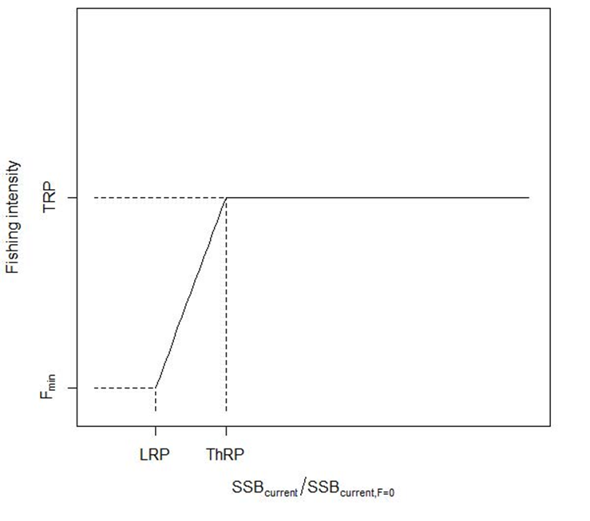
Figure 1. Generalized HCR shape

Other Operational Considerations
The NC recommends that the NP SWO MSE be designed such that the duration of the management periods be 3 years, and that the output controls of the MSE are total allowable catch (TAC).
The MSE should be designed to manage all fishing mortality of NP swordfish (Western and Central North Pacific Ocean SWO and North Eastern Pacific Ocean SWO) in the Pacific Ocean north of the equator.
Recognizing that WCPFC CMM 2023-03 applies to the high seas and EEZ in the WCPFC Convention Area north of 20N, and limits fishing effort for fisheries harvesting over 200 mt of NP SWO, the NC requests the MSE to identify average catch levels for those fisheries that are not included within the WCPFC CMM for the WCPFC Convention Area to inform future considerations related to implementation.

