JOINT IATTC AND WCPFC-NC WORKING GROUP MEETING ON THE
MANAGEMENT OF PACIFIC BLUEFIN TUNA
ELEVENTH SESSION (JWG11)
8 – 11 July 2026
Nagasaki, Japan (Hybrid)
INTERIM PACIFIC BLUEFIN TUNA MANAGEMENT PROCEDURE
(CMM 2026-XX/RESOLUTION C-26-XX)
IATTC-NC-JWG11-2026-WP02
(WCPFC-NC22-2026-WP04)
13 June 2025

PBFJWG Co-Chairs

The Western and Central Pacific Fisheries Commission (WCPFC) adopts, in accordance with Article 10 of the Convention, the following Conservation and Management Measure.

The Inter-American Tropical Tuna Commission (IATTC) adopts, in accordance with Article VII, paragraph 1(c) of the Antigua Convention, the following Resolution.

Objective and Implementation of the Interim Management Procedure (MP)

- The objective of the MP for Pacific bluefin tuna is to ensure that:
  - fishing mortality (F) is maintained at or below F_{TARGET} with a probability of at least 50 percent;
  - spawning stock biomass (SSB) is maintained above the Limit Reference Point (LRP), with a probability of at least 90%; and
  - [an equitable balance in proportional fishery impact between the Western Central Pacific Ocean (WCPO) and the Eastern Pacific Ocean (EPO) is being achieved gradually];
with a view to maximizing yield over the medium (5-10 years) and long (10-30 years) terms, as well as average annual yield from the fishery and increasing average annual catch in all fisheries across WCPFO and EPO, in a manner that achieves relative stability in fishing levels between management periods and in the longer term.

- The IATTC-WCPFC Northern Committee Joint Working Group on the Management of Pacific bluefin tuna (JWG) is held annually to provide recommendations on catch limits and other relevant measures to the WCPFC-NC and IATTC, respectively, to implement a CMM/ Resolution for each two-year period in the schedule as described in paragraph 7 below. Catch limits and other relevant measures may be adjusted for each two-year period but shall be consistent with the MP output and the objectives of this CMM/ Resolution.

Reference Points

- The reference points are:
  - Target reference point (TRP): F27.5%SPR, which is the fishing intensity (F) level that results in the stock producing 27.5% of spawning potential ratio (SPR).
  - Minimum allowed fishing intensity (F_{min}) equal to F70% SPR, which is the F level that results in the stock producing 70% of SPR.
  - Threshold reference point (SSB_{threshold}): 20%SSB_{F=0}, which is 20% of the unfished SSB at equilibrium condition.
  - Limit reference point (LRP): 7.7%SSB_{F=0}, which is 7.7% of the unfished SSB at equilibrium condition.

Scope and design of the MP

- The MP applies to all fisheries taking Pacific bluefin tuna within both Commission areas. The MP (and this CMM/ Resolution) determines the total annual catches of large Pacific bluefin tuna (30 kg or larger in body weight), and small Pacific bluefin tuna (less than 30kg in body weight) to be taken within the WCPFC Convention Area, as well as the total annual catch of Pacific bluefin tuna to be taken within the Eastern Pacific Ocean (EPO), assuming the relative fishing mortality among fishery segments and ages in 2015-2022, while the 2-year implementation CMM/ Resolution will establish the management arrangements for achieving this.

Elements of the MP

- The MP includes:
  - The Harvest Control Rule set out in Annex I;
  - The Estimation Model using the settings set out in Annex II; and
  - The exceptional circumstances set out in Annex III.

Schedule and Roles of the JWG, the Commissions, the Subsidiary Bodies and the ISC

- The ISC shall run the MP, perform stock assessments, and support the JWG and relevant bodies of the WCPFC and the IATTC in monitoring, analysis and review of performance of the MP.

- The JWG shall review the Pacific Bluefin Tuna Management Arrangements and make recommendations to the WCPFC Northern Committee and the IATTC for their decisions in a repeating 2-year schedule as follows:

Year | ISC | JWG | WCPFC Northern Committee (NC) | WCPFC and IATTC Commissions
2026 | Run the MP for application to the period 2027-2028.  Provide advice to the JWG and WCPFC/ IATTC subsidiary bodies on the MP and Management Arrangements CMM. | Provide recommendations to the WCPFC NC and the IATTC on the MP and Management Arrangements CMM/Resolution. | Provide recommendations to the WCPFC Commission on the MP and Management Arrangements CMM. | Review and adopt the MP and the Management Arrangements CMM/Resolution for 2027-2028.
2027 | Perform stock assessment.  Monitor performance of the MP. | Review implementation of CMM/ Resolution and provide recommendations to the WCPFC NC and the IATTC. |  | Apply the Management Arrangements CMM / Resolution.
2028 | Run the MP for application to the period 2029-2030  Monitor the performance of the MP.  Provide advice to the JWG and WCPFC/ IATTC subsidiary bodies on the MP outputs for application to the period 2029-2030. | Review the Management Arrangements CMM/ Resolution.  Provide recommendations to the WCPFC NC and the IATTC, taking into account the output of the MP for application to the period 2029-2030. | Review the Management Arrangements CMM.  Provide recommendations to the WCPFC Commission, taking into account the output of the MP for application to the period 2029-2030. | Adopt the revision of the Management Arrangements CMM / Resolution for 2029-2030.
2029 | Monitor the performance of the MP. | Review implementation of CMM/ Resolution and provide recommendations to the WCPFC NC and the IATTC. |  | Apply the Management Arrangements CMM / Resolution.
2030 | Perform stock assessment.  Run the MP for application to the period 2031-2032.  Monitor the performance of the MP.  Provide advice to the JWG and WCPFC/ IATTC subsidiary bodies on the MP outputs for application to the period 2031-2032. | Review the Management Arrangements CMM/ Resolution.  Provide recommendations to the WCPFC NC and the IATTC, taking into account the output of the MP for application to the period 2031- 2032. | Review the Management Arrangements CMM.  Provide recommendations to the WCPFC Commission, taking into account the output of the MP for application to the period 2031 – 2032. | Adopt the revision of the Management Arrangements CMM / Resolution for 2031-2032.

Management Strategy Evaluation

- The MP has been simulation tested to determine its likely performance against a range of plausible scenarios. These scenarios and the details of the testing procedure are provided in IATTC-NC-JWGI03-2026/IP-01. The results of the evaluations are outlined in the same document and are available online at: https://connect.fisheries.noaa.gov/ISCPBF-MSE-tool/.

Review and Final Provisions

- The WCPFC and IATTC Commissions shall review this MP in 2032 to ensure that the various provisions are having the intended effect. The Commissions may amend the MP based on the results of this review.

- This measure replaces WCPFC HS 2023-03 and IATTC Resolution C-23-01. This measure shall come into effect on 1 January 2027 and shall remain in effect until 31 December 2032 unless otherwise decided by both Commissions, in accordance with Paragraph 9 above.

ANNEX 1: HARVEST CONTROL RULE

- The harvest control rule (HCR) is defined by parameters related to stock status (the ratio of SSB_{current} to SSB_{F=0}) and fishing intensity (SPR) (Fig. 1). SSB_{current} and SSB_{F=0} refer to spawning stock biomass in the terminal year and unfished spawning stock biomass at equilibrium condition, respectively, both estimated by the estimation model. The output from the harvest control rule is a SPR that was used to calculate future TAC along with the age structures of PBF and relative fishing mortality across fleets and ages. Features of HCR include:

  - If SSB_{current}/SSB_{F=0} is above or equal to 1st control point, fishing intensity shall be maintained at the F target.

  - If SSB_{current}/SSB_{F=0} is below 1st control point, and is above 2nd control point, fishing intensity shall be reduced to a level in accordance with following formula:
$F=\frac{F_{target} - F_{min}}{1^{st}contro;point - 2^{nd}control point } × \left(\frac{{SSB}_{current}}{{SSB}_{F=0}} - 2^{nd} control point\right)+ F_{min}$

  - If SSB_{current}/SSB_{F=0} is at or below 2nd control point, fishing intensity shall be set at F_{min}.

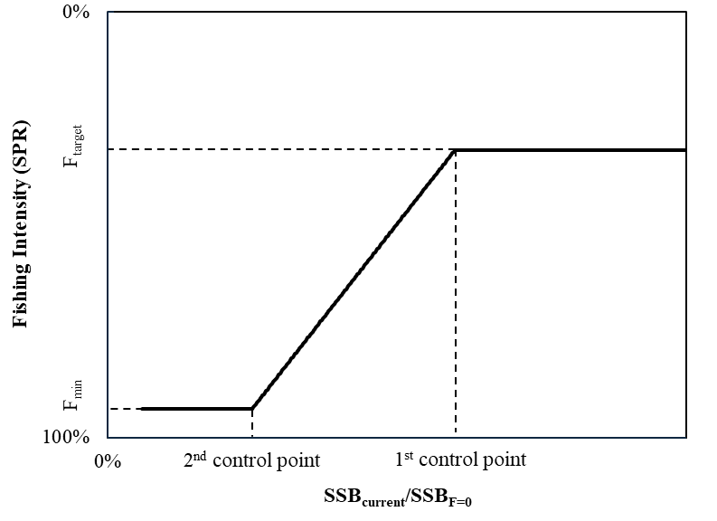
Figure 1: Illustration of the harvest control rule with target reference point (F_{target}), 1st and 2nd control points, and the minimum allowed fishing intensity (F_{min}).

- The maximum changes in catch limits for each fishery segment indicated by the HCR between any 2-year management period shall be 25% relative to the catch limits specified by the MP for the previous 2-year period unless SSB_{current}/SSB_{F=0} is below 2nd control point.

ANNEX 2: ESTIMATION MODEL

- Stock status (SSB_{current} /SSB_{F=0}), age structure of PBF in the terminal year, and relative fishing mortality by fleet and age are estimated within the MP using a stock synthesis (SS3; Methot and Wetzel 2013) based quasi age‑structured-production-model. The model takes into account annual recruitment variation and size selectivity of the key fleets (ASPM‑R+; ISC 2025).

- The ASPM‑R+ estimation model adopts the same demographic assumptions as the 2024 PBF stock assessment base‑case model. Input data include updated longline CPUE‑based abundance indices, updated catch time series for all fleets, and size‑composition data for fleets associated with the longline indices. The model estimates population scale, initial conditions, annual recruitment deviations, and longline fleet selectivity. Estimates of SSB_{current} /SSB_{F=0}, terminal‑year age structure, and relative fishing mortality by fleet and age for 2015–2022 are derived from the model outputs.

- The ASPM‑R+ first estimates the average fishing mortality over 2015–2022 and the corresponding multiplier required to achieve the SPR specified by the HCR. Using these estimates, together with terminal‑year numbers at age, natural mortality, and weight at age derived from the estimation model (EM), the future TAC for each fishery segment is then calculated.

ANNEX 3: CRITERIA FOR IDENTIFYING EXCEPTIONAL CIRCUMSTANCES

- Exceptional circumstances are defined as the occurrence of events that are outside the range of scenarios considered for testing the MP. In the case of such events, it may be necessary to re-evaluate the MP or, in severe cases where there is considered to be a risk to the stock, take remedial action. Exceptional circumstances are not a mechanism for making regular, small
adjustments to the MP, but rather should be invoked where, through an agreed process, the operation of the MP has been demonstrated to be highly risky or inappropriate. This Annex provides guidance on the process for determining whether exceptional circumstances exist and the necessary actions but does not provide firm definitions of all possible exceptional
circumstances.

Process to determine if exceptional circumstances exist:

- The ISC will update CPUE every year, continue to update the estimation model for the scheduled MP run, and conduct stock assessments for the stock with updated data sources. The ISC will also conduct research to examine new evidence about the current stock status and environmental conditions.

- Examples of what might constitute exceptional circumstances for PBF include, but are not limited to:
  - Stock and Fleet Dynamics: Evidence from stock assessment estimates that the stock is in a state not previously simulated in the MSE (e.g., current SSB estimates are outside the range of uncertainty, or new evidence about the biology of the stock is presented). In addition, consider evidence that the fleet structure or fishing operations have changed substantially.
  - Application: Data collection required to produce the stock assessment is no longer available and/or appropriate to apply the adopted MP.
  - Implementation: The implementation of the management action is substantially different from what is prescribed by the MPs. For example, the total removals by the fishery differ substantially from what is prescribed by the MPs. TAC overage is not included here, as it is controllable through management actions.

- Based on the general elements above, indicators are summarized in Table 1.

Process for action in the event of exceptional circumstances:

- Having determined that there is evidence for exceptional circumstances, the ISC shall provide advice to the JWG, WCPFC NC and IATTC including, but not limited to:
  - The nature, severity and potential impacts of the exceptional circumstances;
  - Potential impacts on the performance of the MP;
  - Potential actions to address the exceptional circumstances, such as a change in the MP, additional research, updates to the MSE framework for PBF or other recommendations as appropriate.

Table 1: Elements, indicators, and defined reference ranges used to evaluate whether the stock is experiencing exceptional circumstances beyond those considered in the Pacific bluefin tuna management strategy evaluation.
Element | Indicator | Range | Evaluation Schedule
Stock and Fleet Dynamics | Depletion of stock biomass | In any year estimates fall outside the range of uncertainty simulated by the operating models (OMs) used in the MSE. | EM update or stock assessment
 | Fishing intensity (F_{%SPR}) where SPR is the spawning potential ratio
 | Longline CPUE | In any year estimates fall outside the range of uncertainty simulated by the MSE. | Every year when CPUE is updated.
 | Changes in fleet dynamics or selectivity | Any substantial differences from the structure and parameterization used in the OMs of the most recent MSE | As new evidence and research is presented and accepted by the PBFWG
 | Biological parameters
 | Recruitment drop | Recruitment index shows low trend. | Every year when CPUE is updated.
Application | EM or Stock assessment | EM or Stock assessment is not producible or estimates are unreliable. | EM update or stock assessment
 | Realized catch or effort | If there is evidence that catch or effort outside of management, such as discard mortality or by new fleets, is greater than assumed in the MSE. | As new evidence and research is presented and accepted by the PBFWG

WCPFC and IATTC subsidiary bodies, including WCPFC SC and IATTC SAC, may provide input to the JWG and/or the WCPFC and IATTC, respectively, through existing consultation processes.

