

REGIONAL OBSERVER PROGRAMME INTERSESSIONAL WORKING GROUP
Eighth Meeting
1 April 2026
Electronic Meeting
USA COMMENTS ON CCFS PROCESS FLOW DISCUSSION PAPER
AND THE UPDATED DRAFT SCOPE OF MONITORING FOR CCFS CASES
ROP-IWG08-2026-DP01
7 March 2026
Submitted by the United States of America

Explanatory Note:

The United States submitted for WCPFC22’s consideration WCPFC22-2025-DP15, “Challenges with Observer-Sourced Enforcement Referrals and Proposed Reforms to Strengthen the WCPFC Compliance Monitoring Scheme (CMS).” Although WCPFC22 was unable to discuss WCPFC22-2025-DP15 in detail, WCPFC22 agreed to task the ROP IWG in 2026 to consider relevant issues raised in the paper for further resolution and to formulate a recommendation for action to TCC22.

As the April 2026 meeting of the ROP IWG will review proposals related to the Observer-CCFS process flow and Scope of Monitoring for CCFS cases, the United States notes that WCPFC22-2025-DP15 contains suggested edits to both of those proposals. For ease of reference, the United States has excerpted from WCPFC22-2025-DP15 the specific sections that relate to the CCFS-related proposals, and provided them in this document. A high-level overview of these sections is as follows:

[A] USA Comments on ROP-IWG08 Agenda Item 3.1: Observer–CCFS Process Flow
The United States provided detailed comments on the proposed Observer-CCFS Process Flow in ROP-IWG08-2026-02 (formerly WCPFC22-2025-IP04a_rev01), which were published as a section of WCPFC22-2025-DP15 (pp.8–10, 21–27). The core comments are reproduced below and seek to:
- Clarify Terminology: Ensure consistent language is used throughout the process.
- Define Terms: Add necessary definitions for process steps and components.
- Specify Responsible Parties: Clearly delineate which entity is responsible for each action.
- Harmonize with the Convention: Ensure the procedural flow aligns with the requirements for compliance investigations outlined in Articles 23(5) and 25(2) of the Convention and obligations for sharing of observer evidence (CMM 2018-05 at ¶ 11).
The proposed revisions were provided for review in the following Annexes, reproduced below:
- Annex 1 presents the proposed changes in redline against the original -IP04a draft.
- Annex 2 presents a clean proposed final version of the Observer–CCFS Process Flow.

[B] USA Comments on ROP-IWG08 Agenda Item 3.2: Scope of Monitoring for CCFS Cases
The United States provided detailed comments on the Draft Scope of Monitoring for CCFS Cases in ROP-IWG08-2026-03 (formerly WCPFC22-2025-IP04b), which were published as a section of WCPFC22-2025-DP15 (pp.10–15, 28–37). Key revisions are reproduced below and target:

Clarity & Enforceability: Remove references to unenforceable Obligations.

Precision: Retain and clarify Obligations that have only partial relevance to the ROP.

Completeness: Include a few Obligations that were otherwise called into question.
The proposed revisions are provided for review in the following Annex, which is reproduced below:
- Annex 4 presents a chart with the full text of each CMM obligations alongside feedback.

.

A. USA Comments on ROP-IWG08 Agenda Item 3.1: CCFS Process Flow

Regarding: ROP-IWG08-2026-02 (formerly WCPFC22-2025-IP04a_rev1) See Annex 1 (redline of proposed edits) and Annex 2 (clean proposed final), below.
In WCPFC22-2025-IP04a, the ROP-IWG proposed a process flow to streamline the transfer of information from observer reporting to the WCPFC Secretariat for inclusion in the CCFS. The U.S. supports the proposed process flow—particularly regarding its emphasis on the CCM-led creation of CCFS cases arising out of observer-sourced data (including the automatic provision of complete observer-sourced case packages upon notification under Article 25(2) of the Convention and obligations for sharing of observer evidence (CMM 2018-05 at ¶ 11)) and its description of the debriefing and verification process for observer-alleged infringements.
The U.S. further recommends clarifying edits to the proposed steps, as summarized below (with additional language in step titles indicated in blue-color with underline):
[Step 1. Observer Data Source (Trip Data)] Edits ensure the terminology used is consistent and accurate (e.g., eliminate any reference to “trip report,” which is undefined, and instead reference “trip data”), which will add clarity and help to streamline the proposed process flow.
[Step 2. Data Transmission from Observer to Debriefing Observer Provider] Edits ensure that terminology used is consistent and accurate (e.g., by introducing “Debriefing Observer Provider” as a defined term) and eliminating undefined acronyms.
[Step 3. ROP Observer Debriefing Process (WCPFC ROP Debriefing Questionnaire)] Edits add further detail to clarify how the debriefing process would be done using the newly proposed “WCPFC ROP Debriefing Questionnaire” (to be developed), including by identifying the party or parties responsible for conducting each sub-step in the process and by specifying when and how supporting evidence should be identified and documented.
[Step 4. Compliance Evaluation and Vetting (Infringement Notification Form) and Clearance of Scientific Data for Transmission to SPC] Edits provide crucial clarification by identifying the party responsible for taking various actions in the vetting process, what specifically must be done in order to vet an Observer-Sourced allegation of an alleged infringement, and what specifically must be compiled/forwarded with any subsequent investigation request pursuant to Articles 23(5) and 25(2) of the Convention.

Specifically, the U.S. edits to Step 4 would expand the suggested description of an “Observer-Sourced Case Package” to include all Observer-sourced trip data, whether or not the data is specifically relevant to a particular alleged infringement. As discussed during various ROP-IWG meetings and at TCC21, complete copies of reports are required by the U.S. and other members’ legal systems, with confidential information redacted as needed. For the United States, this is true even if only portions of the report will be used as evidence in domestic proceedings. The limitation on access to each CCFS case and using redaction technologies (rather than omitting pages) should be sufficient to mitigate observer providers’ concerns about uploading confidential observer information directly to the CCFS.

[Step 5. Initiating CCM’s Formal Investigation Request (Observer-Sourced Case Package)] During TCC21, several CCMs noted that all CCFS cases should be Initiated by CCMs pursuant to Convention Articles 23(5) and 25(2) and paragraph 11 of CMM 2018-05. The United States agrees and endorses the substance of the ROP-IWG’s proposed process flow Step 5, but has offered edits to clarify the details by, for example, defining the relevant parties (e.g., Initiating CCMs, Responsible CCMs) and defining/describing the “Observer-Sourced Case Package” materials to be included with any subsequent investigation referral under the Convention. Moreover, suggested edits to the proposed process flow step aim to clarify who specifically is responsible for transmission of the Observer-Sourced Case Package
[Step 6. WCPFC Secretariat CCFS Integration] Edits clarify that supporting documentation for Observer-Sourced CCFS cases, as is true for all Inspection-Sourced CCFS cases, should be uploaded to the CCFS and/or attached to the initial referral communication, as contemplated under Articles 23(5) and 25(2)of the Convention.

[Step 7. Investigation of Alleged Infringements and Domestic Enforcement] Finally, edits proposed to process flow Step 7 clarify the order of actions and responsible parties for investigations into observer-sourced allegations of alleged infringements and, if applicable, their subsequent domestic prosecution.

As noted, a “redline” version of the draft proposed process flow incorporating the USA’s suggested line edits appears in Annex 1, infra, and a “clean” version of the draft proposed process flow incorporating the above-summarized comments appears in Annex 2, infra.

ANNEX 1: USA Proposed “Redline” Edits to ROP-IWG’s

Working Draft Observer–CCFS Process Flow (from pp. 4–5 of WCPFC22-2025-IP04a_rev1)

Notes:
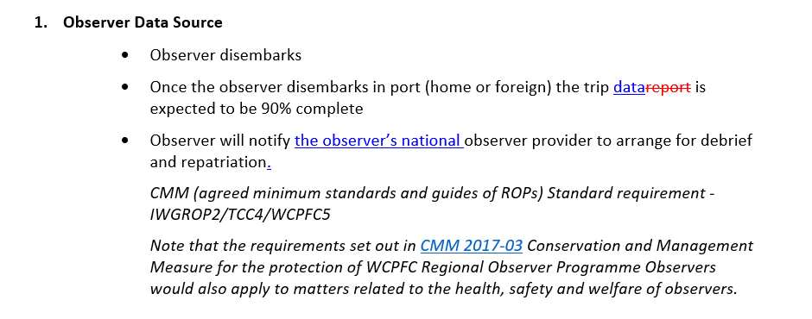
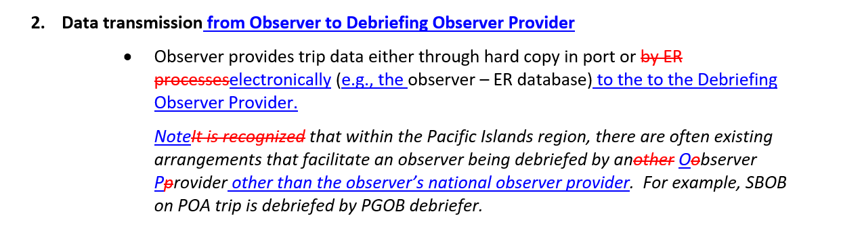
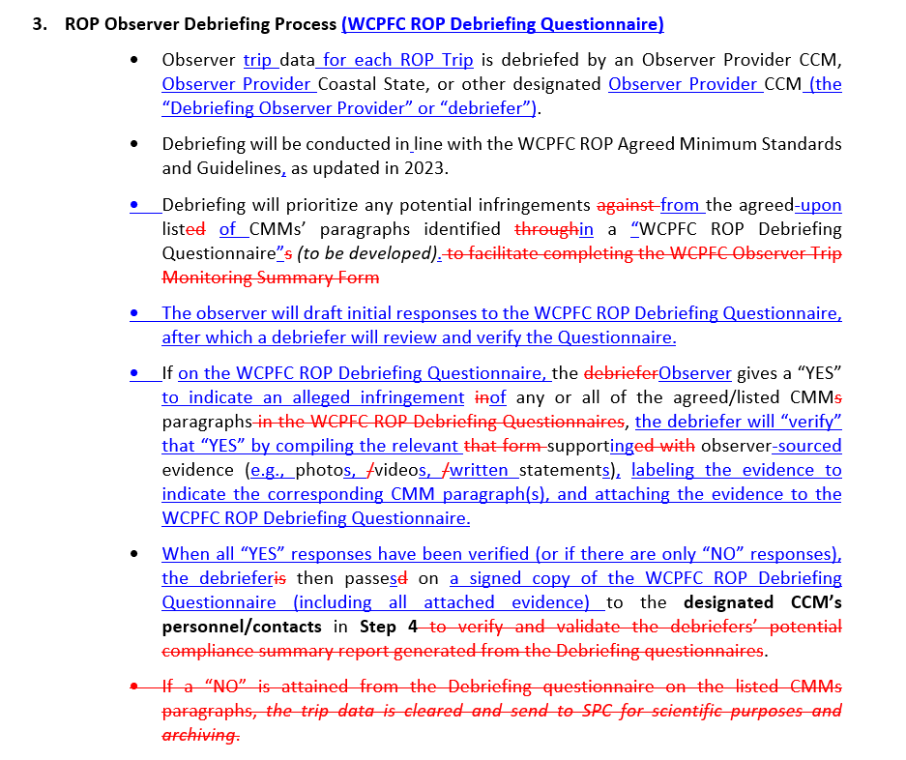
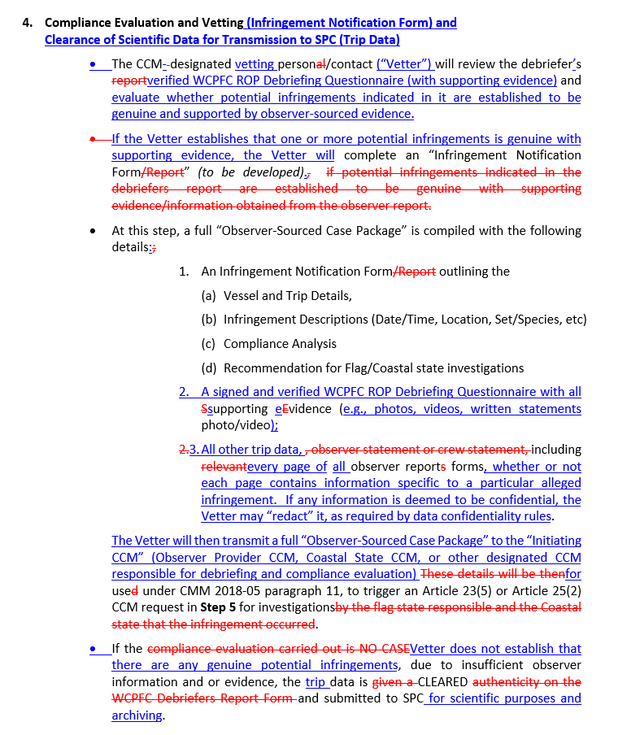
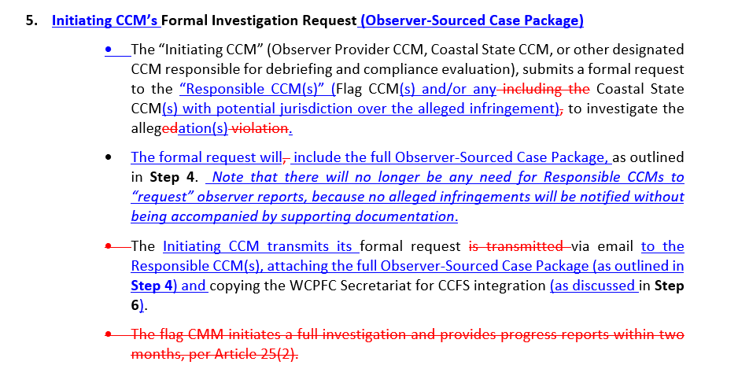
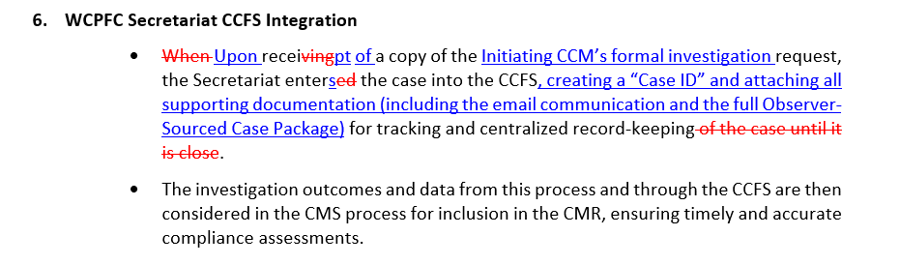

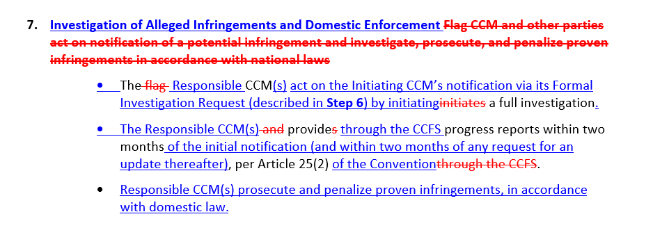

ANNEX 2: Proposed “Clean” Working Draft Observer–CCFS Process Flow
from pp. 4–5 of WCPFC22-2025-IP04a_rev1 (incorporating USA edits described above)

Notes:
- Observer Data Source
- Observer disembarks
- Once the observer disembarks in port (home or foreign) the trip data is expected to be 90% complete
- Observer will notify the observer’s national observer provider to arrange for debrief and repatriation.
CMM (agreed minimum standards and guides of ROPs) Standard requirement - IWGROP2/TCC4/WCPFC5
Note that the requirements set out in CMM 2017-03 Conservation and Management Measure for the protection of WCPFC Regional Observer Programme Observers would also apply to matters related to the health, safety and welfare of observers.

- Data transmission from Observer to Debriefing Observer Provider
- Observer provides trip data either through hard copy in port or electronically (e.g., the observer – ER database) to the Debriefing Observer Provider.
Note that within the Pacific Islands region, there are often existing arrangements that facilitate an observer being debriefed by an Observer Provider other than the observer’s national observer provider. For example, SBOB on POA trip is debriefed by PGOB debriefer.

- ROP Observer Debriefing Process (WCPFC ROP Debriefing Questionnaire)
- Observer trip data for each ROP Trip is debriefed by an Observer Provider CCM, Observer Provider Coastal State, or other designated Observer Provider CCM (the “Debriefing Observer Provider” or “debriefer”).
- Debriefing will be conducted in line with the WCPFC ROP Agreed Minimum Standards and Guidelines, as updated in 2023.
- Debriefing will prioritize any potential infringements from the agreed-upon list of CMMs’ paragraphs identified in a “WCPFC ROP Debriefing Questionnaire” (to be developed).
- The observer will draft initial responses to the WCPFC ROP Debriefing Questionnaire, after which a debriefer will review and verify the Questionnaire.
- If on the WCPFC ROP Debriefing Questionnaire, the Observer gives a “YES” to indicate an alleged infringement of any or all of the agreed/listed CMM paragraphs, the debriefer will “verify” that “YES” by compiling the relevant supporting observer-sourced evidence (e.g., photos, videos, written statements), labeling the evidence to indicate the corresponding CMM paragraph(s), and attaching the evidence to the WCPFC ROP Debriefing Questionnaire.
- When all “YES” responses have been verified (or if there are only “NO” responses), the debriefer then passes on a signed copy of the WCPFC ROP Debriefing Questionnaire (including all attached evidence) to the designated CCM’s personnel/contacts in Step 4.

- Compliance Evaluation and Vetting (Infringement Notification Form) and
Clearance of Scientific Data for Transmission to SPC (Trip Data)
- The CCM-designated vetting person/contact (“Vetter”) will review the debriefer’s verified WCPFC ROP Debriefing Questionnaire (with supporting evidence) and evaluate whether potential infringements indicated in it are established to be genuine and supported by observer-sourced evidence.
- If the Vetter establishes that one or more potential infringements is genuine with supporting evidence, the Vetter will complete an “Infringement Notification Form” (to be developed). At this step, a full “Observer-Sourced Case Package” is compiled with the following details:
  - An Infringement Notification Form outlining the
        - Vessel and Trip Details,
        - Infringement Descriptions (Date/Time, Location, Set/Species, etc)
        - Compliance Analysis
        - Recommendation for Flag/Coastal state investigations
  - A signed and verified WCPFC ROP Debriefing Questionnaire with all supporting evidence (e.g., photos, videos, written statements photo/video);
  - All other trip data, including every page of all observer report forms, whether or not each page contains information specific to a particular alleged infringement. If any information is deemed to be confidential, the Vetter may “redact” it, as required by data confidentiality rules.
- The Vetter will then transmit a full “Observer-Sourced Case Package” to the “Initiating CCM” (Observer Provider CCM, Coastal State CCM, or other designated CCM responsible for debriefing and compliance evaluation) for use under CMM 2018-05 paragraph 11, to trigger an Article 23(5) or Article 25(2) CCM request in Step 5 for investigations. If the Vetter does not establish that there are any genuine potential infringements, due to insufficient observer information and or evidence, the trip data is CLEARED and submitted to SPC for scientific purposes and archiving.

- Initiating CCM’s Formal Investigation Request (Observer-Sourced Case Package)
- The “Initiating CCM” (Observer Provider CCM, Coastal State CCM, or other designated CCM responsible for debriefing and compliance evaluation), submits a formal request to the “Responsible CCM(s)” (Flag CCM(s) and/or any Coastal State CCM(s) with potential jurisdiction over the alleged infringement) to investigate the allegation(s).
- The formal request will include the full Observer-Sourced Case Package, as outlined in Step 4. Note that there will no longer be any need for Responsible CCMs to “request” observer reports, because no alleged infringements will be notified without being accompanied by supporting documentation.
- The Initiating CCM transmits its formal request via email to the Responsible CCM(s), attaching the full Observer-Sourced Case Package (as outlined in Step 4) and copying the WCPFC Secretariat for CCFS integration (as discussed in Step 6).
- WCPFC Secretariat CCFS Integration
- Upon receipt of a copy of the Initiating CCM’s formal investigation request, the Secretariat enters the case into the CCFS, creating a “Case ID” and attaching all supporting documentation (including the email communication and the full Observer-Sourced Case Package) for tracking and centralized record-keeping.
- The investigation outcomes and data from this process and through the CCFS are then considered in the CMS process for inclusion in the CMR, ensuring timely and accurate compliance assessments.

Note that if the WCPFC eventually creates a “ROP Portal” (similar to the recently implemented “HSBI Portal”), then an Initiating CCM in Step 5 would also create a CCFS case in the ROP Portal and upload the Observer-Sourced Case Package described in Step 4, and Step 6 would be comprised of the Secretariat’s review of the ROP-Portal entry to finalize the creation of a case in CCFS for tracking and centralized record-keeping purposes.

- Investigation of Alleged Infringements and Domestic Enforcement
  - The Responsible CCM(s) act on the Initiating CCM’s notification via its Formal Investigation Request (described in Step 6) by initiating a full investigation.
  - The Responsible CCM(s) provide through the CCFS progress reports within two months of the initial notification (and within two months of any request for an update thereafter), per Article 25(2) of the Convention.
  - Responsible CCM(s) prosecute and penalize proven infringements, in accordance with domestic law.

B. USA Comments on ROP-IWG08 Agenda Item 3.2: Scope of Monitoring

Regarding: ROP-IWG08-2026-03 (formerly WCPFC22-2025-IP04b) See Annex 4 (redline of U.S. edits to the table in -IP04 at pp. 10–32), below.
In WCPFC22-2025-IP04b, the ROP-IWG proposed updates to the ROP Minimum Standard Data Fields (MSDFs) and other areas of the ROP data forms to add or revise fields for better monitoring of CMMs and improving ROP data integration into the CCFS.

The U.S. has provided comments on which WCPFC obligations are appropriate for monitoring by human observers with the ROP-IWG, and a summary of those comments appears below, with an abbreviated and annotated “redline” version of the table on PDF pages 10–32 of WCPFC22-2025-IP04b with U.S. and PNA+ comments, is provided in Annex 4, infra.

The U.S. also submitted to the ROP-IWG a revised Summary of Obligations and Proposed Case-Type Identifiers for Observer-Sourced CCFS Cases, updated from the version appearing on PDF pages 8–9 of WCPFC22-2025-IP04b, to reflect these recommendations. That table is also reproduced below in redline, under sub-paragraph (B)(ii).

i. Summary of the U.S.’s Substantive Comments regarding pp. 10–32 of WCPFC22-2025-IP04b (see Annex 4 for U.S. edits in redline)
The U.S. is proposing to remove or edit specific CMM paragraphs from the formal list of obligations for inclusion in the WCPFC ROP Debriefing Questionnaire’s list of possible CCFS/enforcement referral topics when the obligations are considered to be mere suggestions, are unenforceable, or are otherwise inappropriate for compliance assessments. Those recommendations are summarized below.
- Removal of Obligations Deemed to be Suggestions/Guidance. The U.S. is proposing to remove or edit the following specific CMM paragraphs from the Questionnaire because the obligations (in whole or in part) are considered to be mere suggestions that are not binding on CCMs or their vessels. Affected paragraphs include:
    - CMM 2008-04 02 (regarding Driftnet Prohibitions (DNS))—U.S. recommends removing and replacing with CMM 2008-04 01 (DNS));
    - CMM 2009-05 05 (regarding Data Buoys (FAD))—Second sentence is an encouragement and first sentence is overly broad;
    - CMM 2017-04 05 (regarding Marine Pollution (POL)); and
    - CMM 2019-05 08 (regarding Mobulid Rays (RAY)).
The U.S. supports retaining references to the following obligations but would also recommend some clarification to ROP reference materials because portions of those obligations are merely encouragements:
- CMM 2009-05 05 (FAD)—Retain but specify that the second sentence is merely an encouragement.
- CMM 2019-05 05 (RAY)— Retain but specify that the second sentence is merely an encouragement.
- Removal of Otherwise Unenforceable Obligations. The U.S. is proposing to remove or edit the following specific CMM paragraphs from the Questionnaire because the obligations (in whole or in part) are unenforceable against individual vessel owners, whose alleged compliance would become the subject of a new CCFS case and referral. Paragraphs falling into this category include:
- CMM 2019-05 06 (RAY)–Remove in its entirety because, although the U.S. supports the intent of the obligation, compliance with it would only be verifiable after disembarkation in port, so this is an impractical subject for observers to monitor.
- CMM 2024-05 24 (03) (regarding Sharks (SHK))–Remove this sub-paragraph of the obligation only (and retain the other sub-paragraphs) because 24(03) relates to activities that would often not be verifiable until after the catch is landed and disposed of at markets in port.
- CMM 2024-05 25 (03, 04, 05(b), 06, and 07) (regarding Whale Sharks (CWS))—Remove reference to sub-paragraphs 25(3), 25(4), 25(5b), 25(6), and 25(7), which are all CCM obligations outside the scope of observer data collection.
- Clarification of Guidance to Observers for Some Retained Obligations. The U.S. is proposing to retain certain obligations that some others have recommended for removal from the WCPFC ROP Debriefing Questionnaire, but the U.S. also recommends that ROP reference materials be clarified to avoid confusion as follows:
- CMM 2018-04 04 (regarding Sea Turtles (TUR))–Retain but clarify that observers may disregard the last sentence of the paragraph, which obligates a CCM to adopt domestic legislation and is therefore not enforceable against individual vessel owners or operators, as would be supported by an Observer-Sourced CCFS case.
- CMM 2023-01 14 (FAD)– Retain but clarify that only the first sentence of the obligation is relevant; observers may disregard the last two sentences, which involve notice by CCMs to the Secretariat and are therefore impractical for observers to monitor.
- CMM 2018-03 06 (regarding Sea Birds (BIR))–Retain for now, and (i) ensure that ROP reference materials reproduce the relevant tables from this CMM, if not already included, and (ii) conduct further discussions with interested stakeholders regarding the practicality of tasking ROP observers with monitoring for the obligation.
- Inclusion/Retention of Specific Obligations for Monitoring. The U.S. is actively supporting the retention of certain CMM paragraphs in the ROP Debriefer Questionnaire, such as the full Cetaceans paragraphs (CMM 2024-07 01–04 (CWS)) and CMM 2018-05 15(g) (regarding allegations of Observer Obstruction (OBS)), to ensure they remain part of the observer's monitoring scope.
Worth highlighting here are several such obligations, for which the U.S. disagrees with calls to remove them by other stakeholders, including certain obligations that the U.S. proposes should be retained in their entirety, as specified:
- CMM 2024-05 08 (SHK)–Retain because observers can record a yes/no response regarding whether the vessel has landed sharks with their fins naturally attached or not.
- CMM 2024-05 09 (SHK)—Retain, but edit ROP reference materials to clarify that in monitoring for compliance with this obligation, observers are expected only to record whether alternative measures were used and whether they were complied with.
- CMM 2024-05 14 (SHK)—Retain because observers can verify whether vessels did, in fact, retain on board, transship, and/or land fins harvested in contravention of the obligation.
- CMM 2024-05 15 (SHK)–Retain because observers can verify compliance with the requirement that carcasses and fins be landed and/or transshipped together.
Similarly, although the U.S. supports retaining references to the following obligations in the WCPFC ROP Debriefing Questionnaire, some clarification to ROP reference materials may be warranted as follows:
- CMM 2019-05 (10) (RAY)—Retain because, although the U.S. agrees with PNA+’s observation that the obligation also goes to observer interference (OBS), the U.S. recommends that allegations going to this obligation only be recorded in one place–here, as “RAY” CCFS Case Types–in order to avoid inflated statistics, and because charging the conduct under both theories remains available to Responsible CCMs exercising prosecutorial discretion, domestically.
The U.S. defers to the ROP for technical considerations of whether to accomplish the above via amendments to the MSDFs or by other means.

ii. Summary of Obligations & Case-Type Identifiers for Observer-Sourced CCFS Cases from pp. 8–9 of WCPFC22-2025-IP04b, incorporating U.S. feedback in redline.
Type | Description | Relevant CMMs
POL (same as current) | Marine Pollution (including required prohibition on vessel discharge any non-fishing gear plastics and encouragements to CCMs regarding additional marine pollution measures and reporting of gear loss) | CMM 2017-04 (for Marine Pollution; eff. 01 Jan 2019 - Current)  - CMM 2017-04 02  - CMM 2017-04 05
FAD (currently “FAI”) | Fishing on Data Buoys (including prohibition on fishing within 1 nautical mile or interacting with data buoys on the high seas and adherence to various requirements in the case of entanglement) and FAD closures for Tropical Purse Seine Vessels (including prohibition on setting on FADs in EEZ waters or high seas of the Convention Area during the 1.5-month FAD closure and for one additional month of FAD Closure period that the Flag State has chosen) | CMM 2023-01 (for Bigeye, Yellowfin and Skipjack Tuna in the Western & Central Pacific Ocean;  eff. 06 Feb 2024 - Current)  - CMM 2023-01 13  - CMM 2023-01 14 (1st sentence)  CMM 2009-05 (Prohibiting Fishing on Data Buoys; eff. 09 Feb 2010 - Current)  - CMM 2009-05 01, 03, 05
CWS  (same as current) | Interactions with Cetaceans (including prohibition on purse seine (“PS”) setting on cetaceans if animal is sighted prior to commencement of the set; requirements in the event of unintentional circling of cetaceans in the PS net, including incident reporting; the prohibition on all vessels (PS and longline (“LL”)) from harvesting, retaining onboard, transshipping, or landing any cetacean, in whole or any part thereof, in the Convention Area; and the requirement that LL vessels release, taking into account the safety of the crew, any cetacean that is caught or entangled by its fishing gear in the Convention Area as soon as possible and in a manner that results in as little harm to the cetacean as possible and utilizing the Best Practices for the Safe Handling and Release of Cetaceans, if possible); and Interactions with Whale Sharks (including prohibition on PS setting on whale sharks and on retention/ transshipment) | Cetaceans:  CMM 2024-07 (for Protection of Cetaceans from PS & LL Fishing Operations; eff. 01 July - Current)  - CMM 2024-07 01-04  Whale Sharks:  CMM 2024-05 (for Sharks; eff. 01 Feb 2025 - Current).  - CMM 2024-05 25 (01, 02, 05(a), -07)
OBS (currently “OAI”) | Observer Obstruction | CMM 2018-05 (for the ROP; eff. 12 Feb 2019 - Current)  - CMM 2018-05 15(g)
DNS  (NEW) | Driftnet regulations (including prohibition on the use of large-scale driftnets on the high seas) | CMM 2008-04 (to Prohibit the Use of Large Scale Driftnets on the High Seas of the Convention Area; eff. 10 Feb 2009 - Current)  - CMM 2008-04 02  - CMM 2008-04 01
SHK (same as current) | Shark Catch (including prohibitions on shark finning (including transshipment of fins), retention on board of sharks (including for crew consumption), provisions intended to minimize bycatch of sharks in certain LL fisheries, the preference for hauling non-retained sharks alongside for species identification, and various requirements related to Silky Sharks and Oceanic White Tip sharks specifically, among others) | CMM 2024-05 (for Sharks; eff. 01 Feb 2025 - Current).  - CMM 2024-05 07-09  - CMM 2024-05 14  - CMM 2024-05 15  - CMM 2024-05 18  - CMM 2024-05 21  - CMM 2024-05 24 (01, 02-03)
RAY  (NEW) | Mobulid Rays (including prohibitions on the retention, transshipment, storing, or landing of mobulid rays, as well as the targeted fishing or intentional setting on them) | CMM 2019-05 (for Mobulid Rays caught in association with fisheries in the WCPFC Convention Area; eff. 01 Jan 2021 - Current).  - CMM 2019-05 (04, 05 (1st sentence) 06, 08, 10)  - CMM 2019-05 03
TUR  (NEW) | Sea Turtles (including CMMs ensuring that fishermen use proper mitigation and handling techniques and foster the recovery of any incidentally captured turtles before returning them to the water, requiring LL vessels to carry and use certain equipment for the prompt handling and release of incidental bycatch, and imposing mitigation requirements for shallow-set LL vessels) | CMM 2018-04 (of Sea Turtles; eff. 01 Jan 2020 - Current).  - CMM 2018-04 04  - CMM 2018-04 06  - CMM 2018-04 07 (a, b)
BIR  (NEW) | Seabirds (including: Required longline mitigation measures to reduce incidental catch of seabirds applying north of 23N or south of 25S. i. use at least two mitigation measures in paragraph 1(a) or hook shielding devices when fishing south of 30°S ii. use one of the mitigation measures in paragraph 2 when fishing in area 25°S-30°S iii. 24m or more in overall length, to use at least two mitigation measures in paragraph 6, Table 1; and including at least one from Column A when fishing north of 23°N iv. less than 24m in overall length, to use at least one of the mitigation measures from Column A in Table 1,when fishing north of 23°N) | CMM 2018-03 (to mitigate the impact of fishing for highly migratory fish stocks on seabirds; eff. 12 Feb 2019 - Current)  - CMM 2018-03 01, 02, 06

ANNEX 4: Proposed “Redline” List of Obligations for Inclusion in ROP Observer Records for Possible CCFS/Enforcement Referral from PDF pages 10–32 of WCPFC22-2025-IP04b
Below, the U.S. shares its comments on whether certain WCPFC obligations are appropriate for inclusion on a forthcoming WCPFC ROP Debriefing Questionnaire in the below table, which is an abbreviated and annotated version of the table on PDF pages 10–32 of WCPFC22-2025-IP04b. New comments by the United States are shown in green italicized font (e.g., new comment) and reflecting the U.S.’s recommended insertions in underlined, blue font (e.g., insertions), and showing proposed deletions in stricken, red font (e.g., delete)):
CMM | Obligation / CMM Paragraph (Full Text) | Comments
OBSERVER OBSTRUCTION (currently “OAI”)—Case Type Identifier: “OBS”

CMM 2018-05  CMM for the ROP  (eff. 12 Feb 2019 - Current) | CMM 2018-05 15(g) (“(g) The Commission ROP shall be operated to ensure that observers shall not be unduly obstructed in the discharge of their duties. To this extent, CCMs of the Commission shall ensure that vessel operators comply with the Guidelines in Annex B — Guidelines for the Rights and Responsibilities of Vessel Operators, Captains and Crew.”) | PNA supports maintaining this paragraph  USA: Supports including this paragraph in the WCPFC ROP Debriefing Questionnaire.
DRIFTNET PROHIBITION (NEW)—Case Type Identifier: “DNS”

CMM 2008-04  CMM to Prohibit the Use of Large Scale Driftnets on the High Seas of the Convention Area  (eff. 10 Feb 2009 - Current) | CMM 2008-04 02 (“2. CCMs shall take all measures necessary to prohibit their fishing vessels from using large-scale driftnets while on the high seas in the Convention Area.”)  CMM 2008-04 01 (“1. The use of large-scale driftnets¹ on the high seas within the Convention Area shall be prohibited and such nets shall be considered prohibited fishing gear, the use of which shall constitute a serious violation in accordance with Article 25 of the Convention.” ([Footnote 1: “Large-scale driftnets” are defined as gillnets or other nets or a combination of nets that are more than 2.5 kilometers in length whose purpose is to enmesh, entrap, or entangle fish by drifting on the surface of, or in, the water column.”] ) | PNA supports maintaining  PNA comment: Suggest leaving it out and keep it for debriefing process as no high impact at the moment  USA: Notes that the current obligation identified (paragraph 2) is not enforceable against individual vessel owners or operators, as in a domestic enforcement action. Instead, the U.S. proposes inclusion of CMM 2008-04 01 instead, notwithstanding the lack of existing “obligation” webpage for this paragraph of the CMM.
FISHING ON DATA BUOYS PROHIBITION (NEW) & FAD CLOSURE – TROPICAL PURSE SEINE (currently “FAI”)
—Case Type Identifier “FAD”

CMM 2009-05  CMM Prohibiting Fishing on Data Buoys  (eff. 09 Feb 2010 - Current) | CMM 2009-05 01 (“1. CCMs shall prohibit their fishing vessels from fishing within one nautical mile of or interacting with a data buoy in the high seas of the Convention Area, which includes, but is not limited to, encircling the buoy with fishing gear; tying up to or attaching the vessel, or any fishing gear, part or portion of the vessel, to a data buoy or its mooring; or cutting a data buoy anchor line.”)  CMM 2009-05 03 (“3. CCMs shall prohibit their fishing vessels from taking on board a data buoy unless specifically authorized or requested to do so by the Member or owner responsible for that buoy.”)  CMM 2009-05 05 (“5. CCMs shall require their fishing vessels that become entangled with a data buoy to remove the entangled fishing gear with as little damage to the data buoy as possible. CCMs are encouraged to require their fishing vessels to report to them all entanglements and provide the date, location and nature of the entanglement, along with any identifying information contained on the data buoy. CCMs shall notify the Secretariat of all such reports.”) | PNA support to maintain para 01 and 03 but question mark about para 05 if it is observer level or CCM level.  PNA comment: Suggest leaving it out and keep it for debriefing process.  USA: Supports including paras 01 and 03 but recommends removing para 05 from the WCPFC ROP Debriefing Questionnaire because it is unenforceable. The first sentence in para 05 lacks specificity as to what constitutes “as little damage . . . as possible,” and the second sentence in para 05 is merely an encouragement to CCMs.
CMM 2023-01  CMM for Bigeye, Yellowfin and Skipjack Tuna in the Western & Central Pacific Ocean  (eff. 06 Feb 2024 - Current) | CMM 2023-01 13 (“13. A one and a half (1 1/2) months (July to mid-August) prohibition of deploying, servicing or setting on FADs shall be in place between 0001 hours UTC on 1 July and 2359 hours UTC on 15 August each year for all purse seine vessels, tender vessels, and any other vessels operating in support of purse seine vessels fishing in exclusive economic zones and the high seas in the area between 20oN and 20oS.” (footnote omitted)) | PNA supports maintaining.  PNA comment: suggest that it be made available publicly on the website and circulate widely to Observer providers so observer can be advised during placement.  USA: Supports including all of para 13 in the WCPFC ROP Debriefing Questionnaire
CMM 2023-01  CMM for Bigeye, Yellowfin and Skipjack Tuna in the Western & Central Pacific Ocean  (eff. 06 Feb 2024 - Current)  [continued] | CMM 2023-01 14 (“14. In addition to the one and a half month FAD closure in paragraph 13, except for those vessels flying the Kiribati flag when fishing in the high seas adjacent to the Kiribati exclusive economic zone, and Philippines’ vessels operating in HSP1 in accordance with Attachment 2, it shall be prohibited to deploy, service or set on FADs in the high seas for one additional month of the year. . . Each CCM shall decide which one month (either April, May, November or December) shall be closed to setting on FADs by their fleets in the high seas for 2024, 2025, 2026 and notify the Secretariat of that decision by March 1, each year. In case a CCM decides to change the notified period at any given year of the application of this CMM this shall be notified to the Secretariat before 1st March of that year”) | PNA supports maintaining.  USA: Would encourage observer reference materials to specify that only the first sentence of para 14 is relevant; the last two sentences of para 14 (stricken in the column to the left) involve notice by CCMs to the Secretariat and therefore are not appropriate for observer notation.
MARINE POLLUTION (currently “POL”)—Case Type Identifier: “POL”

CMM 2017-04  CMM on Marine Pollution  (eff. 01 Jan 2019 - Current) | CMM 2017-04 02 (“2. CCMs shall prohibit their fishing vessels operating within the WCPFC Convention Area from discharging any plastics (including plastic packaging, items containing plastic and polystyrene) but not including fishing gear.”) | PNA supports to maintain.  PNA comment: only PN-a MSDF is useful for CCFS  USA: Agrees with PNA—The WCPFC ROP Debriefing Questionnaire should include the obligation in para 02.
CMM 2017-04  CMM on Marine Pollution  (eff. 01 Jan 2019 - Current)  [continued] | CMM 2017-04 05 (“5. CCMs shall encourage their fishing vessels within the WCPFC Convention Area to retrieve abandoned, lost or discarded fishing gear and retain the material on board, separate from other waste for discharge to port reception facilities. Where retrieval is not possible or does not occur, CCMs shall encourage their fishing vessels to report the latitude, longitude, type, size and age of abandoned, lost or discarded fishing gear.” | PNA suggest omitting para 05 because of its non-binding language.  PNA comment: About the Secretariat comment to be useful for Observers to collect information about how crew may attempt to retrieve ALDFG is best left for CCMs reporting and not useful for CCFS purposes.  USA: Agrees with and recommends that the obligation in para 05 be removed, as it is only an encouragement.
SEA BIRDS (NEW)—Case Type Identifier: “BIR”

CMM 2018-03  CMM to mitigate the impact of fishing for highly migratory fish stocks on seabirds  (eff. 12 Feb 2019 - Current) | CMM 2018-03 01 (“1. CCMs shall require their longline vessels fishing south of 30°S, to use either[:] a) at least two of these three measures: i). weighted branch lines;  ii). night setting; iii). tori lines; or b) hook-shielding devices. Table 1 does not apply south of 30° South. See Annex 1 for specifications of these measures.”)  CMM 2018-03 02 (“2. CCMs shall require their longline vessels fishing in the area 25°S-30°S to use one of the following mitigation measures: i) weighted branch lines; ii) tori lines; or  iii) hook-shielding devices. Table 1 does not apply in the area 25°S-30°S. See Annex 1 for specifications of these measures.”)  CMM 2018-03 06 (“6. CCMs shall require their large-scale longline vessels of 24 meters or more in overall length  fishing north of 23°N, to use at least two of the mitigation measures in Table 1, including at least one from Column A. CCMs also shall require their small-scale longline vessels less than 24 meters in overall length fishing north of 23°N, to use at least one of the mitigation measures from Column A in Table 1. See Annex 1 for specifications of these measures.”) | PNA supports maintaining para 01 and 02 but have a question mark around paragraph 06 on whether it is practical for observers to collect the information require[d]  USA: Supports including all three of these paragraphs in the WCPFC ROP Debriefing Questionnaire but would welcome further discussion with PNA and other members regarding the practicality of para 06. In the meantime, and in order to minimize observer confusion regarding the details of the obligation in para 06 of the CMM, reference materials provided to observers should also reproduce the relevant tables from this CMM.
SEA TURTLES (NEW)—Case Type Identifier: “TUR”

CMM 2018-04  Conservation and Management of Sea Turtles  (eff. 01 Jan 2020 - Current) | CMM 2018-04 04 (“4. CCMs shall require fishermen on vessels targeting species covered by the Convention to bring aboard, if practicable, any captured hard-shell sea turtle that is comatose or inactive as soon as possible and foster its recovery, including giving it resuscitation, before returning it to the water. . . . CCMs shall ensure that fishermen are aware of and use proper mitigation and handling techniques, as described in WCPFC guidelines.”). | PNA supports maintaining para 04.  PNA comment: PS-3 already capture SSI sighting and encirclement data for purse seine and support that additional Yes/No question on the GEN3 maybe taken up during debriefing to minimize at sea workload.  USA: The U.S. is supportive including the obligation in the first sentence of para 04 but recommends removing reference to the second/final sentence in that paragraph, which obligates a CCM to adopt domestic legislation and is therefore not enforceable against individual vessel owners or operators, as would be supported by an Observer-Sourced CCFS case.
CMM 2018-04  Conservation and Management of Sea Turtles  (eff. 01 Jan 2020 - Current)  [continued] | CMM 2018-04 06 (“6. CCMs with longline vessels that fish for species covered by the Convention shall ensure that the operators of all such longline vessels carry and use line cutters and de-hookers to handle and promptly release sea turtles caught or entangled, and that they do so in accordance with WCPFC guidelines. CCMs shall also ensure that operators of such vessels are, where appropriate, required to carry and use dip-nets in accordance with these WCPFC guidelines.”)  CMM 2018-04 07 (a, b) (“7. CCMs with longline vessels that fish in a shallow-set manner* shall: a. Ensure that the operators of such vessels, while in the Convention Area, are required to employ or implement at least one of the following three methods to mitigate the capture of sea turtles: i. Use only large circle hooks, which are fishing hooks that are generally circular or oval in shape and originally designed and manufactured so that the point is turned perpendicularly back to the shank. These hooks shall have an offset not to exceed 10 degrees. ii. Use only finfish for bait. iii. Use any other measure, mitigation plan** or activity that has been reviewed by the Scientific Committee (SC) and the Technical and Compliance Committee (TCC) and approved by the Commission to be capable of reducing the interaction rate (observed numbers per hooks fished) of turtles in shallow-set longline fisheries. b. The requirements of paragraph 7(a) need not be applied to those shallow-set longline fisheries determined by the SC, based on information provided by the relevant CCM, to have minimal*** observed interaction rates of sea turtles over a three-year period and a level of observer coverage of at least 10% during each of those three years. *n.1: “Shallow-set” fisheries are generally to be considered those in which the majority of hooks fish at depth shallower than 100 meters; however pursuant to paragraph 7(c) CCMs are to establish and enforce their own operational definitions. **n 2: A mitigation plan details the actions that will be taken to achieve specified reductions in sea turtle interactions. ***n.3: As determined by SC5.”) | PNA supports maintaining [para 06, and para 07].  USA: The U.S. is supportive including the obligation in the first sentence of para 04 but recommends removing reference to the second/final sentence in that paragraph, which obligates a CCM to adopt domestic legislation and is therefore not enforceable against individual vessel owners or operators, as would be supported by an Observer-Sourced CCFS case.  The U.S. supports including the obligations in paras 06 and 07 (a, b).
MOBULID RAYS (NEW)—Case Type Identifier: “RAY”

CMM 2019-05  CMM for Mobulid Rays caught in association with fisheries in the WCPFC Convention Area  (eff. 01 Jan 2021 - Current) | CMM 2019-05 03 (“3. CCMs shall prohibit their vessels from targeted fishing or intentional setting on mobulid rays in the Convention Area.”) | PNA comment: PS-3 already capture SSI sighting and encirclement data for purse seine and support that additional Yes/No question on the GEN3 maybe taken up during debriefing to minimize at-sea workload.  USA: Agrees with PNA and supports retaining para 03.
CMM 2019-05  CMM for Mobulid Rays caught in association with fisheries in the WCPFC Convention Area  (eff. 01 Jan 2021 - Current)  [continued] | CMM 2019-05 04, 05, 06 (“4. CCMs shall prohibit their vessels from retaining on board, transhipping, or landing any part or whole carcass of mobulid rays caught in the Convention Area. 5. CCMs shall require their fishing vessels to promptly release alive and unharmed, to the extent practicable, mobulid rays as soon as possible, and to do so in a manner that will result in the least possible harm to the individuals captured. . . .CCMs should encourage their fishing vessels to implement the handling practices detailed in Annex 1, while taking into consideration the safety of the crew. 6. Notwithstanding paragraph 4, in the case of mobulid rays that are unintentionally caught and landed as part of a purse seine vessel’s operation, the vessel must, at the point of landing or transhipment, surrender the whole mobulid ray to the responsible governmental authorities, or other competent authority, or discard them where possible. Mobulid rays surrendered in this manner may not be sold or bartered but may be donated for purposes of domestic human consumption.”)  CMM 2019-05 (08) (“8. CCMs shall ensure that fishers are aware of proper mitigation, identification, handling and releasing techniques and should encourage them to keep on board all necessary equipment for the safe release of mobulid rays. For this purpose, CCMs are encouraged to use the handling practices included as Annex 1.”)”)  CMM 2019-05 (10) (“10. Observers shall be allowed to collect biological samples of mobulid rays caught in the WCPFC Convention Area that are dead at haul-back.”) | PNA supports maintaining paragraph 03-05, para 06 is suggested to be omitted because it is not monitored by observers and paragraph 10 can be considered as obstruction under ROP CMM.  PNA comment: PS-3 already capture SSI sighting and encirclement data for purse seine and support that additional Yes/No question on the GEN3 maybe taken up during debriefing to minimize at-sea workload.  USA: Agrees with PNA and supports retaining para 04 and the first sentence of para 05 but recommends removing the second sentence in para 05, which involves a mere encouragement. Although the U.S. supports the intent of the obligation in para 06 recommends deleting it from the WCPFC ROP Debriefing Questionnaire, as compliance with its obligations would only be verifiable after disembarkation in port.  The U.S. recommends removing para 08, which is merely an encouragement.  While the U.S. agrees with the PNA comments noting that the obligation in para 10 also goes to observer interference, the U.S. recommends that allegations going to this obligation only be recorded in one place—here, under “RAY”—in order to avoid inflated statistics, and because charging the conduct under both theories remains available to Responsible CCMs exercising prosecutorial discretion.
SHARKS (currently “SHK”)—Case Type Identifier: “SHK”

CMM 2024-05  CMM for Sharks  (eff. 01 Feb 2025 - Current) | CMM 2024-05 07–09 (“7. CCMs shall take measures necessary to require that all sharks retained on board their vessels are fully utilized. CCMs shall ensure that the practice of finning is prohibited. 8. In order to implement the obligation in paragraph 7, in 2025, 2026, and 2027, CCMs shall require their vessels to land sharks with fins naturally attached to the carcass. 9. Notwithstanding paragraph 8, in 2025, 2026, and 2027, CCMs may authorize their vessels to implement one of the alternative measures listed below to comply with paragraph 7.* CCMs shall implement enhanced monitoring efforts on its vessels authorized to implement the alternatives. To ensure that individual shark carcasses and their corresponding fins can be easily identified by inspectors on board the vessel at any time, these alternatives shall be applied before sharks are stored in fish holds as soon as possible. (1) Each individual shark carcass is bound to the corresponding fins using rope or wire; or (2) Identical and uniquely numbered tags are attached to each shark carcass and its corresponding fins in a manner that inspectors can easily identify the matching of the carcass and fins at any time. Both the carcasses and fins shall be stored on board in the same hold.” (*internal footnote omitted)) | PNA agree to maintain paragraph 07 as it is monitored by observers and suggest omitting paragraph 8-9 as it is a CCM level obligation.  USA: Supports maintaining para 07. Notwithstanding the PNA’s comment suggesting removal of paras 08 and 09, the U.S. notes that observers can record a yes/no response regarding whether the vessel has landed sharks with their fins naturally attached or not, and therefore the obligation in para 08 should remain. As to para 09, the U.S. agrees that the observer’s limited role should be clarified as recording whether alternative measures were used, and whether they were complied with. The U.S. does not agree that the reference to para 09 should be removed altogether.
CMM 2024-05  CMM for Sharks  (eff. 01 Feb 2025 - Current)  [continued] | CMM 2024-05 14 (“14. CCMs shall take measures necessary to prevent their fishing vessels from retaining on board (including for crew consumption), transshipping, and landing any fins harvested in contravention of this CMM.”) | PNA suggest that this paragraph is not feasible for observer to report on or collect those data and suggest omitting  USA: Disagrees that these paragraphs should be removed, recommends retaining them because observers can verify whether vessels did, in fact, retain on board, transship, and/or land fins harvested in contravention of the CMM in para 14.
CMM 2024-05  CMM for Sharks  (eff. 01 Feb 2025 - Current)  [continued] | CMM 2024-05 15 (“15. CCMs shall take measures necessary to ensure that both carcasses and their corresponding fins are landed or transshipped together, in a manner that allows inspectors to verify the correspondence between an individual carcass and its fins when they are landed or transshipped.”) | PNA suggest that this paragraph is not feasible for observer to report on or collect those data and suggest omitting  USA: Disagrees that this paragraph should be removed, recommends retaining it because observers can verify compliance with para 15’s requirement that carcasses and fins be landed and/or transshipped together.
CMM 2024-05  CMM for Sharks  (eff. 01 Feb 2025 - Current)  [continued] | CMM 2024-05 18 (“18. Starting on January 1, 2024, between 20 N and 20 S, CCMs shall ensure that their longline vessels, targeting tuna and billfish do not use, or if carrying, must stow wire trace as branch lines or leaders and do not use shark lines or branch lines running directly off of the longline floats or drop lines (see Annex 1 for schematic diagram of a shark line).”)  CMM 2024-05 21 (“21. CCMs shall ensure that sharks that are caught and are not to be retained, hauled alongside the vessel before being cut free in order to facilitate a species identification. This requirement shall only apply when an observer or electronic monitoring camera is present, and should only be implemented taking into consideration the safety of the crew and observer.”) | PNA supports maintaining [both paragraphs]  USA: Supports including both paragraphs in the WCPFC ROP Debriefing Questionnaire.
CMM 2024-05  CMM for Sharks  (eff. 01 Feb 2025 - Current)  [continued] | CMM 2024-05 24 (01, 02 -03) (“24. Oceanic whitetip shark and silky shark. (1) CCMs shall prohibit vessels flying their flag and vessels under charter arrangements to the CCM from retaining on board, transshipping, storing on a fishing vessel or landing any oceanic whitetip shark, or silky shark, in whole or in part, in the fisheries covered by the Convention. (2) CCMs shall require all vessels flying their flag and vessels under charter arrangements to the CCM to release any oceanic whitetip shark or silky shark that is caught as soon as possible after the shark is brought alongside the vessel, and to do so in a manner that results in as little harm to the shark as possible, following any applicable safe release guidelines for these species. . . . (3) Subject to national laws and regulations, and notwithstanding (1) and (2), in the case of oceanic whitetip shark and silky shark that are unintentionally caught and frozen as part of a purse seine vessels’ operation, the vessel must surrender the whole oceanic whitetip shark and silky shark to the responsible governmental authorities or discard them at the point of landing or transshipment. Oceanic whitetip shark and silky shark surrendered in this manner may not be sold or bartered but may be donated for purpose of domestic human consumption.”) | PNA supports maintaining sub-paragraph 1-2 and omitting sub-para 03  USA: Agrees with PNA. USA supports maintaining sub-paragraphs 01 and 02 of para 24 but recommends removing any reference to sub-paragraph 03, which relates to activities that would often not be verifiable until after the catch is landed and disposed of at markets in port.
WHALE SHARKS and CETACEANS (currently “CWS”)—Case Type Identifier: “CWS”

Whale Sharks:  CMM 2024-05  CMM for Sharks  (eff. 01 Feb 2025 - Current) | CMM 2024-05 25 (01, 02, 05(a) -07) (“(1) CCMs shall prohibit their flagged vessels from setting a purse seine on a school of tuna associated with a whale shark if the animal is sighted prior to the commencement of the set. (2) CCMs shall prohibit vessels flying their flag and vessels under charter arrangements to the CCM from retaining on board, transshipping, or landing any whale shark caught in the Convention Area, in whole or in part, in the fisheries covered by the Convention. . . . (3) For fishing activities in Parties to Nauru Agreement (PNA) exclusive economic zones, the prohibition in paragraph (1) shall be implemented in accordance with the Third Arrangement implementing the Nauru Agreement as amended on 11 September 2010. (4) Notwithstanding sub-paragraph (1) above, for fishing activities in exclusive economic zones of CCMs north of 30 N, CCMs shall implement either this measure or compatible measures consistent with the obligations under this measure. When CCMs apply compatible measures, the CCMs shall annually provide to the Commission, in their Part 2 Annual Report, a description of the measure. (5) CCMs shall require that, in the event that a whale shark is incidentally encircled in the purse seine net, the master of the vessel shall: (a) ensure that all reasonable steps are taken to ensure its safe release. . . .; and (b) report the incident to the relevant authority of the flag State, including the number of individuals, details of how and why the encirclement happened, where it occurred, steps taken to ensure safe release, and an assessment of the life status of the whale shark on release. (6) In taking steps to ensure the safe release of the whale shark as required under sub-paragraph (5)(a) above, CCMs shall encourage the master of the vessel to follow the WCPFC Guidelines for the Safe Release of Encircled Whale Sharks (WCPFC Key Document SC-10).** (7) In applying steps under sub-paragraphs (1), (5)(a) and (6), the safety of the crew shall remain paramount.”) | PNA supports maintaining sub-paragraph 1-2 and 5a and suggest omitting sub-paragraph 3, 4, 6, and 7 as it is not practical for observers to collect  PNA comment: PS-3 already capture SSI sighting and encirclement data for purse seine and support that additional Yes/No question on the GEN3 maybe taken up during debriefing to minimize at-sea workload.  USA: Supports retaining reference to sub-paras 01, 02, and 05(a). The U.S. agrees with PNA’s recommendation to remove reference to paras. 03, 04, 05b, 06, and 07, which are CCM obligations outside the scope of observer data collection.
Cetaceans:  CMM 2024-07  CMM for Protection of Cetaceans from Purse Seine and Longline Fishing Operations  (eff. 01 July - Current) | CMM 2024-07 01–04 (“1. CCMs shall prohibit their flagged vessels from setting a purse seine net on a school of tuna associated with a cetacean in the high seas and exclusive economic zones of the Convention Area, if the animal is sighted prior to commencement of the set. 2. CCMs shall require that, in the event that a cetacean is unintentionally encircled in the purse seine net, the master of the vessel shall: (a) ensure that all reasonable steps are taken to ensure its safe release. This shall include stopping the net roll and not recommencing fishing operation until the animal has been released and is no longer at risk of recapture; and (b) through the logsheet or any other means, report the incident to the relevant authority of the  flag CCM, including details of the species (if known) and number of individuals, location and date of such encirclement, steps taken to ensure safe release, and an assessment of the life status of the animal on release (including, if possible, whether the animal was released alive but subsequently died). 3. CCMs shall prohibit all longline and purse seine vessels flying their flag, including vessels fishing under charter arrangements, from harvesting, retaining onboard, transshipping, or landing any cetacean, in whole or any part thereof, in the Convention Area. 4. CCMs shall require all longline vessels flying their flag, including those fishing under charter arrangements, to release, taking into account the safety of the crew, any cetacean that is caught or entangled by its fishing gear in the Convention Area as soon as possible and in a manner that results in as little harm to the cetacean as possible and utilizing the Best Practices for the Safe Handling and Release of Cetaceans (suppl_CMM 2011-03-01), if possible.”) | PNA support maintaining [all paragraphs].  PNA comment [re: paras. 01, 03, and 04 only]: PS-3 already capture SSI sighting and encirclement data for purse seine and support that additional Yes/No question on the GEN3 maybe taken up during debriefing to minimize at-sea workload.  USA: Supports retaining paras 01, 02, 03, and 04 for this obligation in the WCPFC ROP Debriefer Questionnaire.

2. Each member of the Commission shall, at the request of any other member, and when provided with the relevant information, investigate fully any alleged violation by fishing vessels flying its flag of the provisions of this Convention or any conservation and management measure adopted by the Commission. A report on the progress of the investigation, including details of any action taken or proposed to be taken in relation to the alleged violation, shall be provided to the member making the request and to the Commission as soon as practicable and in any case within two months of such request and a report on the outcome of the investigation shall be provided when the investigation is completed.
11. CCMs shall take advantage of the information collected by observers for the purpose of investigations under Convention Articles 23 and 25, and shall cooperate in the exchange of such information, including by proactively requesting, responding to, and facilitating the fulfilment of requests for, copies of observer reports in accordance with standards adopted by the Commission, as applicable.
A “redline” version showing the ROP-IWG’s latest draft at the time of writing with the U.S.-proposed edits in tracked changes appears in Annex 1, infra, and a “clean” version showing the U.S. proposed final version of the Observer–CCFS Process Flow steps appears in Annex 2, infra.
The United States is also interested to further discuss the details of the wording to be included in the WCPFC ROP Debriefing Questionnaire once the universe of CMM paragraph(s) for observer attention is finalized.
See, e.g., WCPFC-TCC21-2025-TCC21_DRAFT ¶¶ 211 & 213 (Draft Summary Report)
The ROP-IWG identified the obligations in CMM 2024-07, which superseded CMM 2011-03. The relevant obligations are described in: CMM 2011-03 01, CMM 2011-03 02, CMM 2011-03 03, and CMM 2011-03 05.
CMM 2024-05 supersedes CMM 2022-04, CMM 2019-04 (Sharks), and CMM 2012-04 (Whale Sharks).
CMM 2010-07 (Sharks) and CMM 2013-08 (Silky Sharks) were superseded by CMM 2019-04 (Sharks), and subsequently by CMM 2022-04 (Sharks), and CMM 2024-05 (eff. 01 Feb 2025 - Current).
PNA members including Tokelau and Vanuatu. PNA comments included here are reflected as closely as possible to those appearing in the table on PDF pages 10–32 of WCPFC22-2025-IP04b, showing PNA comments from the lefthand column of that table in orange color, regular font, and showing underlined and italicized PNA columns from the righthand column in the ROP-IWG paper in orange color, underlined and italicized font.
The ROP-IWG draft table separates Fishing on Data Buoys Prohibitions from FAD-Closure Prohibitions, but the U.S. suggests combining the two into one “FAD” category for CCFS purposes. For that reason, the discussion of CMM 2023-01 appearing here appears earlier in this table than in the ROP-IWG draft, in which that obligation is discussed on PDF pp. 13–14 of WCPFC22-2025-IP04b.
CMM 2010-07 (Sharks) and CMM 2013-08 (Silky Sharks) were superseded by CMM 2019-04 (Sharks), and subsequently by CMM 2022-04 (Sharks), and CMM 2024-05 (eff. 01 Feb 2025 - Current). Although CMM 2011-04 (Oceanic Whitetip Sharks) was effective until 01 Nov 2020 and does not appear to have been superseded, paragraph 24 of the currently effective CMM 2024-05 includes specific requirements to protect these species.
CMM 2024-05 supersedes CMM 2022-04, CMM 2019-04 (Sharks), and CMM 2012-04 (Whale Sharks).

