

The Commission for the Conservation and Management of
Highly Migratory Fish Stocks in the Western and Central Pacific Ocean

Twenty-First Regular Session of the Scientific Committee

Nuku’alofa, Tonga
13–21 August 2025

SUMMARY REPORT

TABLE OF CONTENTS

SUMMARY REPORT 1
AGENDA ITEM 1 — OPENING OF THE MEETING 1
AGENDA ITEM 2 — REVIEW OF FISHERIES 4
AGENDA ITEM 3 — DATA AND STATISTICS THEME 11
AGENDA ITEM 4 — STOCK ASSESSMENT THEME 34
AGENDA ITEM 5 — MANAGEMENT ISSUES THEME 135
AGENDA ITEM 6 — ECOSYSTEM AND BYCATCH MITIGATION THEME 169
AGENDA ITEM 7 — OTHER RESEARCH PROJECTS 193
AGENDA ITEM 8— COOPERATION WITH OTHER ORGANISATIONS 197
AGENDA ITEM 9 — SPECIAL REQUIREMENTS OF DEVELOPING STATES AND PARTICIPATING TERRITORIES 197
AGENDA ITEM 10 — FUTURE WORKPLAN AND BUDGET 198
AGENDA ITEM 11 — ADMINISTRATIVE MATTERS 201
AGENDA ITEM 12 — OTHER MATTERS 209
AGENDA ITEM 13 — ADOPTION OF THE REPORT 209
AGENDA ITEM 14 — CLOSEOF MEETING 209
ATTACHMENTS 211
ATTACHMENT A — LIST OF PARTICIPANTS 211
ATTACHMENT B — OPENING REMARKS BY THE CEO OF THE TONGA MINISTRY OF FISHERIES 225
ATTACHMENT C — OPENING REMARKS BY THE PRIME MINISTER OF TONGA 227
ATTACHMENT D — OPENING REMARKS BY THE WCPFC CHAIR 229
ATTACHMENT E — OPENING REMARKS BY THE WCPFC EXECUTIVE DIRECTOR 231
ATTACHMENT F — AGENDA 233
ATTACHMENT G — REPORT FROM ISG-01 237
ATTACHMENT H — REPORT FROM ISG-05 241
ATTACHMENT I — REPORT FROM ISG-06 242
ATTACHMENT J — REPORT FROM ISG-07 243
ATTACHMENT K — REPORT FROM ISG-02 247
ATTACHMENT L — REPORT FROM ISG-03 255
ATTACHMENT M — SKIPJACK MONITORING STRATEGY – UPDATES BY SC21 257
ATTACHMENT N — REPORT FROM ISG-04 260
ATTACHMENT O — SUMMARY OF THE SC21 ONLINE DISCUSSION FORUM 263
ATTACHMENT P — LIST OF ABBREVIATIONS 285

The Commission for the Conservation and Management of
Highly Migratory Fish Stocks in the Western and Central Pacific Ocean

SCIENTIFIC COMMITTEE
TWENTY-FIRST REGULAR SESSION

Nuku’alofa, Tonga
13–21 August 2025

SUMMARY REPORT

AGENDA ITEM 1 — OPENING OF THE MEETING

- The Twenty-first Regular Session of the Scientific Committee of the Commission for the Conservation and Management of Highly Migratory Fish Stocks in the Western and Central Pacific Ocean (SC21) was held in Nuku’alofa, Tonga, over eight days (13–21 August 2025). The meeting was chaired by Ms. Emily Crigler (USA).

- The following WCPFC Members, Cooperating Non-members and Participating Territories (CCMs) attended SC21: Australia, Canada, China, Cook Islands, European Union (EU), Federated States of Micronesia (FSM), Fiji, Indonesia, Japan, Kiribati, Republic of Korea, Republic of Marshall Islands (RMI), Nauru, New Zealand, Niue, Palau, Papua New Guinea (PNG), Philippines, Samoa, Solomon Islands, Chinese Taipei, Tonga, Tuvalu, United States of America (USA), Vanuatu, French Polynesia, New Caledonia, Tokelau, El Salvador and Thailand.

- Observers from the following inter-governmental organizations attended SC21: Inter-American Tropical Tuna Commission (IATTC), International Scientific Committee for Tuna and Tuna-like Species in the North Pacific Ocean (ISC), Pacific Islands Forum Fisheries Agency (FFA), Parties to the Nauru Agreement (PNA), the Pacific Community (SPC), and the Secretariat of the Pacific Regional Environment Programme (SPREP).

- Observers from the following non-governmental organizations attended SC21: Agreement for the Conservation of Albatross and Petrels (ACAP), Birdlife International, Conservation International (CI), International Seafood Sustainability Foundation (ISSF), Marine Stewardship Council, The Nature Conservancy (TNC), The Ocean Foundation, The Pew Charitable Trusts (Pew), Sharks Pacific, University of the South Pacific, and World Tuna Purse Seine Organisation (WTPO).

- The list of participants can be found in Attachment A.

  - Welcome address

- The Rev. Semisi Fonua (Tonga) gave the opening prayer.

- Dr. Sione Vailala Matoto, Chief Executive Officer of the Tonga Ministry of Fisheries welcomed participants, stating that their presence serves to reaffirm the importance of the platform, one that provides the opportunity to come together to share and plan as a regional fisheries body that not only covers the biggest ocean area, but also provide the largest tuna and tuna-related resources (as well as the only well managed tuna resources) in the world. He noted that Tonga previously hosted SC6 in 2010, and stated his hope that the environment and atmosphere in Tonga would be conducive to solving long-standing issues within the Scientific Committee. He encouraged participants to take into consideration precautionary and holistic approaches, work together harmoniously, and consider everyone as one big family. He stated that coastal states, distant water fishing nations, cooperating non-members, NGOs, and observers all have a role to play in ensuring our children and grandchildren's future is protected. He referenced Tonga’s development aspirations and stated that only the renewable tuna resources are large enough to fulfill Tonga’s economic, health, and food security needs, which would require cooperation from all partners. His complete statement is in Attachment B.

- Dr. ‘Aisake Valu Eke, the Prime Minister of Tonga and Minister for Fisheries, offered the official welcoming speech. He warmly welcomed all participants and stated that they were gathered with the responsibility to discuss how to sustain the region’s tuna resources, both for the consumption and benefit of present generations and those to come. He stated it was very important to maintain regional efforts to sustain our oceans, not only for economics, food security, and employment, but also for our culture, identities, and way of life. He emphasised the importance of the work of the committee in providing scientific information to interpret what is happening and enable sustainable resource use. He reviewed the history of commercial tuna fishing in Tonga and observed that room for growth and development remained, both in Tonga and across the Pacific. He stated that Tonga is deeply committed to regional cooperation and also uses the best available evidence to make informed decisions, and recognised that only through sound science and collaboration can we meet the challenges ahead. He recalled the Pacific Islands Forum leaders' focus on the sustainability and management of marine life. He thanked those involved in SC and the dedication and expertise they provide to fulfill the responsibility of working together and to accomplish great achievements for the countries in the Pacific. He closed by stating that it was his privilege and honour to declare the 21st regular session of the Scientific Committee meeting officially open. His complete statement is in Attachment C.

- Dr. Josie Tamate (Niue), Chair of the WCPFC, welcomed participants and thanked the government of Tonga and its people for their warm hospitality. She thanked the Prime Minister and Minister of Fisheries of the Kingdom of Tonga for their welcome and stated that their presence emphasized the importance of science in policy decisions by the Commission. She observed that the Western Central Pacific Ocean supplies just over 50% of the global tuna catch and is the only region where the stock status of the four key tuna species is healthy. She observed that attending SC meetings helped her to stay informed and prepare for the Commission’s December meeting. She noted some key expected outcomes for WCPFC22 include an endorsement of the stock assessment for skipjack tuna, Southwest Pacific swordfish, Southwest Pacific striped marlin, and oceanic white tip sharks; and adoption of the South Pacific Albacore Management Procedure and implementing measures. She thanked the Commission’s scientific services provider (SSP), the Pacific Community’s Oceanic Fisheries Programme (SPC-OFP), for their ongoing work and support, all the contributing authors of the working papers, the conveners and SC Chair, and the Secretariat staff for their support, and the Minister and staff of the Ministry of Fisheries for their hosting and support of the meeting. Her complete statement is in Attachment D.

- The WCPFC Executive Director, Ms. Rhea Moss-Christian, welcomed the Prime Minister, distinguished guests, CCM delegations and observers, and participants. She observed that tuna catches in the WCPFC Convention Area (CA) reached a new record in 2024, at just over 3 million metric tons, 13.5% higher than in 2023, and equivalent to 54% of the total global tuna catch. Over 80% is from the waters of coastal states. She stated that these figures illustrate the importance of decisions made by the WCPFC. She noted the importance of tuna to global food security, with the global canned tuna market valued at over US$20 billion in 2024, with skipjack accounting for almost half. She emphasized the importance of science and the work of SC to the region’s fisheries, noting the extensive information reviewed by SC each year and the resulting increasing burden placed on all CCMs. She commended the excellent work by the SSP as well as CCM’s scientists and practitioners, and the strong support by WCPFC observers. Her complete statement is in Attachment E.

  - Meeting arrangements

- The SC21 Chair outlined procedural matters, including the meeting schedule (WCPFC-SC21-2025-05), administrative arrangements, and the theme conveners.

Theme | Convener(s)
ST Theme | Valerie Post (USA)
SA Theme | Hidetada Kiyofuji (Japan)  Berry Muller (Marshall Islands)  Michelle Sculley (USA)
MI Theme | Shuya Nakatsuka (Japan)
EB Theme | Yonat Swimmer (USA)  Leyla Knittweis (New Zealand)

- Seven informal small working groups (ISGs) were formed as listed below.

ISG-ID | Title/TOR | Agenda | Coordinator/ Facilitator
ISG-01 | SC21-SA-IP-17. Tuna Assessment Research Plan for ‘Key’ Tuna Species Assessments in the WCPO, 2025-2028 | 4.7.6.1 | P. Hamer (SSP)  T. Usu (PNG)
ISG-02 | SC21-SA-IP-18. Progress against the 2023-2030 Billfish Research Plan – 2025 | 4.7.6.2 | S. Brouwer (PNA)  F. Carvalho (USA)
ISG-03 | SC21-SA-IP-19. Progress against the 2021-2030 Shark Research Plan – 2025 | 4.7.6.3 | S. Brouwer (PNS)  M. Kai (Japan)
ISG-04 | Review of CMM for Seabirds (CMM 2018-03) | 6.4 | I. Debski (NZ)  H. Benko (NZ)
ISG-05 | SC21-ST-WP-02 Review and reconciliation of size data collected in the WCPFC-CA for stock assessment purposes (WCPFC Project: 127) | 3.1.2 | P. Hamer (SSP)  V. Post (USA)
ISG-06 | SC21-ST-WP-04 Project 114 Update: Progress in improving Cannery Receipt Data for WCPFC scientific work | 3.1.5 | T. Vidal (SSP)  E. Crigler Chair)
ISG-07 | SC21-SA-WP-01. Project 123: Scoping the next generation of tuna stock assessment software | 4.1.2 | A. Magnusson (SSP)  M. Fitchett (A Samoa)

- SC21 made use of an online discussion forum (ODF) to facilitate consideration of discussions on 2025 SC projects and other items. The ODF was closed on 17 August 2025, during SC21, to allow the outcomes of the ODF discussions to be considered by CCMs at SC21. A summary of the comments made through the ODF is included as Attachment O.
  - Issues arising from the Commission

- The SC21 Chair noted paper SC21-GN-IP-01, Issues arising from the Commission. There were no questions or comments.

  - Adoption of the agenda

- The SC21 agenda was adopted (Attachment F).

  - Reporting arrangements

- The SC21 Chair reviewed the reporting arrangements. In accordance with Rule 33 of the Commission’s Rules of Procedure, the Outcomes Document, containing the text of all decisions adopted by SC21, will be distributed to all members, territories, and observers within seven (7) working days of the adoption. The SC21 Summary Report is adopted intersessionally.

  - Intercessional activities of the Scientific Committee

- The SC21 Chair noted SC21-GN-IP-02 (Intersessional activities of the Scientific Committee), which includes a general update on the work of SPC, ongoing SC projects, and the SC work program, cooperation with other organizations, voluntary contributions, and research projects, noting that these issues were addressed under various agenda items. There were no questions or comments.

AGENDA ITEM 2 — REVIEW OF FISHERIES

  - Overview of Western and Central Pacific Ocean (WCPO) fisheries

- T. Vidal (SPC-OFP) and T. Ruaia (FFA) presented SC21-GN-WP-01. Overview of tuna fisheries in the Western and Central Pacific Ocean, including economic conditions – 2024. The paper provides a broad description of the major fisheries in the WCPFC Statistical Area (WCPFC-CA), highlighting activities during the most recent calendar year (2024) and covering the most recent summary of catch estimates by gear and species.

- The provisional total WCPFC–CA tuna catch for 2024 was estimated at 3,024,149 mt, a record for the time series dating back to 1970, and substantially higher than the 2023 catch level (2,665,161 mt). The catches in 2024 were about 50,000 mt higher than the previous record catch in 2019 (2,974,314 mt). The WCPFC–CA tuna catch (3,024,149 mt) for 2024 represented 85% of the total Pacific Ocean tuna catch of 3,559,788 mt, and 54% of the global tuna catch (the provisional estimate for 2024 is 5,327,838 mt), noting that, unlike other oceans, over 80% of the WCPFC–CA tuna catch occurs in the waters of coastal states.

- In 2024, market prices for purse seine-caught tuna products declined across key markets. Thai imports averaged $1,523/mt, representing a 14% decrease from 2023 levels. Similarly, prices in Yaizu fell by 24% to $1,466/mt.

- In 2024, the total estimated delivered value of the tuna catch in the WCP-CA declined by 6% to $5.6 billion. The purse seine fishery remained the dominant contributor, accounting for 61% of the total value. Similarly, the value of the longline fishery dropped significantly by 20% to $1.1 billion. The pole-and-line fishery also experienced a notable decline, with catch value falling by 11% to $227 million, largely driven by a 30% decrease in Yaizu prices for pole-and-line-caught skipjack. The value of catches from other gears declined slightly by less than 1% to $882 million.

- In 2024, economic conditions in the WCP-CA purse seine fishery improved, while those in the tropical and southern longline fisheries deteriorated compared to 2023. The tropical purse seine index rose to 111, remaining above its 20-year average, largely due to higher catch rates and lower fuel prices. From 2018 to 2020, the index consistently exceeded the long-term average, supported by high catch rates. It dipped slightly below average in 2021 and 2022 but rebounded in 2023, driven by a combination of rising fish prices, reduced fuel costs, and improved catch rates. This positive trend continued into 2024, sustained mainly by high catch rates and falling fuel prices.

- In contrast, the southern longline fishery experienced a downturn in 2024, with the economic index falling below its 20-year average, primarily due to a sharp decline in fish prices, despite improved catch rates and lower fuel costs. Similarly, economic conditions in the tropical longline fishery deteriorated, as the index also dropped below the long-term average. This decline was likewise driven by low fish prices, offsetting the benefits of high catch rates and reduced fuel prices.

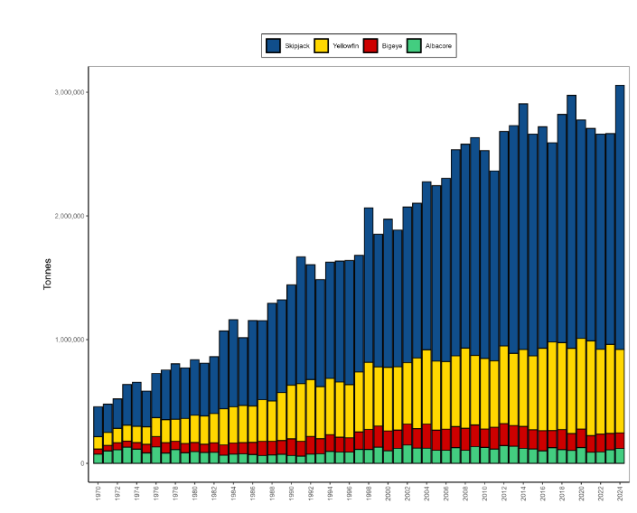
Figure WCPO-01. Catch (mt) of albacore, bigeye, skipjack, and yellowfin (combined) in the WCPFC–CA.

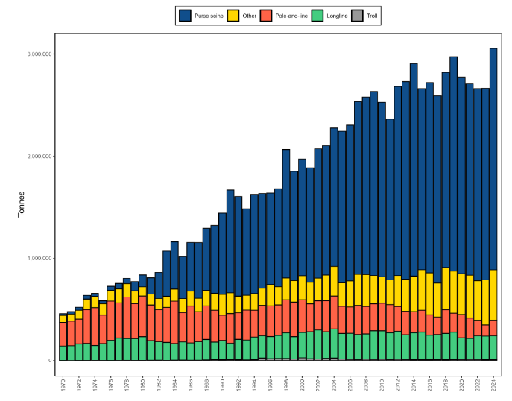
Figure WCPO-02. Catch (mt) of albacore, bigeye, skipjack, and yellowfin tuna (combined) in the WCPFC-CA, by longline, pole-and-line, purse seine, and other gear types.

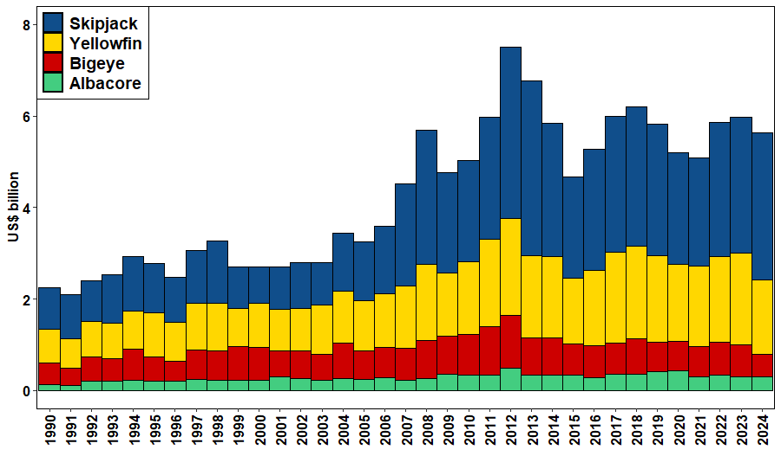
Figure WCPO-03. Catch value of albacore, bigeye, skipjack, and yellowfin in the WCPFC–CA.

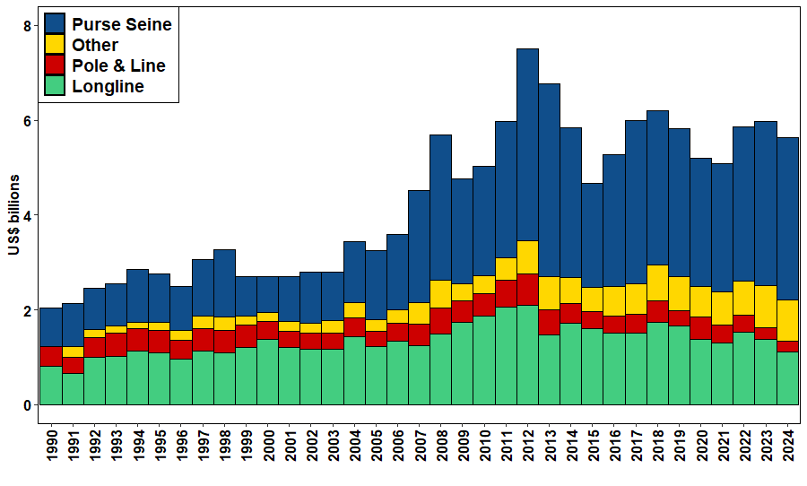
Figure WCPO-04. Catch value of albacore, bigeye, skipjack, and yellowfin in the WCPFC–CA, by longline, pole-and-line, purse seine, and other gear types.

Discussion
- Niue, on behalf of FFA members, extended appreciation to the SSP and FFA for the comprehensive work, stating it provides an overview of the catch and economic conditions of the key fisheries in the WCPO as well as invaluable insights into fishery performance. They noted the record-high skipjack catches and the decline in bigeye catches. While catches show strong volume, economic returns remain mixed. FFA members expressed concerns about deteriorating economic conditions in the longline fisheries, driven largely by declining fish prices, and stated that addressing this must remain a priority to ensure the sustainability and viability of these fisheries.

- Tonga, on behalf of CCMs of the South Pacific Group (SPG), noted the WCPO longline catch of albacore is up in 2024 while the albacore price has generally dropped, and questioned whether there could be an oversupply of albacore to key markets. They noted that the southern longline economic conditions composite index (Figure 5.12) became negative in 2024, with the recent downturn in the index apparently driven entirely by the decrease in price. They stated that, with the increase in catch in 2024, one of the most important management controls needed is to control total albacore catch at a level that helps maintain market prices. They welcomed thoughts on why prices for most longline catches are dropping.

- FFA stated price declines in 2024 result from a number of factors, and that they had not tested the correlation with supply, but in theory, increased catch will place pressure on prices, as would a switch in consumer preference, and stated they could further examine the data.

- In response to an inquiry from Japan regarding the definition of handline data and its impact on the increased fishing mortality of bigeye, the SSP stated that historically, it has been very difficult to separate small and large fish in the data, and these catches are combined as handline. Assumptions have been made regarding what constitutes small and large fish based on the size composition and information at hand. Over the past few years, this overall handline catch has largely been put into the small fish category (more juvenile size classes). Those high catches of small sizes may be contributing to the decline in the bigeye projections. But recent discussions with Indonesia indicate some of those catches should be in the large fish category and fewer in the small juvenile category. That shift — if it is real and recent catches are reconciled to put more of that catch in the large fish handline category — would have an impact, presumably, on the assessment and the projections. The SSP stated they are particularly interested in doing some sensitivities or further analyses to explore the issue and to work with Indonesia to understand the characterization of those catches from recent years as well. In response to an observation by Japan that catching more large fish rather than small fish would presumably have a positive effect if included in the projection results, the SSP clarified that the figure shown in the presentation was based on very recent data, which were not included in any of the assessment or projection work to this point.

- Indonesia encouraged the Commission to continue providing an overview of tuna fisheries in the WCPO. They referenced Figure 3.2 in SC21-GN-WP-01, noting the estimated purse seine effort seems stable, but catch of BET has increased, and inquired as to the cause. Indonesia also noted an increase in skipjack and a decreased price, and inquired whether this reflected oversupply or a difference in value between purse seine catch and pole and line (thus related to quality), and whether this had been specifically studied. Indonesia stated that it continues to collaborate with SPC-OFP on estimations of tuna catch by gear, such as handline.

- The SSP noted high catch rates, particularly in 2024, that have been validated by CCMs. In 2024, the SSP prepared a paper to evaluate how effort is reported to evaluate how accurately effort is represented in the contemporary fishery. That paper has not been updated for 2025.

- FFA stated that increased catch of skipjack and corresponding increased trade volumes have pressured prices. Regarding demand, FFA stated it is unaware of studies specifically looking at the demand side — whether consumers are switching to alternatives as opposed to fresh tuna from the Pacific — but that this would obviously place pressure on prices. FFA stated that the quality is not the issue but rather supply and demand.

- The EU referenced increased catches by other gears, particularly the small-scale troll and hook and line fisheries, and that the paper indicated it may be due to the improvement in data collection as part of the WPEA project rather than to an increase in catches. The EU suggested this may have important implications for some stock assessments, particularly for yellowfin, and asked if the SSP foresees exploring catch time-series reconstructions to correct past data. The SSP noted that this was a very good suggestion, but had not been explored, and that it would consider what is possible.

- The USA commented on bigeye catches, as addressed by Japan, noting bigeye catches in 2024 were among the lowest since the 1990s, with reductions in both catch of juvenile bigeye in the purse seine fisheries and adult bigeye in the longline fishery. Given that stock assessments will be conducted in 2025, the USA encouraged the SSP to examine how environmental conditions, particularly the La Niña-related westward shift in effort observed in 2024, influenced bigeye catch rates and distribution, and to consider these factors in the preparation of the data for the assessment.

- The Philippines stated that SC21 provides a crucial opportunity to collaboratively address the evolving dynamics within WCPO fisheries and highlighted several points. First, the significant increase in catch, which may seem positive, but may also reflect the impacts of environmental changes and phenomena, especially on stock distribution, as most of these catches are within CCMs’ EEZs. They stated that understanding the underlying drivers of these changes is essential to ensure long-term sustainability. Regarding socioeconomics, they noted the need to optimize benefits from increased catches, as tuna resources are vital both for food security and livelihoods within the region. They noted changes and shifts in CPUE and some parameters in fishing activities, which indicate changes in fishing patterns and potentially the distribution and behaviour of target species, and stated that accurately assessing these changes is vital for effective stock assessment and management. The Philippines stated it looked forward to a productive and insightful discussion.

- Kiribati, on behalf of the PNA and Tokelau, noted that a key feature of 2024 was the 25% increase in purse seine skipjack catch. They noted that there was no increase in effort, and the catch was about the same as in 2019, when there were similar oceanographic conditions, and thus concluded the increase was largely a result of oceanographic conditions. Another feature of 2024 was the apparent reduction in FAD sets in a year when the FAD closure length was reduced. They stated data on the balance of FAD and free school sets is typically provided in a Management Issues theme information paper on data related to tropical tuna, which was not provided to SC21, apparently because most of the data in it is more relevant to TCC. They stated that the data on sets by set type is useful, and that they would appreciate these data being provided to SC21 if possible. They also inquired regarding the likely reasons for the drop in FAD sets and FAD use in 2024.

- The SSP noted that when fishing effort and stock availability shift westward, vessels tend to target free schools more. In contrast, a more easterly stock distribution is associated with greater reliance on FADs. The SSP suggested that this dynamic was a contributing factor in 2024. The SSP noted that it would provide the requested summaries to FFA members as soon as possible.

- Chinese Taipei inquired how the price for bigeye tuna was calculated, given that prices vary by whether the fish is frozen, fresh, and by source.

- FFA stated they mainly use the Japanese auction price for the Japanese fleet, and for other fleets, they may use other prices.

- FSM, on behalf of the PNA and Tokelau, thanks the SSP for including Figure A1 showing the breakdown of catches by area of jurisdiction, noting the information gets lost in the Appendix, and fits well with Figures 2.1 and 2.2. The balance of catches by area of jurisdiction is also an important and distinctive feature of the WCPO tuna fisheries, and they requested that the information be presented with Figures 2.1 and 2.2. The SSP stated that this could probably be accommodated.

- New Caledonia noted SC21-ST-IP-01 on estimates of annual catches in the WCPFC statistical area, which provides analysis on discarded bigeye and yellowfin longline catch, and inquired if the analysis presented in Figure 7 has also been carried out for albacore longline catches. The SSP stated this hasn’t been done but it is feasible.

  - Overview of Eastern Pacific Ocean (EPO) fisheries

- M. Hutchinson (IATTC) presented SC21-GN-WP-02 The Tuna Fishery in the Eastern Pacific Ocean in 2024, a summary of catches and effort of fisheries for species covered by the IATTC’s
Antigua Convention in the eastern Pacific Ocean (EPO) in 2024. A complementary IATTC document, EB-03-01 (Ecosystem Considerations), provides information on non-target species. The paper demonstrates that almost all the catches in the EPO are made by the purse-seine and longline fleets, while pole-and-line vessels and various artisanal and recreational fisheries account for a small percentage of the total catches. Detailed catch data are presented for the purse-seine fishery, which takes over 90% of the total reported catches; the data for the other fisheries are incomplete. Purse-seine data for 2023 and 2024, and 2021–2023 data for longlines and other gears are preliminary. Since 1993, all Class-6 purse-seine vessels carry observers, who collect detailed data on catches, including those discarded at sea. Estimates of the “retained” catch (the portion of the total catch that is landed) are based principally on data collected during vessel unloading. In 2024, the total tuna landings were 40% higher (> 1 million mt) than the 10-year average from 2014–2023(~ 745,000 mt). Total effort in the purse seine fishery was up by 5% in 2024, FAD-associated sets decreased by 12%, dolphin-associated sets increased by 2% and sets around free yellowfin tuna in 2024 compared to the 10-year average, where the majority of catches came from dolphin-associated sets around Mexico and Central America. Catches of skipjack were 100% higher in 2024 over the 10-year average and came from FAD-associated sets between 10°N and 5°S and from 90°W to 120°W, also on unassociated sets inshore between 5°N and 20°S from 90°W to the coast. Bigeye tuna catches in the purse seine fishery were down 43% in 2024 compared to the 10-year average, and this is thought to be due to the influence of the Individual Vessel Threshold conservation measure, which has improved communication among the fleet to avoid areas with higher catch rates of juvenile bigeye.

Discussion
- China thanked the IATTC and noted the presentation also indicates a peak catch for skipjack in 2024, and that fishing effort for skipjack did not increase as much as catch, indicating an increase in abundance in the EPO as well as the WCPO, suggesting a general increase in population abundance rather than movement between EPO and WCPO. They inquired whether this possibility had been discussed.

- The IATTC stated that the increase in catch rates was in free schools, so there was a reduction in effort in FAD-associated sets and an increase in effort on free-school sets. There was a benchmark stock assessment in 2024, which discusses some potential reasons for the increase in catch, and it does appear to be an increase in abundance, with an abundance estimate generated based on IATTC’s tagging programs.

- Fiji, on behalf of FFA members, thanked the IATTC Secretariat for the comprehensive overview of the fisheries for highly migratory species in the EPO region, noting that the catch trends in the EPO are similar to those in the WCPFC, with higher catch of skipjack and yellowfin tuna and lower catches of bigeye and albacore. They stated that given the clear stock connectivity between regions, cooperative management between IATTC and WCPFC is essential, and strongly supported increased collaboration and compatible measures to ensure sustainable and equitable management of Pacific tuna resources.

  - Annual Report – Part 1 from Members, Cooperating Non-Members, and Participating Territories

  - Reports from regional fisheries bodies and other organizations

AGENDA ITEM 3 — DATA AND STATISTICS THEME

  - Data gaps of the Commission
    - Report on the WCPFC scientific data
- T. Vidal presented SC21-ST-WP-01 Scientific data available to the Western and Central Pacific Fisheries Commission. This paper reports on the major developments over the past year with regard to data and data management for the Commission, as well as the identification of progress made toward filling gaps in the provision of scientific data to the Commission. In 2025, the SSP transitioned to a new database platform as part of an upgrade to an antiquated system. This transition had been in the works for several years, and the migration and transition were completed in 2025. The SSP is now fully operating from the new SQL Server database platform. This transition represents a positive step forward for the work of the Commission. As with all system transitions of this size and complexity, there have been challenges. The most obvious this year is the timing of the provision of key data products and the resulting delays in associated papers relying on those data products. This transition has allowed identification of areas for improvement in the SSP’s work to keep CCMs informed.

- The review of data gaps in 2023 and 2024 scientific data provisions includes the assignment of a tier-scoring evaluation level. In 2024, all CCMs submitted their annual SciData by the deadline (i.e., deadline of 30 April 2024). In 2025, all but one CCM submitted their annual SciData by the 30 April 2025 deadline. Aggregate catch/effort data for 2024 were provided by the deadline of 30th April 2025 for all but one CCM. The main gap in the provision of 2024 aggregate catch/effort data was the low coverage of operational data available to generate aggregate data for two CCMs (which has been the case in recent years). The other main data gap, which has been highlighted in recent years as well, is the anticipated under-reporting of key shark species in general. However, the quality of aggregate data provided continues to improve with a reduction in the number of data-gap notes assigned to the aggregate data in recent years. Operational catch/effort data for 2024 were provided by the deadline of 30 April 2025 for all but one CCM. The main gaps in the 2023 and 2024 data submissions include i) the low coverage in the data provided by two CCMs, and ii) the non-provision of several required fields in the data submission for one CCM.

- The coverage of 2024 operational data for most fleets is nearly 100%, and it is expected that there will be additional operational data submissions in the coming year to complete some of the existing gaps. In most cases where coverage is not 100%, but annual catch and effort estimates by geographic area (e.g., aggregate data) have been made available, the combination of the two data sources is sufficient for the scientific work of the Commission to be undertaken (these situations are noted in each of the tables).

- Tables providing a breakdown of the coverage levels for each operational data field by year and fleet have been prepared in response to a SC17 recommendation (SC17-ST-WP-01). The latest version of these tables is included in a separate SC21 Information Paper (SC21-ST-IP-02), for the SC to review. SPC-OFP continues to engage with relevant CCMs to resolve some of the gaps presented in these tables, with several gaps resolved over the past year. CCMs have continued to adjust their annual submissions of operational data to align with Annex 2, ‘guidelines for data submission of operational level catch and effort data fields for fisheries’, in the Scientific Data to be Provided to the Commission (SciData), which facilitated the import into the WCPFC databases this year. However, the format of many data submissions remains a challenge, and a separate paper prepared for SC21 has prepared suggestions to improve and standardize the format of data submissions to facilitate the processing of these critical data (SC21-ST-WP-03).

Discussion
- China stated its interest in this new data dissemination platform and inquired whether any scoping work has been done on existing platforms.

- The SSP stated that such scoping work has not been done, and that the initial work would likely focus on building the data warehouse and user roles and appropriate privileges associated with specific data sources and products to ensure the appropriate access is in place relative to Commission data rules and any other data sharing agreements that are in place. Once that is done, data products of various types can be added.

- RMI, on behalf of FFA members, thanked the SSP and acknowledged the effort in the successful migration and transition to the new SQL Server database platform. They recognized this impacted the availability of some data products and associated papers at SC21, but considered the migration a significant milestone in modernizing the SSP's data systems and looked forward to the benefits it would bring, including the timely provision of data products and papers on data submission. They noted the continued improvements in the timeliness, quality, and completeness of data submitted to the Commission and commended both CCMs and the SSP for their efforts. They stated that reliable, high-quality, timely, and comprehensive data are essential for science-based decision making as they underpin stock assessment and compliance monitoring to ensure sustainable fisheries management, but noted that persistent data gaps remain, and encouraged relevant CCMs to address and resolve these data gaps in a timely manner. In addition, they stated their awareness of the burden placed on the SSP in processing data submitted in varying formats, leading to inefficiencies. For this reason, they strongly supported the move toward the use of standardized templates for key data submissions (discussed under Agenda Item 3.1.3) and recognized the value of cannery data (discussed under Agenda Item 3.1.5). They highlighted the use and the availability of observer data as a critical issue evident across numerous scientific analyses and papers, noting that observer data is a vital data source for scientific assessments whose importance cannot be overstated. They stated that the purse seine fishery benefits from 100% observer coverage, while the longline fishery remains significantly under-observed, with coverage still around 5%. They reiterated their long-standing position on the need to increase observer coverage in the longline fisheries for both scientific work and monitoring. Finally, they supported the SSP's initiative to enhance data accessibility through the development of a data warehouse and stated they look forward to engaging further and providing input as the initiative progresses, including on any budgetary implications.

    - Reconciliation of size composition data for stock assessments (Project 127)
- P. Hamer (SPC-OFP) presented SC21-ST-WP-02 Review and reconciliation of size data collected in the WCPFC-CA for stock assessment purposes (WCPFC Project: 127), summarizing progress of phase 1 of project 127, which is scheduled to finish in 2026. The phase 1 work constituted a ‘getting the house in order’ review and compilation of the sources of size composition data for tuna, billfish, and sharks, and provides summary information on these sources as guidance to stock assessment scientists and others. Conversion factors were also reviewed as a key part of generating size data in standard formats for stock assessments. Conversion factors were noted as an area that still requires improvement and additional data collection (considered in a Terms of Reference for additional funding support to continue sampling beyond the end of Project 90). The SSP processes to generate the LF and WT_MASTER databases were outlined, as most stock assessment scientists lack awareness of this process. The progress report will hopefully provide a useful reference document for assessment scientists and others to better understand the sources of size data and the generation of the SSP-held LF and WF_MASTER databases that consolidate the size data available for use in stock assessments. Recommended work areas to focus on in phase 2 were noted to include further work on historical data quality/suitability, more focused technical analysis of data coverage deficiencies (including possible oversampling), and identifying any other issues with the current data collection sources, and improved statistical treatment of size data for use in stock assessments.

- ISG-05 was convened in reference to Project 127. The ISG agreed on several no-cost actions, discussed phase 2 work areas that would require additional resources, and discussed other areas for improvement of size data. ISG-01, convened in reference to the Tuna Assessment Research Plan, also discussed the work areas noted by the SSP under Project 127 and the related Terms of Reference for additional funds that were submitted for SC21 ranking. The ISG-01 report is included as Attachment G, and the ISG-05 summary is included as Attachment H.

Discussion
- Samoa, on behalf of FFA members, thanked the SSP for the progress report and for highlighting issues that require SC's attention to improve the quality of size composition data for stock assessments. They noted the SSP's recommendations to enhance the documentation and reporting of size composition data used in WCPFC's assessments, including by providing formal documentation for all current and ongoing non-ROP and PICTs sampling size data sources to the SSP to establish a size data collection “protocols and information” repository, including protocols in any language, and imagery to validate measurement methods and the interpretation of standard measurement codes. They also noted the SSP's recommendation that size data submissions be accompanied by a standard set of information consistent with WCPFC requirements. They agreed that this could be a task for the SSP to work with countries and TCC to develop and implement through the Sci Data Requirements. They supported the recommended work priorities for the second phase of the project and stated that this is a good way to address the issues raised in the paper if needed. They also supported the formation of a small working group to discuss further and refine the suggested set of information to accompany size data submissions, agree on phase 2 work priorities, and consider any additional resourcing needs. They emphasized that size composition data are essential inputs to stock assessments, and that the quality of these data directly affects the quality of scientific advice provided to managers and the effectiveness of fisheries management decisions.

Outcomes
- SC21 recognized the importance of reconciling size composition data for stock assessments and recommended continuation of the projects identified as part of phase 2 of this project.

- SC21 requested the SSP circulate a draft pro forma of supporting information to accompany non-ROP size data submissions, for CCMs to review and provide feedback to the SSP.

- SC21 encouraged CCMs to provide responses to the SSP on the draft pro forma and communicate with them on size data collection methods for non-ROP size data.

- SC21 requested that the SSP provide a report to SC22 on the development of the pro forma and a summary of CCM responses, with the objective of working towards implementing a standardized pro forma (consistent with the requirements for size data provisions contained in the SciData guidelines) by 2027.

    - Improving operational data evaluation and submission standards
- T. Vidal (SPC-OFP) presented SC21-ST-WP-03 Proposed data standardization approaches for improved efficiency. Ensuring the timely and accurate provision of data for the work of the Commission is critical for the efficacy of this organization. Data needs to continually evolve to meet growing demands for science, management, and compliance. The WCPFC aims to use the most up-to-date information available to support science and decision-making. As a result, Members, the SSP, and the WCPFC Secretariat are increasingly required to operate within unreasonably short timeframes to prepare information for the Commission’s consideration. In recent years, members of the Commission have raised the issue of having insufficient time to thoroughly review papers and materials for the meetings of the Commission and its subsidiary bodies.

- One potential solution to improve the timing of data availability is to streamline and standardize the data submissions themselves. Without clear guidelines on how data should be submitted, data arrive in various formats. Processing these ‘non-standard’ data submissions requires time and, at times, interpretation, requiring correspondence with members. In addition, errors may be introduced due to the reliance on manual entry and extensive re-formatting (e.g., dates and times, species codes, conversion between weight units, etc.). The paper details several potential approaches to improve the standardization of annual reporting requirements to the Commission. Adoption of these approaches is intended to reduce the amount of time required to prepare, process, and disseminate these data for the work of the Commission, thereby freeing up time to provide more value-added services (e.g., enhancing data quality).

Discussion
- Tonga, on behalf of FFA members, thanked SPC for this paper and noted that time spent cleaning and standardizing data could have been used more efficiently, and that delays in analysis, results, and paper preparation also delay SC’s work and create additional difficulties for SIDS. They noted that the growing number of late-submitted paper for SC meetings make it difficult to fully review and prepare effectively, and supported the recommendation to adopt standardized data submission templates for the Sci Data submission. They supported further refining the proposed templates, companion data format documents, and comprehensive reference table to facilitate the successful implementation of these templates for review at TCC21.

- China stated it would be beneficial to have an online portal or website where CCMs can upload data. They suggested minimizing the change to current formats to enable the extraction of required information from the current Excel document, which would reduce the burden for CCMs when preparing data. They encouraged further dialogue and communication between the SSP and CCMs.

- Indonesia supported improvements in data collection and related databases while noting the complexities involved for CCMs, observing that Indonesia has a very complex fisheries situation with 34 provinces and 580 districts, all of which must submit data in the same format. They stated that at this stage, the Excel format and current database are working and showing improvements in Indonesia, although some challenges remain. Indonesia proposed the need for further technical assistance. They stated they are in the process of developing a data warehouse and would like to work on that under the WPEA project, if possible, and proposed maintaining current practices for Indonesia while investigating the potential for improvements.

- Korea supported the adoption of a standardized data submission template, which would assist in preparing and reviewing data. They stated some of the proposed options could lead to duplication and increase the workload for crews, or reduce the recording of data, and suggested it is important that the reporting approach takes into account the operational circumstances of each CCM.

- Sharks Pacific stated the consideration of these data elements is one of the most important issues before SC21, and referenced RMI’s previous intervention on SC21-ST-WP-01, noting data cannot be assessed or standardised unless it is first submitted. They stated that good fisheries management depends on good data that is effectively and efficiently provided, with many SC21 papers noting that inadequate observer coverage in the longline fleet remains the single most significant obstacle to achieving sustainable fisheries management in the WCPO. At least four papers presented to SC21 identify poor observer coverage as a primary impediment to sound scientific assessment and effective CMMs. They stated that the Convention obligates all CCMs to ensure decisions are based on the best scientific evidence available, which is a binding legal obligation compelling CCMs to both use best available evidence and ensure CMMs generate such evidence. This obligation is not met when observer coverage is inadequate. They stated that CMM 2007-01 sought to achieve 5% observer coverage by 2012 in the longline fleet, but WCPFC has only recently exceeded that level by a percentage point or two and remains a long way from adequate observer coverage. They observed that the SSP's admirable data standardization efforts confirm the continued failure to meet even these basic monitoring obligations by insisting the SSP engage in time-consuming standardization efforts. They observed that 5% (or 7%) coverage, even if consistently achieved, is statistically and practically inadequate for most management and almost all compliance purposes, and thus current coverage levels produce data inadequate to properly manage WCPFC’s tuna fisheries or protect bycatch species. For sharks specifically, inadequate monitoring and reporting directly contribute to high uncertainty and poor performance of stock assessments, and the uncertainty is consistently cited as justification for management inaction. They stated that the Commission has to date been unable to even conduct stock assessments on several shark species (e.g., shortfin makos) because of data deficiencies, and continuing to exploit these stocks in the absence of stock assessments is an effective inversion of the precautionary principle. They stated that this can be addressed only through improved data collection. Sharks Pacific urged SC21 to provide clear, unambiguous recommendations to the Commission that prioritize the adoption of data standardization templates but also improve observer coverage across the longline fleet as an urgent conservation imperative.

- The Philippines thanked the SSP for providing the options, recognizing the limitations some CCMs face in complying with the submission requirements for operational data, and noting the recommendation by China. They stated the need to consider this option and develop a clear understanding of standardization and the complexities of their fisheries. They stated they would engage with the SSP on these issues.

- The EU stated it understands the issues linked to processing the vast amount of information received by the SSP in such a variety of forms and with little time available, which reduces efficiency and increases the probability of errors in data processing, and voiced support for any effort to standardize data submission. Of the different options proposed, the EU suggested electronic reporting would be ideal, but that some CCMs already have mandatory ER systems that cannot be substituted. The EU noted JSON standards can be a highly technical solution that may not be feasible in many instances, and recommended development and endorsement of additional Excel/CSV templates for data submission.

- Australia supported the interventions of FFA members and others and strongly supported the adoption of a standardized template for data submissions. Australia stated this would mean changing their practices and stated they are ready to do so. They noted prior SC discussions that addressed how to give the SSP more time to get their work done between the provision of data and when their analysis and assessments are due at SC, and that the proposal is an obvious mechanism to help get data to the SSP in a cleaner format and thus allow the SSP more time to conduct the assessments.

- Chinese Taipei noted that they had experience with these issues in ICCAT and IATTC and could provide more information.

Outcomes
- SC21 supported the development of a standardized data reporting mechanism by the SSP to enhance the efficiency of processing required data submissions under the SciData guidelines. SC21 encouraged CCMs to work with the SSP as it prepares revised templates for consideration at TCC21.

    - Better data on fish weights and lengths for scientific analyses (Project 90)
- The theme convener noted the project was included in the SC21 ODF.

    - Improved coverage of cannery receipt data (Project 114)
- T. Vidal (SPC-OFP) presented SC21-ST-WP-04, Project 114 Update: Progress in improving Cannery Receipt Data for WCPFC scientific work. This paper brieﬂy describes the scientific needs that improved cannery data could support, including improved precision of species composition for purse seine catch estimates and enhanced understanding of tuna movements for stock assessment modelling and tuna product ﬂow for traceability. The purse seine fishery is the key fishery in the WCPFC, and yet reliably monitoring the catch compositions from it remains challenging. The current practice is to use species composition sampling conducted by observers to generate model-based adjustments to logbook-reported catch estimates. However, operational limitations for observer sampling mean that less than 0.2% of the catch is generally sampled due to the high volume. Improving the coverage of cannery receipt data would provide an independent data source to improve species composition estimates and overall species-level catch estimates for the purse seine fishery. Species composition has been the driver for the collection of cannery data, but using cannery receipt data as the basis to describe a physical network of the tuna supply chain for the WCPO could be used to improve the quality of reported tagging data, as well as be tested against tag seeding to identify weak nodes for tag reporting and where traceability of product is particularly strong. The paper presents preliminary results of building a tuna product ﬂow network using a limited subset of the available cannery data, with the aim of highlighting its potential for such applications to enhance the work of the SC and support industry initiatives (e.g., Fisheries Improvement Programs as described in the Annex). The priority remains to receive full cannery receipt data where WCPFC tuna resources are landed and processed; however, given the challenges encountered around improved cannery data submissions to the Commission, the authors propose a complementary initiative to work with CCMs to develop WCPFC standards around the use of cannery receipt data to address some of these scientific uncertainties. Holding a workshop later in 2025 with key CCMs is proposed to better understand the cannery data collected, how it is used, and to collectively work toward developing WCPFC standards and methodologies for using these data to improve species-level catch estimates. The intention of this proposal is to work within data sharing constraints some CCMs may have around cannery data, while still realizing benefits for the scientific work of the Commission. The remaining funds available through the no-cost extension of Project 114 (approximately $35,000) could be used to support this initiative.

Discussion
- Korea expressed appreciation to the project coordinators for their dedicated effort, stating that Korea has been consistently engaged in the project from the outset and would continue to provide support.

- The USA supported project 114 and the use of cannery receipts data to improve purse seine data in species composition analysis. They noted that US vessels and processors have and currently are supplying their cannery receipts to the SSP through ISSF, and observed some CCMs and non-ISSF processors have significant confidentiality concerns about supplying that data. The USA suggested holding a workshop with CCMs to develop WCPFC standards for species composition adjustments, where the cannery data could not be provided directly to the Commission, could be beneficial.

- El Salvador stated that it is interested in such a project and participating in the proposed workshop.

- Kiribati, on behalf of FFA members, acknowledged the progress made under Project 114 and supported the proposed 2025 workshop funded through the project through a no-cost extension to standardize the use of in-country cannery receipt data to improve species composition, enhance cash verification, and boost traceability across the basin fishery.

- The SSP thanked CCMs for their support for the project.

- ISG-06 (Cannery data) discussed the potential timing and location of the proposed
workshop, and the summary is included as Attachment I.

Outcome
- SC21 requested the SSP to plan a dedicated workshop in October 2025, to include participation by all interested CCMs, and particularly those CCMs that may have significant cannery data. The workshop objectives are to discuss existing and potential cannery data collections and to develop agreed WCPFC standards for using these data to adjust species composition and catch estimates from the purse seine fishery. Korea has generously offered to host this workshop.

    - Minimum data reporting requirements
3.1.6.1 Proposal on sea turtle data reporting requirements for fishing operations
- T. Vidal (SPC-OFP) presented SC21-ST-WP-05. Strengthening Scientific Data Reporting to Support Sea Turtle Conservation (CMM 2018-04). Sea turtles are a highly vulnerable species in the Western and Central Pacific Ocean, and interactions with fisheries pose significant conservation challenges. Conservation and Management Measure (CMM) 2018-04 established a suite of operational guidelines, mitigation measures, and reporting requirements relating to sea turtle interactions and bycatch; however, identified gaps exist in how this information is included in the annual SciData or otherwise reported to the Commission. In response to SC20’s request (paragraph 76, SC20 2024 Summary Report), the proposal outlines specific enhancements to the SciData standards for longline and purse seine fisheries to improve data quality, consistency, and conservation outcomes, for SC21 to consider. Specifically, a few proposals for enhanced alignment between the reporting requirements outlined in CMM 2018-04 and the SciData are highlighted, and it is suggested that SC21 consider:
- rewording the catch reporting sections in the SciData, currently labelled as ‘Number of fish per set’ (longline) and ‘Weight of fish caught per set’ (purse seine), to include turtles (e.g., changing `fish’ to individuals or catch, respectively);
- ensuring established CCM criteria to characterize shallow sets can be determined from operational data fields (e.g., number of hooks between floats, hook depth, etc.); and
- adding additional longline gear characteristics to the SciData, including hook size and type, while elevating the importance of existing voluntary operational data fields (e.g., bait type).

Discussion
- Japan noted the difficulties in correcting the logbook bycatch data because of the uncertainty of the data. Japan gave several examples, including weight data, the provision of which would require landing of the sea turtle on the board, which is a violation of the safe release protocol; bait type (which may be mixed); and hook size, which may be varied.

- SPC agreed with Japan that some of these categories posed a challenge, noting corrections for longline referenced “number of individuals or animals” caught per set (not weight).

- Australia, on behalf of FFA members, thanked the SSP and noted the paper highlights that low observer coverage in longline fisheries continues to hinder accurate estimation of sea turtle bycatch, increasing the risk of misreporting or under-reporting. In this context, they reiterated their long-standing position on the critical need to increase observer coverage in the longline fishery, to support both scientific assessments and effective monitoring. With respect to the specific recommendations to better align the reporting requirements under CMM 2018-04 and the scientific data to be provided to the Commission, they noted the proposed process in SC21-ST-WP-06 for review of the sea turtle CMM in 2026, and suggested the proposed enhancements be considered in the context of that broader review.

- The USA thanked the SSP for their commitment to working with high-quality data for their analyses. The USA supported the recommendation to explicitly include sea turtles under the size data reporting provision and noted the similar recommendation to explicitly include citations in the reporting provisions, stating this could be reasonably recommended to the Commission by SC to clarify reporting requirements and ensure consistent reporting among CCMs.

- China supported comments by Japan regarding individuals vs. weight and multiple hook sizes and types, and resultant reporting problems. They also inquired what constitutes a shallow set.

- The SSP confirmed the proposal would reference the number of individuals per set for longline and agreed that the proposal (in the second bullet) raises concerns about multiple hook sizes and types, which perhaps would need to be considered under a review of the CMM. The SSP stated that in the third bullet, there is a provision around shallow set sets with a requirement for bait, certain mitigation measures, and hook types (large circle hooks for shallow sets). Evaluation of compliance with the CMM using available data would rely on operational logbook data and would require being able to distinguish shallow and deep sets using the available data. The CMM includes a provision whereby CCMs can indicate to the Secretariat what criteria they use to characterize what constitutes a shallow set (e.g., hook depth or another criteria). The SSP stated this data might not be currently collected because it depends on how CCMs have defined shallow sets and which CCMs are making them. Thus, the recommendation may not be applicable, but is in place if CCMs use criteria to define a shallow set. The SSP offered to hold additional discussions to clarify this issue.

- The USA presented SC21-ST-WP-06. Proposed process to review current reporting requirements and mitigation measures in CMM 2018-04 (sea turtle), noting that at WCPFC21, the Commission agreed to review and revise conservation and management measure (CMM 2018-04) for sea turtles in 2026, to ensure that the reporting requirements are clearly defined and to consider expanding the scope of the measure for consideration by SC22, TCC22 and WCPFC23. The USA stated it was proposing to host the review via an informal intersessional information-sharing process. The review would aim to clarify sea turtle data reporting requirements, either through submission of operational-level data or in a summary form, and the review would include an overview of sea turtle range and status within the WCPO and sea turtle bycatch in WCPFC longline fisheries, and explore potential mitigation options to strengthen CMM 2018-04.

- Fiji, on behalf of FFA members, thanked the United States for proposing the establishment of an informal IWG to support the 2026 review of the sea turtle measure. They supported the proposed process and emphasized the importance of a risk-based, evidence-informed approach to any proposed expansion of the CMM. They also highlighted the need for analysis of the implementation burden and potential costs of any new mitigation requirements for deep-set fisheries, particularly on SIDS. They also welcomed clarification from the USA regarding the scope of the work outlined in the paper, specifically numbers 2, 3, and 4 under the scope relating to providing an overview of sea turtle populations in the WCPO, evaluating the scope of sea turtle bycatch in deep and shallow set fisheries, and considering the operational characteristics of deep-set longline fisheries and potential mitigation measures. They noted some preparatory technical work would be needed if the proposed IWG was to undertake this effectively, and inquired how that would be handled.

- Cook Islands, on behalf of the SPG, supported the proposal by the USA for a process in 2026 to review CMM 2018-04 and stated they would take part in the proposed IWG. They stated that turtles have major cultural significance in the Pacific, and SPG members seek risk-informed ways of identifying and mitigating the impact of fishing mortality on the most endangered turtle species in ways that also conserve the financial viability of the limited tuna fisheries available to the SPG. They also noted that one of the outputs of the work described in SC21-ST-WP-09 confirms that “depth of setting” has a strong effect on the catch composition of longliners, where catch rates of turtle and other bycatch as well as swordfish are higher for shallow sets compared with deep sets, and the opposite is true for target tuna species, where catch rates for deep sets are higher.

- Japan noted the proposal for a review of the sea turtle CMM and stated Japan would participate in an ISG. Japan also recalled similar recent discussions in the IATTC about the effectiveness of sea turtle bycatch mitigations, such as circle hooks, in the EPO. Japan suggested the discussion be continued.

- Fiji thanked the United States for taking the lead in the work and sought clarification from the USA on the technical aspects and the technical analysis, and who will be conducting the work relative to points 2, 3, and 4 in the project scope. Fiji also inquired regarding the costs to SIDS.

- The USA stated the intent was to host a workshop in a similar manner to the review for the CMM for seabirds, by inviting experts in various fields to present on these specific topics. By having a virtual meeting and inviting experts to present, the USA stated that the cost should be low. The USA outlined several topics: (i) provide an overview of sea turtle range and status, noting that sea turtle experts would very likely volunteer their time to give presentations on these issues; (ii) evaluation of sea turtle bycatch, with presentations by experts who have done these analyses. The USA stated they might also seek input from the SSP and could discuss how to select the speakers. Considering potential mitigation strategies, the USA noted that, as Japan indicated, extensive information is available regarding the science to date on these issues that can be used for this discussion.

- Canada thanked the US for the presentation and proposal and supported the establishment of an informal intersessional working group to discuss the issues and provide recommendations regarding potential revisions to the CMM. They stated they also supported the recommendation to revise the catch reporting section to include the number of turtles, which would be a simple and important step to improve data reporting.

- Japan noted the comments raised by FFA, and observed that of the points proposed for review, 2, 3, and 4 are broad, and only point 1 is a review of the specific CMM. Japan also inquired whether the workshop would target scientists or could include managers.

- The USA stated that the review by New Zealand of the seabird CMM was for a general audience and was quite effective. Much of the early information was background (covered under 2. in the scope), including overviews of the species and their ranges within the CA. The USA stated that much of the information is published literature, and much of the needed analysis has also already been done.

- China also stated it had some concerns about the review scope or approach, noting it identified some potential concerns about the scope of the literature review undertaken for the seabird review, and suggested the need for careful reflection, especially regarding the evaluation of the scope of sea turtle bycatch in WCPFC longline fisheries. China stated that if this is restricted to the area of WCPFC longline fisheries, it would place a restriction on the applicability of the literature, which would need to be addressed by the working group. Also, China asked whether, instead of, or in complement to, a literature review approach, it would be possible to have an experimental project directly addressing this concern, which would be more scientifically sound and relevant. China observed that this would require more resources, but it could be helpful to consider, possibly through an experimental research project.

Outcome
- SC21 endorsed the formation of an informal intersessional working group led by the United States to review CMM 2018-04 for sea turtles, noting that an examination of sea turtle data reporting requirements could be undertaken as part of this review. SC21 requested that this informal intersessional working group report back to SC22 and TCC22 on the outputs of its discussions.

3.1.6.2 Development of a FAD Logbook
- FAD Management Options IWG Chair J. James presented SC21-ST-WP-07 Proposed minimum FAD logbook data fields to be provided by vessel operators. The paper presents the proposed minimum FAD logbook data fields to be recorded by vessel operators. At WCPFC12 (2015), the Commission agreed that vessel operators should report data on FAD design and construction (materials, electronics, size, etc.) and FAD activity (deploying, retrieving, setting, visiting, loss, etc.). The Parties to the Nauru Agreement (PNA) implemented requirements for such reporting in 2022, applied to licensed purse seine vessels. In 2023, SC19 endorsed the scientific value of the proposed Minimum Data Fields to be Recorded by WCPFC Vessel Operators (SC20-ST-WP-06) and recommended further development of a standardized FAD logbook through the FADMO-IWG. At SC20, the Secretariat and SSP were tasked to detail the utility of proposed data fields for WCPFC’s science, management, and monitoring, which was reported in TCC20-2024-18. TCC20 and the FADMO-IWG have since reviewed and refined the proposed minimum data fields. Additionally, the FADMO-IWG continued to work on the refinement of the FAD logbook as part of its priority task for 2025. Progress on the FADMO-IWG discussions on the FAD logbook is detailed in the Chair’s Summary Report and its Attachment C (SC21-EB-WP-06). Details of the proposed minimum FAD logbook data fields to be provided by vessel operators are in SC20-ST-WP-06.

- The FADMO-IWG Chair noted that SC 21 was invited to
- review and endorse, from a scientific perspective, the proposed minimum FAD logbook data fields to support WCPFC’s scientific analyses and research needs, including stock assessments, bycatch monitoring, and evaluation of FAD impacts, and
- provide further feedback to the FADMO-IWG on the scientific adequacy and relevance of the proposed FAD logbook data fields, to inform finalization of the logbook format for vessel operators, if necessary.

- The ST theme convener noted that a FAD management options working group would be held prior to TCC21, which would provide more opportunities to comment.

Discussion
- The Cook Islands, on behalf of the FFA members, thanked the FADMO-IWG Chair and the WCFSC Secretariat for their work to advance a long-standing issue. They emphasized the importance of compatibility between high seas measures and those adopted under national jurisdictions as required by the Convention and thus supported the proposal.

- China stated that effective and complete data fields are crucial for tracking FAD activity. China observed that, considering the complexity of FAD operations, the data fields in the FAD logbooks are highly interconnected, and that while the proposed fields are detailed, they currently lack a clear logical relationship. China suggested the FADMO-IWG draft a detailed logical structure diagram for data fields to ensure the information enables end-to-end traceability of FADs and buoys, preventing data fragmentation and confusion. Regarding the proposed FAD ID, China asked for clarification whether the number would be provided by the vessel owner or assigned by WCPFC, and whether the number needed to be changed if a FAD was stolen or changed ownership?

- The FADMO-IWG Chair stated that, based on the FADMO-IWG discussions, the FAD would be attached to the buoy; the buoy would have the ID, and the ID would be provided by the buoy provider.

- Solomon Islands, on behalf of the PNA and Tokelau, stated that the PNA is currently collecting the information set out in Table 1, noting:
- This information is currently being provided by all fleets operating in PNA waters.
- PNA and Tokelau are open to suggestions that would improve the value of the data for scientific and management purposes.
- The proposed FAD log is designed to enable observers to focus on monitoring of requirements such as those for FAD design and impacts on bycatch.
- The options in Annex 1 for materials used in FAD construction may need some refinement to accurately cover fine mesh materials currently being used and differentiate those from mesh net materials.

- The EU agreed on the scientific interest of the proposal, but stated, as expressed on other occasions, it had some concerns in relation to the recording of some of the fields, such as expressing the percentage of each material and the skipper’s reporting on SSIs, because this may affect data usability and can also duplicate some of the observer's work. The EU noted that, as expressed previously, ideally, the format should be compatible with the one required by IATTC. The EU looked forward to the discussion during TCC21.

- The United States supported the proposed data fields for the FAD logbook and recognized the importance of documenting raft design and structure. It agreed this is straightforward when FADS are deployed by the vessels that own them, but that there are situations — such as when FAD ownership is transferred or buoys are swapped after the initial deployment — where it is not feasible to provide accurate information on raft design or materials. They noted that this is particularly true for biodegradable FADS, where retrieving them from the water could compromise their structure and purpose. In that limited case, the USA suggested including an additional response such as “Unknown biodegradable FAD”.

- The FADMO-IWG stated the IWG would seek to discuss the issue at the next FADMO-IWG meeting.

Outcome
- SC21 acknowledged the importance of developing a FAD logbook and generally supported the proposed minimum FAD logbook data fields, but recognized the concerns about the logical consistency, redundancy, and availability among logbook data fields. SC21 encouraged CCMs to work through the FAD MO IWG to refine the proposed minimum FAD logbook data fields.

3.1.6.3 Reporting requirements for cetacean interaction

- T. Vidal (SPC-OFP) presented SC21-ST-WP-08 Cetacean interaction data reporting requirements, which provides background information on cetacean reporting within the Commission to support SC21 to develop scientific advice for WCPFC22 on appropriate requirements for effective reporting of cetacean interactions in tuna and associated species fisheries. As per the Commission’s request, this work will include consideration of data types, collection methods, reporting formats, and alignment with SciData provisions to ensure robust and consistent monitoring across gear types, particularly in support of implementing CMM 2024-07 and enhancing cetacean interaction data from both longline and purse seine operations. The key reporting of cetacean interactions comes from observer-collected data; however, flag states have responsibilities to report on captures through operational data and to detail interactions with cetaceans more fully in reports to the Commission (e.g., annual reports to the SC). The paper invited SC to
- consider explicitly noting the required reporting of cetacean catches under the SciData provisions, potentially with a footnote to the key species to be reported;
- explicitly require reporting on cetacean interactions and encirclements, steps taken to ensure safe release, and assessment of the life status of the animal on release, in the CCM annual reports to the SC, given that dedicated logsheet fields for reporting interactions are not available;
- consider including time that a species of special interest (e.g., cetacean) is first sighted as part of the Regional Observer Programme Minimum Standard Data Fields (purse seine); and
- encourage CCMs to promote training of vessel operators and observers, where data reporting
gaps are identified to facilitate the complete and accurate reporting of cetacean interactions.

Discussion
- Japan inquired regarding a plan to determine the key cetacean species for WCPFC, noting the need to do this when discussing data collection, and inquired regarding how to report the steps taken to ensure safe release, given that there may be several options for safe release. Japan also commented on the difficulty of identifying cetacean species, given that cetaceans are not brought aboard.

- The SSP agreed that more consideration would be required if many species of sea turtles, cetaceans, and possibly other species groups were included in the key species in the size data. The SSP suggested adding a footnote pointing either to the CMM or that citations are required because it would be complicated to include lengthy lists of specific cetacean species. She agreed it can be difficult to identify cetacean species in the water, and that some of the International Whaling Commission (IWC) suggestions for an enhanced ID guide address this concern.

- The EU stated they generally support the recommendations, but share concerns in relation to the species identification, which could potentially be addressed with additional codes. In relation to the second recommendation, the EU inquired whether this was to be on a case-by-case basis and what level of detail would be required, noting that in the case of the IATTC, for some species, all data, including confidential data such as the position and the name of the vessel, were reported to the IATTC Secretariat.

- The SSP stated that this would depend on what was prescribed in the CMM.

- Nauru, on behalf of FFA members, supported the inclusion of additional cetacean-related fields in the ROP minimum standard data field for the purse seine fisheries, namely the time of first sighting of the cetacean and the fate code. In addition, FFA members noted that observers do collect some data related to cetacean interactions, and that while the purse seine fishery benefits from 100% observer coverage, the longline fishery remains around 5%. In this context, they suggested that priority be placed on increasing observance coverage in the longline fishery, enhancing the data collected by the observer, and ensuring consistent data collection through existing mechanisms. They supported the recommendation to include cetaceans either as key species or as a footnote in the scientific data to be provided to the Commission.

- The United States supported the recommendation to explicitly include cetaceans under the size data reporting provisions, consistent with its earlier support for including sea turtles under the same provisions. They also supported efforts to promote training for vessel operators and observers to improve the quality of cetacean data.

- Solomon Islands, on behalf of the PNA and Tokelau, strongly supported enhancing requirements for reporting relating to cetaceans, in particular requirements for data on key cetacean species sightings, interactions, and purse seine encirclements, as well as catches in the operational data requirements under the scientific data rules. They also supported the recommendations for improvement on observer reporting of sightings and training of vessel operators and observers. They did not support that some data be provided in Part One reports because logsheet fields for reporting interactions are not available; they also stated that in their experience, operational data collected through electronic log sheets and issues related to the availability of particular fields are no longer an issue with electronic log sheets.

- Canada supported requirements for effective reporting of cetacean interactions in tuna and associated fisheries. They supported consistent and effective reporting requirements across fleets in line with what Canada requires domestically. Specifically, they supported a recommendation to the Commission to consider explicitly noting the required reporting of cetacean catches under the scientific data provisions and stated that the suggestion of a footnote to include cetaceans to be reported is a reasonable suggestion.

- PNG, on behalf of PNA and Tokelau, noted SC21-EB-IP-07, which provides an analysis of observer data relating to interactions in the purse seine fishery with false killer whales and rough-toothed dolphins, noting the paper recommends the development of models to assess trends in rough toothed dolphins and false killer whales and a plan to assess the reasons for the higher mortality rates of rough-toothed dolphins in purse seine operations.

- Indonesia noted the importance of improving data for cetaceans and stated that it generally has regulations to protect cetaceans from fishing operations. However, Indonesia stated it faces some challenges, including those related to the absence of observers on board small vessels. Indonesia suggested focusing on the large vessels initially. Indonesia stated that training skippers in relation to cetacean mitigation and recording is also challenging in terms of capacity, and further strengthening of observer capacity is also needed to enable implementation of the current data collection requirements. They noted that the difficulty increases if additional data for monitoring of cetaceans is required. In response to a query from the theme convener, Indonesia clarified that this applied with respect to both purse seine and longline vessels and reiterated the desire to focus on large vessels.

- China inquired regarding the third bullet point, which considers including the time that a species of special interest is first sighted as part of the minimum standard data fields, and questioned what the purpose is, whether this would simply be recorded by the observer or if the observer would also report this to the captain, and whether there is a requirement to that effect in the current CMM? China noted that if avoiding interaction was the intent, including a requirement for an observer to notify the captain would be of benefit, but if the intent is to document interactions, such notification would not be needed.

- The SSP stated their understanding that observers are to indicate when a cetacean is sighted and then add context if a set is made so as to better understand the fishing practice, but agreed the issue raised by China regarding notification of the captain should be reviewed within the context of how the data field is currently reported.

- The Philippines stated that, in principle, the recommendations presented align with their internal regulations regarding cetacean interactions in purse seine operations, as stated in Fisheries Administrative Order #271. However, as to the requirement on the time when the cetacean was first sighted as part of the ROP minimum data standard, the Philippines may revisit its internal regulations, including the reporting needs and capacity building for both operators and observers, to align with this requirement.

Outcomes
- SC21 recommended revising section 1.5 in Annex 1 of the SciData guidelines as follows:
- Weight of fish caught per set’ to be replaced by ‘Weight of catch per set’
- Add ‘Number of discarded/released individuals per set’ to capture interactions with cetaceans

- SC21 recommended revising the SciData guidelines in Annex 2 table A2.2.4 to add footnotes to the text “and other species as determined by the Commission” in the SPECIES CODE reference text field and in the NOTES columns for the following field:
- DISCARDED/RELEASED NUMBER field to align with the requirements for reporting catches of cetaceans under CMM 2024-07 (table A2.2.4).

- SC21 encouraged CCMs to promote training for vessel operators and observers where data reporting gaps are identified to facilitate the complete and accurate reporting of cetacean interactions.

    - Bycatch estimates of the longline fishery
- S. Nicol (SPC) presented SC21-ST-WP-09. Summary of bycatch in WCPFC longline fisheries at a regional scale, 2003-2023. The paper describes the assessment of the impact of fishing on non-target species, especially the estimated bycatch of the longline fishery operating in the WCPFC Convention Area for the period 2003 to 2023. The estimates cover the full range of finfish, billfish, shark and ray, marine mammal, and sea turtle species that have been recorded in longline observer data. The presenter noted that it was difficult to obtain reliable estimates of WCPO longline catches from observer data, given the low levels and imbalanced nature of longline observer coverage, and additionally, the low coverage of available aggregate effort data disaggregated by hooks between floats. Because of this, the catch estimates for the WCPFC Convention Area are unlikely to be reliable and should be viewed in that context. The SSP noted that the trends in estimated catch are more robust than the magnitudes of the estimated catches. The catch rate models do not appear to adequately capture targeting behaviour, nor spatial variation in catch rates more generally. The SSP recommended that the SC, in the future, may choose to consider this as an Information Paper only unless changes in the trends of bycatch estimates are detected and/or sufficient observer coverage is available to address spatial disaggregation requests of the SC.

Discussion
- Chinese Taipei asked why different model structures were used for the Great barracuda and Barracudas, as shown in Table 2 of SC21-ST-WP-09. They suggested focusing on prioritized species in Resolution 2005-03 — mahi mahi, rainbow runner, and wahoo.

- The SSP stated that regarding the two methods for barracuda, the decision was made based on the best data fit, noting that in some cases the data fits a Poisson distribution better and in others a delta log normal, but there's not too much difference between model performance. Regarding species, they agreed that selecting those with more regular reporting and more comprehensive data, allowing for more robust estimation, could be a better strategy.

- New Zealand, on behalf of FFA members, thanked the SSP for the paper and comprehensive analysis. They inquired about changes in observed bycatch levels since the previous reporting period (2020–2023), stating SC19 noted a decline in observer coverage due to COVID-19. They noted that this paper covers the post-pandemic period, and it would be useful to clarify whether recent trends reflect actual changes in bycatch or shifts in monitoring effort. They stated they remain concerned about the persistent lack of reliable data for longline fisheries operating in the North Pacific, noting many FFA members already implement observer coverage above 5% on their own flag vessels, as well as on foreign fishing vessels operating in their zones, but the same level of data collection is not apparent for some distant water fishing nations operating north of 10°N. FFA members called for greater compatibility and observer coverage across the CA, and sought clarification from the authors regarding the recent increase in estimated catch rates for loggerhead and leatherback turtles. They stated that given the conservation status of these species, any upward trend in interaction rates is a matter of concern, and if the data confirm these are actual increases, the Commission should consider further action.

- The SSP stated it's quite difficult at present to determine the impact of changes in observer coverage due to COVID-19, and that they have some concerns in terms of how significant some observed trends are because of the difficulty of differentiating COVID effects. In terms of loggerhead turtles, SPC agreed these are species the WCPFC should monitor, and the upwards trend in catch warrants some level of concern by the Commission if confirmed, which is difficult to do given the model uncertainty. The SSP noted that in most cases it is pushing the boundaries of what the available data can answer and reiterated that there may be limited value in investing more in the modelling and focus instead on alternate data sources or improving existing data.

- The USA noted the analysis excludes seabirds, particularly because seabird bycatch estimates have been generated separately through WCPFC Project 68, and asked how to ensure that seabird bycatch will be included in future analyses. The USA highlighted that the analysis once again reiterates the high level of uncertainty in bycatch estimation due to low (around 5%) observer coverage rates in the longline fishery and stated it is very supportive of recommendations to consider ways to increase observer coverage in the longline fishery, potentially through the use of electronic monitoring.

- Niue, on behalf of SPG members, expressed concern that the bycatch estimation methodology remains limited by the incompleteness of observer coverage or the non-provision of available CCM observer data, and noted that SC21-ST-WP-09 highlights the particularly low available observer coverage in the Northwest Pacific. They noted that several SPG SIDS have much higher rates of longline observer coverage in their EEZs than the regional average, and some have been pioneers of electronic video monitoring, and stated their concern that SIDS are bearing more of the effective reporting burdens than some developed countries. They asked that the final recommendations of SC21-ST-WP-09 be reflected in the record: “that enhancement of the level and special coverage of observers through human electronic monitoring approaches would improve the estimation of the catch rate models and catches.”

- Japan stated that observed operations inside EEZs are not counted as ROP observer data and inquired how this affected the observer coverage shown in Figure 5 in SC21-ST-WP-09. Regarding the sea turtle catch rate comparison between deep and shallow sets in Figure 9, Japan noted that the deep set catch rate is much lower than the shallow set rate and inquired if this was correct.

- The SSP stated it would review the ROP observer data issue and update the figure if needed. Regarding deep and shallow sets, the SSP stated in previous work with sea turtles that shallow set interactions exceeded deep set interactions, and where deep-set interactions did occur, they tended to be in hooks that are close to the floats. The SSP noted this was documented at SC15.

- Japan suggested that those results will be provided to the informal workshop to be hosted by the USA. Japan also noted that CCSBT is undertaking a global seabird assessment using the risk assessment approach, and suggested WCPFC contact the CCSBT secretariat if interested in joining the project.

- Sharks Pacific, also on behalf of Pew, supported the previous comments by FFA and SPG members, and acknowledged the authors for their work in providing valuable long-term analysis of bycatch trends across the region, stating they sincerely appreciated the author’s point that they are unable to effect further improvements to the model. They note the paper presents a sobering yet crucial picture of the continued and significant decline of many shark and ray species in the WCPO. Notably, there has been a steady and consistent decline from 2011 through to 2023, and Sharks Pacific stated it believes this trend warrants specific attention by the SC and the Commission. They observed that the decline is most notably driven by blue sharks, which account for more than half of all elasmobranch catches, likely due to targeting to supply the shark meat trade; blue sharks show a gradual but persistent downward trend, signalling a potential reduction in population abundance or shifts in fishing practices and reporting. Other shark species all show similar patterns of clear declines over the past decade. Sharks Pacific stated that the paper also highlights the limitations of available data, particularly low observer coverage in critical areas such as the Northwest Pacific, and observed that these data gaps compromise the ability to accurately assess population status and manage these species effectively. In addition to a general call to expand observer coverage, Sharks Pacific expressed strong support for a recommendation to expand electronic monitoring programs and improve spatial modelling to better understand species distributions and interactions with fisheries, noting these trends reflect broader concerns about the sustainability of elasmobranch populations and the adequacy of our current conservation and management measures.

- Sharks Pacific stated that the WCPFC cannot afford to allow these declines to continue unchecked, stating that sharks and rays play critical ecological roles in maintaining the balance of oceanic ecosystems, and members have an obligation under the Convention to manage these stocks appropriately. They requested that SC:
- Acknowledge these long-term declining trends as a key scientific finding with serious implications for the health of pelagic ecosystems;
- Reiterate recommendations of the SC to improve observer coverage by including the recommendation text from last year;
- Encourage increased investment in independent monitoring, including observer coverage and electronic monitoring;
- Support continued research and modelling improvements to better account for spatial variation in bycatch and species-specific impacts.

Outcomes
- SC21 noted the lack of sufficient data available to the SSP to provide reliable estimates of bycatch in longline fisheries, as a consequence of limited ROP observer coverage in these fisheries. SC21 noted that under the methodology applied, enhancement of the level of coverage of observers through human and/or electronic monitoring approaches may improve the accuracy of bycatch estimates and urged the Commission to consider this issue.

  - Further analysis of purse seine fishing behaviour, reporting, and effort estimation
  - Regional Observer Programme
    - ROP Data Issues
- L. Tarapic, ROP-IWG Chair, presented ROP taskings and a proposal for changes to the ROP Minimum Standards. He noted that the ROP-IWG held two online intersessional meetings (on 11 April and 28 June), and comments received were used to revise the proposed Minimum Standard updates now submitted to SC21 and TCC21. He stated they anticipate feedback also from the FFA SPC Data Collection Committee, which met 7–8 July 2025.
Discussion
- Vanuatu, on behalf of the FFA members, thanked the ROP-IWG for its work and support, and stated that the recommendations regarding the list of data fields proposed for removal from the ROP minute minimum standard data fields, as preliminarily agreed by IWG-06, also support the inclusion of non-fish transfers or other supplies as data fields to be recorded by observers when monitoring transshipment activities. FFA members reaffirmed their commitment to actively contributing to the IWG's ongoing discussions.

- Japan expressed uncertainty about the role of SC in the context of the ROP data fields and suggested CCMs could provide comments directly to the ROP-IWG.

- China inquired why no-fish transshipment records should be recorded when they are not used for any research, and stated China could not support their inclusion in a revised CMM in the absence of such research. China further suggested the issue might be better discussed at the TCC and the Commission meeting.

- The Executive Director noted the increasing amount of intercessional work taking place through IWGs, and the need to consider how that work passes through SC and TCC. She observed the challenge in bringing the work to the Commission, given that there is significant overlap between the work of the IWGs and subsidiary bodies and stated it relates to the broader issue of the workload of the Commission and how it is managed. She observed that the ongoing practice — in which the work of the IWGs comes through SC and TCC — is sensible in that their work is relevant to the work of those committees, and discussions in SC or TCC can help inform the IWG discussions, but may raise practical issues regarding the appropriate venue for discussions, as alluded to by Japan. She encouraged CCMs to reflect on these issues and consider whether a process needs to be established to differentiate intercessional work and facilitate the way it is handled between annual Commission meetings.

    - Training observers for elasmobranch biological sampling (Project 109)
- The ST theme convener noted that project 109, SC21-ST-IP-06, Training observers for elasmobranch biological sampling (Project 109), was included in the SC21 ODF.

  - Electronic Reporting and Electronic Monitoring
- F. Carvalho (USA) presented SC21-ST-WP-11. Proposal for joint work through the ROP and ERandEM IWGs, which proposes the development of a single, comprehensive WCPFC Regional Monitoring Program that integrates both the Regional Observer Programme (ROP) and the emerging Electronic Monitoring Programme (EMP). This proposal builds on the mirrored objectives agreed at WCPFC16, the previous discussions within the ERandEM IWG in 2022, and the significant progress made on EM standards since then. The USA recommended that the Chairs of the ROP and ERandEM IWGs, along with interested parties, draft Terms of Reference to guide this work, covering data collection and reporting needs, current monitoring requirements across all fisheries sectors, and identifying overlaps or inconsistencies between the two programs. The USA stated its aim is to streamline efforts, ensure consistent and comprehensive data collection, and position the Commission to evaluate this integrated framework by WCPFC23 in 2026.

Discussion
- Solomon Islands, on behalf of FFA members, thanked the United States for the proposal, and noted the concept was also proposed by a previous ERandEM IWG. They acknowledged the good progress made by both working groups and welcomed the nomination of Leslie Horn (USA) to chair the ERandEM IWG. They noted that one work area under the ERandEM IWG is developing an assurance on audit process for longline EM standards based on the ROP audit model and stated it is particularly important if a CCM intends to use EM to meet the increased coverage requirements associated with the longline bigeye limit under the tropical tuna measure. They stated that while they could see merit in exploring joint work between the ROP and ERandEM IWGs, FFA members did not wish to divert focus or disrupt the momentum of the work of either working group, and considered it important that both IWGs complete the work under their existing work plans before new arrangements are pursued.

- PNG, on behalf of the PNA, supported the current work being undertaken by the ROP IWG and ERandEM IWG, noting good progress has been made by both IWGs, and stated they are eager to see this progress further. PNA members acknowledged the proposal by the USA but stated that, in their view, this is not the time to drastically change the operation of the work being undertaken by the two IWGs, as progress is being made. They stated the ERandEM IWG’s work on an assurance and verification system is fundamentally important to progress the work being undertaken by the ROP IWG on aligning minimum data fields for collection across monitoring platforms, and the preference of the PNA is not to disrupt that work. PNA members stated they would be willing to consider a unified monitoring CMM after the current IWG work has progressed to completion, including the collection of transshipment data.

- Japan thanked the USA for the proposal of the joint work between the IWGs and inquired whether the USA proposed that these two IWGs be merged into one program in the future, or whether the proposal related to temporary activities on data reporting systems.

- The USA stated that, in their view, there is already a significant overlap in the work of the two programs and that it would suggest they work together to address that overlap, and once that work has been completed, it could be further considered whether both IWGs are needed or could be combined.

- In response, Japan expressed support for the proposal and noted the importance of efficient data reporting. Japan observed that the IATTC is harmonizing the human observer and EM programs into a single program and is facing challenges because of differences in data accuracy between human observer and EM video footage data and encouraged that this issue be addressed.

- S. Harley (New Zealand) presented SC21-ST-WP-12, a report from the Electronic Monitoring (EM) Minimum Standards Harmonization Workshop, held in Donostia – San Sebastián, Spain, in December 2024, which brought together 24 experts representing tuna RFMOs, EM technology providers, and industry observers under the Common Oceans Tuna Project. The report describes the review of the current EM standards in place for each of the tuna RFMOs and includes recommendations and suggestions for areas where individual RFMOs could seek to make changes to their standards to improve harmonization, and also areas where close collaboration across tuna RFMOs could be especially important given the number of fleets (and vessels) that fish in multiple tuna RFMO regions (e.g., Vessel Monitoring Plans, coverage definitions, and audit and assurance processes). Consideration of this report was signalled in the ERandEM IWG workplan agreed by the Commission in 2024.

- The USA thanked the presenter and ISSF (FAO ABNJ2 Tuna Project) for hosting the workshop and providing an update on the outcomes regarding harmonization in certain aspects of EM programs across tuna RFMOs. They agreed it could be very helpful, especially in relation to overlap areas in data standardization, templates, and audit or certification protocols. They noted one of the 2025 taskings to the ERandEM IWG is to provide advice on potential changes to the interim EM standards to improve harmonization across RFMOs based on outcomes of the workshop. They stated they look forward to Leslie Hahn serving as ERandEM IWG Chair and hoped the outcomes from this workshop would assist the ERandEM IWG in undertaking the work. They indicated the importance of ensuring, where possible, that the adoption of EM data standards and other issues, such as the development of an audit process, are harmonized with current WCPFC ROP requirements. They noted a number of ERandEM IWG tasks for 2025 would benefit from collaboration and advice with the ROP IWG, including review of data requirements not already included in the ROP minimum standard data fields, development of an audit process based on the ROP model, and consideration of EM data standards for transshipment events. They also highlighted three of the four priority tasks of the ROP IWG as agreed at TCC 19 and WCPFC 20, including review of potential modifications to the ROP minimum standard data fields, consideration of recommendations to increase observer coverage, and consideration of recommendations related to emerging technologies, including EM, noting these priorities are directly relevant to and should include collaboration with the ERandEM IWG. Given the overlapping work and taskings between the two IWGs, the USA stated it would be in the best interest of both groups to seek greater collaboration on these issues, and in that regard, highlighted their recommendation that the ROP and ERandEM IWGs work together to harmonize data reporting and other overlapping work plan taskings beginning in 2026 and beyond.

- Chinese Taipei inquired whether any discussions at the workshop addressed the certification in relation to the interpretation of images or video, noting that it is a very important part of the EM system.

- The presenter stated that this may have been addressed through the small groups at the workshop and would likely be addressed in the audit and assurance aspects of the EM program design.

- Solomon Islands, on behalf of FFA members, recommended that this technical paper be referred to the ERA&EM IWG and stated they looked forward to working with the new chair.

- The theme convener noted that the report would be forwarded to the ERandEM IWG.

Outcomes
- SC21 noted that WCPFC21 tasked the ERandEM IWG to develop advice on potential changes to the interim EM standards to improve harmonization across RFMOs, and recommended forwarding SC21-ST-WP-12, “Report of the Electronic Monitoring Minimum Standards Harmonization Workshop,” to the ERandEM IWG for its consideration.

  - Fisheries and Resources Monitoring Systems (FIRMS) Partnership
- The Executive Director referenced SC21-ST-WP-13 Assessment of the Value of WCPFC Joining the FIRMS Partnership, and observed FIRMS (the Fisheries and Resources Monitoring System) is a platform for sharing data, which collects and compiles data from a number of RFMOs coordinated by the FAO to serve as an authoritative source for fishery information. She stated WCPFC is already an observer to this process and provides publicly available data through SPC as the Commission SSP, so that WCPFC fisheries information is included in FIRMS reports or publications. For WCPFC to be a full partner to FIRMS, the requirements may become a bit more formal. Implementation or engagement would come largely through the SSP and provision of WCPFC data, but with some support from the Secretariat through its IT Department. She stated that the Secretariat’s ICT Manager, Tim Jones, has been engaging with FIRMS on aspects of data sharing and IT infrastructure to support that exchange. The task for SC is to consider the merits of WCPFC becoming a partner. The benefits from the Secretariat’s viewpoint are that, as the world's largest tuna fishery, it is important for WCPFC’s publicly available data to be accessible by stakeholders. Other tuna RFMOs are partners in the FIRMS partnership, and WCPFC involvement would complete tuna RFMO contributions and provide a more global picture of the state of the world’s fisheries. Potential challenges might arise in relation to coordination with the ISC and the IATTC to ensure that, where these organisations cooperate in the management of shared fisheries, a consistent or single data set is shared that accurately represents the three organizations.

- The SSP stated that, as an observer, WCPFC and SPC-OFP (as the SSP) have largely been meeting most of the requirements that would be associated with participation as a full partner, which currently involves providing a formatted version of the publicly available aggregate data on catch and effort. Other requirements would include summarizing key outputs from stock assessments, including reference points and management frameworks, and these have largely been established. The SSP has largely already adapted to FIRMS templates, and FIRMS has prepared some R scripts based on the Commission’s publicly available data. Annually, it would likely require a few days of work on the part of the SPC-OFP and perhaps a few from the Secretariat to summarize outputs from the accepted stock assessments on an annual basis. In addition, there is a biannual (1 week every 2 years) meeting of FIRMS, usually in conjunction with the coordinated working parties, and WCPFC and/or SPC-OFP would likely participate. The SSP stated that involvement as a partner would allow WCPFC to have more control over the narrative and the interpretation of its data, being able to control how those data are aggregated, presented, and interpreted, especially when there are shared stocks or aggregation at different fishery or stock levels.

Discussion
- Chinese Taipei supported WCPFC joining FIRMS. It also noted that it supplies fishery data to both FAO and WCPFC and has found discrepancies between FAO data and its national statistics. Chinese Taipei stated it would like to ensure that if catch data is provided to FIRMS, there is a mechanism to enable CCMs to check the catch data.

- The SSP stated there have been problems in bringing different data systems together and that its ability to effectively review those potential issues or discrepancies is limited, especially in a timely manner. They noted that FIRMS’ data calls are typically 2 years behind — with 2023 data supplied in 2025 — which should give the opportunity to thoroughly review the public domain information that would be provided but noted the need to ensure the process is robust to avoid potential discrepancies.

- PNG, on behalf of FFA members, sought (i) clarification on whether FIRMS participation would necessitate adjustments to national reporting processes and engagement with WCPFC; (ii) confirmation that the data to be shared are structured summaries of fisheries public domain Commission data, or if it is also encompasses non-public domain data; and (iii) the implications for WCPFC and SSP in terms of staff time, resource requirement and any potential future budget impacts.

- The SSP stated that all the data are in the public domain, and they don't anticipate any additional reporting requirements or effort on the part of CCMs. But as Chinese Taipei highlighted, there is a need to ensure that the data are reviewed and approved for release to the SSP’s system and to the FIRMS’ process. That could be an extra step, but one that should be a normal part of data processing, and one that should not add additional reporting burdens to CCMs.

- The Executive Director stated that, in terms of human resources, as the SSP described, this is expected to be part of the normal course of data compilation and submission. WCPFC already contributes data as an observer. She stated the budgetary implication would be if WPCFC participated in FIRMS’ biannual meetings in person, noting that these are hybrid meetings, and prior participation has been both in-person and online; there are no other extra-budgetary allocations needed to support the partnership.

- The EU expressed support for the proposal, stating that joining FIRMS would help WCPFC share its fishery data globally, improve transparency, and support sustainable fishing. It would also make WCPFC's work more visible and compatible with other international efforts, with minimal extra effort needed. The EU inquired about the level of aggregation required in FIRMS data submissions and if there could be any potential impact, for example, with the three-vessel rule that currently applies for WCPFC public domain data.

- The SSP stated it is and would continue to use only data in the public domain, which respects the three-vessel rule; they noted the FIRMS data submissions have been reviewed against the WCPFC data sharing and data dissemination rules and determined to be in the public domain.

- FSM, on behalf of FFA members, stated that in principle they saw merit in WCPFC's participation in FIRMS, recognizing the benefits of increased visibility, standardization, and global integration of WCPFC's data products, provided this does not impact national reporting processes or place additional resource demands on the SSP and the Secretariat. FFA members noted that participation in FIRMS involves sharing structured summaries of fisheries data. They stated the need to ensure that appropriate safeguards are in place to protect this data where necessary and that such measures remain consistent with the WCPFC’s data rules. FSM also emphasized that, should the Commission decide to proceed with this partnership, any data shared by the Secretariat and the SSP with FIRMS must be restricted to the Commission's data and exclude any data held by the SSP that is not authorized as such. In addition, FFA members stated the need to ensure that the benefits of this partnership also flow to the CCMs, particularly SIDS, and noted they are eager to explore how the arrangement can support capacity building and provide targeted technical assistance to SIDS. They further requested that CCMs be regularly consulted and kept informed of the FIRMS-related developments, including any implications for national reporting and associated capacity needs. Finally, in considering this partnership, they stated it may be useful to adopt a phased implementation approach to allow for the adjustment of internal workflows and effective resource planning.

- RMI stated it shared the concerns of Chinese Taipei and that it would be interested in seeing what this means for CCMs in terms of FAO data requirements, and whether reporting could be streamlined.

- The Executive Director noted the comments from FSM and RMI, while stressing that the proposed partnership would not involve a new reporting activity, but would formalize what is already happening with WCPFC participation as an observer. She stated that concerns about duplication or conflicting data coming from the national level and WCPFC level are valid, and stated that because there is a 2-year lag in submission of data, there is an expectation that there is time to ensure data consistency, or at a minimum, an absence of data conflicts. She suggested that if the Commission decides to formalize the partnership and to become a full partner, the Secretariat could undertake to report to CCMs whenever there's any data exchange taking place and to provide details on the data that is submitted, to increase visibility as to how the partnership works in practice.

Outcomes
- Noting the value of alignment with other tuna RFMOs already participating in FIRMS, SC21 supported WCPFC progressing its engagement with the FIRMS partnership through a phased approach, consistent with FIRMS’ partnership structure. SC21 emphasized that this should involve no submission of non-public domain data, no duplication of existing data reporting, and no need for additional resources.

  - Other ST issues
- No other issues were raised under the Data and Statistics theme.

AGENDA ITEM 4 — STOCK ASSESSMENT THEME

  - Improvement of MULTIFAN-CL software
    - Update of MULTIFAN-CL software
- There was no presentation, and SC21-SA-IP-02 (Developments in the MULTIFAN-CL Software 2024-25) was taken as read. There were no questions or comments raised from the floor.

    - Scoping the next generation of tuna stock assessment software (Project 123)
- A. Magnusson (SPC) presented SC21-SA-WP-01 Scoping the Next Generation of Tuna Stock Assessment Software: Progress Report, Project 123, describing the current status of the scoping project launched in 2024 and the progress so far. The first part of the presentation was an evaluation of the necessary features for tuna assessment software. In addition to the technical features, three main criteria have been identified as requirements: scientific quality, beginner-friendly, and widely used. Stock Synthesis, Gadget, SBT, FIMS, and CASAL have been reviewed, and the recommendation is to launch a new project developing a new software platform in collaboration with IATTC and other tuna RFMOs. The second part of the presentation focused on two development work streams that have been initiated: DTU (Technical University of Denmark) spatio-temporal analysis of tagging data and a future SPC-IATTC model for tuna assessments. SPC organized a workshop in May 2025 with Tobias Mildenberger and Anders Nielsen at the DTU, starting a collaborative project that will analyze WCPO skipjack tagging data and aim to produce abundance indices that could then be incorporated into a stock assessment model. An online CAPAM workshop is planned for December 2025 as a collaboration between SPC and IATTC, focusing on the design of a new software platform for future tuna assessments. An initial concept outline has been proposed by Mark Maunder at IATTC, using the RTMB programming environment and starting with core features in the first development stage, adding later extensions in the second stage. A proposal will be presented at SC22 for the development project that will follow the scoping project. The current recommendation is to have the development project support both the DTU spatio-temporal tagging analysis and the development of a new SPC-IATTC assessment model, where the output from the tagging analysis could be used as data input in the assessment model.

Discussion
- Tokelau, on behalf of FFA members, thanked the Project 123 team for their update in SC21-SA-WP-01. They congratulated them on the significant achievement of transitioning the two billfish stock assessments from Multifan-CL (MFCL) to Stock Synthesis. FFA members fully supported the paper’s recommendations, particularly the convening of an intersessional working group to draft year-3 activities and TORs for Project 123. They welcomed the proposed collaborations with IATTC on developing a new tuna model based on RTMB, and the potential collaboration with the University of Denmark on analysing tagging data through an external spatio-temporal model, provided it remains focused on stock assessment development. FFA members further encouraged the team to strengthen partnerships with other tuna RFMOs, such as the CCSBT, which has rewritten its southern bluefin tuna stock assessment model over the last 6 months. They stated they would like to see work on actual code to progress as soon as practical, noting some urgency to work on the code for the next South Pacific albacore assessment in particular, because this will need to incorporate close-kin mark-recapture (CKMR) for the first time. They stated that these strategic collaborations are key to advancing robust, science-based fisheries management in the region.

- The EU thanked the SSP for the overview, noting its complexity, and stated that the development of a new model seems to be the best option to provide a tailored solution that meets the needs of the stock assessments carried out in the WCPFC. They stated the approach clearly wins a high score in the first criterion for the selection of future assessment software, but asked for the SSP’s views in relation to the two work streams proposed and the other two selection criteria (being user-friendly and having a large user community supporting it).

- The SSP stated that this would be at the top of their minds in the coming months, and especially at the workshop in December to design the next tuna assessment software. They noted the inherent challenges of balancing high scientific quality, multiple features, model configuration options, and user friendliness. They stated that scientific quality is most critical, but it is also very important (perhaps more so at SPC than the other two RFMOs) that the model be usable by new scientists. They will seek to optimize the three criteria and maintain a focus on the auxiliary tools that help prepare the model input and tools that help in parsing, plotting, and diagnosing the model output. The SSP stated that working collaboratively would mean many people are involved in developing those tools, and they could be developed at the same rate as the main model, meaning the user interface would not be an afterthought. The SSP stated that ICCAT and IATTC are also very interested, which would provide access to expert help through technical advice and workshops, and those involved in non-tuna assessments globally may also be interested.

- Chinese Taipei observed that some of the new model features are designed to fit a spatial-temporal framework for analysing tagging data and CKMR data and producing an abundance index. Traditionally, many of these indices have been estimated using logbook data provided by CCMs, which also contain valuable regional information, and inquired whether this new approach will replace the traditional CPUE standardization.

- The SSP noted that these spatial-temporal models are quite different in their analytical approach from, for example, SPC’s stock assessment models in that they deal with continuous space. So instead of having the tags assigned to some huge blocks of rectangular areas as we have today, they incorporate the fine locations. The DTU spatial-temporal model has many resemblances and similarities with SEAPODYM, for example, and has some resemblance to the spatial-temporal model that's used for CPUE. The SSP stated that these are three separate platforms: SEAPODYM addresses more ecological domain questions; the DTU model focuses on basically analyzing the tags to produce abundance indices, and can also produce movement coefficients between any arbitrary rectangular definitions; and CPUE analysis is separate, but the analytical equations used are not unrelated. They stated that it is an exciting thought whether they should be combined in some way, but at the moment, they are separate.

- J. Hampton (SPC) observed that SEAPODYM is already a well-established spatiotemporal model that analyses tagging data, and SPC may already be a considerable distance along the way to be able to do the same sorts of things as is envisaged with the DTU team. He encouraged not discarding the idea of using SEAPODYM in that way, given that SEAPODYM already has a well-established framework for incorporating environmental data to drive movement estimation in a fairly realistic way, and can produce abundance indices, and estimates of absolute abundance if tags were analysed in more of a release-specific way, where tags would better inform fishing mortality and abundance. At the moment, the tags are used in a recapture condition mode that is mainly designed to inform movement estimation, but if the release condition mode for analysing the tags was incorporated, it would move closer to a spatiotemporal model, as envisaged with the DTU work.

- The SSP agreed that SEAPODYM and the DTU spatial-temporal model have similarities in this sense, although SEAPODYM has limitations as a tool for producing abundance indices as it stands, because what is needed is both software and the team, and the SEAPODYM team is more than fully tasked with other research. The DTU spatiotemporal model may have some features that are very focused on this task of producing abundance indices that will make it a better tool, but the DNA of these models is strikingly similar, with minor features that are different. They stated the DTU spatial-temporal model is fully developed and was used in the 2024 EPO skipjack assessment to produce abundance indices. It will continue to be refined and improved, but it is presently operational, and SPC plans to secure funding to enable the analysis to be carried out.

- The United States indicated it is fully committed to the success of Project 123 and is looking forward to working closely with the SSP and other CCMs at SC21. The USA stated it sees real value in aiming for a streamlined delivery timeline as outlined in the proposed schedule, with a functional core model in place within 2–3 years; this would allow benefits to be realized sooner, and enable them to be incorporated into upcoming assessments. The USA stated it has previously supported exploring collaboration with the NOAA Fisheries Integrated Modelling System (FIMS) development team, but their view now is that Project 123 may be better served by focusing efforts elsewhere, namely, continued collaboration with DTU on modelling the tagging data and development of a new model with IATTC. They stated that FIMS operates on its own pace and priorities, which may not align with WCPFC timelines. Concentrating on areas where tangible near-term progress can be made could yield more immediate benefits. As SC considers the next phase of Project 123 (which ends at SC22), the USA stated it expects that model development (including simulation testing) will likely entail a substantial workload. Recognizing the ever-increasing workload the SSP is asked to complete each year in support of existing Commission obligations, the USA suggested that when developing the proposal for phase 2, it includes plans to outsource the work from the SSP. In support of these model development efforts, the United States indicated it could contribute directly by supporting the development of a simulation testing framework, which could be an important step in evaluating new models, testing their performance under realistic scenarios, and ensuring the robustness of future stock assessments.

- The SSP thanked the USA for its interest and support and for offering to assist with operating model development.

- China stated that it is encouraged to see progress with the DTU and IATTC and considers this initiative to develop a more tuna-centric stock assessment model or software to be very important, acknowledging the collaboration between the SPC and other tuna RFMOs. China emphasized the importance of transparency, noting SPC had already developed a GitHub page to document all the progress over time, and encouraged this approach. China stated that the new coding, components, and even the simulation testing could be well documented to enable all CCMs to see the progress and have the opportunity to contribute. China also stressed wider engagement or involvement with different teams, observing that the workload will be huge to develop the new software, and stating that, in addition to scientists from the SSP and other tuna RFMOs, there may be people interested in contributing from the general scientific community. China observed it would be beneficial to broadcast this initiative more widely. China stated it is willing to contribute to the development of the new software, especially by contributing to different components of the RTMB coding, and looked forward to the collaboration.

- The SSP concurred that the most successful way to develop open-source software today is to invite collaboration and stated that at the initial meeting (probably in December) they would establish a repository and encourage source code contributions and discussions on features.

- Indonesia inquired whether, given that the tagging data is optional for Stock Synthesis, it is still necessary to collect tagging data for the future (2028) skipjack stock assessment, considering the substantial cost of the tagging program, and asked, in the context of the proposed new software, whether tagging data would still be required as input in the new software?

- The SSP stated that the tagging data are extremely important for the skipjack assessment and that will always be the case. The modelling approach — whether the tags are analysed within the stock assessment model or externally and provided as input to the assessment model — will not affect the importance of tagging data, or the tagging protocols or resources. The results obtained over the next 12 to 18 months in terms of external analysis of tag data in a spatial-temporal model should indicate whether analysis external from the stock assessment model to produce abundance indices is feasible, or if a model that can internally analyse tags will still be needed.

- Chinese Taipei encouraged the SSP to collaborate with outside contributors to do develop the software and inquired what criteria would be used in choosing which work stream to continue.

- The SSP stated that the two work streams are not options in the sense that one would be chosen, but are two tools that are used together. The DTU spatiotemporal model is used for the important task of analysing the tags, whereas the stock assessment model, at least in its first version, would rely on the tags being analysed externally and provided as abundance indices, which will allow the stock assessment model to be much simpler than it would be otherwise. The SSP stated that the current conceptual design is that these tools will both be needed, and acknowledged that the development work would primarily take place outside of SPC. The DTU spatial model would be developed by the DTU team, and the model collaboration with IATTC would be headed by a part-time consultant for a few years.

- The SSP stated while it will to be important to get the best available scientific information from the stock assessments, the small working group may consider the role of assessments as WCPFC moves into the harvest strategy approach, in which the stock assessments do not remain the major source of management advice on harvest levels, but are part of the monitoring strategy, making it important to consider that the role of assessments in the work of the scientific committee may evolve.

- The theme convener observed that developing a model is a very specialized task that requires very detailed discussion on technical issues, but urged CCMs to keep in mind the big picture of the project.

- China stated that this is an important project both for WCPFC and tuna management globally. China stated the project is important and necessary, and encouraged support for Project 123.

- The United States supported Project 123 and thanked the SSP for taking into consideration their comments when it was first presented to focus on certain items that will provide a clear path for developing new software and strengthening collaboration with IATTC and other CCMs, starting with the workshop in December. The USA stated it is looking forward to working with the SSP and IATTC, and encouraged other CCMs to join the team.

Outcomes

- SC21 thanked the SSP for their extensive work on Project 123, the Next Generation of Tuna Stock Assessment Software, and acknowledged the project's progress, including the review of existing and ongoing software development projects.

- SC21 noted that using a collaboration platform such as GitHub would facilitate continued collaboration with the wider scientific community in a consistent and transparent manner.

- SC21 recommended the SSP to collaborate with external contributors on this project to improve transparency, broaden expertise, and support the long-term development of the next-generation tuna stock assessment platform.

- The report from the Informal Small Group 07 (Project 123: Scoping the next generation of tuna stock assessment software) is included as Attachment J.

- ISG-07 provided the following project work areas to be conducted in 2026:
- DTU work on external tagging analysis
- Tuna model development collaboration (IATTC, etc); and
- Operational Model/simulation testing framework to evaluate model performance.

- SC21 encouraged the continuation of work on the project with the revised 2026 work plan listed in the updated Project 123 Terms of Reference (TOR).

  - Template for reporting stock assessment outcomes (Project 113b)
- P. Neubauer (Dragonfly Data Science) introduced SC21-SA-IP-22 regarding changes that were asked for by the Commission (para 206, WCPFC21 Summary Report) and sought feedback on whether it meets the request by the Commission, which was recorded as:
- the inclusion of MSY-based reference points
- use an overfished reference status with respect to SB/SB_{F=0}
- revise the overfishing reference to F_{MSY}.

- The intention was for the template to be modified for specific stock assessments, using the specific reference points and the specific management quantities that are accepted for specific stocks. It was also intended to reflect the assessment quantities and assessment advice as accepted by SC. Thus, once the assessment is presented and accepted, the assessment teams will include the assessment outcomes in the template, with the completed and hopefully accepted template and stock status table ultimately submitted to the Commission as part of the assessment advice.

Discussion
- Australia, on behalf of FFA members, stated that on the template for reporting stock assessment outcomes, they noted the Commission’s advice to include MSY-based reference points in the template ‘if calculable and useful’. They stated that while MSY-based reference points are widely recognized and referred to in the WCPFC Convention as default benchmarks, caution should be used in their application, because MSY estimates are heavily influenced by poorly understood parameters in the stock–recruitment relationship and other assumptions that reduce their utility for prescription of management advice. FFA members stated that depletion-based RPs (such as SB/SB_{F=0}) are more appropriate benchmarks against which stock status should be reported when possible. They stated that, depending on the type of assessment, these may be calculated with greater confidence, are less sensitive to recruitment uncertainties, and provide a more direct measure of reproductive potential, making them a more reliable basis for management decisions. With these caveats, they recommended SC21 adopt the template as a guideline for reporting stock assessment trends, stock status, and management advice in support of the Commission’s work, and looked forward to its application for stocks assessed at SC21, including skipjack.

- Japan stated its understanding that the template is a guideline and should be applied based on the specific situation of each stock assessment. So, as noted by Australia, SC21 can adopt this with a caveat that it will be applied on a case-by-case basis.

- The EU thanked Dragonfly for their work and for including the advice presented during WCPFC21 (including MSY-based referent points to be included within the standardized template, if they were able to be calculated).

- The USA concurred with other CCMs that some species and models may require small adjustments to the templates to fit the unique characteristics of each stock, but that a consistent core structure will help communicate the science clearly and consistently across the Commission's work. The USA proposed that the template be formally adopted as a guideline by the SC and that every future stock assessment presented to the SC follow this format when reporting results.

- The Theme Convener noted the general agreement on using the template as a guideline for future use to provide management advice.

Outcomes
- SC20 recommended a template for Consistent Reporting of Stock Assessment Outcomes, Uncertainties and Risk, and the commission endorsed the templates as a guideline, providing (i) inclusion of MSY-based reference points in the template if calculable and useful, (ii) correct overfished status reference to LRP (20%SB_{F=0}), and (iii) revise the overfishing reference to FMSY. Dragonfly provided an updated template in consultation with the SPC-OFP (WCPFC-SC21-2025/SA-IP-22).

- SC21 thanked the Dragonfly for updating the template in line with the commission’s requests. Although SC21 acknowledges that some species and models may require minor adjustments to the template, maintaining a consistent core structure ensures that our science is conveyed clearly and consistently throughout the Commission's work.

- SC21 adopted the revised template as a guideline, with the caveat that certain elements, such as reference points, should be considered on a case-by-case basis for each species.

  - WCPO Tunas
    - WCPO skipjack tuna (Katsuwonus pelamis)
4.3.1.1 Skipjack stock assessment

- T. Teears introduced SC21-SA-WP-02, WCPO skipjack tuna stock assessment. The paper describes the 2025 stock assessment of skipjack tuna, Katsuwonus pelamis, in the WCPO. Three additional years of data were available since the previous assessment in 2022, and the model extends through to the end of 2024.

- The 2025 stock assessment of skipjack adopts an eight-region spatial structure, very similar to the structure adopted in previous skipjack assessments. The model estimates quarterly movement between the regions and assumes regional reproduction, with 32 extraction fisheries. The major structural uncertainties considered include drawing steepness from a beta distribution with mode 0.85, drawing growth coefficient k from a uniform distribution (range 0.2-0.4), drawing effort creep trajectories from a prior distribution, and applying various tag mixing scenarios based on dissimilarity of tagged and untagged populations (using the K statistic metric). These structural uncertainties were incorporated into the estimation of reference point values. The annual catches show a general increase throughout the time series with higher variability since 2010.

- The estimated recruitment aggregated across all regions shows high inter-annual variation; however, the trend in recruitment is stationary over the time series. Large estimates are indicated throughout the 1970s and 1980s, and are less variable thereafter. The regional recruitments indicated similar trends with high variability in recruitment at the beginning of the time series.

- The 2025 diagnostic model predicted that the aggregated spawning potential (over all regions) showed an initial increase in the early 1970s and a steady decline until the early 1990s, when spawning potential stabilised until the terminal year. Estimates of F/F_{MSY} indicate a steady increase over time, with a sharp decline in the early 2020s, followed by a similar increase in the terminal year. All estimates (and the confidence interval) were below 0.4 over the full time series.

- The model convergence is very good, as seen from the jitter analysis, retrospectives, convergence criteria, model fit, ASPM, CCA, and tag-free model results. However, likelihood profiles indicate some conflict in the data regarding population scaling. Specifically, the length data indicate a better likelihood at higher biomass, whereas the CPUE and tagging data indicate a better likelihood at lower biomass.

- The 2025 diagnostic model predicted that the aggregated (across all regions) spawning depletion (SB_{recent}/SB_{F=0}) indicated a steady decline in stock status until around the early 2020s, after which spawning depletion stabilised until the terminal year, when the stock status showed a slight improvement.

- Estimation uncertainty was also incorporated by sampling from a Monte-Carlo model ensemble approach to the estimated asymptotic error distribution. Estimates of SB_{recent}/SB_{F =0} and F_{recent}/F_{MSY} indicated that tag mixing period assumptions (i.e., dissimilarity K statistic) had the largest impact on estimates of stock status.

- The models from the ensemble indicated the probability that SB_{recent}/SB_{F =0} < 0.2 (LRP) was 0, the probability that F_{recent}/F_{MSY} >1 was 0, and the probability of F_{recent}/F_{MSY} < 1 was 0. The dynamic MSY analysis indicated that for all time periods, the SB_{recent}/SB_{F =0} was > 0.2, SB_{recent}/SB_{MSY} > 1, and the F_{recent}/F_{MSY} < 1. Similarly, all models in the ensemble for the recent period (i.e., SB_{recent} = 2021–2024, F_{recent} = 2020-2023) indicated that the SB_{recent}/SB_{F =0} was > 0.2, SB_{recent}/SB_{MSY} > 1, and the F_{recent}/F_{MSY} < 1. As in the previous stock assessment, the skipjack stock in the WCPO is not overfished, and overfishing is not occurring.

- The year 2024 represents the first year of application of the skipjack interim management procedure (CMM 2022-01). The stock is on average at 98% of the recalibrated TRP for depletion (0.94 – 1.01). This is within the range expected through the MSE testing of the adopted interim skipjack MP.

Discussion
- Japan inquired why, despite downwards CPUE trends, the SB_{recent}/SB _{F=0} (which is a depletion rate) remains almost unchanged from the previous assessment.

- SPC stated that it's difficult to compare this model with the previous assessment model, especially considering the number of influential changes that were made, but stated that there clearly must be some other signals in the length and tagging data. They noted that there were surprises in some of the diagnostics, when, for instance, removing the length data, unexpected differences in scale emerged; clearly, there are signals informing the model in ways that one might not expect.

- Japan stated that one possible reason for the recent spawning biomass is a change in the growth model setting. Japan stated that the offsets introduced in the early growth stages resulted in a steeper growth curve, and earlier maturity resulted in an increased proportion of younger mature fish. CPUE and tagging data suggest a lower stock status, but the size composition data, affected by the new growth assumptions, may raise the spawning biomass estimates. Japan recommended further refining the model so that the stock dynamics primarily follow the CPUE trends while incorporating size data through the growth model in a way that supports and is consistent with these CPUE trends. Japan also pointed out that residual patterns remain in the purse seine CPUE, suggesting that the model does not fully capture the observed dynamics, and there is a notable mismatch between observed and predicted Japan tagging program recaptures, indicating a need for further refinement. In particular, the movement assumptions require review. Japan referenced Figure 29, which shows the movement coefficient, showing the model estimates that about 30% of individuals released in Region 1 moved to Region 5 during the fourth quarter, and stated this level of movement does not appear to reflect the actual recaptures, and this needs to be revised. Additionally, bimodal patterns are evident in the ensemble results. When such multimodality exists, summarizing stock status using the median may produce values that fall between the modes and do not represent either plausible scenario. Japan suggested using options in such cases, such as excluding those runs from the grid or using the mode instead of the median value. Japan inquired if the issue had been explored and whether alternative summary statistics were under consideration for such cases.

- J. Hampton (SPC) followed up on the bimodal appearance of the depletion ratio, noting it largely results from the discrete nature of the tag mixing scenarios that were incorporated into the ensemble. With time and with the benefit of hindsight of the results, he stated SPC would probably have run a larger number of tag mixing scenarios that captured the range in a more highly resolved fashion, so instead of it just being k equals 0.1, 0.2, 0.3, we could have had 0.05, 0.1, 0.15, 0.2, 0.25, 0.3, with the result that the gap in that distribution would likely be filled out. It would probably not vastly alter the estimate of the median because there would be balancing scenarios on the low and high sides. But the bimodal appearance is likely an artifact of the discrete nature and the small number of these case scenarios that SPC was able to investigate.

- China inquired if there were any temporal patterns to the length-composition fit over time for each fishing fleet. The SSP responded that it was a good issue to consider and could be looked at. China also inquired whether deterministic stochastic recruitment projection was used, and if stochastic, how the SSP is drawing the residuals or the stochastic pattern to the projection.

- The SSP responded that these are stochastic in this case, 30 projections from each of the 270 models they were able to run the projections for, with the recruitment deviations sampled from the stock recruitment relationship from the historical period (1982 to 2020, consistent with the period over which the stock recruitment relationship is drawn). So in the future, the primary driver is the average recruitment expected from the stock recruitment relationship. The recruitment deviation sampled for that particular year is then incorporated with the expected average recruitment. The residuals are drawn randomly into the future. China suggested that if there is an autocorrelation structure in the past, it could be beneficial to keep that structure in the projection and to test how that might affect the reference point or stock status. The SSP noted that it keeps the quarterly pattern of recruitment into the future, but it hasn’t observed any clear autocorrelation pattern.

- Korea congratulated the team on achieving successful research through improvements made in various areas, in particular, the analysis of effort creep. Korea noted that at present, the skipjack management procedure assumes a fixed annual increase of default value 2% for purse seine effort creep, and that recent revisions to the CMM are moving toward maintaining the sustainable use of the resources and strengthening fishing operations, which could impact effort creep. Korea inquired regarding plans to assess effort creep to inform the skipjack stock assessment.

- The SSP stated that it has discussed applying effort creep into the purse seine fishery, but that it needs to know what those levels are, noting there could even be negative effort creep due to things such as FADs, which could be impacting the free school fisheries used to develop the CPUE analysis. They stated that this is being examined for incorporation in the future. They noted that this was addressed in the ODF. They also noted that the purse seine CPUE they are using is not for the entire purse seine fishery, but is only for the free school portion and is restricted to vessels that routinely undertake free school sets. The effort metric is related to the VMS distance travelled, so it is more related to searching than days fished. These factors reduce the chance that there is a substantial effort creep influence within the purse seine CPUE index.

- Cook Islands, on behalf of FFA members, noted that the 2025 skipjack stock assessment represents an improvement over the previous assessment, with stronger model diagnostics, improved convergence, and better fits to data. They acknowledged that the assessment shows stable trends in spawning potential, depletion, and fishing mortality since 2010, providing a more consistent picture with the observed catch history. They recognised that all ensemble model runs concluded skipjack is not overfished and not subject to overfishing, with recent spawning biomass estimated at 51% of unfished levels and fishing mortality at 35% of F_{MSY}. None of the models estimated spawning biomass to be below the LRP of 20% of unfished spawning biomass. They noted that tag mixing assumptions remain the most influential source of uncertainty, with stricter mixing criteria producing more optimistic stock status outcomes, and that there is a data conflict between size composition data, which suggests a higher population scale, and tagging and CPUE data, which constrain it. They supported the proposed priorities for future research to address these key uncertainties in the assessment model and stated they appreciate the improvements to this assessment. Noting the conversations and suggestions for future improvements, FFA members proposed that the assessment be accepted as a basis for monitoring the status of skipjack under the adopted management procedure (MP). Finally, they noted that the recent skipjack tuna status is very close to the recalibrated target reference point (TRP) and there has been relative stability of biomass depletion over the recent decade, giving some confidence that extending the skipjack MP period for an additional year can be supported by SC21, as proposed in the Management Issues theme in SC21-MI-WP-10. Further support is provided by the recently completed projections, indicating the relative stability of stock depletion when recent conditions are assumed. They noted that this will also be considered within the Management Issues Theme, under agenda items 5.1.1 (skipjack monitoring) and 5.1.5 (Harvest strategy workplan).

- New Zealand acknowledged the substantial work undertaken by the SSP in preparing the 2025 skipjack assessment and the significant improvements that have been made to the model, including the exclusion of the early Skipjack Survey and Assessment Programme tagging data and the inclusion of pole and line effort creep corrections. As such, they agreed with FFA members that the 2025 assessment be accepted as a basis for skipjack monitoring and management advice. They thanked the SSP for the responses to the comments and questions posed on the ODF, noting that substantive issues remain to be addressed in the skipjack assessment, particularly regarding remaining data conflicts and the incorporation and interpretation of tagging data. New Zealand stressed that skipjack has a 2024 value of over US$3 billion, and provides a substantial proportion of the global tuna supply, making it vital to address modelling uncertainties and ensure a solid foundation for the provision of management advice for this stock. They recognized that the stock assessment team is under huge pressure to deliver on time and that this year, there were issues with data preparation that caused delays. This resulted in CCMs receiving the very complex skipjack assessment document with one week to review it, which is simply not enough time. Given the importance of the skipjack stock to the Pacific region, they emphasized that the current review process is not working well. Noting the decision of the ISC to institute routine peer reviews of their stock assessments, New Zealand proposed that WCPFC adopt a similar process of periodic formal peer reviews, starting with a review of the 2025 skipjack assessment.

- The USA recognized the SSP for directly responding to and addressing several concerns raised by SC18 with regard to the 2022 skipjack assessment. In particular, they noted the following improvements that address some of those concerns: more detailed diagnostic and convergence reporting, inclusion of plausible effort creep scenarios for the pole and line fishery, elimination of reporting rates on bounds, constraining the functional form of natural mortality, and an effort to reduce the number of estimated parameters. The USA stated it also appreciated the thoughtful replies to questions and comments raised on the ODF. As mentioned on the ODF and despite several positive improvements to the assessment, the USA stated it has concerns with the reliability of the assessment outcomes, similar to their concerns at SC20 with Southwest Pacific Ocean striped marlin. They noted it is apparent from a number of diagnostics presented that conflicts exist with the data, either due to model misspecification or issues with data quality. The overall assessment result appears to split the difference between fitting the tagging, size composition, or index data components, and as a result, does not fit all of them as well as desired. These misfits, along with evidence from the diagnostics that different data components pull the model in very different directions, undermine confidence that the model accurately captures key population dynamics. As a result, the USA stated there is a critical need to reevaluate the modelling approach and the input data to reduce data conflicts and ensure that data components included in the model are well fit. If this is not possible, then this represents a key uncertainty, and alternative model formulations should be developed and appropriately fit to the different data components. The USA stated that an initial suggestion would be for the 2028 assessment to build off the recent collaboration with Danish Technical University (DTU) and adopt the approach taken by the IATTC, whereby the tagging data is modelled externally and input into a simplified fleet areas model as an index. Another suggestion, as noted by China, would be to model the length composition data with time-varying selectivity in order to capture apparent changes in size over time. Regardless of the approach taken, the USA stated it should be supported by simulation testing to show that the model structure is able to produce robust estimates under representative data conditions. They noted that many of the challenges identified in the assessment are similar to those encountered in the 2023 bigeye and yellowfin tuna stock assessments, and stated the SC does not want to be in the same position in 2026 for those assessments, where convergence and data fit issues undermine the credibility of model estimates. They recommended that the modelling approach for those two assessments be reviewed prior to the development of the 2026 assessment. Lastly, the USA strongly supported New Zealand's recommendation for a dedicated peer review of the stock assessment and stated they greatly value SPC's ongoing commitment to strengthening the scientific foundation of the Commission’s management decisions. The USA stated that a formal review is an important step in addressing current uncertainties and improving future model performance, and looked forward to working closely with SPC to explore the most effective format and timing for the review. Drawing on existing peer review protocol and use within the Commission, they recommended SC21 agree to hold a peer review before the next scheduled skipjack assessment and commit to having SC22 help develop the scope and terms of the review.

- Chinese Taipei inquired about the historical trajectory of the stock. The 2019 assessment estimated a depletion level of 0.44, and the 2022 assessment a level of 0.51. However, the 2019 assessment implied the stock had improved between 2012 and 2019, with a relative depletion level (SB_{recent}/SB_{F=0} relative to SB₂₀₁₂/SB_{F=0}) of about 1.04. In contrast, the 2022 assessment indicated the stock had declined over the same period, with a relative depreciation level of 0.91 for the 2019 assessment and 0.91 for the 2022 assessment. Chinese Taipei asked the SSP to provide a ratio of the estimated spawning potential depletion for 2019 relative to that of 2012, based on this year’s diagnostic case model, to enable comparison of the historical stock trajectory. They also observed that the current trend is more stable than in the 2022 assessment and inquired whether this will affect the MP. Chinese Taipei also supported conducting a peer review to identify more critical issues to be resolved in the future.

- The SSP computed the ratio requested by Chinese Taipei (0.99) and made it available in the online forum. Regarding the MP, SPC observed that this raises the role of the stock assessment within the harvest strategy approach. One of the key outputs in the stock assessment report noted the ratio of SB _{recent}/ SB_{F=0} relative to the recalibrated interim TRP (iTRP). SPC observed that it is not the absolute values that are of interest, but the values relative to the iTRP, that relative value being 0.98, a value that is well within the range of outcomes that were tested using the management strategy evaluation (MSE) for the adopted MP for skipjack. SPC stated that a key output is verifying that the modelling and the performance of the MP are consistent with what was expected from the testing, and this is where the outcomes of the stock assessment and the MP itself overlap. SPC noted that this is a slightly different role for the stock assessment, in this case, as an indicator of the performance of the MP. But the outcomes in terms of the absolute values of the stock assessments don't have a bearing on the MP and the running of that MP.

- Indonesia noted the improved skipjack assessment results and acknowledged the SSP and the work of other colleagues, including Japan, on effort creep. They noted that the assessments use data from the three countries involved in the WPEA project. They also noted that the assessment has addressed data complexities and uncertainty associated with skipjack, in particular from Indonesian waters. Indonesia stated it was willing to work closely with SPC to address this uncertainty in the future to improve the data provided to the Commission. They noted the increase in catch of skipjack in WCPO, and the assessment outcome that the stock is not overfished and overfishing is not occurring. Regarding recruitment, overall recruitment in the WCPO looks stable but varies between regions, and Indonesia asked for an explanation of what drives this variation.

- The SSP stated that Region 5 is generally more depleted than some of the other regions, and so as the region becomes more depleted, this may dampen those recruitment signals somewhat, especially in the later years. They stated they would address the issue in more detail in the ODF.

- The EU thanked the SSP for the new assessment, noting that the short life span of the species and the lack of indices with a broad coverage and a consistent effort metric make this assessment challenging, in spite of the amount of data and the efforts devoted. They commended the SSP for the work, noting that despite the uncertainties, the results, particularly the trajectories in stock biomass depletion, are reassuring, and they concurred with other CCMs on the adoption of the current assessment and its use to monitor the management procedure in place. The EU also concurred with previous views that management advice should be based on the MP already in place, and suggested discussions could focus on future improvements in stock assessment for monitoring stock status. They noted concerns raised in the ODF that could serve as the basis for the research recommendations, together with those provided in the paper. A main issue is the conflict between data sources and the use of tagging data. In relation to this, the EU proposed in the set of recommendations the inclusion of likelihood profiling for different tag-mixing scenarios, to help identify to what extent differences between these scenarios are due to relative data weighting or to the violation of the perfect mixing assumption. The SSP replied that this would take some time, but could be done.

- RMI on behalf of the PNA stated its members do not agree with the suggestion for a peer review of the skipjack assessment at this stage, noting the SSP has two major assessments that will take much of their time in 2026 and potentially 2027; if running of the skipjack MP is deferred, the SSP won't have time to do a review, which takes months of work to prepare for and respond to. That might require dropping the bigeye or yellowfin assessments in 2026, which they stated is not a tenable outcome. PNA suggested that if periodic reviews are to be done, then they should be scheduled in years when key tuna assessments are not affected. They stated MFCL has been thoroughly reviewed in the context of bigeye and the yellowfin, and PNA members do not see the value in reviewing the model until the data conflicts have been resolved, and suggested a peer review would be more valuable if focused on North Pacific albacore or bluefin. They stated the stock is being managed through the MP, and the assessment is there as part of the monitoring procedure, and not for providing alternative management advice.

- The SA theme convener observed that there is an interim skipjack MP in CMM 2022-01 and that this was the first instance of having a stock assessment and an MP at the same time, and suggested there was a need to reflect on how to provide management advice based on the results to the Commission. Second, he stated there are still many technical and scientific questions to address regarding the assessment, and SC should determine whether these should be provided in the SC21 report. Third, he observed that several CCMs suggested a peer review, but some CCMs have a different view, which could be further discussed offline.

- Australia stated that the advice to the Commission regarding the stock assessment and trends for stock status was relatively straightforward. Management advice is framed around the MP, with the caveat that in the Management Issues theme, there is explicit consideration of a review of the MP and the performance of the MP using the stock assessment, in accordance with the schedule in the CMM. Australia suggested that the management advice in the stock assessment theme could refer to the Management Issues theme, and avoid doing the same task in two places.

- The SA theme convener stated that for stock status, SC has templates to be filled in based on the current results. The most important decision or advice the SC should make regarding the skipjack stock assessment is whether it supports the continued use of the existing MP. Although concerns and suggestions were raised regarding the stock assessment model itself, it appears that no CCMs are opposing the continued use of the current MP based on the current skipjack stock assessment. He stated that this is an uncharted discussion for SC on how the stock assessment results will need to be presented when an MP is running. He stated his understanding that SC sees no reason or concern with the use of the current MP, which should be cross-referenced to the monitoring strategy, which is to be discussed in the Management Issues theme.

- Japan noted that some CCMs mentioned the timing of the possible future stock assessments and suggested that this could be addressed by the Management Issues theme in the context of the harvest strategy work plan.

- Australia acknowledged the work involved in producing, reviewing, and commenting on the skipjack stock assessment, and the importance of periodic, in-depth, independent reviews of stock assessments as an example of good scientific practice in fisheries management globally. They noted that this has been suggested by CCMs for this particular assessment. Australia suggested that discussion of the merits of the skipjack assessment and the suggestion of independent reviews of assessments were best considered as two separate issues. Regarding the merits of the assessment, Australia aligned with the statement of the Cook Islands on behalf of FFA members in their evaluation of the assessment, stating they regard it as appropriate for providing management advice, or, more properly, for monitoring the performance of the skipjack MP. Regarding independent reviews of stock assessments, Australia stated that such a process has merit and should be considered further. To facilitate this, they suggested two steps would be helpful. First, develop a proposed process for such reviews, possibly drawing on the example from the ISC, and second, identify a list of candidate assessments for prioritisation and scheduling among the membership. They noted that this is quite crucial because of the complexity of the forward work plan associated with harvest strategies and the assessment cycle. They noted the work the SSP has already done without the additional burden associated with independent reviews. Australia stated it could foresee several considerations that would need to be addressed in that prioritisation discussion and suggested this could be a focal topic at SC22.

- The SC Chair noted the suggestions that WCPFC should consider the adoption of an external peer review process, and reminded CCMs that this was adopted by SC13. The SC Chair referenced where this could be accessed on the WCPFC website.

- The SSP encouraged all CCMs to review the existing process for peer reviews. They noted that if peer reviews were to accompany each assessment, that would need to be built into the SSP assessment work plan.

- Australia stated it proposed a discussion at SC22 regarding a review because deciding to undertake an individual one-off independent review for a discrete assessment associated with particular concerns that have arisen was not a particularly strategic way of addressing what should be part of a longer-term approach, which should be embedded within the framework of the way that the SC operates. Australia noted that although a process had been agreed to (at SC13), the fact that it has not yet been applied for some stocks in this Commission is surprising. They stated it is appropriate that there be a schedule to help manage the workload for members, and that would enable consideration of other factors, such as the adoption of new software. They stated many other considerations would need to be factored in, which warrant proper discussion rather than a decision in response to an individual assessment's outcomes, and thus Australia’s recommendation of a process at SC22.

Outcomes
- SC21 thanked the SSP for their thorough work conducted on the skipjack tuna stock assessment and for the considerable efforts to improve the assessment.

- SC21 accepted the 2025 skipjack assessment results as the best available science, noting that conflicts among data sources and issues with model fit highlight the need for improvements to the modelling approach.

- SC21 agreed that management advice should be based on the management procedure already in place (CMM2022-01) under the skipjack monitoring strategy.

- SC21 recognised the need for a regular peer review system for the WCPFC stock assessment, acknowledging the importance of conducting periodic, in-depth, independent reviews of stock assessments as an example of good global fisheries management practice, and recommended that this be considered at SC22.

4.3.1.2 Provision of scientific information to the Commission

a. Stock assessment and trends

- The 2025 stock assessment of skipjack adopts an eight-region spatial structure (Figure SKJ-01) similar to the structure adopted in previous skipjack assessments. The model estimates quarterly movement between the regions and assumes regionally varying recruitment, with 32 extraction fisheries (Table SKJ-01, SKJ-02).

- The major structural uncertainties considered include drawing steepness from a beta distribution with mode 0.85, drawing growth coefficient k from a uniform distribution (range 0.2-0.4), drawing effort creep trajectories from a prior distribution, and applying various tag mixing scenarios based on dissimilarity of tagged and untagged populations (using the K statistic metric). These structural uncertainties were incorporated into the estimations of reference point values listed in Table SKJ-02.

- Skipjack tuna comprises the largest component of the tuna fisheries throughout the WCPO and is caught using a wide variety of fishing gears. The annual catches show a general increase until 2009, with higher variability since that time (Figure SKJ-02).

- The Japanese pole-and-line CPUE indices indicated relatively stable trends (Figure SKJ-03a). However, with the application of effort creep, each index shows a slight decline in relative abundance over time. Similarly, the purse seine CPUE indices (Figure SKJ-03b) indicated an overall decline in relative abundance. The region 8 purse seine CPUE index indicated high uncertainty in some time-steps due to very low sample sizes.

- The estimated recruitment aggregated across all regions (Figure SKJ-04a) shows high inter-annual variation throughout the 1970s and 1980s and reduced variability thereafter. Mean recruitment declines during the 1970s and 1980s, increases from 1990 until the mid-2000s, and remains stable thereafter. The trends of the regional recruitment time series (Figure SKJ-04b) vary strongly and suggest substantial changes in regional recruitment distribution through time.

- The 2025 diagnostic model predicted that spawning potential (Figure SKJ-05a, b) declined steadily but with strong seasonality throughout the time series for regions 1–4. Regions 3 and 4 showed a slow increase in the last five years. However, regions 5–8 indicated less monotonic trends. Region 5 indicated the highest overall biomass with an initial decline until the 1980s, a stable trend until the early 2000s when biomass rose sharply, followed by a steady decline until the early 2020s. Region 6 indicated an overall slight declining trend with periodically sharp increases through the early 2000s and then less variability thereafter. Regions 7 and 8 demonstrated similar patterns with seasonality and a slow decline until approximately 1990 when spawning potential dropped sharply, recovered slightly in the mid-1990s, and then slowly increased with variability until the terminal year. The aggregated spawning potential (over all regions) indicated an initial increase in the early 1970s and a steady decline to a minimum in the early 1990s, after which spawning potential increased and then stabilized until the terminal year.

- Average fishing mortality rates for juvenile and adult age classes (Figure SKJ-06) indicated variability spatially as well as temporally. Overall, juveniles and adults showed similar trends, with the exception of region 7 and all regions combined, where juveniles indicated less severe increases in fishing mortality. Regions 1–4 demonstrated relatively stable trends over time in fishing mortality, but with periods of high variability, and regions 3 and 4 indicated fishing mortality to be much lower in scale compared to other regions. Juveniles in region 1 experienced higher fishing mortality than adults. Regions 5–8 and the combined regions indicated overall increasing trends in fishing mortality, with regions 6 and 7 being much higher in scale than region 8, and all regions combined (with the exception of juveniles in region 7), with differing periods of high variability. Regions 5, 6, and 7 had the highest fishing mortality, and region 4 had the lowest. Region 5 shows a very strong increase in fishing mortality from around 2000.

- Estimates of F/F_{MSY} indicate a steady increase over time with a sharp decline in the early 2020s, followed by an increase in the terminal year (Figure SKJ-07). All estimates (and confidence intervals) were below 0.4 over the time series.

- The 2025 diagnostic model predicted that spawning depletion SB_{recent}/SB_{F =0} (Figure SKJ-08) had a similar pattern to the spawning potential with overall declines (i.e., increased stock depletion) in regions 1–4 and high seasonality. However, there were stronger increases in spawning depletion (i.e., less depleted status) in the last 5-10 years of the model. Region 5 indicated less seasonality with high uncertainty in the 1980s and an overall decline with periods of stability from 1990 through 2010 and an increase in the early 2020s. Region 6 showed an overall decline, but with high variability. Region 7 indicated strong declines until around 2000, followed by a relatively stable period until around 2010, and then an increasing trend (i.e., increased stock depletion) until the end of the model period. Region 8 indicated a similar trend to region 6, with overall declining stock status with periods of temporary recovery. The aggregated spawning depletion (over all regions) estimates suggested a steady decline in stock status until approximately the early 2020s, when stock status increased until the terminal year, when it then decreased slightly. Uncertainty in regions 1-3 was higher compared to regions 4-8, with region 5 indicating higher uncertainty between the 1980s and 2000. Overall, the uncertainty was moderate throughout the time series.

- The model convergence is better than that obtained in the 2022 assessment, as seen from the convergence criteria. However, jitter analyses still indicate the presence of multiple local minima. Likelihood profiles indicate some conflict in the data regarding population scaling. Specifically, the length data indicate a better likelihood at higher biomass, whereas the CPUE and tagging data indicate a better likelihood at lower biomass.

- This assessment is a substantial improvement over the previous assessment in 2022. In contrast to previous assessments, recruitment is estimated to have been more variable and above average but declining slightly prior to 1990. Recruitment increased from 1990 to around 2005, after which there has been no particular trend. There is some evidence of high recruitment in recent years. The lack of a persistently increasing trend in recruitment that was estimated in previous assessments appears due to the exclusion of the SSAP tagging data and some early size data, and the incorporation of effort creep in the pole-and-line CPUE indices.

Table SKJ-01. Definition of fisheries by gear, model region, flags, fishery type (extraction or CPUE indices), and proportion of total catch (Prop. Catch).
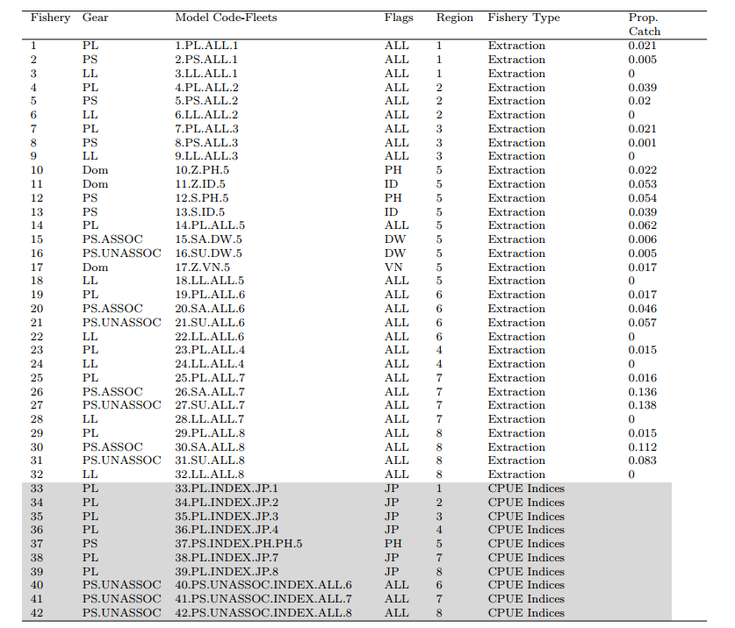

Table SKJ-02. Summary of stock assessment configuration and key sources of uncertainty in the WCPO skipjack tuna stock assessment by the MFCL.
TYPE | RATIONALE | UNCERTAINTY | IMPACT | CONFIDENCE
DATA
CPUE | Best available standardised indices, incorporating operational data,  multiple indices. | Potential hyperstability in PS CPUE indices | Abundance estimates could be biased from 2010-2024 | High
Catch | Best available information | ID catches may be biased high or low | Sensitivity indicated low impact | High
Size | Representative sampling | Good certainty, mandatory length reporting | Selectivity may vary temporally | Medium
Tag
MODEL
MFCL | Commonly used platform for the WCPO tuna stocks | Robust platform for modeling length and tagging data | Low impact | High
SPATIAL ASSUMPTIONS
8 regions | Based on regional processes informed by size and tagging data | Low uncertainty; informed by the literature | Low impact | High
KEY PARAMETER UNCERTAINTY
Growth coefficient k | Not estimable | Uniform distribution (0.2-0.4) | Influential on MSY-based reference points | High
Steepness | Not estimable | Beta distribution (mode of 0.85) | Influential on MSY-based reference points | High
STRUCTURAL UNCERTAINTIES
Mixing period K statistic | External estimates | K statistic (0.1, 0.2, 0.3) | Highly influential in the ensemble | Medium
Effort creep | External estimates | Effort creep trajectories randomly sampled from prior | Low influence | High
Estimation uncertainty
Estimation uncertainty | Monte-Carlo model ensemble | Estimated | Estimation uncertainty | High
Other source of uncertainty
Data conflict | Likelihood profile indicates length conflicts with CPUE and tag data | Conflict in the scaling of biomass | Not considered | Low
Table SKJ-03. WCPO Skipjack stock status summary table.
Skipjack
Year: 2025 | Spawning Potential | Exceptionally unlikely (<1%) to be below the LRP |  | Stock is not overfished
Year: 2025 | Fishing mortality | Exceptionally unlikely (<1%) to be above F_{MSY} |  | Overfishing is not occurring
Year: 2025 | Projection | The stock is on average at 98% of the recalibrated interim TRP (iTRP) as defined in CMM 2022-01 |  | Depletion is in the range expected through the MSE testing of the adopted interim skipjack MP (CMM 2022-01)
Year: 2025 | Recommendation | The stock has had stable spawning potential, spawning potential depletion (SB/SB_{F=0}), and fishing mortality since around 2010. The stock status and fishing mortality are well above the LRPs for depletion and fishing mortality, respectively.
Reference points/MP |  | Estimate  [10%--90%] | Comment
iTRP (interim Target Reference Point) | iTRP recalibrated based on 2025 stock assessment | 0.52  [0.47 – 0.64] | The calculation method for the iTRP is described in CMM 2022-01. The iTRP depletion value requires recalibration for each new stock assessment. Stock status is reported below as the ratio of the SB_{recent}/SB_{F=0} of the new stock assessment to the corresponding recalibrated iTRP value.
iTRP (interim Target Reference Point) | iTRP | 0.98  [0.94 – 1.01] | The iTRP value is recalibrated for each assessment according to the definition in – Reference Points. The ratio presented here is the ratio of the SB_{recent}/SB_{F=0} from the current stock assessment to the recalibrated iTRP value.
Depletion | LRP (0.2SB_{F=0}) | 0.51  [0.45 – 0.63] | LRP based on SB_{recent}/SB_{F=0} is the adopt LRP (0.2) for tuna stocks by the WCPFC.
Fishing Mortality | F_{MSY} | 0.28  [0.25 – 0.32] | F_{MSY} is the upper-level limit reference point for fishing mortality used by WCPFC for tuna stocks.
Recent estimates |  |  | Recent trend/projection
SB depletion (w/ estimation uncertainty) | SB_{recent}/SB_{F=0} | 0.51  [0.45 – 0.63]
Fishing mortality | F_{recent} | 0.10  [0.07 – 0.12]
SB depletion (w/o estimation uncertainty) | SB_{recent}/SB_{F=0} | 0.51  [0.45 – 0.63]
Status |  |  | Likelihood
Ratio of SB depletion:iTRP | SB_{recent}/SB_{F=0}：iTRP | 0.98  [0.94 – 1.01] | Within the range expected through the MSE testing of the adopted interim skipjack MP
SB depletion (w/ estimation uncertainty) | SB_{recent}/SB_{F=0} | 0.51  [0.45 – 0.63] | <1% probability < 0.2 (LRP)
SB depletion with respect SB_{MSY} (w/estimation uncertainty) | SB_{recent}/SB_{MSY} | 3.90  [2.95 – 5.61] | <1% probability < SB_{MSY}
Fishing mortality | F_{recent}/F_{MSY} | 0.35  [0.24 – 0.45] | <1% probability > F_{MSY}

Table SKJ-04. Summary of reference points over the model ensemble, along with results incorporating estimation uncertainty. Note that these values do not include estimation uncertainty, unless otherwise indicated.
 | Mean | Median | Min | 10% | 90% | Max
F_{MSY} | 0.28 | 0.28 | 0.22 | 0.25 | 0.32 | 0.37
F_{mult} | 3.01 | 2.85 | 1.88 | 2.25 | 4.12 | 5.42
F_{recent}/F_{MSY} | 0.35 | 0.35 | 0.18 | 0.24 | 0.44 | 0.53
MSY | 2,506,046 | 2,374,800 | 1,819,600 | 2,090,400 | 3,200,800 | 4,204,000
SB_{latest} | 3,715,913 | 3,365,822 | 2,320,595 | 2,747,472 | 5,231,863 | 5,801,571
SB_{recent} | 3,681,316 | 3,248,438 | 2,337,134 | 2,641,802 | 5,337,579 | 6,023,691
SB_{F=0} | 6,844,279 | 6,466,725 | 5,102,043 | 5,753,337 | 8,444,739 | 9,440,668
SB_{latest}/SB_{F=0} | 0.54 | 0.53 | 0.42 | 0.46 | 0.62 | 0.82
SB_{latest}/SB_{MSY} | 4.17 | 3.91 | 2.24 | 3.07 | 5.62 | 8.92
SB_{MSY} | 924,241 | 893,900 | 399,400 | 624,900 | 1,232,000 | 1,908,000
SB_{MSY}/SB_{F=0} | 0.13 | 0.14 | 0.07 | 0.10 | 0.16 | 0.20
SB_{recent}/SB_{F=0} | 0.53 | 0.51 | 0.40 | 0.45 | 0.63 | 0.68
SB_{recent}/SB_{MSY} | 4.11 | 3.91 | 2.14 | 2.98 | 5.60 | 8.92
Y_{Frecent} | 440,394 | 438,000 | 362,400 | 398,500 | 486,800 | 562,600
20%SB_{F=0} | 1,368,856 | 1,293,345 | 1,020,409 | 1,150,667 | 1,688,948 | 1,888,134
SB_{recent}/SB_{F=0}:iTRP | 0.98 | 0.98 | 0.83 | 0.94 | 1.01 | 1.05
Including estimation uncertainty
F_{recent}/F_{MSY} | 0.35 | 0.35 | 0.16 | 0.24 | 0.45 | 0.59
SB_{recent}/SB_{F=0} | 0.53 | 0.51 | 0.37 | 0.45 | 0.63 | 0.74
SB_{recent}/SB_{MSY} | 4.11 | 3.90 | 1.92 | 2.95 | 5.61 | 10.73

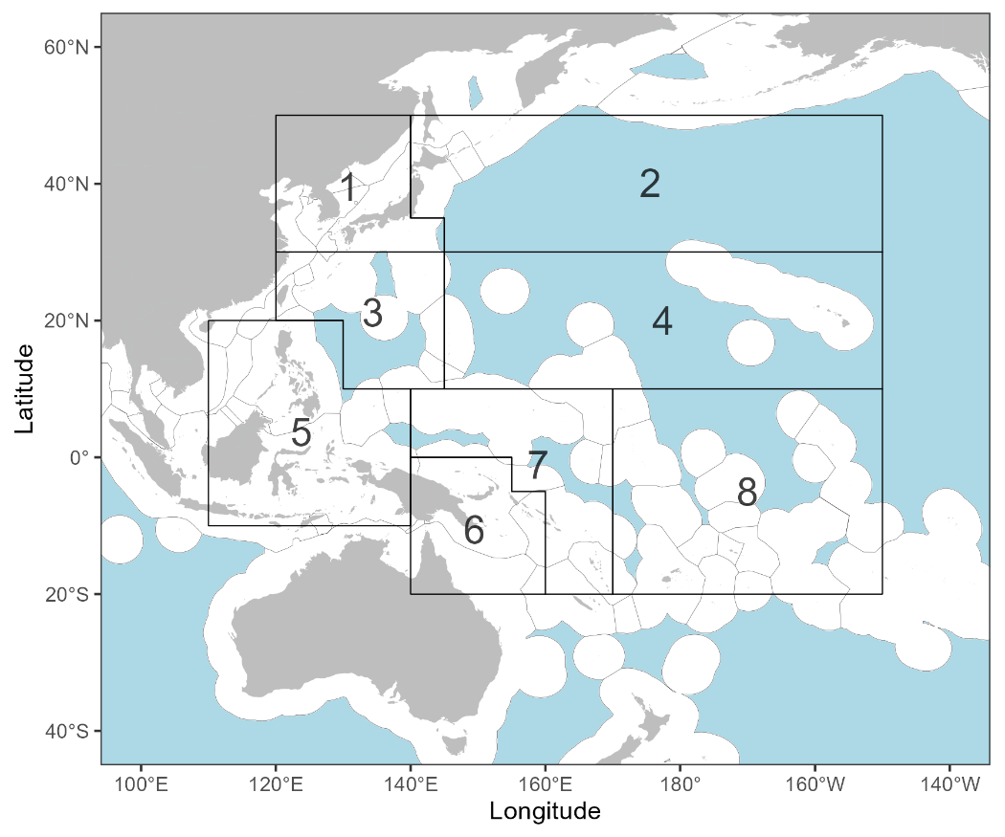
Figure SKJ-01. The geographical area covered by the stock assessment and the boundaries of the eight model regions used for the 2025 skipjack assessment.

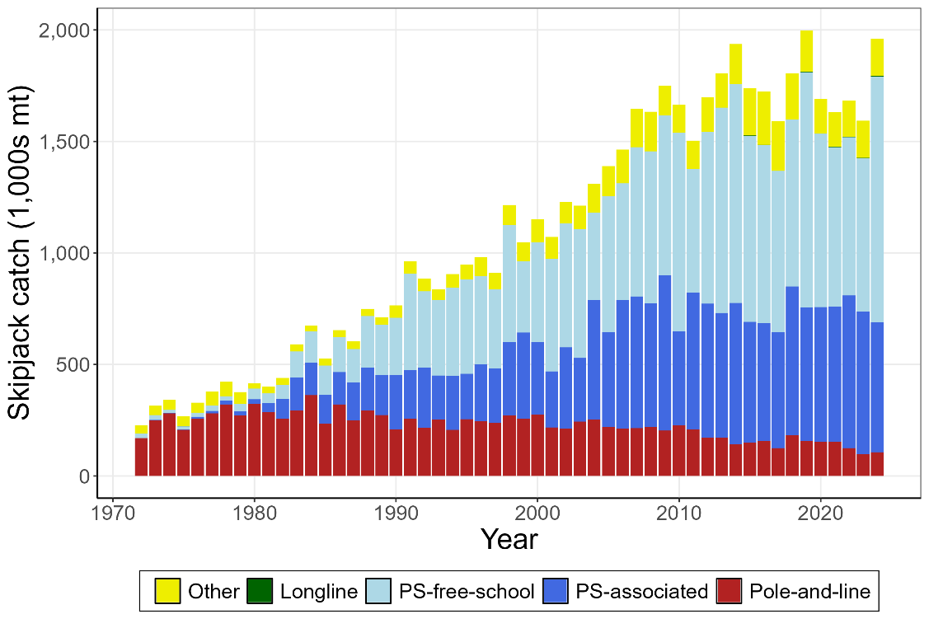
Figure SKJ-02. Time series of total annual catch (1000’s mt) by fishing gear over the full assessment period.

(a)
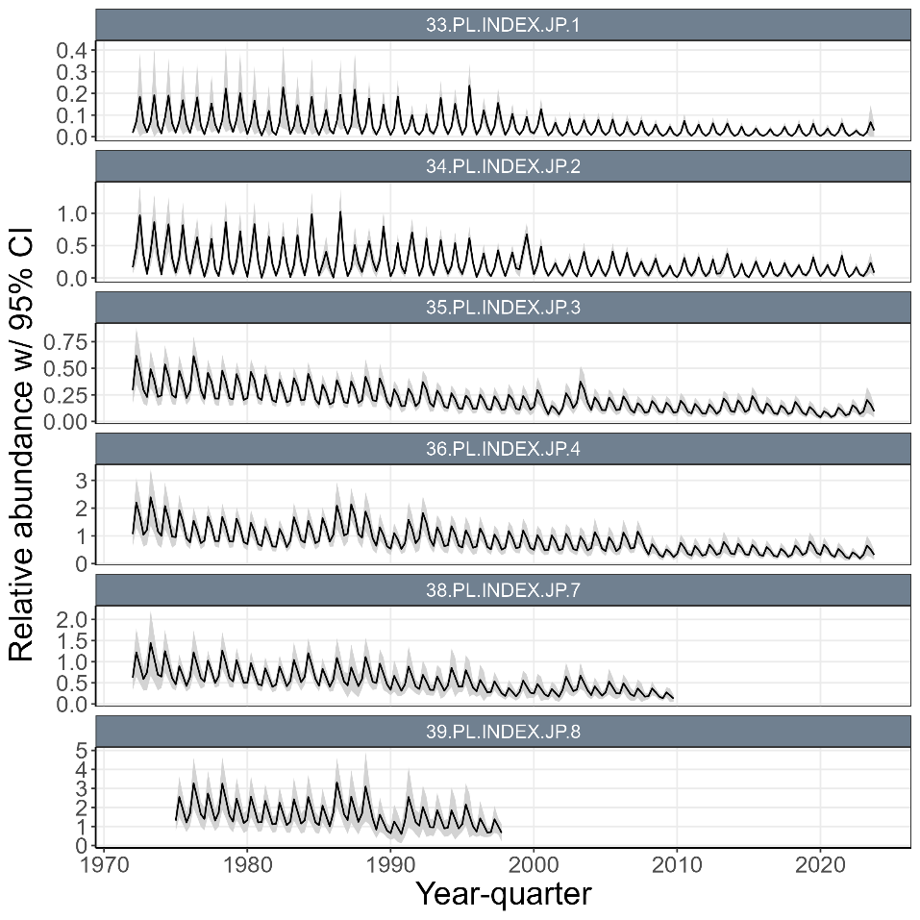
(b)
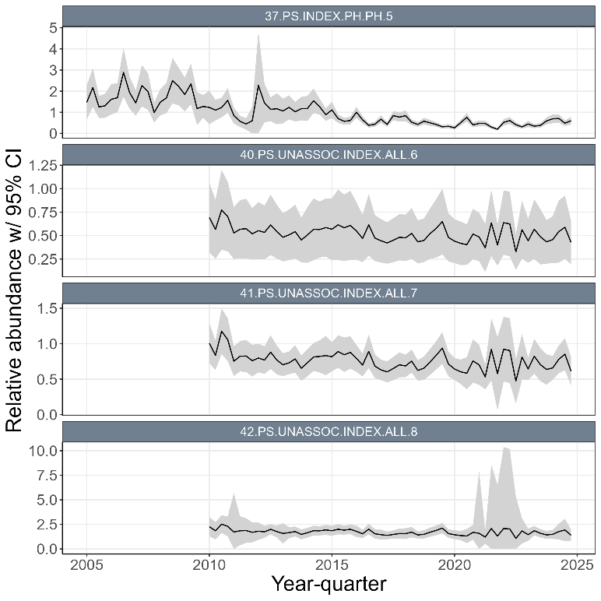
Figure SKJ-03. (a) Time series of standardized CPUE with 95% confidence intervals (CI) for the Japanese pole-and-line with effort creep adjustment and confidence intervals derived from bi-regionally grouped models (i.e., region 1 with 2, region 3 with 4, and region 7 with 8). (b) Time series of standardized CPUE with 95% confidence intervals (CI) for the ‘unassociated’ purse seine CPUE indices in region 6, 7 and 8, and the Philippines purse seine index in region 5. Fishery labels indicate fishery number, gear type, flags, and region, respectively.

(a)
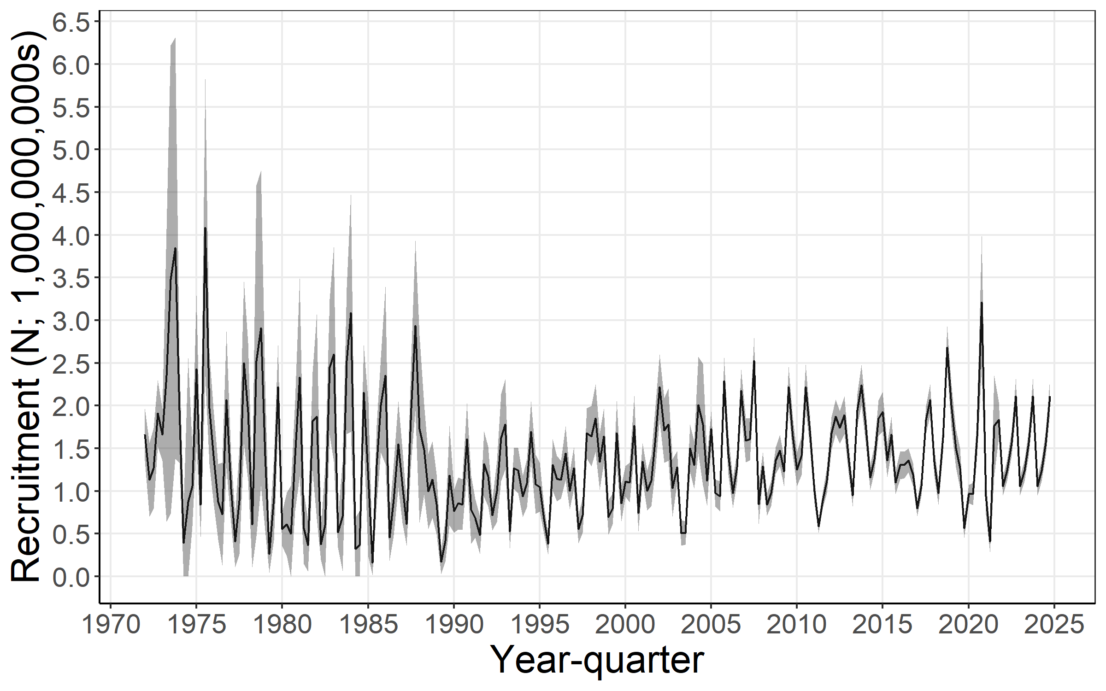
(b)
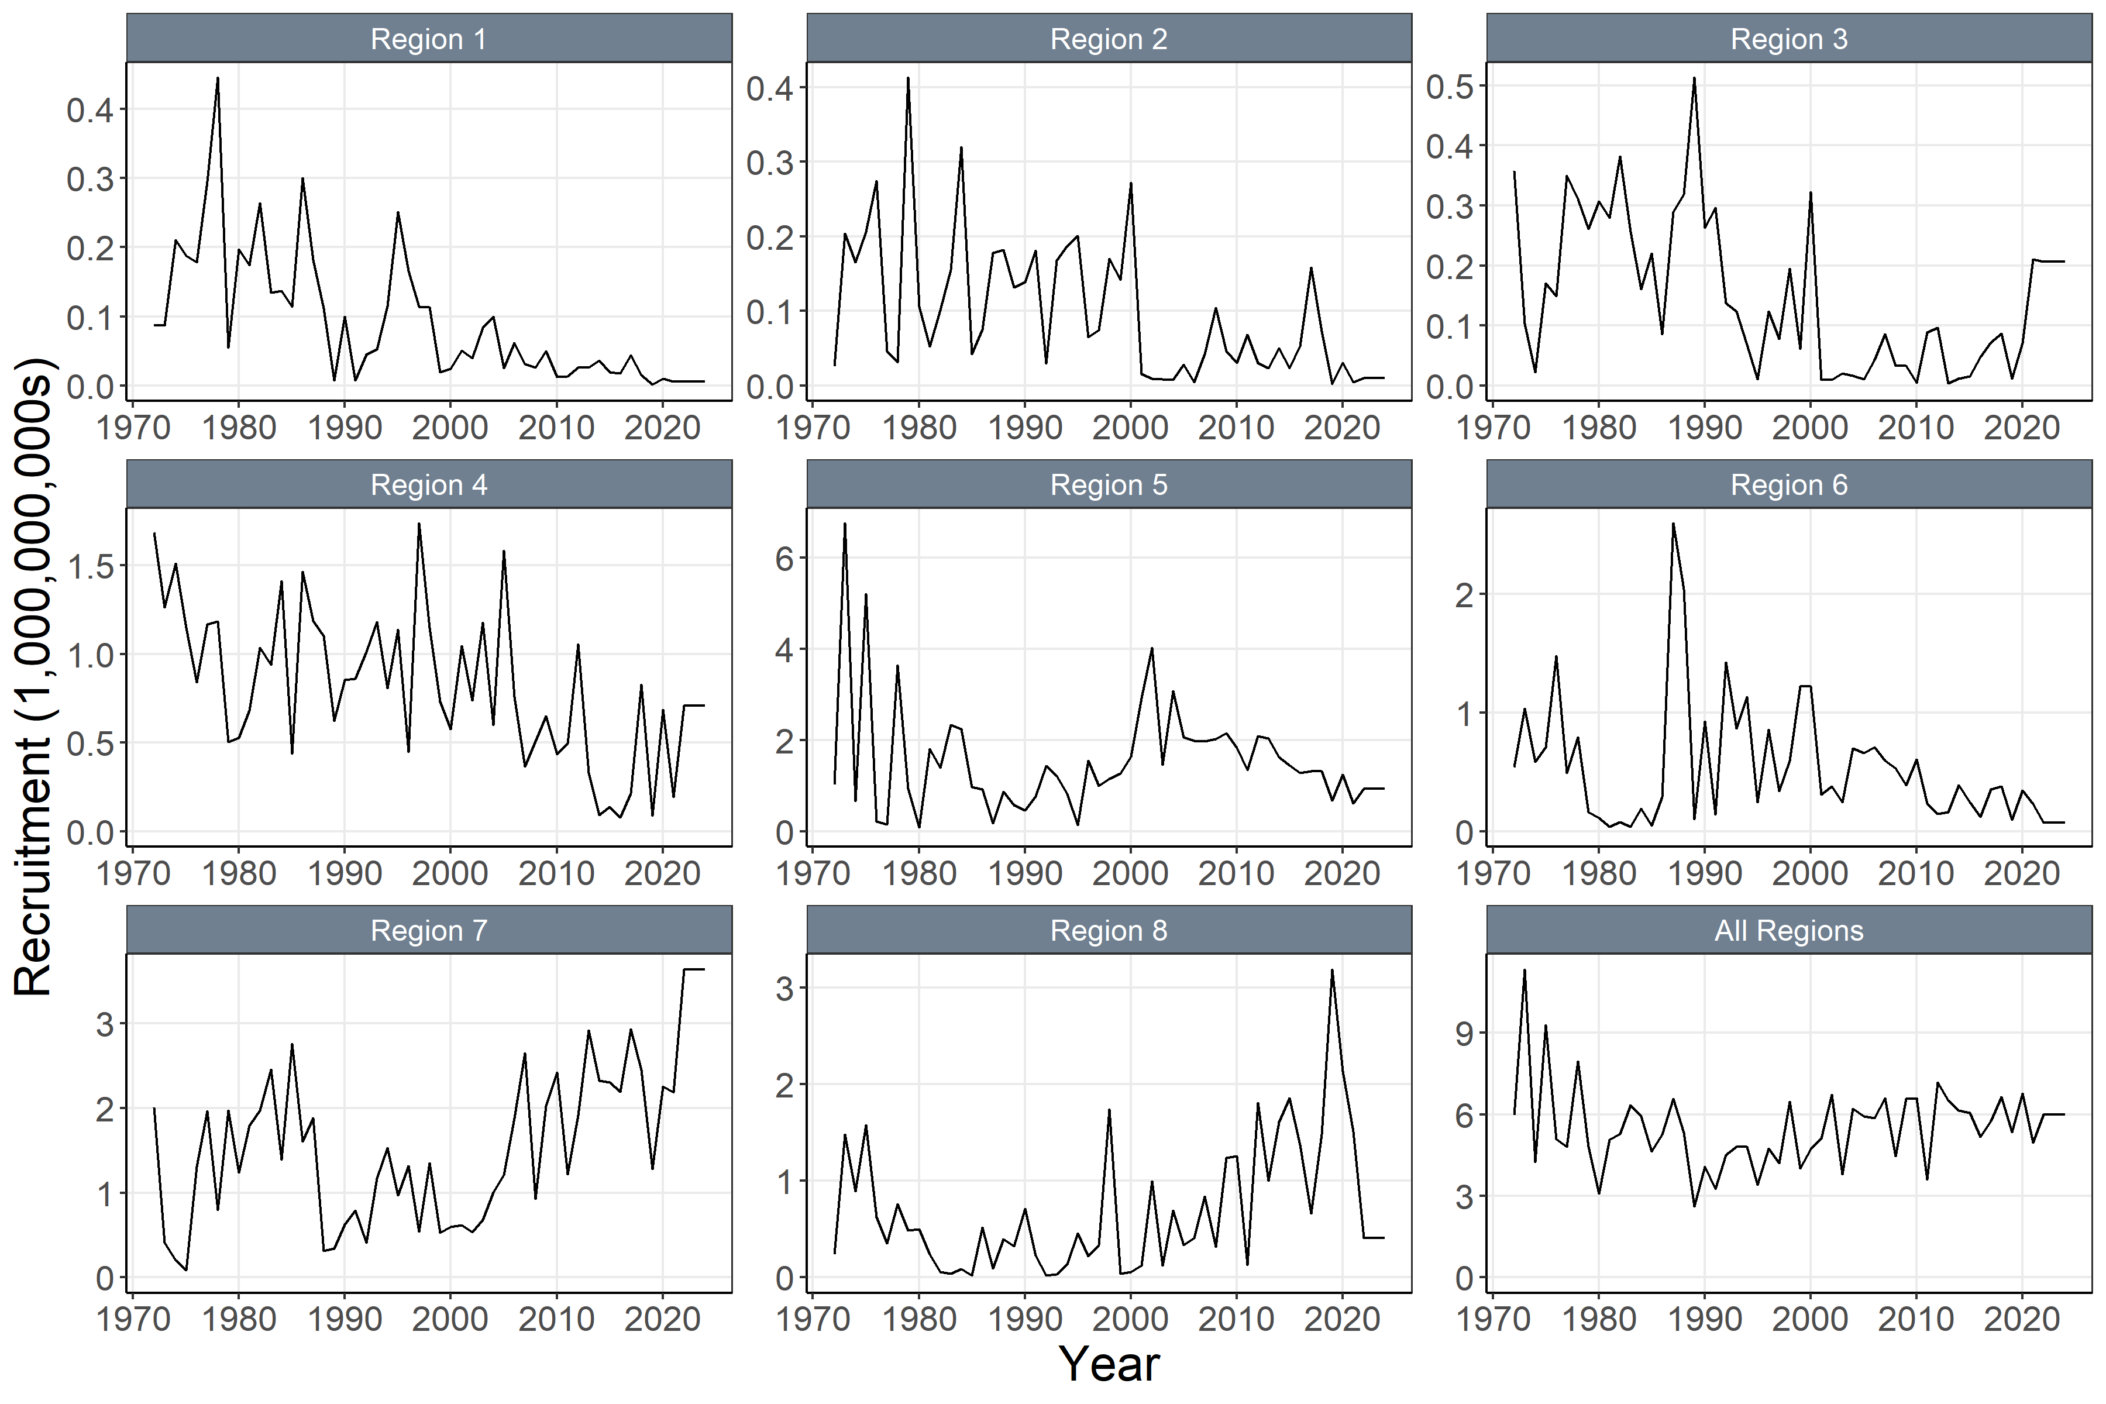
Figure SKJ-04. (a) Annual time series of estimated quarterly recruitment (including estimation error) summed across regions with 95% confidence interval for the diagnostic model. (b) Annual time series of estimated annual recruitment (without estimation error) among regions for the diagnostic model.

(a)
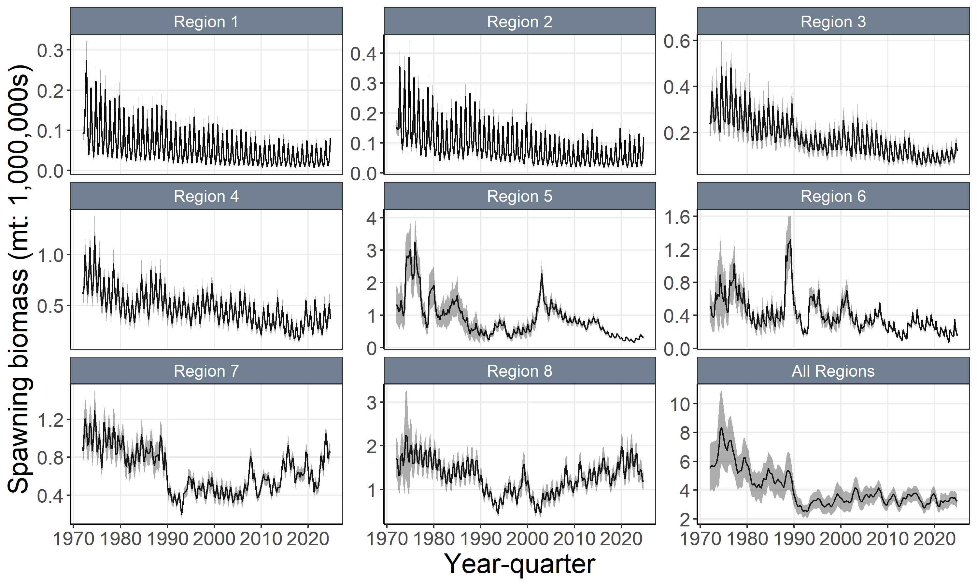
(b)
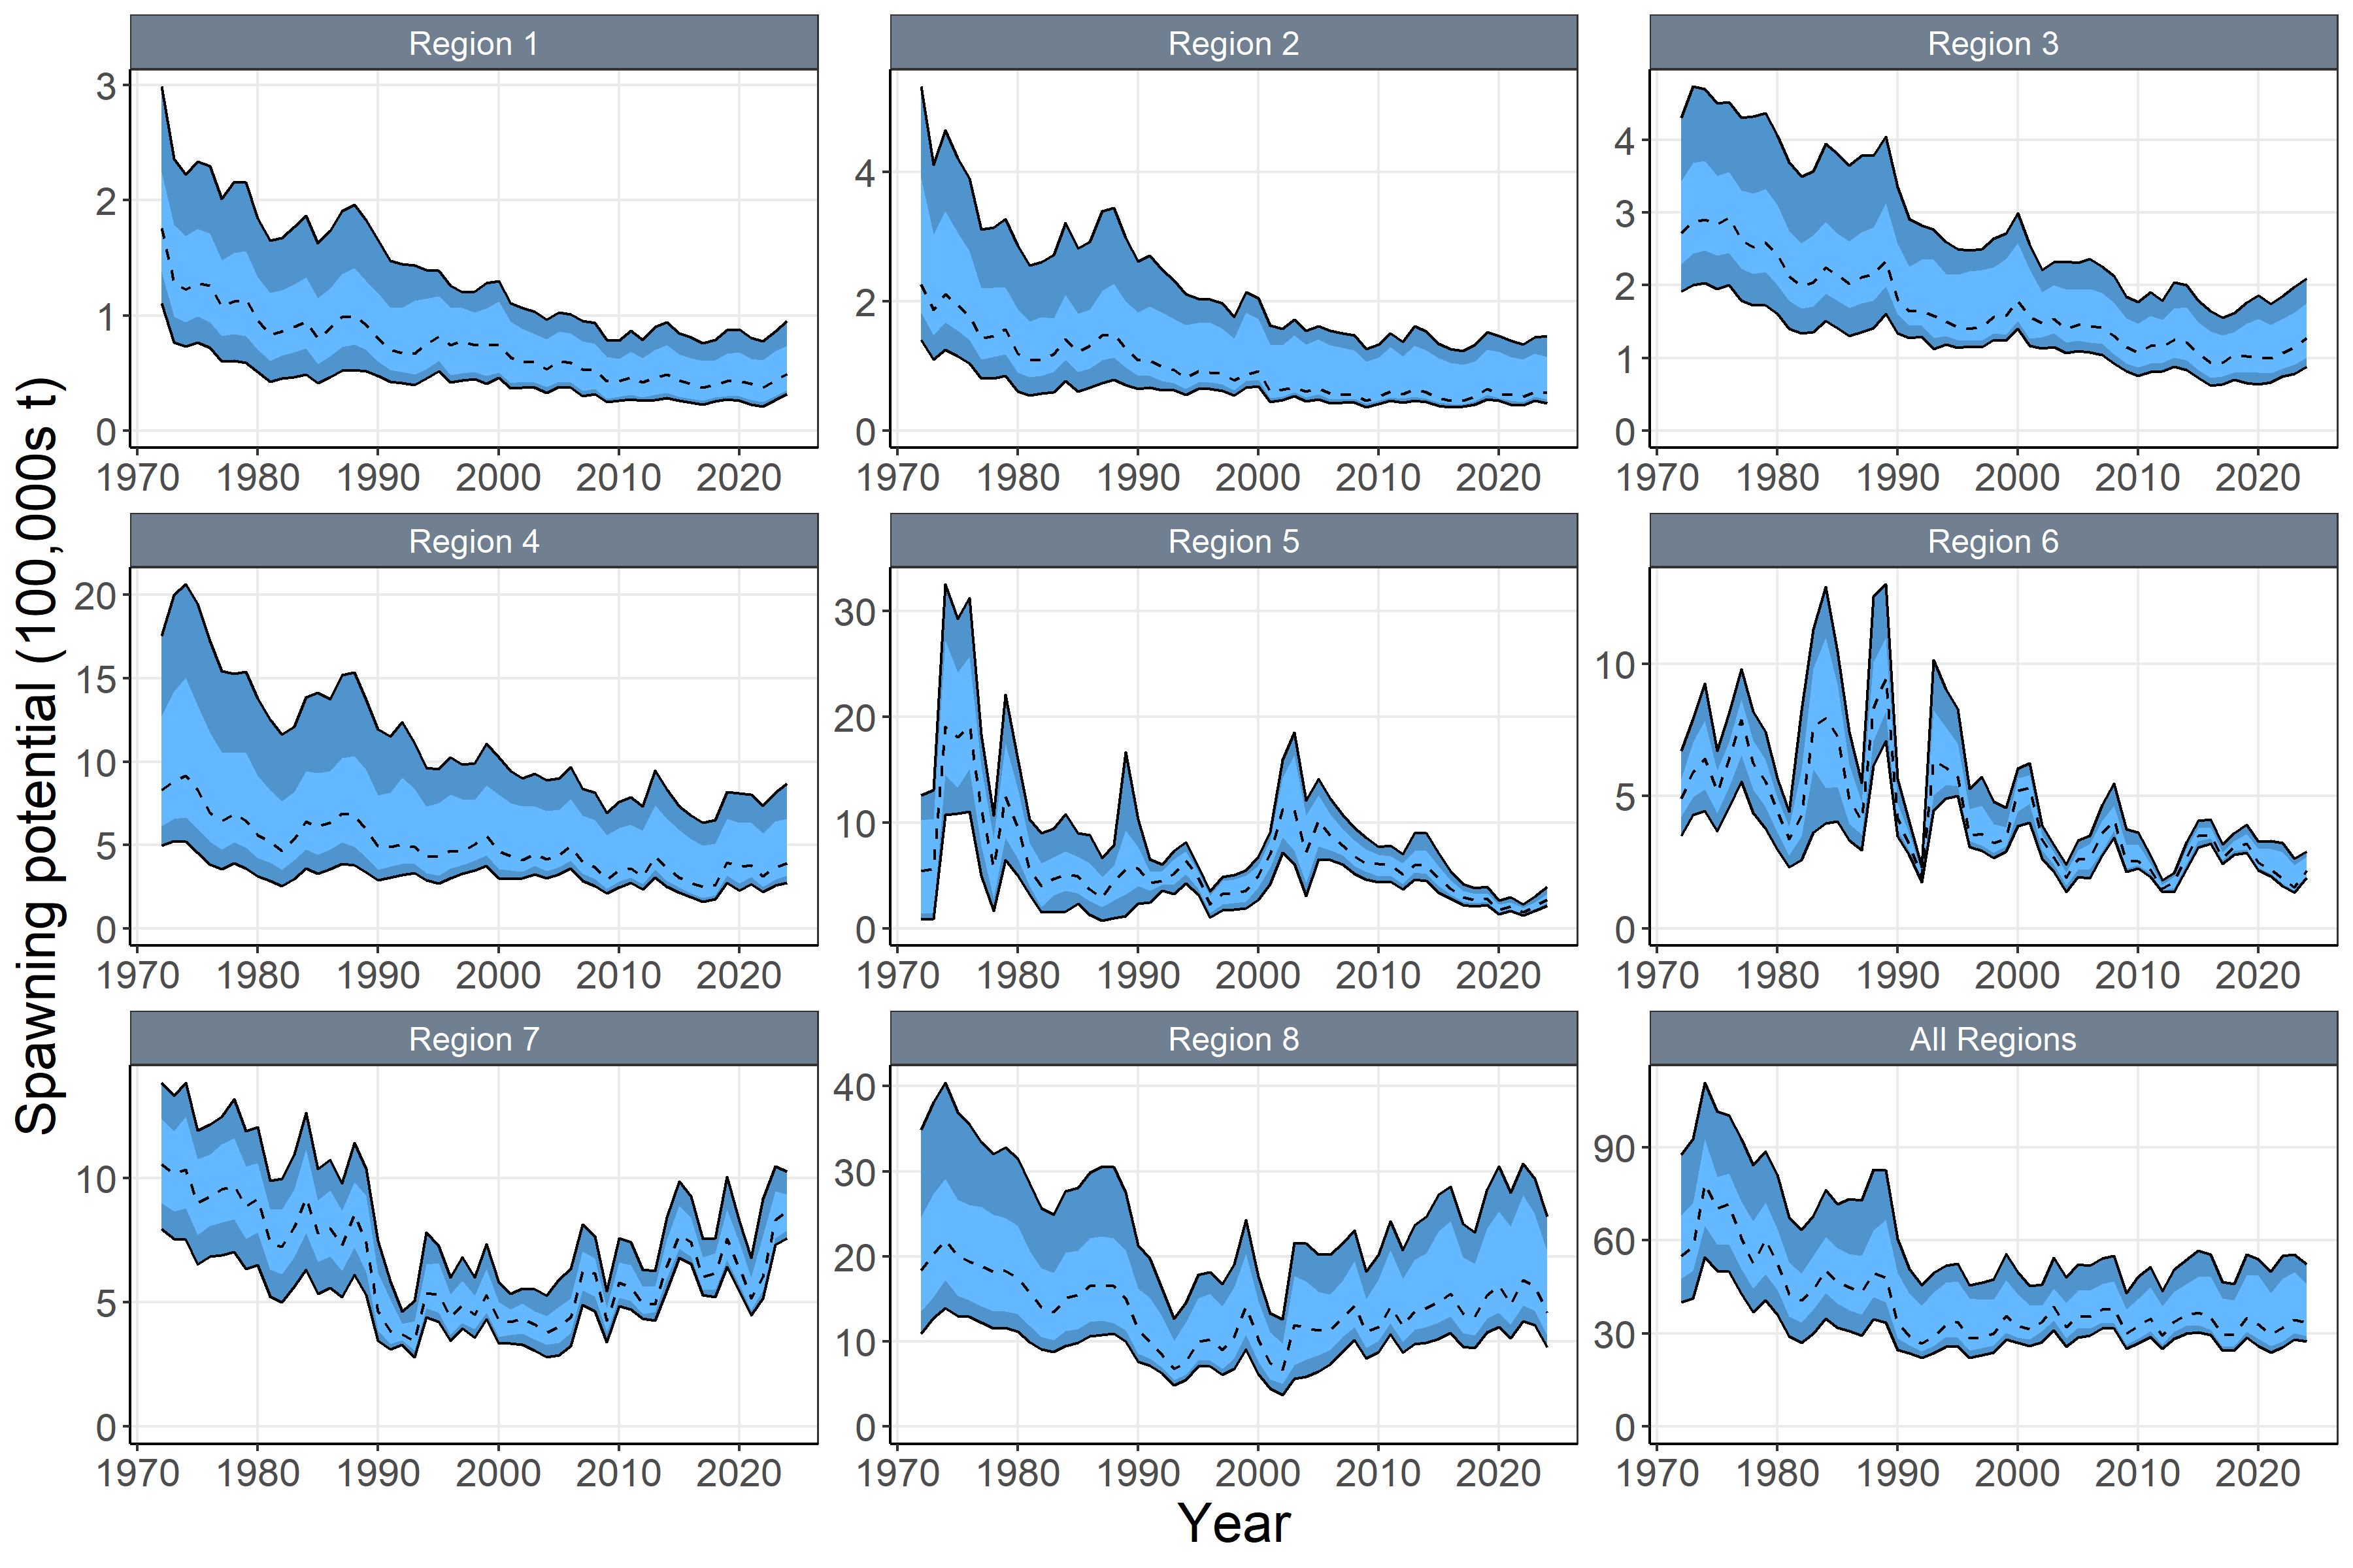
Figure SKJ-05. (a) Time series of estimated quarterly spawning potential by region with 95% confidence interval for the diagnostic model, including estimation error. (b) Time series of annual estimated 90% (dark blue) and 75% (light blue) quantiles of spawning potential by region from the model ensemble. The dashed line indicates the median. Estimation uncertainty is not included in b).

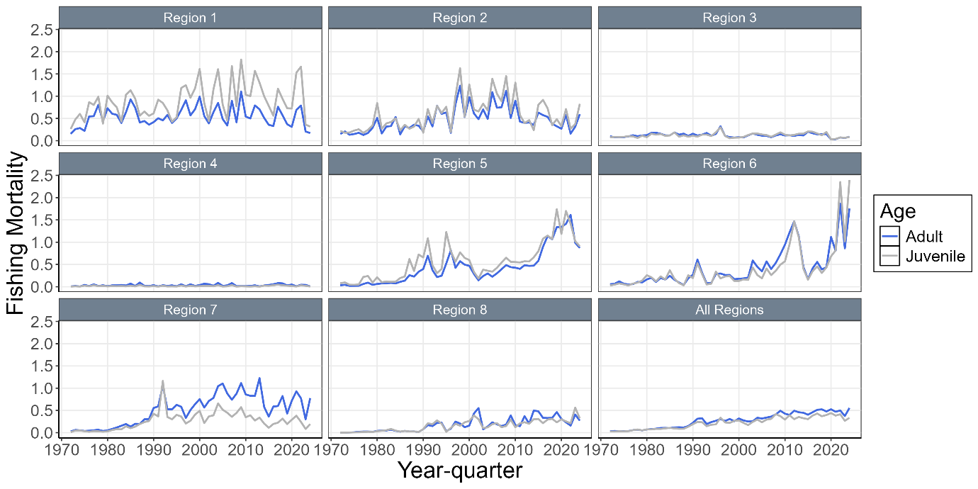
Figure SKJ-06. Time series of annual estimated fishing mortality (F) for adults and juveniles by regions for the diagnostic model.

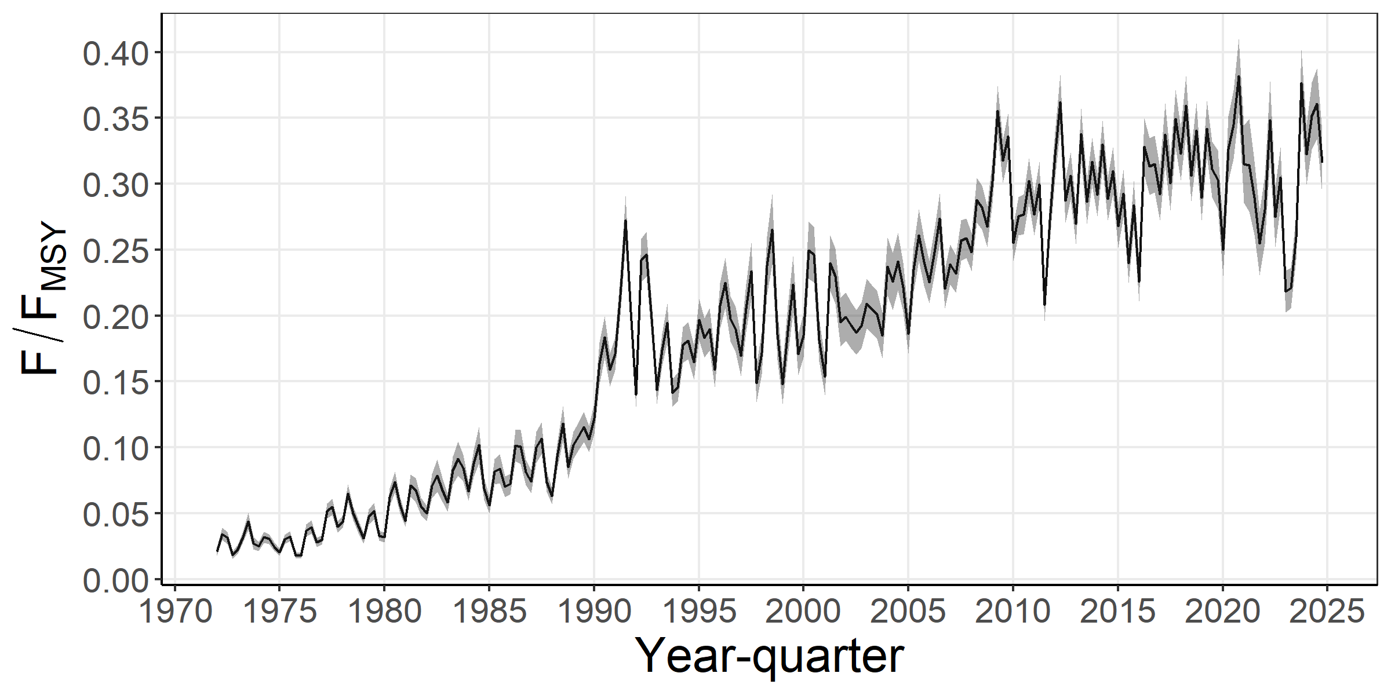
Figure SKJ-07. Time series of estimated F/F_{MSY} with 95% estimation error for the diagnostic model.
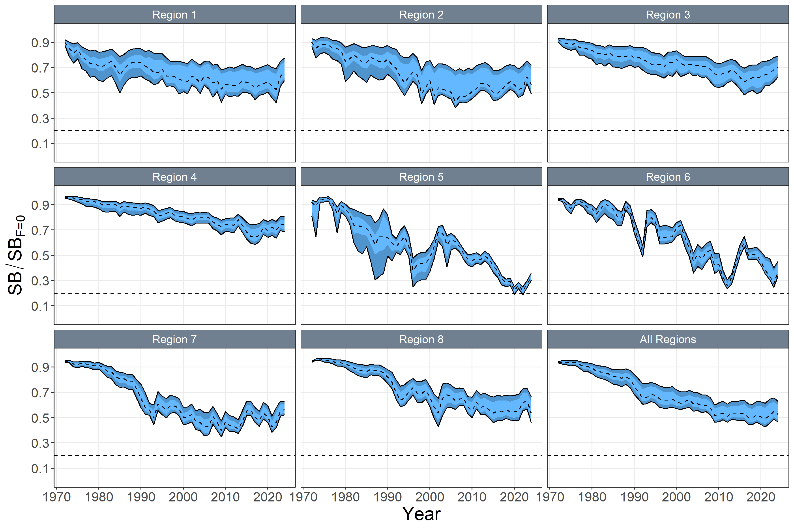
Figure SKJ-08. Time series of annual estimated 90% (dark blue) and 75% (light blue) quantiles of SB/SB_{F=0} by region from the model ensemble. The dashed line within the interval indicates the median. Estimation uncertainty not included.

b. Stock status

- Estimation uncertainty was incorporated by applying a Monte-Carlo model ensemble approach. Estimates of SB_{recent}/SB_{F=0} (Figure SKJ-09) and F_{recent}/F_{MSY} (Figure SKJ-10) indicated that tag mixing period assumptions (i.e., dissimilarity K statistic) had the largest impact on estimates of stock status.

- The models from the ensemble indicated the probability that SB_{recent}/SB_{F =0} < 0.2 (LRP) was 0 (Table SKJ-03), the probability that F_{recent}/F_{MSY} >1 was 0. The dynamic Majuro and Kobe plots indicated that for all time periods, the SB_{recent}/SB_{F=0} was > 0.2, SB_{recent}/SB_{MSY} was > 1, and the F_{recent}/F_{MSY} was < 1 (Figure SKJ-11). Similarly, all models in the ensemble for the recent period (2021–2024) indicated that the SB_{recent}/SB_{F=0} was > 0.2, SB_{recent}/SB_{MSY} was > 1, and the F_{recent}/F_{MSY} was < 1. As in the previous stock assessment, results indicate that the skipjack stock in the WCPO is not overfished, and overfishing is not occurring.

- The projected stock depletion levels under recent conditions are presented in Figure SKJ-12. The year 2024 represents the first year of application of the skipjack interim management procedure (CMM 2022-01). The stock is on average at 98% of the recalibrated TRP (0.94 – 1.01). This is within the range expected through the MSE testing of the adopted interim skipjack MP (see MSE shiny at https://ofp-sam.shinyapps.io/PIMPLE_WCPFC19/; performance indicator: ‘SB/SB_{F=0} relative to target’).

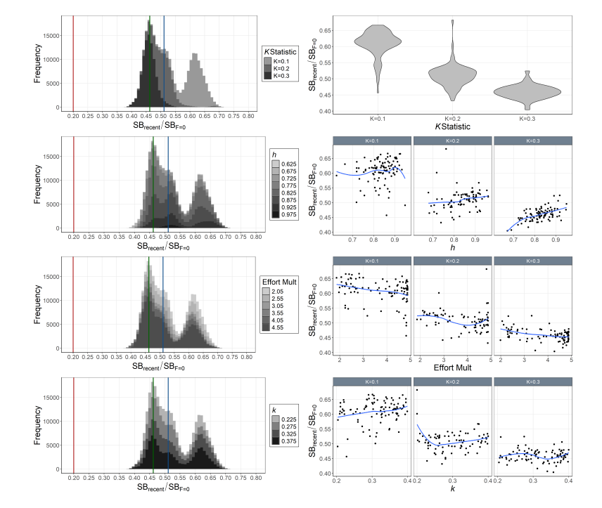
Figure SKJ-09. Histograms of Monte-Carlo estimated model uncertainty for SB_{recent}/SB_{F=0} by mixing period (K statistic, top-left), h (2nd-left), effort multiplier (Effort Mult; 3rd-left), and growth coefficient k (bottom left) with mode (green line), median (blue line), and SB_{recent}/SB_{F=0} = 0.2 (red line). Also includes estimated SB_{recent}/SB_{F=0} by mixing period (K statistic; top-right), h (2nd-right), effort multiplier (Effort Mult; 3rd-right), and growth coefficient k (bottom-right) for each model in the ensemble with a loess smoother.

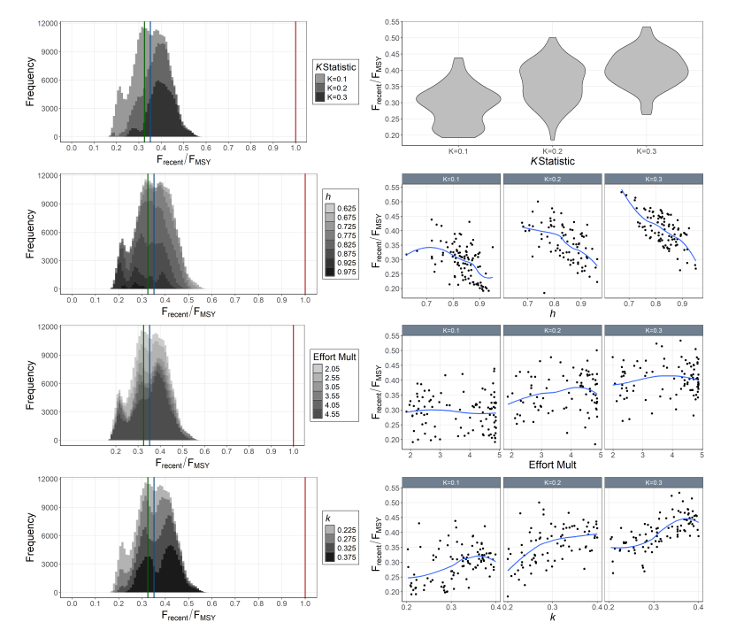
Figure SKJ-10. Histograms of Monte-Carlo estimated model uncertainty for F_{recent}/F_{MSY} by mixing period (K statistic, top-left), h (2nd-left), effort multiplier (Effort Mult; 3rd-left), and growth coefficient k (bottom left) with mode (green line), median (blue line), and F_{recent}/F_{MSY} = 1.0 (red line). Also includes estimated F_{recent}/F_{MSY} by mixing period (K statistic; top-right), h (2nd-right), effort multiplier (Effort Mult; 3rd-right), and growth coefficient k (bottom-right) for each model in the ensemble with a loess smoother.

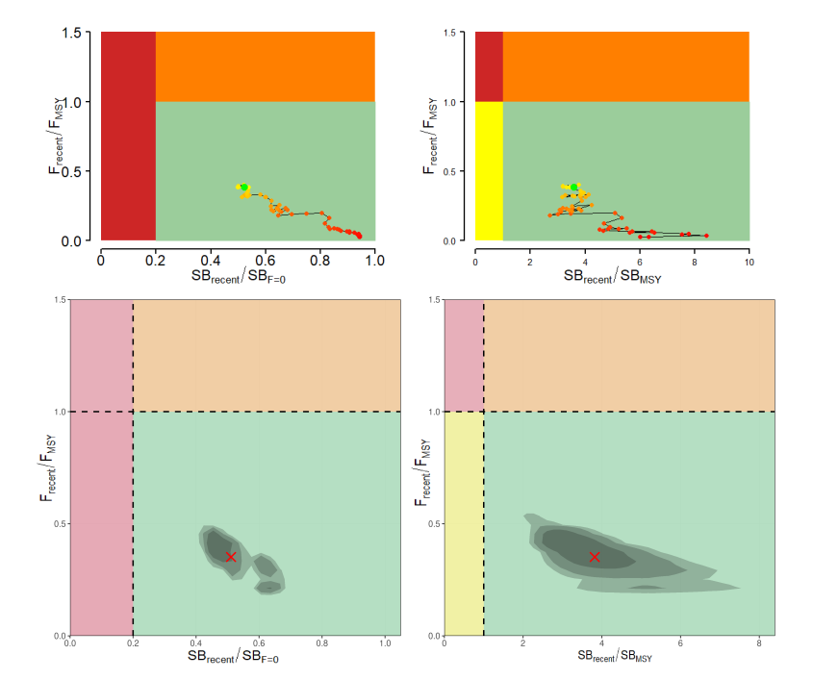
Figure SKJ-11. Majuro plots (left) and Kobe plots (right) summarizing the results for the dynamic MSY analysis (top; 4-year window moving back in time) and the Monte-Carlo random draws from the model ensemble (i.e., including estimation uncertainty) for the recent period (2021–2024; right). Colors for dynamic MSY go from red to green over time. The shading of model ensemble results indicates the 50th, 80th, and 90th highest density regions. The red X in the model ensemble represents the median.

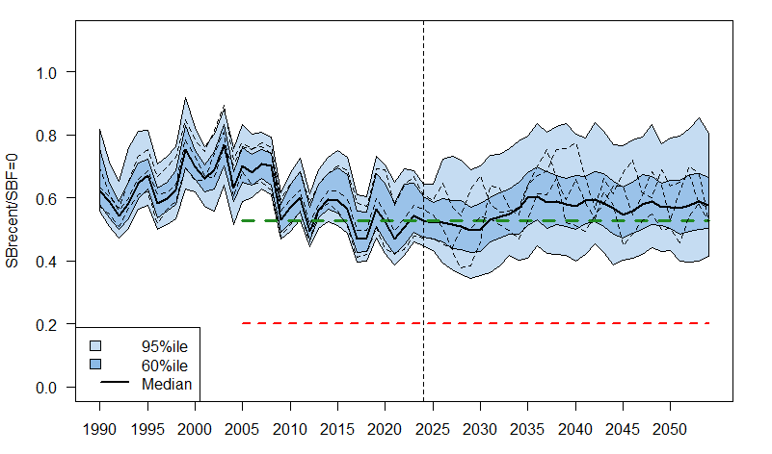
Figure SKJ-12. WCPO skipjack tuna SB depletion from the uncertainty grid of assessment model runs for the period 1990 to 2024 (the vertical line at 2024 represents the last year of data used in the assessment), and stochastic projection results for the period 2025 to 2054 assuming catch and effort levels in 2024 continued into the future. Prior to 2025, the data represent the 60th and 95th percentiles of the uncertainty grid from the assessment models and the median. During the projection period (2025-2054), levels of recruitment variability estimated over the period used to estimate the stock-recruitment relationship (1984-2020) are assumed to continue in the future. The dashed lines indicate three example trajectories (chosen randomly out of 8,100) from the model grid. The red dashed line represents the WCPFC agreed limit reference point (0.20). The green dashed line represents the recalibrated skipjack TRP level.

c. Management advice

- While acknowledging that ongoing improvements to the modelling are still needed, the SC21 accepted the 2025 skipjack stock assessment results and considered that they, in general, support the continued application of the skipjack management procedure (MP). The entire monitoring strategy for the skipjack MP can be found in Agenda item 5.1.1.2 of the Management Issues theme.

d. Research recommendations

- SC21 identified a range of areas for improvement and suggested the following items for consideration in the development of the next stock assessment:
- Potential effort creep in PS CPUE.
- Data conflicts that affect assessment outcomes, and approaches to resolving them.
- Impact of tagging data on population scale
- Tag diagnostics: Models that fit to tagging data require diagnostic plots that indicate a) the degree of mixing for the tags included in the model, b) the likelihood profile on the SSB scale by tagging program, and c) tag mixing scenarios.
- Tag reporting rate priors
- Tag mixing period: more appropriately modelling the tagging data externally using the approach being developed in collaboration with DTU to develop external abundance indices for the tagging data.
- Meta population structure: improve understanding of linkages between East Asian waters and WCPFC area, and east-west linkages across the Pacific.
- Growth and age structure research: conduct research to explore the epigenetic approach

    - Other WCPO tunas
4.3.2.1 Indicator analysis

- P. Hamer (SSP) presented SC21-SA-WP-03 Compendium of Fisheries Indicators for Target Tuna Stocks, and noted that the “Indicators Paper” is an annual SC report tracking a set of indices for the target tuna stocks, generally presented in plenary for the non-assessed stocks. The indices include time series of catch by gear, CPUE indices by gear, spatial maps of catch, effort, and CPUE, and catch at length /weight by gear type. Additionally, short-term projections using updated catch data are provided based on status quo catches over the next three years. Discussion of each graphic with highlights is noted. For the non-assessed (bigeye, South Pacific albacore, and yellowfin tuna) stocks, some notable observations included: a strong recent increase in South Pacific albacore CPUE for three of the Distant Water fleets (Japan, Korea, and Chinese Taipei), but China showed a decline in the recent year. There was an absence of recorded catches in a region south of French Polynesia, an area usually fished by China, and where a relatively high CPUE is recorded. The reason for the lack of catch in this area is currently unclear. Short-term status quo (2024 fishing levels) stock projections predict that the South Pacific albacore stock would become less depleted (i.e., a higher SB/SB_{F=0} ratio) over the next few years. Bigeye catches were the lowest observed in 30 years, but the proportion taken in the ‘Other’ fishery, mostly in the Indonesian region, was the highest on record. The large increase in catches in the ‘Other’ fishery involves small fish and impacts the fishing mortality predicted by the status quo bigeye projections, with an F/F_{MSY} ratio >1 projected to occur by the end of 2026. Yellowfin catch declined slightly, but the proportion taken in the ‘Other’ fisheries was also the highest on record. Catches declined across the central equatorial Pacific, commensurate with the shift in the purse seine fishery to the western Pacific as La Niña conditions developed in the 2nd half of 2024. The mean weight of yellowfin in the catch shows a strong declining trend across all gear types and warrants further investigation. An unusual drop in the mean weight of skipjack tuna in the unassociated (free school) purse seine fishery component was noted during the COVID period, but this appears to be due to biases in sampling during COVID and is unlikely to be representative. The SSP will aim to correct this in the next indicators paper.

Discussion
- China recommended including the trawl fishery CPUE to indicate abundance for recruitment, and inquired if this could be included and the report updated if possible. In response, SPC indicated this could be done and noted it was not necessarily indicative of recruitment trends because of where and how the fishery operates. SPC stated that the nominal values are in SC21-SA-IP-09 (Figure 7). China also mentioned that bigeye longline CPUE for Japan and Korea are in conflict with the CPUE for the US Hawai’i fleet, and inquired why. SPC stated it would have to examine that, and whether they are reflective of recruitment, differences in how the fleets operate, or strongly influenced by oceanographic trends in those regions, is still up for debate. China asked whether SPC considered the FAD closure for the bigeye and yellowfin in the short-term projection? SPC stated they included the new FAD closure period in 2024 and that, despite the shorter FAD closure period, there were actually more free school sets in 2024 than ever before. So, although nominally the FAD closure period is captured within those, it just reflects the actual conditions of fishing in 2024 in terms of catch for longline and effort for purse seine fisheries.

- Japan stated that SC21 still lacks a standard response action to the indicator analysis, and, as in the past case, it remains unclear what the right action would be based on the results. They noted that in 2025, there are some noticeable results, such as the sudden increase of fishing mortality, much over F_{MSY}, but it seems SPC thinks that needs to be further considered. As discussed previously, it seems to have a very large influence on the bigeye assessment. Japan stated that this needs to be very well studied prior to the next stock assessment.

- Tuvalu, on behalf of FFA members, recognised that the indicators presented, such as catch, CPUE trends, spatial effort distribution, and size composition, are essential tools for tracking annual changes in fishery performance and providing early warning signs of potential stock concerns, particularly between full stock assessments. While empirical indicators cannot replace full stock assessments, they provide timely insights that, when combined with stochastic projections, help interpret trends in fishing pressure and stock health. For albacore, indicators suggest recovery, with the highest CPUE since 2009, and increased mean weights. Projections show no risk of breaching the LRP. For yellowfin, total catch remains relatively high and fishing pressure is below overfishing levels, but the stock is projected to decline slightly. For bigeye, catch is now at a 30-year low, and CPUE remains well below historic levels despite slight recent rebounds. However, FFA members noted with concern the increased catches of small bigeye in other gear fisheries in Region 7 of the bigeye stock assessment, more than 50% higher than the baseline average, resulting in a high probability of overfishing in the projections. However, following the discussion in the Data and Statistics theme on the nature of these catches, they stated their understanding that this result may not be reliable, so they will await further information. They noted that if confirmed, this is a serious issue and SC will need to draw the Commission’s attention to this development and its projected consequences for bigeye stock status, noting that an assessment is scheduled for 2026. FFA members recommended that the SSP continue producing this compendium annually.

- Chinese Taipei inquired about an apparent increase in 2024 albacore catch north of 10°S and the decrease in the Southeast region and inquired whether there were changes in species or effort distribution, and whether it would impact MP projection assumptions.

- SPC stated that the increasing average weight and the increasing catch to the northern areas in the tropics are consistent with the biology of the species, but shifts in catch and effort were an issue to examine.

- The USA stated that in response to China's question regarding the observed trends in the United States’ bigeye tuna nominal CPUE, some of the decline can be attributed to operational changes within the fleet, making nominal CPUE quite difficult to interpret, given these operational changes. The USA recommended SPC undertake a detailed analysis of bigeye tuna mean weight trends by space, time, fleet, and gear over the past 10 to 20 years to better understand these patterns and to inform next year's assessment to be discussed at the next pre-assessment workshop (PAW) in 2026.

- SPC stated exploration of the mean weight and size trends is something that is consistent with the work it would look at doing through the size data project. Given that it would be hard to do that kind of analysis across all the species, it might focus some prototype analyses or methodologies on bigeye and yellowfin, starting this year, for the next assessments of those species.

Outcomes
- SC21 thanked the SSP for conducting an indicator analysis, providing empirical information on recent patterns affecting key stocks.

- SC21 noted that there is no standard action by the SC to respond to the analysis.

- SC21 expressed concern over the apparent increased catches of small bigeye in other gear fisheries in Region 7, which resulted in a high probability of overfishing in the projections (SC21-SA-WP-03). However, SC21 noted that this result may not be reliable because the size class of these fish may have been misclassified. SC21 recommended that this uncertainty be resolved as a matter of urgency and that updated information be provided as necessary for the Commission’s consideration.

- SC21 recommended that the SSP undertake a detailed analysis of BET mean weight trends by space, time, and fleet over the past 10 to 20 years. This will improve our understanding of these patterns and inform next year's assessment, which will be discussed at the next Pre-Assessment Workshop (PAW).

4.3.2.2 Updated reproductive biology of tropical tunas (Project 120)

- SC21-SA-IP-10 Project. 120: Progress report on Reproductive Biology of WCPO Yellowfin Tuna was included as topic 16 in the SC21 ODF.

  - Northern stocks
    - Provision of scientific information from the ISC
- R. Ahrens, ISC chair, remotely presented an "Overview of Fisheries and Stock Status of Tuna, Billfish, and Sharks in the North Pacific Ocean". He provided updated landings data for species assessed by the ISC, showing mixed trends across the region, with notable increases in landings for blue and striped marlin — 42%–48% year-over-year increases — while others experienced modest declines. The presentation also summarized stock status updates, which did not change because no new assessments were conducted since SC20. A number of tasks assigned to the ISC by the Northern Committee of the WCPFC and the Joint Working Group were completed. The Albacore Working Group assessed the suitability of effort-spawning potential ratio relationships in Japanese longline fleets targeting North Pacific albacore and developed an erratum to the 2023 albacore stock assessment. Key management and research tasks completed or underway include the finalization of the Management Strategy Evaluation (MSE) for Pacific bluefin tuna, with supporting projections accounting for new 2024 management measures and conversion factor calculations. The billfish working group updated the North Pacific striped marlin projections to align with new catch distribution rules under CMM 2024-06. ISC plans assessments for albacore and blue marlin in 2026, a peer review of the 2024 Pacific bluefin tuna assessment, and the continued development of open science workflows, expansion of the International Billfish Biological Sampling program, and a conceptual model for blue shark management. The ISC26 Plenary meeting is scheduled for June 22–29, 2026, in Chinese Taipei. Additional details are available on the ISC website.

Discussion
- Palau, on behalf of FFA members, noted their ongoing concern regarding the status of the Pacific bluefin tuna stock, and encouraged both continued scientific work and necessary management attention to support its recovery. They noted that the MP for Pacific bluefin tuna would be discussed under its dedicated agenda item. Given that the 2024 stock assessment, while encouraging, was considered optimistic, they encouraged the NC to maintain a strong focus on conservation of the stock in its forthcoming decisions on the MP. They acknowledged and commended the NC for the positive status of other North Pacific stocks, and encouraged continued efforts and proactive management to ensure these stocks remain sustainable. They expressed support for the ISC25 agreement to review the WCPFC management advice and uncertainty template, and encouraged the NC to request that the ISC apply this template in its regular reporting of management advice. They noted that there have been differences in how uncertainty in stock assessments is addressed between the ISC and SPC, and stated that using a common approach would allow managers to more easily compare the results of stock assessments for all tuna species across the WCPO.

- The ISC noted that at ISC25, the plenary did discuss the recommended kind of structure and format from the WCPFC, and it was agreed that, as best as possible, they would seek to adhere to the recommendations for the reporting structure in those stock assessment reports. Those changes will be integrated into future ISC reports, which will hopefully help harmonize the information so that it is easier to digest and allows for cross-comparison.

- The ISC stated that in response to questions from the USA on a CKMR feasibility study for short fin mako shark, that work has been postponed by 1 year, and an update would be provided by the ISC at SC22.

Outcomes
- SC21 thanked the International Scientific Committee (ISC) for its continued efforts and the provision of high-quality scientific assessments that are essential to informed decision-making in the Commission.

- SC21 supported the ISC25 agreement to review the WCPFC management advice and uncertainty template, and encouraged the Northern Committee to request the ISC to apply this template as a guideline in its regular reporting of management advice to promote consistency and comparability of stock assessment results across the WCPO.

    - Pacific bluefin tuna (Thunnus orientalis)
4.4.2.1 Research on migratory patterns

  - Billfish
    - Southwest Pacific swordfish (Xiphias gladius)
4.5.1.1 Stock assessment of Southwest Pacific swordfish

- J. Day presented SC21-SA-WP-05 Stock assessment of Southwest Pacific swordfish, which describes the development of the 2025 stock assessment, which includes an additional four years of data since the previous assessment in 2021, and the data used in the model extends through to the end of 2023. The assessment retained the 2-region spatial structure used in 2021, but with each fishery separated into six (6) subregions rather than combining fishery data from multiple subregions, as was done in the 2021 assessment. The assessment was simplified, which resulted in improved convergence properties and positive definite Hessian solutions for every model in the uncertainty grid. Other significant new features in the assessment include: the transition from MULTIFAN-CL to Stock Synthesis; conversion from a 1-sex model to a 2-sex model; revision of the size data inputs, stronger filtering methods and additional downweighting of unreliable size data; changing from age-based selectivity to length-based selectivity; inclusion of sex-specific conditional age-at-length data within the assessment and using these data to contribute to internal growth estimation; estimating the scale of the Lorenzen natural mortality form; switching to an updated length-weight relationship based on a new dataset and with more careful filtering of the old data; the use of a quarterly model time step to allow greater resolution in modelling the growth curve; and the adoption of variable bin widths for the weight composition data.

- In addition to standard stock assessment results and diagnostics, the presentation focused on the reasons for the simplification of the model and noted the following concerns with the model: difficulties modelling or obtaining alternative growth forms to incorporate growth uncertainty in the assessment; large uncertainty in the estimates of population scale and the conflict in CPUE and weight composition data that was required to get plausible estimates of population scale; the influence of the weight composition data in subregion 1C; and uncertainty in the appropriate spatial structure to use for this assessment.

- Overall, the assessment results indicate that the stock status has been generally declining over the period of the assessment, with some variation in the rate of decline over time. However, the median values of SB_{recent}/SB_{MSY} of 2.37 from the grid indicate that SB is well above SB_{MSY}, and the median value of F_{recent}/F_{MSY} of 0.27 from the grid indicates that F is well below F_{MSY}, and SB_{recent}/SB_{F=0} has a median value of 0.5. The conclusion is that the swordfish stock in the SWPO is not overfished, nor undergoing overfishing.

- The general conclusions of this assessment were as follows:
1) The spawning biomass of the stock has become more depleted over the period of the assessment.
2) Average harvest rates for juvenile and adult age-classes were low (<0.025) until the late 1990s, with a steady increase to around 2005, stabilising at around 0.06, with some annual variation.
3) Overall, the median depletion from the uncertainty grid for the recent period (2020-2023; SB_{recent}/SB_{F=0}) is estimated at 0.50 (80 percentile range including structural uncertainty only of 0.46–0.58, full range 0.37–0.67).
4) No models from the uncertainty grid, including estimation uncertainty, estimate the stock to be below 20% SB_{F=0}.
5) Overall, the median values of SB_{recent}/SB_{MSY} for the recent period (2020-2023) are estimated to be 2.37 from the grid (80 percentile range, including both structural and estimation uncertainty of 1.80–3.37, full range 0.48–5.37).
6) Overall, the median values of F_{recent}/F_{MSY} for the recent period (2019-2022) are estimated to be 0.27 from the grid (80 percentile range, including both structural and estimation uncertainty of 0.16–0.41, full range 0.00–0.93).
7) Recent (2019–2022) median fishing mortality (F_{recent}/F_{MSY}) was 0.28 (80 percentile range, including estimation and structural uncertainty 0.18–0.28, full range 0.11–0.53).
8) Assessment results suggest that the swordfish stock in the SWPO is not overfished, nor undergoing overfishing.

- A number of key research needs have been identified in undertaking this assessment that should be investigated either internally or through directed research. These include:
                - Increased representative biological sampling, especially of conditional age-at-length data.
                - Collection of appropriately sampled close kin mark recapture data.
                - Robust age validation procedures.
                - Duplicate readings of otoliths to enable the age reading error to be estimated.
                - Further research on growth and regional growth variation.
                - Explore the influence of environmental factors on recruitment.
                - Review the length and weight composition data and explore further models to standardise these composition inputs to assessments.
                - Collaborative work with colleagues from the EU to diagnose potential problems with the current EU CPUE index.
                - Additional exploration of alternative abundance indices, CPUE, or otherwise.
                - Regional agreements on standard length and weight measurements to be applied to best inform the stock assessment.
                - Full review of conversion factors used in the assessment, and consideration of the development of regional or flag-based conversion factors.
                - A review of data collection preferences for stock assessment purposes would be helpful, especially composition data.
                - Investigation into stock structure and connectivity with adjacent regions in the northeast corner of the assessment region.

- Chinese Taipei posed several questions that were answered by the SSP:
- CPUE residuals show a noticeable time trend, and the recent biomass estimate doesn't align with the index trend. They asked if the distant water fishery index should be included in the uncertainty grid? The SSP stated that inclusion would be preferable, although how much difference it would make was unclear. Looking at the indices that were prepared last time, the SSP stated it didn't have time to rework those indices, and that was likely a deficiency in the assessment, and it would be worth exploring. The other concern is that those are largely bycatch fisheries, so they are probably less informative and less useful than some of the other fisheries, as they may tell more about variations in fishing behavior rather than variations in the stock. But it's worth exploring with enough time. The SSP stated they simply ran out of time to do that. Leaving out the EU index was also perhaps unfortunate, but there were some problems with that as well.
- Regarding growth, Chinese Taipei stated that billfish typically grow rapidly before age 1, but the current growth curve appears to underestimate their early growth. They suggested the parameter standard error could possibly be used for a fixed growth curve in the revised grid. The SSP replied that this was tried, noting a big difference in the estimated growth from the external growth, which was quite interesting. It did fit the conditional age-at-length data pretty well, and the weight data really well. So the model does seem to fit the input data used in the assessment quite well, although it would be better to include more uncertainty on growth and some other viable growth options in the grid. Other viable options would certainly be worth exploring.
- Regarding diagnostics, Chinese Taipei noted several diagnostics produce inconsistent results and inquired if this could indicate a possible model misspecification. The SSP stated that the question on the diagnostics again was very helpful, and agreed that they indicate that there are some problems with the model. The SSP stated that the model is the best that could be done with the data in the time available, but that there are clearly some problems, and the diagnostics show what some of them are. There is evidence, especially in the likelihood profile, of some conflict, but without that conflict, model results were not plausible, and getting a plausible estimate of population scale was more important than eliminating all conflict.
- Chinese Taipei stated that a significant number of swordfish were caught near the upper right boundary of the model area. Both fish and fleets move beyond the assessment boundaries, and they asked how this source of uncertainty might be partially incorporated into the grid. The SSP replied that this is important for this assessment, in particular, the northeast boundary, because there's clearly a lot of fishing on the other side and there's probably a lot of movement across that boundary as well; it is not clear how best to incorporate that in the grid, but it would be good to do.

- The USA stated it appreciates the efforts of the SSP in making many improvements to the Southwest Pacific Ocean swordfish stock assessment, including the transition to stock synthesis, incorporating aging data, internally estimating the growth curve, and considering only data that are representative of the stock. They also appreciated the diagnostic tests and plots provided, which have facilitated the review of the assessment. They voiced concerns about the fits in the model and noted suggestions for how to improve the model (both in the ODF), but stated they are generally happy with the outcome of the assessment. The USA highlighted that the model relies heavily on the length and weight data to drive the population dynamic, as evidenced by the age-structured production model (ASPM). As many of the size data components, included in the assessment, are in conflict and strongly influence the population trajectory, especially in the last 5 years of the model, they strongly recommend a better understanding of how these fisheries change over time and the use of time-varying parameters and selectivity, or other adjustments to reduce the influence that these data have. Fits to the CPUE data should be prioritized over fits to the size data, but this does not appear to be the case in this model.

- The SSP replied that time-varying selectivity is an interesting idea, noting it is unclear whether there's sufficient data to be able to estimate that well enough, but it would be worth exploring. Getting selectivity estimates that were sensible and plausible for the model was a struggle, and it seemed part of that was dependent on the fishery. Of course, with some fisheries it was easier than others to get a selectivity that seemed plausible, but whether there is sufficient data to be able to estimate that well is an open question; the issue is worth investigating.

- Japan stated regarding the data input, while understanding there are many issues with fisheries data, it is a concern from a scientific process standpoint to develop assessments that subjectively exclude data from major fisheries. For example, the recent decline in the EU-Spain CPUE noted in SC21-SA-IP-12 directly contradicts the stable trend in the New Zealand CPUE from SC21-SA-IP-11. Given the concern with the recent EU-Spain data, Japan suggested it would have been more appropriate to consider ways to still use the index in the diagnostic model, either by removing only the recent data or by down-weighting it. Furthermore, in SC21-SA-IP-14, several historical periods of Japanese size data were excluded as anomalous. In the absence of an objective and quantitative method for data filtering, they stated they believe the principle should be to use as much of the data as possible. It appears that instead of fitting the model to the data, the data are being adjusted to fit the model, which raises concern about the overall reliability of the assessment model.

- In reply, the SSP noted the comments on the EU CPUE and stated that if the EU CPUE is switched for the New Zealand CPUE, the results are very similar. When the EU CPUE was included, the last 2 years of the time series (which featured a large drop) were excluded. That big drop is an important point to mention and deserves more investigation. There's some suggestion that the targeting that was thought to be of swordfish for that fishery may be another species, and in those last 2 years, the drop in swordfish CPUE may not be related to swordfish. The SSP had concerns about including that, thinking that it's showing a trend, but asked if that is really a trend in swordfish. That was the reason for excluding the last 2 years. The SSP stated it could have included that series without those last 2 years in the assessment grid, but it would have made little difference, given the results are so similar to using just the New Zealand index. Certainly, other options could be explored in terms of removing and down-weighting data. The SSP noted that this was a very difficult assessment with a lot of conflict. Some of the data sources were combined, so some of the data were removed from fisheries, and some of those fisheries were amalgamated from several flags. Contributing to the difficulty with that data is that there are data from different flags in different time periods, and the model only knows about fisheries. If flags are combined into one fishery, the model assumes this is all homogeneous data, and that may not be the case. A lot of the data that was excluded was sporadic both spatially and temporally. The SSP stated it tried to smooth that data, and perhaps the size composition data modelling approach suggested for future assessments will allow =some of that data to be included in future, by essentially taking account of those variations spatially, temporally and perhaps by flag.

- In reply to the SSP, Japan stated that the Japanese fleet is also a major fleet in the early period (1950, 1960) and thereafter. Japan requested that the SSP consider the abundance indices of Japanese and Chinese Taipei CPUE.

- In a separate comment, Japan stated that the data issues have clear consequences for the model's result. The likelihood profiles show a conflicting signal between CPUE and weight data. Fishing mortality, recruitment, and spawning stock biomass exhibit serious retrospective bias with a Mohn's rho of 0.628. Considering these issues, Japan believes there is significant uncertainty regarding the reliability of the stock status in the final year, which serves as the basis for management recommendations.

- The SSP agreed that there are data issues, there is conflict in the likelihood profile, and there are problems with the retrospective, and stated that it's important to look into what's happening, as detailed in the paper itself. Regarding the conflict in the likelihood profile, the Piner plots give information on the source of that conflict. This was examined in some detail to retrospectively work out which of the data sources were causing those problems. There is a real trend in the retrospective analysis, in particular with Australian weight data, with a real decline in mean weight over the last five years. That does deserve more scrutiny. The SSP agreed that the retrospective pattern is quite concerning and that, in some sense, it may illustrate there is a lack of stability and some extra uncertainty in the model that isn't captured by the grid and should be considered. The model and the results need to be taken with some caution in light of that. The SSP noted that this is not a perfect model, and while it is unclear how that should be dealt with from a management perspective, it should be considered.

- Japan commented on consistency, stating that swordfish and striped marlin are caught by the same fishery, but the data usage period and the area definitions differ significantly between the two assessments. In this Southwest Pacific Ocean swordfish assessment, data from the 1950s to 1980s are largely unused aside from catch data, which is a major difference from the striped marlin assessment. They stated that this inconsistency is a point for future consideration. If data prior to 1990 are considered unreliable, then perhaps assessments using only data from 1990 onward could be a useful sensitivity analysis in the future.

- The SSP stated that the issue of sensitivity could be interesting for swordfish. The lack of distant water fishing nation CPUE in this assessment is perhaps an omission, but there was an issue of whether those fisheries were targeting swordfish and whether they actually provide a useful abundance index. Stock assessments are driven by the abundance data, and if the index data are not a good indicator of abundance, that can also be misleading, so CPUE is probably all that can be used. If it's not actually reflecting what the abundance is (because it is largely a bycatch fishery, or for other reasons), then that can also be misleading.

- New Zealand, on behalf of FFA members, expressed appreciation to the SSP for delivering the comprehensive 2025 Southwest Pacific Ocean swordfish stock assessment, stating that the work represents a new benchmark involving a fundamental transition from MFCL to the Stock Synthesis platform, a change requested by SC20. As part of Project 123, the SSP has implemented significant structural changes, including conversion to a 2-sex model, major revisions to size data inputs, separation of fisheries into distinct sub-regional components, and a shift to length-based selectivity. They stated that the considerable effort and technical expertise are highly commendable. New Zealand noted that the assessment estimates the Southwest Pacific Ocean swordfish stock is not overfished, with recent spawning biomass well above both SB_{MSY} and the 20% depletion LRP that is applied to tunas. It is also not undergoing overfishing. However, it is crucial to recognize that the estimated spawning biomass relative to unfished levels does show a continued decline over the last decade, despite a brief recovery to 2015. This declining trend highlights the ongoing need for management. To this end, FFA members noted the Commission's intention to develop a management strategy evaluation framework for Southwest Pacific Ocean swordfish and to develop and evaluate candidate management procedures covered under the Management Issues agenda item 5.5. They further appreciated the likely use of this year's stock assessment as the basis for an OM reference set for evaluation of candidate MPs.

- Niue, on behalf of FFA members, endorsed the assessment authors’ recommendations to strengthen future analyses, specifically supporting:
- Implementation of CKMR for more reliable independent population estimates as a one-off analysis to anchor the stock biomass estimates in the assessment. Future continuation of the SWO CKMR work should be subject to the evaluation of costs.
- Expansion of biological sampling, including
  - expanded otolith collection for conditional age-at-length data
  - application of otolith-based methods to investigate population structure.
  - Increased tissue sampling for genetic studies.
- Given that age data are among the most informative for this model, and current datasets remain limited both spatially and temporally, these improvements would significantly enhance assessment reliability.
- Development of alternative abundance indices, particularly observer-based CPUE, to complement existing data streams.
They noted that these strategic investments in data quality and methodology will be crucial for maintaining the assessment’s robustness.

- The SSP stated that regarding the observer index data, it developed a CPUE index from the observer data and used it this year. They reinforced that CKMR would be the gold standard for an assessment such as this, and it would be really useful, but it would be costly and time-consuming and that additional age data should be of higher priority.

- Australia stated that the assessment benefited from bringing in expertise and ideas. This was discussed at SC21 in the context of the next stock assessment package, and Australia supported this with challenging assessments such as this. Regarding the narrow uncertainty bounds of the grid, Australia inquired what additional axes of uncertainty might be tractable and appropriate. What other axes could we consider?

- The SSP agreed that the uncertainty is unrealistically narrow and stated it wasn’t necessarily obvious how to improve that. That would benefit from wider discussion. Growth uncertainty would be good to include. The assessment was constrained to some extent by computational limitations on the number of options to include for some of the existing axes, such as the proportion of recruitment allocated to each region. It is not clear where swordfish recruit relative to the two regions in the model, but exploring more options and seeking more information from those who might know more about the biology may be useful. They also noted the potential utility in having more time for assessments (perhaps a 2-year period) so that preliminary results could be presented and then revised and brought back to inform management.

- The EU thanked the SSP’s team for their substantial efforts in delivering the assessment and particularly Jemery for the way he developed it, professionally and collaboratively, with optimism and friendliness in spite of stressful circumstances. The EU recognized the complexity of evaluating a species such as swordfish, due to the information available, the complexity of the different data sources, and the biology of the species. They sincerely appreciated the challenges the team navigated throughout the process and commended them for the work. They also thanked the SSP for their responses in the ODF to their requests. The EU stated that catches in bycatch fisheries north of 20°S is possibly the major challenge for the management of the species, and stated they would specify their request in relation to the time-series they would like to see separately, noting they sought to illustrate the amount of catch that is currently out of the scope of the current CMM and its trend over time. They also noted the comment on the use of MSY reference points and acknowledged the limitations of MSY when the stock recruitment relationship is not well known. At the same time, the EU stated it considers this uncertainty is captured in the confidence intervals provided in the assessments and that — due to the alignment with some national regulations, the Convention, and to the work carried out elsewhere — it is important that this metric is included in the assessment on a regular basis. The EU stated that the new assessment represents a significant methodological advancement, in spite of the limited time, and that the transition to Stock Synthesis is a positive step forward and aligns well with the objectives of Project 123. Moreover, some other changes, like the incorporation of a two-sex model structure, conditional age-at-length (CAAL) data, and length-based selectivity, are commendable improvements that enhance the assessment approach. That said, and as the authors indicate, the assessment remains subject to several important uncertainties—some of which may be intrinsic to the biology of the species. In this regard, although they agreed the assessment should form the basis of the OM grid in the forthcoming MSE work, the EU also considered, as the SSP and Australia have indicated, that additional sources of uncertainty might need to be included to ensure a robust performance of an eventual MP. The EU expressed support for the research recommendations proposed by the authors, particularly those aimed at improving growth estimation, exploring the implementation of CKMR methods, and refining the understanding of population structure. At the same time, they acknowledged that certain issues may prove difficult to resolve in the near term, even with additional data collection or analytical refinement. For example, the persistent conflict between size composition and CPUE signals, the retrospective patterns, and the divergence in CPUE trends across fleets may not solely reflect data limitations, but could also stem from structural assumptions within the model that are difficult to validate or adjust. Given the experience with other species, it would be worthwhile to include in the recommendations the further exploration of a complementary, simplified modelling approach for the next assessment. Such an approach could serve as a robustness check and help isolate the influence of structural assumptions on key outcomes. Finally, taking into account the difficulties in the preparation of data inputs, the EU endorsed the comment by the SSP and proposed considering an assessment in two years.

- The SSP supported the suggestion to examine a simplified model as an alternative.

- China acknowledged the various difficulties with the assessment and stated its largest concern related to the diagnostics, noting some clear signs of model misspecification. China stated that the reason data should be excluded or filtered should be the quality of the data or issues linked to the data itself, and not because it cannot fit the model. China emphasized this as a very important principle that should apply to all assessments after filtering of the data, and that if misspecification is evident, we should seriously think about changing the model structure. For tuna, the stock structure assumptions behind the model are very influential and important for the results. If the model is to be used as an operating model for the MSE, then it's important to think even more about this direction. Regarding the coverage or representativeness of the CPUE index, China agreed with some CCMs who have mentioned the limitations of using only the Australian and New Zealand CPUE indexes, which are more centered on the southwest part of the larger catch, with other major areas not represented by this index, and China encouraged the SSP to seek more options to include. China suggested developing a joint index by combining different fleets that operate in similar ways but cover a relatively large spatial area, which might represent the entire population trend when doing the assessment. China encouraged others to further refine and improve the model, and to address the problem of model misspecification before future use or consideration of the model.

- The SSP thanked China for the summary and reiterated that they did include a PICT observer coverage CPUE index, which is in the uncertainty grid, and the model is not just restricted to the Australian and New Zealand CPUE indices. The PICT observer index was developed for this model in 2025 and has a much broader geographic range, and is used in half the models in the uncertainty grid. The SSP agreed it would be good to look at other alternatives as well. The use of the PICT grid was suggested by the USA. The SSP stated that it would be worthwhile to examine the model, stock, and regional structures. Regarding data quality, the SSP stated it initially down-weighted data largely based on data quality, without looking at the model results, but that further work with the data was needed, and noted that the retrospective patterns and the poor residual for the New Zealand index are problems. They observed that a formal runs test on the CPUE analysis is relatively easy to do, but that it is readily apparent from looking at the data that this test fails for the New Zealand CPUE. Thus, it doesn't fit that as well as would be desirable, and the New Zealand CPUE index is an assumption about the abundance in the entire Region 2, which is a weakness because the New Zealand index covers a very small area. The PICT index covers a larger area and may be better for that reason. The SSP expressed thanks for the positive suggestions about how to improve the model in the next iteration.

Outcomes
- SC21 thanked the SSP for their thorough work conducted on the Southwest Pacific swordfish stock assessment and for the considerable efforts to improve the assessment, particularly by transitioning to a Stock Synthesis model, implementing a two-sex model, including conditional-age-at-length data, and the use of length-based selectivity.

- SC21 accepted this assessment for management advice and expressed overall confidence in the assessment, noting the model still shows some lack of fit to the CPUE index and diagnostics still suggest some model mis-specification. The need for increased collection of conditional age-at-length data, improving limitations of the size composition data, a better understanding of potential boundary effects on the assessment, further work on CPUE indices, and further refining the stock assessment model structure were noted.

4.5.1.2 Provision of scientific information to the Commission

- Stock assessment and trends

- The 2025 stock assessment of the southwest Pacific Ocean swordfish adopts a two-region spatial structure with three subregions within each region (Figure SWO-01). The model assumes a fixed quarterly movement between these two regions and a single reproductive stock, with 19 extraction fisheries (Table SWO-01), each operating in one of six sub-regions.

- The major structural uncertainties considered include incorporating: two alternative CPUE indices for region 2; three fixed values for steepness; two options for the proportion of recruitment in each region; three movement rate options between the two regions; five data weighting options for the length and weight composition data; and two options for natural mortality (Table SWO-02). These axes of structural uncertainty were incorporated into the estimates of reference point values listed in Table SWO-03.

- The annual catches show a generally moderate increase through to the late 1990s, when there was a notable increase to a peak in annual catches in 2007, followed by a general decrease in catches through to 2023. However, recent catches remain twice as large as the catches during the early 1990s (Figure SWO-02).

- Catches in the WCPFC-CA south of the equator but north of 20ºS, and therefore not managed by CMM 2009-03, have accounted for 42% of the catch in the most recent period (2021-2024; Figure SWO-03).

- Both the Australian CPUE index (Figure SWO-04a) and the New Zealand CPUE index (Figure SWO-4b) peak in the 2010s, but with no obvious longer-term trends that would indicate a general increase or decrease in the population size. The CPUE indices start much later (1998 for the Australian index and 2004 for the New Zealand index) than the catch series (1953).

- The estimated absolute recruitment and recruitment deviations (Figure SWO-05) suggest some autocorrelation, and they appear to be partly driven by the pattern in the CPUE indices. The estimated time series of spawning biomass by region (Figure SWO-06) also reflects the pattern seen in the CPUE, but with a declining trend since the late 1990s, to match the increase in catches in this period. Fishing mortality started to increase in the late 1990s (Figures SWO-07) and has been relatively stable, fluctuating around a higher historical average mortality level, since around 2005.

- The model convergence is very good, as seen from the jitter analysis. However, likelihood profiles indicate some conflict in the data. The retrospective analysis indicates sensitivity to recent data, and the ASPM indicates that the population scale is not well determined by the CPUE.

- The spawning biomass trajectory is relatively stable into the mid-1990s (Figure SWO-08), followed by a period of decline and then a period of some recovery, from 2008-2015, followed by a further decline. The spawning biomass relative to SB_{MSY}, the default WCPFC reference point, shows a similar pattern (Figure SWO-09).

- The 2025 stock assessment results are generally similar to the previous assessment, indicating that the stock is unlikely to be experiencing overfishing or to be overfished, albeit with tighter uncertainty bounds, which are likely to be underestimated due to the simplified model structure and the limited range of options explored in the uncertainty grid.

Table SWO-01. Definition of fisheries by model regions (1, 2), fleet areas (N, C, S), and flags. Extraction fisheries: 1-19 and CPUE indices: 20-21), and indication of whether catch data is in tonnes (t) or numbers of fish (nos).
Fishery | Catch
01.DW.1N | nos
02.DW.1C | nos
03.DW.1S | nos
04.AU.1N | nos
05.AU.1C | nos
06.AU.1S | nos
07.EU.1C | t
08.PICT.1N | nos
09.PICT.1C | nos
10.DW.2N | nos
11.DW.2C | nos
12.DW.2S | nos
13.NZ.2C | nos
14.NZ.2S | nos
15.EU.2N | t
16.EU.2C | t
17.EU.2S | t
18.PICT.2N | nos
19.PICT.2C | nos
Index fisheries
20.AU.IDX.1 | nos
21.NZ.IDX.2 | nos

Table SWO-02. Key sources of uncertainty in the 2025 Southwest Pacific swordfish stock assessment.
TYPE | RATIONALE | UNCERTAINTY | IMPACT | CONFIDENCE
DATA
CPUE | Best available standardised indices, incorporating operational data,  multiple indices. | Not a spatio-temporal index, limited spatial range for index fisheries compared to fishery range, mostly bycatch fisheries | May not be representative of the full stock | Medium
Catch | Best available information | Good certainty, mandatory catch reporting | Minor | High
Length | Representative sampling | Considerable uncertainty in some data sources.  Conversion factors, patchy sampling, and likely selective sampling issues. | May have temporal variation, but due to filtering and data weighting, the impact of unreliable data will be low. | Medium
Weight | Representative sampling | Conversion factors have some uncertainty. Weight sampling programs have high coverage from some fisheries, but restricted spatial coverage. | Medium | High (but spatial coverage is low)
Age | Representative sampling | Very limited temporal and spatial sampling of age composition data. | Influences estimated growth | Low
MODEL
Stock Synthesis | Widely used platform | Low, well-tested | Single model framework used for inference | High
SPATIAL ASSUMPTIONS
2 regions | Based on the movement of satellite tags | High uncertainty in spatial structure, only one spatial structure considered. | Potentially important, but uncertainty not quantified, impact unknown | Low
KEY PARAMETER UNCERTAINTY
M | Estimable | Estimated and fixed (in grid) | Influential in the grid | Medium
Steepness | Not estimable in the current model | Grid (0.7, 0.8, 0.9) | Influential in the grid | High
Growth | Estimable | Estimated, variance of length-at-age fixed | Not included in the grid | Medium
Recruitment proportion | Not estimable in the current model | Grid (1:3, 1:4) | Some influence in the grid | Medium
Movement | External estimates | Grid (halving each of 2 movement rates successively) | Limited influence in the grid | Low
STRUCTURAL UNCERTAINTIES
CPUE options | PICT observer index in region 2 | Limited time series | Potentially important | Medium
Estimation uncertainty
Hessian | Variance-covariance estimates | Calculated | Important | High
Other source of uncertainty
Climate | Possible recruitment impacts | Not considered | Changes to productivity parameters | Low
Stock structure |  | Not considered | Unknown | Low
Spatial variation in growth |  | Not considered | Unknown | Low

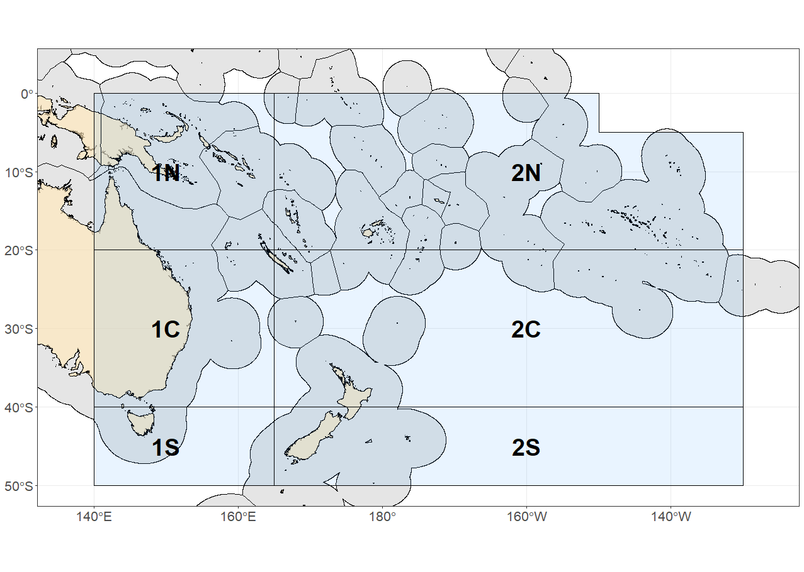
Figure SWO-01. The geographical area covered by the stock assessment and the boundaries of the two model regions (1, 2) and 6 subregions (N, C, S) used for the 2025 southwest Pacific swordfish assessment.

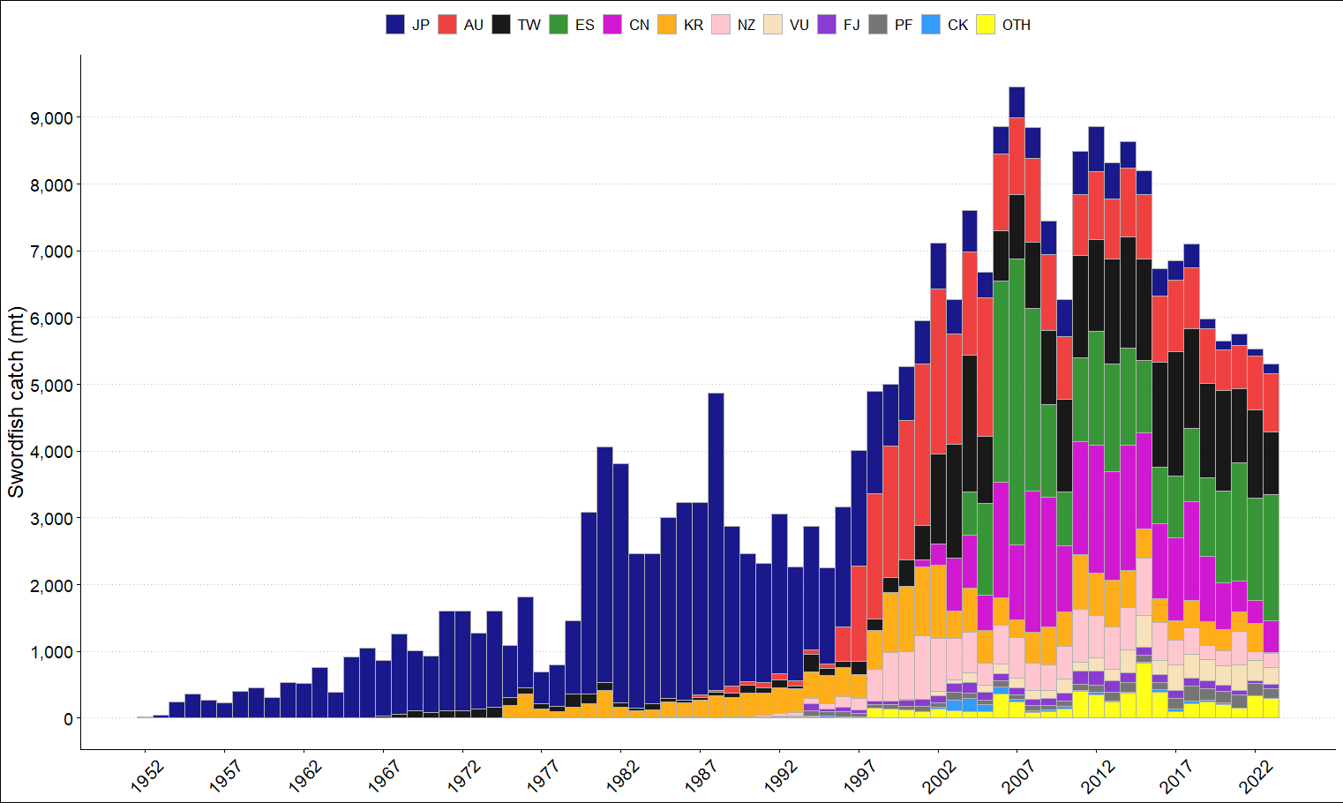
Figure SWO-02. Annual catches of southwest Pacific swordfish by flag in the area covered by the assessment.

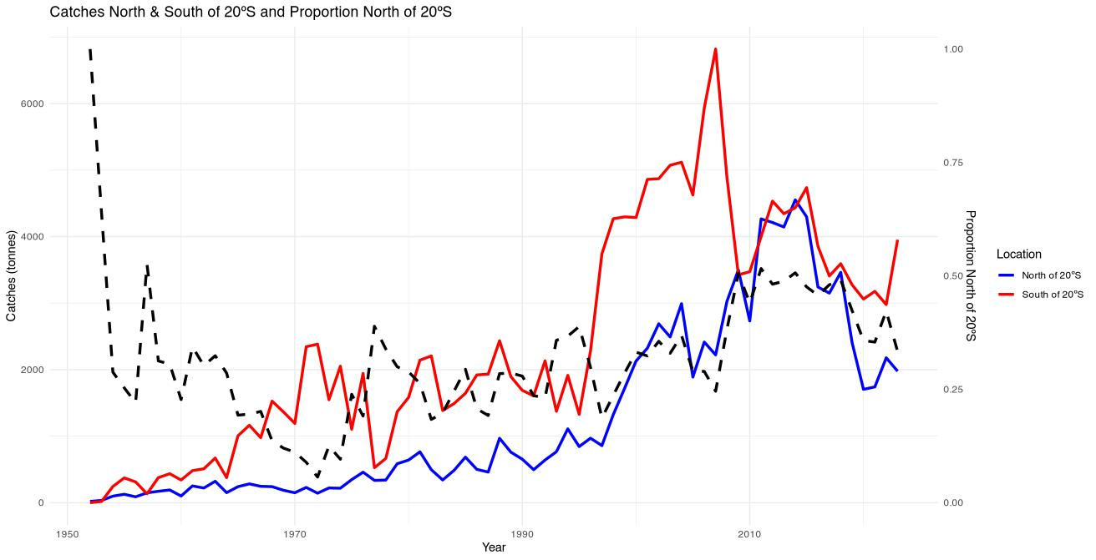
Figure SWO-03. Plot of the total Southwest Pacific swordfish catch (primary axis) south of 20S (red line), between the equator and 20S (blue line), and proportion of catch between the equator and 20S (dashed black line, secondary axis) by year in the WCPFC-CA.

(a)
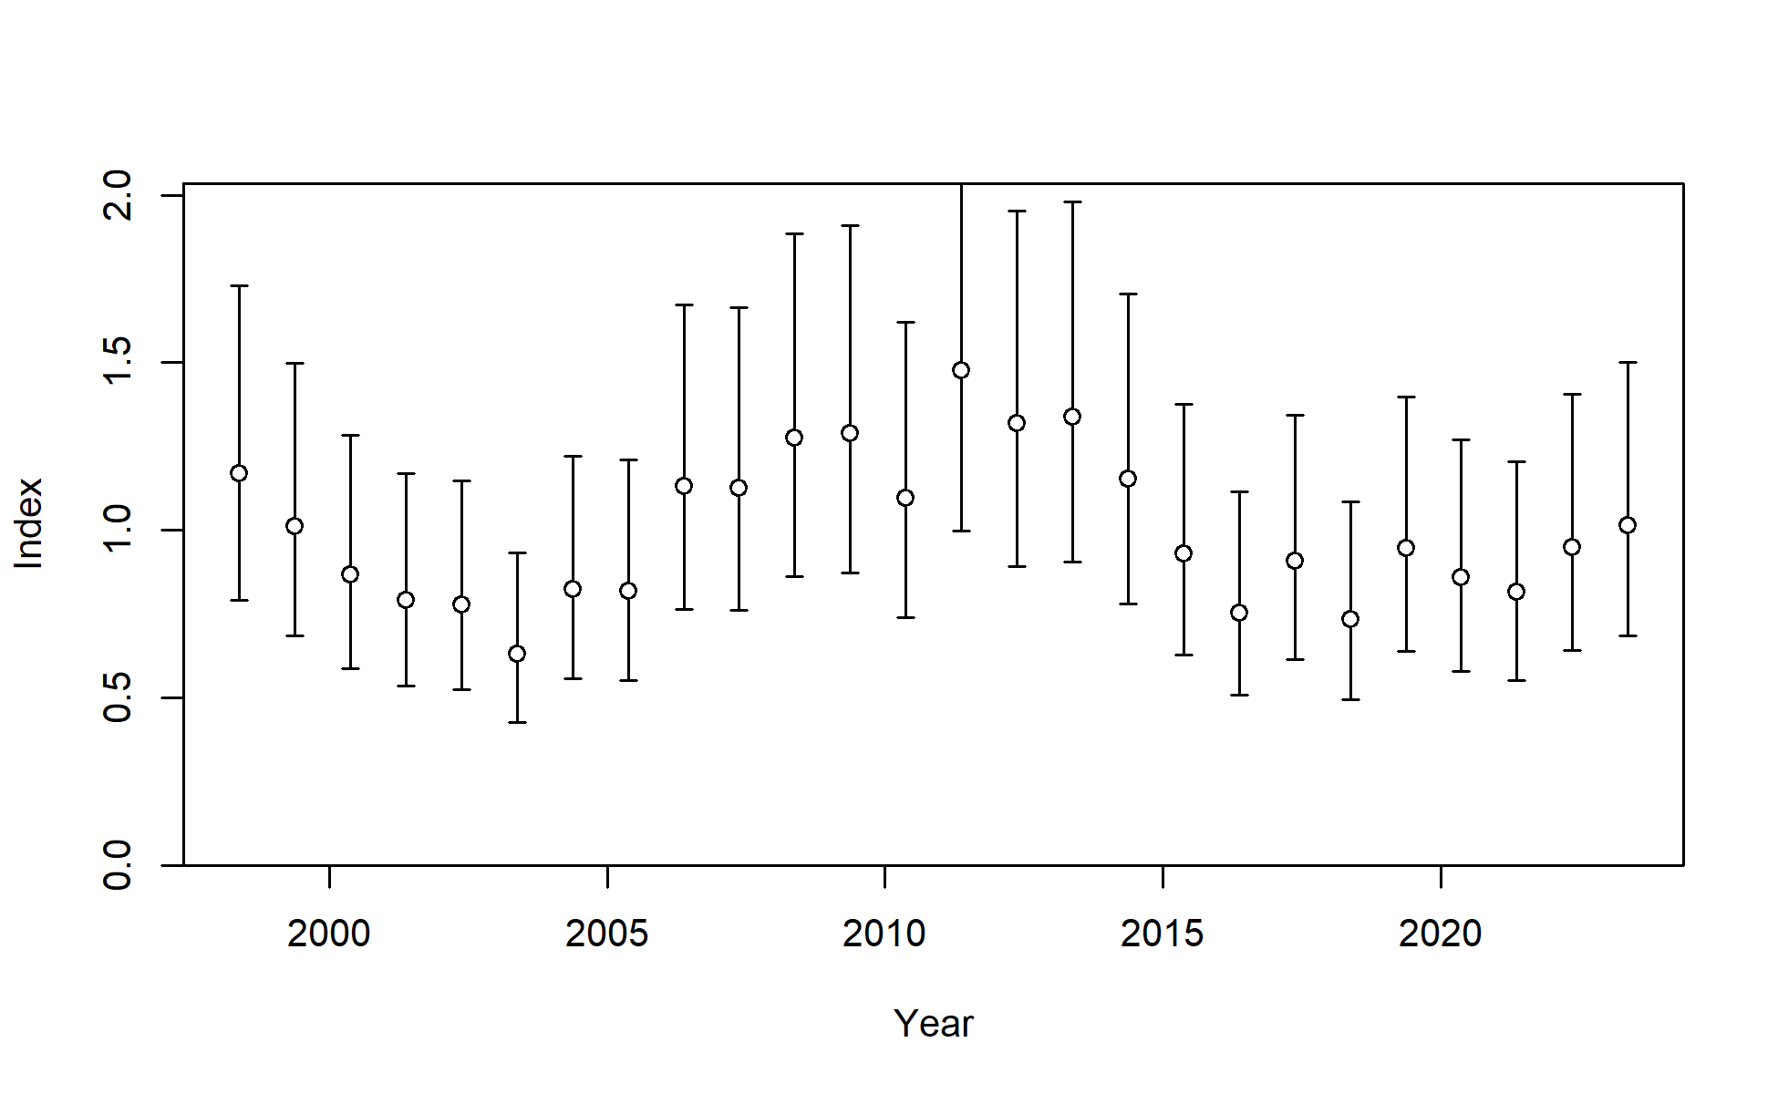
(b)
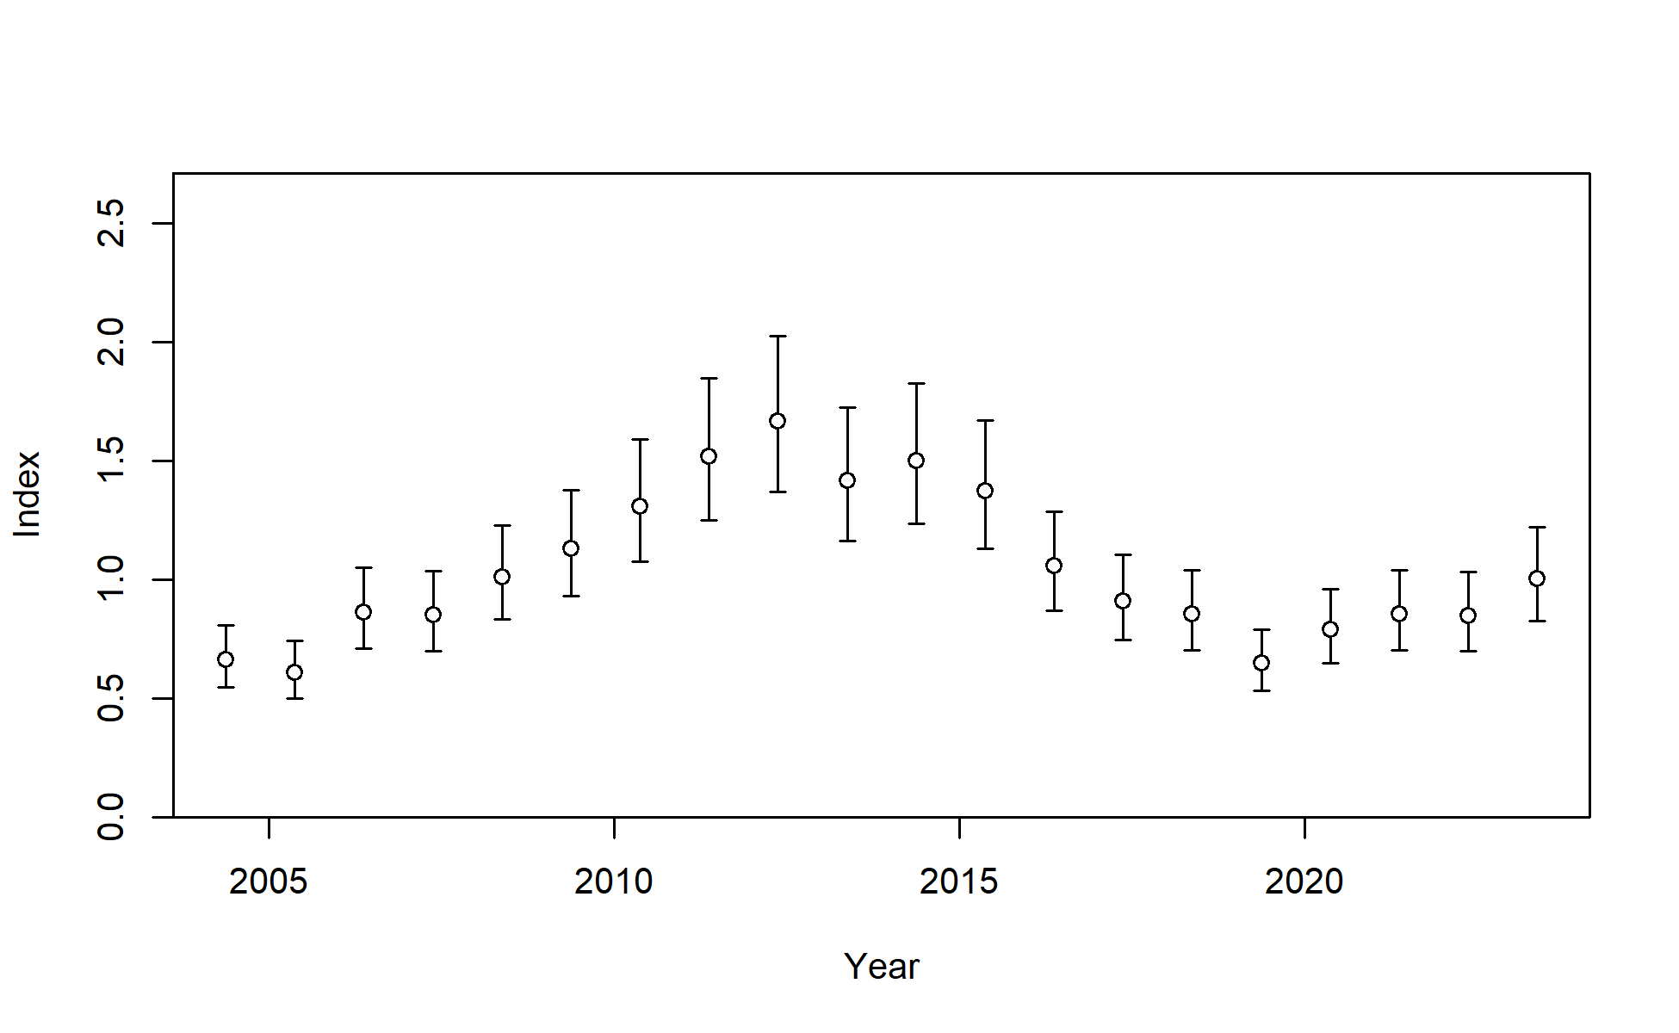
Figure SWO-04. Standardised CPUE with initial input 95% confidence interval (CI) for (a) the Australian longline CPUE index fishery in region 1 and (b) the New Zealand longline CPUE index fishery in region 2. Additional variance was estimated within the model, which effectively reduced these confidence intervals for the AU index and increased them for the NZ index.
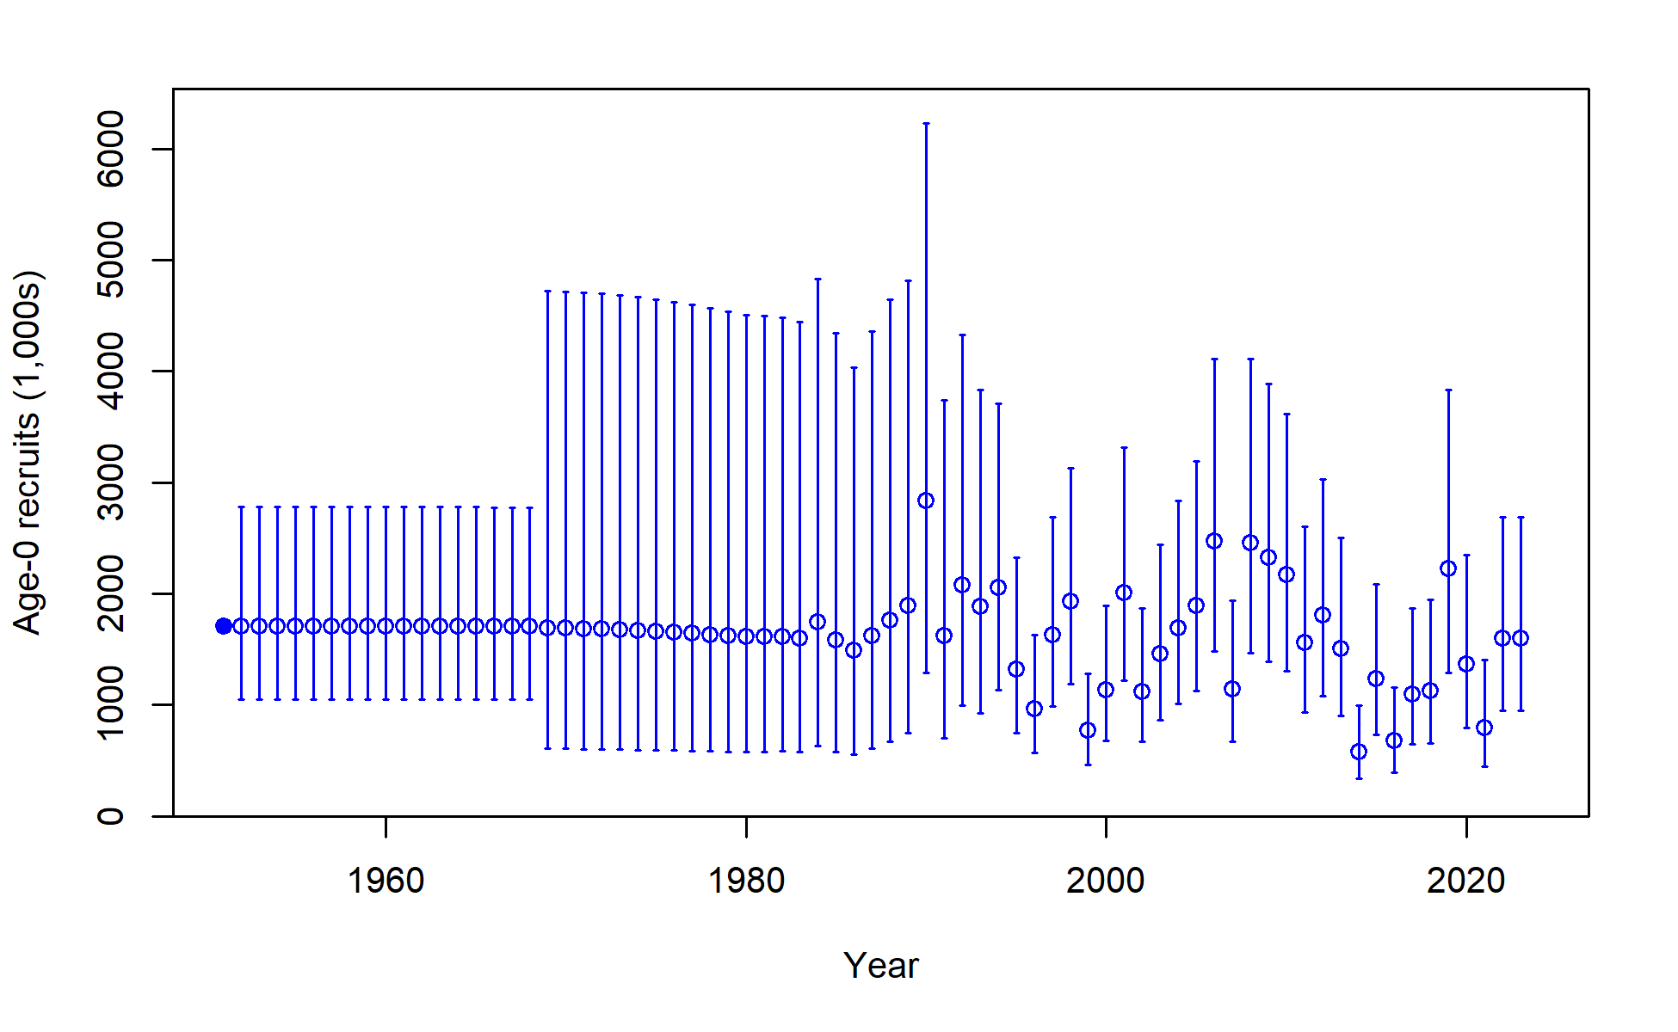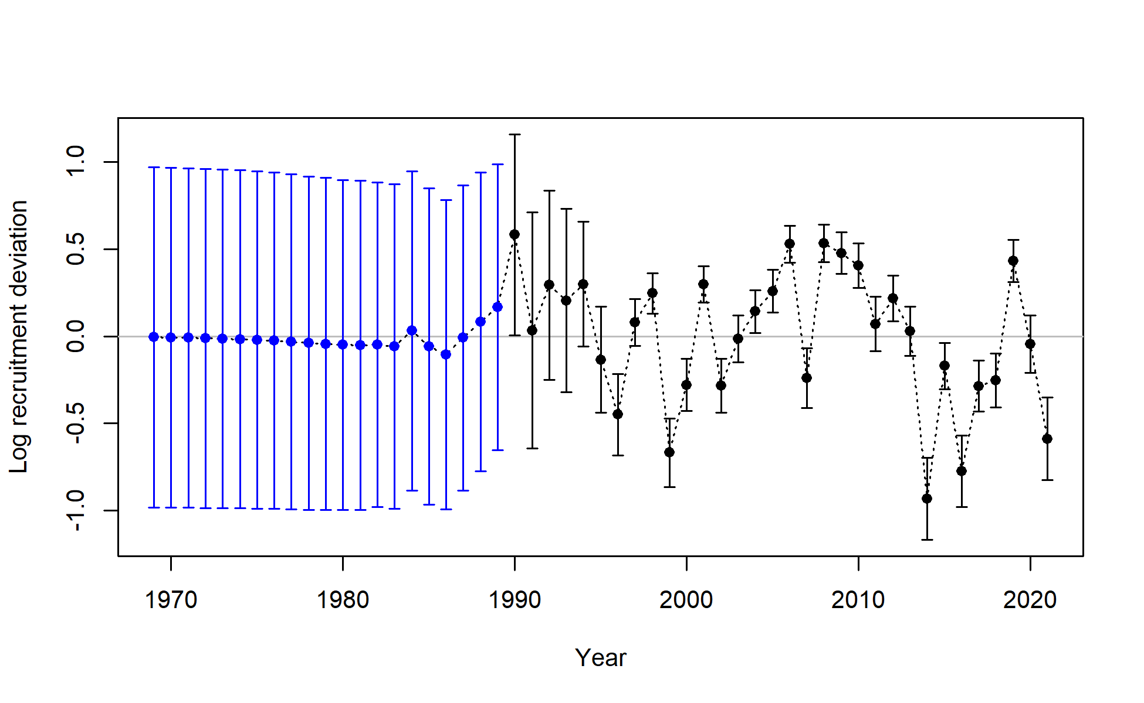
Figure SWO-05. Annual time series of estimated absolute annual recruitment in numbers (top) and annual time series of estimated log annual recruitment deviations (bottom), including estimation uncertainty with 95% confidence interval for the diagnostic model.

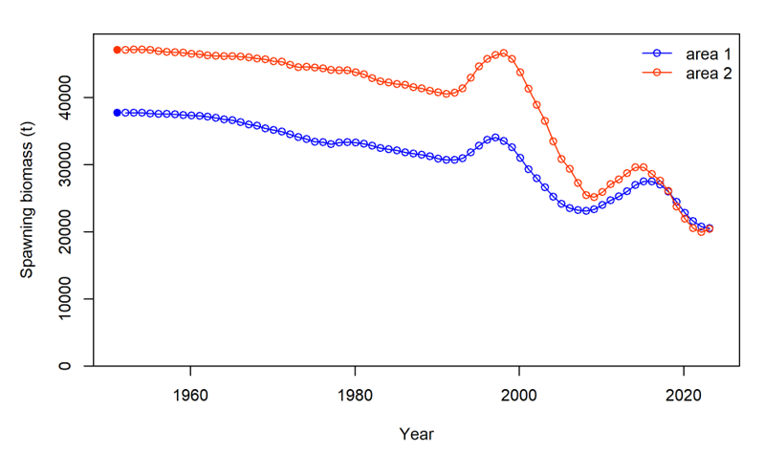

Figure SWO-06. Time series of estimated annual female spawning biomass (without estimation uncertainty) by region for the diagnostic model.

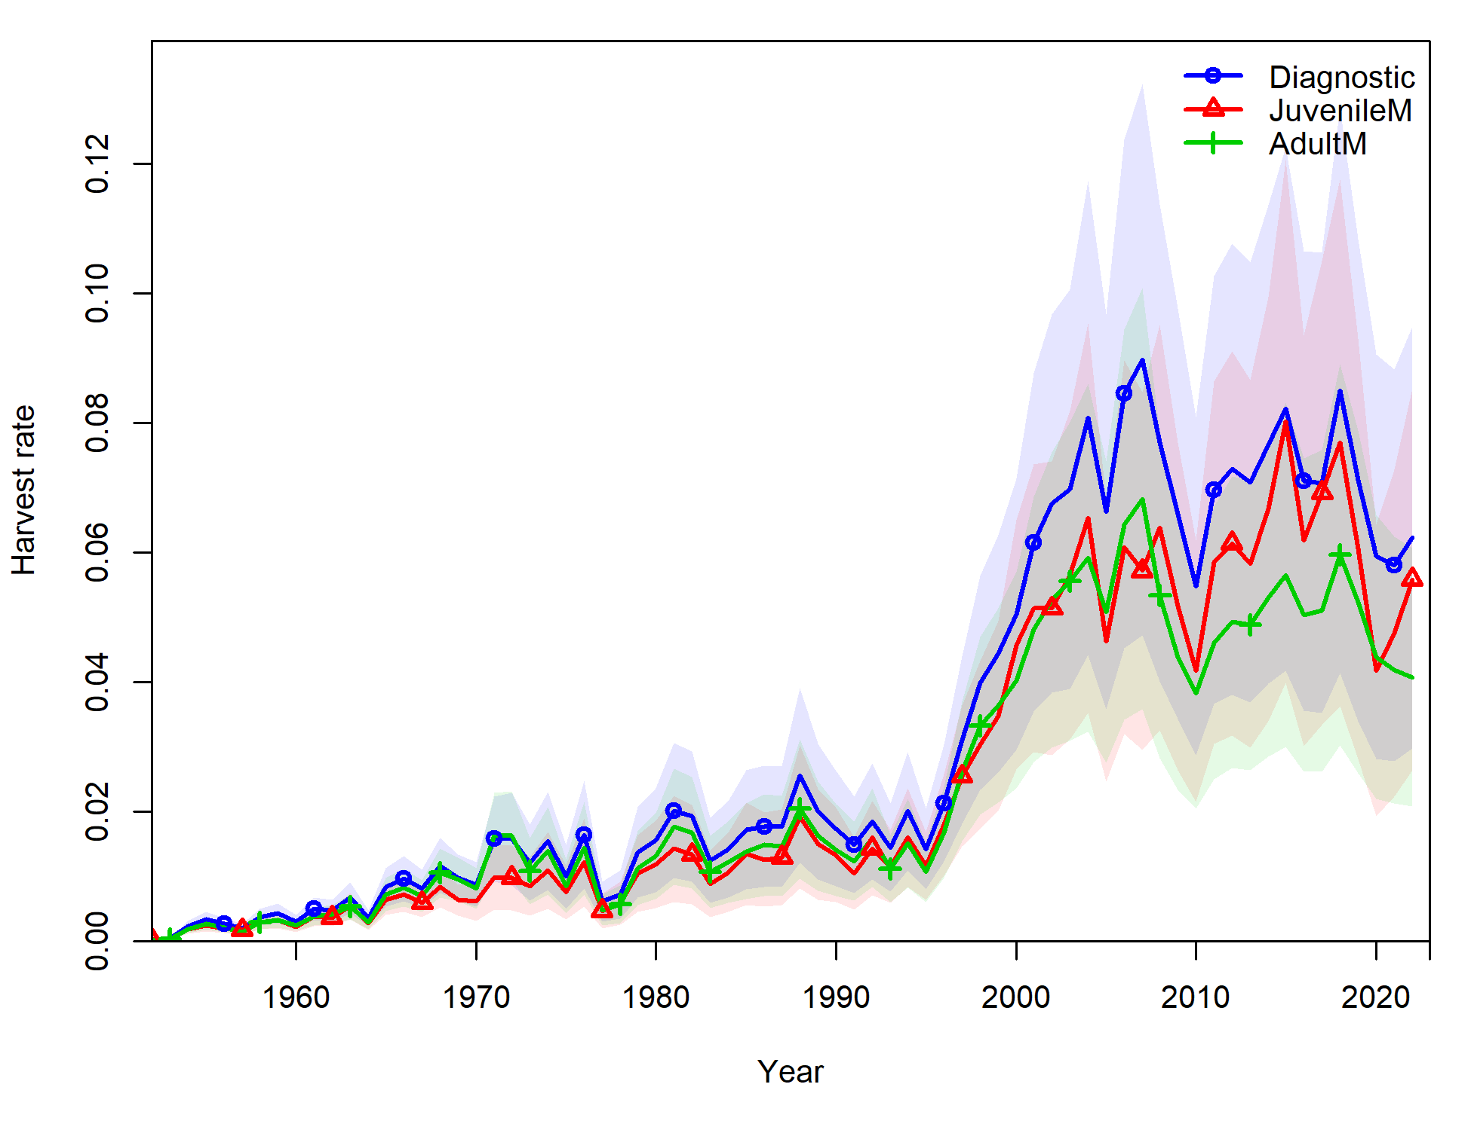
Figure SWO-07. Time series of annual estimated mean fishing mortality for age range 3-12 years for the diagnostic model (blue); for juvenile SWPO swordfish (age 1-3, red); and for adult SWPO swordfish (age 8-15, green).
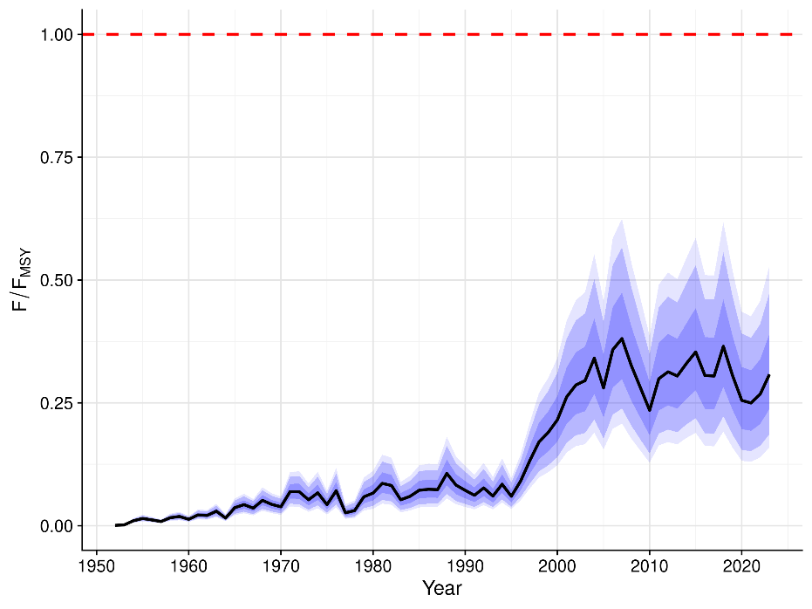
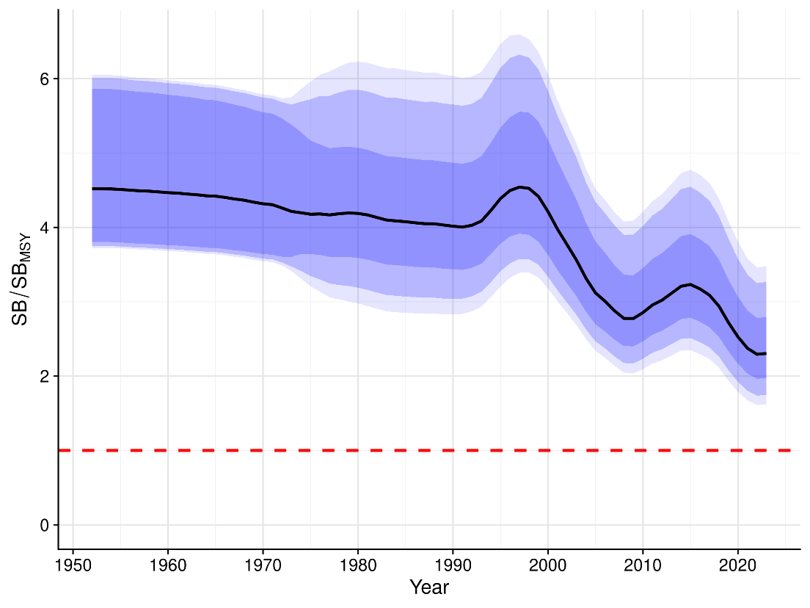
Figure SWO-08. Annual estimated F/F_{MSY} (top) and annual SB/SB_{MSY} (bottom) from the uncertainty grid. The black line indicates the median of all trajectories, along with 50%, 80% and 90% quantile ranges.

- Stock status

- There are no agreed reference points for Southwest Pacific swordfish. Stock status is therefore assessed in relation to the default WCPFC SB/SB_{MSY} and F/F_{MSY} reference points, with information also provided for the depletion relative to the 20%SB_{F=0} LRP that is applied to key tunas. The 2025 stock assessment indicates that the stock status is positive with respect to the MSY-based reference points, and although the stock biomass trend and depletion decline, the last few years of the model indicate some stability in female spawning biomass.

- Median recent fishing mortality was below F_{MSY} (F_{recent}/F_{MSY} is 0.28 with 80% quantile range from 0.18 – 0.38, and the probability of F_{recent}/F_{MSY} > 1 is < 1%, Tables SWO-03 and SWO-04). Median recent female spawning biomass was well above SB_{MSY} (SB_{recent}/SB_{MSY} biomass reference point is 2.33 with 80% quantile range 1.88 – 3.34, and the probability of SB_{recent}/SB_{MSY} < 1 is < 1%, Table SWO-03 and Table SWO-04). Median recent spawning biomass was also well above the 20%SB_{F=0} LRP applied to tunas (SB_{recent}/SB_{F=0} = 0.50 with 80% quantile range 0.46-0.58, without estimation uncertainty, Tables SWO-03 and SWO-04). Depletion with respect to unfished female biomass (SB_{recent}/SB_{F=0}) is 0.50 with an 80% quantile range of 0.46 – 0.58 (Tables SWO-03 and SWO-04), without estimation uncertainty.

- Based upon these results, the stock is exceptionally unlikely to be experiencing overfishing (< 1% probability) and to be overfished (< 1% probability) relative to MSY-based reference points (Figures SWO-09 – SWO-12).

Table SWO-03. Summary of reference points over the uncertainty grid, along with results incorporating estimation uncertainty. Note that these values do not include estimation uncertainty, unless otherwise indicated.
Metric | Mean | Median | Min | 10%ile | 90%ile | Max
C latest | 5922 | 5926 | 5758 | 5846 | 5994 | 6071
SBlatest | 47080 | 43738 | 26110 | 35742 | 62301 | 96686
SBrecent | 48523 | 44994 | 27255 | 36729 | 64013 | 99654
TBlatest | 118832 | 110466 | 65944 | 91676 | 155510 | 234896
TBrecent | 118023 | 109628 | 65577 | 90625 | 154507 | 234147
Flatest | 0.06 | 0.06 | 0.03 | 0.04 | 0.07 | 0.10
Frecent | 0.06 | 0.06 | 0.03 | 0.04 | 0.07 | 0.10
SBMSY | 20039 | 19502 | 11521 | 13580 | 26557 | 38811
MSY | 12078 | 11560 | 8189 | 9708 | 15339 | 22310
FMSY | 0.21 | 0.20 | 0.15 | 0.16 | 0.27 | 0.27
Frecent/FMSY | 0.28 | 0.28 | 0.11 | 0.18 | 0.38 | 0.53
Flatest/FMSY | 0.28 | 0.27 | 0.11 | 0.18 | 0.38 | 0.53
SBrecent/SBMSY | 2.48 | 2.33 | 1.54 | 1.88 | 3.34 | 4.10
SBlatest/SBMSY | 2.41 | 2.27 | 1.47 | 1.82 | 3.24 | 3.98
SBrecent/SBF =0 | 0.52 | 0.50 | 0.37 | 0.46 | 0.58 | 0.67
SBlatest/SBF =0 | 0.50 | 0.49 | 0.36 | 0.45 | 0.57 | 0.65
Including estimation uncertainty
 | Mean | Median | Min | 10%ile | 90%ile | Max
Frecent/FMSY | 0.28 | 0.27 | 0.00 | 0.16 | 0.41 | 0.93
SBrecent/SBMSY | 2.48 | 2.37 | 0.48 | 1.80 | 3.37 | 5.37

Table SWO-04. Estimates of management quantities (stock status as abundance SB_{recent} relative to SB_{MSY} and unfished spawning biomass (SB_{F=0}), and recent fishing mortality (F_{recent}/F_{MSY}). P(>RP) refers to the probability that the metric (status, fishing mortality) is above the respective indicator.
Year: 2025  (final data year = 2023) | Spawning Potential | Exceptionally unlikely (<1%) to be below SB_{MSY} |  | Stock is not overfished
 | Fishing mortality | Exceptionally unlikely (<1%) to be above fishing mortality upper limit of F_{MSY} |  | Overfishing is not occurring
 | Projections | Not conducted |  | Not conducted
 | Recommendation | The stock has a generally declining female spawning biomass since the late 1990s, with some periodic oscillations, but with a steadier and a gentler decline in $\frac{{SB}_{recent}}{{SB}_{F=0}}$, with a generally stable fishing mortality since 2004. No action required to reach target biomass.
Reference points |  | Median [10%--90%] | Comment
Ratio of ${SB}_{recent}$ to ${SB}_{MSY}$ | $$\frac{{SB}_{recent}}{{SB}_{MSY}}$$ | 2.33 [1.88-3.34] | Spawning biomass is well above SB_{MSY}, the default WCPFC limit reference point (LRP) for billfish stocks
Ratio of $F_{recent}$ to $F_{MSY}$ | $$\frac{F_{recent}}{F_{MSY}}$$ | 0.28 [0.18 – 0.38] | Fishing mortality is well below the default F_{MSY} WCPFC LRP for fishing mortality.
Recent estimates |  |  | Recent trend / projection
Fishing mortality | $$F_{recent}$$ | 0.06 [0.04 – 0.07] | $F_{recent}$ shows a stable trend, with short-term variation over the last 15 years, and a slight increase over the last 3 years of the assessment, which is most likely variability rather than indicative of any recent trend.
SB relative to SB to produce MSY | $$\frac{{SB}_{recent}}{{SB}_{MSY}}$$ | 2.33 [1.88-3.34] | The spawning biomass relative to biomass at MSY has a trend of becoming more depleted, especially since the 1990s, but with some signs of stability in the very recent years.
SB depletion relative to SB without fishing (w/o estimation uncertainty) | $$\frac{{SB}_{recent}}{{SB}_{F=0}}$$ | 0.50 [0.46 – 0.58] | The spawning biomass relative to unfished spawning biomass has a trend of becoming more depleted, especially since the 1990s, but with some signs of stability in the very recent years.
Status |  |  | Likelihood
SB depletion | $$\frac{{SB}_{recent}}{{SB}_{MSY}}$$ | 0.50 [0.46 – 0.58] | <1% probability < SB_{MSY} (Exceptionally unlikely)
Fishing mortality | $$\frac{F_{recent}}{F_{MSY}}$$ | 0.28 [0.18 – 0.38] | <1% probability > $F_{MSY}$ (Exceptionally unlikely)

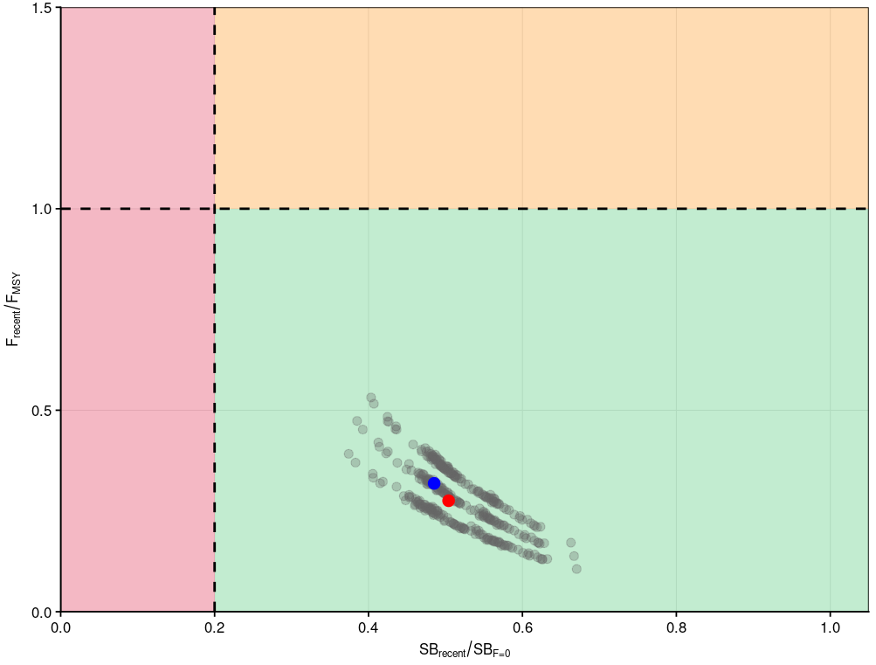
Figure SWO-09. Majuro plot summarising the results for the uncertainty grid (without estimation error) for the relevant recent periods, 2020–2023 for SB_{recent}/SB_{F=0} and 2019–2022 for F_{recent}/F_{MSY,} respectively. The red dot indicates the median, and the blue dot the diagnostic model.
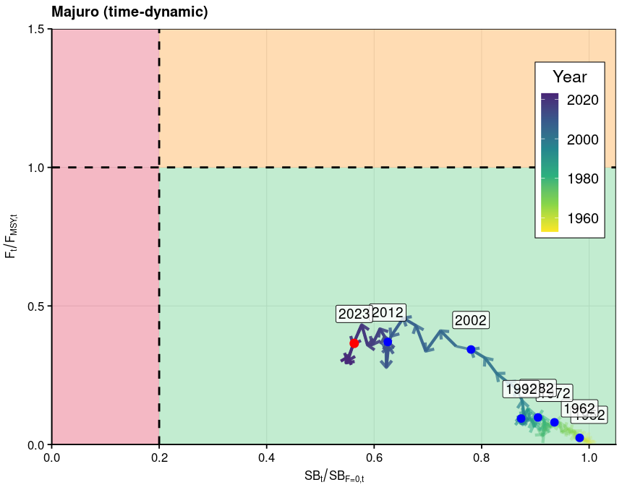
Figure SWO-10. Time dynamic Majuro plot from the diagnostic model for SWPO swordfish for the period 1952 to 2023 (red dot).

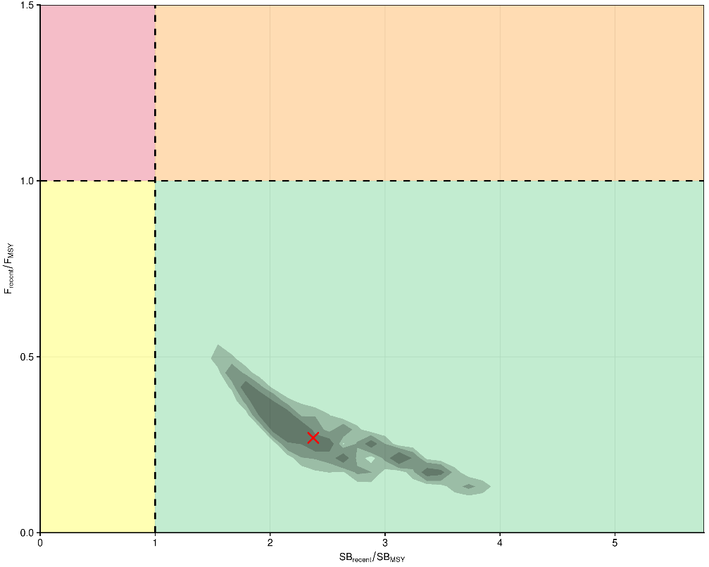
Figure SWO-11. Kobe plot for the relevant recent periods, 2020–2023 for SB_{recent}/SB_{MSY} and 2019–2022 for F_{recent}/F_{MSY,} respectively, using contour plots to summarise the full uncertainty grid, including structural and estimation uncertainty, with 50%, 80% and 90% quantile ranges. The red cross shows the median.
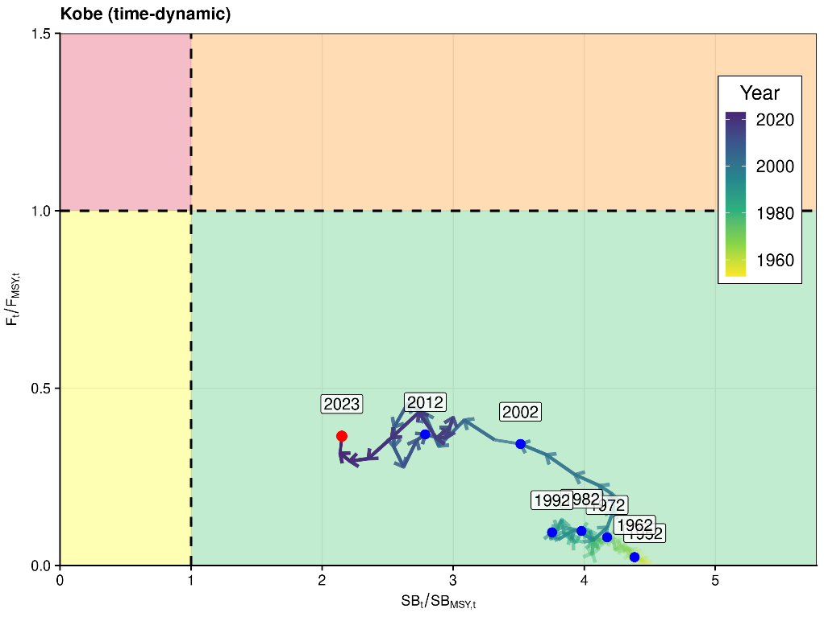
Figure SWO-12. Time dynamic Kobe plot from the diagnostic model for SWPO swordfish for the period 1952 to 2023 (red dot).

- Management advice

- SC21 advised that it is exceptionally unlikely that Southwest Pacific swordfish is overfished and subject to overfishing. SC21 noted that the estimated spawning biomass relative to unfished levels has continued to decline over the last decade, despite a brief recovery in 2015. This declining trend highlights the ongoing need for management. To this end, SC21 noted the Commission’s intention to develop a management strategy evaluation framework for Southwest Pacific swordfish and to design and evaluate a candidate management procedure (see SC21-GN-WP-04 Project P21X03). SC21 agreed to use this year’s stock assessment model as a starting point for developing an operating model reference set to evaluate the candidate management procedures, noting that better addressing the issue of model mis-specification is necessary to improve the reliability of the operating model reference set.

- SC21 noted that due to challenges and associated time constraints in fitting the stock assessment model, no projections were provided to the SC and recommended that projections be included in future assessment reports.

d. Research recommendations
- SC21 noted the challenges in developing this model. The persistent conflict between size composition and CPUE signals, the retrospective patterns, and the divergence in CPUE trends across fleets may not solely reflect data limitations, but could also stem from structural assumptions within the model that are difficult to validate or adjust. SC21 recommended several research avenues to help improve the next assessment, including:
- additional conditional age-at-length data;
- exploring the use of close-kin mark recapture;
- the further exploration of a simplified modeling approach; and
- SC21 also recommended moving data-moderate billfish assessments like Southwest Pacific swordfish and striped marlin to a two-year approach, similar to the shark assessments.
    - Southwest Pacific striped marlin (Kajikia audax)
4.5.2.1 Stock assessment of Southwest Pacific striped marlin

- C. Castillo-Jordan (SPC-OFP) presented SC21-SA-WP-06 Revised 2024 stock assessment of striped marlin in the southwestern Pacific Ocean: Part 1- integrated assessment in Stock Synthesis. The report describes the development of a revised integrated assessment for Southwest Pacific Ocean (SWPO) striped marlin (requested by SC20) that aimed to resolve issues raised at SC20 and subsequently at the 2025 PAW. The assessment presented in this paper should be considered in combination with the companion assessment using a Bayesian Surplus Production Model (BSPM) (SC21-SA-WP-07) as supporting information for SC21 to formulate management advice. The revised assessment involved collaboration with scientists from the US delegation based at the NOAA Pacific Islands Fisheries Sciences Center in Hawai’i, under an arrangement supported by SC20. This collaboration was initiated through an in-person workshop in Hawai’i in January 2025. An important part of this revision involved moving the assessment from MFCL to Stock Synthesis (SS3), a collective decision that was made at the Hawai’i workshop. Along with the change in software, numerous other changes and data modifications were implemented in the revision based on the workshop in Hawai’i, discussions at the SPC PAW, and OFP’s regular stock assessment team meetings. Some of the more important changes included:
- Switch from MFCL to SS3.
- Start the model in 1952, and include early catch uncertainty.
- Implement size-based selectivity and modifications to selectivity functions.
- Major revision of size data inputs and refined size data filtering, resulting in a significant reduction in size data inputs.
- Separate New Caledonia and French Polynesia longline ﬂeets from the mixed ﬂag fisheries and create separate fisheries due to their diﬀerent length data distributions.
- Use of ad hoc size data weighting to downweight the inﬂuential size data.
- Use conditional age-at-length data to estimate growth internally for the diagnostic model.
- Explored sensitivity to alternative CPUE indices, including Australian longline, New Zealand recreational, and newly developed observer-based longline indices for PICT ﬂeets (SC21-SA-IP-13).

- These changes addressed the core concerns raised at SC20. However, despite the improvements, the model results remained very similar to those from the previous 2024 MFCL assessment, and MFCL assessments in 2019 and 2012. In the course of the revision, other issues were raised, most notably, concerns around the low population/biomass size (scale) that was estimated since the 1970s. These concerns were raised through the PAW process and were not specifically noted as issues at SC20. The concerns are equally relevant to previous striped marlin assessments that estimated similar population scales. In this respect, the review work on this assessment has relevance to previous SC-accepted SWPO striped marlin assessments that were used for management advice by WCPFC.

- The low population size estimates became a key focus of the assessment revision. Despite a range of modelling investigations, including one-oﬀ sensitivities on biological parameters, alternative CPUE, and a factorial grid on biological parameters, the model results would not change substantially from the low estimated population size. The SS3 model, as configured, was estimating the stock as being very small and highly productive, with the dynamics being driven by recruitment variability. Various diagnostic analyses pointed to issues the model was having in estimating a well-determined production function. The development of the BSPM assessment was motivated to investigate these issues and see if a simplified, more ﬂexible Bayesian modelling approach could allow for the identification of a production function, and more eﬀectively characterize uncertainty in estimates of population scale.

- It is problematic to reconcile the small population scale in the context of the recent observed catches and the assessment spatial scale. Simple calculations indicated the population scale being estimated was implausibly low. Nonetheless, the assessment model passed a number of key diagnostics, provided reasonable fits to the data, and could produce all the quantities of management interest, such as MSY, SB_{MSY}, SB/SB_{MSY}, F/F_{MSY}, SB/SB_{F=0}, and are presented herein. However, the reliability of these reference point estimates is questionable given the concerns over the low spawning biomass estimates, and uncertainty on how much higher the population biomass might actually be. More details on this issue are available in the discussion; however, MSY-related quantities, as used by SC for billfish management advice, will be highly uncertain if the absolute abundance scale is highly uncertain. Further model investigations also demonstrated that SB/SB_{F=0} will also be biased low if the population scale is biased low.

- While we provide a summary of stock status relative to the estimated reference points, it is clear that uncertainty in population scale equates to uncertainty in the management reference points. This needs to be considered seriously by SC21 when considering how they might interpret the outcomes of this assessment for management advice. Assuming a higher ’true’ population scale would result in more optimistic values of the key management reference points. The diﬀerences would depend on how much higher the true population scale is. The management reference points are more uncertain than presented here due to the population scale uncertainty, but it is reasonable to suggest that they may be overly pessimistic.

- The revised integrated assessment should be considered in combination with the BSPM assessment when considering management advice, and also take into account trends in the empirical indicators, such as the CPUE indices, that show recent increases in CPUE for several indices.

- N. Ducharme-Barth (USA) presented SC21-SA-WP-07 Stock Assessment of Striped Marlin in the Southwest Pacific Ocean: Part II – Bayesian Surplus Production Model. The working paper presents part II of the 2025 stock assessment of Southwest Pacific Ocean (SWPO) striped marlin (Kajikia audax) and describes a data-moderate Bayesian surplus production model (BSPM) approach. This assessment represents a strategic shift from the integrated age-structured models used previously, given challenges with data conﬂicts, poor fits to size composition data, and difficulties in estimating model initial conditions in the integrated age-structured model. The complexity of integrated age-structured models becomes problematic when fundamental data conﬂicts exist or when key biological parameters are uncertain, making the simplified yet robust BSPM framework a reasonable alternative. In combination with information from the integrated stock assessment, the BSPM can provide a holistic view of likely stock status and population trajectory.

- In order to evaluate stock status, a series of BSPMs spanning 1952-2022 were developed following the Fletcher-Schaefer production model framework, incorporating biological uncertainty through simulation-based priors, process error in population dynamics, and observation error in abundance indices and catch data. Informative priors for the maximum intrinsic rate of increase R_{Max} and carrying capacity log(K) were developed through numerical simulation based on biological and fishery characteristics, with prior distributions refined using pushforward analysis to ensure biological realism. The assessment utilized annual catch data in numbers aggregated into total removals and fitted to standardized CPUE indices, primarily the distant water fishing nation (DWFN) longline index and the New Zealand recreational sportfish index. An extensive sensitivity analysis, including 38 one-oﬀ models, was conducted to explore uncertainties in data inputs, model structure, and biological assumptions, with a four-model ensemble ultimately proposed for the provision of management advice.

- Given that a surplus production modelling approach was used, conventional WCPFC management metrics related to spawning biomass (SB) could not be produced with the surplus production model. Rather than metrics related to SB, stock status was summarized in terms of the following maximum sustainable yield (MSY) and depletion D-based reference points: total depletion relative to total depletion at which MSY is produced (D/D_{MSY} ), fishing mortality relative to fishing mortality that produces MSY (F/F_{MSY}), and total depletion relative to a generalized limit reference point of 20% depletion from the unfished state (D/D_{0.2F=0}). All ratios were calculated with respect to two periods: recent and latest. For depletion ratios, D_{recent} refers to the average over 2019-2022, and D_{latest} refers to 2022. For fishing mortality ratios, F_{recent} refers to the average over 2018-2021, and F_{latest} refers to 2021. Additionally, in this report, D is the static depletion of total population numbers relative to the unfished total population numbers, rather than the time-dynamic depletion reported by age-structured models (e.g., MULTIFAN-CL or Stock Synthesis).

- Key uncertainties and limitations of the assessment include:
- Population scale: Substantial uncertainty in absolute population scale, though the minimum scale is well-constrained by the 70-year catch history.
- Stock structure: Potential stock connectivity issues given genetic evidence of SWPO fish in North Pacific catches.
- Data representativeness: Uncertainty in how well available abundance indices represent true stock trends and whether catch reporting has been complete over the assessment period.
- Model structure: The BSPM approach inherently simplifies complex age-structured population dynamics, assuming a single well-mixed population with knife-edged selectivity.
- Biological parameters: Uncertainty in key biological parameters (e.g., natural mortality, steepness, and growth) propagates through prior distributions and contributes to wide credible intervals around stock status estimates.

- The general conclusions of this assessment are as follows:
- Population trajectory: The SWPO striped marlin stock declined substantially from the assumed unfished state in 1952, reaching minimum levels around the mid-2010s, with strong evidence of recovery since approximately 2015.
- Current stock status: The stock is estimated to be overfished but not undergoing overfishing, with recent depletion relative to D_{MSY} at 0.77 (95% CI: 0.33 – 2.3) and recent fishing mortality relative to F_{MSY} at 0.77 (95% CI: 0.05 – 1.51).
- Stock status probabilities: There is a 74% probability that the stock is below D_{MSY} and only a 22.9% probability that overfishing is occurring.
- Future projections: Ten-year projections assuming recent average catch levels indicate continued recovery, with median D/D_{MSY} projected to reach 1.32 by 2032 and only a 26.05% chance of remaining overfished.

Discussion
- Chinese Taipei thanked the presenters and noted the cooperation between SPC-OFP and NOAA in improving the assessment. They remarked that fishing effort is one of the most important inputs in the assessment and observed there may be substantial uncertainty in the nominal effort data, especially in the early years, due to the lower logbook recovery rate, and inquired if the method used could address this uncertainty. They noted that the stock assessment shows catchability deviation goes down each year and has a very clear trend, and inquired how to explain this steady decline, given that Southwest Pacific Ocean striped marlin is mostly a bycatch species. They inquired if this was supported by other information, such as species composition. Regarding population scale, they asked whether the assumption of stationary productivity over such a long assessment period is reasonable. They stated their previously published research has shown non-stationary population processes can significantly influence the estimation result for the billfish, and inquired about considering a hybrid approach — for example, specifying certain SS3 model parameters using the prior derived from the Bayesian production model? Because some of the parameters are convertible between these two models, this might help reduce the population scale issue by introducing additional constraints and making the results of the two models more comparable.

- The SSP stated that using the prior from the Bayesian model could be something that could help, and perhaps the prior development in this Bayesian model could help to start the approach toward a full Bayesian model for striped marlin.

- The USA stated the assessment does assume stationarity over a long time period, but we know that the ocean has changed a lot, and that might not be a valid assumption to make. The USA agreed that exploring non-stationarity could be worth considering in future modelling approaches, not just for this species but for any integrated assessment. Regarding the comment about the estimation of fishing mortality and using an approach where fishing mortality is driven by effort or directly estimating fishing mortality as a free parameter, the USA stated that they began by trying to estimate fishing mortality as a free parameter and showed in the report that it is possible. They noted the results are quite sensitive to the assumptions made on the prior specification for fishing mortality, and it's really difficult to derive a good objective prior for what that fishing mortality should be, because one is essentially picking the solution with that. The USA stated they then switched to an effort-driven approach, where they could use the early effort time period, link that to catchability, and then derive a more defensible prior for what catchability could be, given observations in the data and the effort that they saw, and they allowed for that change in catchability over time in order to be able to produce catches that match the observation. If catchability is not allowed to vary, the effort trend simply climbs. Longline effort in the South Pacific has increased quite dramatically over the last 70 years. Failure to allow for time-varying catchability would result in catches continuing to climb, and that does not agree with the observed data. So, time-varying catchability was needed because the included effort is the nominal effort of all longlines operating in the South Pacific. A lot of that effort is not directed at and wouldn't be an effective effort for striped marlin; it is either targeting albacore or tropical tunas. Some of the early longline efforts (as highlighted by a paper provided by Japan) specifically targeted Southwest Pacific striped marlin. But that has changed over time. If a more refined input effort was used that just looked at effective effort for striped marlin (possibly looking at the shallowest hooks fished over time, and how that number has increased, and perhaps excluding clear targeting for other species such as swordfish or albacore), we would expect that catchability trend would be a lot less extreme than the one seen just using all effort in the South Pacific.

- Japan stated that the stock assessment is much improved from the previous assessment, and that if a reasonable result cannot be obtained through an integrated model for stock assessment, their view is that it may be useful to apply an alternative simple production model instead. Japan stated that in Figure 29 of SC21-SA-WP-06, spawning biomass and total biomass show a significant decline during the 1950s and 1960s. However, Figure 3 suggests that, except for 1954, the catch amount during that period was not particularly high, while Figure 32 shows that fishing mortality in the 1950s and 1960s was also not very high. Additionally, CPUE data have only been used from 1979 onward. Given these facts, they stated it is puzzling why such a pronounced initial depletion is observed. Looking at Figure 2, it appears that weight conversion data from the New Zealand recreational fishery in the 1950s and 1960s were used. On the other hand, the catch data is mostly from Japanese longline fisheries. Japan suggested this discrepancy might be the source of the issue. Regarding SC21-SA-WP-07, Japan referenced Figure 48, where the trajectory shows that F gradually increases and D/DMSY drops below 1, leading to the current stock status. However, because F/ F_{MSY} only slightly exceeds 1, it is unnatural that the relative depletion value drops this much.

- SPC stated the conversion data could be an issue, and that they did many investigations — removing data from New Zealand, excluding some data — but couldn't solve the issue. For the next assessment, perhaps this should be investigated in more detail.

- The USA agreed that the decline in the spawning biomass with relatively low catches was suspicious and is one reason for the investigation with the surplus production model. Regarding the comment about whether or not it's plausible for the stock to have declined to the point that it has, with median estimates only rarely going over into overfished, the USA stated it is plausible, and that just because the stock hasn't experienced overfishing doesn't mean that fishing mortality hasn't been large enough or impactful enough to cause the stock to decline. They noted that the trajectory we're seeing is not incompatible with the data that are going into the model.

- China inquired about the uncertainty in the growth curve used in the Stock Synthesis model, noting that Figure 12 illustrates possible maturity at the age of 2 years for rapid growth vs. 9 or 10 years for a slow growth curve. China suggested reducing the uncertainty, possibly fixing or making an assumption of maturity at age, but not using the length.

- The SSP stated that they had explored different growth curves and could keep exploring the maturity. They used about 90 otoliths to estimate the growth for a species that has been caught since the 1950s, which is not enough.

- China also stated its understanding that a demographic analysis was used to generate the prior of the key parameter, and then a Bayesian model was used to produce the result, which is a common method to use for shark species, because it is easy to calculate the length as the fecundity, and then perform the demographic analysis. They observed that this is difficult for tuna, so steepness is used instead to calculate the fecundity, followed by the demographic analysis. China inquired if there could be a conflict in the basic assumption of steepness, and asked why the ratio of B_{MSY} to K was not obtained from the steepness, rather than rerunning the model to get this parameter.

- The USA agreed that it is more straightforward to apply the approach for sharks and species where fecundity or the intrinsic rate of increase is easier to calculate, because more direct assumptions can be made in terms of litter size, fecundity, and survival. The USA followed techniques for applying this approach for pelagic species that are described in the literature, which (as mentioned) use steepness. A range of steepness values was used based on the previous striped marlin assessment. In terms of calculating the shape parameter directly from the steepness, rather than from the demographic analysis, the USA agreed that it is a valid suggestion and something that could be done in a future analysis. They noted they did consider uncertainty in the shape parameter using a prior from the demographic analysis and also a more conservative Shaffer production model assumption. Whether that captures the same range of uncertainty in the shape parameter that would be obtained from a direct calculation of steepness is uncertain, because that wasn’t done, but it could be considered in future analyses.

- China agreed with Chinese Taipei that the mean length and age structure of the catch had changed, and this should be reflected in the population age structure. China stated that simulation tests of the Indian Ocean blue shark indicate that, given a stock with a strong age structure, the use of a constant R makes it very difficult to match the population dynamics. China suggested integrating approaches, like JABBA-Select and demographic analysis, to improve the stock assessment.

- The USA agreed that this was the direction the assessment should go in the future, noting that simplification has trade-offs in terms of the ability to represent what we know to be complex population dynamics. The next step in the process, now that there is a good understanding of the dynamics using the simplified model, is to progressively add complexity to the age structure.

- Samoa, on behalf of FFA members, congratulated the SSP and the USA on completing this comprehensive revision of Southwest Pacific Ocean striped marlin stock assessment, a major scientific undertaking delivered through strong collaboration. They recognised Part 1 of the assessment sought to address the recommendations of SC20, including the transition to Stock Synthesis. They proposed using Part 2: BSPM to provide the management advice from this assessment. FFA members noted that the stock is likely to be overfished according to the B_{MSY} reference point and are still considering the applicability of depletion reference points in this assessment. They noted that the stock is likely not subject to overfishing with the fishing mortality estimate below F_{MSY}. Noting this status, FFA members recalled that the Commission has requested a series of projections be undertaken to evaluate management options and pathways to recovery of the stock, and supported this work now being undertaken, but sought confirmation that all scenarios are feasible, noting the preferred use of the BSPM approach. They highlighted the persistent key uncertainties around population scale estimations. This fundamental question requires resolution to ensure management confidence. In the short term, FFA members proposed the implementation of a routine ageing programme, which could build on the Southwest Pacific striped marlin preliminary ageing work presented to SC15 and SC17. In the longer term they support the initiation of CKMR studies for Southwest Pacific striped marlin, building on the work of Project 100c and most appropriate for determining absolute population size, resolving stock structure uncertainties, and validating current scale assumptions, as a one-off analysis to anchor the stock biomass estimates in the assessment Future continuation of the Southwest Pacific Striped marlin CKMR work should be subject to evaluation of costs. FFA members also encouraged holding a workshop on assessment approaches for bycatch species to consolidate learnings from this assessment revision, fostering improved methodologies for future assessments of similar species.

- Australia agreed that the BSPM should be the basis for management advice, noting that it does have some implications for what can be estimated and what reference points can practically be used. They recognised that depletion in the BSPM management quantities is total individuals and quite different from spawning individuals or indeed from spawning biomass, which does impact what projections can be done. They stated that the Commission asked for status quo projections, which have been done, and it asked for several projections of recovery to certain biomass levels in certain time frames. Australia stated that those are probably no longer appropriate given the new model, but welcomed discussion on that. The last projection the Commission requested was a scenario of live release or non-retention of striped marlin, which is probably possible with the right information on post-release survival. However, given the very positive results, with rapid and short recovery seen in the 10-year status quo projections that have been done, Australia stated it was unsure that a non-retention assumption would change much in terms of the recovery time (within the next few years, it was projected to be above B_{MSY} with about 50% probability). But subject to any further discussion, Australia proposed that the striped marlin and SC management advice could make reference to the current set of projections in advising the Commission.

- The SSP referenced the FFA request about these projections and Australia’s comments, and stated these projections would not be based on the integrated assessment model. SPC encouraged that if CCMs require a set of projections, these should be carefully defined.

- The USA addressed Australia’s comment about the projections and agreed that the nature of the production model — tracking total numbers and calculating depletion in total numbers — will produce reference points that are different from what is normally seen from an age-structured approach. However, it does not necessarily impact the type of projections that can be done, but when those projections are presented, they will be in slightly different units than what the Commission is used to, other than in shark assessments that have used this approach and provided similar metrics. They noted that the status quo projections do currently show that the stock will no longer be in an overfished state in 2027, and other projection scenarios could be run if desired. The projection scenario of live release could probably be conducted by adjusting the catches forward based on some proportion of post-release survival and an interaction rate, so it would be technically feasible to do, but it may not show a great difference in the rebuilding timeline from what is currently assumed in the status quo projections.

- The EU thanked SPC and the USA for the excellent collaborative work carried out to improve the 2024 assessment. They noted that the SS3 stock assessment results, though implausible in several instances, are quite consistent with previous ones using MFCL, despite the significant modelling efforts undertaken. They stated that this appears to be a recurrent issue with this assessment and is possibly linked to the fact that the available data are insufficient to adequately inform the complex biology of the species, and that it is critical to evaluate the appropriateness of using fully integrated models in this data-poor situation. The EU stated that this is a recurring issue for other shark and billfish species as well, and supported the recommendations suggested by the authors, particularly the proposal to hold a workshop on assessment approaches for bycatch species. Additionally, the EU recommended continuing with a dual assessment strategy for this stock and considering the convenience of a 2-year assessment schedule for species with longstanding data input challenges, even if this means a lower frequency of assessments. The EU also supported the use of the BSPM outcomes as the basis for management advice.

- New Zealand echoed the previous interventions of several CCMs in congratulating the SSP and USA scientists for their open and collaborative approach to revising the Southwest Pacific striped marlin assessment. They stated that, as SC21 saw previously with the Southwest Pacific Ocean swordfish assessment, strategic collaborations to tap into the expertise available throughout the wider Pacific region can help solve the problems posed by these complex billfish assessments, which ultimately help advance more robust science-based fisheries management in our region.

- The USA noted that, as New Zealand mentioned, the Southwest Pacific Ocean swordfish assessment was an example of what's possible when scientists work together to address the unique and complex challenges of billfish stock assessments in the Pacific region. It was a clear demonstration of the openness, expertise, and problem-solving spirit that can drive SC. The Southwest Pacific Ocean striped marlin assessment has furthered that collaborative spirit. The USA’s contribution alongside those from other CCMs was to support the SSP’s work, adding perspective and capacity to enable addressing the challenges from multiple perspectives. From a technical standpoint, the USA recognized the significant efforts made by Claudio and the SSP’s team in addressing concerns raised with the 2024 age-structured integrated assessment model and in developing an improved version. Unfortunately, unresolved issues remained, and diagnostics indicated that the productivity assumptions were likely mis-specified, which could affect estimates of model scale. They concurred with the recommendation from other CCMs that BSPM is the most robust available approach and should form the basis for management advice. They noted it had been a truly shared effort toward delivering the best science possible for SC and a learning experience for everyone. The USA thanked the SSP and all those who contributed, and looked forward to many more opportunities to collaborate.

- The SA theme co-convener noted consensus among CCMs that the BSPM model outcomes should be used as the basis for management advice.

Outcomes
- SC21 thanked the SSP and the collaborative contribution (as supported by SC20) from the NOAA Pacific Islands Fisheries Science Center, for their thorough work conducted on the revision of the Southwest Pacific striped marlin stock assessment and considerable efforts to improve the assessment, particularly by providing multiple model frameworks to consider, and working with CCMs to address the concerns raised about the assessment at SC20. Individual working papers were presented for both assessment approaches. SC21 noted that the model outcomes presented were reasonably consistent with previous stock assessment results and with each other. However, there were remaining issues with the integrated assessment (moved from Multifan-CL to Stock Synthesis 3) that could not be resolved in the time available. The alternative Bayesian Surplus Production Model (BPSM) was proposed as a simpler, more robust model for management advice that more appropriately characterized the assessment uncertainty.

- SC21 recommended that stock status and management advice be based upon the Bayesian surplus production model (BSPM) results as the most parsimonious and robust assessment presented for the SW Pacific MLS stock. As such, the summary text, figures, and tables below are based on the BSPM.

4.5.2.2 Provision of scientific information to the Commission

- Stock assessment and trends

- The revision of the 2024 Southwest Pacific Ocean striped marlin stock assessment employed a multi-model approach in an effort to provide a robust basis for the provision of management advice on stock status. During the revision work, issues with the age-structured integrated assessment, using Stock Synthesis 3, that could not be satisfactorily resolved led to a strategic shift to a data-moderate Bayesian surplus production model (BSPM). For the BSPM, the Fletcher-Schaefer production model framework was implemented in Stan using a state-space formulation where population depletion evolves according to surplus production and fishing mortality dynamics linked to effort data. This approach condenses biological and fishery assumptions, which provides a robust framework for estimating stock status and efficiently exploring uncertainties in productivity and scale. The model assumes a single, well-mixed stock (Figure MLS-01) with no population age structure and fished by a single aggregate fishery (Table MLS-01).

- The assessment incorporated multiple sources of uncertainty through both model structure and parameter estimation approaches (Table MLS-02). Key uncertainties included substantial uncertainty in absolute population scale, biological parameter uncertainty in growth, maturity, natural mortality, and steepness that contributed to broad priors for maximum intrinsic rate of increase, and population scale. The model ensemble explicitly incorporated uncertainty in population trend by considering the distant water fishing nation (DWFN) and the New Zealand recreational sportfish index. Alternative priors for the shape parameter, which informs the location of MSY, were also considered in the ensemble.

- Annual catches are provided from 1952 to 2022 (Figure MLS-02). The annual catch series showed initially low removals in 1952-1953, followed by a high but potentially legitimate peak of ~80,000 individuals in 1954, then generally stable catches of between 20,000 and 40,000 individuals with a slight decline since 2000.

- The standardized DWFN CPUE index (1988-2022) and New Zealand recreational index (Figure MLS-03) were the only indices with sufficient length and contrast to inform population-scale estimates, both exhibiting declining trends that constrain population size. The DWFN index showed high variability with a general decline most pronounced after 2000, though stabilizing somewhat before showing slight recent increases. The New Zealand index showed a more continual decline from the mid-1990s, though observation error was larger in the terminal years. The shorter observer indices were largely flat from 2000 to 2022. The Australian longline index was also short and showed an initial decline before being largely stable with a larger observation in the terminal year.

- The ensemble estimated total population trajectories (Figure MLS-04) showing a pronounced decline from unfished conditions during the 1950s-1960s, relatively stable population levels around from the 1970s through early 2000s, and recovery since approximately 2015. Fishing mortality (F) estimates (Figure MLS-04) generally increased through the model period until the early 2000s, followed by generally declining trends in recent decades consistent with population recovery patterns. The models demonstrated evidence of a well-determined production function through successful model-free hindcast validation, where models fitted to progressively truncated datasets successfully predicted future population dynamics based solely on estimated production parameters and catch data. Model validation through retrospective analysis showed acceptable bias within recommended ranges, and all models showed good convergence according to conventional Bayesian diagnostics.

- Total depletion (D), defined as the static depletion of total numbers relative to the initial total unfished numbers, largely followed the same patterns as the total population trajectory (Figure MLS-04). Uncertainty in total depletion was large and asymmetrical, with more uncertainty to the high side. This is driven by the large uncertainty in population scale. The lower bound of uncertainty was constrained by requiring a large enough population to support the 70-year catch history. However, the existing data do not support a large population but rather indicate a small, highly productive stock capable of sustaining observed catch levels, which is a conclusion consistent with the Stock Synthesis assessment and previous assessments of this stock. Though population scale estimates were driven by different productivity assumptions, larger catches or a flatter CPUE index would all support a larger population.

- As noted, this BSPM approach showed similar results to the Stock Synthesis integrated model but provided greater confidence in the results by identifying a well-determined production function and more appropriately integrating over uncertainty in population scale and productivity. Previous integrated assessments encountered challenges fitting size composition data, conflicts between data sources, and difficulties in determining a stock production function. Key strengths of the BSPM included explicit parameter uncertainty incorporation through simulation-based priors, prior pushforward analysis ensuring biological realism, comprehensive sensitivity analysis, and a well-determined production function.

Table MLS-01. Stock assessment model structure for the 2025 Southwest Pacific striped marlin assessment.
 | Number | Description
Spatial structure | 1 | Assumes single, well-mixed stock
Age structure | 1 | Assumes a single age class
Fishery structure | 1 | Assumes a single fishery with knife-edge asymptotic selectivity

Table MLS-02. Key sources of uncertainty considered in the 2025 Southwest Pacific striped marlin stock assessment.
Rationale | Uncertainty | Impact | Confidence
Data
CPUE | Best available long-term indices (DWFN & New Zealand recreational) | Changes in the fleet composition and or fishing location in the DWFN index can be interpreted by the model as population level changes. For the New Zealand index, if the stock distribution has shifted, this may impact representativeness | Medium
Catch | Situationally targeted species, so catch reporting may be inconsistent | Reported catches are highly influential on the estimated population scale | Medium
Model
Parsimonious and robust model | Over-simplifies population and spatial dynamics | Unknown | Medium
Static models | The value of key parameters is constant | Changes in the fleet composition would influence the age structure of the population and lead to time-varying population dynamics. | Low
Spatial Assumptions
Little tagging data to understand the structure | Unclear | Potentially important, not quantified, impact unknown | Low
Key Parameter uncertainty
Productivity ($R_{MAX}$) | Uncertainty in key biological processes | Wide prior contributes to high uncertainty within model runs | High
Population scale (log(K) & $q_{eff}$) | Scale prior dependent on the maximum observed catch being representative of MSY | Broad prior contributes to high uncertainty within model runs | High
Shape n | Alternative priors used to capture the shape of the production function | Uncertainty in where MSY occurs as a fraction of the unfished condition | Medium
Structural Uncertainty
Fixed $σ_{C}$ = 0.2 | Choice of $σ_{C}$ and observation model impacts estimated removals | Removal estimates may not exactly match observations | Medium
Estimation Uncertainty
Full Bayesian estimation integrating uncertainty over key parameters | Estimated | Basis for model ensemble | High
Other sources of uncertainty
Genetic sampling of catch in the North Pacific indicates the presence of Southwest Pacific Ocean fish | Not considered | Actual population removals may be under-counted, impacting scale and stock status | Low

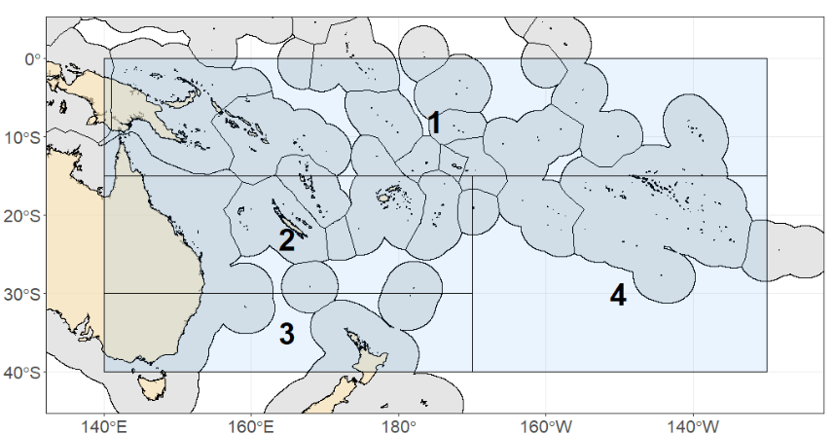
Figure MLS-01. Assessment model spatial domain, noting that no sub-fleets or regions were used.

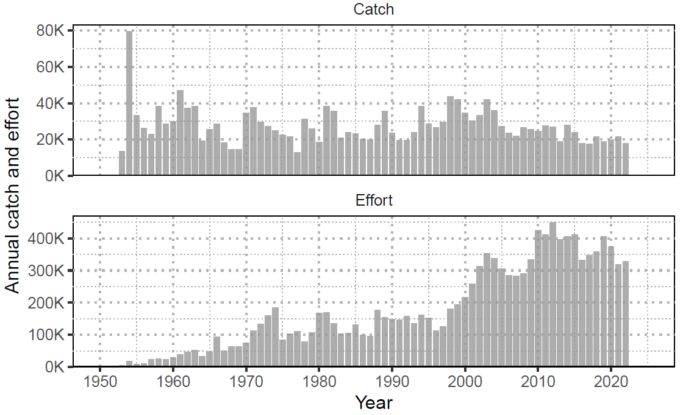
Figure MLS-02. Annual catch (numbers; individuals) of striped marlin and nominal longline effort (hooks fished; thousands) in the Southwest Pacific Ocean (1952-2022).
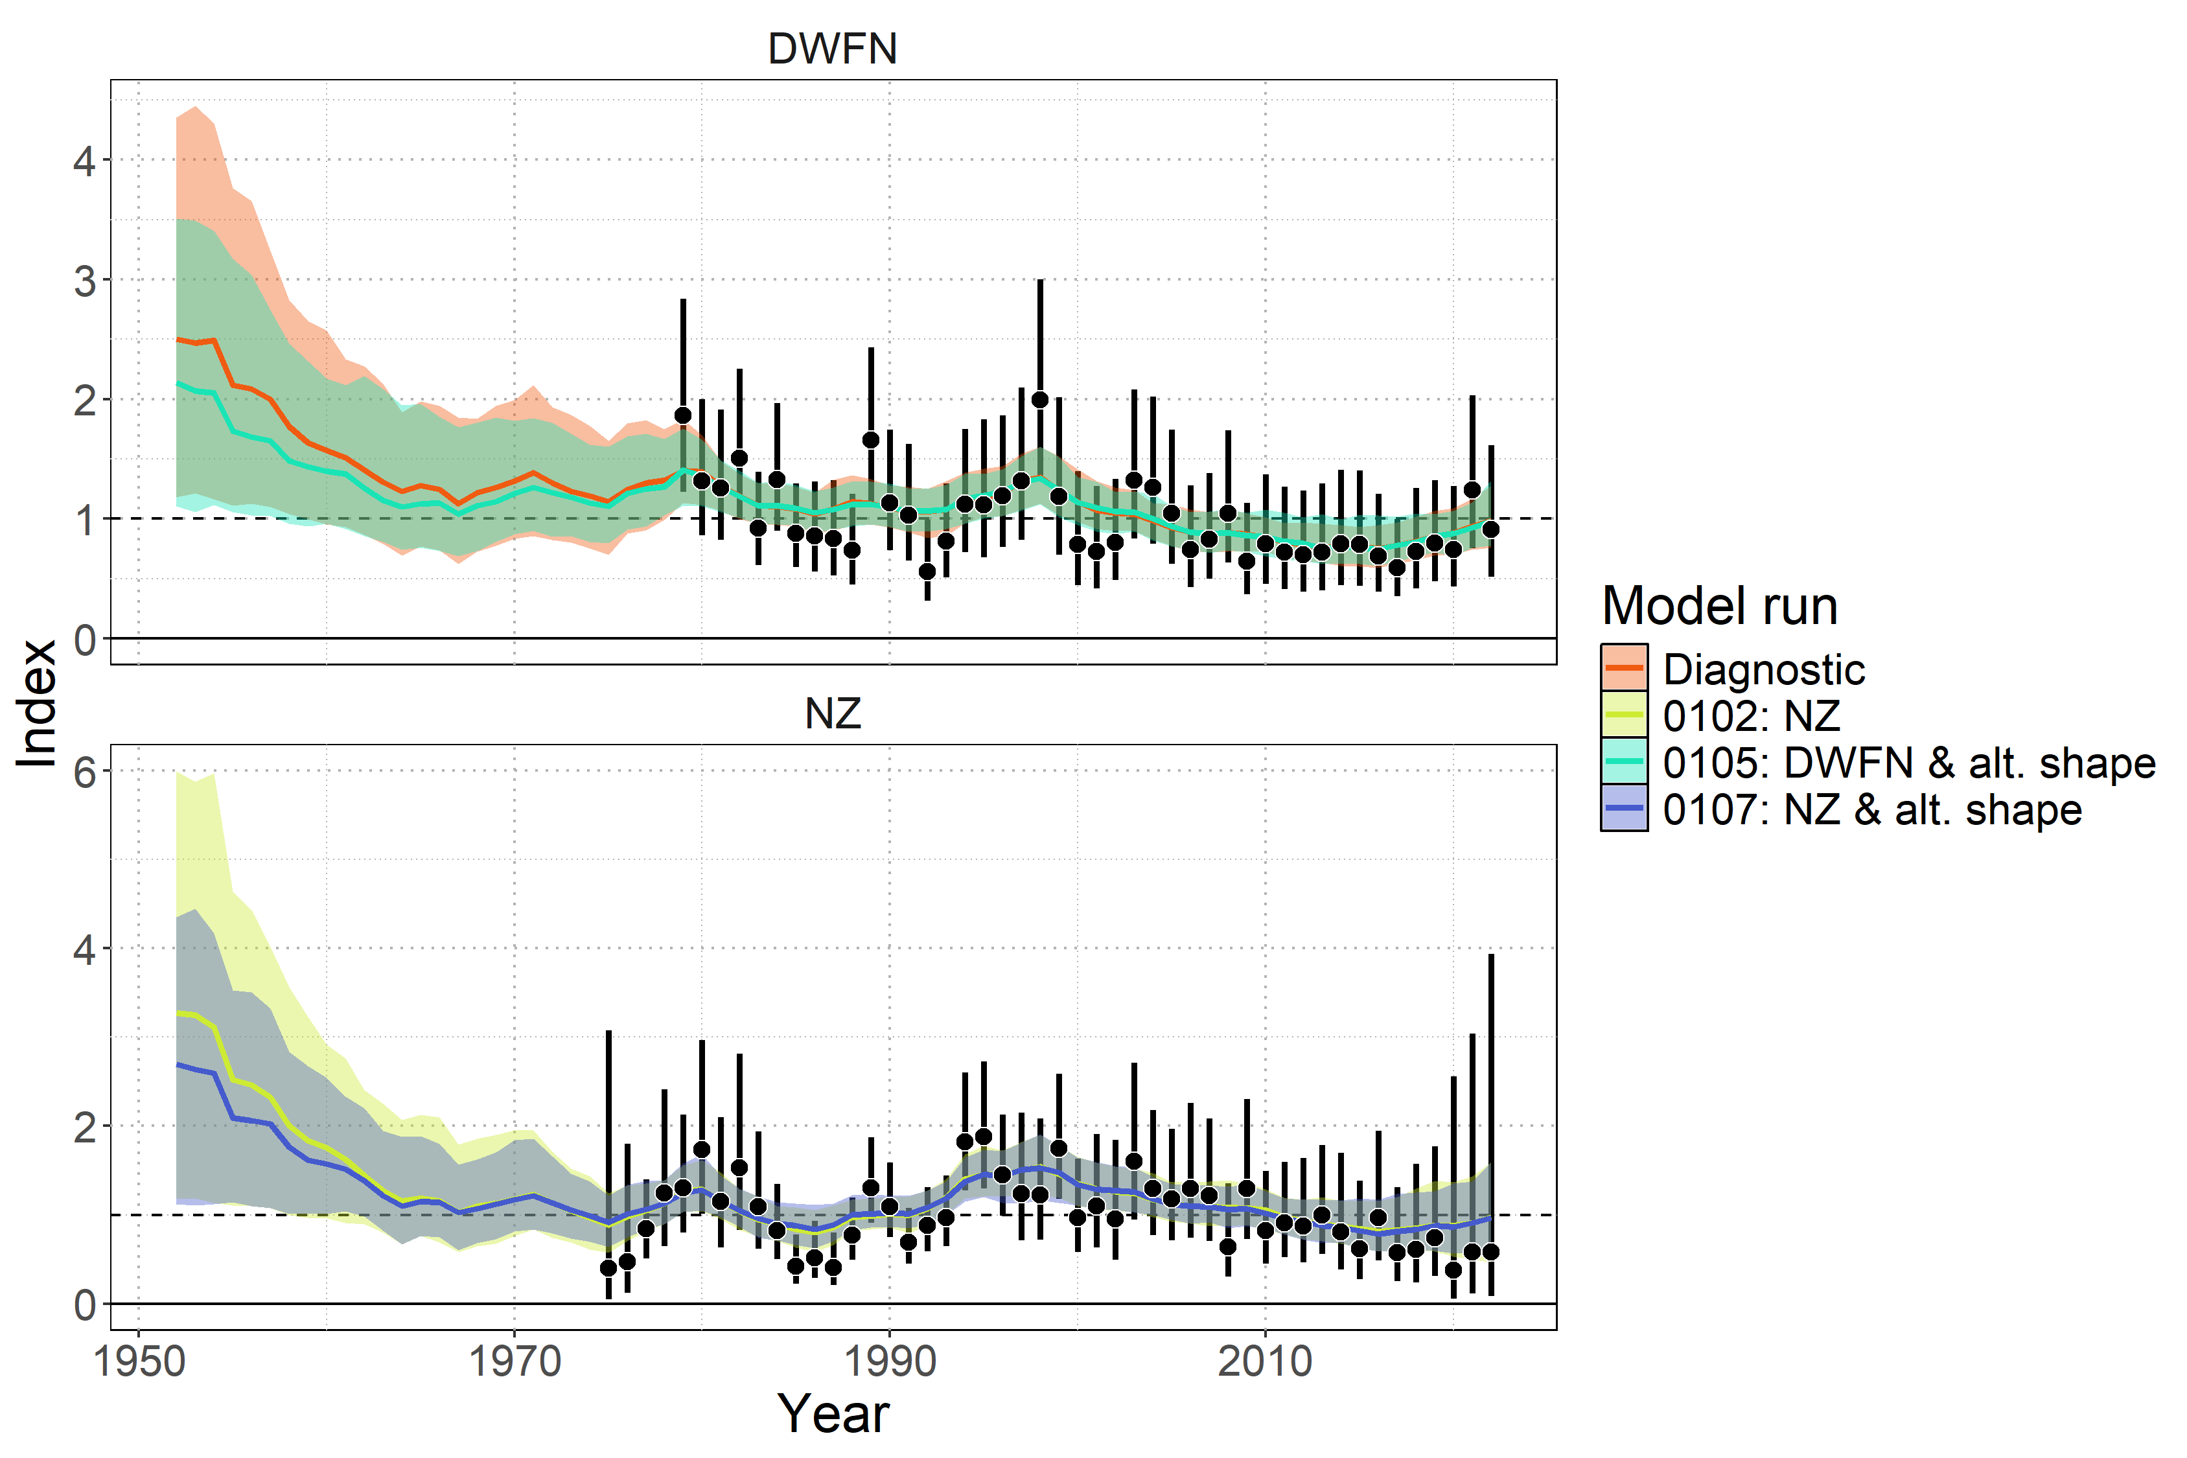
Figure MLS-03. Model fit to standardized index data showing observations (black points with 95% error bars) and model predictions (colored lines and shaded ribbons representing 95% credible intervals). The diagnostic model (0100 ) is shown in orange.

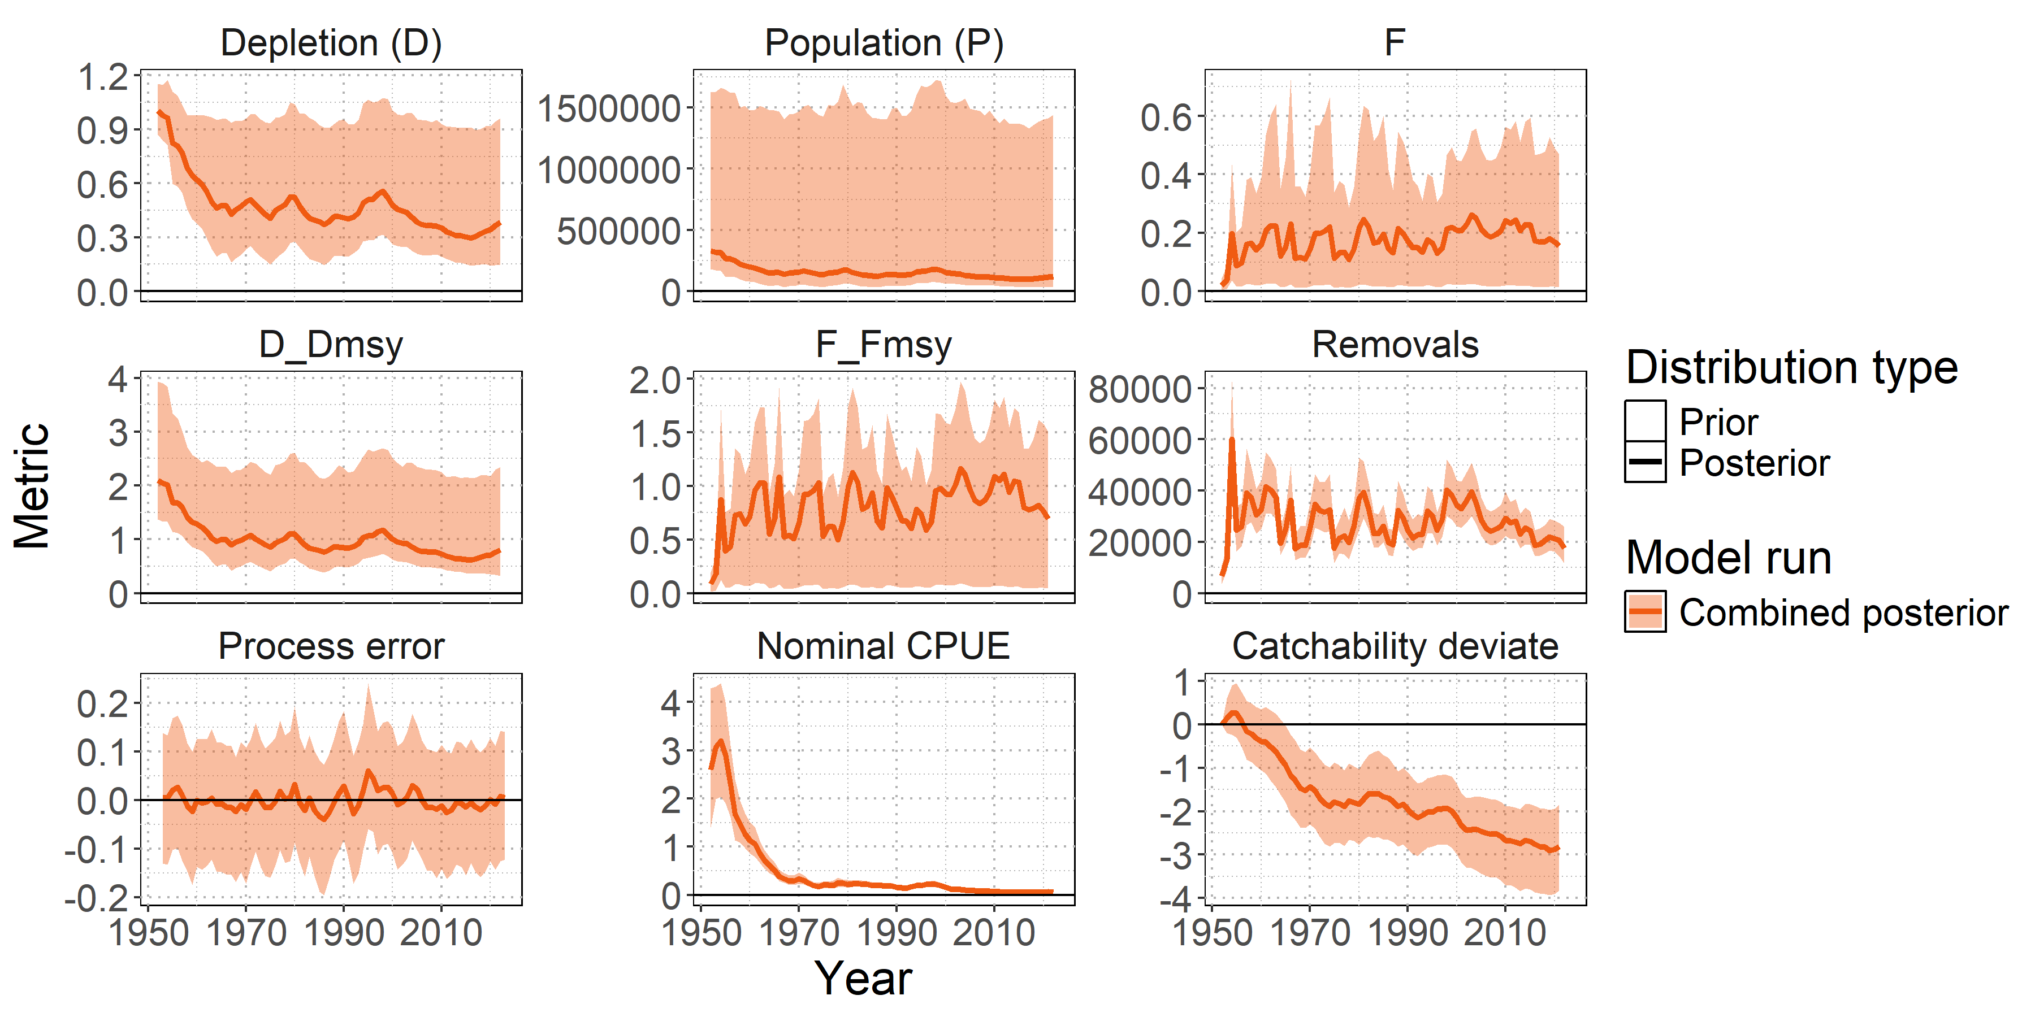

Figure MLS-04. Posterior time series distributions for key derived quantities over time (line = median, shading = 95% credible interval): depletion (D), absolute population size in numbers (P), fishing mortality (F), stock status relative to MSY reference points ($D/D_{MSY}$ , $F/F_{MSY}$ ), total removals in numbers, process error, nominal CPUE (numbers caught per 1000 hooks), and catchability deviates. The model ensemble is shown in orange.

- Stock status

- SWPO striped marlin lacks formal, agreed-upon reference points, so stock status (Table MLS-03) was summarized using MSY-based reference points and total depletion relative to the generalized limit reference point of 20% total depletion from the unfished state ($D/D_{0.2,F=0}$).

- Median recent fishing mortality was below F_{MSY} (F_{recent}/F_{MSY} = 0.77 with a 95% range of 0.05-1.51 and a 22.9% probability of F_{recent} exceeding F_{MSY}. Figure MLS-06) indicating the stock was unlikely to be subject to overfishing.

- Median recent stock abundance was below D_{MSY} (D_{recent}/D_{MSY} = 0.77 with a 95% range of 0.33-2.3 and a 74% probability that the stock abundance was below D_{MSY}. Figure MLS-06) indicating the stock was likely to be overfished. The depletion value at which MSY occurs is 0.48 (the 95% credible interval is 0.26-0.7).

- The stock is very unlikely to be below 20% of the unfished state (Figure MLS-05). The probability of the stock being below D_{0.2,F=0} is 9.2% for the recent period, with a median ratio of 1.84 (95% CI: 0.73 – 4.7295). Noting that this depletion is relative to the 20% total depletion from the equilibrium unfished population level and is not equivalent to the conventional SB/SB_{20%,F=0}.

- SC21 recommended that future work investigate the estimated long-term decline in catchability and evaluate the assumption of stationary productivity, in order to reduce uncertainty and improve confidence in future stock assessments. In addition, it encouraged using the prior information and results from the BSP approach to improve the Stock Synthesis model and to continue using both models in parallel to improve understanding of the status of the SWPO MLS stock.
Table MLS-03. Estimates of management quantities (stock status as depletion D_{recent} relative to MSY), and fishing mortality (F) relative to indicators (F_{MSY}). P(>RP) refers to the probability that the metric (status, fishing mortality) is above the respective indicator.
Summary
Year of assessment: 2025 | Depletion ($D_{recent}$) | Likely (74%) to be below $D_{MSY}$ |  | The stock is overfished
Last year of data: 2022 | Fishing mortality ($F_{recent}$) | Unlikely (23%) to be above $F_{MSY}$ |  | Overfishing is not occurring
 | Projection | $F$ about as likely as not (33-66%) to decline further by 2027 |  | The stock is unlikely (<33%) to be undergoing overfishing in the near term under recent average catch levels.
 |  | $D$ likely (>66%) to increase further by 2027 |  | The stock is about as likely as not (33-66%) to be overfished in the near term under recent average catch levels.
Reference points | Metric | Median [2.5%-97.5% CI] | Likelihood | Recent trend / projection
Depletion | $$D_{MSY}$$ | 0.48 [0.26 – 0.7]
Abundance | $$P_{MSY}$$ | 155,183 n [63,037 – 808,861]
Abundance | $$0.2×log\left(K\right)$$ | 65,041 n [36,198 – 327,844]
Catch | MSY | 29,962 n [25,828 – 184,069]
Fishing mortality | $$F_{MSY}$$ | 0.23 [0.08 – 0.69]
Estimates | Metric | Median [2.5%-97.5% CI] | Likelihood | Recent trend / projection
Depletion | $$D_{latest}$$ | 0.38 [0.14 – 0.96] |  | Increasing
Depletion | $$D_{recent}$$ | 0.37 [0.15 – 0.94] |  | Increasing
Abundance | $$P_{latest}$$ | 121,943 n [34,067 – 1,479,253] |  | Increasing
Abundance | $$P_{recent}$$ | 117,967 n [34,199 – 1,442,511] |  | Increasing
Catch | $$C_{latest}$$ | 17,488 n [11,545 – 25,988] |  | Stable, decreasing
Catch | $$C_{recent}$$ | 20,570 n [13,357 – 28,058] |  | Stable, decreasing
Fishing mortality | $$F_{latest}$$ | 0.15 [0.01 – 0.47] |  | Decreasing
Fishing mortality | $$F_{recent}$$ | 0.17 [0.01 – 0.49] |  | Decreasing
Status | Metric | Median [2.5%-97.5% CI] | Likelihood | Recent trend / projection
Depletion | $$D_{latest}/D_{MSY}$$ | 0.81 [0.32 – 2.36] | Likely (>66%) to be below $D_{MSY}$
Depletion | $$D_{recent}/D_{MSY}$$ | 0.77 [0.33 – 2.3] | Likely (>66%) to be below $D_{MSY}$
Fishing mortality | $$F_{latest}/F_{MSY}$$ | 0.69 [0.05 – 1.51] | Unlikely (<33%) to be above $F_{MSY}$
Fishing mortality | $$F_{recent}/F_{MSY}$$ | 0.77 [0.05 – 1.51] | Unlikely (<33%) to be above $F_{MSY}$
Projections | Metric | Median [2.5%-97.5% CI] | Likelihood | Recent trend / projection
Depletion | $$D_{proj}^{2027}/D_{MSY}$$ | 1.1 [0.13 – 2.47] | About as Likely as Not (33-66%) to be below $D_{MSY}$ | $D_{proj}$ increasing
Fishing mortality | $$F_{proj}^{2027}/F_{MSY}$$ | 0.6 [0.04 – 19.3] | Unlikely (<33%) to be above $F_{MSY}$ | $F_{proj}$ decreasing

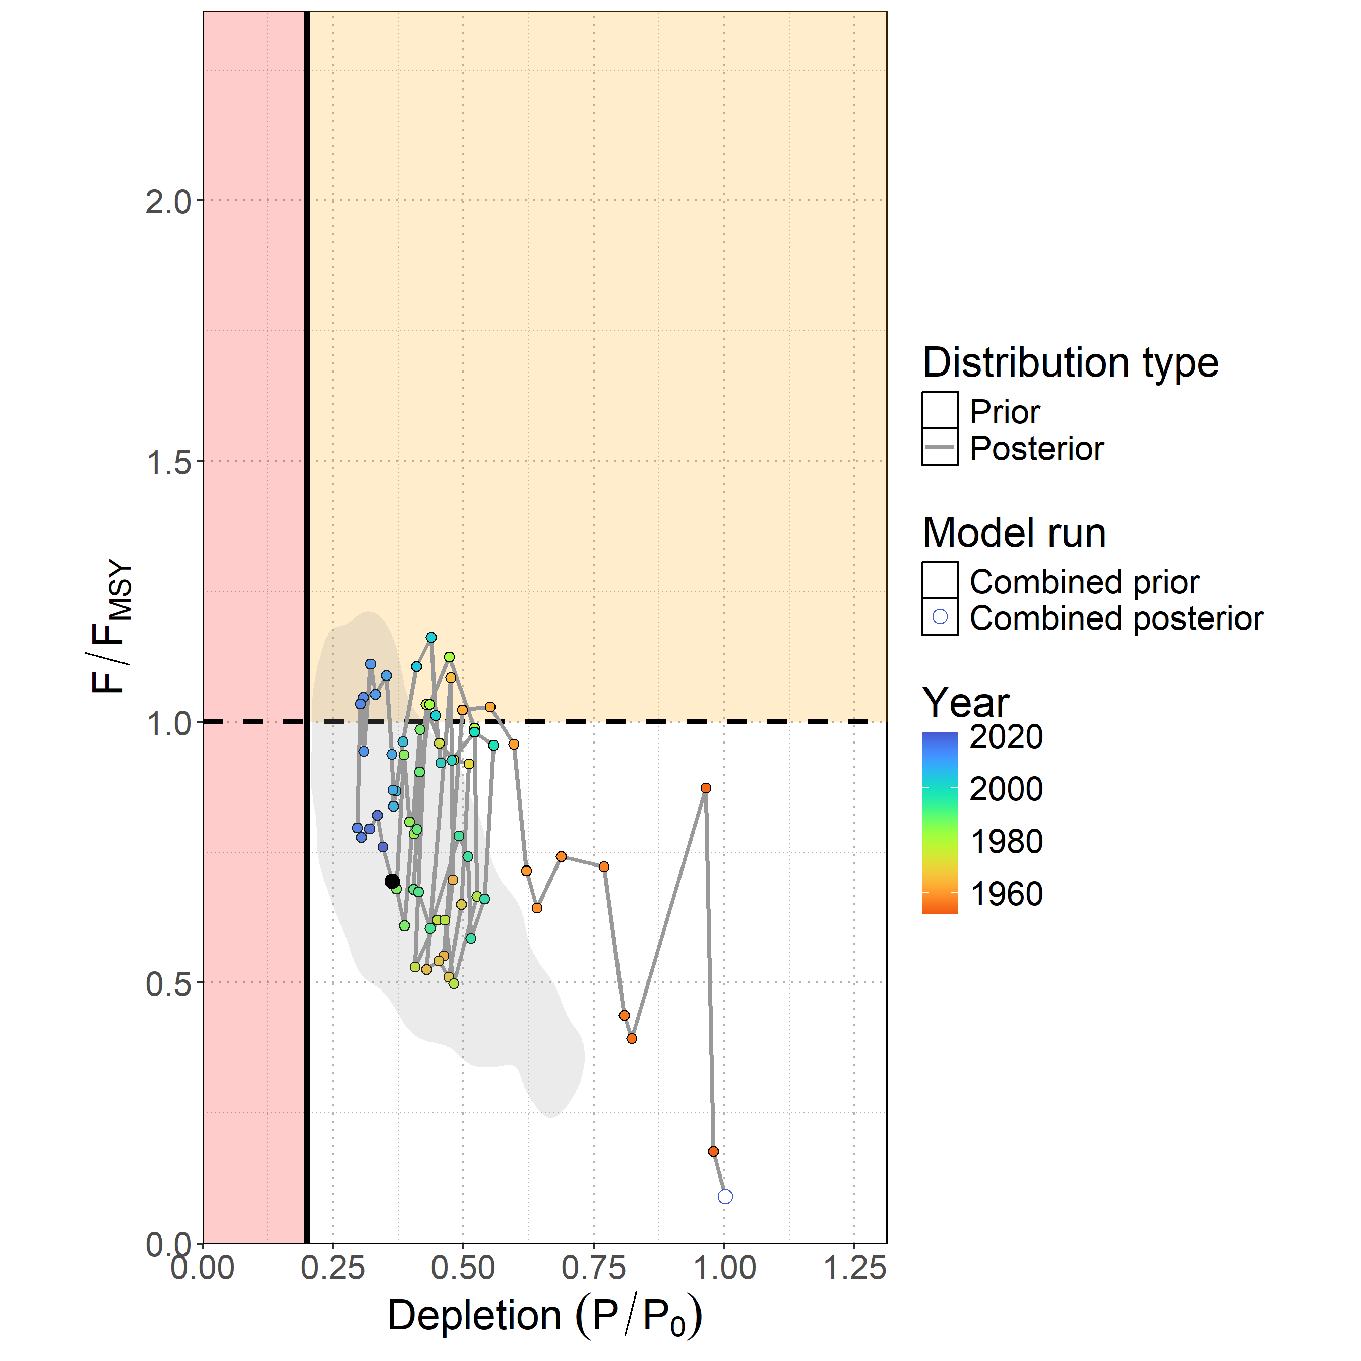
Figure MLS-05. Majuro plot showing the median posterior estimate of the latest stock depletion ($D_{latest} = P_{latest}/P_{0}$) and fishing mortality relative to MSY ($F_{latest}/F_{MSY}$ ). Points represent model estimates colored by year (blue ∼ 2020, green ∼ 1985, orange ∼ 1950), with a connecting line showing the trajectory over time. The gray shaded contour is the bi-variate 95% credible distribution around the terminal year estimate $D_{2022}$ and $F_{2021}/F_{MSY}$.
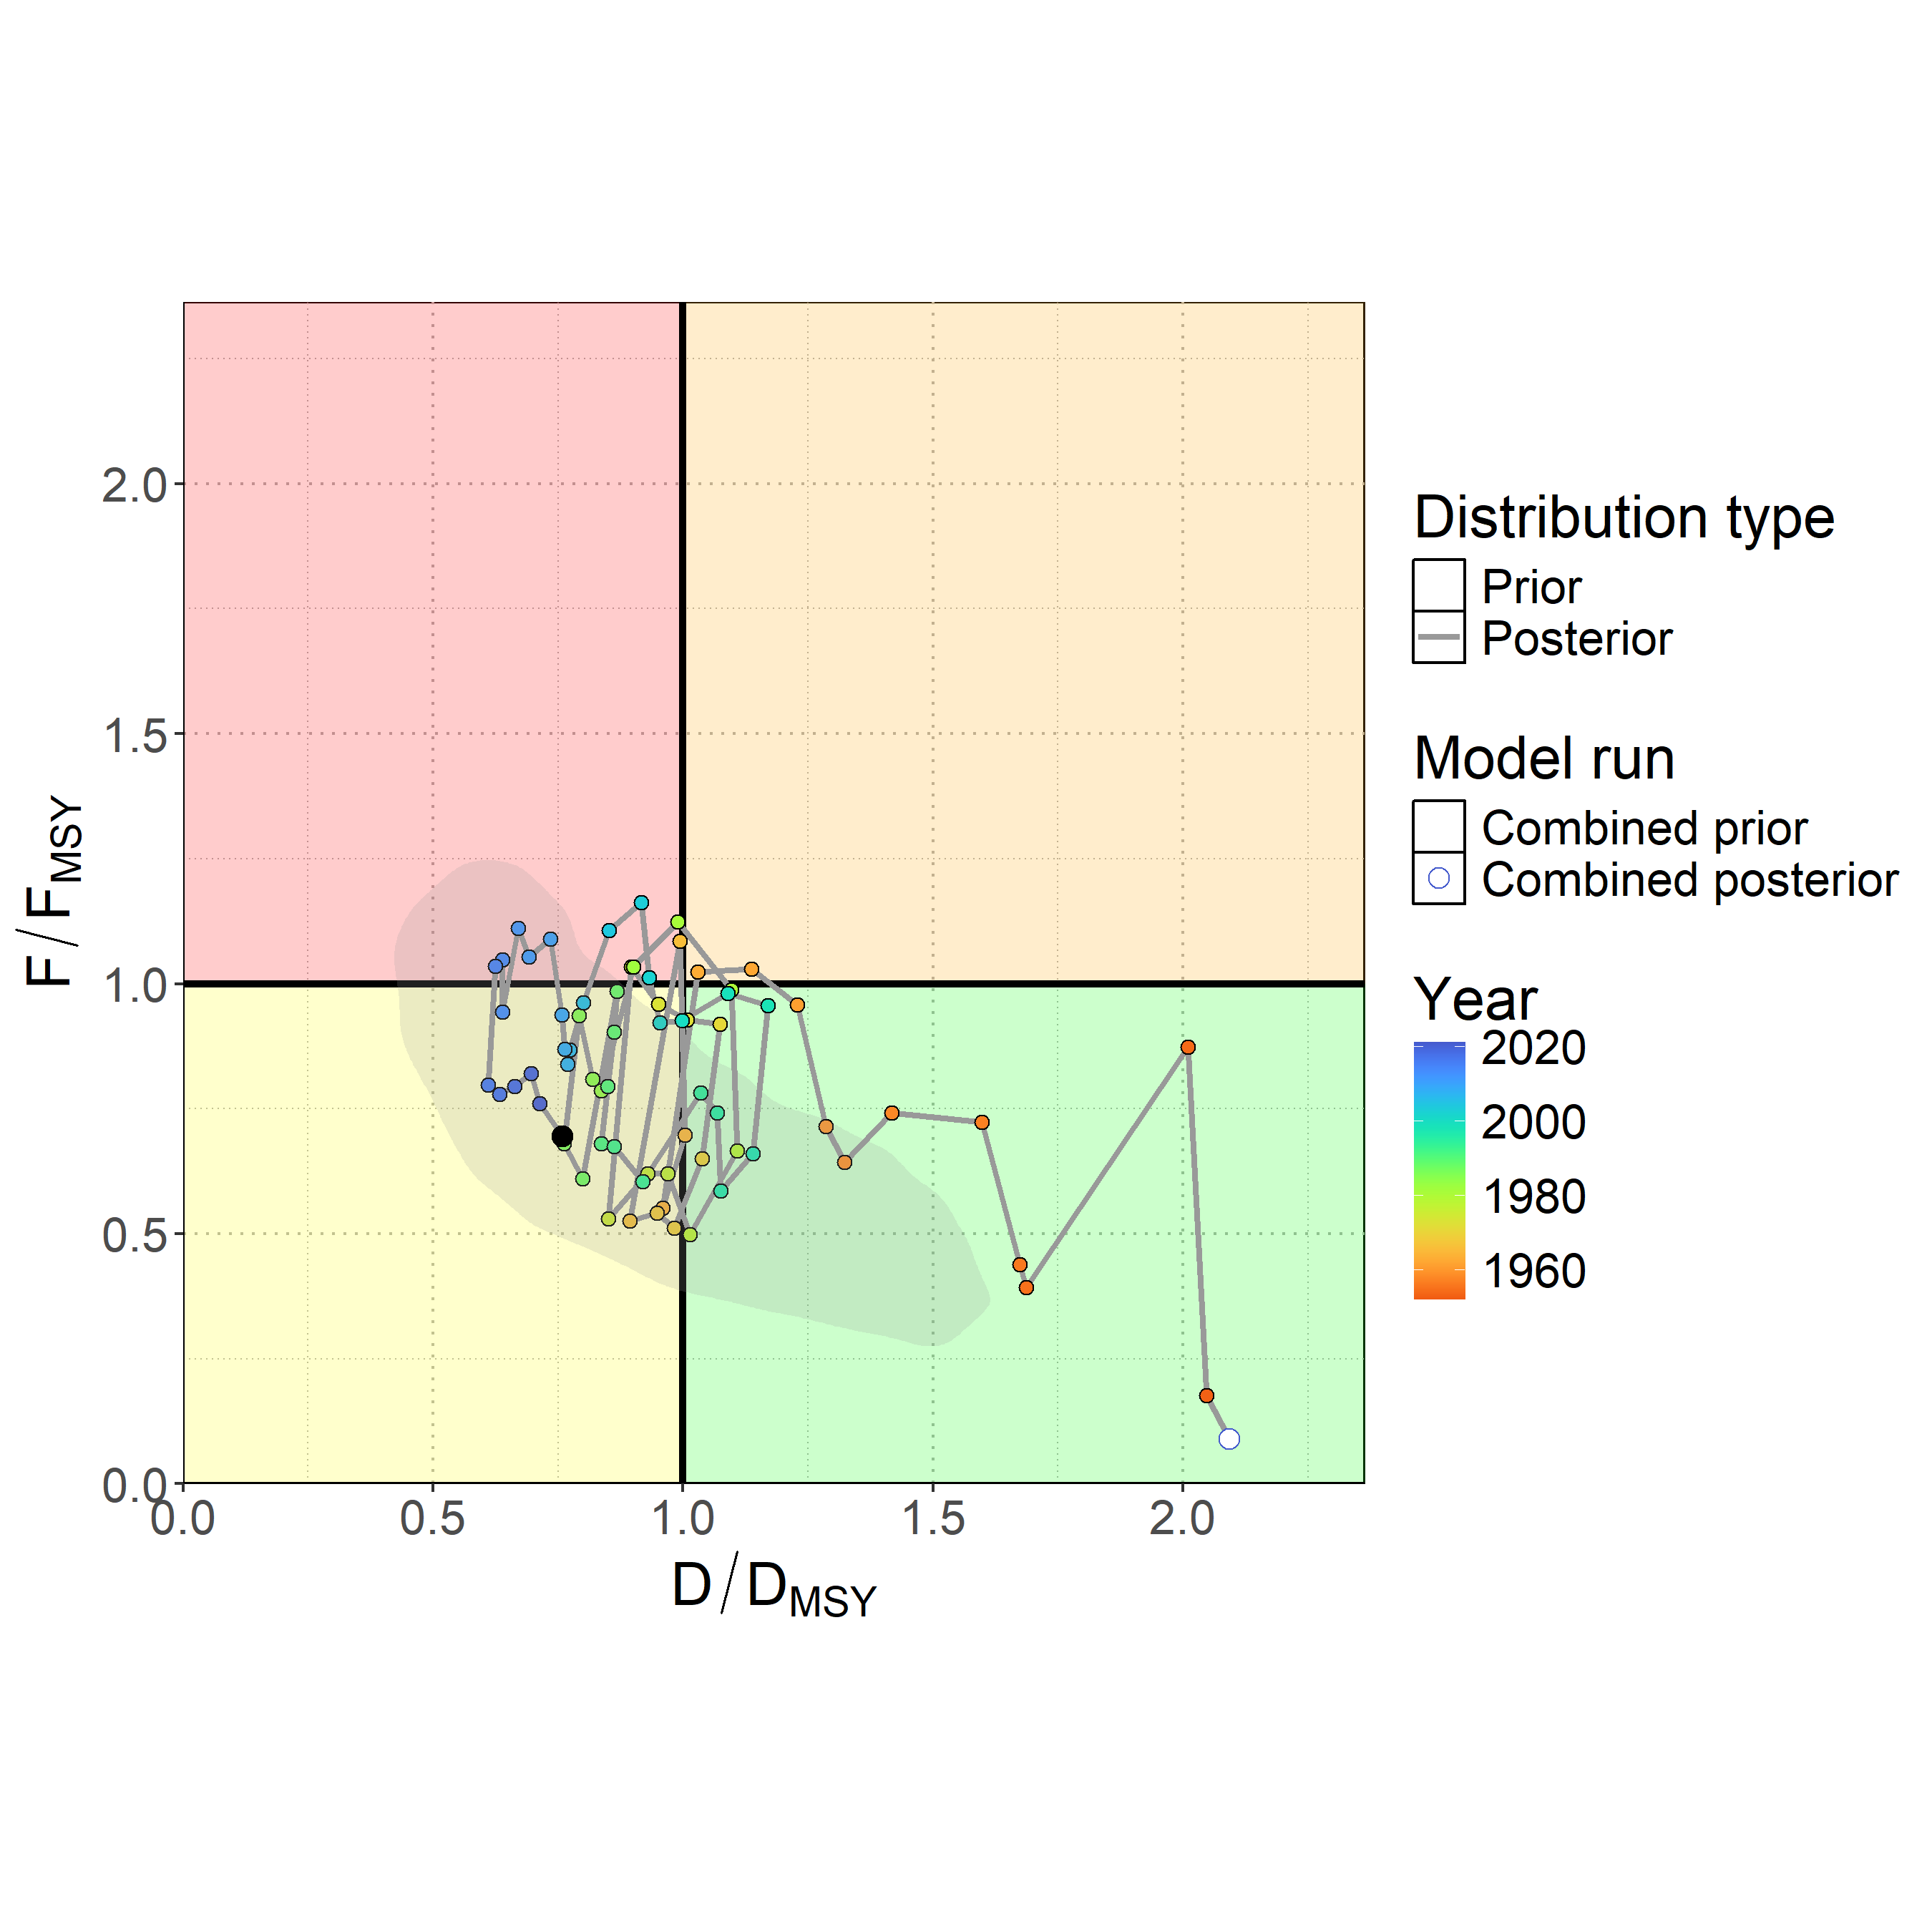
Figure MLS-06. Kobe plot showing the median posterior estimate of the latest stock depletion relative to depletion at MSY ($D_{latest}/D_{MSY}$ ) and fishing mortality relative to MSY ($F_{latest}/F_{MSY}$ ). Points represent model estimates colored by year (blue ∼ 2020, green ∼ 1985, orange ∼ 1950), with a connecting line showing the trajectory over time. The gray shaded contour is the bi-variate 95% credible distribution around the terminal year estimate $D_{2022}/D_{MSY}$ and $F_{2021}/F_{MSY}$ .

- Management advice

- Ten-year stochastic projections (Figure MLS-07) assuming recent average catch levels (2018-2022) indicated continued population recovery through 2032, with median $D/D_{MSY}$ projected to reach 1.32 by 2032 and only a 26% chance of remaining overfished. Projections to 2025 showed a median $D/D_{MSY}$ of 0.99 with only a 51% chance of being overfished, improving to less than 50% probability by 2026. Fishing mortality was projected to continue declining through the projection period, with a median $F/F_{MSY}$reaching 0.49 by 2032 and only a 15% chance of overfishing occurring. While continued recovery was expected under status quo catch scenarios, the substantial uncertainty in model inputs was carried forward into projections, and, for example, there remained a very unlikely risk (5%) of the stock declining to less than 5% depletion under recent average catch levels by 2032. This risk would be expected to increase if catches rose above recent average levels.

- SC21 noted that under projections using recent average catch, the stock had a 55% probability of recovering to greater than MSY levels by 2026 (Table MLS-04), and recommended not increasing catch above recent average levels.

- SC21 also agreed that the projections requested in SC20 were likely not necessary based upon the results provided(Agenda item 5.3).

- SC21 noted that the current BSPM may not reflect population dynamics associated with the changing population age structure, and encouraged the SSP to include non-stationary population processes in model parameters to improve understanding of the population dynamics in future assessments.

Table MLS-04. Table of the probability of Southwest Pacific striped marlin reaching D_{MSY} from status quo projections.
Year | Probability
2023 | 38%
2024 | 44%
2025 | 49%
2026 | 55%
2027 | 59%
2028 | 62%
2029 | 66%
2030 | 69%
2031 | 71%
2032 | 74%

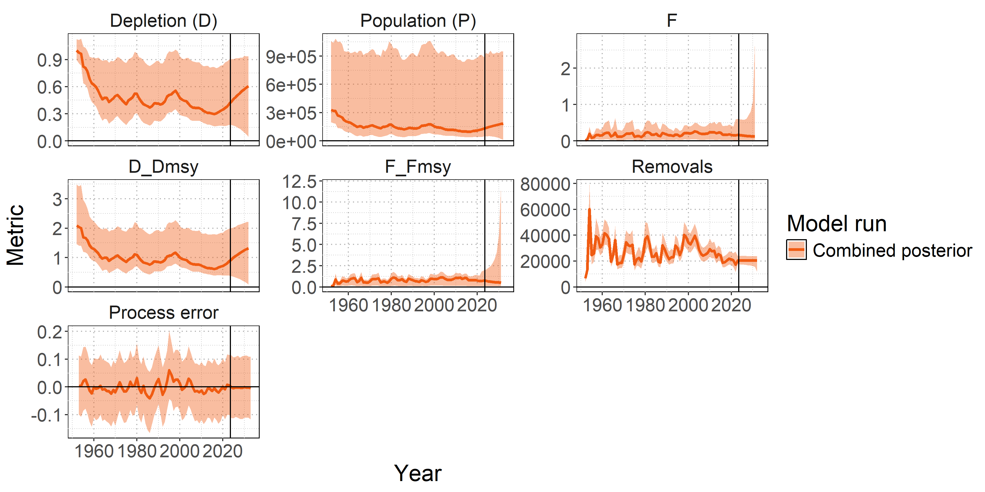

Figure MLS-07. Posterior time series distributions for key derived quantities over time during the forecast period 2023-2032 (line = median, shading = 90% credible interval): depletion (D), absolute population size in numbers (P), fishing mortality (F), stock status relative to MSY reference points ($D/D_{MSY}$ , $F/F_{MSY}$), total removals in numbers, and process error. The model ensemble is shown in orange. A 90% credible interval is shown to restrict the y-axis of the fishing mortality F panel, which shows high values of F in the projection period, as a very small percentage of populations are estimated to go to zero under recent average catch levels.

  - Sharks
    - Oceanic whitetip shark (Carcharhinus longimanus)
4.6.1.1 Oceanic whitetip shark stock assessment (Project 124)

- P. Neubauer (Dragonfly Data Science) presented SC21-SA-WP-08 Stock Assessment of Oceanic Whitetip Shark in the Western and Central Pacific Ocean 2025 (Project 124). The analysis is the third stock assessment of this stock and incorporates updated data inputs through 2023, and uses methodologies building upon recent WCPFC shark stock assessments to address the challenges and uncertainties inherent in assessing OCS and sharks in general. A central challenge, acknowledged throughout the assessment process, is the paradoxical effect of the primary conservation measure CMM-2011-04, which, while intended to reduce mortality through a non-retention policy, has simultaneously degraded the quality of the scientific data required to monitor its effectiveness.

- For this assessment, all data inputs were re-evaluated and redeveloped. The historical catch series supporting the model was reconstructed using a refined approach for imputing hooks-between-floats (HBF), a critical proxy for fishing depth. Previous assessments treated reported zero-HBF values as true data, which likely inflated early catch estimates. By treating these zeros as missing data, the updated catch history for the early period was markedly lower and less variable than catch estimates used for the previous stock assessment for OCS. Despite improvements in methodologies, a conflict persisted between the standardised CPUE index, which shows a steep historical decline, and the length-composition data, which did not show the expected corresponding decline in the mean size of caught sharks.

- In recognition of this data conflict and other structural uncertainties, the 2025 assessment applied a dual-model approach to ensure the robustness of its conclusions. The primary assessment was conducted using an ensemble of integrated, age-structured population models in Stock Synthesis (SS3), which built on the framework of the 2019 assessment. In parallel, a more parsimonious dynamic surplus production model (DSPM) was used. The DSPM relied primarily on catch and CPUE time series and did not use the conflicting length-composition data. This approach served as a crucial structural sensitivity analysis and provides an additional perspective on stock status.

- This multi-model inference strengthens the scientific basis for management advice in a data-limited context. The multi-model analysis showed that the OCS stock remains in a severely depleted state but is showing signs of recovery. The stock synthesis ensemble estimated that the stock biomass reached a low point around 2013–2014, at approximately 4% of its unfished level. Since then, the biomass was estimated to have experienced a subtle but steady increase, reaching approximately 6% of the unfished level in recent years (i.e., 2022–2023). This trajectory aligned with expectations from previous projection studies and indicates that the steep decline observed in prior decades has likely been halted. Nevertheless, fundamental uncertainties remain, and recent signs of improvement need to be considered with caution, given the subtlety of the estimated increase.

- Considering fishing pressure, the largest historical source of fishing mortality was estimated to be from longline fisheries. The significant reduction in interactions resulting from changes in fishing practices over the last decade appears to have been effective in reducing this pressure. The assessment concluded with high confidence that recent fishing mortality has been below the biological limit reference points that would preclude stock rebuilding. The ensemble of models indicates that recent fishing mortality rates are below both F_{lim} and F_{crash} (the fishing mortality that would lead to long-term extinction), and the probability of exceeding these limits was near zero in recent years (i.e., 2022–2023) under the considered models.

- Main assessment conclusions:
- Based on the precedent of using SS3 for the OCS assessment, and on advances in Bayesian methodologies used for the present assessment (relative to the 2024 silky shark assessment), we suggest that the ensemble of SS3 models be used for management advice.
- The multi-model approach for assessing OCS resulted in a low stock status, but with high confidence that recent fishing mortality is below levels that would preclude stock rebuilding.
- The largest fishing mortality of OCS was estimated to be in longline fisheries. Reductions in OCS interactions as a result of changes in fishing practices over the last decade may have substantially reduced this source of mortality, likely halting the previously observed steep decline, and possibly leading to some (albeit slow) rebuilding.
- Recent fishing mortality rates were below biological limit reference points for the ensemble (Diagnostic F_{recent}/F_{crash}: 0.54 [0.37–0.74]; P(F_{recent}/F_{crash} >1)=0; P(F_{recent}/F_{lim} >1)=0).
- Recent biomass was estimated to have had a subtle increase from a low point in 2013–2014, near 4% of unfished biomass, to 6% of unfished biomass in recent years (2022–23).

Discussion
- Tokelau, on behalf of FFA members, commended the assessment authors for the extensive and important assessment of the oceanic whitetip shark, stating that while they welcome signs of recovery and reduced fishing pressure below critical limits, the stock remains severely depleted, and sustained, science-based management is crucial to ensure continued rebuilding. They generally supported the assessment authors’ recommendations:
- The CMM’s unintended consequence has been degraded data quality. FFA members stated they can consider standardized observer protocols for all shark interactions, length estimates for water-released specimens, and clear documentation for discarded-cut-free events.
- FFA members supported accelerating research areas under the Shark Research Plan, addressing release mortality estimates through expanded satellite tagging and regional genetic studies to evaluate stock structure. FFA members also supported addressing life history uncertainties by validating ageing methods, conducting growth studies across locations, and addressing current growth study discrepancies, which significantly impact productivity estimates.
- On the persistent data conflicts, FFA members recommend continuing multi-model approaches (Stock Synthesis and BSPM), and support a review workshop and summary paper to capture recent progress and outstanding challenges across the full cycle for upcoming work, and to gain the opportunity to share these advances across RFMOs.

- Japan stated that it appreciates the effort made to improve the stock assessment of these regulated species, and stated that it is noteworthy that the positive impact of the CMM was quantitatively evaluated and confirmed in the assessment. The report clearly highlights the impact of the introduction of management measures, particularly in relation to the degradation in the quality of CPUE and size data for the species. Based on the biological information in Figure 23, the age at maturity is estimated to be 5 to 10 years, so the effect of the no retention measure implemented in 2013 should be starting to appear. However, looking at Figure 45, fishing mortality has also declined in recent years. There is no corresponding increasing trend in recruitment or stock biomass. This may be related to the fact that this species is not as productive as the silky shark, but there might also be issues with the data, as mentioned in the document. Japan inquired about the so-called recruitment relationship in Figure 14, if each of these assumptions resulted in a significant change in the trend of stock biomass or fishing mortality.

- Dragonfly noted that, because of recent issues with data quality and quantity, there is potentially a bias in how many shark records have been received recently, relative to what was previously reported, and they would expect to see a delayed signal of recovery relative to what's actually happening in the water if not all sharks are recorded. This is one reason it's so important to have consistent observer protocols with observers asked to bring all sharks close to the vessel so that they can be identified. Hopefully, in the future, there will be usable data and these potential biases will be kept to a minimum, but it's very hard to know for sure the scale of this issue. They stated that interestingly the stock recruitment relationship in this context had very little impact in that ensemble; it was introduced into the ensemble and they expected to see more of an impact, given the depletion level, but it may be that given how slow the rebuilding is the impact of reduced fishing mortality on recruitment and population trends takes a few years to become evident. They noted that this will be interesting to examine in the next stock assessment.

- Japan inquired regarding the recruitment assumption. What value was used as a sigma R for this stock? Dragonfly replied that the sigma R was fixed very low at 0.1, which was the same assumption as for the last stock assessment. The recruitment trends in the document show the recruitment deviations in the model are very small. So it barely needs a 0.1.

- The USA stated that the 2025 oceanic white tip shark assessment represents a noteworthy shift in the way we approach complex, data-limited, and high uncertainty stock assessments. In the Pacific, SPC implemented a Bayesian version of the SS3 integrated age-structured model, enabling the integration of prior biological knowledge with available data in a more transparent representation of uncertainty. What makes this important is that Bayesian frameworks can be particularly powerful for highly migratory species like oceanic white tip sharks, where data conflicts, sparse catch histories, and uncertainty in life history parameters can undermine the robustness of traditional integrated assessments. However, the utility of Bayesian frameworks extends to all stocks. By using priors informed by empirical studies and producing full posterior distributions, the assessment team was able to characterize uncertainty in a way that better supports precautionary risk-based management advice. The USA stated the benefits of this are seen with the BSPM for Southwest Pacific striped marlin. In both cases, the Bayesian framework not only proved the transparency of assumptions but also made it easier to evaluate model performance against multiple hypotheses about productivity and scale. The USA stated it sees this as a potential path forward for future work in the WCPFC, given the complexity of many of the Commission’s assessments, especially for species with conflicting data sets on certain growth curves or limited tag information. Incorporating Bayesian approaches either as a primary or complementary model could help resolve some of the current challenges faced in terms of model convergence, data weighting, and communication of uncertainty. The USA posed a question: noting the assessment is showing only a slight increase in biomass from the historical low, they inquired if the authors explored or could the model be used to explore what levels of mortality reduction or post-release survival improvement would be required to achieve rebuilding within shorter, more practical time frames?

- Dragonfly fully agreed with the statement by the USA. In reference to the question, they stated that it could definitely be explored. Estimates of mortality that came out of catch reconstructions and mortality models are included, but it would be relatively straightforward to include other mortality assumptions and scenarios in line with what was done by Keith Bigelow in 2022 and prior to that. This would be relatively straightforward and could be run across the full ensemble.

- FSM, on behalf of the PNA and Tokelau, thanked the team for a very thorough assessment. They noted that the extra time provided for this assessment has again been well worth it, and the detailed level of background information and multi-assessment approach has been valuable for our understanding of the fisheries catching oceanic whitetip sharks, the extent to which management action is being applied, and the resulting confidence in the stock status of the resource. They stated a similar multi-assessment approach would also be useful for South Pacific blue sharks in the 2026 assessment. The multi-assessment approach is useful for data-limited stocks in the event that one method fails. PNA and Tokelau noted that the approach could be used for billfish, where assessment teams are struggling, and having a joint shark billfish workshop to progress these methods and build on the work presented in SC21-SA-IP-15 would benefit both assessment groups.

- Sharks Pacific thanked the authors for the excellent effort to develop the stock assessment for oceanic whitetip sharks, but observed that this was another instance with a poor data baseline. They stated the stock assessment displayed the same kind of data deficiencies as observed in other shark stock assessments, which leads to declining stocks and management failures. Unfortunately, the data deficiency is compounded both by the lack of longline observer coverage, which they emphasised must be improved, and the WCPFC’s well-intentioned operational approach to non-retention. Sharks Pacific encouraged SC to recommend a critical operational approach that directly addresses fundamental data collection failures undermining shark conservation efforts in the WCPO, especially as it pertains to oceanic whitetip shark. Specifically, as a matter of improving the scientific baseline for all sharks, Sharks Pacific stated it strongly supports improving observer data protocols for all longline vessels to pull all sharks within view of observers, use extendable line cutters, and cut gangions as close to the hook as possible. They stated that the scientific evidence supporting these operational requirements is compelling and directly addresses persistent data quality issues that have plagued all WCPFC shark assessments for years. As indicated in research presented at SC21, non-retention measures have been critical to stop the decline of some shark species. Unfortunately, current common operational practices systematically undermine both observer reporting accuracy and post-release survival rates for vulnerable elasmobranch species. Common industry practices of cutting longline gangions near the mainline before observers can adequately identify species create two critical problems, which the paper highlights: i) the practice obscures accurate reporting, particularly when observers are present, and ii) leaves substantial trailing gear on sharks, significantly increasing post-release mortality rates. Sharks Pacific stated that for oceanic whitetip sharks, the situation is particularly concerning because recent genetic evidence confirms that oceanic whitetip sharks represent a distinct and demographically isolated stock, making accurate mortality accounting absolutely critical for recovery efforts. The 2025 stock assessment shows only very modest improvement in stock status trends, underscoring the urgent need for every conservation measure to function effectively. In light of the need for improved data on all shark species, but especially oceanic whitetip, Sharks Pacific urged SC21 to recommend required procedures for:
- Pulling all sharks within view of observers or EM cameras to ensure proper species identification, which is fundamental to accurate catch accounting and stock assessment validity;
- Using extendable line cutters to allow the crew to maintain safe distances while minimizing stress to the shark and allowing proper species identification before release; and
- Cutting gangions as close to the hook as possible to minimize trailing gear, directly reducing post-release mortality and improving the conservation effectiveness of non-retention policies.
They stated that as a matter of scientific integrity, these requirements represent evidence-based best practices that simultaneously improve data quality and conservation outcomes, and the operational solutions are practical and achievable, as demonstrated by French Polynesia, which already requires these procedures in its waters.

- French Polynesia stated that cutting the branch line close to the hook is a good practice that increases shark survival, reduces marine pollution, and increases bycatch data accuracy, as it allows better shark identification by fishermen, observers, or EM. It is a very simple and safe practice using an extendable line cutter. They supported the full implementation of the practice that is fully in place in French Polynesia, and supported the recommendation.

- The USA inquired regarding fit to the CPUE index and noted this was something that Japan had picked up on at SC15 with the previous assessment. They sought comments on what appears to be a more rapid increase in the observed index than what the model is able to capture, particularly looking at 2017 to 2023, and asked whether the same thing is evident in the surplus production model, which might have less conflict in other data sources. Secondly, they asked if the team explored how stock recruitment assumptions may or may not impact the fit to that?

- Dragonfly noted that recent CPUE was used with the surplus production model and stated that overall, the model does slightly better in fitting recent CPUE, unless very high recent mortality levels are assumed, at which point it also can't really fit that level of increase. Dragonfly wondered initially whether it was constrained by the low sigma R, so it wasn't being allowed to fit that increase in the Stock Synthesis model. It turns out that the actual deviations are quite a bit lower than the sigma R, and changing those did not make much difference, which was curious because they allow the model to estimate natural mortality, for example, and some of the stock recruitment relationship as well, and it wasn't able to pick up the very low and very high points in recent years. Dragonfly stated their assumption is that it's constrained by the declines in early years and by the signal that comes from that, and that it basically can't fit some of those rapid changes in recent years. Going back to a comment that Japan made on the ODF, in future iterations, it may be worthwhile to split either catchability or CPUE into time blocks to see the effect and evaluate whether the impact of the CMM results in recent CPUE means something different from CPUE prior to the non-retention CMM. Dragonfly stated that this was not done in this research, but would be worthwhile for oceanic whitetip and possibly more broadly for other shark species, because the issue also arose in other shark stock assessments.

- China stated that this is difficult work due to the data quality, and observed that the authors sought to build the relationship between the hooks per float (HPF) and the CPUE, noting HPF is subjective, because China’s fishermen will choose different HPF, even in the same fleet in the same area. China suggested that hook depth can also be calculated from other data, such as the length of the float, and the relationship between the CPUE and the hook depth was then established. China stated this might be better than using only HPF.

- Dragonfly stated it broadly agrees, and noted that a key limitation is the extent to which other variables are actually reported consistently, especially when going back in time. In the context of being able to generate a CPUE time series — and this is true for the catch reconstruction and predicting overall catches — they are pretty limited by what's been reported historically. One issue is that operational parameters are often very inconsistently reported between different observer programs, in which some variables are provided by some observer programs but not others, or for some regions and not others. If the analysis relies on operational details of the fishing operations, Dragonfly stated that they often end up having to drop a lot of data. The starting point is that there is very little data available, especially early in the time series (late 1990s and early 2000s). The limitation ends up being the amount of data that remains to actually work with, whether that's representative more broadly, and whether it can be used. Dragonfly stated that they also face this problem in terms of how representative observer data is. They try to ensure that the predictions that are made or the trends that are inferred are corrected as much as possible. But when getting into operational details — and this was examined in 2025 with the billfish work — 50% or more of the data must be dropped, making it very difficult to then develop defensible CPUE trends. Dragonfly stated that it would be great to do what China proposes, and it may be possible for some distinct fleets or subsets of fleets, but whether that's possible for a broader data set is another question. It often means losing too much data in the context of sharks.

Outcomes
- SC21 noted the extensive efforts undertaken to provide the dual-model stock assessment and appreciated the thoroughness of the assessment approach. While the Stock Synthesis (SS3) integrated age-structured model and Dynamic Surplus Production Model (DSPM) provide different structural assumptions for addressing data conflicts and uncertainties, SC21 noted that the multi-model ensemble approach strengthened conclusions about stock status compared to single-model approaches used previously.

- SC21 recommended that stock status and management advice be based upon the Bayesian ensemble across SS3 models, given that it both more appropriately captures the age-structured dynamics and has satisfactory model diagnostics. Additionally, the Bayesian approach provides a comprehensive and principled framework for characterizing uncertainty in stock status and recent fishing mortality.

4.6.1.2 Provision of scientific information to the Commission

  - Stock assessment and trends

- This assessment represents the third for oceanic whitetip shark (Carcharhinus longimanus; OCS) in the Western and Central Pacific Ocean. The assessment employed a dual-model approach to address persistent data conflicts and structural uncertainties. The primary assessment utilized an integrated, age-structured population model in Stock Synthesis (SS3), building on the 2019 assessment framework, using a single region model (Figure OCS-01, Table OCS-01). A parallel dynamic surplus production model (DSPM) served as a structural sensitivity analysis, relying on catch and CPUE data while avoiding potentially problematic length-composition data. The assessment incorporated updated data inputs, largely based on observer data, from 1995 through 2023.

- The assessment identified multiple sources of uncertainty and, in particular, emphasized the issue surrounding data quality following non-retention measures (Table OCS-02). Conflicts between CPUE indices and length-composition data, and life history parameter uncertainty, both identified in the 2019 stock assessment, remained present. Uncertainties in the level of survival from current discarding practices were considered to inform alternative estimates of recent fishing mortality. Potential non-representativeness of length data was addressed by fitting the DSPM and including model runs with alternative weighting for length compositions in the Bayesian model ensemble.

- Historical catch reconstruction suggested markedly lower and less variable early catch estimates compared to the previous assessment. This discrepancy was largely due to the treatment of likely mis-reported hooks-between-float numbers in early assessment years (late 1990s and early 2000s). Longline fisheries were identified as the primary source of catch and historical fishing mortality (Figure OCS-02). Significant reductions in catches were predicted over the past decade, following the implementation of the non-retention measure for OCS (CMM-2011-04).

- Standardized CPUE indices showed a steep historic decline, with a slow recent increase since the implementation of CMM-2011-04 (Figure OCS-03). These trends in CPUE created a persistent conflict with length-composition data; the latter did not show any trends over time.

- The diagnostic model showed a reasonable fit to CPUE and length compositions, despite the low weight assigned to the length compositions (Figure OCS-04). Recent CPUE increases could not be fitted without some residual trends, suggesting that recent CPUE increases exceed expectations under the current model configuration. SC21 noted that future shark assessments should explore time-blocks or alternative methods to more explicitly account for changes in the fishery post-CMM-2011-04. The model showed little retrospective pattern in recent depletion or fishing mortality estimates, with retrospective patterns mainly concerning estimates of initial depletion.

- A full Bayesian ensemble across key uncertainties was used to characterise uncertainty in stock status and fishing mortality levels. Growth and associated natural mortality priors were key determinants of stock status estimates in the ensemble, while recent discard mortality was a major determinant for recent fishing mortality estimates.

- SC21 noted that biomass and recruitment declined substantially during the late 1990s from a starting point that was estimated to be near 20% of equilibrium unfished levels (SB₀) to levels around 4% of equilibrium unfished biomass between 2013-2015 (Figure OCS-05). Recent biomass was estimated at approximately 6% of unfished biomass in 2022-2023, following a substantial decline in fishing mortality. The stock, therefore, remains in a severely depleted state, with indications that declines have been halted and slow rebuilding is taking place.

- SC21 noted that the 2025 assessment showed a high level of consistency with the previous stock assessment (Tremblay-Boyer et al. 2019) as well as with projections performed from the 2019 stock assessment (Bigelow et al. 2022), while incorporating improved methodologies and data. The dual-model approach strengthened conclusions about stock status compared to single-model approaches used previously.

Table OCS-01. Assessment structure, including key ﬁsheries and catch proportions.
Species | Oceanic whitetip shark (Carcharhinus longimanus)
Stock area | Western and Central Pacific Ocean; Single area
Assessment model | Dual approach: Stock Synthesis (SS3) and Dynamic Surplus Production Model (DSPM)
Data period | 1995 through 2023
Primary fisheries | Longline bycatch (major source of mortality), purse seine (minor)
Key data | Catch predictions, discard condition (mortality) estimates, standardized CPUE, and length compositions

Table OCS-02. Summary of main sources of uncertainty in the assessment, with a degree of conﬁdence assigned to each aspect of the assessment and potential source of uncertainty.
Source | Type | Rationale | Uncertainty | Impact | Confidence
Data | CPUE | Standardized longline CPUE index | Steep decline and recent recovery conflicts with length data; recent CPUE may be biased by cutting free of sharks | Potential bias in recent abundance trends | Medium
Data | Catch | Reconstructed historical catches using refined HBF methods | Early period uncertainty, zero-HBF treatment. HBF may not reflect depth of hook in some cases. Uncertainty in the proportion of discard survival and historic overall catch | Population scale estimates may be impacted | Medium
Data | Length composition | Observer length measurements | Data quality degraded by non-retention policy | Conflicts with CPUE trends | Low
Model | Stock Synthesis | Integrated age-structured model | Length data probably not representative of abundance trends | Primary model for inference | High
Model | DSPM | Surplus production model | Alternative structural assumption | Provides robustness check | Medium
Spatial assumptions | Single stock | WCPO treated as single unit | Stock structure unknown | May affect assessment validity | Low
Key parameter | Natural mortality (M) | Literature- derived priors | Conflicting information in data | Affects productivity | Medium
Key parameter | Growth | Fixed, from Literature | Not estimable from data | Structural uncertainty | Medium
Structural | CMM-2011-04 effects | Non-retention conservation measure | Data quality | Potential under-estimated recent CPUE | Low
Estimation | Bayesian inference | MCMC estimation | Parameter uncertainty | Principled estimation of uncertainty | High

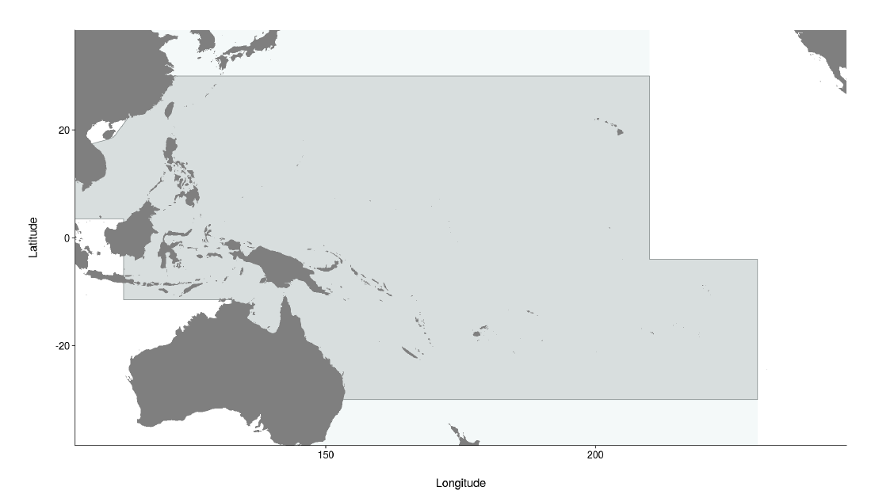

Figure OCS-01. Western and Central Pacific Fisheries Commission Convention Area (light grey), including the stock assessment area for oceanic whitetip shark (dark grey), bounded by the 30◦ N and 30◦S parallels.

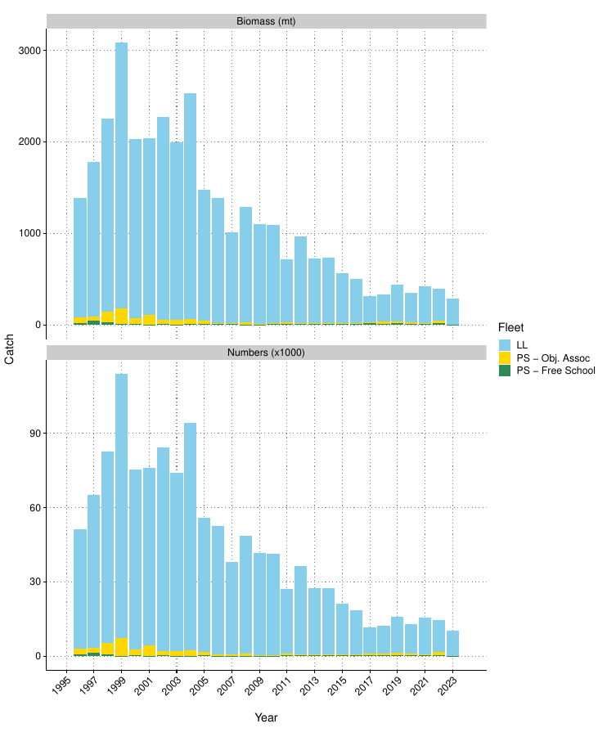
Figure OCS-02. Estimated mortality by fleet in biomass and numbers.

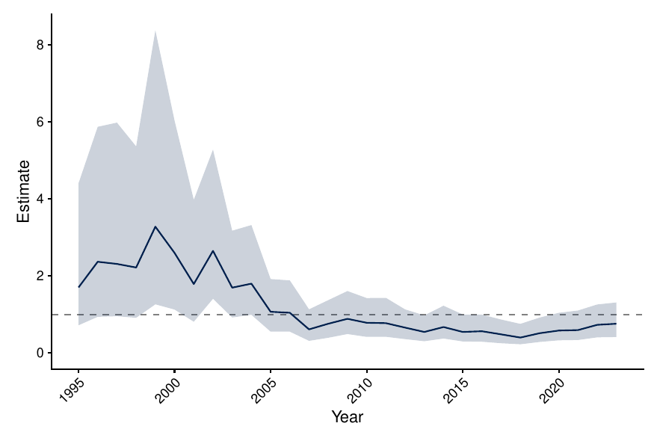

Figure OCS-03. Longline CPUE index using long-running observer indices. Shown is the posterior median and 95% credible interval for the year effect, standardised for regional trends and environmental variables.

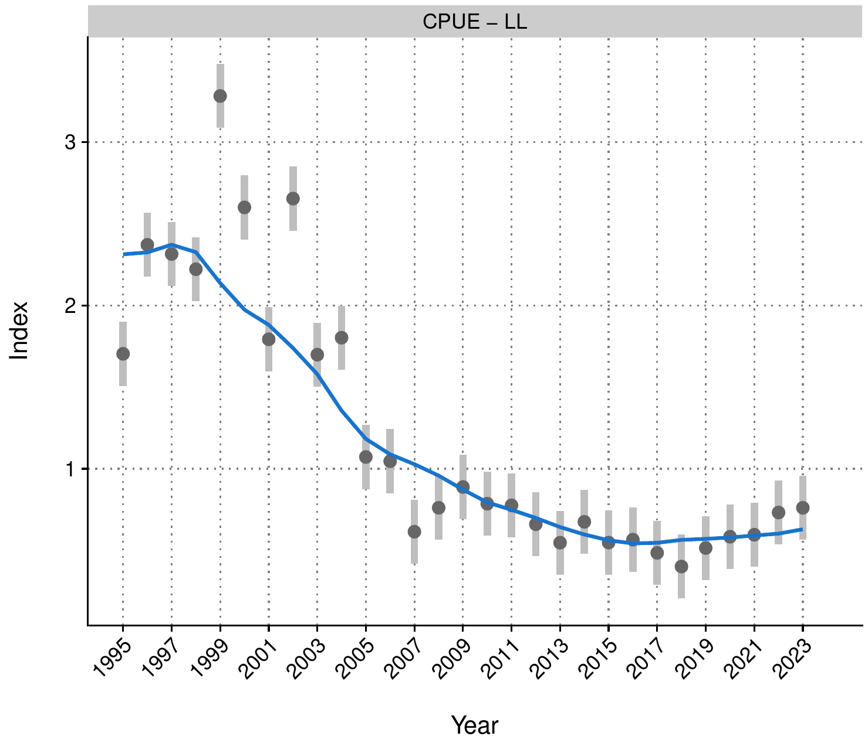

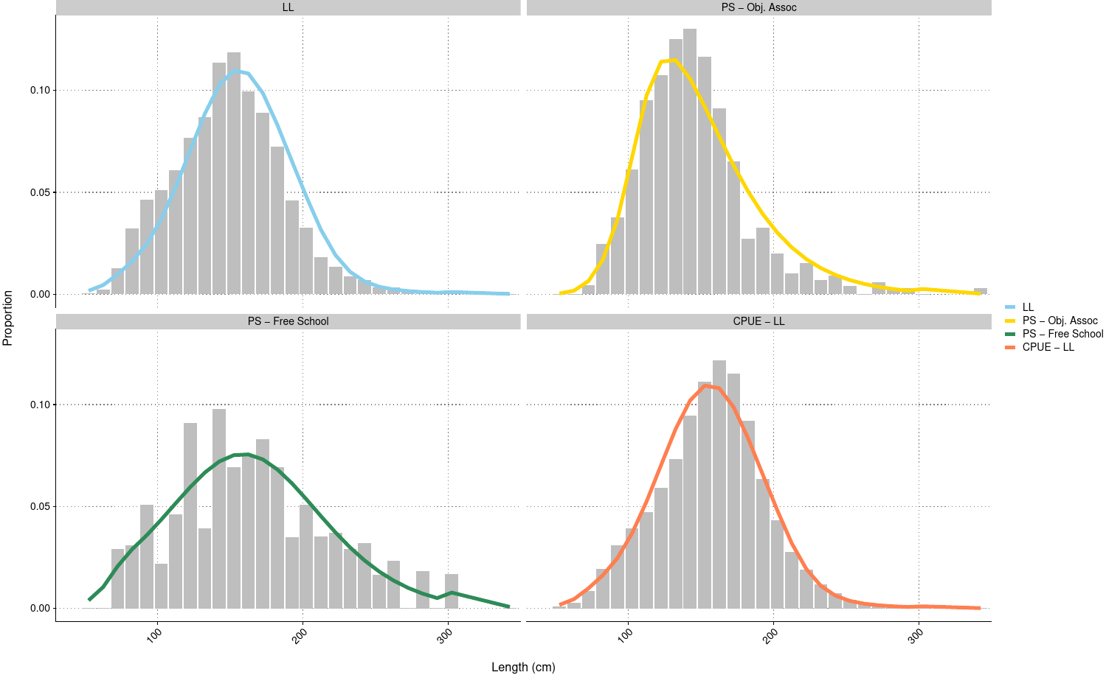
Figure OCS-04. Fits to CPUE and length composition data for the diagnostic model for OCS in 2025.

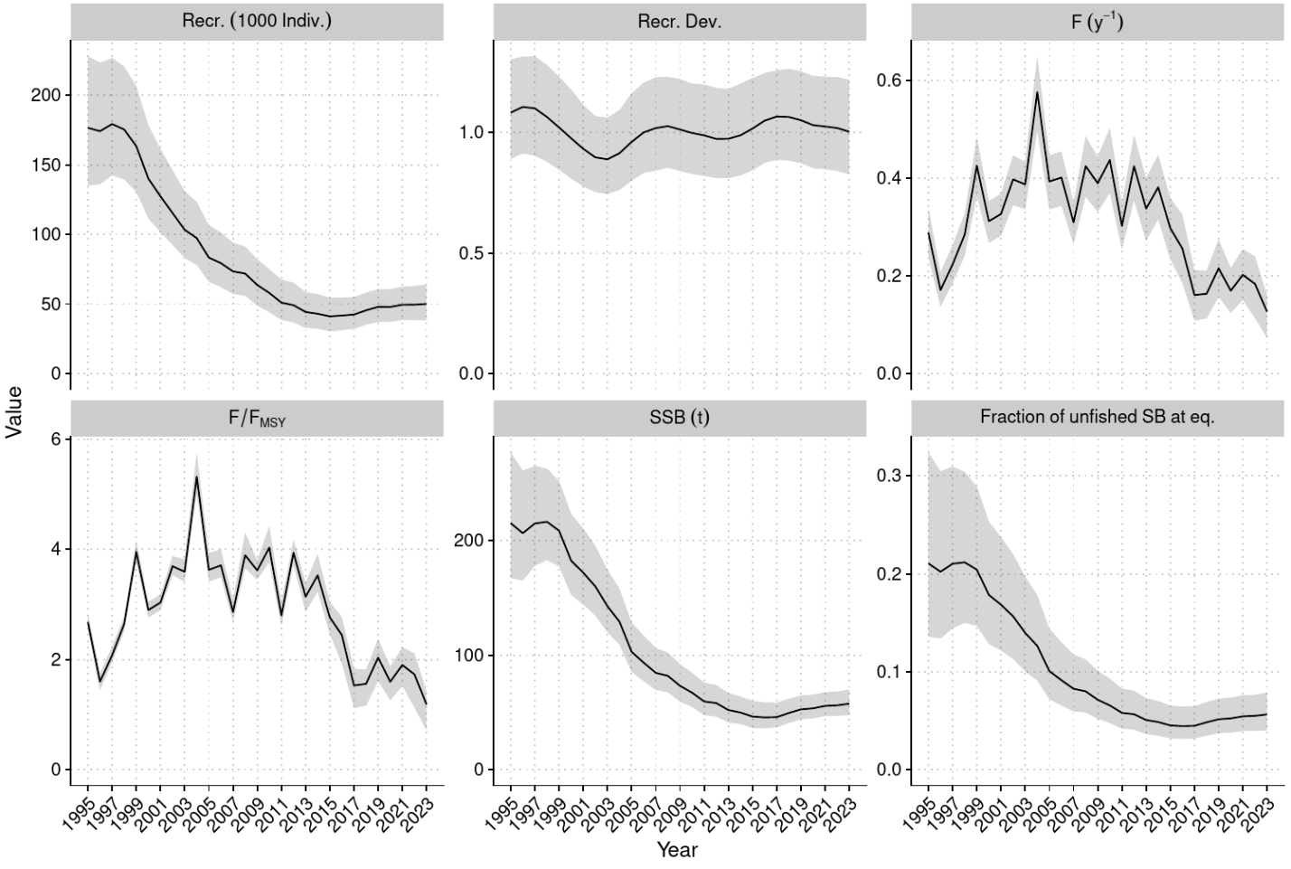

Figure OCS-05. Estimated annual average recruitment (top left), recruitment deviations (top middle), fishing mortality (F; top right), fishing mortality relative to FMSY (bottom left), spawning biomass (bottom middle), and spawning biomass depletion (bottom right) across the model ensemble.

  - Stock status

- SC21 noted that there are no agreed reference points for sharks in the WCPFC. The 2025 model suggested that stock status has been improving since 2015. Recent fishing mortality was estimated to be below suggested biological reference points for sharks with high probability (F_{recent}/F_{crash} = 0.54 [95% credible interval 0.37-0.74]; Figure OCS-06, Table OCS-03).

- SC21 noted that the 2025 assessment for oceanic whitetip shark concluded that the stock was overfished at 6% of estimated unfished equilibrium biomass, and as likely as not to be subject to overfishing (F_{recent}/F_{MSY} = 1.07 [0.73 – 1.39]; P[F>F_{MSY}] = 0.57).

- SC21 noted that the multi-model ensemble indicated recent fishing mortality rates are below suggested limit reference points (F_{lim} and F_{crash},, WCPFC-SC15-2019/MI-IP-04), and current estimated fishing pressure is unlikely to preclude stock rebuilding.

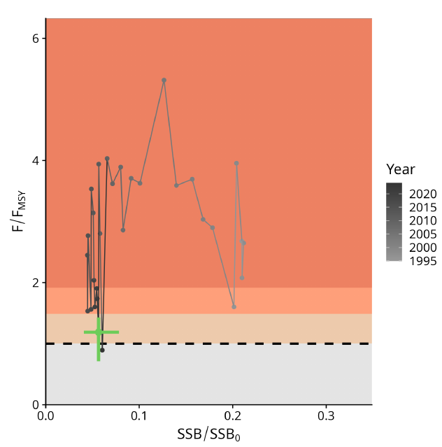

Figure OCS-06. Majuro plot summarising the results for each of the models, including uncertainty arising from estimation, structural, and intrinsic uncertainties (variability and process error). Note that the SSB axis has been truncated to better depict the results.

  - Management advice

- SC21 noted that the 2025 oceanic whitetip assessment concluded that while oceanic whitetip shark remains severely depleted at approximately 6% of unfished biomass (Table OCS-03), recent signs of recovery indicate conservation measures are likely providing some positive effects.

- SC21 noted that the largest reductions in mortality appear to have come from changes in longline fishing practices, suggesting gear-based mitigation measures have been effective. However, given the subtle nature of estimated recovery and persistent uncertainties, continued monitoring is essential.

- SC21 noted that the assessment provides high confidence that recent fishing mortality is below levels that would preclude rebuilding, with F/F_{crash} ratios well below 1. It is as likely as not that recent fishing mortality has exceeded F_{MSY.}

- SC21 additionally recommended continuing multi-model assessments for shark species, where possible, to address persistent concerns with data quality and structural assumptions.

- SC21 noted the need for improved observer data collection to inform monitoring of shark abundance trends and shark post-release survival. SC21 also noted this would be expected to inform the review of implementation of CMM 2024-05 paragraphs 21 and 22.

- SC21 recommended that the IWG-ROP assess and identify specific data gaps for enhancements needed in order to improve the accuracy and consistency of shark species identification and reporting, noting lower reporting rates of oceanic whitetip sharks by observers relative to logbooks in some regions and diminishing levels of length records since the implementation of CMM 2011-04.

- Given persistent uncertainties about stock structure and life-history parameters, SC21 recommended that tagging, genetic, and life-history studies be conducted to improve the biological baseline for future stock assessments of oceanic whitetip shark.

Table OCS-03. Stock status summary table
Summary
Year: 2023 | Fishing mortality | Likely (>60%) to be below tentative limits
 | Recommendation | Stock is increasing slowly, and F is declining at the current catch; maintain conservation measures to minimize fishing mortality. There is a high level of confidence that recent fishing mortality is below levels that would preclude stock rebuilding.
Reference points |  | Estimate [5%--95%] |  | Comment
Fishing Mortality | F_{MSY} | 0.11 [0.09 – 0.13] |  | (not agreed)
Fishing Mortality | F_{Lim} | 0.16 [0.14 – 0.18] |  | (not agreed)
Fishing Mortality | F_{Crash} | 0.21 [0.18 – 0.24] |  | (not agreed)
Recent (2023) estimates |  |  |  | Recent trend / projection
Biomass | SB_{recent} | 12 630 [7 670 – 19 350] |  | SB_{recent} increasing
Depletion | SB_{recent}/SB₀ | 0.06 [0.04 – 0.08]
Fishing mortality | F_{recent} | 0.12 [0.07 – 0.16] |  | F_{recent} declining
Status |  |  | Likelihood
Fishing mortality | F_{recent}/F_{MSY} | 1.07 [0.73 – 1.39] | As likely as not (40%-60%) to be above F_{MSY}
Fishing mortality | F_{recent}/F_{lim} | 0.71 [0.49 – 0.93] | Likely (>60%) to be below F_{lim}
Fishing mortality | F_{recent}/F_{crash} | 0.54 [0.37 – 0.74] | Very likely (>90%) to be below F_{crash}

  - Projects and Requests
    - Application of Close-Kin-Mark-Recapture methods (Project 100c)
- S. Nicol (SSP) presented Project 100c (Preparing WCPO tuna fisheries for the application of CKMR methods to resolve key stock assessment uncertainties, 2023-2025), which comprises three working papers (SC21-SA-WP-09, SC21-SA-WP-10, and SC21-SA-WP-14). The SSP advised that the epigenetic calibrations remained delayed whilst the technical partners continue to refine the method for high volume and cost-effective applications of epigenetic ageing. Scoping studies for South Pacific swordfish and bigeye are complete, as is the feasibility study for South Pacific albacore. The Standard Operating Procedures for CKMR tissue have been developed and tested. Contamination and DNA degeneration rates are below 4% when the SOPs are followed, demonstrating that the collection of tissue samples is unlikely to be an impediment to CKMR applications. Over 160 samplers have been trained in CKMR sampling, providing capacity for over 50,000 South Pacific albacore samples to be collected per year. Tests of the assay for kin identification are complete, and the sequencing of ~15,000 tissue samples identified three parent-offspring pairs and 12 half-sibling pairs. This indicates that no refinement to the number of samples collected (36,000-84,000 samples), as recommended in Tremblay-Boyer et al., (2024), is expected to be required for estimation of CKMR-derived population estimates for South Pacific albacore. The SSP advised that the population structure analyses for South Pacific albacore identified three genetic groups. The spatial composition of the genetic groups supports the latitudinal movement assumed in the last stock assessment for South Pacific albacore and the past tagging data that indicates some (but more limited) longitudinal movement. The process (spatial, temporal, or other) driving this structure has not yet been assessed. The SSP advised that additional sampling of spawning adults would allow the underlying process to be established. Sampling of albacore from the Southeastern Pacific is planned, but the samples are yet to be collected. The addition of samples from this region may result in further identification of additional genetic groups. The SSP advised SC21 that, based on all the outcomes from Project 100c, the CKMR application was feasible for South Pacific albacore.

Discussion
- Samoa, on behalf of FFA members, generally supported the recommendations from SC21-SA-WP-09 but sought clarifications on what resourcing is required for the inclusion of CKMR data in future assessments of the South Pacific albacore. They supported the expansion of sampling efforts in the EEZs of the Solomon Islands, American Samoa, and Tuvalu, and gaps between New Zealand’s east coast and the EPO, to better understand the South Pacific albacore population structure. They noted the results summarised in the paper and recognised the value of the evidence presented that can inform the configuration of tuna assessments and inform CKMR sampling designs and analytical pipelines for Project 100c.

- China stated it was glad to be able to start a collaboration with the SSP to collect samples from the EPO. They noted that from the current sampling in the WCPO area, the SSP identified three genetic groups, and that inclusion of EPO tissue samples would likely result in the identification of even more genetic groups, but that the issue is how to interpret this and link it to the stock assessment. They observed that when considering CKMR data and the assessment, a predefined population structure is normally used, and inquired how that would be changed if research suggests there may be multiple genetic groups. They stated that this raises the question of what is meant by a genetic group. Is it equivalent to a subpopulation, and do we need to modify the population structure from the stock assessment? And how relevant is this to the conservation of the population? China stated that if the genetic differentiation is suspected to result from different spawning grounds or spawning groups, it would be very useful to try to find these spawning grounds and their location and time. And if they are truly geographically or temporally separate, then we have gained information to help the stock assessment more realistically model the dynamics of potentially a meta population. That links to a potential follow-up project on tagging, telemetry, or other techniques to try to see where the different spawners spawn.

- The SSP stated that the analysis done to date suggests that there is a level of spawning isolation that is occurring. The mechanism for that, whether spatial or temporal, has not yet been identified, and for that reason, they recommended that future sampling focuses on the sampling of genetic tissue from spawning adults, given that they can then associate space and time with the actual events of spawning, which helps resolve those types of issues from a stock assessment perspective. The importance of the current results is that genetically, there is strong evidence to suggest that there are quite unique spawning aggregations that occur in time and space across the South Pacific. But the actual fishery is not catching fish that are necessarily specific to those spawning groups. So, at any point in time for a non-spawning fish that is caught in one particular location, there is a probability that it could be made up of any one of those genetic groups. In that sense, it is responding as a mixed fishery of capture of those genetic groups. That doesn’t necessarily relate to having a different stock structure, to saying there are multiple different stocks. The SSP stated the need to be cognizant that there are multiple different genetic groups within the stock that is being assessed. CKMR makes it possible — through the level of provenance or genetic group assignment — to understand if any genetic groups are undergoing higher fishing mortality than others. This knowledge would not be available in the absence of CKMR or another genetic assignment, and would likely require employing very conservative TRPs, or otherwise working through the MSE process to ensure the likelihood of depleting any particular genetic group is minimised. The SSP agreed that this opens a question for the Commission on how it wishes to structure future albacore assessments, and raises questions about how to undertake future sampling.

- China responded, noting that the mixed fishery relates to the fishing process in the stock assessment model, but that the assumption of a single stock or multiple stocks represents a very different fundamental assumption for stock assessment.

- In response, the SSP referenced Figure 5 in SC21-SA-WP-10, noting it shows a significant separation of genetic groups between French Polynesia, for example, and Fiji and further west. They noted if the mechanism of these genetic groups being maintained was spawning-ground related, so a spatial component, it would depend somewhat on the timing of taking those samples. If they were taken during the spawning season, for example, one would expect that sort of separation. But if they were taken during the low point in the spawning season, say in August or July, perhaps there would be more mixing. The SSP stated that the data can be broken down by time of sampling, but unfortunately, given the nature of the current sampling, there's probably insufficient balance between spawning and non-spawning seasons to understand that. The specific data are provided in Table 2 in SC21-SA-WP-10 (proportional representation of each genetic group by sampling location). They agreed that from a stock assessment perspective, there is a need to consider how this is managed — whether South Pacific albacore is thought of as separate populations, or as a single population — and whether this may require a more conservative approach in terms of setting reference points. The SSP stated that these are decisions for SC to address over the next 12 to 24 months before the next South Pacific albacore stock assessment.

Outcomes
- SC21 thanked the SSP for their extensive work on Project 100c, acknowledging the progress made and the preliminary results regarding the genetic structure of SPALB. SC21 noted that further consideration was needed on how these results could be applied to future stock assessments.

- SC21 generally supported the recommendations in the working paper, particularly the suggestion to expand sampling efforts into eastern areas such as the Solomon Islands, Samoa, and Tuvalu, as well as the region between New Zealand’s east coast and the EPO, in order to improve our understanding of the SPALB biological characteristics, such as stock structure and growth.

    - Longline effort creep and CPUE index collaboration across Tuna-RFMOs (Project 122a)
- Pew stated that as part of the NGO contingent supporting the project, they viewed the proposed workshop as critical for tuna RFMOs globally, noting CPUE indices are possibly the most important set of data informing both stock assessments and MPs as they are developed, and better developed and more precise indices will generate more reliable stock assessments and MPs, and thus benefit management. Pew encouraged CCMs to consider this carefully and hopefully prioritize this project for funding.

- P. Hamer (SPC-OFP) provided a brief overview of the project's background and progress, as outlined in SC21-SA-IP-16. Project 122: Progress report on the scoping study on longline effort creep in the WCPO. The initiative began in 2024 as an online effort-creep-focused project. The scope has since broadened to include longline CPUE, reflecting a consensus across tuna RFMOs on the importance of advancing technical work in this area. To address these needs, a workshop is planned with objectives to; (i) review the current status of CPUE standardized methods, (ii) conduct technical work, (iii) develop a set of good practices on longline CPUE analysis, and (iv) prepare a paper in a special issue of a peer-reviewed scientific journal.

    - Biology from billfish in longline fisheries (Project 125)
- The SSP presented the working paper associated with Agenda Items 4.7.3, 4.7.4, 4.7.6.4, and 4.7.6.5 Sampling Plans (Projects 117, 118, 125, and 126) (SC21-SA-WP-15). The SSP explained that the approach adopted (based on consultation with SC members) was to focus on two contrasting life histories (skipjack and bigeye) and undertake an analysis to evaluate the bias associated with Proportional Sampling, Fixed Sampling, and Random Sampling using operating models developed for the last stock assessments for each species. Proportional Sampling performed markedly better than Fixed Sampling for both skipjack and bigeye, regardless of whether selectivities were a function of length or age. This suggested that the size composition of WCPFC catches is sufficiently representative of the population and that sampling plans could be developed using size composition information from available samples based on the 5-year period (2019 –2023). The SSP requested SC21 guidance on the next steps of progressing to developing sampling plans based on proportional sampling (i.e., sampling plans that determine the number of samples to be collected by fleet, flag, and region to be calculated).

Discussion
- PNG, on behalf of FFA members, thanked SPC for the paper. They supported the recommendation to adopt proportional sampling as the preferred method for collecting biological samples for tuna, billfish, and sharks. We note that endorsing this sampling approach will have implications for the sampling plans in the four related SC Projects 117, 118,125, and 126.

- Fiji thanked the SSP for updates on reported projects, including Project 126. They supported the no-cost extension for Project 126, which will ensure the development of a statistically robust, spatially and temporally optimised sampling plan for sharks. However, we seek clarification from the SSP regarding the projected costs and their feasibility within current budget allocations.

- The SSP stated that in terms of the cost implications, there are none for a no-cost extension; in terms of the work, there's no implication from a cost perspective from that side. For SC22, the SSP will present essentially a finalisation of these sampling plans, which will be a design that has an allocation by fleet, by area, and then it will be for SC22 to decide the practicalities of being able to implement that within their national and domestic observer programs, plus those within the regional observer programs.

- Chinese Taipei offered to provide support from its observer program, and inquired regarding the length-sampling aim for each length class to have a 50/50 male–female ratio, noting that would not be possible for some size classes. The SSP thanked Chinese Taipei for the offer of support, and stated that the sex ratio would be tailored to the characteristics of each species, and that they are aware that they would see, particularly in the larger size classes, a difference in the proportion of sexes per size class.

Outcomes
- SC21 agreed that the development of a structured sampling plan for sharks and billfish is important and necessary to the improvement of the stock assessments and advice provided to the commission, and that an update to this project should be presented at SC22 after the completion of Project 118 (WCPFC billfish biological sampling plan).

    - Developing sampling strategy for sharks (Project 126)
Outcomes
- SC21 agreed to a no-cost extension to continue work on this project based upon the sampling plans developed in Project 117.

    - Stock connectivity scoping study (Project 128)
- B. Moore (CSIRO) presented SC21-SA-WP-13, summarising the outputs of Project 128. Project 128 consisted of two objectives: 1) to undertake a feasibility study to understand the connectivity of SKJ and yellowfin tuna across the region, with a particular focus on the western Pacific Ocean and East Asia region and the wider WCPFC-CA, and 2) to develop Terms of Reference for a larger project to investigate this issue. The key recommendations from the feasibility study were that:
- A genetic approach was the most likely to reveal fine-scale stock structure across the regions of interest.
- Sampling should focus on young-of-the-year (YOY) fish, as small as possible, from a set of representative sampling locations. Spawning adults/larvae should be sampled at ~3 locations to validate signals in young-of-the-year fish.
- Low Coverage Whole Genome Sequencing (LCWGS), an emerging genomic approach, be used for the analysis.
- The project should take a phased approach with repeated intra- and inter-annual sampling.
- Training in the use of genetic sampling tools and in sample collection be undertaken in Indonesia, Philippines, and Vietnam.
- Some preliminary analyses should be conducted to support further proposal development and funding acquisition, specifically an assessment of the impact of different connectivity scenarios on the regional yellowfin tuna (and potentially skipjack) stock assessment, and a pilot study of the LCWGS approach, using existing samples.
The draft TOR charted the work necessary to improve understanding of connectivity in the region, outlining a 4-year project using LCWGS of sampled muscle tissue that could feasibly provide provisional results to inform the 2028 SKJ and 2029 yellowfin tuna stock assessments. A separate, smaller TOR was included to cover the preliminary analyses described above to support further proposal development and funding acquisition.

Discussion
- China stated that they generally supported the TOR for the project, but observed that for 2026, the authors sought to assess the impact of different connectivity hypotheses on the results of the assessment, while the entire purpose of this project is to generate those connectivity hypotheses. China questioned whether such an assessment should not be delayed until after doing all the genetic analysis, when there is a better understanding of what could be a more realistic connectivity pattern, and a simulation test can then be done. China also suggested the title should refer to Southeast Asia, because it includes Vietnam, Indonesia, and the Philippines.

- CSIRO stated that the Phase 1 work described in Section 3 of the paper is designed to boost understanding of the influence of different connectivity scenarios between the WPEA region and the broader WCPFC-CA on the stock assessment and management advice for yellowfin tuna in the WCPO, as well as to assess the feasibility of using the LCWGS approach for detecting connectivity, based on existing samples (including sample size and analytical requirements). This is important to do before embarking on a costly field sampling project, as described in Section 2.

- China stated the concern that, from the explanation, it appears the modelling is more of a sensitivity test to see whether it matters if there are different connectivity patterns. China inquired what action would be pursued if the simulation found that it is not sensitive. They also noted that connectivity hypotheses are generated from literature reviews, and asked whether, after carrying out the entire project, the authors would not have a new hypothesis, requiring the modelling test to be run a second time again to see whether the resultant connectivity hypothesis is affecting the assessment results. In terms of timing, China noted that in 2026, there was a lot of work on stock assessment and management procedure (MP) evaluations, raising the question of whether the SSP has the capacity to pursue this sensitivity analysis.

- CSIRO noted that SPC recommended that the Phase 1 work component be included in the project. With respect to remodelling at the end of the project, that isn’t included in the genetic study budget.

- The SSP stated that, in hindsight, and following the observations from China, SC might consider incorporating this element into some of the preliminary work to be done for the yellowfin stock assessment in 2026, in order to get an idea of the sensitivity of the current model to connectivity levels, perhaps using the SEAPODYM model to inform that. This would lead to some budget savings. The SSP further noted that, potentially, it is feasible to get information on connectivity, or at least pose reasonable hypotheses that are consistent with the environment and the life history as it is known for these two species, using the SEAPODYM model. The SSP stated it routinely uses SEAPODYM to produce probability matrices of movements between all of the regions that are considered in the stock assessment model. Those could be provided immediately for comparative purposes or as a hypothesis-framing mechanism. The SSP also stated that it is likely reasonable (certainly in far western areas) to assume that Young-of-the-year are taken from areas where they originate. There is access to very small fish in Indonesia, Philippines, etc. For the areas east of that (such as Tonga), the SSP inquired what the source of those samples would be in areas that don't have substantial fisheries, such as purse seine fisheries, targeting the smaller sizes of these fish. The SSP inquired whether it would be worthwhile to check once again using SEAPODYM or the Ikamoana offshoot to see what the sort of dispersal would be for the sizes of fish that the project intends to sample, where they may have originated, even if just drifting passively.

- CSIRO agreed regarding sampling of the young of the year in the southeastern region, and difficulties posed by sampling around Tonga or Fiji. They stated they agreed with the suggestion to use SEAPODYM or Ikamoana to look at possible dispersion patterns, and based their sample selection on what is held by the Pacific Marine Specimen Bank. The eastern locations are included for perspective from the eastern region of the Convention Area. If comparable sizes to what is obtained in the Southeast Asian region are not available, CSIRO stated they would try to obtain fish that are as small as possible, but also concentrate on getting an adult population of spawning adults or larvae from an eastern location to help validate the signal, if possible.

- Kiribati, on behalf of FFA members, acknowledged the importance of improving our understanding of yellowfin and skipjack tuna connectivity in the WPEA region and its influence on regional stock assessments and management advice, as this has been an important area of uncertainty in stock assessments for WCPO tropical tuna. They stated that the outcomes of Project 128, as outlined in SC21-SA-WP-13, demonstrate that a scientifically credible and logistically feasible pathway exists to investigate stock structure using modern genomic techniques. They noted the feasibility findings and preparatory work completed under Project 128, and the proposed draft Terms of Reference and project design for investigating fine-scale connectivity of skipjack and yellowfin using Low Coverage Whole Genome Sequencing. FFA members supported the TOR and recommended its prioritisation for future WCPFC research funding, subject to available resources. They encouraged the SC to explore co-funding opportunities to reduce budgetary pressure on the SC research budget. They acknowledged that including this project within the SC budget would likely require the deferral or reprioritisation of other scheduled research activities, given its relatively high cost. Also, given the reported increase in recent bigeye catches from the WPEA region, FFA members enquired whether bigeye could be considered for inclusion in the project within the proposed budget.

- CSIRO stated that bigeye could be included in the study and that they could incorporate a cost estimate for that.

- Indonesia referenced the points raised by China and stated that they don't really understand the impact of different regional biological characteristics on the stock assessment, in particular for yellowfin tuna in region five or region two. Noting this, they suggested that the connectivity study will potentially give fundamental input to understand that process. Indonesia stated it is already collecting some samples of bigeye and can consider the proposal for the inclusion of bigeye, and would further discuss this with its team and SPC.

- The Philippines noted that the project aims to understand the extent of the distribution and connectivity of skipjack and yellowfin stocks in the WPEA region to the rest of the WCPO Convention Area, and stated that the region exhibits high recruitment of highly migratory stocks in the WCPO in terms of value. They observed that the project will support harvest strategies and MPs and the implementation of compatible measures in CCMs within the WPEA. They endorsed the proposal for consideration and encouraged the solicitation of external funding for the project, and thanked CSRIO and SPC colleagues for the support given by FFA member countries.

Outcomes
- SC21 generally supported the proposed work for project 128a, and further recommended the completion of the impact analysis of various connectivity hypotheses between the WPEA and the greater Pacific basin as part of the preparation for the yellowfin tuna assessment in 2026. If the outcomes of further genetic analyses indicate a different connectivity hypothesis than those considered in 2026, another sensitivity analysis of the new hypothesis would be necessary in future assessments.

- SC21 also recommended that Project 128a collect bigeye tuna samples to apply a similar connectivity analysis.

    - Research Plan Update
4.7.6.1 Tuna Assessment Research Plan (2023 – 2026) annual update

- ISG-01 was convened in reference to SC21-SA-IP-17: Tuna Assessment Research Plan (TARP) 2025–2028 to refine and agree on priority research projects to strengthen tuna stock assessments in the WCPO. Two sessions were held on 14 and 16 August 2025. The first session reviewed the SSP’s proposed priority table, which was circulated for comments. In the second session, members discussed the feedback received and successfully reached consensus on the key projects requiring further resourcing. The discussions were constructive, with strong participation, and Terms of Reference (TORs) were developed for inclusion in the SC21 prioritization exercise. The outcomes of ISG-01 are included in Attachment G.

- The group endorsed several priority areas, including supporting a joint t-RFMO technical workshop on longline CPUE abundance indices, the population structure genetics study to improve understanding of connectivity between the east Asia region and the broader western and central Pacific (focused on yellowfin and skipjack, but consider bigeye inclusion), developing an age-length data pipeline for tuna stock assessments, improvements to size data reconciliation and conversion factors, and support the work on the next-generation tuna model development. While these projects were recognized as critical for advancing robust and defensible stock assessments, members also highlighted challenges such as high funding needs for large projects (e.g. the east Asia/western Pacific population structure project, ~USD 1M), limited SSP capacity in 2026 due to major stock assessments, and the need for long-term sustainability of otolith data collections and ageing programs. Members also noted the importance of developing a clear peer review process, with the US and Australia, to prepare a paper for SC22. TORs for agreed projects have been submitted for SC21’s ranking.

Outcomes
- SC21 agreed to adopt the recommendations put forward by ISG-01 in Attachment G.

4.7.6.2 Billfish Research Plan (2023 – 2030) annual update

- Based on the suggested recommendations in SC21-SA-IP-18 (“Progress against the 2023-2030 Billfish Research Plan - 2025”), the ISG-02 Billfish Research Plan was asked to review and provide feedback on the following elements:
- Review the work plan and project list for the 2025/26 year and make recommendations to SC21 for any changes the SC may want to consider, including any new project priorities.
- Review the project specifications and make any changes for SC21’s review.
- Consider the proposal to re-purpose the biology project 3 (SWO tagging) as a genetics project and develop the ToR at SC21 ISG-billfish.
- Provide feedback on the suggestion for a joint bycatch (billfish and sharks)2021-2030 assessment methods workshop and amend the stock assessment project 6 (new TOR) if approved by SC21 ISG-billfish.
- Review the current billfish stock assessment schedule and confirm accuracy or suggest any revisions.
- A full report and table of projects and assessment schedule is available in the ISG-02 Report (included as Attachment K). The ISG-02 recommended one new addition to the 2021-2030 Billfish Research Plan, to include a joint bycatch (billfish and sharks) assessment methods workshop, to review and recommend potential assessment methods for data-limited billfish. The ISG-02 also agreed to postpone the development of assessment approaches for WCPO black marlin, sailfish, and shortbill spearfish until 2027, following the conclusion of the new proposed workshop to inform those assessments. ISG-02 recommended a revision of one project in the Billfish Research Plan, biology project 3, to undertake directed longitudinal tagging of SW Pacific swordfish to reduce the uncertainty in movement rate. The ISG-02 agreed that there would be more value if this project were amended to remove the tagging elements and instead, to sample a wider range of fish, undertake epigenetic aging work, and genetic analysis of stock distribution.

- ISG-02 recommended two changes to the billfish assessment schedule to reflect updates to the ISC assessment schedule for NP striped marlin and NP swordfish. The ISG-02 also recommended a shift in the scheduled low information assessment characterizations for black marlin, sailfish, and shortbill spearfish from 2026 to 2027, based on the agreement to postpone that work. The ISG-02 discussed potential changes to the assessment schedule for SW Pacific striped marlin and SW Pacific swordfish. Given the current assessment schedule for tropical tunas, it is unlikely that SPC would be able to undertake both assessments in the same year. This issue will be discussed during the workshop to review assessment methods for billfish and sharks, to discuss how these assessments will be conducted, and to determine whether and how to modify the assessment schedule.

Outcomes
- SC21 agreed to adopt the recommendations put forward by ISG-02 in Attachment K.

4.7.6.3 Shark Research Plan 2021-2030 annual updates

- An informal small group (ISG-03) met for one session to review the progress against the 2021-2030 Shark Research Plan (SRP) - 2025 (SC21‐SA-IP-19). The outcomes of ISG-03 are included as Attachment L. The ISG-03 reviewed the recommendations in SC21-SA-IP-19, evaluated the assessment schedule for sharks, and assessed the project list for work due to begin in 2026. ISG-03 suggested removing recommendation 4 (SC21 consider proposing the southwest Pacific (SWP) mako shark assessment as a low information assessment), as since the last assessment, the shark assessments have moved to a 2-year time frame, and the 2026 billfish and shark bycatch assessment workshop may provide a more considered approach to this assessment. ISG-03 noted that the SWP mako shark assessment should not start until the workshop has made a recommendation on a suggested way forward. The assessment models/methodologies should therefore be determined by the billfish and shark bycatch assessment workshop. The stock assessment schedule was revised (See the ISG-03 meeting report). For North Pacific (NP) mako sharks, the ISC Plenary concluded that the indicator analysis had limited usefulness and preferred a two-year schedule for producing North Pacific shark assessments. ISG-03 also noted that once enough data has been collected by the Regional Observer Program, each of the biology projects could be reconsidered pending successful data collection prior to the projects being rescheduled. ISG-03 recommended progressing three projects in 2026:
- A general characterisation of low information shark stocks;
- Epigenetic and stock structure analysis of SWP mako sharks; and
- Post-release survival of oceanic whitetip sharks.
- The ISG-03 noted that two assessments (SWP and NP blue sharks) will commence in 2026.

- Finally, it was noted that the ISC Shark Working Group (ISC-SHARKWG) was not able to commit to undertake a scoping study for CKMR of mako sharks in the North Pacific Ocean as scheduled, and it was noted that the ISC-SHARKWG had postponed this work pending revision to ISC-SHARKWG schedule.

- During the discussion of the outcomes of the ISG on the shark research plan, the IATTC noted that an existing NOAA study was conducted in two of the US longline sectors (the American Samoa tuna fleet and the Hawai’i deep set fleet) but was not included in the shark research plan.

- The USA stated that SC20 requested the ISC-SHARKWG to develop a feasibility study on the use of closed key mark recapture for future shark stock assessments. The ISC-SHARKWG reported to the ISC that the feasibility study could not be developed due to capacity issues. The ISC noted that they would check if this was addressed in the ISC report.

Outcome
- SC21 agreed to adopt the recommendations put forward by ISG-03 in Attachment L.

4.7.6.4 WCPFC tuna biological sampling plan (Project 117)

- Project 117 was included in the presentation given under Agenda Item 4.7.3.

Outcomes
- SC21 noted the sampling plans for skipjack and bigeye tuna that were presented and agreed that the current methodology was robust. SC21 requested that these methods be applied to the other tuna, billfish, and shark stocks, and these results should be provided at SC22.

4.7.6.5 WCPFC billfish biological sampling plan (Project 118)

- Project 118 was included in the presentation given under Agenda Item 4.7.3.

Outcome
- SC21 noted that the SSP intends to provide sampling plans using the methodology described in Project 117 for billfish stocks.

  - Other SA issues
- No other matters were raised.

AGENDA ITEM 5 — MANAGEMENT ISSUES THEME

  - Development of the WCPFC harvest strategy framework for key tuna species
- The SC21 Chair noted SC21-MI-IP-01. Capacity building and stakeholder consultation - 2025 update.

    - Skipjack tuna
5.1.1.1 Skipjack tuna management procedure

- N. Yao (SSP) presented SC21-MI-WP-01. Skipjack MP estimation method analysis: P&L CPUE. The regional Japanese pole-and-line (JPPL) CPUE indices are key inputs to the skipjack tuna MP adopted by the WCPFC in 2022. The paper addresses issues identified through the skipjack MP monitoring strategy relating to the representativeness and appropriateness of pole and line CPUE data used for the skipjack MP. Specifically, it examines differences in CPUE time series developed for the 2022 ‘dry run’ and the 2023 implemented MP, assesses the implications of transitioning from the VAST to the sdmTMB platform for CPUE standardisation, and evaluates the sensitivity of MP performance to reduced future JPPL data availability in the tropical region through simulation testing.

- Analyses found that inconsistencies in penalty application and omission of the sea surface temperature (SST) spatial filter in the 2022 dry run index were resolved by reapplying the SST filter and correcting penalty calculations. This highlights that clear documentation of CPUE standardisation settings should be included in all relevant WCPFC MPs. Transitioning to sdmTMB produced CPUE series and MP outputs comparable to those from VAST. The move to the more future-proof sdmTMB framework is therefore recommended. Simulations showed the MP remained robust to short-term loss of JPPL data in the equatorial region, although long-term degradation remains a concern. The study concludes that the current MP is valid for the next management cycle, while alternative indices should be explored for longer-term resilience.

Discussion
- Japan expressed appreciation for the advances that have been achieved and agreed with the recommendation to maintain the current MP and continue its application in 2026. They noted that, given the reduction in JPPL fishing grounds, they consider the use of purse seine CPUE in the tropical waters as one of the most promising alternative indicators for consideration in MPs in addition to JPPL. With regard to incorporating stock indices derived from purse seine, they stated that challenges — such as handling stock indices from different fisheries — could be addressed through procedures such as applying appropriate weighting or adjusting scales by penalties. Japan looked forward to the continued advancement of the skipjack tuna MP.

- The SSP thanked Japan for the suggestions and looked forward to further discussion on the topic.

- Solomon Islands stated that PNA members welcomed the results in SC21-MI-WP-01 because of concerns about making a change to the MP at this point. They supported the recommendation for the continued use of the adopted MP for the next implementation cycle of the MP.

- Indonesia noted the importance of the JPPL data and asked how the potential long-term degradation of that data would affect the reliability of MP outputs, given the alternate estimation methods provided. They asked whether purse seine CPUE data are reliable to estimate the abundance indices considering the use of FADs, and inquired what alternative data sources could be provided to mitigate the risk other than the purse seine CPUE data.

- The SSP stated that the MP is robust and has been running since 2019, and noted that JPPL data are not the only source; other data sources include tag and length composition data. Also, the JPPL data are only degraded in the equatorial region, and the fishery is still active in fishing grounds 1, 2, 3, and 4, so that information continues to contribute to the estimation method under the current MP. As Japan mentioned, the purse seine CPUE has been used in the current and previous assessments, which is promising because purse seine CPUE will cover the major fishing grounds in the equatorial region, which is where there is less JPPL CPUE data, so these sources complement each other. The SSP noted the need for more research.

- The USA thanked the MSC team for a thorough and comprehensive analysis of potential issues related to the construction and future degradation of the index used in the skipjack MP. They agreed with the conclusions that the MP remains robust in the near term, and also noted the author's recommendation that, in the longer term, alternative data sources may need to be developed to replace the equatorial JPPL index. Given the large amount of work involved, the USA supported beginning that development soon, so that such a product can be considered as part of the comprehensive review of the MP scheduled for 2029. In considering the development of an alternative data source, in contrast to previous comments in support of using a purse seine CPUE index, the US expressed preference for continuing the collaboration with DTU to develop a tag-based abundance index, as used by the IATTC in their recent skipjack stock assessment, as, in their view, it is as a more promising and reliable index.

- The SSP thanked the USA for the comments. On the DTU model, they stated that one of the challenges to consider is that there is some oceanographic information that goes into that model. How to develop that within the operating model framework and what assumptions of future climate would need to be developed to allow that DTU model to operate within the Skipjack MP would need to be considered.

- Nauru, on behalf of FFA members, strongly endorsed maintaining the interim skipjack MP for the next management cycle. They noted that the recent evaluation confirms its robustness with the successful transition to the sdmTMB CPUE standardization, showing negligible impact on MP outputs. While the estimation method demonstrates resilience in the short term, they noted long-term risks from the degradation of the JPPL data and supported developing an alternative abundance index. The consistent 2% annual rise in skipjack catchability since 2008 signals potential efficiency gains masking biomass changes. This trend warrants close monitoring as it may obscure true stock status. They encouraged ongoing work to consider climate change impacts within the Skipjack MP operating module grid.

- R. Scott (SSP) presented SC21-MI-WP-02. Impacts of FAD closure duration on the skipjack MP, which presents analyses conducted to determine the potential impact of changes in the duration of the FAD closure on the expected performance of the interim skipjack management procedure. A FAD closure period of 3 months in EEZs and high seas, plus an additional 2 months on the high seas, was initially assumed when testing the adopted skipjack management procedure. Following changes in the FAD closure period in 2024, SC20 requested an evaluation of the impacts of these changes on the expected performance of the management period. The analyses were conducted using the same evaluation framework as that used for the development and testing of the adopted skipjack MP. Three alternative FAD closure scenarios were considered: 1) a 3-month prohibition of FAD fishing in EEZs and high seas, plus an additional 2 months on the high seas. 2) a 1.5-month prohibition of FAD fishing in EEZs and high seas, plus an additional 1 month on the high seas, and 3) no prohibition of FAD fishing. For each scenario, the same baseline level of purse seine fishing was assumed (as determined by the MP), such that the overall level of purse seine fishing is the same, but the relative proportions of FAD and free-school sets change. The results indicate that changes in the extent of the FAD closure under these scenarios have only a very small impact on the expected performance of the skipjack management procedure.

Discussion
- Nauru, on behalf of FFA members, thanked the SSP and noted the analysis showing CMM 23-01 modified FAD closures will have minimal effect on MP performance. They noted issues for development, including quantitative effort creep metrics, enhanced logbook accuracy standards, and refinement of VMS data analysis, and items for inclusion in a future report, such as indicators for FAD deployment and FADs monitored per vessel.

- Japan stated that the analysis concludes that shortening or eliminating FAD closure periods has minimal impact on the performance of the skipjack MP in terms of depletion or catch, but indicated they are unclear why this is the case. Japan stated the indicator analysis presented in SC21-SA-WP-03 shows that nominal CPUE varies among set types (e.g., 35 mt for free schools and 44 mt for drifting FAD sets in 2024). If the set type composition changes because of the closure period, one would expect catch dynamics to change as well. In addition, looking further into the stock assessment documents, it is strange that the impact is not reflected at all, given that sizes differ when targeting FADs and free schools. Japan asked the SSP to elaborate on why these changes do not affect the MP's output.

- The SSP stated that the approach is to use the models in the OM and project those forward, based on the catchability values and the selection patterns in those OMs. In many cases, the catchability is not too different from the fitted OMs. The selection pattern does change somewhat, with a small change in selection selectivity between the type of purse seine (FAD fishery and free school fishery), with the free school fishery catching slightly larger fish. That is potentially why there is a very small reduction in the spawning biomass depletion level over time, because it shifts to those younger fish, and impacts the maturity state of the overall population somewhat. There is little change in the catches because at that point, those fish, although they're a little bit younger and potentially less mature, are about the same size. Skipjack tuna grow very quickly, so this doesn't have much impact in terms of the catches. But there is some change in the depletion level over time, potentially as a result of those different selection patterns and selectivity curves.

- Japan inquired about the general ecological effects on skipjack, noting that FADs impact skipjack aggregation, and a longer FAD deployment period could increase the total time fish spend remaining aggregated, potentially altering their natural movement patterns. While the movement parameters are currently fixed in the EM, if the FAD period continues to be shortened in the future, Japan suggested it may be necessary to review these movement settings and asked for thoughts.

- The SSP stated that the broader life history dynamics and behaviour of skipjack are not captured by its current models, which have a simpler structure. The SSP stated that it would be interesting to see what information is available, what potential impacts this might have, whether this should be included in future evaluations, and how it could be incorporated.

- Japan inquired how the scalar is estimated to allocate the reduction of FAD closure to the free school.

- The SSP stated that this is related to work done under the tropical tuna measurement evaluations presented to SC20. The approach is to look at the relative level of FAD and preschool fishing and how that's distributed through the year, and the relative levels of effort. They stated that if, for example, a FAD closure period is reduced by 50%, giving an extra 1.5 months of FAD fishing potential, then the scalars can be applied to readjust the distribution of fishing between those two components. This was done on a fishery-specific basis to work out the relative proportions of expected or anticipated increased effort under the free school fishery for those fisheries in regions 5, 6, 7, and 8. An average across those regions was taken, and a single scalar was then applied to the overall fishery. This spreads any increase or reduction in FAD fishing across the whole region.

- China commented that the potential assumption is that the total fishing effort remains constant, with the closure only affecting the proportion between the FAD and free school, but based on their experience, vessels typically reduce activity during FAD closure. A shortened closure could then lead to an increase in total effort rather than just redistribution. China inquired if the SSP has investigated the total effort change considering the FAD closure?

- The SSP replied that there is no specific analysis on that point. However, the analysis assumes there would be an increase in FAD fishing under a reduction of the FAD closure and that the change in the fishery and the redistribution of fishing effort would exactly follow the assumed reduction of the closure period. What was seen for 2024 contradicts that somewhat: although there was a reduction in the FAD closure period, there has been an increase in the proportion of free school fishing. It is not the case that reducing the level of the FAD closure necessarily results in an increase in the proportion of FAD sets, but the SSP stated it made the simplifying assumption for this analysis that a proportional increase in FAD fishing would follow a reduction in the FAD closure period. They further noted that the analysis presented in SC21-MI-WP-02 suggests that, despite the increase in free school sets in 2024, the MP is robust to varying FAD closure periods.

- The Philippines stated their understanding that, since various scenarios do not significantly impact FAD closure reductions, and purse seine effort remains the same as in comparison to both unassociated and associated sets during FAD closure periods, would it be possible to confirm changes or shifts in fishing operation patterns?

- The SSP stated that the analysis is based on the number of sets, and they scale up or down the number of sets, respectively, under the FAD and free school fisheries, under that assumption. The fisheries identified in these operating models are a fairly broad collection of fisheries defined by those modelling regions, specifically regions 5, 6, 7, and 8, and each region can contain a combination of high seas and in-zone fishing vessels. That's all lumped into sort of one set of fishery definitions. Across those fishery definitions, they make an assumption of averaging those scalars as well. So it's included but not explicitly modelled in any sort of fine detail, but it does include the CPUE assumptions. A catchability assumption runs through the models, and it is a sort of fishery-specific catchability across those fairly broadly defined fishery units that are disaggregated by the spatial structure of the model.
- Indonesia highlighted the importance of considering other factors in the evaluation, as mentioned by Japan. They asked how other factors — such as environmental variability, fishing effort redistribution, and fishing strategy — might increase catchability during non-FAD closure periods, and interact with changes in the FAD closure duration and affect skipjack stock sustainability in the long term.

- The SSP stated that this relates to some of the work to build in climate change components, to look at what can be modeled, and to try to understand the impacts on stocks and fisheries under various management approaches and management measures. It is difficult to answer at present.

Outcomes
- SC20 requested that the SSP conduct analyses to: (a) evaluate whether changes in the FAD closure duration (as adopted in CMM 2023-01) will affect the performance of the interim MP; and (b) determine the representativeness and appropriateness of candidate CPUEs for use in the MP.
- On (a), SC21 noted that, based on the analysis by SSP (SC21-MI-WP-02), changes in the FAD closure duration (as adopted in CMM 2023-01) have a negligible impact on the performance of the interim skipjack MP. The effects of the FAD closure period on other tropical tunas were not considered in this evaluation. SC21 also noted that the results are based on the assumption that the relative levels of FAD and free-school fishing change proportionally with changes in the FAD closure period. These assumptions may not always hold, as witnessed in 2024 when the proportion of free-school sets increased notwithstanding a reduction in the FAD closure period.
- On (b) above, based on the analysis presented by SSP(SC21-MI-WP-01), SC21 noted the following: (i) the index used within the 2022 dry run analysis contained inconsistencies in the penalty application within MFCL and did not implement the sea surface temperature (SST) spatial filter. Reapplying the SST filter and correcting the penalty calculations restored consistency with the tested MP, (ii) the transition to sdmTMB for standardization has had minimal impact on MP outputs and is acceptable under current MP settings, (iii) the settings used to develop standardized CPUE indices should be included within MP documentation for all relevant WCPFC management procedures, and (iv) the MP appears reliable in the short term under JPPL data degradation in the tropical region, but presents increased risks in the longer-term.

- Pending agreement by the Commission on proposed changes to the WCPFC harvest strategy workplan and MP implementation timetable (see agenda item 5.1.5), the skipjack MP may next be run in either 2026 or 2027, and the review of the skipjack MP may occur in either 2028 or 2029.

- SC21 supported the continued application of the interim skipjack MP for the next implementation cycle, while also emphasizing the importance of further development of alternative indices in advance of the third implementation of the MP. This work should be conducted as part of the scheduled MSE review in 2028 (or potentially, 2029). SC21 further noted that changes to the tuning indices used by the MP may require reconditioning of the OMs and retesting of the MP, which is a considerable undertaking.

5.1.1.2 Monitoring strategy for skipjack tuna

- R. Scott (SSP) presented SC21-MI-WP-03. Skipjack monitoring strategy. The skipjack management procedure monitoring strategy was adopted at WCPFC21 and identifies a number of issues pertaining to the design, testing, and implementation of the management procedure. SC21-MI-WP-03 considered the ongoing development of the monitoring strategy in the light of analyses presented to SC21 to specifically address a number of these issues (SC21-MI-WP-01 on the representativeness of pole and line CPUE data used for the estimation method, and SC21-MI-WP-02 on the impacts of changes in the FAD closure period). It was noted that additional data requested by TCC for monitoring compliance with the MP would be provided to TCC21 and that work to develop climate change scenarios for the OMs would be carried out as part of a longer-term study. It was further noted that the 2025 stock assessment of WCPO skipjack (SC21-SA-WP-02) would also provide important information for monitoring the performance of the MP, subject to acceptance of the assessment by SC21.

- The theme convener discussed approaches to updating the monitoring strategy for the skipjack MP (Table 1 in SC21-MI-WP-03), and invited comments from CCMs.

Discussion
- Japan stated that the relationship between the monitoring strategy and the stock assessment for the skipjack MP is not yet clearly defined in the table. Japan inquired how the stock assessment result is evaluated under the monitoring strategy. Which value or specific ER would be evaluated?

- The theme convener stated that the stock assessment is used only for the year in which it is done.

- The SSP confirmed this and stated that the output from the 2025 stock assessment will be examined to see if it is consistent with the predicted performance of the stock under the MSE testing scenarios. One of the outputs of the stock assessment is the recalibration of the TRP, using the rules and formula developed by the SSP for calculating the skipjack TRP, and comparing the recalibrated TRP from the new assessment with the expectations from the MSC evaluations and testing process. That is included in the skipjack stock assessment to show the comparison of the recalibrated TRP to expected performance.

Outcomes
- Based on the discussion and information available, including the 2025 skipjack stock assessment, SC21 made the following updates to the skipjack monitoring strategy table, as shown in Attachment M.

    - South Pacific albacore tuna
5.1.2.1 South Pacific albacore management procedure

- F. Scott (SSP) presented SC21-MI-WP-04. South Pacific Albacore: MP evaluations. The paper presents recent evaluations of candidate management procedures (MPs) for South Pacific albacore (SPA). The key differences with the evaluations presented at SMD02 and WCPFC21 in 2024 are that, following the mixed fishery approach and as described in WCPFC Circular 2025/17, the SPA MP now applies to longline and troll fisheries operating south of 10S in the WCPFC-CA. To perform the evaluations, it is necessary to make assumptions about catches of SPA in the Eastern Pacific Ocean (EPO) and the longline fisheries operating between the equator and 10°S (the tropical longlines – TLL). The future catches are fixed at the average of 2014-2023 catches: 18,000 mt per annum in the EPO and 9000 mt per annum for the TLL. Sensitivity tests are conducted around these future catch levels.

- Four candidate MPs are evaluated, which aim to achieve the interim TRP, and the proposed TRP ranges, in the long term. The long-term performance of these MPs is equivalent to that of the candidate MPs presented in 2024. Fewer constraint options are presented as evaluations performed in 2024 showed a limited impact of the constraint on long-term performance. Performance is evaluated using six performance indicators. Each MP achieves a probability of being above the Limit Reference Point (LRP) greater than 0.8. The main trade-off is between expected catches and vulnerable biomass (a proxy for catch rates). The MPs output a catch or effort limit. Allocation of that limit, and how those allocations are managed in practice (e.g., through effort if the allocation is in terms of catch, or catch if the allocation is in terms of effort), is external to the MP.

Discussion
- The theme convener sought clarification that the assumption regarding the new MP — that it applies only south of 10°S and to catch in the EPO — was based not on instructions from the Commission, but on the SSP’s expert advice.

- The SSP replied that papers from SC15 and 16 include a large table describing the operational range of the single stock MPs, and the albacore MP applied to the “southern long line fishery” (operating south of 10° S). But this raised the question of what the “tropical long line fishery” (those operating north of 10° S) was doing, while the bigeye MP was being evaluated and potentially adopted. So, as an interim measure, the 0° to 10°S region was included under the albacore MP, noting that the long-term plan for the mixed fishery approach was always to have the albacore MP operating only south of 10° S. SPC stressed this was not their decision, but reflects that development of the bigeye MP is now underway. Certainly, in 2025, it made sense and was better to have the albacore MP only operating south of 10° S.

- The theme convener noted that the assumptions being made would have important implications if the MP is applied, and observed that in the absence of clear guidance from the Commission on what those assumptions should be, the SSP’s sensitivity tests could assist in the evaluation of the impact of the assumptions.

- Tonga, on behalf of FFA members, thanked the SSP for its ongoing work evaluating candidate South Pacific albacore MPs. They supported the changes made to the MP design, including the change to the area of application to now apply to the WCPO south of 10°S, in accordance with the mixed fishery framework. They also supported the use of a consistent recent average baseline for the assumed catches in the EPO of 18,000 t, and for the WCPFC-CA 0° to 10°S region of 9,000 t. They endorsed the refined estimation method, using solely longline indices, stating this streamlined approach enhances the MP's robustness and future-readiness for stock status monitoring. FFA members noted that the four candidate MPs continue to perform well in terms of biological risk to the stock, but have quite different outcomes in terms of the trade-off between catches and catch rates. They also noted the sensitivities conducted, which evaluated the performance of the MPs when catches in the two external areas were set to higher levels. This resulted in a slight reduction in performance in terms of spawning biomass and catch rates over time, but in general, the FFA members are pleased to see that the MPs are quite robust to higher catch in the two external areas. With the above technical information included, Tonga proposed that this set of candidate MPs be passed to the Commission for decision and adoption of an MP for South Pacific albacore. They noted their commitment to actively participate in the SPAM workshop to accelerate progress and ensure the MP's development, especially concerning the compatibility of the SPA and BET MPs under the mixed fishery framework, and noted they are developing proposals for the SPA MP and MP Implementing Measures, which they will share with CCMs prior to WCPFC22.

- Japan stated that the current HCR parameter values seem to differ from those discussed at WCPFC21 and the number of HCRs has been reduced, but that the reason for these changes did not appear to be clearly documented, and inquired about the decision-making process that led to these changes.

- The SSP stated that in 2024, they had 18 MPs, which were a mix of several different HCRs that were aiming to get to different long-term objectives based on the TRP ranges, but also a large mix of different constraint options. The parameters that define the HCR “shapes”, or curves, differ from those presented in 2024, primarily because now the MP is only being applied south of 10°S. To achieve those similar long-term objectives, it is necessary to retune the HCR, and so the harvest control shapes are slightly different to allow achievement of those same long-term objectives. Rather than importing the 18 MPs from 2024 into the new evaluation framework and then continuing to add to them, the SSP attempted to capture most of the discussions from 2024 into an initial suite of four MPs, which aim for the same long-term objectives, but now have just one constraint option for each of the HCRs, while noting that HCR 9 has a slightly different constraint to the other three. The impact of the different constraint options in 2024 had a fairly small impact on the long-term performance of those MPs. To simplify the suite of available candidate MPs, at the moment, these have only one constraint option evaluated, and that's why there are four. The SSP stated they could continue to evaluate additional candidate MPs if desired.

- The theme convener noted that when the subsidiary bodies act without instruction from the Commission, it can cause problems, and suggested that the presentation clearly explain any actions taken in the absence of specific requests from the Commission.

- China stated that southern albacore tuna comprises bycatch from the tropical longline fishery, including north of 10°S. China stated that effort control measures should be implemented rather than a catch limit, and that in some cases the long-term projections based on a catch limit show stock status going down and even collapsing, and suggested the use of effort control for projections would produce more realistic results. China recalled that in prior SC and Commission meetings. China and some CCMs stated that the actual production in the EPO is close to 30,000 t and suggested that the SSP use the recent 3-year catch for the EPO. China also stated its understanding that normally the same MP should apply across the entire species distribution range, and thus the artificial division of the South Pacific albacore stock along 10°S requires careful consideration, including whether bigeye south of 10°S should be considered in the upcoming MP. China stated that the decision should be made by the Commission and suggested providing more scenarios and options for their consideration.

- The SSP stated that the range of the MP south of 10°S was agreed by SC in the past as the way to move forward with the mixed fishery framework, and that is what it has done. The SSP stated it projects the tropical longline on a constant catch basis, and the suggestion to put it on an effort-based assumption is certainly possible, and one it will definitely consider. They would need to think carefully about an alternative (considerably higher) catch assumption for the EPO. The SSP has some sensitivity tests where it is higher than the current baseline and can perform additional sensitivity tests, but noted it is important not to keep producing more and more evaluations. The baseline assumption of 18,000 mt can be agreed to be changed, but the SP stated it seeks to avoid having multiple baseline assumptions for the EPO and then having to tune the HCRs to achieve the same long-term objectives under those different EPO examples. The SSP advised SC may wish to select one of the existing long-term objectives (for example, to reach the ITRP) and then evaluate what the harvest control would need to look like if the EPO assumption were much higher than the current 18,000 t, and then adjust that HCR to give the same long-term performance under an alternative EPO catch assumption. The SSP stated that the assumptions can be changed based on agreement at SC, but that CCMs should be mindful of the need to avoid having a huge number of different evaluations that need to be done. The SSP also noted that regarding the mixed fishery framework, WCPFC16 agreed that this should be progressed, and that the mixed fishery approach — involving the South Pacific albacore MP working from 10°S — should be used. In terms of the EPO catch, the SSP noted the need to be quite specific because the MP applies to the WCPFC-IATTC overlap area in its evaluations, and if the overlap area is removed from the catch of the EPO, the result is about 22,500 t, which is about the level the SSP looked at within the evaluations. In this context, the EPO excluded the overlap area.

- American Samoa referenced a working paper presented by the SSP that demonstrated the recent decline in the overall economic performance of the South Pacific albacore longline fisheries during COVID-19. The decline was particularly hard-hitting for American Samoa and its neighbours despite good catch rates. The decline in economic performance can be attributed to an all-time low in prices and rising costs. American Samoa experienced this very situation with improved catch rates, but prices declined 26% from 2023 to 2024, and costs rose by 40% in recent years. They noted concern regarding oversupply of albacore in the market affecting prices for island longline fisheries, and stated this underscores the importance of an MP being adopted by the Commission without delay. American Samoa stated its economic performance is declining, and any further delay in adopting an MP will jeopardize the existence of the local island's longline fishery, as American Samoa’s MSC certification is at risk and the local longline fishery depends on it in order to supply the local cannery in Pangpong. American Samoa stated it looks forward to working with other CCMs to best utilize discussions at SC21 to prepare for the South Pacific Albacore Management Workshop in September. They thanked the SSP for reducing the complexity by narrowing candidate MPs from 18 to 4 to allow for more productive discussions at the workshop, and observed that the analysis provided is adequate to inform and proceed with further discussions. They asked that CCMs strongly consider the presented fishery and economic performance indicators that affect local fisheries in SIDS and territories, such as vulnerable biomass and catch stability.

- Chinese Taipei inquired whether the current four MPs are robust to the uncertainty associated with potential future changes in the catch distribution and whether additional scenario testing might be needed to explore this key uncertainty.

- The SSP stated that when these evaluations are run, they necessarily make some assumptions about what's happening with the fisheries outside of the control of the MP, and they run some additional sensitivity tests on those. They stated they can conduct additional sensitivity tests, but it's also worth noting that when or if the MP is adopted, it would be conditional on the assumptions made in the MSC framework, and that those assumptions will continue to be monitored under the monitoring program. So if future catches don't match those assumptions, that would hopefully be picked up by the monitoring strategy, and then appropriate action can be taken if necessary.

- The theme convener noted that this is an important point: if an assumption is breached, a response is needed, either through the monitoring strategy or exceptional circumstances provisions.

- The USA thanked the SSP’s MSE team for again delivering a series of very comprehensive reports to the MI theme and for updating the MP evaluations to match the spatial extent of the proposed albacore MP. The USA stated it is comfortable with the current approach being put forward to the Commission, noting the two sensitivities that the MI theme convener raised in a previous comment. The USA stated that while appreciative of the initiative to reduce the suite of MPs from what was presented to WCPFC20, and while in agreement that the reduced subset of MP candidates generally covers the range of options discussed, from a point of procedure, the USA recommended that future changes to the list of candidate MPs should flow directly from Commission decisions or a subsidiary body. Additionally, the USA also noted statements in this presentation and report, and the bigeye MP report, stating that an MP could be allocated and implemented using different metrics. The example that was provided would be adopting a catch-based MP, but implementing it in terms of effort. The USA stated it agrees with the comment that the authors make that implementation and allocation are external to the MP. However, they noted a technical concern that assumptions made in converting catch allocation to effort limits in the implementation could result in a departure from what was tested in the MP evaluations. The USA recommended that if the Commission adopts a mixed-matched allocation implementation scheme, observed catches be closely tracked as a part of the monitoring strategy. This is to ensure that catch levels do not deviate from what was tested during MP evaluations and that the selected MP still meets management objectives.

- The EU suggested that including a time series with catch in the areas not managed by the MP in the document to be presented at WCPFC22 might be helpful, noting that they were unsure if the recent catches mentioned by China were included in the overlap area until the SSP clarified the issue.

- Australia commented on some of the prior interventions. First, on the use of catch or effort in the 0° to 10° area, Australia stated a preference to assume fixed catch levels rather than effort, and to assume this in both of the two external areas, because it's much more directly associated with fishing mortality. But it's also much easier to include in the monitoring of the South Pacific albacore MP performance, and alludes to what was noted by the USA. Australia stated a continuing need to monitor these external areas, and stated it's much easier to monitor catch; knowing what that catch is assumed to be in the MP is an easier approach. Second, with respect to some additional MPs, perhaps with different EPO catch assumptions, Australia stated it is generally fine with the assumption in both of the external areas in conjunction with the sensitivity analysis that assumes higher catches in both areas, but noted this is a Commission decision, because to some extent it is an allocation question between the two RFMOs. They noted the desire to constrain the number of MPs evaluated and use sensitivities for other scenarios, but stated that if SC is to propose some new MPs, it should do so in a balanced way that facilitates the Commission's decision-making. Australia stated it would be happy to have further discussion in the margins on those issues. Third, on the area of application, Australia stated its understanding and supported the move to an MP that covers only the defined area of the southern longline and separates it from the tropical longline, where the bigeye tuna MP will prevail. This clear separation of the two areas is well-founded based on the biology of albacore temperate tuna and where the catches actually occur. It was, as has been stated, a very intentional design feature of the mixed fishery approach to separate these two management areas so that catch, or more particularly, effort constraints would not conflict between the two MPs. Fourth, Australia echoed the EU’s request for a plot from the SSP showing trends over the last decade or more in the two “external areas”.

- The theme convener welcomed the suggestion from Australia to have informal discussions regarding requests for additional MP evaluations.

- Solomon Islands, on behalf of the PNA, supported the change in the area of application put forward by the SSP, stating that this clearly separates the tropical longline and southern longline fisheries. From the evaluation of the candidate MPs, they stated their understanding that includes the change in the area of application, and were pleased to note that none of the candidate MPs had a probability of breaching the LRP, noting this is an important consideration leading into a Commission discussion and decision-making process on a South Pacific albacore MP.

- The theme convener clarified that, as discussed, the area of application would ultimately be a Commission decision.

- Japan requested clarification regarding SC’s role in forming a recommendation regarding the candidate MPs, given that the MPs had already been reduced in number from 16 to 4.

- The theme co-convener suggested that SC could consider endorsing the results for further consideration by the Commission, noting that modifications that were made without clear instruction from the Commission need to be clearly explained and specified, and the results reviewed.

- The SSP stated that in 2024, there were 18 MPs tuned to achieve particular long-term objectives. Because of the change in the scope of the MP to now being south of 10°S, none of those existing 18 MPs achieved their original intention of achieving those long-term objectives, so all 18 MPs had to be redone. Instead of trying to reproduce all of them, the same long-term objectives (the TRPs) that those MPs achieved were reserved, and the number of constraints that applied was reduced, given that the constraint options that were included did not materially affect the long-term performance of those MPs. The SSP stated it had to do something to move away from the 18 MPs, and has come up with four MPs that capture the same performance as the MPs in 2024, but in a smaller subset. The SSP noted they are always interested and available to evaluate additional MPs. Regarding the change in the geographic scope of the MP, and following on from the comment about WCPSC16's endorsement of pursuing the mixed fishery approach, subsequent to the Commission’s decision at WCPFC21, SPC put out a circular on 04 April 2025 detailing the proposed technical approach. The SSP stated that hopefully, managers will have seen that and be aware of the change resulting from the Commission's decision at WCPFC21.

- China stated that the purpose of the SC is to provide options that ideally should cover the range of concerns the Commissioners may have. At this stage, we are providing four options, and we do not know if those four options have adequately captured their concerns or thoughts. For the sake of trying to reduce the probability of going to the Commission meeting and get additional requests that have not been prepared and postpone the whole process to the next year, China suggested it may be good practice to hold discussions during the margins on possibilities to have additional MPs that may reduce the probability of having an abrupt objection during the commission meeting, which may be likely when faced with only four options.

- Australia voiced agreement with China, stating that it may be possible to anticipate one or two of the issues that could be raised. They noted that the South Pacific Albacore Management workshop (occurring on 11–12 September 2025) will be evaluating what comes out of SC21, and hopefully, the SSP can do additional evaluations. There is an opportunity then to have input on alternative MPs. Australia stated that the four MPs that were evaluated for SC21, together with the exploration of the sensitivities that looked at the higher catch scenario, essentially capture most of the set of MPs that were considered at WCPFC21. But the procedural issues are valid, and suggesting a few other MPs to evaluate, which can be passed through to the next round (in September), could facilitate the overall process.

- Samoa, on behalf of the SPG, expressed concern about further delays. They noted that the future of the South Pacific albacore stock is very important to SPG CCMs, as well as to several other South Pacific coastal states and territories, and all participants in the southern longline fishery. They stated that they do not have the great abundance of tuna resources available to states with equatorial EEZs, the option of shifting their vessels into other regions when stocks get low, or the option of feeding their people from other protein sources. The SPG stated their aim for WCPFC22 is to get an MP and an implementing CMM in place to secure the future of this resource. The SPG acknowledged that SC is a scientific advisory body with a limited remit and that management decisions will be focused through the September Management Working Group and made at the Commission meeting in December, but stated that advice from SC will be very important in guiding those decisions. The SPG stated it is not seeking a high-risk management procedure that maximizes total sustainable yield, but a robust, fault-tolerant procedure that recognizes the limits to our biological knowledge and the approximate nature of reporting from many fishing vessels. The SPG asked CCMs to bear these issues in mind when advising the Commission on the best choices to be made between the different options being considered.

- New Caledonia echoed comments made by other CCMs and reminded that its domestic fishery, operating only in its EEZ, relies strongly on albacore catches, which support food security, with over 85% of the catch consumed locally in 2024. The economic viability of the industry was under severe strain in 2024 with the deterioration of global and, especially, local economic conditions. New Caledonia noted the changes made to the MSC design and to the estimation methods and appreciated the comprehensive explanation of these changes. New Caledonia supported the submission of the results to the Commission, including reasonable potential additions requested by SC following the process suggested by Australia. New Caledonia also expressed a preference for a catch-based MP.

- Pew acknowledged the work by the SSP and stated that some great progress has been made. Pew suggested stepping back and remembering the purpose of the process. They noted that developing an MP and testing it via MSE is a critical way to begin managing proactively, and is what was agreed on by WCPFC. It is important that all MPs that go through this process — not just for albacore, but all species — and is critical to consider what could plausibly happen in the future. With regards to albacore, that includes numerous assumptions, including regarding catches in the EPO outside the overlap area, tropical catch levels, and implementation error. It is important for SC, as the Commission’s science body, to provide advice to managers of what it thinks are plausible future scenarios, so that once an MP is adopted, we don't suddenly (within 1 or 2 years) have a situation where we've gone outside the bounds of the MSC testing. Pew noted that the current suite of sensitivity runs included a higher level of EPO catch, for example, but are still within the historical range. They leave no room for a potential catch in the future. Pew stated the situation is similar to the tropical catch, insofar as they could infer. Pew noted the importance of avoiding the triggering of exceptional circumstances if possible. Ideally, an MP should be robust to a wide range of scenarios. Pew suggested that when testing various scenarios, the high variability in the stock would be better considered on a rolling average rather than a year-by-year average of catch levels. Pew suggested including that in the analysis in some way, in sensitivities, not necessarily in the reference set. Also, a few CCMs pointed out that it's very important to monitor the catches very closely, particularly where we have some fisheries managed under effort, and how that relates to the assumptions on conversions to catch and so on. That is very important, but that monitoring will simply tell us whether or not we are potentially triggering exceptional circumstances, and then the managers will have to figure out how to respond. Pew urged CCMs to consider additional alternative scenarios to put in sensitivity runs, not necessarily in the reference set, in order to provide a suite of results to the managers that will not overload them with results, but give a reasonable balance between results they can look at and ones that will cover as many plausible future scenarios as possible.

- The SA theme co-convener thanked Pew for the comments and agreed that if the MP variation is based on historical data and something happens out of historical experience, then it will probably become an exceptional circumstance. The MSE is supposed to be robust to unknown situations, which is an important point, and thus, this may be taken care of. The theme co-convener acknowledged the very robust discussion and stated that the current plan remained for SC to endorse the results to forward to the First South Pacific Albacore Management Workshop.

- CCMs discussed the mechanism by which to provide guidance to the SSP during the MSE process. The Cook Islands stated their concern that it could be inefficient if the SSP could respond only to specific instructions issued during Commission meetings. For example, they may find after starting the MSE that it is not physically possible to evaluate the number of cases requested, or that some of the cases are likely to produce identical outcomes and can be merged, and inquired if they should then wait for the next Commission meeting to get permission to amend the analysis, or if there could be a more timely process for getting feedback from members.

- The SSP stated that ideally, the SSP should not be making decisions regarding MP settings, as those are management decisions. However, over the last 12 months or so, SPC has faced challenges in enabling progress while managing the workloads and the timetables set by the Commission. This issue was highlighted at WCPFC21 when managers at that meeting requested that bigeye MPs be developed for consideration at the end of 2025. The problem is that there is no real mechanism — outside the Commission, its subsidiary bodies, or any science management dialogue that's developed — to gain any guidance from managers on the settings that should be used. In 2025, the SSP will not receive management guidance until WCPFC22, during which bigeye MPs are to be presented. The SSP stated that a WCPFC circular was issued earlier in 2025 to managers to highlight important issues, but these may not be shared with the scientists who could weigh in on some of those issues. The SSP noted it would be helpful to consider mechanisms through which input can be provided in a timely manner.

- The USA requested that the SSP develop a tool for albacore nominal CPUE to enable CCMs to match the historical vulnerable biomass levels as calculated for the MP performance over time to nominal catch rates over time by flag or EEZ. The USA stated that this information is a critical input to upcoming discussions so that CCMs can effectively translate MP performance into units relevant to their fishery in order to help identify a preferred management procedure. The USA agreed to discuss this further with the SSP.

Outcomes
- SC21 reviewed the revised candidate South Pacific albacore management procedures provided in SC21-MI-WP-04. SC21 noted the management area to which the MPs presented in SC21-MI-WP-04 applies has changed to the WCPFC Convention Area south of 10S, which is in accordance with the proposed mixed fishery framework (notified in WCPFC Circular 2025/17, SC21-MI-IP-04). SC21 also noted that, in comparison to the results presented to WCPFC21, a reduced set of MPs was provided with different HCRs and assumed catch levels in the EPO and in the area north of 10 degrees S (together with sensitivity analyses of higher catches in these areas). SC21 encouraged the SSP to provide sufficient explanation and additional information as necessary (such as historical catch trajectory in the EPO and the area bounded by 0-10 degrees S) to the SPAMWS01 (Sept 2025) and to WCPFC22 to assist decision makers.

- While SC21 acknowledged the need to focus discussion on a reduced set of MPs, SC21 also recommended that in the future, revisions to the set of candidate MPs preferably be guided by the Commission, its subsidiary bodies, or by dedicated WCPFC science-management dialogue, including species-specific workshops, while suggestions from SSP may be helpful in certain instances. SC21 requested WCPFC22 to consider developing a mechanism to provide timely feedback for MSE development to achieve the timelines detailed in the harvest strategy workplan.

- SC21 recognized that, in developing the candidate MPs in SC21-MI-WP-04, it was necessary to make some assumptions with respect to future catches of SPA in the Eastern Pacific Ocean (excluding the overlap area) and in WCPFC-CA from the Equator to 10S, which are outside the control of SPA MP. SC21 noted that for the evaluations presented in SC21-MI-WP-04, these annual catches were set at a baseline level of 18,000 mt for the EPO (excluding the overlap area) and 9,000 mt for WCPFC-CA equator to 10°S region, being the approximate averages for the period 2014-2023.

- It was further noted that, following the adoption and implementation of the MP, the occurrence of conditions outside the range of scenarios used for testing may invoke consideration of exceptional circumstances. SC21 noted the need for candidate MPs to be tested against a range of plausible scenarios that may be beyond historical observations, to minimize this possibility. In developing the monitoring strategy, SC21 also noted the importance of closely monitoring catches if MP implementation differs from conditions assumed when testing MP (e.g., if implementation is in terms of effort for a catch-based MP). This is to ensure that catch levels do not deviate from the tested range during MP evaluations and that the selected MP still meets management objectives.

- SC21 recommended the continued application of the Estimation Method, which does not include a troll index, as presented to WCPFC21 in WCPFC21-2024-30_Rev01.

- For the four candidate MPs provided, SC21 draws the attention of the Commission to the following:
- All the MPs perform well in terms of biological risk to the stock, with the risk of breaching the limit reference point below the specified 20% threshold, and only HCR 10 shows a greater than 5% risk of breaching this threshold.
- The candidate MPs have different outcomes in terms of the trade-off between catches and catch rates.
- Sensitivity tests were conducted, which evaluated the performance of the MPs when catches in the two areas outside of the MP were set to higher levels (EPO excluding the overlap area at 22,500 mt, and the WCPFC-CA between 0° and 10°S at 12,000 mt), which appears below. These tests showed that the performance of the candidate MPs was not strongly affected by the alternative catch assumptions examined.

- SC21 noted that it is desirable to constrain the number of candidate MPs evaluated to a manageable level. SC21 recommended that, in addition to the results presented in SC21-MI-WP-04, three additional MPs be developed for the Commission's consideration that more fully explore EPO (excluding overlap area) catch consequences as well as the use of a fixed effort assumption in the WCPFC-CA area equator to 10°S.
- EPO (excluding the overlap area) set to 22,500 mt (being the approximate average of catches in the years 2021-22), WCPFC-CA 0-10S set to 9,000t (being the approximate average in the period 2014-2023), using a catch control HCR “tuned” to achieve the adopted iTRP.
- EPO (excluding the overlap area) set to 13,500 mt (being the approximate catch in the year 2020), WCPFC-CA 0-10°S set to 9,000 t (being the approximate average in the period 2014–2023), using a catch control HCR “tuned” to achieve the adopted iTRP.
- EPO (excluding the overlap area) set to 18,000 mt (being the approximate average for the period 2014-2023), WCPFC-CA 0-10°S set to average effort levels in the period 2014-2023, using a catch control HCR “tuned” to achieve the adopted iTRP.

- SC21 recommended that, to the extent possible, the results of this expanded set of seven candidate MP evaluations and all candidate MP evaluations in WCPFC21-2024-30 (those applied to longline and troll fisheries operating in the WCPFC-CA, south of the equator) be provided to the SPAMWS01 in September 2025 and to the Commission for their consideration and decision.

- SC21 also requested that the SSP report the median time series of vulnerable biomass from the OMs for the historical period and to develop a table with the average nominal CPUE (kg/100 hooks) for the reference period (2020–2022) by CCMs with SPA catches.

5.1.2.2 Joint WCPFC/IATTC Working Group for South Pacific Albacore

- No discussion was held on this agenda item.

5.1.2.3 Updates on SP Albacore Roadmap IWG

- The SP Albacore Roadmap IWG chair stated that the IWG did not convene in 2025, but that WCPFC21 agreed to hold the First South Pacific Albacore Management Workshop (co-chaired by the SC Chair and the IWG Chair) between SC and TCC. It will take place online on 11-12 September 2025 and be the first dedicated forum in 2025 to address and facilitate discussions on management procedures and implementing measures for SPA and other outstanding issues. The collective aim, as agreed at WCPFC21, is to have both the MP and implementing measure ready for adoption in WCPFC22, replacing CMM 25-02. The workshop will focus on (i) candidate SPA management procedures, (ii) SPA management arrangements for implementing the management procedure, and (iii) considering mixed fishery issues. Outstanding decisions on the design of the MP include:
- Whether the output of the MP will be catch or effort (noting that alternative metrics could be used when implementing the MP.
- The geographical area to which the MP applies (specifically, confirming whether the area 0-10°S is excluded from the scope of the MP, consistent with the mixed fishery approach)
- The level of fishing (catch or effort) that should be assumed to occur in the area 0-10°S.
- The level of fishing (catch)that should be assumed to occur in the EPO.
- The maximum allowable change in catch or effort between management periods.

- The IWG Chair noted the work is central to the broader SPA Roadmap and will ensure coherence across the WCPFC process to make the SPAM workshop as productive as possible. He encouraged all CEMs to submit proposals and preferences in advance on the candidate MP designs. Elements of the implementing measure and early submissions will allow SPAM to prepare targeted discussions and ensure that the September Workshop will focus on narrowing down to a set of options for WCPFC22.

Outcomes
- SC21 noted the briefing by the Chair of the SPA Roadmap IWG that emphasized the importance of adopting an SPA MP this year.

    - Bigeye tuna
5.1.3.1 Bigeye operating models

- R. Scott (SSP) presented SC21-MI-WP-05. BET operating models. SC21-MI-WP-05 presents a reference set of 24 operating models for bigeye tuna that includes alternative settings for steepness, tag mixing, future recruitment variability, effort creep, and observation error in catch and effort reporting. The operating models have been developed using a combination of modelling approaches that employ MULTIFAN-CL for fitting models to historical observations and a revised framework (working title Tandoori) for projecting into the future. The revised framework implements deterministic and stochastic projections in the same way as MULTIFAN-CL but allows for a much larger and more flexible range of stochastic inputs. Testing of the framework yields identical projection outcomes to those of MULTIFAN-CL for projections conducted with fishery-specific constraints for either catch or effort. The proposed grid presents a core reference set of operating models for initial testing of candidate MPs for bigeye tuna in the WCPO. However, the range of model outcomes from the OM grid provides a relatively small spread of model outcomes, in particular for historical estimates of spawning biomass depletion. Additional sources of uncertainty could include alternative spatial structures and movement dynamics, and hyperstability in CPUE. It was recommended that uncertainty regarding future management actions, for example, on the FAD closure period or catches in areas outside the control of the MP, should be considered as sensitivity analyses rather than be included in the OM grid, and that the technical approach to modelling alternative FAD closure periods within stock projections is well established through recent analyses.

- The theme convener noted that the overall schedule is discussed under SC21-MI-WP-10, with an MP for bigeye possibly adopted in 2026. An OM is needed to test candidate MPs, and SPC is recommending that SC adopt the grid as the operating model for the testing of the MP.

Discussion
- Japan acknowledged the clear presentation on the complex process of constructing an OM, and stated that the new future projection framework, Tandoori, is an excellent tool that will significantly improve the efficiency of simulation tests. Regarding the OM grid, and looking at the weights of the current OM grid, they stated their understanding that the majority of it is driven by the long-term recruitment uncertainty. Japan suggested it is unreasonable for a single source of uncertainty to have such a large influence on the future stock projection, and proposed two points for the MP candidate tests. First is to reconsider the variability of the long-term recruitment uncertainty, and secondly, to consider additional uncertainties: spatial structure and the growth curve due to their potential impact. In particular, Japan has otolith data for tuna in temperate waters. Although still in the preliminary analysis stage, these data seem to indicate differences from the growth curve used in tropical regions. Using this information, it would be possible to incorporate the uncertainty of the growth curve into the MP analysis.

- The SSP thanked Japan for the suggestions and agreed that it is perhaps not ideal that the large component of the uncertainty feeding into the future comes through that recruitment variability, but stated that is the nature of the type of long-term history of recruitment in the stock, and the variability seen through annual recruitments across that time period. In terms of additional sources of uncertainty, spatial structure is something SPC would like to look at, and they stated they might revisit this with a broader view within the mixed fishery framework, and aligning some of the boundaries and the regional structures across the four stocks (three in the tropical region) being looked at, perhaps in terms of streamlining and facilitating a broader mixed fishery implementation. The SSP noted that is probably a longer-term study, and stated that changing the spatial structure of one stock is quite a big task, while changing and unifying it across three stocks is three times bigger. They agreed that's something to look at, however, and stated they will examine how long that might take and when it could be implemented. Regarding the growth curve, the SSP noted a very small amount of variability that's being introduced through those growth estimates, which are derived from information collected throughout the region. Since the 2017 assessment, there has been a concerted effort to get more representative information on the length of age across the region. The growth estimates or biological samples are now fairly representative of the extent of the fishery, and the SSP stated they might need to look at alternative approaches for capturing wider levels of uncertainty in that growth model. The model uncertainty from the assessment tends to give similarly quite tight and narrow ranges of uncertainty in the fitted growth parameters.

- China acknowledged that in 2026, there will be a new bigeye stock assessment and stated they were unsure how that might affect this OM grid, noting they were posing the question in light of having gone through the process for South Pacific albacore, in which an OM was attempted to be developed before the stock assessment. The reference used to guide the OM set, which is from the previous assessment models, is quite different from the latest assessment model, for albacore in particular. The spatial structure oddly changed, which led to extensive debate. Coincidentally, we have a similar situation because of the pressure to adopt an MP, which means in 2026, there will be a new assessment for bigeye, and SC will be seeking to adopt an MP. China noted that this failed a few years before with South Pacific albacore because the SSP has insufficient staff. China suggested running a new assessment and then, based on this new assessment, developing the OM set, and then running the whole MSE. China inquired regarding the plan for the 2026 stock assessment and asked when the SSP develops the OM grid, if there are any internal discussions about how this might help next year's assessment, or if they will be compatible with each other. They noted this will affect whether it's feasible to achieve the goal of passing the MP or not.

- The SSP stated that China raised a very valid point. Certainly, developing the OMs for albacore at the same time as the stock assessment was a particular challenge and something that SPC would not try to do. They stated that it's almost impossible to predict how the next assessment will develop. The hope would be that there would be no significant changes. SPC stated it knew there were some issues or things to address in the albacore modelling approach, largely because some projections from that model showed behaviour SPC wanted to understand in terms of the bigeye assessment. The two prior assessments of bigeye have been fairly consistent and perhaps shown a little bit more stability.

- The USA expressed appreciation to the SSP for their comprehensive reporting of steps taken to advance the bigeye tuna MSC work. For the sake of continuing to progress this work, the USA stated it can support the current OM grid as the minimum set of future uncertainties to consider. The USA strongly recommended that the reference set be expanded to consider uncertainty in movement and relative population distribution between spatial regions, the latter being informed by the relative scaling between the standardized CPU indices. Additionally, the USA stated it has documented reservations with the 2023 bigeye tuna stock assessment with regard to model convergence and the scope of uncertainty presented in that analysis, and would suggest additional robustness axes to incorporate uncertainty in growth and natural mortality. Additionally, the development and testing of the bigeye tuna management procedure pose a unique challenge. Unlike for skipjack or South Pacific albacore, in the case of bigeye tuna, any developed MP will control a minority of the total bigeye tuna fishing mortality. Recent tropical longline catches have been around 27% of the total. The USA noted that a number of assumptions regarding future levels of the remaining 73% of the catch or effort have to be made. The USA requested that either further sensitivity analyses be conducted or alternative assumptions for future catch levels be formally included in the OM grid as an important axis representing management or implementation error.

- The SSP noted regarding the dynamics of alternative fisheries that they hope to capture this by implementing the mixed fishery approach, and stated that through the evaluations being undertaken, for example, for skipjack, the dynamics of the purse seine fishery can be used to feed into the bigeye evaluations. Through that process, they are seeking to capture those other fishery dynamics that are not directly controlled through the bigeye MP.

- Vanuatu, on behalf of FFA members, supported the use of the proposed reference set of 24 operating models for the bigeye tuna management strategy evaluation for initial testing. This includes alternative settings for steepness, tag mixing, future recruitment, variability, and effort creep, and FFA members agreed that this provides a sound basis for the initial testing of candidate management procedures. FFA members also recognized the need to continue to refine the OM grid to expand the reference set as soon as possible, to include alternative assumptions related to growth, natural mortality, special structure and movement dynamics, and potential hyperstability in the CPUE. The revised standard modelling framework will also assist in testing future scenarios, including the potential impacts of climate change. FFA members stated that the questions around assumptions for purse seine FAD closures, as well as domestic fisheries, are very important, but really fit better in the assumptions for MP design rather than OM set specifications, and stated they would address them under the appropriate agenda item.

- The theme convener inquired when testing would take place, provided WCPFC plans to adopt the MP in 2026.

- The SSP stated that they have preliminary analyses of MPs that they will present at WCPFC22 and there will be discussion of those and some re-evaluations will be undertaken and brought back to SC22, and in that interim period there will be potential to investigate some additions to the OM grid and a potential option to bring back some revisions or to augment the existing grid with some of the components that SC has discussed.

- Korea stated that in the OM, the impact of bigeye tuna migration and migratory patterns was considered as a movement rate. Korea observed that the movement rate could be very important in determining the bigeye tuna resources present in model regions 1 to 9, and asked how the bigeye tuna movement rate was applied in the OM (e.g., by using water temperature, salinity current, or temperature gradient according to the climate change scenario)?

- The SSP stated that in the existing models, the movement rate is estimated through MFCL as part of the assessment; tagging data informs that movement, as well as other components of the assessment itself, but it doesn't include any climate data or oceanographic information. Alternative movement rates are determined through SEAPODYM; those estimates do include the sort of climate and the physical forcing components and provide an alternative estimate. Those SEAPODYM estimates are not incorporated into the OMs at present, and SPC stated it can look into developing that in the ongoing work for these OMs.

- Australia, responding to the USA and noting the point also from FFA members, stated that there are a few different ways to evaluate alternative catch and effort assumptions in fisheries not under direct control of the bigeye MP. They stated their initial preference is to evaluate these alternatives explicitly in the MP design specification implications and assumptions, including through sensitivity tests, rather than building this uncertainty over the external fisheries into the OM set. They noted SC21 does need to determine whether the MSC framework is ready for a Commission decision this year, including the OMs. Australia stated it's probably not ready for a Commission decision at WCPFC22 and that further work, at least in terms of the OMs and possibly other aspects, is required before SC will be ready to recommend this to the Commission for decision. Australia suggested more work could be required on the OM and possibly the robustness set.

- The EU stated they are happy to endorse the current OM grid as a good starting point, stating that one of the major assumptions affecting the performance of a fundamental MP, in addition to model assumptions, is the catches that are not directly managed by the MP. The EU noted the comment that some of the dynamics will hopefully be captured by the skipjack or albacore MPs, but the treatment of FAD closures is possibly a major source of uncertainty. Noting the schedule currently being considered, the EU stated it is important to start discussing this major issue, and asked if there is already a default approach the SSP is considering, such as using current closures in the reference set and alternatives for robustness.

- The theme co-convener noted the EU’s question and asked the SSP if the OM could manage the FADs numbers through a bigeye MSE, should the Commission request that.

- The SSP stated that for the evaluations that will be presented, the assumption was made that the current 2024 FAD management measures are in place — that's the basis for the evaluations considered so far. The SSP stated it is interested in hearing from SC on what they would like to see in terms of future assumptions or alternative scenarios in that respect. They stated it is possible to consider those FAD management measures, and noted purse seine is disaggregated into associated and unassociated components in the tropical region, and that is the approach SPC used for skipjack evaluations.

- Indonesia inquired about the internal estimation of growth parameters, and how the internal estimation of growth parameters in the 2023 bigeye stock assessment influences the uncertainty captured in the OM grid, and what further work is needed to better characterize this uncertainty.

- The SSP stated that growth parameters are estimated internally in each of the MFCL fits, so independent growth estimates are produced for each of the individual OMs. Those estimates are all fairly consistently estimated, and there's very little variability in the overall values, which leads to fairly consistent estimates of stock status. This is an issue in terms of trying to find out how to increase that range of uncertainty and what to base those revised estimates on. The SSP stated it is possible to try to fit these models externally and to see if that introduces a wider range of uncertainty, but that they did not try to artificially inflate the values because that becomes a fairly arbitrary process of deciding what might result in a slightly more variable growth estimate. The SSP stated it used the estimated values and accepted that those give a fairly narrow range, but agreed the issue requires further consideration and work.

- Pew recalled their intervention under albacore, and re-emphasised the importance of developing an MP that is robust to plausible future scenarios. Looking at the other factors for consideration, Pew suggested that CCMs request that all of them be incorporated in some way and pointed in particular to hyperstability, noting that hyperstability is built into the skipjack MP for consistency and should be built into this MP for the same reason. One concern is that the MP is designed to manage the tropical longline fishery, which, as presented in the paper, only represents 27% of the mortality. Pew asked how, in building a robust MP, it can be ensured that the whole package of mixed fisheries manages each individual species effectively. Pew encouraged members to propose scenarios to the SSP for testing and to consult with their domestic managers on possible options. Other additional scenarios to be tested that may have more of a management slant to them, rather than a purely scientific slant.

- The theme co-convener reviewed the items for consideration as presented by the SSP and some of the comments previously shared by CCMs and asked for views from CCMs on how to proceed.

- Marshall Islands, on behalf of the PNA, supported the proposed OM grid and stated that the PNA is unable to support an assumption for the MSE that the existing FAD closure continues to apply. PNA stated they have made it clear that the bigeye MP cannot be based on the FAD closure continuing to apply. They agreed that this is a management issue that should be referred to the Commission, and suggested the Commission's consideration of this issue could be advanced by the SSP undertaking similar evaluations on candidate MPs to those in SC21-MI-WP-05, which assumes the FAD closures are removed for presentation at WCPFC22.

- The MI theme co-convener noted that this implies we cannot have OM set until we have instructions from the Commission on what the future FAD closure level will be.

- The EU referenced the issue raised by the Marshall Islands on assumptions regarding FAD closures and stated that assessing the performance of MPs without clear guidance on catch scenarios is difficult or impossible. In this regard, the EU asked SPC if two FAD closure scenarios could be treated as an additional axis of uncertainty, for example, as an implementation error in the reference set of the OMs.

- The SSP stated their preference would be not to include it as an axis of uncertainty in the OM grid because, although they can't necessarily predict what future FAD management measures will be, it is a management concern, and the Commission has some control over what they might be. The factors in the OM grid represent those sources of uncertainty that the Commission has no control over, such as recruitment, variability, climate, and process and observation error. The SSP stated their preference is to address management measures such as FAD closures as one-off sensitivity analyses, which makes it possible to see the specific impact of making that management decision, and thereby probably benefits the decision-making process.

- Indonesia stated that it inquired how FAD closures would be handled, noting the difference in impact on the skipjack and bigeye MPs. The Management Issues theme co-convener stated that this would be addressed when discussing the MP paper (SC21-MI-WP-06 or SC21-MI-WP-07).

Outcomes
- SC21 noted that, under the Indicative Harvest Strategy Workplan, the Commission is scheduled to adopt an MP for bigeye tuna in 2025 or, failing that, in 2026. SC21 reviewed the proposed OM reference set (SC21-MI-WP-05). SC21 considered the grid represented a core set of OM models but noted that it spanned a relatively narrow range and that this may increase the likelihood of future events occurring outside the range of tested scenarios (exceptional circumstance). Therefore, a number of additional sources of uncertainty should be investigated for the further development of the OM reference set. Candidate MPs developed for the consideration of SC22 should, where possible, be tested against this extended OM grid.

- Mindful of the above concerns, SC21 supported the use of the proposed reference set of 24 OMs for the bigeye tuna as a basis for further development. However, SC21 recommended that work should continue to promptly refine and expand the OM reference set to include alternative assumptions as listed below as much as practicable, with a view to the formal adoption of the OM reference set in 2026. SC21 noted that assumptions around the purse seine FAD closure period may not need to be included in the OM reference set, but rather that those assumptions can be addressed through specific MP design and sensitivity analysis.

- SC21 noted that in 2026, SC22 is scheduled to review a new BET stock assessment in addition to adopting BET OMs, the latter being necessary for WCPFC23 to adopt BET MP. SC21 reiterated that as a default, development of a new assessment should not necessarily impact OM development unless SC recommends otherwise or SSP determines it necessary.

Table MI-01. List and priorities of uncertainties to be considered in bigeye tuna operating models
Uncertainty | Priority | Timing
Growth | High | Short (preferably by 2026)
Natural mortality | High | Short (preferably by 2026)
Movement dynamics | High | Short (preferably by 2026)
Hyperstability in CPUE | High | Short (preferably by 2026)
Variability in recruitment | High | Short (preferably by 2026)
Spatial structure | High | Long
uncertainty in domestic catch level | High | Long
Effect of climate change | High | Long

5.1.3.2 Bigeye management procedure – design

- The SSP introduced SC21-MI-WP-06. Bigeye tuna: Management Procedure Design. The WCPFC harvest strategy workplan schedules the consideration and refinement of bigeye tuna MPs in 2025, with the adoption of the bigeye tuna MP by the end of 2026. The report presents design considerations for candidate MPs and identifies a candidate estimation method (EM). The companion report (SC21-MI-WP-07) presents performance evaluations of candidate MPs.

- The SSP, in response to a request from the theme convener, provided clarification on how the consensus index was developed and the performance indicator. They stated that the most recent bigeye tuna stock assessment used the geostatistical spatial model from sdmTMB, which uses nine areas to create a longline index for each area. Under that model, the index from each area is already scaled to the size of the area, so by summing those indices, they produced a consensus index representing the entire fishery. The performance indicator relates to the input signal that would be passed onto the harvest control rule. The analysis showed that using a relative measure of stock abundance — here the most recently estimated SB/SB_{F=0} relative to the estimated average SB/SB _{F=0} in 2012-2015. It is similar in some ways to the estimation method for albacore, which is also a relative measure. So rather than it just being SB_{F=0}, stock depletion at the outset is relative to the estimated stock depletion in some past period. 2012–2015 was chosen because it also forms the basis for the TRPs proposed by WCPFC in 2024. If the OM set was expanded, it would likely be necessary to analyse whether this still offers the best performance.

- FSM, on behalf of FFA members, supported the ASPM Stock Synthesis model as the most suitable estimation method for the bigeye tuna MP and endorsed its continued development, and supported the proposed use of the ratio estimator (SB/SB₂₀₁₂₋₁₅). They noted that the 2012-2015 reference for the ratio estimator has no significance beyond its use to construct an index that tracks abundance. In relation to other operational aspects of the MP, they supported running the MP every 3 years, considered the proposed percentage constraints reasonable, and supported including such constraints for candidate MPs, consistent with the approach taken in the design of the skipjack and South Pacific albacore MPs. FFA members also noted that expressing the MP output in clear management terms, such as catch or effort levels (rather than relying on a scalar value, possibly applied to a set of differing reference levels, as in the case of the skipjack MP) would assist managers’ understanding and would likely be easier to implement.

- The USA acknowledged the SSP for the careful and meticulous testing of candidate estimation models for the bigeye MP, and supported the approach for the estimation model in general terms, but suggested some additional work may be needed, and offered recommendations for potential improvements. The USA stated that in developing the 2025 SWPO striped marlin assessment, the USA investigated a number of simplified stock synthesis age-structured production models similar to that being used here as the estimation model. In these investigations, model performance appeared to be somewhat sensitive to the assumptions made for both the sigma R, the recruitment penalty around the stock relationship, and fixed productivity. The USA stated they would be happy to discuss both aspects further on the margins, but an initial suggestion would be to also estimate the productivity parameters, such as natural mortality and steepness, with informative priors, which might help with some of the performance issues that were noted. Regarding the consensus index, the USA suggested that in the future, this be calculated directly from the output of the spatial-temporal standardization model rather than as the abundance weighted average across the nine regions, because while the mean trends in the indices should be similar between the two approaches, the former may more appropriately capture the observation error in the index. The USA also noted that testing of the estimation model performance was based on generating populations subject to removals by applying constant catch layer scalars in the future. The USA inquired whether this was a reasonable assumption to make, or whether catches under an MP would be expected to show some oscillation around an average level. The USA indicated it raised this because the simulation under a constant catch may be expected to generate one-way trip data that may be less informative and may not have sufficient contrast for production modelling approaches to actually estimate both productivity and scale.

- The SSP stated it would follow up directly with the USA to get more detailed comments. Regarding the catch scenarios, they were set at constant catches for the different scenarios, and introducing some variability in that future catch may improve testing, although arguably having a constant catch almost deliberately starves the model of information, forcing it to work a bit harder.

- China and the SSP discussed a number of issues:
- Regarding evaluation of Surplus Production in Continuous Time (SPiCT) versus the age-structured production model (ASPM) implemented in Stock Synthesis as the two potential estimation methods (EMs), China stated their understanding that the primary input to those two models is the CPUE index, and asked why the performance differs, and whether there is strong variation of age structure over time? The SSP stated that when it was developing the models, it gave both SPiCT and SS3 the same data and found immediately that SPiCT was failing, apparently as a result of the significance of the selectivity and the usefulness of being able to say what type, age, and length fish each extraction fishery takes.
- China noted that this provides evidence that age structure matters when fitting the CPUE index, and should be kept in mind for assessments of other stocks. China stated that for some stocks it's likely the ASPM will diverge from the SS3 results due to potential conflict between the CPUE index and age composition data, and inquired if the SSP has a third option they can consider for the EM? The SSP stated that continued development of the OMs as planned will be informed by the work that will be done under the stock assessment, but this does not necessarily mean that the stock assessment will form the basis for the new OMs. The SSP stated they would continue to develop the OMs and test any candidate estimation methods against those OMs to check their performance. If it does look like the ASPM, as currently formulated, won’t work, then alternatives will be investigated. Thus, the estimation method will continue to evolve and be tested against OM developments.
- China suggested that when refining the OMs down to one, possibly there should be a stronger linkage between the new set of operating models and the new assessment model, and asked if SPC had considered the possibility of not using EM in the MP, but using some kind of index for testing? The SSP stated it considered this but didn't test whether or not an empirical-based estimation method (based perhaps just on CPUE indices) would work. The SSP noted that, on the observation of having an estimation method that's closer to the regular stock assessment, one of the challenges is that the stock assessments (such as for bigeye) can take many hours to converge and produce an outcome, and thus, using that approach within MSE testing is not practical. The aim really for the EM is to provide a reliable indication of stock status that feeds into the MP that is good enough and robust to the uncertainties that SPC is testing it against. It does not have to be a full MFCL stock assessment per se.

Outcomes
- SC21 noted that the candidate EM (estimation method) to inform the BET MP is based on an age-structured production model implemented in Stock Synthesis 3, and the resulting HCR input is calculated as a relative measure of stock status: estimated SB/SB_{F=0} in the final year relative to the mean estimated SB/SB_{F=0} in 2012-2015 (SC21-MI-WP-06). SC21 endorsed the general approach of using an ASPM for the EM but made a number of technical suggestions for consideration in future work to refine the EM (e.g., model settings for sigma R, natural mortality, steepness, construction of CPUE indices) for further analysis, including re-evaluation of the EM under any expanded OM grid and taking into account the outcomes of agenda item 5.1.3.1.

5.1.3.3 Bigeye Target Reference Points and Performance Evaluation of Candidate Management Procedures

- The SSP presented SC21-MI-WP-07 Bigeye tuna MP evaluations. The presentation includes preliminary evaluations of candidate management procedures for bigeye tuna in the WCPFC-CA, including an overview of the management strategy evaluation framework and the assumptions made. Under the mixed fishery approach, the bigeye MP manages the tropical longline (TLL) fishery, which operates between 20N and 10S. The other fisheries that catch bigeye, including purse seine, pole and line, domestic fisheries of Vietnam, Indonesia, and the Philippines, and southern and northern longline fisheries, would be managed through the single-stock MPs for skipjack and South Pacific albacore, and North Pacific albacore management measures. To run the evaluations, it is necessary to make assumptions about future catches of bigeye or fishing effort by fisheries not managed through the bigeye MP. In these evaluations, these assumptions are consistent with the skipjack MP scenario for the bigeye Tropical Tuna Measure evaluations presented to WCPFC21.

- Three candidate MPs have been tested, which have been designed to achieve performance in terms of median long-term SB/SB_{F=0} at the three candidate TRPs specified at WCPFC21. Each MP has the same data collection, estimation method, and meta-rule, and differs only in its HCR shape. The estimation method is described in SC21-MI-WP-06. Six performance indicators are used to evaluate performance. These are preliminary analyses, demonstrating the utility of the bigeye MSE framework and providing results based upon the request of WCPFC21. However, further guidance will be needed from managers on the assumptions made on key settings within the analyses to progress the work.

Discussion
- Japan sought to clarify that the WCPFC has not yet agreed to use a hierarchical approach to implement MPs, and has not agreed that the bigeye tuna MP will only control the longline fishery, noting that the structure of the MP requires essential input from the Commission. Japan stated that prior to proceeding with future work, it is crucial that the specific structure of the MP be discussed, either within the Commission or the SMD. Given the potential request from the Commission, Japan agreed that SPC should prepare an option that could control other significant fisheries, such as FAD operations and domestic fisheries of Vietnam, Indonesia, and the Philippines.

- Samoa, on behalf of FFA members, stated that they appreciate that the three candidate MPs have been designed around the three candidate TRPs that were identified at WCPFC21, noting the three evaluated candidate MPs maintain the bigeye tuna stock above the LRP in all timeframes, with probabilities exceeding the 0.8 threshold required by the WCPFC. They acknowledged that all candidate MPs produce higher tropical longline catches compared to the 2019–2021 average. However, the overall increase in total regional catch is modest, as the MP only governs the tropical longline fishery, which accounts for just 27% of total bigeye catch, and assumes constant catch/effort for other fleets. FFA members recognised that MP performance will be highly sensitive to the assumptions for “Domestic” WPEA fisheries and to the assumption on the purse seine FAD closure. They noted that the candidate MPs assume the FAD closure specified in CMM 2023-01 will continue into the future. They noted that the extent of FAD closures is clearly a management decision and agreed with the SSP that it is a matter for the Commission to decide. FFA members proposed that the sensitivity of a base-case MP to alternative FAD closure scenarios be explored. FFA members also noted that the current candidate MPs assume 2016-2018 catch levels for the significant catches from the WPEA domestic region. They expressed concern about reports of increasing bigeye catches from this area and requested an evaluation of alternative and more recent catch assumptions for the WPEA region, followed by sensitivity runs of a base-case MP to assess how these changes could affect MP performance.

- Chinese Taipei stated the variational mixed fishery approach fixes the future catch over effort from fisheries excluded from the MP, which together account for some 60% of the total big eye catch, and inquired regarding the risk to the performance of the candidate MPs if these key assumptions do not hold.

- The SSP stated the preliminary evaluations include a baseline assumption that fisheries not managed by the bigeye MP are being managed in accordance with the objectives of the Skipjack MP, so, for example, 2012 levels of effort. It is possible that under the skipjack MP, effort may be higher, in which case they would perform robustness and sensitivity testing using alternative catch and effort scenarios for those other fisheries to see how well a potential bigeye MP would perform. Additionally, any bigeye MP would be adopted on the basis of the assumptions inside the MSC framework, and the monitoring strategy would monitor actual realized catches and compare those to the assumptions made in the MSC framework. Should real and assumed catch levels diverge, that would be a case for examining the MP’s performance. The main thing is to include a lot of robustness and sensitivity testing around the performance of the non-MP fisheries.

- Chinese Taipei noted the results present a potentially counterintuitive outcome, in which all candidate MPs are projected to result in higher future catches for the tropical tuna tropical longline than 2019-2021 levels, but also a lower vulnerable biomass, and asked how this trade-off between increasing total catch while experiencing declining catch rates should be interpreted and communicated to the industry.

- The SSP stated that catches of this tropical longline fishery were higher than the reference period of 2019-2021, whereas the vulnerable biomass or proxy catch rates were lower than the reference period. They noted this is a function of the TRPs that were put forward by the Commission in 2024, which are not low, but not that far away from the LRP. Having that lower level of vulnerable biomass is really a consequence of steering the stock towards the level that achieves the candidate TRP put forward by the Commission, and the catches are a result of that. SPC stated that the results are consistent with what was shown in 2024, but CCMs need to be aware of this and should communicate it to the industry.

- Chinese Taipei stated that the report notes that 17% of the total bigeye catch is taken in archipelagic waters, which are not managed under the proposed MP framework. Given this substantial unmanaged catch, they asked what the risk of this omission is, and how it might impact the ability of the MP to achieve the overall stock status objectives.

- The SSP stated that their response is similar to their prior response to Chinese Taipei regarding MP performance: make some additional assumptions, do some sensitivity tests around the assumed values, and then continue to monitor the catches to see if those assumptions hold true.

- China stated that their understanding is this is a preliminary design for MPs to test their feasibility, and agreed that the real MP design or structure should be determined by the Commission. China posed a general question of how the MPs work. Recalling earlier discussions at SC21, China stated it feels as though there is an order to MP implementation (between the bigeye, skipjack, and albacore MPs), with some conditioned on the “priority” MP, and noted that the order matters in terms of the real effect on different species. China stated it is unsure how this order should be or will be decided, although it is a Commission decision. China observed that size also matters because of the need to make the system biologically realistic, and that there will be interactions and feedback between MPs, so if one is changed, it's likely to affect the other. China stated the presentation began with the single stock MP approach, but inquired about how to address the potential conflict between multiple MPs implemented simultaneously in the future.

- The MI theme convener stated that ideally, a mixed-stock, mixed-fishery MSE would control everything, but such a system does not exist anywhere in the world; it probably requires too much data, and isn’t expected to be possible anytime soon. With that in mind, the view of WCPFC to date is to use the “hierarchy approach”, meaning multiple stock-specific MSEs will be applied with some hierarchy. The key point, as pointed out by Japan and China, is that the commission has not agreed on the order of the MPs. As China indicated, it matters very much. The theme convener stated the skipjack MP was developed first and is now in place, but the order of how additional MPs will be applied remains unknown.

- RMI thanked the SSP for the preliminary evaluations described in SC21-MI-WP-07, and supported the approach in the paper, including the suite of performance indicators used. They stated they expect that the next step will be to undertake similar evaluations on candidate MPs that assume the FAD closure is removed, which will provide the Commission with a useful range of preliminary evaluations of candidate MPs with and without the FAD closure to advance its further consideration of a bigeye MP.

- Indonesia supported the comment of RMI regarding evaluating the impact of the FAD closure on the bigeye candidate MP. Regarding the mixed fishery concept, Indonesia inquired whether the MP for bigeye can be a reference as well for yellowfin tuna for the projection, or if yellowfin will be handled separately. They also requested further explanation of why the MSE model setup for purse seine skipjack used 2012, and the reason for the + 12% for northern and southern long line?

- The SSP stated yellowfin would be addressed in an upcoming presentation. Regarding the settings in the MSC framework with skipjack on 2012 levels of effort, this relates to the performance of the interim skipjack MP, the objective of which includes maintaining the purse seine effort at 2012 levels. So, in these assumptions, SPC assumed that the skipjack MP is working perfectly, and the purse seine effort continues at 2012 levels of effort going into the future. Regarding the longline setup, the skipjack MP does not set anything for the longline. The southern longline would be managed through the albacore MP, but one has not yet been adopted, so a decision was made to set it at a plausible level for the future, which was 2019–2021. The plus 12% came from some additional assumptions that were being made about other CCMs increasing their longline catches in the future. This reflects an effort to make a plausible assumption about what's happening with the fisheries, and additional scenarios are, of course, possible.

- The USA echoed the concern raised by a number of CCMs about the sensitivity of the performance of bigeye to uncontrolled catches, or catches that are not under the control of the MP. The USA welcomed the suggestion by SPC that there will be some future sensitivity analysis evaluating the robustness of the MP to those assumptions. In addition to that, the USA requested that future work consider developing constraint-free versions of the HCRs, because it might be important to have a more responsive MP, given that so little of bigeye catch is actually under MP control.

- The MI theme convener inquired of the SSP whether the FAD period could be proportionately changed within the MP. The SSP stated this would not be trivial but could probably be done. They stated it was challenging because what the MP is trying to do is to reach a certain level of depletion in the bigeye stock. Recalling the analyses done prior to the renegotiation of the tropical tuna measure, they stated it is possible to reach a certain level of depletion with very different combinations of purse seine FAD closure period and longline catch. If the goal was to have an MP that controlled both, it would be necessary to specify what the relative impact of those two gears would be to achieve a certain depletion level.

Outcomes
- SC21 welcomed the development of a full feedback simulation modelling framework for BET and the initial testing of candidate MPs designed to achieve the three TRP options identified by WCPFC21. SC21 noted that the MP controls only a fraction of the BET catch (27% over the period 2020-2022) and stressed the importance of considering the dynamics of other fisheries that catch BET that are either managed under an MP (same or separate) or require assumptions about their management. SC21 also noted that specific settings within the BET MSE remained to be defined by the Commission.

- A variety of alternatives for MP design settings were suggested by CCMs. Those need to be carefully considered by the Commission so that plausible assumptions are properly covered in the MSE testing. SC21 also draws the Commission’s attention to the fact that the order of MP and MSE application under the mixed fishery harvest strategy framework (i.e., which species’ MP goes first) could affect the performance across the individual MPs, and that this order of MP application has not yet been formally agreed upon.

- SC21 recommended that WCPFC22 review the current proposed BET MSE framework and provide guidance on BET MP settings and assumptions.

- SC21 considered that the six proposed performance indicators should be included in future presentations and encouraged the SSP to consider further options to help inform management decision-making, including through feedback from WCPFC22.

    - Mixed fishery MSE framework
- F. Scott presented SC21-MI-WP-08 Yellowfin tuna: preliminary evaluations under the mixed fishery harvest strategy design. Under the mixed fishery framework, there is no WCPFC MP that explicitly considers the stock status of yellowfin and controls the associated fisheries. Instead, the fisheries that catch yellowfin are primarily managed through the MPs of bigeye, skipjack, and
South Pacific albacore. However, it is still necessary to evaluate likely outcomes for the yellowfin stock and assess the probability of achieving the agreed yellowfin management objectives. It will, therefore, be necessary to develop an MSE framework for yellowfin to perform those evaluations. SC21-MI-WP-08 describes key technical and policy considerations for developing the yellowfin MSE framework, including key uncertainties to include in the operating model grid, management objectives and target reference points, performance indicators, and the role and content of the monitoring strategy.

Discussion
- New Zealand, on behalf of FFA members, proposed that the yellowfin tuna OM reference set be largely based around the yellowfin assessment grid, consistent with a similar approach used for the other key tuna species, and augmented with the addition of effort creep to the axis of uncertainty. They stated that a consistent set of performance indicators across yellowfin and bigeye tuna would be desirable and proposed that the yellowfin evaluation apply the same performance indicator set as applied to bigeye in 2025. They also proposed that SC21 identify the intended use of the multi-fishery approach, whereby yellowfin is managed through the catch and effort constraints that are applied by the three other MPs.

- In response to queries from China, the SSP stated that assessment and MP scheduling would be addressed during the workplan discussion, and that under the mixed fishery approach that is currently being pursued under WCPFC instructions, there is no MP for yellowfin.

- Indonesia stressed the need to have a specific evaluation for yellowfin and stated it would like to work together to further develop the MSE framework for yellowfin. Indonesia stated its understanding that there are several key uncertainties, as explained in the presentation, in particular the catch in archipelagic waters, and stated it would like to work closely with SPC to address that. Indonesia stated it would like to ensure the TRP is compatible with the harvest strategy that it is developing in its archipelagic waters, and that performance indicators also need to be developed, which at this stage may be quite similar to bigeye.

- Japan asked whether it is appropriate to determine the MP for yellowfin tuna based on those for skipjack and bigeye, noting, for example, if the skipjack stock is in good condition but the yellowfin tuna stock is in poor condition, there is a concern that the yellowfin tuna catches could become excessive. Japan also asked whether more than one OM is used for the yellowfin tuna internal evaluation?

- The SSP stated that regarding the potential impact of the skipjack MP on the yellowfin stock, it will take two approaches. One is in the evaluations for yellowfin tuna, where a number of scenarios about the impact of purse seine and the skipjack MP on yellowfin will be conducted. Second, in the monitoring strategy, any assumptions that SPC has made that support the adoption of the skipjack MP would need to be carried over to yellowfin to monitor impacts on the stock. There will need to be additional monitoring for yellowfin to ensure that realized catches on that stock do not exceed those that were expected under the yellowfin evaluations. Regarding OMs, the intention is to develop an OM grid as there is for skipjack, bigeye, and albacore. The SSP stated that these will likely be a large grid of models in which they will attempt to capture a full range of plausible uncertainties, as well as an additional robustness set that will also include plausible but perhaps more extreme levels of uncertainty. Through this, SPC will attempt to evaluate the combined impact of the other three MPs.

- The MI theme convener inquired how, if yellowfin tuna is monitored and action is required to restore the stock, this would be undertaken in the absence of a yellowfin tuna MP. The SSP stated that it would be a Commission decision, as there is no formal mechanism for adjusting fishing pressure on yellowfin under this approach, and it would need to come through a decision of the Commission.

- Australia proposed that SC21 recommend that the initial yellowfin tuna operating model reference set be constructed around the yellowfin tuna assessment grid consistent with the similar approach used for the other key tuna species; that this be augmented with an additional effort creep axis of uncertainty; that SC21 recommend a consistent set of performance indicators across yellowfin and bigeye tuna, and therefore that yellowfin use the same indicator set as has been applied to bigeye in SC21-MI-WP-07; and that SC21 note the proposed use and evaluation of the multi-species approach whereby yellowfin is managed through the catch and effort constraints that are applied by the three other MPs.

- The USA agreed with Australia's comments on the basis of an OM grid for yellowfin, and added that they have many of the same concerns in terms of the uncertainty characterized by the previous yellowfin tuna assessment. Similar to the USA’s comments for the bigeye OMs, the USA considers this to be a minimum set and would like to see an augmented OM grid for yellowfin as well. The USA inquired whether the current yellowfin catch beyond the historical period of the operating model will only be incorporated in the monitoring strategy, and how performance indicators and measures of stock status will be evaluated in the projection (will that just purely be based on projections from the operating models)? If so, the USA asked how that would take into account the realized catch levels observed beyond OM conditioning?

- The SSP stated that although there is no MP for yellowfin, catches of yellowfin would be monitored and form part of the monitoring strategy, and then be compared to the expected catches of yellowfin under the MSE evaluations that have been performed. Regarding stock status, this would be one of the indicators, emerging from the evaluations or the expected stock status, and can be compared to any TRP or threshold TRP that was agreed. Because this is not an MP, in practice, the evaluations consist of projections where the catch or effort of those other fisheries has been predetermined and run forward, which would enable running those kinds of projections and evaluations more frequently, and there could be a requirement for frequent reevaluations of the impact on yellowfin under the monitoring strategy.

- Pew stated that it is timely to consider how this would work, and that the yellowfin “MP” is critical in terms of how the various other MPs interact with one another, which should be considered by the Commission. Pew supported Australia’s suggested recommendation text.

- China observed that with yellowfin tuna, the proposal was to engage in an MSE without an MP, but stated that MPs are the heart of MSE. China observed that what was being described is more like a monitoring process, and expressed doubt that this should be framed as MSE because there's no feedback loop; this is basically a check-in.

- The SSP suggested adding further terminology in the process could be confusing, and stated there are three MPs that will control a proportion of the impact on the yellowfin stock, and that it will test the performance of those three MPs through an MSE for yellowfin. If an MP is in place for the Indonesian archipelagic waters that affect yellowfin, that would also feed directly into this process.

- The MI theme convener asked if there really is a feedback loop based on the stock status of any of the stocks to fit into a yellowfin “MSE”, and inquired how different that is from having a simple assumption for the future?

- The SSP stated that future conditions for yellowfin in each of those fisheries are being defined through MPs focused on other stocks. Through MSE testing, SPC will assess whether this approach is effective; if it is not, the feedback will be that an alternative approach should be pursued.

Outcomes
- SC21 reviewed the current status of YFT MSE development (SC21-MI-WP-08) and recommended that the initial yellowfin tuna operating model reference set be constructed around the 2023 yellowfin stock assessment grid, consistent with the approach used for the other key tuna species. Additionally, it was recommended that the proposed OM grid be expanded to also take into account similar additional uncertainties as suggested for the BET OM grid, as well as recommendations from the past tuna assessment peer reviews.

- SC21 further noted that a consistent set of performance indicators across yellowfin and bigeye tunas should be used.

- SC21 noted that under the current proposed framework of the mixed fishery MSE framework, YFT is intended to be managed through the catch and effort constraints that are applied by the three other MPs without a dedicated MP for YFT. SC21 noted that testing of the mixed fishery harvest strategy framework would be needed to evaluate how effectively such a management framework can achieve YFT objectives.

    - Progress of the WCPFC Harvest Strategy Work Plan
- Australia introduced SC21-MI-WP-10 Wider Issues for Consideration Within the Harvest Strategy Workplan Review. The Indicative Harvest Strategy Workplan schedules technical work and decision-making for the development of harvest strategies across the four key tuna stocks, as guided by CMM 2022-03. The workplan focuses on the following harvest strategy elements: Objectives, Reference Points, Acceptable Levels of Risk, Monitoring, HCRs, and MSEs. It provides a timeline focused on high-level activities and decision-making by the Commission and its subsidiary bodies, and it drives the technical work of the SSP required to facilitate those decisions. It is a living document and has been updated annually to reflect actual progress as well as other needs and developments. The most recent plan can be found within the WCPFC 21 Summary Report, Attachment 16. The scheduling within the plan gives consideration to the proper sequencing of decisions and technical work to develop harvest strategies, as well as the workload and capacity of the Commission, its subsidiary bodies, and the SSP. This paper explores broader planning and scheduling considerations beyond the harvest strategy itself, in particular, the need to consider the likely implementing mechanism for each of the key tuna MPs. These, together with other considerations, are used to propose a high-level revision of the harvest strategy schedule that can inform the Harvest Strategy Workplan.

- Japan noted the need for changes to be reviewed by the Commission.

- Tonga, on behalf of FFA members, thanked Australia and the SSP for their work on the Harvest Strategy Workplan schedule, noting that delays have resulted in a build-up of tasks that now need to be carefully scheduled to manage CCMs’ collective workloads. They fully supported the proposed workplan revisions, noting these will better align the running of the MP with their corresponding Implementing Measures, thereby avoiding unnecessarily frequent opening of measures, the review of which has very significant costs in terms of time and resources, and overloading of the Commission and subsidiary bodies. Regarding the implications of extending the skipjack MP by 1 year as a one-off measure, they recognised the obvious benefits in terms of the efficient running of the Commission as a whole, and that there are some risks with this proposal. On balance and given the results of the stock assessment and the projections, FFA members consider these risks low and stated they are inclined to accept the proposed extension of the skipjack MP to 4 years. They noted this gives time for the adoption of the BET MP to 2026 to allow sufficient time to evaluate candidate MPs while prioritizing the adoption of an SPA MP in 2025. They reiterated the need for continuous capacity building on harvest strategies and expansion into national-level MP implementation to enable effective participation.

- Indonesia noted that outcomes for yellowfin under the mixed fishery approach should be evaluated through the skipjack and bigeye MPs.

Outcomes
- SC21 noted the planning and scheduling considerations for the development, adoption, and implementation of harvest strategies for the key tuna stocks provided in SC21-MI-WP-10. SC21 noted that this is primarily a matter for the Commission's consideration, but that the proposal to extend the skipjack current MP application from 3 to 4 years was a matter that required SC advice. SC21 considered the risks to the performance of the skipjack MP and the achievement of its objectives from extending the current application period from three to four years. SC21 refers to the Commission on the results of the skipjack monitoring strategy report from SC21 and also notes the following relevant considerations:
The 2025 stock assessment indicates spawning potential depletion, and average fishing mortality rates have remained relatively stable since 2010 (SC21-SA-WP-02).
- The 2025 stock assessment indicates the recent stock depletion is close to the recalibrated TRP and is within the range expected through the MSE testing of the adopted interim skipjack MP.
- Stochastic projections indicate relative stability of stock depletion in the future when recent (2024) conditions are assumed (SC21-SA-WP-02).
- The FAD closure period has been determined to have very little impact on the performance of the skipjack MP (SC21-MI-WP-02).

- Based on these considerations, SC21 recommended that the Commission support a one-time extension of the current skipjack MP application period from 3 to 4 years. SC21 noted that such a change would need to be reflected in an amendment to CMM-2022-01. SC21 recommended that SC21-MI-WP-10 be provided to WCPFC22.

- SC also reconfirmed the importance of capacity building for the implementation of the harvest strategy.

- MSE analyses for three stocks (SKJ, SPA, BET) were presented to SC21 this year and represented a significant body of work for the SC’s consideration. SC21 noted that, as the development and implementation of the harvest strategy approach progresses under the milestones within the WCPFC harvest strategy work plan, it is critical to receive timely guidance and instruction from the Commission on key aspects of this work. The workplan anticipates the adoption of multiple MPs in the near future, and it is important that the Commission provide guidance in relation to the implementation of the mixed fishery approach.

- SC21 noted that for complex fisheries management, such as that required for WCPFC key tuna stocks, the development and simultaneous application of species-specific MPs, as in WCPFC, is a reasonable approach due to the difficulty in developing fully integrated multi-stocks approaches When developing species-specific MPs in this approach, settings must be agreed not just for individual MPs but also for how those individual MPs should interact. These would include, but are not limited to:
- How each fishery is to be managed (catch or effort).
- What catch or effort levels in fisheries not managed by the MP should be considered.
- The scope of candidate MPs in terms of their spatial extent and the fisheries to be managed.
- Management objectives for fisheries and, in particular, TRP options to consider.
- How the stock status of individual species may trigger Exceptional Circumstances in other species MPs.
- Order of MP application

  - Pacific bluefin tuna management strategy evaluation
- D. Tommasi (UCSC/NOAA) presented, on behalf of the ISC PBFWG, SC21-MI-WP-09. Report of the Pacific Bluefin Tuna Management Strategy Evaluation, comprising an overview of the Pacific Bluefin tuna (PBF) MSE simulation framework used to evaluate the performance of 16 candidate MPs put forward by the IATTC and WCPFC NC Joint Working Group (JWG) on PBF management. The candidate MPs have different HCRs associated with them and are designed to achieve either an 80:20 (HCRs 1 to 8) or a 70:30 (HCRs 9 to 16) WCPO:EPO fisheries impact ratio. These HCRs define the management action to be taken (i.e., a desired fishing mortality, F, calculated as 1-SPR, where SPR is the spawning potential ratio) given the ratio of current SSB to unfished SSB relative to SSB-based control points from a simulated stock assessment (i.e., the estimation model, EM). A TAC by fleet segment (i.e., EPO, WCPO large fish, WCPO small fish) is then set using the desired F and the current biomass from the simulated stock assessment. The simulation recreates the real-world management process to ensure that MPs will work even in the presence of errors in the observations, assessment, and implementation. To consider uncertainty stemming from our limited understanding of the true PBF population dynamics, 20 different but equally plausible OMs were developed. The MPs were applied to each of these reference set OMs. All results and performance metrics were calculated across the entire reference set and evaluated against safety, status, stability, and yield objectives put forward by the JWG. Here we detail the process used to select the 20 reference set OMs and present a summary of results, and show that there is a tradeoff between the yield and safety objectives. Results for the 10-year recruitment drop robustness scenarios are also outlined.

Discussion
- Japan stated that the 2025 ISC Pacific bluefin tuna MSE was completed while accommodating many complex requests from the two commissions, WCPFC and IATTC. Some of these requests were highly unusual, such as balancing the impacts between eastern and western fisheries. Thanks to efforts by the ISC PBFWG, all of the requests were successfully addressed. Japan stated that, given the potential vulnerability of the MPs to sudden and prolonged declines in recruitment, the ISC has planned to develop exceptional circumstance provisions related to recruitment and will continue monitoring recruitment through timely surveys.

- The SSP inquired about uncertainty characterization, noting that because the rebuilding strategy is dependent on reaching certain benchmarks with a probability, the uncertainty characterisation is important. For natural mortality, the SSP noted that ISC used a Tmax approach (28 years normally), and stated that with that approach, the recommended CV for the natural mortality is 0.3. The SSP inquired whether the representation of uncertainty is adequate. Secondly, uncertainty in growth was characterised by the length at age three, which was not based on the full distribution but from truncated distributions (shown by dotted red lines in the presentation). The SSP inquired why this was done rather than selecting from the whole distribution and waiting accordingly.

- The PBFWG stated that, in terms of Tmax, there is a CV of 0.4. They indicated that the OM was developed based on extensive data, and the selected models were those that performed okay in the diagnostics, and if the range of the uncertainty axis is expanded, it's likely that it won't work as a model.

- The SPC commented about the resulting steepness range in the operating models, noting there was an attempt to fit 66 potential OMs with a steepness ranging from 0.81 through to 0.99, and because of the conditioning process, all models had a steepness of at least 0.91 and quite often 0.99 or 0.999. They stated that it will have implications for the performance of MPs in the future, and it should be kept in mind when managers are looking at these results. It implies a very productive stock from all spawning biomass levels. SPC noted it was good to see that the robustness set includes a recruitment failure scenario. Regarding the estimation method, SPC stated it was tested using a surplus production model that mirrors the assessment, and inquired if that surplus production estimation model would be used in the MP?

- The PBFWG stated that the other steepness assumptions didn't really fit the data well with the diagnostics. Bluefin tuna stocks went down to quite low levels; for some of the OEMs, it went down to 0.8 when it was at its lowest, and it started to fit this decline with a smaller steepness. They stated it was very useful to run the recruitment drop scenario. In terms of the EM, they proposed that this estimation model would be used in the MP. So, as tested in the MSC, if the Commission decides to proceed with one of these MPs, it would use the ASPMR+ estimation model.

- PNG, on behalf of FFA members, stressed the importance of maintaining safe stock status and, consistent with their long-standing position, noted the mandate of WCPFC to agree on RPs, including LRPs. They recalled the recommendations from the performance review of the WCPFC regarding the application of the precautionary approach and the adoption of LRPs, which the Commission has identified as a high priority. They also recalled paragraph 7 of CMM-2022-03 on other strategies, which clearly requires both TRPs and LRPs for each stock. Finally, for FFA members, a 20% SSB 0 remains the most precautionary and appropriate option for an LRP for tuna species with an aggregate risk level not exceeding a 20% probability of breaching that limit.

- The theme co-convener thanked PNG for raising the issue, noting the need to distinguish between the LRP level and the shape of the HCR, stating that the low point where there is a change of F does not have to be exactly the same as the LRP. How the LRP is achieved will be judged by the performance, the risk to breach that level, not by the shape.

Outcomes
- SC21 reviewed the results of the PBF MSE conducted by ISC (SC21-MI-WP-09). The ISC PBF working group presented the results of testing sixteen candidate HCRs against the agreed Management Objectives using performance indicators, computed over a 20-year evaluation period from 2026 to 2045. SC21 noted that the MSE process is still underway, since NC21 could not reach an agreement on an HCR for recommendation, and could not agree on an LRP nor a TRP.

- SC21 recalled paragraph 7 of CMM 2022-03 on Harvest Strategies, which requires both target and limit reference points for each stock, acceptable levels of risk, an HCR, and a monitoring strategy to be adopted. SC21 commended the work done by ISC and noted the results, and recommended that the NC reach an agreement on an MP for PBF, based on the performance evaluated through the MSE.

  - Southwest Pacific striped marlin – management projections
- SC21 agreed that the projections requested in SC20 were not necessary based upon the results and projections provided from the 2025 SWPO MLS stock assessment.

  - North Pacific striped marlin projections
- As requested by the WCPFC Commission, the ISC Billfish Working Group provided updated projection runs for the Western and Central North Pacific Ocean MLS rebuilding analysis to reflect the catch distribution by country from the CMM 2024-06, which was adopted at the WCPFC Commission meeting in December 2024 (SC21-SA-WP-04). Three scenarios are provided with a few updates on model configuration. Primarily, reported catch from 2021-2024 was used in the projections instead of estimated catch based upon 2018-2020 fishing mortality. All three scenarios indicate that additional reductions in catch would be necessary in 2028 to meet the rebuilding target of 20%SSB_{F=0} by 2034, and these projections are generally consistent with those provided in 2024.

Discussion
- FSM, on behalf of FFA members, thanked the ISC for delivering these important projections as requested, recognising this represents significant technical work. They noted the projections align with 2024 results and indicate current measures can achieve their targets within established timeframes. However, they highlighted their ongoing concern about the North Pacific striped marlin. This stock requires continued scientific focus and proactive management attention. These projections demonstrate the useful value of regular performance tracking and early intervention opportunities, rather than waiting until the measure expiration for review.

Outcome
- SC21 endorsed this information to be forwarded to the Commission for further consideration.

  - Southwest Pacific swordfish management procedure
- Australia introduced Project P21X03, noting the Commission requested that Australia and the EU work together to develop a project scope and work plan for the consideration of SC21. They noted the project would not require funding from WCPFC and extended the MSE project from 2026 to 2028, with potential extension to 2029 and 2030.

Discussion
- The Cook Islands, on behalf of FFA members, supported the proposed project to develop an MSE framework to evaluate candidate management procedures for SW Pacific swordfish. They appreciated the clear acknowledgment that swordfish are a bycatch species for many fleets, and stated this has been reflected in the proposal, with guidance also provided to constrain workloads.

- French Polynesia thanked Australia for initiating the MSC process on Southwest Pacific swordfish, stating this is an important species for the future development of French Polynesia’s fisheries, and noting they are committed to supporting the workload and to financing the WCPFC project with Australia and the European Union and with other interested parties.

- Chinese Taipei noted the 2025 swordfish assessment and the significant uncertainties, and suggested it would be important to first get a good assessment, while acknowledging the importance of the MP, and expressed concerns about the workload of the SSP and Secretariat.

- The EU thanked Australia for taking the lead on this issue and stated that it is important that the work follow the same procedures used for other outsourced work within the WCPFC — it would be centralized through the Secretariat and supervised by the SSP, in the same manner as with other stocks.

- The MI Theme co-convener stated that the MSE work should consider both the stock assessment results and the comments about model uncertainty.

Outcomes
- SC21 recognized that the Commission has agreed to develop a management strategy evaluation framework to evaluate candidate management procedures for Southwest Pacific swordfish and to consider developing a Harvest Strategy. SC21 endorsed the project scope, addressing this decision provided in SC21-GN-WP-04, Project P21x03, and recommended that the development of the MSE take into account the key uncertainties highlighted in the 2025 swordfish assessment (for example, population scale, growth, and spatial structure), as these will be challenges for both the operating models and estimation methods. SC21 also recommended that the commission consider the broader Indicative Workplan for Developing a Southwest Pacific Swordfish Harvest Strategy contained in Attachment 1 of the scope.

  - Review of effectiveness of CMM 2023-01
- G. Pilling (SSP) introduced SC21-MI-IP-03. Evaluation of CMM 2023-01, noting that the tropical tuna CMM has been in place for several years. The skipjack stock assessment agreed at SC21 was the first new assessment of relevance to the CMM since SC20. The CMM 2023-01 analysis will therefore need to be updated, so a modified version of the paper will go to the Commission at WCPFC22. One of the things that has been updated is the performance of the fishery relative to our assumptions of how it will perform under the CMM, which is in Table 9 of the paper. In general, the situation is on track, but as was noted in the indicators paper for this meeting, there was a notably higher proportion of free school sets in 2024, which was slightly unexpected given the shorter FAD closure. It appears to be a result of fishing operations in relation to ENSO conditions in 2024. This is part of the ongoing monitoring that SPC does in relation to the tropical tuna measure.

Outcomes
- SC21 noted the analysis and requested the SSP update it in light of the skipjack stock assessment adopted at SC21. SC21 recommended that the updated paper be provided to WCPFC22.

  - Other MI issues
- No other issues were discussed under this agenda item.

AGENDA ITEM 6 —ECOSYSTEM AND BYCATCH MITIGATION THEME

  - Ecosystem and Climate Indicators
    - Ecosystem and Climate Indicator Report Card
- The EB Theme co-convener noted that SC21-EB-IP-01 Project 121 Update: Ecosystem and Climate Indicators was open for discussion on the SC21 OD, with a suggestion from the USA to add estimated median phytoplankton size as either a fishery or ecosystem indicator. The SSP confirmed that they have commenced exploratory analyses and look forward to working with the USA on this indicator. In response to a question raised by the USA regarding next steps on this work, the SSP stated that two workshops are planned for March 2026, and details will be forthcoming.

- Tokelau stated on behalf of FFA members that they welcomed the progress on developing and testing ecosystem and climate indicators for the WCPO, including the outcome of the November 2024 Suva Workshop. They recognized the development of new indicators and the refinement of existing fishery indicators tested against agreed criteria and acknowledged that the work is on track, with selected indicators already integrated into Commission reporting. FFA commended the SSP's work and encouraged the SSP to continue refining the criteria to support their use in management.

Outcomes
- SC21 commends the SSP’s work on developing new indicators for the Ecosystem and Climate Indicator Report Card and encourages the SSP to continue refining the criteria to support their use in management.
- SC21 recommended that the SSP investigate the addition of estimated median phytoplankton size derived from satellite remotely sensed SST and chlorophyll-a data to the Ecosystem and Climate Indicator Report Card.

- SC21 requested that the SSP provide a Working Paper to SC22 with outcomes from the proposed March 2026 workshops on Ecosystem Indicators and Climate Indicators.

    - Climate change

      - Climate Change Workplan

- The EB theme co-convener noted that WCPFC21 adopted the WCPFC Climate Change Workplan for 2024 – 2027 (Attachment 13, WCPFC21 Summary Report), and that several projects in the workplan are covered under other relevant agenda items.

      - CMM climate change vulnerability assessment

- K. Robertson (Adira Consulting) presented SC21-EB-WP-01. WCPFC CMM Climate Change Vulnerability Assessment, which provides an update on the development of the WCPFC Climate Change Vulnerability Assessment (CCVA) Framework, was commissioned following WCPFC21. The consultants reported that the framework development responds to WCPFC Resolution 2019-01 on Climate Change and the Climate Change Workplan 2024-2027. They noted this represents the first global attempt to conduct climate change vulnerability assessments of a multi-jurisdictional fisheries management framework. The consultants presented findings from their comprehensive review of over 500 documents from 2015 to 2025, which identified 80+ unique definitions of vulnerability and 460 peer-reviewed assessments. Key findings included the absence of standardized approaches and the importance of context-specific, flexible frameworks that can accommodate data limitations. The consultants described their Excel-based CCVA framework aligned with IPCC AR6 climate risk methodology (Risk = Hazard × Exposure × Vulnerability). The framework is designed for practical implementation within existing WCPFC processes, enabling iterative updates and systematic assessment through multiple interconnected tabs covering hazard applicability, exposure, sensitivity, and adaptive capacity. Results were presented for five 2025 CMMs: CMM 2024-07 (Cetaceans): HIGH climate risk; CMM 2019-05 (Mobulid rays): HIGH climate risk; CMM 2024-05 (Sharks): MEDIUM climate risk; CMM 2017-04 (Marine pollution): MEDIUM climate risk; and CMM 2024-06 (NP striped marlin): LOW climate risk. The consultants reported that assessments effectively identified knowledge gaps, highlighted relationships between climate impacts and management challenges, and pinpointed risk sources. However, they noted significant data limitations, particularly information not currently held or verified through WCPFC processes. They emphasized that framework effectiveness depends on data quality and expert input, and that results should inform rather than direct management decisions. For these reasons, the consultants urged caution in relying on the results of the pilot assessments at this stage. The consultants also outlined plans for TCC consultation, framework revision based on feedback, and final delivery of Terms of Reference outputs for submission to WCPFC22.

Discussion
- Vanuatu, on behalf of FFA members, commended the consultants for delivering an impressive and exhaustive piece of work, noting it appears to be the most comprehensive climate change vulnerability assessment framework for transboundary fisheries management developed to date, and notably the first within an RFMO. They noted the consultants proposed the use of the comprehensive and widely recognized IPCC risk Assessment Framework, including its definitions of vulnerability. However, they also observed that the volume of information required for the assessment is substantial, which raises some doubt as to whether the proposed tool fully reflects the rapid and easily implementable approach described at its inception. FFA members sought clarification on whether the Secretariat, including the SSP, would be in a position to support its implementation in future CMM reviews. FFA members suggested developing a more structured method, perhaps in the form of a template, to clearly identify how scientific information already presented to the SC can be captured. This would include data such as ecosystem and climate indicators, stock assessments, SEAPODYM results, and other recurring scientific inputs. Clear guidance on how these can be integrated directly into the software would streamline the process and reduce time spent sourcing information elsewhere. They noted that a few specific technical aspects of the framework might benefit from further clarification or refinement, which they posted on the ODF. They underlined the importance of ensuring the framework remains fit for purpose, specifically as it delivers a clear, practical assessment of the vulnerability of CMMs to climate change that is usable within the Commission's decision-making processes. Finally, given the scope of the paper, nearly 200 pages, and the breadth of the information it covers, it would be challenging for SC to adequately discuss and address all points raised in the time available. They therefore noted the limited time available to fully consider the trial outcomes on CMMs as validated information.

- SPC noted the need to consider the implications of the study and future support based on the ongoing discussion.

- The Secretariat highlighted one task in the TOR: “The scope of the Assessment is limited to informing (i.e., not advising) the Commission and its subsidiary bodies as to whether specific provisions of conservation and management measures (CMMs) might be affected by climate change.” The Secretariat then asked how the report addressed the assessment of specific provisions and their susceptibility to climate change.

- The consultant explained that the terms of reference required them to examine each provision of a CMM to determine its vulnerability. They attempted this approach, but found it yielded no useful information, as noted briefly in the report. Ranking a CMM “vulnerable” or “not vulnerable” doesn't indicate why they are vulnerable, what's causing the vulnerability, or what can be done. It also misses things that aren't overt in the paragraph of a CMM. For example, in looking at a catch limit provision, what matters is what underpins the catch limit, and what's happening to that fish and to its habitat. These aren't explicitly mentioned in the CMM. To produce useful answers, it was necessary to assess the environment of a species and the context of the CMM rather than the specific CMM paragraphs.

- In response to a suggestion from FFA regarding the capture of scientific information that has already been presented to SC, the consultant stated that their instruction was to use publicly available information. They relied in the first instance on recent information (from the prior 5 years) provided to the Commission via SC and the SSP. She noted that there are criteria in the assessment framework that are not overtly addressed by information submitted to the Commission, and suggested it would help if there were an interim process to identify reasonable sources and bring them through the SC process, so that there was a single and consolidated answer to these questions.

- The Executive Director thanked the consultants for their work, which the Commission can study and consider. In terms of the Secretariat supporting future implementation, she stated that it would depend on whether the Commission decides to incorporate this tool into its decision-making processes.

- The SSP thanked the consultants for their work and inquired how long it would take to review a new CMM if, in theory, SC and other groups would have a good background of information available on each individual subject.

The consultant stated that each assessment took about 12 to 15 hours to prepare. The bulk of that time was spent sourcing information, particularly information related to exposure: what happens to a species when certain events occur. If this were done for a new CMM, and someone (or a group) was an expert in the topic, it would likely take them far less time.

Outcomes
- SC21 acknowledged the consultants for delivering a comprehensive framework for WCPFC CMM Climate Change Vulnerability Assessments (CCVA) and recommended further refinement of this so that it can be a useful tool to CCMs.

- SC21 noted the framework requires the review of a substantial amount of information from different sources, and hence recommended the development of a template or revision of indicators to streamline the information already routinely provided to SC to be integrated into the software.

- SC21 provided several technical comments on the assessment approach, such as a way to facilitate ease of interpretation of findings, especially identifying where quicker action may be needed.

- SC21 recommended that these changes be incorporated for review by TCC21 and presentation to WCPFC22.

- SC21 noted the extensive scope of the paper and the limited time available for its review. SC21, therefore, acknowledged that it was not in a position to fully consider the trialled outcomes on CMMs as validated information at this session.

    - Updates on the 2019 SEAPODYM Review
- S. Nicol (SPC-OFP) presented SC21-EB-WP-02 (Updates on the 2019 SEAPODYM Review (WCPFC Project: 62)). SC21-EB-WP-02 provides the SSP’s response to the most recent SEAPODYM review (Dunn & Webber, 2019). It describes the main achievements and progress in improving the SEAPODYM modelling framework following the reviewers’ recommendations. The SSP considers that the recommendations of the reviewers are fully addressed to the extent possible. The SSP notes that the separation of the population dynamics from the environmental gradients proposed by the reviewers to evaluate some structural sensitivities is not practical, given the SEAPODYM framework. The improvements to the SEAPODYM numerical code and analysis tools have made a significant improvement in the workflow and the current results. The release of code and reference manuals on more accessible repositories has also resulted in an expansion of the SEAPODYM user community. The SSP noted that any future review of SEAPODYM should include a focus on the environmental forcing data for the model, given that biases in these data can have significant impacts on model projections and optimisation.

Discussion
- Australia stated that FFA members appreciate the progress made since the 2019 review, particularly the public release of the SEAPODYM code and Reference Manual, the integration of new data sets, the clearer documentation, reduced computing demands, and the encouraging expansion of its user base through international collaboration. FFA members acknowledged that SEAPODYM is an important tool for understanding tuna spatial dynamics under changing ocean conditions, and for informing climate impact assessments. It complements MFCL, and in some cases, its outputs are used directly in stock assessments as well. They suggested options to build on these recent improvements, in particular by progressing with validation against other approaches, to enable continued development of SEAPODYM. The progress update in particular notes that the bridging analysis was considered impractical, but FFA members made two suggestions for possible inclusion in TOR for the review requested by the 2nd Science Management dialogue: fit to simulated data to show that SEAPODYM can reproduce known dynamics, and employ a simplified environmental data approach as a bridging analysis to better understand model dynamics (essentially try to remove the sources of variation in environmental data to enable focussing on population dynamics). FFA members suggested these steps would help strengthen confidence in SEAPODYM and ensure it continues to develop as a climate-responsive tool that could, in the future, be more closely integrated with other ecosystem models. FFA members welcomed views from the SSP and other experts.

- The SSP noted the two approaches FFA members mentioned: fitting to simulated data and removing sources of environmental variation, and stated it viewed the bridging analysis slightly differently to the way that it is undertaken from a stock assessment perspective, as described in the review or the recommendations from the review, in that the integration process within SEAPODYM is different to the integration process of data within a stock assessment. Thus, there is not necessarily a direct translation in the way that it would be done. But if SC sought to review the reference models currently generated for SEAPODYM — for example, the latest Skipjack reference model — SPC would essentially take SC through that bridging analysis to demonstrate that level of performance. They stated that this is not done in exactly the same way as would be done with a stock assessment, but that approach has essentially been adopted in the way those reference models are developed.

- Japan noted that stock assessments were developing “next generation” models, and given the age of the SEAPODYM model (and noting the ongoing improvements), inquired whether using SEAPODYM was the best approach.

- The SSP stated that SEAPODYM remains one of the best models available in terms of being able to describe the spatial dynamics. They noted there are new reference models for skipjack, yellowfin, and bigeye, and SC might want to consider having those presented and reviewed by SC22. One of the things that is encouraging about those new reference models is that many of the emergent properties of SEAPODYM are effectively describing new aspects of the biology of tuna species that SPC sees through independent analysis. From a model performance perspective — at a qualitative or predictive level — performance is very strong when looking at validation against the fishing data, with an impressive level of improvement. There is very good correspondence and fitting between the model and the fishing data, with not a lot of conflict between the varying data sources. It is always desirable to have multiple frameworks and, for the foreseeable future, there is value in having both types of models.

- The EB theme-co-convener noted the suggestion to have reference models for skipjack, yellowfin tuna, and bigeye that are being developed, presented to SC22.

- The United States agreed that SEAPODYM is a sophisticated and valuable tool and that it's being used as an important decision-making resource to evaluate how tuna distributions in the Pacific may shift in the future. It stated appreciation for the author’s efforts made in response to the comments made and issues highlighted in the 2019 review. Using the newest skipjack reference model mentioned (in SC21-SA-IP-20) as a guide, the USA noted the attention given to reporting data fits and model validation in that report, and stated these are useful and helpful for interpreting the model’s ability to accurately capture the target species population dynamics, particularly the model’s ability to fit data held out of the model optimization. Given the high-stakes nature of the advice that the SEAPODYM model provides, they supported the recommendation that the reference models be presented to SC22 and considered it critical that the performance of the SEAPODYM model outputs be evaluated using conventional stock assessment modelling diagnostics. In addition to the data fit plots and the table of fixed and estimated parameters already presented in SC21-SA-IP-20, the USA recommended that reporting of the reference models to SC22 include standard convergence diagnostics, sensitivity analysis to fix parameters and key model assumptions such as the lower trophic level dynamics and environmental model forcings that were mentioned, likelihood profiles, sensitivity of model results to data used in the optimization, and quantification of uncertainty and model estimates. The USA also requested that SPC also present to SC22 the results of SEAPODYM model runs fit to simulated fisheries data as requested by the 2019 review, and suggested that the Indian Ocean yellowfin tuna data produced by the SPM model that formed the basis of a spatial temporal simulation modelling study 2 years ago could be used as input data for that activity, because comparisons to existing MFCL runs are interesting, but neither model can be assumed to be the truth, so it is difficult to evaluate if one is performing better than the other.

- The SSP stated they would have to consider how much of that they could achieve between now and SC22, but they would do their best to meet those requests.

Outcomes
- SC21 noted the progress made on the 2019 SEAPODYM Review and recommended that the SSP progress validation against other approaches to continue improving this important tool. SC21 agreed that this should include fitting to simulated data, focusing on population dynamics by evaluating variation (e.g., the Indian Ocean yellowfin data produced by SPM, Goethel, et al., 2024).

- SC21 recommended that reporting of the reference models for tropical tunas based on SEAPODYM to SC22 include, as appropriate, standard convergence diagnostics, sensitivity analyses to fixed parameters and key model assumptions, likelihood profiles, sensitivity of model results to data used in the optimization period, and quantification of uncertainty in model estimates.

  - FAD impacts
    - Research on non-entangling and biodegradable FADs
- The SSP presented an update of WCPFC Projects 110 and 110a: trials of non-entangling and biodegradable drifting Fish Aggregation Devices (dFADs) in the Western and Central Pacific Ocean (WCPO), including collaboration with the International Seafood Sustainability Foundation (ISSF). Five fleets, representing more than 56 vessels, are engaged as project partners. The projects involve 56 vessels testing 665 jelly-FADs across different countries and fleets. Construction and training workshops have been held in Croatia, FSM, American Samoa, Ecuador, PNG, China, and the Marshal Islands, with more than 125 people attending. A total of 645 non-entangling and biodegradable dFADs (jelly-FADs) have been constructed and 321 deployed. The design tested is the jelly-FAD, including the original 3D cubic structure, as well as a newly developed cylindrical jelly-FAD design. Jelly-FADs and paired conventional dFADs were monitored for on average 9 months. The number of visits and sets is low (25 in total), with one jelly-FAD visited after 6 months. However, considerable data has been obtained from their acoustic satellite buoys. This data shows that the drift speed of conventional dFADs and jelly-FADs was similar. Tuna aggregation patterns were also similar, with a peak in biomass at 2 months after deployment. Twenty fishing sets have been performed on the jelly-FADs with an average catch of 53.3 mt per set. This compares to an average of 49.0 and 54.5 mt per set across over 22,380 dFAD sets in the WCPO in 2023 and 2024. The trials are ongoing and providing essential information and capacity building that will support the industry to transition to non-entangling and biodegradable dFADs. A final report from the project will be presented at SC22.

Discussion
- Niue delivered a statement on behalf of FFA members and thanked the SSP for the progress update on Project 110. They noted the encouraging results from the ongoing trials of the jelly-FAD design while also recognizing the need for continued testing. They also acknowledged the project's contribution to assessing the feasibility of bioFADs and its relevance to the 2026 deadline for a decision on their use as set out in para. 18 of CMM 2023-01. They also looked forward to the final report being presented at SC22. FFA members also emphasized the importance of close collaboration with industry on capacity building and outreach to ensure familiarity with financial and effective trials of the designs as part of the transition process.

- China commented that it joined WCPFC’s project 110a in 2025, and plans to complete the deployment of 145 biodegradable FADs at sea in September, with 65 FADs already in transit. The subsequent data will be submitted to the SSP for analysis. Experimentation is ongoing on different biodegradable materials and FAD structural designs to evaluate their economy, cost, and performance. However, China noted that the current assessment of FAD performance relies heavily on the captain's experience and judgment and lacks scientific statistical analysis, and stressed the need to strengthen data analysis and conduct more in-depth scientific research to better support management decisions.

- The SSP stated it was doing its best to carry on robust statistical analysis, but agreed that some data it collects depends on the forms that are submitted by captains. They noted very useful information can be obtained from ecosounder buoys, independent of visits to FADs by fishing vessels.

- Kiribati, on behalf of FFA members, stated that both the IATTC and WCPFC measures on biodegradable FAD designs refer to standards for materials that are biodegradable in the marine environment, and asked what standards are being used in the trials and how the standards affect the life of biodegradable FADs.

- The SSP stated that this needs to be addressed by both WCPFC and IATTC. It is being considered, but to date, there is no certification of the materials being used, other than that they are natural-based materials without treatment. The SSP stated that none of the companies it has been able to procure materials from or talk to are able to provide certification. In particular, a certification of biodegradability in the marine environment is something that is quite complicated to find, and may not even exist. The SSP stated it is working on this with ISSF as well. Certification will probably be needed if the CMM is made binding. This would be important for industry and, later, potentially for observers or skippers if they want to show that they're complying with the measure. If an observer or skipper finds a FAD at sea, it may be very difficult to know if the material is actually biodegradable; for example, after 6 months, the rope may be covered in barnacles and biofouling, and thus, having a certificate is important.

- Indonesia noted the progress being made in reducing non-biodegradable materials in FADs (mainly for dFADs at present), and stated they already see positive results. They inquired whether the jelly-FAD concept would be tried for anchored FADs. Indonesia observed that the lifespan of the jelly-FADs is 6 months, while anchored FADs may be 4 years, and welcomed thoughts on this.

- The SSP stated that this WCPFC project was focusing on drifting FADs and that it had not investigated options for anchored FADs, but could support countries that are interested in investigating those. The SSP noted the jelly-FAD may not be the best option to consider. There are some lessons from the project that could be applied to anchored FADs as well, in particular, some of the materials. In talks with industry, 6 months is good, but ideally 9–12 months would be the target for biodegradable FADs to remain structurally sound and then degrade quickly when the bioFADs are outside the fishing grounds. With anchored FADs, the requirement would be 3–4 years. SPC is testing a material — Lyocell — with the Chinese fleet that seems to be stronger, and results will be available once the FADs are deployed. It could be investigated for anchored FADs.

- The EU stated that the progress is very positive, and noted that some years ago, the discussion was focused on the adoption of non-entangling FADs, and now the focus is on the use of biodegradable materials, and SC has started tackling the issue of stranding FADs. The EU stated the preliminary results are very promising and looks forward to seeing the final results once the sample sizes are improved.

Outcomes
- SC21 noted the positive progress of projects 110 and 110a on non-entangling and biodegradable FADs by the SSP and collaborating CCMs, and agreed on the importance of capacity building and collaboration between the SSP and the fishing industry in implementing the final phase of this work.

- SC21 noted that, based on limited sea-trial results, the drift speed, monitoring period, and tuna aggregation patterns were similar between conventional drifting FADs and jelly-FADs.

- SC21 requested that additional work on the definition of biodegradable materials be conducted, including on the standards of biodegradable materials in the marine environment. SC21 suggested that the SSP develop a TOR for a project to be considered by SC22.

- SC21 also recommended that similar work should be considered for materials used in the construction of anchored FADs and that the SSP develop a TOR for a project to be considered at SC22.

    - Research on dFAD loss and abandonments
- SPC presented SC21-EB-WP-04, which summarises the work plan and preliminary results of a project to assess the impacts of dFADs on the marine environment in PICTs from 2024 to 2026. The project aims to gather additional information on dFAD loss, abandonment, and stranding, as well as explore mitigation options. Project tasks include: (i) monitor dFAD drifts outside fishing grounds; (ii) review the regulatory framework of dFADs in the Pacific, with a focus on loss and abandonment; (iii) evaluate the economic viability and operational feasibility of measures aimed at minimizing dFAD loss and abandonment, including retrieval mechanisms; and (iv) consult with stakeholders. The review of the regulatory framework of dFAD loss and abandonment is almost complete, and monitoring of dFADs outside fishing grounds is underway, with 109 dFAD tracking buoys monitored to date. This has enabled the identification of stranding events in areas where trajectory data has previously been very limited. Pitot dFAD recovery projects are also ongoing. The economic viability and operational feasibility analyses of options to reduce dFAD loss and abandonment, including dFAD retrieval, are underway, with 72 responses from a large stakeholder consultation. Recoveries from longline vessels present outside fishing grounds, along with increased retrieval efforts by purse seine vessels, were considered both the most feasible and cost-effective options. Additional analyses and stakeholder consultations are planned, as well as a regional workshop. A final report will be prepared and presented to SC22 in 2026.

- The SSP presented SC21-EB-WP-05, which updates SC19-EB-WP-04, the voluntary stranded FAD data-collection programmes implemented in 16 PICTs through a collaboration between SPC, fisheries departments, and NGOs. There are three main objectives: (i) characterize and quantify stranding events using data collected in situ, and evaluate the environmental impact; (ii) assess currently used design and materials; and (iii) highlight the origins (areas and fleet) of stranded dFADs. A total of 3,591 stranding events have been identified to date (spanning 2006–2025), with data collected on the type of object, date and position, materials and design, fate, and environmental impacts. The origins of the stranded dFADs and buoys were investigated using markings on the buoys and satellite buoy serial numbers. The stranding sites reported are all located within the WCPFC CA, but the largest proportion (47%) of satellite buoys originated from vessels fishing in the IATTC CA, with 34% from vessels fishing in the WCPFC CA, and 19% from vessels fishing in both CAs. Large variability in terms of country of origin for stranding events was observed. It was noted that the programme provides an incomplete picture of the level and sources of dFAD strandings on Pacific Islands, as it is highly dependent on the data collection effort and locations.

Discussion
- French Polynesia stated it is facing an increasing number of stranded dFADs, most of them coming from the EPO, but some from the WCPO. They supported the work done by SPC and the recommendations to address the data gaps on dFADs trajectories, behaviour, and stranding events. They expressed the hope that CMMs with purse seine fleets and the purse seine industry would commit to beginning a dFAD retrieval program with coastal states and territories, especially working together on options 3, 4, and 5 as presented by the SSP. French Polynesia stated that although it is not a purse seine territory, it stands ready to cooperate on the issue and would be pleased to welcome everyone in Tahiti in February 2026 for a dFAD retrieval workshop, organized with SPC.

- China stated that in terms of the recovery questionnaire, it noticed that the feasibility rankings show significant, even contradictory opinions, and stated the need to fully consider the varied perspectives of all stakeholders. China observed that a single solution is unlikely to be widely accepted or put into practice, stating that it is necessary to find a comprehensive solution through negotiation and dialogue that can balance the interests of the fishing industry, management bodies, scientists, and NGO groups.

- Solomon Islands, on behalf of FFA members, acknowledged the work undertaken by PICTs and the SSP as outlined in SC21-EB-WP-05 and SC21-EB-WP-04, and stated these provide valuable insight into the scale of drifting FAD stranding incidents across the region and help in better understanding the challenges. They noted with concern the high number of stranding events occurring in Pacific Island countries’ waters and stated that the issue has significant environmental and management implications for coastal communities and marine ecosystems. Regarding SC21-WP-EB-04, FFA members supported the recommendation for SC to note the monitoring of dFAD tracking buoys outside fishing grounds and the pilot projects to retrieve buoys and dFADs close to shore. FFA members also supported the recommendation to encourage CCMs, the fishing industry, and other stakeholders to complete the stakeholder surveys and for the SC to note the plan for the Mitigation Workshop on dFAD Loss and Abandonment to be held in French Polynesia. However, FFA members considered it prudent to withhold comments on the outcomes of the legal study until the report is available. FFA members thanked the World Bank for its support for this work and stressed the importance of securing ongoing funding for initiatives that contribute to the work of the FADMO-IWG and advance discussions on these issues. FFA members agreed with the recommendations in SC21-WP-EB-05 to support the valuable programs on FAD stranding and to recognize the importance of FAD trajectory data. FFA members also agreed on the need to consider initiatives to reduce FAD stranding and support recommendations to encourage recovery programs such as FAD Watch, as well as initiatives for processing, reusing, or recycling FAD materials. FFA members stated they also see merit in working closely with the IATTC on measures to reduce FAD stranding, given the high percentage of stranded FADs originating from the EPO.

- Tuvalu, on behalf of the PNA, thanked the SSP for the comprehensive programme of work on FADs set out in SC21-EB-WP-04 and commented on the first recommendation, requesting feedback on the programme of activities in the paper. They stated that a key priority is to improve the understanding of the impacts of lost and stranded FADs, and noted that the coverage of the PNA FAD Buoy tracking programme has increased from around 28,000 FAD buoys in 2023 to around 40,000 FAD buoys per year currently, with expanded coverage on tracking of each buoy because of the prohibition against geo-fencing and the deactivation ban. They stated that, given this expanded data coverage, some priority could now be given to reviewing the estimation of overall levels of FAD buoy operations, lost and stranded FADs, and to improving data on the impacts of lost and stranded FADs in terms of distribution by area and by different habitats. They noted the information is important for making assessments of the scale and distribution of environmental impacts as an input into decisions on a range of FAD management issues, including the introduction of requirements for biodegradable material in FAD construction. PNA members inquired what work is planned in this direction over the next few years. PNA also supported the valuable work undertaken by the SSP in SC21-EB-WP-05, noting the valuable insights provided into FAD stranding and the support for programmes related to FAD stranding. They noted in particular the value of the information in Table 4 on the type of environment where stranded FADs are found for assessing the impacts of FADs. PNA stated it would like to see the same analysis done using the recent, more complete FAD buoy tracking data.

- The SSP welcomed the comments from the PNA in terms of the planned work on getting additional information on FADs fates and their environmental impacts using mostly trajectory data. As part of the project, the SSP stated it plans to analyse tracking data it holds, including PNA tracking data, from 20°N to 20°S. It will look at FAD fates — reviewing the level of stranding events—but also looking at the number of signal losses and the number of FADs that exit this area and the fishing grounds. To complement this information and the work led by the PNA, the SSP stated they are looking at doing similar work for FADs outside the fishing grounds. This would include a lower number of FADs (350 buoys for 1 year) compared to the tracking data that the PNA has access to. The SSP commented on the lack of long-term funding to continue the work, either for the PNA or for WCPFC.

- Korea commented on research matching the origin of the lost FADs using satellite buoys, and stated that around 400 of 2,207 satellite buoys have been positively identified. As noted in the paper, this may provide only a partial picture of the FAD stranding events. Given this research, Korea stated it is important to put in place measures to improve the identification rate, such as by encouraging greater participation to get more reliable data on FAD movement.

Outcomes
- SC21 noted with concern the high number of FAD stranding events occurring in PICT waters, and that almost half of the reported stranding events are from FADs deployed in the EPO.

- SC21 welcomed the monitoring of dFAD tracking buoys outside fishing grounds and the pilot projects to retrieve buoys and dFADs close to shore undertaken by the SSP in collaboration with partners, and requests the FAD MO IWG to facilitate discussion on ways to track FADs once they are not actively monitored by the owners.

- SC21 encouraged CCMs to undertake additional work to:
- increase the collection of data on stranded FADs;
- improve FAD identification rates;
- better understand the environmental impacts of stranded FADs; and
- continue the economic and feasibility assessments and further the development of drifting FAD recovery programs.

- SC21 considers it important to balance stakeholder concerns on the work encouraged of CCMs above through cooperation between purse seine industries, buoy providers, coastal states, territories, and other stakeholders. SC21 encourages CCMs and stakeholders to update the SC on the progress of this work at future meetings.

- SC21 encouraged CCMs, the fishing industry, and other stakeholders to complete the ongoing stakeholder surveys, to participate in the February 2026 international workshop on mitigation of drifting FAD loss and abandonment in French Polynesia, and interested CCMs to participate in the collection of data on in-situ stranded FADs.

- SC21 recommended that additional work should be conducted to better understand the impacts of stranded FADs on different habitats, including using FAD tracking data, and recognized the importance of the availability of historical data.

- SC21 recognized that ongoing funding sources are needed for the continuation of the work led by the SSP on these topics. SC21 hence requested that a work plan and any relevant project proposals should be developed by the SSP on the assessment of options to increase FAD recovery, and requested the SSP provide the latest scientific information to the FADMO IWG and SC22.

    - Updates on FAD Management Options IWG
- J. James (FSM) presented SC21-EB-WP-06 Progress of the FADMO-IWG Priority Tasks for 2025, which summarized progress of the FAD Management Options Intersessional Working Group (FADMO-IWG) on its priority tasks, as communicated during its 10th session through email communications from 11 April to 15 July 2025. It highlighted key discussions from the FADMO-IWG and invited SC21 to provide views and advice to the FADMO-IWG to strengthen the scientific basis of its ongoing work, in support of ecosystem-based management and future recommendations to the Commission.

Discussion
- Nauru, on behalf of FFA members, thanked the FADMO-IWG Chair and the WCPFC Secretariat for the progress report on the IWG priority tasks for 2025. In relation to satellite buoy data transmission requirements, FFA members supported the collection of three categories of data from dFADs: identification and operational data, environmental and performance data, and event-based reporting. They stated that while the specifics of each data field can be discussed in detail in the September 2025 meeting, in principle, FFA members support mirroring in-zone FAD management and reporting efforts for the high seas and emphasize the importance of real-time reporting for at-sea FAD monitoring, which are crucial for both fisheries and compliance, and as support for any retrieval efforts. In this context, they also suggested removing event-based reporting as a key data field to be transmitted by satellite buoy, as the buoy itself cannot generate this information; instead, data within this category should be provided directly in separate reports by the FAD buoy owner operator. They acknowledged that information derived from the reporting of trajectories and environmental and performance data contributes to very valuable scientific analysis, such as stock assessments, and as such, FFA members support the collection of this type of information relative to FAD recovery programs. They noted their pertinent comments under the previous agenda item, specifically on the discussion undertaken within the FADMO-IWG regarding this issue. They supported New Zealand's proposal for the development of a standardized form or template, and potentially a WCPFC web portal to facilitate highlighting by CCMs of FAD stranding events to the flag, CCM, and associated operator and vessel owner as a way of supporting FAD watch and retrieval programs. On the FAD logbook discussion, FFA members noted that they commented under agenda item 3.1.6.2, with comments on biodegradable dFADs made under Agenda Item 6.2.1. Relative to dFAD deployment and the dFAD deployment limit in CCM 23-01, FFA members reiterated that it is very complex to implement this provision in the WCPFC CA, as many vessels share FADs and individual FADs cannot be uniquely associated with a single vessel. Nonetheless, and in an attempt to make this limit somehow effective, the FFA members supported the PNA position of banning the deactivation of drifting buoys, which will ease the monitoring of FADs deployed within the WCPFC CA. In relation to the discussion around the type of vessels allowed to engage in FAD-related activities, FFA members stated that although this topic seems to be more appropriate for discussion within the TCC, they see value in improving the reporting and monitoring FADs activities by different vessels, carrier fishing, etc.

- China suggested authorizing buoy manufacturers to provide satellite buoy data directly to reduce the burden on fishing vessels. It stressed the need to establish a standard buoy data processing procedure to identify the status of FADs. Regarding a FAD recovery plan, China stated that the plan’s economic and implementation feasibility requires more discussion among stakeholders, as there are currently significant operational challenges, because FADs often change hands, making the allocation or responsibility difficult to define. China stated that incentive-based policies and technical cooperation are needed to promote FAD recovery. Regarding biodegradable FADs, China noted the WCPFC project on biodegradable FADs has achieved some preliminary results in terms of ecosystem economic variability and effectiveness. However, there appear to be some uncertainties regarding the adoption of measures for implementing biodegradable materials in 2026. For instance, the definition of biodegradable materials is currently unclear, and the feasibility of enforcement needs to be further clarified. China suggested that these issues be solved before SC22.

Outcomes
- SC21 emphasized the importance of real-time reporting by satellite buoys for at-sea FAD monitoring to support retrieval efforts. SC21 agreed that event-based reporting be removed as a key data field since this information cannot be generated by the buoy. Instead, SC21 recommends that TCC21 consider the provision of data within this category directly in separate reports by the FAD Buoy Owner/Operator.

- SC21 further agreed that, where practically feasible, manufacturers could enter agreements with the FAD Buoy Owner/Operator to provide satellite data directly to WCPFC SSP.

- SC21 agreed that the implementation of FAD recovery plans requires further discussion to overcome operational challenges and that the FADMO-IWG should consider incentive-based policies where practical. SC21 noted the work currently carried out by the SSP on this topic.

- SC21 suggested the FAD MO IWG continue discussions on developing a WCPFC web portal for the reporting and tracking of FAD stranding events and noted the template on FAD sightings already developed by the SSP (Appendix 2 SC21-EB-WP-05), currently used by 16 CCMs and adopted by the IATTC.

- SC21 noted that the effectiveness of the dFAD deployment limit as set in CMM 2023-01 in limiting FAD deployments can be impacted due to buoy deactivation practices, and requests that the FADMO-IWG and TCC21 further consider this issue.

- SC21 noted the need for improving the reporting and monitoring of FAD activities by different vessels and recommended that TCC21 discuss the types of vessels allowed to engage in FAD-related activities.

  - Bycatch management
    - Bycatch Management Information System
    - Bycatch Assessment and Management
- Australia, on behalf of FFA members, acknowledged and thanked the PNA office for the informative and transparent analysis presented in SC21-EB-IP-07. The interaction rate and distribution of false killer whales and rough-toothed dolphin in the PNA purse seine fishery. They commended the PNA’s continued efforts to improve understanding of interactions between cetaceans and purse seine operations in the WCPO. FFA members recommended to SC that the Commission develop population models to assess trends in rough-toothed dolphins and false killer whales using observer data from purse seine and longline fishing fisheries across the Pacific, and then develop a targeted research plan to investigate the causes of higher mortality rates in rough-toothed dolphins during purse seine operations, and consider the development of appropriate strategies to reduce mortality and improve mitigation of cetacean interactions in tuna fisheries.

  - Review of CMM for Seabirds (CMM 2018-03)
- I. Debski (New Zealand) presented SC21-EB-WP-07. Review of Conservation and Management Measure to mitigate the impact of fishing for highly migratory fish stocks on seabirds (CMM 2018-03): an update of WCPFC-SC20-EB-WP06. It reported on the continued review, led by New Zealand, of the seabird measure CMM 2018-03. The review process in 2025 included an invitation for CCMs to provide: further comments on the science reviewed in 2024; any new science and supporting information; and further comments on the New Zealand proposal for CMM 2018-03 tabled in 2024 (WCPFC21-2024-21). As a result, New Zealand revised the scope of proposed amendments to CMM 2018-03 and proposed that amendments be considered in stages. The priority focus is on areas where the most benefit can be realised while minimising impacts on fishing. For the first stage in 2025, New Zealand proposed to focus efforts to revise the Southern Hemisphere measures to address bycatch risk to the most endangered species. A second stage, commencing in 2026, will focus on improving other measures, such as those used in the Northern Hemisphere. Evidence presented to support this prioritisation included: the poor and worsening conservation status of WCPFC seabirds; the greater risk to Southern Hemisphere species such as the Antipodean Albatross; that longline bycatch is a top threat for seabirds in the Convention Area; and that the most important habitat for endangered Southern Hemisphere species is the high seas south of 25°S. From the evidence and rationale presented, three priority recommendations were made as part of the first stage of the review:
- In the area 25°S to 30°S, require the combined use of two measures from the following: tori lines, branch line weighting, and night setting. Or use hook shielding devices as a standalone option.
- In the area south of 30°S, require the combined use of three measures: tori lines, branch line weighting, and night setting. Or use hook shielding devices as a standalone option.
- Require the following branch line weighting specifications for the Southern Hemisphere:
- ≥40 g within 0.5 m of the hook
- ≥60 g within 1 m of the hook
- ≥80 g within 2 m of the hook, and
- specify that all branch lines must be weighted when applying this method.

Discussion
- Fiji, on behalf of FFA members, noted with concern the critical conservation status of seabirds in the Convention Area and the clear evidence of interactions and impacts from longline fisheries, particularly south of 25°S and north of 20°N. They commended New Zealand for the leadership in reviewing CMM 2018-03 and for providing substantial scientific evidence to support this important work. They supported New Zealand's phased approach to revising CMM 2018-03, beginning with the provision requiring the combined use of two measures (tori lines, branchline weighting, or night setting - or hook shielding devices as a standalone option) in the areas 25°S to 30°S, with an exemption for SIDS EEZs, given the low seabed interaction rates in those waters. They noted the scientific basis and rationale for the proposed mitigation measures and the merit in progressing them accordingly.

- China thanked New Zealand for its continued contributions to seaboard mitigation. It noted that SC21-EB-WP-07 is mostly based on a literature analysis and lacks actual experiments conducted on fishing or survey vessels between 25°S to 35°S to mitigate seabird bycatch, and noted a lack of direct evidence proving longline fishing vessels in this latitude range have caused a decline in seabird populations. It stated that the working paper associated vessel position (determined by AIS) within 100 kilometers of seabird activity range as overlap between seabirds and fishing activity, without verifying whether the vessel was actively fishing. China stated that because the maximum speed of fishing vessels is 20 kilometers per hour, the 100-kilometer threshold appears large. It also suggested the document may suffer from double-counting, as a single seabird could be attracted by multiple vessels, which may lead to overestimation of the fishing impact on the seabird behavior. Regarding the case study on Gibson’s albatross, China stated that the overlap with Gibson’s albatross was arbitrary, with fishing operations referenced in the paper occurring between 25°S and 31°S but confined to 150°E to 180°, which it stated is not a traditional fishing ground for the distant water longline fishery. China observed that, based on SPC’s fishing effort distribution statistics (in SC21-GN-WP-01), the domestic and offshore fleet is the main fleet in this region, where the prime overlap occurs, and stated that, therefore, the bycatch within the EEZ area is far more significant than that for the distant water long line fishery. China also compared some CCMs' annual reports and the Global Fishing Watch system’s AIS database, and found that for the coastal fishery, some fleets’ fishing activities cannot be detected from this database, suggesting some small-scale fishing fleets may turn off their AISs, which may lead to overestimation of the overlap for the distant water fishery. Regarding overlap for the Pacific as outlined in the working paper, China stated it has changed significantly since SC20, and suggested that more detail be provided about the data provider and technique. Regarding New Zealand’s suggestion about branch line weighting, China stated that the analysis is based on broad definitions that combine a range of weighting and leader length combinations that may affect the estimate of specific seabird bycatch risk.

- New Zealand clarified that the working paper provides information available on estimated bycatch in the WCPFC area, with numerous caveats, and stated that the 2019 assessment from Project 68 (SC15-EB-WP-03) is the most recent quantitative assessment in the area. Part of the work undertaken since WCPFC21 was to review the latest information based on observer data in the WCPFC area; SPC's conclusion was that there was insufficient evidence to produce any meaningful updates to that. At SC19, New Zealand committed resources to updating assessments, but WCPFC de-prioritised that work because of the lack of new observer data over that period as a result of the COVID-19 pandemic. Thus, there was insufficient evidence and data available to generate new, more robust data. In the absence of good, robust observer data across that area, New Zealand stated it relied on the overlap analyses. Regarding the 100 km threshold, they noted that some bird tags only transmit locations every 12 hours, while 100 km is about the typical length of a pelagic longline in this area. New Zealand suggested holding more detailed discussions in the IWG.

- Chinese Taipei stated its government could not agree with major seabird mitigation amendments. It noted that their fisherman see offal discharge management as an effective mitigation method.

- New Zealand stated that offal discharge attracts seabirds to vessels, particularly when hauling during the daytime, and encouraged the use of responsible discharge management at all times. However, there is no evidence for its use for mitigation during setting, which is where the highest risk is for the high seas vessels in the southern hemisphere. New Zealand re-stated the need to ensure that proposals are evidence-based.

- The USA thanked New Zealand for its work for several years to strengthen CMM 2018-03 to reduce impacts to seabird populations within the WCPO. Given the particular vulnerability of species in the Southern Hemisphere, prioritizing the region appears to be a logical first step. The USA stated it would welcome the opportunity to work with New Zealand and the SC to identify potential modifications in the Northern Hemisphere in the future.

- Japan noted that this was continuing a discussion from SC20 about the amendment of the seabird mitigation measures. It noted that CCSBT had an ongoing seabird risk assessment over the fishing grounds for southern bluefin tuna, which extend well beyond the WCPFC CA, and suggested discussion on the area-specific management proposal resume after the CCSBT study is complete. Regarding the weighted branch lines amendment, Japan stated there is concern about increasing the weight. Japan looked forward to further discussion.

- New Caledonia expressed its appreciation for the comprehensive work done by New Zealand and noted the results from SC21-EB-IP-17 showing that effort and catch south of 25°S are minor, providing a rationale for maintaining the exemption in the measure.

- The EU concurred that this represents the best scientific information available and endorsed the staged approach proposed. They noted that in addition to the scientific findings, there are additional considerations to be taken into account and recommended that these be discussed at the TCC and Commission meetings, including but not limited to potential exemptions from the measure. The EU noted Japan’s comments regarding safety concerns related to the change in the specifications of branch line weighting.

- Australia aligned with the FFA statement endorsing the staged approach and, in particular, supporting the extension of two out of three measures in the 25°S–30°S zone. In response to comments by CCMs, Australia reassured members that all vessels in its zone are required to use AIS, VMS, and EM, which unfortunately cannot be said for vessels operating in the adjacent high seas.

- ACAP noted progress in achieving a sustainable fisheries resource but also the adverse effects of longline fishing, particularly in the Southern Hemisphere, which have led to significant declines of a number of the albatrosses and petrels under the purview of ACAP. They stated that sustainable fisheries require not only that the targeted resources are sustainable, but the biodiversity of the associated independent species is also sustainable, which was clear in the commitments made when the Convention was established. ACAP stated that line weighting measures adopted by the WCPFC have had only a limited effect. They noted that the science behind the branch line weighting used by ACAP is based on over 15 separate research studies, with five research studies particularly focused on the effectiveness of these measures. ACAP stated these are well tested, and it has taken the time to also invest significantly in considering the hazards posed by branch line weighting and to develop a series of guidelines to address this hazard on fishing vessels. ACAP stated that the main issue before SC is the staged approach, and it encouraged its adoption within the area 25°S and 30°S, where there is clear evidence of population decline. The measure is practical, feasible, and effective. ACAP noted the work being done in CCSBT under the SEFRA model, but stated that the model does not provide anything specific to this issue within the WCPFC, and to delay action until a wider process is established that will apply across the Southern Hemisphere will mean a further potentially 5–10 year delay, and another significant decline in these other associated independent species.

- O. Daisuke presented SC21-EB-WP-08 Review of Tori-Line Specifications for Large Longline Vessels in the South Pacific under CMM 2018-03, which considered both effectiveness and practicality.

Discussion
- New Zealand noted that some detail provided in the ACAP guidance was missed (information about streamer intervals, streamer length, and streamer attachment positions). New Zealand stated that it is comfortable with the idea of having minimum standards and accompanying technical guidelines, and that it would be supportive of most of the suggestions on how to divide this, some of which align with proposals made in 2024 as part of the comprehensive review of the seabird measure. New Zealand noted one particular area of disagreement, the issue of aerial extent and tori line attachment height, and which aspects are maintained in the minimum standards. New Zealand noted that it's very important that key attributes that ensure mitigation effectiveness are maintained in minimum standards to enable robust monitoring of these elements. The minimum standard of 100 meters of aerial extent is an attribute that is very difficult to monitor. The key attributes that lead to the aerial extent are the height of the attachment point of the tori line and maximising drag in the in-water section. As noted, other things, such as the material of the tori line, also contribute. Of these, the most important aspect that can be easily measured is attachment height above the water, and this can be easily checked during in-port inspections. New Zealand stated that the attachment height should be included in both minimum standards and technical guidance. The technical guidance could focus on how increasing the attachment height is one option to improve the aerial extent (other options being the towed device or materials) and strongly encourage this approach. New Zealand stated its interest in supporting work to draft proposals along those lines.

- The presenter agreed that pole height is an important factor for compliance, and agreed with retaining the minimum standard as a full height, with technical guidelines about pole height and the area extended relationships.

- ACAP also noted the suggestion to review the tori line specifications in CMM 2018-03 into minimum standards and technical guidelines as contained in SC21-EB-WP-08, and welcomed further innovation concerning guidance around tori lines, stating they would be pleased to work with Japan, New Zealand and others in further developing a proposal for consideration, and would be pleased to raise this matter at their next meeting that will occur in May or June 2026 in Namibia. However, ACAP also stated its concern that aspects of the suggested changes do not take into consideration the ACAP best practice advice for reducing the impact of pelagic longline fisheries on seabirds. ACAP recommended that SC21 seek input from ACAP on the proposed tori line specifications and revisit the proposed specifications at SC22.

- Birdlife supported most of the changes that would make it easier for vessels to be compliant with tori line specifications and ensure that they are effective in reducing seabird bycatch. The exception, as mentioned, was the height of the tori pole as a means to measure compliance with aerial extent, and supported including that as part of any changes to the measure. Birdlife also offered its support in helping draft those recommendations.

- Chinese Taipei generally supported the recommendation, while noting guidelines would be needed to inform fishermen regarding the standard for the tori line and other mitigation measures.

- The theme convener commended Japan for the proposal, which was well-received. The issue was further considered during SC21 through SC21-ISG-04.

- CCMs further discussed the outcomes of IS-04 and research and evidence relating to seabird bycatch in longline fishing operations. The following points were raised.
- New Zealand noted that extensive evidence was presented to SC20 about the role of fisheries bycatch on a range of species, and referenced SC20-EB-IP-26, a thorough multi-threat risk assessment that looked at all possible drivers of population decline and concluded that fishing impact, particularly pelagic longline fishing in the high seas, is the only viable explanation. In response to suggestions that there was insufficient evidence to demonstrate that particular WCPFC fleets are driving particular seabird declines, New Zealand observed that fisheries bycatch often occurs across a seabird’s entire distribution range. As such, population-level impacts accumulate from different zones, often in multiple RFMOs, and by multiple different fishing methods. Therefore, while the level of fisheries bycatch of one fishery, in one particular zone, in a single RFMO, may not in itself drive a population decline, it can still be an important contributing factor leading to seabird declines.
- China stated the need to do field experiments to directly assess the problem of seabird bycatch.
- Australia stated that seabird population declines were best studied using a risk assessment approach, as undertaken by New Zealand and other CCMs, while at-sea experiments were appropriate for detecting and evaluating the level of bycatch in a particular fishery.
- Regarding the level of effort in EEZs extending south of 25°S, the SSP stated that effort is very low in the five EEZs that extend south of 25°S. New Zealand indicated that the proportional risk of bycatch on a per hook basis is very small and that seabirds are generally more prevalent further south.
- ACAP noted with concern that SC21-EB-WP-07 and SC21-WP-IP-08 highlight the significant population-level impacts this century on southern hemisphere albatross species (Antipodean albatross and Gibson’s Albatross) because of seabird bycatch during pelagic longline fishing operations in fisheries managed by WCPFC. ACAP stated that, as expressly required by Article 6 of the Convention, it considers that effective CMMs require the application of the precautionary approach, based on the best scientific information available, and not delay until future research findings become available. ACAP further stated that it considers that the precautionary approach is triggered in the present circumstances. They stated that reported population-level declines and possible extinction of species represent a threat of serious or irreversible environmental damage, and this threat is adequately established by scientific evidence. ACAP recognised there is scientific uncertainty about the threat of damage, but full scientific certainty as to the threat of damage is an unattainable goal. The threshold is reasonable scientific plausibility, which may be established by empirical scientific data (as in the present circumstances). ACAP stated it considers that, because the precautionary approach is triggered, CCMs must assume in their decision-making that there is, or will be, a serious or irreversible threat of damage to the affected species, notwithstanding the degree of scientific uncertainty about whether the threat exists. ACAP supported the staged approach in SC21-EB-WP-07 and urged SC to recommend in the area 25°S to 30°S, requiring the combined use of two measures from the following: tori lines, branch line weighting, and night setting, or the use of hook shielding devices as a standalone option.
- BirdLife, in response to concerns raised by some CCMs in the context of the use of unofficial fishing data (e.g., AIS) to represent fishing behaviour in evaluating overlap between seabird and fishing operations, commented that best available science has been presented to the Commission, and that assertions regarding scientific concerns was not supported by any evidence provided to the SC or subject to discussion. BirdLife stated it felt obligated to remind SC that the WCPFC Convention is unambiguous in regard to making decisions on the best available science. Most importantly, SC’s obligation to observe the precautionary approach under Part II Articles 5 and 6 of the Convention bolsters its obligation to use and provide advice to the Commission based on well-supported scientific evidence and not by if science does not support the personal or institutional goals or objectives of any Commission member. BirdLife stated that as a scientific body, if the SC fails to provide substantive and actionable scientific advice to the WCPFC because of political or institutional obstruction at these meetings, it risks, at best, losing the confidence of the WCPFC in the SC and the SSP, and at worst, failing in its responsibilities and becoming irrelevant.

Outcomes
- SC21 recalled previous advice from SC20 regarding the long-term population declines of seabirds in the southern WPO area, which, for some, has been attributed to bycatch in commercial pelagic longline fisheries. Key areas of importance for albatrosses and petrels vulnerable to bycatch in the Southern Hemisphere, such as Antipodean and Gibson’s albatross, include areas with reduced bycatch mitigation requirements (25°-30°S). SC20 further noted the relatively high effectiveness of combining mitigation practices, as well as the high effectiveness of hook-shielding devices as a stand-alone seabird bycatch mitigation option.

- SC21 noted the further and updated information presented on key vulnerable seabird populations in the Southern Hemisphere of the WPO, including rapidly declining Antipodean and Gibson’s albatrosses. These data reiterated the importance of the area south of 25° South, including the area 25°-30° South, where CCM 2018-03 currently requires the use of only a single seabird mitigation practice. The effectiveness of required measures in this area could be improved by the combined use of multiple mitigation practices or hook-shielding devices.

- SC21 requested that TCC21 consider further any practicality issues related to the use of combined mitigation measures south of 25° South.

- SC21 endorsed the approach to develop a two-tiered structure that separates minimum, compliance-based standards from adaptable technical guidelines in relation to the specification of tori lines for large vessels in the Southern Hemisphere (Paragraph 1a of CMM 2018-03 Annex 1). Such guidelines would enable the improvement of this seabird bycatch mitigation practice and enhance operational flexibility.

- SC21 requested interested CCMs and Observers to work intersessionally to present an updated draft to TCC21 based on a draft set of technical guidelines discussed during ISG-04 (refer to the summary of ISG-04 in Attachment N).

  - Elasmobranchs
- M. Hutchison (IATTC) presented SC21-EB-WP-09. A collaborative approach to collecting species-specific manta and devil ray catch data and assessing handling effects on post-release survival. Conservation of mobulid rays (manta and devil rays) is constrained by the limited availability of species-specific data on interactions with pelagic longline fisheries, including bycatch rates and post-release survival. To address these critical data gaps, a collaborative research program among scientists, fishers, policy makers, and other industry personnel was implemented within the U.S. Hawaiʻi-based longline fisheries. This effort integrated genetic sampling, development of a regional species identification guide, satellite tagging, and the use of electronic monitoring (EM) to document bycatch events. Genetic sampling in combination with improved observer program identification capabilities confirmed the presence of four mobulid species in the fishery—Mobula birostris, M. tarapacana, M. mobular, and M. thurstoni. EM analysis provided high-resolution documentation of mobulid interactions, including species identification, at-vessel condition, hook and entanglement location, gear configuration, and handling and release practices. Satellite tagging revealed that mobulid rays, when released from fishing gear using best handling and release practices, exhibit high rates of post-release survival. Combining EM data with tagging outcomes further enables linkage between interaction conditions and survival rates for improved population assessments. The presence of M. birostris, a listed species under the USA’s Endangered Species Act, highlights the importance of continued investment in accurate identification and monitoring tools. These data directly support recovery objectives by improving catch composition estimates and informing post-release survival metrics.

Discussion
- The USA noted that the current CMM for mobulid rays, CMM 2019-05, includes a provision encouraging CCMs to investigate at-vessel and post-release mortality in mobulids, including through application of satellite tagging programs to investigate the best handling and release practices that effectively increase an animal's probability of survival. The USA stated it is fully supportive of this work and noted that this research is being undertaken through partnership with NOAA’s Pacific Islands Fisheries Sciences Center in Hawai’i in order to fill critical data gaps in understanding of fishery interactions and fishery impacts on mobulid rays that interact with Hawai’i’s longline fisheries, and that the outcomes of this work will be useful to consider in any future revisions to the CMM for mobulids.

- Samoa, on behalf of the FFA members, thanked the authors and acknowledged the value of recent research. They stated these efforts offer important lessons for improving species identification and for better estimating post-release mortality, and stated they will be interested in requesting further guidance from both the SSP and the Secretary on how post-release survival data can be incorporated into bycatch impact assessments and on its potential value for evaluating the effectiveness of CMM 2019-05 and its associated compliance monitoring framework.

- Chinese Taipei noted the research and inquired if it was possible to obtain the species identification material, which could then be translated and included in their observer training material. They stated that, in their view, it was not appropriate to include these species in the bycatch assessments that focus on finfish.

- The IATTC stated that a translation to simplified Mandarin and Spanish is on the ITTC website. The guide was funded by NOAA, and they have made it available for translation into any language.

- Sharks Pacific thanked the US and welcomed the findings in SC21-EB-WP-09, stating it offers one of the most comprehensive analyses of mobulid bycatch in longline fisheries to date. They noted these species are particularly vulnerable due to their slow reproductive rates and ecological sensitivity, and the study reinforces why accurate species identification and best handling practices are critical. Sharks Pacific stated that when best handling and release practices are followed, survival rates are high, and the methods are not surprising: minimizing trailing gear, keeping large rays over 30 kilograms over the side, and generally minimising handling. They stated that despite these known best practices, video analysis still shows some rays released with over 10 meters of trailing gear, which is a problem that can and should be easily fixed. They particularly noted the success of the USA with EM, which achieved a remarkable 79% success rate in identifying species and documenting gear interactions and handling methods, which is better than many human observers who continue to use outdated codes that currently don’t capture species-specific data. Importantly, the study confirms that mobulid interactions are largely the result of spatial overlap, and most interactions result from entanglement or foul hooking, not active feeding. This provides a clear management pathway to avoid known aggregation areas and improve handling protocols when interactions do occur. They recommended SC:
- support updating observer and fisher data systems to include species-specific mobulid codes;
- recommend wider adoption of the new field guide and training for accurate ID;
- encourage continued EM use to supplement low observer coverage and improve accountability; and
- promote satellite tagging and expanded genetic sampling to support robust survival estimates.
Sharks Pacific stated the work exemplifies what’s possible when scientists, fishers, and managers collaborate, and encouraged the momentum be expanded into the broader Pacific context, where consistent, science-based practices can protect these rare and magnificent rays.

Outcomes
- SC21 acknowledged the value of further research on post-release mortality of mobulids to accurately assess the mortality rate after fisheries interactions.

- SC21 requested guidance from the SSP on how post-release survival data can be incorporated into bycatch impact assessments, and its potential value for evaluating the effectiveness of CMM 2019-05.

    - Review of CMM for sharks (CMM 2024-05)
- The EB theme co-convener noted that SC21 was tasked by the Commission with providing advice on potential shark bycatch mitigation measures as preparatory work for the Commission's 2027 review of the CMM. She stated that SC does not currently have a CCM leading the shark CMM review, and encouraged one or ideally two CCMs to come forward as volunteers for this task. She observed that in the absence of a CCM to lead the work, four papers (SC21-EB-WP-11, SC21-EB-IP-12, SC21-EB-IP-13, and SC21-EB-IP-14) were provided to SC21 to provide information and context for the review.

- M. Hutchinson (IATTC) presented SC21-EB-WP-11. Best handling and release practice guidelines for sharks in IATTC fisheries. The incidental capture of sharks and other vulnerable and or non‐target species in tuna fisheries has prompted growing efforts to improve survivorship through best handling and release practices. Despite existing measures within the IATTC on this matter, many lack clear, evidence‐based guidance. In response, the IATTC staff reviewed available scientific literature, fisheries data, and stakeholder input to identify effective practices and regulatory gaps for best handling and release practices. The document synthesizes updated shark best handling and release practices guidelines based on scientific evidence, input from IATTC members and cooperating non‐members, subject matter experts, and industry representatives. It provides detailed, fishery‐specific recommendations designed to enhance post‐release survival of sharks and ensure crew safety and practical implementation.

Discussion
- Canada stated it appreciates the information presented on the best handling and release practices for sharks, and that using best handling and release practices greatly increases survivorship for sharks after they've been encountered. Canada stated it looks forward to the review of the shark CMM in the coming years, and that this information will be helpful as the SC considers recommendations to the Commission.

- Sharks Pacific stated that the guidelines reflect a rigorous, evidence-based effort to reduce shark mortality in tuna fisheries, which they believe the WCPFC should take note of and emulate. They stated that the science, which is the best available, is clear: how sharks are handled during and after capture makes a measurable difference to their survival. In purse seine fisheries, sharks confined in the sack of the net stand little chance. However, sharks caught in earlier brails and properly released from the main deck can survive at rates more than double those in later brails. In longline fisheries, simply removing gear while sharks remain in the water improves survival by up to 50%. Cutting the trailing gear to under one meter can boost survival by 40%. Most importantly, the guidelines emphasize universal principles:
- avoid the interaction in the first place - avoidance remains the best form of mitigation;
- keep sharks in the water when removing gear;
- minimize handling time; and
- use proper equipment that avoids blunt force trauma or suffocation.
Sharks Pacific stated that prohibited practices are equally important and should already be unacceptable, including rolling sharks through power blocks; dragging them behind vessels; gaffing or electrocuting sharks; or lifting them by their heads or gills. They noted the document provides a roadmap that balances conservation goals with operational feasibility and crew safety. It is a pragmatic, science-based approach that has already been developed and implemented in the EPO. Sharks Pacific encouraged the Scientific Committee to:
- recognize the best handling and release practices guidelines as best practice for the WCPFC context;
- recommend their adoption or adaptation for regional implementation; and
- Integrate them into compliance and training frameworks for both purse seine and longline fleets.

- Tokelau, on behalf of FFA members, thanked the authors for the paper and acknowledged the detailed information provided in the comprehensive guidelines. They stated that, as the Shark CMM review is scheduled for 2027, they proposed referring this paper for consideration at that review process.

Outcomes
- SC21 noted the process that the IATTC followed for producing the best handling and release practice guidelines for sharks in IATTC fisheries.

- SC21 agreed that the content of the IATTC shark handling release guidelines will be a useful reference to SC23, and recommended that the information be considered by the SC as a reference during the 2027 review of CMM 2024-05.

  - Cetaceans
- The EB theme co-convener recalled that WCPFC21 adopted CMM 2024-07 (CMM for the protection of cetaceans from purse seine and longline fishing operations), which entered into force on July 1, 2025. The Commission directed that a Citation ID Guide be developed in order to fill a critical gap in the tools available to support the implementation of CMM 2024-07, and in response to this Commission tasking, the Secretariat contacted the IWC regarding existing guides specific to the Pacific region. Following this, IWC has been engaging with SPC to initiate a collaborative approach to building on the existing whale, dolphin, and seabird ID cards for the Pacific Islands regional fisheries observers and has offered to bring a proposal to SC21.

- E. Campbell (IWC) presented SC21-EB-WP-10 Developing a Cetacean Identification Guide for the Pacific Ocean, noting that CMM 2024-07 requires members to report interactions with cetaceans in purse seine and longline fisheries. However, reporting is limited due to the difficulty of correctly identifying species that interact with fisheries. In response to a request from the WCPFC Secretariat, the IWC presented a proposal to develop, jointly with WCPFC and SPC, a Cetacean Identification Guide designed specifically for use by Pacific Ocean onboard observers, fishers, and compliance officers. The guide will expand on existing guides by including whale, dolphin, and porpoise species found in the temperate and tropical areas of the Pacific Ocean, and will include physical characteristics, size references, and a range map for each species. The guide will support the implementation of CMM 2024-07 and contribute to improved data collection, capacity building, and the conservation of marine biodiversity in the Pacific Ocean.

Discussion
- Korea stated that its view is that the Cetacean Identification Guide will greatly assist in collecting accurate data to better understand the interactions between sedation and the fisheries. Korea expressed its appreciation to the IWC for its voluntary support in developing the guide and supported collaboration between the WCPFC and the IWC for this.

- Australia, on behalf of FFA members, thanked the WCPFC Secretariat and SPC for their collaboration with the IWC on the development of a Cetacean Identification Guide. They noted that under Agenda Item 3.1.6.3, the SSP informed members of an already published identification guide, the Pacific Islands Regional fisheries observers whale and dolphin identification cards. In this context, and noting that it was briefly mentioned in the presentation, they inquired with both IWC and SPC about the added value of the new proposal, and asked for elaboration on how it would complement or build upon existing materials already available to observers.

- The IWC stated that the proposed guide would be more comprehensive, so it would include a wider range of species, and would include items not currently included in the SPC ID card (e.g., key differences between very similar species that are hard to identify at sea). Specific content would depend on consultations with WCPFC and SPC, so other items that would be considered helpful could be included.

- SPC stated that there is an existing guide, but in talking with IWC and SPC’s observer training team, it is clear there are a number of areas where that could be improved, so that the data that is collected through observers can be more accurate. SPC stated that in its view, this is a positive development.

- Australia stated that, with that clarification, FFA members were happy to support the proposal as outlined in SC21-EB-WP-10 and to support the implementation of CMM 2024-07.

- The USA stated that it is supportive of efforts to improve cetacean species identification to help enhance overall understanding of species-specific interaction rates and fisheries impacts to populations in the WCPO. They supported IWC's proposal, especially in collaboration with the SPC to produce a region-specific ID guide, particularly if there is no cost to the Commission, and stated they look forward to seeing the results of this work.

Outcomes
- SC21 supported the development of a Cetacean Identification Guide for the Pacific Ocean to support the implementation of CMM 2024-07. SC21 supported the TORs provided by the International Whaling Commission (IWC), which recognised non-budgetary implications for the WCPFC, and recommended that this be produced in collaboration with the SSP, WCPFC Secretariat, and other WCPO stakeholders.

- SC21 noted the research about cetacean bycatch in purse seine fisheries provided by SC21-EB-IP-07. SC21 also encouraged CCMs to do further research about cetacean bycatch and, in particular, recommended the continuation of the following research:
- Extending population-level modelling to assess trends in rough-toothed dolphins and false killer whales using observer data from purse seine and longline fisheries across the Pacific.
- Developing a targeted research plan to investigate the causes of higher mortality rates in rough-toothed dolphins during purse seine operations. Considering the development of appropriate strategies to reduce mortality and improve mitigation of cetacean interactions in tuna fisheries.

  - Deep-sea mining
- The MI theme co-convener noted the information paper prepared by the Secretariat: SC21-EB-IP-15. Update on Secretariat Taskings Relating to Deep Sea Mining.

- Niue, on behalf of FFA members, thanked the Secretariat for the update on deep-sea mining activities and their potential implications for tuna fisheries, and supported the Secretary's continued engagement with the International Seabed Authority (ISA) and related partners, and noted the formal request for WCPFC observer status with the ISA. They looked forward to an update following the ISA Assembly's decision in July 2025. They encouraged linking WCPFC scientific advice, including tuna fishery trends and climate change impacts, to ISA processes, such as the development of regional environmental management plans. They also noted the development of the Northwest Pacific Regional Environmental Management Plan and recommended strong WCPFC participation in future workshops to ensure tuna fisheries are considered in defining areas of particular environmental interest. They also supported continued collaboration with other RFMOs, including IATTC and the North Pacific Fisheries Commission, to ensure consistent messaging and coordination on deep-sea mining issues, particularly in shared fishing areas. Finally, they stated that although commercial deep-sea mining has not yet started, exploratory activities are increasing, and the potential impacts on pelagic fisheries are still uncertain, and that early engagement for environmental assessments and coordinated monitoring will be essential.

- New Caledonia reaffirmed its support to continue involvement in this process, stating that the observer position will be important for the Commission in terms of its role for stock and conservation management in the region.

Outcomes
- SC21 supported the Secretariat’s continued engagement with the International Seabed Authority (ISA) and requested that the Secretariat provide an update at WCPFC22 following the ISA Assembly’s decision on WCPFC observer status.

- SC21 encouraged the Secretariat to collaborate with other RFMOs to ensure consistent messaging, maintain awareness, and coordination on deep-sea mining issues related to fisheries in the Pacific Ocean.

- SC21 further encouraged the Secretariat to link WCPFC scientific advice to ISA processes such as the development of Regional Environmental Management Plans, and recommended strong WCPFC participation in future workshops to ensure tuna fisheries are considered in defining Areas of Particular Environmental Interest.

  - Other EB issues
- Japan referenced SC21-EB-IP-16. Preliminary report of “Pacific Tuna and Ecosystem Research Cruise Project” in 2024, and stated that this is a new cruise that started in 2024 through collaboration with SPC and many coastal countries to study the reproduction of the tropical tuna, and that they looked forward to reporting results when available. Japan thanked CCMs for their collaboration.

AGENDA ITEM 7— OTHER RESEARCH PROJECTS

  - Pacific Marine Specimen Bank (Project 35b)
- V. Alain (SPC) presented SC21-RP-P35b-01. Project 35b: WCPFC Pacific Marine Specimen Bank. The WCPFC Pacific Marine Specimen Bank (PMSB) operations are supported by the WCPFC through Project 35b. Under this project, the SSP is tasked with maintaining, developing, and expanding the PMSB. This paper updates SC21 on Project 35b activities undertaken since SC20 (as they pertain to the 2024–2025 work plan endorsed by SC20). A work plan and budget for 2026, and indicative budgets for 2027 and 2028 are provided for this ongoing project.

Discussion
- Vanuatu on behalf of FFA members thanked the SSP and WCPFC for Project 35B on the PMSB and acknowledged the value the project is contributing towards understanding of tuna dynamics and the management of Pacific fisheries, and noted other work done from the samples collected under this project, including those related to seafood safety. FFA members supported the PMSB work plan for 2025 and 2026 and the recommendations of the paper.

Outcomes
- SC21 endorsed the following recommendations from the PMSB Steering Committee:
- Continue to support initiatives to increase rates of biological sampling, especially by fisheries observers at sea, noting that this contribution is essential to the ongoing success of the WCPFC’s work.
- Endorse the proposed 2026 budget and the 2027-28 indicative budgets,
- Endorse that the 2026 work plan
- Endorse request from the WCPFC Secretariat that a Working Paper should be presented at SC22 on isotope, mercury, and other pollutant studies that have used PMSB samples
  - Pacific Tuna Tagging Project (Project 42)
- The SSP introduced Project 42, noting SC21-RP-PTTP-01 Project 42: Pacific Tuna Tagging Project Report and Work-plan for 2024-2027 and SC21-RP-PTTP-02 Project 42: Report of the Pacific Tuna Tagging Project Steering Committee. Highlights from the past 12 months include the expansion of the tax seeding program, in particular, providing substantive data for estimating reporting rates by fleet, which is a critical piece of information for SPC’s assessments. It also helps better quantify the recovery points in terms of vessels, transshipment processes, and processor activities by fleet. In addition, a successful Central Pacific tagging cruise was implemented in 2025. There is strong industry collaboration, both with the vessel that is hired and with the companies that provide FAD positions during the FAD closure, which can be used to augment the tagging program. The 50-day 2025 cruise tagged almost 4,500 tuna. Another key activity is the process of refurbishing the existing tagging platform for the Western Pacific cruises and the development of the new tagging platform that SPC is developing for the region. In terms of the work plan for the next three years, under the assumption that refurbishment of the Western Pacific vessel is completed in time, a Western Pacific cruise in 2026 would be the seventh, focused particularly on skipjack and yellowfin. The work on tag recovery and tag seeding will continue, and there will be work undertaken to start preparation of the tagging data for the upcoming assessments of yellowfin and bigeye, as well as integration of tagging data into SEAPODYM, and examining (as discussed under Project 123) the application of DTU's modelling for external tag analysis. A 2027 Western Central Pacific cruise is planned, focused on yellowfin and bigeye and similar work in terms of tag recovery and seeding, and wider analyses using the tagging data. In 2028, a return to the Western Pacific with another skipjack and yellowfin-focused cruise coincides with data preparations for the skipjack stock assessment. Funding is supplied by WCPFC, SPC, and the Republic of Korea, whose support for the tagging program is greatly appreciated.

Discussion
- China thanked the SSP for their work on the tagging project and for the opportunity to collaborate on some tagging events in 2025, noting they encouraged continued collaboration between SPC and other CCMs on the tagging project and possibly further diversification of the types of tags and techniques used to enable more information about fish movement to be gathered.

- PNG, on behalf of FFA members, stated that tagging helps collect data that is crucial for stock assessment, such as the estimation of the mixing and exploitation rates. They acknowledged that the project is providing added opportunity for collecting biological samples important for other work, including that related to detecting and determining the presence of persistent organic pollutant such as pesticides, and the presence of plastics and plastic activities, which are important indicators in seafood safety. FFA members noted with great concern the lack of a suitable research vessel to continue the tagging program, but stated they were that heartened design and construction of a dedicated vessel would begin in 2026. They stated FFA members are supportive of the project and its work plan for 2025 to 2026.

Outcomes
- SC21 noted the critical importance of effective tag seeding for informing stock assessment and support the increased deployment and fleet coverage of tag seeding experiments through regional and national observer programmes, while also recognizing the need for member participation in tag reporting as both wild and seeded tags continue to be found throughout the fishery, acknowledging the refurbishment of the Soltai 105 for continued skipjack-tagging that is essential for stock assessment input, and supporting the ongoing regional fisheries research vessel project.

- SC21 supported the PTTP work-plan for 2025-2028, and the indicative budget.

  - West Pacific East Asia Project
- Lars Olsen (WPEA-SPF project manager) introduced WCPFC-SC21-2025/RP-WPEA-01. WPEA-SPF Project Update. The tuna fisheries in the Pacific Ocean waters of Indonesia, the Philippines, and Vietnam represent about 30% of the annual catches of key tuna species in the WCPO, and 40% of the yellowfin tuna catch. To improve understanding of these fisheries and increase the accuracy of data available for stock assessments, a series of projects has been implemented since 2005 to support data collection in Indonesia and the Philippines, and later in Vietnam. The current West Pacific and East Asia - Sustainable Pacific Fisheries (WPEA-SPF) project is funded by New Zealand and runs through June 2027. Key project achievements since inception in mid-2024 include:
- convening of the Annual Catch Estimates workshops in each of the three WPEA countries. These workshops are the focal point of the tuna year, bringing together national and regional stakeholders to work through catch figures and agree on the annual estimates. At each workshop, recommendations from the previous workshop are reviewed, and new recommendations are made to seek improvements in the quality and quantity of tuna data.
- occasions when all three countries come together for a shared workshop or meeting, such as the negotiations training, the stock assessment and harvest strategy workshop, and the annual WPEA-SPF planning meeting.
- holding the stock assessment and harvest strategy workshop to coincide with the CSIRO-run workshop for WCPFC Project 128: Improving understanding of connectivity of key tuna species in the Western Pacific and East Asia region with the WCPFC Convention Area, which allowed for additional participation and an overlap between SPC and CSIRO scientists working on the project.
The biggest challenge is that the Implementing Agreement between the WCPFC and the government of Vietnam has not yet been signed, due to internal processes within the Vietnamese government. It is hoped that the agreement will be signed very soon so Vietnam can fully participate in WPEA activities, particularly at the national level.

Discussion
- Samoa, on behalf of FFA members, thanked the WCPFC for continuing to progress the WPEA project, noting it is crucial in the overall management of the tuna fisheries in the WCPO. FFA members thanked New Zealand for the funding support for the project. They noted that Vietnam has not signed the project implementation agreements with the WCPFC and urged Vietnam to sign them as soon as possible. FFA members also expressed support for the project and its planned activities.

- Indonesia thanked New Zealand, the SSP, and the WCPFC Secretariat for their support. Indonesia stated that they continuously conduct the monitoring with active involvement by industry, tuna fishing associations, and NGOs that work together to improve data collection and monitoring. Indonesia stated it faces several challenges, including reorganization that places budget constraints on the implementation of some activities, but stated the project helps to overcome that constraint and enables Indonesia to continue its activities and positively contribute by submitting data to the Commission. They highlighted that the WPEA-SPF receives fundamental and essential support from SPC, and that Indonesia will continue to work closely and collaboratively with SPC to improve data collection, monitoring, and analysis, and to benefit from additional capacity building.

- The Philippines thanked New Zealand for its funding and other support, and acknowledged the statement by FFA members in support of the WPEA project.

Outcome
- SC21 noted the progress to date on the new WPEA-SPF project, which began in July 2024.

  - Japan Trust Fund activities
- The WCPFC Executive Director noted SC21-RP-JTF-01 Japan Trust Fund Status Report (2025) and reviewed the Japan Trust Fund (JTF) Steering Committee meeting held on 14 August, which involved Japan as the project donor and the project recipients of the Cook Islands, Fiji, Palau, Philippines, Samoa, Solomon Islands, Tonga, Vanuatu, and the South Pacific Group. Four projects were approved for 2025, and eight projects that were carried over from the last few years, including those from 2019. All of the project recipients provided updates on the status of their projects, which include support for data collection activities, observer training, and development of EM programs. The Japan Trust Fund Steering Committee Meeting Report (2025) was cleared electronically. Two projects were reported as completed, one from Tonga and one from the SPG. For those projects that are still in progress, those recipients have committed to reporting back or reporting updates to Japan by the end of October, in case any additional support or changes need to be made.

Discussion
- Tonga extended its sincere appreciation to the government and the people of Japan for their long-standing and continuing support (for over 10 years). They stated the JTF has enhanced data collection in both observer and the port sampling data collection program, and also other related fisheries activities. They thanked Japan for its support of the Pacific Islands’ fisheries growth and development.

- The Government of Solomon Islands expressed gratitude to the people and Government of Japan for the support provided to the Commission through the JTF, which has enabled Solomon Islands to receive assistance for its national projects. They stated that the support has greatly contributed to the development of their staff capacity, helped provide EM support to their fishing industries, and assisted in the development of their EM policy. Solomon Islands affirmed that they will seek to complete all projects and provide reports to the Commission.

- Samoa registered the same sentiment and thanked the Government of Japan for its generous offer of assistance, and looked forward to further help from Japan for Samoa and all CCMs.

- Palau also conveyed its appreciation to the Government of Japan for their continued support through the JTF, stating that it has been important for the initiation of their EM&ER project. They also thanked the Commission and Secretariat for their continued facilitation of this project.

- Philippines thanked the Government of Japan for granting a project introducing biodegradable FADs using bamboo wrap and abaca ropes in the Philippines, and stated they would provide an initial report by October 2025.

- Fiji would share the sentiments expressed by other CCMs in thanking the Government of Japan for the support and the WCPFC for their continued management of JTF. They acknowledged the selection of their proposal and stated that it will help them address national challenges, with a focus on training observers and holding consultations to strengthen operations, services, and compliance. Fiji stated that it will ensure the timely implementation of the JTF project timelines.

- The Cook Islands joined the others in thanking the Government of Japan for the ongoing support through this project and for providing the opportunity to enhance their capacity and capabilities in fisheries management. They also thanked the Secretariat for its administrative work with the JTF.

- Japan thanked the Secretariat for its continuous work on the implementation of the JTF over many years. Japan also thanked all members participating in the JTF projects, including Tonga, for their cooperation to properly implement the project. They noted that the primary objective of the JTF is to support capacity building of the developing members in terms of data collection, as well as management officials. Japan stated it believes that the JTF fund can accommodate specific needs or gaps in each country, and the projects can be tailored to the needs of those countries. Japan encouraged CCMs to contact them or the Secretariat regarding the JTF.

- The SC Chair thanked Japan for its continued support in the region and the Secretariat for its continued support for this fund.

  - Other Projects
- The SC Chair noted SC21-GN-IP-02, which essentially outlines members and observers of the Commission who have continued to offer voluntary financial support to the scientific work of the Commission. She noted support from the EU to continue work on Project 110, which addresses non-entangling and biodegradable FADs in the WCPO, and also to fund Project 120, which is an updated project on reproductive biology of tropical tunas. The Chair noted the support from the Korean government for SPC's Pacific tuna tagging project, which was highlighted previously; Korea noted in its 2025 national budget that it would consider including additional support for the Pacific tuna tagging project in the future, with commitments to be confirmed annually. The Chair recognized other members and observers who have offered contributions and support for the Commission’s scientific work, including New Zealand, the United States, IATTC, CSIRO, and ISSF. The SC Chair thanked all CCMs and observers who have provided support to the work of the SC and the Commission.

AGENDA ITEM 8 — COOPERATION WITH OTHER ORGANISATIONS

- The SC Chair referenced SC21-GN-IP-03 Cooperation with other organizations, noting that some of the ongoing cooperation with other organizations had been discussed at SC21 under other agenda items. She thanked the Secretariat for its continued work to ensure cooperation and collaboration with the various organizations detailed in the paper.

AGENDA ITEM 9 — SPECIAL REQUIREMENTS OF DEVELOPING STATES AND PARTICIPATING TERRITORIES

- Niue, on behalf of FFA members, stated that the special requirements of SIDS and territories are an essential part of SC’s annual agenda. FFA members highlighted the discussions at SC21 on the increasing volume of work and papers that the SC has to consider each year and the need to prioritize and rationalize the work of the science, but to also ensure that processes are developed that support sufficient time for data management and scientific analysis that underpins the papers that provide scientific advice to the Commission. FFA members stated that discussions around timelines and resourcing are essential to them as these directly affect the ability of their small delegations to fully and effectively engage in the work of SC. They stated that, as SIDS, they face unique challenges in keeping pace with an increasingly broad and technically complex agenda. Many SIDS lack the level of internal scientific capacity available to developed CCMs to analyse the highly technical material presented to SC, and stated they appreciated the Chair’s efforts to find suitable solutions to these challenges. In addition, provisional data is also crucial to the work of the SC. SIDS carry many of these responsibilities, and these crucial data are used for scientific analysis as presented to SC. Meeting these obligations can place a disproportionate burden on their limited administrative capacities. FFA members stated that, despite this, they continue to meet their obligations even beyond Commission data requirements, but stressed that any SSP-held data that is not authorized as Commission data that is needed for projects must be authorized for use by the data owner. They also acknowledged support from SPC, which provides capacity-building opportunities for CCMs, particularly in stock assessment, tuna data, and national strategy workshops, and junior scientist positions. They stated that these are useful and important forums that have also enabled engagement and learning from other WCPFC developing states. Finally, Chair, FFA members acknowledged the Commission's support for SIDS participation in the SC, noting the Special Requirement Fund is essential for enabling SIDS’ participation in Commission meetings. They strongly advocated for this continued support and extended their heartfelt gratitude to the CCMs for their valuable contributions. FFA members also thanked the Secretariat for their role in facilitating the engagement of SIDS at SC.

AGENDA ITEM 10 — FUTURE WORKPLAN AND BUDGET

  - Development of the 2026 work program and budget, and projection of 2027-2028 provisional work program and indicative budget

Outcome
- SC21 once again undertook a ranking process for all proposed 2026 SC projects. SC21 recommended that the proposed work program and budget for 2026–2028, together with CCM’s priority scores for the budgeted projects, be forwarded to FAC19 and WCPFC22 for consideration.

Table WP-01. Recommended future work program and budget table for 2026 – 2028 with CCMs’ priority scores. The new project ID P21Xi denotes an arbitrary identifier (Xi) proposed by SC21. The data needs field marked as “N/A” indicates that no specific descriptions were provided in the Terms of Reference.

No. | Project Title | 2026 | 2027 | 2028 | Notes | Data  needs | Score
 | Sub-item 1. Scientific services
 | SPC-OFP scientific services | 1,041,164 | 1,061,987 | 1,083,227 | Budget: 2% annual increase
 | Sub-item 2. Scientific research
 | SPC Additional resourcing | 187,484 | 191,234 | 195,058 | Budget: 2% annual increase  TOR: MFCL work
 | SPC FIRST additional stock assessment scientist | 171,666 | 175,099 | 178,601 | Budget: 2% annual increase
I. Project priority ranking - NOT required
1 | P35b. WCPFC Pacific Marine Specimen Bank | 111,711 | 113,945 | 116,224 | Responsibility: SPC  Budget: 2% annual increase
2 | P42. Pacific Tuna Tagging Program | 950,000 | 950,000 | 988,630 | Responsibility: SPC
3 | P110a: Terms of Reference for a project to support additional work on trialling and supporting the development of non-entangling and biodegradable FADs in the WCPO |  |  |  | Responsibility: SPC  Funded by EU, ISSF, and US WCPFC’s matching fund
4 | P117. WCPFC tuna biological sampling plan |  |  |  | Responsibility: SPC  SPC complementary project
5 | P118. WCPFC billfish biological sampling plan |  |  |  | Responsibility: SPC  SPC complementary project
6 | P120. Updated reproductive biology of tropical tunas |  |  |  | Responsibility: SPC  EU and WCPFC funds
6 | P125. Biology of South Pacific striped marlin, blue marlin, black marlin, shortbill spearfish, and sailfish in the WCPO from longline fisheries. |  | 40,000 |  | Responsibility: SPC  (Ongoing)  2025 budget: carry over to 2026
7 | P126. Developing a sampling strategy for sharks |  |  |  | Responsibility: SPC  (Ongoing)  No cost extension
8 | P21X02. An assessment of the quantity and potential impact of abandoned, lost, or discarded pelagic longline fishing gear in the WCPFC-CA |  |  |  | Responsibility: GGGI (K. Bigelow)
9 | P21X03. Southwest Pacific swordfish management strategy evaluation |  |  |  | Responsibility: SPC
II. Priority ranking - Required
10 | P68. Seabird mortality | 30,000 |  |  | Responsibility: SPC | N/A | 3.6
11 | 100d. Application of CKMR methods to SP albacore and cost-benefit evaluation and prioritisation of CKMR to WCPFC stocks (tuna, billfish, sharks) | 250,000 | 250,000 |  | Responsibility: SPC  (New project) | No | 6.3
12 | P121. Ecosystem and Climate Indicators | 15,000 | 15,000 |  | Responsibility: SPC (Ongoing) | N/A | 6.3
13 | P122a. Extending the scoping study on longline effort creep in the WCPO to a broader longline CPUE project: support a cross-tuna RFMO collaborative technical workshop on longline CPUE abundance index methods, issues, and good practices | 20,000 |  |  | Responsibility: SPC (Ongoing) | N/A | 7.1
14 | P123. Scoping the next generation of tuna stock assessment software | 50,000 |  |  | Responsibility: SPC (Ongoing) | Yes | 7.3
15 | P127a. Additional resources to P127 (Reconciliation of size composition data for stock assessments) | 50,000 |  |  | Responsibility: SPC (Ongoing) | Yes | 6.6
16 | P128a. Initial analyses to support investigations of the connectivity of key tuna species between the Western Pacific and East Asia (WPEA) region and the broader WCPFC-CA | 125,000 |  |  | Responsibility: CSIRO  (New project) | Yes | 6.3
17 | P21X01. Characterisation of vessel gear interactions and stock trend evaluation of false killer whales (Pseudorca crassidens) and rough‐toothed dolphins (Steno bredanensis) | 60,000 |  |  | Responsibility: SPC (PNA)  (New project) | Yes | 5.4
18 | P21X04. Assessment of the SW Pacific blue shark stock (Phase 1) | 55,000 | 55,000 |  | Responsibility: SPC  (New project) | Yes | 5.6
19 | P21X05. Building an age-length data stream for tuna assessments | 80,000 | 60,000 | 60,000 | Responsibility: SPC  (New project) | Yes | 7.0
20 | P21X06. Southwest Pacific swordfish epigenetics and stock structure | 50,000 | 25,000 |  | Responsibility: SPC (BRP ISG)  (New project) | TBD | 4.6
21 | P21X07. Joint bycatch assessment workshop for billfish and sharks | 60,000 |  |  | Responsibility: SPC (BRP ISG)  (New project) | NA | 5.7
22 | P21X08. Southwest Pacific mako shark epigenetics and stock structure | 50,000 | 25,000 |  | Responsibility: SPC (BRP ISG)  (New project) | TBD | 4.3
23 | P21X09. Fishery characterisation of low information sharks and mobulids | 60,000 |  |  | Responsibility: SPC (SRP ISG)  (New project) | Yes | 5.0
24 | P21X10. Post-release survival of oceanic whitetip sharks from WCPO longline fisheries | 60,000 | 25,000 |  | Responsibility: SPC (SRP ISG)  (New project) | TBD | 5.4
 | Total Sub-item 2 | 2,435,861 | 1,925,278 | 1,538,514
 | Total SC budget (Sub-items 1+2) | 3,477,025 | 2,987,266 | 2,621,741

AGENDA ITEM 11 — ADMINISTRATIVE MATTERS

  - Future operation of the Scientific Committee
    - Guidelines and process improvements
- The SC Chair opened discussion on SC21-GN-WP-03 Guidelines for Paper Submission and Operations of the Scientific Committee, which she noted emerged from recommendations made at SC20, and combines guidance on the SC paper submission via the WCPFC website and criteria for acceptance and type of papers, the updated template for project proposals to SC, and the updated guidelines for the SC Chair and Theme Convenors.

- Japan expressed support for the guidelines as contained in the paper, noting these could be updated as needed in the future. Japan stressed the need to follow the guidelines, noting that at SC21, CCMs had some difficulty reviewing stock assessments because of time constraints. Japan stated that the guidelines provide that assessment papers be submitted at least 18 days in advance of SC meetings. Japan stated that it is fully aware of the difficulties and workload faced by the SSP but emphasized the importance of ensuring that CCMs also have sufficient time to properly review the assessment reports.

- New Zealand also supported adopting the guidelines and echoed the comments regarding time frames that were just made by Japan. New Zealand also commented from the perspective of an EB theme co-convener, stating they tried very hard to follow the guidelines for development of SC recommendations (in Attachment D of SC21-GN-WP-03) when drafting the EB theme recommendations at SC21. Feedback from CCMs indicated there was confusion about the usual mini-summaries of key points mentioned in the interventions (such as noting results, welcoming certain activities, and suggesting time frames associated with each action). New Zealand suggested CCMs consider concrete actions and next steps when making interventions across the floor during the discussions to simplify the drafting of recommendations that follow the guidelines.

- Australia also supported endorsement of the guidelines and the prior comments regarding the timeliness of papers being made available for review. Australia noted that some factors were within the control of the SSP, and others were the responsibility of CCMs, such as the timely provision of data to enable assessments to be conducted as scheduled. Australia stated CCMs should collectively make their best efforts to provide data in a timely manner and in the most useful form. Australia recommended following up on prior discussions and putting in place processes to improve data compilation. Australia also agreed with the comments by New Zealand regarding difficulties faced by conveners in translating interventions into direct actions in the form of recommendation text. Australia suggested that when CCMs intervene, they highlight text they believe is relevant to a recommendation, to whom they believe it is being recommended, and for what action, because often in draft text, it is not clear who is being asked to do what. They stated that this may also apply to paper authors.

- The SC Chair thanked CCMs for their support of the guidelines and stated that the guidelines would be considered a living document and could be further updated by SC as needed. The SC Chair also reflected that some of the broader issues raised by CCMs had been expressed throughout the course of SC21, and recalled previous discussions and recommendations during SC19 and SC20 about how to address challenges faced by the SSP and SC, and to enable SC to operate efficiently. She reminded CCMs of three core functions that the Convention sets out for SC, as outlined in Article 12 of the Convention.
- The first is to report to the Commission on its findings or conclusions on the status of target stocks or non-targeted associated or dependent species, and the SC Chair observed that SC does a pretty good job of this through stock assessments and management advice, as well as ongoing development of harvest strategies.
- She stated that the second is to review the results of research and analyses of non-target associated or dependent species, and that SC has done a substantial amount of work to review such ongoing research.
- The third pillar, as outlined in the Convention, is to make recommendations to the Commission on matters concerning the conservation and management of and research on target stocks or non-targeted associated or dependent species. She observed that SC has been struggling — not just at SC21, but in previous years — with the development of clear recommendations to the Commission on these issues. The SC Chair stated that if SC simply notes, recognizes, or suggests further consideration of research, then it is not doing its job as the Scientific Committee of one of the biggest tuna RFMOs that manages a majority of global tuna fisheries. She stated that she has a very strong feeling that SC can do better.

- The SC Chair urged CCMs to consider these issues in thinking about and trying to progress the work in the future. The SC Chair also recognized that substantial progress on these issues has been made over the prior few years, and reminded CCMs of options to alleviate time constraints and challenges for the SSP. During SC19 and SC20, CCMs were encouraged, if able, to submit their scientific data earlier than the April 30 deadline, and SC recommended development of a standardized template for data reporting, work on which is ongoing, with some outcomes hopefully available in 2026. The SC Chair suggested it would be helpful if CCMs that are not able to submit data prior to the April 30 deadline share information on the challenges that they face, and thereby inform discussions on how such timing constraints can be addressed, including possibly through additional resources provided to CCMs through the SSP. She noted that SC previously discussed options such as a 2-year assessment period for certain stock assessments and lengthening the stock assessment cycle for some assessments. She thanked CCMs for their suggestions and agreement on those issues. She also noted discussions about potentially revising the assessment schedule for bigeye and yellowfin tuna to a 4-year assessment cycle. The SC Chair expressed confidence that SC will be able to continue those discussions and potentially develop solid recommendations on potential modifications to the assessment schedule and cycle. The SC Chair noted that additional resources were allocated for the SSP at WCPFC20 to support four full-time stock assessment scientists. Also, several of the assessments presented at SC21 have included substantial collaboration between the SSP and CCMs, which she noted is inspiring. She stated that these efforts embody the spirit of partnership integral to the WCPFC and strengthen SC’s ability to provide the best scientific advice for the Commission, and thanked the SSP and CCMs for those continuing collaborations. The SC Chair also noted the development of a website and online process to submit SC papers, which she stated will be further refined, and noted the adoption of a stock assessment that has also been endorsed by ISC, which will support collaboration across the two organizations and ensure that the stock assessment is consistent. In addition, the EB theme was modified to reduce the number of taxa being reviewed every year, although that did not quite work out as planned at SC21. She invited comments from the SSP on additional capacity improvements that could reduce its workload.

- The SSP thanked the SC Chair, addressing the issues of workload and capacity, and stated that the addition of the staff member was very important; the SSP thanked SC for its support in gaining the additional budget needed for that. The SSP stated it continues to face a timing issue, as highlighted by Japan, in terms of data availability, the timing of the stock assessment papers, and the timing of SC itself. The SSP noted that the delivery of the assessment has tended to be focused on what becomes about a 6-week period of extremely long hours to deliver the expanding requirements of the assessment reports that have been requested by SC. The SSP also noted the significant increase in the level of delivery being requested across all the subjects under SC’s purview, and noted that for SC21, the SSP delivered (as lead authors or collaborators) 71 papers to SC21. The SSP gave a huge thanks to its staff for the massive hours they put in to deliver to SC21 as successfully as they have, but noted that it doesn't address the issues raised. The SSP stated there is apparently little support for holding SC later in the year, and that doing so would raise a number of practical issues, which means the constraint remains the date when data becomes available. SC21 held discussions about systems and processes to improve the format and the quality of data being provided, which hopefully will allow more efficient entry of data into the databases and reduce the need for consultations with CCMs regarding the data being provided. The SSP thanked those CCMs who had provided updated data by the end of the previous calendar year for the year that preceded it, which allows some initial work to begin a bit earlier. They stated that this works for some stocks, although in some cases (such as skipjack), the most up-to-date information is needed. The SSP closed by stating that this remains a work in progress, and that without some action, SC would be in the same position in 2026 and thereafter, making increasing calls on SSP staff that are unsustainable in the long term.

- New Zealand commented from the perspective of an EB theme co-convener, and recalled that at SC20, it was discussed that it would be more appropriate for the EB theme to focus on certain taxa each year to enable prioritization of the workload and more detailed consideration of issues at hand. However, they noted that SC has obligations to periodically provide updates on mitigation measures under the CMMs. New Zealand stated that it is not clear how this can be addressed with the current scheduling, in the sense that it's quite difficult to review updated information, agree on specifications for mitigation, and generate recommendations for TCC and Commission in a single year. The seabird CMM review at SC21 is an example, as the EB theme was not scheduled to work on seabirds at SC21, but was tasked to do so by the Commission to try to progress work on revising the CMM for seabirds. SC20 agreed that further decisions on the EB theme agenda would be taken during SC22, and New Zealand suggested this be included in the SC22 agenda.

- The SC Chair agreed it hasn't been easy to just limit the number of taxa being reviewed each year, and that this should be further considered, hopefully with a view to finding solutions at SC22.

- The United States recognized the concerns raised by the CCMs on the timeliness of assessments and the significant workload currently carried by the SSP. They stated that one of the biggest challenges before SC is to be proactive in finding ways to maintain the excellence of scientific advice while being mindful of capacity. They stated that it was mentioned at SC21 that 1 week is not enough for CCMs to fully review an assessment, and stated their agreement with that. SC21 also heard directly from the SSP about the challenges of managing the growing number of tasks before it. The United States emphasized that the SSP has done an outstanding job in fostering collaboration through pre-assessment workshops, virtual meetings, and direct engagement with CCM scientists. These efforts have greatly improved the quality of assessments, built capacity among CCMs, and created opportunities for shared ownership of the science. The USA stated they very much value this collaborative approach and believe it should continue and expand. They noted that the Convention text also provides a reminder of the importance of this model. It emphasizes not only making the best use of regional scientific organizations to leverage existing technical capacity in a cost-effective way, but also encouraging cooperation and contributions from CCMs so that the Commission has the strongest possible scientific foundation for its work. They noted that in many ways this is a natural continuation of that shared responsibility with the aim of helping the SSPs manage their workloads while enhancing collaboration across the Commission. In this context, the USA proposed the following SC21 recommendation:
“SC21 recommends that CCMs provide additional support to the SSP by
              - participating in more collaborative workshops, in addition to the pre-assessment workshops, to allow sufficient time and space to work together ahead of assessment deadlines;
              - lending staff capacity to the SSP during busy assessment periods, such as through short-term placements or in-kind scientific support; and
              - helping develop communication tools for providing more regular updates and engagement by applying Open Science principles to produce transparent and reproducible science accessible to all.
The goal of this recommendation is to support the SSP’s leadership in developing and providing scientific products in a manageable way without introducing additional complications or burden on the SSP.”

- Japan stated it generally shared the sentiment expressed by the USA, but inquired if this was something the SC should recommend, and inquired if there were legal or contractual framework issues regarding the relationship between SC and the SSP, because this would encourage any CCM to send a scientist to help.

- The USA stated its belief that the proposal recognizes and strengthens the collaborative practices already underway, and by grounding them in the Convention’s call for cost-effective cooperation, SC can continue to deliver the excellent assessments that are the foundation of our management decisions, while ensuring that SSPs are well supported to meet the challenges ahead.

- SPC stated it welcomed the discussion and the assistance that it received with recent stock assessments. They acknowledged the issue raised by Japan that there are some wider considerations based on the Commission text and SPC’s role as the independent SSP that might need to be considered as well. SPC stated it seeks to provide the best scientific information available to the SC, and is having discussions about holding a ‘pre-PAW,’ an early pre-assessment workshop towards the end of the calendar year to get further input. However, SPC suggested the need to consider how various levels of engagement by CCMs in the SSP's activities may be perceived.

- China stated it is generally supportive of the idea and the initiative to increase the contribution from CCMs to the scientific work to resolve existing workload challenges, which are likely to worsen. China stated it also recognizes SPC's concern about the independence of its scientific advice to the Commission. China reflected that some RFMOs do not have an SSP, with their assessments conducted by CCM scientists. They noted that a recommendation should not attempt to bias SSP advice towards one CCM versus others, and that it is important to address the issue in this recommendation. The idea is that the SSP will lead the process, and the CCMs’ role is more about helping, collaborating, or complementing their work; the SSP retains the ability to determine whether or how to accept a CCM's advice or help in their process, and how they want that to be integrated in their internal decision-making process. In that way, independence of the SSP could be maintained, but help could be provided by CCMs.

- Australia stated that it is important to consider the spirit in which the USA offered the recommendation, which Australia stated it understands and can broadly support, and its specific application under the Convention, which Australia would have serious concerns with. Australia noted that a recommendation to CCMs is at best a request. But more broadly, there are a number of reasons why an independent SSP has been established in the WCPFC. Australia noted its involvement in other commissions where individual members submit scientific papers as the primary form of scientific entry point into the meeting discussions, and stated that the WCPFC model is preferable, noting that there is incredible benefit in having an independent voice able to provide such material. While agreeing with the USA on the virtue of collaboration with the SSP, Australia stated that the way such collaboration is conducted is very important. Asking CCMs to volunteer and participate sets up a very unequal situation in which those with the resources will participate, and those without may not. Australia stated that is not the premise under which the Commission was established, and they would have serious concerns with it. Australia stated that the last-minute timing of the recommendation was difficult, and while supporting the broader principle of collaboration, they observed that there are reasons why WCPFC operates in the way it does.

- The Cook Islands fully supported the points made by Australia and asked for additional time to consider the proposed recommendation.

- The Executive Director observed that the Secretariat is exploring ways to use its website to communicate information, especially scientific information, in ways that are more useful and can facilitate engagement by members. Initially, that has involved making information on the website more user-friendly, with a refreshed website due to be released over the next several weeks. She encouraged CCMs to consider how the Secretariat can present information in a manner that can facilitate greater engagement and discussion.

- The USA agreed with the points raised by Australia and the Cook Islands, and observed that the recommendation presented a lot to consider. The USA stressed that it was not seeking to benefit some CCMs over others, but to enhance collaborative thinking and facilitate more ways to integrate all CCMs in the process. And the USA stressed that, as expressed in the last sentence of the recommendation, the intent is to support the SSP's leadership and development.

- Japan noted the statement by the Executive Director regarding a possible update of the website, stating that it would be appreciated to have better communication of science, but that what was being suggested is very different from what is involved with the WCPFC website, whereby use of a collaborative site such as GitHub would ensure open and accessible sharing of information. Japan stated it would welcome the ability to have access to models as they are under development, but that CCMs should be aware that this is very different from what's currently being done.

- The EU voiced agreement with the spirit behind the recommendation, noting that the support provided by the USA for the SWPO striped marlin was crucial and highly appreciated. At the same time, the EU stated it understands the concerns expressed by CCMs regarding the benefits of independent work in terms of confidentiality, transparency, and objectivity. Taking this into account, the EU agreed that the second proposal needs further consideration, but expressed support for points (i) and (iii), suggesting they would support SPC's work without compromising any of the good practice requirements in the scientific process.

- Canada also supported the intent of the proposal.

- Australia supported the idea underlying the USA proposal — about seeking to have an inclusive and open approach to science — while noting the practical application of that in the WCPFC is quite difficult, requiring it to be executed well, and in a way that enables broader participation across the membership, in a way that doesn't create inadvertent barriers. Australia suggested SC note the successful collaborations that have been conducted to date, and recommend further discussion of collaboration at SC22.

- The Cook Islands thanked the USA for addressing the issue, supported the comments by the EU and Australia, and suggested pursuing the discussion at SC22.

- Kribati, on behalf of the PNA and Tokelau, stated they appreciate the comments by Australia regarding the commencement of work by the Commission. They noted it was suggested at that time that it would be better to have a collaborative science process where scientists from certain CCMs meet and go through their models to agree on what approach to use. That option was considered in the design of the WCPFC science process and rejected. They noted it is the process used by some other RFMOs, but stated it represents a non-independent approach that vests control in the hands of a few developed members with advanced scientific capacities, to the detriment of developing CCMs, which are mainly PNA members. SPC was chosen as the WCPFC SSP because they are independent, capable, and committed to capacity building. The PNA stated they appreciate the intent behind the US proposed recommendation language, but are concerned that the result of the proposed part (i) would make the product of the work from the independent SSP less impartial.

- Australia noted the need to consider whether the ongoing collaboration, in which CCMs contribute as and when they can, is the model SC wished to continue, and whether there is enough engagement across the wider membership with that model, or if SC wished to move to something new. Australia stated that if SC sought to expand collaboration, some of the concerns raised by CCMs would arise, and suggested further discussions at SC22 would be needed to ensure the appropriate mechanisms were in place to ensure broader participation.

- New Zealand supported the intent of the USA’s proposal and recalled that it appreciated the collaborative spirit shown in the stock assessments presented at SC21. New Zealand voiced support for the Open Science principles and Australia's suggestion to revisit the issue at SC22.

- Chinese Taipei noted that the type of cooperation is very important and positive, as seen in the stock assessment work, and noted that they sometimes receive requests from the SSP, for example, for size data improvement filtering. They also stated they understand Australia's concerns.

Outcomes
- SC21 adopted the Guidelines for Paper Submission and Operations of the Scientific Committee (SC2W-GN-WP-03) and requested that they be posted on the ‘Key Documents’ section of the WCPFC Website, with a link also included on each meeting page for future meetings of the Scientific Committee.

- SC21 highlighted a number of ongoing efforts to improve the overall operations of the Scientific Committee, including the development of a standardized data reporting template to enhance the efficiency of uploading CCM data submissions, recommended changes and ongoing discussions related to the stock assessment schedule and stock assessment review for key tuna and billfish species, and significant collaboration between SPC and CCMs in the development of stock assessments, harvest strategy analyses, and tagging efforts through the Pacific Tuna Tagging Program.

- SC21 acknowledged the increasing challenge with the availability of stock assessments sufficiently in advance of SC meetings to facilitate CCM’s review, which is partially due to the availability of CCM data to the SSP. SC21 again encouraged CCMs to make best efforts to submit their scientific data to the SSP earlier than the annual deadline of 30 April. SC21 recommended that the Commission consider the utility as well as the feasibility of including data from the previous year in stock assessments, noting that the current April 30 data submission deadline and August scheduling of the SC meeting pose significant challenges when including data from the previous year. SC21 recommended that if the Commission considers it important to retain data from the previous year in the stock assessments, it should prioritize consideration of the following constraints and the implications of that decision: 1) challenges for CCMs in providing annual scientific data submissions earlier than the current 30 April deadline; and 2) the current scheduling of SC meetings to be held in annually in August. SC21 requested that the Secretariat, in consultation with SPC, provide a paper outlining these challenges for consideration by WCPFC22.

- SC21 noted the successful collaborations between SSP and CCM scientists that have been conducted to date, including in the development of stock assessment reports, CPUE analyses, the development of management procedures, and tagging efforts through the Pacific Tuna Tagging Program, and encouraged continued collaborations in the future. Recognizing that the goal of these collaborations is to support the SSP’s role in developing and providing scientific products in a manageable way without introducing additional complications or burden on the SSPs, SC21 recommended further discussion of further collaboration during SC22.

- SC21 encouraged the continued application of Open Science principles to produce transparent and reproducible science accessible to all.

    - Policy of SC meeting duration
- The SC Chair stated the agenda item was added based on discussions at SC20 on whether SC should hold a 7-day or 8-day meeting. She noted the extent of the upcoming work for SC and the work being tasked to SSP, both of which are growing each year. The SC Chair also noted the growth in the SC budget to support that work. Acknowledging the need to address the workload of both SC and the SSP, as addressed under Agenda Item 10.1.1, the SC Chair invited comments on the meeting duration.

- The EU stated that it fully shares the SC Chair’s views. The EU stated that improvements had been made, including by holding technical discussions through the ODF and the existence of an MP for the most important species for the Commission. In spite of this, the EU noted that SC used all the time originally scheduled. The EU also noted the number of relevant issues to be covered at SC22, and observed that while lengthy meetings are not desirable, meetings that are shorter than needed are much worse. The EU suggested maintaining the SC meeting duration at 8 days for SC22.

- The SC Chair suggested SC consider establishing 8 days as a default meeting period for SC.

- Australia endorsed the recommendation of establishing an 8-day meeting default, and stated that, particularly while developing and seeking to implement harvest strategies, there is a significant additional stream of work in addition to previous work. So at least for the foreseeable future, the 8-day meeting seems practical. Australia noted that the broader issue of whether this is a sustainable model for the SC should be discussed. Australia suggested possibly extending the heads of delegation meeting at SC22 to enable an opportunity for a strategic discussion about handling SC workload over the medium term, noting that other commissions have found value in such processes, and this could help avoid adding to the meeting burden. Australia agreed that the current approach would not persist indefinitely without consequences.

- The SC Chair supported the idea of adding time to the HODS or possibly having a specific dedicated meeting with HODS in advance of SC22 to have a thoughtful discussion on this matter.

- The WCPFC Executive Director supported the comments made by the SC Chair on this topic and noted Australia’s suggestion. She observed that the efforts by the Commission to develop a strategic plan had not been successful for various reasons and that it would be unlikely to change in the near future. She suggested SC could request the Commission consider its workload and Commission priorities over a certain time frame, which could help SC engage in a prioritization exercise, but stated she would be reluctant to see the SC do that in isolation of the Commission providing some direction about its priorities. She stated CCMs have been quite clear that the direction comes from the Convention and from CMMs, but after 20 years of work, there is a massive amount of information that SC must continue to deal with each year. She stated that there can be an outcome from the SC or a request to the Commission to consider this in the interest of ensuring that the SC can continue to do good work, because the pressure and demands are growing, along with the availability of data. She suggested it would be beneficial for SC to consider how the Commission can help provide guidance so that SC can better structure its work.

- The Commission Chair stated that for the last few years she has attended SC and observed the workload, and agreed there is a need for SC to examine its workload to ensure it is able to provide the Commission with the information and advice it requires to fulfil its role as a decision-making body. She noted the need to consider prioritisation to avoid burnout, and observed that there appeared to be a reason for holding 8-day SC meetings.

Outcome
- SC21 noted the continued increasing workload of the Scientific Committee and the SSP, in particular, the added work related to harvest strategies in addition to traditional stock assessment work, and recommended that the Commission consider the resources necessary to undertake this workload and provide guidance to SC22 on potential prioritization of work. SC21 recommended further discussion of this issue during SC22 based on advice from the Commission on the prioritization of SC’s work.

- SC21 recommended that the Commission agree to establish an 8-day meeting schedule as a default for regular meetings of the Scientific Committee.

  - Election of Officers of the Scientific Committee
- The SC Chair noted that Yonat Swimmer would be stepping down from her role as EB theme co-convener at the end of 2025, and thanked her for eight years of work in that position.

Outcome
- SC21 noted the following vacant SC Officer positions: Vice Chair of the Scientific Committee; Ecosystems and Bycatch Theme Co-Convenor. SC21 requested that nominations for these positions be considered intersessionally and discussed further at WCPFC22.

- SC21 recommended the nomination of Emily Crigler (USA) to serve as SC Chair for another 2-year term.

  - Next meeting
- SC21 recommended that SC22 in 2026 be held in Samoa, with tentative meeting dates of 11-19 August 2026, to be confirmed by the Commission at WCPFC22. The Federated States of Micronesia offered to host SC23 in Pohnpei in 2027.

- SC21 noted the previous decision from SC20 that the EB theme agenda for SC22 will include review of sea turtles and seabirds, and that additional SC review of certain taxa may be based on Commission request or review frequency of CMMs. SC21 recommended that further discussions and decisions regarding the EB theme agenda be taken during SC22.

- SC21 recommended that the Commission agree that the Scientific Committee shall be held every other year in the location of the Commission Secretariat, unless agreed otherwise, beginning with SC23 in 2027.

AGENDA ITEM 12 — OTHER MATTERS
- SPC noted that their Chief Scientist, John Hampton, would be retiring in October of 2025. SPC acknowledged the years of effort that John has put into providing science to SC and the Commission since its inception and thanked him for all his efforts. CCMs and observers, including ISSF, Japan, China, the USA, the EU, and Chinese Taipei, reflected on their work with John over many years; his contributions to understanding fisheries in the Pacific and globally; and his role as a mentor.

- John Hampton thanked CCMs and participants for their friendship and collaboration, and their support over many years, stating it has truly been a wonderful experience.

AGENDA ITEM 13 — ADOPTION OF THE REPORT OF THE TWENTY-FIRST REGULAR SESSION OF THE SCIENTIFIC COMMITTEE

- SC21 will adopt all recommendations of the Scientific Committee, and the SC21 Summary Report will be adopted intersessionally after SC21.

AGEDNA ITEM 14 — CLOSE OF MEETING
- Tonga extended a heartfelt farewell and words of appreciation to all SC21 participants. Tonga recognized the outstanding leadership of the SC Chair and the dedicated work of the SC during this session, stating that their careful discussions and valuable scientific advice continue to strengthen the work of the Commission and the sustainable management of our fisheries. Tonga also acknowledged the retirement of John Hampton of SPC, noting his immense contribution to the SC and to fishery science in the region, stating it would always be remembered with deep gratitude and respect. Tonga also honoured the long-standing service of the WCPFC Science Manager SungKwon Soh, stating that his dedication and commitment over the years have left a lasting impact, and his support has been invaluable to the success of the Commission's work. Tonga thanked all participants, delegates, and observers for their valuable contributions to the success of the meeting and more broadly to Tonga’s economic and development aspirations, stating that their work at SC21 has not only advanced fishery science but has also contributed to the well-being of Tonga’s people. Tonga also thanked its fishery staff, technical support staff, and all others who contributed to making SC21 run smoothly.

- Niue, on behalf of all FFA members, extended its sincere gratitude to the government of Tonga for the hospitality shown towards them during their stay in Tonga. FFA members also recognized the SC Chair for her wisdom, knowledge, and leadership in reaching a successful conclusion to SC21. Niue also recognized the Executive Director and WCPFC Secretariat team for their effort to enable the meeting, including all the scientists and the role of the SSPs who provide all the technical information, and also to all of the HODs and those who contributed to the successful discussions throughout the week. They also recognized the WCPFC Science Manager and SPC’s Chief Scientist, John Hampton, who contributed much to the work of the Commission.

- The SC Chair thanked Tonga for its generosity and warmth in hosting the meeting, and FFA members for their very warm closing statements. She thanked all participants for their engagement during SC21 and stated she looked forward to seeing everyone in Samoa at SC22.

- The SC Chair closed SC21 at 1300 Tonga time on 21 August 2025.

Attachment A

The Commission for the Conservation and Management of Highly Migratory Fish Stocks in the Western and Central Pacific Ocean
TWENTY-FIRST REGULAR SESSION OF THE SCIENTIFIC COMMITTEE

Nuku’alofa, Tonga
13–21 August 2025

LIST OF PARTICIPANTS

CHAIR

Emily Crigler
NOAA Fisheries
Fishery Policy Analyst
emily.crigler@noaa.gov

AUSTRALIA

Rohan Currey
Department of Agriculture, Fisheries and Forestry, Australia
Principal Scientist
rohan.currey@aff.gov.au

James Larcombe
Australian Department of Agriculture, Fisheries and Forestry
Principal Scientist
james.larcombe@aff.gov.au

Lara Ainley
AFMA
Tuna Manager
lara.ainley@afma.gov.au

CANADA

Jennifer Shaw
Fisheries and Oceans Canada
Senior Science Advisor
jennifer.shaw@dfo-mpo.gc.ca

CHINA

Zhe Geng
Shanghai Ocean University
Stock Assessment Scientist
zgeng@shou.edu.cn

Cheng Zhou
Shanghai Ocean University
Associated professor
c-zhou@shou.edu.cn

Dongqi Lu
Shanghai Ocean University
Assistant Scientist
ldq1336206908@163.com

Fan Zhang
Shanghai Ocean University
Research Scientist
f-zhang@shou.edu.cn

Heyang Huang
Shanghai Ocean University
Postgraduate student in Fisheries
214329421@qq.com

Jiangfeng Zhu
Shanghai Ocean University
Professor
jiangfeng_zhu@yeah.net

Jiaqi Wang
Shanghai Ocean University
Ecology Scientist
jiaqiwang1108@gmail.com

Li Chunhong
China National Overseas FISHERIES CO., Ltd.
Manager

Li Xiaodong
Shanghai Ocean University
Delegation Member
zhegeng1993@foxmail.com

Li Yan
China Overseas Fisheries Association
Deputy Director of High Seas Fisheries
liyan@cofa.net.cn

Shu Su
Shanghai Ocean University
Dr
ssu@shou.edu.cn

Shuqi Fan
Shanghai Ocean University
assistant scientist
1582187049@qq.com

Tong Li
CNFC Overseas FISHERIES Company Ltd
Manager

Zhang Chang
Zhejiang Ocean University
lecturer
itschang@foxmail.com

COOK ISLANDS

Lualua Tua-Trood
Ministry of Marine Resources, Government of the Cook Islands
Director, Offshore Fisheries Division
l.tua@mmr.gov.ck

Tiare-Renee Nicholas
Ministry of Marine Resources, Cook Islands
Data Manager
t.nicholas@mmr.gov.ck

Tim Adams
Ministry of Marine Resources
South Pacific Group Adviser
tim.adams@gonedau.com

EUROPEAN UNION

Francisco J. Abascal
Spanish Institute of Oceanography
Fisheries Scientist
francisco.abascal@ieo.csic.es

FEDERATED STATES OF MICRONESIA

Jamel James
FSM National Oceanic Resource Management Authority
Assistant Director
jamel.james@norma.fm

Shawn Walter
FSM National Oceanic Resource Management Authority
Assistant Biologist
shawn.walter@norma.fm

Tosuo Irons Jr
FSM National Oceanic Resource Management Authority
Observer Debriefer/Trainer
tosuojr.irons@norma.fm

FIJI

Moses Nainoka Mataika
Ministry of Fisheries
Fisheries Officer - Data
mataika.moses@gmail.com

Epi Batibasaga
Ministry of Fisheries
Senior Fisheries Officer
batibasaga@gmail.com

INDONESIA

Fayakun Satria
National Research and Innovation Agency
Head of Research Center for Fisheries
fsatria70@gmail.com

Lilis Sadiyah
Center for Fisheries Research (CFR)
Researcher
sadiyah.lilis2@gmail.com

Rista Devi Juniar
Ministry of Marine Affairs and Fisheries of the Republic of Indonesia
Capture Fisheries Production Management Junior Officer
devikkp17@gmail.com

JAPAN

Akihito Fukuyama
Japan Far Seas Purse Seine Fishing Association
Managing Director
fukuyama@kaimaki.or.jp

Daisuke Ochi
Fisheries Resource Institute, Japan Fisheries Research and Education Agency
Group Head
ochi_daisuke36@fra.go.jp

Hidetada Kiyofuji
Fisheries Resources Institute
Highly Migratory Resource Division, Fisheries Stock Assessment Center
kiyofuji_hidetada20@fra.go.jp

Hidetoshi Ito
Taiyo A & F Co., Ltd.
Director
hid-itou@maruha-nichiro.co.jp

Hiromu Fukuda
Fisheries Research and Education Agency of Japan, Fisheries Resources Institute
Head, Bluefin Tunas Group, Highly Migratory Resources Division
fukuda_hiromu57@fra.go.jp

Hiroshige Tanaka
Fisheries Research and Education Agency of Japan, Fisheries Resources Institute
Senior scientist, Tuna biology group, Highly Migratory Resources Division
tanaka_hiroshige98@fra.go.jp

Hirotaka Ijima
National Research Institute of Far Seas Fisheries, Japan
Researcher
ijima_hirotaka69@fra.go.jp

Kei Okamoto
Highly Migratory Resources Division, Fisheries Resources Institute, Japan Fisheries Research and Education Agency
Scientist
okamoto_kei98@fra.go.jp

Keisuke Satoh
Fisheries Resources Institute, Japan Fisheries Research and Education Agency
Head, Bigeye and Yellowfin tunas Group, Highly Migratory Resources Division
sato_keisuke31@fra.go.jp

Kenichi Sakuragi
Fisheries Department
Director
kenichi_sakuragi@kyokuyo.co.jp

Kirara Nishikawa
Fisheries Resources Institute, FRA
Scientist, Bluefin Tunas Group, Highly Migratory Resource Division
nishikawa_kirara68@fra.go.jp

Makoto Nishimoto
Japan Fisheries Research and Education Agency
Skipjack and albacore group, National Research Institute of Far Sea Fisheries,
nishimoto_makoto44@fra.go.jp

Marko Jusup
Fisheries Research and Education Agency of Japan, Fisheries Resources Institute
Senior Scientist, Billfish, Shark, and Bycatch Group, Highly Migratory Resources Division
jusup_marko00@fra.go.jp

Meiko Kawahara
Taiyo A & F Co., Ltd.
Deputy General Manager
m-kawahara@maruha-nichiro.co.jp

Mikihiko Kai
Fisheries Resources Institute
Head, Billfish, Shark, and Bycatch Group
kai_mikihiko61@fra.go.jp

Muneharu Tokimura
JOP (The Overseas Fishery Cooperation Foundation of Japan)
Adviser
tokimura@ofcf.or.jp

Naoto Matsubara
Japan Fisheries Research and Education Agency, Fisheries Resources Institute
Scientist, Skipjack and Albacore Group, Highly Migratory Resources Division
matsubara_naoto84@fra.go.jp

Satoshi Nirazuka
Highly Migratory Resource Division, Fisheries Stock Assessment Center
Highly Migratory Resource Division, Fisheries Stock Assessment Center
nirazuka_satoshi88@fra.go.jp

Shuya Nakatsuka
Fisheries Resources Institute
Deputy Director, Highly Migratory Resources Division
nakatsuka_shuya49@fra.go.jp

Takaaki Hasegawa
Fisheries Research and Education Agency of Japan, Fisheries Resources Institute
Scientist, Bigeye and Yellowfin Tuna Group, Highly Migratory Resources Division
hasegawa_takaaki53@fra.go.jp

Yasuko Semba
Fisheries Resources Institute, Highly Migratory Resources Division
Senior Scientist
semba_yasuko25@fra.go.jp

Yoshinori Aoki
Japan Fisheries Research and Education Agency
Skipjack and albacore group, National Research Institute of Far Sea Fisheries,
aoki_yoshinori04@fra.go.jp

Yuichi Tsuda
Fisheries Resources Institute, Japan Fisheries Research and Education Agency
Head, Skipjack and Albacore Group, Highly Migratory Resources Division
tsuda_yuichi58@fra.go.jp

Yuji Uozumi
Japan Tuna Fisheries Co-operative Association
Adviser

KIRIBATI

Tiura Takenimakin
Ministry of Fisheries and Ocean Resources (MFOR)
Principal Licensing Officer
tiurat@mfor.gov.ki

Kobure Norman
Ministry of Fisheries and Ocean Resources (MFOR)
Senior License Officer
koburen@mfor.gov.ki

NAURU

Malgram Dowabobo
Nauru Fisheries and Marine Resources Authority
Oceanic Fisheries Manager
mdowabobo@gmail.com

Karlick Agir
Nauru
Catch Data Officer
k.agir1957@gmail.com

Salodina Thoma
Nauru Fisheries and Marine Resources Authority
VDS Officer
salodina.thoma13@gmail.com

NEW ZEALAND

Leyla Knittweis
Ministry for Primary Industries
Principal Scientist

Heather Benko
Ministry for Primary Industries
Senior Fisheries Analyst

Campbell Murray
Ministry for Primary Industries
Fisheries Scientist
campbell.murray@mpi.govt.nz

Darcy Webber
Quantifish Ltd
Fisheries Scientist
darcy@quantifish.co.nz

Heather Ward
Ministry for Primary Industries
Manager, International Fisheries

Igor Debski
Department of Conservation
Principal Science Advisor, Marine
idebski@doc.govt.nz

Johannes Fischer
Department of Conservation
Science Advisor
jfischer@doc.govt.nz

John Holdsworth
Blue Water Marine Research
Scientist
john@bluewatermarine.co.nz

Shelton Harley
Fisheries Consultant
sheltonjharley@gmail.com
Simon Hoyle
Hoyle Consulting Ltd
Director
simon.hoyle@gmail.com

Vivita Matanimeke
Ministry for Primary Industries
Senior Policy Analyst

NIUE

Poimatagi Okesene
Department of Agriculture, Forestry and Fisheries-Niue Government
Director
poi.okesene@gov.nu

Taaniela Faakianga Launoa Gataua
Ministry of Natural Resources (MNR)
Principal Fisheries Officer
launoa.gataua@gov.nu

PALAU

Zilah D. Oiterong-Chin
Ministry of Agriculture, Fisheries and Environment
Licensing and Revenue Officer
dirremeang@gmail.com

Keith Osima Inawo
Bureau of Fisheries, MAFE
Data Entry Clerk
inawokeith@gmail.com

PAPUA NEW GUINEA

Thomas Usu
PNG National Fisheries Authority
Executive Manager - Fisheries Management Business Group
tusu@fisheries.gov.pg

Angela Kwapena
National Fisheries Authority of Papua New Guinea
Ecosystem Monitoring Manager
akwapena@fisheries.gov.pg

Benthly Sabub
National Fisheries Authority (NFA)
Manager, Tuna Fishery
bsabub@fisheries.gov.pg

David Maua
PNG National Fisheries Authority
Fisheries Officer
dmaua@fisheries.gov.pg

Greg Maiva
PNG National Fisheries Authority
Senior Fisheries Management Officer - Tuna Fishery
gmaiva@fisheries.gov.pg

Sai Ugufa
National Fisheries Authority of Papua New Guinea
Manager - VDS
sugufa@fisheries.gov.pg

PHILIPPINES

Joeren Yleana
Bureau of Fisheries and Aquatic Resources
Supervising Aquaculturist
joerenyleana@yahoo.com

Alma C. Dickson
Bureau of Fisheries and Aquatic Resources
Fisheries Consultant
alma_dickson@yahoo.com

Francisco SB Torres Jr
National Fisheries Research and Development Institute - Philippines
Senior Science Research Specialist
franciscojr.torres@nfrdi.da.gov.ph

Isidro Tanangonan
Bureau of Fisheries and Aquatic Resources
Aquaculturist II
itanangonan@bfar.da.gov.ph

Marlo Demo-os
DA-BFAR
Aquaculturist II
mbdemoos@gmail.com

Rafael V. Ramiscal
Bureau of Fisheries and Aquatic Resources (BFAR)
Resource Person/Adviser
rv_ram55@yahoo.com

Rosanna Bernadette B. Contreras
Socsksargen Federation of Fishing and Allied Industries, Inc.
Executive Director
fishing.federation@gmail.com

Rose Antoneth F. Loquere
Bureau of Fisheries and Aquatic Resources Regional Fisheries Office 11
Aquaculturist II/NSAP Project Leader
roseloquere@gmail.com

Suzette B.Barcoma
National Fisheries Research and Development Institute (NFRDI)
Senior Science Research Specialist
suzette_barcoma@yahoo.com

REPUBLIC OF KOREA

Heeyong Kim
National Institute of Fisheries Science
Director
heeyongkim@korea.kr

Heewon Park
National Institute of Fisheries Science(NIFS)
Republic of Korea

Mi Kyung Lee
National Institute of Fisheries Science
Distant Water Fisheries Resources Division
ccmklee@korea.kr

Sanggyu Shin
National Institute of Fisheries Science Korea
Assistant Researcher
gyuyades82@gmail.com

REPUBLIC OF MARSHALL ISLANDS

Beau Bigler
Marshall Islands Marine Resources Authority
Chief Fisheries Officer
bbigler@mimra.com

Berry Muller
Marshall Islands Marine Resources Authority
Deputy Director - Oceanic and Industrial Affairs Division
bmuller@mimra.com

Maggie Skirtun
MIMRA
Fisheries Economist

SAMOA

Roseti Tile Imo
Ministry of Agriculture and Fisheries
Assistant Chief Executive Officer
roseti.imo@maf.gov.ws

Betty Sailivale
MAF
Fisheries Officer
betty.sailivale@maf.gov.ws

Moli Iakopo
Ministry of Agriculture, Fisheries
Principal Fisheries Officer
moli.iakopo@maf.gov.ws

SOLOMON ISLANDS

Charlyn Grace Golu
Solomon Islands Government, Ministry of Fisheries and Marine Resources
Deputy Director Offshore
gcharlyn@fisheries.gov.sb

Jan Tahaka Oli Pitu
Ministry of Fisheries and Marine Resources
Chief Fisheries Officer
jpitu@fisheries.gov.sb

Joanna Victoria Mesepitu
Ministry of Fisheries and Marine Resources
Principal Fisheries Officer
JMesepitu@fisheries.gov.sb

CHINESE TAIPEI

Ren-Fen Wu
Overseas Fisheries Development Council
Director of Information Division
fan@ofdc.org.tw

Shui-Kai Chang
National Sun Yat-sen University
Professor
skchang@faculty.nsysu.edu.tw

Wen-Yu Chen
Pacific Ocean Fisheries Management Section, Distant Water Fisheries Division, Fisheries Agency, Ministry of Agriculture
Specialist
chenwenyu@ms1.fa.gov.tw

Wu Jia-Rong
Overseas Fisheries Development Council
Statistician
wujiarong@ofdc.org.tw

Yi-Jay Chang
National Taiwan University
Associate Professor
yjchang@ntu.edu.tw

TONGA

Sione Vailala Matoto
Ministry of Fisheries
Chief Executive Officer - CEO, Head of Fisheries
vailalam@yahoo.com

Lavinia Vaipuna
Ministry of Fisheries
Fisheries Officer
nia.vaipuna@gmail.com

Matini Finau
Ministry of Fisheries
Deputy CEO Fisheries Science Division
finau.martin@gmail.com

Mele 'Atuekaho
Ministry of Fisheries
Deputy CEO for Fisheries
mele.atuekaho@tongafish.gov.to

TUVALU

Siouala Malua
Tuvalu Fisheries Department
Senior Fisheries Officer (Licensing & Data)
sioualam@tuvalufisheries.tv

UNITED STATES OF AMERICA

Felipe Carvalho
NOAA PIFSC
Supervisory Fisheries Scientist
felipe.carvalho@noaa.gov

Alex Kahl
NOAA Fisheries - Pacific Islands Regional Office
International Fisheries
alex.kahl@noaa.gov

Jacey Van Wert
NOAA
Postdoctoral associate
jacey.van.wert@noaa.gov

Jennifer Stahl
NOAA Fisheries
Fishery Management Specialist
jennifer.stahl@noaa.gov

Michelle Sculley
NOAA
Stock Assessment Scientist
michelle.sculley@noaa.gov

Nicholas Ducharme-Barth
NOAA Fisheries
Research Mathematical Statistician
nicholas.ducharme-barth@noaa.gov

Valerie Post
NOAA Fisheries
Fishery Policy Analyst
valerie.post@noaa.gov

Yonat Swimmer
NOAA Fisheries PIFSC
Fisheries Biologist
yonat.swimmer@noaa.gov

VANUATU

Sompert Gereva
Vanuatu Fisheries Department
Deputy Director Coastal
sgereva@fisheries.gov.vu

Feeongka Kaltho
Vanuatu Fisheries Department
Senior Data Officer National
kalthofee88@gmail.com

Guan Oon
c/- Vanuatu Fisheries Department
Technical Advisor / Service Provider

Lucy Joy
Vanuatu Fisheries Department
Principal Data Officer
ljoy@fisheries.gov.vu

AMERICAN SAMOA

Domingo Ochavillo
Department of Marine & Wildlife Resources
Chief Fisheries Biologist
ochavill@gmail.com

Mark Fitchett
Western Pacific Regional Fishery Management Council
Pelagic Fisheries Ecosystems Scientist
mark.fitchett@wpcouncil.org

FRENCH POLYNESIA

Thibaut Thellier
Marine Resources Department
Fisheries officer
thibaut.thellier@administration.gov.pf

Hirohiti Raapoto
Marine Resources Department
Data manager
hirohiti.raapoto@administration.gov.pf

NEW CALEDONIA

Mickael Lercari
New Caledonia Government (Fisheries department)
Principal Fisheries and Environment Officer
mickael.lercari@gouv.nc

TOKELAU

Luisa Naseri-Sale
Planning and Policy Manager
Fisheries Management
Tokelau
naserisale@gmail.com

Lesley Gould
Tokelau Fisheries Management Agency
Fisheries Advisor
lesleykgould@gmail.com

EL SALVADOR

Abilio Orellana
CENDEPESCA
Technical Assistant for Projects
jose.orellana@mag.gob.sv

THAILAND

Jidapa Setthatham
Department of Fisheries, Thailand
Fisheries Biologist, Practitioner Level
jidapa.stm@gmail.com

Nattawut Aiemubolwan
Department of Fisheries, Thailand
Fisheries Biologist, Practitioner Level
nattawut.mnk62@gmail.com

Orawan Prasertsook
Marine Fisheries Research and Development Division
Fishery Biologist, Practitioner Level
orawanp.dof@gmail.com

Supranee Chatthong
Department of Fisheries, Thailand
Fisheries Biologist, Practitioner Level
supranee7c@gmail.com

Thitirat Rattanawiwan
Department of Fisheries, Thailand
Fisheries Biologist, Practitioner Level
milky_gm@hotmail.com

AGREEMENT ON THE CONSERVATION OF ALBATROSS AND PETRELS (ACAP)

Jonathon Barrington
Agreement on the Conservation of Albatrosses and Petrels (ACAP)
Executive Secretary
jonathon.barrington@acap.aq

BIRDLIFE INTERNATIONAL

Stephanie Borrelle
BirdLife International
Pacific Marine Regional Coordinator
Stephanie.Borrelle@Birdlife.org

CONSERVATION INTERNATIONAL (CI)

Jyanti Singh
Conservation International
Sustainable Tuna Program Manager
jsingh@conservation.org

EARTH ISLAND INSTITUTE

Sarah Elzea
Earth Island Institute International Marine Mammal Project (Dolphin Safe)
Dolphin Safe Program Manager
sarah@earthisland.org

INTER-AMERICAN TROPICAL TUNA COMMISSION (IATTC)

Carolina Minte-Vera
IATTC
Senior Scientist Stock Assessment Program
cminte@iattc.org

Haikun Xu
IATTC
Scientist
hkxu@iattc.org

Mark Maunder
Iattc
Head of stock assessment program
Mmaunder@iattc.org

Melanie Hutchinson
Inter-American Tropical Tuna Commission
Senior Bycatch Mitigation Scientist
mhutchinson@iattc.org

INTERNATIONAL SCIENTIFIC COMMITTEE FOR TUNA AND TUNA-LIKE SPECIES IN THE NORTH PACIFIC OCEAN (ISC)

Robert Ahrens
NOAA PIFSC
Research Fish Biologist
robert.ahrens@noaa.gov

INTERNATIONAL SEAFOOD SUSTAINABILITY FOUNDATION (ISSF)

Keith A Bigelow
ISSF
Fisheries Consultant
kbigelow100@gmail.com

Victor Restrepo
ISSF
Vice-President, Science
vrestrepo@iss-foundation.org

MARINE STEWARDSHIP COUNCIL

Bill Holden
Marine Stewardship Council
Senior Tuna Fisheries Outreach Manager
bill.holden@msc.org

Sayuri Ichikawa
Marine Stewardship Council
WCPO Tuna Project Manager
sayuri.ichikawa@msc.org

PACIFIC COMMUNITY (SPC)

Arni Magnusson
Pacific Community
Senior Fisheries Scientist
arnim@spc.int

Claudio Castillo Jordán
Pacific Community
Fisheries Scientist
claudioc@spc.int

Donald David
Pacific Communities
FADs and Sea Safety Officer

Finlay Scott
Pacific Community
Fisheries Scientist
finlays@spc.int

Giulia Anderson
Pacific CommunityFisheries Scientist

Graham Pilling
Pacific Community
Deputy Director FAME (OFP)
grahamp@spc.int

Jemery Day
Pacific Community
Senior Fisheries Scientist
jemeryd@spc.int

Jennyfer Mourot
Pacific Community
Research Assistant - Fish Aggregation Devices (FADs)
jenniferm@spc.int

Joe Scutt Phillips
Pacific Community
Senior Fisheries Scientist
joes@spc.int

Kath Large
Dragonfly Data Science
Fisheries Scientist
kath@dragonfly.co.nz

Kyuhan Kim
Pacific Community
Fisheries scientist
kyuhank@spc.int

Lauriane Escalle
Pacific Community
Fisheries Scientist
laurianee@spc.int

Montana Wickens
Pacific Community
Fishery Scientist
montanaw@spc.int

Nan Yao
Pacific Community
Fisheries Scientist

Nicholas Mark Davies
Pacific Community
Consultant
nickd@spc.int

Paul Hamer
Pacific Community
Principal Scientist
paulh@spc.int

Philipp Neubauer
Dragonfly Data Science
Director, Fisheries and Marine Science
philipp@dragonfly.co.nz

Robert Scott
Pacific Community
Senior Fisheries Scientist
robertsc@spc.int

Simon Nicol
Pacific Community
Principal Fisheries Scientist
simonn@spc.int

Tiffany Vidal
Pacific Community
Principal Fisheries Scientist (Data Management)
tiffanyv@spc.int

Valerie Allain
Pacific Community
Senior Fisheries Scientist
valeriea@spc.int

William John Hampton
Pacific Community
Chief Scientist
johnh@spc.int

Thomas Teears
Pacific Community
Fisheries Scientist
thomast@spc.int

PACIFIC ISLANDS FORUM FISHERIES AGENCY (FFA)

'Ana F. Taholo
Pacific Islands Forum Fisheries Agency
Compliance Policy Advisor
ana.taholo@ffa.int

Joyce Samuelu-Ah Leong
Pacific Islands Forum Fisheries Agency
Fisheries Management Adviser
joyce.samuelu-ahleong@ffa.int

Ludwig Kumoru
Pacific Islands Forum Fisheries Agency
Director, Fisheries Management Division
ludwig.kumoru@ffa.int

Marina Abas
Pacific Islands Forum Fisheries Agency
Fisheries Management Advisor
marina.abas@ffa.int

Thomas Ruaia
Pacific Islands Forum Fisheries Agency
Fisheries Economist
thomas.ruaia@ffa.int

Ueta Jr. Faasili
Pacific Islands Forum Fisheries Agency
Fisheries Management Advisor
uetajunior.faasili@ffa.int

Yaniba Alfred
Pacific Islands Forum Fisheries Agency
Catch Documentation Scheme Technical Advisor

PARTIES TO THE NAURU AGREEMENT (PNA)

Brian Kumasi
Office of the Parties to the Nauru Agreement
Policy Manager
Brian@pnatuna.com

Les Clark
Office of the Parties to the Nauru Agreement
Adviser
les@pnatuna.com

Sangaalofa Clark
Office of the Parties to the Nauru Agreement
Chief Executive Officer
sangaa@pnatuna.com

Stephen Brouwer
Office of the Parties to the Nauru Agreement
Consultant

PEW CHARITABLE TRUSTS

Glen Holmes
The Pew Charitable Trusts
Senior Officer
gholmes@pewtrusts.org

SHARKS PACIFIC

Brittany Graham
Observer with Sharks Pacific
observer
d15ngirl@gmail.com

Bubba Cook
Sharks Pacific
Policy Director
bubba@sharkspacific.org

THE NATURE CONSERVANCY (TNC)

Craig Heberer
The Nature Conservancy
Deputy Director, TNC Tuna Program
craig.heberer@tnc.org

Robynn Laplante
The Nature Conservancy
High Seas Policy Advisor
robynn.laplante@tnc.org

THE OCEAN FOUNDATION

Rebecca Scott
The Ocean Foundation
Program Officer
rscott@oceanfdn.org

UNIVERSITY OF THE SOUTH PACIFIC

Viliame Bainivesi
University of the South Pacific
Researcher in Climate Change Impacts
bainivesiviliame80@gmail.com

WORLD TUNA PURSE SEINE ORGANISATION (WTPO)

Marcel Roderick C. Chiu
World tuna Purse seine Organization
Secretary
wtpo.secretariat.manila@gmail.com

WCPFC SECRETARIAT

Bradley Moore
CSIRO
Senior Research Scientist
bradley.moore@csiro.au

Eidre Sharp
Western and Central Pacific Fisheries Commission (WCPFC)
Deputy Compliance Manager
Eidre.Sharp@wcpfc.int

Elaine G. Garvilles
Western and Central Pacific Fisheries Commission (WCPFC)
Assistant Science Manager
Elaine.Garvilles@wcpfc.int

Emma Nelson-Mori
Western and Central Pacific Fisheries Commission (WCPFC)
Project Management Assistant
emma.mori@wcpfc.int

Hilary Ayrton
Western and Central Pacific Fisheries Commission (WCPFC)
Fisheries Management and Compliance Adviser
hilary.ayrton@wcpfc.int

Jeannie M. Nanpei
Western and Central Pacific Fisheries Commission (WCPFC)
CCM Support Officer

Josie M Tamate
Western and Central Pacific Fisheries Commission (WCPFC) Chair
josie.tamate@gmail.com

Justin Lemuel
Western and Central Pacific Fisheries Commission (WCPFC)
Data and Support Technician
justin.lemuel@wcpfc.int

Karl Staisch
Western and Central Pacific Fisheries Commission (WCPFC)
ROP Training and Audit Consultant
karl.staisch@wcpfc.int

Kerrie Robertson
Adira Consulting
Consultant to WCPFC
kerrie@adiraconsulting.com.au

Kilafwasru Albert
Western and Central Pacific Fisheries Commission (WCPFC)
ROP Data Entry Technician
Kilafwasru.Albert@wcpfc.int

Lara Manarangi-Trott
Western and Central Pacific Fisheries Commission (WCPFC)
Compliance Manager
Lara.Manarangi-Trott@wcpfc.int

Lars Olsen
South Pacific Group
Technical Adviser
olsenpacific@gmail.com

Lucille Martinez
Western and Central Pacific Fisheries Commission (WCPFC)
Administrative Officer
lucille.martinez@wcpfc.int

Mark Smaalders
Western and Central Pacific Fisheries Commission (WCPFC)
Meeting Rapporteur
marksmaalders@gmail.com

Natsuko Akinaga
Western and Central Pacific Fisheries Commission (WCPFC)
HR Officer
natsuko.akinaga@wcpfc.int

Nicole Solomon
Western and Central Pacific Fisheries Commission (WCPFC)
Secretary/Receptionist
nicole.solomon@wcpfc.int

Peter Grewe
CSIRO
Principal Research Scientist
peter.grewe@csiro.au

Raijeli Dranibaka-Natadra
Western and Central Pacific Fisheries Commission (WCPFC)
Consultant
Raijeli.Dranibaka-Natadra@wcpfc.int

Rhea Moss-Christian
Western and Central Pacific Fisheries Commission (WCPFC)
Executive Director
rhea.moss-christian@wcpfc.int

Simson Nanpei
Western and Central Pacific Fisheries Commission (WCPFC)
IT Officer
simson.nanpei@wcpfc.int

SungKwon Soh
Western and Central Pacific Fisheries Commission (WCPFC)
Science Manager
sungkwon.soh@wcpfc.int

Tim Jones
Western and Central Pacific Fisheries Commission (WCPFC)
IT Manager
tim.jones@wcpfc.int

Attachment B

The Commission for the Conservation and Management of Highly Migratory Fish Stocks in the Western and Central Pacific Ocean
TWENTY-FIRST REGULAR SESSION OF THE SCIENTIFIC COMMITTEE

Nuku’alofa, Tonga
13–21 August 2025
Welcoming Speech – CEO for the Ministry of Fisheries, Dr Sione Vailala Matoto

Hon. Prime Minister of Tonga, who is also the Minister for Ministry of Fisheries – Hon. Dr. Aisake Valu Eke
Rev. Semisi Fonua
Western and Central Pacific Fisheries Commission (WCPFC), Chairlady – Dr Josie Tamate
WCPFC Executive Director – Ms. Rhea Moss-Christian and your team
Scientific Committee Chairlady – Ms. Emily Crigler
Distinguished Government Representatives and Diplomatic Corp
Government Department CEOs and International Organisation Representatives
Distinguished Head of Delegation and delegates representing Members and Cooperating Non-Member of the WCPFC
FFA and SPC staff, scientists, observers, and respected guests: both with us here and those are joining us online
Ladies and Gentlemen
Good morning and Big Mālō e lelei Greetings to you all here at the meeting venue and those who are with us online and listening to the radio.
I am pleased and honoured to welcome you all to our shore, Friendly Islands of Tonga for the 21st Regular Session of the Scientific Committee of the Western and Central Pacific Fisheries Commission as known as WCPFC. I am very heartened to see so many of you in attendance, despite the many commitments competing for your time, and despite the logistical difficulties a virtual meeting brings, with time differences and connection issues. Your presence today reaffirms the importance of this platform, one which provides us with an opportunity to come together to share and plan as a regional fisheries body that is not only cover the biggest ocean area but also provide the largest tuna and tuna related resources in the world. Additionally, the only well managed tuna resources in the world.
Therefore, we continue to give thanks to the Almighty God for His protection and guidance in bringing us all safely to today’s event, the Twenty-First (21st) Regular Session of the Scientific Committee of the Western and Central Pacific Fisheries Commission, and not to forget all the blessings and opportunities that we shared.
This is the second time Tonga had the opportunity to host this important meeting; first time was SC6 in 2010. At the time that was the seventh year of this Tuna Commission known as Western and Central Pacific Fisheries Commission or WCPFC. The meeting was held at Fa’onelua Convention Centre and that venue was enough to accommodate everyone. Since then, the organisation has grown mainly in cooperating non-members and observers. Now we are coming back to Tonga after about 15 years. We do wish that the environment and atmosphere we provided is conducive for solving long standing issues with in the Scientific Committee and the Commission meeting.

For those of you, this is your first time to visit Tonga, please take your spare time to visit and explore whatever possible to do in Tonga and enjoy your time. For those who are here for the second and third times, welcome back and I am sure you are making the best of every opportunity to visit Tonga. Share all the good things with your friends, colleagues and co-workers, families, etc and tell them why they should visit Tonga.

WCPFC members, cooperating non-members and observers that you are here today, in person or virtually, I noted that we have a very busy and full agenda before us. Some of the agendas and issues will be presented and discussed contentiously. However, I urge you people to take it easy, relax and invite the power and the guidance of the almighty above to help and enlighten us to see and think beyond scientific findings, take into consideration precautionary and holistic approach and working together harmoniously and consider everybody as one big family. Whether you are costal states, distant water fishing nations, cooperating non-members, NGOs or observer, we all have a role to play in ensuring our children and grand children’s future are protected.
Tonga has a development aspiration and only the Tuna resources is the only renewable resources large enough to fulfill our economic, health and food security aspects. Therefore, we still need cooperation with all of you, coastal states, distant water fishing nations and NGOs to realise our development aspirations.
I am pleased and heartened to acknowledge the many partners we have present in our virtual room today. I am even more pleased to note that we are joined by our Civil Society and Private Sector partners. Strong partnerships are essential to ensure our actions are holistic and have a sustained impact across the Fisheries sectors. We have here an opportunity over the coming days to guide and maintain the sustainability of WCPFC tuna resources for partners to work together.
Ladies and gentlemen,
We have a packed agenda before us, and as mentioned above, we have a wide-ranging assortment of technical topics to discuss and debate. I encourage a robust and honest talanoa over the next few days for the betterment of our Tuna and fisheries sectors.
Thank you, Malo ‘Aupito.

Attachment C

The Commission for the Conservation and Management of Highly Migratory Fish Stocks in the Western and Central Pacific Ocean
TWENTY-FIRST REGULAR SESSION OF THE SCIENTIFIC COMMITTEE

Nuku’alofa, Tonga
13–21 August 2025
Opening Statement by the Guest of Honor, Prime Minister and Minister for the Ministry of Fisheries
Honorable Dr. Aisake Valu Eke

WCPFC Chair – Dr Josie Tamate
WCPFC Executive Director – Ms. Rhea Moss-Christian and your team
Scientific Committee Chair – Ms. Emily Crigler
Distinguished Government Representatives and Diplomatic Envoys
Distinguished Head of Delegation and delegates representing Members and Cooperating Non-Member of the WCPFC
FFA and SPC staff, scientists, observers, and respected guests:
Ladies and Gentlemen
Mālō e lelei!!!!
On behalf of the Government of Tonga, I am very warmly welcome you all to the Friendly Islands, the Kingdom of Tonga.
I give thanks to the Almighty God for His protection and guidance in bringing you safely to the Twenty-First (21st) Regular Session of the Scientific Committee of the Western and Central Pacific Fisheries Commission.
I extend my sincere appreciation to the organizers, sponsors, institutions and national government for their collective effort that have made your presence here at the Tonga High School Indoor Stadium this morning possible.
It is both an honor and a privilege to open this session of the Scientific Committee here in our beautiful capital, Nuku’alofa. Our Pacific home holds the largest and best-managed tuna fishery in the world. We gathered here as stewards of one of the richest and most vital marine ecosystems – the Western and Central Pacific Ocean (WCPO). This region sustains not only our economies, food security and employment, but also our cultures, identities, and way of life.
The work of this Committee is critical. The scientific information you produce, interpret, and advise on underpins the decision that shape the future of our tuna stock, the health of our marine biodiversity, and the livelihoods of millions across the Pacific and beyond.
Tuna fishing is the main commercial fishery here in Tonga. It began in the late 1970s and further developed through the 1980s, with significant improvement in catch rates that drew greater interest in the fishery. In 2000s, we noticed fluctuations in catch rates, alongside the increasing impact of climate change, change in tuna migration behavior and the global economic crisis – all of which affected the interest in the fishery. However, there is still a room for growth and development in Tonga’s tuna fishery.
As a Coastal States, Tonga is deeply committed to regional cooperation and to using the best available evidence to make informed decisions. We recognize that only through sound science, collaboration, and shared responsibility can we meet the challenges ahead – from climate change and shifting stock distributions to improve data collection and compliance.
We acknowledge the tireless work of our scientific community, and especially the dedication of those who have travelled far to be here. Your expertise, your integrity, and your commitment to the sustainability of our ocean resources are deeply valued.
Let us make the most of the week together. May our discussion be robust, respectful, and grounded in a shared vision of a healthy, resilient Pacific Ocean for generations to come.
On behalf of the Government and the people of Tonga, I thank you all for being here and extend our warmest hospitality
And now, I hereby declare the 21st Regular Session of the Scientific Committee Meeting, Officially Open!!!!
ʻOfa atu, and may God bless our work this week….. Malo ‘Aupito

Attachment D

The Commission for the Conservation and Management of Highly Migratory Fish Stocks in the Western and Central Pacific Ocean
TWENTY-FIRST REGULAR SESSION OF THE SCIENTIFIC COMMITTEE

Nuku’alofa, Tonga
13–21 August 2025
Opening Remarks
by the WCPFC Chair Dr. Josie Tamate

Rev Semisi Fonua, President of the Free Church of Tonga
Honorable Prime Minister Dr ‘Aisake Eke,
WCPFC Scientific Committee Chair Emily Crigler, Members, Observers, Executive Director Rhea Moss-Christian and Secretariat staff, Members of the Diplomatic Corp, Science Service Provider – the Secretariat of the Pacific Community team led by Dr Graham Pilling, ladies and gentlemen. Malo lelei, Fakaalofa lahi atu.

Firstly, I would like to express with sincere appreciation, to the Government of the Kingdom of Tonga and your people for the warm hospitality accorded since our arrival here in Tongatapu.
Honourable Prime Minister Dr Eke, thank you for joining us this morning and to open this meeting. It is a great honour to have you with us; not only as the Minister of Fisheries and Prime Minister for the Kingdom of Tonga, but also as the current Chair of the Pacific Islands Forum Leaders. The WCPO region supplies over 50% of the global tuna catch and the only region to still have the 4 key tuna species in a healthy status compared to other tuna RFMOs. Therefore, your presence, elevates and re-emphasises, the important contribution of the science and advice into the policy decision making in this region. Malo Aupito.

This is my 3rd year attending the Scientific Committee in my capacity as Commission Chair. The opportunity to observe and listen to the discussions is invaluable. Attending SC meetings have help me, to stay inform of the issues and help with preparations for the main Commission meeting in December.
Last year’s Commission meeting held in Suva, Fiji, we restructured the agenda of the meeting to have the reports and the recommendations from the Subsidiary Bodies presented first. The intention was for the Commission to formally receive the reports and recommendations from the Subsidiary Bodies, and these will be used to inform its decisions. This approach underscores the direct linkages between the Commission decisions and the work of the Subsidiary Bodies.

I intend to use the same format and approach for this year’s Commission meeting that will be held in Manila in early December. However, as directed, the New Proposals will be tabled and presented at the beginning.

A circular letter from the Chair of the Commission and the Chairs of the Subsidiary Bodies was sent earlier this year to members, informing you of the expected outcomes from the WCPFC22 in December.
Under Tuna and Billfish Species, some of the key expected outcomes include:
- Endorsement of the stock assessments for Skipjack tuna, south west pacific swordfish, south west pacific striped marlin and oceanic whitetip shark;
- Adoption of the SP albacore management procedure and implementing measure including the adoption of the TORs for the establishment of the JWG with IATTC on SP-ALB. The two informal JWG meetings between IATTC and WCPFC held over last 3 months made excellent progress, we now have draft tors and work plans.
- Adoption of pacific bluefin tuna management procedure
- Progress on harvest strategy work
The Commission will also be expected to progress a number of works on Bycatch species, which include the strengthening of the seabirds CMM, the sea turtles CMM, the sharks CMM and the cetacean CMM, including the progress on the preparation of the cetacean identification guide.
As Climate change is a standing agenda item, a key outcome from WCPFC22 would be the progress on integrating CC with fisheries management.

The agenda and the schedule for SC21 is fully loaded for the next 8 days. A lot of work have been undertaken to ensure that we have a successful meeting and especially the recommendations and outcomes from SC21 for the WCPFC22 meeting. On that note, I would like to thank our Science Service Provider – SPC, for their ongoing work and support. I would also like to thank all the contributing authors of the working papers, the convenors, the WCPFC Science team – SK and Elaine, our SC Chair Emily, and the Executive Director and the Secretariat team for all the arrangements and support the meeting.
Finally, I would like to thank you Honourable Prime Minister once again for your presence with us this morning. I would also like to thank the Ministry of Fisheries – CEO Dr Sione Matoto and your team, for all the logistic arrangements and support for this meeting, and the friendly smiles and hospitality. Malo Aupito for hosting a Commission meeting, closest to my home country Niue.

Kia fakamonuina mai he Atua e fono nai ha tautolu. All the very best for the meeting and deliberations.
Fakaue lahi mahaki; Malo Aupito.

Attachment E

The Commission for the Conservation and Management of Highly Migratory Fish Stocks in the Western and Central Pacific Ocean
TWENTY-FIRST REGULAR SESSION OF THE SCIENTIFIC COMMITTEE

Nuku’alofa, Tonga
13–21 August 2025
Opening Remarks by WCPFC Executive Director Rhea Moss-Christian

Prime Minister and Minister of Fisheries for the Kingdom of Tonga, Dr. Aiseke ‘Eke,
WCPFC Chair, Dr. Josie Tamate,
SC Chair, Emily Crigler,
CCM and Observer delegations,
Special guests, ladies and gentlemen,

Tuna catches in the WCPFC Convention Area hit a new record in 2024 at just over 3 million metric tons, which was ~13.5% higher than the 2023 catch level. The 2024 catch represents 54% of the total global tuna catch, with more than 80% of the WCPFC CA catch coming from the waters of coastal States. You can find this data and additional details in the incredibly useful Overview of Tuna Fisheries paper developed by SPC and FFA.

These are significant figures, not only in volume but also in terms of WCPFC’s work and why our decisions are so important. I recently had the opportunity to speak about the importance of tuna to global food security. As one of the top five most consumed seafoods worldwide, the global canned tuna market was valued at more than 20 billion USD in 2024, with skipjack tuna accounting for nearly 48% of the market share. The strength of this region’s tuna fishery starts with the science and the work of this Committee.

At this 21st meeting of the SC, we will hear the results of the latest skipjack stock assessment, as well as updated assessments on the Southwest Pacific swordfish, Southwest Pacific striped marlin, and Oceanic Whitetip shark stocks. We are also going to review information in relation to other tuna and billfish species, as well as other shark species and important bycatch species like sea turtles and seabirds.
I continue to be amazed at the sheer volume of information that this Committee is required to review each year. The passing of each year gives us more data to review, and it requires more resources – our time, our energy, and our financial capacity. We recognize the increasing burden that this organization’s work places on all members. Each of you is grappling with competing priorities, growing challenges, and dwindling resources – and not just in relation to fisheries.

In the Secretariat, we are working on ways to ensure that all of this scientific information is easily accessible to all stakeholders. This will happen through the way we present information on our website as well as to the Commission to support strengthened science-based decision making. I commend the excellent work that SPC as the WCPFC Science Service Provider continues to do for the Commission, and the scientists and practitioners from CCM delegations, as well as the strong support provided by WCPFC’s accredited observer community.

The FAO’s 2025 review of the state of the world fisheries reflected that 95 percent of the total catch comes from sustainable stocks—that is, stocks that are not overfished and where overfishing is not occurring. The report further states that this is due to the fact that skipjack tuna stocks contribute more than half of the global catch of tunas, and all are in healthy conditions

In 2017, the United Nations General Assembly proclaimed that the years between 2021-2030 would be the UN Decade of Ocean Science for Sustainable Development. This Ocean Decade, as it is known, would seek to stimulate ocean science and knowledge generation to reverse the decline of the state of the ocean system and catalyze new opportunities for sustainable development of this massive marine ecosystem.

The vision of the Ocean Decade is ‘the science we need for the ocean we want.’ Our Convention Objective outlines the ocean we want in the WCPFC: sustainably managed highly migratory fish stocks for generations to come. And our work in the Scientific Committee will ensure that we continue to achieve it.

Thank you and the Secretariat looks forward to supporting your discussions over the next several days.

Attachment F

The Commission for the Conservation and Management of Highly Migratory Fish Stocks in the Western and Central Pacific Ocean
TWENTY-FIRST REGULAR SESSION OF THE SCIENTIFIC COMMITTEE

Nuku’alofa, Tonga
13–21 August 2025
Agenda

- OPENING OF THE MEETING

  - Welcome address
  - Meeting arrangements
  - Issues arising from the Commission
  - Adoption of the agenda
  - Reporting arrangements
  - Intersessional activities of the Scientific Committee

- REVIEW OF FISHERIES

  - Overview of Western and Central Pacific Ocean (WCPO) fisheries
  - Overview of Eastern Pacific Ocean (EPO) fisheries
  - Annual Report – Part 1 from Members, Cooperating Non-Members, and Participating Territories
  - Reports from regional fisheries bodies and other organizations

- DATA AND STATISTICS THEME

  - Data gaps of the Commission
    - Report on the WCPFC scientific data
    - Reconciliation of size composition data for stock assessments (Project 127)
    - Improving operational data evaluation and submission standards
    - Better data on fish weights and lengths for scientific analyses (Project 90)
    - Improved coverage of cannery receipt data (Project 114)
    - Minimum data reporting requirements

Proposal on sea turtle data reporting requirements for fishing operations

Development of a FAD Logbook

Reporting requirements for cetacean interaction
    - Bycatch estimates of the longline fishery
  - Further analysis of purse seine fishing behavior, reporting, and effort estimation
  - Regional Observer Programme
    - ROP Data Issues
    - Training observers for elasmobranch biological sampling (Project 109)
  - Electronic Reporting and Electronic Monitoring
  - Fisheries and Resources Monitoring Systems (FIRMS) Partnership
  - Other ST issues

- STOCK ASSESSMENT THEME

  - Improvement of MULTIFAN-CL software
    - Update of MULTIFAN-CL software
    - Scoping the next generation of tuna stock assessment software (Project 123)
  - Template for reporting stock assessment outcomes (Project 113b)
  - WCPO Tunas
    - WCPO skipjack tuna (Katsuwonus pelamis)
      - Skipjack stock assessment
      - Provision of scientific information to the Commission
    - Stock assessment and trends
    - Stock status
    - Management advice
    - Other WCPO tunas
      - Indicator analysis
      - Updated reproductive biology of tropical tunas (Project 120)
  - Northern stocks
    - Provision of scientific information from the ISC
    - Pacific bluefin tuna (Thunnus orientalis)
      - Research on migratory patterns
  - Billfish

    - Southwest Pacific swordfish (Xiphias gladius)
      - Stock assessment of Southwest Pacific swordfish
      - Provision of scientific information to the Commission
- Stock assessment and trends
- Stock status
- Management advice
    - Southwest Pacific striped marlin (Kajikia audax)
      - Stock assessment of Southwest Pacific striped marlin
      - Provision of scientific information to the Commission
  - Sharks
    - Oceanic whitetip shark (Carcharhinus longimanus)
      - Oceanic whitetip shark stock assessment (Project 124)
      - Provision of scientific information to the Commission
- Stock assessment and trends
- Stock status
- Management advice
  - Projects and Requests
    - Application of Close-Kin-Mark-Recapture methods (Project 100c)
    - Longline effort creep and CPUE index collaboration across Tuna-RFMOs (Project 122a)
    - Biology from billfish in longline fisheries (Project 125)
    - Developing sampling strategy for sharks (Project 126)
    - Stock connectivity scoping study (Project 128)
    - Research Plan Update

      - Tuna Assessment Research Plan (2023 – 2026) annual update
      - Billfish Research Plan (2023 – 2030) annual update
      - Shark Research Plan 2021-2030 annual updates
      - WCPFC tuna biological sampling plan (Project 117)
      - WCPFC billfish biological sampling plan (Project 118)
  - Other SA issues

- MANAGEMENT ISSUES THEME

  - Development of the WCPFC harvest strategy framework for key tuna species
    - Skipjack tuna
      - Skipjack tuna management procedure
      - Monitoring strategy for skipjack tuna
    - South Pacific albacore tuna
      - South Pacific albacore management procedure
      - Joint WCPFC/IATTC Working Group for South Pacific Albacore
      - Updates on SP Albacore Roadmap IWG
    - Bigeye tuna

      - Bigeye operating models
      - Bigeye management procedure – design
      - Bigeye Target Reference Points and Performance Evaluation of Candidate Management Procedures
    - Mixed fishery MSE framework
    - Progress of the WCPFC Harvest Strategy Work Plan
  - Pacific bluefin tuna management strategy evaluation
  - Southwest Pacific striped marlin – management projections
  - North Pacific striped marlin projections
  - Southwest Pacific swordfish management procedure
  - Review of effectiveness of CMM 2023-01
  - Other MI issues

- ECOSYSTEM AND BYCATCH MITIGATION THEME

  - Ecosystem and Climate Indicators
    - Ecosystem and Climate Indicator Report Card
    - Climate change
      - Climate Change Workplan
      - CMM climate change vulnerability assessment
    - Updates on the 2019 SEAPODYM Review
  - FAD impacts
    - Research on non-entangling and biodegradable FADs
    - Research on dFAD loss and abandonments
    - Updates on FAD Management Options IWG
  - Bycatch management

    - Bycatch Management Information System
    - Bycatch Assessment and Management
  - Review of CMM for Seabirds (CMM 2018-03)
  - Elasmobranchs
    - Review of CMM for sharks (CMM 2024-05)

  - Cetaceans
  - Deep-sea mining
  - Other EB issues

- OTHER RESEARCH PROJECTS
  - Pacific Marine Specimen Bank (Project 35b)
  - Pacific Tuna Tagging Project (Project 42)
  - West Pacific East Asia Project
  - Japan Trust Fund activities
  - Other Projects

- COOPERATION WITH OTHER ORGANISATIONS

- SPECIAL REQUIREMENTS OF DEVELOPING STATES AND PARTICIPATING TERRITORIES

- FUTURE WORK PROGRAM AND BUDGET

  - Development of the 2026 work program and budget, and projection of 2027-2028 provisional work program and indicative budget

- ADMINISTRATIVE MATTERS

  - Future operation of the Scientific Committee
    - Guidelines and process improvements
    - Policy of SC meeting duration
  - Election of Officers of the Scientific Committee
  - Next meeting

- OTHER MATTERS

- ADOPTION OF THE SUMMARY REPORT OF THE TWENTIETH REGULAR SESSION OF THE SCIENTIFIC COMMITTEE

- CLOSE OF THE MEETING

Attachment G

The Commission for the Conservation and Management of Highly Migratory Fish Stocks in the Western and Central Pacific Ocean
TWENTY-FIRST REGULAR SESSION OF THE SCIENTIFIC COMMITTEE

Nuku’alofa, Tonga
13–21 August 2025
REPORT FROM ISG-01
Tuna Assessment Research Plan (TARP)

ISG-01 discussion was convened in reference to SC21-SA-IP-17: Tuna Assessment Research Plan (TARP) for 2025–2028.

The intersessional small working group (ISG-01) was established to discuss project priorities under the Tuna Assessment Research Plan (TARP).

The first session was convened on the 14th of August 2025 to review and refine priority research areas to strengthen tuna stock assessments in the WCPO. The group agreed on a refined table of project priorities proposed by the Scientific Services Provider (SSP), and the table was circulated for further comments. In the second session (16/8) the ISG discussed comments received and reached consensus on the key projects requiring resourcing.

The discussions were constructive, with active participation from the group. An agreement was reached on the key projects requiring resourcing, and Terms of Reference (TORs) have been drafted for inclusion in the SC21 prioritisation exercise.

Key Outcomes

- Agreement on Priority Projects
- Members endorsed the prioritisation of research projects identified by the SSP (Table 1).
- TORs for these projects were developed and submitted for SC21’s ranking.

- Project Areas Agreed for Resourcing
- CPUE Abundance Indices (Project 122a): TOR developed for funds to contribute to a joint t-RFMO technical workshop on longline CPUE analysis in 2026.
- Population Structure (Project 128): Significant long-term funding needed (~USD 1M); Considered critical for understanding tuna connectivity; TOR prepared by CSIRO and submitted for a phase 1 workplan at around 125K USD.
- Developing an age-length data pipeline for tuna assessments: Support further development of new rapid ageing methods, including epigenetic markers and rapid otolith age analysis from morphometrics and otolith weight, also scoping of sampling requirements and logistics/feasibility; TOR developed and submitted for SC21 prioritising.
- Size Data Improvement: request for additional resources to support Project 127, to conduct statistical analysis of current sample coverage and identify deficiencies and potential oversampling to provide guidance to optimise future size data collections. Also identified the need to improve problematic conversion factors identified in the phase 1 review work, through further data collection. TOR developed and submitted for SC21 prioritization.
- Next-Generation Tuna Model (Project 123): Collaboration with IATTC on developing a new tuna model, DTU (Technical University of Denmark) on external analysis of tag data to develop abundance indices (focused on skipjack data initially) for stock assessment, and others, terms or reference developed for 2026 work and submitted for SC21 prioritisation.

- Additional (Peer Review Process)
- Members noted the suggestion to review and develop peer review processes and scheduling. No additional funding required; US and Australia to develop a paper for SC22.
Some Issues to Note from Discussions

Funding Challenges: Large projects such as the WPEA population structure study (USD 1 million) may exceed WCPFC’s regular funding scope and will require external funding. Indonesia noted they were reviewing the proposed budget for the phase 1 terms of reference, and the scoping project was to be presented and discussed on Monday, 18th.

Capacity Constraints: SSP has limited capacity in 2026 due to major stock assessments, which could affect timely progress on some projects.

Sustainability of Ageing Programs: Establishing routine ageing requires long-term funding and technical support.

Next Steps

Developed TORs for the agreed project areas and submitted these for SC21’s prioritisation.

Table 1. Agreed project areas to be prioritised under the Tuna Assessment Research Plan (TARP). 1=highest priority by SSP.
Project | Project work areas (bold) | SSP priority ranking | Comments
1. CPUE abundance indices | Joint t-RFMO longline CPUE technical workshop.  Project 122 – requesting 20K USD contribution to support the workshop | 1 | TOR developed and will be submitted for ranking by SC21  20K USD for 2026  TOR submitted for SC prioritising
2. Population structure | East Asia region v western Pacific (project 128) YFT/SKJ - BET  (larger project: 1 million USD)  Phase 1 preliminary work = $125k USD (sensitivity assessment modelling and feasibility of Low Coverage Genome Sequencing (LCWGS)). | Discussed with presentation on SC21-SA-WP-13  SSP views this as very important. | TOR developed, but with a large funding requirement, may be beyond the funding scope or regular WCPFC projects.  TOR submitted for SC prioritising
3. Building an age composition data stream for tuna assessments | Includes four key focus areas:  - Epigenetic aging development (requires otoliths for validation)  - Rapid whole otolith aging methods (simple morphometrics and otolith weight) – work is happening, but not fully resourced, currently doing yellowfin.  - Building the sample collection pipeline  - Sampling targets (considering Project 117: biological sampling design project: add an age composition requirements analysis).  - Develop the routine aging program (multi-methods), modelling requirements, etc.  - Age validation research (increase coral core radiocarbon chronologies) | 2 | TOR would focus on specific aspects and would be reviewed each year. 100K USD/year over 5 years  Priority for 2026 would be work areas 2 and 4, and convene an expert workshop for this initiative.  80-100K USD for 2026  YFT/BET, but samples should start being collected for SKJ  TOR submitted for SC prioritising
4. Size data improvement | Includes three key focus areas:  - Detailed analysis of current size data coverage (20K USD)  - Development of statistical size data standardisation methods (20K USD)  - Conversion factors etc. – i.e., Sokskargen annual sampling, observer tasking (20K USD) | 3 | TOR for additional resources towards project 127: would focus on areas 1, and 3.  40K USD for 2026  TOR submitted for SC prioritising
5. Project 123 – next generation tuna model | - DTU work on external tagging analysis  - Tuna model development collaboration (IATTC, etc.) – get going on this, funds to support collaboration/development workshops  - Operating Model/data simulator development – US offer of support | 4 | Lower priority for 2026, Project 123 still has resources, and the SSP project leader has a stock assessment to lead in 2026, so reduced SSP capacity. Would value the potential technical contribution from US towards work areas 2 and 3.  TOR will be submitted for the pre-allocated 50K by Arni under Project 123  TOR submitted for SC prioritising
Additional | Review of peer review processes and scheduling, CCMs to lead, no funding required. | No funding required, not ranked by SSP, as this is a CCM initiative | CCMs volunteer to develop a paper for SC22  US and Australia to take the lead in developing a paper for SC22

Attachment H

The Commission for the Conservation and Management of Highly Migratory Fish Stocks in the Western and Central Pacific Ocean
TWENTY-FIRST REGULAR SESSION OF THE SCIENTIFIC COMMITTEE

Nuku’alofa, Tonga
13–21 August 2025
Report from ISG-05
Project 127 – Size data collected in the WCPFC-CA for stock assessment purposes

In order to improve understanding of size data sampling methods and programs conducted by CCMs, and for tracking consistency and/or changes in sampling that might impact size composition data provisions:
- SC21 requested the SSP to circulate a draft pro forma of supporting information to accompany non-ROP size data submissions, for CCMs to review and provide feedback to the SSP.
- SC21 encouraged CCMs to provide responses to the SSP on the draft pro forma and communicate with them on size data collection methods for non-ROP size data.
- SC21 requested that the SSP provide a report to SC22 on the development of the pro forma and a summary of CCM responses, with the objective to work towards implementing a pro forma (consistent with the requirements for size data provisions contained in the SciData guidelines) by 2027.
This does not require additional resourcing, and was supported by the ISG.

Other phase 2 work areas were noted that would require additional resourcing:
- Detailed analysis of current size data coverage deficiencies, and potential oversampling, development of tools for mapping and analysis of size data coverage to support data summaries and preparatory analysis and reconciliation for stock assessment. This would require additional resourcing (20K USD)
- Development of statistical size data standardisation methods and testing of methods on WCPFC size data – initial focus on tuna species. This would require additional resourcing (20K USD)
These two could be combined into one TOR for 40K or staged as two separate but related pieces of work, with the analysis of current size data coverage occurring first, reporting to SC22.

Other areas for improvement
Conversion factors:
- Improve data on length-length and weight-weight conversion factors across broad size ranges (bigeye, yellowfin, striped marlin, swordfish focus) – continue Sokskargen annual sampling – additional resources (20K USD)
- Additional sampling of Length-Weight relationships (and L-L and W-W when possible) can be tasked to other programs in the southwest Pacific, to broaden coverage to the eastern south Pacific regions that are not well covered in current Length-Weight data sets – no additional resources.

Attachment I

The Commission for the Conservation and Management of Highly Migratory Fish Stocks in the Western and Central Pacific Ocean
TWENTY-FIRST REGULAR SESSION OF THE SCIENTIFIC COMMITTEE

Nuku’alofa, Tonga
13–21 August 2025
Report from ISG-06
Cannery Receipt Data for WCPFC scientific work

SC21 recognized Project 114 for its significant progress in enhancing the coverage of cannery receipt data, which are expected to support improvements in the accuracy of species composition estimates in purse seine fisheries. SC21 supported continued collaboration to expand the application of cannery receipt data for the work of the Commission through a dedicated workshop with interested CCMs to develop WCPFC standards for species composition adjustments where the cannery data could not be provided to the Commission directly. Funding for the workshop will be provided through the no-cost extension of Project 114 from 2024; however, this will not include funding to support travel for participants. ISG 06 discussed the potential timing and location of such a workshop and provided the following recommendations:
- SC21 requested that the SSP plan a dedicated workshop in October 2025, to include participation by all interested CCMs, and particularly those CCMs that may have significant cannery data. The workshop objectives are to discuss existing and potential cannery data collections and work toward developing WCPFC standards for using these data to adjust species composition and catch estimates from the purse seine fishery. Korea has generously offered to host the workshop.

Attachment J

The Commission for the Conservation and Management of Highly Migratory Fish Stocks in the Western and Central Pacific Ocean
TWENTY-FIRST REGULAR SESSION OF THE SCIENTIFIC COMMITTEE

Nuku’alofa, Tonga
13–21 August 2025
Report from ISG-07
Project 123 – Scoping the next generation of tuna stock assessment software

During the course of SC21, an informal small group (ISG-07) met to review SC21-SA-WP-01 (Scoping the Next Generation of Tuna Stock Assessment Software). Arni Magunusson (Pacific Community) was appointed as convener, and Mark Fitchett (Western Pacific Regional Fishery Management Council, USA) was appointed rapporteur. Participant comments were as follows:

Arni Magnusson (SPC) opened the meeting, stating he is looking for the ISG to provide an open venue to have a more dynamic and technical discussion, including an opportunity to clarify any questions regarding the two development work streams: the Technical University of Denmark (DTU) spatio-temporal model (STM) and an IATTC-designed tuna stock assessment software.

The IATTC budget is currently very limited and cannot provide funding commitments. During the scoping component of Project 123, there was hope that funding commitment could come from more than one tuna RFMO, but WCPFC may have to identify the best strategy and options for WCPFC’s needs without financial commitment from others. IATTC will commit its staff time to have a lead role in the software design and an active long-term role on the steering committee of the upcoming software project. IATTC also mentioned that since this software development is likely to benefit the sustainable management of tuna fisheries globally, external sources could be considered. However, the WCPFC development project should not stall while waiting for such grant proposals.

The United States supports the project development and is willing to participate and provide technical support and collaboration with IATTC and SPC. The USA inquired about a virtual workshop led by IATTC.

Magnusson confirmed he and Mark Maunder (IATTC lead) will be co-conveners of an online CAPAM workshop, currently aiming for 9-11 December 2025. The objective will be to move the design of the model platform forward, focused on the development of a new tuna assessment model.

The United States inquired if the expected outcome from the workshop would be a draft of a design document for a new software. It was noted that it would be useful to leave the workshop with a tangible outcome.

Magnusson noted that different participants will have different objectives in attending the workshop. From the scoping project, Magnusson’s objective would be to ensure that a key outcome from the workshop will be a firm design document to take forward.

SPC noted that operationalizing in the design phase would be preferred and to have a software expert from the beginning, noting the staff have coding expertise but need expertise in overall software design. There is a cost associated with needed resources to employ or contract from the start. General elements are well-known already, and there remains a need for a scalable software package in the next step.

Magnusson noted it is a good point to consider to ensure a compact and well-organized codebase that can be extended and scaled up. It is important to find a domain expert in software design and software engineering. The roles of a lead designer, lead programmer, and project coordinator can be separate individuals with different focus areas and skillsets. The most prominent RTMB programmers who have produced relevant software based on RTMB tend to be either statisticians or fisheries scientists, rather than computer scientists. Magnusson and his collaborators will be looking for a top-notch RTMB programmer, probably a consultant working part-time for a number of years.

Japan noted in the case of CCSBT that there is a contractor who is supported to move the stock assessment from ADMB to RTMB. This has been successful, while having a stock assessment scientist do the work is difficult. Noting the active role of the US in supporting Project 123, Japan requested clarification regarding the FIMS project, which has the potential to become a successor model for Stock Synthesis. IATTC is also in a supporting role in the FIMS software project. Japan asked for the reasoning behind not using FIMS.

The United States noted FIMS development has been progressing and is on a track to incorporate U.S. domestic stock assessments, but also sees that the pace of FIMS might not be the pace needed for the tuna assessments, where they anticipate the need for something in the next 5 years. The U.S. stated that with this new collaboration, progress would be made in a much faster time frame.

China asked what the expectation is of the proposed software, if it is more like an R package or a standalone software where intense software engineering is needed. China also asked about the possibility of more contributors in the long run. China noted it is easier to work with an R package, which would also allow more stock assessment scientists to contribute, with long-term benefits to grow the model. Standalone software will not likely be as open and collaborative.

Magnusson clarified that the SPC is thinking of an R package based on the RTMB programming interface, where models are written in standard R, which is easy and efficient for developers and contributing users. This will be discussed at the workshop. This also makes it easy to write small additional packages and functions to work with the main package. There is a tradition to have a separate package providing important user interface functions: SS3 and r4ss, MFCL and FLR4MFCL, which might also be a convenient design separation in the new tuna assessment software. Magnusson and colleagues are fortunate that the timing of RTMB as a new development environment coincides with the scoping project, as it is well-suited for developing the next tuna assessment software, following a streamlined development paradigm that is easy to extend and maintain.

New Zealand noted RTMB already handles important architecture aspects, such as efficient computations and object structure, so it doesn’t require a computer scientist or engineer to develop the new tuna assessment software. RTMB makes it much more usable in that respect. Collaborators can leverage a lot of software engineering areas using an R package, while testing and validation can happen in tandem. To further that, New Zealand suggested ensuring the source code is written in a clear style that is readable by fisheries scientists, because otherwise it becomes just another ‘black box’ of software. Readable code is also very important for long-term development and maintenance. RTMB has made the development of this type of software relatively quick, which was an observation for assessment models for particular stocks developed over a couple of months, so the development of new tuna assessment software might not be as big an undertaking as everyone thinks it is.

Magnusson stated that it is worth elaborating on two points regarding the DTU spatio-temporal model. (1) The DTU spatio-temporal model and the IATTC-designed new tuna assessment software are not two options to choose between, but tools that will be used together. The DTU spatio-temporal model is used as part of the data processing to analyze and produce abundance indices, which are later used as input for the stock assessment model. This is similar to how sdmTMB is used to analyze CPUE data to produce indices that are later used as input for the stock assessment model. (2) As described in the Project 123 report, there is a possibility in the longer-term future that the DTU spatio-temporal model could be extended to become a full stock assessment model. The model already tracks fishing mortality (F) and natural mortality (M), and the design could be extended to estimate recruitment, fit to length composition, etc. The DTU team of statisticians has a track record in developing successful software that has introduced new paradigms in fisheries science. This significant extension of the DTU spatio-temporal model is only a possibility to be examined and discussed at a later point, after the current DTU spatio-temporal model has been refined to produce abundance indices to be considered for the 2027 skipjack assessment.

SPC staff asked how the DTU spatio-temporal model deals with tag reporting rates, an issue in stock assessments using tagging. Magnusson stated that the DTU model authors, Tobias Mildenberger and Anders Nielsen, have the expertise and understanding of the model required to answer that.

Japan inquired about the time frame for extending the DTU spatio-temporal model to be a full stock assessment model. Magnusson stated that the development of the DTU spatio-temporal model can be viewed in three stages. (1) The model was operational in 2024 as a collection of TMB scripts that were used to analyze the EPO tagging data for the 2024 IATTC skipjack assessment. (2) The model is currently being refined and rewritten as an RTMB package, which may also involve some redesign to support parallel computations, as the WCPO skipjack tagging dataset is very much larger than the EPO skipjack tagging dataset. Further possible enhancements involve the mark-recapture estimator and the incorporation of effort data. This RTMB-based package can be expected to be available in 2025-2026 and will continue to be developed and enhanced after that. (3) The possible extension of the spatio-temporal model to become a full assessment model is only at the idea stage, an interesting concept on the horizon in fisheries science. No one knows whether it would be practical or estimable for tuna stock assessments, given the patchy data available for tuna stocks. The likelihood and time frame of this development would depend on funding.

Japan stated there is a need to add some additional components, like CKMR, as a ‘Stage 4’ in an integrated DTU model. Magnusson clarified that the IATTC-designed model is modest and achievable, as the first version would perhaps not incorporate traditional tags or CKMR data. This allows the development project to produce a working model in a reasonably short time frame that can be tested on tuna datasets. A single-region yellowfin tuna test dataset has been prepared to compare and test assessment software, although the initial IATTC-designed tuna model had multiple regions and movement as a core feature early in the development.

The ISG-07 would reconvene on August 16, 2026, at SC21 to agree on a path forward, including terms of continuing this work in 2026 and development of a proposal in further years.

Attachment K

The Commission for the Conservation and Management of Highly Migratory Fish Stocks in the Western and Central Pacific Ocean
TWENTY-FIRST REGULAR SESSION OF THE SCIENTIFIC COMMITTEE

Nuku’alofa, Tonga
13–21 August 2025
Report from ISG-02
Billfish Research Plan

Based on the suggested recommendations in SC21-SA-IP-18 (“Progress against the 2023-2030 Billfish Research Plan - 2025”), the ISG-02 Billfish Research Plan was asked to review and provide feedback on the following elements:
- Review the work plan and project list for the 2025/26 year (Table 1) and make recommendations to SC21 for any changes the SC may want to consider, including any new project priorities.
- Review the project specifications and make any changes for SC21’s review.
- Consider the proposal to re-purpose the Biology project 3 (SWO tagging) as a genetics project and develop the ToR at SC21 ISG-billfish.
- Provide feedback on the suggestion for a joint bycatch - billfish and sharks - assessment methods workshop and amend Stock assessment project 6 (new TOR) if approved by SC21 ISG-billfish.
- Review the current billfish stock assessment schedule (Table 2) and confirm accuracy or suggest any revisions.
The ISG-02 recommended one new addition to the 2021-2030 Billfish Research Plan, to include a joint bycatch-billfish and sharks-assessment methods workshop, to review and recommend potential assessment methods for data-limited billfish. A draft ToR for this new project is included in Appendix 1. The ISG-02 also agreed to postpone the development of assessment approaches for WCPO black marlin, sailfish, and shortbill spearfish until 2027, following the conclusion of the new proposed workshop to inform those assessments. ISG-02 recommended a revision of one project in the Billfish Research Plan, biology project 3, to undertake directed longitudinal tagging of SW Pacific swordfish to reduce the uncertainty in movement rate. The ISG-02 agreed that there would be more value if this project were amended to remove the tagging elements and instead, sample a wider range of fish, undertake epigenetic aging work, and genetic analysis of stock distribution. A draft ToR for this revised and expanded project is included in Appendix 1.
The ISG-02 recommended two changes to the billfish assessment schedule (Table 2), to reflect updates to the ISC assessment schedule for NP striped marlin and NP swordfish. The ISG-02 also recommended a shift in the scheduled low information assessment characterizations for black marlin, sailfish, and shortbill spearfish from 2026 to 2027, based on the agreement to postpone that work. The ISG-02 discussed potential changes to the assessment schedule for SW Pacific striped marlin and SW Pacific swordfish. Given the current assessment schedule for tropical tunas, it is unlikely that SPC would be able to undertake both assessments in the same year. This issue will be discussed during the workshop to review assessment methods for billfish and sharks, to discuss how these assessments will be conducted, and to determine whether and how to modify the assessment schedule.
Table 1: The 2021-2030 billfish work as agreed at SC19 and updated for 2025.
1. Stock assessment
Title | Priority | Start  year | End  year | Comments
Assessment 1) North Pacific striped marlin stock assessment | High | 2023 | 2023 | Completed (2023) - assessment accepted by SC19 (SC19-SA-WP-11 and SC20-SA-WP-12).  Projections provided for 2025 (SC21-SA-WP-04)
Assessment 2) Southwest Pacific striped marlin stock assessment | High | 2024 | 2025 | Completed (2024) – evaluated but rejected by SC20 (SC20-SA-WP-03 and SC20-SA-IP-06)  Revised assessment tabled at SC21 (SC21-SA-WP-06 and SC21-SA-WP-07), other relevant papers (SC21-SA-IP-13, SC21-SA-IP 14 and SC21-SA-IP-15).
Assessment 3) North Pacific swordfish stock assessment | High | 2023 | 2023 | Completed (2023) – assessment accepted by SC19 (SC19-SA-WP-09).
Assessment 4) Southwest Pacific swordfish stock assessment | High | 2025 | 2025 | Completed tabled for SC21 review (SC21-SA-WP-05) other relevant papers (SC21-SA-IP-11, SC21-SA-IP-12, SC21-SA-IP-13 and SC21-SA-IP-14).
Assessment 5) Pacific blue marlin stock assessment | High | 2026 | 2026 | Previous assessment successfully conducted by the ISC.
Assessment 6) Joint bycatch assessment workshop for billfish and sharks | Medium | 2026 | 2026 | Host a Pacific-wide billfish and shark assessment methods workshop to review assessments that are considered to have been successful and recommend assessment methods for bycatch billfish and sharks. Draft project specification in Appendix 1.
Assessment 7) Assessment approaches for WCPO black marlin, sailfish, and shortbill spearfish | Medium | 2027 | 2027 | Develop conceptual models for each species to identify appropriate approaches for low catch, low information assessments. This project will be postponed until after the workshop to inform bycatch assessment methods.

2. Biology
Title | Priority |  | Start  year |  | End  year | Comments
Biology 1) Development of a statistically robust sampling plan for the collection of fisheries-dependent biological samples (by sex), including but not limited to age, size frequency data, and genetic samples for WCPO swordfish (north and south). | High |  | 2024 |  | 2025 | Completed (2024)- (SC20-SA-IP-13)  Additional work in 2025 (SC21-SA-WP-14)
Biology 2) Biology of South Pacific striped marlin, blue marlin, black marlin, shortbill spearfish and sailfish in the WCPO from longline fisheries. | High |  | 2025 |  | 2028 | Project initiated under WCPFC project 125 - update report expected at SC21 (SC21-SA-WP-11).
Biology 3) Southwest Pacific swordfish epigenetics and stock structure | High | 2026 |  | 2028 |  | Draft project specification in Appendix 1. Resolve stock structure and improve age estimates for SW Pacific swordfish.

Table 2: Billfish stock assessment table. Note this includes all assessment types, from data-rich to low-information assessment models. The assessment type will be determined by the SC ISG-Billfish for each successive year. Billfish assessments are currently scheduled 5-yearly, but 4-yearly for swordfish. A = Assessment; L/C = Low information assessment or characterisation; X = Scheduled work moved; U = Assessment tabled but not accepted.
Species | Stock | Last  assessment | 2022 | 2023 | 2024 | 2025 | 2026 | 2027 | 2028 | 2029 | 2030
Striped marlin | N Pacific | 2023 |  | A |  |  |  | A
Striped marlin | SW Pacific | 2025 |  |  | U | A |  |  |  | A  (TBD)
Swordfish | N Pacific | 2023 |  | A |  |  |  |  | A
Swordfish | SW Pacific | 2025 |  |  |  | A |  |  |  | A  (TBD)
Blue marlin | Pacific | 2021 |  |  |  |  | A
Black marlin | WCPO | Never |  |  |  |  |  | L/C
Sailfish | WCPO | Never |  |  |  |  |  | L/C
Shortbill spearfish | WCPO | Never |  |  |  |  |  | L/C

Appendix 1 – Draft ToRs for 202626 projects proposed by ISG-02

Draft ToR: Joint Bycatch Assessment Workshop for Billfish and Sharks (Assessment Project 6)

Part A: Administrative Summary
1. Project Title | Joint bycatch assessment workshop for billfish and sharks
2. Organization | Submitted by the BRP
3. Administrative Contact | TBD - SPC
4. Principal Investigator (PI) and CV | TBD - SPC
5. Commencement and Completion Date | 1 March 2026 - 31 August 2026
6. Project Budget Summary | Overview of major cost categories:  o Costs for invited experts and facilitator - $50,000  o Travel to SC22 $10,000  o Operating Costs (e.g., equipment, supplies) - NA  o Other Costs (e.g., sub-contracts, dissemination) - NA
Part B: Project Proposal Description
1. Project Title | As above
2. Background and Need | See Rationale
3. Objectives and Benefits | See scope of work
4. Note | NA
5. Rationale | The BRP and the SRP have both highlighted the need for a workshop to standardise and find the most appropriate stock assessment model types to evaluate bycatch billfish shark stocks. Furthermore, for low information stocks, some guidance would be useful for outputs for fishery characterisations.  The BRP suggested that Stock Assessment Project 6 be repurposed as a ToR for a stock assessment methods workshop. Given the difficulty in running billfish assessments, the BRP indicated that there would be value in conducting a review of stock assessment methods for billfish. This should include low and high information stocks as well as multi-model approaches (low and high information for the same stock) and Bayesian assessment methods, as is done in the shark assessments. This would preferably be done as an in-person workshop and would benefit from including people who have successfully completed this type of approach for sharks.  The review should be Pacific-wide and include participation from IATTC and ISC. There would be the most value in having the workshop as a joint bycatch assessment workshop for billfish and sharks.  The focus should be pan-Pacific, but could also invite experts from other tuna RFMOs.
6. Assumptions | Personnel are available to undertake this work. A venue can be found to host the workshop.
7. Scope of Work | 1. Host a workshop to assess the best approaches for assessing lower information bycatch species.  2. Invite experts who have undertaken successful stock assessments of billfish and sharks, and those involved in the assessment of these stocks in other RFMOs, particularly the IATTC.  3. Review assessments that are considered to be successful for billfish and sharks in tuna RFMOs, including CKMR possibilities.  4. Evaluate successes and failures.  5. Recommend assessment methods for bycatch billfish and sharks.  6. Summarise the best practice for these assessments and list potential reference points for reporting stock status for these species.  7. Note that not all stocks would have the same level of information available to them, and as such, a tiered approach based on the certainty of the data available for the assessment may be required.  8. Include low information characterisations and provide information as to what information would be useful for inclusion in these fishery characterisations.  9. Provide input to the stock assessment schedule, including any commentary on aligning North and South Pacific assessments.
8. Activity Schedule | Identify experts and venue (March 2026)  Run the workshop (April/May 2026)  Compile the report and submit to SC22 (June/July 2026)
9. Project Outcomes | Report document and presentation to SC22.
10. Forms of Results | Report document and presentation to SC22.
11. Methods | TBD
12. Data Management Plan / Data Sets Required | NA
13. Other Related Projects | NA
14. Collaborations | TBD
15. Project Staff and CVs | TBD
16. Risks of Project Not Achieving Objectives | Not all experts may be available for the workshop.
17. Timeframe | As above
18. Budget | As above
19. References | SC21-SA-IP-17  SC21-SA-IP-18

Draft ToR: Southwest Pacific Swordfish Epigenetics and Stock Structure (Biology Project 3)
Part A: Administrative Summary
1. Project Title | Southwest Pacific swordfish epigenetics and stock structure
2. Organization | Submitted by the BRP
3. Administrative Contact | TBD - SPC
4.PrincipalInvestigator (PI) and CV | TBD - SPC
5. Commencement and Completion Date | 1 March 2026 - 31 August 2027
6. Project Budget Summary | Overview of major cost categories:  o 0.5 FTE $50,000  o Travel to SC23 $10,000  o Operating Costs (e.g., equipment, supplies) - $25,000  o Other Costs (e.g., sub-contracts, dissemination) - NA
Part B: Project Proposal Description
1. Project Title | As above
2. Background and Need | See Rationale
3. Objectives and Benefits | See scope of work
4. Note | NA
5. Rationale | The Billfish research plan (BRP) has noted that there is a need to resolve the stock structure of swordfish, but there is also a need to get better age estimates.  In 2025, the BRP suggested amending a project to tag and release swordfish to change the work into a generic analysis to evaluate stock structure, as the results would likely have a greater utility, and the work would be logistically easier and could sample more fish for the same price as tagging. Given the issues with getting age estimates and since a single sample could be used for both stock derivation and epigenetic ageing, it is suggested that both be evaluated.  Epigenetics is used to estimate the chronological age of an organism. Epigenetic modifications, such as DNA methylation, accumulate in a predictable way as an organism ages. By analysing these modifications in a biological sample, an "epigenetic clock" is used to determine age. These can then be used to produce length-at-age estimates.  The epigenetic clocks should be calibrated against otolith-derived age estimates of fin spine.
6. Assumptions | Sufficient existing fisheries and biological data are readily available from the WCPO or other sources.  Personnel are available to undertake this work.
7. Scope of Work | Identify and collate the genetic samples housed on the WCPFC tissue bank.  1. If samples do not exist, provide recommendations for the spatial collection of data (including options for port-based sampling programs - if the location of the catch can be identified) to collect the genetic and vertebral collections.  2. If sufficient samples exist, that is if samples have been collected from enough fish from a wide enough area,  a) undertake a genetic analysis to assess the stock structure and determine the genetic age of the fish sampled.  b) Assess if genetic and vertebral samples have been collected from the same fish. Where samples exist estimate the age from the vertebral samples to calibrate the genetic age.  3. Produce length-at-age estimates.
8. Activity Schedule | TBD
9. Project Outcomes | Report document and presentation to SC22.
10. Forms of Results | Report document and presentation to SC22.
11. Methods | TBD
12. Data Management Plan / Data Sets Required | TBD
13. Other Related Projects
14. Collaborations | TBD
15. Project Staff and CVs | TBD
16. Risks of Project Not Achieving Objectives | Risk that genetic material will not be able to be collected and that otolith and/or fin spine samples cannot be collected from the same fish as the genetic samples.
17. Timeframe | As above
18. Budget | As above
19. References | SC21-SA-IP-18

Attachment L

The Commission for the Conservation and Management of Highly Migratory Fish Stocks in the Western and Central Pacific Ocean
TWENTY-FIRST REGULAR SESSION OF THE SCIENTIFIC COMMITTEE

Nuku’alofa, Tonga
13–21 August 2025
Report from ISG-03
Shark Research Plan

The ISG-03 met for one session to review the progress against the 2021-2030 Shark Research Plan (SRP) - 2025 (SC21‐2025/SA-IP-19). The ISG-03 reviewed the recommendations in SC21-SA-IP-19, evaluated the assessment schedule for sharks, and assessed the project list for work due to begin in 2026. The ISG-03 suggested removing recommendation 4 (SC21 consider proposing the southwest Pacific (SWP) mako shark assessment as a low information assessment), as since the last assessment, the shark assessments have moved to a 2-year time frame, and the 2026 billfish and shark bycatch assessment workshop may provide a more considered approach to this assessment. The ISG-03 noted that SWP mako shark assessment should not start until the workshop has made a recommendation on a suggested way forward. The assessment models/methodologies should therefore be determined by the billfish and shark bycatch assessment workshop. The stock assessment schedule was revised (Table X). The indicator analysis for North Pacific (NP) mako sharks was removed due to limited utility and instead focused on the stock assessment. It was agreed. The ISG-03 also noted that once enough data has been collected by the RoP, each of the biology projects can be reconsidered pending successful data collection prior to the projects being rescheduled. The ISG-03 recommended progressing three projects in 2026:
- A general characterisation of low information shark stocks;
- Epigenetic and stock structure analysis of SWP mako sharks; and
- Post-release survival of oceanic whitetip sharks.
The ISG-03 notes that two assessments (SWP and NP blue sharks) will commence in 2026.

Finally, it was noted that the ISC Shark Working Group (ISC-SWG) was not able to commit to undertake a scoping study for CKMR of mako sharks in the north Pacific Ocean as scheduled, and it was noted that the ISC-SWG had postponed this work pending revision to the ISC-SWG schedule.

The ISG-03 requested the authors of SC21-SA-IP-19 to submit a revision of the SRP to reflect these discussions.

Species | Stock | Last assessment | 2021 | 2022 | 2023 | 2024 | 2025 | 2026 | 2027 | 2028 | 2029 | 2030
Blue shark | Southwest Pacific | 2021 | A | A* |  |  |  | A
Blue shark | North Pacific | 2022 |  | A |  |  | I | A | A
Shortfin mako | Southwest Pacific | 2022 |  | A |  |  |  |  | A (pending workshop outcomes)
Shortfin mako | North Pacific | 2024 |  |  | A |  |  |  |  | A
Silky shark | WCPO | 2024 |  |  | A |  |  |  |  | A
Oceanic whitetip shark | WCPO | 2019 |  |  |  | A |  |  |  |  |  | A
Pelagic thresher | WCPO | - |  |  |  |  |  | L/C
Bigeye thresher | Pacific | 2017 |  |  |  |  |  | L/C
Common thresher | WCPO | - |  |  |  |  |  | L/C
Greater hammerhead | WCPO | - |  |  |  |  |  | L/C
Smooth hammerhead | WCPO | - |  |  |  |  |  | L/C
Scalloped hammerhead | WCPO |  |  |  |  |  |  | L/C
Winghead shark | WCPO | - |  |  |  |  |  | L/C
Whale shark | WCPO | - |  |  |  |  |  | L/C
Giant manta | WCPO | - |  |  |  |  |  | L/C
Reef manta | WCPO | - |  |  |  |  |  | L/C
Spinetail devil ray | WCPO | - |  |  |  |  |  | L/C
Table X. Shark stock assessment table. Note this includes all assessment types from data rich to low information assessment models. The assessment type will be determined by the SC ISG-Sharks for each successive year. Shark assessments are currently scheduled 5-yearly. A = Assessment; I = Indicator analysis; L/C = Low information assessment or characterisation; X = Scheduled work moved; U = Assessment tabled but nt accepted. Red letters indicate proposed change from the SRP or additions. A* - revised assessment grid and management advic
Attachment M

The Commission for the Conservation and Management of Highly Migratory Fish Stocks in the Western and Central Pacific Ocean
TWENTY-FIRST REGULAR SESSION OF THE SCIENTIFIC COMMITTEE

Nuku’alofa, Tonga
13–21 August 2025
Skipjack Monitoring Strategy – Updates by SC21

- Review of MP performance
- Comparison of predicted MP performance against latest stock assessment outcomes
SC
Regularly review/check the performance and outputs of the MP, including the indicators set out in Annex III of CMM 2022-01 and provide advice to the Commission on:

- The performance of the MP in managing skipjack tuna to achieve defined objectives, including the TRP. This includes the robustness of the MP to changes in the fishery and any exceptional circumstances consistent with Annex IV of CMM 2022-01.
- The application of the MP outputs to CMM 2023-01.

SC21: The 2025 stock assessment (SC21-SA-WP-02) includes only one year of data (2024) under MP implementation and therefore provides a preliminary measure of the MPs performance. The 2025 stock assessment indicates the recent stock depletion is close to the recalibrated TRP and is within the range expected through the MSE testing of the adopted interim skipjack MP.
Projections indicate relative stability of stock depletion in the future when recent (2024) conditions are assumed.
- Data availability to run the MP
SC
Check availability, quantity and quality of data necessary to run the MP (e.g. the estimation method)

SC19: Sufficient data were available to run the MP. However, declining effort in the pole and line fishery in some regions (e.g. tropical region) and consequent reduction of informative CPUE data represents a risk to the future performance of the MP.

SC20: The effect of changes made to the historical data is not known.

SC21: Analyses (SC21-MI-WP-01) indicate that the current MP remains valid in the short-term, for at least the second implementation of the MP. In the longer term, degradation of data used in the MP estimator remains a risk that should be addressed before the third implementation of the MP.
- Other sources of data to monitor performance
SC
Identify any other data, as available, that might not be included in the MSE framework, that can inform on performance indicators (economic, social, ecosystem, etc.)

SC21: No other sources of data have been identified.

- Performance of the estimation method (EM)
SC
Confirm the EM is performing well and not subject to estimation failure.

SC19: Overall, the EM performed well and provided estimates of stock status within the prediction range of the MSE.
- Review of the MP design
- Management objectives
SC
No input anticipated.
- Scope of the management procedure
SC
Confirm that the fisheries controlled by the MP, and the method of control, remain appropriate

SC21: No new information
- Exceptional circumstances
SC
Provide technical advice to identify the occurrence of exceptional circumstances (see CMM 2022-01 Annex IV) and review, modify, or replace the MP as appropriate.

SC21: None identified.
- Review of MSE
- Operating model grid
SC
Ensure the most important sources of uncertainty are included in the OM grid.

SC19: OM grid to be extended to include climate change scenarios (robustness set). In particular, the effects of warm pool expansion in the WCPO. This requires further analysis of SEAPODYM outputs and may occur over an extended time frame.
Medium priority

Further investigation of the OM grid is suggested to investigate the lack of overlap in estimates of stock status for the historical period. These issues will be
considered for inclusion when the current MP
is reviewed.
Low priority

SC21: The impact of changes to the FAD closure period on the expected performance of the WCPO skipjack tuna MP was evaluated (SC21-MI-WP-02). It was determined that the FAD closure period had very little impact on the performance of the skipjack MP.

SC21: The ongoing need to consider climate change impacts within the Skipjack MP operating model set were noted.
- Calculation of performance indicators
SC
Check that performance indicators adequately represent management objectives
SC21: No new information at the time of SC21.

- Modelling assumptions
SC
Consider the technical details of the simulation and testing framework.

SC21: No issues identified at the time of SC21.
- Data availability to support the MSE framework
SC
Identify any improvements in data collection to either enhance the OM framework or reduce uncertainty included in the OM grid.

Attachment N

The Commission for the Conservation and Management of Highly Migratory Fish Stocks in the Western and Central Pacific Ocean
TWENTY-FIRST REGULAR SESSION OF THE SCIENTIFIC COMMITTEE

Nuku’alofa, Tonga
13–21 August 2025
Report from ISG-04
Proposed amendments of tori-line specs for large vessels in the SPO

- Minimum Standard
The minimum standards are necessary to ensure the essential elements for seabird bycatch mitigation.
- Securing a sufficiently long aerial section to provide an effective spatial deterrent
- Ensuring the presence of visible and stable streamers in the aerial section
- Casting baited hooks within the area protected by the tori-line(s)

Spec | Current measure | Suggested revision
Aerial extent | ≧100m | Same text as current measure
Streamer type | Mix of long and short | Same text as current measure
Streamer length | Long: sufficient length to sea surface  Short: >1m | “For short streamers, add the requirement that they must be at least 1 meter long or reach the water surface.”
Streamer interval | Long: <5ｍ  Short: <1m | Same text as current measure
Attachment  method | Swivels  (MUST) | "Make the streamer so that it does not get tangled in the main line."
Streamer area | N/A | "Streamers are to be attached along the mainline from behind the stern to the point where the mainline enters the water."
Pole placement | Windward side of sinking bait | Same text as current measure
Number of tori-lines | 1 or 2 | "Deploy at least 1 tori line. If two tori-lines are deployed, both tori lines shall be deployed simultaneously, one on each side of the line being set. "
Operational practice | N/A | "During line setting, baited hooks must be landed close to the tori-line coverage area cast it should be avoided areas of propeller turbulence."
Pole height | ≧7m | Same text as current measure
- Technical Guideline
The guidelines take into account environmental and operational variables such as weather conditions, setting speed and ship size, all of which influence tori line performance and design in protecting baits from birds. Tori line design and use may change to take account of these variables provided that line performance is not compromised.

Spec | Current measure | Suggested revision
Mainline length | ≧200m | To achieve this aerial extent the tori line shall have a total length of 200m
Mainline material | N/A | - It is effective to use different materials for the main line above water and below water.  - For the aerial section, a lightweight material with a braided rope that is easy to insert a streamer is desirable.  - For the underwater section, a material that floats in water is preferrable to reduce entanglement with fishing gear, and a rope with a rough texture to provide towing power is preferrable too.  - It is better not to use nylon monofilament for the main line due to low durability and coiling problem.
Towing device | N/A | - The towing object (e.g. triangular cone) attached to the end of the main line can generate strong drag power to create sufficient aerial extent, but this increases the risk of entanglement with fishing gear. It is necessary to adjust the size and shape based on actual operational circumstance.  - It is also effective to insert dozens of 20-30 cm sturdy packing strap near the end of the main line as an alternative to the towing object.
Streamer material | N/A | - Plastic or vinyl tubes, or nylon cords are preferred for long streamers. Avoid materials that tear easily.  - Light weight plastic packing straps or ribbon-like materials are preferred for short streamers.
Streamer color | Brightly  coloured | Low-visible colours, such as blue and black, should be avoided as streamer colors.
Attachment  method | Swivels  (MUST) | - The use of metal swivels as mounting hardware should be avoided, as they add extra weight to the line and make it difficult to achieve sufficient aerial extent.  - Plastic joints or pulleys, or long streamers made of relatively rigid materials, can be used to prevent entanglement.
Number of tori-lines | 1 or 2 | Vessels are encouraged to use a second tori line at times of high bird abundance or activity.
Pole height | ≧7m | Note that raising the tori-line attachment position may require lengthening the total line length or adding an additional towing device to ensure sufficient aerial extent.
Operational practice | N/A | A spare tori-line should be prepared, and that when using a bait-casting machine, the landing position should be adjusted in advance.

Attachment O

The Commission for the Conservation and Management of Highly Migratory Fish Stocks in the Western and Central Pacific Ocean
TWENTY-FIRST REGULAR SESSION OF THE SCIENTIFIC COMMITTEE

Nuku’alofa, Tonga
13–21 August 2025
SUMMARY OF THE SC21 ONLINE DISCUSSION FORUM
WCPFC-SC21-2025/ODF-01

- INTRODUCTION

The twenty-first meeting of the Scientific Committee (SC21) was held in Nuku’alofa, Tonga. SC21 made use of an online discussion forum (ODF) to facilitate consideration of discussions on 2025 SC projects and other items. The ODF was closed on 17 August 2025, during SC21, to allow the outcomes of the ODF discussions to be considered by CCMs at SC21.

For reference during the SC21 Work Programme and Budget discussions, the table below summarizes the input provided by SC participants on ODF Topics related to WCPFC projects. The full comments are presented in this paper under each Topic.

SUMMARY OF INPUT FROM SC21 ON SC PROJECTS
Topic # | Subject | Comments
1 | Project 127: Review and reconciliation of size data collected in the WCPFC-CA for stock assessment purposes | Chinese Taipei: correction to Table 12
2 | Project 114: Progress in improving coverage of cannery receipts data for WCPFC scientific work | ISSF: support for SPC’s efforts to obtain a more complete set of cannery receipts and for identifying networks to improve tag reporting
5 | Project 123: Scoping the next generation of tuna stock assessment | USA: supportive of continued work on Project 123, with high priority on continuing collaborations with DTU on tagging data analysis, and collaboration with IATTC on development of a new modelling platform. In view of SPC’s workload, support outsourcing the work from SPC when developing the proposal for phase 2.
10 | Project 124: Stock Assessment of Oceanic Whitetip Shark in the WCPO | Japan: appreciated work to improve the stock assessment of this regulated species, noting it is remarkable that the positive effect of management measures was evaluated and confirmed quantitatively. Additional detailed technical questions.
21 | Project 121: Ecosystem and climate indicators | USA: agree that this is a reasonable collection of indicators. Suggest adding the estimated median phytoplankton size as either a fishery or ecosystem indicator. Requested (and received in comments) update from SPC on the anticipated next steps towards implementation.

- TOPIC 1. Project 127 – Review and reconciliation of size data collected in the WCPFC-CA for stock assessment purposes
Relevant Documents: SC21-ST-WP-02. P. Hamer, E. Schneiter, T. Vidal, P. Williams. Review and reconciliation of size data collected in the WCPFC-CA for stock assessment purposes (WCPFC Project: 127)

Questions and Comments
Chinese Taipei
Just a correction on weight data for ALB (Table12, page41). “TWWT: …Weights are processed weights…” should be changed to " Weights are whole weights in both fresh and frozen forms".

Reply
SPC: Many thanks for the correction, Ren-Fen, I will correct it in the paper.

- TOPIC 2. Progress in improving coverage of cannery receipts data for WCPFC scientific work (Project 114)

Relevant Documents: SC21-ST-WP-04 T. Vidal, S. Gislard, J. Scutt Phillips, and T. Peatman. Project 114 Update: Progress in improving Cannery Receipt Data for WCPFC scientific work

Questions and Comments
ISSF
It is good to see that SPC continues to endeavor to obtain a more complete set of cannery receipts, which could be beneficial to stock assessments. The idea of identifying networks to improve tag reporting also seems novel and worthwhile.

- TOPIC 3. Project 90 update 2025 – Better data on fish weights and lengths for scientific analyses
No questions or comments

- TOPIC 4. Project 109 – Training observers for elasmobranch biological sampling
No questions or comments

- TOPIC 5. Scoping the next generation of tuna stock assessment software (Project 123) Update
Relevant documents: SC21-SA-WP-01. A. Magnusson, N. Davies, G. Pilling, and P. Hamer. Project 123: Scoping the next generation of tuna stock assessment software

Questions and Comments
USA
The USA is supportive of continued work on Project 123. We see real value in having interested members and the SC continuing to have the opportunity to guide prioritization and scope of the project. We look forward to working with other CCMs during the small group meeting to further this project.

In the meantime we place a high priority on continuing collaborations with DTU on tagging data analysis either as an input to a new modeling approach, or as a dedicated spatiotemporal modelling platform. We also prioritize further collaboration with the IATTC on the development of a new modelling platform.
Lastly, while we consider the development of a single-region MFCL model to be an interesting exercise, we emphasize the importance of simulation testing modelling approaches relative to a known “truth” rather than only comparing to alternative modelling approaches fit to the same data. In the absence of a suitable operating/simulation model, the IOTC YFT simulated data from the spatial simulation workshop (Goethel et al., 2024; https://onlinelibrary.wiley.com/doi/10.1111/faf.12819) could be used to evaluate performance. We place a low-priority on developing alternative modelling approaches (e.g., GADGET) outside of a simulation framework.

As the SC considers the next phase of Project 123 which ends next year at SC22, we expect that model development (including simulation testing) will likely entail a substantial workload. We also recognize the ever-increasing workload the SSP is asked to complete each year in support of existing Commission obligations. Therefore, we would like to suggest that when developing the proposal for phase 2, it includes plans to outsource the work from the SSP.

- TOPIC 6. Skipjack Tuna Stock assessment

Relevant Documents: SC21-SA-WP-02 T Teears. WCPO skipjack tuna stock assessment

Questions and Comments
New Zealand
We acknowledge the substantial work undertaken in preparing the 2025 SKJ assessment, and the significant improvements, particularly the removal of Skipjack Survey and Assessment Programme (SSAP) tagging data and inclusion of pole and line effort creep corrections. However, several technical concerns remain that could affect the reliability of stock status estimates. New Zealand recommends addressing these issues before the next assessment.

1. Recruitment trends (Comment)
SC18 noted that the steadily increasing recruitment in the SKJ assessment may be a model artefact. In response, the 2025 Pre-assessment Workshop (PAW) suggested that three modelling changes might address the recruitment trend in the 2022 assessment: removing conflict between tagging programs, removing some anomalous size data, and including pole and line effort creep. The SSP has integrated some of these changes into the 2025 SKJ assessment, including removing the SSAP tagging data, which we consider has improved model realism.

2. Model scaling from tag data (Question)
The SKJ assessment is built around data from Tagging Programmes (TPs). The tagging data, and the assumptions that go into modelling tags, strongly determine the biomass estimated during each TP period. The effect of tagging data is evident in the model development series (figure 26): the biomass trend from the 1970s to 1990 is fixed until the SSAP is removed. Once the SSAP data is removed the early biomass trend becomes more responsive, such as when pole and line effort creep is included.

However, the biomass trend after 1990 stays largely the same, even when effort creep is added (figure 26). This may be due to the constraining effects of the Regional Tuna Tagging Project (RTTP) in the early 1990s, and subsequently the Pacific Tuna Tagging Programme (PTTP) - from 2005 to the present.

The PAW recommended that the model should be run with one TP at a time to test the effect on biomass trends (p. 37 of SC21-SA-IP-01), because of the conflicts between all the TPs. These scenarios have not been reported in the current assessment document. Could the SSP please comment on the results of these runs? If they were not conducted, we recommend including them in future to reduce internal conflict, and to help interpret each programme’s influence on biomass scaling.

2. Reply (SPC)
Runs excluding, in turn, the RTTP, PTTP and JPTP tagging programs were not undertaken due to time constraints. There is however a run reported in the Diagnostics section of the report where all tagging data are excluded (Figure 61). When time permits, the three additional runs, excluding the TP’s one at a time, can be undertaken and the results shared.

3. Apparent conflict with CPUE data (Question)
The pole and line CPUE indices have a declining residual trend from 1990 to 2005 (figure 46), indicating that the RTTP and PTTP data conflict with the CPUE indices. The CPUE indicates that biomass declined from 1990 to 2005, but the TPs indicate stable biomass. The increasing recruitment trend from 1990 to 2005 (figure 34) is another diagnostic indicator of this conflict. The declining CPUE is consistent with the fact that the catch approximately doubles from 1990 to 2010 (figure 3), while the TP data indicate stable biomass across this period. Could the SSP please comment on this apparent conflict indicated by the model diagnostics?

3. Reply (SPC)
The scale of the CPUE residuals is generally very small for those fisheries showing a slight decline over this period. Overall, we feel that the residuals pattern is as good as one could expect in a complex assessment integrating several data types. Regarding the increase in recruitment from 1990, we agree that this could be a result of the model accommodating increasing catch over this period, as well as fitting simultaneously the tagging and CPUE data. However, overall scaling seems reasonably consistently informed by the CPUE and tagging data (Figure 62).

4. Tag mixing and Ikamoana (Comment)
It is well accepted that tuna tags mix slowly, and that unmixed tags cause bias in model parameter estimates. Ikamoana has been used to identify release-specific mixing periods, by simulating mixing between tag releases and untagged fish. This approach appears preferable to assuming uniform mixing. However, the simplifying assumption that there is no entrainment by coastlines and FADs may affect the mixing estimates from Ikamoana. We suggest providing diagnostics to compare Ikamoana’s predicted levels of mixing with observed levels of mixing, such as via aggregated tag density plots.

More importantly, plots of tag densities for the tags included in the stock assessment are an important diagnostic to determine how much bias may be caused by unmixed tags; plots of this type were provided for YFT and BET in WCPFC-SC19-2023/SA-WP-03 (figs 48-49, Appendix 1). However, more aggregated plots can better monitor for the density trends characteristic of poor mixing, such as plots with densities combined across time and release groups (e.g. WCPFC-SC9-2013/SA-IP-06, figure 37).

These would be useful standard diagnostics for a stock assessment that assumes tags are mixed and would help members to evaluate whether mixing assumptions could affect scaling.

4. Reply (SPC)
The phenomena of poor mixing in tropical tuna tagging experiments and it’s potential to bias demographic parameters has been well discussed. The use of the most recent SEAPODYM solution to simulate tag releases in Ikamoana is an attempt to characterise the potential variability for different release groups. As SEAPODYM includes tagging data in its estimation of movement parameters, in essence this approach leverages information from many tags over time to permit this characterisation, even for tag release groups with very few releases and/or recaptures.

Entrainment of fish around islands or other bathymetric features is considered to the degree that such features influence the oceanographic forcing at the scale that they are included in SEAPODYM (1 degree). The effect of attraction/entrainment by FADs, vessel level behaviour, or any other local scale dynamics hypothesised to influence mixing, is not included in the simulation. Indeed, we are unaware of any model of such dynamics that is quantitatively estimated on data.

In response to discussion at the 2025 Pre-assessment Workshop, a comparison of observed recapture rates and simulated recapture probability distributions was made, and discussed in SC21-SA-IP-3 (table 3.). Tag recapture density plots can be calculated as was done for the 2023 yellowfin and bigeye, although aside from a qualitative and visual examination of uniform tag recapture over time, it is unclear how this would support selection of an appropriate mixing period for stock assessment.

5. Fits to size data (Comment)
Models that downweight tagging data or apply stricter tag mixing criteria suggest substantially higher biomass, based on the influence of size data (see figures 61, 62). However, size data are difficult to fit well in the skipjack model (figures 48-55), and they may be receiving too much statistical weight. Multiple factors can contribute to poor size data fits: skipjack growth is poorly known and assumed to be uniform throughout the WCPO, and all fisheries assume constant selectivity (even though realized selectivity tends to change seasonally and through time).
Size data that fit poorly may not provide reliable information about biomass scale, as seen with the 2024 and 2025 striped marlin assessments. We note the benefits of the work to improve size data fits in the swordfish assessment and we appreciate the efforts already made to improve the skipjack size data. However, we believe this issue is very challenging and will require additional attention for the next skipjack assessment.

5. Reply (SPC)
The fits to the aggregate size data are easily the best ever seen in a WCPO skipjack assessment. Some fisheries that have small observed sample sizes are naturally not fitted as well, but the fits to the large-catch fisheries in particular – tropical purse seine and the domestic fisheries in Indonesia and Philippines – are fitted quite well in aggregate. We note that the data weight of the size data is estimated in the model and the extent of estimated down-weighting is shown in Figure 21. We prefer this approach to arbitrary down-weighting.

6. Management parameters (Question)
After increasing linearly until 2010, catch has varied between 1.5 and 2 million tonnes for 15 years, as though it has reached a plateau. Nevertheless, the model estimates biomass to be between 2 to 5 times BMSY, and the Fmultiplier is estimated to be between 2 and 5, which suggests the potential to substantially increase the exploitation rate. There are various possible explanations for this, but it is an inconsistency that needs to be addressed. Could the SSP please comment on this?

6. Reply (SPC)
We note that WCPFC (and PNA) effort limits on the purse seine fishery have been in place since 2010. This, related access restrictions, and economic factors in the purse seine fishery, will have been a major factor in the ‘plateauing’ of the catch. We see no particular inconsistency in the management quantities, with the median fmult = 2.85, Frecent/Fmsy (1/fmult) = 0.35, and median SBrecent/SBmsy = 3.9. Aside from the constraints mentioned above, there is technically some ‘potential’ to increase the exploitation rate ( if this refers to fishing mortality or related metric). The estimated MSY is about 20% higher than the 2024 catch, but since we are reaching the dome-shaped top of the yield curve, it would require an estimated 2.85 times the recent total effort across all components of the fishery to achieve that. This does not make a lot of sense from a fisheries management perspective. And note that the level of SB at MSY is estimated to be 14% of the unexploited SB, which is less than WCPFC’s LRP.

7. Model diagnostics (Comment)
The three main sources of scaling information are tagging data, size data, and the relationship between catch and CPUE, but all of the diagnostic alternative models include either tagging or size data. We would be interested to see a standard ASPM model, with CPUE and catch data but no tagging or size data, as an additional diagnostic for this assessment. A BSPM model would also be a useful sensitivity / diagnostic approach to consider in future assessments.

7. Reply (SPC)
We can quickly do this and include in the presentation. Presumably you would like the estimated movement parameters to be fixed, as are the selectivities.

In respect of NZ point 7, we re-ran the ASPM removing the tagging data in addition to removing the size data. In so doing, we fixed the movement coefficients at their values estimated in the diagnostic case. As for the original ASPM, we did two runs, one excluding the estimation of recruitment variability and one including it. Below is the equivalent plot to Figure 59 in the SKJ assessment report.
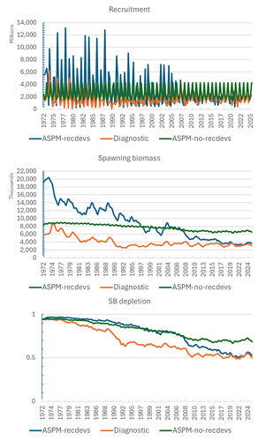
image907×1549 126 KB

We see that when the tagging data are omitted, the recruitment and SB are up-scaled considerably, and SB depletion is more modest for most of the time series, particularly when recruitment variation is disabled. When recruitment variation is allowed, the most recent estimates of depletion converge with the diagnostic case, but there is considerable divergence in the earlier estimates.

8. Review process (Comment)
We recognise that the stock assessment team are under huge pressure to deliver on time and that this year there were issues with data preparation which caused delays. That said, this year the members received this very complex SKJ assessment document with one week to review it, which is simply not enough time for a full review. This is further complicated by the fact that we only have reports, not the assessment input and output files which tend to be published well after SC is finished. [We note the SWO assessment files have been provided in a GitHub repository, which is very helpful.]

Given the importance of the skipjack stock to the Pacific region, we think the current review process is not working well, and we would like to suggest a full external peer review of this assessment in the period leading up to the next assessment. This could follow a similar approach to the 2024 review of the northwest Pacific striped marlin stock assessment. Terms of Reference for the review could be determined by SC22.

8. Reply (SPC)
All relevant files relating to the 2025 skipjack stock assessment will be placed on a GitHub repository as soon as possible. SPC has a long history of making assessment input and output files available for interested parties to download. But perhaps WCPFC should establish a formal policy for such transparency, noting that this is not routinely provided for stock assessments conducted for WCPFC by other organisations, or by most other tRFMO’s.

While we would welcome a peer review for the WCPO skipjack assessment, SPC’s experience with the sort of peer review being suggested is that it requires a time commitment from the SPC stock assessment and data team approximately equivalent to undertaking a full assessment. If such a review is to be conducted during the next 3 years, it would likely require modification of the stock assessment schedule.

USA
The US would like to recognize the efforts made by the SSP in addressing many of the concerns raised by SC18. We consider this to be an improved assessment in many aspects. However, despite these positive steps forward we do have a number of concerns, questions and/or technical comments which we will raise here in the ODF.

The key area for discussion with this assessment is the high conflict in the different data sources as evidenced by the likelihood profile, jitter analysis, and leave data out analyses (ASPM, CCA, and no tag model). It is worth noting that the expanded diagnostics provided by the assessment team facilitate this identification, and we are grateful for their provision. The overall assessment result is one that appears to split the difference between these components and as a result doesn’t fit any of them as well as desired. As noted by New Zealand, there is evidence of mis-fit to certain data components: indices, mean length over time, and JPTP tagging data. The mis-fit to data components (particularly the large length observations for many fisheries in recent years) and the impact on the likelihood could limit confidence that the model accurately captures the population dynamics.

Given this concern, and the importance of skipjack to the region and the world, we are supportive of New Zealand’s suggestion of an external review of the skipjack assessment and for SC22 to help determine the Terms of Reference for that review.

There are also a number of additional comments/questions related to modeling choices, and estimated outputs that we wish to raise. Some issues are interrelated. These are briefly summarized below (in no particular order):

Model convergence (Comment)
This assessment is a step forward with respect to model convergence. Most ensemble models meet minimum convergence criteria (gradient and PDH). Though a jittering analysis was conducted only 30 jitters were conducted which may or may not be a large enough sample size to identify if the model has converged to a minimum. Furthermore, though no jittered model had a better total likelihood, there appeared to be very high variance in terms of minima with respect to fits to different data components. This tells the same story as the likelihood profiles, that the data are in conflict and that the total likelihood is achieved by trading off fits to the different data components. Given the apparent conflict and sensitivity to starting conditions, this does not appear to be a well-determined solution.

Reply (SPC)
Mostly agree. The final run of jittering was the 3rd or 4th such set of jitters. In the earlier runs, we found one or more somewhat better solutions (but with for all intents and purposes identical assessment results). We repeated the jitter on each occasion using the best model as the basis for the new jitter run. We agree that this sort of sensitivity is not ideal and there is a need to review model complexity and, to the extent possible, conduct additional data quality assessment.

Regarding data conflict, we note that overall the CPUE data provided similar information on overall scaling to the tagging data. The main conflict in fact is between the size data and the priors for tag reporting rates. This motivated us to test for the influence of the tag reporting priors by setting all of them to be uninformative. The results of this run are shown in Figure 67, where we see the expected result that the population scaling is shifted upwards and the depletion ratio increased by several percentage points. This occurs because the reporting rate penalties are much reduced (but many of the estimates now go to their upper bound), allowing the size data to have more influence on scaling. The size data weight given by the Dirichlet Multinomial likelihood is estimated internally and the down-weighting is quite substantial, as indicated by Figure 21. One indication of the effect of further down-weighting of the size data is provided in the ASPM that includes recruitment variability (Figure 59). In this test, the size data are effectively down-weighted to zero, and the impact on scaling is positive, but relatively minor. That is a somewhat curious result, and we might have expected a negative impact on scaling. But of course, many parameters that were estimated in the full model (selectivity, growth, etc) were held fixed at the estimated values in the ASPM.

Model complexity (Comment)
The model reduced active parameter counts by switching to the OPR recruitment parametrization. While this is a step in the right direction, the model remains highly complex and flexible with quarterly movement, and quarterly regional recruitment parameters able to move biomass around as needed in order to reconcile clear conflicts in the data. This results in some interesting regional biomass and recruitment patterns. However, the current documentation and figures are not sufficient for determining if these regional patterns are reasonable (does movement follow tags or another data component; does biomass accumulate in lightly fished regions; does recruitment occur in temperate regions in quarters where it would not be expected). While management is done at the aggregate level, the details at the regional level are important for developing confidence in the model (is it consistent with empirical observations or other model outputs, e.g., SEAPODYM). Future assessments of skipjack (and other species) should re-evaluate the modelling approach used in order to “right-size” the assessment approach to match model complexity to data limitations and stock dynamics.

Reply (SPC)
We agree that more information on the regional allocation of recruitment and biomass could have been given in a more digestible format and we apologise for this oversight. We were generally comfortable in how these regional estimates looked, and can offer the following additional results (from the diagnostic case) to support this:

The overall proportional allocation of recruitment by region was as follows (region 1-8 in sequence): 0.017 0.018 0.027 0.148 0.283 0.097 0.284 0.126

For SB, the regional distribution is shown in the following plot:
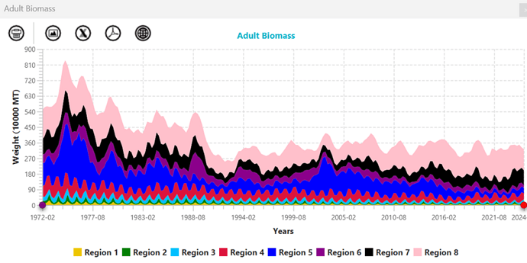
image940×470 169 KB

In both cases, the regional distributions obtained were not surprising, with the tropical regions dominating.

Model diagnostics (Comment)
While there does appear to be a greater focus on model diagnostics, some conventional diagnostics such as reporting of goodness of fit, length composition bubble plots, and hindcast cross-validation are lacking. Some figures are also difficult to interpret (for example the lack of observation error bars on CPUE fit makes it difficult to evaluate the quality of the fit, it is also very challenging to interpret the movement estimated by the model relative to what the tags indicate). The likelihood profiles by data component and fleet were useful for the index and length composition. It would be useful to do something similar for the tagging programs/release groups.

Reply (SPC)
Yes, there are many ways that additional graphics could contribute to interpretation of results – everyone has their favourites! We will take this comment on board for future assessments.

Model fit to data (Comment)
It is difficult to fully evaluate fits to the indices without also seeing the observation error associated with them (see the above comment). There does appear to be some trend in the PL fit residuals as pointed out by NZ. The PH PS index is best fit, unsurprisingly given the tight CV. However, the free-school PS indices do not appear to be well fit at all. The seasonal dynamics and long term dynamics are poorly captured. Future assessment should consider re-balancing the CVs used to fit the indices rather than using the raw CVs as output from the different standardization analyses.

Aggregate length composition data fits appear reasonable for many fisheries, however the fit to the trend over time is poor. In particular large observations are noted at the end of the time series for many fisheries, and these are poorly fit. Given the dome-shaped nature of selectivity, and the time invariance of selectivity, these observations likely have high leverage on model outcomes. As seen by the CCA the comp data indicates an increasing biomass trend, possibly driven by these large observations. In general, it is not preferred for composition data to drive either scale or trend estimates. It is recommended that composition data be scrutinized to exclude problematic observations, and that selectivity be made time-varying to better fit the size data if it represents a real shift and to reduce leverage on model outcomes.

Fits to the JPTP tagging data are poor. Fit to the PTTP and RTTP appear ok, except for RTTP region 8. It was recommended at the PAW to only fit one program at a time.

This is a sensible recommendation raised by New Zealand, and should be investigated. We note that SPC provided a response that said that models excluding one tagging program at a time were explored but this differs from the New Zealand request. The New Zealand request would help alleviate conflict between tagging programs and also with the indices.

Reply (SPC)
We note the comments on the PS CPUE. They are certainly not as well fit as some of the other indices, but we have seen many worse fits in other assessments. We would be interested in receiving more information in how to “re-balance” CVs in an objective way.

We do not agree with the comment that the fit to the size data over time is generally poor. The time trends for LF data sets that have continuously high sample sizes over time (e.g. the tropical PS fisheries responsible for the vast majority of the catch) are generally reasonably well fitted it seems to us. Of course, some of the LF data sets for some fisheries are very sporadic, and these will be not as well fitted. But please point out which fisheries are causing concern.

Regarding the lack of fit to the some of the larger fish sizes in the last year or two, we acknowledge this and point out that this is likely a result of constraints on recruitment variability that we applied at the end of the time series. We had to constrain recruitment in the last 3 years of the assessment to a common level, because earlier runs when this was not done produced enormous spikes in recruitment that we felt were unreasonable. Constraining recruitment in this way inevitably results in some lack of fit to the size data. We have heard in presentations today that very large catches of SKJ occurred in 2024 in both the WCPO and EPO. Therefore strong recruitment in the last year or two of the assessment may in fact have occurred; however we did not feel comfortable in relying on such huge estimates of recruitment in the last couple of years that are based on limited information (at this stage) and because of the way such estimates would impact short-term projections and potentially stock status indicators.

Potential hyperstability in CPUE (Comment)
While hyperstability was addressed for the PL, it remains a potential issue with the free school purse seine as well. This was raised at the PAW but not investigated or addressed in the report.

Reply (SPC)
We were less concerned with effort creep in the PS CPUE indices partly because of the way in which the data were filtered (free-school specialist vessels) and the use of VMS-based searching distance as the basis of the effort metric. When we thought about possibly imposing some effort creep scenarios on the PS CPUE indices, we realised that we would also have to consider negative effort creep due to the possibly of increasing dFAD density since 2010 negatively impacting the availability of SKJ in free schools. And in either the positive or negative effort creep scenario, we would have to have made arbitrary assumptions, unlike the PL CPUE effort creep scenarios that were based on actual estimates by Japanese colleagues.

Biomass scaling (Question)
It is unclear from the model what is now driving the regional estimates of scale as catchability is no longer linked between index fisheries. Regional biomass scale is now no-longer constrained and can be whatever is needed to fit the data. Given concerns with data fits, and noisiness of some data streams, along with a lack of clear visuals it is difficult to understand if the estimated patterns are legitimate or if it is the model simply chasing noise. Could the authors comment on what is now informing regional estimates of scale now that index catchabilities are no longer shared?

We note that the regional scaling was an important uncertainty in previous assessments as the allocation of biomass to more lightly fished regions helped buffer overall stock status (e.g., 5 region model that was presented in 2019 and conducted as a sensitivity in 2022).

Reply (SPC)
CPUE indices were originally grouped (PS and PL indices separately) for catchability, but this resulted in some persistent lack of fit with some indices. It was clear that there was other information in the model regarding regional scaling – possibly from the tagging data – that was causing this. Additionally, the shared selectivity across indices within gear type was causing additional lack of fit to the index size data. Relaxing this grouping occurred in one of the later phases of the estimation. We were pleasantly surprised when the regional scaling of recruitment and biomass remained within expected bounds. With the considerable improvement in both CPUE and size data fits that resulted, we could see no reason to not retain the ungrouped index catchability and selectivity.

Movement estimation (Comment)
It is difficult to determine which data components (should be tags) drive the movement estimation and if this is reasonable. We request that a more useful plot be developed (or consider reverting to the plots shown in previous assessments) which more clearly show how model estimates of movement differ from what is indicated by the tagging observations.

Reply (SPC)
Well noted and agreed.

Regional recruitment estimation (Question)
Regional recruitment estimation is noted to be problematic on occasion, and the considerable flexibility of the model to estimate regional recruitment can lead to some counterintuitive results such as the very high recruitments predicted in quarter 1 for region 1 & 2, but no recruitment in quarter 2 for these regions.
Based on biology and environmental preferences the reverse would be expected and we welcome comments from the authors if available.

Recruitment is predicted to decrease in regions 1-5, and increase in regions 7-8. At the regional scale there appears to be some correlation between recruitment and the evolution of catches. Regions with increasing catches appear to show increasing recruitment, regions with decreasing catches appear to show decreasing recruitment, and regions where catch is relatively stable show relatively stable regional recruitment estimates.

Reply (SPC)
The model will want to put recruitment in a region in a way that allows the seasonality of the catch in that region to be accurately predicted. In the case of R1 and R2, the majority of the catch occurs in Q2. Looking at the size data, most of the catch is small fish in the 2nd quarterly age class. So the model places fish in the 1st quarterly age class (i.e. recruitment) in R1 and R2 in Q1 so that they are available at the right size for capture in Q2. Note that “recruitment” in R1 and R2 might not necessarily be based on spawning in those regions 1 quarter prior. There is the possibility (even likelihood) of transport of larvae in the Kuroshio Current that originates in the more tropical Philippines region for example.
While the use of the orthogonal polynomial recruitment formulation has simplified the recruitment parameterisation compared to the previous recruitment devs approach, there may be a case to simplify further, as the fully saturated year effect and season-region interaction effect still gives the model considerable (perhaps too much) flexibility to put fish where it needs to best fit the available data. We accept that further simplification of the recruitment parameterisation may be required, even if it is inevitably at the expense of poorer fits to data.

Mixing period assumptions (Comment)
The tagging data are unlikely to meet the mixing period assumptions for this large box model, we recommend more appropriately modelling the tagging data externally using the approach being developed in collaboration with DTU.

Reply (SPC)
We agree. Also, we think there is potential to further adapt the SEAPODYM model (e.g. to model tagging data in a release conditioned rather than recapture conditioned mode) for this purpose.

Growth /M estimation (Question)
We note the tradeoff identified in needing a high k to fit the tagging data given the Lorenzen mortality shape (needing high attrition of young ages), request comment from the authors if this is potentially indicative of model mis-specification and warrants a review of how the tagging data is used within the model (is the inclusion of potentially un-mixed tags causing problems?).

Reply (SPC)
This is a possibility than needs investigation. However we note that estimation of high (>0.4 per quarter) was also occurring for the tag mixing scenario (K=0.1) that specified longer mixing periods.

Initial conditions (Question)
The justification for initial depletion of 98% appears inconsistent from previous estimates where initial conditions were estimated (noting that those previous estimates could be wrong). Could the authors provide more justification about the initial condition assumptions and confirm that results were not sensitive to the initial condition assumptions?

Reply (SPC)
The 2022 assessment assumed an unexploited population that was unrealistic given the presence of significant catches prior to 1972. We made the change to assuming a small amount of fishing mortality in the initial equilibrium population to recognise this prior exploitation. The level of 0.02 x M to represent the initial fishing mortality was chosen so as to provide a constant small level of depletion over the first few years of the model. We noted that this specification impacted model estimates only over the first few years and subsequent results were completely insensitive to the setting. Also, note that the previous approach of setting F for the initial population to be at the average of the level estimated for the initial few years was done for the catch-errors version of the model. This approach is not technically feasible for the catch-conditioned approach due to the timing of the availability of the estimates.

Chinese Taipei
During plenary discussion Chinese Taipei asked if SPC could provide a ratio of the estimated spawning potential depletion for 2019 relative to the 2012 based on this year’s diagnostic case model to enable comparison of the historical stock trajectory.

Reply (SPC)
In response to a request from Chinese Taipei during plenary, we calculated the median SBrecent/SBF0 and the median SB2012/SBF0 across the model ensemble and then calculated the ratio between these median estimates. The results indicated the median of SBrecent/SBF0 = 0.5113 and the median SB2012/SBF0 = 0.5115, and the resulting ratio of 0.999.

Response to SPC (Chinese Taipei)
Thanks Thom!

This makes it easier for my delegation to interpret stock status—using the ratio of recent depletion to the 2012 iTRP depletion level rather than an absolute value.

SBrecent(2015-2018)/SBF=0 / (SB2012/SBF0) = 1.04 (from 2019 assessment) (0.44/0.42)
SBrecent(2018-2021)/SBF=0 / (SB2012/SBF0) = 0.85 (from 2022 assessment) (0.51/0.60)
SBrecent(2021-2024)/SBF=0 / (SB2012/SBF0) = 0.99 (from 2025 assessment) (0.51/0.51)

Reply 2 (SPC)
Just to flag that this calculation provides a comparison of SBrecent/SBF=0 with the estimated depletion in 2012, estimated within the three recent skipjack stock assessments. But we note that the adopted iTRP for skipjack, as defined in CMM 2022-01, is calculated as the average of two spawning potential depletion values:
• the estimated average depletion of the skipjack tuna stock over the period 2018-2021 (SB2018-2021/SBF=0).
• the long-term median equilibrium stock depletion that would be reached under the agreed baseline fishing conditions for skipjack tuna (purse seine effort at 2012 levels, pole and line effort at average 2001-04 levels, and the domestic fisheries in assessment region 5 at average 2016-18 levels).
Further details of that calculation are provided in CMM 2022-01. We recalibrate this iTRP value using the 2025 assessment in Section 11.6.1 of SC21-SA-WP-02 (REV3), and provide the recent status of the stock relative to that recalibrated iTRP within the paper.

- TOPIC 7. Southwest Pacific Swordfish Stock Assessment

Relevant Documents: SC21-SA-WP-05 J. Day. Stock assessment of Southwest Pacific swordfish

Questions and Comments
EU
Thank you SPC for the work. We are aware of the challenges and difficulties this kind of assessement may imply. We would like to make a request for its potential inclusion in the management advice section: As we all know, there is a significant proportion of SWO catches that take place as bycatch in tuna longline fisheries north of 20S, which are not currently covered by the CMM. This is a major challenge for the management of the stock without an easy solution. You provide in the assessment report some figures that illustrate this point, but we would like to kindly request the numbers of the estimated catches both north and south of 20S (as an example, in the latest 5 years). Similarly, if you can produce a time series with the proportions, it can be very helpful at a later stage

Reply (SPC)

Thanks for the question - which is clearly important for management. The answer to this question requires some modelling, rather than simply summarising the input data, as catch is reported in a mixture of: numbers of fish caught (for most fisheries); and in t (for the EU fisheries). It makes no sense to compare coconuts with mangoes - so using the catch converted to a common unit (t) by Stock Synthesis, I have calculated the following proportions of the total catch (caught north of 20S), for the last 1, 5 and 10 years.

Period % N Catch N (‘000 t) Catch S (‘000 t)
2023 0.333 1976.57 3953.38
2019-2023 0.379 10005.19 16411.36
2014-2023 0.441 28710.15 36396.16

A full time series could be produced - but we would need to know exactly what is required. Do you want a time series of annual proportions, or a time series of rolling averages (and over how many years), or of total catches, or catches (or proportions) split into .1N and.2N, either combined or separately, or some other combination. Is this something that will need to be regularly and consistently reported in future swordfish assessments?

Incidentally, all of this data is in the Stick Synthesis output file, Report.sso and can be found in the following section:
CATCH report:15
in the column labelled:
dead_bio
listed by fishery, and by quarter.

This file is publicly available at the swordfish 2025 GitHub repository:
GitHub - PacificCommunity/ofp-sam-swo-2025-diagnostic: Swordfish 2025 diagnostic model

The fisheries north of 20S are labelled with either .1N or .2N on the end of the fishery name, or are fisheries numbered 1,4,8,10,15 and 18.

This raw data enables anyone to construct any time series they desire, either as catch (in t), or as a proportion of the total catch, or catch by fishery, by simply summing the appropriate figures. That may be more useful, as it allows any required option to be calculated by any interested party as required?

USA
The US would like to recognize the efforts made by the SSP in improving many aspects of the SWPO swordfish assessment. We consider this to be an improved assessment in many aspects. However, we do have a number of concerns and/or technical comments and suggestions which we will raise here in the ODF.

Fit to the CPUE
There appears to be a substantial lack of fit to the CPUE indices included in the model, with the Australian index slightly better than the New Zealand index. Both indices indicate patterns in the residuals where there are persistent negative residuals through 2010, positive residuals from 2010-2017, and then negative residuals again after 2017. Fitting to CPUE indices should be prioritized over fitting to size data.

There is also a misfit in the CPUE indices in the last few years of the model where both observed CPUE time series are increasing after 2019 but the fitted index declines after 2020. This is most likely driven by the decrease in the mean weight of the Australian 1C fishery after a peak in 2015. As the likelihood profile indicates the CPUE indices are in conflict with the weight data, it is clear that this conflict needs to be better understood in future assessments. Exploration of the decrease in the mean size of the Australian fishery 1C should be fully explored to determine if it is a change in the fishery or a true indicator of a change in abundance.

Alternative CPUE indices
We would also like to suggest that future assessments consider exploring a CPUE index that uses the DW LL fleets such as Korea, Japan, and/or Chinese Taipei. These fleets, while often not targeting swordfish, do catch substantial amounts of swordfish and have a footprint that is much larger than the Australian or New Zealand fleets which may be more representative of the relative abundance of the entire stock. Work in the north Pacific has developed models to identify fleets based upon CPUE and size data, which has resulted in being able to identify fleets which provide information on recruitment, and fleets which catch adult swordfish and can be used as an index of abundance.

Treatment of Size Data
Generally, it is clear from the mis-fit to the CPUE data and the results of the ASPM that the size data are an important driver of the population trends. In fact, the fit to the CPUE in the ASPM model is a straight line, which indicates that it is providing no information to the population dynamics. Stock assessments should be driven by the indices of relative abundance not the size composition data. However, even within the size data from the same fleets operating in different areas (i.e. Australia 1C and 1N) indicate opposite estimates of population size. The sharp increase in mean size from 2015-2019 compared to the years before and after in the AUS 1C fleet is what is driving the decline in population in the last few years of the assessment, as it is attempting to fit the decline from 2016-2023 while the CPUE indices suggest an increase in population. It would be useful to understand why those data are so different than those before and after and if it is a change in fishery operations or operating area, time varying selectivity would likely reduce the influence of those data.

While we appreciate the removal of sparse or unreliable data, we would recommend a slightly different treatment of the selectivity estimates for those fleets fixed based upon an initial model run, as this is a very strong assumption and removes the ability of the model to adjust the selectivity of the model to fit the other data components. Aggregating the data into the superyears option in the size composition module of Stock Synthesis would allow for estimation of the selectivity parameters of fleets that have a reasonable aggregate composition pattern and allow the model to adjust the selectivity of those fleets based upon the other input data. For other fleets with highly uninformative size data, it might be useful to determine if any of the fleets fishing in the same area have a similar operation which would allow for mirroring of selectivity parameters. We also suggest including plots of the residuals of the size data by year in the report in the future, as it can indicate periods when the size data are not well fit and may need time-varying selectivity. This is especially useful for fleets that are not targeting swordfish and may change their operations over time as their species of target changes.

Sensitivity Runs
We also suggest that for the sensitivity runs including the alternative CPUE indices, a likelihood profile be run to evaluate how well the alternative indices agree with those selected in the diagnostic model.

We would like to note the very large catch of swordfish that occurs in the central tropical pacific just outside and along the boundary of the stock assessment. In previous assessment of swordfish stocks, there was a lot of discussion with IATTC and ISC about which stock these catches belong, with the general agreement that these are most likely a mixed stock area where swordfish are feeding and that each stock would include some or all of these catch in their assessments as a sensitivity run. This was done in the 2023 NPO SWO assessment, the 2021 SEPO SWO assessment and the 2021 SWPO SWO assessment. We would recommend that this continue to be the practice for this stock until better information is available to appropriately allocate the catch in that area to the correct Pacific swordfish stock.

- TOPIC 8. Revised 2024 stock assessment of striped marlin in the southwestern Pacific Ocean
No questions or comments

- TOPIC 9. 2025 Stock Assessment of Striped Marlin in the Southwest Pacific Ocean
No questions or comments

- TOPIC 10. Stock Assessment of Oceanic Whitetip Shark in the Western and Central Pacific Ocean 2025 (Project 124)
Relevant documents: SC21-SA-WP-08 P. Neubauer and K. Large. Stock Assessment of Oceanic Whitetip Shark in the Western and Central Pacific Ocean 2025 (Project 124)

Questions and Comments
Japan
We appreciate the work for the improvement of stock assessment of this regulated species. It is remarkable that the positive effect of management measures was evaluated and confirmed quantitatively also in this assessment. We have several questions as follows;

Question1: Treatment(filtering) of HBF
In the current assessment, re-estimation of catch by reconsidering the treatment of HBF with zero or missing data is significant progress. It is reasonable to remove data without HBF and zero data. Given that this process is influential, we have one question on the treatment of HBF. In Figure2, there are several large HBFs (such as >50) in some flags. Is it realistic gear configuration? Those high HBFs may be the number of floats (not HBF) and we would like to know your thoughts on the treatment of such large HBFs.
Reply (SPC)
HBF: While very high HBF numbers may not reflect real gear configurations, it is difficult to determine an effective cutoff point. However, at high HBF, the change in the effect is very flat (see Figure 1), so the exact number is probably less important unless the “true” number would have been low (e.g., <10). Given the small number of occurrences of high HBF in the dataset (compared with zeros or missing HBF), we suspect that any alternative treatment of high HBF records would have a very minor influence - however, this could be investigated in the future to ensure that this assumption is correct.

Response to SPC (Japan)
For Q1, it was well understood that the number of high HBF is small and no threshold is available. Misreporting of HBF and basket number is sometimes observed and high HBF (misreporting: correctly it is basket number) tends to be corrected to low HBF after the correction. This question was based on our experience of such observation.

Question 2: Growth parameter
In the previous stock assessment, both high growth by Seki et al. (1998) and slow growth by Joung et al. (2016) were used. Enhancement method of growth band pair, the period and area of sampling area and sample size are very different between studies, and the discrepancy of growth may not be attributed to regional difference in growth with the current assumption of stock structure.
In the current assessment, both estimates were considered in the informal prior for M, but their means were lower than M used in previous assessment. We would like to know the reason for this difference. In addition, given the several differences between studies, the slower growth was used in the diagnostic model in the stock synthesis. It would be appreciated if you could show the rationale of selecting the slower growth and whether the higher growth was taken into consideration in the model ensemble of stock synthesis.

Reply (SPC)
We maintained the two growth assumptions from the previous assessment, and maintained the same diagnostic case assumption for growth; largely for continuity reasons as opposed to reflecting plausibility. Both growth assumptions received equal weight in the SS ensemble, so the diagnostic choice is purely for illustrative purposes.
The M priors were derived based on available life-history based estimators; while the mean and median of the generated prior densities are lower than previous (fixed) M, this reflects a broader considerations of potential ways to estimate M than the previous assessment, which was based on a single estimate derived from a relatively ad-hoc approach to deriving the M estimates (see methods in Cortes (2002) - Incorporating Uncertainty into Demographic Modeling: Application to Shark Populations and Their Conservation). The actual estimate used in previous assessments was a relatively arbitrary choice within the range reported in Cortes (2002). Our updated priors do incorporate the range of survivorship estimates from Cortes (2002) within the 95% confidence bounds of the prior, and given the wide prior distribution, the prior mean should not be taken as a point estimate of M; the actual M in the model is estimated using this wide prior and informed by data (albeit with some conflict), as shown by the likelihood profiles - but it suggests a somewhat lower M than previously assumed (although the upper end of the posterior distribution is 0.17; which is close to the value of 0.18 previously assumed).

Response to SPC (Japan)
Q2. it was understood that two growth curve was treated equally and the text was just for the illustrative purpose. I also understood that your approach of estimating M with broad prior is more reasonable approach to consider the uncertainty of M rather than fixed and arbitral M. I appreciate your explanation.

Question 3: Treatment of the impact by regulation
The effect of introduction of management measures is well noted in this report in that the quality of CPUE and size data of OCS has been degraded. In addition, historical change of the leader material (if any) would be influential in the CPUE standardization. In this point, we would like to hear your thoughts on the treatment for this change of catchability or data availability in the stock assessment (such as the introduction of time block in the stock synthesis).

Reply (SPC)
We agree that there is a likely impact of regulation on CPUE - but this impact is difficult to treat. Ideally, these changes are standardised for in the CPUE standardisation; however, the observer data available for standardisation are relatively sparse already, and our experience is that operational parameters are inconsistently recorded and their inclusion usually leads to dropping large amounts of data, especially in early years.

An alternative, as noted in the question, would be to split the CPUE series or the catchability parameter in SS. We have not attempted this but agree that this would be a good sensitivity to explore in future shark models (not just for OCS); it has the potential to remove significant signal from the model, as much of the signal likely comes from the stock response to the non-retention measure (i.e., the rate of increase); splitting the time-series at the introduction of non-retention measures could remove this signal - but it is worth exploring within the model to understand the impact in more detail.

Response to SPC (Japan)
Q3, I agree with the difficulty in treating the change of data quality, but I think it is very influential in the results. So it is future work to consider how we can remove artificial impact on the data from the data in regulated species, as well as continuation of data collection. As you pointed out in the presentation, there may be bias of size data sampling on board (e.g., smaller shark may tends to be hauled and measured rather than larger shark).

- TOPIC 11. Progress towards a Close-Kin-Mark-Recapture application to South Pacific Albacore (Project 100c)
No questions or comments

- TOPIC 12. Project 125: Billfish Biological Data Collection
No questions or comments

- TOPIC 13. Project 126: Shark Biological Data Collection
No questions or comments

- TOPIC 14. Project 128: Connectivity study on key tuna species in the WPEA region
No questions or comments

- TOPIC 15. Projects 117 and 118: Biological sampling plans for tuna and billfish
No questions or comments

- TOPIC 16. Project 120: Progress report on Reproductive Biology of WCPO Yellowfin Tuna
No questions or comments

- TOPIC 17. Project 122: Progress report on Longline CPUE
No questions or comments

- TOPIC 18. Climate Change Vulnerability Assessment (Consultancy report)

Relevant Documents: SC21-EB-WP-01 K. Robertson and M. Baird. WCPFC CMM Climate Change Vulnerability Assessment

Questions and Comments
Authors (K. Robertson and M. Baird)
Thank you very much for the opportunity to share our progress on the WCPFC CMM Climate Change vulnerability framework. It has certainly been an interesting exercise.
We have provided all deliverables to the Scientific Committee. It is a lot of information to work through. It includes an SC paper, as well as the CCVA excel workbook and .doc guidance document, as well as 5 CMM assessments, We will present on the main findings at SC on the Thursday session.

Our consultancy runs through to December so we are happy to take on your feedback. The key information we are looking for, consistent with our paper recommendations are:
- Review and comment on the scientific approach and methodology of the draft framework
- Provide input on the indicator system and data requirements
- Identify potential data sources and quality considerations within the SC’s expertise
- Advise on integration with existing scientific processes and assessments
- Recommend capacity building requirements for successful implementation
- Support pilot implementation of the framework for 2025 CMM assessments.

We remain at your disposal for any questions or feedback.

FFA
Thank you very much Kerrie for the amazing work. The FFA has some technical comments re the assessment:
- Suggest an inverse color coding for Adaptive Capacity, considering low AC contributes to a high vulnerability, while high AC contributes to low V (inverse relationship that with Sensitivity),
- The framework considers the lack of information as a “high” score contributing to risk, and although the rationale behind this makes sense (as it contributes to the precautionary approach for decision making), it is not possible to see in the overall outcome whether a “high risk” is due to a majority of “unknown” score, or to actual high risk score. It would be useful to have those details shown in the final outcome, which would save the decision makers a lot of time having to scroll through the individual indicators to understand whether the CMM need more science data, or needs more management action,
- To ease the identification of which exact aspects contribute to higher grading each element of risk (exposure, sensitivity and adaptive capacity), and hence have a quicker understanding of where action could be needed, it would be helpful to have some automated feature in the excel that provides this outcome for each of the elements. In this way, when looking at the climate risk results sheet, it could be clearly identified what is contributing most to the scores. We welcome views.

- TOPIC 19. Project 62: Updates on the 2019 SEAPODYM Review
No questions or comments

- TOPIC 20. Project 110 and 110a: Progress report on Non-entangling and biodegradable FAD trial in the WCPO
No questions or comments

- TOPIC 21. Ecosystem and Climate Indicators (Project 121)

Relevant Documents: SC21-EB-IP-01 SPC-OFP. Project 121 Update: Ecosystem and Climate Indicators

Questions and Comments
USA
The US appreciates the work that the SPC has done, including hosting the workshop last November, and we agree that this is a reasonable collection of indicators. One suggestion would be to add estimated median phytoplankton size as either a fishery or ecosystem indicator. It can be derived from satellite remotely sensed SST and chl-a data, and may have a more direct mechanistic relationship to fish size and other ecosystem properties than either SST or chl-a on their own.

Reply (SPC)
We have started to commence exploratory analyses along similar lines of thought. We look forward to working with the USA to fully test this indicator

Question
We note that there is no updated workplan included in SC21-EB-IP01. The previous workplan from SC20 (SC20-EB-WP-01) indicated that a WCPFC member workshop to refine the indicators would tentatively be held in 2026 and that the indicators would be “adopted” in 2026. We would appreciate an update from SPC on the anticipated next steps towards implementation.

Reply (SPC)
Workshops are planned for 2-6 March 2026 (Ecosystem Indicators) and 9-13 March 2026 (Climate Indicators) in Noumea, New Caledonia. We are waiting confirmation of technical expert participation. Once we have that we will ask the WCPFC Secretariat to send a circular notifying CCMs of the two workshops. Note that participation is not budgeted and will be at CCMs own expense.

Attachment P

The Commission for the Conservation and Management of Highly Migratory Fish Stocks in the Western and Central Pacific Ocean
TWENTY-FIRST REGULAR SESSION OF THE SCIENTIFIC COMMITTEE

Nuku’alofa, Tonga
13–21 August 2025
LIST OF ABBREVIATIONS

ACAP | Agreement on the Conservation of Albatrosses and Petrels
ASPM | age-structured production model
BET | bigeye tuna
B_{MSY} | biomass that will support the maximum sustainable yield
BSPM | Bayesian surplus production model
CCMs | Members, Cooperating Non-members and participating Territories
CCSBT | Commission for the Conservation of Southern Bluefin Tuna
CKMR | close-kin mark-recapture
CMM | Conservation and management measure
CNM | cooperating non-member
the Convention | The Convention for the Conservation and Management of Highly Migratory Fish Stocks in the Western and Central Pacific Ocean
COVID-19 | coronavirus disease
CSIRO | Commonwealth Scientific and Industrial Research Organization (Australia)
CV | coefficient of variation
EM | estimation method/ or electronic monitoring
EPO | Eastern Pacific Ocean
ERandEM/ER&EM | electronic reporting and electronic monitoring
FAD | fish aggregating device
FAO | Food and Agricultural Organization of the United Nations
FFA | Pacific Islands Forum Fisheries Agency
FIRMS | FAO Fisheries and Resources Monitoring System
F_{MSY} | fishing mortality that will support the maximum sustainable yield
GLM | generalized linear model
HCR | harvest control rule
IATTC | Inter-American Tropical Tuna Commission
ISA | International Seabed Authority
ISC | International Scientific Committee for Tuna and Tuna-like Species in the North Pacific Ocean
ISSF | International Seafood Sustainability Foundation
ITRP | interim TRP
IWG | Intersessional working group
LRP | limit reference point
M | mortality
MFCL | MULTIFAN CL
MOU | memorandum of understanding
MP | management procedure
MSE | management strategy evaluation
MSY | maximum sustainable yield
mt | metric ton
NC | Northern Committee
OM | operating model
PNA | Parties to the Nauru Agreement
PNG | Papua New Guinea
PTTP | Pacific Tuna Tagging Programme
ROP | Regional Observer Programme
RFMO | regional fisheries management organization
RMI | Republic of the Marshall Islands
RTMB | Template Model Building in R
SA | stock assessment
SB | spawning biomass
SC | Scientific Committee of the WCPFC
SIDS | small island developing state
SPC-OFP | Oceanic Fisheries Programme of the Pacific Community
SPR | spawning potential ratio
SSB | spawning stock biomass
SSI | species of special interest
SSP | scientific services provider
TCC | Technical and Compliance Committee of the WCPFC
TOR | terms of reference
TRP | target reference point
VB | von Bertalanffy (growth function)
VMS | vessel monitoring system
WCPFC | Western and Central Pacific Fisheries Commission
WCPFC Convention Area | The area of competence of the Commission for the Conservation and Management of Highly Migratory Fish Stocks in the Western and Central Pacific Ocean
WCPFC Statistical Area | The WCPFC Statistical Area is defined in para. 8 of the document “Scientific data to be provided to the Commission”
WCPO | western and central Pacific Ocean
WG | working group

