**The Commission for the Conservation and Management of**

**Highly Migratory Fish Stocks in the Western and Central Pacific Ocean**

**SCIENTIFIC COMMITTEE**

**TWENTY-FIRST REGULAR SESSION**

**Nuku’alofa, Tonga**

**13–21 August 2025**

**OUTCOMES DOCUMENT**

**The Commission for the Conservation and Management of   
Highly Migratory Fish Stocks in the Western and Central Pacific Ocean**

**SCIENTIFIC COMMITTEE**

**TWENTY-FIRST REGULAR SESSION**

**Nuku’alofa, Tonga**

**13–21 August 2025**

|  |
| --- |
| **OUTCOMES DOCUMENT** |

# AGENDA ITEM 1 — OPENING OF THE MEETING

* 1. Welcome address
  2. Meeting arrangements

* 1. Issues arising from the Commission
  2. Adoption of the agenda
  3. Reporting arrangements
  4. Intercessional activities of the Scientific Committee

# AGENDA ITEM 2 — REVIEW OF FISHERIES

* 1. Overview of Western and Central Pacific Ocean (WCPO) fisheries
  2. Overview of Eastern Pacific Ocean (EPO) fisheries
  3. Annual Report – Part 1 from Members, Cooperating Non-Members, and Participating Territories
  4. Reports from regional fisheries bodies and other organizations

# AGENDA ITEM 3 — DATA AND STATISTICS THEME

* 1. Data gaps of the Commission
     1. Report on the WCPFC scientific data
     2. Reconciliation of size composition data for stock assessments (Project 127)

1. **SC21 recognized the importance of reconciling size composition data for stock assessments and recommended continuation of the projects identified as part of phase 2 of this project.**
2. **SC21 requested the SSP circulate a draft pro forma of supporting information to accompany non-ROP size data submissions, for CCMs to review and provide feedback to the SSP.**
3. SC21 encouraged CCMs to provide responses to the SSP on the draft pro forma and communicate with them on size data collection methods for non-ROP size data.
4. **SC21 requested that the SSP provide a report to SC22 on the development of the pro forma and a summary of CCM responses, with the objective of working towards implementing a standardized pro forma (consistent with the requirements for size data provisions contained in the SciData guidelines) by 2027.** 
   * 1. Improving operational data evaluation and submission standards
5. SC21 supported the development of a standardized data reporting mechanism by the SSP to enhance the efficiency of processing required data submissions under the SciData guidelines. SC21 encouraged CCMs to work with the SSP as it prepares revised templates for consideration at TCC21.
   * 1. Better data on fish weights and lengths for scientific analyses (Project 90)
     2. Improved coverage of cannery receipt data (Project 114)
6. **SC21 requested the SSP to plan a dedicated workshop in October 2025, to include participation by all interested CCMs, and particularly those CCMs that may have significant cannery data. The workshop objectives are to discuss existing and potential data collections from the cannery and to develop agreed-upon WCPFC standards for using these data to adjust species composition and catch estimates from the purse seine fishery. Korea has generously offered to host this workshop.** 
   * 1. Minimum data reporting requirements
        1. ****Proposal on sea turtle data reporting requirements for fishing operations****
7. **SC21 endorsed the formation of an informal intersessional working group led by the United States to review CMM 2018-04 for sea turtles, noting that an examination of sea turtle data reporting requirements could be undertaken as part of this review. SC21 requested that this informal intersessional working group report back to SC22 and TCC22 on the outputs of its discussions.** 
   * + 1. ****Development****of a FAD Logbook
8. SC21 acknowledged the importance of developing a FAD logbook, and generally supported the proposed minimum FAD logbook data fields but recognized the concerns about the logical consistency, redundancy, and availability among logbook data fields. SC21 encouraged CCMs to work through the FAD MO IWG to refine the proposed minimum FAD logbook data fields.

### ****Reporting requirements for cetacean interaction****

1. **SC21 recommended revising section 1.5 in Annex 1 of the SciData guidelines as follows:**

* **Weight of fish caught per set’ to be replaced by ‘Weight of catch per set’**
* **Add ‘Number of discarded/released individuals per set’ to capture interactions with cetaceans**

1. **SC21 recommended revising the SciData guidelines in Annex 2 Table A2.2.4 to add footnotes to the text “and other species as determined by the Commission” in the SPECIES CODE reference text field and in the NOTES columns for the following field:**

* **DISCARDED/RELEASED NUMBER field to align with the requirements for reporting catches of cetaceans under CMM 2024-07 (Table A2.2.4).**

1. SC21 encouraged CCMs to promote training for vessel operators and observers where data reporting gaps are identified to facilitate the complete and accurate reporting of cetacean interactions.
   * 1. Bycatch estimates of the longline fishery
2. **SC21 noted the lack of sufficient data available to the SSP to provide reliable estimates of bycatch in longline fisheries, as a consequence of limited ROP observer coverage in these fisheries. SC21 noted that under the methodology applied, enhancing the level of coverage of observers through human and/or electronic monitoring approaches may improve the accuracy of bycatch estimates and urged the Commission to consider this issue.** 
   1. ****Further analysis of purse seine fishing behavior, reporting, and effort estimation****
   2. Regional Observer Programme
      1. ROP Data Issues
      2. Training observers for elasmobranch biological sampling (Project 109)
   3. Electronic Reporting and Electronic Monitoring
3. **SC21 noted that WCPFC21 tasked the ERandEM IWG to develop advice on potential changes to the interim EM standards to improve harmonization across RFMOs, and recommended forwarding SC21-ST-WP-12, “Report of the Electronic Monitoring Minimum Standards Harmonization Workshop,” to the ERandEM IWG for its consideration.** 
   1. Fisheries and Resources Monitoring Systems (FIRMS) Partnership
4. Noting the value of alignment with other tuna RFMOs already participating in FIRMS, SC21 supported WCPFC progressing its engagement with the FIRMS partnership through a phased approach, consistent with FIRMS’ partnership structure. SC21 emphasized that this should involve no submission of non-public domain data, no duplication of existing data reporting, and no need for additional resources.
   1. Other issues

# AGENDA ITEM 4 — STOCK ASSESSMENT THEME

# 

* 1. Improvement of MULTIFAN-CL software
     1. Update of MULTIFAN-CL software
     2. Scoping the next generation of tuna stock assessment software (Project 123)

1. SC21 thanked the SSP for their extensive work on Project 123 (Next Generation of Tuna Stock Assessment Software), and acknowledged the project's progress, including the review of existing and ongoing software development projects.
2. SC21 noted that using a collaboration platform such as GitHub would facilitate continued collaboration with the broader scientific community in a consistent and transparent manner.
3. **SC21 recommended the SSP to collaborate with external contributors on this project to improve transparency, broaden expertise, and support the long-term development of the next-generation tuna stock assessment platform.**
4. The report from the Informal Small Group 07 (Project 123: Scoping the next generation of tuna stock assessment software) is in **Attachment 1**.
5. ISG-07 provided the following project work areas conducted in 2026:

* DTU works on external tagging analysis
* Tuna model development collaboration (IATTC, etc); and
* Operational Model/simulation testing framework to evaluate model performance.

1. **SC21 encouraged the continuation of work on the project with the revised 2026 work plan listed in the updated Project 123 Terms of Reference (TOR).** 
   1. Template for reporting stock assessment outcomes (Project 113b)
2. SC20 recommended a template for Consistent Reporting of Stock Assessment Outcomes, Uncertainties and Risk, and the Commission endorsed the templates as a guideline, providing (i) inclusion of MSY-based reference points in the template if calculable and useful, (ii) correct overfished status reference to LRP (20%SBF=0), and (iii) revise the overfishing reference to FMSY. Dragonfly provided an updated template in consultation with the SPC-OFP (WCPFC-SC21-2025/SA-IP-22).
3. SC21 thanked the Dragonfly for updating the template in line with the Commission’s requests. Although SC21 acknowledges that some species and models may require minor adjustments to the template, maintaining a consistent core structure ensures that our science is conveyed clearly and consistently throughout the Commission's work.
4. **SC21 adopted the revised template as a guideline, with the caveat that certain elements, such as reference points, should be considered on a case-by-case basis for each species.** 
   1. WCPO Tunas
      1. WCPO skipjack tuna (Katsuwonus pelamis)
         1. **Skipjack stock assessment**
5. SC21 thanked the SSP for their thorough work conducted on the skipjack tuna stock assessment and for the considerable efforts to improve the assessment.
6. The last year of the assessment is 2024, and the previous assessment was conducted in 2022.
7. **SC21 accepted the 2025 skipjack assessment results based on the best available science, noting that conflicts among data sources and issues with model fit highlight the need for improvements to the modelling approach.**
8. **SC21 agreed that management advice should be based on the management procedure already in place (CMM2022-01) under the skipjack monitoring strategy.**
9. **SC21 recommended holding a peer review of the skipjack assessment and committed to scheduling the timing of the review at SC22.**
10. **SC21 also recognised the need for a regular peer review system for the WCPFC stock assessment, acknowledging the importance of conducting periodic, in-depth, independent reviews of stock assessments as an example of good global fisheries management practice.** 
    * + 1. **Provision of scientific information to the Commission**
      1. **Stock assessment and trends**
11. The 2025 stock assessment of skipjack adopts an eight-region spatial structure (**Figure SKJ-01**) similar to the structure adopted in previous skipjack assessments. The model estimates quarterly movement between the regions and assumes regionally varying recruitment, with 32 extraction fisheries (**Table SKJ-01, SKJ-02**).
12. The major structural uncertainties considered include drawing steepness from a beta distribution with mode 0.85, drawing growth coefficient *k* from a uniform distribution (range 0.2–0.4), drawing effort creep trajectories from a prior distribution, and applying various tag mixing scenarios based on dissimilarity of tagged and untagged populations (using the *K* statistic metric). These structural uncertainties were incorporated into the estimations of reference point values listed in **Table SKJ-02**.
13. Skipjack tuna comprises the largest component of the tuna fisheries throughout the WCPO and is caught using a wide variety of fishing gears. The annual catches show a general increase until 2009, with higher variability since that time (**Figure SKJ-02**).
14. The Japanese pole-and-line CPUE indices indicated relatively stable trends (**Figure SKJ-03a**). However, with the application of effort creep, each index shows a slight decline in relative abundance over time. Similarly, the purse seine CPUE indices (**Figure SKJ-03b**) indicated an overall decline in relative abundance. The region 8 purse seine CPUE index indicated high uncertainty in some time-steps due to very low sample sizes.
15. The estimated recruitment aggregated across all regions (**Figure SKJ-04a**) shows high inter-annual variation throughout the 1970s and 1980s and reduced variability, thereafter. Mean recruitment declines during the 1970s and 1980s, increases from 1990 until the mid-2000s, and is stable thereafter. The trend of the regional recruitments series (**Figure SKJ-04b**) varies strongly and suggests substantial changes in regional distribution through time.
16. The 2025 diagnostic model predicted that spawning potential (**Figure SKJ-05a, b**) declined steadily with strong seasonality throughout the time-series for regions 1–4, with regions 3 and 4 showing a slow increase in the last five years. However, regions 5–8 indicated less monotonic trends. Region 5 indicated the highest overall biomass with an initial decline until the 1980s, a stable trend until the early 2000s when biomass rose sharply, followed by a steady decline until the early 2020s. Region 6 indicated an overall slight declining trend with periodically sharp increases through the early 2000s and then less variability thereafter. Regions 7 and 8 demonstrated similar patterns with seasonality and a slow decline until approximately 1990 when spawning potential dropped sharply, recovered slightly in the mid-1990s, and then slowly increased with variability until the terminal year. The aggregated spawning potential (over all regions) indicated an initial increase in the early 1970s and a steady decline to a minimum in the early 1990s, after which spawning potential increased and then stabilized until the terminal year.
17. Average fishing mortality rates for juvenile and adult age-classes (**Figure SKJ-06**) indicated variability in trends spatially as well as temporally. Overall, juveniles and adults showed similar trends, except for region 7 and all regions combined, where juveniles indicated less severe increases in fishing mortality. Regions 1–4 demonstrated relatively stable trends over time in fishing mortality but with periods of high variability, and regions 3 and 4 indicated fishing mortality to be much lower in scale compared to other regions. Juveniles in region 1 experienced higher fishing mortality than adults. Regions 5–8 and the combined regions indicated overall increasing trends in fishing mortality, with regions 6 and 7 being much higher in scale than region 8 and all regions combined (except for juveniles in region 7), with differing periods of high variability. Regions 5, 6, and 7 had the highest fishing mortality, and region 4 had the lowest. Region 5 shows a very strong increase in fishing mortality from around 2000.
18. Estimates of *F/FMSY* indicate a steady increase over time with a sharp decline in the early 2020s, followed by a similar increase in the terminal year (**Figure SKJ-07**). All estimates (and confidence intervals) were below 0.4 over the time series.
19. The 2025 diagnostic model predicted that spawning depletion (*SBrecent/SBF*=0; **Figure SKJ-08**) had a similar pattern to the spawning potential with overall declines in regions 1–4 and high seasonality. However, there were stronger increases in spawning depletion (i.e., less depleted status) in the last 5-10 years of the model. Region 5 indicated less seasonality with high uncertainty in the 1980s and an overall decline with periods of stability from 1990 through 2010, and an increase in the early 2020s. Region 6 showed an overall decline, but with high variability. Region 7 indicated strong declines until around 2000, followed by a relatively stable period until around 2010, and then an increasing trend until the end of the model period. Region 8 indicated a similar trend to region 6, with overall declining spawning depletion with periods of temporary recovery. The aggregated spawning depletion (over all regions) estimates suggested a steady decline until approximately the early 2020s, when spawning depletion increased until the terminal year, when it decreased slightly. Uncertainty in regions 1–3 was higher compared to regions 4-8 with region 5 indicating higher uncertainty between the 1980s and 2000. Overall, the uncertainty was moderate throughout the time series.
20. The model convergence is better than for the 2022 assessment, as seen from the convergence criteria. However, jitter analyses indicate the presence of multiple local minima. Likelihood profiles indicate some conflict in the data regarding scaling. Specifically, the length data indicate a better likelihood at higher biomass, whereas the CPUE and tagging data indicate a better likelihood at lower biomass.
21. This assessment is a substantial improvement over the previous assessment in 2022. In contrast to previous assessments, recruitment is estimated to have been more variable and above average but declining slightly prior to 1990. Recruitment increased from 1990 to around 2005, after which there has been no particular trend. There is some evidence of high recruitment in recent years. The lack of a persistently increasing trend in recruitment, as estimated in previous assessments, is due to the exclusion of SSAP tagging data and some early size data, and the admission of effort creep in the pole-and-line CPUE indices.

**Table SKJ-01.** Definition of fisheries by gear, model region, flags, fishery type (extraction or CPUE indices), and proportion of total catch (Prop. Catch).

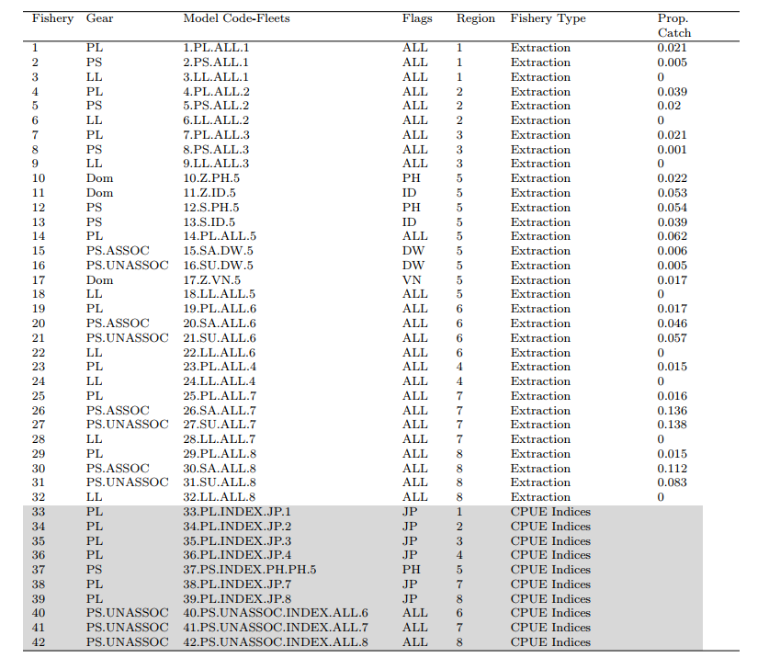

**Table SKJ-02.** Summary of stock assessment configuration and key sources of uncertainty in the WCPO skipjack tuna stock assessment by the MFCL.

|  |  |  |  |  |
| --- | --- | --- | --- | --- |
| **TYPE** | **RATIONALE** | **UNCERTAINTY** | **IMPACT** | **CONFIDENCE** |
| **DATA** | | | | |
| CPUE | Best available standardised indices, incorporating operational data,  multiple indices. | Potential hyperstability in PS CPUE indices | Abundance estimates could be biased from 2010-2024 | High |
| Catch | Best available information | ID catches may be biased high or low | Sensitivity indicated low impact | High |
| Size | Representative sampling | Good certainty, mandatory length reporting | Selectivity may vary temporally | Medium |
| Tag |  |  |  |  |
| **MODEL** | | | | |
| MFCL | Commonly used platform for WCPO tuna stocks | Robust platform for modeling length and tagging data | Low impact | High |
| **SPATIAL ASSUMPTIONS** | | | | |
| 8 regions | Based on regional processes informed by size and tagging data | Low uncertainty; informed by the literature | Low impact | High |
| **KEY PARAMETER UNCERTAINTY** | | | | |
| Growth coefficient *k* | Not estimable | Uniform distribution (0.2-0.4) | Influential on MSY-based reference points | High |
| Steepness | Not estimable | Beta distribution (mode of 0.85) | Influential on MSY-based reference points | High |
| **STRUCTURAL UNCERTAINTIES** | | | | |
| Mixing period *K* statistic | External estimates | *K* statistic (0.1, 0.2, 0.3) | Highly influential in the ensemble | Medium |
|  |  |  |  |  |
| Effort creep | External estimates | Effort creep trajectories randomly sampled from prior | Low influence | High |
| **Estimation uncertainty** | | | | |
| Estimation uncertainty | Monte-Carlo model ensemble | Estimated | Estimation uncertainty replacesstructural uncertainty | High |
| **Other source of uncertainty** | | | | |
| Data conflict | Likelihood profile indicates length conflicts with CPUE and tag data | Conflict in the scaling of biomass | Not considered | Low |

**Table SKJ-03.** WCPO Skipjack stock status summary table.

|  |  |  |  |  |
| --- | --- | --- | --- | --- |
| **Skipjack** | | | | |
| **Year: 2025** | **Spawning Potential** | Exceptionally unlikely (<1%) to be below the LRP | | Stock is not overfished |
| **Fishing mortality** | Exceptionally unlikely (<1%) to be above FMSY | | Overfishing is not occurring |
| **Projection** | The stock is on average at 98% of the recalibrated interim TRP (iTRP) as defined in CMM 2022-01 | | Depletion is in the range expected through the MSE testing of the adopted interim skipjack MP (CMM 2022-01) |
| **Recommendation** | The stock has had stable spawning potential, spawning potential depletion (SB/SBF=0) and fishing mortality since around 2010. The Stock and fishing mortality are well above the LRPs for depletion and fishing mortality, respectively. | | |
| **Reference points/MP** |  | **Estimate**  **[10%--90%]** | **Comment** | |
| iTRP  (interim Target Reference Point) | iTRP recalibrated based on 2025 stock assessment | 0.52  [0.47 – 0.64] | The calculation method for the iTRP is described in CMM 2022-01. The iTRP depletion value requires recalibration for each new stock assessment. Stock status is reported below as the ratio of the SBrecent/SBF=0 of thenew stock assessment to the corresponding recalibrated iTRP value. | |
| iTRP (interim Target Reference Point) | iTRP | 0.98  [0.94 – 1.01] |  | |
| Depletion | LRP (0.2SBF=0) | 0.51  [0.45 – 0.63] |  | |
| Fishing Mortality | FMSY | 0.28  [0.25 – 0.32] |  | |
| **Recent estimates** |  |  | Recent trend/projection | |
| SB depletion (w/ estimation uncertainty) | SBrecent/SBF=0 | 0.51  [0.45 – 0.63] | The iTRP is recalibrated for each assessment according to the definition in [CMM 2022-01](https://cmm.wcpfc.int/measure/cmm-2022-01) – Reference Points.  The ratio presented here is the ratio of the SBrecent/SBF=0 from the current stock assessment to the recalibrated iTRP value. | |
| Fishing mortality | Frecent | 0.10  [0.07 – 0.12] | LRP based on SBrecent/SBF=0 is the adopted LRP for tuna stocks by the WCPFC. | |
| SB depletion (w/o estimation uncertainty) | SBrecent/SBF=0 | 0.51  [0.45 – 0.63] | FMSY is the upper-level limit reference point for fishing mortality used by WCPFC for tuna stocks. | |
| **Status** | | | **Likelihood** | |
| Ratio of SB depletion:iTRP | SBrecent/SBF=0：iTRP | 0.98  [0.94 – 1.01] | Within the range expected through the MSE testing of the adopted interim skipjack MP | |
| SB depletion (w/ estimation uncertainty) | SBrecent/SBF=0 | 0.51  [0.45 – 0.63] | <1% probability < 0.2 (LRP) | |
| SB depletion with respect SBMSY (w/estimation uncertainty) | SBrecent/SBMSY | 3.90  [2.95 – 5.61] | <1% probability < SBMSY | |
| Fishing mortality | Frecent/FMSY | 0.35  [0.24 – 0.45] | <1% probability > FMSY | |

**Table SKJ-04.** Summary of reference points over the model ensemble, along with results incorporating estimation uncertainty. Note that these values do not include estimation uncertainty, unless otherwise indicated.

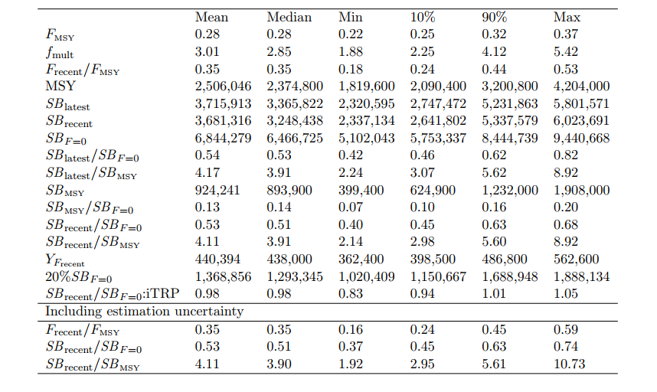

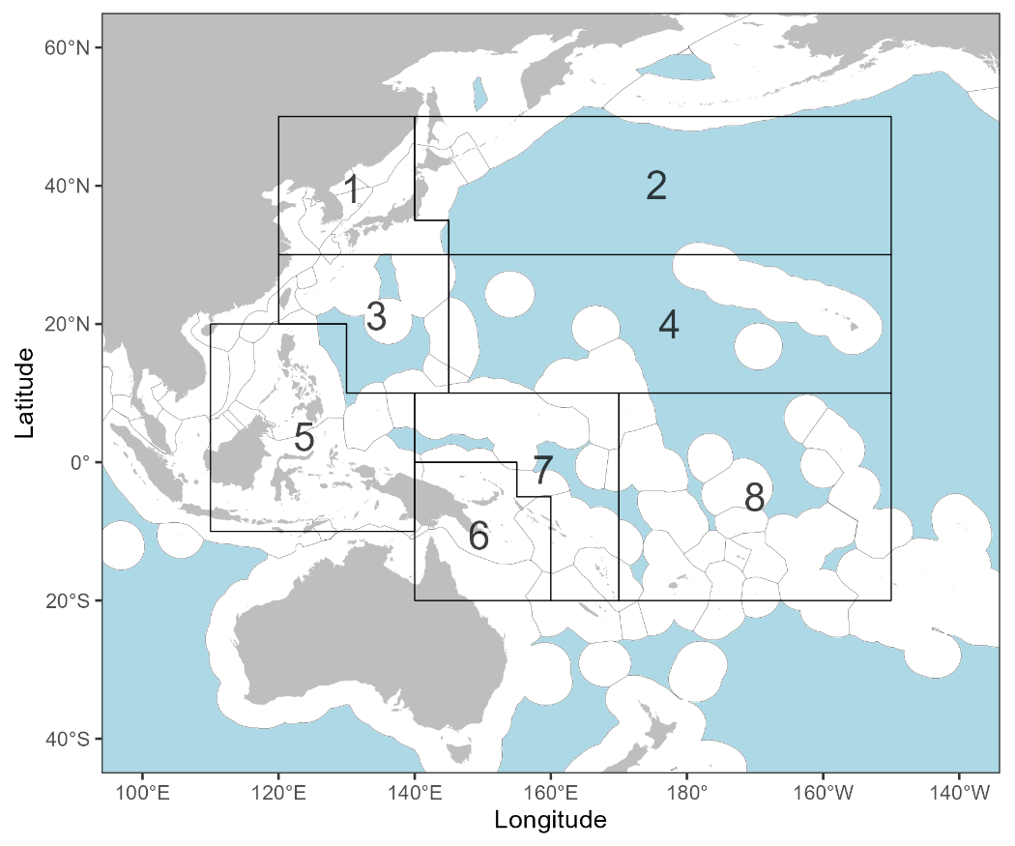

**Figure SKJ-01.** The Geographical area covered by the stock assessment and the boundaries of the eight model regions used for the 2025 skipjack assessment.

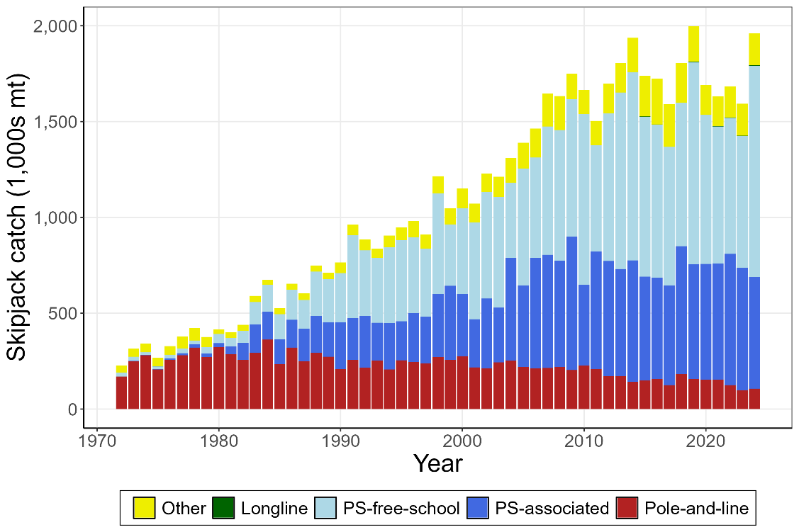

**Figure SKJ-02.** Time series of total annual catch (1000’s mt) by fishing gear over the full assessment period.

(a)

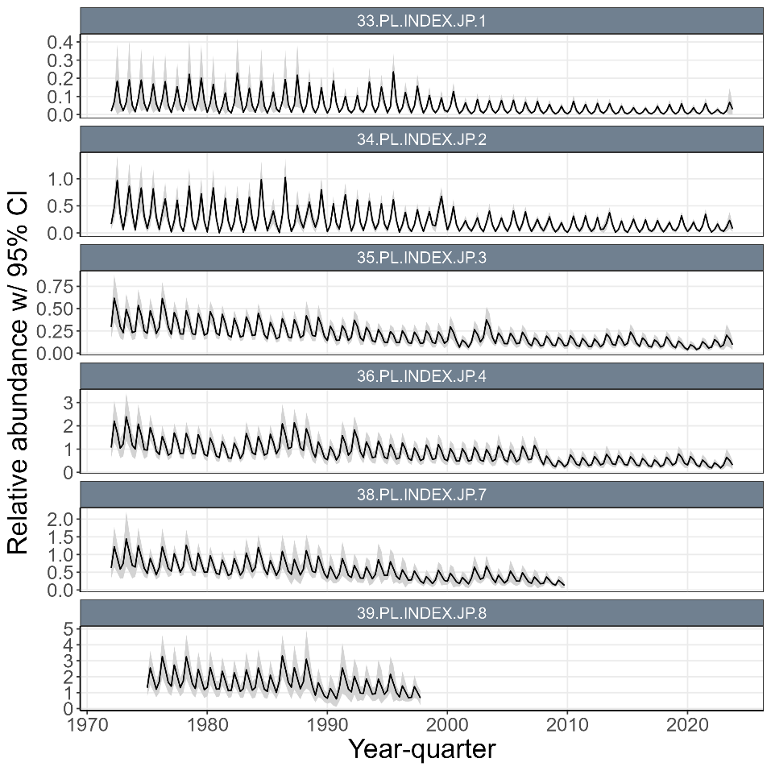

(b)

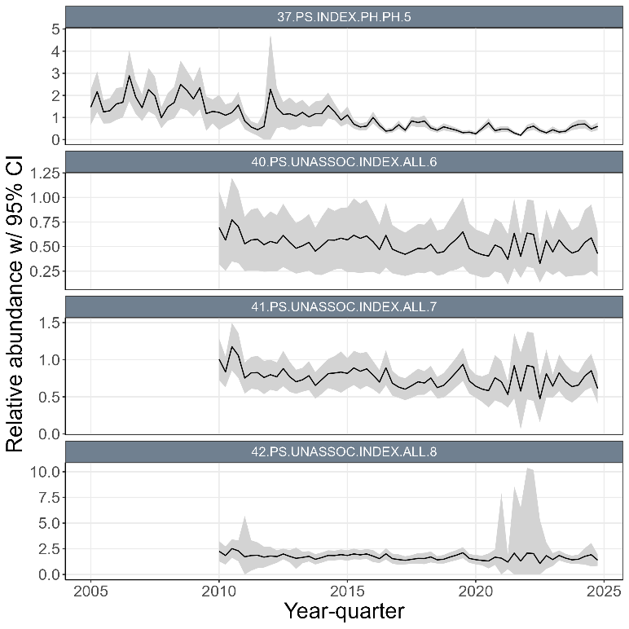

**Figure SKJ-03.** (a) Time series of standardized CPUE with 95% confidence intervals (CI) for the Japanese pole-and-line with effort creep adjustment and confidence intervals derived from bi-regionally grouped models (i.e., region1 with 2, region3 with 4, and region7 with 8). (b) Time series of standardized CPUE with 95% confidence intervals (CI) for the ‘unassociated’ purse seine CPUE indices in regions 6, 7, and 8, and the Philippines purse seine index in region 5. Fishery labels indicate fishery number, gear type, flags, and region, respectively.

(a)

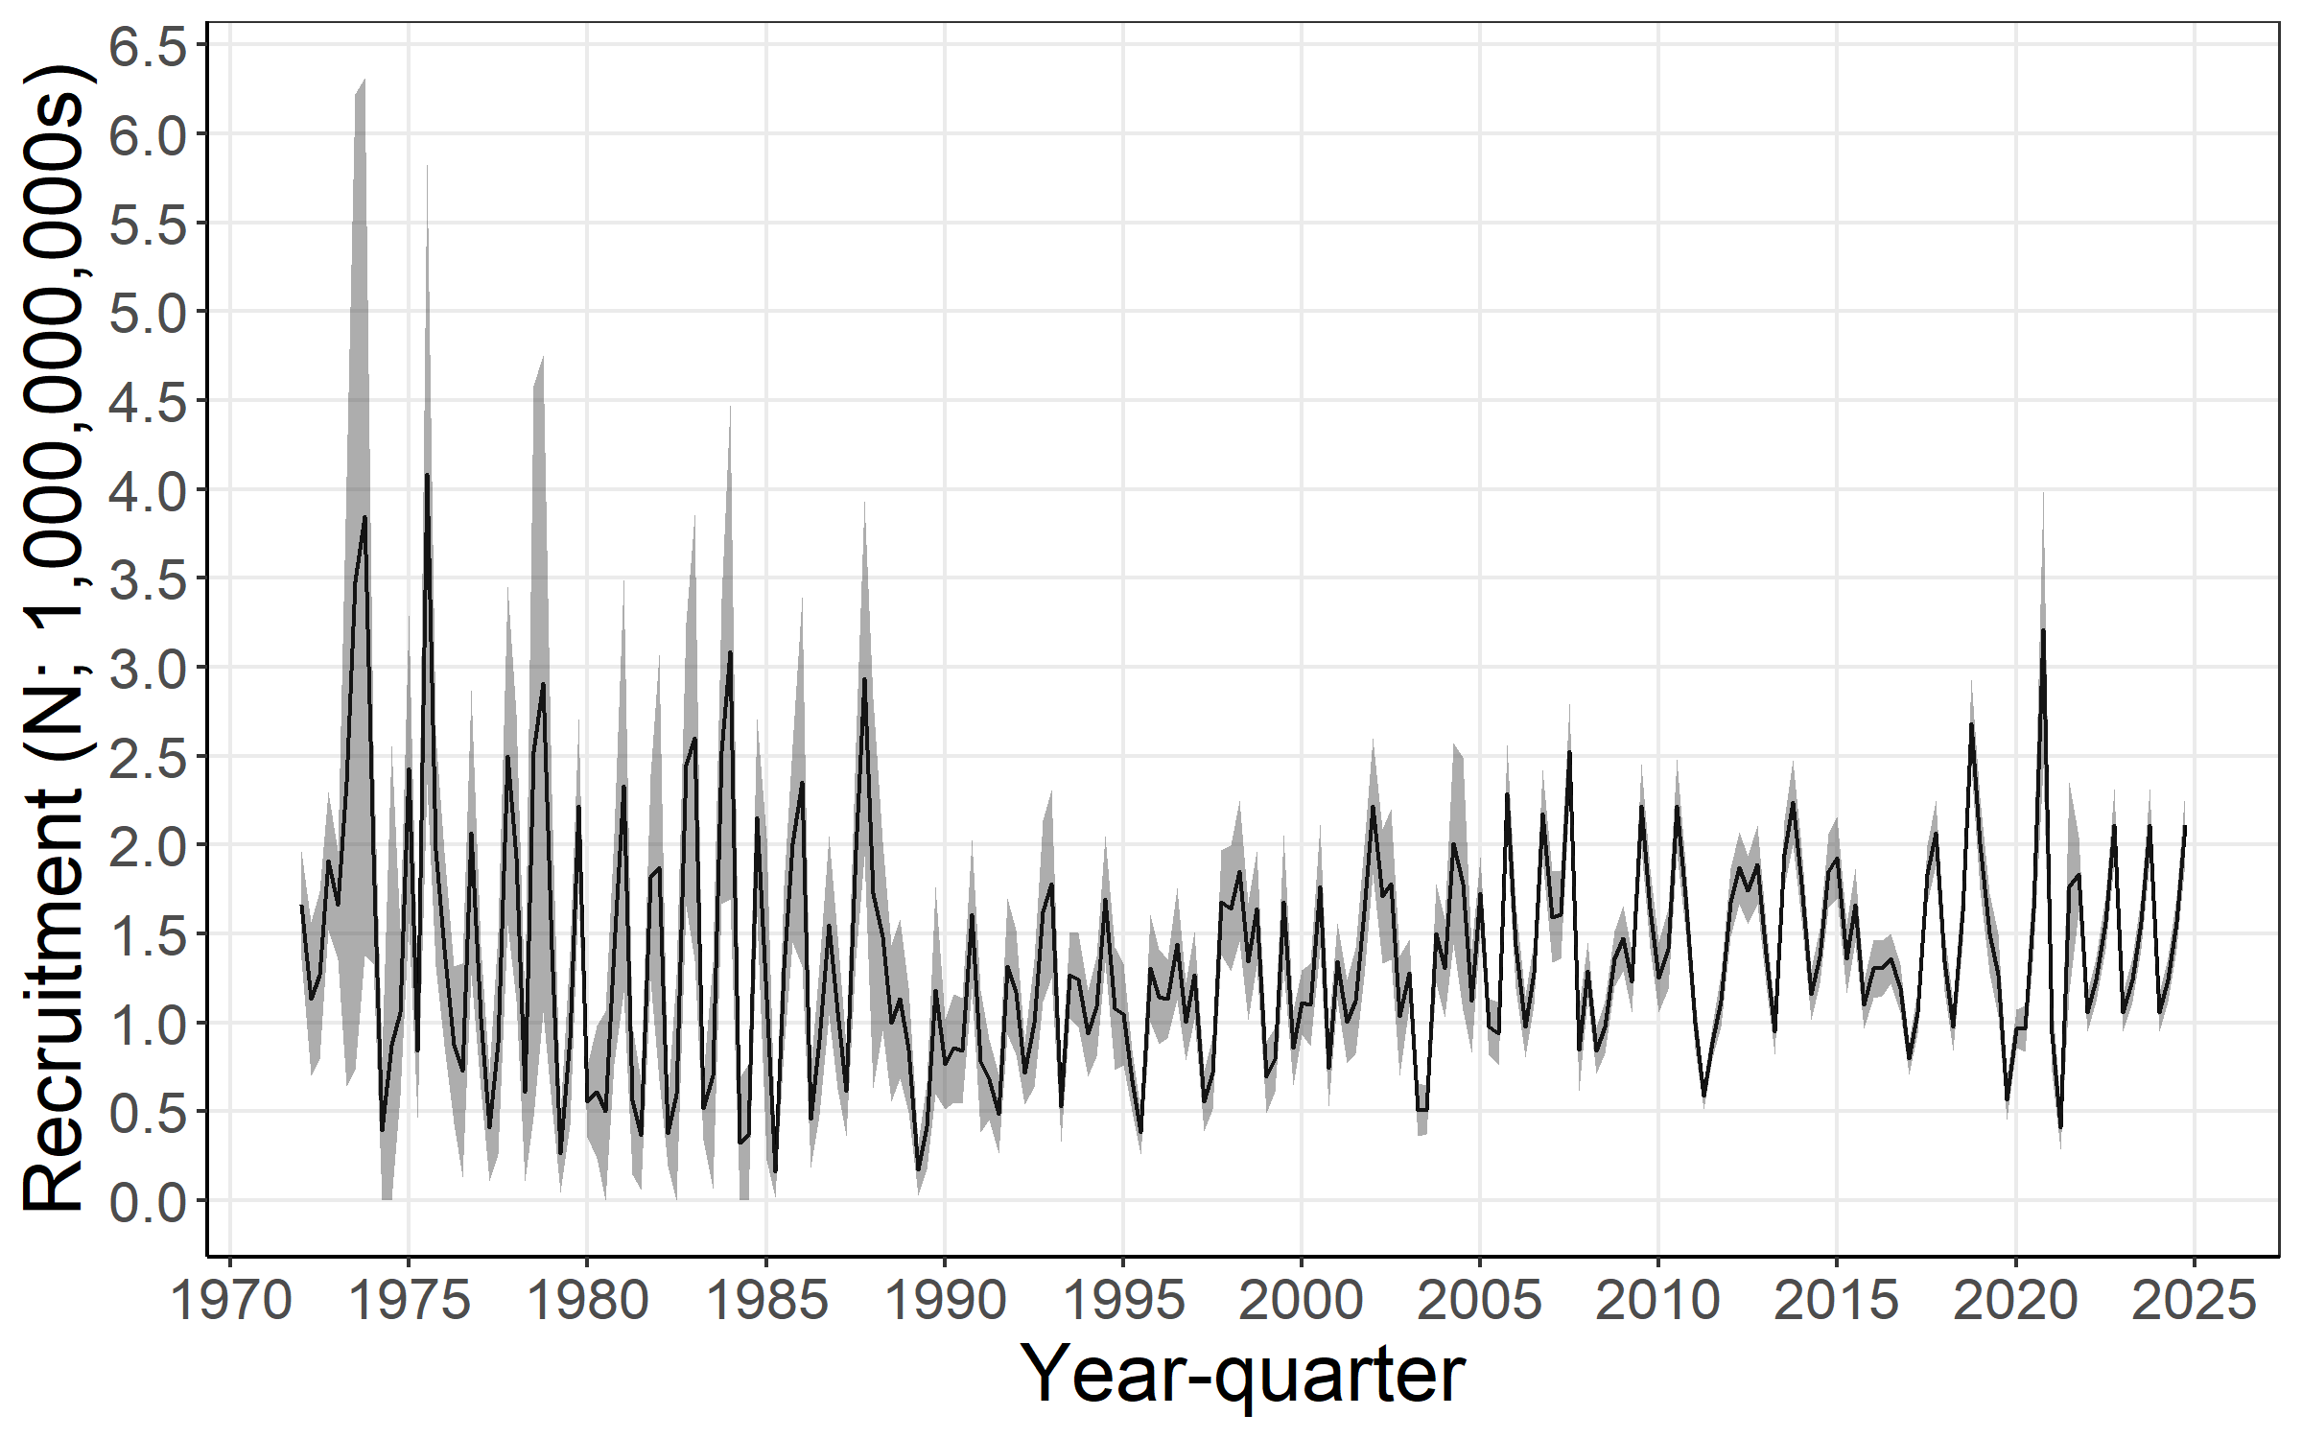

(b)

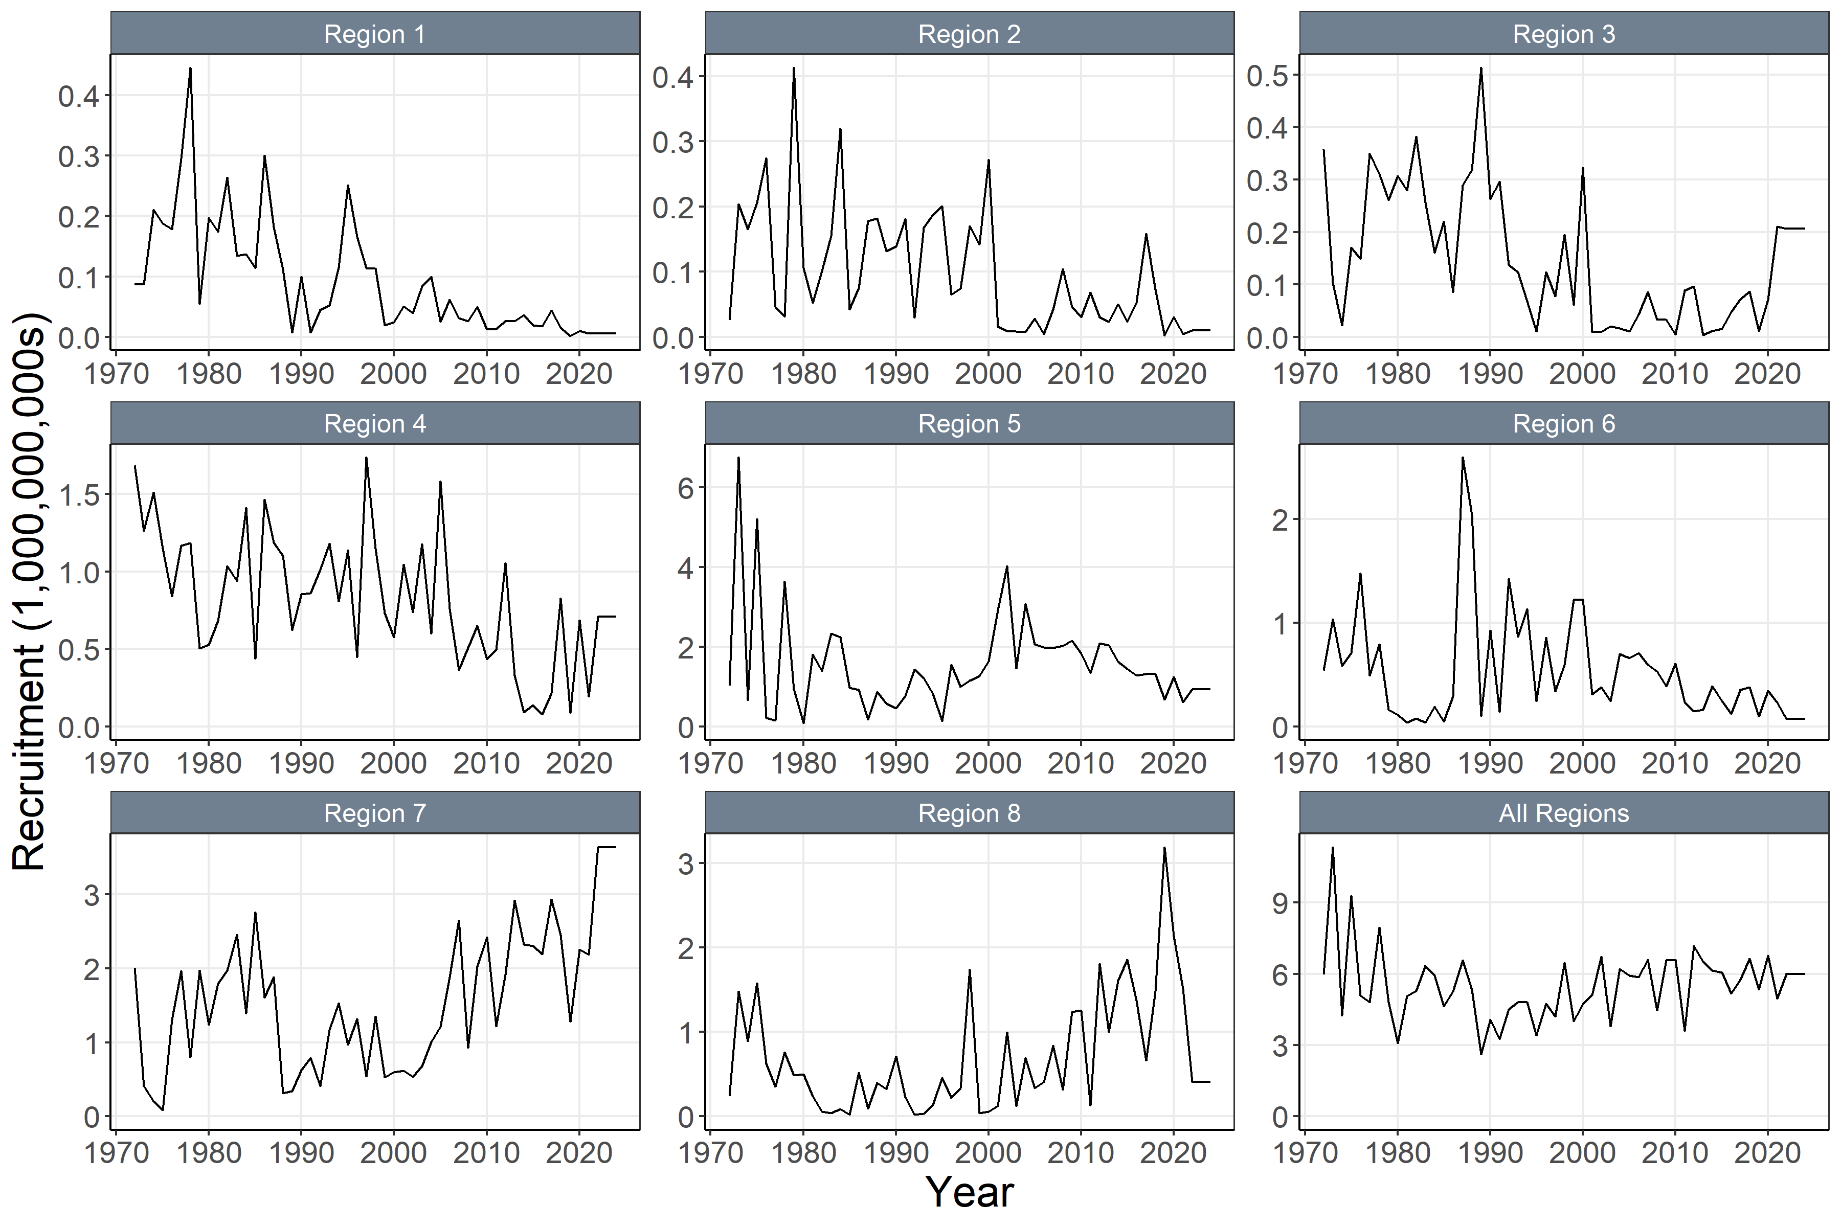

**Figure SKJ-04.** (a)Annual time series of estimated quarterly recruitment (including estimation error) summed across regions with 95% confidence interval for the diagnostic model. (b) Annual time series of estimated annual recruitment (without estimation error) among regions for the diagnostic model.

(a)

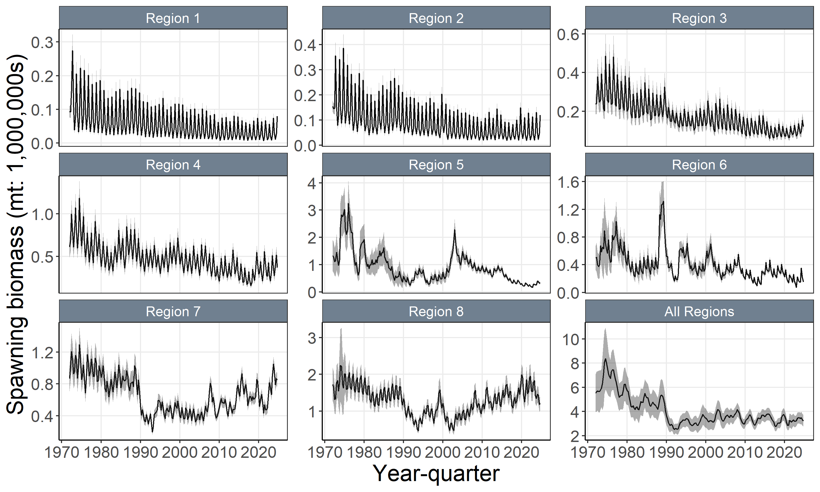

(b)

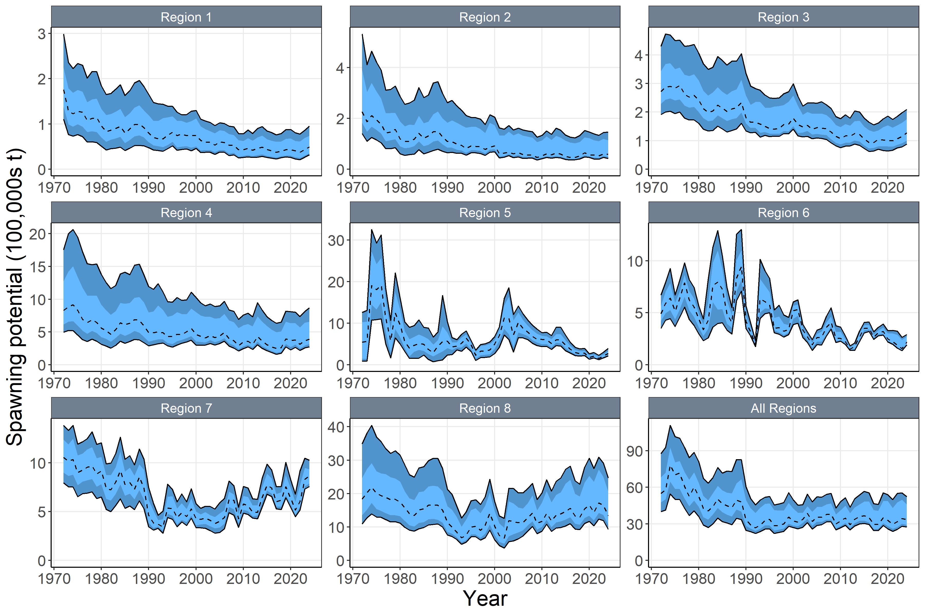

**Figure SKJ-05.** (a) Time series of estimated quarterly spawning potential by region with 95% confidence interval for the diagnostic model, including estimation error. (b) Time series of annual estimated 90% (dark blue) and 75% (light blue) quantiles of spawning potential by region from the model ensemble. The dashed line indicates the median. Estimation uncertainty was not included.

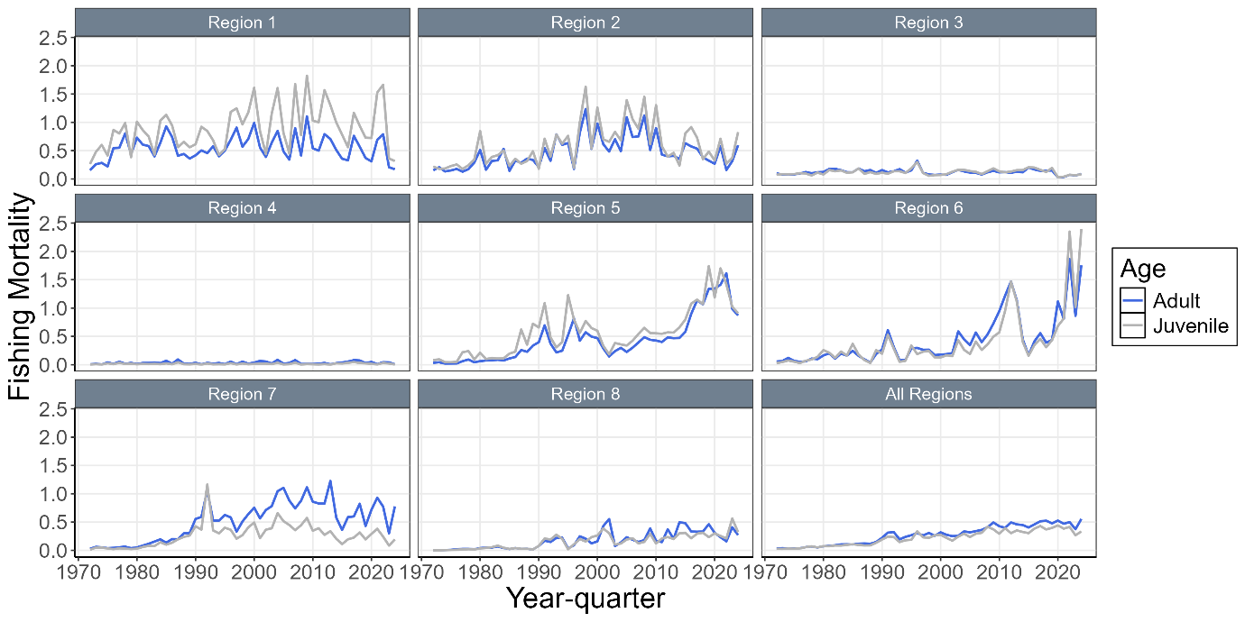

**Figure SKJ-06.** Time series of annual estimated fishing mortality for adults and juveniles by regions for the diagnostic model.

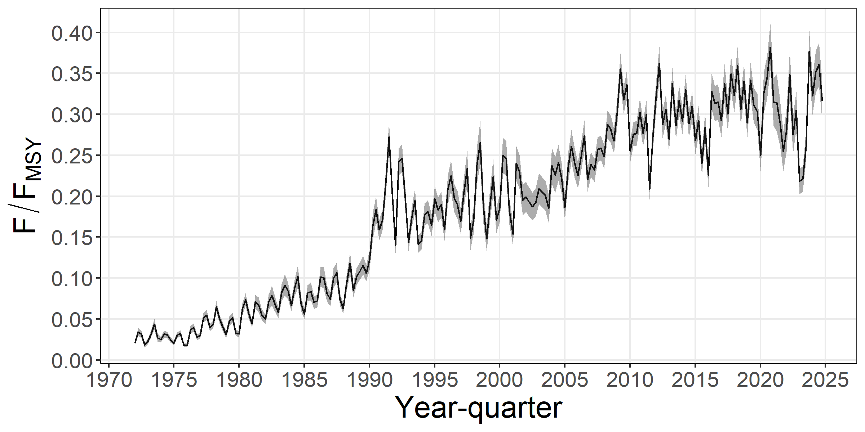

**Figure SKJ-07.** Time series of estimated F/FMSY with 95% estimation error for the diagnostic mode.

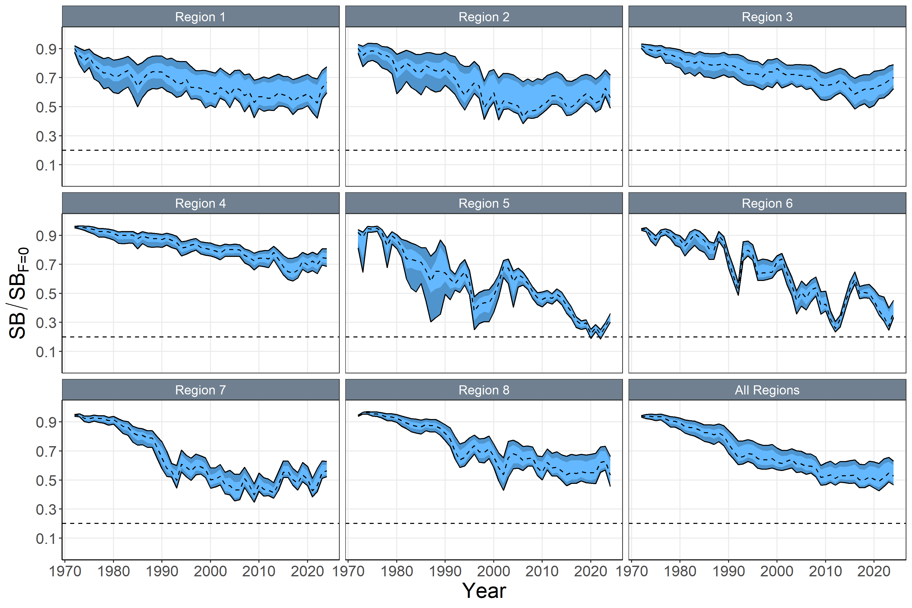

**Figure SKJ-08.** Time series of annual estimated 90% (dark blue) and 75% (light blue) quantiles of SB/SBF=0 by region from the model ensemble. The dashed line within the interval indicates the median. Estimation uncertainty not included.

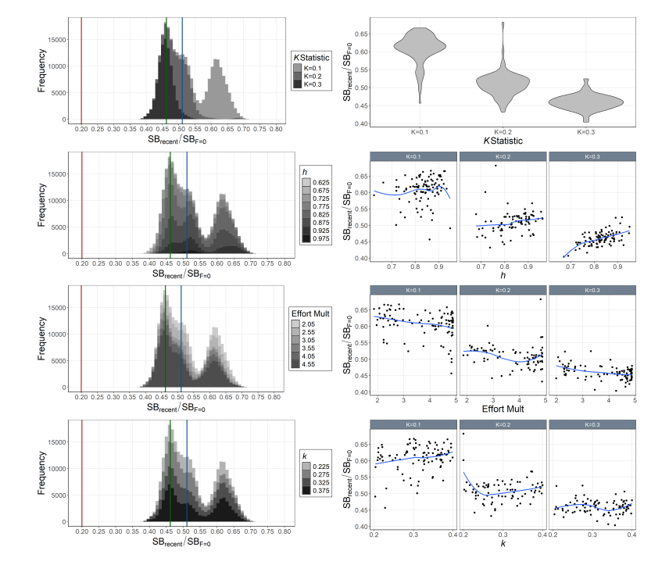

**Figure SKJ-09.** Histograms of Monte-Carlo estimated model uncertainty for SBrecent/SBF=0 by mixing period (K statistic, top-left), h (2nd-left), effort multiplier (Effort Mult; 3rd-left), and growth coefficient k (bottom left) with mode (green line), median (blue line), and SBrecent/SBF =0 = 0.2 (red line). Also includes estimated SBrecent/SBF=0 by mixing period (K statistic; top-right), h (2nd-right), effort multiplier (Effort Mult; 3rd-right), and growth coefficient k (bottom-right) for each model in the ensemble with a loess smoother.

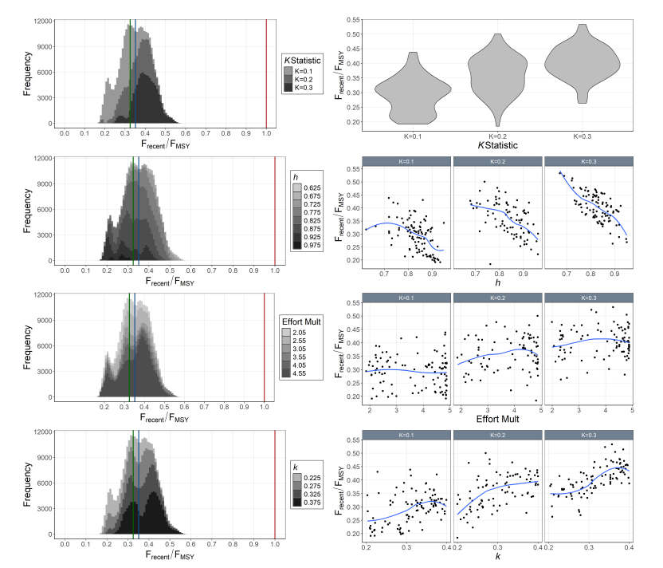

**Figure SKJ-10.** Histograms of Monte-Carlo estimated model uncertainty for Frecent/FMSY by mixing period (K statistic, top-left), h (2nd-left), effort multiplier (Effort Mult; 3rd-left), and growth coefficient k (bottom left) with mode (green line), median (blue line), and Frecent/FMSY = 1.0 (red line). Also includes estimated Frecent/FMSY by mixing period (K statistic; top-right), h (2nd-right), effort multiplier (Effort Mult; 3rd-right), and growth coefficient k (bottom-right) for each model in the ensemble with a loess smoother.

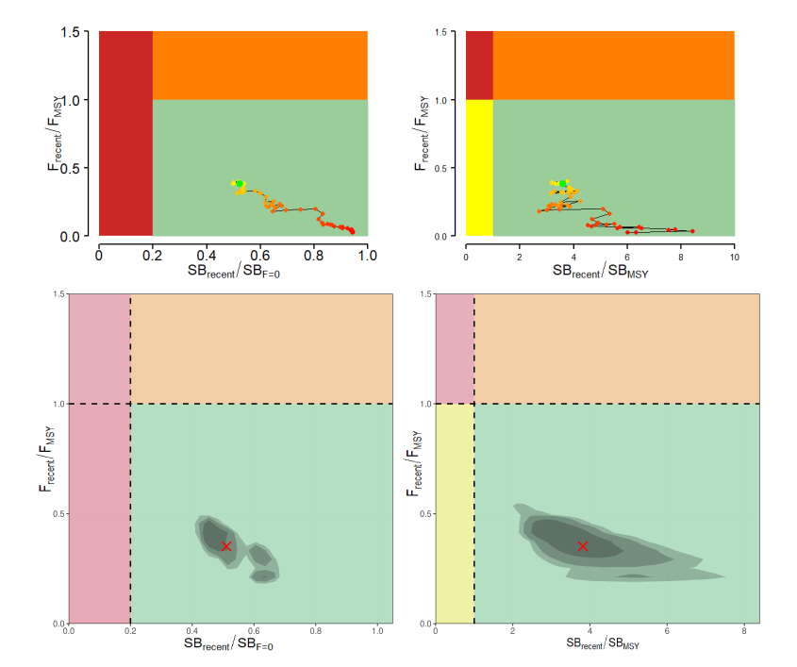

**Figure SKJ-11.** Majuro plots (left) and Kobe plots (right) summarizing the results for the dynamic MSY analysis (top; 4 years window moving back in time) and the Monte-Carlo random draws from the model ensemble (i.e., including estimation uncertainty) for the recent period (2021–2024; right). Colors for dynamic MSY go from red to green over time. The shading of model ensemble results indicates the 50th, 80th, and 90th highest density regions. The red X in the model ensemble represents the median. Fmsy calculated as 1/Fmult..

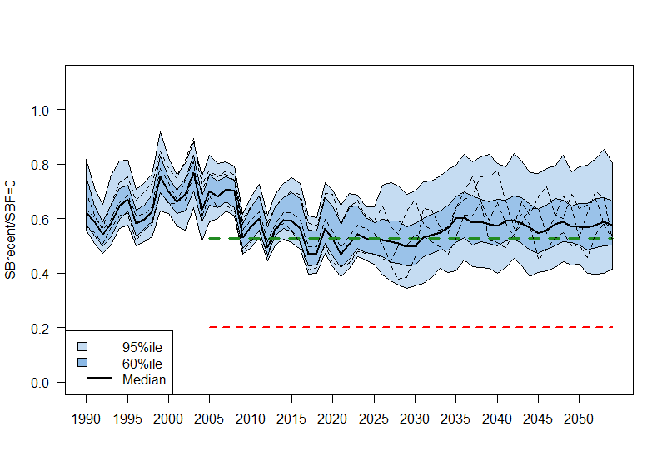

**Figure SKJ-12.** WCPO skipjack tuna SB depletion from the uncertainty grid of assessment model runs for the period 1990 to 2024 (the vertical line at 2024 represents the last year of the assessment), and stochastic projection results for the period 2025 to 2054 assuming catch and effort levels in 2024 continued. Prior to 2025, the data represent the 60th and 95th percentiles of the uncertainty grid from the assessment models and the median. During the projection period (2025-2054), levels of recruitment variability estimated over the period used to estimate the stock-recruitment relationship (1984-2020) are assumed to continue in the future. The dashed lines indicate three example trajectories (chosen randomly out of 8,100) from the model grid. The red dashed line represents the WCPFC agreed limit reference point (0.20). The green dashed line represents the recalibrated skipjack TRP level.

* + 1. **Stock status**

1. Estimation uncertainty was incorporated by applying a Monte-Carlo model ensemble approach. Estimates of *SBrecent/SBF*=0 (**Figure SKJ-09**) and *Frecent/FMSY* (**Figure SKJ-10**) indicated that tag mixing period assumptions (i.e., dissimilarity *K* statistic) had the largest impact on estimates of stock status.
2. The models from the ensemble indicated the probability that *SBrecent/SBF* =0 *<*0.2 (LRP) was 0 (**Table SKJ-03**), the probability that *Frecent/FMSY >*1 was 0. The dynamic Majuro and Kobe plots indicated that for all time periods, the *SBrecent/SBF*=0 was *>* 0.2, *SBrecent/SBMSY* was *>* 1, and the *Frecent/FMSY* was *<* 1 (**Figure SKJ-11**). Similarly, all models in the ensemble for the recent period (2021–2024) indicated the *SBrecent/SBF*=0 was *>* 0.2, *SBrecent/SBMSY* was *>* 1, and the *Frecent/FMSY* was *<* 1. As in the previous stock assessment, results indicate that the skipjack stock in the WCPO is not overfished, and overfishing is not occurring.
3. The projected stock depletion levels under recent conditions are presented in **Figure SKJ-12**. The year 2024 represents the first year of application of the skipjack interim management procedure (CMM 2022-01). The stock is on average at 98% of the recalibrated TRP (0.94 – 1.01). This is within the range expected through the MSE testing of the adopted interim skipjack MP (see MSE shiny at [https://ofp-sam.shinyapps.io/PIMPLE_WCPFC19/](https://aus01.safelinks.protection.outlook.com/?url=https%3A%2F%2Fofp-sam.shinyapps.io%2FPIMPLE_WCPFC19%2F&data=05%7C02%7Cthomast%40spc.int%7Cd1228702ddf2445eb21408dddab563f8%7Cf721524dea604048bc46757d4b5f9fe8%7C0%7C0%7C638907194777958682%7CUnknown%7CTWFpbGZsb3d8eyJFbXB0eU1hcGkiOnRydWUsIlYiOiIwLjAuMDAwMCIsIlAiOiJXaW4zMiIsIkFOIjoiTWFpbCIsIldUIjoyfQ%3D%3D%7C0%7C%7C%7C&sdata=1pF%2Fj386kQ7S4xhehxGcLzSs8hpPdhqKOuz1mkEWxYQ%3D&reserved=0); performance indicator: ‘*SB/SBF*=0 relative to target’).
   * 1. **Management advice**
4. **While acknowledging that ongoing improvements to the modelling are still needed, SC21 accepted the 2025 skipjack stock assessment results and considered that they in general support the continued application of the skipjack management procedure (MP). The entire monitoring strategy for the skipjack MP can be found in Agenda item 5.1.1.2 of the Management Issues theme.** 
   * 1. **Research recommendations**
5. SC21 identified a wide range of areas for improvement and suggested the following items for consideration in the development of the next stock assessment:

* Potential effort creep in PS CPUE.
* Data conflicts that affect assessment outcomes, and approaches to resolving them.
* Impact of tagging data on population scale
* Tag diagnostics: Models that fit to tagging data require diagnostic plots that indicate a) the degree of mixing for the tags included in the model, b) the likelihood profile on the SSB scale by tagging program, and c) tag mixing scenarios.
* Tag reporting rate priors
* Tag mixing period: more appropriately modelling the tagging data externally using the approach being developed in collaboration with DTU to develop external abundance indices for the tagging data.
* Meta population structure: improve understanding of linkages between East Asian waters and the WCPFC area, and East-West linkages across the Pacific.
* Growth and age structure research: conduct research to explore the epigenetic approach.
  + 1. Other WCPO tunas
       1. **Indicator analysis**

1. SC21 thanked the SSP for conducting an indicator analysis providing empirical information on recent patterns affecting key stocks.
2. SC21 noted that there is no standard action by the SC to respond to the analysis.
3. SC21 expressed concern over the apparent increased catches of small bigeye in other gear fisheries in Region 7, which resulted in a high probability of overfishing in the projections (SC21-SA-WP-03). However, SC21 noted that this result may not be reliable because the size class of these fish may have been misclassified. SC21 recommended that this uncertainty be resolved as a matter of urgency and that updated information be provided as necessary for the Commission’s consideration.
4. **SC21 recommended that the SSP undertake a detailed analysis of BET mean weight trends by space, time, and fleet over the past 10 to 20 years. This will improve our understanding of these patterns and inform next year's assessment, which will be discussed at the next Pre-Assessment Workshop (PAW).** 
   * + 1. **Updated reproductive biology of tropical tunas (Project 120)**
   1. Northern stocks
      1. Provision of scientific information from the ISC
5. SC21 thanked the International Scientific Committee (ISC) for its continued efforts and the provision of high-quality scientific assessments that are essential to informed decision-making in the Commission.
6. **SC21 supported the ISC25 agreement to review the WCPFC management advice and uncertainty template, and encouraged the Northern Committee to request the ISC to apply this template as a guideline in its regular reporting of management advice to promote consistency and comparability of stock assessment results across the WCPO.** 
   * 1. Pacific bluefin tuna (*Thunnus orientalis*)
        1. **Research on migratory patterns**
   1. Billfish
      1. Southwest Pacific swordfish (*Xiphias gladius*)
         1. **Stock assessment of Southwest Pacific swordfish**
7. SC21 thanked the SSP for their thorough work conducted on the Southwest Pacific swordfish stock assessment and for the considerable efforts to improve the assessment, particularly by transitioning to a Stock Synthesis model, implementing a two-sex model, including conditional-age-at-length data, and using length-based selectivity.
8. **SC21 accepted this assessment for management advice, and expressed overall confidence in the assessment, noting the model still shows some lack of fit to the CPUE index, and diagnostics still suggest some model mis-specification. The need for increased collection of conditional age-at-length data, improving limitations of the size composition data, a better understanding of potential boundary effects on the assessment, further work on CPUE indices, and further refining the stock assessment model structure were noted.** 
   * + 1. **Provision of scientific information to the Commission**
9. **Stock assessment and trends**
10. The 2025 stock assessment of the southwest Pacific Ocean swordfish adopts a two-region spatial structure with three subregions within each region (**Figure SWO-01**). The model assumes fixed quarterly movement between these two regions, and assumes a single reproductive stock, with 19 extraction fisheries (Error! Reference source not found.), each operating in one of 6 sub-regions.

1. The major structural uncertainties considered include incorporating: two alternative CPUE indices for region 2; three fixed values for steepness; two options for the proportion of recruitment in each region; three movement rate options between the two regions; five data weighting options for the length and weight composition data; and two options for natural mortality (**Table SWO-02**). These axes of structural uncertainty were incorporated into the estimates of reference point values listed in **Table SWO-03**.

1. The annual catches show a general moderate increase through to the late 1990s, when there was a notable increase to a peak in annual catches in 2007, followed by a general decrease in catches through to 2023. However, recent catches remain twice as large as the catches during the early 1990s (**Figure SWO-02**).
2. Catches in the WCPFC-CA south of the equator but north of 20ºS, and therefore not managed by CMM 2009-03, have accounted for 42% of the catch in the most recent period (2021-2024; **Figure SWO-03**).
3. Both the Australian CPUE index (**Figure SWO-04a**) and the New Zealand CPUE index (**Figure SWO-4b**) peak in the 2010s, but with no obvious longer-term trends that would indicate a general increase or decrease in the population size. The CPUE indices start much later (1998 for the Australian index and 2004 for the New Zealand index) than the catch series (1953).
4. The estimated absolute recruitment and recruitment deviations (**Figure SWO-05**) suggest some autocorrelation, and they appear to be partly driven by the pattern in the CPUE indices. The estimated time series of spawning biomass by region (**Figure SWO-06**) also reflects the pattern seen in the CPUE, but with a declining trend since the late 1990s, to match the increase in catches in this period. Fishing mortality started to increase in the late 1990s (**Figures SWO-07**) and has been relatively stable, fluctuating around a higher historical average mortality level, since around 2005.
5. The model convergence is very good, as seen from the jitter analysis. However, likelihood profiles indicate some conflict in the data. The retrospective analysis indicates sensitivity to recent data, and the ASPM indicates that the population scale is not well determined by the CPUE.
6. The spawning biomass trajectory is relatively stable into the mid-1990s (**Figure SWO-08**), followed by a period of decline and then a period of some recovery, from 2008-2015, followed by a further decline. The spawning biomass relative to SBMSY, the default WCPFC reference point, shows a similar pattern (**Figure SWO-09**).
7. The 2025 stock assessment results are generally similar to the previous assessment, indicating that the stock is unlikely to be experiencing overfishing or to be overfished, albeit with tighter uncertainty bounds, which are likely to be underestimated due to the simplified model structure and the limited range of options explored in the uncertainty grid.

**Table SWO-01**. Definition of fisheries by model regions (1, 2), fleet areas (N, C, S), and flags. Extraction fisheries: 1-19 and CPUE indices: 20-21), and indication of whether catch data is in tonnes (t) or numbers (nos).

**Table SWO-02.** Key sources of uncertainty in the 2025 Southwest Pacific swordfish stock assessment.

|  |  |  |  |  |
| --- | --- | --- | --- | --- |
| **TYPE** | **RATIONALE** | **UNCERTAINTY** | **IMPACT** | **CONFIDENCE** |
| **DATA** | | | | |
| CPUE | Best available standardised indices, incorporating operational data,  multiple indices. | Not a spatio-temporal index, limited spatial range for index fisheries compared to fishery range, mostly bycatch fisheries | May not be representative of the full stock | Medium |
| Catch | Best available information | Good certainty, mandatory catch reporting | Minor | High |
| Length | Representative sampling | Considerable uncertainty in some data sources.  Conversion factors, patchy sampling, and likely selective sampling issues. | May have temporal variation, but due to filtering and data weighting, the impact of unreliable data will be low. | Medium |
| Weight | Representative sampling | Conversion factors have some uncertainty. Weight sampling programs have high coverage from some fisheries, but restricted spatial coverage. | Medium | High (but spatial coverage is low) |
| Age | Representative sampling | Very limited temporal and spatial sampling of age composition data. | Influences estimated growth | Low |
| **MODEL** | | | | |
| Stock Synthesis | Widely used platform | Low, well-tested | Single model framework used for inference | High |
| **SPATIAL ASSUMPTIONS** | | | | |
| 2 regions | Based on the movement of satellite tags | High uncertainty in spatial structure, only one spatial structure considered. | Potentially important, but uncertainty not quantified, impact unknown | Low |
| **KEY PARAMETER UNCERTAINTY** | | | | |
| M | Estimable | Estimated and fixed (in grid) | Influential in the grid | Medium |
| Steepness | Not estimable in the current model | Grid (0.7, 0.8,0.9) | Influential in the grid | High |
| Growth | Estimable | Estimated variance of length-at-age fixed | Not included in the grid | Medium |
| Recruitment proportion | Not estimable in the current model | Grid (1:3,1:4) | Some influence on the grid | Medium |
| Movement | External estimates | Grid (halving each of the 2 movement rates successively) | Limited influence on the grid | Low |
| **STRUCTURAL UNCERTAINTIES** | | | | |
| CPUE options | PICT observer index in region 2 | Limited time series | Potentially important | Medium |
| **Estimation uncertainty** | | | | |
| Hessian | Variance-covariance estimates | Calculated | Important | High |
| **Other source of uncertainty** | | | | |
| Climate | Possible recruitment impacts | Not considered | Changes to productivity parameters | Low |
| Stock structure |  | Not considered | Unknown | Low |
| Spatial variation on growth |  | Not considered | Unknown | Low |

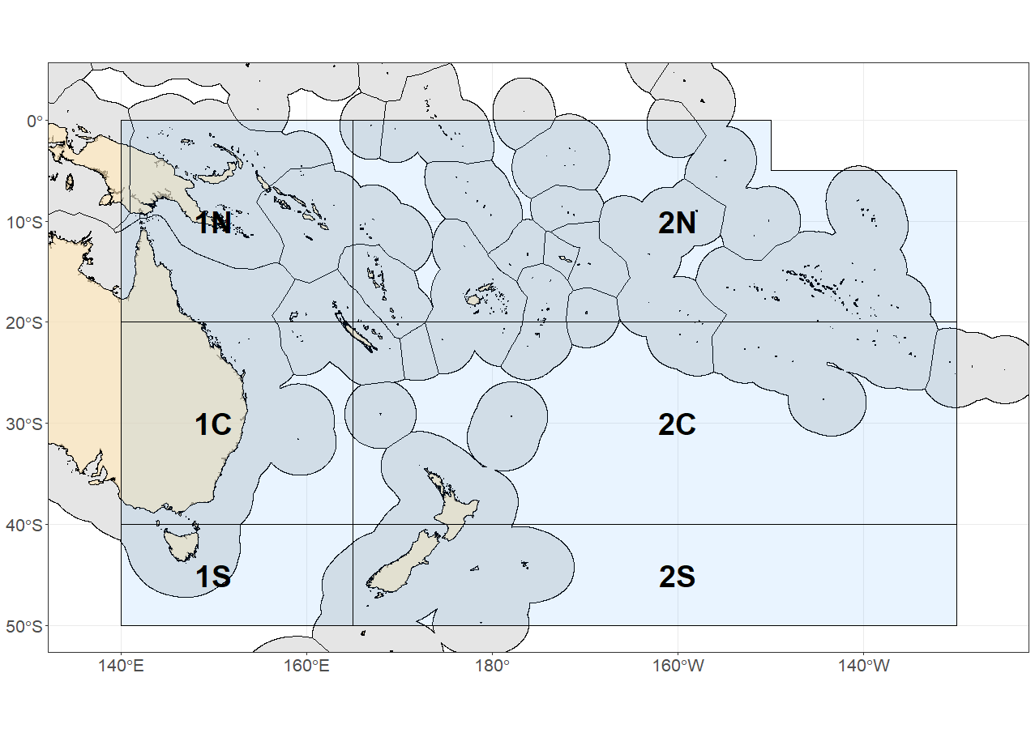

Figure SWO-01. The geographical area covered by the stock assessment and the boundaries of the two model regions (1, 2) and six subregions (N, C, S) used for the 2025 southwest Pacific swordfish assessment.

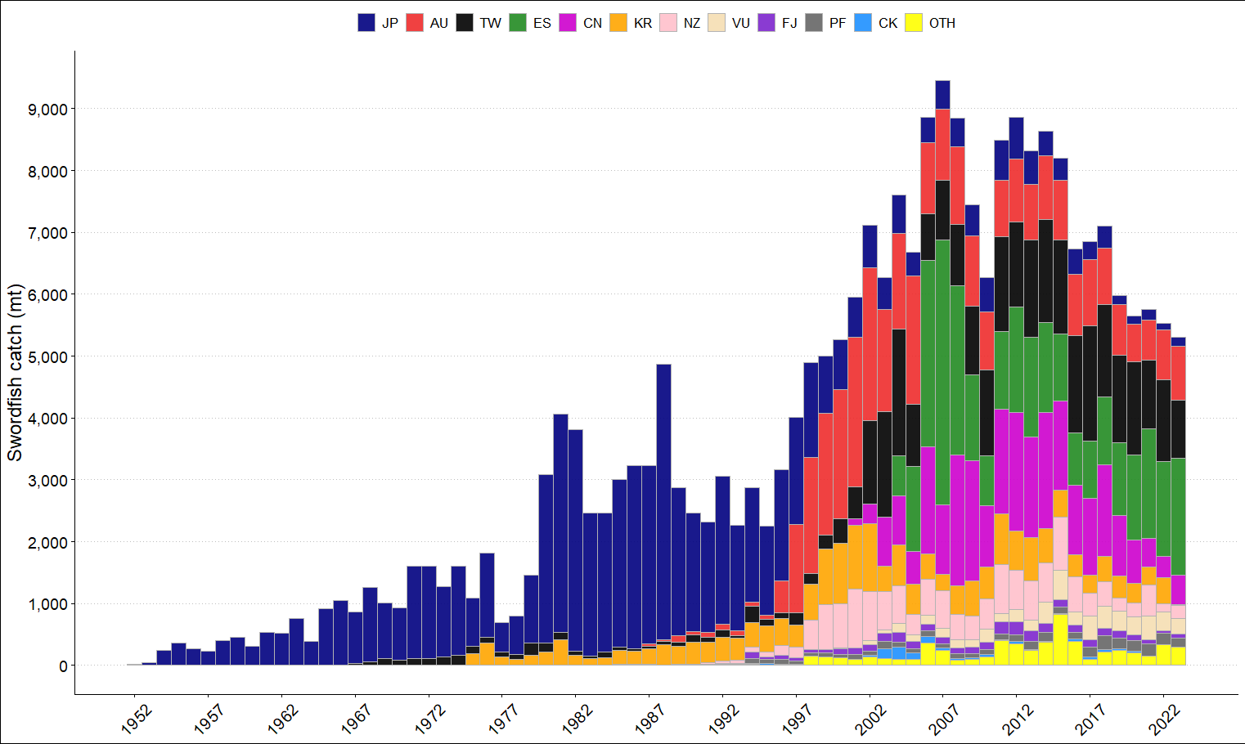

**Figure SWO-02**. Annual catches of southwest Pacific swordfish by flag in the area covered by the assessment.

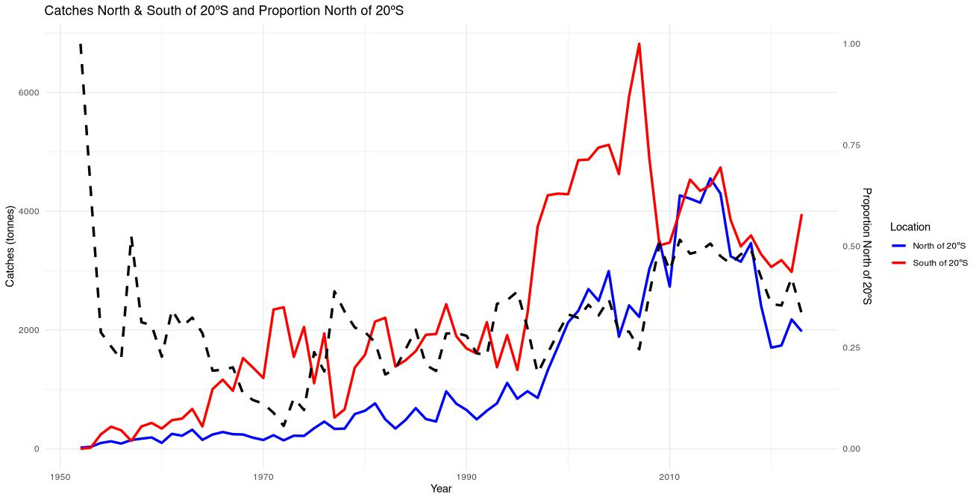

**Figure SWO-03.** Plot of the total Southwest Pacific swordfish catch (primary axis) south of 20S (red line), between the equator and 20S (blue line), and proportion of catch between the equator and 20S (dashed black line, secondary axis) by year in the WCPFC-CA.

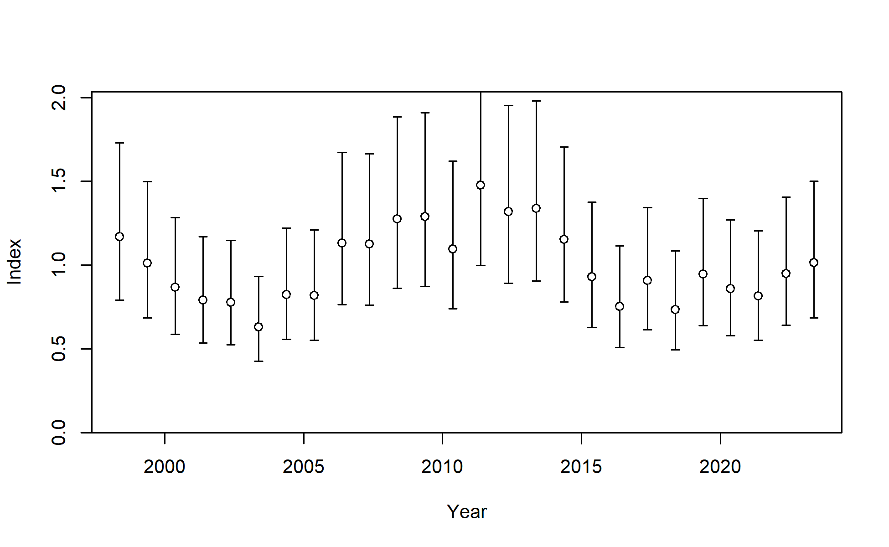

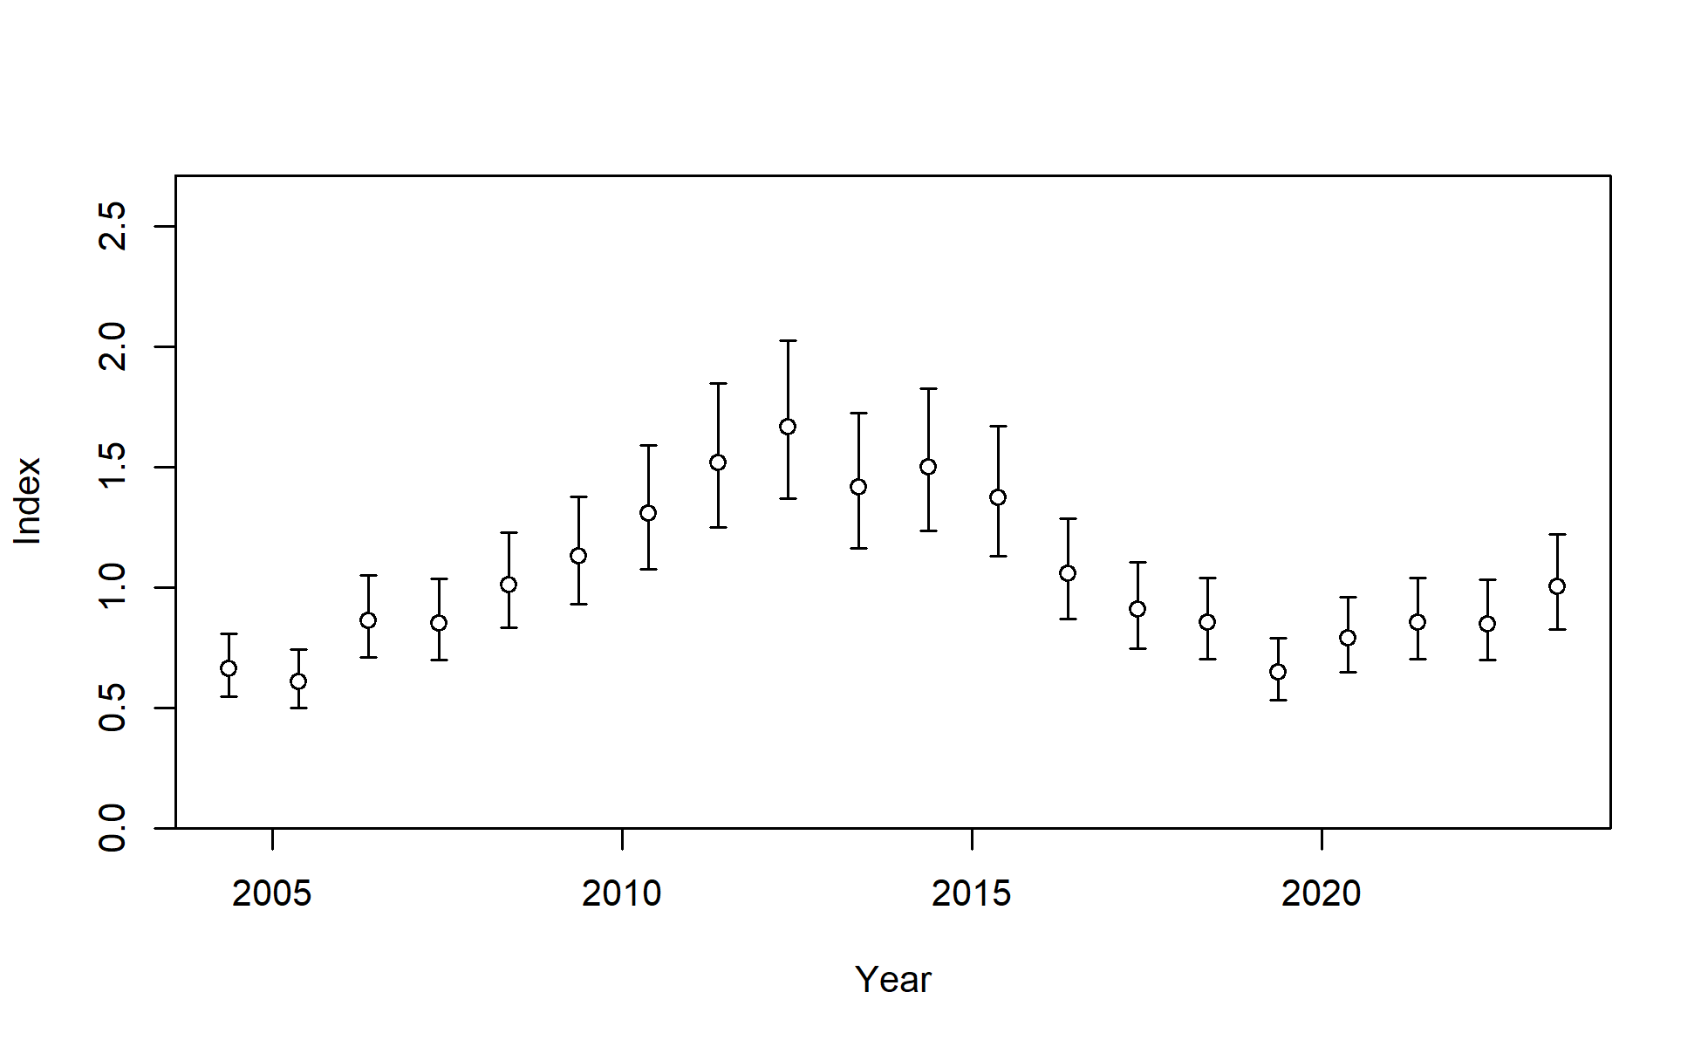

***Figure SWO-04****.* Standardised CPUE with initial input 95% confidence interval (CI) for (top) the Australian longline CPUE index fishery in region 1 and (bottom) the New Zealand longline CPUE index fishery in region 2. Additional variance was estimated within the model, which effectively reduced these confidence intervals for the AU index and increased them for the NZ index.

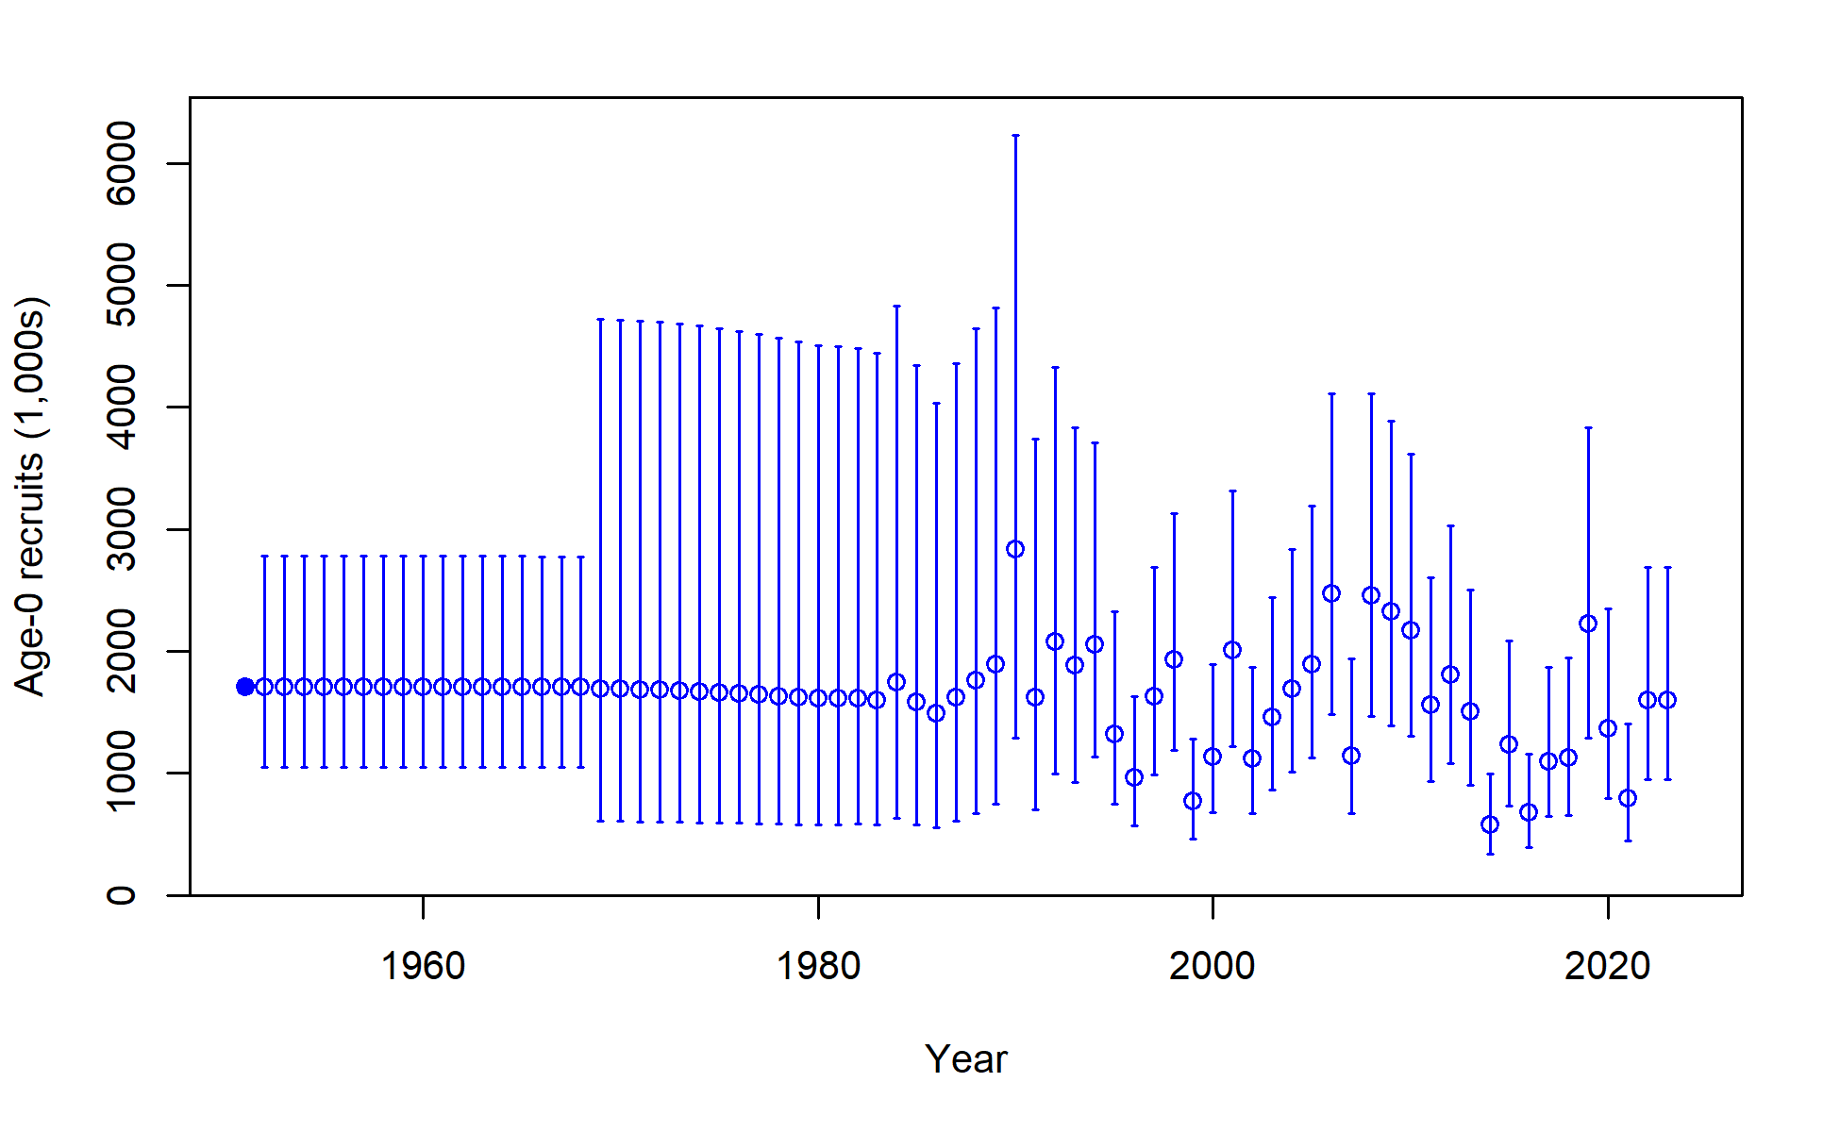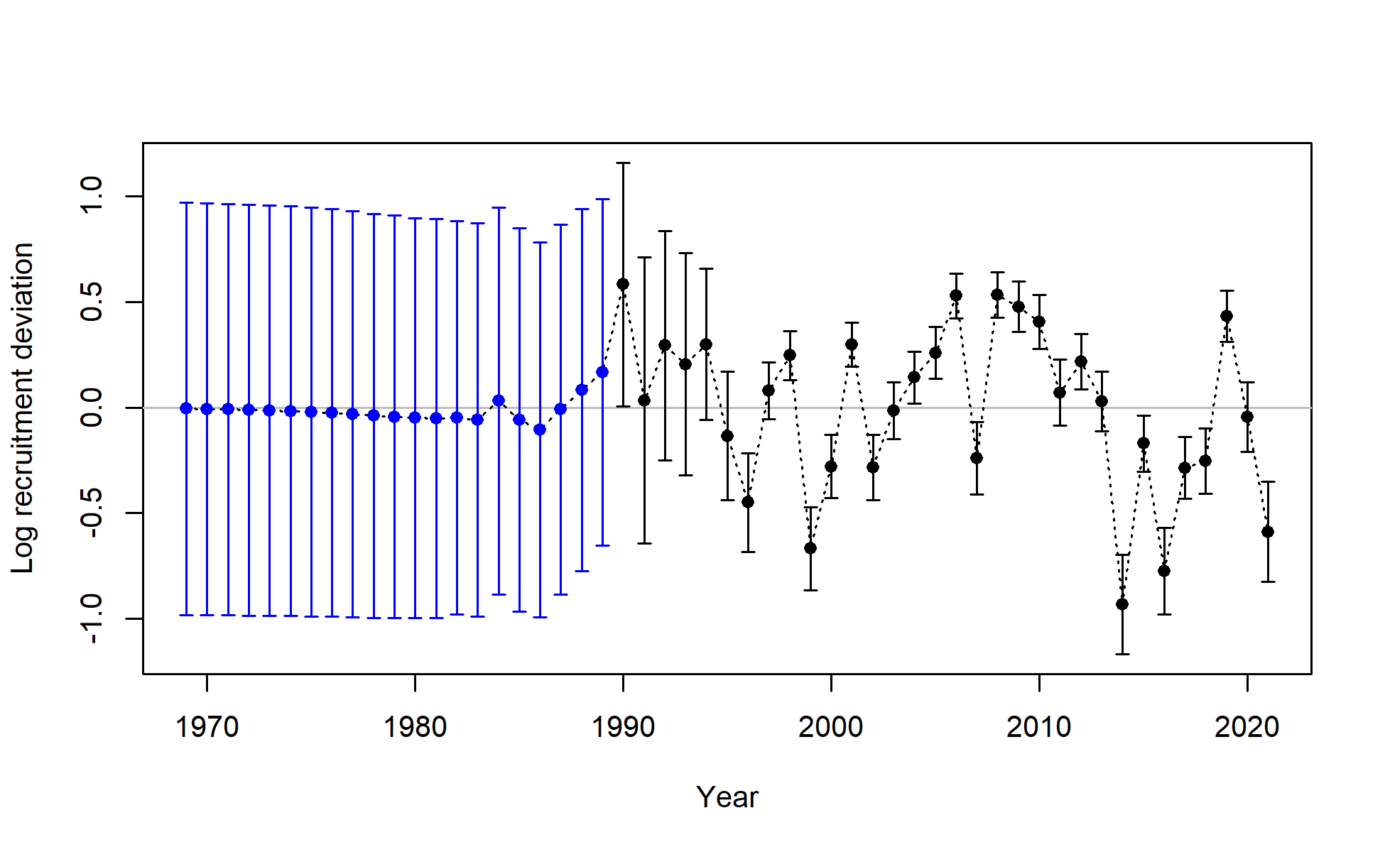

Figure SWO-05. Annual time series of estimated absolute annual recruitment in numbers (top) and Annual time series of estimated log annual recruitment deviations (bottom), including estimation uncertainty with 95% confidence interval for the diagnostic model.

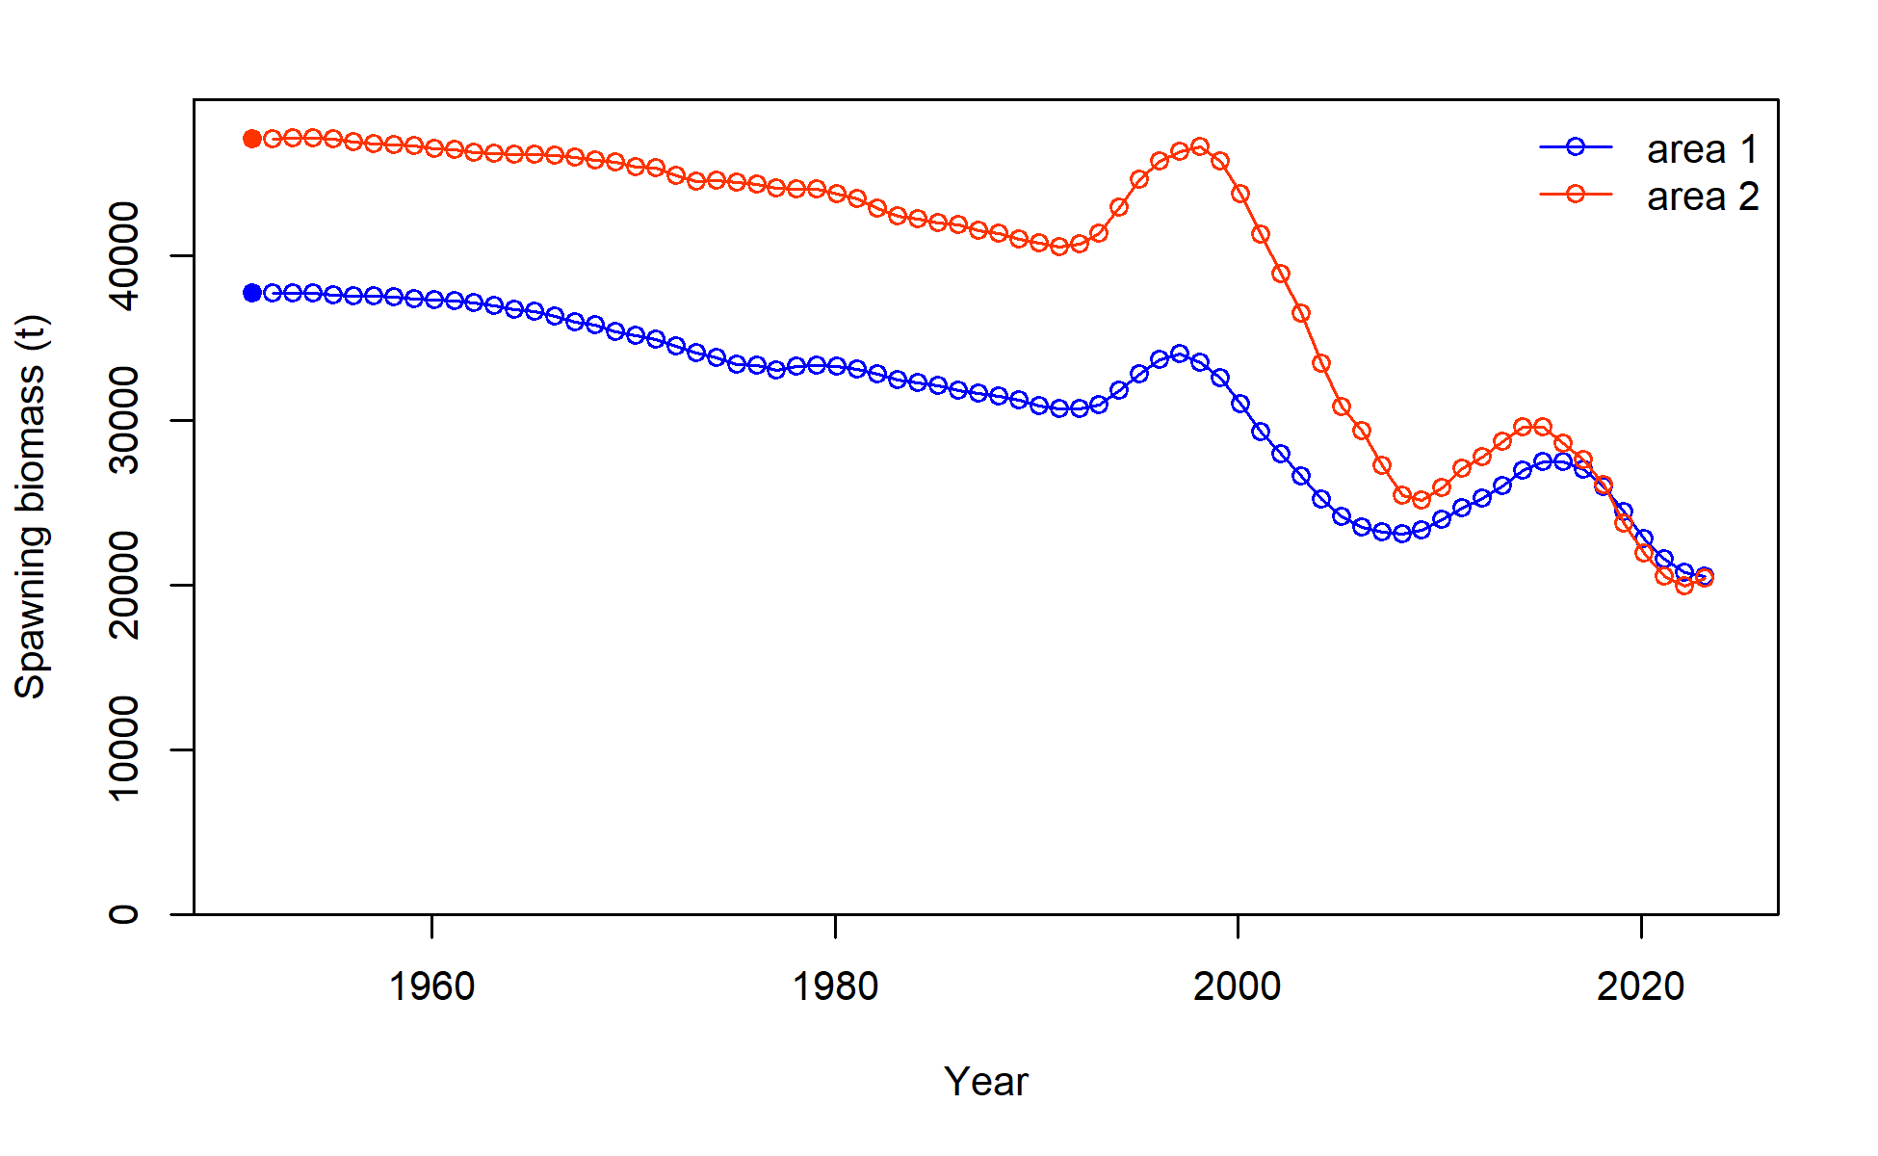

**Figure SWO-06**. Time series of estimated annual female spawning biomass (without estimation uncertainty) by region for the diagnostic model.

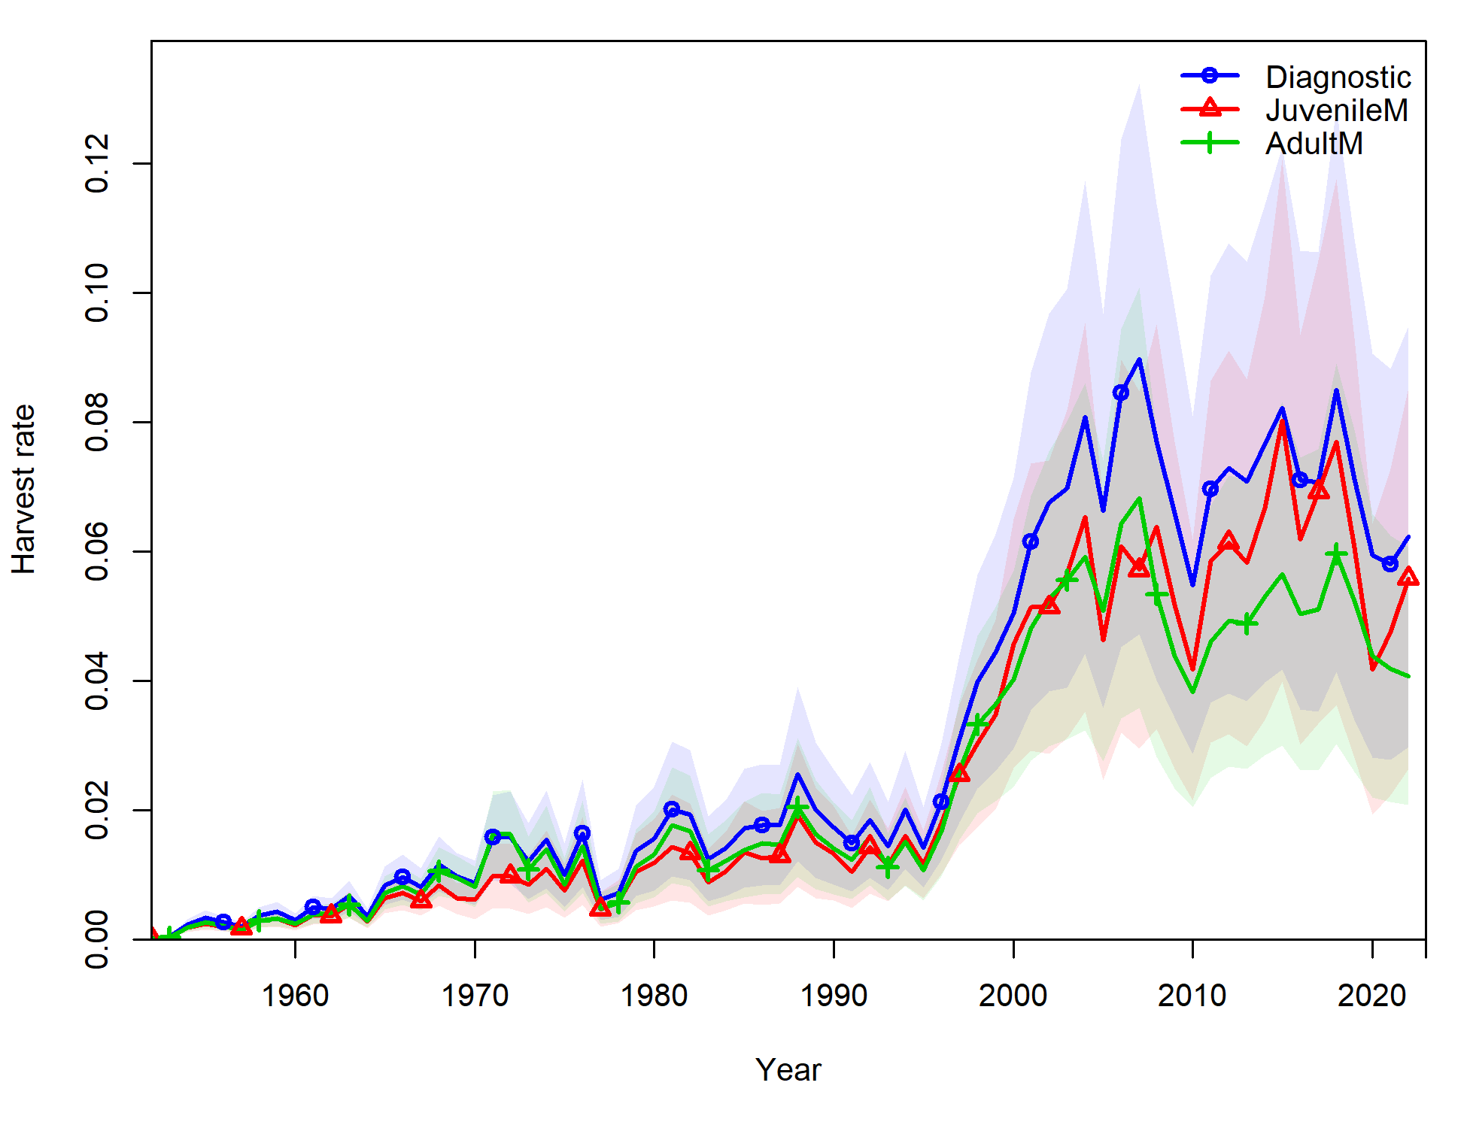

**Figure SWO-07**. Time series of annual estimated mean fishing mortality for age range 3-12 years for the diagnostic model (blue); for juvenile SWPO swordfish (age 1-3, red); and for adult SWPO swordfish (age 8-15, green).

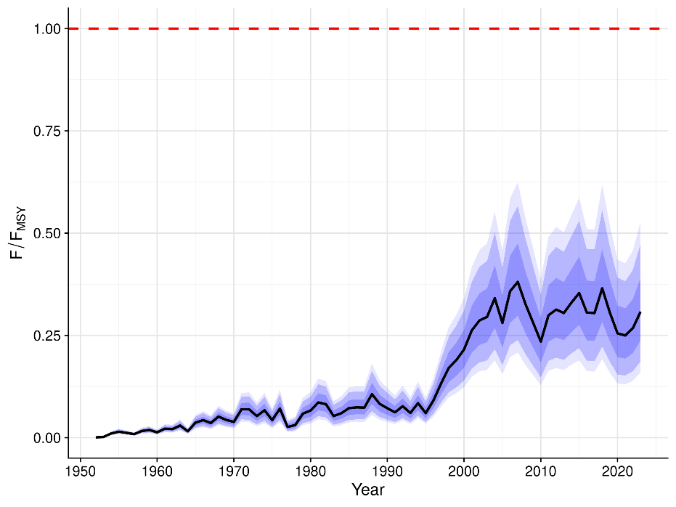

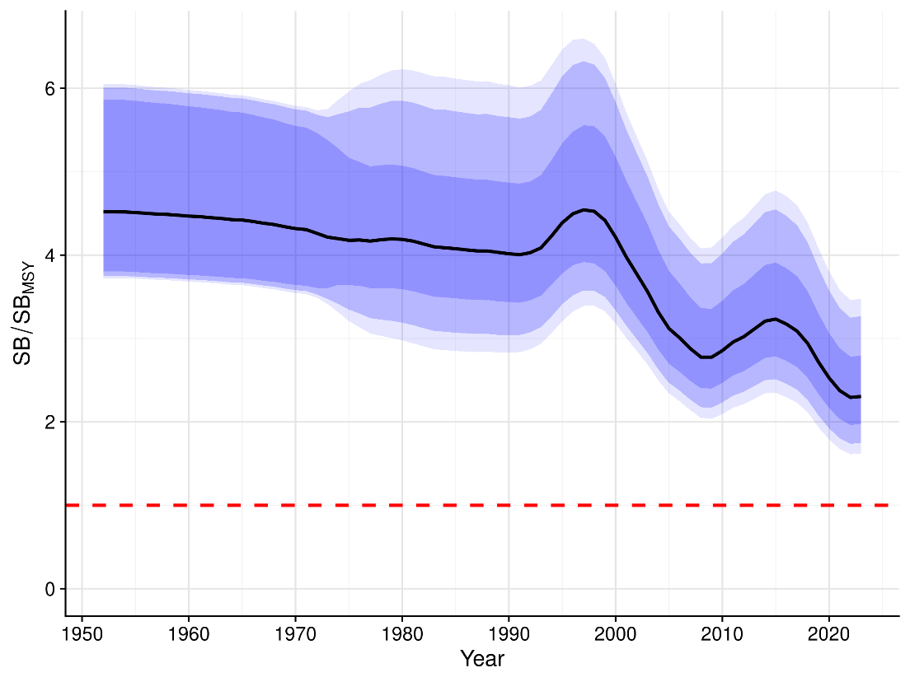

**Figure SWO-08.** Annual estimated F/FMSY (top) and annual SB/SBMSY (bottom) from the uncertainty grid. The black line indicates the median of all trajectories, along with 50%, 80% and 90% quantile ranges.

1. **Stock status**
2. **There are no agreed reference points for Southwest Pacific swordfish. Stock status is therefore assessed in relation to the default WCPFC SB/SBMSY and F/FMSY reference points, with information also provided for the depletion relative to the 20%SBF=0 LRP that is applied to key tunas. The 2025 stock assessment indicates that the stock status is positive with respect to the MSY-based reference points, and although the stock biomass trend and depletion decline, the last few years of the model indicate some stability in female spawning biomass.**
3. **Median recent fishing mortality was below FMSY (Frecent/FMSY is 0.28 with 80% quantile range from 0.18 – 0.38, and the probability of Frecent/FMSY > 1 is <1%, Tables SWO-03 and SWO-04). Median recent female spawning biomass was well above SBMSY (SBrecent/SBMSY biomass reference point is 2.33 with 80% quantile range 1.88 – 3.34, and the probability of SBrecent/SBMSY < 1 is <1%, Table SWO-03 and SWO-4). Median recent spawning biomass was also well above the 20%SBF=0 LRP applied to tunas (SBrecent/SBF=0 = 0.50 with 80% quantile range 0.46-0.58, without estimation uncertainty, Tables SWO-03 and SWO-04). Depletion with respect to unfished female biomass (SBrecent/SBF=0) is 0.50 with an 80% quantile range of 0.46 – 0.58 (Tables SWO-03 and SWO-04), without estimation uncertainty.**
4. **Based upon these results, the stock is exceptionally unlikely to be experiencing overfishing (<1% probability) and to be overfished (<1% probability) relative to MSY-based reference points (Figures SWO-09 – SWO-12).**

**Table SWO-03.** Summary of reference points over the uncertainty grid, along with results incorporating estimation uncertainty. Note that these values do not include estimation uncertainty, unless otherwise indicated.

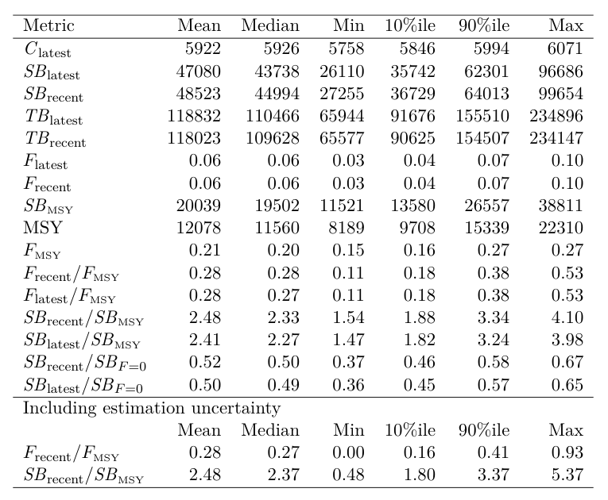

**Table SWO-04**. Estimates of management quantities (stock status as abundance SBrecent relative to SBMSY, and unfished spawning biomass (SBF=0), and recent fishing mortality (Frecent/FMSY). P(>RP) refers to the probability that the metric (status, fishing mortality) is above the respective indicator.

|  |  |  |  |  |
| --- | --- | --- | --- | --- |
| **Year: 2025**  (final data year = 2023) | **Spawning Potential** | **Exceptionally unlikely (<1%) to be below SBMSY** | | **Stock is not overfished** |
|  | **Fishing mortality** | **Exceptionally unlikely (<1%) to be above fishing mortality upper limit of FMSY** | | **Overfishing is not occurring** |
|  | **Projections** | Not conducted | | Not conducted |
|  | **Recommendation** | The stock has a generally declining female spawning biomass since the late 1990s, with some periodic oscillations, but with a steadier and a gentler decline in $\frac{{SB}_{recent}}{{SB}_{F=0}}$, with a generally stable fishing mortality since 2004. No action required to reach target biomass. | | |
| **Reference points** |  | **Median [10%--90%]** | **Comment** | |
| Ratio of ${SB}_{recent}$ to ${SB}_{MSY}$ | $$\frac{{SB}_{recent}}{{SB}_{MSY}}$$ | 2.33 [1.88-3.34] | Spawning biomass is well above SBMSY, the default WCPFC limit reference point (LRP) for billfish stocks | |
| Ratio of $F_{recent}$ to $F_{MSY}$ | $$\frac{F_{recent}}{F_{MSY}}$$ | 0.28 [0.18 – 0.38] | Fishing mortality well below the default FMSY WCPFC LRP for fishing mortality. | |
| **Recent estimates** |  |  | **Recent trend / projection** | |
| Fishing mortality | $$F_{recent}$$ | 0.06 [0.04 – 0.07] | $F_{recent}$ shows a stable trend, with short-term variation over the last 15 years, and a slight increase over the last 3 years of the assessment, which is most likely variability rather than indicative of any recent trend. | |
| SB relative to SB to produce MSY | $$\frac{{SB}_{recent}}{{SB}_{MSY}}$$ | 2.33 [1.88-3.34] | The spawning biomass relative to biomass at MSY has a trend of becoming more depleted, especially since the 1990s, but with some signs or stability in the very recent years. | |
| SB depletion relative to SB without fishing (w/o estimation uncertainty) | $$\frac{{SB}_{recent}}{{SB}_{F=0}}$$ | 0.50 [0.46 – 0.58] | The spawning biomass relative to unfished spawning biomass has a trend of becoming more depleted, especially since the 1990s, but with some signs of stability in the very recent years. | |
| **Status** | | | **Likelihood** | |
| SB depletion | $$\frac{{SB}_{recent}}{{SB}_{MSY}}$$ | 0.50 [0.46 – 0.58] | <1% probability < SBMSY (Exceptionally unlikely) | |  |
| Fishing mortality | $$\frac{F_{recent}}{F_{MSY}}$$ | 0.28 [0.18 – 0.38] | <1% probability > $F_{MSY}$ (Exceptionally unlikely) | |

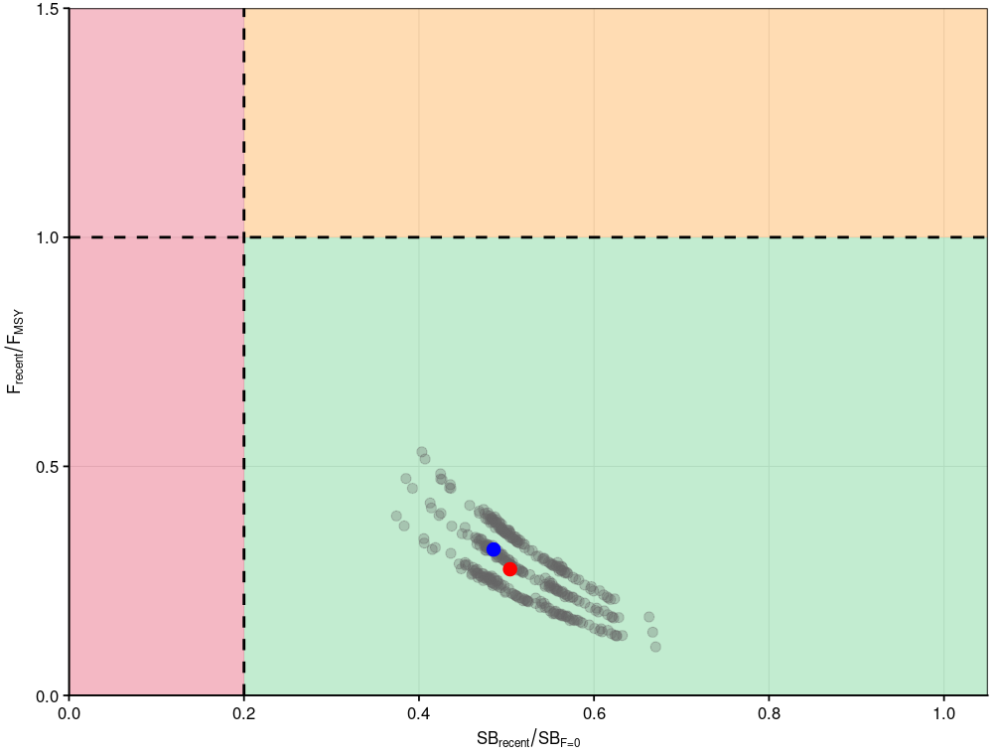

**Figure SWO-09.** Majuro plot summarising the results for the uncertainty grid (without estimation error) for the relevant recent periods, 2020–2023 for SBrecent/SBF=0 and 2019–2022 for Frecent/FMSY, respectively. The red dot indicates the median, and the blue dot the diagnostic model.

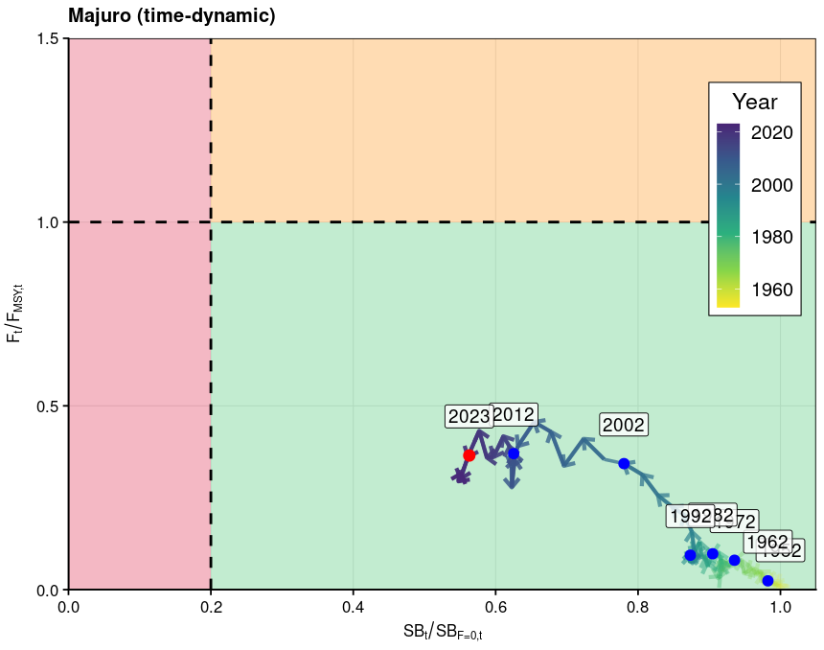

**Figure SWO-10.** Time dynamic Majuro plot from the diagnostic model for SWPO swordfish for the period 1952 to 2023 (red dot).

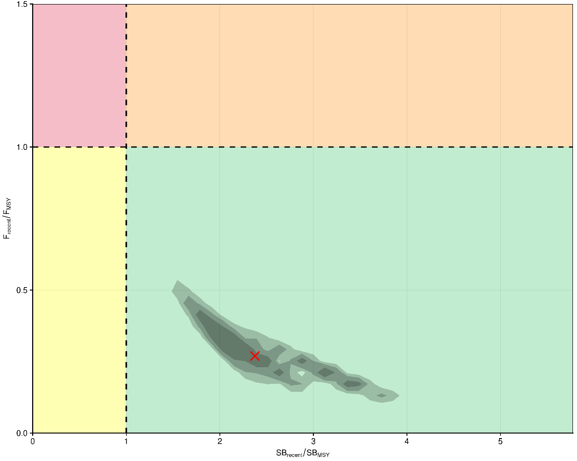

**Figure SWO-11.** Kobe plot for the relevant recent periods, 2020–2023 for SBrecent/SBMSY and 2019–2022 for Frecent/FMSY, respectively, using contour plots to summarise the full uncertainty grid, including structural and estimation uncertainty, with 50%, 80% and 90% quantile ranges. The red cross shows the median.

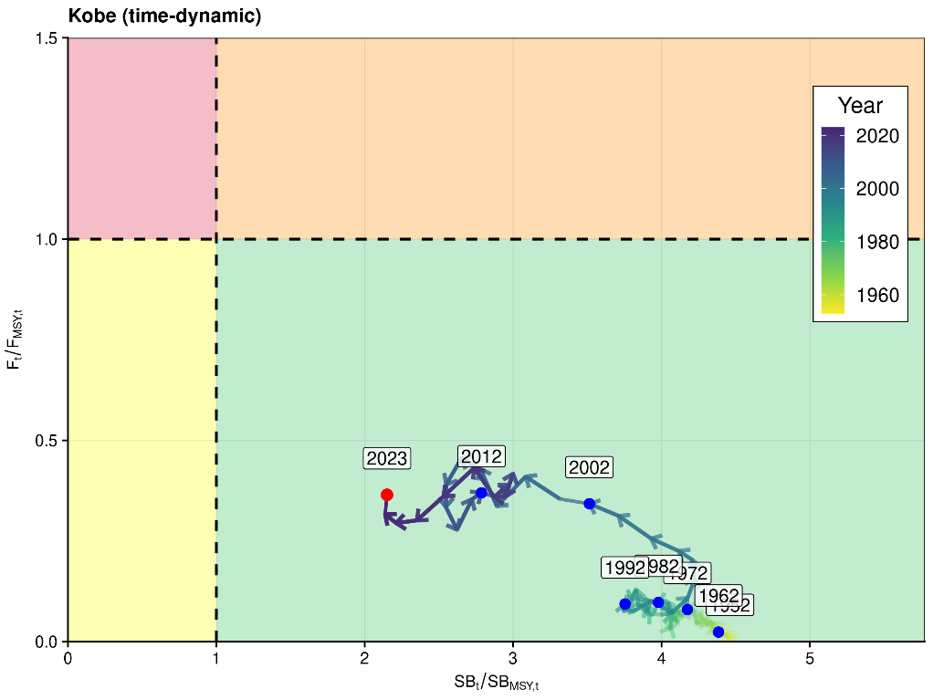

**Figure SWO-12.** Time dynamic Kobe plot from the diagnostic model for SWPO swordfish for the period 1952 to 2023 (red dot).

1. **Management advice**
2. **SC21 advised that** **it** is exceptionally unlikely that Southwest Pacific swordfish is overfished and subject to overfishing. SC21 noted that the estimated spawning biomass relative to unfished levels has continued to decline over the last decade, despite a brief recovery in 2015. This declining trend highlights the ongoing need for management. To this end, SC21 noted the Commission’s intention to develop a management strategy evaluation framework for Southwest Pacific swordfish and to design and evaluate a candidate management procedure (see SC21-GN-WP-04 Project P21X03). **SC21 agreed to use this year’s stock assessment model as a starting point for developing an operating model reference set to evaluate the candidate management procedures, noting that better addressing the issue of model mis-specification is necessary to improve the reliability of the operating model reference set.**
3. **SC21 noted that due to challenges and associated time constraints in fitting the stock assessment model, no projections were provided to the SC, and recommended that projections be included in future assessment reports.**
4. **Research recommendations**
5. SC21 noted the challenges in developing this model. The persistent conflict between size composition and CPUE signals, the retrospective patterns, and the divergence in CPUE trends across fleets may not solely reflect data limitations, but could also stem from structural assumptions within the model that are difficult to validate or adjust. **SC21 recommended several research avenues to help improve the next assessment, including:**

* **additional conditional age-at-length data;**
* **exploring the use of close-kin mark recapture;**
* **the further exploration of a simplified modeling approach; and**
* **SC21 also recommended moving data-moderate billfish assessments like Southwest Pacific swordfish and striped marlin to a two-year approach, similar to the shark assessments.** 
  + 1. Southwest Pacific striped marlin (*Kajikia audax*)
       1. **Stock assessment of Southwest Pacific striped marlin**

1. SC21 thanked the SSP and the collaborative contribution (as supported by SC20) from the NOAA Pacific Islands Fisheries Science Center, for their thorough work conducted on the revision of the Southwest Pacific striped marlin stock assessment and considerable efforts to improve the assessment, particularly by providing multiple model frameworks to consider, and working with CCMs to address the concerns raised about the assessment at SC20. Individual working papers were presented for both assessment approaches. SC21 noted that the model outcomes presented were reasonably consistent with previous stock assessment results and with each other. However, there were remaining issues with the integrated assessment (moved from Multifan-CL to Stock Synthesis 3) that could not be resolved in the time available. The alternative Bayesian Surplus Production Model (BPSM) was proposed as a simpler, more robust model for management advice that more appropriately characterized the assessment uncertainty.
2. **SC21 recommended that stock status and management advice be based upon the Bayesian surplus production model (BSPM) results as the most parsimonious and robust assessment presented for the SW Pacific MLS stock. As such, the summary text, figures, and tables below are based on the BSPM.**
   * + 1. **Provision of scientific information to the Commission**
3. **Stock assessment and trends**
4. The revision of the 2024 Southwest Pacific Ocean striped marlin stock assessment employed a multi-model approach in an effort to provide a robust basis for the provision of management advice on stock status. During the revision work, issues with the integrated age-structured assessment, using Stock Synthesis 3, that could not be satisfactorily resolved led to a strategic shift to a data-moderate Bayesian surplus production model (BSPM). For the BSPM, the Fletcher-Schaefer production model framework was implemented in Stan using a state-space formulation where population depletion evolves according to surplus production and fishing mortality dynamics linked to effort data. This approach condenses biological and fishery assumptions, which provides a robust framework for estimating stock status and efficiently exploring uncertainties in productivity and scale. The model assumes a single, well-mixed stock (**Figure MLS-01**) with no population age structure and fished by a single aggregate fishery (**Table MLS-01**).
5. The assessment incorporated multiple sources of uncertainty through both model structure and parameter estimation approaches (**Table MLS-02**). Key uncertainties included substantial uncertainty in absolute population scale, biological parameter uncertainty in growth, maturity, natural mortality, and steepness that contributed to broad priors for maximum intrinsic rate of increase, and population scale. The model ensemble explicitly incorporated uncertainty in population trend by considering the distant water fishing nation (DWFN) and the New Zealand recreational sportfish index. Alternative priors for the shape parameter, which informs the location of MSY, were also considered in the ensemble.
6. Annual catches are provided from 1952 to 2022 (**Figure MLS-02**). The annual catch series showed initially low removals in 1952-1953, followed by a high but potentially legitimate peak of ~80,000 individuals in 1954, then generally stable catches of between 20,000 and 40,000 individuals with a slight decline since 2000.
7. The standardized DWFN CPUE index (1988-2022) and New Zealand recreational index (**Figure MLS-03**) were the only indices with sufficient length and contrast to inform population-scale estimates, both exhibiting declining trends that constrain population size. The DWFN index showed high variability with a general decline most pronounced after 2000, though stabilizing somewhat before showing slight recent increases. The New Zealand index showed a more continual decline from the mid-1990s, though observation error was larger in the terminal years. The shorter observer indices were largely flat from 2000 to 2022. The Australian longline index was also short and showed an initial decline before being largely stable with a larger observation in the terminal year.
8. The ensemble estimated total population trajectories (**Figure MLS-04**) showing a pronounced decline from unfished conditions during the 1950s-1960s, relatively stable population levels around from the 1970s through early 2000s, and recovery since approximately 2015. Fishing mortality (*F*) estimates (**Figure MLS-04**) generally increased through the model period until the early 2000s, followed by generally declining trends in recent decades consistent with population recovery patterns. The models demonstrated evidence of a well-determined production function through successful model-free hindcast validation, where models fitted to progressively truncated datasets successfully predicted future population dynamics based solely on estimated production parameters and catch data. Model validation through retrospective analysis showed acceptable bias within recommended ranges, and all models showed good convergence according to conventional Bayesian diagnostics.
9. Total depletion (*D*), defined as the static depletion of total numbers relative to the initial total unfished numbers, largely followed the same patterns as the total population trajectory (**Figure MLS-04**). Uncertainty in total depletion was large and asymmetrical, with more uncertainty to the high side. This is driven by the large uncertainty in population scale. The lower bound of uncertainty was constrained by requiring a large enough population to support the 70-year catch history. However, the existing data do not support a large population but rather indicate a small, highly productive stock capable of sustaining observed catch levels, which is a conclusion consistent with the Stock Synthesis assessment and previous assessments of this stock. Though population scale estimates were driven by different productivity assumptions, larger catches or a flatter CPUE index would all support a larger population.
10. As noted, this BSPM approach showed similar results to the Stock Synthesis integrated model but provided greater confidence in the results by identifying a well-determined production function and more appropriately integrating over uncertainty in population scale and productivity. Previous integrated assessments encountered challenges fitting to size composition data, conflicts between data sources, and difficulties in determining a stock production function. Key strengths of the BSPM included explicit parameter uncertainty incorporation through simulation-based priors, prior pushforward analysis ensuring biological realism, comprehensive sensitivity analysis, and a well-determined production function.

Table MLS-01. Stock assessment model structure for the 2025 Southwest Pacific striped marlin assessment.

|  |  |  |
| --- | --- | --- |
|  | Number | Description |
| Spatial structure | 1 | Assumes single, well-mixed stock |
| Age structure | 1 | Assumes a single age class |
| Fishery structure | 1 | Assumes a single fishery with knife-edge asymptotic selectivity |

Table MLS-02 Key sources of uncertainty considered in the 2025 Southwest Pacific striped marlin stock assessment.

| Rationale | Uncertainty | Impact | Confidence |
| --- | --- | --- | --- |
| Data | | | |
| CPUE | Best available long-term indices (DWFN & New Zealand recreational) | Changes in the fleet composition and or fishing location in the DWFN index can be interpreted by the model as population-level changes. For the New Zealand index, if the stock distribution has shifted, this may impact representativeness | Medium |
| Catch | Situationally targeted species, so catch reporting may be inconsistent | Reported catches are highly influential on the estimated population scale | Medium |
|  |  |  |  |
| Model | | | |
| Parsimonious and robust model | Over-simplifies population and spatial dynamics | Unknown | Medium |
| Static models | The value of key parameters is constant | Changes in the fleet composition would influence the age structure of the population and lead to time-varying population dynamics. | Low |
| Spatial Assumptions | | | |
| Little tagging data to understand structure | Unclear | Potentially important, not quantified, impact unknown | Low |
| Key Parameter uncertainty | | | |
| Productivity ($R_{MAX}$) | Uncertainty in key biological processes | Wide prior contributes to high uncertainty within model runs | High |
| Population scale (log(K) & $q_{eff}$) | Scale prior dependent on the maximum observed catch being representative of MSY | Broad prior contributes to high uncertainty within model runs | High |
| Shape n | Alternative priors used to capture the shape of the production function | Uncertainty in where MSY occurs as a fraction of the unfished condition | Medium |
| Structural Uncertainty | | | |
| Fixed $σ_{C}$ = 0.2 | Choice of $σ_{C}$ and observation model impacts estimated removals | Removal estimates may not exactly match observations | Medium |
| Estimation Uncertainty | | | |
| Full Bayesian estimation integrating uncertainty over key parameters | Estimated | Basis for model ensemble | High |
| Other sources of uncertainty | | | |
| Genetic sampling of catch in the north Pacific indicates the presence of SWPO fish | Not considered | Actual population removals may be under-counted, impacting scale and stock status | Low |

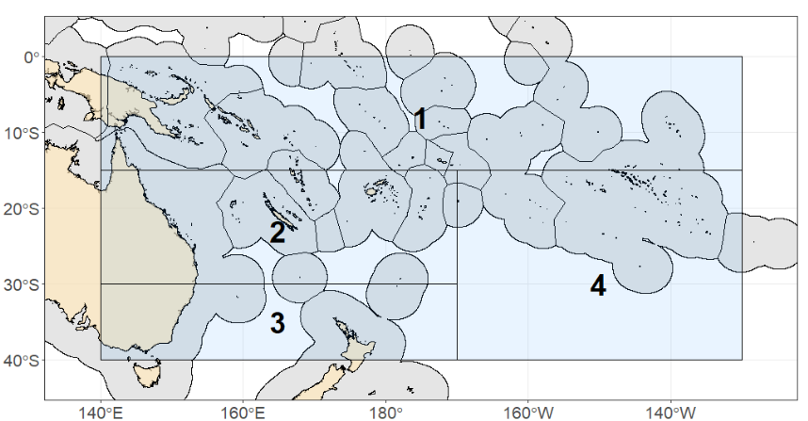

Figure MLS-01 Assessment model spatial domain, noting that no sub-fleets or regions were used.

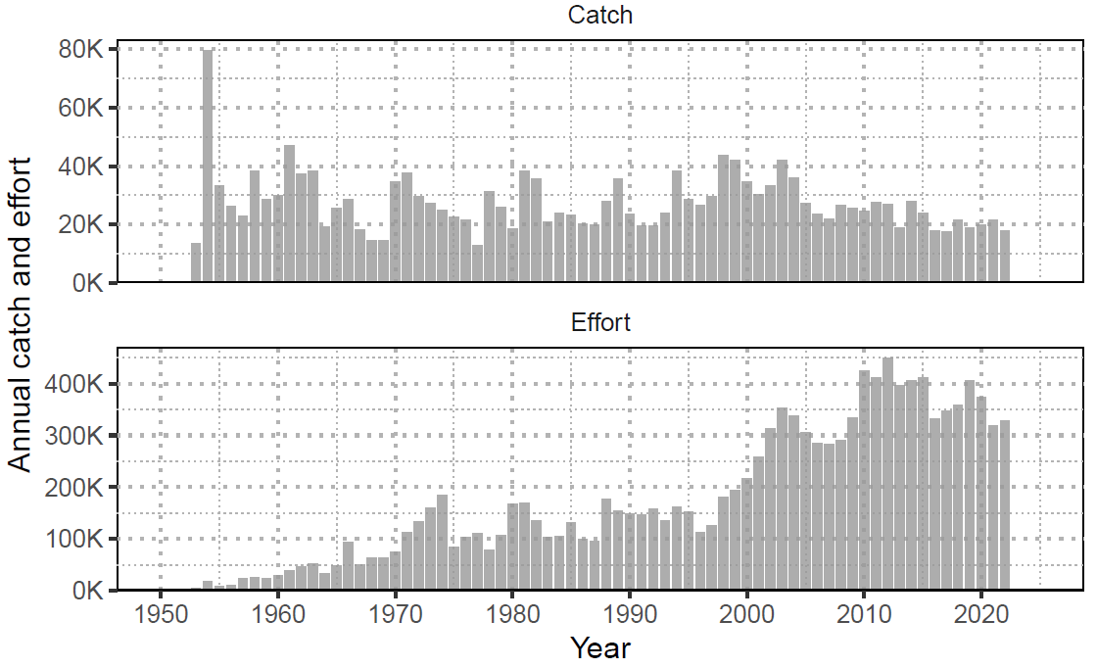

Figure MLS-02 Annual catch (numbers; individuals) of striped marlin and nominal longline effort (hooks fished; thousands) in the Southwest Pacific Ocean (1952-2022).

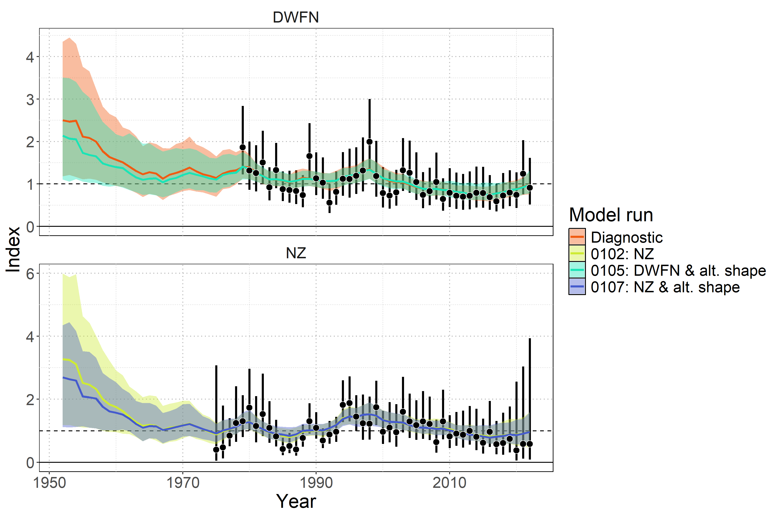

Figure MLS-03 Model fit to standardized index data showing observations (black points with 95% error bars) and model predictions (colored lines and shaded ribbons representing 95% credible intervals). The diagnostic model ( 0100 ) is shown in orange.

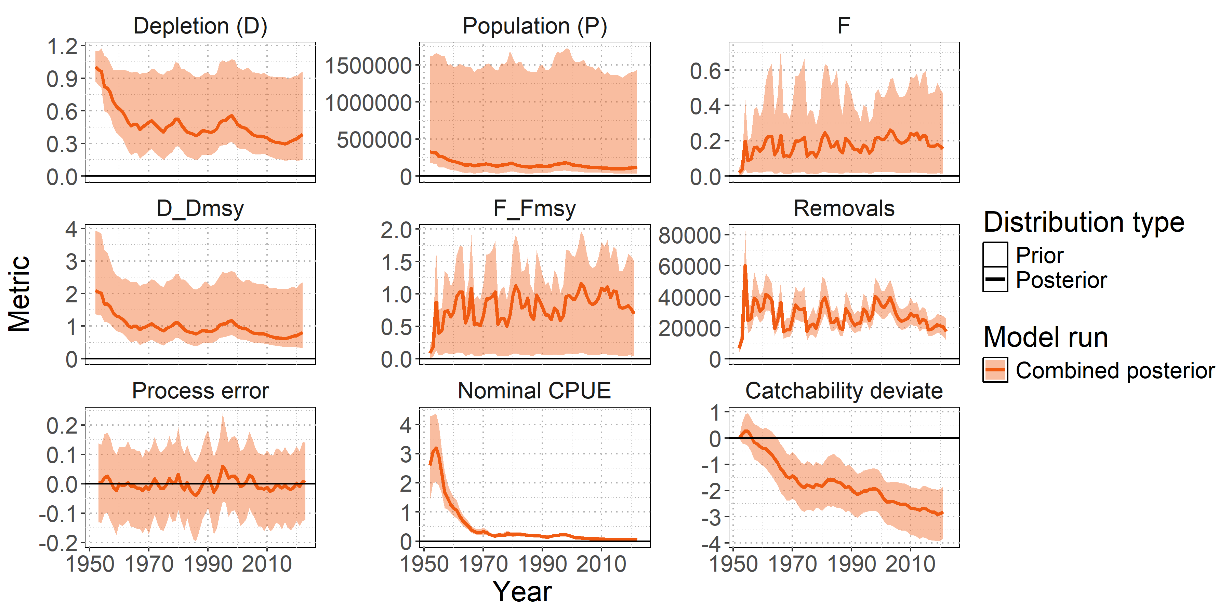

Figure MLS-04 Posterior time series distributions for key derived quantities over time (line = median, shading = 95% credible interval): depletion (D), absolute population size in numbers (P), fishing mortality (F), stock status relative to MSY reference points ( $D/D_{MSY}$, $F/F_{MSY}$), total removals in numbers, process error, nominal CPUE (numbers caught per 1000 hooks), and catchability deviates. The model ensemble is shown in orange.

1. **Stock status**
2. SWPO striped marlin lacks formal, agreed-upon reference points, so stock status (Error! Reference source not found.) was summarized using MSY-based reference points and total depletion relative to the generalized limit reference point of 20% total depletion from the unfished state ($D/D_{0.2,F=0}$).
3. **Median recent fishing mortality was below FMSY (Frecent/FMSY = 0.77 with a 95% range of 0.05-1.51 and a 22.9% probability of Frecent exceeding FMSY. Figure MLS-06) indicating the stock was unlikely to be subject to overfishing.**
4. **Median recent stock abundance was below DMSY (Drecent/DMSY = 0.77 with a 95% range of 0.33-2.3 and a 74% probability that the stock abundance was below DMSY. Figure MLS-06) indicating the stock was likely to be overfished. The depletion value at which MSY occurs is 0.48 (the 95% credible interval is 0.26-0.7).**
5. **The stock is very unlikely to be below 20% of the unfished state (Figure MLS-05). The probability of the stock being below D0.2,F=0 is 9.2% for the recent period, with a median ratio of 1.84 (95% CI: 0.73 – 4.7295). Noting that this depletion is relative to the 20% total depletion from the equilibrium unfished population level and is not equivalent to the conventional SB/SB20%,F=0.**
6. SC21 recommended that future work investigate the estimated long-term decline in catchability and evaluate the assumption of stationary productivity, in order to reduce uncertainty and improve confidence in future stock assessments. In addition, it encouraged using the prior information and results from the BSP approach to improve the Stock Synthesis model and to continue using both models in parallel to improve understanding of the status of the SWPO MLS stock.

**Table MLS-03**. Estimates of management quantities (stock status as depletion Drecent relative to MSY), and fishing mortality (F) relative to indicators (FMSY). P(>RP) refers to the probability that the metric (status, fishing mortality) is above the respective indicator.

| **Summary** |  |  |  |  |
| --- | --- | --- | --- | --- |
|  |  |  |  |  |
| **Year of assessment:** 2025 | **Depletion ($D_{recent}$)** | Likely (74%) to be below $D_{MSY}$ |  | The stock is overfished |
| **Last year of data:** 2022 | **Fishing mortality ($F_{recent}$)** | Unlikely (23%) to be above $F_{MSY}$ |  | Overfishing is not occurring |
|  | **Projection** | $F$ about as likely as not (33-66%) to decline further by 2027 |  | The stock is unlikely (<33%) to be undergoing overfishing in the near term under recent average catch levels. |
|  |  | $D$ likely (>66%) to increase further by 2027 |  | The stock is about as likely as not (33-66%) to be overfished in the near term under recent average catch levels. |
|  |  |  |  |  |
| **Reference points** | **Metric** | **Median [2.5%-97.5% CI]** | **Likelihood** | **Recent trend / projection** |
| Depletion | $$D_{MSY}$$ | 0.48 [0.26 – 0.7] |  |  |
| Abundance | $$P_{MSY}$$ | 155,183 n [63,037 – 808,861] |  |  |
| Abundance | $$0.2×log\left(K\right)$$ | 65,041 n [36,198 – 327,844] |  |  |
| Catch | *MSY* | 29,962 n [25,828 – 184,069] |  |  |
| Fishing mortality | $$F_{MSY}$$ | 0.23 [0.08 – 0.69] |  |  |
|  |  |  |  |  |
| **Estimates** | **Metric** | **Median [2.5%-97.5% CI]** | **Likelihood** | **Recent trend / projection** |
| Depletion | $$D_{latest}$$ | 0.38 [0.14 – 0.96] |  | Increasing |
| Depletion | $$D_{recent}$$ | 0.37 [0.15 – 0.94] |  | Increasing |
| Abundance | $$P_{latest}$$ | 121,943 n [34,067 – 1,479,253] |  | Increasing |
| Abundance | $$P_{recent}$$ | 117,967 n [34,199 – 1,442,511] |  | Increasing |
| Catch | $$C_{latest}$$ | 17,488 n [11,545 – 25,988] |  | Stable, decreasing |
| Catch | $$C_{recent}$$ | 20,570 n [13,357 – 28,058] |  | Stable, decreasing |
| Fishing mortality | $$F_{latest}$$ | 0.15 [0.01 – 0.47] |  | Decreasing |
| Fishing mortality | $$F_{recent}$$ | 0.17 [0.01 – 0.49] |  | Decreasing |
|  |  |  |  |  |
| **Status** | **Metric** | **Median [2.5%-97.5% CI]** | **Likelihood** | **Recent trend / projection** |
| Depletion | $$D_{latest}/D_{MSY}$$ | 0.81 [0.32 – 2.36] | Likely (>66%) to be below $D_{MSY}$ |  |
| Depletion | $$D_{recent}/D_{MSY}$$ | 0.77 [0.33 – 2.3] | Likely (>66%) to be below $D_{MSY}$ |  |
| Fishing mortality | $$F_{latest}/F_{MSY}$$ | 0.69 [0.05 – 1.51] | Unlikely (<33%) to be above $F_{MSY}$ |  |
| Fishing mortality | $$F_{recent}/F_{MSY}$$ | 0.77 [0.05 – 1.51] | Unlikely (<33%) to be above $F_{MSY}$ |  |
|  |  |  |  |  |
| **Projections** | **Metric** | **Median [2.5%-97.5% CI]** | **Likelihood** | **Recent trend / projection** |
| Depletion | $$D_{proj}^{2027}/D_{MSY}$$ | 1.1 [0.13 – 2.47] | About as Likely as Not (33-66%) to be below $D_{MSY}$ | $D_{proj}$ increasing |
| Fishing mortality | $$F_{proj}^{2027}/F_{MSY}$$ | 0.6 [0.04 – 19.3] | Unlikely (<33%) to be above $F_{MSY}$ | $F_{proj}$ decreasing |

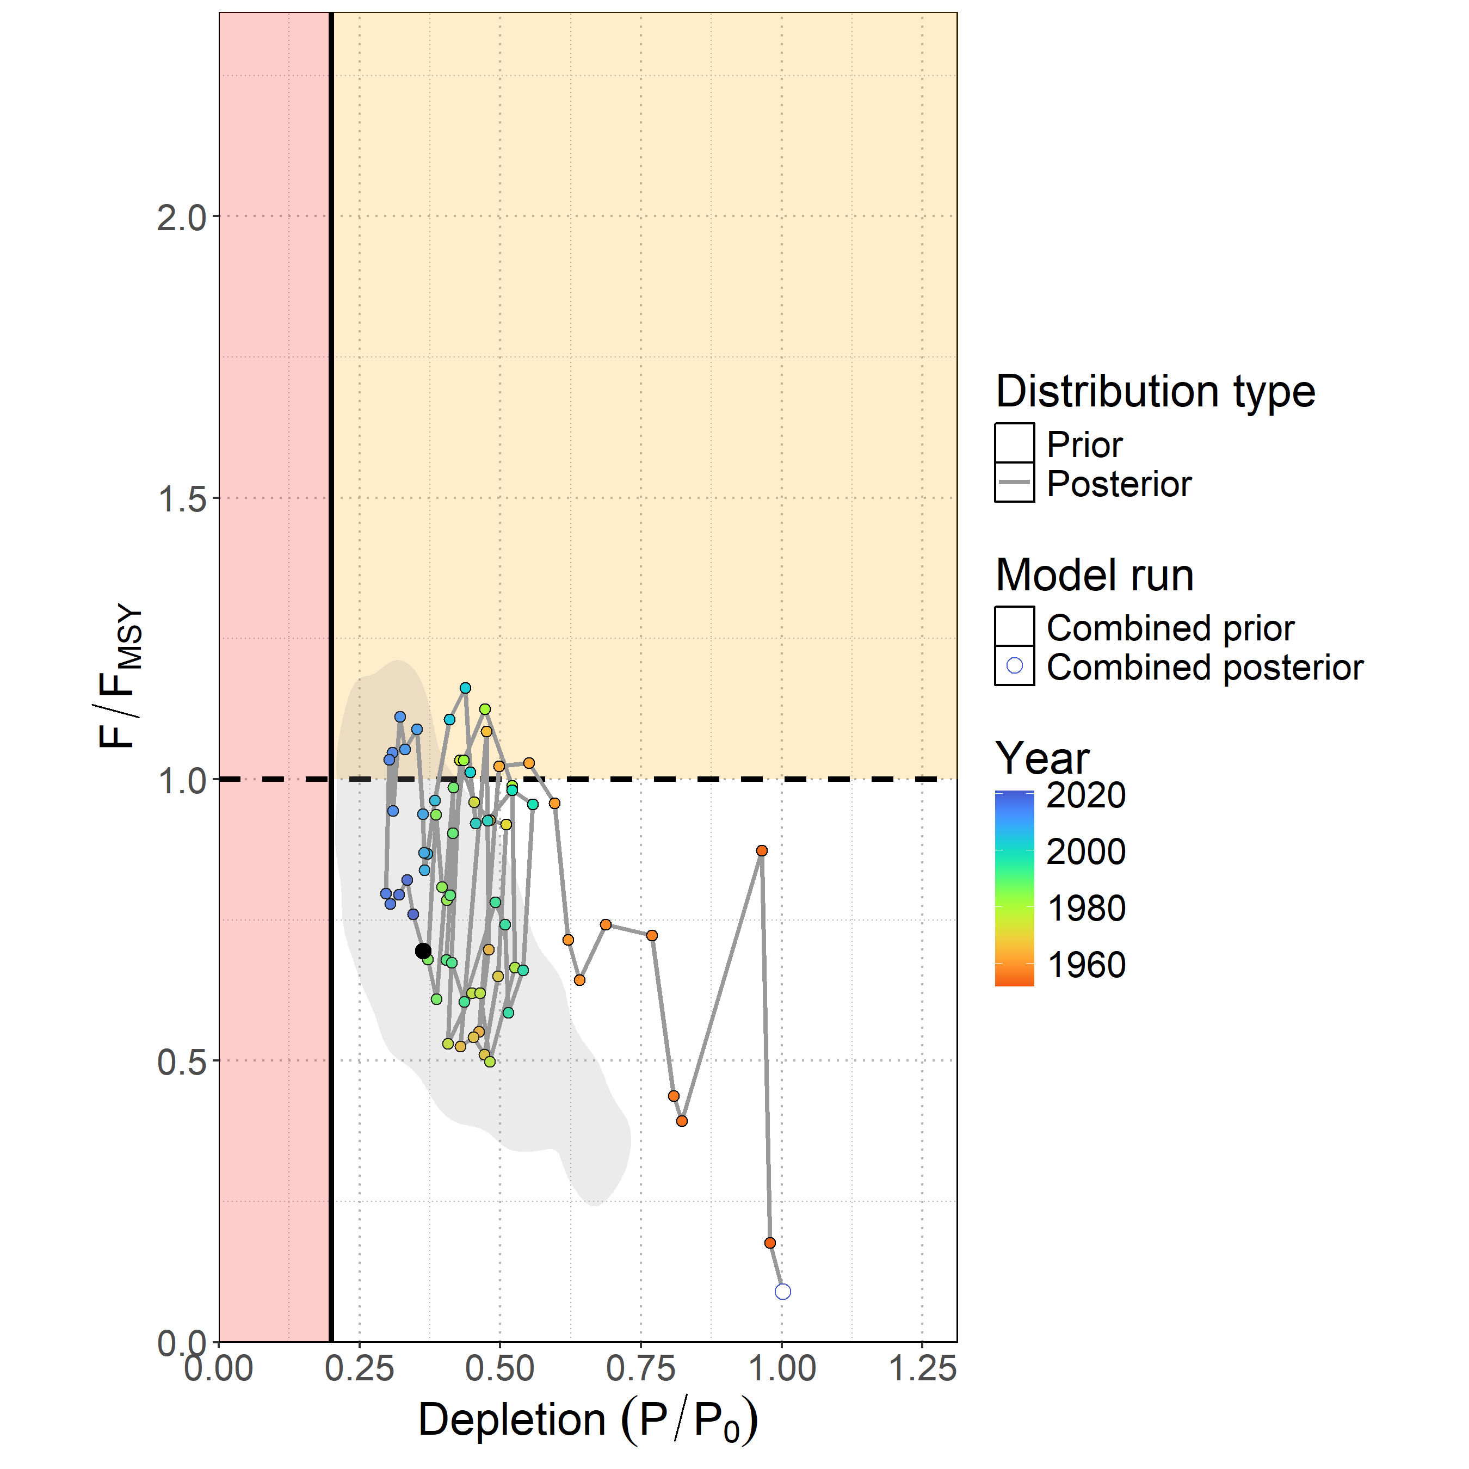

Figure MLS-05. Majuro plot showing the median posterior estimate of the latest stock depletion ($D_{latest} = P_{latest}/P_{0}$) and fishing mortality relative to MSY ( $F_{latest}/F_{MSY}$). Points represent model estimates colored by year (blue ∼ 2020, green ∼ 1985, orange ∼ 1950), with a connecting line showing the trajectory over time. The gray shaded contour is the bi-variate 95% credible distribution around the terminal year estimate $D_{2022}$ and $F_{2021}/F_{MSY}$.

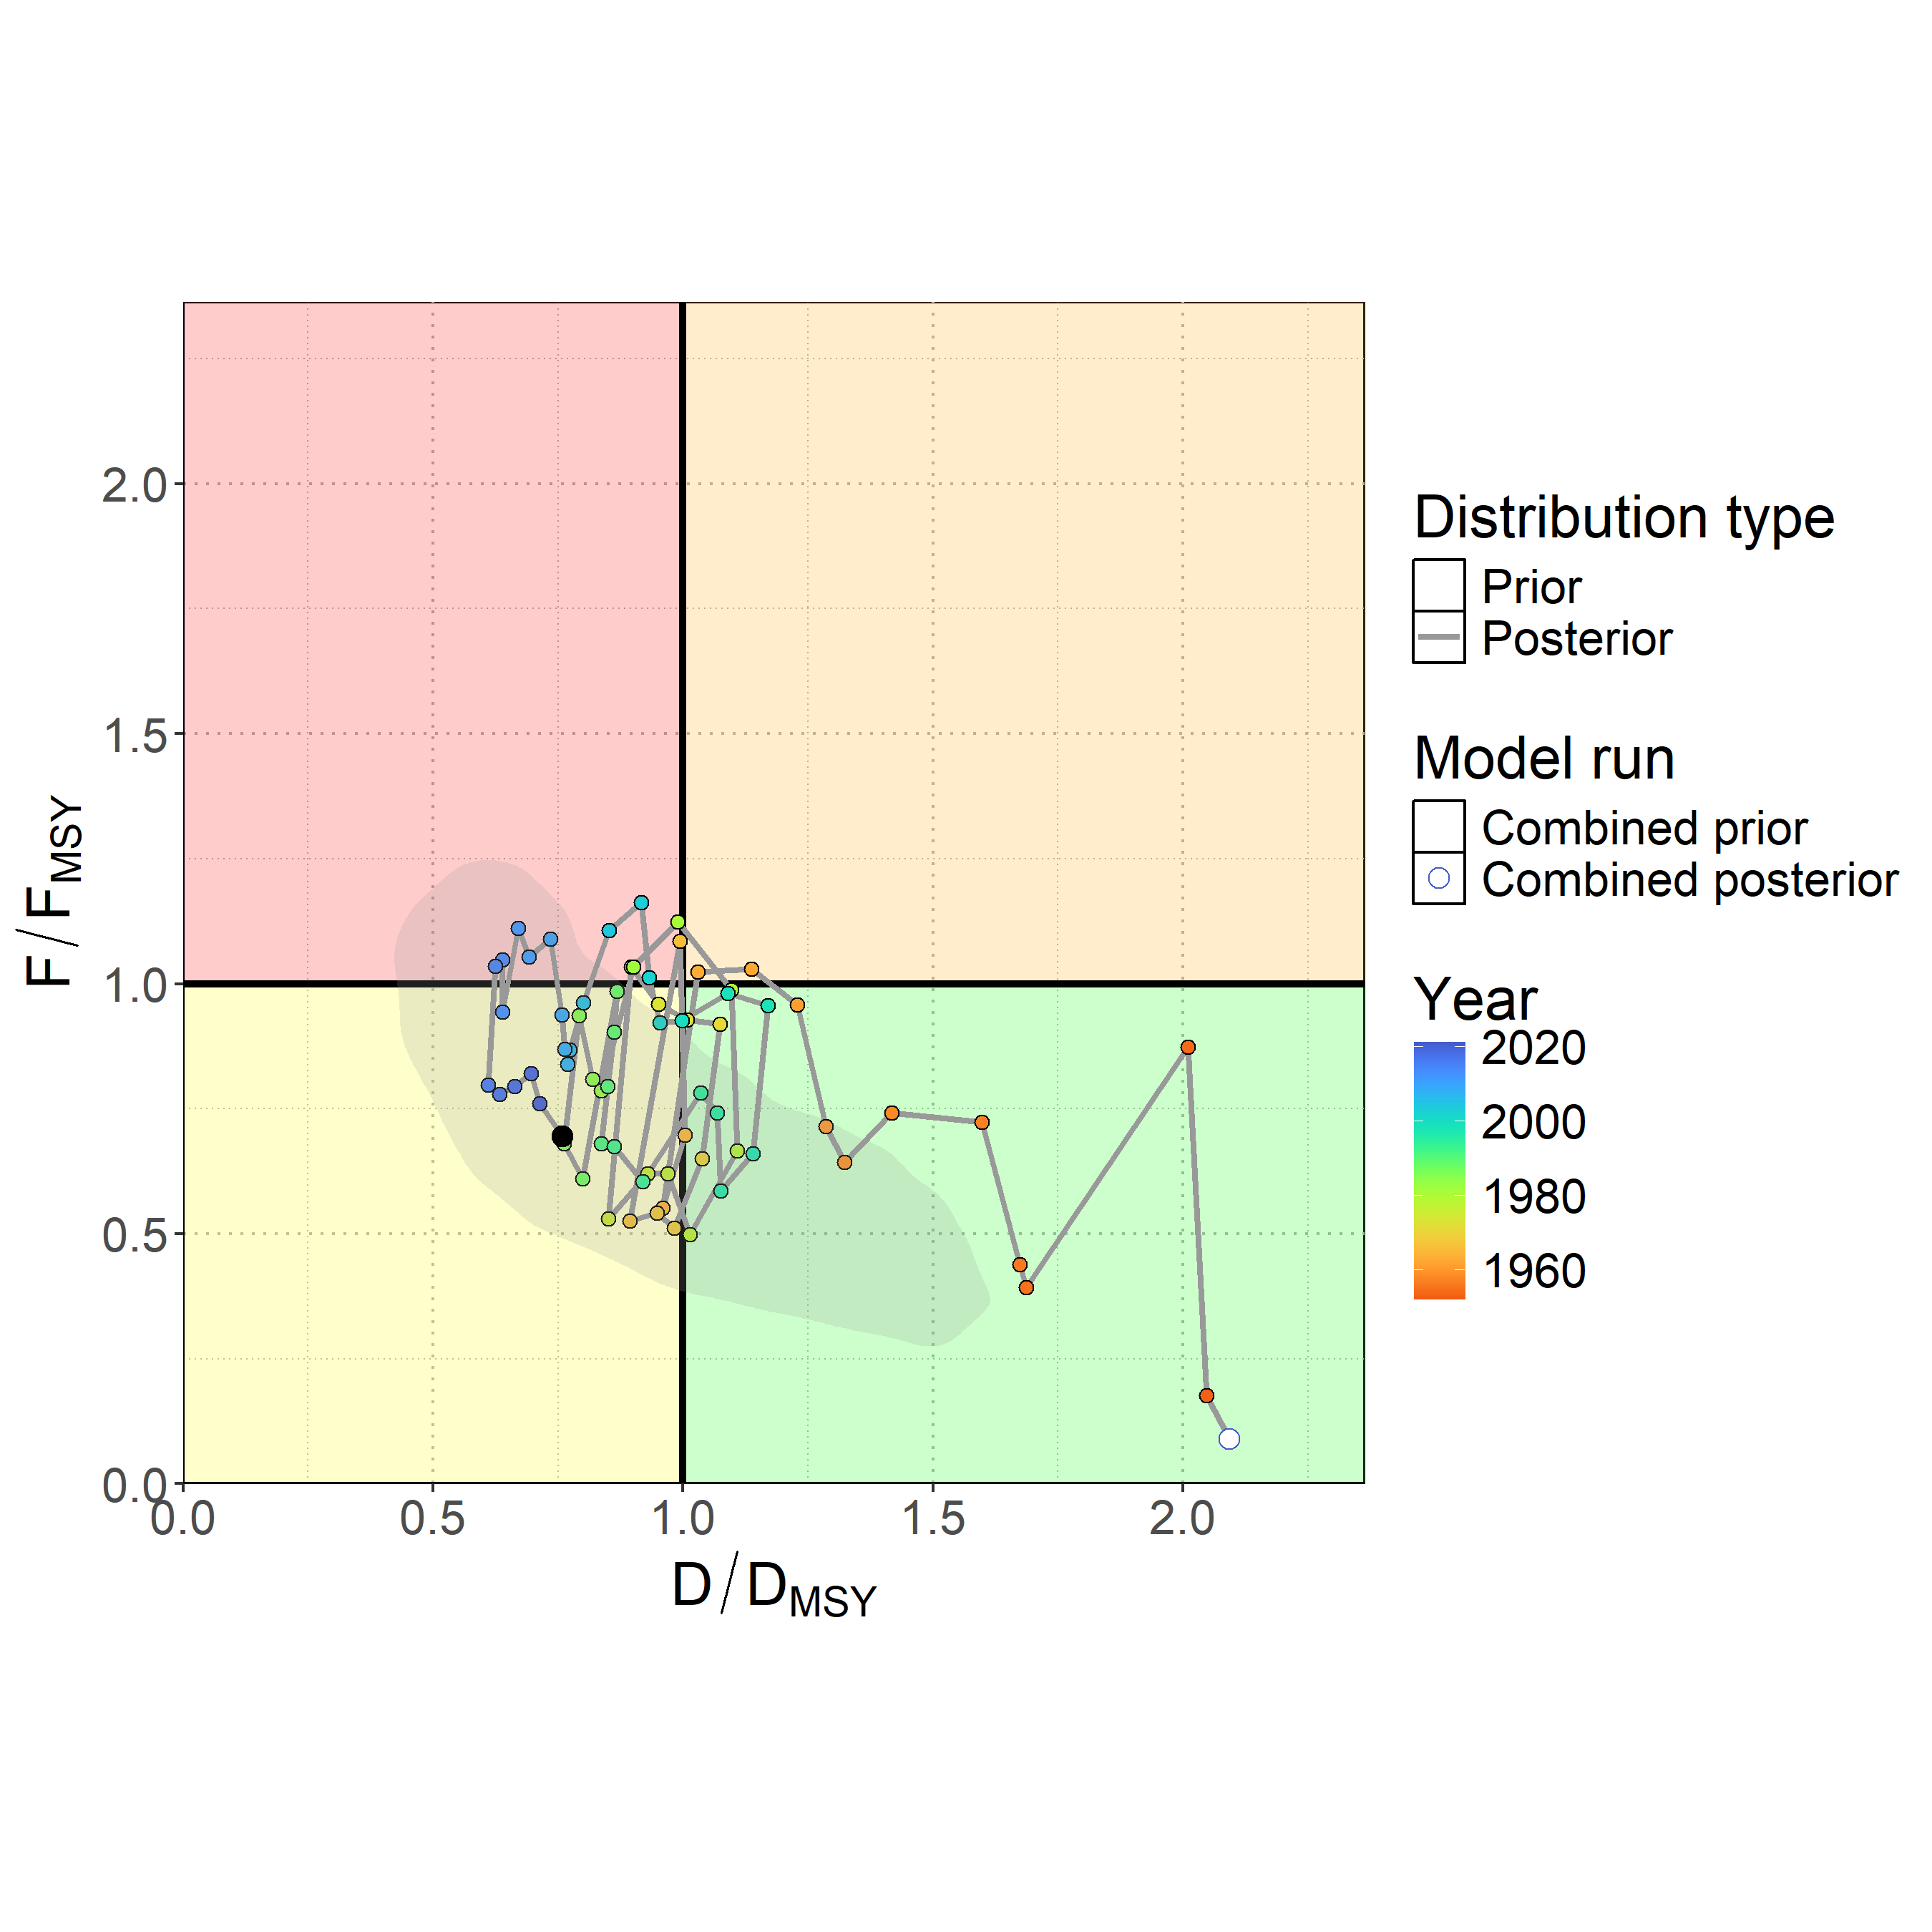

Figure MLS-06. Kobe plot showing the median posterior estimate of the latest stock depletion relative to depletion at MSY ( $D_{latest}/D_{MSY}$) and fishing mortality relative to MSY ( $F_{latest}/F_{MSY}$). Points represent model estimates colored by year (blue ∼ 2020, green ∼ 1985, orange ∼ 1950), with a connecting line showing the trajectory over time. The gray shaded contour is the bi-variate 95% credible distribution around the terminal year estimate $D_{2022}/D_{MSY}$ and $F_{2021}/F_{MSY}$.

1. **Management advice**
2. Ten-year stochastic projections (**Figure MLS-07**), assuming recent average catch levels (2018-2022), indicated continued population recovery through 2032, with a median $D/D_{MSY}$ projected to reach 1.32 by 2032 and only a 26% chance of remaining overfished. Projections to 2025 showed a median $D/D_{MSY}$ of 0.99 with only a 51% chance of being overfished, improving to less than 50% probability by 2026. Fishing mortality was projected to continue declining through the projection period, with a median $F/F_{MSY}$ reaching 0.49 by 2032 and only a 15% chance of overfishing occurring. While continued recovery was expected under status quo catch scenarios, the substantial uncertainty in model inputs was carried forward into projections, and, for example, there remained a very unlikely risk (5%) of the stock declining to less than 5% depletion under recent average catch levels by 2032. This risk would be expected to increase if catches rose above recent average levels.
3. **SC21 noted that under projections using recent average catch, the stock had a 55% probability of recovering to greater than MSY levels by 2026 (Table MLS-04), and recommended not increasing catch above recent average levels.**
4. **SC21 also agreed that the projections requested in SC20 were likely not necessary based upon the results provided (Agenda item 5.3).**
5. SC21 noted that the current BSPM may not reflect population dynamics associated with the changing population age structure, and encouraged the SSP to include non-stationary population processes in model parameters to improve understanding of the population dynamics in future assessments.

**Table MLS-04.** Table of the probability of Southwest Pacific striped marlin reaching DMSY from status quo projections.

|  |  |
| --- | --- |
| Year | Probability |
| 2023 | 38% |
| 2024 | 44% |
| 2025 | 49% |
| 2026 | 55% |
| 2027 | 59% |
| 2028 | 62% |
| 2029 | 66% |
| 2030 | 69% |
| 2031 | 71% |
| 2032 | 74% |

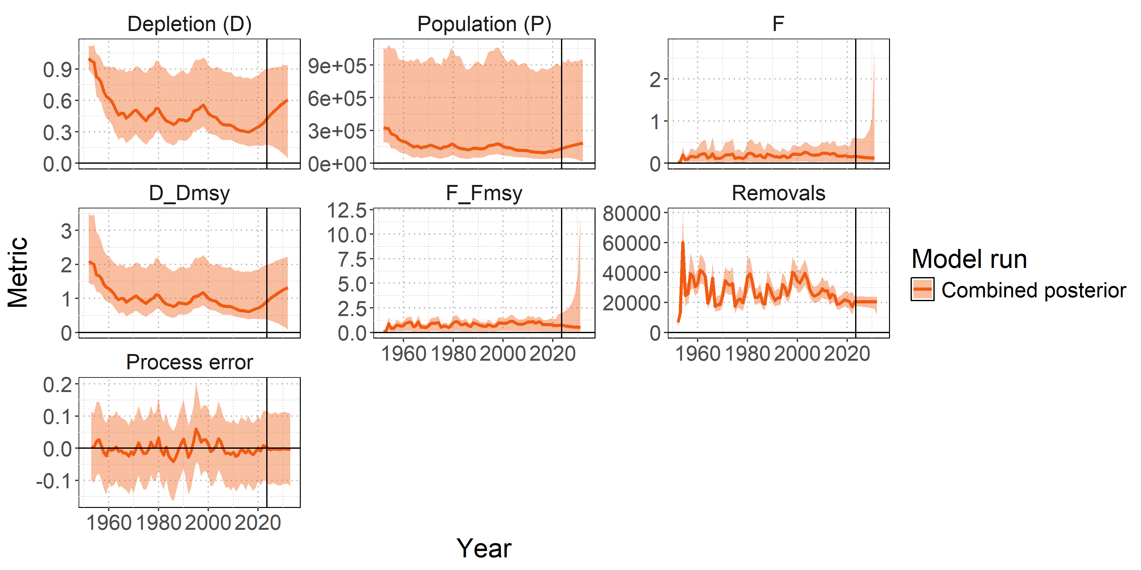

Figure MLS-07. Posterior time series distributions for key derived quantities over time during the forecast period 2023-2032 (line = median, shading = 90% credible interval): depletion (D), absolute population size in numbers (P), fishing mortality (F), stock status relative to MSY reference points ( $D/D_{MSY}$, $F/F_{MSY}$), total removals in numbers, and process error. The model ensemble is shown in orange. A 90% credible interval is shown to restrict the y-axis of the fishing mortality F panel, which shows high values of F in the projection period, as a very small percentage of populations are estimated to go to zero under recent average catch levels.

* 1. Sharks
     1. Oceanic whitetip shark (*Carcharhinus longimanus*)
        1. **Oceanic whitetip shark stock assessment (Project 124)**

1. SC21 noted the extensive efforts undertaken to provide the dual-model stock assessment and appreciated the thoroughness of the assessment approach. While the Stock Synthesis (SS3) integrated age-structured model and Dynamic Surplus Production Model (DSPM) provide different structural assumptions for addressing data conflicts and uncertainties, SC21 noted that the multi-model ensemble approach strengthened conclusions about stock status compared to single-model approaches used previously. **SC21 recommended that stock status and management advice be based upon the Bayesian ensemble across SS3 models, given that it both more appropriately captures the age-structured dynamics and has satisfactory model diagnostics. Additionally, the Bayesian approach provides a comprehensive and principled framework for characterizing uncertainty in stock status and recent fishing mortality.** 
   * + 1. **Provision of scientific information to the Commission**
   1. **Stock assessment and trends**

1. This assessment represents the third for oceanic whitetip shark (*Carcharhinus longimanus*; OCS) in the Western and Central Pacific Ocean. The assessment employed a dual-model approach to address persistent data conflicts and structural uncertainties. The primary assessment utilized an integrated, age-structured population model in Stock Synthesis (SS3), building on the 2019 assessment framework, using a single region model (**Figure OCS-01, Table OCS-01**). A parallel dynamic surplus production model (DSPM) served as a structural sensitivity analysis, relying on catch and CPUE data while avoiding potentially problematic length-composition data. The assessment incorporated updated data inputs, largely based on observer data, from 1995 through 2023.
2. The assessment identified multiple sources of uncertainty, and, in particular, emphasized the issue surrounding data quality following non-retention measures (**Table OCS-02**). Conflicts between CPUE indices and length-composition data, and life history parameter uncertainty, both identified in the 2019 stock assessment, remained present. Uncertainties in the level of survival from current discarding practices were considered to inform alternative estimates of recent fishing mortality. Potential non-representativeness of length data was addressed by fitting the DSPM and including model runs with alternative weighting for length compositions in the Bayesian model ensemble.
3. Historical catch reconstruction suggested markedly lower and less variable early catch estimates compared to the previous assessment. This discrepancy was largely due to the treatment of likely mis-reported hooks-between-float numbers in early assessment years (late 1990s and early 2000s). Longline fisheries were identified as the primary source of catch and historical fishing mortality (**Figure OCS-02**). Significant reductions in catches were predicted over the past decade, following the implementation of the non-retention measure for OCS (CMM-2011-04).
4. Standardized CPUE indices showed a steep historic decline, with a slow recent increase since the implementation of CMM-2011-04 (**Figure OCS-03**). These trends in CPUE created a persistent conflict with length-composition data; the latter did not show any trends over time.
5. The diagnostic model showed a reasonable fit to CPUE and length compositions, despite the low weight assigned to the length compositions (**Figure OCS-04**). Recent CPUE increases could not be fitted without some residual trends, suggesting that recent CPUE increases exceed expectations under the current model configuration. SC21 noted that future shark assessments should explore time-blocks or alternative methods to more explicitly account for changes in the fishery post-CMM-2011-04. The model showed little retrospective pattern in recent depletion or fishing mortality estimates, with retrospective patterns mainly concerning estimates of initial depletion.
6. A full Bayesian ensemble across key uncertainties was used to characterise uncertainty in stock status and fishing mortality levels. Growth and associated natural mortality priors were key determinants of stock status estimates in the ensemble, while recent discard mortality was a major determinant for recent fishing mortality estimates.
7. SC21 noted that biomass and recruitment declined substantially during the late 1990s from a starting point that was estimated to be near 20% of equilibrium unfished levels (SB0) to levels around 4% of equilibrium unfished biomass between 2013-2015 (**Figure OCS-05**). Recent biomass was estimated at approximately 6% of unfished biomass in 2022-2023, following a substantial decline in fishing mortality. The stock therefore remains in a severely depleted state, with indications that declines have been halted and slow rebuilding is taking place.
8. SC21 noted that the 2025 assessment showed a high level of consistency with the previous stock assessment (Tremblay-Boyer et al. 2019) as well as with projections performed from the 2019 stock assessment (Bigelow et al. 2022), while incorporating improved methodologies and data. The dual-model approach strengthened conclusions about stock status compared to single-model approaches used previously.

**Table OCS-01.** Assessment structure, including key ﬁsheries and catch proportions.

|  |  |
| --- | --- |
| **Species** | **Oceanic whitetip shark (Carcharhinus longimanus)** |
| Stock area | Western and Central Pacific Ocean; Single area |
| Assessment model | Dual approach: Stock Synthesis (SS3) and Dynamic Surplus Production Model (DSPM) |
| Data period | 1995 through 2023 |
| Primary fisheries | Longline bycatch (major source of mortality), purse seine (minor) |
| Key data | Catch predictions, discard condition (mortality) estimates, standardized CPUE, and length compositions |

**Table OCS-02.** Summary of main sources of uncertainty in the assessment, with a degree of conﬁdence assigned to each aspect of the assessment and potential source of uncertainty*.*

|  |  |  |  |  |  |
| --- | --- | --- | --- | --- | --- |
| **Source** | **Type** | **Rationale** | **Uncertainty** | **Impact** | **Confidence** |
| Data | CPUE | Standardized longline CPUE index | Steep decline and recent recovery conflicts with length data; recent CPUE may be biased by cutting free of sharks | Potential bias in recent abundance trends | Medium |
| Catch | Reconstructed historical catches using refined HBF methods | Early period uncertainty, zero-HBF treatment. HBF may not reflect the depth of the hook in some cases. Uncertainty in the proportion of discard survival and the historic overall catch | Population-scale estimates may be impacted | Medium |
| Length composition | Observer length measurements | Data quality degraded by non-retention policy | Conflicts with CPUE trends | Low |
| Model | Stock Synthesis | Integrated age-structured model | Length data are probably not representative of abundance trends | Primary model for inference | High |
| DSPM | Surplus production model | Alternative structural assumption | Provides robustness check | Medium |
| Spatial assumptions | Single stock | WCPO treated as a single unit | Stock structure unknown | May affect assessment validity | Low |
| Key parameter | Natural mortality (M) | Literature-derived priors | Conflicting information in the data | Affects productivity | Medium |
| Growth | Fixed, from Literature | Not estimable from data | Structural uncertainty | Medium |
| Structural | CMM-2011-04 effects | Non-retention conservation measure | Data quality | Potential under-estimated recent CPUE | Low |
| Estimation | Bayesian inference | MCMC estimation | Parameter uncertainty | Principled estimation of uncertainty | High |

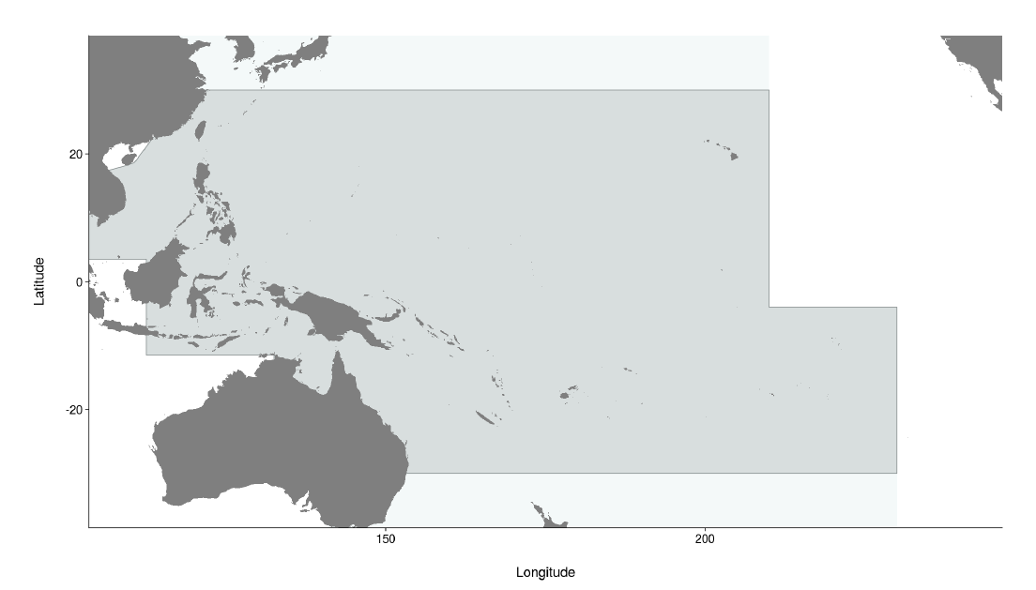

**Figure OCS-01.** Western and Central Pacific Fisheries Commission convention area (light grey), including the stock assessment area for oceanic whitetip shark (dark grey), bounded by the 30◦ N and 30◦S parallels.

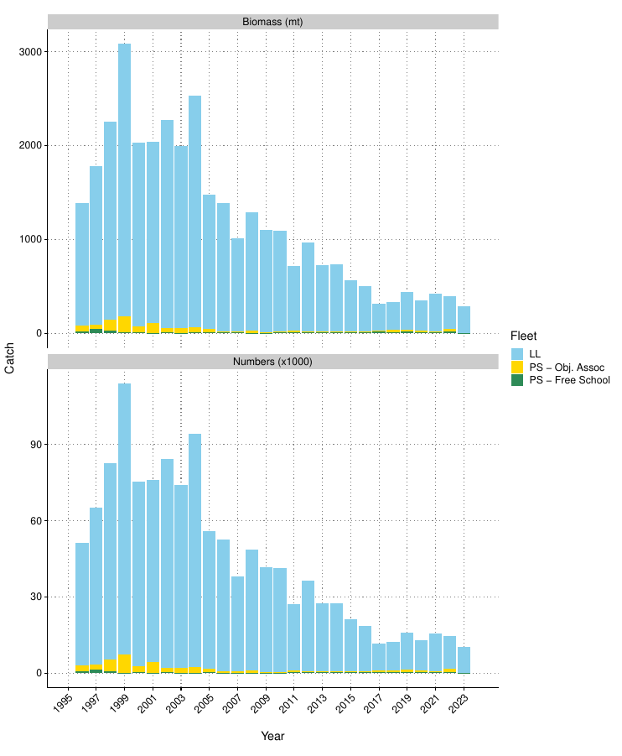

**Figure OCS-02.**  Estimated mortality by fleet in biomass and numbers.

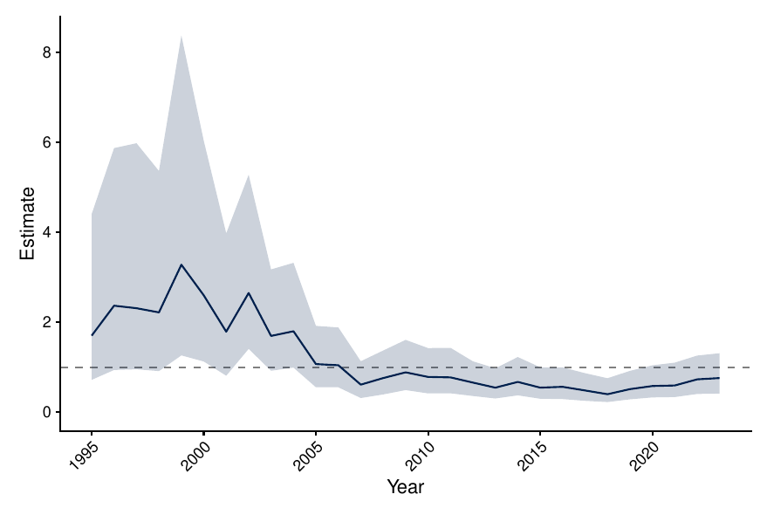

**Figure OCS-03.** Longline CPUE index using long-running observer indices. Shown is the posterior median and 95% credible interval for the year effect, standardised for regional trends and environmental variables.

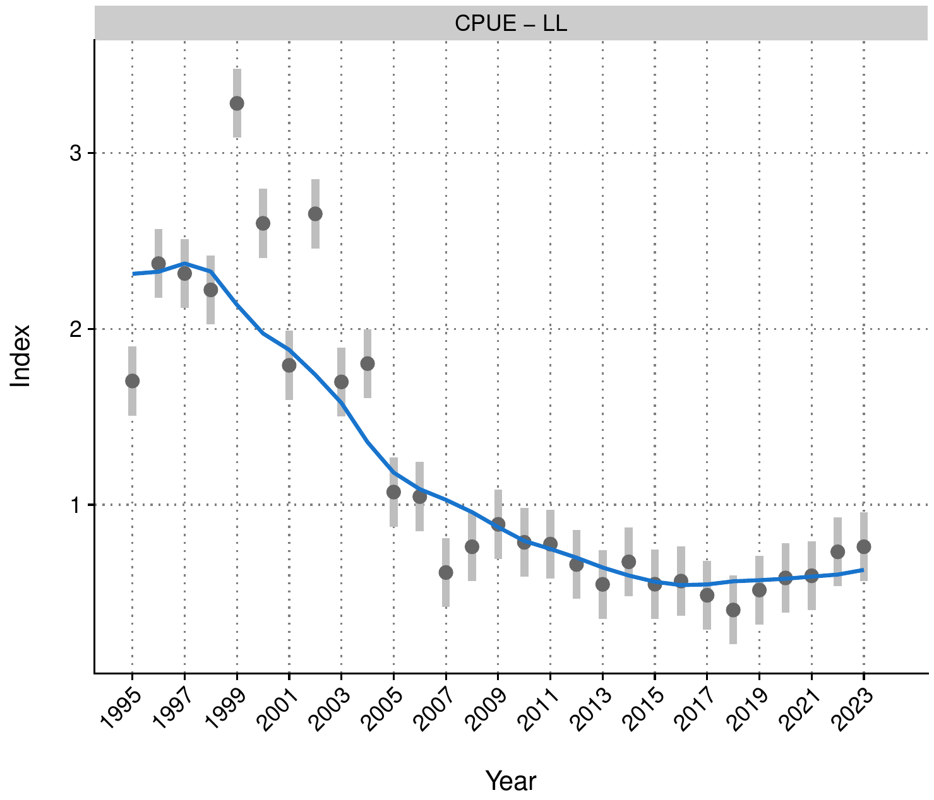

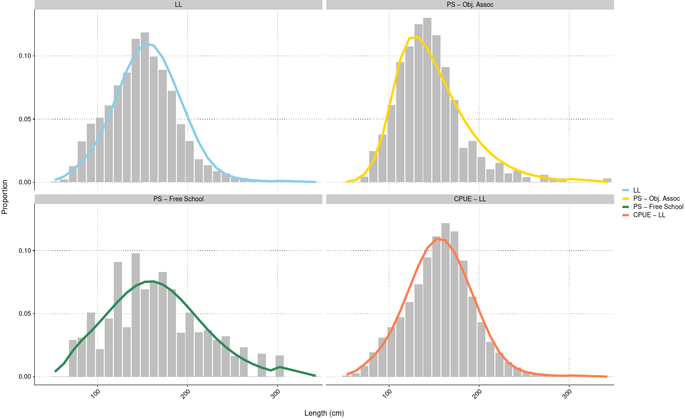

**Figure OCS-04.** Fits to CPUE and length composition data for the diagnostic model for OCS in 2025*.*

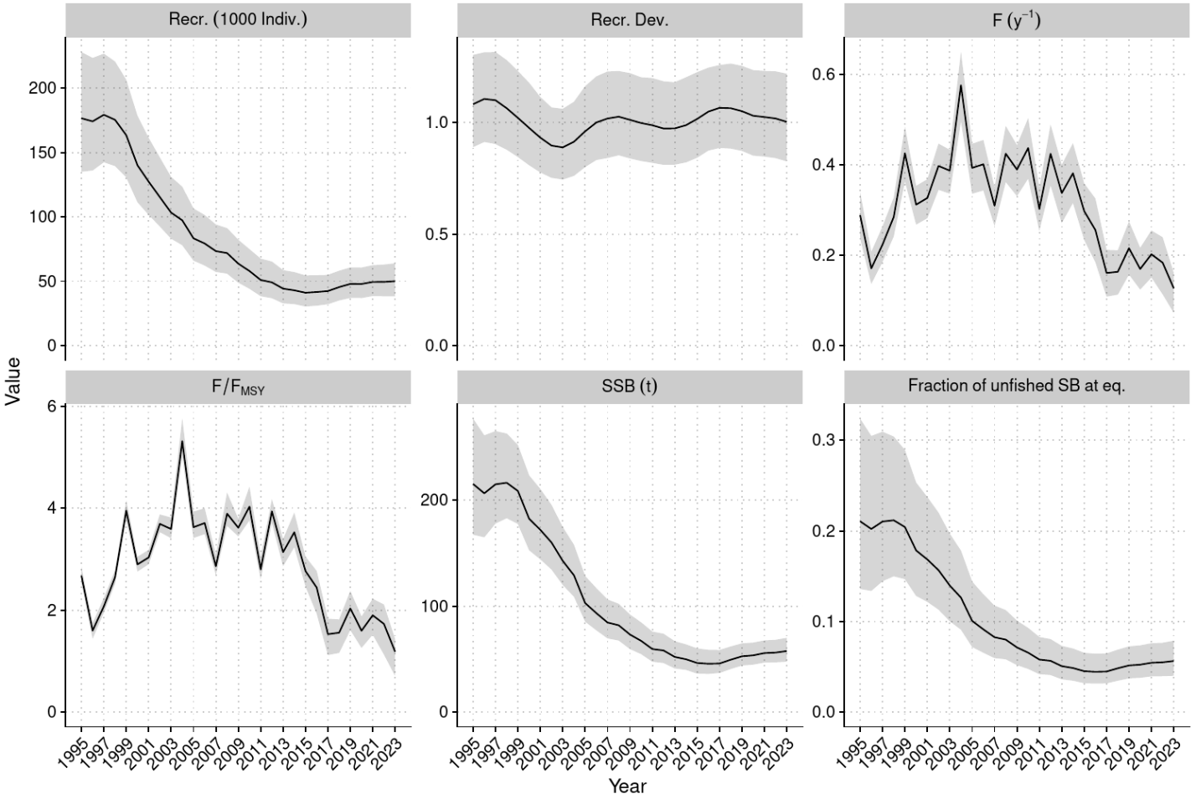

**Figure OCS-05.** Estimated annual average recruitment (top left), recruitment deviations (top middle), fishing mortality (F; top right), fishing mortality relative to FMSY (bottom left), spawning biomass (bottom middle), and spawning biomass depletion (bottom right) across the model ensemble.

* 1. **Stock status**

1. **SC21 noted that there are no agreed reference points for sharks in the WCPFC. The 2025 model suggested that stock status has been improving since 2015. Recent fishing mortality was estimated to be below suggested biological reference points for sharks with high probability (*F*recent*/Fcrash* = 0.54 [95% credible interval 0.37-0.74]; Figure OCS-06, Table OCS-03).**
2. **SC21 noted thatthe 2025 assessment for oceanic whitetip shark concluded that the stock was overfished at 6% of estimated unfished equilibrium biomass, and as likely as not to be subject to overfishing (Frecent/FMSY = 1.07 [0.73 – 1.39]; P[F>FMSY] = 0.57).**
3. **SC21 noted that the multi-model ensemble indicated recent fishing mortality rates are below suggested limit reference points (Flim and Fcrash,,** [**WCPFC-SC15-2019/MI-IP-04**](https://meetings.wcpfc.int/node/11261)**), and current estimated fishing pressure is unlikely to preclude stock rebuilding.**

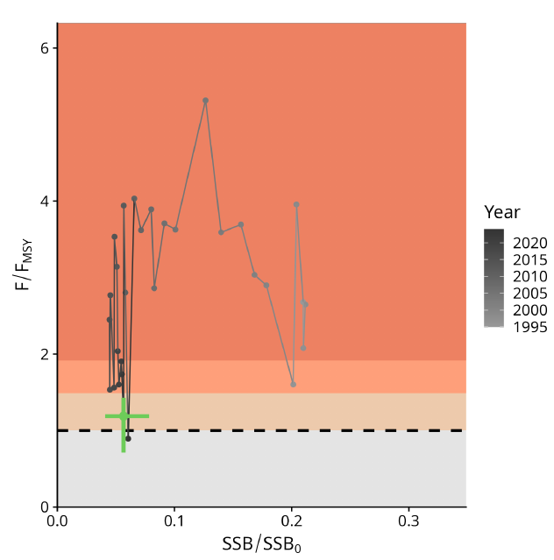

**Figure OCS-06**. Majuro plot summarising the results for each of the models, including uncertainty arising from estimation, structural, and intrinsic uncertainties (variability and process error). Note that the SSB axis has been truncated to better depict the results.

* 1. **Management advice**

1. SC21 noted that the 2025 oceanic whitetip assessment concluded that while oceanic whitetip shark remains severely depleted at approximately 6% of unfished biomass (**Table OCS-03**), recent signs of recovery indicate conservation measures are likely providing some positive effects.
2. SC21 noted that the largest reductions in mortality appear to have come from changes in longline fishing practices, suggesting gear-based mitigation measures have been effective. However, given the subtle nature of estimated recovery and persistent uncertainties, continued monitoring is essential.
3. SC21 noted that the assessment provides high confidence that recent fishing mortality is below levels that would preclude rebuilding, with *F/Fcrash* ratios well below 1. It is as likely as not that recent fishing mortality has exceeded FMSY.
4. **SC21 additionally recommended continuing multi-model assessments for shark species, where possible, to address persistent concerns with data quality and structural assumptions.**
5. **SC21 noted the need for improved observer data collection to inform monitoring of shark abundance trends and shark post-release survival. SC21 also noted this would be expected to inform the review of implementation of CMM 2024-05 paragraphs 21 and 22.**
6. **SC21 recommended that the IWG-ROP assess and identify specific data gaps for enhancements needed in order to improve the accuracy and consistency of shark species identification and reporting, noting lower reporting rates of oceanic whitetip sharks by observers relative to logbooks in some regions and diminishing levels of length records since the implementation of CMM 2011-04.**
7. **Given persistent uncertainties about stock structure and life-history parameters, SC21 recommended that tagging, genetic, and life-history studies be conducted to improve the biological baseline for future stock assessments of the oceanic whitetip shark.**

**Table OCS-03.** Stock status summary table

|  |  |  |  |  |
| --- | --- | --- | --- | --- |
| **Summary** |  |  | |  |
| **Year: 2023** | **Fishing mortality** | **Likely (>60%) to be below tentative limits** | |  |
|  | **Recommendation** | Stock is increasing slowly, and F is declining at the current catch; maintain conservation measures to minimise fishing mortality. There is a high level of confidence that recent fishing mortality is below levels that would preclude stock rebuilding. | | |
| **Reference points** | | **Estimate [5%--95%]** |  | **Comment** |
| Fishing Mortality | FMSY | 0.11 [0.09 – 0.13] |  | (not agreed) |
| FLim | 0.16 [0.14 – 0.18] |  | (not agreed) |
| FCrash | 0.21 [0.18 – 0.24] |  | (not agreed) |
| **Recent (2023) estimates** | | |  | **Recent trend / projection** |
| Biomass | SBrecent | 12 630 [7 670 – 19 350] |  | SBrecent increasing |
| Depletion | SBrecent/SB0 | 0.06 [0.04 – 0.08] |  |  |
| Fishing mortality | Frecent | 0.12 [0.07 – 0.16] |  | Frecent declining |
| **Status** | | | **Likelihood** |  |
| Fishing mortality | Frecent/FMSY | 1.07 [0.73 – 1.39] | As likely as not (40%-60%) to be above FMSY | |
| Frecent/Flim | 0.71 [0.49 – 0.93] | Likely (>60%) to be below Flim | |
| Frecent/Fcrash | 0.54 [0.37 – 0.74] | Very likely (>90%) to be below Fcrash | |

* 1. Projects and Requests
     1. Application of Close-Kin-Mark-Recapture methods (Project 100c)

1. The SSP presented the project 100c (Preparing WCP tuna fisheries for the application of CKMR methods to resolve key stock assessment uncertainties, 2023-2025), which comprises three working papers (SC21-SA-WP-09, SC21-SA-WP-10, and SC21-SA-WP-14).
2. SC21 thanked the SSP for their extensive work on Project 100c, acknowledging the progress made and the preliminary results regarding the genetic structure of SPALB. SC21 noted that further consideration was needed on how these results could be applied to future stock assessments.
3. SC21 generally supported the recommendations in the working paper, particularly the suggestion to expand sampling efforts into eastern areas such as the Solomon Islands, Samoa, and Tuvalu, as well as the region between New Zealand’s east coast and the EPO, in order to improve our understanding of the SPALB biological characteristics, such as stock structure and growth.
   * 1. Longline effort creep and CPUE index collaboration across Tuna-RFMOs (Project 122a)
4. The SSP provided a brief overview of the project's background and progress, as outlined in SC21-SA-IP-16. *Project 122: Progress report on the scoping study on longline effort creep in the WCPO*. The initiative began in 2024 as an online effort-creep-focused project. The scope has since broadened to include longline CPUE, reflecting a consensus across tuna RFMOs on the importance of advancing technical work in this area. To address these needs, a workshop is planned with objectives to; (i) review the current status of CPUE standardized methods, (ii) conduct technical work, (iii) develop a set of good practices on longline CPUE analysis, and (iv) prepare a paper in a special issue of a peer-reviewed scientific journal.
   * 1. Biology from billfish in longline fisheries (Project 125)
5. **SC21 agreed that the development of a structured sampling plan for sharks and billfish is important and necessary to the improvement of the stock assessments and advice provided to the Commission, and that an update to this project should be presented at SC22 after the completion of Project 118.**
   * 1. Developing sampling strategy for sharks (Project 126)
6. **SC21 agreed to a no-cost extension to continue work on this project based upon the sampling plans developed in Project 117.**
   * 1. Stock connectivity scoping study (Project 128)
7. **SC21 generally supported the proposed work for project 128a, and further recommended the completion of the impact analysis of various connectivity hypotheses between the WPEA and the greater Pacific basin as part of the preparation for the yellowfin tuna assessment in 2026. If the outcomes of further genetic analyses indicate a different connectivity hypothesis than those considered in 2026, another sensitivity analysis of the new hypothesis would be necessary in future assessments.**
8. **SC21 also recommended that Project 128a collect bigeye tuna samples to apply a similar connectivity analysis.** 
   * 1. Research Plan Update
        1. **Tuna Assessment Research Plan (2023 – 2026) annual update**
9. ISG-01 was convened in reference to SC21-SA-IP-17: Tuna Assessment Research Plan (TARP) 2025–2028 to refine and agree on priority research projects to strengthen tuna stock assessments in the WCPO. Two sessions were held on 14 and 16 August 2025. The first session reviewed the SSP’s proposed priority table, which was circulated for comments. In the second session, members discussed the feedback received and successfully reached consensus on the key projects requiring further resourcing. The discussions were constructive, with strong participation, and Terms of Reference (TORs) were developed for inclusion in the SC21 prioritization exercise.
10. The group endorsed several priority areas, including supporting a joint t-RFMO technical workshop on longline CPUE abundance indices, the population structure genetics study to improve understanding of connectivity between the east Asia region and the broader western and central Pacific (focused on yellowfin and skipjack, but consider bigeye inclusion), developing an age-length data pipeline for tuna stock assessments, improvements to size data reconciliation and conversion factors, and support the work on the next-generation tuna model development. While these projects were recognized as critical for advancing robust and defensible stock assessments, members also highlighted challenges such as high funding needs for large projects (e.g. the east Asia/western Pacific population structure project, ~USD 1M), limited SSP capacity in 2026 due to major stock assessments, and the need for long-term sustainability of otolith data collections and ageing programs. Members also noted the importance of developing a clear peer review process, with the US and Australia, to prepare a paper for SC22. TORs for agreed projects have been submitted for SC21’s ranking.
11. **SC21 agreed to adopt the recommendations put forward by ISG-01 (Attachment 2).** 
    * + 1. **Billfish Research Plan (2023 – 2030) annual update**
12. Based on the suggested recommendations in SC21-SA-IP-18 (“Progress against the 2023-2030 Billfish Research Plan - 2025”), the ISG-02 Billfish Research Plan was asked to review and provide feedback on the following elements:

* Review the work plan and project list for the 2025/26 year and make recommendations to SC21 for any changes the SC may want to consider, including any new project priorities.
* Review the project specifications and make any changes for SC21’s review.
* Consider the proposal to re-purpose the biology project 3 (SWO tagging) as a genetics project and develop the ToR at SC21 ISG-billfish.
* Provide feedback on the suggestion for a joint bycatch - billfish and sharks - assessment methods workshop and amend stock assessment project 6 (new TOR) if approved by SC21 ISG-billfish.
* Review the current billfish stock assessment schedule and confirm accuracy or suggest any revisions.

1. A full report and table of projects and an assessment schedule are available in the ISG-02 Report. The ISG-02 recommended one new addition to the 2021-2030 Billfish Research Plan, to include a joint bycatch-billfish and sharks-assessment methods workshop, to review and recommend potential assessment methods for data-limited billfish. The ISG-02 also agreed to postpone the development of assessment approaches for WCPO black marlin, sailfish, and shortbill spearfish until 2027, following the conclusion of the new proposed workshop to inform those assessments. ISG-02 recommended a revision of one project in the Billfish Research Plan, biology project 3, to undertake directed longitudinal tagging of SW Pacific swordfish to reduce the uncertainty in movement rate. The ISG-02 agreed that there would be more value if this project were amended to remove the tagging elements and instead, to sample a wider range of fish, undertake epigenetic aging work, and genetic analysis of stock distribution.
2. The ISG-02 recommended two changes to the billfish assessment schedule to reflect updates to the ISC assessment schedule for NP striped marlin and NP swordfish. The ISG-02 also recommended a shift in the scheduled low information assessment characterizations for black marlin, sailfish, and shortbill spearfish from 2026 to 2027, based on the agreement to postpone that work. The ISG-02 discussed potential changes to the assessment schedule for SW Pacific striped marlin and SW Pacific swordfish. Given the current assessment schedule for tropical tunas, it is unlikely that SPC would be able to undertake both assessments in the same year. This issue will be discussed during the workshop to review assessment methods for billfish and sharks, to discuss how these assessments will be conducted, and determine whether and how to modify the assessment schedule.
3. **SC21 agreed to adopt the recommendations put forward by ISG-02 (Attachment 3).** 
   * + 1. **Shark Research Plan 2021-2030 annual updates**
4. An informal small group (ISG-03) met for one session to review the progress against the 2021-2030 Shark Research Plan (SRP) - 2025 (SC21‐2025/SA-IP-19). The ISG-03 reviewed the recommendations in SA-IP-19, evaluated the assessment schedule for sharks, and assessed the project list for work due to begin in 2026. ISG-03 suggested removing recommendation 4 (SC21 consider proposing the southwest Pacific (SWP) mako shark assessment as a low information assessment), as since the last assessment, the shark assessments have moved to a 2-year time frame, and the 2026 billfish and shark bycatch assessment workshop may provide a more considered approach to this assessment. ISG-03 noted that the SWP mako shark assessment should not start until the workshop has made a recommendation on a suggested way forward. The assessment models/methodologies should therefore be determined by the billfish and shark bycatch assessment workshop. The stock assessment schedule was revised (See the ISG-03 meeting report). The indicator analysis for North Pacific (NP) mako sharks was the subject of an ISC Plenary agreement that the indicator analysis had limited usefulness, and a 2-year schedule for producing North Pacific shark assessments was preferred. ISG-03 also noted that once enough data has been collected by the Regional Observer Program, each of the biology projects could be reconsidered pending successful data collection prior to the projects being rescheduled. ISG-03 recommended progressing three projects in 2026:

* A general characterisation of low information shark stocks;
* Epigenetic and stock structure analysis of SWP mako sharks; and
* Post-release survival of oceanic whitetip sharks.

1. The ISG-03 notes that two assessments (SWP and NP blue sharks) will commence in 2026.
2. Finally, it was noted that the ISC Shark Working Group (ISC-SWG) was not able to commit to undertake a scoping study for CKMR of mako sharks in the north Pacific Ocean as scheduled, and it was noted that the ISC-SWG had postponed this work pending revision to the ISC-SWG schedule.
3. **SC21 agreed to adopt the recommendations put forward by ISG-03 (Attachment 4).**
   * + 1. **WCPFC tuna biological sampling plan (Project 117)**
4. **SC21 noted the sampling plans for skipjack and bigeye tuna that were presented and agreed that the current methodology was robust.** **SC21 requested that these methods be applied to the other tuna, billfish, and shark stocks, and these results be provided at SC22.** 
   * + 1. **WCPFC billfish biological sampling plan (Project 118)**
5. SC21 noted that the SSP intends to provide sampling plans using the methodology described in Project 117 for billfish stocks.

* + 1. Other SA issues

1. No other matters were raised.

# AGENDA ITEM 5 — MANAGEMENT ISSUES THEME

# 

* 1. Development of the WCPFC harvest strategy framework for key tuna species
     1. Skipjack tuna
        1. **Skipjack tuna management procedure**

1. SC20 requested that the SSP conduct analyses to: (a) evaluate whether changes in the FAD closure duration (as adopted in CMM 2023-01) will affect the performance of the interim MP; and (b) determine the representativeness and appropriateness of candidate CPUEs for use in the MP.

* **On (a), SC21 noted that, based on the analysis by SSP (SC21-MI-WP-02), changes in the FAD closure duration (as adopted in CMM 2023-01) have a negligible impact on the performance of the interim skipjack MP. The effects of the FAD closure period on other tropical tunas were not considered in this evaluation. SC21 also noted that the results are based on the assumption that the relative levels of FAD and free-school fishing change proportionally with changes in the FAD closure period. These assumptions may not always hold, as witnessed in 2024 when the proportion of free-school sets increased, notwithstanding a reduction in the FAD closure period.**
* On (b) above, based on the analysis presented by SSP(SC21-MI-WP-01), SC21 noted the following: (i) the index used within the 2022 dry run analysis contained inconsistencies in the penalty application within MFCL and did not implement the sea surface temperature (SST) spatial filter. Reapplying the SST filter and correcting the penalty calculations restored consistency with the tested MP, (ii) the transition to sdmTMB for standardization has had minimal impact on MP outputs and is acceptable under current MP settings, (iii) the settings used to develop standardized CPUE indices should be included within MP documentation for all relevant WCPFC management procedures, and (iv) the MP appears reliable in the short term under JPPL data degradation in the tropical region, but presents increased risks in the longer-term.

1. Pending agreement by the Commission on proposed changes to the WCPFC harvest strategy workplan and MP implementation timetable (see agenda item 5.1.5), the skipjack MP may next be run in either 2026 or 2027, and the review of the skipjack MP may occur in either 2028 or 2029. ADOPTED
2. **SC21 supported the continued application of the interim skipjack MP for the next implementation cycle, while also emphasizing the importance of further development of alternative indices in advance of the third implementation of the MP. This work should be conducted as part of the scheduled MSE review in 2028 (or potentially, 2029). SC21 further noted that changes to the tuning indices used by the MP may require reconditioning of the OMs and retesting of the MP, which is a considerable undertaking.** 
   * + 1. **Monitoring strategy for skipjack tuna**
3. **Based on the discussion and information available, including the 2025 SKJ stock assessment, SC21 made updates to the skipjack monitoring strategy table as shown in Attachment 5.** 
   * 1. South Pacific albacore tuna
        1. **South Pacific albacore management procedure**
4. SC21 reviewed the revised candidate South Pacific albacore management procedures provided in SC21-MI-WP-04. SC21 noted the management area to which the MPs presented in SC21-MI-WP-04 applies has changed to the WCPFC Convention Area south of 10S, which is in accordance with the proposed mixed fishery framework (notified in WCPFC Circular 2025/17, SC21-MI-IP-04). SC21 also noted that, in comparison to the results presented to WCPFC21, a reduced set of MPs was provided with different HCRs and assumed catch levels in the EPO and in the area north of 10 degrees S (together with sensitivity analyses of higher catches in these areas). **SC21 encouraged the SSP to provide sufficient explanation and additional information as necessary (such as historical catch trajectory in the EPO and the area bounded by 0-10 degrees S) to the SPAMWS01 (Sept 2025) and to WCPFC22 to assist decision makers.**
5. While SC21 acknowledged the need to focus discussion on a reduced set of MPs, SC21 also recommended that in the future, revisions to the set of candidate MPs preferably be guided by the Commission, its subsidiary bodies, or by dedicated WCPFC science-management dialogue, including species-specific workshops, while suggestions from SSP may be helpful in certain instances. **SC21 requested WCPFC22 to consider developing a mechanism to provide timely feedback for MSE development to achieve the timelines detailed in the harvest strategy workplan.**

1. SC21 recognized that, in developing the candidate MPs in MI-WP-04, it was necessary to make some assumptions with respect to future catches of SPA in the Eastern Pacific Ocean (excluding the overlap area) and in WCPFC-CA from the Equator to 10S, which are outside the control of SPA MP. SC21 noted that for the evaluations presented in SC21-MI-WP-04, these annual catches were set at a baseline level of 18,000 mt for the EPO (excluding the overlap area) and 9,000 mt for the WCPFC-CA equator to 10°S region, being the approximate averages for the period 2014-2023.
2. It was further noted that, following the adoption and implementation of the MP, the occurrence of conditions outside the range of scenarios used for testing may invoke consideration of exceptional circumstances. SC21 noted the need for candidate MPs to be tested against a range of plausible scenarios that may be beyond historical observations, to minimize this possibility. In developing the monitoring strategy, SC21 also noted the importance of closely monitoring catches if MP implementation differs from conditions assumed when testing MP (e.g., if implementation is in terms of effort for a catch-based MP). This is to ensure that catch levels do not deviate from the tested range during MP evaluations and that the selected MP still meets management objectives.
3. **SC21 recommended the continued application of the Estimation Method, which does not include a troll index, as presented to WCPFC21 in WCPFC21-2024-30_Rev01.**
4. **For the four candidate MPs provided, SC21 draws the attention of the Commission to the following:**

* **All the MPs perform well in terms of biological risk to the stock, with the risk of breaching the limit reference point below the specified 20% threshold, and only HCR 10 shows a greater than 5% risk of breaching this threshold.**
* **The candidate MPs have different outcomes in terms of the trade-off between catches and catch rates.**
* **Sensitivity tests were conducted, which evaluated the performance of the MPs when catches in the two areas outside of the MP were set to higher levels (EPO excluding the overlap area at 22,500 mt, and the WCPFC-CA between 0° and 10°S at 12,000 mt), which appears below. These tests showed that the performance of the candidate MPs was not strongly affected by the alternative catch assumptions examined.**

1. **SC21 noted that it is desirable to constrain the number of candidate MPs evaluated to a manageable level. SC21 recommended that, in addition to the results presented in SC21-MI-WP-04, three additional MPs be developed for the Commission's consideration that more fully explore EPO (excluding overlap area) catch consequences as well as the use of a fixed effort assumption in the WCPFC-CA area equator to 10°S.**

* **EPO (excluding the overlap area) set to 22,500 mt (being the approximate average of catches in the years 2021-22), WCPFC-CA 0-10S set to 9,000t (being the approximate average in the period 2014-2023), using a catch control HCR “tuned” to achieve the adopted iTRP.**
* **EPO (excluding the overlap area) set to 13,500 mt (being the approximate catch in the year 2020), WCPFC-CA 0-10°S set to 9,000 t (being the approximate average in the period 2014–2023), using a catch control HCR “tuned” to achieve the adopted iTRP.**
* **EPO (excluding the overlap area) set to 18,000 mt (being the approximate average for the period 2014-2023), WCPFC-CA 0-10°S set to average effort levels in the period 2014-2023, using a catch control HCR “tuned” to achieve the adopted iTRP.**

1. **SC21 recommended that, to the extent possible, the results of this expanded set of seven candidate MP evaluations and all candidate MP evaluations in WCPFC21-2024-30 (those applied to longline and troll fisheries operating in the WCPFC-CA, south of the equator) be provided to the SPAMWS01 in September 2025 and to the Commission for their consideration and decision.**
2. **SC21 also requested that the SSP report the median time series of vulnerable biomass from the OMs for the historical period and to develop a table with the average nominal CPUE (kg/100 hooks) for the reference period (2020–2022) by CCMs with SPA catches.** 
   * + 1. **Joint WCPFC/IATTC Working Group for South Pacific Albacore**
       2. **Updates on SP Albacore Roadmap IWG**
3. SC21 noted the briefing by the Chair of the SPA Roadmap IWG that emphasized the importance of adopting an SPA MP this year.
   * 1. Bigeye tuna
        1. **Bigeye operating models**
4. SC21 noted that, under the Indicative Harvest Strategy Workplan, the Commission is scheduled to adopt an MP for bigeye tuna in 2025 or, failing that, in 2026. SC21 reviewed the proposed OM reference set (SC21-MI-WP-05). SC21 considered the grid represented a core set of OM models but noted that it spanned a relatively narrow range and that this may increase the likelihood of future events occurring outside the range of tested scenarios (exceptional circumstance). Therefore, a number of additional sources of uncertainty should be investigated for the further development of the OM reference set. Candidate MPs developed for the consideration of SC22 should, where possible, be tested against this extended OM grid.
5. **Mindful of the above concerns, SC21 supported the use of the proposed reference set of 24 OMs for the bigeye tuna as a basis for further development. However, SC21 recommended that work should continue to promptly refine and expand the OM reference set to include alternative assumptions as listed below in Table MI-01** **as much as practicable, with a view to the formal adoption of the OM reference set in 2026. SC21 noted that assumptions around the purse seine FAD closure period may not need to be included in the OM reference set, but rather that those assumptions can be addressed through specific MP design and sensitivity analysis.**
6. **SC21 noted that in 2026, SC22 is scheduled to review a new BET stock assessment in addition to adopting BET OMs, the latter being necessary for WCPFC23 to adopt BET MP. SC21 reiterated that, as a default, development of a new assessment should not necessarily impact OM development unless SC recommends otherwise or SSP determines it necessary.**

**Table MI-01**. List and priorities of uncertainties to be considered in bigeye tuna operating models

|  |  |  |
| --- | --- | --- |
| **Uncertainty** | **Priority** | **Timing** |
| Growth | High | Short (preferably by 2026) |
| Natural mortality | High | Short (preferably by 2026) |
| Movement dynamics | High | Short (preferably by 2026) |
| Hyperstability in CPUE | High | Short (preferably by 2026) |
| Variability in recruitment | High | Short (preferably by 2026) |
| Spatial structure | High | Long |
| uncertainty in domestic catch level | High | Long |
| Effect of climate change | High | Long |

* + - 1. **Bigeye management procedure – design**

1. SC21 noted that the candidate EM (estimation method) to inform the BET MP is based on an age-structured production model implemented in Stock Synthesis 3, and the resulting HCR input is calculated as a relative measure of stock status: estimated SB/SBF=0 in the final year relative to the mean estimated SB/SBF=0 in 2012-2015 (SC21-MI-WP-06). **SC21 endorsed the general approach of using an ASPM for the EM but made a number of technical suggestions for consideration in future work to refine the EM (e.g., model settings for sigma R, natural mortality, steepness, construction of CPUE indices) for further analysis, including re-evaluation of the EM under any expanded OM grid and taking into account the outcomes of agenda item 5.1.3.1.** 
   * + 1. **Bigeye Target Reference Points and Performance Evaluation of Candidate Management Procedures**
2. **SC21 welcomed the development of a full feedback simulation modelling framework for BET and the initial testing of candidate MPs designed to achieve the three TRP options identified by WCPFC21. SC21 noted that the MP controls only a fraction of the BET catch (27% over the period 2020-2022) and stressed the importance of considering the dynamics of other fisheries that catch BET that are either managed under an MP (same or separate) or require assumptions about their management. SC21 also noted that specific settings within the BET MSE remained to be defined by the Commission.**
3. A variety of alternatives for MP design settings were suggested by CCMs. Those need to be carefully considered by the Commission so that plausible assumptions are properly covered in the MSE testing. **SC21 also draws the Commission’s attention to the fact that the order of MP and MSE application under the mixed fishery harvest strategy framework (i.e., which species’ MP goes first) could affect the performance across the individual MPs, and that this order of MP application has not yet been formally agreed upon.**
4. **SC21 recommended that WCPFC22 review the current proposed BET MSE framework and provide guidance on BET MP settings and assumptions.**
5. **SC21 considered that the six proposed performance indicators should be included in future presentations and encouraged the SSP to consider further options to help inform management decision-making, including through feedback from WCPFC22.** 
   * 1. Mixed fishery MSE framework
6. **SC21 reviewed the current status of YFT MSE development (SC21-MI-WP-08) and recommended that the initial yellowfin tuna operating model reference set be constructed around the 2023 yellowfin stock assessment grid, consistent with the approach used for the other key tuna species. Additionally, it was recommended that the proposed OM grid be expanded to also take into account similar additional uncertainties as suggested for the BET OM grid, as well as recommendations from the past tuna assessment peer reviews.**
7. **SC21 further noted a consistent set of performance indicators across yellowfin and bigeye tunas be used.**
8. **SC21 noted that under the current proposed framework of the mixed fishery MSE framework, YFT is intended to be managed through the catch and effort constraints that are applied by the three other MPs without a dedicated MP for YFT. SC21 noted that testing of the mixed fishery harvest strategy framework would be needed to evaluate how effectively such a management framework can achieve YFT objectives.** 
   * 1. Progress of the WCPFC Harvest Strategy Work Plan
9. SC21 noted the planning and scheduling considerations for the development, adoption, and implementation of harvest strategies for the key tuna stocks provided in MI-WP-10. SC21 noted that this is primarily a matter for the Commission's consideration, but that the proposal to extend the skipjack current MP application from 3 to 4 years was a matter that required SC advice. SC21 considered the risks of extending the skipjack current MP application period from 3 to 4 years to the performance of the MP and achievement of its objectives. SC21 refers to the Commission to the results of the skipjack monitoring strategy report from SC21 and also notes the following relevant considerations:

* The 2025 stock assessment indicates spawning potential depletion, and average fishing mortality rates have remained relatively stable since 2010 (SA-WP-02).
* The 2025 stock assessment indicates the recent stock depletion is close to the recalibrated TRP and is within the range expected through the MSE testing of the adopted interim skipjack MP.
* Stochastic projections indicate relative stability of stock depletion in the future when recent (2024) conditions are assumed (SA-WP-02).
* The FAD closure period has been determined to have very little impact on the performance of the skipjack MP (MI-WP-02).

1. Based on these considerations, **SC21 recommended that the Commission support a one-time extension of the current skipjack MP application period from 3 to 4 years.** SC21 noted that such a change would need to be reflected in an amendment to CMM-2022-01. **SC21 recommended that SC21-MI-WP-10 be provided to WCPFC22.**
2. **SC also reconfirmed the importance of capacity building for the implementation of the harvest strategy.**
3. **MSE analyses for three stocks (SKJ, SPA, BET) were presented to SC21 this year and represented a significant body of work for the SC’s consideration. SC21 noted that, as the development and implementation of the harvest strategy approach progresses under the milestones within the WCPFC harvest strategy work plan, it is critical to receive timely guidance and instruction from the Commission on key aspects of this work. The workplan anticipates the adoption of multiple MPs in the near future, and it is important that the Commission provide guidance in relation to the implementation of the mixed fishery approach.**
4. **SC21 noted that for complex fisheries management, such as that required for WCPFC key tuna stocks, the development and simultaneous application of species-specific MPs, as in WCPFC, is a reasonable approach due to the difficulty in developing fully integrated multi-stocks approaches. When developing species-specific MPs in this approach, settings must be agreed not just for individual MPs but also for how those individual MPs should interact. These would include, but are not limited to:**

* **How each fishery is to be managed (catch or effort).**
* **What catch or effort levels in fisheries not managed by the MP should be considered.**
* **The scope of candidate MPs in terms of their spatial extent and the fisheries to be managed.**
* **Management objectives for fisheries and, in particular, TRP options to consider.**
* **How stock status of individual species may trigger Exceptional Circumstances in other species MPs.**
* **Order of MP application** 
  1. Pacific bluefin tuna management strategy evaluation

1. SC21 reviewed the results of the PBF MSE conducted by ISC (SC21-MI-WP-09). The ISC PBF working group presented the results of testing sixteen candidate HCRs against the agreed Management Objectives using performance indicators, computed over a 20-year evaluation period from 2026 to 2045. SC21 noted that the MSE process is still underway, since NC21 could not reach an agreement on an HCR for recommendation, and could not agree on an LRP nor a TRP.
2. SC21 recalled paragraph 7 of CMM 2022-03 on Harvest Strategies, which requires both target and limit reference points for each stock, acceptable levels of risk, an HCR, and a monitoring strategy to be adopted. **SC21 commended the work done by ISC and noted the results, and recommended that the NC reach an agreement on an MP for PBF, based on the performance evaluated through the MSE.**
   1. Southwest Pacific striped marlin – management projections
3. **SC21 agreed that the projections requested in SC20 were not necessary based on the results and projections provided from the 2025 SWPO MLS stock assessment.**
   1. North Pacific striped marlin projections
4. As requested by the WCPFC Commission, the ISC Billfish Working Group provided updated projection runs for the Western and Central North Pacific Ocean MLS rebuilding analysis to reflect the catch distribution by country from the CMM 2024-06, which was adopted at the WCPFC Commission meeting in December 2024 (SC21-SA-WP-04). Three scenarios are provided with a few updates on model configuration. Primarily, reported catch from 2021-2024 was used in the projections instead of estimated catch based upon 2018-2020 fishing mortality. All three scenarios indicate that additional reductions in catch would be necessary in 2028 to meet the rebuilding target of 20%SSBF=0 by 2034, and these projections are generally consistent with those provided in 2024. **SC21 endorsed this information to be forwarded to the Commission for further consideration.**
   1. Southwest Pacific swordfish management procedure
5. SC21 recognized that the Commission has agreed to develop a management strategy evaluation framework to evaluate candidate management procedures for Southwest Pacific swordfish and to consider developing a Harvest Strategy. **SC21 endorsed the project scope, addressing this decision provided in SC21-GN-WP-04, project P21X03, and recommended that the development of the MSE take into account the key uncertainties highlighted in the 2025 swordfish assessment (for example, population scale, growth, and spatial structure), as these will be challenges for both the operating models and estimation methods. SC21 also recommended that the Commission consider the broader Indicative Workplan for Developing a Southwest Pacific Swordfish Harvest Strategy contained in Attachment 1 of the scope.**
   1. Review of effectiveness of CMM 2023-01
6. **SC21 noted the analysis and requested the SSP update it in light of the skipjack stock assessment adopted at SC21.** **SC21 recommended that the updated paper be provided to WCPFC22.**
   1. Other MI issues

# AGENDA ITEM 6 —ECOSYSTEM AND BYCATCH MITIGATION THEME

# 

* 1. Ecosystem and Climate Indicators
     1. Ecosystem and Climate Indicator Report Card

1. SC21 commends the SSP’s work on developing new indicators for the Ecosystem and Climate Indicator Report Card and encourages the SSP to continue refining the criteria to support their use in management.
2. **SC21 recommended that the SSP investigate the addition of estimated median phytoplankton size derived from satellite remotely sensed SST and chlorophyll a data to the Ecosystem and Climate Indicator Report Card.**
3. **SC21 requested that the SSP provide a Working Paper to SC22 with outcomes from the proposed March 2026 workshops on Ecosystem Indicators and Climate Indicators.** 
   * 1. Climate change
        1. **Climate Change Workplan**
        2. **CMM climate change vulnerability assessment**
4. **SC21 acknowledged the consultants for delivering a comprehensive framework for WCPFC CMM Climate Change Vulnerability Assessments (CCVA) and recommended further refinement of this so that it can be a useful tool to CCMs.**
5. **SC21 noted the framework requires the review of a substantial amount of information from different sources, and hence recommended the development of a template or revision of indicators to streamline the information already routinely provided to SC to be integrated into the software.**
6. **SC21 provided several technical comments on the assessment approach, such as a way to facilitate ease of interpretation of findings, especially identifying where quicker action may be needed.** **SC21 recommended that these changes be incorporated for review by TCC21 and presentation to WCPFC22**.
7. SC21 noted the extensive scope of the paper and the limited time available for its review. SC21, therefore, acknowledged that it was not in a position to fully consider the trialled outcomes on CMMs as validated information at this session.
   * 1. Updates on the 2019 SEAPODYM Review
8. **SC21 noted the progress made on the 2019 SEAPODYM Review and recommended that the SSP progress validation against other approaches to continue improving this important tool. SC21 agreed that this should include fitting to simulated data, focusing on population dynamics by evaluating variation (e.g. the Indian Ocean yellowfin data produced by SPM, Goethel, et al., 2024).**
9. **SC21 recommended that reporting of the reference models for tropical tunas based on SEAPODYM to SC22 include (as appropriate) standard convergence diagnostics, sensitivity analyses to fixed parameters and key model assumptions, likelihood profiles, sensitivity of model results to data used in the optimization period, and quantification of uncertainty in model estimates.** 
   1. FAD impacts
      1. Research on non-entangling and biodegradable FADs
10. **SC21 noted the positive progress of projects 110 and 110a on non-entangling and biodegradable FADs by the SSP and collaborating CCMs, and agreed on the importance of capacity building and collaboration between the SSP and the fishing industry in implementing the final phase of this work.**
11. SC21 noted that, based on limited sea-trial results, the drift speed, monitoring period, and tuna aggregation patterns were similar between conventional drifting FADs and jelly-FADs.
12. **SC21 requested that additional work on the definition of biodegradable materials be conducted, including on the standards of biodegradable materials in the marine environment. SC21 suggested that the SSP develop a TOR for a project to be considered by SC22.**
13. **SC21 also recommended that similar work should be considered for materials used in the construction of anchored FADs and that the SSP develop a TOR for a project to be considered at SC22.** 
    * 1. Research on dFAD loss and abandonments
14. SC21 noted with concern the high number of FAD stranding events occurring in PICT waters, and that almost half of the reported stranding events are from FADs deployed in the EPO.
15. **SC21 welcomed the monitoring of dFAD tracking buoys outside fishing grounds and the pilot projects to retrieve buoys and dFADs close to shore undertaken by the SSP in collaboration with partners, and requested that the FADMO-IWG facilitate discussion on ways to track FADs once they are no longer actively monitored by their owners.**
16. SC21 encouraged CCMs to undertake additional work to:

* increase the collection of data on stranded FADs;
* improve FAD identification rates;
* better understand the environmental impacts of stranded FADs; and
* continue the economic and feasibility assessments and further the development of drifting FAD recovery programs.

1. SC21 considers it important to balance stakeholder concerns on the work encouraged of CCMs above through cooperation between purse seine industries, buoy providers, coastal states, territories, and other stakeholders. SC21 encourages CCMs and stakeholders to update the SC on the progress of this work at future meetings.
2. SC21 encouraged CCMs, the fishing industry, and other stakeholders to complete the ongoing stakeholder surveys, to participate in the February 2026 international workshop on mitigation of drifting FAD loss and abandonment in French Polynesia, and interested CCMs to participate in the collection of data on in-situ stranded FADs.
3. **SC21 recommended that additional work should be conducted to better understand the impacts of stranded FADs on different habitats, including using FAD tracking data, and recognized the importance of the availability of historical data.**
4. **SC21 recognized that ongoing funding sources are needed for the continuation of the work led by the SSP on these topics. SC21 hence requested that a work plan and any relevant project proposals should be developed by the SSP on the assessment of options to increase FAD recovery, and requested the SSP provide the latest scientific information to the FADMO-IWG and SC22.**
   * 1. Updates on FAD Management Options IWG
5. SC21 emphasized the importance of real-time reporting by satellite buoys for at-sea FAD monitoring to support retrieval efforts. **SC21 agreed that event-based reporting be removed as a key data field since this information cannot be generated by the buoy. Instead, SC21 recommends that TCC21 consider the provision of data within this category directly in separate reports by the FAD Buoy Owner/Operator.**
6. **SC21 further agreed that, where practically feasible, manufacturers could enter agreements with the FAD Buoy Owner/Operator to provide satellite data directly to WCPFC SSP.**
7. **SC21 agreed that the implementation of FAD recovery plans requires further discussion to overcome operational challenges and that the FADMO-IWG should consider incentive-based policies where practical. SC21 noted the work currently carried out by the SSP on this topic.**
8. SC21 suggested the FADMO-IWG continue discussions on developing a WCPFC web portal for the reporting and tracking of FAD stranding events and noted the template on FAD sightings already developed by the SSP (Appendix 2 SC21-EB-WP-05), currently used by 16 CCMs and adopted by the IATTC.
9. **SC21 noted that the effectiveness of the dFAD deployment limit as set in CMM 2023-01 can be impacted due to buoy deactivation practices, and requested that the FADMO-IWG and TCC21 further consider this issue.**
10. SC21 noted the need for improving the reporting and monitoring of FAD activities by different vessels and recommended that TCC21 discuss the types of vessels allowed to engage in FAD-related activities.
    1. Bycatch management
       1. Bycatch Management Information System
       2. Bycatch Assessment and Management
    2. Review of CMM for Seabirds (CMM 2018-03)
11. SC21 recalled previous advice from SC20 regarding the long-term population declines of seabirds in the southern WPO area, which, for some, has been attributed to bycatch in commercial pelagic longline fisheries. Key areas of importance for albatrosses and petrels vulnerable to bycatch in the Southern Hemisphere, such as Antipodean and Gibson’s albatross, include areas with reduced bycatch mitigation requirements (25°-30°S). SC20 further noted the relatively high effectiveness of combining mitigation practices, as well as the high effectiveness of hook-shielding devices as a stand-alone seabird bycatch mitigation option.
12. SC21 noted the further and updated information presented on key vulnerable seabird populations in the Southern Hemisphere of the WPO, including rapidly declining Antipodean and Gibson’s albatrosses. These data reiterated the importance of the area south of 25° South, including the area 25°-30°S, where CCM 2018-03 currently requires the use of only a single seabird mitigation practice. The effectiveness of required measures in this area could be improved by the combined use of multiple mitigation practices or hook-shielding devices.
13. **SC21 requested that TCC21 consider further any practicality issues related to the use of combined mitigation measures south of 25° South.**
14. **SC21 endorsed the approach to develop a two-tiered structure that separates minimum, compliance-based standards from adaptable technical guidelines in relation to the specification of tori lines for large vessels in the Southern Hemisphere (Paragraph 1a of CMM 2018-03 Annex 1). Such guidelines would enable the improvement of this seabird bycatch mitigation practice and enhance operational flexibility.**
15. **SC21 requested interested CCMs and Observers to work intersessionally to present an updated draft to TCC21 based on a draft set of technical guidelines discussed during ISG-04.** 
    1. Elasmobranchs
16. SC21 acknowledged the value of further research on post-release mortality of mobulids to accurately assess the mortality rate after fisheries interactions.

1. **SC21 requested guidance from the SSP on how post-release survival data can be incorporated into bycatch impact assessments, and its potential value for evaluating the effectiveness of CMM 2019-05.** 
   * 1. Review of CMM for sharks (CMM 2024-05)
2. SC21 noted the process that the IATTC followed for producing the best handling and release practice guidelines for sharks in IATTC fisheries.
3. **SC21 agreed that the content of the IATTC shark handling release guidelines will be a useful reference to SC23, and recommended that the information be considered by the SC as a reference during the 2027 review of CMM 2024-05.** 
   1. Cetaceans
4. **SC21 supported the development of a Cetacean Identification Guide for the Pacific Ocean to support the implementation of CMM 2024-07. SC21 supported the TORs provided by the International Whaling Commission (IWC), which recognised non-budgetary implications for the WCPFC, and recommended this to be produced in collaboration with the SSP, WCPFC Secretariat, and other WCPO stakeholders.**
5. SC21 noted the research about cetacean bycatch in purse seine fisheries provided by SC21-EB-IP-07. SC21 also encouraged CCMs to do further research about cetacean bycatch and, in particular, recommended the continuation of the following research:

* Extending population-level modelling to assess trends in rough-toothed dolphins and false killer whales using observer data from purse seine and longline fisheries across the Pacific.
* Developing a targeted research plan to investigate the causes of higher mortality rates in rough-toothed dolphins during purse seine operations.
* Considering the development of appropriate strategies to reduce mortality and improve mitigation of cetacean interactions in tuna fisheries.
  1. Deep-sea mining

1. **SC21 supported the Secretariat’s continued engagement with the International Seabed Authority (ISA) and requested that the Secretariat provide an update at WCPFC22 following the ISA Assembly’s decision on WCPFC observer status.**
2. SC21 encouraged the Secretariat to collaborate with other RFMOs to ensure consistent messaging, maintain awareness, and coordination on deep-sea mining issues related to fisheries in the Pacific Ocean.
3. SC21 further encouraged the Secretariat to link WCPFC scientific advice to ISA processes such as the development of Regional Environmental Management Plans, and recommended strong WCPFC participation in future workshops to ensure tuna fisheries are considered in defining Areas of Particular Environmental Interest.
   1. Other EB issues

# AGENDA ITEM 7— OTHER RESEARCH PROJECTS

# 

* 1. Pacific Marine Specimen Bank (Project 35b)

1. **SC21 endorsed the following recommendations from the PMSB Steering Committee:**
2. **Continue to support initiatives to increase rates of biological sampling, especially by fisheries observers at sea, noting that this contribution is essential to the ongoing success of the WCPFC’s work.**
3. **Endorse the proposed 2026 budget and the 2027-28 indicative budgets,**
4. **Endorse the 2026 work plan**
5. **Endorse request from the WCPFC Secretariat that a Working Paper should be presented at SC22 on isotope, mercury, and other pollutant studies that have used PMSB samples**.
   1. Pacific Tuna Tagging Project (Project 42)
6. SC21 noted the critical importance of effective tag seeding for informing stock assessment and support the increased deployment and fleet coverage of tag seeding experiments through regional and national observer programmes, while also recognizing the need for member participation in tag reporting as both wild and seeded tags continue to be found throughout the fishery, acknowledging the refurbishment of the Soltai 105 for continued skipjack-tagging that is essential for stock assessment input, and supporting the ongoing regional fisheries research vessel project.
7. **SC21 supported the PTTP work-plan for 2025-2028 and the indicative budget.** 
   1. West Pacific East Asia Project
8. SC21 noted the progress to date on the new WPEA-SPF project, which began in July 2024.
   1. Japan Trust Fund activities
   2. Other Projects

# AGENDA ITEM 8 — COOPERATION WITH OTHER ORGANISATIONS

# AGENDA ITEM 9 — SPECIAL REQUIREMENTS OF DEVELOPING STATES AND PARTICIPATING TERRITORIES

# 

# AGENDA ITEM 10 — FUTURE WORKPLAN AND BUDGET

* 1. Development of the 2026 work program and budget, and projection of 2027-2028 provisional work program and indicative budget

1. SC21 once again undertook a ranking process for all proposed 2026 SC projects. **SC21 recommended the proposed work program and budget for 2026–2028, together with CCM’s priority scores to the budgeted projects, be forwarded to FAC19 and WCFPC22 for consideration.**

**Table WP-01.** Agreedtorecommend the future work program and budget table for 2026 – 2028 with CCMs’ priority scores. The new project ID P21Xi denotes an arbitrary identifier (Xi) proposed by SC21. The data needs field marked as “N/A” indicates that no specific descriptions were provided in the Terms of Reference.

|  |  |  |  |  |  |  |  |
| --- | --- | --- | --- | --- | --- | --- | --- |
| **No.** | **Project Title** | **2026** | **2027** | **2028** | **Notes** | **Data  needs** | **Score** |
|  | **Sub-item 1. Scientific services** |  |  |  |  |  |  |
|  | SPC-OFP scientific services | 1,041,164 | 1,061,987 | 1,083,227 | Budget: 2% annual increase |  |  |
|  | **Sub-item 2. Scientific research** |  |  |  |  |  |  |
|  | SPC Additional resourcing | 187,484 | 191,234 | 195,058 | Budget: 2% annual increase TOR: MFCL work |  |  |
|  | SPC FIRST additional stock assessment scientist | 171,666 | 175,099 | 178,601 | Budget: 2% annual increase |  |  |
|  | | | | | | | |
| **I. Project priority ranking - NOT required** | | | | | | | |
| 1 | **P35b**. WCPFC Pacific Marine Specimen Bank | 111,711 | 113,945 | 116,224 | Responsibility: SPC Budget: 2% annual increase |  |  |
| 2 | **P42.** Pacific Tuna Tagging Program | 950,000 | 950,000 | 988,630 | Responsibility: SPC |  |  |
| 3 | **P110a:** Terms of Reference for a project to support additional work on trialling and supporting the development of non-entangling and biodegradable FADs in the WCPO |  |  |  | Responsibility: SPC Funded by EU, ISSF, and US WCPFC’s matching fund |  |  |
| 4 | **P117.** WCPFC tuna biological sampling plan |  |  |  | Responsibility: SPC SPC complementary project |  |  |
| 5 | **P118.** WCPFC billfish biological sampling plan |  |  |  | Responsibility: SPC SPC complementary project |  |  |
| 6 | **P120.** Updated reproductive biology of tropical tunas |  |  |  | Responsibility: SPC EU and WCPFC funds |  |  |
| 6 | **P125.** Biology of South Pacific striped marlin, blue marlin, black marlin, shortbill spearfish, and sailfish in the WCPO from longline fisheries. |  | 40,000 |  | Responsibility: SPC  (Ongoing) 2025 budget: carry over to 2026 |  |  |
| 7 | **P126.** Developing a sampling strategy for sharks |  |  |  | Responsibility: SPC  (Ongoing) No cost extension |  |  |
| 8 | **P21X02.** An assessment of the quantity and potential impact of abandoned, lost, or discarded pelagic longline fishing gear in the WCPFC-CA |  |  |  | Responsibility: GGGI (K. Bigelow) |  |  |
| 9 | **P21X03.** Southwest Pacific swordfish management strategy evaluation |  |  |  | Responsibility: SPC |  |  |
| **II. Priority ranking - Required** | | | | | | | |
| 10 | **P68.** Seabird mortality | 30,000 |  |  | Responsibility: SPC | N/A | **3.6** |
| 11 | **100d.** Application of CKMR methods to SP albacore and cost-benefit evaluation and prioritisation of CKMR to WCPFC stocks (tuna, billfish, sharks) | 250,000 | 250,000 |  | Responsibility: SPC  (New project) | No | **6.3** |
| 12 | **P121.** Ecosystem and Climate Indicators | 15,000 | 15,000 |  | Responsibility: SPC (Ongoing) | N/A | **6.3** |
| 13 | **P122a**. Extending the scoping study on longline effort creep in the WCPO to a broader longline CPUE project: support a cross-tuna RFMO collaborative technical workshop on longline CPUE abundance index methods, issues, and good practices | 20,000 |  |  | Responsibility: SPC (Ongoing) | N/A | **7.1** |
| 14 | **P123**. Scoping the next generation of tuna stock assessment software | 50,000 |  |  | Responsibility: SPC (Ongoing) | Yes | **7.3** |
| 15 | **P127a.** Additional resources to P127 (Reconciliation of size composition data for stock assessments) | 50,000 |  |  | Responsibility: SPC (Ongoing) | Yes | **6.6** |
| 16 | **P128a**. Initial analyses to support investigations of the connectivity of key tuna species between the Western Pacific and East Asia (WPEA) region and the broader WCPFC-CA | 125,000 |  |  | Responsibility: CSIRO  (New project) | Yes | **6.3** |
| 17 | **P21X01.** Characterisation of vessel gear interactions and stock trend evaluation of false killer whales (Pseudorca crassidens) and rough‐toothed dolphins (Steno bredanensis) | 60,000 |  |  | Responsibility: SPC (PNA) (New project) | Yes | **5.4** |
| 18 | **P21X04.** Assessment of the SW Pacific blue shark stock (Phase 1) | 55,000 | 55,000 |  | Responsibility: SPC (New project) | Yes | **5.6** |
| 19 | **P21X05.** Building an age-length data stream for tuna assessments | 80,000 | 60,000 | 60,000 | Responsibility: SPC (New project) | Yes | **7.0** |
| 20 | **P21X06.** Southwest Pacific swordfish epigenetics and stock structure | 50,000 | 25,000 |  | Responsibility: SPC (BRP ISG) (New project) | TBD | **4.6** |
| 21 | **P21X07.** Joint bycatch assessment workshop for billfish and sharks | 60,000 |  |  | Responsibility: SPC (BRP ISG) (New project) | NA | **5.7** |
| 22 | **P21X08.** Southwest Pacific mako shark epigenetics and stock structure | 50,000 | 25,000 |  | Responsibility: SPC (BRP ISG) (New project) | TBD | **4.3** |
| 23 | **P21X09.** Fishery characterisation of low information sharks and mobulids | 60,000 |  |  | Responsibility: SPC (SRP ISG) (New project) | Yes | **5.0** |
| 24 | **P21X10.** Post-release survival of oceanic whitetip sharks from WCPO longline fisheries | 60,000 | 25,000 |  | Responsibility: SPC (SRP ISG) (New project) | TBD | **5.4** |
|  | **Total Sub-item 2** | **2,435,861** | **1,925,278** | **1,538,514** |  |  |  |
|  | **Total SC budget (Sub-items 1+2)** | **3,477,025** | **2,987,266** | **2,621,741** |  |  |  |

**AGENDA ITEM 11 — ADMINISTRATIVE MATTERS**

# 

* 1. Future operation of the Scientific Committee
     1. Guidelines and process improvements

1. **SC21 adopted the Guidelines for Paper Submission and Operations of the Scientific Committee (SC2W-GN-WP-03) and requested that they be posted on the ‘Key Documents’ section of the WCPFC Website, with a link also included on each meeting page for future meetings of the Scientific Committee.**
2. SC21 highlighted a number of ongoing efforts to improve the overall operations of the Scientific Committee, including the development of a standardized data reporting template to enhance the efficiency of uploading CCM data submissions, recommended changes and ongoing discussions related to the stock assessment schedule and stock assessment review for key tuna and billfish species, and significant collaboration between SPC and CCMs in the development of stock assessments, harvest strategy analyses, and tagging efforts through the Pacific Tuna Tagging Program.
3. SC21 acknowledged the increasing challenge with the availability of stock assessments sufficiently in advance of SC meetings to facilitate CCM’s review, which is partially due to the availability of CCM data to the SSP. SC21 again encouraged CCMs to make best efforts to submit their scientific data to the SSP earlier than the annual deadline of 30 April. **SC21 recommended that the Commission consider the utility as well as the feasibility of including data from the previous year in stock assessments, noting that the current April 30 data submission deadline and August scheduling of the SC meeting pose significant challenges when including data from the previous year. SC21 recommended that if the Commission considers it important to retain data from the previous year in the stock assessments, it should prioritize consideration of the following constraints and the implications of that decision: 1) challenges for CCMs in providing annual scientific data submissions earlier than the current 30 April deadline; and 2) the current scheduling of SC meetings to be held annually in August. SC21 requested that the Secretariat, in consultation with SPC, provide a paper outlining these challenges for consideration by WCPFC22.**
4. SC21 noted the successful collaborations between SSP and CCM scientists that have been conducted to date, including in the development of stock assessment reports, CPUE analyses, the development of management procedures, and tagging efforts through the Pacific Tuna Tagging Program, and encouraged continued collaborations in the future. Recognizing that the goal of these collaborations is to support the SSP’s role in developing and providing scientific products in a manageable way without introducing additional complications or burden on the SSPs, SC21 recommended further discussion of further collaboration during SC22.
5. SC21 encouraged the continued application of Open Science principles to produce transparent and reproducible science accessible to all.
   * 1. Policy of SC meeting duration
6. **SC21 noted the continued increasing workload of the Scientific Committee and the SSP, in particular, the added work related to harvest strategies in addition to traditional stock assessment work, and recommended that the Commission consider the resources necessary to undertake this workload and provide guidance to SC22 on potential prioritization of work.** SC21 recommended further discussion of this issue during SC22 based on advice from the Commission on the prioritization of SC’s work.
7. **SC21 recommended that the Commission agree to establish an 8-day meeting schedule as a default for regular meetings of the Scientific Committee.** 
   1. Election of Officers of the Scientific Committee
8. SC21 noted the following vacant SC Officer positions: Vice Chair of the Scientific Committee; Ecosystems and Bycatch Theme Co-Convenor. **SC21 requested that nominations for these positions be considered intersessionally and discussed further at WCPFC22.**
9. **SC21 recommended the nomination of Emily Crigler (USA) to serve as SC Chair for another 2-year term.** 
   1. Next meeting
10. SC21 recommended that SC22 in 2026 be held in Samoa, with tentative meeting dates of 11-19 August 2026, to be confirmed by the Commission at WCPFC22. The Federated States of Micronesia offered to host SC23 in Pohnpei in 2027.
11. SC21 noted the previous decision from SC20 that the EB theme agenda for SC22 will include review of sea turtles and seabirds, and that additional SC review of certain taxa may be based on Commission request or review frequency of CMMs. SC21 recommended that further discussions and decisions regarding the EB theme agenda be taken during SC22.
12. **SC21 recommended that the Commission agree that the Scientific Committee shall be held every other year in the location of the Commission Secretariat, unless agreed otherwise, beginning with SC23 in 2027.**

# AGENDA ITEM 12 — OTHER MATTERS

# AGENDA ITEM 13 — ADOPTION OF THE REPORT OF THE TWENTY-FIRST REGULAR SESSION OF THE SCIENTIFIC COMMITTEE

# AGEDNA ITEM 14 — CLOSE OF MEETING

**Attachment 1**

**The Commission for the Conservation and Management of   
Highly Migratory Fish Stocks in the Western and Central Pacific Ocean**

**SCIENTIFIC COMMITTEE**

**TWENTY-FIRST REGULAR SESSION**

Nuku’alofa, Tonga

13 – 21 August 2025

|  |
| --- |
| **Report from ISG-07**  **Project 123 - Scoping the next generation of tuna stock assessment software** |

During the course of SC21, an informal small group (ISG-07) met to review SC21-SA-WP-01 (Scoping the Next Generation of Tuna Stock Assessment Software). Arni Magunusson (Pacific Community) was appointed as convener, and Mark Fitchett (Western Pacific Regional Fishery Management Council, USA) was appointed rapporteur. Participant comments were as follows:

Arni Magnusson (SPC) opened the meeting, stating he is looking for the ISG to provide an open venue to have a more dynamic and technical discussion, including an opportunity to clarify any questions regarding the two development work streams: the Technical University of Denmark (DTU) spatio-temporal model (STM) and an IATTC-designed tuna stock assessment software.

The IATTC budget is currently very limited and cannot provide funding commitments. During the scoping component of Project 123, there was hope that funding commitment could come from more than one tuna RFMO, but WCPFC may have to identify the best strategy and options for WCPFC’s needs without financial commitment from others. IATTC will commit its staff time to have a lead role in the software design and an active long-term role on the steering committee of the upcoming software project. IATTC also mentioned that since this software development is likely to benefit the sustainable management of tuna fisheries globally, external sources could be considered. However, the WCPFC development project should not stall while waiting for such grant proposals.

The United States supports the project development and is willing to participate and provide technical support and collaboration with IATTC and SPC. The USA inquired about a virtual workshop led by IATTC.

Magnusson confirmed he and Mark Maunder (IATTC lead) will be co-conveners of an online CAPAM workshop, currently aiming for 9-11 December 2025. The objective will be to move the design of the model platform forward, focused on the development of a new tuna assessment model.

The United States inquired if the expected outcome from the workshop would be a draft of a design document for a new software. It was noted that it would be useful to leave the workshop with a tangible outcome.

Magnusson noted that different participants will have different objectives in attending the workshop. From the scoping project, Magnusson’s objective would be to ensure that a key outcome from the workshop will be a firm design document to take forward.

SPC noted that operationalizing in the design phase would be preferred and to have a software expert from the beginning, noting the staff have coding expertise but need expertise in overall software design. There is a cost associated with needed resources to employ or contract from the start. General elements are well-known already, and there remains a need for a scalable software package in the next step.

Magnusson noted it is a good point to consider to ensure a compact and well-organized codebase that can be extended and scaled up. It is important to find a domain expert in software design and software engineering. The roles of a lead designer, lead programmer, and project coordinator can be separate individuals with different focus areas and skillsets. The most prominent RTMB programmers who have produced relevant software based on RTMB tend to be either statisticians or fisheries scientists, rather than computer scientists. Magnusson and his collaborators will be looking for a top-notch RTMB programmer, probably a consultant working part-time for a number of years.

Japan noted in the case of CCSBT that there is a contractor supported to move the stock assessment from ADMB to RTMB. This has been successful, while having a stock assessment scientist do the work is difficult. Noting the active role of the US in supporting Project 123, Japan requested clarification regarding the FIMS project, which has the potential to become a successor model for Stock Synthesis. IATTC is also in a supporting role in the FIMS software project. Japan asked for the reasoning behind not using FIMS.

The United States noted FIMS development has been progressing and is on a track to incorporate U.S. domestic stock assessments, but also sees that the pace of FIMS might not be the pace needed for the tuna assessments, where they anticipate the need for something in the next 5 years. The U.S. stated that with this new collaboration, progress would be made in a much faster time frame.

China asked what the expectation is of the proposed software, whether it is more like an R package or a standalone software where intense software engineering is needed. China also asked about the possibility of more contributors in the long run. China noted it is easier to work with an R package, which would also allow more stock assessment scientists to contribute, with long-term benefits to grow the model. Standalone software will not likely be as open and collaborative.

Magnusson clarified that the SPC is thinking of an R package based on the RTMB programming interface, where models are written in standard R, which is easy and efficient for developers and contributing users. This will be discussed at the workshop. This also makes it easy to write small additional packages and functions to work with the main package. There is a tradition to have a separate package providing important user interface functions: SS3 and r4ss, MFCL and FLR4MFCL, which might also be a convenient design separation in the new tuna assessment software. Magnusson and colleagues are fortunate that the timing of RTMB as a new development environment coincides with the scoping project, as it is well-suited for developing the next tuna assessment software, following a streamlined development paradigm that is easy to extend and maintain.

New Zealand noted RTMB already handles important architecture aspects, such as efficient computations and object structure, so it doesn’t require a computer scientist or engineer to develop the new tuna assessment software. RTMB makes it much more usable in that respect. Collaborators can leverage a lot of software engineering areas using an R package, while testing and validation can happen in tandem. To further that, New Zealand suggested ensuring the source code is written in a clear style that is readable by fisheries scientists, because otherwise it becomes just another ‘black box’ of software. Readable code is also very important for long-term development and maintenance. RTMB has made the development of this type of software relatively quick, which was an observation for assessment models for particular stocks developed over a couple of months, so the development of new tuna assessment software might not be as big an undertaking as everyone thinks it is.

Magnusson stated it is worth elaborating on two points regarding the DTU spatio-temporal model. (1) The DTU spatio-temporal model and the IATTC-designed new tuna assessment software are not two options to choose between, but tools that will be used together. The DTU spatio-temporal model is used as part of the data processing to analyze and produce abundance indices, which are later used as input for the stock assessment model. This is similar to how sdmTMB is used to analyze CPUE data to produce indices that are later used as input for the stock assessment model. (2) As described in the Project 123 report, there is a possibility in the longer-term future that the DTU spatio-temporal model could be extended to become a full stock assessment model. The model already tracks fishing mortality (F) and natural mortality (M), and the design could be extended to estimate recruitment, fit to length composition, etc. The DTU team of statisticians has a track record in developing successful software that has introduced new paradigms in fisheries science. This significant extension of the DTU spatio-temporal model is only a possibility to be examined and discussed at a later point, after the current DTU spatio-temporal model has been refined to produce abundance indices to be considered for the 2027 skipjack assessment.

SPC staff asked how the DTU spatio-temporal model deals with tag reporting rates, an issue in stock assessments using tagging. Magnusson stated that the DTU model authors, Tobias Mildenberger and Anders Nielsen, have the expertise and understanding of the model required to answer that.

Japan inquired about the time frame for extending the DTU spatio-temporal model to be a full stock assessment model. Magnusson stated that the development of the DTU spatio-temporal model can be viewed in three stages. (1) The model was operational in 2024 as a collection of TMB scripts that were used to analyze the EPO tagging data for the 2024 IATTC skipjack assessment. (2) The model is currently being refined and rewritten as an RTMB package, which may also involve some redesign to support parallel computations, as the WCPO skipjack tagging dataset is very much larger than the EPO skipjack tagging dataset. Further possible enhancements involve the mark-recapture estimator and the incorporation of effort data. This RTMB-based package can be expected to be available in 2025-2026 and will continue to be developed and enhanced after that. (3) The possible extension of the spatio-temporal model to become a full assessment model is only at the idea stage, an interesting concept on the horizon in fisheries science. No one knows whether it would be practical or estimable for tuna stock assessments, given the patchy data available for tuna stocks. The likelihood and time frame of this development would depend on funding.

Japan stated there is a need to add some additional components like CKMR, as a ‘Stage 4’ in an integrated DTU model. Magnusson clarified that the IATTC-designed model is modest and achievable, as the first version would perhaps not incorporate traditional tags or CKMR data. This allows the development project to produce a working model in a reasonably short time frame that can be tested on tuna datasets. A single-region yellowfin tuna test dataset has been prepared to compare and test assessment software, although the initial IATTC-designed tuna model had multiple regions and movement as a core feature early in the development.

The ISG-07 would reconvene August 16, 2026 at SC21 to agree on a path forward, including terms of continuing this work in 2026 and development of a proposal in further years.

**Attachment 2**

**The Commission for the Conservation and Management of   
Highly Migratory Fish Stocks in the Western and Central Pacific Ocean**

**SCIENTIFIC COMMITTEE**

**TWENTY-FIRST REGULAR SESSION**

Nuku’alofa, Tonga

13 – 21 August 2025

|  |
| --- |
| **Report from ISG-01**  **Tuna Assessment Research Plan (TARP)** |

ISG-01 discussion was convened in reference to SC21-SA-IP-17: Tuna Assessment Research Plan (TARP) for 2025–2028.

The intersessional small working group (ISG-01) was established to discuss project priorities under the Tuna Assessment Research Plan (TARP).

The first session was convened on the 14th of August 2025 to review and refine priority research areas to strengthen tuna stock assessments in the WCPO. The group agreed on a refined table of project priorities proposed by the Scientific Services Provider (SSP), and the table was circulated for further comments. In the second session (16/8) the ISG discussed comments received and reached consensus on the key projects requiring resourcing.

The discussions were constructive, with active participation from the group. An agreement was reached on the key projects requiring resourcing, and Terms of Reference (TORs) have been drafted for inclusion in the SC21 prioritisation exercise.

**Key Outcomes**

1. **Agreement on Priority Projects**

* Members endorsed the prioritisation of research projects identified by the SSP (Table 1).
* TORs for these projects were developed and submitted for SC21’s ranking.

1. **Project Areas Agreed for Resourcing**

* **CPUE Abundance Indices (Project 122a):** TOR developed for funds to contribute to a joint t-RFMO technical workshop on longline CPUE analysis in 2026.
* **Population Structure (Project 128):** Significant long-term funding needed (~USD 1M); Considered critical for understanding tuna connectivity; TOR prepared by CSIRO and submitted for a phase 1 workplan at around 125K USD.
* **Developing an age-length data pipeline for tuna assessments:** Support further development of new rapid ageing methods, including epigenetic markers and rapid otolith age analysis from morphometrics and otolith weight, also scoping of sampling requirements and logistics/feasibility; TOR developed and submitted for SC21 prioritising.
* **Size Data Improvement:** request for additional resources to support Project 127, to conduct statistical analysis of current sample coverage and identify deficiencies and potential oversampling to provide guidance to optimise future size data collections. Also identified the need to improve problematic conversion factors identified in the phase 1 review work, through further data collection. TOR developed and submitted for SC21 prioritization.
* **Next-Generation Tuna Model (Project 123):** Collaboration with IATTC on developing a new tuna model, DTU (Technical University of Denmark) on external analysis of tag data to develop abundance indices (focused on skipjack data initially) for stock assessment, and others, terms or reference developed for 2026 work and submitted for SC21 prioritisation.

1. **Additional (Peer Review Process)**

* Members noted the suggestion to review and develop peer review processes and scheduling. No additional funding required; US and Australia to develop a paper for SC22.

**Some Issues to Note from Discussions**

Funding Challenges: Large projects such as the WPEA population structure study (USD 1 million) may exceed WCPFC’s regular funding scope and will require external funding. Indonesia noted they were reviewing the proposed budget for the phase 1 terms of reference, and the scoping project was to be presented and discussed on Monday, 18th.

Capacity Constraints: SSP has limited capacity in 2026 due to major stock assessments, which could affect timely progress on some projects.

Sustainability of Ageing Programs: Establishing routine ageing requires long-term funding and technical support.

**Next Steps**

Developed TORs for the agreed project areas and submitted these for SC21’s prioritisation.

**Table 1.** **Agreed project areas to be prioritised under the Tuna Assessment Research Plan (TARP).** *1=highest priority by SSP.*

|  |  |  |  |
| --- | --- | --- | --- |
| **Project** | **Project work areas (bold)** | **SSP priority ranking** | **Comments** |
| **1. CPUE abundance indices** | **Joint t-RFMO longline CPUE technical workshop.**  Project 122 – requesting 20K USD contribution to support the workshop | **1** | TOR developed and will be submitted for ranking by SC21  20K USD for 2026  **TOR submitted for SC prioritising** |
| **2. Population structure** | East Asia region v western Pacific (project 128) YFT/SKJ - BET  (larger project: 1 million USD)  **Phase 1 preliminary work = $125k USD (sensitivity assessment modelling and feasibility of Low Coverage Genome Sequencing (LCWGS)).** | Discussed with presentation on SC21-SA-WP-13  SSP views this as very important. | TOR developed, but with a large funding requirement, may be beyond the funding scope or regular WCPFC projects.  **TOR submitted for SC prioritising** |
| **3. Building an age composition data stream for tuna assessments** | **Includes four key focus areas:**   1. Epigenetic aging development (requires otoliths for validation) 2. **Rapid whole otolith aging methods (simple morphometrics and otolith weight) – work is happening, but not fully resourced, currently doing yellowfin.** 3. Building the sample collection pipeline 4. **Sampling targets (considering Project 117: biological sampling design project: add an age composition requirements analysis).** 5. Develop the routine aging program (multi-methods), modelling requirements, etc. 6. Age validation research (increase coral core radiocarbon chronologies) | **2** | TOR would focus on specific aspects and would be reviewed each year. 100K USD/year over 5 years  Priority for 2026 would be work areas 2 and 4, and convene an expert workshop for this initiative.  80-100K USD for 2026  YFT/BET, but samples should start being collected for SKJ  **TOR submitted for SC prioritising** |
| **4. Size data improvement** | **Includes three key focus areas:**   1. **Detailed analysis of current size data coverage (20K USD)** 2. Development of statistical size data standardisation methods (20K USD) 3. **Conversion factors etc. – i.e., Sokskargen annual sampling, observer tasking (20K USD)** | **3** | TOR for additional resources towards project 127: would focus on areas 1, and 3.  40K USD for 2026  **TOR submitted for SC prioritising** |
| **5. Project 123 – next generation tuna model** | 1. DTU works on external tagging analysis 2. **Tuna model development collaboration** (IATTC, etc.) – get going on this, funds to support collaboration/development workshops 3. **Operating Model/data simulator development** – **US offer of support** | **4** | Lower priority for 2026, **Project 123 still has resources,** and the SSP project leader has a stock assessment to lead in 2026, so reduced SSP capacity. Would value the potential technical contribution from US towards work areas 2 and 3.  TOR will be submitted for the pre-allocated 50K by Arni under Project 123  **TOR submitted for SC prioritising** |
| **Additional** | **Review of peer review processes and scheduling**, CCMs to lead, no funding required. | **No funding required,** not ranked by SSP, as this is a CCM initiative | CCMs volunteer to develop a paper for SC22  **US and Australia to take the lead in developing a paper for SC22** |

**Attachment 3**

**The Commission for the Conservation and Management of   
Highly Migratory Fish Stocks in the Western and Central Pacific Ocean**

**SCIENTIFIC COMMITTEE**

**TWENTY-FIRST REGULAR SESSION**

Nuku’alofa, Tonga

13 – 21 August 2025

|  |
| --- |
| **Report from ISG-02**  **Billfish Research Plan** |

Based on the suggested recommendations in SC21-SA-IP-18 (“Progress against the 2023-2030 Billfish Research Plan - 2025”), the ISG-02 Billfish Research Plan was asked to review and provide feedback on the following elements:

1. Review the work plan and project list for the 2025/26 year (**Table 1**) and make recommendations to SC21 for any changes the SC may want to consider, including any new project priorities.
2. Review the project specifications and make any changes for SC21’s review.
3. Consider the proposal to re-purpose the Biology project 3 (SWO tagging) as a genetics project and develop the ToR at SC21 ISG-billfish.
4. Provide feedback on the suggestion for a joint bycatch - billfish and sharks - assessment methods workshop and amend Stock assessment project 6 (new TOR) if approved by SC21 ISG-billfish.
5. Review the current billfish stock assessment schedule (**Table 2**) and confirm accuracy or suggest any revisions.

The ISG-02 recommended one new addition to the 2021-2030 Billfish Research Plan: a joint bycatch-billfish and sharks-assessment methods workshop to review and recommend potential assessment methods for data-limited billfish. A draft ToR for this new project is included in Appendix 1. The ISG-02 also agreed to postpone the development of assessment approaches for WCPO black marlin, sailfish, and shortbill spearfish until 2027, following the conclusion of the new proposed workshop to inform those assessments. ISG-02 recommended a revision of one project in the Billfish Research Plan, biology project 3, to undertake directed longitudinal tagging of SW Pacific swordfish to reduce the uncertainty in movement rate. The ISG-02 agreed that there would be more value if this project were amended to remove the tagging elements and instead, to sample a wider range of fish, undertake epigenetic aging work, and genetic analysis of stock distribution. A draft ToR for this revised and expanded project is included in Appendix 1.

The ISG-02 recommended two changes to the billfish assessment schedule (Table 2), to reflect updates to the ISC assessment schedule for NP striped marlin and NP swordfish. The ISG-02 also recommended a shift in the scheduled low information assessment characterizations for black marlin, sailfish, and shortbill spearfish from 2026 to 2027, based on the agreement to postpone that work. The ISG-02 discussed potential changes to the assessment schedule for SW Pacific striped marlin and SW Pacific swordfish. Given the current assessment schedule for tropical tunas, it is unlikely that SPC would be able to undertake both assessments in the same year. This issue will be discussed during the workshop to review assessment methods for billfish and sharks, to discuss how these assessments will be conducted, and to determine whether and how to modify the assessment schedule.

***Table 1****: The 2021-2030 billfish work as agreed at SC19 and updated for 2025.*

|  |  |  |  |  |
| --- | --- | --- | --- | --- |
| **1. Stock assessment** | | | | |
| **Title** | **Priority** | **Start**  **year** | **End**  **year** | **Comments** |
| Assessment 1) North Pacific striped marlin stock assessment | High | 2023 | 2023 | Completed (2023) - assessment accepted by SC19 (SC19-SA-WP-11 and SC20-SA-WP-12).  Projections provided for 2025 (SA-WP-04) |
| Assessment 2) Southwest Pacific striped marlin stock assessment | High | 2024 | 2025 | Completed (2024) – evaluated but rejected by SC20 (SC20-SA-WP-03 and SC20-SA-IP-06)  Revised assessment tabled at SC21 (SA-WP-06 and SA-WP-07), other relevant papers (SA-IP-13, SA-IP-14, and SA-IP-15). |
| Assessment 3) North Pacific swordfish stock assessment | High | 2023 | 2023 | Completed (2023) – assessment accepted by SC19 (SC19-SA-WP-09). |
| Assessment 4) Southwest Pacific swordfish stock assessment | High | 2025 | 2025 | Completed tabled for SC21 review (SA-WP-05) other relevant papers (SA-IP-11, SA-IP-12, SA-IP-13 and SA-IP-14). |
| Assessment 5) Pacific blue marlin stock assessment | High | 2026 | 2026 | Previous assessment successfully conducted by the ISC. |
| Assessment 6) Joint bycatch assessment workshop for billfish and sharks | Medium | 2026 | 2026 | Host a Pacific-wide billfish and shark assessment methods workshop to review assessments that are considered to have been successful and recommend assessment methods for bycatch billfish and sharks. Draft project specification in Appendix 1. |
| Assessment 7) Assessment approaches for WCPO black marlin, sailfish, and shortbill spearfish | Medium | 2027 | 2027 | Develop conceptual models for each species to identify appropriate approaches for low catch, low information assessments. This project will be postponed until after the workshop to inform bycatch assessment methods. |

|  |  |  |  |  |
| --- | --- | --- | --- | --- |
| **2. Biology** | | | | |
| **Title** | **Priority** | **Start**  **year** | **End**  **year** | **Comments** |
| Biology 1) Development of a statistically robust sampling plan for the collection of fisheries-dependent biological samples (by sex), including but not limited to age, size frequency data, and genetic samples for WCPO swordfish (north and south). | High | 2024 | 2025 | Completed (2024)- (SC20-SA-IP-13)  Additional work in 2025 (SC21-SA-WP-14) |
| Biology 2) Biology of South Pacific striped marlin, blue marlin, black marlin, shortbill spearfish, and sailfish in the WCPO from longline fisheries. | High | 2025 | 2028 | Project initiated under WCPFC project 125 - update report expected at SC21 (SC21-SA-WP-11). |

|  |  |  |  |  |
| --- | --- | --- | --- | --- |
| Biology 3) Southwest Pacific swordfish epigenetics and stock structure | High | 2026 | 2028 | Draft project specification in Appendix 1. Resolve stock structure and improve age estimates for SW Pacific swordfish. |

**Table 2:** Billfish stock assessment table. Note this includes all assessment types, from data-rich to low-information assessment models. The assessment type will be determined by the SC ISG-Billfish for each successive year. Billfish assessments are currently scheduled 5-yearly, but 4-yearly for swordfish. A = Assessment; L/C = Low information assessment or characterisation; X = Scheduled work moved; U = Assessment tabled but not accepted.

|  |  |  |  |  |  |  |  |  |  |  |  |
| --- | --- | --- | --- | --- | --- | --- | --- | --- | --- | --- | --- |
| **Species** | **Stock** | **Last**  **assessment** | **2022** | **2023** | **2024** | **2025** | **2026** | **2027** | **2028** | **2029** | **2030** |
| Striped marlin | N Pacific | 2023 |  | A |  |  |  | A |  |  |  |
| SW Pacific | 2025 |  |  | U | A |  |  |  | A  (TBD) |  |
| Swordfish | N Pacific | 2023 |  | A |  |  |  |  | A |  |  |
| SW Pacific | 2025 |  |  |  | A |  |  |  | A  (TBD) |  |
| Blue marlin | Pacific | 2021 |  |  |  |  | A |  |  |  |  |
| Black marlin | WCPO | Never |  |  |  |  |  | L/C |  |  |  |
| Sailfish | WCPO | Never |  |  |  |  |  | L/C |  |  |  |
| Shortbill spearfish | WCPO | Never |  |  |  |  |  | L/C |  |  |  |

**Appendix 1 – Draft ToRs for 202626 projects proposed by ISG-02**

**Draft ToR: Joint Bycatch Assessment Workshop for Billfish and Sharks (Assessment Project 6)**

|  |  |
| --- | --- |
| Part A: Administrative Summary | |
| 1. Project Title | Joint bycatch assessment workshop for billfish and sharks |
| 2. Organization | Submitted by the BRP |
| 3. Administrative Contact | TBD - SPC |
| 4. Principal Investigator (PI) and CV | TBD - SPC |
| 5. Commencement and Completion Date | 1 March 2026 - 31 August 2026 |
| 6. Project Budget Summary | Overview of major cost categories:  o Costs for invited experts and facilitator - $50,000  o Travel to SC22 $10,000  o Operating Costs (e.g., equipment, supplies) - NA  o Other Costs (e.g., sub-contracts, dissemination) - NA |
| Part B: Project Proposal Description | |
| 1. Project Title | As above |
| 2. Background and Need | See Rationale |
| 3. Objectives and Benefits | See scope of work |
| 4. Note | NA |
| 5. Rationale | The BRP and the SRP have both highlighted the need for a workshop to standardise and find the most appropriate stock assessment model types to evaluate bycatch billfish shark stocks. Furthermore, for low information stocks, some guidance would be useful for outputs for fishery characterisations.  The BRP suggested that Stock Assessment Project 6 be repurposed as a ToR for a stock assessment methods workshop. Given the difficulty in running billfish assessments, the BRP indicated that there would be value in conducting a review of stock assessment methods for billfish. This should include low and high information stocks as well as multi-model approaches (low and high information for the same stock) and Bayesian assessment methods, as is done in the shark assessments. This would preferably be done as an in-person workshop and would benefit from including people who have successfully completed this type of approach for sharks.  The review should be Pacific-wide and include participation from IATTC and ISC. There would be the most value in having the workshop as a joint bycatch assessment workshop for billfish and sharks.  The focus should be pan-Pacific, but could also invite experts from other tuna RFMOs. |
| 6. Assumptions | Personnel are available to undertake this work. A venue can be found to host the workshop. |
| 7. Scope of Work | 1. Host a workshop to assess the best approaches for assessing lower information bycatch species.  2. Invite experts who have undertaken successful stock assessments of billfish and sharks, and those involved in the assessment of these stocks in other RFMOs, particularly the IATTC.  3. Review assessments that are considered to be successful for billfish and sharks in tuna RFMOs, including CKMR possibilities.  4. Evaluate successes and failures.  5. Recommend assessment methods for bycatch billfish and sharks.  6. Summarise the best practice for these assessments and list potential reference points for reporting stock status for these species.  7. Note that not all stocks would have the same level of information available to them, and as such, a tiered approach based on the certainty of the data available for the assessment may be required.  8. Include low information characterisations and provide information as to what information would be useful for inclusion in these fishery characterisations.  9. Provide input to the stock assessment schedule, including any commentary on aligning north and south Pacific assessments. |
| 8. Activity Schedule | Identify experts and venue (March 2026)  Run the workshop (April/May 2026)  Compile the report and submit to SC22 (June/July 2026) |
| 9. Project Outcomes | Report document and presentation to SC22. |
| 10. Forms of Results | Report document and presentation to SC22. |
| 11. Methods | TBD |
| 12. Data Management Plan / Data Sets Required | NA |
| 13. Other Related Projects | NA |
| 14. Collaborations | TBD |
| 15. Project Staff and CVs | TBD |
| 16. Risks of Project Not Achieving Objectives | Not all experts may be available for the workshop. |
| 17. Timeframe | As above |
| 18. Budget | As above |
| 19. References | SC21-SA-IP-17  SC21-SA-IP-18 |

**Draft ToR: Southwest Pacific Swordfish Epigenetics and Stock Structure (Biology Project 3)**

|  |  |
| --- | --- |
| Part A: Administrative Summary | |
| 1. Project Title | **Southwest Pacific swordfish epigenetics and stock structure** |
| 2. Organization | Submitted by the BRP |
| 3. Administrative Contact | TBD - SPC |
| 4.PrincipalInvestigator (PI) and CV | TBD - SPC |
| 5. Commencement and Completion Date | 1 March 2026 - 31 August 2027 |
| 6. Project Budget Summary | Overview of major cost categories:  o 0.5 FTE $50,000  o Travel to SC23 $10,000  o Operating Costs (e.g., equipment, supplies) - $25,000  o Other Costs (e.g., sub-contracts, dissemination) - NA |
| Part B: Project Proposal Description | |
| 1. Project Title | As above |
| 2. Background and Need | See Rationale |
| 3. Objectives and Benefits | See scope of work |
| 4. Note | NA |
| 5. Rationale | The Billfish research plan (BRP) has noted that there is a need to resolve the stock structure of swordfish, but also there is a need to get better age estimates.  In 2025, the BRP suggested amending a project to tag and release swordfish to change the work into a generic analysis to evaluate stock structure, as the results would likely have a greater utility, and the work would be logistically easier and could sample more fish for the same price as tagging. Given the issues with getting age estimates and since a single sample could be used for both stock derivation and epigenetic ageing, it is suggested that both be evaluated.  Epigenetics are used to estimate the chronological age of an organism. Epigenetic modifications, such as DNA methylation, accumulate in a predictable way as an organism ages. By analysing these modifications in a biological sample, an "epigenetic clock" is used to determine age. These can then be used to produce length-at-age estimates.  The epigenetic clocks should be calibrated against otolith of fin spine derived age estimates. |
| 6. Assumptions | Sufficient existing fisheries and biological data are readily available from the WCPO or other sources.  Personnel are available to undertake this work. |
| 7. Scope of Work | Identify and collate the genetic samples housed on the WCPFC tissue bank.  1. If samples do not exist, provide recommendations for the spatial collection of data (including options for port-based sampling programs - if the location of the catch can be identified) to collect the genetic and vertebral collections.  2. If sufficient samples exist, that is if samples have been collected from enough fish from a wide enough area,  a) undertake a genetic analysis to assess the stock structure and determine the genetic age of the fish sampled.  b) Assess if genetic and vertebral samples have been collected from the same fish. Where samples exist, estimate the age from the vertebral samples to calibrate the genetic age.  3. Produce length-at-age estimates. |
| 8. Activity Schedule | TBD |
| 9. Project Outcomes | Report document and presentation to SC22. |
| 10. Forms of Results | Report document and presentation to SC22. |
| 11. Methods | TBD |
| 12. Data Management Plan / Data Sets Required | TBD |
| 13. Other Related Projects |  |
| 14. Collaborations | TBD |
| 15. Project Staff and CVs | TBD |
| 16. Risks of Project Not Achieving Objectives | Risk that genetic material will not be able to be collected and that otolith and/or fin spine samples cannot be collected from the same fish as the genetic samples. |
| 17. Timeframe | As above |
| 18. Budget | As above |
| 19. References | SC21-SA-IP-18 |

**Attachment 4**

**The Commission for the Conservation and Management of   
Highly Migratory Fish Stocks in the Western and Central Pacific Ocean**

**SCIENTIFIC COMMITTEE**

**TWENTY-FIRST REGULAR SESSION**

Nuku’alofa, Tonga

13 – 21 August 2025

|  |
| --- |
| **Report from ISG-03**  **Shark Research Plan** |

The ISG-03 met for one session to review the progress against the 2021-2030 Shark Research Plan (SRP) - 2025 (SC21‐2025/SA-IP-19). The ISG-03 reviewed the recommendations in SA-IP-19, evaluated the assessment schedule for sharks, and assessed the project list for work due to begin in 2026. The ISG-03 suggested removing recommendation 4 (SC21 consider proposing the southwest Pacific (SWP) mako shark assessment as a low information assessment), as since the last assessment, the shark assessments have moved to a 2-year time frame, and the 2026 billfish and shark bycatch assessment workshop may provide a more considered approach to this assessment. The ISG-03 noted that the SWP mako shark assessment should not start until the workshop has made a recommendation on a suggested way forward. The assessment models/methodologies should therefore be determined by the billfish and shark bycatch assessment workshop. The stock assessment schedule was revised (Table X). The indicator analysis for North Pacific (NP) mako sharks was removed due to limited utility and instead focused on the stock assessment, and it was agreed. The ISG-03 also noted that once enough data has been collected by the RoP, each of the biology projects can be reconsidered pending successful data collection prior to the projects being rescheduled. The ISG-03 recommended progressing three projects in 2026:

1. A general characterisation of low information sharks stocks;
2. Epigenetic and stock structure analysis of SWP mako sharks; and
3. Post-release survival of oceanic whitetip sharks.

The ISG-03 notes that two assessments (SWP and NP blue sharks) will commence in 2026.

Finally, it was noted that the ISC Shark Working Group (ISC-SWG) was not able to commit to undertake a scoping study for CKMR of mako sharks in the north Pacific Ocean as scheduled, and it was noted that the ISC-SWG had postponed this work pending revision to the ISC-SWG schedule.

The ISG-03 requested the authors of SA-IP-19 to submit a revision of the SRP to reflect these discussions.

|  |  |  |  |  |  |  |  |  |  |  |  |  |
| --- | --- | --- | --- | --- | --- | --- | --- | --- | --- | --- | --- | --- |
| Species | Stock | Last assessment | 2021 | 2022 | 2023 | 2024 | 2025 | 2026 | 2027 | 2028 | 2029 | 2030 |
| Blue shark | Southwest Pacific | 2021 | A | A* |  |  |  | A | |  |  |  |
| North Pacific | 2022 |  | A |  |  | I | A | A |  |  |  |
| Shortfin mako | Southwest Pacific | 2022 |  | A |  |  |  |  | A (pending workshop outcomes) | |  |  |
| North Pacific | 2024 |  |  | A | |  |  |  | A | |  |
| Silky shark | WCPO | 2024 |  |  | A | |  |  |  | A | |  |
| Oceanic whitetip shark | WCPO | 2019 |  |  |  | A | |  |  |  |  | A |
| Pelagic thresher | WCPO | - |  |  |  |  |  | L/C |  |  |  |  |
| Bigeye thresher | Pacific | 2017 |  |  |  |  |  | L/C |  |  |  |  |
| Common thresher | WCPO | - |  |  |  |  |  | L/C |  |  |  |  |
| Greater hammerhead | WCPO | - |  |  |  |  |  | L/C |  |  |  |  |
| Smooth hammerhead | WCPO | - |  |  |  |  |  | L/C |  |  |  |  |
| Scalloped hammerhead | WCPO |  |  |  |  |  |  | L/C |  |  |  |  |
| Winghead shark | WCPO | - |  |  |  |  |  | L/C |  |  |  |  |
| Whale shark | WCPO | - |  |  |  |  |  | L/C |  |  |  |  |
| Giant manta | WCPO | - |  |  |  |  |  | L/C |  |  |  |  |
| Reef manta | WCPO | - |  |  |  |  |  | L/C |  |  |  |  |
| Spinetail devil ray | WCPO | - |  |  |  |  |  | L/C |  |  |  |  |

**Table X.** Shark stock assessment table. Note this includes all assessment types from data rich to low information assessment models. The assessment type will be determined by the SC ISG-Sharks for each successive year. Shark assessments are currently scheduled 5-yearly. A = Assessment; I = Indicator analysis; L/C = Low information assessment or characterisation; X = Scheduled work moved; U = Assessment tabled but not accepted. Red letters indicate proposed change from the SRP or additions. A* - revised assessment grid and management advice.

**Attachment 5**

**The Commission for the Conservation and Management of   
Highly Migratory Fish Stocks in the Western and Central Pacific Ocean**

**SCIENTIFIC COMMITTEE**

**TWENTY-FIRST REGULAR SESSION**

Nuku’alofa, Tonga

13 – 21 August 2025

|  |
| --- |
| **Skipjack Monitoring Strategy – Updates by SC21** |

|  |
| --- |
| 1. **eview of MP performance** |
| 1. Comparison of predicted MP performance against latest stock assessment outcomes |
| SC |
| Regularly review/check the performance and outputs of the MP, including the indicators set out in Annex III of CMM 2022-01, and provide advice to the Commission on:     1. The performance of the MP in managing skipjack tuna to achieve defined objectives, including the TRP. This includes the robustness of the MP to changes in the fishery and any exceptional circumstances consistent with Annex IV of CMM 2022-01. 2. The application of the MP outputs to CMM 2023-01.   SC21: The 2025 stock assessment (SC21 SA-WP-02) includes only one year of data (2024) under MP implementation and therefore provides a preliminary measure of the MP's performance. The 2025 stock assessment indicates the recent stock depletion is close to the recalibrated TRP and is within the range expected through the MSE testing of the adopted interim skipjack MP.  Projections indicate relative stability of stock depletion in the future when recent (2024) conditions are assumed. |
| 1. Data availability to run the MP |
| SC |
| Check availability, quantity, and quality of data necessary to run the MP (e.g. the estimation method)  SC19: Sufficient data were available to run the MP. However, declining effort in the pole and line fishery in some regions (e.g., tropical regions) and consequent reduction of informative CPUE data represent a risk to the future performance of the MP.  SC20: The effect of changes made to the historical data is not known.  SC21: Analyses (SC21 MI-WP-01) indicate that the current MP remains valid in the short-term, for at least the second implementation of the MP. In the longer term, degradation of data used in the MP estimator remains a risk that should be addressed before the third implementation of the MP. |
| 1. Other sources of data to monitor performance |
| SC |
| Identify any other data, as available, that might not be included in the MSE framework, that can inform on performance indicators (economic, social, ecosystem, etc.).  SC21: No other sources of data have been identified. |
| 1. Performance of the estimation method (EM) |
| SC |
| Confirm the EM is performing well and not subject to estimation failure.  SC19: Overall, the EM performed well and provided estimates of stock status within the prediction range of the MSE. |
| 1. **Review of the MP design** |
| 1. Management objectives |
| SC |
| No input anticipated. |
| 1. Scope of the management procedure |
| SC |
| Confirm that the fisheries controlled by the MP, and the method of control, remain appropriate  SC21: No new information |
| 1. Exceptional circumstances |
| SC |
| Provide technical advice to identify the occurrence of exceptional circumstances (see CMM 2022-01 Annex IV) and review, modify, or replace the MP as appropriate.  SC21: None identified. |
| 1. **Review of MSE** |
| 1. Operating model grid |
| SC |
| Ensure the most important sources of uncertainty are included in the OM grid.  SC19: OM grid to be extended to include climate change scenarios (robustness set). In particular, the effects of warm pool expansion in the WCPO. This requires further analysis of SEAPODYM outputs and may occur over an extended time frame.  **Medium priority**  Further investigation of the OM grid is suggested to investigate the lack of overlap in estimates of stock status for the historical period. These issues will be  considered for inclusion when the current MP  is reviewed.  **Low priority**  SC21: The impact of changes to the FAD closure period on the expected performance of the WCPO skipjack tuna MP was evaluated (SC21 MI-WP-02). It was determined that the FAD closure period had very little impact on the performance of the skipjack MP.  SC21: The ongoing need to consider climate change impacts within the Skipjack MP operating model set was noted. |
| 1. Calculation of performance indicators |
| SC |
| Check that performance indicators adequately represent management objectives  SC21: No new information at the time of SC21. |
| 1. Modelling assumptions |
| SC |
| Consider the technical details of the simulation and testing framework.  SC21: No issues identified at the time of SC21. |
| 1. Data availability to support the MSE framework |
| SC |
| Identify any improvements in data collection to either enhance the OM framework or reduce uncertainty included in the OM grid. |
|  |