

Voluntary HSBI Regional Guides
Tools for High Seas Boarding and Inspections
- measurement of tori lines
- measurement of weighted branch lines
Bycatch mitigation measuring
Document History
Version | Effective Date | Description of Revision | Prepared by | Reviewed by

Contents
PURPOSE STATEMENT 1
Assessing bycatch mitigation measures in WCPFC HSBI activities. 2
Bycatch mitigation measuring Minimum Standards 2
Accessibility of bycatch mitigation measuring and multi-language information 4

PURPOSE STATEMENT
- This document provides guidance to Authorised inspectors conducting WCPFC High Seas Boarding and Inspections (HSBI)on:
- assessing bycatch mitigation measures and
- the minimum standards for taking and recording measurements, and
- aims to support a consistent approach to the monitoring of bycatch mitigation measures on the high seas.

- The application of this Guide will be voluntary and apply to HSBI activities within the WCPFC Convention Area.
- This guide should be modified in response to future amendments to bycatch mitigation measures and emerging technologies. It is expected that this guide will continue to evolve as the field develops.

Assessing bycatch mitigation measures in WCPFC HSBI activities.
- The aim of HSBIs is to ensure a vessel is compliant with the WCPFC Convention and all applicable WCPFC Conservation and Management Measure (CMM) obligations.

- Authorised inspectors conducting HSBI activities should inspect required bycatch-catch mitigation measures (and equipment) that are on board, being used, or are available for use, including to:
- confirm presence or absence of bycatch mitigation methods
- confirm application of bycatch mitigation methods by trip
- verify configuration and construction of bycatch mitigation methods
- record condition of bycatch mitigation methods

- Inspecting and recording bycatch mitigation measures (and equipment) during HSBI activities assesses compliance with CMMs for:
- Seabirds,
- Shark,
- Cetaceans,
- Sea Turtles, and
- Mobula Rays

- Inspecting and recording bycatch mitigation measures during HSBI activities, can provide the flag CCM with vessel and fishing trip level compliance with bycatch related CMMs.

Bycatch mitigation measuring Minimum Standards
- The general principles and procedures for taking measurements of bycatch mitigation measures in HSBIs:

Documentation and records
- Measurements should be documented using a recording device, including photographs and videos.
- Should be conducted with witness’ present, Authorised Inspectors, master, crew, boarding party. Authorised inspectors should ideally work in pairs
- The master of the vessel must be provided with an interim copy of the report which includes detail of any bycatch mitigation methods and measurements. The master must also be given to opportunity to include any objection or comment to be included in the final report.
- The HSBI report should record bycatch mitigation measure information. The authorised inspector should observe, inspect and record as much as possible, including but not limited to the following information:
  - Date of the inspection
  - Vessel name
  - HSBI coordinates
  - Bycatch mitigation methods:
    - used by vessel
    - measurements (including unit of measurement).

Equipment
- Tape measure and scales
- Photo and video recorder
- HSBI report / recording information materials

Collection and analysis of bycatch mitigation measures for Seabirds
Weighted branch lines
- Branch lines are to be weighted accordingly, based on the distance from the hook. Authorised Inspectors should:
- measure the distance from the weight to the eye (top) of the hook
- document the packages of weights on board
- document the weights showing weight amount if readable
- use scales to weigh individual weights
Tori lines
- Tori lines specifications are dependent on the total length of the vessel (on the RFV and confirmed via the ships documents) and applicable areas on the high seas of the WCPFC Convention Area (i.e. North of 23 North and South and 25 South).

- Space is limited when measuring a tori line at-sea, however an accurate/indicative assessment of length can be achieved using mathematical techniques. To measure the tori line, Authorised inspectors should:
- choose and clear an area on the vessel deck, running along the vessel is often an open and clear space.
- measure the area on the vessel deck
- lay the tori line out in sections along this length (back and forth)
- measure to confirm length of sections
- count number of lengths
- measure overage piece of line leftover
- calculate overall length of tori line
- e.g. 10 sections of line, measuring 15m = 150m tori line length (plus any overage)
[Reference to AFMA/Te Patui tori line measuring at sea youtube video].
Refer to Annex 1 for tori line specifications depending on area of fishing and total length of the fishing vessel.
- If a vessel has two tori lines, both should be measured
Tori line streamers
- Authorised inspectors should:
- measure distance between long streamers
- measure distance between short streamers
- measure the first long streamers from the start of the tori line that meets the attachment point
- measure from attachment point to the first long streamer
- measure and record at least X long and short streamers
Tori pole
- The tori pole or attachment point is where the tori line is deployed from. Authorised inspectors should:
- measure from top of tori pole (estimate) or attachments point to the sea surface
Night Setting
- Depending on the area of fishing, night setting may be an approved seabird mitigation measure. Information on mitigation measures may be recorded in the vessels’ Daily Catch and Effort Records or the ships log. Where night setting is declared, Authorised inspectors should:
  - identify the start and end time of setting, as recorded in the Daily Catch and Effort Records.
  - identify the time of nautical dawn and dusk using a nautical almanac.
  - identify if setting of fishing gear has occurred after nautical dawn or before nautical dusk.
Hook-shielding devices
- Hook shielding devices may be used as a stand along seabird mitigation measure. Where identified, authorised inspectors should:
  - identify if hook shielding devices are used on all gear (full or partial).
  - measure and record the weight of the hook shielding device and distance from the hook.
Management of offal discharge
- Management of offal discharge is a permitted as a seabird mitigation measure where fishing occurs north of 23° North. Where management of offal discharge is identified, authorised inspector can speak with the master and crew to record fishing practices during setting and/or hauling.

Blue dyed bait
- Where blue dyed bait is identified as used, Authorised inspectors should:
  - confirm that bait used is fully thawed when dyed
  - compare the colour of dye to the vessel placard showing the colour to which bait is to be dyed (provided by the Commission Secretariat).

Deep setting line shooter [Possible inclusion]

Accessibility of bycatch mitigation measuring and multi-language information
To assist the bycatch mitigation measuring process during HSBI activities, it would be beneficial for these procedures to be translated into languages that are in use on fishing vessels and/or as pictographs to bridge any language barriers.
The following supporting documentation should be considered for translation by CCMs:
- HSBI Multi-language cards
- [Topic] procedures translated into flag CCM languages, provided online.
- [Topic] procedures given/shown to master of vessel by HSBI Authorised inspectors.
In addition, flag CCMs should also consider providing information about bycatch mitigation measuring procedures that may be used during HSBI inspections to their fishing vessels in a language(s) used by their vessels.

Annex 1. Example HSBI report template/ inspection checklist - seabird mitigation measures
Tori Line for vessels >=35m total length and below 25° South (WCPFC CMM 2018-03, Annex 1,1a)
Image of a tori line
[Schematic needs to fully reflect WCPFC requirement, i.e. clear differentiation between long/short streamers, aerial extent, and total length]
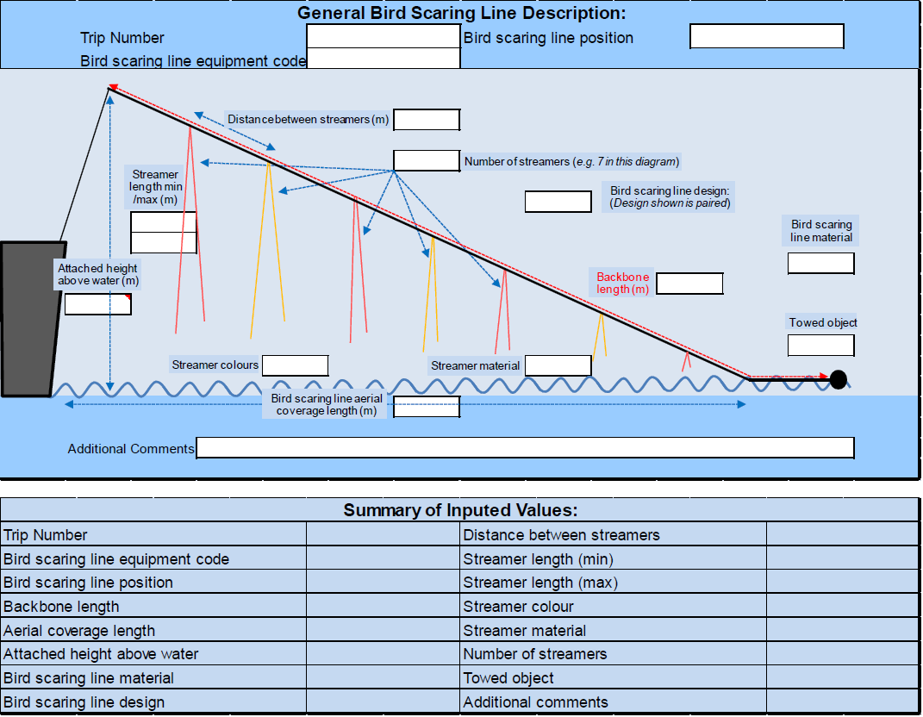

Inspection Theme | Inspection Note | Inspector Comment
Tori Line General Specifications | Did the vessel have at least one tori line? | Has the vessel been fishing below 25 South? Y/N  Number of tori lines examined?
 | Long/Short Streamers | Does the tori line have long and short streamers? (Y/N)
 | Streamer Colour | Are streamers brightly coloured?  Colour of streamers:
 | Overall tori line length | What is the overall length (m) of the tori line?  Is the tori line at least 200m in total length?
 | Aerial Extent | Over what length (m) are streamers included over the total length of the tori line?  Are streamers included over the at least the first 100m of the tori line? (Y/N)
 | Tori Pole | What is the height (m) at which the tori line is secured?  Is the height greater than 7m from the sea surface? (Y/N)
Long Streamer Specifications | Streamer Spacing | What is the distance (m) between long streamers?  Are streamers spaced no more than 5m apart? (Y/N)
 | Long Streamer Swivels | Are swivels used to secure the long streamers to the tori line (Y/N)
 | Long Streamer Length | What is the length (m) of long streamers used?  Are long streamers likely to reach the sea surface? (Y/N)
Short Streamer Specifications | Streamer spacing | What is the distance (m) between short streamers?  Are streamers spaced no more than 1m apart? (Y/N)
 | Short Streamer Length | What is the length (m) of short streamers used?  Are short streamers greater than 1m in length? (Y/N)

Tori Line for vessels <35m total length and below 25° South (WCPFC CMM 2018-03, Annex 1,1b)
Image of a tori line
[Schematic needs to fully reflect WCPFC requirement, i.e. clear differentiation short streamers, aerial extent, and total length]

Inspection Theme | Inspection Note | Inspector Comment
Tori Line General Specifications | Did the vessel have at least one tori line? | Has the vessel been fishing below 25 South? Y/N  Number of tori lines examined?
 | Long/Short Streamers | Does the tori line have short streamers? (Y/N)  Does the tori line have long streamers? (Y/N)
 | Streamer Colour | Are streamers brightly coloured?  Colour of streamers:
 | Overall tori line length | What is the overall length (m) of the tori line?
 | Aerial Extent | Over what length (m) are streamers included over the total length of the tori line?  Are streamers included over the at least the first 75m of the tori line? (Y/N)
 | Tori Pole | What is the height (m) at which the tori line is secured?  Is the height greater than 6m from the sea surface? (Y/N)
Long Streamer Specifications | Streamer Spacing | What is the distance (m) between long streamers?  Are streamers spaced no more than 5m apart? (Y/N)
 | Long Streamer Swivels | How are long streamers secured to the tori line?
 | Long Streamer Length | What is the length (m) of long streamers used?  Are long streamers likely to reach the sea surface? (Y/N)
Short Streamer Specifications | Streamer spacing | What is the distance (m) between short streamers?  Are streamers spaced no more than 1m apart? (Y/N)
 | Short Streamer Length | What is the length (m) of short streamers used?  Are short streamers greater than 1m in length? (Y/N)

Night setting (WCPFC CMM 2018-03, Annex 1, 4)
Inspection Theme | Inspection Note | Inspector Comment
Night Setting | Night Setting Applicable | Has the vessel been fishing below 30 South? Y/N  Does the vessel indicate use of night setting? (Y/N)
 | Setting Times | Does the vessel set fishing lines after nautical dawn and before nautical dusk? (Y/N)
 | Deck Lighting | Is deck lighting kept to a minimum (note lights should not breach minimum standards for safety and inspection) (Y/N) | Annex 1,4(iii)

Weighted Branch Lines (WCPFC CMM 2018-03, Annex 1, 5)
Inspection Theme | Inspection Note | Inspector Comment
Weighted branch line | Application | Has the vessel been fishing below 25 South? Y/N  Does the vessel use of weighted branch lines? (Y/N)  Are weighted branch lines used on all fishing gear? (Full, Partial, No)
 | Specification | Do weighted branch lines meet minimum weight and length specifications?  At least 40g within 50cm of the hook?  At least 45g within 1m of the hook?  At least 60g within 3.5m of the hook?  At least 98g within 4m of the hook?

Hook Shielding devices (WCPFC CMM 2018-03, Annex 1, 6)
Inspection Theme | Inspection Note | Inspector Comment
Weighted branch line | Application | Has the vessel been fishing below 25 South? Y/N  Does the vessel use of hook shielding devices? (Y/N)  Are hook shielding devices used on all fishing gear? (Full, Partial, No)
 | Specification | What is the weight (g) of the hook shielding device?

Tori Lines North of 23° North (WCPFC CMM 2018-03, Annex 1, 2a, b, and c)
Inspection Theme | Inspection Note | Inspector Comment
Tori Line General Specifications | Application | Has the vessel been fishing above 23 North? Y/N  Number of tori lines examined?
 | Minimum Length | What is the overall length (m) of the tori line?  Is the tori line at least 200m in total length?
 | Attachment Point | What is the height (m) at which the tori line is secured?  Is the height greater than 5m from the sea surface? (Y/N)
Long Streamers | Streamer Spacing | What is the spacing between long streamers?  Is the interval between long streamers less than 5m?
 | Streamer specifications | How are the long streamers secured to the tori line?  Are long streamers secured using swivels?  Are long streamers as close to the water as possible?
Short Streamers | Streamer Spacing | What is the spacing between streamers?  Is the interval between short streamers less than 1m? | (Note only encourage where the vessel is <24m total length).
 | Streamer specifications | What is the length of short streamers?  Are streamers at least 30cm in length? | (Note only encourage where the vessel is <24m total length).

Side Setting with bird curtain and weighted branch lines (WCPFC CMM 2018-03, Annex 1, 3)
Inspection Theme | Inspection Note | Inspector Comment
General Specifications | Application | Has the vessel been fishing above 23 North? Y/N
 | General Requirements | Is the mainline deployment deployed from port or starboard side as far from the stern as possible? (at least 1m)  Is a mainline shooter used? If so, must be mounted at least 1m forward of the stern.
 | Bird Streamers | Is bird curtain:  Port aft of line shooter at least 3m long?  Has a minimum of 3 main streamers attached to upper 2m of pole. Y/N  What is the diameter of the streamers?  Is the diameter of the main streamers at least 20mm? Y/N  What is the diameter of branch streamers?  Is the diameter of the branch streamers at least 10mm? Y/N  Are the branch streamers long enough to drag on water?

Management of offal discharge (WCPFC CMM 2018-03, Annex 1, 7)
Inspection Theme | Inspection Note | Inspector Comment
General Specifications | Application | Has the vessel been fishing above 23 North? Y/N
 | General Requirements | Does the vessel discharge offal during setting or hauling? Y/N  If Yes, is offal discharged from the opposite side of the boat to setting/hauling?

Blue-dyed bait (WCPFC CMM 2018-03, Annex 1, 8)
Inspection Theme | Inspection Note | Inspector Comment
General Specifications | Application | Has the vessel been fishing above 23 North? Y/N
 | General Requirements | Is bait used frozen or thawed?  Does the vessel have a placard showing the standardised colour of bait?

Deep setting line shooter (WCPFC CMM 2018-03, Annex 1, 9)
Inspection Theme | Inspection Note | Inspector Comment
General Specifications | Application | Has the vessel been fishing above 23 North? Y/N
 | General Requirements | What is the depth(m) of hooks set by the deep setting line shooter?  Is this depth at least 100m? Y/N

HSBI, refers to boarding, inspection and related activities conducted pursuant to CMM 2006-08 Western and Central Pacific Fisheries Commission Boarding and Inspection Procedures or any successor CMM.

