
Redactor: François AMAUDRIC DU CHAFFAUT
Email: francois.amaudric-du-chaffaut@mer.gouv.fr

Draft guide
Verifying fish quantities in fishing vessel holds - volumetrics method

INTRODUCTION

This procedure is intended to guide inspectors in estimating the quantities of fish on board, when direct weighing or weighing by sampling is not possible.

Volumetrics is a method for measuring a space—typically a ship’s hold—to estimate the volume of fish stored, expressed in cubic metres (m³). The volume of fish can be translated in a weight after applying several factors.
It allows fisheries officers to estimate the weight of the catch on board and verify catch declarations, especially :
- When there is a suspicion of underreporting or false catch declarations.
- If the vessel identity or license status is unclear.
- To cross-check logbooks with physical evidence.

Even if not highly precise, this method reveals significant discrepancies in declared versus actual fish quantities. It can be a trigger conducting to a more extensive and precise method such as sampling, or full discharging and weighting at port.

METHOD IMPLEMENTATION

Ideally, two officers are involved:
- one reviews the logbooks and interviews the master for species, product types, and estimated catch; he can refer to:
  - vessel plans
  - stability book
  - hull survey certificates
- the other performs physical measurements of each fish hold.

PROCEDURAL STEPS

Step 1 – Information Gathering
- Interview the captain about species, product condition, and storage method.
- Review onboard documents: fishing logbook, vessel plans, stability certificate.

Step 2 – Measuring the hold
Use internal dimensions only: Volume (m3) = Length × Width × Height.
For irregular shapes: Triangular volume = (L × W × H) ÷ 2. (see annex 1)

Step 3 – Estimate fill rate
To obtain the fill rate of the hold and estimate the fish volume, either:
- measure the volume occupied by the fish in the hold, or
- measure the free air space in the hold and deduct it from the total volume of the hold.

Step 4 – Apply density factor
Average density for whole fish in bulk: 1080 kg/m³
Examples (FAO and ICCAT sources):
- Marlin (MLS): 1080 kg/m³
- Bigeye tuna (BET): 1065 kg/m³
- Pacific bluefin tuna (PBF): 1070 kg/m³
- Albacore tuna (ALB): 1050 kg/m³
- Skipjack tuna (SKJ): 1030 kg/m³
- Swordfish (SWO): 1075 kg/m³

Step 5 – Apply Processing Conversion Factor
Apply if fish is processed.
Examples:
Species (FAO code) | Whole | Gutted | Gutted + Head off
Marlin (MLS) | 1.00 | 1.10 | 1.30
Bigeye tuna (BET) | 1.00 | 1.13 | 1.33
Pacific bluefin tuna (PBF) | 1.00 | 1.14 | 1.34
Albacore tuna (ALB) | 1.00 | 1.12 | 1.31
Skipjack tuna (SKJ) | 1.00 | 1.10 | 1.28
Swordfish (SWO) | 1.00 | 1.10 | 1.30
Sharks (CWZ) | 1.00 | 1.10 | 2.00
Yellowfin tuna (YFT) | 1.00 | 1.16 | 1.36

Step 6 – Apply Stacking Factor
Factors depending on stacking method:
- Loose: 0.45
- Medium (e.g. tuna): 0.51
- Tight: 0.54

Step 7 – Compare With Onboard Records
Compare the result with the fishing logbook, captain's declarations, and landing data.

Example Calculation
Hold: 8 × 8 × 2.5 m = 160 m³
Fill rate: 70%
Species: Bigeye tuna (BET), gutted
Density: 1065 kg/m³
Stacking factor: 0.51
Processing factor: 1.13
Usable volume: 160 × 0.7 = 112 m³
Gross weight = 112 × 1065 = 119,280 kg
Stacked weight = 119,280 × 0.51 = 60,832.8 kg
Catch weight = 60,832.8 × 1.13 = 68,741 kg ≈ 68.7 tonnes

Annex 1. Calculating volume formulas

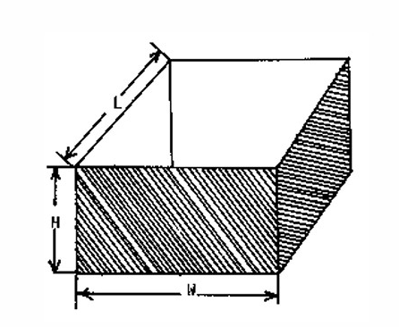
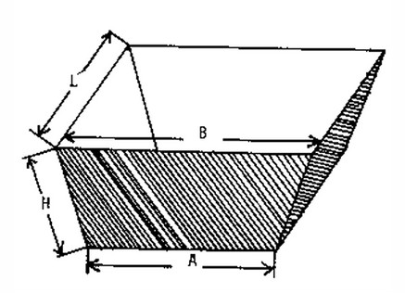
Volume = length x width x height Volume = (width A+width B) x length x height /2

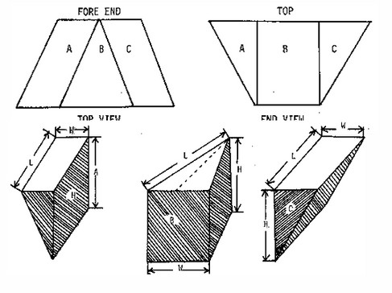
To calculate the size of these holds you need to separate them into a shape you can measure and then use the below formulas.

Total area in metre³ = VA + VB + VC

