**Commission for the Conservation and Management of**

**Highly Migratory Fish Stocks in the Western and Central Pacific Ocean**

**NORTHERN COMMITTEE**

**RESUMED MEETING OF THE TWENTIETH REGULAR SESSION**

**Electronic Meeting**

**5 November 2024**

**SUMMARY REPORT**

**Acknowledgements**

The financial, logistical and administrative support provided by the Western and Central Pacific Fisheries Commission Secretariat and all Members of the Northern Committee are gratefully acknowledged. Mr. Masanori Miyahara, who chaired the Resumed Meeting of the Twentieth Regular Session of the Northern Committee, and Mr. Shinji Hiruma, who served as the rapporteur for the meeting, are acknowledged with appreciation.

**TABLE OF CONTENTS**

AGENDA ITEM 1 — OPEninG OF MEETING 4

AGENDA ITEM 2 — CONSERVATION AND MANAGEMENT MEASURES FOR THE NORTHERN STOCKS 4

AGENDA ITEM 3 — OTHER MATTERS 5

AGENDA ITEM 4 — ADOPTION OF THE SUMMARY REPORT OF THE 20TH REGULAR SESSION OF THE NORTHERN COMMITTEE 5

AGENDA ITEM 5 — CLOSE OF THE MEETING 6

**ATTACHMENTS**

Attachment A – List of Participants

Attachment B – Agenda

Attachment C – WCPFC Circular No.:2024/74

Attachment D –Draft Conservation and Management Measure for the Monitoring, Controlling, and Surveillance of Pacific Bluefin Tuna

**The Commission for the Conservation and Management of   
Highly Migratory Fish Stocks in the Western and Central Pacific Ocean**

**Northern Committee**

**Resumed Meeting of the Twentieth Regular Session**

Electronic Meeting

5 November 2024

|  |
| --- |
| **SUMMARY REPORT** |

# OPEninG OF MEETING

1. The Resumed Meeting of the Twentieth Regular Session of the Northern Committee (hereafter referred to as NC20/2) took place electronically on 5 November 2024. The meeting was attended by Northern Committee (NC) members from Canada, China, Cook Islands, Fiji, Japan, Republic of Korea (ROK), Philippines, Chinese Taipei, United States of America (USA), and Vanuatu and observers from Australia, New Zealand, European Union (EU), Pacific Islands Forum Fisheries Agency (FFA), Tuvalu, and World Wide Fund for Nature (WWF). The list of meeting participants is in **Attachment A**.

## Opening of meeting

1. Mr. Masanori Miyahara, Chair of the NC, opened the meeting.

## Adoption of agenda

1. The provisional agenda was adopted without modification (**Attachment B**).

## Meeting arrangements

1. Mr. Shinji Hiruma (Japan) was appointed as the rapporteur for the meeting.

# CONSERVATION AND MANAGEMENT MEASURES FOR THE NORTHERN STOCKS

## Pacific bluefin tuna

1. The NC noted that WCPFC Circular No.:2024/74 (**Attachment C**) included a letter from Mr. Josh Madeira, the new Co-Chair of the Joint IATTC and WCPFC-NC Working Group on the Management of Pacific Bluefin Tuna (JWG), informing that 102nd meeting of the IATTC adopted [C-24-03](https://www.iattc.org/GetAttachment/76dc3f4f-d12f-49b2-ab1a-f1bca766d4f5/C-24-03_Bluefin-tuna-(monitoring-and-control).pdf) on Monitoring and Control Measures for Pacific bluefin tuna fisheries, with additional details and provisions not included in the JWG recommendation adopted in July 2024.

1. Japan presented a proposal to amend the Draft Conservation and Management Measure for Monitoring, Controlling and Surveillance of Pacific Bluefin Tuna, as recommended by NC20 at its July meeting, to incorporate additional details and provisions in C-24-03 for implementing harmonized measures between the two organizations.
2. EU presented its proposal submitted to the annual meeting, noting that EU is not a member of the NC. EU proposal is similar to Japanese proposal, but there are three main differences (1) bycatch reporting requirement, (2) CDS, because EU believed that those elements are already included in the current CMM but it can go along with Japanese proposal on these two elements and (3) regarding the review process. The EU indicated that, to mirror the provisions in IATTC resolution, the review process in the MCS measures should be attributed to TCC.
3. Japan presented amended proposal which considered EU’s comment on the involvement of TCC while maintaining consistency with the rules of procedure in relation to the role of the NC.
4. EU appreciated the proposal and provided its comment on the timeline.
5. Cook Islands supported the EU’s proposal on the role of the TCC to review the implementation of the CMM including MCS measure of the PBF and suggested to change the order of the TCC and NC in the CMM.
6. US asked questions regarding the order of the meeting of JWG, NC and TCC. NC Chair responded that it is physically impossible to have a perfect order of the meetings, and NC may have additional session after TCC if necessary.
7. China asked to clarify if reporting requirement on by-catches in paragraph 3 does not include zero catch. NC Chair made an affirmative response.
8. EU suggested that not only NC but also TCC should make recommendation to the Commission on possible amendment of the CMM. NC Chair clarified that, in accordance with the Rules of Procedure, it is only NC which can make recommendation to amend the CMM to the Commission on the Northern stocks and that, in this context, EU’s amendment was not considered in line with the rules of procedure.
9. NZ asked clarification if paragraph 2(1) of Japan’s proposal require registration of those NZ fishing vessels operate within its EEZ and are not registered on the WCPFC RFV. Japan responded that the text used “including” and it does include those vessels on WCPFC RFV that operate in the High Seas but does not necessarily include domestic vessels.
10. **The NC recommended that the Commission adopt the Conservation and Management Measure for the Monitoring, Controlling, and Surveillance of Pacific Bluefin Tuna in Attachment D, which replaces the previously adopted CMM in Attachment E of the NC20 Summary Report.**

# OTHER MATTERS

## Other business

1. No other business was discussed.

# ADOPTION OF THE SUMMARY REPORT OF THE 20TH REGULAR SESSION OF THE NORTHERN COMMITTEE

1. The NC reviewed and adopted the Summary Report of the resumed Meeting of the 20th Northern Committee (NC20/2) and agreed that its findings would replace the relevant sections in the NC20 Summary Report adopted in July 2024.

# CLOSE OF THE MEETING

1. The meeting was ended at 12:20 am on 5 November 2024 in Pohnpei time.

**Attachment A**

**Commission for the Conservation and Management of**

**Highly Migratory Fish Stocks in the Western and Central Pacific Ocean**

**NORTHERN COMMITTEE**

**RESUMED MEETING OF THE TWENTIETH REGULAR SESSION**

Electronic Meeting

5 November 2024

|  |
| --- |
| **LIST OF PARTICIPANTS** |

**CHAIR**

**Masanori Miyahara**

Fisheries Agency of Japan

Advisor to the Minister of Agriculture, Forestry and Fisheries

masamiyafaj1@gmail.com

**AUSTRALIA**

**James Van Meurs**

Australian Government Department of Agriculture, Fisheries and Forestry

Assistant Director

james.vanmeurs@agriculture.gov.au

**CANADA**

**Felicia Cull**

Fisheries and Oceans Canada

Deputy Director International Fisheries Policy

Amber.Lindstedt@dfo-mpo.gc.ca

**Kristen Côté**

Fisheries and Oceans Canada

Senior Policy Analyst, International Fisheries Policy

Kristen.Cote@dfo-mpo.gc.ca

**Sarah Hawkshaw**

Fisheries and Oceans Canada

Biologist

sarah.hawkshaw@dfo-mpo.gc.ca

**CHINA**

**Liu Xiaobing**

Shanghai Ocean University

Visiting Professor

[xiaobing.liu@hotmail.com](mailto:xiaobing.liu@hotmail.com)

**Li Yan**

China Overseas Fisheries Association

Deputy Director of High Seas Fisheries

[liyancnfj@outlook.com](mailto:liyancnfj@outlook.com)

**COOK ISLANDS**

**Ian Freeman**

Ministry of Marine Resources

Fisheries Management Adviser

[finsptyltd@gmail.com](mailto:finsptyltd@gmail.com)

**Lualua Tua**

Director

Offshore Fisheries Division

 Ministry of Marine Resources

[l.tua@mmr.gov.ck](mailto:l.tua@mmr.gov.ck)   

**EUROPEAN UNION**

**Stamatis Varsamos**

European Commission, Directorate General for

Maritime Affairs and Fisheries, Unit B2: RFMOs

[Stamatios.VARSAMOS@ec.europa.eu](mailto:Stamatios.VARSAMOS@ec.europa.eu)

**FEDERATED STATES OF MICRONESIA**

**Jamel James**

FSM National Oceanic Resource Management Authority

Assistant Director

jamel.james@norma.fm

**FIJI**

**Moses Nainoka Mataika**

Ministry of Fisheries

Offshore Fisheries Management Division

Fisheries Officer

[mataika.moses@gmail.com](mailto:mataika.moses@gmail.com)

**JAPAN**

**Takumi Fukuda**

Fisheries Agency of Japan

Resource Management Department

takumi_fukuda720@maff.go.jp

**Akihito Fukuyama**

Japan Far Seas Purse Seine Fishing Association

Managing Director

fukuyama@kaimaki.or.jp

**Kazushige Hazama**

National Offshore Tuna Fisheries Association of Japan

Manager

hazama@kinkatsukyo.or.jp

**Naruhito Okuda**

Japan Far Seas Purse Seine Fishing Association

Advisor

n-okuda@kaimaki.or.jp

**Shinji Hiruma**

Fisheries Agency of Japan

International Affairs Division

shinji_hiruma150@maff.go.jp

**Shuya Nakatsuka**

Fisheries Resources Institute

Deputy Director, Highly Migratory Resources Division

nakatsuka_shuya49@fra.go.jp

**Yoshihiro Notomi**

National Offshore Tuna Fisheries Association of Japan

Managing Director

notomi@kinkatsukyo.or.jp

**NEW ZEALAND**

**Arthur Hore**

Ministry for Primary Industries

Chief Fisheries Advisor

arthur.hore@mpi.govt.nz

**Hilary Ayrton**

Ministry for Primary Industries

Senior Fisheries Analyst

hilary.ayrton@mpi.govt.nz

**REPUBLIC OF KOREA**

**Ilkang Na**

Ministry of Oceans and Fisheries

Policy Officer / Multilateral Fisheries Negotiator

ikna@korea.kr

**Jae-geol Yang**

Korea Overseas Fisheries Cooperation Center

Policy Analyst

jg718@kofci.org

**PHILIPPINES**

**Isidro Tanangonan**

Bureau of Fisheries and Aquatic Resources

Aquaculturist II

[itanangonan@bfar.da.gov.ph](mailto:itanangonan@bfar.da.gov.ph)

**CHINESE TAIPEI**

**Joy Hsiangyi Yu**

Fisheries Agency, Ministry of Agriculture

Section Chief, Pacific Ocean Fisheries Management Section, Distant Water Fisheries Division

hsiangyi@ms1.fa.gov.tw

**Shao-Wei Lu**

Fisheries Agency, Ministry of Agriculture

Associate Technical Specialist, Pacific Ocean Fisheries Management Section, Distant Water Fisheries Division

shaowei0220@ms1.fa.gov.tw

**Shui-Kai Chang**

National Sun Yat-sen University

Professor

skchang@faculty.nsysu.edu.tw

**UNITED STATES OF AMERICA**

**Alex Kahl**

NOAA Fisheries

Resource Management Specialist

alex.kahl@noaa.gov

**Amanda Munro**

NOAA Fisheries

Policy Analyst

amanda.munro@noaa.gov

**Christa Svensson**

Pacific Fishery Management Council

Alternate- U.S. Commissioner

csvensson@trimarinegroup.com

**Christopher Dahl**

Pacific Fishery Management Council

Staff Officer - HMS

kit.dahl@noaa.gov

**Emily Reynolds**

NOAA Fisheries

Fishery Policy Analyst

emily.reynolds@noaa.gov

**Jason Philibotte**

NOAA Fisheries

International Fisheries, Division Chief

jason.philibotte@noaa.gov

**Josh Madeira**

Monterey Bay Aquarium

Director of Policy & Stakeholder Engagement

jmadeira@mbayaq.org

**Kelly Kryc**

National Oceanic and Atmospheric Administration

Deputy Assistant Secretary for International Fisheries

kelly.kryc@noaa.gov

**Mark Fitchett**

Western Pacific Regional Fisheries Management Council (WPRFMC)

Pelagic Ecosystem Fisheries Scientist

mark.fitchett@wpcouncil.org

**Rachel Ryan**

U.S. Department of State

Foreign Affairs Officer

RyanRL@state.gov

**Yonat Swimmer**

NOAA Fisheries

Fisheries Biologist

yonat.swimmer@noaa.gov

**VANUATU**

**Jeyalda Ngwele**

Vanuatu Fisheries Department

Senior Data Officer (International)

njeyalda@fisheries.gov.vu

**INTERNATIONAL SCIENTIFIC COMMITTEE FOR TUNA AND TUNA-LIKE SPECIES IN THE NORTH PACIFIC OCEAN (ISC)**

**Robert Ahrens**

International Scientific Committee for Tuna and Tuna-like Species in the North Pacific Ocean

Chair

robert.ahrens@noaa.gov

**PACIFIC ISLANDS FORUM FISHERIES AGENCY (FFA)**

**Marina Abas**

Pacific Islands Forum Fisheries Agency (FFA)

Fisheries Management Advisor

marina.abas@ffa.int

**WORLD WIDE FUND FOR NATURE (WWF)**

**Shuhei Uematsu**

World Wide Fund for Nature (WWF)

Manager of Anti-IUU Fishery Project & Manager of Fisheries Resources Management Oceans and Seafood Group

[uematsu@wwf.or.jp](mailto:uematsu@wwf.or.jp)

**WCPFC SECRETARIAT**

**Eidre Sharp**

Western and Central Pacific Fisheries Commission (WCPFC)

Assistant Compliance Manager

Eidre.Sharp@wcpfc.int

**Elaine G. Garvilles**

Western and Central Pacific Fisheries Commission (WCPFC)

Assistant Science Manager

Elaine.Garvilles@wcpfc.int

**Lara Manarangi-Trott**

Western and Central Pacific Fisheries Commission (WCPFC)

Compliance Manager

Lara.Manarangi-Trott@wcpfc.int

**Lucille Martinez**

Western and Central Pacific Fisheries Commission (WCPFC)

Administrative Officer

lucille.martinez@wcpfc.int

**Natsuko Akinaga**

Western and Central Pacific Fisheries Commission (WCPFC)

Human Resource Officer

[Natsuko.Akinaga@wcpfc.int](mailto:Natsuko.Akinaga@wcpfc.int)

**Rhea Moss-Christian**

Western and Central Pacific Fisheries Commission (WCPFC)

Executive Director

rhea.moss-christian@wcpfc.int

**SungKwon Soh**

Western and Central Pacific Fisheries Commission (WCPFC)

Science Manager

sungkwon.soh@wcpfc.int

**Tim Jones**

Western and Central Pacific Fisheries Commission (WCPFC)

IT Manager

tim.jones@wcpfc.int

**Attachment B**

**Commission for the Conservation and Management of**

**Highly Migratory Fish Stocks in the Western and Central Pacific Ocean**

**NORTHERN COMMITTEE**

**RESUMED MEETING OF THE TWENTIETH REGULAR SESSION**

Electronic Meeting

5 November 2024

|  |
| --- |
| **PROVISIONAL ANNOTATED AGENDA FOR NC20/2** |

# OPENING OF MEETING

* 1. **Opening of meeting**

The Chair Masanori Miyahara (Japan) will open the resumed meeting of the Twentieth Regular Session of the Northern Committee (NC20/2) of the Western and Central Pacific Fisheries Commission (WCPFC), which will be held online on 5 November 2024.

* 1. **Adoption of agenda**

The Chair will introduce the Provisional Agenda, WCPFC-NC20-2024/03-1.

* 1. **Meeting arrangements**

The Chair will outline the schedule of the meeting and introduce the rapporteur for the meeting.

1. **CONSERVATION AND MANAGEMENT MEASURES FOR THE NORTHERN STOCKS**
   1. **Pacific bluefin tuna**

NC20/2 will discuss technical adjustments to the outcomes of the 20th regular session of the Northern Committee (NC20) held in Kushiro, Japan, on 6-7 July. These adjustments are in response to recent IATTC decisions on Monitoring, Control and Surveillance (MCS) measures for Pacific bluefin tuna fisheries.

1. **OTHER MATTERS**

**3.1 Other business**

NC20/2 will discuss any other business raised under Agenda Item 1.2.

1. **ADOPTION OF THE SUMMARY REPORT OF THE NC20/2**

NC20/2 will adopt its Summary Report. It will make every effort to adopt its Summary Report by consensus. If consensus is not reached, the Summary Report will indicate the majority and minority views and may include the differing views of the representatives of the Members on all or any part of the Summary Report.

**AGENDA ITEM 5 CLOSE OF MEETING**

The meeting is scheduled to close at 2 pm on 5 November 2024.

**Attachment C**

**Commission for the Conservation and Management of**

**Highly Migratory Fish Stocks in the Western and Central Pacific Ocean**

**NORTHERN COMMITTEE**

**RESUMED MEETING OF THE TWENTIETH REGULAR SESSION**

Electronic Meeting

5 November 2024

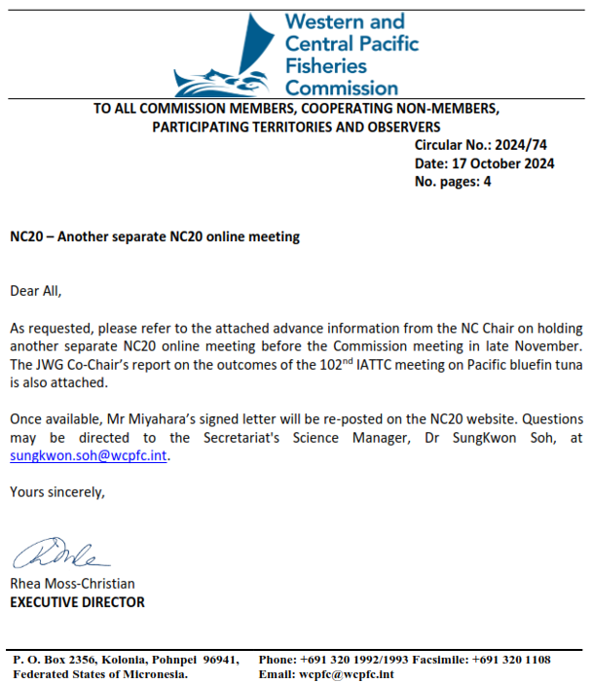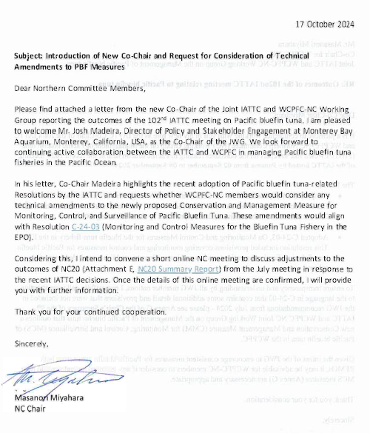

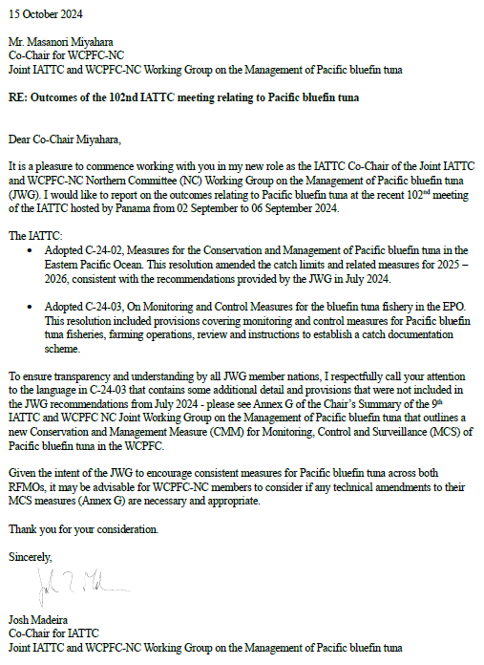

**Attachment D**

**Commission for the Conservation and Management of**

**Highly Migratory Fish Stocks in the Western and Central Pacific Ocean**

**NORTHERN COMMITTEE**

**RESUMED MEETING OF THE TWENTIETH REGULAR SESSION**

Electronic Meeting

5 November 2024

|  |
| --- |
| **Draft Conservation and Management Measure for the**  **Monitoring, Controlling, and Surveillance of Pacific Bluefin Tuna** |

CMM 2024-XX

*The Western and Central Pacific Fisheries Commission (WCPFC):*

*Noting that, Conservation and Management Measure CMM2023-02 establishes annual catch limit of Pacific bluefin tuna for the management of the species,*

*Also noting that, Conservation and Management Measure CMM2023-02 paragraph 11 requires CCMs, to the extent possible, take measures necessary to prevent commercial transaction of Pacific bluefin tuna that undermine the effectiveness of the CMM,*

*Further noting that, Conservation and Management Measure CMM2023-02 paragraph 13 requires CCMs to take measures necessary to strengthen monitoring and data collecting system for Pacific bluefin tuna fisheries and farming,*

*Adopts, in accordance with Article 10 of the WCPFC Convention that:*

**Objectives**

The purpose of this Conservation and Management Measure (CMM) is to establish a regime for the monitoring and control of the conservation and management of the Pacific bluefin tuna fishery in the WCPO set out in CMM 2024-xx.

Each CCM that has Pacific bluefin tuna fisheries and/or farming shall report to the Executive Director by 15 June each year on the implementation of its monitoring and control measures it has taken in the previous calendar year to ensure its compliance with CMM2024-xx that include the following components:

1. Monitoring and control measures for fisheries

Registration of commercial fishing vessels that are authorized to fish for Pacific bluefin tuna (including the WCPFC RFV in accordance with CMM 2018-06 on WCPFC Record of Fishing Vessels and Authorization to Fish)

* + - * 1. Registration of set nets that are authorized to fish for Pacific bluefin tuna (including registration scheme, number of registered set nets)
        2. Allocation of catch limits by fishery within the CCMs, where such allocation exist
        3. Reporting requirements for catches for fisheries (targeted, incidental, and discards)
        4. Measures to monitor catch (e.g. landing receipts, landing inspection, observer program, etc.)
        5. Measures to monitor landings (including CMM2017-02 on Minimum Standards for Port State Measures)
        6. Measures to monitor domestic transactions

1. Monitoring and control measures for farming

Registration of farms that are authorized to farm Pacific bluefin tuna (including registration scheme, number of registered farms, number of registered ‘holding pens’ or ‘cages’)

Reporting requirements for caging of fish

Reporting requirements for harvest of farmed fish

Measures to monitor farming activities (including Rules, standards, and procedures to monitor transfer and caging activities)

CCMs that do not have Pacific bluefin tuna fisheries and/or farming, shall report to the WCPFC Secretariat annually any by-catches of Pacific bluefin tuna under paragraph 29 of CMM 2024-xx.

**Review**

The Technical and Compliance Committee (TCC) and the Northern Committee (NC) shall review the implementation of monitoring, control and surveillance measures reported by CCMs in accordance with this CMM by 2026. Based upon the results of such reviews, the NC shall provide recommendations to the Commission including on possible amendments to this CMM and CMM 2024-xx for Pacific Bluefin Tuna taking into account any considerations from the TCC and those from the Joint IATTC-WCPFC-NC Working Group.

CCMs shall coordinate with the IATTC through the Joint IATTC-WCPFC NC Working Group and discuss any additional MCS measures, as appropriate, at their upcoming meetings.

**Catch Documentation Scheme (CDS)**

WCPFC shall consider the establishment of a catch documentation scheme (CDS) for Pacific bluefin tuna fisheries in the WCPO compatible with other CDSs for Pacific bluefin tuna by 31 December 2026. This CDS should build, inter alia, on the outcomes of the Joint IATTC-WCPFC Northern Committee Working Group.