

The Commission for the Conservation and Management of
Highly Migratory Fish Stocks in the Western and Central Pacific Ocean

Scientific Committee
TWENTIETH Regular Session

Manila, Philippines
14 – 21 August 2024

SC20 OUTCOMES DOCUMENT

The Commission for the Conservation and Management of
Highly Migratory Fish Stocks in the Western and Central Pacific Ocean

Scientific Committee
TWENTIETH Regular Session

Manila, Philippines
14 – 21 August 2024

OUTCOMES DOCUMENT
WCPFC21-2024-SC20-01

- OPENING OF THE MEETING

  - Welcome address
  - Meeting arrangements
  - Issues arising from the Commission
  - Adoption of the agenda
  - Reporting arrangements
  - Intersessional activities of the Scientific Committee

- REVIEW OF FISHERIES

  - Overview of Western and Central Pacific Ocean (WCPO) fisheries
  - Overview of the Eastern Pacific Ocean (EPO) fisheries
  - Annual Report – Part 1 from Members, Cooperating Non-Members, and Participating Territories
  - Reports from regional fisheries bodies and other organizations

- DATA AND STATISTICS THEME

  - Data gaps of the Commission

    - Report of the WCPFC

- SC20 requested that SSP develop a subset of the key species, expected to be encountered by each gear type, to improve the evaluation of operational data reporting of key species, as reported in SC20-ST-IP-02 (e.g., Table 14). Currently, the coverage estimation assumes all key species in the “Scientific Data to be Provided by the Commission (SciData)” are encountered by all gear types and evaluates reporting coverage based on that assumption.

- SC20 requested that SSP develop a proposal to improve data submission workflows through development of data submission standards and templates for consideration by SC21.

    - Species composition of purse-seine catches (Project 60)

- SC20 acknowledged the work conducted under Project 60 and agreed to close Project 60.

    - Better data on fish weights and lengths for scientific analyses (Project 90)
    - Improved coverage of cannery receipt data (Project 114)

    - Minimum data reporting requirements

Additional Longline Operational Data Fields

- SC20 again acknowledged the scientific value of the additional longline operational data fields described in SC20-ST-WP-08.

- SC20 recommended that TCC and the Regular Session of the Commission consider the possible inclusion of these data (Table ST-01) in the “Scientific Data to be Provided by the Commission (SciData)” as voluntary reporting items, taking into account the broad implementation concerns of several CCMs with respect to the collection of these data.

Table ST-01 Proposed new voluntary additional longline operational data fields
DATA FIELD | Suggested PROTOCOL for data collection
Target species for the set | Record the primary target species, or group of species, for this set.
Number of lightsticks used in set | Record the total number of lightsticks used in the set.
Bait type used in set | Record the FAO code(s) for type of bait(s) used for the set. Example types:
  FAO Code | Taxa/species categories
  CLP | HERRINGS, SARDINES, NEI
  DPT | DECAPTHURUS SP. - MUROAJI
  MAX | MACKERELS NEI
  MIL | MILKFISH
  MSD | MACKEREL SCAD
  PIL | EUROPEAN PILCHARD (=SARDINE)
  SAP | PACIFIC SAURY
  SQU | VARIOUS SQUIDS NEI
  TUN | TUNAS NEI
  OTHERS | Comment on bait type
Mainline length | Record the mainline length (in kilometers) used in the trip or set, as appropriate.
Length of branch line | Record the average length in meters of the branch lines in the trip or set. (The total length from the mainline to the hook).
Length of float line | Record the average length in meters of the float lines in the set. (The total length from the float to the mainline).
Vessel speed during setting | Record the average speed in knots of a vessel during line setting.
Speed of the line setter | Record the speed in knots of the line setter (i.e., the line shooter speed).

Additional code for the ACTIVITY field

- SC20 again acknowledged the proposal for the addition of a new activity code for any day when a "transhipment at sea occurs” within the operational data submitted to the Commission (as described in SC20-ST-WP-08). SC20 recommended that this proposal be considered by TCC and the Commission.

Revisions to CMM 2018-04

- SC20 noted the Commission tasking (WCPFC20 Summary Report, paragraph 753e) to review the Scientific Data to be provided to the Commission (SciData) requirements to capture turtle interaction requirements under CMM 2018-04, paragraphs 5c and 7e. SC20 noted that some CCMs have different interpretations of the requirements for those paragraphs, specifically as to whether the paragraphs require reporting through submission of operational level data or in a summary form, and SC20 suggested that TCC and the Commission consider clarifying the requirements of these paragraphs to resolve any ambiguity.

- Meanwhile, SC20 requested SSP to prepare a paper for SC21 on possible sea turtle data reporting requirements for vessels to record during fishing operations, for longline and purse seine vessels, to be incorporated in the annual reporting of Scientific Data to be provided to the Commission (SciData).

Development of a FAD Logbook

- SC20 requested that SSP identify what FAD information fields are anticipated to be used by SSP to support stock assessments and other scientific analyses. SSP indicated that the FAD data fields also relate to WCPFC work involving management and monitoring.

- SC20 recommended that SSP and the WCPFC Secretariat develop a paper for TCC20’s and the FADMO-IWG’s consideration, responding to the request to identify the needs for the FAD data fields for the work of the WCPFC (science, management, and monitoring).

    - Regional bycatch estimates of purse seine fishery

  - Evaluation of purse seine fishing effort

- SC20 requested that SSP conduct further work to better understand relationships between fishing behaviours and strategies, reporting requirements, and estimations of purse seine fishing efforts.

  - Regional Observer Programme

    - Review of an observer training project for elasmobranch biological sampling (Project 109)

    - ROP Data Issues

  - Electronic Reporting and Electronic Monitoring

    - ER and EM IWG Update

    - Requirements for increased observer coverage in longline fisheries under CMM 2023-01

- STOCK ASSESSMENT THEME

  - Improvement of MULTIFAN-CL software

    - Update of MULTIFAN-CL software

- There was no presentation on this agenda item, and the Theme Convenor invited comments from the floor, but no questions or comments were raised on this agenda item.

    - Review of Project 123 outcomes

- SC20 thanked the SSP for their extensive work on the Next Generation of Tuna Stock Assessment Software (Project 123) and the urgent need to identify successor software for MULTIFAN-CL, which will begin to be phased out as the software platform for WCPFC stock assessments over the next 5 years or more.

- SC20 also acknowledged the progress of Project 123, including the review of existing and ongoing software development projects.

- SC20 supported the need to promote cooperation among tRMFOs to coordinate and strengthen the research and development of stock assessment software.

- SC20 was generally supportive of the need to identify a successor software for tuna and billfish assessments in the WCPFC in order to continue to provide reliable stock status and scientific advice to the Commission, and identified several options for moving forward as outlined below.
- Use of an existing generalized stock assessment software package(s)
- Develop a new generalized stock assessment software package
- Develop bespoke code for the assessment of each species
- Some combination of the above three options

- SC20 cautioned that each of these four different options would require different levels of resourcing and that it would be useful for cost estimates for each of the different options to be characterized.

- SC20 noted the importance of ensuring that the identified successor stock assessment model is accessible and user-friendly for CCM scientists to ensure transparency in the stock assessment process.

- Some CCMs supported SC20 convening an informal small group (ISG) during this session to discuss further and prioritize activities requiring additional resources and to develop terms of reference (TOR) for these priority activities, noting that K. Bigelow of the USA had volunteered to convene an Informal Small Group (ISG-09) to assess the draft plan, and this would convene during the meeting and return with member comments.

- The report from the Informal Small Group 09 (Project 123: Scoping the next generation of tuna stock assessment software) is in Attachment 1. The development of new software was discussed but not prioritized by ISG-09. The ISG-09 provided the following prioritization of proposed project 123 activities:
- Move the SW Pacific swordfish assessment to Stock Synthesis;
- Move the next SW Pacific striped marlin assessment to Stock Synthesis, if the successor software is not available;
- Explore a variety of models for a simplified single region yellowfin tuna dataset; and
- Explore including the MFCL tagging module into Stock Synthesis (as a lower priority).

- SC20 recommended that work on the project continue with the revised 2025 work plan listed in the updated project 123 TOR and requested that progress towards the aforementioned prioritized tasks be reported to SC21.

- For candidate transition approaches, SC20 recommended that information on the potential implication on the SC budget be included in the project report to SC21.

  - WCPO Tunas

    - South Pacific albacore tuna (Thunnus alalunga)

      - South Pacific albacore stock assessment

- SC20 thanked the SSP for their thorough work conducted on the South Pacific albacore stock assessment and for the considerable efforts to improve the assessment, particularly by simplifying the spatial structure in the 2024 assessment.

- SC20 accepted this assessment for management advice, and expressed relatively high overall confidence in the assessment, noting the model still shows some lack of fit to the CPUE index and troll length frequency data.

- The 2024 South Pacific-wide albacore tuna stock assessment provides stock status based upon an uncertainty ensemble comprising 100 models derived from prior distributions for average natural mortality and steepness (100 independent replicates from these priors) together with estimation error for individual models.

- SC20 noted that both natural mortality and steepness were influential on assessment outcomes. However, important uncertainties such as stock structure were not considered, and the SC recommended that this be accounted for in the future, subject to the results of ongoing genetic research.

      - Provision of scientific information to the Commission

- The regional spatial structure used in the 2024 stock assessment is shown in Figure SPA-01, and the fisheries' spatial structure is shown in Figure SPA-02. The time series of total annual catch by fishing gear and model region over the full assessment period is shown in Figure SPA-03. The time series of the total annual catch by model region and flag is shown in Figure SPA-04. Estimated spawning biomass by model region is shown in Figure SPA-05, and estimated annual total recruitment is shown in Figure SPA-06. Juvenile and adult fishing mortality rates from the diagnostic model are shown in Figure SPA-07. Estimated trends in spawning biomass for the 100 models are shown in Figure SPA-08. Estimated trends in spawning biomass depletion (SB/SBF=0) for the 100 models in the model ensemble are shown in Figure SPA-09. A Majuro and Kobe plot summarizing the results for each of the 100 models in the model ensemble are shown in Figure SPA-10.

  - Stock status and trends

- Noting that data up to and including 2022 are used in the 2024 assessment, the preliminary estimates of 2023 albacore tuna catch within the southern part of the WCPFC-CA (64,996t) was lower than the 2022 level shown in Figure SPA-03. Longline catch in 2023 (63,804 mt) was lower than the 2022 catch and lower than the recent 10-year average. Four flag states (Canada, the Cook Islands, USA and New Zealand) reported troll catch within the WCPFC-CA during the period from 2000 to 2023. Troll catch in 2023 (1,192t) was lower than the 2022 catch and lower than the recent 10-year average (see tables in WCPFC-SC20-2024/SA-IP-07). By flag, China and Chinese Taipei had the highest catch estimates of South Pacific albacore in recent years, mostly taken on the high seas (Figure SPA-04).

- Spawning biomass shows a sharp decline from the beginning of the model period until the mid-1970s after which it stabilizes (Figure SPA-05). The stock status, as indicated by the spawning biomass depletion (SB/SB_{F=0}), shows a more gradual long-term decline from the beginning of the model period (Figure SPA-09).

- Although spawning biomass estimates for recent years should be interpreted with caution, the terminal decline in spawning biomass depletion that was the focus of the previous assessment has moderated in the new assessment, and there are recent indications that the overall stock status has improved.

- Recruitment shows similar interannual variability across years, with an increasing trend from the late 1990s becoming more apparent in the estimates (Figure SPA-06). SC20 acknowledged the troll CPUEs (from 1992 to 2022) were used to inform stock-wide recruitment and provide some constraints on recruitment variability, although the fit of the troll index was relatively poor in the 1990s and in the final decade.

- Fishing mortality on adults continues to increase, while fishing mortality on juveniles remains low. Fishing mortality has increased sharply in the EPO since 2010 as the longline catches have increased but has remained stable in the WCPFC-CA over a similar period (Figure SPA-07).

- The median depletion from the model ensemble with estimation uncertainty for the recent period (2019-2022; SB_{recent}/SB_{F=0}) was 0.48 (10th to 90th percentile interval of 0.36 to 0.62; Table SPA-01) , which is close to, but just below, the 0.5 re-calibrated interim Target Reference Point (iTRP) for South Pacific albacore based on the 2024 assessment. For each model in the ensemble, the ratio of the SB_{recent}/SB_{F=0} to the iTRP estimated for that model was calculated (Table SPA-01). Across the 100 models, the median ratio of SB_{recent}/SB_{F=0} to the iTRP was 0.952, ranging from 0.899 to 1.016, which is close to the iTRP.

- The median recent spawning biomass from the model ensemble with estimation uncertainty is well above the spawning biomass to achieve MSY (median SB_{recent}/SB_{MSY} = 3.02, 10th to 90th percentile interval of 2.04–5.21, full range 1.20–8.96; Table SPA-01).

- All models in the uncertainty ensemble SB_{recent}/SB_{F=0} was above the limit reference point of 0.2 (Figure SPA-09) and the dynamic MSY analysis indicated that for all time periods, the SB_{recent}/SB_{F=0} was > 0.2, SB_{recent}/SB_{MSY} was > 1 and the F_{recent}/F_{MSY} was < 1 (Figure SPA-10).

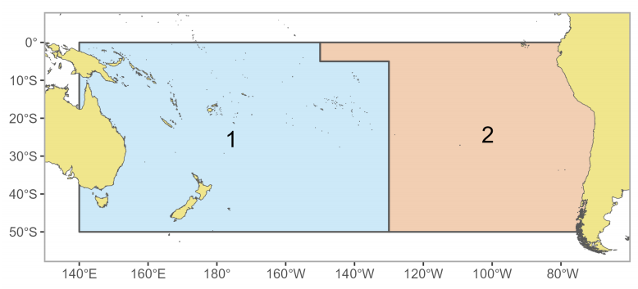
Figure SPA-01 The geographical area covered by the stock assessment and the boundaries of the two model regions used for the South Pacific-wide 2024 albacore assessment.
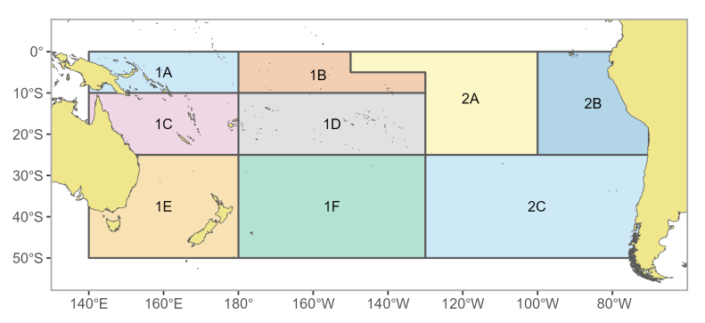
Figure SPA-02 The geographical area boundaries of the nine fisheries areas used for the South Pacific-wide 2024 albacore assessment.

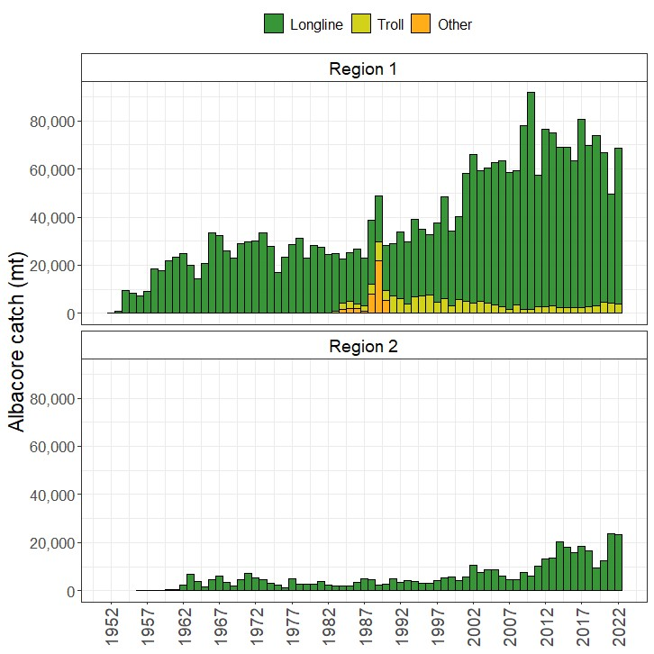
Figure SPA-03 Historical catches of South Pacific albacore in each model region (WCPFC-CA = region 1, EPO = region 2) from 1952-2022 by gear type. Region 1 is the WCPFC-CA (includes catches from the overlap area), and Region 2 is the EPO (excludes the overlap area catches).
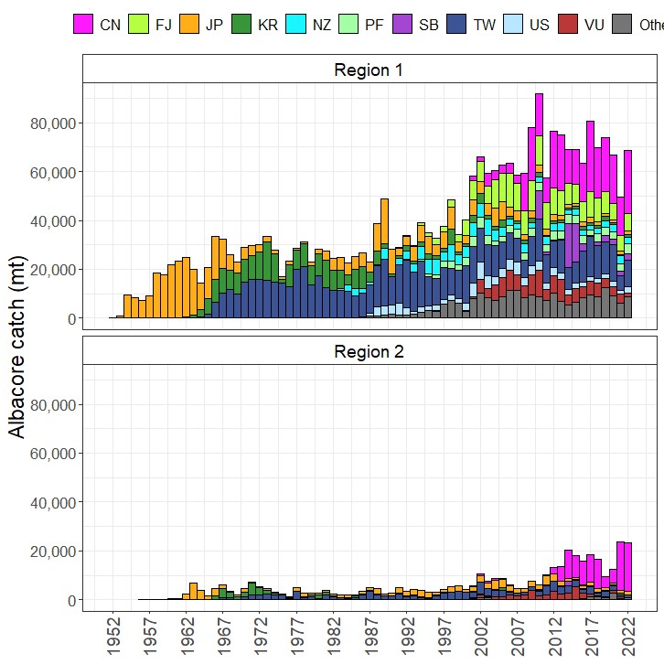

Figure SPA-04 Annual catches of albacore from 1952-2022 separated by flag for the two model regions. Region 1 is the WCPFC-CA (includes cathes from the overlap area), Region 2 is the EPO (excludes the overlap area catches).
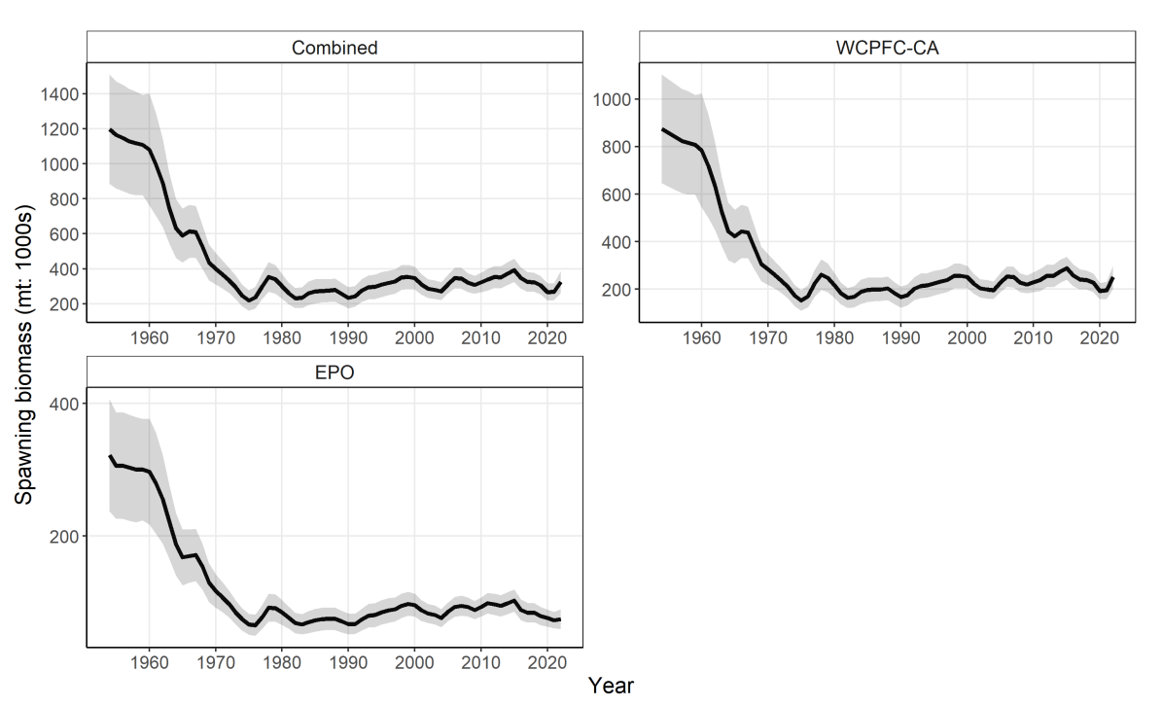
Figure SPA-05 Estimated annual spawning biomass with 95% confidence intervals by model region and the South Pacific for the diagnostic case model.
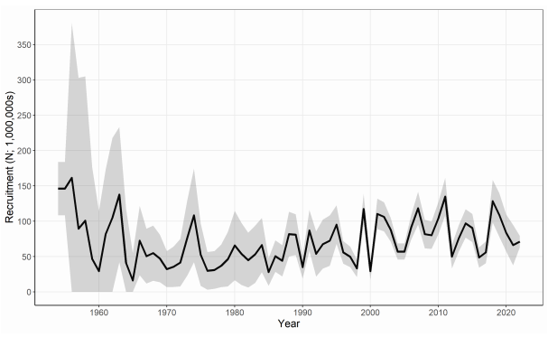
Figure SPA-06 Estimated annual recruitment with 95% confidence intervals across model regions for the diagnostic case model.
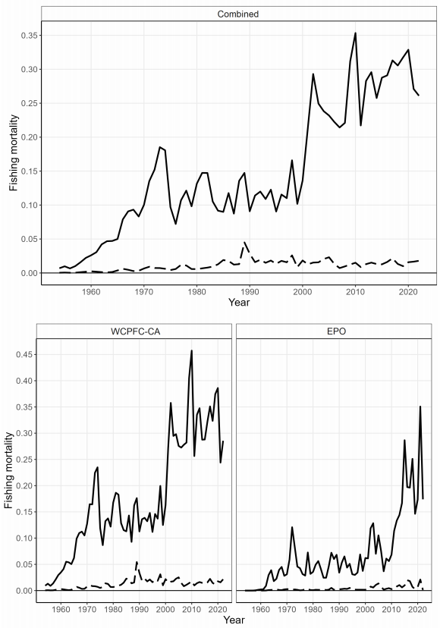
Figure SPA-07 Estimated annual juvenile (dashed line) and adult (solid line) fishing mortality for the diagnostic case model.
Figure SPA-08. Annual estimated 90% (dark blue) and 75% (light blue) quantiles of SB by region from the model ensemble. The dashed line indicates the median.

Figure SPA-09. Annual estimated 90% (dark blue) and 75% (light blue) quantiles of SBt/SBF =0(t) by region from the model ensemble. The dashed line within the interval indicates the median.

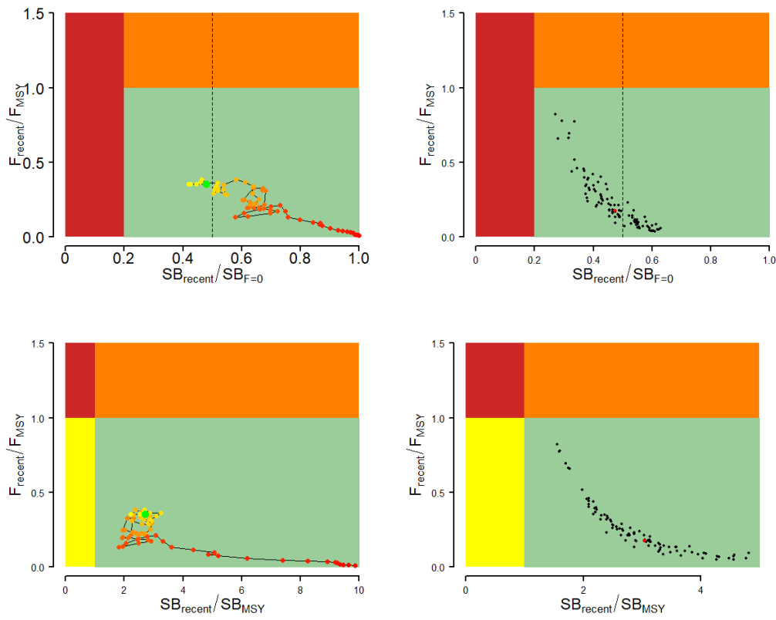
Figure SPA-10 Majuro plots (top) and Kobe plots (bottom) summarising the results for the dynamic MSY analysis (left) and each of the models in the model ensemble for the recent period (2019– 2022; right). Majuro plots include a dashed line at iTRP estimate (0.5), calculated from the current assessment (Pilling et al., 2024). Colors for dynamic MSY go from red to green over time. The red point in the model ensemble (right) represents the median.

- Management advice and implications

- The South Pacific-wide albacore tuna stock spawning biomass depletion is above the RP, and F_{recent} is below F_{MSY} for all models in the uncertainty ensemble. The stock is not overfished (0% probability SB_{recent}/SB_{F=0} < LRP) and is not experiencing overfishing (100% probability F_{recent} < F_{MSY}).

Table SPA-01 Summary of reference points over the model ensemble, along with results incorporating estimation uncertainty. Note that these values do not include estimation uncertainty, unless otherwise indicated.
 | Mean | Median | Min | 10% | 90% | Max
F_{MSY} | 0.15 | 0.16 | 0.10 | 0.12 | 0.18 | 0.20
f_{mult} | 7.95 | 5.61 | 1.21 | 2.27 | 17.18 | 27.66
F_{recent}/F_{MSY} | 0.22 | 0.18 | 0.04 | 0.06 | 0.44 | 0.82
MSY | 113,308 | 101,100 | 62,120 | 74,018 | 176,330 | 202,400
SB₀ | 587,089 | 566,950 | 529,100 | 537,100 | 662,500 | 749,700
SB_{F=0} | 724,200 | 711,059 | 665,389 | 674,633 | 788,312 | 857,071
SB_{latest}/SB₀ | 0.66 | 0.67 | 0.38 | 0.53 | 0.81 | 0.90
SB_{latest}/SB_{F=0} | 0.54 | 0.54 | 0.29 | 0.41 | 0.70 | 0.78
SB_{latest}/SB_{MSY} | 3.71 | 3.40 | 1.65 | 2.32 | 5.77 | 7.45
SB_{MSY} | 111,738 | 110,950 | 65,140 | 80,350 | 142,690 | 172,600
SB_{MSY}/SB₀ | 0.19 | 0.20 | 0.11 | 0.13 | 0.24 | 0.27
SB_{MSY}/SB_{F=0} | 0.15 | 0.16 | 0.10 | 0.11 | 0.19 | 0.22
SB_{recent}/SB_{F=0} | 0.48 | 0.48 | 0.27 | 0.37 | 0.62 | 0.65
SB_{recent}/SB_{MSY} | 3.30 | 3.06 | 1.54 | 2.10 | 5.23 | 6.34
YF_{recent} | 74,531 | 74,375 | 61,760 | 67,731 | 83,023 | 86,180
SB_{latest}/SB_{F=0}: iTRP | 1.065 | 1.051 | 0.961 | 1.015 | 1.139 | 1.213
SB_{recent}/SB_{F=0}: iTRP | 0.952 | 0.952 | 0.899 | 0.924 | 0.986 | 1.016
Including estimation uncertainty
F_{recent}/F_{MSY} | 0.23 | 0.18 | 0.03 | 0.06 | 0.44 | 1.00
SB_{recent}/SB_{F=0} | 0.48 | 0.48 | 0.23 | 0.36 | 0.62 | 0.77
SB_{recent}/SB_{MSY} | 3.32 | 3.02 | 1.20 | 2.04 | 5.21 | 8.96
Note: Recalibrated value for iTRP= 0.50 (Pilling et al., 2024)

    - WCPO skipjack tuna (Katsuwonus pelamis)

      - Indicator analysis

- SC20 thanked the SSP for conducting an indicator analysis providing empirical information on recent patterns in skipjack fisheries.

- SC20 noted that short-term projections are the most useful component for this analysis, and suggested that non-standardized CPUE data not be presented so as to avoid misinterpretation of CPUE trends in relation to abundance. Noting the similarities in information presented within the SC20-GN-WP-01 and Indicators papers, SC20 tasked the SSP to rationalize the content of the latter to minimize duplication.

      - Long-term recruitment and CPUE trends of skipjack tuna (Project 115)

- SC20 thanked the SSP and the Fisheries Research and Education Agency (Japan) for their joint work in providing the results of the project.

- SC20 noted that the conclusion of the project did not provide irrefutable evidence for or against an increasing trend in skipjack tuna recruitment from the 1970s to the early 2000s. While the long-term trend in the Western Pacific Warm Pool was consistent with the trend in the recruitment estimated by the assessment model, interannual dynamics of the Warm Pool area or the other environmental/climatic indicators were not correlated with the assessment’s recruitment estimates. Further, while the SEAPODYM model indicated some recent increases in juvenile skipjack production, it did not show a long-term trend. It was noted that the lack of fishery- independent data and field studies on larval and juvenile skipjack represents a major gap in the ability to understand skipjack recruitment dynamics and trends in the Warm Pool region.

- SC20 supported the need for more sampling to improve the understanding of the early life history of skipjack tuna in the Western Pacific Warm Pool. Such data will help not only to better understand recruitment patterns, but also to examine the effects of climate change by linking recruitment to warm pool spatio-temporal dynamics and productivity changes.

- SC20 recommended that due to the limited information on skipjack recruitment, outside of the assessment model estimates, the increasing trend in recruitment should be considered as an uncertainty in future skipjack assessments. One way to moderate recruitment trends in the stock assessment could be through adjustments to trends in CPUE abundance indices that could be related to effort creep.

- SC20 encouraged further work prior to the next Pre-Assessment Workshop (PAW) scheduled in 2025 to consider an uncertainty axis for the Japanese pole-and-line effort creep for the 2025 assessment. This should be further explored by conducting a MULTIFAN-CL modelling experiment using the 2022 diagnostic case that applies an incremental catchability adjustment to the long-term CPUE time series for the Japanese pole-and-line fishery and the free school purse seine; and compare the results of the modelling experiment with the plausible levels of effort creep suggested in the current study and SC20-SA-IP-19, and provide options for effort creep scenarios not only in the Japanese pole-and-line fisheries but also in the free school purse seine for consideration in the 2025 skipjack tuna assessment.

    - WCPO bigeye tuna (Thunnus obesus) and yellowfin tuna (Thunnus albacares)

      - Further analyses for bigeye and yellowfin tuna assessment

      - Indicator analysis

4.2.3.3 Reproductive biology of yellowfin tuna (Project 120)

  - Northern stocks

    - Pacific bluefin tuna (Thunnus orientalis)

      - Pacific bluefin tuna stock assessment

- SC20 requested the ISC bluefin tuna working group provide a figure of the numbers-at-age by year in the recent past (e.g., last 20 years) in future assessments to determine if the recovery is sustained or if it is only due to a strong year class.

- SC20 also noted that some CCMs expressed concerns about the limited treatment of uncertainty of a single model run for providing management advice, especially with regards to steepness and the stock recruitment relationship, and requested the ISC bluefin tuna working group consider the guidance provided by SC19 for characterizing uncertainty in WCPFC stock assessments.

      - Provision of scientific information to the Commission

  - Stock status and trends

- SC20 welcomed the completion of a benchmark assessment for Pacific bluefin tuna and noted the following stock status and trends information from ISC24:

While there are few Pacific bluefin tuna (PBF) catch records prior to 1952, PBF landing records are available dating back to 1804 from coastal Japan and to the early 1900s for U.S. fisheries operating in the EPO. Based on these landing records, PBF catch is estimated to be high from 1929 to 1940, with a peak catch of approximately 47,635 t (36,217 t in the WPO and 11,418 t in the EPO) in 1935; thereafter catches of PBF dropped precipitously due to World War II. PBF catches increased significantly in 1949 as Japanese fishing activities expanded across the North Pacific Ocean. By 1952, a more consistent catch reporting process was adopted by most fishing nations and estimated annual catches of PBF fluctuated widely from 1952-2022 (Figure [1]). During this period reported catches peaked at 40,383 t in 1956 and reached a low of 8,653 t in 1990. The reported catch in 2021 and 2022 was 15,107 t and 17,458 t, respectively, including non-member countries of the International Scientific Committee for Tuna and Tuna-like Species in the North Pacific Ocean (ISC). Management measures were implemented by Regional Fisheries Management Organizations (RFMOs) beginning in 2011 (WCPFC in 2011 and IATTC in 2012) and became stricter in 2015. While a suite of fishing gears has been used to catch PBF, the majority of the catch is currently made by purse seine fisheries (Figure [2]). Catches during 1952-2022 were predominantly composed of juvenile PBF; the catch of age 0 PBF has increased significantly since the early 1990s but declined as the total catch in weight declined since the mid-2000s and due to stricter control of juvenile catch (Figures [1 and 3]).

Population dynamics were estimated using a fully integrated age-structured model (Stock Synthesis (SS) v3.30) fitted to catch (retained and discarded), size-composition, and catch-per-unit of effort (CPUE) based abundance index data from 1983 to 2023, provided by Members of (ISC), Pacific Bluefin Tuna Working Group (PBFWG) and non-ISC countries obtained from the WCPFC official statistics. Life history parameters included a length-at-age relationship from otolith-derived ages and natural mortality estimates from a tag-recapture study and empirical-life history methods.

In 2024, the PBFWG conducted a benchmark stock assessment. The PBFWG critically reviewed all aspects of the model, and some modifications were made to improve the model. A total of 26 fleets were defined for use in the stock assessment model based on country/gear/season/region stratification until the end of the fishing year 2022 (June 2023). Quarterly observations of catch and size compositions, when available, were used as inputs to the model to describe the removal processes. Annual estimates of standardized CPUE from the Japanese distant water, offshore, and coastal longline, the Chinese Taipei longline, and the Japanese troll fleets were used as measures of the relative abundance of the population. The CPUE of Japanese longline (adult index) after 2020 and Japanese troll (recruitment index) after 2010 were not included in the model, as these observations may be biased due to additional management measures in Japan. The assessment model was fitted to the input data in a likelihood-based statistical framework. Maximum likelihood estimates of model parameters, derived outputs, and their variances were used to characterize stock status and to develop stock projections.

One of the major changes made in this assessment is that the PBFWG decided to shorten the stock assessment model by starting in 1983 instead of 1952. This adjustment was implemented because more reliable data are available after 1983. Additionally, the adoption of a shorter model period enhances flexibility and can accommodate diverse productivity assumptions. This flexibility is an important feature as this model will be used in the upcoming PBF management strategy evaluation (MSE). The PBFWG confirmed that the results and management quantities of the longer period model and the shorter period model are consistent and that the change in the duration of the assessment model does not affect the management advice (Figure 4). A simple update of the 2022 stock assessment with new data estimated slightly higher relative biomass after 2011, reflecting an underestimating tendency of the past model (Figure 4). Other changes include refined parameterization of selectivity to reduce model residuals and shortening of the recruitment index from 1983-2016 to 1983-2010. The truncation of the recruitment index was supported by various analyses as described in the main body of the assessment report and was considered appropriate to reduce the SSB retrospective bias (Mohn’s ρ for 10 years-retrospective analysis in the base case is -0.06), which was observed in several previous assessment models. After these modifications, the base-case model fits better to the input data and shows good prediction skill (the root mean square error of the Taiwanese longline CPUE for the predicted 7-year period was 0.24, see Figure 5). The PBFWG therefore concluded that the model is appropriate for generating management advice. Due to those changes, recent relative biomass was scaled up to some extent (see Figure 4) as the retrospective bias was reduced.

After conducting thorough reviews and implementing necessary modifications, the PBFWG found that the 2024 base-case model is consistent with the previous assessment results, that it fits the data well, that the results are internally consistent among most of the data sources, and that the model has improved overall by addressing the issues previously identified. The model diagnostics have confirmed that the base-case model captures the production function of PBF well, thus its estimated biomass scale is reliable, and that the model has good predictability. Based on these findings, the PBFWG concluded that the 2024 assessment model reliably represents the population dynamics and provides the best available scientific information for the PBF stock.

The base-case model results show that: (1) spawning stock biomass (SSB) fluctuated throughout the assessment period (fishing years 1983-2022); (2) the SSB steadily declined from 1996 to 2010; (3) the SSB has rapidly increased since 2011; (4) fishing mortality (F%SPR) decreased from a level producing about 1% of SPR in 2004-2009 to a level producing 23.6% of SPR in 2020-2022; and (5) SSB in 2022 increased to 23.2% of SSB_{F=0}, achieving the second rebuilding target by WCPFC and IATTC in 2021. Based on the model diagnostics, the estimated biomass trend throughout the assessment period is considered robust. The SSB in 2022 was estimated to be 144,483 t (Table 1 and Figure 6), more than 10 times of its historical low in 2010. An increase in immature fish (0-3 years old) is observed in 2016-2019 (Figure 7), likely resulting from reduced fishing mortality on this age group. This led to a substantial increase in SSB after 2019. The method to estimate confidence interval was changed from bootstrapping in the previous assessments to normal approximation of the Hessian matrix.

Historical recruitment estimates have fluctuated since 1983 without an apparent trend (Figure 6). Currently, stock projections assume that future recruitment will fluctuate around the historical (1983-2020 FY) average recruitment level. Previously, no significant autocorrelation was found in recruitment estimates, supporting the use in the projections of recruitment sampled at random from the historical time series. In addition, now that SSB has recovered to 23.2%SSB_{F=0}, the PBFWG considers the assumption that the future recruitment will fluctuate within the historical range to be reasonable. The PBFWG also confirmed that the distributions of historical recruitment from the updated long-term model (1952-2022) and the present base-case model (1983-2022) are comparable.

The recruitment index based on the Japanese troll CPUE has proven to be an informative indicator of recruitment in PBF assessments. However, the PBFWG found that the catchability of the recruitment index may have been affected by the adoption of a new licensing system and an increase in troll catch for farming operations after 2010, as well as management interventions after 2016. In addition, an examination of model diagnostics suggested that fitting to the recruitment index after 2010 degraded model prediction skill and increased the SSB retrospective pattern. Therefore, for this assessment, the PBFWG extended the approach of the 2022 assessment and terminated the recruitment index after 2010. This was considered appropriate because even in the absence of a recruitment index, the model still has other reliable and mutually consistent data to estimate SSB and recruitments, in particular the adult indices.
Although the recruitments are well estimated for most of the time series, the recruitment estimates in the terminal period (2019-2022) are more uncertain than other years (Figure 6), which is also shown in the retrospective analysis of recruitment. The recruitment estimate in the terminal year (2022) is uninformed by data and was hence based on the stock recruitment relationship and close to the estimated unfished recruitment. Therefore, recent recruitment estimates should be treated with caution.

Additional evidence on recent recruitment trends was examined by the PBFWG using the newly developed standardized CPUE index from the Japanese troll monitoring program for 2011-2023 (Figure 8). Although the PBFWG concluded that it was premature to include this index in the base-case model, this index is believed to provide a good qualitative indication of recruitment trends. With regard to the recent low recruitment period estimated by the base-case model (2019-2021), the monitoring index showed relatively low recruitment in 2019 and 2020, but relatively high recruitment in 2021-2023. Based on this evidence and the uncertainty in the retrospective analysis of recruitment previously noted, the PBFWG considered the 2021 recruitment estimate from the base-case model to be less reliable. Therefore, the PBFWG decided to start using resampled historical recruitment from 2021, rather than 2022, for the projections.

This, in effect, means that the recruitment in 2021 is assumed to be around the historical average, and if in fact it is lower than assumed, though the PBFWG believes it unlikely from the survey index (Figure 8), the near-term projection results would become more pessimistic.

Estimated age-specific fishing mortalities (F) on the stock during the periods of 2012-2014 and 2020-2022, compared with 2002-2004 estimates (the reference period for the WCPFC Conservation and Management Measure), are presented in Figure 9.

Figure 10 depicts the historical impacts of the harvest by the fleets on the PBF stock, showing the estimated biomass when fishing mortality from the respective fleets is zero. Note that trends in fishery impact back to 1970 were computed using the base-case model extended to 1952. Historically, the WPO coastal fisheries group has had the greatest impact on the PBF stock, but since about the early 1990s the WPO purse seine fishery group targeting small fish (ages 0-1) has had a greater impact and the effect of this group in 2022 was greater than any of the other fishery groups. The impact of the EPO fisheries group was large before the mid-1980s, decreasing significantly thereafter. The WPO longline fisheries group has had a limited effect on the stock throughout the analysis period because the impact of a fishery on a stock depends on both the number and size of the fish caught by each fleet; i.e., catching a high number of smaller juvenile fish can have a greater impact on future spawning stock biomass than catching the same weight of larger mature fish. In 2022, the estimated cumulative impact proportion between WPO and EPO fisheries is about 83% and 17%, respectively. There is greater uncertainty regarding discards than other fishery impacts because the impact of discarding is not based on observed data. Currently, the amount of discard is assumed to be 6% of the reported release in EPO and 5% of the catch in WPO, lacking reliable data.

- SC20 noted the following stock status information from ISC24:

PBF spawning stock biomass (SSB) has increased substantially in the last 12 years. These biomass increases coincide with a decline in fishing mortality, particularly for fish aged 0 to 3, over the last decade. The latest (2022) SSB is estimated to be 23.2% of SSB_{F=0} and the probability that it is above 20%SSB_{F=0} is 75.9%.

Based on these findings, the following information on the status of the Pacific bluefin tuna stock is provided:

  - No biomass-based limit or target reference points have been adopted for PBF, but the PBF stock is not overfished relative to 20%SSB_{F=0}, which has been adopted as a biomass-based reference point for some other tuna species by the IATTC and WCPFC. SSB of PBF reached its initial rebuilding target (SSBMED = 6.3%SSB_{F=0}) in 2017, 7 years earlier than originally anticipated by the RFMOs, and its second rebuilding target (20%SSB_{F=0}) in 2021; and

  - No fishing mortality-based reference points have been adopted for PBF by the IATTC and WCPFC. The recent (2020-2022) F%SPR is estimated to be 23.6% and thus the PBF stock is not subject to overfishing relative to some of the F-based reference points proposed for tuna species (Table PBF-02), including F20%SPR.

Table PBF-01. Total biomass, spawning stock biomass, recruitment, spawning potential ratio, and depletion ratio of Pacific bluefin tuna (Thunnus orientalis) estimated by the base-case model, for the fishing years 1983-2022.
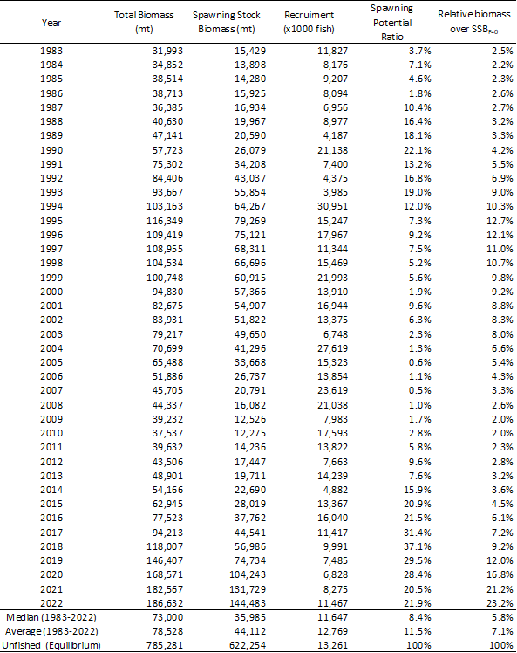

Table PBF-02. Ratios of the estimated fishing mortalities (Fs and 1-SPRs for 2002-04, 2012-14, 2020-2022) relative to potential fishing mortality-based reference points, and terminal year SSB (t) for each reference period, and depletion ratios for the terminal year of the reference period for Pacific bluefin tuna (Thunnus orientalis) from the base-case model. F_{max}: Fishing mortality (F) that maximizes equilibrium yield per recruit (Y/R). Fxx%SPR: F that produces a given % of the unfished spawning potential (biomass) under equilibrium conditions.
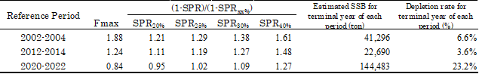

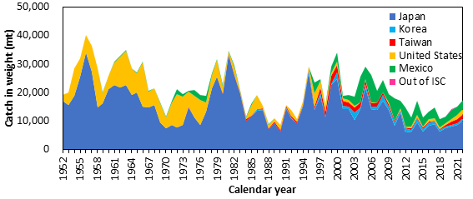

Figure PBF-01. Annual catch (tons) of Pacific bluefin tuna (Thunnus orientalis) by ISC member countries from 1952 through 2022 (calendar year) based on ISC official statistics.

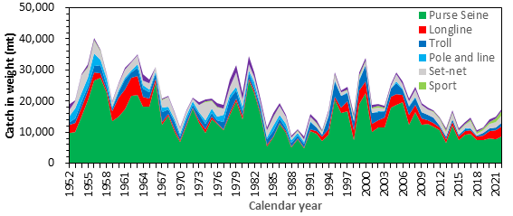

Figure PBF-02. Annual catch (tons) of Pacific bluefin tuna (Thunnus orientalis) by gear type by ISC member countries from 1952 through 2022 (calendar year) based on ISC official statistics.
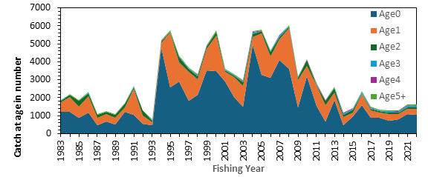
Figure PBF-03. Estimated annual catch-at-age (number of fish) of Pacific bluefin tuna (Thunnus orientalis) by fishing year estimated by the base-case model (1983-2022)

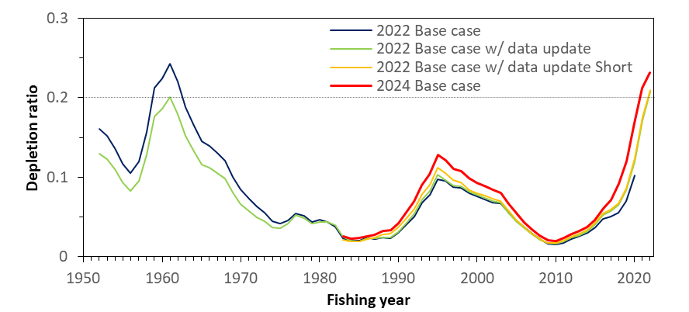
Figure PBF-04. Comparison of the trajectory of relative biomass (SSB/SSB_{F=0}, depletion ratio) of the assessment models bridging from the 2022 base-case to the 2024 base-case (2022 base-case, 2022 base-case with data-update, 2022 base-case with data-update Short (1983-), and the 2024 base-case model). The 2022 base case with data update and the 2022 base case with data update Short (1983-) almost overlap towards the end. SSB is spawning stock biomass, and SSB _{F=0} is the expected SSB under average recruitment conditions without fishing. The horizontal line represents 20%SSB_{F=0} (the second biomass rebuilding target).

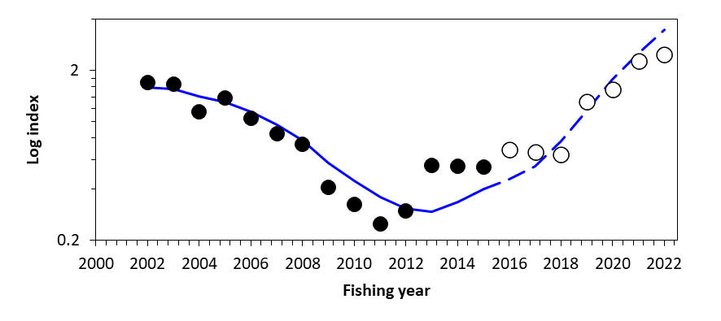
Figure PBF-05. Result for hindcasting of the recent 7 years (2016-2022) based on the catch at age. The expected (blue solid line) and predicted (blue dashed lines) Taiwanese longline CPUE index from the age-structured production model, where CPUE observations were removed for the recent 7 years. The solid circles represent the observations used in the model, and open circles represent the missing values.
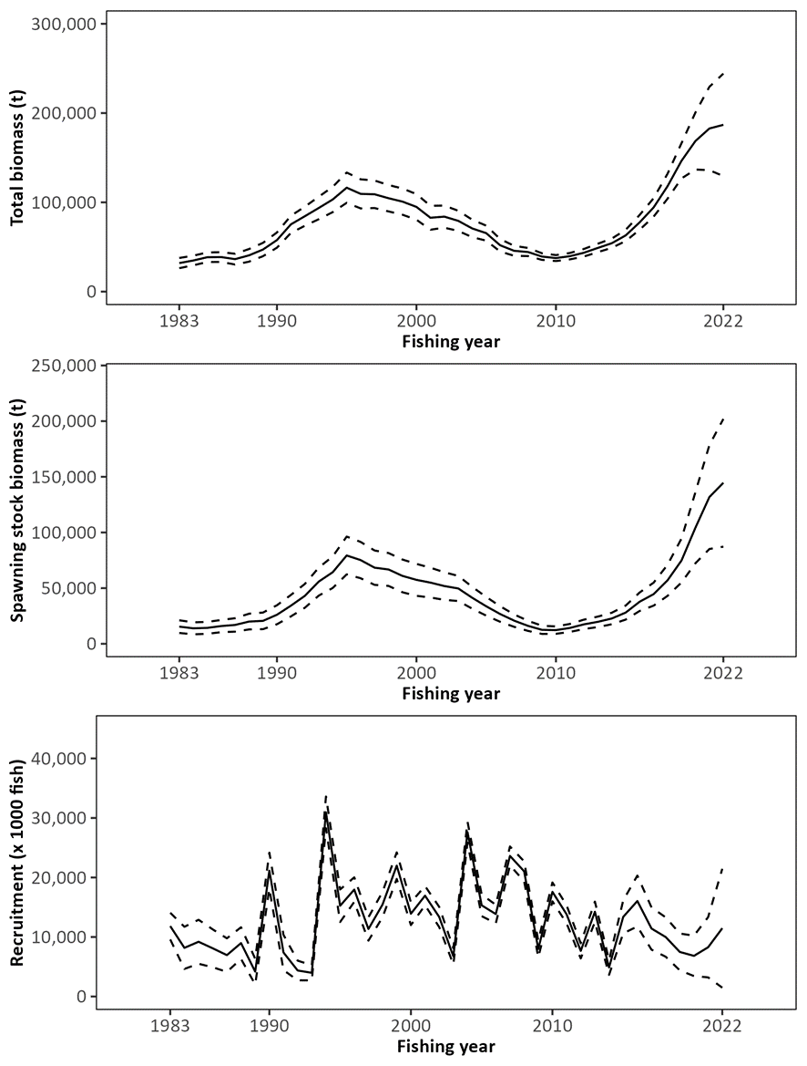
Figure PBF-06. Trajectory of total stock biomass (top), spawning stock biomass (middle), and recruitment (bottom) of Pacific bluefin tuna (Thunnus orientalis) (1983-2022) estimated from the base-case model. The solid line is the point estimate, and dashed lines delineate the 90% confidence interval. The method used to estimate the confidence interval was changed from bootstrapping in the previous assessments to the normal approximation of the Hessian matrix.
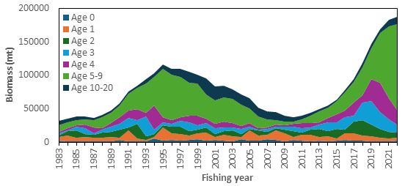
Figure PBF-07. Total biomass (tons) by age of Pacific bluefin tuna (Thunnus orientalis) estimated from the base-case model (1983-2022). Note that the recruitment estimates for 2019-2022 are more uncertain than for other years.

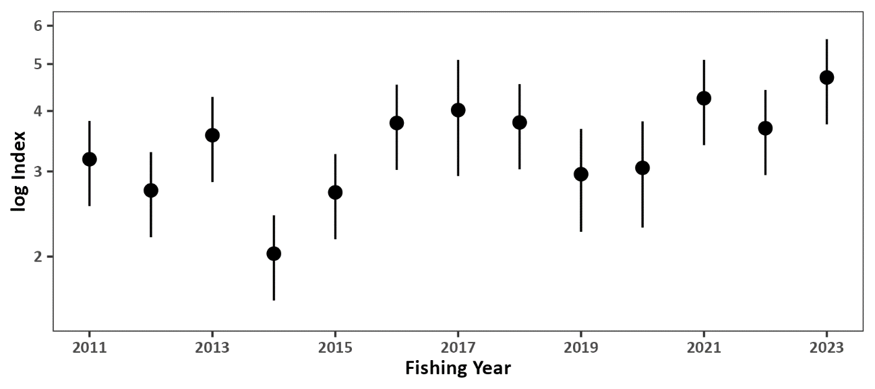
Figure PBF-08. Standardized CPUE index from the Japanese recruitment monitoring program (2011-2023). The bar represents the 95% confidence interval.

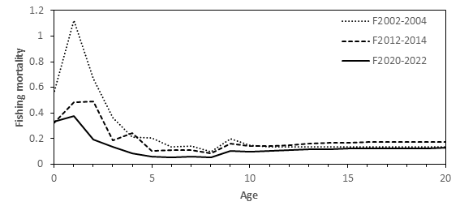
Figure PBF-09. Geometric means of annual age-specific fishing mortalities (F) of Pacific bluefin tuna (Thunnus orientalis) for 2002-2004 (dotted line), 2012-2014 (dashed line), and 2020-2022 (solid line).
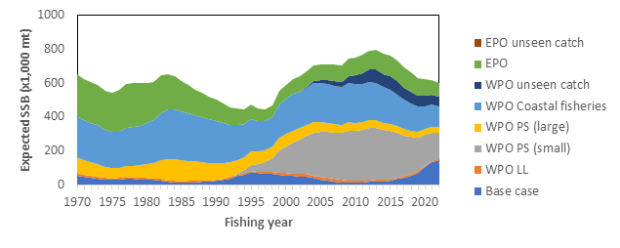
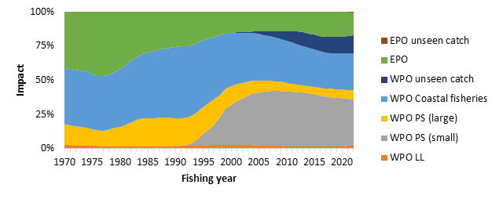
Figure PBF-10. The trajectory of the spawning stock biomass of a simulated population of Pacific bluefin tuna (Thunnus orientalis) when zero fishing mortality is assumed, estimated by the base-case long-term model. (top: absolute SSB, bottom: relative SSB). In 2022, the estimated cumulative impact proportion between WPO and EPO fisheries is about 83% and 17%, respectively. Fisheries group definition: WPO longline fisheries: F1-4. WPO purse seine fisheries for large fish: F5-7. WPO purse seine fisheries for small fish: F8-11. WPO coastal fisheries: F12-19. EPO fisheries: F20-23. WPO unaccounted fisheries: F24, 25. EPO unaccounted fisheries: F26. For exact fleet definitions, please see the 2024 PBF stock assessment report. Although larger PBF have been caught by the Korean offshore large-scale purse seine in recent years, this fleet is included in “WPO PS (small)” because of their historical selectivity.

- Management advice and implications

- SC20 noted the following management advice from ISC24:

The WCPFC and IATTC adopted an initial rebuilding biomass target (the median SSB estimated for the period from 1952 through 2014) and a second rebuilding biomass target (20%SSBF=0 under average recruitment) but not a fishing mortality reference level. The previous (2022) assessment estimated the initial rebuilding biomass target (SSBMED1952-2014) to be 6.3%SSB_{F=0} and the corresponding fishing mortality expressed as SPR of F6.3%SPR (Table [2]). The Kobe plot shows that the point estimate of the SSB2022 was 23.2%SSB_{F=0} and that the recent (2020-2022) fishing mortality corresponds to F23.6%SPR (Table [1] and Figure [10]). The apparent increase in F in the terminal period compared to the historical low in 2018 (F37.1%SPR) is a result of low recruitment in this period. As noted, the recruitment estimates in recent years are more uncertain and this result needs to be interpreted with caution.

After the steady decline in SSB from 1996 to the historically low level in 2010, the PBF stock has started recovering, and recovery has been more rapid in recent years, coinciding with the implementation of stringent management measures. The 2022 SSB was 10 times higher than the historical low and is above the second rebuilding target adopted by the WCPFC and IATTC, which was achieved in 2021. The stock has recovered at a faster rate than anticipated when the Harvest Strategy to foster rebuilding (WCPFC HS 2017-02) was implemented in 2014. The fishing mortality (F%SPR) in 2020-2022 is at a level producing 23.6%SPR. According to the requests from WCPFC and IATTC, future projections under various scenarios were conducted. The projection scenarios and their results, the figure of projection results, “future Kobe plot”, and “future impact plot” are provided as Tables [3-5], Figures [12, 13, and 14], respectively. In addition, the results of additional projections which were requested by the Join Working Group of IATTC-WCPFC NC is provided in Appendix 2 of the stock assessment report (SC20-SA-WP-08, Table A2.1-A2.3, Figure A2.1).

Based on these findings, the following information on the conservation of the Pacific bluefin tuna stock is provided:

- The PBF stock is recovering from the historically low biomass in 2010 and has exceeded the second rebuilding target (20%SSBF=0). The risk of SSB falling below 7.7%SSBF=0 (interim LRP for tropical tunas in IATTC) at least once in 10 years is negligible;
- The projection results show that increases in catches are possible. However, the risk of falling below the second rebuilding target will increase with larger increases in catch;
- The projection results assume that the CMMs are fully implemented and are based on certain biological and other assumptions. For example, these future projection results do not contain assumptions about discard mortality. Discard mortality may need to be considered as part of future increases in catch; and
- Given the uncertainty in future recruitment and the influence of recruitment on stock biomass as well as the impact of changes in fishing operations due to the management, monitoring recruitment and SSB should continue. Research on a recruitment index for the stock assessment should be pursued, and maintenance of a reliable adult abundance index should be ensured. In addition, accurate catch information is the foundation of good stock assessment.

Table PBF-03. Future projection scenarios for Pacific bluefin tuna (Thunnus orientalis).
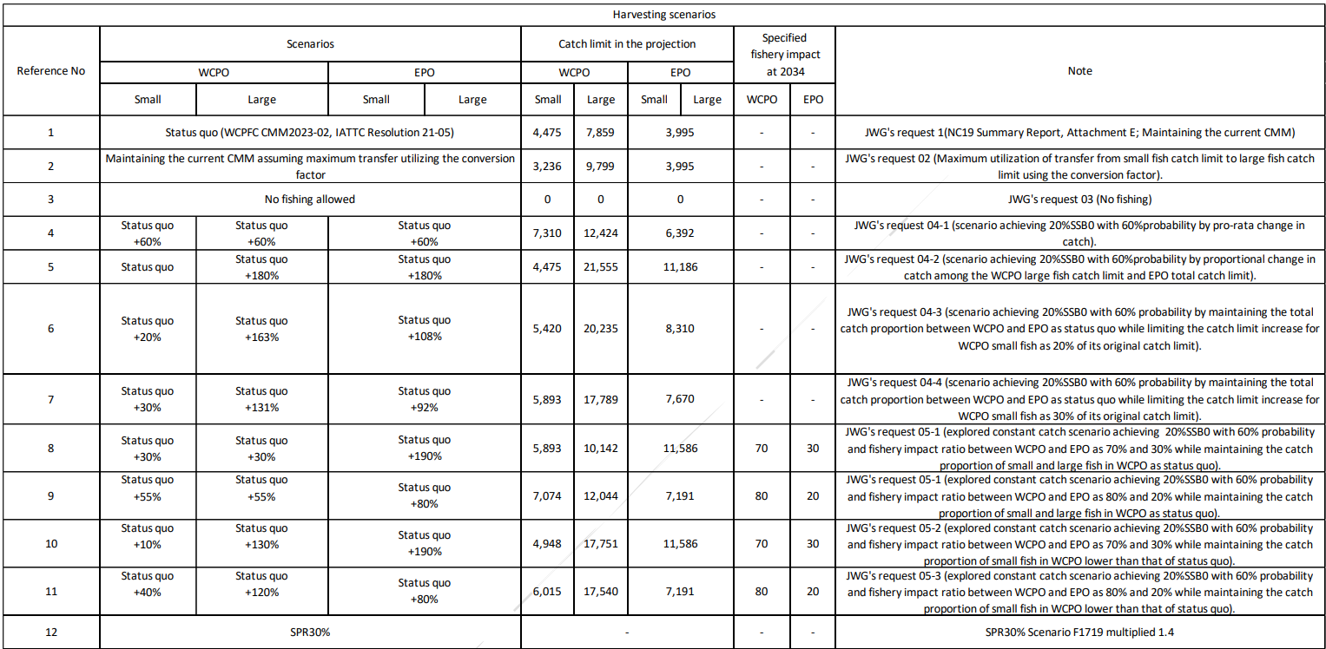 * The numbering of Scenarios is different from those given by the IATTC-WCPFC NC Joint WG meeting.
* Fishing mortality in scenario 3 was kept at zero. The catch limit for scenario 12 is calculated to achieve SPR 30% and allocated to fleets proportionately.
* The Japanese unilateral measure (transferring 250 mt of the catch upper limit from that for small PBF to that for large PBF during 2022-2034) is reflected in the projections.
Table PBF-04. Future projection scenarios for Pacific bluefin tuna (Thunnus orientalis) and their probability of achieving various target levels by various time schedules based on the base-case model.
*The numbering of Scenarios is different from those given by the IATTC-WCPFC NC Joint WG meeting and is the same as Table PBF-03.
* Recruitment is resampled from historical values.

Table PBF-05. Expected yield for Pacific bluefin tuna (Thunnus orientalis) under various harvesting scenarios based on the base-case model.
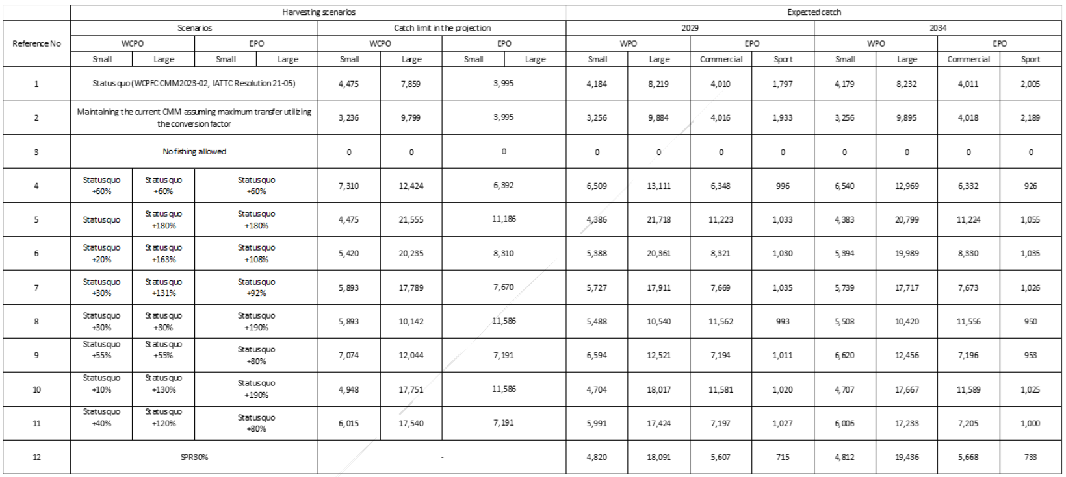
* Korean catch reflects the recent catch proportion for small and large, thus expected catches do not match with catch allocations.

Table PBF-A2.1. Harvest scenarios used in the projection for Pacific bluefin tuna (Thunnus orientalis).
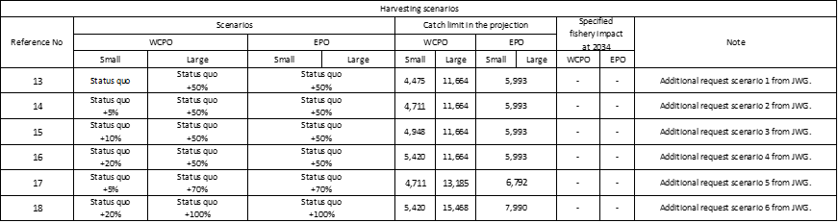

Table PBF-A2.2. Future projection scenarios for Pacific bluefin tuna (Thunnus orientalis) and their probability of achieving various target levels by various time schedules based on the base-case model.
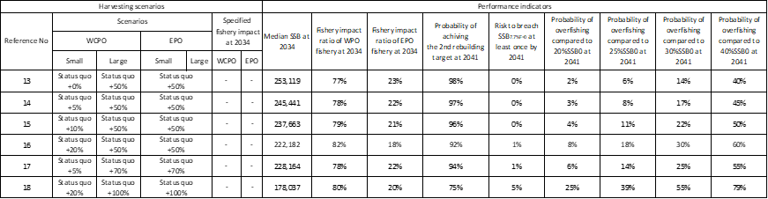

Table PBF-A2.3. Expected annual yield for Pacific bluefin tuna (Thunnus orientalis) under various harvesting scenarios based on the base-case model.
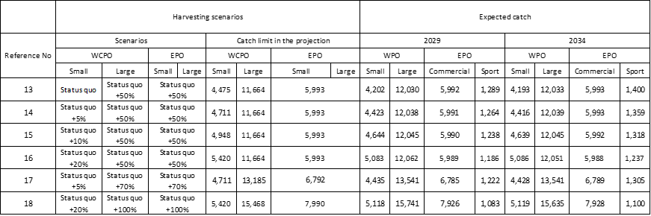
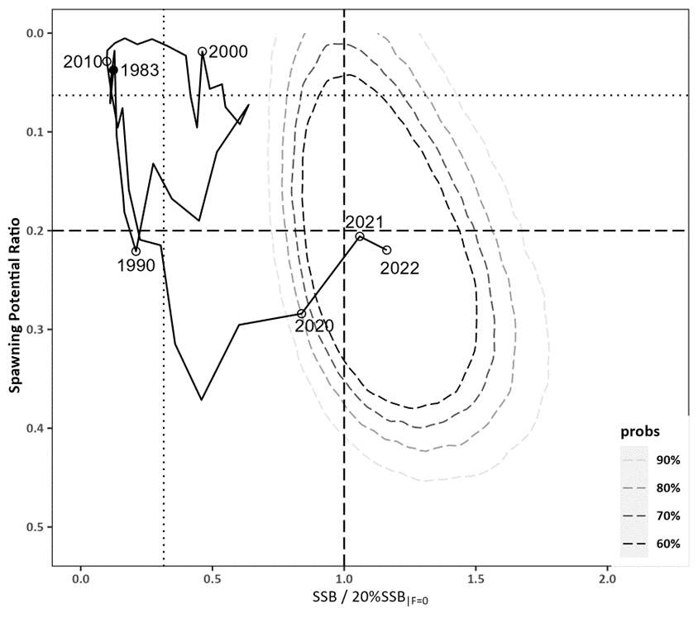
Figure PBF-11. Kobe plot for Pacific bluefin tuna (Thunnus orientalis) estimated from the base-case model from 1983 to 2022. The X-axis shows the annual SSB relative to 20%SSB_{F=0} and the Y-axis shows the spawning potential ratio (SPR) as a measure of fishing mortality. Vertical and horizontal dashed lines show 20%SSB_{F=0} (which corresponds to the second biomass rebuilding target) and the corresponding fishing mortality that produces SPR, respectively. Vertical and horizontal dotted lines show the initial biomass rebuilding target (SSB_{MED} = 6.3%SSB_{F=0}) and the corresponding fishing mortality that produces SPR, respectively. SSB_{MED} is calculated as the median of estimated SSB over 1952-2014 from the 2022 assessment. The apparent increase of F in the terminal period is a result of low recruitment in this period. As noted, the recruitment estimates in recent years are more uncertain and this result needs to be interpreted with caution. Contour plots represent 60% to 90% of two probability density distributions in SSB and SPR for 2022. The method used to estimate the confidence interval was changed from bootstrapping in the previous assessments to resampling from the multi-variate log-normal distribution. The probability distribution for the area where SPR is below zero is not shown as such SPR values are not biologically possible.
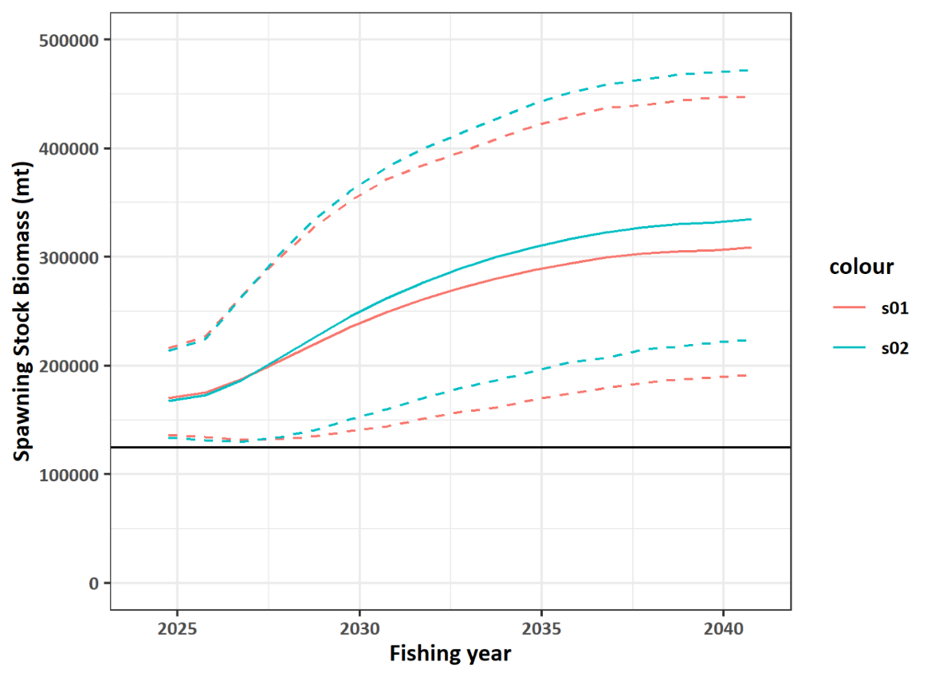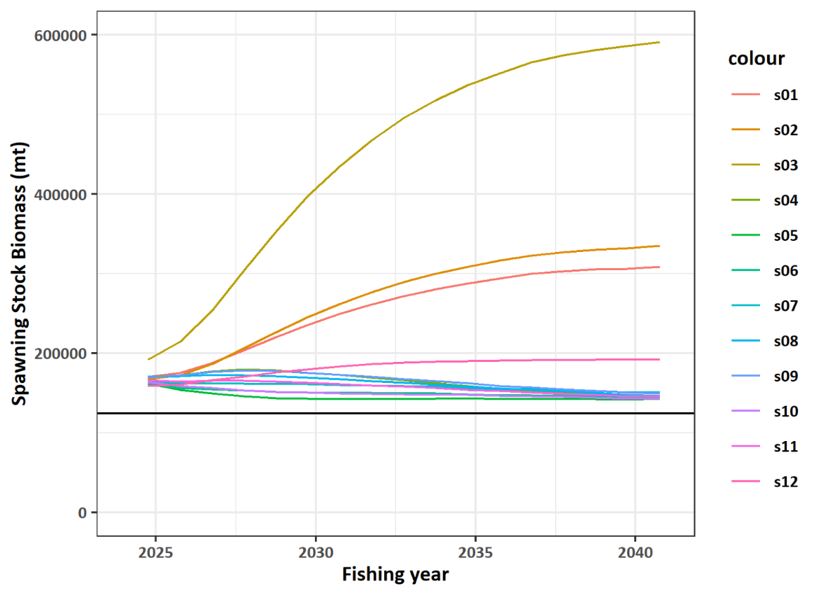
Figure PBF-12. Comparisons of various projection results for Pacific bluefin tuna (Thunnus orientalis) obtained from projection results. (Top) Median of scenarios 1 and 2 (solid lines) and their 90% confidence intervals (dotted lines). (Bottom) Median of all harvest scenarios examined from Table 3. The horizontal line represents the second rebuilding target.
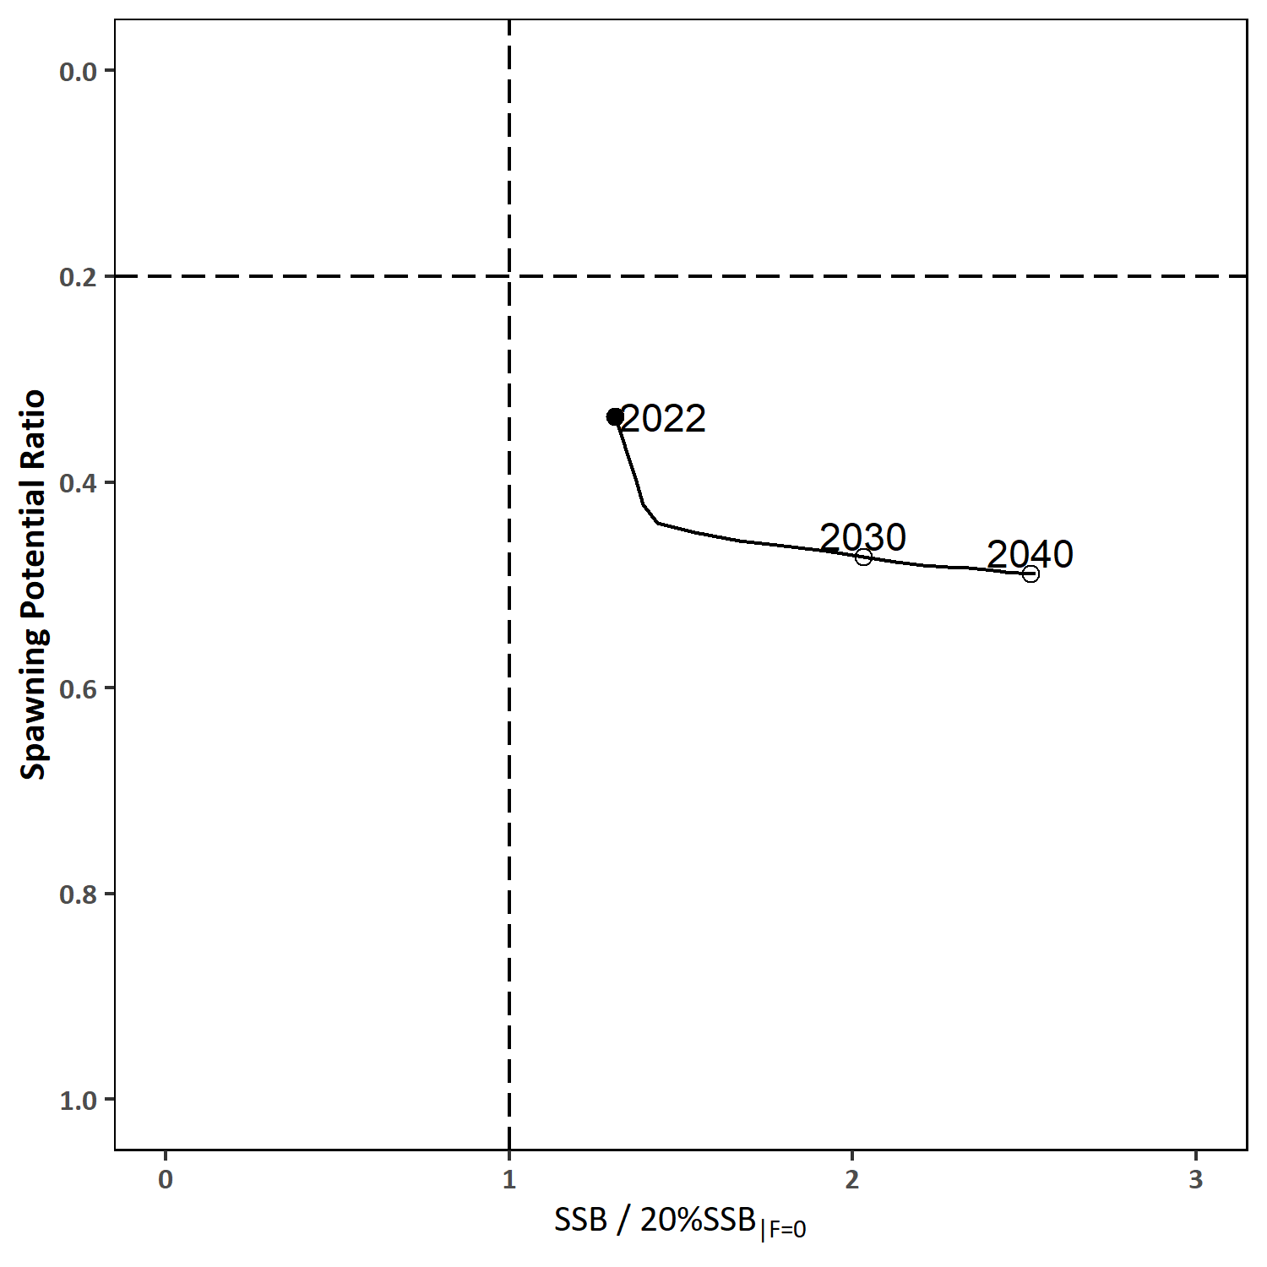
Figure PBF-13. “Future Kobe Plot” of projection results for Pacific bluefin tuna (Thunnus orientalis) from Scenario 1 in Table 3. Vertical and horizontal dashed lines show 20%SSB_{F=0} (which corresponds to the second biomass rebuilding target) and the corresponding fishing mortality that produces SPR, respectively.
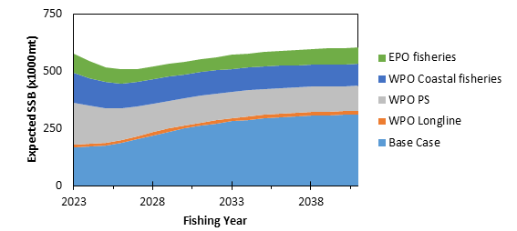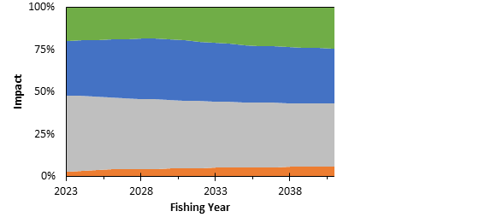

Figure PBF-14. “Future impact plot” from projection results for Pacific bluefin tuna (Thunnus orientalis) from Scenario 1 in Table 3. The top figure shows absolute biomass and the bottom figure shows relative impacts. The impact is calculated based on the expected increase of SSB in the absence of the respective group of fisheries.
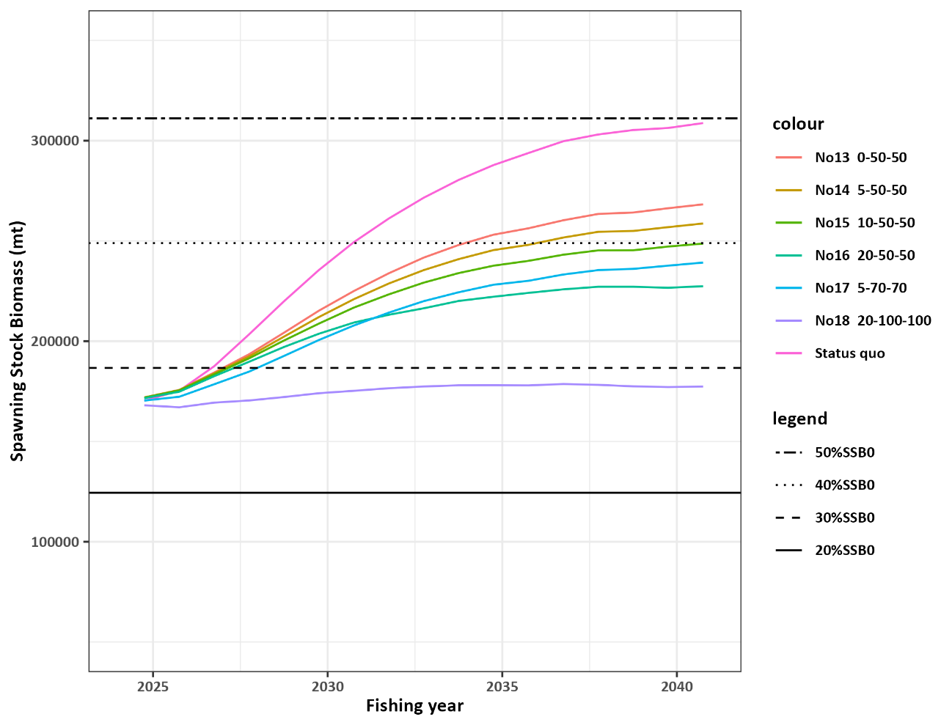

Figure PBF-A2.1 Comparisons of various projected median SSB for all harvest scenarios examined for Pacific bluefin tuna (Thunnus orientalis) obtained from projection results.

      - Billfish

4.4.1 Southwest Pacific striped marlin (Kajikia audax)

4.4.1.1 Stock assessment of Southwest Pacific striped marlin

- SC20 thanked the SSP for conducting the stock assessment of the Southwest Pacific striped marlin (SC20-SA-WP-03) and acknowledged their transparency in outlining the issues of serious concern from the SC with the technical aspects of the assessment.

- Noting the above, SC20 recommended that further work, including resolving the conflict between the size composition data and the CPUE indices, should be undertaken as part of a revision to the assessment for consideration at SC21.

- SC20 acknowledged that further work on the assessment will place unplanned additional burden on the assessment team and welcomed the offer from the United States to provide in-kind support to SSP to moderate the impacts to other key SC21 deliverables.

- SC20 encouraged the collection of additional age-at-length data for striped marlin across the southwest Pacific Ocean from 2025-2028, as outlined in the Billfish Research Plan. Additional age-at-length data are needed to further improve growth estimates through the internal estimation of growth within the stock assessment, as recommended by the WCPFC yellowfin assessment peer review.

      - Provision of scientific information to the Commission

- SC20 reiterated the most recent stock status advice from SC15 that “the stock is likely overfished, and close to undergoing overfishing according to MSY-based reference points.”

- SC20 recommended that a revised assessment be presented at SC21 which includes presentation of the projection scenarios.

- SC20 recommended the WCPFC21 request a tractable set of projections, including, but not limited to the four scenarios proposed below:

- Status quo scenario: Projection based on recent catch levels;
- Recovery scenario 1: Catch levels that result to a median depletion of 20% within 10 years;
- Recovery scenario 2 Catch levels that result to a median depletion of 30% within 10 years; and
- Non-retention/live release scenario: Catch levels that reflect the likely outcomes under a management measure requiring the release of live animals or non-retention of all animals.

    - Western and Central North Pacific Striped Marlin (Kajikia audax)

      - Peer review of the 2023 stock assessment for the Western and Central North Pacific striped marlin

- SC20 thanked the ISC for conducting the first in-person peer review for Western and Central North Pacific striped marlin made possible with funding support from the United States and commended the collaboration between the ISC and WCPFC. SC20 looked forward to receiving future Western and Central North Pacific striped marlin stock assessments which address the issues identified through the peer review and noted the possibility of substantial change in the results.

- SC20 encouraged further peer reviews for other WCPFC stocks, noting the outcomes from the Western and Central North Pacific striped marlin peer review process which will feed into informing future stock assessments.

      - Western and Central Pacific striped marlin rebuilding analysis

- SC20 noted that ISC24 maintained the conservation advice of WCNPO MLS from 2023, which is the latest available scientific information. SC20 also noted that ISC24 provided the results of stochastic rebuilding projection based on the 2023 WCNPO MLS stock assessment. These evaluated harvesting scenarios to achieve the WCNPO MLS interim rebuilding target (20%SSB_{F=0} with more than 60% probability) as requested by the Commission (SC20-SA-IP-15). SC20 noted the recommendations of the peer review of the WCNPO MLS stock assessment (SC20-SA-WP-12) and recommended that these be incorporated into the future stock assessment scheduled for 2027.

- SC20 recommended the Commission to take the above information into account when considering possible revision of the CMM for North Pacific striped marlin.

  - Sharks

    - Silky shark (Carcharhinus falciformis)

      - Stock assessment of silky shark in the WCPO (Project 108)

- SC20 noted the extensive efforts undertaken to provide the stock assessment models and appreciates the thoroughness of the assessment. While the four assessment models provide reasonably different biomass and fishing mortality historical trends, SC20 noted that generally, all four models agree upon the terminal year stock status. SC20 recommended that stock status and management advice be based upon the dynamic surplus production model (DSPM) results as the most parsimonious and robust assessment presented.

      - Provision of scientific information to the Commission

  - Stock assessment and trends

- Silky sharks in the WCPO have no target fisheries and are caught as bycatch in longline and purse seine fisheries. Although caught in Pacific fisheries since the 1950s, catch records for silky sharks only began in the 1990s (Brouwer et al. 2023, Neubauer et al. 2023a). Since 2015, the WCPFC mandates the release of all silky sharks. Reliable catch history estimates are necessary for assessment due to unreliable logsheet and observer data, stemming from generic reporting codes prior to 2015, inadequate bycatch reporting, and inconsistent observer coverage. However, recent data improvements, biological data availability, and previous successful stock assessments led Brouwer and Hamer (2020) to recommend a data-rich assessment for the WCPO silky shark stock.

- The 2024 Pacific silky shark (Carcharhinus falciformis) stock assessment in the Western and Central Pacific Ocean (WCPO) is the third attempt at undertaking an assessment of Pacific silky sharks.

- This assessment used a multi-model approach to assess silky shark in the WCPO, addressing large uncertainties in the underlying data and challenges with fitting integrated stock assessments for sharks. To understand overfishing risk from different perspectives, a range of models with varying complexity and with different data requirements were applied, including a fully integrated stock assessment in Stock Synthesis, a length and age-structured assessment model (LAM), a dynamic surplus production model (DSPM), and a length-based spatial risk assessment (SRA). Each approach was treated independently, without the standardized use of consistent priors, though data inputs were standardized across all four assessment approaches given the single dataset available.

- Non-retention measures have led to sharks being cut free from longlines, potentially reducing the quality of recent catch (interaction) data for silky sharks. Other key uncertainties highlighted in the assessment include: species distribution and interactions with local oceanography and ENSO dynamics; growth uncertainties due to a lack of age-validation and limited data; and stock structure and mixing

- Fisheries interactions from 1995 to 2022 were reconstructed using an ensemble of spatial GLMM models (Neubauer et al. 2023a) that included oceanographic predictors, targeting effects and total effort per stratum (5x5 degree grid, flag, year, month). Post-release mortality was estimated at 15% for long-line fisheries, and 85% for purse-seine fisheries, contributing to total fishing mortality. The base assumption was that catches prior to the reconstructed catch period were lower and increased with an expansion of longline fishing effort in the late 1990s and 2000s (Figure FAL-01).

- CPUE indices were standardized based on observer data in Phase I of this project, and focused on longline and purse seine CPUE indices. However, due to high interannual variability in the longline fishery CPUE index and inconsistencies between different observer programs, only CPUE indices from the purse seine fishery were included in the assessment. The longline CPUE was deemed unreliable for reflecting silky shark abundance trends (Figure FAL-02). Purse-seine indices were only used through to 2020, as COVID-related disruptions led to data gaps and potential bias in observer CPUE for 2021 and 2022. Recent estimates were, therefore, based on 2019–2020 data.

- Fishing mortality remained stable until the 2010s, after which it declined substantially through to 2020 (Figure FAL-02]. Throughout the assessment period, fishing mortality was estimated to be below U_{crash} and U_{lim} reference values. Longline fisheries, which capture nearly the full size-range of silky sharks, were estimated to contribute the most to fishing mortality. Reductions in interactions as a result of changes in fishing practices and non-retention over the last decade have likely reduced this source of mortality substantially, allowing the stock to rebuild.

- Estimated process error was generally small, with uncertainties overlapping zero, though it showed a slight increasing trend in the first decade of the assessment and declined after 2015 (Figure FAL-03).

- Spawning stock biomass depletion was estimated to be relatively stable below 0.3 until the 2010s, after which it increased to 0.45 [0.22-0.82 95% credible interval] of unfished abundance by 2020 (Figure FAL-02) (according to the DSP model with the intermediate assumption). However, across the suite of models, biomass was poorly estimated, particularly the specific levels of depletion. Despite this uncertainty, there has been a consistent trend of increasing biomass across the suite of models since 2010.

Table FAL-01. Key sources of uncertainty in the 2024 silky shark stock assessment using the dynamic surplus production model.
Type | Rationale | Uncertainty | Impact | Confidence
Data
CPUE | Observer Index  (purse seine) | ENSO impacts lead to strong standardisation | Unclear if standardisation sufficiently removes ENSO signal from standardised index | Medium
Catch
Reconstructed from extrapolated observer catch-rates | Early low species specific reporting; recent non-retention may lead to bias | Recent catch possibly biased low; early catch highly uncertain; pre-1990 catch unknown | Unknown | Medium
Model
Dynamic surplus production | Most parsimonious model | Over-simplified life-history | Unknown | Medium
Spatial assumptions
No spatial structure | Little tagging data to understand structure | Unclear | Potentially important not quantified impact unknown | Low
Key parameter uncertainty
Initial depletion | Estimated from informative prior | Alternative priors used to capture unknown pre 1990s catch | Highly uncertain starting point | Medium
Productivity (Rmax) | Estimated from informative prior | Poorly understood a priori | Wide prior leads to high uncertainty within model runs | High
Structural uncertainties
Process error | Fixed | Not considered | Fits with fixed process error SD were reasonable | High
Estimation uncertainty
MCMC | Full Bayesian estimation integrating over key uncertainties (Rmax, Initial depletion) | Estimated | Base of uncertainty grid | High
Other sources of uncertainty
Poor recent observer coverage | COVID-driven reduction in coverage means CPUE cannot be used for 2021 and 2022 | Not considered | Most recent estimate with biomass index is 2020 | Low

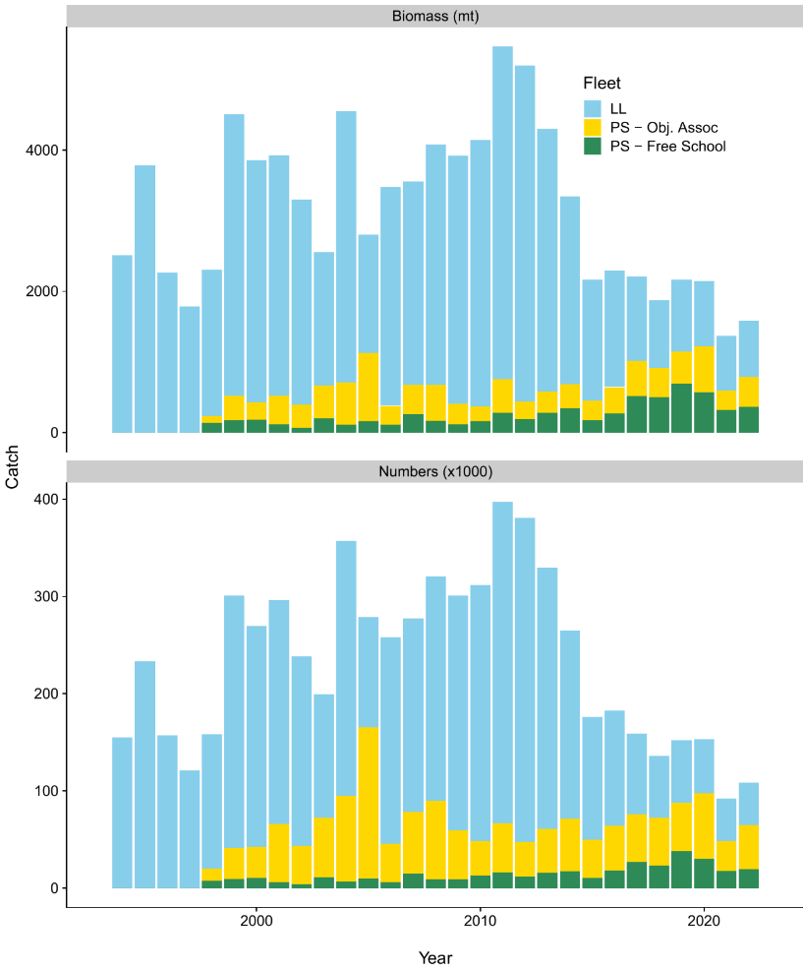
within 10 years
Figure FAL-01. Predicted retained catch by the fleet in biomass and numbers.

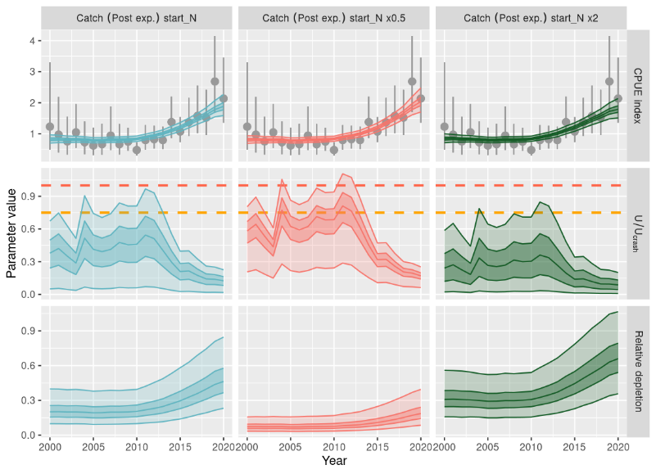

Figure FAL-02. Fitting of catch-per-unit-effort (CPUE) data using a dynamic surplus production model with independent model runs for each CPUE indices (dark shading, inter-quartile; light shading, 95% credible interval). Top row: Predicted CPUE with input CPUE (points) and observation error (interquartile range). Middle row: Time series of fishing mortality relative to the U_{Crash} (red) and U_{lim} = 0:75⋅U_{Crash} (orange) as estimated in the dynamic surplus production model. Bottom row: Estimated relative depletion (relative to unfished abundance K). The stock was not unfished in the first year of the time-series, and each column shows an alternative prior assumption about initial depletion.
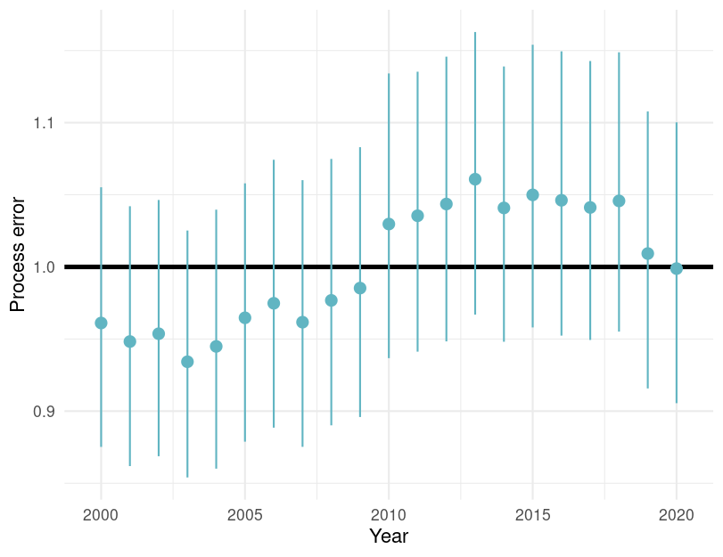

Figure FAL-03. Estimated process error by year with 95% credible intervals for the dynamic surplus production model for silky shark in the WCPO. Note this figure is not in the SC20-SA-WP-04 but is included here at the request of the SC20.

b. Stock Status

- The 2018 assessment for Silky shark showed high uncertainty, and SC14 concluded that the stock was not overfished, but subject to overfishing.

- There are no agreed reference points for sharks in the WCPFC. The 2024 model suggested that stock status has been improving since 2010. Recent (2019–2020) fishing mortality was estimated to be below biological reference points (U_{recent}/U_{crash}: 0.13 [95% credible interval 0.01–0.25]; the probability of U_{recent}/U_{crash} >1 was 0 and the probability of U_{recent}/U_{lim} >1 was 0) [Figure FAL-04, Table FAL-02]. Fishing mortality is estimated to have declined in recent years across all model types and appears to be below the levels that would preclude stock rebuilding and below the MSY reference point (according to the DSPM with intermediate assumption).

- According to these estimates, overfishing is very unlikely (< 10%) to be occurring relative to MSY-based reference points. However, abundance and depletion estimates were very uncertain, and SC20 considered the stock was about as likely as not (40-60 %) to be overfished relative to MSY-based reference points.

Table FAL-02. Estimates of management quantities (stock status as abundance N_{recent} relative to carrying capacity K), and fishing mortality (U) relative to indicators (U_{MSY}) and possible limit reference points U_{Lim}, U_{crash}). P(>RP) refers to the probability that the metric (status, fishing mortality) is above the respective indicator.
Summary: Silky shark
Year assessment conducted: 2024  Last year of data: 2020 | Biomass (abundance) | No agreed target or limit for sharks
Year assessment conducted: 2024  Last year of data: 2020 | Fishing mortality | Very Likely (>90%) to be below biological reference point: Overﬁshing is not occurring
Year assessment conducted: 2024  Last year of data: 2020 | Projection | No projections
Year assessment conducted: 2024  Last year of data: 2020 | Recommendation | Current mitigation measures do appear to be effective for silky sharks
Reference points |  | Estimate [5%–95% credible interval]
Abundance | - | -
Catch | - | -
Harvest rate  Harvest rate | U_{lim} (not agreed)  U_{crash} (not agreed) | 0.19 [0.09 – 0.38]  0.25 [0.16 – 0.48]
Recent estimates |  |  |  | Recent trend / projection
Total Depletion  Harvest rate | N_{recent}/K | 0.44 [0.10 – 0.96]  0.017 [0.0014 – 0.048] |  | Abundance increasing  F declining
Catch | C | 65 189 |  | Catch declining
Status |  |  | Likelihood
Harvest rate | U_{recent}/U_{lim} | 0.18 [0.02 – 0.34] | Very likely (<90%) to be
 |  |  | below limits
Harvest rate | U_{recent}/U_{crash} | 0.13 [0.01 – 0.25] | Very likely (>90%) to be
 |  |  | below limits
Projections
No projections

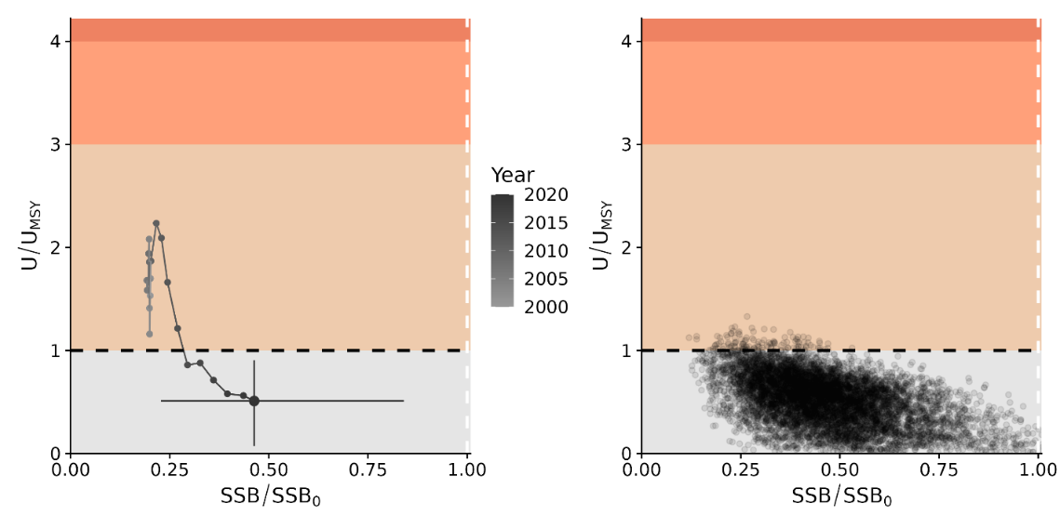 Figure FAL-04. Majuro plots for recent (2019–2020) stock status based on the dynamic surplus production model for silky shark in the WCPFC. Left-hand plots show the stock trajectory, with uncertainty shown for the most recent year in the analysis (2020). In contrast, the plot on the right-hand side shows individual draws from the posterior distribution(s) for recent (2019–2020) years.

- Management advice

- SC20 noted that due to challenges fitting the stock assessment models, no projections were provided to the SC, and recommended that if possible projections be included in future assessment reports.

- SC20 recommended interpreting the results of the silky shark stock assessment with caution due to the large amount of uncertainty in catch, stock structure, life history, and other important components of the assessment, but it noted that all of the models presented resulted in an improving trend in stock status for silky sharks.

- SC20 noted that further research is necessary to continue the improvement of this and other shark stock assessments and that current mitigation measures do appear to be effective for silky sharks.

    - Oceanic whitetip shark (Carcharhinus longimanus)

- SC20 noted that there are likely to be sufficient data and a sufficiently consistent signal in the different datasets, especially from longline, to conduct a stock assessment. SC20 recommended that a fully integrated assessment be attempted for phase II of this project.

- SC20 recommended a dual-track approach where a fully integrated model (e.g., Stock Synthesis) and a dynamic surplus production model are developed concurrently.

- If the agreed assessment approaches are unable to provide reliable stock status information or if the SC wants to gain a better understanding of the utility of risk assessment methods, SC20 recommended exploring a spatial risk assessment as part of the assessment development process. It is intended that this would be a separate project funded in 2026 if required.

    - North Pacific shortfin mako shark (Isurus oxyrinchus)

      - North Pacific shortfin mako shark stock assessment

- SC20 thanked the ISC SHARK WG for their thorough work conducted on the North Pacific shortfin mako shark stock assessment and acknowledged the significant improvement in the assessment due to the model ensemble approach.

- SC20 noted that the current assessment provides the best scientific information available on the North Pacific Ocean (NPO) shortfin mako shark (SMA) stock status. Results from this assessment should be considered with respect to the management objectives of the WCPFC and the IATTC, the organizations responsible for the management of pelagic sharks caught in international fisheries for tuna and tuna-like species in the Pacific Ocean. Target and limit reference points have not yet been established for pelagic sharks in the Pacific Ocean. In this assessment, stock status is reported in relation to maximum sustainable yield (MSY).

- SC20 noted that a Bayesian State-Space Surplus Production Model (BSPM) ensemble was used for this assessment; therefore, the reproductive capacity of this population was characterized using total depletion (D) rather than spawning abundance, which was used in the previous assessment. Total depletion is the total number of SMA divided by the unfished total number (i.e., carrying capacity). Recent D (D₂₀₁₉₋₂₀₂₂) was defined as the average depletion over the period 2019-2022. Exploitation rate (U) was used to describe the impact of fishing on this stock. The exploitation rate is the proportion of the SMA population that is removed by fishing. Recent U (U₂₀₁₈₋₂₀₂₁) is defined as the average U over the period 2018-2021. Note that the exploitation rate is defined relative to population carrying capacity.

- SC20 recognized that there continue to be a number of uncertainties with regard to NPO SMA, particularly related to population scale. The SC20 recommended that the ISC SHARKWG undertake a CKMR feasibility study in 2025-2026, to determine the magnitude of sampling that may be needed as well as a potential sampling strategy and any associated challenges, and report back to ISC26 and SC22.

      - Provision of scientific information to the Commission

- A summary of reference points and management quantities for the model ensemble is shown in Table NPSMA-01. A conceptual model developed for NPO SMA to organize an understanding of NPO SMA, identify plausible hypotheses for stock dynamics and fisheries structures, and to highlight key uncertainties is shown in Figure NPSMA-01. The time series of total annual catch by fishery is shown in Figure NPSMA-02. Standardized indices of relative abundance used in the stock assessment model ensemble are shown in Figure NPSMA-03, representing relative trends in abundance, provided by Japan, Chinese Taipei, and the U.S.A. Time series of estimated: depletion (D), exploitation rate (U), depletion relative to the depletion at maximum sustainable yield (D/D_{MSY}), exploitation rate relative to the exploitation rate that produces MSY (U/U_{MSY}), and total fishery removals (numbers) are shown in Figure NPSMA-04. The bivariate distribution of the average recent depletion relative to the depletion at MSY (D_{2019 – 2022}/D_{MSY}) against the average recent exploitation rate relative to the exploitation rate at MSY (U_{2018 – 2021}/U_{MSY}) is shown in Figure NPSMA-05. Stochastic stock projections of depletion relative to MSY (D/D_{MSY}) and catch (total removals) of NPO SMA from 2023 to 2032 are shown in Figure NPSMA-06.

a. Stock status and trends

- Within the modelled period, catch generally increased from ~50,000 individuals per year in 1994 to ~80,000 individuals per year in 2022 (~94,000 individuals per year, average 2018-2022; Figure NPSMA-02). Catches in the modelled period come predominantly from longline fisheries.

- During the 1994-2022 period, the median D of the model ensemble in the initial year 𝐷₁₉₉₄ was estimated to be 0.19 (95% CI: credible intervals = 0.08-0.44), and steadily improved over time and 𝐷₂₀₁₉₋₂₀₂₂ was 0.60 (95% CI = 0.23-1.00) (Table NPSMA-01 and Figure NPSMA-04). Although there are large uncertainties in the estimated population scale, the best available data for the stock assessment are four standardized abundance indices from the longline fisheries of Japan, Chinese Taipei, and the US; and all four indices indicate a substantial (>100%) increase in the population during the assessment period. The population was likely heavily impacted prior to the start of the modelled period (1994), after which it has been steadily recovering. It is hypothesized that the fishing impact prior to the modelled period was likely due to the high-seas drift gillnet fisheries operating from the late 1970s until it was banned in 1993, though specific impacts from this fishery on SMA are uncertain as species-specific catch data are not available for sharks. Consistent with the estimated trends in depletion, the exploitation rates were estimated to be gradually decreasing from 0.023 (95% CI = 0.004-0.09) in 1994 to the recently estimated exploitation rate (U₂₀₁₈₋₂₀₂₁) of 0.018 (95% CI = 0.004-0.07). The decreasing trends in estimated exploitation rates were likely due to the increase in estimated population size being greater than increases in the observed catch.

- The median of recent D (_{D2019−2022}) relative to the estimated D at MSY (D_{MSY} = 0.51, 95% CI = 0.40-0.70) was estimated to be 1.17 (95% CI = 0.46-1.92) (Table NPSMA-01 and Figure NPSMA-04). The recent median exploitation rate (𝑈₂₀₁₈₋₂₀₂₁) relative to the estimated exploitation rate at MSY (U_{MSY} = 0.05, 95% CI =0.03-0.09) was estimated to be 0.34 (95% CI = 0.07-1.20) (Table NPSMA-01 and Figure NPSMA-04). Surplus production models are a simplification of age-structured population dynamics and can produce biased results if this simplification masks important components of the age-structured dynamics (e.g., selectivity curves are dome-shaped or there is a long-time lag to maturity). Simulations suggest that under circumstances representative of the observed SMA fishery and population characteristics (e.g., dome-shaped index selectivity, long lag to maturity, and increasing indices), the BSPM ensemble may produce biased results. Representative simulations suggested that the D₂₀₁₉₋₂₀₂₂ estimate has a positive bias of approximately 7.3% (median). The trajectories of stock status from the model ensemble revealed that North Pacific SMA had experienced a high level of depletion prior to the start of the model and was likely overfished in the 1990s and 2000s, relative to MSY reference points.

- Based on these findings, the following information on the status of the NPO SMA is provided by the SC20:
- No biomass-based or fishing mortality-based limit or target reference points have been established for NPO SMA by the IATTC or WCPFC;
- Recent median D (D2019-2022) is estimated from the model ensemble to be 0.60 (95% CI = 0.23-1.00). The recent median D₂₀₁₉₋₂₀₂₂ was 1.17 times D_{MSY} (95% CI = 0.46-1.92) and the stock is likely (66% probability) not in an overfished condition relative to MSY-based reference points;
- Recent U (U₂₀₁₈₋₂₀₂₁) is estimated from the model ensemble to be 0.018 (95% CI = 0.004-0.07). U₂₀₁₈₋₂₀₂₁ was 0.34 times (95% CI = 0.07-1.20) U_{MSY} and overfishing of the stock is likely not occurring (95% probability) relative to MSY-based reference points;
- The model ensemble results show that there is a 65% joint probability that the North Pacific SMA stock is not in an overfished condition and that overfishing is not occurring relative to MSY-based reference points; and
- Several uncertainties may limit the interpretation of the assessment results including uncertainty in catch (historical and modelled period) and the biology and reproductive dynamics of the stock, and the lack of CPUE indices that fully index the stock.

b. Management advice and implications

- Stock projections of depletion and catch of North Pacific SMA from 2023 to 2032 were performed assuming four different harvest policies: 𝑈₂₀₁₈₋₂₀₂₁, 𝑈_{𝑀𝑆𝑌}, 𝑈₂₀₁₈₋₂₀₂₁ + 20%, and 𝑈₂₀₁₈₋₂₀₂₁ − 20% and evaluated relative to MSY-based reference points (Figure NPSMA-06).

- Based on these findings, the following conservation information is provided:
- Future projections in three of the four harvest scenarios (U₂₀₁₈₋₂₀₂₁ + 20%, and U₂₀₁₈₋₂₀₂₁ − 20%) showed that median D in the North Pacific Ocean will likely (>50% probability) increase; only the U_{MSY} harvest scenario led to a decrease in median D.
- Median estimated D of SMA in the North Pacific Ocean will likely (>50% probability) remain above D_{MSY} in the next 10 years for all scenarios except U_{MSY}; harvesting at U_{MSY} decreases D towards D_{MSY} (Figure NPSMA-06).
- Model projections using a surplus production model may oversimplify the age structured population dynamics and as a result could be overly optimistic.

Table NPSMA-01. Summary of reference points and management quantities for the model ensemble. Values in parentheses represent the 95% credible intervals when available. Note that exploitation rate is defined relative to the carrying capacity.
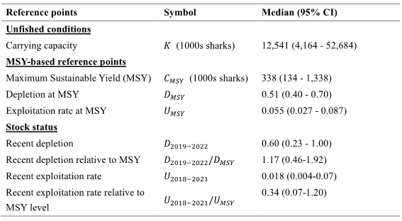

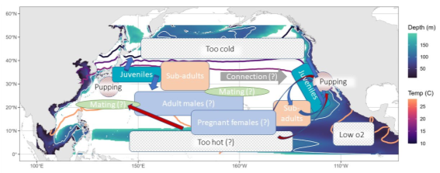
Figure NPSMA-01. Conceptual model for NPO SMA. Contour lines (warm colors) are shown for the average annual 10°, 15°, 18°, and 28°C sea surface temperature isotherms. Background shading (cooler colors) shows the depth of the oxygen minimum zone (3ml/L), a white isocline indicates a depth of 100m which could be limiting based on SMA vertical dive profiles.

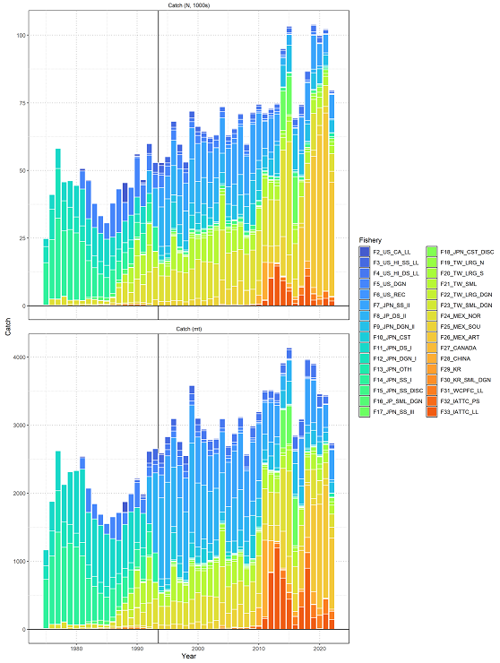

Figure NPSMA-02. Catch of North Pacific shortfin mako by fishery as assembled by the SHARK WORKING GROUP. Upper panel is catch in numbers (1000s) and lower panel is catch in biomass (mt). The vertical black line indicates the start of the assessment period in 1994.

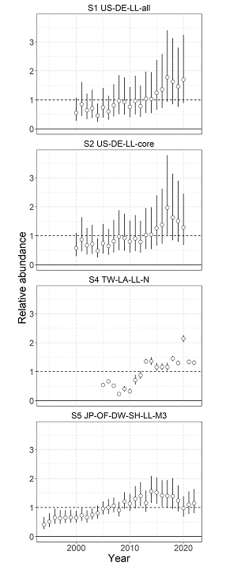
Figure NPSMA-03. Standardized indices of relative abundance used in the stock assessment model ensemble. Open circles show observed values (standardized to mean of 1; black horizontal line) and the vertical bars indicate the observation error (95% confidence interval).

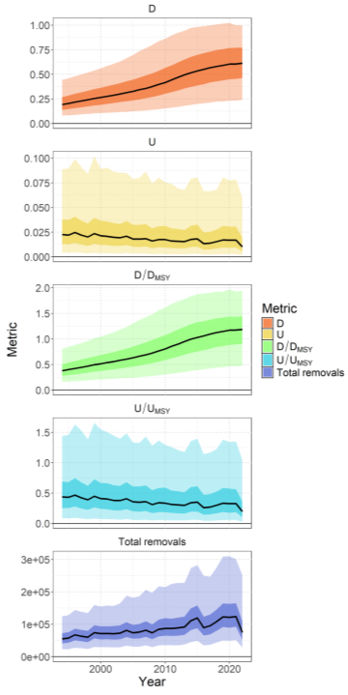
Figure NPSMA-04. Time series (solid lines) of estimated depletion (D), exploitation rate (U), depletion relative to the depletion at maximum sustainable yield (D/D_{MSY}), exploitation rate relative to the exploitation rate that produces MSY (U/U_{MSY}), and total fishery removals (numbers). Darker shading indicates a 50% credible interval, and lighter shading indicates a 95% credible interval.
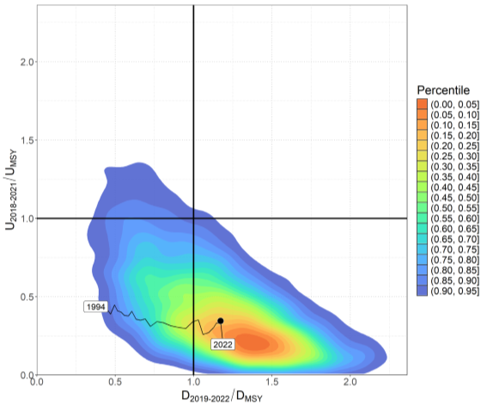
Figure NPSMA-05. Kobe plot showing the bivariate distribution (shaded polygon) average recent depletion relative to the depletion at MSY (D₂₀₁₉₋₂₀₂₂/D_{MSY} ) against the average recent exploitation rate relative to the exploitation rate at MSY (U₂₀₁₈₋₂₀₂₁/U_{MSY}). The median of this bivariate distribution is shown with the solid black point. The time series of annual D_{t}/D_{MSY} versus U_{t}/U_{MSY} is shown from 1994 to 2022.

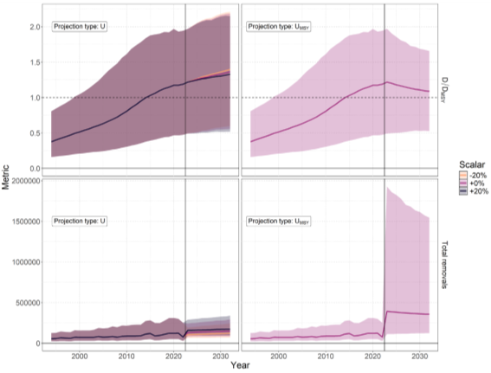

Figure NPSMA-06. Stochastic stock projections of depletion relative to MSY (𝑫/𝑫_{𝑴𝑺𝒀}) and catch (total removals) of North Pacific SMA from 2023 to 2032 were performed assuming four different harvest rate policies: U₂₀₁₈₋₂₀₂₁, U₂₀₁₈₋₂₀₂₁ + 𝟐𝟎%, U₂₀₁₈₋₂₀₂₁ −𝟐𝟎%, and U_{MSY}. The 95% credible interval around the projection is shown by the shaded polygon.

  - Projects and Requests

    - Stock Status and Management Advice Template (Project 113b)

- SC20 thanked the consultants for their work on Project 113b and agreed on the need for a standardized approach to reporting stock status and management advice from stock assessments for the work of the Commission and recommended it as a guideline.

- SC20 noted that the inconsistency in the current reporting of stock status and management advice, particularly regarding the communication of uncertainty, should be a significant concern for the Scientific Committee and its work.

- SC20 generally supported the recommendations for reporting stock status and management advice described in the SC20-SA-WP10 as outlined below.
- Rename sections of the Stock Status and Management Advice report to better reflect the content, ensuring consistency in section structures. This includes clearly defining elements such as assessment methodology, uncertainties, catch estimates, and management quantities.
- Use consistent language to describe uncertainties, including a summary of the main sources of uncertainty in the assessment and the associated degree of confidence
- Use IPCC likelihood categories with corresponding probability statements.
- Tabulate main sources of uncertainty in the assessment, including rationale, impact, and confidence level in a consistent manner across all stocks.
- Provide a consistent and user-friendly interface for accessing stock assessment reports such as a web-based reporting app..

- The report from the Informal Small Group (ISG-06) (Project 113b: Develop Stock Status and Management Advice Template for Consistent Reporting of Stock Assessment Outcomes, Uncertainties and Risk) is included in Attachment 2. Based on the results of ISG-06, SC20 agreed that the proposed template be used as a guideline for providing such information to SC21, noting that the decision to accept or request revisions to the report rests with the SC. A worked example using WCPO silky shark was provided to and approved by SC20. SC20 recommended the Commission review the template and advise, if necessary.

    - Application of Close-Kin-Mark-Recapture Methods (Project 100c)

- SC20 noted the demonstrated capacity of sampling teams now established throughout the region to achieve the updated target of 36,000-84,000 South Pacific albacore tissue samples over a three-year period and recommended the SSP consider exploring the possibility of the inclusion of CKMR data in future stock assessments for South Pacific albacore, including the analysis of financial as well as human resource requirement.

- SC20 recommended continuing to dedicate all relevant resources for capacity building workshops to support the understanding of the CKMR work on South Pacific albacore.

- SC20 recommended the SSP consider undertaking follow-up studies on South Pacific albacore including those that:
- incorporates finer-scale, structured sampling across the WCPO and further east in the EPO;
- considers the implication of the possible existence of multiple stocks on the CKMR work.
- combines empirical and modelled data from a variety of sources where available; and
- explores intrinsic and environmental mechanisms that might have caused the observed population structure.

    - Scoping study on longline effort creep in the WCPO (Project 122)

- SC20 recommended project 122a be given a no-cost extension to continue the scoping study on longline effort creep (projection 122) in conjunction with collaborations with other tRFMOs on longline CPUE standardization efforts, consistent with the CPUE project priority detailed in the Tuna Assessment Research Plan.

    - WCPFC Tuna Biological Sampling Plan (Project 117)

    - WCPFC Billfish Biological Sampling Plan (Project 118)

    - Research Plan Update

      - Tuna Assessment Research Plan (2023 - 2026) update

      - Billfish Research Plan (2023 - 2026) update

4.6.6.3 Review of the Shark Research Plan 2021-2030

- MANAGEMENT ISSUES THEME

  - Development of the WCPFC harvest strategy framework for key tuna species

    - Skipjack tuna

      - Skipjack tuna management procedure

- SC20 noted that the Interim Skipjack Management Procedure (CMM 2022-01) calls for the review of the performance of the Management Procedure in 2025 and that WCPFC20 noted that a re-evaluation of the skipjack estimation method may need to be undertaken prior to the next implementation of the MP. SC20 recommended that the SSP evaluate the following potential approaches to modify the estimation method for the WCPO skipjack interim MP, using the current OM grid and HCR, to evaluate whether the performance of the MP would change if the EM is revised, and report back to SC21 on outcomes and recommendations:
  - Modification of tropical CPUE abundance indices in the existing estimation method along the lines of the approach taken using unassociated set purse seine CPUE data by the 2022 stock assessment.
  - Further investigation of alternative stock assessment platforms and modelling approaches.

- SC20 recommended that the SSP provide the information presented in SC20-MI-WP-01 as well as outcomes from the discussions at SC20 to SMD for further discussion and consideration.

- SC20 further recommended that SC21 review the outputs from the re-evaluation and provide recommendations to WCPFC22 regarding the potential need to revise the current interim skipjack MP (CMM 2022-01).

      - Monitoring strategy for skipjack tuna

- SC20 requested that the SSP conduct the following analyses related to the monitoring strategy for skipjack:
  - Evaluate whether changes in the FAD closure duration (as adopted in CMM 2023-01) will affect the performance of the interim MP;
  - Representativeness and appropriateness of candidate CPUEs for use in MP.

- SC20 recommended that in years when an assessment is not conducted, the monitoring strategy could be reviewed by SC and feedback provided through the Online Discussion Forum.

- SC20 was invited to review the information provided in the Monitoring Strategy included in Table 1 of SC20-MI-WP-02, and to update the text in column 1 (SC) as appropriate. SC20 recommended the following modifications to Table 1 (Monitoring strategy for the skipjack Management Procedure):
  - Amend sub-paragraph a) of Element 1.a) (comparison of predicted MP performance against the latest stock assessment outcomes) to read “The performance of the MP in managing skipjack tuna to achieve defined objectives, including the TRP”.
  - Amend element 1.b) (Data availability to run the MP) to include a new comment for SC20: “The effect of changes made to the historical data is not known”.

- SC20 recommended the monitoring strategy be forwarded to the SMD, TCC and the Commission for their consideration.

    - South Pacific albacore tuna

      - Target reference points

- SC20 recognized that WCPFC20 adopted an interim TRP for South Pacific albacore, defined as 4% below the estimated average spawning potential depletion of the stock over the period 2017-2019 (0.96 SB2017- 2019/SBF=0). SC20 recommended the Commission note that the biomass depletion associated with the adopted interim TRP has been re-estimated to be 50% according to the 2024 SPA stock assessment outcomes. This biomass depletion when the interim TRP was adopted by WCPFC20 was previously estimated at 47% based on the 2021 SPA stock assessment

- SC20 recommended the SMD and the Commission consider results from the evaluation of a range of alternative candidate South Pacific albacore target reference points provided in SC20-MI-WP-03, in reviewing the interim TRP and other scenarios recommended by SC20.

- SC20 recommended that both catch numbers and weight be used for projections to inform the Commission discussion on reviewing the interim TRP for South Pacific albacore noting that projections conducted in terms of weight are more consistent with the MP evaluations and management through, for example, a TAC. SC20 further recommended that SSP present trends in vulnerable biomass among specific WCPFC-CA longline fleets, and for WCPFC-CA catch levels to also be related to 2017-2019 levels.

- SC20 recommended including more scenarios for projections by fixing EPO catch at 2017-2019 levels and using multiple catch levels in the WCPFC-CA related to 2017-2019 levels.

      - South Pacific albacore operating models

- SC20 adopted the operating model (OM) reference set, together with the proposed robustness set (Table 2, SC20-MI-WP-04), for the evaluation of candidate South Pacific albacore MPs.

- SC20 noted there are concerns about the range of uncertainty covered by the current operating model set. SC20 recommended that future work to elaborate the OM sets be conducted through the monitoring strategy and could include:
- development of scenarios for the impacts of climate change
- consideration of potential effects of effort creep and/or hyperstability in CPUE
- development of models that address uncertainties around stock structure to the robustness set.

- SC20 recommended that simulations be conducted to explore the implications of assuming a single stock OM when there could be multiple stocks. If ongoing genetics work confirms the presence of multiple-stocks and the simulations indicate that the single-stock assumption made in the OMs is problematic, then exceptional circumstances should be considered and the OM sets should be revised to account for multiple reproductive stocks in the South Pacific.

      - South Pacific albacore management procedure

- SC20 recommended that SSP focus primarily on the following two ASPM-derived estimators with a view to having a robust estimator, without obvious future data vulnerabilities:
- A direct biomass depletion approach using mean SB/SBF=0 of the last three years; and
- A ratio approach that uses Mean SB/SBF=0 of the last three year (same as in 1.a) relative to 2017-2019.

- SC20 noted that there was bias in estimation model performance at low predicted stock sizes. SC20 recommended that this bias be addressed through the design of the HCR and its significance or otherwise will be evaluated through evaluation of candidate MPs. Should the estimation model bias become problematic in the MP design context, then steps will need to be taken to address that issue.

- SC20 recommended that SSP conduct a Management Strategy Evaluation of a range of candidate MPs, using updated estimators together with HCR and maximum change metarule specifications similar to those presented at SC19 (SC19-MI-WP-06).

- SC20 recommended that SSP, in addition to running projections assuming a single baseline for all fisheries within the Management Procedure evaluations, explore the potential implications of using different reference periods for different fisheries and gears within the MP.

- SC20 recommended that EPO catches be assumed to remain constant at recent levels but with an exploration of a case where the EPO is subject to MP controls (in a similar way to SC20-MI-WP-03).

- SC20 noted that it was desirable to constrain the number of candidate MPs evaluated for consideration and recommended that steps be taken to manage this, including using one-off variations from a base-case scenario, rather than a full factorial grid of options.

- SC20 recommended that, to the extent possible, the results of the above candidate MP evaluations be provided to the SMD and the Commission for their consideration or decision.

      - Monitoring strategy for South Pacific albacore

5.1.2.5 Updates on South Pacific albacore roadmap IWG

    - Mixed fishery MSE framework

      - Target reference points for bigeye and yellowfin tuna

- SC20 recommended that the SSP include the following updates to SC20-MI-WP-07 for presentation to the Commission:
  - Update tables 2-7 with the equivalent depletion levels for South Pacific albacore based on the 2024 South Pacific albacore stock assessment;
  - Include additional columns in the evaluation of candidate TRPs for YFT and BET which provide the impact on vulnerable biomass within the tropical longline fishery and the southern longline fishery.

- SC20 recommended that the SMD and Commission take into account the analysis contained in SC20-MI-WP-07 including the following when considering target reference points for bigeye and yellowfin tuna:
  - Based on the 2023 stock assessment for yellowfin, the miscellaneous fisheries are estimated to account for approximately 37% of the impact on the spawning potential over the period 2016-2018 (see Table 5 of WCPFC20-2023-16), but recent catch for yellowfin is higher.
  - Based on the analysis in SC20-MI-WP-07, the CMM 2023-01 objectives for yellowfin and bigeye tuna cannot both be met simultaneously – if precisely achieved for one stock, the other will be above or below that level.

- SC20 recommended that an additional working paper be submitted to WCPFC21, which will include a re-evaluation of the candidate yellowfin and bigeye tuna TRPs using more recent fishing conditions for the domestic fisheries of Indonesia, Philippines, and Vietnam. The 2016-18 average catches are significantly lower than the recent fishing level, likely leading to a more optimistic projected stock status for yellowfin tuna.

      - Mixed fishery MSE framework update

    - Progress of the WCPFC Harvest Strategy Work Plan

5.2 Review of the effectiveness of CMM 2023-01

- ECOSYSTEM AND BYCATCH MITIGATION THEME

  - Ecosystem and Climate Indicators

    - Ecosystem and Climate Indicator Report Card

- SC20 noted the SSP’s progress towards implementing the SC19-endorsed Ecosystem and Climate Indicators Work Plan.

- SC20 noted the delay in the first expert workshop due to travel disruptions associated with the 2024 civil disturbances in New Caledonia.

- SC20 noted plans for the SSP to work with the WCPFC Secretariat to prepare for a November 2024 Climate Indicators Expert Workshop, which will include experts in physical and fisheries oceanography, climate and ecosystem science, ocean climate service providers, as well as WCPFC members with a background in climate and ecosystem science.

    - Research proposal

- SC20 noted the introduction of a Draft Climate Change Work Plan to guide the Commission’s efforts to address climate change impacts on WCPFC fisheries and a Draft Terms of Reference for a climate change risk assessment of active CMMs. SC20 acknowledged the work and consultative approach of co-leads on the Work Plan.

- SC20 recommended that, in the further development of the draft Climate Change Work Plan, an indication of the status of SC tasks and whether there are ongoing projects or activities that need to commence, along with the resources required, is added in a column, as well as details of expected outcomes and how these will inform the Commission’s decision-making process. This task will require support from the WCPFC Secretariat and an extension of the work plan to 2027.

- SC20 noted the uncertainties regarding data availability, the complexity and length of the CMM susceptibility assessment, and the resources available to the Secretariat, SSP, and Commission Subsidiary Bodies to undertake this work.

- SC20 encouraged future discussions at the SC and TCC to clarify expected outcomes, resourcing requirements, and the value of this work in informing the Commission.

- SC20 requested that the TORs in Attachment B in SC20-EB-WP-02 be further refined, including by incorporating indigenous and traditional knowledge as a valuable source of information.

  - FAD impacts

    - Research on non-entangling and biodegradable FADs

- SC20 supported the ongoing research activities undertaken by SSP, ISSF, and industry partners, under WCPFC Project 110, 110a, and NOAA, and noted that complete results are expected to be available by SC22.

- SC20 noted that 430 non-entangling and biodegradable jelly-FADs were constructed (and 286 deployed), and noted that drift speed, tuna aggregation patterns, and tuna catch was similar between non-entangling and biodegradable FADs and conventional FADs, in the Project 110 and other EPO trials, while further standardization of data may be warranted given the preference of the fishers for traditional FADs over the biodegradable jelly-FADs.

- SC20 recommended that more research be conducted on designs and materials available for non-entangling and biodegradable FADs.

- SC20 encouraged fishing fleets to join experimental trials on biodegradable FADs and to share results at future SCs, including information regarding interactions with Species of Special Interest (SSI).

- SC20 noted that FADs strand on the shores of Pacific Island Countries and Territories, and that options for on-land and at-sea recovery programmes, including FAD Watch, be discussed at future SCs.

    - Updates on FAD Management Options IWG

- SC20 noted the priority tasks for the FADMO-IWG are technical, complex and interconnected and SC20 further supported the suggestion of the FADMO-IWG on physical meeting of the FADMO-IWG in 2025 back-to-back with TCC to reduce meeting cost.

- SC20 suggested prioritizing work on i) requirements for the transmission of satellite buoy data; ii) developing a WCPFC FAD logbook; and iii) FAD recovery program/strategies.

- SC20 requested the FADMO-IWG to further discuss issues related to i) buoy deactivation scenarios; ii) submission deadline for historical data gaps on FAD buoy data transmission; iii) harmonization with existing IATTC logbook and PNA logbook; and iv) incentivizing the use of biodegradable FADs.

  - Bycatch management

    - Bycatch Management Information System

6.3.2 Bycatch Assessment and Management

  - Sharks

    - Estimating the impact of fishing on sharks (Project 116)

- SC20 agreed that SC shall continue to review the impact of fishing gear on non-retained sharks, including oceanic whitetip shark (OCS) and silky shark (FAL), inside and outside of the area between 20°N and 20°S, and provide advice on potential mitigation measures that would benefit such shark species.

- SC20 noted that the EU (Spanish) fleet has a shallow-set longline fishery that targets swordfish, particularly to the south of 20°S area. SC20 recommended that interaction data from the EU fleet should be included when reviewing the impact of fishing gear on non-retained sharks.

- SC20 recommended using the estimation procedures of Peatman and Nicol (2020, 2023) to stratify catches of OCS and FAL to the north of 20°N, 20°N-20°S and south 20°S for comparison with estimates from nominal CPUE presented in SC20-EB-WP-05. SC20 agreed that this alternative estimation procedure would provide catches in areas in order to assess requirements for additional spatial management measures.

- If an analysis of impact is desired for a latitudinal extension of CMM 2022-04, this may:
  - Use the anticipated 2025 OCS assessment and the variety of structural hypotheses; and
  - Update the projections (Rice et al. 2021, Bigelow et al. 2022) to assess the impacts and future fishing mortality on recovery timelines, using catches from 20°N-20°S with mitigation (CMM 2022-04) and catches from the north of 20°N and south 20°S with and without mitigation.

  - Seabirds

    - Review of seabird research

- SC20 noted that at least eight albatross species that breed in New Zealand show significant, long-term, and ongoing population declines, which, for some, are most likely caused by bycatch in commercial pelagic longline fisheries.

- SC20 noted key areas of importance for albatrosses and petrels vulnerable to bycatch in the Southern Hemisphere, including in areas with reduced (25°-30°S) or no bycatch mitigation requirements (20°-25°S).

- SC20 noted substantial spatiotemporal overlap of Antipodean and Gibson’s albatross with pelagic longline fishing effort and that overlap probability increases at lower latitudes.

- SC20 noted that studies (SC20-EB-IP-26) suggest that the Antipodean Albatross are at risk of extinction if the current rate of decline continues and is predicted to become extinct around 2070.

    - Review of CMM on seabirds (CMM 2018-03)

- SC20 thanked New Zealand for leading a comprehensive intersessional review of CMM 2018-03.

- SC20 noted the summary of the informal intersessional review process of CMM-2018-03 in SC20-EB-WP-06, highlighting:
- The relatively high effectiveness of combining tori lines, branch line weighting, and night setting.
- The high effectiveness of hook-shielding devices as a stand-alone seabird bycatch mitigation option.
- The effectiveness of underwater bait setters (which set hooks at a predetermined depth) as a stand-alone seabird bycatch mitigation option.
- The limited evidence for the effectiveness of deep-setting line shooters, blue-dyed bait, and offal discharge management.
- The effectiveness of branch line weighting may be improved through modification of the current specifications in CMM 2018-03.

- Some CCMs supported, but other CCMs expressed concern about the suggested recommendations 1-16 in paper SC20-EB-WP-06 for the revision of CMM 2018-03.

- SC20 highlighted the importance of technical, practical, and human safety considerations for the implementation of bycatch mitigation methods. SC20 noted the Commission could make special considerations for fisheries that demonstrate low interaction rates.

- SC20 recommended that TCC20 further consider the suggested recommendations in SC20-EB-WP-06 in terms of technical, practical, and safety aspects and TCC20 provides advice to the Commission to improve the effectiveness of CMM 2018-03.

  - Sea turtles

    - Review of sea turtle research

    - Review of Conservation and Management of Sea Turtles (CMM 2018-04)

  - Cetaceans

- SC20 thanked US and Korea for presenting a draft CMM to recommend that WCPFC21 amend the Conservation and Management Measure for the Protection of Cetaceans (CMM 2011-03) to expand information collection for cetacean interaction and to prohibit the retention, transhipment, or landing of any cetacean on longline vessels. This proposal aims to improve the understanding of fisheries impacts on cetacean populations in the WCPO and SC20 encouraged interested CCMs to provide their suggestions to the proponent for further consideration of the CMM.

  - Deep-sea mining

- SC20 adopted the following recommendations:
- SC20 noted that International Seabed Authority (ISA) activities in the Pacific Ocean region overlap with the WCPFC Convention Area.
- SC20 noted the planned activities by the ISA in the Northwest Pacific toward deep sea exploration and the ongoing deep sea exploration activities in the Clarion-Clipperton Zone (CCZ).
- SC20 also noted the present uncertainties around direct or indirect interactions between deep-sea mining activities and commercial fisheries for pelagic species.
- SC20 recommended that the Commission task the Secretariat to engage with a broad range of stakeholders to gain awareness and understanding of deep seabed mining activities and their potential direct or indirect impact on tuna fisheries in the WCPFC Convention Area.
- SC20 noted the Commission could consider tasking the WCPFC Secretariat to apply for observer status to the ISA.

- OTHER RESEARCH PROJECTS

  - Pacific Marine Specimen Bank (Project 35b)

- SC20 endorsed the following recommendations from the PMSB Steering Committee:
- Continue to support initiatives to increase rates of observer biological sampling, noting that this contribution is essential to the ongoing success of the WCPFC’s work;
- Incorporate the identified PMSB budget into the 2025 budget and the 2026 indicative budget, as the development of the WCPFC PMSB is intended to be ongoing and is considered essential;
- Endorse change for Project 35b to report on the 12 months of the civil year (Jan-Dec) preceding SC, instead of reporting on the 12 months before SC (July-June), which would allow the provision of better-quality data in the SC report; and
- Endorse that the work plan in section 3 of the Steering Committee report (SC20-RP-P35b-02) be pursued by the scientific services provider, in addition to standard duties associated with the maintenance and operation of the WCPFC PMSB in 2024-2025.

  - Pacific Tuna Tagging Project (Project 42)

- SC20 noted the critical importance of effective tag-seeding for informing stock assessment and support the increased deployment and fleet coverage of tag-seeding experiments through regional and national observer programmes, and the need for member participation and support in tag reporting as both wild and seeded tags continue to be found throughout the fishery.

- SC20 noted and supported the ongoing regional fisheries research vessel project.

- SC20 supported the PTTP work plan for 2024-2027, and indicative budget presented

  - West Pacific East Asia Project

- SC20 noted the successful completion of the WPEA-ITM project and the beginning of the next phase of this work – the WPEA-SPF project.

  - Japan Trust Fund activities

7.5 Other Projects

- COOPERATION WITH OTHER ORGANISATIONS

- SPECIAL REQUIREMENTS OF DEVELOPING STATES AND PARTICIPATING TERRITORIES

- FUTURE WORK PROGRAM AND BUDGET

10.1 Development of the 2025 work program and budget, and projection of 2026-2027 provisional work program and indicative budget

- After a ranking process by CCMs, based on the process for project scoring agreed by SC17, SC20 recommended the proposed work program and budget for 2025– 2027 together with CCM’s priority scores to the budgeted projects in Table WP-01 (below) to the Commission.

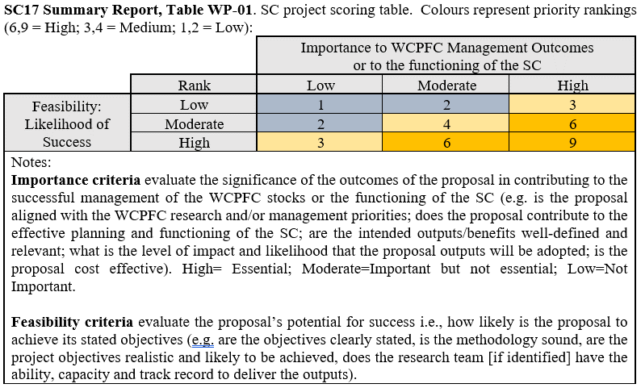

Table WP-01. Recommended Future Work Program and Budget for 2025 – 20267 with CCMs’ priority scores (reference: SC20-GN-WP-06a; New project ID P20Xi represents an arbitrary Project ID number proposed by SC20).
No. | Project Title | 2024 | 2025 | 2026 | 2027 | Notes | Tasks | Score
 | Sub-item 1. Scientific services
 | SSP scientific services |  | 1,020,749 | 1,041,164 | 1,061,987 | Budget: 2% annual increase | Essential
 | Sub-item 2. Scientific research
 | SSP Additional resourcing |  | 183,808 | 187,484 | 191,234 | Budget: 2% annual increase  TOR: MFCL work | Essential
 | SSP FIRST additional stock assessment scientist |  | 168,300 | 171,666 | 175,099 | Budget: 2% annual increase | Essential
1 | P35b. WCPFC Pacific Marine Specimen Bank |  | 109,520 | 111,711 | 113,945 | Responsibility: SSP  Budget: 2% annual increase | Essential
2 | P42. Pacific Tuna Tagging Program |  | 875,000 | 950,000 | 950,000 | Responsibility: SSP | Essential
3 | P68. Seabird mortality |  |  | 30,000 |  | Responsibility: SSP  No budget request for 2025 | No scoring
4 | P100c. Preparing WCP tuna fisheries for application of CKMR methods to resolve key SA uncertainties. (Duration: 2023 - 2025) |  |  |  |  | Responsibility: SSP  Funding: SSP, EU, IATTC and CSIRO; WCPFC18 approved matching fund | No scoring
5 | P110a: Terms of Reference for a project to support additional work on trialling and supporting the development of non-entangling and biodegradable FADs in the WCPO |  |  |  |  | Responsibility: SSP  Funded by EU, ISSF, and US matching fund | No scoring
6 | P117. WCPFC tuna biological sampling plan |  |  |  |  | Responsibility: SSP  SSP complementary project | No scoring
7 | P118. WCPFC billfish biological sampling plan |  |  |  |  | Responsibility: SSP  SSP complementary project | No scoring
8 | P120. Updated reproductive biology of tropical tunas |  |  |  |  | Responsibility: SSP  Funded by EU and WCPFC’s matching fund | No scoring
9 | P122. Scoping study on longline effort creep in the WCPO |  |  |  |  | No cost extension, rolled into CPUE research priority as part of Tuna Assessment Research Plan (below) | No scoring
10 | P122a. Extending the scoping study on longline effort creep in the WCPO to enable cross-tuna RFMO collaboration and broader discussion on CPUE abundance index development |  |  |  |  | Responsibility: SSP  No cost extension of Project 122 with an expanded scope of work to the end of 2025 as part of Tuna Assessment Research Plan CPUE priority. | No scoring
11 | P90. Length-weight conversion |  | 20,000 |  |  | Responsibility: SSP  (Ongoing) | Priority ranking | 6.29
12 | P114. Improved coverage of cannery receipt data for WCPFC scientific work |  | 35,000 |  |  | Responsibility: SSP | Priority ranking | 4.92
13 | P121. Ecosystem and Climate Indicators |  | 20,000 | 15,000 | 15,000 | Responsibility: SSP (Ongoing) | Priority ranking | 7.13
14 | P123. Scoping the next generation of tuna stock assessment software |  | 50,000 | 50,000 |  | Responsibility: SSP (Ongoing) | Priority ranking | 7.75
15 | P124. Oceanic whitetip assessment in the WCPO (2024-2025) |  | 80,000 |  |  | Responsibility: SSP (Ongoing) | Priority ranking | 7.27
16 | P20X01. New Zealand albacore troll fishery catch sampling |  | 85,000 | 85,000 | 85,000 | Submitted by NZ  Responsibility: SSP | Priority ranking | 4.71
17 | P20X02. Fishery characterisation of manta and mobulid rays and whale sharks |  | 60,000 |  |  | Submitted by the SRP  Responsibility: SSP | Priority ranking | 5.04
18 | P20X03. Assessment approaches for WCPO black marlin, sailfish and shortbill spearfish |  | 40,000 |  |  | Submitted by the BRP  Responsibility: SSP | Priority ranking | 5.17
19 | P20X04. Biology of South Pacific striped marlin, blue marlin, black marlin, shortbill spearfish and sailfish in the WCPO from longline fisheries. |  | 40,000 | 40,000 | 40,000 | Submitted by the BRP  Responsibility: SSP | Priority ranking | 6.00
20 | P20X05. Developing a statistically robust and spatial/temporal optimized sampling strategy for biological data collection – consider ISC’s approach |  | 40,000 |  |  | Submitted by the SRP  Responsibility: SSP | Priority ranking | 6.00
21 | P20X06. Fishery characterisation and CPUE analysis of thresher and hammerhead sharks in the WCPO |  | 60,000 |  |  | Submitted by the SRP  Responsibility: SSP | Priority ranking | 4.67
22 | P20X07. Review and reconciliation of size data collected in the WCPFC-CA for assessment purposes |  | 50,000 |  |  | Submitted by the TARP  Responsibility: SSP | Priority ranking | 6.54
23 | P20X08. Understanding connectivity of the yellowfin and skipjack stocks in the Western Pacific and East Asia region with the WCPFC Convention Area |  | 60,000 |  |  | Submitted by IDN, PHL, and VNM  Responsibility: IDN, PHL, VNM | Priority ranking | 5.92
 | Total Sub-item 2. | 1,656,577 | 1,976,628 | 1,640,861 | 1,570,278
 | Total SC budget (Sub-items 1+2) | 2,657,311 | 2,997,377 | 2,682,025 | 2,632,265

- ADMINISTRATIVE MATTERS

  - Future operation of the Scientific Committee

- SC20 encouraged CCMs who were able to do so to submit their scientific data before the annual deadline of 30 April.

- SC20 recommended that the EB theme agenda rotate to prioritize the review of cetaceans and elasmobranchs during SC21 and sea turtles and seabirds during SC22. Additional SC review of certain taxa may be based on Commission request or review frequency within CMMs. SC20 recommended that further decisions on the EB theme agenda be taken during SC22.

- SC20 recommended that guidance on the submission of papers to the Scientific Committee, as agreed at SC3 (Attachment S of SC3 Summary Report) be updated to include the following:
- Paper titles and a preliminary abstract should be submitted to the Secretariat, SC Theme Convenors, and the SC Chair 50 days prior to the start of regular meetings of the Scientific Committee.
- Full papers should be submitted to the Secretariat, SC Theme Convenors and the SC Chair 30 days prior to the start of regular meetings of the Scientific Committee. Certain papers from the SSP may, when necessary, be submitted 18 days in advance of the start of the meeting to allow them to be available on the website two weeks before the commencement of the meeting.
- As a general rule, working papers will be submitted by CCMs, the Secretariat, and the SSP. Observers may submit information papers unless invited by the Secretariat, SC Theme Convenors, or the SC Chair to present a working paper.

- SC20 recommended that the Secretariat work with SC Theme Convenors and the SC Chair to develop a process to submit all papers and project proposals through the WCPFC website, to further streamline the submission process and allow for greater organization and tracking of submissions, for implementation in advance of SC21.

- SC20 recommended that the Secretariat work with SC Theme Convenors and the SC Chair to update the guidelines for the SC Chair and Theme Convenors (SC13-GN-IP-03) to clarify criteria for theme convenors to consider papers submitted to the Scientific Committee.

- SC20 recommended that the template for the project proposals for SC projects, as agreed in Table 3 in Attachment K of the SC9 Summary Report, be updated to include information on the WCPFC Data sets required to support the project, as well as notes from WCPFC SSP on feasibility to provide WCPFC data in the format requested, when possible.

- SC20 recommended that the updated guidance on the submission of papers to the SC, the template for project proposals for SC projects, and the updated guidelines for the SC Chair and Theme Convenors be combined as overall Guidelines for Paper Submissions and Operations of the SC and circulated for review and adoption at SC21. SC20 further recommended that, once adopted, the Guidelines for Paper Submissions and Operations of SC should be posted to the Key Documents section of the WCPFC website.

- SC20 recommended that the Commission revert back to the 8-day meeting schedule for SC21 in the event that the Commission does not decide to convene a Science Management Dialogue in 2025. SC20 recommended that the Commission maintain the current 7-day meeting schedule for SC21 in the event that the Commission decides to convene a Science Management Dialogue in 2025. The length of future SC meetings should be further considered following the meeting schedule for SC21, particularly considering the workload for subsequent SC meetings.

- SC20 noted the high workload required to revise CMMs, and hence recommended bycatch measures to be reviewed in a cycle similar to the process for stock assessments, to ensure that there is appropriate time between a measure being adopted and being able to assess the impacts of the measure.

  - Election of Officers

- The SC Chair noted that MI Theme Convenors could be appointed intersessionally, while any nominations for Vice-Chair would be deferred until WCPFC21.

  - Next meeting

- SC20 confirmed that SC21 in 2025 would be held in the Kingdom of Tonga, with the meeting dates to be finalized at WCPFC21. The Federated States of Micronesia offered to host SC22 in 2026.

- OTHER MATTERS

- ADOPTION OF THE SUMMARY REPORT OF THE TWENTIETH REGULAR SESSION OF THE SCIENTIFIC COMMITTEE

- CLOSE OF MEETING

Attachment 1

The Commission for the Conservation and Management of
Highly Migratory Fish Stocks in the Western and Central Pacific Ocean
SCIENTIFIC COMMITTEE
TWENTIETH REGULAR SESSION
Manila, Philippines
14 – 21 August 2024
Report from ISG-09
Project 123 - Scoping the next generation of tuna stock assessment software

An informal small group 9 (ISG-09) met during the course of SC20 to review SC20-SA-WP-01 Scoping the next generation of tuna stock assessment software). There were ten options of possible tasks for SSP to prioritize subject to SC advice and funding approvals by WCPFC based on the presentation of SC20-SA-WP-01.

- Move the swordfish assessment to Stock Synthesis: relatively simple compared to other SSP assessments
- Move the next striped marlin assessment to Stock Synthesis: also relatively simple
- Explore Casal/Gadget/Stock Synthesis/sbt models for SP albacore: simpler than the other tuna species
- Explore Casal/Gadget/Stock Synthesis models for original five-region yellowfin data test capabilities of platforms: regions, tags, large number of fisheries
- Explore a variety of models for a simplified single-region yellowfin tuna dataset: ALSCL, Casal, Gadget, MFCL, sbt, Stock Synthesis, WHAM + Length
- ALSCL + Fleets: Fan Zhang (Shanghai Ocean University) and Nick Davies (SSP consultant)
- Stock Synthesis + Enhanced Tags: Nicholas Ducharme-Barth, Matthew Vincent (NOAA), and Arni Magnusson (SSP)
- WHAM + Length: Giancarlo Correa (AZTI) and Arni Magnusson (SSP)
- SAM + Length: Anders Nielsen (DTU), Colin Millar (ICES), and Arni Magnusson (SSP)
- Initial explorations using RTMB: Nick Davies (SSP consultant) and Arni Magnusson (SSP)

Member comments are as follows:

We thank Arni for his comprehensive overview of the items to be prioritized. The U.S. recommends prioritizing items 1, 2, and 5 in the agenda, emphasizing their immediate relevance and impact. For item 5, we suggest building on insights from the recent study by Goethel et al., which introduces a valuable simulation framework that could enhance discussions and decisions.

In principle, we support the idea of developing a new software from a scientific point of view and acknowledge its potential future benefits, we do not support prioritizing development of a new software at the moment due to the existing workload challenges faced by the SSP. This concern is heightened by the fact that, despite recommending two new assessment positions last year, only one was funded, further straining resources. We believe it is crucial to manage current tasks efficiently and suggest revisiting the software development idea when resources and capacity allow. Our strategic focus should remain on addressing the most critical and time-sensitive issues to ensure the successful completion of high-priority tasks, such as stock assessment and MSE work.

Are you going to establish one software for all species, or species specific? Will you develop criteria for the final software used? We prefer a software that is already in international application and familiar with scientists from all CCMs so that they can participate in future discussions.

Arni (SSP): Sensible goal would be to develop a new software that can handle the most complex, and then it could be used for the simpler assessments. This will take years. The development will take years and may benefit from testing many other assessment platforms with the goal of developing a tuna assessment platform.

Support prioritizing 1, 2 and 5 given time and capacity. Should focus on practical tasks. Assessments, MSE and CKMR. Migration to existing software such as stock synthesis may be the more reasonable way forward as this software is already used by many. CAPAM 2019 workshop participants recognized that MFCL has a clear advantage for tagging data. It will be very important to communicate this to the team developing the next generation model.

Arni (SSP): SSP would like to explore the use of stock synthesis. Currently a tagging module is problematic. Item 7 proposes lifting the tagging module from MFCL and moving it into Stock Synthesis. I agree that the next-gen platform may take more time to develop than MFCL will last and we may need this interim step.

Questions about the longevity of SS, are we postponing the problem by moving to stock synthesis. See merits of 1 and 2 on the basis of sex-structure since it can do this better. Not sure of the rationale of some of these other models proposed. What features do they have? Concerned with bespokeness of CCSBT model. Need to be careful for this interim model. Supportive of the tuna RFMO model as a medium to long term goal. Short term goals need to be considered on an assessment specific basis.

Arni (SSP): There may not need to be an interim period for the more complex assessments pending the development of a next gen platform. MFCL has been tailored for WCPFC assessment needs and may do better than any other platform. Does there need to be an interim? Would be nice if future platforms would arise quickly. On CCSBT model, this is not open source at the moment. As explained by Darcy it is implemented as a package and the data is included in the package. Maybe this could be tested if it became available. And there may be important features such as CKMR that could be lifted for a next generation.

It is correct that CCSBT is not publicly available but that is subject to discussion. There is only a single region and no plans to extend this functionality. The way the fisheries are configured is very fixed. There is no flexibility. Would take a lot of modification but no reason that you could use key parts of the code.

Going back to Stock Synthesis. What is the sunset situation for Stock Synthesis, how does this relate to the FIMS package development?

Item 7 would be our 4th priority after 1, 2 and 5. We view the potential risk from having to transition from Stock Synthesis to be low as there is a succession plan in place and there would be a large community of Stock Synthesis users, including on other tuna RFMOs, making a similar transition.

From SC20-SA-WP-01, the work plan for years 2025 and 2026 (subject to SC advice and funding approvals by WCPFC) is as follows.

1) Explore and compare existing platforms, fitting to SSP tuna data.
2) Determine which platforms can be considered viable candidates.
3) If a viable candidate platform has been identified, plan transition.
4) If no viable candidate platform is identified, launch a software development project to extend a platform or create a new one.

With regard to items 1 to 3 in the work plan, one member prioritized tasks 1 ( Move the swordfish assessment to Stock Synthesis), 2 (Move the next striped marlin assessment to Stock Synthesis), 5 ( Explore a variety of models for a simplified single-region yellowfin tuna dataset) with a lower priority for 7 (Stock Synthesis + Enhanced Tags). Another member prioritized tasks 1, 2 and 5. Conceptional items related to task 10 (Initial explorations using RTMB) were discussed, although there was no prioritization of task 10 by ISG-09.

The conclusion of the ISG-09 discussion was that some members offered a prioritization. The year 2025 worksplan outlined in SC20-SA-WP-01 seems appropriate: 1) Explore and compare existing platforms, fitting to SSP tuna data, 2) Determine which platforms can be considered viable candidate and 3) If a viable candidate platform has been identified, plan transition.

Attachment 2

The Commission for the Conservation and Management of
Highly Migratory Fish Stocks in the Western and Central Pacific Ocean
SCIENTIFIC COMMITTEE
TWENTIETH REGULAR SESSION
Manila, Philippines
14 – 21 August 2024
Report from ISG-06: Project 113b - Stock Status and Management Advice Template

An informal small group 6 (ISG-06) met during the course of SC20 to review SC20-SA-WP-10.
- Philipp Neubauer from Dragonfly presented a report on the WCPC SC status and management advice template (Project 113b) and described in detail all the components from the proposed template.
- This report included multiple recommendations discussed by various CCMs and is accompanied by an updated template for SC to adopt.

Day 1 (Friday - August 16)

- Australia and FFA suggested splitting sections in the report for clarity, particularly separating objective information from management advice.
- The United States highlighted the importance of maintaining the split between sections to avoid confusion, especially concerning the quantification of uncertainty.
- There was a general agreement on maintaining objective information and management advice in separate sections to ensure clarity and coherence.
- Suggestions were made to have corresponding paragraphs for figures and tables, explaining the main points concisely.
- A proposal was made to take an assessment, apply the discussed approach, and review the results next year at SC21.
- Another session was suggested to discuss the recommendations further and finalize the report structure. The group agreed to schedule another ISG for the following day (Saturday).

Day 2 (Saturday - August 17th)

- Phil provided a detailed template for discussion, which precisely separates stock status statements from management advice.
- He suggested structuring the report into three sections: stock assessment and trends, stock status, and management advice.
- The discussion highlighted that template should include:
  - A summary table of main uncertainties in the assessment.
  - A summary table of stock status, with a brief overview, presented separately from the management advice section.

Paragraphs should describe:

  - Stock structure and rationale.
  - Key uncertainties and how the assessment dealt with them.
  - Annual catch estimates, trends, and diagnostic model trends.
  - Comparisons between the current and previous assessments highlighting the differences.
  - Depletion and biomass trends.

- Japan suggested including a brief paragraph on the diagnostics of the diagnostic model before diving into trends, emphasizing that detailed explanations should go into the main body of the stock assessment report.
- Discussions included how to better represent uncertainties, particularly the spatial assumptions.
- Confidence levels in the table should reflect whether uncertainties have been adequately addressed in the model.

Table Additions:

- The proposed tables for stock assessment and management advice sections were reviewed, focusing on a clear presentation of key data and associated uncertainties.
- Japan requested clarification on how uncertainties would be represented, especially in Figures 7 and 8. Phil clarified that the plots would show uncertainty along both axes and that major sources of uncertainty would be included.

Recommendations:

- SC20 advice should use this template where practicable.
- Ask the SC to adopt the template provided for stock assessments from SC21 wherever practicable.

Stock assessment and trends

Paragraphs (link to Figures)
            - Describe the assessment structure and rationale (Fig 1, Table 1)
            - Describe the main uncertainties considered (Table 2)
            - Describe annual catch estimates and trends (Figure 2)
            - Describe CPUE trends and other indicators of biomass trends (Figure 3)
            - Describe trends in a diagnostic model, including recruitment, spawning potential, and fishing mortality, as well as performance against diagnostics (Figures 4-6)
            - Describe the depletion of spawning stock biomass and associated uncertainty (Figure 7)
            - Describe stock assessment results compared to the previous assessment

Table 1. Assessment structure, including key ﬁsheries and catch proportions. No deﬁned format to accommodate alternative assessment methods.
Table 2. Summary of main sources of uncertainty in the assessment, with a degree of conﬁdence assigned to each aspect of the assessment and potential source of uncertainty.
Figure 1. Spatial structure used in the 20XX stock assessment model
Figure 2. Time series of total annual catch (1000's mt) by fishing gear over the full assessment period
Figure 3. Time series of CPUE and/or other main abundance indices
Figure 4. Estimated annual average recruitment by model region for the diagnostic case model, including estimation uncertainty.
Figure 5. Estimated annual average spawning potential by model region for diagnostic case model, including estimation uncertainty.
Figure 6. Estimated annual average juvenile and adult fishing mortality for the diagnostic case model, including estimation uncertainty.
Figure 7. Plot showing the trajectories of spawning biomass and spawning biomass depletion (of spawning potential) by region, including uncertainty arising from estimation, structural, and intrinsic uncertainties (variability and process error).

Table 2 Example: Assessment configuration and sources of uncertainty.
Source | Type | Rationale | Uncertainty | Impact | Confidence**
Data | CPUE | Best available spatio-temporally standardised Index | Low availability of gear configuration impacting catchability | Potential hyperstability, leading to over-estimating current biomass | Medium
Data | Catch | Best available information | Reporting, early catch | Early catch probably less impactful now; total magnitude will impact productivity estimates | High
Model | MULTIFAN-CL | Standard tuna model in WCPFC | Low, benchmark tested | Single model used for inference | High
Spatial assumptions | 9 Regions | Most parsimonious given available tags, alternative spatial configurations difficult to test | Not considered | Potentially important, not quantified, impact unknown | Low
Key parameter uncertainty | M | Estimable given trend | Estimated | Impacts estimation uncertainty | Medium
Key parameter uncertainty | steepness | Not estimable in present model | Grid (VALUES) | Impacts overall structural uncertainty | High
Structural uncertainties (model configurations) | Process error | Recruitment variability, time-varying selectivity | Estimated | Potential to over-fit selectivities, bias other parameter estimates | Medium
Structural uncertainties (model configurations) | Movement | Best estimates from tag data | Estimated, grid over assumed tag-mixing rates | Estimates driven by assumptions may not fully represent the true movement process | Low
Structural uncertainties (model configurations) | Time-varying selectivity | Evident in LFs | Estimated | Impacts estimation uncertainty | Medium
Estimation uncertainty | MCMC | Full Bayesian estimation integrating over key uncertainties (M) | Estimated | Estimation uncertainty replaces structural uncertainty for M | High
Other sources of uncertainty | Climate impacts | Recent recruitment may have been impacted by above-normal temperatures | Not considered | Projected biomass may be optimistic | Low

**For Table 2, use the following criteria to assign confidence in model inputs and decisions (last column in Table 1). Note that inputs
Confidence levels (diagonal across IPCC confidence table) | Description
High | Data are representative, parameters or processes well known or highly likely to be contained within prior/grid range considered
Medium | Some uncertainty about data representativeness, parameters/processes or unsure if fully captured in data/parameter scenarios/priors (e.g., single M may be used for technical reasons even though length-based M has been shown in literature)
Low | Considerable uncertainty about data/parameters/process or unlikely to be well represented in data/parameter scenarios/priors (e.g., Climate impacts, past catch unknown)

Stock status

            - Describe management quantities for recent and latest years related to LRP, TRP, and/or other agreed objectives with CMMs (Table 3, Figures 7 & 8)
            - Describe projections (where relevant; Figure 9)

Table 3. Stock status summary table (see examples below).
Figure 7. Majuro plot summarising the results for each of the models, including uncertainty arising from estimation, structural, and intrinsic uncertainties (variability and process error).
Figure 8. Kobe plot summarising the results for each of the models, including uncertainty arising from estimation, structural, and intrinsic uncertainties (variability and process error).
Figure 9. Plot showing projected stock status under recent fishing levels, including uncertainty arising from estimation, structural and intrinsic uncertainties (variability and process error)

Management advice

Describe agreed recommendations based on the results of the stock assessment (possibly more than 1 paragraph; include in Table 3 summary)

Table 3. Stock status table (Example only)
Summary
Year of  assessment: 2023  Final year of assessment data: 2021 | Biomass | Unlikely (<33% to be above target |  | Stock is overfished
 | Fishing mortality | Likely (>66%) to be below target |  | Overfishing is not occurring
 | Projection | F likely (>66%) decline further |  | Overfishing is unlikely (<66%) to occur under current catch levels
 | Recommendation | Stock increasing towards target and F declining at current catch, no action required to reach target biomass.
Reference points |  | Estimate [Lower–Upper]
Biomass | TRP (0.4B_{F=0}) | 3,000,000 t [low – up]
Biomass | LRP (0.2B_{F=0}) | 1,500,000 t [low – up]
Catch | MSY | 250,000 t [low – up]
Fishing Mortality | F_{MSY} | 0.1 [0.08; 0.014]
Recent estimates |  |  |  | Recent trend/projection
Biomass | B | 1,800,000 t [low – up] |  | Biomass increasing
Depletion | B_{recent}/B_{F=0} | 0.32 [0.18 – 0.43]
Fishing Mortality | F | 0.08 [0.06 – 0.09] |  | F declining
Catch | C | 200,000 |  | Catch stable
Status |  |  | Likelihood
Biomass | B_{recent}/TRP | 0.8 [0.65 – 1.07] | Unlikely (<33%) to be above target
 | B_{recent}/LRP | 1.65 [0.9 – 2.65] | Unlikely (<33%) to be below limit
Fishing mortality | F_{recent}/F_{target} | 0.8 [0.6 – 1.1] | Likely (>66%) to be below target
 | F_{recent}/F_{limit} | 0.8 [0.6 – 1.1] | Very likely (>99%) to be below limits
Projections (basis[recent catch/effort/ alternative catch])
Biomass | $$B_{proj-year}^{proj-basis}/B_{MSY}$$ | 0.42 [0.3 – 0.53] | About as Likely as Not (33 – 66%) to be below | B_{proj} increasing
Fishing mortality | $$F_{proj-year}^{proj-basis}/F_{MSY}$$ | 0.6 [0.5 – 0.7] | Likely (>66%) to be below target | F_{proj} declining

## For table 3, use IPCC likelihood categories with numerical probability statements

Probability | Description
> 99% | Virtually Certain
> 90% | Very Likely
> 60% | Likely
40-60 % | About as Likely as Not
< 40% | Unlikely
< 10% | Very Unlikely
< 1% | Exceptionally Unlikely

The taxa/species list in Table ST-01 represents the common bait types reported for the longline fishery, but see https://www.fao.org/fishery/en/collection/asfis/en for a complete list of FAO species codes.
SPR (spawning potential ratio) is the ratio of the cumulative spawning biomass that an average recruit is expected to produce over its lifetime when the stock is fished at the current fishing level to the cumulative spawning biomass that could be produced by an average recruit over its lifetime if the stock was unfished. F%SPR: F that produces % of the spawning potential ratio (i.e., 1-%SPR).
SSB_{F=0} is the expected spawning stock biomass under average recruitment conditions without fishing.
The template is intended to serve as a guideline. It is the responsibility of the SSP to provide the information according to the guidelines in the template to the extent possible. The decision to accept or request revisions to the report rests with SC.

