

The Commission for the Conservation and Management of Highly Migratory Fish Stocks in the Western and Central Pacific Ocean

Scientific Committee
TWENTIETH Regular Session

14 – 21 August 2024
Manila, Philippines

SUMMARY REPORT

Table of Contents
AGENDA ITEM 1 – OPENING OF THE MEETING 3
AGENDA ITEM 2 – REVIEW OF FISHERIES 5
AGENDA ITEM 3 – DATA AND STATISTICS THEME 11
AGENDA ITEM 4 – STOCK ASSESSMENT THEME 26
AGENDA ITEM 6 – ECOSYSTEM AND BYCATCH MITIGATION THEME 139
AGENDA ITEM 7 – OTHER RESEARCH PROJECTS 161
AGENDA ITEM 8 – COOPERATION WITH OTHER ORGANISATIONS 165
AGENDA ITEM 9 – SPECIAL REQUIREMENTS OF DEVELOPING STATES AND TERRITORIES 166
AGENDA ITEM 10 – FUTURE WORK PROGRAM AND BUDGET 166
AGENDA ITEM 11 – ADMINISTRATIVE MATTERS 170
AGENDA ITEM 12 – OTHER MATTERS 174
AGENDA ITEM 13 – ADOPTION OF SUMMARY REPORT OF THE 20th SCIENTIFIC COMMITTEE 174
AGENDA ITEM 14 – CLOSE OF MEETING 174
Attachment A – List of Participants 175
Attachment B Agenda 191
Attachment C Opening Statement by the Commission Chair Dr. Josie Tamate 195
Attachment D Opening Statement by the Host 196
Attachment E Report from ISG-09 (P123: Scoping stock assessment software) 199
Attachment F Report from ISG-06 (P113b: Stock status and management advice template) 202
Attachment G Report from ISG-05 (Review of Shark Research Plan) 209
Attachment H Report from ISG-02 (Future operation of the Scientific Committee) 211
Attachment I Summary of SC20 Online Discussion Forum 217
Attachment J Reports from ISG-01 (FAD Data Fields) 239
Attachment K Agreement for the Annual Provision of Scientific Services by the SPC 240
Attachment L List of abbreviations 251

The Commission for the Conservation and Management of
Highly Migratory Fish Stocks in the Western and Central Pacific Ocean
SCIENTIFIC COMMITTEE
TWENTIETH REGULAR SESSION
14 – 21 August 2024
Manila, Philippines
SUMMARY REPORT

AGENDA ITEM 1 – OPENING OF THE MEETING

- SC20 Chair Emily Crigler formally opened the meeting and warmly invited the host country to bless it with a prayer. Lilian C Garcia, NFRDI Executive Director and Philippines alternate Head of Delegation, provided this.

1.1 Welcome address

- Drusila Esther E. Bayate, Head of the Philippines Delegation and Undersecretary for Fisheries, said that the Department of Agriculture and the Bureau of Fisheries and Aquatic Resources in the Philippines was honoured to host the 20th Regular Session of the Scientific Committee of the Western and Central Pacific Fisheries Commission (WCPFC). This gathering celebrated two decades of work dedicated to sustainable ocean resource management. The Scientific Committee played a crucial role in assessing fish stocks, providing evidence-based recommendations, and addressing bycatch issues. Over the years, it has contributed to the recovery of valuable fish stocks, including bigeye tuna. The ongoing work remained critical, given that over 80% of the WCPFC–CA tuna catch occurs in coastal state waters. The SC20 agenda included stock assessments for various fish species and research on climate change impacts. The Philippines considered the outcomes of this session significant due to the tuna industry’s role in economic growth and food security. Climate change challenges fisheries, impacting fish stocks’ distribution and abundance. The Philippines emphasized equitable access to High Seas Pocket No.1 for its tuna industry. Regional cooperation was crucial for sustainable fisheries management. The Philippines expressed gratitude for hosting the session and committed to successful collaboration. In closing, the Philippines wished all participants a productive meeting and highlighted the shared responsibility for protecting the Pacific Ocean. Her full statement is appended to this report in Attachment D.

- WCPFC Chair Josie Tamate expressed gratitude to the Philippine Government for hosting the 20th Scientific Committee Meeting. She acknowledged the significant work undertaken by the host country and team. Tamate thanked key individuals, including Ms. Emily Crigler (SC Chair), Ms. Rhea Moss-Christian (Executive Director), and Graham Pilling (Scientific Services Provider, SSP). She highlighted the importance of guidelines for clarity in scientific committee recommendations. Tamate also mentioned the reduction in meeting days for SC20 and emphasized the balance between efficiency and quality. She concluded by looking forward to SC20’s report and recommendations for the WCPFC21 meeting hosted by Fiji in November. Her full statement is appended to this report as Attachment C.

- SC20 Chair Emily Crigler formally greeted the meeting participants and thanked the host for the excellent arrangements. She also recognised the WCPFC Secretariat team for preparing for the meeting and supporting it. The support provided by the WCPFC Science Manager and Assistant Science Manager was particularly important. She thanked the SSP and recognised the significant challenges they had faced in preparing their inputs during the events currently affecting New Caledonia. The Theme Convenors were also crucial for effective outputs from this meeting. She ran briefly through the most important issues on the agenda. She was confident that the participants would all work together to construct effective scientific advice in response to the challenges facing the Commission. Article 12 of the WCPFC Convention provided the foundation for the work of the SC, and participants were asked to review the functions of the SC that were laid out in the Convention. She looked forward to working with all over the next few days and weeks.

- WCPFC Executive Director Rhea Moss-Christian was grateful to be back in the Philippines to start the cycle of Commission meetings for the year. The SC20 Agenda had to cover a wider range of topics, including the need to take into account climate change and consider the potential impacts of deep-sea mining. External influences were increasingly beginning to affect the management process of tuna fisheries, and CCMs needed to consider how the work of this commission should align with broader events. She noted that the Commission had made strides in maintaining the sustainability of tropical tuna stocks and in the process of restoring the Pacific bluefin stock. She wished participants all the best in their deliberations.

1.2 Meeting arrangements

- Meeting arrangements were outlined by the SC20 Chair, including some rearrangement of stock assessment theme agenda items to take account of delayed assessments, the provisional schedule for Informal Small Group (ISG) meetings during tea and lunch breaks, and the identity of the convenors for each of the theme sessions. The Online Discussion Forum (ODF) Guidelines were available in SC20 Paper WCPFC-SC20-2024-04, and the ODF would close on Sunday, 18th August, with a summary posted thereafter. Screen Sharing (http://wcpfc.screenleap.com/wcpfc) would be available to facilitate viewing and hearing presentations.

- The Executive Director explained the improved SC20 meeting page layout on the website and encouraged participants to provide feedback to the secretariat.

1.3 Issues arising from the Commission

- Information paper SC20-GN-IP-01 has been made available to explain SC issues arising from the last Commission meeting. There were no questions or comments.

1.4 Adoption of agenda
Meeting papers: WCPFC-SC20-2024-02 and WCPFC-SC20-2024-03

- Rearrangements of the agenda had already been discussed at the Heads of Delegation meeting and incorporated in a revision of the draft agenda. There were no further comments, so the revised agenda and schedule were adopted by the meeting.

1.5 Reporting arrangements

- The Executive Director shall communicate the text of all decisions adopted by the Scientific Committee pursuant to Article 20 of the Convention to all members of the Commission, to each territory referred to in Article 43 of the Convention, and to observers referred to in rule 36, within seven working days following the adoption of such decision. As a general rule, the summary report of SC20 shall be circulated as soon as possible, to all representatives, who shall inform the Secretariat within thirty working days after the circulation of the summary report of any changes they wish to have made.

1.6 Intersessional activities of the Scientific Committee
Information Paper: SC20-GN-IP-02

- The intersessional activities described in SC20-GN-IP-02 were briefly outlined by the WCPFC Science Manager, Sung Kwon Soh, without further comment from the meeting.

AGENDA ITEM 2 – REVIEW OF FISHERIES

2.1 Overview of Western and Central Pacific Ocean (WCPO) fisheries

- Working Paper SC20-GN-WP-01 was presented by Tiffany Vidal and Peter Williams of the SSP, and Thomas Ruaia of FFA.

- SC20-GN-WP-01 provided a broad description of the major fisheries in the WCPFC Statistical Area (WCPFC-CA), highlighting activities during the most recent calendar year (2023) and covering the most recent summary of catch estimates by gear and species, including economic conditions.

The provisional total WCPFC–CA tuna catch for 2023 was estimated at 2,630,858 mt, slightly lower than the 2022 level (2,702,099 mt) and around 342,728 mt lower than the record catch in 2019 (2,973,586 mt). The WCPFC–CA tuna catch (2,630,858 mt) for 2023 represented 79% of the total Pacific Ocean tuna catch of 3,310,318 mt, and 52% of the global tuna catch (the provisional estimate for 2023 is 5,027,799 mt), noting that, unlike other oceans, over 80% of the WCPFC–CA tuna catch occurs in the waters of coastal states.

The 2023 WCPFC–CA catch of skipjack (1,647,702 mt – 63% of the total catch) was around 397,077 mt lower than the record in 2019 (2,044,779 mt). The WCPFC–CA yellowfin catch for 2023 (746,913 mt – 28% of the total catch) was a decrease of 7,457 mt from the record 2021 catch (754,370 mt), noting that 2023 yellowfin catches are the second highest on record. The recent high catches are partially due to the high catch levels from the ‘other’ category (primarily small-scale fisheries in Indonesia).

The WCPFC–CA bigeye catch for 2023 (140,309 mt – 5% of the total catch) was again one of the lowest of the time series but relatively consistent with the catch levels from the previous two years. The 2023 WCPFC–CA albacore catch (94,934 mt – 4% of the total catch) was around 2,741 mt higher than in 2022 but catches from 2021-2023 are the lowest on record since 1997. The provisional South Pacific albacore catch in 2023 was 67,751 mt; however, this estimate is expected to increase with the addition of catches from the Eastern Pacific Ocean, which have not yet been received.

The provisional 2023 purse seine catch of 1,843,100 mt was around 257,000 mt lower than the record catch in 2019 (2,100,135 mt). With respect to species specific purse seine catches, skipjack (1,377,830 mt: 75% of the purse seine tuna catch) was slightly below the recent 10-year average, yellowfin tuna (408,281 mt; 22% of the purse seine tuna catch) was around 92,000 mt lower than the record catch in 2017 (500,506 mt) and the fourth highest annual catch on record, the provisional catch estimate for bigeye tuna for 2023 (56,094 mt) was about 8,500 mt lower than the 2022 catch and an only a slight increase over the notably low purse seine bigeye tuna catch in 2019 (52,081 mt). The increased bigeye tuna catches since 2020 appear to be related to a higher number of associated sets.

The provisional 2023 pole-and-line catch (143,431 mt) is the lowest annual catch since the early 1960s due to reduced catches in the Japanese fishery. However, as in previous years, we note the provisional nature of the estimate at this stage.

The provisional WCPFC–CA longline catch (234,894 mt) for 2023 remains lower than the average over the previous decade but slightly increased from 2022 (243,115 mt). The bigeye component of the longline fishery (56,203 mt) was similar to the 2022 catch level - which are some of the lowest catches reported since the mid-1980s. Both albacore and yellowfin catches were higher in 2023 than in 2022.

The 2023 South Pacific troll albacore catch (1,192 mt) was the second lowest catch level since 1980 (744 mt were reported in 1983), largely owing to a contraction in NZ’s troll fleet operating in the region. The New Zealand troll fleet (94 vessels catching 864 mt in 2023) and the United States troll fleet (10 vessels catching 328 mt in 2023) accounted for all of the 2023 albacore troll catch, although in other years, minor contributions also come from the Canadian, the Cook Islands and French Polynesian fleets when their fleets are active in this fishery.

In 2023, market prices for purse seine-caught products increased. Thai imports averaged $1,773/mt, marking an 8% increase from 2022, while Yaizu prices increased by 12% to $1,923/mt.

Conversely, prices for longline-caught yellowfin decreased across all markets. In Yaizu, prices fell by 28% to $5.07/kg. Prices for fresh and frozen yellowfin from selected ports decreased by 17% to $7.33/kg and 26% to $5.60/kg, respectively. The price from Oceania also declined by 5% to $8.51/kg, partly due to the appreciation of the US dollar against the Japanese yen.

Prices for longline-caught bigeye also declined across most markets except Oceania. In Japan, average prices from selected ports for fresh bigeye fell by 7% to $12.29/kg, and frozen bigeye decreased by 25% to $7.11/kg. However, the price for fresh imports from Oceania increased by 8% to $14.11/kg. In the U.S, fresh bigeye import prices rose by 4% to a record high of $12.03/kg in 2022, before slightly declining by 4% to $11.19/kg in 2023. Thai import prices for albacore decreased by 10% to $3.19/kg in 2023. Similarly, US fresh prices declined by 5% to $5.63/kg, and Japanese selected ports' fresh prices fell by 20% to $3.24/kg.

In 2023, the total estimated delivered value of the tuna catch in the WCPFC-CA increased marginally by 4% to $6.1 billion. The purse seine fishery, valued at $3.5 billion, saw a 7% rise from 2022, representing 56% of the total value. In contrast, the longline fishery’s value decreased slightly by 1% to $1.6 billion, while the pole and line catch value dropped by 11% to $312 million, attributed to reduced catches and a decline in the Yaizu price for pole-and-line-caught skipjack. Conversely, the value of catches from other gears increased by 11%, reaching $820 million.

In 2023, the WCPFC-CA skipjack catch was valued at $3 billion, a marginal 2% increase from the previous year, and accounted for nearly half of the total tuna catch value. The value of the albacore tuna catch decreased by 9% to $304 million, while the values for yellowfin and bigeye catches increased to $2.1 billion (+10%) and $784 million (+4%), respectively.

In 2023, economic conditions across purse seine, tropical longline, and southern longline fisheries in the WCPFC-CA improved compared with 2022. The tropical purse seine index improved, remaining above average at 109, driven by rising fish prices and declining fuel costs. From 2018 to 2020, this index stayed considerably above its 20-year average, primarily due to high catch rates. In 2022, the index dropped to 98, its lowest level since 2014. However, it rebounded in 2023, driven by an increase in fish prices, declining fuel costs and higher catch rates.

For the southern longline fishery, 2023 saw a positive trend, with the index approaching its 20-year average, supported by higher catch rates and lower fuel prices. Similarly, the economic conditions for the tropical longline fishery improved, nearing the 20-year average, driven by increased catch rates and a decrease in fuel prices.

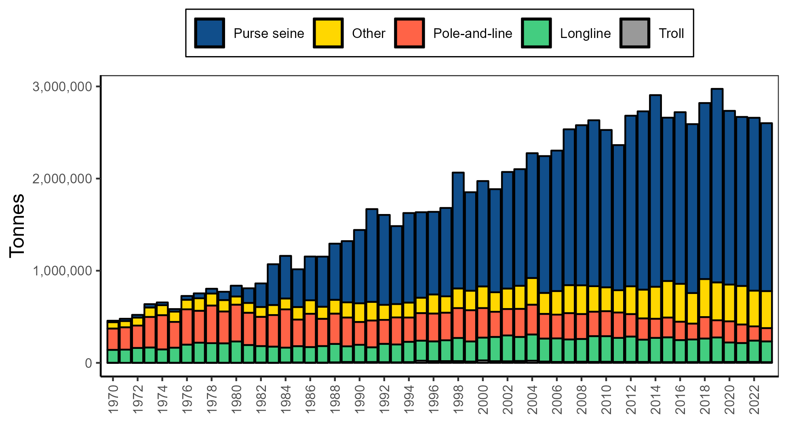
Figure WCPO-01. Catch (mt) of albacore, bigeye, skipjack, and yellowfin tuna (combined) in the WCPFC-CA, by longline, pole-and-line, purse seine, and other gear types

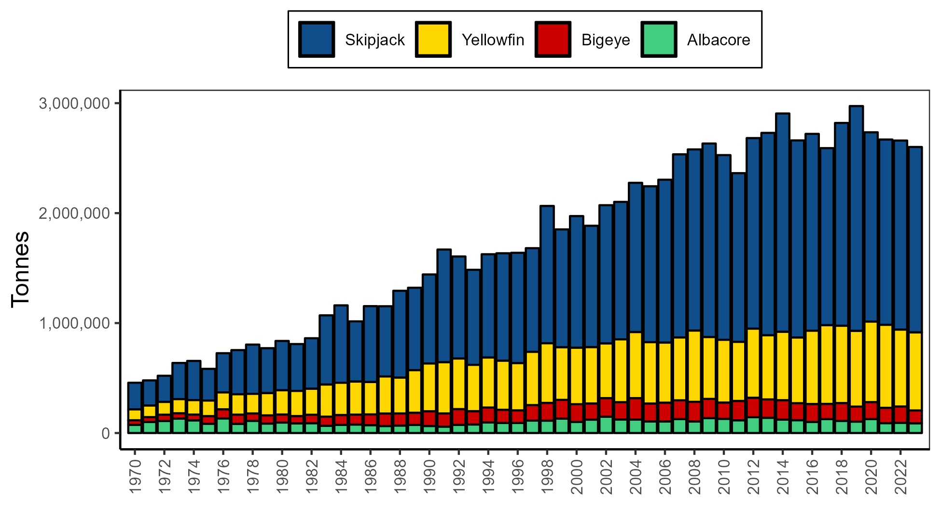
Figure WCPO-02. Catch (mt) of albacore, bigeye, skipjack, and yellowfin (combined) in the WCPFC–CA

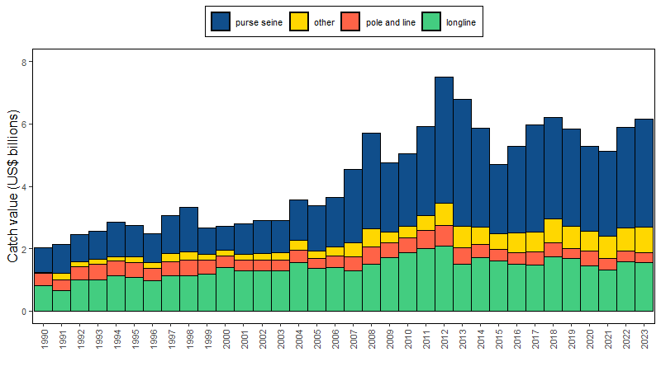
Figure WCPO-03. Catch value of albacore, bigeye, skipjack and yellowfin in the WCPFC–CA, by longline, pole-and-line, purse seine and other gear types

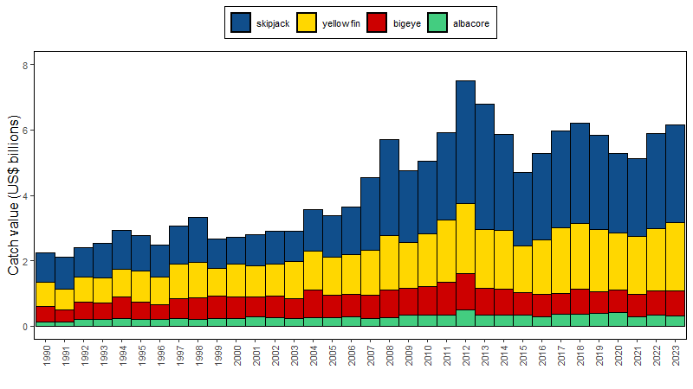
Figure WCPO-04. Catch value of albacore, bigeye, skipjack and yellowfin in the WCPFC–CA

Discussion

- Nauru, on behalf of FFA CCMs, thanked the Oceanic Fisheries Programme of the Pacific Community and Fisheries Development Division of the Pacific Islands Forum Fisheries Agency for the comprehensive work in providing an overview of the catch and economic conditions of the key fisheries in the Western and Central Pacific Ocean. Such information was critical to better understanding how these fisheries are performing and whether or not the Commission needs to step in to ensure that biological, economic, and social objectives are being met.

- FFA Members were happy to see that the economic conditions for the purse seine, southern longline, and tropical longline fisheries all improved in 2023 but noted that these improvements in conditions were largely driven by higher catch rates and lower fuel costs. With the exception of a significant increase in the yellowfin tuna catch, catches across the key stocks in the WCPO were relatively stable in 2023.

- Indonesia felt the presentation was extremely helpful in understanding the conditions of the tuna fisheries in the WCPO and recommended that it be continued into the future. The decreasing trend of the pole and line (PL) fishery over time had been highlighted, but several of these PL fisheries had been MSC-certified, and Indonesia wondered why the fishery continued to decline, especially in economic value, given the higher quality of the fish marketed compared to the purse-seine fishery. The SSP noted that the number of PL vessels had reduced to its lowest-ever level, and this was probably the main contributor to the reduced catch, which in turn contributed to the reduction in value. FFA noted that the skipjack value was based on the Yaizu price, and, for the purposes of the general indicator, the analysis did not drill down to the price of skipjack going into each individual market.

- The USA noted that there were 308 large scale purse-seine vessels in the fishery last year and 270 this year. Unusually, this was a 10% decline in the total number of vessels, and it would be interesting to know why – and whether they had moved to other regions or were decommissioned. The SSP did not have an explanation of why vessels had dropped out of the WCPO fishery but would investigate and report in future iterations of this paper.

- New Caledonia drew attention to the increased proportion of the longline catch needing to be discarded after depredation by sharks and toothed whales – up to 10% - and wondered if this had been taken into account in national annual catch estimates, particularly for albacore. The SSP said they would investigate this.

- The European Union drew attention to the greater reliance on FADs during La Niña conditions identified in the paper, and wondered if the SSP had any information on whether this was affecting the species composition, and whether this potential change in catchability and species composition would have an effect on management procedures. The SSP noted that this was a complex question covering more than one theme and the SSP would try to provide a considered response over the course of the meeting.

- Chinese Taipei asked if the catch by species had been based directly on logbook data or was compiled through other means. The SSP explained that the figure was based on national annual catch estimates using mainly observer data.

2.2 Overview of Eastern Pacific Ocean (EPO) fisheries
Working Paper: SC20-GN-WP-02

- Robert Ahrens (ISC Chair) provided an update on ISC activities since SC19. The ISC24 Plenary meeting was held June 19-24, 2024, in Victoria, Canada. The ISC meeting had approved stock status and conservation information based on benchmark stock assessments for PBF and SMA, which were be presented at SC20 for information. Stock status and conservation information for NPO ALB, NPO BSH, NPO SWO, BUM, and WCNPO MLS remain unchanged from 2023. A formal external peer review of the 2023 WCNPO MLS stock assessment was conducted by an expert panel at an in-person meeting with the Billfish WG in Chinese Taipei in April 2024 with administrative support from the WCPFC Science Manager and Secretariat. The goal of the review was to improve stock assessment modelling and the process. A plan was in place to address the conclusions and recommendations of the review panel, and it was clear that future billfish assessments and assessments undertaken by other ISC WGs would benefit from this review.

- The ISC had also responded to requests for information from the NC and WCPFC. Advice on exceptional circumstances leading to the suspension or modification of the adopted harvest strategy for North Pacific albacore and translating fishing intensity to management controls (catch or effort) was communicated in 2024 (for details, see ISC/24/ANNEX/08, Attachments 5 and 6, respectively). Projections on six additional PBF harvest scenarios were conducted for the IATTC-WCPFC Joint Pacific Bluefin Working Group just prior to the ISC Plenary meeting (see ISC/24/ANNEX/13, Appendix 1). Lastly, 10 projection scenarios based on the 2023 assessment (6 catch, 4 fishing mortality) were provided to support WCNPO MLS stock rebuilding plan discussion at SC20. These projections did not change stock status and conservation information for the stock provided in 2023.

- Workplans for the next year included conducting an indicator analysis of NPO BSH, conducting the first iteration of the PBF MSE process, exploring and formalizing the use of ‘Open Science’ tools and approaches in conducting stock assessment and other ISC activities, and continuing to work on incorporating climate change considerations into the stock status and conservation information to support discussion on a framework at the next ISC meeting. The next ISC Plenary meeting was scheduled for June 17-20, 2025, in Korea.

- During the presentation, attention was drawn to the use of a spatiotemporal Petersen-type model for producing an absolute index of EPO skipjack abundance from tagging data, and to the unusually high cumulative catch trend for skipjack tuna in the EPO purse-seine fishery in the first few months of 2024.

Discussion

- Indonesia noted that the EPO fishery was dominated by purse seiners with less than 10% of the catch taken by longliners and that there were no pole and liners. Indonesia wondered why the longline fishery was so small. IATTC noted that the EPO fishery started with pole and lining, but the fishery gradually disappeared as more efficient gears were introduced. There were probably less than 5 PL boats now operating. Another reason was the establishment of MPAs in several coastal areas that limited access to traditional smaller-scale PL fishing grounds. There was a desire to resume this fishery, and if this happened it would also improve the scientific data available from tagging. Regarding the longline fishery, it was indeed less than 10% of the total, but this fishery was also important for science – especially for indices of abundance, because longliners catch more spawning-age fish. The coefficient of variation had greatly increased and this led to lower precision in stock assessments. Improvements in data availability from the longline fishery would help, but if this was not possible, the Petersen-type tagging analysis might help mitigate this deficiency. This would be a major issue at IATTC in September.

- Australia had a question about albacore from the paper in Table A6, where there was a great increase in EPO catch south of the equator in 2021-22. This had implications for the development of a South Pacific albacore management procedure in the WCPO. Was there any indication about whether these higher catches would continue? IATTC responded that there were 2 consecutive years of about 10,000 tonnes of catch, and it would be interesting to see the results of the SSP SP-ALB stock assessment. There was an increased effort by some of the Asian longline fleets in the southern EPO area and this could account for the increased catch, but more details would need to be obtained before the question can be answered.

2.3 Annual Report Part 1 from Members, Cooperating Non-Members, and Participating Territories
Papers: Refer to CCM Annual Reports (Part 1)

- CCM Annual Reports were not presented at the meeting and taken as read. Questions and comments were invited.

Discussion

- Birdlife International had asked certain members questions before the meeting, mostly to gather more information about seabird bycatch, mitigation and data reporting, and were happy to discuss these with individual CCMs in the margins of the meeting or by email.

2.4 Reports from regional fisheries bodies and other organizations

- No regional fisheries bodies or organisations made any statements or reports under this agenda item.

AGENDA ITEM 3 – DATA AND STATISTICS THEME

3.1 Data gaps of the Commission
Information papers: SC20-GN-IP-02, SC20-ST-IP-08

3.1.1 Report on WCPFC scientific data
Papers: SC20-ST-WP-01, SC20-ST-IP-03, SC20-ST-IP-02

- Working paper SC20-ST-WP-01 was presented by Tiffany Vidal (SSP). The paper provided an overview of the scientific data submissions to the Commission and highlighted gaps in the data provision. The key data provisions, including annual catch estimates, aggregate catch and effort, operational, and size data, were evaluated using a tier-based scoring system. Overall, data gaps had gradually been reduced, with nearly all CCMs meeting 100% of the scientific data reporting requirements for the Commission. Operational data coverage for most fleets in 2023 was nearly 100%. The CCMs with low coverage of operational data had continued to develop their data collection programmes and had demonstrated improved coverage in 2023 for some gears. Reporting of shark catches for key species remained challenging, but reporting has improved in recent years.

- There had been no major developments with respect to the scientific data provisions in 2023; however, several SC19 recommendations had been actioned, including the addition of two billfish species (shortbill spearfish and sailfish) to the scientific data reporting requirements, improved understanding of operational data date/time formats (which would be used to standardized date/time data fields), and provisions for increases in longline observer coverage in association with increases in the longline bigeye quota. Several recommendations from SC19 had been carried forward to SC20, including a proposal for additional operational longline data fields (SC20 ST-WP-08) and a proposal for minimum FAD data fields to be recorded by vessel operators (SC20 ST-WP-06). Lastly, the SSP highlighted the availability of data submission templates and standardized formats to increase efficiency and ease of data submission, including the ACE template and the development of JSON formats for use with APIs. The SSP remained available to assist interested CCMs in developing improved data submission workflows to increase efficiency and timeliness of data availability.

Discussion

- New Zealand, on behalf of FFA CCMs, acknowledged the significant progress made by the WCPFC SSP in collaboration with CCMs in addressing data gaps and quality. Regarding the proposal from Australia for additional longline operational data fields, SC19 had considered this issue last year and acknowledged the scientific value of these additional fields but had noted potential implementation issues and that the fields could be made voluntary. Therefore, FFA members reiterated the recommendations outlined in paragraphs 77-81 of the SC19 Summary Report and, noting that these recommendations were not fully considered by WCPFC20 due to time constraints, FFA Members requested that they be recommended to be considered by TCC20 and WCPFC21.

- Australia followed up the FFA comment and suggested that SC make a recommendation for the SSP to pursue options for standardising data transmission.

- The European Union noted that several of the key species in the table were species that did not apparently appear in the purse-seine fishery, and those fields were perhaps not needed for all fisheries. However, the EU agreed with the proposal by Australia to standardise data provision to make the flow of data more efficient.

- The SSP thought it would be difficult to determine exactly which would be key species for the Commission as a whole and that this could only be done by gear type. The SSP would be happy to develop a proposal for standardisation and bring it back to the Commission next year.

- WWF reminded the meeting that the Commission had been in existence for 20 years, and it has taken two decades to agree on some basic data principles. Although the official minimum requirement for 5% observer coverage had had been achieved last year for the longline fishery as a whole, it was not enough for practical purposes. In light of threats including climate change, deep sea mining and other issues, the Commission MUST understand, in a timely way, how its fisheries were impacting the ocean and how its fisheries in turn were being impacted by those changes. This cannot effectively be done without the appropriate level of observer coverage. Effective observer coverage was also crucial for bycatch management. There needed to be some way of supplementing this low rate of coverage whether through electronic means or more human observers. WWF implored SC20 to push for the increases in observer coverage that would provide the quality and quantity of data needed to effectively manage Commission fisheries.

- SC20 requested that SSP develop a subset of the key species, expected to be encountered by each gear type, to improve the evaluation of operational data reporting of key species, as reported in SC20-ST-IP-02 (e.g., Table 14). Currently, the coverage estimation assumes all key species in the “Scientific Data to be Provided by the Commission (SciData)” are encountered by all gear types and evaluates reporting coverage based on that assumption.

- SC20 requested that SSP develop a proposal to improve data submission workflows through the development of data submission standards and templates for consideration by SC21.

3.1.2 Species composition of purse-seine catches (Project 60)
Working Paper: SC20-ST-WP-02

- SC20-ST-WP-02 was presented by Simon Nicol (SSP), noting that this paper would close out Project 60. The objective of Project 60 had been to improve the accuracy and precision of species composition data for tuna (skipjack, yellowfin and bigeye) caught by purse-seine fisheries in the WCPO, in order to improve species-specific catch histories and size compositions that are used in the stock assessments of these key target species in the WCPO.

Discussion

- Chinese Taipei felt the presentation was useful but asked if there was any process to verify the robustness of the estimates of species composition. The SSP drew the attention of SC to the papers that had been presented on this subject over the last 5 years and noted that different species would require a different level of observer coverage depending on their frequency in the catch, and it was essentially up to SC to decide what level of verification would be needed for key species.

- Japan emphasised that this was important for bigeye assessment and, before shelving the project, wanted to be reassured that the model would work well into the future. The SSP recalled that despite best efforts it had not been possible to expand grab-and-spill paired sampling beyond one or two fleets, nor to achieve a higher level of sampling within those fleets. Unfortunately, the methodology was commercially intrusive, so it was unlikely that this work could continue under current conditions. There would be little point in including increased sampling in the workplan if it were unlikely to be achievable.

- The EU thanked the SSP, particularly Tom Peatman, for work over the years on this most important element of the stock assessment.

- The Marshall Islands, on behalf of FFA CCMs, acknowledged the progress made against the Project 60 workplan, the improvements to species composition models, and the contributions of all those who participated in this work. They recognized the challenges associated with conducting paired sampling trips and the subsequent impact on progressing purse seine species composition estimation. They also noted the ongoing potential for comparative analyses of species compositions from various other data sources to refine catch composition estimation methods, with cannery receipt data being one valuable source. They supported the recommendation for Project 60 to be closed.

- SC20 acknowledged the work conducted under Project 60 and agreed to close Project 60.

3.1.3 Better data on fish weights and lengths for scientific analyses (Project 90)
Information Paper: SC20-ST-IP-04

- There were no comments on this Information Paper.

3.1.4 Improved coverage of cannery receipt data (Project 114)
Information Paper: SC20-ST-IP-05

- Korea commended those concerned with implementing Project 114 and wished to continue collaborating in this work for compiling cannery data.

- Palau, on behalf of FFA CCMs, acknowledged the progress made on Project 114 and commended the work completed to date. They recognized the value of the cannery receipt data as a critical resource for comparative analysis of purse seine species composition. They also supported the planned activities for August to December 2024 and the indicative budget for 2025.

3.1.5 Minimum data reporting requirements
Papers SC20-ST-WP-06, SC20-ST-IP-09

Transhipment at sea activity code

- Australia drew attention to the WCPFC SC19 Summary Report, Paragraphs 79-81:

“Additional code for the ACTIVITY field
79. SC19 acknowledged that the proposal for the addition of a new activity code for any day when a "transhipment at sea occurs” would allow the WCPFC’s SSP to define ‘trips’ within the operational data submitted to the Commission.
80. SC19 also noted the explanation from the SSP that aggregating the catch by species in the longline operational data at the trip level (when the trip is terminated by an at-sea transhipment) is fundamental for the validation processes using other independent sources of data (e.g. transhipment observers and carrier declarations) to provide more certainty in the data used in assessments and other work of the Commission.
81. SC19 recommended that this proposal be considered further by TCC and the Regular Session of the Commission.”

- Several CCMs expressed support for implementing this recommendation, noting that it hadn’t yet been fully implemented and was a simple reiteration of last year’s recommendation.

- Several other CCMs expressed some reservations, worried about the potential difficulty of inserting more fields in an already-crowded longline observer logbook, about the time needed for further consultation with industry, or the time needed to implement new requirements for vessels operating in distant waters.

- After this discussion, it was agreed to recommend that the next TCC and WCPFC meetings consider specifying the voluntary provision of these data in the “Scientific Data to be Provided by the Commission (SciData),” noting the implementation concerns of several CCMs.

FAD minimum data fields

- Working paper SC20-ST-WP-06 was presented by Penihulo Lopati of the PNA Office, who noted that at WCPFC12:
“The Commission agreed that vessel operators should provide data on FADs covering the following two major areas: a. FAD design and construction of FAD to be deployed or encountered (materials, electronics, size, etc); b. FAD activity (deploying, retrieving, setting, visiting, loss etc.)”

- In response to this, the Parties to the Nauru Agreement (PNA) had developed requirements for provision of data on FAD design and construction and FAD activity by vessel operators which had been applied to their licensed purse seine vessels since January 1st, 2022. This information was critical for scientific analyses to guide management of FADs in the waters of PNA and the WCPO, as well as to monitor compliance.

- The provision of FAD data by vessel operators in this way was designed to improve the quality of data, particularly on FAD design and construction and enable observers to focus more on monitoring the implementation of FAD-related CMM obligations. The main differences between the fields of FAD data now required to be provided by vessel operators and the current ROP minimum data fields for FAD data were:
    - requirements for quantitative and measurable information where the WCPFC ROP data fields require the provision of qualitative information and descriptions;
    - more details, including in data fields regarding the buoy and materials for each FAD component; and
    - core details related to Species of Special Interest (SSI) focusing on SSI entanglement.

- SC19 had agreed as follows in paragraphs 95-98 of the SC19 Record:
“SC19 recognised the scientific value of the PNA's proposal on “Minimum Data Fields to be Recorded by WCPFC Vessel Operators” (SC19-ST-WP-05). Noting the current workload of observers, and some FAD data may be more effectively provided by vessel operators, SC19 agreed on the need for developing a FAD logbook for vessel operators as a priority. SC19 noted that the PNA has developed the Standard Operating Procedures (SOPs) for the provision of FAD data by vessel operators for licensed vessels from January 2022 and IATTC have also adopted a FAD logbook, currently used for vessels operating in the EPO and in the overlap area. SC19 noted both could be used as the basis for discussion at FADMO-IWG. SC19 recommended WCPFC20 considers this work be progressed intersessionally within the FADMO-IWG”.

- PNA had presented the set of fields in Table 1 of the ST-WP-06 to the FADMO-IWG. The FADMO-IWG09-01 Working Paper prepared by the FADMO-IWG Chair and Secretariat advised that “Table 1 of SC19-ST-WP-05 is robust enough to cover all the data fields identified in the IATTC FAD Data Collection”. The PNA had prepared modifications to the Scientific Data to be Provided by the Commission to support the submission of FAD Minimum Data Fields to be Recorded by WCPFC Vessel Operators. These were set out in SC20-ST-IP-09.

- SC20 was invited to note the revisions to the proposed “FAD Minimum Data Fields to be Recorded by WCPFC Vessel Operators” compared to those presented to SC19, and to note that these proposed fields had been submitted to the FAD Management Options Intersessional Working Group, and to consider the proposed revisions to the Scientific Data to be provided to the Commission to include the proposed FAD Minimum Data Fields set out in SC20-ST-IP-09.

- Chinese Taipei asked how species of special scientific interest could be identified as being entangled in a FAD, and weighed, while still in the water. PNAO noted that the weight was only meant to be estimated, not exactly determined.

- The EU thanked PNA and Tokelau for the proposal, and for some of the changes made. The EU thought it important to improve the information on FAD-related activities and thought this proposal went in the right direction and was a significant step forward. They still had doubts about the feasibility of collecting some of the fields, but only a few. The EU’s main concern – as expressed on several previous occasions - was related to the fact that some vessels operated in both the WCPFC and the IATTC convention areas, and it was not feasible to request vessels to use two different data formats because it increased the workload of vessel operators and data processors, and also affect data quality. Therefore, at this stage, the EU proposed that both PNA+TK and IATTC formats be accepted as suitable alternatives for vessel operators.

- Japan was not convinced that all of the information proposed to be collected was necessary for WCPFC purposes, and wanted to know how this proposal was related to the discussion at the FAD management IWG.

- The United States supported the collection of better FAD information and understood that vessels rather than observers may be in the best position to provide some of this information. As US vessels operate across both the western and eastern Pacific, they strongly felt that the WCPFC and IATTC should consider harmonising all FAD reporting requirements. They compared the proposed fields from PNAO with IATTC, and the PNA fields were much more detailed than those required by IATTC. Significant information was already being provided by the FAD buoy data during deployment, as well as information during a set, in addition to interactions. They wanted to ensure that the reporting fields fulfilled actual information needs of the Commission and did not add an unnecessary burden if they wwere not used or can be collected another way. As the fleet moves towards non-entangling and biodegradable FADs, some of these reporting requirements such as those on FAD construction and entanglement may be less of an issue in the future. Perhaps, if a small working group is convened, the SSP could provide opinions on what fields are used to inform their various analyses, particularly for stock assessment needs, and if they have any thoughts on a minimum set of FAD data fields.

- Papua New Guinea noted that FFA CCMs fully supported the FAD minimum data field revisions proposed by the PNA+Tokelau to the Scientific Data. These revisions were already being implemented by purse seine vessels fishing in PNA waters – a majority of the purse seiners in the region – and represented important data quality and consistency upgrades. It was only reasonable that these revisions be extended to cover FAD fishing across the whole WCPO.

- Kiribati, speaking for PNA+TK CCMs, explained that the paper from the PNAO was a revision to the paper submitted by PNA+TK to SC19 last year in Palau. They had worked with the SSP to revise the data fields and had removed some fields, and the current paper described those amendments, following the recommendation of SC19 to refer this to the FADMO-IWG. PNA+TK CCMs had also anticipated the next step – the amendment of the SciData rules – to facilitate FAD logsheet data collection, which had been provided as SC20-ST-IP-09 to this meeting. PNA and Tokelau thanked SC participants for their comments on the proposal and looked forward to working with those interested in an Informal Small Group.

- China noted that PNA had already launched a PNA FIMS module implementing the FAD logbook and wondered if WCPFC was going to have an additional FAD logbook, requiring vessels to complete two logbooks.

- Indonesia had some concern over annex 2 and 3, which required details of FAD design, when there were so many differences in design between areas, and felt that this would be difficult for observers to accomplish. The Convenor noted that this was about vessel reporting requirements, not observer data fields.

- Japan wanted the ISG discussion to include the US recommendation that the SSP comment on the value of the different data fields.

- Following a question from the EU, the SSP said that much of this new data would be useful for analysing interactions, and reminded CCMs that these fields were not just of scientific value but were also important to TCC for compliance monitoring purposes. The SSP would endeavour to provide some opinions to TCC.

- The EU considered that provisions on reporting for purse seine fisheries under CMM2018-04 could be better covered through the ROP, and expressed its concern the collection of information by skippers might result in duplication of information of little use. In relation to paragraph 7e on data provision, the EU suggested turtle interactions could be provided as a separate section in the mandatory data provision.

- In view of the significance of the FAD data fields discussion, the ISG-01 was convened by the FADMO-IWG Chair, Jamel James (FSM), on 14 August 2024. The meeting aimed to address further issues raised during the SC20 plenary regarding two key documents: SC20-ST-WP-06, FAD Minimum Data Fields to be Recorded by WCPFC Vessel Operators, and SC20-ST-IP-09, Modifications to the Scientific Data to be Provided by the Commission to support the submission of FAD Minimum Data Fields to be Recorded by WCPFC Vessel Operators. The ISG-01 report was subsequently posted in the Draft Documents folder on the SC20 website, and no additional comments were received (Attachment J).

Revisions to CMM 2018-04 (Conservation and Management of Sea Turtles)

- Although there was no working paper on the subject, it had arisen in the SPC Data Gaps Analysis that SC needed to provide some guidance to WCPFC on how to align the reporting requirements in the Turtle CMM (2018-04) with the “Scientific Data Required to be Reported to the Commission” (SciData). A proposal by the SSP was discussed in the Informal Small Group on data.

- The EU intervened on the issues related to paragraphs 5c and 7e of the CMM as follows:
“In the case of paragraph 5c of CMM 2018-04, which applies to purse seine fisheries, we think this issue could be better covered through the ROP. In most purse seine fleets, there is an observer coverage close to 100%. We are concerned the collection of this information by the skippers might result in duplicate information of little use, because the expectation is that the reliability, in terms of species, animal status, coverage, etc, is lower. In our view, the collection of this information by skippers also affects their workload and the quality of other information we may need from them. This comment is applicable to many other data requests to vessel operators. If, as a group, we think the information that is going to be collected is of little use, be it because it is also available from other sources or because we do not expect it to be reliable, we should avoid it to the extent possible. This is in line with the US comments on the different fields in the FAD logbook. Therefore, we recommend that for fleets with observer coverage beyond a threshold, we propose these data are provided through the ROP. As for paragraph 7e, we have no strong position, but maybe an easy way to comply with the provision of information on interactions could be a separate section in the mandatory data provision.”

3.1.5 Minimum data reporting requirements

Additional Longline Operational Data Fields

- SC20 again acknowledged the scientific value of the additional longline operational data fields described in SC20 ST-WP-08.

- SC20 recommended that TCC and the Regular Session of the Commission consider the possible inclusion of these data (Table ST-01) in the “Scientific Data to be Provided by the Commission (SciData)” as voluntary reporting items, taking into account the broad implementation concerns of several CCMs with respect to the collection of these data.

Table ST-01. Proposed new voluntary additional longline operational data fields
DATA FIELD | Suggested PROTOCOL for data collection
Target species for the set | Record the primary target species, or group of species, for this set.
Number of lightsticks used in set | Record the total number of lightsticks used in the set.
Bait type used in set | Record the FAO code(s) for type of bait(s) used for the set. Example types:
  FAO Code | Taxa/species categories
  CLP | HERRINGS, SARDINES, NEI
  DPT | DECAPTHURUS SP. - MUROAJI
  MAX | MACKERELS NEI
  MIL | MILKFISH
  MSD | MACKEREL SCAD
  PIL | EUROPEAN PILCHARD (=SARDINE)
  SAP | PACIFIC SAURY
  SQU | VARIOUS SQUIDS NEI
  TUN | TUNAS NEI
  OTHERS | Comment on bait type
Mainline length | Record the mainline length (in kilometers) used in the trip or set, as appropriate.
Length of branch line | Record the average length in meters of the branch lines in the trip or set. (The total length from the mainline to the hook).
Length of float line | Record the average length in meters of the float lines in the set. (The total length from the float to the mainline).
Vessel speed during setting | Record the average speed in knots of a vessel during line setting.
Speed of the line setter | Record the speed in knots of the line setter (i.e., the line shooter speed).

Additional code for the ACTIVITY field

- SC20 again acknowledged the proposal for the addition of a new activity code for any day when a "transhipment at sea occurs” within the operational data submitted to the Commission (as described in SC20 ST-WP-08). SC20 recommended that this proposal be considered by TCC and the Commission.

Revisions to CMM 2018-04

- SC20 noted the Commission tasking (WCPFC20 report, para. 753.e) to review the SciData requirements to capture turtle interactions requirements under CMM 2018-04, paragraphs 5.c. and 7.e. SC20 noted that some CCMs have different interpretations of the requirements to those paragraphs, specifically as to whether the paragraphs require reporting through submission of operational level data or in a summary form, and SC20 suggested TCC and the Commission consider clarifying the requirements of these paragraphs to resolve any ambiguity.

- Meanwhile, SC20 requested SSP to prepare a paper for SC21 on possible sea turtle data reporting requirements for vessels to record during fishing operations, for longline and purse seine vessels, to be incorporated in the annual reporting of Scientific Data to be provided to the Commission (SciData).

Development of a FAD Logbook

- SC20 requested that SSP identify what FAD information fields are anticipated to be used by SSP to support stock assessments and other scientific analyses. SSP indicated that the FAD data fields also relate to WCPFC work involving management and monitoring.

- SC20 recommended that SSP and the WCPFC Secretariat develop a paper for TCC20’s and the FADMO-IWG’s consideration, responding to the request to identify the needs for the FAD data fields for the work of the WCPFC (science, management and monitoring).

3.1.6 Regional bycatch estimates of purse seine fishery

- Working Paper SC20-ST-WP-07 from the SSP was presented by Simon Nicol of the SSP.

- This paper described work to estimate the bycatch of the large-scale equatorial purse-seine fishery operating in the WCPFC Convention Area during the period 2003-2022. These large vessels, typically with greater than 500 tonnes carrying capacity, have been responsible for approximately 85% of the purse seine catch of tropical tunas in the WCPFC Convention Area in recent years, with an average annual catch of 1.6 million tonnes since 2010. The estimates covered the full range of finfish, billfish, elasmobranch, marine mammal and sea turtle species that had been recorded in purse seine observer data. The estimates did not, however, cover domestic archipelagic purse seine fisheries in the west of the WCPFC Convention Area, or purse seine fisheries in temperate waters off Japan and New Zealand. In this iteration, a spatio-temporal modelling framework was used to estimate catch rates. These catch rate models should allow better separation of temporal effects from other covariates, improving the utility of the catch rate models for screening of species that may warrant more targeted analyses due to unexplained temporal trends. The inclusion of spatial effects also allowed for the consideration of the spatial distribution of estimated catches. The taxonomic resolution of catch estimates was also improved for marine mammals to allow more meaningful monitoring of catch and catch rate estimates for these species.

- The paper made the following recommendations to the Scientific Committee to:
- Note the estimates of bycatch of the large-scale equatorial purse seine fishery in the WCPFC Convention Area;
- Note that the bycatch estimates should be interpreted as being the bycatch that would have been recorded by observers with 100% coverage of fishing events;
- Note that other studies suggest that shark bycatch estimates were likely to be underestimated due to underestimation of captures by observers;
- Note the refinements to the estimation approach, including the implementation of spatially explicit catch rate models. This should improve the utility of catch rate models for identification of species that may warrant additional targeted analyses;
- Note the impacts of recent reductions in observer coverage on the precision of catch rate and catch estimates, and the extent to which they can be used to monitor for temporal trends;
- Note the refinements to the taxonomic resolution of catch estimates for marine mammals.

Discussion

- Niue, on behalf of FFA CCMs, thanked the authors of SC20-ST-WP-07, particularly for the improvements made in the approach and in the model used for improving the estimates of bycatches as requested by the SC19. This information was useful in informing targeted analyses necessary for improving conservation and management measures for mitigating bycatch and species of special interest.

- The Solomon Islands, on behalf of PNA+TK CCMs, thanked the authors for this very valuable work, pointing out that it highlighted the scale of the bycatch problem in the longline fishery, and the importance of strengthening the current weak reporting and monitoring of the longline fishery. PNA+TK considered the weakness in reporting and monitoring of the longline fishery to be the Commission's biggest remaining failing. However, they appreciated the progress that was made at WCPFC20 in Rarotonga to improve longline monitoring and supported the recommendations in the paper and looked forward to the next iteration of this work. They also suggested that it was time to make more use of this data to complement the observer data used in the Commission meeting agenda items on non-target and dependent species.

3.2 Evaluation of purse seine fishing effort
Information Papers: SC20-ST-IP-11, SC20-ST-IP-10

- Working paper SC20-ST-WP-03 was presented by Tiffany Vidal (SSP). This study investigated shifts in fishing practices and reporting behaviours within the tropical purse seine fishery. The SSP analysed logsheet, observer, and VMS data to explore changes in fishing-related activities compared to non-fishing activities (e.g., transiting) over time. Notably, there were increased reported non-fishing activities during fishing trips, suggesting reduced traditional searching behaviours. This shift may be attributed to fishers relying more on instrumented drifting FADs, which provide real-time information on tuna school locations. The study also examined the impact on overall fishing effort (in days) under different assumptions about days spent at sea. Recommendations for improving reporting requirements were discussed.

Discussion

- Tuvalu, on behalf of FFA CCMs, thanked the Scientific Service Provider for their analysis to help better understand how purse seine fishing activities and the reporting of these activities have changed over time and how this may be influencing estimates of purse seine fishing effort. This was an important issue for WCPFC fisheries that heavily rely on effort-based controls to limit fishing, because failure to account for changes in effective effort poses risks for achieving management objectives through these controls. For this reason, they supported the recommendations made in SC20-ST-WP-03 to further improve the estimates of purse seine effort. These included:
- reviewing the log sheet reporting requirements to bring into alignment with how the purse seine sector has evolved through time;
- further developing the VMS algorithms to improve the differentiation of fishing activities;
- exploring how the FAD closure periods have influenced changes in fishing behaviour and reporting through time; and
- evaluating if changes in behaviour and reporting vary between high seas and EEZ activity.

- The EU suggested that it would be useful to see a combination of figures 7 and 8 in the next paper.

- Japan thought that more efficient electronic fish-finding equipment and data transmission buoys had made it possible to target productive FADs and this might explain the decreasing trend in searching time before FAD sets. But they drew attention to the decreasing trend that was also seen before free-school sets as well. Japan noted that since 2010, searching time had remained consistent for the Japan fleet. The SSP suggested that it could be useful to disaggregate their analysis by fleet.

- SC20 requested that SSP conduct further work to better understand relationships between fishing behaviours and strategies, reporting requirements, and estimations of purse seine fishing effort.

3.3 Regional Observer Programme

3.3.1 Review of an observer training project for elasmobranch biological sampling (Project 109)

- SC20-ST-IP-06 was not presented and taken as read.

- Fiji spoke for FFA CCMs in acknowledging the progress of Project 109 activities and the schedule for the remaining work. They looked forward to the rollout of biological sampling training for elasmobranchs.

3.3.2 ROP Data Issues
Working Paper: SC20-ST-WP-04

- An update (SC20-ST-WP-04) from the Regional Observer Programme Intersessional Working Group was presented by the Secretariat Compliance Manager, Lara Manarangi-Trott, for review and discussion. The paper reported on the feedback and suggestions from IWG-ROP participants received in 2024, and requested further feedback from IWG-ROP participants and SC20 and TCC20 participants. This will be used to further consider proposals for changes to MSDF in 2024. During the presentation, it was noted that the IWG-ROP Chair was vacant and an interim replacement could be appointed intersessionally and confirmed at WCPFC21. Appreciation was expressed to the former IWG-ROP Chair Mr Harold Vilia (Solomon Islands) for his leadership of the IWG-ROP over the past two years, and SC20 wished him the very best in his future endeavours.

- The Solomon Islands for FFA CCMs thanked the IWG-ROP Chair and the Secretariat for the paper. They supported in principle, and were in general agreement that, many of the fields – particularly those related to vessel details – were better collected through existing processes like the vessel registration or the RFV and could be removed from the ROP Minimum Standard Data Fields. They also agreed that a removal of a field does not necessarily mean making space for the addition of other or new fields to be collected by the observers. FFA Members would continue to engage in the work of the IWG-ROP, in particular, in consideration relating to streamlining and removal of redundant fields in the ROP Minimum Standards Data Fields (MSDF).

- Japan was not sure how SC could engage in this discussion when the most appropriate venue would be the IWG-ROP.

- The Convenor pointed out that this had been an opportunity for SC to contribute to the discussion as necessary, but so far no specific recommendations had been made.

3.4 Electronic Reporting and Electronic Monitoring
Information paper SC20-ST-IP-12

3.4.1 ER and EM IWG Update

- Working Paper SC20-ST-WP-05 was presented by Shelton Harley, Chair of the ER&EM Working Group. The paper sought feedback from the SC on work to support the Commission in adopting Interim standards for Electronic Monitoring (EM) at its regular session in December 2024. The paper responded to the task from WCPFC20 explained in WCPFC20 Summary report paragraphs 618 and 619. It also provided draft recommendations on such matters as (1) the scope of the EM program (e.g., fleets to be covered); (2) the objectives for the EM program (what it wants the EM to achieve on these fleets); (3) a set of interim standards for EM; (4) associated minimum EM data requirements; (5) requirements for reporting to the WCPFC on the use of EM; and (6) any process that Commission may choose to establish to have an assurance that CCMs are implementing EM programs in line with adopted EM standards. The SC was particularly encouraged to provide advice on (1) the monitoring objectives; (2) EM data requirements required to reflect the EM Program objectives. In particular, alternative data collection mechanisms, and data requirements that may not yet being achieved through the current ROP minimum data standards; and (3) proposed Annual Report Part 1 reporting requirements in Appendix 3.

- Australia for FFA CCMs thanked the Chair of the ER&EM Working Group for the paper. In response to the specific issues on which the Chair has requested feedback, FFA Members provide the following perspectives:
- Regarding Monitoring Objectives, they acknowledged the primary and secondary objectives proposed by the Chair, but wished to emphasise that the WCPFC in 2019 had endorsed specific objectives for the Commission’s EM Program, as outlined in paragraph 555 of the WCPFC19 Summary Report where it stated: “The objectives of the Commission Electronic Monitoring Programme (EMP) shall be to collect verified catch and effort data, other scientific data, and additional information related to the fishery from the Convention Area and to monitor the implementation of the conservation and management measures adopted by the Commission”. This mirrored the objective of the ROP in paragraph 4 of the ROP measure (CMM 2018-05). They were concerned that the primary and secondary objectives currently proposed may inadvertently narrow the scope of data collection, focusing primarily on verifying catch limits under certain CMMs such as Swordfish (CMM 2009-03 paragraph 2), for NP Striped Marlin (CMM 2010-05 paragraph 1), for Bigeye (CMM 2023-01 paragraph 38) and for Pacific Bluefin (CMM 2023-02 paragraphs 03 and 04). This narrow focus risks excluding the collection of catch-related data for other species not subject to these specific limits. Consequently, FFA Members suggested adhering to the broader objectives endorsed by WCPFC19.
- Regarding scope, FFA Members supported recommendations 1 and 2 of the Chair’s paper, particularly the proposal to initially focus the scope of the WCPFC EM program on longline fisheries, with a specific emphasis on activities in the high seas.

- On EM Data requirements, FSM speaking for FFA CCMs in principle believed that data generated from Electronic Monitoring should be largely equivalent to that collected under the Regional Observer Programme (ROP). They agreed that the ROP Minimum Standard Data Fields should serve as the starting point for this effort. Regarding the Chair's three proposed options for advancing this issue, FFA Members supported Option 1 as the ideal approach. This option proposed adopting minimum EM data requirements based on the ROP requirements (plus any others identified) but associated with a ‘MUST / SHOULD / COULD / WON’T’ assessment. They also emphasised the importance of discussing data that cannot be collected via EM and exploring alternative methods for obtaining such data when necessary. They acknowledged that this option would require additional work leading up to December and they were committed to engaging in this process. Fortunately, existing resources could help inform these discussions, such as the SC20-ST-IP-12, which was tabled at this meeting that compares data collected by EM against ROP standards. Additionally, they recalled the Information Paper tabled by FFA Members at SC in 2020 (SC16-ST-IP-07) on Draft Longline EM Minimum Data Field Standards. They were currently reviewing this document and believed it could significantly contribute to the discussion on EM data requirements. They considered the work on establishing EM data requirements to be both crucial and urgent, particularly for CCMs wishing to use EM to meet the increased observer coverage requirement above 5%, as outlined in the footnote of Table 3 in CMM 2023-01.

- On the proposed Annual Report Part 1 reporting requirements: FFA CCMs agreed on the necessity for relevant CCMs to report implementation of EM and other related information as stated in Appendix 3 of the paper. They believed further consideration was needed on this, including the mechanism and frequency of providing this information, and would continue to deliberate on this issue. In addition to the issues above, regarding the interim EM Standards, Specifications and Procedures (SSPs) in Appendix 2 of the paper: FFA Members had specific comments on this which had been sent to the Chair. FFA CCMs will continue to review the draft interim SSPs and provide any further comments on this in due course

- The United States generally supported the Chair’s recommendations. On the recommendations related to management and monitoring objectives (recommendations 3 and 4), they wondered if recommendation 4 should be made a little broader. They would discuss this more in the next working paper, but there were other requirements, such as those in CMM 2023-01 for coverage, where they might want the EM program to help validate. They suggested the text be edited as follows:
“The Commission agree that secondary objectives of the WCPFC EM program for longline be to collect appropriate information and verify other relevant requirements including but not limited to CMM 2022-04 (sharks), CMM 2019-05 (mobulid rays), CMM 2018-04 (sea turtles), CMM 2018-03 (seabirds), and CMM 2023-01.”

- On EM data requirements for longline, the USA strongly supported the Chair’s recommendation to develop minimum EM data requirements and recommended that the Commission also task this for the ER&EM IWG to complete next year. They noted that the United States had submitted SC20-ST-IP-12, which compared data collectible using EM with data collected by at-sea observers in the Hawaii longline fisheries. Many of the fields currently collected by at-sea observers could be collected through EM but they acknowledged that not all ROP fields would be feasible or practicable for EM to collect.

- The United States also supported Recommendations 8 and 9 from the Chair related to assurance around the operation of EM programs within the WCPFC. They strongly supported establishing a verification system so data generated by EM would meet CMM obligations and provide data of adequate quality. Developing a reporting template for TCC would also help the Commission assess whether an EM program was meeting the requirements of the Commission. The United States appreciated the Chair’s continued leadership in this IWG especially in progressing the EM SSPs. They understood that there was no time to go over the SSPs in this forum in any great detail and would reach out if there were additional comments to provide.

- Korea had aimed to achieve part of the observer coverage requirement using electronic monitoring this year. But Korea had to achieve the coverage using human observers. Noting that there had been no further discussion on developing a regional minimum standard for EM, Korea hoped the minimum standard for the Regional EM Programme could be finalized in the near future.

- Japan was worried that a lot of work would be generated by this discussion and looked forward to discussing it further in the IWG.

3.4.2 Requirements for increased observer coverage in longline fisheries under CMM 2023-01

- In CMM 2023-01 (the CMM for tropical tunas), China, Japan, the Republic of Korea, Indonesia and Chinese Taipei could provide notification of an increase in up to 10% of their annual bigeye longline catch limit, on the condition that they maintained 5% ROP coverage level and committed to a proportionate increase in observer coverage level - up to 10% - which could be achieved by human observer and/or EM coverage (footnotes to CMM 2023-01 Attachment 1, Table 3).

- Secretariat Compliance Manager, Lara Manarangi-Trott presented SC20-ST-WP-09 (Interim steps for evaluating increases in bigeye longline catch limits under CMM 2023-01 - A discussion paper), which had been jointly prepared by the Secretariat and SPC-OFP. The purpose of the paper was to provide information to support SC20 and TCC20 consideration of advice and recommendations to the Commission related to interim steps to support future reviews of requirements for increased observer coverage in longline fisheries, commencing in 2025. In 2024, notifications to increase their bigeye longline catch limit were received from the Republic of Korea and Chinese Taipei. The information in the paper recognised the current stage of development of WCPFC’s EM program and suggested that any interim approaches to support compliance reviews of requirements for increased observer coverage in longline fisheries commencing in 2025, should build on current practice and not pre-empt the outcomes of ER&EM IWG deliberations. It was suggested that agreement on updated audit points would be necessary to support CMR assessments in 2025 and, to this end, interim additional reporting requirements were recommended for relevant Members, which included their plan to achieve the observer coverage over and above the minimum 5% ROP observer coverage rate; and a supplementary report in AR Pt1, to the current CMM 2018-05 Annex C 06 (RP) which reported the observer coverage achieved over and above the minimum 5% ROP observer coverage rate. Draft revised Audit Points were also provided in Annex 1 Table 2 on SC20-ST-WP-09 page 8. Lastly, the paper requested that SC20 review the merits of the points listed in paragraph 17 of the paper, which were intended to support WCPFC’s consideration of interim data submission standard for EM that is “equivalent” to the 5% ROP Observer Coverage rate.

Discussion

- New Zealand, on behalf of FFA CCMs, thanked the Secretariat and the SSP for the paper. They acknowledged that the Secretariat had received notifications from two CCMs regarding their intention to increase their longline bigeye tuna catch, along with a corresponding increase in observer coverage. They understood that while coverage up to 5% must be provided by ROP observers, coverage above 5% can be achieved through either ROP observers or Electronic Monitoring (EM). FFA Members would appreciate further clarification from Korea and Chinese Taipei on how the two CCMs plan to meet the observer coverage requirement above 5%, and to confirm that their EM program captures all ROP Minimum Standard Data Fields and if not, how these data gaps will be addressed.

- Korea noted that it was difficult to collect information about bycatch that is not visible on the surface. They were going to conduct an EM project on at least two longline vessels in 2024, although the overall process is somewhat delayed from the original plan. For 2024, Korea basically intended to achieve 10% coverage by human observers only, noting the uncertainties around the EM minimum standards at the moment. However, in the event that the coverage by human observers could not be achieved due to unforeseen events, they might seek to include some EM results in the coverage, provided that the EM minimum standards and a clear process for inclusion in the LL observer coverage were agreed no later than the end of this year.

- Chinese Taipei noted that the observer coverage rate was just raised by 1% and they had also recently also conducted EM experiments in some EEZs. But their human observer coverage would be increased over the next 2 years on their fishing vessels to achieve the minimum standard. Chinese Taipei had also been training observers to review video and now had some experience with this after collaboration with the vendors. EM could be used to record the catch on board, hook by hook and also the fate of the catch. And observers could also try to record the gear configuration by using the video.

- WCPFC Compliance Manager understood that both KR and TW had explained they would not be using EM to achieve increased observer coverage, and it would be important to communicate this formally to secretariat. This would make the compliance analysis much simpler.

- Kiribati, on behalf of FFA CCMs, recognised that the purpose of the paper was to provide information to support SC and TCC in their consideration of advice and recommendations to the Commission regarding interim steps to support future reviews of requirements for increased observer coverage in the longline fisheries as outlined in Table 3 of CMM 2023-01. They also appreciated that the Commission had yet to agree to updated audit points for the adjusted and new provisions of CMM 2023-01. While acknowledging that CMM 2023-01 allowed for increased observer coverage above 5% to be sourced from ROP or EM, FFA Members’ position was that, in the absence of an agreed-upon framework for EM, the interim solution would be to default to coverage solely by ROP observers. This approach should be maintained while the Commission worked out the details related to EM, and it was seen as the most straightforward interim solution, at least for 2024, and possibly extending into 2025 if necessary. Under this interim solution, the Annual Report Part 1 reporting requirement and the Secretariat’s verification could be a simple extension of the current Audit Point where it would require that the Secretariat verify, through ROP data received by WCPFC, that the CCM did meet the appropriate minimum observer coverage rate for its flagged longline vessels. In essence, the assessment during the CMS process would utilize the existing Audit Point. They did not view this interim solution of defaulting solely to ROP human observers as an unreasonable expectation, particularly for the two CCMs who had notified their intention to increase their longline bigeye catch this year. As evidenced by Table 4 of SC20-ST-IP03, both CCMs achieved ROP observer coverage of over 10% in 2023, as well as in some previous years. This interim solution was deemed necessary to allow the Commission to properly develop the details related to EM and the associated Audit Points without rushing the process. In addition to this interim solution, they suggested that CCMs capable of doing so be encouraged to voluntarily submit EM data where possible, ideally in accordance with the guidance provided in paragraph 17 of the paper. This will aid the work of the ER and EM Working Group, particularly in determining the EM data requirements. Furthermore, they proposed that the information provided in paragraph 17 of the paper ST-WP-09 and the potential revised Audit Points be considered in parallel with the discussion of the EM data requirements at the various relevant fora - including at the ER&EM WG and TCC.

- Japan felt that the FFA CCMs’ position was strict. Japan did not have strong views but assumed that they were talking about the very short term before the EM standard is agreed in the very near future. Japan encouraged CCMs to provide information as soon as possible and even if we missed one or two fields at this stage it was not important in the short term. Only a few vessels were likely to be doing this.

- The Pew Charitable Trusts thought that it would be good to get an interim measure agreed this year, even if most members were going to be supplementing their observer coverage using human observers.

- The WCPFC Compliance Manager agreed with Pew and, in line with Japan’s observation, it seemed there was a need for some formal clarification on the intention not to use EM data before 2024 before forwarding to TCC. Comments on paragraph 17 would probably best be taken up by the ER&EM IWG. The working paper was just a suggestion about how this process might work. The Secretariat would discuss further in the margins with individual CCMs.

AGENDA ITEM 4 – STOCK ASSESSMENT THEME

4.1 Improvement of MULTIFAN-CL software
Papers: SC20-SA-WP-01, SC20-SA-IP-02

4.1.1 Update of MULTIFAN-CL software

- There was no presentation and SC20-SA-IP-02 (“Developments in the MULTIFAN-CL Software 2023-24”) was taken as read. There were no questions or comments raised from the floor.

4.1.2 Review of Project 123 outcomes

- Arni Magnusson (SSP) presented SC20-SA-WP-01 (“Scoping the Next Generation of Tuna Stock Assessment Software: Progress Report and Outline of Options, Project 123”), describing the current status of the scoping project launched in 2024 and the progress so far. A key project activity in 2024 was an international expert meeting with around 40 participants, seeking recommendations and collaboration with other tuna RFMOs and various research labs. Existing stock assessment software of particular relevance was examined, consulting with the respective development teams: Stock Synthesis, SBT, Gadget, Casal, WHAM, SAM, and ALSCL. Possible extensions could be developed for these existing platforms to match the modelling needs for WCPFC tuna assessments. Alternatively, new software tailored for future tuna assessments could be designed and developed in collaboration with other tuna RFMOs. The goal of the main project, which could either overlap or succeed the current scoping project, is to test/develop tuna stock assessment software and transition all SSP assessments from MULTIFAN-CL (MFCL) to other platforms. This will require additional resources beyond the standard service provision agreement for stock assessments. The main project would probably initially require one staff to be dedicated to this work and, depending on the direction taken (i.e., use pre-existing software vs. develop new software), an additional staff or consultant with software development skills. It is likely that transitioning MFCL assessments to other software would be at least a 5-year proposition.

Discussion

- New Zealand thanked the SSP for their comprehensive work on scoping the next generation of tuna stock assessment software (Project 123). They noted that at a fundamental level, there seemed to be four different options to choose from: 1. Use of an existing generalised stock assessment software package(s); 2. Development of a new generalised stock assessment software package 3. Development of bespoke code for the assessment of each species, and 4. Some combination of the first three options. Cost was an important consideration when weighing up each of the options. New Zealand’s view was that leveraging existing generalised software like, for example Gadget or the Casal 2, could be relatively cost-effective and have the additional benefit of being more user friendly, an important consideration given the relatively high level of stock assessment staff rotation at SPC. They asked if the SSP could comment on the estimated costs of the range of options, and whether a cost-benefit analysis of the different approaches might be a helpful next step to guide discussion?

- Graham Pilling of the SSP noted that the costing would depend on whichever broad option was preferred by SC from a practical viewpoint, which could then be elaborated upon.

- Indonesia asked if the new platform would be expected to be more or less complex than the current platform? What were the risks during the transition, and would the new software resulting from the transition require additional data? Would new data be required to make the new systems work, such as tagging data, close-kin mark-recapture etc?

- SPC felt that the general challenge was the time and work required to evaluate each of the existing platforms to better understand what features would be most required and what would be the main caveats before going into the development of a new platform. They would try to minimise the risks by evaluating all the possibilities. It had originally been expected that reviewers would simply recommend moving to Stock Synthesis (SS) but the recommendation was to develop a new platform given that both MFCL and SS were becoming dated. SS is however very widely used and could still be used 20 years from now, although it may not develop further. However, MFCL has more features and is more tailored to WCPFC/tuna assessment needs. New SPC staff tend to have SS experience, and it has a larger user community and automated diagnostic plots and tables. The next generation of software was likely to look at building on SS and to support transferability from SS. Regarding new data requirements, the central Pacific stocks had access to more tagging data than other regions, and Stock Synthesis does not handle tagging data as effectively as MFCL. A first step might be to port the tagging module of MFCL to SS. The SSP could also look to see if the SBT software could be extended to support more than one region. However, many of these would require more resources than are currently available to the SSP.

- The Cook Islands, speaking for FFA CCMs, thanked the SSP for their paper. They recognized the importance of proactively considering the transition from MULTIFAN-CL to alternative software for stock assessments, as MULTIFAN-CL is set to be phased out over the next five years. They acknowledged the progress made under Project 123, including the review of existing and ongoing software development projects and the international expert meeting held in 2024. They advocated exploring alternative software models and improving software development. They recognized the need for more resources to transition all stock assessments from MULTIFAN-CL to new platforms, and supported collaboration among tuna RFMOs to coordinate research and develop stock assessment software. In exploring new or alternative models, they encouraged the WCPFC and the SSP to work in partnership with universities and research institutions that specialise in stock assessment modelling. They recognised that community-based development options should help to minimise some of the risks that may arise with bespoke options. Given the importance of this work, they suggested prioritizing it early. They supported SC convening an Informal Small Group during SC20 to discuss and prioritize activities requiring additional resources and to develop Terms of Reference for these priority activities.

- Japan considered this to be priority work for the SSP and WCPFC, and supported collaboration with experts around the world. They also noted that substantial resources might be required, and that it would be useful to roughly estimate the scale of the financial resources that might be required for different options. We would not necessarily need a model that was unique to the WCPO, and many country scientists were beginning to use Stock Synthesis because MFCL was a unique model that was not used or taught anywhere else. Because of that they preferred a more generic or widely used platform to be used in future, if that were possible.

- SPC said they would be consulting with other RFMOs about the possible development of tuna-focussed software that would be relatively streamlined, but could be used by all tuna RFMOs.

- The USA thanked the SSP for the comprehensive illustration of the pressing need to identify a successor software for MULTIFAN-CL and for laying out multiple pathways to identifying a solution for the continued provision of quality stock status and scientific advice to the commission. The US agreed that this is an urgent need that needs to be addressed quickly. They noted that the paper asked the SC for guidance on the prioritization of possible activities: transitioning to a different software, modifying an existing software, or developing a new software. These were all very different tasks with different levels of resourcing required. It would be important to specify the resourcing requirements along with an analysis on how additional resourcing to software development would impact key WCPFC activities undertaken by the SSP (notably management strategy evaluation development) before the SC could engage in prioritizing the different options. They recommended that the proposals put forth in the paper be further refined and focussed through discussion in the ISG, and the US looked forward to participating in those discussions.

- The USA also wanted to clarify the comparison being made between Stock Synthesis and MULTIFAN-CL regarding succession and sunsetting. While the main developer of Stock Synthesis was retiring in the near term, maintenance of the software had been transitioned to a development team, and successor software was already several years into development. They also noted that Stock Synthesis had many features that MULTIFAN-CL could not currently implement. Given the large widespread user base, and extensive ecosystem of tools and online support, they viewed Stock Synthesis as a viable alternative for most current MULTIFAN-CL assessments in the short and medium term. Additionally, they viewed the potential risk in a transition from Stock Synthesis to be low due to the succession plan in place, and because there would be a large community of Stock Synthesis users making a similar transition.

- The presenter thanked the USA for their views and welcomed the idea of having an informal small group session on this topic during SC20.

- Regarding the different options, the EU saw this as an extremely difficult subject, and wondered if it might be further discussed in the additional experts’ workshops planned over the next year before deciding on a specific direction. They also shared the concerns expressed across the floor about the different resourcing needs depending on the direction selected. The EU had one comment or question, although it had already been partially responded to after the intervention from Indonesian colleagues: Regarding the first point in the feedback request – the last slide on the migration of SS3 in the upcoming billfish assessments – their understanding was that it showed that, in the absence of significant tagging data, SS3 could perform in a similar way to MULTIFAN-CL. If that was the case, the EU was happy to support the proposed migration to SS3 for billfish species. If that was not the case, they were not sure if the fewer features in SS3 only referred to the incorporation of tagging data, or if there are other significant limitations. An expert opinion on the subject would be appreciated.

- The presenter noted that SS3 had already been tried for one or two WCPO billfish assessments and had not yet achieved successful assessments, but it might be useful to test it on albacore.

- Australia expressed thanks to all project participants for their contributions and acknowledged the significant effort and long-term impact of the project. They noted that some comments appeared to favour a bespoke solution, although there was no consensus on this approach. Australia maintained an open mind and emphasized the importance of establishing criteria for the future assessment platform to aid in selecting the appropriate approach and to identify potential collaborators. Would the main project commence after deciding on the approach, or was the approach part of the decision-making process?

- The presenter noted that the first development workshop in New Zealand in 2 weeks would look at a tailored modular approach to each assessment, without trying to develop a platform that would do it all. Regarding the list of features that would need to be prioritised in the new software, the SSP leaned heavily on the recommendations of the expert meeting, but had already compiled a list of the features that they would want to see in the next yellowfin assessment, and this had not been included in the working paper. They assumed the scoping project would be included in the current funding, which would not look at other developments needing additional resources.

- China agreed that we should not need to restrict ourselves to one platform in future. Different parameterisations within the same platform occurred at the moment, but the use of multiple models was becoming increasingly popular in many fields, including fisheries, by using different platforms to try and approach the truth from different directions rather than restricting the assessment to one tool.

- The presenter completely agreed and noted that the SSP might not use the same platform for all stocks. Using the same approach for all stocks would make it easier to transfer tools, but the billfish and swordfish assessments might need a different approach.

- The USA clarified the “recommendations” reported to come out of the international expert meeting. As a participant in those meetings, it had been the USA’s understanding that there was no consensus or agreed set of recommendations. It had been a free-flowing discussion on what a future platform could look like. It would be difficult to take possible recommendations from such an expert group when they did not have the full perspective of the WCPFC’s priorities and budgetary constraints. The US also supported Australia’s recommendation to develop criteria to be used in guiding the prioritization process.

- The Philippines asked if the new platform would be able to include rapid assessment tools and data-limited approaches, as well as species interactions?

- The presenter said that some stocks were so extremely data-limited that this kind of approach was necessary – to appraise some stocks with rapid assessment tools.

- The co-convenor closed the discussion and set up an Informal Small Group (ISG09) during the meeting and suggested that Felipe Carvalho might lead it.

- Later during WCPFC20, ISG09 reported back to plenary (see Attachment E) and the following discussion occurred:
- Japan asked if, based on this report from ISG9, would the Convenor be making any formal recommendations to be output from SC20?
- The convenor suggested that what might go forward would be prioritisation of ISG9 recommendations 1, 2, & 5 with lower priority on 7 as expressed by Japan and one other CCM. The process would then implement the SSP plan based on advice from SC on preferred options.
- The USA thought there might be a disconnect between the 2025 workplan and the prioritisation provided by ISG9, which might remain to be reconciled.
- SPC appreciated the valuable input. The original workplan would be adapted according to priorities coming out of SC. Another element of the output from SC would preferably include a rough costing.
- The Convenor noted that there was a budgetary proposal for $50,000 in 2024 and $50,000 in 2025, but this would be adjusted based on advice from the next SSP Pre-Assessment Workshop (PAW) in 2025.
- Japan said that one of their key desires was to make sure that the stock assessment platform that emerged from this process would be accessible and usable by CCM national scientists as well as tuna RFMOs. It wasn’t clear how this principle was being taken into account in the SC20 output but would like to see it incorporated.
- The convenor noted that this would be considered in the final draft. The key word here was flexibility. It would be difficult to fix priorities now without further investigation being done, and so the group would fine-tuna again in 2025 at the SSP PAW and at next WCPFC Scientific Committee (SC21).

- SC20 thanked the SSP for their extensive work on the Next Generation of Tuna Stock Assessment Software (Project 123) and the urgent need to identify successor software for MULTIFAN-CL, which will begin to be phased out as the software platform for WCPFC stock assessments over the next 5 years or more.

- SC20 also acknowledged the progress of Project 123, including the review of existing and ongoing software development projects.

- SC20 supported the need to promote cooperation among tRMFOs to coordinate and strengthen the research and development of stock assessment software.

- SC20 was generally supportive of the need to identify a successor software for tuna and billfish assessments in the WCPFC in order to continue to provide reliable stock status and scientific advice to the Commission, and identified several options for moving forward as outlined below.
- Use of an existing generalized stock assessment software package(s)
- Develop a new generalized stock assessment software package
- Develop bespoke code for the assessment of each species
- Some combination of the above three options

- SC20 cautioned that each of these four different options would require different levels of resourcing and that it would be useful for cost estimates for each of the different options to be characterized.

- SC20 noted the importance of ensuring that the identified successor stock assessment model is accessible and user-friendly for CCM scientists to ensure transparency in the stock assessment process.

- Some CCMs supported SC20 convening an informal small group (ISG) during this session to discuss further and prioritize activities requiring additional resources and to develop terms of reference (TOR) for these priority activities, noting that K. Bigelow of the USA had volunteered to convene an Informal Small Group (ISG-09) to assess the draft plan, and this would convene during the meeting and return with member comments.

- The report from the Informal Small Group 09 (Project 123: Scoping the next generation of tuna stock assessment software) is in Attachment E. The development of new software was discussed but not prioritized by ISG-09. ISG-09 provided the following prioritization of proposed project 123 activities:
- Move the SW Pacific swordfish assessment to Stock Synthesis;
- Move the next SW Pacific striped marlin assessment to Stock Synthesis, if the successor software is not available;
- Explore a variety of models for a simplified single region yellowfin tuna dataset; and
- Explore including the MFCL tagging module into Stock Synthesis (as a lower priority).

- SC20 recommended that work on the project continue with the revised 2025 work plan listed in the updated project 123 TOR and requested that progress towards the aforementioned prioritized tasks be reported to SC21.

- For candidate transition approaches, SC20 recommended that information on the potential implication on the SC budget be included in the project report to SC21.

4.2 WCPO Tunas

4.2.1 South Pacific albacore tuna (Thunnus alalunga)
Papers: SC20-SA-IP-01, SC20-SA-IP-18

4.2.1.1 South Pacific albacore stock assessment
Papers: SC20-SA-WP-02 SC20-SA-IP-03 SC20-SA-IP-04 SC20-SA-IP-05 SC20-SA-IP-07 SC20-SA-IP-20

- Thomas Teears (SSP) presented SC20-SA-WP-02. The South Pacific albacore (SP-ALB) stock assessment updated the stock status through 2022. The model was simplified to a two-region structure (WCPFC-CA and EPO) using an areas-as-fleets approach within each region informed by a regression tree analysis using longline length data.

- Recruitment frequency was changed from quarterly to annual. Growth was estimated internally informed by the conditional age-at-length and length frequency data with von Bertalanffy offsets for ages 2-4 years. Tagging data were relatively uninformative, therefore movement and recruitment distribution were informed by a SEAPODYM albacore model. Three annual relative abundance indices were developed; two from longline data in the WCPFC-CA (north of 25°S) and EPO and one juvenile index from WCPFC-CA troll (NZ). Length data was weighted using the Francis weighting approach. Natural mortality (M)-at-age followed a Lorenzen (1996) curve scaled by the Hamel and Cope (2022) max-age based approach. Fits to the data and other diagnostics (likelihood profile, jitter analysis, retrospectives, age-structure production model, catch-curve analysis, sensitivities) indicated a well-behaved model. M-at-age and stock recruitment relationship steepness parameter significantly impacted results and were included in the Monte Carlo model ensemble approach applied to estimate stock status, which indicated zero probability of fishing mortality (F) being above the F for achieving maximum sustainable yield (FMSY) and zero probability of depletion (SB/SB_{F=0}) being below the limit reference point (LRP).

Discussion

- Japan thanked the SSP for a comprehensive presentation, and noted that in comparison to the last assessment, diagnostics had been improved. However, looking at figure 14 it was not clear what factors were affecting recruitment and wondered if the presenter had any opinions about this. Regarding the sensitivity analysis for effort creep in figure 45 Japan wondered why it was more profound in the early part of the time series.

- The SSP responded that for differences in recruitment it was difficult to see any clear explanation. Possibly, the changed model structure may have been important, but there were so many changes in the model that it was difficult to identify which major factors might be driving the change in recruitment. And regarding the change in impact of effort creep, perhaps this was because it was applied in an additive rather than a multiplicative way, but this needed further investigation. The SSP was however continuing to look at the approach to model effort creep.

- Samoa spoke for FFA CCMs to thank the SSP for the thorough work conducted on the South Pacific albacore assessment this year. They noted that although estimates for recent years should be interpreted with caution, the dip in spawning biomass depletion that was a feature of the last assessment was moderated in the new assessment, and there were signs that overall stock status had recently improved. However, due to the late submission of this assessment, FFA CCMs had not been able to thoroughly consider the results. They did however note that the results of this assessment appeared to be consistent with the findings of the 2021 South Pacific albacore assessment, whereby the assessment showed a sharp decline in spawning biomass from the start of the model period until the mid-1970s after which it stabilised, whilst spawning biomass ratio depletion showed a more gradual long-term decline. Additionally, they observed that fishing mortality on adults continued to increase, while fishing mortality on juveniles remained low. Fishing mortality had increased sharply since 2010 in the EPO as the longline catch had increased, but had stabilised in the WCPFC-CA over a similar time period. They also recognised that recruitment showed similar interannual variability across years, and that recruitment estimates demonstrated an increasing trend from the late 1990s.

- FFA CCMs noted that median recent depletion was 0.48 of unfished levels, which was close to the recalibrated iTRP of 0.5 across the model ensemble, and all models remained above the 20% LRP. Median recent fishing mortality from the model ensemble was well below the level associated with MSY (with a median estimate of 0.18 F/F_{MSY}). In light of these results, FFA Members were pleased to see that the South Pacific albacore stock in the WCPO was estimated to be neither overfished nor undergoing overfishing.

- Tonga spoke on behalf of the South Pacific Group of CCMs and thanked the SSP for the South Pacific albacore assessment, noting it was delivered in difficult circumstances. SPG was pleased to see that the stock assessment showed a median recent depletion level of 0.48 of unfished levels and noted that this was only 2 percentage points away from the recalibrated iTRP of 0.50 of unfished levels that was adopted last year.

- China was glad to see the SP-ALB stock remained in healthy condition but had two comments: One was on slide 11 on the diagnostics, noting the troll fishery index did not fit well and had positive residuals at the start and negative at the end. Presumably this was a conflict between the troll index and the longline index, so given that the troll catch is mostly in the south of the assessment area and targeting small tuna, if a multiple area model had been used like previous assessments this might have fitted better. The current 2-region model can only account for movement between the EPO and WCPO when the main actual movement of albacore is North-South. And the troll fishery is only a small component so it cannot represent recruitment abundance for the whole stock. China suggested removing the troll index from the diagnostic or changing the model region structure. They also noted that the previous model time period had started at 1960 and this one had started in 1954. Could these different start periods be used as scenarios in a sensitivity analysis?

- John Hampton of the SSP noted that the troll index was not a perfect index of juvenile abundance – it was spatially restricted to New Zealand coastal waters – and the trend in residuals might reflect that. The trend might just reflect availability of that portion of the population to that particular fishery. The SSP would need to follow this up. They did run a sensitivity analysis where this index was removed from the diagnostic case model (see figure 38 in the paper). The main impact was on the recruitment, where the model wanted to increase recent recruitment when the troll index was left out. So, it had been retained to provide a restraint on the recent recruitment. For the second question the SSP was using a catch-conditioned model and so the starting point was important. They had not gone back to 1954 previously because they were uncertain about the quality of the data but after talking with Japan, they had decided to include it.

- China noted that the SP-ALB catch was only 5000t in 1954 and that was only in a small area. Was that representative of the whole?

- Thomas Teears for the SSP said that was a valid point, but in the SSP’s opinion the benefits from including this earlier data outweighed the potential drawbacks. There were not a lot of covariates in the model.

- The EU thanked Thom and the others for the presentation and the work, particularly noting all the difficulties they had to overcome given the situation in New Caledonia. The authors had incorporated a significant number of SC recommendations, which needed thorough work and analysis, and this assessment incorporated a good number of improvements over the previous one. The current assessment confirmed a long-term declining trend that was in the EU’s view concerning, despite the estimates in the terminal year, and they concurred with previous concerns about the increases in catches in certain fisheries. The EU had three questions: -
  - Firstly, something that was recurrent in this assessment, and also in others, was the rapid estimated decrease in spawning potential in the initial period (as shown in figure 59 of the assessment document), when catches were relatively low, and then a relatively stable biomass while catches increase, in part explained by the model through increases in recruitment. It would be useful to know the SSP’s opinion on this.
  - The second question was related to the likelihood profiling. It seemed that in this assessment, CPUE was more informative about total biomass than in the previous one, which had been mainly informed by length frequencies. What were the reasons for this change, (which was very welcome, of course)?
  - The third question was about the issue of the “big dip” in the depletion ratio that was observed in the previous assessment, and which had been so concerning, not only for the stock assessment, but also in the context of MSE. This was related to the previous question by Japan. Clearly it would be difficult to point to a specific driver of this change. However, to rule out one of them – taking a look at the retrospective patterns – was the fix not due simply to the addition of additional years of data informing the model about those weak cohorts, but rather to the changes in the model settings? Did the SSP agree with possibility?

- SPC said the decline in spawning biomass in at the start of the time-series being coincident with higher recruitment was a concern, particularly when we will never be able to get more information about these early years. It was a limitation of these kinds of models. On the profile, where the CPUE was having a bigger impact, this was one of the strengths of the Francis method which allowed the model to follow the indices of abundance – CPUE – more than the signal from the length data. On the pattern in recruitment – the initial decline in biomass following the decline in CPUE – this always causes some concern to the assessment team, whether or not it is real, given the fairly modest catches at the time. The SSP had run many different models omitting earlier data and keeping early recruitment constant etc, but in no case did it alter the results of the assessment or the trends in the last 10-20 years of the assessment. So, they were reassured that they had a fairly stable assessment for management purposes. The management advice is based on the recent trends that are more highly weighted in the model. Regarding the 3rd question on the big dip – they did not yet have a conclusive answer to why it is not there to the same degree, but there was a lot more information available to the assessment from the last three years of fishery data. It did however suggest we ought to treat estimates for the most recent years with some caution.

- New Zealand had provided detailed technical questions on the ODF (see Attachment I) and appreciated the SSP’s responses to date. They had noted that some issues with the 2024 assessment remained, including challenges fitting to some data sources. They also had concerns about a number of model assumptions, some of which had been mentioned in previous interventions - including the high level of connectivity between the WCPO and EPO in the absence of a WCPO-only model run; the magnitude of initial decline in biomass informed by CPUE; and the increasing trend in recruitment since the 1980s. They hoped that these issues could be further explored and - where appropriate - addressed in future iterations of the assessment. Despite these concerns they considered that the 2024 assessment was a substantial improvement on the 2021 version and represented the best available science on the stock status of South Pacific albacore to inform management advice.

- John Hampton noted that there had not been an assumption of high East-West connectivity. The movement rates derived from SEAPODYM were actually quite modest and indicated a high degree of spatial separation between east and west. This could be explained further offline.

- The USA thanked the SSP for their efforts and for providing opportunities for CCMs to engage early in the process. This was an improved South Pacific albacore stock assessment model and the USA had made some technical comments on the ODF (see Attachment I). They agreed that simplification of the model made analysis of uncertainties easier. SC20-ST-IP-04 indicated that stock structure could be an important uncertainty. If New Caledonia and French Polynesian albacore were genetically different it would cast doubt on the assumption that this was one stock. How might the SSP plan to address this uncertainty in future?

- SPC said they intended to follow up on a WCPO-only model, but that may not be able to address the results of the latest genetics work and it might be necessary to go back to a more complex spatial structure. There is a major Close-Kin Mark-Recapture (CKMR) project occurring which should provide a lot of information on spatial structure and potential mixing rates across the South Pacific.

- Simon Nicol (SSP) also urged caution in interpreting the genetic data as separate stocks. The study was looking at connectivity and suggested this was weak between SW and SE Pacific albacore but that does not necessarily imply separate stocks. The data does necessarily prove that at present.

- The USA thought this was still an open question and awaited further information. Until the next assessment they still thought the stock structure process should be dealt with through the MSE and this could be discussed in the Management Issues theme.

- American Samoa thanked the science provider for the various scientific outputs, noting the very challenging situation in New Caledonia. American Samoa was always appreciative of being able to attend these discussions because they were very dependent on tuna, with a tuna-based economy, with an indigenous longline fishery targeting albacore, and a cannery of regional importance. These discussions of the latest South Pacific albacore stock assessment were an important prelude to progression of the Harvest Strategy leading up to the Commission meeting in Fiji.

- The Solomon Islands for PNA+TK CCMs supported the FFA statement and thanked the SSP for the delivery of the South Pacific albacore stock assessment. They noted that the results of the stock assessment were broadly consistent with the 2021 assessment in terms of the median depletion level estimated for the stock across the South Pacific. They noted that the effects of the ‘big dip’ have to some degree been offset by the estimated good recruitment in the recent period, however some headwinds are possible in terms of the low catch in the New Zealand troll fishery and the way the model interprets that data.

- Chinese Taipei had some concern that the fits for 18LL and 19TR indices were poor in the early years and wondered what might be causing this issue.

- John Hampton explained that when looking at fits to the CPUE trends it was useful to bear in mind the confidence intervals around the data in the early parts of the time series. There was fairly high uncertainty in the data from early years going into the CPUE index. The model was informed about this uncertainty and would deviate from this data if there was other information available. The SSP was very reliant on the information available, particularly from Japan colleagues. There was no answer yet to the question of the early CPUE decline, but it was probably not really declining abundance given the small scale of the catches. Thom Teears added that there was more information about some of these CPUE standardisation analyses in the inputs paper.

- Australia felt that – in comparing this assessment to the previous – the likelihood profile was one of the best they had seen and there was very good agreement between the data components. One of the key issues from previous assessments was the presence of quite strong retrospective bias that showed both rescaling of the biomass series, as well as a change in the trends with each successive peel of the data. It was very pleasing to see that this retrospective pattern was gone from the new assessment. On the stock structure question Australia noted that the substantial ongoing CKMR project for South Pacific albacore had very widespread data collection, and Close-Kin Mark-Recapture studies had utility for answering questions about stock structure and connectivity. Australia was hopeful that those sorts of questions would be answerable in the coming years through that project. Australia echoed the comments of New Zealand that SC20 should accept this assessment as a basis for management advice, and had a few comments on framing stock status, partially in accordance with the approach proposed in Working Paper 10, which would be discussed in the IWG at the break. Australia proposed that SC express a high overall confidence in the assessment; that SC describe stock status for fishing mortality and biomass in the usual way; that the appropriate IPCC likelihood categories be included for the probability statements; and that SC use the quantities that include the estimation uncertainty for this purpose.

- New Caledonia thanked the SSP for this hard work on South Pacific albacore. The stock assessment was conducted under very difficult conditions, so congratulations were due. Even if improvement were done in the future based on the comments here by some CCM, the results of this new assessment would drive the future discussion on the management strategy. They looked forward to sustainable and profitable fisheries that would benefit the coastal States which are dependent on this stock.

- Before closing this agenda item, the convenor asked if SC20 could agree that this assessment was the best available information to produce the stock status and management advice to the commission? There was no dissent, and the following formal outcome was agreed later in the meeting after discussion of the convenor’s draft text:

- SC20 thanked the SSP for their thorough work conducted on the South Pacific albacore stock assessment and for the considerable efforts to improve the assessment, particularly by simplifying the spatial structure in the 2024 assessment.

- SC20 accepted this assessment for management advice, and expressed relatively high overall confidence in the assessment, noting the model still shows some lack of fit to the CPUE index and troll length frequency data.

- The 2024 South Pacific-wide albacore tuna stock assessment provides stock status based upon an uncertainty ensemble comprising 100 models derived from prior distributions for average natural mortality and steepness (100 independent replicates from these priors) together with estimation error for individual models.

- SC20 noted that both natural mortality and steepness were influential on assessment outcomes. However, important uncertainties such as stock structure were not considered, and the SC recommended that this be accounted for in the future, subject to the results of ongoing genetic research.

4.2.1.2 Provision of scientific information to the Commission

- The regional spatial structure used in the 2024 stock assessment is shown in Figure SPA-01, and the fisheries' spatial structure is shown in Figure SPA-02. The time series of total annual catch by fishing gear and model region over the full assessment period is shown in Figure SPA-03. The time series of the total annual catch by model region and flag is shown in Figure SPA-04. Estimated spawning biomass by model region is shown in Figure SPA-05, and estimated annual total recruitment is shown in Figure SPA-06. Juvenile and adult fishing mortality rates from the diagnostic model are shown in Figure SPA-07. Estimated trends in spawning biomass for the 100 models are shown in Figure SPA-08. Estimated trends in spawning biomass depletion (SB/SB_{F=0}) for the 100 models in the model ensemble are shown in Figure SPA-09. A Majuro and Kobe plot summarizing the results for each of the 100 models in the model ensemble are shown in Figure SPA-10.

a. Stock status and trends

- Noting that data up to and including 2022 are used in the 2024 assessment, the preliminary estimates of 2023 albacore tuna catch within the southern part of the WCPFC-CA (64,996t) was lower than the 2022 level shown in Figure SPA-03. Longline catch in 2023 (63,804 mt) was lower than the 2022 catch and lower than the recent 10-year average. Four flag states (Canada, the Cook Islands, USA and New Zealand) reported troll catch within the WCPFC-CA during the period from 2000 to 2023. Troll catch in 2023 (1,192t) was lower than the 2022 catch and lower than the recent 10-year average (see tables in WCPFC-SC20-2024/SA-IP-07). By flag, China and Chinese Taipei had the highest catch estimates of South Pacific albacore in recent years, mostly taken on the high seas (Figure SPA-04).

- Spawning biomass shows a sharp decline from the beginning of the model period until the mid-1970s after which it stabilizes (Figure SPA-05). The stock status, as indicated by the spawning biomass depletion, shows a more gradual long-term decline from the beginning of the model period (Figure SPA-09).

- Although spawning biomass estimates for recent years should be interpreted with caution, the terminal decline in spawning biomass depletion that was the focus of the previous assessment has moderated in the new assessment, and there are recent indications that the overall stock status has improved.

- Recruitment shows interannual variability across years, with an increasing trend from the late 1990s becoming more apparent in the estimates (Figure SPA-06). SC20 acknowledge the troll CPUE (from 1992-2022) were used to inform stock-wide recruitment and provide some constraints on recruitment variability, although the fit of the troll index was relatively poor in the 1990s and in the final decade.

- Fishing mortality on adults continues to increase, while fishing mortality on juveniles remains low. Fishing mortality has increased sharply in the EPO since 2010 as the longline catches have increased but has remained stable in the WCPFC-CA over a similar period (Figure SPA-07).

- The median depletion from the model ensemble with estimation uncertainty for the recent period (2019-2022; SB_{recent}/SB_{F=0}) was 0.48 (10th to 90th percentile interval of 0.36 to 0.62; Table SPA-01), which is close to, but just below, the 0.5 re-calibrated interim Target Reference Point (iTRP) for South Pacific albacore. For each model in the ensemble, the ratio of the SB_{recent}/SB_{F=0} to the iTRP estimated for that model was calculated (Table SPA-01). Across the 100 models, the median ratio of SB_{recent}/SB_{F=0} to the iTRP was 0.952, ranging from 0.899 to 1.016, which is close to the iTRP.

- The median recent spawning biomass from the model ensemble with estimation uncertainty is well above the spawning biomass to achieve MSY (median SB_{recent}/SB_{MSY} = 3.02, 10th to 90th percentile interval of 2.04–5.21, full range 1.20–8.96; Table SPA-01).

- All models in the uncertainty ensemble SB_{recent}/SB_{F=0} were above the limit reference point of 0.2 (Figure SPA-09) and the dynamic MSY analysis indicated that for all time periods, the SB_{recent}/SB_{F=0} was > 0.2, SB_{recent}/SB_{MSY} was > 1 and the F_{recent}/F_{MSY} was < 1 (Figure SPA-10).

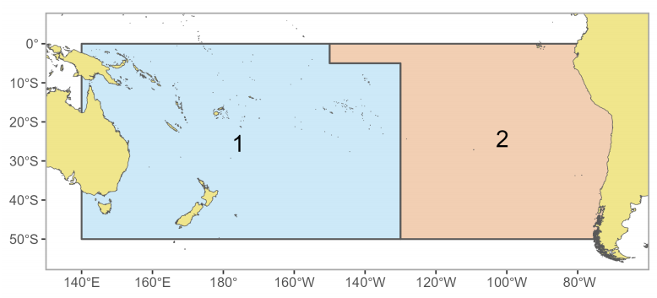
Figure SPA-01 The geographical area covered by the stock assessment and the boundaries of the two model regions used for the South Pacific-wide 2024 albacore assessment.

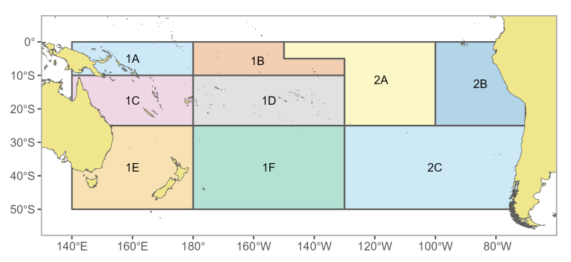
Figure SPA-02 The geographical area boundaries of the nine fisheries areas used for the South Pacific-wide 2024 albacore assessment.

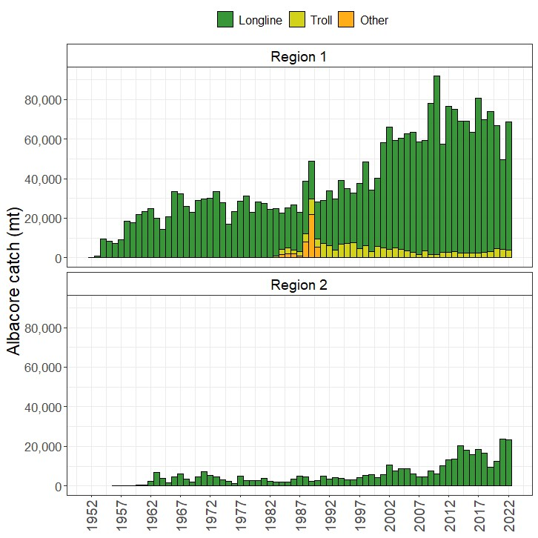

Figure SPA-03 Historical catches of albacore in each model region (WCPFC-CA = region 1, EPO = region 2) from 1952-2022 by gear type. Region 1 is the WCPFC-CA (includes catches from the overlap area), and Region 2 is the EPO (excludes the overlap area catches).
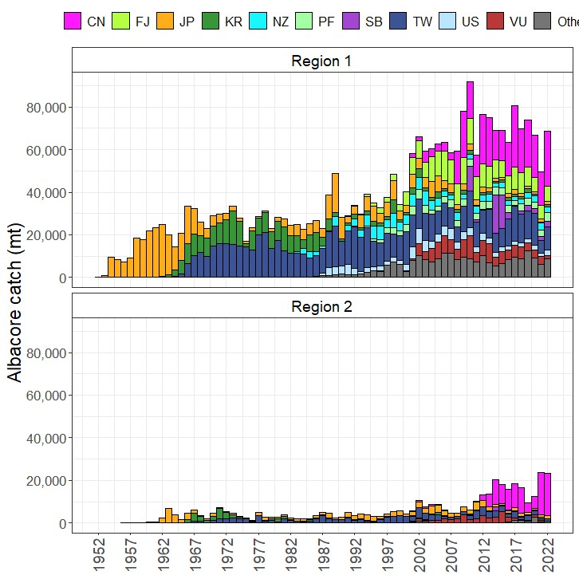

Figure SPA-04 Annual catches of albacore from 1952-2022 separated by flag for the two model regions. Region 1 is the WCPFC-CA (includes cathes from the overlap area), Region 2 is the EPO (excludes the overlap area catches).

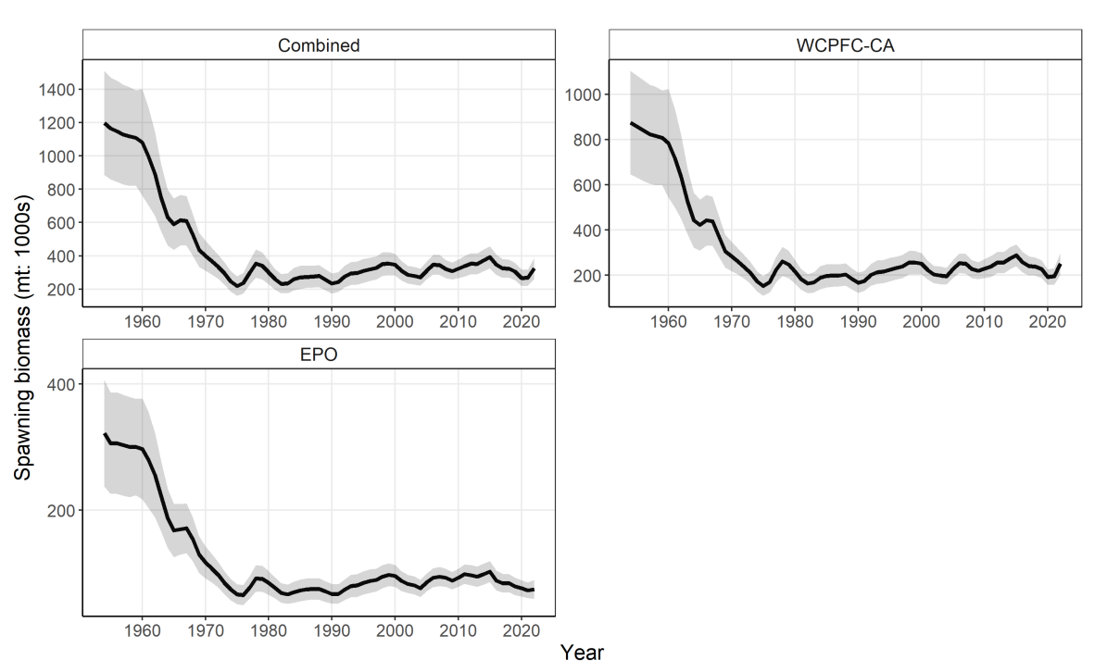
Figure SPA-05 Estimated annual spawning biomass with 95% confidence intervals by model region and the South Pacific, for the diagnostic case model.

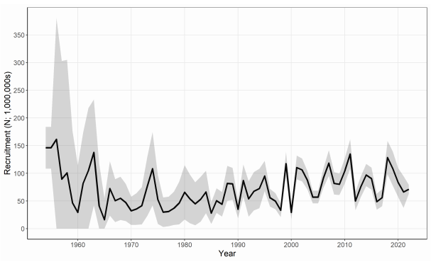
Figure SPA-06 Estimated annual recruitment with 95% confidence intervals across model regions for the diagnostic case model.
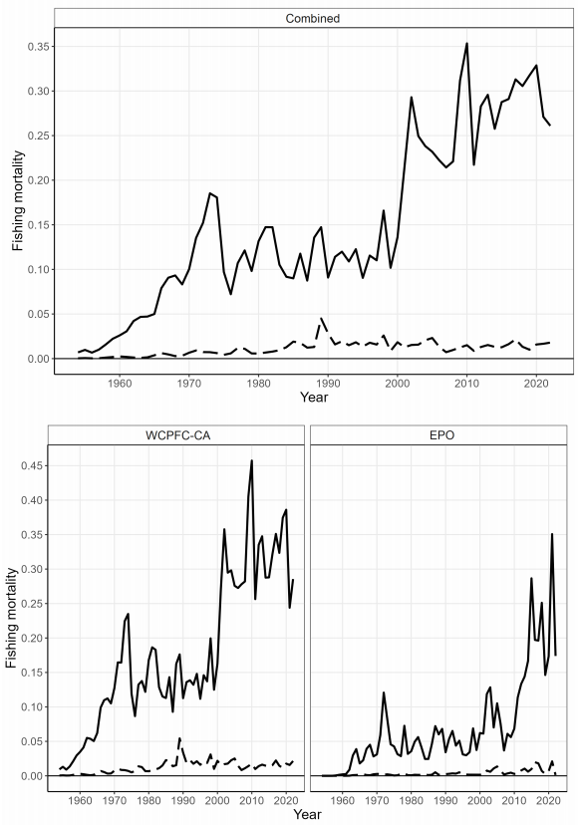
Figure SPA-07 Estimated annual juvenile (dashed line) and adult (solid line) fishing mortality for the diagnostic case model.
Figure SPA-08. Annual estimated 90% (dark blue) and 75% (light blue) quantiles of SB by region from the model ensemble. The dashed line indicates the median.

Figure SPA-09. Annual estimated 90% (dark blue) and 75% (light blue) quantiles of SB_{t}/SB_{F =0(t)} by region from the model ensemble. The dashed line within the interval indicates the median.

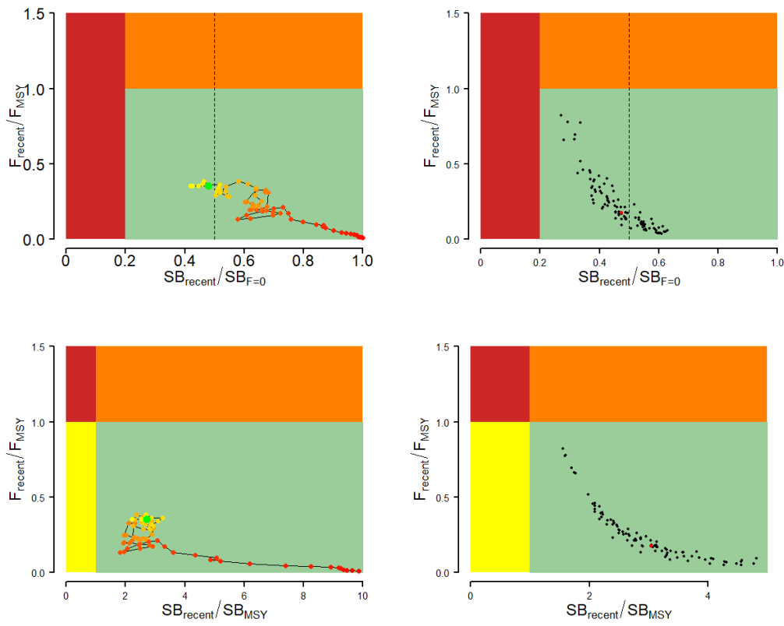
Figure SPA-10 Majuro plots (top) and Kobe plots (bottom) summarising the results for the dynamic MSY analysis (left) and each of the models in the model ensemble for the recent period (2019– 2022; right). Majuro plots include a dashed line at iTRP estimate (0.5), calculated from the current assessment (Pilling et al., 2024). Colors for dynamic MSY go from red to green over time. The red point in the model ensemble (right) represents the median.

b. Management advice and implications

- The South Pacific-wide albacore tuna stock spawning biomass is above the biomass LRP, and Frecent is below FMSY for all models in the uncertainty ensemble. The stock is not overfished (0% probability SB_{recent}/SB_{F=0} < LRP) and is not experiencing overfishing (100% probability F_{recent} < F_{MSY}).

Table SPA-01 Summary of reference points over the model ensemble, along with results incorporating estimation uncertainty. Note that these values do not include estimation uncertainty, unless otherwise indicated.
 | Mean | Median | Min | 10% | 90% | Max
F_{MSY} | 0.15 | 0.16 | 0.10 | 0.12 | 0.18 | 0.20
F_{mult} | 7.95 | 5.61 | 1.21 | 2.27 | 17.18 | 27.66
F_{recent}/F_{MSY} | 0.22 | 0.18 | 0.04 | 0.06 | 0.44 | 0.82
MSY | 113,308 | 101,100 | 62,120 | 74,018 | 176,330 | 202,400
SB₀ | 587,089 | 566,950 | 529,100 | 537,100 | 662,500 | 749,700
SB_{F=0} | 724,200 | 711,059 | 665,389 | 674,633 | 788,312 | 857,071
SB_{latest}/SB₀ | 0.66 | 0.67 | 0.38 | 0.53 | 0.81 | 0.90
SB_{latest}/SB_{F=0} | 0.54 | 0.54 | 0.29 | 0.41 | 0.70 | 0.78
SB_{latest}/SB_{MSY} | 3.71 | 3.40 | 1.65 | 2.32 | 5.77 | 7.45
SB_{MSY} | 111,738 | 110,950 | 65,140 | 80,350 | 142,690 | 172,600
SB_{MSY}/SB₀ | 0.19 | 0.20 | 0.11 | 0.13 | 0.24 | 0.27
SB_{MSY}/SB_{F=0} | 0.15 | 0.16 | 0.10 | 0.11 | 0.19 | 0.22
SB_{recent}/SB_{F=0} | 0.48 | 0.48 | 0.27 | 0.37 | 0.62 | 0.65
SB_{recent}/SB_{MSY} | 3.30 | 3.06 | 1.54 | 2.10 | 5.23 | 6.34
YF_{recent} | 74,531 | 74,375 | 61,760 | 67,731 | 83,023 | 86,180
SB_{latest}/SB_{F=0}: iTRP | 1.065 | 1.051 | 0.961 | 1.015 | 1.139 | 1.213
SB_{recent}/SB_{F=0}: iTRP | 0.952 | 0.952 | 0.899 | 0.924 | 0.986 | 1.016
Including estimation uncertainty
F_{recent}/F_{MSY} | 0.23 | 0.18 | 0.03 | 0.06 | 0.44 | 1.00
SB_{recent}/SB_{F=0} | 0.48 | 0.48 | 0.23 | 0.36 | 0.62 | 0.77
SB_{recent}/SB_{MSY} | 3.32 | 3.02 | 1.20 | 2.04 | 5.21 | 8.96
Note: Recalibrated value for iTRP= 0.50 (Pilling et al., 2024)

4.2.2 WCPO skipjack tuna (Katsuwonus pelamis)

4.2.2.1 Indicator analysis

- The skipjack indicators in Working Paper SC20-SA-WP-07 (Compendium of Fisheries Indicators for Target Tuna Stocks) from the WCPFC SSP were presented by Steven Hare of the SSP, who pointed out that the “Indicators Paper” is an annual SC report tracking a set of indices for the target tuna stocks, generally presented in plenary on the non-assessed stocks. The indices include time series of catch by gear, CPUE indices by gear, spatial maps of catch, effort and CPUE, and catch at length /weight by gear type. Additionally, short-term projections using updated catch data are provided based on status quo catches over the next three years. Discussion of each graphic with highlights are noted. Some of the highest skipjack CPUE rates seen in recent years occurred in the purse seine fishery, with the fishery shifting significantly eastward in association with the change to El Niño conditions in 2023. Yellowfin CPUE saw large changes in dFAD (-35%) and free school (+50%) rates. Yellowfin catches were second highest on record, continuing a decade long trend of generally increasing catches in contrast to the stable, or declining trends, seen in the other target tuna stocks. Skipjack and yellowfin were both projected to decline slightly over the next three years, while bigeye was projected to increase.
Discussion

- FFA CCMs through the Cook Islands thanked the Scientific Service Provider for the comprehensive work undertaken to compile these fishery indicators. They found these indicators very useful as they provide empirical information on recent patterns in fisheries for all `key' target tuna species for those years when a stock assessment is not conducted. Along with short-term stochastic projections, this helped us to assess potential stock status until such time as a full stock assessment is undertaken.

Note: SC20 outcomes based on the discussion of skipjack indicators in working paper SC20-SA-WP-07 are recorded under agenda item 4.2.3.2, where the paper’s yellowfin and bigeye indicators were also discussed. These outcomes are relevant for all of the species represented in the ‘Indicators’ paper.

4.2.2.2 Long-term recruitment and CPUE trends of skipjack tuna (Project 115)
Papers: SC20-SA-WP-06, SC20-SA-IP-16

- Paul Hamer of the SSP and Makoto Nishimoto of Japan FRA presented SC20-SA-WP-06, which discussed the work done under WCPFC Project 115. The first part explored the increasing trend in skipjack recruitment, particularly from the 1970s to the early 2000s, estimated by successive MFCL skipjack assessments for the Western and Central Pacific Ocean. The second part described attempts to determine the possible extent of effort creep (catchability increase) in the Japanese pole-and-line fishery for skipjack (JPPL), through industry surveys and a modelling approach. Given the lack of irrefutable evidence for or against the increasing recruitment trend, it was concluded that the trend should be considered as an uncertainty in the stock assessment. Under the hypothesis that the recruitment trend is at least partly a model estimation artifact related to stable JPPL CPUE abundance trends due to effort creep, alternative CPUE indices adjusted for plausible changes in catchability should be modelled. The study on the JPPL fishery provided support for effort creep occurring due to major technological advances in the 1990s. These advances have likely led to increased catchability following an S shaped trajectory, with the modelling suggesting that JPPL skipjack catchability has increased by 1.99 since the 1970s. This work would inform the consideration for further modelling experiments and the inclusion of effort creep scenarios for JPPL CPUE indices in the 2025 skipjack assessment.

Discussion

- Indonesia was surprised that recruitment of skipjack appeared to have increased over time and noted that the hotspot for recruitment of skipjack was in region 5. Paul Hamer pointed out that the only skipjack larval data is one survey from 50 years ago, and the hotspot is probably more broadly distributed through the warm pool region.

- Indonesia also asked a question about Japan pole and line effort creep and wondered if the analysis had also included vessel size, engine size and use of water pumps. Makoto said these factors were not included but could be looked at.

- Tuvalu, on behalf of FFA CCMs, noted that the results of Project 115 did not provide irrefutable evidence for, or against, an increasing trend in skipjack tuna recruitment from the 1970s to the early 2000s predicted by successive MULTIFAN-CL skipjack tuna assessments. For this reason, they agreed with the conclusions made by the authors of paper SC20-SA-WP-06 that the increasing recruitment trend should be treated as an uncertainty in the skipjack tuna assessment and that this uncertainty should be further explored by conducting a MULTIFAN-CL modelling experiment using the 2022 diagnostic case that applies incremental catchability adjustment to the long-term CPUE time series for the Japanese pole-and-line fishery for skipjack tuna; and comparing the results from the modelling experiment to the plausible levels of catchability creep suggested in the current study, and other literature, and provide options for effort creep scenarios to be considered in the 2025 skipjack tuna assessment.

- FFA CCMs also supported the need for regular sampling to improve the understanding of the early life-history of skipjack tuna in the Western Pacific Warm Pool. Such data would be helpful in not only better understanding recruitment patterns, but would also be helpful examining the effects of climate change by linking recruitment with warm pool dynamics.

- The EU thanked the presenters for huge amount of work carried out in this study. It noted there seemed to be a good long-term correlation between the environmental data and estimated recruitment trend, and although correlation did not necessarily mean causation, they agreed that the way environment and fishery data link could be quite complex and that none of the possibilities could be ruled out at this stage. The EU had one comment in relation to the further exploration of the MFCL long-term recruitment trend, which now seems to be limited to catchability scenarios. Did the SSP think it might be worth also exploring additional scenarios, such as testing runs with higher steepness values and natural mortality vectors, since they could also provide an alternative explanation to the apparent stock resilience to exploitation? This may have been explored previously in the stock assessments, but it would be helpful if the presenter could provide an opinion on this.

- Paul Hamer noted that the models would be looked at in more detail in future and would include some additional potential parameter settings.

- China pointed out the lack of strong correlation between residuals of recruitment and size of the warm pool, and wondered if the linkage was indirect. This lack of correlation between residuals might be ironed out in the long-term trend, and they encouraged the SSP to investigate this further. Also, it sounded like there was a plan to integrate Japan Pole and Line (PL) effort creep in the next SKJ assessment and wondered if the Purse-seine (PS) fishery was also going to be tested for effort creep for incorporation into the assessment model.

- The SSP noted that there was already a detailed PS effort creep analysis, but it had only covered the period since the PNA VDS was introduced and this was not a long enough time period to usefully correlate with the environmental trends.

- The Marshall Islands asked how the SSP reconciled WCPFC recruitment scenarios with what was happening in the IATTC region.

- The presenter could not answer that immediately. The hypothesis of increased production within the western and central Pacific could not be rejected, and there may be other factors involved. The SSP hadn’t investigated the potential implications of reduction in populations of predators that eat juvenile skipjack, but noted that would be a complex investigation. One mechanism for maintaining the SKJ catch in the PS fishery could be the expansion in area of the skipjack fishery overtime, and there is some evidence for this. There is clearly more to consider and investigate.

- Chinese Taipei found the potential correlation between expansion of the warm pool and the recruitment trend in the SKJ model interesting. Was there a possibility that something similar might be affecting bigeye tuna? The major effort creep in the Japan pole and line fishery over the long term was also interesting.

- Paul Hamer replied that the same trend in recruitment was not observed in the bigeye stock assessment, although he hadn’t yet looked at what SEAPODYM might estimate. But bigeye tuna are very different from skipjack, not so dependent on the warm pool and are not confined to surface waters, showing daily migration from surface waters (night), to depths of 400+ m (daytime).

- SC20 thanked the SPC and the Fisheries Research and Education Agency (Japan) for their joint work in providing the results of the project.

- SC20 noted that the conclusion of the project did not provide irrefutable evidence for or against an increasing trend in skipjack tuna recruitment from the 1970s to the early 2000s. While the long-term trend in the Western Pacific Warm Pool was consistent with the trend in the recruitment estimated by the assessment model, interannual dynamics of the Warm Pool area or the other environmental/climatic indicators were not correlated with the assessment’s recruitment estimates. Further, while the SEAPODYM model indicated some recent increases in juvenile skipjack production, it did not show a long-term trend. It was noted that the lack of fishery-independent data and field studies on larval and juvenile skipjack represents a major gap in the ability to understand skipjack recruitment dynamics and trends in the Warm Pool region.

- SC20 supported the need for more sampling to improve the understanding of the early life history of skipjack tuna in the Western Pacific Warm Pool. Such data will help not only to better understand recruitment patterns, but also to examine the effects of climate change by linking recruitment to warm pool spatio-temporal dynamics and productivity changes.

- SC20 recommended that due to the limited information on skipjack recruitment, outside of the assessment model estimates, the increasing trend in recruitment should be considered as an uncertainty in future skipjack assessments. One way to moderate recruitment trends in the stock assessment could be through adjustments to trends in CPUE abundance indices that could be related to effort creep.

- SC20 encouraged further work prior to the next Pre-Assessment Workshop (PAW) scheduled in 2025 to consider the uncertainty axis for the Japanese pole-and-line effort creep for the 2025 assessment. This should be further explored by conducting a MULTIFAN-CL modelling experiment using the 2022 diagnostic case that applies an incremental catchability adjustment to the long-term CPUE time series for the Japanese pole-and-line fishery and the free school purse seine; and compare the results of the modelling experiment with the plausible levels of effort creep suggested in the current study and SC20-SA-IP-19, and provide options for effort creep scenarios not only in the Japanese pole-and-line fisheries but also in the free school purse seine for consideration in the 2025 skipjack tuna assessment.

4.2.3 WCPO bigeye (Thunnus obesus) and yellowfin tuna (Thunnus albacares)
Information Paper SC20-SA-IP-21, SC20-SA-IP-22

4.2.3.1 Further analyses for bigeye and yellowfin tuna assessment

4.2.3.2 Indicator analysis

- BET and YFT indicators in SC20-SA-WP-07 were presented for the SSP by Steven Hare of the SSP.

- The USA thanked the SSP for this paper. Since feedback had been requested, they suggested that the most useful component of the paper was the short-term projections conducted from the stock assessment models. In general, they were uncomfortable with the presentation of unstandardized data as it might lead to misinterpretation of trends. If trends in mean size and/or CPUE continue to be presented, it may be more informative to present these trends following standardization. They understood that standardizing all of this data will require a substantial effort so a more feasible solution could be to only present the short-term projections.

- SC20 thanked the SSP for conducting an indicator analysis providing empirical information on recent patterns affecting key stocks.

- SC20 noted that short-term projections are the most useful component for this analysis and suggested that non-standardized CPUE data not be presented so as to avoid misinterpretation of trends. Noting the similarities in information presented within the SC20-GN-WP-01 and Indicators papers, SC20 tasked the SSP to rationalize the content of the latter to minimize duplication.

4.2.3.3 Reproductive biology of yellowfin tuna (Project 120)
Information paper SC20-SA-IP-11

4.3 Northern stocks
Working Paper: SC20-GN-WP-03

- Robert Ahrens (ISC Chair) provided an update on ISC activities since SC19. The ISC24 Plenary meeting was held June 19-24, 2024, in Victoria, Canada. The ISC approved the stock status and conservation information based on benchmark stock assessments for PBF and SMA, which were presented at SC20 for information. Stock status and conservation information for NPO-ALB, NPO-BSH, NPO-SWO, BUM, and WCNPO-MLS remained unchanged from 2023. A formal external peer-review of the 2023 WCNPO-MLS stock assessment was conducted by an expert panel at an in-person meeting with the Billfish WG in Chinese Taipei in April 2024 with administrative support from the WCPFC Science Manager and Secretariat. The goal of the review was to improve stock assessment modelling and the process. A plan was in place to address the conclusions and recommendations of the review panel and it was clear that future billfish assessments and assessments undertaken by other ISC WGs would benefit from the work of the review panel.

- The ISC had also responded to requests for information from the NC and WCPFC. Advice on exceptional circumstances leading to the suspension or modification of the adopted harvest strategy for NP-ALB, and translating fishing intensity to management controls (catch or effort), was communicated in 2024 (for details see ISC/24/ANNEX/08, Attachments 5 and 6, respectively). Projections on six additional PBF harvest scenarios were conducted for the IATTC-WCPFC Joint PBF WG just prior to the ISC Plenary meeting (see ISC/24/ANNEX/13, Appendix 1). Lastly, 10 projection scenarios based on 2023 assessment (6 catch, 4 fishing mortality) were provided to support WCNPO-MLS stock rebuilding plan discussion at SC20. These projections did not change stock status and conservation information for the stock provided in 2023.

- Workplans for the next year included conducting an indicator analysis of North Pacific Ocean blue shark (NPO-BSH), conducting the first iteration of the PBF MSE process, exploring and formalizing the use of ‘Open Science’ tools and approaches in conducting stock assessment and other ISC activities, and continuing to work on incorporating climate change considerations into stock status and conservation information to support discussion on a framework at the next ISC meeting. The next ISC Plenary meeting was scheduled for June 17-20, 2025, in the Republic of Korea.

4.3.1 Pacific bluefin tuna (Thunnus orientalis)

4.3.1.1 Pacific bluefin tuna stock assessment
Working Paper: SC20-SA-WP-08

- H. Fukuda, the lead modeller of the ISC Pacific Bluefin tuna (PBF) Working Group (WG), made a detailed report on the benchmark stock assessment for PBF conducted in March 2024 (SC20-SA-WP-08). As this assessment was a benchmark assessment, all of the aspects of assessment, including data, biological information, and assumptions were reviewed and re-considered during the data preparation and assessment workshops. Based on the review works on the previous stock assessment base case, the PBFWG highlighted two issues to be addressed, which are the inflexibility of the model to the alternative productivity assumptions as well as a systematic retrospective pattern. The PBFWG acknowledged that several modifications were required to improve those such as the changing the model start year from 1952 to 1983, terminating the abundance index based on the troll CPUE in 2010, reducing the residuals associated with the size composition data. The 2024 base case model showed a consistent SSB estimates over the retrospective runs, better model fits to both the index and size data, and a higher flexibility to the alternative assumption to the steepness assumption. Population dynamics during 1983-2022 period was modelled using quarterly observations of catch and size compositions, when available, as well as the annual estimates of standardized CPUE-based abundance indices. The assessment model was fitted to the input data in a likelihood-based statistical framework. Based on the diagnostic analysis, the PBFWG concluded that the new base-case model represented the data sufficiently and there was an internal consistency among the assumptions of the assessment model and input data. The 24th ISC plenary concluded that the 2024 assessment model reliably represented the population dynamics and was the best available scientific information for the PBF stock.

- The base-case model results showed that: (1) spawning stock biomass (SSB) fluctuated throughout the assessment period (fishing years 1983-2022); (2) the SSB steadily declined from 1996 to 2010; (3) the SSB had rapidly increased since 2011; (4) fishing mortality (F%SPR) decreased from a level producing about 1% of SPR in 2004-2009 to a level producing 23.6% of SPR in 2020-2022; and (5) SSB in 2022 increased to 23.2% of SSBF=0, achieving the second rebuilding target by WCPFC and IATTC in 2021. Based on the model diagnostics, the estimated biomass trend throughout the assessment period was considered robust. The SSB in 2022 was estimated to be 144,483t, more than 10 times its historical low in 2010. An increase in immature fish (0-3 years old) was observed in 2016-2019, likely resulting from reduced fishing mortality on this age group, and this led to a substantial increase in SSB after 2019.

- The projection analysis was conducted based on the several harvesting scenarios requested by the IATTC-WCPFC NC Joint Working Group on the PBF management. Those results showed a rapid increase of the stock with status quo management, and a possibility of catch increase with negligible risk of the stock falling below 7.7%SSB_{F=0} (the interim LRP for tropical tunas agreed by IATTC) at least once in 10 years.

Discussion

- Vanuatu, on behalf of FFA CCMs, thanked the Pacific bluefin tuna Working Group of the ISC for the stock assessment of the Pacific bluefin tuna in the Pacific Ocean. They noted that the spawning stock biomass continues to build at a rapid rate and has been above the LRP of 20% SSB_{F=0} used for key tuna stocks in WCPFC and IATTC since 2021. This continued improvement in the status of the stock was a credit to all the CCMs who drastically reduced their PBF catch when the stock was performing poorly and highlighted the importance of having a good harvest strategy to guide decision-making. Regarding the stock assessment, SC19 had adopted guidance for addressing uncertainty in WCPFC stock assessments last year and FFA Members noted that again this best-practice approach had not been utilised in the 2024 PBF stock assessment, which utilised only a single model for determining stock status. They recommended that future assessments gave proper consideration to this guidance for addressing uncertainty. FFA Members noted that the projection outcomes essentially relied on the assumption that recent and future recruitment would be adequate to support the recovery. They continued to advocate for careful monitoring in this regard.

- The presenter explained that while the Working Group considered using an ensemble approach, the model diagnostics showed positive results, so they did not see a need for it. They were, however, incorporating structural uncertainty in the operating model for the ongoing MSE work.

- The EU thanked the authors for the assessment. They welcomed the results – evidence for good recovery of stock, which was now estimated to be at a level slightly above the second rebuilding target, coinciding with the default LRP for key tuna stocks in the WCPFC. They thought it was great news and showed a commitment from all involved in the catch of this species. At the same time, as the EU had expressed in previous occasions, they shared the concerns expressed by FFA CCMs about the treatment of uncertainty in this stock assessment and projections, which required the EU also to call for caution when considering future management measures. They appreciated the comment of the presenter in relation to the robustness of the results to uncertainty, but at the same time, it seemed the 2nd rebuilding target would not have been met if, as an example, a steepness value below 0.98 had been used. They thought it was very important to take this into consideration.

- The US asked if the ISC PBFWG could comment on the likely cause of the increase in SSB. Was it mainly driven by an across the board increase in numbers or was it mainly due to the strong year classes in 2015-2016 growing in body mass, considering that recruitments had been lower than average in 2017-2020? It would be helpful when considering management objectives if the BFT WG could provide a figure of numbers at age in the recent past (e.g., last 20 years) in future assessments to determine if the recovery was sustained or if it was only due to a strong year class. The USA encouraged an external peer review for the Pacific bluefin tuna stock similar in scope to the recently completed WCNPO-MLS stock. The USA was considering partial funding for such a review.

- The presenter acknowledged that the recovery was partly supported by the 2015 and 2016 year-classes, though these were not particularly strong compared to previous strong year-classes. However, due to low fishing mortality, these year-classes were able to survive to the terminal year, contributing to the recovery of the stock. He also mentioned that post-2016 recruitment estimates were uncertain because of the lack of a recruitment index, and the Working Group was currently working to develop alternative indices.

- FSM, on behalf of PNA and Tokelau, supported the FFA statement. They thanked the ISC for the assessment and congratulated everyone involved on the progress in rebuilding this important stock. However, this stock remained the most depleted of the target tuna stocks in the WCPO. They noted that while the stock status appeared to be improving, the range of all projections for all 12 model runs has not been presented to inform management considerations by the Commission for this stock. There were stocks managed through the WCPFC that were much healthier than the Pacific bluefin tuna stocks. However, a greater degree of caution is taken with respect to assessing uncertainty for those other stocks than for Pacific bluefin, which is in a more depleted state. They believed that caution was warranted when advising the Commission on a management approach for Pacific bluefin tuna. The priority should be in determining the next rebuilding target, that equates to being less than the 20% risk of falling below 20%SB_{F=0}, under current conditions.

- The presenter said that despite uncertainty, the diagnostics showed positive results and average effect of productivity was captured under assumptions. It was possible to predict future dynamics as a result of this, and based on the 2016 production assumption, it could be predicted how the stock would respond – the actual result was close to the projection and this kind of assessment could be very powerful for assisting management decisions.

- Japan acknowledged the impressive match between the model projections and actual data, attributing it to the availability of good data and the stock’s simple structure. They emphasized the importance of monitoring recruitment, which Japan is actively conducting. Japan also noted the increasing catch of Pacific bluefin tuna in the southern hemisphere by New Zealand, highlighting the need for further cooperation from New Zealand. They expressed confidence in the future projections from the assessment and supported the results, particularly the stock recovery, recommending that the SC welcome the findings and note the ISC recommendations as in the past.

- China noted there was still high uncertainty and limited information about the link between biomass and recruitment. They suggested ISC could do some further research on this and on key parameters like steepness.

- Indonesia congratulated the ISC and the assessment team for their explanation that the PBF spawning biomass had recovered, which was good news. They had one question on the projection plot, where it seemed the projection suggested that the biomass would soon reach a higher level than in the first year that fishing was recorded in the assessment – around 1950. Was it possible that a level higher than B₀ could be reached, and what would be the reason?

- The presenter explained that the recovery was driven by reduced fishing mortality due to strict catch limits and the larger size of fish caught, which could continue to drive further increases in biomass.

- SC20 requested the ISC bluefin tuna working group provide a figure of the numbers-at-age by year in the recent past (e.g., last 20 years) in future assessments to determine if the recovery is sustained or if it is only due to a strong year class.

- SC20 also noted that some CCMs expressed concerns about the limited treatment of uncertainty of a single model run for providing management advice, especially with regards to steepness and the stock recruitment relationship, and requested the ISC bluefin tuna working group consider the guidance provided by SC19 for characterizing uncertainty in WCPFC stock assessments.

4.3.1.2 Provision of scientific information to the Commission

a. Stock status and trends

- SC20 welcomed the completion of a benchmark assessment for Pacific bluefin tuna and noted the following stock status and trends information from ISC24:

“While there are few Pacific bluefin tuna (PBF) catch records prior to 1952, PBF landing records are available dating back to 1804 from coastal Japan and to the early 1900s for U.S. fisheries operating in the EPO. Based on these landing records, PBF catch is estimated to be high from 1929 to 1940, with a peak catch of approximately 47,635 t (36,217 t in the WPO and 11,418 t in the EPO) in 1935; thereafter catches of PBF dropped precipitously due to World War II. PBF catches increased significantly in 1949 as Japanese fishing activities expanded across the North Pacific Ocean. By 1952, a more consistent catch reporting process was adopted by most fishing nations and estimated annual catches of PBF fluctuated widely from 1952-2022 (Figure [1]). During this period reported catches peaked at 40,383 t in 1956 and reached a low of 8,653 t in 1990. The reported catch in 2021 and 2022 was 15,107 t and 17,458 t, respectively, including non-member countries of the International Scientific Committee for Tuna and Tuna-like Species in the North Pacific Ocean (ISC). Management measures were implemented by Regional Fisheries Management Organizations (RFMOs) beginning in 2011 (WCPFC in 2011 and IATTC in 2012) and became stricter in 2015. While a suite of fishing gears has been used to catch PBF, the majority of the catch is currently made by purse seine fisheries (Figure [2]). Catches during 1952-2022 were predominantly composed of juvenile PBF; the catch of age 0 PBF has increased significantly since the early 1990s but declined as the total catch in weight declined since the mid-2000s and due to stricter control of juvenile catch (Figures [1 and 3]).
Population dynamics were estimated using a fully integrated age-structured model (Stock Synthesis (SS) v3.30) fitted to catch (retained and discarded), size-composition, and catch-per-unit of effort (CPUE) based abundance index data from 1983 to 2023, provided by Members of (ISC), Pacific Bluefin Tuna Working Group (PBFWG) and non-ISC countries obtained from the WCPFC official statistics. Life history parameters included a length-at-age relationship from otolith-derived ages and natural mortality estimates from a tag-recapture study and empirical-life history methods.

In 2024, the PBFWG conducted a benchmark stock assessment. The PBFWG critically reviewed all aspects of the model, and some modifications were made to improve the model. A total of 26 fleets were defined for use in the stock assessment model based on country/gear/season/region stratification until the end of the fishing year 2022 (June 2023). Quarterly observations of catch and size compositions, when available, were used as inputs to the model to describe the removal processes. Annual estimates of standardized CPUE from the Japanese distant water, offshore, and coastal longline, the Chinese Taipei longline, and the Japanese troll fleets were used as measures of the relative abundance of the population. The CPUE of Japanese longline (adult index) after 2020 and Japanese troll (recruitment index) after 2010 were not included in the model, as these observations may be biased due to additional management measures in Japan. The assessment model was fitted to the input data in a likelihood-based statistical framework. Maximum likelihood estimates of model parameters, derived outputs, and their variances were used to characterize stock status and to develop stock projections.

One of the major changes made in this assessment is that the PBFWG decided to shorten the stock assessment model by starting in 1983 instead of 1952. This adjustment was implemented because more reliable data are available after 1983. Additionally, the adoption of a shorter model period enhances flexibility and can accommodate diverse productivity assumptions. This flexibility is an important feature as this model will be used in the upcoming PBF management strategy evaluation (MSE). The PBFWG confirmed that the results and management quantities of the longer period model and the shorter period model are consistent and that the change in the duration of the assessment model does not affect the management advice (Figure 4). A simple update of the 2022 stock assessment with new data estimated slightly higher relative biomass after 2011, reflecting an underestimating tendency of the past model (Figure 4). Other changes include refined parameterization of selectivity to reduce model residuals and shortening of the recruitment index from 1983-2016 to 1983-2010. The truncation of the recruitment index was supported by various analyses as described in the main body of the assessment report and was considered appropriate to reduce the SSB retrospective bias (Mohn’s ρ for 10 years-retrospective analysis in the base case is -0.06), which was observed in several previous assessment models. After these modifications, the base-case model fits better to the input data and shows good prediction skill (the root mean square error of the Taiwanese longline CPUE for the predicted 7-year period was 0.24, see Figure 5). The PBFWG therefore concluded that the model is appropriate for generating management advice. Due to those changes, recent relative biomass was scaled up to some extent (see Figure 4) as the retrospective bias was reduced.

After conducting thorough reviews and implementing necessary modifications, the PBFWG found that the 2024 base-case model is consistent with the previous assessment results, that it fits the data well, that the results are internally consistent among most of the data sources, and that the model has improved overall by addressing the issues previously identified. The model diagnostics have confirmed that the base-case model captures the production function of PBF well, thus its estimated biomass scale is reliable, and that the model has good predictability. Based on these findings, the PBFWG concluded that the 2024 assessment model reliably represents the population dynamics and provides the best available scientific information for the PBF stock.

The base-case model results show that: (1) spawning stock biomass (SSB) fluctuated throughout the assessment period (fishing years 1983-2022); (2) the SSB steadily declined from 1996 to 2010; (3) the SSB has rapidly increased since 2011; (4) fishing mortality (F%SPR) decreased from a level producing about 1% of SPR in 2004-2009 to a level producing 23.6% of SPR in 2020-2022; and (5) SSB in 2022 increased to 23.2% of SSB_{F=0}, achieving the second rebuilding target by WCPFC and IATTC in 2021. Based on the model diagnostics, the estimated biomass trend throughout the assessment period is considered robust. The SSB in 2022 was estimated to be 144,483 t (Table 1 and Figure 6), more than 10 times of its historical low in 2010. An increase in immature fish (0-3 years old) is observed in 2016-2019 (Figure 7), likely resulting from reduced fishing mortality on this age group. This led to a substantial increase in SSB after 2019. The method to estimate confidence interval was changed from bootstrapping in the previous assessments to normal approximation of the Hessian matrix.

Historical recruitment estimates have fluctuated since 1983 without an apparent trend (Figure 6). Currently, stock projections assume that future recruitment will fluctuate around the historical (1983-2020 FY) average recruitment level. Previously, no significant autocorrelation was found in recruitment estimates, supporting the use in the projections of recruitment sampled at random from the historical time series. In addition, now that SSB has recovered to 23.2%SSB_{F=0}, the PBFWG considers the assumption that the future recruitment will fluctuate within the historical range to be reasonable. The PBFWG also confirmed that the distributions of historical recruitment from the updated long-term model (1952-2022) and the present base-case model (1983-2022) are comparable.

The recruitment index based on the Japanese troll CPUE has proven to be an informative indicator of recruitment in PBF assessments. However, the PBFWG found that the catchability of the recruitment index may have been affected by the adoption of a new licensing system and an increase in troll catch for farming operations after 2010, as well as management interventions after 2016. In addition, an examination of model diagnostics suggested that fitting to the recruitment index after 2010 degraded model prediction skill and increased the SSB retrospective pattern. Therefore, for this assessment, the PBFWG extended the approach of the 2022 assessment and terminated the recruitment index after 2010. This was considered appropriate because even in the absence of a recruitment index, the model still has other reliable and mutually consistent data to estimate SSB and recruitments, in particular the adult indices.

Although the recruitments are well estimated for most of the time series, the recruitment estimates in the terminal period (2019-2022) are more uncertain than other years (Figure 6), which is also shown in the retrospective analysis of recruitment. The recruitment estimate in the terminal year (2022) is uninformed by data and was hence based on the stock recruitment relationship and close to the estimated unfished recruitment. Therefore, recent recruitment estimates should be treated with caution.

Additional evidence on recent recruitment trends was examined by the PBFWG using the newly developed standardized CPUE index from the Japanese troll monitoring program for 2011-2023 (Figure 8). Although the PBFWG concluded that it was premature to include this index in the base-case model, this index is believed to provide a good qualitative indication of recruitment trends. With regard to the recent low recruitment period estimated by the base-case model (2019-2021), the monitoring index showed relatively low recruitment in 2019 and 2020, but relatively high recruitment in 2021-2023. Based on this evidence and the uncertainty in the retrospective analysis of recruitment previously noted, the PBFWG considered the 2021 recruitment estimate from the base-case model to be less reliable. Therefore, the PBFWG decided to start using resampled historical recruitment from 2021, rather than 2022, for the projections.

This, in effect, means that the recruitment in 2021 is assumed to be around the historical average, and if in fact it is lower than assumed, though the PBFWG believes it unlikely from the survey index (Figure 8), the near-term projection results would become more pessimistic.
Estimated age-specific fishing mortalities (F) on the stock during the periods of 2012-2014 and 2020-2022, compared with 2002-2004 estimates (the reference period for the WCPFC Conservation and Management Measure), are presented in Figure 9.

Figure 10 depicts the historical impacts of the harvest by the fleets on the PBF stock, showing the estimated biomass when fishing mortality from the respective fleets is zero. Note that trends in fishery impact back to 1970 were computed using the base-case model extended to 1952. Historically, the WPO coastal fisheries group has had the greatest impact on the PBF stock, but since about the early 1990s the WPO purse seine fishery group targeting small fish (ages 0-1) has had a greater impact and the effect of this group in 2022 was greater than any of the other fishery groups. The impact of the EPO fisheries group was large before the mid-1980s, decreasing significantly thereafter. The WPO longline fisheries group has had a limited effect on the stock throughout the analysis period because the impact of a fishery on a stock depends on both the number and size of the fish caught by each fleet; i.e., catching a high number of smaller juvenile fish can have a greater impact on future spawning stock biomass than catching the same weight of larger mature fish. In 2022, the estimated cumulative impact proportion between WPO and EPO fisheries is about 83% and 17%, respectively. There is greater uncertainty regarding discards than other fishery impacts because the impact of discarding is not based on observed data. Currently, the amount of discard is assumed to be 6% of the reported release in EPO and 5% of the catch in WPO, lacking reliable data. “

- SC20 noted the following stock status information from ISC24:

“PBF spawning stock biomass (SSB) has increased substantially in the last 12 years. These biomass increases coincide with a decline in fishing mortality, particularly for fish aged 0 to 3, over the last decade. The latest (2022) SSB is estimated to be 23.2% of SSB_{F=0} and the probability that it is above 20%SSB_{F=0} is 75.9%.

Based on these findings, the following information on the status of the Pacific bluefin tuna stock is provided:
  - No biomass-based limit or target reference points have been adopted for PBF, but the PBF stock is not overfished relative to 20%SSB_{F=0}, which has been adopted as a biomass-based reference point for some other tuna species by the IATTC and WCPFC. SSB of PBF reached its initial rebuilding target (SSBMED = 6.3%SSB_{F=0}) in 2017, 7 years earlier than originally anticipated by the RFMOs, and its second rebuilding target (20%SSB_{F=0}) in 2021; and

  - No fishing mortality-based reference points have been adopted for PBF by the IATTC and WCPFC. The recent (2020-2022) F%SPR is estimated to be 23.6% and thus the PBF stock is not subject to overfishing relative to some of the F-based reference points proposed for tuna species (Table 2), including F20%SPR.”

Table PBF-01. Total biomass, spawning stock biomass, recruitment, spawning potential ratio, and depletion ratio of Pacific bluefin tuna (Thunnus orientalis) estimated by the base-case model, for the fishing years 1983-2022.
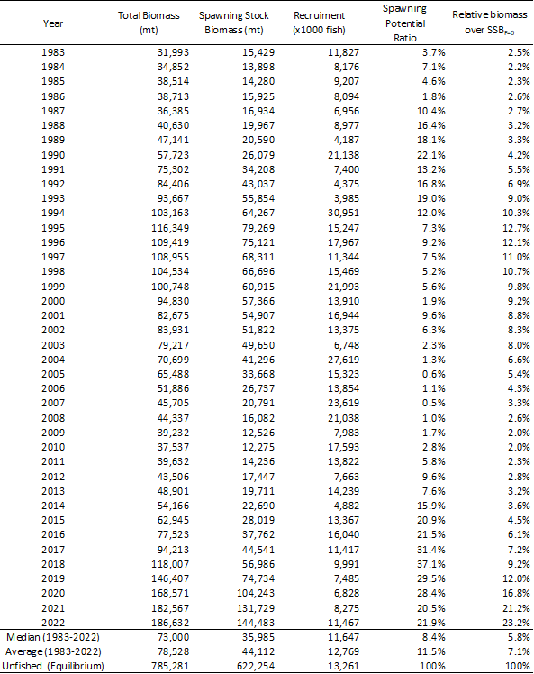

Table PBF-02. Ratios of the estimated fishing mortalities (Fs and 1-SPRs for 2002-04, 2012-14, 2020-2022) relative to potential fishing mortality-based reference points, and terminal year SSB (t) for each reference period, and depletion ratios for the terminal year of the reference period for Pacific bluefin tuna (Thunnus orientalis) from the base-case model. F_{max}: Fishing mortality (F) that maximizes equilibrium yield per recruit (Y/R). Fxx%SPR: F that produces a given % of the unfished spawning potential (biomass) under equilibrium conditions.
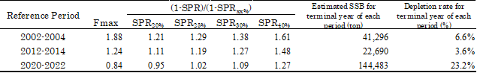

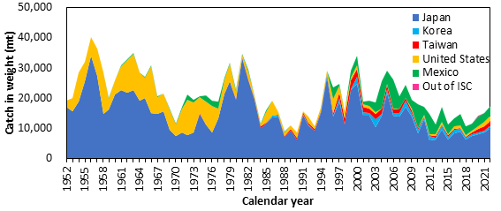

Figure PBF-01. Annual catch (tons) of Pacific bluefin tuna (Thunnus orientalis) by ISC member countries from 1952 through 2022 (calendar year) based on ISC official statistics.

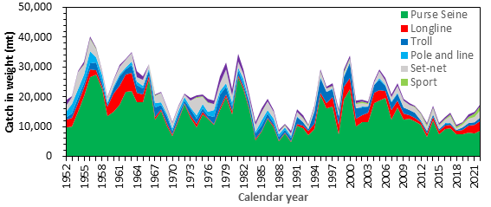

Figure PBF-02. Annual catch (tons) of Pacific bluefin tuna (Thunnus orientalis) by gear type by ISC member countries from 1952 through 2022 (calendar year) based on ISC official statistics.
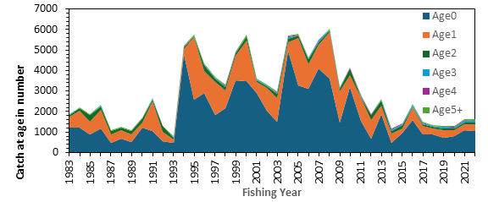
Figure PBF-03. Estimated annual catch-at-age (number of fish) of Pacific bluefin tuna (Thunnus orientalis) by fishing year estimated by the base-case model (1983-2022)
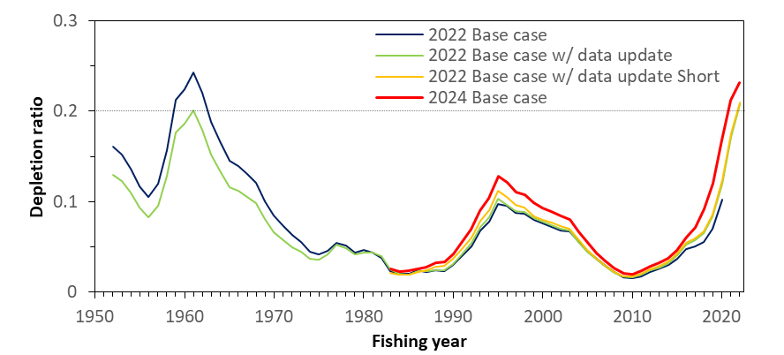
Figure PBF-04. Comparison of the trajectory of relative biomass (SSB/SSB_{F=0}, depletion ratio) of the assessment models bridging from the 2022 base-case to the 2024 base-case (2022 base-case, 2022 base-case with data-update, 2022 base-case with data-update Short (1983-), and the 2024 base-case model). The 2022 base case with data update and the 2022 base case with data update Short (1983-) almost overlap towards the end. SSB is spawning stock biomass, and SSB _{F=0} is the expected SSB under average recruitment conditions without fishing. The horizontal line represents 20%SSB_{F=0} (the second biomass rebuilding target).
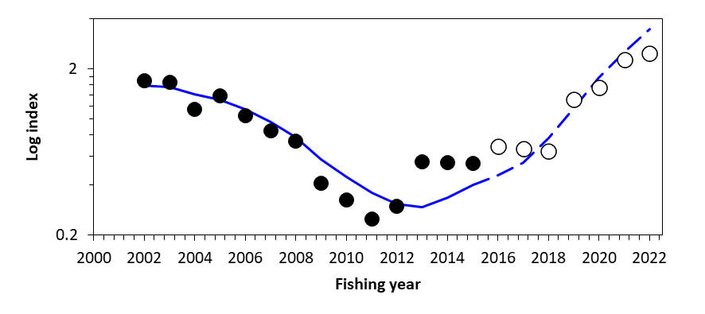
Figure PBF-05. Result for hindcasting of the recent 7 years (2016-2022) based on the catch at age. The expected (blue solid line) and predicted (blue dashed lines) Taiwanese longline CPUE index from the age-structured production model, where CPUE observations were removed for the recent 7 years. The solid circles represent the observations used in the model, and open circles represent the missing values.

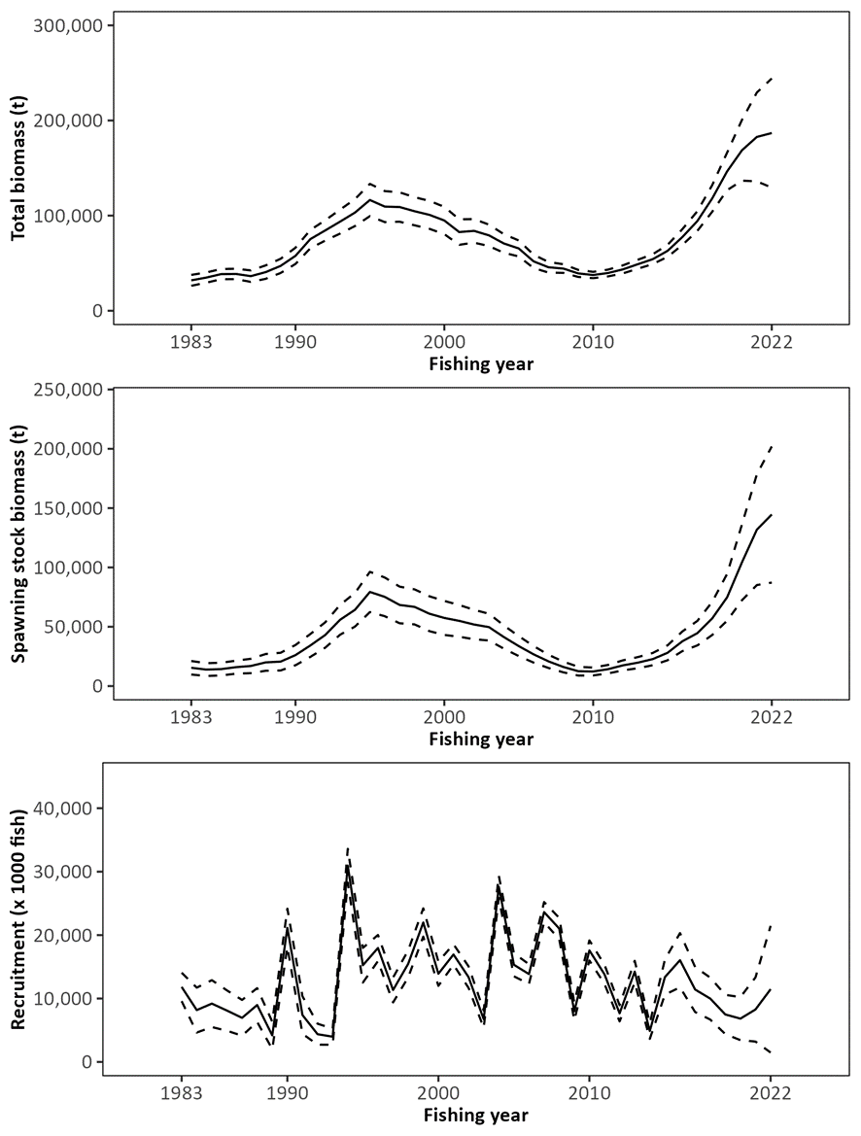
Figure PBF-06. Trajectory of total stock biomass (top), spawning stock biomass (middle), and recruitment (bottom) of Pacific bluefin tuna (Thunnus orientalis) (1983-2022) estimated from the base-case model. The solid line is the point estimate, and dashed lines delineate the 90% confidence interval. The method used to estimate the confidence interval was changed from bootstrapping in the previous assessments to the normal approximation of the Hessian matrix.
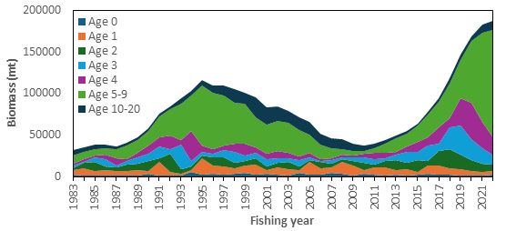
Figure PBF-07. Total biomass (tons) by age of Pacific bluefin tuna (Thunnus orientalis) estimated from the base-case model (1983-2022). Note that the recruitment estimates for 2019-2022 are more uncertain than for other years.

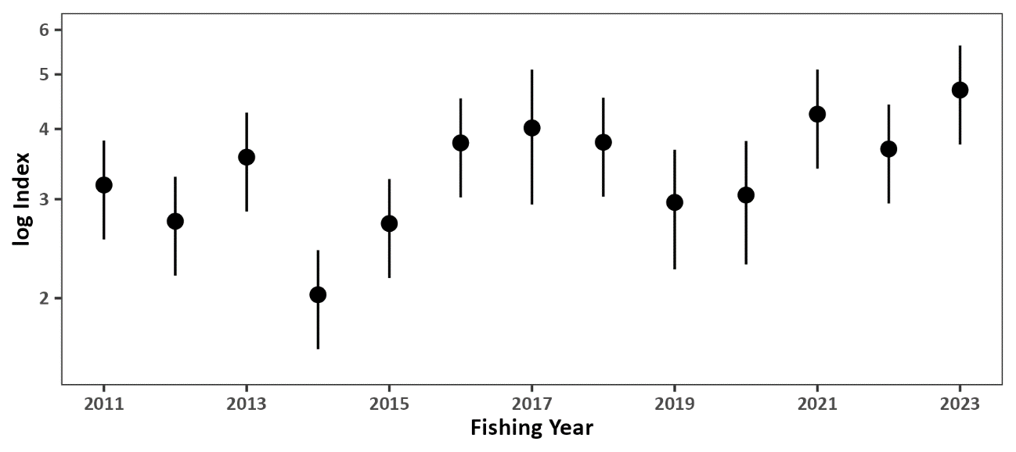
Figure PBF-08. Standardized CPUE index from the Japanese recruitment monitoring program (2011-2023). The bar represents the 95% confidence interval.

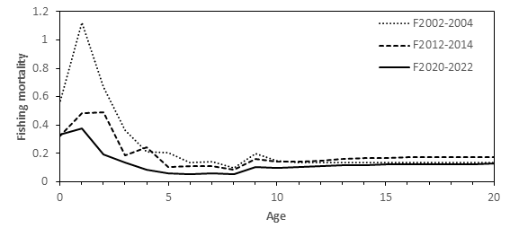
Figure PBF-09. Geometric means of annual age-specific fishing mortalities (F) of Pacific bluefin tuna (Thunnus orientalis) for 2002-2004 (dotted line), 2012-2014 (dashed line), and 2020-2022 (solid line).
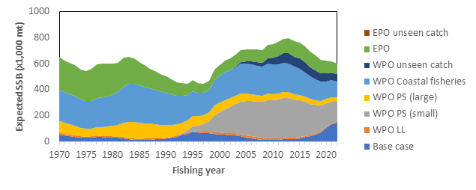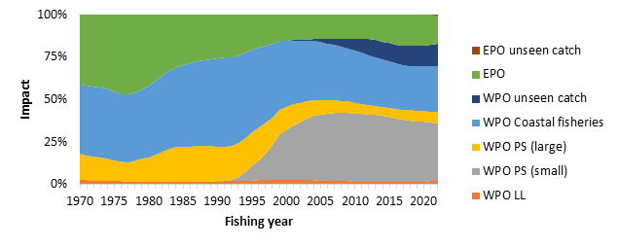
Figure PBF-10. The trajectory of the spawning stock biomass of a simulated population of Pacific bluefin tuna (Thunnus orientalis) when zero fishing mortality is assumed, estimated by the base-case long-term model. (top: absolute SSB, bottom: relative SSB). In 2022, the estimated cumulative impact proportion between WPO and EPO fisheries is about 83% and 17%, respectively. Fisheries group definition: WPO longline fisheries: F1-4. WPO purse seine fisheries for large fish: F5-7. WPO purse seine fisheries for small fish: F8-11. WPO coastal fisheries: F12-19. EPO fisheries: F20-23. WPO unaccounted fisheries: F24, 25. EPO unaccounted fisheries: F26. For exact fleet definitions, please see the 2024 PBF stock assessment report. Although larger PBF have been caught by the Korean offshore large-scale purse seine in recent years, this fleet is included in “WPO PS (small)” because of their historical selectivity.

b. Management advice and implications

- SC20 noted the following management advice from ISC24:

“The WCPFC and IATTC adopted an initial rebuilding biomass target (the median SSB estimated for the period from 1952 through 2014) and a second rebuilding biomass target (20%SSBF=0 under average recruitment) but not a fishing mortality reference level. The previous (2022) assessment estimated the initial rebuilding biomass target (SSBMED1952-2014) to be 6.3%SSB_{F=0} and the corresponding fishing mortality expressed as SPR of F6.3%SPR (Table [2]). The Kobe plot shows that the point estimate of the SSB2022 was 23.2%SSB_{F=0} and that the recent (2020-2022) fishing mortality corresponds to F23.6%SPR (Table [1] and Figure [10]). The apparent increase in F in the terminal period compared to the historical low in 2018 (F37.1%SPR) is a result of low recruitment in this period. As noted, the recruitment estimates in recent years are more uncertain and this result needs to be interpreted with caution.
After the steady decline in SSB from 1996 to the historically low level in 2010, the PBF stock has started recovering, and recovery has been more rapid in recent years, coinciding with the implementation of stringent management measures. The 2022 SSB was 10 times higher than the historical low and is above the second rebuilding target adopted by the WCPFC and IATTC, which was achieved in 2021. The stock has recovered at a faster rate than anticipated when the Harvest Strategy to foster rebuilding (WCPFC HS 2017-02) was implemented in 2014. The fishing mortality (F%SPR) in 2020-2022 is at a level producing 23.6%SPR. According to the requests from WCPFC and IATTC, future projections under various scenarios were conducted. The projection scenarios and their results, the figure of projection results, “future Kobe plot”, and “future impact plot” are provided as Tables [3-5], Figures [12, 13, and 14], respectively. In addition, the results of additional projections which were requested by the Join Working Group of IATTC-WCPFC NC is provided in Appendix 2 of the stock assessment report (SC20-SA-WP-08, Table A2.1-A2.3, Figure A2.1).

Based on these findings, the following information on the conservation of the Pacific bluefin tuna stock is provided:
- The PBF stock is recovering from the historically low biomass in 2010 and has exceeded the second rebuilding target (20%SSB_{F=0}). The risk of SSB falling below 7.7%SSB_{F=0} (interim LRP for tropical tunas in IATTC) at least once in 10 years is negligible;
- The projection results show that increases in catches are possible. However, the risk of falling below the second rebuilding target will increase with larger increases in catch;
- The projection results assume that the CMMs are fully implemented and are based on certain biological and other assumptions. For example, these future projection results do not contain assumptions about discard mortality. Discard mortality may need to be considered as part of future increases in catch; and
- Given the uncertainty in future recruitment and the influence of recruitment on stock biomass as well as the impact of changes in fishing operations due to the management, monitoring recruitment and SSB should continue. Research on a recruitment index for the stock assessment should be pursued, and maintenance of a reliable adult abundance index should be ensured. In addition, accurate catch information is the foundation of good stock assessment.”

Table PBF-03. Future projection scenarios for Pacific bluefin tuna (Thunnus orientalis).
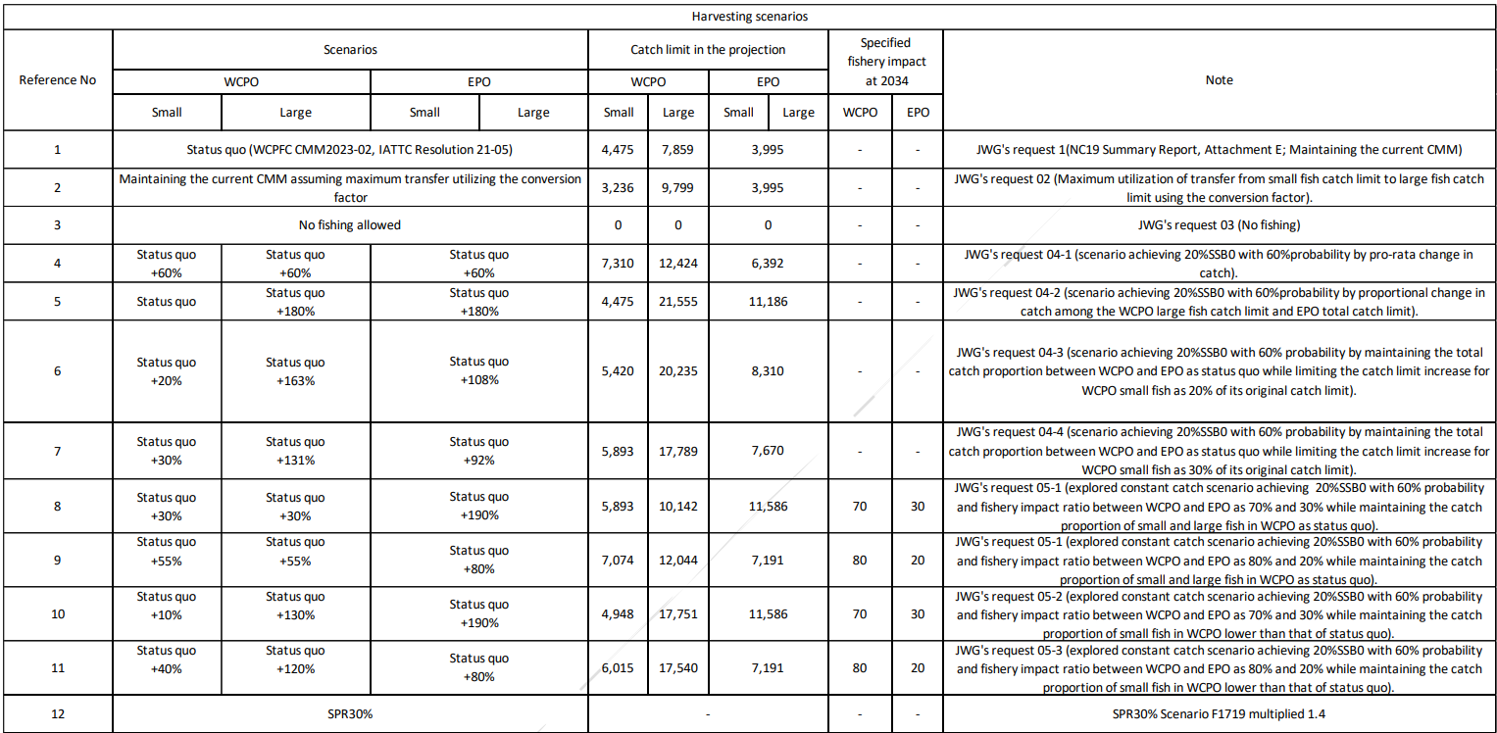

* The numbering of Scenarios is different from those given by the IATTC-WCPFC NC Joint WG meeting.
* Fishing mortality in scenario 3 was kept at zero. The catch limit for scenario 12 is calculated to achieve SPR 30% and allocated to fleets proportionately.
* The Japanese unilateral measure (transferring 250t of the catch upper limit from that for small PBF to that for large PBF during 2022-2034) is reflected in the projections.

Table PBF-04. Future projection scenarios for Pacific bluefin tuna (Thunnus orientalis) and their probability of achieving various target levels by various time schedules based on the base-case model.
*The numbering of Scenarios is different from those given by the IATTC-WCPFC NC Joint WG meeting and is the same as Table 3.
* Recruitment is resampled from historical values.
Table PBF-05. The expected yield for Pacific bluefin tuna (Thunnus orientalis) under various harvesting scenarios based on the base-case model.
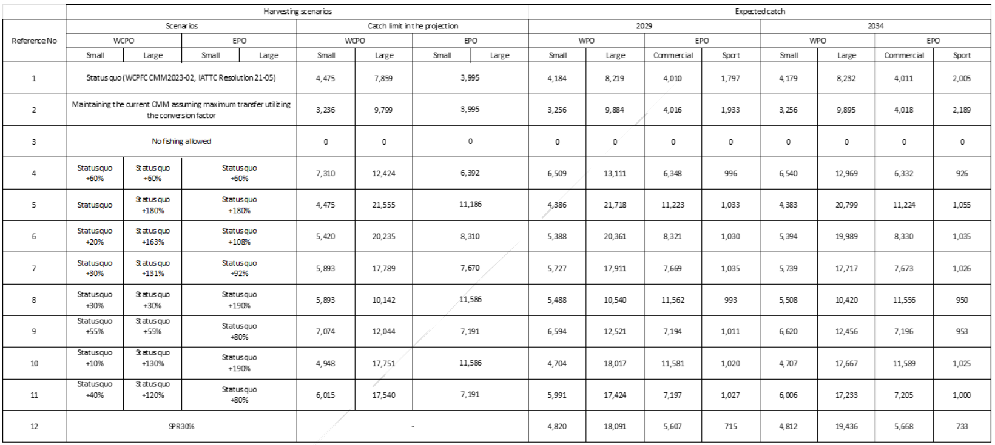
* Korean catch reflects the recent catch proportion for small and large, thus expected catches do not match catch allocations.

Table PBF-A2.1. Harvest scenarios used in the projection for Pacific bluefin tuna (Thunnus orientalis).
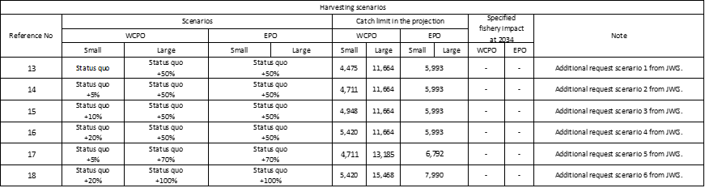
Table PBF-A2.2. Future projection scenarios for Pacific bluefin tuna (Thunnus orientalis) and their probability of achieving various target levels by various time schedules based on the base-case model.
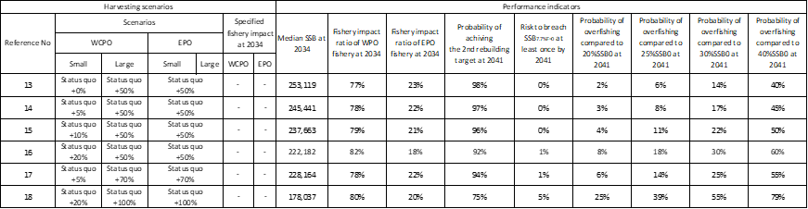

Table PBF-A2.3. Expected annual yield for Pacific bluefin tuna (Thunnus orientalis) under various harvesting scenarios based on the base-case model.
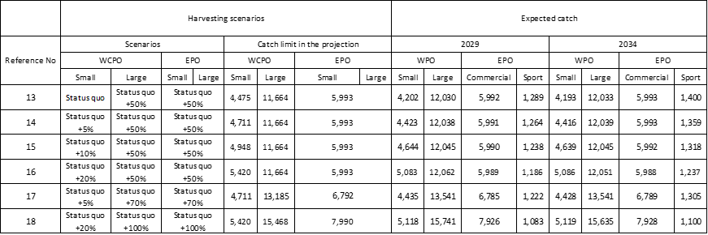

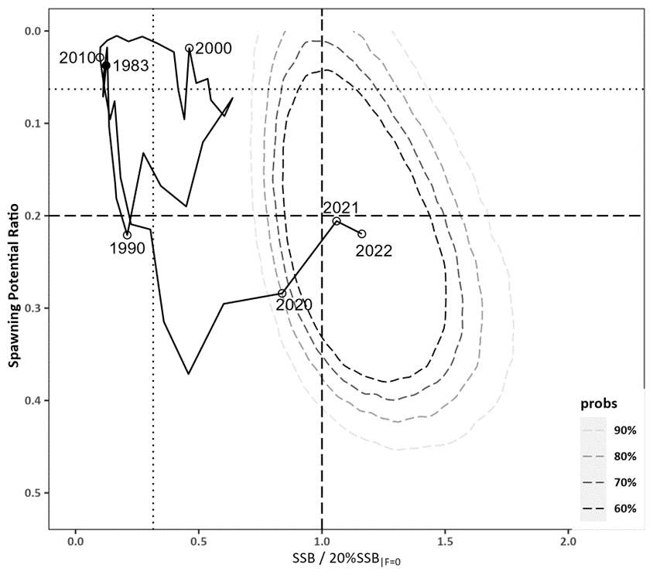
Figure PBF-11. Kobe plot for Pacific bluefin tuna (Thunnus orientalis) estimated from the base-case model from 1983 to 2022. The X-axis shows the annual SSB relative to 20%SSB_{F=0} and the Y-axis shows the spawning potential ratio (SPR) as a measure of fishing mortality. Vertical and horizontal dashed lines show 20%SSB_{F=0} (which corresponds to the second biomass rebuilding target) and the corresponding fishing mortality that produces SPR, respectively. Vertical and horizontal dotted lines show the initial biomass rebuilding target (SSB_{MED} = 6.3%SSB_{F=0}) and the corresponding fishing mortality that produces SPR, respectively. SSB_{MED} is calculated as the median of estimated SSB over 1952-2014 from the 2022 assessment. The apparent increase of F in the terminal period is a result of low recruitment in this period. As noted, the recruitment estimates in recent years are more uncertain and this result needs to be interpreted with caution. Contour plots represent 60% to 90% of two probability density distributions in SSB and SPR for 2022. The method used to estimate the confidence interval was changed from bootstrapping in the previous assessments to resampling from the multi-variate log-normal distribution. The probability distribution for the area where SPR is below zero is not shown as such SPR values are not biologically possible.
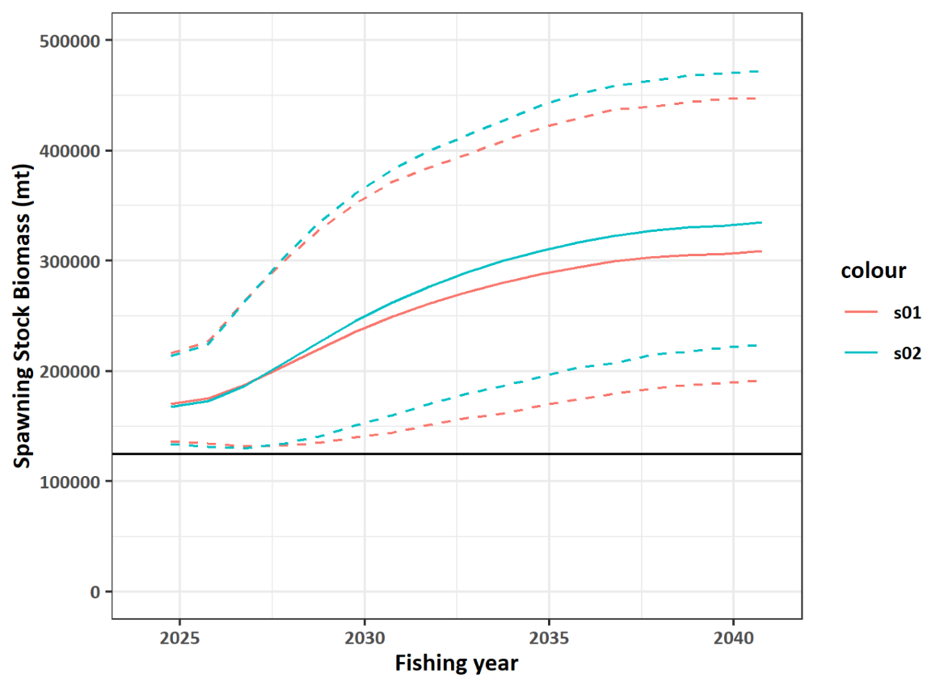
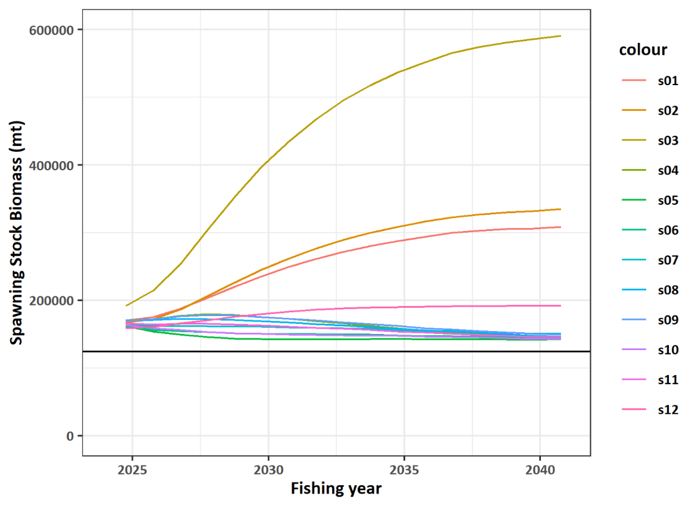
Figure PBF-12. Comparisons of various projection results for Pacific bluefin tuna (Thunnus orientalis) obtained from projection results. (Top) Median of scenarios 1 and 2 (solid lines) and their 90% confidence intervals (dotted lines). (Bottom) Median of all harvest scenarios examined from Table 3. The horizontal line represents the second rebuilding target.
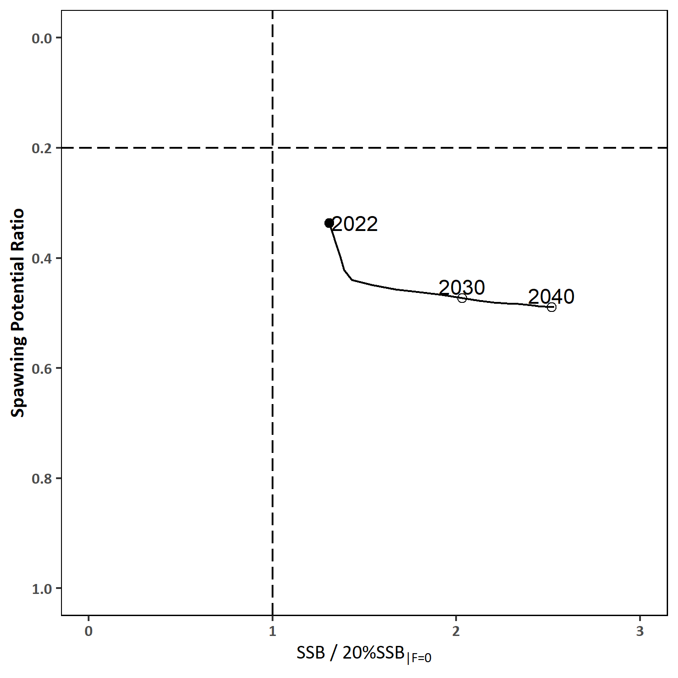
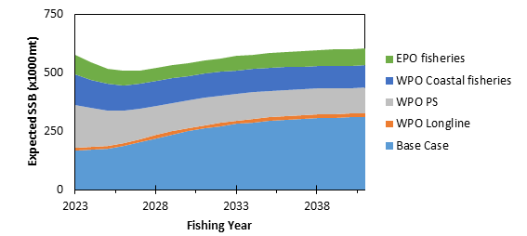
Figure PBF-13. “Future Kobe Plot” of projection results for Pacific bluefin tuna (Thunnus orientalis) from Scenario 1 in Table 3. Vertical and horizontal dashed lines show 20%SSB_{F=0} (which corresponds to the second biomass rebuilding target) and the corresponding fishing mortality that produces SPR, respectively.
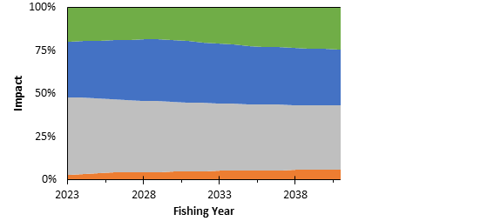
Figure PBF-14. “Future impact plot” from projection results for Pacific bluefin tuna (Thunnus orientalis) from Scenario 1 in Table 3. The top figure shows absolute biomass and the bottom figure shows relative impacts. The impact is calculated based on the expected increase of SSB in the absence of the respective group of fisheries.
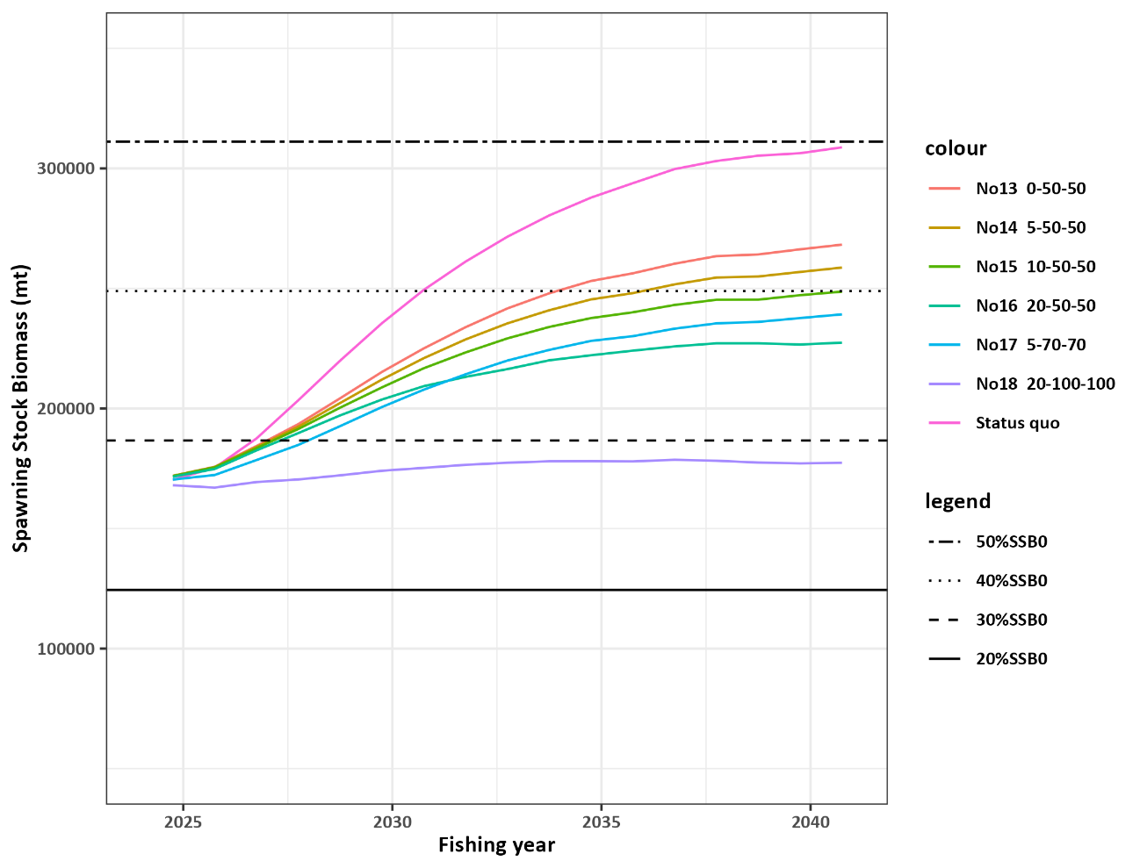
Figure PBF-A2.1 Comparisons of various projected median SSB for all harvest scenarios examined for Pacific bluefin tuna (Thunnus orientalis) obtained from projection results.

4.4 Billfish

4.4.1 Southwest Pacific striped marlin (Kajikia audax)
Information paper: SC20-SA-IP-17

4.4.1.1 Stock assessment of Southwest Pacific striped marlin
Papers: SC20-SA-WP-03, SC20-SA-IP-06

- Claudio Castillo-Jordan (SSP) presented SC20-SA-WP-03. This described the 2024 stock assessment of striped marlin (Kajikia audax) in the southwestern Pacific Ocean (SWPO) within the convention area of the Western and Central Pacific Fisheries Commission. An additional five years of data were available since the previous assessment was conducted in 2019, with the current assessment extending the model period to 2022. The assessment maintained a single region areas-as-fleets approach and fisheries structure consistent with the 2019 assessment, except for some differences in the grouping of flags for the CPUE index fishery. The assessment differed from the 2019 assessment by moving from a catch-errors to a catch-conditioned framework, with catch used as input data with no uncertainty (an approach used in the most recent WCPFC skipjack, yellowfin, and bigeye assessments and recommended by the recent independent peer review of the WCPFC yellowfin tuna assessment). This assessment also moved from a traditional fixed factor orthogonal uncertainty grid for management advice to a Monte Carlo approach where uncertainty was characterised by randomly drawing parameters from prior assumed distributions for average natural mortality (M) and steepness (h), and the inclusion of estimation uncertainty for the key management quantities. There were other changes to growth, and maturity ogive. The change in growth was substantial. While the diagnostic model was well converged, some diagnostics indicated there were issues with model fits to CPUE (particularly in the last decade) and components of the size data, and significant conflict between these data types. The Francis data weighting appeared to place a strong emphasis on fitting the size data as indicated by comparison of an Age Structured Production Model (ASPM) and Catch a Curve model. While management-related quantities were provided, the analysts provided some late model runs, in response to ODF comments, that could not be included in the WP03. These model runs indicated that a model that fits primarily to size composition data provides more pessimistic management values. Whereas models that fit better to CPUE provide more optimistic management values. While the broader outcomes in terms of stock status appear consistent with the previous assessment, the management quantities presented are biased toward pessimistic values because the current assessment models are overly weighted towards fitting the size data, which is in conflict with the CPUE. Further work is required to address this strong bias to the size data and try to reduce data conflict. Finally, there are concerns with some size data, that have implications for the model estimations in the important recent years, which require further exploration. The analysts recommended further work to improve the confidence in the management quantities to better reflect the information across the data.

Discussion

- Japan felt that spawning potential might have been overestimated. Since 2010, the stock has been driven by recruitment variations. They suggested that recently, fishing grounds had expanded off the coast of Australia to the area south of the equator, probably resulting in smaller fish being caught than in previous years. The change in size composition may have been contributing to the inconsistencies seen. Japan asked what was the main reason for the lower confidence in data before 1979 when the data came mainly from the Japanese longline fleet. Also, they noted that any consistent trend in recruitment should be considered a sign of model misspecification. What was the reason for the declining trend in recruitment? Was it model misspecification, a model process, or an environmental effect?

- SPC said that the Pre-Assessment Workshop had looked at the level of confidence in the data from the 1950s and 1960s. Including the vessel ID to take account of CPUE was not possible for that period so it had been decided to start the model in 1979. Regarding the recruitment trend, this appeared to be an artifact of the model.

- Japan thanked the presenter for the explanation for the reason for starting the model in 1979. So, additional information such as vessel ID or hooks between floats might be needed, but the catch data itself was reliable.

- SPC explained that another one of the reasons for starting in 1979 was because of the new growth data problems and the transition to catch conditioning, which led to very large recruitments at the start of the time series, and this seemed implausible. Starting later removed those problems.

- Chinese Taipei noted that SSB had dropped rapidly over last 12 years despite the gradual decline in catch during the same period. And the new growth curve meant that the CPUE did not fit well, especially in recent years. Also, the size data also shows overestimation. Would it be possible to request a sensitivity analysis that increased the CVs of the growth model see if it could enhance flexibility and improve the fit of some of the size data?

- Paul Hamer (SSP) explained that they had reduced the weighting of the length data in some recently run models to explore this problem of the size data conflict with CPUE and these are described on the ODF (see Attachment I) if further information was needed.

- John Hampton noted that striped marlin occur more in shallower waters, and in the mixed layer at depths less than commonly found for swordfish, albacore and bigeye. CPUE was based on the number of hooks, and there had been a notable increase in hooks per set and hooks between floats over the years, and improvements in gear materials etc. The assessment might be overcounting effective effort for striped marlin if the fish are shallower than the depth range of most of the hooks – and this might lead to an overestimate of CPUE decline in the recent times.

- Kiribati, on behalf of FFA CCMs, thanked the SSP for their efforts to assess striped marlin in the Southwest Pacific Ocean and recognised the difficulties faced by them in the development of this assessment. They noted that a second revision to this assessment had now been provided to SC20 which noted a range of problems and recognised that the assessment would benefit from further work to improve confidence in the management quantities. FFA CCMs appreciated the consideration that had gone into this conclusion and after careful deliberation, we considered that this assessment should not be used for management advice at this time. They proposed that the necessary work be conducted to allow SC21 to reconsider the assessment next year. In doing so, they were mindful of the assessment workload of the Scientific Service Provider in 2025, which included stock assessments of skipjack tuna and Southwest Pacific swordfish. As such, they considered that the tasking for the Scientific Service Provider needs to be reasonable and constrained to manage this workload. FFA CCMs reiterated the most recent stock status advice from SC15 was that “the striped marlin stock in the Southwest Pacific Ocean is likely overfished, and close to undergoing overfishing according to MSY-based reference points”.

- FFA CCMs considered that revisions to CMM 2006-04 were likely to be required to reduce fishing mortality. Given this, they recommended starting this process and that the Commission consider possible management scenarios that could be evaluated by the Scientific Service Provider to inform a future revision of this CMM. Proposed management scenarios for the consideration of the Commission might include, but not be limited to:
- Status quo scenario: Projection based on recent catch levels;
- Recovery scenario 1: Catch levels that result to a median depletion of 20% within 10 years;
- Recovery scenario 2: Catch levels that result to a median depletion of 30% within 10 years; and
- Non-retention/live release scenario: Catch levels that reflect the likely outcomes under a management measure requiring release of live animals or non-retention of all animals.
Following the input of the Commission, the Scientific Service Provider could then be tasked with undertaking the necessary suite of projections, using the revised assessment, for the consideration of SC21, if possible. Furthermore, FFA Members encouraged CCMs to collect additional age-at-length data for striped marlin across the southwest Pacific Ocean from 2025-2028, as outlined in the Billfish Research Plan, to further improve growth estimates or to allow these data to be used as conditional age-at-length data to estimate growth internally within the stock assessment, as recommended by the WCPFC yellowfin assessment peer review.

- New Zealand appreciated the opportunity given by the SSP to comment on the model configuration. New Zealand has registered serious concerns about the assessment on the ODF, including annual selectivities which do not allow the model to capture fishing dynamics and result in poor fits to the length frequency data, conflicts between length and weight frequency data in some fisheries, lack of fit to the CPUE data in the most recent years, and fixed initial conditions which affect uncertainty estimation and sensitivity analyses. Level of depletion may be overestimated because of the strong scaling effect from size data, resulting in a vulnerable biomass trend that appears to be more pessimistic than the CPUE trend. New Zealand agreed with SPC that the assessment would benefit from more work and considered that the assessment should not be used for management advice yet. New Zealand reiterated the FFA proposal for a precautionary approach to management by recommending a range of management scenarios for consideration by the Commission. This should help avoid delay in amendments to CMM 2006-04 if the updated assessment presented to SC21 confirms that reductions to fishing mortality are required likelihood categories and probability statements.

- The USA thanked the SSP for the assessment. The USA particularly thanked Claudio, Jemery and the rest of their SPC colleagues for their transparency in outlining the issues with the current assessment, both in the revision of the assessment document and across the floor in this presentation. This was facilitated by the expansive suite of diagnostics presented for both assessments this year, particularly the ASPM and Catch-Curve diagnostics. This was much appreciated. Along with New Zealand, the USA also appreciated the opportunity to engage in productive discussions with the assessment staff in the lead-up to the SC. They viewed these honest discussions, both today and in the preceding weeks, to be a key component in perpetuating the scientific integrity of this Committee, and believed that it was essential to producing good scientific outcomes.

- The USA agreed with New Zealand, Japan, and the authors of the assessment report that there were serious issues with the current assessment. There was a clear conflict between the size composition data and the CPUE index that needed to be resolved. It was also apparent that changes needed to be made to the model structure in order to give the selectivity curves the necessary flexibility to fit the size composition data, given the rapid growth demonstrated in the new growth curve. They were also concerned with the model’s inability to estimate initial population conditions.

- The USA recognised that the civil unrest in New Caledonia had been extremely disruptive to the assessment team, and it was clear that the current assessment needed more time to investigate and resolve these issues before it could form the basis for stock status and management advice. They suggested that the SSP continue working on this assessment as they have suggested and bring it back for reconsideration at SC21. They realized that this placed an unplanned additional burden on the assessment staff for 2025, and the US was prepared to provide some in-kind support to the SSP where appropriate in order to minimize impacts to other key SC21 deliverables that are part of their 2025 work plan.

- Australia concurred with others that the assessment needed more time to tackle the problems discussed. SC would now need to compile a set of tasks to guide the assessment going forward bearing in mind the rest of the SSP workload. The USA’s offer of in-kind support was appreciated.

4.4.1.1 Stock assessment of Southwest Pacific striped marlin

- SC20 thanked the SSP for conducting the stock assessment of the Southwest Pacific striped marlin (SC20-SA-WP-03) and acknowledged their transparency in outlining the issues of serious concern from the SC with the technical aspects of the assessment.

- Noting the above, SC20 recommended that further work, including resolving the conflict between the size composition data and the CPUE indices, should be undertaken as part of a revision to the assessment for consideration at SC21.

- SC20 acknowledged that further work on the assessment will place unplanned additional burden on the assessment team and welcomed the offer from the United States to provide in-kind support to SPC to moderate the impacts to other key SC21 deliverables.

- SC20 encouraged the collection of additional age-at-length data for striped marlin across the southwest Pacific Ocean from 2025-2028, as outlined in the Billfish Research Plan. Additional age-at-length data are needed to further improve growth estimates through the internal estimation of growth within the stock assessment, as recommended by the WCPFC yellowfin assessment peer review.

4.4.1.2 Provision of scientific information to the Commission

- SC20 reiterated the most recent stock status advice from SC15 that “the stock is likely overfished, and close to undergoing overfishing according to MSY-based reference points.”

- SC20 recommended that a revised assessment be presented at SC21 which includes presentation of the projection scenarios.

- SC20 recommended the WCPFC21 request a tractable set of projections, including, but not limited to the four scenarios proposed below:
- Status quo scenario: Projection based on recent catch levels;
- Recovery scenario 1: Catch levels that result to a median depletion of 20% within 10 years;
- Recovery scenario 2 Catch levels that result to a median depletion of 30% within 10 years; and
- Non-retention/live release scenario: Catch levels that reflect the likely outcomes under a management measure requiring the release of live animals or non-retention of all animals.

4.4.2 Western and Central North Pacific striped marlin (Kajikia audax)

4.4.2.1 Peer review of the 2023 assessment for North Pacific striped marlin
Working Paper: SC20-SA-WP-12

- Robert Ahrens, vice-chair of the ISC, presented a summary of the ISC Western and Central North Pacific Striped Marlin Assessment peer review. The review was held April 15-19, 2024, at the Institute of Oceanography, National Taiwan University (IONTU) in Chinese Taipei. The review was chaired by the vice chair, as recommended in the ISC protocol, and the reviewers were Hiromu Fukuda, Simon Hoyle, and Ian Stewart. The review was very successful thanks to the dedication of the ISC Billfish Working Group, and the reviewers provided highly relevant suggestions to improve the next assessment. The workgroup and the review panel greatly appreciated the hospitality provided by IONTU. The final consensus report can be found here on the ISC website. Terms of reference for the review covered assessment structure, input, configuration, diagnostics, reference points, future research, and material presentation. The reviewer’s main recommendations focused on resolving the tension in the assessment model due to discontinuities between CPUE, catch, and length composition time series. Continued improvement to input data was encouraged with the goal of obtaining the longest possible viable time series. The reviewers recommended the adoption of an ensemble modelling approach to address uncertainty in model structure. Some key recommendations were to explore the potential of combining information from multiple nations in an index fishery to address data gaps due to the range contraction of individual fleets, the exploration of CKMR, and strong support for the International Biological Billfish Sampling Project (IBBS).

Discussion

- Japan thanked ISC for conducting the peer review. ISC had done desktop peer reviews in the past, but this was the first face-to-face peer review, and Japan congratulated the group for completing this work. It involved good cooperation between ISC and WCPFC, and thanks to the USA for the financial support that made it possible and for the contribution of CCMs in selecting reviewers. Hopefully ISC would learn from this process and would think about similar kinds of reviews, possibly for Pacific bluefin. Thanks to all concerned. The resultant advice was substantial, and Japan looked forward to the ISC Working group taking this aboard in future assessments. Some of the recommendations might substantially change the outcome of the 2022 assessment so further discussion of the management advice for NP Striped marlin might be needed later. However given the likely change coming in the future, the Commission should look to avoid deterioration in the stock status rather than making substantial changes to the management advice.

- SC20 thanked the ISC for conducting the first in-person peer review for Western and Central North Pacific striped marlin, made possible with funding support from the United States, and commended the collaboration between the ISC and WCPFC. SC20 looked forward to receiving future Western and Central North Pacific striped marlin stock assessments which address the issues identified through the peer review and noted the possibility of substantial change in the results.

- SC20 encouraged further peer reviews for other WCPFC stocks, noting the outcomes from the Western and Central North Pacific striped marlin peer review process which will feed into informing future stock assessments.

4.4.2.2 Western and Central North Pacific striped marlin rebuilding analysis
Papers: SC20-SA-WP-13 , SC20-SA-IP-15

- Michelle Sculley presented SC20-SA-WP-13, noting that the Western and Central North Pacific Ocean (WCNPO) striped marlin stock was currently estimated to be depleted and experiencing excess fishing mortality relative to maximum sustainable yield-based reference points. The projection analyses described in this working paper were based on 2023 benchmark stock assessment of WCNPO striped marlin. Two fishing mortality and six catch projection scenarios met the rebuilding plan goal of rebuilding the spawning biomass of the stock to 20% of the unfished level, or 20%SSB_{F=0} = 3,660 t, by 2034 with a probability of rebuilding success of least 60%. Two of the catch scenarios also included a requirement to release MLS smaller than 120 cm EFL with two possible mortality assumptions. Two fishing mortality scenarios: F_{statusquo} and F_{MSY} did not meet the rebuilding target. The projection scenarios were a model ensemble of 3 possible recruitment scenarios; these were the short-term (last five years average recruitment), medium-term (last 20 years average recruitment), and long-term recruitment (stock-recruitment curve) models. Phased constant catch scenarios showed that the rebuilding target could be achieved if catch from 2025-2027 was maintained at recent average levels (2018-2020 average catch = 2,400 t), followed by moderate reductions in quota starting in 2028. The ISC billfish working group provided these results to support any potential revisions to CMM-2010-01, but noted that these projections did not change the stock status and management advice provided by ISC23, specifically that it was recommended that catch should be kept at or below the recent level (2018-2020 average catch = 2,428t).

Discussion

- Japan thanked ISC for the additional work conducted at the request of the Commission. They proposed SC20 take note of the additional projection result and maintain the 2023 advice.

- As the EU had noted during the last Commission meeting, they expected that after so many years of postponements, there would finally be a more ambitious rebuilding plan for this stock, particularly noting the ISC Chair’s opinion at the commission meeting the stock assessment was conclusive. The EU welcomed the peer-review of the assessment and agreed it was the way to progress, but this should not prevent us from taking management decisions using the best information available, which was the latest assessment and the rebuilding scenarios provided here. So, the EU continued to expect the Commission to try to take action to develop a more ambitious rebuilding plan as soon as possible, based on the information available.

- Japan noted that the information was available for anyone to take into account, but they thought it important to notify the commission that the next assessment may produce substantially different advice after taking into account the results of the review. They would want to include this information in the recommendation. SC20 should probably note the result.

- Australia had noticed a couple of scenarios involving additional release of small fish, but this appeared to make very little difference to the result. Why might that be? They also noted that survival was set at .2 and .4 and was that a net number? Was a scenario of non-retention or full release examined?

- The presenter explained that it would be very difficult to model the release of small fish. There was not a lot of difference because both survival scenarios were not very different. For all these scenarios, the difference in the catch was relatively small.

- The USA noted that the assessment was produced by ISC and adopted by ISC and then by WCPFC. The next assessment may change but we didn’t have that assessment yet so we must base our advice on the current assessment – the best available scientific information.

- SC20 noted that ISC24 maintained the conservation advice of WCNPO MLS from 2023, which is the latest available scientific information. SC20 also noted that ISC24 provided the results of stochastic rebuilding projection based on the 2023 WCNPO MLS stock assessment. These evaluated harvesting scenarios to achieve the WCNPO MLS interim rebuilding target (20%SSB_{F=0} with more than 60% probability) as requested by the Commission (SC20-SA-IP-15). SC20 noted the recommendations of the peer review of the WCNPO MLS stock assessment (SC20-SA-WP-12) and recommended that these be incorporated into the future stock assessment scheduled for 2027.

- SC20 recommended the Commission to take the above information into account when considering possible revision of the CMM for North Pacific striped marlin.

4.5 Sharks

4.5.1 Silky shark (Carcharhinus falciformis)

4.5.1.1 Stock assessment of silky shark in the WCPO (Project 108)
Working paper: SC20-SA-WP-04

- Philipp Neubauer and Kyuhan Kim presented SC20-SA-WP-04. This analysis assessed the WCPO silky shark (Carcharhinus falciformis) stock. This was the third attempt at undertaking an assessment of silky shark in the WCPO. There are no target fisheries for silky sharks in the WCPO, and they are caught as bycatch in longline and purse seine fisheries. Since 2015 all silky sharks caught in fisheries managed by the Western and Central Pacific Fisheries Commission (WCPFC) were required to be released. In an effort to understand overfishing risk to silky shark based on different lines of reasoning, a range of models were applied, with varying degrees of complexity and with different data requirements, including a fully integrated stock assessment in Stock Synthesis and three alternative assessments: length and age structured assessment model (LAM), dynamic surplus production model (DSPM), and a length-based spatial risk assessment (SRA). The main conclusions were that:
• The multi-model approach to assessing silky shark resulted in an uncertain stock status, but high confidence that recent fishing mortality was below levels that would preclude stock rebuilding.
• Based on considerations of model complexity, fits to observed data and estimation issues, it was suggested that the dynamic surplus production model be used for providing management advice. The model ensemble across initial depletion priors may have been over-representing uncertainty, and output from the intermediate assumption could be a candidate model for management advice.
• The largest fishing mortality was estimated to have come from longline fisheries capturing nearly the full size-range of silky sharks, and reductions in interactions (and mortalities) as a result of changes in fishing practices and non-retention requirements over the last decade may have substantially reduced this source of mortality, allowing the stock to rebuild.
• The stock status had been improving since 2010, and the recent fishing mortality rates were below biological reference points for the ensemble (Diagnostic F_{recent}/F_{crash}: 0.13 [0.01–0.25]; Probability F_{recent}/F_{crash} >1=0; Probability F_{recent}/F_{lim} >1=0).

Discussion

- Vanuatu, on behalf of FFA CCMs, thanked the SSP and acknowledged the excellent technical expertise and the high-quality work undertaken in the assessment methods presented. This was the best available science for this stock. They thought it important to scrutinise the data inputs to ensure the results were plausible, and that results should be interpreted with care due to the gaps in data, and biological and ecological knowledge. Improving biological and ecological understanding was crucial, particularly given the biomass estimate uncertainty bounds were very narrow despite limited data and knowledge. The four modelling approaches consistently showed a decline in fishing mortality as well as an increase in biomass over the last decade. This coincided with the introduction of non-retention measures, and aligned with the uptick in later years of the unstandardised purse-seine free-school fishery CPUE index.

- FFA CCMs supported the use of alternative stock assessment approaches such as dynamic surplus production models for some shark species under current data constraints. Although integrated models may be desirable, they were not always appropriate, as demonstrated in this case with the severe retrospective issues with the SS3 integrated model, which cast doubt on its reliability. Additionally, they noted that the use of several assessment approaches highlighted that data issues persist irrespective of the modelling approach used, resulting in unrealistic stock projections.

- The assessment authors noted that there was a need to better understand how the lack of data affected model parameterization, particularly when novel approaches were being used. Additionally, there was a need for further research on the effect of scaled length frequencies and catch on model interpretation and parameterisation, since limited data were available to characterise the spatio-temporal trends in the population and might not have been representative of reality.

- FFA CCMs proposed the inclusion of a table in future shark assessments detailing all the biological parameters used in the model along with their sources. This recommendation was aligned with Project 113b's objective to standardise metrics across assessments. Additionally, they proposed that shark assessment reports include Kobe plots. Finally, while non-retention measures may make data collection challenging, this should not preclude the continued need for shark mitigation practices and sustainable management. The reduced use of shark lines, the removal of wire traces and the implementation of non-retention measures were very likely having a positive impact on reducing interactions with silky and other sharks and should therefore be maintained across all fleets.

- The EU commended the authors for the work, and thought that this assessment presented some improvements over the previous one. In particular, this approach – using an ensemble of models for the catch reconstruction – improved upon previous approaches using fin trade data, assuming ratios between species to be constant. Also, the fact that different modelling approaches had provided consistent results, at least qualitatively, was reassuring. The EU indicated a preference for the use of the dynamic surplus production model for management advice, after noting the considerations of the authors.

- PNA and Tokelau thanked Neubauer and team for a very thorough assessment. They felt that the extra time taken for this assessment had been well worth it. The detailed level of background information and the multi-assessment approach had been valuable for understanding the fisheries catching silky sharks, the extent to which management action was being applied, and the resulting stock status of the resource. They believed that a similar multi-assessment approach would also be useful for the oceanic whitetip shark assessment next year, given that the team may be faced with a more limited set of data for that assessment. The multi-assessment approach was useful for data-limited stocks in the event that one method could fail. Given the lessons learned from this assessment, it may be useful only to undertake a dynamic surplus production model and a data-driven risk assessment for oceanic whitetip sharks.

- PNA+TK had two questions:
- They had noticed that this assessment excluded domestic fisheries in Indonesia, Philippines and Vietnam, although these were covered in the previous assessment. Had they considered how this may have affected the assessment, and what might be deduced from the results of the assessment about this potentially broader stock relation?
- PNA and Tokelau also wanted to know the extent to which the assessment could provide information on any unobserved mortality arising from possible FAD entanglements of silky sharks. Does the assessment tell us anything about potential entanglement mortality?

- The presenter responded, noting that in terms of the shark fin trade estimates, it wasn’t clear what regions were actually contributing to that trade, and most of the data used in the previous assessment had similar constraints. In the WCPO, higher densities were estimated across the different catch reconstructions but there was little data. If there was a single stock and there was migration between domestic Indonesia and Philippines waters and more easterly areas, then the CPUE trends would be indicative of trends across the whole area. But if there was little mixing then separate assessments might be needed. However, the assumption at the moment was of a single stock, and the data from the areas with good observer coverage were used to assess the whole stock. It was mostly juvenile sharks that appeared in the purse-seine PS fishery – and although mortality of those young sharks was relatively high, it did not seem to have a significant impact on the recent stock recovery observed across the different assessment approaches.

- Japan congratulated the presenters on the reasonable outcomes and the conclusions, and could support the results, although there were still large uncertainties in the parameterization and outcomes of biomass level due to a lack of data. For silky sharks in the WCPO, non-retention measure has been implemented since 2014, so it was almost 10 years after reducing the impact of the fishery. Japan thought this was enough time to start rebuilding this stock, noting the maturity at approximately age 6 years. Therefore, they believed that this stock assessment results suggested that the current management measure (the non-retention measure) was enough to reduce the fishing mortality and increase the population to the appropriate level, such as an MSY level. In addition, a new management measure (prohibition of wire leader and shark lines between 20°S and 20°N) was implemented this year, so it could be expected to accelerate the recovery of the spawning biomass. They thought it useful and valuable for SC to assess the potential effectiveness of the management measure in the future through stochastic projections. It was suggested that providing such future projection would help in considering the effect of management measures under recent fishing pressure on spawning biomass.

- The presenter agreed that projections were useful and should be done. The late pivot from Stock Synthesis to the integrated biomass model had not left time to accomplish this, but it definitely would have been useful.

- The USA thanked the presenters for an excellent investigation. Despite individual models having flaws they showed a consistent output. However, all were dependent on the same data which may have had biases and they suggested ways of approaching this to minimise such risks.

- The presenter explained that they had investigated some of these uncertainties in the initial Stock Synthesis model-based approach and had been hoping to import these into the multi-model approach, but time ran out.

- China thanked the modellers for the great work and believed this was an excellent example of how to use multiple models for stock assessments. They noted the high uncertainty in each model, and suggested ways of accounting for it. LAM and spatial models were less mature than SS, and they encouraged more simulation testing. Ideally, the final decision or inference would be based on all the models, but there was some question about how they should be combined. This would be something for exploration in the future.

- Philipp Neubauer agreed. They had not put forward an ensemble across all the models because two of the models were relatively immature and required more testing before being included in an ensemble that was going to provide management advice. And SS had other issues, so all of these were given a weight of zero. There was certainly more work to do on how best to integrate these models into an ensemble.

- Australia thanked the team for what was quite a tour de force. They appreciated the multi-model approach, and recalled that this had been specifically requested by SC for this assessment, so it was good to see it carried forward. Australia had some thoughts for framing stock status, and these were derived from the excellent concluding summary provided by the authors. For the biomass status, SC20 could note that our degree of confidence is low. Biomass was poorly estimated, particularly the specific levels of depletion. However, there was a consistent trend of increasing biomass across the suite of models since 2010. So, a statement of the following nature may be appropriate: “Biomass depletion is poorly estimated but the stock may not be overfished according to the B_{msy} reference point, and appears to be increasing. For the fishing mortality status - our degree of confidence is moderate/high. Fishing mortality is estimated to have declined in recent years across all model types and appears to be below the levels that would preclude stock rebuilding. According to the DSP model (the intermediate assumption) the stock is likely not subject to overfishing according to the F_{msy} reference point”.

- SC20 noted the extensive efforts undertaken to provide the stock assessment models and appreciates the thoroughness of the assessment. While the four assessment models provide reasonably different biomass and fishing mortality historical trends, SC20 noted that generally, all four models agree upon the terminal year stock status. SC20 recommended that stock status and management advice be based upon the dynamic surplus production model results as the most parsimonious and robust assessment presented.

4.5.1.1 Provision of scientific information to the Commission

Stock assessment and trends

- Silky sharks in the WCPO have no target fisheries and are caught as bycatch in longline and purse seine fisheries. Although caught in Pacific fisheries since the 1950s, catch records for silky sharks only began in the 1990s (Brouwer et al. 2023, Neubauer et al. 2023a). Since 2015, the WCPFC mandates the release of all silky sharks. Reliable catch history estimates are necessary for assessment due to unreliable logsheet and observer data, stemming from generic reporting codes prior to 2015, inadequate bycatch reporting, and inconsistent observer coverage. However, recent data improvements, biological data availability, and previous successful stock assessments led Brouwer and Hamer (2020) to recommend a data-rich assessment for this stock.

- The 2024 Pacific silky shark (Carcharhinus falciformis) stock assessment in the Western and Central Pacific Ocean (WCPO) is the third attempt at undertaking an assessment of Pacific silky sharks.

- This assessment used a multi-model approach to assess silky shark in the WCPO, addressing large uncertainties in the underlying data and challenges with fitting integrated stock assessments for sharks. To understand overfishing risk from different perspectives, a range of models with varying complexity and with different data requirements were applied, including a fully integrated stock assessment in Stock Synthesis, a length and age-structured assessment model (LAM), a dynamic surplus production model (DSPM), and a length-based spatial risk assessment (SRA). Each approach was treated independently, without the standardized use of consistent priors, though data inputs were standardized across all four assessment approaches given the single dataset available.

- Non-retention measures have led to sharks being cut free from longlines, potentially reducing the quality of recent catch (interactions) data for silky sharks. Other key uncertainties highlighted in the assessment include: species distribution and interactions with local oceanography and ENSO dynamics; growth uncertainties due to a lack of age-validation and limited data; and stock structure and mixing

- Fisheries interactions from 1995 to 2022 were reconstructed using an ensemble of spatial GLMM models (Neubauer et al. 2023a) that included oceanographic predictors, targeting effects and total effort per stratum (5x5 degree grid, flag, year, month). Post-release mortality was estimated at 15% for long-line fisheries, and 85% for purse-seine fisheries, contributing to total fishing mortality. The base assumption was that catches prior to the reconstructed catch period were lower and increased with an expansion of longline fishing effort in the late 1990s and 2000s (Figure FAL-01).

- CPUE indices were standardized based on observer data in Phase I of this project, and focused on longline and purse seine CPUE indices. However, due to high interannual variability in the longline fishery CPUE index and inconsistencies between different observer programs, only CPUE indices from the purse seine fishery were included in the assessment. The longline CPUE was deemed unreliable for reflecting silky shark abundance trends (Figure FAL-02). Purse-seine indices were only used through to 2020, as COVID-related disruptions led to data gaps and potential bias in observer CPUE for 2021 and 2022. Recent estimates were, therefore, based on 2019–2020 data.

- Fishing mortality remained stable until the 2010s, after which it declined substantially through to 2020 (Figure FAL-02]. Throughout the assessment period, fishing mortality was estimated to be below U_{crash} and U_{lim} reference values. Longline fisheries, which capture nearly the full size-range of silky sharks, were estimated to contribute the most to fishing mortality. Reductions in interactions as a result of changes in fishing practices and non-retention over the last decade have likely reduced this source of mortality substantially, allowing the stock to rebuild.

- Estimated process error was generally small, with uncertainties overlapping zero, though it showed a slight increasing trend in the first decade of the assessment and declined after 2015 (Figure FAL-03).

- Spawning stock biomass depletion was estimated to be relatively stable below 0.3 until the 2010s, after which it increased to 0.45 [0.22-0.82 95% credible interval] of unfished abundance by 2020 (Figure FAL-02) (according to the DSP model with the intermediate assumption). However, across the suite of models, biomass was poorly estimated, particularly the specific levels of depletion. Despite this uncertainty, there has been a consistent trend of increasing biomass across the suite of models since 2010.

Table FAL-01. Key sources of uncertainty in the 2024 silky shark stock assessment using the dynamic surplus production model.
Type | Rationale | Uncertainty | Impact | Confidence
Data
CPUE | Observer Index | ENSO impacts lead to strong standardisation | Unclear if standardisation sufficiently removes ENSO signal from standardized index | Medium
Catch
Reconstructed from extrapolated observer catch-rates | Early species-specific reporting; recent non-retention may lead to bias | recent catch possibly biased low; early catch highly uncertain; pre-1990 catch unknown | Medium
Model
Dynamic surplus production | Most parsimonious model | Over-simplified life-history | Unknown | Medium
Spatial assumptions
No spatial structure | Little tagging to understand structure | Unclear | Potentially important not quantified impact unknown | Low
Key parameter uncertainty
Initial depletion | Estimated from informative prior | Alternative priors used to capture unknown pre 1990s catch | Highly uncertain starting point | Medium
Productivity (Rmax ) | Estimated from informative prior | Poorly understood a priori | Wide prior leads to high uncertainty within model runs | High
Structural uncertainties
Process error | Fixed | Not considered | Fits with fixed process error SD were reasonable | High
Estimation uncertainty
MCMC | Full Bayesian estimation integrating over key uncertainties (Rmax, Initial depletion) | Estimated | Base of uncertainty grid | High
Other sources of uncertainty
Poor recent observer coverage | COVID driven reduction in coverage means CPUE cannot be used for 2021 and 2022 | Not considered | Most recent estimate with biomass index is 2020 | Low

Stock Status

- The 2018 assessment for Silky shark showed high uncertainty, and SC14 concluded that the stock was not overfished, but subject to overfishing.

- There are no agreed reference points for sharks in the WCPFC. The 2024 model suggested that stock status has been improving since 2010. Recent (2019--2020) fishing mortality was estimated to be below biological reference points (U_{recent}/U_{crash}: 0.13 [95% credible interval 0.01–0.25]; the probability of U_{recent}/U_{crash} >1 was 0 and the probability of U_{recent}/U_{lim} >1 was 0) [Figure FAL-04, Table FAL-02]. Fishing mortality is estimated to have declined in recent years across all model types and appears to be below the levels that would preclude stock rebuilding and below the MSY reference point (according to the DSP model with intermediate assumption).

- According to these estimates, overfishing is very unlikely (< 10%) to be occurring relative to MSY-based reference points. However, biomass and depletion estimates were very uncertain, and SC20 considered the stock was about as likely as not (40-60 %) to be overfished relative to MSY-based reference points.

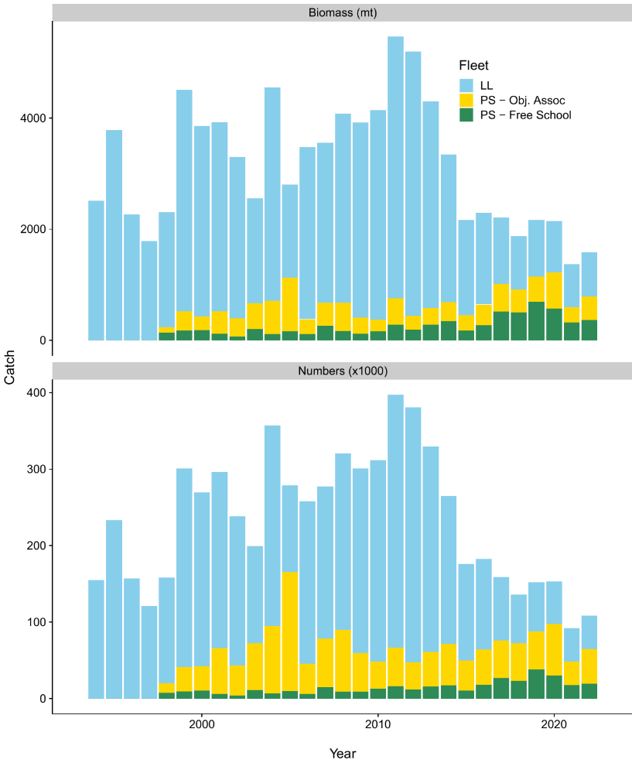
Figure FAL-01. Predicted retained catch by the fleet in biomass and numbers.

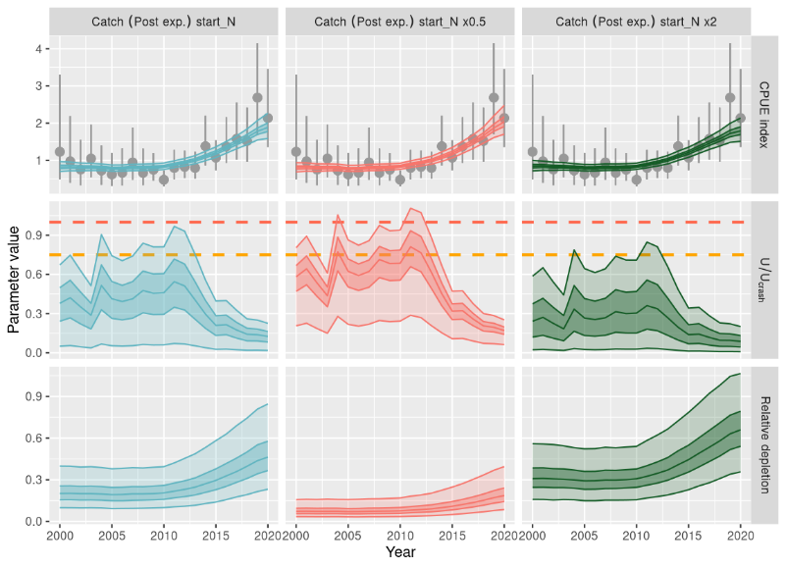
Figure FAL-02. Fitting of catch-per-unit-effort (CPUE) data using a dynamic surplus production model with independent model runs for each CPUE indices (dark shading, inter-quartile; light shading, 95% credible interval). Top row: Predicted CPUE with input CPUE (points) and observation error (interquartile range). Middle row: Time series of fishing mortality relative to the U_{crash} (red) and U_{lim} = 0:75⋅C_{rash} (orange) as estimated in the dynamic surplus production model. Bottom row: Estimated relative depletion (relative to unfished abundance K). The stock was not unfished in the first year of the time-series, and each column shows an alternative prior assumption about initial depletion.

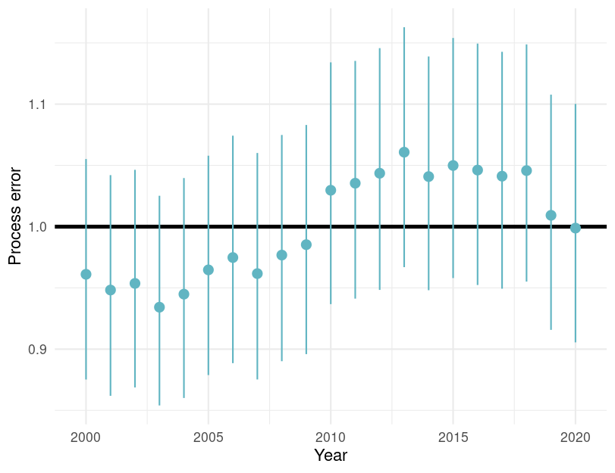
Figure FAL-03. Estimated process error by year with 95% credible intervals for the dynamic surplus production model for Silky shark in the WCPO.
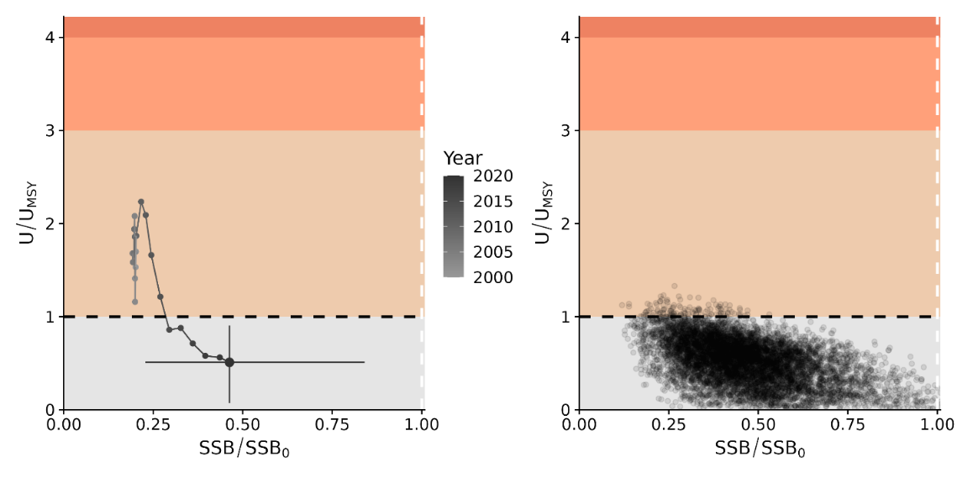
Figure FAL-04. Majuro plots for recent (2019–2020) stock status based on the dynamic surplus production model for silky shark in the WCPFC. Left-hand plots show the stock trajectory, with uncertainty shown for the most recent year in the analysis (2020). In contrast, the plot on the right-hand side shows individual draws from the posterior distribution(s) for recent (2019–2020) years.

Table FAL-02. Estimates of management quantities (stock status as abundance N_{recent} relative to carrying capacity K), and fishing mortality (U) relative to indicators (U_{MSY}) and possible limit reference points U_{lim}, U_{crash}). P(>RP) refers to the probability that the metric (status, fishing mortality) is above the respective indicator.
Summary: Silky shark
Year: 2024 | Biomass | No agreed target or limit for sharks
Year: 2024 | Fishing mortality | Very Likely (>90%) to be below biological reference point: Overﬁshing is not occurring
Year: 2024 | Projection | No projections
Year: 2024 | Recommendation | Current mitigation measures do appear to be effective for silky sharks
Reference points |  | Estimate [5%–95%]
Biomass | - | -
Biomass | - | -
Catch | - | -
Harvest rate  Harvest rate | U_{lim} (not agreed)  U_{crash} (not agreed) | 0.19 [0.09 – 0.38]  0.25 [0.16 – 0.48]
Recent estimates |  |  |  | Recent trend / projection
Depletion  Harvest rate | N_{recent}/N₀ U | 0.44 [0.10 – 0.96]  0.017 [0.0014 – 0.048] |  | Abundance increasing  F declining
Catch | C | 65 189 |  | Catch declining
Status |  |  | Likelihood
Harvest rate | U_{recent}/U_{lim} | 0.18 [0.02 – 0.34] | Very likely (<90%) to be
 |  |  | below limits
Harvest rate | U_{recent}/U_{crash} | 0.13 [0.01 – 0.25] | Very likely (>90%) to be
 |  |  | below limits
Projections
No projections

Management advice

- SC20 noted that due to challenges fitting the stock assessment models, no projections were provided to the SC, and recommended that projections be included in future assessment reports.

- SC20 recommended interpreting the results of the silky shark stock assessment with caution due to the large amount of uncertainty in catch, stock structure, life history, and other important components of the assessment, but it noted that all of the models presented resulted in an improving trend in stock status for silky sharks.

- SC20 noted that further research is necessary to continue the improvement of this and other shark stock assessments and that current mitigation measures do appear to be effective for silky sharks.

4.5.2 Oceanic whitetip shark (Carcharhinus longimanus)
Papers: SC20-SA-WP-11, SC20-SA-IP-23

- Philipp Neubauer presented SC20-SA-WP-11 analysing potential inputs to the 2025 stock assessment of Western and Central Pacific oceanic whitetip shark. Oceanic whitetip sharks are caught as bycatch in longline and purse seine fisheries in the Western and Central Pacific Ocean. Previous assessments indicated the stock was overfished and overfishing was occurring, and the recent assessment highlighted issues associated with some of the inputs.

- This report documented Phase 1 of the current project which investigated the potential methods for catch reconstruction, CPUE and length compositions for use in the stock assessment for oceanic whitetip shark in 2025 (Phase 2). This study used model developments made in the context of other shark assessments to develop a set of potential inputs for the upcoming assessment. Different subsets of longline CPUE observer data showed similar trends, with the exception of the distant water fleet index. Overall, the indices showed a consistent decline from a high in 1999 that flattens around 2005. The indices remained fairly low post-2005 but seemed to increase slightly in the most recent years. Purse seine CPUE indices showed different standardisation effects between set-types, but both free-school and associated indices showed an increase in CPUE in recent years (2009–2020). These indices were corrected for climatic conditions expressed by the NINA4 index. Predicting longline interactions across the WCPO indicated that the total predicted interactions have declined since 1999, a trend that was consistent with previous analyses. Overall, for both purse seine fisheries, the predicted total interactions declined since the late 1990s and have remained comparably low since then. Length compositions trends were inconsistent among years and months for models associated with catch and CPUE. However, area effects in longline length data were observed, with smaller fish in the equatorial regions and larger fish at higher latitudes.

- It was recommended that there were likely to be sufficient data and a sufficiently consistent signal in the different datasets, especially from longline, to conduct a stock assessment.

Discussion

- Tokelau, on behalf of FFA CCMs, thanked the SSP for the work done so far. They supported the SSPs recommendations and supported the continuation of work on oceanic whitetip sharks. They recognised the implications of non-retention measures for the collection of important data for sharks, and how the balance between conservation and management had resulted in data that were now limited. In light of this, they supported the recommendation that the 2025 stock assessment should address the hypothesis of decreased fishing-related mortality since 2015 and evaluate the effectiveness of release policies. Given the analyses conducted as part of this project, and the work done to assess silky shark, they agreed that conducting an integrated assessment in 2025 was possible.

- Philipp noted that although this assessment could be treated as an opportunity to gain some further understanding of recent trends in fishing mortality, particularly as the previous WCPO assessment results from 2019 showed that oceanic whitetip sharks were both overfished and overfishing was occurring, the results from the silky shark assessment had demonstrated that an integrated assessment was probably not necessary. An alternative assessment, specifically a dynamic surplus production model, could be conducted rather than the integrated approach, particularly given the sparse data, and the data available were likely to represent a single generation. Additionally, and if funding allowed, a data-driven risk assessment could be conducted in parallel. This was in light of the outcomes of the silky shark assessment across the four model approaches tested.

- Japan thought the input data had been improved through several analytical approaches, such as the standardization of CPUE and length data, and also the reconstruction of the catch. For the CPUE trends, it was mentioned that the longline indices showed a consistent decline from a high in 1999 that flattened around 2005. The indices were fairly low post-2005, but seemed to increase slightly in the most recent years. Purse seine CPUE also indicated an increased trend in recent years (2009-2020).

- It was noted that the increases in the CPUEs in recent years seemed reasonable under the implementation of the non-retention measure. However, the effect of the non-retention measure seemed small especially for longline CPUE. Japan thought it might be better to investigate the impact of the non-retention measure from the perspective of the changes in the quality and quantity of the observer data after implementing management measures, in addition to the effects of COVID. In the discussion, it was suggested that, at a minimum, alternative indices should be explored for the upcoming stock assessment. Japan agreed with this direction. Also, it may be useful to construct the conceptual model to consider which CPUE is most suitable as the adult indices.

- Japan also suggested the use of alternative assessment methods such as a surplus production model which could be run in parallel with an integrated model (SS3). This was demonstrated in the silky shark assessment in consideration of the large uncertainty in the fishery and biological data. The environmental effect (NINA 4) had a large impact on the annual trends of CPUE for free school purse seine and caused the increasing trends to flatten (Figure 10). The environmental change may have caused the distributional changes of this shark and just increased the catch rate superficially. If so, but for CPUE from object-associated sets, NINA4 had a small effect compared to free-school set CPUE. Did the SSP have any thoughts about what might be the main reason for the different effects of NINA4 on these two-purse seine CPUEs?

- The presenter did not have a conclusive answer, and it was something that they wanted to look at in more detail. One problem with the purse-seine indices was that observer coverage only increased to a reasonable level in 2008/9 and the time-period with high observer coverage was short compared to ENSO periodicity. The same had been observed for silky shark and it would be necessary to investigate what was driving this variability, and to see whether it was appropriate to standardise it. There would be more work to do before these indices could be used in a stock assessment.

- FSM thanked the team, on behalf of PNA+TK CCMs, for the work on OCS. Working on the data the year before the assessment was time well spent. They agreed with applying a multi-model approach but, given the lessons learned from the recent silky shark assessment, to concentrate on a dynamic surplus production model and also include a data driven risk assessment.

- The EU thanked Dragonfly and Sagittus for this work, and thought this work evidenced how convenient the move was to a two-year assessment schedule for shark species. As mentioned previously in the case of the silky shark assessment, the catch reconstruction approach looked very interesting. However, the same source of data was being used for the catch reconstruction and for the indices of abundance in the assessment. What might be the implications in terms of the bias it might cause, and the potential for gaining a mistaken impression of model diagnosis and reliability?

- The presenter thought this a very good question, and difficult to answer because there hadn’t been many other options available. Logsheet reporting was insufficient for good catch history, and the team was uncomfortable with having to default back to this approach because of the potential to introduce bias, in the sense that essentially the same data set was being used twice in that context. However, one of the ways in which it might be justified, was that in one case they had used that dataset to predict across a much broader fleet. They were using a whole set of models to predict across a much wider range and across the total catch, whereas for the other, they were essentially just maintaining the observed catch rates, and often restricted and standardized for operational parameters, which could not be done in the catch reconstruction. So, they were not treated in an identical way. However, there remained a potential for bias. For blue shark there had been more confidence in logsheet reporting, so this data could be used to estimate catch, but that was not possible here. It was an assumption made out of necessity, not choice.

- The USA thanked Philipp Neubauer for the presentation and the rest of the coauthors for the excellent data preparatory work. They were also appreciative that the SC had adopted the two-year approach, and considered this intermediate data review an integral part of producing good scientific outcomes. This two-year assessment approach would have benefit for other assessments brought forward to the SC, and this was something to keep under consideration. The USA supported the parallel track approach of an integrated age-structured model and a dynamic surplus model. They recommended that Part II of the project – to conduct the assessment – should go forward. Given the importance that initial conditions, catch scenarios and CPUE trends will have on both assessment types but especially surplus production models, they encouraged the thorough exploration of uncertainties related to these inputs. This would include developing alternative scenarios for initial conditions, catch and relative abundance time series. They also suggested that developing an explicit conceptual model of WCPO oceanic whitetip shark could serve as an initial step in the stock assessment model development process, to help guide modelling decisions and support assessment assumptions. There was ROP and in-zone longline data available. Could it be confirmed, at some point, if the USA in-zone data was available to the assessment? If not, the USA could authorize the use of in-zone data for the OCS assessment.

- Canada thanked the presenter for the considerable amount of work that had been completed this year on shark data, compilation, history, characterization and catch reconstructions. Like others, Canada supported attempting a fully integrated assessment based on the consistency of the data sets and a surplus production model in parallel with the integrated assessment also seemed like a good approach, so Canada would support the recommendations presented.

- China shared the comments and concerns of others on the potential issue of the poor quality of data, and the challenges of using these in an assessment. They encouraged Dragonfly to try and adequately account for uncertainty in the stock assessment next time. Regarding the biology of OCS: over the past few years, China has been doing some work on growth and would like to collaborate with the assessment team in the coming months to incorporate this latest information.

- The presenter said the offer by China was greatly appreciated, and they would like to take up this offer.

- SC20 noted that there are likely to be sufficient data and a sufficiently consistent signal in the different datasets, especially from longline, to conduct a stock assessment. SC20 recommended that a fully integrated assessment be attempted for phase II of this project.

- SC20 recommended a dual-track approach where a fully integrated model (e.g., Stock Synthesis) and a dynamic surplus production model are developed concurrently.

- If the agreed assessment approaches are unable to provide reliable stock status information or if the SC wants to gain a better understanding of the utility of risk assessment methods, SC20 recommended exploring a spatial risk assessment as part of the assessment development process. It is intended that this would be a separate project funded in 2026 if required.

4.5.3 North Pacific shortfin mako shark (Isurus oxyrinchus)

4.5.3.1 North Pacific shortfin mako shark stock assessment
Working Paper: SC20-SA-WP-14

- Nicholas Ducharme-Barth (USA) presented SC20-SA-WP-14 on behalf of the ISC Shark Assessment Working Group. This provided the results of the 2024 ISC SHARKWG stock assessment of shortfin mako shark (SMA, Isurus oxyrinchus) in the North Pacific Ocean. Previously an indicator analysis was performed in 2015 and an integrated, age-based stock assessment using the Stock Synthesis (SS3) modelling platform was conducted in 2018. Revision of historical catch data and removal of the early relative abundance index made it challenging to reconcile the recent catch and index data with the biological assumptions, and a strategic decision was made to use a Bayesian State-Space Surplus Production Model (BSPM) for the 2024 assessment to model stock status from 1994-2022.

Discussion

- Japan acknowledged the significant improvement in the assessment due to the introduction of a multi-model approach and model ensemble approach, which considered uncertainties in biological parameters and fishery data. However, Japan noted that there were still significant uncertainties regarding the catch data from driftnet fisheries in the 1980s and 1990s, and longline fisheries including mortality from dead discards and live release. Japan also mentioned the need to address issues such as different growth curves in the western and eastern areas, specific natural mortality schedules for males and females, and a wide range of steepness parameters. Japan hoped that these issues would be resolved in next future assessments through improved data input and modelling approaches. Additionally, Japan suggested considering close-kin mark-recapture as a promising future study but emphasized the difficulty in exchanging gene samples due to the CITES listing and the need for sufficient budget to collect adequate samples.

- The United States recognized ongoing uncertainties regarding the stock structure of the North Pacific mako shark, particularly due to the lack of information about large females. The USA proposed that close-kin mark-recapture be seriously evaluated as a method to address these uncertainties. They recommended that the ISC Shark Working Group undertake a feasibility study in 2025 to determine the magnitude of sampling that may be needed and develop a sampling strategy. They also suggested that this scoping project proposal be presented to SC21.

- SC20 thanked the ISC SHARK WG for their thorough work conducted on the North Pacific shortfin mako shark stock assessment and acknowledged the significant improvement in the assessment due to the model ensemble approach.

- SC20 noted that the current assessment provides the best scientific information available on the North Pacific Ocean (NPO) shortfin mako shark (SMA) stock status. Results from this assessment should be considered with respect to the management objectives of the WCPFC and the IATTC, the organizations responsible for the management of pelagic sharks caught in international fisheries for tuna and tuna-like species in the Pacific Ocean. Target and limit reference points have not yet been established for pelagic sharks in the Pacific Ocean. In this assessment, stock status is reported in relation to maximum sustainable yield (MSY).

- SC20 noted that a Bayesian State-Space Surplus Production Model (BSPM) ensemble was used for this assessment; therefore, the reproductive capacity of this population was characterized using total depletion (D) rather than spawning abundance, which was used in the previous assessment. Total depletion is the total number of SMA divided by the unfished total number (i.e., carrying capacity). Recent D (D₂₀₁₉₋₂₀₂₂) was defined as the average depletion over the period 2019-2022. Exploitation rate (U) was used to describe the impact of fishing on this stock. The exploitation rate is the proportion of the SMA population that is removed by fishing. Recent U (U₂₀₁₈₋₂₀₂₁) is defined as the average U over the period 2018-2021. Note that the exploitation rate is defined relative to population carrying capacity.

- SC20 recognized that there continue to be a number of uncertainties with regard to NPO SMA, particularly as it related to population scale. The SC20 recommended that the ISC SHARKWG undertake a CKMR feasibility study in 2025-2026, to determine the magnitude of sampling that may be needed as well as a potential sampling strategy and any associated challenges, and report back to ISC26 and SC22.

4.5.3.2 Provision of scientific information to the Commission

- A summary of reference points and management quantities for the model ensemble is shown in Table NPSMA-01. A conceptual model developed for NPO SMA to organize an understanding of NPO SMA, identify plausible hypotheses for stock dynamics and fisheries structures, and to highlight key uncertainties is shown in Figure NPSMA-01. The time series of total annual catch by fishery is shown in Figure NPSMA-02. Standardized indices of relative abundance used in the stock assessment model ensemble are shown in Figure NPSMA-03, representing relative trends in abundance, provided by Japan, Chinese Taipei, and the U.S.A. Time series of estimated: depletion (D), exploitation rate (U), depletion relative to the depletion at maximum sustainable yield (D/D_{MSY}), exploitation rate relative to the exploitation rate that produces MSY (U/U_{MSY}), and total fishery removals (numbers) are shown in Figure NPSMA-04. The bivariate distribution of the average recent depletion relative to the depletion at MSY (D_{2019 – 2022}/D_{MSY}) against the average recent exploitation rate relative to the exploitation rate at MSY (U_{2018 – 2021}/U_{MSY}) is shown in Figure NPSMA-05. Stochastic stock projections of depletion relative to MSY (D/D_{MSY}) and catch (total removals) of NPO SMA from 2023 to 2032 were shown in Figure NPSMA-06.

Stock status and trends

- Within the modelled period, catch generally increased from ~50,000 individuals per year in 1994 to ~80,000 individuals per year in 2022 (~94,000 individuals per year, average 2018-2022; Figure NPSMA-02). Catches in the modelled period come predominantly from longline fisheries.

- During the 1994-2022 period, the median D of the model ensemble in the initial year 𝐷₁₉₉₄ was estimated to be 0.19 (95% CI: credible intervals = 0.08-0.44), and steadily improved over time and 𝐷₂₀₁₉₋₂₀₂₂ was 0.60 (95% CI = 0.23-1.00) (Table NPSMA-01 and Figure NPSMA-04). Although there are large uncertainties in the estimated population scale, the best available data for the stock assessment are four standardized abundance indices from the longline fisheries of Japan, Chinese Taipei, and the US; and all four indices indicate a substantial (>100%) increase in the population during the assessment period. The population was likely heavily impacted prior to the start of the modelled period (1994), after which it has been steadily recovering. It is hypothesized that the fishing impact prior to the modelled period was likely due to the high-seas drift gillnet fisheries operating from the late 1970s until it was banned in 1993, though specific impacts from this fishery on SMA are uncertain as species-specific catch data are not available for sharks. Consistent with the estimated trends in depletion, the exploitation rates were estimated to be gradually decreasing from 0.023 (95% CI = 0.004-0.09) in 1994 to the recently estimated exploitation rate (U₂₀₁₈₋₂₀₂₁) of 0.018 (95% CI = 0.004-0.07). The decreasing trends in estimated exploitation rates were likely due to the increase in estimated population size being greater than increases in the observed catch.

- The median of recent D (_{D2019−2022}) relative to the estimated D at MSY (D_{MSY} = 0.51, 95% CI = 0.40-0.70) was estimated to be 1.17 (95% CI = 0.46-1.92) (Table NPSMA-01 and Figure NPSMA-04). The recent median exploitation rate (𝑈₂₀₁₈₋₂₀₂₁) relative to the estimated exploitation rate at MSY (U_{MSY} = 0.05, 95% CI =0.03-0.09) was estimated to be 0.34 (95% CI = 0.07-1.20) (Table NPSMA-01 and Figure NPSMA-04). Surplus production models are a simplification of age-structured population dynamics and can produce biased results if this simplification masks important components of the age-structured dynamics (e.g., selectivity curves are dome-shaped or there is a long-time lag to maturity). Simulations suggest that under circumstances representative of the observed SMA fishery and population characteristics (e.g., dome-shaped index selectivity, long lag to maturity, and increasing indices), the BSPM ensemble may produce biased results. Representative simulations suggested that the D₂₀₁₉₋₂₀₂₂ estimate has a positive bias of approximately 7.3% (median). The trajectories of stock status from the model ensemble revealed that North Pacific SMA had experienced a high level of depletion prior to the start of the model and was likely overfished in the 1990s and 2000s, relative to MSY reference points.

- Based on these findings, the following information on the status of the NPO SMA is provided by the SC20:
- No biomass-based or fishing mortality-based limit or target reference points have been established for NPO SMA by the IATTC or WCPFC;
- Recent median D (D2019-2022) is estimated from the model ensemble to be 0.60 (95% CI = 0.23-1.00). The recent median D₂₀₁₉₋₂₀₂₂ was 1.17 times D_{MSY} (95% CI = 0.46-1.92) and the stock is likely (66% probability) not in an overfished condition relative to MSY-based reference points;
- Recent U (U₂₀₁₈₋₂₀₂₁) is estimated from the model ensemble to be 0.018 (95% CI = 0.004-0.07). U₂₀₁₈₋₂₀₂₁ was 0.34 times (95% CI = 0.07-1.20) U_{MSY} and overfishing of the stock is likely not occurring (95% probability) relative to MSY-based reference points;
- The model ensemble results show that there is a 65% joint probability that the North Pacific SMA stock is not in an overfished condition and that overfishing is not occurring relative to MSY-based reference points; and
- Several uncertainties may limit the interpretation of the assessment results including uncertainty in catch (historical and modelled period) and the biology and reproductive dynamics of the stock, and the lack of CPUE indices that fully index the stock.

Management advice and implications

- Stock projections of depletion and catch of North Pacific SMA from 2023 to 2032 were performed assuming four different harvest policies: 𝑈₂₀₁₈₋₂₀₂₁, 𝑈_{𝑀𝑆𝑌}, 𝑈₂₀₁₈₋₂₀₂₁ + 20%, and 𝑈₂₀₁₈₋₂₀₂₁ − 20% and evaluated relative to MSY-based reference points (Figure NPSMA-06).

- Based on these findings, the following conservation information is provided:
- Future projections in three of the four harvest scenarios (U₂₀₁₈₋₂₀₂₁ + 20%, and U₂₀₁₈₋₂₀₂₁ − 20%) showed that median D in the North Pacific Ocean will likely (>50% probability) increase; only the U_{MSY} harvest scenario led to a decrease in median D.
- Median estimated D of SMA in the North Pacific Ocean will likely (>50% probability) remain above D_{MSY} in the next 10 years for all scenarios except U_{MSY}; harvesting at U_{MSY} decreases D towards D_{MSY} (Figure NPSMA-06).
- Model projections using a surplus production model may oversimplify the age structured population dynamics and as a result could be overly optimistic.

Table NPSMA-01. Summary of reference points and management quantities for the model ensemble. Values in parentheses represent the 95% credible intervals when available. Note that exploitation rate is defined relative to the carrying capacity.
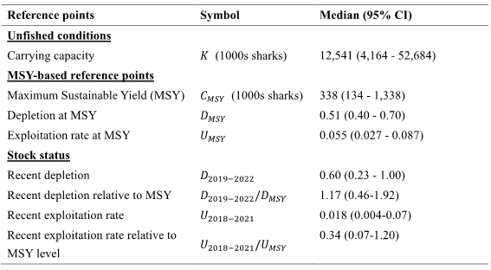

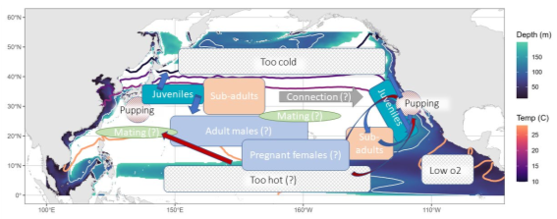
Figure NPSMA-01. Conceptual model for NPO SMA. Contour lines (warm colours) are shown for the average annual 10°, 15°, 18°, and 28°C sea surface temperature isotherms. Background shading (cooler colours) shows the depth of the oxygen minimum zone (3ml/L), a white isocline indicates a depth of 100m which could be limiting based on SMA vertical dive profiles.

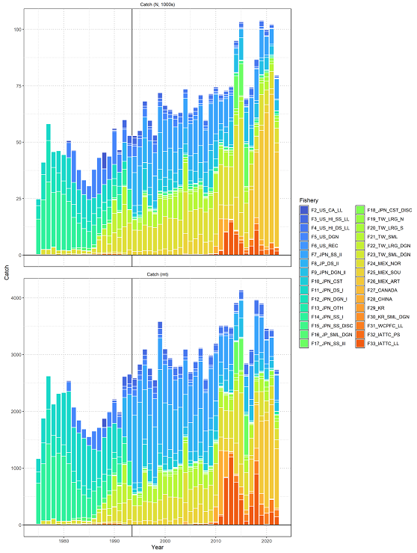
Figure NPSMA-02. Catch of North Pacific shortfin mako by fishery as assembled by the SHARK WORKING GROUP. Upper panel is catch in numbers (1000s) and lower panel is catch in biomass (t). The vertical black line indicates the start of the assessment period in 1994.

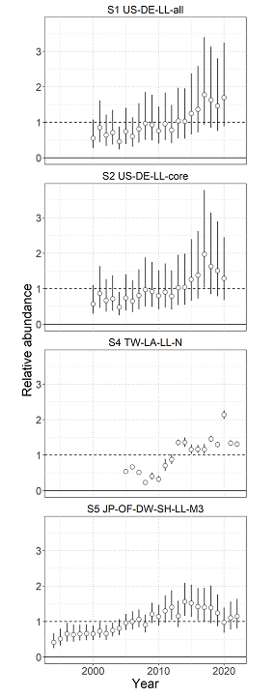
Figure NPSMA-03. Standardized indices of relative abundance used in the stock assessment model ensemble. Open circles show observed values (standardized to mean of 1; black horizontal line) and the vertical bars indicate the observation error (95% confidence interval).

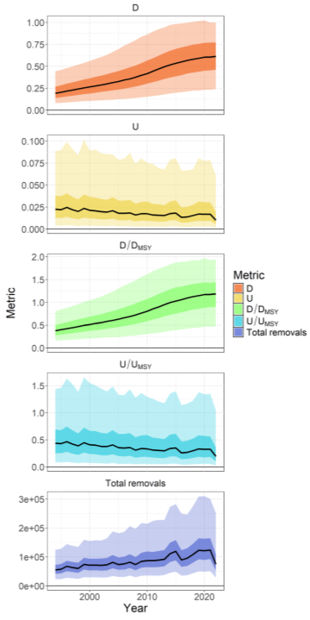
Figure NPSMA-04. Time series (solid lines) of estimated depletion (D), exploitation rate (U), depletion relative to the depletion at maximum sustainable yield (D/D_{MSY}), exploitation rate relative to the exploitation rate that produces MSY (U/U_{MSY}), and total fishery removals (numbers). Darker shading indicates a 50% credible interval, and lighter shading indicates a 95% credible interval.
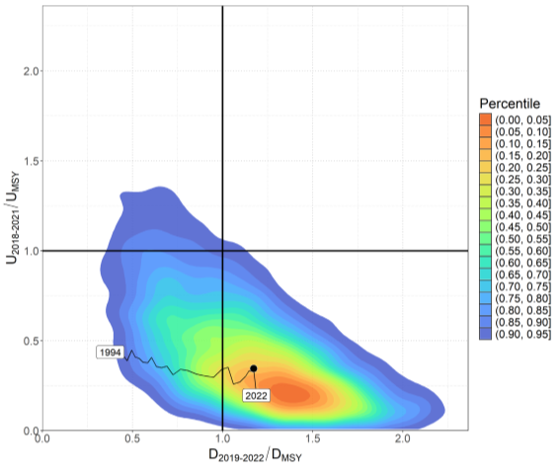
Figure NPSMA-05. Kobe plot showing the bivariate distribution (shaded polygon) average recent depletion relative to the depletion at MSY (D₂₀₁₉₋₂₀₂₂/D_{MSY} ) against the average recent exploitation rate relative to the exploitation rate at MSY (U₂₀₁₈₋₂₀₂₁/U_{MSY}). The median of this bivariate distribution is shown with the solid black point. The time series of annual D_{t}/D_{MSY} versus U_{t}/U_{MSY} is shown from 1994 to 2022.

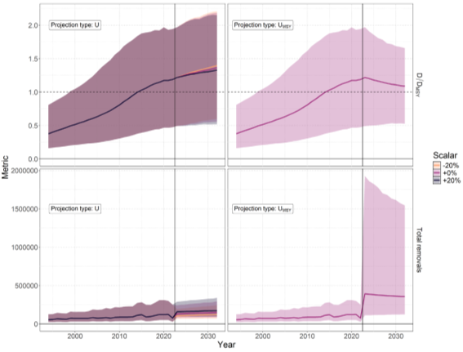
Figure NPSMA-06. Stochastic stock projections of depletion relative to MSY (𝑫/𝑫_{𝑴𝑺𝒀}) and catch (total removals) of North Pacific SMA from 2023 to 2032 were performed assuming four different harvest rate policies: U₂₀₁₈₋₂₀₂₁, U₂₀₁₈₋₂₀₂₁ + 𝟐𝟎%, U₂₀₁₈₋₂₀₂₁ −𝟐𝟎%, and U_{MSY}. The 95% credible interval around the projection is shown by the shaded polygon.

4.6 Projects and Requests

4.6.1 Stock Status and Management Advice Template (Project 113b)
Working Paper: SC20-SA-WP-10

- SC20-SA-WP-10 was presented by Philipp Neubauer (Dragonfly Data Science for the SSP). The present study, conducted as part of Project 113b, aimed to develop recommendations for a more standardized approach to reporting stock status and management advice from stock assessments, as had been recommended by the review conducted as part of Project 113 and presented to SC19. The research involved a survey of 17 participants (15 managers and two scientists) to gather insights on the effectiveness of current reporting methods and preferences for future improvements. Additionally, the study examined best practices from other jurisdictions and scientific literature, particularly drawing inspiration from the Intergovernmental Panel on Climate Change (IPCC) guidelines for reporting uncertainty. The importance of this work lay in its potential to enhance the WCPFC’s ability to implement precautionary approaches to fisheries management, as mandated by the WCPFC convention. By improving the consistency and clarity of stock status reports and management advice, the Commission could make more informed decisions and better track changes in stock status over time.

- Key findings from the survey and analysis included:
• Current reporting of stock status and management advice lacks consistency across different fish stocks, making comparisons and trend analysis challenging.
• While the detail and clarity of current reports are generally considered sufficient, the reporting of uncertainty is not consistently adequate across all assessments.
• Uncertainty is recognized as an important aspect of stock assessments, both for stocks with and without explicit management strategies.
• The communication of uncertainty and its consideration in management decisions could be improved to better support the application of the precautionary principle.
• There is a need for a more structured and standardized approach to reporting, including consistent terminology and formatting across different stock assessments.

- Based on these findings and a review of best practices, the study proposed several key recommendations to improve the reporting of stock status and management advice:
1. Rename report sections for clarity: “Stock Assessment and Trends” and “Stock Status and Management Advice”.
2. Implement consistent section content structures for both renamed sections, including specific elements like assessment structure, uncertainties, catch estimates, and management quantities.
3. Use consistent language for describing uncertainty: Apply a 3-level confidence scale (high, medium, low) in the “Stock Assessment and Trends” section, where confidence relates to the assessment’s ability to capture key uncertainties. And use IPCC likelihood categories with corresponding probability statements in the “Stock Status and Management Advice” section.
4. Tabulate main sources of uncertainty in the assessment, including rationale, impact, and confidence level.
5. Provide a standardized stock status table in the “Stock Status and Management Advice” section, including probability statements and likelihood categories for key status indicators.

Discussion

- Japan recalled that this sort of approach had been discussed in many RFMOs, and it was never easy to standardise the presentation of assessments resulting from many different kinds of models. Because of this heterogeneity it was going to be difficult to set strict rules for the presentation of assessments, and Japan hoped that these recommendations would result in guidelines rather than rules. It was also important to have consistent scaling of data sources, and this was information that needed to be included. Hindcasting and predictability of the model was also something useful to consider in providing assessment advice to Commissions.

- The presenter did not expect that all assessments would result in the same output elements, and pointed out that not all of the standard template components would need to be filled in for all assessments. But there was a certain set of information that should be provided consistently.

- Samoa provided feedback, on behalf of FFA CCMs, and thanked the consultants for their work. These were important findings from the report and they totally agreed that there should be a standardised approach to reporting stock status and management advice from stock assessments to the WCPFC. The lack of consistency on the stock status and management advice – and the reporting of uncertainty in particular – should be of real concern to the Scientific Committee and its work. Thus, FFA CCMs strongly supported the recommendations on:
- having consistent section content structures including specific elements like assessment structure, uncertainties, catch estimates, and management quantities;
- using consistent language for describing uncertainty. and where confidence relates to the assessment’s ability to capture key uncertainties;
- using IPCC likelihood categories with corresponding probability statements in the ”Stock Status and Management Advice” section;
- tabulation of main sources of uncertainty in the assessment, including rationale, impact, and confidence level; and
- providing a standardised stock status table in the “Stock Status and Management Advice” section, including probability statements and likelihood categories for key status indicators.

- They did however have reservations on the proposed renaming of the two report sections. At this point they considered that it would be better to retain the current practice of separating stock status from management advice.

- The USA was supportive of this effort and recommended that SC endorse these guidelines. For clarification, was the idea that the SC would modify the tables before approval similar to the way that management advice was currently subject to SC approval?

- The author clarified that it should be SC that puts forward management advice to the Commission, and the management recommendations drafted by the stock assessment team would not necessarily be unqualified by SC. If there were management recommendations to be made, then those were ultimately the responsibility of the SC.

- New Zealand commended the work on the development of a stock status and management advice template that has been undertaken, which in their view provided a practical proposal for improving how this committee should communicate stock status and management advice. They noted that New Zealand used a tabular ‘status of stocks’ template domestically, which also made use of the IPCC likelihood categories and probability statements. This has served New Zealand well to communicate results in a standardised way, including on stock assessment uncertainty. Besides clearly communicating information to stakeholders and managers, they found that this approach provided guidance to stock assessment scientists on how to summarise the key aspects of assessments. They agreed with the earlier suggestions to think of the proposed template as a guideline in the first instance, which SC and Commission could test and adjust from time to time.

- FSM, on behalf of PNA and Tokelau CCMs, endorsed the FFA CCMs’ statement. They thought the report was a good response to the Terms of Reference. They valued the advice on how to communicate uncertainty, and how to make the SC management advice more easily understood. In particular, they agreed with the approach in Table 4 for integrating the Stock Status information and the Management advice. They had one question, and understood that with harvest strategies, the assessments would become part of the monitoring strategy for the management procedures, and would not be the primary source of management advice to the Commission. They pointed out that this development had been addressed on page 19 of the working paper where it said that when a management procedure was adopted, the management strategy evaluation would typically evaluate management options. Could the presenter elaborate on how management advice from the assessments might be reframed to fit into the use of Management Procedures?

- The presenter noted that MPs were not in place for most stocks at the moment. The template would have to remain flexible depending on which MPs they would need to respond to in the future.

- Australia was in broad agreement with the findings, and the IPCC probability approach had been discussed in SC before. As noted by the FFA CCMs, there were some concerns about the responsibility for conveying management advice, but this is currently accommodated by 2-part stock status and management advice components. Australia agreed with others on the need to retain some flexibility

- Japan asked what was to be included in the management advice section. SC tends to spend a long time on the discussion of management advice text, so if it is to be reduced to numbers and tables it could save some time. But what sort of wording should be used for management advice?

- Dragonfly replied that the outputs from the scientific process should be mainly numerical, but that didn’t preclude having descriptive paragraphs for those elements. And it was the job of the Scientific Committee to provide the management recommendations. The table would only take the key recommendations from the text and put that up front as a high-level summary, but it wouldn’t replace the management advice. It would simply supplement it with a set of consistent outputs.

- Canada said they had recently gone through a similar process to develop a template for stock status and management advice to be applied to all stocks in Canada, but it was flexibly implemented.

- An Informal Small Group – ISG6, led by the USA – discussed what SC20 should convey as advice to the Commission on this topic (see Attachment F) and its outputs, with some minor amendments, was adopted by plenary as follows:

- SC20 thanked the consultants for their work on Project 113b and agreed on the need for a standardized approach to reporting stock status and management advice from stock assessments for the work of the Commission and recommended it as a guideline.

- SC20 noted that the inconsistency in the current reporting of stock status and management advice, particularly regarding the communication of uncertainty, should be a significant concern for the Scientific Committee and its work.

- SC20 generally supported the recommendations for reporting stock status and management advice described in the SC20-SA-WP10 as outlined below.
- Rename sections of the Stock Status and Management Advice report to better reflect the content, ensuring consistency in section structures. This includes clearly defining elements such as assessment methodology, uncertainties, catch estimates, and management quantities.
- Use consistent language to describe uncertainties, including a summary of the main sources of uncertainty in the assessment and the associated degree of confidence
- Use IPCC likelihood categories with corresponding probability statements.
- Tabulate main sources of uncertainty in the assessment, including rationale, impact, and confidence level in a consistent manner across all stocks.
- Provide a consistent and user-friendly interface for accessing stock assessment reports such as a web-based reporting app.

- The report from the Informal Small Group (ISG-06) (Project 113b: Develop Stock Status and Management Advice Template for Consistent Reporting of Stock Assessment Outcomes, Uncertainties and Risk) is included in Attachment F. Based on the results of ISG-06, SC20 agreed that the proposed template be used as a guideline for providing such information to the SC21, noting that the decision to accept or request revisions to the report rests with the SC. A worked example using WCPO silky shark was provided to and approved by SC20. SC20 recommended the Commission review the template and advise, if necessary.

4.6.2 Application of Close-Kin-Mark-Recapture Methods (Project 100c)
Papers SC20-SA-WP-09 , SC20-SA-IP-24

- Simon Nicol (SSP) presented SC20-SA-WP-09. It had been hoped to provide the SP-ALB genetic calibration but this had been delayed because CSIRO was in the process of commercialising this aspect of genomics - moving from an R&D perspective into a commercial high-volume approach. The SSP hoped to finalise the SP-ALB calibration this year and report in 2025. Part of task with South Pacific swordfish was to look at ageing using bomb radiocarbon dating, and older specimens needed to be found to enable the calibration of an epigenetic clock for ageing swordfish as well. One aspect of CKMR was to characterise markers for CKMR purposes. The tuna genomes had been mapped but the work needed to narrow down on the alleles useful for identifying kin pairs. This was just at the resequencing stage. There was an initial design for SP-ALB close-kin application and this was attached to the working paper. The project had looked at the number of samples needed to detect the 50-odd kin pairs, initially estimating a need for 20-25,000 individuals, but this was now estimated at between 34-86,000 samples, split evenly between juveniles and adults. It was noted that the existing sampling regime could actually achieve up to 100,000 samples without restructuring the existing programme. The Online Discussion Forum (see Attachment I) had asked if the project included individuals in eastern Pacific, but the project was just looking at the WCPO. There would however be some benefits in looking at bigeye over a broader area. The SP-SWO scoping study had been completed recently and was undergoing review and should be presented in 2025. Drafts of this could be viewed soon. The project had developed Standard Operating Procedures (SOPs) for high quality sample collection and was now working on quality control. Port Samplers were currently being trained across many key ports in the Pacific. An ancillary study using both otoliths and genetics had been done to see if there was consistency with the types of connectivity anticipated by SEAPODYM model. French Polynesia and New Caledonia had been sampled at same time of year, and another set of samples had been taken 6 months earlier from New Caledonia. The USA interpretation yesterday was almost correct and there were likely to be strong differences in the stock between east and west. However, whether that was a strong indicator of isolation, or whether there was a gradient from east to west is yet to be determined from additional sampling between French Polynesia and New Caledonia, and also further into the eastern Pacific. This would also help indicate if there were any oceanographic barriers. WCPFC might also want the SP-ALB work across the whole South Pacific to be extended to the North Pacific as well – it would be more efficient to do both at once. Regarding upskilling; as well as sampling it might also be useful to consider what sort of expertise would be needed in SC to interpret this kind of genomic input. We need to think now about how we will incorporate this information into future assessments.

Discussion

- China was interested in collaborating with the SSP on understanding the stock structure of SP-ALB especially through sampling in the EPO. They were also interested in capacity-building workshops in future years on sampling and interpreting CKMR work, especially when institutions might otherwise start diverging in methodology and potentially in the comparability of results.

- Niue, for FFA CCMs, sought some clarity on the number of tissue samples the Project had now acquired and whether the plan from the SSP that set targets for tissue samples of up to 84,000 was a realistic target for 3 years. They thanked the SSP and partners for this important work and report. Acknowledging the importance of the application of the CKMR, they supported the integration of the CKMR data into future stock assessments for the South Pacific albacore. They endorsed the set target for tissue samples collection. They also supported the recommendations outlined in activities 2 and 5 in the report.

- SPC felt it would not be overly onerous to collect 84,000 or more samples. During the busiest periods their experience had been that 12-15,000 samples could be obtained per month. So, it was reasonable to achieve the target of 84,000 samples over 3 years or even 2 years. The CKMR steps were: to estimate number of samples needed; to be sure that the samples could be collected to the standard required; and to decide if they were in a position to refine markers for kin detection. All was currently positive, but more work was still needed on the bioinformatics necessary to detect kin relationships in albacore. However, there was no reason to assume this would fail when it has proven possible for many other tunas and teleosts. It also needed to be understood how this information could be used in stock assessment models. In the past, models have been developed based only on close kin aspects, and that work probably needed to start now. If so, by the time of the next SP-ALB assessment, the information should be available to apply such models.

- Tonga has been participating in this project since March and has continued to support it. In 2023, they signed an LOA with SPC along with other CCMs to carry out CKMR sampling. Port samplers have been trained and have collected 2,000 samples since March this year.

- Japan also supported this work. They had been going to ask about feasibility but were reassured by Simon’s explanations. Noting that if there were multiple stocks, the sampling areas would have to be considered carefully. Japan noted that the SSP was comfortable that the analysis would be feasible, but that it was now necessary to develop a model and this was something new to SC, which might need some additional expertise to do that. Which in turn will require more finance. It would be useful to have a holistic view of resources required in future presentations.

- New Caledonia wanted to recognise the importance of this work for understanding SP-ALB, and they supported all the recommendations in the paper. New Caledonia and its fishery would remain fully available to assist with sampling.

- The EU was in principle supportive of all the recommendations, but wanted to confirm ask about the budget implications of the proposal to increase the sample size for the would also be concerned about a change SP-ALB study.

- SPC noted that much of the resources to implement this work had come from EU sources. The SSP also had some resources from NZ to increase the science capacity of SPC members to adapt to climate change impacts and part of that was about biological sampling. So, these resources had all supported the sampling work, but he agreed with Japan that we need to consider the overall resources needed in future, including sequencing costs (although those were reducing), the bioinformatics and the model development work.

- As located in the overlap area between IATTC and WCPFC, French Polynesia felt this CKMR work was particularly important for them they were aware of the seabirds mentioned and they remained prepared to support the sampling.

- SC20 noted the demonstrated capacity of sampling teams now established throughout the region to achieve the updated target of 36,000-84,000 tissue samples over a three-year period and recommended the SSP consider exploring the possibility of the inclusion of CKMR data in future stock assessments for South Pacific albacore, including the analysis of financial as well as human resource requirement.

- SC20 recommended continuing to dedicate all relevant resources for capacity building workshops to support the understanding of the CKMR work on South Pacific albacore.

- SC20 recommended the SSP consider undertaking follow-up studies on South Pacific albacore including those that:
- incorporate finer-scale, structured sampling across the WCPO and further east in the EPO;
- consider the implication of the possible existence of multiple stocks on the CKMR work.
- combine empirical and modelled data from a variety of sources where available; and
- explore intrinsic and environmental mechanisms that might have caused the observed population structure.

4.6.3 Scoping study on longline effort creep in the WCPO (Project 122)
Papers: SC20-SA-WP-05 , SC20-SA-IP-19

- Jemery Day of the SSP presented SC20-SA-WP-05. Recognising the limited time available for the presentation, he noted that longline effort creep level of zero percent was implausible, even though that was the standard assumption in modelling. He also noted that effort creep could be negative particularly for non-target species subject to mitigation measures. If possible (if the data were available), effort creep should be incorporated into CPUE standardisation. Incorporating effort creep into assessment models could have significant implications for management. The Commission for the Conservation of Southern Bluefin Tuna (CCSBT) already applied a standard effort creep rate of 0.5%.

Discussion

- The USA encouraged the continuation of this work to look at the potential for incorporating effort creep into stock assessments.

- The EU recommended a no-cost extension of this project. And had a question – purely out of curiosity – regarding the possibility for a negative effort creep for target species. They referred to the sharp decreases in CPUE and biomass observed in many stocks early in the time series. Could this be included in the effort creep work or would there be a non-linearity between CPUE and abundance? This was a very speculative question but the EU would like to know if the SSP was aware of any study treating this as a catchability issue or if they have any other opinion, because the inclusion of effort creep for the whole time series in many assessments could potentially worsen this apparent artefact, and the EU did not know if it was worth taking it into account for future work.

- SPC acknowledged the EU's question and admitted that they were unaware of any studies showing negative effort creep for target species. The SSP discussed the complexity of CPUE data and suggested that unusual signals might indicate other issues, possibly unrelated to effort creep, but did not have a definitive answer.

- New Zealand thanked the SSP for their research on longline effort creep in the WCPO and acknowledged Simon Hoyle's comprehensive review and the importance of considering effort creep when integrating CPUE series in tuna assessments. New Zealand highlighted that while further research was needed, progress may be slow and inconclusive due to the complexity of the processes at play. New Zealand suggested that in the absence of precise research, a range of effort creep assumptions should be considered as part of the uncertainty grid, and also recommended selecting a sensible value for effort creep for diagnostic models, as was already done by some tuna RFMOs.

- SC20 recommended project 122a be given a no-cost extension to continue the scoping study on longline effort creep (project 122a), in conjunction with collaboration with other tRFMOs on longline CPUE standardization efforts, consistent with the CPUE projects detailed in the Tuna Research Plan.

4.6.4 WCPFC Tuna Biological Sampling Plan (Project 117)
Information Paper: SC20-SA-IP-12

- Information paper SC20-SA-IP-12 was taken as read.

Discussion

- Tonga made one comment, on behalf of FFA CCMs, to acknowledge the ongoing work in the collection and storage of biological samples through the WCPFC Pacific Marine Specimen Bank (PSMB) and to reinforce the importance of improved biological data for tuna and tuna-like species in the WCPO. They supported the proposed methodology for developing biological sampling plans for tuna within the WCPFC convention area and invited relevant CCMs to participate in this initiative.

4.6.5 WCPFC Billfish Biological Sampling Plan (Project 118)

- Information Paper SC20-SA-IP-12 was taken as read.

4.6.6 Research Plan Update

4.6.6.1 Tuna Assessment Research Plan (2023 – 2026) update
Working Paper: SC20-SA-IP-08

- Graham Pilling (SPC) presented SC20-SA-IP-08, which described the Tuna Assessment Research Plan (TARP). The first TARP was adopted at SC16 and has been updated annually since then. IP08 presented a draft TARP updated from the Plan agreed upon at SC19 and provided updates on previous versions of the Scientific Committee (SC) research plan for improving the stock assessments of key WCPO tuna stocks: WCPO skipjack, bigeye, yellowfin, and South Pacific albacore. It highlighted some important potential research and development areas that SC might have considered for submission as SC projects into the meeting’s prioritization process.

- Every stock assessment performed by the SPC-OFP identified areas for improvement and provided recommendations for future work. Some recommendations were pointers for areas to consider in future assessments. In contrast, others indicated key gaps in fishery data and understanding of biology and population structure that, if filled, might have reduced both future model misspecification and uncertainty in assessment outcomes. Many of these could not be directly rectified through improvements to the assessment model alone; ongoing efforts to improve regional fishery data collection and a well-structured and appropriately resourced programme of biological studies targeting the areas required to reduce stock assessment uncertainty were needed.

- Furthermore, many of the enhancements to MULTIFAN-CL and key tuna stock assessments had arisen through the independent peer review of the bigeye stock assessment undertaken in 2012 (Ianelli et al., 2012), while the 2022 yellowfin assessment review (Punt et al., 2023) had identified further recommendations, and relevant issues were captured in this TARP. Some of this work had been undertaken by WCPFC members and the SPC-OFP through specific SC research projects that had arisen directly from SC discussions on these issues. Other key work had been undertaken by WCPFC members or SPC-OFP through other funding sources, and capturing these efforts within the plan would have enhanced SC’s research planning and facilitated the identification of gaps to be filled.

Discussion

- The co-convenor noted that this Information Paper would be forwarded to the TARP ISG and invited any further comments that might need to be taken into account by the ISG.

- Vanuatu presented the views of FFA CCMs. They acknowledged the importance of the Tuna Assessment Research Plan in guiding the Scientific Committee and the SSP in prioritizing funding and managing the SSP's workload, both of which were constrained. They noted that the current list of projects was not prioritised, and many were not yet funded including the project for a cross tuna RFMO workshop on abundance index modelling and the standardization of size composition data. These projects were critical for improving stock assessments and would significantly enhance the efficiency of the Commission and the SSP in processing data inputs. FFA supported the Informal Small Group (ISG) process to discuss and prioritize project in the TARP in the margins of SC20. They further recommended that SC20 should task the WCPFC Secretariat, with the assistance of the SSP, to review and update the tuna assessment research plan on an annual basis.

- SC20 tasked an informal small group (ISG-03), chaired by Keith Bigelow of the USA, with reviewing the Tuna Assessment Research Plan (TARP, SC20-SA-IP-08).

- After presenting the ISG-03 report and discussing proposals and the comments made by CCMs in the plenary, ISG-03 indicated to SC20 that there were four new projects for consideration:
- P20X01. New Zealand albacore troll fishery catch sampling;
- P20X07. Review and reconciliation of size data collected in the WCPFC-CA for assessment purposes;
- P122a. Extending the scoping study on longline effort creep in the WCPO to enable cross tuna RFMO collaboration and broader discussion on CPUE abundance index development; and
- P20X08. Understanding connectivity of the yellowfin and skipjack stocks in the Western Pacific and East Asia region with the WCPFC Convention Area.

4.6.6.2 Billfish Research Plan (2023 – 2026) update
Working Paper: SC20-SA-IP-09

- Paul Hamer of the SSP presented SC20-SA-IP-09, explaining that the report of Project 112 (Billfish Research Plan 2023-2027) had been adopted by SC19 and endorsed by WCPFC20 in December 2023. The 2023-2027 Billfish Research Plan (BRP) represented the first phase of the WCPFC’s BRP. The 2023-2027 BRP was a living document that could evolve based on the information needs and priorities of the WCPFC. When reviewing the BRP, SC19 recommended that the BRP be extended to 2030 with short annual reviews to evaluate progress and ensure that the subsequent years’ work remained relevant and required. The purpose of this document was to review progress against the BRP tasks to facilitate future planning of WCPFC billfish research. The project list is included in Table 1. Additionally, Table 2 was provided to update the Scientific Committee’s assessment schedule for billfish. It was suggested that data-rich assessments be undertaken for blue marlin, striped marlin, and swordfish, with standardised CPUE analyses and fishery characterisations for black marlin, sailfish, and shortbill spearfish.

- At SC19, the ISG-Billfish had suggested that prior to beginning any assessment or analysis of these latter species, it was important to develop conceptual models for them, to identify data availability, biological and stock structure knowledge, and suggest the most appropriate assessment approaches. The ISG-Billfish had proposed that this characterisation/conceptual modelling work could take place in 2025, and the development of a ToR for this work had been deferred until SC20. For SC20, two projects had been completed: Stock assessment of Southwest Pacific striped marlin (SC20-SA-WP-03, SC20-SA-WP-12, and SC20-SA-WP-13) and the development of a statistically robust sampling plan for billfish (SC20-SA-IP-13). Two papers had been submitted to SC20 that fell outside of the BRP: a rebuilding plan for WCPO striped marlin (SC20-SA-IP-15) and a CPUE analysis of the New Zealand recreational fishery for striped marlin (SC20-SA-IP-17). There were four new projects scheduled to start in 2025 pending agreement at the SC20 ISG-Billfish and approval of the budget by WCPFC21. The new projects had a draft project specification included in Appendix 1 for review by SC20 ISG-Billfish.

- The paper recommended that (1) SC20 ISG-Billfish review the work plan and project list for the 2024/25 year and make recommendations to SC20 for any changes the SC might have wanted to consider, and (2) SC20 ISG-Billfish review the project specifications and make any changes for SC20’s review.

Discussion

- The Solomon Islands thanked the SSP on behalf of the FFA CCMs for providing the updated BRP and including the draft project specifications for the projects, as requested by SC19. They noted the progress of the 2 completed projects, the stock assessment of Southwest Pacific striped marlin and the development of a statistically robust sampling plan for billfish. They also suggested including projects undertaken by CCMs in the BRP, following a similar structure to the Tuna Assessment Research Plan. This would help inform which information is available and take stock of past projects as well. In that regard, they suggested including the “CPUE analysis of the New Zealand recreational fishery for striped marlin” in the BRP.

- Australia thanked Paul and Steve for the work on the BRP and informed SC20 of Australia’s intention to develop a Management Procedure for Southwest Pacific Swordfish. They would like to see this reflected in the BRP. There will be a stock assessment next year, and Australia is looking for funding to help develop a management procedure.

- French Polynesia noted that swordfish is a particularly important species for them and thanked Australia for looking to address gaps in SWP-SWO management and asked members and other interested parties to support Australia in this work.

- The Pew Charitable Trusts echoed the comments by Australia and French Polynesia, and said they would be looking to assist in the development of a Management Procedure for SWP Swordfish.

- SC20 tasked an informal small group (ISG-04) with reviewing the Billfish Assessment Research Plan (BRP, SC20-SA-IP-09). ISG-04 provided the following three agreed paragraphs.

- A slight revision to the stock assessment schedule for billfish species was agreed, with WCNPO MLS scheduled to be assessed again in 2027 and NP SWO in 2028.

- Members reviewed three projects that were identified at SC19 and approved two of those projects to be provided for SC20 priority ranking:
- Project P20X03 Assessment approaches for WCPO black marlin, sailfish, and shortbill spearfish.
- Project 20X04 Biology of South Pacific striped marlin, blue marlin, shortbill spearfish, and sailfish in the WCPO from longline fisheries.

- In addition, members noted the following projects that were discussed but were not required to be ranked for prioritisation:
- The southwest Pacific swordfish stock assessment will be undertaken by the SSP in 2025.
- CPUE analysis of the New Zealand recreational fishery for striped marlin (Funded by New Zealand).
- Developing a management procedure for southwest Pacific swordfish by Australia (Commission funding not sought in 2025, a TOR for the project may be provided at a future SC).

4.6.6.3 Review of the Shark Research Plan 2021 - 2030
Working Paper: SC20-SA-IP-10

- Paul Hamer of the SSP presented SC20-SA-IP-10 and noted that the report of Project 97 (Shark Research Plan 2021-2025 (Brouwer and Hamer, 2020)) had been adopted by SC16 and endorsed by WCPFC17 in December 2020. The 2021-2025 Shark Research Plan (SRP) represented the third phase of the WCPFC’s SRP, building on the previous two plans. The 2021-2025 SRP was a living document that could evolve based on the information needs and priorities of the WCPFC. This plan had undergone a mid-term review in 2023 (Brouwer and Hamer, 2023), and as part of that review, SC19 had recommended that the current SRP be extended to 2030 with shorter annual reviews to evaluate progress and ensure that the subsequent years’ work remained relevant and required. Additionally, it had been agreed that shark assessments would be carried out over two years. The first year (which, in reality, was 4-5 months in duration from contracting the work as projects with the WCPFC secretariat in February to the SC paper delivery at the end of July) provided time to collate the data, undertake fishery characterisations, develop catch reconstructions and preliminary CPUE work, and provide SC with a recommendation on the possible approach(es) that might be suitable for a stock assessment. The second year of the assessment projects for sharks focused on the actual stock assessment, which now may also include risk assessment methods, if agreed by SC and the additional funding supported by WCPFC.

- The purpose of this document was to review progress against the SRP tasks to facilitate future planning of WCPFC shark research. At SC19, the SC reviewed the proposed work in the SRP and updated the research plan. These updates on the 2021-2030 SRP, as well as the work progressed against that project list, were included in Table 1. Additionally, Table 2 was provided to update the SC assessment schedule for sharks. It was suggested that data-rich assessments be attempted for blue, shortfin mako, silky, and oceanic whitetip sharks, with the remainder being evaluated through fishery characterisations and/or low information estimations of fishing mortality (F) risk. A new assessment for southwest Pacific blue shark was due to start with the data exploration work beginning in 2025; however, it was suggested that the start date be moved to 2026 to better fit with the rest of the stock assessment schedule and to avoid the first year of new shark assessments overlapping with the second year of the shark assessment that was underway.

- There had been four changes to the assessment schedule: The ISC had proposed to undertake indicator analyses for North Pacific blue and North Pacific shortfin mako sharks in 2025 and 2026, respectively. The ISC had also identified several uncertainties that would require more work to resolve and had proposed moving the next North Pacific blue shark assessment from 2026 to 2027. The project to conduct fishery characterisation of manta and mobulid rays and whale sharks had been moved by WCPFC20 from 2024 to 2025. Additionally, it was suggested to change the southwest Pacific shortfin mako shark assessment to a low information assessment or characterisation given the data issues experienced with the last assessment. Under Table 1 section c(i), there was an item to include data-poor assessment metrics as standard outputs for data-rich assessments where possible. This was a standing item currently, and these metrics had been included in SP-blue sharks, SP-shortfin mako, and silky shark assessments. The SC20 ISG-Sharks might have wanted to review these and provide a specific list for future assessments. If they were able to do that, then this item could be removed from the list; if not, it should remain until such time as firm recommendations on these metrics were accepted by the SC.

- For SC20, three projects had been completed, and there were three projects that were scheduled to start pending agreement at SC20 ISG-Sharks and approval of the budget at WCPFC21. The new projects had a draft project specification included in Appendix 1 for review by SC20 ISG-Sharks. Additionally, a new project on oceanic whitetip and silky shark in longline fisheries between 20N and 20S and outside the area to evaluate CMM 2022-04 had been completed (SC20-EB-WP-05).

- The paper recommended that:
    - SC20 ISG-Sharks review the work plan and project list for the 2024/25 year, and make recommendations to SC20 for any changes the SC may want to consider.
    - SC20 ISG-Sharks review the proposed amendments to the stock assessment schedule and make recommendations to SC20.
    - SC20 ISG-Sharks review the project specifications and make any changes for SC20’s review.
    - SC20 ISG-Sharks consider if there is enough information to provide the SC with advice on the use of data-poor metrics in shark assessments and their future use for low information stock assessments.

Discussion

- Tonga expressed the view of FFA CCMs, acknowledging the work undertaken to review the progress made under the Shark Research Plan (SRP). They reiterated the need for increased support relating to CITES obligations given the large number of shark species newly listed in CITES Appendix II. FFA Members requested that these needs be addressed in the SRP, particularly given the large number of look-alikes listed, and NDF development assistance for WCPFC key shark species, particularly for blue shark, mako shark and hammerhead sharks.

- An informal small group (ISG-05) met during SC20 to discuss the SRP and the recommendations of the review. The outputs of ISG-05 (see Attachment G) were presented to the meeting, noting that the ISG did not recommend any changes to the SRP itself apart from a few changes to scheduling. There had also been a discussion on the prioritisation of projects for 2025 which contributed to the outputs of Agenda Item 10.

AGENDA ITEM 5 – MANAGEMENT ISSUES THEME

5.1 Development of the WCPFC harvest strategy framework for key tuna species

5.1.1 Skipjack tuna

5.1.1.1 Skipjack tuna management procedure
Working paper: SC20-MI-WP-01

- Rob Scott of the SSP presented SC20-MI-WP-01 (Re-evaluation of the Skipjack Management Procedure Estimation Method). The estimation method (EM) was an important component of the management procedure (MP). Its role was to provide a reliable estimate of stock status that could be used by the harvest control rule (HCR) to determine future fishing opportunities. For WCPO skipjack, given the stock biology and reliance on tagging information, the EM adopted in CMM 2022-01 was comparable, but not identical to, the diagnostic case model of the 2019 stock assessment. Following the first implementation of the adopted interim skipjack MP, the monitoring strategy highlighted that while sufficient data were available to run the MP, the continued decline of pole and line fishing effort in the tropical regions presents a potential problem for the future running of the MP.

- This was reflected in the WCPFC20 Summary Report (paragraph 302). A re-evaluation of the estimation method was recommended prior to the next implementation of the MP (in 2026) as a high priority. This paper summarises potential options for changing the existing estimation method within the WCPO skipjack management procedure to address the issues raised by the monitoring strategy. It provides SC20 with a timeline to consider for the next 2 years prior to the running of the skipjack MP in 2026. A technical workshop, organised by the SSP, to gain external expert input into the EM re-evaluation issues is recommended. Potential approaches to modify the estimation method of the WCPO skipjack interim MP include:
- Modification of tropical CPUE abundance indices in the existing estimation method along the lines of the approach taken using purse seine CPUE data by the 2022 stock assessment.
- Development of a catch-conditioned model, as was conducted in the 2022 assessment.
- Further investigation of alternative stock assessment platforms and modelling approaches.

- It was proposed that a re-evaluation of the revised approach be presented to SC21 with agreement of the updated MP at WCPFC22, prior to the next running of the skipjack MP in 2026.

Discussion

- Australia asked about the tasking in 2025 noting SC would be evaluating a different Estimation Model. Would this be a different model from the Operating Model and, if so, would this also need to be run through an MSE process?

- SPC responded that it would. It would be an update of the MP, through a re-evaluation of the MSE approach, where it could be checked if it still represented the best option for management. There were no proposals to replace the operating models themselves.

- Japan understood that the suggestion was to review and probably revise the MP that the WCPFC adopted two years ago after very lengthy negotiation. Usually, the MP was supposed to be a stable, long-term mechanism, but now SC was thinking of revising it after only one use. That would be fine if it was necessary, but the scheduling of timing of MPs was one of the most difficult negotiations facing any RFMO. The way this was being proposed seemed very casual as if the SSP was just saying: “Let’s revise it and see what the result is next year.” The SSP had provided some options on how to revise the Estimation Model, but there had been no decision on how it was to be changed. Could this be done without changing the Operating Model? In SC20-SA-WP-01, there had been a suggestion for having a technical workshop and probably that was necessary and was the biggest question in the paper. If SC was to approve this the Terms of Reference must be prepared for agreement because this would be an important step.

- The presenter agreed with the first point, that it was very unfortunate that we were in the position of having to revise the MP. The SSP would not have suggested it if it was not absolutely necessary. But it was better to fix it now than wait until 2026. It had been hoped in the first case that it could be accommodated in the existing axes of uncertainty. The workshop would be a technical workshop to get some additional expertise applied and the SSP fully agreed that the TORs would need to be discussed and agreed in advance.

- Japan asked for confirmation that the SSP was now recommending a revision of the MP. Japan felt that this had a huge implication for all the work of the Commission.

- Kiribati, speaking for FFA CCMs, noted that the contraction of pole-and-line fishing effort to restricted areas of the overall assessment region may impact the ability of the estimation method of the skipjack tuna management procedure to provide a reliable estimate of stock status that can be used by the harvest control rule to determine future fishing opportunities. Clearly, this issue needs to be resolved prior to the next running of the skipjack tuna management procedure scheduled for 2026 under CMM 2022-01. They therefore supported the recommendation by the Scientific Service Provider to run a dedicated technical workshop with invited external experts in parallel with updating the skipjack tuna stock assessment, which would also be affected by this issue. This would allow for a discussion of the challenges and potential options for alternative approaches to the estimation method within the skipjack tuna management procedure. FFA CCMs also supported the proposed timeline for the re-evaluation process in the paper SC-MI-WP-01, as it had been scheduled to have an agreed and updated estimation method prior to the next run of the skipjack tuna management procedure in 2026.

- SPC noted that there had been an observation by SC last year that this issue resulting from the continued decline of the tropical pole and line fishery, and the indices that depended upon it, was a 'high priority' for review under the monitoring strategy rather than considering it an exceptional circumstance.

- PNA+TK CCMs thanked the SSP for the paper. They understood the need to revisit the estimation model. However, they were concerned about the effect that developing a new estimation model might have on the HCR and Management Procedure and possibly even the TRP. They understood that testing indicated that an alternative estimation model might give very similar results to the current estimation model in tracking historical stock status. But there might still be a need to re-evaluate candidate TRPs and redo the Management Strategy Evaluation. At the same time, they understood that new assessment software would have to be adopted. In addition, there have been changes made to the historical data that were not expected and there may be effects on the Management Procedure from the change to the FAD closure. For PNA+TK CCMs, these developments confirmed the value of the skipjack MP Management Procedure having been adopted on a trial basis. Overall, PNA was highly supportive of the proposed approaches to develop a new estimation model, and the shift to new assessment software. However, they also noted that changes may affect the continued implementation of the skipjack Management Procedure.

- The USA thanked Rob Scott and the rest of the SSP MSE team for their careful consideration of the issues faced by the skipjack estimation method. They agreed with the authors that switching to a free-school purse-seine index was probably most tractable in the near term; however they also recognised, as the authors also had stated, that such an index could have representativeness issues. They supported the authors’ recommendation to further look into the development of an external fine-scale movement model similar to that which the IATTC had developed. This would ensure that the OMs and EMs were different and may more appropriately treat the tagging data. Such a model could be used as an estimation model in the MSE framework and could also be used to ground truth upcoming skipjack stock assessments.

- The EU concurred the issue was really unfortunate, but at the same time thought it unavoidable and that it should be done as soon as possible, because that path would have to be followed at some stage, and the consequences of having an unreliable estimation method in 2026 would be dramatic. So, the sooner the better. They, therefore, seconded the proposed approach. They asked for one minor clarification: the idea at this stage is testing the performance of the current HCR only under a different estimation method with the hope it does not have any implications in terms of TRP and long-term performance, was that correct? The SSP responded, essentially, yes.

- Indonesia asked if there have been any efforts to compare pole and line indices with purse-seine. And will the PL indices still be used for comparison in the future?

- SPC said they had not yet had the chance to look deeply into alternative CPUE indices to augment or even replace the pole and line indices.

- Japan felt they were the only CCM concerned about this proposal, but if it needed to be done then the earlier the better. But SC would now be effectively invoking the “exceptional circumstances” clause of the MP, and the result would be a revision of the MP. This needed to be reported to the Commission and possibly required an additional Science Management Dialogue on the subject. There was possibly a good opportunity for this in one month’s time.

- The Convenor suggested that SC would need to work on language to capture any exceptional circumstances. And if TORs needed to be developed for WCPFC project to fund an expert workshop, this would need to be done within the next few hours.

- SPC clarified that such an expert workshop would be funded by the NZ grant to SPC for the MSE work, and would not involve additional WCPFC funding, so the TORs to be developed would not be for a WCPFC SC Project.

- The Chair reminded CCMs that the MP was an interim MP and it was intended to be reviewed in 2025. The SSP was proposing an expert workshop to investigate the possibility of a change in the Estimation Model so that work could be conducted and presented to SC21 and a recommendation could then be made to the Commission on the way forward.

- Japan proposed that the SPC workshop go ahead and then the Commission could decide if exceptional circumstances had occurred. Any change to an MP – even an interim MP and even a minor change – was a significant matter and needed to be treated through a robust process. Otherwise, Japan could consider modification only to the estimation method.

- The Chair proposed to discuss the Chair’s text and Japan text side by side to see if they could be merged.

- SPC noted that if the work was constrained to just look at the estimation method, then the expert workshop may not be needed.

- The Chair noted that there were some other recommendations for consideration, including those from PNA. This would conflict with Japan’s recommendation that nothing should be changed apart from the estimation method, and this conflict needed to be reconciled.

- Japan said that Commission members were getting nervous about the possibility of the OM and MP being changed. An MP was meant to be a long-term commitment. If the process needed to incorporate the latest information, then that was a valid point, but that might mean needing to update the management procedure after every new assessment. Japan was not a strong proponent of the management procedure for this reason. They suggested that SC overhaul the current MSE in 4 years’ time rather than next year.

- The EU would also be concerned about a change in the OM grid in response to the FAD closure duration, since it responds to the multiplier obtained in the previous run of the MP and did not understand what were the changes proposed. Would this be changed every time the MP was run? The EU also suggested exploring this issue instead of reconditioning the OM.

- The USA agreed that it was not a good idea to be constantly reconditioning the OM, but that was not what was being proposed – not a change, but adding to the existing OM possibly with an extra grid axis or changing how fishing mortality was dealt with in the projection period, not reconditioning the OM.

- SPC thought the EU suggestion was good, to do a separate analysis to look at the impact of changing the FAD closure period. It probably did not have a great impact on the status of SKJ but it could be looked at again, based on the latest assessments.

- FSM said that the PNA+TK CCMs appreciated the comments, but it was their recommendation that the OM be amended to take into account the FAD closure. There might be unexpected effects.

- The Chair understood that PNA+TK CCMs were in support of the EU suggestion. Was any CCM opposed?

- FSM said that PNA+TK were not proposing a change to the OM, so the EU proposal was probably not needed.

- Following this discussion, the SC20 Chair reviewed the history of this issue and brought a summary back to the meeting when the agenda item was reopened the following day. It was recalled that the same issue had been presented last year at SC19, after which SC19 had recommended that a re-evaluation of the Skipjack Estimation Method should be undertaken prior to the next implementation of the Management Procedure. SC19 did not discuss or conclude that a decision on an Exceptional Circumstance would need to be undertaken for this evaluation to take place. This issue was also presented to the Commission last year at WCPFC20, at which point it was agreed that the estimation method should be reevaluated prior to the next running of the MP. The idea of exceptional circumstances did come up last year during the Commission meeting. However, at that time there was no indication from the commission that this re-evaluation would trigger that Exceptional Circumstances clause.

- It was recognized that, during discussions the previous day, there were concerns expressed that the development of an alternative estimation method might result in a need to re-evaluate the MP. And possibly even the TRP. There was also the possibility that an alternative estimation model might give very similar results to the current estimation model. So, the main point to consider here was that nobody yet knew whether or not the MP might need to be modified. So, at this point, based on discussions yesterday, SC would really only be recommending that the science services provider continue to explore the issue and present their findings back to SC21 in 2025. At that point, if there was a need to modify the management procedure, then CCMs could come prepared to discuss whether or not these findings might trigger an exceptional circumstance next year, and SC could provide relevant advice to WCPFC22 on how to deal with that.

- The Chair also raised some additional points to keep in mind as SC20 considered what its recommendations were going to be this year. CMM 2022-01 – the SKJ Management Procedure CMM – has been adopted as an interim management procedure. Paragraph 11 of the measure specified that the Commission would review it in 2025 to ensure that the various provisions had the intended effect. So, there was already a plan to review the measure next year. The measure also specified in Annex 4 that exceptional circumstances were not a mechanism for making regular adjustments to the MP. But rather should be invoked where, through an agreed process, the operation of the MP had been demonstrated to be highly risky or inappropriate.

- Yesterday there had been general agreement with the proposed approach from the science services provider to hold an expert workshop to continue exploring this re-evaluation of the Estimation Method as well as on the proposed timeline for the SSP to report back to SC21. With all of that in mind, the Chair proposed that SC20 recommendations be developed to support those 2 points. Some proposed language had been drafted to capture this, and colleagues from Japan had also been kind enough to draft some proposed language.

- The meeting then discussed an amalgamated draft, and agreed as follows:

- SC20 noted that the Interim Skipjack Management Procedure (CMM 2022-01 Attachment G) calls for the review of the performance of the Management Procedure in 2025 and that WCPFC20 noted that a re-evaluation of the skipjack estimation method may need to be undertaken prior to the next implementation of the MP. SC20 recommended that the SSP evaluate the following potential approaches to modify the estimation method for the WCPO skipjack interim MP, using the current OM grid and HCR, to evaluate whether the performance of the MP would change if the EM were revised, and report back to SC21 on outcomes and recommendations:
- Modification of tropical CPUE abundance indices in the existing estimation method along the lines of the approach taken using unassociated set purse seine CPUE data by the 2022 stock assessment.
- Further investigation of alternative stock assessment platforms and modelling approaches.

- SC20 recommended that the SSP provide the information presented in SC20-MI-WP-01 as well as outcomes from the discussions at SC20 to SMD for further discussion and consideration.

- SC20 further recommended that SC21 review the outputs from the re-evaluation and provide recommendations to WCPFC22 regarding the potential need to revise the current interim skipjack MP (CMM 2022-01).

5.1.1.2 Monitoring strategy for skipjack tuna
Working Paper SC20-MI-WP-02

- Rob Scott (SSP) presented MI-WP-02, explaining that the monitoring strategy routinely evaluated the performance of the management procedure (MP) to check that it was working as expected. The monitoring strategy should consider all aspects of the harvest strategy including procedures for evaluating and testing MPs; the identification of any scenarios that should be added to the OM grid; the preparation and application of the EM and the performance of the management procedure as a whole. In addition, it may identify changes in the dynamics of the fishery resulting from environmental, economic or social factors that may require a reconsideration for the management objectives and the testing of alternative MPs. This paper provided an update of the skipjack MP monitoring strategy to reflect Commission discussions and observations at WCPFC20 and key issues arising subsequently, and clarified areas for consideration by TCC20, for SC20 discussion and input.

Discussion

- FFA CCMs through Tokelau thanked the Scientific Service Provider for updating the monitoring strategy of the skipjack tuna management procedure and noted that the FAD Set Management provisions provided in paragraphs 13 and 14 of the tropical tuna measure were significantly amended at WCPFC20. Given this, they recommended that the Scientific Service Provider evaluate if these changes to the provisions would affect the performance of CMM 2022-01 – the interim management procedure for WCPO skipjack tuna.

- Tuvalu, representing PNA+ CCMs thought that Working Paper 2 was a very good paper. They particularly appreciated that the SSP had included recognition of the “disconnect” issue. There were also two other issues that PNA+TK had raised last year that they thought needed to be referred to in the Monitoring Strategy Report. Those were the need to ensure that measurement of the performance of the MP against the TRP was covered in Section 1a) and that the changes to the historical data were covered in Section 1b). They had proposed amendments to the Report text for these reasons: to amend sub-para a) of Element 1a) to read “The performance of the MP in managing skipjack tuna to achieve defined objectives, including the TRP”; and to include a new comment for SC20: under b. Data availability to run the MP. “The effect of changes made to the historical data is not known”.

- The USA noted that there were several updates this year for skipjack. Was it necessary for SC to provide input every year, or should a monitoring strategy be reviewed less frequently? And as the Commission moves towards adopting MPs for other stocks, could we think about how to make this process more efficient? Could this be accommodated through the Online Discussion Forum in years when an assessment was not carried out? Finally, the USA supported the recommendation to modify the OM grid to account for changes in the length of the FAD closure.

- Japan felt the comments by the USA to be important. Once the Commission had adopted a management procedure it should not be easy to revise it. Japan did not have a definite proposal. Their actual point was to see if there were exceptional circumstances, but if there were no exceptional circumstances then they felt that the Commission did not have to revise the MP.

- The EU asked for an explanation of how the OM was going to be changed to account for this change in the FAD closure duration.

- The SSP noted they had collated the issues in the Monitoring Strategy report and hadn’t had much chance to work out what modelling response might be needed. The FAD and free-school components were separate but at the moment, in the case of SKJ, the FAD closure change might not have much impact. It needed to be investigated along with all the other issues listed under the monitoring strategy report.

- The SSP wanted to come back to the exceptional circumstances component. The changes that were made last year were not considered to be at a level that triggered exceptional circumstances, whatever that “level” actually was. The SSP wanted some clarity from SC20 on what was required to trigger exceptional circumstances in this case, and at what level such exceptional circumstances would normally be triggered. One of the things that was noted last year was that it was of high priority to undertake this work. And if SC wanted to consider whether there was some method of grading issues in a priority sense that do, or do not, trigger exceptional circumstances this would certainly help the SSP and probably the whole SC as they moved forward with future Management Procedure reviews.

- Japan was not fully familiar with the exact wording of the exceptional circumstances clause but suggested that a potential issue could arise if the CPUE index, necessary for evaluating exceptional circumstances, was unavailable. But that evaluation process would perhaps take one or more years to complete. So, they were not sure how it would fit with exceptional circumstances process. If SC considered the MP was not working as intended, then SC needed to recommend remedial action. Perhaps SC should compare the performance of the current MP and the revised MP? But then what would be the point of having an MP? It would be like carrying out another stock assessment, and that was Japan’s biggest difficulty. Perhaps next year, SC could be presented with this comparison and then decide what to do. Many members seemed to accept this approach and Japan hoped that they were aware of the impact. Japan did not know what the goal of this process was.

- Similar to Japan, Australia was not entirely familiar with the definition of “exceptional circumstances”. But Australia did not consider that the approach being proposed here meant there were exceptional circumstances. However, it would be a high priority to resolve for the future – perhaps before the next run of the MP. It was a problem identified last year and it was proposed last year to rectify it in the short term rather than the long term. But Japan’s point was understood. It was not ideal to be revising the approach so soon after agreeing a harvest strategy, which is indeed supposed to be agreed for the long term.

- The EU asked whether the issue should be presented to the Commission and let the Commission decide whether to trigger the exceptional circumstances clause.

- The USA suggested coming back to this issue in the morning, to provide time for reflection.

- After discussion of a preliminary draft text the next day, the following recommendations were agreed:

- SC20 requested that the SSP conduct the following analyses related to the monitoring strategy for skipjack:
- Evaluate whether changes in the FAD closure duration (as adopted in CMM 2023-01) will affect the performance of the interim MP;
- Representativeness and appropriateness of candidate CPUEs for use in MP.

- SC20 recommended that in years when an assessment is not conducted, the monitoring strategy could be reviewed by SC and feedback provided through the Online Discussion Forum.

- SC20 was invited to review the information provided in the Monitoring Strategy included in Table 1 of SC20-MI-WP-02, and to update the text in column 1 (SC) as appropriate. SC20 recommended the following modifications to Table 1 (Monitoring strategy for the skipjack Management Procedure):
- Amend sub-paragraph a) of Element 1.a) (comparison of predicted MP performance against the latest stock assessment outcomes) to read “The performance of the MP in managing skipjack tuna to achieve defined objectives, including the TRP”.
- Amend element 1.b) (Data availability to run the MP) to include a new comment for SC20: “The effect of changes made to the historical data is not known”.

- SC20 recommended the monitoring strategy be forwarded to the SMD, TCC and the Commission for their consideration.

5.1.2 South Pacific albacore tuna

5.1.2.1 Target reference points
Working Paper: SC20-MI-WP-03

- Graham Pilling presented SC20-MI-WP-03 which described the task of recalibrating the SP-ALB iTRP based on the results of the new South Pacific albacore stock assessment, and evaluating the implications of the range of depletion levels requested by WCPFC20 (0.42–0.56 SB_{F=0}). Recalibration used the requested approach of WCPFC20, which was 0.96 x median of mean (SB₂₀₁₇/SB_{F=0},₂₀₀₇₋₂₀₁₆, SB₂₀₁₈/ SB_{F=0, 2008-2017}, SB₂₀₁₉/ _{SBF=0,2009-2018}) from each assessment run. The resultant iTRP was calculated to be 50% of SB_{F=0}

- Long-term stochastic catch-based projections off the grid of 100 models provided to SC20 were performed for the two scenarios requested by SC17:
  - catch of WCPFC-CA and EPO longline and troll fleets within the assessment model was scaled equally;
  - only WCPFC-CA longline and troll fleet catches were scaled.

- The baseline period was the mean across 2020-2022. Noting increases in EPO catches identified in recent years, the catch of longline fisheries within the ‘remainder of the EPO’ (EPO excluding the overlap area) was scaled up to an equivalent of 22,500t, being the level reported in 2021 and 2022. Future recruitment was defined by the estimated stock-recruitment relationship, with variability around it through recruitment deviation estimates from the stock assessment over the period 1973 to 2020. Fifty projections were run from each of the 100 assessment models, and future catch levels (in terms of the number of fish) were adjusted so that the long-term WCPFC-CA depletion achieved the specified level.

- Based upon the current results, WCPFC-CA longline and troll average catch levels over 2020-2022 combined with EPO longline catches of approximately 22,500t would achieve the recalibrated iTRP on average in the long term. Under those conditions, there is an 8% risk of the stock falling below the limit reference point under the current uncertainty framework. Fishing mortality on average was below F_{MSY}. The average vulnerable biomass available across the WCPFC-CA to the longline fishery was 26% lower than that estimated across 2017-2019 and 33% lower than in 2013.

- Under WCPFC-CA management, reductions in longline and troll catches relative to 2020-2022 levels are required to achieve less-depleted stock levels than the iTRP, by up to 13% to achieve a depletion of 0.56 SB_{F=0}. If a more depleted stock were considered appropriate, WCPFC-CA catches (modelled using numbers of fish) could be increased by 18% and 25% for the two evaluated depletion levels that were lower than the iTRP, noting that the risk of falling below the LRP increased to a maximum of 19%. Where catch management was South Pacific-wide, reductions in catch to achieve less-depleted stock levels were slightly less than the WCPFC-CA equivalents. If a more depleted stock level was permissible, increases across South Pacific fisheries were lower than WCPFC-CA-only equivalents.

- Recommendations from the paper were to:
- Note the recalibrated iTRP depletion value based on the submitted 2024 stock assessment grid, for use in the provision of stock status advice relative to this level.
- Consider the levels of fishing necessary to achieve the recalibrated iTRP and alternative depletion levels, and corresponding catch, catch rate and risk outcomes.
- Consider whether alternative depletion levels should be evaluated.
- Consider the implications of management action within the WCPFC Convention Area only, and those where action is taken across the South Pacific.
- Provide advice on the methodology for longline catch-based projections in terms of use of catch in numbers of fish or catch weight as their basis.

Discussion

- Niue, on behalf of FFA CCMs, thanked the SSP for the work conducted. They noted the recalibrated iTRP depletion value of 0.5 SB/SB_{F=0}, based on the 2024 stock assessment. However, due to the late submission of this assessment, these CCMs were able to thoroughly consider the results and the implications of the iTRP evaluation presented. They did, however, support the use of recent catches for the EPO in the WCPFC-CA only scenario, rather than the 2017-2019 average catches, given that this is more representative of reported catches in the EPO in recent years. Referring to the preliminary results using catch weight as opposed to catch in numbers, FFA members proposed that results using catch weight would be most appropriate for the Commission’s consideration as this is consistent with the OM grid development and candidate MPs. So FFA Members requested an additional analysis of the South Pacific-wide scenario using catch in weight. They were pleased to note the enhanced collaboration between WCPFC and IATTC, and towards the development of compatible and effective management of this stock across its entire range.

- China had some concerns about the catch scaling used in the projection. Previously the TRP was being achieved with 2017-19 catches and now it was achieved using the recent catches. They hoped that the numbers would be available before the Commission meeting.

- Tokelau, on behalf of PNA+ CCMs, thanked the SSP for the presentation of the recalibrated iTRP, which was estimated to be at 0.5 based on the new stock assessment. They thanked the SSP for producing Table 3 of SC20-MI-WP-03 which set out the evaluation of the range of alternative candidate South Pacific albacore target reference points, based on the new stock assessment. They believed this formed a good basis for the Commission discussion on reviewing the interim TRP for South Pacific albacore. These CCMs considered, given the consistently robust status of the stock, that both metrics – numbers and weight – be used for projections to inform the Commission discussion on reviewing the interim TRP for South Pacific albacore.

- Vanuatu, speaking for SPG CCMs, wanted to see even more collaboration with IATTC on South Pacific albacore science and management.

- Chinese Taipei wondered if current methods could effectively reflect recent changes in fishing effort. And noted that page 5 of WP03 suggested that trends in Vulnerable Biomass (VB) would vary between different fleets. Could this data be presented?

- Graham Pilling for the SSP responded that it would take time to develop effort-based projections across the hundred models in the assessment, and there was also the question about what the management control on the fishery would be – or that might be left to the SMD in September. On the breakdown of longline-vulnerable biomass, that could be done, but that would produce a very large table across the 10 or so fleets and could be difficult for managers to interpret. But it could be done.

- Chinese Taipei thanked the SSP for the answer. Would it be possible to restrict this VB compartmentalisation to the major fleets that had very different trends? The SSP replied that this could be done – to identify key fleets and just present that information.

- Australia had some suggestions for framing recommendations. Australia was assuming that SC had agreed the assessment and the uncertainty ensemble, and suggested the following:
“SC20 recognized that WCPFC20 adopted an interim TRP for SP-ALB defined as four percent below the estimated average spawning potential depletion of the stock over the period 2017-2019 (0.96 SB₂₀₁₇₋ ₂₀₁₉/SB_{F=0}). SC20 recommended the Commission note that the biomass depletion associated with the adopted interim TRP has been [re-estimated/ recalibrated] to be 50%SB_{F=0} according to the 2024 SP-ALB stock assessment outcomes. We note that it is not the role of the SC to recommend a specific alternative TRP. SC20 recommended the SMD and the Commission consider results from the evaluation of a range of alternative candidate South Pacific albacore target reference points provided in MI-WP-03. SC20 recommended that the most appropriate analyses for this consideration are based on projections of catch rather than fish numbers.”

- American Samoa drew attention to the short time remaining before the SMD, but it would be very useful if some of these additional analyses could be done before the SMD.

- The Chair noted that the SSP could apparently do some of this before the SMD meeting.

- FSM reminded the meeting that PNA+TK CCMs had wanted projections to be made on both catch and numbers of fish.

- SC20 recognized that WCPFC20 adopted an interim TRP for South Pacific albacore, defined as 4% below the estimated average spawning potential depletion of the stock over the period 2017-2019 (0.96 SB₂₀₁₇₋₂₀₁₉/SB_{F=0}). SC20 recommended the Commission note that the biomass depletion associated with the adopted interim TRP has been re-estimated to be 50%SB_{F=0} according to the 2024 SP-ALB stock assessment outcomes. This biomass depletion when the interim TRP was adopted by WCPFC20 was previously estimated at 47% based on the 2021 SP-ALB stock assessment

- SC20 recommended the SMD and the Commission consider results from the evaluation of a range of alternative candidate South Pacific albacore target reference points provided in SC20-MI-WP-03, in reviewing the interim TRP and other scenarios recommended by SC20.

- SC20 recommended that both catch numbers and weight be used for projections to inform the Commission discussion on reviewing the interim TRP for South Pacific albacore noting that projections conducted in terms of weight are more consistent with the MP evaluations and management through, for example, a TAC. SC20 further recommended that SSP present trends in vulnerable biomass among specific WCPFC-CA longline fleets, and for WCPFC-CA catch levels to also be related to 2017-2019 levels.

- SC20 recommended including more scenarios for projections by fixing EPO catch at 2017-2019 levels and using multiple catch levels in the WCPFC-CA related to 2017-2019 levels.

5.1.2.2 South Pacific albacore operating models
Working Paper SC20-MI-WP-04

- Robert Scott (SSP) presented SC20-MI-WP-04, explaining that a suite of operating models (OMs) for South Pacific albacore, developed from the 2021 stock assessment model, had been provisionally adopted by SC19 as the basis for initial testing of candidate MPs. It was recommended that further work be conducted to continue refining, or revising, the OMs. A revised stock assessment of South Pacific albacore had been conducted this year and the updated suite of OMs, presented here, had adopted many of the updates and improvements to the assessment of the stock. The proposed OM grid represented an initial set of scenarios for testing candidate management procedures and could be further modified and enhanced as new information was attained and additional analyses conducted. In particular future work should focus on further developing scenarios for the impacts of climate change and the potential effects of hyperstability in CPUE. An initial robustness set was also proposed that included a low recruitment scenario with a more extreme reduction in recruitment than the scenarios considered in the reference set; a higher level of effort creep in longline fisheries; and alternative assumptions for the level of fishing in the WCPFC-CA and EPO.

- SC20 was invited to:
  - advise whether the sources of uncertainty included in the OM grid were sufficient and if any further scenarios should be considered.
  - advise whether the ranges of parameter values adequately reflected the uncertainty in stock dynamics.
- And to note that:
- It should not always be necessary to update the suite of operating models each time a new assessment is conducted. Any changes to the OM grid should be considered as part of an agreed monitoring strategy.
- The grid of models outlined in this report forms the basis of the evaluations of candidate MPs for South Pacific albacore detailed in SC20-MI-WP-06.

- China thanked the SSP for the hard work to complete the SP-ALB MSE. This was built on the new stock assessment model so that left very little time for consideration. However, the operating model grid might be insufficient. It seemed that only a subset of the uncertainty was covered in the stock assessment model (SAM). The OM needs to have some different factors from the SAM. Steepness etc parameters do not need to be duplicated from the SAM but the OM should include factors such as growth and natural mortality. And possibly more levels for movement. Hopefully a more mature and complete set can be obtained next year.

- SPC noted that it was difficult to find alternative plausible scenarios for growth when the model fits the data well. Plausible alternatives were needed for inclusion. But the point about some of the factors that were included for the sake of avoiding bimodal outputs, was taken. The move from a multi-region model to a two-region model limited the variation that could be specified for movement. The multi-region model would have made it easier to do this and might also have helped with investigating climate change effects.

- Samoa for FFA CCMs thanked the SSP and acknowledged the work done regarding the redevelopment of the OM grid using the 2024 stock assessment as its basis. Given the assessment and estimation method papers were submitted late, some FFA CCMs had not had sufficient time to consider the appropriateness of this updated grid and the parameter values defined. They were looking forward to discussions to better inform decisions on adopting OMs.

- The USA thanked the SSP MSE team for their work this year in bringing to SC20 a revised OM grid for SP-ALB. This was always going to be challenging, and under the difficult circumstances facing the SSP in New Caledonia they really appreciated their efforts to have something ready in time for SC to review and discuss. The USA viewed the proposed OM grid as a useful starting point to continue progressing the SP-ALB MSE work. However, and in agreement with China, they did believe that the current OM grid was probably an under-representation of the plausible uncertainty. The USA was supportive of continued research into incorporating climate-based scenarios in the OM grid related to but not limited to recruitment. They also felt that effort creep and/or hyperstability in indices should also be addressed. More specifically, they considered the open question of stock structure to be an important uncertainty that needed to be addressed. Fortunately, the MSE process was ideally suited to evaluate this. Pending the results of future genetics work, simulation testing should be conducted to explore the implications of assuming a single stock OM when there could be multiple stocks. Unless genetics research can unequivocally settle the stock structure question, or the simulation research indicates that the single stock assumption does not prove problematic, the OM grid should be augmented to account for multiple reproductive stocks in the SPO.

- New Zealand thanked the SSP for their efforts working towards an MP for South Pacific albacore. They agreed that future work on OMs should look at further developing scenarios for the impacts of climate change and the potential effects of hyperstability in CPUE. It is also good to see that effort creep has been considered in both the reference set and the robustness set as this topic was discussed several times during the PAW. However, NZ agreed with China and the USA that future efforts should also consider adding some models to the reference set that address uncertainties around stock structure. Finally, NZ noted that the OMs and the stock assessment were not the same model. With that in mind they had a question: Did the line labelled “assessment” in Figures 7-10 of the WP refer to the updated 2024 stock assessment? If so, it was good to see how close these were. If not, then it would be good to see this comparison in the future.

- SPC recalled that they referred to a single run of the diagnostic case in the assessment.

- Fiji, on behalf of SPG CCMs, thanked the SSP for the update of the OM. SPG thanks the SSP and appreciates and supports the update of the SP-ALB operating models to align with this year’s stock assessment. SPG CCMs recognise that the outcomes of SC20 deliberations on the SP-ALB stock assessment uncertainty ensemble may be relevant to the framing of the OM reference set. However, pending this, we are generally satisfied with the proposed composition of the reference set comprising steepness and natural mortality (same as the assessment) together with recruitment variability and effort creep axes. Further, they supported the proposed robustness set which contains a low recruitment “stress test”, a higher effort creep assumption and two scenarios where EPO catches increase by substantial margins from recent levels. Again, we thank the SSP for updating the OMs with revised natural mortality assumptions to align with the approach taken in the 2024 stock assessment. Having symmetry between the OMs and this current assessment is desirable. We recommend that SC20 adopt this full set of operating models for the purposes of MP evaluation.

- Australia thanked Rob and the MSE team and thought the improvements to the quality and robustness of this year’s SP-ALB stock assessment model clearly backs up the decision to move the operating models to this basis. This had been a good move. Australia supported the intervention from the SPG. They proposed that SC20 adopt the operating model reference set, together with the proposed robustness set (Table 2, SC20-MI-WP-04), for the evaluation of candidate SP-ALB MPs. It was an appropriate time to freeze the models and get on with the management procedures in Australia’s view. It was very easy to get into a cycle of constant improvement and constant questioning but things had to be guillotined at some point. This was an important principle of the MP process. Australia recognized that there was the potential to consider other scenarios and uncertainties in the future (climate and hyperstability being two – or indeed spatial scenarios and EPO movement rates) but this could be done through additions to the robustness set and through the monitoring program in the coming years.

- Japan said that they were not a major stakeholder in the South Pacific albacore fishery at the moment. They understood that the anticipated goal of this year's meeting was to adopt the operating models but were not quite sure if there was consensus in that regard, even though there had been a very strong position at the end of the current discussion from SPG, supported by Australia. But there were a lot of additional issues to follow the agreement of an OM, particularly about how an HCR was going to be applied. Was it going to act through effort control, catch control, or number control? What would be the target? Whatever the shape of HCR, there would be many things to be discussed. The Commission would have to agree them one by one and there was no estimate of how long that might take. Japan just wanted to remind members of that.

- New Caledonia agreed with SPG and Australia that we had to move forward. The Commission could not stay eternally in the middle of the river.

- The USA clarified that they were in full support of adopting this OM set and, as Australia had said, this grid could be augmented as necessary in future.

- China did not want to extend this discussion forever, but at the same time didn’t want to be rushed. They were concerned about the current set of OMs in the current format. As the skipjack discussion had proved, once an MP is in place, people were reluctant to revise it.

- New Zealand wanted to clarify their previous statement. NZ supported the adoption of this set of OMs at this point in time and had been suggesting that the OM set might be improved upon in the future.

- Australia responded to China, felt that there was always a balance. This Commission had been seeking better management for albacore for more than a decade and the MSE process had been running for at least 4 years. That was quite a long time. Last year a set of OMs had been adopted as interim on the understanding that they would be looked at again this year after the new assessment, and this did not mean the Commission should not adopt anything.

- After further informal discussion around a Chair’s draft text the following recommendations were adopted by SC20:

- SC20 adopted the operating model (OM) reference set, together with the proposed robustness set (Table 2, SC20-MI-WP-04), for the evaluation of candidate South Pacific albacore MPs.

- SC20 noted there are concerns about the range of uncertainty covered by the current operating model set. SC20 recommended that future work to elaborate the OM sets be conducted through the monitoring strategy and could include:
- development of scenarios for the impacts of climate change
- consideration of potential effects of effort creep and/or hyperstability in CPUE
- development of models that address uncertainties around stock structure to the robustness set.

- SC20 recommended that simulations be conducted to explore the implications of assuming a single stock OM when there could be multiple stocks. If ongoing genetics work confirms the presence of multiple-stocks and the simulations indicate that the single-stock assumption made in the OMs is problematic, then exceptional circumstances should be considered and the OM sets should be revised to account for multiple reproductive stocks in the South Pacific.

5.1.2.3 South Pacific albacore management procedure
Papers: SC20-MI-WP-05 SC20-MI-WP-06 SC20-MI-IP-01

- Rob Scott (SSP) presented SC20-MI-WP-05 on testing and developing an estimation method for South Pacific albacore, noting that it was not possible to develop a Management Procedure in the time available.

Discussion

- Tonga spoke for FFA CCMs to acknowledge the work done by the SSP on developing the estimation method for the South Pacific albacore management procedure. They felt the approach used is promising and worthy of further development, and therefore supported the continuation of this work.

- Samoa spoke for South Pacific Group CCMs. SPG recognised that, due to constraints of time and other challenges faced by the SSP, no candidate management procedures would be available for consideration here at SC20. However, they were seeking to ensure that SC20 provided the necessary guidance and decisions to allow candidate management procedures to be evaluated through the MSE framework for consideration by the SMD next month and for a potential MP adoption in December of 2024. They believed it would still be possible to adopt an MP for South Pacific albacore at WCPFC21.

- China had a question about potential input into the HCR. It was understood that the relative stock status metric was more reliable than the absolute stock status metric, but the recommendation was to use both.

- SPC said they had retained the absolute stock status metric as one of the options to see how it might perform during running the whole framework. However, the SSP anticipated that the relative metric approach would continue to perform better.

- Australia thanked the SPC team of Finlay, Rob and Nan. Australia thought it important to provide some guidance to constrain the number of estimators and by doing so also constrain the number of candidate MPs that land on the SMD and the Commission. From the paper, Australia proposed that the SSP primarily focus on two alternative ASPM-derived estimators:
- one being the direct biomass depletion approach using mean SB/SB_{F=0} of the last three years (diagnostic case M). This estimator avoided the “terminal year issues”, and was also easy for managers to understand, but did not perform quite so well within this analysis (but may actually perform fine in an HCR).
- the other being the ratio approach that used mean SB/SB_{F=0} relative to 2019-2022. This estimator avoided the issues around the M assumption, performed better (at least within this analysis) but was less intuitive for managers to understand.

- But Australia would recommend that the SSP be given a relatively free hand to explore other alternatives as required with a view to having a robust estimator, without obvious future data vulnerabilities. It was recommended that the number of MPs evaluated be constrained according to their relative performance or advantages. A “variations on a base-case” approach could be used to evaluate some of the alternative options rather than a full grid of all combinations.

- New Zealand noted that the ASPM estimation model presented was very different to the OM and that the ASPM tended to overestimate the stock status. This was a potential problem as the ASPM may not always detect when the stock was at or below the Limit Reference Point (LRP). This bias in the ASPM had been partially addressed by using relative measures of depletion. Unfortunately, considerable bias remained as illustrated in Figure 6 of SC20-MI-WP-05. They suggested that the bias and variability between the operating model and the estimation model could be characterised across a range of biomass levels, and then included as a stochastic process in the projections that were done during MSE. This might help correct this bias on average. They were willing to discuss this idea further in the margins of the meeting. If this was not possible in the limited time available to the SSP before the SMD meeting, they suggested this issue be addressed in future iterations of the MSE.

- The USA thanked the SSP for the rapid turnaround and endorsed the proposed EM and options for HCR. They agreed with New Zealand on the likelihood of overly optimistic projections, and also agreed with the NZ proposal for addressing it. Overestimation might be addressed by adjusting the floor and inflection point of the HCR.

- The EU, in addition to the comment of China on the performance of the relative vs absolute metrics, recalled the issues that the Commission has had in the case of skipjack when using absolute metrics. In the view of the EU, in addition to the issues of performance, the problem with the use of absolute depletion metrics was that perceptions might vary as the performance of the MP is monitored with new stock assessments.

- Japan supposed that, at some point, the Commission would make a decision and need to think about some elements. Whether it would apply catch control or effort control etc. If progress was to be made, these issues needed to be specified item by item and discussed at Commission level to avoid issues arising.

- New Zealand recalled that at SC19, several CCMs had agreed that – “due to its small impact on the overall stock, options for the troll fishery to be treated differently within the MP could be considered in future updates.” In order to provide all the required scientific information for the upcoming SMD2, NZ would therefore like the SSP to be requested to look at the potential implications of treating the troll fishery differently within the MP so that managers could have informed discussions. They asked the SSP, in addition to running projections assuming a single baseline for all fisheries within the Management Procedure Evaluations, that projections separating longline from troll catches also be run, using a baseline period of 2000-2004 for all WCPO troll catches.

- The Cook Islands, representing the views of SPG CCMs, recalled that, up to this point with the MP evaluations, there had been a single catch reference period which was simply used as a starting point from which catches could be scaled up and down by the MP. This reference period served only as a "starting point" and held no relevance to CCM catches during that time or to allocation questions. They preferred that the MP be kept simple and retain the current approach for all SP-ALB fisheries south of the equator. They thought that allocation discussions should not be part of the MP discussions. They noted that the NZ proposal introduced complexity into the MP with the associated challenges that brought about the management implementation. They recalled the implementation problems that had arisen with the SKJ MP, which contained three different baselines. It was a responsibility of the SC to ensure that we do not put forward management approaches that we know are likely to have issues – we should learn from our experience and be clear when we foresee issues that may be overlooked by managers. The Cook Islands understood that the 2000-2004 total troll catches were in the vicinity of 5,500t whereas the recent catch was closer to 3,500t and even lower in the last couple of years. A baseline for troll that was over 2000t higher than any level seen in the last 10 years seemed very unrealistic and had consequences. If a two-baseline MP were to be evaluated, it would be assumed that the troll catches were fully taken when in reality this is unlikely in the real world because of the very high starting point and the ensuing troll latency. This would be a form of implementation error with the MSE framework where there would be a mismatch between simulated high troll catches vs. what was likely in reality. With this substantial latency existing in the troll catch, it would effectively mean the conservation burden would sit with the longline sector. This would place a disproportionate burden on the SIDS operating in the longline fishery, an unacceptable outcome.

- The USA said that the troll fishery had a very low impact, and they could support a separate analysis. Allocation was a management decision, and the USA anxiously awaited the MP to inform managers.

- New Zealand thanked the SPG CCMs for expressing their views. Like the US, NZ considered the SC to be not the right forum for management considerations. Their request to the SSP simply aimed to ensure that all the necessary scientific information was available to managers at the forthcoming SMD and Commission meetings. In their view this was particularly important given the Management Procedure was set to be adopted this year in the harvest strategy workplan. They also pointed out that a precedent had already been established at WCPFC for different treatment of fisheries based on gear and different reference periods. The Harvest Control Rule in the skipjack Management Procedure provides for three different baseline conditions.

- Australia shared the concern of SPG. One of the axioms of implementing a Management Procedure is that it is entirely separate from allocation discussions, And the NZ proposal - because of the way it has been framed - essentially takes catch away from the longline fishery for the benefit of the troll fishery. Precedents are not always good. There have been many precedents set by the commission that had to be rescinded down the track.

- New Zealand found the reaction to its simple request for additional scientific analysis surprising. They reminded the SC that the SSP previously set out a range of decisions and factors for consideration in the design of the SP-ALB MP (see SC19-MI-WP-05) and this included treatment of the troll fisheries and baseline decisions amongst a range of other things. As already stated, they did not consider that the scientific committee was the right forum for management decisions on which fisheries should be included or indeed baseline decisions. They therefore reiterated their request for the SSP to run additional projections separating longline from troll catches using a baseline period of 2000-2004 for all WCPO troll catches - so that managers have the information required for discussions and making decisions available at SMD and Commission.

- The Federated States of Micronesia asked to make a late intervention on behalf of PNA+TK and, following on from the NZ request to have a separate analysis for their fishery in the SP-ALB Management Procedure development process, to request that the SSP also do a separate analysis for fisheries in PNA waters which take south pacific albacore.

- Australia suggested some wording for recommendations on SP-ALB MP development:
“SC20 noted that MP evaluations were not available for its consideration. SC20 recommended that the SSP conduct a Management Strategy Evaluation of a range of candidate MPs, using the two updated SP-ALB estimators, together with HCR and maximum change metarule specifications similar to those presented at SC19 (SC19-MI-WP-06).”
Further: “That EPO catches be assumed to remain constant at recent levels but with an exploration of a case where the EPO is subject to MP controls (in a similar way to some of the scenarios in SC20-MI-WP-03).”
And finally that: “SC20 recommended that the results of these MP evaluations be provided to the SMD and the Commission for their consideration.”

- After further informal discussions around draft output texts, SC20 agreed the following:

- SC20 recommended that SSP focus primarily on the following two ASPM-derived estimators with a view to having a robust estimator, without obvious future data vulnerabilities:
- A direct biomass depletion approach using mean SB/SB_{F=0} of the last three years; and
- A ratio approach that uses Mean SB/SB_{F=0} of the last three year (same as in a.) relative to 2017-2019.

- SC20 noted that there was bias in estimation model performance at low predicted stock sizes. SC20 recommended that this bias be addressed through the design of the HCR and its significance or otherwise will be evaluated through evaluation of candidate MPs. Should the estimation model bias become problematic in the MP design context, then steps will need to be taken to address that issue.

- SC20 recommended that SSP conduct a Management Strategy Evaluation of a range of candidate MPs, using updated estimators together with HCR and maximum change metarule specifications similar to those presented at SC19 (SC19-MI-WP-06).

- SC20 recommended that SSP, in addition to running projections assuming a single baseline for all fisheries within the Management Procedure evaluations, explore the potential implications of using different reference periods for different fisheries and gears within the MP.

- SC20 recommended that EPO catches be assumed to remain constant at recent levels but with an exploration of a case where the EPO is subject to MP controls (in a similar way to SC20-MI-WP-03).

- SC20 noted that it was desirable to constrain the number of candidate MPs evaluated for consideration and recommended that steps be taken to manage this, including using one-off variations from a base-case scenario, rather than a full factorial grid of options.
- SC20 recommended that, to the extent possible, the results of the above candidate MP evaluations be provided to the SMD and the Commission for their consideration or decision.

5.1.2.4 Monitoring strategy for South Pacific albacore

- No working or information papers so no discussion under this agenda item

5.1.2.5 Updates on SP Albacore Roadmap IWG

- The Chair of the IWG, Fiji, provided a brief update noting a meeting had been planned for early August to consider the SSP’s scientific outputs, but this work had been delayed due to the civil unrest in Nouméa.

5.1.3 Mixed fishery MSE framework

5.1.3.1 Target reference points for bigeye and yellowfin tuna
Working Paper: SC20-MI-WP-07

- Graham Pilling (SSP) presented SC20-MI-WP-07 on behalf of the SSP, noting that under the harvest strategy workplan, WCPFC21 was scheduled to agree target reference points (TRPs) for bigeye and yellowfin this year. To provide some information on which SC20 may base discussions and provide advice, this paper updated the analyses presented in WCPFC18-2021-11 using the results of projections developed from the agreed 2023 stock assessments for bigeye and yellowfin.

- Two approaches were taken. The first (‘equal change’) had also been used in previous analyses, with equal proportional changes in purse seine effort and longline catch made from baseline levels to achieve candidate TRPs. The second (‘incorporating CMM 2022-01’) reflected the potential implications of CMM 2022-01 (the skipjack harvest strategy) for future purse seine effort levels (bigeye, yellowfin and skipjack), and for bigeye specifically the potential implications of CMM 2023-01 for future FAD closure periods. This ‘defined’ future purse seine fishing levels, and candidate TRPs were then achieved by adjusting future longline catch levels. This scenario could be considered as an example of the balance of fishery controls that would need to be achieved across the stocks as the mixed fishery harvest strategy framework is developed. It was highlighted that candidate TRP levels could be achieved through a range of different purse seine and longline fishing combinations.

- The current analysis reflected the challenges in setting ‘common’ TRPs for different stocks in a multispecies fishery. The objectives in CMM 2023-01 for bigeye and yellowfin could not both be met precisely:– if achieved for one of the stocks, the other would be above or below that currently specified level. In the examples presented here, TRPs for both bigeye and skipjack could be achieved under specific bigeye recruitment assumptions, but the current objective for yellowfin could not. Compatible TRPs for all stocks may require a trade-off between objectives for the different stocks.

- Key decisions remain to be taken for the mixed fishery framework to help inform analyses, including:
- Did the Commission wish to identify the bigeye TRP stock level that achieved desirable outcomes, so that an MP could be designed to achieve it on average?
- Did the Commission wish to identify ‘baseline’ levels for the bigeye management procedure (e.g. FAD closure duration, longline catch levels) that would help define the TRP?
- Could the yellowfin TRP be an emergent property of the other MPs, noting that not all fisheries taking yellowfin would be controlled within the candidate mixed fishery framework?
- How should the catch of relevant components of ‘other fisheries’ be dealt with within evaluations for yellowfin? In this analysis, they were set to be consistent with CMM 2022-01.
- WCPFC20 had discussed the use of ‘threshold’ target reference points, representing levels that the stock should remain at or above, which may provide greater flexibility to achieve objectives across stocks within the mixed fishery approach to harvest strategies. However, the status of a threshold TRP would need to be clarified by managers in terms of the risk of falling below that level.

- SC20 was invited to:
  - Discuss outcomes for bigeye and yellowfin tuna under the different SC16 candidate TRPs.
  - Consider whether alternative levels should be considered for WCPFC21.
  - Consider the assumptions made for fisheries (baselines, effort/catch) within these evaluations and provide guidance on tractable alternative assumptions.
  - Consider how a threshold target reference point may be specified and request further guidance from managers if necessary.

Discussion

- The Chair noted that these discussions would be revisited at the SMD in September and asked for views.

- On behalf of FFA CCMs, Fiji thanked the Scientific Service Provider for updating the analysis presented in WCPFC18 Working Paper 11, using the results of projections developed from the agreed 2023 stock assessments for yellowfin and bigeye tuna. It was clear from this analysis that the CMM 2023-01 objectives for yellowfin and bigeye tuna could not both be met simultaneously – if achieved for one stock, the other would be above or below that level. This did not mean that target reference points could not be identified for all stocks that were compatible, but this might require a trade-off between objectives for the different stocks. FFA CCMs noted that Tables 2-7 in the paper SC20-MI-WP-07 lacked the equivalent depletion levels that would result for South Pacific albacore for each of the candidate yellowfin and bigeye tuna TRPs evaluated because the Scientific Committee had yet to agree to the 2024 SP-ALB stock assessment when this paper was posted. Given this, they requested the Scientific Service Provider to update these tables with the equivalent depletion levels for South Pacific albacore, once the Scientific Committee had agreed on the 2024 SP-ALB stock assessment. They also requested the Scientific Service Provider re-evaluate the candidate yellowfin and bigeye tuna TRPs in Tables 2-7 using recent fishing conditions for the domestic fisheries of Indonesia, Philippines and Vietnam rather than the 2016-18 average catches, as specified under CMM 2022-01 because the 2016-18 average catches were significantly lower than the recent fishing conditions, likely leading to more optimistic projected stock status for yellowfin tuna in the current result. Pending these updates, FFA Members referred these evaluations of candidate TRPs for yellowfin and bigeye tuna for further discussions at WCPFC21 for a decision in accordance with the Harvest Strategy Work Plan.

- Japan understood that the TRP was based on 2012-2015. This made it challenging to achieve the objectives for both species at the same time because of the large difference between bigeye and yellowfin during this period. Japan was concerned whether this was an appropriate baseline to achieve the objectives and thought it better to consider the alternative options

- SPG CCMs, through Tonga, suggested that, in addition to the FFA request for the Scientific Service Provider to update the tables with the equivalent depletion levels for South Pacific albacore once the Scientific Committee had agreed on the 2024 SP-ALB stock assessment; that SC20 request that the evaluation of candidate TRPs for YFT and BET should include additional columns which provide the impact on vulnerable biomass within the tropical longline fishery and the southern longline fishery. This would help the Commission better understand the impacts of the various candidate TRPs on these two different fisheries.

- China thanked the SSP for their work on this complex and challenging subject – they thought that one key uncertainty here was what type of assumption should be made for different catch, including whether projections into the future should be constant or time-varying, and also different levels. And several of these questions were more for managers because, scientifically speaking, we can have arbitrary combinations. We don’t have specific recommendations but wonder if this complex story can be made more concise and easier to digest for managers. The tables give an idea of the trade-offs between different scenarios, but perhaps there was a way to provide figures or plots which provide a more intuitive way of reflecting the trade-offs on the different assumptions. The SMD and Commission needed something to enable a better understanding of the difficulty and complexity behind these exercises.

- Japan had more observations: first, for anyone to say there was a trade-off among the TRPs for different species was a little misleading. If the Commission achieves the YFT TRP, it will certainly achieve the objectives for the other two species as well. Different levels of fishing were required to achieve each of the TRPs. So, saying it was a trade-off would be, to some extent, a little misleading. Of course, that may cause some underutilisation of some species but it was certainly possible to keep exploitation low enough for all three species to achieve TRPs simultaneously. Japan hoped the SSP could avoid using the word “trade-off” when presenting this work to the SMD. Secondly, it would also need to be explained why this work was done based on the 2022 assessment, when the MP used the 2019 assessment, so what was presented here might not actually be true when running the SKJ MP. This was still difficult to understand, so further explanation would be appreciated.

- SPC noted that several requests for additional work had just been made and given the time constraints, these were more likely to be delivered to WCPFC21 in December than the SMD in September. Responding to China’s comment about constant or time-varying, this was a fair point, because the SSP was looking at the implications assuming equilibrium conditions for the projections. The time-varying side of things would come in under a management procedure which could adjust catches or effort (or whatever the metric was to achieve that target) over the long term. If anyone had ideas about how to simplify these presentations, the SSP would be grateful to hear them, because they became multi-dimensional with yellowfin on one side, bigeye on the other, bigeye under two different assumptions, longline and purse-seine, and the whole explanation rapidly becomes much more complex. Perhaps this could be discussed outside of the session.

- Regarding Japan’s point about trade-offs, the SSP could use the terms under- and over-utilisation but it was essentially the same thing. The trade-off was that the fisheries would be under-utilising one and over-utilising the other. However, the terminology could be changed. Regarding the skipjack 2019 versus 2022 assessments – something which was also relevant to bigeye and yellowfin – as this body had always said, managers needed to specify these target reference points relative to a time-period of specific conditions that they would want to see in the fishery rather than specifying a particular depletion level, because this gives the scientists much more leeway to translate those conditions into the management procedure work and to provide a comparable performance against the TRP in a relative sense rather than an absolute.

- Chinese Taipei noted that in most scenarios, YFT was projected to fall below its objective while BET and SKJ were not. Was the TRP for YFT set too high? The objectives for BET and YFT were set at the same 2012-2015 level without consideration of their different productivities or other biological differences. Could they be set at different levels of reference yield with different depletion levels, just like SKJ? Another question was how to measure the achievement of the objective. What do we mean by “the objective is met”? Specifically, what probability or likelihood are we using when we determine that the objective is achieved? What were the SSP’s thoughts on reducing the probability of achieving the objective for YFT? Finally, Chinese Taipei supported the FFA proposal to set the level of other fisheries to the level of recent years, and would also like to see the results of including the most recent fishing conditions.

- The presenter recalled that this 2012-2015 objective for both BET and YFT was because it was the most recent period in the stock assessment at the time (2017). Managers wanted to ensure the stock remained at or above recent levels based on the 2017 assessment. That was a valid objective, but as you say, managers could also set different levels for these stocks taking into account their biological differences but more importantly – given that biology is already the main factor controlling the limit reference point – taking into account their objectives for each fishery, including catch rate, economic value etc. As for our definition of achievement of the objective, from memory the tropical tuna CMM said the stock should be on average at, or above, a certain depletion level over a certain period. So, for yellowfin, if you were at 44%, that was fine. But if you were at 46% that also meets the tropical Tuna CMM’s objective in terms of recent levels within the fishery. And regarding the request to see the results of including the most recent fishing conditions, the SSP would be assuming that this was referring to the Region 2 fisheries which is what had been requested by FFA CCMs.

- Chinese Taipei understood then that the objective to be achieved was a median rather than one specific percentage. Can SC then recommend some kind of percentage probability to achieve this, to provide more flexibility?

- SPC noted that when we say that the stock is at that level on average over a certain period, then 50% of the time, you can be above it, and 50% of the time, you can be below it. So, it already has an inherent percentage. But the conversation about threshold levels may also achieve what Chinese Taipei suggested. For example, a maximum 30% probability of being below a threshold level could be allowed as long as it didn’t fall below the LRP. This might be relevant for some of the stocks, particularly within the management procedure context.

- Australia thanked Graham and the SSP and felt that these were complex matters, raising many management-related questions. Australia suggested that some careful and clear explanations were required for the SC20 report. Similar to China, Australia was contemplating whether there was a better way to communicate the comparisons across the species, and they requested the SSP to consider this. They supported the recommendations made by FFA colleagues. Australia recognised that time was limited and the workload already high for the SMD across a range of issues, so we recognised that not all of SC20’s requests to the SSP would be achievable before the SMD. They proposed that SC20 frame a set of recommendations drawing the SMD’s and the Commission’s attention to the issues, questions and decision points raised by this paper and in the presentation.

- The Marshall Islands, on behalf of PNA+TK CCMs, thanked the SSP for a very important paper and some very responsive thinking about the way ahead on the management procedures for bigeye and yellowfin. On bigeye, they thanked the SSP for taking on board the PNA request for a bigeye TRP option based on 2012-2015 depletion, with the FAD closure removed. They thought that had worked very well. They considered that the analyses in the paper now provided a good basis for the Commission to consider and adopt a TRP for bigeye. They preferred a threshold-type TRP for bigeye, and thought that the way to express a threshold TRP would be that the objective of a bigeye MP would be to ensure that the spawning potential depletion ratio of bigeye tuna was maintained at a level above a certain threshold; PNA and Tokelau thought the TRP based on the 2012-2015 average depletion without the FAD closure would be expressed as “the average 2012-15 depletion minus 6%”.

- On Baseline Conditions: PNA and Tokelau CCMs were very keen to avoid the problem with the skipjack management procedure where it didn’t fit with the Tropical Tuna CMM. So, they were looking for a management procedure that could be used to apply to the existing bigeye measures as they stand without reverting back to a base year as ended up with the skipjack management procedure.

- On Yellowfin, PNA and Tokelau saw real problems with adopting a yellowfin TRP and management procedure at this point because of the uncertainty associated with catches in domestic fisheries in archipelagic waters, which would not be covered by a WCPFC HCR or MP. That uncertainty created risks for other CCMs in that a high yellowfin TRP may result in HCR outputs indicating a need to reduce effort in other fisheries under the MP as a result of further catch increases in those other domestic fisheries. PNA and Tokelau liked the SSP suggestion on page 1 and page 8 that yellowfin would be controlled by the bigeye and skipjack MPs, and that a yellowfin TRP may not be needed at this time.

- Indonesia asked if it would be possible to consider having a specific management procedure for YFT that incorporate BET and the other species in the context of a mixed fishery, and leave BET to be controlled by the other MPs?

- SPC understood that Indonesia was basically asking for the current situation to be turned around, where bigeye would be controlled by the yellowfin and skipjack MPs rather than yellowfin being controlled by the bigeye and skipjack MPs. The SSP said that this was feasible, but there were extra challenges because there were fisheries which had a significant impact on yellowfin and were outside the management oversight of the WCPFC but under national control. There would need to be some way for the regional modelling process to be able to understand what the levels of fishing in that region were going to be, or to have a way for a management procedure for that region to be plugged into the WCPFC process. Exactly how the mixed fishery process was going to go was still undecided. The SSP had already said on a number of occasions, from the technical side, skipjack, albacore, bigeye, yellowfin, in whatever combination, in whatever order, were a tractable way of doing the analyses. But it was up to WCPFC to decide if the mixed fishery process was the way to go, or whether WCPFC wanted to work on it in a different way. So, technically what Indonesia was asking could be done, but it was not clear that it would solve any of the mixed fishery problems that have been identified under the current process of taking bigeye as the next focus for developing management procedures and seeing what happens to yellowfin as a result.

- The EU suggested, in relation to the latest discussion about the impact of domestic fisheries, including a recommendation indicating something along the following lines: “SC20 notes miscellaneous fisheries are estimated to account for XX% of the spawning potential under the current assumptions, and this is expected to increase when updating the baseline effort levels”.

- SPC unfortunately did not have those figures to hand from the projections, and was not sure of an easy approach to producing them. It would also vary between the scenarios because the relative impact of purse-seine, longline and other fisheries would be different. Perhaps SC20 could note that, “based upon the 2023 stock assessment for yellowfin, the miscellaneous fisheries are estimated to account for approximately 37% of the impact on the spawning potential over the period 2016-2018 (see Table 5 of WCPFC20-2023-16), and it is expected…”

- The EU thanked the SSP and apologised for the lack of clarity, because they were referring specifically to the results of the latest stock assessment. Perhaps: “SC20 notes miscellaneous fisheries were estimated, based upon the 2023 stock assessment, to account for approximately 37% of the yellowfin spawning potential over the period 2016-2018, and it is expected the recent increase of effort in these fisheries results in a greater impact.”

- SC20 recommended that the SSP include the following updates to SC20-MI-WP-07 for presentation to the Commission:
- Update tables 2-7 with the equivalent depletion levels for South Pacific albacore based on the 2024 South Pacific albacore stock assessment;
- Include additional columns in the evaluation of candidate TRPs for YFT and BET which provide the impact on vulnerable biomass within the tropical longline fishery and the southern longline fishery.

- SC20 recommended that the SMD and Commission take into account the analysis contained in SC20-MI-WP-07 including the following when considering target reference points for bigeye and yellowfin tuna:
- Based on the 2023 stock assessment for yellowfin, the miscellaneous fisheries are estimated to account for approximately 37% of the impact on the spawning potential over the period 2016-2018 (see Table 5 of WCPFC20-2023-16), but recent catch for yellowfin is higher.
- Based on the analysis in SC20-MI-WP-07, the CMM 2023-01 objectives for yellowfin and bigeye tuna cannot both be met simultaneously – if precisely achieved for one stock, the other will be above or below that level.

- SC20 recommended that an additional working paper be submitted to WCPFC21, which will include a re-evaluation of the candidate yellowfin and bigeye tuna TRPs using more recent fishing conditions for the domestic fisheries of Indonesia, Philippines, and Vietnam. The 2016-18 average catches are significantly lower than the recent fishing level, likely leading to a more optimistic projected stock status for yellowfin tuna.

5.1.3.2 Mixed fishery MSE framework update

- Information Paper SC20-MI-IP-03 was taken as read and not presented, but one comment was made under this agenda item.

- Japan wished to repeat its position on the mixed fisheries MSE. Although the Commission now had an interim Skipjack Management Procedure up and running, in the future if multiple MSE’s existed, how would those interact? The basic idea presented by the SSP was that we first apply the skipjack MSE and then the others MSEs follow. Again, Japan had not agreed to that order. Meaning that sometimes other species MSE or MP should run first and then skipjack might follow. So again, this was just to register Japan’s position. Japan had not agreed the order of when or how those MPs would be implemented in future if there were multiple MPs.

5.1.4 Progress of the WCPFC Harvest Strategy Work Plan
Paper: SC20-MI-IP-04

- Australia explained that the main developments in the workplan would be to adopt the TRPs for BET and YFT and the MP for SP-ALB. There seemed to be an appetite from many CCMs to adopt an SP-ALB MP this year despite the delays. SC20 might recommend reallocating some SMD time to allow SC to reconvene in the margins of the SMD to provide any required scientific advice on the candidate SP-ALB MPs that should be available then.

- The Solomon Islands said that FFA CCMs remained committed to the successful implementation of the remainder of the Harvest Strategy Work Plan and strongly supported the capacity building and stakeholder engagement activities performed by the SSP. Such activities would greatly assist CCMs, particularly SIDS, to participate fully in this complex process, and to have confidence in the harvest strategy development process and its outcomes when implemented. They noted that under the indicative Harvest Strategy Work Plan, the ambitious aim of the Commission in 2024 had been to focus on adopting a management procedure for South Pacific albacore, to agree to target reference points for BET and YFT, to finalise the skipjack tuna monitoring strategy and continue to develop of the multi-species modelling framework. In order to achieve all these scheduled tasks by the end of 2024, they suggested that capacity-building and engagement activities focus on topics such as how to select target reference points, management procedures and performance indicators.

- SPG CCMs, through Niue, supported the proposed way forward from Australia, and remained hopeful that WCPFC would be in a position to adopt an MP for SP-ALB this year in line with the harvest strategy work plan, even with the challenges faced. These CCMs did not want to risk problems occurring with their albacore fishery MSC certifications as the result of further delays.

- The EU, although they did not have a strong view, was however a little uncomfortable with the Australian proposal for reallocating some of the time of the SMD for reconvening SC to consider and provide guidance on the SP-ALB candidate Management Procedures to the SMD, and wondered if the WCPFC Secretariat could provide some guidance on whether there were rules regarding convening extraordinary sessions of WCPFC Subsidiary Bodies.

- The WCPFC Executive Director noted that this had happened more than once in the past – where a Commission meeting had reconvened briefly for the purpose of making a decision that had been delayed. There had been a case where TCC had to reconvene ahead of the Commission meeting and after the close of the meeting. So, pending the provision of more exact details, this should not be considered a barrier, and SC should think at this stage what would be needed in order to progress the existing plan of action.

- The EU remained uncomfortable, because their comment was not about the convenience of holding another session, which in principle they felt very comfortable about, but about who decides the timing of the meeting, and if it is pertinent or not to make that decision now, because the commissioners may decide they want to liaise first with the scientists, and if the timing is adequate or not.

- The Chair noted that we had a very general proposal for timing, and we knew that this special SC session would need to take place in advance of the SMD

- AU stressed that theirs had been a proposal to try and chart a course forward to allow an MP to be adopted this year according to the wishes of the Commission as adopted last year. And clarified that the proposal was not to seek additional time, but to reallocate SMD time.

- Japan did not necessarily oppose the proposal by the Harvest Strategy Workplan lead, but was thinking about the options for the best use of participants’ time over three 4-hour working days. Japan thought the selection among the candidate MPs would be discussed by managers, which was the original intention of the SMD. The proposal originated from the fact that SC was unable to review the results of the MSE process on the candidate MPs, and would reconvene to review these before the candidate MPs were presented to the SMD. But even if it was presented to scientists sitting as SC, it will then be presented to managers 30 minutes later sitting as SMD and there would not be much time for national scientists and managers to consult with each other. Would that be the best use of our time? It was true that SC has not reviewed the results. But perhaps the SSP could just present the results. Japan did not have strong views either way and would go along with the wish of the membership, but it didn’t seem like the best use of time to reconvene separately as SC.

- China shared the concern of Japan. Time would be limited. And was not sure how effective it would be. SC papers are normally shared well in advance of the meeting to review and consult. China understood the desire to adopt a South Pacific albacore MP this year, but in reality that depended on very swift perusal of everything during the 3 x 4 hours of the Dialogue. It might be possible to have the scientists from all the CCMs meeting on the first day for 4 hours, and somehow everybody agreed on the MP of choice, and then passed that on to the managers. But it was unclear.

- FSM apologised for delaying the meeting, but in this agenda item focussed on the albacore management SMD, PNA and Tokelau thought it was important to raise this issue, and to request that the SSP also provide projections based on a separate baseline for the waters of PNA+TK to the SMD and the Commission. It was appropriate for SC to recognize that the management system in place was not sufficient to cater for legally binding catch limits for longline fisheries. PNA+TK had requested appropriate information to provide a baseline from the SSP, and they would advise before the end of this meeting.

5.2 Review of effectiveness of CMM 2023-01
Papers: SC20-MI-WP-09 SC20-MI-IP-05

- Graham Pilling presented SC20-MI-WP-09 on behalf of the SSP. He outlined the main differences between CMM 2023-01 and the previous iteration of the Tropical Tuna Measure, and the assumptions that had to be made under the various review scenarios. Thirty-year stochastic stock projections were used to evaluate potential long-term consequences of resulting future fishing levels under each scenario for the three stocks. For each, projections were run across the grid of the most recent stock assessment models agreed by SC as the basis for management advice.

- CMM 2023-01 specified objectives for both bigeye and yellowfin stocks: being to maintain their spawning stock depletion ratio (SB/SB_{F=0}) at or above the average SB/SB_{F=0} for 2012-2015. These values were 0.34 SB_{F=0} and 0.44 SB_{F=0}, for bigeye and yellowfin respectively, based upon the 2023 assessment results. For skipjack, CMM 2022-01 adopted a TRP as described in paragraph 2 of that measure, which equated to a value of 0.50 SB_{F=0} based upon the 2022 assessment results. The potential long-term performance of the CMM against these objectives was evaluated.

- The potential long-term performance of CMM 2023-01 for bigeye tuna was primarily influenced by the scenarios assumed for future fishing levels; while absolute levels were influenced by the assumed future recruitment levels, outcomes relative to the objectives were generally consistent. Under future fishing levels defined by the ‘optimistic’ scenario and the ‘skipjack MP/Table 3’ scenario, the objective of maintaining the stock at or above 2012-2015 levels was achieved under both future recruitment scenarios. Under the ‘fully utilised’ scenario, the stock fell below the objective, and where long-term recruitment was assumed, there was a 30% chance of the stock falling below the LRP. The SSP noted it was the combination of purse seine and longline fishing levels that had led to this outcome. Relative to recent estimated levels, fishing mortality was projected to increase in each of the scenarios and future recruitment assumptions. Fishing mortality was projected to remain below F_{MSY} under the ‘optimistic’ under both recruitment assumptions, but to exceed F_{MSY} on average under both the ‘fully utilised’ scenario (both recruitment assumptions) and ‘skipjack MP/Table 3’ scenario where long-term recruitment was assumed for the future.

- Results for skipjack were defined by the assumed level of future purse seine effort. Under the optimistic scenario (essentially 2019-2021 average purse seine effort levels), the stock would remain on average above the TRP. Under the ‘skipjack MP’ or ‘fully utilised’ scenarios, where future overall levels were assumed to return to those seen in 2012, skipjack depletion was projected to stabilise at the level consistent with the TRP (0.50 SB_{F=0}), while F was projected to be 31-35% of F_{MSY}. There was no risk of breaching the adopted limit reference point, and a 2% chance that F could increase above F_{MSY} under the ‘skipjack MP’/’fully utilised’ scenarios.

- For yellowfin tuna, under all future scenarios examined the stock did not achieve the CMM’s current objective of maintaining the stock at or above 2012-2015 levels. The stock fell to levels of 77-93% of that objective, with the stock stabilising on average at 0.34 to 0.41 SB_{F=0}. Median F remained well below F_{MSY}. There was a predicted risk of spawning biomass falling below the LRP of 2% and F increasing above F_{MSY} of 2% under the ‘fully utilised’ scenario.

- Tuvalu thanked the SSP for this evaluation, on behalf of FFA CCMs. They recognised the assumption – that yellowfin could be effectively managed by proxy at the current management objective levels through the management of skipjack and bigeye, as proposed under the mixed fishery framework – may need to be reconsidered. They noted that:
  - the assumption of a direct relationship between bigeye and yellowfin catch scalars, as observed differences in 2022 suggest this assumption may not always hold true, and
  - the TRP for skipjack and the management objective for bigeye could be achieved, under specific bigeye recruitment assumptions, but not the current objective for yellowfin.

- Both the evaluation of TRPs for bigeye and yellowfin tuna and this review reflected the challenges in achieving objectives for all stocks at the same time, and in setting ‘common’ TRPs for different stocks in a multispecies fishery, and a trade-off between objectives for the different stocks may be required.

- Finally, noting the impact of fishing within Region 2 on the yellowfin stock status, FFA Members acknowledged and supported the continued work under the WPEA project in improving the estimation of the substantive yellowfin catch in this region. Additionally, it would be worth exploring whether current assumptions were consistent with recent and potential future exploitation. They invited Indonesian and Philippine colleagues to provide an update on this project, as their insights were crucial for collective success. They looked forward to hearing these contributions and how we CCMs could work together to enhance understanding and management of yellowfin tuna.

- China noted that only the fully utilised scenarios led to the failure to achieve the objectives for bigeye. What did the SSP think was the major factor leading to the difference. Was it the increase of the longline catch, or the change in a FAD closure period, or something else?

- SPC responded that it was never easy to identify exactly what the cause was when there were several changes at once. Both factors were likely to contribute. There was an analysis last year which estimated the likely impact of each gear change separately, but how those had contributed in practice was not yet known. Ultimately it was both gears acting together to fish the stock that led to the overall outcome. So the SSP could not really point towards one fishery or the other in this case.

- China also asked if gear selectivity was based on recent years estimates, noting that longliners caught larger bigeye and purse-seiners caught smaller bigeye.

- SPC responded that selectivity was basically that estimated within the stock assessment and, as observed by China, purse-seine was more towards the smaller end of the size spectrum and longline more towards the larger end

- The EU made one comment for the record, noting that none of the scenarios tested assumed EEZ purse-seine effort limits as specified in Table 1 of CMM 2023-01.

- The USA pointed out that there were two bigeye recruitment scenarios – recent recruitment (in the last 10 years) and long-term recruitment. SC had repeatedly stated that recent recruitment was more plausible than long-term, but the long-term scenario kept being included, despite nobody using it. At what point could we eliminate this relatively implausible long-term recruitment scenario?

- The SSP explained that the SSP was just following orders, and in this case some CCMs wanted that scenario to continue to be included in the analysis.

- Japan noted that Japan fishery managers did indeed pay attention to long term recruitment.

- Indonesia wanted more clarification on the summary slide informing the second bullet that there was no full utilisation and for yellowfin there were no CMM 2023-01 scenario objectives. Was this because the Management Procedure for yellowfin was dependent on the MP for bigeye? And was this coming mainly from purse-seiners and other fisheries, or from longline? How did this help explain the yellowfin in relation to the CMM?.

- SPC explained that they were trying to evaluate the Tropical Tuna CMM as it stood – as it was written – rather than in relation to any Management Procedures that may occur at some future point in time. They were assuming that effort and catch remained constant into the future (at 2016-2018 levels). Under a Management Procedure, whether for YFT or BET, it would depend on the management objectives set for those stocks and that would be a different kind of evaluation to the one done here. In the interests of time the SSP offered to explain this in more detail outside the session.

AGENDA ITEM 6 – ECOSYSTEM AND BYCATCH MITIGATION THEME

6.1 Ecosystem and Climate Indicators

6.1.1 Ecosystem and Climate Indicator Report Card
Working Paper: SC20-EB-WP-01

- SC20-EB-WP-01 was presented for the SSP by Simon Nicol to update SC20 on progress regarding development of the candidate ecosystem and climate indicators for the Western and Central Pacific Ocean. Significant progress had been made to improve the methods applied to remove biases in Earth System Models (ESM) that overly influenced the projections of future climate state in the WCPO. The removal of these biases improved the robustness of these models for generating climate change indicators that would be relevant for tuna fisheries management, in addition to providing more realistic environmental forcings for the next generation of climate change projections on tuna stocks. In addition, the bias-corrected versions of ESM had been de-trended for climate change trend facilitating the commencement of analyses that could attribute current impacts of greenhouse gas emissions. The terms of reference for a workshop to develop a specific set of criteria/process for selecting, testing and adopting candidate indicators were provided in the working paper.

Discussion

- Noting that climate was a key factor in their future, and climate change was projected to severely impact a lot of the Small Island Developing States, including their marine resource and food security dependencies, Niue, on behalf of FFA members, thanked the SSP for the update and supported the recommendations.

- New Caledonia supported the statement of the FFA CCMs.

- The USA thanked the SSP for the continued development of climate and ecosystem indicators and for the invitation to the 2nd November workshop.

- Indonesia noted the reasons for the delays to the workplan caused by the civil unrest in New Caledonia and hoped that the situation would become normal very soon. They noted the important step of addressing the effects of climate change on tuna fisheries and that Indonesia still had limited understanding of these impacts. They wondered if the workshop planned in Fiji could be held closer to the Commission meeting starting on 28th November.

- SPC noted that the dates were already more or less fixed because of the need to coordinate and share with other meetings being held in early November, including on environmental monitoring from a meteorological and an ocean perspective in Suva. It might be possible vary the dates of the workshop but this would have to be discussed with the other meeting convenors.

- SC20 noted the SSP’s progress towards implementing the SC19-endorsed Ecosystem and Climate Indicators Work Plan.

- SC20 noted the delay in the first expert workshop due to travel disruptions associated with the 2024 civil disturbances in New Caledonia.

- SC20 noted plans for the SSP to work with the WCPFC Secretariat to prepare for a November 2024 Climate Indicators Expert Workshop, which will include experts in physical and fisheries oceanography, climate and ecosystem science, ocean climate service providers, as well as WCPFC members with a background in climate and ecosystem science.

6.1.2 Research proposals
Working papers: SC20-EB-WP-02, SC20-EB-WP-07
Information papers: SC20-EB-IP-11, SC20-EB-IP-32, SC20-EB-IP-01, SC20-EB-IP-33, SC20-EB-IP-03

- Kelly Kryc of the USA and Berry Muller of the Marshall Islands presented SC20-EB-WP-02 (Commission’s Climate Change Work Plan and TOR for the Assessment of CMMs Susceptible to Climate Change Impacts), which provided an overview of their work to date to consult with stakeholders towards drafting a climate change workplan under the guidance provided by WCPFC20. The co-leads introduced the resultant draft work plan and terms of reference and described the process to date to solicit input from each of the WCPFC subsidiary bodies—starting with the Northern Committee in July, followed by the Scientific Committee in August, and the Technical and Compliance Committee in September. Following their overview presentation of both documents, the climate change co-leads invited the SC to provide comments on both.

Discussion

- Samoa, representing FFA CCMs expressed gratitude to the co-leads for their work and acknowledged their consultative approach. On the workplan, they suggested refining the SC tasks to clearly identify ongoing projects or activities that need to commence, along with the resources required. Additionally, they recommended adding a column to capture expected outcomes and how these would inform the Commission’s decision-making process. They further enquired whether the WCPFC Secretariat could support CCMs in this task.

- The paper SC20-EB-WP-07: "A Review of the Scope and Feasibility of an Assessment of CMM Susceptibility to Climate Change Impacts" was then presented by the WCPFC Secretariat along with the preliminary assessment of the SSP of two CMMs in response to a task from WCPFC20. It examined the feasibility of assessing active Conservation and Management Measures (CMMs) to identify specific provisions that may be vulnerable to climate change impacts. The expected outcomes from this activity aimed to provide the necessary data and information to enhance CMMs, and incorporate climate change impacts into the WCPFC harvest strategy framework. One approach to advancing this work would be through a consultancy, for which the Climate Co-leads had submitted a draft Terms of Reference (TOR). The Secretariat also suggested that a comprehensive assessment of all active CMMs could include potential actions in response to the varying levels of vulnerability, a process that would likely take 2-3 years given the number of active obligations and the other ongoing work of the SSP. The preliminary assessment of two specific measures: CMM 2023-01 (Tropical Tunas) and CMM 2018-03 (Seabirds) conducted by the SSP indicated that a comprehensive review would guide the Commission's future actions by recommending steps to mitigate the potential impacts of climate change on WCPFC-managed fisheries. The Secretariat emphasized that a full assessment should consider whether current data and information were sufficient to meet the Commission's needs in climate change discussions. Importantly, the current assessment framework focussed on how climate change might affect existing CMM provisions rather than how those changes might impact the subsidiary body’s ability to assess compliance with those obligations. Should the assessment proceed, appropriate resources would be required to enable the Secretariat and SSP to contribute effectively to this essential work.

Discussion

- Samoa expressed the gratitude of FFA CCMs to the Secretariat and SSP for the comprehensive paper and to the co-leads for drafting the TORs to support these important discussions. They acknowledged the value of this exercise in identifying information gaps and enhancing understanding of climate change susceptibility and vulnerability. Given the uncertainties regarding data availability, the complexity and length of the assessment, and the resources available to the Secretariat, SSP and Commission Subsidiary Bodies, the short-term feasibility of the CMM assessment was unclear. Nevertheless, recognising the significant impact of climate change and the need for an early and adaptive approach, the FFA supported the 2–3-year strategy proposed by the WCPFC Secretariat. FFA CCMs also proposed ongoing discussions with the SC and TCC to clarify expected outcomes, their value in informing the Commission, and the resources required. They recommended using this 2–3-year period to conduct in-depth discussions on the scope and framework of the assessment, potentially trialling it on a small number of CMMs—focusing on key tuna species management, non-target species, and MCS measures.

- FFA CCMs supported engaging an external consultant to lead the assessment and appreciated the preliminary work and draft TORs provided by the SSP and co-leads. They suggested incorporating indigenous knowledge as a valuable source of information while ensuring that it was used with free, prior and informed consent. They also recommended that the TORs include a clear rationale, methodology, timeline for activities, and an estimate of resources needed. Finally, they acknowledged the considerable effort required to draft these TORs and thanked the co-leads for their voluntary work in providing a solid foundation for further discussion.

- Japan was aware that this was an important topic. However, they were concerned that there was a large amount of work involved in the two activities proposed. It would not just involve extra finance but additional time to be added to the work of CCMs in the Scientific Committee. It would be important to have a better understanding of what would be involved. Regarding the TORs, there was a timeframe attached suggesting a comment period until September with a consultancy proposed for 2025. Would these comments be provided intersessionally, and would the consultancy be subject to approval at the Commission?

- The Co-convenor noted that these ideas had emerged from a discussion at TCC19, and $75,000 had been made available by two CCMs to the Commission’s additional work. However, information would need to be sourced from many places to make this work possible. This was a groundbreaking activity from WCPFC to look at climate risk within the work of the Commission. Intersessional comments would be welcome, and everything would be subject to the approval of the Commission, including WCPFC21.

- China was also worried about the capacity of the Commission and CCMs to accomplish this work in addition to the very heavy workload next year. And the timeframe of the table quotes the third quarter of 2025 with results presented to SC21 for review. And a definition would be reviewed by SC21 but that would delay the timeline by one year, assuming SC21 agreed to a definition.

- The co-convenor noted that the timeline would be finalised once the TORs and the other elements had been agreed, and this was subject to comment by CCMs. This was unlikely to be completed within one year anyway. But this discussion was valuable for better defining the work within the Commission. This work would be the first of its kind and some learning would be involved.

- Regarding the SSP workload, Graham Pilling noted that if the Commission put a high priority on this work then the SSP would of course reprioritise the SSP workload to accommodate it, unless additional resources were available. The SSP would need some guidance on how deeply to investigate some of these issues – for example the effects on seabirds would need to be investigated well outside the Commission area, and down to Antarctica. This kind of guidance would need to be considered.

- The USA said they would propose specific language to the co-convenors about the timeframe for the TORs.

- Australia, regarding the standing climate agenda item for SC, suggested that the description was a bit too wide in scope. They suggested it be more focussed and tied to the climate indicators work which was beginning to show real promise. Regarding the climate implications of CMMs and their susceptibility, these questions were unlikely to have qualitative answers, and there could be unexpectedly deep investigation required, so the magnitude of these tasks should not be underestimated.

- The co-convenor asked if CCMs could provide specific language on how to accommodate such concerns in the workplan.

- The EU thanked the co-leads for the provision of the draft. They did agree it was a very important topic, and the analyses and examples proposed were really useful. However, they shared others’ concerns about the implications in terms of resources. They had already raised this point at WCPFC20, and expressed that their preferred approach was to concentrate effort in creating the scientific foundation, in line with the climate and ecosystem indicators work that would allow anticipating the effects of climate change and developing measures that are robust to climate change. Having said that, they thought it was good to continue with the current consultative approach, but to include more focus on the resources that might be needed, and to seek guidance and a final decision from WCPFC21.

- The Executive Director echoed the SSP comments and noted that reprioritisation of the programming of the Commission resources would follow the indicated CCM priorities. WCPFC might be able to take alternative processes to assessments in order to identify climate change impacts in a way that could indicate definite actions.

- The co-convenor noted that this paper had also been uploaded to the SC20 Online Discussion Forum (ODF) so if any CCMs had suggestions to make for more precise language, to please propose this on the ODF.

- SC20 noted the introduction of a Draft Climate Change Work Plan to guide the Commission’s efforts to address climate change impacts on WCPFC fisheries and a Draft Terms of Reference for a climate change risk assessment of active CMMs. SC20 acknowledged the work and consultative approach of co-leads on the Work Plan.

- SC20 recommended that, in the further development of the draft Climate Change Work Plan, an indication of the status of SC tasks and whether there are ongoing projects or activities that need to commence, along with the resources required, is added in a column, as well as details of expected outcomes and how these will inform the Commission’s decision-making process. This task will require support from the WCPFC Secretariat and an extension of the work plan to 2027.

- SC20 noted the uncertainties regarding data availability, the complexity and length of the CMM susceptibility assessment, and the resources available to the Secretariat, SSP, and Commission Subsidiary Bodies to undertake this work.

- SC20 encouraged future discussions at the SC and TCC to clarify expected outcomes, resourcing requirements, and the value of this work in informing the Commission.

- SC20 requested that the TORs in Attachment B in SC20-EB-WP-02 be further refined, including by incorporating indigenous and traditional knowledge as a valuable source of information.

6.2 FAD impacts
Information Papers: SC20-EB-IP-12, SC20-EB-IP-13

6.2.1 Research on non-entangling and biodegradable FADs
Papers: SC20-EB-WP-03, SC20-EB-IP-15 SC20-EB-IP-02 SC20-EB-IP-16 SC20-EB-IP-14 SC20-EB-IP-31

- Lauriane Escalle (SSP) presented an update on the work under WCPFC Projects 110 and 110a: “Non-entangling and Biodegradable FAD Trial in the Western and Central Pacific Ocean and results from preliminary analyses”. Under WCPFC Project 100 and ISSF-led NOAA BREP project, 430 jelly-FADs had been constructed (including 216 under Project 110), and 286 jelly-FADs had been deployed already. Follow-up project 110a would also construct and deploy an extra 110, with 35 already constructed in Papua New Guinea. Analyses were performed using data collected through forms fill-up by captains and observers, and position and echosounder from buoys. Results indicated similar drift speed and aggregation patterns from echosounder buoys, peaking 2 months after deployment, between conventional and jelly FADs. 20 fishing sets were performed on jelly-FADs (6% of the jelly-FADs deployed), with an average tuna catch of 53.3 t per set. This is lower than the average catch on conventional dFADs (71.3 t) but higher than the average catch per set for the whole WCPO in 2023 (32.5 t). Jelly-FADs were in good condition for up to 3 months, however, the low number of jelly-FADs visited so far limited the conclusions that could be drawn regarding their condition after prolonged periods at sea. So far, no sets or visits had been made for either the conventional or jelly-FADs 6 months after deployment.

- Results from other trials in the EPO were also presented, one led by ISSF using the jelly-FADs (2000 deployed), and another from TUNACONS testing another design of non-entangling and biodegradable FAD (more than 5000 deployed). Similar results were found from the EPO jelly-FAD trials in terms of similar drift speed, and aggregation patterns. Average catch on jelly-FADs (70 fishing sets; 39.4 t) were similar to conventional FADs (35.9 t). Many sets occurred after 5 months at-sea (up to 11 months) with the FADs being in perfect condition. TUNACONS tested EcoFADs made of natural fibre (Abaca, balsa wood and bamboo), with a tail using 2-D panels and ropes. Similar average catch between EcoFADs (23.1 t) and conventional FADs (23.2 t) was observed. EcoFADs were in good condition for 3 months and regular condition after 4 months.

- It was emphasised that the success of these trials relied on a large number of non-entangling and biodegradable FADs deployed and fished. The SSP noted that this work was ongoing and that complete results from the trial and analyses of all non-entangling and biodegradable dFADs from Project 110 and the follow-up project were expected to be available by SC22.

Discussion

- FSM, on behalf of FFA CCMs, thanked the SSP and its partners in this project, and noted the progress of the Project and the positive outcomes. The FFA supported the recommendations put forward by the authors and would also suggest, if possible, gathering information on interaction with species of special interest for these new designs.

- SPC noted that in addition to the total catch that is made on sets of jelly FADs, the project already gathered information on bycatch – including the catch by species. That hadn’t been presented because as yet it had a very small sample size. But if there were any SSIs, that would emerge in the final results.

- Japan felt that environmental factors such as ocean currents would be different for different types of FAD. Did the SSP have any way of accounting for such effects?

- The SSP explained that there had not been time in the presentation to provide these details, but the ways in which these factors were accounted for were described in the working paper. For example, the SSP looked at the performance of paired jelly-FADs and conventional FADs drifting within the same water, in particular in terms of biomass yield. Initially, the pairings were filtered by removing the ones that very quickly drift into different areas, while this comparative analysis used the pairs that transited within the same environment, and so would experience the same environmental factors.

- China noted that traditional and jelly FADs had similar characteristics, but some fleets had different kinds of biodegradable FADs and wondered if the SSP could investigate the performance of such FADs

- SPC replied that a minimum number of deployments needed to be monitored. Over 400 jelly FADs had been deployed but this was not enough to attract many visits by commercial vessels and an additional 150 were being deployed. But it would be interesting to test other designs and If Chinese fishing companies were interested, this could be accommodated.

- EU thought the results looked promising in terms of FAD durability, drifting, and biomass estimates. The only result that might be relatively discouraging was the catch by set, but the sample size was still too low to have a conclusion and the median values, which is a preferred metric in its view, were not that different. The EU asked if they had observed any pattern that might explain the difference in the catch per set other than the FAD type, like the spatial distribution, set times, vessels involved or on the contrary, if it was also a difference they observed in the few results they had from paired FADs sets.

- SPC pointed out that the EU had answered the question by pointing out that the sample size was not yet large enough to reduce uncertainty. However, the results from the IATTC area indicated that the productivity of the jelly FAD and the conventional FAD were identical, so a longer time, and more commercial sets on the experimental FADs were needed to obtain more statistical significance in the results.

- The United States continued to be supportive of Project 110 and the follow-up project to continue trialling non-entangling and biodegradable FADs, including encouraging more trials among the fleets. The United States supported continued research on the biodegradable FAD design and encouraged more research on materials and exploration of designs. Lastly the USA was eager to learn about opportunities to expand FAD Watch and about recovery ideas.

- Japan thought there might be some bias in fishermen’s minds against certain types of FADs, and asked how this possibility could be accounted for in the experimental design.

- SPC acknowledged that this was a good point, and that there was almost always some reluctance to use the new FADs. It took some time for most commercial users to become accustomed to them. They might see a promising amount of biomass but don’t quite trust what would be there. With the Ugavi fleet in the IATTC area, there had definitely been a learning curve with some of the skippers, slowly getting more knowledge and experience with the jelly FAD, and getting better knowledge of how to handle them when they bring them on board, and then tending to go and visit them more. But with one US company they didn’t know whether they were observing data from a conventional FAD or a jelly FAD at the time when they checked the biomass, and that was the company that had been visiting the jelly FADs the most.

- Because their EEZ was affected by abandoned FADs, New Caledonia supported the recommendations in the paper.

- SC20 supported the ongoing research activities undertaken by SPC, ISSF, and industry partners, under WCPFC Project 110, 110a, and NOAA, and noted that complete results are expected to be available by SC22.

- SC20 noted that 430 non-entangling and biodegradable jelly-FADs were constructed (and 286 deployed), and noted that drift speed, tuna aggregation patterns, and tuna catch was similar between non-entangling and biodegradable FADs and conventional FADs, in the Project 110 and other EPO trials, while further standardization of data may be warranted given the preference of the fishers for traditional FADs over jelly-FADs.

- SC20 recommended that more research be conducted on designs and materials available for non-entangling and biodegradable FADs.

- SC20 encouraged fishing fleets to join experimental trials on biodegradable FADs and to share results at future SCs, including information regarding interactions with Species of Special Interest (SSI).

- SC20 noted that FADs become stranded on the shores of Pacific Island Countries and Territories, and that options for on-land and at-sea recovery programmes, including FAD Watch, be discussed at future SCs.

6.2.2 Updates on FAD Management Options IWG
Papers: SC20-EB-WP-04, SC20-EB-IP-17

- The IWG Chair Jamel James presented SC20-EB-WP-04 – an update on the progress of priority tasks of the FADMO Intersessional Working Group. The tasks identified in the work plan for 2024-6 were:
- Satellite Buoy Data Transmission Requirements: to consider requirements for the transmission of satellite buoy data from drifting FADs in 2024 to promote effective and sustainable FAD management in the WCPFC (paragraph 56, WCPFC20 Outcomes Document)
- FAD Recovery Programs/Strategies: to consider ways to implement FAD recovery programs/strategies, including economic aspects and standards required for programs to be effective (paragraph 52, WCPFC20 Outcomes Document)
- FAD logbook: to consider relevant information/materials to develop the WCPFC FAD logbook for vessel operators (paragraph 53c, WCPFC20 Outcomes Document)
- Biodegradable FADs: to consider ways for the implementation of the stepwise introduction of biodegradable dFADs (paragraph 53a, WCPFC20 Outcomes Document)
- DFAD Deployment: to provide advice to WCPFC23 on the effectiveness of the limit on the number of dFADs deployed as set in paragraph [21] of the CMM 2023-01 (paragraph 53b, WCPFC20 Outcomes Document)

Discussion

- The Solomon Islands spoke for FFA CCMs and thanked the FADMO-IWG Chair for leading these discussions. FFA members recommended prioritizing Satellite Buoy Data Transmission, FAD logbooks, and FAD recovery programs in this year's FADMO-IWG discussions. They emphasized the interconnectivity of these topics, because comprehensive data collection from these areas was essential for informed and effective FAD management. In particular, they stressed the importance of gathering more data on FAD stranding events, supported by enhanced data from FAD logbooks and Satellite Buoy Data, to strengthen recovery efforts. They fully supported the FADMO-IWG's recommended approach to FAD logbooks and continued to support the PNA+TK’s suggested revisions to the scientific data fields in the proposed FAD minimum data requirements. Considering that some of the FAD management issues in the 2024-2026 workplan had highly technical components that might be difficult to discuss online, FFA Members supported the Chair’s suggestion of holding an in-person meeting to progress discussions. Their preference was for this meeting to be held on the side of an already-arranged WCPFC meeting, to ensure the efficient use of resources.

- Tuvalu associated PNA+TK CCMs with the FFA Statement. They thanked the FAD Working Group Chair for the report and his leadership. They also thanked the Secretariat for their support to the Working Group, where they felt good progress was being made. They emphasised that a face-to-face session be held as soon as possible, as they had suggested at WCPFC20 in Rarotonga, because of the technical content of several of the tasks. On priorities, they attached particular priority to the two basic data systems tasks – the FAD logsheet and the provision of satellite transmission data to the Commission. This was because it would not be possible, for example, to implement requirements for biodegradable FADs and increased reporting on FADs, until a FAD logsheet is in place for FAD activity reporting. Otherwise, they saw all the elements in the workplan as important.

- The EU thanked the IWG Chair for the good work done, noting the number and the complexity of the tasks involved. They had sent a series of comments on the second email communication of the Chair, and some of them were not included in this document, possibly because many of them required a discussion with all the other participants. The EU would not reiterate all of them at SC because most of them were technical and likely be raised at TCC20. But at this stage, they would like to flag four of them:
  - One was about the proposal to ban the deactivation of buoys without any further consideration since this could be really problematic for purse seine fleets. An option could be to consider scenarios for deactivation such as those currently in place in IATTC resolution C-21-04 paragraph 20. Another option was allowing that, under some circumstances, the buoys could stop transmitting information to the vessel but transmit information to the CPC or WCPFC at a lower frequency.
  - The EU also had some doubts about some of the deadlines, such as the feasibility of requesting historical data by January 2025, given the amount of data to be provided.
  - They strongly supported the harmonization of WCPFC and IATTC FAD logbooks for several reasons, but that was something they had already raised.
  - Finally, they mentioned their concern about the suggestion to incentivise the use of biodegradable FADs by allowing their use during the closures, because it could affect the performance of the CMM and also have MCS implications.
They agreed with the chair’s proposal for holding a physical meeting in 2025 and agreed with the previous proposal of holding it back-to-back with a meeting of a regular subsidiary body.

- SC20 noted the priority tasks for the FADMO-IWG are technical, complex and interconnected and SC20 further supported the suggestion of the FADMO-IWG on physical meeting of the FADMO-IWG in 2025 back-to-back with TCC to reduce meeting cost.

- SC20 suggested prioritizing work on i) requirements for the transmission of satellite buoy data; ii) developing a WCPFC FAD logbook; and iii) FAD recovery program/strategies.

- SC20 requested the FADMO-IWG to further discuss issues related to i) buoy deactivation scenarios; ii) submission deadline for historical data gaps on FAD buoy data transmission; iii) harmonization with existing IATTC logbook and PNA logbook; and iv) incentivizing the use of biodegradable FADs.

6.3 Bycatch management

6.3.1 Bycatch Management Information System

- Information paper SC20-EB-IP-04 was taken as read and not discussed.

6.3.2 Bycatch Assessment and Management
Information Papers: SC20-EB-IP-05, SC20-EB-IP-19, SC20-EB-IP-07, SC20-EB-IP-20, SC20-EB-IP-10, SC20-EB-IP-21, SC20-EB-IP-18

- New Caledonia presented the recent shark depredation mitigation research described in SC20-EB-IP-10. The New Caledonian longline fleet operated in one of the biggest Marine Protected Areas in the world. These waters were a sanctuary for sharks and some marine mammals with which the fishing activity has to coexist. This could lead to various direct or indirect interactions such as accidental catches, predation on baits but also through depredation – the taking of target fish from hooks. New Caledonia was continuously working in collaboration with fishing companies to improve practices to limit these interactions and ensure the long-term conservation of these species as well as the economic viability of the fishery. The two major projects were detailed in SC20-EB-IP-10, and New Caledonia acknowledged the work of François Prioul who was not able to attend SC20 but was also instrumental in implementing these projects.

- In 2023, the New Caledonia fishery took part in sea trials testing a novel shark deterrent device developed by Fishtek Marine called SharkGuard that was attached to branchlines above the baited hook and emitted a powerful electric field designed to deter sharks and rays from being caught. These first trials showed encouraging results demonstrating the efficiency of the device, and more trials were to be carried out in the future following the improvement of the device to again confirm its effectiveness and test if there was any impact on catch rates. These last 3 years, following concerns expressed by local fishing companies about increasing depredation events by sharks and odontocetes, New Caledonia with the support of the SSP and the French National Research Institute for Sustainable Development (IRD) launched a project to characterize and assess the depredation phenomenon. In 2023, close to 10% of observed tuna catches had to be discarded due to depredation by marine mammals and sharks. Analysis of the available data from 2002 to 2022 showed that while shark depredation occurred more frequently than odontocete depredation (58.5% vs. 9.2% of the longline sets), they damaged a lower proportion of fish (3.9% vs. 12.3%). It also shows a selective depredation by odontocetes of tuna species compared to sharks. These results indicate that depredation in the New Caledonian longline fishery is high compared to other regions and seems to be increasing.

- Further work was required, particularly on species ecology and vessel fishing strategies, in order to draw up recommendations for reducing the impact of the interaction between marine fauna and fisheries. The project would continue with the implementation of a data collection protocol covering a wide range of biological and environmental information using underwater cameras, hydrophones, accelerometers and genetic samples deployed to complement the observer and logbook data. Finally, as New Caledonia accounted for only a small proportion of Pacific longline catches, the topic of depredation and its impact seemed interesting to consider at a regional scale.

6.4 Sharks

6.4.1 Estimating the impact of fishing on sharks (Project 116)
Working Paper: SC20-EB-WP-05

- Keith Bigelow (USA) presented a review of the Shark CMM. The purpose of the working paper was to evaluate CMM 2022-04 (Conservation and Management Measure for Sharks). Paragraph 28 in CMM 2022-04 stated: “In 2024, and commencing periodically thereafter, the SC shall review the impact of fishing gear on sharks that are not retained, including oceanic whitetip shark and silky shark, inside and outside of the area between 20 N and 20 S, and provide advice on potential mitigation measures that would benefit such shark species.” Longline fishing data were analysed from the WCPFC Regional Observer Program (ROP) from 2010 to 2023 for three spatial areas: 1) to the north of 20°N, 2) between 20°S and 20°N and 3) south of 20°S. Nominal CPUE was estimated by flag, deep and shallow longline sectors and annually. The area between 20°S and 20°N had a higher nominal CPUE for both oceanic whitetip shark and silky shark, which reflected the latitudinal habitat preferences of each species. In the deep-set longline sector, oceanic whitetip shark CPUE was 6.7 and 12.2 times higher in the spatial area 20°S to 20°N than north of 20°N and south of 20°S. In the deep-set sector, silky shark CPUE was 68.8 and 37.1 times higher in the spatial area 20°N to 20°S than north of 20°N and south of 20°S. The higher silky shark CPUE reflects a latitudinal preference for a tropical habitat compared to the oceanic whitetip shark, which has additional habitat to the north of 20°N and south of 20°S.

Discussion

- The Marshall Islands provided the views of FFA CCMs on this work. While FFA Members acknowledged that this paper provided some valuable insights into the current catch rates between latitudinal areas, and set depth, there was insufficient data to appropriately review the impact of fishing gear on non-retained sharks, particularly oceanic whitetip and silky sharks, within and outside the 20°N to 20°S area and provide mitigation advice. It would be essential that the EU, particularly Spain, contribute their ROP data from their shallow-set longline fishery targeting swordfish and blue shark, in the standard format. The inclusion of this data was vital for improving understanding of regions south of 20°S where current information is limited. Their cooperation would greatly enhance our regional assessments and management efforts, and FFA CCMs strongly encouraged the EU to provide their data to fill these critical gaps. In addition to this, they supported and urged the enhancement of observer coverage, through increasing the number of human observed trips and the implementation of electronic monitoring to address issues with low and spatially imbalanced observer coverage. They noted that in order to review the impact of fishing gear on non-retained sharks, FFA Members felt it most appropriate that the evaluation of mitigation options be conducted through appropriate regular stock assessments and/or dedicated modelling work.

- The EU thanked the presenter for this work. They noted that the current results reinforced their rationale for not extending the measure beyond the area where it would result in more disadvantages than benefits when the current measure was developed. And in response to the request by the FFA CCMs, the ROP data from the EU fleet were being provided, trying to follow the current data provision requirements, but of course the EU would be happy to work towards any improvement in collaboration with the SSP.

- SC20 agreed that SC shall continue to review the impact of fishing gear on non-retained sharks, including oceanic whitetip shark (OCS) and silky shark (FAL), inside and outside of the area between 20°N and 20°S, and provide advice on potential mitigation measures that would benefit such shark species.

- SC20 noted that the EU (Spanish) fleet has a shallow-set longline fishery that targets swordfish, particularly in the south of 20°S area. SC20 recommended that interaction data from the EU fleet should be included when reviewing the impact of fishing gear on non-retained sharks.

- SC20 recommended using the estimation procedures of Peatman and Nicol (2020, 2023) to stratify catches of OCS and FAL to the north of 20°N, 20°N-20°S and south 20°S for comparison with estimates from nominal CPUE presented in SC20-EB-WP-05. SC20 agreed that this alternative estimation procedure would provide catches in areas in order to assess requirements for additional spatial management measures.

- If an analysis of impact is desired for a latitudinal extension of CMM 2022-04, this may:
- Use the anticipated 2025 OCS assessment and the variety of structural hypotheses; and
- Update the projections (Rice et al. 2021, Bigelow et al. 2022) to assess the impacts and future fishing mortality on recovery timelines, using catches from 20°N-20°S with mitigation (CMM 2022-04) and catches from the north of 20°N and south 20°S with and without mitigation.

6.5 Seabirds

6.5.1 Review of seabird research
Papers: SC20-EB-WP-10, SC20-EB-WP-06, SC20-EB-WP-11, SC20-EB-IP-25, SC20-EB-IP-26, SC20-EB-IP-08, SC20-EB-IP-27, SC20-EB-IP-22, SC20-EB-IP-28, SC20-EB-IP-23, SC20-EB-IP-29, SC20-EB-IP-24, SC20-EB-IP-30

- Johannes Fischer (New Zealand) presented SC20-EB-WP-10, an update on the New Zealand large-scale seabird monitoring and tracking programme.

- SC20 noted that at least eight albatross species that breed in New Zealand showed significant, long-term, and ongoing population declines, which, for some, are most likely caused by bycatch in commercial pelagic longline fisheries.

- SC20 noted key areas of importance for albatrosses and petrels vulnerable to bycatch in the Southern Hemisphere, including in areas with reduced (25°-30°S) or no bycatch mitigation requirements (20°-25°S).

- SC20 noted substantial spatiotemporal overlap of Antipodean and Gibson’s albatross with pelagic longline fishing effort and that overlap probability increases at lower latitudes.

- SC20 noted that studies (SC20-EB-IP-26) suggest that the Antipodean Albatross are at risk of extinction if the current rate of decline continues and is predicted to become extinct around 2070.

6.5.2 Review of CMM on seabirds (CMM 2018-03)

- Johannes Fischer (New Zealand) presented SC20-EB-WP-06. Over the intersessional period 2023-24, New Zealand led the review of CMM 2018-03, with the purpose “to ensure that effective mitigation methods are required and applied across the Convention Area where there is bycatch risk to vulnerable seabirds from longline fishing”. The review involved the compilation of all available evidence, two informal intersessional online meetings with interested CCMs and the industry, and the drafting of potential management options.

- The review highlighted that seabirds, particularly Southern Hemisphere species, were showing concerning declines. For instance, 73% of 11 analysed New Zealand taxa were declining. These declines had not reduced over time. The taxa ranged widely, but the WCPO south of 25°S was of crucial importance. In addition to horizontal space use, the vertical space use had important bycatch mitigation implications and seabirds in both hemispheres can dive to considerable depths. Data on some taxa allowed for more sophisticated analyses. Antipodean Albatross was predicted to face global extinction by around 2070. This decline could not be attributed to climate change impacts or bycatch within the New Zealand EEZ. Simulations indicated that the most likely explanation for this decline was bycatch in the high seas within the WCPO. Pelagic longline mortality analyses provided estimates in orders of magnitude that aligned with the declines observed. Additionally, virtually all New Zealand breeding sites had been cleared of invasive species, impacts of plastics in the Southern WCPO were still absent, and highly pathogenic avian influenza (HPAI) had not yet reached the Southern WCPO. Consequently, seabird bycatch in pelagic longline fisheries was the most likely, and the most manageable, driver of seabird declines in the WCPO.

- Solutions to seabird bycatch in pelagic longline fisheries existed and their effective use could allow populations to recover. However, CMM 2018-03 included ineffective mitigation methods as well as suboptimal specifications of effective mitigation methods. Blue-dyed bait, deep setting line shooters, and management of offal discharge were not proven effective mitigation methods. Branch line weighting could be highly effective when adequate sink rates (≥0.5 m/s) were achieved, but not all specifications in CMM 2018-03 enabled this. Similarly, tori lines could be highly effective when adequate aerial extents (e.g., 75 m for small vessels) were achieved and when streamers were used, but in the Northern Hemisphere this was not a requirement. Each mitigation method still had shortcomings and, because of this, the combination of three methods (tori lines, branch line weighting, and night setting) was required to reduce seabird bycatch to negligible levels. Two novel stand-alone methods exist – hook-shielding devices and underwater bait setters – but only the former was listed in CMM 2018-03. Additional analyses evaluating the relative performance of mitigation methods highlighted that improvements of 61% south of 30°S, 81% for 25°-30°S, and 73% for north of 23°N could be achieved by amending CMM 2018-03 specifications to ACAP best practice advice. Complementary analyses of reported observed bycatch mitigation usage highlighted that branch line weighting was the most commonly observed method, that the use of 2/3 methods is common (69%) in 25°-30°S, and that the use of 3/3 methods is not uncommon (24% south of 30°S). Finally, fishing effort, and therefore impacts on seabirds, in the exempt EEZs under Paragraph 4 remains negligible (0.2%).

- Based on this review, the following management options were recommended:
- Require the same aerial extent in Southern Hemisphere and Northern Hemisphere (75 m for small vessels (<24m) and 100 m for large vessels (>24m)).
- Require streamers on both large and small vessel tori lines.
- Amend the current requirement for the use of swivels to attach streamers to be optional in the Southern Hemisphere.
- Amend the current requirement for a minimum 200m length (i.e. 100m in-water section) to a requirement to have an in-water section which creates sufficient drag.
- Encourage targeted capacity support and design innovation to address challenges of achieving aerial extent where tori poles are difficult to use due to hull material.
- Encourage the use of paired tori lines for large vessels
- Clarify vessel log reporting and observer reporting requirements for night setting.
- Require the following branch line weighting specifications for both Hemispheres (≥40 g within 0.5 m of the hook or ≥60 g within 1 m of the hook or ≥80 g within 2 m of the hook)
- Specify that all branch lines must be weighted when applying this method.
- Include approved underwater bait setters as a stand-alone mitigation method in addition to the stand-alone option of using hook-shielding devices.
- Remove blue-dyed bait, deep setting line shooters, and management of offal discharge as primary mitigation methods.
- Encourage all vessels to adopt effective offal management, such that offal and discards should not be discharged during line setting. During line hauling, offal and used baits should preferably be retained or discharged on the opposite side of the vessel from that on which the line is hauled. All hooks should be removed and retained on board before discards are discharged from the vessel.
- In the area 25°S-30°S, require the combined use of tori lines, branch-line weighting, and night setting, or hook shielding devices or underwater bait setters as stand-alone options.
- In the area south of 30°S, require the combined use of tori lines, branch line weighting, and night setting or hook shielding devices or underwater bait setters as standalone options.
- In the area 23°N -25°S, in particular the area 20°S -25°S – encourage use of effective mitigation options, and targeted capacity building to support the implementation of mitigation methods.
- Strengthen mitigation requirements for the area north of 23°N by improving the specifications of current options and removing ineffective options.

Discussion

- Tokelau, speaking for FFA CCMs, thanked New Zealand for its leadership and transparent approach. They acknowledged the sound scientific information provided to support the review of this CMM and appreciated that this science review offered comprehensive management recommendations, which they supported. FFA CCMs noted the critical situation of seabirds, particularly the alarming decline in Antipodean and Gibson’s albatross populations, and the impact that fisheries had on them. They were therefore supportive of this work to address effective mitigation methods to help restore populations and conserve these species.

- French Polynesia said they were aware of the seabirds mentioned by New Zealand but there were also seabirds in French Polynesia affected by longline fisheries in tropical and temperate waters, which is why they worked with Birdlife International and NZ on the use of tori lines. French Polynesia reminded and supported SC18 recommendation about reviewing CMM 2018-03 in order to meet more efficient mitigation of longline impact on seabirds. French Polynesia seabirds in French Polynesia affected by longline fisheries supported the FFA statement by Tokelau.

- Japan had several comments but would present the technical ones in the Seabirds Informal Small Group. There had been long discussion about seabird bycatch in the WCPFC and Japan had already pointed out that the situation in the North and South Pacific were quite different. New Zealand had found that seabird populations were declining in the south, but in the northern hemisphere they were not. From Japan observer data, the bycatch level relative to population size was quite clear and less of a concern at this moment. Also, there were different mitigation measures specialised for the kind of gear used in the north. The CCSBT project was working in high-risk areas in the southern hemisphere. Japan suggested that when SC looked at mitigation measures in the southern hemisphere it needed to use the risk-assessment process of CCSBT. They understood that mixing mitigation measures were said to be more effective but had serious concerns about installing some mitigation measures. There was no improvement in the effectiveness of some mitigation measures, and Hawaiian longline fishermen said they had been severely injured by branchlines, so Japan sought more practical mitigation measures.

- New Caledonia was fully committed to ensuring seabird wellness and conservation in its waters. Their remote islands were major nesting places for seabirds in the western Pacific, 10% of NC waters, including major seabird foraging areas, were under a high protection level without any fishing activity since 2023, and several studies were in progress to increase the knowledge of the status of seabirds in New Caledonia waters. New Caledonia thanked New Zealand for its very conservative proposal, however, as mentioned in 2018, the area under consideration in the south was not the main fishing area for New Caledonian fishing vessels which were mainly concentrated north of 25°S. Fishing activities south of this limit are very rare, and for example, no fishing activity there was recorded in 2023. It would be very difficult to add new constraints on their small industry whilst also working on other important ecosystem and bycatch issues such as mitigation of shark bycatch and depredation issues, especially with regards to marine mammals. Furthermore, the cost and the deployment constraints of the combined mitigation methods recommended might be a disproportionate burden for the small NC fishery compared to the expected results, as interactions rates remain really low and without any accidental catch of albatross according to observer data, which has close to 10% coverage. Based on this information, New Caledonia thanked New Zealand for its proposal to maintain the exemption for SIDS as defined in CMM2018-03. At the same time, New Caledonia, recognizing the importance of this issue presented by New Zealand, expressed its interest in developing its capacity by implementing trials of mitigation methods in its waters in the future. These trials would aim to facilitate the implementation of mitigation devices by the vessel crews with a step-by-step approach and the development of a mitigation strategy consistent with their EEZ context.

- Indonesia noted that this was a comprehensive review of the Seabirds CMM and congratulated New Zealand for their effort. Indonesia supported the proposal for amendments to the CMM. They would also like to hear more about which management options would be recommended for Indonesian waters.

- China wanted more information and illustrated procedures about practical ways of implementing some of the recommended mitigation measures, along with practical guidelines for logsheet reporting and quantification of gear descriptions, so flag states could implement training. China did not agree that all branch lines must be weighted, and there was no need for the use of tori lines or weighted branchlines. More research needed to be done on the implementation of CMM 2018-03.

- The EU thanked NZ for having led this important process and for how they had implemented it, and also for the thorough work that Johannes and others had carried out. It was remarkable. As a matter of principle, like others around the table, the EU agreed it was of utmost importance to develop measures that mitigated unwanted impacts of the fishing activity, and which were effective. They drew attention to the fact that the recommendations were based on a meta-analysis of many other studies, and experience has shown that measures that prove effective for certain fisheries may not be adequate for others when there are operational differences, or variation in the areas fished. This was in line with some previous comments by Japan. In this specific case, the EU provided NZ with several studies that indicated an extremely minor seabird interaction rate of the EU surface longline fleet targeting swordfish in other oceans, which was also a conclusion in accord with ROP data in the WCPFC area. Interaction has been directly null for many years. Some of the reasons for that, in those studies, are related to night setting, which in this case may take place entirely during night hours, or other operational differences like the size and type of bait. The EU wanted to raise this point, since it might be something that needed to be taken into account when further discussing the different options at TCC and intersessionally before a draft was presented to the commission. Additionally, they expected to have additional technical discussions on the specifications of the measures during those future meetings.

- Chinese Taipei agreed that NZ had given the Commission useful information about seabird mitigation measures. Concerning the areas where seabird populations had increased, they asked if in these areas the seabird ranges overlapped with fisheries. And had some questions about the scientific evidence for the effectiveness of the 100-metre line.

- New Zealand thanked CCMs for their comments and noted that these questions had been expected. New Zealand would respond in more detail to the questions raised during this discussion in the Online Discussion Forum (see Attachment I, Topic 27)

- Australia thanked New Zealand for their efforts on this matter and their ongoing commitment to arresting the decline of vulnerable and endangered seabirds. Thanks were due in particular to Johannes for his efforts over the last year, and to participants in the intersessional work. It had been a comprehensive and transparent process over the course of last year and it was clear that New Zealand had been responsive to the inputs of others. Overall, the working and information papers provided to SC20 represented a good compilation and analysis of the evidence base. Australia proposed that SC20 acknowledge the sound scientific foundation of the recommended mitigation regimes proposed in SC20-EB-WP-06 and acknowledge that they represent best practices for mitigating seabird impacts from pelagic longlining. Australia considered this to be an objective statement based on the science and the evidence base. This was of course distinct from some of the issues around operating environments, possible crew safety issues or questions of timing for transition that may remain for national implementation. These should properly be taken up elsewhere.

- SC20 thanked New Zealand for leading a comprehensive intersessional review of CMM 2018-03.

- SC20 noted the summary of the informal intersessional review process of CMM-2018-03 in SC20-EB-WP-06, highlighting:
- The relatively high effectiveness of combining tori lines, branch line weighting, and night setting.
- The high effectiveness of hook-shielding devices as a stand-alone seabird bycatch mitigation option.
- The effectiveness of underwater bait setters (which set hooks at a predetermined depth) as a stand-alone seabird bycatch mitigation option.
- The limited evidence for the effectiveness of deep-setting line shooters, blue-dyed bait, and offal discharge management.
- The effectiveness of branch line weighting may be improved through modification of the current specifications in CMM 2018-03.

- Some CCMs supported, but other CCMs expressed concern about the suggested recommendations 1-16 in paper SC20-EB-WP-06 for the revision of CMM 2018-03.

- SC20 highlighted the importance of technical, practical, and human safety considerations for the implementation of bycatch mitigation methods. SC20 noted the Commission could make special considerations for fisheries that demonstrate low interaction rates.

- SC20 recommended that TCC20 further consider the suggested recommendations in SC20-EB-WP-06 in terms of technical, practical, and safety aspects and TCC20 provides advice to the Commission to improve the effectiveness of CMM 2018-03.

6.6 Sea turtles

6.6.1 Review of sea turtle research
Papers: SC20-EB-WP-12 , SC20-EB-IP-09

6.6.2 Review of Conservation and Management of Sea Turtles (CMM 2018-04)

- The Theme Convenor noted that there had been one working paper under this agenda item but it had been retracted by the authors. There was however an information paper available for discussion.

- The USA, especially in Hawaii, was very concerned about protected species. In the past, there was litigation against NMFS concerning sea turtles. They noted that SC20-EB-IP-09 identified high rates of both bycatch and mortality among critically endangered Western Pacific leatherback turtles from Pacific deep-set longline fisheries. The current turtle CMM 2018-04 might not be sufficient to prevent the near-extinction of this population, given that the longline-related provisions are limited to shallow set fisheries. The United States believed that the Commission could consider mitigation measures for deep-set longline fisheries, and that a first step could be for the scientific committee to review the best available information on this subject.

- Text for a potential recommendation based on this intervention was not agreed

6.7 Cetaceans
Working Papers: SC20-EB-WP-08, SC20-EB-WP-13

SC20-EB-WP-08 (Proposed amendments to CMM2011-03)

- The USA and Korea presented SC20-EB-WP-08 “Proposed Amendments to Conservation and Management Measure for Protection of Cetaceans from Purse Seine and Longline Fishing Operations (CMM 2011-03)”. The USA noted that there were a number of threatened and endangered cetacean (whales, dolphins and porpoises) species and populations in the Western and Central Pacific Ocean and there was evidence that marine mammal interactions with fishing gear could lead to injury or mortality for some of these animals. CMM 2011-03 managed interactions between cetaceans and purse seine operations, however, there was no current measure to manage interactions between cetaceans and longline fisheries. This proposal sought to expand information collection for cetacean interactions and to prohibit the retention, transhipment or landing of any cetacean on longline vessels.

- Korea proposed a project to improve species identification by vessels and observers. This would help understand fisheries impacts on whales in the WCPO and could produce guidelines for identifying whales, especially in poor visibility or at long distances.

Discussion

- Australia for FFA CCMs appreciated the proposals jointly put forward by the USA and Korea, and shared the sentiment on the importance of improving the data. However, FFA members considered bycatch measures should be assessed in a cycle similar to the process for stock assessments, to ensure that there was appropriate time between a measure being adopted and being able to revise the impacts of the measure, providing more time for SC to discuss them appropriately. This would also alleviate the work for small delegations. New Zealand's inclusive process in revising the seabird CMM, involving multiple stakeholders and CCM consultations was commended, and FFA members encouraged similar approaches to be applied to other bycatch CMMs as well. Looking toward future improvements, they saw value in using rapid risk-assessment methods to evaluate the vulnerability of data-poor species to fishing activities that may be applicable to cetaceans. This approach, recommended by SC19, along with understanding the impact since the application of “Best Practices for the Safe Handling and Release of Cetaceans”, would be key to improving our understanding and management of these interactions.

- Japan thanked the USA and Korea for their proposals. Protection of other species was important for this commission, but Japan preferred to take a scientific approach. Most of the interactions appeared to be with small-toothed whales which were relatively abundant. It was not clear if this proposal would go to TCC.

- The USA clarified that this proposal would also go to TCC20, and comments could be provided at any time for inclusion.

- Canada noted that some cetacean species’ ranges overlapped longline fishing areas and that some of these cetaceans were threatened. Canada supported the proposal.

- Chinese Taipei thought they might be able to support this, but noted that in the Indian Ocean one of the interactions was depredation and wondered if data would be collected on this as well. They also wondered if there was any interaction between cetaceans and other fisheries apart from longline and purse-seine.

- The USA classed cetacean interaction with longline fisheries as being hooked or entangled, so this didn’t include depredation, which was not usually deleterious to cetacean survival. And pole and line fisheries were extremely unlikely to catch any cetaceans.

- Japan would provide comments in writing to the USA, but these would probably include a comment on the preamble, proposing to delete the new insertions. The main concern was the ability of vessels to actually collect the data required here, so the newly inserted paragraphs 5 and 6 would not be supported by Japan. Also, paragraph 7 seemed strange to include in a measure and was not supported by Japan. Some of the additions in paragraph 8 also seemed difficult and were not supported, but all of this would be explained in writing.

- The EU wanted to thank the USA and Korea for this and thought it was a beneficial improvement to the existing CMM.

- Indonesia also supported this revision to the CMM but had some difficulties with paragraph 5 in a similar manner to Japan and noted that it was difficult even for observers to identify some cetaceans reliably.

- The Marshall Islands, in addition to the points made by the FFA CCMs through Australia, asked for a CMM 2013-06 assessment to be completed, as had been done for CMM revisions in the past.

SC20-EB-WP-13 (Proposal for undertaking research analyses to inform discussions of mitigating impacts on cetaceans in the WCPFC purse seine tuna fishery)

- Working Paper SC20-EB-WP-13 from the Earth Island Institute was then presented. It suggested that further scientific analyses were greatly needed in order to help understand the nature of the impacts on cetaceans from purse seine fisheries in the WCPO. If a study were performed by the SSP, using observer data that the SSP already has access to, it could provide detailed analyses comparing cetacean impacts during daylight purse-seine sets compared to sets made during darkness. A similar study was conducted by IATTC in 2011. This study could also help determine the relative impacts on cetaceans of sets on logs, anchored FADs, drifting FADs, and free schools. Recognizing that research budgets were stretched, Earth Island Institute’s International Marine Mammal Project offered to seek outside funding to assist such a study. Once a more precise determination was made on the anticipated costs, the authors of SC20-EB-WP-13 were prepared to engage with the SSP and the Secretariat to provide the Commission with a funding option, under the assumption that the SC agrees that this analysis is worthy of support. SC20-EB-WP-13 invited SC20 to make a recommendation to the Commission to approve a scientific data analysis of existing observer data in order to provide more definitive information on impacts on cetaceans from purse-seine tuna fishery activities. The study could provide information to inform ongoing discussions of ways to mitigate impacts on cetaceans.

Discussion

- Japan noted that WCPFC data is the property of this organisation, and how the RFMO uses its money was an important decision. Using outside money would distort organisational priorities, and Japan was not really supportive of that idea. Cetacean bycatch was an issue and if the Commission thought it a big enough issue, then we should use our own money.

- FSM asked if Terms of Reference had been submitted for an SC project proposal. Earth Island Institute said that at this stage they had not.

- The USA noted that some of these issues had already been investigated, looking at purse-seine bycatch at different times of day, but it might be worthwhile updating this. The preference of the USA would be that this work be done at no cost to the Commission, and EII should consult with the WCPFC Science Manager on the process of submitting a proposal to SC.

- The Executive Director noted that there did not appear to be any specific rules on who could or could not submit proposals to the Commission.

- SC20 thanked the USA and Korea for presenting a draft CMM to recommend that WCPFC21 amend the Conservation and Management Measure for the Protection of Cetaceans (CMM 2011-03) to expand information collection for cetacean interaction and to prohibit the retention, transhipment, or landing of any cetacean on longline vessels. This proposal aims to improve the understanding of fisheries impacts on cetacean populations in the WCPO, and SC20 encouraged interested CCMs to provide their suggestions to the proponents for further consideration of the CMM.

6.8 Deep-sea mining
Papers: SC20-EB-WP-09, SC20-EB-WP-14, SC20-EB-IP-06

- Jesse van der Grient, representing the Ocean Foundation, presented SC20-EB-WP-09. They noted that deep-sea mining was a nascent industry aiming to extract deposits containing commercially valuable minerals such as manganese, copper, cobalt, nickel, zinc, and rare earth minerals from the deep seafloor. They indicated that if deep-sea mining progressed to exploitation, the likelihood of conflicts between fisheries and deep-sea mining would increase, particularly due to the existing spatial overlap between the two industries. They also highlighted that impacts, including sediment plumes, noise, and light, were expected to extend beyond the zones of direct impact. The WCPFC countries that recorded the highest average annual tuna catches (in tonnes) in the water column over the licensed cobalt-rich ferromanganese crust areas in the Northwest Pacific were the Republic of Korea, Philippines, Japan, Ecuador, Chinese Taipei, China, and Vanuatu (van der Grient & Drazen, 2021). They explained that interactions with tuna fisheries would be primarily influenced by the depth of the discharge release. Specifically, the shallower the release depth, the greater the chance that sediment and toxic metals would enter food webs and affect commercially important species. The mesopelagic zone (200-1000 meters depth) hosted many diurnal vertical migrators, which were important prey species for deep-diving tuna (e.g., bigeye tuna) (Musyl et al., 2003; Dagorn et al., 2000; Young et al., 2010; Josse et al., 1998; Sutton 2013; Drazen et al., 2020; Perelman et al., 2021). They pointed out that there were critical unresolved questions about the deep sea and its potential impacts from deep-sea mining. These included mining technology, the depth of discharge, and cumulative or synergistic impacts between deep-sea mining, fisheries, and climate change. They emphasized that these knowledge gaps significantly limited the effective management of this industry (Amon et al., 2022a; 2023). They concluded that substantial work was still required to develop robust rules, regulations, and procedures encapsulating the Mining Code. They noted that fishing nations, industries, and/or RFMOs had not been adequately considered, engaged, or consulted by the ISA thus far. They observed that the fragmented patchwork of sectoral management bodies currently lacked the capacity to adopt a holistic, cooperative, and ecosystem-based approach to managing human activities, especially concerning shifting stocks.

- The WCPFC Executive Director presented WP14 by the WCPFC Secretariat, which explained the potential interaction between WCPFC and ISA on these issues, and invited SC20 to:
  - Note that ISA activities in the Pacific Ocean region overlap with the WCPFC Convention Area.
  - Note the planned activities by the ISA in the Northwest Pacific toward deep sea exploration and the ongoing deep sea exploration activities in the CCZ and the present uncertainties around interactions between deep sea mining activities and commercial fisheries for pelagic species.
  - Recommend that the Commission task the Secretariat to engage with a broad range of stakeholders to gather information to support WCPFC awareness and understanding of deep seabed mining activities taking place in the WCPFC Convention Area.
  - Recommend that the Commission task the WCPFC Secretariat to apply for Observer status for the WCPFC to the ISA, to be represented by the Secretariat.

- Vanuatu, speaking for FFA CCMs, noted that the activities of the International Seabed Authority overlapped with parts of the WCPFC Convention Area, raising concerns about the possible environmental impacts of deep-sea mining, particularly those on the ocean ecosystem and populations of tuna and tuna-like species. Given these concerns, they thought some of the recommendations made to the IATTC by its Scientific Advisory Committee were a good starting point on how the Commission could deal with the potential interactions between deep-sea mining and tuna fisheries in the WCPFC Convention Area. These included:
  - monitoring the development of deep-sea mining and its potential effects on the ocean ecosystem and populations of tuna and tuna-like species; and;
  - collaborating in research on the potential effects of deep-sea mining on the ocean ecosystem and populations of tuna and tuna-like species.

- FFA Members believed that these recommendations would improve our understanding of the impacts of deep-sea mining and this, in turn, would help the Commission to better protect our fish stocks and fishing activities, which were critical to our economies and way of life, especially for SIDS. FFA Members did not consider the role of the Scientific Committee to be to determine or recommend the membership or participation of the WCPFC Secretariat in other organisations. This should be left to the Commission. FFA Members supported the recommendation for the Commission to task the WCPFC Secretariat to engage with a broad range of stakeholders to gather information to support WCPFC awareness and understanding of deep seabed mining activities taking place in the WCPFC Convention Area.

- New Caledonia thanked the WCPFC secretariat for considering the very important issue of the interaction between deep sea mining and tuna fisheries. Deep sea mining impacts on fisheries and more widely on marine ecosystems were a major concern for New Caledonia. They fully agreed with the main conclusions of WP09 regarding future challenges in terms of knowledge gaps, lack of mining code, lack of holistic approach, issues of equity and the unknown impact of deep-sea mining on seafood quality which could be a disaster in terms of self-sufficiency of SIDS and island territories. New Caledonia considered that the impact of DSM on fragile and non-resilient deep-sea ecosystems remained as yet unknown, and could have irreversible impacts. They also considered that mining mineral resources from the deep seafloor – the last frontier – to build green technology did not make sense. Indeed, regarding the rapid evolution of technology, it was possible that the minerals needed to build batteries, for example, might not even be necessary in the near future. Based on these considerations, the New Caledonia government had adopted in 2023 a 10-year moratorium on deep sea mining exploration and exploitation, and this moratorium should be adopted by the Assembly in the next few months. Finally, New Caledonia encouraged the Commission to seriously consider this topic which could quickly become a major concern, and they fully supported the recommendation for the Commission to apply for observer status to the ISA and to engage with stakeholders for the understanding of deep mining activities.

- China had followed the presentation by the Ocean Foundation and noted that all of the interactions were potential interactions and did not see any evidence provided of DSM affecting tuna fisheries. The Commission needed to make decisions based on evidence rather than hypothesis. Was SC20 in a position to make any recommendations without any evidence? If it was a case of assisting member countries to obtain greater understanding, most CCMs were already members of the International Seabed Authority, and WCPFC observation of ISA would not help. In any case, it was not the SC’s role to recommend this.

- The Executive Director noted that this was a very sensitive topic. The secretariat view was that this is still an area where little evidence is available. The secretariat wanted to know if SC was interested in getting more evidence to determine if this was an issue. ISA observership would be by the Commission, not the Secretariat. Did SC want to recommend that the Commission be involved in this way, or not?

- Pew Charitable Trusts supported the comments by the Secretariat and noted that there were also numerous other international processes that may impact tuna fisheries, such as the BBNJ treaty and the WTO subsidies process. It would help WCPFC regional tuna fishery managers to better understand these issues if the Commission took a more active part in monitoring them.

- The discussion was shelved at this point to allow time for delegations to think about the recommendations that had been proposed by various participants.

- During later discussion of the potential outcomes, New Caledonia asked for the following statement to be recorded:

“New Caledonia recognizes and respects that members do not share a common position and strategy regarding seabed mining. Nevertheless, we should remember that we, all around the floor, share the same purpose which is to conserve and manage highly migratory fish stocks in the Convention Area in their entirety, as mentioned in article 5 of the convention text. Additionally, we would like to remind SC of point (c) of article 5 of the convention text which is: “assess the impacts of fishing, other human activities and environmental factors on target stocks, non-target species, and species belonging to the same ecosystem or dependent upon or associated with the target stocks”.
“Even if there is no clear scientific evidence on the direct impact of DSM to date, there is a wide range of indicators that should lead us to take this possibility into account and to consider it as an issue of major interest on several aspects: interaction of deep sea mining with tuna species life traits, potential interaction/overlap between deepsea mining activities and fishing activities and, last but not least, the impact of deepsea mining activities on seafood quality.”
“In French we usually say “il vaut mieux prévenir que guérir” which means “prevention is better than cure”. This reflects more widely the precautionary approach which is stated in point (d) of article 5 of the convention text.”
“Becoming an observer at ISA does not mean that the commission will hold any position in favour of, or against, deepsea mining. It only gives the commission the opportunity to enhance its awareness of this potentially major issue for tuna fisheries in the future. It will provide the opportunity for the Scientific Committee to access a range of updated information which will be useful for taking into account the potential situation we might have to face in the future, and to manage it to the extent possible. This is clearly in accordance with the commission convention and mandate”.

- After further discussion of the proposed outcomes, SC arrived at a consensus recommendation to WCPFC21.

- SC20 adopted the following outcome:
- SC20 noted that International Seabed Authority (ISA) activities in the Pacific Ocean region overlap with the WCPFC Convention Area.
- SC20 noted the planned activities by the ISA in the Northwest Pacific toward deep sea exploration and the ongoing deep sea exploration activities in the Clarion-Clipperton Zone (CCZ).
- SC20 also noted the present uncertainties around direct or indirect interactions between deep-sea mining activities and commercial fisheries for pelagic species.
- SC20 recommended that the Commission task the Secretariat to engage with a broad range of stakeholders to gain awareness and understanding of deep seabed mining activities and their potential direct or indirect impact on tuna fisheries in the WCPFC Convention Area.
- SC20 noted the Commission could consider tasking the WCPFC Secretariat to apply for observer status to the ISA.

AGENDA ITEM 7 – OTHER RESEARCH PROJECTS

7.1 Pacific Marine Specimen Bank (Project 35b)
Papers: SC20-RP-P35b-01 SC20-RP-P35b-02

- Valerie Allain (SSP) presented the report of the Marine Specimen Bank – a repository of biological samples of tuna and other species, to support stock assessment and other tuna management work. The WCPFC Pacific Marine Specimen Bank (PMSB) operations continued to be supported by the WCPFC through Project 35b. Under this project, the SPC was tasked with maintaining, developing and expanding the PMSB. This paper updated SC20 on Project 35b activities undertaken since SC19 (as they pertained to the 2023-24 work plan endorsed by SC19). A work plan and budget for 2025, and indicative budgets for 2026 and 2027 were provided for this ongoing project. Key topics covered included:

- Biological sampling and PMSB progress during the period 1 July 2023 to 30 June 2024:
  - 48,068 new biological samples, taken from 16,723 fish, were added to PMSB holdings. SPC now housed 273,116 biological samples taken from 101,032 individual animal specimens.
  - Training for observers, debriefers, and observer trainers continued. 55 staff undertook training in biological sample collection this year. In addition to PIRFO-related training, sampling training and refresher courses were run in Solomon, New Caledonia and Kiribati.
  - The renovation and extension of the PMSB laboratory in Nouméa commenced in June 2022. The new dry laboratory was operational and the wet laboratory construction had been delayed due to the civil unrest in Nouméa. It should be operational in August-September 2024.
  - The biological sampling feature in the OnShore app was now being used in Fiji, Kiribati, Marshall Islands, Tonga, Vanuatu, New Zealand, Papua New Guinea, Solomon Islands, New Caledonia, Samoa, French Polynesia, Federated States of Micronesia and Philippines – its functionality continuing to evolve to cater to specific project needs (e.g. Close-Kin Mark-Recapture). The same biological sampling feature was developed in the OLLO app and is currently in use in Fiji, Papua New Guinea, Solomon Islands, Tonga, New Caledonia, Cook Islands and French Polynesia.

- Regarding PMSB Access and use during the period 1 July 2023 to 30 June 2024, several inquiries were received to organize the withdrawal of samples from the PMSB prior to formal requests being made to WCPFC. At present, 42 projects were classified as ‘ongoing’ in using PMSB samples for WCPFC-related work. Thirty-four projects were listed as ‘completed’ as of 30 June 2023. Two Information Papers or Research Papers linked to the PMSB were submitted to SC20 this year. And five other books, peer-reviewed articles, conference papers or popular articles associated with PMSB work were published.

Discussion

- PNG spoke for FFA CCMs to thank the SSP’s project leads for this progress report and the future workplan and budget provided. FFA Members were very supportive of this project and were actively contributing to this work. They supported the request for the change of reporting period to the calendar year; and supported the proposed workplan and budgets for 2024-2027 that had been provided.

- SC20 endorsed the following recommendations from the PMSB Steering Committee:
- Continue to support initiatives to increase rates of observer biological sampling, noting that this contribution is essential to the ongoing success of the WCPFC’s work;
- Incorporate the identified PMSB budget into the 2025 budget and the 2026 indicative budget, as the development of the WCPFC PMSB is intended to be ongoing and is considered essential;
- Endorse change for Project 35b to report on the 12 months of the civil year (Jan-Dec) preceding SC, instead of reporting on the 12 months before SC (July-June), which would allow the provision of better-quality data in the SC report; and
- Endorse that the work plan in section 3 of the Steering Committee report (SC20-RP-P35b-02) be pursued by the SSP, in addition to standard duties associated with the maintenance and operation of the WCPFC PMSB in 2024-2025.

7.2 Pacific Tuna Tagging Project (Project 42)
Papers: SC20-RP-PTTP-01 SC20-RP-PTTP-02

- Joe Scutt-Phillips of the SSP described the work of the PTTP, which had been supported by WCPFC Project 42 since 2006, and presented the report of the PTTP Steering Committee.
Discussion
- Kiribati for FFA CCMs thanked the project leads for this report and note the recommendations provided. They supported the work plan and associated budgets provided for 2024-2027.

- Japan asked whether the PTTP funding would be materially supporting the construction of the SPC Research Vessel. The SSP confirmed that it would not.

- SC20 noted the critical importance of effective tag-seeding for informing stock assessment and support the increased deployment and fleet coverage of tag-seeding experiments through regional and national observer programmes, and the need for member participation and support in tag reporting as both wild and seeded tags continue to be found throughout the fishery.

- SC20 noted and supported the ongoing regional fisheries research vessel project.

- SC20 supported the PTTP work plan for 2024-2027, and indicative budget presented.

7.3 West Pacific East Asia Project
SC20-RP-WPEA-01

- Project Manager Lars Olsen presented RP-WPEA-01 which described the latest work of the WPEA project. SC20 was asked to note the successful completion of the WPEA-ITM project and beginning of the next phase of this work being the WPEA-SPF project.

- The Philippines expressed sincerest thanks to Lars, the donors and to all the WCPFC staff who had been supporting the project for several years. The project had been instrumental in assisting the Philippines to engage with WCPFC obligations, in particular, to improve the collection and management of tuna data in view of the importance of Philippine catches in the WCPO, and had supported the Philippines in fisheries negotiations and on ongoing negotiations in WCPFC on the Tropical Tuna Measure, the project will also address in reducing IUU fishing with collaborative activities in enhancing the BFAR FOP with 100% observer. The impending extension of the project will support the Philippine positions in various WCPFC negotiations and including the continued operations of the Philippine fleet in HSP1 which contributes to our annual tuna catch and provides livelihood to Philippines. Further, the Philippines also supported the studies that could help understand stock distribution and connectivity within the WCPO Convention area.

- Indonesia appreciated and thanked the New Zealand Government for its continuous support of WPEA. They also extended gratitude to the WCPFC Secretariat, experts, and various organizations for their ongoing support since the inception of the WPEA Project. Among other significant outcomes seeded by the WPEA Project were the development of the National Tuna Management Plan, first established in 2015, with subsequent reviews and improvements in 2017, 2019, and 2021. Additionally, a process was initiated to develop a Harvest Strategy for tropical tuna in archipelagic waters in 2017, which was reviewed and updated in 2023. Continuous improvements have been made to the logbook (including e-logbooks), observer programs, port sampling, and data submission to the WCPFC. After a long process, there was now ongoing enhancement of collaboration among tuna fishing industries, fishing associations, NGOs, and fishers to monitor tuna fisheries. Some eco-label certifications, such as MSC, have been earned by skipjack pole-and-line and handline tuna fisheries. Furthermore, the purse seine fishery has joined the FIP program. Recently, a quota-based policy (including for tuna) to limit the catch has been introduced to each province and fishing actor under the 'Penangkapan Ikan Terukur' policy, which is still in a trial stage at major fishing ports across Indonesia.

- Indonesia expected that the WPEA would continue to support the processes for data collection, capacity building for stock assessment, harvest strategy, and addressing climate change for the three countries. In addition, a collaborative tuna research project with ACIAR and CSIRO was focused on the reproductive biology of tropical tuna, with approximately 8,000 samples collected. Of these, 337 samples had been processed, and the completion of this work was expected in 2024. It was expected that more data, samples, and information would be gathered through collaboration with other members to gain a better understanding of the connectivity of tropical tuna (YFT and SKJ) in the WCPO. Additionally, this would help in understanding local depletion issues and their impact on other regions.

- Vietnam thanked Lars and the WPEA project for many positive contributions. The tuna fisheries in the WPEA region were very different from the rest of the region and provided major challenges to data collection from small-scale tropical fisheries using many fishing gears to catch many species. WPEA had enabled all the participating countries to contribute data to understanding the regional stocks and the management process. These time-series data have not only been used to improve the tuna fisheries management system in Viet Nam but also contributed to reducing uncertainties in the tuna stock assessments in the WCPO waters. Based on these data, Viet Nam was planning to develop a tuna harvest strategy in its EEZ waters, application of the quota management system for the tuna fisheries and develop an action plan to adapt to climate change. In this journey, Viet Nam looked forward to collaboration and assistance from the SSP, WCPFC and other CCMs to share and learn knowledge and expertise in stock assessments and implementing an MCS system effectively.

- The USA expressed gratitude to NZ for funding another three years of the project. WPEA had been particularly notable for helping establish a time-series of data particularly for tropical tuna species, particularly yellowfin.

- The project manager noted that there were several shared capacity-building activities under the project, and some of the individuals around the table might be contacted to see if they could assist in delivering these activities.

- FFA CCMs through Samoa acknowledged the successful completion of this project and the efforts of the WPEA countries. They thanked New Zealand for the funding support that enabled further progress from this project. They also acknowledged the importance of the data from the waters of the WPEA countries that are not within the mandate of the WCPFC, however the estimated fishing efforts in these waters was having significant impacts on the tuna stocks sustainability throughout the WCPO, particularly yellowfin tuna. They hoped that this project continued to make significant contributions to improving data availability for the required scientific work.

- New Zealand was happy to support the WPEA project and looked forward to seeing the follow-up results. They were sure this would build on the excellent collaborative work done under the first phase, which has just been completed successfully.

- SC20 noted the successful completion of the WPEA-ITM project and the beginning of the next phase of this work – the WPEA-SPF project.

7.4 Japan Trust Fund activities
Papers: SC20-RP-JTF-01 SC20-RP-JTF-02

- The WCFPC Executive Director briefly presented reports of the work supported by this trust fund during the previous year.

- Japan thanked the WCPFC secretariat for the administrative support for this Fund which supported capacity development in SIDS. Next year there would be almost the same amount of money available for the Trust Fund and Japan hoped it would continue to support capacity development in future.

- Vanuatu said that the South Pacific Group of CCMs was very thankful for the support of the JTF for helping develop a Catch Estimation and Visualisation Tool (CEVT) and a Register of Fishing Rights (RFR) that are key to enabling zone-based management of South Pacific albacore. The CEVT in particular, will help translate effort into catch of South Pacific albacore in near real-time at a fleet and EEZ level.

- Tonga noted that JTF support had been instrumental in improving tuna fishery management in Tonga and strengthening national capacity. They sincerely thanked the government of Japan for this ongoing support.

- Solomon Islands also thanked the people and government of Japan for supporting training of compliance officers, onsite EM systems training and also consulting in developing the national Electronic Monitoring policy. Japan’s support had been crucial here.

- Palau also expressed its sincere appreciation to Japan for the continued support towards the initiation of an enhancement of the ER program. They were pleased that the progress was positively ongoing and anticipated its further advancement.

- Samoa expressed gratitude to the governments and people of Japan for their generous support through the Japan Trust Fund. As a small Pacific Island nation with limited resources, Samoa was among the members who submitted a proposal seeking support under the Japan Trust Fund project. They were deeply grateful that our proposal was approved, and particularly appreciated and acknowledged the support provided. This project was crucial in enhancing capacity and strengthening Samoa’s national program. It supported efforts to align with regional standards and achieve our regional observer accreditation. We committed to making the most of the approved funds to realize our objectives and looked forward to the positive impact on our National Observer Program and Regional Management.

- The Cook Islands agreed that the Japan Trust Fund had proven to be a vital resource for addressing resourcing gaps. It facilitated capacity building, and the opportunity to access technical expertise enabled improvements in engagement with the WCPFC, as well as supporting training and learning for national representatives. The support for learning by national representatives about regional management was greatly appreciated. The government of the Cook Islands expressed its gratitude to the government of Japan.

7.5 Other Projects

- Commission Finance Manager Aaron Nighswander briefly explained other project funding received by WCPFC from EU, Japan, ISSF and the contributions to the Special Requirements Fund by China, Canada and the USA.

AGENDA ITEM 8 – COOPERATION WITH OTHER ORGANISATIONS

- The Executive Director presented SC20-GN-IP-03 briefly, noting that further details were in the paper. WCPFC had updated the Memorandum of Understanding with SPRFMO and signed an MOU with NPFC. The Secretariat had also strengthened cooperation and collaboration with IATTC following a directive from the last Commission meeting.

- The Cook Islands for FFA CCMs noted that the paper SC20-GN-IP-03 provided a good summary of the arrangements that the Commission had with other RFMOs and international organisations. Regarding the arrangement with the IATTC, FFA Members appreciated the Secretariat’s efforts in response to WCPFC20’s call to strengthen collaborations with IATTC to enhance conservation and management efforts in the region. Particularly on South Pacific albacore and, following the recent virtual meeting between the two Secretariats, they sought an update on whether or not the IATTC has accepted the invitation to observe the SMD2. Noting the IATTC Commission meeting that would take place from 2-6 September, it would be opportune for the Secretariat and other WCPFC CCMs who are also IATTC members to drive greater coordination in our work, particularly in the development of harvest strategies for South Pacific albacore. FFA Members strongly support greater engagement between the WCPFC and IATTC Secretariats to work towards compatible conservation and management measures and a harmonised approach for the management of the South Pacific albacore.

- The Executive Director confirmed that the circular about SMD2 had been shared with the IATTC Secretariat and they had also shared this with IATTC CPCs. Some CPCs as well as officers of the IATTC Secretariat were planning to participate in the SMD, including some that are participating as cooperating non-members to this organization. The meeting between the secretariats had a lengthy agenda – mostly science-related – and was not confined to South Pacific albacore. This was not new cooperation. The SSP for example has been working closely with IATTC for many years, and the Secretariats have been looking for opportunities both to strengthen the work already underway and explore how to work together on emerging issues such as climate change.

AGENDA ITEM 9 – SPECIAL REQUIREMENTS OF DEVELOPING STATES AND TERRITORIES

- The Marshall Islands spoke for FFA CCMs concerning SIDS special requirements. The Special Requirements of small island developing states and territories were an essential part of the SC's annual agenda. FFA members highlighted the discussions this year on the increasing volume of work and papers that each SC has had to consider, and the need to prioritise and rationalise the work of the SC, but to also ensure that we develop processes that support sufficient time for data management and scientific analyses that underpin the papers we use to provide scientific advice to the Commission. Discussion around rescheduling, timelines and resourcing were essential to FFA members, as this supported the ability for small delegations to be able to effectively engage in SC deliberations. Some CCMs only had one delegate, or in some years none. They appreciated the Chair's efforts to find suitable solutions to these challenges, and wished to take this time to acknowledge the support from SPC who provide capacity building opportunities for CCMs, particularly the stock assessment and tuna data workshops and junior scientist positions. These have proved to be useful and important activities that have also enabled engagement and learning from other WCPFC developing States. Finally, FFA members acknowledged the Commission's support for SIDS participation in the SC, as well as the contributors to the Special Requirements Fund. It is critical that this support is maintained. They greatly acknowledge the support by Canada, China and the USA to the SRF this year, and thanked the Secretariat, particularly Aaron and Lucille, for their role in facilitating SIDS engagement in the SC.

- New Caledonia thanked FFA CCMs for their statement and supported its sentiments.

AGENDA ITEM 10 – FUTURE WORK PROGRAM AND BUDGET

10.1 2025 work program & budget, and 2026-7 provisional work program & indicative budget

- The discussion of the future SC work programme and budget (see Working Paper SC20-GN-WP-06) took place in an Informal Small Group context.

- The SPC-OFP provided the following specific list as the 2025 priority work for the scientific services (Sub-item 1), SSP’s additional resourcing, and additional stock assessment scientist (Sub-item 2) in Table WP-01:
- WCPO skipjack tuna stock assessment;
- Southwest Pacific swordfish stock assessment;
- Continuation of the Southwest Pacific striped marlin assessment and associated stock management projections;
- Ongoing work on WCPO tuna stock assessments;
- Development, support, and consolidation work on MULTIFAN-CL;
- Ongoing work on improving the workflow and systems for efficient repeatability of stock assessments and supporting analyses;
- Analytical support for management needs, such as TRPs and harvest strategies, CMM evaluations, that lie outside of existing externally funded work;
- SC20 taskings on approaches to improve data reporting;
- Technical and analytical support to WCPFC meetings called in 2025; and
- Ongoing work on assessment diagnostics based on SC discussions.

- While the above indicates ‘priority work’ for 2025, for a more comprehensive list of potential SSP taskings for 2025, the reader should refer to Attachment K, which reflects the agreed work to be undertaken in 2024 and includes some of the additional ongoing activities that those funding lines support.

- After a ranking process by CCMs, based on the process for project scoring agreed by SC17, SC20 recommended the proposed work program and budget for 2025– 2027 together with CCM’s priority scores to the budgeted projects in Table WP-01 (below) to the Commission.

Table WP-01. Recommended Future Work Program and Budget for 2025 – 20267 with CCMs’ priority scores (reference: SC20-GN-WP-06a; New project ID P20Xi represents an arbitrary Project ID number proposed by SC20).
No. | Project Title | 2024 | 2025 | 2026 | 2027 | Notes | Tasks | Score
 | Sub-item 1. Scientific services
 | SPC-OFP scientific services |  | 1,020,749 | 1,041,164 | 1,061,987 | Budget: 2% annual increase | Essential
 | Sub-item 2. Scientific research
 | SPC Additional resourcing |  | 183,808 | 187,484 | 191,234 | Budget: 2% annual increase  TOR: MFCL work | Essential
 | SPC FIRST additional stock assessment scientist |  | 168,300 | 171,666 | 175,099 | Budget: 2% annual increase | Essential
1 | P35b. WCPFC Pacific Marine Specimen Bank |  | 109,520 | 111,711 | 113,945 | Responsibility: SPC  Budget: 2% annual increase | Essential
2 | P42. Pacific Tuna Tagging Program |  | 875,000 | 950,000 | 950,000 | Responsibility: SPC | Essential
3 | P68. Seabird mortality |  |  | 30,000 |  | Responsibility: SPC  No budget request for 2025 | No scoring
4 | P100c. Preparing WCP tuna fisheries for application of CKMR methods to resolve key SA uncertainties. (Duration: 2023 - 2025) |  |  |  |  | Responsibility: SPC  Funding: SPC, EU, IATTC and CSIRO; WCPFC18 approved matching fund | No scoring
5 | P110a: Terms of Reference for a project to support additional work on trialling and supporting the development of non-entangling and biodegradable FADs in the WCPO |  |  |  |  | Responsibility: SPC  Funded by EU, ISSF and US | No scoring
6 | P117. WCPFC tuna biological sampling plan |  |  |  |  | Responsibility: SPC  SPC complementary project | No scoring
7 | P118. WCPFC billfish biological sampling plan |  |  |  |  | Responsibility: SPC  SPC complementary project | No scoring
8 | P120. Updated reproductive biology of tropical tunas |  |  |  |  | Responsibility: SPC  EU Project (funding of Euro 200,000)  WCPFC’s matching fund (Euro 40,000) | No scoring
9 | P122. Scoping study on longline effort creep in the WCPO |  |  |  |  | No cost extension and replaced with P122a | No scoring
10 | P122a. Extending the scoping study on longline effort creep in the WCPO to enable cross-tuna RFMO collaboration and broader discussion on CPUE abundance index development |  |  |  |  | Responsibility: SPC  No cost extension of Project 122 with an expanded scope of work to the end of 2025 | No scoring
11 | P90. Length-weight conversion |  | 20,000 |  |  | Responsibility: SPC  (Ongoing) | Priority ranking | 6.29
12 | P114. Improved coverage of cannery receipt data for WCPFC scientific work |  | 35,000 |  |  | Responsibility: SPC | Priority ranking | 4.92
13 | P121. Ecosystem and Climate Indicators |  | 20,000 | 15,000 | 15,000 | Responsibility: SPC (Ongoing) | Priority ranking | 7.13
14 | P123. Scoping the next generation of tuna stock assessment software |  | 50,000 | 50,000 |  | Responsibility: SPC (Ongoing) | Priority ranking | 7.75
15 | P124. Oceanic whitetip assessment in the WCPO (2024-2025) |  | 80,000 |  |  | Responsibility: SPC (Ongoing) | Priority ranking | 7.27
16 | P20X01. New Zealand albacore troll fishery catch sampling |  | 85,000 | 85,000 | 85,000 | Submitted by NZ  Responsibility: SPC | Priority ranking | 4.71
17 | P20X02. Fishery characterisation of manta and mobulid rays and whale sharks |  | 60,000 |  |  | Submitted by the SRP  Responsibility: SPC | Priority ranking | 5.04
18 | P20X03. Assessment approaches for WCPO black marlin, sailfish and shortbill spearfish |  | 40,000 |  |  | Submitted by the SRP  Responsibility: SPC | Priority ranking | 5.17
19 | P20X04. Biology of South Pacific striped marlin, blue marlin, black marlin, shortbill spearfish and sailfish in the WCPO from longline fisheries. |  | 40,000 | 40,000 | 40,000 | Submitted by the SRP  Responsibility: SPC | Priority ranking | 6.00
20 | P20X05. Developing a statistically robust and spatial/temporal optimized sampling strategy for biological data collection – consider ISC’s approach |  | 40,000 |  |  | Submitted by the SRP  Responsibility: SPC | Priority ranking | 6.00
21 | P20X06. Fishery characterisation and CPUE analysis of thresher and hammerhead sharks in the WCPO |  | 60,000 |  |  | Submitted by the SRP  Responsibility: SPC | Priority ranking | 4.67
22 | P20X07. Review and reconciliation of size data collected in the WCPFC-CA for assessment purposes |  | 50,000 |  |  | Submitted by the SRP  Responsibility: SPC | Priority ranking | 6.54
23 | P20X08. Understanding connectivity of the yellowfin and skipjack stocks in the Western Pacific and East Asia region with the WCPFC Convention Area |  | 60,000 |  |  | Submitted by IDN, PHL, and VNM  Responsibility: IDN, PHL, VNM | Priority ranking | 5.92
 | Total Sub-item 2. | 1,656,577 | 1,976,628 | 1,640,861 | 1,570,278
 | Total SC budget (Sub-items 1+2) | 2,657,311 | 2,997,377 | 2,682,025 | 2,632,265

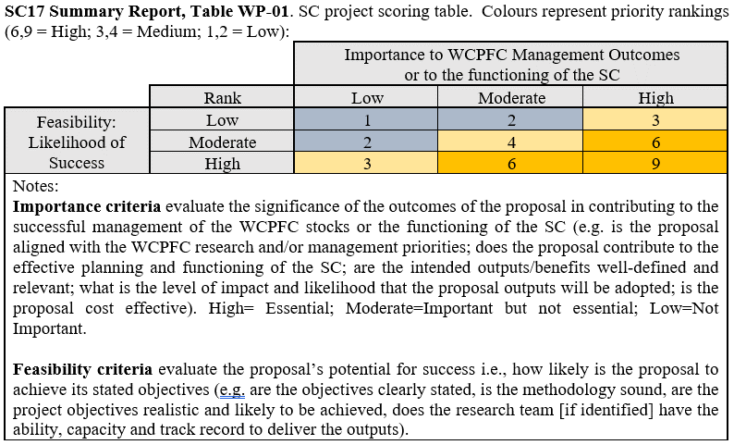

AGENDA ITEM 11 – ADMINISTRATIVE MATTERS

11.1 Future operation of the Scientific Committee
Working paper SC20-GN-WP-05

- The WCPFC Executive Director briefly introduced SC20-GN-WP-05, concentrating on the updates since SC19 to the challenges brought up for discussion. A new challenge was the one facing the SSP in New Caledonia, although the SSP had been able to work through most of the difficulties caused by the civil unrest occurring since May 2024. The existing timing challenges in getting stock assessments and other working papers completed well ahead of SC were described. Various remedies have been proposed to speed up the delivery of papers, including earlier provision of data before the 30th April deadline for the previous calendar year. Other options included using video, the ODF, and other technologies to discuss certain issues before the SC properly. Work had also been done to streamline the website to make it easier to track discussions and access working papers.

- The SSP supplemented the presentation by the ED and noted that additional resources were being brought to bear and should improve the situation next year. The skipjack tuna assessment next year would be particularly challenging because the latest year of data to be included in the assessment had been advanced to improve the timeliness of the assessment.

- The Chair asked CCMs to begin thinking about these issues and provide some recommendations later in the meeting. Modifying the deadlines for paper submission was one possibility that needed to be considered, requiring 30 days instead of 18 days before the submission of full papers, with an exemption for some SSP papers that were themselves constrained by data deadlines. Another possibility would be for papers to be posted directly to a secure page on the website rather than to theme convenors in the first instance. An Informal Small Group was suggested for these discussions.

- Fiji spoke for FFA CCMs and appreciated the Secretariat’s efforts in response to the tasking from WCPFC20 with the updates presented in the paper. FFA Members noted the paper’s recommendation to encourage CCMs that are able to submit their scientific data earlier than the annual deadline of 30 April. They understood that Japan and Chinese Taipei submitted their available Scientific Data before the end of 2023 with one re-submitting their data with some updates around the submission deadline and the other confirming that all their data came in their earlier submission. They fully appreciated and thanked Japan and Chinese Taipei for taking the lead to submit the Scientific Data early and understood from the SSP that this was very much welcomed. They encouraged all CCMs to do the same.

- FFA CCMs believed it essential for SC and the Commission to explore and implement concrete solutions to this challenge. Some of the solutions included more frequent data submissions. They recalled WCPFC19 tasking SC to provide guidance to the Commission on how CCMs can provide operational catch and effort data to the Commission more frequently during the year (see WCPFC19 Summary Report paragraph 460). In particular, this guidance would consider CCMs’ implementation of data provision within 30 days of the end of a trip and, where applicable, at the end of every transhipment at sea; and/or by 1 July and 31 December with available information for that calendar year. Noting the lack of discussion on this agenda item last year, they raised it again for the SC's consideration as a potential solution to the timing issue. This was not new as it stemmed from an FFA proposal when CMM 2022-06 was negotiated and a number of CCMs were onboard with this. They also recognized that electronic reporting, as acknowledged by SC19, could significantly improve the timeliness of data submissions.

- Therefore, FFA CCMs proposed that SC consider more frequent submissions of operational catch and effort data, as well as the Scientific Data required by Commission, to address the challenges at hand. To this end, FFA Members were re-tabling their 2022 proposal and suggested that:
- SC20 recommend to the Commission that CCMs submit their operational catch and effort data, where possible in accordance with the Standards, Specifications and Procedures for Electronic Reporting in the WCPFC - operational catch and effort data:
i. within 30 days of the end of a trip and where applicable, at the end of every transhipment at sea; and/or
ii. by 1 July and 31 December with available information for that calendar year.

- Japan understood that there would be three topics to be considered during the ISG, on the timing of papers and who would be able to make proposals. The Chair noted that the ISG discussion would be broader than that, including the proposal just made by Fiji on behalf of FFA members.

- Niue also spoke, on behalf of FFA member CCMs, and noted that the volume of SC papers was significant, particularly for certain theme sessions. It may be worth undertaking a scheduling exercise to focus on particular issues, stocks or species, as well as adjusting CMM review cycles to provide sufficient time for papers to be developed and properly considered by the SC. They reiterated the options in Attachment B of the paper for SC to consider concrete decisions to alleviate time constraints faced by CCMs in reviewing the outcomes of stock assessments before SC meetings and streamlining the outcomes of the SC meetings to support more effective and efficient discussions at the Commission.

- AU supported the point made by Niue regarding streamlining the work of the SC through better scheduling of agenda items across years. One earlier proposal for the Ecosystem and Bycatch theme (which this year contains some 14 WPs and 31 IPs) was to develop a rotating annual schedule of specific subject areas or species groups for the SCs consideration – seabirds in one year followed by turtles in the next etc. The problem that was identified with this approach was that many of the relevant CMMs require or imply that the SC should review matters annually [some 90 SC obligations based on an estimate made at SC14]. However, it should still be possible to develop a rotating schedule of items against which the SC is committing to focussed consideration and where papers are invited and prioritised. Other “out year” matters would be dealt with by exception or against a management urgency criterion. Such a system perhaps represents a middle ground that manages the EB theme paper load and the SC’s time but also would not transgress the reporting requirements within CMMs. As a side note, In the future, it would seem wise to ensure CMMs do not include unnecessarily frequent consideration by SC. It may take a while to bed such an approach down, but there should be long-term benefits.

- Chinese Taipei said it was very difficult to submit data more frequently.

- The Cook Islands supported the comments by Australia about focussing on the priority work of the Commission. SC had adopted a guideline for theme convenors several years ago, and this might need to be updated depending on what decisions were made at this meeting

- Korea pointed out that time was needed for the review and verification of data, and more frequent provision would be challenging for Korea

- The EU felt there was some benefit from more frequent submission of data, but it would require additional work not only for the data provider but also for the SSP. One of the major data gaps was the access to historical data, which was provided on condition that the data could only be used for specific analyses under restrictive conditions and deleted after its use. It could have implications in terms of reproducibility of the analyses and efficiency. The EU would like to discuss this in the ISG.

- The USA reminded the meeting that these matters had been discussed comprehensively when CMM 2022-06 was discussed, and the USA would also have difficulty in providing data 30 days after each trip because the logsheet data had to be verified. There might also be merit in Australia’s suggestion to rotate topics for consideration during the EB Theme.

- The Chair thanked the meeting for raising these issues and asked that they be discussed in an Informal Small Group format. This ISG later reported back to the meeting (see Attachment H), and after discussion and some amendments, its recommendations were adopted as follows:

- SC20 encouraged CCMs who were able to do so to submit their scientific data before the annual deadline of 30 April.

- SC20 recommended that the EB theme agenda rotate to prioritize the review of cetaceans and elasmobranchs during SC21 and sea turtles and seabirds during SC22. Additional SC review of certain taxa may be based on Commission request or review frequency within CMMs. SC20 recommended that further decisions on the EB theme agenda be taken during SC22.

- SC20 recommended that guidance on the submission of papers to the Scientific Committee, as agreed at SC3 (Attachment S of SC3 Summary Report) be updated to include the following:
- Paper titles and a preliminary abstract should be submitted to the Secretariat, SC Theme Convenors, and the SC Chair 50 days prior to the start of regular meetings of the Scientific Committee.
- Full papers should be submitted to the Secretariat, SC Theme Convenors and the SC Chair 30 days prior to the start of regular meetings of the Scientific Committee. Certain papers from the SSP may, when necessary, be submitted 18 days in advance of the start of the meeting to allow them to be available on the website two weeks before the commencement of the meeting.
- As a general rule, working papers will be submitted by CCMs, the Secretariat, and the SSP. Observers may submit information papers unless invited by the Secretariat, SC Theme Convenors, or the SC Chair to present a working paper.

- SC20 recommended that the Secretariat work with SC Theme Convenors and the SC Chair to develop a process to submit all papers and project proposals through the WCPFC website, to further streamline the submission process and allow for greater organization and tracking of submissions, for implementation in advance of SC21.

- SC20 recommended that the Secretariat work with SC Theme Convenors and the SC Chair to update the guidelines for the SC Chair and Theme Convenors (SC13-GN-IP-03) to clarify criteria for theme convenors to consider papers submitted to the Scientific Committee.

- SC20 recommended that the template for the project proposals for SC projects, as agreed in Table 3 in Attachment K of the SC9 Summary Report, be updated to include information on the WCPFC Data sets required to support the project, as well as notes from WCPFC SSP on feasibility to provide WCPFC data in the format requested, when possible.

- SC20 recommended that the updated guidance on the submission of papers to the SC, the template for project proposals for SC projects, and the updated guidelines for the SC Chair and Theme Convenors be combined as overall Guidelines for Paper Submissions and Operations of the SC and circulated for review and adoption at SC21. SC20 further recommended that, once adopted, the Guidelines for Paper Submissions and Operations of SC should be posted to the Key Documents section of the WCPFC website.

- SC20 recommended that the Commission revert back to the 8-day meeting schedule for SC21 in the event that the Commission does not decide to convene a Science Management Dialogue in 2025. SC20 recommended that the Commission maintain the current 7-day meeting schedule for SC21 in the event that the Commission decides to convene a Science Management Dialogue in 2025. The length of future SC meetings should be further considered following the meeting schedule for SC21, particularly considering the workload for subsequent SC meetings.

- SC20 noted the high workload required to revise CMMs, and hence recommended bycatch measures to be reviewed in a cycle similar to the process for stock assessments, to ensure that there is appropriate time between a measure being adopted and being able to assess the impacts of the measure.

11.2 Election of Officers of the Scientific Committee

- The floor was opened for nominations for the SC Vice Chair (an Officer of the Commission), and for the Convenor of the SC Management Issues theme (a less formal role controlled by SC directly).

- There being no CCM nominations, despite two previous calls this year for nominees, the Pew Charitable Trusts put forward Glen Holmes as Management Issues Theme Convenor if that was acceptable.

- Japan appreciated Holmes’ willingness to lead the discussion but could not accept, not because of any doubts about the nominee, but regarding information security issues.

- The Chair asked for Holmes’ nomination to be captured in the meeting record and the matter be discussed further.

- The SC Chair noted that MI Theme Convenors could be appointed intersessionally, while any nominations for Vice-Chair would be deferred until WCPFC21

11.3 Next meeting

- SC20 confirmed that SC21 in 2025 would be held in the Kingdom of Tonga, with the meeting dates to be finalized at WCPFC21. The Federated States of Micronesia offered to host SC22 in 2026.

AGENDA ITEM 12 – OTHER MATTERS

- The meeting heard that Keith Bigelow would be leaving NOAA and thus would no longer head the USA delegation to SC. Keith shared some reflections on the SC since its establishment in New Caledonia in 2005. James Larcombe of Australia and John Hampton of the SSP seized the opportunity to deliver fulsome encomia.

AGENDA ITEM 13 – ADOPTION OF SUMMARY REPORT OF THE 20th SCIENTIFIC COMMITTEE

- The Chair briefly outlined the schedule for publication of meeting reports contained in SC20-GN-IP-04.

AGENDA ITEM 14 – CLOSE OF MEETING

- The Executive Director for feedback from participants on the conduct of the meeting with a view to making improvements to the process. SC20 closed at 16:00 on 21st August 2024.

Attachment A

The Commission for the Conservation and Management of
Highly Migratory Fish Stocks in the Western and Central Pacific Ocean
SCIENTIFIC COMMITTEE
TWENTIETH REGULAR SESSION
Manila, Philippines
14 – 21 August 2024
List of Participants

CHAIR

Emily Crigler
NOAA Fisheries
Fishery Policy Analyst
emily.crigler@noaa.gov

AUSTRALIA

James Larcombe
Department of Agriculture, Water and the Environment
Principal Scientist
james.larcombe@awe.gov.au

Ashley Williams
CSIRO Oceans and Atmosphere
Principal Research Scientist
ashley.williams@csiro.au

Elissa Rosina Mastroianni
AFMA
Senior Management Officer
Elissa.MASTROIANNI@afma.gov.au

Lara Ainley
AFMA
Tuna Manager
lara.ainley@afma.gov.au

Laura Tremblay-Boyer
CSIRO
Scientist
laura.tremblay-boyer@csiro.au

CANADA

Jennifer Shaw
Fisheries and Oceans Canada
Senior Science Advisor
jennifer.shaw@dfo-mpo.gc.ca

Felicia Cull
Fisheries and Oceans Canada
Senior Policy Advisor
felicia.cull@dfo-mpo.gc.ca

Sarah Hawkshaw
Fisheries and Oceans Canada
Biologist
sarah.hawkshaw@dfo-mpo.gc.ca

CHINA

Xiaojie Dai
Shanghai Ocean University
Professor
xjdai@shou.edu.cn

Zhe Geng
Shanghai Ocean University
Stock Assessment Scientist
zgeng@shou.edu.cn

Cheng Zhou
Shanghai Ocean University
Lecturer
c-zhou@shou.edu.cn

Fan Zhang
Shanghai Ocean University
Research Scientist
f-zhang@shou.edu.cn

Jiaqi Wang
Shanghai Ocean University
Post doctor
jq-wang@shou.edu.cn

Shu Su
shanghai ocean university
member
ssu_maine@163.com

Zhang Chang
zhejiang ocean university
lecturer
itschang@foxmail.com

COOK ISLANDS

Pamela Maru
Ministry of Marine Resources
Secretary
P.Maru@mmr.gov.ck

Tiare-Renee Nicholas
Ministry of Marine Resources Cook Islands
Data Manager
t.nicholas@mmr.gov.ck

EUROPEAN UNION

Francisco Javier Abascal Crespo
Spanish Institute of OCeanography
Fisheries Scientist
francisco.abascal@ieo.csic.es

Maria Jose Juan Jorda
Instituto Español de Oceanografia - CSIC
Researcher - Cientifico Titular
mjuan.jorda@ieo.csic.es

FEDERATED STATES OF MICRONESIA

Jamel James
FSM National Oceanic Resource Management Authority
Assistant Director
jamel.james@norma.fm

Barbara Hanchard
c/o Marshall Islands Marine Resources Authority
Consultant
barbara@hanchard.net

Dan Gilmete
NORMA
EM/ER Coordinator
dan.gilmete@norma.fm

Shawn Walter
FSM National Oceanic Resource Management Authority
Assistant Biologist
shawn.walter@norma.fm

Truman Jano
NORMA
Port Sampling Coordinator
truman.jano@norma.fm

FIJI

Moses Nainoka Mataika
Ministry of Fisheries Fiji
Fisheries Officer Offshore Fisheries Management Division
mataika.moses@gmail.com

Apete Dabea
Ministry of Fisheries - Offshore Fisheries Division
Fisheries Assistant
apetedabea@gmail.com

Natalie Vilisoni
Ministry of Fisheries
Fisheries Technical Officer-Data
natalielydia96@gmail.com

INDONESIA

Fayakun Satria
National Research and Innovation Agency
Head of Research Center for Fishery
fsatria70@gmail.com

Lilis Sadiyah
Center for Fisheries Research (CFR)
Researcher
sadiyah.lilis2@gmail.com

JAPAN

Shuya Nakatsuka
Fisheries Resources Institute
Deputy Director, Highly Migratory Resources Division
nakatsuka_shuya49@fra.go.jp

Akihito Fukuyama
Japan Far Seas Purse Seine Fishing Association
Managing Director
fukuyama@kaimaki.or.jp

Daisuke Ochi
Fisheries Research and Education Agency of Japan, Fisheries Resources Institute
Group Head, Bycatch and Data Statistics Group, Highly Migratory Resources Division
otthii@affrc.go.jp

Haruo Tominaga
Fisheries Agency of Japany
Director for International Fisheruies Coordination
haruo_tominaga170@maff.go.jp

Hidetada Kiyofuji
Fisheries Resources Institute
Highly Migratory Resource Division, Fisheries Stock Assessment Center
kiyofuji_hidetada20@fra.go.jp

Hiromu Fukuda
Fisheries Research and Education Agency of Japan, Fisheries Resources Institute
Head, Bluefin Tunas Group, Highly Migrately Resources Division
fukuda_hiromu57@fra.go.jp

Hiroshi Ashida
Fisheries Research and Education Agency of Japan, Fisheries Resources Institute
Senior scientist, Tuna biology group, Highly Migratory Resources Division
ashida_hiroshi35@fra.go.jp

Hirotaka Ijima
National Research Institute of Far Seas Fisheries, Japan
Researcher
ijima_hirotaka69@fra.go.jp

Ifune Fukuchi
Fisheries Resources Institute, FRA
Scientist, Bluefin Tunas Group, Highly Migratory Resource Division
fukuchi_ifue78@affrc.go.jp

Kei Okamoto
Highly Migratory Resources Division, Fisheries Resources Institute, Japan Fisheries Research and Education Agency
Scientist
okamoto_kei98@fra.go.jp

Keisuke Satoh
Fisheries Resources Institute, Japan Fisheries Research and Education Agency
Head, Bigeye and Yellowfin tunas Group, Highly Migratory Resources Division
sato_keisuke31@fra.go.jp

Kensuke Goto
Meiho Gyogyo Co., Ltd.
Manager
meiho-goto@vega.ocn.ne.jp

Kirara Nishikawa
Fisheries Resources Institute, FRA
Scientist, Bluefin Tunas Group, Highly Migratory Resource Division
nishikawa_kirara68@fra.go.jp

Makoto Nishimoto
Japan Fisheries Research and Education Agency
Skipjack and albacore group, National Research Institute of Far Sea Fisheries,
nishimoto_makoto44@fra.go.jp

Marko Jusup
Fisheries Research and Education Agency of Japan, Fisheries Resources Institute
Senior Scientist, Billfish, Shark, and Bycatch Group, Highly Migratory Resources Division
jusup_marko00@fra.go.jp

Meiko Kawahara
Taiyo A & F Co., Ltd.
Deputy General Manager
m-kawahara@maruha-nichiro.co.jp

Mikihiko Kai
Fisheries Resources Institute
Head, Billfish, Shark, and Bycatch Group
billfishkai@gmail.com

Muneharu Tokimura
JOP (The Overseas Fishery Cooperation Foundation of Japan)
Adviser
tokimura@ofcf.or.jp

Naoto Matsubara
Japan Fisheries Research and Education Agency, Fisheries Resources Institute
Scientist, Skipjack and Albacore Group, Highly Migratory Resources Division
matsubara_naoto84@fra.go.jp

Naruhito Okuda
Japan Far Seas Purse Seine Fishing Association
Advisor
n-okuda@kaimaki.or.jp

Ryuichi Matsukura
Highly Migratory Resources Division, Fisheries Resources Institute
Scientist
matsukura_ryuichi30@fra.go.jp

Yasuko Semba
Fisheries Resources Institute, Highly Migratory Resources Division
Senior Scientist
semba_yasuko25@fra.go.jp

Yohei Tsukahara
Fisheries Resources Institute, FRA
Senior scientist, Bluefin Tunas Group, Highly Migratory Resource Division
tsukahara_yohei35@fra.go.jp

Yoshihiro Notomi
National Offshore Tuna Fisheries Association of Japan
Managing Director
notomi@kinkatsukyo.or.jp

Yoshinori Aoki
Japan Fisheries Research and Education Agency
Skipjack and albacore group, National Research Institute of Far Sea Fisheries,
aoki_yoshinori04@fra.go.jp

Yuichi Tsuda
Fisheries Resources Institute, Japan Fisheries Research and Education Agency
Head, Skipjack and Albacore Group, Highly Migratory Resources Division
tsuda_yuichi58@fra.go.jp

Yuji Uozumi
Japan Tuna Fisheries Co-operative Association
Adviser

KIRIBATI

Kobure Norman
Ministry of Fisheries and marine Resources Development
Senior Licensing Officer
koburen@mfmrd.gov.ki

Tiura Jacob
Ministry of Fisheries & Marine Resource Development
Fisheries Compliance Officer
tiurat@mfmrd.gov.ki

NAURU

Being Yeeting
Nauru Fisheries and Marine Resources Authority
Fisheries Advisor
byeeting@gmail.com

Jonas Calvin Star
Nauru Fisheries & Marine Resources Authority
Senior Science and Research Officer
jonas.star54@gmail.com

Karlick Agir
Nauru
Catch Data Officer
k.agir1957@gmail.com

NEW ZEALAND

Leyla Knittweis
Ministry for Primary Industries
Principal Scientist
leyla.knittweis@mpi.govt.nz

Bradley Moore
National Institute of Water and Atmospheric Research (NIWA) Ltd
Programme Leader - International Fisheries
bradley.moore@niwa.co.nz

Brittany Finucci
National Institute of Water and Atmospheric Research (NIWA)
Fisheries Scientist
brit.finucci@niwa.co.nz

Darcy Webber
Quantifish Ltd
Fisheries Scientist
darcy@quantifish.co.nz

Heather Ward
Ministry for Primary Industries
Principal Advisor
Heather.Ward@mpi.govt.nz

Hilary Ayrton
Ministry for Primary Industries
Senior Fisheries Analyst

Johannes Fischer
Department of Conservation
Science Advisor
jfischer@doc.govt.nz

Mandy Leathers
Department of Conservation
Senior Advisor, International
mleathers@doc.govt.nz

Olivia Rowley
Department of Conservation
Seabird Data Analyst
orowley@doc.govt.nz

Shelton Harley
Independent
ER and EM IWG Chair
sheltonjharley@gmail.com

Simon Hoyle
Hoyle Consulting Ltd
Director
simon.hoyle@gmail.com

NIUE

Poimatagi Okesene
Government of Niue
Director, Department of Agriculture, Forestry and Fisheries; Ministry of Natural Resources
poi.okesene@gov.nu

PALAU

Zilah Dirremeang Oiterong-Chin
Ministry of Agriculture, Fisheries and Environment
Licensing and Revenue Officer
dirremeang@gmail.com

PAPUA NEW GUINEA

Thomas Usu
PNG National Fisheries Authority
Acting Executive Manager - Fisheries Mangement Business Unit
tusu@fisheries.gov.pg

Benthly Sabub
Papua New Guinea National Fisheries Authority
Fisheries Management Officer, Tuna Fishery
bensabub@gmail.com

Sai Ugufa
National Fisheries Authority of Papua New Guinea
Manager - VDS
sugufa@fisheries.gov.pg

PHILIPPINES

Drusila Esther E. Bayate
Department of Agriculture
Undersecretary for Fisheries
debayate@da.gov.ph

Alma C. Dickson
Bureau of Fisheries and Aquatic Resources
Fisheries Consultant
alma_dickson@yahoo.com

Andrew B. Cadfit
RD Fishing PNG Ltd.
Fleet Operation Manager

Atty. Benjamin F. S. Tabios Jr.
Department of Agriculture-Bureau of Fisheries and Aquatic Resources
Adviser-Tuna Technical Working Group, Bureau of Fisheries and Aquatic Resources
btabios@bfar.da.gov.ph

Bernard Mayo
Philippine Tuna Handline Partnership
Chairperson
bmayo.msifarmc@gmail.com

Christopher M. Ignacio
Department of Agriculture - Bureau of Fisheries and Aquatic Resources
Executive Assistant
ea.do.bfar@gmail.com

Divina Bucog Ignacio
Bureau of Fisheries and Aquatic Resources IX
Senior Fishing Regulatory Officer / National Stock Assessment Program Project Leader
dbignacio79@gmail.com

Eduardo G. Esteban
Trans Pacific Journey Fishing Corporation
Vice President For Admin And International Business Development
ege@tuna.ph

Elsa Fugen Furio
National Fisheries Research and Development Institute
Chief Science Research Specialist
efurio2010@gmail.com

Elviro A. Cinco
DA-BFAR
Consultant/Advisor
el.abasola@gmail.com

Francisco Torres Jr
National Fisheries Research and Development Institute - Philippines
Senior Science Research Specialist
franciscojr.torres@nfrdi.da.gov.ph

Geronimo T. Silvestre
Capture Fisheries Division, Bureau of Fisheries & Aquatic Resources, Philippines
Consultant Advisor
gtsilvestre@yahoo.com

Isidro M. Velayo, Jr.
Bureau of Fisheries and Aquatic Resources
Director
do@bfar.da.gov.ph

Isidro Tanangonan
Bureau of Fisheries and Aquatic Resources
Aquaculturist II
itanangonan@bfar.da.gov.ph

Jan Krianne Pineda
Philippine Tuna Handline Partnership
Corporate Partnerships Liaison
kpineda.pthp@gmail.com

Jay-ar Pol D. Mahinay
DA-BFAR
Aquaculturist I
jayarpolmahinay@gmail.com

Jennifer Viron
Bureau of Fisheries and Aquatic Resources
Senior Fishing Regulations Officer
jennyviron@bfar.da.gov.ph

Joann Binondo
PTHP
BOD Director
jbinondo@wwf.org.ph

Joeren Yleana
Bureau of Fisheries and Aquatic Resources
Supervising Aquaculturist
joerenyleana@yahoo.com

Kenrick Teng
BFAR
Manager
kenrickt@tspmi.com.ph

Kima Karla H. Cedo
DA-BFAR
Senior Aquaculturist
kcedo@bfar.da.gov.ph

Lee Kwang Se (Tuna Lee)
LEE KWANGSE
Consultant
wtpo2020@gmail.com

Lilian C. Garcia
Department of Agriculture-National Fisheries and Research Development Institute
Executive Director

Maria Angelica F Cecilio
Department of Agriculture-Bureau of Fisheries and Aquatic Resources XII
Aquaculturist I
cecilio.mariaangelica@gmail.com

Maria Theresa M. Mutia
National Fisheries Research and Development Institute
Chief Science Research Specialist / Scientist I
mariatheresa.mutia@nfrdi.da.gov.ph

Marlo Demo-os
DA-BFAR
Aquaculturist II
mbdemoos@gmail.com

Mudjekeewis Dalisay Santos
National Fisheries Research and Development Institute
Scientist V and Chief, Training Division
mudjiesantos@gmail.com

Noemi SB. Lanzuela
Bureau of Fisheries and Aquatic Resources - National Capital Region
Regional Director
nsblanzuela@bfar.da.gov.ph

Patrick Dale Sacay
Frabelle Fishing Corporation
Vice President for External Affairs
dale.sacay@frabelle.net

Rafael Mark G. Benitez
Bureau of Fisheries and Aquatic Resources
Employed by CCM Participant to Philippine Delegation
rafaelmarkbenitez@gmail.com

Rafael Vallente Ramiscal
BFAR
Advjser/Resource Person
rv_ram55@yahio.com

Ralph Anthony Casil
TRANS-PACIFIC JOURNEY FISHING CORPORATION
HR Liaison
rdc@tuna.ph

Relly B. Garcia
Bureau of Fisheries and Aquatic Resources XI
Officer In Charge, Regional Director
rgarcia@bfar.da.gov.ph

Rosanna Bernadette B. Contreras
Socsksargen Federation of Fishing and Allied Industries, Inc.
Executive Director
fishing.federation@gmail.com

Roy Gabinete
Frabelle Fishing Corporation
Executive Assistant
roy.gabinete@frabelle.net

Severino Escobar Jr.
Bureau of Fisheries and Aquatic Resources
Chief, Capture Fisheries Licensing Section-Fisheries Regulatory and Licensing Division
jojo_escobar@yahoo.com

Sheryll V. Mesa
Bureau of Fisheries and Aquatic Resources - Regional Field Office VI
Senior Aquaculturist
smesa@bfar.da.gov.ph

Sisenio Jhun Pagalan Jr
Trans-Pacific Journey Fishing Corporation
IBO
slp@tuna.ph

Suzette B. Barcoma
National Fisheries Research and Development Institute
Senior Science Research Specialist
suzettebarcoma@gmail.com

Usop D. Pendaliday Jr.
Bureau of Fisheries & Aquatic Resources Regional Office #12
Regional Director
usop_pendalidayjr@yahoo.com

REPUBLIC OF KOREA

Jeong Ho Park
National Institute of Fisheries Science (NIFS)
Senior scientist
marinebio@korea.kr

Bongjun Choi
Korea Overseas Fisheries Association (KOFA)
Manager
bj@kosfa.org

Heewon Park
National Institue of Fisheries Science(NIFS)
Republic of Korea
heewon81@korea.kr

Ilkang Na
Ministry of Oceans and Fisheries
Policy Officer / Multilateral Fisheries Negotiator
ikna@korea.kr

Sanggyu Shin
National Institute of Fisheries Science Korea
Assistant Researcher
gyuyades82@gmail.com

Youjung Kwon
National Institute of Fisheries Science
Scientist
kwonuj@korea.kr

REPUBLIC OF MARSHALL ISLANDS

Beau Bigler
Marshall Islands Marine Resources Authority
Chief Fisheries Officer
bbigler@mimra.com

Berry Muller
Marshall Islands Marine Resources Authority
Deputy Director - Oceanic and Industrial Affairs Division
bmuller@mimra.com

Caleb Joseph
Marshall Islands Marine Resources Authority
System Developer
cjoseph@mimra.com

Francisco Blaha
MIMRA
Ofsshore Fisheries Advisor
fblaha@mimra.com

SAMOA

Moli Amosa Iakopo
Ministry of Agriculture Fisheries
Principal Fisheries Officer
moli.iakopo@maf.gov.ws

Betty Sailivale
MAF
Fisheries Officer
betty.sailivale@maf.gov.ws

SOLOMON ISLANDS

Jan Tahaka Oli Pitu
Ministry of Fisheries and Marine Resources
Chief Fisheries Officer
jpitu@fisheries.gov.sb

Claudius Ralph Halumwane
Ministry of Fisheries and Marine Resources
Chief Fisheries Officer-Statistics
chalumwane@fisheries.gov.sb

CHINESE TAIPEI

Joy Hsiangyi Yu
Fisheries Agency, Ministry of Agriculture
Section Chief, Pacific Ocean Fisheries Management Section, Distant Water Fisheries Division
hsiangyi@ms1.fa.gov.tw

Ren-Fen Wu
Overseas Fisheries Development Council
Director of Information Division
fan@ofdc.org.tw

Shui-Kai Chang
National Sun Yat-sen University
Professor
skchang@faculty.nsysu.edu.tw

Wenyu Chen
Pacific Ocean Fisheries Management Section, Distant Water Fisheries Division, Fisheries Agency, Ministry of Agriculture
Specialist
chenwenyu@ms1.fa.gov.tw

Wu Jia-Rong
Overseas Fisheries Development Council
Statistician
wujiarong@ofdc.org.tw

Wu, I-Sheng
Fisheries Agency, Ministry of Agriculture,
Project Assistant
isheng0108@ms1.fa.gov.tw

Yi-Jay Chang
National Taiwan University
Associate Professor
yjchang@ntu.edu.tw

TONGA

Sione Vailala Matoto
Ministry of Fisheries
Chief Executive Officer - CEO, Head of Fisheries
vailalam@yahoo.com

Lavinia Vaipuna
Ministry of Fisheries
Fisheries Officer
nia.vaipuna@gmail.com

Matini Uesile Finau
Ministry of Fisheries
Principle Fisheries Officer
finau.martin@gmail.com

TUVALU

Niukita Taape
Tuvalu Fisheries Department
Fisheries Officer, Oceanic Fisheries
niukzi19@gmail.com

Rosalia Uoka
Tuvalu Fisheries Department
Licensing Fisheries Officer
ruoka@gov.tv

Siouala Malua
Tuvalu Fisheries Department
Senior Fisheries Officer (Licensing & Data)
sioualam@tuvalufisheries.tv

Tupulaga Poulasi
Tuvalu Fisheries Department
Principal Fisheries Officer
etuati.ptauia@gmail.com

UNITED STATES OF AMERICA

Keith Bigelow
NOAA PIFSC
Fisheries Biologist
keith.bigelow@noaa.gov

Alex Kahl
NOAA Fisheries - Pacific Islands Regional Office
International Fisheries
alex.kahl@noaa.gov

Christine Bertz
U.S. Department of State
Foreign Affairs Officer
bertzca@state.gov

Emily Reynolds
NOAA Fisheries, Pacific Islands Regional Office
Fishery Policy Analyst
emily.reynolds@noaa.gov

Felipe Carvalho
NOAA PIFSC
Research Mathematical Statistician

John Peschon
NOAA Fisheries
Observer Program
john.peschon@noaa.gov

Alex Kahl
International Fisheries,
NOAA Fisheries - Pacific Islands Regional Office
alex.kahl@noaa.gov

Kelly Kryc
National Oceanic and Atmospheric Administration
Deputy Assistant Secretary for International Fisheries
kelly.kryc@noaa.gov

Kitty Simonds
Western Pacific Regional Fishery Management Council
Executive Director
Kitty.Simonds@wpcouncil.org

Michelle Sculley
NOAA
Stock Assessment Scientist
michelle.sculley@noaa.gov

Nicholas Ducharme-Barth
NOAA Fisheries
Research Mathematical Statistician
nicholas.ducharme-barth@noaa.gov

Theresa Labriola
Wild Oceans
Pacific Program Director
tlabriola@wildoceans.org

Valerie Post
NOAA Fisheries
Fishery Policy Analyst
valerie.post@noaa.gov

Yonat Swimmer
NOAA PIFSC
Fisheries Biologist
yonat.swimmer@noaa.gov

VANUATU

Jeyalda Ngwele
Vanuatu Fisheries Department
Senior Data Officer (International)
njeyalda@fisheries.gov.vu

Lucy Joy
Vanuatu Fisheries Department
Principal Data Officer
ljoy@fisheries.gov.vu

AMERICAN SAMOA

Domingo Ochavillo
Department of Marine & Wildlife Resources
Chief Fisheries Biologist
ochavill@gmail.com

COMMONWEALTH OF THE NORTHERN MARIANA ISLANDS

Jude Cabrera Lizama
CNMI Division of Fish and Wildlife
Data Scientist/Section Supervisor
judelizama.dfw@gmail.com

FRENCH POLYNESIA

Thibaut Thellier
Marine Resources Department
Fisheries officer
thibaut.thellier@administration.gov.pf

Anne-Marie Trinh
Marine resources department
Fisheries officer
anne-marie.trinh@administration.gov.pf

NEW CALEDONIA

Manuel Ducrocq
New Caledonia Government
Head of the natural park of the Coral sea and fisheries department of New Caledonia
manuel.ducrocq@gouv.nc

Mickael Lercari
Natural park of the Coral sea and fisheries department of New Caledonia
Fisheries and environment officer
mickael.lercari@gouv.nc

TOKELAU

Luisa Naseri-Sale
Tokelau
Tokelau
naserisale@gmail.com

Lesley Gould
Tokelau Fisheries Management Agency
Fisheries Advisor
lesleykgould@gmail.com

Solomua Ionatana
Tokelau Fisheries Management Agency
Manager, Fisheries Licensing & Access
tualen@gmail.com

PANAMA

Shannon Leigh Weeks Santos
Panama Aquatic Resources Authority
Researcher
sweeks@arap.gob.pa

THAILAND

Nattawut Aiemubolwan
Department of fisheries Thailand
Fisheries Biologist, Practitioner Level
nattawut.mnk62@gmail.com

Thitirat Rattanawiwan
Department of Fisheries Thailand
Fisheries Biologist, Practitioner Level
milky_gm@hotmail.com

VIETNAM

Vu Duyen Hai
Department of Fisheries
Head of Capture Fisheries Division
vuduyenhai10@gmail.com

AGREEMENT ON THE CONSERVATION OF ALBATROSS AND PETRELS (ACAP)

Dimas Gianuca
Agreement on the Conservation of Albatrosses and Petrels
Seabird Bycatch Working Group Vice Co-convernor
dgianuca@gmail.com

AUSTRALIAN NATIONAL CENTRE FOR OCEAN RESOURCES AND SECURITY (ANCORS)

Adam Ziyad
University of Wollongong
PhD Student
az653@uowmail.edu.au

Bianca Haas
Australian National Centre for Ocean Resources and Security
Research Fellow
bhaas@uow.edu.au

BIRDLIFE INTERNATIONAL

Stephanie Borrelle
BirdLife International
Marine & Pacific Regional Coordinator
Stephanie.Borrelle@Birdlife.org

Tommy Clay
Environmental Defense Fund
Research Scientist
tclay@edf.org

CONSERVATION INTERNATIONAL (CI)

Vilisoni Kotobalavu Tarabe
Conservation International-Fiji
Oceanic Fisheries Coordinator
vtarabe@conservation.org

EARTH ISLAND INSTITUTE

David Phillips
Earth Island Institute International Marine Mammal Project (Dolphin Safe)
Director
Davep@earthisland.org

Melody Eran
Earth Island Institute International Marine Mammal Project (Dolphin Safe)
Environmental Auditor
eranmelody@gmail.com

Sarah Elzea
Earth Island Institute International Marine Mammal Project (Dolphin Safe)
Dolphin Safe Program Manager
sarah@earthisland.org

Trixie Concepcion
Earth Island Institute International Marine Mammal Project (Dolphin Safe)
Regional Director
dolphinsafe@earthisland-ap.org

INTER-AMERICAN TROPICAL TUNA COMMISSION (IATTC)

Alexandre Aires-da-Silva
Inter-American Tropical Tuna Commission
Coordinator of Scientific Research
alexdasilva@iattc.org

Marlon H Roman
IATTC
Bycatch Program
mroman@iattc.org

INTERNATIONAL SCIENTIFIC COMMITTEE FOR TUNA AND TUNA-LIKE SPECIES IN THE NORTH PACIFIC OCEAN (ISC)

Robert Ahrens
International Scientific Committee for Tuna and Tuna-like Species in the North Pacific Ocean
Chair
robert.ahrens@noaa.gov

INTERNATIONAL SEAFOOD SUSTAINABILITY FOUNDATION (ISSF)

Victor Restrepo
ISSF
Vice-President, Science
vrestrepo@iss-foundation.org

MARINE STEWARDSHIP COUNCIL

Bill Holden
Marine Stewardship Council
Senior Tuna Fisheries Outreach Manager
bill.holden@msc.org

Sayuri Ichikawa
Marine Stewardship Council
WCPO Tuna Project Manager
sayuri.ichikawa@msc.org

PACIFIC COMMUNITY (SPC)

Arni Magnusson
Pacific Community
Senior Fisheries Scientist
arnim@spc.int

Caroline Ton
SPC
Fisheries scientist - MSP
carolinet@spc.int

Claudio Castillo Jordan
Pacific Community
Fisheries Scientist
claudioc@spc.int

Colley Falasi
Secretariat of the Pacific Community
Fisheries Data Audit Analyst
colleyf@spc.int

Finlay Scott
Pacific Community
Fisheries Scientist
finlays@spc.int

Graham Pilling
Pacific Community (SPC)
Deputy Director FAME (OFP)
grahamp@spc.int

Jed Macdonald
SPC
Senior Scientist (Tuna Ecology and Biology)
jedm@spc.int

Jemery Day
Pacific Community
Senior Fisheries Scientist
jemeryd@spc.int

Jennifer Mourot
The Pacific Community
Research Assistant on Fish Aggregating Devices
jenniferm@spc.int

Joe Scutt
SPC
Senior Fisheries Scientist
joes@spc.int

John Hampton
Pacific Community
Chief Scientist
johnh@spc.int

Kyuhan Kim
Dragonfly Data Science
Fisheries scientist
kyuhan@dragonfly.co.nz

Lauriane Escalle
Pacific Community
Fisheries Scientist
laurianee@spc.int

Malo Hosken
Oceanic Fisheries Programme - Pacific Community
Regional ER and EM Coordinator
maloh@spc.int

Nan Yao
Pacific Community
Fisheries Scientist
nany@spc.int

Nick Davies
Te Takina Limited
Director
nd200806@gmail.com

Paul Hamer
Pacific Community
Principal Scientist
paulh@spc.int

Peter Williams
Secretariat of the Pacific Community
Principal Fisheries Scientist (Data Mgmt.)
peterw@spc.int

Philipp Neubauer
Dragonfly Data Science
Director, Fisheries and Marine Science
philipp@dragonfly.co.nz

Robert Scott
Pacific Community
Senior Fisheries Scientist
robertsc@spc.int

Samuel Mckechnie
Pacific Community
Fisheries Scientist

Shaazreen Saista Bi
The Pacific Community (SPC)
Fisheries Data and Capacity Development Specialist
shaazreenb@spc.int

Simon Nicol
SPC
Principal Fisheries Scientist
simonn@spc.int

Steven Hare
Pacific Community (SPC)
Senior Scientist
stevenh@spc.int

Thomas Teears
SPC
Fisheries Scientist
thomast@spc.int

Tiffany Vidal
SPC
Principal Fisheries Scientist (Data Management)
tiffanyv@spc.int

Timothy Park
Secretariat of the Pacific Community
Senior Fisheries Advisor (Fisheries Monitoring)
timothyp@spc.int

Valerie Allain
Pacific Community (SPC)
Senior Fisheries Scientist
valeriea@spc.int

PACIFIC ISLANDS FORUM FISHERIES AGENCY (FFA)

'Ana F. Taholo
Pacific Islands Forum Fisheries Agency
Compliance Policy Advisor
ana.taholo@ffa.int

Adele Dutilloy
FFA
Fisheries Management Advisor
adele.dutilloy@ffa.int

Ajay Arudere
Forum Fisheries Agency
Secondee
ajay.arudere@ffa.int

Joyce Samuelu-Ah Leong
Pacific Islands Forum Fisheries Agency (FFA)
Fisheries Management Adviser
joyce.samuelu-ahleong@ffa.int

Lianos Triantafillos
Pacific Islands Forum Fisheries Agency (FFA)
Fisheries Management Advisor
lianos.triantafillos@ffa.int

Lisa Buchanan
Pacific Islands Forum Fisheries Agency
Chief Technical Advisor, Oceanic Fisheries Management Project
lisa.buchanan@ffa.int

Ludwig Kumoru
Pacific Islands Forum Fisheries Agency (FFA)
Director Fisheries Management Division
ludwig.kumoru@ffa.int

Marina Abas
Pacific Islands Forum Fisheries Agency (FFA)
Fisheries Management Advisor
marina.abas@ffa.int

Max GIllespie
Pacific Islands Forum Fisheries Agency (FFA)
Fisheries Economics Advisor
max.gillespie@ffa.int

Thomas Ruaia
Forum Fisheries Agency
Fisheries Economist
thomas.ruaia@ffa.int

Ueta Jr. Faasili
FFA
Fisheries Management Advisor
uetajunior.faasili@ffa.int

PARTIES TO THE NAURU AGREEMENT (PNA)

Brian Kumasi
Office of the Parties to the Nauru Agreement
Policy Manager
Brian@pnatuna.com

Les Clark
PNA
Adviser
les@pnatuna.com

Penihulo Lopati
PNA Office
VMS / VDS Officer
penihulo@pnatuna.com

Sangaalofa Clark
PNAO
Chief Executive Officer
sangaa@pnatuna.com

Stephen Brouwer
Parties to the Nauru Agreement
Consultant
steve@saggitus.co.nz

PEW CHARITABLE TRUSTS

Glen Holmes
The Pew Charitable Trusts
Senior Officer
gholmes@pewtrusts.org

SHARKPROJECT INTERNATIONAL

Laura Brown
Sharkproject
International Cooperation Team
l.brown@sharkproject.org

THE OCEAN FOUNDATION

Dave Gershman
The Ocean Foundation
Officer, International Fisheries Conservation
dgershman@oceanfdn.org

WORLD TUNA PURSE SEINE ORGANISATION (WTPO)

Marcel Roderick C. Chiu
World tuna Purse seine Organization
Secretary
wtpo.secretariat.manila@gmail.com

WORLD WIDE FUND FOR NATURE (WWF)

Bubba Cook
World Wide Fund for Nature
Western and Central Pacific Tuna Programme Manager
acook@wwf.org.nz

Susan Roxas
World Wide Fund for Nature (WWF)
Coral Triangle Program Core Team
sroxas@wwf.org.ph

WCPFC SECRETARIAT

Aaron Nighswander
Western and Central Pacific Fisheries Commission (WCPFC)
Finance and Administration Manager
aaron.nighswander@wcpfc.int

Albert Carlot
Western and Central Pacific Fisheries Commission (WCPFC)
VMS Manager
albert.carlot@wcpfc.int

Eidre Sharp
Western and Central Pacific Fisheries Commission (WCPFC)
Deputy Compliance Manager
Eidre.Sharp@wcpfc.int

Elaine G. Garvilles
Western and Central Pacific Fisheries Commission (WCPFC)
Assistant Science Manager
Elaine.Garvilles@wcpfc.int

Emma Nelson-Mori
Western and Central Pacific Fisheries Commission (WCPFC)
Project Management Assistant
emma.mori@wcpfc.int

Joseph Jack
Western and Central Pacific Fisheries Commission (WCPFC)
Compliance Officer
Joseph.Jack@wcpfc.int

Josie M Tamate
Western and Central Pacific Fisheries Commission
Chair
josie.tamate@gmail.com

Kilaf Albert
Western and Central Pacific Fisheries Commission (WCPFC)
ROP Data Entry Technician
Kilafwasru.Albert@wcpfc.int

Lara Manarangi-Trott
Western and Central Pacific Fisheries Commission (WCPFC)
Compliance Manager
Lara.Manarangi-Trott@wcpfc.int

Lars Olsen
WCPFC WPEA-ITM Project
Project Manager
olsenpacific@gmail.com

Lucille Martinez
Western and Central Pacific Fisheries Commission (WCPFC)
Administrative Officer
lucille.martinez@wcpfc.int

Natsuko Akinaga
Western and Central Pacific Fisheries Commission (WCPFC)
HR Officer
natsuko.akinaga@wcpfc.int

Rhea Moss-Christian
Western and Central Pacific Fisheries Commission (WCPFC)
Executive Director
rhea.moss-christian@wcpfc.int

Samuel T. Rikin
Western and Central Pacific Fisheries Commission (WCPFC)
IT Officer
samuel.rikin@wcpfc.int

SungKwon Soh
Western and Central Pacific Fisheries Commission (WCPFC)
Science Manager
sungkwon.soh@wcpfc.int

SureAnn Poll
Western and Central Pacific Fisheries Commission (WCPFC)
ROP Data Entry
sureann.poll@wcpfc.int

Tim Adams
Western and Central Pacific Fisheries Commission (WCPFC)
Meeting Rapporteur
tim.adams@gonedau.com

Tim Jones
Western and Central Pacific Fisheries Commission (WCPFC)
IT Manager
tim.jones@wcpfc.int

Virginia Ezekias
Western and Central Pacific Fisheries Commission (WCPFC)
VMS Officer
virginia.ezekias@wcpfc.int

Attachment B

The Commission for the Conservation and Management of
Highly Migratory Fish Stocks in the Western and Central Pacific Ocean
SCIENTIFIC COMMITTEE
TWENTIETH REGULAR SESSION
Manila, Philippines
14 – 21 August 2024
Agenda

- OPENING OF THE MEETING

  - Welcome address
  - Meeting arrangements
  - Issues arising from the Commission
  - Adoption of agenda
  - Reporting arrangements
  - Intersessional activities of the Scientific Committee

- REVIEW OF FISHERIES

  - Overview of Western and Central Pacific Ocean (WCPO) fisheries
  - Overview of Eastern Pacific Ocean (EPO) fisheries
  - Annual Report – Part 1 from Members, Cooperating Non-Members, and Participating Territories
  - Reports from regional fisheries bodies and other organizations

- DATA AND STATISTICS THEME

  - Data gaps of the Commission
    - Report of the WCPFC scientific data
    - Species composition of purse-seine catches (Project 60)
    - Better data on fish weights and lengths for scientific analyses (Project 90)
    - Improved coverage of cannery receipt data (Project 114)
    - Minimum data reporting requirements
    - Regional bycatch estimates of purse seine fishery
  - Evaluation of purse seine fishing effort
  - Regional Observer Programme
    - Review of an observer training project for elasmobranch biological sampling (Project 109)
    - ROP Data Issues
  - Electronic Reporting and Electronic Monitoring
    - ER and EM IWG Update
    - Requirements for increased observer coverage in longline fisheries under CMM 2023-01

- STOCK ASSESSMENT THEME

  - Improvement of MULTIFAN-CL software
    - Update of MULTIFAN-CL software
    - Review of Project 123 outcomes
  - WCPO Tunas
    - South Pacific albacore tuna (Thunnus alalunga)
      - South Pacific albacore stock assessment
      - Provision of scientific information to the Commission
    - WCPO skipjack tuna (Katsuwonus pelamis)
      - Indicator analysis
      - Long-term recruitment and CPUE trends of skipjack tuna (Project 115)
    - WCPO bigeye tuna (Thunnus obesus) and yellowfin tuna (Thunnus albacares)
      - Further analyses for bigeye and yellowfin tuna assessment
      - Indicator analysis
      - Reproductive biology of yellowfin tuna (Project 120)
  - Northern stocks
    - Pacific bluefin tuna (Thunnus orientalis)
      - Pacific bluefin tuna stock assessment
      - Provision of scientific information to the Commission
  - Billfish
    - Southwest Pacific striped marlin (Kajikia audax)
      - Stock assessment of Southwest Pacific striped marlin
      - Provision of scientific information to the Commission
    - Western and Central North Pacific striped marlin (Kajikia audax)
      - Peer review of the 2023 stock assessment for Western and Central North Pacific striped marlin
      - Western and Central North Pacific striped marlin rebuilding analysis
  - Sharks
    - Silky shark (Carcharhinus falciformis)
      - Stock assessment of silky shark in the WCPO (Project 108)
      - Provision of scientific information to the Commission
    - Oceanic whitetip shark (Carcharhinus longimanus)
    - North Pacific shortfin mako shark (Isurus oxyrinchus)
      - North Pacific shortfin mako shark stock assessment
      - Provision of scientific information to the Commission
  - Projects and Requests
    - Stock Status and Management Advice Template (Project 113b)
    - Application of Close-Kin-Mark-Recapture Methods (Project 100c)
    - Scoping study on longline effort creep in the WCPO (Project 122)
    - WCPFC Tuna Biological Sampling Plan (Project 117)
    - WCPFC Billfish Biological Sampling Plan (Project 118)
    - Research Plan Update
      - Tuna Assessment Research Plan (2023 – 2026) update
      - Billfish Research Plan (2023 – 2026) update
      - Review of the Shark Research Plan 2021 - 2030

- MANAGEMENT ISSUES THEME

  - Development of the WCPFC harvest strategy framework for key tuna species
    - Skipjack tuna
      - Skipjack tuna management procedure
      - Monitoring strategy for skipjack tuna
    - South Pacific albacore tuna
      - Target reference points
      - South Pacific albacore operating models
      - South Pacific albacore management procedure
      - Monitoring strategy for South Pacific albacore
      - Updates on SP Albacore Roadmap IWG
    - Mixed fishery MSE framework
      - Target reference points for bigeye and yellowfin tuna
      - Mixed fishery MSE framework update
    - Progress of the WCPFC Harvest Strategy Work Plan
  - Review of effectiveness of CMM 2023-01

- ECOSYSTEM AND BYCATCH MITIGATION THEME

  - Ecosystem and Climate Indicators
    - Ecosystem and Climate Indicator Report Card
    - Research proposal
  - FAD impacts
    - Research on non-entangling and biodegradable FADs
    - Updates on FAD Management Options IWG
  - Bycatch management
    - Bycatch Management Information System
    - Bycatch Assessment and Management
  - Sharks
    - Estimating the impact of fishing on sharks (Project 116)
  - Seabirds
    - Review of seabird research
    - Review of CMM on seabirds (CMM 2018-03)
  - Sea turtles
    - Review of sea turtle research
    - Review of Conservation and Management of Sea Turtles (CMM 2018-04)
  - Cetaceans
  - Deep-sea mining

- OTHER RESEARCH PROJECTS

  - Pacific Marine Specimen Bank (Project 35b)
  - Pacific Tuna Tagging Project (Project 42)
  - West Pacific East Asia Project
  - Japan Trust Fund activities
  - Other Projects

- COOPERATION WITH OTHER ORGANISATIONS

- SPECIAL REQUIREMENTS OF DEVELOPING STATES AND PARTICIPATING TERRITORIES

- FUTURE WORK PROGRAM AND BUDGET

  - Development of the 2025 work programme and budget, and projection of 2026-2027 provisional work program and indicative budget

- ADMINISTRATIVE MATTERS

  - Future operation of the Scientific Committee
  - Election of Officers of the Scientific Committee
  - Next meeting

- OTHER MATTERS

- ADOPTION OF THE SUMMARY REPORT OF THE TWENTIETH REGULAR SESSION OF THE SCIENTIFIC COMMITTEE

- CLOSE OF MEETING

Attachment C

The Commission for the Conservation and Management of
Highly Migratory Fish Stocks in the Western and Central Pacific Ocean
SCIENTIFIC COMMITTEE
TWENTIETH REGULAR SESSION
Manila, Philippines
14 – 21 August 2024
Opening Statement by the Commission Chair Dr. Josie Tamate

Secretary for the Department of Agriculture, Chair of the Scientific Committee Ms Emily Crigler, WCPFC Executive Director Ms Rhea Moss-Christian, Heads of Delegations, delegates and observers;
Fakalofa lahi atu ke he higoa he Iki ha tautolu ko Iesu Keriso. Mabuhay and Magadang umagah to you all.
Firstly, I would like to acknowledge with appreciation my gratitude to the Government and the people of Philippines for warmly welcoming us all to your country. Thank you for all the work and preparation you have done towards the 20th Scientific Committee Meeting of the WCPFC. One of the first images I saw on arrival was the welcoming banner for the SC20 meeting and I immediately felt the enormity of the work our host country and team have undertaken.
Secondly, I would like to thank the SC Chair Ms Emily Crigler, the Convenors and the Executive Director Ms Rhea Moss-Christian, Science Manager SK and all the Secretariat Staff for all the work that gone into preparing for this meeting. I would also like to recognize our SSP – Secretariat of the Pacific Community – led by Graham Pilling and his team. The last few months have been challenging for SPC but you have worked diligently to ensure the work and the services provided are not affected.
Last but not the least, I would like to thank all the CCM delegates and observers for being here in Manila. I also recognize those joining online.
Last year, I attended my first SC meeting in Palau. It was also my first year as the Commission Chair and I wanted to learn as much as I can especially how the SC works and especially the process to identify and agree on recommendations and advice for the WCPFC. One thing I observed was the way the meeting was organized, the role of the convenors and their support for the SC Chair. It is not an easy job and I want to commend them for all their excellent work, especially the preparations and the coordination. I am pleased to note the information paper that the Secretariat and the SC Officers have prepared, providing a set of Guidelines to help the development of scientific committee’s recommendations. The objective of these guidelines is to help ensure clarity and ease of understanding, especially those who are non-scientists.
One of the key decisions from SC19 was the reduction in meeting days for SC20. I am looking forward to seeing how this will pan out and whether it would be possible to further reduce the number of meeting days as we strive for efficiency without undermining the quality and results required for the SC’s consideration and subsequently, the SC Advice or recommendation for the Commission’s adoption.
Chair, on that note, let me end my remarks here and wish you all a successful meeting. I look forward to receiving SC20’s report, advice and recommendations for the WCPFC20 meeting, that will be host by Fiji end of November. Fakaue lahi, Kia Monuina. Salamat!

Attachment D

The Commission for the Conservation and Management of
Highly Migratory Fish Stocks in the Western and Central Pacific Ocean
SCIENTIFIC COMMITTEE
TWENTIETH REGULAR SESSION
Manila, Philippines
14 – 21 August 2024
Opening Statement by the Department of Agriculture Secretary Francisco P. Tiu Laurel Jr.
delivered by the Philippine Head of Delegation, Undersecretary for Fisheries Drusila Esther E. Bayate

Josie Tamate, Chair of the Western and Central Pacific Fisheries Commission (WCPFC),
Ms. Rhea Moss-Christian, Executive Director of the WCPFC,
Ms. Emily Crigler, SC Chair of the WCPFC,
Mr. Graham Pilling, Secretariat of the Pacific Community,
WCPFC Secretariat,
Delegates, scientists, colleagues, and observers,

A pleasant morning!

On behalf of the Philippine government, we warmly welcome you to the Philippines! The Department of Agriculture and the Bureau of Fisheries and Aquatic Resources are truly honored to host the Western and Central Pacific Fisheries Commission 20th Regular Session of the Scientific Committee here in the vibrant urban landscape of Quezon City.

During this eight-day gathering, we also celebrate two decades of tireless work and dedication to the sustainable management of our ocean’s resources. This marks the second time that the Philippines has had the privilege of hosting this esteemed committee, the first being back in 2006. We consider it a great privilege to be part of this milestone.

The Scientific Committee Meeting is a cornerstone of the WCPFC’s efforts to protect the future of our shared marine resources. It brings together scientific experts, fisheries managers, policymakers, industry representatives, and other stakeholders to discuss and provide scientific advice on various aspects of fisheries management within the WCPFC's jurisdiction. The committee plays a crucial role in assessing fish stocks, analyzing fisheries data, evaluating the impacts of fishing activities, and developing strategies for sustainable fisheries management.

Over the years, the Scientific Committee has been instrumental in providing evidence-based recommendations for the conservation and management of tuna and other highly migratory fish stocks in the Western and Central Pacific regions. Some of the Committee’s work have resulted favorably in the recovery of stocks, particularly, bigeye tuna. The recommendations the esteemed members of the Committee make are important in guiding our collective efforts to ensure the long-term sustainability of these valuable resources.

Moreover, the Committee has addressed the bycatch of non-target species, including sharks, seabirds, sea turtles, and marine mammals, by recommending mitigation measures such as gear modifications and time-area closures. The development of harvest strategies that include management strategy evaluation (MSE) has further ensured that our management approaches are both robust and adaptive.

The Committee’s emphasis on accurate and timely data collection has also led to significant advancements, including the establishment of the Regional Observer Program and the promotion of electronic reporting and monitoring systems. These initiatives have strengthened our ability to manage fisheries effectively and sustainably.

Over the past 20 years, we have witnessed significant improvements in the status of tuna stocks, thanks in large part to the efforts of this Committee. However, challenges remain. The Committee has consistently identified concerns on overfishing of some of the stocks that the Commission seeks to manage and has recommended measures to reduce fishing mortality and promote stock recovery.

The Western and Central Pacific Ocean is where more than half of the global tuna catch is caught. Notably, unlike other oceans, over 80% of the WCPFC–CA tuna catch occurs in the waters of coastal states.

These figures highlight the critical importance of our ongoing work and the need for continued vigilance and cooperation to ensure the sustainability of these stocks.

As we move forward in this session, I understand that the SC20 agenda will cover issues on stock assessments of the following fish species: South Pacific albacore, Pacific bluefin tuna stock, Southwest Pacific striped marlin, silky shark, mako shark; improvement of MULTIFAN-CL software; and, research findings on the impacts of climate change and environmental variability on fish stocks and marine ecosystems.

These topics are of critical importance, and I am confident that our collective expertise will lead to valuable insights and actionable recommendations.

For the Philippines, the outcomes of this session are of particular significance. The tuna industry is a major catalyst of economic growth and food security in our nation. As such, we are deeply interested in ensuring fair and equitable access to tuna resources.

Climate change presents significant challenges to our fisheries, affecting the distribution and abundance of fish stocks. This is a pressing issue for the Philippines, and we are eager to engage in discussions on how to address these challenges.

Furthermore, the Philippines remains committed to maintaining access to High Seas Pocket No.1, which is vital for our tuna industry. We emphasize the importance of regional cooperation and collaboration among WCPFC member countries to address shared challenges and achieve sustainable fisheries management goals.

In closing, I wish everyone a successful and productive meeting. The work we do here as member states will have lasting implications for the sustainable use of the Pacific Ocean, a resource that we all share the responsibility of protecting. The Philippines, a party to various international fishing agreements, takes cognizance of its obligations as a responsible fishing nation where most of our fisheries management and conservation measures are rooted.

I would like to express my deepest gratitude to the leadership of the WCPFC for trusting the Philippines to host a regular session for the second time. We also acknowledge the thorough preparations done by the WCPFC Secretariat and their counterpart administrative and logistics team in the Department of Agriculture’s Bureau of Fisheries and Aquatic Resources.

We are committed to making this meeting a resounding success. Rest assured that the Philippine government is always ready to cooperate with its neighboring states as we sail towards our common goal of advancing conservation and management measures for the sustainability of international fishing.

I hope you all have a worthwhile and enjoyable stay in Metro Manila.

Thank you and mabuhay!

Attachment E

The Commission for the Conservation and Management of
Highly Migratory Fish Stocks in the Western and Central Pacific Ocean
SCIENTIFIC COMMITTEE
TWENTIETH REGULAR SESSION
Manila, Philippines
14 – 21 August 2024
Report from ISG-09
Project 123 - Scoping the next generation of tuna stock assessment software

An informal small group 9 (ISG-09) met during the course of SC20 to review SC20-SA-WP-01 Scoping the next generation of tuna stock assessment software). There were ten options of possible tasks for the SSP to prioritize subject to SC advice and funding approvals by WCPFC based on the presentation of SC20-SA-WP-01.

- Move the swordfish assessment to Stock Synthesis: relatively simple compared to other the SSP assessments
- Move the next striped marlin assessment to Stock Synthesis: also relatively simple
- Explore Casal/Gadget/Stock Synthesis/sbt models for SP albacore: simpler than the other tuna species
- Explore Casal/Gadget/Stock Synthesis models for original five-region yellowfin data test capabilities of platforms: regions, tags, large number of fisheries
- Explore a variety of models for a simplified single-region yellowfin tuna dataset: ALSCL, Casal, Gadget, MFCL, sbt, Stock Synthesis, WHAM + Length
- ALSCL + Fleets: Fan Zhang (Shanghai Ocean University) and Nick Davies (SPC consultant)
- Stock Synthesis + Enhanced Tags: Nicholas Ducharme-Barth, Matthew Vincent (NOAA), and Arni Magnusson (SPC)
- WHAM + Length: Giancarlo Correa (AZTI) and Arni Magnusson (SPC)
- SAM + Length: Anders Nielsen (DTU), Colin Millar (ICES), and Arni Magnusson (SPC)
- Initial explorations using RTMB: Nick Davies (SPC consultant) and Arni Magnusson (SPC)

Participant comments were as follows:

We thank Arni for his comprehensive overview of the items to be prioritized. The U.S. recommends prioritizing items 1, 2, and 5 in the agenda, emphasizing their immediate relevance and impact. For item 5, we suggest building on insights from the recent study by Goethel et al., which introduces a valuable simulation framework that could enhance discussions and decisions.

In principle, we support the idea of developing a new software from a scientific point of view and acknowledge its potential future benefits, we do not support prioritizing development of a new software at the moment due to the existing workload challenges faced by the SPC. This concern is heightened by the fact that, despite recommending two new assessment positions last year, only one was funded, further straining resources. We believe it is crucial to manage current tasks efficiently and suggest revisiting the software development idea when resources and capacity allow. Our strategic focus should remain on addressing the most critical and time-sensitive issues to ensure the successful completion of high-priority tasks, such as stock assessment and MSE work.

Are you going to establish one software for all species, or species specific? Will you develop criteria for the final software used? We prefer a software that is already in international application and familiar with scientists from all CCMs so that they can participate in future discussions.

Arni (SPC): Sensible goal would be to develop a new software that can handle the most complex, and then it could be used for the simpler assessments. This will take years. The development will take years and may benefit from testing many other assessment platforms with the goal of developing a tuna assessment platform.

Support prioritizing 1, 2 and 5 given time and capacity. Should focus on practical tasks. Assessments, MSE and CKMR. Migration to existing software such as stock synthesis may be the more reasonable way forward as this software is already used by many. CAPAM 2019 workshop participants recognized that MFCL has a clear advantage for tagging data. It will be very important to communicate this to the team developing the next generation model.

Arni (SPC): SPC would like to explore the use of stock synthesis. Currently a tagging module is problematic. Item 7 proposes lifting the tagging module from MFCL and moving it into Stock Synthesis. I agree that the next-gen platform may take more time to develop than MFCL will last and we may need this interim step.

Questions about the longevity of SS, are we postponing the problem by moving to stock synthesis. See merits of 1 and 2 on the basis of sex-structure since it can do this better. Not sure of the rationale of some of these other models proposed. What features do they have? Concerned with bespokeness of CCSBT model. Need to be careful for this interim model. Supportive of the tuna RFMO model as a medium to long term goal. Short term goals need to be considered on an assessment specific basis.

Arni (SPC): There may not need to be an interim period for the more complex assessments pending the development of a next gen platform. MFCL has been tailored for WCPFC assessment needs and may do better than any other platform. Does there need to be an interim? Would be nice if future platforms would arise quickly. On CCSBT model, this is not open source at the moment. As explained by Darcy it is implemented as a package and the data is included in the package. Maybe this could be tested if it became available. And there may be important features such as CKMR that could be lifted for a next generation.

It is correct that CCSBT is not publicly available but that is subject to discussion. There is only a single region and no plans to extend this functionality. The way the fisheries are configured is very fixed. There is no flexibility. Would take a lot of modification but no reason that you could use key parts of the code.

Going back to Stock Synthesis. What is the sunset situation for Stock Synthesis, how does this relate to the FIMS package development?

Item 7 would be our 4th priority after 1, 2 and 5. We view the potential risk from having to transition from Stock Synthesis to be low as there is a succession plan in place and there would be a large community of Stock Synthesis users, including on other tuna RFMOs, making a similar transition.

From SC20-SA-WP-01, the work plan for years 2025 and 2026 (subject to SC advice and funding approvals by WCPFC) is as follows.

1) Explore and compare existing platforms, fitting to SPC tuna data.
2) Determine which platforms can be considered viable candidates.
3) If a viable candidate platform has been identified, plan transition.
4) If no viable candidate platform is identified, launch a software development project to extend a platform or create a new one.

With regard to items 1 to 3 in the work plan, one member prioritized tasks 1 ( Move the swordfish assessment to Stock Synthesis), 2 (Move the next striped marlin assessment to Stock Synthesis), 5 ( Explore a variety of models for a simplified single-region yellowfin tuna dataset) with a lower priority for 7 (Stock Synthesis + Enhanced Tags). Another member prioritized tasks 1, 2 and 5. Conceptional items related to task 10 (Initial explorations using RTMB) were discussed, although there was no prioritization of task 10 by ISG-09.

The conclusion of the ISG-09 discussion was that some members offered a prioritization. The year 2025 workplan outlined in SC20-SA-WP-01 seems appropriate: 1) Explore and compare existing platforms, fitting to SPC tuna data, 2) Determine which platforms can be considered viable candidate and 3) If a viable candidate platform has been identified, plan transition.

Attachment F

The Commission for the Conservation and Management of
Highly Migratory Fish Stocks in the Western and Central Pacific Ocean
SCIENTIFIC COMMITTEE
TWENTIETH REGULAR SESSION
Manila, Philippines
14 – 21 August 2024
Report from ISG-06
Project 113b - Stock Status and Management Advice Template

An informal small group 6 (ISG-06) met during the course of SC20 to review SC20-SA-WP-10.
- Philipp Neubauer from Dragonfly presented a report on the WCPC SC status and management advice template (Project 113b) and described in detail all the components from the proposed template.
- This report included multiple recommendations discussed by various CCMs and is accompanied by an updated template for SC to adopt.

Day 1 (Friday - August 16)

- Australia and FFA suggested splitting sections in the report for clarity, particularly separating objective information from management advice.
- The United States highlighted the importance of maintaining the split between sections to avoid confusion, especially concerning the quantification of uncertainty.
- There was a general agreement on maintaining objective information and management advice in separate sections to ensure clarity and coherence.
- Suggestions were made to have corresponding paragraphs for figures and tables, explaining the main points concisely.
- A proposal was made to take an assessment, apply the discussed approach, and review the results next year at SC21.
- Another session was suggested to discuss the recommendations further and finalize the report structure. The group agreed to schedule another ISG for the following day (Saturday).

Day 2 (Saturday - August 17th)

- Phil provided a detailed template for discussion, which precisely separates stock status statements from management advice.
- He suggested structuring the report into three sections: stock assessment and trends, stock status, and management advice.
- The discussion highlighted that template should include:
  - A summary table of main uncertainties in the assessment.
  - A summary table of stock status, with a brief overview, presented separately from the management advice section.

Paragraphs should describe:

  - Stock structure and rationale.
  - Key uncertainties and how the assessment dealt with them.
  - Annual catch estimates, trends, and diagnostic model trends.
  - Comparisons between the current and previous assessments highlighting the differences.
  - Depletion and biomass trends.

- Japan suggested including a brief paragraph on the diagnostics of the diagnostic model before diving into trends, emphasizing that detailed explanations should go into the main body of the stock assessment report.
- Discussions included how to better represent uncertainties, particularly the spatial assumptions.
- Confidence levels in the table should reflect whether uncertainties have been adequately addressed in the model.

Table Additions:

- The proposed tables for stock assessment and management advice sections were reviewed, focusing on a clear presentation of key data and associated uncertainties.
- Japan requested clarification on how uncertainties would be represented, especially in Figures 7 and 8. Phil clarified that the plots would show uncertainty along both axes and that major sources of uncertainty would be included.

Recommendations:

- SC20 advice should use this template where practicable.
- Ask the SC to adopt the template provided for stock assessments from SC21 wherever practicable.

Stock assessment and trends

Paragraphs (link to Figures)
            - Describe the assessment structure and rationale (Fig 1, Table 1)
            - Describe the main uncertainties considered (Table 2)
            - Describe annual catch estimates and trends (Figure 2)
            - Describe CPUE trends and other indicators of biomass trends (Figure 3)
            - Describe trends in a diagnostic model, including recruitment, spawning potential, and fishing mortality, as well as performance against diagnostics (Figures 4-6)
            - Describe the depletion of spawning stock biomass and associated uncertainty (Figure 7)
            - Describe stock assessment results compared to the previous assessment

Table 1. Assessment structure, including key ﬁsheries and catch proportions. No deﬁned format to accommodate alternative assessment methods.
Table 2. Summary of main sources of uncertainty in the assessment, with a degree of conﬁdence assigned to each aspect of the assessment and potential source of uncertainty.
Figure 1. Spatial structure used in the 20XX stock assessment model
Figure 2. Time series of total annual catch (1000's mt) by fishing gear over the full assessment period
Figure 3. Time series of CPUE and/or other main abundance indices
Figure 4. Estimated annual average recruitment by model region for the diagnostic case model, including estimation uncertainty.
Figure 5. Estimated annual average spawning potential by model region for diagnostic case model, including estimation uncertainty.
Figure 6. Estimated annual average juvenile and adult fishing mortality for the diagnostic case model, including estimation uncertainty.
Figure 7. Plot showing the trajectories of spawning biomass and spawning biomass depletion (of spawning potential) by region, including uncertainty arising from estimation, structural, and intrinsic uncertainties (variability and process error).

Table 2 Example: Assessment configuration and sources of uncertainty.
Source | Type | Rationale | Uncertainty | Impact | Confidence**
Data | CPUE | Best available spatio-temporally standardised Index | Low availability of gear configuration impacting catchability | Potential hyperstability, leading to over-estimating current biomass | Medium
Data | Catch | Best available information | Reporting, early catch | Early catch probably less impactful now; total magnitude will impact productivity estimates | High
Model | MULTIFAN CL | Standard tuna model in WCPFC | Low, benchmark tested | Single model used for inference | High
Spatial assumptions | 9 Regions | Most parsimonious given available tags, alternative spatial configurations difficult to test | Not considered | Potentially important, not quantified, impact unknown | Low
Key parameter uncertainty | M | Estimable given trend | Estimated | Impacts estimation uncertainty | Medium
Key parameter uncertainty | steepness | Not estimable in present model | Grid (VALUES) | Impacts overall structural uncertainty | High
Structural uncertainties (model configurations) | Process error | Recruitment variability, time-varying selectivity | Estimated | Potential to over-fit selectivities, bias other parameter estimates | Medium
Structural uncertainties (model configurations) | Movement | Best estimates from tag data | Estimated, grid over assumed tag-mixing rates | Estimates driven by assumptions may not fully represent the true movement process | Low
Structural uncertainties (model configurations) | Time-varying selectivity | Evident in LFs | Estimated | Impacts estimation uncertainty | Medium
Estimation uncertainty | MCMC | Full Bayesian estimation integrating over key uncertainties (M) | Estimated | Estimation uncertainty replaces structural uncertainty for M | High
Other sources of uncertainty | Climate impacts | Recent recruitment may have been impacted by above-normal temperatures | Not considered | Projected biomass may be optimistic | Low

**For Table 2, use the following criteria to assign confidence in model inputs and decisions (last column in Table 1). Note that inputs
Confidence levels (diagonal across IPCC confidence table) | Description
High | Data are representative, parameters or processes well known or highly likely to be contained within prior/grid range considered
Medium | Some uncertainty about data representativeness, parameters/processes or unsure if fully captured in data/parameter scenarios/priors (e.g., single M may be used for technical reasons even though length-based M has been shown in literature)
Low | Considerable uncertainty about data/parameters/process or unlikely to be well represented in data/parameter scenarios/priors (e.g., Climate impacts, past catch unknown)

Stock status

            - Describe management quantities for recent and latest years related to LRP, TRP, and/or other agreed objectives with CMMs (Table 3, Figures 7 & 8)
            - Describe projections (where relevant; Figure 9)

Table 3. Stock status summary table (see examples below).
Figure 7. Majuro plot summarising the results for each of the models, including uncertainty arising from estimation, structural, and intrinsic uncertainties (variability and process error).
Figure 8. Kobe plot summarising the results for each of the models, including uncertainty arising from estimation, structural, and intrinsic uncertainties (variability and process error).
Figure 9. Plot showing projected stock status under recent fishing levels, including uncertainty arising from estimation, structural and intrinsic uncertainties (variability and process error)

Management advice

Describe agreed recommendations based on the results of the stock assessment (possibly more than 1 paragraph; include in Table 3 summary)

Table 3. Stock status table (Example only)
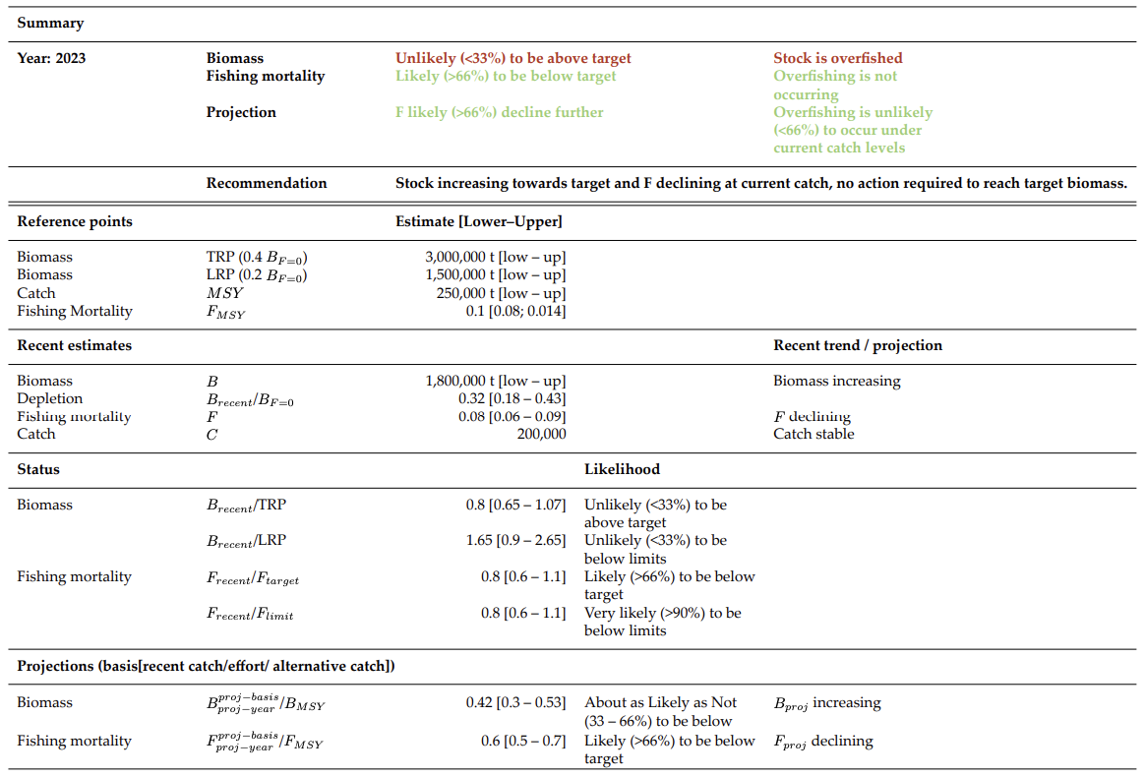

## For table 3, use IPCC likelihood categories with numerical probability statements

Probability | Description
> 99% | Virtually Certain
> 90% | Very Likely
> 60% | Likely
40-60 % | About as Likely as Not
< 40% | Unlikely
< 10% | Very Unlikely
< 1% | Exceptionally Unlikely

Attachment G

The Commission for the Conservation and Management of
Highly Migratory Fish Stocks in the Western and Central Pacific Ocean
SCIENTIFIC COMMITTEE
TWENTIETH REGULAR SESSION
Manila, Philippines
14 – 21 August 2024
Report from ISG-05
Review of Shark Research Plan

The ISG-05 was convened by the SC Chair (Emily Crigler) on 15 August 2024, to discuss issues raised in SC20-SA-IP-10: Progress against the 2021-2030 Shark Research Plan – 2024. There was a request from SC20-SA-IP-10 for the ISG-Sharks to:
- Review the work plan and project list for the 2024/25 year, and make recommendations to SC20 for any changes the SC may want to consider;
- Review the proposed amendments to the stock assessment schedule and make recommendations to SC20;
- Review the project specifications and make any changes for SC20’s review; and
- Consider if there is enough information to provide the SC with advice on the use of data poor metrics in shark assessments, and their future use for low information stock assessments.

1. Review of Shark Research Plan
No recommended changes were proposed by the ISG-Sharks.

2. Review of proposed amendments to stock assessment schedule
ISG-Sharks discussed the following proposed amendments to the stock assessment schedule for sharks:
- Data rich assessments for blue, shortfin mako, silky and oceanic whitetip sharks, with the remainder being evaluated through fishery characterizations and/or low information estimations of fishing mortality (F) risk.
- A revised start date from 2025 to 2026 for the new assessment for southwest Pacific blue shark to better fit align with other shark assessment schedules.
- ISC Indicator analyses for north Pacific blue and north Pacific shortfin mako sharks in 2025 and 2026 respectively.
- ISC north Pacific blue shark assessment in 2027 instead of 2026.
- A revised start data for fishery characterization of manta and mobulid rays and whale sharks from 2024 to 2025.
- A modification of the southwest Pacific shortfin mako shark assessment to a low information assessment or characterization given the data issues experienced with the last assessment.

ISG-Sharks requested two corrections to the shark assessment schedule. The ISC north Pacific mako shark indicator analysis is scheduled for 2027 not 2026 and the ISC north Pacific blue shark assessment is schedule for 2027, not 2026.

3. Review of projects
ISG-Sharks reviewed three proposed projects from the shark research plan for 2025:
- P20X02: Fishery characterization of manta and mobulid rays and whale sharks;
- Project 124: Pacific oceanic whitetip shark assessment – phase II; and
- P20X05: Developing a statistically robust and spatial/temporal optimized sampling strategy for biological data collection.
ISG-sharks supported submission of all three project proposals. For all three projects, the ISG-sharks requested that “notes” section of the TORs be updated to clarify whether the projects ranked by the ISG or SC during SC19.
ISG-sharks also supported submission of a fourth project proposal: Fishery characterization and CPUE analysis of thresher and hammerhead sharks in the WCPO (P20X06).
4. Consider advice for SC on the use of data poor metrics in shark assessments
ISG-05 Sharks did not discuss advice on the use of data poor metrics in shark assessments.

Attachment H

The Commission for the Conservation and Management of
Highly Migratory Fish Stocks in the Western and Central Pacific Ocean
SCIENTIFIC COMMITTEE
TWENTIETH REGULAR SESSION
Manila, Philippines
14 – 21 August 2024
Report from ISG-02
Future Operations of the Scientific Committee

The ISG-02 was convened by the SC Chair (Emily Crigler) on 15 & 18 August 2024, to discuss issues raised in SC20-GN-WP-50: Strengthening Stock Assessments and Operations of the Scientific Committee.

SC20 was tasked with considering any proposals for the efficient operation of the Scientific Committee, including streamlining the agenda, rapporteuring, process of theme sessions, and other related aspects.

The Commission at WCPFC20 requested that the Secretariat, SC Chair, SC Vice-Chair, SC Convenors, TCC Chair, and TCC Vice-Chair further explore and consider options discussed at SC19 and TCC19 relating to addressing time challenges in the SC review of WCPFC stock assessment inputs and report the intersessional discussions to WCPFC21 for its consideration.
SC19 recommended that the options outlined in the Table to Attachment H (SC19 Summary Report) be further explored by the Secretariat, SC Chair, Vice-Chair and Convenors in order to develop recommendations for improving the structure and functioning of the SC, to be presented to SC20.

ISG-02 discussed the options included in Table 1 below. ISG-02 supported, in principle, the following SC20 recommendations:

- SC20 encouraged CCMs that are able to do so to submit their scientific data earlier than the annual deadline of 30 April.

- SC20 recommended that the EB theme agenda rotate to review taxa every two years (e.g., review seabirds and cetaceans during SC21 and sharks and sea turtles during SC22), unless the Commission specifically requests otherwise.

- SC20 recommended that guidance on the submission of papers to the Scientific Committee, as agreed as SC3 (Attachment S of SC3 Summary Report) be updated to include the following:
- Paper titles and a preliminary abstract should be submitted to the Secretariat, SC Theme Convenors and the SC Chair 50 days prior to the start of regular meetings of the Scientific Committee.
- Full papers should be submitted to the Secretariat, SC Theme Convenors and the SC Chair 30 days prior to the start of regular meetings of the Scientific Committee. Stock assessments and MSE analyses may, when necessary, be submitted 18 days in advance of the start of the meeting, to allow them to be available on the website two weeks before commencement of the meeting.
- As a general rule, working papers will be submitted by CCMs, the Secretariat and the SSP. Observers may submit information papers, unless invited by the Secretariat, SC Theme Convenors, or the SC Chair to present a working paper.

- SC20 recommended that the Secretariat work with SC Theme Convenors and the SC Chair to develop a process to submit all papers (see example template included in Annex 1) and project proposals through the WCPFC website, to further streamline the submission process and allow for greater organization and tracking of submissions, for implementation in advance of SC21.

- SC20 recommended that the Secretariat work with SC Theme Convenors and the SC Chair to update the guidelines for the SC Chair and Theme Convenors (SC13-GN-IP-03) to clarify criteria for theme convenors to consider papers submitted to the Scientific Committee.

- SC20 recommended that the updated guidance on the submission of papers to the SC and the updated guidelines for the SC Chair and Theme Convenors be combined as overall Guidelines for the Operation of SC and circulated for review and adoption at SC21. SC20 further recommended that, once adopted, the Guidelines for the Operation of SC should be posted to the annual SC meeting page.

- SC20 recommended that the Terms of Reference for proposed SC projects be updated to include information on the WCPFC Data sets required to support the project, as well as notes from WCPFC/SSP on feasibility to provide WCPFC data in the format requested, when possible.

Table1. List of challenges and options from Attachment H, including updates on additional work undertaken and additional SC20 suggestions
Challenge | Options from SC19 | Work Undertaken or Ongoing since SC19 | SC20 Suggestions
- Options to alleviate time constraint challenges for SSP
Period over which the assessment and related work done by the SSP is undertaken. | Bring forward the deadline of data submission. | Some CCMs have voluntarily submitted their scientific data earlier than the annual deadline of 30 April. | Encourage CCMs that are able to do so to submit their scientific data earlier than the annual deadline of 30 April.
 | More frequent data submissions (e.g., quarterly) and more streamline data submission (using better formats). |  | More frequent data submissions - data provision within 30 days following the end of a trip & after every transshipment  - Some members were not in support of more frequent data submissions  Related recommendation from ST Theme: Recommendation for SPC to pursue options for standardization of data reporting and report back to SC20
 | Swap dates of TCC and SC. | No specific recommendation from SC19  Discussions during SC19: May not be possible due to constraints imposed by existing schedule of other RFMO meetings as well as associated challenges in changing the current compliance monitoring schedules.
 | Explore the option of moving the SC to a later date by identifying a window of time that is suitable for all CCMs. | Secretariat and the SSP are continuing to explore options for adjusting SC's meeting dates with other t-RFMOs.
Level of work undertaken by SSP | Fewer assessments. | SC19 did not see this as a viable option as the review of assessments for the key target species, together with co-occurring species, is a principal remit of the Commission’s work.
Level of work undertaken by SSP | 2-year assessment period. | No specific recommendations from SC19  Discussions during SC19: Without an increase in overall staffing levels, would increase the workload for SSP scientists.
Level of work undertaken by SSP | Lengthen the stock assessment cycle (i.e., the number of years between when an assessment is undertaken for each stock). | No specific recommendations from SC19  Discussions during SC19: Might not be tenable for short-lived species (e.g. skipjack tuna). Delay in assessment may result in delay in taking appropriate management actions.
Level of work undertaken by SSP | Use of simpler ‘updated’ assessments only using new data. | No recommendation from SC19, as no consensus could be reached:  Several CCMs considered it was essential to simplify the assessments for any stocks for which there are management procedures, noting that with management procedures in place, the stock assessments will no longer be the basis for management  Other CCMs did not see this as a viable option as the stock assessments form a critical component of the monitoring strategy for the Commission and the assessment models are not yet mature enough. There is a need for scientific rigor by using the best assessment models so that SC can provide the best scientific advice to the Commission. | Several members reiterated their views from SC19 that it will be essential to simplify the assessments for stocks for which there are management procedures in place.
Level of work undertaken by SSP | Smaller set of axes in the grid of uncertainty used in stock assessments. | SC19 did not see this as a viable option as it is important that the full grid of uncertainties is explored by the assessment models. This is required for management, such as monitoring the probability of breaching a limit reference point.
Resources available to SSP for undertaking its work | More SSP staffing resources (e.g., 5 full-time assessment scientists, with one assessment scientist dedicated to each key species, and data analysis support). | Additional budget approved at WCPFC20 for additional stock assessment services in 2024. Will likely alleviate some capacity challenges in the 2025 assessment cycle.
Resources available to SSP for undertaking its work | More computing power. | No specific recommendations from SC19  SC19 Discussions: Would require increase in WCPFC budget for SPC-OFP
Resources available to SSP for undertaking its work | Better use of SPC alumni. | No specific recommendations from SC19  SC19 Discussions: Would require in-kind commitment from CCMs and may increase project management load for SSP
Resources available to SSP for undertaking its work | Better resources and processes to allow for more input by CCM scientists into development of assessment models and other inputs. | No specific recommendations from SC19  SC19 Discussions: Would require in-kind commitment from CCMs and may increase project management load for SSP
- Options to further streamline the functions of SC
Challenge | Options from SC19 | Work Undertaken or Ongoing since SC19 | SC20 Suggestions
Rationalize SC Functions | SC19 recommended that the Commission consider reducing the length of SC to 7 days in 2024. The length of future SC meetings should be further considered following the 7-day SC20, particularly considering the workload for subsequent SC meetings. | SC20 was reduced to 7 meeting days.  Secretariat & SC Chair developed guidelines to assist SC Theme Convenors in developing clear and concise SC recommendations (SC20-GN-IP-04), to ensure that SC recommendations are effectively taken up by TCC and the Commission. | Update guidelines for SC Chair and Theme Convenors (SC13-GN-IP-03) to clarify criteria for theme convenors to consider papers that have been submitted.  Request Secretariat to develop a process to submit all papers through the WCPFC website - to further streamline paper submission process and allow for greater organization and tracking of submissions by the theme convenors and Secretariat.  Clarify who can submit WPs (e.g. including Observers? Or limited only to CCMs, Secretariat and IGOs?).
Time constraints for Theme Convenors & CCMs to review papers for SC discussion |  | Secretariat improvements to WCPFC Meeting webpage designed to support CCMs' participation in SC discussions. | Update paper submission deadline (e.g. all non-SPC papers or all apers other than new stock assessments or MSE analyses) due 30 days in advance of the meeting to provide additional time for theme convenors and members to review  Modify SC Agenda to allow for rotating schedule of agenda items for EB theme (e.g. to focus on priority work of the commission)  Recommend the Commission consider for future adoption of CMMs the need to limit unnecessary SC consideration of CMMs/provisions in CMMs.

Annex 1. Draft template for SC paper submission

Please submit papers to the SC via this form. Final determination on the appropriate theme and submission type will be made by the theme conveners. They will contact the corresponding author and/or the presenting author to communicate their decisions. Please note that working papers will generally have 15 minutes to present, except for stock assessments which will have 30 minutes. Information papers are not presented to SC, however can be referenced in presentations or discussions across the floor.

- Corresponding Author
- Corresponding Author email
- Corresponding Author Affiliation (Observer or CCM)
- Other Authors
- Presenter (If different than the corresponding author)
- Presenter Email
- Paper title
- Abstract
- Please select to which theme you are submitting:
- General Papers
- Data and Statistics Theme
- Stock Assessment Theme
- Ecosystems and Bycatch Mitigation Theme
- Management Issues Theme
- NGO Papers
- Research projects (Use for submitting TORs for SC to consider)
- Other_____________
- Please provide a justification for your theme selection (if necessary).
- Under which agenda item does your paper belong?
- Please select your submission type:
- Working Paper
- Information Paper
- Would you like an ODF for your paper?
- Yes
- No
- Has this information been published elsewhere? If yes, please provide a link to the other publication.
- Yes, ___________________
- No
- Please attach your paper.

Attachment I

The Commission for the Conservation and Management of
Highly Migratory Fish Stocks in the Western and Central Pacific Ocean
SCIENTIFIC COMMITTEE
TWENTIETH REGULAR SESSION
Manila, Philippines
14 – 21 August 2024
Summary of SC20 Online Discussion Forum

Contents

TOPIC 2. Project 90 update – Better data on fish weights and lengths for scientific analyses 218
TOPIC 4. Progress in improving coverage of cannery receipts data for WCPFC scientific work (Project 114) 218
TOPIC 6. Stock assessment of South Pacific albacore 219
TOPIC 7. Stock assessment of Southwest Pacific striped marlin 225
TOPIC 8. Stock Assessment of Silky Shark in the Western and Central Pacific Ocean (Project 108) 227
TOPIC 10. Progress towards a Close-Kin-Mark-Recapture application to South Pacific Albacore (Project 100c) 230
TOPIC 11. Develop stock status and management advice template for consistent reporting of stock assessment outcomes, uncertainties and risk (Project 113b) 231
TOPIC 12. Analysing Potential Inputs to the 2025 Stock Assessment of Western and Central Pacific Oceanic Whitetip Shark (Carcharhinus longimanus) (Project 124) 231
TOPIC 21. Project 110: Non-entangling and biodegradable FAD trial in the Western and Central Pacific Ocean 232
TOPIC 23. Predicting albatross bycatch hotspots across the North Pacific Ocean 232
TOPIC 24. Straddling Sets: Clarification of RFMO seabird bycatch mitigation requirements for timing of longline setting 233
TOPIC 25. Proposal for undertaking research analyses to inform discussions of mitigating impacts on cetaceans in the WCPFC purse seine tuna fishery 233
TOPIC 26. Commission’s Climate Change Work Plan and TOR for the Assessment of CMMs Susceptible to Climate Change Impacts 234
TOPIC 27. Responses to interventions and further discussions on CMM 2018-03 review 234

TOPIC 2. Project 90 update – Better data on fish weights and lengths for scientific analyses
14 Aug finau.martin Tonga
FFA member’s views on paper SC20-ST-IP-04:
FFA Members commend the significant achievements of Project 90 in collecting and analyzing conversion factor data, particularly the substantial number of sample measurements.
We acknowledge the project’s expansion beyond its initial objectives, which demonstrates adaptability and a focus on providing updated conversion factor relationships for WCPFC stock assessments.
We emphasize the importance of CMM continued support for new data collection initiatives, including the recently signed Letters of Agreement with Tonga, Cook Islands, and RMI. FFA Members advocate for Project 90 to be recognized as an ongoing initiative within the WCPFC framework, with dedicated funding of USD 20,000 per annum for 2025 and 2026. This funding will ensure the project can continue its essential work on data collection, analysis, and updating of conversion factor relationships
15 Aug keith.bigelow United States of America
The United States supports the continuation of Project 90, and would prioritize the identified tasks as follows:
- Collection of GG-WW conversion factor data on bigeye facilitated by the LOAs between SPC and Tonga, Cook Islands and RMI
- Continuing work with Australia, New Zealand and US troll fleet to collect measurements for SP ALB with the aim of using this to calculate length and age estimates from tail cuts alone to support CKMR sampling program for fish landed in US and Canadian ports.
- Updating and expanding the conversion factor database
- Investigation into accuracy of historical length data used in tuna and billfish assessments
- Refinement of web-based dashboard for platting CF relationships that links to SPC’s database and is accessible on WCPFC website
Aug 16 jedm Pacific Community (SPC)
We thank Tonga, other FFA Members and the US for their continued support of the Project 90 workplan and note the priority tasks listed by the US.

TOPIC 4. Progress in improving coverage of cannery receipts data for WCPFC scientific work (Project 114)
13 Aug Vrestrepo International Seafood Sustainability Foundation (ISSF)
COMMENT: ISSF thanks SPC-OFP for its continued efforts to improve the coverage of cannery data. If all cannery receipts were available for PS vessels, this would greatly improve certain aspects of stock assessment and fishery monitoring. We hope that good progress can be made during SC20 to get more bilateral arrangements in place.
19 Aug peter.williams Pacific Community (SPC)
Many thanks to ISSF for their continued support of this project, and in particular their initiative that started the process of cannery data submissions into tRFMOS from their affiliated companies many years ago.
15 Aug keith.bigelow United States of America
The United States thanks SPC for the update on progress on Project 114.
The paper provides an example comparing annual proportions of bigeye tuna in purse seine catches for U.S. vessels as estimated from cannery data and as estimated from logbook data adjusted for species composition using observer data from 2014-2023. It notes that the percentage of bigeye has increased since 2020, and that may be due to a variety of reasons. The paper also notes that there was low observer coverage between 2020-2022 due to the pandemic. Although there were observer coverage waivers in place in 2020-2022 in the WCPFC, many of our vessels carried IATTC observers. Would data from IATTC observers for 2020-2022 be able to help inform this analysis?
19 Aug peter.williams Pacific Community (SPC)
Thanks to the US delegation for their supporting comments. In regards to using IATTC Observer data for 2020-2022 to help inform analysis, we will liaise directly to discuss in more detail, for example, to understand the structure of data potentially available.

TOPIC 6. Stock assessment of South Pacific albacore
Aug 12 leyla.knittweis New Zealand
New Zealand would like to note that we are happy with many of the changes in the 2024 SPA assessment, including the change to a mostly fisheries as areas model, and the use of annual recruitments. We also appreciated the opportunity, provided a month ago by SPC, to comment on the model configuration.
We have some initial questions to seek clarification on a few aspects of the assessment:
In Figure 20 - is the value “adj= X” the actual weight that is used within the multinomial? For instance, 11.TR.ALL.1e has a much higher weight of 3497 when compared with 13.DN.ALL.1ef where the weight is 6, which implies that 11.TR.ALL.1e has more influence in the model?
Are the residual plots (Figures 19 and 22) showing standardised or raw residuals?
In Figure 24: In the LF likelihood profiles, 2 fleets are supporting lower biomass, indicated by green and grey lines. Which fleets are these? There are 2 fleets of each colour in the legend: Fleets 6 & 18 are green, and fleets 3 & 15 are grey.
Aug 12 john.hampton Pacific Community (SPC)
Re Q1 from New Zealand. The likelihood used for the LF data is a robust log-normal. We have not provided a comprehensive report of the individual components going into the likelihood but can do so on request. For the diagnostic case model, the LF log-likelihood contributions for each fishery are as follows:
0.000000000000e+00 0.000000000000e+00 -8.697151724799e+03 -4.752327526431e+03 0.000000000000e+00 -8.283958753574e+03 -9.303971115731e+02 -2.364662849441e+03 -3.348676114203e+02 -2.873168391526e+03 -4.711262568110e+03 -1.043392290010e+03 -6.084868465710e+01 -3.105856540692e+03 -7.736225722830e+02 -2.564092759313e+02 -4.861724972482e+01 -2.066095734537e+03 -8.737060084112e+02 -1.280980206065e+03
So the log-likelihood contribution the troll fishery (fishery 11) is -4.711262568110e+03, and that for the driftnet fishery (fishery 13) is -6.084868465710e+01. The smaller contribution (in absolute terms) for the driftnet fishery is because there are only 2 LF samples for that fishery, which occurred over a small number of years, compared to a much longer time series for the troll fishery. So naturally the troll fishery LF data has more influence over the model estimates than the driftnet fishery.
Aug 12 thomast_634475 Pacific Community (SPC)
We thank New Zealand for their comments and suggestions. We have revised the albacore stock assessment report to address the concerns raised and it will be uploaded shortly.
The revision includes an update to Figure 24 (fishery-specific LF likelihood profile) with formatting changes for clarity, Figure 19 (CPUE fits) and Figure 22 (CAAL fits) have been updated with standardised residuals, Figure 20 (aggregated LF composition fits) has additional text for each fishery with true effective sample size (as derived from robust normal likelihood), and Table 9 has an additional line with estimates of recent depletion for the WCPFC-CA only.
Aug 15 keith.bigelow United States of America
The US thanks SPC for their efforts and improvements to the South Pacific albacore stock assessment. We also echo New Zealand’s comments of appreciation for an opportunity to engage with the assessment team and provide feedback prior to the completion of the assessment. At this time, we would like to request clarification (either on the ODF or through plenary discussion) on the following points:
What is the uncertainty in the proportion of movement by age and season from SEAPODYM, either in terms of estimation error or annual variability in these values?
The CPUE standardization combines data from multiple flags, and the information paper notes that data from different flags appeared to show different trends. Combining data implicitly assumes that selectivity is the same across flags. Were length frequency distributions consistent across flags fishing in the same area? Additionally, catchability may differ across flags which can be accounted for with the flag effect in the standardization model. Was an interaction between flag effect and other catchability covariates (e.g., HBF) considered?
In Figure 22 there appears to be a substantial deviation between the model predicted age at length (red line) and the observed conditional age at length data. However, the estimated growth curve appears to closely align with the observed conditional age at length data. Could the SPC comment on this apparent discrepancy?
In Figure 39 there appears to be a large increase in recruitment towards the end of the model period when troll data are excluded. Can the SPC comment on which data component may be driving this result?
There appears to be a pattern in the predicted recruitment where large recruits are needed early on, and recruitment tends to increase in recent years. It appears that these recruitments may be in response to discrepancies between the catch and CPUE. Large recruitments followed by small recruitments may be needed to drive the CPUE down in early years given the small catches. In later years, catch appears to increase at a faster rate than CPUE declines with increased recruitment needed to compensate. Both of these could imply a mis-specification in the index, though for different reasons: hyperdepletion in the initial years and hyperstability in recent years. Could SPC comment on the plausibility of this recruitment pattern? As follow-up, we request that the next assessment investigate what would be required to remove these patterns in the estimated recruitment.
The US would also like to make the following suggestions/comments for consideration in future stock assessments:
Diagnostic model step 9 combines multiple changes, some of which could be offsetting. In the future we request that single steps be presented in the stepwise unless they have no effect on model estimates and can be bundled together for convenience.
We request that in the future, fits to the CPUE index be provided for ASPM and catch-curve analyses.
The US concurs with the research recommendation to explore including sex-structure in a future stock assessment. The simplified model structure of the current assessment may make such an exploration tractable in Stock Synthesis.
Aug 15 leyla.knittweis New Zealand
New Zealand thanks SPC for their responses so far. The changes to the figures and the log-likelihoods provided for the LFs are very useful. We have a few follow up questions and statements.
The likelihood profiles (Fig. 24) show that the R1 index and R2 indices are holding the biomass down. Conversely, the troll index and LFs are both pushing the biomass higher (Fig. 24). The New Zealand troll and LF data may be given too much statistical weight, particularly given that this fishery is substantially affected by environmentally driven availability. A sensitivity that drops both of these data sets at the same time is not presented, but we wondered if this was attempted?
The WCPO is quite strongly connected to the EPO by movement between the two regions and because recruitment is shared between the two regions (but split using a time invariant proportion). This linkage may be influential on model results so a sensitivity that fully separates the two regions or a WCPO-only model would have been very informative. It would be good to see such a sensitivity in the future.
And similar to the comments by the US, New Zealand also notes the recruitment trends upwards from 1970 to 2020. We suspect that it has to trend upwards to explain the increasing catches, given the low biomass, and because CPUE in the WCPO is not declining very much. If biomass was estimated higher, the decline in CPUE may be more consistent with the increasing catch, and the model wouldn’t need to estimate an increasing recruitment trend.
In addition, the initial decline in biomass, as estimated by the model using the declining trend in CPUE, seems likely to be overstated. In SPA assessments prior to 2021 the early period of CPUE was given very low statistical weight so that the model did not fit to it, because it was thought not to represent abundance but change in catchability. This suggests that a low statistical weight for the early part of the CPUE series may not be enough and that a change in catchability may be a more appropriate choice here.
18 Aug thomast_634475 Pacific Community (SPC)
We thank both New Zealand and the US for their further comments and questions. This dialogue is much appreciated. We would like to address these concerns here.
Q1: “What is the uncertainty in the proportion of movement by age and season from SEAPODYM, either in terms of estimation error or annual variability in these values?”
- This question has been referred to the principal SEAPODYM modeller Inna Senina and she responded that she did produce Hessian-based estimation error plots of movement probabilities in the 2021 four-region model configuration. The errors were very tight around the estimates and would be even more so for the current assessment collapsed to two regions. Therefore, our conclusion is that estimation errors in movement probabilities would be more than covered by the sensitivity analyses of movement that are documented in the assessment report.
Q2: “The CPUE standardization combines data from multiple flags, and the information paper notes that data from different flags appeared to show different trends. Combining data implicitly assumes that selectivity is the same across flags. Were length frequency distributions consistent across flags fishing in the same area? Additionally, catchability may differ across flags which can be accounted for with the flag effect in the standardization model. Was an interaction between flag effect and other catchability covariates (e.g., HBF) considered?”
- An exploration was done to explore differences in aggregated length compositions between flags operating in overlapping 5° spatial cells during overlapping years. Due to time constraints, this was not included in the inputs paper however, please see slides 25 and 26 in the CPUE presentation entitled “P12_ALB_cpue.pptx” at 2024 SPC Pre-assessment workshop – Google Drive for brief details of the analysis and results. These results indicated <1% of the cell-specific flag-to-flag combinations were significantly different providing evidence that selectivity between flags was not different.
Q3: “In Figure 22 there appears to be a substantial deviation between the model predicted age at length (red line) and the observed conditional age at length data. However, the estimated growth curve appears to closely align with the observed conditional age at length data. Could the SPC comment on this apparent discrepancy?”
- It is perhaps better to orient to the growth plot in a vertical fashion rather than horizontal. The residuals are the better way to assess the fit. The main discrepancy is the group of positive residuals at large size. We have commented on this as an area for follow-up research in the paper.
Q4: “In Figure 39 there appears to be a large increase in recruitment towards the end of the model period when troll data are excluded. Can the SPC comment on which data component may be driving this result?”
- This is more difficult to answer considering all the factors affecting recruitment signals within the integrated model. However, at the end of the SPALB presentation submitted to SC20, slide 21 provides a comparison of likelihoods when the troll index is excluded and included. Length data likelihoods tend to exhibit the largest differences and vary by fishery.
Q5: “There appears to be a pattern in the predicted recruitment where large recruits are needed early on, and recruitment tends to increase in recent years. It appears that these recruitments may be in response to discrepancies between the catch and CPUE. Large recruitments followed by small recruitments may be needed to drive the CPUE down in early years given the small catches. In later years, catch appears to increase at a faster rate than CPUE declines with increased recruitment needed to compensate. Both of these could imply a misspecification in the index, though for different reasons: hyperdepletion in the initial years and hyperstability in recent years. Could SPC comment on the plausibility of this recruitment pattern? As follow-up, we request that the next assessment investigate what would be required to remove these patterns in the estimated recruitment.”
- We are currently investigating this and will report when more information is available. At this time, we can report that when a de-trended recruitment time series is imposed on the model, the main likelihood components that are negatively impacted are the two longline CPUE indices, particularly the initial 15 years or so where declines are most evident. Investigation of this issue is ongoing.
“The US would also like to make the following suggestions/comments for consideration in future stock assessments:”
S1: “Diagnostic model step 9 combines multiple changes, some of which could be offsetting. In the future we request that single steps be presented in the stepwise unless they have no effect on model estimates and can be bundled together for convenience.”
- This request has been duly noted and efforts will be made in the future to provide a more detailed stepwise process.
“We request that in the future, fits to the CPUE index be provided for ASPM and catch-curve analyses.”
- Slides 22 and 23 at the end of the SPALB presentation submitted to SC20 provide the CPUE fits and CPUE standardised residuals for the age-structure production model (with and without recruitment deviations), catch-curve analysis, and diagnostic model for comparison.
S3: “The US concurs with the research recommendation to explore including sex-structure in a future stock assessment. The simplified model structure of the current assessment may make such an exploration tractable in Stock Synthesis.”

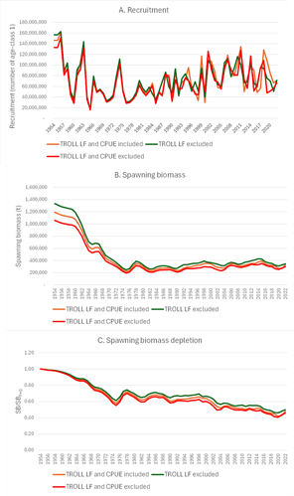
- Preliminary work has been undertaken on a Stock Synthesis multiple sex model and it is noted that further work on this would be appreciated by the US.
“New Zealand thanks SPC for their responses so far. The changes to the figures and the log-likelihoods provided for the LFs are very useful. We have a few follow up questions and statements.”
Q6: “The likelihood profiles (Fig. 24) show that the R1 index and R2 indices are holding the biomass down. Conversely, the troll index and LFs are both pushing the biomass higher (Fig. 24). The New Zealand troll and LF data may be given too much statistical weight, particularly given that this fishery is substantially affected by environmentally driven availability. A sensitivity that drops both of these data sets at the same time is not presented, but we wondered if this was attempted?”
- In spite of the likelihood profile indication, removing the troll capture fishery LF data resulted in a slight increase in biomass (see plots below). The removal of both the CPUE index with associated length data and the removal of the troll capture fishery LF data resulted in a lower biomass than the diagnostic case model.
S4: “The WCPO is quite strongly connected to the EPO by movement between the two regions and because recruitment is shared between the two regions (but split using a time invariant proportion). This linkage may be influential on model results so a sensitivity that fully separates the two regions or a WCPO-only model would have been very informative. It would be good to see such a sensitivity in the future.”
- As was mentioned in the plenary discussion, the low movement rates between the WCPFC-CA and the EPO estimated by SEAPODYM indicate a low level of connectivity between the two regions, as measured by bulk movement probabilities for the whole of these large regions (there could be more substantial movement probabilities of fish in the vicinity of the region boundary). However, these two regions are also connected by the shared stock recruitment relationship. We note the suggestion that a WCPFC-CA only model be investigated further moving forward.
S5: “And similar to the comments by the US, New Zealand also notes the recruitment trends upwards from 1970 to 2020. We suspect that it has to trend upwards to explain the increasing catches, given the low biomass, and because CPUE in the WCPO is not declining very much. If biomass was estimated higher, the decline in CPUE may be more consistent with the increasing catch, and the model wouldn’t need to estimate an increasing recruitment trend.”
- We note the agreement with the US regarding this important subject and we are currently investigating this and will report when more information is available.
S6: “In addition, the initial decline in biomass, as estimated by the model using the declining trend in CPUE, seems likely to be overstated. In SPA assessments prior to 2021 the early period of CPUE was given very low statistical weight so that the model did not fit to it, because it was thought not to represent abundance but change in catchability. This suggests that a low statistical weight for the early part of the CPUE series may not be enough and that a change in catchability may be a more appropriate choice here.”
- As mentioned in the plenary discussion, we see this as an area of further development. One concern we have with assuming time-varying catchability is that we could lose valuable information on relative abundance dynamics. Ideally, we would include operational changes in vessel and gear characteristics. The possibility of including vessel ID in the CPUE standardisation may help alleviate some of the issue and will continue to be pursued as well as other areas of research exploration.
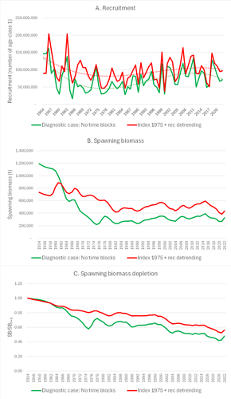
19 Aug thomast_634475 Pacific Community (SPC)
We would like to provide some additional information to address the issue of possibly uncertain (or biased) initial CPUE index observations. A model was fitted with the early (pre-1975) CPUE index observations removed. To constrain the model with effectively no relative abundance information prior to 1975, a penalty was added to reduce the early trend in recruitment. The results, shown below include:
- Somewhat up-scaled recruitment with a reduced trend compared to the diagnostic case (see fitted trend lines);
- A moderated early decline in SB, with an increased scale over most of the model period; and
- Moderate SB depletion as indicated by an increased SB/SBF=0, consistent with the upscaling of biomass.

TOPIC 7. Stock assessment of Southwest Pacific striped marlin
15 Aug leyla.knittweis New Zealand
New Zealand notes with appreciation the 2024 southwest Pacific striped marlin assessment, particularly with the improved growth curve based on otolith data. We also appreciated the opportunity, provided a month ago by SPC, to comment on the model configuration.
New Zealand would like to comment on a number of issues:
New Zealand notes that including the new growth curve seems to be linked to difficulties fitting the size data. Growth now occurs very rapidly at a young age - fish are 180 cm by age 2, almost a year younger than in the last assessment. This is a significant change.
The growth change means that selectivity at age will be very different from the 2019 assessment. However, the yearly step in selectivity-at-age means that selectivity can only change with age by year rather than by quarter. Most growth occurs before age 2, which may be one reason the model is having difficulty fitting to the size data – it may need more flexibility during the early period of rapid growth. We support the suggestion in the assessment document of exploring a quarterly model.
We note that the length frequency data in Fishery 12 are very influential in reducing the biomass level (see Figure 42). Their influence is mostly because the model consistently predicts larger fish than the observations in the F12 LF data (Figure 22). We do not fully understand why the model is unable to fit these data, because the fishery selectivity is dome-shaped and the model should be able to predict catches of smaller fish. These data also appear to contribute to a poor fit to the recent CPUE (Figure 18).
In several other fisheries LF and WF data appear to conflict, i.e., the length-weight relationships are inconsistent with the assessment assumptions, or there have been sampling or conversion biases (F6 and F7 - see Table 2 and Figures 22 & 23). This likely also affects the biomass estimates and trend.
New Zealand considers that the level of depletion may be overestimated because of the strong scaling effect from size data that the model in fact does not fit well. The vulnerable biomass trend also appears to be much more pessimistic than the CPUE trend in recent years.
New Zealand would therefore like to request that, if possible in the available time, a sensitivity model is run that substantially down-weights the length frequency data in F12 and the weight frequency data in F6 and F7, until they no longer conflict with the CPUE data.
15 Aug keith.bigelow United States of America
The US thanks SPC for their efforts in producing the current assessment, and recognizes the difficulties faced due to the civil unrest in New Caledonia. We also appreciate along with New Zealand the opportunity to provide feedback to the assessment team prior to the completion of the report. Regarding the above comments by New Zealand, the United States is in full agreement.
We also note that a potentially useful consideration for a future assessment of striped marlin would be migrating to an assessment platform, such as a Stock Synthesis, which can model selectivity as a function of length and two-sex population dynamics. Doing so, along with implementing the suggestions made by New Zealand, may help to alleviate the issues seen in fitting to the size composition data.
Aug 17 paulh Pacific Community (SPC)
Thanks to New Zealand for their thorough review of the southwest Pacific striped marlin assessment and constructive comments and suggestions to further explore to improve the confidence in estimation of management quantities. We are in general agreement with the concerns raised by New Zealand and have expressed similar concerns in the WP03. Unfortunately, we ran out of time to conduct the additional work required to explore and address these issues. Our more recent model runs to try to understand the implications of some issue, especially poor fits to recent CPUE, and in particularly the dominant influence of the size data on the assessment outcomes, confirm that the estimation of the management quantities presented for the diagnostic model in the WP03 are biased towards pessimistic values and models that increase the influence of the CPUE are more optimistic (see below). This likely also permeates through the uncertainty ensemble used for management advice. The model run requested by New Zealand has been run, in an extreme case by removing the length frequency data for F12 and the weight frequency data in F6 and F7, and indicates more optimistic management quantities, however we have not time to generate the new likelihood profile or fully run diagnostics on this model or other shown below. This model to address the New Zealand request removed large amounts of size composition data (95% of the Australian longline data removed).
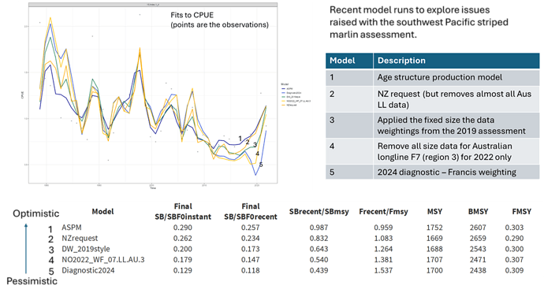

TOPIC 8. Stock Assessment of Silky Shark in the Western and Central Pacific Ocean (Project 108)
15 Aug keith.bigelow United States of America
The US thanks Dragonfly and Saggitus for a comprehensive and thorough assessment. Upon reading the assessment report the US has a request to make and a few follow-up questions. If it is not possible to respond on the ODF we request responses be made during the plenary discussion.
Would it be possible to report the MSY based reference points for the models recommended for management?
Model results across the four approaches trialed appear to be fairly consistent, however these approaches are all conditioned on the same data and the assumptions that the data are representative of the underlying system. Specifically with regards to the free-school purse seine index, the increase seen at the end of the time series is fairly dramatic. The US notes that the simplest explanation for that may be the correct one (e.g., reduced mortality from the longline has resulted in a rebuild of the stock), however did you consider any other CPUE scenarios? Could there be other factors at play there with regards to the spatial coverage of the index, or if observer reporting behavior changed in a way that could influence the observed trend? To be more precise, from Figure 1 we see that all or almost all of the observer programs considered in the standardization are part of the ROP and would receive similar training and guidance with respect to species identification and reporting. If possible the US would also be interested in seeing an additional row added to figure 1 that shows the nominal CPUE for each program prior to any standardization.
The US is also curious about the possibility for catchability change in that index? We understand that silky shark is a bycatch species but if they aggregate to tuna schools then changes in catchability impacting the ability to detect/encircle free schools could also have a similar effect on the catch rate of the associated bycatch.
Specifically with respect to the model proposed for management (DSP - Diagnostic), the US has a series of technical questions. What does the pattern of estimated process error look like, are process error deviates needed to match the increase seen in the index? How was the variability in process error dealt with, was this estimated or fixed, and if estimated what was the specified prior? How was observation error dealt with for the free-school purse seine index? Lastly, can you confirm that the Rmax posterior suggested a less productive stock than what the prior distribution of Rmax values indicated?
15 Aug philipp Pacific Community (SPC)
We thank the US for their feedback and questions.
Yes - we will add the MSY-based reference points for the dynamic surplus production model.
CPUE being what it is, we believe there’s a duty to question it, and investigate if it’s something else. We suggested in the paper that the weight of evidence is in favour of an abundance increase in the assessment area - but that’s by no means proof, of course.
The increase in the index perhaps looks more dramatic than it is after standardisation, at least in some of the plots that include the 2021 and 2022 year - but those are excluded from the assessment due to poor post-COVID observer coverage making those points highly suspicious. Without those, it suggests a doubling of the population over roughly 10 years; that’s still pretty fast, but perhaps within the realm of believable increase given the estimated decline in fishing mortality.
The high level of consistency between indices from different observer programs seems hard to explain with a reporting trend alone (i.e., one would expect more of a jump up as opposed to the noisy but steady increase seen across all observer programs but one - see raw CPUE below). Given the consistency, it didn’t seem warranted to try alternative indices based on this analysis. The SS model considered the object-associated index, although it did not fit to the data; as this fishery mainly catches juveniles, it did not appear a useful index for spawning or total biomass. Long-line indices were not consistent and very noisy, and these indices were therefore not considered. Longline logsheet-reported FAL captures were analysed at an early stage of the project, and suggested increases seen in many fleets; however, these time-series are very short and often it is unclear how lowsheet reporting pattern may have amplified the observed increases in logsheet-reported FAL.
We thought it was most relevant to test if the increase was due to the fleet fishing different areas - given that the fleet probably doesn’t see the “full” stock (i.e., the stock is not 100% available to purse seine), if there are spatial patterns we don’t understand, a shift in fishing grounds will almost certainly affect CPUE. We were actually quite surprised to get a near identical index from the spatio-temporal model across a consistent area; this suggests that the initial model sufficiently controls for spatial shifts via the spatial and ENSO terms.
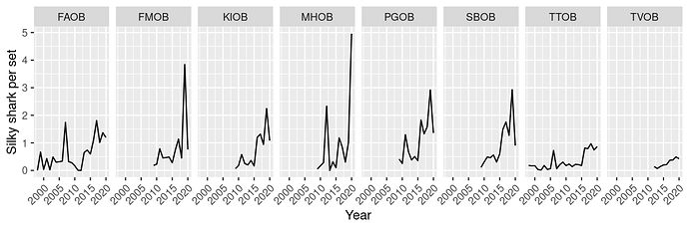
The other useful information here is that the increase in abundance appears to be driven by an increase in the eastern equatorial PO - where targeted shark fishing happened before 2012 or so, with large numbers caught in the area by PNG, Solomons and TW longliners. Since, the cessation of targeted fishing, movement of the TW fleet from the area, and the 2008 FAD closure may have significantly increased survival in the area. The increase in estimated recruitment (and hence recruit survival in the SS model/PE in the surplus production model) may proxy for some of these developments where the data don’t reflect this (e.g., we cannot account for the 3 month FAD closure well in the annual model, but it effectively makes juveniles less available).
We want to repeat that we have similar concerns with the use of CPUE, and will list the representativeness as CPUE as a key uncertainty. It is possible (and likely happening to some unknown degree) is that there is large-scale movement in and out of the area from elsewhere (e.g., Archeplagic waters). That movement would have to be directional over a long cycle to cause the directional pattern seen in CPUE; but given the sensitivity to ENSO indices, it could be that FAL also respond to longer-term trends with more (or less) movement to other areas (e.g. EPO) in recent years. Cleridy Lennert-Cody discusses this in some detail in her fisheries oceanography paper, suggesting such long-range movements from the WP might explain ENSO-related trends in the EPO. The previous silky assessment attempted a full Pacific-scale model to resolve this and failed. We suggest that It might be time to revisit that idea.
The possibility of a catchability increase would need to be explained with an increase in gear efficiency rather than search-efficiency as we use a per-set index and don’t account for search effort. But it could be that operators change what types of schools they look for and set on - i.e., if they would have avoided certain types of schools in the past that tend to associate with silky sharks and shifted targeting towards schools that associate with FAL; that appears unlikely to happen with the observed level of consistency across fleets. Also, in terms of efficiency of the gear itself - given that we only see the per-set makeup, it would have to affect the makeup of the school (e.g., sharks used to escape purse-seine capture, for example, due to changes in vessel speed). Again, such an explanation seems possible, but unlikely to have happened with this level of consistency for a decade.
Please find a plot of the process error (PE) below; the PE is pretty small. We fixed the PE SD at 0.05; the BDM package that was used doesn’t allow estimating the PE SD. The observation error of the log index (un-associated purse-seine) was set to the same as for the SS model (~0.18), using the Francis procedure of fitting a smoother through the index and estimating the required error. Normally this should reflect the sum of OE and PE, but was used as an estimate of OE here, and set the PE to a comparably low value. The PE has a trend (see plot below) - comparable to the recruitment in the SS model, but much smaller magnitude (<5% for most years) and all overlapping zero. With additional time, we would have run more runs with small increases in PE until the index residuals have no trend to see what PE is needed to perfectly fit the CPUE, but we suspect it wouldn’t be much different given it already fits reasonably well.
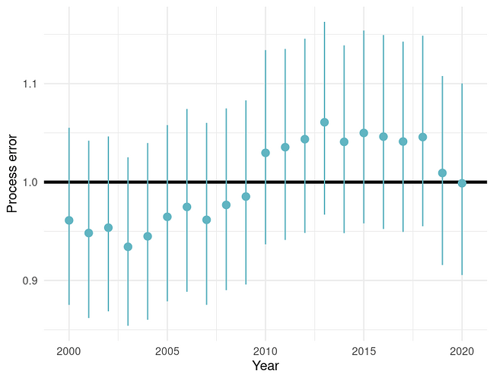
The estimated Rmax was consistently estimated in the lower end of the prior; that said, the prior is limited at the lower end by the constraint to produce a viable stock under the catch history whereas a the higher end that constraint is not a “strong”, so it’s perhaps not surprising that with an a priori constrained Rmax prior to see this result.

TOPIC 10. Progress towards a Close-Kin-Mark-Recapture application to South Pacific Albacore (Project 100c)
15 Aug keith.bigelow United States of America
The US thanks SPC for the comprehensive overview of ongoing CKMR related activities within the WCPFC. With regards to the 6 main project areas we have a number of questions and/or supporting comments which are listed below.
- Activity 2 - We support the recommendation from SC20-SA-IP-24 that current samples be genotyped as this can accomplish two goals: 1) confirm that the standard operating procedure for sample collection, preservation, and transportation can produce a high rate of “effective” samples, and 2) to narrow down the range of population scale scenarios in order to refine the sample design calculations.
- Activity 3 - Does the preliminary scoping for bigeye tuna consider connectivity with the EPO population? We note that the paper suggests that ~60-100k samples are likely needed to achieve 100 kin-pairs however at the lower end of samples this number would be more highly skewed towards half-sibiling pairs (HSPs). In species where reproductive output may increase as a function of body size, detection of parent offspring pairs (POPs) are an important component of the analysis in order to disentangle fecundity effects, and sufficient numbers of POPs (e.g., greater than 50) would only be achieved at higher levels of sampling (> 100k+). We support further more formal design work be undertaken to incorporate both connectivity with the EPO component of the population and detection of a sufficient number of POPs.
- Activity 4 - We note the tremendous logistical challenge of collecting, preserving and transporting genetic samples across a wide, and diverse spatial area, and commend SPC on efforts to date to implement a standardized operating procedure. We note that quality control analyses are expected soon, and we look forward to seeing the results of this analysis as quality control is critical for determining how the “effective number of useable samples” collected by the defined SOP compares to the required number of samples indicated by the design step, and to ensure that money is not wasted on collecting ineffective samples. We encourage continued quality control analyses, under more realistic transport conditions, in case the current batch of quality controlled samples do not represent actual conditions.

TOPIC 11. Develop stock status and management advice template for consistent reporting of stock assessment outcomes, uncertainties and risk (Project 113b)
Aug 13 vrestrepo International Seafood Sustainability Foundation (ISSF)
COMMENT: I find this to be a very valuable report and hope that SC20 will use it to improve consistency and clarity in the Stock Assessment sections. In my experience (here and elsewhere), inconsistencies in reporting for different stocks tend to increase over time for many reasons, including human nature. An exercise like this every 10-15 years or so is useful to bring consistency back to a place where managers (and scientists and other stakeholders) won’t be confused.
Aug 15 keith.bigelow United States of America
The US thanks the WCPFC for funding this important project, and appreciates the thoughtful consideration and proposed template presented by Dragonfly NZ. With regards to the proposed template the US would request that status relative to MSY based reference points be included within the standardized template unless MSY based reference points are unable to be calculated given the modeling approach (e.g., some data-limited assessment or risk-analysis type approaches). The US also would like the ranges (lower and upper bounds) in the stock status table (Table 4) be specified to be consistent between all assessments (i.e. all 95% CI, 80% CI, etc).**

TOPIC 12. Analysing Potential Inputs to the 2025 Stock Assessment of Western and Central Pacific Oceanic Whitetip Shark (Carcharhinus longimanus) (Project 124)
15 Aug keith.bigelow United States of America
The US thanks Dragonfly and Saggitus for their extensive investigation into the data inputs available for the upcoming oceanic whitetip shark assessment, and has a few follow up questions that we request be addressed either through the ODF or the plenary discussion.
Assessment inputs for sharks (catch, CPUE, and length compositions) are likely to be model inputs in their own right. Beyond using estimated variances to inform data weightings, how are the uncertainties in these input analyses proposed to be incorporated into the assessment?
As a technical point, the Hawai’i observer data used in the analysis should not share a program code but should be further subdivided into deep and shallow-set sectors given their different operating characteristics and spatiotemporal footprint. The US is happy to correspond further on this point offline if need be. Also, are leader material, bait type available, set time (time of day), and soak time available as covariates for analysis?
15 Aug Philipp Pacific Community (SPC)
We thank the US for their feedback and questions.
The most uncertain input is most likely the early model-derived catch history. We can change (usually increase) the scale of early catch beyond that predicted by the catch-reconstruction, to acknowledge that early shark under-reporting by observers potentially led to under-estimation of catch for the early years in our analysis. This same assumption would then also need to be accounted for in CPUE by down-weighting early CPUE derived from observers.
For CPUE, we may attempt to fit to alternative indices, if these are considered plausible indicators of abundance. While purse-seine captures are very low for OCS, log-sheet indices may provide additional insights in recent years and lead to alternative considerations. We plan to explore these before settling on how best to reflect uncertainties in CPUE in the assessment.
We will liaise with the US offline to incorporate this difference into the index. It would be desirable to find a formulation that would allow similar differences in fleets elsewhere (and presumably different catchability for OCS) to be reflected in the CPUE standardisation more broadly.

TOPIC 21. Project 110: Non-entangling and biodegradable FAD trial in the Western and Central Pacific Ocean
Aug 16 tusu Papua New Guinea
PNG commends the project’s efforts to test and monitor non-entangling and biodegradable dFADs recognising the importance of these innovations in promoting ecological sustainability. We note the average catch per set on jelly-FADs was lower than on conventional dFADs, although the median catch was comparable to the fleet-wide average. This suggests potential trade-offs in performance.
We would like to emphasize the need for further analysis to better understand the performance differences and to explore potential design improvements that could enhance the efficacy of jelly-FADs while maintaining their ecological benefits. We would also like to stress the importance of increased industry participation to achieve a representative sample size to support robust analysis.

TOPIC 23. Predicting albatross bycatch hotspots across the North Pacific Ocean
09 Aug Stephanie.Borrelle Birdlife International
Information Paper SC20-EB-IP-23 (Predicting albatross bycatch hotspots across the North Pacific Ocean | WCPFC Meetings 2) presents new research by Clay et al. using >1,200 albatross tracks from eleven populations of three species (short-tailed, Laysan, and black-footed) to provide an assessment of bycatch risk in the North Pacific.
Bycatch risk from pelagic longline fisheries was identified in the central and northwest subtropical Pacific that occurred mostly during breeding (winter-spring); though the months with elevated risk differed according to population and fishing vessel flag state. There was considerable (88%) overlap with pelagic longline fishing effort occurred in the High Seas where observer coverage is extremely low (<5%) and use of bycatch mitigation is variable. Three flag states (Japan, USA and Chinese Taipei) were responsible for >90% of total risk.
BirdLife International seeks discussion with Members on the proposed recommendations:
- Increasing observer coverage of the longline fleets of Japan (particularly the small offshore fleet; 10-19 gross register tonnage) and Chinese Taipei.
- Adopting best-practice seabird bycatch mitigation measures in all North Pacific longline fleets, particularly the fleets of the US, Japan and Chinese Taipei.

TOPIC 24. Straddling Sets: Clarification of RFMO seabird bycatch mitigation requirements for timing of longline setting
09 Aug Stephanie.Borrelle Birdlife International
BirdLife International and the Humane Society International (HSI) Australia submitted Information paper SC20-EB-IP-24 for the Scientific Committee’s consideration on ensuring clarity in the wording about night setting in a revised CMM for seabird bycatch mitigation. What constitutes night or day is not in question. The question is what the mitigation obligations are when a set spans both daylight and darkness.
Arguably, the obligations of employing night setting as a mitigation measure are clear, however this may include the assumption that line weights are not able to be introduced mid-set. While not all vessels will have the capacity to switch hook configurations mid-set, some fleets may have this capability.
BirdLife International and Humane Society International encourage discussion on this paper and the recommendations of:
- Require 3/3: LW + TL + NS, or the standalone measures of hook shielding devices (HSD) or underwater bait setters (UBS) – as advised by ACAP as best practice to avoid any ambiguity in interpretation of night setting obligations,
- In a revised CMM that allows for two mitigation options to clarify that provided every hook is set in darkness, either LW or BSL remain a requirement, that straddling sets are considered daylight sets, and therefore both LW + TL apply for the entirety of the set,
- Reporting straddling sets as two separate fishing operations along with all associated mitigation use and bycatch information.

TOPIC 25. Proposal for undertaking research analyses to inform discussions of mitigating impacts on cetaceans in the WCPFC purse seine tuna fishery
SC20-EB-WP-13 4: D. Phillips & S. Elzea (Earth Island Institute International Marine Mammal Project). Proposal for undertaking research analyses to inform discussions of mitigating impacts on cetaceans in the WCPFC purse seine tuna fishery
13 Aug vrestrepo International Seafood Sustainability Foundation (ISSF)
COMMENT: This is a good idea and it would be good to do the analyses if they haven’t been done already. Also, I would think that it would not be too onerous given the observer database readily available to SPC.

TOPIC 26. Commission’s Climate Change Work Plan and TOR for the Assessment of CMMs Susceptible to Climate Change Impacts
08 Aug kelly.kryc_688057United States of America
On behalf of the Climate Co-Leads (RMI/Berry Muller and the United States/Kelly Kryc), I’m reaching out to start an online discussion forum on one of the two climate-related papers (SC20-EB-WP-02) submitted to the Scientific Committee. SC20-EB-WP-02 includes the WCPFC20 report language tasking the co-leads to develop a work plan that would be considered by each of the WCPFC Subsidiary Bodies. We encourage you to review the paper and invite you to submit any questions or provide thoughts here so we can have a robust discussion next week in Manila. Many thanks!

TOPIC 27. Responses to interventions and further discussions on CMM 2018-03 review
16 Aug jfischer_960273 New Zealand
New Zealand responses to the draft interventions on Agenda Item 6.5.1 and 6.5.2 as captured by the rapporteur and support rapporteurs
Tokelau, speaking for FFA CCMs thanked New Zealand for its leadership and transparent approach. They acknowledged the sound scientific information provided to support the review of this CMM and appreciated that this science review offers comprehensive management recommendations, which they support. FFA CCMs note the critical situation of seabirds, particularly the alarming decline in Antipodean and Gibson’s albatross populations, and the impact that fisheries are having on them. They are therefore supportive of this work to address effective mitigation methods to help restore populations and conserve these species.
New Zealand thanks the FFA for their response and support for the recommendations in SC20-EB-WP-06 and their note of the alarming decline of several Southern Hemisphere seabirds, particularly Antipodean and Gibson’s Albatross.
French Polynesia said they were aware of the seabirds mentioned by New Zealand but there are also seabirds in French Polynesia affected by longline fisheries in tropical and temperate waters, which is why they worked with Birdlife NZ on the use of tori lines. French Polynesia reminded and supported SC18 recommendation about reviewing CMM 2018-03 in order to meet more efficient mitigation of longline impact on seabirds. French Polynesia ssupports the FFA statement by Tokelau.
New Zealand thanks French Polynesia as well for their support for the recommendations in SC20-EB-WP-06 and welcome their proactive approach to seabird mitigation in their waters.
Japan needed to make several comments, but would present the technical ones in the Seabirds ISG on Friday.
There has been long discussion about seabird bycatch in the WCPFC and Japan has already pointed out that the situation in the North and South Pacific are quite different. New Zealand had found that seabird populations are declining in the south, but in the northern hemisphere they are not. From Japan observer data, the bycatch level relative to population size is quite clear and less of a concern at this moment. Also, there are different mitigation measures specialised for the kind of gear used in the north.
The CCSBT project was working in high-risk areas in the southern hemisphere. Japan suggests that when we look at mitigation measures in southern hemisphere we need to use the risk assessment process of CCSBT.
They understand that mixing mitigation measures are said to be more effective but have serious concerns about installing some mitigation measures. There is no improvement in the effectiveness of some mitigation measures.
Hawaiian longline fishermen say they have been severely injured by branchlines, so Japan is seeking more practical mitigation measures.
[Also, in regards to the analysis in SC20-EB-WP-11, Japan highly recommends redoing the analysis with covariance including local seabird abundance]
New Zealand thanks Japan for their detailed input into this important issue, now and throughout the process.
New Zealand is pleased to hear that the dire situation in the South is not directly reflected in the North, yet we note that in one of the presentations given at the informal intersessional meetings on the review of CMM 2018-03, it was highlighted that an increase in bycatch rates of black-footed albatross in recent years had occurred triggering further work on this species vulnerable species. The mandate of this review as agreed at WCPFC20 was to “ To ensure that effective mitigation methods are required and applied across the Convention Area where there is bycatch risk to vulnerable seabirds from longline fishing”. Consequently, it appears that there is still evidence justifying the removal of ineffective bycatch mitigation methods and addressing ineffective specifications of effective mitigation methods in the Northern Hemisphere.
New Zealand thanks Japan for their ongoing collaboration in the CCSBT project and their leadership in driving the SEFRA process forward. However, New Zealand highlights that the SEFRA is highly likely to provide the same insights as previous mortality and risk estimates, i.e., the larger and more long-lived species such as Antipodean, Gibson’s, Northern and Southern Royal Albatross are more at risk and are being bycaught at high levels where their abundance and longline fishing effort intersect. Yet, any SEFRA will not provide any guidance on the effectiveness of seabird bycatch mitigation methods. Consequently, the SEFRA process, while providing highly robust spatially explicit estimates of mortality, will not provide the guidance needed for the review of CMM 2018-03, which is what we were tasked with to complete. Additionally, SC is tasked to provide the best available scientific evidence to Commission to make management decisions, including the review of CMM 2018-03. The evidence we compiled reflects this, the best available scientific evidence, which provides the foundation for Commission to make decisions. The dire state of the Southern Hemisphere seabirds highlights the urgency for decisions. Future results from SEFRA can inform future iterations of CMM reviews.
New Zealand appreciates the concerns raised by Japan on the scientific evidence underpinning the effectiveness of combining mitigation methods. However, we’ve been very clear and transparent in our review process. All available evidence indicates that combining methods provide substantial increases in effectiveness. If there is additional evidence to the contrary, this is not available in the current body of published literature, and it was not provided throughout the inclusive intersessional review process despite repeated invites for the provision of any missing pieces of evidence. Given the lack of evidence underpinning the concerns raised and the considerable amount of evidence underpinning the effectiveness of combining mitigation methods, we consider our recommendations robust.
As raised in the presentation, health and safety concerns associated with weighted branch lines are to be taken serious, but New Zealand continues to highlight that this challenge has been addressed through a decade worth of research, resulting in the development of safe weighting options in the form of sliding weights. Furthermore, New Zealand highlights that despite the serious health and safety concerns associated with this mitigation method, it remains by far the most reported observed bycatch mitigation method throughout the WCPO. The evidence, including what is being used in the WCPO, highlights that weighted branch lines can be a highly effective and practicable mitigation method if applied adequately.
New Zealand appreciates the concern raised by Japan on the analysis in SC20-EB-WP-11 and agrees that in an ideal scenario, this covariate was included indeed. However, New Zealand highlights that for most seabird bycatch mitigation studies, this covariate has never been measured and thus it is not realistic to incorporate this covariate in this or any future meta-analysis that incorporates the current body of evidence. New Zealand highlights that it attempted to overcome this shortcoming by comparing the relative performance of mitigation methods within studies first before modelling them across studies.
New Caledonia is fully committed to ensuring seabird wellness and conservation in its waters. Their remote islands are major nesting places for seabirds in the western Pacific, 10% of NC waters, including major seabird foraging areas, are under a high protection level without any fishing activity since 2023 and several studies are in progress to increase the knowledge of the status of seabirds in New Caledonia waters. New Caledonia thanked New Zealand for its very conservative proposal, however, as mentioned in 2018, the area under consideration in the south is not the main fishing area for our fishing vessels which are mainly concentrated North of 25°S. Fishing activities south of this limit are very rare and for example no fishing activity were recorded in 2023. It would be very difficult to add new constraints on our small industry whilst also working on other important ecosystem and bycatch issues such as mitigation of shark bycatch and depredation issues especially with regards to marine mammals. Furthermore, the cost and the deployment constraints of the combined mitigation methods recommended might be a disproportionate burden for the small NC fishery compared to the expected results, as interactions rates remain really low and without any accidental catch of albatross according to observer data, which has close to 10% coverage. Based on this information, New Caledonia thanked New Zealand for its proposal to maintain the exemption for SIDS as defined in the CMM2018-03. At the same time New Caledonia, recognizing the importance of this issue supported by New Zealand, expressed its interest to develop its capacity by implementing trials of mitigation methods in its waters in the future. These trials would aim to facilitate the appropriation of mitigation devices by the vessel crews with a step by step approach and the development of a mitigation strategy consistent with our EEZ context.
New Zealand thanks New Caledonia for their support for the recommendations in SC20-EB-WP-06 and welcomes their practical step-by-step approach to seabird mitigation in their waters.
Indonesia noted that this is a comprehensive review of the Seabirds CMM and congratulated New Zealand for their effort. ID supports the proposal for amendments to the CMM. They would also like to hear more about which management options are recommended for ID waters.
New Zealand thanks Indonesia for their support for the recommendations in SC20-EB-WP-06 and highlights that the recommendations relevant to their waters are to encourage the use of effective mitigation methods such as branch line weighting, tori lines or night setting. However, at this current stage, New Zealand is not suggesting recommending any required mitigation methods in the area that is relevant to the Indonesian fishery. New Zealand highlights that it would be open to collaborating with Indonesia on identifying which mitigation methods would be most suitable for their fishery and is looking forward to working together.
China wanted more information and illustrated procedures about practical ways of implementing some of the recommended mitigation measures, along with practical guidelines for logsheet reporting and quantification of gear descriptions, so flag states could implement training. China did not agree that all branch lines must be weighted, and there was no need for the use of tori lines or weighted branchlines. More research needed to be done on the implementation of CMM 2018-03.
The Co-convenor requested China to please provide the text of their intervention to assist the rapporteur to report it accurately.
New Zealand thanks China for their commitment to improving adherence to effective specifications and will continue work bilaterally to provide practical guidelines and illustrated procedures. However, New Zealand highlights that all scientific evidence shows that branch line weighting (when indeed all hooks are weighted) and tori lines with adequate specifications are indeed effective and there is no evidence available to suggest the contrary. In regard to the comment that more research is needed, the advice and recommendations provided are built on a compilation of scientific evidence compiled during over 20 years of research from around the world resulting in >130 papers that were all made available during the intersessional review process. Any new research is highly unlikely to drastically change the insights provided by this large body of evidence. Furthermore, during this review New Zealand, and SC in general, is tasked with providing advice to the Commission based on the best available science. This is what the review process did and how it arrived at the recommendations provided. That being said, New Zealand would of course welcome further research to provide further insights, but such work should only be conducted in parallel with implementing the improvements to the CMM as suggested considering the dire situation of Southern Hemisphere seabirds and the impending extinction of some species.
The EU thanked New Zealand for having led this important process and for the manner in which they had implemented it, and also for the thorough work that Johannes and others have carried out. It was remarkable. As a matter of principle, like others around the table, the EU agreed it is of utmost importance to develop measures that mitigate unwanted impacts of the fishing activity, and that are effective. They drew attention to the fact that the recommendations were based on a meta-analysis of many other studies, and experience has shown that measures that prove effective for certain fisheries may not be adequate to others when there are operational differences, or variation in the areas fished. This was in line with some previous comments by Japan. In this specific case, the EU provided New Zealand with several studies that indicate an extremely minor seabird interaction rate of the EU surface longline fleet targeting swordfish in other oceans, which is also a conclusion in accord with ROP data in the WCPFC area. Interaction is directly null in many years. Some of the reasons that can be found on those studies are related to the night setting, which in this case may take place entirely during night hours, or other operational differences like the size and type of bait. The EU wanted to raise this point, since it may be something that they thought needed to be taken into account when further discussing the different options at TCC and intersessionally before a draft is presented to the commission. Additionally, they expected to have additional technical discussions on the specifications of the measures during those future meetings.
New Zealand thanks the EU for their considerations and congratulate them on the low interaction rates that they report from other ocean basins. We appreciate the practicality concerns raised by EU and we reflect on the intervention provided by Australia that the body of evidence presented contains the scientific foundation of what mitigation methods, specifications, and combinations thereof inform the recommendations and that the practicality aspect should be followed in different fora as suggested by the EU as well.
Chinese Taipei agreed that New Zealand had given the Commission informative information about seabird mitigation measures. There was just one question they wished to ask concerning the areas where seabird populations had increased and wondered if in these areas the seabird ranges overlapped with fisheries. And wondered if the scientific evidence about the effectiveness of the 100 metre line.
New Zealand thanks Chinese Taipei for their continuing engagement on this topic. The reason why some species are not declining is largely due to a lower susceptibility to bycatch in pelagic longlines. In regard to the effectiveness of the 100 m drag section, this has been proven to provide sufficient drag to achieve the 100 m aerial extent which is required to allow hooks to sink mostly out of reach of seabirds before the end of the aerial extent. However, other methods can be used to achieve sufficient drag to achieve the desired aerial extent and as such, we propose to remove the 100 in water drag section requirements to allow for more flexibility and ease of implementation. A variety of papers on this topic are available in the SharePoint and New Zealand can continue to engage bilaterally to provide the exact papers if required.
Australia thanked New Zealand for their efforts on this matter and ongoing commitment to arresting the decline of vulnerable and endangered seabirds. Thanks in particular to Johannes for his efforts over the last year and to participants in the intersessional work. It has been a comprehensive and transparent process over the last year in our view and it is clear that New Zealand have been responsive to the inputs of others. Overall, the working and information papers represent a good compilation and analysis of the evidence base. Australia proposed that SC20 acknowledge the sound scientific foundation of the recommended mitigation regimes proposed in EB-WP-06, and acknowledge that they represent best practice for mitigating seabird impacts from pelagic longline. Australia considers this to be an objective statement based on the science and the evidence base. This is of course different from some of the issues around operating environments, possible crew safety issues or questions of timing for transition that may remain for national implementation. These should properly be taken up elsewhere.
New Zealand thanks Australia for their support and for their pragmatic and logical approach to evaluating scientific evidence in the Scientific Committee and taking up practical considerations elsewhere.

Attachment J

The Commission for the Conservation and Management of
Highly Migratory Fish Stocks in the Western and Central Pacific Ocean
SCIENTIFIC COMMITTEE
TWENTIETH REGULAR SESSION
Manila, Philippines
14 – 21 August 2024
Reports from ISG-01
FAD Data Fields

- The ISG-01 was convened by the FADMO-IWG Chair (Jamel James) on 14 August 2024 to further discuss issues raised in the SC20 plenary on SC20-ST-WP-06: FAD Minimum Data Fields to be Recorded by WCPFC Vessel Operators and SC20-ST-IP-09: Modifications to the Scientific Data to be Provided by the Commission to support the submission of FAD Minimum Data Fields [to be Recorded by WCPFC Vessel Operators].

- It was suggested to analyze and harmonize the compatibility of the FAD logbook being developed for WCPFC with the existing IATTC and PNA FAD data fields.

- It was acknowledged that there are different FAD designs, and the FAD logbook should allow space to describe other FAD designs not listed /described in Annex 2 and 3 of SC20-ST-WP-06.

- It was requested that SPC give feedback on the value of FAD data fields for future scientific use which can be further discussed in the FADMO-IWG, as needed.

- SPC indicated that the data fields also relate to management and monitoring. A paper will be jointly developed by the Secretariat and SSP for consideration by TCC20 to provide their input in relation to the data fields that are required for the work of the TCC.

Attachment K

The Commission for the Conservation and Management of
Highly Migratory Fish Stocks in the Western and Central Pacific Ocean
SCIENTIFIC COMMITTEE
TWENTIETH REGULAR SESSION
Manila, Philippines
14 – 21 August 2024
Agreement for the Annual Provision of Scientific Services to the
Commission and Assistance to Members by the Pacific Community

Period covered by this Agreement

This Agreement is for the period from 1 January to 31 December 2024 and will be reviewed annually and be extended by one calendar year.

Specific Services and Terms of Reference for the Provision of Scientific Services for 2024

The scientific services to be provided to the Commission by SPC’s OFP during the period of this Agreement are as follows:

Activity | Description of Service | Specific Outputs | Timing | Performance
Core SPC services
- Data management, statistical analyses and related services
i. | Data Management
 | - Incorporate data provided by Members, Cooperating Non-Members and Participating Territories (CCMs) under the Commission’s data provision policy into existing databases and facilitate access of Commission Secretariat staff to those data as appropriate. | - Databases updated and installed at WCPFC headquarters  - Updated database query tools for regional databases available at WCPFC headquarters  - WCPFC staff training as required | January-December
 | - Produce a summary on the status of the provision of scientific data to the Commission. | - SC / TCC / WCPFC papers as required  - Continued update of the WCPFC Scientific Data Catalogue | Mid-July, mid-September and mid-November
ii. | Compilation of catch and effort estimates
 | - Compile estimates of annual catches by species, gear type and flag, as specified in the procedures for Scientific Data to be Provided to the Commission AND in support of the functions of the Commission and its subsidiary bodies. | SC papers | Mid-July
 | - In relation to reporting of set start time, assist Flag CCMs with understanding and submitting information about the date/time standard that can be linked back to GMT/UTC, and urge relevant Flag CCMs to contact the SSP as soon as practicable should assistance be needed. (paragraph 79-80, WCPFC20 Outcomes Document) | SC papers
 | - Recognizing the importance of catch and effort data related to short-billed spearfish and sailfish species, provide assistance on the necessary amendments to the Scientific Data to be Provided to the Commission (paragraph 81, WCPFC20 Outcomes Document) | SC papers
 | - Estimates of annual catches by vessel flag, EEZ, archipelagic waters, and IATTC/WCPFC overlap area for use in determining the catch component of the Commission’s assessed contributions | Catch table provided to the Commission Secretariat | Late-Sept
 | - For catches for which estimates are not otherwise available, conduct statistical analyses to estimate catches, particularly regarding:  - purse-seine catches of bigeye, skipjack, and yellowfin tuna,  - discards of target tuna species, and  - provide updates of catch estimates of non-target species, including estimate uncertainties (e.g., CVs) of bycatch for the purse seine fishery, noting the challenges of reduced observer coverage through the Covid period (Refer to Note 1 and 2 below):  Note 1: SC14 recommended that the SSP continue the work on purse seine and longline bycatch estimates and provide updates every 2-3 years. (Paragraph 83, SC14 summary report).  Previous papers provided include:  - PS bycatch estimates: SC14-ST-IP-04 and SC17-ST-IP-06  - LL bycatch estimates: SC14-ST-WP-03, SC16-ST-IP-11 and SC19-ST-WP-02  The purse seine bycatch update is due in 2024 under a 3-year cycle.  Note 2: Future papers consider the following SC17 recommendation in Para 58 in the SC17 Summary Report:  58. SC17 recommended that future analyses providing estimates of purse seine bycatch include estimates of marine mammal bycatch to the species level, where possible, to allow for additional monitoring of bycatch and bycatch rates of marine mammal species.  Estimates of marine mammal/cetacean interactions can be produced if requested (ref: SC17-ST-IP-10, SC19-EB-WP-10). | SC papers | Mid-July
 | - To facilitate CCM’s data submission for efficient stock assessments,  the data manager at the SSP liaise and consult with CCMs about the possibility of bringing forward the data submission deadline for fleets, especially historical data updates;  the Secretariat and SSP explore options for the WCPFC website to include a portal for CCMs to enter/edit/manage their ACE data submissions, and  the SSP develop guidelines for standardised structure/file layouts for Annual Catch Estimates and aggregate catch/effort data that can be used by CCMs to submit these data. | SC papers
iii. | Data dissemination
 | - Produce and publish on the Commission’s website the Tuna Fishery Yearbook, containing annual catch estimates by gear type, flag and species. | Yearbook published on WCPFC website | Dec
 | - Disseminate public domain catch, effort and size data on the Commission’s website at agreed level of resolution, enhancing where possible, while ensuring that the WCPFC rules for public domain data are applied. | Update WCPFC public domain webpage | Jan-Dec
 | - Continue to produce the Overview of Tuna Fisheries in the WCPO, including Economic Conditions paper and include summaries of northern stocks in the WCPFC Convention Area; and more information on the “other” fisheries (Para 38, SC15 Summary Report). | SC paper | Mid-July
 | - Generate the Annual Catch and Effort (ACE) tables based on the latest data, publish the ACE Tables on the relevant WCPFC webpages according to the agreed schedule. | Update WCPFC ACE Tables webpage | Mid-July, mid-September and November
 | - Generate and disseminate the latest version of the WCPFC public domain bycatch data, including data defined in the Bycatch Data Exchange Protocol on the WCPFC public domain webpage. | Update WCPFC BDEP and public domain bycatch webpages | November
 | - Update and disseminate the WCPFC Data Catalogue via the WCPFC Data Catalogue webpage. | Update WCPFC Data Catalogue webpage | November
iv. | Technical / policy advice
 | - Provide ad-hoc advice on science and data-related implications of relevant MCS activities, including, but not limited to: transshipment, the regional observer programme, port sampling, VMS, port state measures, catch documentation schemes, the implementation of e-reporting and e-monitoring (ER and EM), etc. | Advice provided on request | Jan - Dec
 | - Provide advice and tasks as needed on data-related procedures of the Commission, e.g., Rules and Procedures for the Protection, Access to and Dissemination of Non-Public Domain Data and Information Compiled by the Commission, and Scientific Data to be Provided to the Commission”. | Advice provided on request | Jan - Dec
 | - Provide support to coordination and collaboration on data-related matters between the ISC and WCPFC, including specific tables that show provisions of operational level catch and effort data for the North Pacific region from all CCMs. | Advice provided on request | Jan-Dec
- Stock assessment and related analytical services
v. | Target species stock assessments and auxiliary analyses
 | - Undertake full assessment for South Pacific albacore tuna (South Pacific-wide) and Southwest Pacific striped marlin in 2024 to be presented at SC20 with due considerations for South Pacific albacore on recommendations in paragraph 301 of SC19 Summary Report and paragraph 31 of WCPFC20 Outcomes Document. | SC papers | Mid-July
 | - Undertake analyses of catch and effort data, including operational-level data where possible, to construct indices of abundance for target and non-target species; and any additional research on biological parameters, to support stock assessments. | SC paper(s) | Mid-July
 | - Make available stock assessment data, model settings and results files. | Link to input files, model settings, and output files posted on SPC-FAME website, and link on WCPFC website | Dec
 | - Indicator papers for bigeye, yellowfin, skipjack tuna and South Pacific albacore for those years when a stock assessment is not conducted, with explanatory details for the figures and a brief interpretation of the trends. | SC paper | Mid-July
 | - Trends paper for South Pacific albacore longline and troll fisheries. | SC paper | Mid-July
 | - Develop and consolidate work on MULTIFAN-CL, including work addressing the Yellowfin Peer Review recommendations. | SC papers as required | Mid-July
 | - Continue working on improving the workflow and systems for efficient repeatability of stock assessments and supporting analyses. | SC papers as required | Mid-July
 | - Continue working on assessment diagnostics based upon SC19 discussions | SC papers as required | Mid-July
vi. | Model development and refinement
 | - Refinement or development of stock assessment models, as appropriate, and refinement of models for CPUE standardization, model ensemble approaches, and harvest strategy framework. | SC paper(s) as required | Mid-July
- Management analyses and CMM performance monitoring
vii. | Conservation and Management Measure performance monitoring
 | - According to Paragraph 52, review CMM 2023-01 (CMM for bigeye, yellowfin and skipjack tuna in the WCPO) annually and provide advice as needed to the SC20 to ensure that the various provisions are having the intended effect.  - Provide any additional technical advice as needed related to the options for a baseline of the Indonesia’s “large-fish” handline fishery under Paragraph 48 of the CMM 2023-01. | SC / TCC/ WCPFC papers, and tables or figures as required | Mid-July, mid-September and mid-November
viii. | Development of Harvest Strategy Framework
- Revised Indicative Harvest Strategy Work Plan
The Commission adopted an updated Indicative Work Plan for the Adoption of Harvest Strategies under CMM 2014-06 at WCPFC20 (Attachment 4, WCPFC20 Outcomes Document). Activities specified in the updated work plan are noted in relevant sections below.
 | - South Pacific albacore management procedure and monitoring strategy  - Review the WCPFC20-adopted interim target reference point (iTRP) for South Pacific albacore following the 2024 stock assessment and provide advice as needed to the Commission for any amendment of the iTRP by the Commission (paragraph 32, WCPFC20 Outcomes Document).  Noting the following is funded by NZ under the ‘Pacific Tuna MSE’ project:  - Conduct the following analyses tasked by the Commission (paragraph 33, WCPFC20 Outcomes Document):  - Evaluations of some selected candidate management procedures for South Pacific albacore where the output of the harvest control rule is total allowable effort and alternatively where the output of the same or similar harvest control rule is total allowable catch;  - Evaluation of a range of alternative candidate South Pacific albacore target reference points between SB/SB_{F=0} = 0.42-0.56 (long-term average SB/SB_{F=0} WCPF-CA, or preferably equivalent levels defined in terms of reference period) that will be considered in the context of the review of the adopted iTRP.  - Develop the reference set of the Operating Models (Table 1 of SC19-MI-WP-04) to allow the continued progress and evaluation of candidate Management Procedures for South Pacific albacore for adoption by SC20, noting the ongoing investigations that might require a reconditioning of the reference set ahead of SC20, and the potential for other changes in light of the 2024 SPA stock assessment.  - Provide relevant elements to be considered for the monitoring strategy of candidate South Pacific albacore MPs. | SC / TCC / WCPFC papers | Mid-July
 | - Skipjack management procedure and monitoring strategy  - Noting that data to monitor performance of the skipjack MP will not be available in first year of the MP implementation, commence undertaking a re-evaluation of the skipjack estimation method prior to the next implementation of the management procedure and provide any preliminary progress as required.  - Continue working on the development of skipjack monitoring strategy for adoption at WCPFC21, using the information in Attachment B of WCPFC20-2023-14 as a reference. | SC / TCC / WCPFC papers | Mid-July
 | - Bigeye and Yellowfin Tuna and Mixed Fishery Framework  - Conduct analyses required to support decision-making on TRPs for bigeye and yellowfin tuna for the Commission’s agreement in 2024.  - Continue development of the mixed fishery MSE framework to support SC advice on performance of candidate management procedures. | SC / TCC / WCPFC papers | Mid-July
 | - Science-Management Dialogue (Virtual meeting, 10-12 September 2024)  - Provide technical assistance for the conduct of a Science-Management Dialogue in 2024 (SMD-02) and for the development of SMD-02 agenda, focusing on (paragraph 36, WCPFC20 Outcomes Document):  - South Pacific albacore management procedures (including review of the iTRP);  - Development of bigeye and yellowfin tuna TRPs;  - Issues pertaining to the application of the skipjack tuna management procedure, and  - Harvest strategies capacity building for CCMs (SPC-facilitated).  - Provide capacity building activities including education materials and capacity building workshops to build understanding by CCMs of harvest strategy development, functioning and implications to enable their participation in the process of harvest strategy development, decision making and implementation.  - Provide technical assistance to areas of cooperation with IATTC to enhance cross-RFMO coordination in the development of the management strategy evaluation and management procedures for South Pacific albacore. | SMD-02 papers | Late August
ix. | Ecosystem and Climate Indicators  (paragraphs 18-26, WCPFC20 Outcomes Document)
 | - The Ecosystem and Climate Indicator Report Card is updated and presented annually to the Commission and its subsidiary bodies.  - Provide a draft proposal on the scope and feasibility of undertaking an assessment of active CMMs and to determine specific CMM provisions that may be susceptible to be impacted by climate change, and present the findings to SC20, TCC20 and WCPFC21. The proposal will include, but not be limited to:  - how to capture potential effects of climate change on WCPFC fisheries and fish stocks.  - mechanisms to test the robustness of existing and candidate management procedures under plausible climate change scenarios within the MSE framework. | SC / TCC / WCPFC papers
x. | Analyses to support development of Conservation and Management Measures
 | - Evaluate the potential impacts of existing, new or revised management measures, and the results of which may be suggested to the Commission and/or meetings of its subsidiary bodies as requested. | SC / TCC / WCPFC papers and ad hoc advice, as required | Jan - Dec
 | - Provide data and advice regarding the revision of CMMs as requested. | SC / TCC / WCPFC papers as required | Jan - Dec
- Other advisory and technical services
xi. | Other advisory and technical services
 | - Provide support to continue Intersessional Working Groups for 2024, including the SP Albacore Roadmap IWG, noting SPA small working group outcomes (Attachment 18, draft WCPFC20 Summary Report), and the FAD Management Options IWG including review of the effectiveness of paragraph 22 of CMM 2021-01 and other FAD related issues tasked by the Commission. | SC paper | Mid-July
- Oversight of WCPFC-funded or supported projects
xii. | - Oversight of the Commission supported projects (as of January 2024) and appropriate reporting on each as per individual contracts:  - Project 35b: Maintenance of the WCPFC Pacific Marine Specimen Bank  - Project 42: Pacific Tuna Tagging Program  - Project 60: Purse seine species composition  - Project 90: Fish weights/lengths for scientific analysis  - Project 100c: Application of CKMR  - Project 108: Silky shark stock assessment in the WCPO  - Project 109: Training observers for elasmobranch biological sampling  - Project 110: Non-entangling and biodegradable FADs  - Project 114: Improved coverage of cannery receipt data  - Project 115: Recruitment of skipjack tuna in the equatorial pacific  - Project 117: Tuna biological sampling  - Project 118: Billfish biological sampling  - Project 119: Additional work on trialling and supporting development of non-entangling and biodegradable FADs  - Project 120: Updated reproductive biology of tropical tunas  - Project 122: Scoping study on longline effort creep in the WCPO  - Project 123: Scoping the next generation of tuna stock assessment software  - Project 124: Oceanic whitetip shark stock assessment in WCPO
 | - Provide a “provisional” list of the SPC-OFP documents for SC20 to the WCPFC Secretariat (Science Manager) as early as possible but no later than by 30 April 2024 for the finalization of the SC20 provisional agenda.

III. Financial Support to be provided by the Commission

The financial support to be provided by the Commission to SPC’s OFP for the services outlined above is as follows:

Item | Cost basis | USD
Data management, stock assessment, and other advisory and technical services | Costs based on SPC costs of scientific staff positions, administration costs, travel to SC, TCC and WCPFC annual sessions, and computer support. | 1,000,734
Providing essential computer support and software development for stock assessment |  | 180,204
SPC’s additional stock assessment scientist |  | 165,000
Total Commission funding |  | 1,345,938

IV. Schedule for Payments and Bank Details for Payment

The schedule of payments shall be as follows:
28 February 2024 (or before) | USD 336,486 |  | Name of Bank | Banque de Nouvelle-Caledonie
30 April 2024 (or before) | USD 336,484 |  | Address | 25 av Henri Lafleur Victoire, Noumea, New Caledonia
30 June 2024 (or before) | USD 336,484 |  | Account name | La Communauté du Pacifique - USD
30 September 2024 (or before) | USD 336,484 |  | Account Number (IBAN/Swift code) | IBAN : FR76 1488 9000 8181 7160 0101 206  Swift Code: CEPANCNM
Rhea Moss-Christian  Executive Director, WCPFC  Date: ______ February 2024 |  | Paula Vivili  Deputy Director General (Science and Capability), SPC  Date: ______ February 2024

Attachment L

The Commission for the Conservation and Management of
Highly Migratory Fish Stocks in the Western and Central Pacific Ocean
SCIENTIFIC COMMITTEE
TWENTIETH REGULAR SESSION
Manila, Philippines
14 – 21 August 2024
List of Abbreviations

ACAP | Agreement on the Conservation of Albatrosses and Petrels
ACE | Annual Catch and Effort estimate
ANCORS | Australian National Centre for Ocean Resources and Security
ASPM | Age-Structured Production Model
AW | Archipelagic waters
BET | Bigeye tuna (FAO ASFIS code)
BRP | Billfish Research Plan
CCM | Members, Cooperating Non-members and participating Territories
CKMR | Close-kin mark-recapture (based on genome analysis)
CMM | Conservation and Management Measure
CMR, pCMR, fCMR | Compliance Monitoring Report (p-provisional; f-final)
CMS | Compliance Monitoring Scheme
CNM | Cooperating Non-Member
D | Depletion ratio (current versus unfished number of fish)
EEZ | Exclusive Economic Zone
EM | Estimation Method/ or Electronic Monitoring
EPO | Eastern Pacific Ocean
ERandEM, ER&EM | Electronic reporting and electronic monitoring
FAC | WCPFC Finance and Administration Committee
FAD | Fish aggregating (or aggregation) device
FAL | Silky shark (FAO ASFIS species code)
FAO | Food and Agriculture Organization of the United Nations
FFA | Pacific Islands Forum Fisheries Agency (PNA+TK+SPG+AU+NZ)
FIMS, PNA-FIMS | The PNA Fisheries Information Management System
FSM, FM | Federated States of Micronesia
HCR | Harvest Control Rule
HS | Harvest Strategy
HSBI | High Seas Boarding and Inspection
IATTC | Inter-American Tropical Tuna Commission
ISA | International Seabed Authority
ISC | International Scientific Committee for Tuna and Tuna-like Species in the North Pacific Ocean
ISG | Informal Small Group (side-meeting during an SC session break)
ISSF | International Seafood Sustainability Foundation
IWG | Intersessional Working Group
JTF | Japan Trust Fund
JWG | Joint Working Group
MFCL | MULTIFAN-CL – an SPC tuna stock assessment modelling platform
MLS | Striped Marlin
MOU | Memorandum of Understanding
MP | Management Procedure
MSC | Marine Stewardship Council
MSE | Management Strategy Evaluation
NC | WCPFC Northern Committee
NGO | Non-Governmental Organization
NPFC | North Pacific Fisheries Commission
NP-ALB | North Pacific albacore stock (based on FAO ASFIS species code)
NTADS | Non-target and Associated or Dependent Species
OCS | FAO ASFIS code for oceanic whitetip shark
OM | Operating model
PBF | Pacific Bluefin Tuna
PNA | Parties to the Nauru Agreement (FM, KI, MH, NR, PG, PW, SB, TV)
PNA+TK, or PNA+ | PNA and Tokelau – the Parties to the Palau Arrangement, VDS participants
PNAO | Office of the Parties to the Nauru Agreement
PNG, PG | Papua New Guinea
RBAF | Risk-based assessment framework
RMI, MH | Republic of the Marshall Islands
ROP | Regional Observer Programme
SB/SB_{F=0} | Spawning Biomass depletion ratio (current spawning biomass vs unfished SB)
SBT | Southern bluefin tuna
SC | WCPFC Scientific Committee
SciData | Scientific Data to be Provided to the Commission
(P)SIDS | (Pacific) Small Island Developing States
SKJ | Skipjack tuna
SMD | Science Management Dialogue
SP-ALB | South Pacific albacore stock (based on FAO ASFIS species code)
SPARM | South Pacific albacore Roadmap
SPC | Pacific Community (originally the South Pacific Commission)
SPG | South Pacific Group (CK, FJ, NU, TO, VU, WS)
SPR | Spawning potential ratio
SPRFMO | South Pacific Regional Fisheries Management Organisation
SRP | Shark Research Plan
SS | Stock Synthesis (a widespread stock assessment modelling platform)
SSB, SB | Spawning Stock Biomass (ISC term), Spawning Biomass (SSP term)
SSP | Scientific Service Provider (SPC), or Standards, Specifications and Procedures
SWG | Small working group
TCC | WCPFC Technical and Compliance Committee
TRP | Target Reference Point
U | Proportion of unfished stock abundance removed by fishing
VDS | Vessel Day Scheme
VMS | Vessel Monitoring System
WCPFC-CA | WCPFC Convention Area (including IATTC overlap area)
WCPO | Western and Central Pacific Ocean (not including IATTC overlap area)
WPEA-ITM | West Pacific East Asia – Improved Tuna Monitoring Project
WWF | World Wide Fund for Nature
YFT | Yellowfin tuna

The taxa/species list in Table ST-01 represents the common bait types reported for the longline fishery, but see https://www.fao.org/fishery/en/collection/asfis/en for a complete list of FAO species codes.
SPR (spawning potential ratio) is the ratio of the cumulative spawning biomass that an average recruit is expected to produce over its lifetime when the stock is fished at the current fishing level to the cumulative spawning biomass that could be produced by an average recruit over its lifetime if the stock was unfished. F%SPR: F that produces % of the spawning potential ratio (i.e., 1-%SPR).
SSB_{F=0} is the expected spawning stock biomass under average recruitment conditions without fishing.
From the SC19 Report: “557. Several CCMs noted that they supported a harvest strategy that could account for both effort and catch controls in recognition of the diversity of management approaches across the region. It was also suggested that, due to its small impact on the overall stock, options for the troll fishery to be treated differently within the MP could be considered in future updates.”
The template is intended to serve as a guideline. It is the responsibility of the SSP to provide the information according to the guidelines in the template to the extent possible. The decision to accept or request revisions to the report rests with SC.
To be completed by SPC and WCPFC in November each year and provided as a paper to the Regular Session of the WCPF Commission and its appropriate subsidiary bodies (e.g., FAC)
Terms of reference for this resourcing includes, but is not limited to: - Further enhancement of MULTIFAN-CL and its use in stock assessment to implement SC recommendations - Maintain and further develop the MULTIFAN-CL website to facilitate access to software and support - Continue to implement a formal framework for management of MULTIFAN-CL code updates, testing new developments, training, and updating the users’ guide

