Joint IATTC and WCPFC-NC Working Group on the Management of Pacific bluefin tuna (JWG) - Intersessional Meeting 2025

Monterey, California, USA
Hosts
The United States of America and the Monterey Bay Aquarium

Meeting Dates
February 5 - 7, 2025
- Feb. 5 (Wednesday): 09:00 – 17:00 Pacific Time (PT)
- Feb 6 (Thursday): 09:00 – 17:00 PT
- Feb. 7 (Friday): 09:00 – 12:00 PT

Meeting Format
All delegations are encouraged to attend and participate in person. For delegations that cannot attend in person, a hybrid option will be available via Zoom.

Meeting Location
Monterey Conference Center, One Portola Plaza, Monterey, CA 93940
The recently constructed conference venue is in the center of downtown Monterey and is connected to the Portola Hotel & Spa at Monterey Bay.

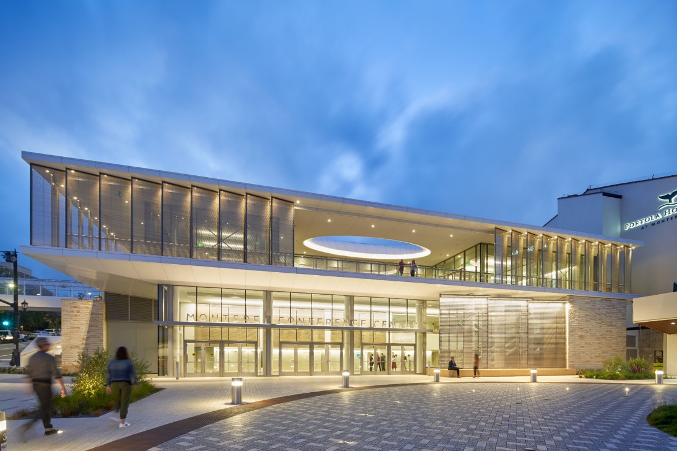
Monterey Conference Center and Portola Hotel & Spa at Monterey Bay

Accommodation
Participants are encouraged to stay at the Portola Hotel & Spa at Monterey Bay. The Aquarium has arranged a special group rate of $229 USD/ night (plus taxes and fees) for JWG participants. To make a reservation, please use this link or call hotel reservations at (+1) 866 711 1734. If making reservations by phone, please mention you are with the IATTC WCPFC Joint Working Group - Intersessional Meeting to access the group rate.

Participants are encouraged to make hotel reservations as soon as possible to access the special group rate. The Portola Hotel will accept reservations at the special group rate on a first-come, first served basis, and all reservations must be made by January 6, 2025.

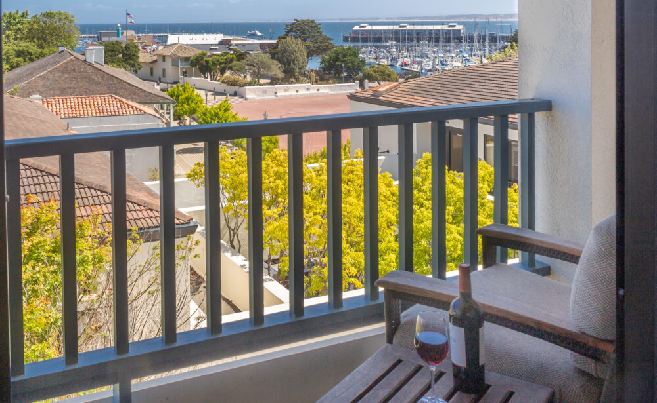
Portola Hotel overlooking the waterfront, Fisherman’s Wharf and the recreational trail

Hotel guest parking
Portola Hotel & Spa offers self- and valet parking. Overnight self-parking is $17.00; valet parking is $27.00 per night plus applicable taxes.

Transportation - Airports
Monterey is located approximately 120 miles south of San Francisco, CA, and can be accessed via three airports – see information below. Although it is possible to fly directly to Monterey, the flights may have more limited availability. Many travelers choose to fly into San Francisco or San Jose.

Airports:
- Monterey Regional Airport (MRY); 10 minutes from downtown.
- San Jose Mineta International Airport (SJC); 90 minutes to Monterey via shuttle bus or rental car.
- San Francisco International Airport (SFO): 120 minutes to Monterey via shuttle bus or rental car.

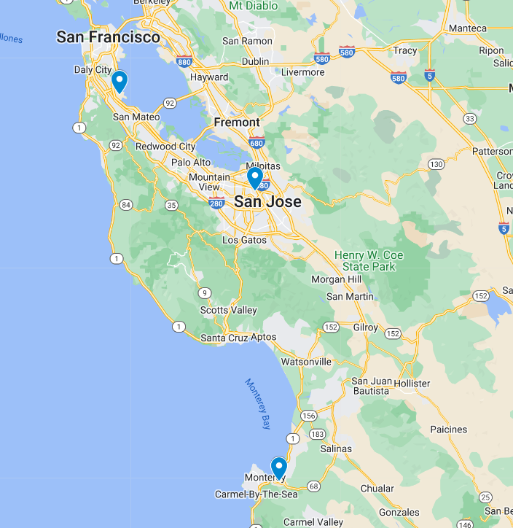
Locations of major airports (SFO, SJC, MRY)

Ground transportation
For those arriving at Monterey airport, you can take a taxi or ride app to downtown Monterey in approximately 12 minutes.

Groome Transportation provides convenient airport shuttle buses from San Francisco and San Jose airports and arrives in downtown Monterey within a short (2 block) walk to the hotel and conference center. The bus drops off and picks up from Monterey Shuttle Station, 438 Calle Principal, Monterey.

Alternatively, travelers can rent a car at any of the three airports, or you can utilize ride apps, such as Uber and Lyft, to travel to Monterey.

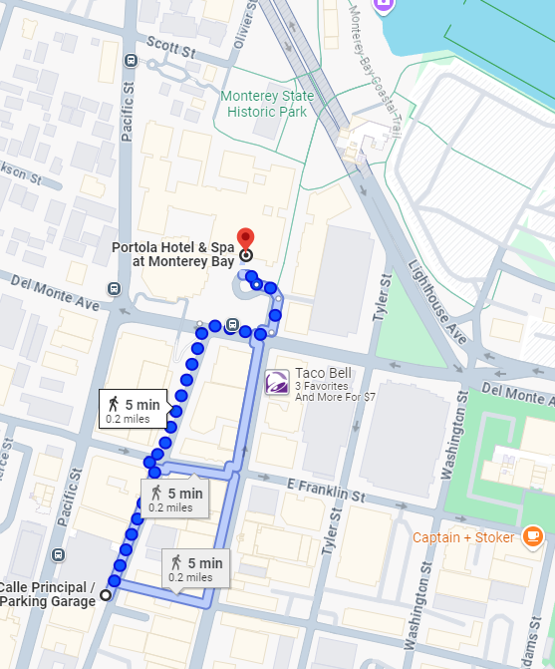
Map: Directions from Monterey airport shuttle stop to hotel

Visiting Monterey Bay Aquarium
The Aquarium is located approximately 1 mile from the hotel and conference center and can be accessed via bus, taxi or walking along the coastal trail.

Further information on opportunities for JWG participants to visit the Aquarium will be announced at the start of the meeting. For Monterey Bay Aquarium hours and location, visit https://www.montereybayaquarium.org/

Tourism information
For things to do while visiting Monterey and the surrounding area, visit:
Things to Do in Monterey | Find Parks, Shopping & Attractions (seemonterey.com)

For an interactive map of the area’s attractions, activities, and restaurants, visit:
https://www.portolahotel.com/destination-guide/interactive-map

Questions? Please contact the Aquarium at JWG@mbayaq.org

