

The Commission for the Conservation and Management of
Highly Migratory Fish Stocks in the Western and Central Pacific Ocean

Scientific Committee
NINETEENTH Regular Session

Koror, Palau
16-24 August 2023

OUTCOMES DOCUMENT

The Commission for the Conservation and Management of
Highly Migratory Fish Stocks in the Western and Central Pacific Ocean

SCIENTIFIC COMMITTEE
NINETEENTH REGULAR SESSION

Koror, Palau
16-24 August 2023

OUTCOMES DOCUMENT
WCPFC20-2023-SC19-01

AGENDA ITEM 1 — OPENING OF THE MEETING

Welcome address

Meeting arrangements

Issues arising from the Commission

Adoption of agenda

Reporting arrangements

Intersessional activities of the Scientific Committee

AGENDA ITEM 2 — REVIEW OF FISHERIES

Overview of Western and Central Pacific Ocean (WCPO) fisheries

Overview of Eastern Pacific Ocean (EPO) fisheries

Annual Report – Part 1 from Members, Cooperating Non-Members, and Participating Territories

Reports from regional fisheries bodies and other organizations

AGENDA ITEM 3 — DATA AND STATISTICS THEME

Data gaps

Data gaps of the Commission

Data gaps

SC19 noted the availability of the Annual Catch Estimate (ACE) template to facilitate the uploading of information to WCPFC databases and encouraged CCMs to consider using this voluntary template.

Updates on data-related projects

SC19 noted the progress on Projects 60 (Improved purse seine species composition), 90 (Better data on fish weights and lengths for scientific analysis), and 114 (Improving coverage of cannery receipt data) and supported the proposed workplans in those progress reports.

Minimum data reporting requirements

Operational longline data fields

SC19 acknowledged the scientific value of the additional longline operational data fields in Table ST-01 and recommended that these fields be considered for inclusion in the “Scientific Data to be Provided by the Commission (SciData)”.

However, SC19 noted broad implementation concerns of CCMs with respect to the collection of these data, recommended that TCC and the Regular Session of the Commission take account of these concerns, and suggested a possible option would be to include them as voluntary reporting items.

Table ST-01. Additional longline operational data fields for CPUE standardization and related analyses
DATA FIELD | Suggested PROTOCOL for data collection
Target species for the set | Record the primary target species, or group of species, for this set.
Number of lightsticks used in set | Record the total number of lightsticks used in the set.
Bait type used in set | Record the FAO code for type of bait used for the set. Example types:  - Squid (class Cephalopoda)  - Sardine or Pilchard (family Clupeidae)  - Mackerel (family Scombridae)  - Mixed Mackerel and Sardine …
Mainline length | Record the mainline length (in kilometres) used in the trip or set, as appropriate.
Length of branch line | Record the average length in metres of the branch lines in the trip or set. (The total length from the mainline to the hook).
Length of float line | Record the average length in metres of the float lines in the set. (The total length from the float to the mainline).
Vessel speed during setting | Record the average speed in knots of vessel during line setting.
Speed of the line setter | Record the speed in knots of the line setter (i.e. the line shooter speed).

Additional code for the ACTIVITY field

SC19 acknowledged that the proposal for the addition of a new activity code for any day when a "transhipment at sea occurs” would allow the WCPFC’s Scientific Services Provider (SSP) to define ‘trips’ within the operational data submitted to the Commission.

SC19 also noted the explanation from the SSP that aggregating the catch by species in the longline operational data at the trip level (when the trip is terminated by an at-sea transhipment) is fundamental for the validation processes using other independent sources of data (e.g. transhipment observers and carrier declarations) to provide more certainty in the data used in assessments and other work of the Commission.

SC19 recommended that this proposal be considered further by TCC and the Regular Session of the Commission.

Inconsistencies between SciData and CMM operational data reporting requirements

SC19 acknowledged the review by the WCPFC SSP of inconsistencies in the data reporting requirements between the Scientific Data to be Provided by the Commission (SciData), and other WCPFC reporting obligations (e.g., in CMMs)

This review identified a reporting requirement under CMM 2018-04 (Conservation and Management of Sea Turtles) that does not appear to be specifically covered in operational data requirements of the SciData (refer to CMM 2018-04 paragraph 5 (c) and 7(e)).

After discussion and consideration, SC19 noted that the reporting requirement under CMM 2018-04 does not explicitly require operational data. SC19 recommended that TCC19 consider whether it is necessary to clarify the reporting requirements in the CMM 2018-04, while noting the difficulty of logbook-based data collection for sea turtles.

Inconsistent reporting of Set Start Time

The SC19 working paper on the proposed Billfish Research Plan 2023 - 2027 (SC19-SA-WP-16) noted in a review of available operational data for future billfish research that, "…some fleets record time as ships time, others at UTC and some as country capital time. Clarifying this at a fleet level will be needed before this analysis can be completed with any certainty."

The SciData indicates that "the date of start of set and time of start of set: The date and start of set time should be GMT/UTC". Reporting date/time in the GMT/UTC standard is not a binding SciData requirement, so SC19 recommended that the WCPFC CCMs, with assistance from the WCPFC SSP where required, indicate:
- the date/time standard used in their historical operational data submissions to the Commission, and
- the date/time standard in their operational data, when they are submitted each year in the future.
Information to ensure the date/time standard is linked back to GMT/UTC shall also be provided.

Additional Billfish Species

SC19 noted the need for data on short-billed spearfish and sailfish catches, as highlighted in the Billfish Research Plan, and recommended that TCC19 determine how to best accommodate the inclusion of these two species into the Science Data to be Provided to the Commission.

FAD Data fields

SC19 recognised the scientific value of the PNA's proposal on “Minimum Data Fields to be Recorded by WCPFC Vessel Operators” (SC19-ST-WP-05).

Noting the current workload of observers, and some FAD data may be more effectively provided by vessel operators, SC19 agreed on the need for developing a FAD logbook for vessel operators as a priority.

SC19 noted that the PNA has developed the Standard Operating Procedures (SOPs) for the provision of FAD data by vessel operators for licensed vessels from January 2022 and IATTC have also adopted a FAD logbook, currently used for vessels operating in the EPO and in the overlap area. SC19 noted both could be used as the basis for discussion at FADMO-IWG.

SC19 recommended WCPFC20 considers this work be progressed intersessionally within the FADMO-IWG.

Frequent submission of operational catch and effort data

Bycatch estimates of longline fisheries

SC19 noted the following in relation to the updated estimates of longline bycatch:
  - Changes to the methodology now allow for uncertainty in the estimated hooks between floats (HBF) to propagate through uncertainty in estimated catches.
  - There continue to be difficulties in robust estimation of longline bycatch resulting in high uncertainty given the low levels and spatially imbalanced nature of observer coverage, and for some years the low coverage of data.
  - Earlier work suggests the trends in estimated catch rates are more reliable than the magnitude of the estimated catches.
  - Assuming a timely return of observer coverage to pre-COVID levels, that there will probably be sufficient observer data available to revise the catch rates models in the future.
  - A previous analysis (SC16-ST-IP-11) suggested that an observer coverage of at least 10 % of trips would allow for reasonably good estimates of bycatch, and that the increase in precision would be highest for species that are frequently caught, and weakest for rarely caught species, especially sea turtles and cetaceans.

SC19 noted that the adopted level of 5% observer coverage, which has been in place for over a decade, has not provided good estimates of longline bycatch. Therefore, SC19 recommended that the Commission explore options to expand the observer coverage on longline vessels through both human and electronic approaches in the WCPO so that the SC can provide better estimates of bycatch levels and other metrics from these fleets.

Regional Observer Programme

Review of observer training project for elasmobranch biological sampling (Project 109)

SC19 endorsed a no-cost extension of Project 109 to the end of December 2024.

ROP data issues

Electronic Reporting and Electronic Monitoring (ER and EM)

SC19 noted the report from the research project on EM monitoring transhipment that utilized a digital scale integrated to the onboard EM system to automatically store transmitted weights. SC19 welcomed such developments and recommended that the trials of EM on at-sea transhipment vessels should be continued.

Economic data

Baseline period or limit of the Indonesian Large Fish Handline Fishery

AGENDA ITEM 4 — STOCK ASSESSMENT THEME

Independent review of recent WCPO Yellowfin tuna assessment

SC19 noted the recommendations in the peer review of the 2020 WCPO yellowfin tuna stock assessment (SC19-SA-WP-01 Independent review of recent WCPO yellowfin tuna assessment), and recommended that, where practical, recommendations therein be considered for future bigeye and yellowfin tuna assessments, as well as other assessments as appropriate.

SC19 noted that regular and ongoing peer reviews are helpful for improving stock assessments.

Improvement of MULTIFAN-CL software

SC19 supported ongoing development of MULTIFAN-CL by the SSP but noted that the next generation of assessment models for tuna assessments in the WCPFC should be considered. SC19 noted that a TOR for work towards the development of the next generation of tuna assessment models was submitted to SC19.

WCPO tunas

4.3.1 WCPO yellowfin tuna (Thunnus albacares)

4.3.1.1 Research and information

Review of 2023 yellowfin tuna stock assessment

A. Magnusson (SPC-OFP) presented SC19-SA-WP-04 (Stock assessment of yellowfin tuna in the western and central Pacific Ocean: 2023), which describes the 2023 stock assessment of yellowfin tuna (Thunnus albacares) in the WCPO.

SC19 noted that the SSP had made significant improvements to the WCPO yellowfin tuna assessment based upon the recommendations from the 2022 peer review of the 2020 yellowfin tuna assessment, and from several CAPAM (Center for the Advancement of Assessment Modeling) meetings. Some key changes from the 2020 assessment include:
- Estimating natural mortality internally in the model.
- Reducing the spatial complexity from 9 regions to 5 regions.
- Using a Lorenzen functional form of natural mortality.
- Changing to a catch-conditioned model and estimating a likelihood for CPUE
- Revising the treatment of tagging data included in the model.
- Incorporating estimation uncertainty to the structural uncertainty grid.

4.3.1.2 Provision of scientific information

Stock status and trends

The 2023 WCPO yellowfin tuna assessment provides stock status based upon a 54-model structural uncertainty grid with four axes: steepness with three levels, tag mixing period with two levels, and size and age composition data with three levels each, as illustrated in table YFT-01. SC19 recommended that the proposed axes of uncertainty be accepted and that all models should be weighted equally. SC19 noted that an important improvement in the characterization of uncertainty was the inclusion of estimation uncertainty for each of the models in the grid.

SC19 noted that the most influential axis of uncertainty in the grid was steepness.

The spatial structure used in the 2023 stock assessment is shown in Figure YFT-01. SC19 noted that the simplification of the model from 9 regions to 5 regions improved the convergence of the model.

The time series of total annual catch by fishing gear over the full assessment period is shown in Figure YFT-02. The time series of total annual catch by fishing gear and assessment region is shown in Figure YFT-03. Estimated annual average recruitment, spawning potential, and total biomass by model region is shown in Figure YFT-04. Estimated trends in spawning potential depletion (SB/SB_{F=0}) for the 54 models in the structural uncertainty grid is shown in Figure YFT-05, and juvenile and adult fishing mortality rates from the diagnostic model is shown in Figure YFT-06. Estimates of the reduction in spawning potential due to fishing by region are shown in Figure YFT-07. Estimated trends in spawning potential for the 54 models are shown in Figure YFT-08. A Majuro and Kobe plot summarizing the results for each of the 54 models in the structural uncertainty grid are shown in Figure YFT-09. A comparison of the dynamic MSY for the diagnostic model compared with annual catch by the main gear types are shown in Figure YFT-10.

SC19 noted that the preliminary estimate of total catch of WCPO yellowfin tuna for 2022 was 721,169 mt which was lower than the 2021 level. Longline catch in 2022 (84,232 mt) was higher than the 2021 catch, but lower than the recent 10-year average. Purse-seine catch in 2022 (379,715 mt) was similar to the 2021 catch, and higher than the recent 10-year average (Figure YFT-02).

The 2023 WCPO yellowfin tuna stock assessment median depletion from the model grid for the recent period (2018–2021; SB_{recent}/SB_{F=0}) was estimated at 0.47 (10th to 90th percentile interval of 0.42 to 0.52, including estimation and structural uncertainty). For all models in the grid SB_{recent}/SB_{F=0} was above the biomass limit reference point. The recent median fishing mortality (2017–2020; F_{recent}/F_{MSY}) was 0.50 (10th to 90th percentile interval of 0.41 to 0.62, including estimation and structural uncertainty, Table YFT-02). For all models in the grid, F_{recent}/F_{MSY} was less than one.

SC19 noted that the spawning potential of the stock has become more depleted across all model regions until around 2010, after which it has become more stable, or shown a slight increase.

SC19 also noted that average fishing mortality rates for juvenile and adult age-classes have increased throughout the period of the assessment, although more so for juveniles which have experienced considerably higher fishing mortality than adults. In the recent period (2015-2021), a sharp increase in juvenile fishing mortality was estimated, while adult fishing mortality stabilized.

Table YFT-01: Summary of reference points over the 54 individual models in the structural uncertainty grid, along with results incorporating estimation uncertainty (Table 5 from SC19-SA-WP-04).
 | mean | median | min | 10%ile | 90%ile | max | diagnostic model
C_{latest} | 751657 | 751856 | 750785 | 750860 | 752268 | 752337 | 751908
F_{MSY} | 0.07 | 0.07 | 0.06 | 0.06 | 0.09 | 0.09 | 0.07
F_{mult} | 1.96 | 2.00 | 1.47 | 1.64 | 2.38 | 2.50 | 1.89
F_{recent}/F_{MSY} | 0.51 | 0.50 | 0.40 | 0.42 | 0.61 | 0.68 | 0.53
MSY | 697874 | 700400 | 616800 | 644320 | 739560 | 771600 | 671600
SB₀ | 5761796 | 5729000 | 4455000 | 4817200 | 6640900 | 7279000 | 5216000
SB_{F=0} | 5633743 | 5603267 | 4624645 | 4907798 | 6280841 | 6825888 | 5173954
SB_{latest}/SB₀ | 0.49 | 0.50 | 0.41 | 0.44 | 0.54 | 0.56 | 0.49
SB_{latest}/SB_{F=0} | 0.50 | 0.50 | 0.41 | 0.45 | 0.55 | 0.58 | 0.49
SB_{latest}/SB_{MSY} | 2.49 | 2.48 | 1.78 | 1.91 | 3.11 | 3.16 | 2.44
SB_{MSY} | 1177733 | 1160500 | 740400 | 838260 | 1538200 | 1707000 | 1044000
SB_{MSY}/SB₀ | 0.20 | 0.20 | 0.17 | 0.17 | 0.23 | 0.24 | 0.20
SB_{MSY}/SB_{F=0} | 0.21 | 0.21 | 0.16 | 0.17 | 0.24 | 0.25 | 0.20
SB_{recent}/SB_{F=0} | 0.47 | 0.47 | 0.38 | 0.42 | 0.52 | 0.54 | 0.46
SB_{recent}/SB_{MSY} | 2.31 | 2.30 | 1.68 | 1.77 | 2.89 | 2.94 | 2.27
Y_{Frecent} | 157188 | 155300 | 141400 | 145150 | 172270 | 173300 | 152500
Including estimation uncertainty:
 | mean | median | min | 10%ile | 90%ile | max
SB_{recent}/SB_{F=0} | 0.47 | 0.47 | 0.36 | 0.42 | 0.52 | 0.59
F_{recent}/F_{MSY} | 0.51 | 0.50 | 0.26 | 0.41 | 0.62 | 0.78
SB_{recent}/SB_{MSY} | 2.31 | 2.28 | 0.93 | 1.73 | 2.95 | 3.59

Table YFT-02: Structural uncertainty grid for the 2023 WCPO yellowfin tuna stock assessment. Bold values indicate settings for the diagnostic model (Table 3 from SC19-SA-WP-04).
Axis | Levels | Option 1 | Option 2 | Option 3
Steepness | 3 | 0.65 | 0.8 | 0.95
Tag mixing (# quarters) | 2 | 1 | 2
Size data weighting divisor | 3 | 10 | 20 | 40
Age data weighting | 3 | 0.5 | 0.75 | 1

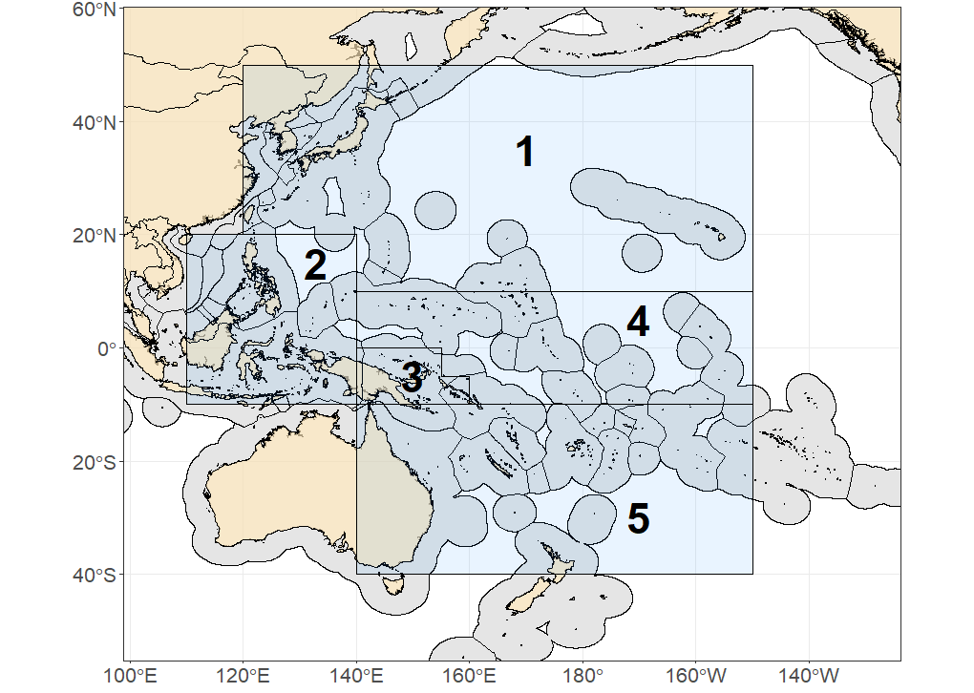

Figure YFT-01: The geographical area covered by the stock assessment and the boundaries of the model regions for the 5-region structure that was used for 2023 WCPO yellowfin tuna assessment (Figure 1a from SC19-SA-SP-04).

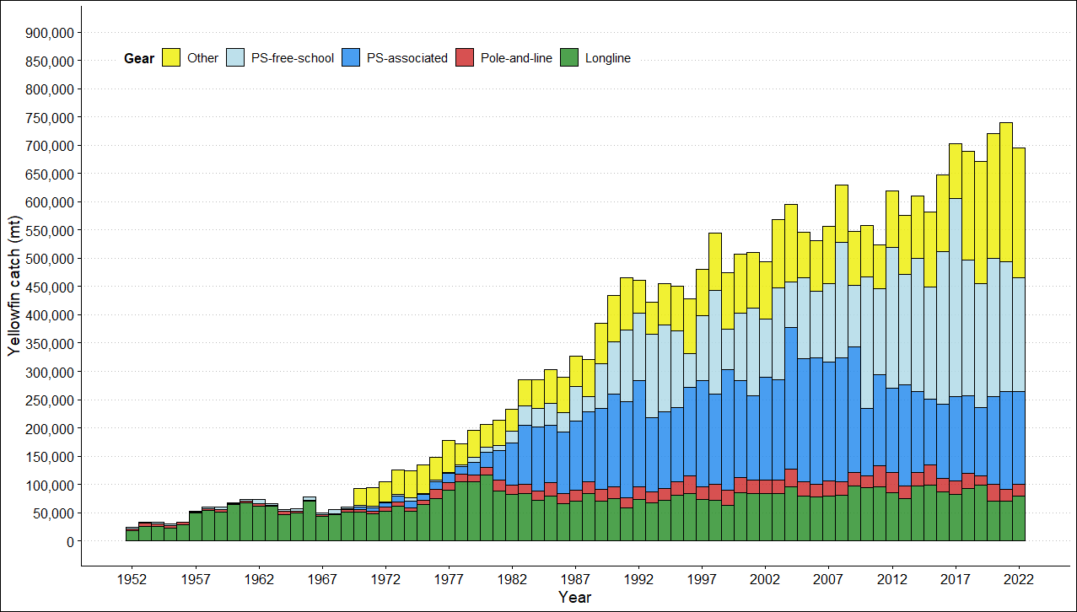
Figure YFT-02: Annual catches of yellowfin by gear type in the WCPO area covered by the assessment (Figure 3 from SC19-SA-WP-04).

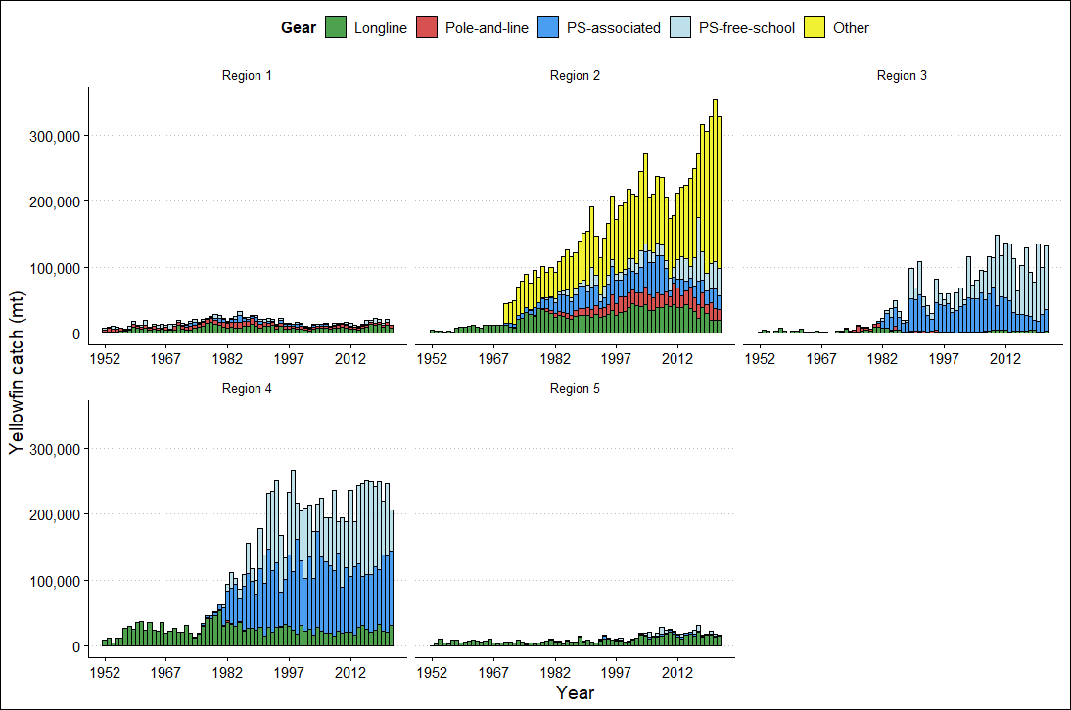
Figure YFT-03: Annual catches of yellowfin by gear type for each of the five model regions (Figure 4 from SC19-SA-WP-04).
Figure YFT-04: Time series of estimated annual spawning potential, recruitment and total biomass by model region for the diagnostic model, showing the relative proportions among regions. Note the data represent the averages of the quarterly model time steps for each year for spawning potential and total biomass and the sum of the quarterly recruitment estimates for annual recruitment (Figure 45 from SC19-SA-WP-04).

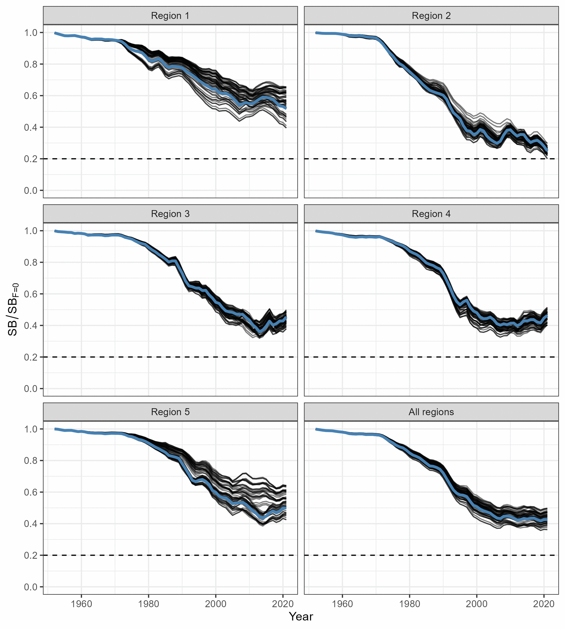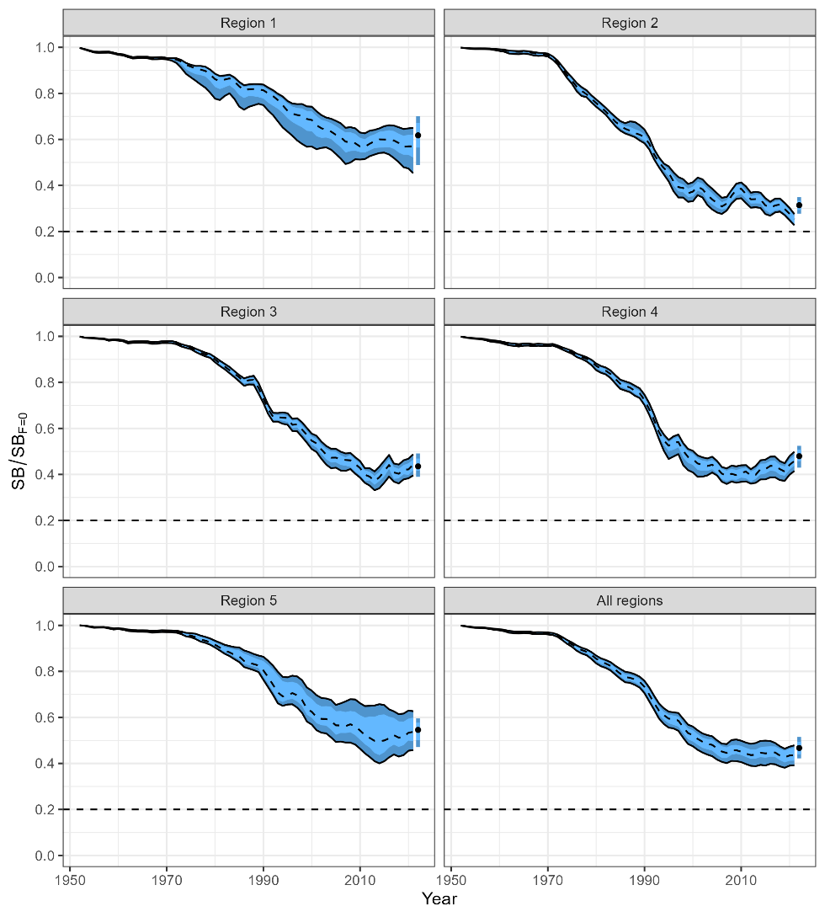
Figure YFT-05: (Left) Trajectories of spawning potential depletion for the individual model runs included in the structural uncertainty grid over the period 1952-2021. (Right) Estimated spawning depletion across all models in the structural uncertainty grid over the period 1952-2021. The dashed line represents the median, the lighter band shows the 25th and 75th percentiles, and the dark band shows the 10th and 90th percentiles of the model estimates. The bar at the right of each ribbon indicates the median (black dots) with the 10th and 90th percentiles for SB_{recent}/SB_{F=0} (Figure 59 from SC19-SA-WP-04).

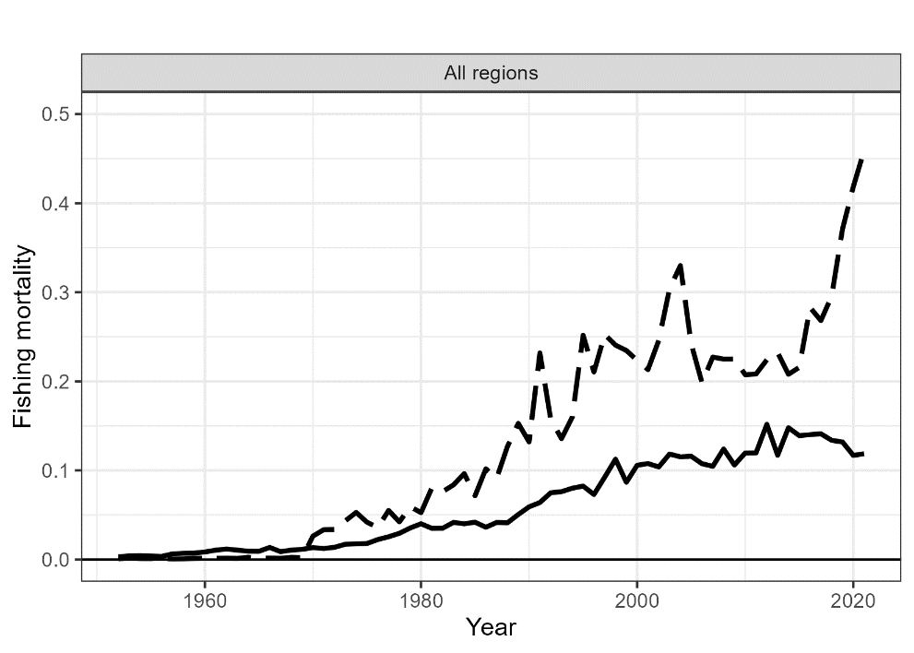
Figure YFT-06: Estimated annual average adult (solid line) and juvenile (dashed line) fishing mortality for the diagnostic model (Figure 50 from SC19-SA-WP-04).

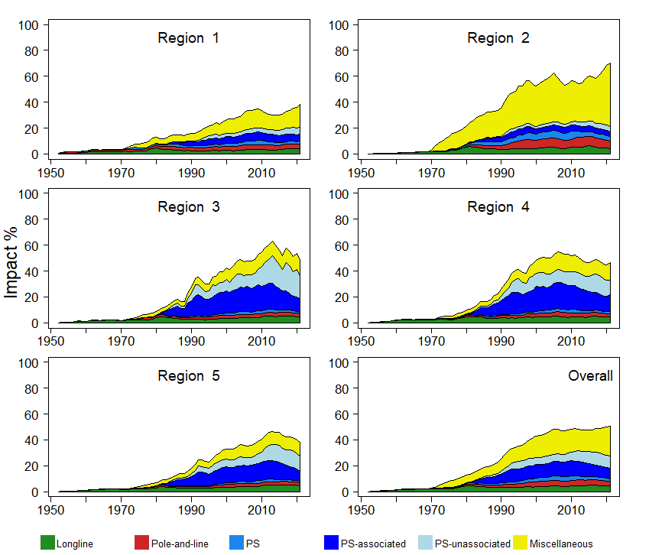
Figure YFT-07: Estimates of reduction in spawning potential due to fishing (Fishery Impact = 1− SB_{t}/SB_{t,F=0}) by region, and over all regions (lower right panel), attributed to various fishery groups for the diagnostic model (Figure 66 from SC19-SA-WP-04).

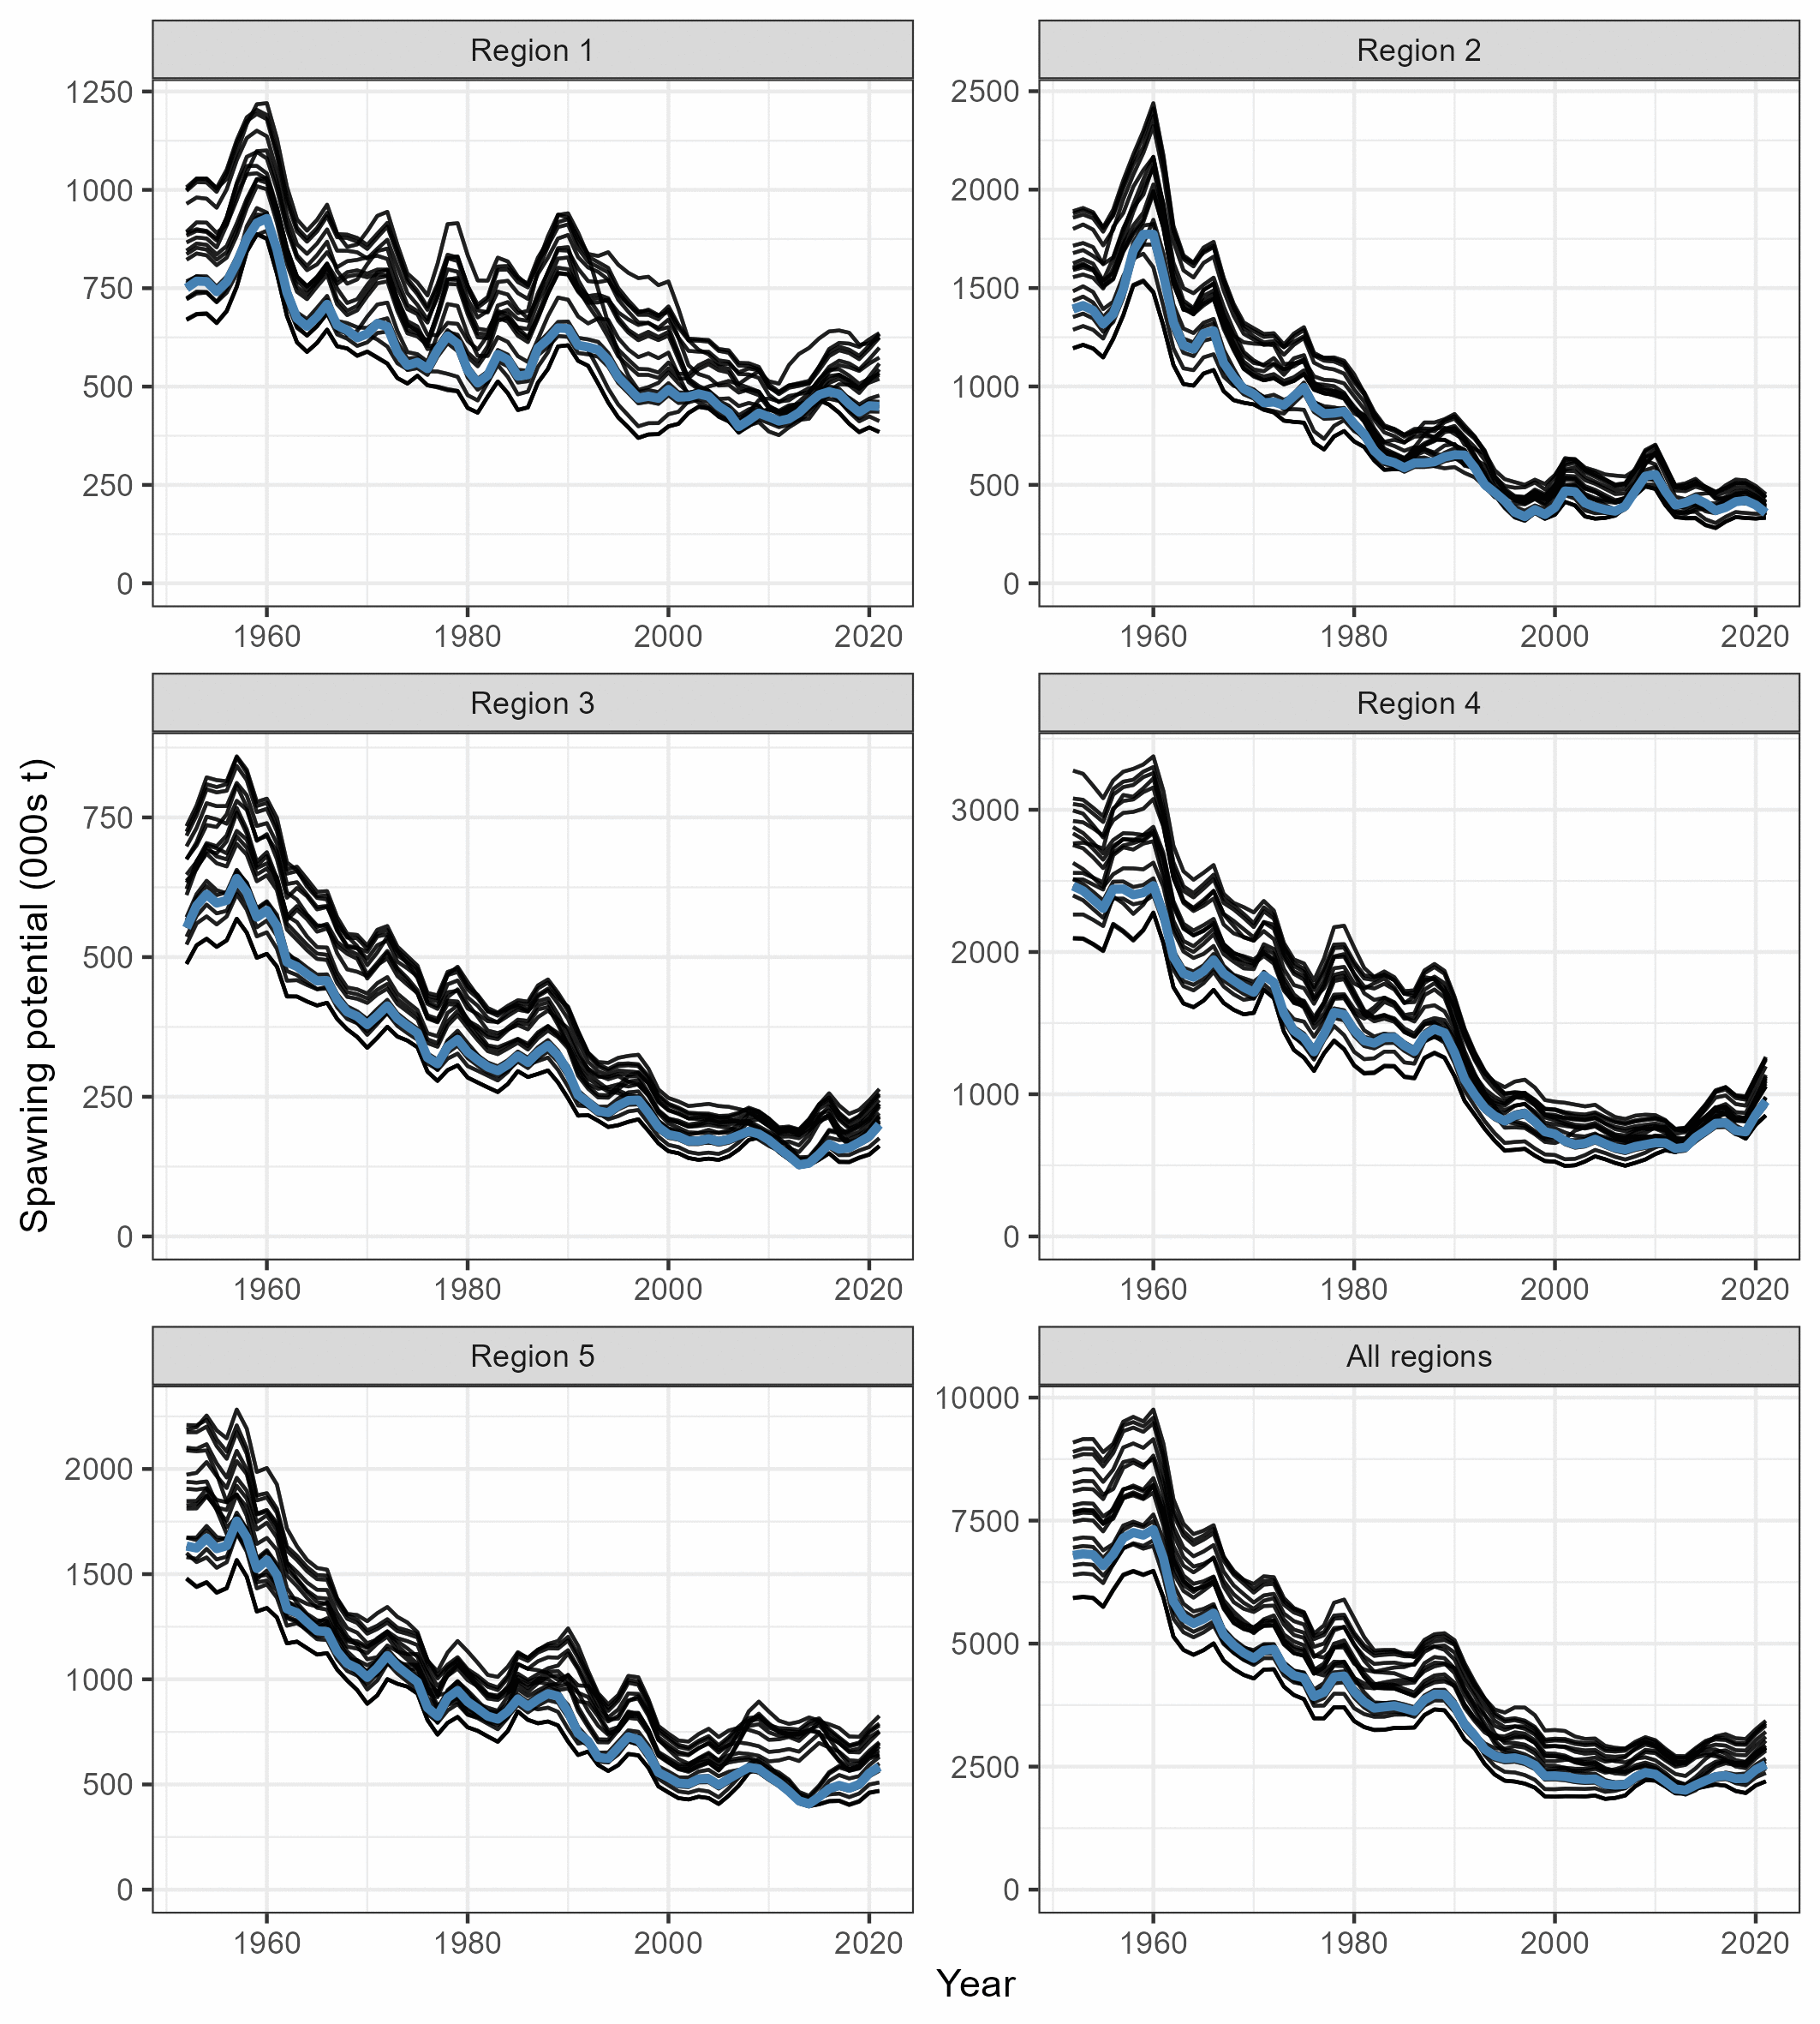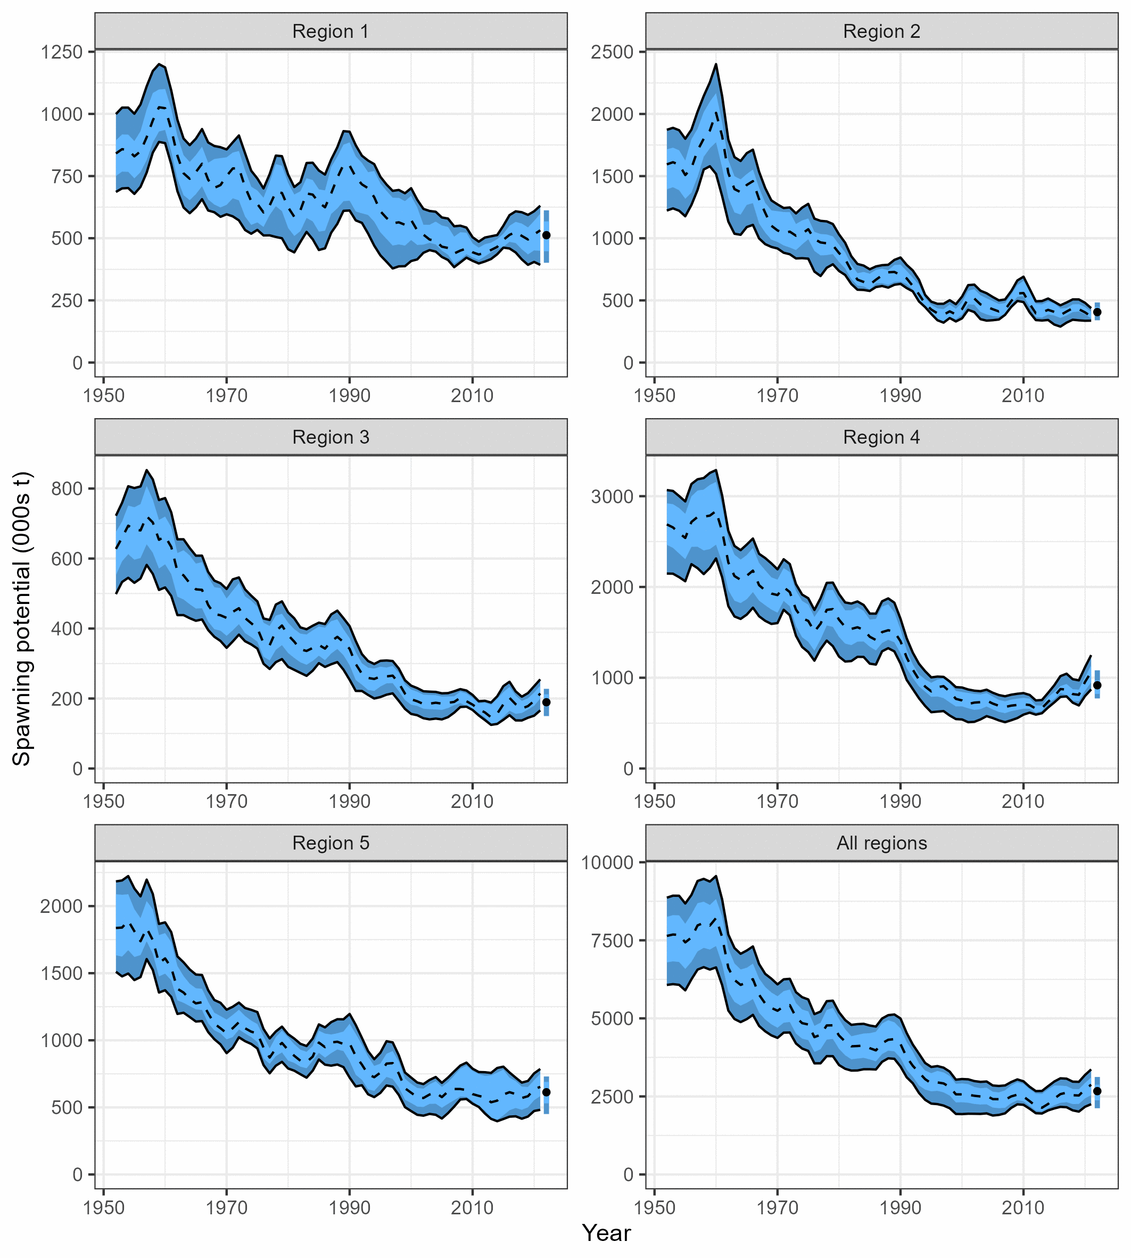
Figure YFT-08: (Left) Trajectories of spawning potential for the individual model runs included in the structural uncertainty grid over the period 1952-2021. (Right) Estimated spawning potential across all models in the structural uncertainty grid over the period 1952-2021. The dashed line represents the median, the lighter band shows the 25th and 75th percentiles, and the dark band shows the 10th and 90th percentiles of the model estimates. The bar at the right of each ribbon indicates the median (black dots) with the 10th and 90th percentiles for SB_{recent} (Figure 60 from SC19-SA-WP-04).

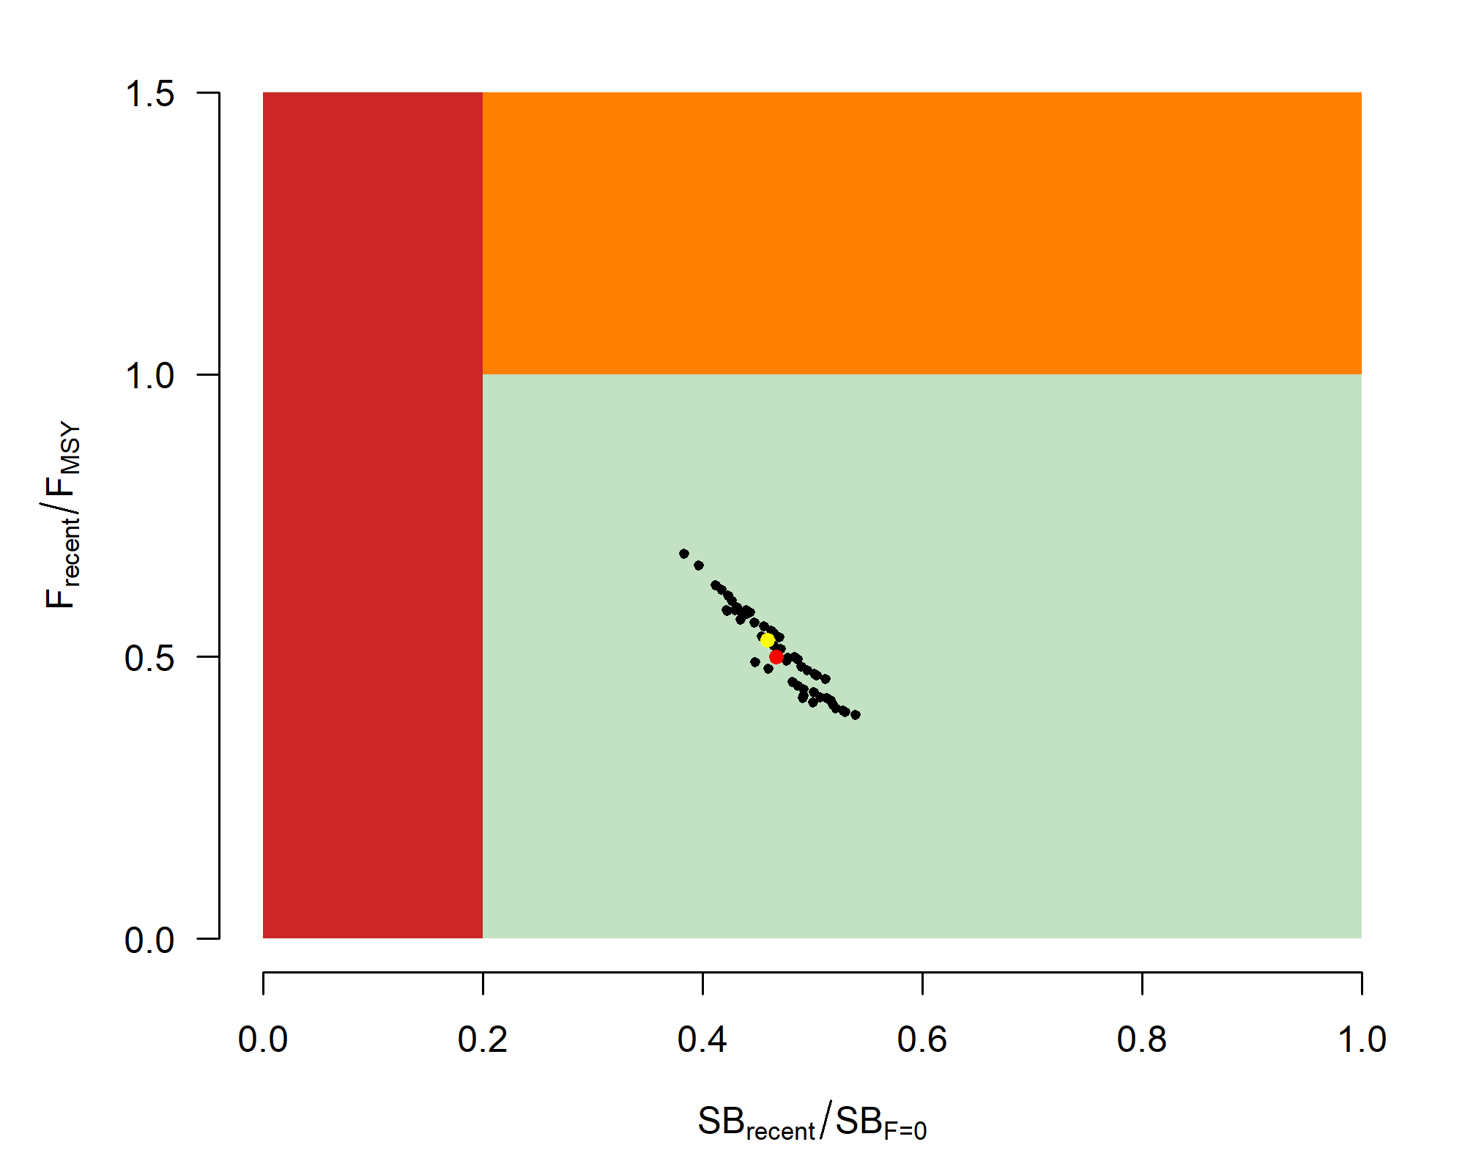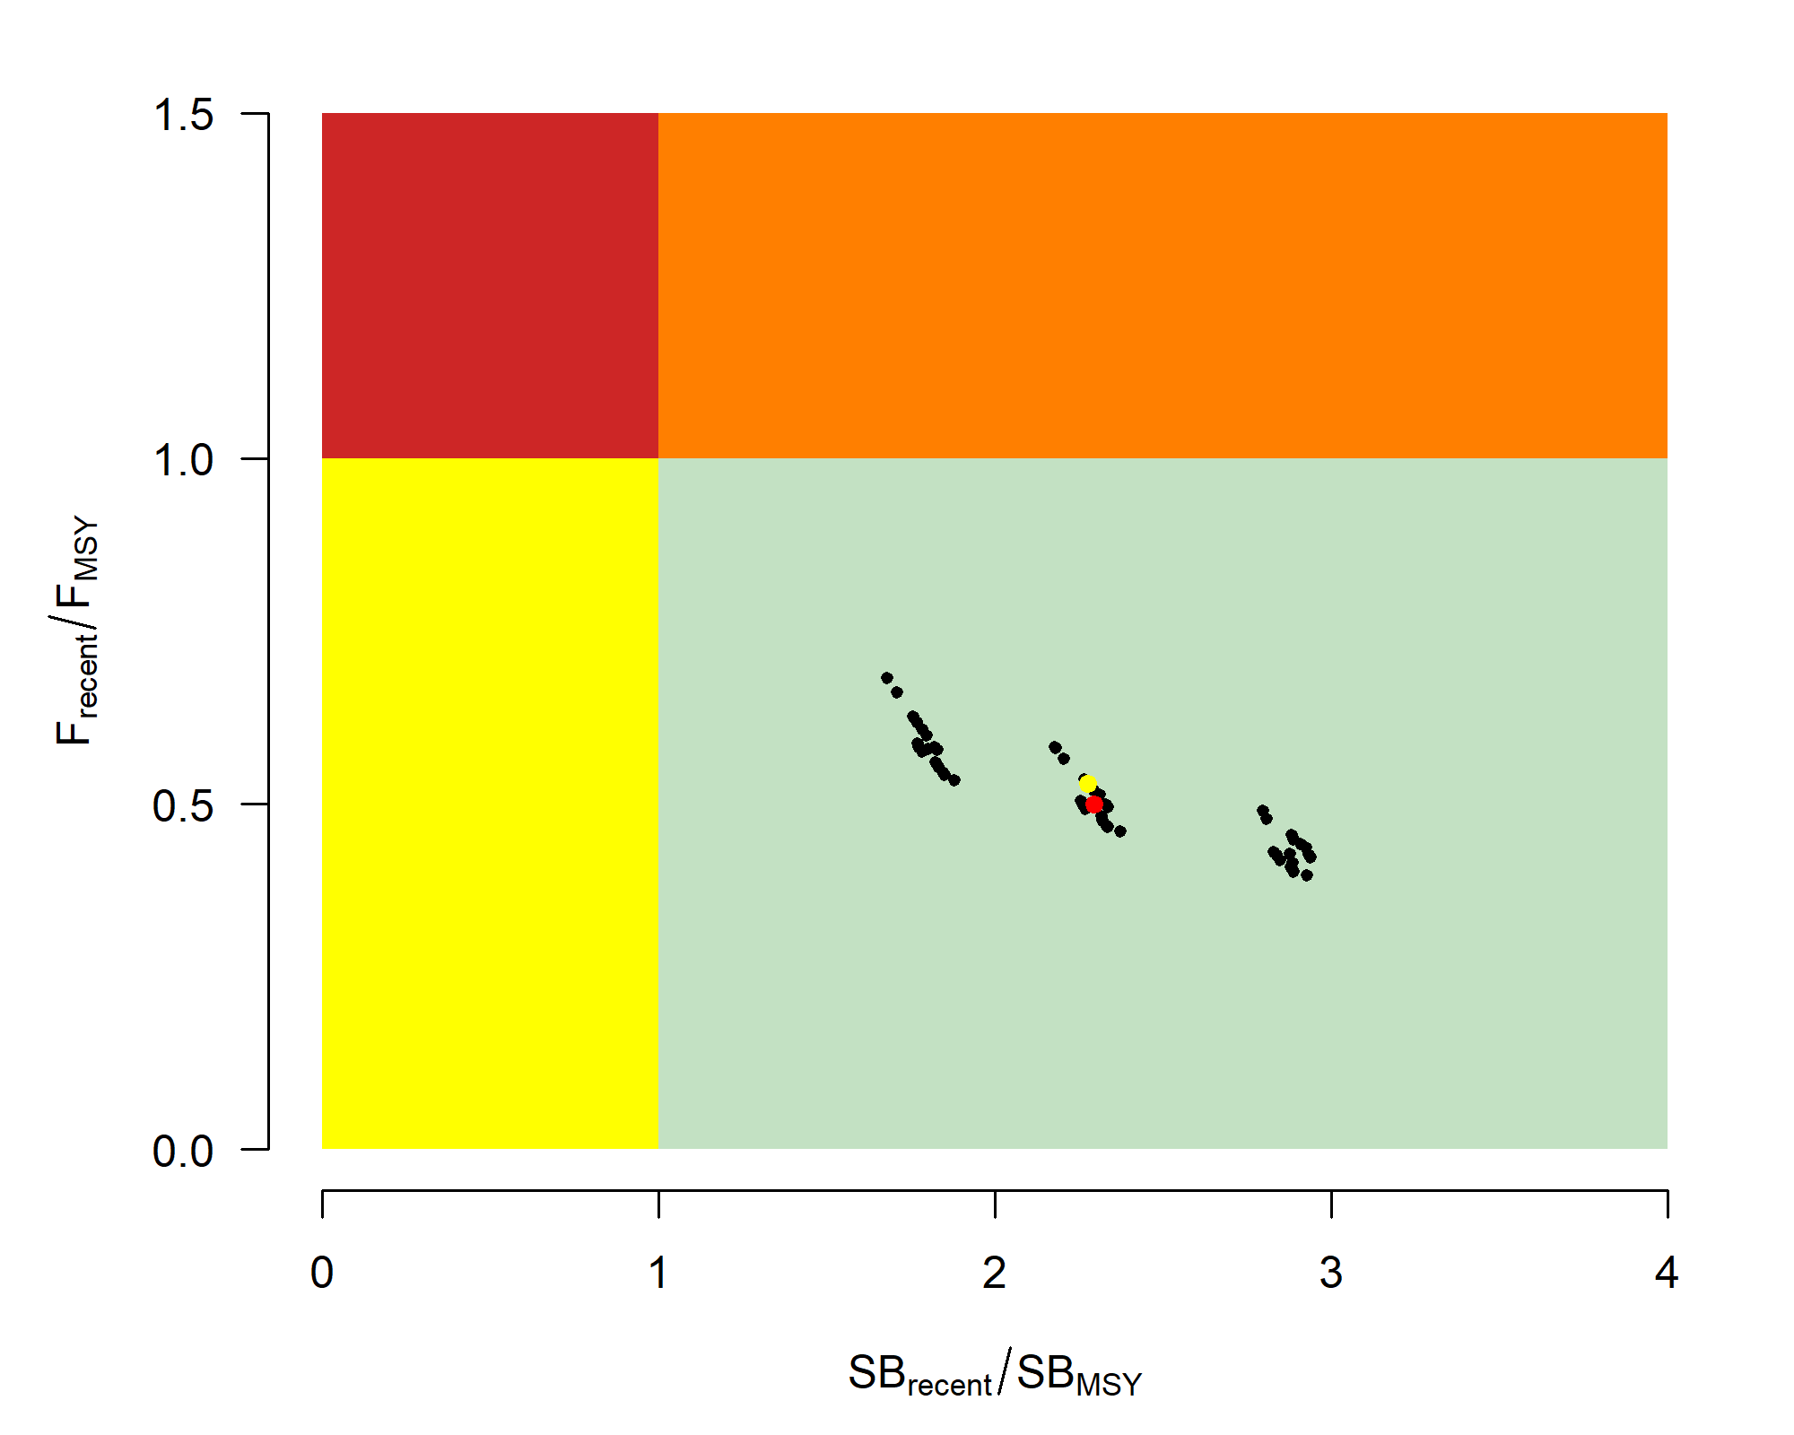

Figure YFT-09: Majuro plot (top) and Kobe plot (bottom) summarising the results for each of the models in the structural uncertainty grid for the recent period (2018-2021). The yellow point is the 2023 diagnostic model and the red point is the median (Figure 64 from SC19-SA-WP-04).
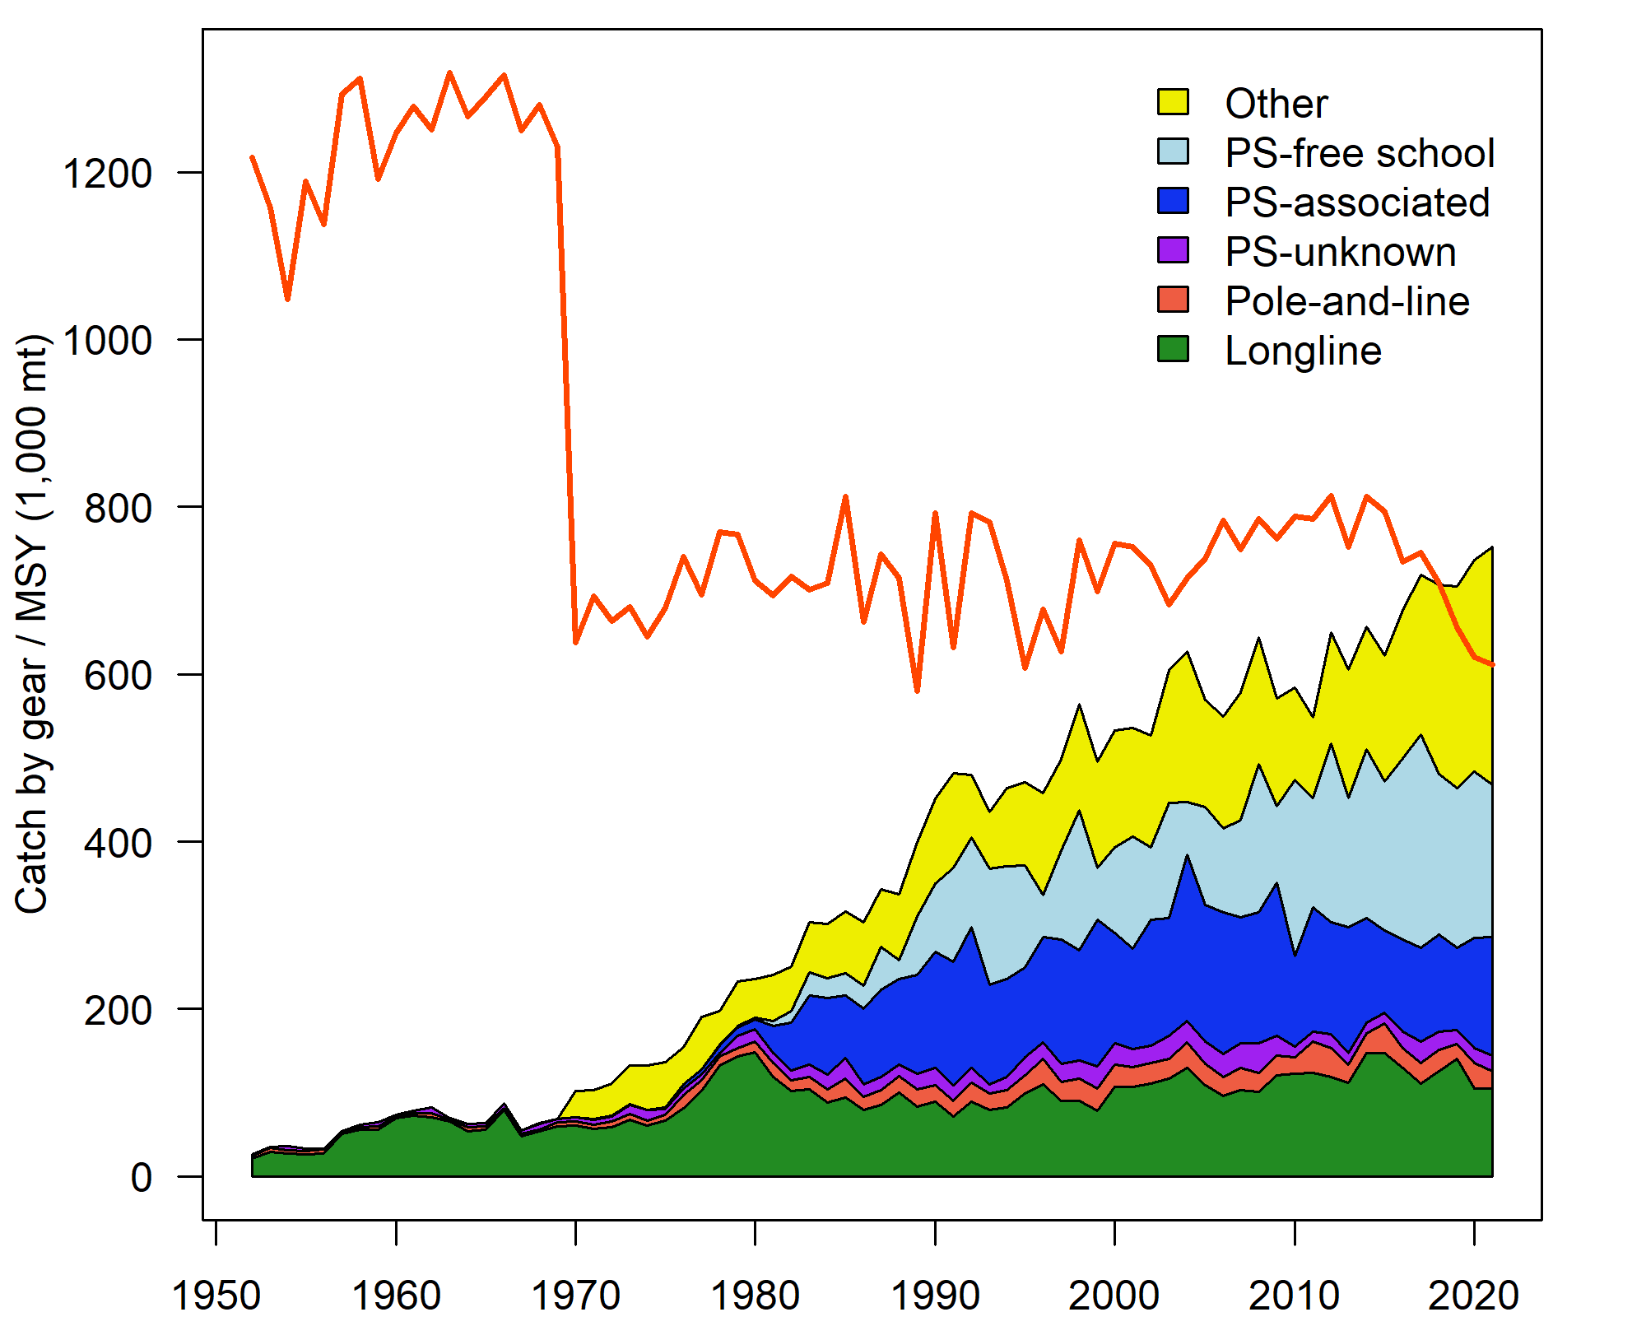
Figure YFT-10: History of the annual estimates of MSY (red line) for the diagnostic model compared with annual catch by the main gear types. Note that this is a ‘dynamic’ MSY (Figure 68 from SC19-SA-WP-04).

Management advice and implications

The WCPO yellowfin tuna spawning biomass is above the LRP and recent F is below F_{MSY} based on the uncertainty grid, The stock is not experiencing overfishing (100% probability F_{recent}<F_{MSY}) and is not in an overfished condition (0% probability SB_{recent}/SB_{F=0}<LRP).

The objective for yellowfin tuna in CMM 2021-01 (the Tropical Tuna Measure) to maintain the spawning biomass depletion ratio at or above the average SB/SB_{F=0} for 2012-2015 is being achieved. SB_{recent}/SB_{F=0} (47%) exceeds the average SB/SB_{F=0} for 2012-2015 (44% calculated across the unweighted grid).

SC19 recommends stochastic projections based on the adopted yellowfin tuna grid be undertaken by the SSP and provided to the Commission for their consideration.

The interim objective for the yellowfin tuna stock under CMM 2022-01 is to maintain the depletion level of the stock at or above the average SB/SB_{F=0} for 2012-2015 and the recent depletion level of yellowfin tuna is close to the interim objective. SC19 noted that while the projection results based on the 2023 yellowfin tuna assessment were not available for SC19 to review, this information will be available when for the 4th tropical tuna management workshop and will provide the Commission guidance on future expected levels of fishing mortality and the outcomes relative to the interim or future management objectives.

SC19 also noted a continuous downward trend in spawning potential ratio over the recent decade in Region 2 in the westernmost equatorial region, mainly due to the miscellaneous gear fisheries within this region, whereas other regions have been relatively stable over this period. This is the impact of artisanal (small-scale) fisheries other than longline and purse seine within this region. SC19 recommends that the Commission note the need for clear limits for these.

SC19 also noted that there is evidence that the overall stock status is buffered with spawning biomass kept at a more elevated level overall by low exploitation in the temperate regions (1 and 5). The assessment model estimates spawning biomass to be divided between the tropical (59%) and temperate (41%) regions, but the vast majority of catch occurred in the tropical (94%) region.

Research recommendations

SC19 noted several research recommendations for the further development and improvement of the WCPO yellowfin tuna assessment:
  - Exploration into the conflict between the length and weight composition data; if unresolved this conflict should be reflected within future structural uncertainty grids;
  - Exploration of a simplification of the spatial structure by using a single area, with “areas-as-fleets”;
  - Exploration of alternative approaches to modeling of tagging data, including consideration of the most appropriate mixing periods for different regions and development of stand-alone tagging (mark-recapture) models;
  - Exploration of which parameters are most sensitive to initial model starting values, and taking steps to reduce the impact of starting values on the results in future assessments; this could include simplification of models and/or systematic use of jittering;
  - Further research to improve estimates of catches (both historical and recent) in the fisheries of Indonesia, the Philippines and Vietnam through the continued funding of the WPEA monitoring project;
  - An exploration of seasonal and regional growth traits for the stock assessment;
  - A study on longline CPUE standardization process considering effort creep; and
  - Developing alternative CPUE scenarios with different implied regional weightings.

4.3.2 WCPO bigeye tuna (Thunnus obesus)

4.3.2.1 Research and information

Review of 2023 bigeye tuna stock assessment

J. Day (SPC-OFP) presented SC19-SA-WP-05 (Stock assessment of bigeye tuna in the western and central Pacific Ocean), which described the 2023 stock assessment of bigeye tuna Thunnus obesus in the WCPO.

SC19 thanked the SSP for the thorough work conducted on the WCPO bigeye stock assessment and for the considerable efforts to improve the assessment and to incorporate the recommendations from SC18 and the 2022 yellowfin tuna peer review.

SC19 noted that the 2023 bigeye stock assessment applied a more rigorous approach, including randomized initial parameter analyses, i.e., “jittering” and achieving a positive definite Hessian for the diagnostic model, however, model instability appears to remain.

SC19 noted that the changes in the modelling of the bigeye tuna stock in the WCPO indicate that the assessment results are slightly less optimistic than the 2020 assessment.

SC19 accepted the 2023 WCPO bigeye tuna stock assessment with a 9-region spatial structure (Figure BET-01) and adopted the full unweighted grid in Table BET-01 to provide stock status and management advice, however, future projection results were not provided at SC19. SC19 recommended that those stock projection analyses to be provided for the Commission consideration for management advice prior to the Commission meeting.

Given the similarity in stock status as presented to SC16, some CCMs preferred to re-iterate the advice from SC16 that WCPFC20 could continue to consider measures to reduce fishing mortality from fisheries that take juveniles, with the goal to increase adult bigeye fishery yields and reduce any further impacts on the spawning biomass for this stock. Other CCMs considered that this advice was unclear and had previously been misinterpreted, noting that the SC had previously agreed not to advise the Commission to take measures to reduce mortality in fisheries that take juvenile bigeye tuna. The aforementioned CCMs did not share this observation.

4.3.2.2 Provision of scientific information

Stock status and trends

The 2023 WCPO bigeye tuna assessment provides stock status based upon a 54-model structural uncertainty grid with four axes: steepness with three levels, tag mixing period with two levels, and size and age composition data with three levels each, as illustrated in Table BET-01. SC19 recommended that the proposed axes of uncertainty be accepted and that all models should be weighted equally. The SC19 noted that an important improvement in the structural uncertainty grid was the inclusion of estimation uncertainty for each of the models in the grid.

SC19 noted that the most influential axes of uncertainty in the grid were steepness and tag mixing period.

The spatial structure used in the 2023 stock assessment is shown in Figure BET-01. Time series of total annual catch by fishing gear over the full assessment period is shown in Figure BET-02. The time series of total annual catch by fishing gear and assessment region is shown in Figure BET-03. Estimated annual spawning potential, average recruitment, and total biomass by model region is shown in Figure BET-04. Estimated trend in spawning potential depletion (SB/SB_{F=0}) for the 54 models in the structural uncertainty grid is shown in Figure BET-05, and juvenile and adult fishing mortality rates from the diagnostic model is shown in Figure BET-06. Estimates of the reduction in spawning potential due to fishing by region are shown in Figure BET-07. A comparison of the dynamic MSY for the diagnostic model compared with annual catch by the main gear types are shown in Figure BET-08, and estimated age specific fishing mortality for the diagnostic model, by region and overall are in Figure BET-09.

SC19 noted that the preliminary estimate of total catch of WCPO bigeye tuna for 2022 was 140,664 mt which was similar to the 2021 level. Longline catch in 2022 (54,800 mt) was similar to the 2021 catch and lower than the recent ten-year average and understood to be partly due to the impacts of the COVID-19 pandemic. Purse-seine catch in 2022 (62,811 mt) was also similar to the 2021 catch, and lower than the recent ten-year average (Figure BET-02).

The 2023 WCPO bigeye tuna stock assessment median depletion from the model grid for the recent period (2018-2021; SB_{recent}/SB_{F=0}) was 0.35 (10th to 90th percentile interval of 0.30 to 0.40, including estimation and structural uncertainty, Table BET-02). For all models in the grid SB_{recent}/SB_{F=0} was above the biomass limit reference point. The recent median fishing mortality (2017-2020; F_{recent}/F_{MSY}) was 0.59 (10th to 90th percentile interval of 0.46 to 0.74, including estimation and structural uncertainty, Table BET-02). For all models in the grid, F_{recent}/F_{MSY} was less than one.

SC19 noted that the results show that both total and spawning potential has been continuously declining since the late 1950s through until the mid-1970’s, followed by a more gradual decline through to the present (Figure BET-04).

SC19 noted that the catch in the last year of the assessment (2021) was less than the median MSY (164,640 mt), which is a 17% increase in the estimated MSY for bigeye tuna from the 2020 stock assessment (140,720 mt).

Majuro (Figure BET-10) and Kobe (Figure BET-11) plots show that the stock status estimates across the 54 models are all within plot zones that indicate that the stock is not overfished nor undergoing overfishing.

Table BET-01. Description of the updated structural sensitivity grid used to characterize uncertainty in the assessment with bolded values indicating the diagnostic case (Table 3 from SC19-SA-WP-05).
Axis | Value 1 | Value 2 | Value 3
Steepness | 0.65 | 0.8 | 0.95
Tag mixing (# quarters) | 1 | 2
Size data weighting divisor | 10 | 20 | 40
Age data weighting | 0.5 | 0.75 | 1

Table BET-02. Summary of reference points over the 54 models in the structural uncertainty grid. Note that “recent” is the average over the period 2018-2021 for SB and fishing mortality, while “latest” is 2021. The values of the upper 90th and lower 10th percentiles of the empirical distributions are also shown. F_{mult} is the multiplier of recent (2018-2021) fishing mortality required to produce MSY (Table 5 from SC19-SA-WP-05).
 | Mean | Median | Minimum | 10th percentile | 90th percentile | Maximum
C_{latest} | 139,314 | 139,199 | 138,527 | 138,947 | 139,939 | 140,347
Y_{Frecent} | 37,982 | 37,805 | 33,400 | 34,365 | 42,369 | 42,980
F_{MSY} | 0.06 | 0.06 | 0.04 | 0.04 | 0.07 | 0.08
F_{mult} | 1.69 | 1.67 | 2.27 | 2.17 | 1.35 | 1.22
MSY | 162,248 | 164,640 | 137,920 | 143,112 | 180,820 | 184,440
F_{recent}/F_{MSY} | 0.59 | 0.59 | 0.37 | 0.46 | 0.74 | 0.99
SB_{F=0} | 1,952,050 | 1,921,715 | 1460,378 | 1,612,630 | 2,356,598 | 2,561,690
SB_{MSY} | 393,037 | 376,300 | 225,100 | 277,230 | 534,330 | 595,900
SB_{MSY}/SB_{F=0} | 0.20 | 0.20 | 0.15 | 0.17 | 0.23 | 0.24
SB_{latest}/SB_{F=0} | 0.34 | 0.34 | 0.27 | 0.30 | 0.38 | 0.40
SB_{latest}/SB_{MSY} | 1.76 | 1.77 | 1.16 | 1.28 | 2.31 | 2.46
SB_{recent}/SB_{F=0} | 0.35 | 0.35 | 0.28 | 0.31 | 0.40 | 0.41
SB_{recent}/SB_{MSY} | 1.82 | 1.83 | 1.20 | 1.32 | 2.38 | 2.54
Including estimation uncertainty
 | Mean | median | min | 10%ile | 90%ile | max
SB_{recent}/SB_{F=0} | 0.35 | 0.35 | 0.25 | 0.30 | 0.40 | 0.46
F_{recent}/F_{MSY} | 0.59 | 0.59 | 0.37 | 0.46 | 0.74 | 0.99
SB_{recent}/SB_{MSY} | 1.82 | 1.79 | 0.94 | 1.32 | 2.41 | 2.96

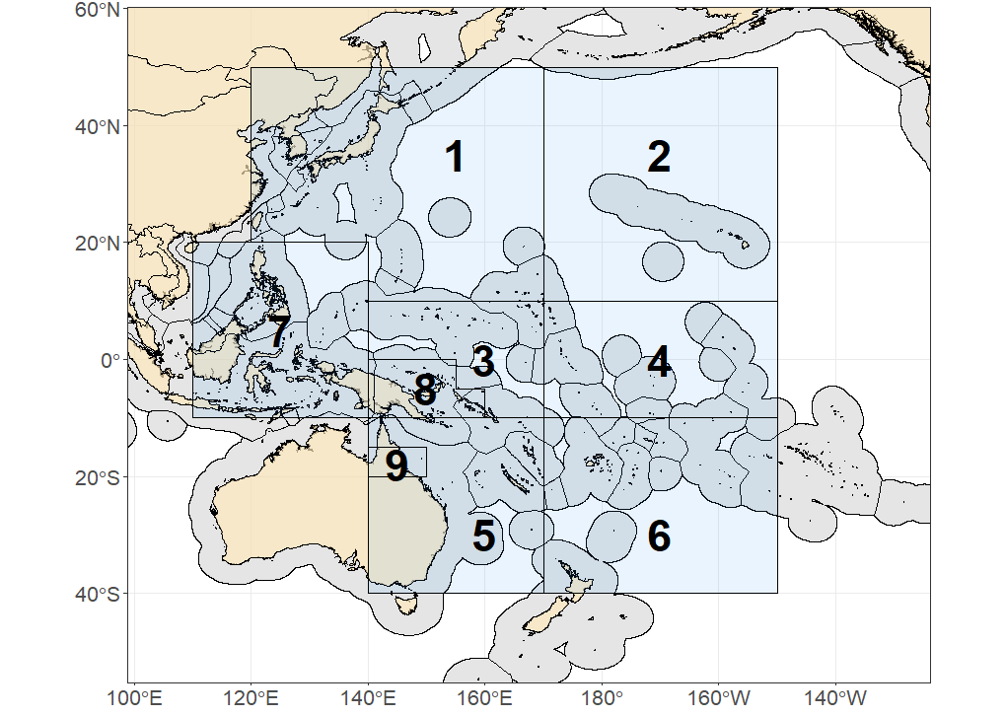

Figure BET-01. Spatial structure for the 2023 bigeye tuna stock assessment (Figure 1 from SC19-SA-WP-05).

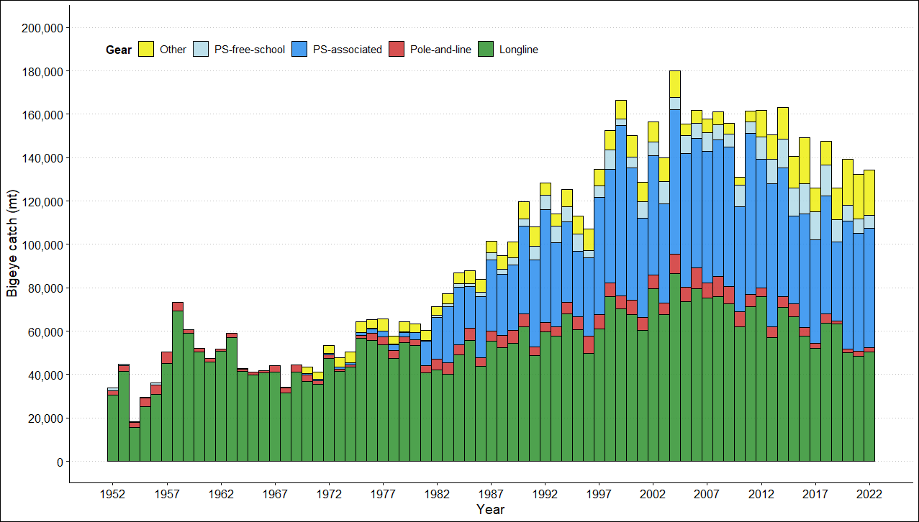

Figure BET-02. Time series of total annual catch (1000s mt) by fishing gear for the diagnostic model over the full assessment period. The different colors refer to longline (green), pole-and-line (red), purse seine (blue), purse seine associated (dark blue), purse seine unassociated (light blue), miscellaneous (yellow), and index (gray). Note that the catch by longline gear has been converted into catch-in-weight from catch-in-numbers and so may differ from the annual catch estimates presented in (Williams et al., 2023), however these catches enter the model as catch-in-numbers (Figure 3 from SC19-SA-WP-05).

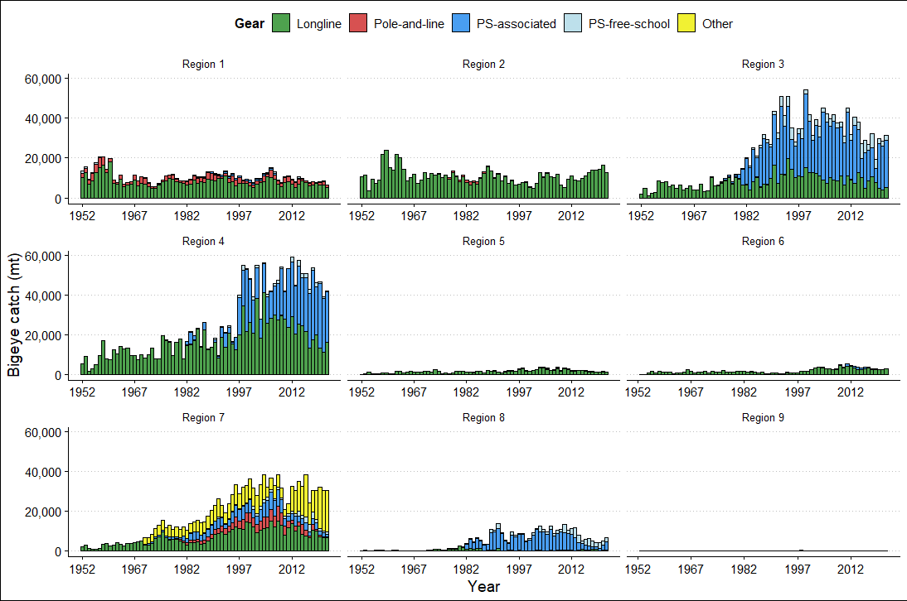

Figure BET-03. Annual catches of bigeye by gear type for each of the nine model regions (Figure 4 from SC19-SA-WP-05).
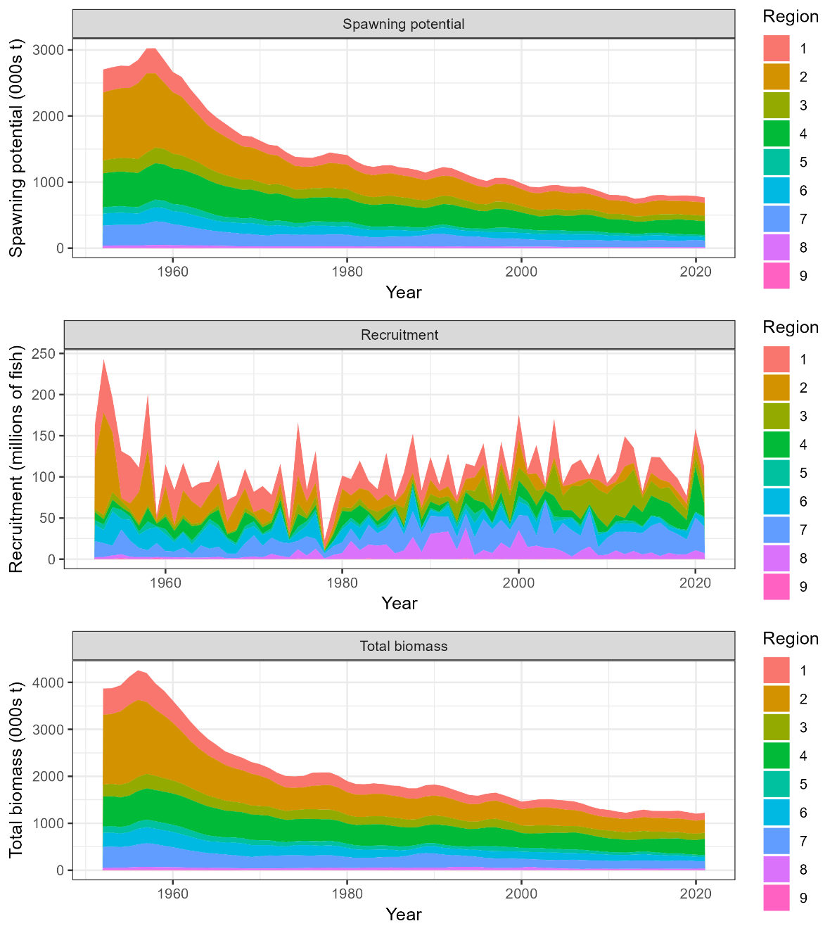

Figure BET-04. Time series of estimated annual spawning potential, recruitment and total biomass by model region for the diagnostic model, showing the relative proportions among regions. Note the data represent the averages of the quarterly model time steps for each year for spawning potential and total biomass and the sum of the quarterly recruitment estimates for annual recruitment (Figure 49 from SC19-SA-WP-05).
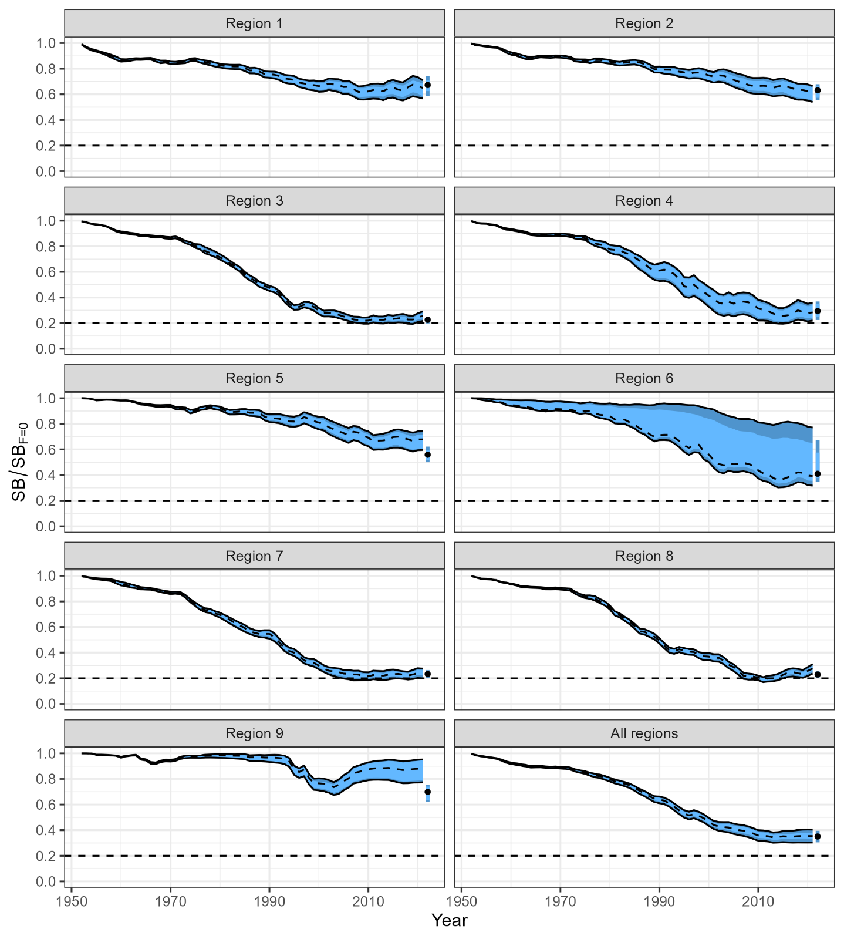
Figure BET-05. Estimated spawning depletion across all models in the structural uncertainty grid over the period 1952-2021. The lighter band shows the 25th and 75th percentiles, and the dark band shows the 10th and 90th percentiles of the model estimates. The bar at the right of each ribbon indicates the median (black dots) with the 10th and 90th percentiles for SB_{recent}/SB_{F=0} (Figure 63 from SC19-SA-WP-05).

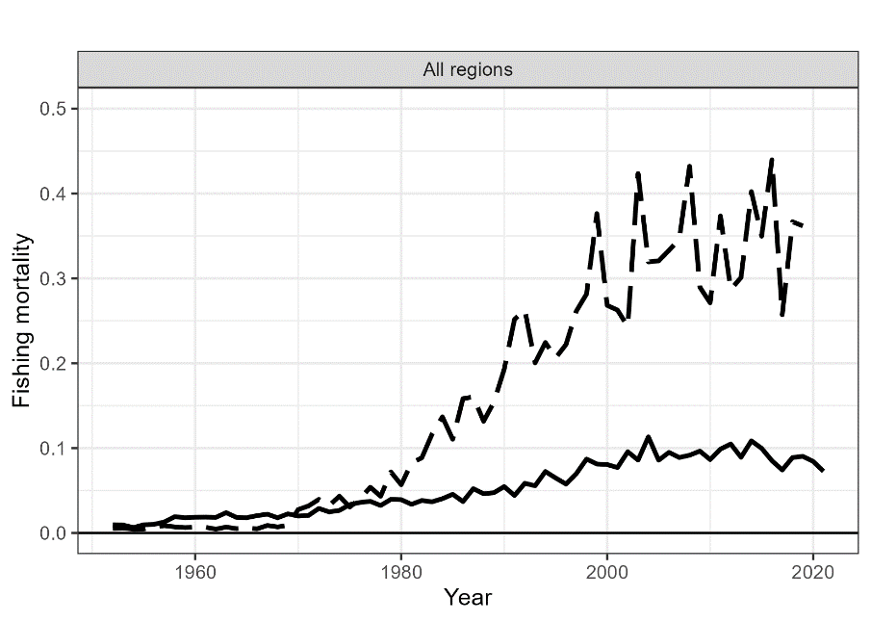

Figure BET-06. Estimated annual average adult (solid line) and juvenile (dashed line) fishing mortality for the 2023 diagnostic model (Figure 54 from SC19-SA-WP-05).

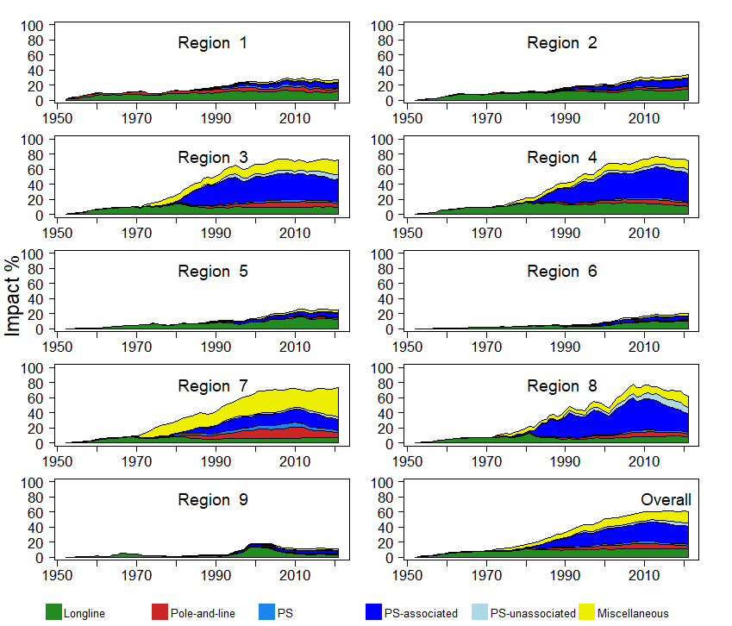
Figure BET-07. Estimates of reduction in spawning potential due to fishing (fishery impact = (1-SB_{t}/SB_{t,F=0}) * 100%) by region, and over all regions (lower right panel), attributed to various fishery groups for the 2023 diagnostic model (Figure 70 from SC19-SA-WP-05).
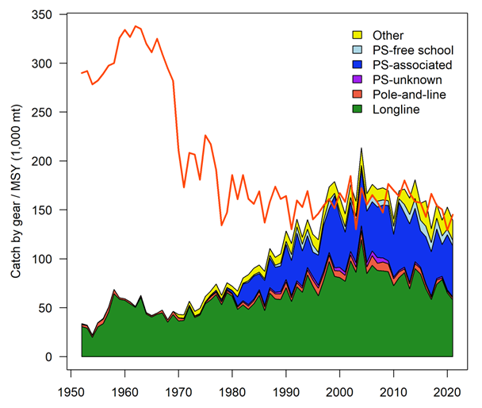
Figure BET-08. History of the annual estimates of MSY (red line) for the diagnostic model compared with annual catch by the main gear types. Note that this is a ‘dynamic’ MSY (Figure 72 from SC19-SA-WP-05).
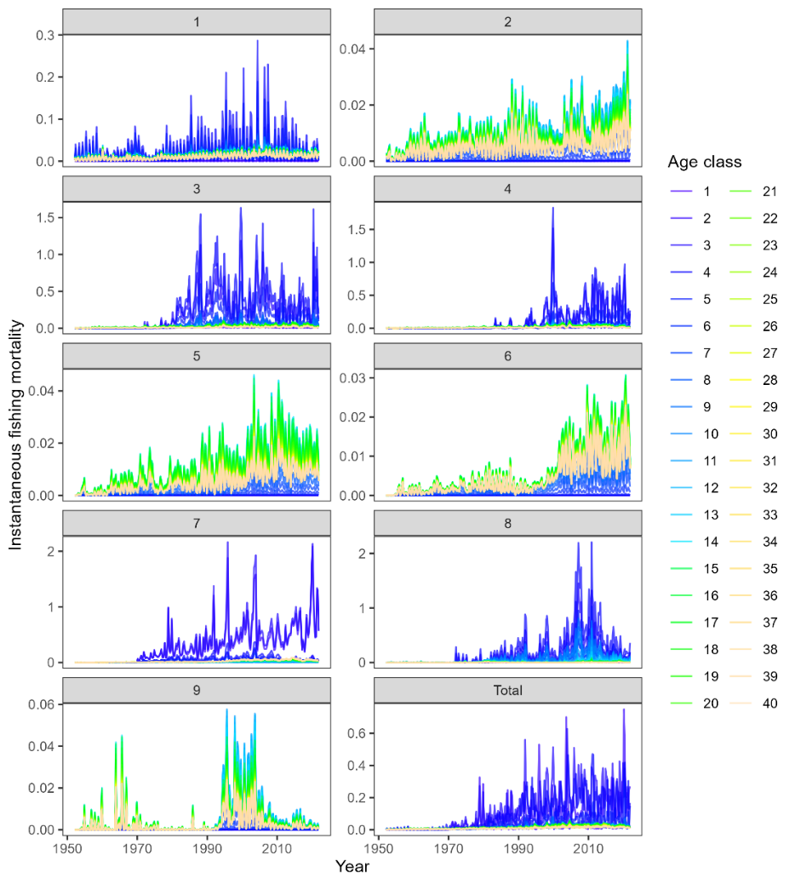
Figure BET-09 Estimated age specific fishing mortality for the diagnostic model, by region and overall (Figure 55 from SC19-SA-WP-05).
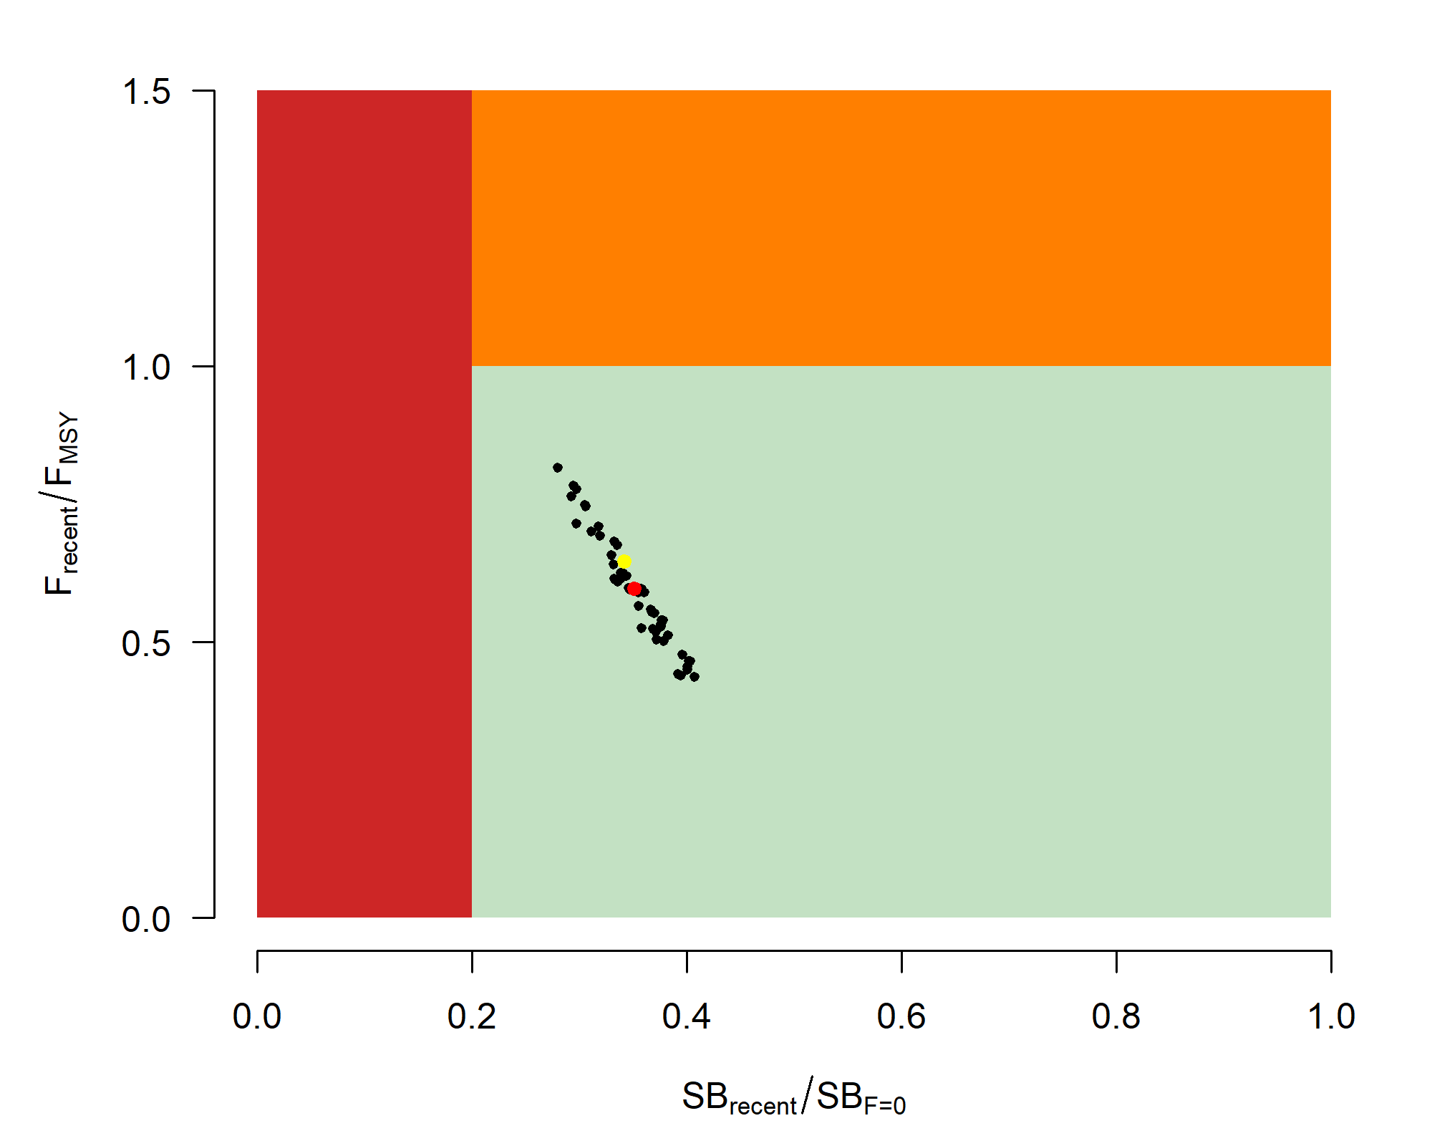

Figure BET-10. Majuro plot for the recent spawning potential (2018–2021) summarizing the results for each of the models in the structural uncertainty grid. The plots represent estimates of stock status in terms of spawning biomass depletion and fishing mortality. The yellow point is the 2023 diagnostic model and red point is the median (Figure 68 from SC19-SA-WP-05).

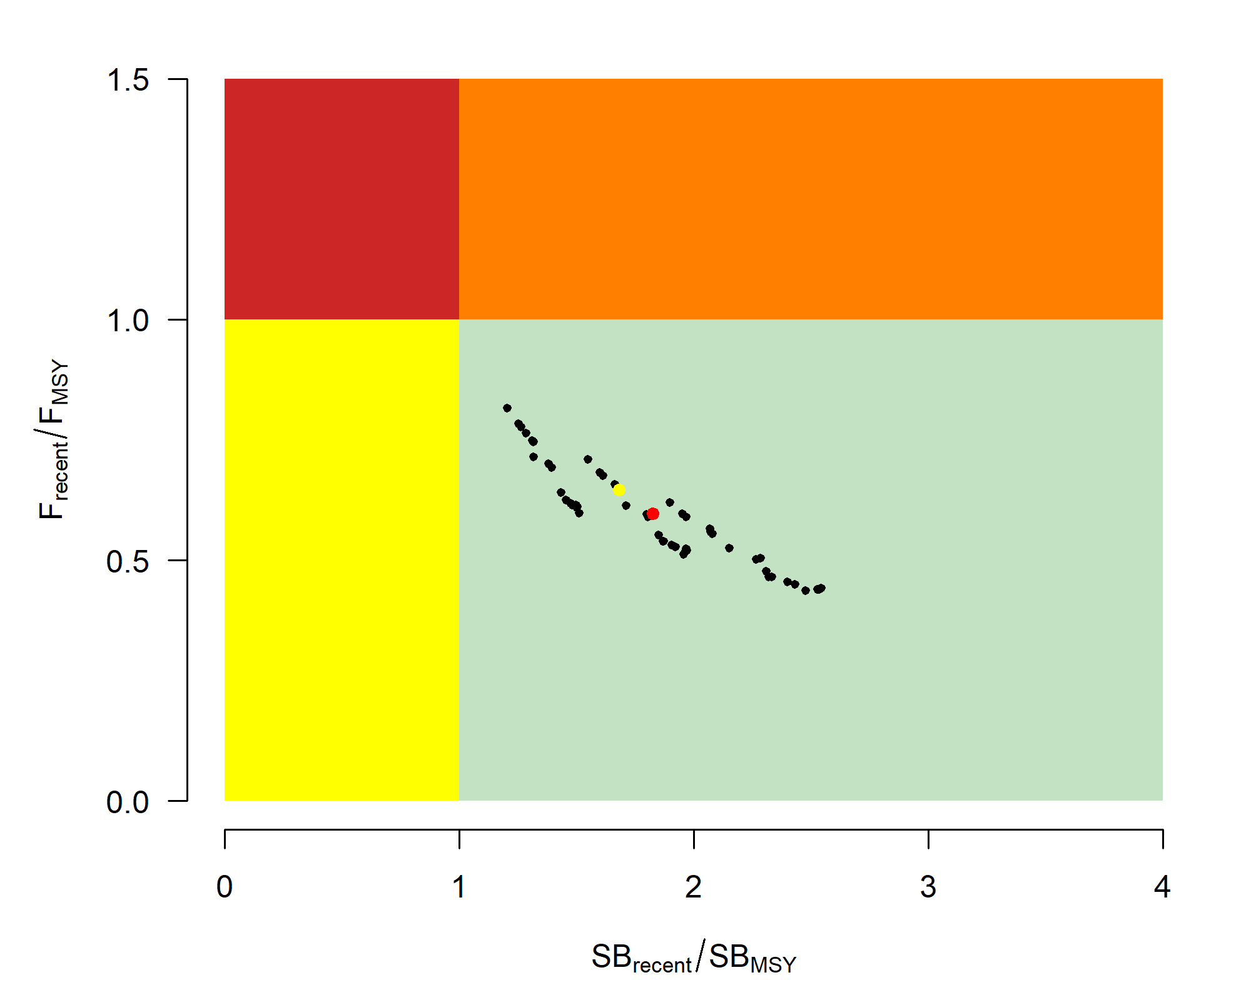
Figure BET-11. Kobe plot for the recent spawning potential (2018–2021) summarizing the results for each of the models in the structural uncertainty grid. The plots represent estimates of stock status in terms of spawning biomass depletion and fishing mortality. The yellow point is the 2023 diagnostic model and red point is the median (Figure 68 from SC19-SA-WP-05).

Management advice and implications

The objective for bigeye tuna in CMM 2021-01 (the Tropical Tuna Measure) – to maintain the spawning biomass depletion ratio at or above the average SB/SB_{F=0} for 2012-2015 – is being achieved. SB_{recent}/SB_{F=0} (35%) is very close to the average SB/SB_{F=0} for 2012-2015 (34%) calculated across the unweighted grid.

The WCPO bigeye tuna spawning biomass is above the biomass LRP, and F_{recent} is below F_{MSY} for all models in the uncertainty grid. The stock is very likely not experiencing overfishing (100% probability F_{recent}<F_{MSY}) and is not in an overfished condition (0% probability SB_{recent}/SB_{F=0}<LRP).

SC19 also noted that average fishing mortality rates for juvenile and adult age-classes have increased throughout the period of the assessment (Figure BET-08), although more so for juveniles which have experienced considerably higher annual fishing mortality than adults (Figure BET-06). The purse-seine associated fishery has the most impact, with that of the miscellaneous and longline fisheries also being notable (Figure BET-07). Higher fishing mortality rates on juvenile bigeye tuna reduces the realized yield per recruit for the bigeye fishery.

SC19 noted that levels of fishing mortality and depletion differ among regions, and that fishery impact was higher in the tropical regions (Regions 3, 4, 7 and 8 in the stock assessment model), with particularly high fishing mortality on juvenile bigeye tuna in these regions.

There is also evidence that the overall stock status is buffered with biomass and low exploitation in the temperate region (1, 2, 6 and 9) and most of the predicted movement is within the equatorial region. Exchange rates between temperate and tropical regions are estimated to be low.

SC19 noted that the reduction of fishing mortality on fisheries that take juveniles could increase bigeye fishery yields and reduce any further impacts on spawning biomass of this stock. SC19 also noted that this could require considering the impact to other fisheries and stocks.

The interim objective of bigeye tuna stock under CMM 2021-01 is to maintain the depletion level of the stock at or above the average SB/SB_{F=0} for 2012-2015. The recent depletion level of bigeye tuna is close to this interim objective. SC19 noted that while the projection results based on the 2023 bigeye tuna assessment were not available for SC19 to review, this information will be available for the 4th tropical tuna management workshop and will provide the Commission guidance on future expected levels of fishing mortality and the outcomes relative to the interim or future management objectives.

Research Recommendations

SC19 adopted several research recommendations for the further development and improvement of the WCPO bigeye tuna stock assessment, and suggested these be considered for potential inclusion in the Tuna Assessment Research Plan (TARP):
  - Continued collection of more representative biological data (e.g., age composition) and tagging data.
  - Develop additional CPUE index series testing key uncertainties about the analysis (e.g., regional vs. global model, classification of catchability vs. abundance covariates, etc.) and explore those as one-off sensitivities to the stock assessment.
  - Consideration of options to account for effort creep in CPUE standardization and/or the assessment model.
  - Simulation study to explore appropriate spatial structure of the stock assessment with a focus on simplifying the spatial structure (e.g., areas-as-fleets and/or 6 region structure) given the estimates of limited movement rates among regions.
  - Investigation of the 2023 model specifications with respect to the increase in unfished SSB over time for the tropical regions (3, 4, 7 and 8).
  - Yield per recruit analyses comparing fishery sectors with different selectivity patterns.
  - Evaluation of the variability and plausibility of estimated growth and mortality-at-age relationship across the structural uncertainty grid.
  - Additional one-off sensitivities exploring key uncertainties in biological assumptions, model specification, and data inputs (e.g., tag mixing, data weighting, and growth).
  - Identification of key parameters that are either highly correlated or highly sensitive to the jittering procedure to inform possible changes in model specification with the aim to decrease model complexity and/or sensitivity to starting conditions.
  - Exploration of seasonal and regional growth traits for the stock assessment.
  - Comprehensive review of the representativeness of the size composition data given conflicts identified in the likelihood profiles.
  - Investigation of the 2023 model specifications that lead to the inversion of the effect of the weight vs. tagging data signal on the total biomass, as shown in the likelihood profile.
  - Further exploration of the advantages and disadvantages of strategies to decrease model sensitivity to starting conditions, including but not limited to multi-start approaches.
  - Pursue development of tag mixing diagnostics and approaches, and investigate the impacts of tag mixing assumptions.

WCPO skipjack tuna (Katsuwonus pelamis)

Research and information

Indicator analysis

S. Hare (SPC) presented SC19-SA-WP-06, “A compendium of fisheries indicators for target tuna stocks in the WCPFC Convention Area” providing empirical information on recent patterns in skipjack fisheries.

SC19 thanked the SSP for conducting an indicator analysis providing empirical information on recent patterns in skipjack fisheries.

Update of skipjack tuna stock assessment information

C. Castillo-Jordan presented SC19-SA-WP-07 (Follow up work on 2022 skipjack assessment recommendations).

SC19 thanked the SSP for their efforts on improving the skipjack diagnostic model and achieving a positive definite Hessian. The follow up work on the model provides a sound basis for future assessments.

SC19 noted the results of SPC’s work investigating technical issues highlighted by SC18 regarding the 2022 skipjack diagnostic model.

SC19 noted that the resulting updates to the diagnostic model for the WCPO skipjack assessment had negligible effect on the stock status and management advice from 2022.

SC19 emphasized that while the updates had not resulted in changes to stock status, some estimated quantities differed between the 2022 and 2023 version, most notably the growth curve, the mortality-at-age and the selectivity-at-age, noting these relationships are interrelated. SC19 encouraged further investigation to understand these changes.

SC19 noted that this process for allowing staff resources to conduct follow-up is a useful one that could be conducted for other WCPFC assessments, with continued dialogue between the SSP assessment team and SC in the intervening years between assessments to address concerns and lay the groundwork for the subsequent assessment. The SSP noted that this was possible this year because staff resources were available. This is not the case every year due to changes in experience and availability of staff resources. Follow-up work suggested by SC should be prioritised under the TARP process.

SC19 encouraged that this follow-up work process become standard practice for WCPO tuna stock assessments. Noting that follow-up work is subject to available staff resources and should be prioritised as part of the TARP process.

SC19 noted the following issues for further improvements:
  - Improve fits to the length composition data.
  - Estimation of tag reporting rates.
  - Alternative spatial structure.
  - Unrealistic recruitment estimates particularly in temperate regions.
  - Model jittering diagnostic to confirm convergence stability.

South Pacific albacore tuna (Thunnus alalunga)

Research and information

Indicator analysis

S. Hare (SPC-OFP) presented SC19-SA-WP-06 (A compendium of fisheries indicators for target tuna stocks in the WCPFC Convention Area).

SC19 thanked the SSP for the indicator analysis providing empirical information on recent patterns South Pacific albacore fisheries.

SC19 noted that the South Pacific albacore catch in the WCPFC-CA was 68,975t in 2022, a 39% increase from 2021 and a 4% increase from the 2017-2021 average.

Some CCMs recommended to keep the current catch levels in mind when discussing the South Pacific albacore TRP.

SC19 recommended that the 2024 assessment of South Pacific albacore be South Pacific-wide. Noting the need to provide management advice specifically for the WCPFC-CA and the ongoing developments relating to the Harvest Strategy process, if a fleets-as-areas approach is considered for the 2024 assessment, SC19 recommends retaining a separate area for the IATTC. SC19 noted that a WCFPC-CA only model might also be considered as a one-off sensitivity analysis. If results from the one-off sensitivity analysis for the WCPFC-CA-only model are different from the WCPFC-CA results from the Pacific-wide model, additional analyses should be conducted with a view to understanding which spatial structure is more reliable when considering future assessment development.

Northern stocks

North Pacific albacore (Thunnus alalunga)

Research and Information

North Pacific albacore stock assessment

S. Teo (ISC) presented SC19-SA-WP-08 (Stock assessment of albacore tuna in the North Pacific Ocean), which detailed the data, biological parameters, model, model diagnostics and sensitivities, and results of the North Pacific albacore stock assessment conducted by ISC’s Albacore Working Group (ISC ALBWG) in 2023.
SC19 thanked ISC ALBWG for their work conducted on the albacore tuna stock assessment in the North Pacific Ocean.

Provision of scientific information

Stock status and trends

SC19 noted that the ISC provided the following conclusions on the stock status of North Pacific albacore:
  - Estimated summary biomass (males and females at age-1+) declined at the beginning of the time series until 2004 (Figure NPALB-1A). Subsequently, the summary biomass fluctuated without a trend until 2018, after which the biomass rapidly increased to historically high levels. It should be noted that the high summary biomass estimates during 2018 – 2021 were highly uncertain and should be treated with caution (Figure NPALB-1A). These high summary biomass estimates were due to historically high recruitment estimates in 2017 (~433 million fish; 95% CI: 194 – 671 million fish) (Figure NPALB-1C). However, it should be noted that the recruitment estimates in the last 5 years (2017- 2021) were highly uncertain and should be treated with caution. Estimated female SSB exhibited a similar population trend to the summary biomass, albeit with a lag of several years, and showed an initial decline until 2007 followed by fluctuations without a clear trend through 2021 (Figure NPALB-1B).
  - The average fishing intensity during 2018 – 2020 was estimated to be F59_{%SPR} (95% CI: F72_{%SPR} – F46_{%SPR}), which was relatively moderate and resulted in a population with an SPR of approximately 59%. Instantaneous fishing mortality at age (F-at-age) was similar in both sexes through age-5, peaking at age-4 and declining to a low at age-6, after which males experienced higher F-at-age than females up to age 12 (Figure NPALB-2). Juvenile albacore aged 2 to 4 years comprised approximately 64% of the annual catch-at-age in numbers between 1994 and 2021 (Figure NPALB-3) due to the larger fishery impact of surface fisheries (primarily troll, pole-and-line), which remove juvenile fish, relative to longline fisheries, which primarily remove adult fish (Figure NPALB-4).
  - Stock status is depicted in relation to the target (F45_{%SPR},), threshold (30%SSB_{current, F=0}), and limit (14%SSB_{current, F=0}) reference points (Figure NPALB-5A; Table NPALB-1). The estimated female SSB has never fallen below the threshold and limit reference points since 1994, albeit with large uncertainty in the terminal year (2021) estimates. However, the estimated fishing intensity for five years (1999, 2002, 2003, 2004, and 2007) have exceeded the target reference point. Even when alternative hypotheses about key model uncertainties such as growth were evaluated, the point estimate of female SSB in 2021 (SSB₂₀₂₁) did not fall below the threshold and limit reference points, although the risk increases with this more extreme assumption (Figure NPALB-5B). However, estimated average fishing intensity during 2018-2020 (F₂₀₁₈₋₂₀₂₀) did exceed the target reference point under one of these alternative hypotheses but did not exceed the average fishing intensity during 2002 – 2004 (Figure NPALB-5B; Table NPALB-1).
  - The SSB₂₀₂₁ was estimated to be approximately 54% (95% CI: 40 – 68%) of SSB_{current, F=0} and 1.8 (95% CI: 1.3 – 2.3) times greater than the estimated threshold reference point (Figure NPALB-6A and Table NPALB-1). The estimated current fishing intensity (F₂₀₁₈₋₂₀₂₀) was estimated to be F59_{%SPR} (95% CI: F72_{%SPR} – F46_{%SPR}) and was lower than both the F45_{%SPR} target reference point and the average fishing intensity during 2002 – 2004 (Figure NPALB-6B and Table NPALB-1).

SC19 noted the following stock status from ISC:
  - The stock is likely not overfished relative to the threshold (30%SSB_{current, F=0}) and limit (14%SSB_{current, F=0}) reference points adopted by the WCPFC and IATTC, and
  - The stock is likely not experiencing overfishing relative to the adopted target reference point (F45_{%SPR}).
  - Current fishing intensity (F2018-2020) is lower than the fishing intensity from the 2002-2004 period (the reference level for IATTC Resolution C-05-02 and WCPFC CMM 2019-03).

Management advice and implications

SC19 noted the following conservation information from the ISC:
  - Two harvest scenarios were projected to evaluate impacts on the management objectives of IATTC and WCPFC for this stock: 1) maintain SSB above the limit reference point, with a probability of at least 80% over the next 10 years; 2) maintain depletion of total biomass around historical (2006—2015) average depletion over the next 10 years; and 3) maintain fishing intensity at or below the target reference point with a probability of at least 50% over the next 10 years (WCPFC HS 2022-01; IATTC Resolution C-22-04).
  - The constant fishing intensity scenario showed that the current fishing intensity (F₂₀₁₈₋₂₀₂₀) is expected to result in female SSB increasing to 90,098 t (95% CI: 23,218—156,978t) and an SSB/SSB_{current,F=0} ratio of 0.54 by 2031. Over the next 10 years, there was: 1) a 97.7% probability of the female SSB remaining above the 14%SSB_{current, F=0} LRP for all 10 years; 2) a 72.0% probability of the total biomass (age-1+) being above the average of 2006 – 2015 for any year; and 3) a 95.5% probability of the fishing intensity remaining at or below the F45_{%SPR} TRP for any year (Figure NPALB-7).
  - The randomly resampled fishing intensity scenario showed that if future fishing intensity is similar to the 2005 – 2019 period, it is expected to result in female SSB increasing to 87,669 t (95% CI: 22,219 – 153,119 t) and a SSB/SSB_{current, F=0} ratio of 0.52 by 2031. Over the next 10 years, there was: 1) a 98.1 % probability of the female SSB remaining above the 14%SSB_{current, F=0} LRP for all 10 years; 2) a 69.5 % probability of the total biomass (age-1+) being above the average of 2006 – 2015 for any year; and 3) a 79.6 % probability of the fishing intensity remaining at or below the F45_{%SPR} TRP for any year (Figure NPALB-8).

Based on these findings, the following conservation information was provided by ISC:
  - If fishing intensity over the next ten years is maintained at the current fishing intensity (F₂₀₁₈₋₂₀₂₀), then female SSB is expected to remain around 54%SSB_{current, F=0} (90,098 t), with a 97.7% probability of the female SSB remaining above the 14% SSB_{current, F=0} LRP for all ten years, and the management objectives of IATTC and WCPFC will likely be met.
  - If fishing intensity over the next ten years is similar to the 2005-2019 period, then female SSB is expected to decrease to 52%SSBc_{urrent, F=0} (87,669 t), with a 98.1% probability of the female SSB remaining above the 14% SSB_{current, F=0} LRP for all ten years, and the management objectives of IATTC and WCPFC will likely be met.

Table NPALB-1. Estimates of maximum sustainable yield (MSY), female spawning stock biomass (SSB), fishing intensity (F), and reference point ratios for north Pacific albacore tuna for: 1) the base case model; 2) two important sensitivity models due to uncertainty in growth parameters; and 3) a model representing an update of the 2020 base case model to 2023 data. SSB0, SSB_{current}, _{F=0} and SSB_{MSY} are the expected female SSB of a population in the equilibrium, unfished state; in the current, dynamic, unfished state; and at MSY, respectively. The Fs in this table are indicators of fishing intensity based on spawning potential ratio (SPR) and calculated as %SPR. SPR is the ratio of the equilibrium SSB per recruit that would result from the estimated F-at-age relative to that of an unfished population. Depletion is calculated as the proportion of the age-1+ biomass during the specified period relative to an unfished age-1+ equilibrium biomass. The model representing an update of the 2020 base case model is similar to but not identical to the 2020 base case model due to changes in data preparation and model structure.
* Model may not have converged and uncertainty estimates were unreliable because of the lack of a positive, definite Hessian matrix.
† A value of >1 for the depletion ratio indicates higher age-1+ biomass in 2021 relative to the 2006 –2015 period.
§ Higher %SPR values indicate lower fishing intensity levels.
¶ Values of >1 for ratios of F_{%SPR} to F_{%SPR}-based reference points indicate fishing intensity levels lower than the reference points.

Quantity | Base Case | Growth  CV = 0.06 for L_{inf} | Growth  All parameters estimated | Update of 2020 base case model to 2023 data*
MSY (t) | 121,880 | 93,167 | 144,792 | 97,777
SSB_{MSY} (t) | 23,154 | 18,133 | 30,435 | 18,756
SSB₀ (t) | 165,567 | 128,155 | 198,913 | 132,570
SSB_{current, F=0} (2021 estimate) | 129,581 | 97,368 | 155,542 | 93,808
SSB₂₀₂₁/SSB_{current, F=0} | 0.54 | 0.36 | 0.65 | 0.39
SSB₂₀₂₁/30%SSB_{current, F=0} | 1.81 | 1.21 | 2.17 | 1.31
SSB₂₀₂₁/14%SSB_{current, F=0} | 3.87 | 2.6 | 4.65 | 2.81
†Depletion₂₀₂₁/Depletion₂₀₀₆₋₂₀₁₅ | 1.34 | 1.33 | 1.37 | 1.3
§ F_{%SPR, 2018-2020} (%SPR) | 59.0 | 41.4 | 70.4 | 43.2
§ F_{%SPR, 2011-2020} (%SPR) | 55.0 | 36.6 | 63.8 | 37.9
¶ F_{%SPR, 2018-2020}/F_{%SPR, MSY} | 2.04 | 1.42 | 2.78 | 1.47
¶ F_{%SPR, 2011-2020}/F45_{%SPR} | 1.22 | 0.81 | 1.42 | 0.84
¶ F_{%SPR, 2018-2020}/F45_{%SPR} | 1.31 | 0.92 | 1.56 | 0.96
¶ F_{%SPR, 2018-2020}/F_{%SPR, 2002-2004} | 1.48 | 1.63 | 1.40 | 1.25

Figure NPALB-1. Maximum likelihood estimates of (A) age-1+ biomass (B), female spawning biomass (SSB), and (C) age-0 recruitment of north Pacific albacore tuna (Thunnus alalunga). Dashed lines (A and B) and vertical bars (C) indicate 95% confidence intervals. Closed black circle and error bars in (B) and (C) are the maximum likelihood estimate and 95% confidence intervals of unfished female spawning biomass, SSB0, and unfished recruitment, respectively, at equilibrium (Figure ES3 from SC19-SA-WP-08).

Figure NPALB-2. Estimated sex-specific instantaneous fishing mortality-at-age (F-at-age) for the 2023 base case model, averaged across 2018-2020 (Figure ES4 from SC19-SA-WP-08).

Figure NPALB-3. Historical catch-at-age of north Pacific albacore (Thunnus alalunga) estimated by the 2023 base case model (Figure ES5 from SC19-SA-WP-08).

Figure NPALB-4. Fishery impact analysis on north Pacific albacore (Thunnus alalunga) showing female spawning biomass (SSB) (red) estimated by the 2023 base case model as a percentage of dynamic, unfished female SSB (SSB_{current, F=0}). Colored areas show the relative proportion of fishing impact attributed to longline (green) and surface (blue) fisheries (primarily troll and pole-and-line gear but including all other gears except longline) (Figure ES6 from SC19-SA-WP-08).

Figure NPALB-5. Stock status phase plot showing the status of the north Pacific albacore (Thunnus alalunga) stock relative to the biomass-based threshold (30%SSB_{current, F=0}) and limit (14%SSB_{current, F=0}) reference points, and fishing intensity-based target reference point (F45_{%SPR}) over the modeling period (1994 – 2021). Blue triangle indicates the start year (1994) and black circle with 95% confidence intervals indicates the terminal year (2021). (B) Stock status plot showing current stock status and 95% confidence intervals of the base case model (black circle), an important sensitivity run of CV = 0.06 for Linf in the growth model (gray square), an important sensitivity run with an estimated growth model (purple triangle), and a model representing an update of the 2020 base case model to 2023 data (red diamond). 95% confidence intervals are not shown for the update of the 2020 base case model (red diamond) because the model did not have a positive definite Hessian matrix and uncertainty estimates were unreliable. Red zones in both panels indicate female SSBs falling below the limit reference point while the orange zones indicate female SSBs between the threshold and limit reference points. Green zones indicate female SSBs above the threshold reference point and fishing intensity levels below the target reference point. Yellow areas indicate female SSBs above the threshold reference point and fishing intensity levels above the target reference point. The Fs in this figure are indicators of fishing intensity based on spawning potential ratio (SPR) and calculated as %SPR. SPR is the ratio of the equilibrium SSB per recruit that would result from the estimated F-at-age relative to that of an unfished population. A higher %SPR indicates lower fishing intensity. Current fishing intensity values and SSB/SSB_{current,F=0} ratios in (B) were calculated as the average during 2018- 2020 (F_{%SPR}, 2018-2020) and 2021 (SSB2021/SSB_{current, F=0}), respectively. The model representing an update of the 2020 base case model is similar to but not identical to the 2020 base case model due to changes in data preparation and model structure (Figure ES7 from SC19-SA-WP-08).

Figure NPALB-6. (A) Estimated dynamic biomass ratio (SSB/SSB_{current, F=0}) of north Pacific albacore relative to biomass-based threshold (30%SSB_{current, F=0}) (orange dotted line) and limit (14%SSB_{current, F=0}) reference points (red dashed line) over the modeling period (1994 – 2021); and (B) estimated fishing intensity relative to the fishing intensity-based target reference point (F45_{%SPR}) over the modeling period (1994 – 2021). Light and dark gray areas indicate 95% and 60% confidence intervals respectively. The limit reference point is considered to be breached if the lower bound of the 60% confidence intervals overlaps the limit reference point (Figure ES8 from SC19-SA-WP-08).

Figure NPALB-7. Future projection results under a constant fishing intensity (F₂₀₁₈₋₂₀₂₀) harvest scenario. Solid lines indicate mean values, uncertainty ranges indicate 60% and 95% confidence intervals, and the dashed line is the reference point, respectively. (A) Annual changes in spawning biomass; (B) Interannual changes in fishing mortality (F_{%SPR}); (C) Projected ratios to the limit reference point thresholds; and (D) Projected ratios to management targets for the total biomass (Figure ES9 from SC19-SA-WP-08).

Figure NPALB-8. Future projection results under a randomly F (2005-2019) scenario. Solid lines indicate mean values, and uncertainty ranges indicate 60% and 95% confidence intervals, and the dashed line is the reference point, respectively. (A) Annual changes in spawning biomass; (B) Interannual changes in fishing mortality (F_{%SPR}); (C) Projected ratios to the limit reference point thresholds; and (D) Projected ratios to management targets for the total biomass (Figure ES10 from SC19-SA-WP-08).

Pacific bluefin tuna (Thunnus orientalis)

Research and Information

Update of Pacific bluefin tuna stock assessment information

SC19 noted that no stock assessments were conducted for Pacific bluefin tuna in 2023 and no updated information was presented on the status of Pacific bluefin tuna. Therefore, the stock status descriptions from SC18 are still current for Pacific bluefin tuna.

Concern was expressed that no scientific evaluation was provided to SC19 related to the increase in converting part of the small fish catch limit to the large fish catch limit in CMM 2021-02 as recommended by NC19. However, it was clarified that assessment results provided to SC18 showed that the projection under which part of the small fish catch limit was converted to the large fish catch limit using the current conversion factor provides benefit to stock recovery.

It was noted that there are some WCPFC members, including New Zealand, who have a strong interest in PBF but are not involved in the ISC. And they encouraged the ISC to ensure that there are sufficient opportunities for all parties with an interest to be involved in the stock assessment and MP processes.

North Pacific swordfish (Xiphias gladius)

Research and Information

North Pacific swordfish stock assessment

M. Sculley (ISC) presented SC19-SA-WP-09 (Stock assessment of swordfish in the North Pacific Ocean through 2021), which detailed the data, biological parameters, model, model diagnostics and sensitivities, and results of the North Pacific swordfish stock assessment conducted by ISC’s Billfish Working Group (ISC BILLWG) in 2023.

SC19 thanked ISC BILLWG for their work conducted on the swordfish stock assessment in the North Pacific Ocean.

Provision of scientific information

Stock Identification and Distribution

The North Pacific swordfish (Xiphias gladius, NP SWO) stock area was defined to be the waters of the North Pacific Ocean contained in the Western and Central Pacific Fisheries Commission (WCPFC) Convention Area bounded by the equator and the waters of the Inter-American Tropical Tuna Commission (IATTC) Convention Area north of 10°N (Figure NPSWO-1). All available fishery data from the stock area were used for the stock assessment. For the purpose of modelling observations of catch-per-unit effort (CPUE) and size composition data, it was assumed that there was an instantaneous mixing of fish throughout the stock area on a quarterly basis. The stock was modelled using a fleets-as-areas approach with separate catch and index fleets for the Western and Central North Pacific Ocean (WCNPO) and Eastern Pacific Ocean (EPO) region delineated in (Figure NPSWO-1).

Catches

The NP SWO catches were high from the 1970’s to the 1980’s averaging about 14,000 mt per year during 1975-1990, peaked with unusually high catches in 1998-2000, and then generally declined to the current levels around 11,000mt. Catches by most fleets have generally declined, while minor catches by other WCPFC CCMs have generally increased, except in in the last three years (Figure NPSWO-2). Overall, longline fishing gear has accounted for the vast majority of NP SWO catch.

Data and Assessment

Catch and size composition data were collected from International Scientific Committee for tuna and tuna-like species in the North Pacific Ocean (ISC) countries (Chinese Taipei, Japan, and USA) and the WCPFC and IATTC. Standardized CPUE data used to measure trends in relative abundance were provided by Chinese Taipei, Japan, and USA. The NP SWO stock was assessed using an age- and length-structured assessment Stock Synthesis (SS3) model fit to time series of standardized CPUE and size composition data. Life history parameters for growth and maturity were updated for this benchmark stock assessment. The value for stock-recruitment steepness used for the base case model was h = 0.9. The assessment model was fit to relative abundance indices and size composition data in a likelihood-based statistical framework. Maximum likelihood estimates of model parameters, derived outputs, and their variances were used to characterize stock status and to develop stock projections. Several sensitivity analyses were conducted to evaluate the effects of changes in model parameters, including natural mortality rate at age, stock-recruitment steepness, growth curve parameters, and female length at 50% maturity, as well as uncertainty in the input data and model structure.

Biological Reference Points

MSY-based biological reference points were computed for the base case model with SS3 (Table NPSWO-2). The point estimate of annual catch at F_{MSY} was calculated to be 14924 mt. The point estimate of the spawning biomass to produce MSY (adult female biomass) was 16,388 mt. The point estimate of F_{MSY}, the fishing mortality rate to produce SSB_{MSY} (average fishing mortality on ages 1 – 10) was 0.18 and the corresponding equilibrium value of spawning potential ratio at SSB_{MSY} was 19%.

Projections

Stock projections for NP SWO were conducted using SS3. No recruitment deviations nor log-bias adjustment were applied to the future projections. Projections are reported as the mean and standard deviation around 100 bootstrapped model runs for each scenario. Projections started in 2022 and continued through 2031 under 5 levels of fishing mortality. The five fishing mortality stock projection scenarios were: (1) F at 20%SSB_{(F=0)} which was calculated from the mean dynamic SSB in the five years, (2) F₍₂₀₀₈₋₂₀₁₀₎ which is the reference years for the proposed CMM for NP SWO, (3) F_{Low} at F_{30%SPR}, (4) F_{MSY}, and (5) F status quo (average F during 2019-2021). Results show the projected female spawning stock biomass and the catch biomass under each of the scenarios (Table NPSWO-3 and Figure NPSWO-5-6).

Stock status and trends

SC19 noted that the ISC provided the following conclusions on the stock status of North Pacific Swordfish:
  - Estimates of population biomass fluctuated around an average of 80,800 mt during 1975-2021 and was estimated to be 88,800 mt in 2021 (Figure NPSWO-3a and Table NPSWO-1). Initial estimates of female spawning stock biomass (SSB) averaged around 27,600 mt in the late 1970s. SSB was at its highest level of 35,778 metric tons in 2021, and was at its minimum of 22,415 mt in 1981. Overall, spawning stock biomass has been relatively stable for the entirety of the assessment period (Figure NPSWO-3b). Estimated F (arithmetic average of F for ages 1 – 10) decreased from 0.17 year-1 in 1978 to a minimum of 0.09 year⁻¹ in 2021 (Figure NPSWO-3c). It averaged roughly F=0.09 during 2019-2021 or about 51% of FMSY with a relative fishing mortality of F/F_{MSY} = 0.49 in 2021. Fishing mortality has been below FMSY since the beginning of the assessment time period and has had a declining trend with the exception of a high peak in 1998 coinciding with high catch by the US LL fleet. Recruitment (age-0 fish) estimates averaged approximately 838,000 individuals during 1975-2021. While the overall pattern of recruitment varied, there was no apparent trend in recruitment strength over time (Figure NPSWO-3d). Overall, total annual catch is declining, CPUE is increasing, and recruitment is relatively stable. When the status of NP SWO is evaluated relative to MSY-based reference points, the 2021 SSB of 35,778 mt is 220% above SSBMSY (16,000 mt) and the 2019-2021 F is about 49% below F_{MSY}. Therefore, relative to MSY-based reference points, overfishing is very likely not occurring (>99% probability) and the NP SWO stock is very likely not overfished (>99% probability, Figure NPSWO-4).
  - WCPFC16 established a limit reference point for the exploitation rate of NP SWO of F_{MSY}. SSB_{F=0}, set to equal the average of the last 5 years dynamic B₀ assuming no fishing during those years. NP SWO reference points will be provided with reference to MSY and with reference to 20%SSB_{F=0}.

SC19 noted the following stock status from ISC:
  - Female spawning stock biomass was estimated to be 35,778mt in 2021, with a relative SSB ratio of SSB/SSB_{MSY} = 2.18 in 2021;
  - Estimated F (arithmetic average of F for ages 1 – 10) averaged roughly F=0.09 yr⁻¹ during 2019-2021 with a relative fishing mortality of F/F_{MSY} = 0.49 in 2021; and
  - Relative to MSY-based reference points, overfishing is very likely not occurring (>99% probability) and the NP SWO stock is very likely not overfished (>99% probability, Figure NPSWO-4).

Management advice and implications

SC19 noted the following conservation information from the ISC:
  - Projections started in 2022 and continued through 2031 under five levels of fishing mortality. The five fishing mortality stock projection scenarios were: (1) F at 20%SSB_{(F=0)} which was calculated from the mean dynamic SSB in the most recent five years, (2) F₍₂₀₀₈₋₂₀₁₀₎ which are the reference years for the proposed CMM for NPO SWO, (3) F_{Low} at F_{30%SPR}, (4) F_{MSY}, and (5) F status quo (average F during 2019-2021). Results show the projected female spawning stock biomass and the catch biomass under each of the scenarios (Table NPSWO-3; Figure NPSWO-5, Figure NPSWO-6).

Based on these findings, the following conservation information was provided:
  - The NP SWO stock has produced annual yields of around 11,500 mt per year since 2016, or about 2/3 of the MSY catch amount.
  - NP SWO stock status is positive with no evidence of excess F above F_{MSY} or substantial depletion of spawning potential.
  - It was also noted that retrospective analyses show that the assessment model appears to underestimate spawning potential in recent years.

Special Comments

The lack of sex-specific size data and the simplified treatment of the spatial structure of swordfish population dynamics remained as two important sources of uncertainty for improving future assessments.

Table NPSWO-1. Reported catch (mt) used in the stock assessment along with annual estimates of population biomass (age-1 and older, mt), female spawning biomass (mt), relative female spawning biomass (SSB/SSB_{MSY}), recruitment (thousands of age-0 fish), fishing mortality (average F, ages 1–10), relative fishing mortality (F/F_{MSY}), and spawning potential ratio of North Pacific swordfish (Xiphias gladius).
Year | 2016 | 2017 | 2018 | 2019 | 2020 | 2021 | Mean¹ | Min¹ | Max¹
Reported Catch | 12,648 | 11,831 | 12,730 | 11,093 | 10,731 | 10,136 | 12,876 | 9,539 | 19,230
Population Biomass | 83,200 | 86,835 | 89,418 | 89,617 | 89,992 | 88,755 | 80,762 | 65,722 | 89,992
Spawning Biomass | 28,205 | 29,785 | 31,661 | 33,761 | 35,159 | 35,778 | 28,777 | 22,415 | 35,778
Relative Spawning Biomass | 1.72 | 1.82 | 1.93 | 2.06 | 2.15 | 2.18 | 1.76 | 1.37 | 2.18
Recruitment (age 0) | 964,401 | 746,962 | 783,354 | 739,400 | 624,962 | 633,046 | 838,473 | 595,771 | 1,430,430
Fishing Mortality | 0.1 | 0.09 | 0.1 | 0.09 | 0.09 | 0.09 | 0.12 | 0.09 | 0.19
Relative Fishing Mortality | 0.55 | 0.52 | 0.57 | 0.49 | 0.5 | 0.49 | 0.68 | 0.49 | 1.09
Spawning Potential Ratio | 0.34 | 0.37 | 0.37 | 0.42 | 0.43 | 0.44 | 0.33 | 0.24 | 0.44
¹ During 1975-2021
Table NPSWO-2. Estimated biological reference points derived from the Stock Synthesis base case model for North Pacific swordfish where F is the instantaneous annual fishing mortality rate, SPR is the annual spawning potential ratio, SSB is spawning stock biomass, and SSB_{(F=0)} indicates the average 5-year SSB₀ estimate, 20%SSB_{(F=0)} is the associated reference point, and MSY is the maximum sustainable yield reference point.
Reference Point | Estimate
F_{20%SSB(F=0)} (age 1-10) | 0.16
F_{MSY} (age 1-10) | 0.18
F₂₀₂₁ | 0.09
F₂₀₁₉₋₂₀₂₁ | 0.09
SSB_{F=0} | 95,732
20%SSB_{F=0} | 19,146
SSB_{MSY} | 16,388
SSB₂₀₂₁ | 35,778
SSB₂₀₁₉₋₂₀₂₁ | 34,899
C_{20%SSB(F=0)} | 14,815
C_{MSY} | 14,924
C₂₀₁₉₋₂₀₂₁ | 10,653
SPR_{20%SSB(F=0)} | 22%
SPR_{MSY} | 19%
SPR₂₀₂₁ | 44%
SPR₂₀₁₉₋₂₀₂₁ | 43%

Table NPSWO-3. Projected median values of Western and Central North Pacific swordfish spawning stock biomass (SSB, mt) and catch (mt) under five constant fishing mortality rate (F) and two recruitment scenarios during 2021-2040.
Year | 2022 | 2023 | 2024 | 2025 | 2026 | 2027 | 2028 | 2029 | 2030 | 2031
Scenario 1: F_{20%SSB(F=0)}
SSB | 40,457 | 38,288 | 36,295 | 35,452 | 35,425 | 35,611 | 36,064 | 36,387 | 36,264 | 36,478
Catch | 16,906 | 14,986 | 13,531 | 13,120 | 13,298 | 13,612 | 13,875 | 14,053 | 14,161 | 14,220
Scenario 2: F₁₉₉₈₋₂₀₀₀
SSB | 41,567 | 40,422 | 38,952 | 38,309 | 38,371 | 38,565 | 39,133 | 39,534 | 39,336 | 39,625
Catch | 14,302 | 13,389 | 12,608 | 12,428 | 12,656 | 12,967 | 13,224 | 13,399 | 13,509 | 13,572
Scenario 3: Low F (F_{SPR30%})
SSB | 42,268 | 42,368 | 41,811 | 41,756 | 42,235 | 42,712 | 43,610 | 44,300 | 44,162 | 44,705
Catch | 11,370 | 11,249 | 11,096 | 11,255 | 11,623 | 11,990 | 12,263 | 12,445 | 12,557 | 12,631
Scenario 4: F_{MSY}
SSB | 38,291 | 34,051 | 31,164 | 29,979 | 29,800 | 29,894 | 30,225 | 30,452 | 30,322 | 30,473
Catch | 23,395 | 17,817 | 14,992 | 14,169 | 14,264 | 14,565 | 14,812 | 14,966 | 15,052 | 15,095
Scenario 5: F_{Status Quo} (Average F₂₀₁₉₋₂₀₂₁)
SSB | 38,828 | 35,056 | 32,339 | 31,201 | 31,036 | 31,138 | 31,489 | 31,733 | 31,602 | 31,765
Catch | 21,803 | 17,218 | 14,723 | 13,981 | 14,082 | 14,379 | 14,627 | 14,785 | 14,875 | 14,921

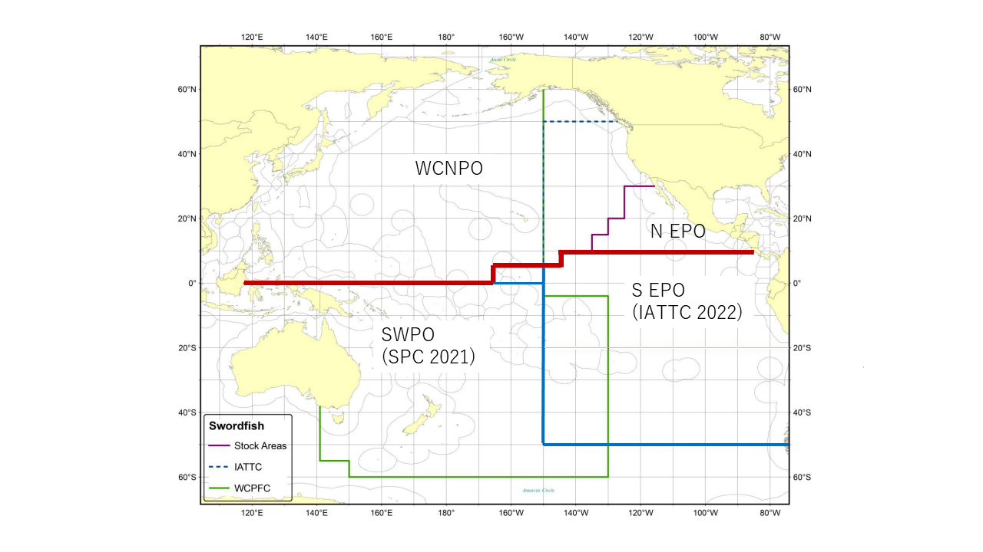
Figure NPSWO-1. Western and Central North Pacific Ocean and North Eastern Pacific Ocean swordfish stock boundaries for the 2023 North Pacific swordfish assessment. Spatial structure is treated implicitly using fleets as areas (Figure S1 from SC19-SA-WP-09).

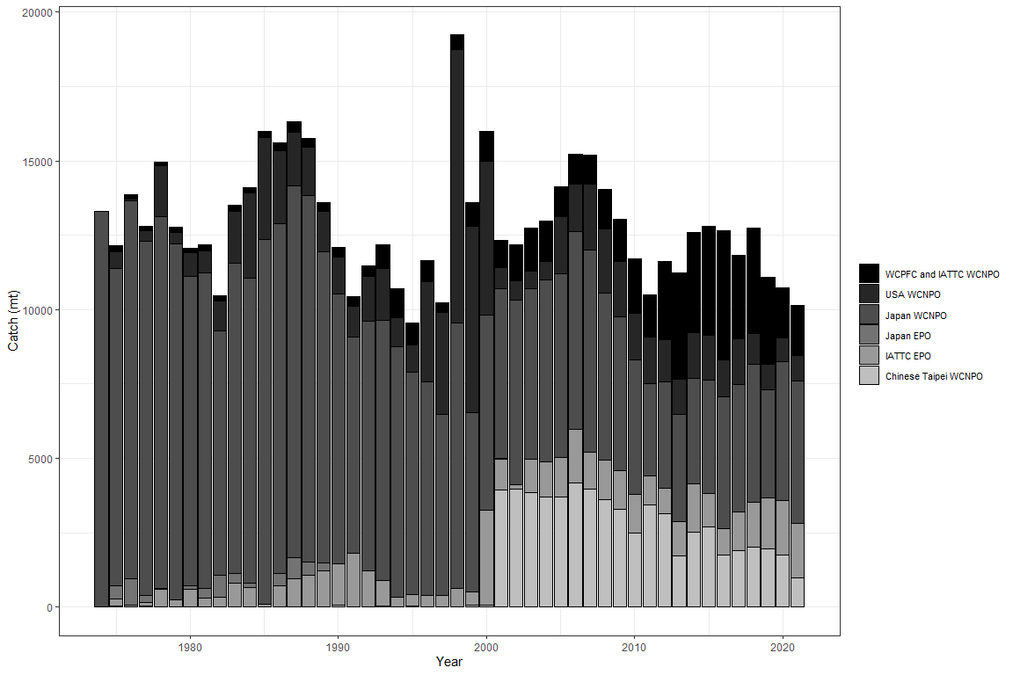

Figure NPSWO-2. Annual catch of NP swordfish by country or commission and area (Figure S2 from SC19-SA-WP-09).

  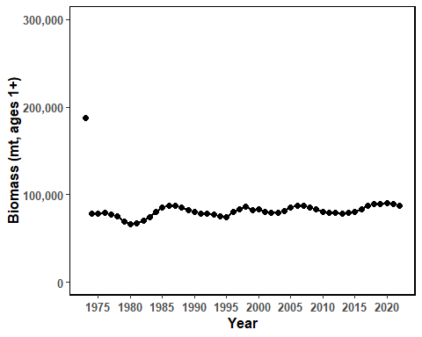
  (a)
  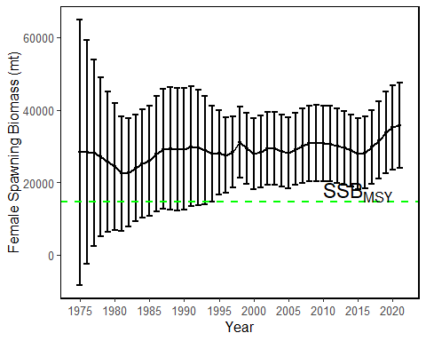
  (b)

  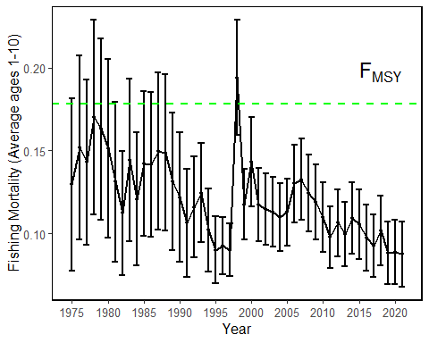
  (c)
  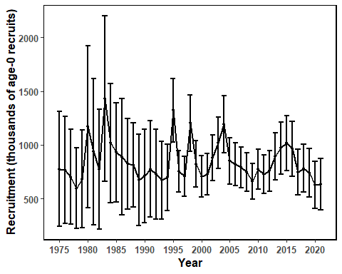
  (d)

Figure NPSWO-3. Time series of estimates of (a) population biomass (age 1+), (b) spawning biomass, (c) instantaneous fishing mortality (average for age 1-10, year⁻¹), and (d) recruitment (age-0 fish) for North Pacific swordfish (Xiphias gladius) derived from the 2023 stock assessment. The circles represents the maximum likelihood estimates by year for each quantity and the error bars represent the uncertainty of the estimates (95% confidence intervals), green dashed lines indicate the dynamic SSB_{MSY} and F_{MSY} reference points (Figure S3 from SC19-SA-WP-09).

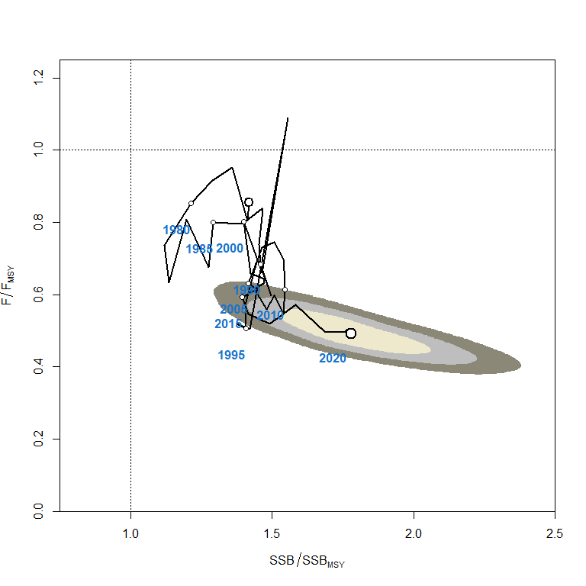
Figure NPSWO-4. Kobe plot of the time series of estimates of relative fishing mortality (average of age 1-10) and relative spawning stock biomass of North Pacific swordfish (Xiphias gladius) during 1977-2020. The first white dot indicates 1975, subsequent dots are in 5-year increments. Shading indicates 50%, 80%, and 95% confidence intervals, respectively (Figure S4 from SC19-SA-WP-09).

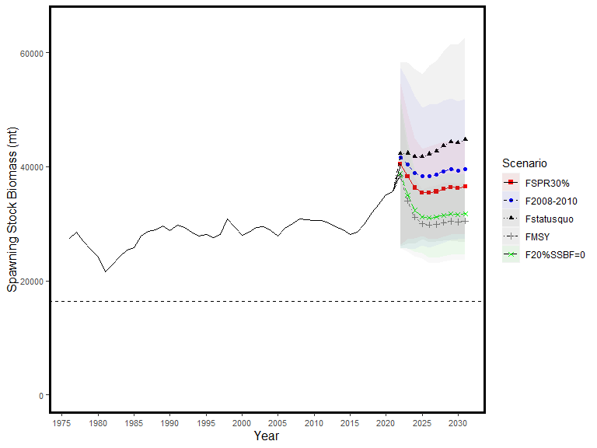
Figure NPSWO-5. Historical and projected trajectories of spawning biomass from the North Pacific swordfish base case model based upon F scenarios. Dashed line indicates the spawning stock biomass at SSB_{MSY}. The list of projection scenarios can be found in SC19-SA-WP-09 Table S3 (Figure S5 from SC19-SA-WP-09).

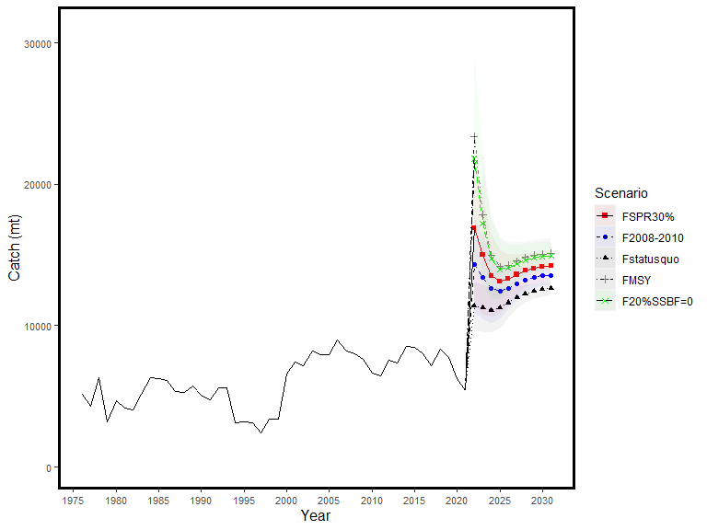
Figure NPSWO-6. Historical and projected trajectories of catch from the North Pacific swordfish base case model based upon F scenarios. The list of projection scenarios can be found in SC19-SA-WP-09 Table S3 (Figure S6 from SC19-SA-WP-09).

WCPO sharks

Silky shark (Carcharhinus falciformis)

Research and information

Silky shark stock assessment in the WCPO (Project 108)

SC19 recommended that an integrated assessment for silky shark be attempted and that alternative assessment methods such as data-limited methods or a risk analysis be developed concurrently.

WCPO billfishes

North Pacific striped marlin (Kajikia audax)

Research and Information

North Pacific striped marlin stock assessment

H. Ijima presented SC19-SA-WP-11 (Stock assessment report for North Pacific striped marlin (Kajikia audax) through 2020), which detailed the data, biological parameters, model, model diagnostics and sensitivities, and results of the North Pacific striped marlin stock assessment conducted by ISC’s Billfish Working Group (BILLWG) in 2023.

SC19 thanked ISC BILLWG for their work and welcomed the progress made on the North Pacific striped marlin stock assessment.

SC19 recommended having more consistency in the stock assessment metrics used between assessments across the WCPO stocks, as recommended in SC19-SA-WP-12.

Provision of scientific information

Stock Identification and Distribution

The WCNPO MLS (Kajikia audax) stock area was defined to be the waters of the North Pacific Ocean contained in the Western and Central Pacific Fisheries Commission Convention Area bounded by the equator and 150°W. All available fishery data from the stock area were used for the stock assessment. For the purpose of modeling observations of CPUE and size composition data, it was assumed that there was an instantaneous mixing of fish throughout the stock area on a quarterly basis.

Catches

The WCNPO MLS catches were high from the 1970’s to the 1990’s averaging about 7,200 mt per year during 1977-1999 and have decreased to an annual average of 2,500 mt during 2018-2020. Catches by Japanese fleets have decreased and catches from the US and Chinese Taipei have varied without trend, while minor catches by other WCPFC countries have generally increased (Figure WCNPOMLS-1). Overall, longline fishing gear has accounted for the vast majority of WCNPO MLS catches since the 1990’s while catches by the Japanese driftnet fleet were predominant during 1977 to 1993. It should be noted that the Japanese driftnet catch during this period is highly uncertain due to possible inaccurate reporting as well as possible inclusion of catch from southern hemisphere, both of which cannot be verified at this moment.

Data and Assessment

Catch and size composition data were collected from ISC countries (Chinese Taipei, Japan, and USA) and the WCPFC. Standardized catch-per-unit effort (CPUE) data used to measure trends in relative abundance were provided by Chinese Taipei, Japan, and USA. The WCNPO MLS stock was assessed using an age- and length-structured assessment Stock Synthesis (SS3) model fit to time series of standardized CPUE and size composition data. Life history parameters for growth and maturity were updated for this benchmark stock assessment. The value for stock-recruitment steepness used for the base case model was h = 0.87. The assessment model was fit to relative abundance indices and size composition data in a likelihood-based statistical framework. Maximum likelihood estimates of model parameters, derived outputs, and their variances were used to characterize stock status and to develop stock projections. Several sensitivity analyses were conducted to evaluate the effects of changes in model parameters, including natural mortality rate at age, stock-recruitment steepness, growth curve parameters, and female length at 50% maturity, as well as uncertainty in the input catch data and model structure.

Biological Reference Points

Biological reference points were computed for the base case model with SS3 (Table WCNPOMLS-2). The reference points were based upon 20% of the dynamic B₀ (SSB_{(F=0)}) averaged over the last 20 years (2001-2020), which corresponds to about 4 mean generation times for WCNPO-MLS. The point estimate of equilibrium annual catch at the dynamic 20%SSB_{(F=0)} was calculated to be 4,468 mt. The point estimate of the spawning biomass to produce 20%SSB_{(F=0)} (adult female biomass) was 3,660 mt. The point estimate of F_{20%SSB(F=0)}, the fishing mortality rate to produce 20% of SSB_{(F=0)} (average fishing mortality on ages 3 – 12) was 0.53 and the corresponding equilibrium value of spawning potential ratio at 20%SSB_{(F=0)} was 22%.

Projections

Stock projections for WCNPO-MLS were conducted using SS3. No recruitment deviations nor log-bias adjustment were applied to the future projections. The absolute future recruitments were based on two deterministic scenarios: the expected stock-recruitment relationship and the average recruitment in the last 20 years (2001-2020). Projections started in 2021 and continued through 2040. The five levels of fishing mortality with the two recruitment scenarios and the ten catch levels with only the 20-year average recruitment scenario were applied for projections. The five fishing mortality scenarios were: F status quo (average F during 2018-2020), F_{MSY}, F at 20%SSB_{(F=0)}, F_{High} at the highest 3-year average during 1977-2017 (1998-2000), and F_{Low} at F_{30%}. The ten catch level scenarios were: No catch (F=0), 500 mt catch, 1,000 mt catch, 1,500 mt catch, 2,000 mt catch, 2,300 mt catch, 2,400 mt catch, 2,500 mt catch, 3,000 mt catch, and 3,500 mt catch. Twenty results show the projected female spawning stock and catch biomasses under each scenario (Tables WCNPOMLS-3, WCNPOMLS-4, Figures WCNPOMLS-4 and WCNPOMLS-5).

Stock status and trends

SC19 noted the following conclusions on the stock status of the North Pacific striped marlin:
- Estimates of population biomass from the base-case fluctuated around an average of 11,300 mt during 1977-2020 and was estimated to be 7,300 mt in 2020 (Figure WCNPOMLS-2a). Initial estimates of female spawning stock biomass (SSB) averaged around 4,700 mt in 1977-1979. SSB was at its highest level of 5,096 metric tons in 1977, and declined to its lowest level 1,080 mt in 2011. The time-series of SSB during 2011-2020 averaged about 1,200 metric tons, or about 33% of the dynamic 20-year 20%SSB_{(F=0)} and about 42% of SSB_{MSY}. Overall, SSB exhibited a strong decline during 1992-1998 and has stabilized to an average of about 1,400 mt since then (Figure WCNPOMLS-2b). Estimated fishing mortality (arithmetic average of F for ages 3 – 12) increased from 0.53 year⁻¹ in 1977 to a peak of 1.42 year⁻¹ in 1998, and subsequently declined to 0.58 year⁻¹ in 2020 (Figure WCNPOMLS-2c). It averaged roughly F=0.68 during 2018-2020 or about 28% above F_{20%SSB(F=0)} and 8% above F_{MSY}, with a relative fishing mortality of F/F_{20%SSB(F=0)} = 1.09 in 2020. Fishing mortality has been above F_{20%SSB(F=0)} and F_{MSY} since the beginning of the assessment time period, but has had a declining trend since 1998.
- Recruitment (numbers of age-0 fish) estimates averaged approximately 366,000 during 1977-2020. While the overall pattern of recruitment from 1977-2020 varied, there was an apparent declining trend in recruitment strength over time with higher recruitments observed during 1977-1992 and lower recruitments from 2000 to the present (Figure WCNPOMLS-2d). Recruitment from 2001-2020 averaged about 225,000 age-0 fish, which was 60% of the 1977-2020 average. The WCPFC has requested the BILLWG to provide estimates of stock status for WCNPO MLS relative to biological reference points based on 20% of a dynamic SSB₀ estimate (SSB_{(F=0)}), where SSB₀ is the moving average of the last 20 years SSB₀ estimates. Despite the relative large L₅₀/L_{inf} ratio for WCNPO MLS, the stock is expected to be highly productive due to its rapid growth and high resilience to reductions in spawning potential. Recent recruitments have been lower than expected and have been below the long-term average since 2000 (Figure WCNPOMLS-2b). Although fishing mortality has decreased since 2000, the two decades of low recruitment combined with consistent landings of immature fish have inhibited increases in spawning biomass since 2001.

SC19 noted the following stock status from the ISC:
Based upon these findings, the following information on the status of the WCNPO MLS stock is provided:
  - When the status of WCNPO MLS is evaluated relative to dynamic 20%SSB_{F=0}-based reference points, the 2020 spawning stock biomass of 1,696 mt is 54% below 20%SSB_{F=0} (3,660 mt) and the 2018-2020 fishing mortality is about 28% above F_{20%SSB(F=0)}.
  - Therefore, relative to 20%SSB_{F=0}-based reference points, the WCNPO MLS stock is very likely to be overfished (>99% probability) and is likely to be subject to overfishing (>66% probability, Figure WCNPOMLS-3).

Management advice and implications

SC19 noted the following conservation information from the ISC however, some CCMs recommended that the catch limit be set at 2,300 mt or lower due to concern about the reliability of the model and associated increased risk:
- Stock projections for WCNPO MLS were conducted using two deterministic scenarios for future recruitment: the expected stock recruitment relationship and the average recruitment in the last 20 years (2001-2020). Projections started in 2021 and continued through 2040. Five levels of fishing mortality with the two recruitment scenarios (Table WCNPOMLS-3) and the ten catch levels with only the 20-year average recruitment scenario (Table WCNPOMLS-4) were applied for projections. The five fishing mortality scenarios were: F status quo (average F during 20182-020), F_{MSY}, F at 20%SSB_{F= 0}, F_{High} at the highest 3-year average during 1977-2017 (1998-2000), and F_{Low} at F30%. The ten catch level scenarios were: No catch (F=0), 500 t catch, 1,000 t catch, 1,500 t catch, 2,000 t catch, 2,300 t catch, 2,400 t catch, 2,500 t catch, 3,000 t catch, and 3,500 t catch.
- Twenty results show the projected female spawning stock and catch biomasses under each scenario (Table WCNPOMLS-3 and Table WCNPOMLS-4; Figure WCNPOMLS-4 and Figure WCNPOMLS-5). When recruitment is assumed to be consistent with the stock recruitment relationship, then only two fixed F scenarios result in the WCNPO MLS stock rebuilding beyond SSB_{MSY} and 20%SSB_{F=0}: F_{Low} and F_{20%SSB(F=0)} (Figure WCNPOMLS-4a). In contrast, when recruitment is assumed to be the average over the last 20 years (2001-2020), none of the fixed F scenarios result in the stock rebuilding to or beyond F_{20%SSB(F=0)} and only one scenario, F_{Low}, resulted in the stock rebuilding above the SSB_{MSY} level (Figure WCNPOMLS-4b). Constant catch scenario results are different that the constant F projection results. At catch levels less than 2,400 t, the projections show that the WCNPO MLS stock rebuilds beyond the SSB_{MSY} and 20%SSB_{F=0} levels by 2040 (Figure WCNPOMLS-4c).
- The assumed recruitment levels for projections vary substantially for the two scenarios, with the average recruitment from the stock recruitment curve around 350,000 individuals per year and the recruitment from the low recruitment scenario around 225,000 individuals per year. In the past, the WG has recommended that management measures consider the low recruitment scenarios as the projections using the stock recruitment curve do not consider the long-term declining trend in recruitment (ISC21). If spawning biomass rebuilds to the target, which is about equal to the average spawning biomass observed during the 1977-1989 period, then recruitment may be expected to return to the high levels observed during the 1977-1989 period or about twofold higher than current recruitment (Figure WCNPOMLS-2d). The WG intends to provide additional stochastic ensemble projection results considering model uncertainty, as requested by WCPFC16. One of the important axes of uncertainty will be the assumptions on future recruitment.
- Based on these findings, the following information on the conservation of the WCNPO MLS stock is provided by ISC:
  - It is recommended that catch should be kept at or below the recent level (2018-2020 average catch = 2,428 t); and
  - The results of deterministic projection show that when catches are 2,400 t, or less, the stock is expected to recover above SSB_{MSY} and near the 20% SSB_{F=0} reference level (3,660 t) by 2040, or sooner at the lower catch levels under a low recruitment regime.

Special Comments

While the WG agreed upon a base case model for WCNPO MLS, there is concern about the reliability of the base case results for providing conservation advice due to uncertainty in growth, Japanese driftnet catches and initial conditions of the model. The ISC22 Plenary requested that the WG continue working on the 2022 WCNPO MLS base case model, with a focus on the growth parameters, particularly incorporating the Richard’s four parameter growth curve directly into the SS3 model, for presentation to ISC23. The WG concluded that a revised von Bertalanffy growth curve rather than the Richard’s curve was the best information available at this time for use in the 2023 base case model, while highlighting the suite of sensitivity runs to show the sensitivity of the model to changes in the growth curve (Figure WCNPOMLS-6; see the list and description of the sensitivity runs in table 12 in SC19-SA-WP-11). The sensitivity runs show that the growth curve assumption may affect the interpretation of stock status. The WG also noted a concern that the estimation of initial F and thus the virgin biomass scale is largely affected by the selection of the growth curve, as the initial catch remains uncertain.

The WG recognized that substantial uncertainties have been discussed and documented in this stock assessment report. The high seas drift net catch data are highly uncertain owing to limited record availability, the estimation of life history parameters, such as growth, from limited data, and the mixing of the stock with other management areas, as revealed by genetic analyses. The WG evaluated the fit of several growth assumptions to the data and other diagnostics. The WG found that the stock assessment results showed large differences in estimated biomass among various growth curves. Future improvements of the growth curve are expected due to incoming data from the ongoing International Billfish Biological Sampling program, which will be followed by continued biological research and model development to address other sources of uncertainty.

Table WCNPOMLS-1. Reported catch (mt) used in the stock assessment along with annual estimates of population biomass (age-1 and older, mt), female spawning biomass (mt), relative female spawning biomass (SSB/20%SSB_{F=0}), recruitment (thousands of age-0 fish), fishing mortality (average F, ages-3 – 12), relative fishing mortality (F/F_{20%SSB(F=0)}), and spawning potential ratio of Western and Central North Pacific striped marlin.
Year | 2014 | 2015 | 2016 | 2017 | 2018 | 2019 | 2020 | Mean¹ | Min¹ | Max¹
Reported Catch | 2,745 | 3,272 | 2,456 | 2,256 | 2,177 | 2,695 | 2,412 | 5,383 | 2,177 | 10,912
Population Biomass | 7,142 | 6,476 | 5,944 | 5,506 | 5,316 | 6,831 | 7,339 | 11,283 | 5,316 | 19,463
Spawning Biomass | 1,142 | 1,293 | 1,305 | 1,238 | 1,223 | 1,158 | 1,696 | 2,266 | 1,081 | 5,118
Relative Spawning Biomass | 0.31 | 0.35 | 0.35 | 0.33 | 0.33 | 0.31 | 0.46 | 0.61 | 0.29 | 1.38
Recruitment (age 0) | 102,169 | 196,286 | 138,584 | 150,045 | 299,538 | 215,884 | 263,519 | 366,217 | 89,526 | 711,480
Fishing Mortality | 0.77 | 0.91 | 0.70 | 0.74 | 0.69 | 0.77 | 0.58 | 0.89 | 0.53 | 1.42
Relative Fishing Mortality | 1.46 | 1.70 | 1.31 | 1.39 | 1.30 | 1.45 | 1.09 | 1.67 | 1.00 | 2.67
Spawning Potential Ratio | 0.14 | 0.11 | 0.16 | 0.16 | 0.16 | 0.14 | 0.20 | 0.13 | 0.06 | 0.23
¹ During 1977-2020

Table WCNPOMLS-2. Estimates of biological reference points along with estimates of fishing mortality (F), spawning stock biomass (SSB), recent average yield (C), and spawning potential ratio (SPR) of Western and Central North Pacific striped marlin, derived from the base case model assessment model, where SSB_{F=0} indicates the average 20-year dynamic B0 estimate, 20%SSB_{F=0} is the associated reference point, and MSY indicates the maximum sustainable yield reference point.

Reference Point | Estimate
F_{20%SSB(F=0)} (age 3-12) | 0.53
F_{MSY} (age 3-12) | 0.63
F₂₀₂₀ (age 3-12) | 0.58
F₂₀₁₈₋₂₀₂₀ | 0.68
SSB_{F=0} | 18,300 mt
20%SSB_{F=0} | 3,660 mt
SSB_{MSY} | 2,920 mt
SSB₂₀₂₀ | 1,696 mt
SSB₂₀₁₈₋₂₀₂₀ | 1,359 mt
C_{20%SSB(F=0)} | 4,468 mt
MSY | 4,512 mt
C₂₀₁₈₋₂₀₂₀ | 2,428 mt
SPR_{20%SSB(F=0)} | 22%
SPR_{MSY} | 18%
SPR₂₀₂₀ | 20%
SPR₂₀₁₈₋₂₀₂₀ | 17%

Table WCNPOMLS-3. Projected median values of Western and Central North Pacific striped marlin spawning stock biomass (SSB, mt) and catch (mt) under five constant fishing mortality rate (F) and two recruitment scenarios during 2021-2040. For scenarios which have a 50% probability of reaching the target of 20%SSB_{F=0}, the year in which this occurs is provided; NA indicates projections that did not meet this criterion. Note that 20%SSB_{F=0} is 3,660 mt.
Year | 2021 | 2022 | 2023 | 2024 | 2025 | 2030 | 2040 | Year when target achieved
Scenario 1: F_{20%SSB(F=0),} F_{Btgt}; Stock – Recruitment Curve
SSB | 2084 | 2412 | 2775 | 3071 | 3275 | 3620 | 3658 | NA
Catch | 2624 | 3041 | 3461 | 3803 | 4039 | 4426 | 4468
Scenario 2: Highest F (Average F₁₉₉₈₋₂₀₀₀); Stock – Recruitment Curve
SSB | 2032 | 2217 | 2464 | 2663 | 2796 | 3017 | 3043 | NA
Catch | 3080 | 3386 | 3729 | 3997 | 4174 | 4461 | 4494
Scenario 3: Low F (F_{30%}); Stock – Recruitment Curve
SSB | 2390 | 3059 | 3758 | 4367 | 4825 | 5675 | 5783 | 2024
Catch | 1807 | 2293 | 2770 | 3177 | 3477 | 4009 | 4072
Scenario 4: F_{MSY}; Stock – Recruitment Curve
SSB | 2062 | 2369 | 2712 | 2991 | 3182 | 3504 | 3540 | NA
Catch | 2685 | 3090 | 3502 | 3836 | 4064 | 4439 | 4481
Scenario 5: F_{Status Quo} (Average F₂₀₁₈₋₂₀₂₀); Stock – Recruitment Curve
SSB | 2026 | 2291 | 2593 | 2837 | 3005 | 3289 | 3322 | NA
Catch | 2795 | 3170 | 3550 | 3854 | 4062 | 4406 | 4445
Scenario 6: F_{20%SSB(F=0),} F_{btgt}; 20-year Average Recruitment
SSB | 2084 | 2343 | 2411 | 2392 | 2371 | 2351 | 2351 | NA
Catch | 2623 | 2886 | 2952 | 2924 | 2896 | 2871 | 2871
Scenario 7: Highest F (Average F₁₉₉₈₋₂₀₀₀); 20-year Average Recruitment
SSB | 2032 | 2149 | 2130 | 2077 | 2046 | 2023 | 2022 | NA
Catch | 3080 | 3182 | 3131 | 3056 | 3014 | 2986 | 2986
Scenario 8: Low F (F_{30%}); 20-year Average Recruitment
SSB | 2390 | 2979 | 3296 | 3414 | 3456 | 3483 | 3484 | NA
Catch | 1806 | 2177 | 2368 | 2430 | 2447 | 2453 | 2454
Scenario 9: F_{MSY}; 20-year Average Recruitment
SSB | 2062 | 2301 | 2355 | 2331 | 2308 | 2287 | 2287 | NA
Catch | 2684 | 2932 | 2987 | 2952 | 2921 | 2895 | 2895
Scenario 10: F_{Status Quo} (Average F₂₀₁₈₋₂₀₂₀); 20-year Average Recruitment
SSB | 2026 | 2225 | 2254 | 2220 | 2194 | 2171 | 2171 | NA
Catch | 2794 | 2996 | 3016 | 2968 | 2932 | 2905 | 2905

Table WCNPOMLS-4. Projected median values of Western and Central North Pacific striped marlin spawning stock biomass (SSB, mt) under ten constant catches with low recruitment scenarios during 2021-2040. For scenarios that have a 50% probability of reaching the target of 20%SSB_{F=0}, the year in which this occurs is provided; NA indicates projections that did not meet this criterion. Note that 20%SSB_{F=0} is 3,660 mt.
Year | 2021 | 2022 | 2023 | 2024 | 2025 | 2030 | 2040 | Year when  target achieved
Scenario 11: No catch; 20-year Average Recruitment
SSB | 3097 | 4809 | 6370 | 7587 | 8486 | 10304 | 10644 | 2022
Scenario 12: 500 mt catch; 20-year Average Recruitment
SSB | 2907 | 4350 | 5639 | 6629 | 7358 | 8858 | 9159 | 2022
Scenario 13: 1,000 mt catch; 20-year Average Recruitment
SSB | 2719 | 3892 | 4915 | 5679 | 6236 | 7405 | 7660 | 2022
Scenario 14: 1,500 mt catch; 20-year Average Recruitment
SSB | 2537 | 3454 | 4213 | 4771 | 5160 | 5986 | 6182 | 2023
Scenario 15: 2,000 mt catch; 20-year Average Recruitment
SSB | 2361 | 3030 | 3540 | 3874 | 4106 | 4607 | 4738 | 2024
Scenario 16: 2,300 mt catch; 20-year Average Recruitment
SSB | 2258 | 2783 | 3152 | 3368 | 3509 | 3809 | 3895 | 2026
Scenario 17: 2,400 mt catch; 20-year Average Recruitment
SSB | 2224 | 2703 | 3026 | 3204 | 3316 | 3551 | 3619 | NA
Scenario 18: 2,500 mt catch; 20-year Average Recruitment
SSB | 2190 | 2623 | 2901 | 3042 | 3126 | 3297 | 3347 | NA
Scenario 19: 3,000 mt catch; 20-year Average Recruitment
SSB | 2026 | 2238 | 2303 | 2274 | 2230 | 2104 | 2058 | NA
Scenario 20: 3,500 mt catch; 20-year Average Recruitment
SSB | 1868 | 1881 | 1779 | 1631 | 1505 | 1202 | 1083 | NA

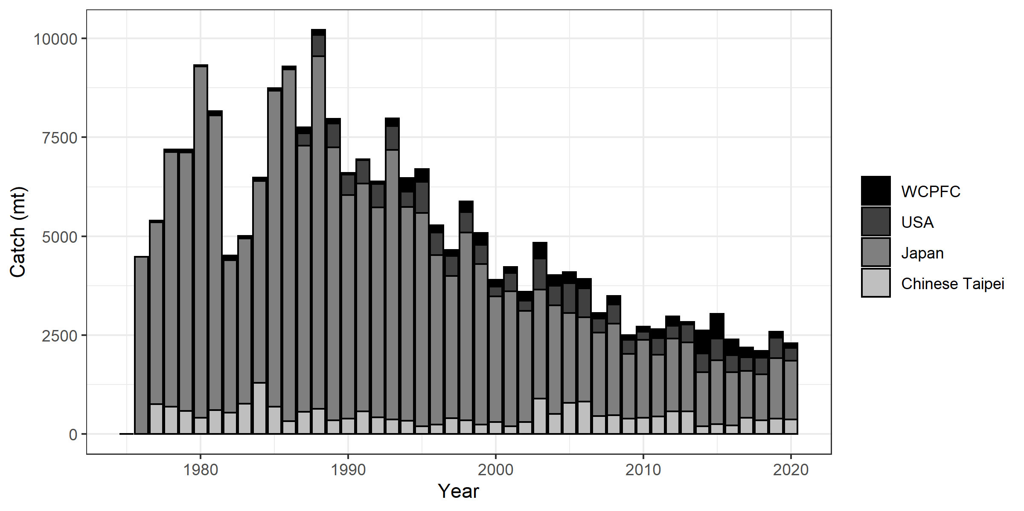
Figure WCNPOMLS-1. Annual catch biomass (mt) of Western and Central North Pacific striped marlin (Kajikia audax) by country for Japan, Chinese Taipei, the U.S.A., and all other countries during 1977-2020 (Figure S1 from SC19-SA-WP-11).

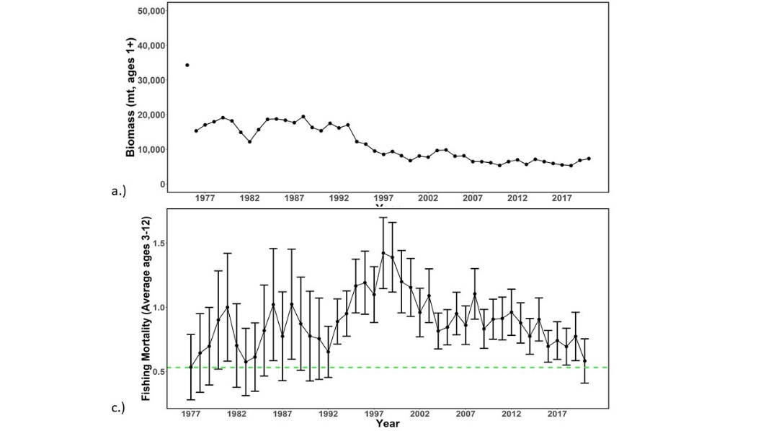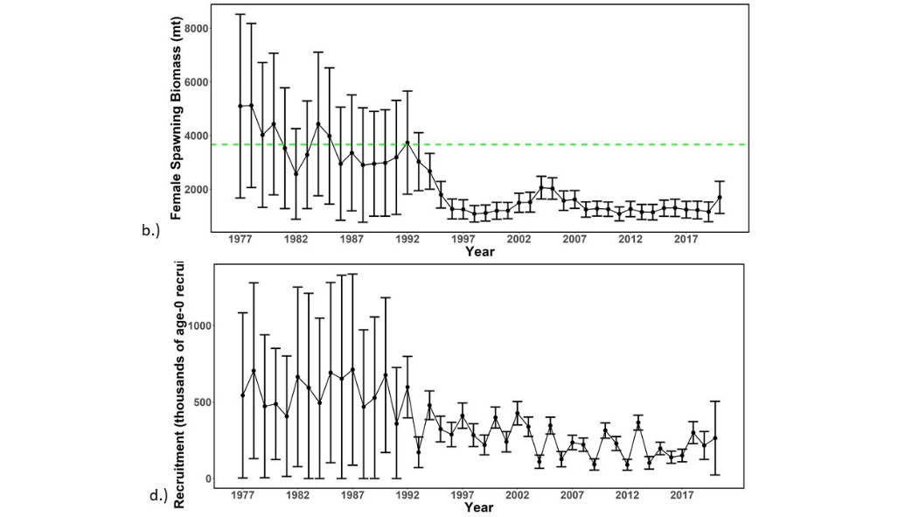

Figure WCNPOMLS-2. Time series of estimates of (a) population biomass (age 1+), (b) spawning biomass, (c) instantaneous fishing mortality (average for age 3-12, year⁻¹), and (d) recruitment (age-0 fish) for Western and Central North Pacific striped marlin (Kajikia audax) derived from the 2023 stock assessment. The circles represent the maximum likelihood estimates by year for each quantity and the error bars represent the uncertainty of the estimates (95% confidence intervals), green dashed lines indicate the dynamic 20%SSB_{F=0} and F_{20%SSBF=0} reference point (Figure S2 from SC19-SA-WP-11).

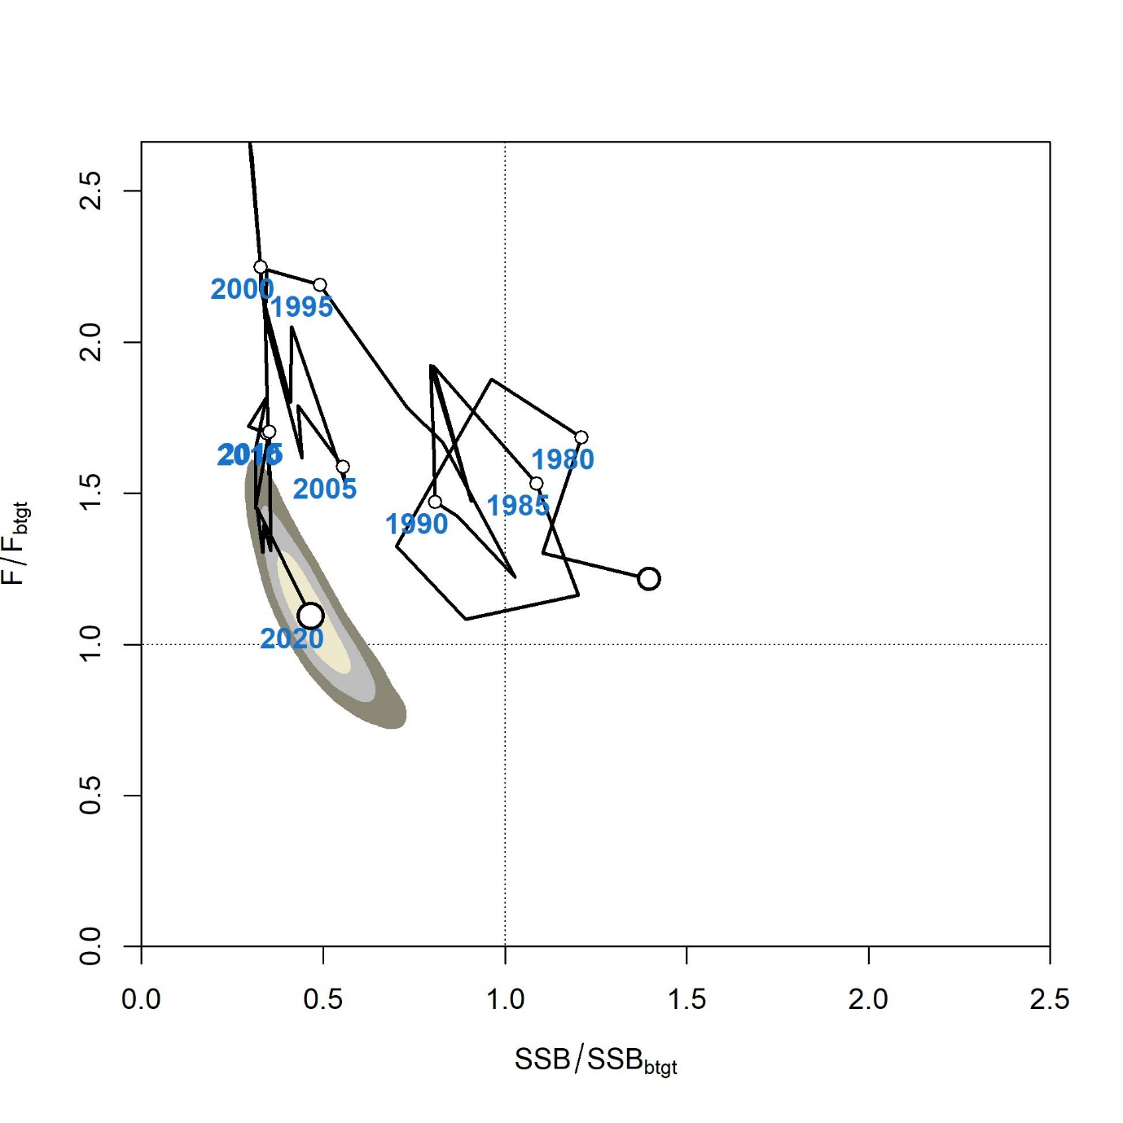

Figure WCNPOMLS-3. Majuro plot of the time series of estimates of relative fishing mortality (average of age 3-12) and relative spawning stock biomass of Western and Central North Pacific striped marlin (Kajikia audax) during 1977-2020. F_{btgt} and SSB_{btgt} refer to F_{20%SSBF=0} and 20%SSB_{F=0}, respectively. The large, un-labeled open circle indicates 1977, subsequent open circles are in 5-year increments. Shading indicates 50%, 80%, and 95% confidence intervals, respectively (Figure S3 from SC19-SA-WP-11).

a.)
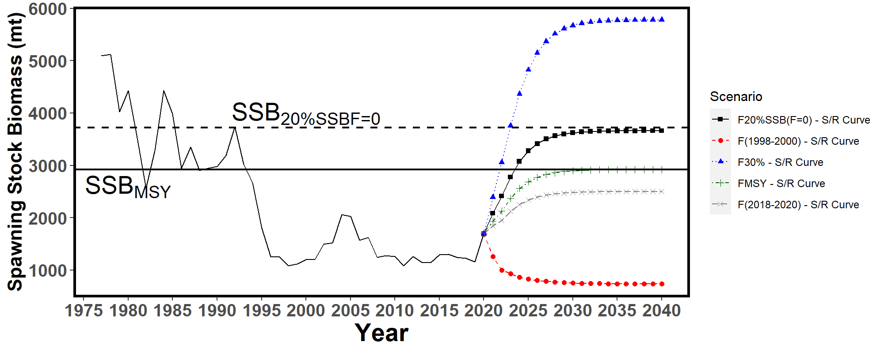
b.)
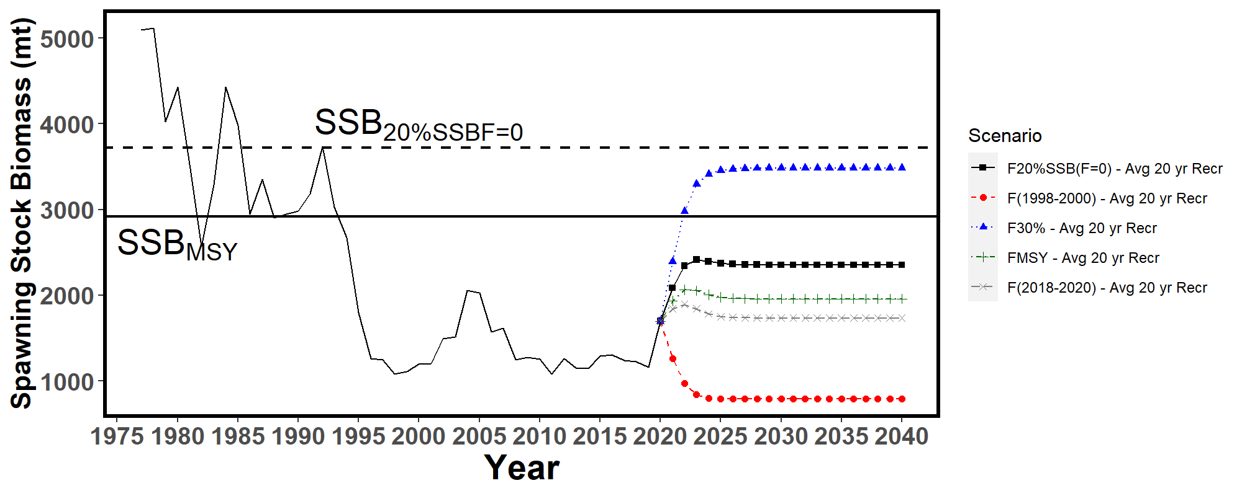
c.)
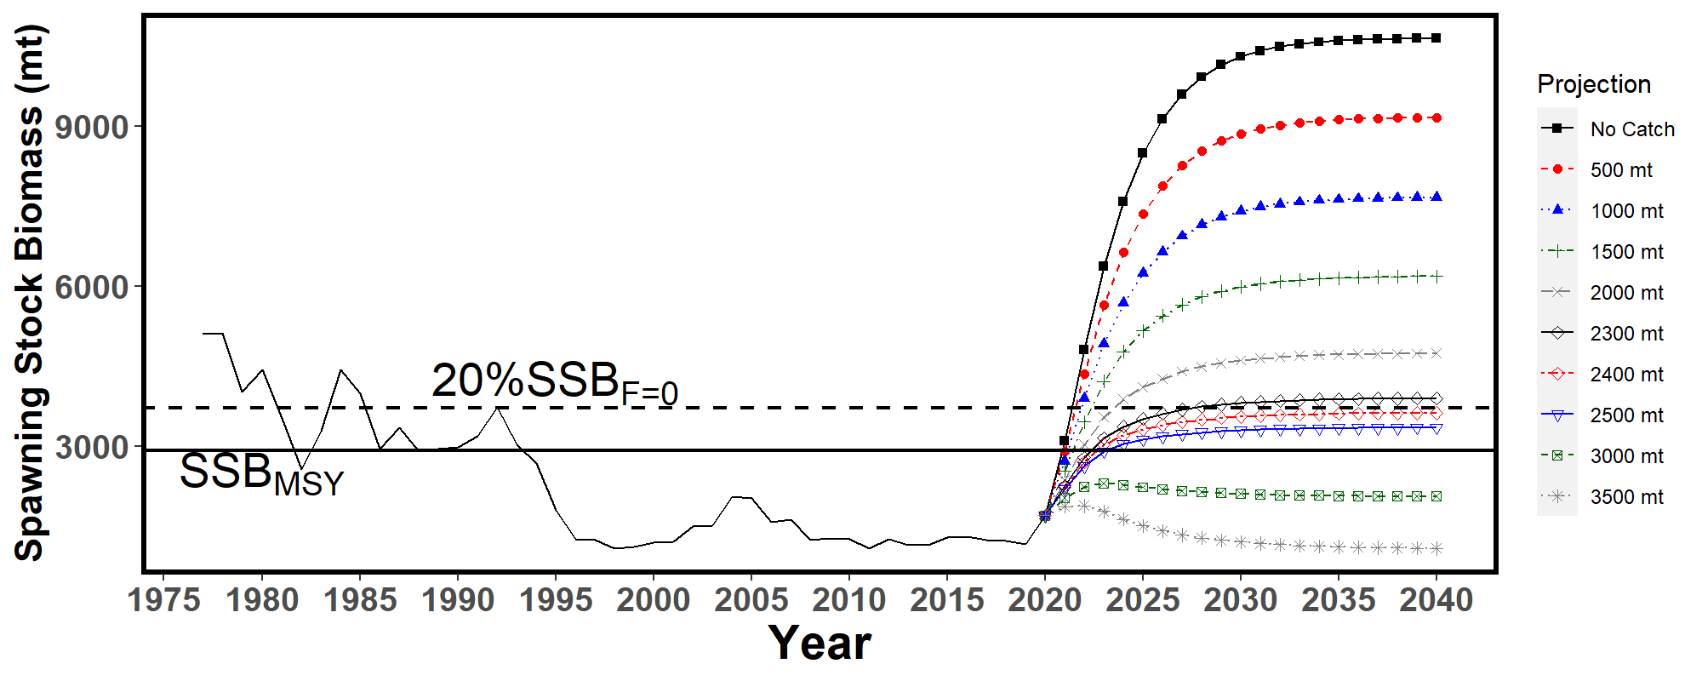
Figure WCNPOMLS-4. Historical and projected trajectories of spawning biomass from the Western and Central North Pacific striped marlin base case model based upon F scenarios: (a) F scenarios projected spawning biomass using recruitment estimated from the stock-recruitment curve; (b) F scenarios projected spawning biomass using average recruitment from 2001-2020. (c) Catch scenarios projected spawning biomass using average recruitment from 2001-2020. Dashed line indicates the spawning stock biomass at the dynamic 20%SSB_{F=0} reference point. Solid line indicates the spawning stock biomass at SSB_{MSY}. The list of projection scenarios can be found in SC19-SA-WP-11 Tables S3 and S4 (Figure S4 from SC19-SA-WP-11).

a.)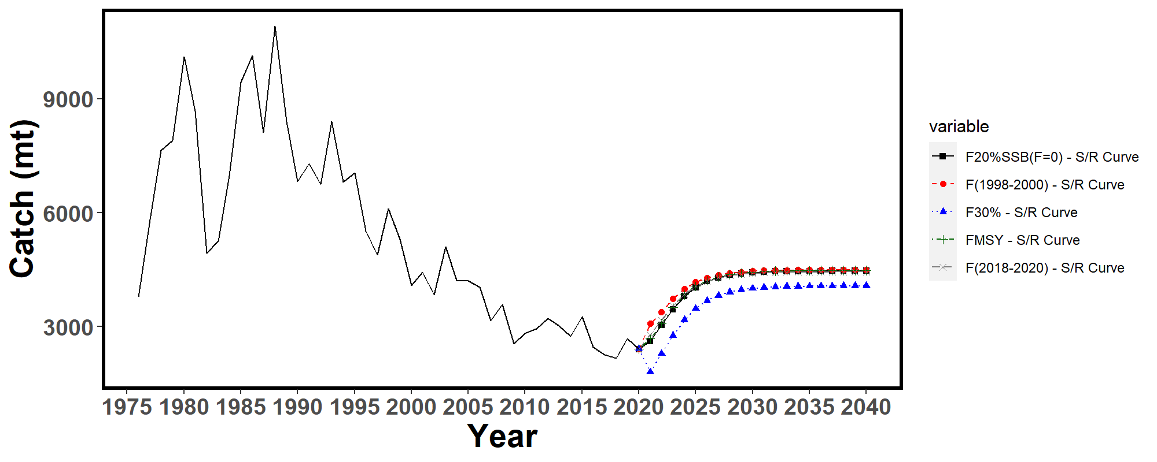
b.)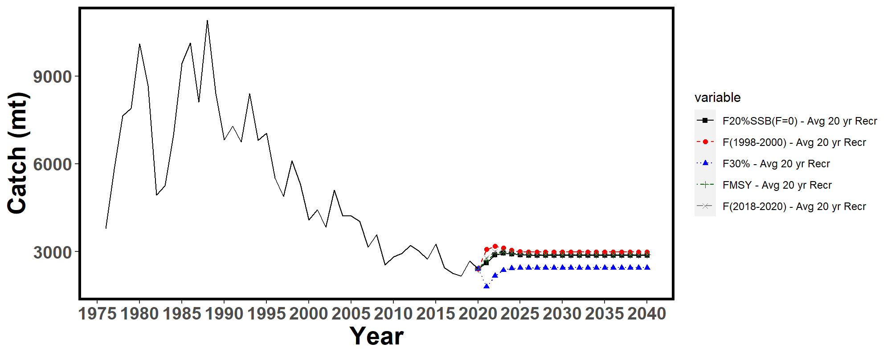
Figure WCNPOMLS-5. Historical and projected trajectories of catch from the Western and Central North Pacific striped marlin base case model based upon F scenarios: (a) F scenarios projected catch using recruitment estimated from the stock-recruitment curve; (b) F scenarios projected catch using recruitment estimated from 2001-2020 average. The list of projection scenarios can be found in SC19-SA-WP-11 Table S3 (Figure S5 from SC19-SA-WP-11).

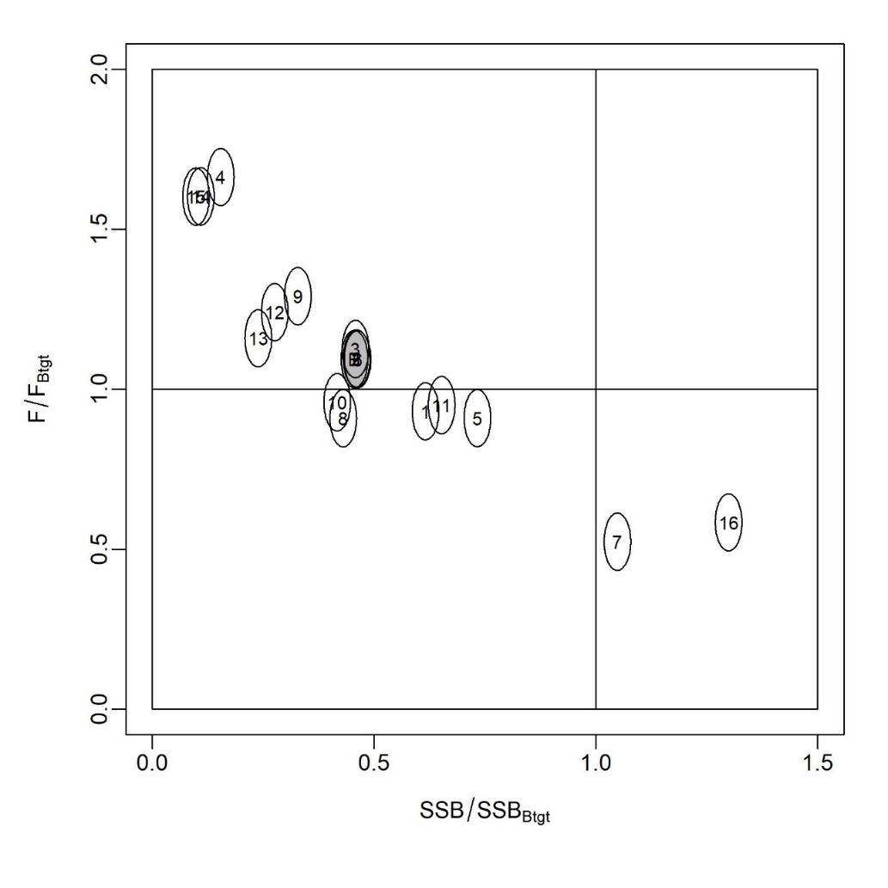
Figure WCNPOMLS-6. Majuro plot showing the terminal year stock status for the base-case model (gray circle, B) and the 16 sensitivity runs used to evaluate the sensitivity of the model to various model assumptions (circled numbers, circles are used as a visual aid). Models 12, 13, 15, and 16 are all sensitivity runs on assumptions on growth. See SC19-SA-WP-11 Table 12 in the stock assessment report for the full list and description of the sensitivity runs (Figure S6 from SC19-SA-WP-11).

Projects and Requests

Characterization of stock assessment uncertainty (Project 113)

P. Neubauer (DRAGONFLY) presented SC19-SA-WP-12 (Addressing uncertainty in WCPFC stock assessments: Review and recommendations from WCFPC Project 113).

SC19 supported the recommendations made in the report and encouraged the SSP and the ISC to take necessary steps to implement them as appropriate. Most notably, the design of a standardized reporting template including language for stock status outcomes, management advice, and uncertainties, and the development of consistent terminology regarding the description of the stock status probabilities relative to reference points are considered a priority.

SC19 noted a consistent reporting format would support clear comparison among stocks and years.

SC19 recommended that this project be included in the 2024 SC workplan and added to the Tuna Assessment Research Plan.

SC19 also noted the continuation of Project 113b to develop the standardized reporting template and language.

Application of Close-Kin Mark-Recapture Methods (Project 100c)

SC19 noted the progress being made on the CKMR preliminary study, and notes that this type of work has improved stock assessments in other tRFMOs and looks forward to seeing how the SPA assessment is improved in the future.

Options to provide information to the Scientific Committee

Noting the need for the SSP to have more time to complete the work required to conduct annual stock assessments and other analyses reviewed by the SC each year, SC19 recommended that:
  - the data manager at the SSP liaise and consult with CCMs about the possibility of bringing forward the data submission deadline for fleets, especially historical data updates,
  - the Secretariat explore options for moving the dates of the SC meeting to a later period in the calendar year,
  - the Secretariat and SSP explore options for the WCPFC website to include a portal for CCMs to enter/edit/manage their ACE data submissions, and
  - the SSP develop guidelines for standardised structure/file layouts for Annual Catch Estimates and aggregate catch/effort data that can be used by CCMs to submit these data.

Noting the need for further resources to assist the SSP in conducting annual stock assessments and other analyses related to the work of the Commission, SC19 recommended that the Commission consider increasing the SSP’s budget so that the number of full-time assessment scientists can be increased to four or five.

Tuna Assessment Research Plan

An informal small group 3 (ISG03) met during the course of SC19 to review SC19-SA-WP-15 (Draft Tuna Assessment Research Plan (TARP) for ‘key’ tuna species assessments in the WCPO, 2023-2026) and the ISG03 Report is in Attachment 1.

Billfish Research Plan (Project 112)

An Informal Small Group (ISG04) met during the course of SC19 to review SC19-SA-WP-16 (Draft billfish research plan, Project 112), and the ISG04 report is contained in Attachment 2.

Noting that SC17 agreed a framework for selecting LRPs for billfish species, SC19 seeks general guidance from the Commission on whether in the case of non-targeted species it is acceptable to have a higher level of risk to the stock and a lower biomass LRP compared with the equivalents for target species.

Reproductive biology of yellowfin tuna

S. Nicol (SPC-OFP) presented SC19-SA-WP-17 (Concept note for a new EU supported study on the reproductive biology of yellowfin tuna).

SC19 recognized the importance of biological parameters and acknowledged the valuable updates on the reproductive biology and spawning potential for yellowfin that this project could provide for stock assessments.

SC19 agreed that the project should be expanded to include bigeye and skipjack tuna.

SC19 endorsed the project and recommended that the WCPFC co-finance EU 40,000 so that funding from the European Maritime, Fisheries and Aquaculture Fund could be accessed.

SC19 noted that the project, if approved for WCPFC co-funding and EU funding, would be established as an SC project, and could commence in January 2024 with a final report to the SC scheduled in August 2026.

AGENDA ITEM 5 — MANAGEMENT ISSUES THEME

Development of harvest strategy framework for key tuna species

Skipjack tuna

5.1.1.1 Implementation of Management Procedure for WCPO skipjack tuna

SC19 noted that WCPFC19 had adopted CMM 2022-01 Conservation and Management Measure on a Management Procedure for WCPO Skipjack Tuna, which includes a repeating 3-year implementation schedule of the management procedure (MP). Also noting the request to review the performance and outputs of the initial run of the skipjack MP, and provide advice and recommendation to the Commission, SC19 reviewed SC19-MI-WP-01 (WCPO skipjack management procedure).

SC19 noted that the estimation method ran successfully and returned an estimate of SB_{latest}/SB_{F=0} of 0.42, and that the corresponding scalar from the HCR was 1.0. Under the adopted MP outlined in CMM 2022-01, this sets maximum effort in the purse seine and pole and line fisheries, and maximum catches in all other fisheries, at baseline levels (PS at 2012 effort; PL at 2001-04 effort; Region 5 domestic fisheries at average 2016-18 catches) for the subsequent management period (2024 to 2026).

Several CCMs noted that they were happy with this outcome, as it is consistent with the objective of relative stability in fishing levels between management periods.

SC19 noted that the data used to determine this estimate was not entirely consistent with that used for the dry run of the management procedure in the previous year. This change appears to be largely attributed to differences in the standardised pole and line indices, both for the historical time series and for most recent years. However, SC19 noted that SPC and Japanese colleagues will be working together to identify the issue in last year’s dry run. Nevertheless, SC19 noted that the initial running of the skipjack MP was consistent with that predicted by the MSE and all data requirements were satisfied.

SC19 was informed that the contraction of pole and line fishing effort is impairing the ability to index relative abundance of WCPO skipjack across the equatorial region and diagnostic analyses indicate that it is likely to affect the future performance of the MP. The SSP indicated that it would consider what alternative options might be possible for dealing with this issue and report progress back to SC20.

SC19 noted that this is not just an issue for the estimation model of the MP but also for the stock assessment.

Noting that with maximum effort and catches now recommended by the MP for respective fisheries for the next three years, this provides a time window for further work, and SC19 recommends that a re-evaluation of the skipjack estimation method needs to be undertaken prior to the next implementation of the MP.

SC19 recommended that the Commission take into consideration the successful running of the skipjack MP as outlined in SC19-MI-WP-01 and its output, which indicates that maximum effort in the purse seine and pole-and-line fisheries and maximum catches in all other fisheries should be set to their respective baseline levels (specified in CMM 2022-01) for the period 2024-2026, when implementing CMM 2022-01.

Monitoring strategy for WCPO skipjack tuna

Noting the Commission’s request to review the elements of the monitoring strategy as set out in ANNEX III of CMM 2022-01, and information provided by the SSP on the elements of the harvest strategy to be included in the monitoring strategy, SC19 reviewed SC19-MI-WP-02 (Monitoring the WCPO skipjack management procedure).

SC19 noted the aspects of the MP that may be considered for inclusion in the monitoring strategy and the Commission body at which those considerations can be made (Annex III, Table 2, also shown in Table 1 of SC19-MI-WP-02).

In order to simplify and streamline the monitoring process for the Commission and its subsidiary bodies, SC19 supported the concept of compiling a summary monitoring report consisting of a summary table that identifies the elements of the monitoring programme that may require additional work or through which major problems may be identified, along with a few short paragraphs to provide further details of the work required to address those issues. The priority of any issues identified can be determined based on the considered severity of the issue and the amount of work required to address it.

An example of such a summary report is attached as Attachment 3.

While noting that this report covers all the elements of the MP to be reviewed, SC19 also noted a need for both the TCC and the Commission to provide input into the development of this report considering the elements of the monitoring strategy that have been assigned to each body to review.

SC19 also noted that the initial development and implementation of this monitoring strategy, and the associated report, will likely be an iterative process, with some time-lags before each body will be able to fulfil some of its roles. For example, given the MP will be first implemented in 2024, TCC will only first be able to monitor compliance in 2025. Once this initial phase in period is complete, review and updating of the monitoring report should be undertaken annually by each body. However, as the MP and stock assessment are only run every three years, some elements of the monitoring strategy will not be able to be reviewed and updated on an annual basis.

SC19 noted that as this is the first year for which this MP has been run, there is limited ability to monitor its full performance now. However, to initiate the development of the monitoring report, SC19 reviewed those elements of the monitoring strategy assigned to the SC. The outcomes of that review are shown in the draft monitoring report listed in Attachment 3 and show that SC19 supported the conclusions of SC19-MI-WP-02, that the outcomes of initial running the skipjack MP were consistent with that predicted by the MSE and that all data requirements were satisfied. Some priorities for future work are also noted.

Finally, SC19 noted that the annual review of each element of the monitoring strategy will provide an opportunity for the Commission and its two subsidiary bodies to review, and where necessary (depending on the degree of impact on the MP), update the management objectives to ensure the overall harvest strategy remains appropriate as the nature of the fishery evolves over time.

Noting that the Commission is scheduled to adopt a monitoring strategy for skipjack tuna in 2023, SC19 supported the proposed monitoring strategy as outlined in SC19-MI-WP-02 and recommended that it be considered for adoption following further discussion by TCC and the Commission.

SC19 recommended that the Commission take note of the initial review of the skipjack MP under the proposed monitoring strategy as outlined in SC19-MI-WP-02 and consider the proposed monitoring strategy summary report drafted by SC and TCC and advise accordingly.

South Pacific Albacore Tuna

Target reference point (TRP)

SC19 noted that the Commission is scheduled to adopt a target reference point (TRP) for South Pacific albacore tuna in 2023 and reviewed SC19-MI-WP-03 (Update to further inform discussions on South Pacific albacore objectives and the TRP).

SC19 examined the update from the table of possible outcomes to SP albacore tuna under candidate TRPs presented to WCPFC19-2022-15 by the Scientific Service Provider. It was noted that the change to the methodology, whereby failed projections are now included in the summary metrics, resulted in slightly more pessimistic outcomes. The set of candidate TRPs presented in Table 1 was considered to be extensive and no requests were made for further additions prior to consideration by WCPFC20.

SC19 noted that according to the latest stock assessment for SP albacore tuna (accepted by SC17) the stock was not considered overfished or to be undergoing overfishing, and that an updated stock assessment was due for presentation at SC20 in 2024.

Several CCMs noted the importance of SP albacore tuna fisheries to their economy and encouraged the adoption of a TRP for SP albacore tuna by WCPFC20. The importance of economic considerations when selecting a TRP, notably when reviewing the changes in catch limits resulting from the adoption of specific TRPs, was also mentioned.

Several CCMs noted that TRPs defined from specific depletion levels are susceptible to changes in our perception of stock status that occurs with each successive stock assessment, or between the stock assessment and the set of operating models used to develop a management procedure. It was recommended that a TRP be set based on stock status in a reference set of years instead, noting that multiple years provide increased robustness against peculiarities that may be present in a single specific year.

Some CCMs noted that there are features in the 2021 SP albacore assessment that are still being investigated, most notably the pronounced low estimated recruitment in 2016 and the projected dip in biomass depletion levels. As such the suggestion was that WCPFC20 adopt an interim TRP conditional on the results of the next SP albacore assessment scheduled for SC20.

SC19 noted the proposal by the South Pacific Group and Australia for an interim TRP submitted at the Fourth meeting of the South Pacific Albacore Roadmap Intersessional Working Group. The proposed iTRP is based on the estimated average depletion of the SP ALB over the period 2017-2019 and is outlined in SPA-RM-IWG04 Working Paper 3.

SC19 recommended that WCPFC20 reviews the list of candidate TRPs outlined in SC19-MI-WP-03 when adopting a TRP for SP albacore tuna and consider a TRP that is based on a set of reference years instead of a specific level based on a biomass depletion percentage.

South Pacific Albacore operating models

SC19 noted that under the indicative Harvest Strategy Work Plan (WCPFC19-2022- 19a_rev2), SC19 is scheduled to agree on the operating models to use for the Management Strategy Evaluation of SP albacore tuna and that the Commission is scheduled to adopt a management procedure (MP) for SP albacore tuna in 2024.

SC19 thanked the Scientific Service Provider (SSP) for their presentation of SC19-MI-IP-08 (Factors contributing to recent and projected declines in south Pacific albacore stock status) investigating potential explanations for the 2016 “recruitment dip” predicted by the 2021 stock assessment which carries forward to a significant projected biomass decline over recent years. SC19 noted that SC19-MI-IP-08 findings do not resolve whether the recruitment dip is real or a misspecification of the model. While there is some evidence that the recruitment dip might be real, specifications of the stock assessment model might also have exacerbated the extent of the recruitment dip in the projections and within the OMs.

Several CCMs were concerned about the development of a reference grid based on operating models that estimate a recruitment dip, noting that the evaluated performance of MPs would in part reflect a response to that dip and be misleading, particularly in the short term. There was support for continued research investigating improvements to the operating models, especially in light of the revised stock assessment to be completed in 2024.

The SSP noted that it would be possible to recondition the OM grid if required following SC20 and highlighted that the main matter of interest was changes in the relative performance of each of the MPs being tested under any updated OM, although other metrics might also be of interest to CCMs.

SC19 also reviewed SC19-MI-WP-04 (Selecting and Conditioning Operating Models for South Pacific Albacore) outlining a candidate OM reference grid to use for testing management procedures for SP albacore tuna.

SC19 noted the importance of model diagnostics for assessing the performance of operating models and thanked the Scientific Service Provider for their development of a Shiny app (SC19-MI-IP-03) with such diagnostics. It was suggested that CPUE diagnostics also be included for future consideration by SC20.

Despite some concerns, several CCMs agreed that the current OM and proposed reference grid were appropriate to enable MP development testing to progress. There was also support for the SSP to evaluate performance of MPs with the first year of simulated operation in 2025 (using data up to 2023). 2025 is the first year a MP would be implemented under the current HS workplan within the ongoing MSE simulation framework. There was also support for considering SB_{recent}/SB_{F=0} (as opposed to SB_{latest}/SB_{F=0}) as a management quantity to further reduce the potential impact of some of the modelling concerns.

In light of the concerns about the suitability of the current operating models, it was suggested that the reference set be treated as interim, conditional on future investigations of operating model specifications and the identification of additional OMs where relevant. SC19 supported the SSP’s suggestion to expand the OM reference set to incorporate a scenario where the recent estimated ‘recruitment dip’ was less pronounced.

Several CCMs noted the importance of considering expanded areas of uncertainty as part of the robustness set and proposed, at this stage, that this should include scenarios of climate change and CPUE hyperstability, however further robustness tests may be required.

SC19 recommended the use and development of the reference OM set provided in Table 1 of SC19-MI-WP-04 over the next year to allow the continued progress and evaluation of candidate MPs for SPA.

Further SC19 recommended that SC20 again consider formally adopting the reference OM set for SPA noting the ongoing investigations that might require a reconditioning of the reference set ahead of SC20, and the potential for other changes in light of the 2024 SPA stock assessment.

South Pacific albacore tuna management procedures

SC19 noted that according to the Harvest Strategy Work Plan, SC19 is scheduled to provide advice to the Commission on the performance of candidate management procedures for South Pacific albacore. As such, SC19 reviewed an update on the progress of developing and testing MPs for South Pacific albacore presented by the Scientific Service Provider (SSP), including estimation model options, HCR designs, and preliminary evaluations and consideration of performance indicators.

SC19 thanked the SSP for their presentation of SC19-MI-WP-05 (“Developing management procedures for South Pacific albacore”) and SC19-MI-WP-06 (“Evaluation of candidate management procedures for South Pacific albacore”) and noted the inclusion of a clear list of items informing management procedure design for which feedback was sought.

Some CCMs noted that while they are able to provide feedback on aspects of MP development to inform technical discussions, decisions on specific configurations ultimately could only be made by the Commission since they relate to management issues.

One CCM noted that there were several influential decisions to be made with regards to MP settings and sought clarification as to the best mechanism to support feedback on each of these settings noting the lack of guidance on the best approach to conduct these discussions. It was clarified that CCMs could provide feedback on specific MP features as part of the SC19 plenary discussions.

Other CCMs mentioned further opportunities for detailed feedback to the SSP on MP settings for exploration, for instance the stakeholder engagement and capacity building activities undertaken by the SSP under the project “Pacific Tuna Management Strategy Evaluation” (see SC19-MI-IP-05), the South Pacific Albacore Roadmap Intersessional Working Group and the SP albacore tuna-focused Science Management Dialogue tentatively planned under the Roadmap for 2024 (WCPFC-SPALB-RM-2023-00).

SC19 noted its support for the use of the age-structured surplus production model (ASPM) as the estimation model and a 3-year cycle for MP update consistent with the stock assessment cycle for SP albacore tuna.

Several CCMs noted that they supported a harvest strategy that could account for both effort and catch controls in recognition of the diversity of management approaches across the region. It was also suggested that, due to its small impact on the overall stock, options for the troll fishery to be treated differently within the MP could be considered in future updates.

Several CCMs further noted that, while all sources of commercial mortality on the SP albacore stock should ideally be covered by the MP, EPO catches (outside of WCPFC management) could be fixed at recent levels for the purpose of MP evaluation and development. SC19 encouraged the Commission to seek compatible measures in the IATTC to address this gap in the management of SPA that may impact the effectiveness of an adopted MP.

SC19 requested that a dry run of one or more of the candidate MPs be presented to SC20 next year, similar to that done for skipjack tuna at SC18.

Some CCMs stated ongoing concerns with the impact of the recruitment dip on MP testing. While there was support for MP evaluation to start in 2025 as a partial solution to the recruitment dip it was emphasized that there was still a clear impact of the dip on the performance of candidate MPs over the short term (2026-34).

Several CCMs noted the importance of accounting for environmental impacts when testing the MP, for example as part of the robustness set.

SC19 noted that the projections from the initial MP testing appeared more pessimistic than those conducted as part of the 2021 SP albacore tuna stock assessment. The SSP responded that, unlike in the 2021 stock assessment, there was no down-weighting of the SEAPODYM movement axis in the operating model grid, leading to a more pessimistic outcome for stock status.

In response to a question on the impact of the HCRs across regions and fisheries the SSP clarified that, for the current set of evaluations, all fisheries were impacted equally by the catch scalars prescribed by the Harvest Control Rule.

SC19 sought clarifications with respect to the conditions that would exacerbate population crashes that sometimes occur in the simulations. As this feature had not been investigated by the SSP, it was noted that the type of management input (effort or catch) might impact this behaviour, and that asymmetrical catch constraints might be considered as a possible solution.

Several CCMs noted that a representative set of MPs needed to be available to support discussions at WCPFC20 but that the number of candidate MPs could easily expand to unmanageable levels when considering multiple options applied across different MP settings. As such, it was encouraged that the number of MPs presented to the Commission be kept to manageable levels (e.g., 10 or less) so that the Commission could provide clear input on desirable features for future exploration.

SC19 recommended that WCPFC20 review the current set of 6 candidate MPs for initial consideration, noting the diverse range of MP configurations provided by the SSP is sufficient to support discussions on desirable features and design priorities.

SC19 further recommended that the Commission provide guidance based on these exploratory MPs on features to be further developed by the SSP, including performance indicators, controlled fisheries and control mechanisms, and HCR shape and design.

Mixed fisheries MSE framework

Noting the work reviewed by previous SC meetings in developing a multi-species modelling framework for including mixed ﬁshery interactions when developing and testing harvest strategies for the four main WCPO tuna stocks, SC19 reviewed an update on the development of this framework outlined in SC19-MI-WP-07 (Mixed fishery harvest strategy update).

One CCM stated that although the current diagram depicts that the purse-seine fleets catching bigeye are only controlled by the skipjack MP regardless of the stock status of bigeye, it has not agreed with such a one-way hierarchy of multi-species MP application. Noting that the mixed fishery approach has not yet been agreed, they suggested that the Commission is the most appropriate place for this decision to be made. Another CCM also suggested that the decision hierarchy of the MPs may not be a topic for SC, but for fishery managers.

Several CCMs supported the more flexible approach to management objectives described in the paper. Noting the difficulty of getting agreement on management objectives among CCMs who have different visions of how stocks and fisheries should be managed, and that reaching agreement on the form and level of management objectives has been made more difficult by modelling changes, they supported the threshold approach to the nature of the yellowfin management objective as outlined in the paper. They also noted that the relatively large yellowfin catches taken within archipelagic waters strengthens the need for such a flexible approach. They also expressed support for developing a threshold-type management objective for bigeye.

Several other CCMs noted the progress made in the development of the mixed-fishery harvest strategy approach and encouraged the Commission to keep the mixed-fishery strategies and questions in mind while developing target reference points for bigeye and yellowfin, as well as development of the MPs.

One CCM noted that discussions between the Philippines, Indonesia and Vietnam indicated concern about future management of yellowfin tuna in the WCPO and stated a preference for yellowfin tuna being controlled by a separate MP. However, it was also noted that a separate harvest strategy is presently being developed for Indonesian archipelagic waters and could help alleviate some of those issues.

In response to the views expressed, the presenter noted that the mixed fishery framework is a proposal, and not a decision. The current plan is to build the modelling framework and see how it performs for bigeye and yellowfin. If it suggests that these are not well managed under the current mixed fishery framework, then another approach will be needed.

One CCM noted that a TRP should specify fishery conditions that managers would like to achieve and that they believed it would be more logical if this made reference to conditions in a fishery over several specified years instead of a depletion-based TRP value. They noted that this is a decision for the Commission.

SC19 supported continuing the work on the development of the mixed fishery MSE framework and recommended that WCPFC20 take note of the progress to date and provide feedback.

Progress of the WCPFC Harvest Strategy Workplan

SC19 noted the adoption by WCPFC19 of the updated Indicative Workplan for the Adoption of Harvest Strategies under CMM 2014-06 (Attachment M, WCPFC19 Summary Report).

SC19 also noted the presentation made by Australia on behalf of FFA which outlined proposed changes that will be presented to WCPFC20, including the following two ‘high-level’ changes: i) as a contingency allow for a potential one-year delay in the adoption of a MP for SP-albacore, noting potential issues with the operating models, and ii) reschedule the adoption of a MP for bigeye and yellowfin to 2026 to avoid subsequent running of the MP in the same year the stock assessment is conducted.

SC19 was informed that the Marine Stewardship Council Conformity Assessment Bodies are developing milestones for harvest strategies that will apply to MSC certified fisheries in the WCPO. However, SC19 also noted that the place for this important planning is within the Commission and its subsidiary bodies.

SC19 noted that the second of these proposed revisions would result in the adoption of the MP for bigeye and yellowfin in the same year that the updated stock assessments are provided to the SC. The presenter noted that the optimal timing of these items can often be difficult, but this proposal would result in a similar process to that undertaken for skipjack and would avoid the longer-term issue of coinciding running the MP with the stock assessment.

Several CCMs articulated their strong commitment to the successful implementation of the remainder of the Harvest Strategy Work Plan. They also encouraged continued capacity-building initiatives as they greatly assist CCMs, particularly SIDS, to participate fully in this complex process and have the confidence in the harvest strategy development process, and its outcomes when implemented. They suggested that such activities focus on topics such as agreeing to a management objective, the selection of a target reference point, management procedure design and performance indicators.

SC19 recommended that the Commission take note of the above views when updating the Harvest Strategy Workplan at WCPFC20.

Implementation of CMM 2021-01

Review of effectiveness of CMM 2021-01

SC19 noted that WCPFC 19 had agreed that the process to revise the Tropical Tuna Measure (TTM) will be based on CMM 2021-01 without a complete overhaul, and at least two workshops will be needed to make progress towards the adoption of a revised TTM in 2023. Based on the request to provide recommendations to the Commission on the effectiveness of CMM 2021-01, SC19 reviewed SC19-MI-WP-08 (Updates to table 9 of the evaluation of CMM 2021-01).

SC19 noted that SC19-MI-WP-08 evaluates the potential for CMM 2021-01 to achieve its objectives for each of the three WCPO tropical tuna (bigeye, yellowfin and skipjack) stocks. The current evaluations are based on the 2020 SC-agreed stock assessments for bigeye and yellowfin (last year of data is 2018) and the 2022 assessment for skipjack (last year of data is 2021). These evaluations now need to be updated to take account of the updated stock assessments for bigeye and yellowfin adopted by SC19 (last year of data is 2021) and consider the interim MP adopted for skipjack in 2022.

Several CCMs noted, that relative to the FAD set effort levels and the longline catches of bigeye and yellowfin, the TTM is performing adequately. However, as noted by the SSP in their previous evaluation presented at WCPFC19, since 2020 the evaluation of longline bigeye and yellowfin catches are below the expected range under the TTM. Additionally, the actual changes in catch relative to the 2016-2018 average baseline suggests the assumption of a direct relationship between the catch scalars may not be appropriate and may require further investigation.

SC19 supported the current analysis framework described in SC19-MI-WP-08. However, it queried as to how the 30-year projections used in the analyses will account for the effort levels in the skipjack fishery now likely being set every three years based on the adopted interim MP, as implementing the MP would reduce catch if stock biomass decreased. The SSP noted that while this needs to be finalised, these projections just present alternative scenarios that bound future levels between optimistic (i.e., similar levels of catch and effort to recent years) and fully utilised scenarios (maximums under the specified limits).

SC19 noted that the SSP is planning to have the updated projections ready for the TTMW4 in September. The updated evaluations will include an update to the baseline period which will now be 2019-2021. The SSP also explained that the preliminary FAD set scalar of 1.19 for the purse seine fisheries in the fully-utilised conditions, is the ratio of effort in 2012 divided by the effort in the period 2019-2021.

SC19 recommended that the updates to SC19-MI-WP-08 be forwarded to both TTMW4 and the Commission for their consideration in reviewing the Tropical Tuna Measure.

AGENDA ITEM 6 — ECOSYSTEM AND BYCATCH MITIGATION THEME

Ecosystem and Climate Indicators

SC19 noted that the SSP has completed a first screening of a subset of potential indicators for adoption and based on this experience recommended that the criteria identified at SC12 are appropriate for the initial screening of candidate indicators. However, more specific criteria are needed for testing and adoption.

SC19 recommended adoption of the proposed workplan for the development and testing of ecosystem and climate indicators for the period 2024-2027.

FAD Impacts

Research on non-entangling and biodegradable FADs (Project 110)

SC19 noted that limited information on dFAD designs and materials is available from 2020 to 2023 due to low observer coverage, and there is a need for additional data fields or more systematic data to be recorded to adequately assess the designs, materials, and type of dFADs deployed in the WCPO.

SC19 recommended that further studies are implemented to quantify the effectiveness and the entanglement frequency of Species of Special Interest (SSI) in the WCPO on dFAD designs, including Low Entanglement Risk dFADs, Non-Entangling dFADs and Biodegradable dFADs.

To help reduce marine pollution and ecosystem impacts linked to the use of dFADs, SC19 promotes the reduced use of plastics and non-biodegradable materials in the construction of dFADs and the use of non-entangling FADs, as required from CMM 2021-01 and implemented beginning in January 2024.

SC19 noted the delays in the activities from Project 110 due to the COVID-19 pandemic and updated timing of activities, and supported the no-cost project extension with a final anticipated report to be presented at SC21 in 2025.

SC19 highlighted the importance of the on-going research activities led by SPC and ISSF, in collaboration with fishing industry, to trial non-entangling and biodegradable dFADs in the WCPO to inform implementation of the requirements under CMM 2021-01. SC19 supported the TOR for a follow-up project to enhance SC Project 110 by trialling additional non-entangling and biodegradable dFADs and to investigate alternative construction locations and locally sourced materials.

SC19 supports CCMs to encourage their purse seine vessels to participate in trials of biodegradable FADs of Category I and II (all FAD components are biodegradable except for flotation devices and GPS buoy).

6.2.1.1 Extension to EU supported biodegradable FAD Project

The SSP provided a brief summary of a proposal for additional funds to support research on biodegradable FADs being submitted to the EU’s European Maritime Fisheries and Aquaculture Fund (outlined in project TOR SC19-EB-WP-07). It was noted that the proposal has a budget of 218,000 Euros, of which 20% (44,000 Euros) would be sought from the WCPFC as co-funds. The project would need to start in 2024 to align with the current Project 110 work and co-funds would therefore be required to be approved at WCPFC20. The ISSF generously committed to providing 20,000 USD as co-funds.

FAD Management Options IWG Issues

SC19 recommended that the FADMO-IWG and TCC review the timelines for the stepwise introduction of biodegradable dFADs considering the expected outcomes of projects related to the design, cost-effectiveness and performance of biodegradable dFADs (e.g., jelly FADs) in the WCPO and other oceans.

SC19 viewed that moving to biodegradable FADs is important for reducing marine pollution and other impacts. However, SC19 noted that it is challenging for some CCMs, especially for purse seine operators that are going through a major process of eliminating netting in FADs, to meet the non-entangling requirement for 2024 and further noted that trials for biodegradable FADs are still ongoing. In this regard SC19 noted that, for some CCMs, the year 2025 to start the transition to biodegradable FADs implementation may not be viable.

SC19 noted IATTC's biodegradable FAD implementation program, which includes timelines with the mandatory use of categories I to IIIb by 2026 (Table FAD-1); and categories I to II by 2029, which could be reviewed by TCC and the FADMO-IWG for consideration in the WCPO.

TABLE FAD-1: Preliminary categories of drifting FADs biodegradability levels (from non-biodegradable to 100% biodegradable) for the gradual implementation of biodegradable drifting FADs. In year X, FADs of either category III(a) (biodegradable tail) or/and category III(b) (biodegradable raft) are required/implemented simultaneously.
Categories | Potential Timeline  (Suggestion 1) | Potential Timeline  (Suggestion 2) | Remarks
Category I. The FAD is made of 100% biodegradable materials. | Year X + 3 | Year X + d | Year X will be determined by the WCPFC and subject to review based on available information and availability of materials
Category II. The FAD is made of 100% biodegradable materials except for plastic-based flotation components (e.g., plastic buoys, foam, purse-seine corks). | Year X + 2 | Year X + c | Year X will be determined by the WCPFC and subject to review based on available information and availability of materials
Category III(a). The subsurface part of the FAD is made of 100% biodegradable materials, whereas the surface part and any flotation components contain non-biodegradable materials (e.g., synthetic raffia, metallic frame, plastic floats, nylon ropes). | Year X | Year X +b | Year X will be determined by the WCPFC and subject to review based on available information and availability of materials
Category III(b). The subsurface part of the FAD contains non-biodegradable materials, whereas the surface part is made of 100% biodegradable materials, except for, possibly, flotation components. | Year X | Year X +a | Year X will be determined by the WCPFC and subject to review based on available information and availability of materials
Category IV. The surface and subsurface parts of the FAD contain non-biodegradable materials. | Current | Year X
Note* These definitions do not apply to electronic buoys attached to FADs to track them.

SC19 recommended the FADMO-IWG and TCC consider incentivising the use of biodegradable dFADs.

SC19 noted that some CCMs suggested one example of an incentive could be to allow biodegradable dFADs to be deployed during the FAD closure.

SC19 noted the limitation in the scientific analyses of FAD tracking data due to the current incomplete data. SC19 noted the importance of complete FAD tracking data, including for historical periods, to support scientific analyses to detect trends in dFAD use; to evaluate the effectiveness of paragraph 21 of the Tropical Tuna Measure (CMM 2021-01); to determine the origin of FADs and buoys found stranded; and to explore spatial management options to reduce stranding events.

SC19 supported the suggestion of the FADMO-IWG on requiring the provision of the daily location records from buoys attached to dFADs to be provided, including historical periods, to research organizations (SPC), research organizations within CCMs, or to the Commission.

SC19 noted that, based on the information available, no vessel monitored more than 350 active buoys per day (the current buoy number limit under CMM 2021-01), with 90% of the vessels monitoring less than 130 buoys per day. It was noted these results were limited to the fleets that have provided tracking information since January 2023 and some differences for at least one fleet have been noted. SC19 recommended that the FADMO-IWG and TCC further discuss the active FAD buoy limit and provide advice to TTMW4 and the Commission on this issue.

SC19 recommended that options should be developed by the FADMO-IWG and TCC for reporting the number of active buoys per vessel (paragraph 21 of CMM 2021-01); and to develop processes to i) report the number of dFADs and buoys deployed and retrieved per year; ii) report lost and abandoned dFAD; and iii) to eventually abandon and deactivate buoy communication (paragraph 22 of CMM 2021-01).

SC19 highlighted the need for in-situ data collection to better quantify FAD stranding events and the impacts of FADs on marine and coastal environments; and encouraged the expansion of the in-country stranded FAD data collection programs to other CCMs.

SC19 highlighted the need to promote FAD retrieval, preferably by the owner of the buoy attached, and eventually through dedicated programs, before FADs are abandoned or lost and ultimately reach coastal areas. SC19 recommended that options for increased FAD detection and retrieval should be considered, including economic aspects and standards required for programs to be effective. SC19 recommended that a FAD recovery program/strategy be an agenda item for the FADMO-IWG.

SC19 supported the Pacific-wide collaboration on dFAD research, in particular on harmonising data collection processes, increasing non-confidential data exchanges and collaborating on data analyses.

Sharks

Review of Conservation and Management Measures for sharks

SC19 recommended that, given the reduction in observer coverage over the COVID years and the amendments made to the shark CMM in 2022, it would be more effective to postpone the review of CMM 2022-04 to 2027, and this is proposed in the Shark Research Plan.

SC19 noted a need to support better data collection, particularly for less commonly caught species interactions and the utility of electronic technologies to complement monitoring and estimation of their interactions.

Mid-term Review of 2021-2025 Shark Research Plan (Project 97b)

SC19 agreed to extend the current shark research plan (SRP) to 2030 to encompass two assessment cycles.

SC19 agreed to the changes in Table 5 of the SC19-EB-WP-06 Shark Research Plan Mid-term Review (reproduced as Table SHK-1 below), as discussed by the Informal Small Group (ISG05), and recommended continuation of the ISG-Sharks at future SC meetings for annual ongoing review and amendment of the SRP. The ISG-05 report is contained in Attachment 4.

Noting that integrated stock assessments for elasmobranchs are challenging and can sometimes not succeed, SC19 recommended that, to the extent possible, integrated shark assessments projects undertaken within the WCPFC should also include a data-poor component so that advice on stock status can still be provided even if the integrated assessment approach fails.

SC19 encouraged future integrated elasmobranch stock assessments presented to SC to include data-limited stock status metrics such as those outlined in SC17 report Table MI-01, if they can be estimated.

TABLE SHK-1. Table 5 of the Shark Research Plan 2021-2025 Mid-term Review (SC19-EB-WP-06), as discussed by the Informal Small Group (ISG05) during SC19.
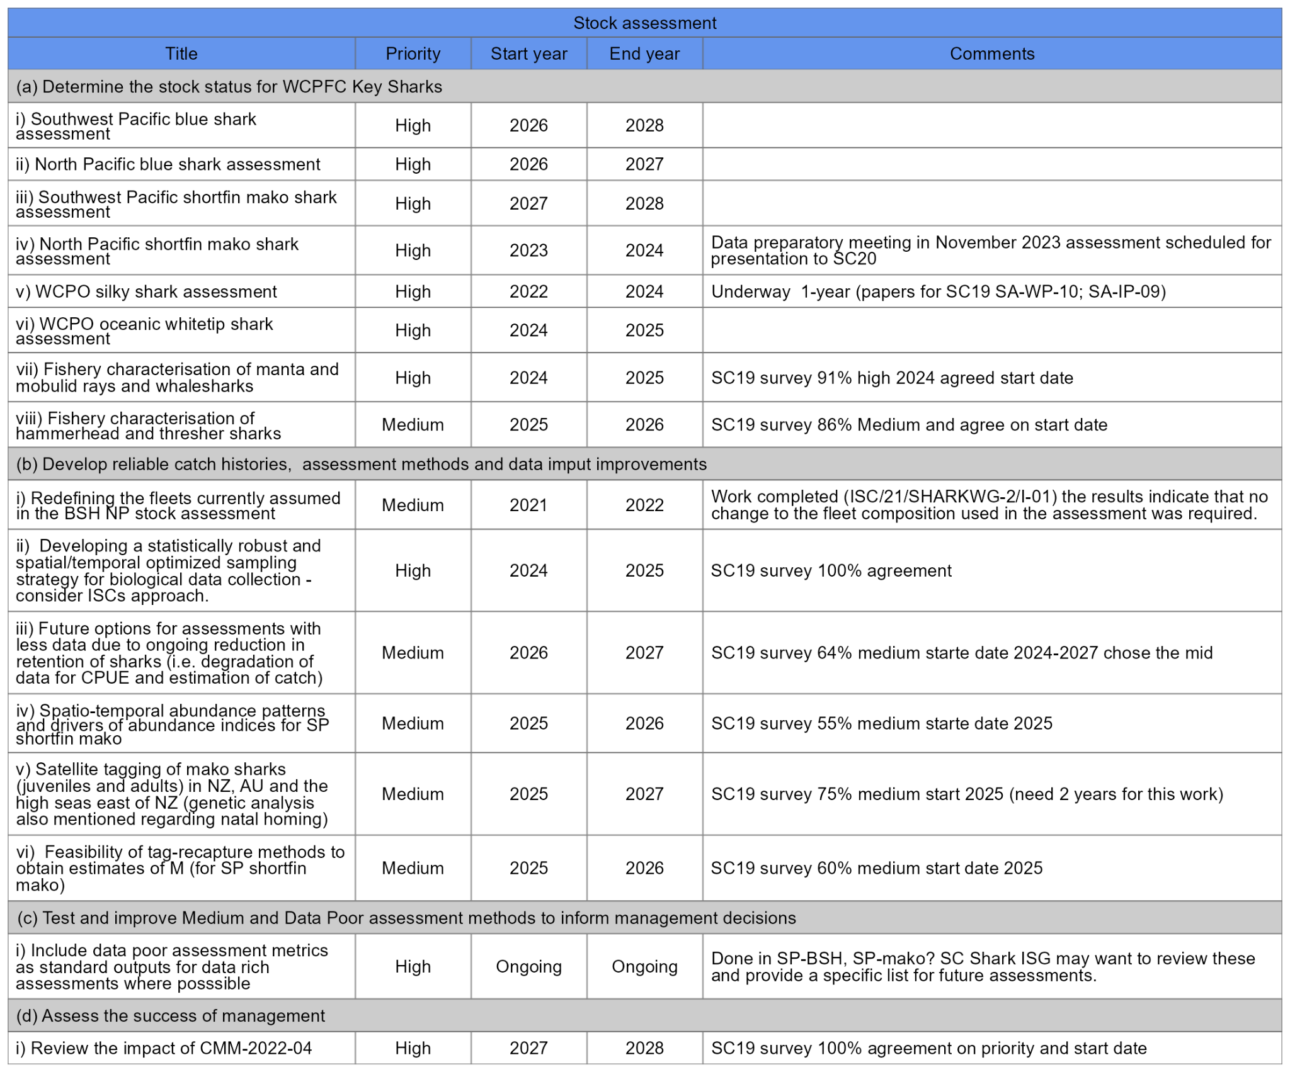
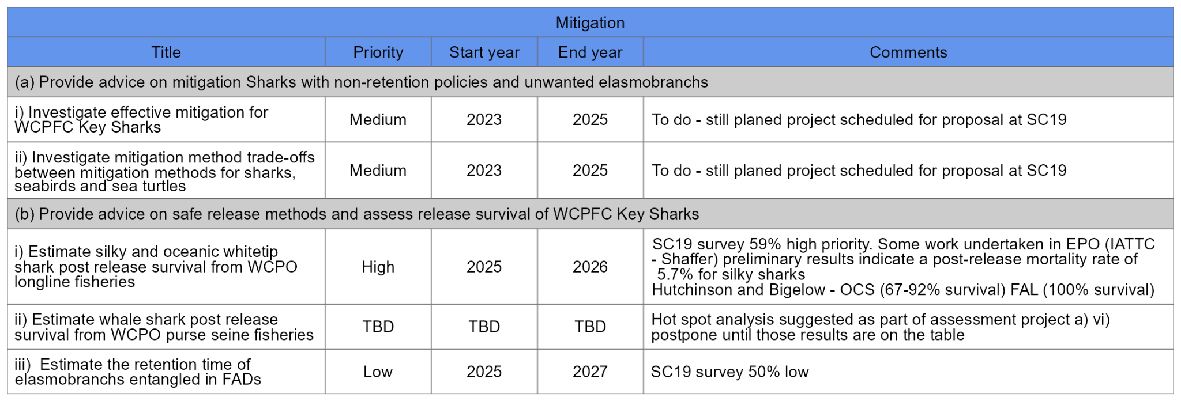
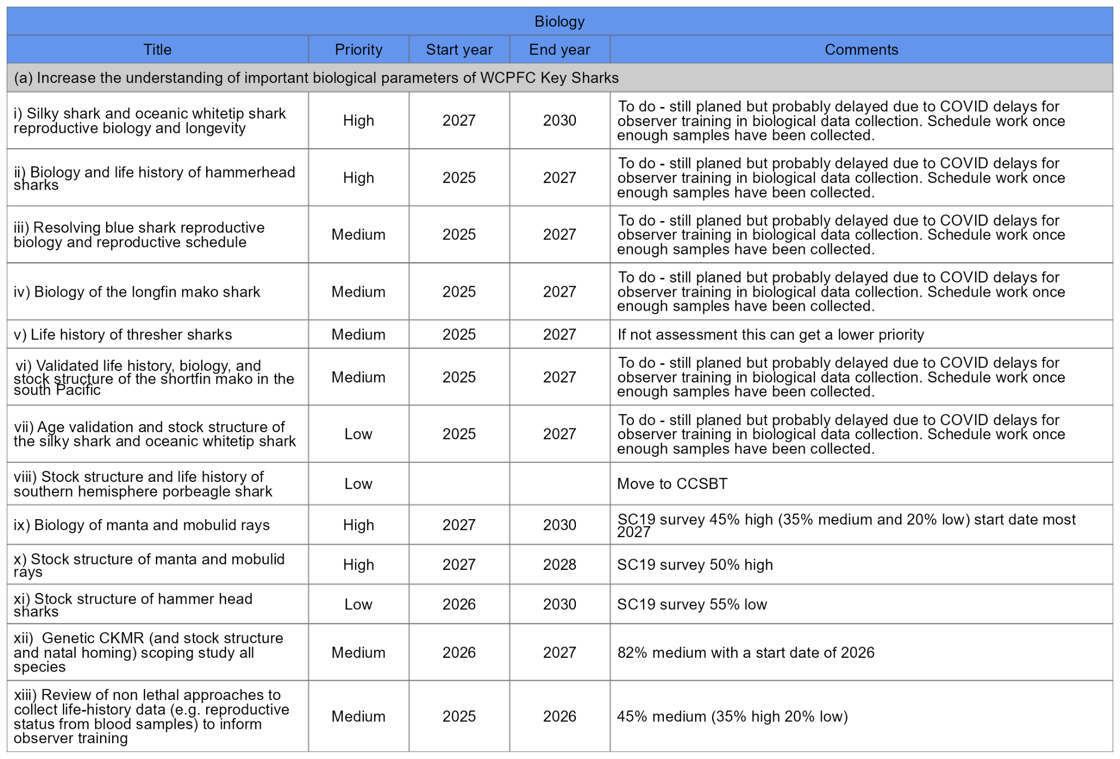
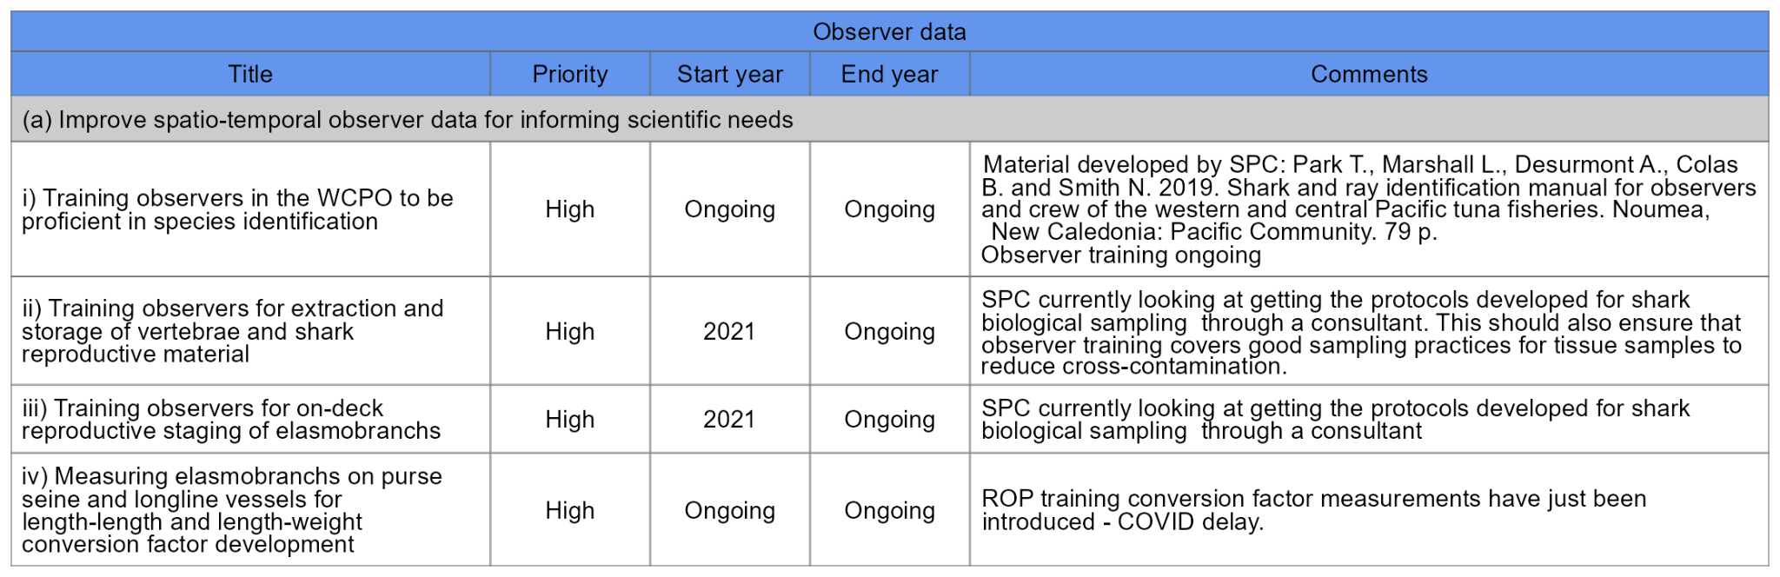

Seabirds

Review of seabird research

Review of CMM on seabirds (CMM 2018-03)

SC19 noted that Aotearoa New Zealand was offering to lead a review of CMM 2018-03 “To ensure that effective mitigation methods are required and applied across the Convention Area where there is bycatch risk to vulnerable seabirds from longline fishing” and that its proposed scope would include I) the spatial extent of required mitigation methods, II) the Southern Hemisphere mitigation options and specifications, and III) the Northern Hemisphere mitigation options and specifications. To ensure a meaningful and collaborative review of CMM 2018-03, Aotearoa New Zealand was also offering to establish and lead informal intersessional meetings with interested CCMs to review the latest scientific evidence on seabird bycatch mitigation and gather views on the review of CMM 2018-03. Aotearoa New Zealand would aim to draft a revision of CMM 2018-03 for submission to SC20, TCC20, and WCPFC21. SC19 supported this approach to the review of CMM 2018-03.

Sea turtles

Review of sea turtle research

Review of Sea Turtle CMM (CMM 2018-04)

SC19 suggests development of a best practices and guidelines to minimize the impact of FADs on sea turtles to inform CCMs of potential impacts. Ideally this would include detailed information on Fully Non-entangling FADs and ideas related to a “FAD WATCH” program.

Cetaceans

SC19 noted the value of improving the understanding of interaction rates, particularly species-specific rates, of cetaceans in the WCPO fisheries, in particular those species of conservation concern.

SC19 did not support the proposal from the IWC to engage in an ABNJ project focussed on assessing and mitigating cetacean bycatch and its impacts on cetacean populations in the WCPO.

Bycatch management

AGENDA ITEM 7 — OTHER RESEARCH PROJECTS

7.1 Pacific Marine Specimen Bank (Project 35b)

SC19 noted the progress report of the Pacific Marine Specimen Bank Project (SC19-RP-P35b-01). SC19 endorsed the following recommendations from the PMSB Steering Committee (SC19-RP-P35b-02):
  - Continue to support initiatives to increase rates of observer biological sampling, noting that this contribution is essential to the ongoing success of the WCPFC’s work.
  - Incorporate the identified budget into the 2024 budget and the 2025-26 indicative budgets, as development of the WCPFC PMSB is intended to be ongoing and is considered essential.
  - Support efforts to obtain further super-cold storage capacity to ensure longevity of PMSB samples.
  - Endorse the work plan in Section 5 of SC19-RP-P35b-01 to be pursued by the SSP, in addition to standard duties associated with maintenance and operation of the WCPFC PMSB in 2023-24.

7.2 Pacific Tuna Tagging Project (Project 42)

SC19 noted the report of ongoing progress in the implementation of the PTTP (SC19-RP-PTTP-01). SC19 endorsed the following recommendations from the PTTP Steering Committee (SC19-RP-PTTP-02):
  - Note the successful 2022 WP6 tagging voyage despite the mechanical issues arising from the ageing charter vessel;
  - Note the urgent need for refurbishment of the current pole & line tagging platform in time for the scheduled 2024 skipjack-focused tagging cruise;
  - Note the critical importance of effective tag seeding to informing stock assessment, support further increasing recent improvements in deployment number and fleet, and assist with developing alternative approaches to understand the flow of tags through tuna product networks;
  - Note the need for continued member participation and support in cruise permitting, tag reporting, and industry support of the tagging programme (e.g., through the sharing of drifting FAD buoy data);
  - Support 2024 tagging programme, work-plan and associated budget (noting recommended increase in the WCPFC contribution to USD 800,000);
  - Support the 2025-2026 tagging programme, work-plan, and indicative budget (Noting further incremental increases in WCPFC contribution for a more balanced SSP co-financing of 25%).

7.3 West Pacific East Asia Project

Based on the End of Project Gap Analysis (SC19-RP-WPEA-02), SC19 recommended the development of a new project proposal for the next phase of WPEA work that is relevant to the WCPFC, to begin immediately after the current WPEA-ITM project expires at the end of 2024.

7.4 Other Projects

AGENDA ITEM 8 — COOPERATION WITH OTHER ORGANISATIONS

SC19 recommended to the Commission the conclusion of an MOU between WCPFC and NPFC on the basis of the text in Attachment 5.

SC19 recommended to the Commission the renewal of the MOU with SPRFMO, with an amendment to remove the current three-year term limit while retaining the provision that either Organisation may discontinue the MoU by giving six months’ prior written notice to the other Organisation. The revised text is contained in Attachment 6.

AGENDA ITEM 9 — SPECIAL REQUIREMENTS OF DEVELOPING STATES AND PARTICIPATING TERRITORIES

AGENDA ITEM 10 — FUTURE WORK PROGRAM AND BUDGET

10.1 Development of the 2024 work programme and budget, and projection of 2025-2026 provisional work programme and indicative budget

There were no objections raised regarding the progress and results of 2023 SC projects through the Online Discussion Forum.

Based on the outputs of Informal Small Group 6 (ISG06), SC19 recommended the proposed work program and budget for 2024 and indicative budget for 2025 – 2026 together with CCM’s priority scores to the budgeted projects in Table WP-01 (below) to the Commission.

TABLE WP-01. Recommended Future Work Program and Budget for 2024 – 2026. Average score is based on Table WP-01 SC Project Scoring Table in the SC17 Summary Report (annexed below), with priority rankings: 6&9 = High; 3&4 = Medium; 1&2 = Low. ‘No. CCMs’ represent the number of CCMs which provided scores on that project. (Excel file at SC19-GN-WP-07a, and P19Xi represents an arbitrary Project ID number proposed by SC19)
No. | Project Title | 2023 | 2024 | 2025 | 2026 | Notes | CCM Score | #CCMs
 | Sub-itm 1. Scientific services
1 | SPC-OFP scientific services |  | 1,000,734 | 1,020,749 | 1,041,164 | Budget: 2% annual increase |  | Essential
 | Sub-item 2. Scientific research
2 | SPC Additional resourcing |  | 180,204 | 183,808 | 187,484 | Budget: 2% annual increase  TOR: MFCL work |  | Essential
3 | SPC FIRST additional stock assessment scientist |  | 165,000 | 168,300 | 171,666 | Budget: 2% annual increase |  | TBC at  WCPFC20
4 | SPC SECOND additional stock assessment scientist |  | 165,000 | 168,300 | 171,666 | Budget: 2% annual increase |  | TBC at  WCPFC20
5 | P35b. WCPFC Pacific Marine Specimen Bank |  | 107,373 | 109,520 | 111,711 | Responsibility: SPC  Budget: 2% annual increase |  | Essential
6 | P42. Pacific Tuna Tagging Program |  | 800,000 | 875,000 | 950,000 | Responsibility: SPC |  | Essential
7 | P60. Purse seine species composition |  |  |  |  | Responsibility: SPC  Carry over 2021 budget of USD 30,000 to 2023 |  | No scoring required
8 | P100c. Preparing WCP tuna fisheries for application of CKMR methods to resolve key SA uncertainties.  (Duration: 2023 - 2025) |  |  |  |  | Responsibility: SPC  Funding: WCPFC, SPC, EU, IATTC and CSIRO  Budget (matching fund) approved at WCPFC18 |  | No scoring required
9 | P109. Training observers for elasmobranch sampling |  |  |  |  | Responsibility: SPC  (On-going) |  | No scoring required
10 | P115. Exploring evidence and mechanisms for a long-term increasing trend in recruitment of skipjack tuna in the equatorial Pacific and the development and modelling of defensible effort creep scenarios |  |  |  |  | Responsibility: SPC  Continue to 2024 with no-cost extension |  | No scoring required
11 | P19X1. Estimating impacts to sharks between 20N and 20S |  |  |  |  | Responsibility: USA  (In-kind contribution by USA) |  | No scoring required
12 | P19X2. WCPFC tuna biological sampling plan |  |  |  |  | Responsibility: SPC  (In-kind contribution by USA--- with budget implication in the future) |  | No scoring required
13 | P19X3. WCPFC billfish biological sampling plan |  |  |  |  | SPC complementary projects |  | No scoring required
14 | P68. Seabird mortality |  | 30,000 | 35,000 |  | Responsibility: SPC  Indicative budget approved at WCPFC18  Total budget for 2024 + 2025 = USD 75,000 (USD 10,000 will be provided by NZ in 2024) | 4.9 | 24
15 | P90. Length weight conversion  (WCPFC17 endorsed the extension of P90 to 57 months until Sep. 2023) |  | 20,000 | 20,000 |  | Responsibility: SPC  (On-going) | 6.2 | 23
16 | P108. WCPO silky shark assessment (USD 50,000) |  | 100,000 |  |  | Responsibility: SPC  Indicative budget approved for 2024 was USD 50,000 at WCPFC18;  Total 2024 = USD 100,000 (USD 40,000 for risk assessment + USD 10,000 for travel to SC20) | 7.4 | 24
17 | P113b. Develop stock status and management advice template for consistent reporting of stock assessment outcomes, uncertainties and risk |  | 40,000 |  |  | Responsibility: WCPFC tendered activity | 7.6 | 23
18 | P114. Improved coverage of cannery receipt data for WCPFC scientific work |  | 60,000 | 35,000 |  | Responsibility: SPC | 5.4 | 24
19 | P19X4: Terms of Reference for a project to support additional work on trialling and supporting development of non-entangling and biodegradable FADs in the WCPO |  | 29,000 |  |  | Responsibility: SPC  EU Project (funding of USD 242,000) that should be signed by November 2023.  WCPFC’s matching fund (Euro 44,000/USD 49,000) is required for this contract.  ISSF confirmed to support USD 20,000.  WCPFC matching fund requires USD 29,000 | 8.0 | 24
20 | P19X5. Updated reproductive biology of tropical tunas |  | 44,000 |  |  | Responsibility: SPC  EU Project (funding of Euro 200,000) that should be signed in November 2023.  WCPFC’s matching fund (Euro 40,000) is required. | 7.1 | 23
21 | P19X6. Ecosystem and Climate Indicators |  | 20,000 | 20,000 | 15,000 | Responsibility: SPC | 7.0 | 24
22 | P19X7. Scoping study on longline effort creep in the WCPO |  | 30,000 |  |  | Responsibility: SPC | 5.7 | 24
23 | P19X8. Scoping the next generation of tuna stock assessment software |  | 50,000 | 50,000 | 50,000 | Responsibility: SPC | 7.7 | 24
24 | P19X9. Manta, mobulid and whale shark fisheries characterisation, CPUE standardisation and data-poor assessment |  | 56,000 |  |  | Responsibility: SPC | 5.2 | 24
25 | P19X10. Oceanic whitetip assessment in the WCPO (2024-2025) |  | 60,000 | 60,000 |  | Responsibility: SPC | 7.0 | 24
26 | P19X11. Developing a statistically robust and spatial/temporal optimized sampling strategy for shark biological data collection |  | 40,000 | 45,000 |  | Responsibility: WCPFC tendered activity | 5.0 | 23
 | Total Sub-item 2. | 1,231,938 | 1,996,577 | 1,769,928 | 1,657,527
 | Total SC budget (Sub-items 1+2) | 2,063,050 | 2,997,311 | 1,915,677 | 1,748,691
 | Total Sub-item 2  (WCPFC19 INDICATIVE) |  | 1,267,577

SC17 Summary Report – Table WP-01. SC project scoring table. Colours represent priority rankings (6,9 = High; 3,4 = Medium; 1,2 = Low):
Importance to WCPFC Management Outcomes
or to the functioning of the SC
 | Rank | Low | Moderate | High
Feasibility: Likelihood of Success | Low | 1 | 2 | 3
Feasibility: Likelihood of Success | Moderate | 2 | 4 | 6
Feasibility: Likelihood of Success | High | 3 | 6 | 9
Notes:
Importance criteria evaluate the significance of the outcomes of the proposal in contributing to the successful management of the WCPFC stocks or the functioning of the SC (e.g. is the proposal aligned with the WCPFC research and/or management priorities; does the proposal contribute to the effective planning and functioning of the SC; are the intended outputs/benefits well-defined and relevant; what is the level of impact and likelihood that the proposal outputs will be adopted; is the proposal cost effective). High= Essential; Moderate=Important but not essential; Low=Not Important.

Feasibility criteria evaluate the proposal’s potential for success i.e., how likely is the proposal to achieve its stated objectives (e.g. are the objectives clearly stated, is the methodology sound, are the project objectives realistic and likely to be achieved, does the research team [if identified] have the ability, capacity and track record to deliver the outputs).

AGENDA ITEM 11 — ADMINISTRATIVE MATTERS

11.1 Future operation of the Scientific Committee

SC19 considered the outputs of the Informal Small Group 2 (ISG02) convened to discuss the future operation of the Scientific Committee, recorded in Attachment 7.

SC19 recommended that the options outlined in the Tables to Attachment 7 be further explored by the Secretariat, SC Chair, Vice-Chair and Convenors in order to develop recommendations for improving the structure and functioning of the SC, to be presented to SC20.

SC19 recommended that the Commission consider reducing the length of SC to 7 days in 2024. The length of future SC meetings should be further considered following the 7-day SC20, particularly considering the workload for subsequent SC meetings.

11.2 Election of Officers of the Scientific Committee

SC19 nominated Emily Crigler (USA), who is the current SC Vice Chair, as future SC Chair, noting her excellent performance as Acting Chair for the SC19 meeting.

11.3 Next meeting

SC19 recommended to the Commission that SC20 would be held from 14 – 21 August 2024, and that, subject to confirmation in December, Tonga offered to host SC20 in 2024.

AGENDA ITEM 12 — OTHER MATTERS

AGENDA ITEM 13 — ADOPTION OF THE SUMMARY REPORT OF THE NINETEENTH REGULAR SESSION OF THE SCIENTIFIC COMMITTEE

SC19 adopted the recommendations of SC19 in session.

SC19 agreed that the Summary Report of the 19th Regular Session of the WCPFC Scientific Committee would be adopted intersessionally according to the following indicative schedule:
Indicative Schedule | Actions to be taken
24 August 2023  Close of SC19 | By 4 September, SC19 Outcomes Document will be distributed to all CCMs and observers (within 7 working days, Rules of Procedure).
By 31 August | Secretariat will receive a Draft Summary Report from the rapporteur.
By 7 September | Secretariat will clear the Draft report, and distribute the cleaned report to all Theme Convenors for review.
By 14 September | Theme conveners will review the report and return it back to the Secretariat
By 19 September | The Secretariat will post/distribute the draft Summary Report (including the Executive Summary) to all for CCMs’ and Observers’ review
By 31 October | Deadline for the submission of comments from CCMs and Observers

AGENDA ITEM 14 — CLOSE OF MEETING

The SC Chair closed SC19 at 1:32pm Koror time on Thursday, 24 August 2023.
Attachment 1

The Commission for the Conservation and Management of
Highly Migratory Fish Stocks in the Western and Central Pacific Ocean
Scientific Committee
Nineteenth Regular Session
Koror, Palau
16-24 August 2023
Report from ISG-3 Draft Tuna Assessment Research Plan (TARP) for ‘key’ tuna species assessments in the WCPO, 2023-2026

The requests from Head of Delegation meeting of SC19 for informal small group 3 (ISG-03) is to review Tuna Assessment Research Plan (TARP, SA-WP-15).

The requests from SA-WP-15 to the ISG were to:
  - assess the draft TARP,
  - fill identified gaps and
  - identify priority work areas for the development of new SC project proposals for consideration at SC19.

The convenor suggested that the scope of 1 and 2 were very broad for the ISG to consider in the time allotted and these items could be addressed intersessionally.

Members indicated there were three new projects for SC19 consideration:
- Scoping study on longline effort creep in the WCPO,
- WCPFC tuna biological sampling plan and

There are 54 projects within the Tuna Assessment Research Plan (TARP) for ‘key’ tuna species assessments in the WCPO, 2023-2026. Thirty-seven projects are funded in 2024 and perhaps longer. The ISG-3 reviewed the titles of the 17 unfunded projects (Table 1). A project proposal has been developed for three project addressing reproductive biology. The remaining 14 projects were reviewed and two projects were prioritized for proposals for SC19 consideration: 1) Investigation of approaches to ensure WCPO assessment software remains fit-for-purpose, including enhancing existing or developing new modelling software and 2) Project 113b - Develop stock status and management advice template for consistent reporting of stock assessment outcomes, uncertainties and risk.

There was one project added to the TARP - Simulation evaluation of alternative spatial structures and model configuration/complexity of the assessment models.

Table 1. Unfunded projects within the research plan for WCPO ‘key’ tuna stocks (subset of SC19-SA-WP-15).
Stock/Focus area | Research need | Activity | Funding  (incl. SC budget lines) | Timescale |  |  |  | Lead
 |  |  |  | 2023¹ | 2024 | 2025 | 2026 | Lead
Common across stocks | Improved stock assessment software performance and features suited to WCPFC tuna assessments | Explore approaches to capture spatial patterns and variation in biological parameters into assessments | Not currently resourced |  | (X) | (X) | (X) | TBD
Common across stocks |  | Investigation of approaches to ensure WCPO assessment software remains fit-for-purpose, including enhancing existing or developing new modelling software | Existing WCPFC SC ‘additional resourcing SPC’ funding line; additional resources required | X | (X) | (X) | (X) | SSP/SC
Common across stocks | Improved abundance indices | Proposal for a cross-tuna-RFMO workshop on abundance indices modelling to apply best practice, and to consider approaches for standardisation of size composition data. | Not currently resourced | (X) | (X) |  |  | SC
Common across stocks | Improved fishery input data | Improved data for WPEA fisheries (E1(7)) | NZ-funded WPEA project, not currently resourced post March 2025 | X | (X) | (X) | (X) | WCPFC Sec
Common across stocks | Improved fishery input data | Improved accounting for discards and longline depredation losses in stock assessments | Not currently resourced |  | (X) | (X) |  | TBD
Common across stocks | Improved fishery input data | Improved/enhanced collection of logbook and observer longline data, including the use of EM, to improve SC analyses (CPUE standardisation focus) | Requires WCPFC mandate | (X) | (X) | (X) |  | SC
Common across stocks | Biological inputs | Enhanced collection of fish hard parts and measurements from across the WCPO region for all relevant stocks, with a focus on age-length data (E4(6)) | SC Project 35b, additional resources required | X | (X) | (X) | (X) | SSP/SC
Common across stocks | Biological inputs | Further investigation of input size composition data, with review of all size composition data for tuna assessments (E1(1); E1(2); E1(3)) | Existing SPC resourcing, additional resources required | X | (X) | (X) | (X) | SSP
Skipjack | Biological inputs | Update estimates of reproductive potential (E4(4)) | EU and SC supporting funding being sought (SC19-SA-WP-17) |  | (X) | (X) |  | SSP
Skipjack | Biological inputs | Validate growth and improve growth estimates | Other resourcing, additional resourcing may be required | X | (X) | (X) |  | AU/SSP
Bigeye | Biological inputs | Age validation and improved growth estimates | (SC Project 105 complete)  Additional resourcing required |  | (X) | (X) |  | TBD
Bigeye | Biological inputs | Update reproductive biology estimates (E4(4)) | EU and SC supporting funding being sought (SC19-SA-WP-17) |  | (X) | (X) |  | SSP
Bigeye | Biological inputs | Improved weight conversion factors (e.g. G&G to whole wt) (E4(5)) | SC Project 90. Additional resourcing required | X | (X) | (X) |  | SSP/SC
Yellowfin | Biological inputs | Age validation and improved growth estimates | (SC Project 105 complete)  Additional resourcing required |  | (X) | (X) |  | TBD
Yellowfin | Biological inputs | Update _{reproductive} biology estimates (E4(4)) | EU and SC supporting funding being sought (SC19-SA-WP-17) |  | (X) | (X) |  | SSP
Yellowfin | Biological inputs | Improved weight conversion factors (e.g. G&G to whole wt) (E4(5)) | SC Project 90. Additional resourcing required | X | (X) | (X) |  | SSP/SC
South Pacific albacore | Biological inputs | Ongoing NZ troll fishery characterisation and CPUE | Additional resources may be required | (X) | (X) |  |  | NZ/TBD

Attachment 2

The Commission for the Conservation and Management of
Highly Migratory Fish Stocks in the Western and Central Pacific Ocean
Scientific Committee
Nineteenth Regular Session
Koror, Palau
16-24 August 2023
Report from ISG-04 (ISG-Billfish)

There was a request from SC19-SA-WP-16 (“Billfish research plan 2023 - 2027”) for ISG-Billfish to review the following recommendations:
- Extend the BRP to 2030.
- Evaluate, streamline, schedule and prioritize the projects listed in SC19-SA-WP-16 Table 7 and to develop ToRs for any projects given high priority for 2024.
- Take into account metrics listed SC19-SA-WP-16 Tables 4 & 5 when reporting assessment results.
- It is recommended that standardised CPUE analyses and fishery characterisations be undertaken for black marlin, sailfish and shortbill spearfish and that the SC19 ISG-billfish consider prioritisation and timing for this work.
- It is recommended that a stratified sampling program be designed to make biological sampling most efficient and useful.
- It is also recommended that the SC discuss how to incorporate the SC17 recommendations on Limit Reference Points into the BRP and develop a process to make recommendations to the Commission on agreed LRPs for use within assessments.
- It is also recommended that on all longline logsheets vessels record time as UTC and not ships time so that local time can be estimated.

1. Extension of the BRP to 2030

This was supported by ISG-04 on the basis that it is sensible for long term planning, and suggested that an annual ISG Billfish (held at SC) be convened to inform ongoing and future projects planning.

2. Evaluate, streamline, schedule and prioritize the projects

The majority of ISG-04 time was spent discussing projects listed in SC19-SA-WP-16 Table 7 in order to evaluate, streamline, schedule and prioritize projects since there were a number of projects with similar scope and overlapping themes. The ISG-04 discussed the need for improved biological data for all billfish species (swordfish, striped marlin, blue marlin, black marlin, sailfish, and short-billed spearfish) within the WCPFC convention area, since this was a feature of many of the project proposals. The ISG-04 noted that the ISC has developed and implemented a structured sampling plan for three billfish species in the north Pacific Ocean (SC19-SA-IP-11), and identified that prior to collecting biological data it would be important to develop a structured sampling plan in collaboration with the ISC similar to the one proposed in SC19-SA-IP-11. The ISG-04 also noted that once a sampling plan is developed there will likely have to be subsequent prioritization and scheduling needed to define which data is collected. The ISG-04 acknowledged that TORs for the collection of the biological data according to the sampling plan may have to be developed in subsequent years.

The ISG-04 also discussed the need for conducting a feasibility study for the application of close-kin mark-recapture (CKMR) to SWPO swordfish. The ISG-04 noted that there are existing efforts underway in the region to develop scoping studies for applying CKMR to SWPO swordfish as a part of WCPFC Project 100c.

Following these discussions, the working group identified three projects as high priority: development of a structured biological sampling plan for billfish, application of CKMR for SWPO swordfish, and a directed longitudinal tagging project for SWPO swordfish. The ISG-04 proposed scheduling the development of the biological sampling plan for 2024, and a TOR was subsequently developed. The ISG-04 deferred developing a TOR for exploring the feasibility of applying CKMR to SWPO swordfish pending the results of WCPFC Project 100c. The ISG-04 proposed scheduling the tagging study for 2025/2026 and deferred developing a TOR until SC20.

3. Take into account metrics listed in SC19-SA-WP-16 Tables 4 & 5 when reporting assessment results

The ISG-04 was generally supportive of reporting the metrics listed SC19-SA-WP-16 Tables 4 & 5 when reporting assessment results on a voluntary basis. However, the ISG-04 also noted that for some of the metrics listed, specific percentage reference level values are undefined.

4. Standardised CPUE analyses and fishery characterisations for black marlin, sailfish and shortbill spearfish

The ISG-04 assigned assessment of black marlin, sailfish, and short-billed spearfish as a medium priority item. However, prior to beginning any assessment or analysis of these species the ISG-04 suggested developing conceptual models for these species to identify the most appropriate modelling approach. The ISG-04 proposed that this characterization/conceptual modelling work could take place in 2025, and development of TOR was deferred until SC20. Related to these species, ISG-04 made the request to ISG-01 that short-billed spearfish and sailfish be added into the SciData, and this will be considered at TCC19.

5. Development of a stratified sampling program for biological data

The ISG-04 discussed this issue and identified it as a high priority item. A TOR was developed with a proposed start date of 2024.

6. Discuss how to incorporate the SC17 recommendations on Limit Reference Points into the BRP and develop a process to make recommendations to the Commission on agreed LRPs for use within assessments

The ISG-04 developed the following text for SC19 to put forward to WCPFC20:

Noting that SC17 agreed a framework for selecting LRPs for billfish species, SC19 seeks general guidance from the Commission on whether in the case of non-targeted species it is acceptable to have a higher level of risk to the stock and a lower biomass LRP compared with the equivalents for target species.

7. Logsheet reporting in UTC time

The ISG-04 made the request to ISG-01 that longline vessels record time as UTC and not ships time so that local time can be determined. Following discussion within ISC-01, SC19 recommended that the date of start of set and time of start of set should be, where required, reported in a way that can be linked back to GMT/UTC.

Appendix I: Updated Table 6 for inclusion in revised SC19-SA-WP-16
Stock assessment
Title | Priority | Start year | End year | Comments
Assessment 1) North Pacific striped marlin stock assessment | High | 2023 | 2023 | Previous assessment successfully conducted by the ISC
Assessment 2) Southwest Pacific striped marlin stock assessment | High | 2024 | 2024 | Previous assessment successfully conducted by the SPC
Assessment 3) North Pacific swordfish stock assessment | High | 2023 | 2023 | Previous assessment successfully conducted by the ISC
Assessment 4) Southwest Pacific swordfish stock assessment | High | 2025 | 2025 | Previous assessment successfully conducted by the SPC
Assessment 5) Pacific blue marlin stock assessment | High | 2026 | 2026 | Previous assessment successfully conducted by the ISC
Assessment 6) Modelling approaches for WCPO black marlin, sailfish and shortbill spearfish | Medium | (2025) | (2025) | Develop conceptual models for each species to identify appropriate modelling approaches for low catch low information assessments

Appendix II: Updated Table 7 for inclusion in revised SC19-SA-WP-16
Biology
Title | Priority | Start year | End year | Comments
Biology 1) Development of a statistically robust sampling plan for the collection of fisheries dependent biological samples (by sex), including but not limited to age, size frequency data, and genetic samples for WCPO swordfish (north and south). | High | 2024 | 2025
Biology 2) Biology of South Pacific striped marlin, blue marlin, black marlin, shortbill spearfish and sailfish in the WCPO from longline fisheries. | High | 2025 | 2028 | Collect samples (fin spines and otoliths) and then undertake age growth and reproductive analyses to get growth and maturity parameters to inform productivity rates of this species. Length-weight and length-length conversion factor data collection for SP striped marlin
Biology 3) Undertake directed longitudinal tagging of Southwest Pacific swordfish to reduce the uncertainty in movement rate. | High | 2025 | 2027

Attachment 3

The Commission for the Conservation and Management of
Highly Migratory Fish Stocks in the Western and Central Pacific Ocean
Scientific Committee
Nineteenth Regular Session
Koror, Palau
16-24 August 2023
WCPO skipjack management procedure monitoring report

This summary monitoring report is intended to provide an overview of the status of the management procedure (MP) for WCPO skipjack tuna and to allow for information to be collated progressively as elements of the MP are considered by different groups and Commission bodies (as outlined in the Appendix).

The summary monitoring report lists the elements of the WCPO skipjack MP monitoring programme, the status of those elements after review by the relevant body of the Commission, and identifies those elements that may require additional work or through which problems have been identified. Highlighted elements have a priority placed on the corresponding issue, based on the issue’s considered severity and the amount of work likely required to address it. This is summarised in the table below. This report also includes summary paragraphs following the table, which provide further details of the work required.

Each of the Commission’s bodies is requested to review and update their previous comments on an annual basis, as necessary.

Monitoring report summary table
Item | MP element | Commission  Body | Status and comments | Priority
1. Review MP performance
1.1 | Comparison with stock assessment | SC19 | Will be reviewed following implementation of the MP through the stock assessment scheduled in 2025, noting however that there will only be one year of MP implementation included within that assessment.
1.2 | Data availability & quality | SC19 | The level of pole and line CPUE data in tropical regions is declining over time. If this trend continues, there may be insufficient information to inform the MP. Work should begin to evaluate alternative MPs that are robust to this potential decline in pole and line data availability. | High
1.2 | Data availability & quality | TCC19
1.3 | Other sources of data | SC19 | No new information noted at SC19. | -
1.3 | Other sources of data | TCC19
1.4 | EM performance | SC19 | The EM showed acceptable performance.
2. Review of the MP
2.1 | Management objectives | WCPFC20 |  | -
2.2 | Scope of the MP | SC19 | No new information at the time of SC19. | -
2.2 | Scope of the MP | TCC19
2.2 | Scope of the MP | WCPFC20
2.3 | Exceptional circumstances | SC19 | None identified by SC19. | -
2.3 | Exceptional circumstances | TCC19
2.3 | Exceptional circumstances | WCPFC20
3. Review MSE framework
3.1 | Operating model grid | SC19 | The OM grid (robustness set) to be augmented with climate change scenarios. Further consideration of the OM grid is also suggested given the predicted outcomes of the adopted MP and the 2022 stock assessment showed some departure for the historical period. These issues will be considered for inclusion when the current MP is reviewed. | Medium
3.2 | Calculation of performance indicators | SC19 | No new information at the time of SC19. | -
3.3 | Modelling assumptions | SC19 | While no major issues are identified, any re-evaluation of the skipjack EM (identified under 1.2) may require a re-evaluation of the modelling framework. | High
3.4 | Data availability and quality | SC19 | Generally good
3.4 | Data availability and quality | TCC19

Further Details

1. Review MP performance

1.1 Comparison against stock assessment outcomes: With the first implementation of MP outputs in 2024, the stock assessment for WCPO skipjack in 2025 will be the first in which the impact of the MP on stock status will be experienced. There will only be one year of MP implementation included within that assessment, so this comparison will be preliminary. A comparison of the MSE predicted outcomes of the adopted MP and the 2022 stock assessment shows good correspondence for the most recent years but shows some departure for the historical period. This is considered under 3.1.

1.2 Data availability and quality: Sufficient data were available to run the MP. However, it was noted that pole and line fishing effort in tropical regions continues to decline and this presents a potential problem for the future running of the MP. A re-evaluation of the estimation method is recommended prior to the next implementation of the MP. This issue is a high priority.

1.3 Other sources of data: No other sources of data have been identified.

1.4 EM performance: Overall the estimation method performed well and provided estimates of stock status within the prediction range of the MSE.

2. Review MP

2.1 Management objectives: No change noted by SC19.

2.2 Scope of the MP: No change noted by SC19.

2.3 Exceptional circumstances: None identified by SC19.

3. Review MSE framework

3.1 Operating model grid: OM grid to be extended to include climate change scenarios (robustness set). In particular the effects of warm pool expansion in WCPO. These analyses require further analysis of the SEAPODYM outputs and may occur over an extended timeframe. This issue is considered to be of medium priority. The comparison of the MSE predicted outcomes of the adopted MP and the 2022 stock assessment did show some departure for the historical period. This is not considered a major problem affecting the MP but some further investigation of the OM grid may be required.

3.2 Calculation of performance indicators: No change in performance indicators required at this time.

3.3 Modelling assumptions: no issues identified; however, re-evaluation of the skipjack EM (identified above) may require a re-evaluation of the modelling framework (for example the calculation of simulated data used to test the MP). This issue is of high priority.

3.4 Data availability and quality: Generally good - some changes may be required depending on the approach adopted to address the decline in pole and line fishing in tropical regions.

Appendix to Attachment 3. Elements of the management procedure that may be considered for inclusion in the monitoring strategy and the Commission body at which those considerations can be made. (Table 2 of Annex III, CMM 2022-01).
MP Element | Commission Body | Monitoring Considerations
1. Review MP performance
Comparison of predicted MP performance against latest assessment outcomes | SC | Check that the MP is performing as expected
Data availability to run the MP | SC/TCC | Check availability, quantity and quality of data necessary to run the MP (e.g. the estimation method)
Other sources of data to monitor performance | SC/TCC | Identify other data as available, that may not be included in the MSE framework, to inform calculation of performance indicators (economic, social, ecosystem, etc.)
Performance of the estimation method | SC | Confirm the EM is performing well and not subject to estimation failure
2. Review of the MP
Management objectives | Commission | Check that overall objectives of the MP remain appropriate
Scope of the management procedure | SC/TCC/Comm | Confirm the fisheries controlled by the MP, and the method of control, remains appropriate
Exceptional circumstances | SC/TCC/Comm | Drawing on all of the above, have events (unexpected, extra-ordinary) occurred such that remedial action is required to either review modify or replace the MP
3. Review MSE framework
Operating model grid | SC | Ensure that the most important sources of uncertainty are included in the OM grid
Calculation of performance indicators | SC | Check for appropriate representation of objectives by performance indicators
Modelling assumptions | SC | Consider the technical details of the simulation and testing framework
Data availability to support the MSE framework | SC/TCC | Improvements to data collection to either enhance the OM framework or to reduce uncertainty included in the OM grid

Attachment 4

The Commission for the Conservation and Management of
Highly Migratory Fish Stocks in the Western and Central Pacific Ocean
Scientific Committee
Nineteenth Regular Session
Koror, Palau
16-24 August 2023
Report from ISG-05 (Shark Research Plan 2021-2025 Mid-term Review)

There was a request from SC19-EB-WP-06 (“Shark research plan 2021-2025 mid-term review”) for ISG-Sharks to:
- Consider an extension of the SRP to 2030
- Review the current assessment schedule
- Review priority rankings and timelines for new and existing projects
- Submit TORs for SC consideration for any projects requiring funding in 2024
- Review recommendations for consideration by SC19

1. Extension of the SRP to 2030

The midterm review of the SRP suggested an extension of the SRP to encompass two shark assessment cycles. This was supported by ISG-05, together with annual reviews of SRP progress via a short paper to the SC, and an annual ISG Sharks (held at SC) to inform ongoing and future projects planning.

2. Review of the current assessment schedule

The SRP included Table 5.1 listing the current schedule for key shark stock assessments in the WCPFC. ISG-05 supported the removal of the southwest Pacific porbeagle shark assessment from the list of WCPFC stock assessments, given most catches for this species occur within the CCSBT convention area. The removal of the Pacific wide silky shark assessment was also supported, noting that the expansion of the stock assessment spatial scope to the EPO provided limited new data. The WCPO silky shark assessment is meant to proceed as planned. Other assessments planned were not opposed.

The authors of the SRP suggested that for key species with poor data availability, fishery characterisations, CPUE standardisations and data-poor methods be considered. This includes threshers sharks, hammerhead sharks, manta rays, mobulids and whale sharks, and explore data poor methods to provide information on trends. This approach was supported by ISG-05, acknowledging that integrated stock assessments were not possible for these species. It was suggested that the species be grouped into two projects based on the main fishing gears concerned (for purse-seine fisheries, whale sharks, manta rays and mobulids; for longline fisheries, thresher and hammerhead sharks). The existing project proposal for a whale shark stock assessment was removed to reflect the switch to a fishery characterisation and data-poor approach for this species.

It was suggested to amend Table 5.1 to note which assessments were to be led by ISC, and confirmed there was no change to the schedule for these assessments.

Additional key changes to Table 5.1 included the removal of a catch reconstruction project utilising global fin trade data given methodological concerns noted in previous WCPFC shark assessments. The NP blue shark assessment was also noted as completed and removed from the list of projects.

There was a suggestion that two projects on data-poor assessment methods and data-poor metrics (5(c)(i) and 5(c)(ii)) could be accommodated within the existing assessment framework for WCPFC key sharks. For the first one, it was suggested that a data poor/risk assessment approach be added to TORs for future WCFPC integrated stock assessment projects, where possible. Advantages of this approach include the provision of stock status should the integrated stock assessment approach fail, and useful insights to SC arising from the comparison of data-poor vs. data-rich assessment outcomes. ISG-05 supported this on a case-by-case basis but noted budget increases would likely result from the expanded scope of the TORs.

For project 5(c)(ii) “Include data poor assessment metrics as standard outputs for data rich assessments”, it was suggested that data-poor assessment metrics could be discussed as standard assessment outputs for WCPFC key shark assessments. Further clarifications were sought from CCMs as to the nature of these metrics and whether this request would also apply to North Pacific stocks. It was suggested that to the extent possible the data-poor metrics provided in SC17 report Table MI-01 could be used as a baseline (noting they are standard output of common assessment packages like Stock Synthesis) and that their inclusion in North Pacific assessments could be encouraged, but not treated as mandatory.

3. Review of projects

ISG-05 reviewed the existing projects in Table 5 and new projects listed in Table 7 of SC19-EB-WP-06.

Projects listed in Tables 5 and 7 were reviewed in terms of their current relevance and proposed timeline. New proposals included the development of a biological sampling plan. One CCM also indicated a need to extend training for sample collection to port samplers. The additional logistical challenges of sample collection given the recently updated Appendix II listings for requiem shark were also noted.

Mitigation projects 5.2(a)(i) “Investigate effective mitigation of WCPFC key sharks” and 5.2(a)(ii) “Investigate mitigation method trade-offs between mitigation methods for sharks, seabirds and turtles” were reviewed. ISG-05 supported the removal of project 5.2(a)(i) as its scope could be covered by project 5.2(a)(ii) which would also consider mitigation methods in general. It was clarified that these projects were for longline fisheries.

The table was amended to remove project 5.2(b)(i) “Estimate silky shark and oceanic whitetip shark post release survival from WCPO longline fisheries” as it had been completed. Noting the ban of setting on whale sharks enacted by CMM 2022-04 and its predecessors, project 5.2(b)(ii) “Estimate whale shark post release survival from WCPO purse seine fisheries” was removed. However, there was a request to include a hot spot analysis for whale sharks to inform future tagging opportunities in the relevant fishery characterisation work.

Timelines for all projects listed in Table 5.3 (“Biological data improvements”) were shifted by two years to reflect delays in observer training incurred by the COVID-19 pandemic. ISG-05 considered whether the project on thresher sharks’ life-history was still relevant given the recommended shift to a data-poor assessment for this species, but agreed to retain the project as listed as data-poor methods remain sensitive to biological assumptions.

ISG-05 noted that observer data collection training support was ongoing and should remain prioritised as a project work area. CCMs also emphasized the potential of EM data to be integrated into observer data.

For new project Table 7 (11), Japan mentioned challenges in the measurement of the length of the trailing branchline from cut-free sharks due to concerns about crew and observer safety. Undue burden incurred to crew and observers for the collection of this measurement during hauling given the short time window (fishers cut and release the sharks immediately after capture) were also highlighted. Japan suggested that this item should not be included in the minimum requirements of the Regional Observer Programme (ROP). ISG-05 acknowledged the concern to crew and observer safety and noted that this should be discussed in the ISG dealing with minimum data standards.

Japan noted similar concerns about crew safety for new project Table 7 (15) and questioned the feasibility of observer training in this area. Japan suggested that this item should not be included in the observer training as a minimum requirement of the ROP but that it could be considered on a voluntary basis.

Research needs for manta, mobulids and hammerhead sharks were reviewed with a focus on biological areas (general biology, population structure, post-release survival) given the recommendation of a new project on fisheries characterisation, CPUE standardisation and data-poor methods. The US noted ongoing domestic work on mantas and mobulids release survival for purse seine and longline fisheries. ISG-05 supported the improvement of life-history and general biology as key research areas, underpinned by the sampling planning work. New Zealand also expressed support for satellite tagging on shortfin mako in the southwest Pacific and suggested genetic approaches as more suited to understanding natal homing.

A sampling optimisation project was further discussed, noting it would be important to support sample collections for research areas utilising genetic information. It was noted that while sample optimisation for close-kin mark recapture (CKMR) for sharks was also required, that this project should be considered separately due the nature of the simulation work required.

There was also support for a project exploring approaches for dealing with the deterioration of fishery dependent data due to non-retention measures.

Finally, ISG-05 supported a delayed review of the shark CMM (CMM-2022-04) until 2027 to allow time for its implications to have effects and also to account for the impacts of COVID on data.

Updated project tables were collated by the Chair to reflect ISG-05 discussions. An online survey was distributed to Heads of Delegations seeking feedback on priorities and timelines when these had not already been discussed at ISG-05 (16 projects). One response was allowed by delegation, and updated rankings and timelines were allotted to projects based on survey responses (19 respondents). The priority rankings and timelines were reviewed and approved by ISG-05.

ISG-05 requested that the authors of the SRP (SC19-EB-WP-03) submit a revision reflecting the updated project definitions, priorities and timelines as discussed at the ISG-05. An updated version of Table 5 including the changes outlined above is also included in Appendix I.

4. Submit TORs for SC consideration for any projects requiring funding in 2024

Four new TORs were submitted to SC for funding consideration following discussions at ISG-05:
- Manta, mobulid and whale shark fisheries characterisation, CPUE standardisation and data-poor assessment
- Oceanic whitetip assessment in the WCPO
- Developing a statistically robust and spatial/temporal optimized sampling strategy for biological data collection
- Estimate the post-mortality retention time of elasmobranchs entangled in FADs

These TORs were developed by the ISG chair with support from the authors of the mid-term review of the SRP (Steve Brouwer and Paul Hamer) with further support from SPC. In addition, a modified TOR for Project 108 “Silky shark stock assessment in the WCPO” was submitted to reflect an expanded scope including data-poor methods, as recommended by ISG-05.

5. Review recommendations for consideration by SC19

ISG-05 agreed on the following recommendations for SC19 to consider:

- Extend the current shark research plan to 2030 to encompass two assessment cycles.
- SC19 should note Table 5 and consider any proposed changes.
- Noting that integrated stock assessments for elasmobranchs are challenging and can sometimes fail to succeed, SC19 recommends that, to the extent possible, integrated shark assessments projects undertaken within the WCPFC also include a data-poor component so that advice on stock status can still be provided even if the integrated assessment approach fails.
- SC19 would also like to encourage that future integrated elasmobranch stock assessments presented to SC also report data-limited stock status metrics such as those outlined in SC17 report Table MI-01, if they can be estimated.

Updated Table 5 for inclusion in revised SC19-EB-WP-06
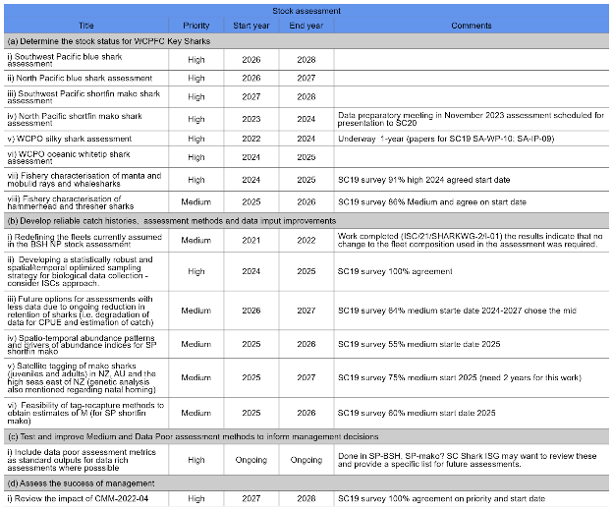
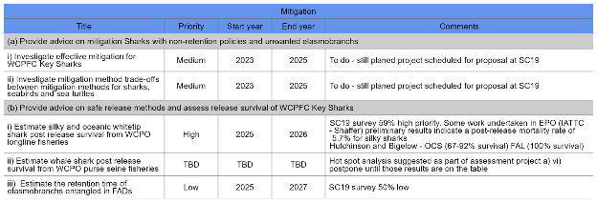
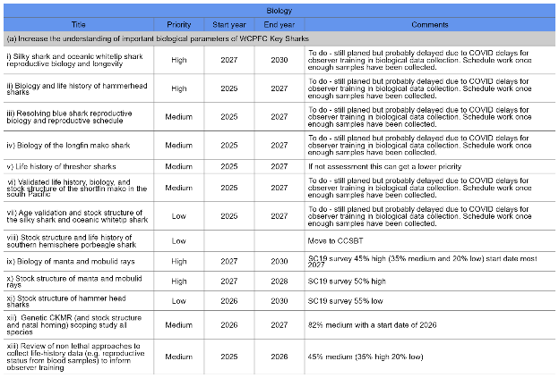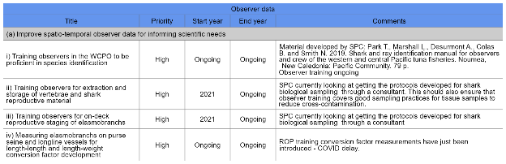

Attachment 5

The Commission for the Conservation and Management of
Highly Migratory Fish Stocks in the Western and Central Pacific Ocean
Scientific Committee
Nineteenth Regular Session
Koror, Palau
16-24 August 2023
MOU between NPFC and WCPFC



Memorandum of Understanding between the
North Pacific Fisheries Commission (NPFC) and the
Western and Central Pacific Fisheries Commission (WCPFC)

The North Pacific Fisheries Commission (hereafter NPFC) and the Western and Central Pacific Fisheries Commission (hereafter WCPFC):

Acknowledging that the objective of the Convention on the Conservation and Management of High Seas Fisheries Resources in the North Pacific Ocean is to ensure the long-term conservation and sustainable use of the fisheries resources in the Convention Area while protecting the marine ecosystems of the North Pacific Ocean in which these resources occur;

Acknowledging also that the objective of the Convention on the Conservation and Management of Highly Migratory Fish Stocks in the Western and Central Pacific Ocean (hereafter WCPF Convention) is to ensure, through effective management, the long-term conservation and sustainable use of highly migratory fish stocks in the western and central Pacific ocean;

Recognising that Article 22 of the WCPFC Convention calls upon the WCPFC to make suitable arrangements for consultation, cooperation and collaboration with other relevant intergovernmental organizations;

Recognising further that Article 21 of the NPFC Convention calls upon the NPFC to take into account the conservation and management measures or recommendations adopted by regional fisheries management organizations and arrangements and other relevant intergovernmental organizations that have competence in relation to areas adjacent to the NPFC Convention;

Conscious of the fact that there is a geographical area overlap within the Convention Areas of both the NPFC and the WCPFC;

Noting that provisions of both the NPFC and the WCPF Conventions address the conservation of non-target, associated or dependent species which belong to the same ecosystem as the target species;

Desiring to put in place a mechanism to promote and facilitate cooperation between WCPFC and NPFC;
Therefore, NPFC and WCPFC record the following understandings:
OBJECTIVE OF THIS MEMORANDUM

The objective of this MoU is to facilitate, where appropriate, cooperation between NPFC and WCPFC (‘the Organisations’) in order to advance their respective objectives, particularly with respect to stocks or species which are within the competence or mutual interest of both Organisations.

AREAS OF COOPERATION

The Organisations will establish and maintain consultation, cooperation and collaboration in respect of matters of common interest to both organisations, including but not limited to, the following areas:

  - exchange meeting reports, information, documents and publications regarding matters of mutual interest, consistent with the information sharing policies of each organization;

  - exchange data and scientific information in support of the work and objectives of both Organisations, consistent with the confidentiality rules, information sharing policies and internal data security procedures of each Organisation including, but not limited to, information on:
    - vessels authorised to fish in accordance with conservation and management measures adopted under the NPFC and WCPFC Conventions;
    - at the specific request of one of the Organisations, transhipment activities of those vessels authorised to conduct transhipment in accordance with conservation and management measures adopted under the NPFC and WCPFC Conventions, on a necessity basis; and,
    - vessels identified as having engaged in illegal, unreported and unregulated (IUU) fishing activity and the IUU Vessel Lists established by each Organisation.

  - collaborate, where appropriate, on research efforts relating to species and stocks of mutual interest, including non-target, associated and dependent species;

  - cooperate where appropriate, on the implementation of conservation and management measures adopted under the NPFC Convention and under the WCPFC Convention;

  - share best practices in areas of mutual interest, including but not limited to:
    - monitoring, control and surveillance policies and systems, including with respect to Vessel Monitoring Systems;
    - administration, auditing, training and structure of observer programmes; and
    - Compliance Monitoring Schemes, and information management systems.

  - exchange on expertise gained, lessons learned and use of best practices between the Organisations’ Secretariats in their areas of activity.

  - consistent with each Organisation’s rules of procedure, grant reciprocal observer status to representatives of the respective Organisations in relevant meetings of each Organisation, including those of each Organisation’s subsidiary bodies;

CONSULTATIVE PROCESS

To facilitate effective development, implementation and enhancement of cooperation, the Organisations may establish a consultative process between their respective Secretariats that includes telephone, email and any other means of communication. The consultative process may also proceed in the margins of meetings at which both Organisations’ Secretariats are represented by appropriate staff.

MODIFICATION

This MoU may be modified at any time with the mutual written consent of both Organisations.

LEGAL STATUS

This MoU does not create legally binding rights or obligations. Each Organisation should cover their own costs related to the implementation of this MoU.

This MoU does not alter the obligations of members of either Organisation to comply with the conservation and management measures adopted under their respective Conventions.

OTHER PROVISIONS

This MoU will commence on the date of the second signature.

Either Organisation may discontinue this MoU by giving six months’ prior written notice to the other Organisation.

SIGNATURES

Signed on behalf of the North Pacific Fisheries Commission and the Western and Central Pacific Fisheries Commission:
FOR THE NORTH PACIFIC FISHERIES COMMISSION (NPFC)  --------------------------------------------------  Robert Day  Executive Secretary  Place:  Date: | FOR THE WESTERN AND CENTRAL PACIFIC FISHERIES COMMISSION (WCPFC)  ----------------------------------------------------  Rhea Moss-Christian  Executive Director  Place:  Date:

Attachment 6

The Commission for the Conservation and Management of
Highly Migratory Fish Stocks in the Western and Central Pacific Ocean
Scientific Committee
Nineteenth Regular Session
Koror, Palau
16-24 August 2023
MOU between SPRFMO and WCPFC



Memorandum of Understanding between the South Pacific Regional
Fisheries Management Organisation (SPRFMO) and the Western and Central Pacific Fisheries Commission (WCPFC)

The South Pacific Regional Fisheries Management Organisation (hereafter SPRFMO) and the Commission for the Western and Central Pacific Fisheries Commission (hereafter WCPFC):
Acknowledging that the objective of the Convention on the Conservation and Management of High Seas Fishery Resources in the South Pacific Ocean (hereafter SPRFMO Convention) is, through the application of the precautionary approach and an ecosystem approach to fisheries management, to ensure the long-term conservation and sustainable use of fishery resources in the SPRFMO Convention Area and, in so doing, to safeguard the marine ecosystems in which these resources occur;
Acknowledging also that the objective of the Convention on the Conservation and Management of Highly Migratory Fish Stocks in the Western and Central Pacific Ocean (hereafter WCPF Convention) is to ensure, through effective management, the long-term conservation and sustainable use of highly migratory fish stocks in the western and central Pacific ocean;
Recognising that Article 22 of the WCPFC Convention calls upon the WCPFC to make suitable arrangements for consultation, cooperation and collaboration with other relevant intergovernmental organizations;
Recognising also that Article 31 of the SPRFMO Convention requires the SPRFMO Commission, inter alia, to cooperate, as appropriate, with other relevant organisations on matters of mutual interest and to seek to make suitable arrangements for consultation, cooperation and collaboration with such other organisations;
Conscious of the fact that there is a geographical area overlap within the Convention Areas of both the SPRFMO and the WCPFC;
Noting that provisions of both the SPRFMO and the WCPF Conventions address the conservation of nontarget, associated or dependent species which belong to the same ecosystem as the target species; Desiring to put in place a mechanism to promote and facilitate cooperation between SPRFMO and WCPFC;
Therefore SPRFMO and WCPFC record the following understandings:

OBJECTIVE OF THIS MEMORANDUM OF UNDERSTANDING
The objective of this MoU is to facilitate, where appropriate, cooperation between SPRFMO and WCPFC (‘the Organisations’) in order to advance their respective objectives, particularly with respect to stocks or species which are within the competence or mutual interest of both Organisations.

AREAS OF COOPERATION
The Organisations will establish and maintain consultation, cooperation and collaboration in respect of matters of common interest to both organisations, including but not limited to, the following areas:
- exchange meeting reports, information, documents and publications regarding matters of mutual interest, consistent with the information sharing policies of each Organisation;
- exchange data and scientific information in support of the work and objectives of both Organisations, subject to the information sharing policies and data use, access and confidentiality rules of each Organisation, including but not limited to, information on:
  - vessels authorised to fish in accordance with conservation and management measures adopted under the SPRFMO and WCPFC Conventions;
  - at the specific request of one of the Organisations, transhipment activities of those vessels authorised to conduct transhipment in accordance with conservation and management measures adopted under the SPRFMO and WCPFC Conventions, on a necessity basis; and
  - vessels identified as having engaged in illegal, unreported and unregulated (IUU) fishing activity and on the IUU Vessel Lists established by each Organisation;
- collaborate, where appropriate, on research efforts relating to species and stocks of mutual interest, including non-target, associated and dependent species;
- cooperate where appropriate, on the implementation of conservation and management measures adopted under the SPRFMO Convention and under the WCPFC Convention;
- share best practices in areas of mutual interest, including but not limited to:
  - monitoring, control and surveillance policies and systems, including with respect to Vessel Monitoring Systems;
  - administration, auditing, training and structure of observer programmes; and
  - Compliance Monitoring Schemes, and information management systems;
- exchange of information between the Secretariats of the Organisations on expertise gained, lessons learned and the use of best practices in their respective activities;
- consistent with each Organisation’s rules of procedure, grant reciprocal observer status to representatives of the respective Organisations in relevant meetings of each Organisation, including those of each Organisation’s subsidiary bodies.

CONSULTATIVE PROCESS
To facilitate effective development, implementation and enhancement of cooperation, the Organisations may establish a consultative process between their respective Secretariats that includes telephone, email and any other means of communication. The consultative process may also proceed in the margins of meetings at which both Organisations’ Secretariats are represented by appropriate staff.

MODIFICATION
This MoU may be modified at any time by the mutual written consent of both Organisations.

LEGAL STATUS
This MoU does not create legally binding rights or obligations. Each Organisation will cover its own costs related to the implementation of this MoU.
This MoU does not alter the obligations of members of either Organisation to comply with the conservation and management measures adopted under their respective Conventions.

OTHER PROVISIONS
This MoU will commence on the date of the second signature.
Either Organisation may discontinue this MoU by giving six months’ prior written notice to the other Organisation.
This MoU will operate for three (3) years. Before the end of the three year period, the Organisations will separately review the operation of this MoU to decide whether it should be renewed.

SIGNATURES
Signed on behalf of the South Pacific Regional Fisheries Management Organisation and the Western and Central Pacific Fisheries Commission:

FOR THE SOUTH PACIFIC REGIONAL FISHERIES FOR THE WESTERN AND CENTRAL PACIFIC MANAGEMENT ORGANISATION (SPRFMO) FISHERIES COMMISSION (WCPFC)

--------------------------------------------------------- ---------------------------------------------------
Mr Luis Molledo Dr Josie Tamate
Chair SPRFMO Chair WCPFC
Place: Place:
Date: Date:

Attachment 7

The Commission for the Conservation and Management of
Highly Migratory Fish Stocks in the Western and Central Pacific Ocean
Scientific Committee
Nineteenth Regular Session
Koror, Palau
16-24 August 2023
Report from ISG-02 (Future Operations of the Scientific Committee)

Options to address time challenges in the SC review of WCPFC stock assessment inputs (SC19-SA-WP-14)

Introduction

Following discussions on the issue at SC18, Paragraph 103 of that meeting’s summary report noted “…the challenge of fully reviewing the key inputs into WCPFC stock assessments and providing feedback within the time available. SC recommended that approaches that may address this issue be discussed at SC19 and recommended that the Scientific Services Provider (SSP) develop a discussion paper to inform those discussions”.

To facilitate this discussion, working paper SA-WP-14 was presented to the SC19 plenary, with further discussion undertaken at a subsequent session of ISG-2. The working paper provided an overview of the time and logistical challenges for SC19 to consider when attempting to resolve the important issue of the limited timespan available for assessment completion, including assessment scope and exploration, treatment of uncertainty and opportunities for SC review and feedback.

The issues are quite complex, as the challenges faced by the SSP in undertaking the annual work program of the Commission, and the aspects of that work that are required by the SC, within the limited time currently available, are embedded in a framework of data deadlines and meeting schedules. As such, there is not likely to be a single simple solution. However, SC19 saw the present situation as not sustainable, noting that assessment scientists are currently subject to heavy workloads leading to high stress and potential burnout. SC19 therefore considered it as a high priority to find solutions that would enhance the retention of these key scientists.

Based on the discussion of the working paper, SC19 identified the following three central issues which need to be addressed to help overcome the current challenges.
- Extend the period over which the assessment work done by the SSP is undertaken,
- Adjust the level of work undertaken by the SSP,
- Increase the resources available to SSP for undertaking its work.
These challenges, together with options identified by SC19 offering possible solutions to addressing them, are outlined in Table 1 below. The pros and cons of each option are also outlined. SC19 recommended that each of these options be further explored by the Secretariat, SC Chair and Vice-Chair and Convenors, together with the SSP, over the coming year, taking into account further consideration by both the TCC and the Commission.

Recommendations

Noting the need for the SSP to have more time to complete the work required to conduct annual stock assessments and other analyses reviewed by the SC each year, SC19 recommended that:
- the data manager at the SSP liaise and consult with CCMs about the possibility of bringing forward the data submission deadline for fleets, especially historical data updates, and
- the Secretariat explore options for moving the dates of the SC meeting to a later period in the calendar year,
- The Secretariat and SSP explore options for the WCPFC website to include a portal for CCMs to enter/edit/manage their ACE data submissions, and
- The SSP develops guidelines for standardised structure/file layouts for Annual Catch Estimates and aggregate catch/effort data that can be used by CCMs to submit these data.
Noting the need for further resources to assist the SSP in conducting annual stock assessments and other analyses related to the work of the Commission, SC19 recommended that the Commission consider increasing the SSP’s budget so that the number of full-time assessment scientists can be increased to four or five.

Table1. List of challenges and options
Challenge | Option | Pros | Cons
Extend the period over which the assessment and related work done by the SSP is undertaken. | Bring forward the deadline of data submission. | The earlier the data are summitted and processed, the earlier the data is available for analysis. | Possible difficulties for CCMs to compile data by an earlier deadline.
 | More frequent data submissions (e.g., quarterly) and more streamline data submission (using better formats). | Allows supporting analyses to begin earlier.  Greater efficiency in loading new data into the SciData database.  Greater use of electronic monitoring and reporting is seen as greatly facilitating the need to report data in a more timely manner. | Possibly more work for CCMs related to submitting data more regularly.
 | Swap dates of TCC and SC. | May be able to provide up to an additional 5 weeks for assessment and related analyses and will help reduce the ‘stress’ and extreme workloads currently being experienced by SPC staff. | Constraints imposed by existing schedule of other RFMO meetings.  Issues for changing the current compliance monitoring schedules.
 | Explore the option of moving the SC to a later date by identifying a window of time that is suitable for all CCMs. | Will provides additional time for assessment and related analyses and will help reduce the ‘stress’ and extreme workloads currently being experienced by SPC staff.
Adjust the level of work undertaken by SSP | Fewer assessments. | Reduce time to review assessments thus saving time for the SC. | SC19 did not see this as a viable option as the review of assessments for the key target species, together with co-occurring species, is a principal remit of the Commission’s work.
Adjust the level of work undertaken by SSP | 2-year assessment period. | Provides an opportunity for continued dialogue between the assessment team and SC in the two years of the assessment, and potentially help concerns identified early on within the assessment time-frame to be addressed before assessments are used to inform management. | Without an increase in overall staffing levels, would increase the workload for SSP scientists.
Adjust the level of work undertaken by SSP | Lengthen the stock assessment cycle (i.e., the number of years between when an assessment is undertaken for each stock). | Would allow further exploratory analyses to be undertaken between assessments to assist with improving the model inputs and model structure.  Could be combined with a 2-year assessment period. | Would lengthen the period between the last year of data in the assessment and the year when management procedure/action is implemented. This would not be tenable for short-lived species like skipjack tuna.  Assessment of the status of stocks would be delayed, resulting also in a delay in taking appropriate management actions when required.
Adjust the level of work undertaken by SSP | Use of simpler ‘updated’ assessments only using new data. | Limited need to undertake supporting data analyses and development of the stock assessment model, thus saving time.  Several CCMs considered it was essential to simplify the assessments for any stocks for which there are management procedures, noting that with management procedures in place, the stock assessments will no longer be the basis for management. | Other CCMs did not see this as a viable option as the stock assessments form a critical component of the monitoring strategy for the Commission and the assessment models are not yet mature enough. There is a need for scientific rigour by using the best assessment models so that SC can provide the best scientific advice to the Commission.
Adjust the level of work undertaken by SSP | Smaller set of axes in the grid of uncertainty used in stock assessments. | Smaller set of analyses required to be run, thus saving time. | SC19 did not see this as a viable option as it is important that the full grid of uncertainties is explored by the assessment models. This is required for management, such as monitoring the probability of breaching a limit reference point.
Increase the resources available to SSP for undertaking its work | More SSP staffing resources (e.g., 5 full-time assessment scientists, with one assessment scientist dedicated to each key species, and data analysis support). | An expanded team of scientists would allow more staff to work on the range of analyses required for assessments and other projects.  With a dedicated scientist for each stock, allows for follow-up work on a single assessment to continue between the 3-year assessment cycle.  Less staff ‘burn-out’. | Increase in WCPFC budget for SPC-OFP scientific services.
 | More computing power. | Many model analyses currently have long time times (up to 24 hours). Increased computing power may help to shorten these run times and allow models runs to be undertaken simultaneously (as required to construct the full uncertainty grid). | Possible increase in WCPFC budget for SPC-OFP scientific services.
 | Better use of SPC alumni. | Helps spread analysis load across a larger number of assessment scientists who have experience with MULTIFAN-CL and the WCPO assessments. | In-kind budgetary commitment from CCMs.  Additional project management load for the SSP.
 | Better resources and processes to allow for more input by CCM scientists into development of assessment models and other inputs. | Helps to overcome problems of process relating to a lack of mechanism at the SC for timely feedback and review.  Could be facilitated by online meetings. | In-kind budgetary commitment from CCMs.  Additional project management load for the SSP.

Future Operations of the Scientific Committee (SC19-GN-WP-06)

Introduction

At previous SC meetings, some CCMs have expressed the view that the functions of the SC could be improved. Some CCMs also consider that the current meeting duration of 8 days is lengthy, which requires participants to consider a significant number of documents.

In order to rationalize future operations of the SC, it was considered worthwhile to review: i) the use of alternative platforms such as the online discussion forum (ODF) and virtual meetings, ii) streamlining the SC agenda in line with the Commission’s requests or on its own initiative, and iii) review of the number of SC working papers to be presented at SC and timeframe for the submission of SC papers.

To facilitate this review, Working Paper SC19-GN-WP-06 was posted on the Online-Discussion-Forum at SC19 and presented to the SC19 plenary. A summary of the main options covered by this working paper together with comments received from both flora is outlined in Table 2 below. The pros and cons of each option are also outlined.

SC19 agreed that effort to improve, where possible, the functioning of the SC is of high importance. The SC was, nevertheless, mindful that efforts must be taken to retain the quality and presentation of highly valuable scientific information in whatever approach is adopted, so that future operations of the SC continue to provide the highest-quality scientific advice to the Commission.

Recommendations

SC19 recommended that the options in outlined in Table 2 be further explored by the Secretariat, SC Chair, Vice-Chair and Convenors, in order to develop recommendations for improving the structure and functioning of the SC to be presented to SC20.

NEW RECOMMENDATION: SC19 recommends that the Commission consider a 7-day SC meeting in 2024. The length of future SC meetings should be further considered following the 7-day meeting at SC20, particularly considering the workload for subsequent SC meetings.

Table 2. Possible options to improve SC structure and efficiency.
Issue | Option | Pros | Cons
Use of alternative platforms | ODF | Seen as a useful complementary tool to provide feedback on papers/topics that are not discussed in plenary.  May be useful for administrative agenda items, and for technical feedback. | At present it is not seen as providing a viable option to replace the substantive discussion and review of papers during plenary.  Also, seen as by many as peripheral to the main SC record, and so not widely used.  Concern expressed that it may result in many instances in moving the work of the SC to other formats that might not be as efficient as in-person meetings
Use of alternative platforms | Online-meeting | Maybe useful for small meeting groups | Seen as unlikely to replace SC plenary. Issues associated with timing, etc. for some CCMs. Does not allow for the many benefits from in-person meetings.
Use of alternative platforms | Video presentations | May be useful for some very specific matters (e.g., training materials). | Little support, as not many, if any, benefits from this approach. Indeed, likely to increase workload for both presenters and delegates, so does little to reduce workload.
Streamlined SC agenda | Scope for re-prioritising WPs as IPs to save time presenting and discussing these items. | May allow the number of days that SC meets to be reduced.  However, any time-savings from restructuring SC should be re-invested to increase time for discussion of main agenda items (e.g., stock assessments) rather than to reduce it. | SC19 noted that important issues which had been discussed in previous in-person SCs did not get the scrutiny that they deserved during the streamlined SCs.  Reducing the number of items discussed may also reduce the functioning of the SC.
Streamlined SC agenda | Condense theme sessions such that they occur over a period of 3-4 days. For example, all MI theme sessions occur over days 1 - 3, all SA theme sessions occur over days 4-6, etc. | May reduce the duration of stay for a few delegates from larger delegation | Extra time needed for drafting recommendations, consideration of these drafts by CCMs, and then final clearance and adoption. As such the foreseen savings in time may not be possible.
Streamlined SC agenda | Streamline stock assessments | Would reduce the time during SC to review stock assessments.  Several CCMs considered it was essential to simplify the assessments for any stocks for which there are management procedures, noting that with management procedures in place, the stock assessments will no longer be the basis for management. | Other CCMs did not see this as a viable option as the stock assessments form a critical component of the monitoring strategy for the Commission and the assessment models are not yet mature enough. There is a need for scientific rigour by using the best assessment models so that SC can provide the best scientific advice to the Commission.
Streamlined SC agenda | The EB agenda could be streamlined by addressing species groups in a rolling 3 or 4-year program instead of having management of sharks, seabirds and turtles on the agenda annually. | Time savings due to reduced EB agenda. | Reporting on, and assessment of the status of these species groups, would be delayed, resulting also in a delay in taking appropriate management actions when required.  May not be consistent with CMM requirements for certain species.
SC document deadlines | Consider a ~1 month deadline for submitting papers | Would provide additional time for members to review the scientific input to the SC. | Without an increase in the length of time available to the SSP to undertake the work required for SC, would likely increase the workload of the SSP. Highly dependent on SSP schedules and workload.

The Categories were renumbered as follows: Category III = Category III(a); Category IV = Category III(b) and Category V = Category IV

