

The Commission for the Conservation and Management of Highly Migratory Fish Stocks in the Western and Central Pacific Ocean

Nineteenth Regular Session of the Scientific Committee

Koror, Palau
16-24 August 2023

SUMMARY REPORT

Contents

EXECUTIVE SUMMARY iii
AGENDA ITEM 1 — OPENING OF THE MEETING 1
AGENDA ITEM 2 — REVIEW OF FISHERIES 4
AGENDA ITEM 3 — DATA AND STATISTICS THEME 11
AGENDA ITEM 4 — STOCK ASSESSMENT THEME 23
AGENDA ITEM 5 — MANAGEMENT ISSUES THEME 115
AGENDA ITEM 6 — ECOSYSTEM AND BYCATCH MITIGATION THEME 141
AGENDA ITEM 7 OTHER RESEARCH PROJECTS 163
AGENDA ITEM 8 — COOPERATION WITH OTHER ORGANISATIONS 166
AGENDA ITEM 9 — SPECIAL REQUIREMENTS OF DEVELOPING STATES AND PARTICIPATING TERRITORIES 166
AGENDA ITEM 10 — FUTURE WORK PROGRAM AND BUDGET 166
AGENDA ITEM 11 — ADMINISTRATIVE MATTERS 170
AGENDA ITEM 12 — OTHER MATTERS 172
AGENDA ITEM 13 — ADOPTION OF THE SUMMARY REPORT OF THE NINETEENTH REGULAR SESSION OF THE SCIENTIFIC COMMITTEE 172
AGENDA ITEM 14 CLOSE OF MEETING 172
Attachment A – List of Participants 173
Attachment B – Opening Remarks by the Commission Chair Dr Josie Tamate 188
Attachment C – Opening Remarks by the Executive Director Rhea Moss-Christian 189
Attachment D – Opening Remarks by the Scientific Committee Acting Chair Emily Crigler 191
Attachment E – Agenda 193
Attachment F – Report from ISG-03 (Tuna Assessment Research Plan (TARP) for ‘Key’ Tuna Species Assessments in the WCPO, 2023-2026) 197
Attachment G – WCPO Skipjack Management Procedure Monitoring Report 200
Attachment H – Report from ISG-02 (Future Operations of the Scientific Committee) 204
Attachment I – Report from ISG-04 (Billfish Research Plan) 211
Attachment J – Report from ISG-05 (Shark Research Plan 2021-2025 Mid-term Review) 214
Attachment K – Summary of SC19 Online Discussion Forum 221
Attachment L – MOU between NPFC and WCPFC 240
Attachment M – MOU between SPRFMO and WCPFC 243
Attachment N – List of Abbreviations 246

The Commission for the Conservation and Management of
Highly Migratory Fish Stocks in the Western and Central Pacific Ocean

SCIENTIFIC COMMITTEE
NINETEENTH REGULAR SESSION

Koror, Palau
16-24 August 2023

EXECUTIVE SUMMARY

AGENDA ITEM 1 — OPENING OF THE MEETING

- The Nineteenth Regular Session of the Scientific Committee of the Commission for the Conservation and Management of Highly Migratory Fish Stocks in the Western and Central Pacific Ocean (SC19) took place for eight days during 16–24 August 2023 at the Ngarachamayong Cultural Centre, Koror, Palau as a hybrid in-person/online meeting. The meeting was chaired in an acting capacity by the SC Vice-Chair Emily Crigler (USA) following the stepping-down of the SC Chair, Dr Tuikolongahau Halafihi (Tonga), who had recently left the Tonga Government service.

- The following WCPFC Members, Participating Territories and Cooperating Non-members (CCMs) attended SC19: Australia, Canada, China (online only), Cook Islands, European Union (EU), Federated States of Micronesia (FSM), Fiji, Indonesia, Japan, Kiribati, Republic of Korea, Republic of Marshall Islands (RMI), Nauru, New Zealand, Niue, Palau, Papua New Guinea (PNG), Philippines, Samoa, Solomon Islands, Chinese Taipei, Tonga, Tuvalu, United States of America (USA), Vanuatu, American Samoa, Commonwealth of the Northern Mariana Islands (CNMI), French Polynesia, New Caledonia, Tokelau, Panama, Thailand and Vietnam.

- Observers from the following inter-governmental organizations attended SC19: Agreement for the Conservation of Albatross and Petrels (ACAP), Inter-American Tropical Tuna Commission (IATTC), Pacific Community (SPC, including the SPC Oceanic Fisheries Programme in their capacity as the Scientific Services Provider to WCPFC), Pacific Islands Forum Fisheries Agency (FFA), Office of the Parties to the Nauru Agreement (PNAO), the South Pacific Group (SPG), Secretariat of the Pacific Regional Environment Programme (SPREP) and the South Pacific Regional Fisheries Management Organisation (SPRFMO).

- Observers from the following non-governmental organizations attended SC19: American Tunaboat Association (ATA), Australian National Centre for Ocean Resources and Security (ANCORS), Birdlife International, Conservation International (CI), International Seafood Sustainability Foundation (ISSF), International Whaling Commission (IWC), Marine Stewardship Council, Monterey Bay Aquarium, Pew Charitable Trusts (Pew), Sharkproject International, and the World Wide Fund for Nature (WWF).

- The Theme Convenors and their assigned theme sessions would be:
Theme | Convenor
Statistics (ST) Theme Convenor | Valerie Post (USA)
Stock Assessment (SA) Theme Convenors | Hidetada Kiyofuji (Japan)  Berry Muller (Marshall Islands)  Michelle Scully (USA)
Management (MI) Theme Convenors | Robert Campbell (Australia)  Laura Tremblay-Boyer (Australia)
Ecosystem and Bycatch (EB) Theme Convenors | Yonat Swimmer (USA)  Emily Crigler (USA)

- The following Informal Small Group (ISG) meetings were to be held during tea-breaks and lunches:
ISG | Topic | Facilitator
ISG-01 | Data Gaps – Additional or amended data fields | James Larcombe (Australia)
ISG-02 | SC future operation | Robert Campbell (Australia)
ISG-03 | Tuna Assessment Research Plan (TARP) | Keith Bigelow (USA)
ISG-04 | Billfish Research Plan (BRP) | Nicholas Ducharme-Barth (USA)
ISG-05 | Shark Research Plan mid-term review | Laura Tremblay-Boyer (Australia)
ISG-06 | SC Work program and Budget | Emily Crigler (USA)

AGENDA ITEM 2 — REVIEW OF FISHERIES

2.1 Overview of Western and Central Pacific Ocean (WCPO) fisheries

- Peter Williams (SPC Data Manager) and Thomas Ruaia (FFA Economist) presented SC19-GN-WP-01 (Overview of tuna fisheries in the Western and Central Pacific Ocean, including economic conditions – 2022).

- The provisional total WCP–CA tuna catch for 2022 was estimated at 2,702,099 mt, slightly higher than the 2021 level and around 270,000 mt lower than the record catch in 2019 (2,973,586 mt). The WCP–CA tuna catch (2,702,099 mt) for 2022 represented 80% of the total Pacific Ocean tuna catch of 3,371,780 mt, and 54% of the global tuna catch (the provisional estimate for 2022 is 4,963,170 mt), noting that unlike other oceans, over 85% of the WCP–CA tuna catch occurs in the waters of the coastal states.

- The 2022 WCP–CA catch of skipjack (1,735,500 mt – 64% of the total catch) was around 310,000 mt lower than the record in 2019 (2,044,779 mt). The WCP–CA yellowfin catch for 2022 (721,169 mt – 27%) was a decline of around 33,000 mt on the record 2021 catch (754,442 mt), noting the previous five years have produced the highest annual yellowfin catches on record, and related to some extent to recent high catch levels from the “other” category (primarily small-scale fisheries in Indonesia). The WCP–CA bigeye catch for 2022 (140,664 mt – 5%) was similar to the 2021 catch level. The 2022 WCP–CA albacore catch (104,766 mt – 4%) was around 15,000 mt higher than in 2021 (which at 89,282 mt was the lowest catch since 1993), but clearly lower than the record catch in 2002 of 148,051 mt. The provisional South Pacific albacore catch in 2022 (77,912 mt), was higher than the past two years and around 16,000 mt less than the record catch taken in 2017 (94,504 mt).

- The provisional 2022 purse seine catch of 1,893,794 mt was around 205,000 mt lower than the record catch in 2019 (2,100,135 mt). The 2022 purse seine skipjack catch (1,451,079 mt: 77% of the catch) was the fifth highest on record, but around 250,000 mt lower than the catch in 2019 (~1,700,000 mt). The 2022 purse seine catch for yellowfin tuna (379,715 mt; 20% of the total purse seine tuna catch) was around 120,000 mt lower than the record catch in 2017 (500,506 mt) but still amongst the highest annual catches for this fishery. The provisional catch estimate for bigeye tuna for 2022 (62,811 mt) was similar to the 2021 catch and a clear increase on the notably low purse seine bigeye tuna catch in 2019 (52,081 mt). The increased bigeye tuna catches since 2020 appears to be related to a higher number of associated sets in conjunction with La Nina conditions.

- The provisional 2022 pole-and-line catch (168,807 mt) is clearly lower than the 2021 catch (200,108 mt) and at this stage, the lowest annual catch since the early-1960s, due to reduced catches in the Japanese fishery.

- The provisional WCP–CA longline catch (230,038 mt) for 2022 remains lower than the recent ten-year average but an increase on the past two years, which were impacted by COVID-19. The prevailing La Niña conditions during the past three years may also have contributed to changes in the catch by species throughout extent of the longline fishery.

- The 2022 South Pacific troll albacore catch (3,777 mt) was slightly less than 2021 (4,037 mt) but amongst the highest catches since 2004 (4,990 mt). The New Zealand troll fleet (134 vessels catching 2,377 mt in 2022) and the United States troll fleet (18 vessels catching 1,400 mt in 2022) accounted for all the 2022 albacore troll catch.

- In 2022, market prices for purse seine-caught products rose to levels similar to those observed in 2018 with Thai imports averaging to $1,645/mt, a 19% increase compared to 2021. The Yaizu price rose by 20% to $2,014/mt.

- Prices for longline-caught yellowfin across all markets increased in 2022, except for the Japanese Yaizu longline caught price and Japan selected ports frozen price, which fell 2% to $7,015/mt and $7,620/mt, respectively. This decline was primarily driven by the depreciation of the Japanese yen against the US dollar. However, prices for longline-caught bigeye increased across all markets with the Japan selected ports frozen price exceeding $10,000/mt for the first time since 2017. Thai import prices for albacore increased to $3,540/mt, while US fresh prices rose to $5,940/mt in 2022 while the Japanese selected ports fresh price surged 24% to $4,041/mt.

- The total estimated delivered value of the tuna catch in the WCP-CA rose by 17% to $5.95 billion in 2022. The purse seine fishery was valued at $3.3 billion, a 21% increase from 2021 and accounting for 55% of the total value of the tuna catch. Similarly, the value of the longline fishery increased by 16% to $1.5 billion, while the pole and line catch saw a 7% increase to $387 million, driven by significant price hikes. The catch by other gears also experienced a 9% increase, reaching $766 million in 2022. The 2022 WCP-CA skipjack catch was valued at $3 billion, a substantial 25% increase from the previous year, and comprised half of the total tuna catch value. The value of the albacore tuna catches increased by 23% to $364 million, while the yellowfin and bigeye catches reached $1.9 billion (+8%) and $715 million (+9%), respectively.

- In 2022, the economic conditions for the purse seine, tropical longline, and southern longline fisheries in the WCP-CA showed mixed results. The tropical purse seine index remained above average at 101 but hit its lowest level since 2014 due to a significant increase in Marine Diesel Oil (MDO) prices. In the preceding years (2018-2021), the index remained considerably above its 20-year average, primarily due to high catch rates. For the southern longline fishery, the economic conditions index declined in 2021, to a value below its 20-year average due to lower catch rates and fish prices. Economic conditions improved in 2022 largely driven by a significant increase in catch rates. In contrast, the economic conditions for the tropical longline fishery remained below its 20-year average mainly influenced by rising fuel prices.

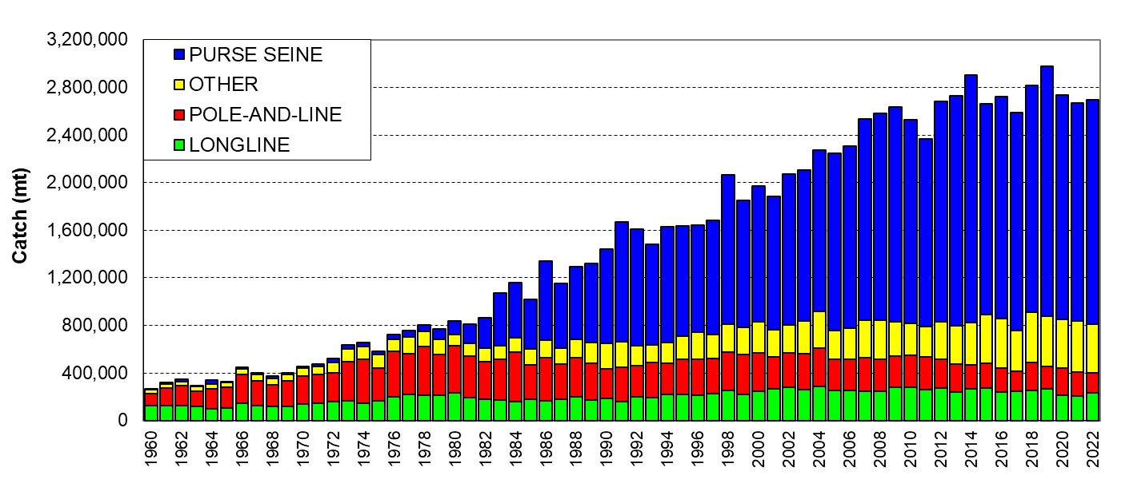 | 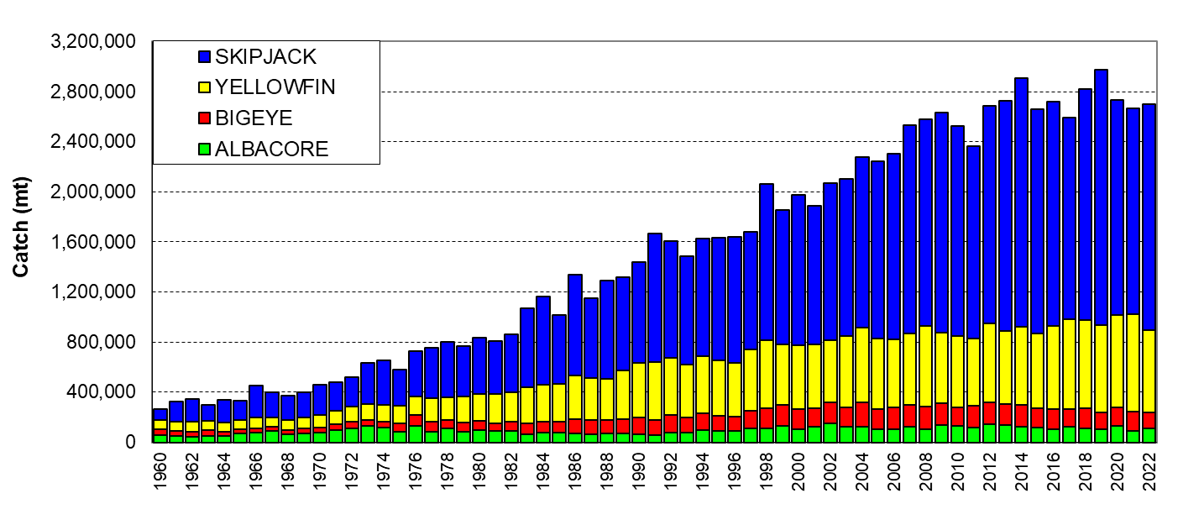
Figure 01. Catch (mt) of albacore, bigeye, skipjack and yellowfin in the WCP–CA, by longline, pole-and-line, purse seine and other gear types. | Figure 02. Catch (mt) of albacore, bigeye, skipjack and yellowfin in the WCP–CA.
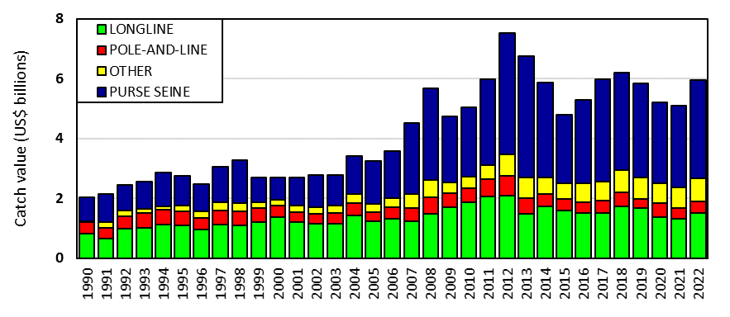 | 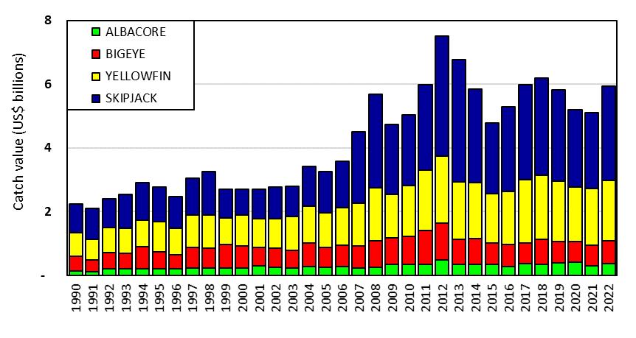
Figure 03. Catch value of albacore, bigeye, skipjack and yellowfin in the WCP–CA, by longline, pole-and-line, purse seine and other gear types. | Figure 04. Catch value of albacore, bigeye, skipjack and yellowfin in the WCP–CA.

AGENDA ITEM 3 — DATA AND STATISTICS THEME

3.1 Data gaps

3.1.1 Data gaps of the Commission

- Peter Williams (SPC) presented SC19-ST-WP-01 (Scientific data available to the Western and Central Pacific Fisheries Commission).

- SC19 noted the availability of the Annual Catch Estimate (ACE) template to facilitate the uploading of information to WCPFC databases and encouraged CCMs to consider using this voluntary template.

Updates on data-related projects

- The following information papers on three data-related projects had been posted to the Online Discussion Forum (ODF).
  - SC19-ST-IP-03 Project 60 – Species composition of purse-seine catches
  - SC19-ST-IP-04 Project 90 – Better data on fish weights and lengths for scientific analyses
  - SC19-ST-IP-06 Project 114 – Improved coverage of cannery receipt data

- SC19 noted the progress on Projects 60 (Improved purse seine species composition), 90 (Better data on fish weights and lengths for scientific analysis), and 114 (Improving coverage of cannery receipt data) and supported the proposed workplans in those progress reports.

Operational longline data fields

- J. Larcombe (Australia) presented SC19-ST-WP-03 (Proposal from Australia for additional or amended data fields for collection within WCPFC).

- SC19 acknowledged the scientific value of the additional longline operational data fields in Table ST-01 and recommended that these fields be considered for inclusion in the “Scientific Data to be Provided by the Commission (SciData)”.

- However, SC19 noted broad implementation concerns of CCMs with respect to the collection of these data, recommended that TCC and the Regular Session of the Commission take account of these concerns, and suggested a possible option would be to include them as voluntary reporting items.

Table ST-01. Additional longline operational data fields for CPUE standardization and related analyses
DATA FIELD | Suggested PROTOCOL for data collection
Target species for the set | Record the primary target species, or group of species, for this set.
Number of lightsticks used in set | Record the total number of lightsticks used in the set.
Bait type used in set | Record the FAO code for type of bait used for the set. Example types:  - Squid (class Cephalopoda)  - Sardine or Pilchard (family Clupeidae)  - Mackerel (family Scombridae)  - Mixed Mackerel and Sardine …
Mainline length | Record the mainline length (in kilometres) used in the trip or set, as appropriate.
Length of branch line | Record the average length in metres of the branch lines in the trip or set. (The total length from the mainline to the hook).
Length of float line | Record the average length in metres of the float lines in the set. (The total length from the float to the mainline).
Vessel speed during setting | Record the average speed in knots of vessel during line setting.
Speed of the line setter | Record the speed in knots of the line setter (i.e., the line shooter speed).

Additional code for the ACTIVITY field

- SC19 acknowledged that the proposal for the addition of a new activity code for any day when a "transhipment at sea occurs” would allow the WCPFC’s Scientific Services Provider (SSP) to define ‘trips’ within the operational data submitted to the Commission.

- SC19 also noted the explanation from the SSP that aggregating the catch by species in the longline operational data at the trip level (when the trip is terminated by an at-sea transhipment) is fundamental for the validation processes using other independent sources of data (e.g., transhipment observers and carrier declarations) to provide more certainty in the data used in assessments and other work of the Commission.

- SC19 recommended that this proposal be considered further by TCC and the Regular Session of the Commission.

Inconsistencies between SciData and CMM operational data reporting requirements

- SC19 acknowledged the review by the WCPFC SSP of inconsistencies in the data reporting requirements between the Scientific Data to be Provided by the Commission (SciData), and other WCPFC reporting obligations (e.g., in CMMs).

- This review identified a reporting requirement under CMM 2018-04 (Conservation and Management of Sea Turtles) that does not appear to be specifically covered in operational data requirements of the SciData (refer to CMM 2018-04 paragraph 5 (c) and 7(e)).

- After discussion and consideration, SC19 noted that the reporting requirement under CMM 2018-04 does not explicitly require operational data. SC19 recommended that TCC19 consider whether it is necessary to clarify the reporting requirements in the CMM 2018-04, while noting the difficulty of logbook-based data collection for sea turtles.

Inconsistent reporting of Set Start Time

- The SC19 working paper on the proposed Billfish Research Plan 2023 - 2027 (SC19-SA-WP-16) noted in a review of available operational data for future billfish research that, "…some fleets record time as ships time, others at UTC and some as country capital time. Clarifying this at a fleet level will be needed before this analysis can be completed with any certainty."

- The SciData indicates that "the date of start of set and time of start of set: The date and start of set time should be GMT/UTC". Reporting date/time in the GMT/UTC standard is not a binding SciData requirement, so SC19 recommended that the WCPFC CCMs, with assistance from the WCPFC SSP where required, indicate:
- the date/time standard used in their historical operational data submissions to the Commission, and
- the date/time standard in their operational data, when they are submitted each year in the future.
Information to ensure the date/time standard is linked back to GMT/UTC shall also be provided.

Additional Billfish Species

- SC19 noted the need for data on short-billed spearfish and sailfish catches, as highlighted in the Billfish Research Plan, and recommended that TCC19 determine how to best accommodate the inclusion of these two species into the Science Data to be Provided to the Commission.

FAD Data fields

- P. Lopati (PNAO) presented SC19-ST-WP-05 (FAD Minimum Data Fields to be Recorded by WCPFC Vessel Operators).

- SC19 recognised the scientific value of the PNA's proposal on “Minimum Data Fields to be Recorded by WCPFC Vessel Operators” (SC19-ST-WP-05).

- Noting the current workload of observers, and some FAD data may be more effectively provided by vessel operators, SC19 agreed on the need for developing a FAD logbook for vessel operators as a priority.

- SC19 noted that the PNA has developed the Standard Operating Procedures (SOPs) for the provision of FAD data by vessel operators for licensed vessels from January 2022 and IATTC have also adopted a FAD logbook, currently used for vessels operating in the EPO and in the overlap area. SC19 noted both could be used as the basis for discussion at FADMO-IWG.

- SC19 recommended WCPFC20 considers this work be progressed intersessionally within the FADMO-IWG.

3.1.2 Bycatch estimates of longline fisheries

- S. Nicol (SPC) presented SC19-ST-WP-02 (Summary of bycatch in WCPFC longline fisheries at a regional scale, 2003-2021).

- SC19 noted the following in relation to the updated estimates of longline bycatch:
  - Changes to the methodology now allow for uncertainty in the estimated hooks between floats (HBF) to propagate through uncertainty in estimated catches.
  - There continue to be difficulties in robust estimation of longline bycatch resulting in high uncertainty given the low levels and spatially imbalanced nature of observer coverage, and for some years the low coverage of data.
  - Earlier work suggests the trends in estimated catch rates are more reliable than the magnitude of the estimated catches.
  - Assuming a timely return of observer coverage to pre-COVID levels, that there will probably be sufficient observer data available to revise the catch rates models in the future.
  - A previous analysis (SC16-ST-IP-11) suggested that an observer coverage of at least 10 % of trips would allow for reasonably good estimates of bycatch, and that the increase in precision would be highest for species that are frequently caught, and weakest for rarely caught species, especially sea turtles and cetaceans.

- SC19 noted that the adopted level of 5% observer coverage, which has been in place for over a decade, has not provided good estimates of longline bycatch. Therefore, SC19 recommended that the Commission explore options to expand the observer coverage on longline vessels through both human and electronic approaches in the WCPO so that the SC can provide better estimates of bycatch levels and other metrics from these fleets.

3.2 Regional Observer Programme

3.3 Electronic Reporting and Electronic Monitoring (ER and EM)

- SC19 noted the report from the research project on EM monitoring transhipment that utilized a digital scale integrated to the onboard EM system to automatically store transmitted weights. SC19 welcomed such developments and recommended that the trials of EM on at-sea transhipment vessels should be continued.

3.4 Economic data

3.5 Baseline period or limit of the Indonesian Large Fish Handline Fishery

AGENDA ITEM 4 — STOCK ASSESSMENT THEME

4.1 Independent review of the 2020 WCPO Yellowfin tuna assessment

- M. Maunder (IATTC) presented SC19-SA-WP-01 (Independent review of recent WCPO yellowfin tuna assessment).

- SC19 noted the recommendations in the peer review of the 2020 WCPO yellowfin tuna stock assessment (SC19-SA-WP-01 Independent review of recent WCPO yellowfin tuna assessment), and recommended that, where practical, recommendations therein be considered for future bigeye and yellowfin tuna assessments, as well as other assessments as appropriate.

- SC19 noted that regular and ongoing peer reviews are helpful for improving stock assessments.

4.2 Improvement of MULTIFAN-CL software

- There was no presentation on this agenda item.

- SC19 supported ongoing development of MULTIFAN-CL by the SSP but noted that the next generation of assessment models for tuna assessments in the WCPFC should be considered. SC19 noted that a TOR for work towards the development of the next generation of tuna assessment models was submitted to SC19.

4.3 WCPO tunas

4.3.1 WCPO yellowfin tuna (Thunnus albacares)

4.3.1.1 Research and information

a. Review of 2023 yellowfin tuna stock assessment

CPUE Analysis

- T. Teears (SPC) presented SC19-SA-WP-03 (CPUE analysis and data inputs for the 2023 bigeye and yellowfin tuna assessments in the WCPO).

2023 Yellowfin Tuna Stock Assessment

- A. Magnusson (SPC-OFP) presented SC19-SA-WP-04 (Stock assessment of yellowfin tuna in the western and central Pacific Ocean: 2023).

- SC19 noted that the SSP had made significant improvements to the WCPO yellowfin tuna assessment based upon the recommendations from the 2022 peer review of the 2020 yellowfin tuna assessment, and from several CAPAM (Center for the Advancement of Assessment Modeling) meetings. Some key changes from the 2020 assessment include:
- Estimating natural mortality internally in the model.
- Reducing the spatial complexity from 9 regions to 5 regions.
- Using a Lorenzen functional form of natural mortality.
- Changing to a catch-conditioned model and estimating a likelihood for CPUE
- Revising the treatment of tagging data included in the model.
- Incorporating estimation uncertainty to the structural uncertainty grid.

4.3.1.2 Provision of scientific information

Stock status and trends

- The 2023 WCPO yellowfin tuna assessment provides stock status based upon a 54-model structural uncertainty grid with four axes: steepness with three levels, tag mixing period with two levels, and size and age composition data with three levels each, as illustrated in Table YFT-01. SC19 recommended that the proposed axes of uncertainty be accepted and that all models should be weighted equally. SC19 noted that an important improvement in the characterization of uncertainty was the inclusion of estimation uncertainty for each of the models in the grid.

- SC19 noted that the most influential axis of uncertainty in the grid was steepness.

- The spatial structure used in the 2023 stock assessment is shown in Figure YFT-01. SC19 noted that the simplification of the model from 9 regions to 5 regions improved the convergence of the model.

- The time series of total annual catch by fishing gear over the full assessment period is shown in Figure YFT-02. The time series of total annual catch by fishing gear and assessment region is shown in Figure YFT-03. Estimated annual average recruitment, spawning potential, and total biomass by model region is shown in Figure YFT-04. Estimated trends in spawning potential depletion (SB/SB_{F=0}) for the 54 models in the structural uncertainty grid are shown in Figure YFT-05, and juvenile and adult fishing mortality rates from the diagnostic model are shown in Figure YFT-06. Estimates of the reduction in spawning potential due to fishing by region are shown in Figure YFT-07. Estimated trends in spawning potential for the 54 models are shown in Figure YFT-08. A Majuro and Kobe plot summarizing the results for each of the 54 models in the structural uncertainty grid are shown in Figure YFT-09. A comparison of the dynamic MSY for the diagnostic model compared with annual catch by the main gear types is shown in Figure YFT-10.

- SC19 noted that the preliminary estimate of total catch of WCPO yellowfin tuna for 2022 was 721,169 mt which was lower than the 2021 level. Longline catch in 2022 (84,232 mt) was higher than the 2021 catch, but lower than the recent 10-year average. Purse-seine catch in 2022 (379,715 mt) was similar to the 2021 catch, and higher than the recent 10-year average (Figure YFT-02).

- The 2023 WCPO yellowfin tuna stock assessment median depletion from the model grid for the recent period (2018–2021; SB_{recent}/SB_{F=0}) was estimated at 0.47 (10th to 90th percentile interval of 0.42 to 0.52, including estimation and structural uncertainty). For all models in the grid SB_{recent}/SB_{F=0} was above the biomass limit reference point. The recent median fishing mortality (2017–2020; F_{recent}/F_{MSY}) was 0.50 (10th to 90th percentile interval of 0.41 to 0.62, including estimation and structural uncertainty, Table YFT-02). For all models in the grid, F_{recent}/F_{MSY} was less than one.

- SC19 noted that the spawning potential of the stock has become more depleted across all model regions until around 2010, after which it has become more stable, or shown a slight increase.

- SC19 also noted that average fishing mortality rates for juvenile and adult age-classes have increased throughout the period of the assessment, although more so for juveniles which have experienced considerably higher fishing mortality than adults. In the recent period (2015-2021), a sharp increase in juvenile fishing mortality was estimated, while adult fishing mortality stabilized.

Table YFT-01: Summary of reference points over the 54 individual models in the structural uncertainty grid, along with results incorporating estimation uncertainty (Table 5 from SC19-SA-WP-04).
 | Mean | median | min | 10%ile | 90%ile | max | diagnostic model
C_{latest} | 751657 | 751856 | 750785 | 750860 | 752268 | 752337 | 751908
F_{MSY} | 0.07 | 0.07 | 0.06 | 0.06 | 0.09 | 0.09 | 0.07
F_{mult} | 1.96 | 2.00 | 1.47 | 1.64 | 2.38 | 2.50 | 1.89
F_{recent}/F_{MSY} | 0.51 | 0.50 | 0.40 | 0.42 | 0.61 | 0.68 | 0.53
MSY | 697874 | 700400 | 616800 | 644320 | 739560 | 771600 | 671600
SB₀ | 5761796 | 5729000 | 4455000 | 4817200 | 6640900 | 7279000 | 5216000
SB_{F=0} | 5633743 | 5603267 | 4624645 | 4907798 | 6280841 | 6825888 | 5173954
SB_{latest}/SB₀ | 0.49 | 0.50 | 0.41 | 0.44 | 0.54 | 0.56 | 0.49
SB_{latest}/SB_{F=0} | 0.50 | 0.50 | 0.41 | 0.45 | 0.55 | 0.58 | 0.49
SB_{latest}/SB_{MSY} | 2.49 | 2.48 | 1.78 | 1.91 | 3.11 | 3.16 | 2.44
SB_{MSY} | 1177733 | 1160500 | 740400 | 838260 | 1538200 | 1707000 | 1044000
SB_{MSY}/SB₀ | 0.20 | 0.20 | 0.17 | 0.17 | 0.23 | 0.24 | 0.20
SB_{MSY}/SB_{F=0} | 0.21 | 0.21 | 0.16 | 0.17 | 0.24 | 0.25 | 0.20
SB_{recent}/SB_{F=0} | 0.47 | 0.47 | 0.38 | 0.42 | 0.52 | 0.54 | 0.46
SB_{recent}/SB_{MSY} | 2.31 | 2.30 | 1.68 | 1.77 | 2.89 | 2.94 | 2.27
Y_{Frecent} | 157188 | 155300 | 141400 | 145150 | 172270 | 173300 | 152500
Including estimation uncertainty:
 | mean | median | min | 10%ile | 90%ile | max
SB_{recent}/SB_{F=0} | 0.47 | 0.47 | 0.36 | 0.42 | 0.52 | 0.59
F_{recent}/F_{MSY} | 0.51 | 0.50 | 0.26 | 0.41 | 0.62 | 0.78
SB_{recent}/SB_{MSY} | 2.31 | 2.28 | 0.93 | 1.73 | 2.95 | 3.59

Table YFT-02: Structural uncertainty grid for the 2023 WCPO yellowfin tuna stock assessment. Bold values indicate settings for the diagnostic model (Table 3 from SC19-SA-WP-04).
Axis | Levels | Option 1 | Option 2 | Option 3
Steepness | 3 | 0.65 | 0.8 | 0.95
Tag mixing (# quarters) | 2 | 1 | 2
Size data weighting divisor | 3 | 10 | 20 | 40
Age data weighting | 3 | 0.5 | 0.75 | 1

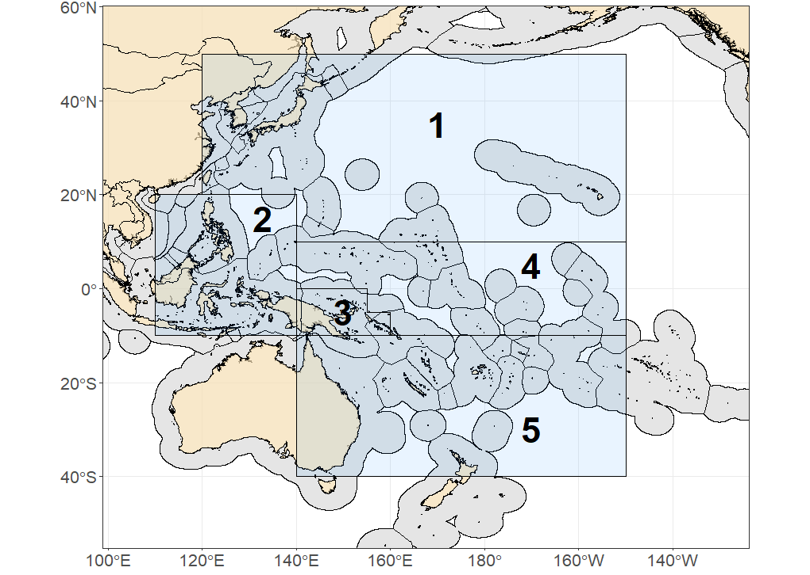
Figure YFT-01: The geographical area covered by the stock assessment and the boundaries of the model regions for the 5-region structure that was used for 2023 WCPO yellowfin tuna assessment (Figure 1a from SC19-SA-SP-04).

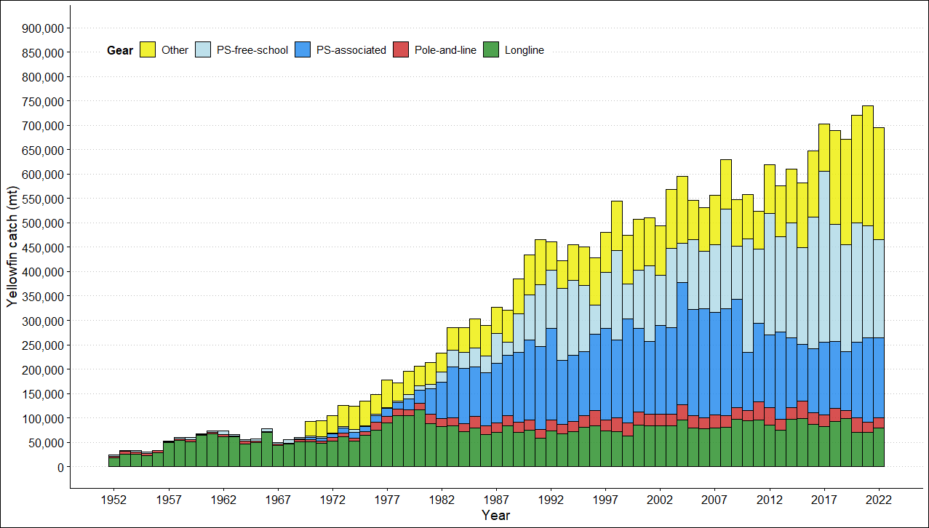
Figure YFT-02: Annual catches of yellowfin by gear type in the WCPO area covered by the assessment (Figure 3 from SC19-SA-WP-04).

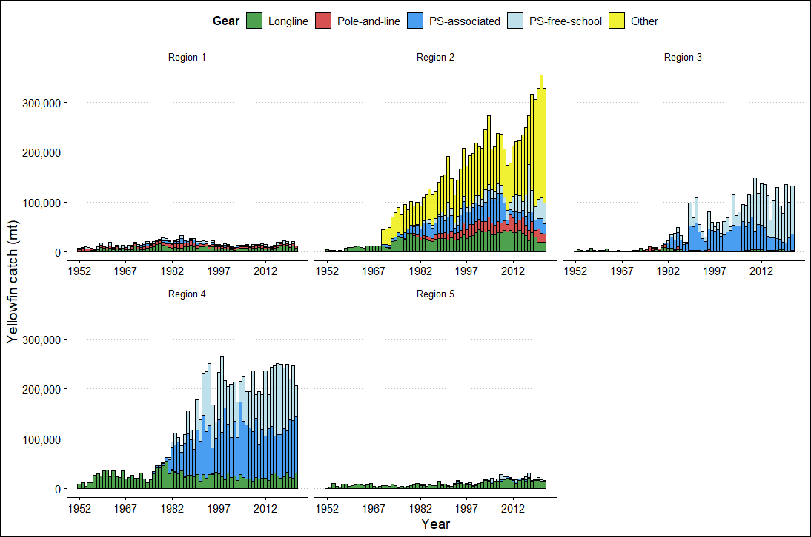
Figure YFT-03: Annual catches of yellowfin by gear type for each of the five model regions (Figure 4 from SC19-SA-WP-04).

Figure YFT-04: Time series of estimated annual spawning potential, recruitment and total biomass by model region for the diagnostic model, showing the relative proportions among regions. Note the data represent the averages of the quarterly model time steps for each year for spawning potential and total biomass and the sum of the quarterly recruitment estimates for annual recruitment (Figure 45 from SC19-SA-WP-04).

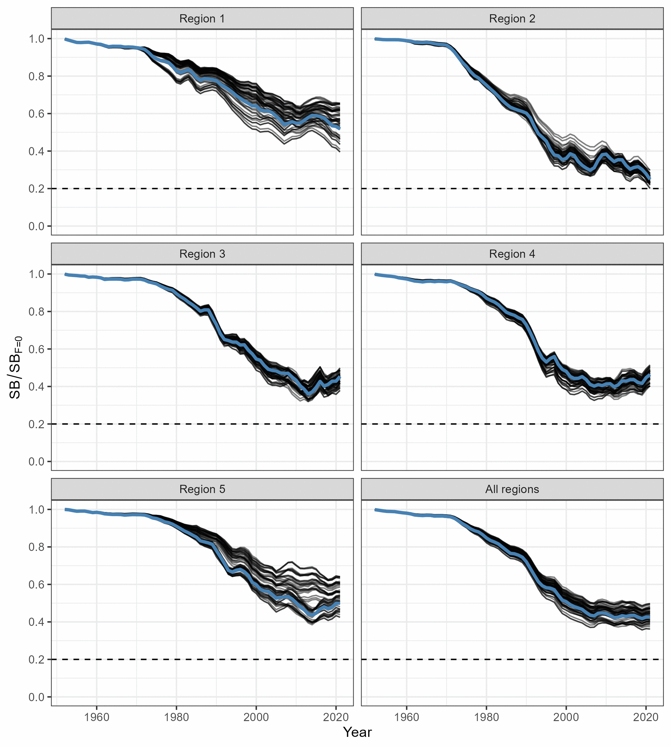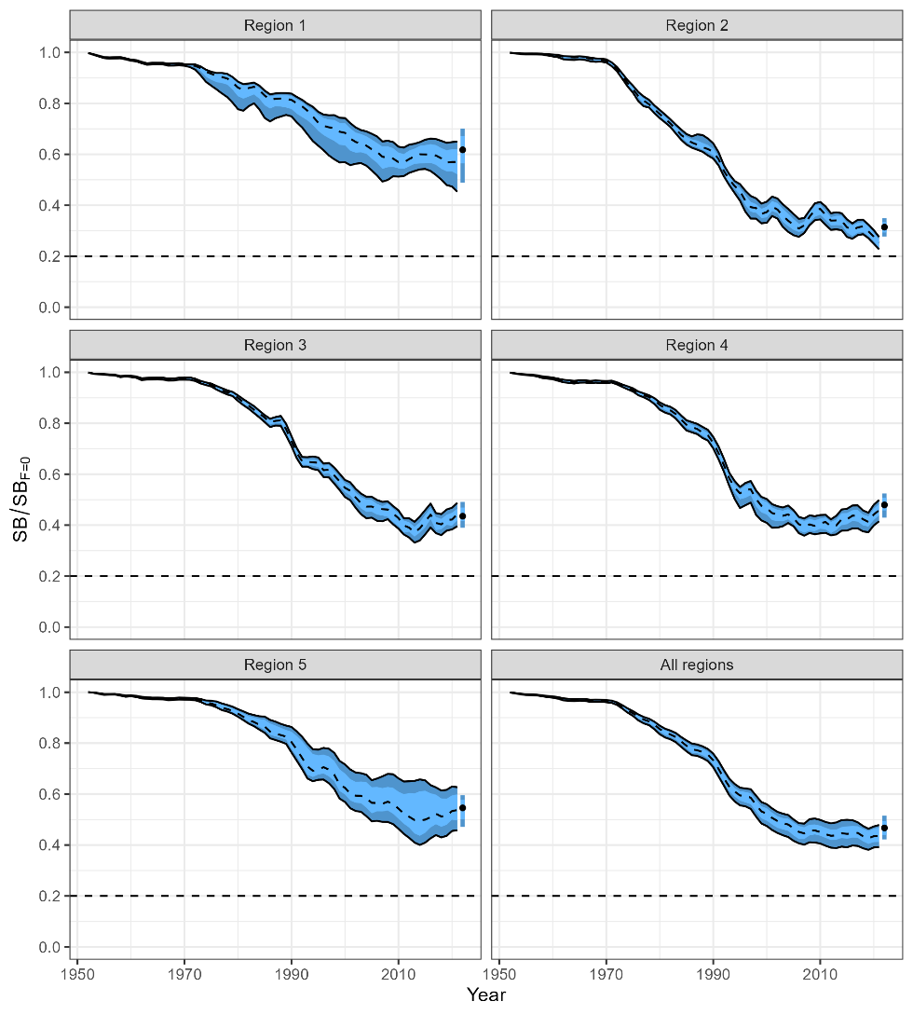
Figure YFT-05: (Left) Trajectories of spawning potential depletion for the individual model runs included in the structural uncertainty grid over the period 1952-2021. (Right) Estimated spawning depletion across all models in the structural uncertainty grid over the period 1952-2021. The dashed line represents the median, the lighter band shows the 25th and 75th percentiles, and the dark band shows the 10th and 90th percentiles of the model estimates. The bar at the right of each ribbon indicates the median (black dots) with the 10th and 90th percentiles for SB_{recent}/SB_{F=0} (Figure 59 from SC19-SA-WP-04).

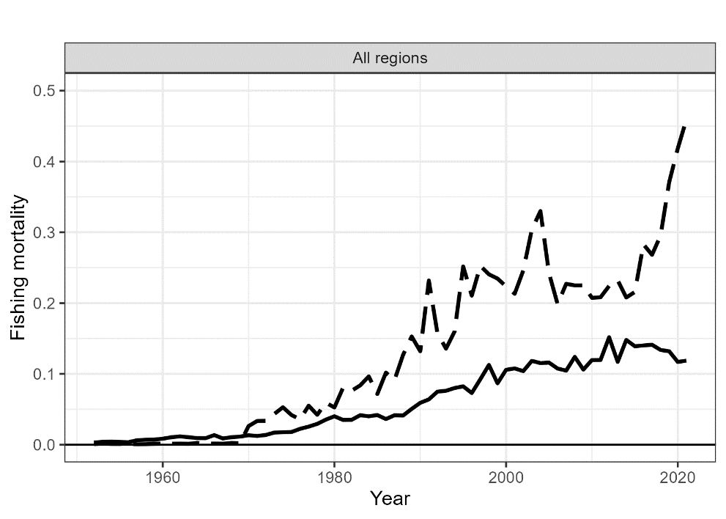
Figure YFT-06: Estimated annual average adult (solid line) and juvenile (dashed line) fishing mortality for the diagnostic model (Figure 50 from SC19-SA-WP-04).

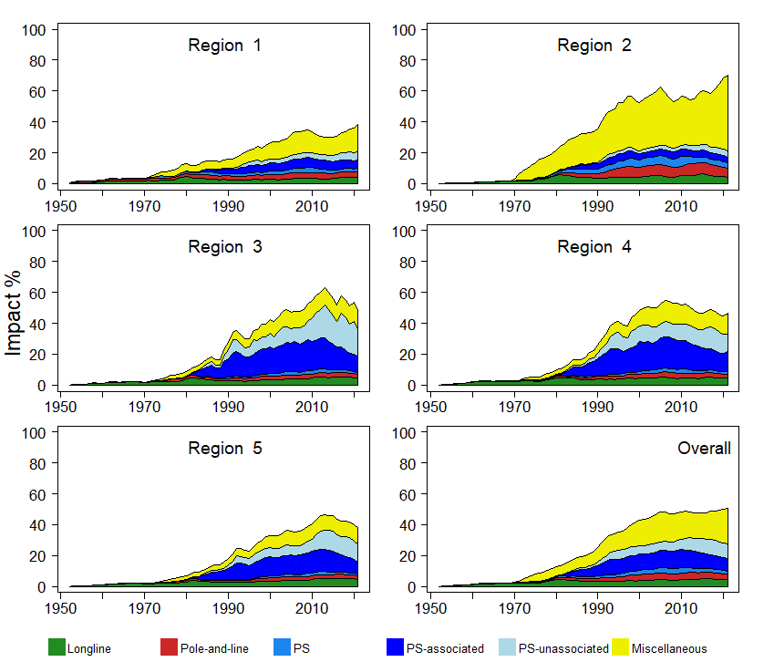

Figure YFT-07: Estimates of reduction in spawning potential due to fishing (Fishery Impact = 1− SB_{t}/SB_{t,F=0}) by region, and over all regions (lower right panel), attributed to various fishery groups for the diagnostic model (Figure 66 from SC19-SA-WP-04).

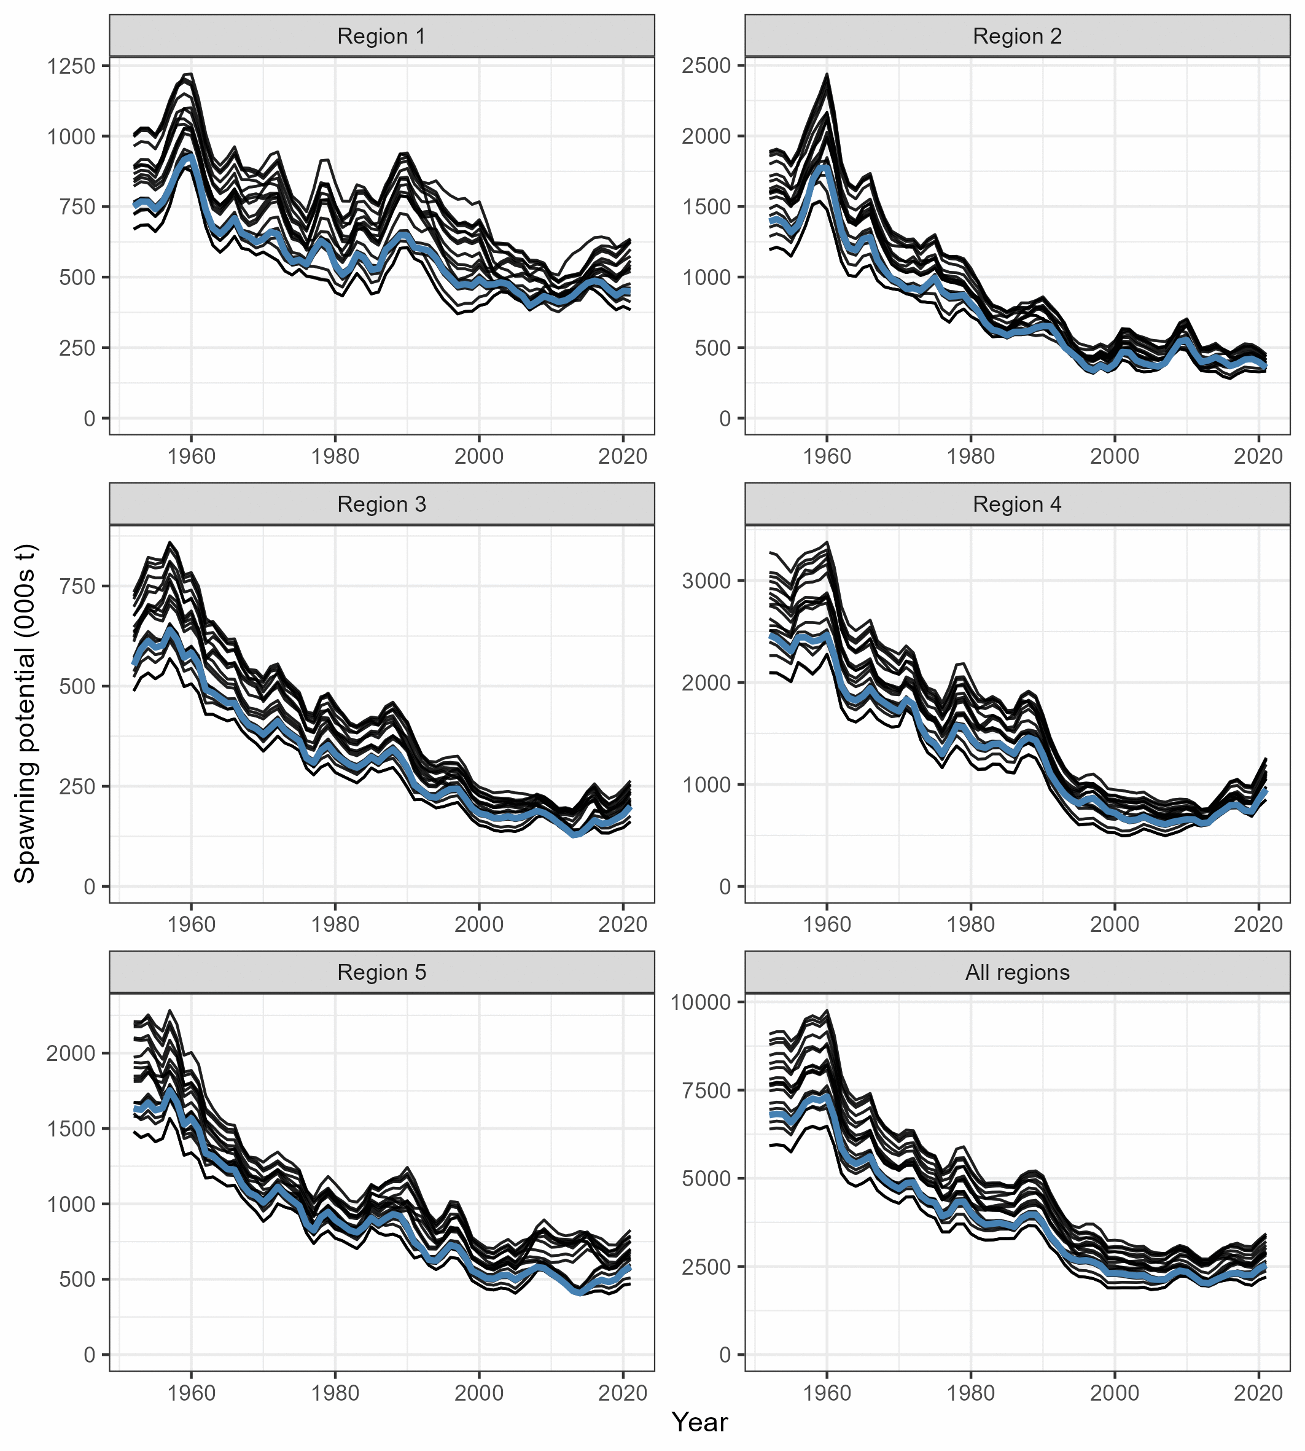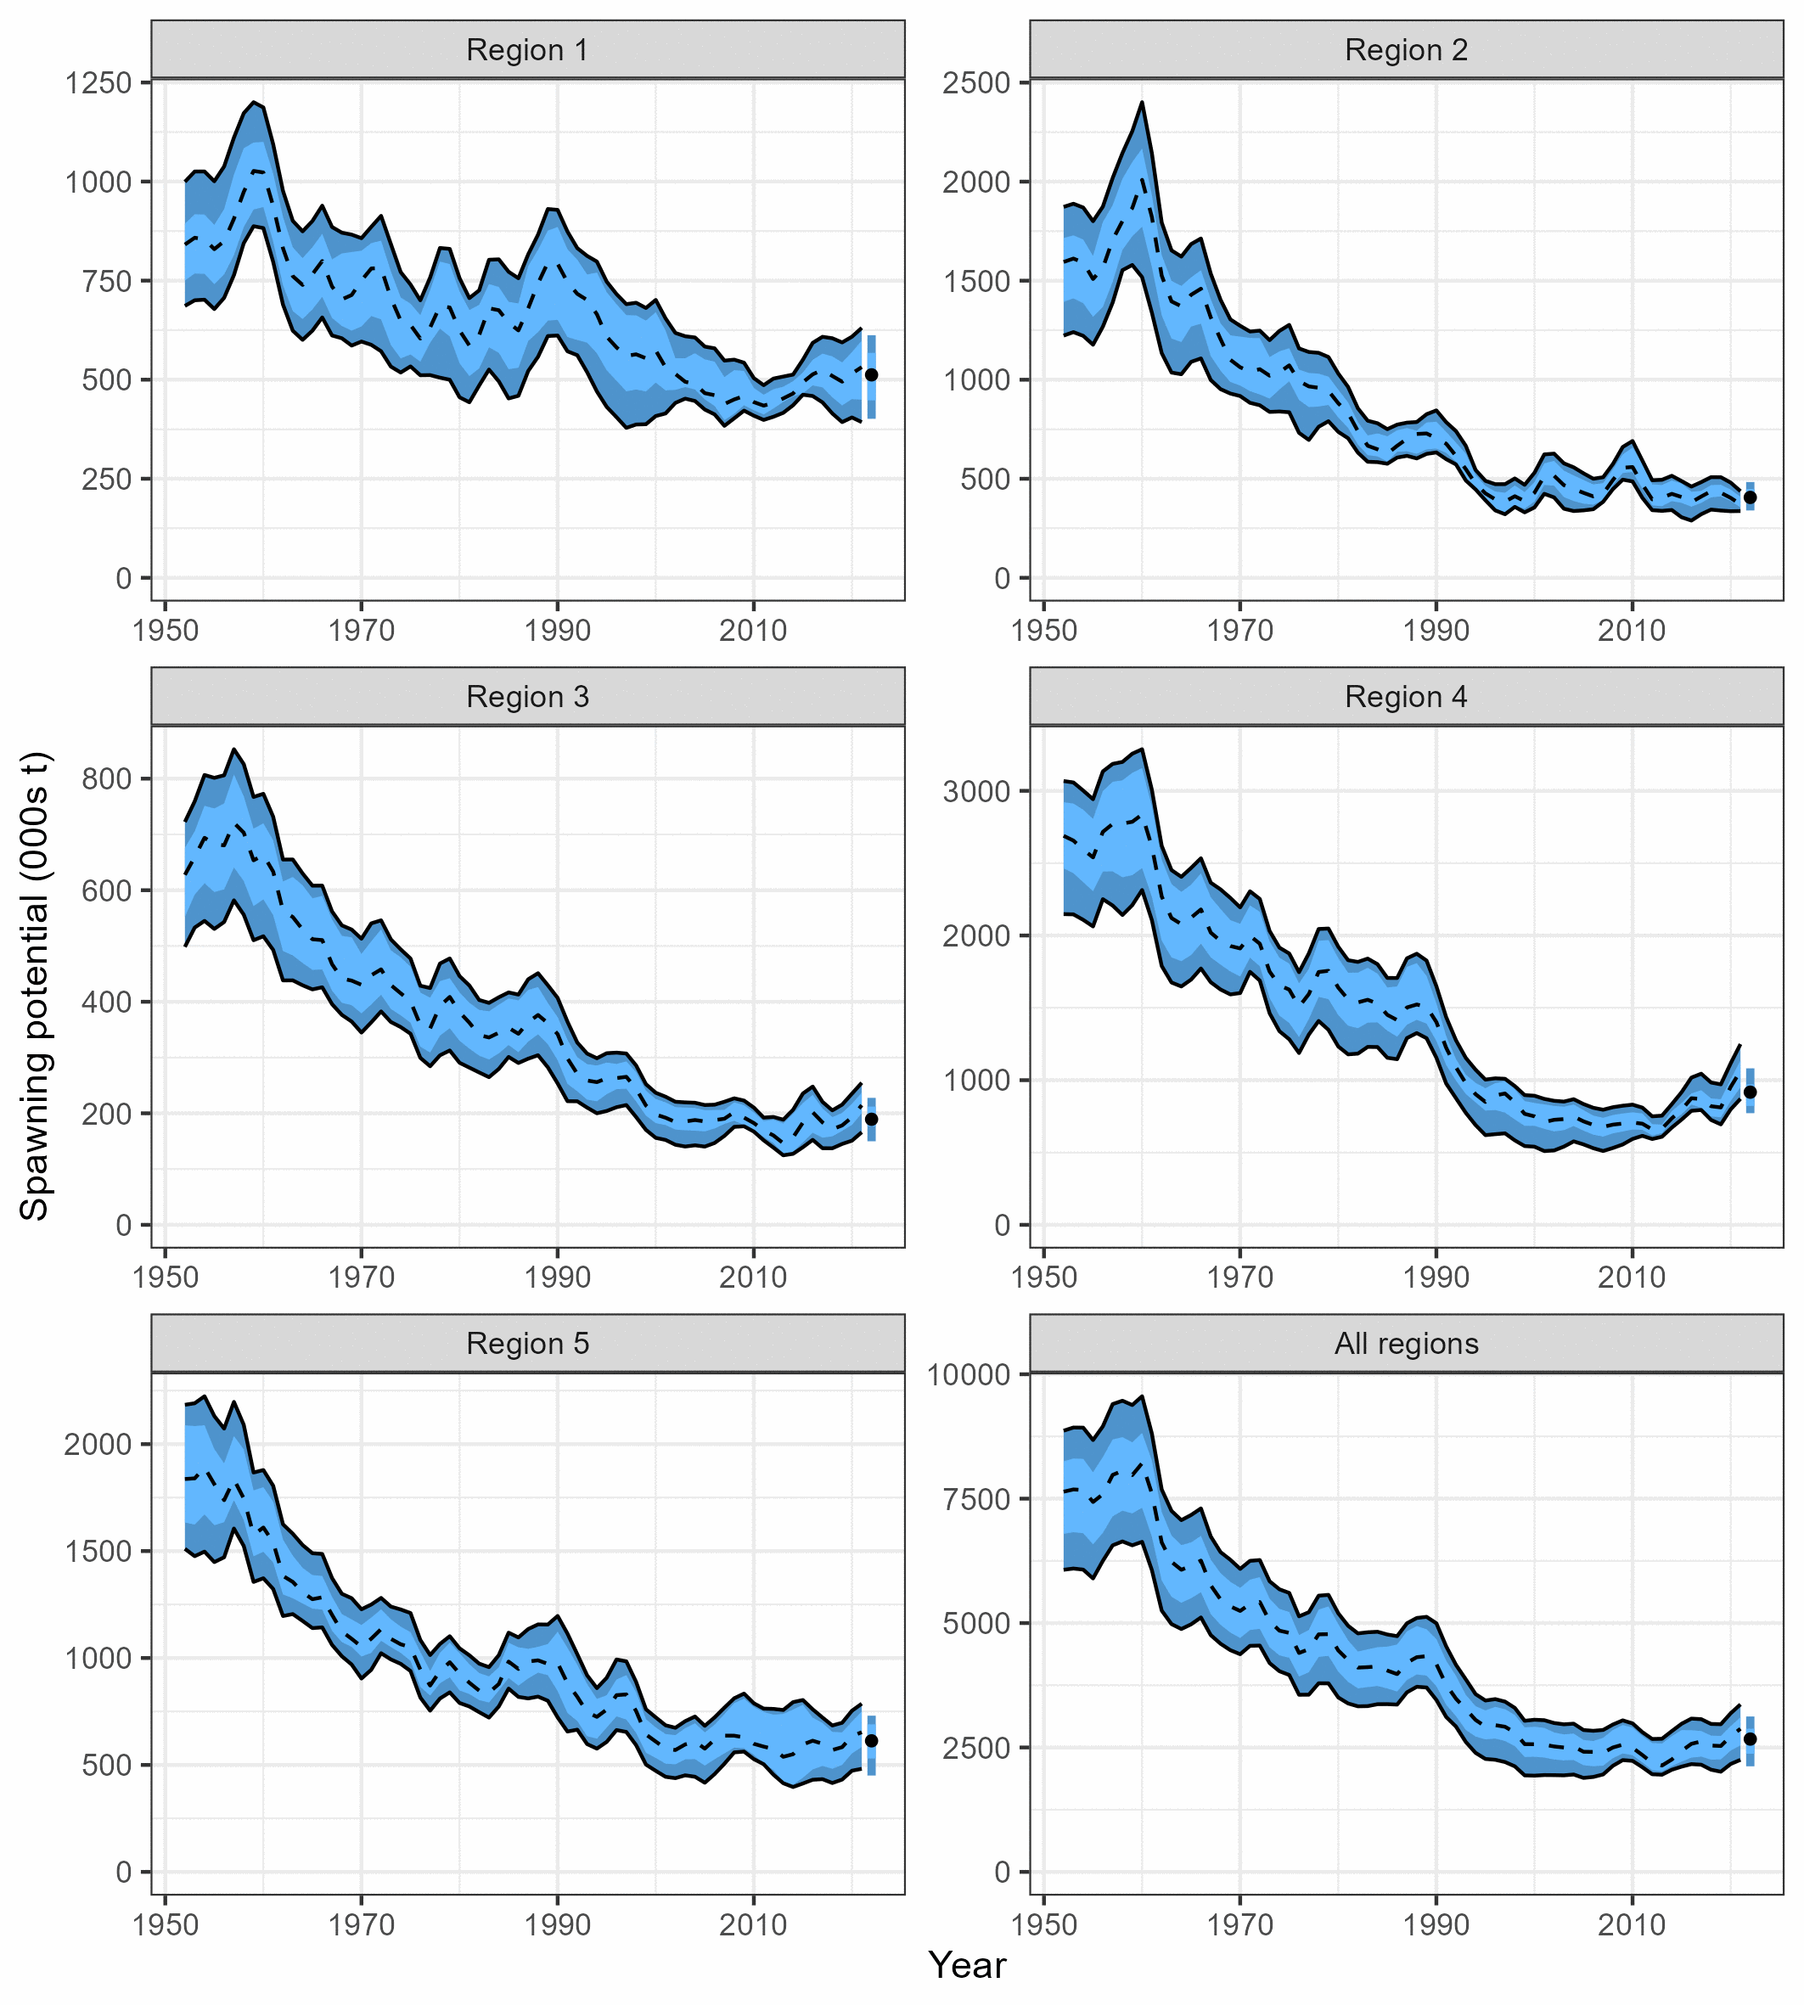
Figure YFT-08: (Left) Trajectories of spawning potential for the individual model runs included in the structural uncertainty grid over the period 1952-2021. (Right) Estimated spawning potential across all models in the structural uncertainty grid over the period 1952-2021. The dashed line represents the median, the lighter band shows the 25th and 75th percentiles, and the dark band shows the 10th and 90th percentiles of the model estimates. The bar at the right of each ribbon indicates the median (black dots) with the 10th and 90th percentiles for SB_{recent} (Figure 60 from SC19-SA-WP-04).

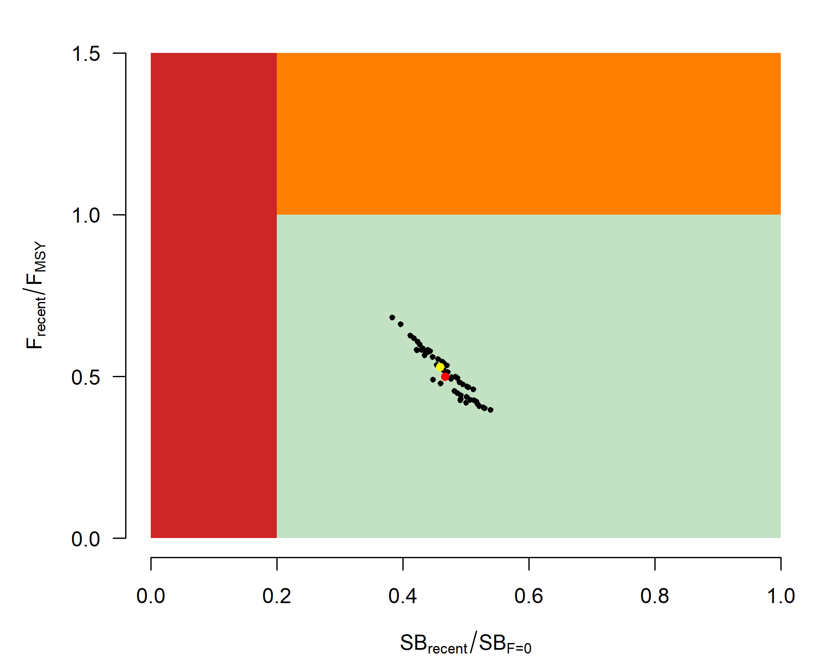 | 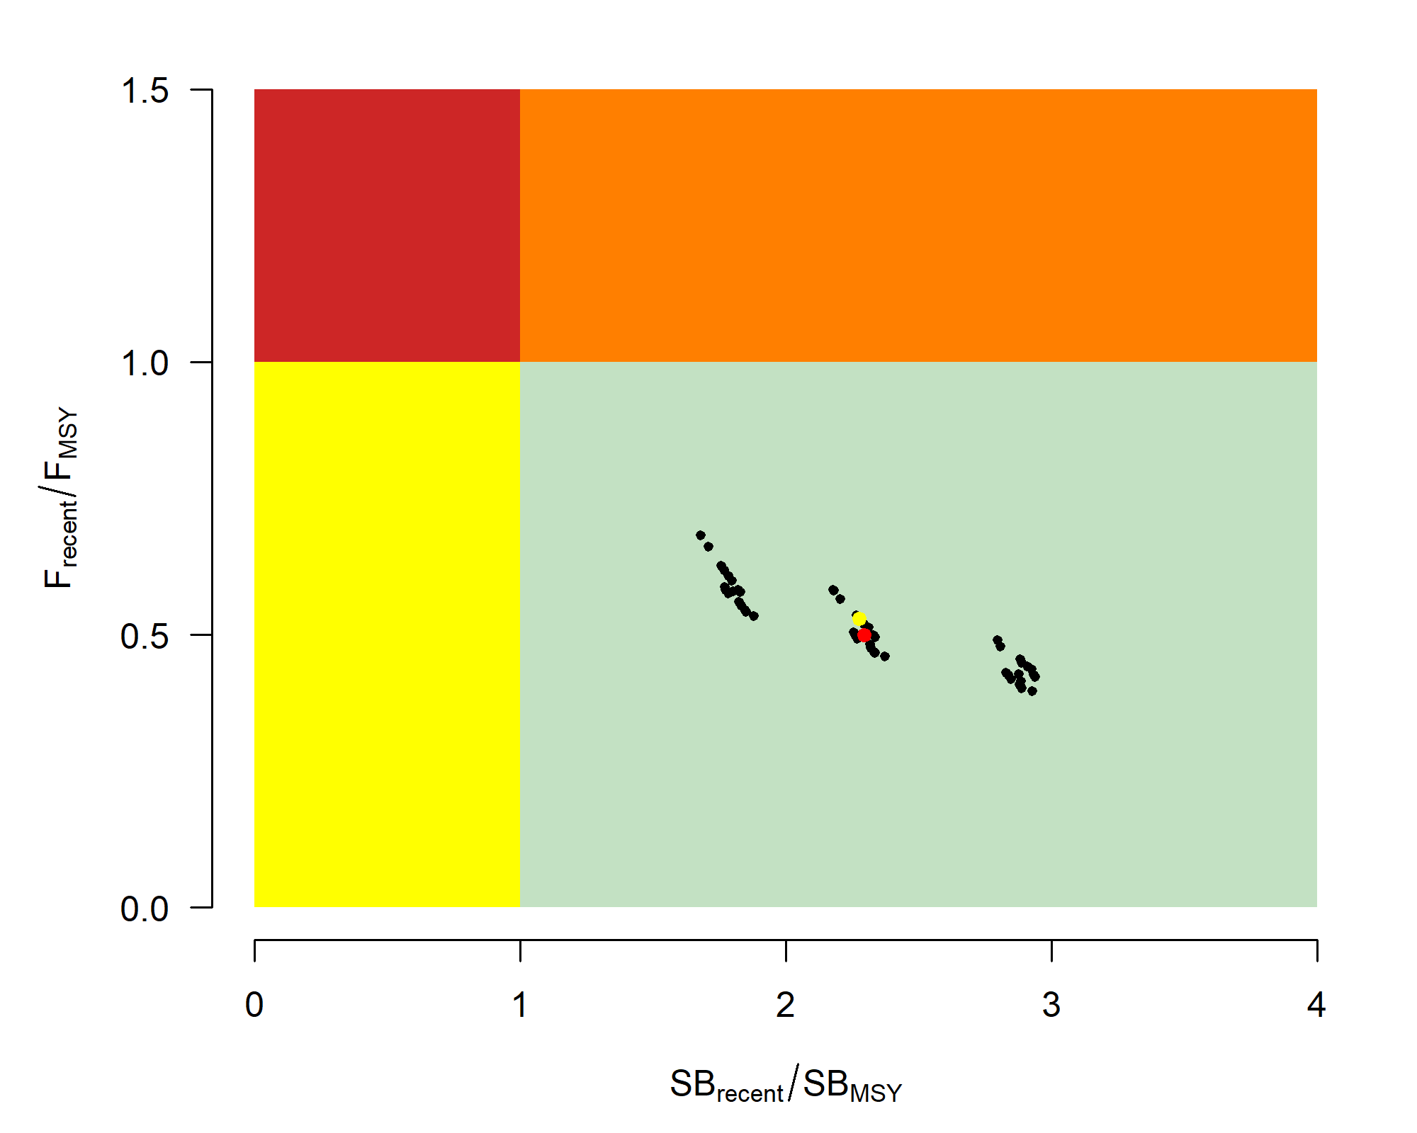
Figure YFT-09: Majuro plot (top) and Kobe plot (bottom) summarising the results for each of the models in the structural uncertainty grid for the recent period (2018-2021). The yellow point is the 2023 diagnostic model, and the red point is the median (Figure 64 from SC19-SA-WP-04).

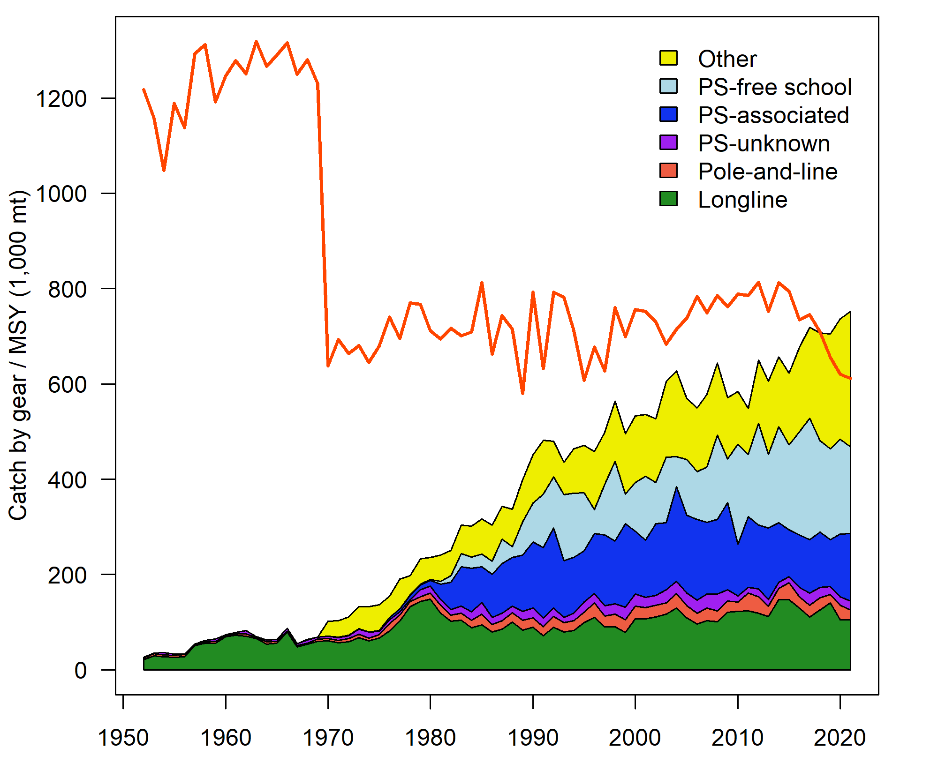
Figure YFT-10: History of the annual estimates of MSY (red line) for the diagnostic model compared with annual catch by the main gear types. Note that this is a ‘dynamic’ MSY (Figure 68 from SC19-SA-WP-04).

b. Management advice and implications

- The WCPO yellowfin tuna spawning biomass is above the LRP and recent F is below F_{MSY} based on the uncertainty grid, The stock is not experiencing overfishing (100% probability F_{recent}<F_{MSY}) and is not in an overfished condition (0% probability SB_{recent}/SB_{F=0}<LRP).

- The objective for yellowfin tuna in CMM 2021-01 (the Tropical Tuna Measure) to maintain the spawning biomass depletion ratio at or above the average SB/SB_{F=0} for 2012-2015 is being achieved. SB_{recent}/SB_{F=0} (47%) exceeds the average SB/SB_{F=0} for 2012-2015 (44% calculated across the unweighted grid).

- SC19 recommends stochastic projections based on the adopted yellowfin tuna grid be undertaken by the SSP and provided to the Commission for their consideration.

- The interim objective for the yellowfin tuna stock under CMM 2022-01 is to maintain the depletion level of the stock at or above the average SB/SB_{F=0} for 2012-2015 and the recent depletion level of yellowfin tuna is close to the interim objective. SC19 noted that while the projection results based on the 2023 yellowfin tuna assessment were not available for SC19 to review, this information will be available when for the 4th tropical tuna management workshop and will provide the Commission guidance on future expected levels of fishing mortality and the outcomes relative to the interim or future management objectives.

- SC19 also noted a continuous downward trend in spawning potential ratio over the recent decade in Region 2 in the westernmost equatorial region, mainly due to the miscellaneous gear fisheries within this region, whereas other regions have been relatively stable over this period. This is the impact of artisanal (small-scale) fisheries other than longline and purse seine within this region. SC19 recommends that the Commission note the need for clear limits for these.

- SC19 also noted that there is evidence that the overall stock status is buffered with spawning biomass kept at a more elevated level overall by low exploitation in the temperate regions (1 and 5). The assessment model estimates spawning biomass to be divided between the tropical (59%) and temperate (41%) regions, but the vast majority of catch occurred in the tropical (94%) region.

c. Research recommendations

- SC19 noted several research recommendations for the further development and improvement of the WCPO yellowfin tuna assessment:
- Exploration into the conflict between the length and weight composition data, if unresolved this conflict should be reflected within future structural uncertainty grids;
- Exploration of a simplification of the spatial structure by using a single area, with “areas-as-fleets”;
- Exploration of alternative approaches to modeling of tagging data, including consideration of the most appropriate mixing periods for different regions and development of stand-alone tagging (mark-recapture) models;
- Exploration of which parameters are most sensitive to initial model starting values, and taking steps to reduce the impact of starting values on the results in future assessments; this could include simplification of models and/or systematic use of jittering;
- Further research to improve estimates of catches (both historical and recent) in the fisheries of Indonesia, the Philippines and Vietnam through the continued funding of the WPEA monitoring project;
- An exploration of seasonal and regional growth traits for the stock assessment;
- A study on longline CPUE standardization process considering effort creep; and
- Developing alternative CPUE scenarios with different implied regional weightings.

4.3.2 WCPO bigeye tuna (Thunnus obesus)

4.3.2.1 Research and information

Review of the 2023 bigeye tuna stock assessment

- J. Day (SPC-OFP) presented SC19-SA-WP-05 (Stock assessment of bigeye tuna in the western and central Pacific Ocean).

- SC19 thanked the SSP for the thorough work conducted on the WCPO bigeye stock assessment and for the considerable efforts to improve the assessment and to incorporate the recommendations from SC18 and the 2022 yellowfin tuna peer review.

- SC19 noted that the 2023 bigeye stock assessment applied a more rigorous approach, including randomized initial parameter analyses, i.e., “jittering” and achieving a positive definite Hessian for the diagnostic model, however, model instability appears to remain.

- SC19 noted that the changes in the modelling of the bigeye tuna stock in the WCPO indicate that the assessment results are slightly less optimistic than the 2020 assessment.

- SC19 accepted the 2023 WCPO bigeye tuna stock assessment with a 9-region spatial structure (Figure BET-01) and adopted the full unweighted grid in Table BET-01 to provide stock status and management advice, however, future projection results were not provided at SC19. SC19 recommended that those stock projection analyses be provided for the Commission consideration for management advice prior to the Commission meeting.

- Given the similarity in stock status as presented to SC16, some CCMs preferred to re-iterate the advice from SC16 that WCPFC20 could continue to consider measures to reduce fishing mortality from fisheries that take juveniles, with the goal to increase adult bigeye fishery yields and reduce any further impacts on the spawning biomass for this stock. Other CCMs considered that this advice was unclear and had previously been misinterpreted, noting that the SC had previously agreed not to advise the Commission to take measures to reduce mortality in fisheries that take juvenile bigeye tuna. The aforementioned CCMs did not share this observation.

4.3.2.2 Provision of scientific information

a. Stock status and trends

- The 2023 WCPO bigeye tuna assessment provides stock status based upon a 54-model structural uncertainty grid with four axes: steepness with three levels, tag mixing period with two levels, and size and age composition data with three levels each, as illustrated in Table BET-01. SC19 recommended that the proposed axes of uncertainty be accepted and that all models should be weighted equally. SC19 noted that an important improvement in the structural uncertainty grid was the inclusion of estimation uncertainty for each of the models in the grid.

- SC19 noted that the most influential axes of uncertainty in the grid were steepness and tag mixing period.

- The spatial structure used in the 2023 stock assessment is shown in Figure BET-01. Time series of total annual catch by fishing gear over the full assessment period is shown in Figure BET-02. The time series of total annual catch by fishing gear and assessment region is shown in Figure BET-03. Estimated annual spawning potential, average recruitment, and total biomass by model region are shown in Figure BET-04. Estimated trend in spawning potential depletion (SB/SB_{F=0}) for the 54 models in the structural uncertainty grid is shown in Figure BET-05, and juvenile and adult fishing mortality rates from the diagnostic model is shown in Figure BET-06. Estimates of the reduction in spawning potential due to fishing by region are shown in Figure BET-07. A comparison of the dynamic MSY for the diagnostic model compared with annual catch by the main gear types are shown in Figure BET-08, and estimated age specific fishing mortality for the diagnostic model, by region and overall are in Figure BET-09.

- SC19 noted that the preliminary estimate of total catch of WCPO bigeye tuna for 2022 was 140,664 mt which was similar to the 2021 level. Longline catch in 2022 (54,800 mt) was similar to the 2021 catch and lower than the recent ten-year average and understood to be partly due to the impacts of the COVID-19 pandemic. Purse-seine catch in 2022 (62,811 mt) was also similar to the 2021 catch, and lower than the recent ten-year average (Figure BET-02).

- The 2023 WCPO bigeye tuna stock assessment median depletion from the model grid for the recent period (2018-2021; SB_{recent}/SB_{F=0}) was 0.35 (10th to 90th percentile interval of 0.30 to 0.40, including estimation and structural uncertainty, Table BET-02). For all models in the grid SB_{recent}/SB_{F=0} was above the biomass limit reference point. The recent median fishing mortality (2017-2020; F_{recent}/F_{MSY}) was 0.59 (10th to 90th percentile interval of 0.46 to 0.74, including estimation and structural uncertainty, Table BET-02). For all models in the grid, F_{recent}/F_{MSY} was less than one.

- SC19 noted that the results show that both total and spawning potential has been continuously declining since the late 1950s through until the mid-1970’s, followed by a more gradual decline through to the present (Figure BET-04).

- SC19 noted that the catch in the last year of the assessment (2021) was less than the median MSY (164,640 mt), which is a 17% increase in the estimated MSY for bigeye tuna from the 2020 stock assessment (140,720 mt).

- Majuro (Figure BET-10) and Kobe (Figure BET-11) plots show that the stock status estimates across the 54 models are all within plot zones that indicate that the stock is not overfished nor undergoing overfishing.

Table BET-01. Description of the updated structural sensitivity grid used to characterize uncertainty in the assessment with bolded values indicating the diagnostic case (Table 3 from SC19-SA-WP-05).
Axis | Value 1 | Value 2 | Value 3
Steepness | 0.65 | 0.8 | 0.95
Tag mixing (# quarters) | 1 | 2
Size data weighting divisor | 10 | 20 | 40
Age data weighting | 0.5 | 0.75 | 1

Table BET-02. Summary of reference points over the 54 models in the structural uncertainty grid. Note that “recent” is the average over the period 2018-2021 for SB and fishing mortality, while “latest” is 2021. The values of the upper 90th and lower 10th percentiles of the empirical distributions are also shown. F_{mult} is the multiplier of recent (2018-2021) fishing mortality required to produce MSY (Table 5 from SC19-SA-WP-05).
 | Mean | Median | Minimum | 10th percentile | 90th percentile | Maximum
C_{latest} | 139,314 | 139,199 | 138,527 | 138,947 | 139,939 | 140,347
Y_{Frecent} | 37,982 | 37,805 | 33,400 | 34,365 | 42,369 | 42,980
F_{MSY} | 0.06 | 0.06 | 0.04 | 0.04 | 0.07 | 0.08
F_{mult} | 1.69 | 1.67 | 2.27 | 2.17 | 1.35 | 1.22
MSY | 162,248 | 164,640 | 137,920 | 143,112 | 180,820 | 184,440
F_{recent}/F_{MSY} | 0.59 | 0.59 | 0.37 | 0.46 | 0.74 | 0.99
SB_{F=0} | 1,952,050 | 1,921,715 | 1460,378 | 1,612,630 | 2,356,598 | 2,561,690
SB_{MSY} | 393,037 | 376,300 | 225,100 | 277,230 | 534,330 | 595,900
SB_{MSY}/SB_{F=0} | 0.20 | 0.20 | 0.15 | 0.17 | 0.23 | 0.24
SB_{latest}/SB_{F=0} | 0.34 | 0.34 | 0.27 | 0.30 | 0.38 | 0.40
SB_{latest}/SB_{MSY} | 1.76 | 1.77 | 1.16 | 1.28 | 2.31 | 2.46
SB_{recent}/SB_{F=0} | 0.35 | 0.35 | 0.28 | 0.31 | 0.40 | 0.41
SB_{recent}/SB_{MSY} | 1.82 | 1.83 | 1.20 | 1.32 | 2.38 | 2.54
Including estimation uncertainty
 | Mean | median | min | 10%ile | 90%ile | max
SB_{recent}/SB_{F=0} | 0.35 | 0.35 | 0.25 | 0.30 | 0.40 | 0.46
F_{recent}/F_{MSY} | 0.59 | 0.59 | 0.37 | 0.46 | 0.74 | 0.99
SB_{recent}/SB_{MSY} | 1.82 | 1.79 | 0.94 | 1.32 | 2.41 | 2.96

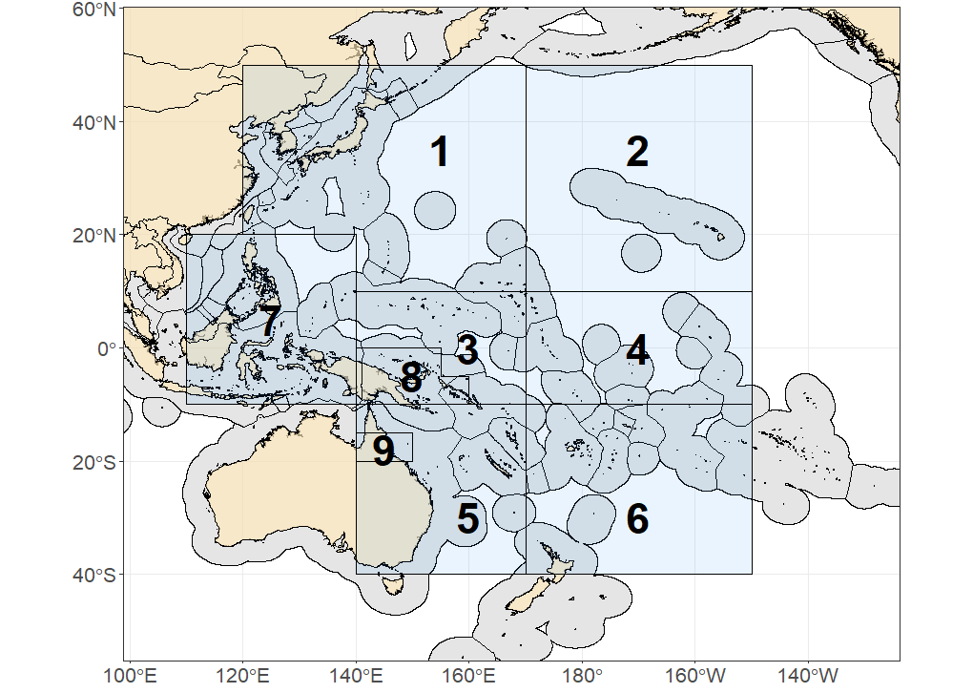
Figure BET-01. Spatial structure for the 2023 bigeye tuna stock assessment (Figure 1 from SC19-SA-WP-05).

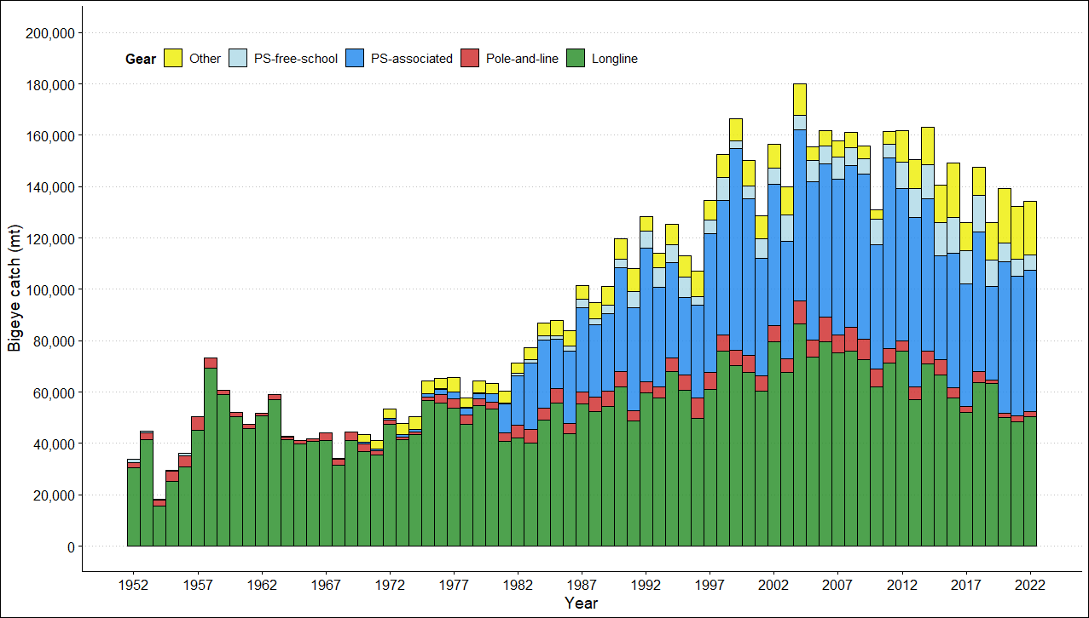
Figure BET-02. Time series of total annual catch (1000s mt) by fishing gear for the diagnostic model over the full assessment period. The different colors refer to longline (green), pole-and-line (red), purse seine (blue), purse seine associated (dark blue), purse seine unassociated (light blue), miscellaneous (yellow), and index (gray). Note that the catch by longline gear has been converted into catch-in-weight from catch-in-numbers and so may differ from the annual catch estimates presented in (Williams et al., 2023), however these catches enter the model as catch-in-numbers (Figure 3 from SC19-SA-WP-05).

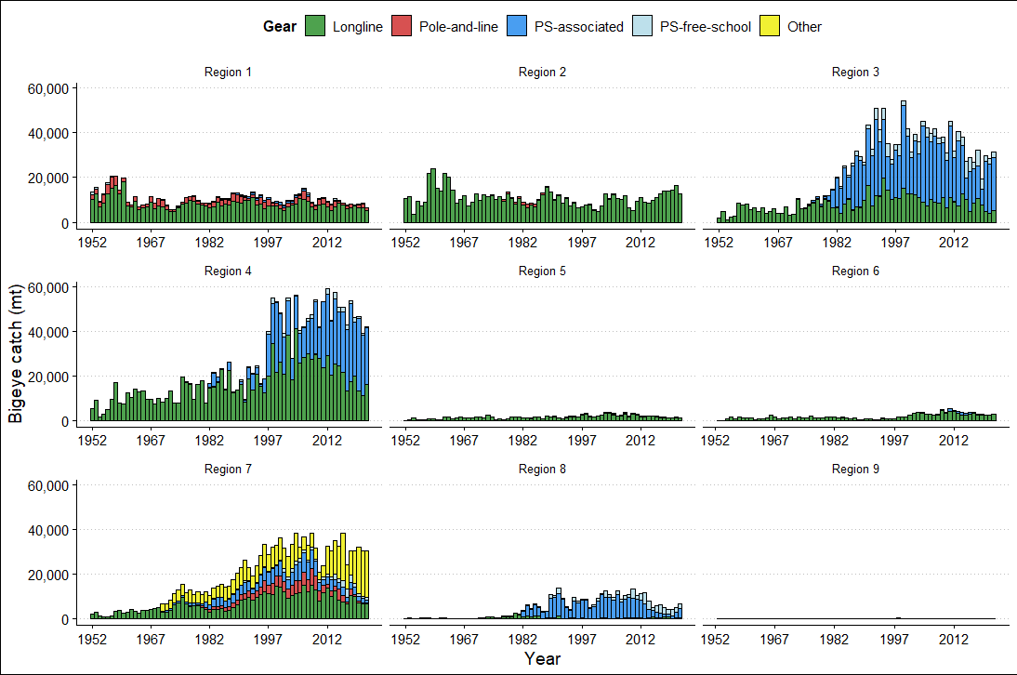
Figure BET-03. Annual catches of bigeye by gear type for each of the nine model regions (Figure 4 from SC19-SA-WP-05).

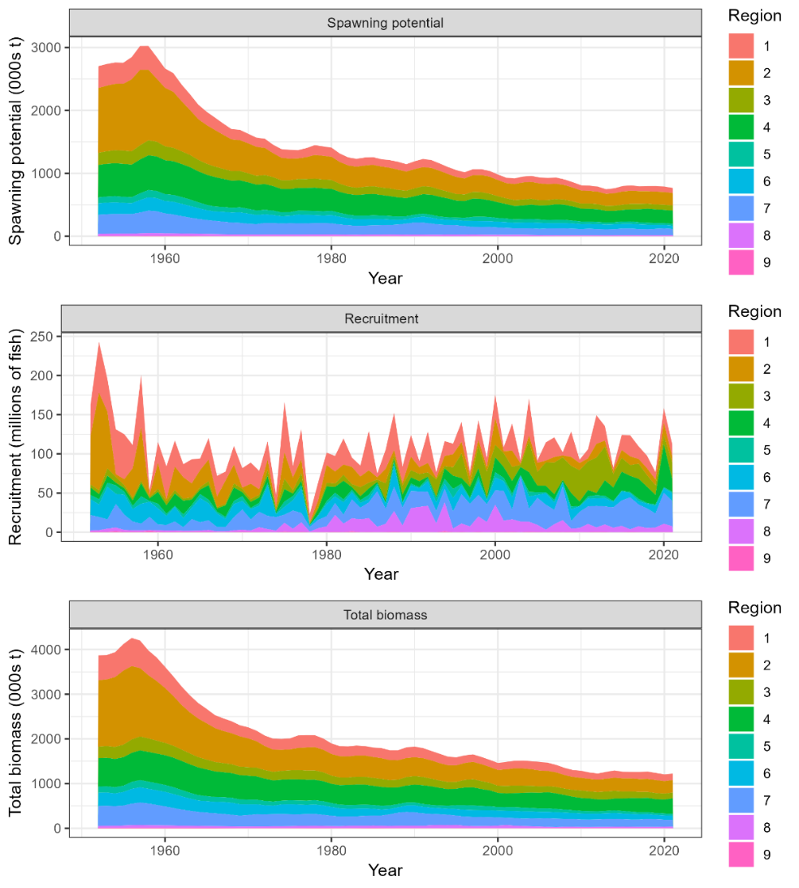
Figure BET-04. Time series of estimated annual spawning potential, recruitment and total biomass by model region for the diagnostic model, showing the relative proportions among regions. Note the data represent the averages of the quarterly model time steps for each year for spawning potential and total biomass and the sum of the quarterly recruitment estimates for annual recruitment (Figure 49 from SC19-SA-WP-05).
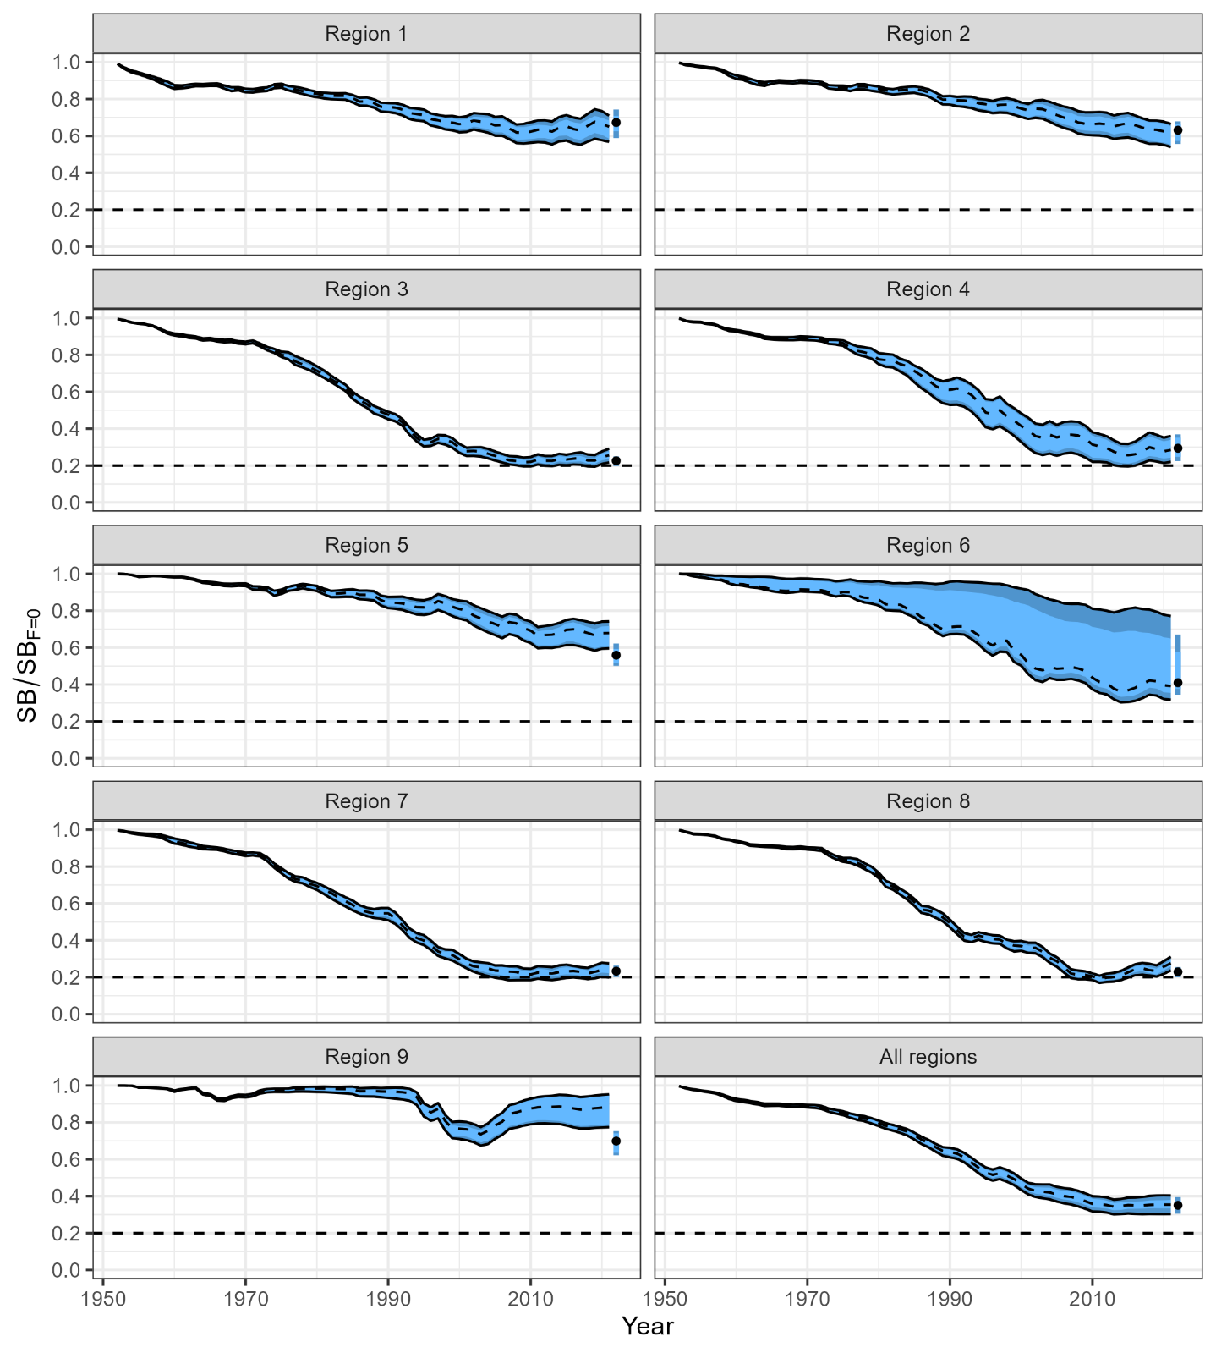
Figure BET-05. Estimated spawning depletion across all models in the structural uncertainty grid over the period 1952-2021. The lighter band shows the 25th and 75th percentiles, and the dark band shows the 10th and 90th percentiles of the model estimates. The bar at the right of each ribbon indicates the median (black dots) with the 10th and 90th percentiles for SB_{recent}/SB_{F=0} (Figure 63 from SC19-SA-WP-05).

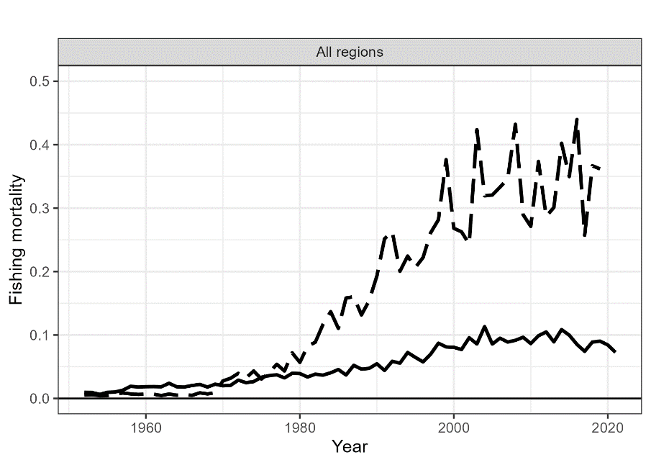
Figure BET-06. Estimated annual average adult (solid line) and juvenile (dashed line) fishing mortality for the 2023 diagnostic model (Figure 54 from SC19-SA-WP-05).

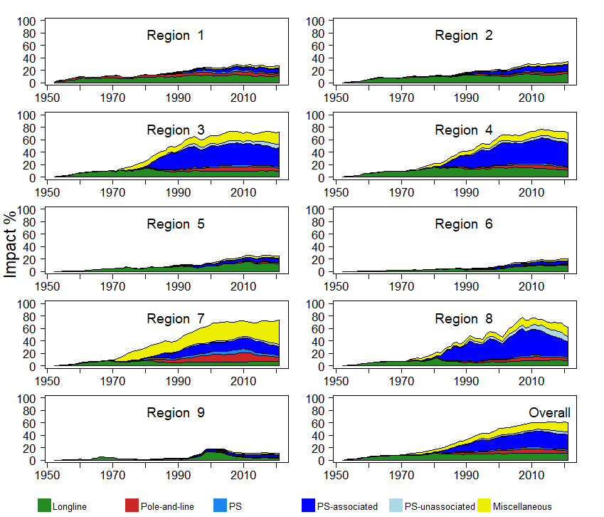
Figure BET-07. Estimates of reduction in spawning potential due to fishing (fishery impact = (1-SB_{t}/SB_{t,F=0}) * 100%) by region, and over all regions (lower right panel), attributed to various fishery groups for the 2023 diagnostic model (Figure 70 from SC19-SA-WP-05).
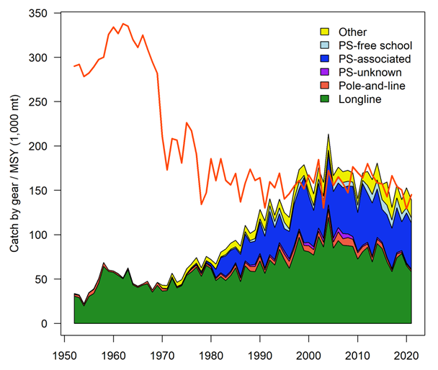

Figure BET-08. History of the annual estimates of MSY (red line) for the diagnostic model compared with annual catch by the main gear types. Note that this is a ‘dynamic’ MSY (Figure 72 from SC19-SA-WP-05).

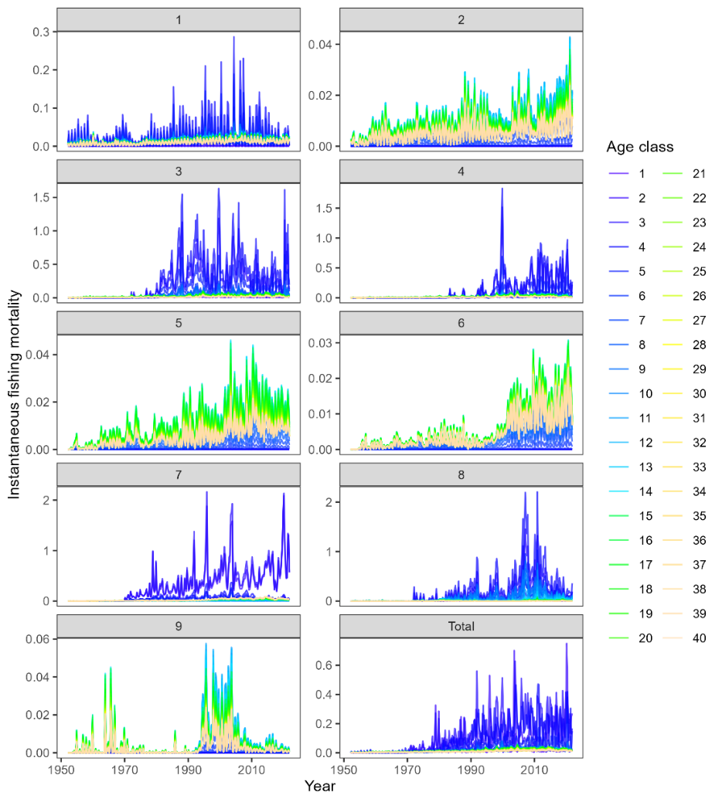
Figure BET-09 Estimated age specific fishing mortality for the diagnostic model, by region and overall (Figure 55 from SC19-SA-WP-05).
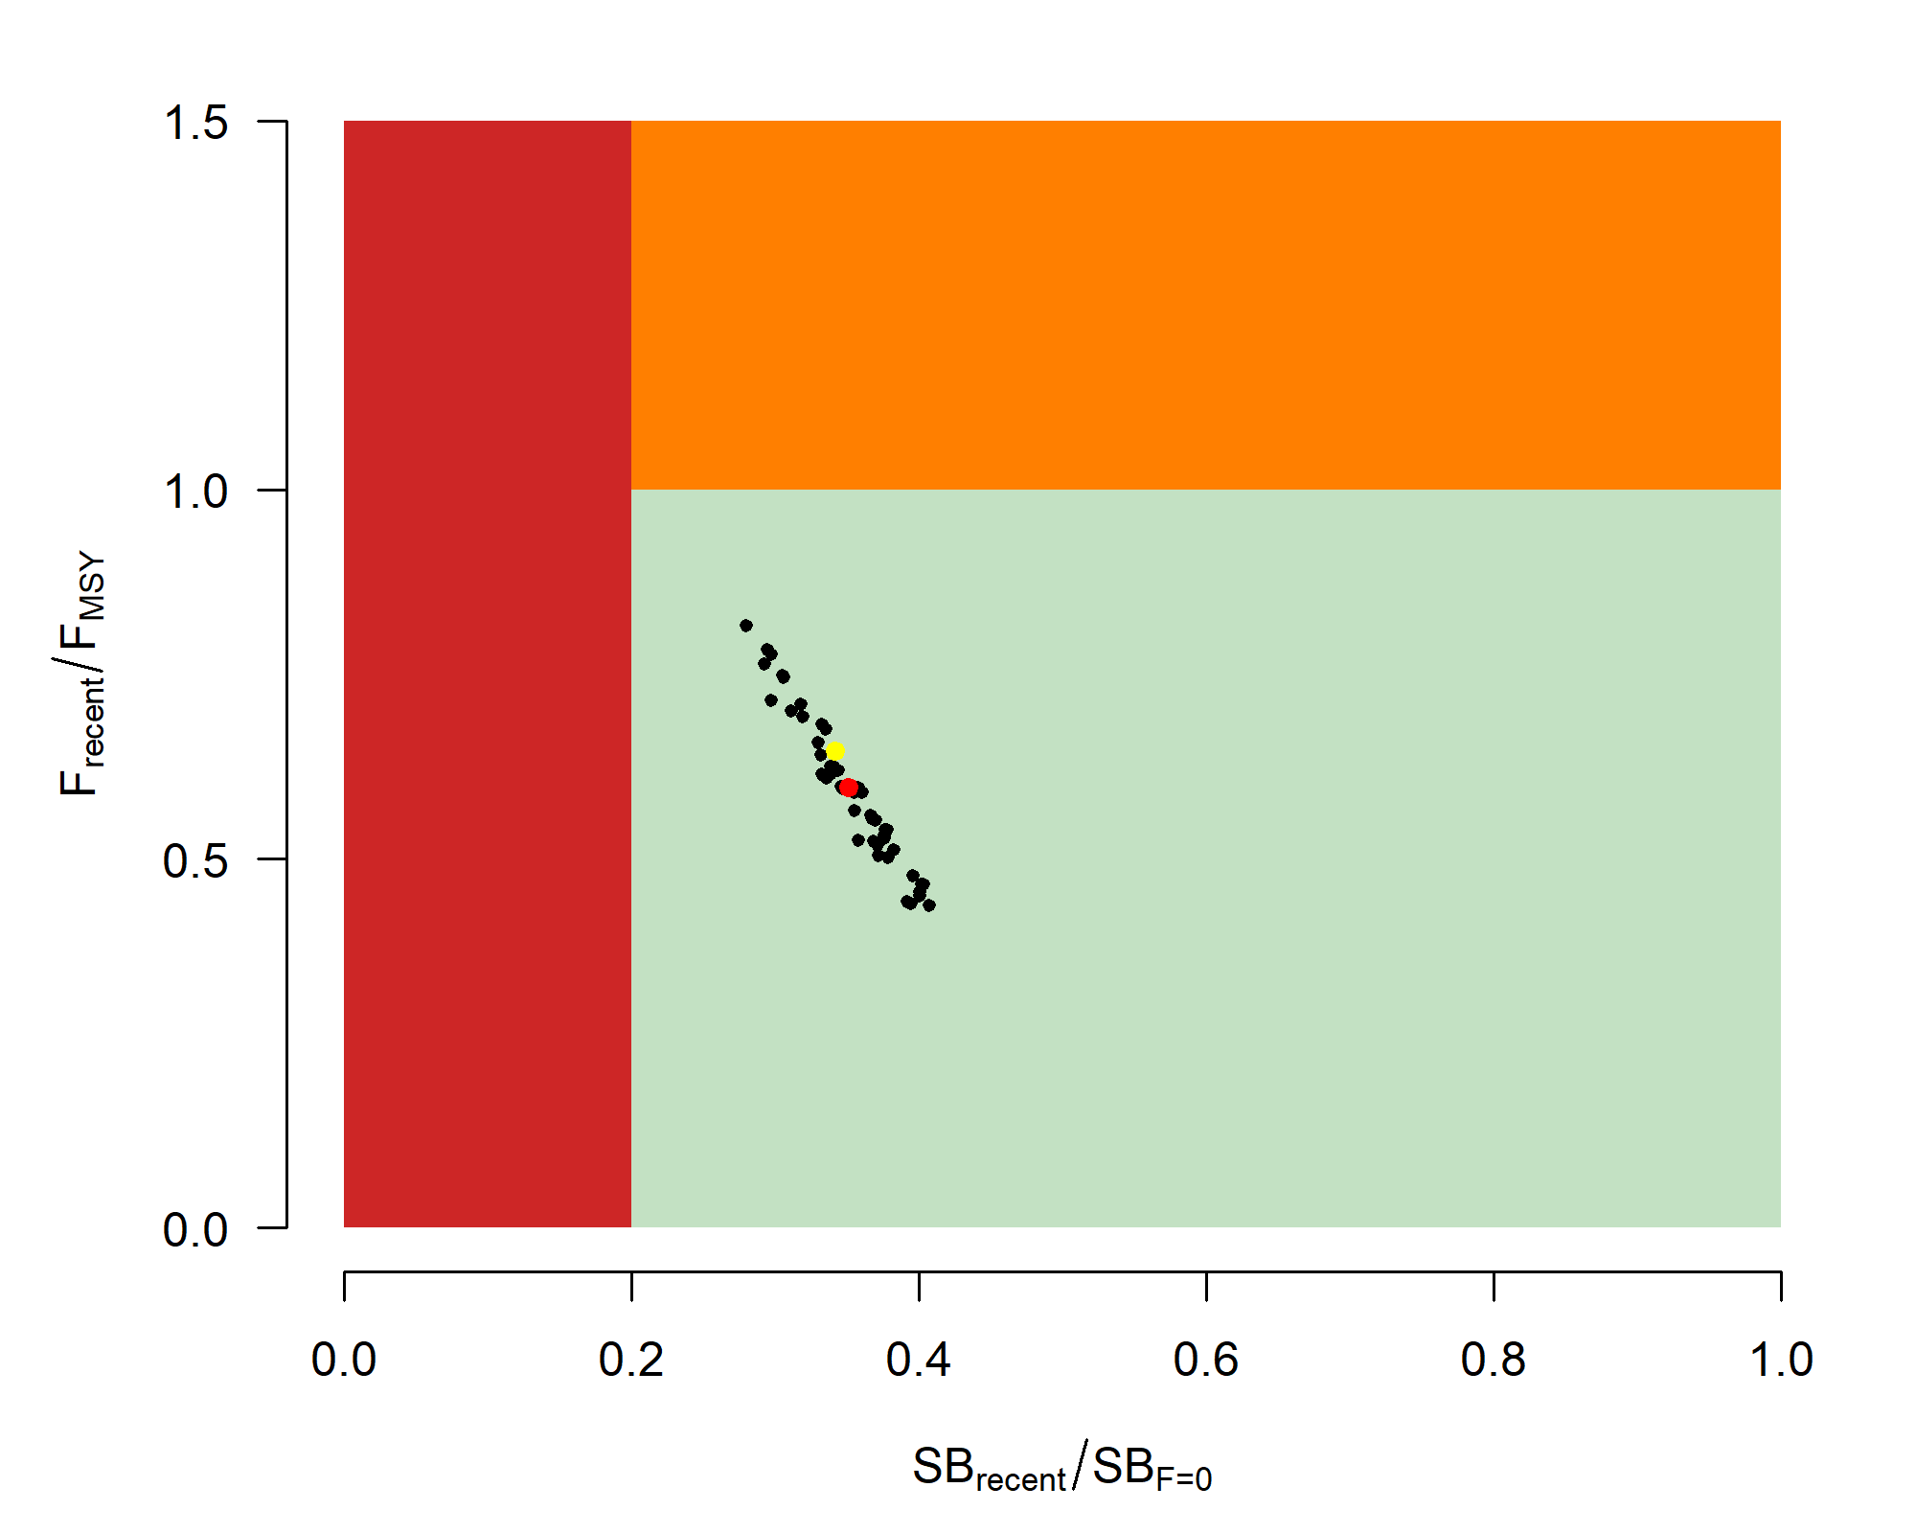 | 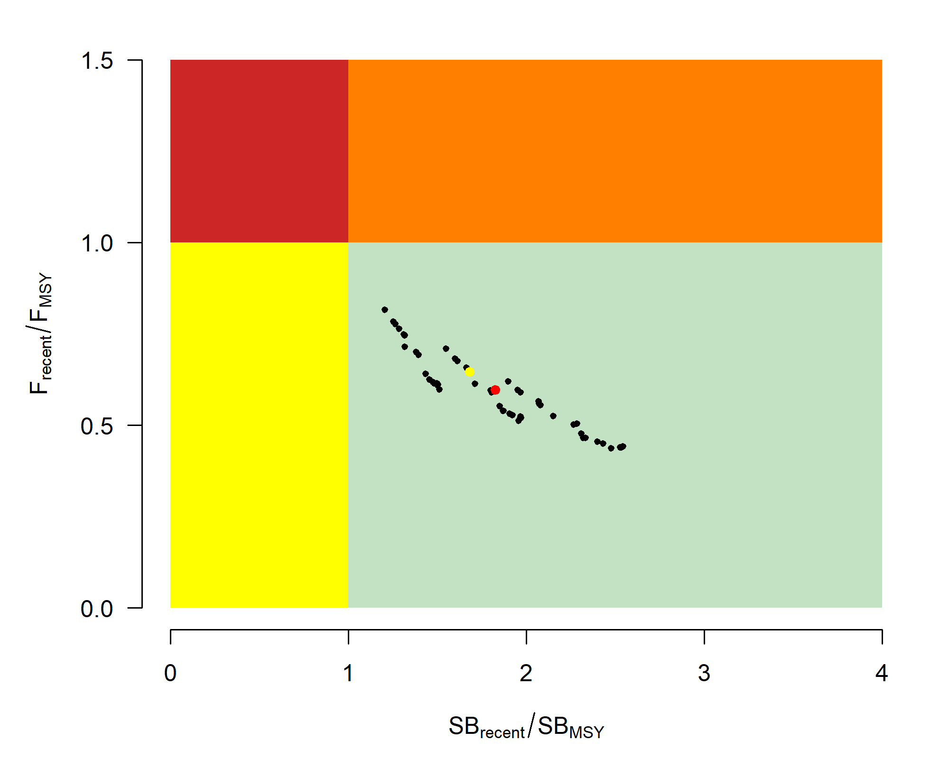
Figure BET-10. Majuro plot for the recent spawning potential (2018–2021) summarizing the results for each of the models in the structural uncertainty grid. The plots represent estimates of stock status in terms of spawning biomass depletion and fishing mortality. The yellow point is the 2023 diagnostic model and red point is the median (Figure 68 from SC19-SA-WP-05). | Figure BET-11. Kobe plot for the recent spawning potential (2018–2021) summarizing the results for each of the models in the structural uncertainty grid. The plots represent estimates of stock status in terms of spawning biomass depletion and fishing mortality. The yellow point is the 2023 diagnostic model and red point is the median (Figure 68 from SC19-SA-WP-05).

b. Management advice and implications

The objective for bigeye tuna in CMM 2021-01 (the Tropical Tuna Measure) – to maintain the spawning biomass depletion ratio at or above the average SB/SB_{F=0} for 2012-2015 – is being achieved. SB_{recent}/SB_{F=0} (35%) is very close to the average SB/SB_{F=0} for 2012-2015 (34%) calculated across the unweighted grid.

The WCPO bigeye tuna spawning biomass is above the biomass LRP, and F_{recent} is below F_{MSY} for all models in the uncertainty grid. The stock is very likely not experiencing overfishing (100% probability F_{recent}<F_{MSY}) and is not in an overfished condition (0% probability SB_{recent}/SB_{F=0}<LRP).

SC19 also noted that average fishing mortality rates for juvenile and adult age-classes have increased throughout the period of the assessment (Figure BET-08), although more so for juveniles which have experienced considerably higher annual fishing mortality than adults (Figure BET-06). The purse-seine associated fishery has the most impact, with that of the miscellaneous and longline fisheries also being notable (Figure BET-07). Higher fishing mortality rates on juvenile bigeye tuna reduces the realized yield per recruit for the bigeye fishery.

SC19 noted that levels of fishing mortality and depletion differ among regions, and that fishery impact was higher in the tropical regions (Regions 3, 4, 7 and 8 in the stock assessment model), with particularly high fishing mortality on juvenile bigeye tuna in these regions.

There is also evidence that the overall stock status is buffered with biomass and low exploitation in the temperate region (1, 2, 6 and 9) and most of the predicted movement is within the equatorial region. Exchange rates between temperate and tropical regions are estimated to be low.

SC19 noted that the reduction of fishing mortality on fisheries that take juveniles could increase bigeye fishery yields and reduce any further impacts on spawning biomass of this stock. SC19 also noted that this could require considering the impact on other fisheries and stocks.

The interim objective of bigeye tuna stock under CMM 2021-01 is to maintain the depletion level of the stock at or above the average SB/SB_{F=0} for 2012-2015. The recent depletion level of bigeye tuna is close to this interim objective. SC19 noted that while the projection results based on the 2023 bigeye tuna assessment were not available for SC19 to review, this information will be available for the 4th tropical tuna management workshop and will provide the Commission guidance on future expected levels of fishing mortality and the outcomes relative to the interim or future management objectives.

c. Research Recommendations

SC19 adopted several research recommendations for the further development and improvement of the WCPO bigeye tuna stock assessment, and suggested these be considered for potential inclusion in the Tuna Assessment Research Plan (TARP):
  - Continued collection of more representative biological data (e.g., age composition) and tagging data.
  - Develop additional CPUE index series testing key uncertainties about the analysis (e.g., regional vs. global model, classification of catchability vs. abundance covariates, etc.) and explore those as one-off sensitivities to the stock assessment.
  - Consideration of options to account for effort creep in CPUE standardization and/or the assessment model.
  - Simulation study to explore appropriate spatial structure of the stock assessment with a focus on simplifying the spatial structure (e.g., areas-as-fleets and/or 6 region structure) given the estimates of limited movement rates among regions.
  - Investigation of the 2023 model specifications with respect to the increase in unfished SSB overtime for the tropical regions (3, 4, 7 and 8).
  - Yield per recruit analyses comparing fishery sectors with different selectivity patterns.
  - Evaluation of the variability and plausibility of estimated growth and mortality-at-age relationship across the structural uncertainty grid.
  - Additional one-off sensitivities exploring key uncertainties in biological assumptions, model specification, and data inputs (e.g., tag mixing, data weighting, and growth).
  - Identification of key parameters that are either highly correlated or highly sensitive to the jittering procedure to inform possible changes in model specification with the aim to decrease model complexity and/or sensitivity to starting conditions.
  - Exploration of seasonal and regional growth traits for the stock assessment.
  - Comprehensive review of the representativeness of the size composition data given conflicts identified in the likelihood profiles.
  - Investigation of the 2023 model specifications that lead to the inversion of the effect of the weight vs. tagging data signal on the total biomass, as shown in the likelihood profile.
  - Further exploration of the advantages and disadvantages of strategies to decrease model sensitivity to starting conditions, including but not limited to multi-start approaches.
  - Pursue development of tag mixing diagnostics and approaches and investigate the impacts of tag mixing assumptions.

4.3.3 WCPO skipjack tuna (Katsuwonus pelamis)

4.3.3.1 Research and information

a. Indicator analysis

- S. Hare (SPC) presented SC19-SA-WP-06 (A compendium of fisheries indicators for target tuna stocks in the WCPFC Convention Area).

- SC19 thanked the SSP for conducting an indicator analysis providing empirical information on recent patterns in skipjack fisheries.

b. Update of skipjack tuna stock assessment information

- C. Castillo-Jordan presented SC19-SA-WP-07 (Follow up work on 2022 skipjack assessment recommendations).

SC19 thanked the SSP for their efforts on improving the skipjack diagnostic model and achieving a positive definite Hessian. The follow up work on the model provides a sound basis for future assessments.

SC19 noted the results of SPC’s work investigating technical issues highlighted by SC18 regarding the 2022 skipjack diagnostic model.

SC19 noted that the resulting updates to the diagnostic model for the WCPO skipjack assessment had negligible effect on the stock status and management advice from 2022.

SC19 emphasized that while the updates had not resulted in changes to stock status, some estimated quantities differed between the 2022 and 2023 version, most notably the growth curve, the mortality-at-age and the selectivity-at-age, noting these relationships are interrelated. SC19 encouraged further investigation to understand these changes.

SC19 noted that this process for allowing staff resources to conduct follow-up is a useful one that could be conducted for other WCPFC assessments, with continued dialogue between the SSP assessment team and SC in the intervening years between assessments to address concerns and lay the groundwork for the subsequent assessment. The SSP noted that this was possible this year because staff resources were available. This is not the case every year due to changes in experience and availability of staff resources. Follow-up work suggested by SC should be prioritised under the TARP process.

SC19 encouraged that this follow-up work process become standard practice for WCPO tuna stock assessments. Noting that follow-up work is subject to available staff resources and should be prioritised as part of the TARP process.

- SC19 noted the following issues for further improvements:
- Improve fits to the length composition data.
- Estimation of tag reporting rates.
- Alternative spatial structure.
- Unrealistic recruitment estimates particularly in temperate regions.
- Model jittering diagnostic to confirm convergence stability.

4.3.4 South Pacific albacore tuna (Thunnus alalunga)

Research and information

a. Indicator analysis

- S. Hare (SPC-OFP) presented SC19-SA-WP-06 (A compendium of fisheries indicators for target tuna stocks in the WCPFC Convention Area).

SC19 thanked the SSP for the indicator analysis providing empirical information on recent patterns of South Pacific albacore fisheries.

SC19 noted that the South Pacific albacore catch in the WCPFC-CA was 68,975t in 2022, a 39% increase from 2021 and a 4% increase from the 2017-2021 average.

Some CCMs recommended keeping the current catch levels in mind when discussing the South Pacific albacore TRP.

SC19 recommended that the 2024 assessment of South Pacific albacore be South Pacific-wide. Noting the need to provide management advice specifically for the WCPFC-CA and the ongoing developments relating to the Harvest Strategy process, if a fleets-as-areas approach is considered for the 2024 assessment, SC19 recommends retaining a separate area for the IATTC. SC19 noted that a WCFPC-CA only model might also be considered as a one-off sensitivity analysis. If results from the one-off sensitivity analysis for the WCPFC-CA-only model are different from the WCPFC-CA results from the Pacific-wide model, additional analyses should be conducted with a view to understanding which spatial structure is more reliable when considering future assessment development.

Northern stocks

4.4.1 North Pacific albacore (Thunnus alalunga)

4.4.1.1 Research and Information

a. North Pacific albacore stock assessment

- S. Teo (ISC) presented SC19-SA-WP-08 (Stock assessment of albacore tuna in the North Pacific Ocean).

4.4.1.2 Provision of scientific information

a. Stock status and trends

- SC19 noted the following stock status from ISC:
  - The stock is likely not overfished relative to the threshold (30%SSB_{current, F=0}) and limit (14%SSB_{current, F=0}) reference points adopted by the WCPFC and IATTC, and
  - The stock is likely not experiencing overfishing relative to the adopted target reference point (F45_{%SPR}).
  - Current fishing intensity (F2018-2020) is lower than the fishing intensity from the 2002-2004 period (the reference level for IATTC Resolution C-05-02 and WCPFC CMM-2019-03).

b. Management advice and implications

- SC19 noted the following conservation information from ISC:
  - If fishing intensity over the next ten years is maintained at the current fishing intensity (F₂₀₁₈₋₂₀₂₀), then female SSB is expected to remain around 54%SSB_{current, F=0} (90,098 t), with a 97.7% probability of the female SSB remaining above the 14% SSB_{current, F=0} LRP for all ten years, and the management objectives of IATTC and WCPFC will likely be met.
  - If fishing intensity over the next ten years is similar to the 2005-2019 period, then female SSB is expected to decrease to 52%SSBc_{urrent, F=0} (87,669 t), with a 98.1% probability of the female SSB remaining above the 14% SSB_{current, F=0} LRP for all ten years, and the management objectives of IATTC and WCPFC will likely be met.

Table NPALB-1. Estimates of maximum sustainable yield (MSY), female spawning stock biomass (SSB), fishing intensity (F), and reference point ratios for north Pacific albacore tuna for: 1) the base case model; 2) two important sensitivity models due to uncertainty in growth parameters; and 3) a model representing an update of the 2020 base case model to 2023 data. SSB0, SSB_{current}, _{F=0} and SSB_{MSY} are the expected female SSB of a population in the equilibrium, unfished state; in the current, dynamic, unfished state; and at MSY, respectively. The Fs in this table are indicators of fishing intensity based on spawning potential ratio (SPR) and calculated as %SPR. SPR is the ratio of the equilibrium SSB per recruit that would result from the estimated F-at-age relative to that of an unfished population. Depletion is calculated as the proportion of the age-1+ biomass during the specified period relative to an unfished age-1+ equilibrium biomass. The model representing an update of the 2020 base case model is similar to but not identical to the 2020 base case model due to changes in data preparation and model structure.
* Model may not have converged, and uncertainty estimates were unreliable because of the lack of a positive, definite Hessian matrix.
† A value of >1 for the depletion ratio indicates higher age-1+ biomass in 2021 relative to the 2006 –2015 period.
§ Higher %SPR values indicate lower fishing intensity levels.
¶ Values of >1 for ratios of F_{%SPR} to F_{%SPR}-based reference points indicate fishing intensity levels lower than the reference points.
Quantity | Base Case | Growth  CV = 0.06 for L_{inf} | Growth  All parameters estimated | Update of 2020 base case model to 2023 data*
MSY (t) | 121,880 | 93,167 | 144,792 | 97,777
SSB_{MSY} (t) | 23,154 | 18,133 | 30,435 | 18,756
SSB₀ (t) | 165,567 | 128,155 | 198,913 | 132,570
SSB_{current, F=0} (2021 estimate) | 129,581 | 97,368 | 155,542 | 93,808
SSB₂₀₂₁/SSB_{current, F=0} | 0.54 | 0.36 | 0.65 | 0.39
SSB₂₀₂₁/30%SSB_{current, F=0} | 1.81 | 1.21 | 2.17 | 1.31
SSB₂₀₂₁/14%SSB_{current, F=0} | 3.87 | 2.6 | 4.65 | 2.81
†Depletion₂₀₂₁/Depletion₂₀₀₆₋₂₀₁₅ | 1.34 | 1.33 | 1.37 | 1.3
§ F_{%SPR, 2018-2020} (%SPR) | 59.0 | 41.4 | 70.4 | 43.2
§ F_{%SPR, 2011-2020} (%SPR) | 55.0 | 36.6 | 63.8 | 37.9
¶ F_{%SPR, 2018-2020}/F_{%SPR, MSY} | 2.04 | 1.42 | 2.78 | 1.47
¶ F_{%SPR, 2011-2020}/F45_{%SPR} | 1.22 | 0.81 | 1.42 | 0.84
¶ F_{%SPR, 2018-2020}/F45_{%SPR} | 1.31 | 0.92 | 1.56 | 0.96
¶ F_{%SPR, 2018-2020}/F_{%SPR, 2002-2004} | 1.48 | 1.63 | 1.40 | 1.25

Figure NPALB-1. Maximum likelihood estimates of (A) age-1+ biomass (B), female spawning biomass (SSB), and (C) age-0 recruitment of north Pacific albacore tuna (Thunnus alalunga). Dashed lines (A and B) and vertical bars (C) indicate 95% confidence intervals. Closed black circle and error bars in (B) and (C) are the maximum likelihood estimate and 95% confidence intervals of unfished female spawning biomass, SSB0, and unfished recruitment, respectively, at equilibrium (Figure ES3 from SC19-SA-WP-08).

Figure NPALB-2. Estimated sex-specific instantaneous fishing mortality-at-age (F-at-age) for the 2023 base case model, averaged across 2018-2020 (Figure ES4 from SC19-SA-WP-08).

Figure NPALB-3. Historical catch-at-age of north Pacific albacore (Thunnus alalunga) estimated by the 2023 base case model (Figure ES5 from SC19-SA-WP-08).

Figure NPALB-4. Fishery impact analysis on north Pacific albacore (Thunnus alalunga) showing female spawning biomass (SSB) (red) estimated by the 2023 base case model as a percentage of dynamic, unfished female SSB (SSB_{current, F=0}). Colored areas show the relative proportion of fishing impact attributed to longline (green) and surface (blue) fisheries (primarily troll and pole-and-line gear but including all other gears except longline) (Figure ES6 from SC19-SA-WP-08).

Figure NPALB-5. Stock status phase plot showing the status of the north Pacific albacore (Thunnus alalunga) stock relative to the biomass-based threshold (30%SSB_{current, F=0}) and limit (14%SSB_{current, F=0}) reference points, and fishing intensity-based target reference point (F45_{%SPR}) over the modeling period (1994 – 2021). Blue triangle indicates the start year (1994) and black circle with 95% confidence intervals indicates the terminal year (2021). (B) Stock status plot showing current stock status and 95% confidence intervals of the base case model (black circle), an important sensitivity run of CV = 0.06 for Linf in the growth model (gray square), an important sensitivity run with an estimated growth model (purple triangle), and a model representing an update of the 2020 base case model to 2023 data (red diamond). 95% confidence intervals are not shown for the update of the 2020 base case model (red diamond) because the model did not have a positive definite Hessian matrix and uncertainty estimates were unreliable. Red zones in both panels indicate female SSBs falling below the limit reference point while the orange zones indicate female SSBs between the threshold and limit reference points. Green zones indicate female SSBs above the threshold reference point and fishing intensity levels below the target reference point. Yellow areas indicate female SSBs above the threshold reference point and fishing intensity levels above the target reference point. The Fs in this figure are indicators of fishing intensity based on spawning potential ratio (SPR) and calculated as %SPR. SPR is the ratio of the equilibrium SSB per recruit that would result from the estimated F-at-age relative to that of an unfished population. A higher %SPR indicates lower fishing intensity. Current fishing intensity values and SSB/SSB_{current,F=0} ratios in (B) were calculated as the average during 2018- 2020 (F_{%SPR}, 2018-2020) and 2021 (SSB2021/SSB_{current, F=0}), respectively. The model representing an update of the 2020 base case model is similar to but not identical to the 2020 base case model due to changes in data preparation and model structure (Figure ES7 from SC19-SA-WP-08).

Figure NPALB-6. (A) Estimated dynamic biomass ratio (SSB/SSB_{current, F=0}) of north Pacific albacore relative to biomass-based threshold (30%SSB_{current, F=0}) (orange dotted line) and limit (14%SSB_{current, F=0}) reference points (red dashed line) over the modeling period (1994 – 2021); and (B) estimated fishing intensity relative to the fishing intensity-based target reference point (F45_{%SPR}) over the modeling period (1994 – 2021). Light and dark gray areas indicate 95% and 60% confidence intervals respectively. The limit reference point is considered to be breached if the lower bound of the 60% confidence intervals overlaps the limit reference point (Figure ES8 from SC19-SA-WP-08).

Figure NPALB-7. Future projection results under a constant fishing intensity (F₂₀₁₈₋₂₀₂₀) harvest scenario. Solid lines indicate mean values, uncertainty ranges indicate 60% and 95% confidence intervals, and the dashed line is the reference point, respectively. (A) Annual changes in spawning biomass; (B) Interannual changes in fishing mortality (F_{%SPR}); (C) Projected ratios to the limit reference point thresholds; and (D) Projected ratios to management targets for the total biomass (Figure ES9 from SC19-SA-WP-08).

Figure NPALB-8. Future projection results under a randomly F (2005-2019) scenario. Solid lines indicate mean values, and uncertainty ranges indicate 60% and 95% confidence intervals, and the dashed line is the reference point, respectively. (A) Annual changes in spawning biomass; (B) Interannual changes in fishing mortality (F_{%SPR}); (C) Projected ratios to the limit reference point thresholds; and (D) Projected ratios to management targets for the total biomass (Figure ES10 from SC19-SA-WP-08).

4.4.2 Pacific bluefin tuna (Thunnus orientalis)

4.4.2.1 Research and Information

a. Update of Pacific bluefin tuna stock assessment information

- S. Nakatsuka (ISC) said the working group did not conduct an assessment this year but is planning a benchmark assessment next year.

SC19 noted that no stock assessments were conducted for Pacific bluefin tuna in 2023 and no updated information was presented on the status of Pacific bluefin tuna. Therefore, the stock status descriptions from SC18 are still current for Pacific bluefin tuna.

Concern was expressed that no scientific evaluation was provided to SC19 related to the increase in converting part of the small fish catch limit to the large fish catch limit in CMM 2021-02 as recommended by NC19. However, it was clarified that assessment results provided to SC18 showed that the projection under which part of the small fish catch limit was converted to the large fish catch limit using the current conversion factor provides benefit to stock recovery.

It was noted that there are some WCPFC members, including New Zealand, who have a strong interest in PBF but are not involved in the ISC. And they encouraged the ISC to ensure that there are sufficient opportunities for all parties with an interest to be involved in the stock assessment and MP processes.

4.4.3 North Pacific swordfish (Xiphias gladius)

4.4.3.1 Research and Information

a. North Pacific swordfish stock assessment

M. Sculley (ISC) presented SC19-SA-WP-09 (Stock assessment of swordfish in the North Pacific Ocean through 2021).

4.4.3.2 Provision of scientific information

Stock Identification and Distribution

The North Pacific swordfish (Xiphias gladius, NP SWO) stock area was defined to be the waters of the North Pacific Ocean contained in the Western and Central Pacific Fisheries Commission (WCPFC) Convention Area bounded by the equator and the waters of the Inter-American Tropical Tuna Commission (IATTC) Convention Area north of 10°N (Figure NPSWO-1). All available fishery data from the stock area were used for the stock assessment. For the purpose of modelling observations of catch-per-unit effort (CPUE) and size composition data, it was assumed that there was an instantaneous mixing of fish throughout the stock area on a quarterly basis. The stock was modelled using a fleets-as-areas approach with separate catch and index fleets for the Western and Central North Pacific Ocean (WCNPO) and Eastern Pacific Ocean (EPO) region delineated in (Figure NPSWO-1).

Catches

The NP SWO catches were high from the 1970’s to the 1980’s averaging about 14,000 mt per year during 1975-1990, peaked with unusually high catches in 1998-2000, and then generally declined to the current levels around 11,000mt. Catches by most fleets have generally declined, while minor catches by other WCPFC CCMs have generally increased, except in in the last three years (Figure NPSWO-2). Overall, longline fishing gear has accounted for the vast majority of NP SWO catch.

Data and Assessment

Catch and size composition data were collected from International Scientific Committee for tuna and tuna-like species in the North Pacific Ocean (ISC) countries (Chinese Taipei, Japan, and USA) and the WCPFC and IATTC. Standardized CPUE data used to measure trends in relative abundance were provided by Chinese Taipei, Japan, and USA. The NP SWO stock was assessed using an age- and length-structured assessment Stock Synthesis (SS3) model fit to time series of standardized CPUE and size composition data. Life history parameters for growth and maturity were updated for this benchmark stock assessment. The value for stock-recruitment steepness used for the base case model was h = 0.9. The assessment model was fit to relative abundance indices and size composition data in a likelihood-based statistical framework. Maximum likelihood estimates of model parameters, derived outputs, and their variances were used to characterize stock status and to develop stock projections. Several sensitivity analyses were conducted to evaluate the effects of changes in model parameters, including natural mortality rate at age, stock-recruitment steepness, growth curve parameters, and female length at 50% maturity, as well as uncertainty in the input data and model structure.

Biological Reference Points

MSY-based biological reference points were computed for the base case model with SS3 (Table NPSWO-2). The point estimate of annual catch at F_{MSY} was calculated to be 14924 mt. The point estimate of the spawning biomass to produce MSY (adult female biomass) was 16,388 mt. The point estimate of F_{MSY}, the fishing mortality rate to produce SSB_{MSY} (average fishing mortality on ages 1 – 10) was 0.18 and the corresponding equilibrium value of spawning potential ratio at SSB_{MSY} was 19%.

Projections

Stock projections for NP SWO were conducted using SS3. No recruitment deviations nor log-bias adjustment were applied to the future projections. Projections are reported as the mean and standard deviation around 100 bootstrapped model runs for each scenario. Projections started in 2022 and continued through 2031 under 5 levels of fishing mortality. The five fishing mortality stock projection scenarios were: (1) F at 20%SSB_{(F=0)} which was calculated from the mean dynamic SSB in the five years, (2) F₍₂₀₀₈₋₂₀₁₀₎ which is the reference years for the proposed CMM for NP SWO, (3) F_{Low} at F_{30%SPR}, (4) F_{MSY}, and (5) F status quo (average F during 2019-2021). Results show the projected female spawning stock biomass and the catch biomass under each of the scenarios (Table NPSWO-3 and Figure NPSWO-5-6).

a. Stock status and trends

- SC19 noted the following stock status from ISC:
  - Female spawning stock biomass was estimated to be 35,778mt in 2021, with a relative SSB ratio of SSB/SSB_{MSY} = 2.18 in 2021;
  - Estimated F (arithmetic average of F for ages 1 – 10) averaged roughly F=0.09 yr⁻¹ during 2019-2021 with a relative fishing mortality of F/F_{MSY} = 0.49 in 2021; and
  - Relative to MSY-based reference points, overfishing is very likely not occurring (>99% probability) and the NP SWO stock is very likely not overfished (>99% probability, Figure NPSWO-4).

b. Management advice and implications

- SC19 noted the following conservation information from ISC:
  - The NP swordfish stock has produced annual yields of around 11,500 mt per year since 2016, or about 2/3 of the MSY catch amount.
  - NP swordfish stock status is positive with no evidence of excess F above FMSY or substantial depletion of spawning potential.
  - It was also noted that retrospective analyses show that the assessment model appears to underestimate spawning potential in recent years.

Table NPSWO-1. Reported catch (mt) used in the stock assessment along with annual estimates of population biomass (age-1 and older, mt), female spawning biomass (mt), relative female spawning biomass (SSB/SSB_{MSY}), recruitment (thousands of age-0 fish), fishing mortality (average F, ages 1–10), relative fishing mortality (F/F_{MSY}), and spawning potential ratio of North Pacific swordfish (Xiphias gladius).
Year | 2016 | 2017 | 2018 | 2019 | 2020 | 2021 | Mean¹ | Min¹ | Max¹
Reported Catch | 12,648 | 11,831 | 12,730 | 11,093 | 10,731 | 10,136 | 12,876 | 9,539 | 19,230
Population Biomass | 83,200 | 86,835 | 89,418 | 89,617 | 89,992 | 88,755 | 80,762 | 65,722 | 89,992
Spawning Biomass | 28,205 | 29,785 | 31,661 | 33,761 | 35,159 | 35,778 | 28,777 | 22,415 | 35,778
Relative Spawning Biomass | 1.72 | 1.82 | 1.93 | 2.06 | 2.15 | 2.18 | 1.76 | 1.37 | 2.18
Recruitment (age 0) | 964,401 | 746,962 | 783,354 | 739,400 | 624,962 | 633,046 | 838,473 | 595,771 | 1,430,430
Fishing Mortality | 0.1 | 0.09 | 0.1 | 0.09 | 0.09 | 0.09 | 0.12 | 0.09 | 0.19
Relative Fishing Mortality | 0.55 | 0.52 | 0.57 | 0.49 | 0.5 | 0.49 | 0.68 | 0.49 | 1.09
Spawning Potential Ratio | 0.34 | 0.37 | 0.37 | 0.42 | 0.43 | 0.44 | 0.33 | 0.24 | 0.44
¹ During 1975-2021

Table NPSWO-2. Estimated biological reference points derived from the Stock Synthesis base case model for North Pacific swordfish where F is the instantaneous annual fishing mortality rate, SPR is the annual spawning potential ratio, SSB is spawning stock biomass, and SSB_{(F=0)} indicates the average 5-year SSB₀ estimate, 20%SSB_{(F=0)} is the associated reference point, and MSY is the maximum sustainable yield reference point.
Reference Point | Estimate
F_{20%SSB(F=0)} (age 1-10) | 0.16
F_{MSY} (age 1-10) | 0.18
F₂₀₂₁ | 0.09
F₂₀₁₉₋₂₀₂₁ | 0.09
SSB_{F=0} | 95,732
20%SSB_{F=0} | 19,146
SSB_{MSY} | 16,388
SSB₂₀₂₁ | 35,778
SSB₂₀₁₉₋₂₀₂₁ | 34,899
C_{20%SSB(F=0)} | 14,815
C_{MSY} | 14,924
C₂₀₁₉₋₂₀₂₁ | 10,653
SPR_{20%SSB(F=0)} | 22%
SPR_{MSY} | 19%
SPR₂₀₂₁ | 44%
SPR₂₀₁₉₋₂₀₂₁ | 43%

Table NPSWO-3. Projected median values of Western and Central North Pacific swordfish spawning stock biomass (SSB, t) and catch (t) under five constant fishing mortality rate (F) and two recruitment scenarios during 2021-2040.
Year | 2022 | 2023 | 2024 | 2025 | 2026 | 2027 | 2028 | 2029 | 2030 | 2031
Scenario 1: F_{20%SSB(F=0)}
SSB | 40,457 | 38,288 | 36,295 | 35,452 | 35,425 | 35,611 | 36,064 | 36,387 | 36,264 | 36,478
Catch | 16,906 | 14,986 | 13,531 | 13,120 | 13,298 | 13,612 | 13,875 | 14,053 | 14,161 | 14,220
Scenario 2: F₁₉₉₈₋₂₀₀₀
SSB | 41,567 | 40,422 | 38,952 | 38,309 | 38,371 | 38,565 | 39,133 | 39,534 | 39,336 | 39,625
Catch | 14,302 | 13,389 | 12,608 | 12,428 | 12,656 | 12,967 | 13,224 | 13,399 | 13,509 | 13,572
Scenario 3: Low F (F_{SPR30%})
SSB | 42,268 | 42,368 | 41,811 | 41,756 | 42,235 | 42,712 | 43,610 | 44,300 | 44,162 | 44,705
Catch | 11,370 | 11,249 | 11,096 | 11,255 | 11,623 | 11,990 | 12,263 | 12,445 | 12,557 | 12,631
Scenario 4: F_{MSY}
SSB | 38,291 | 34,051 | 31,164 | 29,979 | 29,800 | 29,894 | 30,225 | 30,452 | 30,322 | 30,473
Catch | 23,395 | 17,817 | 14,992 | 14,169 | 14,264 | 14,565 | 14,812 | 14,966 | 15,052 | 15,095
Scenario 5: F_{Status Quo} (Average F₂₀₁₉₋₂₀₂₁)
SSB | 38,828 | 35,056 | 32,339 | 31,201 | 31,036 | 31,138 | 31,489 | 31,733 | 31,602 | 31,765
Catch | 21,803 | 17,218 | 14,723 | 13,981 | 14,082 | 14,379 | 14,627 | 14,785 | 14,875 | 14,921
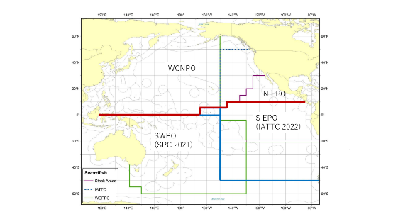
Figure NPSWO-1. Western and Central North Pacific Ocean and Northeastern Pacific Ocean swordfish stock boundaries for the 2023 North Pacific swordfish assessment. Spatial structure is treated implicitly using fleets as areas (Figure S1 from SC19-SA-WP-09).

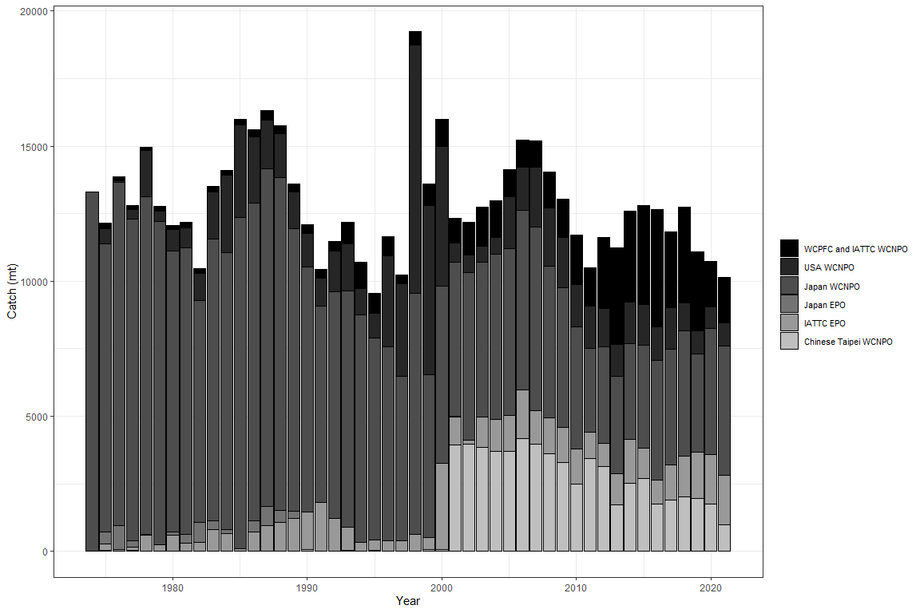

Figure NPSWO-2. Annual catch of NP swordfish by country or commission and area (Figure S2 from SC19-SA-WP-09).

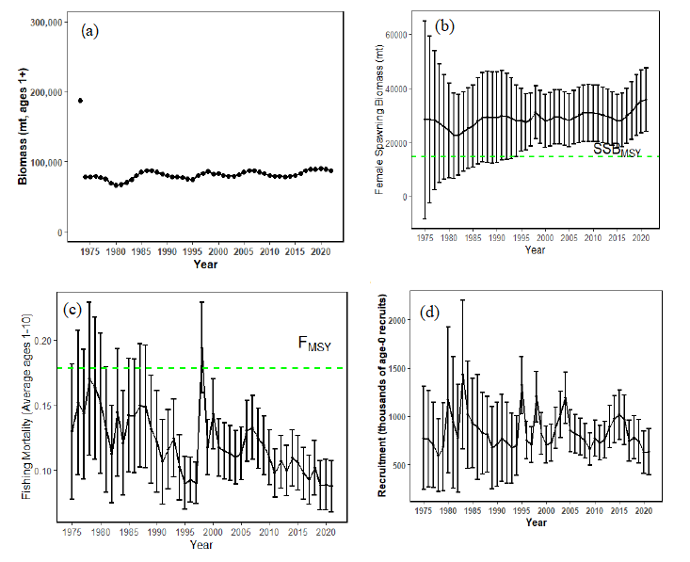
Figure NPSWO-3. Time series of estimates of (a) population biomass (age 1+), (b) spawning biomass, (c) instantaneous fishing mortality (average for age 1-10, year⁻¹), and (d) recruitment (age-0 fish) for North Pacific swordfish (Xiphias gladius) derived from the 2023 stock assessment. The circles represent the maximum likelihood estimates by year for each quantity and the error bars represent the uncertainty of the estimates (95% confidence intervals), green dashed lines indicate the dynamic SSB_{MSY} and F_{MSY} reference points (Figure S3 from SC19-SA-WP-09).
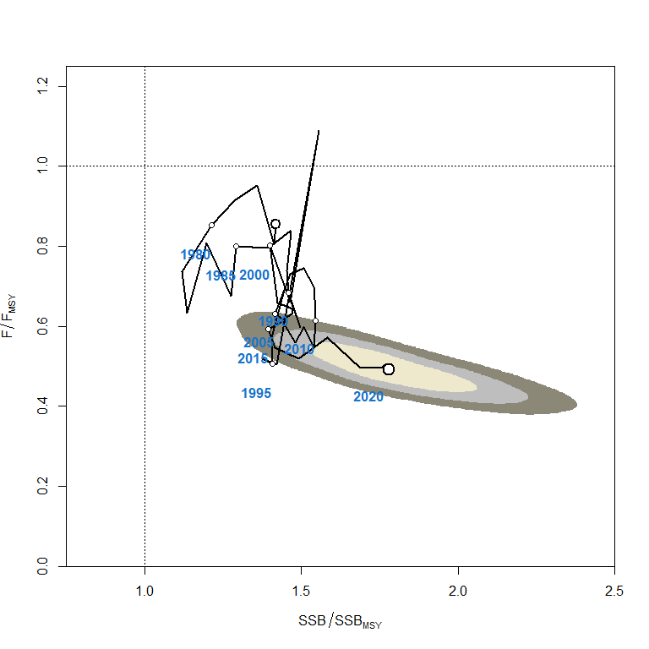
Figure NPSWO-4. Kobe plot of the time series of estimates of relative fishing mortality (average of age 1-10) and relative spawning stock biomass of North Pacific swordfish (Xiphias gladius) during 1977-2020. The first white dot indicates 1975, subsequent dots are in 5-year increments. Shading indicates 50%, 80%, and 95% confidence intervals, respectively (Figure S4 from SC19-SA-WP-09).

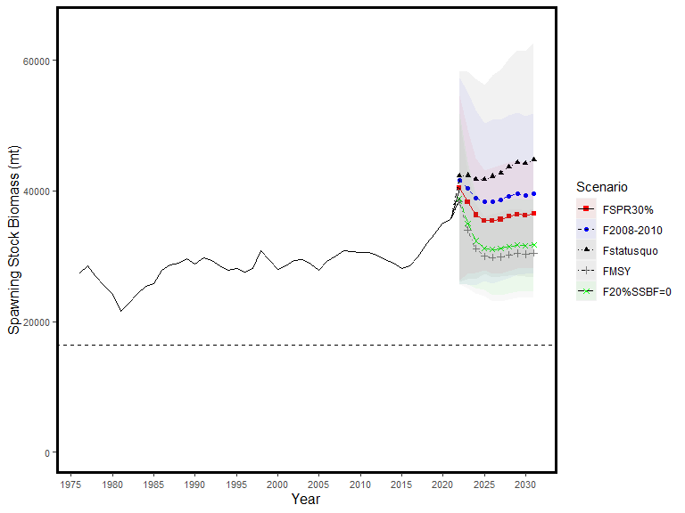
Figure NPSWO-5. Historical and projected trajectories of spawning biomass from the North Pacific swordfish base case model based upon F scenarios. Dashed line indicates the spawning stock biomass at SSB_{MSY}. The list of projection scenarios can be found in SC19-SA-WP-09 Table S3 (Figure S5 from SC19-SA-WP-09).

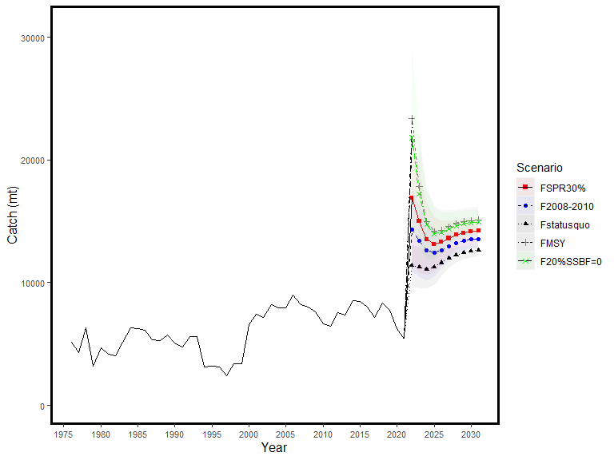
Figure NPSWO-6. Historical and projected trajectories of catch from the North Pacific swordfish base case model based upon F scenarios. The list of projection scenarios can be found in SC19-SA-WP-09 Table S3 (Figure S6 from SC19-SA-WP-09).

4.5 WCPO sharks

4.5.1 Silky shark (Carcharhinus falciformis)

4.5.1.1 Research and information

a. Silky shark stock assessment in the WCPO (Project 108)

- P. Neubauer (Dragonfly Data Science) presented SC19-SA-WP-10 (Analysing potential inputs to the 2024 stock assessment of Western and Central Pacific silky shark Carcharhinus falciformis).

- SC19 recommended that an integrated assessment for silky shark be attempted and that alternative assessment methods such as data-limited methods or a risk analysis be developed concurrently.

WCPO billfishes

North Pacific striped marlin (Kajikia audax)

4.6.1.1 Research and Information

a. North Pacific striped marlin stock assessment

- H. Ijima presented SC19-SA-WP-11 (Stock assessment report for North Pacific striped marlin (Kajikia audax) through 2020).

SC19 recommended having more consistency in the stock assessment metrics used between assessments across the WCPO stocks, as recommended in SC19-SA-WP-12.

4.6.1.2 Provision of scientific information

Stock Identification and Distribution

The WCNPO MLS (Kajikia audax) stock area was defined to be the waters of the North Pacific Ocean contained in the Western and Central Pacific Fisheries Commission Convention Area bounded by the equator and 150°W. All available fishery data from the stock area were used for the stock assessment. For the purpose of modeling observations of CPUE and size composition data, it was assumed that there was an instantaneous mixing of fish throughout the stock area on a quarterly basis.

Catches

The WCNPO MLS catches were high from the 1970’s to the 1990’s, averaging about 7,200 mt per year during 1977-1999 and have decreased to an annual average of 2,500 mt during 2018-2020. Catches by Japanese fleets have decreased and catches from the USA and Chinese Taipei have varied without trend, while minor catches by other WCPFC countries have generally increased (Figure WCNPOMLS-1). Overall, longline fishing gear has accounted for the vast majority of WCNPO MLS catches since the 1990’s while catches by the Japanese driftnet fleet were predominant during 1977 to 1993. It should be noted that the Japanese driftnet catch during this period is highly uncertain due to possible inaccurate reporting as well as possible inclusion of catch from southern hemisphere, both of which cannot be verified at this moment.

Data and Assessment

Catch and size composition data were collected from ISC countries (Chinese Taipei, Japan, and USA) and the WCPFC. Standardized catch-per-unit effort (CPUE) data used to measure trends in relative abundance were provided by Chinese Taipei, Japan, and USA. The WCNPO MLS stock was assessed using an age- and length-structured assessment Stock Synthesis (SS3) model fit to time series of standardized CPUE and size composition data. Life history parameters for growth and maturity were updated for this benchmark stock assessment. The value for stock-recruitment steepness used for the base case model was h = 0.87. The assessment model was fit to relative abundance indices and size composition data in a likelihood-based statistical framework. Maximum likelihood estimates of model parameters, derived outputs, and their variances were used to characterize stock status and to develop stock projections. Several sensitivity analyses were conducted to evaluate the effects of changes in model parameters, including natural mortality rate at age, stock-recruitment steepness, growth curve parameters, and female length at 50% maturity, as well as uncertainty in the input catch data and model structure.

Biological Reference Points

Biological reference points were computed for the base case model with SS3 (Table WCNPOMLS-2). The reference points were based upon 20% of the dynamic B₀ (SSB_{(F=0)}) averaged over the last 20 years (2001-2020), which corresponds to about 4 mean generation times for WCNPO-MLS. The point estimate of equilibrium annual catch at the dynamic 20%SSB_{(F=0)} was calculated to be 4,468 mt. The point estimate of the spawning biomass to produce 20%SSB_{(F=0)} (adult female biomass) was 3,660 mt. The point estimate of F_{20%SSB(F=0)}, the fishing mortality rate to produce 20% of SSB_{(F=0)} (average fishing mortality on ages 3 – 12) was 0.53 and the corresponding equilibrium value of spawning potential ratio at 20%SSB_{(F=0)} was 22%.

Projections

Stock projections for WCNPO-MLS were conducted using SS3. No recruitment deviations nor log-bias adjustment were applied to the future projections. The absolute future recruitments were based on two deterministic scenarios: the expected stock-recruitment relationship and the average recruitment in the last 20 years (2001-2020). Projections started in 2021 and continued through 2040. The five levels of fishing mortality with the two recruitment scenarios and the ten catch levels with only the 20-year average recruitment scenario were applied for projections. The five fishing mortality scenarios were: F status quo (average F during 2018-2020), F_{MSY}, F at 20%SSB_{(F=0)}, F_{High} at the highest 3-year average during 1977-2017 (1998-2000), and F_{Low} at F_{30%}. The ten catch level scenarios were: No catch (F=0), 500 mt catch, 1,000 mt catch, 1,500 mt catch, 2,000 mt catch, 2,300 mt catch, 2,400 mt catch, 2,500 mt catch, 3,000 mt catch, and 3,500 mt catch. Twenty results show the projected female spawning stock and catch biomasses under each scenario (Tables WCNPOMLS-3, WCNPOMLS-4, Figures WCNPOMLS-4 and WCNPOMLS-5).

Stock status and trends

- SC19 noted the following stock status from the ISC:
  - When the status of WCNPO MLS is evaluated relative to dynamic 20%SSB_{F=0}-based reference points, the 2020 spawning stock biomass of 1,696 mt is 54% below 20%SSB_{F=0} (3,660 mt) and the 2018-2020 fishing mortality is about 28% above F_{20%SSB(F=0)}.
  - Therefore, relative to 20%SSB_{F=0}-based reference points, the WCNPO MLS stock is very likely to be overfished (>99% probability) and is likely to be subject to overfishing (>66% probability, Figure WCNPOMLS-3).

Management advice and implications

- SC19 noted the following conservation information from the ISC however, some CCMs recommended that the catch limit be set at 2,300 mt or lower due to concern about the reliability of the model and associated increased risk.
  - It is recommended that catch should be kept at or below the recent level (2018-2020 average catch = 2,428 t); and
  - The results of deterministic projection show that when catches are 2,400 t, or less, the stock is expected to recover above SSB_{MSY} and near the 20% SSB_{F=0} reference level (3,660 t) by 2040, or sooner at the lower catch levels under a low recruitment regime.

Table WCNPOMLS-1. Reported catch (mt) used in the stock assessment along with annual estimates of population biomass (age-1 and older, mt), female spawning biomass (mt), relative female spawning biomass (SSB/20%SSB_{F=0}), recruitment (thousands of age-0 fish), fishing mortality (average F, ages-3 – 12), relative fishing mortality (F/F_{20%SSB(F=0)}), and spawning potential ratio of Western and Central North Pacific striped marlin.
Year | 2014 | 2015 | 2016 | 2017 | 2018 | 2019 | 2020 | Mean¹ | Min¹ | Max¹
Reported Catch | 2,745 | 3,272 | 2,456 | 2,256 | 2,177 | 2,695 | 2,412 | 5,383 | 2,177 | 10,912
Population Biomass | 7,142 | 6,476 | 5,944 | 5,506 | 5,316 | 6,831 | 7,339 | 11,283 | 5,316 | 19,463
Spawning Biomass | 1,142 | 1,293 | 1,305 | 1,238 | 1,223 | 1,158 | 1,696 | 2,266 | 1,081 | 5,118
Relative Spawning Biomass | 0.31 | 0.35 | 0.35 | 0.33 | 0.33 | 0.31 | 0.46 | 0.61 | 0.29 | 1.38
Recruitment (age 0) | 102,169 | 196,286 | 138,584 | 150,045 | 299,538 | 215,884 | 263,519 | 366,217 | 89,526 | 711,480
Fishing Mortality | 0.77 | 0.91 | 0.70 | 0.74 | 0.69 | 0.77 | 0.58 | 0.89 | 0.53 | 1.42
Relative Fishing Mortality | 1.46 | 1.70 | 1.31 | 1.39 | 1.30 | 1.45 | 1.09 | 1.67 | 1.00 | 2.67
Spawning Potential Ratio | 0.14 | 0.11 | 0.16 | 0.16 | 0.16 | 0.14 | 0.20 | 0.13 | 0.06 | 0.23
¹ During 1977-2020

Table WCNPOMLS-2. Estimates of biological reference points along with estimates of fishing mortality (F), spawning stock biomass (SSB), recent average yield (C), and spawning potential ratio (SPR) of Western and Central North Pacific striped marlin, derived from the base case model assessment model, where SSB_{F=0} indicates the average 20-year dynamic B0 estimate, 20%SSB_{F=0} is the associated reference point, and MSY indicates the maximum sustainable yield reference point.
Reference Point | Estimate
F_{20%SSB(F=0)} (age 3-12) | 0.53
F_{MSY} (age 3-12) | 0.63
F₂₀₂₀ (age 3-12) | 0.58
F₂₀₁₈₋₂₀₂₀ | 0.68
SSB_{F=0} | 18,300 mt
20%SSB_{F=0} | 3,660 mt
SSB_{MSY} | 2,920 mt
SSB₂₀₂₀ | 1,696 mt
SSB₂₀₁₈₋₂₀₂₀ | 1,359 mt
C_{20%SSB(F=0)} | 4,468 mt
MSY | 4,512 mt
C₂₀₁₈₋₂₀₂₀ | 2,428 mt
SPR_{20%SSB(F=0)} | 22%
SPR_{MSY} | 18%
SPR₂₀₂₀ | 20%
SPR₂₀₁₈₋₂₀₂₀ | 17%

Table WCNPOMLS-3. Projected median values of Western and Central North Pacific striped marlin spawning stock biomass (SSB, mt) and catch (mt) under five constant fishing mortality rate (F) and two recruitment scenarios during 2021-2040. For scenarios which have a 50% probability of reaching the target of 20%SSB_{F=0}, the year in which this occurs is provided; NA indicates projections that did not meet this criterion. Note that 20%SSB_{F=0} is 3,660 mt.
Year | 2021 | 2022 | 2023 | 2024 | 2025 | 2030 | 2040 | Year when target achieved
Scenario 1: F_{20%SSB(F=0),} F_{Btgt}; Stock – Recruitment Curve
SSB | 2084 | 2412 | 2775 | 3071 | 3275 | 3620 | 3658 | NA
Catch | 2624 | 3041 | 3461 | 3803 | 4039 | 4426 | 4468
Scenario 2: Highest F (Average F₁₉₉₈₋₂₀₀₀); Stock – Recruitment Curve
SSB | 2032 | 2217 | 2464 | 2663 | 2796 | 3017 | 3043 | NA
Catch | 3080 | 3386 | 3729 | 3997 | 4174 | 4461 | 4494
Scenario 3: Low F (F_{30%}); Stock – Recruitment Curve
SSB | 2390 | 3059 | 3758 | 4367 | 4825 | 5675 | 5783 | 2024
Catch | 1807 | 2293 | 2770 | 3177 | 3477 | 4009 | 4072
Scenario 4: F_{MSY}; Stock – Recruitment Curve
SSB | 2062 | 2369 | 2712 | 2991 | 3182 | 3504 | 3540 | NA
Catch | 2685 | 3090 | 3502 | 3836 | 4064 | 4439 | 4481
Scenario 5: F_{Status Quo} (Average F₂₀₁₈₋₂₀₂₀); Stock – Recruitment Curve
SSB | 2026 | 2291 | 2593 | 2837 | 3005 | 3289 | 3322 | NA
Catch | 2795 | 3170 | 3550 | 3854 | 4062 | 4406 | 4445
Scenario 6: F_{20%SSB(F=0),} F_{btgt}; 20-year Average Recruitment
SSB | 2084 | 2343 | 2411 | 2392 | 2371 | 2351 | 2351 | NA
Catch | 2623 | 2886 | 2952 | 2924 | 2896 | 2871 | 2871
Scenario 7: Highest F (Average F₁₉₉₈₋₂₀₀₀); 20-year Average Recruitment
SSB | 2032 | 2149 | 2130 | 2077 | 2046 | 2023 | 2022 | NA
Catch | 3080 | 3182 | 3131 | 3056 | 3014 | 2986 | 2986
Scenario 8: Low F (F_{30%}); 20-year Average Recruitment
SSB | 2390 | 2979 | 3296 | 3414 | 3456 | 3483 | 3484 | NA
Catch | 1806 | 2177 | 2368 | 2430 | 2447 | 2453 | 2454
Scenario 9: F_{MSY}; 20-year Average Recruitment
SSB | 2062 | 2301 | 2355 | 2331 | 2308 | 2287 | 2287 | NA
Catch | 2684 | 2932 | 2987 | 2952 | 2921 | 2895 | 2895
Scenario 10: F_{Status Quo} (Average F₂₀₁₈₋₂₀₂₀); 20-year Average Recruitment
SSB | 2026 | 2225 | 2254 | 2220 | 2194 | 2171 | 2171 | NA
Catch | 2794 | 2996 | 3016 | 2968 | 2932 | 2905 | 2905

Table WCNPOMLS-4. Projected median values of Western and Central North Pacific striped marlin spawning stock biomass (SSB, mt) under ten constant catches with low recruitment scenarios during 2021-2040. For scenarios that have a 50% probability of reaching the target of 20%SSB_{F=0}, the year in which this occurs is provided; NA indicates projections that did not meet this criterion. Note that 20%SSB_{F=0} is 3,660 mt.
Year | 2021 | 2022 | 2023 | 2024 | 2025 | 2030 | 2040 | Year when  target achieved
Scenario 11: No catch; 20-year Average Recruitment
SSB | 3097 | 4809 | 6370 | 7587 | 8486 | 10304 | 10644 | 2022
Scenario 12: 500 mt catch; 20-year Average Recruitment
SSB | 2907 | 4350 | 5639 | 6629 | 7358 | 8858 | 9159 | 2022
Scenario 13: 1,000 mt catch; 20-year Average Recruitment
SSB | 2719 | 3892 | 4915 | 5679 | 6236 | 7405 | 7660 | 2022
Scenario 14: 1,500 mt catch; 20-year Average Recruitment
SSB | 2537 | 3454 | 4213 | 4771 | 5160 | 5986 | 6182 | 2023
Scenario 15: 2,000 mt catch; 20-year Average Recruitment
SSB | 2361 | 3030 | 3540 | 3874 | 4106 | 4607 | 4738 | 2024
Scenario 16: 2,300 mt catch; 20-year Average Recruitment
SSB | 2258 | 2783 | 3152 | 3368 | 3509 | 3809 | 3895 | 2026
Scenario 17: 2,400 mt catch; 20-year Average Recruitment
SSB | 2224 | 2703 | 3026 | 3204 | 3316 | 3551 | 3619 | NA
Scenario 18: 2,500 mt catch; 20-year Average Recruitment
SSB | 2190 | 2623 | 2901 | 3042 | 3126 | 3297 | 3347 | NA
Scenario 19: 3,000 mt catch; 20-year Average Recruitment
SSB | 2026 | 2238 | 2303 | 2274 | 2230 | 2104 | 2058 | NA
Scenario 20: 3,500 mt catch; 20-year Average Recruitment
SSB | 1868 | 1881 | 1779 | 1631 | 1505 | 1202 | 1083 | NA

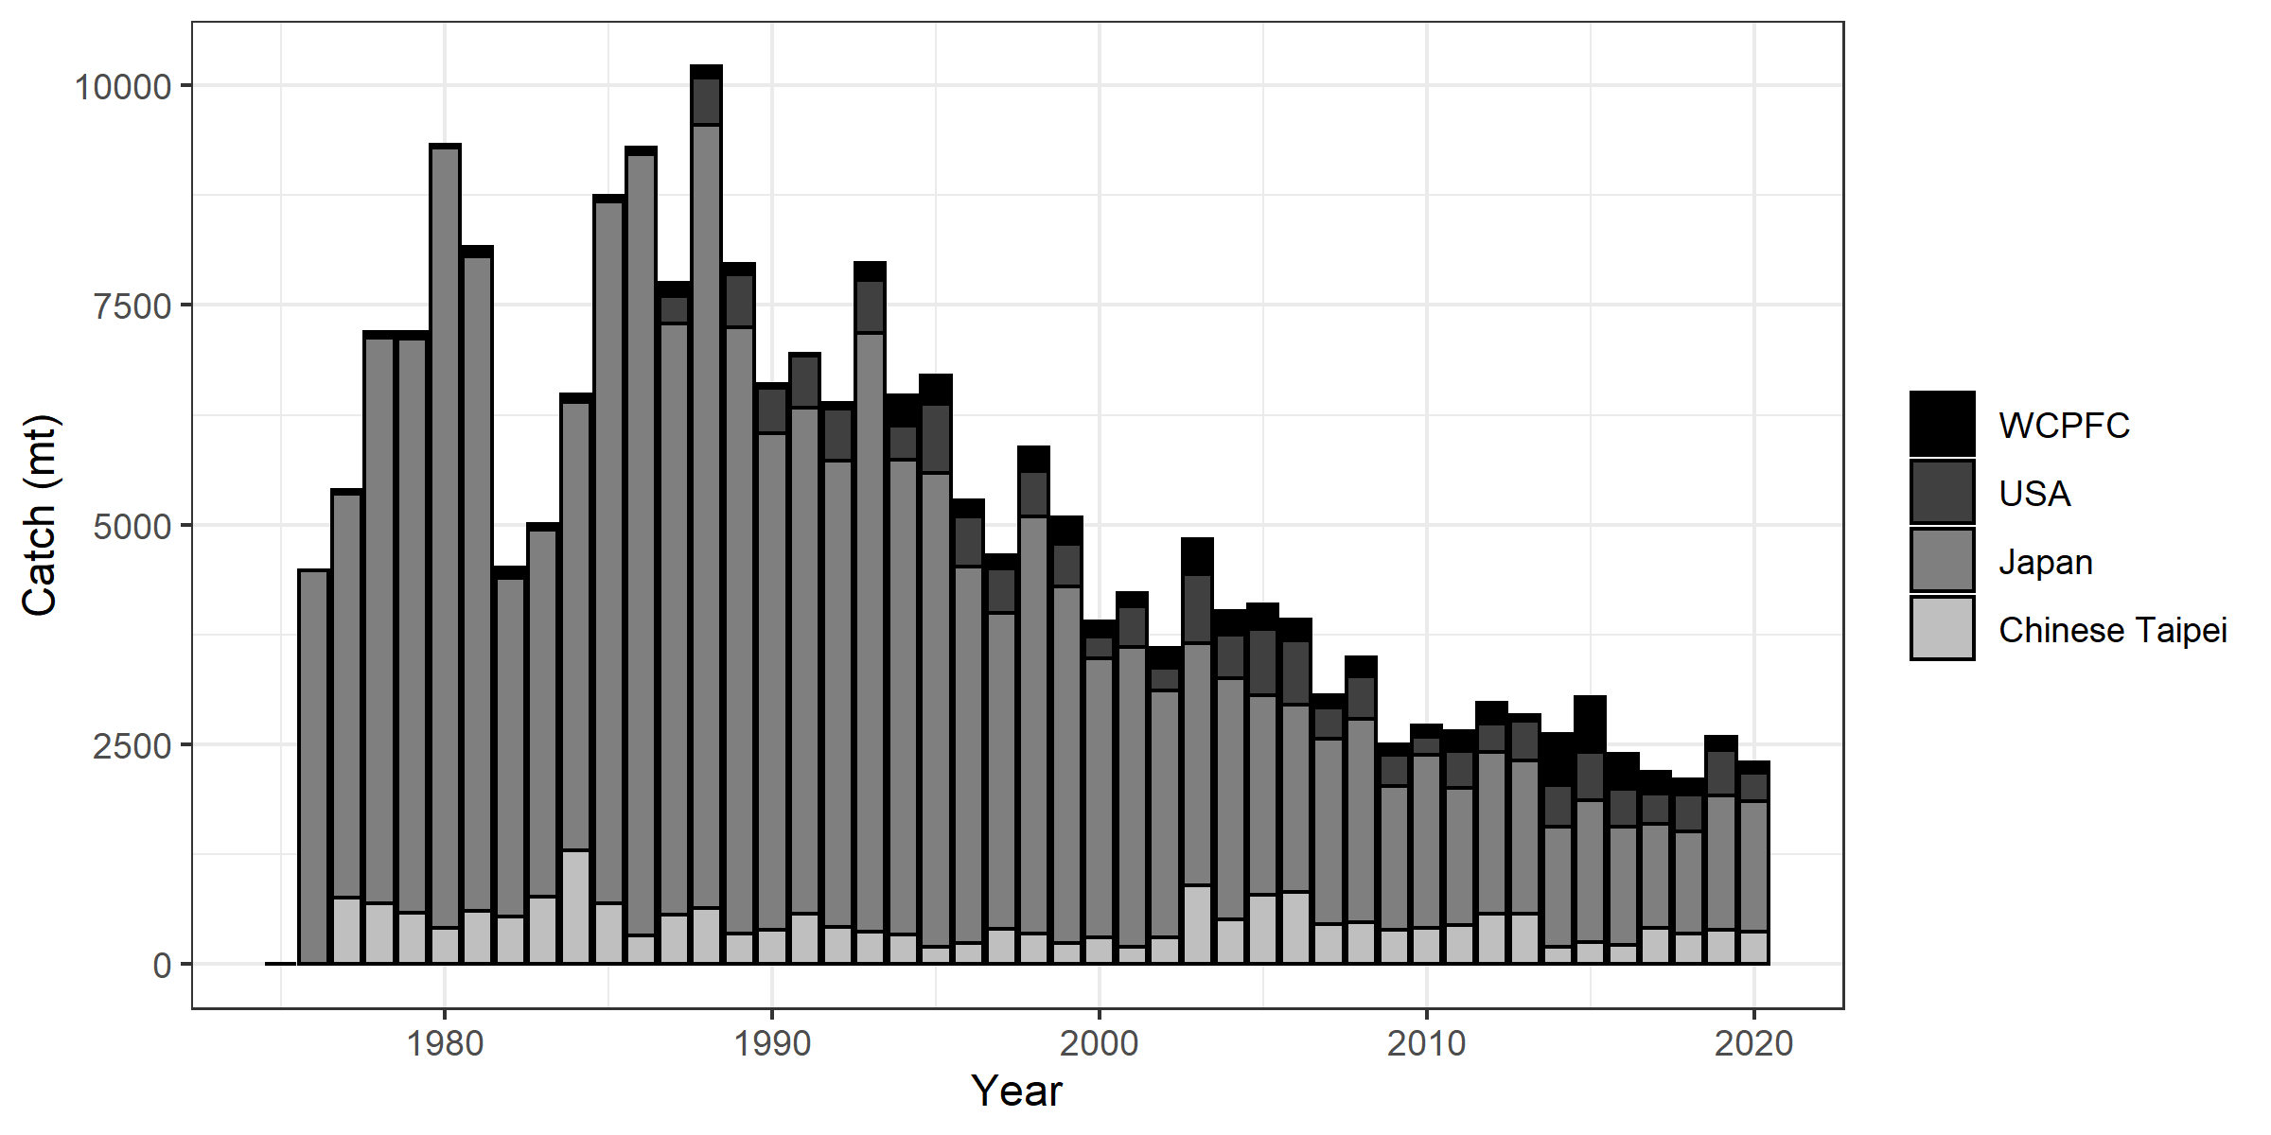
Figure WCNPOMLS-1. Annual catch biomass (mt) of Western and Central North Pacific striped marlin (Kajikia audax) by country for Japan, Chinese Taipei, the U.S.A., and all other countries during 1977-2020 (Figure S1 from SC19-SA-WP-11).

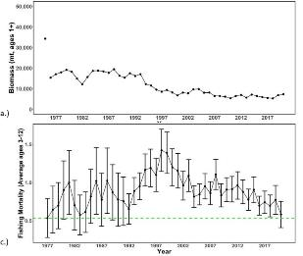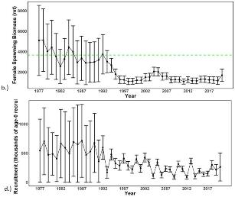

Figure WCNPOMLS-2. Time series of estimates of (a) population biomass (age 1+), (b) spawning biomass, (c) instantaneous fishing mortality (average for age 3-12, year⁻¹), and (d) recruitment (age-0 fish) for Western and Central North Pacific striped marlin (Kajikia audax) derived from the 2023 stock assessment. The circles represent the maximum likelihood estimates by year for each quantity and the error bars represent the uncertainty of the estimates (95% confidence intervals), green dashed lines indicate the dynamic 20%SSB_{F=0} and F_{20%SSBF=0} reference point (Figure S2 from SC19-SA-WP-11).

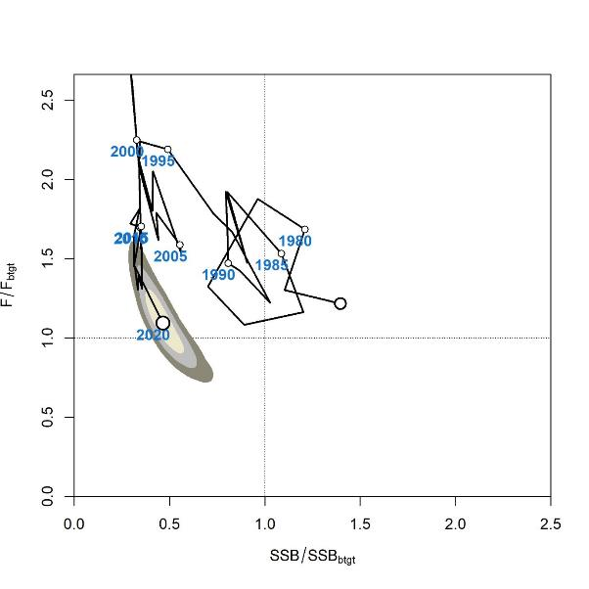

Figure WCNPOMLS-3. Majuro plot of the time series of estimates of relative fishing mortality (average of age 3-12) and relative spawning stock biomass of Western and Central North Pacific striped marlin (Kajikia audax) during 1977-2020. F_{btgt} and SSB_{btgt} refer to F_{20%SSBF=0} and 20%SSB_{F=0}, respectively. The large, un-labeled open circle indicates 1977, subsequent open circles are in 5-year increments. Shading indicates 50%, 80%, and 95% confidence intervals, respectively (Figure S3 from SC19-SA-WP-11).

a.)
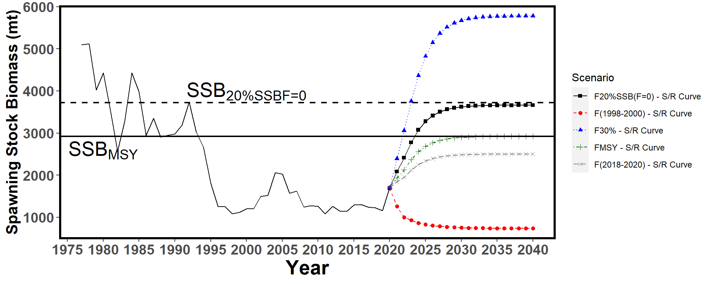
b.)
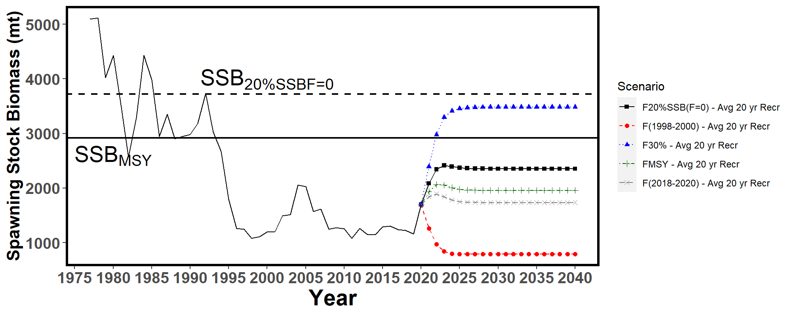
c.)
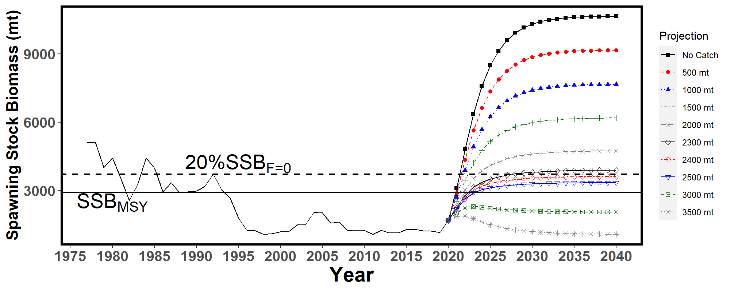
Figure WCNPOMLS-4. Historical and projected trajectories of spawning biomass from the Western and Central North Pacific striped marlin base case model based upon F scenarios: (a) F scenarios projected spawning biomass using recruitment estimated from the stock-recruitment curve; (b) F scenarios projected spawning biomass using average recruitment from 2001-2020. (c) Catch scenarios projected spawning biomass using average recruitment from 2001-2020. Dashed line indicates the spawning stock biomass at the dynamic 20%SSB_{F=0} reference point. Solid line indicates the spawning stock biomass at SSB_{MSY}. The list of projection scenarios can be found in SC19-SA-WP-11 Tables S3 and S4 (Figure S4 from SC19-SA-WP-11).

(a)
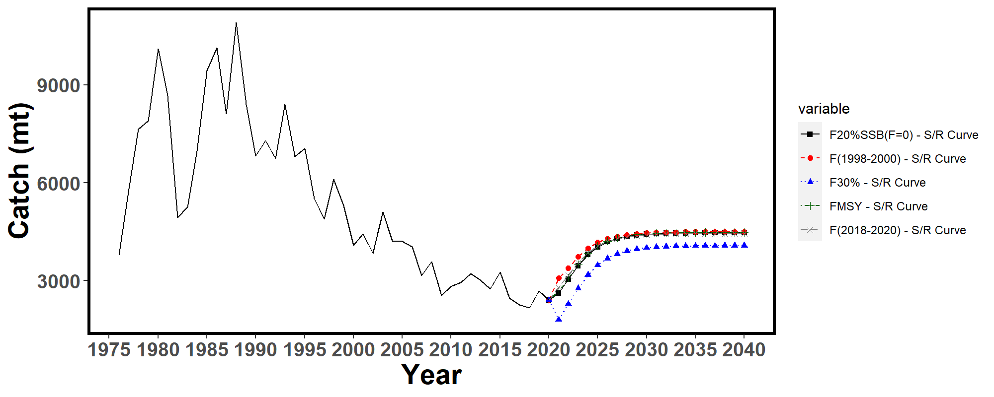
(b)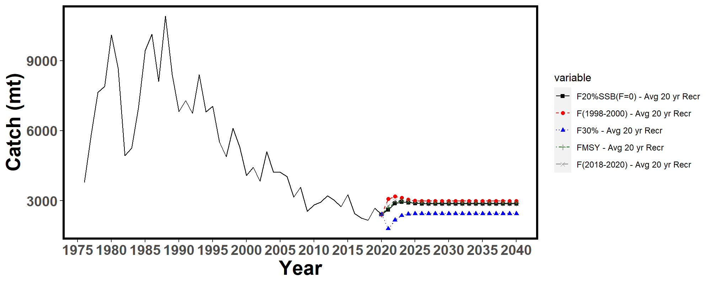
Figure WCNPOMLS-5. Historical and projected trajectories of catch from the Western and Central North Pacific striped marlin base case model based upon F scenarios: (a) F scenarios projected catch using recruitment estimated from the stock-recruitment curve; (b) F scenarios projected catch using recruitment estimated from 2001-2020 average. The list of projection scenarios can be found in SC19-SA-WP-11 Table S3 (Figure S5 from SC19-SA-WP-11).

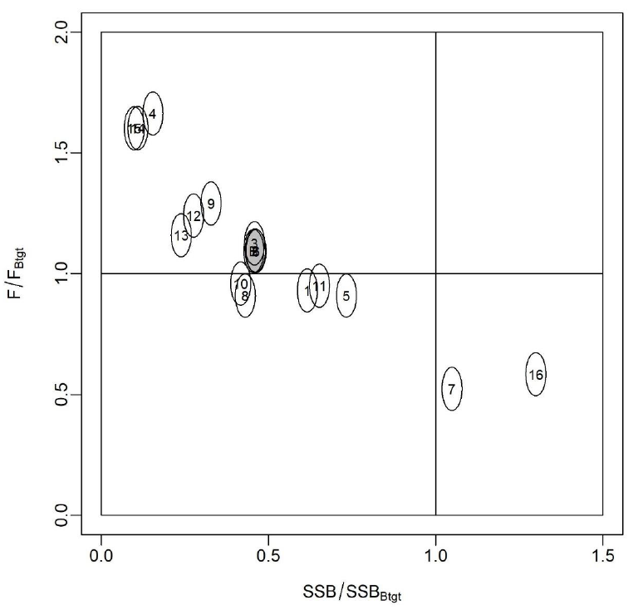
Figure WCNPOMLS-6. Majuro plot showing the terminal year stock status for the base-case model (gray circle, B) and the 16 sensitivity runs used to evaluate the sensitivity of the model to various model assumptions (circled numbers, circles are used as a visual aid). Models 12, 13, 15, and 16 are all sensitivity runs on assumptions on growth. See SC19-SA-WP-11 Table 12 in the stock assessment report for the full list and description of the sensitivity runs (Figure S6 from SC19-SA-WP-11).

4.7. Projects and Requests

4.7.1 Characterization of stock assessment uncertainty (Project 113)

- P. Neubauer (Dragonfly) presented SC19-SA-WP-12 (Addressing uncertainty in WCPFC stock assessments: Review and recommendations from WCFPC Project 113).

- SC19 supported the recommendations made in the report and encouraged the SSP and the ISC to take necessary steps to implement them as appropriate. Most notably, the design of a standardized reporting template including language for stock status outcomes, management advice, and uncertainties, and the development of consistent terminology regarding the description of the stock status probabilities relative to reference points are considered a priority.

- SC19 noted a consistent reporting format would support clear comparison among stocks and years.

- SC19 recommended that this project be included in the 2024 SC workplan and added to the Tuna Assessment Research Plan.

- SC19 also noted the continuation of Project 113b to develop the standardized reporting template and language.

4.7.2 Application of Close-Kin Mark-Recapture Methods (Project 100c)

- S. Nicol (SPC) presented SC19-SA-WP-13 (CKMR application to South Pacific Albacore – Project 100c).

SC19 noted the progress being made on the CKMR preliminary study, and notes that this type of work has improved stock assessments in other tRFMOs and looks forward to seeing how the SPA assessment is improved in the future.

4.7.3 Options to provide information to the Scientific Committee

- G. Pilling (SPC) presented SC19-SA-WP-14 (Options to address time challenges in the SC review of WCPFC stock assessment inputs) which addressed paragraph 103 of the SC18 Summary Report.

- Noting the need for the SSP to have more time to complete the work required to conduct annual stock assessments and other analyses reviewed by the SC each year, SC19 recommended that:
  - the data manager at the SSP liaise and consult with CCMs about the possibility of bringing forward the data submission deadline for fleets, especially historical data updates,
  - the Secretariat explore options for moving the dates of the SC meeting to a later period in the calendar year,
  - the Secretariat and SSP explore options for the WCPFC website to include a portal for CCMs to enter/edit/manage their ACE data submissions, and
  - the SSP develop guidelines for standardised structure/file layouts for Annual Catch Estimates and aggregate catch/effort data that can be used by CCMs to submit these data.

Noting the need for further resources to assist the SSP in conducting annual stock assessments and other analyses related to the work of the Commission, SC19 recommended that the Commission consider increasing the SSP’s budget so that the number of full-time assessment scientists can be increased to four or five.

- Report from the ISG-02 (Future operations of the SC) is in Attachment H and ODF communications on this topic are compiled in the Summary of SC19 ODF in Attachment K.

4.7.4 Tuna Assessment Research Plan (TARP)

- G. Pilling (SPC-OFP) presented SC19-SA-WP-15 (Draft Tuna Assessment Research Plan (TARP) for ‘key’ tuna species assessments in the WCPO, 2023-2026), which provided the background and current contents of what was proposed to be a ‘living document’ that would be updated annually.

- An informal small group 3 (ISG03) met during the course of SC19 to review SC19-SA-WP-15 (Draft Tuna Assessment Research Plan (TARP) for ‘key’ tuna species assessments in the WCPO, 2023-2026) and the ISG03 Report is in Attachment F.

4.7.5 Billfish Research Plan (Project 112)

- S. Brouwer (Sagittus Ltd) presented SC19-SA-WP-16 (Billfish research plan 2023 – 2027).

- An Informal Small Group (ISG-04) met during the course of SC19 to review SC19-SA-WP-16 (Draft billfish research plan, Project 112), and the ISG04 report is contained in Attachment I.

- Noting that SC17 agreed a framework for selecting LRPs for billfish species, SC19 seeks general guidance from the Commission on whether in the case of non-targeted species it is acceptable to have a higher level of risk to the stock and a lower biomass LRP compared with the equivalents for target species.

4.7.6 Reproductive biology of yellowfin tuna

- S. Nicol (SPC-OFP) presented SC19-SA-WP-17 (Concept note for a new EU supported study on the reproductive biology of yellowfin tuna). This research proposal aims to undertake the research needed on the reproductive biology of all tropical tunas in the WCPO, not just yellowfin tuna, and the study will be supported by the European Maritime, Fisheries and Aquaculture Fund (EMFAF), with a total budget of Euro 240,000, commencing work in 2024 if WCPFC’s co-finance contribution of a Euro 40,000 is available.

SC19 recognized the importance of biological parameters and acknowledged the valuable updates on the reproductive biology and spawning potential for yellowfin that this project could provide for stock assessments.

SC19 agreed that the project should be expanded to include bigeye and skipjack tuna.

SC19 endorsed the project and recommended that the WCPFC co-finance EU 40,000 so that funding from the European Maritime, Fisheries and Aquaculture Fund could be accessed.

SC19 noted that the project, if approved for WCPFC co-funding and EU funding, would be established as an SC project, and could commence in January 2024 with a final report to the SC scheduled in August 2026.

AGENDA ITEM 5 — MANAGEMENT ISSUES THEME

5.1 Development of harvest strategy framework for key tuna species

5.1.1 Skipjack tuna

5.1.1.1 Implementation of Management Procedure for WCPO skipjack tuna

F. Scott (SPC) presented SC19-MI-WP-01 (WCPO skipjack management procedure).

SC19 noted that the estimation method ran successfully and returned an estimate of SB_{latest}/SB_{F=0} of 0.42, and that the corresponding scalar from the HCR was 1.0. Under the adopted MP outlined in CMM 2022-01, this sets maximum effort in the purse seine and pole and line fisheries, and maximum catches in all other fisheries, at baseline levels (PS at 2012 effort; PL at 2001-2004 effort; Region 5 domestic fisheries at average 2016-2018 catches) for the subsequent management period (2024 to 2026).

Several CCMs noted that they were happy with this outcome, as it is consistent with the objective of relative stability in fishing levels between management periods.

SC19 noted that the data used to determine this estimate was not entirely consistent with that used for the dry run of the management procedure in the previous year. This change appears to be largely attributed to differences in the standardised pole and line indices, both for the historical time series and for most recent years. However, SC19 noted that SPC and Japanese colleagues will be working together to identify the issue in last year’s dry run. Nevertheless, SC19 noted that the initial running of the skipjack MP was consistent with that predicted by the MSE and all data requirements were satisfied.

SC19 was informed that the contraction of pole and line fishing effort is impairing the ability to index relative abundance of WCPO skipjack across the equatorial region and diagnostic analyses indicate that it is likely to affect the future performance of the MP. The SSP indicated that it would consider what alternative options might be possible for dealing with this issue and report progress back to SC20.

SC19 noted that this is not just an issue for the estimation model of the MP but also for the stock assessment.

Noting that with maximum effort and catches now recommended by the MP for respective fisheries for the next three years, this provides a time window for further work, and SC19 recommends that a re-evaluation of the skipjack estimation method needs to be undertaken prior to the next implementation of the MP.

SC19 recommended that the Commission take into consideration the successful running of the skipjack MP as outlined in SC19-MI-WP-01 and its output, which indicates that maximum effort in the purse seine and pole-and-line fisheries and maximum catches in all other fisheries should be set to their respective baseline levels (specified in CMM 2022-01) for the period 2024-2026, when implementing CMM 2022-01.

5.1.1.2 Monitoring strategy for WCPO skipjack tuna

- G. Pilling (SPC) presented SC19-MI-WP-02 (Monitoring the WCPO skipjack management procedure), noting the MP has only just been run and the Commission will need to see how it performs after 2 or 3 years in the real world.

Noting the Commission’s request to review the elements of the monitoring strategy as set out in ANNEX III of CMM 2022-01, and information provided by the SSP on the elements of the harvest strategy to be included in the monitoring strategy, SC19 reviewed SC19-MI-WP-02 (Monitoring the WCPO skipjack management procedure).

SC19 noted the aspects of the MP that may be considered for inclusion in the monitoring strategy and the Commission body at which those considerations can be made (Annex III, Table 2, also shown in Table 1 of SC19-MI-WP-02).

In order to simplify and streamline the monitoring process for the Commission and its subsidiary bodies, SC19 supported the concept of compiling a summary monitoring report consisting of a summary table that identifies the elements of the monitoring programme that may require additional work or through which major problems may be identified, along with a few short paragraphs to provide further details of the work required to address those issues. The priority of any issues identified can be determined based on the considered severity of the issue and the amount of work required to address it.

- An example of such a summary report is attached as Attachment G.

While noting that this report covers all the elements of the MP to be reviewed, SC19 also noted a need for both the TCC and the Commission to provide input into the development of this report considering the elements of the monitoring strategy that have been assigned to each body to review.

SC19 also noted that the initial development and implementation of this monitoring strategy, and the associated report, will likely be an iterative process, with some time-lags before each body will be able to fulfil some of its roles. For example, given the MP will be first implemented in 2024, TCC will only first be able to monitor compliance in 2025. Once this initial phase in period is complete, review and updating of the monitoring report should be undertaken annually by each body. However, as the MP and stock assessment are only run every three years, some elements of the monitoring strategy will not be able to be reviewed and updated on an annual basis.

SC19 noted that as this is the first year for which this MP has been run, there is limited ability to monitor its full performance now. However, to initiate the development of the monitoring report, SC19 reviewed those elements of the monitoring strategy assigned to the SC. The outcomes of that review are shown in the draft monitoring report listed in Attachment 3 and show that SC19 supported the conclusions of SC19-MI-WP-02, that the outcomes of initial running the skipjack MP were consistent with that predicted by the MSE and that all data requirements were satisfied. Some priorities for future work are also noted.

Finally, SC19 noted that the annual review of each element of the monitoring strategy will provide an opportunity for the Commission and its two subsidiary bodies to review, and where necessary (depending on the degree of impact on the MP), update the management objectives to ensure the overall harvest strategy remains appropriate as the nature of the fishery evolves over time.

Noting that the Commission is scheduled to adopt a monitoring strategy for skipjack tuna in 2023, SC19 supported the proposed monitoring strategy as outlined in SC19-MI-WP-02 and recommended that it be considered for adoption following further discussion by TCC and the Commission.

SC19 recommended that the Commission take note of the initial review of the skipjack MP under the proposed monitoring strategy as outlined in SC19-MI-WP-02 and consider the proposed monitoring strategy summary report drafted by SC and TCC and advise accordingly.

5.1.2 South Pacific Albacore Tuna

5.1.2.1. Target reference point (TRP)

- G. Pilling (SPC) presented SC19-MI-WP-03 (Update to further inform discussions on South Pacific albacore objectives and the TRP).

SC19 noted that the Commission is scheduled to adopt a target reference point (TRP) for South Pacific albacore tuna in 2023 and reviewed SC19-MI-WP-03 (Update to further inform discussions on South Pacific albacore objectives and the TRP).

SC19 examined the update from the table of possible outcomes to SP albacore tuna under candidate TRPs presented to WCPFC19-2022-15 by the Scientific Service Provider. It was noted that the change to the methodology, whereby failed projections are now included in the summary metrics, resulted in slightly more pessimistic outcomes. The set of candidate TRPs presented in Table 1 was considered to be extensive and no requests were made for further additions prior to consideration by WCPFC20.

SC19 noted that according to the latest stock assessment for SP albacore tuna (accepted by SC17) the stock was not considered overfished or to be undergoing overfishing, and that an updated stock assessment was due for presentation at SC20 in 2024.

Several CCMs noted the importance of SP albacore tuna fisheries to their economy and encouraged the adoption of a TRP for SP albacore tuna by WCPFC20. The importance of economic considerations when selecting a TRP, notably when reviewing the changes in catch limits resulting from the adoption of specific TRPs, was also mentioned.

Several CCMs noted that TRPs defined from specific depletion levels are susceptible to changes in our perception of stock status that occurs with each successive stock assessment, or between the stock assessment and the set of operating models used to develop a management procedure. It was recommended that a TRP be set based on stock status in a reference set of years instead, noting that multiple years provide increased robustness against peculiarities that may be present in a single specific year.

Some CCMs noted that there are features in the 2021 SP albacore assessment that are still being investigated, most notably the pronounced low estimated recruitment in 2016 and the projected dip in biomass depletion levels. As such the suggestion was that WCPFC20 adopt an interim TRP conditional on the results of the next SP albacore assessment scheduled for SC20.

SC19 noted the proposal by the South Pacific Group and Australia for an interim TRP submitted at the Fourth meeting of the South Pacific Albacore Roadmap Intersessional Working Group. The proposed iTRP is based on the estimated average depletion of the SP ALB over the period 2017-2019 and is outlined in SPA-RM-IWG04/WP-03.

SC19 recommended that WCPFC20 reviews the list of candidate TRPs outlined in SC19-MI-WP-03 when adopting a TRP for SP albacore tuna and consider a TRP that is based on a set of reference years instead of a specific level based on a biomass depletion percentage.

5.1.2.2 South Pacific Albacore operating models

- F. Scott and N. Yao (SPC) presented SC19-MI-IP-08 (Factors contributing to recent and projected declines in South Pacific albacore stock status) and SC19-MI-WP-04 (Selecting and Conditioning Operating Models for South Pacific Albacore), respectively.

SC19 noted that under the indicative Harvest Strategy Work Plan (WCPFC19-2022- 19a_rev2), SC19 is scheduled to agree on the operating models to use for the Management Strategy Evaluation of SP albacore tuna and that the Commission is scheduled to adopt a management procedure (MP) for SP albacore tuna in 2024.

SC19 thanked the Scientific Service Provider (SSP) for their presentation of SC19-MI-IP-08 (Factors contributing to recent and projected declines in south Pacific albacore stock status) investigating potential explanations for the 2016 “recruitment dip” predicted by the 2021 stock assessment which carries forward to a significant projected biomass decline over recent years. SC19 noted that SC19-MI-IP-08 findings do not resolve whether the recruitment dip is real or a misspecification of the model. While there is some evidence that the recruitment dip might be real, specifications of the stock assessment model might also have exacerbated the extent of the recruitment dip in the projections and within the operating models.

Several CCMs were concerned about the development of a reference grid based on operating models that estimate a recruitment dip, noting that the evaluated performance of MPs would in part reflect a response to that dip and be misleading, particularly in the short term. There was support for continued research investigating improvements to the operating models, especially in light of the revised stock assessment to be completed in 2024.

The SSP noted that it would be possible to recondition the operating model grid if required following SC20 and highlighted that the main matter of interest was changes in the relative performance of each of the MPs being tested under any updated operating model, although other metrics might also be of interest to CCMs.

SC19 also reviewed SC19-MI-WP-04 (Selecting and Conditioning Operating Models for South Pacific Albacore) outlining a candidate operating model reference grid to use for testing management procedures for SP albacore tuna.

SC19 noted the importance of model diagnostics for assessing the performance of operating models and thanked the Scientific Service Provider for their development of a Shiny app (SC19-MI-IP-03) with such diagnostics. It was suggested that CPUE diagnostics also be included for future consideration by SC20.

Despite some concerns, several CCMs agreed that the current operating model and proposed reference grid were appropriate to enable MP development testing to progress. There was also support for the SSP to evaluate performance of MPs with the first year of simulated operation in 2025 (using data up to 2023). 2025 is the first year an MP would be implemented under the current HS workplan within the ongoing MSE simulation framework. There was also support for considering SB_{recent}/SB_{F=0} (as opposed to SB_{latest}/SB_{F=0}) as a management quantity to further reduce the potential impact of some of the modelling concerns.

In light of the concerns about the suitability of the current operating models, it was suggested that the reference set be treated as interim, conditional on future investigations of operating model specifications and the identification of additional operating models where relevant. SC19 supported the SSP’s suggestion to expand the operating model reference set to incorporate a scenario where the recent estimated ‘recruitment dip’ was less pronounced.

Several CCMs noted the importance of considering expanded areas of uncertainty as part of the robustness set and proposed, at this stage, that this should include scenarios of climate change and CPUE hyperstability, however further robustness tests may be required.

SC19 recommended the use and development of the reference operating model set provided in Table 1 of SC19-MI-WP-04 over the next year to allow the continued progress and evaluation of candidate MPs for SPA.

Further SC19 recommended that SC20 again consider formally adopting the reference operating model set for SPA noting the ongoing investigations that might require a reconditioning of the reference set ahead of SC20, and the potential for other changes in light of the 2024 SPA stock assessment.

5.1.2.3 South Pacific albacore tuna management procedures

- R. Natadra and F. Scott (SPC) presented SC19-MI-WP-05 (Developing management procedures for South Pacific albacore) and SC19-MI-WP-06 (Evaluation of candidate management procedures for South Pacific albacore), respectively.

SC19 noted that according to the Harvest Strategy Work Plan, SC19 is scheduled to provide advice to the Commission on the performance of candidate management procedures for South Pacific albacore. As such, SC19 reviewed an update on the progress of developing and testing MPs for South Pacific albacore presented by the Scientific Service Provider (SSP), including estimation model options, HCR designs, and preliminary evaluations and consideration of performance indicators.

SC19 thanked the SSP for their presentation of SC19-MI-WP-05 (“Developing management procedures for South Pacific albacore”) and SC19-MI-WP-06 (“Evaluation of candidate management procedures for South Pacific albacore”) and noted the inclusion of a clear list of items informing management procedure design for which feedback was sought.

Some CCMs noted that while they are able to provide feedback on aspects of MP development to inform technical discussions, decisions on specific configurations ultimately could only be made by the Commission since they relate to management issues.

One CCM noted that there were several influential decisions to be made with regards to MP settings and sought clarification as to the best mechanism to support feedback on each of these settings noting the lack of guidance on the best approach to conduct these discussions. It was clarified that CCMs could provide feedback on specific MP features as part of the SC19 plenary discussions.

Other CCMs mentioned further opportunities for detailed feedback to the SSP on MP settings for exploration, for instance the stakeholder engagement and capacity building activities undertaken by the SSP under the project “Pacific Tuna Management Strategy Evaluation” (see SC19-MI-IP-05), the South Pacific Albacore Roadmap Intersessional Working Group and the SP albacore tuna-focused Science Management Dialogue tentatively planned under the Roadmap for 2024 (WCPFC-SPALB-RM-2023-00).

SC19 noted its support for the use of the age-structured surplus production model (ASPM) as the estimation model and a 3-year cycle for MP update consistent with the stock assessment cycle for SP albacore tuna.

Several CCMs noted that they supported a harvest strategy that could account for both effort and catch controls in recognition of the diversity of management approaches across the region. It was also suggested that, due to its small impact on the overall stock, options for the troll fishery to be treated differently within the MP could be considered in future updates.

Several CCMs further noted that, while all sources of commercial mortality on the SP albacore stock should ideally be covered by the MP, EPO catches (outside of WCPFC management) could be fixed at recent levels for the purpose of MP evaluation and development. SC19 encouraged the Commission to seek compatible measures in the IATTC to address this gap in the management of SPA that may impact the effectiveness of an adopted MP.

SC19 requested that a dry run of one or more of the candidate MPs be presented to SC20 next year, similar to that done for skipjack tuna at SC18.

Some CCMs stated ongoing concerns with the impact of the recruitment dip on MP testing. While there was support for MP evaluation to start in 2025 as a partial solution to the recruitment dip it was emphasized that there was still a clear impact of the dip on the performance of candidate MPs over the short term (2026-34).

Several CCMs noted the importance of accounting for environmental impacts when testing the MP, for example as part of the robustness set.

SC19 noted that the projections from the initial MP testing appeared more pessimistic than those conducted as part of the 2021 SP albacore tuna stock assessment. The SSP responded that, unlike in the 2021 stock assessment, there was no down-weighting of the SEAPODYM movement axis in the operating model grid, leading to a more pessimistic outcome for stock status.

In response to a question on the impact of the HCRs across regions and fisheries the SSP clarified that, for the current set of evaluations, all fisheries were impacted equally by the catch scalars prescribed by the Harvest Control Rule.

SC19 sought clarifications with respect to the conditions that would exacerbate population crashes that sometimes occur in the simulations. As this feature had not been investigated by the SSP, it was noted that the type of management input (effort or catch) might impact this behaviour, and that asymmetrical catch constraints might be considered as a possible solution.

Several CCMs noted that a representative set of MPs needed to be available to support discussions at WCPFC20 but that the number of candidate MPs could easily expand to unmanageable levels when considering multiple options applied across different MP settings. As such, it was encouraged that the number of MPs presented to the Commission be kept to manageable levels (e.g., 10 or less) so that the Commission could provide clear input on desirable features for future exploration.

SC19 recommended that WCPFC20 review the current set of 6 candidate MPs for initial consideration, noting the diverse range of MP configurations provided by the SSP is sufficient to support discussions on desirable features and design priorities.

SC19 further recommended that the Commission provide guidance based on these exploratory MPs on features to be further developed by the SSP, including performance indicators, controlled fisheries and control mechanisms, and HCR shape and design.

5.1.3 Mixed fisheries MSE framework

- F. Scott (SPC) presented SC19-MI-WP-07 (Mixed-fishery harvest strategy update).

Noting the work reviewed by previous SC meetings in developing a multi-species modelling framework for including mixed ﬁshery interactions when developing and testing harvest strategies for the four main WCPO tuna stocks, SC19 reviewed an update on the development of this framework outlined in SC19-MI-WP-07 (Mixed fishery harvest strategy update).

One CCM stated that although the current diagram depicts that the purse-seine fleets catching bigeye are only controlled by the skipjack MP regardless of the stock status of bigeye, it has not agreed with such a one-way hierarchy of multi-species MP application. Noting that the mixed fishery approach has not yet been agreed, they suggested that the Commission is the most appropriate place for this decision to be made. Another CCM also suggested that the decision hierarchy of the MPs may not be a topic for SC, but for fishery managers.

Several CCMs supported the more flexible approach to management objectives described in the paper. Noting the difficulty of getting agreement on management objectives among CCMs who have different visions of how stocks and fisheries should be managed, and that reaching agreement on the form and level of management objectives has been made more difficult by modelling changes, they supported the threshold approach to the nature of the yellowfin management objective as outlined in the paper. They also noted that the relatively large yellowfin catches taken within archipelagic waters strengthens the need for such a flexible approach. They also expressed support for developing a threshold-type management objective for bigeye.

Several other CCMs noted the progress made in the development of the mixed-fishery harvest strategy approach and encouraged the Commission to keep the mixed-fishery strategies and questions in mind while developing target reference points for bigeye and yellowfin, as well as development of the MPs.

One CCM noted that discussions between the Philippines, Indonesia and Vietnam indicated concern about future management of yellowfin tuna in the WCPO and stated a preference for yellowfin tuna being controlled by a separate MP. However, it was also noted that a separate harvest strategy is presently being developed for Indonesian archipelagic waters and could help alleviate some of those issues.

In response to the views expressed, the presenter noted that the mixed fishery framework is a proposal, and not a decision. The current plan is to build the modelling framework and see how it performs for bigeye and yellowfin. If it suggests that these are not well managed under the current mixed fishery framework, then another approach will be needed.

One CCM noted that a TRP should specify fishery conditions that managers would like to achieve and that they believed it would be more logical if this made reference to conditions in a fishery over several specified years instead of a depletion-based TRP value. They noted that this is a decision for the Commission.

SC19 supported continuing the work on the development of the mixed fishery MSE framework and recommended that WCPFC20 take note of the progress to date and provide feedback.

5.1.4 Progress of the WCPFC Harvest Strategy Workplan

- J. Larcombe (Australia) presented the FFA members’ proposal for updating the Harvest Strategy Work Plan, noting the Harvest Strategy Work Plan was a living document subject to review and revision from year to year.

SC19 noted the adoption by WCPFC19 of the updated Indicative Workplan for the Adoption of Harvest Strategies under CMM 2014-06 (Attachment M, WCPFC19 Summary Report).

SC19 also noted the presentation made by Australia on behalf of FFA which outlined proposed changes that will be presented to WCPFC20, including the following two ‘high-level’ changes: i) as a contingency allow for a potential one-year delay in the adoption of a MP for SP-albacore, noting potential issues with the operating models, and ii) reschedule the adoption of a MP for bigeye and yellowfin to 2026 to avoid subsequent running of the MP in the same year the stock assessment is conducted.

SC19 was informed that the Marine Stewardship Council Conformity Assessment Bodies are developing milestones for harvest strategies that will apply to MSC certified fisheries in the WCPO. However, SC19 also noted that the place for this important planning is within the Commission and its subsidiary bodies.

SC19 noted that the second of these proposed revisions would result in the adoption of the MP for bigeye and yellowfin in the same year that the updated stock assessments are provided to the SC. The presenter noted that the optimal timing of these items can often be difficult, but this proposal would result in a similar process to that undertaken for skipjack and would avoid the longer-term issue of coinciding running the MP with the stock assessment.

Several CCMs articulated their strong commitment to the successful implementation of the remainder of the Harvest Strategy Work Plan. They also encouraged continued capacity-building initiatives as they greatly assist CCMs, particularly SIDS, to participate fully in this complex process and have the confidence in the harvest strategy development process, and its outcomes when implemented. They suggested that such activities focus on topics such as agreeing to a management objective, the selection of a target reference point, management procedure design and performance indicators.

SC19 recommended that the Commission take note of the above views when updating the Harvest Strategy Workplan at WCPFC20.

5.2 Implementation of CMM 2021-01

Review of effectiveness of CMM-2021-01

- P. Hamer (SPC) presented SC19-MI-WP-08 (Updates to table 9 of the evaluation of CMM 2021-01), which is an update to Table 9 of the paper WCPFC19-2022-13_rev1 (Evaluation of CMM 2021-01: Tropical Tuna Measure).

- A major outcome was to update the 30-year forward stock projection estimates in Table 9 of WCPFC19-2022-13_rev1 as follows:

Table 1. Comparison of predicted CMM 2021-01 performance (scalars) relative to baseline 2016-2018 average levels with actual patterns of purse seine effort (FAD sets) and longline bigeye and yellowfin catches and associated relative scalars for 2019, 2020, 2021, 2022. (Source: Table 1 of SC19-MI-WP-08, which is an update of Table 9 in WCPFC19-2022-13_rev1)
Gear | CMM Scenarios and baseline |  |  | Actual fishery outcomes
Gear | Average 2016-18 | Optimistic CMM scalar and (FAD set /catch level) | Pessimistic CMM scalar | 2019  reported | Scalar 2019  reported | 2020  reported | Scalar 2020  reported | 2021 reported | Scalar 2021 reported | 2022 reported | Scalar 2022 reported
Purse seine FAD sets | 16,315 | 1.11 | 1.13 | 14,935 | 0.92 | 15,250 | 0.93 | 17,231 | 1.06 | 18,160 | 1.11
Longline bigeye catch (mt) | 58,593 | 1 | 1.51 | 63,897 | 1.09 | 53,289 | 0.91 | 51,043 | 0.87 | 51,862 | 0.89
Longline yellowfin catch (mt) | 68,940 | 1 | 1.51 | 84,202 | 1.22 | 56,260 | 0.82 | 57,828 | 0.84 | 66,211 | 0.96
Note: minor updates in catches and FAD set reported levels have occurred for 2019, 2020 and 2021 compared to Table 9 in SPC-OFP (2022) (appendix 1). These are due to minor corrections to the updated databases and additional data for 2021, they have minor influence on the scalars for these years. Catches and effort in this table exclude those from Vietnam and archipelagic waters that are not within the scope of CMM 2021-01.

SC19 noted that WCPFC 19 had agreed that the process to revise the Tropical Tuna Measure (TTM) will be based on CMM 2021-01 without a complete overhaul, and at least two workshops will be needed to make progress towards the adoption of a revised TTM in 2023. Based on the request to provide recommendations to the Commission on the effectiveness of CMM 2021-01, SC19 reviewed SC19-MI-WP-08 (Updates to table 9 of the evaluation of CMM 2021-01).

SC19 noted that SC19-MI-WP-08 evaluates the potential for CMM 2021-01 to achieve its objectives for each of the three WCPO tropical tuna (bigeye, yellowfin and skipjack) stocks. The current evaluations are based on the 2020 SC-agreed stock assessments for bigeye and yellowfin (last year of data is 2018) and the 2022 assessment for skipjack (last year of data is 2021). These evaluations now need to be updated to take account of the updated stock assessments for bigeye and yellowfin adopted by SC19 (last year of data is 2021) and consider the interim MP adopted for skipjack in 2022.

Several CCMs noted, that relative to the FAD set effort levels and the longline catches of bigeye and yellowfin, the TTM is performing adequately. However, as noted by the SSP in their previous evaluation presented at WCPFC19, since 2020 the evaluation of longline bigeye and yellowfin catches are below the expected range under the TTM. Additionally, the actual changes in catch relative to the 2016-2018 average baseline suggests the assumption of a direct relationship between the catch scalars may not be appropriate and may require further investigation.

SC19 supported the current analysis framework described in SC19-MI-WP-08. However, it queried as to how the 30-year projections used in the analyses will account for the effort levels in the skipjack fishery now likely being set every three years based on the adopted interim MP, as implementing the MP would reduce catch if stock biomass decreased. The SSP noted that while this needs to be finalised, these projections just present alternative scenarios that bound future levels between optimistic (i.e., similar levels of catch and effort to recent years) and fully utilised scenarios (maximums under the specified limits).

SC19 noted that the SSP is planning to have the updated projections ready for the TTMW4 in September. The updated evaluations will include an update to the baseline period which will now be 2019-2021. The SSP also explained that the preliminary FAD set scalar of 1.19 for the purse seine fisheries in the fully-utilised conditions, is the ratio of effort in 2012 divided by the effort in the period 2019-2021.

SC19 recommended that the updates to SC19-MI-WP-08 be forwarded to both TTMW4 and the Commission for their consideration in reviewing the Tropical Tuna Measure.

AGENDA ITEM 6 — ECOSYSTEM AND BYCATCH MITIGATION THEME

6.1 Ecosystem and Climate Indicators

- S. Nicol (SPC) presented SC19-EB-WP-01 (Ecosystem and Climate Indicators).

SC19 noted that the SSP has completed a first screening of a subset of potential indicators for adoption and based on this experience recommended that the criteria identified at SC12 are appropriate for the initial screening of candidate indicators. However, more specific criteria are needed for testing and adoption.

SC19 recommended adoption of the proposed workplan for the development and testing of ecosystem and climate indicators for the period 2024-2027.

6.2 FAD Impacts

6.2.1 Research on non-entangling and biodegradable FADs (Project 110)

SC19-EB-WP-03 (Evaluation of the use of netting and biodegradable materials in drifting FAD construction in the WCPO)

- L. Escalle (SPC) presented SC19-EB-WP-03 (Evaluation of the use of netting and biodegradable materials in drifting FAD construction in the WCPO) and SC19-EB-WP-02 (Progress report of Project 110: Non-entangling and biodegradable FAD trial in the Western and Central Pacific Ocean), and V. Restrepo (ISSF) presented SC19-EB-WP-11 (The Jelly-FAD: new results on its performance).

SC19 noted that limited information on dFAD designs and materials is available from 2020 to 2023 due to low observer coverage, and there is a need for additional data fields or more systematic data to be recorded to adequately assess the designs, materials, and type of dFADs deployed in the WCPO.

SC19 recommended that further studies are implemented to quantify the effectiveness and the entanglement frequency of Species of Special Interest (SSI) in the WCPO on dFAD designs, including Low Entanglement Risk dFADs, Non-Entangling dFADs and Biodegradable dFADs.

To help reduce marine pollution and ecosystem impacts linked to the use of dFADs, SC19 promotes the reduced use of plastics and non-biodegradable materials in the construction of dFADs and the use of non-entangling FADs, as required from CMM 2021-01 and implemented beginning in January 2024.

SC19 noted the delays in the activities from Project 110 due to the COVID-19 pandemic and updated timing of activities, and supported the no-cost project extension with a final anticipated report to be presented at SC21 in 2025.

SC19 highlighted the importance of the on-going research activities led by SPC and ISSF, in collaboration with fishing industry, to trial non-entangling and biodegradable dFADs in the WCPO to inform implementation of the requirements under CMM 2021-01. SC19 supported the TOR for a follow-up project to enhance SC Project 110 by trialling additional non-entangling and biodegradable dFADs and to investigate alternative construction locations and locally sourced materials.

SC19 supports CCMs to encourage their purse seine vessels to participate in trials of biodegradable FADs of Category I and II (all FAD components are biodegradable except for flotation devices and GPS buoy).

6.2.1.1 Extension to EU supported biodegradable FAD Project

- P. Hamer (SPC) presented SC19-EB-WP-07 (Terms of Reference for a project to support additional work on trialling non-entangling and biodegradable FADs in the WCPO). The proposal is for additional funds to support research on biodegradable FADs being submitted to the EU’s European Maritime Fisheries and Aquaculture Fund. It was noted that the proposal has a budget of 218,000 Euros, of which 20% (44,000 Euros) would be sought from the WCPFC as co-funds. The project would need to start in 2024 to align with the current Project 110 work and co-funds would therefore be required to be approved at WCPFC20. The ISSF generously committed to providing 20,000 USD as co-funds.

6.2.2 FAD Management Options IWG Issues

- J. James (FSM, FADMO-IWG Chair) presented the FADMO-IWG report in SC19-EB-WP-13 (Progress of FADMO-IWG Priority Tasks for 2023). L. Escalle (SPC) presented SC19-EB-WP-03 (Evaluation of the use of netting and biodegradable materials in drifting FAD construction in the WCPO), SC19-EB-WP-04 (Analyses of the regional database of stranded drifting Fish Aggregating Devices (dFADs) in the Pacific Ocean), and SC19-EB-WP-12 (Guidelines to reduce impact of FADs on turtles) on behalf of the primary author G. Moreno of ISSF.

- SC19 recommended that the FADMO-IWG and TCC review the timelines for the stepwise introduction of biodegradable dFADs considering the expected outcomes of projects related to the design, cost-effectiveness and performance of biodegradable dFADs (e.g., jelly FADs) in the WCPO and other oceans.

- SC19 viewed that moving to biodegradable FADs is important for reducing marine pollution and other impacts. However, SC19 noted that it is challenging for some CCMs, especially for purse seine operators that are going through a major process of eliminating netting in FADs, to meet the non-entangling requirement for 2024 and further noted that trials for biodegradable FADs are still ongoing. In this regard SC19 noted that, for some CCMs, the year 2025 to start the transition to biodegradable FADs implementation may not be viable.

- SC19 noted IATTC's biodegradable FAD implementation program, which includes timelines with the mandatory use of categories I to IIIb by 2026 (Table FAD-1); and categories I to II by 2029, which could be reviewed by TCC and the FADMO-IWG for consideration in the WCPO.

TABLE FAD-1: Preliminary categories of drifting FADs biodegradability levels (from non-biodegradable to 100% biodegradable) for the gradual implementation of biodegradable drifting FADs. In year X, FADs of either category III(a) (biodegradable tail) or/and category III(b) (biodegradable raft) are required/implemented simultaneously.
Categories | Potential Timeline  (Suggestion 1) | Potential Timeline  (Suggestion 2) | Remarks
Category I. The FAD is made of 100% biodegradable materials. | Year X + 3 | Year X + d | Year X will be determined by the WCPFC and subject to review based on available information and availability of materials
Category II. The FAD is made of 100% biodegradable materials except for plastic-based flotation components (e.g., plastic buoys, foam, purse-seine corks). | Year X + 2 | Year X + c | Year X will be determined by the WCPFC and subject to review based on available information and availability of materials
Category III(a). The subsurface part of the FAD is made of 100% biodegradable materials, whereas the surface part and any flotation components contain non-biodegradable materials (e.g., synthetic raffia, metallic frame, plastic floats, nylon ropes). | Year X | Year X +b | Year X will be determined by the WCPFC and subject to review based on available information and availability of materials
Category III(b). The subsurface part of the FAD contains non-biodegradable materials, whereas the surface part is made of 100% biodegradable materials, except for, possibly, flotation components. | Year X | Year X +a | Year X will be determined by the WCPFC and subject to review based on available information and availability of materials
Category IV. The surface and subsurface parts of the FAD contain non-biodegradable materials. | Current | Year X
Note* These definitions do not apply to electronic buoys attached to FADs to track them.

SC19 recommended the FADMO-IWG and TCC consider incentivising the use of biodegradable dFADs.

SC19 noted that some CCMs suggested one example of an incentive could be to allow biodegradable dFADs to be deployed during the FAD closure.

SC19 noted the limitation in the scientific analyses of FAD tracking data due to the current incomplete data. SC19 noted the importance of complete FAD tracking data, including for historical periods, to support scientific analyses to detect trends in dFAD use; to evaluate the effectiveness of paragraph 21 of the Tropical Tuna Measure (CMM 2021-01); to determine the origin of FADs and buoys found stranded; and to explore spatial management options to reduce stranding events.

SC19 supported the suggestion of the FADMO-IWG on requiring the provision of the daily location records from buoys attached to dFADs to be provided, including historical periods, to research organizations (SPC), research organizations within CCMs, or to the Commission.

SC19 noted that, based on the information available, no vessel monitored more than 350 active buoys per day (the current buoy number limit under CMM 2021-01), with 90% of the vessels monitoring less than 130 buoys per day. It was noted these results were limited to the fleets that have provided tracking information since January 2023 and some differences for at least one fleet have been noted. SC19 recommended that the FADMO-IWG and TCC further discuss the active FAD buoy limit and provide advice to TTMW4 and the Commission on this issue.

SC19 recommended that options should be developed by the FADMO-IWG and TCC for reporting the number of active buoys per vessel (paragraph 21 of CMM 2021-01); and to develop processes to i) report the number of dFADs and buoys deployed and retrieved per year; ii) report lost and abandoned dFAD; and iii) to eventually abandon and deactivate buoy communication (paragraph 22 of CMM 2021-01).

SC19 highlighted the need for in-situ data collection to better quantify FAD stranding events and the impacts of FADs on marine and coastal environments; and encouraged the expansion of the in-country stranded FAD data collection programs to other CCMs.

SC19 highlighted the need to promote FAD retrieval, preferably by the owner of the buoy attached, and eventually through dedicated programs, before FADs are abandoned or lost and ultimately reach coastal areas. SC19 recommended that options for increased FAD detection and retrieval should be considered, including economic aspects and standards required for programs to be effective. SC19 recommended that a FAD recovery program/strategy be an agenda item for the FADMO-IWG.

SC19 supported the Pacific-wide collaboration on dFAD research, in particular on harmonising data collection processes, increasing non-confidential data exchanges and collaborating on data analyses.

6.3 Sharks

6.3.1 Review of conservation and management measures for sharks

M. Cronin presented SC19-EB-WP-09 (Evaluating public elasmobranch catch data).

- SC19 recommended that, given the reduction in observer coverage over the COVID years and the amendments made to the shark CMM in 2022, it would be more effective to postpone the review of CMM 2022-04 to 2027, and this is proposed in the Shark Research Plan.

- SC19 noted a need to support better data collection, particularly for less commonly caught species interactions and the utility of electronic technologies to complement monitoring and estimation of their interactions.

6.3.2 Mid-term Review of 2021-2025 Shark Research Plan (Project 97b)

- S. Brouwer presented SC19-EB-WP-06 (Shark Research Plan 2021-2025 mid-term review (Project 97b)) via Zoom.

SC19 agreed to extend the current shark research plan (SRP) to 2030 to encompass two assessment cycles.

SC19 agreed to the changes in Table 5 of the SC19-EB-WP-06 Shark Research Plan Mid-term Review (reproduced as Table SHK-01 below), as discussed by the Informal Small Group (ISG-05), and recommended continuation of the ISG-Sharks at future SC meetings for annual ongoing review and amendment of the SRP. The ISG-05 report is contained in Attachment J.

Noting that integrated stock assessments for elasmobranchs are challenging and can sometimes not succeed, SC19 recommended that, to the extent possible, integrated shark assessments projects undertaken within the WCPFC should also include a data-poor component so that advice on stock status can still be provided even if the integrated assessment approach fails.

SC19 encouraged future integrated elasmobranch stock assessments presented to SC to include data-limited stock status metrics such as those outlined in SC17 report Table MI-01, if they can be estimated.

TABLE SHK-01. Table 5 of the Shark Research Plan 2021-2025 Mid-term Review (SC19-EB-WP-06), as discussed by the Informal Small Group (ISG-05) during SC19.
- Stock assessment
Title | Priority | Start year | End year |  | Comments
- Determine the stock status for WCPFC key sharks
- Southwest Pacific blue shark assessment | High | 2026 | 2028
- North Pacific blue shark assessment | High | 2026 | 2027
- Southwest Pacific shortfin mako shark assessment | High | 2027 | 2028
- North Pacific shortfin mako shark assessment | High | 2023 | 2024 |  | Data preparatory meeting in November 2023; assessment scheduled for presentation to SC20.
- WCPO silky shark assessment | High | 2022 | 2024 |  | Underway 1-year (papers for SC19-SA-WP-10 and SC19-SA-IP-09)
- WCPO oceanic whitetip shark assessment | High | 2024 | 2025
- Fishery characterisation of manta and mobulid rays and whale sharks | High | 2024 | 2025 |  | SC19 survey 91% high 2024 agreed start date
- Fishery characterisation of hammerhead and thresher sharks | Medium | 2025 | 2026 |  | SC19 survey 86% medium and agree on start date
- Develop reliable catch histories, assessment methods and data input improvements
- Redefining the fleets currently assumed in the BSH NP stock assessment | Medium | 2021 | 2022 |  | Work completed (ISC/21/SHARKWG-2/I-01) the results indicate that no change to the fleet composition used in the assessment was required.
- Developing a statistically robust and spatial/temporal optimized sampling strategy for biological data collection – consider ISC’s approach | High | 2024 | 2025 |  | SC19 survey 100% agreement
- Future options for assessments with less data due to ongoing reduction in retention of sharks (i.e., degradation of data for CPUE and estimation of catch) | Medium | 2026 | 2027 |  | SC19 survey 64% medium start date 2024-2027 chose the mid
- Spatio-temporal abundance patterns and drivers of abundance indices for SP shortfin mako | Medium | 2025 |  | 2026 | SC19 survey 55% medium start date 2025
- Satellite tagging of mako sharks (juveniles and adults) in NZ, AU and the high seas east of NZ (genetic analysis also mentioned regarding natal homing) | Medium | 2025 |  | 2027 | SC19 survey 75% medium start 2025 (need 2 year for this work)
- Feasibility of tag-recapture methods to obtain estimates of M (for SP shortfin mako) | Medium | 2025 |  | 2026 | SC19 survey 60% medium start date 2025
- Test and improve medium and data poor assessment methods to inform management decisions
- Include data poor assessment metrics as standard outputs for data rish assessments where possible | High | Ongoing |  | Ongoing | Done in SP-BSH, SP-mako? SC Shark ISG may want to review these and provide a specific list for future assessments.
- Assess the success of management
- Review the impact of CMM 2022-04 | High | 2027 |  | 2028 | SC19 survey 100% agreement on priority and start date

- Mitigation
Title | Priority | Start year | End year | Comments
- Provide advice on mitigation Sharks with non-retention policies and unwanted elasmobranchs.
- Investigate effective mitigation for WCPFC Key Sharks | Medium | 2023 | 2025 | To do – still planned project scheduled for proposal at SC19
- Investigate mitigation method trade-offs between mitigation methods for sharks, seabirds and sea turtles | Medium | 2023 | 2025 | To do – still planned project scheduled for proposal at SC19
- Provide advice on safe release methods and assess release survival of WCPFC Key Sharks
- Estimate silky and oceanic whitetip shark post release survival from WCPO longline fisheries | High | 2025 | 2026 | SC19 survey 59% high priority. Some work undertaken in EPO (IATTC – Shaffer) preliminary results indicate a post-release mortality rate of 5.7%for silky sharks  Hutchinson and Bigelow – OCS (67%-92% survival) FAL (100% survival)
- Estimate whale shark post release survival from WCPO purse seine fisheries | TBD | TBD | TBD | SC19 survey 50% low
- Estimate the retention time of elasmobranchs entangled in FADs | Low | 2025 | 2027

- Biology
Title | Priority | Start year | End year | Comments
- Increase the understanding of important biological parameters of WCPFC Key Sharks
- Silky shark and oceanic whitetip shark reproductive biology and longevity | High | 2027 | 2030 | To do – still planned but probably delayed due to COVID delays for observer training in biological data collection. Schedule work once enough samples have been collected.
- Biology and life history of hammerhead sharks | High | 2025 | 2027 | To do – still planned but probably delayed due to COVID delays for observer training in biological data collection. Schedule work once enough samples have been collected.
- Resolving blue shark reproductive biology and reproductive schedule | Medium | 2025 | 2027 | To do – still planned but probably delayed due to COVID delays for observer training in biological data collection. Schedule work once enough samples have been collected.
- Biology of the longfin mako shark | Medium | 2025 | 2027 | To do – still planned but probably delayed due to COVID delays for observer training in biological data collection. Schedule work once enough samples have been collected.
- Life history of thresher sharks | Medium | 2025 | 2027 | If not assessment, this can get a lower priority
- Validated life history, biology, and stock structure of the shortfin make in the South Pacific | Medium | 2025 | 2027 | To do – still planned but probably delayed due to COVID delays for observer training in biological data collection. Schedule work once enough samples have been collected.
- Age validation and stock structure of the silky shark and oceanic whitetip shark | Low | 2025 | 2027 | To do – still planned but probably delayed due to COVID delays for observer training in biological data collection. Schedule work once enough samples have been collected.
- Stock structure and life history of southern hemisphere porbeagle shark | Low |  |  | Move to CCSBT
- Biology of manta and mobulid rays | High | 2027 | 2030 | SC19 survey 45% high (35% medium and 20% low) start date most 2027
- Stock structure of manta and mobulid rays | High | 2027 | 2028 | SC19 survey 50% high
- Stock structure of hammerhead sharks | Low | 2026 | 2030 | SC19 survey 55% low
- Genetic CKMR (and stock structure and natal homing) scoping study all species | Medium | 2026 | 2027 | 82% medium with a start date of 2026
- Review of non-lethal approaches to collect life-history data (e.g., reproductive status from blood samples) to inform observer training | Medium | 2025 | 2026 | 45% medium (35% high 20% low)

- Observer data
Title | Priority | Start year | End year | Comments
- Improve spatio-temporal observer data for informing scientific needs
- Training observers in the WCPO to be proficient in species identification | High | ongoing | ongoing | Material developed by SPC: Park T., Marshall L., Desurmont A., Colas B. and Smith N. 2019. Shark and ray identification manual for observers and crew of the western and central Pacific tuna fisheries. Noumea, New California: Pacific Community . 79p.  Observer training ongoing
- Training observers for extraction and storage of vertebrae and shark reproductive material | High | 2021 | ongoing | SPC currently looking at getting the protocols developed fro shark biological sampling through a consultant. This should also ensure that observer training covers good sampling practices for tissue samples to reduce cross-contamination.
- Training observers for on-desk reproductive staging of elasmobranchs | High | 2021 | ongoing | SPC currently looking at getting the protocols developed for shark biological sampling through a consultant.
- Measuring elasmobranchs on purse seine and longline vessels for length-length and length-weight conversion factor development | High | ongoing | ongoing | ROP training conversion factor measurements have just been introduced – COVID delay.

6.4 Seabirds

6.4.1 Review of seabird research

S. Tsuji presented a report on progress in the CCSBT seabird strategy (SC19-EB-IP-11 CCSBT Multi-year Seabird Strategy and its action plan -- toward establishment of global risk assessment framework of seabird bycatch by tuna longliners) via Zoom. Ting-Chun Kuo presented SC19-EB-IP-20 (Tori line experiments on Taiwanese tuna longline fishing vessels in the North Pacific Ocean) over Zoom. D. Gianuca of the Agreement on the Conservation of Albatrosses and Petrels (ACAP) presented SC19-EB-IP-21 (Updated ACAP Advice on Reducing the Bycatch of Albatrosses and Petrels in WCPFC Fisheries), and J. Fischer (New Zealand) presented SC19-EB-IP-16 (Proposed purpose, scope, and process for the seabird CMM 2018-03 review).

SC19 noted that New Zealand was offering to lead a review of CMM 2018-03 “To ensure that effective mitigation methods are required and applied across the Convention Area where there is bycatch risk to vulnerable seabirds from longline fishing” and that its proposed scope would include I) the spatial extent of required mitigation methods, II) the Southern Hemisphere mitigation options and specifications, and III) the Northern Hemisphere mitigation options and specifications. To ensure a meaningful and collaborative review of CMM 2018-03, New Zealand was also offering to establish and lead informal intersessional meetings with interested CCMs to review the latest scientific evidence on seabird bycatch mitigation and gather views on the review of CMM 2018-03. New Zealand would aim to draft a revision of CMM 2018-03 for submission to SC20, TCC20, and WCPFC21. SC19 supported this approach to the review of CMM 2018-03.

6.5 Sea turtles

6.5.1 Review of sea turtle research

The only new work on turtles was SC19-EB-WP-12 (Guidelines to reduce the impact of drifting Fish Aggregating Devices on sea turtles) which had already been considered under Agenda Item 6.2.2.

6.5.2 Review of Sea Turtle CMM (CMM 2018-04)

SC19 suggests development of best practices and guidelines to minimize the impact of FADs on sea turtles to inform CCMs of potential impacts. Ideally this would include detailed information on Fully Non-entangling FADs and ideas related to a “FAD WATCH” program.

6.6 Cetaceans

K. Baird (SPREP) presented SC19-EB-WP-08 (An initial exploration of cetacean bycatch and interactions in the WCPFC), and C. Passadore (IWC) presented SC19-EB-WP-10 (IWC Focus on cetacean bycatch in the western central Pacific Ocean).

SC19 noted the value of improving the understanding of interaction rates, particularly species-specific rates, of cetaceans in the WCPO fisheries, in particular those species of conservation concern.

SC19 did not support the proposal from the IWC to engage in an ABNJ project focussed on assessing and mitigating cetacean bycatch and its impacts on cetacean populations in the WCPO.

6.7 Bycatch management

Bycatch Management Information System or the bycatch management site is available at www.wcpfc.int/bycatch-management or www.bmis-bycatch.org.

AGENDA ITEM 7 OTHER RESEARCH PROJECTS

7.1 Pacific Marine Specimen Bank (Project 35b)

SC19 noted the progress report of the Pacific Marine Specimen Bank Project (SC19-RP-P35b-01). SC19 endorsed the following recommendations from the PMSB Steering Committee (SC19-RP-P35b-02):
  - Continue to support initiatives to increase rates of observer biological sampling, noting that this contribution is essential to the ongoing success of the WCPFC’s work.
  - Incorporate the identified budget into the 2024 budget and the 2025-26 indicative budgets, as development of the WCPFC PMSB is intended to be ongoing and is considered essential.
  - Support efforts to obtain further super-cold storage capacity to ensure longevity of PMSB samples.
  - Endorse the work plan in Section 5 of SC19-RP-P35b-01 to be pursued by the SSP, in addition to standard duties associated with maintenance and operation of the WCPFC PMSB in 2023-24.

7.2 Pacific Tuna Tagging Project (Project 42)

SC19 noted the report of ongoing progress in the implementation of the PTTP (SC19-RP-PTTP-01). SC19 endorsed the following recommendations from the PTTP Steering Committee (SC19-RP-PTTP-02):
  - Note the successful 2022 WP6 tagging voyage despite the mechanical issues arising from the ageing charter vessel;
  - Note the urgent need for refurbishment of the current pole & line tagging platform in time for the scheduled 2024 skipjack-focused tagging cruise;
  - Note the critical importance of effective tag seeding to informing stock assessment, support further increasing recent improvements in deployment number and fleet, and assist with developing alternative approaches to understand the flow of tags through tuna product networks;
  - Note the need for continued member participation and support in cruise permitting, tag reporting, and industry support of the tagging programme (e.g., through the sharing of drifting FAD buoy data);
  - Support 2024 tagging programme, work-plan and associated budget (noting recommended increase in the WCPFC contribution to USD 800,000);
  - Support the 2025-2026 tagging programme, work-plan, and indicative budget (Noting further incremental increases in WCPFC contribution for a more balanced SSP co-financing of 25%).

7.3 West Pacific East Asia Project

Based on the End of Project Gap Analysis (SC19-RP-WPEA-02), SC19 recommended the development of a new project proposal for the next phase of WPEA work that is relevant to the WCPFC, to begin immediately after the current WPEA-ITM project expires at the end of 2024.

7.4 Other Projects

AGENDA ITEM 8 — COOPERATION WITH OTHER ORGANISATIONS

The WCPFC Executive Director provided a brief overview of the various formal relationships of other organisations with WCPFC (SC19-GN-IP-03 Cooperation with Other Organisations), and made two recommendations: for WCPFC to conclude an MOU with the North Pacific Fisheries Commission (NPFC) (SC19-GN-WP-04 Draft MOU between WCPFC and NPFC), and to amend the MOU with SPRFMO to remove the 3-year term limit, while retaining the provision that either organisation may discontinue the MOU by giving 6 months written notice to the other organisation (SC19-GN-WP-05 Renewal of MOU between WCPFC and SPRFMO).

SC19 recommended to the Commission the conclusion of an MOU between WCPFC and NPFC on the basis of the text in Attachment L.

SC19 recommended to the Commission the renewal of the MoU with SPRFMO, with an amendment to remove the current three-year term limit while retaining the provision that either Organisation may discontinue the MoU by giving six months’ prior written notice to the other Organisation. The revised text is contained in Attachment M.

AGENDA ITEM 9 — SPECIAL REQUIREMENTS OF DEVELOPING STATES AND PARTICIPATING TERRITORIES

The report of the Steering Committee of the Japan Trust Fund was posted as SC19-RP-JTF-02 (JTF 2023 Steering Committee Report). Japan noted that the available JTF budget for 2024 is USD 168,474 in total, including the 7% administrative fee to support projects that should be in line with the JTF project objectives as noted in SC19-RP-JTF-01.

AGENDA ITEM 10 — FUTURE WORK PROGRAM AND BUDGET

10.1 Development of the 2024 work programme and budget, and projection of 2025-2026 provisional work programme and indicative budget

There were no objections raised regarding the progress and results of 2023 SC projects through the Online Discussion Forum.

SPC-OFP provided the following specific list as the 2024 priority work for core budget for ‘SPC scientific services’ and ‘SPC additional budget’ in the Table WP-01, which supplements the on-going services related to data management, compilation of catch and effort estimates, data dissemination, etc.:
- South Pacific albacore assessment;
- Southwest Pacific striped marlin assessment;
- Development, support and consolidation work on Multifan-CL, including work addressing the Yellowfin Peer Review recommendations;
- Ongoing work on improving the workflow and systems for efficient repeatability of stock assessments and supporting analyses;
- Analytical support for management needs, such as TRPs and harvest strategies (i.e., SMDs), CMM evaluations, that lie outside of existing externally funded work; and
- Ongoing work on assessment diagnostics based upon SC19 discussions.

Based on the outputs of Informal Small Group 6 (ISG06), SC19 recommended the proposed work program and budget for 2024 and indicative budget for 2025 – 2026 together with CCM’s priority scores to the budgeted projects in Table WP-01 (below) to the Commission.

TABLE WP-01. Recommended Future Work Program and Budget for 2024 – 2026. Average score is based on Table WP-01 SC Project Scoring Table in the SC17 Summary Report (annexed below), with priority rankings: 6&9 = High; 3&4 = Medium; 1&2 = Low. ‘No. CCMs’ represent the number of CCMs which provided scores on that project. (Excel file at SC19-GN-WP-07a, and P19Xi represents an arbitrary Project ID number proposed by SC19)
No. | Project Title | 2024 | 2025 | 2026 | Notes | CCM Score | #CCMs
 | Sub-item 1. Scientific services
1 | SPC-OFP scientific services | 1,000,734 | 1,020,749 | 1,041,164 | Budget: 2% annual increase |  | Essential
 | Sub-item 2. Scientific research
2 | SPC Additional resourcing | 180,204 | 183,808 | 187,484 | Budget: 2% annual increase  TOR: MFCL work |  | Essential
3 | SPC FIRST additional stock assessment scientist | 165,000 | 168,300 | 171,666 | Budget: 2% annual increase |  | TBC at  WCPFC20
4 | SPC SECOND additional stock assessment scientist | 165,000 | 168,300 | 171,666 | Budget: 2% annual increase |  | TBC at  WCPFC20
5 | P35b. WCPFC Pacific Marine Specimen Bank | 107,373 | 109,520 | 111,711 | Responsibility: SPC  Budget: 2% annual increase |  | Essential
6 | P42. Pacific Tuna Tagging Program | 800,000 | 875,000 | 950,000 | Responsibility: SPC |  | Essential
7 | P60. Purse seine species composition |  |  |  | Responsibility: SPC  Carry over 2021 budget of USD 30,000 to 2023 |  | No scoring required
8 | P100c. Preparing WCP tuna fisheries for application of CKMR methods to resolve key SA uncertainties.  (Duration: 2023 - 2025) |  |  |  | Responsibility: SPC  Funding: WCPFC, SPC, EU, IATTC and CSIRO  Budget (matching fund) approved at WCPFC18 |  | No scoring required
9 | P109. Training observers for elasmobranch sampling |  |  |  | Responsibility: SPC  (On-going) |  | No scoring required
10 | P115. Exploring evidence and mechanisms for a long-term increasing trend in recruitment of skipjack tuna in the equatorial Pacific and the development and modelling of defensible effort creep scenarios |  |  |  | Responsibility: SPC  Continue to 2024 with no-cost extension |  | No scoring required
11 | P19X1. Estimating impacts to sharks between 20N and 20S |  |  |  | Responsibility: USA  (In-kind contribution by USA) |  | No scoring required
12 | P19X2. WCPFC tuna biological sampling plan |  |  |  | Responsibility: SPC  (In-kind contribution by USA--- with budget implication in the future) |  | No scoring required
13 | P19X3. WCPFC billfish biological sampling plan |  |  |  | SPC complementary projects |  | No scoring required
14 | P68. Seabird mortality | 30,000 | 35,000 |  | Responsibility: SPC  Indicative budget approved at WCPFC18  Total budget for 2024 + 2025 = USD 75,000 (USD 10,000 will be provided by NZ in 2024) | 4.9 | 24
15 | P90. Length weight conversion  (WCPFC17 endorsed the extension of P90 to 57 months until Sep. 2023) | 20,000 | 20,000 |  | Responsibility: SPC  (On-going) | 6.2 | 23
16 | P108. WCPO silky shark assessment (USD 50,000) | 100,000 |  |  | Responsibility: SPC  Indicative budget approved for 2024 was USD 50,000 at WCPFC18;  Total 2024 = USD 100,000 (USD 40,000 for risk assessment + USD 10,000 for travel to SC20) | 7.4 | 24
17 | P113b. Develop stock status and management advice template for consistent reporting of stock assessment outcomes, uncertainties and risk | 40,000 |  |  | Responsibility: WCPFC tendered activity | 7.6 | 23
18 | P114. Improved coverage of cannery receipt data for WCPFC scientific work | 60,000 | 35,000 |  | Responsibility: SPC | 5.4 | 24
19 | P19X4: Terms of Reference for a project to support additional work on trialling and supporting development of non-entangling and biodegradable FADs in the WCPO | 29,000 |  |  | Responsibility: SPC  EU Project (funding of USD 242,000) that should be signed by November 2023.  WCPFC’s matching fund (Euro 44,000/USD 49,000) is required for this contract.  ISSF confirmed to support USD 20,000.  WCPFC matching fund requires USD 29,000 | 8.0 | 24
20 | P19X5. Updated reproductive biology of tropical tunas | 44,000 |  |  | Responsibility: SPC  EU Project (funding of Euro 200,000) that should be signed in November 2023.  WCPFC’s matching fund (Euro 40,000) is required. | 7.1 | 23
21 | P19X6. Ecosystem and Climate Indicators | 20,000 | 20,000 | 15,000 | Responsibility: SPC | 7.0 | 24
22 | P19X7. Scoping study on longline effort creep in the WCPO | 30,000 |  |  | Responsibility: SPC | 5.7 | 24
23 | P19X8. Scoping the next generation of tuna stock assessment software | 50,000 | 50,000 | 50,000 | Responsibility: SPC | 7.7 | 24
24 | P19X9. Manta, mobulid and whale shark fisheries characterisation, CPUE standardisation and data-poor assessment | 56,000 |  |  | Responsibility: SPC | 5.2 | 24
25 | P19X10. Oceanic whitetip assessment in the WCPO (2024-2025) | 60,000 | 60,000 |  | Responsibility: SPC | 7.0 | 24
26 | P19X11. Developing a statistically robust and spatial/temporal optimized sampling strategy for shark biological data collection | 40,000 | 45,000 |  | Responsibility: WCPFC tendered activity | 5.0 | 23
 | Total Sub-item 2. | 1,996,577 | 1,769,928 | 1,657,527
 | Total SC budget (Sub-items 1+2) | 2,997,311 | 1,915,677 | 1,748,691
 | Total Sub-item 2  (WCPFC19 INDICATIVE) | 1,267,577

SC17 Summary Report – Table WP-01. SC project scoring table. Colours represent priority rankings (6,9 = High; 3,4 = Medium; 1,2 = Low):
Importance to WCPFC Management Outcomes
or to the functioning of the SC
 | Rank | Low | Moderate | High
Feasibility: Likelihood of Success | Low | 1 | 2 | 3
Feasibility: Likelihood of Success | Moderate | 2 | 4 | 6
Feasibility: Likelihood of Success | High | 3 | 6 | 9
Notes:
Importance criteria evaluate the significance of the outcomes of the proposal in contributing to the successful management of the WCPFC stocks or the functioning of the SC (e.g. is the proposal aligned with the WCPFC research and/or management priorities; does the proposal contribute to the effective planning and functioning of the SC; are the intended outputs/benefits well-defined and relevant; what is the level of impact and likelihood that the proposal outputs will be adopted; is the proposal cost effective). High= Essential; Moderate=Important but not essential; Low=Not Important.

Feasibility criteria evaluate the proposal’s potential for success i.e., how likely is the proposal to achieve its stated objectives (e.g., are the objectives clearly stated, is the methodology sound, are the project objectives realistic and likely to be achieved, does the research team [if identified] have the ability, capacity and track record to deliver the outputs).

AGENDA ITEM 11 — ADMINISTRATIVE MATTERS

11.1 Future operation of the Scientific Committee

The WCPFC Executive Director Rhea Moss-Christian presented SC19-GN-WP-06 (Future Operations of the Scientific Committee).

SC19 considered the outputs of the Informal Small Group 2 (ISG02) convened to discuss the future operation of the Scientific Committee, recorded in Attachment H.

SC19 recommended that the options outlined in the Tables to Attachment H be further explored by the Secretariat, SC Chair, Vice-Chair and Convenors in order to develop recommendations for improving the structure and functioning of the SC, to be presented to SC20.

SC19 recommended that the Commission consider reducing the length of SC to 7 days in 2024. The length of future SC meetings should be further considered following the 7-day SC20, particularly considering the workload for subsequent SC meetings.

11.2 Election of Officers of the Scientific Committee

SC19 nominated Emily Crigler (USA), who is the current SC Vice Chair, as future SC Chair, noting her excellent performance as Acting Chair for the SC19 meeting.

11.3 Next meeting

SC19 recommended to the Commission that SC20 would be held from 14 – 21 August 2024, and that, subject to confirmation in December, Tonga offered to host SC20 in 2024.

AGENDA ITEM 12 — OTHER MATTERS

There were no other matters raised under this agenda item.

AGENDA ITEM 13 — ADOPTION OF THE SUMMARY REPORT OF THE NINETEENTH REGULAR SESSION OF THE SCIENTIFIC COMMITTEE

SC19 adopted the recommendations of SC19 in session.

SC19 agreed that the Summary Report of the 19th Regular Session of the WCPFC Scientific Committee would be adopted intersessionally according to the following indicative schedule:
Indicative Schedule | Actions to be taken
24 August | Close of SC19  By 4 September, SC19 Outcomes Document will be distributed to all CCMs and observers (within 7 working days, Rules of Procedure).
By 31 August | Secretariat will receive a Draft Summary Report from the rapporteur.
By 7 September | Secretariat will clear the Draft report and distribute the cleaned report to all Theme Convenors for review.
By 14 September | Theme conveners will review the report and return it back to the Secretariat
By 19 September | The Secretariat will post/distribute the draft Summary Report (including the Executive Summary) to all for CCMs’ and Observers’ review
By 31 October | Deadline for the submission of comments from CCMs and Observers

AGENDA ITEM 14 CLOSE OF MEETING

- The SC Chair closed SC19 at 1:32pm Koror time on Thursday, 24 August 2023.

The Commission for the Conservation and Management of
Highly Migratory Fish Stocks in the Western and Central Pacific Ocean

Scientific Committee
Nineteenth Regular Session

Koror, Palau
16-24 August 2023

SUMMARY REPORT

AGENDA ITEM 1 — OPENING OF THE MEETING

- The Nineteenth Regular Session of the Scientific Committee of the Commission for the Conservation and Management of Highly Migratory Fish Stocks in the Western and Central Pacific Ocean (SC19) took place for eight days during 16–24 August 2023 at the Ngarachamayong Cultural Centre, Koror, Palau as a hybrid in-person/online meeting. The meeting was chaired in an acting capacity by the SC Vice-Chair Emily Crigler (USA) following the stepping-down of the SC Chair, Dr Tuikolongahau Halafihi (Tonga), who had recently left the Tonga Government service.

- The following WCPFC Members, Participating Territories and Cooperating Non-members (CCMs) attended SC19: Australia, Canada, China (online only), Cook Islands, European Union (EU), Federated States of Micronesia (FSM), Fiji, Indonesia, Japan, Kiribati, Republic of Korea, Republic of Marshall Islands (RMI), Nauru, New Zealand, Niue, Palau, Papua New Guinea (PNG), Philippines, Samoa, Solomon Islands, Chinese Taipei, Tonga, Tuvalu, United States of America (USA), Vanuatu, American Samoa, Commonwealth of the Northern Mariana Islands (CNMI), French Polynesia, New Caledonia, Tokelau, Panama, Thailand and Vietnam.

- Observers from the following inter-governmental organizations attended SC19: Agreement for the Conservation of Albatross and Petrels (ACAP), Inter-American Tropical Tuna Commission (IATTC), Pacific Community (SPC, including the SPC Oceanic Fisheries Programme in their capacity as the Scientific Services Provider to WCPFC), Pacific Islands Forum Fisheries Agency (FFA), Office of the Parties to the Nauru Agreement (PNAO), the South Pacific Group (SPG), Secretariat of the Pacific Regional Environment Programme (SPREP) and the South Pacific Regional Fisheries Management Organisation (SPRFMO).

- Observers from the following non-governmental organizations attended SC19: American Tunaboat Association (ATA), Australian National Centre for Ocean Resources and Security (ANCORS), Birdlife International, Conservation International (CI), International Seafood Sustainability Foundation (ISSF), International Whaling Commission (IWC), Marine Stewardship Council, Monterey Bay Aquarium, Pew Charitable Trusts (Pew), Sharkproject International, and the World Wide Fund for Nature (WWF).

- The full list of participants can be found at Attachment A.

Welcome

- Participants were greeted by the SC Chair, and an opening prayer was provided by the Delegation of Tonga.

- The Chair of the Commission, Dr Josie Tamate, officially welcomed delegations of the WCPFC Members, Cooperating Non-members and Participating Territories (CCMs), Observers and members of staff of the WCPFC Secretariat to the Nineteenth Regular Session of the Scientific Committee (SC19). On this, her third visit to Palau, she thanked the host Government and the people of Palau for the warm hospitality accorded to all the participants. She noted that in her first year as the Commission Chair, she wanted to attend all of the annual sessions of the subsidiary bodies of the Commission in order to fully understand its business, and to fully support the work they were doing. Last month she had also attended the Northern Committee meeting in Fukuoka, Japan. She noted that there are many interests within the Commission but that all participants were united in the quest to ensure the sustainability of fish stocks and species they are tasked to look after. Dr Tamate underlined the importance of the Scientific Committee, emphasising that its advice and recommendations are critical for the management decisions that are to be made by WCPFC, and that this was a huge responsibility. She acknowledged with appreciation all the work leading up to this meeting; from the collection and submission of data by all CCMs, the analysis and the assessments undertaken by the Science Service Provider team, the guidance and coordination by the secretariat Science Manager and his team, and all the convenors for the thematic areas. She thanked them all for their contributions. She wished the Chair of the Scientific Committee a successful meeting and looked forward to receiving SC19’s recommendations and advice in due course. Her full remarks are appended as Attachment B.

- The Executive Director of the Commission, Rhea Moss-Christian, acknowledged participants, both those attending in person and online, and expressed gratitude to people of Palau for hosting this nineteenth meeting of the WCPFC Scientific Committee. She was particularly grateful to the SC Chair, Emily Crigler, who had stepped up to act as Chair for two different subsidiary bodies for two successive years. She hoped that serving as an SC co-convenor would become more of a competitive process, and acknowledged the work of the scientific services provider, as well as the Commission Science Manager SungKwon Soh and Assistant Science Manager Elaine Garvilles. This year the Commission would be paying greater attention to climate change and its impacts on fisheries and ecosystems. Under the WCPFC the Northern Committee at its nineteenth session in July had taken the lead in the Commission's 2023 consideration of climate change, and SC19 would follow suit, providing advice to the Commission on how to incorporate climate change impacts into fisheries. As the Commission continues to chip away at the development of harvest strategies for key tuna and billfish species, SC’s focus would need to transition to provide advice and information to assist the Commission’s implementation of the Harvest Strategy approach, including Management Procedures and Monitoring Strategies. Management of Tropical Tuna Stocks remained the core of the Commission's work and SC’s review of new and updated tuna stock assessments at this meeting would be important, particularly as this was a year when the Commission must finalise its review of the tropical tuna measure and strengthen its management of South Pacific albacore. The Executive Director also pointed out the need to rationalise the way this Committee does its work. She looked forward to SC19’s discussions and recommendations to advance these matters and other important work in front of the Commission. Her full remarks are appended as Attachment C.

- Scientific Committee Chair, Emily Crigler reinforced the words of the Commission Chair and Executive Director in thanking Palau for hosting the meeting in their beautiful country. She outlined the structure of the Provisional Agenda in WCPFC19 Papers 2 and 3. Two important challenges were considering options to improve the timeliness of stock assessments and to address uncertainty. She noted the thematic structure of the meeting and thanked the volunteer theme convenors. Participants were encouraged to take advantage of the Online Discussion Forum to efficiently communicate with authors of papers on topics not covered in the main agenda, or which might benefit from preliminary technical comments. Small working groups would be convened to address priority issues. She thanked SPC for the work of Graham Pilling and his group for the enormous number of papers, as well as the ISC and John Holmes for their contributions. The contribution by Mark Maunder of IATTC for his overview of the Eastern Pacific Ocean, and by NGOs for their papers and advice was particularly welcomed. She gave personal thanks to SungKwon Soh and Elaine Garvilles for their help in preparing for chairing this meeting and looked forward to all working together in a constructive manner to achieve useful outcomes. Her full remarks are appended as Attachment D.

1.2 Meeting arrangements

- The SC Chair noted procedural matters, including the meeting schedule, administrative arrangements, and the list of Theme Conveners. The Theme Convenors and their assigned theme sessions would be:
Theme | Convenor
Statistics (ST) Theme Convenor | Valerie Post (USA)
Stock Assessment (SA) Theme Convenors | Hidetada Kiyofuji (Japan)  Berry Muller (Marshall Islands)  Michelle Scully (USA)
Management (MI) Theme Convenors | Robert Campbell (Australia)  Laura Tremblay-Boyer (Australia)
Ecosystem and Bycatch (EB) Theme Convenors | Yonat Swimmer (USA)  Emily Crigler (USA)

- The following Informal Small Group (ISG) meetings were to be held during tea-breaks and lunches:
ISG | Topic | Facilitator
ISG-01 | Data Gaps – Additional or amended data fields | James Larcombe (Australia)
ISG-02 | SC future operation | Robert Campbell (Australia)
ISG-03 | Tuna Assessment Research Plan (TARP) | Keith Bigelow (USA)
ISG-04 | Billfish Research Plan (BRP) | Nicholas Ducharme-Barth (USA)
ISG-05 | Shark Research Plan mid-term review | Laura Tremblay-Boyer (Australia)
ISG-06 | SC Work program and Budget | Emily Crigler (USA)

- The WCPFC IT Manager Tim Jones explained the arrangements for online participation and for audio enhancement in the meeting room. Japan expressed appreciation for the IT arrangements. Members commented that the hybrid mode continued to provide a particular advantage for comprehensive participation, and it was hoped that the secretariat could maintain the option for online participation into the future, if finance allowed.

1.3 Issues arising from the Commission

- The Science Manager drew attention to SC19-GN-IP-01 describing issues arising from SC18 and WCPFC19 last year which might require the attention of SC19. He noted that most of the issues were reflected in the SC19 agenda and meeting papers.

1.4 Adoption of agenda

- The SC19 agenda (SC19-2023-02 and 03) was adopted without change, and without any other matters being identified for discussion under Agenda Item 12, which is in Attachment E.

1.5 Reporting arrangements

- The SC Chair described the process of preparing, reviewing and adopting the summary report of the meeting. This process was similar to previous years, and the timeline for would be discussed in Agenda Item 13.

1.6 Intersessional activities of the Scientific Committee

- The Science Manager drew attention to SC19-GN-IP-02 “Intersessional activities of the SC” which described the activities of the Secretariat and the Scientific Services Provider (SSP) in the period between SC18 and SC19. There were no comments.

AGENDA ITEM 2 — REVIEW OF FISHERIES

2.1 Overview of Western and Central Pacific Ocean (WCPO) fisheries

- Peter Williams (SPC Data Manager) and Thomas Ruaia (FFA Economist) presented SC19-GN-WP-01 (Overview of tuna fisheries in the Western and Central Pacific Ocean, including economic conditions – 2022). This paper provided a broad description of the major fisheries in the WCPFC Statistical Area (WCP-CA) highlighting activities during the most recent calendar year (2022) and covering the most recent summary of catch estimates by gear and species.

- The provisional total WCP–CA tuna catch for 2022 was estimated at 2,702,099 mt, slightly higher than the 2021 level and around 270,000 mt lower than the record catch in 2019 (2,973,586 mt). The WCP–CA tuna catch (2,702,099 mt) for 2022 represented 80% of the total Pacific Ocean tuna catch of 3,371,780 mt, and 54% of the global tuna catch (the provisional estimate for 2022 is 4,963,170 mt), noting that unlike other oceans, over 85% of the WCP–CA tuna catch occurs in the waters of the coastal states.

- The 2022 WCP–CA catch of skipjack (1,735,500 mt – 64% of the total catch) was around 310,000 mt lower than the record in 2019 (2,044,779 mt). The WCP–CA yellowfin catch for 2022 (721,169 mt – 27%) was a decline of around 33,000 mt on the record 2021 catch (754,442 mt), noting the previous five years have produced the highest annual yellowfin catches on record, and related to some extent to recent high catch levels from the “other” category (primarily small-scale fisheries in Indonesia). The WCP–CA bigeye catch for 2022 (140,664 mt – 5%) was similar to the 2021 catch level. The 2022 WCP–CA albacore catch (104,766 mt – 4%) was around 15,000 mt higher than in 2021 (which at 89,282 mt was the lowest catch since 1993), but clearly lower than the record catch in 2002 of 148,051 mt. The provisional South Pacific albacore catch in 2022 (77,912 mt), was higher than the past two years and around 16,000 mt less than the record catch taken in 2017 (94,504 mt).

- The provisional 2022 purse seine catch of 1,893,794 mt was around 205,000 mt lower than the record catch in 2019 (2,100,135 mt). The 2022 purse seine skipjack catch (1,451,079 mt: 77% of the catch) was the fifth highest on record, but around 250,000 mt lower than the catch in 2019 (~1,700,000 mt). The 2022 purse seine catch for yellowfin tuna (379,715 mt; 20% of the total purse seine tuna catch) was around 120,000 mt lower than the record catch in 2017 (500,506 mt) but still amongst the highest annual catches for this fishery. The provisional catch estimate for bigeye tuna for 2022 (62,811 mt) was similar to the 2021 catch and a clear increase on the notably low purse seine bigeye tuna catch in 2019 (52,081 mt). The increased bigeye tuna catches since 2020 appears to be related to a higher number of associated sets in conjunction with La Nina conditions.

- The provisional 2022 pole-and-line catch (168,807 mt) is clearly lower than the 2021 catch (200,108 mt) and at this stage, the lowest annual catch since the early-1960s, due to reduced catches in the Japanese fishery.

- The provisional WCP–CA longline catch (230,038 mt) for 2022 remains lower than the recent ten-year average but an increase on the past two years, which were impacted by COVID-19. The prevailing La Niña conditions during the past three years may also have contributed to changes in the catch by species throughout extent of the longline fishery.

- The 2022 South Pacific troll albacore catch (3,777 mt) was slightly less than 2021 (4,037 mt) but amongst the highest catches since 2004 (4,990 mt). The New Zealand troll fleet (134 vessels catching 2,377 mt in 2022) and the United States troll fleet (18 vessels catching 1,400 mt in 2022) accounted for all the 2022 albacore troll catch.

- In 2022, market prices for purse seine-caught products rose to levels similar to those observed in 2018 with Thai imports averaging to $1,645/mt, a 19% increase compared to 2021. The Yaizu price rose by 20% to $2,014/mt.

- Prices for longline-caught yellowfin across all markets increased in 2022, except for the Japanese Yaizu longline caught price and Japan selected ports frozen price, which fell 2% to $7,015/mt and $7,620/mt, respectively. This decline was primarily driven by the depreciation of the Japanese yen against the US dollar. However, prices for longline-caught bigeye increased across all markets with the Japan selected ports frozen price exceeding $10,000/mt for the first time since 2017. Thai import prices for albacore increased to $3,540/mt, while US fresh prices rose to $5,940/mt in 2022 while the Japanese selected ports fresh price surged 24% to $4,041/mt.

- The total estimated delivered value of the tuna catch in the WCP-CA rose by 17% to $5.95 billion in 2022. The purse seine fishery was valued at $3.3 billion, a 21% increase from 2021 and accounting for 55% of the total value of the tuna catch. Similarly, the value of the longline fishery increased by 16% to $1.5 billion, while the pole and line catch saw a 7% increase to $387 million, driven by significant price hikes. The catch by other gears also experienced a 9% increase, reaching $766 million in 2022. The 2022 WCP-CA skipjack catch was valued at $3 billion, a substantial 25% increase from the previous year, and comprised half of the total tuna catch value. The value of the albacore tuna catches increased by 23% to $364 million, while the yellowfin and bigeye catches reached $1.9 billion (+8%) and $715 million (+9%), respectively.

- In 2022, the economic conditions for the purse seine, tropical longline, and southern longline fisheries in the WCP-CA showed mixed results. The tropical purse seine index remained above average at 101 but hit its lowest level since 2014 due to a significant increase in Marine Diesel Oil (MDO) prices. In the preceding years (2018-2021), the index remained considerably above its 20-year average, primarily due to high catch rates. For the southern longline fishery, the economic conditions index declined in 2021, to a value below its 20-year average due to lower catch rates and fish prices. Economic conditions improved in 2022 largely driven by a significant increase in catch rates. In contrast, the economic conditions for the tropical longline fishery remained below its 20-year average mainly influenced by rising fuel prices.

Figure 01. Catch (mt) of albacore, bigeye, skipjack and yellowfin in the WCP–CA, by longline, pole-and-line, purse seine and other gear types.

Figure 02. Catch (mt) of albacore, bigeye, skipjack and yellowfin in the WCP–CA.

Figure 03. Catch value of albacore, bigeye, skipjack and yellowfin in the WCP–CA, by longline, pole-and-line, purse seine and other gear types.

Figure 04. Catch value of albacore, bigeye, skipjack and yellowfin in the WCP–CA.

Discussion

- Australia inquired whether SPC could summarise how COVID-19 had impacted WCPO tuna fisheries, noting that longline catch and effort were appreciably lower in COVID years. SPC responded that CCMs would be best placed to respond to this and noted that national reports would likely be instructive.

- The EU asked how unassociated (free school) purse-seine effort is considered. Does the number of sets include skunk sets? After SPC confirmed that it did, a question was asked about the change in size composition of the purse-seine catch in 2022. SPC had attributed this to low observer coverage and the EU wondered if this could be improved with port sampling data. SPC did not think so because it was not easy to assign these fish to individual sets. They drew attention to SC19-ST-IP-02 which summarised observer coverage, showing total purse-seine effort vs observers, and this did suggest a linkage with observer coverage. SC19 would come back to this when SC19-ST-IP-02 was discussed.

- The USA noted the reduction in purse-seine vessel numbers in recent years, and asked if SPC had any data on well capacity trends over the same period? SPC noted that this had been attempted in previous years, and this analysis can be included again if needed. The information however was not immediately at hand.

- FFA members thanked SPC and the Fisheries Development Division of the Pacific Islands Forum Fisheries Agency for the comprehensive work they had undertaken to provide an overview of the catch and economic conditions of the key fisheries in the Western and Central Pacific Ocean. Such information is critical to better understand how these fisheries are performing and whether or not the Commission needs to step in to ensure that biological, economic and social objectives are being met. FFA members were pleased to note that none of the four key tuna species in the WCPO declined in catch in 2022 and, combined with better prices, this resulted in the value of all four species increasing in 2022. FFA members were most pleased with the 25% increase in the skipjack tuna catch value, which was now worth an estimated $3 billion per year, and the 23% increase in the albacore tuna catch value.

- Indonesia appreciated this report and had two questions:
  - In Figure 8.1.2 on the distribution of skipjack catch by gear: Indonesia had noted that there was a skipjack catch also in New Zealand and Australia. How was the catch accounted for in the stock assessment model – in Region 8 or Region 7? Australia explained that there was a very small Australian skipjack fishery in previous years, and SPC pointed out that the small New Zealand catch was seasonal, and SC had decided not to include it in the model.
  - On economic information, Indonesia understood this summary was done every year, and that the Commission needed to link economics with the harvest strategy objectives. FFA noted that it was important that economic conditions were part of the Monitoring Strategy in the Management Procedures and would think about how this might be meaningfully presented in future meetings.

- PNA and Tokelau thanked SPC and FFA for a very valuable report. Overall, the data in the report and in the summaries in SC19-MI-IP-03 indicated a high degree of stability in catches and catch rates across the fisheries, despite the impacts of COVID, the ENSO cycle, climate change and other recent global events. PNA and Tokelau took this outcome as reinforcing the scientific advice that the major WCPO tuna stocks are generally only moderately exploited. It also showed that despite some gaps and weaknesses, the current resource management processes are generally working well.

- Philippines noted the higher number of small yellowfin tuna and wondered what the influence of recruitment was on this. SPC said they would need to consider this carefully, but in 2021-2022 there was only 15% observer coverage for purse-seining, and this does appear to be a major cause of these differences in the apparent size structure in the catch. A larger proportion of the observer coverage may have been in areas where smaller yellowfin were more commonly caught.

2.2 Overview of Eastern Pacific Ocean (EPO) fisheries

- Mark Maunder (IATTC) gave a summary of SC19-GN-WP-02 (IATTC-SAC-14-03, The tuna fishery in the Eastern Pacific Ocean in 2022, the status of stocks and management recommendations by the IATTC staff) which described the fisheries for tuna (tropical and temperate) in the EPO managed by the IATTC and the status of the stocks. Collection of port sampling data was impacted by the COVID pandemic, and a spatial-temporal model was used to corrected for possible bias in the 2020 and 2021 catch estimates. The general increasing trend in the OBJ sets (purse-seine sets associated with floating objects) has resumed after a decline during the COVID pandemic and reached its highest historic value in 2022. There has been a strong increase of yellowfin OBJ catches (at highest historic levels in 2022), strong declines of bigeye OBJ catches in 2021-2022.

- Stock assessments have been conducted for all three tropical tuna species and a risk analysis approach is used to provide information about uncertainty in the management advice. Management of tropical tunas is based on the species needing most restrictive management. This has typically been bigeye tuna. Additional management including an individual vessel threshold of bigeye catch was implemented in 2022. An enhanced monitoring program was introduced to better estimate the catch of bigeye by vessels. The main management concern is the continued increase in the number of purse seine sets on FADs, despite the drop during the COVID pandemic. It is unclear if the drop in bigeye catch and increase in yellowfin catch is caused by a change in fishing strategy due to the new bigeye catch thresholds, changes in recruitment or availability, or another factor. The staff will continue to monitor and investigate these recent trends. The staff recommendation is to maintain the provisions of the current resolution (C-21-04) and to continue the Enhanced Monitoring Program (EMP) for bigeye catches.

- Benchmark assessments will be conducted in 2024 for all three tropical tuna species, including a risk analysis. The results of the bigeye MSE will also be available to inform management advice on a harvest strategy for bigeye tuna. Several resolutions were adopted at the 101 IATTC meeting including: North Pacific Bluefin Harvest Control Rule, North Pacific Albacore Harvest Control Rule, Proxy target reference points (skipjack), Conservation and management of shark stocks, FADs (Biodegradable, Recovery, Collection and analysis of data), VMS, Dorado data collection, assessment, and HCR, Climate change. In addition, funding was approved for a permanent Harvest Strategy scientist. He noted that most of this information is also available on the IATTC meeting website.

Discussion

- Australia asked if IATTC could explain their exploratory assessments, and how the process works. IATTC noted they had 3 types of assessments – benchmark assessments (best practice), update assessments, and exploratory assessment where assessments are fine-tuned and not used for management advice but for scientific committee to advise on. There were also reviews of assessments – not pass/fail reviews, but reviews to provide advice on how to improve the benchmark assessment the following year. There would be two reviews in 2023 – a data review and modelling review – and SPC would be involved in both. These would focus on bigeye and yellowfin but the skipjack assessment would also be assisted by their advice.

- The EU asked if the catch data were based on port sampling or on individual reports and noted that catch based limits for individual species in the purse-seine fishery have been problematic in one RFMO. The presenter said that catch data were mainly compiled from radio reports from vessels themselves, and was particularly useful for gathering recent data, since port sampling data takes time to arrive. The Port Sampling data was useful because it was independent of the observer and logbook data. However, IATTC had reviewed its data mechanisms recently and noted that observer data was representative of the catch. They did not see any major biases emerging but would refer interested parties to other people at IATTC who had more information on this topic.

- Nauru, on behalf of FFA members, thanked IATTC for the report on tuna fisheries in the Eastern Pacific Ocean in 2022. They found it informative for understanding fishing conditions in the EPO. FFA members considered information-sharing between WCPO and EPO to be invaluable for a better understanding of conditions and stock status over the entire Pacific and encouraged further cooperation towards achieving compatible measures on key tuna species. They noted that the data on purse seine for 2021 and 2022, and 2019-2021 data for longline and other gears are preliminary and were interested in the factors that seemed to have contributed to this situation.

- Indonesia wanted more information about the IATTC approach to climate change, noting that understanding the impact of climate change on tropical tuna stocks is a priority for WCPFC, and inquired whether IATTC had plans to collaborate with WCFPC in future. The presenter noted he was not the best person to answer that question but drew the attention of SC19 to recent adoption by IATTC of a Resolution on the subject and expected that it would be posted on the IATTC website in the near future. IATTC has recently hired a new staff member to the ecosystem and bycatch group who has experience in analysing environmental and climate change that could be a good contact for WCPFC in their climate change work.

- SPREP was interested in IATTC’s mention of a FAD resolution that covered FAD recovery as well, and asked if the presenter could expand on the newly adopted resolution. It was suggested that they contact John Lopez, head of the bycatch and gear technology programme at IATTC, and the resolution C-23-03 FADs could be downloaded from the website.

2.3 Annual Report – Part 1 from Members, Cooperating Non-Members, and Participating Territories

- The SC Chair noted that all Annual Reports were taken as read and would not be presented. The floor was open for comments or questions.

- SPREP was concerned to learn about the high bycatch of leatherback turtles in the New Zealand longline fishery. They welcomed the fishers’ honest reporting of this issue. In the Pacific Ocean, leatherback turtles were critically endangered in both the Western and Eastern Pacific and faced many threats to their long-term survival. A recent review by SPREP stated that Western Pacific leatherback turtles have declined by more than 80% since the mid-20th century, from greater than 12,000 nests per year (corresponding to just 2,600 females per year), to less than 2,200 nests per year. Main nesting areas were in Indonesia, PNG, and Solomon Islands. In the Eastern Pacific, leatherbacks had declined by more than 97%. Loss of any mature females from this critically endangered species was a problem. They noted that New Zealand had no mandatory requirements for use of turtle mitigation as required under the CMM 2018-04 which requires use of at least one measure. Was New Zealand intending to mandate its fisheries to implement mitigation for turtles in the near future?

- New Zealand noted that they had already taken action to implement the sea turtle CMM by mandating the use of circle hooks in all surface longline and that they had written to the WCPFC Secretariat to inform them of this development.

- Birdlife International thanked members for continuing to report on seabird mitigation measures and bycatch rates of seabirds. These data were important for the Commission to be able to manage the impacts of WCPFC fisheries on ecologically related species as a requirement under the convention. They welcomed the accurate reporting by New Zealand, however it showed an increasing seabird bycatch rate, which had more than tripled from previous years to 0.871 birds / 1000 hooks. They would like to know what New Zealand planned to do to rectify this increasing bycatch rate of seabirds in WCPFC fisheries.

- New Zealand said they were concerned about any seabird bycatch, and this had been demonstrated by continuous leadership on seabird mitigation issues in the WCPFC, including leading the current review of the seabird CMM. New Zealand indicated that they are currently reviewing their domestic regulatory measures and noted that Birdlife representatives were part of that process. Updates from that review will be provided to the WCPFC as appropriate.

2.4 Reports from regional fisheries bodies and other organizations

- The SC Chair noted that IATTC had just provided a presentation, and ISC generally provides several presentations under Agenda Item 4.4 (Northern Stocks). The two draft MOUs with NPFC and SPRFMO will be discussed under Agenda Item 8. There were no further discussions under this agenda item.

AGENDA ITEM 3 — DATA AND STATISTICS THEME

3.1 Data gaps

3.1.1 Data gaps of the Commission

3.1.1.1 Data gaps

- Peter Williams, SPC Principal Fisheries Scientist (Data Management), presented a summary of SC19-ST-WP-01 (Scientific data available to the Western and Central Pacific Fisheries Commission) and noted that several other information papers related to this work would also be relevant, including SC19-ST-IP-02 (ROP Data Management, SC19-ST-IP-03 on PROJECT 60: Progress towards achieving SC18 recommendations), SC19-ST-IP-07 (Tables of coverage levels for operational data fields submitted to the WCPFC), and SC19-ST-IP-06 (Project 114 Update: Progress in improving cannery receipt data for WCPFC scientific work).

- The presentation of SC19-ST-WP-01 explained the major developments over the past year in filling gaps in the provision of scientific data to the Commission.

- The review of gaps in 2021 and 2022 scientific data provisions included the assignment of a tier-scoring evaluation level. There have not been any significant developments in some categories of the main data gaps over the past five years and readers have therefore been referred to the relevant sections in past data-gap papers.

- All CCMs provided annual catch estimates for 2021 by the deadline (30 April 2022), and only one CCM had not submitted annual catch estimates for 2022 by the deadline (30 April 2023); this CCM's submission was provided in July 2023.

- Aggregate catch/effort data for 2022 were provided by the deadline of 30th April 2023 for most fleets. The main gap in the provision of 2022 aggregate catch/effort data was the low coverage of operational data available to generate aggregate data for two CCMs (which has been the case in recent years).

- The other main data gap anticipated was under-reporting of key shark species in general. However, the quality of aggregate data provided continues to improve with a reduction in the number of data-gap notes assigned to the aggregate data in recent years.

- Operational catch/effort data for 2022 were provided before the 30 April 2023 for all but three CCMs. The main gaps in the 2021 and 2022 data submissions include:
- The low coverage in the data provided by two CCMs; and
- The non-provision of several required fields in the data submission for one CCM.

- The coverage of 2022 operational data for some fleets was not complete (100%), but the SSP expected there would be additional operational data submissions in the coming year. There were noted gaps in the provision of 2021 and 2022 size data for several fleets where the impacts of COVID-19 prevented any size data collection (mainly through observers).

- Tables providing a breakdown of the coverage levels for each operational data field by year and fleet have been prepared in response to a SC17 recommendation (Williams, 2021). The latest version of these tables are included in a separate SC19 Information Paper - Tables of coverage levels for operational data fields submitted to the WCPFC (WCPFC-SC19-2032-ST-IP-07), were also provided for SC19 review. SPC-OFP continues to engage with relevant CCMs to resolve some of the gaps presented in these tables, with several gaps resolved over the past year.

- The continuation of work on how the impacts (due to COVID-19) of the reduced observer coverage in the purse seine fishery on the precision of tuna catch estimates is presented in Peatman et al. (2023). The results of the sub-sampling analysis (described in Peatman et al., 2022) using the most recent data suggests that the reduction in observer coverage rates in 2020, 2021 and 2022 has significantly reduced the precision in estimated species proportions, with increases in CVs in the region of 90 to 250% depending on the species and set type. This study also recognized the importance of processor (cannery) data in the validation of purse seine species composition data.

- Several CCMs adjusted their submission of 2022 operational data according to align to Annex 2, "guidelines for data submission of operational level catch and effort data fields for fisheries", in the "Scientific Data to be Provided to the Commission (SciData)", which greatly facilitated the import into the WCPFC databases this year.

- Two proposals were received responding to the SC18 recommendation for additional or amended operational data fields in the SciData; these proposals are provided in two SC19 Statistics and Data Theme working papers.

- The presenter provided the following updates and proposals for SC19 consideration:
- The WCPFC SSP has developed a template for CCMs to potentially use when submitting their annual catch estimates (ACE) to improve the efficiency and data quality control of loading the ACE data into the WCPFC databases. SC19 is invited to note that the use of this template is VOLUNTARY, but strongly encouraged, at least as a means of cross-checking the required ACE information that should be submitted. Please see https://www.wcpfc.int/ace-template. The WCPFC SSP is available to assist CCMs that are interested in using this template. It is anticipated that an online tool available on the WCPFC website will be developed for CCMs to enter and manage their Annual Catch Estimates (ACE) in the longer term.
- Recognizing the importance of processor (cannery) data for, inter alia, the validation of tuna species composition, SC19 is invited to note the progress with WCPFC Project 114 (provided in an SC19 Information paper Project 114 [Williams, 2023]), and endorse the project for Years 2 and 3.

Discussion

- Indonesia thanked SPC for the presentation of SC19-ST-WP-01 and took the opportunity to also thank P. Williams for his assistance to Indonesia in improving data collection and submission. Indonesia indicated that they would appreciate continued assistance in the future, if possible.

- Regarding Project 114, Korea commented that they had conducted a trial on species identification for purse-seine catches landed at the cannery. SC19-ST-IP-06 recorded the result of sorting catches of yellowfin and skipjack by size. However, there was some difficulty in separating small yellowfin from bigeye (<3.4kg) and Korea would be collaborating with Project 114 in its future work.

- The EU commented on the lack of size data from the Spanish PS fleet, noting that this data usually comes from ROP observers and in the absence of these there was no alternative source of size data. In relation to the reduced observer coverage and the patterns in the yellowfin tuna size distributions, the EU asked if information from canneries or port sampling data could assist.

- The presenter noted that even if this data was at the trip level, the cannery data is size-sorted, and it should be able to assign fish to broad areas using the trip data. He also noted that SPC does not have much port-sampling data for most of the tropical purse-seine fishery, except for PH and ID domestic fleets. In the past the main challenges to conducting port sampling from purse-seiners was where there is mixing between wells, and the sampling can disrupt unloading making it very difficult for the operator.

- SC19 noted the availability of the Annual Catch Estimate (ACE) template to facilitate the uploading of information to WCPFC databases and encouraged CCMs to consider using this voluntary template.

3.1.1.2 Updates on data-related projects

- The Convener noted that the following information papers on three data-related projects had been posted to the Online Discussion Forum (ODF).
- SC19-ST-IP-03 Project 60 – Species composition of purse-seine catches
- SC19-ST-IP-04 Project 90 – Better data on fish weights and lengths for scientific analyses
- SC19-ST-IP-06 Project 114 – Improved coverage of cannery receipt data

- SC19 noted the progress on Projects 60 (Improved purse seine species composition), 90 (Better data on fish weights and lengths for scientific analysis), and 114 (Improving coverage of cannery receipt data) and supported the proposed workplans in those progress reports.

3.1.1.3 Minimum data reporting requirement

Operational longline data fields

- J. Larcombe (Australia) presented SC19-ST-WP-03 (Proposal from Australia for additional or amended data fields for collection within WCPFC). The paper included a proposal for additional data fields, which were bases largely on a recommendation from SC18.

- The presenter noted that WCPO longline fisheries have a range of target species, so CPUE has to be standardised to enable indices of abundance for individual species to be estimated more accurately. The fields necessary to facilitate CPUE standardisation were described, and it was noted that this was a data need that had been discussed by SC for several years. The proposal was to expand the minimum reporting requirements for longline operational characteristics to include a priori target species, light stick use, bait type, mainline length and gear settings that influence fishing depth (including branch line length, float line length, vessel speed and line setting (shooting) speed. There was a further proposal to add “transhipment at sea” as an additional item to the list of ACTIVITIES that is recorded at the DAILY level in the longline operational data (Section 1.3 in the ANNEX 1 of the Scientific data to be provided to the Commission.

Discussion

- Philippines asked if there had been any studies to help identify hook density. The presenter noted that the paper had provided a set of references to justify the inclusion of each of the new fields, but this was not exhaustive. He was not sure if it was possible to calculate hook density from the information currently provided.

- Indonesia asked for an opinion from SPC on the collection of these additional data fields. SPC noted that they had been involved with this proposal from the start, and some of these fields were proposed specifically by SPC. SPC supported the value of these additional fields for facilitating essential scientific work. He noted however that this proposal was for implementation over the long term. There was no doubt that these fields were all useful for science, but there would be challenges in acquiring them. This proposal was being made to clarify what would be needed, but the mechanism for implementation would have to be discussed.

- New Zealand, on behalf of FFA members, thanked Australia for this proposal, which was in response to the need for clear research identified by the SC17. The fields proposed were important to improve characterisation of longline fishing activities and so the assessment of catch rates are technically well supported. FFA members fully recognised the importance of these fields to scientific analysis. However, they were also mindful of the application challenges and that it would be ambitious to adopted them all at once. They supported an Informal Small Group to discuss these proposed minimum data fields to consider whether some might be implemented on a voluntary basis.

- The USA said they collected 4 of the 9 fields already and would certainly consider submitting these. For the 5 remaining fields there would be challenges, due to various issues including language, and simply to the space available on paper backup logsheets. Many operators were already challenged to provide the existing set of fields.

- The EU acknowledged the importance of obtaining this information but also noted the practical problems of modifying systems to accommodate them.

- Japan supported the views of previous speakers, recognising the contribution that this additional data could make, but the difficulty of implementation and looked forward to further discussion at the ISG.

- SC19 acknowledged the scientific value of the additional longline operational data fields in Table ST-01 and recommended that these fields be considered for inclusion in the “Scientific Data to be Provided by the Commission (SciData)”.

- However, SC19 noted broad implementation concerns of CCMs with respect to the collection of these data, recommended that TCC and the Regular Session of the Commission take account of these concerns, and suggested a possible option would be to include them as voluntary reporting items.

Table ST-01. Additional longline operational data fields for CPUE standardization and related analyses
DATA FIELD | Suggested PROTOCOL for data collection
Target species for the set | Record the primary target species, or group of species, for this set.
Number of lightsticks used in set | Record the total number of lightsticks used in the set.
Bait type used in set | Record the FAO code for type of bait used for the set. Example types:  - Squid (class Cephalopoda)  - Sardine or Pilchard (family Clupeidae)  - Mackerel (family Scombridae)  - Mixed Mackerel and Sardine …
Mainline length | Record the mainline length (in kilometres) used in the trip or set, as appropriate.
Length of branch line | Record the average length in metres of the branch lines in the trip or set. (The total length from the mainline to the hook).
Length of float line | Record the average length in metres of the float lines in the set. (The total length from the float to the mainline).
Vessel speed during setting | Record the average speed in knots of vessel during line setting.
Speed of the line setter | Record the speed in knots of the line setter (i.e., the line shooter speed).

Additional code for the ACTIVITY field

- SC19 acknowledged that the proposal for the addition of a new activity code for any day when a "transhipment at sea occurs” would allow the WCPFC’s Scientific Services Provider (SSP) to define ‘trips’ within the operational data submitted to the Commission.

- SC19 also noted the explanation from the SSP that aggregating the catch by species in the longline operational data at the trip level (when the trip is terminated by an at-sea transhipment) is fundamental for the validation processes using other independent sources of data (e.g., transhipment observers and carrier declarations) to provide more certainty in the data used in assessments and other work of the Commission.

- SC19 recommended that this proposal be considered further by TCC and the Regular Session of the Commission.

Inconsistencies between SciData and CMM operational data reporting requirements

- SC19 acknowledged the review by the WCPFC SSP of inconsistencies in the data reporting requirements between the Scientific Data to be Provided by the Commission (SciData), and other WCPFC reporting obligations (e.g., in CMMs).

- This review identified a reporting requirement under CMM 2018-04 (Conservation and Management of Sea Turtles) that does not appear to be specifically covered in operational data requirements of the SciData (refer to CMM 2018-04 paragraph 5 (c) and 7(e)).

- After discussion and consideration, SC19 noted that the reporting requirement under CMM 2018-04 does not explicitly require operational data. SC19 recommended that TCC19 consider whether it is necessary to clarify the reporting requirements in the CMM 2018-04, while noting the difficulty of logbook-based data collection for sea turtles.

Inconsistent reporting of Set Start Time

- The SC19 working paper on the proposed Billfish Research Plan 2023 - 2027 (SC19-SA-WP-16) noted in a review of available operational data for future billfish research that, "…some fleets record time as ships time, others at UTC and some as country capital time. Clarifying this at a fleet level will be needed before this analysis can be completed with any certainty."

- The SciData indicates that "the date of start of set and time of start of set: The date and start of set time should be GMT/UTC". Reporting date/time in the GMT/UTC standard is not a binding SciData requirement, so SC19 recommended that the WCPFC CCMs, with assistance from the WCPFC SSP where required, indicate:
- the date/time standard used in their historical operational data submissions to the Commission, and
- the date/time standard in their operational data, when they are submitted each year in the future.
Information to ensure the date/time standard is linked back to GMT/UTC shall also be provided.

Additional Billfish Species

- SC19 noted the need for data on short-billed spearfish and sailfish catches, as highlighted in the Billfish Research Plan, and recommended that TCC19 determine how to best accommodate the inclusion of these two species into the Science Data to be Provided to the Commission.

FAD Data fields

- P. Lopati (PNAO) presented SC19-ST-WP-05 (FAD Minimum Data Fields to be Recorded by WCPFC Vessel Operators). PNAO thanked the SPC for their substantial contribution to identifying FAD data requirements, and also the input from Pew Charitable Trusts, ISSF and MRAG Asia-Pacific. The presenter noted that the WCPFC12 Summary Report stated in paragraph 596, “The Commission agreed that vessel operators should provide data on FADs covering the following two major areas: FAD design and construction of FAD to be deployed or encountered (materials, electronics, size, etc), and FAD activity (deploying, retrieving, setting, visiting, loss etc.)" In addition, in paragraph 597 says "597. The Commission noted that the FADMgmtOptions-IWG recommendations that: i) the FAD data fields to be reported by vessel operators should be based on the WCPFC ROP Minimum Standard Data Fields and the data fields collected by other RFMOs; ii) data collected by observers on FADs can be used for verification of FAD activities of vessels; iii) the FAD data should be provided to the Commission via flag State electronically using appropriate systems such as FAD e-logbooks or information systems such as PNA iFIMS etc."

- PNA and Tokelau have developed requirements for provision of data on FAD design and construction and FAD activity by purse seine vessel operators, and these have been applied to PNA and Tokelau licensed vessels from 1 January 2022. FAD data collected is based on the WCPFC ROP Minimum Standard Data Fields and takes into account the FAD data fields collected by IATTC. This information is critical for scientific analyses to guide management of FADs in the waters of the PNA and Tokelau and the WCPO, as well as to monitor compliance. The main differences between the fields required in the proposed “FAD minimum data fields to be provided by vessel operators” and the current Regional Observer Programme (ROP) minimum data fields for FAD data are the proposed data fields would provide more quantitative, detailed and measurable information – particularly buoy, FAD materials, and on Species of Special Interest (SSI). These are not currently included in the ROP Minimum Data Fields. These data are already required by purse-seine vessel operators in all PNA and Tokelau waters, which cover around 90% of the total large-scale purse-seine fishery. This requirement will also allow some of these data fields to be removed from observer logbooks and allow them to concentrate on verification. The PNA FAD Logsheet can be used by any vessels deploying or using or retrieving FADs, in theory, but is only required for purse-seiners in PNA waters at the moment. The form is entirely electronic, via the PNA Fisheries Information Management System (FIMS). The new PNA FAD data requirements are being implemented in association with the PNA FAD Tracking and FAD Buoy Registration Arrangement (the PNA 4th Implementing Arrangement) which will be applied from January 1, 2024.

- The presenter noted that the system had been generally well received by operators. It did require additional effort from onboard personnel, but the PNA position was that increasing information on FADs is being demanded from managers and vessels operators, to fulfil increasing regional and international obligations. Any vessel planning to continue using FADs should be planning to meet requirements for the provision of additional information on their FADs.

Discussion

- Tonga, on behalf of FFA members, thanked PNA and Tokelau for this proposal, which aims to align the minimum data reporting requirements to ensure there is consistency of data on dFADs for the Commission and, more importantly, address some of the data gaps identified for improved monitoring and management of dFADs. They noted the expansion of the fields for the minimum data requirements and noted that it will be very useful for the monitoring and management of FADs. They also noted that the proposal includes a trial period comparing new FAD data systems with current FAD data systems to ensure high quality is being maintained. FFA members supported PNA and Tokelau recommendations for upgrading WCPFC Minimum FAD data fields.

- The EU thanked PNA and Tokelau for the proposal. They concurred with the authors that it is essential to have good information on the use of FADs to carry out certain scientific analyses, like CPUE standardization. It can also serve to assess the broader impact of FAD use over the ecosystem. At the same time, they thought that there were many details to discuss, and some mechanisms to progress intersessionally were required. The Spanish fleet had adopted a FAD logbook in the Atlantic and Indian Oceans back in 2013. Since then, they have made changes trying to improve both data collection and usability. Soon after the adoption of the FAD logbook, the EU received feedback from the skippers and realized filling FAD logbooks is extremely time consuming for them, and in addition to the time spent, a good part of the information collected might not be usable due to the complexity, the fragmentation in the provision of certain fields and the different interpretations. Therefore, although as scientists there is a preference to have as much information as possible, it is also important to find a trade-off between the data desired and what is practically feasible. For example, for some fields such as information on material percentages or identification of species of special interest with FAO codes, it may be difficult to expect skippers to accurately report, lead to a large reporting burden and be of little use afterwards. So, it might be good to further discuss if some fields may be better to be collected by observers, if there is need of 100% coverage or if a sample may suffice.

- The EU also noted that it would be important to take into account the vessels that are fishing in PNA EEZs, other EEZs, the high seas in the WCPFC and also in the IATTC convention area. They noted it would not be realistic to expect vessels using different forms for WCPFC and IATTC when fishing in the overlap area, as an example, or shifting from one form to another. They therefore suggested that further discussion and dialogue takes place intersessionally, for example in the framework of the FADMO-IWG, ideally with the participation of different stakeholders. Coordination with IATTC would be essential, although in their view, a Kobe-type meeting with all tRFMOs involved, for harmonizing standards and procedures would be ideal. They had a list of several more comments provided by colleagues, but these might better be discussed during the Minimum Data Fields ISG.

- French Polynesia thanked SPC and the WCPFC secretariat for their hard work to make this SC happen and thanked PNA for their work on FAD data collection. As the WCPFC membership well knew, purse seiners are not permitted to operate in the waters of French Polynesia, but these waters are still impacted by dFADs, including an increasing frequency of dFAD beaching events. It would be very important to better manage the deployment and retrieval of dFADs and to improve dFAD monitoring, not only in the eastern Pacific Ocean but also across the WCPO. They noted that PNA's proposal was a good step forward, especially given that observer data don't currently provide any information on such matters as the biodegradability nor the design of FADs. Also, the proposed overlap between logsheet and observer data during a transition period was noted to be a useful proposal and would assist in the conduct of further scientific analysis.

- SC19 recognised the scientific value of the PNA's proposal on “Minimum Data Fields to be Recorded by WCPFC Vessel Operators” (SC19-ST-WP-05).

- Noting the current workload of observers, and some FAD data may be more effectively provided by vessel operators, SC19 agreed on the need for developing a FAD logbook for vessel operators as a priority.

- SC19 noted that the PNA has developed the Standard Operating Procedures (SOPs) for the provision of FAD data by vessel operators for licensed vessels from January 2022 and IATTC have also adopted a FAD logbook, currently used for vessels operating in the EPO and in the overlap area. SC19 noted both could be used as the basis for discussion at FADMO-IWG.

- SC19 recommended WCPFC20 considers this work be progressed intersessionally within the FADMO-IWG.

3.1.1.4 Frequent submission of operational catch and effort data

- There were no working papers under this agenda item and no comments from the floor.

3.1.2 Bycatch estimates of longline fisheries

- S. Nicol (SPC) presented SC19-ST-WP-02 (Summary of bycatch in WCPFC longline fisheries at a regional scale, 2003-2021). This paper describes assessment of the impact of fishing on non-target species, especially the estimated bycatch of the longline fishery operating in the WCPFC Convention Area for the period 2003 to 2021. The estimates cover the full range of finfish, billfish, shark and ray, marine mammal and sea turtle species that have been recorded in longline observer data. The presenter noted that it was difficult to obtain reliable estimates of WCPO longline catches from observer data, given the low levels and imbalanced nature of longline observer coverage, and additionally the low coverage of available aggregate effort data disaggregated by hooks between floats in the mid-2000s. Observer coverage was particularly low in the northwest Pacific. Because of this, the catch estimates for the broad area north of 10°N, and consequently the catch estimates for the WCPFC Convention Area as a whole, are unlikely to be reliable and should be viewed in that context. The catch rate models do not appear to adequately capture targeting behaviour, nor spatial variation in catch rates more generally. There may however be sufficient observer data to consider explicitly capturing spatial variation in catch rate models in the next iteration of this work, given the recent increases in spatial coverage of available observer data.

Discussion

- Samoa, on behalf of FFA members, thanked the SSP for this important work and noted the results and supported the recommendations provided. They again reiterated the need for improved observer coverage in the longline fisheries and improved observer data provision to WCPFC and urged CCMs to meet the agreed observer coverage requirements. They also noted the importance of electronic monitoring to supplement areas with very low observer coverage or data provision, such as the high seas.

- Japan thanked SPC for the presentation. They noted that the recommendations on the screen were different from the recommendations in the working paper. They had been prepared to agree with the working paper but having just seen these new recommendations they were not yet prepared to go along with them. The presenter suggested that the most significant difference between the recommendations in the paper and those in the presentation was the reference to the SC16 paper recommending minimum observation (human and/or electronic) of 10% of sets from all trips, but this was just a reminder to SC about something they had already agreed and where some of the solutions to the issues with the estimation process may sit. Japan said they were ready to go along only with the notes in the working paper.

- PNA and Tokelau through Palau thanked the authors for this valuable work. It highlighted the scale of the bycatch problem in the longline fishery and the importance of strengthening the current weak reporting and monitoring of this fishery. They noted that the weakness in reporting and monitoring of the longline fishery is now the Commission's biggest failing. They supported the recommendations and looked forward to the next iteration of this work.

- Australia asked how catch was defined, whether life status was taken into account so that only dead discards were included or did catches include all catches irrespective of life status upon retrieval. The presenter noted that they included all catches.

- Australia commented that, in the models used to predict catch-rates and in the model to predict the probability of obtaining a catch, the number of hooks in the set was absent. As mentioned, when we discussed the CPUE analyses for yellowfin and bigeye tuna, the catch probability will most likely increase with the number of hooks deployed and needs to be accounted for in these models. Concerning Figure 3 in SC19-ST-WP-02 (see below), the spatial coverage of observer data was quite low in many regions. This implied that catch estimates in many areas remain highly uncertain. The working paper also states that "reported catches are used where available i.e., for albacore, bigeye, skipjack and yellowfin tuna, and all billfish species". However, it would be useful to gain some measure of how well the models are predicting catches, by comparing the estimated catches for species that are well reported (e.g., tunas) with the reported catches. This could also provide some measure of spatial bias.

(a) Observed effort | (b) Reported effort
Figure 3. (a) Observed and (b) total reported longline fishing effort (bottom) in ’000 hooks from 2003 to 2021 in the WCPFC-CA. Note that colour scales are different for the two panels, and a square root transformation was applied. (Source: SC19-ST-WP-02)

- Australia also noted that currently there was an aim to achieve a 5% observer coverage across all longline fleets in the WCPO but whether this coverage level is sufficient to achieve good estimates of total catch and other metrics probably remains uncertain. They wondered if it might be useful to do a study using randomly sub-sampled operational-level data as a proxy for observer data and then undertake a series of analyses to see what levels of sampling are required to get 'good' estimates (i.e., Co-variances less than a specified level). Again, if the sampling mimicked the current observer data, then this could be used to estimated spatial sampling bias current analyses such as that described in this paper. Could SPC please comment on the utility of undertaking such a study to assist in the estimation of bycatch catches?

- SPC noted that is essentially what was provided at SC16 in 2020 where SPC did exactly this form of simulation to determine optimal coverage. It had two elements - what sort of coverage would be needed if you have an observer on the trip, and what proportion of every set or every trip needs to be covered. They found the optimal result in terms of efficiency was to have a proportion of every set observed rather than a proportion of every trip. They didn't present the relationship with the target tuna species, but that was done in the previous 3 reports. What is consistent is that these models don't perform particularly well, but they are able to follow the trends in the target catch. The value in this data is to look at trends rather than absolute magnitude of the estimates.

- Australia noted that the estimates are aggregated across the Pacific, but to assist in deciding observer coverage targets it would be useful to break this down by area.

- WWF pointed out that this body, SC, is charged with making scientifically supported recommendations – that SC needed to put this forward to WCPFC. The WWF position statement laid out the reasons for having a level of observer coverage greater than 5%. WWF expressed frustration that the WCPFC is still talking about 5% observer coverage as being a target when the level of coverage is inadequate. SPC suggested 10% was optimal in terms of efficiency, but what level of coverage does WCPFC need to achieve the "best available scientific information"?

- SPC said that when they talked about “efficiency” in this paper it was about how to get the best estimates possible for purposes of a particular question – to estimate bycatch, and then to spatially disaggregate those estimates. And across the range of species, the optimal solution was to sample all sets rather than to sample all trips. But what is optimal for all WCPFC responsibilities? There was an Information Paper in 2021 which looked more at this broader question. Where interactions are very rare then the coverage needs to increase substantially. The question SPC posed to SC is “what confidence is required around the probability of detecting these rare events”, so the optimum coverage can be calculated.

- Australia noted that sampling a percentage of sets rather than a percentage of trips was practically difficult, and asked if there was an optimum coverage for trips. SPC opined that for tuna, 10% coverage of trips would provide good estimates. For most bycatch adequate coverage would likely be around 20-25% of trips.

- The EU noted that this was well in line with their previous understanding and proposed that the text in the working paper was used as the basis for the recommendations, and then discuss on some additional ideas or modifications, as those presented by the SSP or those raised by several CCMs.

- SPREP thought it useful to keep an eye on trends in bycatch. Estimate of turtle bycatch remains high with no declining trend despite the CMM. An increase in leatherback turtle interactions was also noted in this paper.

- Pew acknowledged the challenge in increasing longline observer coverage, but also noted that electronic monitoring opens the door considerably for increasing observation. Pew stated that the onus is on the Commission to collect data to enable management. He drew attention to the Chair of the WCPFC ERandEM IWG (Shelton Harley of NZ) who was in the meeting and suggested it might be useful to have a discussion with him before he left.

- SC19 noted the following in relation to the updated estimates of longline bycatch:
- Changes to the methodology now allow for uncertainty in the estimated hooks between floats (HBF) to propagate through uncertainty in estimated catches.
- There continue to be difficulties in robust estimation of longline bycatch resulting in high uncertainty given the low levels and spatially imbalanced nature of observer coverage, and for some years the low coverage of data.
- Earlier work suggests the trends in estimated catch rates are more reliable than the magnitude of the estimated catches.
- Assuming a timely return of observer coverage to pre-COVID levels, that there will probably be sufficient observer data available to revise the catch rates models in the future.
- A previous analysis (SC16-ST-IP-11) suggested that an observer coverage of at least 10 % of trips would allow for reasonably good estimates of bycatch, and that the increase in precision would be highest for species that are frequently caught, and weakest for rarely caught species, especially sea turtles and cetaceans.

- SC19 noted that the adopted level of 5% observer coverage, which has been in place for over a decade, has not provided good estimates of longline bycatch. Therefore, SC19 recommended that the Commission explore options to expand the observer coverage on longline vessels through both human and electronic approaches in the WCPO so that the SC can provide better estimates of bycatch levels and other metrics from these fleets.

3.2 Regional Observer Programme

3.2.1 Review of observer training project for elasmobranch biological sampling (Project 109)

- Based on comments in the ODF, and with no further intervention in plenary, SC19 endorsed a no-cost extension of Project 109 to the end of December 2024.

3.2.2 ROP Data Issues

- An update on the work of the recently revived Intersessional Working Group on the WCPFC Regional Observer Programme (IWG-ROP) was presented by the Chair of the IWG-ROP Harold Vilia, speaking to SC19-ST-IP-09.

Discussion

- Vanuatu, on behalf of FFA members, took note of the developments regarding the adoption of ROP minimum data fields for observer transshipment monitoring as agreed at WCPFC19 and saw this as a positive step toward enhancing at sea transshipment monitoring. Vanuatu acknowledged that progress has been made and noted that key fields providing information on estimates of transhipped catch and intended landing port have not yet been made mandatory in the ROP minimum data fields for observer transshipment monitoring as further work is required to define how the observer would collect and record this data. The information is important for verification of catch log sheets from vessels that tranship in the high seas and improving confidence in data input for the Commission’s scientific work. Vanuatu urged the Commission to prioritise the development and agreement on the protocols to facilitate the collection and recording of information for these data fields by ROP observers.

3.3 Electronic Reporting and Electronic Monitoring (ER and EM)

- The incoming Chair of the WCPFC Electronic Reporting and Electronic Monitoring Intersessional Working Group (ERandEM-IWG), S. Harley from New Zealand, introduced himself and drew the attention of the meeting to WCPFC Circular 2023/65 of 17th August, which provided some details about how the ERandEM IWG process would operate. He indicated that he would be available for discussion in the margins of SC and by Zoom and email thereafter and reminded members that a page for the Group has been set up on the WCPFC website at https://www.wcpfc.int/erandem-iwg.

- FFA members welcomed the new Chair of the ERandEM-IWG and looked forward to working with him and other CCMs to progress electronic monitoring in the WCPO, especially in areas where there is a lack of verifiable independent data such as the high seas. SC would recall that FFA noted that they had tabled their EM Standards, Specifications and Procedures (SSPs) to WCPFC19 (WCPFC19-2022-DP08) to help progress the development of the EM SSPs at the Commission level.

- C. Heberer (The Nature Conservancy) presented SC19-ST-WP-04 (TNC and Tunago Electronic Monitoring Trans-shipment Vessel Research Project). This provided background information and preliminary results from a cooperative multi-phase electronic monitoring (EM) research project on a tuna transshipment vessel. Phases 1 and 2 of the project have been completed and planning is underway to carry out a final Phase 3 component. The Nature Conservancy (TNC) has been working closely with various partners including the Pacific Islands Forum Fisheries Agency (FFA) and the Pacific Community (SPC), to design the project to collect information on previously identified data gaps and proposed monitoring elements to inform the use of EM as a complementary and reliable monitoring tool on board tuna transshipment vessels. Of note in this working paper was the installation and testing of an integrated motion-compensated crane scale during the Phase 2 trial. The in-line crane scale successfully transmitted and electronically recorded, via WiFi signal, the weights from over 3,200 full nets of frozen purse seine caught tuna to the EM system located in the wheelhouse of the transshipment vessel. This transmission was done automatically without need for human intervention which is the first time this type of data transmission has been accomplished in the Pacific. The ingested weights, coupled with the 24/7 EM video footage and supporting meta-data documenting the transshipment activities, provide a powerful monitoring, control, and surveillance (MCS) data set and tool to meet various science and compliance needs. After completion of the Phase 2 field work, TNC has been working closely with the EM vendor Satlink based in Madrid, Spain, to acquire and bench test a new motion-compensated crane scale that will be a demonstrable improvement over the prototype scale used in the Phase 2 cruise. The improvements include a lighter overall scale weight (3 kg vs 25 kg), enhanced digital integration and automation features, longer battery life, a hand-held remote to monitor weights from various locales on the ship, and a new automatic data transmission protocol that relies on radio frequency technology versus Wi-Fi technology offering a longer-range data transmission signal. One of the main objectives of the proposed Phase 3 research component would be to test this new fit-for-purpose scale during at-sea longline transshipment activity. TNC and project partners would value any comments and suggestions on additional data elements to collect and test during the Phase 3 component of the proposed project. An industry partner with a suitable transshipment vessel is currently being sought to sponsor the Phase 3 work.

Discussion

- FFA members thanked TNC and partners and noted the report.

- SC19 noted the report from the research project on EM monitoring transhipment that utilized a digital scale integrated to the onboard EM system to automatically store transmitted weights. SC19 welcomed such developments and recommended that the trials of EM on at-sea transhipment vessels should be continued.

3.4 Economic data

- No papers or presentations were received to address this agenda item and the Convener opened the floor for comments.

- Kiribati, on behalf of FFA members, reminded SC19 of the decision of WCPFC16 to develop performance indicators (PIs) that would help SIDS measure the economic effects of WCPFC management measures on their fisheries. They strongly encouraged all CCMs to collaborate with the SSP to acquire the necessary economic data for accurate PI calculation, particularly for the operation of multispecies management procedures.

3.5 Baseline period or limit of the Indonesian Large Fish Handline Fishery

- No papers or presentations were received to address this agenda item and no comments were provided when the floor was opened. The Theme Convenor recalled that SC18 had last year provided some information and had also noted that this was more of a policy decision than a scientific issue.

AGENDA ITEM 4 — STOCK ASSESSMENT THEME

4.1 Independent review of the 2020 WCPO Yellowfin tuna assessment

- M. Maunder (IATTC) presented the review on behalf of the review panel. An independent review of the 2020 WCPO yellowfin tuna assessment was held at SPC, Nouméa, New Caledonia on 7 – 13 September 2022. The review panel consisted of A. Punt (Panel Chair), M. Maunder, and J. Ianelli. The assessment team was thanked for their cooperation that greatly facilitated the review process. Many additional model runs, analyses, and presentations were requested by the review panel and produced by the assessment team. Although the reason for the more optimistic 2020 assessment could not be precisely determined, several changes were identified as causing more optimistic and more pessimistic results. Consequently, an approach for recording incremental changes to the model was suggested.

- Several issues were identified with the assessment and many recommendations were given that may provide improvements. Notably, it was suggested that a conceptual model be developed for the stock to help with stock and fishery structure definitions. Tag mixing was identified as a major issue and it was recommended that using external fine spatial-temporal scale analysis of tagging data to investigate mixing and movement be considered. More data needs to be collected including aging, age-validation, sex ratio, and reproductive biology. Fits to the composition data are relatively poor and more work needs to be conducted on data weighting, selectivity, and growth to ensure the fits are not causing bias. Several recent changes to the MULTIFAN-CL assessment software were endorsed by the review panel but deficiencies still remain.

- Most of the issues identified were common to all tRFMOs. There is also a lot of recent information available (reviews of other species or in other oceans, workshops (e.g., CAPAM), and journal special issues) that could be used to address these issues and improve the assessment. A lot more research and data collection were needed. Consideration should be given to conducting a carefully planned close-kin mark-recapture, which had the potential to address many of the remaining issues. It was recommended that a joint tRFMO scoping study should be conducted to explore the next tuna assessment model including the possibility of a length and age structured model.

Discussion

- Samoa, on behalf of FFA members thanked the panel for their comprehensive peer review of the 2020 yellowfin tuna stock assessment and noted that the outcomes of this review provide direction for improving data inputs, modelling approaches and treatment of uncertainty for both the yellowfin and bigeye assessments and, potentially, other assessments of WCPO stocks. They also noted and supported the recommendation made by the Panel for the SSP to carefully document and illustrate each change in model specification for future assessments so that effects can easily be understood and isolated. FFA members also support the recommendation made by the Panel for the Scientific Service Provider to be given more time or additional technical support to ensure that model exploration is such that it is possible to fully understand the causes of changes in model results.

- The EU thanked the reviewers for the thorough review and noted it provided guidance in state-of-the-art stock assessment processes. They commented the peer-review had recommended that natural mortality (M) continued to be estimated externally until MULTIFAN-CL (MFCL) could be extended to calculate mortality at age from sex ratio at length internally, given the male bias in sex ratio of larger fish. M had been estimated internally in the new yellowfin tuna assessment based on a recommendation from the CAPAM workshops and this new estimate had a major effect on unfished biomass estimation in the new assessment, and the EU sought the reviewer views about this issue.

- The reviewer noted that, historically it was assumed that M is the cause of the sex-difference, but now better information on growth is available, and it appears there may be different growth rates between males and females, which suggests that M may be the same for males and females. There has also been some recent work on how M varies with size by Kyle Lorenzan and his group about the best way to model how natural mortality increases with size over time, which seems to be a fairly consistent phenomenon. It is really hard to give solid advice on how to estimate natural mortality and how to specify natural mortality at this stage. The information coming out of the CAPAM workshops was that the Lorenzan approach for estimating a scaling factor is probably the most reasonable way forward at this stage. What the SPC is doing now sounds like it's a reasonable way forward. However, a lot more work needs to be done in sorting out the growth estimates, including any variability in growth with time and space, and how that influences the length frequencies and the sex ratios. Hopefully in the next year or two, there will be a lot more data collected on growth, some validation work, and also the sex ratio information. Then, perhaps a more comprehensive approach to specify natural mortality will be provided. Hopefully, MFCL or the new model is going to have a sex structure to actually represent natural mortality more appropriately in the model and estimate it by fitting to the sex ratio data.

- Australia thanked the reviewer for an excellent presentation and recommendations. Regular external reviews are a good practice for improving WCPFC stock assessments.

- Indonesia also appreciated the presentation and the review and drew attention to the slide on movement which says that the differences in growth in different areas may be due to movement. What was meant by “capturing the spatial differences in growth by the model as movement”?

- The reviewer explained that the model estimated movement as a parameter, and that data such as tagging data are used in the model to estimate movement; however, there are also constraints in the model in terms of selectivity and catchability for the longline fishery. If it is assumed that the selectivity is the same in each area, but fish get bigger in certain areas than other areas, then the model will try and move those fish around so that the large fish end up in the area that's catching larger fish. In actuality, it may just be due to growth rather than movement. It is hard to know without a lot more investigation and data whether or not there's been artifacts of the movement estimates caused by the differences in growth. This is something that needs to be taken under consideration, and may require a different way of modelling selectivity, a different way of modelling movement or a different spatial to ensure that there are no biases feeding into the final assessment result .

- Indonesia suggested that growth curves might be biased because of the way that otoliths were selected for developing the growth curves and inquired how the selection was made. Was the problem related to the representativeness of the data in selecting the samples for the readability of the age for the otolith samples? The reviewer thought that some otoliths were rejected because they couldn't be read. Possibly this was because faster or slower growing otoliths could not be read so easily and so discarding more of those would bias the growth estimates.

- Indonesia noted that when there is work ongoing for estimating age as an external growth parameter, the review suggested that unless an internal growth estimate is clearly implausible, the external estimate of growth can be used. In the case of yellowfin, Indonesia inquired whether the review suggests using internally estimated growth rather than using otoliths.

- The reviewer clarified that the recommendation was not to ignore otolith data, but to include the otolith data inside the stock assessment model and estimate the growth parameters within the model from the otolith data, but also from the other data that is in the model such as the length frequencies. He was not sure if it was a problem with MFCL but the model will not fit growth increment data from tagging, which is why other growth estimation mechanisms need to be used. Another way is to analyse the growth data outside and incorporate this into the modelling as priors.

- Indonesia noted that the report on yellowfin also included at least one recommendation related to skipjack tuna. The reviewer pointed out that most aspects of these reviews should be relevant to all assessments using this platform and methodology. However not all stocks have all the necessary data available, and so there will be some differences and not all our recommendations will be applicable to all stock assessments.

- Japan had one specific question regarding the model grid approach. As was noted, in WCPFC, the recent approach was to have a model grid, but the models are complex and take time to run. Therefore, logistically, it was difficult to get stochastic results from the model grid and we tended to use deterministic approaches. Japan asked any further comment on this.

- The reviewer said there were several ways to include model uncertainty in the assessment advice. The way they did was to take the normal approximation to the uncertainty and the estimates and combine that together, which restricted the number of model runs to the grid itself, which obviates the need for a Monte Carlo approach to uncertainty estimation. It depended on the limitations of the available computing power, and if assessment had access to cloud computing this could speed things up. What people had done in the past was a lot of model combinations on the grid. However, the reviewer also advised that some of the models included in the grid ensemble were not reliable or valid and ended up biasing the results. It’s more about which models get included in the grid rather than putting all the potential models in and then weighing them.

- The USA wanted to return to the estimation of growth internally in the model, and wondered if the reviewer could comment on some of the sampling and otolith selection issues. The USA was not sure that these problems would go away with an internal curve, since these would be impacted by all the other data sources in the model. If model estimates of total mortality (Z) are biased, this could also impact internal estimates of growth. The USA queried a view of the extent of bias using internal estimation.

- The reviewer responded that these were valid points. One of the reasons for estimating growth inside the model is to deal with length-specific sampling or length-specific selectivity and their influence on the growth information from otolith data, which is addressed using conditional age-at-length inside the stock assessment model. However, there could be specific selectivity or sampling that would cause the opposite bias which wouldn't be addressed. If something is mis-specified in the model and tries to fit to the data, you could end up having a biased estimate of growth internally in the model as well. Growth is very important in terms of fitting to the length composition data. With a decent estimated growth and no fitting of the length frequency data, then any sort of small bias in that growth is probably not going to have a big influence on the results, because it's only going into estimating the yield per recruit and converting numbers into weight, etc. When fitting in to the length frequency data, it is important to get growth and selectivity right. By estimating it inside the model, it’s also getting confounded with all the other parameters such as movement and selectivity. The reviewer’s recommendation would be to estimate growth inside the model due to the robustness, noting that some parameters such as spatial structure and estimates of movement would need to be fixed to ensure there is no bias caused by non-mixing.

- SC19 noted the recommendations in the peer review of the 2020 WCPO yellowfin tuna stock assessment (SC19-SA-WP-01 Independent review of recent WCPO yellowfin tuna assessment), and recommended that, where practical, recommendations therein be considered for future bigeye and yellowfin tuna assessments, as well as other assessments as appropriate.

- SC19 noted that regular and ongoing peer reviews are helpful for improving stock assessments.

4.2 Improvement of MULTIFAN-CL software

- There was no presentation on this agenda item, and the Theme Convenor invited comments from the floor.

- Marshall Islands, on behalf of FFA members, noted the developments made to MULTIFAN-CL over the last year and noted that given the retirement of the lead MULTIFAN-CL developer, there was a reduced capacity for the ongoing development of the software. Therefore, consideration and testing of alternative modelling frameworks and the development of more refined modelling software based on MULTIFAN-CL would be required in coming years. Additionally, they sought further clarification on the likely timeline for transition to a new platform, what process would be followed to develop new software, and the steps that will need to be taken to ensure there is no drop off in the quality of assessments. FFA members support the continued work plan for 2023-24, noting the concerns raised with regards to the need for strategic planning for the completion of this work, particularly relating to resource limitations.

- G. Pilling (SPC) noted several comments about the use of alternative models to MULTIFAN. Dave Fournier, the lead MFCL developer had retired but Nick Davies was continuing to develop new features. The advances would continue but may not be as mathematically innovative as in the past. He made it clear that MFCL will not disappear because it is particularly useful for the integration of tagging data, and thus particularly for skipjack stock assessment. SPC did indicate the need to develop better length-based approaches into the future and noted that there are a small number of packages being investigated currently. The NOAA-led Integrated Fisheries Modeling System was being developed, but it was not exactly clear to SPC what direction it was taking. The Pre-Assessment Workshop did suggest a scoping study to decide if length-based modelling approaches were really needed. Once the results of that study are available then new directions can be decided. All tRFMOs should be interested in tuna-adapted modelling approaches, so it would be useful to have a staged approach that started with the design of a scoping study, hopefully in collaboration with other RFMOs. Possibly this could be informally discussed by interested parties during or after SC19.

- SC19 supported ongoing development of MULTIFAN-CL by the SSP but noted that the next generation of assessment models for tuna assessments in the WCPFC should be considered. SC19 noted that a TOR for work towards the development of the next generation of tuna assessment models was submitted to SC19.

4.3 WCPO tunas

4.3.1 WCPO yellowfin tuna (Thunnus albacares)

4.3.1.1 Research and information

a. Review of 2023 yellowfin tuna stock assessment

CPUE Analysis

- T. Teears (SPC) presented SC19-SA-WP-03 (CPUE analysis and data inputs for the 2023 bigeye and yellowfin tuna assessments in the WCPO). This paper described details on the key supporting analyses and data sets used to inform the 2023 assessment models for the WCPO bigeye and yellowfin tuna stocks. These include the standardization procedure used for the CPUE time-series to provide relative abundance indices for the index fisheries and the preparation of tagging data to construct the tag input files. Preparation of size composition data, analysis to inform tagger effects modeling, and tag reporting rate priors are covered in papers Peatman et al. (2023a) (SC19-SA-IP-03), Peatman et al. (2023b) (SC19-SA-IP-08), and Peatman and Nicol (2023) (SC19-SA-IP-07). The resulting indices for both bigeye and yellowfin tuna showed declines in many of the key stock assessment regions and were consistent with the trends seen in both the previous 2020 analyses (Ducharme-Barth et al., 2020b; McKechnie et al. 2017b; Tremblay-Boyer et al., 2017a; Tremblay-Boyer and Pilling, 2017) and the nominal CPUE.

Discussion

- Australia noted this was one of the most important inputs to the assessment and had several comments and questions. While the final indices were shown in Figures 23 and 24, it was not possible to understand the influence of each of the ‘effects’ included in the models. It would be useful in future if the indices are displayed in a stepwise fashion with the ‘effects’ being introduced into the model one at the time. The interpretation of Figure 31 (showing the influence of the Flag and HPB effects) was also difficult to understand. It would have been much simpler to just show the relative influence of each level of these effects or show these levels on Figure 31.

- Australia also noted that it was not possible to include the ‘Number of Hooks’ as an effect in the binomial component of the model. This results in a model that is not taking account of what is likely to be an important effect. There has been a substantive shift to deploying more hooks over the decades, and this would mean that the Probability of Capture should have increased over time, all else being equal. Not including this shift would introduce a temporal bias into the resulting indices, resulting in them being overly optimistic. Australia also highlighted that different types of targeting often used different numbers of hooks and inquired whether it would have been possible to run the binomial and positive component models separately or whether a future version of TMB would allow the binomial model to include the hooked fished covariate.

- SPC thanked Australia for the comments and the advice regarding the figures. Concerning the ability to separate the binomial model from the positive component model, this would probably require further research to develop ways in which differences in catchability could be accounted for. More information was definitely needed but unfortunately sdmTMB had the same problem that VAST had in terms of not being able separate those 2 models by including the hooks between floats for both a binomial and positive component. SPC indicated that would need to be looked at in more depth, especially with the longline data, where there was bigeye and yellowfin as well as albacore that depend on that data. More research into that avenue would be worthwhile, but they could not say immediately whether platforms would need to be switched.

- Regarding Australia’s question about not using of the vessel ID in computing the index, SPC noted that they had no time to explore it, but the inclusion of vessel ID helps ensure that the results are not being biased.

- Regarding Australia’s question about the spatial domain for analyses related to cells on the edge of the fishery that are fished in some years or quarters and not in others, SPC responded that, by including these cells, an estimate of abundance could be obtained, but very low abundance was estimated. Even when they cut off everything above 40°, they were still getting similar results. They wanted to include them in case there was some kind of transient movement in those areas, so they could monitor that, but they wanted to be sure they were estimating abundance that was realistic compared to what was expected in these areas.

- Australia noted that the differences between the sub-basin alone indices and those derived from the global model were notable. Also, the use of correlation to compare the two series was not appropriate in this instance, as two straight lines with different slopes would have a correlation of 1, but it was the different trends that are important. Perhaps the sub-basin indices are more accurate as they are not influenced by data outside that region. However, Australia did not understand the comment in the paper that “results provide evidence that some regions are more accurately characterised by the global model” – and asked for explanation, and why the global based indices were chosen over the regional based indices. Furthermore, it would have been good to include a CPUE axis of uncertainty or as one-off sensitivities in the assessment so that the influence of these two approaches to doing the CPUE analyses could be explored.

- SPC noted that was an interesting comment. What they were trying to do initially was base their explorations on the recommendations by the peer review. Looking at correlations, Australia’s point was understood - that just because two things were correlated didn’t mean they were accurately modelling the same process in an unbiased way. But by breaking the regions into independent sub basins there was no longer the ability to estimate the regional scaling. This was really important for MFCL, to be able to inform the relative scaling between those different areas. They noted that the results from the sub basin-scale model were very informative to help to understand what was happening. They were presented here because it was hoped to stimulate more discussion, to help understand what this stock was doing. There were certainly advantages to isolating a small area, especially when looking at different covariates that might be important in one area, but not important in other areas. Those same covariates were applied to a global model. Therefore, those were things that definitely needed to be considered and should help in developing models that were capturing those differences.

- Japan noted that in the CPUE standardization process, the catchability was assumed to be constant during the analysis period, and that it could be due to lack of information about time series of catchability, which could bias the standardized CPUE. Further analysis of historical changes of fishing gear and practice would be needed. Japan had posted some useful information in SC19-SA-IP-13, although this is only a preliminary analysis at this stage. However, this could be helpful for the longline fishery CPUE standardization process when finalized.

- SPC appreciated the comment and was excited by the potential for understanding how catchability is changing over time. They did explore some time changing covariates. This was a computational burden but produced interesting results and work was needed to look at changes in catchability over time. There might be some overlap with the effort creep work, but it would be definitely useful for improving CPUE indices.

- The USA thanked SPC for the updated CPUE analysis, and for the efforts made by the analysts to investigate concerns raised by the 2022 yellowfin tuna peer review regarding the regional scaling. The bridging analyses showing the consistency in model outputs when switching modelling software as well as changing the spatial structures were useful in making comparisons with the previous analysis. However, they disagreed with the conclusions that differences in trends between regional and basin scale indices had limited implications for the assessment and would have liked to see that investigated further. With regard to the tagging data, the USA was appreciative that additional supporting analyses were conducted to attempt to provide further justification for the mixing period scenarios and suggest similar plots aggregated by mixing period could also be useful. However, they still had concerns relative to the representativeness of this data to estimate age invariant movement rates. The USA noted that high temperate biomass implied by the regional scaling from the CPUE indices was a topic raised at the 2022 yellowfin peer review, and again appears to be a concern in the current assessment. Could SPC comment on how changes to the model configuration from 2020 such as including environmental covariates impacted the estimates of regional scaling and if alternative indices or regional scaling were developed?

- SPC thanked the USA for their comments and noted that most of their work was building upon the previous work in 2020. Most of this had been to look at how much of a difference was made. The regional scaling did not appear to result in significant difference in where the biomass occurs, so they had assumed the spatial models made useful estimates of proportional spatial abundance. This was why they hadn’t gone much further in exploring this.

- The USA followed up by remarking on the reference to the 2020 analysis. That report noted that the inclusion of oceanographic covariates substantially changed the regional scaling, but it wasn’t clear if this was reported anywhere. It was difficult to understand why the oceanographic covariates did not change the trend. They suggested this be reported in analyses in future. SPC said they would be happy to provide that and would note that in future work.

- New Zealand, like the previous speakers, wanted to recognise the ongoing work to develop longline indices. Recognising their importance for many of our stock assessments, they recommended that alternative CPUE series be developed using different methods, or modelling assumptions, so that uncertainty in CPUE could be carried through into the stock assessments. The spatiotemporal models have some more sophisticated features than the GLMs used in the past. But GLMs (or GAMs) could include hooks fished and vessel effects. They agreed with previous interventions that it would be important to consider these. One of the highest priorities for CPUE is that analyses include variables that affect the index.

- The EU thanked SPC for the work and if they understood correctly, environmental variables were considered as abundance rather than catchability covariates. When looking at this standardized CPUE for bigeye in Region 4 this might be one of the regions that could be more impacted by environmental variables. In Region 4 there were peaks in abundance that the model struggled to fit, and these seemed to be linked to El Niño events like 1992, 1998 or 2016, and these were strong events. These might make sense if temperature had been included as a catchability covariate.

- SPC noted they had originally used ENSO as potential covariate as well as Sea Surface Temperature (SST). ENSO data seemed to cause problems in the model and had to be abandoned, but SST was included. It was not as important as the others and its inclusion did not improve the performance of the model. Although intuitively, it should have been very important. Hopefully this work would help in beginning to understand how these stocks interacted with environmental as well as fisheries factors. Looking at covariance with catchability versus abundance needed to be explored further.

- Indonesia echoed appreciation for the work to address the recommendations by the reviewers and had two questions. The covariate used to reflect the seasonal variable was modelled by including month as a cyclic spline, however, it stated in the summary that additional abundance-based covariates included month for the bigeye data only. Indonesia asked how this was modelled for yellowfin and how seasonality would be reflected. Indonesia also indicated that they were aware of the importance of vessel ID to investigate catchability and questioned whether SPC explored this or any other alternative covariates that could replace vessel ID.

- SPC responded that, for the yellowfin seasonal component, the nominal CPUE plotted spatially for yellowfin suggests there were no major seasonal differences and inclusion did not improve the predictive capacity of the model. For bigeye, there was more of a seasonal component. Regarding the question about vessel ID, they had used vessel ID for Japanese Pole and Line indices, but there was a computational burden from having a large number of vessels in a large dataset, and there was a need to look at smaller datasets to isolate how important VID would be. This would be very important to understand, because the way that a vessel operates should have a major impact on catchability.

- The Convener noted that there were many useful technical questions here, and this might be a good example of the kind of issue that would benefit from discussion on the Online Discussion Forum in the future.

2023 Yellowfin Tuna Stock Assessment

- A. Magnusson (SPC-OFP) presented SC19-SA-WP-04 (Stock assessment of yellowfin tuna in the western and central Pacific Ocean: 2023). This assessment includes additional three years of data available since the previous assessment in 2020, and the extended model through to the end of 2021. The assessment moved to a new 5 region spatial structure with improved convergence properties, and which achieved a positive definite Hessian solution. Other significant new features in the assessment include the estimation of natural mortality, catch-conditioned modelling of fishing mortality, updated tagger effects, and a revised method to prepare the CPUE index data.

- In addition to standard stock assessment results, this paper covered three special topics, all involving regional aspects of the stock. First, the question whether the CPUE data provide credible evidence of 41% of the estimated biomass being in temperate regions, where 6% of the fishery takes place. Second, the long-standing feature of regions estimated without recruitment. Third, the recent increase in observed Indonesian juvenile catches and the corresponding rise in the estimated fishing mortality of juveniles. Overall, the assessment results indicate that the stock status has been relatively stable from around 2005 to 2021, with SB/SB F=0 varying between 0.4 and 0.5. The estimated final SB recent /SB F=0 has a median of 0.47 with an 80% percentile range from 0.42 to 0.52. The other key reference point F recent /F MSY has a median of 0.50 and an 80% percentile range of 0.41 to 0.62.

- The general conclusions of this assessment were as follows:
- The spawning potential of the stock has become more depleted across all model regions until around 2010, after which it has become more stable, or shown a slight increase.
- Average fishing mortality rates for juvenile and adult age-classes have increased throughout the period of the assessment, although more so for juveniles which have experienced considerably higher fishing mortality than adults. In the recent period a sharp increase in juvenile fishing mortality is estimated, while adult fishing mortality has stabilised.
- Overall, median depletion from the model grid for the recent period (2018–2021; SB_{recent}/SB_{F=0}) is estimated at 0.47 (80 percentile range including estimation and structural uncertainty 0.42–0.52, full range 0.33–0.60).
- No models from the uncertainty grid, including estimation uncertainty, estimate the stock to be below the LRP of 20%SB_{F=0}.
- CMM 2021-01 contains an objective to maintain the spawning biomass depletion ratio above the average of 2012–2015, SB₂₀₁₂₋₂₀₁₅/SB_{F=0}, which is a value of 0.44 calculated across the unweighted grid. Based upon the estimates of SB_{recent}/SB_{F=0} of 0.47, this objective has currently been met.
- Recent (2017–2020) median fishing mortality (F_{recent}/F_{MSY}) was 0.50 (80 percentile range, including estimation and structural uncertainty 0.41–0.62, full range 0.26–0.78).
- Assessment results suggest that the yellowfin stock in the WCPO is not overfished, nor undergoing overfishing.

Discussion

- Japan noted that the initial yellowfin fishing mortality during the modelled period was assumed to be zero, which is different from the assumption of the previous assessment. The zero assumption was also applied to the current bigeye tuna stock assessment. In 1950 the catch of yellowfin and bigeye tunas was 3% and 13% of the recent catch, thus setting initial fishing mortality (F) to zero may be strong assumption. Japan asked SPC to clarify the effect on depletion rate caused by the initial F assumption during the stepwise model development , noting that in figure 18 of the paper, the step of the initial F changes was presented as a complex effect of changing other three model settings.

- SPC responded that the initial mortality used to be the average of the first 4-6 years of the model, so it was an interesting change to have the initial fishing mortality rate set to zero in 1952. This change came through the skipjack assessment, where a key change to achieve a positive definite Hessian came through changing the initial conditions. SPC was of the opinion that this was a very small change in terms of model outputs and noted interest in seeing the results if a more realistic fishing mortality rate was used in 1952. They indicated that this would be explored in the next assessment cycle.

- Japan also had a question related to the number of one-off sensitivity analyses. In previous assessments, SC has considered axes for the uncertainty structure from the one-off-sensitivity analysis. However, the number of one-off-sensitivity analyses in the current assessment are four, and the number of axes of the tentative uncertainty grid is also four, meaning there is little opportunity to consider another axis, for example natural mortality. Japan asked whether SPC considered any options to increase the number of axes of uncertainty in the current assessment.

- SPC noted the importance of considering options for uncertainty and highlighted that in the 2020 assessments different natural mortality (M) options and different growth options were included. Both of these were now fully incorporated within the model itself, a statistically better way to look at uncertainty within the model. The problem with the uncertainty grid was that the options are somewhat arbitrary. It was more elegantly done within the model rather than including a set of alternative M options into the uncertainty grid.

- Japan also asked for clarification on the uncertainty grid and whether SPC believed it properly represented the uncertainty of the model. SPC noted that the estimation uncertainty for any given model was relatively small but not insignificant. SPC noted it was appropriate to provide a complete picture. It was not so evident in yellowfin tuna where the stock is not approaching the LRP, but in a stock approaching the LRP it would be important to characterise the tail of the distribution to assess the probability of exceeding the LRP.

- Solomon Islands, on behalf of PNA and Tokelau, supported the exploration of alternative model structures between the assessments. As part of the reporting, they requested that some details be provided on the exploration of alternative spatial structures similar to those contained in the 2017 yellowfin tuna stock assessment. That would assist in evaluating the information provided in the assessment report. SPC thanked PNA and Tokelau for the suggestion and agreed that it would be useful.

- Indonesia thanked the presenter for the comprehensive work on the yellowfin stock assessment and noted that one major change was the internal modelling of growth and mortality. They asked SPC to comment on the advantages that were gained by the internal estimation of growth, including whether there were any improvements in the model fits, and which model component might be driving the internal fit to differ from the external fit. Indonesia also noted that each region has different biological characteristics, including growth, and inquired how those differences in growth among regions is captured in the internal growth estimation.

- SPC clarified the internal growth was also in the 2020 diagnostic model. The main new feature in the new assessment is the estimation of natural mortality within the model. Last time, M was fixed at an arbitrary value, so when it was estimated, there were some improvements in the fit. SPC would have to go back to the dashboard to demonstrate which likelihood components changed in which way, and which residual patters improved more than others.

- With regard to growth differences between regions, when SPC first looked at the 1,471 otoliths from yellowfin, they plotted age by length and then split it by age or by sex or by regions. They were surprised that there was so little difference between length by age growth curves in different regions, as there can be massive differences in other species in other regions (e.g., Atlantic cod). MFCL cannot offer different growth curves between different regions anyway, and now that MFCL development is slowed, it is unlikely to be incorporated in future. However, based on the data available at the moment, there are no strong indications of growth curve differences between regions.

- Tuvalu, on behalf of FFA members, said that due to its late arrival, they had not had enough time to thoroughly consider the findings of this very important stock assessment and could only provide some initial thoughts. FFA members supported the use of the 5-region spatial structure in this assessment and also in future yellowfin tuna stock assessments since it resulted in improved convergence properties and achieved a positive definite Hessian solution, a requirement for future assessments from SC18. They did, however, note with concern the increasing trend in catch and associated increase in juvenile mortality in Region 2 by the Miscellaneous Fisheries and the impact this was having on the stock depletion in all five regions. Nonetheless, it was pleasing to note that none of the models from the uncertainty grid had estimated that the stock was below the limit reference point of 20% of spawning biomass in the absence of fishing. It was also pleasing to note that the median depletion from the model grid for the recent period of 2018-2021 was estimated at 0.47 and is 0.03 higher than that period 2012-15. The latter is an objective of the tropical tuna measure (CMM 2021-01) and the results of the assessment indicated that this objective was being met. The results of the assessment also suggest that the yellowfin tuna stock in the WCPO is not overfished, nor undergoing overfishing. Finally, FFA members supported the investigation of the following research needs highlighted in the stock assessment report by the Scientific Service Provider:
- continued work examining appropriate approaches for modelling natural mortality for the WCPO yellowfin tuna stock assessment;
- further simplifying the assessment by combining fisheries within regions;
- evaluation of growth parameter settings;
- improved sampling of biological data across the WCPO region for yellowfin tuna;
- the need to explore and develop alternative stock assessment software platforms to succeed MULTIFAN-CL; and
- an equatorial-only model investigation.

- The USA recognized and commended the authors for implementing a number of improvements to the current assessment, including a simplification of the regional structure, switch to catch-conditioning, and a revised treatment of the size-frequency data. The USA also appreciated the comprehensive and transparent documentation of the difficulties in achieving a stable solution. USA suggested, however, that many of the fundamental issues with the 2020 assessment remain unresolved and requested the opportunity for deeper discussion on some of these points. The USA noted that the assessment report comments on the time-consuming nature of addressing the SC18 request of producing converged models with positive definite hessian solutions and appreciate this considerable effort. They acknowledged that this came at a trade-off to investigations of model assumptions and key uncertainties, such as investigating the assumption of initial fishing mortality as referenced earlier in this discussion. They agreed with the authors that presence of a positive definite Hessian solution does not guarantee a well converged model. However, absence of one is evidence of a poorly determined statistical solution, and they continued to support the SC18 recommendation since it is best practice for any statistical model. They encouraged an investigation of correlated parameters to identify opportunities for further simplification of the model in order to make a full exploration of the model more tractable. As raised in the CPUE discussion, the USA recognized that the assessment report raises concerns with the proportion of biomass estimated to be in the temperate regions (41%) relative to catch (6%). This was a substantial concern given the issues identified with the CPUE analysis. Additionally, there was evidence in the lack of fit to certain data components and in estimated model quantities to suggest that the model is not correctly estimating the spatial dynamics. They agreed with the authors’ recommendation to investigate alternative spatial structures, and more specifically encouraged the development of an areas-as-fleets model. If spatially explicit modelling approaches continue to be used, they echoed recommendations made at the PAW to develop and implement alternative CPUE regional scaling scenarios, and the yellowfin peer-review recommendation to investigate an equatorial model in the years leading up to the 2026 assessment. The USA was happy to discuss these and other concerns with the SPC in further detail and looked forward to subsequent discussions during the ISG-02 on how the SC and CCMs can best support the SPC in addressing these concerns.

- The EU said they did not have as much time as desired to review this assessment. This was relevant to the discussion already had on the need to streamline SC functioning at the ODF, and that discussion will continue under agenda item 11.1 and the ISG. They thanked the authors for the assessment. They were aware of the workload this year and the extra hours that staff have been subject to is even higher than normal. They hoped some solutions could be found to alleviate this in the future.

- Concerning the assessment, the EU asked about the conflict between length and weight frequencies as evidenced in the likelihood profiling. This is not a new issue, which was seen last year. It seems the signal from longline fisheries, pointing to a lower total biomass, is quite different from other fisheries catching smaller fish, and possibly points to a conflict in the model, because it fails to explain at the same time trends in small and large age classes, and asked whether this interpretation was correct. Another important issue pointed out by the peer-review in the latest assessment was the lack of fit to size data, which could result in the removal of wrong sizes from the population in the case of extraction fisheries or a wrong perception of the age structure of the population in index fisheries. It seems there is a better fit for many fisheries in this assessment, but there seems to be a particular bad fit to index fisheries in regions 3 and 4, noting Figure 23. This may have important effects over the SSB estimates. EU also noted that there seems to be a bad fit to few extraction fisheries, like the purse seine unassociated in region 4, which is important in terms of removals, and was not understood well, given the flexibility in the selectivity splines and that there was no shared selectivity constraint. The EU appreciated comments on these two issues.

- SPC agreed that they struggled with the difference between signals from longline and other fisheries and noted that it was a shortcoming. SPC also indicated that it is general practice for index fisheries to share selectivity but might be able to relax selectivity constraints for these.

- Australia congratulated SPC for their considerable efforts in completing the yellowfin tuna stock assessment and their consideration of SC18’s suggestions as well as recommendations from the external review, CAPAM and the PAW. The switch to the catch conditioned approach was a considerable modelling effort from the MULTIFAN-CL development team and the initial results look promising. It also supported the switch to a simplified 5-region structure for this year’s assessment. They were pleased to see that some of the recommendations from the peer review and CAPAM workshop have been incorporated in this assessment. Australia do suggest that these recommendations need to be applied in light of other assessment priorities, most notably the achievement of a stable assessment model where new features have been well-explored. Also, as possibly influential model specifications are still being explored, notably for M and growth, it would have been useful to consider accounting for the uncertainty by including them as one-off sensitivities and possible axes of uncertainties in the grid. It also noted that, according to it understanding, jittering is intended to be used as a test of model convergence, not as the main tool to achieve model stability. A model requiring extensive jittering to achieve a stable solution implies extreme sensitivity to starting conditions. In the future, Australia suggested that if model changes require complicated jittering to achieve stable predictions, that the analysts consider taking a step back and finding a model specification where extensive jittering is not required to achieve a stable solution. Finally, the joint estimation of growth and mortality in this year’s assessment was an influential change and likely to have given rise to decreased model stability as these two relationships are often confounded. Australia asked two questions: 1) Were you able to examine the distribution of estimated growth and mortality curves across the uncertainty grid to see how they varied across grid settings? 2) Also, would you be able to comment on the group of parameters that was most impacted by jittering, as that might indicate areas of model specification that require further consideration?

- SPC said their top priority in these models was to improve the factors highlighted. Next steps are not obvious, but Australia had listed some useful directions. Regarding the relations between natural mortality and growth, SPC noted that the Lorenzen estimator (Lorenzen 2022) of natural mortality is dependent on the von Bertalanffy growth curve. Variation in the growth curve could result in parameter correlation with M that could undermine parameter convergence. On jittering (changing initial parameter values to see if there is a better fit), in a well-behaved model world, SPC wouldn’t have needed to do that. They didn’t look at them in great detail, but selectivity parameters were commonly running into bounds. The explanation is complicated, but that was a really good point.

- Australia mentioned that the large increase estimated in juvenile mortality is due to the large increase in the catch in the miscellaneous Indonesian (MISC-ID) fishery, which appears to have increased 5-fold over the past 15 years. Australia asked comments on whether this large increase in catch in this fishery is real or the consequence of better catch monitoring as a result of the WPEA project.

- SPC responded that they were not able to attend the annual catch estimates workshop in the last few years (apart from 2023), so it could not confirm the causes. This fishery has several gears, including troll and other small-fish hook and line gear, so they remain uncertain on some of the questions related complexity.

- Indonesia explained that they had improvement in data not only from WPEA and SPC but also from NGO awareness-raising. Also, the policy that restricted foreign vessels in 2015-16 meant that large foreign vessels were replaced by new small local vessels, which needs to cover more sampling sites in future.

- Australia highlighted some of the usual features of the model results, like the next to no recruitment in Region 3 and the unusual dynamics in Region1, but SPC has already mentioned some of these issues. It noted that SPC also highlighted in their presentation the apparent mismatch between the proportion of the total catch taken from a region and the proportion of the total biomass in that region. Whether or not this mismatch between the distributions of catch and biomass is meaningful, how any mis-modelling of the regional dynamics may be influencing the overall status of the stock is perhaps the more important question. It is acknowledged that these assessment models are complex. With such a large number of parameters to be estimated, this complexity adds to the possibility of confounding between parameters and instability in the model results. So, a simpler model structure may be required to overcome some of these problems. As such, Australia strongly supported exploring a model limiting the assessment to the equatorial region. This would greatly reduce the complexity of the model and reduce the likelihood that the biomass is being buffered by higher-than-expected biomasses in the two temperate regions. This was also a recommendation of the PAW and a suggestion of the yellowfin tuna peer review as a potential sensitivity to explore the influences of removing the northern and southern regions and their possible buffering effects. Also, SC19-SA-WP-02 suggests that the tropical region has several features that warrant it being considered as a separate spatial stratum from the northern and southern sub-tropical/temperate regions. Australia would also strongly support this work being undertaken intersessionally and the results reported to SC20.

- New Zealand thanked SPC for the yellowfin stock assessment and the considerable amount of work that has been undertaken, in particular towards addressing recommendations from the independent review. New Zealand are supportive of the use of the Lorenzen natural mortality ogive and the steps towards simplifying the spatial structure of the assessment through the reduction in the number of regions. It hoped that more simplistic models could help improve estimation performance and interpretability of the assessment results. There are several technical aspects noted below, which New Zealand would like to highlight as having the potential to bring further improvements to the assessment, and they would be happy to work with SPC to elaborate further on these points:
- First, continued work on spatial matters. New Zealand recommends that further work into tag mixing periods be considered to reflect the smaller number of larger spatial regions. Furthermore, New Zealand supports the examination of the ‘areas-as-fleets-approach’ as recommended by the USA.
- Second, work on size and weight data conflict which other CCMs have also commented on. New Zealand recommends that the conflicts between size and weight frequency data – as evidenced in the likelihood profiles – be specifically examined within the yellowfin tuna uncertainty grid. New Zealand further recommends consideration of un-grouping the selectivity for the two Australian longline fisheries.
- Third, work on tagging data: New Zealand sees value in the further examination of tagging data and its impact on the assessment. This could involve running models without tagging data or running stand-alone models with tagging data. They note that there are recommendations from the yellowfin tuna review related to this and some interesting developments from the CAPAM workshop earlier this year.

- SPC noted that there shouldn’t be an expectation that these things will be the same. There is a purse-seine fishery which produces a signal only for the equatorial fish, but the longline fishery has a much broader range, so will produce a different signal. SPC also noted that jittering is also useful for finding the right area of parameter space for such complex models, for example, performing a hundred jitters and picking the best 10 then continue jittering on that group etc. until no more improvement.

- SC19 noted that the SSP had made significant improvements to the WCPO yellowfin tuna assessment based upon the recommendations from the 2022 peer review of the 2020 yellowfin tuna assessment, and from several CAPAM (Center for the Advancement of Assessment Modeling) meetings. Some key changes from the 2020 assessment include:
- Estimating natural mortality internally in the model.
- Reducing the spatial complexity from 9 regions to 5 regions.
- Using a Lorenzen functional form of natural mortality.
- Changing to a catch-conditioned model and estimating a likelihood for CPUE
- Revising the treatment of tagging data included in the model.
- Incorporating estimation uncertainty to the structural uncertainty grid.

4.3.1.2 Provision of scientific information

Stock status and trends

- The 2023 WCPO yellowfin tuna assessment provides stock status based upon a 54-model structural uncertainty grid with four axes: steepness with three levels, tag mixing period with two levels, and size and age composition data with three levels each, as illustrated in Table YFT-01. SC19 recommended that the proposed axes of uncertainty be accepted and that all models should be weighted equally. SC19 noted that an important improvement in the characterization of uncertainty was the inclusion of estimation uncertainty for each of the models in the grid.

- SC19 noted that the most influential axis of uncertainty in the grid was steepness.

- The spatial structure used in the 2023 stock assessment is shown in Figure YFT-01. SC19 noted that the simplification of the model from 9 regions to 5 regions improved the convergence of the model.

- The time series of total annual catch by fishing gear over the full assessment period is shown in Figure YFT-02. The time series of total annual catch by fishing gear and assessment region is shown in Figure YFT-03. Estimated annual average recruitment, spawning potential, and total biomass by model region is shown in Figure YFT-04. Estimated trends in spawning potential depletion (SB/SB_{F=0}) for the 54 models in the structural uncertainty grid are shown in Figure YFT-05, and juvenile and adult fishing mortality rates from the diagnostic model are shown in Figure YFT-06. Estimates of the reduction in spawning potential due to fishing by region are shown in Figure YFT-07. Estimated trends in spawning potential for the 54 models are shown in Figure YFT-08. A Majuro and Kobe plot summarizing the results for each of the 54 models in the structural uncertainty grid are shown in Figure YFT-09. A comparison of the dynamic MSY for the diagnostic model compared with annual catch by the main gear types is shown in Figure YFT-10.

- SC19 noted that the preliminary estimate of total catch of WCPO yellowfin tuna for 2022 was 721,169 mt which was lower than the 2021 level. Longline catch in 2022 (84,232 mt) was higher than the 2021 catch, but lower than the recent 10-year average. Purse-seine catch in 2022 (379,715 mt) was similar to the 2021 catch, and higher than the recent 10-year average (Figure YFT-02).

- The 2023 WCPO yellowfin tuna stock assessment median depletion from the model grid for the recent period (2018–2021; SB_{recent}/SB_{F=0}) was estimated at 0.47 (10th to 90th percentile interval of 0.42 to 0.52, including estimation and structural uncertainty). For all models in the grid SB_{recent}/SB_{F=0} was above the biomass limit reference point. The recent median fishing mortality (2017–2020; F_{recent}/F_{MSY}) was 0.50 (10th to 90th percentile interval of 0.41 to 0.62, including estimation and structural uncertainty, Table YFT-02). For all models in the grid, F_{recent}/F_{MSY} was less than one.

- SC19 noted that the spawning potential of the stock has become more depleted across all model regions until around 2010, after which it has become more stable, or shown a slight increase.

- SC19 also noted that average fishing mortality rates for juvenile and adult age-classes have increased throughout the period of the assessment, although more so for juveniles which have experienced considerably higher fishing mortality than adults. In the recent period (2015-2021), a sharp increase in juvenile fishing mortality was estimated, while adult fishing mortality stabilized.

Table YFT-01: Summary of reference points over the 54 individual models in the structural uncertainty grid, along with results incorporating estimation uncertainty (Table 5 from SC19-SA-WP-04).
 | Mean | median | min | 10%ile | 90%ile | max | diagnostic model
C_{latest} | 751657 | 751856 | 750785 | 750860 | 752268 | 752337 | 751908
F_{MSY} | 0.07 | 0.07 | 0.06 | 0.06 | 0.09 | 0.09 | 0.07
F_{mult} | 1.96 | 2.00 | 1.47 | 1.64 | 2.38 | 2.50 | 1.89
F_{recent}/F_{MSY} | 0.51 | 0.50 | 0.40 | 0.42 | 0.61 | 0.68 | 0.53
MSY | 697874 | 700400 | 616800 | 644320 | 739560 | 771600 | 671600
SB₀ | 5761796 | 5729000 | 4455000 | 4817200 | 6640900 | 7279000 | 5216000
SB_{F=0} | 5633743 | 5603267 | 4624645 | 4907798 | 6280841 | 6825888 | 5173954
SB_{latest}/SB₀ | 0.49 | 0.50 | 0.41 | 0.44 | 0.54 | 0.56 | 0.49
SB_{latest}/SB_{F=0} | 0.50 | 0.50 | 0.41 | 0.45 | 0.55 | 0.58 | 0.49
SB_{latest}/SB_{MSY} | 2.49 | 2.48 | 1.78 | 1.91 | 3.11 | 3.16 | 2.44
SB_{MSY} | 1177733 | 1160500 | 740400 | 838260 | 1538200 | 1707000 | 1044000
SB_{MSY}/SB₀ | 0.20 | 0.20 | 0.17 | 0.17 | 0.23 | 0.24 | 0.20
SB_{MSY}/SB_{F=0} | 0.21 | 0.21 | 0.16 | 0.17 | 0.24 | 0.25 | 0.20
SB_{recent}/SB_{F=0} | 0.47 | 0.47 | 0.38 | 0.42 | 0.52 | 0.54 | 0.46
SB_{recent}/SB_{MSY} | 2.31 | 2.30 | 1.68 | 1.77 | 2.89 | 2.94 | 2.27
Y_{Frecent} | 157188 | 155300 | 141400 | 145150 | 172270 | 173300 | 152500
Including estimation uncertainty:
 | mean | median | min | 10%ile | 90%ile | max
SB_{recent}/SB_{F=0} | 0.47 | 0.47 | 0.36 | 0.42 | 0.52 | 0.59
F_{recent}/F_{MSY} | 0.51 | 0.50 | 0.26 | 0.41 | 0.62 | 0.78
SB_{recent}/SB_{MSY} | 2.31 | 2.28 | 0.93 | 1.73 | 2.95 | 3.59

Table YFT-02: Structural uncertainty grid for the 2023 WCPO yellowfin tuna stock assessment. Bold values indicate settings for the diagnostic model (Table 3 from SC19-SA-WP-04).
Axis | Levels | Option 1 | Option 2 | Option 3
Steepness | 3 | 0.65 | 0.8 | 0.95
Tag mixing (# quarters) | 2 | 1 | 2
Size data weighting divisor | 3 | 10 | 20 | 40
Age data weighting | 3 | 0.5 | 0.75 | 1

Figure YFT-01: The geographical area covered by the stock assessment and the boundaries of the model regions for the 5-region structure that was used for 2023 WCPO yellowfin tuna assessment (Figure 1a from SC19-SA-SP-04).
Figure YFT-02: Annual catches of yellowfin by gear type in the WCPO area covered by the assessment (Figure 3 from SC19-SA-WP-04).

Figure YFT-03: Annual catches of yellowfin by gear type for each of the five model regions (Figure 4 from SC19-SA-WP-04).

Figure YFT-04: Time series of estimated annual spawning potential, recruitment and total biomass by model region for the diagnostic model, showing the relative proportions among regions. Note the data represent the averages of the quarterly model time steps for each year for spawning potential and total biomass and the sum of the quarterly recruitment estimates for annual recruitment (Figure 45 from SC19-SA-WP-04).

Figure YFT-05: (Left) Trajectories of spawning potential depletion for the individual model runs included in the structural uncertainty grid over the period 1952-2021. (Right) Estimated spawning depletion across all models in the structural uncertainty grid over the period 1952-2021. The dashed line represents the median, the lighter band shows the 25th and 75th percentiles, and the dark band shows the 10th and 90th percentiles of the model estimates. The bar at the right of each ribbon indicates the median (black dots) with the 10th and 90th percentiles for SB_{recent}/SB_{F=0} (Figure 59 from SC19-SA-WP-04).

Figure YFT-06: Estimated annual average adult (solid line) and juvenile (dashed line) fishing mortality for the diagnostic model (Figure 50 from SC19-SA-WP-04).

Figure YFT-07: Estimates of reduction in spawning potential due to fishing (Fishery Impact = 1− SB_{t}/SB_{t,F=0}) by region, and over all regions (lower right panel), attributed to various fishery groups for the diagnostic model (Figure 66 from SC19-SA-WP-04).

Figure YFT-08: (Left) Trajectories of spawning potential for the individual model runs included in the structural uncertainty grid over the period 1952-2021. (Right) Estimated spawning potential across all models in the structural uncertainty grid over the period 1952-2021. The dashed line represents the median, the lighter band shows the 25th and 75th percentiles, and the dark band shows the 10th and 90th percentiles of the model estimates. The bar at the right of each ribbon indicates the median (black dots) with the 10th and 90th percentiles for SB_{recent} (Figure 60 from SC19-SA-WP-04).

Figure YFT-09: Majuro plot (top) and Kobe plot (bottom) summarising the results for each of the models in the structural uncertainty grid for the recent period (2018-2021). The yellow point is the 2023 diagnostic model, and the red point is the median (Figure 64 from SC19-SA-WP-04).

Figure YFT-10: History of the annual estimates of MSY (red line) for the diagnostic model compared with annual catch by the main gear types. Note that this is a ‘dynamic’ MSY (Figure 68 from SC19-SA-WP-04).

b. Management advice and implications

- The WCPO yellowfin tuna spawning biomass is above the LRP and recent F is below F_{MSY} based on the uncertainty grid, The stock is not experiencing overfishing (100% probability F_{recent}<F_{MSY}) and is not in an overfished condition (0% probability SB_{recent}/SB_{F=0}<LRP).

- The objective for yellowfin tuna in CMM 2021-01 (the Tropical Tuna Measure) to maintain the spawning biomass depletion ratio at or above the average SB/SB_{F=0} for 2012-2015 is being achieved. SB_{recent}/SB_{F=0} (47%) exceeds the average SB/SB_{F=0} for 2012-2015 (44% calculated across the unweighted grid).

- SC19 recommends stochastic projections based on the adopted yellowfin tuna grid be undertaken by the SSP and provided to the Commission for their consideration.

- The interim objective for the yellowfin tuna stock under CMM 2022-01 is to maintain the depletion level of the stock at or above the average SB/SB_{F=0} for 2012-2015 and the recent depletion level of yellowfin tuna is close to the interim objective. SC19 noted that while the projection results based on the 2023 yellowfin tuna assessment were not available for SC19 to review, this information will be available when for the 4th tropical tuna management workshop and will provide the Commission guidance on future expected levels of fishing mortality and the outcomes relative to the interim or future management objectives.

- SC19 also noted a continuous downward trend in spawning potential ratio over the recent decade in Region 2 in the westernmost equatorial region, mainly due to the miscellaneous gear fisheries within this region, whereas other regions have been relatively stable over this period. This is the impact of artisanal (small-scale) fisheries other than longline and purse seine within this region. SC19 recommends that the Commission note the need for clear limits for these.

- SC19 also noted that there is evidence that the overall stock status is buffered with spawning biomass kept at a more elevated level overall by low exploitation in the temperate regions (1 and 5). The assessment model estimates spawning biomass to be divided between the tropical (59%) and temperate (41%) regions, but the vast majority of catch occurred in the tropical (94%) region.

c. Research recommendations

- SC19 noted several research recommendations for the further development and improvement of the WCPO yellowfin tuna assessment:
- Exploration into the conflict between the length and weight composition data, if unresolved this conflict should be reflected within future structural uncertainty grids;
- Exploration of a simplification of the spatial structure by using a single area, with “areas-as-fleets”;
- Exploration of alternative approaches to modeling of tagging data, including consideration of the most appropriate mixing periods for different regions and development of stand-alone tagging (mark-recapture) models;
- Exploration of which parameters are most sensitive to initial model starting values, and taking steps to reduce the impact of starting values on the results in future assessments; this could include simplification of models and/or systematic use of jittering;
- Further research to improve estimates of catches (both historical and recent) in the fisheries of Indonesia, the Philippines and Vietnam through the continued funding of the WPEA monitoring project;
- An exploration of seasonal and regional growth traits for the stock assessment;
- A study on longline CPUE standardization process considering effort creep; and
- Developing alternative CPUE scenarios with different implied regional weightings.

4.3.2 WCPO bigeye tuna (Thunnus obesus)

4.3.2.1 Research and information

Review of the 2023 bigeye tuna stock assessment

- J. Day (SPC-OFP) presented SC19-SA-WP-05 (Stock assessment of bigeye tuna in the western and central Pacific Ocean). This assessment includes an additional three years of data that were available since the previous assessment in 2020, and the model extends through to the end of 2021. The assessment retained the 9-Region spatial structure used in 2020, but with improved convergence properties and which achieved a positive definite Hessian solution for the diagnostic model. Other significant new features in the assessment include the use of conditional age-at-length data and estimation of growth, estimation of natural mortality, catch-conditioned modelling of fishing mortality, updated tagger effects, and a revised method to prepare the CPUE index data.

- In addition to standard stock assessment results, the presentation focused on the reasons for estimating growth within the model, which improved the objective function and visibly improved fits to some time-aggregated length composition fits, in particular to the miscellaneous fishery in the Philippines in region 7. Overall, the assessment results indicate that the stock status has been stable from around 2010 to the present, with SB/SB F=0 varying between 0.3 and 0.4 over this period. The estimated final SB recent /SB F=0 has a median of 0.35 with an 80% percentile range from 0.30 to 0.40. The other key reference point F recent /F MSY has a median of 0.59 and an 80% percentile range of 0.46 to 0.74. The conclusion is that the bigeye stock in the WCPO is not overfished, nor undergoing overfishing.

- The general conclusions of this assessment were as follows:
- The spawning potential of the stock has become more depleted across all model regions until around 2010, after which it has become more stable.
- Average fishing mortality rates for juvenile and adult age-classes have increased throughout the period of the assessment until around 2000, after which they have stabilised, but with high inter-annual variability for juveniles. Juveniles have experienced considerably higher fishing mortality than adults.
- Overall, the median depletion from the uncertainty grid for the recent period (2018-2021; SB_{recent}/SB_{F=0}) is estimated at 0.35 (80 percentile range including estimation and structural uncertainty 0.30–0.40, full range 0.25–0.46)
- No models from the uncertainty grid, including estimation uncertainty, estimate the stock to be below the LRP of 20% SB_{F=0}.
- CMM 2021-01 contains an objective to maintain the spawning biomass depletion ratio above the average for 2012-2015, SB₂₀₁₂₋₂₀₁₅/SB_{F =0}, which is a value of 0.34 calculated across the unweighted grid. Based upon the estimates of SB_{recent}/SB_{F=0} of 0.35 this objective has currently been met.
- Recent (2017–2020) median fishing mortality (F_{recent}/F_{MSY}) was 0.59 (80 percentile range, including estimation and structural uncertainty 0.46–0.74, full range 0.37–0.99).
- Assessment results suggest that the bigeye stock in the WCPO is not overfished, nor undergoing overfishing. A number of key research needs have been identified in undertaking this assessment that should be investigated either internally or through directed research. These include:
- Increased representative biological sampling, especially of age data.
- Continued resources to develop staff technical skills, improve software platforms and data preparation and quality control.
- Greater time and resources to conduct these assessments, to explore these complex models and data sources.
- Continued collection of more representative tagging data.
- A comprehensive review of size compositional data to ensure the data being used in the assessment models is representative of the population.

Discussion

- The EU thanked the authors for the work. The team had done an impressive work to improve the assessment and incorporate many of the recommendations from the peer review. The achievement of a positive definite Hessian in the models, the elimination of non-decreasing selectivity for many fisheries, that could result in cryptic biomass in many instances, or the improvement to size data, as an example, are great improvements in their view. The EU thanked the authors for the diagnostics and the transparency when presenting data conflicts. The EU had two comments and two questions:
- As the peer review indicated, the shared selectivity assumption can be an issue. In addition to the comments indicated in the peer review and mentioned by Mark yesterday related to the spatial differences in growth, there is evidence from the archival tagging data that fish vertical behaviour and selectivity may be different between areas. It seems there are grounds for considering adult fish can be well selected in areas with a significant thermal stratification or low oxygen levels, while in areas with a less structured water column, adult fish may be out of the reach of the longline gear and hence have a decreasing selectivity pattern in the right end of the curve. The EU noted from the thorough answer SPC has provided to the peer review that the relaxation of the shared selectivity and catchability assumption requires further investigation, but it could be an important field for research.
- The second comment is in relation to tagging data. As compared to other RFMOs, the Commission is lucky to have a great tagging data dataset that can inform on the stock and fishery dynamics. At the same time, they noted that assumptions around tagging are very influential in all tropical tuna assessments. In this regard, consideration of tag mixing periods is a major field for research. As an example, from some of the figures in SC19-SA-WP-03, it is clear tag mixing for yellowfin tuna is not met in some regions even after 3 or 4 quarters. Also, the need of carrying out continuous tag seeding experiments, and analysing variations of reporting rates within tagging programs, some spanning for almost 20 years, can be very important.
- Question 1: Tag mixing is a recurrent issue in many assessments. The selection of a tag mixing period can impact the result in two ways: One is that, if in both scenarios the tag mixing assumption is met, a longer tag mixing period simply downweights the tagging data. Alternatively, what might be occurring is that the mixing assumption is better met in a scenario than in the other one and tagging data information is different. It is extremely important to tell between both causes, and I would like to ask the presenter if he thinks it could be tested within the assessment framework. One option could be carrying out likelihood profiling for some parameters in different mixing period scenarios or giving a fixed relative weight of the tagging data in the objective function, but I do not know if it is doable.
- Question 2: Tagging data in the Coral Sea, if I remember correctly, were problematic and were the cause of creating region 9. From Figure 44 in the paper on the reporting rate estimates, it seems the tag mixing assumption could still be violated, even after isolating this area. The effect of this possibly affects the estimates of biomass in other regions. I wonder if simply dropping this tagging data should be considered – and the region might not be needed anymore.

- SPC had concerns about tag mixing and noted that this is a complicated model. Ideally, tags can only be released in the middle of a region to make sure all fish cross boundaries with equal probability etc. SPC wanted to run a model with tag-mixing period of 3 but didn’t have time to follow it up. Essentially it needs a lot more work and the answers are not obvious. Weighting different sources of data – CPUE and tagging – is difficult.

- Regarding the Coral Sea, SPC noted high tag reporting rates here, and fewer concerns about tag mixing because it is a smaller area. They had discussed inclusion or not of these tags at some length. But there is information from these tags not available from any other source –times at liberty for example – so this data is important for estimating mortality. If that factor is characteristic of whole stock, then dropping the region would lose that information. It would be good to have more information to investigate this question.

- Australia congratulated authors for the bigeye tuna stock assessment. They appreciated their hard work on a difficult assessment and consideration of SC18’s suggestions as well as recommendations from the external review, CAPAM and the PAW. They also welcomed the detailed description of the effects of the stepwise changes on the assessment and the improved fit to the size composition data. A special thanks to the presenters of this and also the previous assessment for their frank presentations of both stock assessments. This was very much appreciated. This remains a complex assessment despite the switch to the catch conditioned approach. As such Australia supports further explorations into a simplified 6 region structure as was attempted in the assessment. Many of the technical concerns remain the same as for yellowfin tuna, notably the apparent extreme sensitivity of the assessment to starting conditions in a way that impacts management quantities, and the relationship between the growth and mortality estimation which might compound the instability issues and would require further exploration. Australia concerned that the removal of a mortality axis in the structural grid overestimates their confidence in understanding of the mortality-at-age relationship. They noted that tag mixing was very influential in the stock status of bigeye tuna and support the ongoing development of tagging diagnostics as they noted in a previous intervention. Australia would suggest that one-off sensitivities exploring different treatments of the tagging data be considered for the next version of the assessment. This assessment like previous versions shows striking patterns in the trends in unfished spawning potential across regions as seen in Figure 52, whereby unfished spawning potential has increased significantly in tropical regions and decreased in temperature regions, generating strong tropical vs. temperate patterns in depletion status. This pattern was present in the previous version but appears exacerbated in the current one, and Australia advised further research into changes in the current assessment that might have contributed to this phenomenon. Australia thanked the authors for adding additional likelihood profile diagnostics, notably the Piner plots and support the development of profiles on other key quantities in future assessments where possible. Australia asked a question on the likelihood profile. Similar to 2020, there is a conflict between the tag and the weight-conflict information. However, in this year’s assessment, the tagging data pushes for a smaller biomass while the weight composition pushes for a larger biomass. In contrast in 2020 the opposite trend was present, with the weight data pushing for a smaller biomass and the tagging data pushing for a larger biomass. Australia asked comment on what changes in the assessment this year might have driven this switch in the signals of these two data inputs.

- The presenter said they hadn’t been aware of that switch and would need to look into it.

- Australia had two more questions:
- During earlier presentations in the Data and Statistics Theme it was noted that the COVID-19 pandemic resulted in low observer coverage of the purse seine fleets for the last two years of the assessment period. The estimated coverage for 2020 was ~50%, and only ~15% in 2021. This lower observer coverage would have implications on the purse seine catch composition estimates and there is also spatial bias in the coverage of observer length samples available. Can you explain whether the assessment was able to account for these potential biases?
- Secondly, I am just trying to understand some of the changes in the dynamics of the bigeye population between this and the last assessment. The 2023 assessment estimates recruitment levels to be around 40% lower than the 2020 assessment (30 million fish per year vs 50 million fish on average as mentioned on page 56 of the WP). On the other hand, the natural mortality of juveniles is estimated to be higher in the latest assessment (cf. Fig 18) and fishing mortality on juveniles is also estimated to be slightly higher (cf. Fig 53 in 2023 assessment vs Fig 30 in 2019 assessment). Despite this lower recruitment, and higher total mortality on juveniles, the total biomass (1.25 million tonnes) and spawning biomass (750,000 tonnes) estimates are similar between the two assessments. (cf. Fig 47 in 2023 assessment vs Fig 26 in 2019 assessment.). Is this mainly due to the estimated lower natural mortality on adults in the 2023 assessment or is something else contributing to this result (change in growth)? Also, I gather there is an older age structure of the bigeye population estimated by this model compared to the 2020 assessment. If so, is this one of the factors, together with the estimation of growth that you mentioned, that has led to a better fit to the size data seen in this assessment?”

- The presenter referred to the sections of the paper where these issues were considered, and it was further noted that, if it was assumed the catch was higher in 2020 and 2021 then it wouldn’t have had have much effect on the assessment, but these cohorts would be soon entering the Spawning Biomass and poor estimation at this point could have some effect on the next assessment.

- Australia pointed out that the 2023 assessment has lower fish recruitment than the previous assessment. The natural mortality of juveniles was estimated to be slightly higher. Was this due to the lower mortality of adults, or the change in growth? SPC responded that it was complicated, and possibly due to a number of factors. They would rather not speculate at this stage. Australia suggested it was possibly due to the older age structure in this model, which may possibly have contributed to the better fit? SPC remained cautious.

- Japan was grateful for SPC’s huge effort in addressing so many of the points raised by peer review panels. Japan drew attention to Figure 47 and suggested that spatial recruitment was likely an overestimate for areas 1 and 2, where spawning in these areas only occurs during part of the year with appropriate water temperature. Accordingly, Japan noted that, although the area is large, the large amount of recruitment in the temperate area is curious to them and asked SPC to confirm on this. Japan also noted that some growth model settings are different in all bigeye assessments recently. Lack of robustness in growth models needs some further work. Japan had reported in SC19-SA-IP-12 about seasonal variation in growth. This was mainly about yellowfin tuna but also relevant to bigeye tuna and could help in incorporating temporal growth variation into the assessment.

- SPC responded that it would be good to allow for spatial variation in growth, but MFCL couldn’t handle this. On spatial recruitment, the recruitment does show a seasonal pattern. Maybe this is not in the report, but SPC has information about regions 1 and 2 showing higher recruitment in some seasons. There is also a trade-off between recruitment and movement in these complex models – but whether they are reflecting reality is another question. The model has freedom to choose between different options ranging from “all movement” to “all recruitment” when trying to achieve a fit.

- The USA thanked the presenter for a very comprehensive, transparent and honest discussion of the strengths and weaknesses of the current assessment, and recognized the considerable efforts made and the difficulties faced by SPC in developing the 2023 bigeye tuna assessment. They mentioned that this was a challenging assessment to review. There are some clear improvements that were made in response to concerns raised in the previous assessment, to SC requests, and to the 2022 yellowfin peer-review. As mentioned yesterday by the presenter, the structure of these assessments is very similar, and the USA identified many of the same positive developments and points of concern with bigeye as for yellowfin. Specifically, the USA recognized that the current assessment improved the fit to the size frequency data. Similar to yellowfin, the USA also appreciated the comprehensive and transparent documentation of the difficulties in achieving a converged solution. They also recognized that dealing with this issue was a significant effort and consumed a large portion of the analysts valuable time for model development. Again, as for yellowfin, they highlighted this as a point of concern. The necessity of the jittering step in the stepwise was indicative of a model that was highly sensitive to initial conditions, and this is typically interpreted as a sign that the model was poorly determined. This also posed a problem for reproducibility as it could be impossible to replicate the solution without knowing the random values used to initialize the estimation. As a result, the USA has a strong preference for models that are less sensitive to the initial conditions.

- SPC noted the comment on whether jittering can be reproducible. SPC used a non-random set of seeds and stored the best seeds so that was completely reproducible. Again, SPC did not believe that the need to jitter a model is a signal that it is suboptimal. They couldn’t have obtained the fit to the comp data without it. There were weaknesses but SPC put forward the model that they thought was the best but, as the saying goes – “all models are wrong, but some are useful”. This is both the best and the worst stock assessment they had worked on, and so many things remained to be explored. They did spend some time looking at the projections, and when those fishing mortalities were estimated there was a very small change to the objective function. They were of the opinion that it was not of concern, and it was put aside for when the full projections could be run.

- New Zealand thanked SPC for the bigeye stock assessment and the considerable amount of work that has been undertaken by the team, in particular towards addressing recommendations for the independent review. They agreed with SPC’s comment about the need for more representative age at length data, and further suggested that to be representative, the priority should be the distribution of the size data that affects the assessment, more than the catch distribution. For both assessments, they thought it was particularly important to sample temperate areas where the longline fishery weight frequency data is a source of data conflict. Regarding the data conflict between weight and tag data, as for the yellowfin assessment, New Zealand recommended that these conflicts – as evidenced in the likelihood profiles – should be specifically examined within the bigeye tuna uncertainty grid.

- FSM said that PNA and Tokelau supported the exploration of alternative spatial structures between the assessments. In particular, they noted the 6-region model that was investigated as part of the development of this assessment model report. They sought comments from SPC on their initial impressions of investigating the 6-region model. They also took the opportunity to request that if an alternative spatial structure is identified for the next assessment, some details be provided on the exploration of alternative spatial structures such as that contained in the 2017 yellowfin tuna stock assessment. That would assist in evaluating the information provided in the assessment report. SPC believed that could be done.

- Indonesia had been comparing reference points with the previous model, noted that there was a different spawning biomass, and asked the reason of difference. SPC replied that they used a 2015-2018 estimate depletion in both assessments to allow comparison between them – the idea being to compare outputs for the same time period.

- Australia said that when discussing the yellowfin tuna assessment, it was noted that selectivity was asymptotic, but it was not used here for bigeye tuna and asked the level of influence. SPC pointed out that in this matter bigeye tuna is different from yellowfin tuna, although other aspects of assessment were as similar as possible. There is one extraction fishery for bigeye tuna which takes large fish with a fat tail. There is no similar extraction fishery for yellowfin tuna. Taking account of this led to a better fit to the size data, but it was relatively insignificant in relation to the objective function.

- The USA noted that in the 2022 skipjack assessment it was identified that the fishing-mortality regression assumptions used to run effort-based projections for catch-conditioned models had a noticeable impact on estimates of population scale. Was that the case in the current assessment, and if not, how was this resolved or dealt with? SPC responded that this hadn’t been investigated in this assessment. The USA recognised that the internally estimated growth curve appears to be similar to the “otolith-only” external growth curve tested as a part of the 2020 assessment. Specifically, they noted that the internally estimated curve predicted slightly faster growth and smaller sizes for young ages than the fixed version used in 2020, but it appeared similar to the otolith-only growth curve trialled in that assessment, with poor results. The USA asked whether there was any evaluation of this curve in the context of other changes made in the development of the current assessment.

- SPC pointed out that externally estimated growth curves were technically incorrect. Sample data was conditional on length, rather than a length at age estimation. Andre Punt pointed out this could lead to quite significant biases. Jemery – just to point out that if growth is treated internally this is not an issue.

- The USA said that in previous assessments, a plot of dynamic MSY was reported showing how MSY changed as a function of the changing fishing pressure of fleets with different selectivities. They requested that this plot be made available, if possible, otherwise they requested that it be included in future stock assessment reports since reductions in the dynamic MSY could be an indication that fish are being removed from the system at a sub-optimal size. SPC said this plot could be produced and circulated at the meeting.

- The USA’s last comment related to the depletion plots (Figure 65) where they note that miscellaneous and associated purse seine fisheries form an important component of depletion in many regions that they are not defined in. Re-colouring this figure according to fisheries that are defined in that region and out of that region, rather than gear type, may help in determining the regional impacts given the estimated movement and spatial dynamics of the model.

- SC19 thanked the SSP for the thorough work conducted on the WCPO bigeye stock assessment and for the considerable efforts to improve the assessment and to incorporate the recommendations from SC18 and the 2022 yellowfin tuna peer review.

- SC19 noted that the 2023 bigeye stock assessment applied a more rigorous approach, including randomized initial parameter analyses, i.e., “jittering” and achieving a positive definite Hessian for the diagnostic model, however, model instability appears to remain.

- SC19 noted that the changes in the modelling of the bigeye tuna stock in the WCPO indicate that the assessment results are slightly less optimistic than the 2020 assessment.

- SC19 accepted the 2023 WCPO bigeye tuna stock assessment with a 9-region spatial structure (Figure BET-01) and adopted the full unweighted grid in Table BET-01 to provide stock status and management advice, however, future projection results were not provided at SC19. SC19 recommended that those stock projection analyses be provided for the Commission consideration for management advice prior to the Commission meeting.

- Given the similarity in stock status as presented to SC16, some CCMs preferred to re-iterate the advice from SC16 that WCPFC20 could continue to consider measures to reduce fishing mortality from fisheries that take juveniles, with the goal to increase adult bigeye fishery yields and reduce any further impacts on the spawning biomass for this stock. Other CCMs considered that this advice was unclear and had previously been misinterpreted, noting that the SC had previously agreed not to advise the Commission to take measures to reduce mortality in fisheries that take juvenile bigeye tuna. The aforementioned CCMs did not share this observation.

4.3.2.2 Provision of scientific information

- Japan noted that the depletion ratio in areas 3, 4, 7, 8 has been close to the regional LRP since 2010. This suggests that management for juveniles may not be sufficient. F for juvenile fish is high. Japan is concerned that growth overfishing is occurring and that this is not a sustainable stock. SC needs to realise that management cannot be relaxed for juveniles.

- Fiji, on behalf of FFA members, thanked the SSP for the thorough work conducted on the bigeye assessment this year and acknowledged the inclusion of recommendations from SC18 and those that came out of the independent peer review of the 2020 yellowfin assessment. However, due to the late submission of this assessment, the FFA members had not been able to thoroughly consider the results. They noted that this assessment utilised a more rigorous approach, including jittering analysis, to ensure reliable and stable model convergence, leading to positive definite Hessians in the diagnostic model. However, given jittering was not performed for each step due to time and computational constraints, caution is needed, and definitive conclusions require jittering of the full stepwise development. They recognised the significant steps taken in developing the 2023 diagnostic model, including constraining non-decreasing selectivity to a single fishery, estimating growth internally, and adopting a revised tagger effects method, and that these steps notably influenced the final estimates of spawning biomass, providing insight into stock status. FFA members noted that local depletion in many regions was close to the 20% stock LRP. However, the overall depletion estimate is the most robust estimate and is above the LRP. FFA members noted results of the 2023 assessment and were pleased that the bigeye stock in the WCPO is neither overfished nor is it undergoing overfishing. They were also pleased that the management objective outlined in CMM 2021-01 were being met. They supported all of the SSP’s recommended research from this stock assessment report and would support their inclusion in the TARP, where not already included.

- Australia echoed the points raised by FFA members and proposed that SC19 accept the bigeye tuna assessment as a foundation for advice on stock status and trends and for the provision of management advice to the Commission. Here again Australia proposes that the full and unweighted grid as described in Table 3 with results in Table 5 of the assessment report be adopted by SC19 as the basis of the SC’s advice and as a basis for subsequent work (such as stochastic projections and for evaluation of the Tropical Tuna Measure). For management advice and implications, they propose that SC19 state that, based on the uncertainty grid adopted by SC19, the WCPO bigeye tuna spawning biomass is above the biomass LRP, and recent F is below F_{MSY}. The stock is not experiencing overfishing (100% probability F<F_{MSY}) and is not in an overfished condition (0% probability SB/SB_{F=0}<LRP).

- Australia proposed there be a statement informing managers whether TTM interim objective for bigeye tuna (pertaining to SB/SBF=0 for 2012-2015) has been met. And that SC could further note that evaluation of the likely stock status outcomes for bigeye tuna under CMM 2021-01 (the TTM) will be undertaken by the SSP following SC19 in advance of Tropical Tuna Measure Workshop 4 at the end of September and for consideration of the Commissions consideration (this being an update of SC19-MI-WP-08 using the agreed bigeye tuna grid).

- Regarding the regional trends for bigeye tuna, Australia noted the pattern of greater equatorial biomass depletion that they have seen in previous assessments. However, they also noted that the SSP has cautioned against placing too much emphasis on the reliability of model-regional results, and so they recommend that SC19 place its primary focus on the overall results, particularly with respect to status determination and consideration of the LRP. For the “stock status and trends” section they referred to the comments and proposals had Australia made earlier for yellowfin tuna which could apply again here.”

- The USA noted that the model indicated limited connectivity between temperate and equatorial regions, but however predicts large average recruitments into the northern temperate regions. Most of the predicted movement is within the equatorial region. Predicted movements with the more temperate region are small as there is very little tagging data to inform movement in or out of these regions. For Management Advice, the USA encourages similar language as in 2020, that there is an indication that overall stock status is being buffered by the more temperate regions. The USA notes that uncertainty in management quantities from the current assessment is considerably less than the 2020 assessment. The previous assessment included more significant down-weighting of the size composition data, giving more influence on the CPUE which indicated a more pessimistic stock status. The current assessment considers a much smaller range of data weighting scalars for the size frequency data and as a result could underestimate the risk of breaching the LRP.

- Marshall Islands made it clear that PNA and Tokelau welcomed the bigeye tuna stock assessment report for 2023. They noted that changes in the modelling of bigeye tuna stock in the WCPO indicate that the assessment results are less optimistic than the last assessment in 2020. They noted that the report specifically provides an important metric for reference in terms of information to provide to fisheries managers. CMM 2021-01 contains an objective to maintain the spawning biomass depletion ratio at or above the average for 2012-2015, SB2012−2015/SB_{F=0}, which is a value of 0.34 calculated across the unweighted grid. Based upon the estimates of SB_{recent}/SB_{F=0} of 0.35 this objective has currently been met. No models from the uncertainty grid, including estimation uncertainty, estimate the stock to be below the LRP of 20% SB_{F=0}.”

- The USA stated that concerning model stability and convergence, the USA has a number of recommendations to make. To improve model stability, they suggested identifying and removing highly correlated parameters from the model and also encourage further simplifications be made to develop a more tractable model for analysts to work with given existing time constraints. They recommended a research track assessment be developed in order to investigate a spatially implicit, fleets-as-areas model in addition to any simpler spatially explicit models. The question of appropriate spatial structure can likely only be effectively explored through simulation as was recently done for IOTC yellowfin tuna. They suggested the additional recommendation that such simulation evaluation be conducted and note that this exercise will likely benefit the development/selection of the successor software to MFCL.

a. Stock status and trends

- The 2023 WCPO bigeye tuna assessment provides stock status based upon a 54-model structural uncertainty grid with four axes: steepness with three levels, tag mixing period with two levels, and size and age composition data with three levels each, as illustrated in Table BET-01. SC19 recommended that the proposed axes of uncertainty be accepted and that all models should be weighted equally. SC19 noted that an important improvement in the structural uncertainty grid was the inclusion of estimation uncertainty for each of the models in the grid.

- SC19 noted that the most influential axes of uncertainty in the grid were steepness and tag mixing period.

- The spatial structure used in the 2023 stock assessment is shown in Figure BET-01. Time series of total annual catch by fishing gear over the full assessment period is shown in Figure BET-02. The time series of total annual catch by fishing gear and assessment region is shown in Figure BET-03. Estimated annual spawning potential, average recruitment, and total biomass by model region are shown in Figure BET-04. Estimated trend in spawning potential depletion (SB/SB_{F=0}) for the 54 models in the structural uncertainty grid is shown in Figure BET-05, and juvenile and adult fishing mortality rates from the diagnostic model is shown in Figure BET-06. Estimates of the reduction in spawning potential due to fishing by region are shown in Figure BET-07. A comparison of the dynamic MSY for the diagnostic model compared with annual catch by the main gear types are shown in Figure BET-08, and estimated age specific fishing mortality for the diagnostic model, by region and overall are in Figure BET-09.

- SC19 noted that the preliminary estimate of total catch of WCPO bigeye tuna for 2022 was 140,664 mt which was similar to the 2021 level. Longline catch in 2022 (54,800 mt) was similar to the 2021 catch and lower than the recent ten-year average and understood to be partly due to the impacts of the COVID-19 pandemic. Purse-seine catch in 2022 (62,811 mt) was also similar to the 2021 catch, and lower than the recent ten-year average (Figure BET-02).

- The 2023 WCPO bigeye tuna stock assessment median depletion from the model grid for the recent period (2018-2021; SB_{recent}/SB_{F=0}) was 0.35 (10th to 90th percentile interval of 0.30 to 0.40, including estimation and structural uncertainty, Table BET-02). For all models in the grid SB_{recent}/SB_{F=0} was above the biomass limit reference point. The recent median fishing mortality (2017-2020; F_{recent}/F_{MSY}) was 0.59 (10th to 90th percentile interval of 0.46 to 0.74, including estimation and structural uncertainty, Table BET-02). For all models in the grid, F_{recent}/F_{MSY} was less than one.

- SC19 noted that the results show that both total and spawning potential has been continuously declining since the late 1950s through until the mid-1970’s, followed by a more gradual decline through to the present (Figure BET-04).

- SC19 noted that the catch in the last year of the assessment (2021) was less than the median MSY (164,640 mt), which is a 17% increase in the estimated MSY for bigeye tuna from the 2020 stock assessment (140,720 mt).

- Majuro (Figure BET-10) and Kobe (Figure BET-11) plots show that the stock status estimates across the 54 models are all within plot zones that indicate that the stock is not overfished nor undergoing overfishing.

Table BET-01. Description of the updated structural sensitivity grid used to characterize uncertainty in the assessment with bolded values indicating the diagnostic case (Table 3 from SC19-SA-WP-05).
Axis | Value 1 | Value 2 | Value 3
Steepness | 0.65 | 0.8 | 0.95
Tag mixing (# quarters) | 1 | 2
Size data weighting divisor | 10 | 20 | 40
Age data weighting | 0.5 | 0.75 | 1

Table BET-02. Summary of reference points over the 54 models in the structural uncertainty grid. Note that “recent” is the average over the period 2018-2021 for SB and fishing mortality, while “latest” is 2021. The values of the upper 90th and lower 10th percentiles of the empirical distributions are also shown. F_{mult} is the multiplier of recent (2018-2021) fishing mortality required to produce MSY (Table 5 from SC19-SA-WP-05).
 | Mean | Median | Minimum | 10th percentile | 90th percentile | Maximum
C_{latest} | 139,314 | 139,199 | 138,527 | 138,947 | 139,939 | 140,347
Y_{Frecent} | 37,982 | 37,805 | 33,400 | 34,365 | 42,369 | 42,980
F_{MSY} | 0.06 | 0.06 | 0.04 | 0.04 | 0.07 | 0.08
F_{mult} | 1.69 | 1.67 | 2.27 | 2.17 | 1.35 | 1.22
MSY | 162,248 | 164,640 | 137,920 | 143,112 | 180,820 | 184,440
F_{recent}/F_{MSY} | 0.59 | 0.59 | 0.37 | 0.46 | 0.74 | 0.99
SB_{F=0} | 1,952,050 | 1,921,715 | 1460,378 | 1,612,630 | 2,356,598 | 2,561,690
SB_{MSY} | 393,037 | 376,300 | 225,100 | 277,230 | 534,330 | 595,900
SB_{MSY}/SB_{F=0} | 0.20 | 0.20 | 0.15 | 0.17 | 0.23 | 0.24
SB_{latest}/SB_{F=0} | 0.34 | 0.34 | 0.27 | 0.30 | 0.38 | 0.40
SB_{latest}/SB_{MSY} | 1.76 | 1.77 | 1.16 | 1.28 | 2.31 | 2.46
SB_{recent}/SB_{F=0} | 0.35 | 0.35 | 0.28 | 0.31 | 0.40 | 0.41
SB_{recent}/SB_{MSY} | 1.82 | 1.83 | 1.20 | 1.32 | 2.38 | 2.54
Including estimation uncertainty
 | Mean | median | min | 10%ile | 90%ile | max
SB_{recent}/SB_{F=0} | 0.35 | 0.35 | 0.25 | 0.30 | 0.40 | 0.46
F_{recent}/F_{MSY} | 0.59 | 0.59 | 0.37 | 0.46 | 0.74 | 0.99
SB_{recent}/SB_{MSY} | 1.82 | 1.79 | 0.94 | 1.32 | 2.41 | 2.96

Figure BET-01. Spatial structure for the 2023 bigeye tuna stock assessment (Figure 1 from SC19-SA-WP-05).

Figure BET-02. Time series of total annual catch (1000s mt) by fishing gear for the diagnostic model over the full assessment period. The different colors refer to longline (green), pole-and-line (red), purse seine (blue), purse seine associated (dark blue), purse seine unassociated (light blue), miscellaneous (yellow), and index (gray). Note that the catch by longline gear has been converted into catch-in-weight from catch-in-numbers and so may differ from the annual catch estimates presented in (Williams et al., 2023), however these catches enter the model as catch-in-numbers (Figure 3 from SC19-SA-WP-05).
Figure BET-03. Annual catches of bigeye by gear type for each of the nine model regions (Figure 4 from SC19-SA-WP-05).

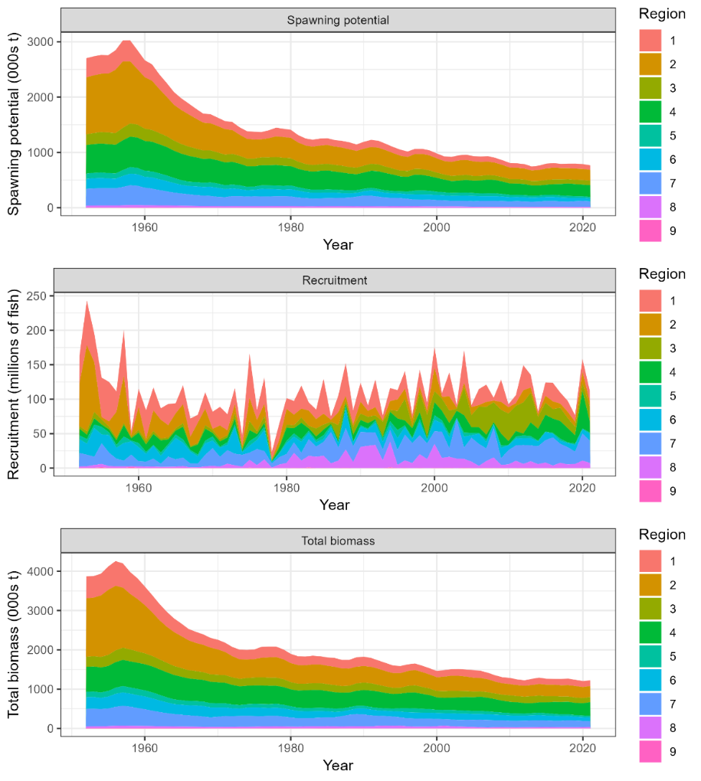
Figure BET-04. Time series of estimated annual spawning potential, recruitment and total biomass by model region for the diagnostic model, showing the relative proportions among regions. Note the data represent the averages of the quarterly model time steps for each year for spawning potential and total biomass and the sum of the quarterly recruitment estimates for annual recruitment (Figure 49 from SC19-SA-WP-05).
Figure BET-05. Estimated spawning depletion across all models in the structural uncertainty grid over the period 1952-2021. The lighter band shows the 25th and 75th percentiles, and the dark band shows the 10th and 90th percentiles of the model estimates. The bar at the right of each ribbon indicates the median (black dots) with the 10th and 90th percentiles for SB_{recent}/SB_{F=0} (Figure 63 from SC19-SA-WP-05).

Figure BET-06. Estimated annual average adult (solid line) and juvenile (dashed line) fishing mortality for the 2023 diagnostic model (Figure 54 from SC19-SA-WP-05).

Figure BET-07. Estimates of reduction in spawning potential due to fishing (fishery impact = (1-SB_{t}/SB_{t,F=0}) * 100%) by region, and over all regions (lower right panel), attributed to various fishery groups for the 2023 diagnostic model (Figure 70 from SC19-SA-WP-05).
Figure BET-08. History of the annual estimates of MSY (red line) for the diagnostic model compared with annual catch by the main gear types. Note that this is a ‘dynamic’ MSY (Figure 72 from SC19-SA-WP-05).
Figure BET-09 Estimated age specific fishing mortality for the diagnostic model, by region and overall (Figure 55 from SC19-SA-WP-05).
Figure BET-10. Majuro plot for the recent spawning potential (2018–2021) summarizing the results for each of the models in the structural uncertainty grid. The plots represent estimates of stock status in terms of spawning biomass depletion and fishing mortality. The yellow point is the 2023 diagnostic model and red point is the median (Figure 68 from SC19-SA-WP-05).

Figure BET-11. Kobe plot for the recent spawning potential (2018–2021) summarizing the results for each of the models in the structural uncertainty grid. The plots represent estimates of stock status in terms of spawning biomass depletion and fishing mortality. The yellow point is the 2023 diagnostic model and red point is the median (Figure 68 from SC19-SA-WP-05).

b. Management advice and implications

- The objective for bigeye tuna in CMM 2021-01 (the Tropical Tuna Measure) – to maintain the spawning biomass depletion ratio at or above the average SB/SB_{F=0} for 2012-2015 – is being achieved. SB_{recent}/SB_{F=0} (35%) is very close to the average SB/SB_{F=0} for 2012-2015 (34%) calculated across the unweighted grid.

- The WCPO bigeye tuna spawning biomass is above the biomass LRP, and F_{recent} is below F_{MSY} for all models in the uncertainty grid. The stock is very likely not experiencing overfishing (100% probability F_{recent}<F_{MSY}) and is not in an overfished condition (0% probability SB_{recent}/SB_{F=0}<LRP).

- SC19 also noted that average fishing mortality rates for juvenile and adult age-classes have increased throughout the period of the assessment (Figure BET-08), although more so for juveniles which have experienced considerably higher annual fishing mortality than adults (Figure BET-06). The purse-seine associated fishery has the most impact, with that of the miscellaneous and longline fisheries also being notable (Figure BET-07). Higher fishing mortality rates on juvenile bigeye tuna reduces the realized yield per recruit for the bigeye fishery.

- SC19 noted that levels of fishing mortality and depletion differ among regions, and that fishery impact was higher in the tropical regions (Regions 3, 4, 7 and 8 in the stock assessment model), with particularly high fishing mortality on juvenile bigeye tuna in these regions.

- There is also evidence that the overall stock status is buffered with biomass and low exploitation in the temperate region (1, 2, 6 and 9) and most of the predicted movement is within the equatorial region. Exchange rates between temperate and tropical regions are estimated to be low.

- SC19 noted that the reduction of fishing mortality on fisheries that take juveniles could increase bigeye fishery yields and reduce any further impacts on spawning biomass of this stock. SC19 also noted that this could require considering the impact on other fisheries and stocks.

- The interim objective of bigeye tuna stock under CMM 2021-01 is to maintain the depletion level of the stock at or above the average SB/SB_{F=0} for 2012-2015. The recent depletion level of bigeye tuna is close to this interim objective. SC19 noted that while the projection results based on the 2023 bigeye tuna assessment were not available for SC19 to review, this information will be available for the 4th tropical tuna management workshop and will provide the Commission guidance on future expected levels of fishing mortality and the outcomes relative to the interim or future management objectives.

c. Research Recommendations

- SC19 adopted several research recommendations for the further development and improvement of the WCPO bigeye tuna stock assessment, and suggested these be considered for potential inclusion in the Tuna Assessment Research Plan (TARP):
  - Continued collection of more representative biological data (e.g., age composition) and tagging data.
  - Develop additional CPUE index series testing key uncertainties about the analysis (e.g., regional vs. global model, classification of catchability vs. abundance covariates, etc.) and explore those as one-off sensitivities to the stock assessment.
  - Consideration of options to account for effort creep in CPUE standardization and/or the assessment model.
  - Simulation study to explore appropriate spatial structure of the stock assessment with a focus on simplifying the spatial structure (e.g., areas-as-fleets and/or 6 region structure) given the estimates of limited movement rates among regions.
  - Investigation of the 2023 model specifications with respect to the increase in unfished SSB overtime for the tropical regions (3, 4, 7 and 8).
  - Yield per recruit analyses comparing fishery sectors with different selectivity patterns.
  - Evaluation of the variability and plausibility of estimated growth and mortality-at-age relationship across the structural uncertainty grid.
  - Additional one-off sensitivities exploring key uncertainties in biological assumptions, model specification, and data inputs (e.g., tag mixing, data weighting, and growth).
  - Identification of key parameters that are either highly correlated or highly sensitive to the jittering procedure to inform possible changes in model specification with the aim to decrease model complexity and/or sensitivity to starting conditions.
  - Exploration of seasonal and regional growth traits for the stock assessment.
  - Comprehensive review of the representativeness of the size composition data given conflicts identified in the likelihood profiles.
  - Investigation of the 2023 model specifications that lead to the inversion of the effect of the weight vs. tagging data signal on the total biomass, as shown in the likelihood profile.
  - Further exploration of the advantages and disadvantages of strategies to decrease model sensitivity to starting conditions, including but not limited to multi-start approaches.
  - Pursue development of tag mixing diagnostics and approaches and investigate the impacts of tag mixing assumptions.

4.3.3 WCPO skipjack tuna (Katsuwonus pelamis)

4.3.3.1 Research and information

a. Indicator analysis

- S. Hare (SPC) presented SC19-SA-WP-06 (A compendium of fisheries indicators for target tuna stocks in the WCPFC Convention Area) providing empirical information on recent patterns in skipjack fisheries.

- Regarding the long-term decline in pole and line CPUE in recent years, Australia raised a question about the potential mechanisms driving this reduction, noting that pole and lining seemed to have almost disappeared from the equatorial regions and wondered if that was the explanation. SPC said it could just be because the vessels are no longer ranging far enough afield to access the good spots. It wasn’t clear if the CPUE decline was a matter of contraction or simply not being able to choose the best grounds and staying closer to home.

- Indonesia referred to the slide showing nominal CPUE indices for skipjack in the purse-seine fishery and asked if there was any information on standardising the CPUE. And would the assessment use both purse-seine and pole and line CPUE indices. They noted that the trend in both indices was similar in the 1970s but diverged later. Was this perhaps due to a change in fishing strategy or stock status?

- SPC noted that they used a CPUE standardisation procedure for the full triennial assessment covering around 20 fisheries. This annual indicator analysis used just a nominal CPUE, picking 4 fisheries with a long time-series across broad areas. Regarding the Pole and Line fishery CPUE, he noted that there was as yet no definitive answer to the reasons for the relative stability in CPUE from the 1970s-2000 and the slow decay since then. As had been suggested, there could be a number of factors in play, and this needed to be examined more closely in the next skipjack assessment.

- SC19 thanked the SSP for conducting an indicator analysis providing empirical information on recent patterns in skipjack fisheries.

b. Update of skipjack tuna stock assessment information

- C. Castillo-Jordan presented SC19-SA-WP-07 (Follow up work on 2022 skipjack assessment recommendations) on behalf of SPC, noting there was concern about several aspects of the 2022 assessment. Certain aspects were identified for further investigation before the next assessment. This kind of follow-up was more common nowadays because SPC has more staff than previously, at least for the immediate future.

- The presenter described the follow-up work on the diagnostic model of the 2022 skipjack tuna stock assessment in the western and central Pacific Ocean conducted using the MULTIFAN-CL stock assessment software. This paper was part of ongoing work in response to issues and recommendations raised by the SC18 on the 2022 skipjack assessment. A central concern that was raised by the SC18 was that the 2022 assessment diagnostic model may not have converged to a global minimum and did not have a positive definite Hessian solution. While this is one of several areas requiring follow-up work, it was desirable to explore options to satisfy this important convergence diagnostic before moving on to the other aspects of the follow work. The work described in this paper was primarily focused on the changes made to the modelling procedures for the 2022 diagnostic model that successfully achieved a positive definite Hessian solution.

- The changes to the model resulted in a reduction of estimable model parameters, from 2253 for the 2022 diagnostic model to 2122 for the 2023 follow-up model, which could improve the model’s efficiency. Compared to the original 2022 diagnostic model, the 2023 follow-up model with positive definite Hessian displays very minor differences in stock status estimates or other reference point values. It is therefore expected that applying this model in the 2022 stock assessment would not have resulted in any notable differences in stock status or altered management advice. Statistical uncertainty for management quantities from the diagnostic case model has now been estimated.

- Overall, the results of the 2023 follow-up model were positive and have improved the model’s stability and reliability. The improved diagnostic model will now be used to continue exploring other concerns and recommendations arising from the 2022 skipjack assessment. As this additional work is conducted it will be important to continue to run the Hessian diagnostic to check that any changes do not compromise achieving a positive definite Hessian. It is expected the additional follow-up work will be reported at SC20 and provide the major steps towards a new diagnostic model for the 2025 assessment. This will hopefully lead to a more efficient workflow and delivery of the 2025 skipjack assessment.
Comparison of reference points for the 2022 diagnostic model and the 2023 follow-up model
Reference  point | 2022 diagnostic |  | 2023  follow-up | Ratio  2023/2022
C_{latest} | 1,530,207 |  | 1,530,207 | 1
MSY | 2,416,000 |  | 2,382,400 | 0.986
Y_{fcurrent} | 440,600 |  | 440,300 | 0.999
F_{mult} | 2.861 |  | 2.761 | 0.965
F_{MSY} | 0.244 |  | 0.243 | 0.995
F_{recent}/F_{MSY} | 0.350 |  | 0.362 | 1.034
SB_{MSY} | 1,073,000 |  | 1,116,000 | 1.040
SB₀ | 5,686,000 |  | 5,742,000 | 1.009
SB_{MSY}/SB₀ | 0.189 |  | 0.194 | 1.026
SB_{F=0} | 6,147,340 |  | 6,294,480 | 1.023
SB_{MSY}/SB_{F=0} | 0.175 |  | 0.177 | 1.011
SB_{latest}/SB₀ | 0.479 |  | 0.482 | 1.006
SB_{latest}/SB_{F=0} | 0.443 |  | 0.440 | 0.993
SB_{latest}/SB_{MSY} | 2.539 |  | 2.480 | 0.976
*SB_{recent}/SB_{F=0} | 0.503 |  | 0.509 | 1.011
SB_{recent}/SB_{MSY} | 2.880 |  | 2.869 | 0.996
*2023 follow-up with positive definite Hessian: 95% confidence interval SB_{recent}/SB_{F=0} = 0.490 – 0.528

Discussion

- Japan appreciated the effort that had gone into this work. Achieving a convergence of the model was an important step for the next skipjack assessment. They made two suggestions. One was for jitter analysis to check whether the convergence falls on a local minimum. The other was setting a thermal limit for recruitment distribution. In this analysis, SPC considered the thermal limit for CPUE analysis, and the same logic could be applied to the recruitment distribution. In particular, Japan saw high recruitment in region 2 in quarter 1, but these areas were not suitable habitats for either adult or recruits because these areas were less than 18° C. As the available information on recruitment is limited, these kinds of biological information can be useful to inform the model of the recruitment.

- Palau, on behalf of FFA members noted the updates provided by the SSP and thanked them for their efforts. They noted the follow-up work and achievements made to improve the diagnostic model for the WCPO skipjack assessment, and while it had negligible effect on the stock status and management advice, they appreciated the improved stability and efficiency for future assessments.

- Australia wanted to thank Claudio and SPC for performing and reporting back to SC on these new analyses for the 2022 skipjack assessment. They were valuable additions to the stock assessment process, and they hoped that such follow-up analyses will continue to be supported in the future. They also appreciated the detailed technical descriptions of the stepwise changes, including the MULTIFAN flag settings. Australia had one comment and three questions.

- Apart from the use of the updated version of MULTIFAN, four main changes were made to the 2022 assessment model. While each of these changes may not be considered to be substantial on their own, it is interesting to note that many of the estimated parameters (for example, natural mortality and selectivity) show substantial changes between the 2022 and 2023 versions. They also noted the success achieved in improving convergence diagnostics for the skipjack assessment, notably the obtention of a positive definite Hessian.

- The first question was whether SPC had been able to identify the stepwise change at which the Hessian became Positive Definite?

- SPC replied that they would need to provide the detail later on this, but they obtained the positive definite Hessian just when they did the changing of the initial conditions.

- The second question from Australia was, given issues noted with the bigeye and yellowfin assessments whereby models with positive definite Hessian did not ultimately show to be stable when jittered, was SPC able to jitter the final model and if so, could they share what the initial results where? If jittering was not applied, Australia would suggest the addition of this diagnostic before the next phase of model exploration as demonstrating or improving stability in a model with possible over-parameterisation and/or possible parameter confounding should remain a priority.

- SPC replied that for this follow up work, they didn't jitter the model and not sure if people remember that last year jittering the skipjack model was scaling up and down the potential biomass, but the depletion and the final point didn't change across all the jittering models that were run. So, SPC was confident that this is happening again.

- Finally, Australia asked if SPC could elaborate on what might be driving the difference in the mortality-at-age estimated between the 2022 and 2023 versions. Again, this work was appreciated, and Australia looked forward to seeing the results of future exploration of this important stock assessment.

- SPC thought that the pattern of the natural mortality is the flexibility of the blind natural mortality that are being used, and the model is trying to adjust to the data available at the moment. Also, it needs to be considered that this affects the death. The funny pattern is according after age 9. So maybe it's not affecting the model much, but also something that needs to keep exploring.

- The USA thanked and commended SPC for finding the resources to begin looking into and addressing the issues raised by SC18. This was an example of how the scientific review process should work for assessments, with continued dialogue between the assessment team and SC in the intervening years between assessments in order to address concerns and lay the groundwork for the subsequent assessment. They would encourage that this become standard practice for assessments not developed as a part of working groups, and that this workflow and additional resources required be considered in discussions of SC19-SA-WP-14 and ISG-02. On a more technical note, the USA appreciated SPC’s efforts to achieve a positive definite Hessian solution and noted that the new model had negligible impacts on management quantities. However, they did note that there still appear to be issues with fitting to the length composition data, and estimation of tag reporting rates. They encouraged the authors to keep investigating these issues and to explore alternative spatial structures as possible solutions. They looked forward to continuing this dialogue on these and other issues over the coming year and again at SC20. Lastly, the USA suggested that the model fits be presented for all “exploratory” models rather than just the initial and terminal models.

- SPC noted that having some excellent additional scientists available this time helped SPC to do this work, but that SPC was essentially subsiding WCPFC-commissioned work at the moment and that this may not be sustainable unless put on a more formal footing. He looked forward to discussing this later in the small working group.

- Papua New Guinea, on behalf of PNA and Tokelau, thanked Claudio and the team at SPC for this important work. They noted the results of SPC’s work to find a solution to the issues highlighted in the paper around some of the technical elements of the 2022 skipjack stock assessment model. They also took note of the information in the paper that applying this technical solution to the 2022 stock assessment would not have resulted in any notable differences in stock status or altered the information available to managers.

- Japan made some general comments, appreciating this kind of improvement of stock assessments, and noted that it was fortunate that the improved model showed similar results. As explained by USA, it is the ideal standard process to have a final assessment model that provides confidence in the results of the assessment. There is a logistical issue of course when each run takes a day to converge, and this makes it hard to improve the model during the meeting itself. In some other assessment meetings, they can discuss improvements and run them during the meeting.

- Indonesia thanked the presenter. They understood that skipjack stock assessment is complex and challenging, and noted the improvements in the model to better explain the situation of skipjack in WCPO. It is quite challenging for us to follow the process of stock assessment and to understand the process for stock assessment to explain to our stakeholders and managers in ID. Would like to have further communication and interaction with SPC to improve the understanding. The WPEA project gives us more understanding, but there are some new aspects here which need greater interaction.

- SC19 thanked the SSP for their efforts on improving the skipjack diagnostic model and achieving a positive definite Hessian. The follow up work on the model provides a sound basis for future assessments.

- SC19 noted the results of SPC’s work investigating technical issues highlighted by SC18 regarding the 2022 skipjack diagnostic model.

- SC19 noted that the resulting updates to the diagnostic model for the WCPO skipjack assessment had negligible effect on the stock status and management advice from 2022.

- SC19 emphasized that while the updates had not resulted in changes to stock status, some estimated quantities differed between the 2022 and 2023 version, most notably the growth curve, the mortality-at-age and the selectivity-at-age, noting these relationships are interrelated. SC19 encouraged further investigation to understand these changes.

- SC19 noted that this process for allowing staff resources to conduct follow-up is a useful one that could be conducted for other WCPFC assessments, with continued dialogue between the SSP assessment team and SC in the intervening years between assessments to address concerns and lay the groundwork for the subsequent assessment. The SSP noted that this was possible this year because staff resources were available. This is not the case every year due to changes in experience and availability of staff resources. Follow-up work suggested by SC should be prioritised under the TARP process.

- SC19 encouraged that this follow-up work process become standard practice for WCPO tuna stock assessments. Noting that follow-up work is subject to available staff resources and should be prioritised as part of the TARP process.

- SC19 noted the following issues for further improvements:
- Improve fits to the length composition data.
- Estimation of tag reporting rates.
- Alternative spatial structure.
- Unrealistic recruitment estimates particularly in temperate regions.
- Model jittering diagnostic to confirm convergence stability.

4.3.4 South Pacific albacore tuna (Thunnus alalunga)

Research and information

a. Indicator analysis

- S. Hare (SPC-OFP) presented SC19-SA-WP-06 (A compendium of fisheries indicators for target tuna stocks in the WCPFC Convention Area). He noted that some of the information contained in the supplementary information paper SC19-SA-IP-04 (“Trends in the South Pacific albacore longline and troll fisheries”) was also included in the presentation.

Discussion

- Samoa, on behalf of SPG CCMs, thanked SPC for the updated analysis. They noted that South Pacific albacore catch in the WCPFC-CA was 68,975t in 2022, a 39% increase from 2021 and a 4% increase from the 2017-2021 average [SC19-SA-WP-06, Figure 9]. They were also happy that the 2022 combined mean SP-ALB CPUE increased 47% from 2021, as the economic viability of this fishery was critical to their countries [SC19-SA-WP-06 Figure 10]. They asked that the SC keep these current catch levels in mind when later discussing the South Pacific albacore TRP under Agenda Item 5.1.2.

Figure 9. South Pacific albacore tuna catch (mt) by gear type and year for the WCPFC-Convention Area south of the equator. Note: ‘Other’ gear here is primarily troll gear, but includes driftnet catches in the 1980s and early 1990s. (Source: SC19-SA-WP-06)

Figure 10. South Pacific albacore tuna catch per unit effort in the southern WCPFC-CA (south of 10oS) by year for major longline fleets. Figure 10: South Pacific albacore tuna catch per unit effort in the southern WCPFC-CA (south of 10oS) by year for major longline fleets. (Source: SC19-SA-WP-06)

- The USA asked SPC about some apparent inconsistencies between Figure 16 from this indicators paper and Figure 2 in SC19-MI-WP-06. Both these are based heavily on 2021 assessment grid and use the observed catch data 2020-2022 so should be similar, but the projections in the indicator were considerably more pessimistic with significant risk of breaching the LRP, and USA wondered if SPC could comment.

- SPC noted that would need to look into it and get back to the USA with an explanation.

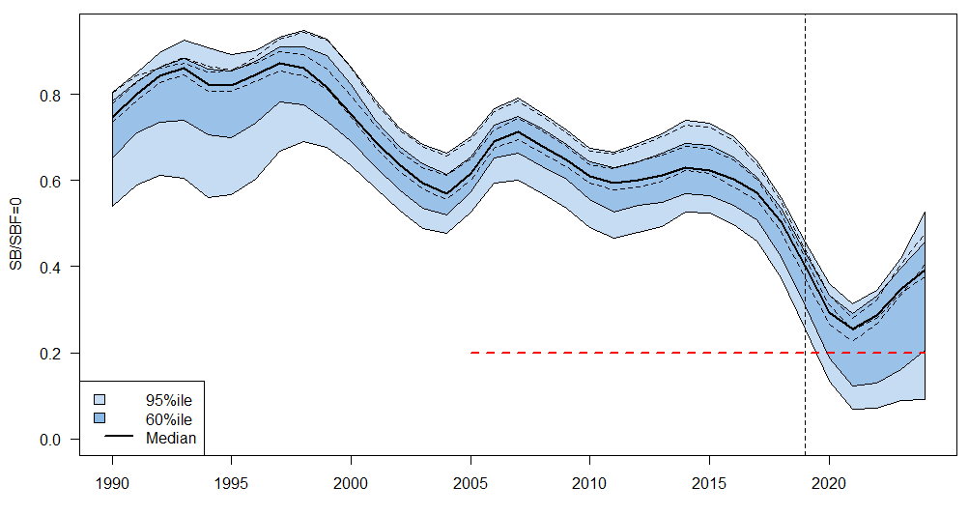
Figure 16. Stochastic projection results of South Pacific albacore tuna spawning biomass (SB/SBF=0) from 2019 using actual catch and effort levels between 2020 and 2022 and then through to 2024 assuming 2022 levels continued. Prior to 2020 the data represent the 60th and 95th percentiles of the uncertainty grid from the assessment models and the median. Levels of recruitment variability estimated for the period used to estimate the stock-recruitment relationship (1960-2017) are assumed to continue in the future. Projections are from the model runs of Castillo-Jordan et al., 2021, and are projected on the basis of albacore catch. The dashed lines indicate three example trajectories (chosen randomly out of 7200) from the model grid. The red dashed line represents the WCPFC agreed limit reference point (0.20). (Source: SC19-SA-WP-06)

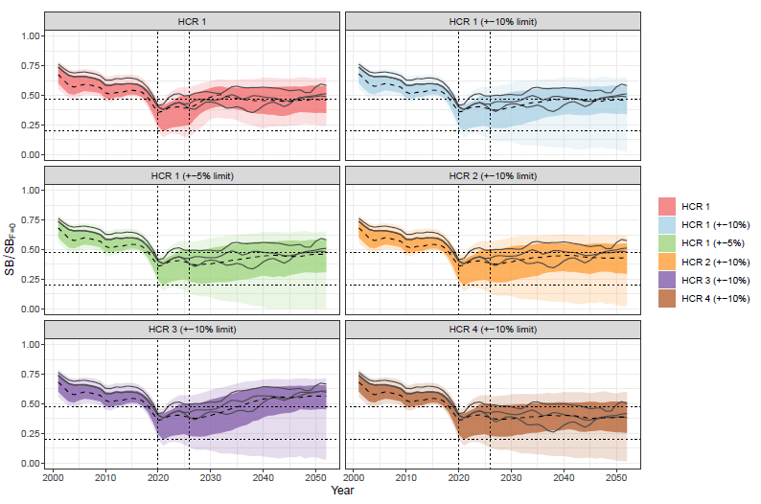
Figure 2. Time series of expected SB/SBF=0 in the WCPFC_CA for each HCR. The outer ribbon shows the 80th percentile range, the inner ribbon shows the 50th percentile range. The median is shown as a dashed line. The vertical lines show the start of the projection period (2020) and the first year the management procedure is called (2026). Horizontal dashed lines show the Limit Reference Point (0.2) and the median of the 2017-2019 SB/SBF=0 average. Several individual trajectories are shown for illustration. Only values from 2000 onwards are shown. (Source: SC19-MI-WP-06)

- SC19 thanked the SSP for the indicator analysis providing empirical information on recent patterns of South Pacific albacore fisheries.

- SC19 noted that the South Pacific albacore catch in the WCPFC-CA was 68,975t in 2022, a 39% increase from 2021 and a 4% increase from the 2017-2021 average.

- Some CCMs recommended keeping the current catch levels in mind when discussing the South Pacific albacore TRP.

- SC19 recommended that the 2024 assessment of South Pacific albacore be South Pacific-wide. Noting the need to provide management advice specifically for the WCPFC-CA and the ongoing developments relating to the Harvest Strategy process, if a fleets-as-areas approach is considered for the 2024 assessment, SC19 recommends retaining a separate area for the IATTC. SC19 noted that a WCFPC-CA only model might also be considered as a one-off sensitivity analysis. If results from the one-off sensitivity analysis for the WCPFC-CA-only model are different from the WCPFC-CA results from the Pacific-wide model, additional analyses should be conducted with a view to understanding which spatial structure is more reliable when considering future assessment development.

Northern stocks

- The Chair of the ISC J. Holmes presented the outcomes of the ISC23 plenary meeting held in Kanazawa, Japan, during 12-17 July 2023.

- Australia appreciated and welcomed the ISCs progress on a process for independent review of stock assessments, climate considerations and the use of ensemble modelling approaches to represent uncertainty, all of which are very important issues. Australia made a comment regarding NP albacore and the use of the specified target reference point (F45%SPR) to define the fishing mortality (or overfishing) status of this stock. It noted that the stated objective is to maintain F at or below the F45%SPR target level with a 50% probability. So, if this objective was to be met, then fishing mortality would fluctuate around this level half the time above and half the time below. However, if the “overfishing” status is also determined using this target reference point, then it follows that the stock would be “subject to overfishing” half the time as well. This is the problem of using a target to define status rather than the more usual practice of using limits to define status. Therefore, it seems that overfishing status would be better defined relative to the specified threshold or limit biomass (which are 30% and 14% of the current, dynamic SSB under zero fishing). More specifically, the fishing mortality that would result in these biomass levels and asked any comment on this.

- The presenter noted that the Australian point was understood but could not be answered at this point since he was not involved in discussions around reference points. Australia said they would bring this up when SC19 gets to the NP albacore assessment.

4.4.1 North Pacific albacore (Thunnus alalunga)

4.4.1.1 Research and Information

a. North Pacific albacore stock assessment

- S. Teo (ISC) presented SC19-SA-WP-08 (Stock assessment of albacore tuna in the North Pacific Ocean) conducted by ISC’s Albacore Working Group (ISC ALBWG) in 2023, which detailed the data, biological parameters, model, model diagnostics and sensitivities, and results of the North Pacific albacore stock assessment, including stock status, future projections, conservation information, key uncertainties and criteria for identifying exceptional circumstances.

Discussion

- Cook Islands, on behalf of FFA members, thanked the ISC for the benchmark North Pacific albacore tuna assessment and noted that the stock was not overfished nor experiencing overfishing relative to the reference points adopted by the WCPFC and IATTC in their respective North Pacific albacore harvest strategies. Furthermore, they noted that projections showed that if fishing intensity was maintained at 2018-2020 levels or is similar to the 2005-19 period over the next ten years, there would be a greater than 97.9% probability that the female spawning stock biomass would remain above the LRP for all 10 years, and the management objectives of the WCPFC and IATTC harvest strategies would likely be met. FFA members noted that the assessment used data from 1994 to 2021, leaving out significant amounts of data from the early years of the fishery. They believed that these data would be informative in getting estimates of initial biomass. As with the previous assessment, they suggested trying to find ways to incorporate these data and wondered if any progress had been made in those endeavours? FFA members supported the revisions made by the Northern Committee to better define the harvest control rule in the interim WCPFC North Pacific albacore harvest strategy and improve its monitoring strategy. As these revisions significantly improved the ability of this harvest strategy to achieve its objectives, they supported the recommendation made by NC19 for the Commission to review and possibly adopt this revised harvest strategy.

- The USA was concerned that the COVID impacts on observer data had resulted in an unprecedentedly low amount of information going into last 2 years and wondered how the WG would cope with this. The presenter responded that the ISC WG was planning to update this data every year and provide the update to ISC plenary.

- SPC had two questions following from the Cook Islands:
  - It sounds like you had problems fitting CPUE and size data before 1994 and so it was excluded. What reassurance can you give that model gives an adequate description of life history?
  - How equilibrium assumptions hold up given the massive removal of small albacore by driftnet fisheries in late 1980s and early 1990s?

- The presenter agreed that there were problems before 1994. The main issue was the size-function data which had suggested that growth might have changed, and there were no growth data from before that period. So, the data were down-weighted from before that date. The biggest problem was with catch data – there was a lot of removals from high seas driftnet fishery particularly the squid fishery, which were not landed. Perhaps 20-30,000 tonnes per year as bycatch during that period. But there is no good estimate and the WG is now getting a group together who had worked on the gillnet fishery data to develop better estimate of removals during that period. On the SPC second question, their confidence in current stock status in absence of information about the earlier period is based on looking at the performance of the model diagnostics, particularly the age structure production diagnostics. They also try to do hindcasting, as shown in the paper, and all the diagnostics suggested the model is performing well. It’s not as good as three years ago because of the much poorer data in the COVID period. They are trying to let the initialisation part of the model be as free as possible to allow it to fit the data during the first 5-10 years of the data and not forcing it to fit the equilibrium catch.

- The Philippines suggested that additional to the eleven recommendations on page 57, they need to further investigate steepness as it relates to recruitment. Sect 5.22 on page 50 suggests this be treated with caution. Page 38 suggests further work is needed here. This recruitment is very crucial in the model estimates. The presenter agreed that steepness is always uncertain and noted that sensitivity analyses on this was conducted. The assessment generally tended not to be too sensitive to steepness because it was on the flatter part of the curve.

- Australia noted that this point was made at ISC as well – the use of 45%FSPR TRP. If this reference point is also used to determine fishing status it means the stock will be subject to overfishing 50% of the time. We’d normally use the LRP rather than the TRP to define stock status in terms of overfishing or being overfished. The presenter said that they tried to provide information relative to all reference points. It’s not quite usual practice, so overfishing information was provided relative to last 3 years of TRP and also relative to TRP over last 10 years.

- SC19 thanked ISC ALBWG for their work conducted on the albacore tuna stock assessment in the North Pacific Ocean.

4.4.1.2 Provision of scientific information

a. Stock status and trends

- SC19 noted that the ISC provided the following conclusions on the stock status of North Pacific albacore:
- Estimated summary biomass (males and females at age-1+) declined at the beginning of the time series until 2004 (Figure NPALB-1A). Subsequently, the summary biomass fluctuated without a trend until 2018, after which the biomass rapidly increased to historically high levels. It should be noted that the high summary biomass estimates during 2018 – 2021 were highly uncertain and should be treated with caution (Figure NPALB-1A). These high summary biomass estimates were due to historically high recruitment estimates in 2017 (~433 million fish; 95% CI: 194 – 671 million fish) (Figure NPALB-1C). However, it should be noted that the recruitment estimates in the last 5 years (2017- 2021) were highly uncertain and should be treated with caution. Estimated female SSB exhibited a similar population trend to the summary biomass, albeit with a lag of several years, and showed an initial decline until 2007 followed by fluctuations without a clear trend through 2021 (Figure NPALB-1B).
- The average fishing intensity during 2018 – 2020 was estimated to be F59_{%SPR} (95% CI: F72_{%SPR} – F46_{%SPR}), which was relatively moderate and resulted in a population with an SPR of approximately 59%. Instantaneous fishing mortality at age (F-at-age) was similar in both sexes through age-5, peaking at age-4 and declining to a low at age-6, after which males experienced higher F-at-age than females up to age 12 (Figure NPALB-2). Juvenile albacore aged 2 to 4 years comprised approximately 64% of the annual catch-at-age in numbers between 1994 and 2021 (Figure NPALB-3) due to the larger fishery impact of surface fisheries (primarily troll, pole-and-line), which remove juvenile fish, relative to longline fisheries, which primarily remove adult fish (Figure NPALB-4).
- Stock status is depicted in relation to the target (F45_{%SPR},), threshold (30%SSB_{current, F=0}), and limit (14%SSB_{current, F=0}) reference points (Figure NPALB-5A; Table NPALB-1). The estimated female SSB has never fallen below the threshold and LRPs since 1994, albeit with large uncertainty in the terminal year (2021) estimates. However, the estimated fishing intensity for five years (1999, 2002, 2003, 2004, and 2007) have exceeded the target reference point. Even when alternative hypotheses about key model uncertainties such as growth were evaluated, the point estimate of female SSB in 2021 (SSB₂₀₂₁) did not fall below the threshold and LRPs, although the risk increases with this more extreme assumption (Figure NPALB-5B). However, estimated average fishing intensity during 2018-2020 (F₂₀₁₈₋₂₀₂₀) did exceed the target reference point under one of these alternative hypotheses but did not exceed the average fishing intensity during 2002 – 2004 (Figure NPALB-5B; Table NPALB-1).
- The SSB₂₀₂₁ was estimated to be approximately 54% (95% CI: 40 – 68%) of SSB_{current, F=0} and 1.8 (95% CI: 1.3 – 2.3) times greater than the estimated threshold reference point (Figure NPALB-6A and Table NPALB-1). The estimated current fishing intensity (F₂₀₁₈₋₂₀₂₀) was estimated to be F59_{%SPR} (95% CI: F72_{%SPR} – F46_{%SPR}) and was lower than both the F45_{%SPR} target reference point and the average fishing intensity during 2002 – 2004 (Figure NPALB-6B and Table NPALB-1).

- SC19 noted the following stock status from ISC:
- The stock is likely not overfished relative to the threshold (30%SSB_{current, F=0}) and limit (14%SSB_{current, F=0}) reference points adopted by the WCPFC and IATTC, and
- The stock is likely not experiencing overfishing relative to the adopted target reference point (F45_{%SPR}).
- Current fishing intensity (F2018-2020) is lower than the fishing intensity from the 2002-2004 period (the reference level for IATTC Resolution C-05-02 and WCPFC CMM-2019-03).

b. Management advice and implications

- SC19 noted the following conservation information from ISC:
- Two harvest scenarios were projected to evaluate impacts on the management objectives of IATTC and WCPFC for this stock: 1) maintain SSB above the LRP, with a probability of at least 80% over the next 10 years; 2) maintain depletion of total biomass around historical (2006—2015) average depletion over the next 10 years; and 3) maintain fishing intensity at or below the target reference point with a probability of at least 50% over the next 10 years (WCPFC HS 2022-01; IATTC Resolution C-22-04).
- The constant fishing intensity scenario showed that the current fishing intensity (F₂₀₁₈₋₂₀₂₀) is expected to result in female SSB increasing to 90,098 t (95% CI: 23,218—156,978t) and an SSB/SSB_{current,F=0} ratio of 0.54 by 2031. Over the next 10 years, there was: 1) a 97.7% probability of the female SSB remaining above the 14%SSB_{current, F=0} LRP for all 10 years; 2) a 72.0% probability of the total biomass (age-1+) being above the average of 2006 – 2015 for any year; and 3) a 95.5% probability of the fishing intensity remaining at or below the F45_{%SPR} TRP for any year (Figure NPALB-7).
- The randomly resampled fishing intensity scenario showed that if future fishing intensity is similar to the 2005 – 2019 period, it is expected to result in female SSB increasing to 87,669 t (95% CI: 22,219 – 153,119 t) and an SSB/SSB_{current, F=0} ratio of 0.52 by 2031. Over the next 10 years, there was: 1) a 98.1 % probability of the female SSB remaining above the 14%SSB_{current, F=0} LRP for all 10 years; 2) a 69.5 % probability of the total biomass (age-1+) being above the average of 2006 – 2015 for any year; and 3) a 79.6 % probability of the fishing intensity remaining at or below the F45_{%SPR} TRP for any year (Figure NPALB-8)

- Based on these findings, the following conservation information was provided by ISC:
- If fishing intensity over the next ten years is maintained at the current fishing intensity (F₂₀₁₈₋₂₀₂₀), then female SSB is expected to remain around 54%SSB_{current, F=0} (90,098 t), with a 97.7% probability of the female SSB remaining above the 14% SSB_{current, F=0} LRP for all ten years, and the management objectives of IATTC and WCPFC will likely be met.
- If fishing intensity over the next ten years is similar to the 2005-2019 period, then female SSB is expected to decrease to 52%SSBc_{urrent, F=0} (87,669 t), with a 98.1% probability of the female SSB remaining above the 14% SSB_{current, F=0} LRP for all ten years, and the management objectives of IATTC and WCPFC will likely be met.

Table NPALB-1. Estimates of maximum sustainable yield (MSY), female spawning stock biomass (SSB), fishing intensity (F), and reference point ratios for north Pacific albacore tuna for: 1) the base case model; 2) two important sensitivity models due to uncertainty in growth parameters; and 3) a model representing an update of the 2020 base case model to 2023 data. SSB0, SSB_{current}, _{F=0} and SSB_{MSY} are the expected female SSB of a population in the equilibrium, unfished state; in the current, dynamic, unfished state; and at MSY, respectively. The Fs in this table are indicators of fishing intensity based on spawning potential ratio (SPR) and calculated as %SPR. SPR is the ratio of the equilibrium SSB per recruit that would result from the estimated F-at-age relative to that of an unfished population. Depletion is calculated as the proportion of the age-1+ biomass during the specified period relative to an unfished age-1+ equilibrium biomass. The model representing an update of the 2020 base case model is similar to but not identical to the 2020 base case model due to changes in data preparation and model structure.
* Model may not have converged, and uncertainty estimates were unreliable because of the lack of a positive, definite Hessian matrix.
† A value of >1 for the depletion ratio indicates higher age-1+ biomass in 2021 relative to the 2006 –2015 period.
§ Higher %SPR values indicate lower fishing intensity levels.
¶ Values of >1 for ratios of F_{%SPR} to F_{%SPR}-based reference points indicate fishing intensity levels lower than the reference points.
Quantity | Base Case | Growth  CV = 0.06 for L_{inf} | Growth  All parameters estimated | Update of 2020 base case model to 2023 data*
MSY (t) | 121,880 | 93,167 | 144,792 | 97,777
SSB_{MSY} (t) | 23,154 | 18,133 | 30,435 | 18,756
SSB₀ (t) | 165,567 | 128,155 | 198,913 | 132,570
SSB_{current, F=0} (2021 estimate) | 129,581 | 97,368 | 155,542 | 93,808
SSB₂₀₂₁/SSB_{current, F=0} | 0.54 | 0.36 | 0.65 | 0.39
SSB₂₀₂₁/30%SSB_{current, F=0} | 1.81 | 1.21 | 2.17 | 1.31
SSB₂₀₂₁/14%SSB_{current, F=0} | 3.87 | 2.6 | 4.65 | 2.81
†Depletion₂₀₂₁/Depletion₂₀₀₆₋₂₀₁₅ | 1.34 | 1.33 | 1.37 | 1.3
§ F_{%SPR, 2018-2020} (%SPR) | 59.0 | 41.4 | 70.4 | 43.2
§ F_{%SPR, 2011-2020} (%SPR) | 55.0 | 36.6 | 63.8 | 37.9
¶ F_{%SPR, 2018-2020}/F_{%SPR, MSY} | 2.04 | 1.42 | 2.78 | 1.47
¶ F_{%SPR, 2011-2020}/F45_{%SPR} | 1.22 | 0.81 | 1.42 | 0.84
¶ F_{%SPR, 2018-2020}/F45_{%SPR} | 1.31 | 0.92 | 1.56 | 0.96
¶ F_{%SPR, 2018-2020}/F_{%SPR, 2002-2004} | 1.48 | 1.63 | 1.40 | 1.25

Figure NPALB-1. Maximum likelihood estimates of (A) age-1+ biomass (B), female spawning biomass (SSB), and (C) age-0 recruitment of north Pacific albacore tuna (Thunnus alalunga). Dashed lines (A and B) and vertical bars (C) indicate 95% confidence intervals. Closed black circle and error bars in (B) and (C) are the maximum likelihood estimate and 95% confidence intervals of unfished female spawning biomass, SSB0, and unfished recruitment, respectively, at equilibrium (Figure ES3 from SC19-SA-WP-08).

Figure NPALB-2. Estimated sex-specific instantaneous fishing mortality-at-age (F-at-age) for the 2023 base case model, averaged across 2018-2020 (Figure ES4 from SC19-SA-WP-08).

Figure NPALB-3. Historical catch-at-age of north Pacific albacore (Thunnus alalunga) estimated by the 2023 base case model (Figure ES5 from SC19-SA-WP-08).

Figure NPALB-4. Fishery impact analysis on north Pacific albacore (Thunnus alalunga) showing female spawning biomass (SSB) (red) estimated by the 2023 base case model as a percentage of dynamic, unfished female SSB (SSB_{current, F=0}). Colored areas show the relative proportion of fishing impact attributed to longline (green) and surface (blue) fisheries (primarily troll and pole-and-line gear but including all other gears except longline) (Figure ES6 from SC19-SA-WP-08).

Figure NPALB-5. Stock status phase plot showing the status of the north Pacific albacore (Thunnus alalunga) stock relative to the biomass-based threshold (30%SSB_{current, F=0}) and limit (14%SSB_{current, F=0}) reference points, and fishing intensity-based target reference point (F45_{%SPR}) over the modeling period (1994 – 2021). Blue triangle indicates the start year (1994) and black circle with 95% confidence intervals indicates the terminal year (2021). (B) Stock status plot showing current stock status and 95% confidence intervals of the base case model (black circle), an important sensitivity run of CV = 0.06 for Linf in the growth model (gray square), an important sensitivity run with an estimated growth model (purple triangle), and a model representing an update of the 2020 base case model to 2023 data (red diamond). 95% confidence intervals are not shown for the update of the 2020 base case model (red diamond) because the model did not have a positive definite Hessian matrix and uncertainty estimates were unreliable. Red zones in both panels indicate female SSBs falling below the limit reference point while the orange zones indicate female SSBs between the threshold and limit reference points. Green zones indicate female SSBs above the threshold reference point and fishing intensity levels below the target reference point. Yellow areas indicate female SSBs above the threshold reference point and fishing intensity levels above the target reference point. The Fs in this figure are indicators of fishing intensity based on spawning potential ratio (SPR) and calculated as %SPR. SPR is the ratio of the equilibrium SSB per recruit that would result from the estimated F-at-age relative to that of an unfished population. A higher %SPR indicates lower fishing intensity. Current fishing intensity values and SSB/SSB_{current,F=0} ratios in (B) were calculated as the average during 2018- 2020 (F_{%SPR}, 2018-2020) and 2021 (SSB2021/SSB_{current, F=0}), respectively. The model representing an update of the 2020 base case model is similar to but not identical to the 2020 base case model due to changes in data preparation and model structure (Figure ES7 from SC19-SA-WP-08).

Figure NPALB-6. (A) Estimated dynamic biomass ratio (SSB/SSB_{current, F=0}) of north Pacific albacore relative to biomass-based threshold (30%SSB_{current, F=0}) (orange dotted line) and limit (14%SSB_{current, F=0}) reference points (red dashed line) over the modeling period (1994 – 2021); and (B) estimated fishing intensity relative to the fishing intensity-based target reference point (F45_{%SPR}) over the modeling period (1994 – 2021). Light and dark gray areas indicate 95% and 60% confidence intervals respectively. The limit reference point is considered to be breached if the lower bound of the 60% confidence intervals overlaps the limit reference point (Figure ES8 from SC19-SA-WP-08).

Figure NPALB-7. Future projection results under a constant fishing intensity (F₂₀₁₈₋₂₀₂₀) harvest scenario. Solid lines indicate mean values, uncertainty ranges indicate 60% and 95% confidence intervals, and the dashed line is the reference point, respectively. (A) Annual changes in spawning biomass; (B) Interannual changes in fishing mortality (F_{%SPR}); (C) Projected ratios to the limit reference point thresholds; and (D) Projected ratios to management targets for the total biomass (Figure ES9 from SC19-SA-WP-08).

Figure NPALB-8. Future projection results under a randomly F (2005-2019) scenario. Solid lines indicate mean values, and uncertainty ranges indicate 60% and 95% confidence intervals, and the dashed line is the reference point, respectively. (A) Annual changes in spawning biomass; (B) Interannual changes in fishing mortality (F_{%SPR}); (C) Projected ratios to the limit reference point thresholds; and (D) Projected ratios to management targets for the total biomass (Figure ES10 from SC19-SA-WP-08).

4.4.2 Pacific bluefin tuna (Thunnus orientalis)

4.4.2.1 Research and Information

a. Update of Pacific bluefin tuna stock assessment information

- S. Nakatsuka (ISC) said the working group did not conduct an assessment this year but is planning a benchmark assessment next year. They will use MSE development on this, and testing grid with operating models somewhat resembling the yellowfin tuna peer review recommendations. They would bring this back next year.

Discussion

- The Cook Islands on behalf of FFA members noted that there was no new information available to consider at SC19 on the stock status and conservation information of the Pacific bluefin tuna stock. This made it hard to determine the merits of any proposals to amend the CMM for Pacific bluefin tuna, such as the one proposed by the Republic of Korea at NC19. As mentioned at NC19 an update from both ISC23 and SC19 would help in our understanding of the implications of this proposal. They did note, however, that the previous projection results show that increases in catches are possible without adversely affecting the attainment of the second rebuilding target. Given the stock assessment and projection results were based on certain assumptions, including those on future recruitment, that may not always be met, FFA members maintain that a precautionary approach will be needed for the second rebuilding target of 20%SSB_{F=0} to be met. They strongly cautioned against implementing catch limits that would keep the stock hovering just above the second rebuilding target, when the intent should be to ensure the stock continues to rebuild at a steady rate until such time as more refined management objectives, LRPs and target reference points are developed through the management strategy evaluation process.

- New Zealand as an FFA CCM reinforced these comments. And they wanted to make sure that there was an opportunity for all parties with an interest in Pacific Bluefin to be involved in the stock assessment and MP processes.

- FSM on behalf of PNA and Tokelau noted that some of the success in terms of recovery of the stock is a result of reducing the catch on juvenile fish, and that a new assessment will be presented next year, and suggested that the assessment paper explicitly include an analysis of the impact of changing the percentage of small tuna that can be counted against the catch of larger tuna as well as the impact of an increased catch limit. Until they saw this analysis it would not be possible to evaluate the impact of such a change to the CMM.

- Japan stated that from ISC perspective, appreciated interest from other members including NZ, and of course ISC had a process to involve other expertise in the assessment process. In response to comments from Cook Islands for FFA member regarding the updated management measure for the proportion of catch of large versus small fish, the PBFWG Chair stated that studies conducted in response to requests from WCPFC and IATTC have shown that, given the impact on the stock when large and small fish are each caught for the same weight, future projections are better if that catch is consumed by large fish, that the current recommendations are based on those results, and that results show a very high probability of future recruitment recovery being achieved.

- SC19 noted that no stock assessments were conducted for Pacific bluefin tuna in 2023 and no updated information was presented on the status of Pacific bluefin tuna. Therefore, the stock status descriptions from SC18 are still current for Pacific bluefin tuna.

- Concern was expressed that no scientific evaluation was provided to SC19 related to the increase in converting part of the small fish catch limit to the large fish catch limit in CMM 2021-02 as recommended by NC19. However, it was clarified that assessment results provided to SC18 showed that the projection under which part of the small fish catch limit was converted to the large fish catch limit using the current conversion factor provides benefit to stock recovery.

- It was noted that there are some WCPFC members, including New Zealand, who have a strong interest in PBF but are not involved in the ISC. And they encouraged the ISC to ensure that there are sufficient opportunities for all parties with an interest to be involved in the stock assessment and MP processes.

4.4.3 North Pacific swordfish (Xiphias gladius)

4.4.3.1 Research and Information

a. North Pacific swordfish stock assessment

- M. Sculley (ISC) presented SC19-SA-WP-09 (Stock assessment of swordfish in the North Pacific Ocean through 2021), which detailed the data, biological parameters, model, model diagnostics and sensitivities, and results of the North Pacific swordfish stock assessment conducted by ISC’s Billfish Working Group (ISC BILLWG) in 2023.

- The assessment included the biological information, catch, abundance index, and size composition data for 1975-2021. The results indicated that the population biomass fluctuated around an average of 83,000t during 1975-2021 and was estimated to be 88,755t in 2021. Estimated fishing mortality (F) showed a declining trend from the 1970s to the late-1990s, slightly increased again to the 2001, and then continued declining in 2018-2021. Fishing mortality has been below F_{MSY} for the entire assessment period. The stock status was based upon MSY reference points because there are no defined reference points. The recent average spawning biomass of 34,900 mt was almost 2.5 times greater than SSB_{MSY} and the current F (average for ages 1 – 10 during 2019-2021) was 49% above F_{MSY}. The base case model indicated that under current conditions the NP SWO stock was very likely not overfished (>99% probability) and was very likely not subject to overfishing (>99% probability) relative to MSY-based reference points.

Discussion

- Vanuatu spoke for all FFA members and thanked the ISC for the new North Pacific swordfish assessment and note that relative to these MSY-based reference points, overfishing is very likely not occurring and the stock is very likely not overfished. They also noted that the projected spawning stock biomass and catch is expected to increase under all harvest scenarios examined. This suggests that the steady decline in catches for this species in the North Pacific over the last 3-4 years is likely to be the result of the general decline in the longline catch in the areas where this species is usually taken. To help in the discussions on the results of WCPFC Project 113 in SC19-SA-WP-12, it is worth noting that FFA members found several of the metrics used in the assessment for North Pacific swordfish and other northern stocks to be unconventional and hard to interpret. FFA members subsequently request that all stock assessments use metrics that are widely used and understood by WCPFC Members such as depletion levels relative to unfished biomass. These should be reflected in the summary.

- The USA requested the measure of convergence to the solution for the optimisation algorithm to provide a measure of distance between the parameter estimates. Typically, what is being used is a gradient estimate, which may in fact be sensitive to the spatial structure of the surface. A distance measure between successive iterates of the parameter vector is welcomed in terms of the verification of convergence.

- SC19 thanked ISC BILL WG for their work conducted on the swordfish stock assessment in the North Pacific Ocean.

4.4.3.2 Provision of scientific information

Stock Identification and Distribution

- The North Pacific swordfish (Xiphias gladius, NP SWO) stock area was defined to be the waters of the North Pacific Ocean contained in the Western and Central Pacific Fisheries Commission (WCPFC) Convention Area bounded by the equator and the waters of the Inter-American Tropical Tuna Commission (IATTC) Convention Area north of 10°N (Figure NPSWO-1). All available fishery data from the stock area were used for the stock assessment. For the purpose of modelling observations of catch-per-unit effort (CPUE) and size composition data, it was assumed that there was an instantaneous mixing of fish throughout the stock area on a quarterly basis. The stock was modelled using a fleets-as-areas approach with separate catch and index fleets for the Western and Central North Pacific Ocean (WCNPO) and Eastern Pacific Ocean (EPO) region delineated in (Figure NPSWO-1).

Catches

- The NP SWO catches were high from the 1970’s to the 1980’s averaging about 14,000 mt per year during 1975-1990, peaked with unusually high catches in 1998-2000, and then generally declined to the current levels around 11,000mt. Catches by most fleets have generally declined, while minor catches by other WCPFC CCMs have generally increased, except in in the last three years (Figure NPSWO-2). Overall, longline fishing gear has accounted for the vast majority of NP SWO catch.

Data and Assessment

- Catch and size composition data were collected from International Scientific Committee for tuna and tuna-like species in the North Pacific Ocean (ISC) countries (Chinese Taipei, Japan, and USA) and the WCPFC and IATTC. Standardized CPUE data used to measure trends in relative abundance were provided by Chinese Taipei, Japan, and USA. The NP SWO stock was assessed using an age- and length-structured assessment Stock Synthesis (SS3) model fit to time series of standardized CPUE and size composition data. Life history parameters for growth and maturity were updated for this benchmark stock assessment. The value for stock-recruitment steepness used for the base case model was h = 0.9. The assessment model was fit to relative abundance indices and size composition data in a likelihood-based statistical framework. Maximum likelihood estimates of model parameters, derived outputs, and their variances were used to characterize stock status and to develop stock projections. Several sensitivity analyses were conducted to evaluate the effects of changes in model parameters, including natural mortality rate at age, stock-recruitment steepness, growth curve parameters, and female length at 50% maturity, as well as uncertainty in the input data and model structure.

Biological Reference Points

- MSY-based biological reference points were computed for the base case model with SS3 (Table NPSWO-2). The point estimate of annual catch at F_{MSY} was calculated to be 14924 mt. The point estimate of the spawning biomass to produce MSY (adult female biomass) was 16,388 mt. The point estimate of F_{MSY}, the fishing mortality rate to produce SSB_{MSY} (average fishing mortality on ages 1 – 10) was 0.18 and the corresponding equilibrium value of spawning potential ratio at SSB_{MSY} was 19%.

Projections

- Stock projections for NP SWO were conducted using SS3. No recruitment deviations nor log-bias adjustment were applied to the future projections. Projections are reported as the mean and standard deviation around 100 bootstrapped model runs for each scenario. Projections started in 2022 and continued through 2031 under 5 levels of fishing mortality. The five fishing mortality stock projection scenarios were: (1) F at 20%SSB_{(F=0)} which was calculated from the mean dynamic SSB in the five years, (2) F₍₂₀₀₈₋₂₀₁₀₎ which is the reference years for the proposed CMM for NP SWO, (3) F_{Low} at F_{30%SPR}, (4) F_{MSY}, and (5) F status quo (average F during 2019-2021). Results show the projected female spawning stock biomass and the catch biomass under each of the scenarios (Table NPSWO-3 and Figure NPSWO-5-6).

a. Stock status and trends

- SC19 noted that the ISC provided the following conclusions on the stock status of North Pacific Swordfish:
  - Estimates of population biomass fluctuated around an average of 80,800 mt during 1975-2021 and was estimated to be 88,800 mt in 2021 (Figure NPSWO-3a and Table NPSWO-1). Initial estimates of female spawning stock biomass (SSB) averaged around 27,600 mt in the late 1970s. SSB was at its highest level of 35,778 metric tons in 2021 and was at its minimum of 22,415 mt in 1981. Overall, spawning stock biomass has been relatively stable for the entirety of the assessment period (Figure NPSWO-3b). Estimated F (arithmetic average of F for ages 1 – 10) decreased from 0.17 year-1 in 1978 to a minimum of 0.09 year⁻¹ in 2021 (Figure NPSWO-3c). It averaged roughly F=0.09 during 2019-2021 or about 51% of FMSY with a relative fishing mortality of F/F_{MSY} = 0.49 in 2021. Fishing mortality has been below FMSY since the beginning of the assessment time period and has had a declining trend with the exception of a high peak in 1998 coinciding with high catch by the USA LL fleet. Recruitment (age-0 fish) estimates averaged approximately 838,000 individuals during 1975-2021. While the overall pattern of recruitment varied, there was no apparent trend in recruitment strength over time (Figure NPSWO-3d). Overall, total annual catch is declining, CPUE is increasing, and recruitment is relatively stable. When the status of NP SWO is evaluated relative to MSY-based reference points, the 2021 SSB of 35,778 mt is 220% above SSBMSY (16,000 mt) and the 2019-2021 F is about 49% below F_{MSY}. Therefore, relative to MSY-based reference points, overfishing is very likely not occurring (>99% probability) and the NP SWO stock is very likely not overfished (>99% probability, Figure NPSWO-4).
  - WCPFC16 established a LRP for the exploitation rate of NP SWO of F_{MSY}. SSB_{F=0}, set to equal the average of the last 5 years dynamic B₀ assuming no fishing during those years. NP SWO reference points will be provided with reference to MSY and with reference to 20%SSB_{F=0}.

- SC19 noted the following stock status from ISC:
  - Female spawning stock biomass was estimated to be 35,778mt in 2021, with a relative SSB ratio of SSB/SSB_{MSY} = 2.18 in 2021;
  - Estimated F (arithmetic average of F for ages 1 – 10) averaged roughly F=0.09 yr⁻¹ during 2019-2021 with a relative fishing mortality of F/F_{MSY} = 0.49 in 2021; and
  - Relative to MSY-based reference points, overfishing is very likely not occurring (>99% probability) and the NP SWO stock is very likely not overfished (>99% probability, Figure NPSWO-4).

b. Management advice and implications

- SC19 noted the following conservation information from ISC:
Projections started in 2022 and continued through 2031 under five levels of fishing mortality. The five fishing mortality stock projection scenarios were: (1) F at 20%SSB(F=0) which was calculated from the mean dynamic SSB in the most recent five years, (2) F(2008-2010) which are the reference years for the proposed CMM for NPO SWO, (3) FLow at F30%SPR, (4) F_{MSY}, and (5) F status quo (average F during 2019-2021). Results show the projected female spawning stock biomass and the catch biomass under each of the scenarios (Table NPSWO-3; Figure NPSWO-5, Figure NPSWO-6).

- Based on these findings, the following conservation information was provided:
  - The NP SWO stock has produced annual yields of around 11,500 mt per year since 2016, or about 2/3 of the MSY catch amount.
  - NP SWO stock status is positive with no evidence of excess F above FMSY or substantial depletion of spawning potential.
  - It was also noted that retrospective analyses show that the assessment model appears to underestimate spawning potential in recent years.

Special Comments

- The lack of sex-specific size data and the simplified treatment of the spatial structure of swordfish population dynamics remained as two important sources of uncertainty for improving future assessments.

Table NPSWO-1. Reported catch (mt) used in the stock assessment along with annual estimates of population biomass (age-1 and older, mt), female spawning biomass (mt), relative female spawning biomass (SSB/SSB_{MSY}), recruitment (thousands of age-0 fish), fishing mortality (average F, ages 1–10), relative fishing mortality (F/F_{MSY}), and spawning potential ratio of North Pacific swordfish (Xiphias gladius).
Year | 2016 | 2017 | 2018 | 2019 | 2020 | 2021 | Mean¹ | Min¹ | Max¹
Reported Catch | 12,648 | 11,831 | 12,730 | 11,093 | 10,731 | 10,136 | 12,876 | 9,539 | 19,230
Population Biomass | 83,200 | 86,835 | 89,418 | 89,617 | 89,992 | 88,755 | 80,762 | 65,722 | 89,992
Spawning Biomass | 28,205 | 29,785 | 31,661 | 33,761 | 35,159 | 35,778 | 28,777 | 22,415 | 35,778
Relative Spawning Biomass | 1.72 | 1.82 | 1.93 | 2.06 | 2.15 | 2.18 | 1.76 | 1.37 | 2.18
Recruitment (age 0) | 964,401 | 746,962 | 783,354 | 739,400 | 624,962 | 633,046 | 838,473 | 595,771 | 1,430,430
Fishing Mortality | 0.1 | 0.09 | 0.1 | 0.09 | 0.09 | 0.09 | 0.12 | 0.09 | 0.19
Relative Fishing Mortality | 0.55 | 0.52 | 0.57 | 0.49 | 0.5 | 0.49 | 0.68 | 0.49 | 1.09
Spawning Potential Ratio | 0.34 | 0.37 | 0.37 | 0.42 | 0.43 | 0.44 | 0.33 | 0.24 | 0.44
¹ During 1975-2021

Table NPSWO-2. Estimated biological reference points derived from the Stock Synthesis base case model for North Pacific swordfish where F is the instantaneous annual fishing mortality rate, SPR is the annual spawning potential ratio, SSB is spawning stock biomass, and SSB_{(F=0)} indicates the average 5-year SSB₀ estimate, 20%SSB_{(F=0)} is the associated reference point, and MSY is the maximum sustainable yield reference point.
Reference Point | Estimate
F_{20%SSB(F=0)} (age 1-10) | 0.16
F_{MSY} (age 1-10) | 0.18
F₂₀₂₁ | 0.09
F₂₀₁₉₋₂₀₂₁ | 0.09
SSB_{F=0} | 95,732
20%SSB_{F=0} | 19,146
SSB_{MSY} | 16,388
SSB₂₀₂₁ | 35,778
SSB₂₀₁₉₋₂₀₂₁ | 34,899
C_{20%SSB(F=0)} | 14,815
C_{MSY} | 14,924
C₂₀₁₉₋₂₀₂₁ | 10,653
SPR_{20%SSB(F=0)} | 22%
SPR_{MSY} | 19%
SPR₂₀₂₁ | 44%
SPR₂₀₁₉₋₂₀₂₁ | 43%

Table NPSWO-3. Projected median values of Western and Central North Pacific striped marlin spawning stock biomass (SSB, mt) and catch (mt) under five constant fishing mortality rate (F) and two recruitment scenarios during 2021-2040. For scenarios which have a 50% probability of reaching the target of 20%SSB_{F=0}, the year in which this occurs is provided; NA indicates projections that did not meet this criterion.
Year | 2022 | 2023 | 2024 | 2025 | 2026 | 2027 | 2028 | 2029 | 2030 | 2031
Scenario 1: F_{20%SSB(F=0)}
SSB | 40,457 | 38,288 | 36,295 | 35,452 | 35,425 | 35,611 | 36,064 | 36,387 | 36,264 | 36,478
Catch | 16,906 | 14,986 | 13,531 | 13,120 | 13,298 | 13,612 | 13,875 | 14,053 | 14,161 | 14,220
Scenario 2: F₁₉₉₈₋₂₀₀₀
SSB | 41,567 | 40,422 | 38,952 | 38,309 | 38,371 | 38,565 | 39,133 | 39,534 | 39,336 | 39,625
Catch | 14,302 | 13,389 | 12,608 | 12,428 | 12,656 | 12,967 | 13,224 | 13,399 | 13,509 | 13,572
Scenario 3: Low F (F_{SPR30%})
SSB | 42,268 | 42,368 | 41,811 | 41,756 | 42,235 | 42,712 | 43,610 | 44,300 | 44,162 | 44,705
Catch | 11,370 | 11,249 | 11,096 | 11,255 | 11,623 | 11,990 | 12,263 | 12,445 | 12,557 | 12,631
Scenario 4: F_{MSY}
SSB | 38,291 | 34,051 | 31,164 | 29,979 | 29,800 | 29,894 | 30,225 | 30,452 | 30,322 | 30,473
Catch | 23,395 | 17,817 | 14,992 | 14,169 | 14,264 | 14,565 | 14,812 | 14,966 | 15,052 | 15,095
Scenario 5: F_{Status Quo} (Average F₂₀₁₉₋₂₀₂₁)
SSB | 38,828 | 35,056 | 32,339 | 31,201 | 31,036 | 31,138 | 31,489 | 31,733 | 31,602 | 31,765
Catch | 21,803 | 17,218 | 14,723 | 13,981 | 14,082 | 14,379 | 14,627 | 14,785 | 14,875 | 14,921

Figure NPSWO-1. Western and Central North Pacific Ocean and Northeastern Pacific Ocean swordfish stock boundaries for the 2023 North Pacific swordfish assessment. Spatial structure is treated implicitly using fleets as areas (Figure S1 from SC19-SA-WP-09).

Figure NPSWO-2. Annual catch of NP swordfish by country or commission and area (Figure S2 from SC19-SA-WP-09).

Figure NPSWO-3. Time series of estimates of (a) population biomass (age 1+), (b) spawning biomass, (c) instantaneous fishing mortality (average for age 1-10, year⁻¹), and (d) recruitment (age-0 fish) for North Pacific swordfish (Xiphias gladius) derived from the 2023 stock assessment. The circles represent the maximum likelihood estimates by year for each quantity and the error bars represent the uncertainty of the estimates (95% confidence intervals), green dashed lines indicate the dynamic SSB_{MSY} and F_{MSY} reference points (Figure S3 from SC19-SA-WP-09).
Figure NPSWO-4. Kobe plot of the time series of estimates of relative fishing mortality (average of age 1-10) and relative spawning stock biomass of North Pacific swordfish (Xiphias gladius) during 1977-2020. The first white dot indicates 1975, subsequent dots are in 5-year increments. Shading indicates 50%, 80%, and 95% confidence intervals, respectively (Figure S4 from SC19-SA-WP-09).

Figure NPSWO-5. Historical and projected trajectories of spawning biomass from the North Pacific swordfish base case model based upon F scenarios. Dashed line indicates the spawning stock biomass at SSB_{MSY}. The list of projection scenarios can be found in SC19-SA-WP-09 Table S3 (Figure S5 from SC19-SA-WP-09).

Figure NPSWO-6. Historical and projected trajectories of catch from the North Pacific swordfish base case model based upon F scenarios. The list of projection scenarios can be found in SC19-SA-WP-09 Table S3 (Figure S6 from SC19-SA-WP-09).

4.5 WCPO sharks

4.5.1 Silky shark (Carcharhinus falciformis)

4.5.1.1 Research and information

a. Silky shark stock assessment in the WCPO (Project 108)

- P. Neubauer (Dragonfly Data Science) presented SC19-SA-WP-10 (Analysing potential inputs to the 2024 stock assessment of Western and Central Pacific silky shark Carcharhinus falciformis). This paper described that previous silky shark assessments had indicated that the stock was possibly overfished, and that overfishing was occurring, but these assessments also highlighted large uncertainties in inputs, with inconsistent longline indices, and inconsistent signals in other indices compounding uncertainties. The present project endeavoured to thoroughly investigate potential methods for reconstructing overall catch, CPUE and length compositions for use in a potential assessment, which is scheduled for 2024. The present study represents year one of the two-year project to assess silky shark and the following conclusions were provided:
  - Conclude that there are likely sufficient data and a sufficiently consistent signal in the different datasets, especially from purse-seine, to conduct a stock assessment.
  - Recent CPUE shows an increasing trend across all purse seine fisheries, which mirrors declines in longline catch since 2013.
  - Suggest that our analyses provide evidence that changes in reported interactions from longline vessels due to non-retention measures do not change over-all trends in interactions for silky shark, and do not change the conclusion that longline interactions with silky sharks have declined substantially from their peak in 2013.
  - Suggest that a fully integrated assessment could be attempted, based on the consistency of datasets developed herein.
  - As year effects are relatively minor in the longline fisheries, future catch reconstruction attempts could extrapolate interactions further back in time to avoid complications with assuming or estimating initial fishing mortalities in the assessments.
  - Alternative assessment methods (for example spatial risk assessments) could be run in parallel with an integrated assessment and provide an alternative approach that is independent of recent longline data and allow for multi-model inference that can strengthen conclusions and potentially management advice from an integrated approach.

Discussion

- Japan was thankful for your comprehensive analysis of the fishery data in relation to the silky shark stock assessment in 2024. Japan would like to support the analysis and current conclusions for the model structures based on SS with CPUE of purse seine fishery rather than the CPUE of longline fishery due to the conflicting trends among the longline fleets.

- Tuvalu, speaking for FFA members, thanked the Scientific Service Provider for the thorough analyses conducted thus far for the silky shark assessment. Based on this work, they supported the recommendations, and supported the continuation of work on Silky shark.
  - FFA members recognised the implications that non-retention measures have had on the collection of important data for sharks, and how the balance between conservation and management has resulted in data that are now limited.
  - With this in mind, and given the analyses conducted by the SSP, they supported conducting an integrated assessment in 2024. They viewed this assessment as an opportunity to gain some further understanding of recent trends in fishing mortality, particularly since the previous WCPO assessment results from 2013 showed that silky sharks were both overfished and overfishing was occurring.
  - An alternative assessment could also be conducted as a one-off test in parallel with the integrated approach, particularly given sparse data. This approach would help determine the suitability of models that are less complicated and data-demanding thereby aiding in future assessment method selection. This integrated approach also would allow for multi-model inference to strengthen conclusions and potential management advice.

- The USA thanked the presenter for doing this work on silky shark. In thinking about applying an integrated assessment for 2024 I noted that the maximum age of silky Shark is somewhere 25 to 35 years and you're proposing to start a model in the mid-90s. Which is one generation at best. Do you have any thoughts on how to handle that, because I know that there are going to be other, similarly long-lived sharks that are going to be assessed in 2024 - North Pacific Ocean mako shark that are going to have the exact same problem.

- The presenter had already encountered that problem with a Southwest Pacific mako shark last year. In previous assessments, and especially the oceanic whitetip assessment, assumptions were made about starting points and guessed estimates for those starting points and evaluated the model over a lot of those. Especially given that the data prior to the mid-90s, where the observer data are just not sufficient to provide reasonable estimates of catches and catch rates. But that's where the interest of an alternative assessment comes in because it comes from a very different angle and, at least in oceanic whitetip, it seemed to corroborate the findings of the integrated assessment. And the presenter noted that the utility of the combined approach especially for these species will have to make a lot of assumptions in the assessment approach.

- SC19 recommended that an integrated assessment for silky shark be attempted and that alternative assessment methods such as data-limited methods or a risk analysis be developed concurrently.

WCPO billfishes

North Pacific striped marlin (Kajikia audax)

4.6.1.1 Research and Information

a. North Pacific striped marlin stock assessment

- H. Ijima presented SC19-SA-WP-11 (Stock assessment report for North Pacific striped marlin (Kajikia audax) through 2020), which detailed the data, biological parameters, model, model diagnostics and sensitivities, and results of the North Pacific striped marlin stock assessment conducted by ISC’s Billfish Working Group (BILLWG) in 2023.

- New Zealand on behalf of FFA members thanked the ISC for finalising the assessment on the WCNPO striped marlin stock this year and noted that the data and model uncertainties in last year's assessment had been addressed, improving the level of certainty in the conservation and management advice provided on this stock. They noted that the information needed to take action was finally available to rebuild this stock. And action was desperately needed because there was a very high probability this stock was overfished and subject to overfishing relative to biomass-based reference points. FFA members noted the suggestion by the Billfish Working Group that catch be kept at, or below, the recent level of 2,428 mt, the 2018-2020 average catch, until the assessment is further improved or additional projections were provided. Under this catch scenario, the stock was projected to recover near the 20%SSB_{F=0} reference level by 2040, assuming the low recruitment regime of the previous 20 years. This would be a much better result than all five constant fishing mortality rate scenarios tested, none of which would allow the stock to recover within the projection time period to 2040. Having said that, the suggestion by the Billfish Working Group that catch should be kept at, or below, the recent level of 2,428 mt was out of step with the projection results which showed a catch of 2,300 mt or less would be required to recover above the 20%SSB_{F=0} reference level. Given this, FFA members recommended that the catch limit be set at 2,300 mt or lower.

- Japan noted one of their major concerns was rapid decline in catch due to moratorium on high seas driftnetting, but the status continued to degrade despite the moratorium and this was apparent in the current assessment. ISC was intending to conduct a peer review of this stock and Japan looked forward to results of this review.

- The USA thanked the assessment team for what was a lot of hard work and supported the proposed review of the assessment in 2024.

- FSM, on behalf of the PNA, asked what was causing the large increase in biomass, which seemed to be too big to be biologically plausible, and the decrease in F in the terminal year of the assessment. This increase seemed to be inconsistent with the trends in catch which have not dramatically decreased in the last two years of the assessment, recruitment which does not show a big increase prior to the terminal year, and most unstandardised CPUE indices which don't show a strong increase in the last year. PNA members queried whether the increase in the terminal year was the reason for some of the very quick recoveries predicted in the projections and thought that it would be useful to have more consistency in the stock assessment metrics used between assessments across the WCPO stocks, recommended in SC19-SA-WP-12.

- The presenter noted that this was due to effects fishing mortality and recruitment. F was close to a historical low in 1997, and second lowest was in 2020. And in 2018, recruitment was relatively high, and these combined to suggest biomass growth.

- Pew noted that the stock was not likely to recover until 2040 and, taking into account the unreliability of the information, asked the presenter whether it was prudent to make that recommendation about catch, and the risk that it will not be achieved? The presenter was not sure of the effect of the current 10 years recruitment but stated that the uncertainty in recruitment would be checked during the rebuilding plan calculation.

- SC19 thanked ISC BILLWG for their work and welcomed the progress made on the North Pacific striped marlin stock assessment.

- SC19 recommended having more consistency in the stock assessment metrics used between assessments across the WCPO stocks, as recommended in SC19-SA-WP-12.

4.6.1.2 Provision of scientific information

Stock Identification and Distribution

- The WCNPO MLS (Kajikia audax) stock area was defined to be the waters of the North Pacific Ocean contained in the Western and Central Pacific Fisheries Commission Convention Area bounded by the equator and 150°W. All available fishery data from the stock area were used for the stock assessment. For the purpose of modeling observations of CPUE and size composition data, it was assumed that there was an instantaneous mixing of fish throughout the stock area on a quarterly basis.

Catches

- The WCNPO MLS catches were high from the 1970’s to the 1990’s, averaging about 7,200 mt per year during 1977-1999 and have decreased to an annual average of 2,500 mt during 2018-2020. Catches by Japanese fleets have decreased and catches from the USA and Chinese Taipei have varied without trend, while minor catches by other WCPFC countries have generally increased (Figure WCNPOMLS-1). Overall, longline fishing gear has accounted for the vast majority of WCNPO MLS catches since the 1990’s while catches by the Japanese driftnet fleet were predominant during 1977 to 1993. It should be noted that the Japanese driftnet catch during this period is highly uncertain due to possible inaccurate reporting as well as possible inclusion of catch from southern hemisphere, both of which cannot be verified at this moment.

Data and Assessment

- Catch and size composition data were collected from ISC countries (Chinese Taipei, Japan, and USA) and the WCPFC. Standardized catch-per-unit effort (CPUE) data used to measure trends in relative abundance were provided by Chinese Taipei, Japan, and USA. The WCNPO MLS stock was assessed using an age- and length-structured assessment Stock Synthesis (SS3) model fit to time series of standardized CPUE and size composition data. Life history parameters for growth and maturity were updated for this benchmark stock assessment. The value for stock-recruitment steepness used for the base case model was h = 0.87. The assessment model was fit to relative abundance indices and size composition data in a likelihood-based statistical framework. Maximum likelihood estimates of model parameters, derived outputs, and their variances were used to characterize stock status and to develop stock projections. Several sensitivity analyses were conducted to evaluate the effects of changes in model parameters, including natural mortality rate at age, stock-recruitment steepness, growth curve parameters, and female length at 50% maturity, as well as uncertainty in the input catch data and model structure.

Biological Reference Points

- Biological reference points were computed for the base case model with SS3 (Table WCNPOMLS-2). The reference points were based upon 20% of the dynamic B₀ (SSB_{(F=0)}) averaged over the last 20 years (2001-2020), which corresponds to about 4 mean generation times for WCNPO-MLS. The point estimate of equilibrium annual catch at the dynamic 20%SSB_{(F=0)} was calculated to be 4,468 mt. The point estimate of the spawning biomass to produce 20%SSB_{(F=0)} (adult female biomass) was 3,660 mt. The point estimate of F_{20%SSB(F=0)}, the fishing mortality rate to produce 20% of SSB_{(F=0)} (average fishing mortality on ages 3 – 12) was 0.53 and the corresponding equilibrium value of spawning potential ratio at 20%SSB_{(F=0)} was 22%.

Projections

- Stock projections for WCNPO-MLS were conducted using SS3. No recruitment deviations nor log-bias adjustment were applied to the future projections. The absolute future recruitments were based on two deterministic scenarios: the expected stock-recruitment relationship and the average recruitment in the last 20 years (2001-2020). Projections started in 2021 and continued through 2040. The five levels of fishing mortality with the two recruitment scenarios and the ten catch levels with only the 20-year average recruitment scenario were applied for projections. The five fishing mortality scenarios were: F status quo (average F during 2018-2020), F_{MSY}, F at 20%SSB_{(F=0)}, F_{High} at the highest 3-year average during 1977-2017 (1998-2000), and F_{Low} at F_{30%}. The ten catch level scenarios were: No catch (F=0), 500 mt catch, 1,000 mt catch, 1,500 mt catch, 2,000 mt catch, 2,300 mt catch, 2,400 mt catch, 2,500 mt catch, 3,000 mt catch, and 3,500 mt catch. Twenty results show the projected female spawning stock and catch biomasses under each scenario (Tables WCNPOMLS-3, WCNPOMLS-4, Figures WCNPOMLS-4 and WCNPOMLS-5).

Stock status and trends

- SC19 noted the following conclusions on the stock status of the North Pacific striped marlin:
- Estimates of population biomass from the base-case fluctuated around an average of 11,300 mt during 1977-2020 and was estimated to be 7,300 mt in 2020 (Figure WCNPOMLS-2a). Initial estimates of female spawning stock biomass (SSB) averaged around 4,700 mt in 1977-1979. SSB was at its highest level of 5,096 metric tons in 1977 and declined to its lowest level 1,080 mt in 2011. The time-series of SSB during 2011-2020 averaged about 1,200 metric tons, or about 33% of the dynamic 20-year 20%SSB_{(F=0)} and about 42% of SSB_{MSY}. Overall, SSB exhibited a strong decline during 1992-1998 and has stabilized at an average of about 1,400 mt since then (Figure WCNPOMLS-2b). Estimated fishing mortality (arithmetic average of F for ages 3 – 12) increased from 0.53 year⁻¹ in 1977 to a peak of 1.42 year⁻¹ in 1998, and subsequently declined to 0.58 year⁻¹ in 2020 (Figure WCNPOMLS-2c). It averaged roughly F=0.68 during 2018-2020 or about 28% above F_{20%SSB(F=0)} and 8% above F_{MSY}, with a relative fishing mortality of F/F_{20%SSB(F=0)} = 1.09 in 2020. Fishing mortality has been above F_{20%SSB(F=0)} and F_{MSY} since the beginning of the assessment time period but has had a declining trend since 1998.
- Recruitment (numbers of age-0 fish) estimates averaged approximately 366,000 during 1977-2020. While the overall pattern of recruitment from 1977-2020 varied, there was an apparent declining trend in recruitment strength over time with higher recruitments observed during 1977-1992 and lower recruitments from 2000 to the present (Figure WCNPOMLS-2d). Recruitment from 2001-2020 averaged about 225,000 age-0 fish, which was 60% of the 1977-2020 average. The WCPFC has requested the BILLWG to provide estimates of stock status for WCNPO MLS relative to biological reference points based on 20% of a dynamic SSB₀ estimate (SSB_{(F=0)}), where SSB₀ is the moving average of the last 20 years SSB₀ estimates. Despite the relatively large L₅₀/L_{inf} ratio for WCNPO MLS, the stock is expected to be highly productive due to its rapid growth and high resilience to reductions in spawning potential. Recent recruitment has been lower than expected and has been below the long-term average since 2000 (Figure WCNPOMLS-2b). Although fishing mortality has decreased since 2000, the two decades of low recruitment combined with consistent landings of immature fish have inhibited increases in spawning biomass since 2001.

- SC19 noted the following stock status from the ISC:
  - When the status of WCNPO MLS is evaluated relative to dynamic 20%SSB_{F=0}-based reference points, the 2020 spawning stock biomass of 1,696 mt is 54% below 20%SSB_{F=0} (3,660 mt) and the 2018-2020 fishing mortality is about 28% above F_{20%SSB(F=0)}.
  - Therefore, relative to 20%SSB_{F=0}-based reference points, the WCNPO MLS stock is very likely to be overfished (>99% probability) and is likely to be subject to overfishing (>66% probability, Figure WCNPOMLS-3).

Management advice and implications

- SC19 noted the following conservation information from the ISC, however, some CCMs recommended that the catch limit be set at 2,300 mt or lower due to concern about the reliability of the model and associated increased risk:
- Stock projections for WCNPO MLS were conducted using two deterministic scenarios for future recruitment: the expected stock recruitment relationship and the average recruitment in the last 20 years (2001-2020). Projections started in 2021 and continued through 2040. Five levels of fishing mortality with the two recruitment scenarios (Table WCNPOMLS-3) and the ten catch levels with only the 20-year average recruitment scenario (Table WCNPOMLS-4) were applied for projections. The five fishing mortality scenarios were: F status quo (average F during 20182-020), F_{MSY}, F at 20%SSB_{F= 0}, F_{High} at the highest 3-year average during 1977-2017 (1998-2000), and F_{Low} at F30%. The ten catch level scenarios were: No catch (F=0), 500 t catch, 1,000 t catch, 1,500 t catch, 2,000 t catch, 2,300 t catch, 2,400 t catch, 2,500 t catch, 3,000 t catch, and 3,500 t catch.
- Twenty results show the projected female spawning stock and catch biomasses under each scenario (Table WCNPOMLS-3 and Table WCNPOMLS-4; Figure WCNPOMLS-4 and Figure WCNPOMLS-5). When recruitment is assumed to be consistent with the stock recruitment relationship, then only two fixed F scenarios result in the WCNPO MLS stock rebuilding beyond SSB_{MSY} and 20%SSB_{F=0}: F_{Low} and F_{20%SSB(F=0)} (Figure WCNPOMLS-4a). In contrast, when recruitment is assumed to be the average over the last 20 years (2001-2020), none of the fixed F scenarios result in the stock rebuilding to or beyond F_{20%SSB(F=0)} and only one scenario, F_{Low}, resulted in the stock rebuilding above the SSB_{MSY} level (Figure WCNPOMLS-4b). Constant catch scenario results are different that the constant F projection results. At catch levels less than 2,400 t, the projections show that the WCNPO MLS stock rebuilds beyond the SSB_{MSY} and 20%SSB_{F=0} levels by 2040 (Figure WCNPOMLS-4c).
- The assumed recruitment levels for projections vary substantially for the two scenarios, with the average recruitment from the stock recruitment curve around 350,000 individuals per year and the recruitment from the low recruitment scenario around 225,000 individuals per year. In the past, the WG has recommended that management measures consider the low recruitment scenarios as the projections using the stock recruitment curve do not consider the long-term declining trend in recruitment (ISC21). If spawning biomass rebuilds to the target, which is about equal to the average spawning biomass observed during the 1977-1989 period, then recruitment may be expected to return to the high levels observed during the 1977-1989 period or about twofold higher than current recruitment (Figure WCNPOMLS-2d). The WG intends to provide additional stochastic ensemble projection results considering model uncertainty, as requested by WCPFC16. One of the important axes of uncertainty will be the assumptions on future recruitment.

- Based on these findings, the following information on the conservation of the WCNPO MLS stock is provided by ISC:
  - It is recommended that catch should be kept at or below the recent level (2018-2020 average catch = 2,428 t); and
  - The results of deterministic projection show that when catches are 2,400 t, or less, the stock is expected to recover above SSB_{MSY} and near the 20% SSB_{F=0} reference level (3,660 t) by 2040, or sooner at the lower catch levels under a low recruitment regime.

Special Comments

- While the WG agreed upon a base case model for WCNPO MLS, there is concern about the reliability of the base case results for providing conservation advice due to uncertainty in growth, Japanese driftnet catches and initial conditions of the model. The ISC22 Plenary requested that the WG continue working on the 2022 WCNPO MLS base case model, with a focus on the growth parameters, particularly incorporating the Richard’s four parameter growth curve directly into the SS3 model, for presentation to ISC23. The WG concluded that a revised von Bertalanffy growth curve rather than the Richard’s curve was the best information available at this time for use in the 2023 base case model, while highlighting the suite of sensitivity runs to show the sensitivity of the model to changes in the growth curve (Figure WCNPOMLS-6; see the list and description of the sensitivity runs in table 12 in SC19-SA-WP-11). The sensitivity runs show that the growth curve assumption may affect the interpretation of stock status. The WG also noted a concern that the estimation of initial F and thus the virgin biomass scale is largely affected by the selection of the growth curve, as the initial catch remains uncertain.

- The WG recognized that substantial uncertainties have been discussed and documented in this stock assessment report. The high seas drift net catch data are highly uncertain owing to limited record availability, the estimation of life history parameters, such as growth, from limited data, and the mixing of the stock with other management areas, as revealed by genetic analyses. The WG evaluated the fit of several growth assumptions to the data and other diagnostics. The WG found that the stock assessment results showed large differences in estimated biomass among various growth curves. Future improvements of the growth curve are expected due to incoming data from the ongoing International Billfish Biological Sampling program, which will be followed by continued biological research and model development to address other sources of uncertainty.

Table WCNPOMLS-1. Reported catch (mt) used in the stock assessment along with annual estimates of population biomass (age-1 and older, mt), female spawning biomass (mt), relative female spawning biomass (SSB/20%SSB_{F=0}), recruitment (thousands of age-0 fish), fishing mortality (average F, ages-3 – 12), relative fishing mortality (F/F_{20%SSB(F=0)}), and spawning potential ratio of Western and Central North Pacific striped marlin.
Year | 2014 | 2015 | 2016 | 2017 | 2018 | 2019 | 2020 | Mean¹ | Min¹ | Max¹
Reported Catch | 2,745 | 3,272 | 2,456 | 2,256 | 2,177 | 2,695 | 2,412 | 5,383 | 2,177 | 10,912
Population Biomass | 7,142 | 6,476 | 5,944 | 5,506 | 5,316 | 6,831 | 7,339 | 11,283 | 5,316 | 19,463
Spawning Biomass | 1,142 | 1,293 | 1,305 | 1,238 | 1,223 | 1,158 | 1,696 | 2,266 | 1,081 | 5,118
Relative Spawning Biomass | 0.31 | 0.35 | 0.35 | 0.33 | 0.33 | 0.31 | 0.46 | 0.61 | 0.29 | 1.38
Recruitment (age 0) | 102,169 | 196,286 | 138,584 | 150,045 | 299,538 | 215,884 | 263,519 | 366,217 | 89,526 | 711,480
Fishing Mortality | 0.77 | 0.91 | 0.70 | 0.74 | 0.69 | 0.77 | 0.58 | 0.89 | 0.53 | 1.42
Relative Fishing Mortality | 1.46 | 1.70 | 1.31 | 1.39 | 1.30 | 1.45 | 1.09 | 1.67 | 1.00 | 2.67
Spawning Potential Ratio | 0.14 | 0.11 | 0.16 | 0.16 | 0.16 | 0.14 | 0.20 | 0.13 | 0.06 | 0.23
¹ During 1977-2020

Table WCNPOMLS-2. Estimates of biological reference points along with estimates of fishing mortality (F), spawning stock biomass (SSB), recent average yield (C), and spawning potential ratio (SPR) of Western and Central North Pacific striped marlin, derived from the base case model assessment model, where SSB_{F=0} indicates the average 20-year dynamic B0 estimate, 20%SSB_{F=0} is the associated reference point, and MSY indicates the maximum sustainable yield reference point.
Reference Point | Estimate
F_{20%SSB(F=0)} (age 3-12) | 0.53
F_{MSY} (age 3-12) | 0.63
F₂₀₂₀ (age 3-12) | 0.58
F₂₀₁₈₋₂₀₂₀ | 0.68
SSB_{F=0} | 18,300 mt
20%SSB_{F=0} | 3,660 mt
SSB_{MSY} | 2,920 mt
SSB₂₀₂₀ | 1,696 mt
SSB₂₀₁₈₋₂₀₂₀ | 1,359 mt
C_{20%SSB(F=0)} | 4,468 mt
MSY | 4,512 mt
C₂₀₁₈₋₂₀₂₀ | 2,428 mt
SPR_{20%SSB(F=0)} | 22%
SPR_{MSY} | 18%
SPR₂₀₂₀ | 20%
SPR₂₀₁₈₋₂₀₂₀ | 17%

Table WCNPOMLS-3. Projected median values of Western and Central North Pacific striped marlin spawning stock biomass (SSB, mt) and catch (mt) under five constant fishing mortality rate (F) and two recruitment scenarios during 2021-2040. For scenarios which have a 50% probability of reaching the target of 20%SSB_{F=0}, the year in which this occurs is provided; NA indicates projections that did not meet this criterion. Note that 20%SSB_{F=0} is 3,660 mt.
Year | 2021 | 2022 | 2023 | 2024 | 2025 | 2030 | 2040 | Year when target achieved
Scenario 1: F_{20%SSB(F=0),} F_{Btgt}; Stock – Recruitment Curve
SSB | 2084 | 2412 | 2775 | 3071 | 3275 | 3620 | 3658 | NA
Catch | 2624 | 3041 | 3461 | 3803 | 4039 | 4426 | 4468
Scenario 2: Highest F (Average F₁₉₉₈₋₂₀₀₀); Stock – Recruitment Curve
SSB | 2032 | 2217 | 2464 | 2663 | 2796 | 3017 | 3043 | NA
Catch | 3080 | 3386 | 3729 | 3997 | 4174 | 4461 | 4494
Scenario 3: Low F (F_{30%}); Stock – Recruitment Curve
SSB | 2390 | 3059 | 3758 | 4367 | 4825 | 5675 | 5783 | 2024
Catch | 1807 | 2293 | 2770 | 3177 | 3477 | 4009 | 4072
Scenario 4: F_{MSY}; Stock – Recruitment Curve
SSB | 2062 | 2369 | 2712 | 2991 | 3182 | 3504 | 3540 | NA
Catch | 2685 | 3090 | 3502 | 3836 | 4064 | 4439 | 4481
Scenario 5: F_{Status Quo} (Average F₂₀₁₈₋₂₀₂₀); Stock – Recruitment Curve
SSB | 2026 | 2291 | 2593 | 2837 | 3005 | 3289 | 3322 | NA
Catch | 2795 | 3170 | 3550 | 3854 | 4062 | 4406 | 4445
Scenario 6: F_{20%SSB(F=0),} F_{btgt}; 20-year Average Recruitment
SSB | 2084 | 2343 | 2411 | 2392 | 2371 | 2351 | 2351 | NA
Catch | 2623 | 2886 | 2952 | 2924 | 2896 | 2871 | 2871
Scenario 7: Highest F (Average F₁₉₉₈₋₂₀₀₀); 20-year Average Recruitment
SSB | 2032 | 2149 | 2130 | 2077 | 2046 | 2023 | 2022 | NA
Catch | 3080 | 3182 | 3131 | 3056 | 3014 | 2986 | 2986
Scenario 8: Low F (F_{30%}); 20-year Average Recruitment
SSB | 2390 | 2979 | 3296 | 3414 | 3456 | 3483 | 3484 | NA
Catch | 1806 | 2177 | 2368 | 2430 | 2447 | 2453 | 2454
Scenario 9: F_{MSY}; 20-year Average Recruitment
SSB | 2062 | 2301 | 2355 | 2331 | 2308 | 2287 | 2287 | NA
Catch | 2684 | 2932 | 2987 | 2952 | 2921 | 2895 | 2895
Scenario 10: F_{Status Quo} (Average F₂₀₁₈₋₂₀₂₀); 20-year Average Recruitment
SSB | 2026 | 2225 | 2254 | 2220 | 2194 | 2171 | 2171 | NA
Catch | 2794 | 2996 | 3016 | 2968 | 2932 | 2905 | 2905

Table WCNPOMLS-4. Projected median values of Western and Central North Pacific striped marlin spawning stock biomass (SSB, mt) under ten constant catches with low recruitment scenarios during 2021-2040. For scenarios that have a 50% probability of reaching the target of 20%SSB_{F=0}, the year in which this occurs is provided; NA indicates projections that did not meet this criterion. Note that 20%SSB_{F=0} is 3,660 mt.
Year | 2021 | 2022 | 2023 | 2024 | 2025 | 2030 | 2040 | Year when  target achieved
Scenario 11: No catch; 20-year Average Recruitment
SSB | 3097 | 4809 | 6370 | 7587 | 8486 | 10304 | 10644 | 2022
Scenario 12: 500 mt catch; 20-year Average Recruitment
SSB | 2907 | 4350 | 5639 | 6629 | 7358 | 8858 | 9159 | 2022
Scenario 13: 1,000 mt catch; 20-year Average Recruitment
SSB | 2719 | 3892 | 4915 | 5679 | 6236 | 7405 | 7660 | 2022
Scenario 14: 1,500 mt catch; 20-year Average Recruitment
SSB | 2537 | 3454 | 4213 | 4771 | 5160 | 5986 | 6182 | 2023
Scenario 15: 2,000 mt catch; 20-year Average Recruitment
SSB | 2361 | 3030 | 3540 | 3874 | 4106 | 4607 | 4738 | 2024
Scenario 16: 2,300 mt catch; 20-year Average Recruitment
SSB | 2258 | 2783 | 3152 | 3368 | 3509 | 3809 | 3895 | 2026
Scenario 17: 2,400 mt catch; 20-year Average Recruitment
SSB | 2224 | 2703 | 3026 | 3204 | 3316 | 3551 | 3619 | NA
Scenario 18: 2,500 mt catch; 20-year Average Recruitment
SSB | 2190 | 2623 | 2901 | 3042 | 3126 | 3297 | 3347 | NA
Scenario 19: 3,000 mt catch; 20-year Average Recruitment
SSB | 2026 | 2238 | 2303 | 2274 | 2230 | 2104 | 2058 | NA
Scenario 20: 3,500 mt catch; 20-year Average Recruitment
SSB | 1868 | 1881 | 1779 | 1631 | 1505 | 1202 | 1083 | NA

Figure WCNPOMLS-1. Annual catch biomass (mt) of Western and Central North Pacific striped marlin (Kajikia audax) by country for Japan, Chinese Taipei, the U.S.A., and all other countries during 1977-2020 (Figure S1 from SC19-SA-WP-11).

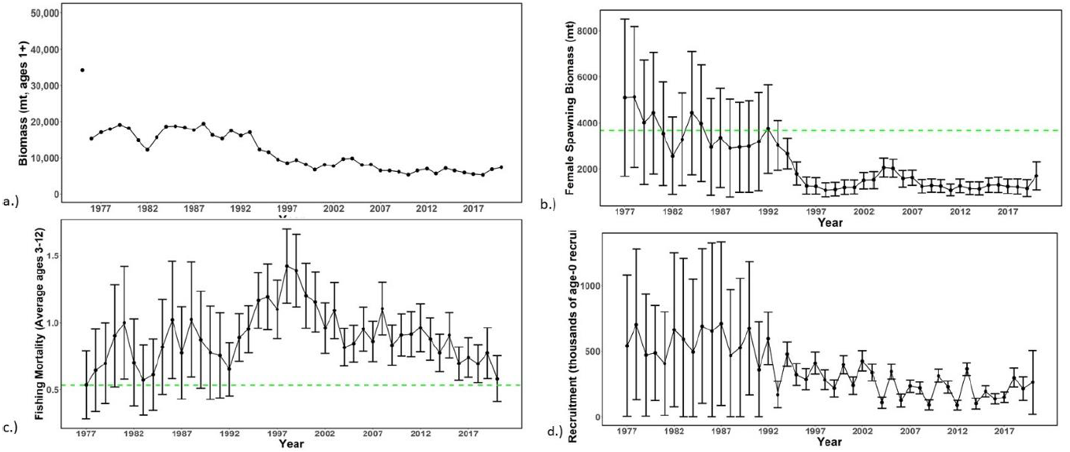

Figure WCNPOMLS-2. Time series of estimates of (a) population biomass (age 1+), (b) spawning biomass, (c) instantaneous fishing mortality (average for age 3-12, year⁻¹), and (d) recruitment (age-0 fish) for Western and Central North Pacific striped marlin (Kajikia audax) derived from the 2023 stock assessment. The circles represent the maximum likelihood estimates by year for each quantity and the error bars represent the uncertainty of the estimates (95% confidence intervals), green dashed lines indicate the dynamic 20%SSB_{F=0} and F_{20%SSBF=0} reference point (Figure S2 from SC19-SA-WP-11).

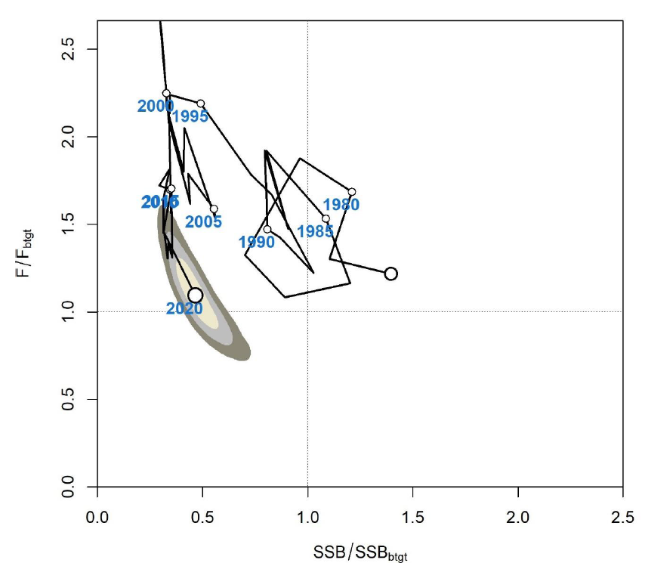

Figure WCNPOMLS-3. Majuro plot of the time series of estimates of relative fishing mortality (average of age 3-12) and relative spawning stock biomass of Western and Central North Pacific striped marlin (Kajikia audax) during 1977-2020. F_{btgt} and SSB_{btgt} refer to F_{20%SSBF=0} and 20%SSB_{F=0}, respectively. The large, un-labeled open circle indicates 1977, subsequent open circles are in 5-year increments. Shading indicates 50%, 80%, and 95% confidence intervals, respectively (Figure S3 from SC19-SA-WP-11).

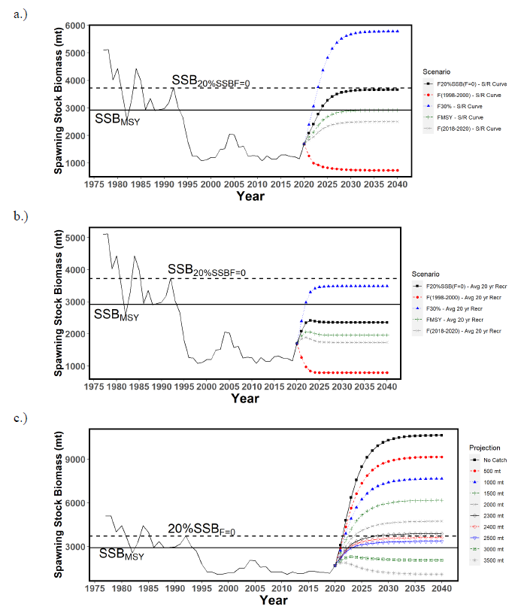
Figure WCNPOMLS-4. Historical and projected trajectories of spawning biomass from the Western and Central North Pacific striped marlin base case model based upon F scenarios: (a) F scenarios projected spawning biomass using recruitment estimated from the stock-recruitment curve; (b) F scenarios projected spawning biomass using average recruitment from 2001-2020. (c) Catch scenarios projected spawning biomass using average recruitment from 2001-2020. Dashed line indicates the spawning stock biomass at the dynamic 20%SSB_{F=0} reference point. Solid line indicates the spawning stock biomass at SSB_{MSY}. The list of projection scenarios can be found in SC19-SA-WP-11 Tables S3 and S4 (Figure S4 from SC19-SA-WP-11).

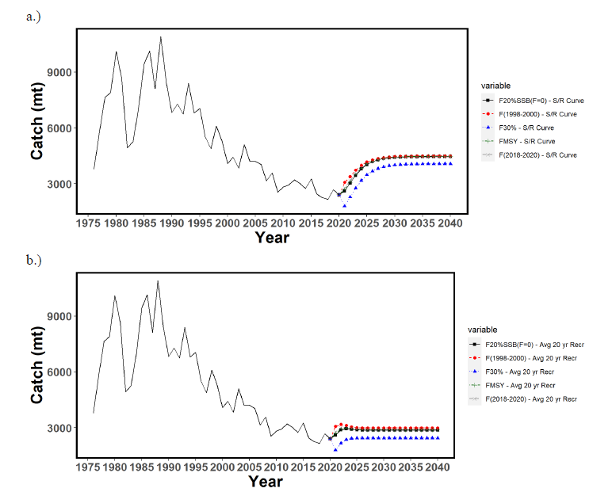 Figure WCNPOMLS-5. Historical and projected trajectories of catch from the Western and Central North Pacific striped marlin base case model based upon F scenarios: (a) F scenarios projected catch using recruitment estimated from the stock-recruitment curve; (b) F scenarios projected catch using recruitment estimated from 2001-2020 average. The list of projection scenarios can be found in SC19-SA-WP-11 Table S3 (Figure S5 from SC19-SA-WP-11).

Figure WCNPOMLS-6. Majuro plot showing the terminal year stock status for the base-case model (gray circle, B) and the 16 sensitivity runs used to evaluate the sensitivity of the model to various model assumptions (circled numbers, circles are used as a visual aid). Models 12, 13, 15, and 16 are all sensitivity runs on assumptions on growth. See SC19-SA-WP-11 Table 12 in the stock assessment report for the full list and description of the sensitivity runs (Figure S6 from SC19-SA-WP-11).

4.7. Projects and Requests

4.7.1 Characterization of stock assessment uncertainty (Project 113)

- P. Neubauer (Dragonfly) presented SC19-SA-WP-12 (Addressing uncertainty in WCPFC stock assessments: Review and recommendations from WCFPC Project 113). Model weighting is a central challenge in stock assessments because the retention or rejection of models, and relative weights given to models and their respective uncertainties can markedly affect quantities measuring risk of available management options. This research aimed to provide both general and specific review components to develop recommendations for stock status and management advice to the Commission. The review considered how uncertainty was addressed through the use of ensembles and sensitivities, and whether this uncertainty was used in management advice. There is currently no best practice identified to weight models, or to address uncertainty in stock assessments more broadly, but there may be a valuable “middle ground” for both aspects of stock assessments. This approach would explicitly acknowledge and explore uncertainty, with standardised reporting to allow consistent management advice of the uncertainties considered for each assessment. This paper provides authors’ recommendations for consideration by SC19.

Discussion

- Palau, on behalf of FFA members, noted the important findings from this study and suggested that SPC work with the project team to develop a reporting template that complements SPCs assessments. A more consistent reporting format could also ensure that results are easily comparable between stocks and years, even if assessment approaches are not the same. The FFA members supported the following recommendations:
  - the establishment of a project to develop a standardised reporting template for the reporting of uncertainty and risk that incorporates recommendations made in the present review; and
  - the further development of methodology and idealised simulations to develop principled model ensemble approaches, in particular to consider the ability of alternative model diagnostics to identify model plausibility and weights.

- FFA members further noted that the delay of the bigeye and yellowfin tuna assessments were partly the result of incorporating SC18 advice and the yellowfin tuna peer review recommendations and hoped that the advice from this project would complement efforts by the SSPs and not significantly increase their workload, given the current constraints.

- Tokelau, on behalf of PNA and Tokelau, thanked the presenter and co-authors for the important paper, which highlighted the lack of consistency between assessments and the reporting of management quantities to the SC. They noted that at a recent SC meeting, disagreements on how to frame the management advice had resulted in none being provided for one of the key stocks, which was problematic. The proposed recommendations from this paper, if adopted, would go a long way to resolving some of the issues faced in recent years. PNA and Tokelau therefore were very supportive of the recommendations from this paper and, in particular, supported the need to develop a template for reporting management advice and uncertainties as well as the construction of agreed terminology regarding the description of the stock status probabilities relative to reference points. They were also supportive of the need to undertake a project to develop a standardised reporting template for uncertainty and risk reporting and suggested that this work be included in the 2024 SC workplan so that it can be completed and presented to SC20. They asked SPC to also add this to the Tuna Assessment Research Plan (TARP).

- The USA thanked the team at Dragonfly Data Science for this comprehensive, well-thought-out analysis. They supported all recommendations made in the report and encouraged this body to take all necessary steps to implement them. The USA noted that adopting a WCPFC standardized reporting template and language for stock status outcomes and management advice could greatly streamline the functioning of the SC by making the provision of management advice/stock status more objective and formulaic. Adopting standardized reporting would allow for streamlined integration of research priorities needed to reduce key uncertainties into existing species research plans and could only improve the ability for managers to make sound, science-based decisions. The USA noted that there was a draft proposal for the continuation of project 113 to conduct the standardized reporting template and language. The USA also recognized the likely impacts on assessment team workloads for developing and presenting uncertainty in assessments following the recommendations made in this paper, and encouraged CCMs to keep this in mind when discussing how the SC can best support assessment teams as a part of SC19-SA-WP-14 discussions.

- Australia commended the authors for a detailed and thoughtful overview of uncertainty treatment in stock assessments across tuna RFMOs, and like the United States supported all of the recommendations therein. They noted the diversity of approaches across stocks within and across RFMOs, and that this area of research, while key to fisheries management, did not receive the attention it deserves. Past SCs had repeatedly noted the need to improve the approach to characterise uncertainty in stock assessments and this work has made a valuable contribution towards that goal, by providing terminology and guidelines to support SC discussion of this topic. A key issue with the fully factorial structural grid approach was the presence of implausible level combinations which receive equal weight to other members of the grid, despite their low probability of reflecting a true state of nature. From a practical perspective, it is likely that achieving convergence for these models is also more challenging, possibly making their predictions of stock status less reliable. Given those factors, they supported the authors’ suggestion to develop joint priors where relevant (e.g., for life-history parameters), or explicit rationales for axes modifying model parameters. They agreed that these weightings should be developed a priori. Finally, they supported the inclusion of multiple sources of uncertainty when generating reference metrics to inform management, noting that this had been done for the yellowfin and bigeye tuna assessments reviewed this year. They also noted the authors’ recommendations for clear, consistent terminology describing the type of uncertainty considered in each assessment, and the need for consistent reporting to support management discussions and comparison across stocks and management entities.

- Japan thanked Dragonfly Data Science for the hard work and for conducting so many interviews, including consulting ISC both individually and collectively. Like others Japan was generally happy with, and supported, the recommendations. They were not sure they would formally adopt these recommendations but view them as loose guidance or principles for assessments to be conducted. There is no one model fits all when it comes to the characterisation of uncertainty, and we should not try to impose just one approach to all the various different assessments. But trying to achieve a standardised approach to showing results of assessments would be useful.

- New Zealand noted that the ensemble approach is a useful framework to attempt to capture sources of uncertainty that cannot easily be included within a single model run. Since computer resources are not unlimited what is included needs to be a deliberate choice. . They noted that for both bigeye and yellowfin there are conflicts between input data sets that are not currently reflected in the uncertainty grids. New Zealand were interested in the presenter’s thoughts about guidelines for assessment scientists – for example a series of questions and/or steps to help them determine the most important things to capture in the assessment ensemble.

- The presenter noted that the most important sources of uncertainty should be captured in the grid. But it was not always obvious which were the most likely to influence the grid. So, it would be difficult to be formulaic about it. The possibilities had to be explored. But it was something to keep in mind especially with respect to the disagreements that sometimes occurred over what to include.

- The EU commended the authors and their recommendations. As a comment, they noted that there were 5 sets of recommendations and the EU thought they agreed with 4 of them: those on communication of uncertainty and risk; the communication about the quality of the information; the development of a set of research recommendations; and the review of timelines. However, the most important item was still to be resolved, that is, the weighting in the model ensemble. Objective weighting was still a field of research so there needed to be some subjective weighting. Following this presentation, the message they took home was that, to the extent possible, distribution of informed parameters served to provide a priori weights to some axes of uncertainty, and they proposed that this be carried out during the SC, intersessionally or at the SPC Pre-Assessment Workshop (PAW). At this stage, it was not clear how post-hoc weighting should be done, but they seconded the recommendation that, to the extent possible, it should be based on the analyst's advice. As a question, they asked if the presenter would propose the same approach in the MSE framework and when developing operating model grids.

- The presenter replied that broadly it is yes. If the models in the ensemble broadly represented the spread of uncertainty, then those principles should carry through into the operating models. But we would need to have some assumptions in the operating model grid that you may think unlikely because you would want to test robustness against extreme conditions.

- SC19 supported the recommendations made in the report and encouraged the SSP and the ISC to take necessary steps to implement them as appropriate. Most notably, the design of a standardized reporting template including language for stock status outcomes, management advice, and uncertainties, and the development of consistent terminology regarding the description of the stock status probabilities relative to reference points are considered a priority.

- SC19 noted a consistent reporting format would support clear comparison among stocks and years.

- SC19 recommended that this project be included in the 2024 SC workplan and added to the Tuna Assessment Research Plan.

- SC19 also noted the continuation of Project 113b to develop the standardized reporting template and language.

4.7.2 Application of Close-Kin Mark-Recapture Methods (Project 100c)

- S. Nicol (SPC) presented SC19-SA-WP-13 (CKMR application to South Pacific Albacore – Project 100c). This project aims to resolve key stock assessment uncertainties by applying close-kin-mark-recapture methods to the western and central Pacific tuna fisheries. The research is expected to be completed and presented to SC20. Sample collection trials for epigenetic age calibration has been completed to test quality of tissue collected for South Pacific Albacore under different sampling/storage protocols. Standard Operating Procedures for port sampling are currently being trialled. Results indicate that collection of the 25,000-30,000 tissue samples to allow for sufficient kin-pair identification is feasible over a 2–3-year period of sampling, the CKMR feasibility and design study for South Pacific Albacore is expected to be presented to SC20 along with scoping studies for Pacific bigeye and Southwest Pacific Swordfish at SC21.

- Samoa, on behalf of SPG CCMs, said they supported the work being done on this project, as management of the South Pacific albacore stock is of the utmost importance to the countries and territories in the region relying on the southern longline fishery. They were hopeful that this work would help to reduce the uncertainty in future South Pacific albacore stock assessments.

- The Solomon Islands, on behalf of FFA members, recognised the potential high value of the close kin work for eventually reducing the significant level of uncertainty present in the South Pacific albacore stock assessment. FFA members noted the progress of the project and supported the request from the project on scheduling and resourcing of CKMR data in future stock assessments for South Pacific Albacore. They also suggested that these be reflected in the Tuna Research Plan.

- New Zealand was encouraged to see the CKMR work progressing within the WCPFC for South Pacific albacore and had seen the benefits of this work through their involvement with southern bluefin tuna in the CCSBT. New Zealand was pleased to be involved in the early protocol testing stages for South Pacific albacore, thanks to the cooperation from their domestic troll fishers and local scientists working with SPC. They also wanted to acknowledge the contribution and expertise of the young Pacific SPC scientists progressing the work on close kin mark recapture. They were supportive of this work and looked forward to seeing how the work develops. They thanked the European Union for the support provided for this work.

- SC19 noted the progress being made on the CKMR preliminary study, and notes that this type of work has improved stock assessments in other tRFMOs and looks forward to seeing how the SPA assessment is improved in the future.

4.7.3 Options to provide information to the Scientific Committee

- G. Pilling (SPC) presented SC19-SA-WP-14 (Options to address time challenges in the SC review of WCPFC stock assessment inputs) which addressed paragraph 103 of the SC18 Summary Report.

- Following discussions at SC18 on the perceived limited time available to review and provide feedback on key assessment inputs, that meeting’s report tasked the SSP to develop a discussion paper on the issue to inform SC19. The timetable to produce WCPFC ‘key tuna’ stock assessments and other regular SC papers is influenced by:
  - The annual SC-agreed stock assessment schedule;
  - The 30th of April data provision deadline, defining the availability of catch, effort and size composition data, and the subsequent period of data loading and verification;
  - The dates of the SC meeting and hence deadline for SC papers;
  - The delivery of the cumulative requests for additional regular reporting following the data provision deadline, to which resources must be allocated.

- Noting these constraints, this paper highlights some of the issues to be considered by SC, including the need to work with other CCMs and regional partners to deliver specific data inputs, limitations in the resources available to the SSP and regional partners, the need to ensure equal opportunity within any input review framework, and the challenges in implementing any feedback received via early SC review within the timeframe available for annual assessments.

Discussion

- Kiribati on behalf of FFA members thanked the Scientific Service Provider for their discussion paper and noted it was vital that the Scientific Service Provider has adequate time and resources to fully review the key inputs into WCPFC stock assessments and provide feedback in a timely manner. They suggested that adequate time be allocated to consider each of the 14 candidate options separately, and in combination with others. Ideally, this task would be completed before SC19 concluded, but if not, they encouraged all to engage in the discussions in the Informal Small Group at this meeting. FFA members CCMs supported options that increased the resources to the Scientific Service Provider (Option 6), improved the planning of the Scientific Committee budget (Option 12), provided data more frequently throughout the year (Option 2) and supported the development of tools that would improve the efficiency of the collection of data (Option 3). The latter two options would allow dedicated staff resources to focus on analyses to improve and prepare input data sets and biological parameters. This would also free up the assessment scientists to focus on model development and improvements based on recommendations from previous Scientific Committee meetings and peer reviews. They also supported Options 1, 4, and 5 and possibly 14 to give more time for supporting analyses to be performed, reviewed and updated. Noting that these options could have implications on what data is included in the assessments, such implications and others would need to be carefully considered when assessing each of the options individually and holistically. Whichever options the SC19 might put forward, FFA members recommended that they are further discussed at the Technical and Compliance Committee. Finally, FFA members supported the suggestion by the Scientific Service Provider that the chosen options should apply to all assessment inputs being presented to the Scientific Committee, to ensure consistency and enhance the ability of the Scientific Committee to evaluate the assessments being considered.

- Tuvalu, speaking for PNA and Tokelau, supported the need to make more time available for assessment preparations and the need for SPC to have the resources they need to be able to work effectively. At the same time, PNA and Tokelau recognised the need to streamline some elements of the Commission's programme to accommodate a greater priority on harvest strategy activities. In their view, a key element of that streamlining would be to simplify the assessments for any stocks for which there are management procedures. With management procedures in place, the stock assessments will no longer be the basis for management. Instead, the assessments will be an element of the monitoring strategy. So, discussion is needed about how the assessments should be fitted into this reduced role. As examples, they noted that the bigeye and yellowfin assessments this year had provided broadly similar results to the previous assessments for those stocks. In that case, they believed the next bigeye and yellowfin assessments should simply use the same model as this year with updated data unless something in the monitoring strategy points to a need for those models to be changed in some way. Similarly for skipjack. Work has to continue on approaches that address the decline in the value of pole and line CPUE for the assessment. In their view, any changes to the skipjack assessment model for the next assessment should be focused on that issue only. In addition, they supported the SPC proposal to explore alternatives like the IATTC Easi-FISH approach for data-poor species such as shark species, where non-retention requirements reduced the availability of fishery data.

- The USA was very appreciative of SPC putting forth a comprehensive and introspective paper, and for providing the foundation for a discussion that will improve the function of the SC and the quality of the science. The USA had made a number of interventions over the last several days related to perceived issues with the yellowfin and bigeye tuna assessments, and the South Pacific albacore operating models. While these interventions highlighted technical concerns with the models, in reality they are problems of process relating to a lack of mechanism at the SC for timely feedback and review. Critique this late in the assessment process, after the assessment has been finalized, is not overly useful or helpful for the current assessment, yet this is the only formal opportunity available to provide feedback given the current system. This is a source of frustration for the USA and possibly also for SPC and other CCMs as well. Many of the issues identified could have been addressed if they were discussed with the assessment teams earlier in the process and if resources were available to investigate them. SPC worked hard on the assessments and other scientific tasks needed to support the SC and the Commission. This was a tremendous lift and one that was sincerely appreciated. The USA believed that SPC produces the best available science, given the system and the constraints. However, the USA believed the system could be improved to the benefit of the science, SPC staff, and to CCMs. It was our job as stakeholders to put SPC in the best position possible to be successful. As mentioned in a previous intervention, the USA viewed that the skipjack tuna follow-up work (SC19-SA-WP-07) provided a roadmap for how the scientific review process should work for assessments. It provided an opportunity for continued dialogue between the assessment team and SC in the intervening years between assessments in order to address concerns early on within a timeframe where they could actually be addressed before assessments are used to inform management. It also fostered buy-in and ownership of the assessment process by CCMs. They encouraged that year-on-year incremental development become standard practice for assessments not developed through working groups and requested that additional resources be made available to allow SPC to have 5 full-time assessment staff in order for those follow-up investigations to be made feasible. They realized that increasing the SPC assessment staff to 5 from the current budgeted level of 3 staff will have budgetary implications.

- Australia thanked Graham and the SPC team for this clear overview of time and logistical challenges for SC to consider when attempting to resolve the important issue of the limited timespan available for assessment completion. They echoed the comments made on behalf of all FFA members by Kiribati. Australia noted that this issue impacts multiple aspects of the assessments presented at SC, including assessment scope and exploration, treatment of uncertainty and opportunities for SC review and feedback. They also noted that this is a complicated issue to resolve given the multiple constraints (data submission, other RFMOs meetings schedule, etc.) that have resulted in the current available time window, but it remained an important one deserving serious consideration by CCMs. It was difficult to see a good solution without additional time between the data submission deadline and the submission of SC papers. They also considered there was a need for adequate resources to support 4-5 fulltime stock assessment scientists to reduce stress and avoid potential burnout – they considered looking after and retaining key scientists to be important. They noted that these changes would afford opportunities for more timely feedback and review by CCMs and the SC on the assessments and encouraged SC19 to think creatively about the options SPC had provided and looked forward to constructive discussions at the upcoming ISG-02.

- Indonesia thanked SPC for the presentation. They understood the very important role of the SPC in providing the best available science to the Commission, and the importance of the analyses starting from data exploration. This work took time, but it was quite challenging for Indonesia to provide all the data to SPC according to their preferred schedule.

- The EU noted there were very limited opportunities to reduce the duration and workload of the SSP and the SC. The EU expressed initial preferences for:
  - Considering switching the timing of the SC and TCC meetings.
  - The recommendations provided in the current document on considering a different cycle for the assessments, which may include several approaches like moving from a 3 year to a 4-year assessment cycle, a 2-year period to carry out the assessments or combining update and full assessments.
  - The recommendation that the workload and the available budget be better balanced in the future.

- Japan thanked SPC for addressing this complex question and provided just some initial thoughts. On the deadline, Japan wanted to provide data as early as possible, but the current deadline is something based on operational reality, as expressed by Indonesia. On swapping the timing of TCC and SC they would have a problem. The current TCC timing overlapped with the ICCAT SC – and many Japanese scientists covered both WCPFC and ICCAT SCs. During discussions with managers about swapping dates with TCC, there was concern that scientific advice would be delayed, hence the difficulty with switching. They also echoed one point raised by the USA – that one of the key elements would be to take the example of the skipjack assessment follow-up presented this year. Even if SC discussed the assessment model and results, there would be no logistical possibility of seeing the results of a revised model immediately as there was in other Commission meetings where simpler models are used. Therefore, Japan associated itself with comments by the USA.

- Korea thanked the SPC and acknowledged the important scientific work conducted by the scientific providers. Korea wished to cooperate with SPC to ease the workload of the SPC scientists. Korea generally supported the first option provided in the Working Paper 14. However, careful consideration must be given when changing the deadline for the data submission or holding the SC meeting at a later time of the year to avoid potential issues arising from such change, including the observer data preparation and possibly overlapping schedules with other tuna RFMO meetings.

- New Zealand spoke on behalf of FFA members to reiterate their views made at TCC17, TCC18 and more recently when they tabled Delegation Paper 5 at the WCPFC19 meeting last December, on the need to move to more frequent submission of operational catch and effort data through the use of electronic reporting. The benefit of electronic reporting is obvious - timely and frequent submission of more accurate data. This is option 2 in the Stock Assessment Working Paper (SC19-SA-WP-14) provided by the SSP on options to address time challenges in the SC review of WCPFC stock assessment inputs. The benefit of option 2 - data more frequently submitted throughout the year - as stated in that paper includes allowing supporting analyses to be initiated earlier and internal automatic checking on data entry should improve data quality and reduce manual checking processes.

- The USA wished to respond to a previous intervention that had expressed a desire to simplify the assessment process and to merely produce updated assessments for species governed by management procedures. The USA disagreed with this sentiment. Stock assessments formed a critical component of the monitoring strategy and were not yet mature enough to proceed down a data update only track. Both the yellowfin and bigeye showed substantial differences in stock status from the previous assessments, and in both cases numerous research recommendations were made. In order to improve these assessments, the USA had a strong preference that the scientific rigour of the assessments was not diminished, going forward, for any species.

- The Philippines couldn’t agree with option 1 proposing an earlier data provision deadline because of constraints of national agencies. But could agree to 3 and 4.

- Japan wished to follow up and agree with comments by the USA on the simplification of the model. They agreed that if we had a well-developed Management Procedure then in principle the assessment procedure could be simplified, but we were not yet at that stage. There were many issues with the current bigeye and yellowfin tuna assessments, and there are no Management Procedures for these species yet. And on the FFA proposal for more frequent data provision, Japan understood the intent, but questioned the practical benefit for Electronic Reporting for the assessment process. If this was implemented, countries would provide more data, but it would be incomplete. Japan suggested there be a cutoff date and a rule that additional data could not be included in the assessment model after that. They were not quite clear about how it would be better to have multiple submissions of incomplete data.

- SPC put a question back to members: SPC had faced the challenge of obtaining updates for 3 or 4 historical years of data right on the deadline for the current year. If this had been provided earlier in the year, particularly the historical updates, SPC could have started work on the assessments earlier.

- Japan responded that historical data was one thing, but FFA had also suggested providing the latest data in a shorter period.

- Noting the need for the SSP to have more time to complete the work required to conduct annual stock assessments and other analyses reviewed by the SC each year, SC19 recommended that:
  - the data manager at the SSP liaise and consult with CCMs about the possibility of bringing forward the data submission deadline for fleets, especially historical data updates,
  - the Secretariat explore options for moving the dates of the SC meeting to a later period in the calendar year,
  - the Secretariat and SSP explore options for the WCPFC website to include a portal for CCMs to enter/edit/manage their ACE data submissions, and
  - the SSP develop guidelines for standardised structure/file layouts for Annual Catch Estimates and aggregate catch/effort data that can be used by CCMs to submit these data.

- Noting the need for further resources to assist the SSP in conducting annual stock assessments and other analyses related to the work of the Commission, SC19 recommended that the Commission consider increasing the SSP’s budget so that the number of full-time assessment scientists can be increased to four or five.

- Report from the ISG-02 (Future operations of the SC) is in Attachment H and ODF communications on this topic are compiled in the Summary of SC19 ODF in Attachment K.

4.7.4 Tuna Assessment Research Plan (TARP)

- G. Pilling (SPC-OFP) presented SC19-SA-WP-15 (Draft Tuna Assessment Research Plan (TARP) for ‘key’ tuna species assessments in the WCPO, 2023-2026), which provided the background and current contents of what was proposed to be a ‘living document’ that would be updated annually. The TARP focusses on activities and projects of relevance to key tuna stock assessments, including developments to the MULTIFAN-CL assessment platform; research on biological inputs into stock assessments; data gaps and areas for improved fishery data collection; development of inputs into stock assessments; and work undertaken to address specific requests by WCPFC SC members.

- The process of development and delivery of the TARP needed to consider the available capacity of SC members and the SPC-OFP, balancing the delivery of key stock assessments with the developments planned around those assessments and the budget available. It was recommended that planning also take into account the 2-to-3-year time lag between e.g., SC project prioritization and the delivery of project results for incorporation into stock assessments.

Discussion

- SC19 noted that K. Bigelow of the USA had volunteered to convene an Informal Small Group to assess the draft plan, and this would convene during the meeting and return with a proposal for updating the draft.

- Japan queried whether a much more broadly used platform such as Stock Synthesis could also be considered for use within the TARP.

- SPC recalled that Stock Synthesis had been trialled in the past but found it was not feasible for SS to incorporate tagging data. However, the chief MULTIFAN-CL developer Dave Fournier had retired and SPC was now looking at how to transition to an alternative platform that could deal with the various datasets available.

- Nauru on behalf of FFA members noted the need to begin investing in mechanisms for incorporating climate change information in future modelling approaches. FFA members supported the convention of an Informal Small Group at this session to develop the research plan. FFA members wanted to work collaboratively with other members and to conduct annual reviews of the TARP with the assistance of the SPC.

- Palau spoke for PNA and Tokelau in thanking the SPC for this comprehensive list of work. They saw that some of the work is funded by CCMs around the table and thanked them for their contributions. They noted that currently the list is not prioritised and that not all the work is funded. PNA and Tokelau thought that the SC and SPC should prioritise this work so that it would be easier to prioritise funding allocation and SPC workload, both of which are limited. They also noted that there was some repetition, such as the effort creep projects. They suggest that these be collated into a single project for longline and purse seine rather than being repeated in the list.

- Indonesia questioned whether there was a need to undertake a prioritisation process on the items in this plan, or just refer to the whole of table. They further requested that the project for improving the fishery data of the WPEA countries be included in the table, and possibly follow up the continuation of the WPEA work for these three countries involved.

- SPC noted there were some items which did not yet have funding identified, and hoped the ISG Facilitator could get the group to consider these. For the WPEA project, there was a line item under “Improved Fishery Input Data” that seeks improved data for WPEA fisheries, which probably captured the request by Indonesia.

- An informal small group 3 (ISG03) met during the course of SC19 to review SC19-SA-WP-15 (Draft Tuna Assessment Research Plan (TARP) for ‘key’ tuna species assessments in the WCPO, 2023-2026) and the ISG03 Report is in Attachment F.

4.7.5 Billfish Research Plan (Project 112)

- S. Brouwer (Sagittus Ltd) presented SC19-SA-WP-16 (Billfish research plan 2023 – 2027). This document provided a proposal for the WCPFC’s first BRP covering the years 2023-2027. The proposed BRP was developed with input from an online Informal Working Group (BRP-IWG) comprised of CCMs and observers. This document included a data review, and a detailed list of stock assessment and biological metrics are also included in SC19-SA-WP-16 suppl. In addition, the paper collated research recommendations from recent stock assessment papers and provided those as a list of project titles for the consideration of SC19. It is recommended that this be considered within the ISG-04 at SC19 and a final project list be presented to SC19 with a research schedule for prioritisation.

- The following recommendations were proposed for the SC to consider:
  - Given the 4 to 5-year assessment cycle for billfish the research plan is recommended to encompass two assessment cycles and as such the BRP should run over 2023-2030.
  - It is recommended that SC19 establish an Informal Small Group to evaluate the BRP (ISG-billfish) and maintain this as a standing ISG to evaluate progress against the BRP at subsequent SC meetings. When the ISG develops its terms of reference, the ISG needs to consider the following:
    - The ISG-billfish rank the projects listed within Table 7 for prioritisation within the billfish research plan.
    - The ISG-billfish consider streamlining the projects and merge or remove projects where necessary.
    - The ISG-billfish schedule the projects listed in Table 7.
    - The ISG-billfish develop terms of reference for all projects including stock assessments intended to begin in 2024.
  - It is recommended that all assessments take Table 4 and Table 5 into account when considering metrics for reporting assessment results.
  - It is recommended that standardised CPUE analyses and fishery characterisations be undertaken for black marlin, sailfish and shortbill spearfish and that the SC19 ISG-billfish consider prioritisation and timing for this work, once completed if this work is informative, it should be repeated on a five-yearly schedule.
  - It is recommended that a stratified sampling program be designed to make biological sampling most efficient and useful.
  - It is also recommended that the SC discuss how to incorporate the SC17 recommendations on Limit Reference Points into the BRP and develop a process to make recommendations to the Commission on agreed LRPs for use within assessments.
  - Lastly, it is also recommended that on all longline vessels logsheets record time as UTC and not ships time so that local time can be estimated.

Discussions

- The EU asked the presenter to clarify the use of Table 4 (Proposed list of potential LRPs for WCPFC billfish, categorized by SC17 as Target and Bycatch and by assessment type) in SC19-SA-WP-16, and how accurate species identification was, and also noted their view outputs should also include MSY-related metrics since these were used in other RFMOs which already have TRPs and LRPs for these species.

- The presenter noted that Table 4 was being used unchanged from SC17. The MSY reference points were in an earlier version but there were some issues including them, so they weren’t in the final version of the table. This is something that could be discussed when those recommendations are made to the Commission. Regarding the potential for errors in identification, it is assumed that observers were correctly identifying all species. What hadn’t been done yet was comparing what observers are reporting against what the vessels are reporting from the same set. That could be done in future, if the observed set can be linked with the logsheet set. But that may only be possible in the recent data.

- The Marshall Islands speaking for PNA and Tokelau supported the need to co-ordinate and prioritise billfish research work within the SC. They noted that the project list was very long and thought that the ISG should streamline that list where possible. They agreed with the authors' proposal to extend the BRP to 2030. They thought that this would allow us to spread the work over a longer period of time and remove the need to develop a new plan in 2027. PNA and Tokelau noted that some work would be required within their EEZs and thought that this would provide good development opportunities for their staff to get involved with fieldwork and data analysis. They would like to see that theme included in the TORs when the projects are developed. Lastly PNA and Tokelau considered there was nothing more to be done on LRPs for billfish at the SC and thought that the SC17 recommendations on LRPs listed in paragraph 142 for the SC17 report should be forwarded to the Commission for discussion.

- The USA made a comment on project 2.1, noting that one of goals was robustness but it did not want to reinvent the wheel here when ISC had already looked at robustness of assessment for swordfish, striped and blue marlins, and when there has been a collaborative effort between Japan, the USA and Chinese Taipei to develop a unified sampling protocol to be used across the north Pacific (see SC19-SA-IP-11). They thought that SPC and WCPFC could use that to run a similar sampling programme, with the cooperation of ISC and using similar analysis protocols to improve the basic data structures available. And the improvement of the information for Bill fish had been very influential in improving stock estimates of basic biological processes. They're the key components to reduce model uncertainty in the assessment of Billfish in the North Pacific.

- The presenter thanked the USA for that suggestion and noted that there's no reason why they shouldn't be piggybacking on that, and expanding it to the South Pacific, if it could be done in an easy and reasonable manner. It could be discussed in the ISG.

- An Informal Small Group (ISG04) met during the course of SC19 to review SC19-SA-WP-16 (Draft billfish research plan, Project 112), and the ISG04 report is contained in Attachment I.

- Noting that SC17 agreed a framework for selecting LRPs for billfish species, SC19 seeks general guidance from the Commission on whether in the case of non-targeted species it is acceptable to have a higher level of risk to the stock and a lower biomass LRP compared with the equivalents for target species.

4.7.6 Reproductive biology of yellowfin tuna

- S. Nicol (SPC-OFP) presented SC19-SA-WP-17 (Concept note for a new EU supported study on the reproductive biology of yellowfin tuna). The last study to examine the reproductive biology across a broad spatial range for yellowfin tuna was published in 2000, and no such study has been undertaken for bigeye or skipjack tuna in the WCPO. Therefore, this research proposal aims to undertake the research needed on the reproductive biology of all tropical tunas in the WCPO, not just yellowfin tuna, to improve WCPFC stock assessments and to establish baselines of reproductive potential for tropical tunas in the WCPO for monitoring the impacts of climate change. The study will be supported by the European Maritime, Fisheries and Aquaculture Fund (EMFAF), with a total budget of Euro 240,000, commencing work in 2024 if WCPFC’s co-finance contribution of a Euro 40,000 is available.

- Japan recognized the importance of biological parameters and supported the study. They also asked if additional sample collection would be conducted and what type of samples would be collected, noting that this could be extremely expensive. SPC responded that the specimen bank contains frozen samples, and that there are spatial gaps. It was intended to collect fresh samples in the future to fill these gaps. SPC was expecting that existing frozen samples would be suitable for yellowfin gonad staging, but it would also be necessary to obtain additional samples across all three species.

- The USA noted that this project would provide valuable updates to the reproductive biology and spawning potential for central and western Pacific yellowfin necessary for stock assessment. The project would require samples of yellowfin ovarian tissue sampled from a wide size range of fish across a large spatial extent. Samples must be fixed in 10% buffered formalin to be suitable for histological classification to support the development of accurate maturity schedules and estimates of spawning frequency. USA fully agreed that determining the project sampling needs against suitable samples in the PMSB or what needs to be collected should be prioritized. The project concept and budget should be supported, and the work established as a Scientific Committee project to begin at the proposed date of January 2024).

- Solomon Islands, on behalf of FFA members, were supportive of the project but sought views of the Secretariat on co-funding. The WCPFC Finance Manager pointed out an issue with timing. The budget proposal had to be submitted to the EU before the WCPFC20 meeting might approve the co-funding. But if SC agreed, the project could be submitted before WCPFC20, and if the Commission did not subsequently approve co-funding, then the submission could be withdrawn.

- Australia noted that this was a very worthwhile project and queried whether albacore would be also included. SPC responded that they hadn’t included albacore since there had been a comprehensive study on South Pacific albacore reproductive biology around 2012-13, and that there were unlikely to have been changes due to environment factors since that work.

- Philippines was worried that the 4000 samples already collected might not be sufficiently geographically representative for Pacific-wide work. SPC noted these had been collected since 2014 under the ROP and are from across the region wherever PIRFO observers are active, plus specific sampling in Australia and New Zealand EEZs. The spatial gaps with low representation are where PIRFO observers are not active. The first step would be to identify these areas an begin dialogue with relevant countries and fleets.

- SC19 recognized the importance of biological parameters and acknowledged the valuable updates on the reproductive biology and spawning potential for yellowfin that this project could provide for stock assessments.

- SC19 agreed that the project should be expanded to include bigeye and skipjack tuna.

- SC19 endorsed the project and recommended that the WCPFC co-finance EU 40,000 so that funding from the European Maritime, Fisheries and Aquaculture Fund could be accessed.

- SC19 noted that the project, if approved for WCPFC co-funding and EU funding, would be established as an SC project, and could commence in January 2024 with a final report to the SC scheduled in August 2026.

AGENDA ITEM 5 — MANAGEMENT ISSUES THEME

5.1 Development of harvest strategy framework for key tuna species

5.1.1 Skipjack tuna

5.1.1.1 Implementation of Management Procedure for WCPO skipjack tuna

- SC19 noted that WCPFC19 had adopted CMM 2022-01 Conservation and Management Measure on a Management Procedure for WCPO Skipjack Tuna, which includes a repeating 3-year implementation schedule of the management procedure (MP). Also noting the request to review the performance and outputs of the initial run of the skipjack MP, and provide advice and recommendation to the Commission, SC19 reviewed SC19-MI-WP-01 (WCPO skipjack management procedure).

- F. Scott (SPC) presented SC19-MI-WP-01 (WCPO skipjack management procedure). This described the running of the WCPO skipjack interim management procedure (MP). Following the adoption of the WCPO skipjack management procedure (MP) by WCPFC19 (CMM 2022-01), the MP was run in 2023 and the resulting management measures are scheduled to be implemented in 2024. The SPC was tasked with running the MP and reporting the outcomes to SC19. The estimation method (EM) ran successfully and returned an estimate of spawning potential depletion (SB_{latest}/SB_{F=0}) in the terminal year (2022) of 0.42. Running the EM for an additional phase to convergence did not change this value. Under the adopted MP for WCPO skipjack, the maximum catch and effort levels for the period 2024 to 2026 are: effort in the purse seine fisheries at 2012 levels; effort in pole and line fisheries at average 2001-2004 levels; and catch in the domestic fisheries of assessment region 5 at average 2016-2018 levels.

Discussion

- Tokelau, on behalf of FFA members, thanked the SSP for running the interim skipjack tuna MP for the first time and noted with interest that the estimation method ran successfully and returned an estimate of spawning potential depletion of 0.42. They also noted that the data used to determine this estimate was not entirely consistent with that used for the dry run of the MP in the previous year. In any case, using the estimate of 0.42 and the output from the HCR, the skipjack tuna MP indicated that no adjustment to fishing activity was necessary for the period 2024-2026 to maintain the stock at around the target levels. They were happy with this outcome as it was consistent with the objective of relative stability in fishing levels between management periods. FFA members noted the contraction of pole and line fishing effort had impaired the ability to index relative abundance of WCPO skipjack across the equatorial region and the diagnostic analyses indicated that it is likely to affect the future performance of the MP. This was not just an issue for the estimation model of the MP but also the stock assessment. Given this, they supported the recommendation that further work be undertaken to develop and test an alternative estimation model for future use in the WCPO skipjack tuna MP. Finally, they noted the information provided regarding the monitoring of the skipjack MP and supported the proposal for the Scientific Committee and Technical and Compliance Committee to compile a skipjack tuna MP monitoring strategy report for the consideration of the Commission.

- Indonesia noted the growing concern about key pole and line data becoming unavailable and wanted more information about the development of the new estimation method. They inquired about the inclusion of new data. It was noted that as regions 5 and 6 had insufficient pole and line data for indices, there was a plan to use data from purse-seine fisheries. SPC noted work on this was ongoing and would be presented to SC20. The possibility of using a PS index either alone or alongside the PL index is being investigated.

- The convenor suggested that Japan might need to expand the skipjack pole and line fishery again. Japan suggested that if WCPFC wanted Japan pole and line then it may need to look at increasing the FAD closure.

- FSM, on behalf of PNA and Tokelau, thanked SPC for all their work in getting WCPFC to this important step in harvest strategies. They continued to see the value of the harvest strategy approach as providing a basis for improved decision-making by having pre-agreed rules for how fishing will be adjusted as status of stocks change and taking better account of uncertainty. They were also happy that this work was being done as a trial, because there were some elements of the MP run that they had not expected or understood, and that confirmed the value of having a trial. Fortunately, it seemed that the MP output would not require any substantial changes to the tropical tuna measure this year, so WCPFC now had 3 years to look into some of the issues that this MP run had raised.

- Japan thought it unfortunate that the Commission was looking at revising the MP already when it was supposed to be a long-term process. This model should be re-run in 2026 and thus it needed to be reviewed in 2025. The question was when and how a decision would be needed about using an alternative or supplementary index instead, noting an agreed decision would be needed in 2 years’ time.

- SPC replied that it was too early to look at this but noted that if SPC was required to run the MP again in 3 years’ time then they would need to prepare something for SC20 next year. There was the option of using the interim HCR perhaps with some adjustments – tuned to achieve the same performance as the current MP.

- Japan mentioned that SC should recall that this specific form of HCR was developed after lengthy discussion at the Commission. While it was said that the MP may require a small modification, that modification may not seem small if it shifts the performance either way.

- PNG, on behalf of PNA and Tokelau, expressed their appreciation for the work to produce the results of the first run of the skipjack MP. One issue with the run for PNA and Tokelau was that the output was proposed to be applied in a way that was different from their understanding. They had understood that the MP would provide a scalar and that the Commission would then adopt responses in the Tropical Tuna measure that would be consistent with the scalar overall, not necessarily be separated for each of the 3 fishery components. They were particularly concerned that applying the scalar to the separate components may not achieve the MP’s objective of maintaining the stock around the TRP if effort in the pole and line fishery was below the baseline level. They inquired as to whether that was a possible outcome.

- SPC responded that this was related to an output scalar from the HCR, and then that scalar is applied to different baseline levels for these 3 fishery components (PS effort set at 2012 level, PL effort set at 2001-04 level and region 5 domestic fisheries set at 2016-18 catches). This was agreed by the Commission last year and is in the CMM. It was not something that was new. It was SPC’s understanding of how the HCR was going to be applied.

- SPC noted the difficulties in interrogating data inconsistencies without direct access to raw data. Further, not having access to raw data can lead to additional time requirements to have analyses completed and checked, and to explore inconsistencies. SPC greatly appreciated the assistance of the analysts from Japan in providing the pole and line CPUE analysis for both the skipjack MP and stock assessment, and their efforts to do these analyses in a timely manner. Overall, the collaboration had been beneficial, and they would continue to collaborate on analysis of the Japanese pole and line data. However, without access to the raw data it had been difficult for the SPC analysts to assist in identifying and incorporating changes in data when conducting analyses, and to conduct ongoing research on CPUE analysis. They continued to encourage Japan to find a mechanism to allow the SSP direct access to their pole and line operational catch and effort data.

- Japan noted that this was the first time that SC would be seeking to provide management advice based on the adopted MP for skipjack and heighted the fact that there is no existing template as to how this should be done. Japan suggested that SC should carefully craft the wording (of the management advice) in the context of the existing CMM, and since countries may have a different understanding of the measure, some legal advice might need to be sought. The Convenor said that careful thought would be given to this when crafting the recommendation which SC would review the following week.

- The Marshall Islands said, on behalf of PNA and Tokelau, had some questions about the results of the MP run. One important issue was that they understood that the estimation model and historical data would remain the same, so the MP provided a stable or consistent model to assess the relative change in biomass estimated from the stock assessment model. So, they expected that this run of the MP would just involve adding one year of data with perhaps some updating of provisional data for recent years. As it turned out, there have been changes to the historical data that had not been expected. They also noted that the estimated stock depletion had dropped from 0.54 to 0.42 in one year. Again, they had not expected this scale of change with just the addition of one year of data. As they understood it, the paper indicated that this difference appeared to be largely attributed to updates in the standardised pole and line indices, both for the historical time series and for most recent years. This was a concern for PNA and Tokelau. They supported the MP on the basis that fishing for skipjack would be adjusted in response to changes in the fishery, not to changes in historical data. In their view, the next step should be to rerun the MP without the changes to the historical data to see if those changes have resulted in any change in the MP output. If the changes to the historical data did result in changes in the MP output, then, in their view, the Commission may need to look at reworking the TRP and the HCR.

- In addition, the paper suggested that the estimation model would need to be updated, given new data and analysis techniques being used that were not foreseen in the MP testing before the Commission was asked to decide on an MP. PNA and Tokelau understand that changes to the estimation model may be needed to respond to the difficulty resulting from the contraction of the pole and line fishery. There may also be changes resulting from any move to an alternative modelling platform away from MULTIFAN-CL. They expected this would mean reworking the TRP and the HCR. They said again that it was fortunate that there was a trial period, and that WCPFC has another 6 years to address these issues. PNA and Tokelau would certainly be looking for the models and the data to become more stable over that period because this first trial run of the MP showed that there is work to be done before the MP can provide a basis for long term management.

- The EU shared the concern of SPC on the contraction of the pole and line fisheries, which might result in abundance indices not being informative of biomass trends and in issues like hyperstability. They therefore recommended investigating the development of alternative indices as proposed by SPC, like those based on purse seine catch rates or acoustic buoy data, as a priority task. They had been initially concerned about the output of the dry run vs the current one, but the presenter provided a good explanation for this based on the different data inputs. On the other hand, in a previous presentation, an update of the 2022 assessment showed a decrease in depletion levels in the most recent years. Also, they wanted to note that the current effort multiplier of 1 was close to the left end of the flat part in the HCR and, finally, that 2021 effort levels were around 11% below the baseline. They were confident the harvest strategy would meet its objective, but in terms of effort and catch stability, they thought this should be taken into account when considering the development of the new tropical tuna CMM.

- Japan gave a short presentation comparing the Japanese inputs to last year’s dry run with the inputs this year’s operational run, in response to the concern that there was an issue with the analysis. They found that the 2019 assessment used different VAST code from the 2022 MP dry run, the 2022 stock assessment and the 2023 MP operational run. The 2023 run had used updated data for logbook and SST. This change was only a small change affecting a northern area, and if this had indeed been influential then Japan would not be comfortable with the robustness of the MP. They suggested another yet-to-be-identified factor was causing the difference between the inputs.

- SPC noted that because travel restrictions had been lifted, they would now be able to collaborate more closely with Japanese colleagues. If one lesson had been learned, it was that they probably should not run a stock assessment and an MP in the same year. They noted that the output of the MSE was consistent with the MP run this year, and re-iterated that the MP was valid.

- The Solomon Islands, on behalf of PNA and Tokelau, thanked colleagues from Japan for providing the information on the changes to the data inputs that went into the MP run. That had been helpful in understanding one part of the issue. From the 2022 skipjack stock assessment they understood the starting point of the MP consideration was around 0.51 spawning biomass depletion level. The 2022 dry run MP was based on an incorrect specification of the input data if they understood correctly, and they would appreciate the dry run being re-run with the correct specification so they could compare that with the outcomes of the first run of the MP presented to this meeting. This first run indicated a drop of 8% in biomass with the addition of one year in data. However, the fishery had been stable in their view. There was no information in this MP run that provided clarity on the cause of that difference. This was important information in being able to frame the advice to fisheries managers with respect to the outputs of the MP run.

- SC19 noted that the estimation method ran successfully and returned an estimate of SB_{latest}/SB_{F=0} of 0.42, and that the corresponding scalar from the HCR was 1.0. Under the adopted MP outlined in CMM 2022-01, this sets maximum effort in the purse seine and pole and line fisheries, and maximum catches in all other fisheries, at baseline levels (PS at 2012 effort; PL at 2001-2004 effort; Region 5 domestic fisheries at average 2016-2018 catches) for the subsequent management period (2024 to 2026).

- Several CCMs noted that they were happy with this outcome, as it is consistent with the objective of relative stability in fishing levels between management periods.

- SC19 noted that the data used to determine this estimate was not entirely consistent with that used for the dry run of the management procedure in the previous year. This change appears to be largely attributed to differences in the standardised pole and line indices, both for the historical time series and for most recent years. However, SC19 noted that SPC and Japanese colleagues will be working together to identify the issue in last year’s dry run. Nevertheless, SC19 noted that the initial running of the skipjack MP was consistent with that predicted by the MSE and all data requirements were satisfied.

- SC19 was informed that the contraction of pole and line fishing effort is impairing the ability to index relative abundance of WCPO skipjack across the equatorial region and diagnostic analyses indicate that it is likely to affect the future performance of the MP. The SSP indicated that it would consider what alternative options might be possible for dealing with this issue and report progress back to SC20.

- SC19 noted that this is not just an issue for the estimation model of the MP but also for the stock assessment.

- Noting that with maximum effort and catches now recommended by the MP for respective fisheries for the next three years, this provides a time window for further work, and SC19 recommends that a re-evaluation of the skipjack estimation method needs to be undertaken prior to the next implementation of the MP.

- SC19 recommended that the Commission take into consideration the successful running of the skipjack MP as outlined in SC19-MI-WP-01 and its output, which indicates that maximum effort in the purse seine and pole-and-line fisheries and maximum catches in all other fisheries should be set to their respective baseline levels (specified in CMM 2022-01) for the period 2024-2026, when implementing CMM 2022-01.

5.1.1.2 Monitoring strategy for WCPO skipjack tuna

- G. Pilling (SPC) presented SC19-MI-WP-02 (Monitoring the WCPO skipjack management procedure), noting the MP has only just been run and the Commission will need to see how it performs after 2 or 3 years in the real world. This paper provided background on the monitoring strategy, which in this case will routinely evaluate the performance of the adopted interim WCPO skipjack MP to check that it is working as expected, and which considers procedures for evaluating and testing the MPs; any scenarios that should be added to the operating model grid; the preparation and application of the EM; and the performance of the MP overall. In addition, the monitoring strategy would also identify changes in the dynamics of the fishery resulting from environmental, economic or social factors that may require a reconsideration of the management objectives and the testing of alternative MPs. The paper also makes recommendations on the time frames over which these aspects might be considered and identifies key sources of information that can be used to monitor the performance of the MP and highlight where data gaps occur. To operationalise the monitoring strategy within the WCPFC, a process is proposed by which these various elements can be captured in a monitoring report to be progressively collated through existing bodies of the WCPFC. A draft report design is presented here for consideration.

Discussion

- The Marshall Islands, on behalf of PNA and Tokelau, sought clarity from SPC on the Further Details section (Page 11 of the SC19-MI-WP-02) with respect to “1. Review MP performance”, where it says: “1.4 EM performance: Overall the estimation method performed well and provided estimates of stock status within the prediction range of the MSE.” RMI sought clarity if that means the performance of the MP falls within the bounds predicted by the simulation testing procedure when the MP was developed. SPC confirmed the interpretation of Marshall Islands correct.

- PNG, on behalf of for FFA members, supported the proposal from SPC, for the subsidiary bodies of the Commission such as the Scientific Committee and Technical and Compliance Committee, to compile an MP monitoring strategy report for the consideration of the Commission, As the full list of items to consider under the monitoring strategy can be extensive and this will minimise the work involved by CCMs. It will also provide valuable information to help update the Commission on the performance of the MP. To support the compilation of the monitoring strategy report and to ensure that all elements of the monitoring strategy were considered at the appropriate juncture, they suggested standing agenda items be added to the relevant sections of the Scientific Committee and Technical and Compliance Committee agenda to consider the availability of new information and to update this report. Finally, FFA members recommended that the MP monitoring strategy report structure and contents be adopted by the Commission at WCPFC20 once these have been finalised and endorsed by the Scientific Committee.

- Japan commented that some confusion about the report’s usage remained. For instance, it had been suggested that some elements would be considered by the SC and others by the Commission. In practical terms, Japan asked who would write this list and create this table.

- SPC noted that there would need to be some learning process about this over time. SPC had developed the first steps of the skipjack monitoring report for this year, and it was in the paper itself. They suggested CCMs review this and highlight the elements needed to be considered by Commission in future work and flag issues that arise as SC and the Commission went through the process.

- Japan noted that the 11 elements proposed by SPC were fine, but that the body reviewing the list needed to be specified together with the timeline. Stock status for example could only be evaluated when stock assessments occur but, again, SC needs to clarify the process. SC participants did not need to worry too much about lack of objective or scope since this would be in the hands of the Commission, but clarity on the practical aspects of who does what and when would be useful.

- SPC pointed out that Table 1 in the paper did have some suggestions about who might consider each of the elements. As Japan mentioned, some are at Commission level rather than at the SC level. SPC noted that feedback on Table 1 would be useful.

- PNG, speaking for PNA and Tokelau, apologised for what might seem like repetition, but sought clarification under “3.1 Management Objective” of SC19-MI-WP-02 where the paper stated, “The monitoring strategy provides an opportunity to review and where necessary update the management objectives to ensure the overall harvest strategy remains appropriate as the nature of the fishery evolves over time.” They asked if SPC could elaborate on any of the specific circumstances occurring, referenced in the paper, and how this would be notified to the Commission for consideration.

- SPC thanked PNG for their question and highlighted it was one of the areas that subsidiary bodies might flag to the Commission. It was meant to capture any major changes in the environment of the fishery – for example if the impacts of COVID had continued much longer, which might have changed objectives of CCMs regarding the fishery.

- Indonesia sought clarity on an aspect of the monitoring strategy which would also be useful for their own implementation of a national harvest strategy in Indonesia. SPC had mentioned that a formal monitoring strategy can be developed to check the estimation method, etc. If that couldn’t be fulfilled, Indonesia asked whether that would become an exceptional circumstance, or any action could be taken using available historical data to implement the MP.

- SPC agreed this was a useful question and said that it depended on the degree of impact on the MP. Did it, for example, impact the data that was needed for the MP to run – for example like when the Southern bluefin tuna management process dropped the aerial survey? We needed to be ready for lesser situations as they arise, such as an increasing shortage of data – and there are degrees of “exceptional circumstances”.

- Japan asked if SPC was proposing the bullet point at the bottom of Table 2 to provide the MP summary report by SC and TCC for consideration by the Commission for the current year (2023).

- The Convenor suggested proposing that SC should initiate this report. In SC19-MI-WP-02, there were existing comments on running the MP this year, the issues arising from data, etc., and there was already the basis of a template provided. As SC has not gone through Table 2 of SC19-MI-WP-02 in this session, it might want to provide subsidiary comments on this topic at a later MI session.

- Japan acknowledged the clarification, and stated their hope that SC could provide this year’s review based on Table 2 in SC19-MI-WP-02. Japan did not have much issue with the current wording of the table but noted that the wording warranted careful scrutiny should it be provided to TCC or the Commission. For instance, they suggested that the words in the stock status comments were too terse and needed to be made more accessible to non-scientist readers.

- Noting the Commission’s request to review the elements of the monitoring strategy as set out in ANNEX III of CMM 2022-01, and information provided by the SSP on the elements of the harvest strategy to be included in the monitoring strategy, SC19 reviewed SC19-MI-WP-02 (Monitoring the WCPO skipjack management procedure).

- SC19 noted the aspects of the MP that may be considered for inclusion in the monitoring strategy and the Commission body at which those considerations can be made (Annex III, Table 2, also shown in Table 1 of SC19-MI-WP-02).

- In order to simplify and streamline the monitoring process for the Commission and its subsidiary bodies, SC19 supported the concept of compiling a summary monitoring report consisting of a summary table that identifies the elements of the monitoring programme that may require additional work or through which major problems may be identified, along with a few short paragraphs to provide further details of the work required to address those issues. The priority of any issues identified can be determined based on the considered severity of the issue and the amount of work required to address it.

- An example of such a summary report is attached as Attachment G.

- While noting that this report covers all the elements of the MP to be reviewed, SC19 also noted a need for both the TCC and the Commission to provide input into the development of this report considering the elements of the monitoring strategy that have been assigned to each body to review.

- SC19 also noted that the initial development and implementation of this monitoring strategy, and the associated report, will likely be an iterative process, with some time-lags before each body will be able to fulfil some of its roles. For example, given the MP will be first implemented in 2024, TCC will only first be able to monitor compliance in 2025. Once this initial phase in period is complete, review and updating of the monitoring report should be undertaken annually by each body. However, as the MP and stock assessment are only run every three years, some elements of the monitoring strategy will not be able to be reviewed and updated on an annual basis.

- SC19 noted that as this is the first year for which this MP has been run, there is limited ability to monitor its full performance now. However, to initiate the development of the monitoring report, SC19 reviewed those elements of the monitoring strategy assigned to the SC. The outcomes of that review are shown in the draft monitoring report listed in Attachment 3 and show that SC19 supported the conclusions of SC19-MI-WP-02, that the outcomes of initial running the skipjack MP were consistent with that predicted by the MSE and that all data requirements were satisfied. Some priorities for future work are also noted.

- Finally, SC19 noted that the annual review of each element of the monitoring strategy will provide an opportunity for the Commission and its two subsidiary bodies to review, and where necessary (depending on the degree of impact on the MP), update the management objectives to ensure the overall harvest strategy remains appropriate as the nature of the fishery evolves over time.

- Noting that the Commission is scheduled to adopt a monitoring strategy for skipjack tuna in 2023, SC19 supported the proposed monitoring strategy as outlined in SC19-MI-WP-02 and recommended that it be considered for adoption following further discussion by TCC and the Commission.

- SC19 recommended that the Commission take note of the initial review of the skipjack MP under the proposed monitoring strategy as outlined in SC19-MI-WP-02 and consider the proposed monitoring strategy summary report drafted by SC and TCC and advise accordingly.

5.1.2 South Pacific Albacore Tuna

5.1.2.1. Target reference point (TRP)

- G. Pilling (SPC) presented SC19-MI-WP-03 (Update to further inform discussions on South Pacific albacore objectives and the TRP). This paper updated a table of possible outcomes for South Pacific albacore under a range of different longline and troll catch levels, determined by catch scalars relative to the 2017-2019 average. A small change in the method used for analysis was presented, where missing iterations were included in the calculation of results on the basis that these in fact represented results where the stock crashed from excessive fishing mortality. This change led to slightly more pessimistic results. Extra rows had been added to the table to reflect CCM requests since WCPFC19, including rows evaluating the consequences of maintaining the stock at 2017-2019 average depletion levels and 2017-2019 average vulnerable biomass (the CPUE proxy) levels, a depletion level equivalent to maintaining the stock at a level twice the size it would be at MSY, and stock levels equivalent to that seen in 2013, on average between 2015 and 2018, and in 2019. At the conclusion of the presentation, the SSP asked if SC could please provide advice to SPC on how to narrow down the range of options for managers’ consideration.

Discussion

- American Samoa noted that South Pacific albacore is very important for American Samoa, which basically has a tuna economy. It was clear from the presentation that South Pacific albacore is not overfished nor experiencing overfishing, but there was concern that the management approach might imply some catch reductions. American Samoa would like to be part of the ongoing discussion with the South Pacific Group in developing a management process in a way that would not negatively impact the American Samoan economy.

- Samoa, on behalf of FFA members, thanked the SSP for the updated information in SC19-MI-WP-03. They noted the inclusion of projections which fail to complete, and that this now shows slightly more pessimistic results for the South Pacific albacore catch scalars. FFA members were committed to having a revised iTRP for the South Pacific albacore as soon as possible although they were concerned that SC19-MI-IP-08 suggests that there is some evidence for potential model misspecification which may have resulted in unrealistic population dynamics in the most recent assessment. Whilst they noted that the South Pacific albacore stock assessment was scheduled for next year, they nevertheless considered it would be useful to have an iTRP in place as soon as possible, in particular to support the development of the South Pacific albacore MP currently underway. They supported an iTRP that is defined according to a reference set of years and not in more absolute terms such as a biomass depletion percentage. They noted that specific depletion levels were susceptible to changes in perception of stock status with each successive stock assessment or between the stock assessment and the set of operating models used to develop an MP. Using multiple years instead of one year also increases robustness against single year peculiarities or estimation issues. They proposed that any TRP adopted now should be interim and subject to review after the next assessment. They were working to provide an iTRP proposal to WCPFC20, and were considering reference periods that reflected stable CPUE, reasonable levels of total catch and good economic performance. FFA members had always advocated for an iTRP that supported good economic returns for this fishery that has struggled over the years. They welcomed the views of other CCMs on this important issue and were looking forward to engaging with all CCMs in the work of the South Pacific albacore Roadmap IWG. FFA members encouraged other CCMs to examine the results of SC19-MI-WP-03 and consider whether there is a need for additional information to be provided to support the Commission decision-making on this matter. Since they were concerned about uncertainties in the current model, they hoped that these uncertainties were addressed in time for next year’s assessment.

- The Cook Islands spoke on behalf of the South Pacific Group of CCMs (SPG). In case everyone was not familiar with the acronym SPG, it represents the 6 countries of Cook Islands, Fiji, Niue, Samoa, Tonga and Vanuatu. SPG wanted to expand on the comments from the FFA, noting that the SPG along with Australia tabled an iTRP proposal at the most recent South Pacific albacore Roadmap IWG meeting on May 5 - an interim TRP being the estimated average depletion of the South Pacific albacore tuna stock over the period 2017-2019. The full proposal on this is provided in SPA-RM-IWG04-WP-03 on the WCPFC website. This iTRP would be associated with a catch level of around 62,500t, which they noted is quite close to recent catch levels as well as to the current catch of 68,975t. In this sense it was quite achievable. In line with the harvest strategy workplan, they were seeking to progress the iTRP proposal this year and were keen to discuss it here at SC. Further they asked if there was any additional information or analysis CCMs may need to fully understand this proposal.

- Tokelau sought clarification on the different parameters being used for albacore within the WCPO. They noted an LRP of 14% has been adopted by the Commission for the North Pacific albacore stock, whilst the South Pacific albacore is using an LRP of 20%. They thought WCPFC should develop management approaches and measures that are compatible within the Convention Area and wanted to better understand the implications of this difference from the Science Committee.

- The USA said that the reference points for North Pacific albacore were adopted following an MSE by the ISC (north of the equator for the EPO and WCPO). The working group evaluated several different thresholds, including the 20% biomass depletion level, the 7.7% IATTC proxy for tropical tunas and the 14% proxy for MSY. An intermediate LRP level of 14% of dynamic unfished spawning stock biomass was selected, and a threshold biomass depletion level of 30% that would avoid the LRP, with a fishing mortality-based TRP that would result in the stock producing 45% of spawning potential ratio (SPR). These were part of the package agreed in the Harvest Strategy for North Pacific Albacore Fishery.

- Solomon Islands sought commentary from SPC on whether the nominal CPUE indicator shows that the “big dip” is real and how will this affect the projections conducted to inform the iTRP?

- SPC noted this topic was further discussed in SC19-MI-IP-08. Briefly, they noted that the models in the assessment grid are the basis for projections and an assumption is made that they are robust. Historical recruitments are sampled into the future as part of the forward projection. If this recruitment is reasonable, then the stock status at the end of the 30 years projection period would be as predicted. If the recruitment estimate is too low because of the “big dip”, then depletion at the end of the 30-year period will be slightly higher.

- Pew Charitable Trusts stated that the projections assume a constant catch in the Eastern Pacific Ocean (EPO), but the catch there has been higher than this for the last 5 or 6 years. They sought comment from SPC about the implications.

- SPC responded that the catch of 15,600t is the average catch for 2017-2019. It is possible that the EPO’s own estimates contain some fisheries not in the SPC stock such that the full extraction from the stock is not being represented. It is something that needs to be monitored, particularly with the transition into the harvest strategy evaluations, because existing scenarios for the EPO assume it is not controlled by any MP that this WCPFC might adopt. There might be a need for several scenarios using different EPO catch levels to see what level might be problematic.

- SC19 noted that the Commission is scheduled to adopt a target reference point (TRP) for South Pacific albacore tuna in 2023 and reviewed SC19-MI-WP-03 (Update to further inform discussions on South Pacific albacore objectives and the TRP).

- SC19 examined the update from the table of possible outcomes to SP albacore tuna under candidate TRPs presented to WCPFC19-2022-15 by the Scientific Service Provider. It was noted that the change to the methodology, whereby failed projections are now included in the summary metrics, resulted in slightly more pessimistic outcomes. The set of candidate TRPs presented in Table 1 was considered to be extensive and no requests were made for further additions prior to consideration by WCPFC20.

- SC19 noted that according to the latest stock assessment for SP albacore tuna (accepted by SC17) the stock was not considered overfished or to be undergoing overfishing, and that an updated stock assessment was due for presentation at SC20 in 2024.

- Several CCMs noted the importance of SP albacore tuna fisheries to their economy and encouraged the adoption of a TRP for SP albacore tuna by WCPFC20. The importance of economic considerations when selecting a TRP, notably when reviewing the changes in catch limits resulting from the adoption of specific TRPs, was also mentioned.

- Several CCMs noted that TRPs defined from specific depletion levels are susceptible to changes in our perception of stock status that occurs with each successive stock assessment, or between the stock assessment and the set of operating models used to develop a management procedure. It was recommended that a TRP be set based on stock status in a reference set of years instead, noting that multiple years provide increased robustness against peculiarities that may be present in a single specific year.

- Some CCMs noted that there are features in the 2021 SP albacore assessment that are still being investigated, most notably the pronounced low estimated recruitment in 2016 and the projected dip in biomass depletion levels. As such the suggestion was that WCPFC20 adopt an interim TRP conditional on the results of the next SP albacore assessment scheduled for SC20.

- SC19 noted the proposal by the South Pacific Group and Australia for an interim TRP submitted at the Fourth meeting of the South Pacific Albacore Roadmap Intersessional Working Group. The proposed iTRP is based on the estimated average depletion of the SP ALB over the period 2017-2019 and is outlined in SPA-RM-IWG04/WP-03.

- SC19 recommended that WCPFC20 reviews the list of candidate TRPs outlined in SC19-MI-WP-03 when adopting a TRP for SP albacore tuna and consider a TRP that is based on a set of reference years instead of a specific level based on a biomass depletion percentage.

5.1.2.2 South Pacific Albacore operating models

- F. Scott and N. Yao (SPC) presented SC19-MI-IP-08 (Factors contributing to recent and projected declines in South Pacific albacore stock status) and SC19-MI-WP-04 (Selecting and Conditioning Operating Models for South Pacific Albacore) after noting that SC19 is scheduled to agree on the set of operating models for this stock.

- SC19-MI-IP-08 focused on factors contributing to recent and projected declines in South Pacific albacore stock status. Recent assessments of South Pacific albacore show a decline in terminal stock abundance that continues into the projected period. Given this considerable decline in stock status it might be expected that catches and catch rates in recent years would have declined. The absence of strong evidence of significantly reduced catch rates occurring as a result of this population decline leads to two alternative possibilities about the recruitment dip and decline in abundance: 1) It is real and results from high fishing pressure and reduced recruitment in recent years; 2) It is an artifact of the modelling assumptions of the stock assessment and / or issues with the data. These alternatives are not mutually exclusive – data might suggest a decline, but the magnitude could be driven by modelling assumptions. From the analyses described in SC19-MI-IP-08 there is evidence to support both positions. There is some ability to identify cohort strength in the troll and longline fisheries length-composition data. A weak cohort in 2016, the year of the estimated lowest dip in recruitment, can be seen in these data. Additionally, there is a hypothesised link between recruitment in South Pacific albacore and ENSO events, whereby the large El Niño event observed in 2015-2016 could lead to poor recruitment. However, it is likely that the length composition data have been over-weighted in the assessment. Alternative model runs that down-weight length composition data show similar, although slightly moderated outcomes. It is noted that to remove the dip completely, substantial quantities of size composition data needed to be removed from the assessment. There is a notable retrospective bias in the terminal estimates which is an indicator of potential modelling issues. This is a recurring problem for South Pacific albacore assessments, not just the 2021 assessment. So that the harvest strategy can progress it is proposed that additional recruitment scenarios can be included in the operating model (OM) grid. The operating model grid will also be reviewed following the upcoming 2024 stock assessment.

- SC19-MI-WP-04 focuses on outlining important sources of uncertainty that should be considered when conditioning OMs for south Pacific albacore and propose an initial OM reference set comprising 72 models and 144 scenarios, assuming a factorial design. It is noted that several sources of uncertainty are not currently included in the OM grid. In particular for climate change scenarios, hyperstability in CPUE and assumptions for fisheries outside the control of the MP. These represent important sources of uncertainty and further work will be required to better understand these issues and to develop appropriate scenarios for them. In addition, some settings included in the OM grid might be considered preliminary estimates pending further analyses. Scenarios for recruitment distribution and effort creep are currently based either on the assumed dynamics of the south Pacific albacore population or have been selected to try to bound their level of uncertainty. SPC recommended that research continues into these, and other, sources of uncertainty to further develop the OM grid.

Discussion

- Australia spoke for FFA members to thank the Scientific Service Provider and appreciate the work done so far in progressing a harvest strategy approach for South Pacific albacore, including the work towards the adoption of the operating model grid this year and to progress work needed to adopt an MP next year. In summary, they supported the adoption of the proposed operating model reference set for the time being as it provided a platform for progressing the work towards identifying a robust MP. However, they noted that further adjustments to the operating model grid following continued research as well as in light of next year’s South Pacific albacore stock assessment would likely be required. So, they flagged the need for SC20 to reconsider this matter then. They acknowledged the ongoing work to understand the drivers behind the projected spawning biomass dip. They accepted the general conclusion from SC19-MI-IP-08 that, while some level of decline is likely to have occurred, its magnitude was probably much exaggerated in the projections and within the operating model’s. They supported the SSP's suggestion to apply the MP from 2025 to minimise the impact of the biomass dip when testing candidate MPs. However, they viewed this as a partial solution and it would be desirable, if possible, to have an operating model set that did not contain this feature. They noted the need to further investigate recruitment patterns and supported the SSP's efforts to better understand the drivers of both the retrospective bias and the projected biomass dip in the current models.

- FFA members recognized the need for several areas of uncertainty to be developed and explored further (including climate change scenarios and hyperstability in CPUE) and suggested including these factors in the robustness set. Further, they also highlighted the importance of addressing data-related issues in the South Pacific albacore assessment, such as limited usable tag release and recapture data, uncertainty in movement patterns, highly variable length frequency data, and conflicts between CPUE indices and size composition data. They noted that SC19-MI-IP-08 contains a number of insights and findings that are of direct relevance for the development of next year’s South Pacific albacore stock assessment, and they recommended that these be suitably considered. Similarly, there would be applicable findings in the yellowfin tuna review. FFA members highlighted the importance of continuing the momentum in this critical work and the ongoing need for collaboration, communication, and research to improve the understanding of South Pacific albacore dynamics and develop effective MPs. The process for developing management procedures should not be unduly stalled based on concerns with the proposed operating model reference set. It can be updated as needed and the wide uncertainty bounds provide a precautionary platform against which MPs can be tested across a wide range of scenarios.

- The EU thanked SPC for all the work carried out. They endorsed the proposed approach, but concurred with FFA colleagues that there would likely be the need to revisit the operating model grid once the new stock assessment is available. In this regard, and in relation to the hypothesis around the recruitment dip, they noted that weighted stochastic projections from the latest assessment (SC17-SA-WP-02a Stock assessment of SP albacore – results of weighted stochastic projections) predicted decreases in depletion levels from 2016 to 2021 of nearly 60% and decreases since the early 1990’s of around 70%. However, the nominal CPUE for the southern longline fisheries, as presented in the paper with the compendium of fishery indicators, showed quite stable biomass levels in the latest decades, or a very small decreasing trend at the most. So, it seemed there were many grounds for considering it to be an artifact that results in an overly pessimistic view.

- The USA stated that operating models were supposed to encapsulate the likely uncertainty space in order to identify a robust management procedure, and also sufficiently replicate the population dynamics so that there was confidence that the MP would have the intended effect. The USA had concerns on both of these fronts with respect to the current operating models proposed for the South Pacific albacore MSE and were encouraged to hear that additional scenarios could be developed. Current albacore operating models all show decline in recruitment and stock status at the end of the model period, as was apparent with “the big dip”. The performance of any evaluated MPs would be conditional on how well they dealt with these declines. Given that SC19-MI-IP-08 laid out two alternative hypotheses for these declines and found support for both: either they are real, or they are modelling artifacts. The USA supported the development of additional operating models capturing this second hypothesis since the current operating model grid would under-represent the likely uncertainty given the two hypotheses. Lastly, the available diagnostics presented in this paper and in SC19-MI-IP-03 did not appear to support or be sufficient for determining that the operating models were a reasonable representation of the population dynamics. In light of this, the USA requested the following clarifications:
  - Is SC19 still meant to approve these operating models as the final operating models?
  - If not, what modifications could be made to the operating models to address both hypotheses for the “big dip” within the current timelines?
  - Similarly, for the available diagnostics, could fits to the CPUE indices and the results of hindcast cross-validation of the CPUE indices be made available to CCMs before decisions are made on the suitability of the operating model grid?

- SPC said they probably had enough information now to run the candidate MPs against the operating model grid. The current version of the Shiny app needed further work and additional diagnostics. SPC would be happy to include the suggestions that SC have made. Additional scenarios could be included to allow for MP development to proceed, e.g., for developing some candidate MPs. Pending the assessment next year, there might be a re-evaluation or a reconditioning of the operating model grid. Any candidate MPs could then be further tested against that new operating model grid. The main outcome is the relative performance of candidate MPs and whether it is different, or somehow improved, under a potential new operating model grid.

- The USA, for their own clarification, asked if SPC was suggesting they could recondition the operating model next year following the albacore assessment without delaying the current process. SPC responded that reconditioning the entire operating model grid should not delay things since it was really about the relative performance of those candidate MPs against one another. If testing candidate MPs against the new operating model grid is required, a decision will have to be made at that point based on the performance.

- Fiji, on behalf of the South Pacific Group CCMs, wanted to reinforce the FFA position of progressing and not delaying the development of MPs based on the proposed operating model reference set. Having said that, they were mindful of the issues associated with the “big dip” and how that might affect the harvest strategy development.

- Japan thanked SPC for the presentation and enquired about the timeline for operating model adoption. From their understanding, SC cannot adopt an operating model yet as it needs to wait until next year to see if MP performance remains consistent despite potential operating model development. Japan pointed out this was semantics: how can SPC still go ahead with development work but also delay adopting the operating models this year? As noted by US, MSE issues should encompass uncertainty. After next year’s assessment or maybe the year after, SC could adopt the operating model after MSE. Japan did not think it could be adopted this year in its current status. There is no process for a tentative adoption of the operating model in MSEs. In the meantime, SPC can continue development work, perhaps by assuming that the final operating model will not change, and the MP can be developed based on the current operating models. Noting these may or may not be used as the final operating models since they now appear to be tentative depending on next year's assessment. Also, SPC’s presentation states that evaluation starts in 2025. Accordingly, Japan asked whether the final results be presented in 2026 and applied in 2027. SPC clarified that it meant that the MP would start running in 2025, and that SPC had already started doing some runs.

- Australia thanked Japan for their comments and essentially agreed. It was a matter of semantics, but words were important. Rather than “adopt”, SC could “use” the grid, and SC20 has already been flagged to reconsider this matter next year. Japan had also raised issues around the timing, including adoption of the MP, and running the MP, and Australia would like to raise this during the discussion of the Harvest Strategy Workplan.

- Japan supported the suggestion by Australia on the operating model. They also asked SPC to clarify the timeline for reviewing the operating model – whether SC will review the operating model based on the South Pacific albacore assessment next year.

- SPC responded that the MP would first run in 2025 in the MSE simulations. The year 2025 was not mentioned in relation to the timing of the workplan but in reference to the year when the MP is turned on within the MSE simulations (i.e., those run as part of the MP testing).

- SC19 noted that under the indicative Harvest Strategy Work Plan (WCPFC19-2022- 19a_rev2), SC19 is scheduled to agree on the operating models to use for the Management Strategy Evaluation of SP albacore tuna and that the Commission is scheduled to adopt a management procedure (MP) for SP albacore tuna in 2024.

- SC19 thanked the Scientific Service Provider (SSP) for their presentation of SC19-MI-IP-08 (Factors contributing to recent and projected declines in south Pacific albacore stock status) investigating potential explanations for the 2016 “recruitment dip” predicted by the 2021 stock assessment which carries forward to a significant projected biomass decline over recent years. SC19 noted that SC19-MI-IP-08 findings do not resolve whether the recruitment dip is real or a misspecification of the model. While there is some evidence that the recruitment dip might be real, specifications of the stock assessment model might also have exacerbated the extent of the recruitment dip in the projections and within the operating models.

- Several CCMs were concerned about the development of a reference grid based on operating models that estimate a recruitment dip, noting that the evaluated performance of MPs would in part reflect a response to that dip and be misleading, particularly in the short term. There was support for continued research investigating improvements to the operating models, especially in light of the revised stock assessment to be completed in 2024.

- The SSP noted that it would be possible to recondition the operating model grid if required following SC20 and highlighted that the main matter of interest was changes in the relative performance of each of the MPs being tested under any updated operating model, although other metrics might also be of interest to CCMs.

- SC19 also reviewed SC19-MI-WP-04 (Selecting and Conditioning Operating Models for South Pacific Albacore) outlining a candidate operating model reference grid to use for testing management procedures for SP albacore tuna.

- SC19 noted the importance of model diagnostics for assessing the performance of operating models and thanked the Scientific Service Provider for their development of a Shiny app (SC19-MI-IP-03) with such diagnostics. It was suggested that CPUE diagnostics also be included for future consideration by SC20.

- Despite some concerns, several CCMs agreed that the current operating model and proposed reference grid were appropriate to enable MP development testing to progress. There was also support for the SSP to evaluate performance of MPs with the first year of simulated operation in 2025 (using data up to 2023). 2025 is the first year an MP would be implemented under the current HS workplan within the ongoing MSE simulation framework. There was also support for considering SB_{recent}/SB_{F=0} (as opposed to SB_{latest}/SB_{F=0}) as a management quantity to further reduce the potential impact of some of the modelling concerns.

- In light of the concerns about the suitability of the current operating models, it was suggested that the reference set be treated as interim, conditional on future investigations of operating model specifications and the identification of additional operating models where relevant. SC19 supported the SSP’s suggestion to expand the operating model reference set to incorporate a scenario where the recent estimated ‘recruitment dip’ was less pronounced.

- Several CCMs noted the importance of considering expanded areas of uncertainty as part of the robustness set and proposed, at this stage, that this should include scenarios of climate change and CPUE hyperstability, however further robustness tests may be required.

- SC19 recommended the use and development of the reference operating model set provided in Table 1 of SC19-MI-WP-04 over the next year to allow the continued progress and evaluation of candidate MPs for SPA.

- Further SC19 recommended that SC20 again consider formally adopting the reference operating model set for SPA noting the ongoing investigations that might require a reconditioning of the reference set ahead of SC20, and the potential for other changes in light of the 2024 SPA stock assessment.

5.1.2.3 South Pacific albacore tuna management procedures

- R. Natadra and F. Scott (SPC) presented SC19-MI-WP-05 (Developing management procedures for South Pacific albacore) and SC19-MI-WP-06 (Evaluation of candidate management procedures for South Pacific albacore), respectively.

- In SC19-MI-WP-05, it was noted that the MP plays a crucial role in shaping a fishery's harvest strategy by combining three key components: data collection, estimation method, and HCRs. Estimation methods are split into two categories: empirical and model-based approaches, and current development of management procedures for South Pacific albacore is based on model-based estimation methods (see SC19-MI-IP-02). The HCR shapes suggested are "hockey stick"; “curving line” replacing the straight line; and a shape similar to the adopted skipjack HCR where the middle flat section is referred to as the “Hillary Step”. In the context of South Pacific albacore, operational considerations encompass the identification and selection of a TRP; the frequency with which to run the MP; which fisheries to include in the MP; and the undecided extent of Eastern Pacific Ocean (EPO) inclusion. Methods of control, such as catch or effort limits or catch and effort limits, as well as baseline outputs of HCRs need considerations as well.

- In SC19-MI-WP-06, this paper described the evaluation of six candidate MPs for South Pacific albacore and presented various indicators to evaluate their performance. The candidate MPs were evaluated using MSE. The operating models were based on the 2021 stock assessment for South Pacific albacore and included an additional factor for effort creep in the longline fisheries. The operating model grid will continue to evolve during the harvest strategy development process. In the evaluations the model fisheries were managed through the application of catch limits. The MP only manages the fisheries in the WCPFC-CA regions in the model. The future catches of the fisheries in the Eastern Pacific Ocean were held constant at the average 2017-2019 level. In the evaluations, the MP first operated in 2025 and set the catch levels for the next management period starting in 2026. The management period is three years and there is a two-year lag in data collection. The candidate MPs all had the same data collection and estimation method (an age structured production model, implemented in MULTIFAN-CL – see SC19-MI-IP-02), and differed only in their HCRs. The candidate MPs were selected to explore a range of possible behaviours. The results were presented to elicit feedback from members about possible MP design and to allow further refinement.

Discussion

- Japan noted the last point of the recommendations slide provided important issues for MP development. The suite of performance indicators had to be decided before going ahead with the rest of the discussion. However, these were management issues to be decided by the Commission, not by SC. Japan also noted that some of the performance indicators were not really common ones, and that the way SPC presented them was not standard. SPC needed to clarify these so they can be more easily understood, and also needed to be careful about the scaling of axes, etc. They also noted that members would likely prioritise different performance indicators.

- The Convenor reminded the meeting that MP details would be further discussed next year. What SPC was looking for at this stage was the identification of any additional issues they needed to consider.

- Cook Islands on behalf of FFA members commended SPC for their progress in the development of an effective estimator to drive candidate HCRs for South Pacific albacore. They supported the use of the Age-Structure Production Model (ASPM) as the estimation method, noting the need for further investigation with regards to the metrics to be used as the ASPM inputs into the HCR. With regard to the operational considerations noted for consideration by SPC, they supported applying the MP from 2025, in line with the scheduled MP adoption in 2024, and as a partial solution to minimise the impacts of the dip in biomass that was present within the operating model reference set. They proposed that the South Pacific albacore MP follow a 3-year cycle. They also proposed that given the diversity of management controls within the FFA membership and across the region, the South Pacific albacore harvest strategy approach should account for both effort and catch controls.

- On the question of which fisheries or areas are managed by the MP, Cook Islands continued to note that ideally all sources of commercial mortality on the South Pacific albacore stock would be subject to an MP. They also noted that for the EPO, which is not subject to WCPFC management, catches could be assumed fixed at recent levels for the purpose of MP evaluation and development. They also encouraged the Commission to seek compatible measures in the IATTC to address this gap in the management of South Pacific albacore that may impact the effectiveness of an adopted MP. Due to the small impact of the troll fishery on the overall stock, different treatment options such as for example a separate HCR, applying the HCR output to a different baseline period, or different treatment within the allocation process, could be explored as part of later management discussions.

- Vanuatu spoke for SPG CCMs to add to the comments made by all FFA members. In addition, they wanted to see a dry run of one or more of the candidate MPs which could be presented to SC20 next year. This would be similar to what was done for skipjack last year. This would add to their understanding of the MP options in the harvest strategy process but would also help in understanding likely outcomes independent of the operating models and “the big dip.” SPG CCMs were also happy to progress with the current set of 6 candidate MPs for the Commissions early consideration. They looked forward to the capacity building sessions with the SSP to help begin the process of deciding which MP they preferred and what additional alternative MPs they may want to propose.

- Chinese Taipei noted that the method of selecting the threshold values used in the four candidate HCRs was not clearly articulated. The paired values of SB/SB_{F=0} and the catch scalar were not consistent with the values listed in Table 1 of document SC19-MI-WP-03. Chinese Taipei recommended providing a detailed justification for how these values were applied in the candidate HCRs. It was also emphasized that the decisions regarding the HCRs necessitated a collaborative dialogue between scientists and decision-makers, culminating in the final decisions at the Commission meeting. Transparent feedback or recommendations from the managers would greatly contribute to the effective development of the management procedure. Environmental and climate factors were anticipated to influence the dynamics of fished populations, thereby affecting the ability to fulfill conservation and utilization objectives. Chinese Taipei suggested incorporating environmental variables to account for variations in biological parameters, such as recruitment variation, that drive population dynamics. This inclusion would serve as one of the sources of uncertainty considered in the Operating Model (OM), enhancing the model's capacity to reflect real-world complexities.

- SPC agreed that the shape of the HCRs was indeed set up fairly arbitrarily. The 0.86 plateau in 1 and 2 was taken from the albacore paper as achieving the 2017 average SB/SB_{F=0}. Others were included to provide contrast. These were mainly illustrations of what kind of performance would result from different HCR shapes. Regarding the inclusion of environmental factors, SPC agreed it was a good idea. It would be difficult to achieve but SPC could certainly think about inclusion of ENSO signals in the robustness set.

- Australia supported the comments and guidance provided by FFA and SPG. Regarding the indicator paper on short, medium and long term, “the big dip” seemed to remain a major influence on the lower short-term performance versus the better long-term performance. The big dip had not been passed yet. They asked if SPC could comment.

- SPC said that the MP would first be called in 2025 but the last year of data would be 2023. Broadening out the operating grid and including additional recruitment scenarios could be a helpful avenue to resolve that issue.

- Australia noted that LRP risk outcomes remain high for some of the evaluations. The operating model grid for South Pacific albacore contained a lot more uncertainty than other tunas so this was not unexpected. They had expected LRP risk outcomes to fall under the constant catch scenarios, but they did not. They asked if this was because the operating models were unweighted compared to the stock assessment grid.

- SPC responded that it was possibly (more pessimistic) because SEAPODYM movement axis had not been down-weighted like in the assessment. This would result in a more pessimistic outcome for the simulations than expected.

- American Samoa commented on Performance Indicator 4, noting that the maintenance of CPUE is important for Pacific Island-based fisheries. The period 2017-2019 was very hard for American Samoa, given low catch, and they were looking forward to effective catch or effort controls across this fishery. The environmental impacts mentioned by Chinese Taipei were also important to consider.

- The USA pointed out that SC19-MI-WP-05 had invited SC to provide feedback on the agreement of a TRP, MP procedure operational considerations and HCR shape and design. Many of these items likely should be discussed and considered as part of the South Pacific albacore Roadmap IWG, at a potential Science Management Dialogue (if there was interest to re-establish that group) and/or at the Commission level, particularly agreement on a TRP which was a management and not a science decision. While analysis against a single TRP would be optimal, they noted that it would be possible for an MSE to evaluate against different candidates. The North Pacific albacore MSE had evaluated two different candidate TRPs and the Pacific bluefin MSE is also likely to evaluate multiple different candidate TRPs.

- On management procedure operational considerations, three years was probably okay to be consistent with the current stock assessment cycle. Some of the other operational aspects may be best considered by the Commission (e.g., fisheries to be managed, control mechanism, and geographic scope). SC19-MI-WP-06 discussed the performance of some of the evaluations and noted that the stock crashed in a small percentage of iterations throughout the entire simulation. They enquired as to whether these same crashes have occurred if the input were effort rather than catch. SPC noted that they can answer that question with further analysis.

- Indonesia understood this work was not easy. Indonesia did not harvest much South Pacific albacore, but the MP was important for the sustainability of Pacific albacore. They had a question on the presentation slide listing candidate HCRs and constraints, whether all regions and fisheries were affected equally by these HCRs. Also, Indonesia would like to see the possibility of discussion taking into account the lessons of the skipjack HCR – to have a process to discuss and select the HCRs and bring them to the Commission meeting. They asked whether it would be possible, like skipjack, to work towards a compromise HCR or would be more challenging.

- SPC responded that, with regards to regional effects, each of the fisheries in the model would be affected equally. In other words, if the HCR output is 1.1 then each fishery would increase its own catch by 10%. SPC could not predict how this would work at WCPFC though. This could be considered a scoping exercise where CCMs advise SPC on which outcomes they prefer. The Commission was scheduled to adopt this at the end of 2024 so there was some time to think about the MP.

- Japan, like the USA, thought what we needed was very clear input from the Commission on the operational factors in slide 8. Therefore, it was important for SC to make a very clear request on what aspect of instructions SC needs from the Commission. Japan considers all those 5 points are critical for MSE to advance. Further, on the shape of HCRs, there are six (6) candidate shapes, but some CCMs may have different preferences. For Pacific bluefin tuna, there were at first several levels of TRP, LRP and thresholds, resulting in more than 100 combinations. In the end, the Northern Committee was asked to limit the number to 10 candidate HCRs. Similarly, SC needs to specify the constraints on candidate management procedures to be evaluated.

- The EU shared the same thoughts expressed by USA and Japan on the role of the Commission on several points of the feedback requested. They had one question on the performance of the different HCRs tested. It seemed to be in a great part due to the conditions projected under the operating model grid after the transient period. In this regard, they were not sure SC was in a position to provide recommendations on issues like MP design until there was a new assessment, or at least, the operating model grid incorporated somehow the retrospective bias observed. They would appreciate SPC’s opinion on this.

- SPC pointed out that waiting until the next assessment would severely delay the process. But they were interested in the relative performance of candidate MPs. They would prefer not to evaluate more MPs but continue in the knowledge that they can re-evaluate these against any change in the candidate grid of operating models following the assessment.

- Australia agreed with Japan. It was very desirable not to let HCR options balloon uncontrollably. Perhaps SC could use this as a tool to evaluate candidate TRPs. There were around 10 HCRs for skipjack at the start, and the MSE culled that to 3 and eventually one was adopted. Australia would propose that this set of 6 be provided to the Commission and that alternatives are requested if needed.

- The USA asked if there would be more or fewer crashes with the inclusion of asymmetrical catch constraints. SPC said that most of the crashes were from not cutting the catches fast enough rather than constraint symmetry but noted that this can be looked further into.

- Pew suggested putting forward a clear recommendation to WCPFC to convene another Science Management Dialogue and control the number of combinations to be evaluated.

- SC19 noted that according to the Harvest Strategy Work Plan, SC19 is scheduled to provide advice to the Commission on the performance of candidate management procedures for South Pacific albacore. As such, SC19 reviewed an update on the progress of developing and testing MPs for South Pacific albacore presented by the Scientific Service Provider (SSP), including estimation model options, HCR designs, and preliminary evaluations and consideration of performance indicators.

- SC19 thanked the SSP for their presentation of SC19-MI-WP-05 (“Developing management procedures for South Pacific albacore”) and SC19-MI-WP-06 (“Evaluation of candidate management procedures for South Pacific albacore”) and noted the inclusion of a clear list of items informing management procedure design for which feedback was sought.

- Some CCMs noted that while they are able to provide feedback on aspects of MP development to inform technical discussions, decisions on specific configurations ultimately could only be made by the Commission since they relate to management issues.

- One CCM noted that there were several influential decisions to be made with regards to MP settings and sought clarification as to the best mechanism to support feedback on each of these settings noting the lack of guidance on the best approach to conduct these discussions. It was clarified that CCMs could provide feedback on specific MP features as part of the SC19 plenary discussions.

- Other CCMs mentioned further opportunities for detailed feedback to the SSP on MP settings for exploration, for instance the stakeholder engagement and capacity building activities undertaken by the SSP under the project “Pacific Tuna Management Strategy Evaluation” (see SC19-MI-IP-05), the South Pacific Albacore Roadmap Intersessional Working Group and the SP albacore tuna-focused Science Management Dialogue tentatively planned under the Roadmap for 2024 (WCPFC-SPALB-RM-2023-00).

- SC19 noted its support for the use of the age-structured surplus production model (ASPM) as the estimation model and a 3-year cycle for MP update consistent with the stock assessment cycle for SP albacore tuna.

- Several CCMs noted that they supported a harvest strategy that could account for both effort and catch controls in recognition of the diversity of management approaches across the region. It was also suggested that, due to its small impact on the overall stock, options for the troll fishery to be treated differently within the MP could be considered in future updates.

- Several CCMs further noted that, while all sources of commercial mortality on the SP albacore stock should ideally be covered by the MP, EPO catches (outside of WCPFC management) could be fixed at recent levels for the purpose of MP evaluation and development. SC19 encouraged the Commission to seek compatible measures in the IATTC to address this gap in the management of SPA that may impact the effectiveness of an adopted MP.

- SC19 requested that a dry run of one or more of the candidate MPs be presented to SC20 next year, similar to that done for skipjack tuna at SC18.

- Some CCMs stated ongoing concerns with the impact of the recruitment dip on MP testing. While there was support for MP evaluation to start in 2025 as a partial solution to the recruitment dip it was emphasized that there was still a clear impact of the dip on the performance of candidate MPs over the short term (2026-34).

- Several CCMs noted the importance of accounting for environmental impacts when testing the MP, for example as part of the robustness set.

- SC19 noted that the projections from the initial MP testing appeared more pessimistic than those conducted as part of the 2021 SP albacore tuna stock assessment. The SSP responded that, unlike in the 2021 stock assessment, there was no down-weighting of the SEAPODYM movement axis in the operating model grid, leading to a more pessimistic outcome for stock status.

- In response to a question on the impact of the HCRs across regions and fisheries the SSP clarified that, for the current set of evaluations, all fisheries were impacted equally by the catch scalars prescribed by the Harvest Control Rule.

- SC19 sought clarifications with respect to the conditions that would exacerbate population crashes that sometimes occur in the simulations. As this feature had not been investigated by the SSP, it was noted that the type of management input (effort or catch) might impact this behaviour, and that asymmetrical catch constraints might be considered as a possible solution.

- Several CCMs noted that a representative set of MPs needed to be available to support discussions at WCPFC20 but that the number of candidate MPs could easily expand to unmanageable levels when considering multiple options applied across different MP settings. As such, it was encouraged that the number of MPs presented to the Commission be kept to manageable levels (e.g., 10 or less) so that the Commission could provide clear input on desirable features for future exploration.

- SC19 recommended that WCPFC20 review the current set of 6 candidate MPs for initial consideration, noting the diverse range of MP configurations provided by the SSP is sufficient to support discussions on desirable features and design priorities.

- SC19 further recommended that the Commission provide guidance based on these exploratory MPs on features to be further developed by the SSP, including performance indicators, controlled fisheries and control mechanisms, and HCR shape and design.

5.1.3 Mixed fisheries MSE framework

- F. Scott (SPC) presented SC19-MI-WP-07 (Mixed-fishery harvest strategy update). This paper explained that WCPFC12 agreed to a workplan for the adoption of harvest strategies for WCPO skipjack, bigeye, yellowfin and South Pacific albacore tuna. An important consideration when developing harvest strategies for these stocks was to account for mixed-fishery interactions. SC15 agreed to initially consider a multi-species framework for developing mixed-fishery harvest strategies. Under this framework, fisheries are managed through single stock MPs for skipjack, South Pacific albacore and bigeye. This paper provided an update on the mixed-fishery modelling framework.

Discussion

- Japan reiterated their past view that bigeye cannot be controlled by the status of skipjack regardless of the status of bigeye. According to Japan this process was not acceptable. Bigeye should be run first, and other stocks should follow. There had been no agreement on the mixed fishery process yet, and it will be the Commission’s decision.

- The USA thanked SPC and noted that the catches of some stocks were split between fisheries managed by different MPs. For example, bigeye stock status may be influenced by those fisheries managed under the skipjack MP as well as the bigeye MP. Should there be a decision hierarchy or is the expectation that this should be dealt with as an exceptional circumstance. They noted this also gets into deciding what is within the scope of SC to agree and what is within the scope of management.

- Marshall Islands spoke on behalf of PNA and Tokelau thanking SPC for a very important paper and some very responsive thinking about the way ahead. They found the thinking in the paper to be useful not just for the mixed fishery MSE, but for the management procedures for bigeye and yellowfin. PNA very much supported the more flexible approach to management objectives put forward in the paper. The paper opened up discussion on the form of the management objectives for bigeye and yellowfin for reasons related to the operation of the mixed fishery approach. PNA CCMs were also coming to the conclusion that a more flexible approach to management objectives for bigeye and yellowfin was needed for two other reasons.
  - The first was the difficulty of getting agreement on management objectives among CCMs who have very different visions of how stocks and fisheries should be managed. For example, it took three years just to reach agreement on how to revise the skipjack TRP after a modelling change. They also recalled the endless discussions on management objectives for bigeye and yellowfin in the work on revising the Tropical Tuna CMM.
  - Secondly, reaching agreement on the form and level of management objectives had been made more difficult by modelling changes. As a result of the effect of modelling changes, the use of fairly straightforward depletion levels as TRPs had to be dropped and a move was made to using reference timeframes. But even that had been complicated by changes in models that had resulted in changes in stock trajectories as in skipjack that had complicated the adoption of reference period-based TRPs. Therefore, PNA and Tokelau supported the threshold approach to the nature of the yellowfin management objective.

- Niue on behalf of FFA members noted the progress made in the development of mixed-fishery harvest strategies and encouraged the Commission to keep the mixed-fishery strategies and questions in mind while developing TRPs for bigeye and yellowfin, as well as development of the MPs.

- Indonesia noted this is the first time such a procedure had been considered. Discussion among Philippines, Indonesia and Vietnam showed their concern about the future management of yellowfin tuna in the Pacific, especially if it is controlled by another MP which may not respond to yellowfin tuna status. Their preference would be to trial a separate MP for yellowfin tuna alone.

- SPC made it clear that this mixed fishery framework was a proposal and not a decision. Although it had been under discussion at SC for several years, it was adopted as a first attempt to consider the mixed fishery interactions amongst the four stocks. The current plan is to build the modelling framework and see how it performs for bigeye and yellowfin tuna. If it suggests that these are not well managed under the mixed framework, then the proposed strategy will have to be revised.

- SPC also noted SC19-MI-IP-10 which looked at the harvest strategy in Indonesian archipelagic waters (AW). That harvest strategy could be used to alleviate some of the concerns given that 40% of the yellowfin tuna is taken in Indonesian archipelagic waters.

- Regarding the development of bigeye and yellowfin TRPs, SPC noted that the Commission was supposed to be agreeing a TRP for both these stocks by next year, and the current understanding is that there would be a single TRP value for bigeye in the same manner as the one for skipjack and the one under development for albacore. However, it was not yet clear how the yellowfin TRP would work, whether it be a single value or a range of values or some kind of threshold. SPC noted that this is not up to SPC but to CCMs that need to proceed. SPC was looking for guidance about which way members would like it to go.

- PNG, speaking for PNA and Tokelau, said that RMI had explained the reasons for the interest of PNA and Tokelau in a more flexible approach to management objectives. For those reasons, on the three questions on yellowfin in the paper, they support:
  - the yellowfin TRP being largely an emergent property of the other MPs, and they think the threshold approach accommodates this;
  - that the catches of yellowfin in other commercial fisheries should be dealt with in the same way as for skipjack, and noted that the relatively large size of these catches and the levels of recent increases strengthen the need for a more flexible approach to a yellowfin management objective overall; and
  - the threshold approach to the nature of the yellowfin management objective.

- Further on bigeye, PNG noted that the paper says that “the points made below for yellowfin may also apply to bigeye”. PNA and Tokelau considered that the points included in the paper and the additional points made by PNA and Tokelau apply to bigeye tuna. Therefore, they supported developing a threshold-type management objective for bigeye tuna.

- Japan thought TRP issues needed to be primarily decided by the Commission. Japan had some sympathy with the PNA view, where they might want to use a target towards a certain reference year, but that can then change with subsequent models. They noted that had happened several times at SC. In Japan’s view, the TRP should specify the fisheries situation that is preferred. If the fisheries situation in a certain year is preferred, several years can be used to attempt to avoid differences among them caused by different assessments. Japan always has had difficulty in discussing TRP in terms of depletion because depletion can change as the denominator B_{F=0} changes over time based on the assessment. Absolute biomass is more relevant to the actual fisheries and target discussions should always be based on the absolute biomass. But that is just a personal view.

- Noting the work reviewed by previous SC meetings in developing a multi-species modelling framework for including mixed ﬁshery interactions when developing and testing harvest strategies for the four main WCPO tuna stocks, SC19 reviewed an update on the development of this framework outlined in SC19-MI-WP-07 (Mixed fishery harvest strategy update).

- One CCM stated that although the current diagram depicts that the purse-seine fleets catching bigeye are only controlled by the skipjack MP regardless of the stock status of bigeye, it has not agreed with such a one-way hierarchy of multi-species MP application. Noting that the mixed fishery approach has not yet been agreed, they suggested that the Commission is the most appropriate place for this decision to be made. Another CCM also suggested that the decision hierarchy of the MPs may not be a topic for SC, but for fishery managers.

- Several CCMs supported the more flexible approach to management objectives described in the paper. Noting the difficulty of getting agreement on management objectives among CCMs who have different visions of how stocks and fisheries should be managed, and that reaching agreement on the form and level of management objectives has been made more difficult by modelling changes, they supported the threshold approach to the nature of the yellowfin management objective as outlined in the paper. They also noted that the relatively large yellowfin catches taken within archipelagic waters strengthens the need for such a flexible approach. They also expressed support for developing a threshold-type management objective for bigeye.

- Several other CCMs noted the progress made in the development of the mixed-fishery harvest strategy approach and encouraged the Commission to keep the mixed-fishery strategies and questions in mind while developing target reference points for bigeye and yellowfin, as well as development of the MPs.

- One CCM noted that discussions between the Philippines, Indonesia and Vietnam indicated concern about future management of yellowfin tuna in the WCPO and stated a preference for yellowfin tuna being controlled by a separate MP. However, it was also noted that a separate harvest strategy is presently being developed for Indonesian archipelagic waters and could help alleviate some of those issues.

- In response to the views expressed, the presenter noted that the mixed fishery framework is a proposal, and not a decision. The current plan is to build the modelling framework and see how it performs for bigeye and yellowfin. If it suggests that these are not well managed under the current mixed fishery framework, then another approach will be needed.

- One CCM noted that a TRP should specify fishery conditions that managers would like to achieve and that they believed it would be more logical if this made reference to conditions in a fishery over several specified years instead of a depletion-based TRP value. They noted that this is a decision for the Commission.

- SC19 supported continuing the work on the development of the mixed fishery MSE framework and recommended that WCPFC20 take note of the progress to date and provide feedback.

5.1.4 Progress of the WCPFC Harvest Strategy Workplan

- J. Larcombe (Australia) presented the FFA members’ proposal for updating the Harvest Strategy Work Plan, noting the Harvest Strategy Work Plan was a living document subject to review and revision from year to year.

- He noted that the Marine Stewardship Council Conformity Assessment Bodies undertook a consultation process to develop a set of milestones for achieving harvest strategies that will apply to the many MSC certified fisheries taking skipjack, South Pacific albacore, bigeye and yellowfin tuna in the WCPFC. FFA members had taken this as an opportunity to examine the indicative Harvest Strategy Workplan that was adopted by the Commission in December 2022. The FFA members were proposing changes that were informed by a range of factors including:
  - consideration of the appropriate sequencing and staggering of harvest strategy work to manage the workload of the Scientific Science Provider and the Commission and to ensure proper sequencing within and across the tuna species;
  - the need to allow for unforeseen technical issues that may arise;
  - the need to ensure FFA members, and indeed all parties, had the resources and time to make fully informed decisions related to harvest strategies and to understand their implications; and
  - finally, the need to recognise that the adoption of a management procedure together with agreements on the means to implement management procedures was complex and time-consuming.

- The proposed “high level” changes were:
  - South Pacific Albacore. Allow for a potential one-year delay in MP adoption (2024->2025) as a contingency. This would also impact the South Pacific albacore Roadmap. (This reflected the potential need for further changes and improvements to the albacore operating models to deal with retrospective bias and implausible projected biomass trends. Related to this was the potential for substantial updates to the operating models following the 2024 stock assessment).
  - Proposed reschedule of South Pacific albacore MP adoption to 2026 to avoid subsequent running of the MP in the same year the stock assessment is conducted. (This reflected best practice and emphasised that the stock assessment was regarded as a monitoring tool whereas the management procedure was the management tool).

- Other items within the plan (such as agreeing the operating models, MP development, agreeing iTRPs and the monitoring strategy) would be scheduled appropriately around the above MP adoption years. FFA members intended to propose these two changes to the workplan at the Commission in December. The FFA members have also submitted this same position (with a detailed rationale) to the Marine Stewardship Council Conformity Assessment Bodies for the consultation on milestones. A Public Comment Draft Report on this is due October – November 2023.

Discussion

- Japan had looked at the revised assessment table and was critical of the basis for this decision, which was driven by actors outside the Commission. They noted that FFA was suggesting WCPFC adopt the bigeye and yellowfin tuna MP in the same year as the stock assessment. For this case there would be an MSE result in 2026 based on an operating model that was probably based on an earlier assessment, and also a new assessment which may have developed a different model.

- The presenter noted that trying to plan the timing of the different elements of the Harvest Strategy Work Plan caused some difficulty no matter which way it was arranged.

- FFA members strongly supported the adoption of the skipjack management procedure at WCPFC19 and remained committed to the successful implementation of the remainder of the Harvest Strategy Work Plan. They understood that under the current Harvest Strategy Work Plan, the attention of the Commission moves to the agreement of a TRP and a revised set of management objectives for South Pacific albacore and continuing the exploration of a potential multi-species modelling framework in 2023. FFA members continued to encourage capacity-building initiatives as they would greatly assist CCMs, particularly SIDS, to participate fully in this complex process, and to have confidence in the harvest strategy development process and its outcomes when implemented. To achieve the target of adopting a management procedure for South Pacific albacore by the end of 2024, they suggested that capacity building and engagement activities focus on topics such as agreeing to a management objective, the selection of a TRP, management procedure design and performance indicators. FFA members had participated in a process run by the Marine Stewardship Council Conformity Assessment Bodies to develop milestones for harvest strategies that would apply to MSC certified fisheries in the WCPO. These milestones will affect dozens of fisheries and fleets fishing for key tuna species in the WCPO across many CCMs. However, they believed that the right place for this important planning was within the Commission and its subsidiary bodies. Hence FFA members were proposing these changes to the Harvest Strategy Work Plan which they believed were well supported technically and were also realistic. FFA members intended to advocate for these changes to be made to the Harvest Strategy Work Plan at WCPFC20.

- SC19 noted the adoption by WCPFC19 of the updated Indicative Workplan for the Adoption of Harvest Strategies under CMM 2014-06 (Attachment M, WCPFC19 Summary Report).

- SC19 also noted the presentation made by Australia on behalf of FFA which outlined proposed changes that will be presented to WCPFC20, including the following two ‘high-level’ changes: i) as a contingency allow for a potential one-year delay in the adoption of a MP for SP-albacore, noting potential issues with the operating models, and ii) reschedule the adoption of a MP for bigeye and yellowfin to 2026 to avoid subsequent running of the MP in the same year the stock assessment is conducted.

- SC19 was informed that the Marine Stewardship Council Conformity Assessment Bodies are developing milestones for harvest strategies that will apply to MSC certified fisheries in the WCPO. However, SC19 also noted that the place for this important planning is within the Commission and its subsidiary bodies.

- SC19 noted that the second of these proposed revisions would result in the adoption of the MP for bigeye and yellowfin in the same year that the updated stock assessments are provided to the SC. The presenter noted that the optimal timing of these items can often be difficult, but this proposal would result in a similar process to that undertaken for skipjack and would avoid the longer-term issue of coinciding running the MP with the stock assessment.

- Several CCMs articulated their strong commitment to the successful implementation of the remainder of the Harvest Strategy Work Plan. They also encouraged continued capacity-building initiatives as they greatly assist CCMs, particularly SIDS, to participate fully in this complex process and have the confidence in the harvest strategy development process, and its outcomes when implemented. They suggested that such activities focus on topics such as agreeing to a management objective, the selection of a target reference point, management procedure design and performance indicators.

- SC19 recommended that the Commission take note of the above views when updating the Harvest Strategy Workplan at WCPFC20.

5.2 Implementation of CMM 2021-01

Review of effectiveness of CMM-2021-01

- P. Hamer (SPC) presented SC19-MI-WP-08 (Updates to table 9 of the evaluation of CMM 2021-01), which is an update to Table 9 of the paper WCPFC19-2022-13_rev1 (Evaluation of CMM 2021-01: Tropical Tuna Measure). The objective of the evaluation was to answer the question: “Given assumed recent fishing conditions occur into the future, what are the projected outcomes for the stocks of the three tropical tunas under the application of the CMM 2021-01?” Importantly, the evaluation looked at how the CMM performed in relation to meeting the interim stock specific objectives outlined in paras 11-13 of the CMM, and the skipjack TRP calculated as described in CMM 2022-01 (CMM on a Management Procedure for WCPO Skipjack Tuna). The evaluations were based on the most recent SC-agreed stock assessments, that for bigeye and yellowfin were in 2020 (last year of data is 2018) (Ducharme-Barth et al. 2020, Vincent et al. 2020) and for skipjack was in 2022 (last year of data is 2021) (Castillo Jordán et al. 2022). The evaluation is based on updated data in WCPFC19-2022-IP04.

- For skipjack, the evaluation indicated that CMM 2021-01, with the assumptions applied, is predicted to meet the MP objectives using the 2016-2018 baseline with low risk of breaching LRPs.

- A major outcome was to update the 30-year forward stock projection estimates in Table 9 of WCPFC19-2022-13_rev1 as follows:

Table 1. Comparison of predicted CMM 2021-01 performance (scalars) relative to baseline 2016-2018 average levels with actual patterns of purse seine effort (FAD sets) and longline bigeye and yellowfin catches and associated relative scalars for 2019, 2020, 2021, 2022. (Source: Table 1 of SC19-MI-WP-08, which is an update of Table 9 in WCPFC19-2022-13_rev1)
Gear | CMM Scenarios and baseline |  |  | Actual fishery outcomes
Gear | Average 2016-18 | Optimistic CMM scalar and (FAD set /catch level) | Pessimistic CMM scalar | 2019  reported | Scalar 2019  reported | 2020  reported | Scalar 2020  reported | 2021 reported | Scalar 2021 reported | 2022 reported | Scalar 2022 reported
Purse seine FAD sets | 16,315 | 1.11 | 1.13 | 14,935 | 0.92 | 15,250 | 0.93 | 17,231 | 1.06 | 18,160 | 1.11
Longline bigeye catch (mt) | 58,593 | 1 | 1.51 | 63,897 | 1.09 | 53,289 | 0.91 | 51,043 | 0.87 | 51,862 | 0.89
Longline yellowfin catch (mt) | 68,940 | 1 | 1.51 | 84,202 | 1.22 | 56,260 | 0.82 | 57,828 | 0.84 | 66,211 | 0.96
Note: minor updates in catches and FAD set reported levels have occurred for 2019, 2020 and 2021 compared to Table 9 in SPC-OFP (2022) (appendix 1). These are due to minor corrections to the updated databases and additional data for 2021, they have minor influence on the scalars for these years.
Catches and effort in this table exclude those from Vietnam and archipelagic waters that are not within the scope of CMM 2021-01.

- FAD set levels and their scalars for 2019, 2020, 2021 were all less than predicted under the CMM evaluation ‘optimistic” scenario. The scalar for 2022 FAD set levels was the same as the ‘optimistic” scenario predicted under the CMM evaluation with the 2016-2018 baseline. Longline bigeye and yellowfin catches, and their scalar values, in 2019 were higher than expected under the CMM evaluation ‘optimistic” scenario, but lower than the ‘pessimistic’ scenario. In 2020, 2021 and 2022, bigeye and yellowfin catches, and their scalar values were lower than the CMM evaluation ‘optimistic” scenario.

Discussion

- The Cook Islands spoke for FFA members to acknowledge the updated evaluation from the SSP. They noted that, relative to the FAD set effort levels and the longline catches of bigeye and yellowfin, the TTM was performing adequately. However, as noted by the SSP in their previous evaluation presented at WCPFC19, since 2020 the evaluation of longline bigeye and yellowfin catches were below the expected range under the TTM. Additionally, the actual changes in catch relative to the 2016-2018 average baseline suggested the assumption of a direct relationship between the catch scalars may not be appropriate and may require further investigation. Pending the acceptance of the 2023 bigeye and yellowfin stock assessments at this SC meeting, these and the remaining analyses conducted by the SSP to evaluate the performance of the TTM were expected to be further updated for consideration by WCPFC20. FFA members awaited these updated results before making further comment on the overall performance of the TTM in evaluating longline bigeye and yellowfin catches.

- Japan thanked SPC for the presentation, and asked about the meaning of projection results when there is a measure based on an MP. Japan was fine with the current framework as proposed but noted that one MP-based scenario appeared to have a rather high scalar. That level was based on the MP which of course is a simulation tested on the feedback control which is supposed to go down if the stock goes down, but in this projection is assumed to remain constant for 30 years. The monitoring strategy to oversee the performance of an MP looking at the various aspects in a particular stock assessment was discussed earlier. They are still trying to determine what the projection entails for the MP in this kind of analysis.

- SPC was also wondering about the way to reconcile a 30-year projection into a 3-year MP. SPC noted that they had originally run these scenarios as “optimistic” and “pessimistic”. They were now “optimistic” and “fully utilised” – meaning the MP is implemented and limits are fully utilised. Similarly, the implementation of the MP allows us to incorporate that within the scenario. If the MP is implemented and those limits are fully utilized, such as 2012 effort levels in purse seine, 2001-04 in pole and line, that is the fully utilized scenario. The alternative would be that the recent average continued into the future. It is unknown what is going to happen in the future, but it should be between these two scenarios, noting that not all the fisheries are fully controlled in terms of catch or effort because of the flexibility that currently exists within the CMM.

- Japan appreciated and understood the explanation by SPC, but further stated that having “optimistic” and “fully utilised” to bracket the possibilities would only work for 3 years. After that, it will be decided by another run of the MP. If the stock goes down, the MP will reduce the effort. This is not accounted for in the projection, where it continues for 30 years.

- SPC noted they had started to address that issue. For instance, if the MP ran for the next 3 years with a multiplier of one, what would the conditions at the end of the 3-year period actually be, relative to the CMM objectives. Their proposal was to try and capture this through short-, medium- and long-term reporting.

- USA asked whether SPC was envisaging having the bigeye and yellowfin tuna projections ready for the next workshop in 2023. SPC responded that they were planning to have these projections ready for the TTMW4 in September.

- The EU thanked SPC for the presentation, and in particular for providing the actual scalars since the period used for the simulation, and for the workplan post-SC. They thought it would fine-tune the evaluation of the current measure. After SPC’s clarification to Japan, EU asked SPC whether the scalar of 1.19 for the purse seine fisheries in the fully-utilized conditions was the ratio of effort in 2012 divided by the effort in the period 2019-2021. SPC confirmed that was the case.

- SC19 noted that WCPFC 19 had agreed that the process to revise the Tropical Tuna Measure (TTM) will be based on CMM 2021-01 without a complete overhaul, and at least two workshops will be needed to make progress towards the adoption of a revised TTM in 2023. Based on the request to provide recommendations to the Commission on the effectiveness of CMM 2021-01, SC19 reviewed SC19-MI-WP-08 (Updates to table 9 of the evaluation of CMM 2021-01).

- SC19 noted that SC19-MI-WP-08 evaluates the potential for CMM 2021-01 to achieve its objectives for each of the three WCPO tropical tuna (bigeye, yellowfin and skipjack) stocks. The current evaluations are based on the 2020 SC-agreed stock assessments for bigeye and yellowfin (last year of data is 2018) and the 2022 assessment for skipjack (last year of data is 2021). These evaluations now need to be updated to take account of the updated stock assessments for bigeye and yellowfin adopted by SC19 (last year of data is 2021) and consider the interim MP adopted for skipjack in 2022.

- Several CCMs noted, that relative to the FAD set effort levels and the longline catches of bigeye and yellowfin, the TTM is performing adequately. However, as noted by the SSP in their previous evaluation presented at WCPFC19, since 2020 the evaluation of longline bigeye and yellowfin catches are below the expected range under the TTM. Additionally, the actual changes in catch relative to the 2016-2018 average baseline suggests the assumption of a direct relationship between the catch scalars may not be appropriate and may require further investigation.

- SC19 supported the current analysis framework described in SC19-MI-WP-08. However, it queried as to how the 30-year projections used in the analyses will account for the effort levels in the skipjack fishery now likely being set every three years based on the adopted interim MP, as implementing the MP would reduce catch if stock biomass decreased. The SSP noted that while this needs to be finalised, these projections just present alternative scenarios that bound future levels between optimistic (i.e., similar levels of catch and effort to recent years) and fully utilised scenarios (maximums under the specified limits).

- SC19 noted that the SSP is planning to have the updated projections ready for the TTMW4 in September. The updated evaluations will include an update to the baseline period which will now be 2019-2021. The SSP also explained that the preliminary FAD set scalar of 1.19 for the purse seine fisheries in the fully-utilised conditions, is the ratio of effort in 2012 divided by the effort in the period 2019-2021.

- SC19 recommended that the updates to SC19-MI-WP-08 be forwarded to both TTMW4 and the Commission for their consideration in reviewing the Tropical Tuna Measure.

AGENDA ITEM 6 — ECOSYSTEM AND BYCATCH MITIGATION THEME

6.1 Ecosystem and Climate Indicators

- S. Nicol (SPC) presented SC19-EB-WP-01 (Ecosystem and Climate Indicators), which updated SC19 on progress regarding development of the candidate ecosystem and climate indicators for the WCPO. This paper addressed SC18’s recommendation on the request of developing and testing of “Ecosystem and Climate Indicators” as a project of the Scientific Committee for the period 2024-2027. It includes terms of reference for an ecosystem and climate indicators project with timelines and budget.

Discussion

- Nauru, on behalf of FFA members, thanked the SSP for this paper and acknowledge the hard work over the years to complete a first screening of a subset of potential indicators for adoption. They supported the SSPs recommendations, including the proposed work plan for the development and testing of ecosystem and climate indicators for the period 2024-2027; and the proposed budget to support the activities outlined in the workplan. Regarding the criteria to test the indicators, they also asked the SSP for further clarity on the proposal for a more specific set of criteria and or process needed for testing and adoption. They also had noted the submission of SC19-EB-IP-02 “Green Climate Fund Regional Tuna Programme Proposal” and inquired whether there were linkages between the Climate Change Advanced Warning System and potential improvements of ecosystem and climate indicators to meet criterion 7. They also considered it may be beneficial to include workshops and training for interested Members to meet criterion 9, as additional activities to the work plan.

- SPC suggested that development of a more specific set of criteria would best be done by consultation with experienced people rather than a lengthy iterative process of testing and revision. Concerning the Green Climate Fund (GCF), they noted that this project only applies directly to 14 countries in this room, but that the outcomes would be of advantage to all of WCPFC. Funding through the FAO, the Common Oceans Programme will support a workshop towards the end of 2025, looking at the adoption criteria, but this could also include elements of training.

- Japan said that climate change is the most important issue the Commission is currently facing. Stock assessment and management have had to address the effects of climate change in a reactive manner, but we are now discussing how to proactively tackle the issue of climate change. In a general sense, Japan indicated that they could support the recommendations of this paper, but unless SC can develop a mechanism for incorporating climate change impacts into its management advice, this kind of proactive research would have no practical use. Japan noted that the SC should reflect this in our advice to the Commission, and at the moment this did not have a major linkage with management and could require quite a bit of work in the future. It could also have impacts on any efforts to streamline the work of SC in the future.

- SPC agreed that describing physical change was relatively easy compared to deciding how to act upon that information. That process could require considerable investment in the future and the current proposal was only something that could be achieved within current resources. There were however large levels of investment in the pipeline including support for decision-making. WCPFC had the advantage of being able to move forward in the knowledge that there was wider support within the region.

- Kiribati for PNA and Tokelau congratulated SPC for the quality of the work and the information on both the Indicators and the Impacts of climate change. They supported the recommendations and asked if SPC could make sure there is Pacific Island expert participation in the expert workshops.

- USA noted that the first part of the workplan is covered by funding, but inquired whether SPC could provide any additional details on how additional funding would be used for the expert workshops and communication of findings.

- SPC had envisaged using existing skillsets and resources to begin teasing apart the processes that are important to fisheries and could do that in the first 6 months for the warm pool work. They would then want to bring in additional expertise to extend this before reporting to the next SC, and to assess what gaps remain in the indicators that might be useful for the Commission. The best way to test that might be to have a series of workshops to draw this expertise together. Their expectation was that SC does not need thousands of indicators of climate change impacts on fisheries, but 5-10 indicators that are useful. These candidates will also need to be validated and shown to be measuring what they are supposed to be measuring. Developing these would be part of the testing process. Thereafter would be a small amount of resources to enable SPC to revalidate these indicators yearly, to ensure they were doing what they were supposed to do.

- SC19 noted that the SSP has completed a first screening of a subset of potential indicators for adoption and based on this experience recommended that the criteria identified at SC12 are appropriate for the initial screening of candidate indicators. However, more specific criteria are needed for testing and adoption.

- SC19 recommended adoption of the proposed workplan for the development and testing of ecosystem and climate indicators for the period 2024-2027.

6.2 FAD Impacts

6.2.1 Research on non-entangling and biodegradable FADs (Project 110)

SC19-EB-WP-03 (Evaluation of the use of netting and biodegradable materials in drifting FAD construction in the WCPO)

- L. Escalle (SPC) presented SC19-EB-WP-03. This analysis of materials and designs used in dFAD construction over the last 13 years in the Western and Central Pacific Ocean focused on the use of biodegradable materials, using the 5 categories discussed in the FADMO-IWG, and on the use of netting. Results indicated that apart from bamboo, which is commonly used in dFAD rafts with other synthetic materials for buoyancy, very few natural materials are used. In the 2011–2023 period, dFADs are dominated by a mix of synthetic and natural (categories (cat.) II, IIb, III, IV and IVb; 57%); artificial (cat. V; 33%); or completely natural (cat. I; 9%) materials. Currently, a transition towards more environmentally friendly dFAD designs is being promoted through CMM 2019-01 and CMM 2021-01, including banning netting by 2024 and encouraging the use of natural materials, with scientific trials of biodegradable dFADs underway. This analysis provides important baseline data to detect and monitor future changes in dFAD construction and materials in response to CMMs. It also highlights limitations to data collected by observers that will need to be improved to better monitor these changes.

SC19-EB-WP-02 (Progress report of Project 110: Non-entangling and biodegradable FAD trial in the Western and Central Pacific Ocean)

- L. Escalle (SPC) presented SC19-EB-WP-02. The objective of this project is to provide essential information to the WCPFC and tuna fishing industry on the designs, types of materials, performance, implementation challenges and cost-effectiveness of non-entangling and biodegradable dFADs in the WCPO context. While Project 110 was initially delayed due to the COVID-19 pandemic, it made substantial progress in 2022 and the first half of 2023. A no-cost extension was granted by EU to WCPFC to complete in December 2025 with submission of a final report to SC21. Initial planning and training workshops were held in three construction locations: Pohnpei (FSM), Manta (Ecuador) and Pago Pago (American Samoa). As of July 2023, 180 jelly-FADs have been constructed and 72 deployed as part of Project 110 led by SPC, and 216 have been constructed and 52 deployed as part of the ISSF BREP project. Preliminary results of the project included evaluation of the catches from 11 sets on the jelly-FADs deployed so far for the project, with an average of 26.8 t taken on sets on these FADs.

Discussion

- The Solomon Islands, on behalf of FFA members, noted the progress of Project 110 and supported the remaining stages including the construction of the experimental dFADs, conducting at-sea trials, broader industry outreach program, data analysis and reporting of the final workshop and development of an industry plan of action. They also suggested that these results be considered by the FADMO-IWG in their work in considering definitions, research on the designs, feasibility and practicality of biodegradable FADs.

- Tuvalu on behalf of PNA and Tokelau thanked the presenter. They supported the FFA statement and the recommendations of the mid-term review, but also wanted to suggest an additional activity: They thought it important that the Plan should include work on the entanglement of sharks in FADs.

SC19-EB-WP-11 (The Jelly-FAD: new results on its performance)

- V. Restrepo (ISSF) presented SC19-EB-WP-11. The jelly-FAD was a concept for building biodegradable FADs that did not suffer the amount of structural stress that FADs built with conventional methods would suffer. The jelly-FAD concept was first presented at SC16, and updates were provided at SC17 and SC18 and were currently being used in Project 110. This latest working paper focussed on trials undertaken by a fleet of five vessels operating in the EPO that had deployed over 500 jelly-FADs plus other FADs with similar designs but with some modifications such as replacing cotton ropes for polypropylene ones. For the jelly-FADs that were classified as Category II (The FAD is made of 100% biodegradable materials except for plastic-based flotation components), the trials demonstrated that jelly-FADs (i) aggregate tuna as conventional FADs do, (ii) drift as conventional FADs do or even more slowly, and (iii) last 5+ months at sea, thus meeting fisher’s needs for FAD longevity. The working paper encouraged other fleets to trial jelly-FADs in sufficient numbers so that they are visited and set on, which should pave the way for higher acceptance of a transition towards biodegradable FADs.

Discussion

- Tokelau, on behalf of PNA and Tokelau, stated that this was a very important project. The Commission's plans for implementation of bio-degradable FADs depended on outcomes from this project. PNA and Tokelau supported the proposed no-cost extension and the proposed extension to the project including WCPFC co-funding of 44,000 Euros.

- Japan noted that this was an important activity and wondered if the design resulted in a different species catch composition. ISSF responded that species composition is assessed on landing in port in the EPO. But the work in the WCPO would be looking at this.

- Indonesia asked if there was any work on biodegradable anchored FADs. ISSF indicated that they hadn't really started thinking too much about anchored FADs yet. It is known that anchored FADs detach from their anchoring system, and they can end up beaching in sensitive habitats, but usually they are constructed quite differently from the typical drifting FADs. In some cases, anchored FADs may have some netting for additional attractors, and that can be easily eliminated, or changed for palm leaves or other biodegradable materials. However, for the FAD itself, it is not clear whether biodegradable materials could be used as a substitute. It is something that they could consider in the future. Ropes last maybe a year and a half, but it depends on width and other factors.

- Solomon Islands inquired whether the project would continue if there was no co-funding available from the Commission to extend this work. They also asked whether the final report at SC21 be based on the current deployment.

- SPC noted that if the sample size were to be expanded, and training continued and materials tested, they would be looking for co-funding to do the work. But if it was not available, the project would still continue to the end of 2025.

- ISSF noted that they had co-funded part of this project and indicated that they would like to offer $20,000 of the funding requested to continue the project if the Commission agrees to fund the rest.

- SC19 noted that limited information on dFAD designs and materials is available from 2020 to 2023 due to low observer coverage, and there is a need for additional data fields or more systematic data to be recorded to adequately assess the designs, materials, and type of dFADs deployed in the WCPO.

- SC19 recommended that further studies are implemented to quantify the effectiveness and the entanglement frequency of Species of Special Interest (SSI) in the WCPO on dFAD designs, including Low Entanglement Risk dFADs, Non-Entangling dFADs and Biodegradable dFADs.

- To help reduce marine pollution and ecosystem impacts linked to the use of dFADs, SC19 promotes the reduced use of plastics and non-biodegradable materials in the construction of dFADs and the use of non-entangling FADs, as required from CMM 2021-01 and implemented beginning in January 2024.

- SC19 noted the delays in the activities from Project 110 due to the COVID-19 pandemic and updated timing of activities, and supported the no-cost project extension with a final anticipated report to be presented at SC21 in 2025.

- SC19 highlighted the importance of the on-going research activities led by SPC and ISSF, in collaboration with fishing industry, to trial non-entangling and biodegradable dFADs in the WCPO to inform implementation of the requirements under CMM 2021-01. SC19 supported the TOR for a follow-up project to enhance SC Project 110 by trialling additional non-entangling and biodegradable dFADs and to investigate alternative construction locations and locally sourced materials.

- SC19 supports CCMs to encourage their purse seine vessels to participate in trials of biodegradable FADs of Category I and II (all FAD components are biodegradable except for flotation devices and GPS buoy).

6.2.1.1 Extension to EU supported biodegradable FAD Project

- P. Hamer (SPC) briefly presented SC19-EB-WP-07 (Terms of Reference for a project to support additional work on trialling non-entangling and biodegradable FADs in the WCPO). The proposal is for additional funds to support research on biodegradable FADs being submitted to the EU’s European Maritime Fisheries and Aquaculture Fund (outlined in project TOR SC19-EB-WP-07). It was noted that the proposal has a budget of 218,000 Euros, of which 20% (44,000 Euros) would be sought from the WCPFC as co-funds. The project would need to start in 2024 to align with the current Project 110 work and co-funds would therefore be required to be approved at WCPFC20. The ISSF generously committed to providing 20,000 USD as co-funds.

Discussion

- Japan noted that this was an excellent example of collaboration and was looking forward to the result. If the FADs were equipped with echo sounders, Japan asked whether the analysis of success of the jelly FADs be based on the catch or on what was shown by the echo sounder. Japan also inquired whether vessels might be treating experimental FADs differently from normal FADs in a way that might bias the results.

- SPC said that this was using only on catch data at the moment but in future would also be using echo sounder data. They noted their instructions to skippers were to treat the jelly FADs in the same way as they would treat normal FADs.

6.2.2 FAD Management Options IWG Issues

SC19-EB-WP-13 (Progress of FADMO-IWG Priority Tasks for 2023)

- J. James (FSM, FADMO-IWG Chair) presented the FADMO-IWG report in SC19-EB-WP-13, covering the timeline for the stepwise introduction of biodegradable FADs, potential gaps and future research initiatives related to FAD issues, and review of paragraphs 21 and 22 of the tropical tuna measure CMM 2021-01.

- Nauru, on behalf of FFA members, thanked the FADMO-IWG for their work this year and noted the progress report. They suggested the FADMO-IWG should revise the timelines for the stepwise introduction of bio-dFADs to take into account the expected outcomes of projects related to the design, cost effectiveness and performance of bio-dFADs, to inform their work. With regard to the evaluation of effectiveness of paragraph 21 of the Tropical Tuna Measure, FFA members supported the suggestion by the FADMO-IWG on requiring the providers of instrumented buoys to exchange their daily location records with other CCMs and the Commission noting the FAD minimum data field expansion proposal by the PNA include these fields and should be supported.

- Tuvalu, on behalf of PNA and Tokelau, mentioned that moving to bio-FADs was an important goal and PNA and Tokelau were very keen to see progress towards the use of bio-FADs to reduce marine pollution in the region. However, at this point, purse seine operators were going through a major process of change as they replace netting in FADs to meet the non-entangling requirement for 2024. This was particularly challenging for local Pacific Island vessels who face having to import major volumes of material to sometimes remote ports. In addition, trials have been set back and are still ongoing, and it is not yet clear that the bio-FAD designs being trialled will be able to be used economically. With the viability of PNA domestic fleets still deeply damaged by the FAD closure, there was substantial additional risk to agreeing to move to bio-FADs before it is clear that they can be used economically. For these reasons, a 2025 start on bio-FADs is not reasonable, and we need to see the outcomes of these two factors before we can decide on a reasonable starting point. They thanked ISSF for the update on the IATTC adoption of a programme for bio-FAD implementation and will take a careful look at that. They were interested in incentivising the use of bio-FADs and thought that allowing bio-FADs to be deployed during the FAD closure might be an option to consider.

- French Polynesia thanked the IWG Chair for leading this group on a difficult topic. They understood it was difficult to dedicate time to these issues but with the IATTC resolution and this work they noted that this issue is gaining momentum and awareness. They wanted to discuss this also in the margins of the next tropical tuna measure workshop, in particular to talk about dFAD topics, including paragraph 22 of the CMM on retrieval of FADs and paragraph 21.

- The USA wanted to see some more research on BioFADs before adopting a timeline, however, they noted that IATTC has now adopted a timeline and suggested that should be taken into account by the FADMO-IWG. On providing information, they noted some vessels are already voluntarily providing data and encouraged that to continue. They noted that some of these FAD issues are TCC issues as well.

- EU noted it was an important issue to advance but noted that there were important implications. They hoped that the experiments would progress satisfactorily and inquired why category 4 with an implementation date of year X was included in the recommendations, when that is just the status quo. The FADMO-IWG Chair noted category 4 was asked for by one CCM.

- Palau, on behalf of PNA and Tokelau, stated that regarding CMM 2021-01 paragraph 21 which specifies a 350-buoy limit, PNA and Tokelau were implementing a substantial program of FAD management arrangements including a FAD buoy register attaching legal responsibility, a ban on deactivating buoys, buoy tracking, and reporting on buoy status. The PNA and Tokelau did not support a lower limit on buoys at this time. They hadn’t seen any evidence that this measure was effective including in other oceans where lower limits applied. It was clear that the numbers of FADs being used by vessels in the WCPO are much lower than in other ocean regions. In addition, the PNA and Tokelau were already implementing a substantial program of arrangements to strengthen management of FADs in their waters.

- The Marshall Islands, on behalf of PNA and Tokelau, noted a wide range of gaps in information relating to FADs. As the papers for this meeting showed, there was a wide range of potential gaps in information and knowledge relating to FADs, PNA and Tokelau had given high priority to improving the information available on FAD use and design. A key constraint identified in SC19-EB-WP-03 was the need to adjust the information provided by observers to provide better information on the implementation of non-entangling and biodegradable FADs. Currently, observers were the primary source of data on details of FAD design and construction, providing details that can be effectively provided by vessel operators. This was a result of the limitations on data that could be provided by vessel operators on paper before electronic reporting. With electronic reporting it made sense to shift the primary responsibility for data on FAD design and construction to vessel operators and free up observers to focus more on reporting related to implementation of non-entangling and biodegradable requirements. That's why PNA and Tokelau had introduced a FAD logsheet to be completed by vessel operators. That was now working well for data on FADs that were set upon but needed improvement for data on FADs that are deployed. This progress highlighted a gap indicated in the SPC FAD Tracking paper because FADs are also deployed by vessels other purse seiners that don't carry observers and don't have any kind of reporting requirement relating to FADs. It seems that clear action is needed to address this gap to require that all vessels deploying FADs provide data on the FADs they are deploying.

SC19-EB-WP-03 (Evaluation of the use of netting and biodegradable materials in drifting FAD construction in the WCPO)

- L. Escalle (SPC) presented the recommendations from SC19-EB-WP-03, inviting SC19 to:
  - note that limited information on dFAD designs and materials are available from 2020 to 2023, due to low observer coverage, as well as the need for additional data fields or more systematic data to be recorded to adequately assess the designs, materials and type of dFADs deployed in the WCPO;
  - note that materials used in dFADs in the WCPO have been dominated by artificial (cat. V; 33%), or a mix of synthetic and natural (cat. II, IIb, III, IV and IVb; 57.6%) and entangling materials, with variability among fleets, with the limited use of biodegradable dFADs (cat. I, II and IIb; 22.7%);
  - note that, even with the information currently available, a trend in use of dFADs without netting (from 7.7% to 12.2%) and use of smaller mesh sizes in the rafts (from 7.0 to 6.4 cm) and appendages (from 8.1 to 6.9 cm) can be detected since 2020, compared to 2011–2019;
  - note that further studies are needed to quantify the effectiveness and the entanglement frequency of Species of Special Interest (SSI) in the WCPO on common dFAD designs, but also on new low entanglement risk, non-entangling and biodegradable dFADs; and
  - continue to promote the reduced use of plastics, entangling and non-biodegradable materials in the construction of dFADs in the WCPO to help reduce marine pollution and ecosystem impacts and support on-going research activities and at-sea trials of biodegradable and non-entangling dFAD design options in the WCPO.

Discussion

- French Polynesia thanked L. Escalle and SPC for the several papers and presentations being made on dFADs, which were crucial to inform managers. They supported the recommendations made here and stressed that almost half of the buoys are estimated to be abandoned, and more than a third have an uncertain fate. It showed that the Commission may not have dedicated enough attention to the loss and abandonment of dFAD when talking about FAD management so far, and that this subject should gain more priority in the Commission’s work. TCC will need to be tasked also to address many of the issues risen here, to make sure the Commission has the adequate information to make informed decisions and to have a clear view of the next steps to improve FAD management.

- The EU wanted time to consider the recommendations but had some preliminary thoughts. They noted EU vessels seem to use higher numbers of buoys per day, but the EU presence in the WCPO consists only of 4 vessels from 2 companies, which might explain the relatively higher than average use per vessel..

- New Caledonia thanked L. Escalle and SPC for the presentation and the work carried out on FADs. New Caledonia stressed the major potential issue of the loss or abandonment of drifting FADs identified south of New Caledonia’s neighboring EEZs (Solomon Islands, Vanuatu and Fiji) in SC19-EB-WP-05, suggesting there could be a significant number of inactivated FADs drifting within the New Caledonia EEZ. They were concerned about this and therefore supported the continuing work on this subject in order to better characterise the phenomenon. They thanked and encouraged voluntary submission of tracking data and emphasised the need for historical tracking data to be volunteered as well to improve the analysis and better inform discussion and explore spatial management options to prevent stranding events for example.

SC19-EB-WP-04 (Analyses of the regional database of stranded drifting Fish Aggregating Devices (dFADs) in the Pacific Ocean)

- L. Escalle also presented SC19-EB-WP-04 and invited SC19 to:
  - note the preliminary results from analyses of the regional database presented in this paper;
  - highlight the need for in-situ data collection to better quantify FAD stranding events and the impacts of FADs on marine and coastal environments;
  - encourage the expansion of the in-country stranded FAD data collection programs to other Members, Cooperating Non-Members and Participating Territories (CMMs);
  - note the need for FAD-buoy trajectory data, including for historical periods, to better determine the origin of FADs and buoys found stranded and explore spatial management options to reduce stranding events;
  - highlight the need to promote FAD retrieval, before FADs reach coastal areas; and
  - promote Pacific-wide collaboration on dFAD research, in particular on homogenising data collection processes, increasing non-confidential data exchanges and collaborating on data analyses.

- French Polynesia noted that, as mentioned in previous interventions, dFADs stranding on their shores are a high concern for French Polynesia, As SC19-EB-WP-04 showed, almost half of the stranded FADs recorded are in French Polynesia. These figures showed both how hard they had tried to collect data to better characterise the problem and inform the WCPFC and IATTC, but also how hard they were impacted by these FADs in the end. One of the islands mentioned in the study, Rangiroa, where almost 300 hundred of dFAds were recorded, was one of the 2 top islands for diving in French Polynesia, famous all over the world for beautiful ecosystems, and unfortunately, people may now see more FADs than fish in the lagoon. So, they supported the recommendations made, and especially the need for FAD-buoy trajectories, including for historical periods to better understand the origin and explore spatial management options to reduce stranding events, and also to promote FAD retrieval before they damaged the environment.

- The USA thanked SPC for a very comprehensive analysis. It was an impressive review and analysis of FAD strandings: a great effort in collection and compilation of these data. It clearly illustrated concerns of drifting FADs as marine debris especially. As with French Polynesia, the United States supported all the recommendations, and in particular recommendation 3) whereby to encourage the expansion of in-country stranded FAD data collection programs to other members, cooperating non-members and participating territories. They also particularly liked recommendation 6), promoting Pacific-wide collaboration on dFAD research in particular, on standardising the data collection processes, increasing non-confidential data exchanges and collaborating on data analyses.

- Tuvalu, on behalf of PNA and Tokelau, thanked Lauriane and collaborators who contributed to the paper and to the regional database on stranded FADs. PNA and Tokelau was currently engaged in preparing for the roll-out in 2024 of the PNA 4th Implementing Arrangement relating to FAD Tracking and FAD Buoy Registration. They expected that this would contribute to improving data available on stranding and strengthening the capacity of PNA Members and Tokelau to address stranding. For example, the Arrangement will ban transmissions being deactivated from any FAD buoys in the tropical waters of the WCPO, which will reduce abandonment. It will provide data on FADs drifting close to shore, improving opportunities for retrieval. Through the 4IA, any buoys that become stranded can only be deactivated after one month so this should provide a fairly comprehensive picture of strandings.

- The EU supported efforts in the improvement of the regional database on stranded FADs. It also noted that 47% of the recorded stranded FADs were from the EPO, and asked SPC whether this might be due to the high degree of monitoring in French Polynesia or due to data that was obtained from tracking data.

- SPC said that there was a higher degree of monitoring in French Polynesia, but there was a high level of FAD tracking data available from the WCPO and the only data from the EPO was observer data. This high percentage of stranding of EPO FADs in French Polynesia must be real.

- Pew noted that using the submission form for reporting of beached FADs was very simple process. In an earlier paper it had said that only 7% of FADs were recovered, and this was a major concern. WCPFC was the leader in FAD management, but this percentage of recoveries is no better than any of the other tRFMOs and would be useful if WCPFC steps up to take the lead here as well.

SC19-EB-WP-12 (Guidelines to reduce impact of FADs on turtles)

- L. Escalle on behalf of the primary author G. Moreno of ISSF presented SC19-EB-WP-12. This paper describes potential impacts of drafting FADs by the tropical tuna purse seine fishery and provides a series of guidelines to reduce the impact of FADs on sea turtles. Based on the guidelines and best practices to reduce the impact of FADs on sea turtles identified in the paper, SC19 is invited to:
  - adopt and effectively implement fully non-entangling FADs;
  - adopt and effectively implement biodegradable FADs;
  - provide data on the entire trajectory of FADs, through new FAD marking systems or the buoy used by fishers or other systems;
  - retrieve FAD at sea by purse seiners: Put in place a set of best practices during visits/sets at FADs, such as routinely lifting the FAD at sea, repairing or retrieving it if damaged, retrieving FADs on the edge of fishing grounds, and communicating with other vessels to share/sell and retrieve FADs; and
  - participate in FAD retrieval programs: Fishing companies should explore different options mentioned above to retrieve FADs in collaboration with third parties or other fishing companies. Scientists should help define standards for those programs to be effective.

- SC19 recommended that the FADMO-IWG and TCC review the timelines for the stepwise introduction of biodegradable dFADs considering the expected outcomes of projects related to the design, cost-effectiveness and performance of biodegradable dFADs (e.g., jelly FADs) in the WCPO and other oceans.

- SC19 viewed that moving to biodegradable FADs is important for reducing marine pollution and other impacts. However, SC19 noted that it is challenging for some CCMs, especially for purse seine operators that are going through a major process of eliminating netting in FADs, to meet the non-entangling requirement for 2024 and further noted that trials for biodegradable FADs are still ongoing. In this regard SC19 noted that, for some CCMs, the year 2025 to start the transition to biodegradable FADs implementation may not be viable.

- SC19 noted IATTC's biodegradable FAD implementation program, which includes timelines with the mandatory use of categories I to IIIb by 2026 (Table FAD-1); and categories I to II by 2029, which could be reviewed by TCC and the FADMO-IWG for consideration in the WCPO.

TABLE FAD-1: Preliminary categories of drifting FADs biodegradability levels (from non-biodegradable to 100% biodegradable) for the gradual implementation of biodegradable drifting FADs. In year X, FADs of either category III(a) (biodegradable tail) or/and category III(b) (biodegradable raft) are required/implemented simultaneously.
Categories | Potential Timeline  (Suggestion 1) | Potential Timeline  (Suggestion 2) | Remarks
Category I. The FAD is made of 100% biodegradable materials. | Year X + 3 | Year X + d | Year X will be determined by the WCPFC and subject to review based on available information and availability of materials
Category II. The FAD is made of 100% biodegradable materials except for plastic-based flotation components (e.g., plastic buoys, foam, purse-seine corks). | Year X + 2 | Year X + c | Year X will be determined by the WCPFC and subject to review based on available information and availability of materials
Category III(a). The subsurface part of the FAD is made of 100% biodegradable materials, whereas the surface part and any flotation components contain non-biodegradable materials (e.g., synthetic raffia, metallic frame, plastic floats, nylon ropes). | Year X | Year X +b | Year X will be determined by the WCPFC and subject to review based on available information and availability of materials
Category III(b). The subsurface part of the FAD contains non-biodegradable materials, whereas the surface part is made of 100% biodegradable materials, except for, possibly, flotation components. | Year X | Year X +a | Year X will be determined by the WCPFC and subject to review based on available information and availability of materials
Category IV. The surface and subsurface parts of the FAD contain non-biodegradable materials. | Current | Year X
Note* These definitions do not apply to electronic buoys attached to FADs to track them.

- SC19 recommended the FADMO-IWG and TCC consider incentivising the use of biodegradable dFADs.

- SC19 noted that some CCMs suggested one example of an incentive could be to allow biodegradable dFADs to be deployed during the FAD closure.

- SC19 noted the limitation in the scientific analyses of FAD tracking data due to the current incomplete data. SC19 noted the importance of complete FAD tracking data, including for historical periods, to support scientific analyses to detect trends in dFAD use; to evaluate the effectiveness of paragraph 21 of the Tropical Tuna Measure (CMM 2021-01); to determine the origin of FADs and buoys found stranded; and to explore spatial management options to reduce stranding events.

- SC19 supported the suggestion of the FADMO-IWG on requiring the provision of the daily location records from buoys attached to dFADs to be provided, including historical periods, to research organizations (SPC), research organizations within CCMs, or to the Commission.

- SC19 noted that, based on the information available, no vessel monitored more than 350 active buoys per day (the current buoy number limit under CMM 2021-01), with 90% of the vessels monitoring less than 130 buoys per day. It was noted these results were limited to the fleets that have provided tracking information since January 2023 and some differences for at least one fleet have been noted. SC19 recommended that the FADMO-IWG and TCC further discuss the active FAD buoy limit and provide advice to TTMW4 and the Commission on this issue.

- SC19 recommended that options should be developed by the FADMO-IWG and TCC for reporting the number of active buoys per vessel (paragraph 21 of CMM 2021-01); and to develop processes to i) report the number of dFADs and buoys deployed and retrieved per year; ii) report lost and abandoned dFAD; and iii) to eventually abandon and deactivate buoy communication (paragraph 22 of CMM 2021-01).

- SC19 highlighted the need for in-situ data collection to better quantify FAD stranding events and the impacts of FADs on marine and coastal environments; and encouraged the expansion of the in-country stranded FAD data collection programs to other CCMs.

- SC19 highlighted the need to promote FAD retrieval, preferably by the owner of the buoy attached, and eventually through dedicated programs, before FADs are abandoned or lost and ultimately reach coastal areas. SC19 recommended that options for increased FAD detection and retrieval should be considered, including economic aspects and standards required for programs to be effective. SC19 recommended that a FAD recovery program/strategy be an agenda item for the FADMO-IWG.

- SC19 supported the Pacific-wide collaboration on dFAD research, in particular on harmonising data collection processes, increasing non-confidential data exchanges and collaborating on data analyses.

6.3 Sharks

6.3.1 Review of conservation and management measures for sharks

- M. Cronin presented SC19-EB-WP-09 (Evaluating public elasmobranch catch data). Several species of sharks and rays are experiencing severe population declines, however, due to often limited research grade data collection and access, the contribution of these fisheries to elasmobranch mortality is often incomplete, regionally focused, and poorly understood. This paper describes quantitative and qualitative approaches to quantify publicly accessible pelagic elasmobranch catch data in four tRFMOs and describe the scale and potential impact of industrial tuna fisheries on 13 threatened oceanic shark species and 9 mobulid ray species. Authors reported an annual mean of 2.4 million individual pelagic elasmobranchs (91,954 tonnes) over the last years with available data (2013–2019), corresponding to roughly one elasmobranch reported for every two tonnes of tuna caught. Longline fishing is responsible for >90% of this reported catch, due primarily to the commercial status of some elasmobranchs.

Discussion

- Tokelau, on behalf of FFA members, suggested that, given the reduction in observer coverage over the COVID years and the amendments made to the shark CMM in 2022, it would be more effective to postpone the review of CMM 2022-04 to 2027. This aligns with the proposal in the Shark Research Plan. They recognised the need for improved research in line with the Shark Research Plan, effective enforcement and monitoring, surveillance, and control efforts, and alignment with the MSC’s Fisheries Standard Review outcomes, to inform discussions regarding the CMM review. In addition, they suggested that this review could include an evaluation of alternative measures for the prohibition of shark finning. This evaluation could consider the effectiveness and practicality of different shark finning management measures.

- Chinese Taipei noted that the data for this work is mainly coming from industrial fisheries but there is a lot of small-scale driftnet fishing in the northern Indian Ocean, and wondered whether data from this is included in the analysis. The presenter noted that the data for these Indian Ocean small-scale vessels was not considered reliable – like in the IATTC dataset – and thus the analysis was missing potentially a huge amount of shark bycatch.

- The USA thanked the authors and expressed support for better data collection particularly for species less commonly interacted with.

- SC19 recommended that, given the reduction in observer coverage over the COVID years and the amendments made to the shark CMM in 2022, it would be more effective to postpone the review of CMM 2022-04 to 2027, and this is proposed in the Shark Research Plan.

- SC19 noted a need to support better data collection, particularly for less commonly caught species interactions and the utility of electronic technologies to complement monitoring and estimation of their interactions.

6.3.2 Mid-term Review of 2021-2025 Shark Research Plan (Project 97b)

- S. Brouwer presented SC19-EB-WP-06 (Shark Research Plan 2021-2025 mid-term review (Project 97b)) via Zoom. This document represents a mid-term review of the WCPFC's third Shark Research Plan (SRP) covering the years 2021-2025. The intent is to check that the SRP is on track with the proposed work, evaluate if there is new work required, check that the projects in the plan are still relevant and if not do they need to be modified or removed. In addition, some commentary on the general data availability for the work was presented. This review was augmented by input from an ISG at the SC19. This presentation included commentary on progress against the plan and on existing and new project proposals within the plan. New projects have emerged from stock assessment and other recommendations from previous work as well as feedback from an online informal working group that reviewed an earlier draft of this review. A number of recommendations were made for consideration at SC19.

- The ISG-05 was convened by the Facilitator L. Tremblay-Boyer to discuss i) views on extending SRP to 2030, ii) reviewing the assessment schedule out to 2025, iii) reviewing and refining the research projects, and iv) ranking priority of projects as high, medium or low.

- Japan was generally happy with the conclusions of the group. They just had one question, noting that there was one project on survival rate after entanglement in FADs. There already had been some work on survival rates from longline interactions in general. This new project was very focussed on FADs and asked whether there was a study on survival rate in general after purse-seine interactions.

- The Convenor responded to this request referencing earlier work on post-release mortality of sharks released from purse seine gear by M. Hutchinson (Senior Bycatch Mitigation Scientist in the IATTC Ecosystems and Bycatch Program), but this was not a study in the WCPFC.

- ISSF noted this was an ISSF project which looked at post release survival rate from Purse Seine net entanglement where survival rate was 15-25%. A new study in the Indian ocean studying implementation of best practice found that survival rose to 45% if these practices were used. Entanglement in FADs used to be very high in the Indian Ocean. But with non-entangling FADs the rate of entanglement in FADs should go down to zero. The EU noted that due to the adoption of non-entangling FADs, a project on entangling rates might not be feasible..

- S. Brouwer noted there was an observer safety issue on collecting data from large sharks and this was not reflected in the draft ISG output.

- Palau, on behalf of PNA and Tokelau, thanked L. Tremblay-Boyer for her work in leading the ISG-05. These CCMs generally supported the recommendations below.

- SC19 agreed to extend the current shark research plan (SRP) to 2030 to encompass two assessment cycles.

- SC19 agreed to the changes in Table 5 of the SC19-EB-WP-06 Shark Research Plan Mid-term Review (reproduced as Table SHK-01 below), as discussed by the Informal Small Group (ISG05), and recommended continuation of the ISG-Sharks at future SC meetings for annual ongoing review and amendment of the SRP. The ISG-05 report is contained in Attachment J.

- Noting that integrated stock assessments for elasmobranchs are challenging and can sometimes not succeed, SC19 recommended that, to the extent possible, integrated shark assessments projects undertaken within the WCPFC should also include a data-poor component so that advice on stock status can still be provided even if the integrated assessment approach fails.

- SC19 encouraged future integrated elasmobranch stock assessments presented to SC to include data-limited stock status metrics such as those outlined in SC17 report Table MI-01, if they can be estimated.

TABLE SHK-01. Table 5 of the Shark Research Plan 2021-2025 Mid-term Review (SC19-EB-WP-06), as discussed by the Informal Small Group (ISG-05) during SC19.
- Stock assessment
Title | Priority | Start year | End year |  | Comments
- Determine the stock status for WCPFC key sharks
- Southwest Pacific blue shark assessment | High | 2026 | 2028
- North Pacific blue shark assessment | High | 2026 | 2027
- Southwest Pacific shortfin mako shark assessment | High | 2027 | 2028
- North Pacific shortfin mako shark assessment | High | 2023 | 2024 |  | Data preparatory meeting in November 2023; assessment scheduled for presentation to SC20.
- WCPO silky shark assessment | High | 2022 | 2024 |  | Underway 1-year (papers for SC19-SA-WP-10 and SC19-SA-IP-09)
- WCPO oceanic whitetip shark assessment | High | 2024 | 2025
- Fishery characterisation of manta and mobulid rays and whale sharks | High | 2024 | 2025 |  | SC19 survey 91% high 2024 agreed start date
- Fishery characterisation of hammerhead and thresher sharks | Medium | 2025 | 2026 |  | SC19 survey 86% medium and agree on start date
- Develop reliable catch histories, assessment methods and data input improvements
- Redefining the fleets currently assumed in the BSH NP stock assessment | Medium | 2021 | 2022 |  | Work completed (ISC/21/SHARKWG-2/I-01) the results indicate that no change to the fleet composition used in the assessment was required.
- Developing a statistically robust and spatial/temporal optimized sampling strategy for biological data collection – consider ISC’s approach | High | 2024 | 2025 |  | SC19 survey 100% agreement
- Future options for assessments with less data due to ongoing reduction in retention of sharks (i.e., degradation of data for CPUE and estimation of catch) | Medium | 2026 | 2027 |  | SC19 survey 64% medium start date 2024-2027 chose the mid
- Spatio-temporal abundance patterns and drivers of abundance indices for SP shortfin mako | Medium | 2025 |  | 2026 | SC19 survey 55% medium start date 2025
- Satellite tagging of mako sharks (juveniles and adults) in NZ, AU and the high seas east of NZ (genetic analysis also mentioned regarding natal homing) | Medium | 2025 |  | 2027 | SC19 survey 75% medium start 2025 (need 2 year for this work)
- Feasibility of tag-recapture methods to obtain estimates of M (for SP shortfin mako) | Medium | 2025 |  | 2026 | SC19 survey 60% medium start date 2025

- Test and improve medium and data poor assessment methods to inform management decisions
- Include data poor assessment metrics as standard outputs for data rish assessments where possible | High | Ongoing | Ongoing | Done in SP-BSH, SP-mako? SC Shark ISG may want to review these and provide a specific list for future assessments.
- Assess the success of management
- Review the impact of CMM 2022-04 | High | 2027 | 2028 | SC19 survey 100% agreement on priority and start date

- Mitigation
Title | Priority | Start year | End year | Comments
- Provide advice on mitigation Sharks with non-retention policies and unwanted elasmobranchs.
- Investigate effective mitigation for WCPFC Key Sharks | Medium | 2023 | 2025 | To do – still planned project scheduled for proposal at SC19
- Investigate mitigation method trade-offs between mitigation methods for sharks, seabirds and sea turtles | Medium | 2023 | 2025 | To do – still planned project scheduled for proposal at SC19
- Provide advice on safe release methods and assess release survival of WCPFC Key Sharks
- Estimate silky and oceanic whitetip shark post release survival from WCPO longline fisheries | High | 2025 | 2026 | SC19 survey 59% high priority. Some work undertaken in EPO (IATTC – Shaffer) preliminary results indicate a post-release mortality rate of 5.7%for silky sharks  Hutchinson and Bigelow – OCS (67%-92% survival) FAL (100% survival)
- Estimate whale shark post release survival from WCPO purse seine fisheries | TBD | TBD | TBD | SC19 survey 50% low
- Estimate the retention time of elasmobranchs entangled in FADs | Low | 2025 | 2027

- Biology
Title | Priority | Start year | End year | Comments
- Increase the understanding of important biological parameters of WCPFC Key Sharks
- Silky shark and oceanic whitetip shark reproductive biology and longevity | High | 2027 | 2030 | To do – still planned but probably delayed due to COVID delays for observer training in biological data collection. Schedule work once enough samples have been collected.
- Biology and life history of hammerhead sharks | High | 2025 | 2027 | To do – still planned but probably delayed due to COVID delays for observer training in biological data collection. Schedule work once enough samples have been collected.
- Resolving blue shark reproductive biology and reproductive schedule | Medium | 2025 | 2027 | To do – still planned but probably delayed due to COVID delays for observer training in biological data collection. Schedule work once enough samples have been collected.
- Biology of the longfin mako shark | Medium | 2025 | 2027 | To do – still planned but probably delayed due to COVID delays for observer training in biological data collection. Schedule work once enough samples have been collected.
- Life history of thresher sharks | Medium | 2025 | 2027 | If not assessment, this can get a lower priority
- Validated life history, biology, and stock structure of the shortfin make in the South Pacific | Medium | 2025 | 2027 | To do – still planned but probably delayed due to COVID delays for observer training in biological data collection. Schedule work once enough samples have been collected.
- Age validation and stock structure of the silky shark and oceanic whitetip shark | Low | 2025 | 2027 | To do – still planned but probably delayed due to COVID delays for observer training in biological data collection. Schedule work once enough samples have been collected.
- Stock structure and life history of southern hemisphere porbeagle shark | Low |  |  | Move to CCSBT
- Biology of manta and mobulid rays | High | 2027 | 2030 | SC19 survey 45% high (35% medium and 20% low) start date most 2027
- Stock structure of manta and mobulid rays | High | 2027 | 2028 | SC19 survey 50% high
- Stock structure of hammerhead sharks | Low | 2026 | 2030 | SC19 survey 55% low
- Genetic CKMR (and stock structure and natal homing) scoping study all species | Medium | 2026 | 2027 | 82% medium with a start date of 2026
- Review of non-lethal approaches to collect life-history data (e.g., reproductive status from blood samples) to inform observer training | Medium | 2025 | 2026 | 45% medium (35% high 20% low)

- Observer data
Title | Priority | Start year | End year | Comments
- Improve spatio-temporal observer data for informing scientific needs
- Training observers in the WCPO to be proficient in species identification | High | ongoing | ongoing | Material developed by SPC: Park T., Marshall L., Desurmont A., Colas B. and Smith N. 2019. Shark and ray identification manual for observers and crew of the western and central Pacific tuna fisheries. Noumea, New California: Pacific Community . 79p.  Observer training ongoing
- Training observers for extraction and storage of vertebrae and shark reproductive material | High | 2021 | ongoing | SPC currently looking at getting the protocols developed fro shark biological sampling through a consultant. This should also ensure that observer training covers good sampling practices for tissue samples to reduce cross-contamination.
- Training observers for on-desk reproductive staging of elasmobranchs | High | 2021 | ongoing | SPC currently looking at getting the protocols developed for shark biological sampling through a consultant.
- Measuring elasmobranchs on purse seine and longline vessels for length-length and length-weight conversion factor development | High | ongoing | ongoing | ROP training conversion factor measurements have just been introduced – COVID delay.

6.4 Seabirds

6.4.1 Review of seabird research

SC19-EB-IP-11 (CCSBT Multi-year Seabird Strategy and its action plan -- toward establishment of global risk assessment framework of seabird bycatch by tuna longliners)

- S. Tsuji, on Zoom, presented a report on progress in the CCSBT seabird strategy (SC19-EB-IP-11). This paper describes the multi-year Seabird Strategy adopted by the CCSBT in 2019 and its action plan adopted in 2022, together with backgrounds and future plans and a proposal moving toward establishment of regular global risk assessment framework in the future. The Strategy was tiered with three levels: overall objective, five specific objectives and actions under each specific objective. It covered a broad range of activity areas as well as institutions to implement and was expected to facilitate enhanced collaboration and communication among different sectors. The initial implementation would be tried in the period for the next two years and the extent of effectiveness of the Strategy, at least in the area of technical work would become clear at the time of the next ERSWG meeting in 2024.

- The presenter mentioned that the CCSBT plan was notable for its comprehensiveness. It includes outreach and compliance. There has been overall improvement of seabird mitigation as a whole but also species-specific aspects, which include collaborative assessment research among the four CCSBT members who had already agreed on model structures and data requirements for agreed priority species list and main target. They expected to conduct the actual assessment in early 2024 and provide the 1st report in mid-2024. The overall report would be available for WCPFC meeting in 2025 and SC would be kept informed as much as possible along the way.

Discussion

- New Zealand welcomed the CCSBT multi-year seabird strategy action plan and its clear overarching and specific objectives, which align well with New Zealand’s domestic objectives to address seabird bycatch. They also welcomed the proposal for a global seabird risk assessment, including its associated aims. The objectives are ambitious and the feasibility challenging, but regardless, New Zealand is supportive of these ambitious goals and looks forward to continuing the collaboration with Japan on future seabird risk assessments and bycatch mitigation in general.

SC19-EB-IP-20 (Tori line experiments on Taiwanese tuna longline fishing vessels in the North Pacific Ocean)

- Ting-Chun Kuo presented SC19-EB-IP-20 (Tori line experiments on Taiwanese tuna longline fishing vessels in the North Pacific Ocean) over Zoom. The paper described research conducted to assess the suitability of tori line related regulations for Taiwanese tuna longline vessels. In order to address this knowledge gap, our study aimed to conduct experiments on three large vessels in the North Pacific Ocean to evaluate the effectiveness of internationally standardized tori lines in comparison to the lines made by the captains on these vessels. The results indicated that the seabird bycatch per unit effort ranged from 0.07 to 0.63 birds per 1000 hooks per vessel, with increased probability of seabird bycatch in higher latitudes, and higher bycatch rate when using tori lines with the international standard than in the tori line made by the captains. This discrepancy may be attributed to the standard tori lines, broke more frequently during the experiment. Based on the findings, the authors recommend the adoption of "O-Kuan" as the material for the main rope of the tori line, which is the same material used for the main fishing rope on Taiwanese vessels.

- ACAP welcomed the collaboration with Chinese Taipei and would welcome further mitigation trials with materials more readily available aboard boats and using ACAPs best practices.

- New Zealand thanked Chinese Taipei for the very useful information. They welcomed the recommendation of tori lines as a useful seabird mitigation method and encourage their use throughout the Chinese Taipei fleets and beyond. New Zealand would also welcome further experiments on tori lines as well as sink rates and would be happy to collaborate in this work. They would also welcome further discussion on the effectiveness of different tori line designs as part of the process of the CMM 2018-03 review.

SC19-EB-IP-21 (Updated ACAP Advice on Reducing the Bycatch of Albatrosses and Petrels in WCPFC Fisheries)

- D. Gianuca of the Agreement on the Conservation of Albatrosses and Petrels (ACAP) briefly presented SC19-EB-IP-21. The 13th meeting of ACAP’s Advisory Committee (AC13), and associated Working Groups, was held in May 2023. AC13 reviewed Best Practice bycatch mitigation advice for pelagic longline fisheries. This paper provided an update on this review and on other resources and information relevant to seabird bycatch in WCPFC fisheries. It highlighted information that may be useful for WCPFC to consider in the current review of CMM 2018-03, the Conservation and Management Measure to Mitigate the Impact of Fishing for Highly Migratory Fish Stocks on Seabirds.

- Japan noted the need to discuss the process and feasibility of applying new measures when the Commission reviews best practices. Japan also requested that ACAP note the emerging issues with small-scale fisheries, consider working on best practice and provide more information to assist small scale fisheries in avoiding seabird bycatch.

- ACAP thanked Japan for the comments and noted that ACAP is fully aware of the challenge for mitigation support for bycatch in small scale fisheries, and every year the seabird bycatch working group updates its advice based on the new research. Therefore, any new research on best practice recommending mitigation measures for small scale fisheries was always welcome.

- New Zealand welcomed the ACAP presentation, and for their updated and refined Best Practice Advice for longline fisheries and the continuing guidance that they are providing to the WCPFC and beyond. They looked forward to working with them on improving seabird bycatch mitigation in the WCPO and the upcoming CMM review.

- Although it had not been presented, ACAP also wished to comment on Japan’s paper SC19-EB-IP-10 (Supplemental information for SC18-EB-WP-04: Statistical comparison of bycatch mitigation performance with and without streamers in tori-lines for small LL vessels). ACAP welcomed the paper looking at effectiveness of mitigation measures suitable for small scale tuna vessels in the North Pacific, especially on the effectiveness of streamerless tori lines. However, the paper showed a high bycatch rate even under the protection of tori lines and said this was apparently because they did not have weighted branchlines and sets were made in daytime. ACAP noted that this empirically reinforced the need for multiple mitigation measures and not just tori lines.

- Japan thanked ACAP for the comments on the Japanese research but noted that the same discussion had already taken place this year. This was not normal bycatch rate, but an extreme.

6.4.2 Review of CMM on seabirds (CMM 2018-03)

- J. Fischer (New Zealand) presented SC19-EB-IP-16 (Proposed purpose, scope, and process for the seabird CMM 2018-03 review). As recommended by SC18, New Zealand offered to lead the review of the seabird mitigation measure and proposed the purpose, scope, and process for the review of CMM 2018-03. New Zealand proposed a brief discussion on the purpose and scope of the CMM 2018-03 review, with a particular focus on the evaluation of potential mitigation methods and/or specifications that could be improved to reduce seabird bycatch in the Convention Area. New Zealand also proposed to organize a series of an informal intersessional meetings to evaluate scientific research and gather views for the draft text of the revised seabird CMM for submission to SC20 and TCC20, and ultimately, WCPFC21 for consideration and adoption.

- Japan asked to join the informal intersessional working group for this review and also welcomed CCMs providing information about the update of the hook shielding device effectiveness, because the latest CMM obliges CCMs to provide information for the review of the use of hook shielding devices 3 years after implementation.

- The USA thanked New Zealand for their willingness to lead this effort to review the CMM, as well as their willingness to lead this informal small group, and they looked forward to working together over the coming year.

- Tokelau, on behalf of FFA members, supported New Zealand's lead in the review of the current Seabird measure and encouraged like-minded CCMs to engage in this work.

- Australia thanked New Zealand for their leadership. As a fellow high-latitude nation Australia had shared aims regarding seabirds and wanted to engage in the review working group. They encouraged other CCMs to join in the working group to help ensure a meaningful review.

- Chinese Taipei expressed their willingness to join the intersessional working group.

- The Cook Islands also thanked New Zealand for taking on this initiative and would also like to take part in the intersessional working group.

- The EU joined others in thanking New Zealand for the proposal, and also supported the establishment of an informal intersessional working group led by New Zealand following the process proposed.

- Korea thanked New Zealand for the initiative and were also interested in the formation of the intersessional working group.

- ACAP welcomed very much the review of the CMM and recalling the ACAP/WCPFC MOU would like to be invited onto the IWG.

- Birdlife International was grateful to New Zealand for leading this important work of reviewing the seabird CMM. As New Zealand stated, bycatch in fisheries remains a key driver of population declines for several threatened seabird species across the WCPO. They thanked New Zealand for proposing to include the spatial extent of required mitigation methods in the review. Information papers SC19-EB-IP-06 and SC19-EB-IP-13 submitted by New Zealand present new tracking data showing the endangered Antipodean albatross is foraging north of 25S – a species that is predicted to go extinct within 3 generations, likewise the tracking data presented in IP-13 shows that juvenile flesh footed shearwaters are spending a significant amount of time in the area between 25S to 23N where there are no requirements for seabird bycatch mitigation. They also noted the Republic of Korea reported the bycatch of 25 wandering albatross between 25S and 23N, given the tracking data done by the New Zealand government presented in SC19-EB-IP-06, it is likely these are Antipodean Albatross. This evidence demonstrates that bycatch mitigation across the entire WCPO must be considered in the CMM review. Birdlife international thanks Korea for reporting these important data to the Commission, which is necessary for an evidence-based management process. Regarding the proposed key elements 2 and 3 of the review, BirdLife international noted that data collected through port-based outreach in the Pacific demonstrates that there is confusion for vessel masters and crew on where they must implement different measures when they are fishing across a large spatial extent. Given these data, BirdLife recommended that seabird mitigation measures are streamlined across the WCPO and directs Members to information paper IP-21 - ACAPs updated advice on best practice seabird mitigation measures. In simplifying the measures across the WCPO, demands for monitoring and data collection by observers would also be reduced. They were grateful to CCMs that were reporting seabird bycatch, and efforts to improve the reliability of reported data.

- Indonesia also echoed others in thanking New Zealand and would like to join the review working group.

- French Polynesia similarly thanked New Zealand for this paper and would also like to be part of the Working Group.

- SC19 noted that New Zealand was offering to lead a review of CMM 2018-03 “To ensure that effective mitigation methods are required and applied across the Convention Area where there is bycatch risk to vulnerable seabirds from longline fishing” and that its proposed scope would include I) the spatial extent of required mitigation methods, II) the Southern Hemisphere mitigation options and specifications, and III) the Northern Hemisphere mitigation options and specifications. To ensure a meaningful and collaborative review of CMM 2018-03, New Zealand was also offering to establish and lead informal intersessional meetings with interested CCMs to review the latest scientific evidence on seabird bycatch mitigation and gather views on the review of CMM 2018-03. New Zealand would aim to draft a revision of CMM 2018-03 for submission to SC20, TCC20, and WCPFC21. SC19 supported this approach to the review of CMM 2018-03.

6.5 Sea turtles

6.5.1 Review of sea turtle research

- The only new work on turtles was SC19-EB-WP-12 (Guidelines to reduce the impact of drifting Fish Aggregating Devices on sea turtles) which had already been considered under Agenda Item 6.2.2.

6.5.2 Review of Sea Turtle CMM (CMM 2018-04)

- B. Cook (WWF) took floor to highlight the importance of sea turtles in the SC Ecosystem and Bycatch theme as an important component of both those aspects. In the Pacific, sea turtles were important both culturally and ecologically. Unfortunately, all seven sea turtle species that occur in the WCPO were classified as vulnerable, threatened, or endangered across their range. A 2021 study by Abraham, et al, in New Zealand documented an uncharacteristically high rate of captures of leatherback turtles in the domestic longline fishery. As noted at the beginning of the meeting, New Zealand, to their credit, had taken the important step of mandating circle hooks in their surface longline fleet based on the best available science. However, it was likely that a high rate of bycatch was not unique to New Zealand. Moreover, a more recent study by Dunn, et al, in 2023 concluded that non-reporting was likely to be occurring, and turtle captures for all species were likely to be underestimated across all fisheries, further emphasising repeated calls for dramatically increased observer coverage at this meeting. The best available science by Work et al in 2021, demonstrated that sea turtle bycatch mitigation measures implemented in Hawai’i successfully reduced sea turtle bycatch by about 90% (NOAA, 2020; Work et al., 2021). Those measures included multiple approaches such as mandatory use of circle hooks and mackerel-type bait, dehooking and resuscitation training, and 100% observer coverage. The Hawaiian experience could be considered best practice and demonstrated there were proven mitigation measures which could significantly contribute to the conservation of sea turtles with minimal impact on commercial fishing. Moreover, the recent work by the USA further supported best practice approaches described in previous scientific studies reviewed in the 2016 ABNJ Tuna Project Workshops on the Joint Analysis of Sea Turtle Mitigation Effectiveness. It had been 5 years since CMM 2018-04 was adopted and next year it would be 4 years since it came into effect. Sea turtle mortalities had not materially changed overall, and their status continued to worsen or remain highly uncertain. WWF respectfully encouraged the SC to task a literature review of the best available science for best practice sea turtle bycatch mitigation for presentation at SC20 or 21 that included reporting on the Special Requirements Fund assistance to developing State Members and Territories to implement the FAO Guidelines to Reduce Sea Turtle Mortality.

- Korea wanted to deeply thank the authors of SC19-EB-WP-12 and shared the view of having best practices and guidelines to minimize the impact of FADs on sea turtles, given the lack of our knowledge on this impact. However, Korea noted that much of the work in the paper was based on the Eastern Pacific Ocean, and it may be useful to include more results from the WCPO. It would also be useful to include in the guidelines, more detailed information on Fully Non-entangling FADs and FAD WATCH in the Indian Ocean. And using only the FADs manufactured on land may be a difficult option for the Distant Water Fishing vessels due to their operational characteristics. So, further discussion was required on a number of points to come up with a practicable guideline. Finally, any criteria provided by guidelines should be consistent with the CMMs in order to avoid sending contradictory instructions to vessels.

- PNG, on behalf of FFA members, thanked the authors of SC19-EB-WP-12 for their contribution. They suggested that the FADMO-IWG could consider discussing SC19-EB-WP-12, particularly the need for further research on potential impacts of dFADs on marine turtle habitats. They suggested that for any potential review of CMM 2018-04, it would be valuable to consider the work of the FADMO-IWG which resulted in the banning of mesh nets from dFADs effective in 2024 under CMM 2021-01, as well as in the development of a definition, design, construction and rollout of biodegradable dFADs.

- SPREP recalled that they had drawn the attention of SC19, during the discussion on SC19-EB-WP-03, to bycatch data that estimated bycatch of turtles remains very high at over 12,000 individuals annually and there was no apparent declining trend despite the implementation of a new CMM in 2018. SPREP recalled the joint analysis of sea turtle effectiveness from SC13-EB-WP-10 which had noted some important scientific advice to the Commission regarding this issue for the review of the previous CMM 2008-03. However, since there appeared to be no declining trend in bycatch rates this advice remained relevant today and could provide some continued guidance on additional mitigation measures which could be applied to further reduce sea turtle mortalities in the WCPO. These included i) expanding mitigation to deep set longline fisheries which are four times the shallow set effort and where turtles have a higher probability of asphyxiation due to the deep set; ii) using fish bait instead of squid, and iii) removal of the first two hook positions closest to the float. SPREP suggested it would be worthwhile reviewing the current CMM with a view to adding further mitigation requirements to reduce sea turtle mortalities.

- SC19 suggests development of best practices and guidelines to minimize the impact of FADs on sea turtles to inform CCMs of potential impacts. Ideally this would include detailed information on Fully Non-entangling FADs and ideas related to a “FAD WATCH” program.

6.6 Cetaceans

SC19-EB-WP-08 (An initial exploration of cetacean bycatch and interactions in the WCPFC)

- K. Baird (SPREP) presented SC19-EB-WP-08. This paper describes a variety of threats cetaceans are facing in the Pacific Islands Region, including incidental catch and fishing gear interactions. An initial analysis from publicly accessible data covering 2013–2020 and also extracted from SPC summary reports suggests that in the purse seine fishery the species with the highest reported rates of interactions are false killer whales, short-finned pilot whales, roughtoothed dolphins, bottlenose dolphins and spinner dolphins; and in the longline fishery that the species most frequently interacting are false killer whales, bottlenose dolphins, and other toothed whales. However, there are numerous caveats and limitations to this data and in order to address data gaps, this paper provided a large number of recommendations for improving understanding of interactions between WCPFC fisheries and cetaceans.

Discussion

- FFA members through Fiji acknowledged the information provided by SPREP in SC19-EB-WP-08 that suggests there is disparate data available in regard to cetacean interactions within the WCPFC principally attributed to low observer coverage and to the reliability of the information reported. They reiterate their position stated during discussion on Agenda Item 3.1.2 on the need for improved observer coverage particularly in the longline fisheries, and the importance of Electronic Monitoring to supplement areas with low observer coverage. Noting that the TCC priorities for 2022-2024 include periodic activities to improve bycatch reporting, SC19-EB-WP-08 could also be considered for further research and analysis of impacts of FADs on cetaceans.

- The USA expressed support for better data collection including estimated interaction rates.

- Palau, on behalf of PNA and Tokelau, thanked the authors for a thorough piece of work on an important topic. They pointed out that clearly the biggest problem in improving the understanding of cetacean bycatch and interaction was the very low volume and quality of information from the longline fishery. One result is that they had reservations about the value of increased work on cetaceans by observers on purse seine vessels without improvements in data on the longline fishery. So, they could go along with the SC supporting in principle the detailed recommendations in the paper, while at the same time noting the likely limitations in the value of increased work on cetaceans by observers on purse seine vessels without improvements in data on the longline fishery. Within the recommendations, they would attach priority to the proposal on page 13 for rapid risk assessment methods for cetaceans and would also support priority being given to improving observer data for this work.

- Japan noted that they generally supported further correction of bycatch species; however, with regard to the specific recommendations contained in the document, they would need additional time to review so they did not support the specific recommendations being approved by the Scientific Committee.

SC19-EB-WP-10 (IWC Focus on cetacean bycatch in the western central Pacific Ocean)

- C. Passadore (IWC) presented SC19-EB-WP-10. This paper describes IWC’s comprehensive activities to improve the monitoring and mitigation of cetacean bycatch worldwide, and in 2023, the IWC agreed on a 4-year capsule project within the GEF/FAO Common Oceans ABNJ Tuna project Phase 2. This project aimed to assess cetacean bycatch and data gaps; build regional capacity and awareness on cetacean bycatch and available solutions; and develop recommendations to address cetacean bycatch in tuna fisheries in the western central Pacific and Indian Oceans.

Discussion

- Japan said that in their view IWC did not support science-based research and Japan did not support this project although they welcomed IWC representation as an SC observer.

- The USA generally supported work to improve our understanding of interactions with cetaceans. They also noted that the SSC has presented information about interactions with cetaceans and SPREP had also just presented a paper, so they inquired whether and how the planned IWC projects would add to our knowledge in these areas.

- IWC responded that the project Terms of Reference had not yet been defined, and they were looking for advice from WCPFC how best this project could assist. Of course, it would be dependent on data available.

- Kiribati said that PNA and Tokelau strongly supported increased work on mitigating cetacean bycatch. However, they did not support the project as proposed for several reasons. They did not consider that it would be appropriate to analyse cetacean-related matters in the WCPO tuna fisheries through an ABNJ lens when WCPO tuna fisheries occurred largely in national waters. PNA and Tokelau have had mixed experiences with the FAO/GEF Project and also have had longstanding reservations about the value of global harmonisation processes, based on previous experience. The project proposal showed no evidence of the kind of collaboration and consultation with SPC and the Commission secretariat that they would expect. PNA also did not support the approach proposed in the document. Large elements of the proposed work simply duplicated work already undertaken by SPC and the Commission. PNA and Tokelau did not support this proposed Project.

- FFA members through Fiji noted their discomfort with the socialisation of the Phase II of the GEF/FAO Common Oceans (ABNJ) Tuna Project IWC capsule. FFA members agreed with the PNA+, and shared concerns on the lack of consultation with our membership, or the SPC and the WCPFC Secretariat. There was work underway by the Commission led by SPC on addressing cetaceans which did not require duplication with a Tuna Project IWC Capsule.

- SC19 noted the value of improving the understanding of interaction rates, particularly species-specific rates, of cetaceans in the WCPO fisheries, in particular those species of conservation concern.

- SC19 did not support the proposal from the IWC to engage in an ABNJ project focussed on assessing and mitigating cetacean bycatch and its impacts on cetacean populations in the WCPO.

6.7 Bycatch management

- There were no papers tabled or comments from the floor providing new information on bycatch management, or on the Bycatch Management Information System or the bycatch management site at www.wcpfc.int/bycatch-management or www.bmis-bycatch.org and Bycatch Data Exchange Protocol (BDEP) within the BMIS.

AGENDA ITEM 7 OTHER RESEARCH PROJECTS

7.1 Pacific Marine Specimen Bank (Project 35b)

- G. Pilling (SPC) made a short presentation on the steering committee, which had endorsed the recommendations that were recorded in working paper SC19-RP-P35b-01 for SC19 consideration.

- SC19 noted the progress report of the Pacific Marine Specimen Bank Project (SC19-RP-P35b-01). SC19 endorsed the following recommendations from the PMSB Steering Committee (SC19-RP-P35b-02):
  - Continue to support initiatives to increase rates of observer biological sampling, noting that this contribution is essential to the ongoing success of the WCPFC’s work.
  - Incorporate the identified budget into the 2024 budget and the 2025-26 indicative budgets, as development of the WCPFC PMSB is intended to be ongoing and is considered essential.
  - Support efforts to obtain further super-cold storage capacity to ensure longevity of PMSB samples.
  - Endorse the work plan in Section 5 of SC19-RP-P35b-01 to be pursued by the SSP, in addition to standard duties associated with maintenance and operation of the WCPFC PMSB in 2023-24.

7.2 Pacific Tuna Tagging Project (Project 42)

- G. Pilling (SPC) presented the recommendations from SC19-RP-PTTP-01 for SC19 consideration.

- SC endorsed the steering committee recommendations without further discussion.

- SC19 noted the report of ongoing progress in the implementation of the PTTP (SC19-RP-PTTP-01). SC19 endorsed the following recommendations from the PTTP Steering Committee (SC19-RP-PTTP-02):
  - Note the successful 2022 WP6 tagging voyage despite the mechanical issues arising from the ageing charter vessel;
  - Note the urgent need for refurbishment of the current pole & line tagging platform in time for the scheduled 2024 skipjack-focused tagging cruise;
  - Note the critical importance of effective tag seeding to informing stock assessment, support further increasing recent improvements in deployment number and fleet, and assist with developing alternative approaches to understand the flow of tags through tuna product networks;
  - Note the need for continued member participation and support in cruise permitting, tag reporting, and industry support of the tagging programme (e.g., through the sharing of drifting FAD buoy data);
  - Support 2024 tagging programme, work-plan and associated budget (noting recommended increase in the WCPFC contribution to USD 800,000);
  - Support the 2025-2026 tagging programme, work-plan, and indicative budget (Noting further incremental increases in WCPFC contribution for a more balanced SSP co-financing of 25%).

7.3 West Pacific East Asia Project

- The WCPFC Executive Director briefly presented the WPEA end-of-project gap analysis in SC19-RP-WPEA-02, which recommended the development of a new project proposal for the next phase of WPEA work that is relevant to the WCPFC, to begin immediately after the current WPEA-ITM project expired at the end of 2024.

- In summary, the end of project gap analysis conclusions and recommendations were that:
- WPEA-ITM progress remains on track despite pandemic disruptions and that participating countries remain committed to making inroads to data collection improvements necessary for them to meet their WCPFC data obligations.
- Any process to build a further phase of assistance should include clear and concise Transition/Exit strategies agreed to by all stakeholders before commencement of a new project. With some assistance indicative strategies can be prepared before project end so that participating countries can determine realistic time frames towards a reduced dependency on donor funding to support data collection programmes.
- Every effort should be made to identify and secure donor commitment, preferably for a 5-year period. Three options for further assistance based on the gap analysis are all significant investments and there should be some expectation that further prioritization may be necessary. The options include a full sized 5-year programme of assistance (USD 6.8 million), a programme of work over 3-year period (USD 4.4 million) and a third option also over a period of 3 years but in which activities have arbitrarily prioritized (USD 3.5 million).
- The quality and level of technical assistance and regional training opportunities provided to WPEA countries supported by the succession of WCPFC funding initiatives has played a significant role in the improvements to data collection programmes in WPEA countries and this should remain a feature of any new project.
- Communication and outreach aspects should be integrated into any new programme of assistance primarily to raise awareness of the WPEA countries obligations to WCPFC but to also address gaps in data collection and build sustainable data collection programmes in each of the countries. The countries also benefit from closer sub-regional coordination building on common challenges in their tuna fisheries which in turn should strengthen participation at WCPFC.

Discussion

- FFA members noted the update from the West Pacific East Asia Improved Tuna Monitoring Activity (WPEA-ITM Project). They were glad to see the improvements being made and acknowledged the commitment of Indonesia, the Philippines and Vietnam in undertaking reforms under the project to improve data collection and analysis for their respective tuna fisheries. FFA members supported the recommendation for a new project proposal to continue this important work. They noted that the recommendations from the End of Project Gap Analysis Report were important when developing a new project. The sustainability of project initiatives that had helped address data gaps important for tuna stock assessments was crucial to the work of the Commission.

- The Philippines explained the assistance that had been provided by the project in helping them to fulfill their data and other obligations to the Commission for their largely artisanal fisheries and thanked New Zealand for the support.

- Indonesia thanked New Zealand and understood that although a decision had not been made, that New Zealand was considering whether funding support could be continued. He noted that the project had also fostered close collaboration with other CCMs and enabled considerable improvement in capacity and data provision during its two phases of support. He hoped that the close collaboration with other members could continue.

- New Zealand thanked the WCPFC Secretariat, SPC and the three participating countries for their hard work and ongoing support for this activity, including the gap analysis. They considered it a privilege to support this important work. They were pleased to see that the activity continued to improve the quality and quantity of tuna data in the East Asia region and provided assistance to the three partner countries in the analysis of catch data and development of catch estimates for the WCPFC. They looked forward to supporting the current phase of the activity - which concludes in March 2025 - and were exploring ways to continue to support this important work beyond the current phase. They would provide further updates as soon as they could.

- Vietnam thanked New Zealand and the WCPFC secretariat and looked forward very much to a continuation of the project.

- Based on the End of Project Gap Analysis (SC19-RP-WPEA-02), SC19 recommended the development of a new project proposal for the next phase of WPEA work that is relevant to the WCPFC, to begin immediately after the current WPEA-ITM project expires at the end of 2024.

7.4 Other Projects

- There was no further discussion under this agenda item since any other projects had already been dealt with under relevant agenda items.

AGENDA ITEM 8 — COOPERATION WITH OTHER ORGANISATIONS

- The WCPFC Executive Director provided a brief overview of the various formal relationships of other organisations with WCPFC (SC19-GN-IP-03 Cooperation with Other Organisations), and made two recommendations: for WCPFC to conclude an MOU with the North Pacific Fisheries Commission (NPFC) (SC19-GN-WP-04 Draft MOU between WCPFC and NPFC), and to amend the MOU with SPRFMO to remove the 3-year term limit, while retaining the provision that either organisation may discontinue the MOU by giving 6 months written notice to the other organisation (SC19-GN-WP-05 Renewal of MOU between WCPFC and SPRFMO).

- FFA members expressed their agreement.

- There being no other comments, the SC19 Chair recorded that SC19 would forward these recommendations to the Commission.

- SC19 recommended to the Commission the conclusion of an MOU between WCPFC and NPFC on the basis of the text in Attachment L.

- SC19 recommended to the Commission the renewal of the MoU with SPRFMO, with an amendment to remove the current three-year term limit while retaining the provision that either Organisation may discontinue the MoU by giving six months’ prior written notice to the other Organisation. The revised text is contained in Attachment M.

AGENDA ITEM 9 — SPECIAL REQUIREMENTS OF DEVELOPING STATES AND PARTICIPATING TERRITORIES

- The Steering Committee of the Japan Trust Fund met on 17th August in the margins of SC19, and a report was posted to the SC19 webpage as SC19-RP-JTF-02 (JTF 2023 Steering Committee Report).

- Six CCMs were involved in JTF projects in 2022-2023: Cook Islands, Kiribati, Palau, Solomon Islands, Tonga and Tuvalu. These countries thanked Japan for their support and gave updates on the status of their 2022 approved projects, carried-over projects or 2023 approved projects.

- Japan appreciated the Secretariats’ assistance in administering the JTF projects. Japan also thanked the countries for updates on each of their JTF projects.

- Japan further conveyed that the JTF budget for 2023 is USD 232,821 but for 2024 this will be reduced by 28% largely due to depreciation in the currency exchange rate of Japanese Yen which resulted in budget reduction in terms of USD. This means that the available JTF for 2024 is USD 168,474 minus the 7% administrative fee which would leave around USD 156, 680 for the projects. In this regard, Japan emphasized that next year Japan will have to be selective in approving projects for funding under the JTF. Japan further noted that projects should be in line with the JTF project objectives as noted in SC19-RP-JTF-01.

AGENDA ITEM 10 — FUTURE WORK PROGRAM AND BUDGET

10.1 Development of the 2024 work programme and budget, and projection of 2025-2026 provisional work programme and indicative budget

- There were no objections raised regarding the progress and results of 2023 SC projects through the Online Discussion Forum.

- SPC-OFP provided the following specific list as the 2024 priority work for core budget for ‘SPC scientific services’ and ‘SPC additional budget’ in the Table WP-01, which supplements the on-going services related to data management, compilation of catch and effort estimates, data dissemination, etc.:
- South Pacific albacore assessment;
- Southwest Pacific striped marlin assessment;
- Development, support and consolidation work on Multifan-CL, including work addressing the Yellowfin Peer Review recommendations;
- Ongoing work on improving the workflow and systems for efficient repeatability of stock assessments and supporting analyses;
- Analytical support for management needs, such as TRPs and harvest strategies (i.e., SMDs), CMM evaluations, that lie outside of existing externally funded work; and
- Ongoing work on assessment diagnostics based upon SC19 discussions.

- Based on the outputs of Informal Small Group 6 (ISG06), SC19 recommended the proposed work program and budget for 2024 and indicative budget for 2025 – 2026 together with CCM’s priority scores to the budgeted projects in Table WP-01 (below) to the Commission.

TABLE WP-01. Recommended Future Work Program and Budget for 2024 – 2026. Average score is based on Table WP-01 SC Project Scoring Table in the SC17 Summary Report (annexed below), with priority rankings: 6&9 = High; 3&4 = Medium; 1&2 = Low. ‘No. CCMs’ represent the number of CCMs which provided scores on that project. (Excel file at SC19-GN-WP-07a, and P19Xi represents an arbitrary Project ID number proposed by SC19)
No. | Project Title | 2024 | 2025 | 2026 | Notes | CCM Score | #CCMs
 | Sub-item 1. Scientific services
1 | SPC-OFP scientific services | 1,000,734 | 1,020,749 | 1,041,164 | Budget: 2% annual increase |  | Essential
 | Sub-item 2. Scientific research
2 | SPC Additional resourcing | 180,204 | 183,808 | 187,484 | Budget: 2% annual increase  TOR: MFCL work |  | Essential
3 | SPC FIRST additional stock assessment scientist | 165,000 | 168,300 | 171,666 | Budget: 2% annual increase |  | TBC at  WCPFC20
4 | SPC SECOND additional stock assessment scientist | 165,000 | 168,300 | 171,666 | Budget: 2% annual increase |  | TBC at  WCPFC20
5 | P35b. WCPFC Pacific Marine Specimen Bank | 107,373 | 109,520 | 111,711 | Responsibility: SPC  Budget: 2% annual increase |  | Essential
6 | P42. Pacific Tuna Tagging Program | 800,000 | 875,000 | 950,000 | Responsibility: SPC |  | Essential
7 | P60. Purse seine species composition |  |  |  | Responsibility: SPC  Carry over 2021 budget of USD 30,000 to 2023 |  | No scoring required
8 | P100c. Preparing WCP tuna fisheries for application of CKMR methods to resolve key SA uncertainties.  (Duration: 2023 - 2025) |  |  |  | Responsibility: SPC  Funding: WCPFC, SPC, EU, IATTC and CSIRO  Budget (matching fund) approved at WCPFC18 |  | No scoring required
9 | P109. Training observers for elasmobranch sampling |  |  |  | Responsibility: SPC  (On-going) |  | No scoring required
10 | P115. Exploring evidence and mechanisms for a long-term increasing trend in recruitment of skipjack tuna in the equatorial Pacific and the development and modelling of defensible effort creep scenarios |  |  |  | Responsibility: SPC  Continue to 2024 with no-cost extension |  | No scoring required
11 | P19X1. Estimating impacts to sharks between 20N and 20S |  |  |  | Responsibility: USA  (In-kind contribution by USA) |  | No scoring required
12 | P19X2. WCPFC tuna biological sampling plan |  |  |  | Responsibility: SPC  (In-kind contribution by USA--- with budget implication in the future) |  | No scoring required
13 | P19X3. WCPFC billfish biological sampling plan |  |  |  | SPC complementary projects |  | No scoring required
14 | P68. Seabird mortality | 30,000 | 35,000 |  | Responsibility: SPC  Indicative budget approved at WCPFC18  Total budget for 2024 + 2025 = USD 75,000 (USD 10,000 will be provided by NZ in 2024) | 4.9 | 24
15 | P90. Length weight conversion  (WCPFC17 endorsed the extension of P90 to 57 months until Sep. 2023) | 20,000 | 20,000 |  | Responsibility: SPC  (On-going) | 6.2 | 23
16 | P108. WCPO silky shark assessment (USD 50,000) | 100,000 |  |  | Responsibility: SPC  Indicative budget approved for 2024 was USD 50,000 at WCPFC18;  Total 2024 = USD 100,000 (USD 40,000 for risk assessment + USD 10,000 for travel to SC20) | 7.4 | 24
17 | P113b. Develop stock status and management advice template for consistent reporting of stock assessment outcomes, uncertainties and risk | 40,000 |  |  | Responsibility: WCPFC tendered activity | 7.6 | 23
18 | P114. Improved coverage of cannery receipt data for WCPFC scientific work | 60,000 | 35,000 |  | Responsibility: SPC | 5.4 | 24
19 | P19X4: Terms of Reference for a project to support additional work on trialling and supporting development of non-entangling and biodegradable FADs in the WCPO | 29,000 |  |  | Responsibility: SPC  EU Project (funding of USD 242,000) that should be signed by November 2023.  WCPFC’s matching fund (Euro 44,000/USD 49,000) is required for this contract.  ISSF confirmed to support USD 20,000.  WCPFC matching fund requires USD 29,000 | 8.0 | 24
20 | P19X5. Updated reproductive biology of tropical tunas | 44,000 |  |  | Responsibility: SPC  EU Project (funding of Euro 200,000) that should be signed in November 2023.  WCPFC’s matching fund (Euro 40,000) is required. | 7.1 | 23
21 | P19X6. Ecosystem and Climate Indicators | 20,000 | 20,000 | 15,000 | Responsibility: SPC | 7.0 | 24
22 | P19X7. Scoping study on longline effort creep in the WCPO | 30,000 |  |  | Responsibility: SPC | 5.7 | 24
23 | P19X8. Scoping the next generation of tuna stock assessment software | 50,000 | 50,000 | 50,000 | Responsibility: SPC | 7.7 | 24
24 | P19X9. Manta, mobulid and whale shark fisheries characterisation, CPUE standardisation and data-poor assessment | 56,000 |  |  | Responsibility: SPC | 5.2 | 24
25 | P19X10. Oceanic whitetip assessment in the WCPO (2024-2025) | 60,000 | 60,000 |  | Responsibility: SPC | 7.0 | 24
26 | P19X11. Developing a statistically robust and spatial/temporal optimized sampling strategy for shark biological data collection | 40,000 | 45,000 |  | Responsibility: WCPFC tendered activity | 5.0 | 23
 | Total Sub-item 2. | 1,996,577 | 1,769,928 | 1,657,527
 | Total SC budget (Sub-items 1+2) | 2,997,311 | 1,915,677 | 1,748,691
 | Total Sub-item 2  (WCPFC19 INDICATIVE) | 1,267,577

SC17 Summary Report – Table WP-01. SC project scoring table. Colours represent priority rankings (6,9 = High; 3,4 = Medium; 1,2 = Low):
Importance to WCPFC Management Outcomes
or to the functioning of the SC
 | Rank | Low | Moderate | High
Feasibility: Likelihood of Success | Low | 1 | 2 | 3
Feasibility: Likelihood of Success | Moderate | 2 | 4 | 6
Feasibility: Likelihood of Success | High | 3 | 6 | 9
Notes:
Importance criteria evaluate the significance of the outcomes of the proposal in contributing to the successful management of the WCPFC stocks or the functioning of the SC (e.g. is the proposal aligned with the WCPFC research and/or management priorities; does the proposal contribute to the effective planning and functioning of the SC; are the intended outputs/benefits well-defined and relevant; what is the level of impact and likelihood that the proposal outputs will be adopted; is the proposal cost effective). High= Essential; Moderate=Important but not essential; Low=Not Important.

Feasibility criteria evaluate the proposal’s potential for success i.e., how likely is the proposal to achieve its stated objectives (e.g., are the objectives clearly stated, is the methodology sound, are the project objectives realistic and likely to be achieved, does the research team [if identified] have the ability, capacity and track record to deliver the outputs).

AGENDA ITEM 11 — ADMINISTRATIVE MATTERS

11.1 Future operation of the Scientific Committee

- The WCPFC Executive Director Rhea Moss-Christian presented SC19-GN-WP-06 (Future Operations of the Scientific Committee). This paper supported ongoing discussions based on previous consultations for ways to further streamline the work of the Scientific Committee (SC) for the efficient and effective work of the SC as needed. It provided potential options for rationalizing the way the SC operates in future, including issues related to SC in-person meeting days, without hampering its key functions as stated in the WCPFC Convention. This paper should be considered in conjunction with the issues raised by the SSP contained in document SC19-SA-WP-14.

- Japan did not take full part in the ODF and did not consider it a very useful way of exchanging views. In particular they were not happy about the ODF remaining open during the meeting when there were so many other issues for delegations to engage with. They did however feel that the hybrid on-person/online meeting was very effective, particularly in enabling some delegations to participate where they might otherwise be constrained.

- The EU said they would not repeat the comments already made at the ODF, but would like to summarise their position in broad terms:
- Regarding the use of alternative platforms, while it had helped to progress in some specific issues, they were concerned it might simply result in many instances in moving the work to other less-efficient formats. Therefore, they suggested this approach is limited to specific issues.
- Regarding the streamlined SC Theme agenda, they thought was not much opportunity for reducing the SC contents without affecting the quality of the scientific work. Current procedures for the development of the SC agenda or the consideration of contributions as working or information papers were still considered the best approach by them.
- As for document deadlines, noting most CCMs agreed that these should not apply to very important SSP contributions, changing deadlines will not be of much help in our view, but we support it.
- Finally, the re-structuring of the stock assessments and changing the timing of the SC were two options that could definitely be of help and deserved further attention.

- Kiribati for PNA and Tokelau pointed out that if some things are added to the agenda, then other things need to be reduced. PNA and Tokelau had set out their views on this issue in the ODF. The main points they had made there were that work on harvest strategies cannot be simply clipped on to the existing Commission program. There would need to be reductions in some other elements included in the SC. They were expecting the stock assessments to be simplified within the harvest strategy approach, and they considered that the discussion on management advice from the assessments should be streamlined to focus on the sustainability of the use of the resources and the status of the stock in relation to management objectives. Discussion on some other elements now covered under management advice that are more related to CCM's national interests should be transferred to the process of reviews of the Tropical Tuna CMM and other relevant CMMs. The EB agenda item could be streamlined by addressing species groups in a rolling 3- or 4-year programme, instead of having management of sharks, seabirds and turtles on the agenda annually, noting that this would likely require appropriate CMM amendments. They noted that after 10 years of work on harvest strategies for key tuna stocks, there is a trial MP in place for skipjack and very little progress on harvest strategies for the other key stocks. PNA and Tokelau considered that it was necessary to look at streamlining the current approach to management procedures.

- FSM also spoke for PNA and Tokelau and considered that rationalising the assessments for the key stocks was an essential element of the process of developing harvest strategies. As Kiribati had said, with harvest strategies, the assessments will no longer be the basis for management. Instead, we were putting in place management procedures that will be used as the basis for management of the key stocks. PNA and Tokelau’s understanding of that process was that we essentially entrust the management of the key stocks to the MP. Then we stand back and monitor the performance of the MP over a period of years to be sure that the MP is operating as it is meant to. They were surprised that there hadn’t been a serious effort to consider how to change the assessments to fit a new and reduced role. For PNA and Tokelau, it will be important for our continued support for harvest strategies that there be streamlining changes to the stock assessment process.

- The USA noted that they had provided considerable comment on the ODF. They had just one more comment. They understand from Japan that switching meeting dates with TCC wouldn’t work, but is there another window between SC and TCC that SC could be delayed to? They didn’t want to impact on the development of the Compliance Monitoring Report.

- The Cook Islands agreed with Japan that the ODF has limited value. It was especially challenging for small delegations to navigate between all these different forums. They noted the hybrid approach was useful rather than full virtual meetings, but fully virtual meetings might be considered for working groups. There could also be scope for SC inputs to be restricted to those more directly focussed on the work of the Commission. On switching SC and TCC timing, TCC actually depends to some extent on input from SC, and there has also been discussion about moving the date of the Commission meeting itself. The last time it was discussed, the optimum timing seemed to be early February. But that was beyond the scope of this discussion.

- Japan: regarding the date of the meetings, including TCC, everyone was aware that the ultimate decision would be the Commission so we could only make a recommendation here. Regarding the Cook Islands suggestion for reducing topics, Japan agreed that the SC Chair and Convenors have a role to play in that reduction. At same time CCMs would need to avoid giving meeting managers too much discretion about deciding which papers to discuss, no matter how much we trust them at the moment. But it would be one approach to lighten the burden.

- Australia noted there was obvious scope for Convenors to prioritise papers into working papers and information papers but recalled that quite a few papers that turned out to be very important at this meeting were called information papers, such as the longline bycatch paper and the CPUE characterisation that needed SC discussion. Although there is some scope for reducing papers, we did need to be careful. And with management strategy reports to be dealt with by SC, TCC and Commission that was going to actually increase the workload for review by meetings.

- SC19 considered the outputs of the Informal Small Group 2 (ISG02) convened to discuss the future operation of the Scientific Committee, recorded in Attachment H.

- SC19 recommended that the options outlined in the Tables to Attachment H be further explored by the Secretariat, SC Chair, Vice-Chair and Convenors in order to develop recommendations for improving the structure and functioning of the SC, to be presented to SC20.

- SC19 recommended that the Commission consider reducing the length of SC to 7 days in 2024. The length of future SC meetings should be further considered following the 7-day SC20, particularly considering the workload for subsequent SC meetings.

11.2 Election of Officers of the Scientific Committee

- SC19 nominated Emily Crigler (USA), who is the current SC Vice Chair, as future SC Chair, noting her excellent performance as Acting Chair for the SC19 meeting.

11.3 Next meeting

- SC19 recommended to the Commission that SC20 would be held from 14 – 21 August 2024, and that, subject to confirmation in December, Tonga offered to host SC20 in 2024.

AGENDA ITEM 12 — OTHER MATTERS

- There were no other matters raised under this agenda item.

AGENDA ITEM 13 — ADOPTION OF THE SUMMARY REPORT OF THE NINETEENTH REGULAR SESSION OF THE SCIENTIFIC COMMITTEE

- SC19 adopted the recommendations of SC19 in session.

- SC19 agreed that the Summary Report of the 19th Regular Session of the WCPFC Scientific Committee would be adopted intersessionally according to the following indicative schedule:
Indicative Schedule | Actions to be taken
24 August | Close of SC19  By 4 September, SC19 Outcomes Document will be distributed to all CCMs and observers (within 7 working days, Rules of Procedure).
By 31 August | Secretariat will receive a Draft Summary Report from the rapporteur.
By 7 September | Secretariat will clear the Draft report and distribute the cleaned report to all Theme Convenors for review.
By 14 September | Theme conveners will review the report and return it back to the Secretariat
By 19 September | The Secretariat will post/distribute the draft Summary Report (including the Executive Summary) to all for CCMs’ and Observers’ review
By 31 October | Deadline for the submission of comments from CCMs and Observers

AGENDA ITEM 14 CLOSE OF MEETING

- The SC Chair closed SC19 at 1:32pm Koror time on Thursday, 24 August 2023.

Attachment A

The Commission for the Conservation and Management of
Highly Migratory Fish Stocks in the Western and Central Pacific Ocean
Scientific Committee
Nineteenth Regular Session
Koror, Palau
16-24 August 2023
List of Participants

CHAIR

Emily Crigler
NOAA Fisheries
Fishery Policy Analyst
emily.crigler@noaa.gov

AUSTRALIA

James Larcombe
Department of Agriculture, Fisheries and Forestry
Principal Scientist
james.larcombe@agriculture.gov.au

Don Bromhead
Australian Bureau of Agricultural and Resource Economics and Sciences (ABARES), Department of Agriculture Fisheries and Forestry
Senior Scientist
Don.Bromhead@aff.gov.au

Laura Tremblay-Boyer
CSIRO
Scientist
laura.tremblay-boyer@csiro.au

Robert Campbell
CSIRO
Senior Fisheries Scientist
Robert.Campbell@csiro.au

Selina Stoute
Australian Fisheries Management Authority
Senior Manager
selina.stoute@afma.gov.au

CANADA

Sarah Hawkshaw
Fisheries and Oceans Canada
Biologist
sarah.hawkshaw@dfo-mpo.gc.ca

CHINA

Zhe Geng
Shanghai Ocean University
Dr.
zgeng@shou.edu.cn

Dongqi Lu
Shanghai Ocean University
No.999, Huchenghuan Road, Shanghai, China
ldq1336206908@163.com

Jiangfeng Zhu
Shanghai Ocean University
Professor
jfzhu@shou.edu.cn

Xiaojie Dai
Shanghai Ocean University
Professor
xjdai@shou.edu.cn

Jianwei Jia
Shanghai Ocean University
No.999, Huchenghuan Road, Shanghai, China
724932141@163.com

Jiaqi Wang
Shanghai Ocean University
Post doctor
jq-wang@shou.edu.cn

Shengnan Qu
Shanghai Ocean University
No.999, Huchenghuan Road, Shanghai, China
1024009931@qq.com

Xiaodong Li
Shanghai Ocean University
999 Hucheng Huan Rd, Pudong, Shanghai 201306
lixiaodong2019310@163.com

Yuru He
Shanghai Ocean University
Associate Professor
yrhe@shou.edu.cn

COOK ISLANDS

Pamela Maru
Ministry of Marine Resources
Secretary
P.Maru@mmr.gov.ck

Lars Olsen
WCPFC WPEA-ITM Project
Project Manager
olsenpacific@gmail.com

Tiare-Renee Nicholas
Ministry of Marine Resources Cook Islands
Data Manager
t.nicholas@mmr.gov.ck

EUROPEAN UNION

Francisco Javier Abascal Crespo
Spanish Institute of OCeanography
Fisheries Scientist
francisco.abascal@ieo.csic.es

Gorka Merino
AZTI
Principal Investigator
gmerino@azti.es

FEDERATED STATES OF MICRONESIA

Jamel James
FSM National Oceanic Resource Management Authority
Assistant Fisheries Biologist

Dan Gilmete
NORMA
EM/ER Coordinator
dan.gilmete@norma.fm

Mavrick Adolf
National Oceanic Resources Management Authority(NORMA)
Electronic Reporting Officer
mavrick.adolf@norma.fm

FIJI

Neomai Ravitu
Ministry of Fisheries
Director for Fisheries
neomai.ravitu@govnet.gov.fj

Asinate Kotoisuva Ritova
Ministry of Fisheries and Forests
Fisheries Assistant
ritova.asinate@gmail.com

Natalie Lydia Vilisoni
Ministry of Fisheries
Fisheries Technical Officer-Data
natalielydia96@gmail.com

INDONESIA

Fayakun Satria
National Research and Innovation Agency
Head of Research Center for Fishery
fsatria70@gmail.com

Heri Heri
Pahala Bahari Nusantara, PT
Fisheries Improvement Program Coordinator
heri.heri.0780@gmail.com

Lalu Lutfi Nizzami
Ministry of Marine Affairs and Fisheries
Junior Specialist of Capture Fisheries Production Management
lalulutfi@gmail.com

Lilis Sadiyah
Center for Fisheries Research (CFR)
Researcher
sadiyah.lilis2@gmail.com

Mumpuni Cyntia Pratiwi
Ministry of Marine Affairs and Fisheries of the Republic of Indonesia
Capture Fisheries Production Management Officer
mumpuni.cpratiwi@gmail.com

Putuh Suadela
Ministry of Marine Affairs and Fisheries
Deputy Director of Fish Resources Management in IEEZ and High Seas, Directorate General of Capture Fisheries
putuhsuadela@gmail.com

Sarawati
Ministry of Marine Affairs and Fisheries of the Republic Indonesia
Capture Fisheries Production Managemenet Junior Officer
cacasaras@gmail.com

Wudianto Wudianto
Ministry of Marine Affairs and Fisheries
Senior Researcher
wudianto59@gmail.com

JAPAN

Akihito Fukuyama
Japan Far Seas Purse Seine Fishing Association
Managing Director
fukuyama@kaimaki.or.jp

Daisuke Ochi
Fisheries Research and Education Agency of Japan, Fisheries Resources Institute
Chief Scientist, Billfish, Shark, and Bycatch Group, Highly Migratory Resources Division
otthii@affrc.go.jp

Hidetada Kiyofuji
Fisheries Resources Institute
Highly Migratory Resource Division, Fisheries Stock Assessment Center
kiyofuji_hidetada20@fra.go.jp

Hirishi Ashida
Fisheries Research and Education Agency of Japan, Fisheries Resources Institute
Senior scientist, Tuna biology group, Highly Migratory Resources Division
ashida_hiroshi35@fra.go.jp

Hiromu Fukuda
Fisheries Research and Education Agency of Japan, Fisheries Resources Institute
Head, Bluefin Tunas Group, Highly Migrately Resources Division
fukuda_hiromu57@fra.go.jp

Hiroshige Tanaka
Fisheries Research and Education Agency of Japan, Fisheries Resources Institute
Senior scientist, Tuna biology group, Highly Migratory Resources Division
tanaka_hiroshige98@fra.go.jp

Hirotaka Ijima
National Research Institute of Far Seas Fisheries, Japan
Researcher
ijima_hirotaka69@fra.go.jp

Kazushige Hazama
National Offshore Tuna Fisheries Association of Japan
Chief
hazama@kinkatsukyo.or.jp

Kei Okamoto
Highly Migratory Resources Division, Fisheries Resources Institute
Scientist
okamoto_kei98@fra.go.jp

Keisuke Satoh
Fisheries Resources Institute, Japan Fisheries Research and Education Agency
Head, Bigeye and Yellowfin tunas Group, Highly Migratory Resources Division
sato_keisuke31@fra.go.jp

Makoto Nishimoto
Japan Fisheries Research and Education Agency
Skipjack and albacore group, National Research Institute of Far Sea Fisheries,
nishimoto_makoto44@fra.go.jp

Marko Jusup
Fisheries Research and Education Agency of Japan, Fisheries Resources Institute
Senior Scientist, Billfish, Shark, and Bycatch Group, Highly Migratory Resources Division
jusup_marko00@fra.go.jp

Meiko Kawahara
Taiyo A & F Co., Ltd.
Deputy General Manager
m-kawahara@maruha-nichiro.co.jp

Mikihiko Kai
Fisheries Resources Institute
Head, Billfish, Shark, and Bycatch Group
kai_mikihiko61@fra.go.jp

Muneharu Tokimura
JOP (The Overseas Fishery Cooperation Foundation of Japan)
Adviser
tokimura@ofcf.or.jp

Sachiko Tsuji
National Institute of Far Seas Fisheries
Technical Advisor
sachiko27tsuji@gmail.com

Shinji Hiruma
Fisheries Agency of Japan
International Affairs Division
shinji_hiruma150@maff.go.jp

Shuya Nakatsuka
Fisheries Resources Institute
Deputy Director, Highly Migratory Resources Division
nakatsuka_shuya49@fra.go.jp

Takaaki Hasegawa
Fisheries Research and Education Agency of Japan, Fisheries Resources Institute
Scientist, Bigeye and Yellowfin tunas Group, Highly Migratory Resources Division
hasegawa_takaaki53@fra.go.jp

Yasuko Semba
Fisheries Resources Institute, Highly Migratory Resources Division
Senior Scientist
semba_yasuko25@fra.go.jp

Yoshihiro Notomi
National Offshore Tuna Fisheries Association of Japan
Managing Director
notomi@kinkatsukyo.or.jp

Yoshinori Aoki
Japan Fisheries Research and Education Agency
Skipjack and albacore group, National Research Institute of Far Sea Fisheries,
aoki_yoshinori04@fra.go.jp

Yosuke Tanaka
Fisheries Resources Institute, FRA
Head, Tuna Biology Group, Highly Migratory Resource Division
tanaka_yosuke04@fra.go.jp

Yuichi Tsuda
Fisheries Resources Institute, Japan Fisheries Research and Education Agency
Head, Skipjack and Albacore Group, Highly Migratory Resources Division
tsuda_yuichi58@fra.go.jp

Yuji Uozumi
Japan Tuna Fisheries Co-operative Association
Adviser

KIRIBATI

Kobure Norman
Ministry of Fisheries and marine Resources Development
Senior Licensing Officer
koburen@mfmrd.gov.ki

NAURU

Julian Itsimaera
NFMRA
Observer Coordinator
julian.itsimaera2016@gmail.com

Camson Reiyetsi
Nauru Fisheries and Marine Resources Authority
Fisheries Data Clerk
reiyetsifarm@gmail.com

Kaleki Deiye
Nauru Fisheries and Marine Resources Authority
Flag State Officer
kddeiye@gmail.com

Karlick Agir
Nauru Fisheries
Catch Data Officer
k.agir1957@gmail.com

NEW ZEALAND

Leyla Knittweis
Ministry for Primary Industries
Principal Scientist
leyla.knittweis@mpi.govt.nz

Bradley Moore
National Institute of Water and Atmospheric Research (NIWA) Ltd
Fisheries Scientist
bradley.moore@niwa.co.nz

Heather Ward
Ministry for Primary Industries
Principal Advisor
Heather.Ward@mpi.govt.nz

Hilary Ayrton
Ministry for Primary Industries
Senior Fisheries Analyst

Johannes Fischer
Department of Conservation
Science Advisor
jfischer@doc.govt.nz

Shelton Harley
Ministry for Primary Industries
Transformation Manager, Digital Monitoring
shelton.harley@mpi.govt.nz

Simon Hoyle
NIWA
Fisheries modeller
simon.hoyle@niwa.co.nz

NIUE

Taaniela Launoa Gataua
Department of Agriculture, Forestry and Fisheries
MCS Officer
Launoa.Gataua@mail.gov.nu

PALAU

Keith Mesebeluu
Palau Oceanic Fisheries, Bureau of Fisheries, Ministry of Agriculture, Fisheries and Environment
Fisheries Policy Specialist/Acting Chief
keithmesebeluu@gmail.com

Cherelle Williams
Ministry of Agriculture, Fisheries, and the Environment
Project Coordinator
cw.mafe@gmail.com

Everson Sengebau
Division of Oceanic Fisheries, Bureau of Fisheries, Ministry of Agriculture, Fisheries and the Environment
Office Observer
ebs6ya@gmail.com

Keith Osima Inawo
Ministry of Agriculture, Fisheries, and Environment
Data Entry Clerk
inawokeith@gmail.com

King Malsol Sam
Palau International Coral Reef Center
Program Manager, Palau National Marine Sanctuary
ksam.picrc@gmail.com

Meisai Chin
Ministry of Fisheries Agriculture and Environment
Division of Oceanic Fisheries Assistant Tuna Data Coordinator
meisai68@gmail.com

Persis Omelau
Ministry of Agriculture, Fisheries, and the Environment
Fisheries Specialist
omelaupersis@gmail.com

Terepkul Ngiraingas
Palau Commercial Fishing Company
Assistant General Manager
terepkul@gmail.com

Zilah D. Oiterong
Ministry of Agriculture, Fisheries and Environment
Licensing and Revenue Officer
dirremeang@gmail.com

PAPUA NEW GUINEA

Thomas Usu
PNG National Fisheries Authority
Acting Executive Manager - Fisheries Mangement Business Unit
tusu@fisheries.gov.pg

Benthly Sabub
Papua New Guinea National Fisheries Authority
Fisheries Management Officer, Tuna Fishery
bensabub@gmail.com

Sai Ugufa
National Fisheries Authority of Papua New Guinea
Tuna Fisheries Management Officer
sugufa@fisheries.gov.pg

PHILIPPINES

Isidro M Velayo Jr
DA-Bureau of Fisheries and Aquatic Resources
Assistant Director for Technical Services
sidvelayo@gmail.com

Alma C. Dickson
Bureau of Fisheries and Aquatic Resources
Fisheries Consultant
alma_dickson@yahoo.com

Benjamin Felipe S. Tabios Jr.
Bureau of Fisheries and Aquatic Resources
Adviser
btabios@bfar.da.gov.ph

Dennis Janes L Piollo
Bureau of Fisheries and Aquatic Resources
Science Research Specialist II
djpiollo@bfar.da.gov.ph

Francisco SB Torres Jr
National Fisheries Research and Development Institute - Philippines
Senior Science Research Specialist
franciscojr.torres@nfrdi.da.gov.ph

Isidro Tanangonan
Bureau of Fisheries and Aquatic Resources
Aquaculturist II
itanangonan@bfar.da.gov.ph

Jennifer Viron
Bureau of Fisheries and Aquatic Resources
Senior Fishing Regulations Officer
jennyviron@bfar.da.gov.ph

Maria Theresa M Mutia
National Fisheries Research and Development Institute
Chief Science Research Specialist
tmmutia@yahoo.com

Marlo Demo-os
DA-BFAR
Aquaculturist II
mbdemoos@gmail.com

Rafael V. Ramiscal
Bureau of Fisheries and Aquatic Resources (BFAR)
Chief, Capture Fisheries Division
rv_ram55@yahoo.com

Rosanna Bernadette B. Contreras
Socsksargen Federation of Fishing and Allied Industries, Inc.
Executive Director
fishing.federation@gmail.com

Suzette B. Barcoma
National Fisheries Research and Development Institute (NFRDI)
Science Research Specialist II
suzette_barcoma@yahoo.com

REPUBLIC OF KOREA

Haewon Lee
National Institute of Fisheries Sciences (NIFS)
Senior Scientist, Distant Fisheries Research Division
roundsea@korea.kr

Choi Bongjun
Korea Overseas Fisheries Association (KOFA)
Manager
bj@kosfa.org

Eui Sup Shin
Sajo Industries Co., Ltd.
President
sajops@sajo.co.kr

Hee Won Park
National Institue of FIshereis Science(NIFS)
Scientist
heewon81@gmail.com

Ilkang Na
Ministry of Oceans and Fisheries
Policy Officer / Multilateral Fisheries Negotiator
ikna@korea.kr

Jaebong Lee
National Institute of Fisheries Sciences
Division Director
jbonglee@gmail.com

Jeehyun Yoo
Sajo Industries CO., LTD.
Staff
rjh@sajo.co.kr

Jinseok Park
Sajo Industries Company, Ltd.
Deputy General Manager
goodtime9@nate.com

Jung-re Riley Kim
Ministry of Oceans and Fisheries
Head of Fisheries Negotiation Unit
riley1126@korea.kr

Kyung Yung Lee
Sajo Industries Co., Ltd.
General Manager
dada1000@sajo.co.kr

Minsung(Ted Lee) Lee
Sajo Industries Company Ltd.
Manager
ted@sajo.co.kr

Sanggyu Shin
National Institute of Fisheries Science Korea
Assistant Researcher
gyuyades82@gmail.com

Sangjin Baek
Korea Overseas Fisheries Association
Assistant Manager
sjbaek@kosfa.org

Se Mo
Dongwon Industries
Associate
momo9435@dongwon.com

Shin Eui Sup
Sajo Industries Company Ltd.
Assistant Manager
eui@sajo.co.kr

Ung Gyu Han
Sajo Industries Co., Ltd.
Senior Staff
Dan@sajo.co.kr

Yoo Aeri
Sajo Industries Co., Ltd.
Staff
aery@sajo.co.kr

Yoonkyung Jeong
KOFA(Korea Overseas Fisheries Association)
Staff
dbsrud1106@kosfa.org

Youjung Kwon
National Institute of Fisheries Science
Scientist
kwonuj@korea.kr

Zang Geun Kim
Consulting and research center for sustainable fisheries
Chief
zgkim5676@gmail.com

REPUBLIC OF MARSHALL ISLANDS

Beau Bigler
Marshall Islands Marine Resources Authority
Chief Fisheries Officer
bbigler@mimra.com

Berry Muller
Marshall Islands Marine Resources Authority
Deputy Director - Oceanic and Industrial Affairs Division
bmuller@mimra.com

Dike Poznanski
Marshall Islands Marine Resources Authority
Oceanic Division

Yirong Yu
c/o Marshall Islands Marine Resources Authority
Project Manager
yuyirong@skmic.sh.cn

SAMOA

Moli Amosa Iakopo
Ministry of Agriculture Fisheries
Principal Fisheries Officer
moli.iakopo@maf.gov.ws

Serafina Ah-Fook
Ministry of Agriculture and Fisheries
Senior Fisheries Officer
serafina.ahfook@maf.gov.ws

SOLOMON ISLANDS

Harold Vilia
Ministry of Fisheries and Marine Resources
Chief Fisheries Officer (Observer Programme)
hvilia@fisheries.gov.sb

Joana Victoria Mesepitu
Government - Ministry of Fisheries and Marine Resources
Senior Fisheries Officer
JMesepitu@fisheries.gov.sb

Reuben John Sulu
Ministry of Fisheries and Marine Resources, Solomon Islands Government
MSSIF Programme Manager
rsulu@fisheries.gov.sb

CHINESE TAIPEI

Joy Hsiangyi Yu
Fisheries Agency, Council of Agriculture, Executive Yuan
Section Chief, International Fisheries Affair Section, Deep Sea Fisheries Division
hsiangyi@ms1.fa.gov.tw

Ren-Fen Wu
Overseas Fisheries Development Council
Director of Information Division
fan@ofdc.org.tw

Shui-Kai Chang
National Sun Yat-sen University
Professor
skchang@faculty.nsysu.edu.tw

Ting-Chun Kuo
National Taiwan Ocean University
Assistant Professor
tckuo@mail.ntou.edu.tw

Tsai Chen Hao
FCF Company Limited
Account Manager
howard@fcf.com.tw

Wu Jia-Rong
Overseas Fisheries Development Council
Statistician
wujiarong@ofdc.org.tw

Yaru Cai
Ocaen Conservation Administration, Ocean affairs Council
7F., No.25, Chenggong 2nd Rd., Qianzhen Dist., Kaohsiung City , Taiwan(R.O.C.)
cany1006@gmail.com

Yee-Chun Chiang
Fisheries Agency, Council of Agriculture, Executive Yuan
Assistant Trainer, International Fisheries Affair Section, Deep Sea Fisheries Division
yeechun@ms1.fa.gov.tw

Yi-Jay Chang
National Taiwan University
Associate Professor
yjchang@ntu.edu.tw

TONGA

Poasi Fale Ngaluafe
Ministry of Fisheries
Deputy Chief Executive Officer
poasi.ngaluafe@tongafish.gov.to

Lavinia Vaipuna
Ministry of Fisheries
Fisheries Officer
nia.vaipuna@gmail.com

Makeleta Malimali
Ministry of Fisheries
Fisheries Officer
eneiomalimali@gmail.com

TUVALU

Siouala Malua
Tuvalu Fisheries Department
Senior Fisheries Officer (Licensing and Data)
sioualam@tuvalufisheries.tv

Niukita Taape
Tuvalu Fisheries Department
FO Licensing Officer
niukitat@tuvalufisheries.tv

UNITED STATES OF AMERICA

Keith Bigelow
NOAA PIFSC
Fisheries Biologist
keith.bigelow@noaa.gov

Craig Heberer
The Nature Conservancy
Deputy Director, TNC Tuna Program
craig.heberer@tnc.org

David Itano
The Nature Conservancy (TNC)
Contractor
daveitano@gmail.com

Emily Reynolds
NOAA Fisheries, Pacific Islands Regional Office
Fishery Policy Analyst
emily.reynolds@noaa.gov

Eric Kingma
Hawaii Longline Association
Executive Director
Eric.K.Kingma@gmail.com

Huihua Lee
Southwest Fisheries Science Center, NMFS
Research Mathematical Statistician
huihua.lee@noaa.gov

Jon Brodziak
NOAA Fisheries, Pacific Islands Fisheries Science Center
Senior Stock Assessment Scientist
jon.brodziak@noaa.gov

Kitty Simonds
Western Pacific Regional Fishery Management Council
Executive Director
Kitty.Simonds@wpcouncil.org

Mark Fitchett
Western Pacific Regional Fisheries Management Council (WPRFMC)
Pelagic Ecosystem Fisheries Scientist
mark.fitchett@wpcouncil.org

Michelle Sculley
NOAA
Stock Assessment Scientist
michelle.sculley@noaa.gov

Nicholas Ducharme-Barth
NOAA Fisheries
Research Mathematical Statistician
nicholas.ducharme-barth@noaa.gov

Steven Teo
NOAA Fisheries
Research Fisheries Biologist
steve.teo@noaa.gov

Valerie Post
NOAA Fisheries
Fishery Policy Analyst
valerie.post@noaa.gov

Yonat Swimmer
NOAA PIFSC
Fisheries Biologist
yonat.swimmer@noaa.gov

VANUATU

Lucy Joy
Vanuatu Fisheries Department
Principal Data Officer
ljoy@fisheries.gov.vu

Feeongka Kaltho
Vanuatu Fisheries Department
Senior Data Officer National
kalthofee88@gmail.com

Jeyalda Ngwele
Vanuatu Fisheries Department
Senior Data Officer (International)
njeyalda@fisheries.gov.vu

May Mei-chin Juan
Ming Dar Fishery (Vanuatu) Co. Ltd.
Executive Assistant to the President
meichin.mdfc@gmail.com

AMERICAN SAMOA

Domingo Ochavillo
Department of Marine and Wildlife Resources
Chief Fisheries Biologist
ochavill@gmail.com

COMMONWEALTH OF THE NORTHERN MARIANA ISLANDS

Francisco C. Villagomez
CNMI Division of Fish and Wildlife
Fishery Biologist

FRENCH POLYNESIA

Marie Soehnlen
Marine Resources Department
Fisheries officer
marie.soehnlen@administration.gov.pf

Thibaut Thellier
French Polynesia Fishery Department
Offshore Fishery Officer
thibaut.thellier@drm.gov.pf

NEW CALEDONIA

Mickael Lercari
Natural park of the Coral sea and fisheries department of New Caledonia
Fisheries and environment officer
mickael.lercari@gouv.nc

TOKELAU

Luisa Naseri-Sale
Tokelau
Tokelau
naserisale@gmail.com

PANAMA

Laura Molina
Autoridad de los Recursos Acuáticos de Panamá
Biólogo
lmolina@arap.gob.pa

THAILAND

Bunyarit Permnak
Department of fisheries Thailand
Fisheries Biologist, Practitioner Level
Phx_legend@hotmail.com

Nattawut Aiemubolwan
Department of fisheries Thailand
Fisheries Biologist, Practitioner Level
nattawut.mnk62@gmail.com

Thitirat Rattanawiwan
Department of fisheries Thailand
Fisheries Biologist, Practitioner Level
milky_gm@hotmail.com

Weerapol Thitipongtrakul
Department of fisheries Thailand
Fisheries Biologist, Practitioner Level
weerapol.t@gmail.com

VIETNAM

Nguyen Quy Duong
Department of Fisheries
Official
quyduongifep@yahoo.com

AGREEMENT ON THE CONSERVATION OF ALBATROSS AND PETRELS (ACAP)

Dimas Gianuca
Agreement on the Conservation of Albatrosses and Petrels
Seabird Bycatch Working Group Vice Co-convernor
dgianuca@gmail.com

AUSTRALIAN NATIONAL CENTRE FOR OCEAN RESOURCES AND SECURITY (ANCORS)

Bianca Haas
Australian National Centre for Ocean Resources and Security
Research Fellow
bhaas@uow.edu.au

BIRDLIFE INTERNATIONAL

Stephanie Borrelle
BirdLife International
Marine and Pacific Regional Coordinator
Stephanie.Borrelle@Birdlife.org

CONSERVATION INTERNATIONAL (CI)

Jyanti Singh
Conservation International (Fiji)
Oceanic Fisheries Coordinator
jsingh@conservation.org

Leba Dranivesi
Conservation International
Sustainable Fisheries Management Program
ldranivesi@conservation.org

INTER-AMERICAN TROPICAL TUNA COMMISSION (IATTC)

Haikun Xu
IATTC
Scientist
hkxu@iattc.org

Mark Maunder
Iattc
Head of stock assessment program
Mmaunder@iattc.org

INTERNATIONAL SEAFOOD SUSTAINABILITY FOUNDATION (ISSF)

Victor Restrepo
ISSF
Vice-President, Science
vrestrepo@iss-foundation.org

INTERNATIONAL WHALING COMMISSION (IWC)

Cecilia Passadore
International Whaling Commission
Bycatch Coordinator
cecilia.passadore@iwc.int

Elizabeth Campbell
IWC
Programmes Officer
elizabeth.campbell@iwc.int

MARINE STEWARDSHIP COUNCIL

Adrian Gutteridge
Marine Stewardship Council
Fisheries Assessment Manager
adrian.gutteridge@msc.org

Bill Holden
Marine Stewardship Council
Senior Tuna Fisheries Outreach Manager
bill.holden@msc.org

Sayuri Ichikawa
Marine Stewardship Council
WCPO Tuna Project Fisheries Manager
Sayuri.Ichikawa@msc.org

MONTEREY BAY AQUARIUM

Josh Madeira
Monterey Bay Aquarium
Director of Fisheries and Aquaculture Policy
jmadeira@mbayaq.org

PACIFIC COMMUNITY (SPC)

Arni Magnusson
Pacific Community
Senior Fisheries Scientist
arnim@spc.int

Claudio Castillo-Jordan
Pacific Community
Fisheries Scientist
claudioc@spc.int

Colley Falasi
Secretariat of the Pacific Community
Fisheries Data Audit Analyst

Donald David
Secretariat of Pacific Communities
FAD's and Sea Safety Officer
donaldd@spc.int

Eparama Loganimoce
Secretariat of the Pacific Community
ER/EM Technical Coordinator
eparamal@spc.int

Finlay Scott
Pacific Community
Fisheries Scientist
finlays@spc.int

Graham Pilling
Pacific Community (SPC)
Deputy Director FAME (OFP)
grahamp@spc.int

James Wichman
Secretariat of the Pacific Community
SPC

Jed Macdonald
SPC
Senior Scientist (Tuna Ecology and Biology)
jedm@spc.int

Jemery Day
Pacific Community
Senior Fisheries Scientist
jemeryd@spc.int

Jennyfer Mourot
SPC
Fisheries scientist
jenniferm@spc.int

Joanne Potts
SPC
Statistician
joannep@spc.int

Joe Scutt Phillips
SPC
Senior Fisheries Scientist
joes@spc.int

John Hampton
Pacific Community
Chief Scientist
johnh@spc.int

Lauriane Escalle
Pacific Community
Fisheries Scientist
laurianee@spc.int

Malo Hosken
Oceanic Fisheries Programme - Pacific Community
Regional ER and EM Coordinator
maloh@spc.int

Marino Wichman
Secretariat of the Pacific Community
Fisheries Scientist
marinow@spc.int

Martin Finau
SPC
PIFP
martinf@spc.int

Moses Mataika
SPC
Pacific Islands Fisheries Professional
mosesm@spc.int

Nick Davies
Te Takina Limited
Director

Paul Hamer
Pacific Community
Principal Scientist
paulh@spc.int

Peter Williams
Secretariat of the Pacific Community
Principal Fisheries Scientist (Data Mgmt.)
peterw@spc.int

Philipp Neubauer
Dragonfly Data Science
Director, Fisheries and Marine Science
philipp@dragonfly.co.nz

Robert Scott
Pacific Community
Senior Fisheries Scientist
robertsc@spc.int

Simon Nicol
SPC
Principal Fisheries Scientist
simonn@spc.int

Steven Hare
Pacific Community (SPC)
Senior Scientist
stevenh@spc.int

Thomas Teears
SPC
Fisheries Scientist
thomast@spc.int

Timothy Park
Secretariat of the Pacific Community
Senior Fisheries Advisor (Fisheries Monitoring)
timothyp@spc.int

Tracey Holley
Secretariat of the Pacific Community
Science networks and knowledge management officer

PACIFIC ISLANDS FORUM FISHERIES AGENCY (FFA)

'Ana F. Taholo
Pacific Islands Forum Fisheries Agency
Compliance Policy Advisor
ana.taholo@ffa.int

Adele Dutilloy
FFA
Fisheries Management Advisor
adele.dutilloy@ffa.int

Jason Raubani
Pacific Islands Forum Fisheries Agency
MCS Policy Advisor
jason.raubani@ffa.int

Joyce Samuelu-Ah Leong
Pacific Islands Forum Fisheries Agency (FFA)
Fisheries Management Adviser
joyce.samuelu-ahleong@ffa.int

Lianos Triantafillos
Pacific Islands Forum Fisheries Agency (FFA)
Fisheries Management Advisor
lianos.triantafillos@ffa.int

Lily Wheatley
Pacific Islands Forum Fisheries Agency (FFA)
Fisheries Economic Advisor
lily.wheatley@ffa.int

Ludwig Kumoru
Pacific Islands Forum Fisheries Agency (FFA)
Director Fisheries Management Division
ludwig.kumoru@ffa.int

Marina Abas
Pacific Islands Forum Fisheries Agency (FFA)
Fisheries Management Advisor
marina.abas@ffa.int

Rodney Beard
Forum Fisheries Agency
Fisheries Economics Adviser
rodney.beard@ffa.int

Thomas Ruaia
Forum Fisheries Agency
Fisheries Economist
thomas.ruaia@ffa.int

Ueta Junior Faasili
FFA
Fisheries Management Advisor
uetajunior.faasili@ffa.int

Yaniba Alfred
Pacific Islands Forum Fisheries Agency (FFA)
Catch Documentation Scheme Technical Advisor
yaniba.alfred@ffa.int

PARTIES TO THE NAURU AGREEMENT (PNA)

Brian Kumasi
Office of the Parties to the Nauru Agreement
Policy Manager
Brian@pnatuna.com

Les Clark
PNA
Adviser
les@pnatuna.com

Sangaalofa Clark
PNAO
Chief Executive Officer
sangaa@pnatuna.com

Stephen Brouwer
Parties to the Nauru Agreement
Consultant
steve@saggitus.co.nz

PEW CHARITABLE TRUST

Glen Holmes
The Pew Charitable Trusts
Officer
gholmes@pewtrusts.org

SECRETARIAT OF THE PACIFIC REGIONAL ENVIRONMENT PROGRAMME (SPREP)

Karen Baird
Secretariat for the Pacific Environment Programme
Threatened and Migratory Species Adviser
karenb@sprep.org

SHARKPROJECT INTERNATIONAL

Laura Brown
Sharkproject
International Cooperation Team
l.brown@sharkproject.org

SOUTH PACIFIC REGIONAL FISHERIES MANAGEMENT ORGANISATION (SPRFMO)

James N Ianelli
SPRFMO SC
Chairperson
jim.ianelli@gmail.com

WORLD WIDE FUND FOR NATURE (WWF)

Bubba Cook
World Wide Fund for Nature
Western and Central Pacific Tuna Programme Manager
acook@wwf.org.nz

Nilmawati
WWF - Indonesia
Sustainable Tuna Regional Policy Coordinator for CTP (Coral Triangle Program)
nilmawati@wwf.id

WCPFC SECRETARIAT

Aaron Nighswander
Western and Central Pacific Fisheries Commission (WCPFC)
Finance and Administration Manager
aaron.nighswander@wcpfc.int

Arlene Takesy
Western and Central Pacific Fisheries Commission (WCPFC)
Executive Assistant
arlene.takesy@wcpfc.int

Eidre Sharp
Western and Central Pacific Fisheries Commission (WCPFC)
Assistant Compliance Manager
Eidre.Sharp@wcpfc.int

Elaine G. Garvilles
Western and Central Pacific Fisheries Commission (WCPFC)
Assistant Science Manager
Elaine.Garvilles@wcpfc.int

Elise Stull
Western and Central Pacific Fisheries Commission (WCPFC)
Temporary Adviser
elise.stull@gmail.com

Emma N. Mori
Western and Central Pacific Fisheries Commission (WCPFC)
Project Management Assistant
emma.mori@wcpfc.int

Josie M Tamate
Ministry of Natural Resources, Government of Niue
Director-General
josie.tamate@mail.gov.nu

Lara Manarangi-Trott
Western and Central Pacific Fisheries Commission (WCPFC)
Compliance Manager
Lara.Manarangi-Trott@wcpfc.int

Lucille Martinez
Western and Central Pacific Fisheries Commission (WCPFC)
Administrative Officer
lucille.martinez@wcpfc.int

Rhea Moss-Christian
Western and Central Pacific Fisheries Commission (WCPFC)
Executive Director
rhea.moss-christian@wcpfc.int

Samuel T. Rikin
Western and Central Pacific Fisheries Commission (WCPFC)
IT Officer
samuel.rikin@wcpfc.int

SungKwon Soh
Western and Central Pacific Fisheries Commission (WCPFC)
Science Manager
sungkwon.soh@wcpfc.int

Tim Adams
Western and Central Pacific Fisheries Commission (WCPFC)
Meeting Rapporteur
tim.adams@gonedau.com

Tim Jones
Western and Central Pacific Fisheries Commission (WCPFC)
IT Manager
tim.jones@wcpfc.int

Attachment B

The Commission for the Conservation and Management of
Highly Migratory Fish Stocks in the Western and Central Pacific Ocean
Scientific Committee
Nineteenth Regular Session
Koror, Palau
16-24 August 2023
Opening Remarks by the Commission Chair Dr Josie Tamate

Madame Acting Chair of SC19, heads of delegations, delegates, observers, ED Rhea Moss-Christian and your team; Science Services Provider - Secretariat of the Pacific Community team, led by Dr Graham Piling, ladies and gentlemen - Fakalofa lahi atu, Alii and good morning to you all.

To the Government of the Republic of Palau and your people, thank you for welcoming us to your shores and the warm hospitality accorded to all of us.

This is my third time in Palau and it is good to be back. Palau always reminds me of my home country - Niue as we have something in common. Niue is known as a rock of Polynesia: and Palau has the rock islands. So, if this is your first time in Palau, I hope you will have time to visit the Rock Islands. To me, they are simply amazing.

Madame Chair, I am pleased to be here in Palau this week. And to join you for the SC19 mtg in my capacity as the WCPFC Chair. This is my first year as the WCPFC Chair and I wanted to attend all the annual meetings of the subsidiary bodies to get myself up to speed, and also to provide my support for the work you are doing. Last month I attended the Northern Committee in Fukuoka, Japan and this week I am here for the SC.

My aim is to learn as much as I can, through observations and by listening to the discussions and the conversations at the margins. There are many interests, but one thing that we are united on is our quest to ensure the fish stocks and species we are tasked to look after are sustainable.

The SC is an important body of the Wcpfc. Your advice and the recommendations contribute significantly, and are critical, for the management decisions that are to be made by the WCPFC. It is a huge responsibility. And on this juncture, I want to acknowledge with appreciation all the work leading up to this meeting; from the collection and submission of data by all CCMs, the analysis and the assessments undertaken by the Science Service Provider team, the guidance and coordination by the secretariat Science Manager and your team, and all the convenors for the thematic areas. Thank you for all your contributions.

Madame Chair, I wish you a successful meeting and look forward to receiving the SC recommendations and advice.

Fakaaue lahi, Kia monuina.

Thank you Chair.

Attachment C

The Commission for the Conservation and Management of
Highly Migratory Fish Stocks in the Western and Central Pacific Ocean
Scientific Committee
Nineteenth Regular Session
Koror, Palau
16-24 August 2023
Opening Remarks by the Executive Director Rhea Moss-Christian

Madame Commission Chair, Dr. Josie Tamate,
Madame Acting SC Chair, Emily Crigler,
Dr. Graham Pilling and the team from SPC’s Oceanic Fisheries Program,
Heads of CCM Delegations and CCM delegates,
Observers and stakeholders,
Alii.

My gratitude first to the Government and people of Palau for hosting the WCPFC’s 19th Regular Session of the Scientific Committee. It’s a real honor to hold our deliberations here at the Ngarachamayong Cultural Center, an important venue for important decisions. A warm welcome as well to those who are participating in this meeting virtually on Zoom.

I wish to first acknowledge our Acting SC Chair, Emily Crigler, who in her capacity as SC Vice Chair finds herself again filling the shoes of the Chair, which she so ably did for TCC18 in 2022 and does again for SC19 this year. The Commission has been fortunate to have Emily in its lineup of elected officers to step in and lead the work of two of its subsidiary bodies for two consecutive years.

My appreciation also to the Co-Convenors that have committed to supporting SC’s work, noting that a number of Co-Convenors have been leading their respective Themes for multiple years. Noting the critical importance of this role and the opportunity it offers to serve the work of the Commission, it is my personal hope that serving as an SC Co-Convenor will become a more competitive post than it currently is.

I also wish to recognize the Commission’s Scientific Services Provider, the Secretariat of the Pacific Community. Under the leadership of Dr. Graham Pilling, the Pacific Community’s Oceanic Fisheries Program continues to deliver exceptional scientific information and advice that is fundamental to the work of the Commission. I also acknowledge the work of the WCPFC Science Manager, Dr. SungKwon Soh, and Assistant Science Manager, Elaine Garvilles, for their ongoing efforts to manage the Commission’s research projects and scientific activities, and for all their work in preparing members for this meeting.

Colleagues, as this is my first opportunity to address the Scientific Committee as the WCPFC Executive Director, I thank you for indulging me with a few minutes to share my thoughts this morning.
After a little over five months in the role, I have deepened my appreciation for the role that the Secretariat plays in the WCPFC. It is from this new role that I am reminded of the increasing expectations by stakeholders for positive outcomes in this organization, and the increasing demands globally for greater transparency, accountability, and progress in our efforts to manage the fisheries of the western and central Pacific Ocean. On behalf of the Secretariat, I reaffirm our commitment to delivering high quality support to members and stakeholders and confirm our readiness to support SC19’s deliberations over the next eight days.

The SC’s work is foundational to the organization. It sets the stage for management decisions that come later in the year, providing critical information to the Commission’s decision makers on the status of stocks, associated and non-target species, and ecosystems managed by the Convention. This year, the Commission is giving greater attention to climate change and its impacts on fisheries and ecosystems under the WCPFC. The Northern Committee at its 19th Session in July took up the lead in the Commission’s 2023 consideration of climate change and SC19 will follow suit. SC’s advice to the Commission on how to incorporate climate change impacts into fisheries management is long overdue in what is now being coined as an era of global boiling. In other words, we are long past urgency and well into a state of emergency, and how will WCPFC manage this situation?

As the Commission continues to chip away at its development of harvest strategies for key tuna and billfish species, SC’s focus needs to transition to accommodate needs specific to the harvest strategy approach, such as management procedures and monitoring strategy.

Management of tropical tuna stocks remains at the core of the Commission’s work and SC’s review of updated tuna stock assessments at this meeting will be important, particularly as the Commission continues to review the tropical tuna measure in 2023, as well as strengthen its management of SP Albacore.

In addition, and consistent with our mandate to conserve and manage all highly migratory fish stocks and associated and dependent species in our Convention Area, SC’s recommendations relating to the status of billfish and shark species, research on mitigation techniques to avoid catches of turtles and seabirds, and review of biodegradable FAD materials will support the Commission’s ability to make sound decisions in December.

Colleagues, rationalization of the way we do our work, whether that means we shorten the number of days that SC meets in person and move some discussions online, or we reduce the number of agenda items and the time devoted to some items, is something we should continue to think about in improving the way we work. In that vein, at this meeting, the Secretariat has a paper to complement a paper prepared by SPC that aims to stimulate and support discussion.

I look forward to SC19’s discussions and recommendations to advance these and other important work in front of the Commission.

Thank you.

Attachment D

The Commission for the Conservation and Management of
Highly Migratory Fish Stocks in the Western and Central Pacific Ocean
Scientific Committee
Nineteenth Regular Session
Koror, Palau
16-24 August 2023
Opening Remarks by the Scientific Committee Acting Chair Emily Crigler

Distinguished delegates, Chair of the Commission Dr Josie Tamate, Executive Director Rhea Moss-Christian, ladies and gentlemen, good morning. Alii and ungil tutau.

I want to echo our Commission Chair in expressing my sincerest gratitude to our host in Palau for welcoming us to your beautiful country. I also echo my previous speakers, in saying that I am so delighted that the Scientific Committee can be back to an in-person meeting this year, after too many years of virtual meetings during the pandemic. It is wonderful to see you all and I am very much looking forward to working with you to progress some very important issues during this meeting.

As you are all aware, during the pandemic, the time that we were able to dedicate to the important work of the Scientific Committee was greatly reduced and we were operating under a significantly reduced and abbreviated agenda, consisting only of essential items necessary to progress some specific work of the Commission. We have deferred discussions on many important issues over the last few years, which means that we have a large task in front of us this year, to begin to address some of those issues. We have a long list of agenda items to review in the coming days, including five important stock assessments, research plans for tunas, billfish and sharks, issues related to the collection of data, management issues and important ecosystem and bycatch issues. We also have an opportunity to address some very challenging and somewhat urgent emerging issues this year, most importantly options for addressing time challenges associated with the review of WCPFC stock assessment outputs, but also other important issues such as options to address uncertainty in WCPFC stock assessments. I am confident that we are all going to be able to work together in an effective and constructive manner to address some of these issues.

As in previous years, we will have four Theme sessions led by Theme Convenors. I sincerely appreciate all theme convenors for their volunteering to support the work of the Scientific Committee for the Commission’s science:
- Valerie Post for the Data and Statistics Theme Session;
- Michelle Sculley, Berry Muller and Hidetada Kiyofuji for the Stock Assessment Theme Session;
- Robert Campbell and Laura Tremblay-Boyer for the Management Issues Theme Session; and
- Yonat Swimmer and myself for Ecosystem and Bycatch Mitigation Theme Session.

Thank you all for your expertise and kind contribution.

I would like to encourage all of you to take advantage of the Online Discussion Forum to facilitate the progress of SC projects and other key topics. The ODF is a valuable tool to promote further discussion on a number of important issues. I encourage participants to continue making use of the Online Discussion Forum to efficiently communicate with authors on those topics.

At this meeting, we will have several Informal Small Group meetings that will hopefully allow us to efficiently and effectively progress several items during breaks The current list of the ISG meetings include:
- ISG to discuss amended or additional data fields;
- ISG on the future operations of the SC, including review of stock assessment outputs;
- ISGs to discuss research plans for tunas, billfish, and sharks; and finally
- an ISG to discuss an updated SC work programme and budget.

I would like to thank the Commission’s Scientific Services Provider – the Oceanic Fisheries Programme of the Pacific Committee located in Noumea, New Caledonia. I sincerely appreciate Dr Graham Pilling and his group for their hard work and dedicated effort to produce an enormous amount of invaluable meeting documents. I would also like to thank the Chair of the International Scientific Committee for Tuna and Tuna-like Species in the North Pacific Ocean Dr John Homes and his group for their provision of high-quality scientific information and results of stock assessments – on behalf of the WCPFC Scientific Committee, I express my sincere gratitude to all of you for your work and dedication.

Also, thanks to the IATTC Secretariat Dr Alexandre Aires-da-Silva, the Head of Scientific Research Division, who has kindly provided for the time of Dr Mark Maunder to provide us with an overview of EPO fisheries and assessments. I also recognize the invaluable contributions from various Observers by providing several informative meeting papers and their presentations, much appreciated for all their contributions.

And last but maybe most importantly, I would like to offer my sincerest thanks to the Executive Director and all of the Secretariat staff for working so diligently to prepare us all for this meeting. Special thanks to SK and to Elaine particularly for helping to prepare me over the course of the last few days.

With the large number of topics to address during SC19, I ask you all for your cooperation and I hope that we can all work together in a constructive manner, to produce some successful outcomes. Thank you all for your participation and I look forward to working with you.

Thank you very much.

Attachment E

The Commission for the Conservation and Management of
Highly Migratory Fish Stocks in the Western and Central Pacific Ocean
Scientific Committee
Nineteenth Regular Session
Koror, Palau
16-24 August 2023
Agenda

- OPENING OF THE MEETING

  - Welcome address
  - Meeting arrangements
  - Issues arising from the Commission
  - Adoption of agenda
  - Reporting arrangements
  - Intersessional activities of the Scientific Committee

- REVIEW OF FISHERIES

  - Overview of Western and Central Pacific Ocean (WCPO) fisheries
  - Overview of Eastern Pacific Ocean (EPO) fisheries
  - Annual Report – Part 1 from Members, Cooperating Non-Members, and Participating Territories
  - Reports from regional fisheries bodies and other organizations

- DATA AND STATISTICS THEME

  - Data gaps
    - Data gaps of the Commission
      - Data gaps
      - Updates on data-related projects
      - Minimum data reporting requirements
      - Frequent submission of operational catch and effort data
    - Bycatch estimates of longline fishery
  - Regional Observer Programme
    - Review of observer training project for elasmobranch biological sampling (Project 109)
    - ROP Data Issues
  - Electronic Reporting and Electronic Monitoring (ER and EM)
  - Economic data
  - Baseline period or limit of the Indonesian Large Fish Handline Fishery

- STOCK ASSESSMENT THEME

  - Independent review of recent WCPO Yellowfin tuna assessment
  - Improvement of MULTIFAN-CL software
  - WCPO tunas
    - WCPO yellowfin tuna (Thunnus albacares)
      - Research and information
    - Review of 2023 yellowfin tuna stock assessment
      - Provision of scientific information
- Status and trends
- Management advice and implications
    - WCPO bigeye tuna (Thunnus obesus)
      - Research and information
    - Review of 2023 bigeye tuna stock assessment
      - Provision of scientific information
- Stock status and trends
- Management advice and implications
    - WCPO skipjack tuna (Katsuwonus pelamis)
      - Research and information
- Indicator analysis
- Update of skipjack tuna stock assessment information
    - South Pacific albacore tuna (Thunnus alalunga)
      - Research and information
  - Indicator analysis
  - Northern stocks
    - North Pacific albacore (Thunnus alalunga)
      - Research and information
  - North Pacific albacore stock assessment
      - Provision of scientific information
- Status and trends
- Management advice and implications
    - Pacific bluefin tuna (Thunnus orientalis)
      - Research and information
- Update of Pacific bluefin tuna stock assessment information
    - North Pacific swordfish (Xiphias gladius)
      - Research and information
- North Pacific swordfish stock assessment
      - Provision of scientific information
- Status and trends
- Management advice and implications
  - WCPO sharks

    - Silky shark (Carcharhinus falciformis)
      - Research and information
- Silky shark stock assessment in the WCPO (Project 108)
  - WCPO billfishes
    - North Pacific striped marlin (Kajikia audax)
      - Research and information
- North Pacific striped marlin stock assessment
      - Provision of scientific information
- Status and trends
- Management advice and implications
  - Projects and Requests
    - Characterization of stock assessment uncertainty (Project 113)
    - Application of Close-Kin-Mark-Recapture Methods (Project 100c)
    - Options to provide information to the Scientific Committee
    - Tuna Research Plan
    - Billfish Research Plan (Project 112)
    - Reproductive biology of yellowfin tuna

- MANAGEMENT ISSUES THEME

  - Development of harvest strategy framework for key tuna species
- Skipjack tuna
      - Implementation of management procedure for WCPO skipjack tuna
      - Monitoring strategy for WCPO skipjack tuna
- South Pacific albacore tuna
      - Target reference point (TRP)
      - SP Albacore operating models
      - SP Albacore management procedures
- Mixed fishery MSE framework
- Progress of the WCPFC Harvest Strategy Work Plan

  - Implementation of CMM 2021-01
    - Review of effectiveness of CMM 2021-01

- ECOSYSTEM AND BYCATCH MITIGATION THEME

  - Ecosystem and Climate Indicators
  - FAD impacts
    - Research on non-entangling and biodegradable FADs (Project 110)
      - Extension to EU supported biodegradable FADs
    - FAD Management Options IWG Issues
  - Sharks
    - Review of conservation and management measures for sharks
    - Mid-term Review of 2021-2025 Shark Research Plan (Project 97b)
  - Seabirds

    - Review of seabird research
    - Review of CMM on seabirds (CMM 2018-03)
  - Sea turtles

6.5.1 Review of sea turtle research
6.5.2 Review of Conservation and Management of Sea Turtles (CMM 2018-04)
  - Cetaceans
  - Bycatch management

- OTHER RESEARCH PROJECTS

  - Pacific Marine Specimen Bank (Project 35b)
  - Pacific Tuna Tagging Project (Project 42)
  - West Pacific East Asia Project
  - Other Projects

- COOPERATION WITH OTHER ORGANISATIONS

- SPECIAL REQUIREMENTS OF DEVELOPING STATES AND PARTICIPATING TERRITORIES

- FUTURE WORK PROGRAM AND BUDGET

  - Development of the 2024 work programme and budget, and projection of 2025-2026 provisional work programme and indicative budget

- ADMINISTRATIVE MATTERS

  - Future operation of the Scientific Committee
  - Election of Officers of the Scientific Committee
  - Next meeting

- OTHER MATTERS

- ADOPTION OF THE SUMMARY REPORT OF THE NINETEENTH REGULAR SESSION OF THE SCIENTIFIC COMMITTEE

- CLOSE OF MEETING

Attachment F

The Commission for the Conservation and Management of
Highly Migratory Fish Stocks in the Western and Central Pacific Ocean
Scientific Committee
Nineteenth Regular Session
Koror, Palau
16-24 August 2023
Report from ISG-03 (Draft Tuna Assessment Research Plan (TARP) for
‘Key’ Tuna Species Assessments in the WCPO, 2023-2026)

The requests from Head of Delegation meeting of SC19 for informal small group 3 (ISG-03) is to review Tuna Assessment Research Plan (TARP, SA-WP-15).

The requests from SA-WP-15 to the ISG were to:
- assess the draft TARP,
- fill identified gaps and
- identify priority work areas for the development of new SC project proposals for consideration at SC19.

The convenor suggested that the scope of 1 and 2 were very broad for the ISG to consider in the time allotted and these items could be addressed intersessionally.

Members indicated there were two new projects for SC19 consideration:
- Scoping study on longline effort creep in the WCPO, and
- WCPFC tuna biological sampling plan

There are 54 projects within the Tuna Assessment Research Plan (TARP) for ‘key’ tuna species assessments in the WCPO, 2023-2026. Thirty-seven projects are funded in 2024 and perhaps longer. The ISG-3 reviewed the titles of the 17 unfunded projects (Table 1). A project proposal has been developed for three project addressing reproductive biology. The remaining 14 projects were reviewed and two projects were prioritized for proposals for SC19 consideration: 1) Investigation of approaches to ensure WCPO assessment software remains fit-for-purpose, including enhancing existing or developing new modelling software and 2) Project 113b - Develop stock status and management advice template for consistent reporting of stock assessment outcomes, uncertainties and risk.

There was one project added to the TARP - Simulation evaluation of alternative spatial structures and model configuration/complexity of the assessment models.

Table 1. Unfunded projects within the research plan for WCPO ‘key’ tuna stocks (subset of SC19-SA-WP-15).
Stock/Focus area | Research need | Activity | Funding  (incl. SC budget lines) | Timescale |  |  |  | Lead
 |  |  |  | 2023¹ | 2024 | 2025 | 2026 | Lead
Common across stocks | Improved stock assessment software performance and features suited to WCPFC tuna assessments | Explore approaches to capture spatial patterns and variation in biological parameters into assessments | Not currently resourced |  | (X) | (X) | (X) | TBD
Common across stocks |  | Investigation of approaches to ensure WCPO assessment software remains fit-for-purpose, including enhancing existing or developing new modelling software | Existing WCPFC SC ‘additional resourcing SPC’ funding line; additional resources required | X | (X) | (X) | (X) | SSP/SC
Common across stocks | Improved abundance indices | Proposal for a cross-tuna-RFMO workshop on abundance indices modelling to apply best practice, and to consider approaches for standardisation of size composition data. | Not currently resourced | (X) | (X) |  |  | SC
Common across stocks | Improved fishery input data | Improved data for WPEA fisheries (E1(7)) | NZ-funded WPEA project, not currently resourced post March 2025 | X | (X) | (X) | (X) | WCPFC Sec
Common across stocks | Improved fishery input data | Improved accounting for discards and longline depredation losses in stock assessments | Not currently resourced |  | (X) | (X) |  | TBD
Common across stocks | Improved fishery input data | Improved/enhanced collection of logbook and observer longline data, including the use of EM, to improve SC analyses (CPUE standardisation focus) | Requires WCPFC mandate | (X) | (X) | (X) |  | SC
Common across stocks | Biological inputs | Enhanced collection of fish hard parts and measurements from across the WCPO region for all relevant stocks, with a focus on age-length data (E4(6)) | SC Project 35b, additional resources required | X | (X) | (X) | (X) | SSP/SC
Common across stocks | Biological inputs | Further investigation of input size composition data, with review of all size composition data for tuna assessments (E1(1); E1(2); E1(3)) | Existing SPC resourcing, additional resources required | X | (X) | (X) | (X) | SSP
Skipjack | Biological inputs | Update estimates of reproductive potential (E4(4)) | EU and SC supporting funding being sought (SC19-SA-WP-17) |  | (X) | (X) |  | SSP
Skipjack | Biological inputs | Validate growth and improve growth estimates | Other resourcing, additional resourcing may be required | X | (X) | (X) |  | AU/SSP
Bigeye | Biological inputs | Age validation and improved growth estimates | (SC Project 105 complete)  Additional resourcing required |  | (X) | (X) |  | TBD
Bigeye | Biological inputs | Update reproductive biology estimates (E4(4)) | EU and SC supporting funding being sought (SC19-SA-WP-17) |  | (X) | (X) |  | SSP
Bigeye | Biological inputs | Improved weight conversion factors (e.g., G&G to whole wt.) (E4(5)) | SC Project 90. Additional resourcing required | X | (X) | (X) |  | SSP/SC
Yellowfin | Biological inputs | Age validation and improved growth estimates | (SC Project 105 complete)  Additional resourcing required |  | (X) | (X) |  | TBD
Yellowfin | Biological inputs | Update _{reproductive} biology estimates (E4(4)) | EU and SC supporting funding being sought (SC19-SA-WP-17) |  | (X) | (X) |  | SSP
Yellowfin | Biological inputs | Improved weight conversion factors (e.g., G&G to whole wt.) (E4(5)) | SC Project 90. Additional resourcing required | X | (X) | (X) |  | SSP/SC
South Pacific albacore | Biological inputs | Ongoing NZ troll fishery characterisation and CPUE | Additional resources may be required | (X) | (X) |  |  | NZ/TBD

Attachment G

The Commission for the Conservation and Management of
Highly Migratory Fish Stocks in the Western and Central Pacific Ocean
Scientific Committee
Nineteenth Regular Session
Koror, Palau
16-24 August 2023
WCPO Skipjack Management Procedure Monitoring Report

This summary monitoring report is intended to provide an overview of the status of the management procedure (MP) for WCPO skipjack tuna and to allow for information to be collated progressively as elements of the MP are considered by different groups and Commission bodies (as outlined in the Appendix).

The summary monitoring report lists the elements of the WCPO skipjack MP monitoring programme, the status of those elements after review by the relevant body of the Commission and identifies those elements that may require additional work or through which problems have been identified. Highlighted elements have a priority placed on the corresponding issue, based on the issue’s considered severity and the amount of work likely required to address it. This is summarised in the table below. This report also includes summary paragraphs following the table, which provide further details of the work required.

Each of the Commission’s bodies is requested to review and update their previous comments on an annual basis, as necessary.

Monitoring report summary table
Item | MP element | Commission  Body | Status and comments | Priority
1. Review MP performance
1.1 | Comparison with stock assessment | SC19 | Will be reviewed following implementation of the MP through the stock assessment scheduled in 2025, noting however that there will only be one year of MP implementation included within that assessment.
1.2 | Data availability and quality | SC19 | The level of pole and line CPUE data in tropical regions is declining over time. If this trend continues, there may be insufficient information to inform the MP. Work should begin to evaluate alternative MPs that are robust to this potential decline in pole and line data availability. | High
1.2 | Data availability and quality | TCC19
1.3 | Other sources of data | SC19 | No new information noted at SC19. | -
1.3 | Other sources of data | TCC19
1.4 | EM performance | SC19 | The EM showed acceptable performance.
2. Review of the MP
2.1 | Management objectives | WCPFC20 |  | -
2.2 | Scope of the MP | SC19 | No new information at the time of SC19. | -
2.2 | Scope of the MP | TCC19
2.2 | Scope of the MP | WCPFC20
2.3 | Exceptional circumstances | SC19 | None identified by SC19. | -
2.3 | Exceptional circumstances | TCC19
2.3 | Exceptional circumstances | WCPFC20
3. Review MSE framework
3.1 | Operating model grid | SC19 | The operating model grid (robustness set) to be augmented with climate change scenarios. Further consideration of the operating model grid is also suggested given the predicted outcomes of the adopted MP and the 2022 stock assessment showed some departure for the historical period. These issues will be considered for inclusion when the current MP is reviewed. | Medium
3.2 | Calculation of performance indicators | SC19 | No new information at the time of SC19. | -
3.3 | Modelling assumptions | SC19 | While no major issues are identified, any re-evaluation of the skipjack EM (identified under 1.2) may require a re-evaluation of the modelling framework. | High
3.4 | Data availability and quality | SC19 | Generally good
3.4 | Data availability and quality | TCC19

Further Details

1. Review MP performance

1.1 Comparison against stock assessment outcomes: With the first implementation of MP outputs in 2024, the stock assessment for WCPO skipjack in 2025 will be the first in which the impact of the MP on stock status will be experienced. There will only be one year of MP implementation included within that assessment, so this comparison will be preliminary. A comparison of the MSE predicted outcomes of the adopted MP and the 2022 stock assessment shows good correspondence for the most recent years but shows some departure for the historical period. This is considered under 3.1.

1.2 Data availability and quality: Sufficient data were available to run the MP. However, it was noted that pole and line fishing effort in tropical regions continues to decline, and this presents a potential problem for the future running of the MP. A re-evaluation of the estimation method is recommended prior to the next implementation of the MP. This issue is a high priority.

1.3 Other sources of data: No other sources of data have been identified.

1.4 EM performance: Overall the estimation method performed well and provided estimates of stock status within the prediction range of the MSE.

2. Review MP

2.1 Management objectives: No change noted by SC19.

2.2 Scope of the MP: No change noted by SC19.

2.3 Exceptional circumstances: None identified by SC19.

3. Review MSE framework

3.1 Operating model grid: Operating model grid to be extended to include climate change scenarios (robustness set). In particular the effects of warm pool expansion in WCPO. These analyses require further analysis of the SEAPODYM outputs and may occur over an extended timeframe. This issue is considered to be of medium priority. The comparison of the MSE predicted outcomes of the adopted MP and the 2022 stock assessment did show some departure for the historical period. This is not considered a major problem affecting the MP, but some further investigation of the operating model grid may be required.

3.2 Calculation of performance indicators: No change in performance indicators required at this time.

3.3 Modelling assumptions: No issues identified; however, re-evaluation of the skipjack EM (identified above) may require a re-evaluation of the modelling framework (for example the calculation of simulated data used to test the MP). This issue is of high priority.

3.4 Data availability and quality: Generally good - some changes may be required depending on the approach adopted to address the decline in pole and line fishing in tropical regions.

Appendix to Attachment G. Elements of the management procedure that may be considered for inclusion in the monitoring strategy and the Commission body at which those considerations can be made. (Table 2 of Annex III, CMM-2022-01).
MP Element | Commission Body | Monitoring Considerations
1. Review MP performance
Comparison of predicted MP performance against latest assessment outcomes | SC | Check that the MP is performing as expected
Data availability to run the MP | SC/TCC | Check availability, quantity and quality of data necessary to run the MP (e.g., the estimation method)
Other sources of data to monitor performance | SC/TCC | Identify other data as available, that may not be included in the MSE framework, to inform calculation of performance indicators (economic, social, ecosystem, etc.)
Performance of the estimation method | SC | Confirm the EM is performing well and not subject to estimation failure
2. Review of the MP
Management objectives | Commission | Check that overall objectives of the MP remain appropriate
Scope of the management procedure | SC/TCC/Comm | Confirm the fisheries controlled by the MP, and the method of control, remains appropriate
Exceptional circumstances | SC/TCC/Comm | Drawing on all of the above, have events (unexpected, extra-ordinary) occurred such that remedial action is required to either review modify or replace the MP
3. Review MSE framework
Operating model grid | SC | Ensure that the most important sources of uncertainty are included in the operating model grid
Calculation of performance indicators | SC | Check for appropriate representation of objectives by performance indicators
Modelling assumptions | SC | Consider the technical details of the simulation and testing framework
Data availability to support the MSE framework | SC/TCC | Improvements to data collection to either enhance the operating model framework or to reduce uncertainty included in the operating model grid

Attachment H

The Commission for the Conservation and Management of
Highly Migratory Fish Stocks in the Western and Central Pacific Ocean
Scientific Committee
Nineteenth Regular Session
Koror, Palau
16-24 August 2023
Report from ISG-02 (Future Operations of the Scientific Committee)

Options to address time challenges in the SC review of WCPFC stock assessment inputs (SC19-SA-WP-14)

Introduction

Following discussions on the issue at SC18, Paragraph 103 of that meeting’s summary report noted “…the challenge of fully reviewing the key inputs into WCPFC stock assessments and providing feedback within the time available. SC recommended that approaches that may address this issue be discussed at SC19 and recommended that the Scientific Services Provider (SSP) develop a discussion paper to inform those discussions”.

To facilitate this discussion, working paper SA-WP-14 was presented to the SC19 plenary, with further discussion undertaken at a subsequent session of ISG-2. The working paper provided an overview of the time and logistical challenges for SC19 to consider when attempting to resolve the important issue of the limited timespan available for assessment completion, including assessment scope and exploration, treatment of uncertainty and opportunities for SC review and feedback.

The issues are quite complex, as the challenges faced by the SSP in undertaking the annual work program of the Commission, and the aspects of that work that are required by the SC, within the limited time currently available, are embedded in a framework of data deadlines and meeting schedules. As such, there is not likely to be a single simple solution. However, SC19 saw the present situation as not sustainable, noting that assessment scientists are currently subject to heavy workloads leading to high stress and potential burnout. SC19 therefore considered it as a high priority to find solutions that would enhance the retention of these key scientists.

Based on the discussion of the working paper, SC19 identified the following three central issues which need to be addressed to help overcome the current challenges.
- Extend the period over which the assessment work done by the SSP is undertaken,
- Adjust the level of work undertaken by the SSP,
- Increase the resources available to SSP for undertaking its work.
These challenges, together with options identified by SC19 offering possible solutions to addressing them, are outlined in Table 1 below. The pros and cons of each option are also outlined. SC19 recommended that each of these options be further explored by the Secretariat, SC Chair and Vice-Chair and Convenors, together with the SSP, over the coming year, taking into account further consideration by both the TCC and the Commission.

Recommendations

Noting the need for the SSP to have more time to complete the work required to conduct annual stock assessments and other analyses reviewed by the SC each year, SC19 recommended that:
- the data manager at the SSP liaise and consult with CCMs about the possibility of bringing forward the data submission deadline for fleets, especially historical data updates, and
- the Secretariat explore options for moving the dates of the SC meeting to a later period in the calendar year,
- The Secretariat and SSP explore options for the WCPFC website to include a portal for CCMs to enter/edit/manage their ACE data submissions, and
- The SSP develops guidelines for standardised structure/file layouts for Annual Catch Estimates and aggregate catch/effort data that can be used by CCMs to submit these data.
Noting the need for further resources to assist the SSP in conducting annual stock assessments and other analyses related to the work of the Commission, SC19 recommended that the Commission consider increasing the SSP’s budget so that the number of full-time assessment scientists can be increased to four or five.

Table1. List of challenges and options
Challenge | Option | Pros | Cons
Extend the period over which the assessment and related work done by the SSP is undertaken. | Bring forward the deadline of data submission. | The earlier the data are summitted and processed, the earlier the data is available for analysis. | Possible difficulties for CCMs to compile data by an earlier deadline.
 | More frequent data submissions (e.g., quarterly) and more streamline data submission (using better formats). | Allows supporting analyses to begin earlier.  Greater efficiency in loading new data into the SciData database.  Greater use of electronic monitoring and reporting is seen as greatly facilitating the need to report data in a more timely manner. | Possibly more work for CCMs related to submitting data more regularly.
 | Swap dates of TCC and SC. | May be able to provide up to an additional 5 weeks for assessment and related analyses and will help reduce the ‘stress’ and extreme workloads currently being experienced by SPC staff. | Constraints imposed by existing schedule of other RFMO meetings.  Issues for changing the current compliance monitoring schedules.
 | Explore the option of moving the SC to a later date by identifying a window of time that is suitable for all CCMs. | Will provides additional time for assessment and related analyses and will help reduce the ‘stress’ and extreme workloads currently being experienced by SPC staff.
Adjust the level of work undertaken by SSP | Fewer assessments. | Reduce time to review assessments thus saving time for the SC. | SC19 did not see this as a viable option as the review of assessments for the key target species, together with co-occurring species, is a principal remit of the Commission’s work.
Adjust the level of work undertaken by SSP | 2-year assessment period. | Provides an opportunity for continued dialogue between the assessment team and SC in the two years of the assessment, and potentially help concerns identified early on within the assessment time-frame to be addressed before assessments are used to inform management. | Without an increase in overall staffing levels, would increase the workload for SSP scientists.
Adjust the level of work undertaken by SSP | Lengthen the stock assessment cycle (i.e., the number of years between when an assessment is undertaken for each stock). | Would allow further exploratory analyses to be undertaken between assessments to assist with improving the model inputs and model structure.  Could be combined with a 2-year assessment period. | Would lengthen the period between the last year of data in the assessment and the year when management procedure/action is implemented. This would not be tenable for short-lived species like skipjack tuna.  Assessment of the status of stocks would be delayed, resulting also in a delay in taking appropriate management actions when required.
Adjust the level of work undertaken by SSP | Use of simpler ‘updated’ assessments only using new data. | Limited need to undertake supporting data analyses and development of the stock assessment model, thus saving time.  Several CCMs considered it was essential to simplify the assessments for any stocks for which there are management procedures, noting that with management procedures in place, the stock assessments will no longer be the basis for management. | Other CCMs did not see this as a viable option as the stock assessments form a critical component of the monitoring strategy for the Commission and the assessment models are not yet mature enough. There is a need for scientific rigour by using the best assessment models so that SC can provide the best scientific advice to the Commission.
Adjust the level of work undertaken by SSP | Smaller set of axes in the grid of uncertainty used in stock assessments. | Smaller set of analyses required to be run, thus saving time. | SC19 did not see this as a viable option as it is important that the full grid of uncertainties is explored by the assessment models. This is required for management, such as monitoring the probability of breaching a limit reference point.
Increase the resources available to SSP for undertaking its work | More SSP staffing resources (e.g., 5 full-time assessment scientists, with one assessment scientist dedicated to each key species, and data analysis support). | An expanded team of scientists would allow more staff to work on the range of analyses required for assessments and other projects.  With a dedicated scientist for each stock, allows for follow-up work on a single assessment to continue between the 3-year assessment cycle.  Less staff ‘burn-out’. | Increase in WCPFC budget for SPC-OFP scientific services.
 | More computing power. | Many model analyses currently have long time times (up to 24 hours). Increased computing power may help to shorten these run times and allow models runs to be undertaken simultaneously (as required to construct the full uncertainty grid). | Possible increase in WCPFC budget for SPC-OFP scientific services.
 | Better use of SPC alumni. | Helps spread analysis load across a larger number of assessment scientists who have experience with MULTIFAN-CL and the WCPO assessments. | In-kind budgetary commitment from CCMs.  Additional project management load for the SSP.
 | Better resources and processes to allow for more input by CCM scientists into development of assessment models and other inputs. | Helps to overcome problems of process relating to a lack of mechanism at the SC for timely feedback and review.  Could be facilitated by online meetings. | In-kind budgetary commitment from CCMs.  Additional project management load for the SSP.

Future Operations of the Scientific Committee (SC19-GN-WP-06)

Introduction

At previous SC meetings, some CCMs have expressed the view that the functions of the SC could be improved. Some CCMs also consider that the current meeting duration of 8 days is lengthy, which requires participants to consider a significant number of documents.

In order to rationalize future operations of the SC, it was considered worthwhile to review: i) the use of alternative platforms such as the online discussion forum (ODF) and virtual meetings, ii) streamlining the SC agenda in line with the Commission’s requests or on its own initiative, and iii) review of the number of SC working papers to be presented at SC and timeframe for the submission of SC papers.

To facilitate this review, Working Paper SC19-GN-WP-06 was posted on the Online-Discussion-Forum at SC19 and presented to the SC19 plenary. A summary of the main options covered by this working paper together with comments received from both flora is outlined in Table 2 below. The pros and cons of each option are also outlined.

SC19 agreed that effort to improve, where possible, the functioning of the SC is of high importance. The SC was, nevertheless, mindful that efforts must be taken to retain the quality and presentation of highly valuable scientific information in whatever approach is adopted, so that future operations of the SC continue to provide the highest-quality scientific advice to the Commission.

Recommendations

SC19 recommended that the options in outlined in Table 2 be further explored by the Secretariat, SC Chair, Vice-Chair and Convenors, in order to develop recommendations for improving the structure and functioning of the SC to be presented to SC20.

NEW RECOMMENDATION: SC19 recommends that the Commission consider a 7-day SC meeting in 2024. The length of future SC meetings should be further considered following the 7-day meeting at SC20, particularly considering the workload for subsequent SC meetings.

Table 2. Possible options to improve SC structure and efficiency.
Issue | Option | Pros | Cons
Use of alternative platforms | ODF | Seen as a useful complementary tool to provide feedback on papers/topics that are not discussed in plenary.  May be useful for administrative agenda items, and for technical feedback. | At present it is not seen as providing a viable option to replace the substantive discussion and review of papers during plenary.  Also, seen as by many as peripheral to the main SC record, and so not widely used.  Concern expressed that it may result in many instances in moving the work of the SC to other formats that might not be as efficient as in-person meetings
Use of alternative platforms | Online-meeting | Maybe useful for small meeting groups | Seen as unlikely to replace SC plenary. Issues associated with timing, etc. for some CCMs. Does not allow for the many benefits from in-person meetings.
Use of alternative platforms | Video presentations | May be useful for some very specific matters (e.g., training materials). | Little support, as not many, if any, benefits from this approach. Indeed, likely to increase workload for both presenters and delegates, so does little to reduce workload.
Streamlined SC agenda | Scope for re-prioritising WPs as IPs to save time presenting and discussing these items. | May allow the number of days that SC meets to be reduced.  However, any time-savings from restructuring SC should be re-invested to increase time for discussion of main agenda items (e.g., stock assessments) rather than to reduce it. | SC19 noted that important issues which had been discussed in previous in-person SCs did not get the scrutiny that they deserved during the streamlined SCs.  Reducing the number of items discussed may also reduce the functioning of the SC.
Streamlined SC agenda | Condense theme sessions such that they occur over a period of 3-4 days. For example, all MI theme sessions occur over days 1 - 3, all SA theme sessions occur over days 4-6, etc. | May reduce the duration of stay for a few delegates from larger delegation | Extra time needed for drafting recommendations, consideration of these drafts by CCMs, and then final clearance and adoption. As such the foreseen savings in time may not be possible.
Streamlined SC agenda | Streamline stock assessments | Would reduce the time during SC to review stock assessments.  Several CCMs considered it was essential to simplify the assessments for any stocks for which there are management procedures, noting that with management procedures in place, the stock assessments will no longer be the basis for management. | Other CCMs did not see this as a viable option as the stock assessments form a critical component of the monitoring strategy for the Commission and the assessment models are not yet mature enough. There is a need for scientific rigour by using the best assessment models so that SC can provide the best scientific advice to the Commission.
Streamlined SC agenda | The EB agenda could be streamlined by addressing species groups in a rolling 3 or 4-year program instead of having management of sharks, seabirds and turtles on the agenda annually. | Time savings due to reduced EB agenda. | Reporting on, and assessment of the status of these species groups, would be delayed, resulting also in a delay in taking appropriate management actions when required.  May not be consistent with CMM requirements for certain species.
SC document deadlines | Consider a ~1 month deadline for submitting papers | Would provide additional time for members to review the scientific input to the SC. | Without an increase in the length of time available to the SSP to undertake the work required for SC, would likely increase the workload of the SSP. Highly dependent on SSP schedules and workload.

Attachment I

The Commission for the Conservation and Management of
Highly Migratory Fish Stocks in the Western and Central Pacific Ocean
Scientific Committee
Nineteenth Regular Session
Koror, Palau
16-24 August 2023
Report from ISG-04 (Billfish Research Plan)

There was a request from SC19-SA-WP-16 (“Billfish research plan 2023 - 2027”) for ISG-Billfish to review the following recommendations:
- Extend the BRP to 2030
- Evaluate, streamline, schedule and prioritize the projects listed in SC19-SA-WP-16 Table 7 and to develop TORs for any projects given high priority for 2024.
- Take into account metrics listed SC19-SA-WP-16 Tables 4 and 5 when reporting assessment results.
- It is recommended that standardised CPUE analyses and fishery characterisations be undertaken for black marlin, sailfish and shortbill spearfish and that the SC19 ISG-billfish consider prioritisation and timing for this work.
- It is recommended that a stratified sampling program be designed to make biological sampling most efficient and useful.
- It is also recommended that the SC discuss how to incorporate the SC17 recommendations on Limit Reference Points into the BRP and develop a process to make recommendations to the Commission on agreed LRPs for use within assessments.
- It is also recommended that on all longline logsheets vessels record time as UTC and not ships time so that local time can be estimated.

1. Extension of the BRP to 2030

This was supported by ISG-04 on the basis that is sensible for long term planning and suggested that an annual ISG Billfish (held at SC) be convened to inform ongoing and future projects planning.

2. Evaluate, streamline, schedule and prioritize the projects

The majority of ISG-04 time was spent discussing projects listed in SC19-SA-WP-16 Table 7 in order to evaluate, streamline, schedule and prioritized projects since there were a number of projects with similar scope and overlapping themes. The ISG-04 discussed the need for improved biological data for all billfish species (swordfish, striped marlin, blue marlin, black marlin, sailfish, and short-billed spearfish) within the WCPFC convention area, since this was a feature of many of the project proposals. The ISG-04 noted that the ISC has developed and implemented a structured sampling plan for three billfish species in the north Pacific Ocean (SC19-SA-IP-11) and identified that prior to collecting the needed biological data it would be important to develop a structured sampling plan in collaboration with the ISC similar to the one proposed in SC19-SA-IP-11. The ISG-04 also noted that once a sampling plan is developed there will likely have to be subsequent prioritization and scheduling needed to define which data is collected. The ISG-04 acknowledged that TORs for the collection of the biological data according to the sampling plan may have to be developed in subsequent years.

The ISG-04 also discussed the need for conducting a feasibility study for the application of close-kin mark-recapture (CKMR) to SWPO swordfish. The ISG-04 noted that there are existing efforts underway in the region to develop scoping studies for applying CKMR to SWPO swordfish as a part of WCPFC Project 100c.

Following these discussions, the working group identified three projects as high priority: development of a structured biological sampling plan for billfish, application of CKMR for SWPO swordfish, and a directed longitudinal tagging project for SWPO swordfish. The ISG-04 proposed scheduling the development of the biological sampling plan for 2024, and a TOR was subsequently developed. The ISG-04 deferred developing a TOR for exploring the feasibility of applying CKMR to SWPO swordfish pending the results of WCPFC Project 100c. The ISG-04 proposed scheduling the tagging study for 2025/2026 and deferred developing a TOR until SC20.

3. Take into account metrics listed in SC19-SA-WP-16 Tables 4 and 5 when reporting assessment results

The ISG-04 was generally supportive of reporting the metrics listed SC19-SA-WP-16 Tables 4 and 5 when reporting assessment results on a voluntary basis. However, the ISG-04 also noted that for some of the metrics listed, specific percentage values are undefined.

4. Standardised CPUE analyses and fishery characterisations for black marlin, sailfish and shortbill spearfish

The ISG-04 assigned assessment of black marlin, sailfish, and short-billed spearfish as a medium priority item. However, prior to beginning any assessment or analysis of these species the ISG-04 suggested developing conceptual models for these species to identify the most appropriate modelling approach. The ISG-04 proposed that this characterization/conceptual modelling work could take place in 2025, and development of TOR was deferred until SC20. Related to these species, ISG-04 made the request to ISG-01 that short-billed spearfish and sailfish be added into the SciData, and this will be considered at TCC19.

5. Development of a stratified sampling program for biological data

The ISG-04 discussed this issue and identified it as a high priority item. A TOR was developed with a proposed start date of 2024.

6. Discuss how to incorporate the SC17 recommendations on Limit Reference Points into the BRP and develop a process to make recommendations to the Commission on agreed LRPs for use within assessments

The ISG-04 developed the following text for SC19 to put forward to WCPFC20:

Noting that SC17 agreed a framework for selecting LRPs for billfish species, SC19 seeks general guidance from the Commission on whether in the case of non-targeted species it is acceptable to have a higher level of risk to the stock and a lower biomass LRP compared with the equivalents for target species.

7. Logsheet reporting in UTC time

The ISG-04 made the request to ISG-01 that longline vessels record time as UTC and not ships time so that local time can be determined. Following discussion within ISC-01, SC19 recommended that the date of start of set and time of start of set should be, where required, reported in a way that can be linked back to GMT/UTC.

Appendix I: Updated Table 6 for inclusion in revised SC19-SA-WP-16
Stock assessment
Title | Priority | Start year | End year | Comments
Assessment 1) North Pacific striped marlin stock assessment | High | 2023 | 2023 | Previous assessment successfully conducted by the ISC
Assessment 2) Southwest Pacific striped marlin stock assessment | High | 2024 | 2024 | Previous assessment successfully conducted by the SPC
Assessment 3) North Pacific swordfish stock assessment | High | 2023 | 2023 | Previous assessment successfully conducted by the ISC
Assessment 4) Southwest Pacific swordfish stock assessment | High | 2025 | 2025 | Previous assessment successfully conducted by the SPC
Assessment 5) Pacific blue marlin stock assessment | High | 2026 | 2026 | Previous assessment successfully conducted by the ISC
Assessment 6) Modelling approaches for WCPO black marlin, sailfish and shortbill spearfish | Medium | (2025) | (2025) | Develop conceptual models for each species to identify appropriate modelling approaches for low catch low information assessments

Appendix II: Updated Table 7 for inclusion in revised SC19-SA-WP-16
Biology
Title | Priority | Start year | End year | Comments
Biology 1) Development of a statistically robust sampling plan for the collection of fisheries dependent biological samples (by sex), including but not limited to age, size frequency data, and genetic samples for WCPO swordfish (north and south). | High | 2024 | 2025
Biology 2) Biology of South Pacific striped marlin, blue marlin, black marlin, shortbill spearfish and sailfish in the WCPO from longline fisheries. | High | 2025 | 2028 | Collect samples (fin spines and otoliths) and then undertake age growth and reproductive analyses to get growth and maturity parameters to inform productivity rates of this species. Length-weight and length-length conversion factor data collection for SP striped marlin
Biology 3) Undertake directed longitudinal tagging of Southwest Pacific swordfish to reduce the uncertainty in movement rate. | High | 2025 | 2027

Attachment J

The Commission for the Conservation and Management of
Highly Migratory Fish Stocks in the Western and Central Pacific Ocean
Scientific Committee
Nineteenth Regular Session
Koror, Palau
16-24 August 2023
Report from ISG-05 (Shark Research Plan 2021-2025 Mid-term Review)

There was a request from SC19-EB-WP-06 (“Shark research plan 2021-2025 mid-term review”) for ISG-Sharks to:
- Consider an extension of the SRP to 2030
- Review the current assessment schedule
- Review priority rankings and timelines for new and existing projects
- Submit TORs for SC consideration for any projects requiring funding in 2024
- Review recommendations for consideration by SC19

1. Extension of the SRP to 2030

The midterm review of the SRP suggested an extension of the SRP to encompass two shark assessment cycles. This was supported by ISG-05, together with annual reviews of SRP progress via a short paper to the SC, and an annual ISG Sharks (held at SC) to inform ongoing and future projects planning.

2. Review of the current assessment schedule

The SRP included Table 5.1 listing the current schedule for key shark stock assessments in the WCPFC. ISG-05 supported the removal of the southwest Pacific porbeagle shark assessment from the list of WCPFC stock assessments, given most catches for this species occur within the CCSBT convention area. The removal of the Pacific wide silky shark assessment was also supported, noting that the expansion of the stock assessment spatial scope to the EPO provided limited new data. The WCPO silky shark assessment is meant to proceed as planned. Other assessments planned were not opposed.

The authors of the SRP suggested that for key species with poor data availability, fishery characterisations, CPUE standardisations and data-poor methods be considered. This includes threshers sharks, hammerhead sharks, manta rays, mobulids and whale sharks, and explore data poor methods to provide information on trends. This approach was supported by ISG-05, acknowledging that integrated stock assessments were not possible for these species. It was suggested that the species be grouped into two projects based on the main fishing gears concerned (for purse-seine fisheries, whale sharks, manta rays and mobulids; for longline fisheries, thresher and hammerhead sharks). The existing project proposal for a whale shark stock assessment was removed to reflect the switch to a fishery characterisation and data-poor approach for this species.

It was suggested to amend Table 5.1 to note which assessments were to be led by ISC, and confirmed there was no change to the schedule for these assessments.

Additional key changes to Table 5.1 included the removal of a catch reconstruction project utilising global fin trade data given methodological concerns noted in previous WCPFC shark assessments. The NP blue shark assessment was also noted as completed and removed from the list of projects.

There was a suggestion that two projects on data-poor assessment methods and data-poor metrics (5(c)(i) and 5(c)(ii)) could be accommodated within the existing assessment framework for WCPFC key sharks. For the first one, it was suggested that a data poor/risk assessment approach be added to TORs for future WCFPC integrated stock assessment projects, where possible. Advantages of this approach include the provision of stock status should the integrated stock assessment approach fail, and useful insights to SC arising from the comparison of data-poor vs. data-rich assessment outcomes. ISG-05 supported this on a case-by-case basis but noted budget increases would likely result from the expanded scope of the TORs.

For project 5(c)(ii) “Include data poor assessment metrics as standard outputs for data rich assessments”, it was suggested that data-poor assessment metrics could be discussed as standard assessment outputs for WCPFC key shark assessments. Further clarifications were sought from CCMs as to the nature of these metrics and whether this request would also apply to North Pacific stocks. It was suggested that to the extent possible the data-poor metrics provided in SC17 report Table MI-01 could be used as a baseline (noting they are standard output of common assessment packages like Stock Synthesis) and that their inclusion in North Pacific assessments could be encouraged, but not treated as mandatory.

3. Review of projects

ISG-05 reviewed the existing projects in Table 5 and new projects listed in Table 7 of SC19-EB-WP-06.

Projects listed in Tables 5 and 7 were reviewed in terms of their current relevance and proposed timeline. New proposals included the development of a biological sampling plan. One CCM also indicated a need to extend training for sample collection to port samplers. The additional logistical challenges of sample collection given the recently updated Appendix II listings for requiem shark were also noted.

Mitigation projects 5.2(a)(i) “Investigate effective mitigation of WCPFC key sharks” and 5.2(a)(ii) “Investigate mitigation method trade-offs between mitigation methods for sharks, seabirds and turtles” were reviewed. ISG-05 supported the removal of project 5.2(a)(i) as its scope could be covered by project 5.2(a)(ii) which would also consider mitigation methods in general. It was clarified that these projects were for longline fisheries.

The table was amended to remove project 5.2(b)(i) “Estimate silky shark and oceanic whitetip shark post release survival from WCPO longline fisheries” as it had been completed. Noting the ban of setting on whale sharks enacted by CMM 2022-04 and its predecessors, project 5.2(b)(ii) “Estimate whale shark post release survival from WCPO purse seine fisheries” was removed. However, there was a request to include a hot spot analysis for whale sharks to inform future tagging opportunities in the relevant fishery characterisation work.

Timelines for all projects listed in Table 5.3 (“Biological data improvements”) were shifted by two years to reflect delays in observer training incurred by the COVID-19 pandemic. ISG-05 considered whether the project on thresher sharks’ life-history was still relevant given the recommended shift to a data-poor assessment for this species, but agreed to retain the project as listed as data-poor methods remain sensitive to biological assumptions.

ISG-05 noted that observer data collection training support was ongoing and should remain prioritised as a project work area. CCMs also emphasized the potential of EM data to be integrated into observer data.

For new project Table 7 (11), Japan mentioned challenges in the measurement of the length of the trailing branchline from cut-free sharks due to concerns about crew and observer safety. Undue burden incurred to crew and observers for the collection of this measurement during hauling given the short time window (fishers cut and release the sharks immediately after capture) were also highlighted. Japan suggested that this item should not be included in the minimum requirements of the Regional Observer Programme (ROP). ISG-05 acknowledged the concern to crew and observer safety and noted that this should be discussed in the ISG dealing with minimum data standards.

Japan noted similar concerns about crew safety for new project Table 7 (15) and questioned the feasibility of observer training in this area. Japan suggested that this item should not be included in the observer training as a minimum requirement of the ROP but that it could be considered on a voluntary basis.

Research needs for manta, mobulids and hammerhead sharks were reviewed with a focus on biological areas (general biology, population structure, post-release survival) given the recommendation of a new project on fisheries characterisation, CPUE standardisation and data-poor methods. The USA noted ongoing domestic work on mantas and mobulids release survival for purse seine and longline fisheries. ISG-05 supported the improvement of life-history and general biology as key research areas, underpinned by the sampling planning work. New Zealand also expressed support for satellite tagging on shortfin mako in the southwest Pacific and suggested genetic approaches as more suited to understanding natal homing.

A sampling optimisation project was further discussed, noting it would be important to support sample collections for research areas utilising genetic information. It was noted that while sample optimisation for close-kin mark recapture (CKMR) for sharks was also required, that this project should be considered separately due the nature of the simulation work required.

There was also support for a project exploring approaches for dealing with the deterioration of fishery dependent data due to non-retention measures.

Finally, ISG-05 supported a delayed review of the shark CMM (CMM-2022-04) until 2027 to allow time for its implications to have effects and also to account for the impacts of COVID on data.

Updated project tables were collated by the Chair to reflect ISG-05 discussions. An online survey was distributed to Heads of Delegations seeking feedback on priorities and timelines when these had not already been discussed at ISG-05 (16 projects). One response was allowed by delegation, and updated rankings and timelines were allotted to projects based on survey responses (19 respondents). The priority rankings and timelines were reviewed and approved by ISG-05.

ISG-05 requested that the authors of the SRP (SC19-EB-WP-03) submit a revision reflecting the updated project definitions, priorities and timelines as discussed at the ISG-05. An updated version of Table 5 including the changes outlined above is also included in Appendix I.

4. Submit TORs for SC consideration for any projects requiring funding in 2024

Four new TORs were submitted to SC for funding consideration following discussions at ISG-05:
- Manta, mobulid and whale shark fisheries characterisation, CPUE standardisation and data-poor assessment
- Oceanic whitetip assessment in the WCPO
- Developing a statistically robust and spatial/temporal optimized sampling strategy for biological data collection
- Estimate the post-mortality retention time of elasmobranchs entangled in FADs

These TORs were developed by the ISG chair with support from the authors of the mid-term review of the SRP (Steve Brouwer and Paul Hamer) with further support from SPC. In addition, a modified TOR for Project 108 “Silky shark stock assessment in the WCPO” was submitted to reflect an expanded scope including data-poor methods, as recommended by ISG-05.

5. Review recommendations for consideration by SC19

ISG-05 agreed on the following recommendations for SC19 to consider:

- Extend the current shark research plan to 2030 to encompass two assessment cycles.
- SC19 should note Table 5 and consider any proposed changes.
- Noting that integrated stock assessments for elasmobranchs are challenging and can sometimes fail to succeed, SC19 recommends that, to the extent possible, integrated shark assessments projects undertaken within the WCPFC also include a data-poor component so that advice on stock status can still be provided even if the integrated assessment approach fails.
- SC19 would also like to encourage that future integrated elasmobranch stock assessments presented to SC also report data-limited stock status metrics such as those outlined in SC17 report Table MI-01, if they can be estimated.

Updated Table 5 of SC19-EB-WP-06

Table 5.1. Stock assessment
Stock assessment
Title | Priority | Start year | End year |  | Comments
- Determine the stock status for WCPFC key sharks
- Southwest Pacific blue shark assessment | High | 2026 | 2028
- North Pacific blue shark assessment | High | 2026 | 2027
- Southwest Pacific shortfin mako shark assessment | High | 2027 | 2028
- North Pacific shortfin mako shark assessment | High | 2023 | 2024 |  | Data preparatory meeting in November 2023; assessment scheduled for presentation to SC20.
- WCPO silky shark assessment | High | 2022 | 2024 |  | Underway 1-year (papers for SC19-SA-WP-10 and SC19-SA-IP-09)
- WCPO oceanic whitetip shark assessment | High | 2024 | 2025
- Fishery characterisation of manta and mobulid rays and whale sharks | High | 2024 | 2025 |  | SC19 survey 91% high 2024 agreed start date
- Fishery characterisation of hammerhead and thresher sharks | Medium | 2025 | 2026 |  | SC19 survey 86% medium and agree on start date
- Develop reliable catch histories, assessment methods and data input improvements
- Redefining the fleets currently assumed in the BSH NP stock assessment | Medium | 2021 | 2022 |  | Work completed (ISC/21/SHARKWG-2/I-01) the results indicate that no change to the fleet composition used in the assessment was required.
- Developing a statistically robust and spatial/temporal optimized sampling strategy for biological data collection – consider ISC’s approach | High | 2024 | 2025 |  | SC19 survey 100% agreement
- Future options for assessments with less data due to ongoing reduction in retention of sharks (i.e., degradation of data for CPUE and estimation of catch) | Medium | 2026 | 2027 |  | SC19 survey 64% medium start date 2024-2027 chose the mid
- Spatio-temporal abundance patterns and drivers of abundance indices for SP shortfin mako | Medium | 2025 |  | 2026 | SC19 survey 55% medium start date 2025
- Satellite tagging of mako sharks (juveniles and adults) in NZ, AU and the high seas east of NZ (genetic analysis also mentioned regarding natal homing) | Medium | 2025 |  | 2027 | SC19 survey 75% medium start 2025 (need 2 year for this work)
- Feasibility of tag-recapture methods to obtain estimates of M (for SP shortfin mako) | Medium | 2025 |  | 2026 | SC19 survey 60% medium start date 2025
- Test and improve medium and data poor assessment methods to inform management decisions
- Include data poor assessment metrics as standard outputs for data rish assessments where possible | High | Ongoing |  | Ongoing | Done in SP-BSH, SP-mako? SC Shark ISG may want to review these and provide a specific list for future assessments.
- Assess the success of management
- Review the impact of CMM 2022-04 | High | 2027 |  | 2028 | SC19 survey 100% agreement on priority and start date

Table 5.2. Mitigation
Mitigation
Title | Priority | Start year | End year | Comments
- Provide advice on mitigation Sharks with non-retention policies and unwanted elasmobranchs.
- Investigate effective mitigation for WCPFC Key Sharks | Medium | 2023 | 2025 | To do – still planned project scheduled for proposal at SC19
- Investigate mitigation method trade-offs between mitigation methods for sharks, seabirds and sea turtles | Medium | 2023 | 2025 | To do – still planned project scheduled for proposal at SC19
- Provide advice on safe release methods and assess release survival of WCPFC Key Sharks
- Estimate silky and oceanic whitetip shark post release survival from WCPO longline fisheries | High | 2025 | 2026 | SC19 survey 59% high priority. Some work undertaken in EPO (IATTC – Shaffer) preliminary results indicate a post-release mortality rate of 5.7%for silky sharks  Hutchinson and Bigelow – OCS (67%-92% survival) FAL (100% survival)
- Estimate whale shark post release survival from WCPO purse seine fisheries | TBD | TBD | TBD | SC19 survey 50% low
- Estimate the retention time of elasmobranchs entangled in FADs | Low | 2025 | 2027

Table 5.3. Biological data improvements
Biology
Title | Priority | Start year | End year | Comments
- Increase the understanding of important biological parameters of WCPFC Key Sharks
- Silky shark and oceanic whitetip shark reproductive biology and longevity | High | 2027 | 2030 | To do – still planned but probably delayed due to COVID delays for observer training in biological data collection. Schedule work once enough samples have been collected.
- Biology and life history of hammerhead sharks | High | 2025 | 2027 | To do – still planned but probably delayed due to COVID delays for observer training in biological data collection. Schedule work once enough samples have been collected.
- Resolving blue shark reproductive biology and reproductive schedule | Medium | 2025 | 2027 | To do – still planned but probably delayed due to COVID delays for observer training in biological data collection. Schedule work once enough samples have been collected.
- Biology of the longfin mako shark | Medium | 2025 | 2027 | To do – still planned but probably delayed due to COVID delays for observer training in biological data collection. Schedule work once enough samples have been collected.
- Life history of thresher sharks | Medium | 2025 | 2027 | If not assessment, this can get a lower priority
- Validated life history, biology, and stock structure of the shortfin make in the South Pacific | Medium | 2025 | 2027 | To do – still planned but probably delayed due to COVID delays for observer training in biological data collection. Schedule work once enough samples have been collected.
- Age validation and stock structure of the silky shark and oceanic whitetip shark | Low | 2025 | 2027 | To do – still planned but probably delayed due to COVID delays for observer training in biological data collection. Schedule work once enough samples have been collected.
- Stock structure and life history of southern hemisphere porbeagle shark | Low |  |  | Move to CCSBT
- Biology of manta and mobulid rays | High | 2027 | 2030 | SC19 survey 45% high (35% medium and 20% low) start date most 2027
- Stock structure of manta and mobulid rays | High | 2027 | 2028 | SC19 survey 50% high
- Stock structure of hammerhead sharks | Low | 2026 | 2030 | SC19 survey 55% low
- Genetic CKMR (and stock structure and natal homing) scoping study all species | Medium | 2026 | 2027 | 82% medium with a start date of 2026
- Review of non-lethal approaches to collect life-history data (e.g., reproductive status from blood samples) to inform observer training | Medium | 2025 | 2026 | 45% medium (35% high 20% low)

Table 5.4. Observer data collection
Observer data
Title | Priority | Start year | End year | Comments
- Improve spatio-temporal observer data for informing scientific needs
- Training observers in the WCPO to be proficient in species identification | High | ongoing | ongoing | Material developed by SPC: Park T., Marshall L., Desurmont A., Colas B. and Smith N. 2019. Shark and ray identification manual for observers and crew of the western and central Pacific tuna fisheries. Noumea, New California: Pacific Community . 79p.  Observer training ongoing
- Training observers for extraction and storage of vertebrae and shark reproductive material | High | 2021 | ongoing | SPC currently looking at getting the protocols developed fro shark biological sampling through a consultant. This should also ensure that observer training covers good sampling practices for tissue samples to reduce cross-contamination.
- Training observers for on-desk reproductive staging of elasmobranchs | High | 2021 | ongoing | SPC currently looking at getting the protocols developed for shark biological sampling through a consultant.
- Measuring elasmobranchs on purse seine and longline vessels for length-length and length-weight conversion factor development | High | ongoing | ongoing | ROP training conversion factor measurements have just been introduced – COVID delay.

Attachment K

The Commission for the Conservation and Management of
Highly Migratory Fish Stocks in the Western and Central Pacific Ocean
Scientific Committee
Nineteenth Regular Session
Koror, Palau
16-24 August 2023
Summary of SC19 Online Discussion Forum

INTRODUCTION

- The Nineteenth Regular Session of the Scientific Committee (SC19) was held in Koror, Palau with additional online participation. As was the case for the three previous online meetings (SC16-18), SC19 made use of an Online Discussion Forum (ODF) to facilitate discussion of 2023 SC projects and other items that couldn’t be included in the prioritised SC19 agenda. The ODF was opened on 25 July for restricted access by participants at https://forum.wcpfc.int/c/sc-19/27 and closed at noon on 19 August 2023, during SC19, to allow the outcomes of the ODF discussions to be considered by CCMs at SC19.

- For reference during the SC19 Work Program and Budget discussions, the table below summarizes the input provided by SC participants on ODF Topics related to WCPFC projects. The full comments are presented in this paper under each Topic.

SUMMARY OF INPUT FROM SC19 ON ODF TOPICS
(Project-related topic rows are highlighted)
Topic No. | Subject | Comments
1 | Future Operations of the Scientific Committee | This topic was also discussed under SC19 Agenda Item 11. Although it attracted considerable discussion, ODF Topic 1 was not intended to generate firm recommendations for consideration by SC19, but to enable preliminary discussion before plenary.
2 | Project 60 — Progress Report: Improving purse seine species composition estimates. | - The USA supported the proposed workplan for 2023-4  - FFA member CCMs looked forward to the detailed analysis that would emerge from the realisation of the workplan.
3 | Project 90 update — Better data on fish weights and lengths for scientific analyses | - FFA member CCMs supported the continuation of Project 90 and the indicative 2024 and 2025 budgets
4 | Independent review of recent WCPO yellowfin tuna assessment  (Comments on this Peer Review Report were due by 31 March) | This topic was also discussed under SC19 Agenda Item 4.1. ODF Topic 4 was posted several months in advance of SC19 in the hope of providing early feedback to SPC to assist in the conduct of the 2023 YFT/BET stock assessments. Comments were however only posted just before SC19 and were taken into account in the Co-convenors recommendations.
5 | Project 109 — Training observers for elasmobranch biological sampling (update) | The United States supported a no-cost extension of Project 109 to the end of December 2024
6 | Project 114 — Progress in improving coverage of cannery receipts data for WCPFC scientific work | FFA members continue to support the project
7 | Potential project — Concept note for a new EU supported study on the reproductive biology of yellowfin tuna | There were no comments on this topic in the Online Discussion Forum. The project was however discussed at length in plenary under Agenda Item 4.7.6, receiving support from several CCMs and no rejections, following SPC responses to questions asked.
8 | SA-IP-04 — Trends in the South Pacific albacore longline and troll fisheries | There were no comments on this topic in the Online Discussion Forum. The paper was however discussed in plenary under Agenda Item 4.3.4.1
9 | MI-IP-08 — Factors contributing to recent and projected declines in South Pacific albacore stock status | This was the second most commented ODF topic. It was also discussed under agenda 5.1.2
10 | MI-IP-01 — Evaluations of skipjack management procedures for the robustness set | No ODF comments
11 | MI-IP-04 — CPUE analyses for South Pacific albacore | No ODF comments
12 | MI -IP-07 — Examining Indicators of Effort Creep in the WCPO Purse Seine Fishery | No ODF comments
13 | EB-WP-13 — Progress of FADMO-IWG Priority Tasks for 2023 | ISSF suggested that SC19 might recommend a timetable for WCPFC transitioning to BioDegradable FADs that would be similar to IATTC
14 | Project WPEA — West Pacific East Asia Project | Philippines and Indonesia: support a no-cost extension of the project to 2024, and development of a new project proposal for the next phase of WPEA work that is relevant to the WCPFC
15 | SC19-MI-IP-02 — Testing and developing estimation models for South Pacific albacore | No ODF comments
16 | Project 110 Progress report: Non-entangling and biodegradable FAD trial in the Western and Central Pacific Ocean | PNA and Tokelau consider this an important project for improving FAD design and support the proposed no-cost extension and the proposed extension to the project including WCPFC co-funding of 44,000 Euros.
17 | Project Proposal: Terms of Reference for a project to support additional work on trialling non-entangling and biodegradable FADs in the WCPO | No ODF comments but discussed in plenary
18 | SA-WP-07 — Follow-up work on 2022 skipjack assessment recommendations | This topic was discussed in plenary, but USA also provided a comment here: deeply appreciating SPC finding the resources to undertake this work to begin looking into and addressing the issues raised and providing considerable feedback.
19 | SC19-SA-WP-02 — Review and analyses to inform conceptual models of population structure and spatial stratification of bigeye and yellowfin tuna assessments in the Western and Central Pacific Ocean | This topic was discussed in plenary, but USA also provided feedback here.

TEXT OF COMMENTS ON EACH TOPIC IN THE ONLINE DISCUSSION FORUM

- The following comments are transferred from the ODF with minor typographical and style editing. Topics attracting no comments were omitted from the list.

TOPIC 1. Future Operations of the Scientific Committee

Discussion of WCPFC Secretariat paper SC19-GN-WP-06: “Future Operations of the Scientific Committee”

USA - July 22, 2023
The USA appreciates the Secretariat’s efforts to search for improved efficiencies in meetings of the Scientific Committee (SC) and aims to work collaboratively to identify alternatives to the current standard. However, the USA strongly believes that all efforts must be taken in order to retain the quality and presentation of highly valuable scientific information in whatever approach is taken.
The USA is open to discussing future operations of the SC in order to continue to provide high quality scientific advice to the Commission. Changes to the SC structure should be made in order to maintain or improve the quality of science and the USA feels that streamlining the SC agenda could be in conflict with this goal.

OPTIONS TO RATIONALIZE FUTURE SC OPERATIONS
1. Use of Alternative Platforms
7.A. Online Discussion Forum (ODF)
The online discussion forum has its place to serve as a way to discuss and provide feedback on papers/topics that are not discussed across the floor. The USA views this as a complementary tool to existing SC proceedings rather than as a replacement since discussions taking place on the ODF have not been as substantial as those taking place in the plenary. There is a risk that ODF content gets overlooked/not formally incorporated into SC proceedings which is why participation has been “light” in previous years. In the past, some CCMs had preferred to make comments over the floor rather than on the ODF since they wanted their views on the record. The USA encourages a clarification and formalization of the ODF process and better understanding of the mechanisms for how ODF content can be incorporated into the SC reports. Once this is complete, it will be easier to evaluate its role as an effective alternative platform.
7.B. Virtual Meeting
At the risk of adding to WCPFC meeting schedule/overload throughout the year, the virtual working group meetings can be useful for advancing discussion on select agenda items/working groups. In order for this to be successful, the informal small groups will likely have to be formalized with a chair/report etc. Similar to the ODF comments, we view this more as a supplementary tool rather than a replacement of core SC functionality.
7.C. Video Presentations
The USA is least supportive of the suggestion that video presentations be posted on the SC website ahead of the SC meeting. We concur that this presents additional challenges and work to both the presenters and theme session conveners that we believe are unnecessary. SC officers, theme convenors, and delegations would have to watch potentially hours of video in addition to reading the papers while preparing for the meeting, a tedious task that may be redundant when we already have the reports. However, we concede that some may prefer a video format to the written report. In general, we do not believe that this would reduce the time necessary to review scientific information in preparation for decisions at SC, it would only be shifting it so that information would need to be reviewed in advance of the meeting, which could be potentially burdensome to delegations.
With the development of clear guidance on the content and potentially more specific time allocations, SC presentations could be streamlined to short summaries without the need for video presentations. The time savings from shorter presentations could be reinvested to make the SC more efficient by allowing for discussion of additional topics, or lengthier discussion on key topics.
II. Streamlined SC Theme Agenda
While the USA is open to improving efficiencies in the operation of SC, in general, the USA is not supportive of streamlining the SC agenda to reduce the number of items discussed. During the pandemic, the three SC theme convenors as well as members of the USA delegation noted that a number of important issues which had been discussed in previous in-person SCs did not get the scrutiny that they deserved during streamlined SCs occurring from 2020 to 2022. Any time savings from restructuring SC should be re-invested to increase discussion rather than to reduce it.

If members want a shorter, more streamlined SC then perhaps a reform of the schedule may be most appropriate. The USA proposes two suggestions (not mutually exclusive):

1. Consider a shift from an annual to a 2-year assessment development cycle. A two-year assessment development cycle could look as follows, noting that this is largely similar to what has already been agreed to for silky shark under the shark research plan:
- PAW (April year 1): assessment work plan proposed;
- SC (August year 1): progress updates on input analyses and discussion;
- PAW (April year 2): presentations on completed input analyses, and assessment update SC (August year 2): assessment summary presentation and discussion.
This reform could alleviate the burden of the SA theme at SC by spreading out discussion of input analyses (CPUE, etc.) across 2 years. It also will allow for more feedback from the SC on the assessment process in a more proactive way. Perhaps most importantly, it will provide more time for the analysts to produce quality science, and stretching out the timelines can allow for longer SC document deadlines/better review. The USA does not believe that this would result in a change in data cut-offs for the assessments. Approaches/models could be finalized for data available up to the previous year, then once the new data updates in June of the 2nd year (most applicable for skipjack) the inputs/models can be updated using the established method.
The proposed reform may represent a win-win-win in terms of quality of science, quality of review, and schedule but it represents a substantial change from the status quo. It would be beneficial to obtain SPC leadership views on a 2-year assessment development cycle.

2. Consider condensing theme sessions to be closer to one another, such that Theme sessions occur over a period of 3-4 days, which could reduce the duration of stay for a few delegates from larger delegations. For example, all MI theme sessions occur over days 1 - 3, all SA theme sessions occur over days 4-6, etc.

III. SC Document Deadlines
The ~1 month deadline for submitting papers would provide additional time for members to review science. Similar to the previous comment, it would be beneficial to obtain SPC leadership views on the feasibility of these early submission requirements.
Thank you for allowing the USA to comment. The SC has become more efficient through time. The initial SCs and the prior Standing Committee on Tuna and Billfish were conducted over 11 days and reduced to the contemporary 8 days. We look forward to discussion at SC19.

MI Theme Co-Convenor Robert Campbell - July 23, 2023

A few comments:
- Para 3: “earlier submission of meeting papers to allow sufficient time to digest and critical review of the number of agenda items to accommodate the science management dialogue”. Comment: While this is an important issue, I am mindful of the enormous workload that the SSP has in providing all papers to the SC and so earlier submission may not be possible for all papers. Consideration of timelines as to when papers can be made available will need to take input from the SSP into account. Also, does the April 30 deadline for submission of data to the Commission constrain timelines as to when assessments be completed? Would consideration of an earlier deadline be useful?

- Para 5. “In order to rationalize future operation of the SC, it may be worthwhile to consider: i) the use of alternative platforms such as online discussion forum, virtual meetings, video presentations, etc., ii) streamlining the SC agenda in line with the Commission’s requests or on its own initiative[1].” Comment: Over the last three years when the online meetings have been online, plenary has only considered an abbreviated agenda (basically consideration of items essential for the Commission’s work for that year) and other agenda items have been considered via the ODF. It would be useful to access the success or otherwise of this approach – especially from the Commission’s perspective. If deemed a success, then I gather then there is scope for the SC each year to continue this approach and would allow the number of days needed by the SC to consider such an abbreviated agenda to be reduced. All other non-essential items and papers would be dealt with on the ODF. It would be up to Theme convenors to limit WPs to those items deemed essential for the Commission’s work that year. However, such an approach would be dependent on how successful the ODF is in disseminating information on other agenda items (noting that such ‘back-ground’ information is often very useful in providing a broader view on essential agenda items). (This comment is also pertinent to para: 8).

- Para: 7. Virtual meetings. While the past three virtual meetings served their purpose during the pandemic, I gather there is much to be gained from in-person meetings. For example, there is little scope for out-of-session discussions with virtual meetings and Informal Working Groups are difficult if not possible. In the past such in-formal discussions have played a critical role in the function and outputs of the SC. The social (get-to-know you) and collegial aspects of in-person meetings should also not be under-estimated.

- Para: 7. Video presentations. This approach is un-tested but could be problematic if delegates do not look at the videos. Also, there would be a time disconnect between viewing such a video and consideration of the paper by the SC plenary which would not be helpful. Perhaps further consideration could be given to trying to shorten plenary presentations – especially for the lengthy stock assessments (limiting them to critical inputs and results).

- Para: 9 – see comment above about timeline for submission of papers.

- Para 10. “SC19 may use an Informal Small Group during SC19 or commence the use of ODF to consider the proposed approaches in this paper”. Yes, an Informal Small Group during SC19 would be most useful in progressing this issue and canvassing the views of delegates.

SPC Graham Pilling - 23 July 2023

- Regarding para 5 “review of the timeframe for the submission of SC papers”
  - Need to be clear how this would shorten the SC meeting. By giving members more time to read papers, does this allow shorter presentations at SC? See also comment below on the timelines paper to SC19.
  - If it allowed more WPs (that don’t require detailed discussion - i.e. excluding the stock assessments and Harvest Strategies) to be reviewed via an online forum, that might work - i.e. for less critical WPs (and need to work out how those papers would be identified) they could have a deadline say at the start of July - two weeks of online review and then if all clear no need to discuss at the SC itself - recommendations from the online forum are taken through to the SC report.
- Regarding the effectiveness of the ODF
  - The ODF has worked well for administrative matters - e.g., SC sign off on project no-cost extensions, agreement of final reports - but our impression is that given the uncertainty of the standing of the ODF outcomes, members prefer to make statements and recommendations in plenary to ensure they are on the record.
  - So, finding a mechanism to give the ODF sufficient 'standing' at SC would be needed - so that statements and recommendations form part of the main SC report rather than an appendix.
- Regarding the use of virtual meeting platforms
  - So, is the idea to hold some of the SC meeting virtually? Would need to identify those issues suitable for virtual rather than plenary discussion. Potential duplication of ODF. Not sure how much time would be saved without shorter presentations - just moving time spent onto another format.
- Regarding the idea of video presentations, where “one challenge might be additional work for the presenter especially the Scientific Service Provider (SSP).”
  - Agreed, this would not save SSP time. Perhaps for some SC elements it might work, but if implemented would need trialling to see if people took in the information, and also remembered it by the time the outcomes were presented in plenary.
  - As before, is potential duplication of ODF. With added presentation.
- Regarding the suggestion that the meeting agenda might be streamlined if “the SC Heads of Delegation or the plenary review and conclude streamlined the SC agenda”
  - So, this would need to be held well in advance of SC to set the length of the agenda and allow organisation of the venue, people booking flights and accommodation, etc?
- On streamlining the agenda:
  - It would be useful to make some suggestions on where the agenda could be streamlined. This might include:
  - - shortening Agenda Item 2 presentations
  - - reducing the length of presentations - in theory members will have read the papers!
  - - Consideration and prioritisation of theme content by convenors - not easy in advance.
  - - potential focus on SA and MI themes for plenary
  - - an issue for SC consideration is the value of undertaking some shark assessments in the face of management-induced data reductions (non-retention requirements = very uncertain data). Would moving to the IATTC Easi-FISH approach be more appropriate - and save time?
- Regarding SC Document Deadlines
  - A separate consideration - timing of SC. An idea that has been raised here in relation to the issues discussed in SC-WP-14 is the potential to swap TCC and SC around…
  - While an earlier deadline might work for some papers, for the majority of SSP papers this deadline issue is covered in much more detail in SC19-SA-WP-14, which recognises the timing constraints to get the work done.
  - As noted above, the paper has been focussed on streamlining the SC meeting itself. So, need to be clear how these suggestions on deadlines (for SSP work scheduling and country reporting) will help that process.
PNAO - 24 July 2023
Thank you for the opportunity to comment on the draft paper. We appreciate the comments from Dr Pilling and note the links to the SPC paper WCPFC-SC19-2023/SA-WP-14 and the New Zealand paper WCPFC-SC15-2019/GN-WP-03.

The PNA Office has 2 starting points for comments:
- PNA and Tokelau have regularly indicated their expectation that the adoption of the harvest strategy approach would involve the streamlining of some Commission functions including the stock assessments (see for example para 112 of the Summary Report of SMD01) as the harvest strategy approach is applied. In particular, PNA and Tokelau have linked consideration of regular Science-Management Dialogues with the need for streamlining in this direction. We suggest that this link with the Harvest Strategy could be clearer in the draft paper and have suggested some text for that purpose.
- PNA appreciates the time challenges addressed in SC19-SA-WP-14, noting that the deadlines involved are broadly artificial in the sense that none of the major stocks appear to need particularly urgent consideration at this point.

Against this background, the PNAO has these comments, some of which may apply more to SC19-SA-WP-14, made without prejudice to the positions of PNA Members:
- The role and form of the stock assessments within a harvest strategy approach, and of the skipjack assessment in particular will be discussed under SC19 Agenda Item 5.1.1.2 Monitoring strategy for WCPO skipjack tuna.
- Simplification of assessments as suggested in SC19-SA-WP-14 would be an appropriate response to the harvest strategy approach as it is rolled out and contribute to overall streamlining of the SC and to addressing the timing issues addressed in SC19-SA-WP-14.
- We support consideration of the proposals in SC19-SA-WP-14, and also consider that Dr Pilling’s suggestion in his comment on the “Future Operations” paper to swap the timing of the SC and TCC may have particular merit, noting also the scope for adjusting the compliance reporting year to June or September.
- We support Dr Pilling’s suggestion for consideration of an alternative approach to some shark assessments in the face of very uncertain data and consider this might be initiated with the silky shark assessment to be discussed this year, using both approaches.
- PNA find the ODF a valuable element, particularly for gathering comments from other CCMs on specific proposals. We agree that it would be useful to use the ODF to gather comments on this paper.
- There is scope for streamlining the discussion on management advice from the assessments to focus on the sustainability of the use of the resources and the status of the stock in relation to management objectives, and transferring the discussion on some other elements that are more related to CCM’s national interests to the process of reviews of the Tropical Tuna CMM and other relevant CMMs.
- The EB agenda item could be streamlined by addressing species groups in a rolling 3- or 4-year programme instead of having management of sharks, seabirds and turtles on the agenda annually, noting that this would likely require appropriate CMM amendments.
- We note that after 10 years of work on harvest strategies for key tuna stocks, there is a trial/interim MP in place for skipjack and very little progress on harvest strategies for the other key stocks and consider that it will be necessary to look at streamlining the current approach to management procedures.

Chinese Taipei - 24 July 2023

We generally support the idea of reducing the in-person SC meeting days without hampering its key functions. I think the 3 options mentioned in the paper are very worth thinking. After a brief discussion, I would like to provide our initial comments as follows:

1. We think it might be worthwhile to take other RFMO’s experience into consideration. For example, the SPRFMO SC meeting takes 5 days, but there are many intersessional working groups held in virtual. The intersessional working group might help to reduce the SC meeting time, but too many virtual meetings will lead to increasing burden on members.

2. For the first option,
(1) ODF: we agree that ODF might work to reduce the discussion needed during the meeting. However, we don’t agree with opening the ODF for comments or discussions during the in-person meeting. If ODF remains open during the meeting, it will only add burden to members, especially those with small delegation to the SC meeting.
(2) Virtual meeting: please refer to our first point regarding the experience of SPRFMO.

3. We don’t have comments on the second and third option.

Those are our very initial comments. We look forward to working with you and other CCMs on this issue in the near future.

FFA secretariat – 25 July 2023

1) ODF could be useful for administrative agenda items and seeking feedback on issues e.g., agenda 7, 8 and 10 before finalization in plenary. Also noting the comments from SPC on the need to recognise discussions in the ODF in the SC meeting record somewhere.

2) The suggestion of "virtual meeting with carefully selected agenda items (like an informal small group meeting) will be useful to reduce the SC plenary meeting time, though the results of the virtual meeting will be finalized in the SC plenary" - our understanding is that is the purpose of the ODF. In any case, having a virtual meeting with results finalized in SC seems duplicative.

3) Most of the FFA members are with very small administrations and have always advocated for lesser and smaller meetings -so the streamlining of reporting as suggested by SPC in SC19-SA-WP-14 seem logical and doable, and proper consideration on how the ODF is structured and implemented not to be burdensome on the SIDs to participate. The proposal on the dates for SC and TCC are worth revisiting if it is to assist with the cause.

Looking forward to further discussions on these at the SC19.
EU – Francisco Abascal – 26 July 2023

Thank you for the effort to find ways to improve the efficiency of the SC and the opportunity to comment on the draft paper. We also appreciate the contributions from the SSP and different CCMs on different options to achieve this goal.

We have several comments on the different options considered in the draft paper and provided by CCMs through the ODF:

Use of alternative platforms

We think that the use of alternative platforms has no doubt helped progressing in some specific issues, notably during the pandemic. However, we are also concerned it may result in many instances in moving the work of the SC to other formats that might not be as efficient as in-person meetings.

- ODF: The ODF has been useful for progressing on administrative matters and some specific issues. However, due to both the workload during the SC and its informal nature, participation has been limited in the past. In general, we support the use of the ODF as a complementary tool to advance on specific issues that do not need extensive discussions in plenary. We consider including ODF discussion in the body of the SC report might result duplicating discussions and increasing the workload of CCMs.

- Virtual meetings: As noted by others, while virtual meetings have undoubtedly provided great support during the pandemic, at present it is a less preferred option for us, since it can simply imply holding discussion and devoting time to another format and has been challenging for some CCMs due to the meeting times. As noted by the MI Theme Co-Convener, we also see many benefits from in-person meetings. We think virtual meetings could be of help to advance intersessionally on specific issues that can be finalized during the SC.

- Video presentations: In our view it has been useful for some very specific matters (e.g., training materials) but, as with others, we do not see many benefits in this approach as a default.

Streamlined SC Theme agenda

The EU does not consider there is much place for reducing the number of items in the agenda without affecting the functioning of the SC. We think that the consideration of documents as working or information papers serves to provide some prioritization. Including the view of the HoD some time before the SC might also serve to identify matters that are generally noted less urgent and could be postponed. Systematically eliminating some agenda items or forcing them to be discussed every X years are less desirable options in our opinion.

The proposal from the USA on a two-year assessment cycle has many merits in our view. It would possibly allow for a better time schedule for the analysts (possibly for the document submission from the SSP) and for more feedback from the SC. While we are supportive of this approach and think it could improve the functioning of the SC, it might not reduce the duration of the SA theme (due to overlaps of “year 1” and “year 2” stocks).

The idea of swapping TCC and SC around, as proposed in SC19-SA-WP-14, may be worth exploring. If there is agreement on the benefits of such a change for the SC, it could also be consulted at TCC, so that the Commission can take a decision on the matter.

Document deadlines

We agree with the alternative time schedule proposed by the Secretariat but noting delays from the SSP should be excluded and allowing exceptions at the discretion of the theme convener/ED/HoDs.

SPC additional comment – Graham Pilling – 8 August 2023

The option of shifting WCPO tuna assessments from an annual to a 2-year assessment development cycle (Option #10 in SC19-SA-WP-14) has been highlighted by some CCMs in this ODF as a potential approach to facilitating SC review of inputs and streamlining the SC theme agenda. We thought it would be useful to highlight some challenges with this approach, noting some are already listed in SC19-SA-WP-14.

A key challenge is that moving to this approach under the current tuna assessment cycle is likely to further increase the work required of the SSP, such that in a particular – worst case - year there may be two ‘operational’ tuna assessments and one ‘data generation’ tuna assessment being worked on, with the potential for billfish and shark assessments in addition.

The option aims for primary data input modelling to occur in the year prior to the ‘assessment year’ to set the input data modelling approach following SC review, and for those ‘agreed’ input models to be updated with the latest data in the subsequent ‘assessment year’ to ensure the latest information is included. The assumption is that the model outputs and performance will not change significantly during this update. Based on experiences this year, that is not necessarily the case. Updating also includes notable changes to the historical period that affects model performance. This then requires a significant re-evaluation as well as adjustment of other inputs, prior to starting to run the assessment. The challenge of the short period between ‘final’ data availability and delivery of the assessment therefore remains.

Finally, we note this will also increase the time at SC required to cover – in the worst case - all three tuna stocks (plus billfish, sharks) in the greater detail that results.

As a result, this is not seen by the SSP as a feasible approach based upon current resources.
New Zealand – 14 Aug 2023

New Zealand would like to thank the WCPFC Secretariat for its continued efforts to improve the operations of the Scientific Committee (SC). Whilst we are supportive of increasing efficiencies and are open to discussing the different options, we believe that key SC functions and ultimately the continued provision of high-quality science to the Commission need to be safeguarded.

I. Use of Alternative Platforms

a) Online Discussion Forum (ODF)
The ODF is a useful tool to discuss topics for which a floor discussion is not possible, in particular to address matters of an administrative nature. However, we note that in previous years some ODF topics did not receive much attention, with CMMs preferring to raise topics across the floor to ensure comments were recorded in the SC summary report. New Zealand believes that the functioning of the ODF tool need to be formalized so it is clear how ODF comments will be considered/recorded.
New Zealand further believes that the ODF should only be open prior to the SC meeting in order to (1) ensure follow-up discussions on ODF topic comments are possible amongst delegations, and(2) the ODF does not become an additional burden on small delegations.

b) Virtual Meeting
New Zealand views the possibility of holding virtual intersessional meetings as an important tool to advance discussions on selected agenda items. By providing a forum for discussing scientific research as well as management issues virtual meetings can help reduce discussion time at SC. We agree with the WCPFC Secretariat that the results of virtual meetings would need to be finalized at SC plenary.

c) Video Presentations
Whilst video presentations can be useful for training purposes, New Zealand concurs with the concerns expressed by other CMMs that this approach would create an additional burden on the Scientific Service Provider, Theme Convenors and delegations. Presentations play an important role during SC to focus delegations on the next topic to be discussed in plenary.

II. Streamlined SC Agenda
New Zealand is concerned that streamlining the SC Theme Agenda will result in important issues not being discussed in a timely manner. However, ultimately the priorities of the WCPFC subsidiary bodies are driven by the Commission and therefore New Zealand would be open to having a more focused agenda if that was the view of the Commission. If the Commission could provide clear priorities, then this could allow for more attention to be given to the selected matters.
Regarding the stock assessment timeframe challenges, New Zealand considers that there is a need to allow for more time for scientific work to be completed AND for increased review of that work. New Zealand is open to supporting options which would supply data earlier to the Scientific Services Provider, extending the timeframes available for modelers to work on assessments through other means, and increasing the resources available to the Scientific Services Provider.
We look forward to engaging with other CCMs on this important issue during SC19.

III. SC Document Deadlines
We agree with the proposed alternative time schedule for SC paper submission suggested by the WCPFC Secretariat. The current timeframes are very challenging, in particular for small delegations, since a significant volume of materials needs to be considered in a very short timeframe ahead of SC.

TOPIC 2. Project 60 – Progress report – Improving purse seine species composition

Related paper: SC19-ST-IP-03 T. Peatman, P. Williams, S. Nicol. Project 60: Progress report – Improving purse seine species composition
Keith Bigelow - United States of America – 16 Aug
The United States appreciates the progress report provided for Project 60 and supports the proposed workplan included in the paper for 2023-2024.
Sioualam – Tuvalu on behalf of FFA members – 18 Aug
FFA members note the report on Project 60 and look forward to further updates and detailed analysis as the workplan is realised.

TOPIC 3. Project 90 update – Better data on fish weights and lengths for scientific analyses

Sioualam – Tuvalu on behalf of FFA members – Aug 18
FFA members are pleased with the progress made in Project 90 and welcome the decision to include it in the Online Discussion Forum to table and define priority activities.
We also support the continuation of Project 90 based on the indicative 2024 and 2025 budgets to cover ongoing and new work presented in the workplan.

TOPIC 4. Independent review of recent WCPO yellowfin tuna assessment

Comments on this Peer Review Report were due by 31 March 2023 so SPC could take them into account when performing the 2023 YFT and BET assessments. No comments were received by this deadline. One late comment was received as follows:
New Zealand - August 11, 2023
New Zealand would like to thank SPC and the peer review panel for undertaking a comprehensive review of the yellowfin tuna stock assessment. We welcome the findings of the review and consider that the outcomes provide important considerations for WCPO tuna stock assessments in general.
New Zealand notes and supports the recommendation made by the Panel that analysts be given more time or additional technical support during the model exploration stage. New Zealand agrees that changes should be made in a stepwise manner and be clearly documented so that the causes of changes in model results can be fully understood.
We consider that periodic external peer reviews promote common understanding and strengthen assessments by helping to ensure the use of best practice approaches.
New Zealand recalls that at SC18 a discussion on a potential review of the 2022 skipjack stock assessment was deferred to SC19. The outcomes of the yellowfin review could now help determine the scope and resource needs for such a review.
New Zealand would like to encourage discussion on the possibility of introducing a regular scheduled peer review process for WCPO stock assessments, including frequency of reviews, expert selection procedures and implications on resources currently available to the Scientific Services Provider.
Papua New Guinea on behalf of PNA and Tokelau – 16 Aug
PNA and Tokelau thank the peer reviewers and SPC and all others who participated in the peer review.
We are concerned that it wasn’t possible to get a better understanding of why the 2020 yellowfin assessment was so much more optimistic assessment than the previous assessment. However, we understand the reviewers’ explanation of why that wasn’t possible and appreciate the proposed approach by the peer reviewers to future assessments in that respect.
We support the proposals by the reviewers for future assessments, while noting that there is work to be done yet in defining the role and structure of the assessments in future within the monitoring strategies of management procedures.
However, we are left with a serious concern about the implications of the optimistic nature of the yellowfin assessment for the development of a yellowfin harvest strategy. PNA and Tokelau have strong reservations at this point about the scope for developing a hard and fast yellowfin management procedure based on an overly changing assessment model.
John Hampton – SPC – 16 Aug
A couple of points in response to this post. First, we have some additional information now regarding what was driving the optimistic nature of the 2020 YFT assessment. This information is presented in the current assessment document in the description and discussion of the stepwise analysis, which starts from the 2020 diagnostic case and ends with the current assessment diagnostic case. This analysis provides an indication of what steps impact the key stock status indicators resulting in the somewhat less optimistic nature of the 2023 assessment in comparison with 2020. Regarding implications for the harvest strategy work, note that at this stage we are not investigating stand-alone (i.e., single species) management procedures for YFT. We continue to investigate the efficacy of how management procedures for SKJ, BET and SP ALB could also provide good outcomes for YFT without a stand-alone MP for that species. This work is ongoing and there will be a presentation on this by Finlay Scott during the MI theme of SC19. This presentation will also refer to the large amount of YFT catch that occurs in archipelagic waters of several members and is thus not subject to control by any WCPFC MP unless those members agree to this.
Keith Bigelow – USA – 16 Aug
The United States would also like to thank the SPC and the panel of experts for their comprehensive investigation into the 2020 assessment as a part of the recent peer review. The importance of this process is clear given that a number of changes to the current assessments were made in response to recommendations made as a part of the review. We share New Zealand’s comment that regular peer review is an important component of maintaining the high quality of scientific information that forms the basis for the Commissions decisions. We note that the ISC has agreed to a peer review process and will begin with North Pacific Striped Marlin in 2024.
The USA also supports New Zealand’s comment, and the peer review panels recommendation that analysts be given the necessary time, resources, and support to thoroughly investigate and develop these stock assessments.

TOPIC 5. Project 109 – Training observers for elasmobranch biological sampling (Update)
Paper: SC19-ST-IP-05 Tim Park. Training observers for elasmobranch biological sampling (Project 109)
Keith Bigelow – USA – 16 Aug
The United States supports a no-cost extension of Project 109 to the end of December 2024

TOPIC 6. Progress in improving coverage of cannery receipts data for WCPFC scientific work (Project 114)
Paper: SC19-ST-IP-06 P Williams. Progress in improving coverage of cannery receipt data for WCPFC scientific work (Project 114)
Tuvalu – for FFA members – 18 Aug
On Project 114, FFA members note the progress made to date, as well as the planned activities for the rest of 2023 and continue to support this project.

TOPIC 9. Factors contributing to recent and projected declines in South Pacific albacore stock status
Discussion of SPC-OFP paper: SC19-MI-IP-08 Scott, R., Yao, N., Scott, F., Pilling, G., Hamer, P., Natadra, R., Castillo-Jordan, C., Hampton, J. and Hoyle, S. Factors contributing to recent and projected declines in South Pacific albacore stock status
Glen Holmes - Pew Charitable Trusts - 8 August 2023
Thank you to SPC for this analysis of potential causes of the steep decline in SPA stock abundance (aka the big dip). It is imperative that the cause of this decline be determined and, if artificial, models adjusted accordingly.
When assessing potential modelling reasons, the report closely examines the role of size data, as the “size data in the 2021 assessment were substantially upweighted compared with the 2018 assessment.” However, in stock projections prepared for discussions of potential TRPs at WCPFC15 in 2018, the big dip was also apparent, suggesting that if a modelling assumption is responsible, it is also likely in the 2018 assessment model (see fig 1 in WCPFC15-2018-10_rev1).
The retrospective analysis showing a terminal dip in every run as far back as 2009 (fig 6) certainly gives a strong indication that the model itself is playing a role rather than simply the data and it may require examinations prior to the 2018 assessment to get the bottom of it.
Keith Bigelow - United States of America - 16 August 2023
The USA would like to thank SPC and co-authors for this analysis as it is will be important to get to the bottom of this for the sake of understanding the potential implications this has for the MSE and the upcoming 2024 assessment. We echo the comment made by Pew Charitable Trust that the persistent retrospective pattern (terminal decline in depletion) is concerning and potentially indicative that model assumptions are at least partially responsible for this decline.
The USA would like to draw attention to the fact that the terminal decline in depletion is not a feature of the 2018 assessment, even though it is quite pronounced in the equivalent retrospective peel based on the 2021 assessment. In fact, the 2018 assessment indicates an increasing trend in stock status (depletion) over the terminal years. This lends additional support that it is a model assumption driving this pattern.
Looking in closer detail at the 2021 assessment, the USA notes that the terminal decline in depletion appears in the stepwise between models 5 and 6. Model 6 combines a number of changes making it difficult to identify the cause. We strongly recommend that prior to developing the 2024 assessment all changes between 2021 models 5 and 6 are decomposed into individual steps and investigated in a stepwise manner. This will allow the analysts to better understand the cause of this terminal decline in depletion and identify whether it can be resolved with alternative model assumptions.
John Hampton - Pacific Community (SPC)
The above explanation is not very consistent with the result shown in Fig. 14 of SC19-MI-IP-08, in which we re-ran the 2021 diagnostic case but with 2 years of additional data (2020, 2021) added. Here we see the same recruitment and depletion dip with the same timing as the 2021 assessment, but a return of recruitment to more recent average levels and a cessation of the depletion ratio decline in the final couple of years of this extended model.
The retrospective results need a bit more scrutiny, showing recruitment results as well as SB depletion, and making sure that we do not include the recruitment for the terminal time periods that were fixed to the long-term average. This can create a false retro pattern in recruitment if the recent recruitment was above average, and the final points are being pegged to the long-term (lower) average.
Graham pilling - Pacific Community (SPC)
Following on from the US’s point #2, as we note in the paper stock projections run from that 2018 assessment do, after a short period of stability, show a decline. An example is Figure 10 of SC15-SA-WP-08. Estimates of low recruitment toward the end of the time series in the 2018 assessment will only have an impact on stock status once they grow into the adult biomass. The spawning biomass estimates within the projection from 2018 and the assessment/projection from 2021 show quite similar trends and timings.
With regards the retrospective analyses, we note that the presentation of SBlatest in the plots does tend to exaggerate the retrospective pattern, acknowledging that those patterns in the 2021 assessment do look greater than those from the 2018 assessment.
Laura Tremblay-Boyer - Australia – 16 Aug
Thank you SPC for the additional explanation about the 2018 projections. However, it seems strange that the low final recruitment would drive such a pronounced dip in stock status for the projections, given the final year of the model does have low recruitment but is well within the range of other low recruitments predicted by the assessment, and the recruitments predicted by the 2018 assessment are overall increasing from 1980 onwards.
An alternative explanation could be that the stochastic projections sample recruitments from the 1970 to 2015 period, which on average would result in lower projected recruitments than those estimated in the recent time period of the assessment (due to the increasing trend in recruitments from 1980). One way to test this would be to rerun the projections but sampling recruitments from, say, 2005 to 2015, and seeing whether the projected dip in stock status is impacted.

Independent from what causes the projected status dip from the 2018 assessment, the stock status dip in the 2021 stock assessment seems to be driven by a different process. It very clearly appears between steps 5 and 6 of the assessment development, while still using the same time span as the 2018 stock assessment (i.e., before the new 3 years of data are added to the 2021 assessment; see below).
Stepwise from the 2021 assessment (Figure 12)
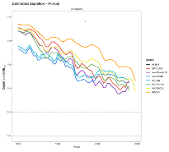
Simon Hoyle - New Zealand – 17 Aug
New Zealand is grateful for the attention that has been given to better understanding some of the retrospective patterns in recruitment and spawning biomass that were present in the 2021 (and also 2015) South Pacific albacore stock assessments. In particular, New Zealand would like to thank the SPC for allowing one of our own national scientists to work with the team to help better understand the issue.
NZ is interested in what further work could be done to improve this assessment, especially noting that we are at a critical time for the Commission as we consider the development of Harvest Control Rules.
When considering the current spatially structured SPA model, New Zealand remains unsure that some of the estimated movement parameters are helpful in informing the model. We are concerned that the size frequency data may not yield useful information on movement and population scale at the same time, given that determining population scale is the higher priority.
Recognising that consideration of a sex-specific model for SPA is already included on the Tuna Assessment Research Plan being considered by SC19, we suggest that the following be considered by the SPC for development of the next stock assessment.
      - Downweighting of longline size frequency data: in general, we do not expect that these data will be particularly informative for either recruitment or movement. However, they are important to the estimation of selectivity and population scale. Downweighting these data would allow other datasets to influence the model. It is also important to effectively implement Francis weighting.
      - Areas as fleets: given the difficulty of estimating both movement and scale, the critical importance of good fits to size data as indicated by the YFT review and the CAPAM workshop on tuna stock assessment, and the very different sizes caught by area and season, we think that strong consideration should be given to reverting to the ‘areas as fleets’ approach for SPA.
      - Early CPUE weighting: New Zealand notes that the new approach for deriving the CPUE indices has resulted in similar indices but a large increase in the weight given to early CPUE indices, which have previously been considered unrepresentative of abundance. Analysts should reconsider the weight given to these observations.
      - Step by step: As with other assessments, wherever possible we recommend a one-change-at-a-time approach to development of the assessment model to allow both the assessment team and the SC to carefully examine the impacts of changes.
Pilling - Pacific Community (SPC) - 19 Aug
Examining the observation by Australia regarding the outcomes of stock projections from the 2018 assessment model, attached is a very rapid look to see whether the assumptions for future recruitment are driving the evolution of projected future stock status. Preliminary results (stressing that this is a rapid evaluation undertaken in the margins of this SC meeting) of the median depletion across 100 projection runs from the diagnostic case model ONLY, is shown in the plot. In both recruitment assumption cases, the near-term decline is still seen, influenced by the ‘burnt in’ estimated recruitments toward the end of the assessment model time period – which includes the terminal (last 4 quarters) assumption of average recruitment levels. Assuming 2005-2015 recruitment patterns in the future (‘recent recruitment’ line in the plot) leads to subsequent stabilisation at higher stock sizes following the decline than in the longer-term recruitment assumption, noting both scenarios have identical assumed fishing levels in the future.
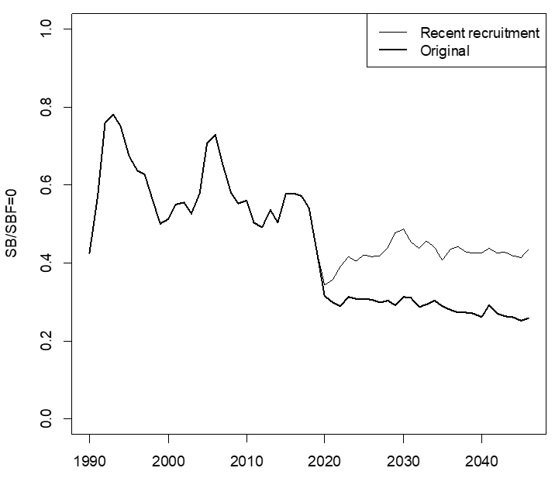
Francisco Abascal - European Union – 19 August
We would like to note that weighted stochastic projections from the latest assessment (SC17-WP-02a) in general predicted decreases in depletion levels from 2016 to 2021 of nearly 60% and decreases since the early 1990’s of around 70%. However, if we take a look at the nominal CPUE for the southern longline fisheries, as presented in the paper with the compendium of fishery indicators, it shows quite stable biomass levels in the latest decades, or a very small decreasing trend at the most.
So, it seems there are many grounds for considering it can be an artefact that results in an overly pessimistic view.

TOPIC 13. Progress of FADMO-IWG Priority Tasks for 2023

Discussion of a paper by the FAD Management Options Intersessional Working Group: SC19-EB-WP-13. Progress of the FADMO-IWG – Priority Tasks for 2023

Victor Restrepo - International Seafood Sustainability Foundation (ISSF) – 12 August 2023

At its annual meeting last week, the IATTC adopted a plan to transition towards biodegradable FADs. Starting 1 Jan 2026, only FADs of Categories I, II, III or IV can be deployed. By 1 Jan 2029, only FADs of Categories I or II can be deployed. Then, in 2030, the IATTC will consider if only Category I FADs can be deployed.

SC19 could consider if it would be convenient to recommend to the WCPFC a similar timetable, given that it is the same Ocean, that many vessels fish in the overlap area, and that many FADs drift from the EPO to the WCPO.

The Categories in the IATTC are now slightly different from those in Table 1 of WCPFC-SC19-2023/EB-WP-13. A similar timetable using the FADMO-IWG terminology would imply deploying only FADs Categories I to III(b) starting in 2026, and only Categories I and II starting in 2029.

TOPIC 16. Progress report of Project 110: Non-entangling and biodegradable FAD trial in the Western and Central Pacific Ocean

Federated States of Micronesia for PNA and Tokelau - 16th August

This is a very important project. The Commission’s plans for implementation of bio-degradable FADs depend on outcomes from this project. PNA and Tokelau support the proposed no-cost extension and the proposed extension to the project including WCPFC co-funding of 44,000 Euros.

TOPIC 18. Follow-up work on 2022 skipjack assessment recommendations

Keith Bigelow — United States of America – 18th August

As mentioned in discussion of this working paper across the floor, the USA is deeply appreciative of SPC finding the resources to undertake this work to begin looking into and addressing the issues raised by SC18. Continuous incremental development with regular review can only lead to better science.

In addition to comments made on the floor, the USA notes that certain biological parameters noticeably changed during the course of the sequential model development. In particular, the new shape of the natural mortality ogive does not appear consistent with current understanding that natural mortality generally declines as a function of age. The USA notes the author’s comment that the new shape is a symptom of the model to attempting to fit certain components of the data better, and that estimating a Lorenzen shape was attempted but unsuccessful. Is it possible in the coming development cycle to identify the data components driving the new shape? Given that the model likely uses the flexibility of the cubic spline function to trade-off natural mortality and fishing mortality in the total mortality calculation, it is possible that the more restrictive Lorenzen shape results in higher Fs at intermediate ages which are incompatible with other model assumptions.

Similarly, the USA notes that the estimation of growth is lower in the “new” model. Given the discussion around model stability at this SC, and the noted differences in estimates of spawning biomass seen from jittering conducted as a part of the 2022 skipjack assessment, it may be helpful to understand if the growth estimates show similar variability from a jittering analysis. If growth estimates are stable, then it would be good to understand the data component driving the lower estimate in L2, as it could be related to the shift in older ages seen in the selectivity curves.

In Appendix 1, we have a few comments. The USA appreciates the update work on the CPUE analysis to re-inform the scale of CPUE in temperate regions. However, as Japan mentioned in discussions on the floor, it would be useful to try and similarly constrain the estimation of recruitment into temperate regions during winter quarters.

Related to the poor fit to some length composition data, the USA understands that a better growth curve may help resolve the problem. However, it may also be useful to explore other selectivity parametrizations (including time-varying selectivity), fishery definitions, or to filter out non-representative size composition data.

The USA notes the successful achievement of a positive definite Hessian solution and recognizes that it is a first for the skipjack assessment. However, we still encourage inspection of the covariance matrix to identify correlated parameters as a starting point for further reductions in complexity for the skipjack model.

Lastly, the USA recognizes that IKAMOANA is a state-of-the-art individual based movement model, which is fit to the tagging data. However, even for models that are fit to data it is still common to conduct residual analyses to see how well predictions match observations. We request that such a diagnostic be provided for the simulated release groups, to confirm that observed release-recaptures are within the simulated distribution of tagged fish movements.

TOPIC 19. Review and analyses to inform conceptual models of population structure and spatial stratification of bigeye and yellowfin tuna assessments in the Western and Central Pacific Ocean

Keith Bigelow — United States of America – 18th August

The USA thanks SPC for taking the time to develop this paper as this is important work. SPC have taken a comprehensive and holistic approach to trying to characterize the relevant spatial considerations for each species. The USA supports additional investigation/resolution of this issue prior to the next SPC assessments (all species with spatially structured assessments).

Spatially explicit assessment structure is inextricably tied to model complexity as additional model regions lead to additional movement and recruitment parameters. Previous assessment reports, the 2022 yellowfin peer review, and the PAW have all raised concerns with model complexity and have urged for the development of simpler assessments.

SPC suggests that both the simpler assessment structure and the 9-Region structure are supported by the analysis. While it is possible that model diagnostics may suggest one structure is more appropriate than another, it is entirely likely that each has its strengths and weaknesses. Research (cited in this study by SPC) and conducted as a part of the NOAA/NIWA spatial assessment simulation project indicate that choice of spatial structure can strongly impact estimated quantities. Choice of spatial structure represents an important un-modelled source of uncertainty, and the USA recommends that rather than identify a single spatial structure, multiple structures are considered as a part of the structural uncertainty grid, provided that alternative structures are supported by model fitting and convergence diagnostics.

This analysis focuses almost exclusively on defining spatially explicit assessment structures, however spatially implicit treatments (areas-as-fleets; AAF) have been shown to be an effective modeling approach (even outperforming spatially explicit models in some cases) and are considerably less complex without movement or regional recruitments (both of which have traditionally been poorly estimated). Inclusion of tagging data within an AAF approach could be problematic, however there also issues with inclusion of the tagging data within the spatially explicit models (e.g., representativeness related to mixing and movement). Information from tagging data based on external analyses such as a fine scale spatiotemporal models (recommended by the yellowfin peer review and recent CAPAM workshop) could still be included as inputs to an AAF model as an informative prior. The USA recommends considering AAF models for future SPC assessments.

Attachment L

The Commission for the Conservation and Management of
Highly Migratory Fish Stocks in the Western and Central Pacific Ocean
Scientific Committee
Nineteenth Regular Session
Koror, Palau
16-24 August 2023
MOU between NPFC and WCPFC


Memorandum of Understanding between the
North Pacific Fisheries Commission (NPFC) and the
Western and Central Pacific Fisheries Commission (WCPFC)

The North Pacific Fisheries Commission (hereafter NPFC) and the Western and Central Pacific Fisheries Commission (hereafter WCPFC):

Acknowledging that the objective of the Convention on the Conservation and Management of High Seas Fisheries Resources in the North Pacific Ocean is to ensure the long-term conservation and sustainable use of the fisheries resources in the Convention Area while protecting the marine ecosystems of the North Pacific Ocean in which these resources occur;

Acknowledging also that the objective of the Convention on the Conservation and Management of Highly Migratory Fish Stocks in the Western and Central Pacific Ocean (hereafter WCPF Convention) is to ensure, through effective management, the long-term conservation and sustainable use of highly migratory fish stocks in the western and central Pacific ocean;

Recognising that Article 22 of the WCPFC Convention calls upon the WCPFC to make suitable arrangements for consultation, cooperation and collaboration with other relevant intergovernmental organizations;

Recognising further that Article 21 of the NPFC Convention calls upon the NPFC to take into account the conservation and management measures or recommendations adopted by regional fisheries management organizations and arrangements and other relevant intergovernmental organizations that have competence in relation to areas adjacent to the NPFC Convention;

Conscious of the fact that there is a geographical area overlap within the Convention Areas of both the NPFC and the WCPFC;

Noting that provisions of both the NPFC and the WCPF Conventions address the conservation of non-target, associated or dependent species which belong to the same ecosystem as the target species;

Desiring to put in place a mechanism to promote and facilitate cooperation between WCPFC and NPFC;
Therefore, NPFC and WCPFC record the following understandings:
OBJECTIVE OF THIS MEMORANDUM

The objective of this MoU is to facilitate, where appropriate, cooperation between NPFC and WCPFC (‘the Organisations’) in order to advance their respective objectives, particularly with respect to stocks or species which are within the competence or mutual interest of both Organisations.

AREAS OF COOPERATION

The Organisations will establish and maintain consultation, cooperation and collaboration in respect of matters of common interest to both organisations, including but not limited to, the following areas:

  - exchange meeting reports, information, documents and publications regarding matters of mutual interest, consistent with the information sharing policies of each organization;

  - exchange data and scientific information in support of the work and objectives of both Organisations, consistent with the confidentiality rules, information sharing policies and internal data security procedures of each Organisation including, but not limited to, information on:
    - vessels authorised to fish in accordance with conservation and management measures adopted under the NPFC and WCPFC Conventions;
    - at the specific request of one of the Organisations, transhipment activities of those vessels authorised to conduct transhipment in accordance with conservation and management measures adopted under the NPFC and WCPFC Conventions, on a necessity basis; and,
    - vessels identified as having engaged in illegal, unreported and unregulated (IUU) fishing activity and the IUU Vessel Lists established by each Organisation.

  - collaborate, where appropriate, on research efforts relating to species and stocks of mutual interest, including non-target, associated and dependent species;

  - cooperate where appropriate, on the implementation of conservation and management measures adopted under the NPFC Convention and under the WCPFC Convention;

  - share best practices in areas of mutual interest, including but not limited to:
    - monitoring, control and surveillance policies and systems, including with respect to Vessel Monitoring Systems;
    - administration, auditing, training and structure of observer programmes; and
    - Compliance Monitoring Schemes, and information management systems.

  - exchange on expertise gained, lessons learned and use of best practices between the Organisations’ Secretariats in their areas of activity.

  - consistent with each Organisation’s rules of procedure, grant reciprocal observer status to representatives of the respective Organisations in relevant meetings of each Organisation, including those of each Organisation’s subsidiary bodies;

CONSULTATIVE PROCESS

To facilitate effective development, implementation and enhancement of cooperation, the Organisations may establish a consultative process between their respective Secretariats that includes telephone, email and any other means of communication. The consultative process may also proceed in the margins of meetings at which both Organisations’ Secretariats are represented by appropriate staff.

MODIFICATION

This MoU may be modified at any time with the mutual written consent of both Organisations.

LEGAL STATUS

This MoU does not create legally binding rights or obligations. Each Organisation should cover their own costs related to the implementation of this MoU.

This MoU does not alter the obligations of members of either Organisation to comply with the conservation and management measures adopted under their respective Conventions.

OTHER PROVISIONS

This MoU will commence on the date of the second signature.

Either Organisation may discontinue this MoU by giving six months’ prior written notice to the other Organisation.

SIGNATURES

Signed on behalf of the North Pacific Fisheries Commission and the Western and Central Pacific Fisheries Commission:
FOR THE NORTH PACIFIC FISHERIES COMMISSION (NPFC)  --------------------------------------------------  Robert Day  Executive Secretary  Place:  Date: | FOR THE WESTERN AND CENTRAL PACIFIC FISHERIES COMMISSION (WCPFC)  ----------------------------------------------------  Rhea Moss-Christian  Executive Director  Place:  Date:

Attachment M

The Commission for the Conservation and Management of
Highly Migratory Fish Stocks in the Western and Central Pacific Ocean
Scientific Committee
Nineteenth Regular Session
Koror, Palau
16-24 August 2023
MOU between SPRFMO and WCPFC



Memorandum of Understanding between the South Pacific Regional
Fisheries Management Organisation (SPRFMO) and the Western and Central Pacific Fisheries Commission (WCPFC)

The South Pacific Regional Fisheries Management Organisation (hereafter SPRFMO) and the Commission for the Western and Central Pacific Fisheries Commission (hereafter WCPFC):

Acknowledging that the objective of the Convention on the Conservation and Management of High Seas Fishery Resources in the South Pacific Ocean (hereafter SPRFMO Convention) is, through the application of the precautionary approach and an ecosystem approach to fisheries management, to ensure the long-term conservation and sustainable use of fishery resources in the SPRFMO Convention Area and, in so doing, to safeguard the marine ecosystems in which these resources occur;

Acknowledging also that the objective of the Convention on the Conservation and Management of Highly Migratory Fish Stocks in the Western and Central Pacific Ocean (hereafter WCPF Convention) is to ensure, through effective management, the long-term conservation and sustainable use of highly migratory fish stocks in the western and central Pacific ocean;

Recognising that Article 22 of the WCPFC Convention calls upon the WCPFC to make suitable arrangements for consultation, cooperation and collaboration with other relevant intergovernmental organizations;

Recognising also that Article 31 of the SPRFMO Convention requires the SPRFMO Commission, inter alia, to cooperate, as appropriate, with other relevant organisations on matters of mutual interest and to seek to make suitable arrangements for consultation, cooperation and collaboration with such other organisations;

Conscious of the fact that there is a geographical area overlap within the Convention Areas of both the SPRFMO and the WCPFC;

Noting that provisions of both the SPRFMO and the WCPF Conventions address the conservation of nontarget, associated or dependent species which belong to the same ecosystem as the target species; Desiring to put in place a mechanism to promote and facilitate cooperation between SPRFMO and WCPFC;

Therefore SPRFMO and WCPFC record the following understandings:

OBJECTIVE OF THIS MEMORANDUM OF UNDERSTANDING

The objective of this MoU is to facilitate, where appropriate, cooperation between SPRFMO and WCPFC (‘the Organisations’) in order to advance their respective objectives, particularly with respect to stocks or species which are within the competence or mutual interest of both Organisations.

AREAS OF COOPERATION

The Organisations will establish and maintain consultation, cooperation and collaboration in respect of matters of common interest to both organisations, including but not limited to, the following areas:

- exchange meeting reports, information, documents and publications regarding matters of mutual interest, consistent with the information sharing policies of each Organisation;
- exchange data and scientific information in support of the work and objectives of both Organisations, subject to the information sharing policies and data use, access and confidentiality rules of each Organisation, including but not limited to, information on:
  - vessels authorised to fish in accordance with conservation and management measures adopted under the SPRFMO and WCPFC Conventions;
  - at the specific request of one of the Organisations, transhipment activities of those vessels authorised to conduct transhipment in accordance with conservation and management measures adopted under the SPRFMO and WCPFC Conventions, on a necessity basis; and
  - vessels identified as having engaged in illegal, unreported and unregulated (IUU) fishing activity and on the IUU Vessel Lists established by each Organisation;
- collaborate, where appropriate, on research efforts relating to species and stocks of mutual interest, including non-target, associated and dependent species;
- cooperate where appropriate, on the implementation of conservation and management measures adopted under the SPRFMO Convention and under the WCPFC Convention;
- share best practices in areas of mutual interest, including but not limited to:
  - monitoring, control and surveillance policies and systems, including with respect to Vessel Monitoring Systems;
  - administration, auditing, training and structure of observer programmes; and
  - Compliance Monitoring Schemes, and information management systems;
- exchange of information between the Secretariats of the Organisations on expertise gained, lessons learned and the use of best practices in their respective activities;
- consistent with each Organisation’s rules of procedure, grant reciprocal observer status to representatives of the respective Organisations in relevant meetings of each Organisation, including those of each Organisation’s subsidiary bodies.

CONSULTATIVE PROCESS

To facilitate effective development, implementation and enhancement of cooperation, the Organisations may establish a consultative process between their respective Secretariats that includes telephone, email and any other means of communication. The consultative process may also proceed in the margins of meetings at which both Organisations’ Secretariats are represented by appropriate staff.

MODIFICATION

This MoU may be modified at any time by the mutual written consent of both Organisations.

LEGAL STATUS

This MoU does not create legally binding rights or obligations. Each Organisation will cover its own costs related to the implementation of this MoU.
This MoU does not alter the obligations of members of either Organisation to comply with the conservation and management measures adopted under their respective Conventions.

OTHER PROVISIONS

This MoU will commence on the date of the second signature.

Either Organisation may discontinue this MoU by giving six months’ prior written notice to the other Organisation.

This MoU will operate for three (3) years. Before the end of the three year period, the Organisations will separately review the operation of this MoU to decide whether it should be renewed.

SIGNATURES

Signed on behalf of the South Pacific Regional Fisheries Management Organisation and the Western and Central Pacific Fisheries Commission:

FOR THE SOUTH PACIFIC REGIONAL FISHERIES FOR THE WESTERN AND CENTRAL PACIFIC MANAGEMENT ORGANISATION (SPRFMO) FISHERIES COMMISSION (WCPFC)

--------------------------------------------------------- ---------------------------------------------------
Mr Luis Molledo Dr Josie Tamate
Chair SPRFMO Chair WCPFC
Place: Place:
Date: Date:

Attachment N

The Commission for the Conservation and Management of
Highly Migratory Fish Stocks in the Western and Central Pacific Ocean
Scientific Committee
Nineteenth Regular Session
Koror, Palau
16-24 August 2023
List of Abbreviations

ABNJ | – | Areas Beyond National Jurisdiction
ACAP | – | Agreement for the Conservation of Albatrosses and Petrels
ALC  ANCORS | –  – | Automatic Location Communicator  Australian National Centre for Ocean Resources and Security
BILLWG | – | ISC Billfish Working Group
BMIS | – | Bycatch Mitigation Information System
B_{MSY} | – | Biomass that will support the maximum sustainable yield
CCM | – | Members, Cooperating Non-members and participating Territories
CCSBT | – | Commission for the Conservation of Southern Bluefin Tuna
CDS | – | catch documentation scheme
CLAV | – | Consolidated List of Authorised Vessels
CMM | – | Conservation and Management Measure
CMR | – | Compliance Monitoring Report
CMS | – | Compliance Monitoring Scheme
CNM  CNMI | –  – | Cooperating Non-Member  Commonwealth of the Northern Mariana Islands
the Convention | – | The Convention for the Conservation and Management of Highly Migratory Fish Stocks in the Western and Central Pacific Ocean
CPUE | – | catch per unit effort
CSIRO | – | Commonwealth Scientific and Industrial Research Organization (Australia)
CV | – | Coefficient of variation
Delta-GLM | – | delta-generalized linear model
Delta-GLMM | – | delta-generalized linear mixed model
DFLL  DM  DSPM  DWFN  EAFM  EDF | –  –  –  –  –  – | deep frozen tuna longline  discard mortality  dynamic surplus production model  distant water fishing nation  ecosystem approach to fisheries management  Environmental Defence Fund
EEZ | – | exclusive economic zone
EM | – | electronic monitoring
ENSO | – | El Niño-Southern Oscillation
EPO | – | eastern Pacific Ocean
ER | – | electronic reporting
ERandEM | – | electronic reporting and electronic monitoring
ERA | – | ecological risk assessment
EHSP-SMA | – | Eastern High Seas Pocket-Special Management Area
EU | – | European Union
F  FAC | –  – | fishing mortality rate  Finance and Administration Committee
FAD | – | fish aggregation device
FAO | – | Food and Agriculture Organization of the United Nations
F_{current} | – | average fishing mortality rate over the period xxxx–xxxx
F_{recent} |  | average fishing mortality rate over the period yyyy–yyyy
FFA | – | Pacific Islands Forum Fisheries Agency
FIMS | – | (PNA) Fisheries Information Management System
FL | – | fork length
F_{MSY} | – | fishing mortality that will support the maximum sustainable yield
FMA  FNA | –  – | fishery management area  fins naturally attached
FRP  FSA | –  – | fishing mortality-based reference point  United Nations Fish Stock Agreement
FSI | – | Flag State Investigation
FSM  GAM  GEF | –  –  – | Federated States of Micronesia  Generalised additive model  Global Environment Facility
geostats | – | geostatistical delta-GLMMs
HCR | – | harvest control rule
HSBI | – | high seas boarding and inspection
IATTC | – | Inter-American Tropical Tuna Commission
ICCAT  IELP  IGOs  IMO | –  –  –  – | International Commission for the Conservation of Atlantic Tunas  International Environmental Law Project  intergovernmental organizations  International Maritime Organization
IMS | – | Information Management System
IOTC  IPNLF | –  – | Indian Ocean Tuna Commission  International Pole and Line Foundation
ISC | – | International Scientific Committee for Tuna and Tuna-like Species in the North Pacific Ocean
ISSF | – | International Seafood Sustainability Foundation
IT | – | information technology
IUU | – | illegal, unreported and unregulated
IWG | – | intersessional working group
JTF | – | Japan Trust Fund
LRP | – | limit reference point
M | – | Natural Mortality
M_{FMT} | – | maximum fishing mortality threshold
MCS  MIMRA | –  – | Monitoring Control and Surveillance  Marshall Islands Marine Resources Authority
MOC | – | management options consultation
MOU  MP  MSC | –  –  – | memorandum of understanding  management procedure  Marine Stewardship Council
MSE | – | management strategy evaluation
MSY | – | maximum sustainable yield
mt | – | metric tonnes
MTU | – | Mobile Transceiver Unit
NC  NGO  NP  NZ  OM  PandL  PBFWG  pCMR | –  –  –  –  –  –  –  – | Northern Committee  Non-governmental Organization  North Pacific  New Zealand  operating model  Pole and Line  Pacific bluefin tuna working group (ISC)  provisional Compliance Monitoring Report
Pew  PI  PITIA | –  –  – | The Pew Charitable Trusts  performance indicator  Pacific Islands Tuna Industry Association
PNA | – | Parties to the Nauru Agreement
PNA+ | – | PNA + Tokelau (Parties to the Palau Arrangement)
PNG  PRM  RFV | –  –  – | Papua New Guinea  post-release mortality  Record of Fishing Vessels
ROP | – | Regional Observer Programme
RFMO | – | regional fisheries management organization
RMI | – | Republic of the Marshall Islands
RV | – | recruitment variability
SB | – | spawning biomass
SB_{F=0} | – | spawning biomass in the absence of fishing
SC | – | Scientific Committee of the WCPFC
SIDS  SIP | –  – | small island developing states  strategic investment plan
SPA-VIWG  SPC | –  – | South Pacific albacore virtual intersessional working group  Pacific Community
SPC-OFP | – | Pacific Community Oceanic Fisheries Programme
SRA | – | spatial risk assessment
SRF | – | Special Requirements Fund
SRR | – | stock-recruitment relationship
SS3 | – | Stock Synthesis 3 (software)
SSB | – | spawning stock biomass
SSI | – | species of special interest
SST  SWG | –  – | sea surface temperature  small working group
Mt  TCC  TNC | –  –  – | metric ton  Technical and Compliance Committee  The Nature Conservancy
TOR  TRP  TUFMAN  UN  UNCLOS | –  –  –  –  – | terms of reference  target reference point  Tuna Fisheries Database Management System  United Nations  United Nations Convention on the Law of the Sea
USA | – | United States of America
USD  VDS  VID  VMS | –  –  –  – | US dollars  vessel day scheme  vessel identification (number)  vessel monitoring system
WCPFC | – | Western and Central Pacific Fisheries Commission
WCPFC Convention Area | – | Area of competence of the Commission for the Conservation and Management of Highly Migratory Fish Stocks in the Western and Central Pacific Ocean, as defined in Article 3 of the Convention
WCPFC Statistical Area | – | The WCPFC Statistical Area is defined in para. 8 of “Scientific data to be provided to the Commission” (as adopted at WCPFC13)
WCNPO | – | Western and Central North Pacific Ocean
WCPO | – | Western and Central Pacific Ocean (not including IATTC overlap)
WG  WPEA  WPRFMC | –  _  – | working group  West Pacific and East Asian Seas (project)  (USA) Western Pacific Regional Fishery Management Council
WTPO | – | World Tuna Purse Seine Organisation
WWF | – | World Wide Fund for Nature

103. SC18 noted the challenge of fully reviewing the key inputs into WCPFC stock assessments and providing feedback within the time available. SC recommended that approaches that may address this issue be discussed at SC19 and recommended that the Scientific Services Provider develop a discussion paper to inform those discussions.
The Categories were renumbered as follows: Category III = Category III(a); Category IV = Category III(b) and Category V = Category IV
Analysing potential inputs to the 2024 stock assessment of Western and Central Pacific silky shark (Carcharhinus falciformis)
Characterisation of the fisheries catching Silky sharks (Carcharhinus falciformis) in the Western and Central Pacific Ocean
SPR: spawning potential ratio
103. SC18 noted the challenge of fully reviewing the key inputs into WCPFC stock assessments and providing feedback within the time available. SC recommended that approaches that may address this issue be discussed at SC19 and recommended that the Scientific Services Provider develop a discussion paper to inform those discussions.
The Categories were renumbered as follows: Category III = Category III(a); Category IV = Category III(b) and Category V = Category IV
Analysing potential inputs to the 2024 stock assessment of Western and Central Pacific silky shark (Carcharhinus falciformis)
Characterisation of the fisheries catching Silky sharks (Carcharhinus falciformis) in the Western and Central Pacific Ocean
Analysing potential inputs to the 2024 stock assessment of Western and Central Pacific silky shark (Carcharhinus falciformis)
Characterisation of the fisheries catching Silky sharks (Carcharhinus falciformis) in the Western and Central Pacific Ocean
[1] Paragraph 2 (g) in Article 12 of the WCPF Convention

