SCIENTIFIC COMMITTEE
EIGHTEENTH REGULAR SESSION

KOROR, PALAU
16-24 August 2023
Progress report of the research survey for 2022 by Chinese fishery research vessel "Song Hang" in the WCPFC area
WCPFC- SC19-ST-IP-10

Zhe Geng, Xiaodong Li, Xiaojie Dai, Feng Wu, Jiangfeng Zhu
Summary
China as a member country has been conducting a five-year scientific survey program using its fishery research vessel "Song Hang" with longline as the main gear in the WCPFC convention area from 2021 to 2025. The survey has collected fundamental data and biological tissue samples to improve the commission's scientific research to support better management advice. The main objectives of our cruises are to improve the understanding of the stock structure and investigate the mechanisms of moving and aggregating by incorporating environmental factors for target and bycatch species. The survey covered the area in the high sea from 129°97′E to 138°05′E and 10°93′ N to 16°02′N between August to September 2022. A total of 22 sets (8425 hooks) were released, and a total of 15 species were recorded in this survey. Preliminary result shows that harvest consists of Longnose lancetfish (41.94%) and blue shark (18.71%). Albacore tuna is the majority catch of commercial tuna. A total of 3 tags with satellites were released, and tissues sample of 48 individuals from 15 species were collected during the cruises.

Introduction
According to WCPFC Convention principles "on the need to collect and share data, including information from national research programs"(Article 5) and "The function of promoting the conduct of relevant scientific research and disseminating the results thereof is one of the functions of the Commission" (Article 10), China as a member country of WCPFC has conducted a five-year scientific survey program using its fishery research vessel "Song Hang" with longline as main gear in the WCPFC convention area. This series of research surveys are supported by the Ministry of Agriculture and Rural Affairs (MARA) of China and conducted by Shanghai Ocean University, focusing on the tuna and bycatch resource in the WCPFC convention area. Through this project, we look forward to providing essential information to supplement the current scientific database of the commission. We also hope that the survey will be a joint project with participants from SPC and other member scientists in the future.

The main objective of this project is based on various CMMs and recommendations raised by SC, including support and encouragement for CCMs to undertake scientific research to understand fisheries and species covered by the Convention. The survey will be conducted to collect fundamental data and conduct experiments to improve the commission's scientific research and support better management advice. Five tasks would be included in this project, which are as below:
- Collecting fishery-independent data, including catch and effort, length-frequency, length-weight data (to estimate various conversion factors), and biological sampling (larvae survey, growth, stomach content, etc.).
- Investigating stock structure (tissue bank) and spatial distribution of longline target and bycatch species.
- Investigating the influence of different types of longline hooks and baits on fishing selectivity, catchability, and survival rate onboard.
- Collecting environment data for ecosystem model, including temperature, salinity, transparency, dissolved oxygen, pH, nitrogen, et al.
- Tagging and releasing experiments for sharks, marine mammals, and turtles if possible. The project would also be used to monitor bycatch migration and releasing mortality.

Methods and materials
Given the capacity and schedule of the “Song hang” research vessel, we surveyed from Aug to Sep of 2022. This survey covered the area from 129°97′E to 138°05′E and 10°93′ N to 16°02′N on the high sea. This survey includes 74 survey stations, but half of them are only for the basic environment survey without fishing behavior. A total of 29 fishing sets(7 for trawl net and 22 for longline) were included in this survey, and a total of 8425 hooks were released in the WCPO (Table 1). For more details about spatial distribution, please refer to Figure 1.
For the requirement of environment data for the ecosystem study, we collected data on temperature, salinity, transparency, dissolved oxygen, pH, nitrogen, etc. Conductivity Temperature Depth (CTD 9-11Plus, Sea-Bird) and its MOUNTED SBE43 probe were used to collect 0-300m vertical hydrological data of the above information at each station. Water samples were collected in layers of 25m, 50m, 75m, 100m, 200m, and 300m, and 12 bottles *250ml/ bottle per station.
This project has conducted tagging and releasing programs for sharks, marine mammals, and turtles. These programs were used to monitor migration, habits, and releasing mortality. This voyage included one type of label, as shown in Table 2.

Result
A total of 15 species (155 individuals) were recorded in this survey. Preliminary result showed that harvest (including escape and released species) consists of Longnose lancetfish (41.94%) and blue shark (18.71%). For commercial tuna, Albacore tuna is the majority caught in this WCPO survey. More details can be found in Table 3. A total of 48 individuals have been sampled on board, and biological tissues include vertebra, gonad, stomach, muscles, and so on (Table 4). The total catch of tuna and tuna-like species caught by Catch was 1135kg (Table 5). The biological characteristics of the main economic fish and bycatch fish species in the catch were recorded (Table 6, Table 7). Currently, our project is still in the process to collect the data and materials, therefore we only provide a brief description of our survey and sampling here.

Table 1. Hooks were released in the WCPO survey
Date | Set | Hooks | Hooks per day
August | 12 | 4386 | 366
September | 10 | 4039 | 404

Table 2 Tags were used in the WCPO survey
Name of tags | number
MiniPAT w/Attached, Dart, Domeier Medium, No Dacron | 3

Table 3 Harvest composition in the WCPO survey
English name | Scientific name | Individuals (num) | Proportion (%)
Blue marlin | Makaira nigricans | 16 | 10.32
Sickle pomfret | Taractichthys steindachneri | 10 | 6.45
Bigeye tuna | Thunnus obesus | 5 | 3.23
Yellowfin tuna | Thunnus albacares | 2 | 1.29
Snake mackerel | Gempylus serpens | 8 | 5.16
Blue shark | Prionace glauca | 29 | 18.71
Escolar | Lepidocybium flavobrunneum | 3 | 1.94
Albacore tuna | Thunnus alalunga | 7 | 4.52
Pelagic stingray | Dasyatis violacea | 1 | 0.65
Longnose lancetfish | Alepisaurus ferox | 65 | 41.94
Great barracuda | Sphyraena barracuda | 1 | 0.65
Oilfish | Ruvettus pretiosus | 1 | 0.65
Sharptail mola | Masturus lanceolatus | 1 | 0.65
Swordfish | Xiphias gladius | 4 | 2.58
Atlantic pomfret | Brama brama | 2 | 1.29
Sum |  | 155 | 100.00

Table 4 Sampling tissues and their numbers for each species of catch
English name | Sampling tissue | Individuals (num)
Blue marlin | Heart, stomach, intestines, muscles, skin, liver, kidneys, gonads, vertebrae, blood, gills, stomach contents, eyeballs, spleen | 12
Sickle pomfret | Muscles, gills, eyes, guts | 4
Bigeye tuna | Muscles, vertebrae, fin spines, liver, stomach, stomach contents, pancreas, spleen, gall bladder, gills, eyes, kidneys, gonads, head, otoliths | 3
Yellowfin tuna | Muscles, vertebrae, fin spines, liver, stomach, stomach contents, pancreas, spleen, gall bladder, gills, eyes, kidneys, gonads, head, otoliths | 2
Blue shark | Stomach, plasma, blood cells, liver, skin, muscle, intestine, intestinal RNA red muscle, gluteal fins, intestinal microbes, vertebrae, uterine ovaries and head | 17
Albacore tuna | Muscles, vertebrae, fin spines, liver, stomach, stomach contents, pancreas, spleen, gall bladder, gills, eyes, kidneys, gonads, head, otoliths | 6
Longnose lancetfish | Muscle, liver, stomach contents, stomach, intestines, skin, eye, pancreas, gallbladder, gonads, vertebrae | 2
Swordfish | Muscle, undecomposed viscera, gills, eyes, vertebrae, head | 1
Atlantic pomfret | Muscle, liver, caudal fin, stomach, intestines, gills, eyes | 1
Sum |  | 48

Table 5 Tuna and tuna-like species were caught in the WCPO survey
Species | Blue marlin | Albacore tuna | Yellowfin tuna | Bigeye tuna | Swordfish
Weight(kg) | 694.93 | 113.64 | 86.1 | 153.25 | 86.9
Individual(num) | 14 | 7 | 2 | 5 | 4

Table 6 Biological characteristics of the main economic fish species
Species | Average length (cm) | Standard deviation of length | Minimum length (cm) | Maximum length (cm)
Blue marlin | 200.4 | 22.9 | 163 | 250
Albacore tuna | 95.9 | 16.5 | 80 | 134
Yellowfin tuna | 133 | 13 | 120 | 146
Bigeye tuna | 108.4 | 17.2 | 77 | 125
Swordfish | 146 | 49.6 | 107 | 230

Table 7 Biological characteristics of the main bycatch species
Species | Average length or width(cm) | Standard deviation of length | Minimum length (cm) | Maximum length (cm)
Blue shark | 204.33 | 12.88 | 185.00 | 225.00
Pelagic stingray | 91 | / | / | /
Sickle Pomfret | 74.00 | 7.40 | 58.00 | 86.00
Atlantic pomfret | 71.00 | 7.07 | 66.00 | 76.00
Swordfish | 157.25 | 56.98 | 115.00 | 240.00
Longnose lancetfish | 106.93 | 20.30 | 65.00 | 173.00
Snake Mackerel | 105.8 | 9.02/ | 96 | 118.00
Oilfish | 140.00 | / | / | /
Great barracuda | 105.00 | / | / | /
Escolar | 109.00 | 9.64 | 98.00 | 116.00
Sharptail mola | 200.00 | / | / | /

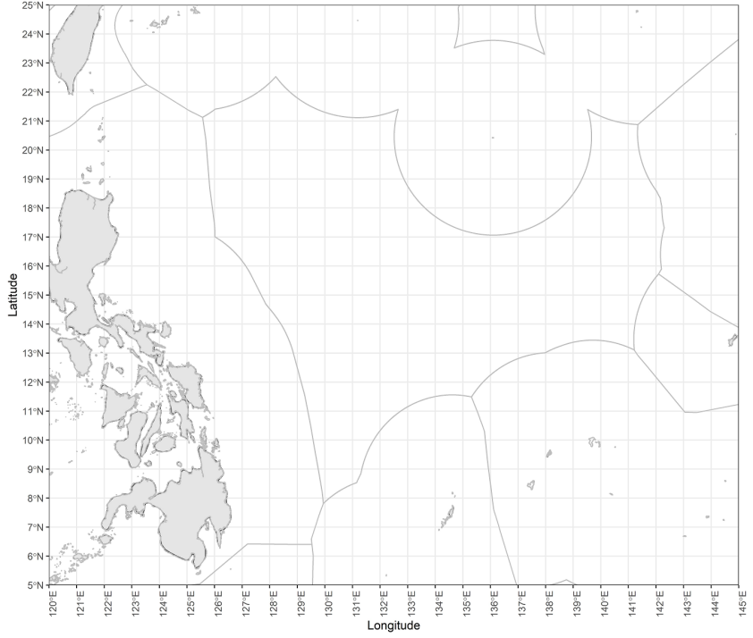
Figure 1 Spatial distribution for the scientific survey in WCPO.

Shanghai Ocean University, Shanghai, People’s Republic of China

