SCIENTIFIC COMMITTEE
NINETEENTH REGULAR SESSION

Koror, Palau
16 –24 August 2023

OVERVIEW OF TUNA FISHERIES IN THE WESTERN AND CENTRAL PACIFIC OCEAN, INCLUDING ECONOMIC CONDITIONS – 2022

WCPFC-SC19-2023/GN WP-1

Paper prepared by

Peter Williams¹ and Thomas Ruaia²

¹ Pacific Community (SPC), Ocean Fisheries Programme (OFP), Noumea, New Caledonia
² Pacific Islands Forum Fisheries Agency (FFA), Honiara, Solomon Islands

ABSTRACT

This paper provides a broad description of the major fisheries in the WCPFC Statistical Area (WCP-CA) highlighting activities during the most recent calendar year (2022) and covering the most recent summary of catch estimates by gear and species.

The provisional total WCP–CA tuna catch for 2022 was estimated at 2,702,099 mt, slightly higher than the 2021 level and around 270,000 mt lower than the record catch in 2019 (2,973,586 mt). The WCP–CA tuna catch (2,702,099 mt) for 2022 represented 80% of the total Pacific Ocean tuna catch of 3,371,780 mt, and 54% of the global tuna catch (the provisional estimate for 2022 is 4,963,170 mt), noting that unlike other oceans, over 85% of the WCP–CA tuna catch occurs in the waters of the coastal states.

The 2022 WCP–CA catch of skipjack (1,735,500 mt – 64% of the total catch) was around 310,000 mt lower than the record in 2019 (2,044,779 mt). The WCP–CA yellowfin catch for 2022 (721,169 mt – 27%) was a decline of around 33,000 mt on the record 2021 catch (754,442 mt), noting the previous five years have produced the highest annual yellowfin catches on record, and related to some extent to recent high catch levels from the “other” category (primarily small-scale fisheries in Indonesia).

The WCP–CA bigeye catch for 2022 (140,664 mt – 5%) was similar to the 2021 catch level. The 2022 WCP–CA albacore catch (104,766 mt – 4%) was around 15,000 mt higher than in 2021 (which at 89,282 mt was the lowest catch since 1993), but clearly lower than the record catch in 2002 of 148,051 mt. The provisional south Pacific albacore catch in 2022 (77,912 mt), was higher than the past two years and around 16,000 mt less than the record catch taken in 2017 (94,504 mt).

The provisional 2022 purse seine catch of 1,893,794 mt was around 205,000 mt lower than the record catch in 2019 (2,100,135 mt). The 2022 purse seine skipjack catch (1,451,079 mt: 77% of the catch) was the fifth highest on record, but around 250,000 mt lower that the catch in 2019 (~1,700,000 mt). The 2022 purse seine catch for yellowfin tuna (379,715 mt; 20% of the total purse seine tuna catch) was around 120,000 mt lower than the record catch in 2017 (500,506 mt) but still amongst the highest annual catches for this fishery. The provisional catch estimate for bigeye tuna for 2022 (62,811 mt) was similar to the 2021 catch and a clear increase on the notably low purse seine bigeye tuna catch in 2019 (52,081 mt). The increased bigeye tuna catches since 2020 appears to be related to a higher number of associated sets in conjunction with La Nina conditions.

The provisional 2022 pole-and-line catch (168,807 mt) is clearly lower than the 2021 catch (200,108 mt) and at this stage, the lowest annual catch since the early-1960s, due to reduced catches in the Japanese fishery, although we note as in previous years the provisional nature of the estimates at this stage.

The provisional WCP–CA longline catch (230,038 mt) for 2022 remains lower than the recent ten-year average but an increase on the past two years, which were impacted by COVID-19. The prevailing La Niña conditions during the past three years may also have contributed to changes in the catch by species throughout extent of the longline fishery.

The 2022 South Pacific troll albacore catch (3,777 mt) was slightly less than 2021 (4,037 mt) but amongst the highest catches since 2004 (4,990 mt). The New Zealand troll fleet (134 vessels catching 2,377 mt in 2022) and the United States troll fleet (18 vessels catching 1,400 mt in 2022) accounted for all the 2022 albacore troll catch.

In 2022, market prices for purse seine-caught products rose to levels similar to those observed in 2018 with Thai imports averaging to $1,645/mt, a 19% increase compared to 2021. The Yaizu price rose by 20% to $2,014/mt.

Prices for longline-caught yellowfin across all markets increased in 2022, except for the Japanese Yaizu longline caught price and Japan selected ports frozen price, which fell 2% to $7,015/mt and $7,620/mt, respectively. This decline was primarily driven by the depreciation of the Japanese yen against the US dollar. However, prices for longline-caught bigeye increased across all markets with the Japan selected ports frozen price exceeding $10,000/mt for the first time since 2017. Thai import prices for albacore increased to $3,540/mt, while US fresh prices rose to $5,940/mt in 2022 while the Japanese selected ports fresh price surged 24% to $4,041/mt.

The total estimated delivered value of the tuna catch in the WCP-CA rose by 17% to $5.95 billion in 2022. The purse seine fishery was valued at $3.3 billion, a 21% increase from 2021 and accounting for 55% of the total value of the tuna catch. Similarly, the value of the longline fishery increased by 16% to $1.5 billion, while the pole and line catch saw a 7% increase to $387 million, driven by significant price hikes. The catch by other gears also experienced a 9% increase, reaching $766 million in 2022. The 2022 WCP-CA skipjack catch was valued at $3 billion, a substantial 25% increase from the previous year, and comprised half of the total tuna catch value. The value of the albacore tuna catches increased by 23% to $364 million, while the yellowfin and bigeye catches reached $1.9 billion (+8%) and $715 million (+9%), respectively.

In 2022, the economic conditions for the purse seine, tropical longline, and southern longline fisheries in the WCP-CA showed mixed results. The tropical purse seine index remained above average at 101 but hit its lowest level since 2014 due to a significant increase in Marine Diesel Oil (MDO) prices. In the preceding years (2018-2021), the index remained considerably above its 20-year average, primarily due to high catch rates. For the southern longline fishery, the economic conditions index decline in 2021, to a value below its 20-year average due to lower catch rates and fish prices. Economic conditions improved in 2022 largely driven by a significant increase in catch rates. In contrast, the economic conditions for the tropical longline fishery remained below its 20-year average mainly influenced by rising fuel prices.

CONTENTS

1. INTRODUCTION 5
2. TOTAL TUNA CATCH AND CATCH VALUE FOR 2022 6
3 WCP–CA PURSE SEINE FISHERY 8
3.1 Historical Overview 8
3.2 Provisional catch estimates, fleet size and effort (2022) 9
3.3 Environmental conditions 11
3.4 Distribution of fishing effort and catch 12
3.5 Catch per unit of effort 15
3.6 Species/Size composition of the catch 19
3.7 Seasonality 20
3.8 Prices, catch value and overall economic conditions 22
3.8.1 Prices 22
3.8.2 Catch Value 23
3.8.3 Economic Conditions in the tropical purse seine fishery 23
4 WCP–CA POLE-AND-LINE FISHERY 25
4.1 Historical Overview 25
4.2 Catch estimates (2022) 25
4.3 Prices and catch value 27
4.3.1 Prices 27
4.3.2 Catch Value 27
5 WCP–CA LONGLINE FISHERY 28
5.1 Overview 28
5.2 Provisional catch estimates and fleet sizes (2022) 29
5.3 Catch per unit effort 30
5.4 Geographic distribution 31
5.5 Prices and catch values 34
5.5.1 Prices 34
5.5.2 Catch Value 36
5.5.3 Economic conditions 37
6 SOUTH-PACIFIC TROLL FISHERY 39
6.1 Overview 39
6.2 Provisional catch estimates (2022) 39
7 OTHER FISHERIES 40
7.1 Large-fish Handline Fishery 40
7.2 Small-scale troll and hook-and-line Fishery 41
7.3 Small-scale gillnet Fishery 41
8. SUMMARY OF CATCH BY SPECIES 42
8.1 SKIPJACK 42
8.2 YELLOWFIN 45
8.3 BIGEYE 48
8.4 SOUTH PACIFIC ALBACORE 52
8.5 SOUTH PACIFIC SWORDFISH 56
8.6 OTHER BILLFISH 60
8.6.1 Blue Marlin 60
8.6.2 Black Marlin 61
8.6.3 Striped Marlin 62
8.6.4 North Pacific Swordfish 63
8.7 NORTH PACIFIC ALBACORE 64
8.8 NORTH PACIFIC BLUEFIN 64
References 65
APPENDIX - Additional Information 66
ALL FISHERIES – Additional Information 66
PURSE SEINE FISHERY – Additional Information 66
LONGLINE FISHERY – Additional Information 67

1. INTRODUCTION

The tuna fishery in the Western and Central Pacific Ocean is diverse, ranging from small-scale artisanal operations in the coastal waters of Pacific states, to large-scale, industrial purse seine, pole-and-line and longline operations in both the exclusive economic zones of Pacific states and on the high seas. The main species targeted by these fisheries are skipjack tuna (Katsuwonus pelamis), yellowfin tuna (Thunnus albacares), bigeye tuna (T. obesus) and albacore tuna (T. alalunga).

This review provides a broad description of the major fisheries in the WCPFC Statistical Area (WCP–CA; see Figure 1), highlighting activities during the most recent calendar year – 2022. The review draws on the latest catch estimates compiled for the WCP–CA, found in Information Paper WCPFC–SC19-ST IP–1 (Estimates of annual catches in the WCPFC Statistical Area – SPC-OFP, 2023). Where relevant, comparisons with previous years' activities have been included, although data for 2022, for some fisheries, are provisional at this stage.

This paper includes sections covering the four target tuna species, as well as blue marlin (Makaira mazara), black marlin (Istiompax indica), striped marlin (Kajikia audax) and swordfish (Xiphias gladius) catch in the WCP–CA tuna fisheries and an overview of the WCP–CA tuna fisheries by gear, including economic conditions in the main fisheries. In each section, the paper comments on recent developments in each fishery, with emphasis on 2022 catches relative to those of recent years, but refers readers to the SC19 National Fisheries Reports, which offer more detail on recent activities at the fleet level.

Additional graphical information that provides more information related to the recent condition of the fishery and certain WCPFC Conservation and Management Measures (CCMs) has been provided in an APPENDIX of this document, and other tabular and graphical information on the fishery can be found in Hare et al. (2023), and WCPFC Secretariat and SPC-OFP (2023).

This overview includes brief summaries of several fisheries in the north Pacific Ocean, including those fisheries catching albacore tuna, Pacific bluefin tuna (T. orientalis), striped marlin and swordfish. Information on these fisheries may be expanded in future reviews, depending on the availability of more complete data.

Figure 1.1 The western and central Pacific Ocean (WCPO), the eastern Pacific Ocean (EPO) and the WCPFC Convention Area (WCP–CA in dashed lines)

2. TOTAL TUNA CATCH AND CATCH VALUE FOR 2022

Annual total catches of the four main tuna species (skipjack, yellowfin, bigeye and albacore) in the WCP–CA increased steadily during the 1980s and 1990s with the purse seine fleet becoming clearly the dominant fishery in terms of catch volume. The increasing trend in total tuna catch continued through to 2009, followed by two years (2010-2011) of reduced catches (due in part to La Nina conditions), before returning to record levels in successive years over the period 2012–2014. Catches in the period 2015–2017 were lower than 2014 but increased again over the next two years, with a record catch taken in 2019. Catches over the past three years (2020-2022) have been clearly lower than the 2019 record, partially due to the impacts of the COVID-19 pandemic (Figure 2.1 and Figure 2.2).

The provisional total WCP–CA tuna catch for 2022 was estimated at 2,702,099 mt, slightly higher than the 2021 level and around 270,000 mt lower than the record catch in 2019 (2,973,586 mt). For 2022, the purse seine fishery accounted for a catch of 1,893,794 mt (70% of the total catch), with pole-and-line taking an estimated 168,807 mt (6%), the longline fishery an estimated 230,106 mt (9%), and the remainder (15%) taken by troll gear and a variety of artisanal gears, mostly in Indonesia and the Philippines. The WCP–CA tuna catch (2,702,099 mt) for 2022 represented 80% of the total Pacific Ocean tuna catch of 3,371,780 mt, and 54% of the global tuna catch (the provisional estimate for 2022 is 4,963,170 mt), noting that unlike other oceans, over 85% of the WCP–CA tuna catch occurs in the waters of the coastal states (see Figure A1 in the Appendix).
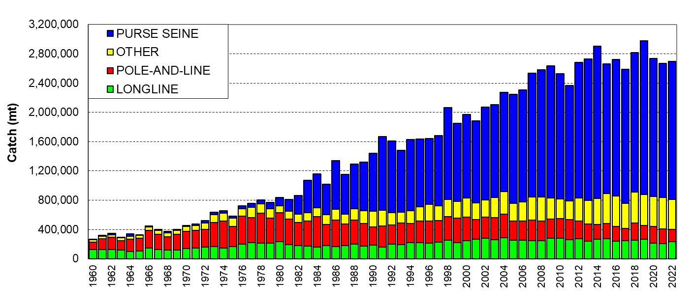
Figure 2.1 Catch (mt) of albacore, bigeye, skipjack and yellowfin in the WCP–CA, by longline, pole-and-line, purse seine and other gear types
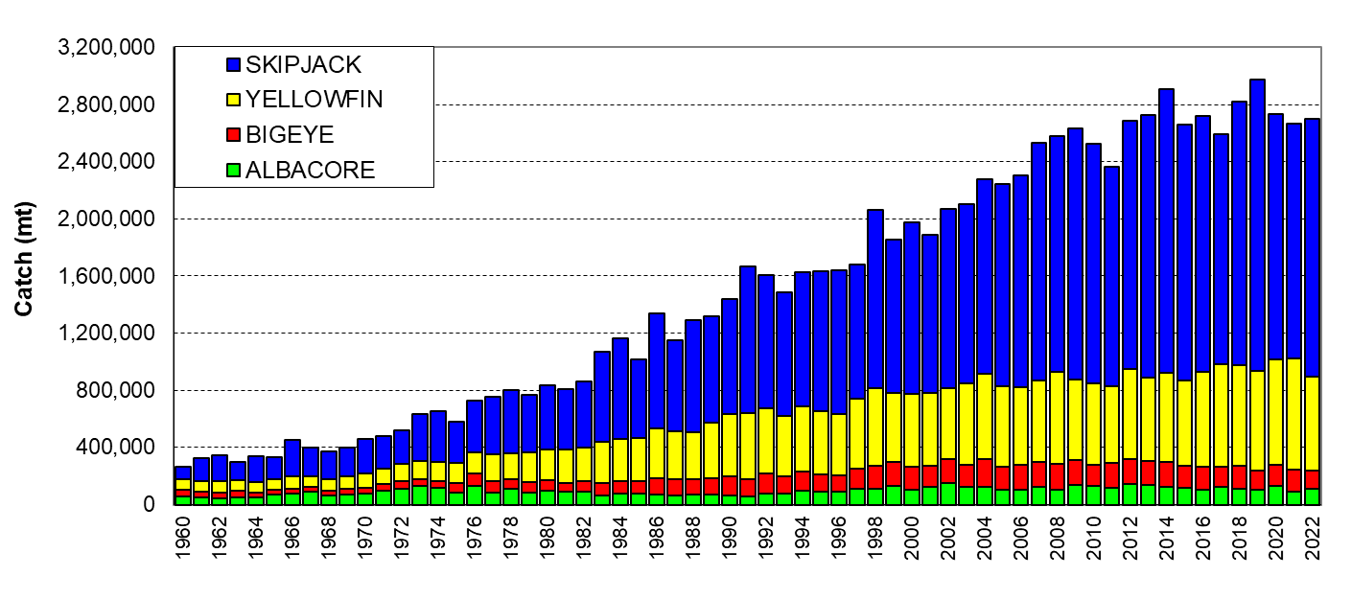
Figure 2.2 Catch (mt) of albacore, bigeye, skipjack and yellowfin in the WCP–CA.

The 2022 WCP–CA catch of skipjack (1,735,500 mt – 64% of the total catch) was around 310,000 mt lower than the record in 2019 (2,044,779 mt). The WCP–CA yellowfin catch for 2022 (721,169 mt – 27%) was a decline of around 33,000 mt on the record 2021 catch (754,442 mt), noting the previous five years have produced the highest annual yellowfin catches on record. The WCP–CA bigeye catch for 2022 (140,664 mt – 5%) was similar to the 2021 catch level. The 2022 WCP–CA albacore catch (104,766 mt – 4%) was around 15,000 mt higher than in 2021 (which at 89,282 mt was the lowest catch since 1993), but clearly lower than the record catch in 2002 of 148,051 mt.

In 2022, the provisional total value of the WCP-CA tuna catch reached approximately $5.9 billion, a 17% increase compared to 2021. The purse seine fishery's value for 2022 was estimated at $3.3 billion, representing 55% of the total tuna catch value. Additionally, the longline fishery's value rose to $1.5 billion, while the pole and line fishery increased to $387 million in 2022. Similarly, the catch taken by other gears increased notably to $766 million, an uptick of 9% from the 2021 year. The longline fishery's value accounted for 25% of the total value of the tuna catch, while the pole and line fishery and other gears contributed 7% and 13%, respectively.
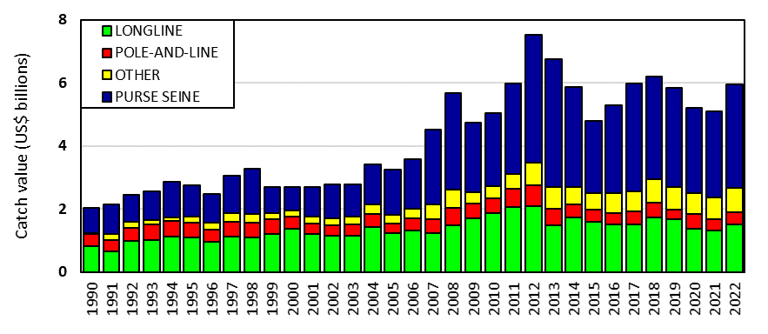
Figure 2.3 Catch value of albacore, bigeye, skipjack and yellowfin in the WCP–CA, by longline, pole-and-line, purse seine and other gear types.

The value of the WCP-CA skipjack catch in 2022 was estimated at $3.0 billion, demonstrating a substantial 25% rise from 2021, and accounting for 50% of the total value of the tuna catch. The WCP-CA yellowfin catch in 2022 was valued at $1.9 billion, representing an 8% increase compared to the previous year. The value of the WCP-CA bigeye catch increased 9% to approximately $715 million, contributing 12% to the total tuna catch value. The WCP-CA albacore catch value surged by 23% to $364 million in 2022.
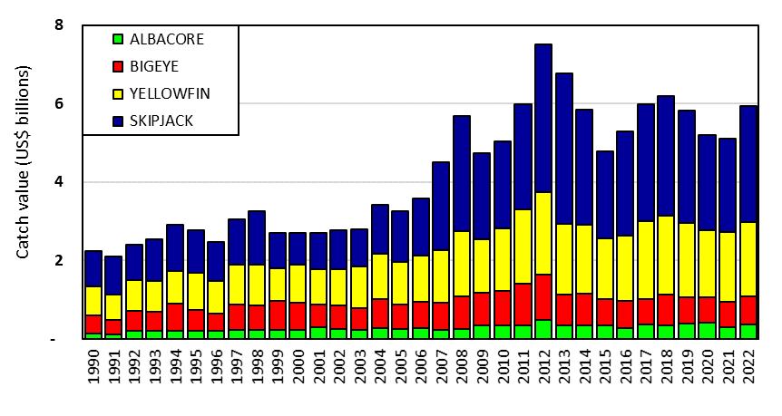
Figure 2.4 Catch value of albacore, bigeye, skipjack and yellowfin in the WCP–CA.

3 WCP–CA PURSE SEINE FISHERY

3.1 Historical Overview

During the mid-1980s, the purse seine fishery (400,000-450,000 mt) accounted for only 40% of the total catch but has grown in significance to a level now over 70% of total tuna catch volume (with more than 2,000,000 mt in 2014 and 2019). The majority of the historic WCP–CA purse seine catch has come from the four main Distant Water Fishing Nation (DWFN) fleets – Japan, Korea, Chinese-Taipei and USA, which numbered a combined 163 vessels in 1992 (Figure 3.1.1) but declined to a low of 111 vessels in 2006 (due to reductions in the US fleet), before some rebound in recent years (up to 129 vessels in 2017 and only 100 vessels in 2022). The Pacific Islands fleets have gradually increased in numbers over the past two decades to a level of 137 vessel in 2022 (Figure 3.3.1). The remainder of the purse seine fishery includes several fleets which entered the WCPFC tropical fishery during the 2000s (e.g. China, Ecuador, El Salvador, New Zealand and Spain).
Figure 3.1.1 Number of purse seine vessels operating in the WCP–CA tropical fishery
(excludes Indonesia, Philippine and Vietnam domestic purse seine/ringnet fleets; bars represent WCPFC yearbook vessel number data)

Figure 3.1.2 Purse seine catch (mt) of bigeye, skipjack and yellowfin and fishing effort (days fishing and searching) in the WCP–CA
(EFFORT: excludes Indonesia, Philippine, and Vietnam domestic purse seine/ringnet fleets)

The total number of purse seine vessels was relatively stable over the period 1990-2006 (in the range of 180–220 vessels), but thence until 2014, the number of vessels gradually increased, attaining a record level of 308 vessels in 2015, before steadily declining since (to 248 vessels in 2022). Further declines have occurred in recent years, with a significant reduction in vessels from one component of the US purse seine fleet. Table 4 in WCPFC-Sec & SPC-OFP (2023) provides a breakdown on purse seine vessel numbers, tuna catch and effort by fleet, set type and species in the tropical tuna purse seine fishery based on raised logsheet data.

The WCP–CA purse seine fishery is essentially a skipjack fishery, unlike those in other ocean areas. Skipjack generally account for 65–77% of the purse seine catch, with yellowfin accounting for 20–30% and bigeye accounting for only a small proportion – 2-5%. Small amounts of albacore tuna are also taken in temperate water purse seine fisheries in the North Pacific.

Features of the purse seine catch by species during the past two decades include:

- Annual skipjack catches fluctuating between 600,000 and 850,000 mt prior to 2002, a significant increase in the catch during 2002, with subsequent skipjack catches maintained well above 1,200,000 mt;
- Annual yellowfin catches fluctuating considerably between 300,000 and 400,000 mt, with a significant catch (record) of 496,000 mt taken in 2017. The proportion of large yellowfin in the catch is generally higher during El Niño years and lower during La Niña years, although other factors appear to affect purse seine yellowfin catch;
- Increased bigeye tuna purse seine catch estimates, coinciding with the introduction of drifting Fish Aggregating Devices –FADs (since mid-late 1990s). Significant years for bigeye catches have been 2011 (87,302 mt–record), 2013 (84,404 mt) and 2014 (81,430 mt) which correspond to years with a relatively high proportion of associated sets, increased bigeye tuna availability to the gear, and/or strong bigeye recruitment.

Total estimated effort shows the same increasing trend as the catch over time (Figure 3.1.2), with years of relatively higher catch rates apparent when the effort line is clearly lower than the top of the histogram bar (that is, in 1998 and 2006–2009, 2014–2022).

3.2 Provisional catch estimates, fleet size and effort (2022)

The provisional 2022 purse seine catch of 1,893,794 mt was around 205,000 mt lower than the record catch in 2019 (2,100,135 mt). The 2022 purse seine skipjack catch (1,451,079 mt: 77% of the catch) was the fifth highest on record, but around 250,000 mt lower than the catch in 2019 (~1,700,000 mt). The 2022 purse seine catch for yellowfin tuna (379,715 mt; 20% of the total purse seine tuna catch) was around 120,000 mt lower than the record catch in 2017 (500,506 mt) but still amongst the highest annual catches for this fishery. The provisional catch estimate for bigeye tuna for 2022 (62,811 mt) was similar to the 2021 catch and a clear increase on the notably low purse seine bigeye tuna catch in 2019 (52,081 mt). The increased bigeye tuna catches since 2020 appears to be related to a higher number of associated sets in conjunction with La Nina conditions.
Figure 3.2.1. Trends in annual effort (top) and catch (bottom) estimates for the top five individual purse seine fleets operating in the tropical WCP–CA, 1996–2022.
Individual fleets (lines; left axis) and the total values for five fleets (bars; right axis)

Figure 3.2.1 compares annual purse seine effort and catches for the five main purse seine fleets operating in the tropical WCP–CA in recent years. The combined “main-fleet” effort was relatively stable over the period 2010–2014, before the clear decline in effort for 2015 and then relatively stable effort levels over the period 2017–2022. The decline in effort during 2015/2016 was related to several factors including reduced access to fishing areas for some fleets, economic conditions and simply a choice to fish in areas outside the WCPFC area. In contrast, catches have generally trended upwards over this time series, suggesting increased efficiency and, in some instances, better catch rates; the 2019 catch for the “main fleets” is consistent with the overall record catch and a year with good catch rates. The slight drop in effort from 2017 to 2022 appears to be primarily related to a decline in vessel numbers (Figure 3.1.1), and the drop in catches over the past three years (2020-2022) compared to 2019 maybe due to less favourable fishing conditions affecting catch rates and also to some extent, and the impacts of COVID.

The combined Pacific-Islands fleet has been clearly the most dominant in the tropical purse seine fishery since 2003 and unlike the other fleets shown in Figure 3.2.1, their recent catches continue to increase each year. There was a hiatus in the Pacific-Islands fleet development in 2008 (when some vessels reflagged to the US purse seine fleet) but catch/effort has picked up in recent years and catch by this component of the fishery was clearly at its highest level in last four years (2019–2022). The combined Pacific-islands fleet catch in 2022 (874,580 mt) easily exceeded the combined catch from the other fleets shown in Figure 3.2.1 (combined 2022 catch for Japan, Korea, Chinese Taipei and USA was 673,492 mt). The fleet sizes and effort by the Japanese and Korean purse seine fleets have been relatively stable for most of this time series. Several Chinese-Taipei vessels re-flagged in 2002, dropping the fleet from 41 to 34 vessels, with fleet numbers relatively stable since. Since 2014, the catch/effort by most of the non-Pacific Island fleets have tended to decline while the catch/effort by the combined Pacific Islands fleet have continued to increase, related to the reflagging of vessels from these distant-water fleets.

The total number of combined Pacific-island fleet vessels has gradually increased over the past two decades, attaining its highest level in 2022 (137 vessels); increases in these years include the reflagging and chartering of vessels from the Asian and US fleets. The combined Pacific-islands purse seine fleet covers vessels fishing under the FSM Arrangement, bilateral agreements and domestically based vessels and comprises vessels from the Federated States of Micronesia (FSM; 25 vessels in 2022), Kiribati (24 vessels), Marshall Islands (11 vessels), Papua New Guinea (PNG: 37 vessels including their chartered vessels), Solomon Islands (10 vessels), Tuvalu (6 vessels) and Vanuatu (8 vessels). Nauru purse seine vessels (2) entered the fishery for the first time in 2018 and their fleet has now grown to 15 vessels fishing in 2022. The Cook Islands entered the purse seine fishery in 2019 with 1 newly flagged vessel.

The domestic Philippine purse seine and ring-net fleets operate in Philippine waters and, since 2013 (as was the case prior to 2010), in the high seas pocket between Palau, Indonesia, FSM and PNG; this fleet accounted for a catch in the range 55,000-90,000 mt annually in the period since 2013. Prior to 2013, the domestic Indonesian purse seine fleet accounted for a similar catch level to the Philippines domestic fishery but generally has not fished in high seas areas. During 2013, the Indonesian fleet catch increased substantially (215,582 mt) with more on-shore processing facilities and more vessels entering the fishery. However, the purse seine catch in 2015 (~56,000 mt) dropped considerably from this level, mainly due to the introduction of a ban on transhipment-at-sea for vessels not built in Indonesia (which is nearly all of the current fleet). The Indonesian purse seine catch recovered (214,605 mt in 2017) apparently due to increased catches by the smaller-scale purse seine component of this fleet, although in recent years, the catch has been around 135,000 mt. Prior to 2009, the domestic fleets of Indonesia and Philippines accounted for about 13-16% of the WCP-CA total purse seine catch, although this proportion has dropped below 10% since then.

Figure 3.2.2 shows annual trends in sets by set type (left) and total tuna catch by set type (right) for the major purse seine fleets. Sets on free-swimming (unassociated) schools of tuna dominate during recent years (61% of all sets for these fleets in 2022). The proportion of sets on drifting FADs in 2022 (33%) was amongst the highest ever and understood to be related to the need to rely on this fishing strategy in the prevailing La Niña conditions. The number and proportion (1% since 2020) of sets on natural logs was clearly the lowest in the fishery for the major fleets and reflects a move away from this type of fishing, in line with the improvements in technology/efficiency involving drifting FAD use. Associated set types, particularly drifting FAD sets, generally account for a higher average catch per set than unassociated sets, so the percentage of catch for drifting FADs (for 2022 = 48%: Figure 3.2.2–right [red]) will be higher than the percentage of sets for drifting FADs (for 2022 = 33%: Figure 3.2.2–left [red]). In contrast, the catch from unassociated schools in 2022 was 47% of the total catch but taken from 61% of the total sets.

It is noteworthy that drifting FAD sets represented 84% of all sets undertaken by the US purse seine fleet during 2022 (94% for 2021), highlighting the reliance on using this strategy in the eastern areas of the tropical WCPO (Figure 3.4.6–right). Table 4 in WCPFC-Sec & SPC-OFP (2023) provides a more detailed breakdown of catch and effort by set type in 2000-2022 using available logsheet and observer data.
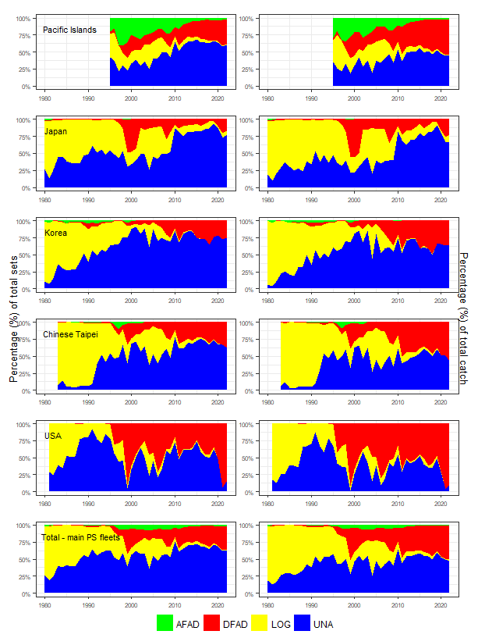
Figure 3.2.2 Time series showing the percentage of total sets (left) and total catch (right), by school type for the major purse seine fleets operating in the WCP–CA.

3.3 Environmental conditions

The purse seine catch/effort distribution in tropical areas of the WCP–CA is strongly influenced by El Niño–Southern Oscillation Index (ENSO) events (Figure 3.3.1). Figure 3.4.1 (left) demonstrates the effect of ENSO events on the spatial distribution of the purse seine activity, with fishing effort typically expanding further to the east during El Niño years and contracting to western areas during La Niña periods.

The WCP–CA fishery was in an ENSO neutral state during most of 2017, but La Niña conditions developed later that year and continued into the early months of 2018, before transitioning through a neutral state which presided over the rest of 2018. Weak-moderate El Niño conditions developed in late 2018, leading into the middle of 2019, and then subsided later in the year to neutral conditions by the start of 2020. La Niña conditions gradually emerged in 2020 and had peaked by the 3rd-4th quarters 2020 before waning briefly in the first quarter of 2021. However, La Nina conditions quickly returned by mid-2021 and persisted through to the end of 2022. There was a clear transition from La Niña to neutral to El Niño conditions in the first half of 2023, with an outlook of well-established El Niño conditions for the remainder of 2023.

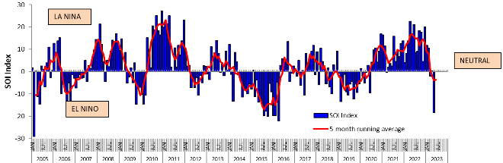
Figure 3.3.1 Trends in El Niño Southern Oscillation Index (ENSO), 2005-2022

3.4 Distribution of fishing effort and catch

Despite the FAD closure for certain periods in each year since 2010, drifting FAD sets remain an important fishing strategy (Figure 3.4.1–right), particularly to the east of 160°E. The move to ENSO-neutral conditions, then weak La Niña during 2017 into early 2018 resulted in more effort in the area west of 160°E (Figure 3.4.1–bottom left; Figure 3.7.3–right) compared to recent years, and a higher use of drifting FADs in the area east of 160°E (Figure 3.4.1–bottom left). By late 2018, weak El Niño conditions presided over the fishery and relatively high catches were taken in the eastern tropical areas, in and adjacent to the waters of Tokelau and the Phoenix Group (Figure 3.7.3). El Niño conditions continued into 2019 with purse seine effort extending further to the east compared to recent years (Figure 3.4.1) and very good catches were taken in a few concentrated areas of the eastern tropical waters (see Figure 3.7.3). The La Niña conditions experienced in 2020 through to 2022 resulted in a general westward shift of fishing effort compared to 2019, with most of the effort in PNG, FSM, Solomon Islands (west of 160°E) during 2022. The western contraction of the warm pool in 2022 (Figure 3.4.1 – bottom left) resulted in more reliance on drifting FADs in the area east of 160°E (Figure 3.4.1 – bottom right) which is in contrast to 2017, for example.

Figures 3.4.2 through 3.4.6 show the distribution of purse seine effort for the five major purse seine fleets during 2021 and 2022. In general, the distribution of effort for most fleets in 2022 is similar to 2021 activities, no doubt related to the prevailing (La Niña) conditions in both years. The US fleet have tended to fish in the more eastern areas in recent years, mainly in the eastern high seas areas adjacent to the Phoenix and Line Islands EEZs, and to the north of the Cook Islands and French Polynesia EEZs, with no effort to the west the Phoenix Islands in these years. The difference in areas fished by the non-Pacific islands’ fleets (Figures 3.4.2–3.4.5) is generally related to the areas they have access to and perhaps also related to fishing strategy (e.g. use of traditional fishing grounds, e.g. FSM, PNG and the Solomon Islands by the Japan fleet).

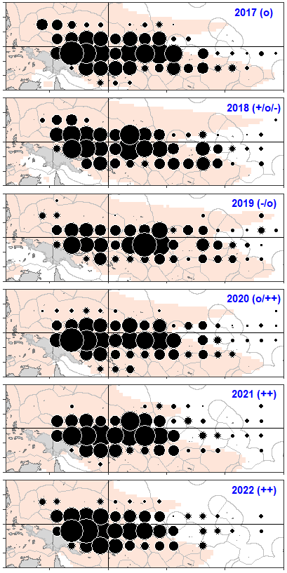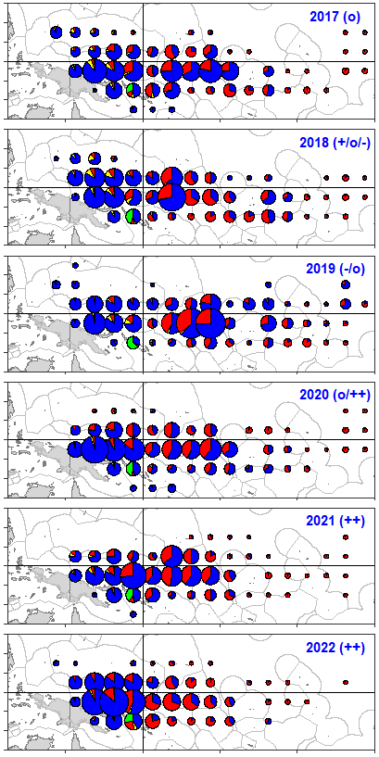
Figure 3.4.1 Distribution of purse seine effort (days fishing – left; sets by set type – right), 2017–2022.
(Blue–Unassociated; Yellow–Log; Red–Drifting FAD; Green–Anchored FAD).
Pink shading represents the extent of average sea surface temperature > 28.5°C
ENSO trends are denoted by “+”: La Niña; “-”: El Niño; “o”: transitional period.

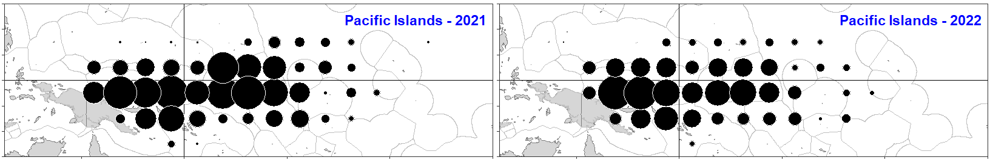
Figure 3.4.2 Distribution of effort by Pacific Islands fleets during 2021 and 2022
lines for the equator (0° latitude) and 160°E longitude included.

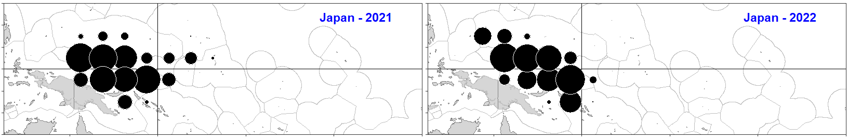
Figure 3.4.3 Distribution of effort by the Japanese purse seine fleet during 2021 and 2022
lines for the equator (0° latitude) and 160°E longitude included.

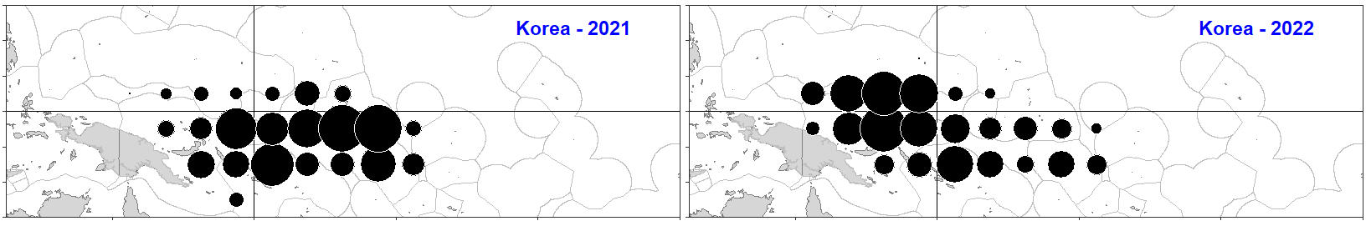
Figure 3.4.4 Distribution of effort by the Korean purse seine fleet during 2021 and 2022
lines for the equator (0° latitude) and 160°E longitude included.

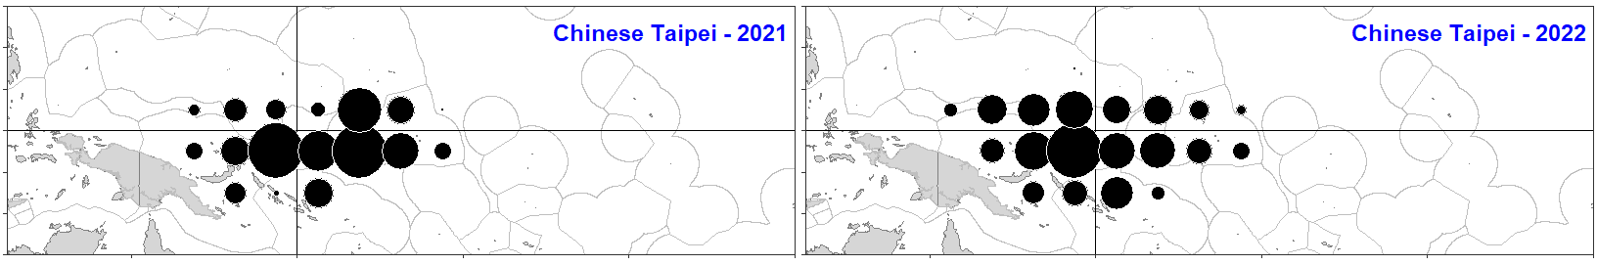
Figure 3.4.5 Distribution of effort by the Chinese-Taipei purse seine fleet during 2021 and 2022
lines for the equator (0° latitude) and 160°E longitude included.

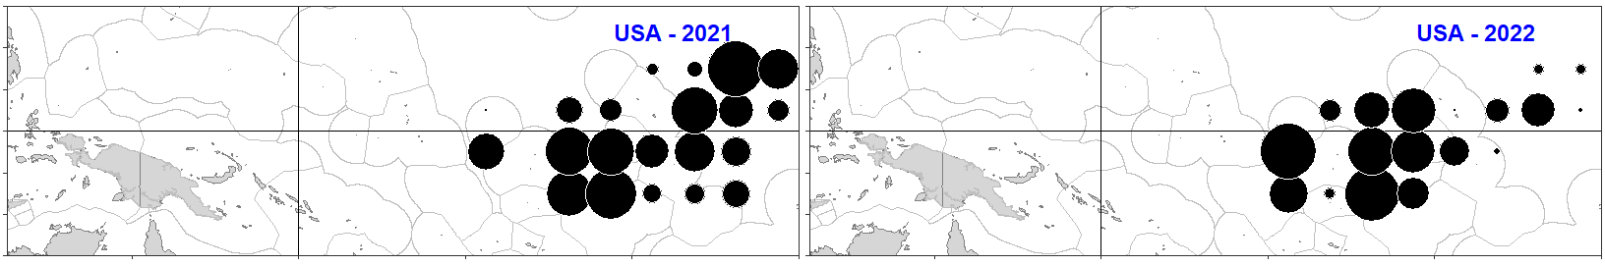
Figure 3.4.6 Distribution of effort by the US purse seine fleet during 2021 and 2022
lines for the equator (0° latitude) and 160°E longitude included.

3.5 Catch per unit of effort

Figure 3.5.1 shows the annual time series of nominal CPUE by set type and vessel nation for skipjack (left) and yellowfin (right). These trends are not standardised for environmental factors or factors that may relate to the efficiency of the fleets, e.g. technological improvements and increased vessel power, so therefore must be interpreted with caution. Recent reviews of the available logsheet data used to determine nominal CPUE highlight an apparent change in reporting behaviour, with a clear increase in the reporting of transit days (over days searching); since transit days are not included as purse seine effort (and days searching is included), this change will inevitably result in a positive bias in the nominal CPUE data presented herein.

Purse seine skipjack CPUE in 2022 increased for all fleets from 2021 levels but was lower than the record levels experienced in 2019, when a combination of environmental conditions and strong recruitment were contributing factors to the high catch rates in that year. Over the entire time series, the trend for skipjack CPUE is clearly increasing, although, as noted, these graphs present nominal CPUE and do not consider the increase in fishing efficiency (often referred to as ‘effort creep’). A possible indicator of an increase in fishing efficiency is the gradual reduction in average trip length over time, which is apparent in the linear trend of VMS trip length, which is estimated to decrease from about 31 days in early 2009 to around 29 days by mid-2023 (Figure 3.5.3).

Yellowfin purse seine CPUE shows strong inter-annual variability and there is greater variation in CPUE among the fleets than for skipjack. Unassociated-set yellowfin CPUE appears influenced by ENSO variation in the WCP–CA, with CPUE generally higher during El Niño episodes. This is believed to be related to increased catchability of yellowfin tuna due to a shallower surface-mixed layer during these periods. Associated (log and drifting FAD) sets generally yield higher catch rates (mt/day) for skipjack than unassociated sets, while unassociated sets sometimes yield a higher catch rate for yellowfin than associated sets. The higher yellowfin CPUE from free-schools occurs when “pure” schools of large, adult yellowfin are more available to the gear in the more eastern areas of the tropical WCP-CA, and so account for a larger catch (by weight) than the (mostly) juvenile yellowfin encountered in associated sets.

The purse seine yellowfin CPUE for free-schools by the US fleet rebounded in 2022 from the very low levels experienced in both 2020 and 2021, noting that this fleet is active in the eastern areas compared to the other ‘main’ fleets shown in these CPUE trends (refer to Figures 3.4.3–3.4.6). The yellowfin tuna free school CPUE in 2022 was generally around the 2021 level for the other fleets with effort concentrated more in the western and central areas in 2022. Figure 3.6.2 shows that for unassociated sets, the “pure” schools of large, adult yellowfin were not present in the east during 2022, perhaps related to the prevailing ENSO conditions and/or different fishing strategies related to market demands, although the paucity of observer data for this area may also explain the absence.

Yellowfin catch rates on drifting FADs in 2022 remained at a similar level to recent years, with the increase in drifting FAD sets (Figure 3.2.2) contributing to a relatively high proportion of yellowfin tuna (20%) in the purse seine catch (SPC-OFP, 2023). The long-term time series for yellowfin CPUE shows more inter-annual variability and overall, a flatter trend than the skipjack tuna CPUE. It is unknown whether these trends reflect an increasing ability to target skipjack tuna at the expense of yellowfin, or reflect a change in yellowfin abundance, given that fishing efficiency has increased.

The difference in the time of day that sets are undertaken is thought to be one of the main reasons why bigeye tuna are rarely taken in unassociated schools compared to log and drifting FAD schools, which have catch rates of this species an order of magnitude higher (Figure 3.5.2). The trends in estimated bigeye tuna CPUE since 2000 varies by fleet and set type with no clear pattern evident, but with drifting FADs accounting for the highest catches and most variability. The bigeye tuna CPUE levels in 2022 were clearly higher than the relatively low levels experienced during 2019 and perhaps related to a shallower thermocline in the eastern and central tropical areas with the restriction of the warm pool under La Niña conditions during recent years (Figure 3.5.2 and 3.7.3). The bigeye tuna CPUE for drifting FADs for the US fleet has been clearly higher in recent years, no doubt related to this fleet’s move further east, to areas adjacent to the Eastern Pacific tropical fishery which is acknowledged to have higher proportions of bigeye tuna in their catches.

Figure 3.5.3 shows the inverse relationship between monthly CPUE (total tuna catch (mt) per day) and average trip length estimates (from logsheets and VMS); logsheet trip length tends to fluctuate in synchrony with CPUE, with shorter trips corresponding to higher CPUE. Average trip length (from VMS data) generally compares well to average trip length (from logsheet data), but as logsheet coverage declines (e.g. early 2023), estimates from these two sources tend to diverge since available logsheets are probably not representative. The FAD closure period each year (commencing in 2010) generally coincides with a decline in total tuna CPUE, with longer trips and apparent difficulties obtaining consistent catches from free-swimming schools. The drop in CPUE from late 2016 into the first 6-8 months of 2017 may simply be due to a return to conditions prior to the most recent El Niño of 2014–2016. The pattern in high CPUE in the months immediately following the FAD closure periods is understood to be mainly due to the build-up of unexploited biomass which then becomes available through FADs, although in 2022, the fishery had an increase in CPUE before the FAD closure period (that is, from months May-June 2022).

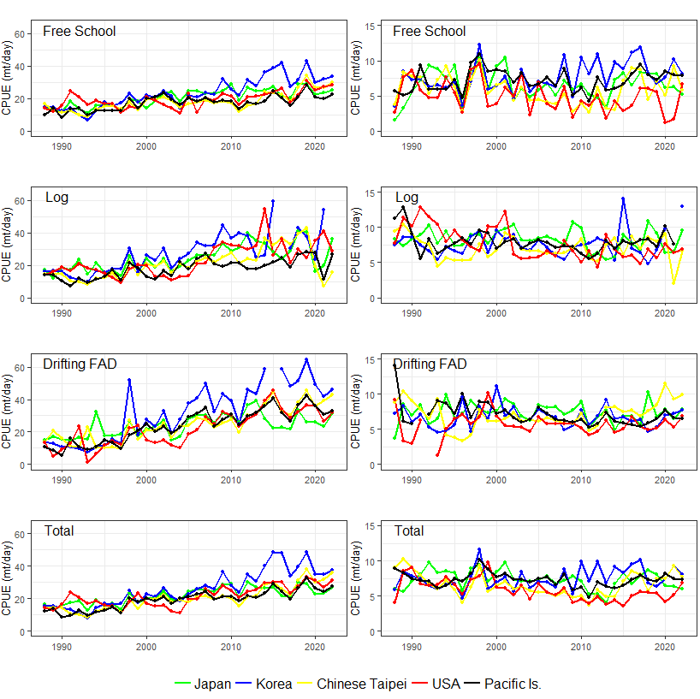
Figure 3.5.1 Skipjack tuna CPUE (mt per day–left) and yellowfin tuna CPUE (mt per day–right) by set-type, and all set types combined, for selected purse seine fleets fishing in the tropical WCP–CA.
Effort and CPUE were partitioned by set type according to the proportions of total sets attributed to each set type.
Thick black line for “All set types” represents the Pacific Islands purse seine fleets combined.

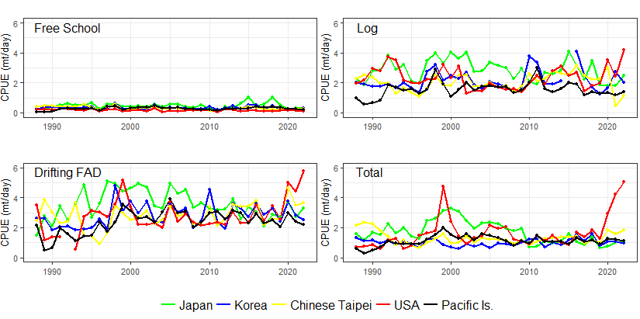
Figure 3.5.2 Estimated bigeye tuna CPUE (mt per day) by major set-type categories (free-school, log and drifting FAD sets) and all set types combined for Japanese, Korean, Chinese-Taipei and US purse seiners fishing in the tropical WCP–CA.
Effort and CPUE were partitioned by set type according to the proportions of total sets attributed to each set type.
Thick black line for “All set types” represents the Pacific Islands purse seine fleets combined.

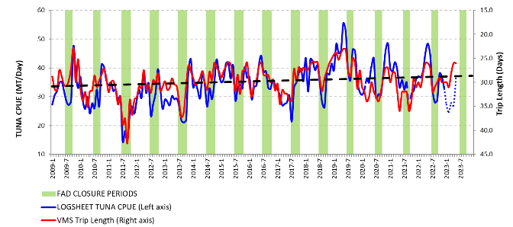
Figure 3.5.3 Monthly purse seine tuna CPUE (mt/day) and average trip length (VMS days), 2009–2023
Dashed, black line represents the linear trend on VMS Trip length. VMS Trip length axis (right) is reversed/inverted.
For 2020, 2021 and 2022, only the full-fishery, mandatory FAD closure period (July-Sept) is shown and acknowledges that flag states must choose an additional two-month FAD closure period as per the requirements in CMM 2018-01, 2020-01 and 2021-01 paras. 17.

3.6 Species/Size composition of the catch

Figures 3.6.1 and 3.6.2 show the species and size composition of the purse seine catch for 2021 and 2022, by set type and broad area of the tropical fishery, noting that observer coverage in the purse seine fishery over the past 2-3 years is incomplete and biased to the few fleets where observer deployment was possible. Points of interest in the comparison of these graphs include:

- Larger tuna catches for the associated set-type categories in both 2021 and 2022 for the tropical area east of 170°E, related to the prevailing La Niña conditions and the increased reliance for drifting FADs;
- Slightly larger skipjack tuna in the area west of 170°E from associated sets in 2021 compared with 2022;
- A higher proportion of the bigeye tuna in associated sets east of 170°E (compared to the west), and the presence of medium-size (70–90 cm) bigeye tuna during 2020, which was not evident in 2022;
- The absence of large yellowfin tuna in the unassociated set catch in the area east of 170°E in 2022, compared to 2021, although there were large yellowfin and bigeye tuna in the associated-set catch in this area for 2022. The lack of large-yellowfin tuna in the unassociated-set catch in this eastern area during 2022 could be due to a combination of factors, for example, fewer unassociated sets conducted in this area (see Figure 3.4.1 – bottom right) and the lack of size data from observers in this area.

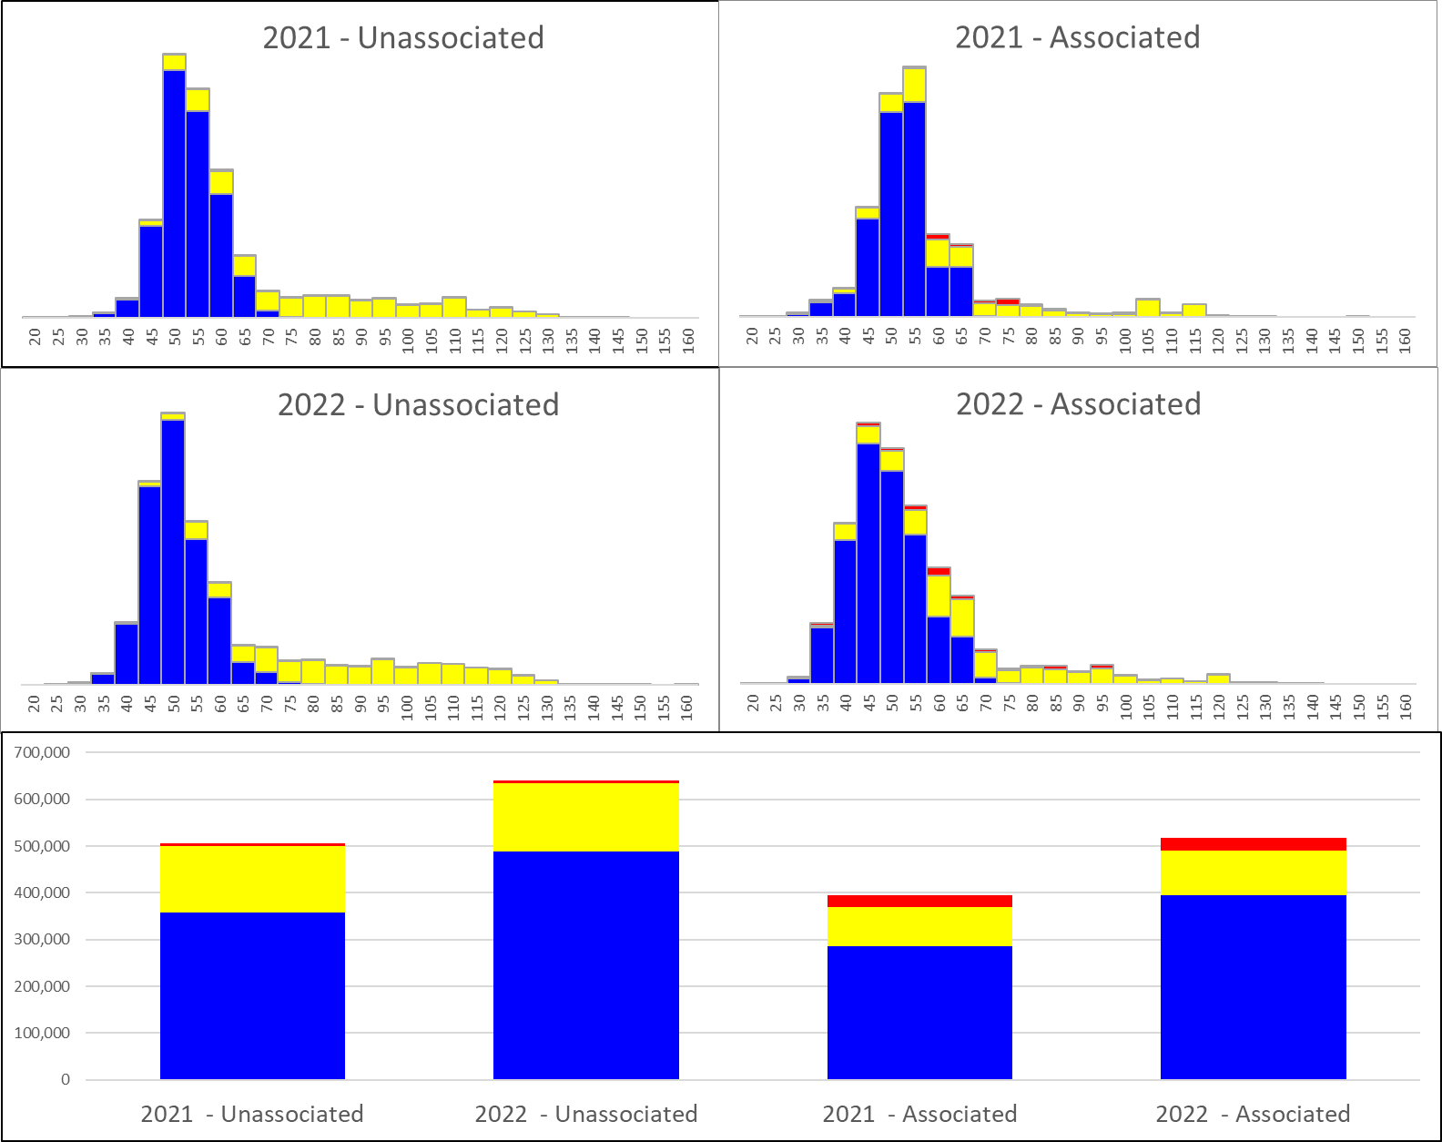
Figure 3.6.1 Species composition (MT: Y-axis) of the 2021 and 2022 purse seine catch, by set type and 5cm size categories (X-Axis) for the tropical fishery, west of 170°E.
Skipjack tuna–blue; Yellowfin tuna–yellow; Bigeye tuna–red

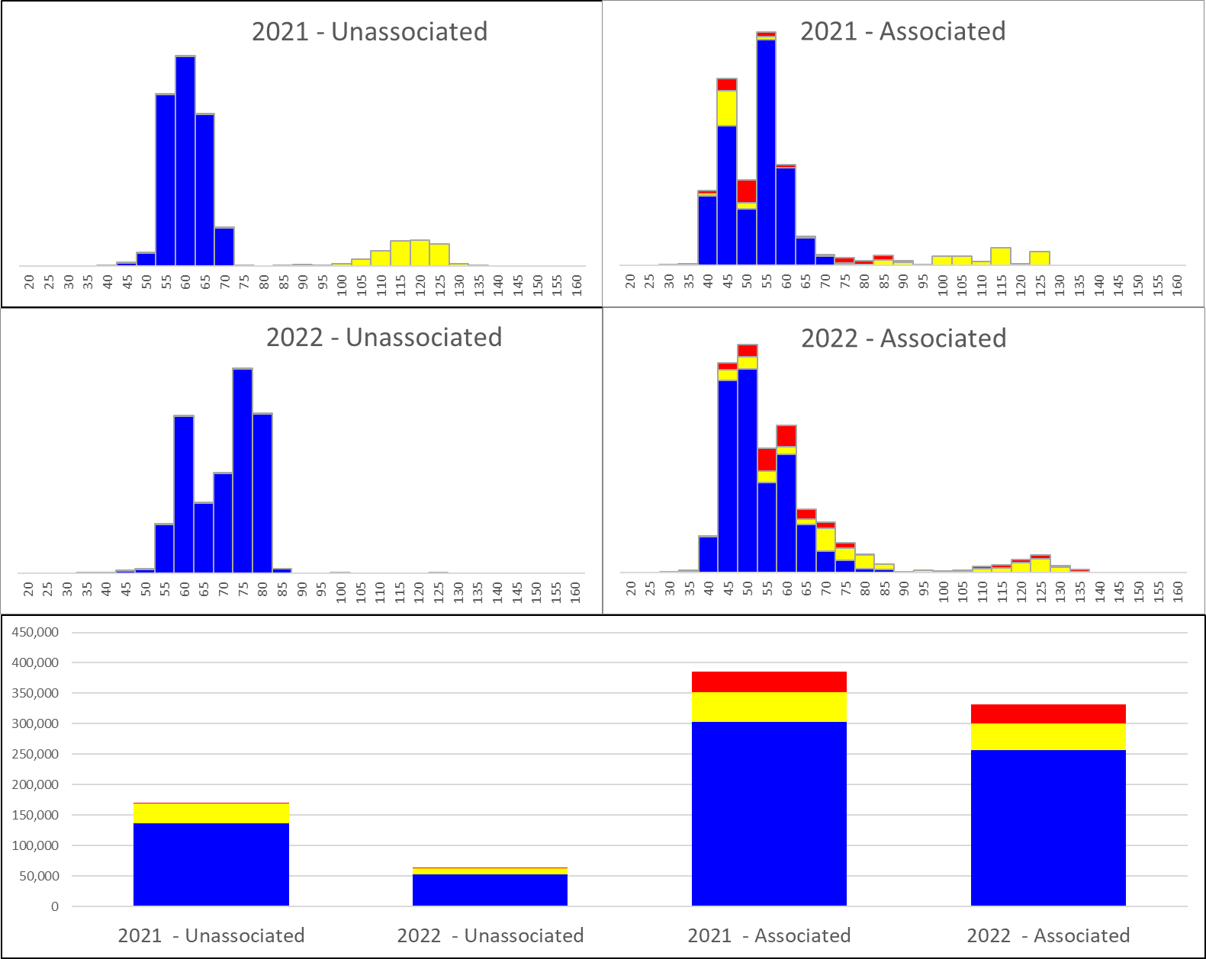
Figure 3.6.2 Species composition (MT: Y-axis) of the 2021 and 2022 purse seine catch, by set type and 5cm size categories (X-Axis) for the tropical fishery, east of 170°E.
Skipjack tuna–blue; Yellowfin tuna–yellow; Bigeye tuna–red
Bottom graph shows the catch volume by year, species and set type; Source : observer data (coverage for 2020: 50%; 2021: 15%; 2022: 15%)

3.7 Seasonality

Figures 3.7.1 and 3.7.2 show the seasonal average CPUE for skipjack and yellowfin tuna in the purse seine fishery for the period 2017–2022, respectively. Figure 3.7.3 shows the distribution of effort by quarter for the period 2017-2021 in comparison to effort by quarter in 2022. Prior to the FAD closure period, the average monthly skipjack CPUE is generally highest in the first half of the year and slightly lower thereafter, which contrasts with the yellowfin CPUE, which was at its lowest during the first six months, but higher thereafter. This situation corresponds to the typical seasonal eastward extension of the fishery in the second half of the year, to an area where schools of large yellowfin are thought to be more available than areas to the west due to, inter alia, a shallower surface-mixed layer. The FAD closure implementation since 2009 has tended to reduce CPUE during those [FAD-closure] months, with relatively high catch rates experienced immediately following the last FAD-closure month.

The trend in monthly skipjack CPUE for 2022 was mostly above the 2016-2021 monthly average for the first six months but was then generally at the average for the remainder of the year; indeed, the monthly 2022 skipjack CPUE was very consistent with the average for the months July to August (FAD closure months).

The monthly yellowfin CPUE was similar to the 2016–2022 average for most of the first four months of 2022. The monthly yellowfin CPUE was then at very high levels for the months May-July 2022, before moving to very low levels in August until returning to the 2016-2021 average level in November-December. The relatively high yellowfin tuna CPUE in the middle of 2022 mostly came from the yellowfin tuna catches in PNG, FSM, Solomon Islands and adjacent waters (Figures 3.7.2 and 3.7.3).

The quarterly extent of the warm pool (i.e. surface water >28.5°C on average) in 2022 compared to the average for 2016-2021 (Figure 3.7.3) shows that the La Niña conditions during 2022 restricted the warm pool to the western areas compared to the recent 5-year average (2016–2021). Higher proportions of the total catch were taken in PNG in the 2nd and 4th quarters of 2022 compared to the 2016-2021 average period (Figure 3.7.3), which show most of the catch to the east of 160°E. However, there were catches outside the warm pool in the eastern tropical areas during 2022, which mainly came from drifting FAD sets (see Figure 3.4.1 – bottom right).

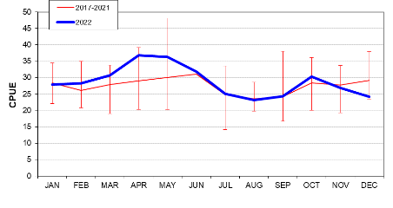
Figure 3.7.1 Average monthly skipjack tuna CPUE (mt per day) for purse seiners fishing in the tropical WCP–CA, 2017–2022.
Red line represents the period 2017–2021 and the blue line represents 2022.
The bars represent the range (i.e. minimum and maximum) of monthly values for the period 2017–2021.

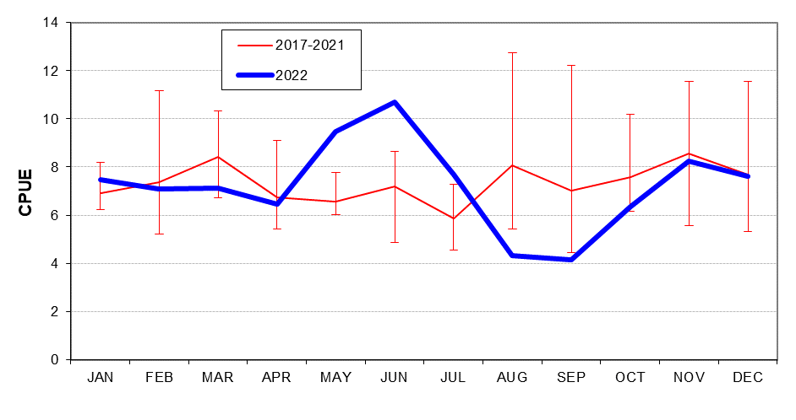
Figure 3.7.2 Average monthly yellowfin tuna CPUE (mt per day) for purse seiners fishing in the tropical WCP–CA, 2017–2022.
Red line represents the period 2017–2021 and the blue line represents 2022.
The bars represent the range (i.e. minimum and maximum) of monthly values for the period 2017–2021.

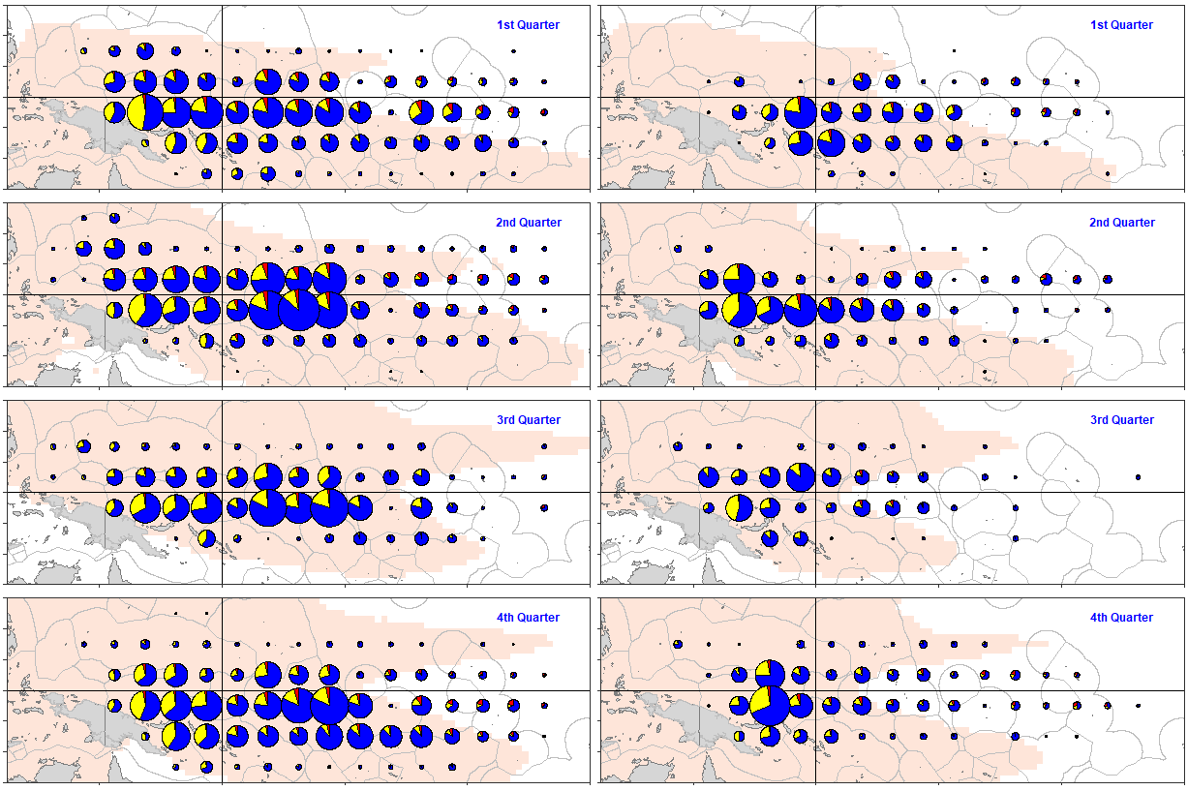
Figure 3.7.3 Quarterly distribution of purse seine catch by species for 2017–2021 (left) and 2022 (right).
(Blue–Skipjack; Yellow–Yellowfin; Red–Bigeye)
Pink/light brown shading represents the extent of average sea surface temperature >28.5°C by quarter for the period 2017–2021 (left) and 2022 (right)

3.8 Prices, catch value and overall economic conditions

3.8.1 Prices

Skipjack

Between 2017 and 2020, global skipjack prices experienced a general downward trend after a notable increase in 2017. Prices stabilized in 2021, where Thai import prices rose by 1% to $1,379/mt and Yaizu purse seine caught skipjack prices (ex-vessel) declined by less than 1% to ¥156/kg ($1,423/mt). However, there was a significant upswing in prices in 2022, with Thai import prices increasing by 19% to $1,645/mt and Yaizu prices surging by 44% to ¥225/kg ($1,710/mt). In real terms, accounting for inflation, the 2022 Thai import and Yaizu purse seine caught USD skipjack prices were 7% and 6% lower than their respective 20-year averages. Over the period up to May in 2023, Thai skipjack import prices averaged $1,777/mt, while Yaizu prices averaged around $2,014/mt.

In 2021 Bangkok markets reports indicated that skipjack prices (4-7.5lbs, cost and freight [c&f]) increased from $1,200/mt to $1,350/mt in the first quarter then declined to $1,280/mt by the end of May. In the second half of 2021, skipjack prices rose to $1,500/mt in July, followed by a decline from August to September. Skipjack prices exhibited an upward trend from October to December and reached their highest level for the year of $1,750/mt in December. In 2022, prices rose to $1,900/mt in March before gradually declining to $1,425/mt by the end of June and then increased again to a peak of $1,800 in August, before settling at $1,700 at the year's end.

The Bangkok skipjack (4-7.5lbs, c&f) price index for 2022 was below that of the FAO Food Price Index, which experienced a significant increase in 2022 to its highest level since 2011 (Figure 3.8.2). However, over the period up to May in 2023, the Bangkok skipjack (4-7.5lbs, c&f) price index exceeded the FAO Food Price Index.
Figure 3.8.2 FAO Food Price Index and Bangkok 4-7.5lbs skipjack price (c&f) index
Note: *For the period January to June

Figure 3.8.1 Annual skipjack prices, Thai imports (c&f) and Yaizu (ex-vessel)
Note: *For the period January to June

Yellowfin
Figure 3.8.3 Annual yellowfin prices, Thai imports (c&f) and Yaizu (ex-vessel)
Note: *For the period January to June

Thai import price for yellowfin (c&f) in 2022 rose by 13%, averaging $1,999/mt compared to the previous year. The Yaizu purse seine caught yellowfin prices (ex-vessel) increased significantly by 33% to ¥358/kg ($2,720/mt). In real terms, the 2022 Thai import prices were 9% lower than the 20-year average, while the Yaizu real prices were 8% lower.

Over the period up to the end of May 2023, the average yellowfin price increased by 7% compared to 2022, with Thai import prices averaging $2,061/mt. Similarly, during the same period in 2023, Yaizu prices averaged ¥423/kg ($3,136/mt), representing a 45% increase compared to the previous year. Over the period up to May 2023, Thai import volumes were 35% lower than for the same period in 2022.

3.8.2 Catch Value

The estimated delivered value of the purse seine tuna catch in the WCP-CA area for 2022 amounted to $3.3 billion, a substantial increase of 21% or $559 million compared to 2021. However, this is approximately 19% lower than the values observed in 2012 and 2013, when the purse seine fishery catch reached at least $4 billion due to high prices for raw materials used in canning. Notably, the value of the 2022 purse seine catch is the highest since 2018, which was at a similar level.
Figure 3.8.4 Value of the WCPFC-CA purse seine fishery tuna catch by species

The 28% increase in the value of the skipjack catch from $1.89 billion in 2021 to $2.42 billion in 2022, represents 74% of the total purse seine tuna catch value. This surge was primarily driven by a notable 20% increase in the Yaizu purse seine caught skipjack price in 2022. Similarly, the value of the yellowfin catch marginally increased by 2% from 2021 to $759 million in 2022 (23% of the total purse seine catch value), mainly due to an 11% rise in the Yaizu purse seine caught price.

3.8.3 Economic Conditions in the tropical purse seine fishery

The assessment of economic conditions indexes for the major WCPFC-CA tuna fisheries has been presented to SC (Scientific Committee) for several years. These indexes evaluate the economic conditions in a fishery based on relative fish price, fishing cost (excluding license and access fee payments) and catch rates over the past 20 years (from 2002 to 2021). The information from these components is combined into a single value expressed as an index against the average value over the preceding 20 years, set at 100, thereby providing a relative measure of changes in economic conditions over time. Values below 100 indicate that the fishery is experiencing below-average economic conditions, while values above 100 indicate periods in which economic conditions in the fishery are relatively favorable. It is important to note that the indexes relate to the fishery itself and not to the vessels operating within it. While favorable economic conditions may suggest the fishery's ability to generate significant profits, they do not specify which parties, such as vessel owners or coastal states, benefit from these profits.

Since 2012, the economic conditions index for the tropical purse seine fishery has consistently remained above average, with the exception of 2014. Over recent years, there has been considerable variation in the contributions of different index components. For instance, in 2017, high index readings were primarily driven by high fish prices, while high catch rates were the main driver between 2018 and 2022. Although the index in 2022 remained above average at 101, it reached its lowest level since 2014, primarily due to a significant increase in MDO (Marine Diesel Oil) prices, which was further exacerbated by the Russia/Ukraine conflict in 2022.
Figure 3.8.5 Tropical purse seine fishery economic conditions component indexes

Figure 3.8.6 Tropical purse seine fishery economic conditions index (LHS) and variance of component indices against average (2003-2022) conditions (RHS)

4 WCP–CA POLE-AND-LINE FISHERY

4.1 Historical Overview

The WCP–CA pole-and-line fishery has several components:
Figure 4.1.1 Pole-and-line vessels operating in the WCP–CA
(excludes pole-and-line vessels from the Japanese Coastal and Indonesian domestic fisheries)
- the year-round tropical skipjack fishery, mainly involving the domestic fleets of Indonesia, Solomon Islands and French Polynesia, and the distant water fleet of Japan
- seasonal sub-tropical skipjack fisheries in the domestic (home) waters of Japan, Australia, Hawai’i and Fiji (although no recent activity in the last three fisheries)
- a seasonal albacore/skipjack fishery east of Japan (largely an extension of the Japanese home-water fishery).

Economic factors and technological advances in the purse seine fishery (primarily targeting the same species, skipjack) have resulted in a gradual decline in the number of vessels in the pole-and-line fishery (Figure 4.1.1) and in the annual pole-and-line catch during the past 15–20 years (Figure 4.1.2). The gradual reduction in numbers of vessels has occurred in all pole-and-line fleets over the past decade. Pacific Island domestic fleets have declined in recent years – fisheries formerly operating in Fiji, Palau and Papua New Guinea are no longer active, only one vessel is now operating (occasionally) in Kiribati, and fishing activity in the Solomon Islands fishery during the 2000s was reduced substantially from the level experienced during the 1990s. Several vessels continue to fish in Hawai’i, and the French Polynesian bonitier fleet remains active (30 vessels in 2022), but an increasing number of vessels have turned to longline fishing. Vessel and catches from Indonesian pole-and-line fleet have also declined over recent years. There is continued interest in pole-and-line fish associated with certification/eco-labelling.

4.2 Catch estimates (2022)

The provisional 2022 pole-and-line catch (168,807 mt) is clearly lower than the 2021 catch (200,108 mt) and at this stage, the lowest annual catch since the early-1960s, due to reduced catches in the Japanese fishery, although we note as in previous years the provisional nature of the estimates at this stage.
Figure 4.2.1 Pole-and-line catch in the WCP–CA
Skipjack accounts for the majority of the catch (~70-83% in recent years, but typically more than 85% of the total catch in tropical areas) and albacore (5–10% in recent years) is taken by the Japanese coastal and offshore fleets in the temperate waters of the north Pacific. Yellowfin tuna (recently 10–15%) and a small component of bigeye tuna (1–4%) make up the remainder of the catch. There are only four pole-and-line fleets currently active in the WCPO (French Polynesia, Japan, Indonesia and Solomon Islands). Japanese distant-water and offshore fleets (51,247 mt in 2022), and the Indonesian fleets (95,881 mt in 2021, carried over to 2022 at this stage), account for nearly all of the WCP–CA pole-and-line catch (99% in 2022). The catches by the Japanese distant-water and offshore fleets in recent years have been the lowest for several decades and this is no doubt related to the continued reduction in vessel numbers (although the vessel numbers have been stable at around 75-80 over the past 5 years). The Solomon Islands fleet recovered from low catch levels experienced in the early 2000s (only 2,773 mt in 2000 due to civil unrest) to reach a level of 10,448 mt in 2003. This fleet ceased operating in 2009 but resumed fishing in 2011 with catches generally around 1,000 mt (1,200 mt in 2022 from 4 vessels).
Figure 4.2.2 Average distribution of WCP–CA pole-and-line effort (1995–2022).

Figure 4.2.2 shows the average distribution of pole-and-line effort for the period 1995–2022. Effort in tropical areas is usually year-round and includes domestic fisheries in Indonesia and the Solomon Islands, and the Japanese distant-water fishery. The pole-and-line effort in the vicinity of Japan by both offshore and distant-water fleets is seasonal (highest effort and catch occurs in the 2nd and 3rd quarters). There was also some seasonal effort by pole-and-line vessels in Fiji, New Zealand and Australia during this period. The effort in French Polynesian waters is essentially the bonitier fleet. Effort by the pole-and-line fleet based in Hawai’i is not shown in this figure because spatial data are not available.

4.3 Prices and catch value

4.3.1 Prices

The pole and line fishery in the WCP-CA region is primarily dominated by the fleets of Japan and Indonesia, while smaller catches are taken by the fleets of Solomon Islands and French Polynesia. In the case of the Japanese fleet, skipjack pole and line fishing follow a seasonal pattern, with southern skipjack fishing typically taking place from November to June, and both nearshore albacore and eastern offshore skipjack fishing occurring mainly from July to October.

In 2022, the Yaizu price for pole and line-caught skipjack averaged $3,014/mt, representing a significant increase of 53% compared to the previous year. Similarly, the price of skipjack caught in waters off and south of Japan increased, averaging $2,955/mt (¥389/kg) and $3,029/mt (¥398/kg) respectively in 2022. These prices were substantially higher, with skipjack caught in waters off Japan being over 50% higher, and skipjack caught in the southern fishery being 38% higher than the prices observed in 2021. Over the period up to May 2023, the prices for skipjack caught in waters off, and south of, Japan averaged ¥370/kg and ¥406/kg respectively, and they were higher than the prices during the same period in 2022.

The volumes of pole and line-caught skipjack caught in waters off Japan and brought into Yaizu port saw a significant decline of 82%. However, the skipjack caught in waters south of Japan were 67% higher than the 2021 levels.

4.3.2 Catch Value

Despite a 16% decline in catch the 2022 delivered value of the WCPFC pole and line catch rose 7% to $387 million. The value of the skipjack catches in 2022 rose by $20 million (7%) to reach $299 million, accounting for 77% of the total pole and line tuna catch value.
Figure 4.3.1 Value of the WCPFC-CA pole and line fishery tuna catch by species

5 WCP–CA LONGLINE FISHERY

5.1 Overview

The longline fishery now accounts for only 8–10% of the total WCP–CA catch (OFP, 2023), but approaches the much larger purse seine catch in landed value. It provides the longest time series of catch estimates for the WCP–CA, with estimates available since the early 1950s. The total number of vessels involved in the fishery has generally fluctuated between 3,000 and 6,000 for the period 1970–2004 (Figure 5.1.1), although for some distant-water fleets, vessels operating in areas beyond the WCP–CA could not be separated out, and more representative vessel numbers for WCP–CA have only become available in recent years. Total longline vessel numbers have slowly declined over the past 20 years, with the provisional estimate of 1,700 vessels in 2022 (while the highest since 2019) showing a 48% drop on vessel numbers in 2003, mainly due to a decline in the category of non-Pacific Islands domestic fleets.

The fishery involves two main types of operation –
Figure 5.1.1 Longline vessels operating in the WCP–CA
(Available data does not make the distinction between foreign “distant-water” and “offshore”)
- large (typically >250 GRT) distant-water freezer vessels which undertake long voyages (months) and operate over large areas of the region. These vessels may target either tropical (yellowfin, bigeye tuna) or subtropical (albacore tuna) species. Voluntary reduction in vessel numbers by at least one fleet has occurred in recent years;
- smaller (typically <100 GRT) offshore vessels which are usually domestically-based, undertaking trips of less than one month, with ice or chill capacity, and serving fresh or air-freight sashimi markets, or [albacore] canneries. There are several foreign offshore fleets based in Pacific Island countries.

The following broad categories of longline fishery, based on type of operation, area fished and target species, are currently active in the WCP–CA:

- South Pacific offshore albacore fishery comprises Pacific-Islands domestic “offshore” vessels, such as those from American Samoa, Cook Islands, Fiji, French Polynesia, Kiribati, New Caledonia, PNG, Samoa, Solomon Islands, Tonga, Tuvalu and Vanuatu; these fleets mainly operate in subtropical waters, with albacore the main species taken. Two new entrants, Tuvalu and Wallis & Futuna, joined this category during 2011, although the latter fleet has not fished recently. Vessel numbers have stabilised in recent years, but they may also vary depending on charter arrangements. More information on this fishery is provided in McKechnie et al. (2023).
- Tropical offshore bigeye/yellowfin-target fishery includes “offshore” sashimi longliners from Chinese-Taipei, based in Micronesia, Guam, Philippines and mainland Chinese vessels based in Micronesia, and domestic fleets based in Indonesia, Micronesian countries, Philippines, PNG, the Solomon Islands and Vietnam.
- Tropical distant-water bigeye/yellowfin-target fishery comprises “distant-water” vessels from Japan, Korea, Chinese-Taipei, mainland China and Vanuatu. These vessels primarily operate in the eastern tropical waters of the WCP–CA (and into the EPO), targeting bigeye and yellowfin tuna for the frozen sashimi market.
- South Pacific distant-water albacore fishery comprises “distant-water” vessels from Chinese-Taipei, mainland China and Vanuatu operating in the south Pacific, generally below 20°S, targeting albacore tuna destined for canneries.
- Domestic fisheries in the sub-tropical and temperate WCP–CA comprise vessels targeting different species within the same fleet depending on market, season and/or area. These fleets include the domestic fisheries of Australia, Japan, New Zealand and Hawai’i. For example, the Hawaiian longline fleet has a component that targets swordfish and another that targets bigeye tuna.
- South Pacific distant-water swordfish fishery is a relatively new fishery and comprises “distant-water” vessels from Spain and Portugal (one vessel started fishing in 2011).
- North Pacific distant-water albacore and swordfish fisheries mainly comprise “distant-water” vessels from Japan (swordfish and albacore), Chinese-Taipei (albacore only) and Vanuatu (albacore only).

Additionally, small vessels in Indonesia, Philippines and Vietnam use the handline gear, usually fishing around the numerous arrays of anchored FADs in home waters and generally fishing at night, some using intense lights to attract prey for the tuna (these types of vessels are not included in Figure 5.1.1). The commercial handline fleets target large yellowfin tuna which comprise the majority of their overall catch (> 90%). The WCP-CA large-fish (yellowfin target) handline fisheries in these south-east Asian countries took over 50,000 mt in 2022 (see Section 7.1).

The WCP–CA longline tuna catch steadily increased from the early years of the fishery (i.e. the early 1950s) to 1980 (230,625 mt), but declined to 162,111 mt in 1984 (Figure 5.1.2). Since then, catches steadily increased over the next 15 years until the late 1990s, when catch levels were again similar to 1980. Annual catches in the longline fishery since 2000 have been amongst the highest ever, but the composition of the catch in recent years (e.g. ALB–38%; BET–24%; YFT–37% in 2022) differs from the period of the late 1970s and early 1980s, when yellowfin tuna contributed a higher proportion of catch (e.g. ALB–18%; BET–27%; YFT–54% in 1980).
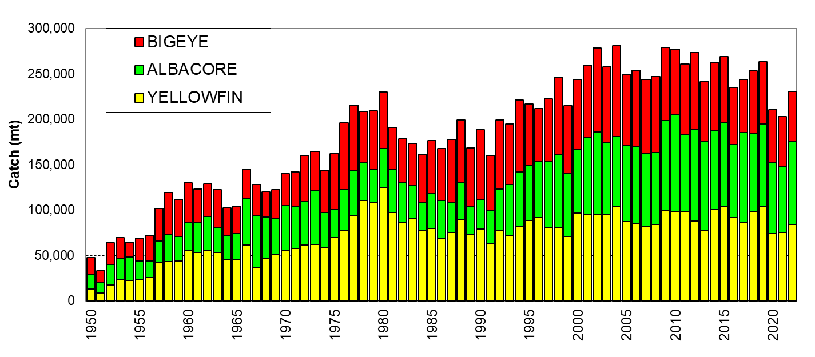
Figure 5.1.2 Longline catch (mt) of target tunas in the WCP–CA

5.2 Provisional catch estimates and fleet sizes (2022)

The provisional WCP–CA longline catch (230,038 mt) for 2022 remains lower than the recent ten-year average but an increase on the past two years, which were impacted by COVID-19. The COVID-19 restrictions played a role in the general reduction of effort in the longline fishery in the past 2-3 years , with clear declines in effort in both the south Pacific Albacore fishery (Figure A4) and in the tropical longline fishery (Figure A5). The prevailing La Niña conditions during the past three years may also have contributed to changes in the catch by species throughout the extent of the longline fishery.

The WCP–CA albacore longline catch (88,437 mt – 38%) for 2022 was the highest since 2019, but nearly 18,000 mt lower than the record of 106,142 mt attained in 2010. The provisional bigeye catch (54,800 mt – 24%) for 2022 was similar to the 2021 catch level which was the lowest since 1984, and well down on the bigeye catch levels experienced in the 2000s (e.g. the 2004 longline bigeye catch was 99,709 mt). The yellowfin catch for 2022 (84,232 mt – 37%), was higher than the past two years, but a significant drop on the high catch level in 2019 (104,426 mt).

A significant change in the WCP–CA longline fishery over the past two decades has been the growth of the Pacific Islands domestic albacore fishery, which has risen from taking 33% of the total South Pacific albacore longline catch in 1998 to accounting for around 50-60% of the catch in recent years. The combined national fleets (including chartered vessels) mainly active in the Pacific Islands domestic albacore fishery have numbered more than 500 (mainly small “offshore”) vessels in some years over the past decade with catches at a similar level to the distant-water longline vessels active in the south WCP–CA.

The distant-water fleet dynamics have continued to evolve in recent years, with catches down from record levels in the mid-2000s initially due to a reduction in vessel numbers, although vessel numbers for some fleets appear to be on the rise again in recent years, but with variation in areas fished and target species. The Japanese distant-water and offshore longline fleets have experienced a substantial decline in both bigeye catches (from 20,725 mt in 2004 to 1,964 mt in 2022) and vessel numbers (366 in 2004 to 54 in 2022). The Chinese-Taipei distant-water longline fleet had a peak bigeye tuna catch of 16,888 mt in 2004 but has stabilised at a lower level in recent years, with 5,661 mt taken in 2022 (108 vessels). The Korean distant-water longline fleet experienced some decline in bigeye and yellowfin catches since the period of highest catches 15–20 years ago in line with a reduction in vessel numbers – from 184 vessels active in 2002 reduced to 94 vessels in 2022.

In contrast, the China longline fleet catches of albacore tuna have been amongst the highest ever in recent years, with a range of 16,000–29,000 mt of albacore tuna in the south WCP-CA area over the past six years; their 2022 albacore tuna catch was 26,437 mt, the second highest catch for this fleet.

With domestic fleet sizes continuing to increase as foreign-offshore and distant-water fleets decrease (Figure 5.1.1), this evolution in fleet dynamics no doubt has some effect on the species composition of the catch. For example, the increase in effort by the Pacific Islands domestic fleets has primarily been in albacore fisheries, although this had been balanced to some extent by the switch to targeting bigeye tuna (from albacore) by certain vessels in the distant-water Chinese-Taipei fleet almost a decade ago. More detail on individual fleet activities during recent years is available in the WCPFC–SC19 National Fisheries Reports.

5.3 Catch per unit effort

Time series of nominal CPUE provide a broad indication of the abundance and availability of target species to the longline gear, and as longline vessels target larger fish, the CPUE time series should be more indicative of adult tuna abundance. However, as is the case with nominal purse seine CPUE, the interpretation of nominal longline CPUE is confounded by various factors, such as the changes in fishing depth that occurred as longliners progressively switched from primarily yellowfin tuna targeting in the 1960s and early 1970s to bigeye tuna targeting from the late 1970s onwards. Such changes in fishing practices will have changed the effectiveness of longline effort with respect to one species over another, and such changes need to be accounted for if the CPUE time series are to be interpreted as indices of relative abundance.

Nominal CPUE graphs are provided in the other papers (see Hare et al., 2023; WCPFC_Sec & OFP, 2023), and this paper does not attempt to explain trends in longline CPUE or effective effort, as this is referenced and dealt with more appropriately in specific studies on the subject and CPUE standardisation papers regularly prepared as WCPFC Scientific Committee (SC) papers.

5.4 Geographic distribution
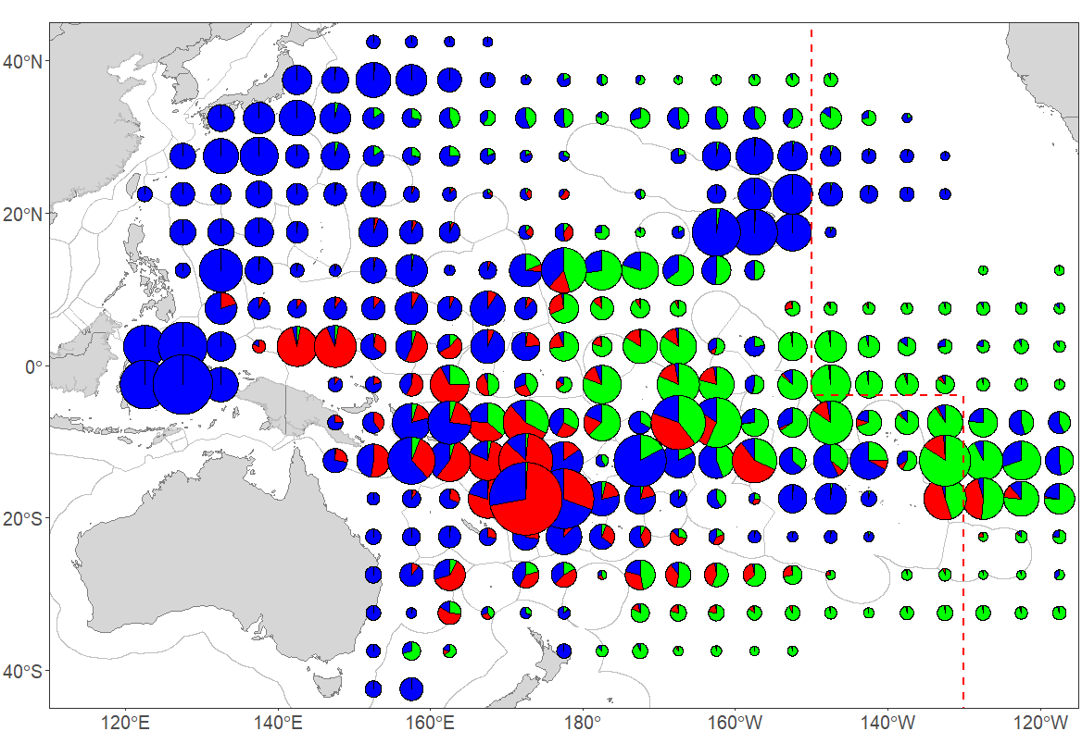
Figure 5.4.1 Distribution of longline effort (100s of hooks) by fleet, 2017–2022
Distant-water fleets (green), foreign-offshore fleets (red) and domestic fleets (blue)
(Note that distant-water effort for Chinese-Taipei and other fleets targeting albacore for the entire North Pacific is poorly covered)

Figure 5.4.1 shows the distribution of effort by category of fleet for the period 2017–2022. Effort by the large-vessel, distant-water fleets of Japan, China, Korea and Chinese-Taipei account for most effort on the high seas in the eastern WCPFC Area, noting the reduction in vessel numbers for some fleets over the past two decades. Effort is widespread as sectors of these fleets target bigeye and yellowfin for the frozen sashimi market in central and eastern tropical waters, and albacore for canning in the more temperate waters (see Figure 5.4.3).

Activity by the foreign-offshore fleets from Japan, mainland China and Chinese-Taipei is restricted to tropical waters, targeting bigeye and yellowfin for the fresh sashimi market; these fleets tend to have limited overlap with the distant-water fleets. The substantial "domestic fleet" effort in the west of the WCPFC Area is primarily by the Indonesian and Chinese-Taipei domestic fleets targeting yellowfin and bigeye in the lower latitudes, and the Japanese offshore and coastal fleets in their home fishery and adjacent high seas.

The growth in Pacific Islands domestic fleets targeting albacore tuna in the South Pacific has been noted; the most prominent fleets in this category are the Cook Islands, Samoa, Fiji, French Polynesia, Solomon Islands (when chartering arrangements are active), Tonga and Vanuatu fleets (Figure 5.4.2). More information on this fishery is provided in McKechnie et al. (2023).

Figure 5.4.2 Distribution of effort for south Pacific albacore-target DOMESTIC longline fleets

Figure 5.4.3 Distribution of effort for south Pacific albacore-target FOREIGN distant-water and offshore longline fleets

Figure 5.4.4 shows quarterly species composition by area for the period 2010–2021 and 2022. The majority of the yellowfin catch is taken in tropical areas, especially in the western parts of the region, with smaller amounts in seasonal subtropical fisheries. The majority of the bigeye catch is also taken from tropical areas, but in contrast to yellowfin, mainly in the eastern parts of the WCP–CA, adjacent to the traditional EPO bigeye fishing grounds. The albacore catch is mainly taken in subtropical and temperate waters in both hemispheres. In the North Pacific, albacore are primarily taken in the 1st and 4th quarters. In the South Pacific, albacore are taken year round, although they tend to be more prevalent in the catch during the 3rd quarter. Species composition also varies from year to year in line with changes in environmental conditions, particularly in waters where there is some overlap in species targeting, for example, in the latitudinal band from 0°–20°S.

There were relatively large catches of the three main target species in the northern Cook Islands and adjacent high seas area (0-10°S, 160°-170°W : Figure 5.4.4 –right) in the second and third quarters of 2022 when compared to the 2010-2021 quarterly averages (Figure 5.4.4 –left). Also noteworthy is the higher proportion of yellowfin in the catch in the area 0°–10°S, 150E°-170°E in the 3rd quarter 2022 compared to the long-term (2010-2021) average.

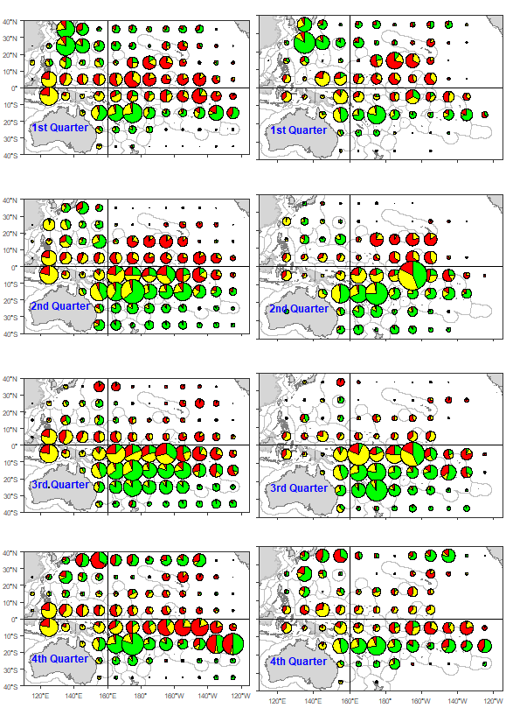
Figure 5.4.4 Quarterly distribution of longline tuna catch by species, 2010-2021 (left) and 2022 (right)
(Yellow–yellowfin; Red–bigeye; Green–albacore)
(Note that catches from some distant-water fleets targeting albacore in the North Pacific may not be fully covered; excludes the Vietnam HL/LL fishery)

5.5 Prices and catch values

5.5.1 Prices

In this section, we present trends in selected longline fishery-related price data for yellowfin, bigeye, albacore, swordfish, and striped marlin, as these species are sold in a variety of markets and product forms.

Yellowfin

In 2022, Japanese yen prices for yellowfin increased significantly across all markets compared to the previous year. Notably, Yaizu longline caught prices rose by 18% to ¥922/kg from ¥784/kg in 2021. Similarly, fresh yellowfin prices from Oceania and selected port prices increased by 30% to ¥1,183/kg and 28% to ¥1,156/kg, respectively. The frozen price at selected ports also saw an 11% increase to ¥1,002/kg.

In 2022, prices for fresh yellowfin imports into the US rose to $10.59/kg from the previous year. In US dollar terms, yellowfin prices across all markets increased, except for the Yaizu longline caught prices and the frozen selected port price, which declined by 2% to $5,638/mt and 8% to $6,236/mt respectively, primarily due to the depreciation of the Japanese yen against the US dollar. The fresh yellowfin price from Oceania saw an 8% increase in 2022 and averaged $8.99/kg. Similarly, the frozen yellowfin prices at selected ports rose by 7% to $8.79/kg from 2021. Furthermore, there was a notable decline in fresh yellowfin imports into Japan and the US in 2020 attributed to supply-chain disruptions from the Covid-19 pandemic. In 2021, Japan's fresh imports experienced a further decline of 39%. However, in 2022, import volumes slowly recovered and increasing by 37% compared to 2021. Nevertheless, the period up to May 2023 saw a significant decline of 63% compared to the same period in 2022.

US fresh imports volumes continued to recover from the severe impacts of COVID-19, rising 31% in 2022, having more than doubled in 2021 compared to2020. However, over the period to May 2023, the import volumes were lower by 10% than in the same period in 2022.
Figure 5.5.1 Japan and US Yellowfin in Yen (LHS) and US dollars (RHS)
Note: Japan fresh imports from Oceania are c.i.f prices, Yaizu and Japan selected port are ex-vessel prices and US imports are f.a.s prices. Frozen at selected ports excludes purse seine caught landings

Bigeye

Fresh bigeye prices across all markets increased in 2022 (Figure 5.5.2). The Japan selected ports fresh and frozen prices averaged ¥1,743/kg (+26%) and ¥1,338/kg (+34%), respectively, while the price for fresh imports from Oceania rose by 25% to ¥1,717/kg. Similarly, US fresh bigeye import prices increased by 4% to reach $12.03/kg, continuing the long-term trend, and marking the highest price on record.

Recent trends in import volumes into Japan and the US showed divergent trends. . The Volumes for the US fresh imports in 2021 and 2022 saw a significant recovery from the COVID-19 pandemic in 2020, with increases of 44% and 67% in 2021 and 2022 respectively. However, the volumes for Japan fresh imports of bigeye have continued to decline, falling of 36% in 2021, and 32% in 2022.

Figure 5.5.2 Japan and US bigeye prices in Yen (LHS) and US dollars (RHS)
Note: Japan fresh imports from Oceania are c.i.f prices, Japan selected ports are ex-vessel prices and US imports are f.a.s prices. Frozen at selected ports excludes purse seine caught landings
Albacore

US fresh albacore prices rose 10% in 2020 to $5.92/kg in 2020 before declining in 2021 by of 6% to $5.54/kg. In 2022, the prices rebounded and increased 7% to reach $5.94/kg. Similarly, Thai frozen imports also experienced an upswing in 2022 increasing by 7% to $3.55/kg, marking the second-highest price on record. Meanwhile, Japan's selected ports saw a notable increase of 24% in fresh prices and reached $4.04/kg in 2022.
Figure 5.5.3 Albacore prices in US dollars
Note: Thai frozen imports are c&f prices, Japan selected ports are ex-vessel prices and US imports are f.a.s prices.

Examining the import volumes, there was a 20% increase in Thai imports in 2020. However, this growth was followed by a substantial decline of 33% in 2021 to an approximate import volume of 42,000mt relative to 63,000mt in 2020. 2022 saw a continued decline volume falling 19% to around 34,000mt. In contrast, the period leading up to May 2023 showed a positive shift, with import volumes experiencing a significant increase of 28% compared to the same period in 2022.

Swordfish and striped marlin

During 2022, notable increases were observed in both the Japan fresh swordfish and fresh striped marlin prices at selected ports, which saw a significant 15% surge to ¥1,308/kg and an impressive 47% rise to ¥752/kg, respectively. Similarly, the US fresh swordfish also experienced a price increase of 9%, averaging $8.82/kg, marking the third-highest price recorded to date.

In US dollar terms, the prices for fresh striped marlin at selected ports also saw a substantial uptick of 23%, reaching $5.72/kg. However, it is noteworthy that the Japan fresh swordfish prices deviated from this trend, as they encountered a decline of 4%, settling at $9.94/kg. This decline can be attributed to the depreciation of the Japanese yen against the US dollar in 2022.

Figure 5.5.4 Japan and US swordfish and striped marlin prices in Yen (LHS) and US dollars (RHS)
Note: Japan selected ports are ex-vessel prices and US imports are f.a.s prices.

5.5.2 Catch Value
Figure 5.5.5 Value of the WCPFC-CA longline fishery tuna catch by species

In 2022, the estimated value of the total catch in the WCPFC longline fishery amounted to $1.52 billion, approximately 25% of the total value of the WCPO tuna catch of $5.95 billion. This indicates a significant 16% increase from the preceding year, equivalent to a substantial $204 million rise in the value of the longline catch.

Notably, the value of the catch in 2022 for all target species exhibited positive growth, with the value of yellowfin catch rising by 19% to $628 million, reflecting an increase of $100 million. Similarly, both the bigeye and albacore catch values experienced considerable growth in 2022, increasing by $35 million (7%) and $68 million (28%) respectively. These increases were largely driven by the increase in catch for longline caught albacore (20%) and yellowfin (13%) in 2022.

5.5.3 Economic conditions

An analysis of economic conditions within the longline fishery encompasses two distinct regions: the southern longline fishery, situated south of 10⁰S in the WPCFC-CA (Western and Central Pacific Fisheries Commission - Convention Area), and the tropical longline fishery, encompassing the area between 10⁰N and 10⁰S in the WPCFC-CA, excluding the waters of Indonesia, Philippines, and Vietnam.

It is important to reiterate a significant caveat, particularly concerning the longline fisheries during 2020 and 2021. The impact of the COVID-19 pandemic on the cost structure may have been underestimated in the economic conditions index. This is because the fishing cost utilized in the index does not account for changes in costs beyond fuel costs, such as shipping, air freight, and imported equipment and gear, all of which were influenced by the COVID-19 pandemic. Hence, when interpreting the respective index figures, particularly, during 2020 and 2021 (presented in the shaded graphs of Figure 5.5.7 and 5.5.9), caution is advised.

Southern Longline
Since 2010, the southern longline fishery index has consistently remained below the average. Despite the exceptionally high fish prices experienced in 2011 and 2012, economic conditions during the period from 2011 to 2014 were notably challenging due to a combination of low catch rates and high fuel prices. However, between 2014 and 2017, as catch rates improved and fuel prices declined, while fish prices remained close to their long-term average, there was a substantial improvement in economic conditions, surpassing the 20-year average during 2015 to 2017.
Figure 5.5.6 Southern longline fishery economic conditions component indexes

Figure 5.5.7 Southern longline economic conditions index (LHS) and variance of component indices against average (2001-2020) conditions (RHS)
Subsequently, the index experienced a decline due to diminishing catch rates, despite the presence of high fish prices in 2018 and particularly in 2019, along with lower fuel prices in the latter year. The economic conditions in 2020 and 2021 further declined as a consequence of significant drops in catch rates, culminating in the index reaching its lowest level since 2013. However, in 2022, despite an increase in fuel costs, attributed to the Russia/Ukraine conflict, the economic index displayed a notable rise, approaching its 20-year average, primarily driven by an increase in catch rates.

Tropical longline
Subsequent to a downturn seen in the economic index during 2017 and 2018, which fell below the 20-year long-term average, the decline was primarily attributed to increased fuel prices and a decrease in catch rates. However, from 2019 to 2020, the economic conditions exhibited stability, hovering around their 20-year long-term average, despite facing challenges such as declining fish prices and catch rates in 2020. This stabilization was a consequence of a reduction in fuel costs, which occurred due to the impact of the Covid-19 pandemic in 2020.
The years 2021 and 2022 saw a continuation of the index's decline, remaining below average, primarily influenced by escalating fuel prices. Notably, the economic index in 2022 reached its lowest level since 2013, reflecting the severity of the prevailing challenges during that period.
Figure 5.5.8 Tropical longline fishery economic conditions component indexes

Figure 5.5.9 Tropical longline economic conditions index (LHS) and variance of component indices against average (2001-2020) conditions (RHS)

6 SOUTH-PACIFIC TROLL FISHERY

6.1 Overview

The South Pacific troll fishery is based in the coastal waters of New Zealand, and along the Sub-Tropical Convergence Zone (STCZ, east of New Zealand waters located near 40°S). The fleets of New Zealand and the United States have historically accounted for the great majority of the catch that consists almost exclusively of albacore tuna.

The fishery expanded following the development of the STCZ fishery after 1986, with the highest catch attained in 1989 (8,370 mt). Over the past decade, catches have declined to range from 2,000–5,000 mt, which are catch levels that have not been experienced since prior to 1988 (Figure 6.1.1). The level of effort expended by the troll fleets each year can be driven by the price conditions for the product, and by expectations concerning likely fishing success.
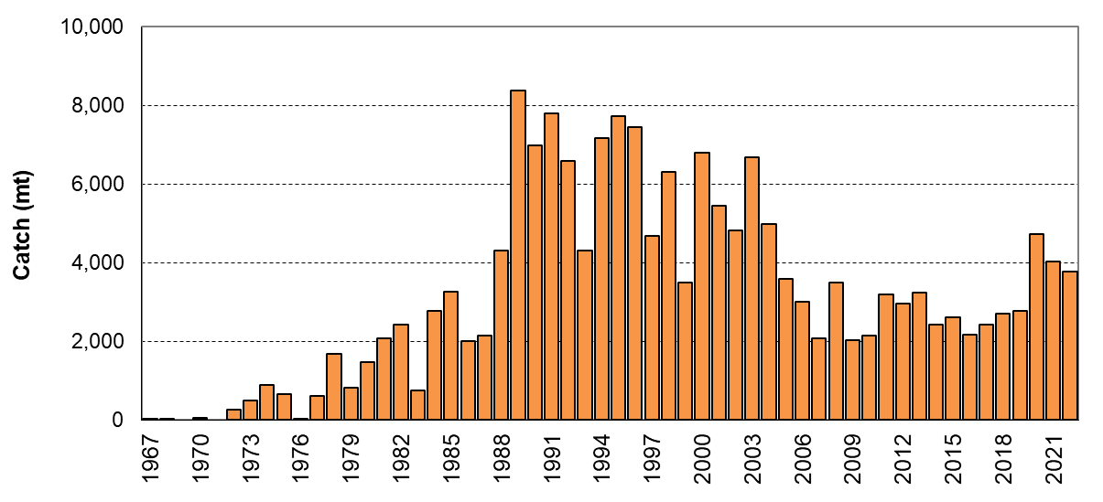
Figure 6.1.1 Troll catch (mt) of albacore in the south Pacific Ocean

6.2 Provisional catch estimates (2022)

The 2022 South Pacific troll albacore catch (3,777 mt) was slightly less than 2021 (4,037 mt), but amongst the highest catches since 2004 (4,990 mt). The New Zealand troll fleet (134 vessels catching 2,377 mt in 2022) and the United States troll fleet (18 vessels catching 1,400 mt in 2022) accounted for all of the 2022 albacore troll catch, although minor contributions also come from the Canadian, the Cook Islands and French Polynesian fleets when their fleets are active in this fishery.

Effort by the South Pacific albacore troll fleets is concentrated off the coast of New Zealand and across the Sub-Tropical Convergence Zone (STCZ) – refer to Figure 6.2.1.

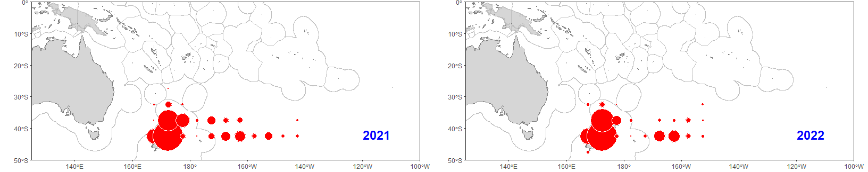
Figure 6.2.1 Distribution of South Pacific troll effort (days) during 2021 (left) and 2022 (right)

7 OTHER FISHERIES

There are a number of other, mainly small-scale, fisheries in the WCP–CA that target the key tuna species, including handline gear that targets large yellowfin tuna, small-scale troll/hook-and-line fisheries, small-scale gillnet and a range of other artisanal gears. The following sections attempt to provide some information on some of these “other” fisheries.

A description of most of these fisheries is provided in recent Scientific Committee papers – MOMAF and SPC-OFP (2021a), MOMAF and SPC-OFP (2021b), NFRDI, BFAR and SPC-OFP (2021), SPC-OFP (2021).

7.1 Large-fish Handline Fishery
Figure 7.1.1 WCP–CA large-fish Handline catch (mt) by species

Large-fish Handline fisheries exist in the Philippines, Indonesia and Hawai’i, where the target is essentially large yellowfin tuna (and also bigeye tuna in the case of Hawaii). In the Philippines and Indonesia, this fishery can be comprised of both small craft and larger vessels (> 24m or > 20GRT). The larger vessels can have several small associated one-person boats (called pakura in the Philippines) used to fish in the vicinity of the larger vessel. The vessels that target large yellowfin tuna with the handline gear are also referred to as “pump boats” in the Philippines. The general characteristics that distinguish the vessels targeting small-fish with the “hook-and-line” gear to those targeting large yellowfin tuna in the Philippines and Indonesia is that the latter fishery is conducted at night, at a depth typically greater than 50 metres with larger hooks. [However, this distinction is not always clear, for example, there are instances when small craft can target both large yellowfin at night and small tunas in the day within one trip]. Large yellowfin tuna dominates the catch from this gear type in the Philippines and Indonesia (typically >= 95% of the total catch) and the catches are landed locally where it is processed and available for export or the high-end local markets.

Over the past two decades, annual catch estimates from the large-fish handline fishery have been in the range of 20,000–57,000 mt (Figure 7.1.1), although the estimates prior to 2013 are acknowledged to exclude the catches from the Indonesian fishery. Estimates for Indonesia were compiled for the period 2013–2016, but were again lacking from 2017 onwards, and only represent carried over values for this fishery since this time. The 2022 catch was similar to recent years, with no apparent negative trends due to the impacts of COVID-19.

7.2 Small-scale troll and hook-and-line Fishery

The small-scale troll and hook-and-line fishery comprises small craft that, due to their size and concerns on safety, conduct trips that do not usually exceed one day and are restricted to coastal waters, rarely venturing beyond territorial seas and/or archipelagic waters (where relevant). The method of fishing is varied and includes trolling, and surface fishing in the vicinity of FADs with one or multiple hooks per line. Small skipjack and yellowfin tuna are the main species taken in this fishery and most coastal states in the tropical and sub-tropical WCP-CA have vessels in this fishery, with the highest catches reported from the Indonesia and the Philippines domestic fisheries, followed by Kiribati, Japan, French Polynesia and Tuvalu (catches from some countries, while only minor, have yet to be compiled and provided to the WCPFC). The catches from this fishery are typically for subsistence or sold at local markets.
Figure 7.2.1 WCP–CA troll / hook-and-line catch (mt) by species

Over the past two decades annual catch estimates from the small-scale troll and hook-and-line fishery have been in the range of 120,000–300,000 mt (Figure 7.2.1), although the trends in some years may be a result of the lack of resources to compile or confirm estimates, rather than changes in the fishery. The increasing trend over the past decade may be related to improvements in estimates in some fisheries (noting the provisional 2022 estimate is slightly lower that 2021, which was a record for this fishery). The species composition tends to fluctuate with some years having a high proportion of small yellowfin tuna (e.g., in recent years, the catch of small yellowfin tuna was estimated to have been at least 50% of the total tuna catch for this fishery).

7.3 Small-scale gillnet Fishery

The main small-scale gillnet fisheries operate in coastal waters of Vietnam and Indonesia, with smaller catches from this gear in Japan and in the archipelagic waters of the Philippines. This fishery targets skipjack tuna but also take small amounts of other pelagic species.
Figure 7.3.1 WCP–CA small-scale gillnet catch (mt) by species

The available annual catch estimates (Figure 7.3.1) are only representative of Vietnam, Philippines and Japan fisheries at this stage; the total tuna catch from these drift gillnet fisheries has ranged from less than 20,000 mt to 48,000 mt over the past decade. Indonesia first separated out the gillnet catch by species from their “other/unclassified gear” tuna catch estimates in 2013 and these have yet to be included in this time series; the Indonesia small-scale gillnet catch has ranged from 5,000–40,000 mt over this period. The decline in catch for the Vietnam fishery is driving the trend in recent years.

8. SUMMARY OF CATCH BY SPECIES
Figure 8.1.1 WCP–CA skipjack catch (mt) by gear

8.1 SKIPJACK

Total skipjack catches in the WCP–CA have increased steadily since 1960, more than doubling during the 1980s, and continuing to increase in subsequent years. Annual catches have exceeded 1.5 million mt in the last decade (Figure 8.1.1). Pole-and-line fleets, primarily Japanese, initially dominated the fishery, with the catch peaking at 380,000 mt in 1984. The relative importance of the pole-and-line fishery, however, has declined over the years primarily due to economic constraints. The skipjack catch increased during the 1980s due to growth in the international purse seine fleet, combined with increased catches by domestic fleets from Philippines and Indonesia (which have made up around 10% of the total skipjack catch in WCP–CA.
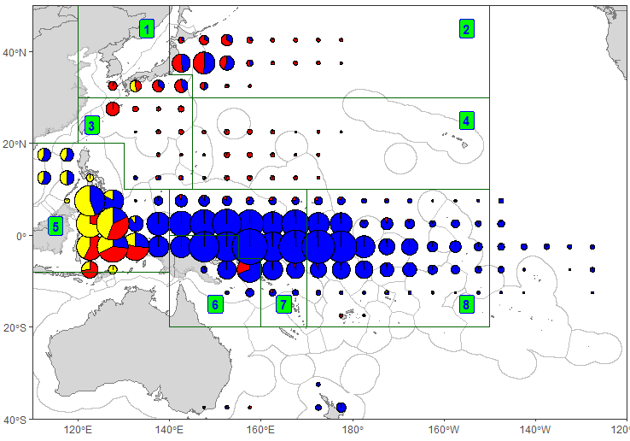
Figure 8.1.2 Distribution of skipjack tuna catch by gear, 1990−2022.
The eight-region spatial stratification used in stock assessment is shown.
Pole-and-line: red; Purse seine: blue; Other fisheries: yellow

The 2022 WCP–CA skipjack catch of 1,735,500 mt was the highest in recent three years, but around 310,000 mt lower than the record in 2019 (2,044,779 mt). Catch in the purse seine fishery for 2022 (1,451,079 mt – 84%) was the fifth highest on record, noting that the trend in purse seine skipjack catch typically drives the trends in overall skipjack catch. The pole-and-line catch for 2022 (135,195 mt – 8%) was amongst lowest catches since 1963, with reductions in both the Japanese and the Indonesian catches (noting 2022 estimates for this fishery are provisional). The various “artisanal” gears in the domestic fisheries including Indonesia, Philippines and Japan took 143,626 mt in 2022 (8% of the total catch) was the lowest since 2005. The longline fishery accounted for less than 1% of the total catch.

The majority of the skipjack catch is taken in equatorial areas, and most of the remainder is taken in the seasonal domestic (home-water) fishery of Japan, with seasonal catches in the NZ fishery (Figure 8.1.2). The domestic fisheries in Indonesia (purse seine, pole-and-line and unclassified gears) and the Philippines (e.g. ring-net and purse seine) account for the majority of the skipjack catch in the western equatorial portion of the WCP–CA. As mentioned in Section 3, the spatial distribution of skipjack catch by purse seine vessels in the central and eastern equatorial areas is influenced by the prevailing ENSO conditions. The Philippines and Indonesian domestic fisheries (archipelagic waters) generally account for most of the skipjack catch in the 20–40 cm size range (Figure 8.1.3), although associated purse seine catch also contribute to this range (e.g. in 2020). Most of the WCP–CA skipjack catch (by weight) is in the range 40–70 cm (corresponding to 1–2+ year-old fish – Figure 8.1.4). Medium-large (60–70 cm) skipjack typically make up the greater proportion of the catch from unassociated, free swimming school sets. The overall purse seine skipjack size distribution in 2021–2022 is different to previous years with a narrower size range (45-55 cm) for most of the catch (Figure 8.1.4), although this could be due to the bias spatial coverage in the observer data during the COVID years. The skipjack size distributions in the Philippine/Indonesia archipelagic fisheries have been relatively constant for a number of years (Figure 8.1.4 – yellow).
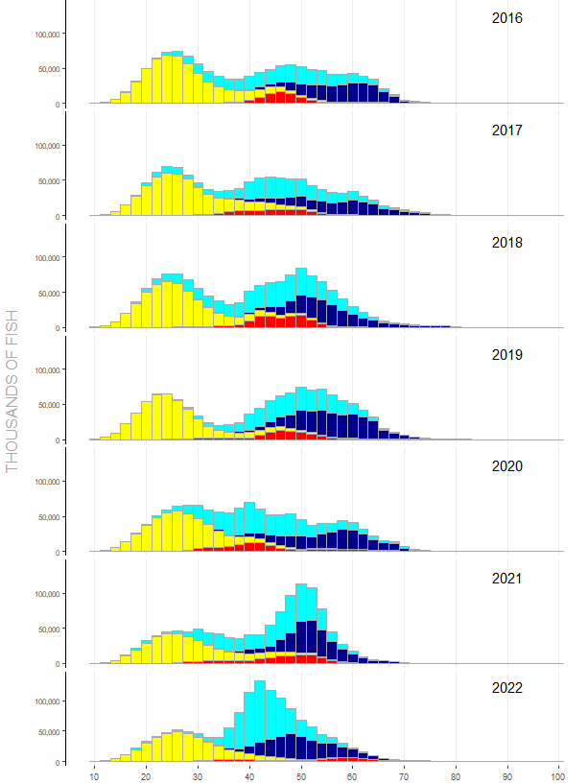

Figure 8.1.3 Annual catches (no. of fish) of skipjack tuna in the WCPO by size (2cm intervals) and gear type, 2016–2022.
(red–pole-and-line; yellow–Phil-Indo archipelagic fisheries; light blue–purse seine associated; dark blue–purse seine unassociated)

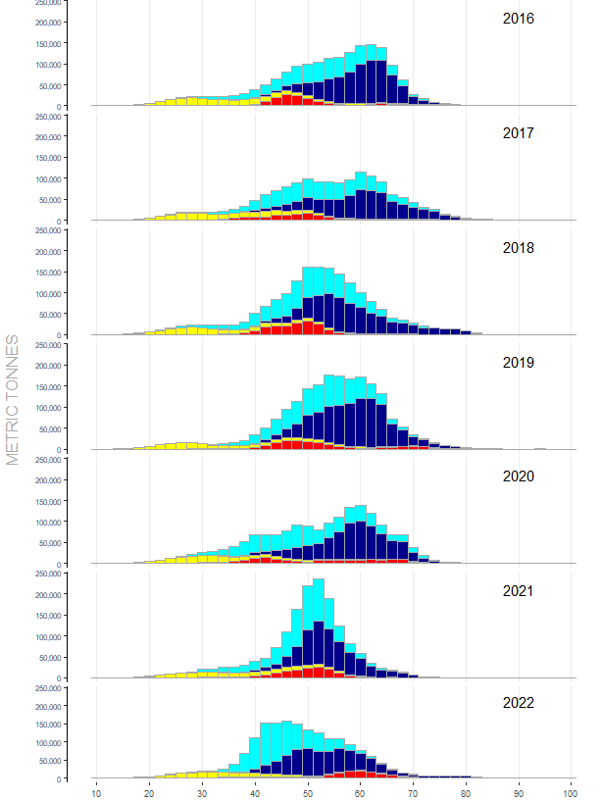

Figure 8.1.4 Annual catches (MT) of skipjack tuna in the WCPO by size (2cm intervals) and gear type, 2016–2022.
(red–pole-and-line; yellow–Phil-Indo archipelagic fisheries; light blue–purse seine associated; dark blue–purse seine unassociated)

8.2 YELLOWFIN
Figure 8.2.1 WCP–CA yellowfin catch (mt) by gear

The total yellowfin tuna catch in the WCP–CA has slowly increased over time but since 1998, jumped to a new level with annual catches regularly exceeding 500,000 mt (Figure 8.2.1), mainly due to increased catches in the purse seine fishery. The 2022 yellowfin catch (721,169 mt) was a drop of around 33,000 mt on the record catch in 2021 (754,442 mt). The recent high yellowfin tuna catches are related to some extent to recent high catch levels from the “other” category (primarily small-scale fisheries in Indonesia – provisional 2022 estimate for “Other” is 233,562 mt –32% of the total catch).
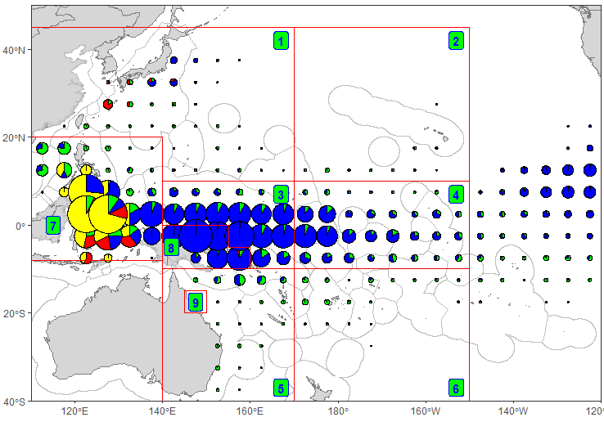
Figure 8.2.2 Distribution of yellowfin tuna catch by gear in the WCP–CA, 1990−2022.
The nine-region spatial stratification used in stock assessment is shown.
Longline: green; Pole-and-line: red; Purse seine: blue; Other fisheries: yellow
The WCP–CA longline catch for 2022 (84,232 mt–12%) was an increase compared to catch in the past two years, but still amongst the lowest catches since 1999 and 20,000 mt less than the 2019 catch in this fishery; a decrease in effort in the broad area where yellowfin are mainly targeted (due to COVID-19) no doubt contributed to the decline in recent years. Since the late 1990s, the purse seine catch of yellowfin tuna (379,715 mt in 2022–53%) has accounted for about 3-5 times the longline yellowfin tuna catch.

The pole-and-line fisheries took only 20,506 mt during 2022 (~3% of the total yellowfin catch), which was similar to the 2021 catch level, but amongst the lowest since the 1970s. Catches in the ‘other’ category are largely composed of yellowfin taken by various assorted gears (e.g. troll, ring-net, bagnet, gillnet, large-fish handline, small-fish hook-and-line and seine net) in the domestic fisheries of the Philippines and eastern Indonesia. Figure 8.2.2 shows the distribution of yellowfin catch by gear type for the period 1990–2022. As with skipjack, the great majority of the catch is taken in equatorial areas by large purse seine vessels, and a variety of gear types in the Indonesian and Philippine fisheries.

The domestic surface fisheries of the Philippines and Indonesia (archipelagic waters) take large numbers of small yellowfin in the 20–50 cm range (Figure 8.2.3), and their deep-water handline fisheries take smaller quantities of large yellowfin tuna (> 110 cm). In the purse seine fishery, smaller yellowfin are caught in log and FAD sets than in unassociated sets. A major portion of the purse seine catch is typically adult (> 100 cm) yellowfin tuna, to the extent that the purse seine catch (by weight) of adult yellowfin tuna is usually higher than the longline catch. Most of the catch of large yellowfin tuna in the size range 120–140 cm from the purse seine unassociated sets is typically taken in the eastern tropical WCP-CA. However, there was only a small proportion of fish >130cm from unassociated sets during 2021 and 2022, in contrast to 2016–2017 for example (Figure 8.2.4), and there was a clear mode of small fish around 45-50 cm in the purse seine associated catch during both 2021 and 2022. The differences in size distribution for 2021 and 2022 may be due to prevailing La Nina conditions restricting most of the purse seine fishery to the western tropical areas, and/or some bias in the spatial representativeness in the available size data for these years (since there was clearly reduced observer coverage during these years). Section 3.6 also provides some insights into the distribution of purse seine yellowfin catch by area and size.
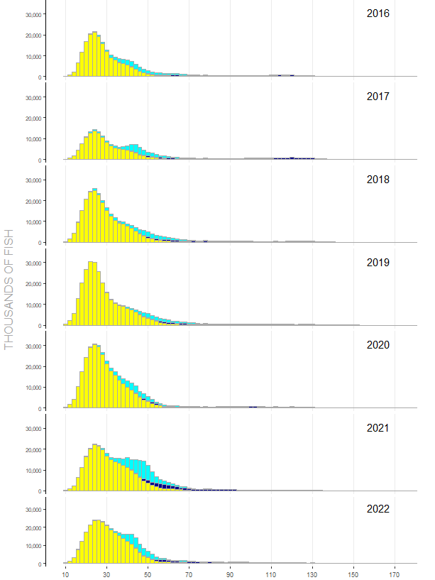

Figure 8.2.3 Annual catches (no. of fish) of yellowfin tuna in the WCPO by size (2cm intervals) and gear type, 2016–2022.
(green–longline; yellow–Phil-Indo archipelagic fisheries; light blue–purse seine associated; dark blue–purse seine unassociated)
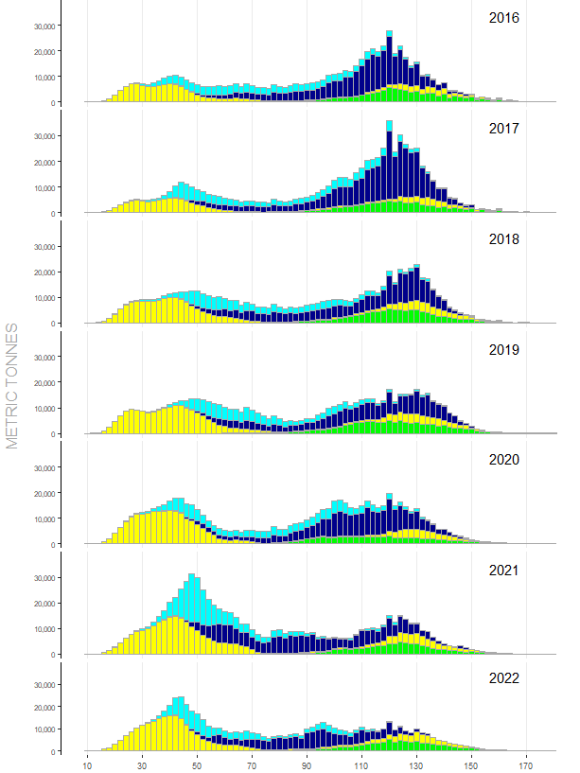

Figure 8.2.4 Annual catches (MT) of yellowfin tuna in the WCPO by size (2cm intervals) and gear type, 2016–2022.
(green–longline; yellow–Phil-Indo archipelagic fisheries; light blue–purse seine associated; dark blue–purse seine unassociated)

8.3 BIGEYE

The provisional WCP-CA bigeye catch (140,664 mt) for 2022 was similar to the 2021 level and around 55,000 mt lower than the record in 2004 (195,052mt). The provisional WCP-CA longline bigeye catch (54,800 mt) was similar to the 2021 catch and clearly lower than the recent ten-year average and understood to be partly due to the impacts of the COVID-19 pandemic. The provisional WCP–CA purse seine bigeye catch for 2022 was estimated to be 62,811 mt which was at a similar level to the 2021 catch, but lower than the recent ten-year average (Figure 8.3.1). The WCP-CA purse seine bigeye catch has exceeded the longline catch for most of the past ten years. The purse seine and longline fisheries have accounted for an average of 89% of the total WCP-CA bigeye catch over the past ten years.
Figure 8.3.1 WCP–CA bigeye catch (mt) by gear

The WCP–CA pole-and-line fishery has generally accounted for between 1,000–5,000 mt (1-4%) of bigeye catch annually over the past decade. The "other" category, representing various gears (including troll) in the Philippine, Indonesia, Vietnam and Japanese domestic fisheries has fluctuated between an estimated 11,000–21,000 mt (7–15% of the total WCP–CA bigeye catch) over the past decade.

Figure 8.3.2 shows the spatial distribution of bigeye catch in the Pacific for the period 1990–2022. The majority of the WCP–CA catch is taken in equatorial areas, both by purse seine and longline, but with some longline catch in sub-tropical areas (e.g. east of Japan and off the east coast of Australia). In the equatorial areas, much of the longline catch is taken in the central Pacific, continuous with the important traditional bigeye longline area in the eastern Pacific.
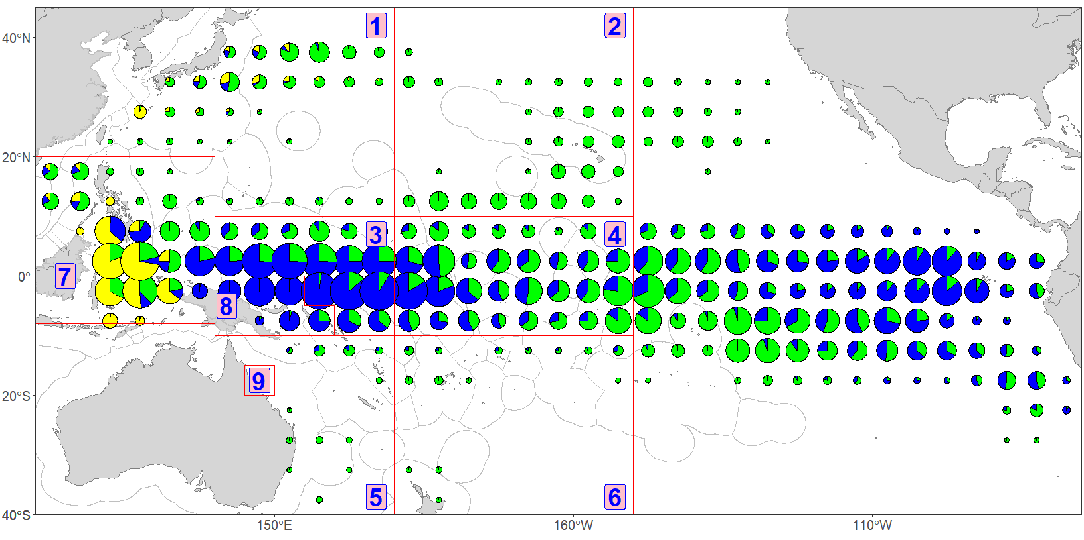
Figure 8.3.2 Distribution of bigeye tuna catch, 1990−2022.
The nine-region spatial stratification used in stock assessment for the WCP–CA is shown.
Longline: green; Purse seine: blue; Other fisheries: yellow

As with skipjack and yellowfin tuna, the domestic surface fisheries of the Philippines and Indonesia (archipelagic waters) take relatively large numbers of small bigeye in the range 20–60 cm (Figure 8.3.3). The longline fishery clearly accounts for most of the catch (by weight) of large bigeye in the WCP–CA (Figure 8.3.4). This contrasts with large yellowfin tuna, which (in addition to longline gear) are also taken in significant amounts from unassociated (free-swimming) schools in the purse seine fishery and in the Philippines handline fishery. Large bigeye tuna are very rarely taken in the WCPO purse seine fishery and only a relatively small amount come from the handline fishery in the Philippines. Bigeye tuna sampled in the longline fishery are predominantly adult fish with a mean size of ~130 cm FL (range 80–170+ cm FL). Associated sets account for nearly all the bigeye catch in the WCP–CA purse seine fishery with considerable variation in the sizes from year to year, but the majority of associated-set bigeye tuna are generally in the range of 45–75 cm.

The year class represented by the mode of fish in the size range of about 25-30 cm in the Philippines/Indonesian domestic fisheries during 2020 appears to progress to a mode of 50-60 cm in the same fisheries during 2021 (Figure 8.3.3).

The graphs for 2022 potentially show several distinct modes (i) at 30 cm and 45-50 cm for the Philippines/Indonesia domestic fisheries, (ii) around 45-50 cm for the purse seine associated fishery, and (iii) the typical broad mode at around 130-135 cm for the longline fishery.

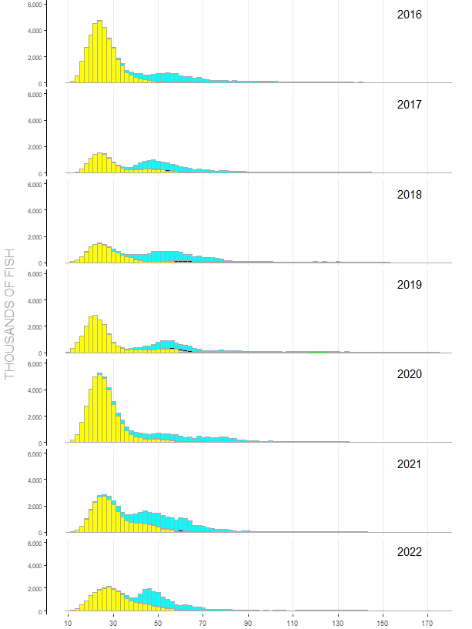

Figure 8.3.3 Annual catches (no. of fish) of bigeye tuna in the WCPO by size (2cm intervals) and gear type, 2016–2022.
(green–longline; yellow–Phil-Indo archipelagic fisheries; light blue–purse seine associated; dark blue–purse seine unassociated)

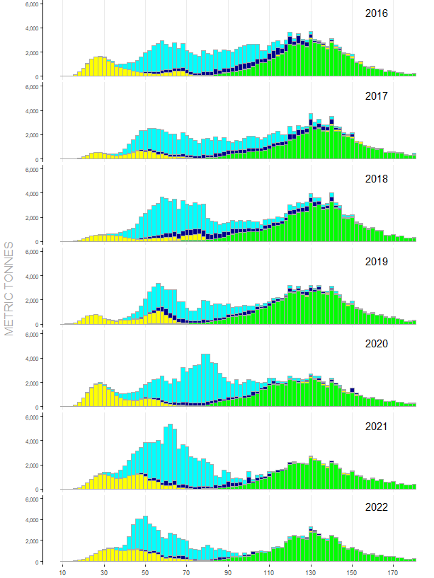

Figure 8.3.4 Annual catches (MT) of bigeye tuna in the WCPO by size (2cm intervals) and gear type, 2016–2022.
(green–longline; yellow–Phil-Indo archipelagic fisheries; light blue–purse seine associated; dark blue–purse seine unassociated)

8.4 SOUTH PACIFIC ALBACORE

Prior to 2001, south Pacific albacore catches were generally in the range 25,000–50,000 mt, with a significant peak in 1989 (49,076 mt) when driftnet fishing was in existence. Since 2001, catches have greatly exceeded this range, primarily as a result of the growth in several Pacific Islands domestic longline fisheries. The provisional south Pacific albacore catch in 2022 (77,912 mt), was higher than the past two years and around 16,000 mt less than the record catch taken in 2017 (94,504 mt).

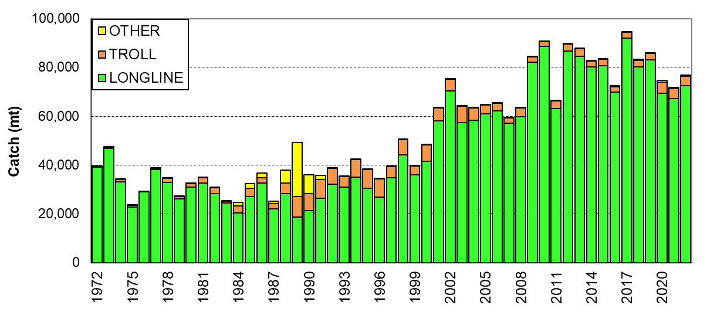
Figure 8.4.1 South Pacific albacore catch (mt) by gear ("Other" is primarily catch by the driftnet fishery)

In the post-driftnet era, longline has accounted for most of the South Pacific albacore catch (> 75% in the 1990s, but > 90% in recent years). The annual South Pacific Albacore troll catch (with a season spanning November–April) dropped from a range between 4,000–8,000 mt during the 1990s, to a range of 2,000–3,500 mt (Figure 6.1.1) over the past 10–15 years, although the troll catches in recent years (4,733 mt for 2020, 4,037 mt for 2021, and 3,777 mt for 2022) were the highest since 2004. The provisional WCP–CA albacore catch for 2022 (104,766 mt) was a clear increase on the very low catch in 2021 (89.282 mt – the lowest catch since 1993) but still around 44,000 mt lower than the record (148,051 mt in 2002). The WCP–CA albacore catch (which includes catches from fisheries in the North Pacific Ocean west of 150°W) typically contributes around 80%–90% of the Pacific catch of albacore (provisional Pacific Ocean albacore tuna catch for 2022 is 127,266 mt).

The longline catch of albacore is distributed over a large area of the south Pacific (Figure 8.4.2) but concentrated in the west. The Chinese-Taipei distant-water longline fleet catch is taken in all regions, while the Pacific Island domestic longline fleet catch is restricted to the latitudes 10°–25°S. Troll catches are distributed in New Zealand's coastal waters, mainly off the South Island, and along the Sub-tropical Convergence Zone (STCZ). Less than 20% of the overall south Pacific albacore catch is usually taken east of 150°W.

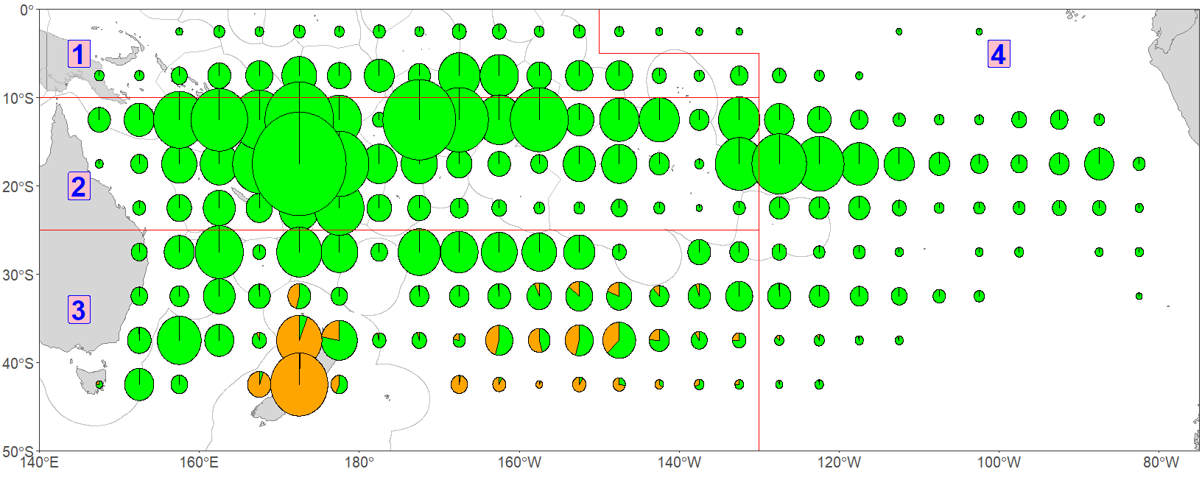
Figure 8.4.2 Distribution of South Pacific albacore tuna catch, 1988–2022.
The four-region spatial stratification used in stock assessment is shown.
Longline: green; Troll: orange
The longline fishery takes adult albacore in the narrow size range of 90–105 cm and the troll fishery take juvenile fish in the range of 45–80cm (Figure 8.4.3 and Figure 8.4.4). Juvenile albacore also appears in the longline catch from time to time (e.g. fish in the range 60–70 cm sampled from the longline catch). The size distribution in the south Pacific albacore catch for recent years shows a clear mode of small albacore around 60cm from the troll fishery and slightly larger fish than for recent years in the longline fishery.
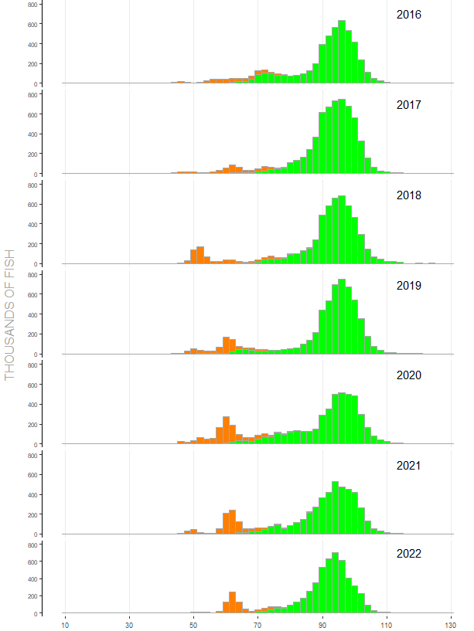

Figure 8.4.3 Annual catches (no. of fish) of albacore tuna in the South Pacific Ocean by size (2cm intervals) and gear type, 2016–2022. (green–longline; orange–troll)

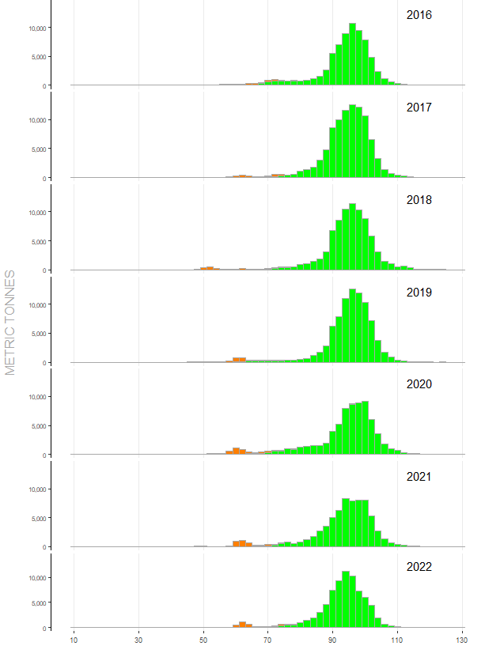

Figure 8.4.4 Annual catches (MT) of albacore tuna in the South Pacific Ocean by size (2cm intervals) and gear type, 2015–2022. (green–longline; orange–troll);

8.5 SOUTH PACIFIC SWORDFISH

The distant-water and offshore Asian fleets (Japan, Chinese Taipei and Korea) accounted for most of the south Pacific swordfish catch from 1972 to the mid-1990s (Figure 8.5.1), with catches slowly increasing from 2,500 mt to about 5,000 mt. The development of target (domestic) fisheries in Australia and New Zealand accounted for most of the increase in total catch to around 10,000 mt in early 2000s, with burgeoning Pacific Island domestic fleets also contributing. The EU-Spanish longline fleet targeting swordfish entered the fishery in 2004 and resulted in total swordfish catches increasing significantly to a new level of around 15,000 mt, and then to more than 20,000 mt over the period 2011-2018, with contributions from the distant-water and offshore Asian fleet catches (Figure 8.5.1). The provisional 2022 catch estimate for the South Pacific swordfish (19,406 mt) was a slight increase on the 2021 catch and clearly lower than the record 2015 catch, mainly due to a reduction in distant-water and offshore Asian fleet catches (although 2022 estimates for some fleets were provisional at the time of writing this paper).
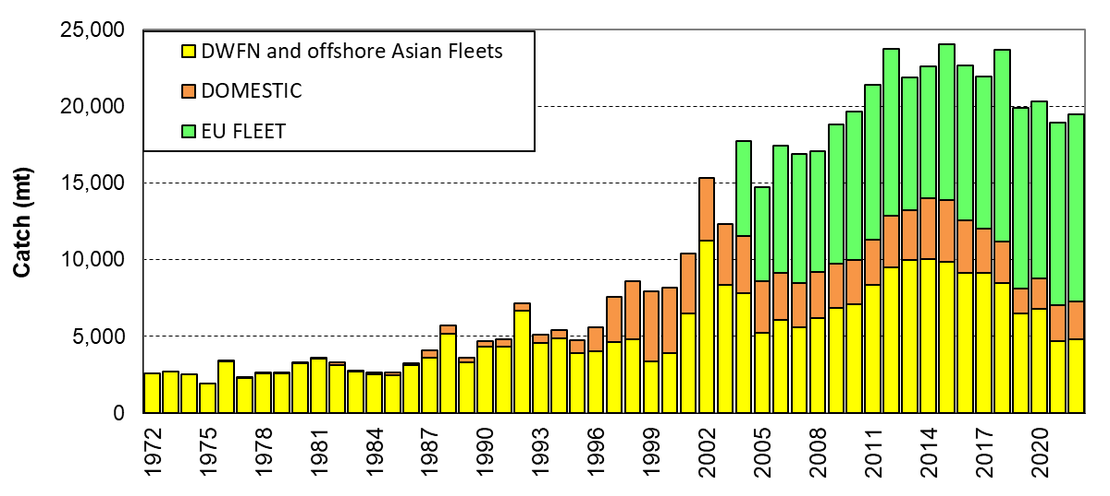
Figure 8.5.1 South Pacific longline swordfish catch (mt) by fleet

The catch of swordfish for the WCP-CA south of the equator (Figure 8.5.2) in 2022 was 6,684 mt, slightly higher than 2021 but clearly lower than the peak years of 2012-2014. As with other WCPFC fisheries, the impacts or COVID-19 were one of the reasons contributing to this decline, although the EU-Spanish fleet catch in 2022 (2,139 mt) was their highest since 2012.

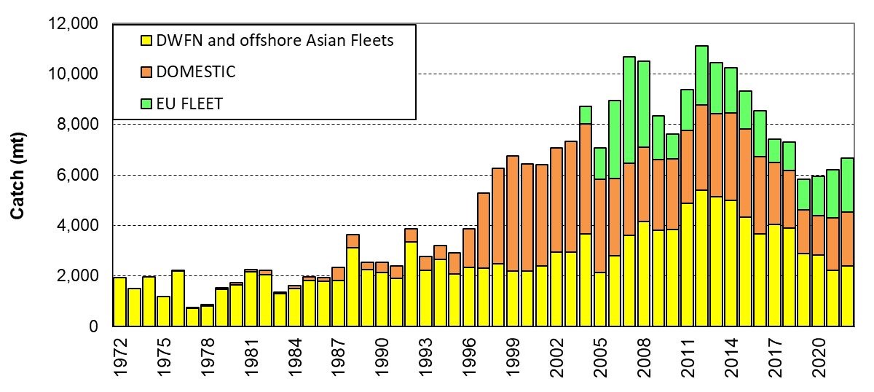
Figure 8.5.2 WCP–CA (south of equator) longline swordfish catch (mt) by fleet

The longline catch of swordfish is distributed over a large area of the south Pacific (Figures 8.5.3 and A10). There are four main areas of catches (i) the far eastern Pacific Ocean off Chile and Peru, where most of the EU-Spanish fleet catch comes from but also some of the distant-water and offshore Asian catches; (ii) the south central Pacific Ocean region south of the Cook Islands and French Polynesia, predominantly covered by the EU-Spanish fleet; (iii) the coastal waters of New Zealand, Australia and adjacent Pacific Island countries (domestic fleets); and (iii) the equatorial Pacific Ocean between 130–160°W, covered by the distant-water and offshore Asian fleets.

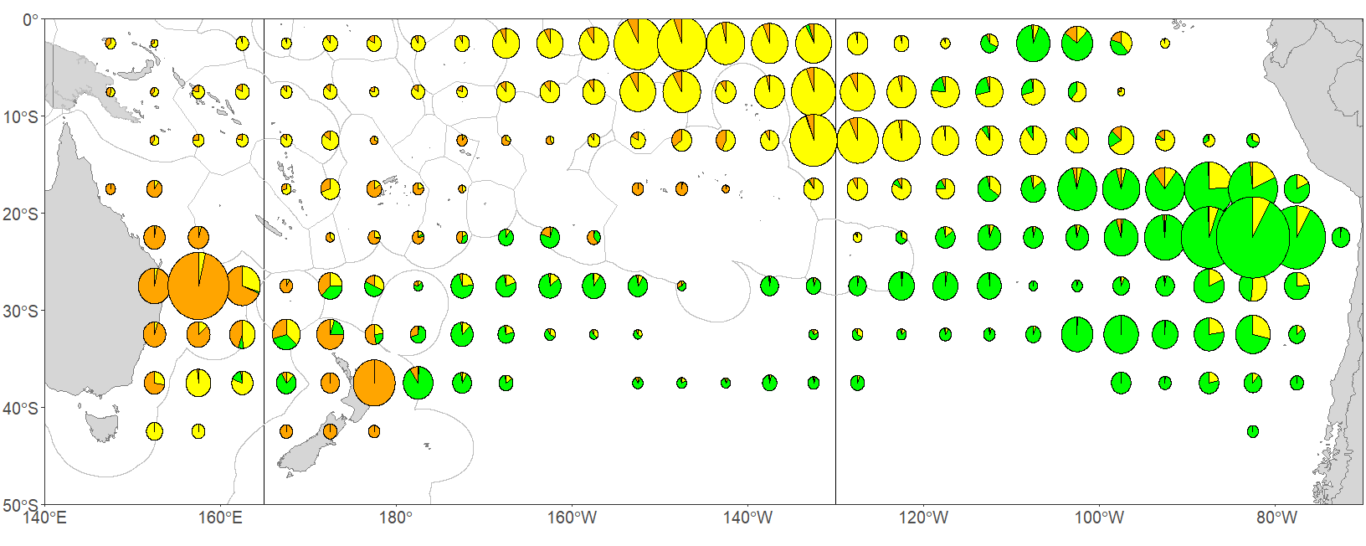
Figure 8.5.3 Distribution of South Pacific longline swordfish catch, 1995–2022.
DWFN and offshore Asian fleets: yellow; Spanish fleet: green; Others: orange

The swordfish caught throughout the South Pacific Ocean are generally in the range of 110–250 cm, with a mean around 180 cm (lower jaw-fork length – Figures 8.5.4 and 8.5.5). There is evidence of inter-annual variation in the size of swordfish taken by fleet and variation in the size of fish by fleet, for example, the EU-Spanish fleet generally catch larger swordfish than the distant-water and offshore Asian fleets, which could be related to area fished. Note the two modes of fish at around 140 cm and 180 cm in the 2019 size data (Figure 8.5.4). There were no size data collected for the EU-Spanish longline fleet during 2020, 2021 and 2022 due to the impact of COVID-19 restrictions.
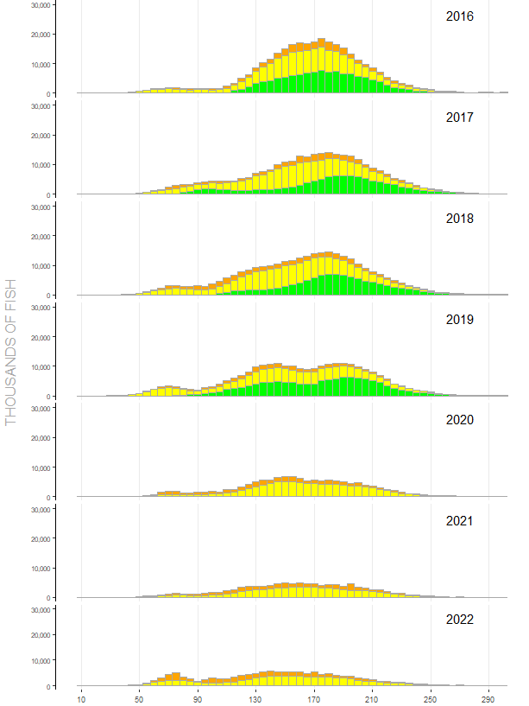

Figure 8.5.4 Annual catches (number of fish) of swordfish in the WCP–CA (south of the equator) by size (5cm intervals) and fleet, 2016–2022. (green–EU-Spanish fleet catch; yellow–distant-water Asian fleet catch; orange– Domestic fleets) 2020-2022 data for EU-Spanish longline fleet are not available.

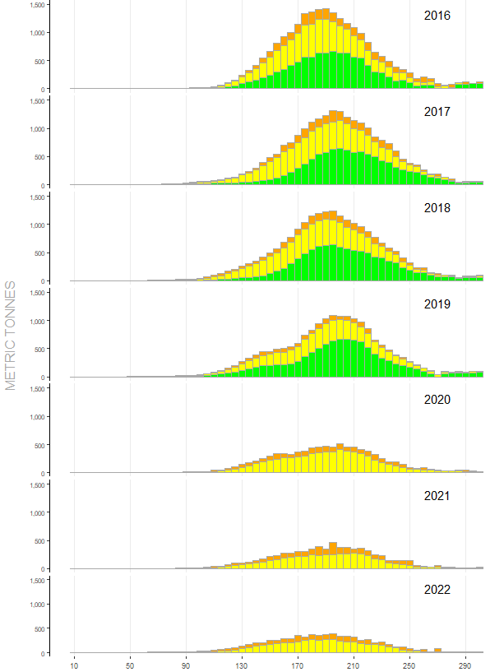

Figure 8.5.5 Annual catches (metric tonnes) of swordfish in the WCP–CA (south of the equator) by size (5cm intervals) and fleet, 2016–2022. (green–EU-Spanish fleet catch; yellow–distant-water Asian fleet catch; orange–Domestic fleets) 2020-2022 data for EU-Spanish longline fleet are not available.

8.6 OTHER BILLFISH

8.6.1 Blue Marlin
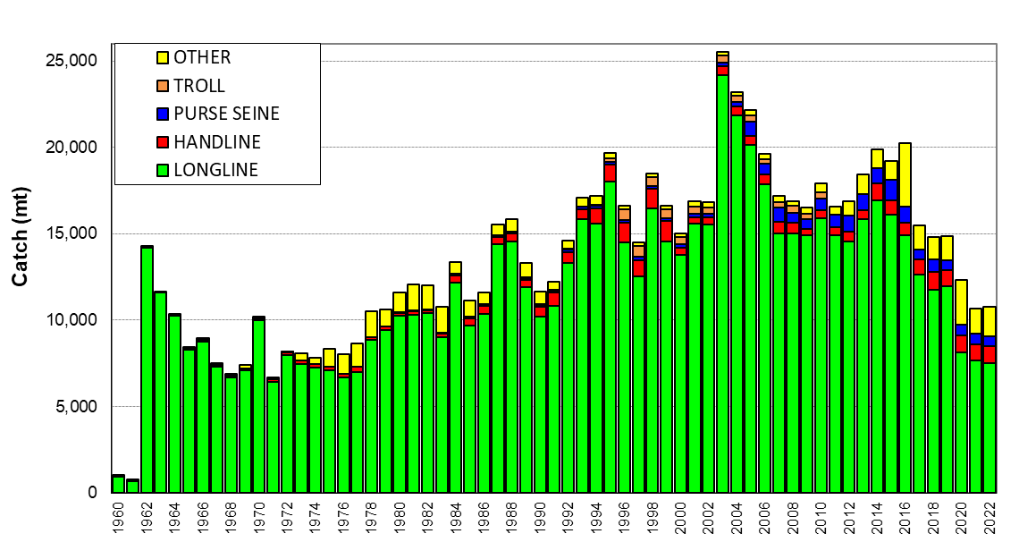
Figure 8.6.1 WCP–CA blue marlin catch (mt) by gear

Blue marlin are mainly taken by the longline gear in the tropical WCP-CA with relatively small amounts also taken by purse seine, troll, handline and a range of other small-scale gears (e.g. gillnet). WCP-CA catches of blue marlin have ranged from around 8,000–25,000 mt since the 1970s although there remains some uncertainty around some of the estimates by fleet and gear. The provisional WCP-CA blue marlin catch (11,103 mt) for 2022 was similar to the 2021 level, but amongst the lowest catches since the 1980s (Figure 8.6.1). Figure 8.6.2 shows the distribution of longline-caught blue marlin highlighting that they are more prevalent in the western tropical waters of the WCP–CA (complete aggregate data stratified by area are not available for the other gears at this stage). The decline in the catch for 2020 and 2022 may be related to the general decline in the longline catch in the areas where blue marlin are usually taken, due to the impacts of COVID-19.

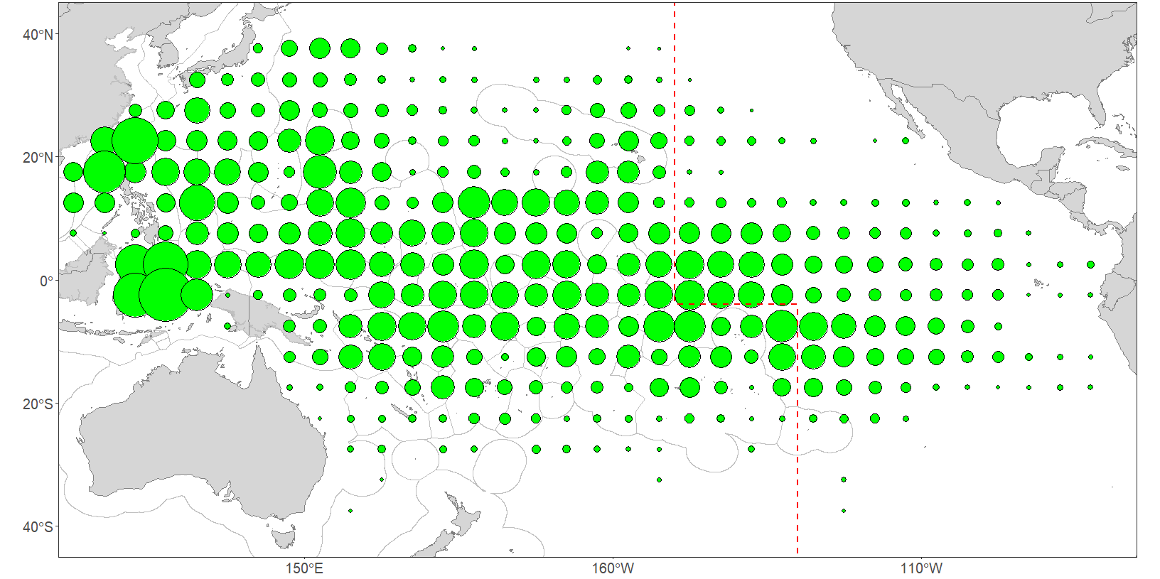
Figure 8.6.2 Distribution of longline Blue marlin catch in the Pacific Ocean, 1990–2022.

8.6.2 Black Marlin

Black marlin are mainly taken by the longline gear in the tropical WCP-CA but also catches by purse seine, handline and a range of other small-scale gears (e.g. gillnet). WCP-CA catches of black marlin have ranged from around 1,300–3,800 mt since the early 1970s (when catches were at their highest), although there remains some uncertainty around some of the estimates by fleet and gear. The provisional WCP-CA black marlin catch (2,144 mt) for 2022 was a similar level to the 2021 catch (Figure 8.6.3). The recent increase in catches have come from several south-east Asian fisheries (including domestic purse seine) and further review is required, although these increases may reflect more reliable estimates from these fisheries. Figure 8.6.4 shows the distribution of longline-caught black marlin highlighting that their distribution does not extend to the eastern areas as much as blue marlin and they are clearly more prevalent in the western tropical waters of the WCP–CA, and to a lesser extent in the waters of PNG, Solomon Islands, New Caledonia and north-east Australia. Complete aggregate data stratified by area are not available for the other gears at this stage, but black marlin catches by Indonesia and Philippines handline and Vietnam gillnet overlap the main areas of the longline catch for this species.
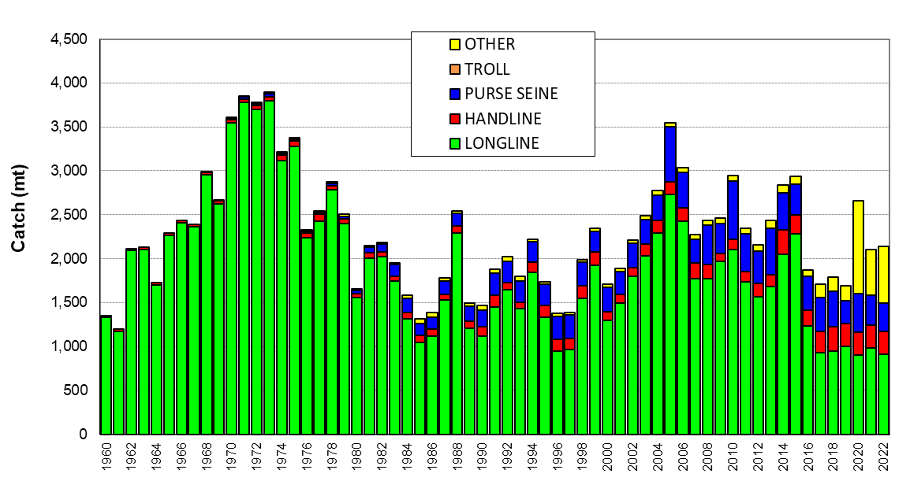
Figure 8.6.3 WCP–CA black marlin catch (mt) by gear

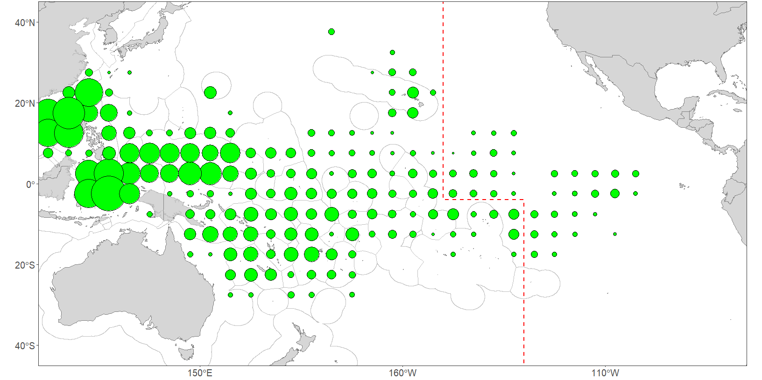
Figure 8.6.4 Distribution of longline Black marlin catch in the Pacific Ocean, 1990–2022.

8.6.3 Striped Marlin

Striped marlin are mainly taken by the longline gear in the sub-tropical areas of the WCP-CA with minor catches by other gears, principally several gillnet fisheries. WCP-CA annual catches of striped marlin often exceeded 8,000 mt prior to 1990, with the gillnet fishery catch comprising a significant proportion of this catch during the 1970s. Since 2000, catches have been generally below 6,000 mt., although there remains some uncertainty around the availability and quality of estimates for some fleets and gears. Species identification is also acknowledged to be an issue in some fisheries. The provisional WCP-CA striped marlin catch (2,487 mt) for 2022 is the lowest in the time series present (Figure 8.6.5) at this stage. Figure 8.6.6 shows the distribution of longline-caught striped marlin, with catches concentrated in the waters off the east coast of Japan, the Coral and Tasman Seas between eastern Australia, New Caledonia and New Zealand, and in the eastern areas, in and around Hawaii and French Polynesia. Complete aggregate data stratified by area are not available for the other gears at this stage.
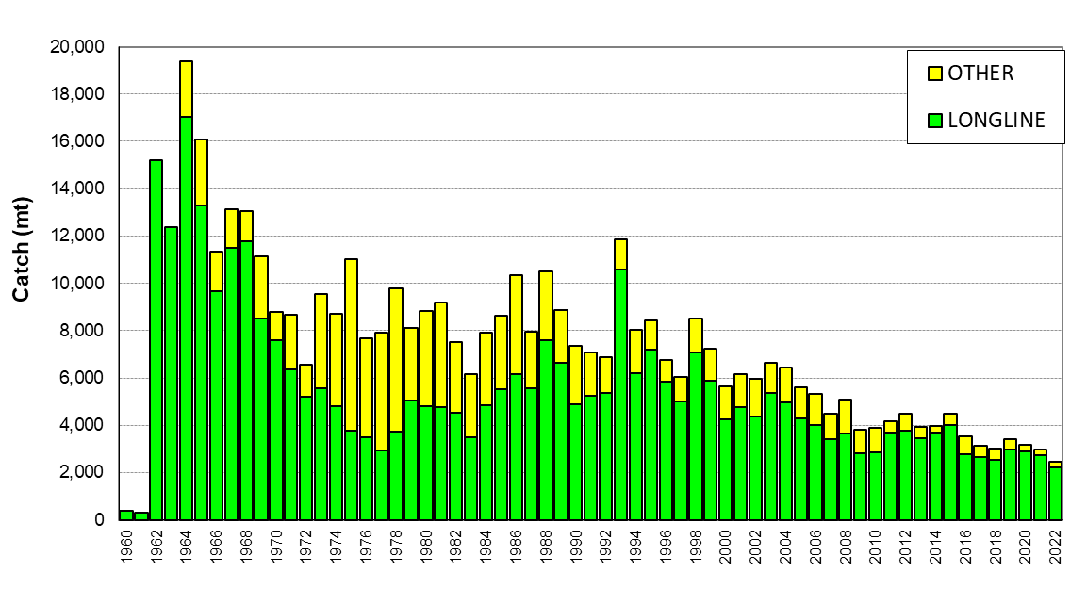
Figure 8.6.5 WCP–CA striped marlin catch (mt) by gear

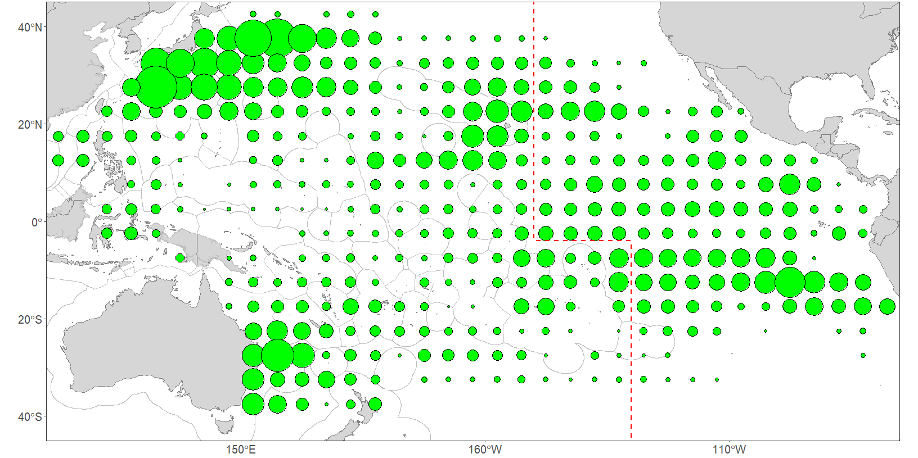
Figure 8.6.6 Distribution of longline Striped marlin catch in the Pacific Ocean, 1990–2022.

8.6.4 North Pacific Swordfish

Swordfish are mainly taken by the longline gear in the north Pacific Ocean with minor catches by other gears, including gillnet fisheries. Annual catches of north Pacific swordfish have generally exceeded 10,000 mt since 1972 (Figure 8.6.7). In recent years, the catches have been amongst the highest recorded (after the record catch in 1993), although there remains some uncertainty around the availability and quality of estimates for some fleets and gears, and these estimates have yet to be reconciled with estimates from the ISC and the IATTC. The provisional North Pacific swordfish catch (8,731 mt) for 2022 was a continuation of the clear decline on catches in recent years and the lowest since the 1980s (Figure 8.6.7). As with the catches of other species, the decline in the North Pacific swordfish catch for 2022 may be related to the general decline in the longline catch in the areas where swordfish are usually taken due to the impacts of COVID-19.
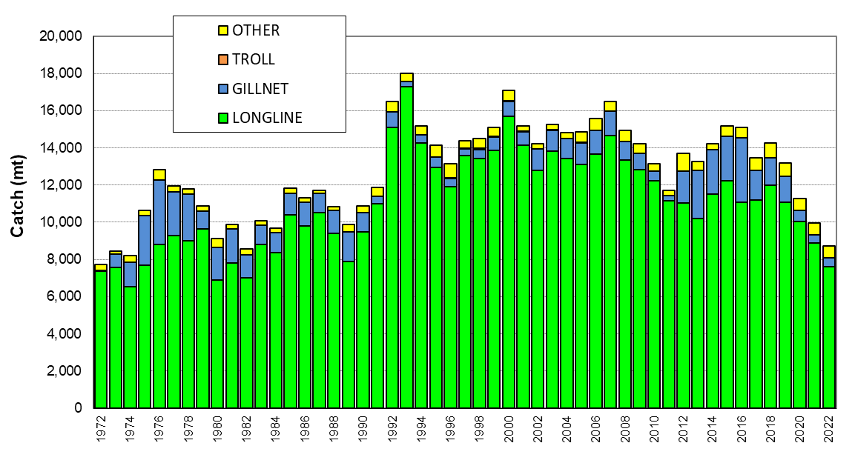
Figure 8.6.7 North Pacific Swordfish catch (mt) by gear

Figure 8.6.8 shows the distribution of longline-caught swordfish in the Pacific Ocean, with catches concentrated across the Pacific Ocean, north of 20°N, including the waters off the east coast of Japan, and adjacent to the Hawaii EEZ. Swordfish catches in the north Pacific Ocean are also prevalent in Indonesia and in the waters bounded by China, Chinese Taipei, Philippines and Vietnam. Complete aggregate data stratified by area are not available for the other gears at this stage.

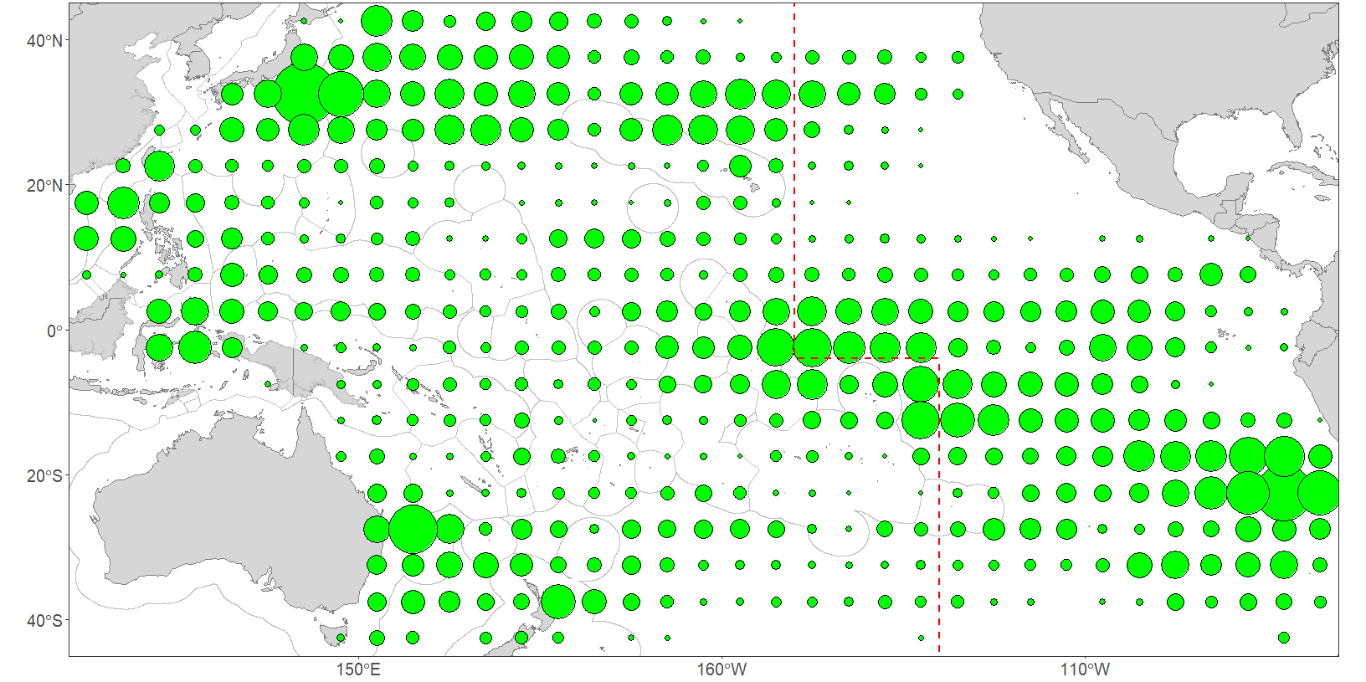
Figure 8.6.8 Distribution of longline swordfish catch in the Pacific Ocean, 1990–2022.

8.7 NORTH PACIFIC ALBACORE

Albacore tuna are mainly taken by the longline, pole-and-line and troll gears in the north Pacific Ocean, with minor catches by purse seine; albacore tuna was also the target of the driftnet fishery in the 1980s. Annual catches of North Pacific albacore have fluctuated since the 1950s, with peak periods in the 1970s and then again in the late 1990s into the early 2000s (Figure 8.7.1). In recent years, catches have been lower, due to declines in the pole-and-line and longline catches. There remains some uncertainty around the availability and quality of estimates for some fleets and gears, and these estimates have yet to be reconciled with estimates from the ISC and the IATTC. The North Pacific albacore catch for 2022 (provisional 49,354 mt) was similar to the recent five-year average (Figure 8.7.1) but amongst the lowest for around 30 years.
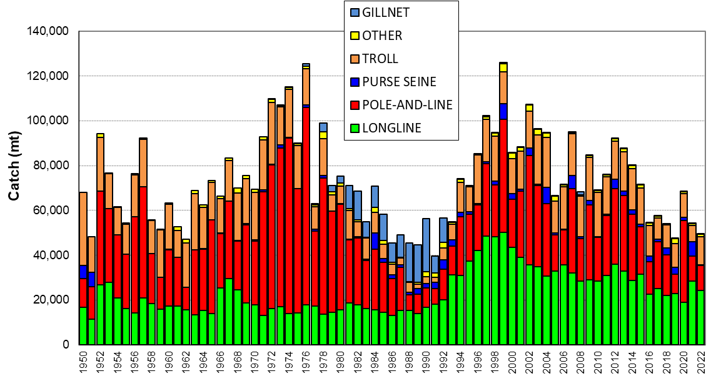
Figure 8.7.1 WCP–CA North Pacific Albacore catch (mt) by gear

8.8 NORTH PACIFIC BLUEFIN

Bluefin tuna are mainly taken by purse seine gear in the north Pacific Ocean with minor catches from the longline, troll and by other small-scale gears in Japan waters; there have also been significant historic catches from the troll and pole-and-line gears. Annual catches of north Pacific bluefin tuna have fluctuated since the 1970s, with peak periods in the early 1980s and for certain years in the mid-late 1990s and into the first decade of 2000s (Figure 8.8.1). Catches declined over the period 2012–2015 but have increased in recent years. There remains some uncertainty around the availability and quality of estimates for some fleets and gears, and these estimates have yet to be reconciled with estimates from the ISC and the IATTC. The provisional North Pacific bluefin tuna catch (11,655 mt) for 2022 was slightly higher than the catch in 2021, the highest since 2016 (Figure 8.8.1), but clearly lower than the long-term average catch.
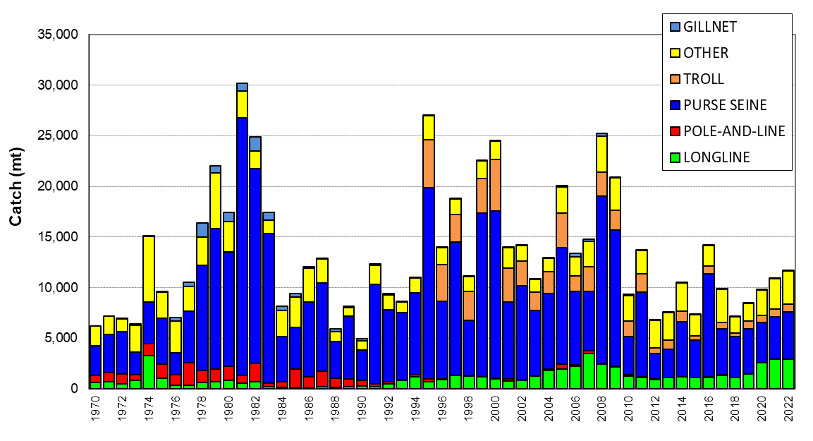
Figure 8.8.1 North Pacific Bluefin catch (mt) by gear

References

McKechnie, S., P. Williams, G. Pilling and WCPFC Secretariat. (2023). Trends in the South Pacific albacore longline and troll fisheries. Information Paper SA–IP–04. Nineteenth Regular Session of the Scientific Committee of the WCPFC (SC19). Koror, Palau, 16–24 August 2023.

Ministry of Marine Affairs and Fisheries, Indonesia (MOMAF) and SPC-OFP. 2021a. Availability of catch estimates from the other commercial fisheries in Indonesia. Statistics and Data Theme Information Paper ST–IP–09. Seventeenth Regular Session of the Scientific Committee of the WCPFC (SC17). Online Meeting. 11–19 August 2021.

Ministry of Marine Affairs and Fisheries, Indonesia (MOMAF) and SPC-OFP. 2021b. Options for a baseline of the “large-fish” Handline fishery fishing in Indonesia’s EEZ (IEEZ) with vessels >30GT for the WCPFC Tropical Tuna Measure. Working Paper WCPFC18-2021-24. Eighteenth Regular Session of the Commission (WCPFC18). Online Meeting. 1–7 December 2021.

National Fisheries Research and Development Institute (NFRDI), Bureau of Fisheries and Aquatic Resources (BFAR), Department of Agriculture, Philippines and SPC-OFP. 2021. Estimates of annual catches of tropical tuna by the Philippines relevant to WCPFC CMM on Tropical Tunas “other commercial fisheries”. Statistics and Data Theme Information Paper ST–IP–08. Seventeenth Regular Session of the Scientific Committee of the WCPFC (SC17). Online Meeting. 11–19 August 2021.

S. Hare, G. Pilling, P. Williams (2023). A compendium of fisheries indicators for target tuna stocks in the WCPFC Convention Area. Information Paper SA–WP–06. Nineteenth Regular Session of the Scientific Committee of the WCPFC (SC19). Koror, Palau, 16–24 August 2023.

SPC-OFP. 2021. An assessment of available information to address the WCPFC17 recommendation on the Tropical Tuna CMM para 51 (other commercial fisheries). Statistics and Data Theme Information Paper ST–WP–02. Seventeenth Regular Session of the Scientific Committee of the WCPFC (SC17). Online Meeting. 11–19 August 2021.

SPC-OFP (2023). Estimates of annual catches in the WCPFC Statistical Area. Information Paper ST–IP–01. Nineteenth Regular Session of the Scientific Committee of the WCPFC (SC19). Koror, Palau, 16–24 August 2023..

WCPFC Secretariat & SPC-OFP (2023). Catch and effort data summaries to support discussions on the TROPICAL TUNA CMMS. Information Paper MI–IP–08. Nineteenth Regular Session of the Scientific Committee of the WCPFC (SC19). Koror, Palau, 16–24 August 2023.

APPENDIX - Additional Information

ALL FISHERIES – Additional Information

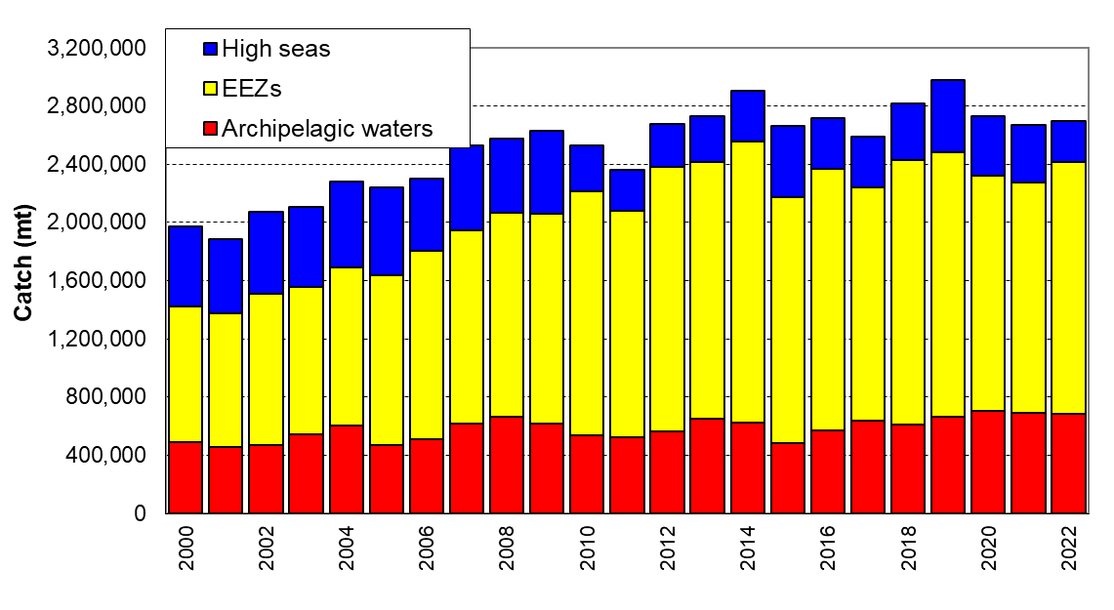
Figure A1. Catch estimates (mt) of the tropical tuna species (albacore, bigeye, skipjack and yellowfin) in the WCP–CA, by archipelagic waters (AWs), national waters (EEZs, excluded AWs) and the high seas for all gear types combined.

PURSE SEINE FISHERY – Additional Information

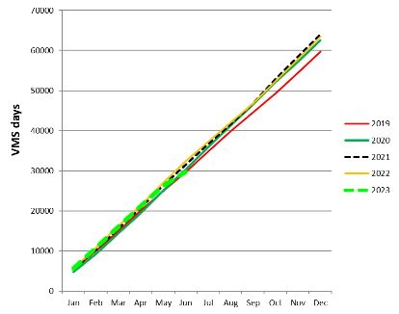
Figure A2. Cumulative tropical purse seine effort by month, 2009-2023, as measured by VMS
(excludes days in port and an estimation of days in transit)

LONGLINE FISHERY – Additional Information

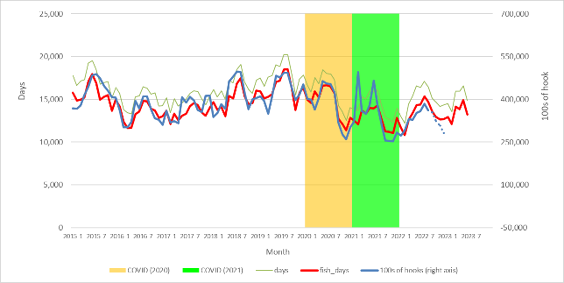
Figure A3. Monthly WCPFC longline fishery effort (VMS fishing days and 100s of Hooks, 2015-2023
(WCPFC Area; Longline Fishery Effort only considers VMS and logbook effort data for the main domestic, domestic-based foreign and distant-water fleets where VMS data with high coverage are available consistently over recent years)

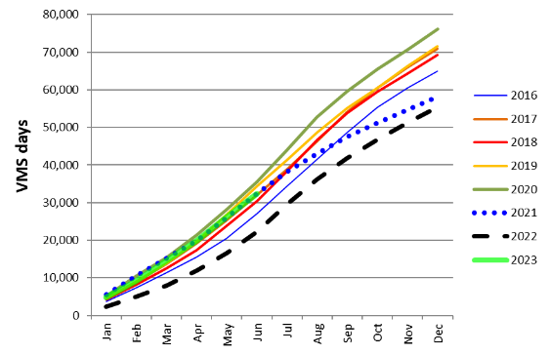
Figure A4. Cumulative South Pacific Albacore longline fishery effort by month, 2016-2023, as measured by VMS
(WCPFC Area south of 10°S; VMS estimated fishing days; only includes VMS data for the main domestic, domestic-based foreign and distant-water fleets where VMS data have been provided with high coverage consistently over recent years)

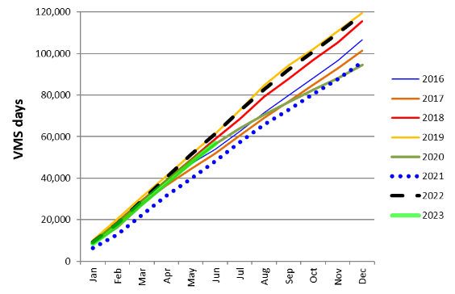

Figure A5. Cumulative Tropical longline fishery effort by month, 2016-2023, as measured by VMS
(WCPFC Area 20°N–10°S, 130°E–150°W; VMS estimated fishing days; only includes VMS data for the main domestic, domestic-based foreign and distant-water fleets where VMS data have been provided with high coverage consistently over recent years)

includes catches of north and south Pacific albacore in the WCP–CA, which comprised 82% of the total Pacific Ocean albacore catch of 127,266 mt in 2022; the section 8.4 “Summary of Catch by Species – South Pacific Albacore” is concerned only with catches of south Pacific albacore (77,912 mt in 2022), which made up approximately 63% of the Pacific albacore catch in 2022.
The number of vessels by fleet in 1992 was Japan (38), Korea (36), Chinese-Taipei (45) and USA (44) and in 2022 the number of active vessels by fleet was Japan (35), Korea (22), Chinese Taipei (29) and USA (14). In 2022, there was an additional 34 vessels in the category less than 200 GRT which are a part of the Japanese offshore purse seine fleet but not included here.
Based on the US CPI as measured by the Bureau of Labor Statistics All Urban Consumers CPI (www.bls.gov/cpi/data.htm)
The delivered value of each year’s catch is estimated as the sum of the product of the annual purse catch of each species, excluding the Japanese purse seine fleet’s catch, and the average annual Thai import price for each species (bigeye was assumed to attract the same price as for skipjack) plus the product of the Japanese purse seine fleet’s catch and the average Yaizu price for purse seine caught fish by species. Thai import and Yaizu market prices were used as they best reflect the actual average price across all fish sizes as opposed to prices provided in market reports which are based on benchmark prices, for example, for skipjack the benchmark price is for fish of size 4-7.5lbs. In deriving these estimates certain assumptions were made due to data and other constraints that may or may not be valid and as such caution is urged in the use of these figures.
Full details of the methodology used to derive the economic conditions indexes presented can be found in Skirtun, M and Reid, C. 2018, Analyses and projections for economic condition in WCPO fisheries, WCPFC-SC14-2018 ST- IP-06, Busan, Republic of Korea, August 8-16.
The tropical purse seine fishery economic conditions index is based on the fishery that lies between 10⁰N and 10⁰S of the WPCFC-CA, excluding the waters of Indonesia, Philippines and Vietnam.
Delivered skipjack prices for the Japanese pole and line fleet are based on a weighted average of the Yaizu ‘south’ and ‘other’ pole and line caught skipjack prices. Delivered yellowfin price for the Japanese pole and line fleet are based on the Yaizu purse seine caught yellowfin price. All other prices are based on Thai import prices. All prices are converted into USD using representative exchange rates provided by the IMF.
Since 2005, more detailed information on fleet/vessel number breakdown has been required through WCPFC reporting requirements and are therefore more representative of WCP–CA longline activity.
For the yellowfin and bigeye caught by fresh longline vessels it is assumed that 80% of the catch is of export quality and 20% is non-export quality. For export quality the annual prices for Japanese fresh yellowfin and bigeye imports from Oceania are used, while it is simply assumed that non-export grade tuna attracted $1.50/kg throughout the period 1997-2013. For yellowfin caught by frozen longline vessels the delivered price is taken as the Yaizu market price for longline caught yellowfin. For bigeye caught by frozen longline vessels the delivered price is taken as the frozen bigeye price at selected major Japanese ports. For albacore caught by fresh and frozen longline vessel the delivered prices is taken as the Thai import price. The frozen longline catch is taken to be the catch from the longline fleets of Japan and Korea and the distant water longline fleet of Chinese Taipei.
Bigeye tuna estimates in the Indonesian troll fishery were provided for the first time for 2013 but have subsequently (since 2017) been included in the “other” category.
ISC – The International Scientific Committee for Tuna and Tuna-like Species in the North Pacific Ocean
IATTC – Inter-American Tropical Tuna Commission

