

**SCIENTIFIC COMMITTEE**

**NINETEENTH REGULAR SESSION**

Koror, Palau

16 –24 August 2023

**Catch and effort data summaries**

**to support discussions**

**on the TROPICAL TUNA CMMS**

**WCPFC-SC19-2023/MI-IP-06**

Paper prepared by the Secretariat

and

Oceanic Fisheries Programme (OFP)

Pacific Community (SPC)

Contents

1. Purse seine fishery information 1

Table 1. Purse seine days fished in waters under national jurisdiction and in the high seas (20°N-20°S) 1

Table 2. Purse seine days fished in the high seas in the WCPFC-CA between 20°N and 20°S, by flag. 3

Table 3. Estimated FAD sets undertaken in the tropical purse seine fishery, by flag, 2001-2022. 5

Table 4. Tropical purse seine tuna catch and effort by set type and species in the WCPFC Convention Area. 7

Table 5. Annual high seas FAD sets, by fleet, 2015–2022. 15

Figure 1. Tuna catch estimates (mt) in the WCP–CA, by broad area, all gear types. 16

Figure 2. Cumulative tropical purse seine days at sea by month, 2009-2023, as measured by VMS 16

Figure 3. Annual trends in purse seine effort in the WCPFC Convention Area between 20°N and 20°S. 17

Figure 4. Purse seine effort (days fishing and searching) in the WCPFC Convention Area between 20°N and 20°S. 18

Figure 5. Sets by set type made in the WCPO tropical purse seine fishery, 2000 – 2022 18

Figure 6. Proportion of the total purse seine fishing activity comprising associated sets. 19

Figure 7. Monthly purse seine catch by species 20

Figure 8. Monthly average weight of bigeye, skipjack and yellowfin tuna. 21

Figure 9. Purse seine effort in waters under national jurisdiction (EEZs and AWs) and in high seas (20°N-20°S) 22

Figure 10. Purse seine effort in high seas (20°N–20°S), by fleet category. 23

Figure 11. Estimated FAD sets undertaken in the tropical purse seine fishery (20°N-20°S), by fleet category. 24

Figure 12. Purse seine tuna catch (top) and effort (bottom) by set type and species 25

2. Longline fishery information 26

Table 6. Reported longline catches metric tonnes of bigeye tuna in the WCPFC-CA, by flag. 26

Table 7. Reported longline catches (metric tonnes) of yellowfin tuna in the WCPFC-CA, by flag. 28

Table 8. Longline effort (100s of hooks) in the tropical WCPFC LONGLINE fishery (20°N-10°S), by fleet. 30

Figure 13. Estimates of effort, bigeye catch and nominal CPUE for the CORE tropical WCPFC longline fishery 31

Figure 14. Estimates of effort, bigeye catch and nominal CPUE for the EASTERN tropical WCPFC longline fishery 32

Figure 16. Reported longline catches (metric tonnes) of yellowfin tuna in the WCPFC-CA, by fleet 33

Figure 17. Longline effort (100s of hooks) in the tropical WCPFC LONGLINE fishery (20°N-10°S), 2010-2022. 34

Figure 18. Annual trends in nominal bigeye tuna CPUE in the tropical WCPFC LONGLINE fishery (20°N-10°S) 35

3. Other Commercial fisheries information 36

Table 9. Tropical tuna catch estimates for OTHER FISHERIES relevant to the tropical tuna measure 36

Table 10. Tropical tuna catch estimates for OTHER FISHERIES deemed exempt from the tropical tuna measure 37

4. ANNEX 38

Table A1. Notes on major recent changes to tables/figures 38

# Purse seine fishery information

## Table 1. Purse seine days fished in waters under national jurisdiction and in the high seas (20°N-20°S)



|  |
| --- |
| **NOTES** |
| 1. Source: Raised logsheet data. |
| 2. CMM 2014-01, CMM 2015-01, CMM 2016-01 -- Para. 23. for years 2015-2017; CMM 2017-01, CMM 2018-01, CMM 2020-01 for years 2018 – 2021, CMM 2021-01 for year 2022. |
| 3. Catches and effort of vessels operating under charters and similar arrangements have been attributed to host island states or territories in accordance with paragraph 2 of CMM 2008-01 (paragraph 5 of CMM 2012-01, paragraph 5 of CMM 2013-01 or its replacement CMM) using the best information available to SPC-OFP. However, in some cases, catches have not yet been attributed to the CCM responsible for the "charter or similar arrangements" since the flag state CCM has yet to advise that it has excluded these catches from their data (and thereby avoid double-counting). |
| 4. Purse-seine days for Indonesia and the Philippines in domestic waters have been estimated according to Appendix A in the SC4 Statistics SWG Working paper WP-4 (Data relating to purse-seine effort on the high seas and in the zones of non-PNA member CCMs). The estimates exclude archipelagic waters (AW) effort. |
| 5. The definition of days effort in this table may differ from the definition of days used in the PNA Vessel Day Scheme (VDS) |
| 6. The Total International waters effort prior to 2013 does not includes estimates of effort for the Philippines domestic fleet at this stage. |
| 7. Since 2011, some components of the tropical purse seine fleet have changed criteria for reporting days with searching (included as a fishing day) and transiting (not included as a fishing day) and this is reflected in the decline in fishing days since 2011. |
| 8. Philippines effort in the high seas pocket 1 during 2013 was 1,352 sets with an estimated 1 set per three days to produce an estimate of 4,056 days effort. |
| 9. Coastal States within the Convention Area either north of 20°N or south of 20°S. CMM 2014-01/CMM 2015-01 references: Para. 22 and footnote 6 on Page 7 -- relevant for 2014 onwards. |
| 10. Operational data for Japan EEZ are not available. Japan effort in their EEZ for years 2001-2007 was determined as the best estimate from their aggregate data. Japan effort for since 2008 in their EEZ has been provided by Japan in their submission of Annual effort by EEZ/high seas areas. |
| 11. International waters covers high seas in the WCPFC Conventional Area covering the area 20°N-20°S (valid for CMM 2014-01, CMM 2015-01, CMM 2017-01, CMM 2018-01, CMM 2020-01 and CMM 2021-01). |
| 12. CMM 2014-01 or its replacement CMM -- Para. 20. for 2014 -2018 "Coastal States within the Convention Area that are Parties to the Nauru Agreement (PNA) shall restrict the level of purse seine effort in their EEZs to 2010 levels through the PNA Vessel Days Scheme". |
| 13. CMM 2018-01, CMM 2020-01 and CMM 2021-01 Attachment 1 includes a comment that PNA + Tokelau effort limits are to be managed cooperatively through the PNA Vessel Day Scheme. |
| 14. The Vietnam purse seine fleet are understood to fish outside the WCPFC Convention Area (South China Sea). |
| 15. CMM 2018-01, CMM 2020-01 and CMM 2021-01 Table 1 provide the EEZ purse seine effort limits (CMM 2018-01 *or its replacement measure* paragraph 25) |
| 16. ESTIMATED EEZ LIMIT --2015: Scientific estimates of catches and effort in Indonesia EEZ were recently revised to reflect distribution of catches between AW vs EEZ. Indonesia is yet to nominate a limit for purse seine effort in their EEZ in accordance with para 23 of CMM 2015-01. SPC advice as at 20 July 2014 (Table 1) – average of estimated EEZ fishing days effort in 2001-2004 is 507 days. CMM 2018-01, CMM 2020-01 and CMM 2021-01 Table 1 says Indonesia’s limit is yet to be notified to the Commission. |
| 17. ESTIMATED EEZ LIMIT --2015: Scientific estimates of catches and effort in Philippines EEZ were recently revised to reflect distribution of catches between AW vs EEZ. SPC advice as at 20 July 2014 (Table 1) – average of estimated EEZ fishing days effort in 2001-2004 is 925 days. CMM 2018-01, CMM 2020-01 and CMM 2021-01 Table 1 says Philippines’s limit is yet to be notified to the Commission. In December 2019, the Philippines advised its EEZ limit was set at 42,000 fishing vessel days in lieu of the original submission, based on the current capacities and conditions of the small purse seine fishing vessels operating in the Philippines Pacific seaboard EEZ. These include wooden hulled ring net/purse seine fishing vessels (WCPFC16-2019-DP25). |
| 18. CMM 2018-01, CMM 2020-01 and CMM 2021-01 Table 1 indicates that the limit is yet to be notified to the Commission (Republic of Korea, Chinese Taipei, Indonesia, Philippines, Wallis and Futuna). |

## Table 2. Purse seine days fished in the high seas in the WCPFC-CA between 20°N and 20°S, by flag.



|  |
| --- |
| **Notes**: |
| 1. Source: Raised logsheet data. |
| 2. Catches and effort of vessels operating under charters and similar arrangements have been attributed to host island states or territories in accordance with paragraph 2 of CMM 2008-01 (paragraph 5 of CMM 2012-01, paragraph 5 of CMM 2013-01 or its replacement CMM) using the best information available to SPC-OFP. However, in several cases, catches have not yet been attributed to the CCM responsible for the "charter or similar arrangements" since the flag state CCM has yet to advise that it has excluded these catches from their data (and thereby avoid double-counting). Under CMM 2017-01 paragraph 8 Charter provisions are not applicable to high seas purse seine effort attribution. |
| 3. Purse-seine days for Indonesia have been arbitrarily assigned 500 days for high seas according to Appendix A in the SC4 Statistics SWG Working paper WP-4 (Data relating to purse-seine effort on the high seas and in the zones of non-PNA member CCMs) |
| 4. The measures that the Philippines will take are in Attachment C of CMM 2014-01 (or its replacement CMM) for years from 2014 onwards. Attachment C para 10 describes two limits: 1) total number of catcher vessels fishing in HSP-SMA is limited to 36, and 2) an effort limit in vessel days of 4,659 days (ref Table 2(b) WCPFC9-2012-IP09_rev3) |
| 5. The Total International waters effort prior to 2012 does not includes estimates of effort for the Philippines domestic fleet at this stage. Philippines effort in the high seas pocket 1 (HSP#1) during 2012 was 209 days for the period Oct-Dec based on observer data. Philippines effort in the high seas pocket 1 (HSP#1) during 2013 was 1,352 sets with an estimated 1 set per three days to produce an estimate of 4,056 days effort. Philippines effort in the high seas pocket 1 during 2014 was listed as 2,667 days according to the Philippines Annual Report Part 1 produced for SC11. Estimates for HSP#1 since 2015 have been based on observer data with 100% coverage. Estimates include the Philippines ringnet fleet. |
| 6. Since 2011, some components of the tropical purse seine fleet have changed criteria for reporting days with searching (included as a fishing day) and transiting (not included as a fishing day) and this is reflected in the decline in fishing days since 2011. |
| 7. The days presented in Table 2 exclude effort in the overlap area because it takes into account the WCPFC9 decision on the application of measures in the part of the WCPF Convention Area that overlaps with the IATTC Convention Area (WCPFC9 Summary Report paragraph 80). European Union is a WCPFC member who is also an IATTC member, notified WCPFC in April 2013, of their choice of IATTC measures in the overlap area. Given that Ecuador and El Salvador are members of IATTC, the rules of the RFMO of which it is a member apply in the overlap area between WCPFC and IATTC, even if the CCM is a cooperating non-member of the other RFMO. The USA notified WCPFC in November 2021 of their choice of IATTC measures in the overlap area. Total days in Table 2 do not therefore reconcile with total high seas days in Table 1. |
| 8. "CMM limits" are taken from CMM 2014-01 (or its replacement CMM) - Attachments D and apply from 2015 -2017. “CMM limits in 2018” are taken from Attachment 1 Table 2 of CMM 2017-01 |
| 9. Subject to CNM on participatory rights, in accordance with paragraph 6 of CMM 2014-01 (or its replacement CMM) for years from 2015 onwards |
| 10. The basis of the CMM 2014-01 (or its replacement CMM) high seas days limit for New Zealand was the average of 2006-2008 effort with an agreed reduction in line with CMM 2013-01 and it's predecessor CMMs. |
| 11. For China and Kiribati, the 2015–2016 effort estimates reflect their WCPFC charter notifications for these years. For WCPFC charter notifications, the 2017–2022 high seas effort estimates have been attributed to the flag state for these years, based on the best information available. |
| 12. CMM 2017-01 Att 1 Table 2 specifies a limit of 95 days for Chinese Taipei. However Chinese Taipei has advised they will apply a limit of 80 days in 2018, to take into account the amount the limit was exceeded in 2017. CMM 2018-01 Att 1 Table 2 specifies a limit of 95 days for Chinese Taipei for 2019. |
| 13. A high seas purse seine effort limit may be adjusted in accordance with para 30 of CMM 2017-01, CMM 2018-01, CMM 2020-01 and CMM 2021-01. |

## Table 3. Estimated FAD sets undertaken in the tropical purse seine fishery, by flag, 2001-2022.



Notes

1. Source: Raised logsheet data.
2. Covers Drifting FAD, Log and Anchored FAD sets in the tropical purse seine fishery of the WCPFC Convention Area (20°N-20°S), by flag
3. Excludes archipelagic waters. Fleets from Indonesia, Kiribati, Papua New Guinea, Philippines (DW), Philippines (domestic) and Solomon Islands in this list are normally the only fleets active in archipelagic waters.
4. Includes high seas
5. Excludes Vietnam domestic fleet
6. Complete information from Indonesia and Philippines domestic fisheries are not available.
7. CMM 2015-01– Paras. 14 and 17, and ATTACHMENT A, provides information on the 2016 FAD set limits that applies to FSM, Japan, Kiribati, Korea and United States of America.
8. CMM 2016-01 – Paras. 14 and 17, and ATTACHMENT A, provides information on the 2017 FAD set limits that applies to Japan, Korea and United States of America.
9. CMM 2014-01 – Paras. 14 and 17, and ATTACHMENT A, provides information on the 2015 FAD set limits that applies to FSM, Japan, Kiribati and Korea.
10. CMM 2013-01, Para 16 (ii) annual limit of FAD sets for 2015 (as set out in Column ‘A’ of Attachment A of CMM 2014-01) applies to FSM, Japan, Kiribati and Korea
11. Annual FAD sets consider CMM 2014-01 (or its replacement CMM) footnote 3 notifications (vessels that are managed outside of FAD set limit). This exemption applied to certain Kiribati vessels for 2016-2017.
12. In 2016, FSM applied CMM 2014-01 footnote 3 notifications, but formally chose the 4th month FAD closure for 2017.
13. The estimates of FAD sets for Kiribati and China reflect their respective WCPFC charter notifications since 2016.
14. This table does not include FAD sets for the exemptions under CMM 2014-01 (see Notes 11, 12 and 13)
15. “CMM 2016-01 – Adjusted Baseline”, applies to Kiribati in 2017. The adjusted baseline includes average annual FAD sets for Kiribati vessels that were previously exempt prior to 2017 (due to being newly-introduced since 2012) that had operated for three years prior to 2017.
16. Annual FAD sets count does include CMM 2017-01 (footnote 2) and CMM 2018-01, CMM 2020-01 AND CMM 2021-01 (footnote 1) FAD Sets of domestic purse seine vessels of PNA countries which are notified as being managed under the PNA 3IA while operating in that PNA CCMs national waters during the 3-month FAD closure period of July – September of a particular notified year.
17. Figure 11 includes the respective exemptions described in Note 14 and 16.

## Table 4. Tropical purse seine tuna catch and effort by set type and species in the WCPFC Convention Area.



**Table 4. (continued)**



**Table 4. (continued)**



**Table 4. (continued)**



**Table 4. (continued)**



**Table 4. (continued)**



**Table 4. (continued)**



|  |
| --- |
| **Notes**: |
| 1. Estimates are based on aggregate data and raised logsheet data with species composition adjusted using observer sampling with grab sample bias correction. Note that these estimates may differ from the annual catch estimates provided by CCMs. |
| 2. Tropical WCPFC Area (20°N–20°S). Estimates exclude domestic purse seine catch/effort in Philippines, Indonesia and Vietnam. [we hope to include estimates of domestic-based Philippines catch/effort in their home EEZ and HSP #1 in future versions of this table]. |
| 3. Two sources of estimates of vessel numbers are provided (i) those provided by CCMs with their annual catch estimates (and therefore appear in the WCPFC Yearbook) and (ii) estimates of vessel numbers from unraised operational data available to SPC. |
| 4. The estimate of Japanese purse seine vessels fishing in the tropical fishery (20°N-20°S) has been determined by only considering vessel numbers in the categories >200 GRT. |
| 5. There are several instances where vessel numbers from unraised logbook data are higher than the vessel numbers provided by the CCM. The reasons for these occurrences include: (i) situations where one vessel became inactive during the calendar year and was replaced by a new vessel – the vessel number from the operational data is based on a count of the total distinct vessels fishing throughout the year; (ii) instances where there are inconsistencies in the charter/flag assignment between the vessel numbers provided by CCMs and the operational logsheet data (e.g. Philippine-flagged vessels chartered to PNG – this will require follow-up and clarification with relevant CCMs). |
| 6. ASSOCIATED covers sets on Drifting FAD, Log and Anchored FAD. Catch/effort for sets on ANIMALS is not shown separately but are included in the TOTAL. |
| 7. Includes Catch and Effort in Archipelagic Waters. |
| 8. Total Associated sets may differ from values provided in Table 3. The reasons for the differences include, (i) sets in archipelagic waters are included in this table but not in Table 3, (ii) the raising process in Table 3 is undertaken at the EEZ/AW level while the raising in this Table is undertaken at the WCPFC Area level; this will be an issue in cases where logbook coverage is not 100%. Future versions of Tables 3 and 7 will be reconciled. |
| **Fleet Codes**  CK - Cook Islands CN - China ES - EU-Spain FM - FSM  JP - Japan KI - Kiribati KR - Republic of Korea  MH - Marshall Islands NZ - New Zealand PG - PNG  PH - Philippines (DW) SB - Solomon Is. SV - El Salvador NR - Nauru  TV - Tuvalu TW - Chinese Taipei US - USA VU - Vanuatu |

## Table 5. Annual high seas FAD sets, by fleet, 2015–2022.



**Notes**

1. This table has been prepared considering the language of CMM 2016-01 paragraph 18 footnote 5 that states “The high seas FAD closure in paragraph 18 does not apply in 2017 to a CCM that has achieved a verifiable reduction in bigeye catches by its purse seine vessels to 55% from current levels (2010-2012), to be reviewed on the basis of the advice of the Scientific Committee. A CCM that has qualified for the above mentioned exemption shall maintain a verifiable reduction in bigeye catches by its purse seine vessels to 55% from the reference levels (2010-2012) also in the course of 2017.”
2. High seas FAD sets are sourced from operational logbook data noting that some data are provisional at this stage.
3. The sets presented in this Table exclude effort in the overlap area because it takes into account the WCPFC9 decision on the application of measures in the part of the WCPF Convention Area that overlaps with the IATTC Convention Area (WCPFC9 Summary Report paragraph 80). European Union is a WCPFC member who is also an IATTC member, notified WCPFC in April 2013, of their choice of IATTC measures in the overlap area. Given that Ecuador and El Salvador are members of IATTC, the rules of the RFMO of which it is a member apply in the overlap area between WCPFC and IATTC, even if the CCM is a cooperating non-member of the other RFMO.
4. At WCPFC13, the discussions confirmed that paragraph 18 measures would be implemented in 2017 and that the following fleets would have qualified for and would apply footnote 5 of CMM 2016-01: El Salvador, Ecuador, European Union, Republic of Marshall Islands, New Zealand, Solomon Islands, Tuvalu and Vanuatu.
5. Despite Note 4, WCPFC13 determined Ecuador’s participatory rights were zero days in the high seas of the Convention Area in 2017.
6. The measures that the Philippines will take are in Attachment C of CMM 2016-01. In 2017, the Philippines expended 2,696 days in the HSP1 during 2017 and no reported purse seine effort in any other high seas areas. These values do not include fishing in the HSP #1.
7. In addition to the FAD measures 2015 and 2016, except for those Kiribati flagged vessels fishing in the adjacent high seas, it shall be prohibited to set on FADs in the high seas, unless the Commission decides on other alternative measures at its 2014 or 2015 or 2016 annual meeting.

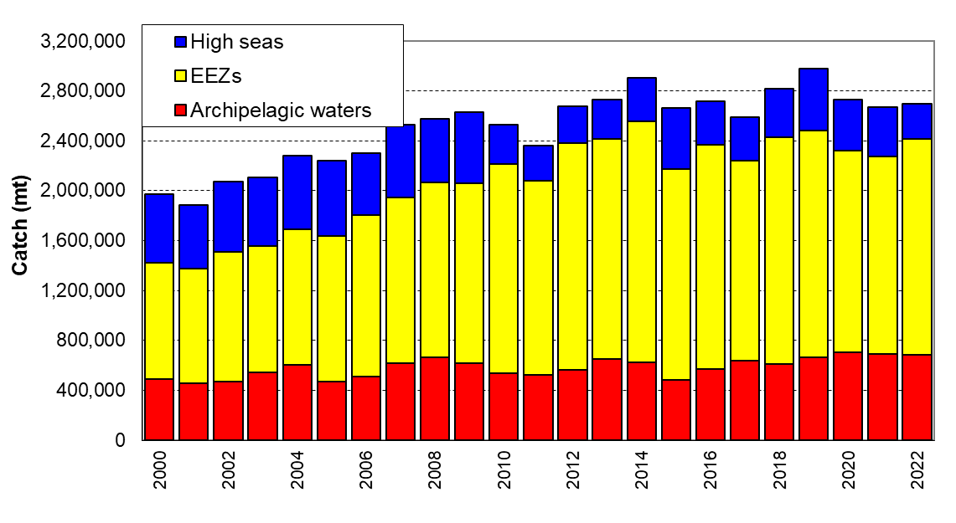

## Figure 1. Tuna catch estimates (mt) in the WCP–CA, by broad area, all gear types.

Tuna species are (albacore, bigeye, skipjack and yellowfin. Areas are: Archipelagic waters (AWs), national waters (EEZs, excluded AWs) and the high seas for all gear types combined.

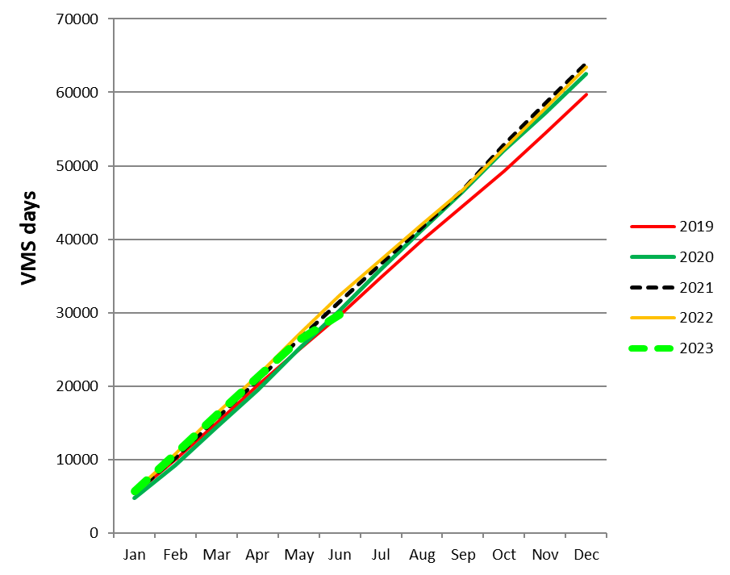

## Figure 2. Cumulative tropical purse seine days at sea by month, 2009-2023, as measured by VMS

(excludes days in port)

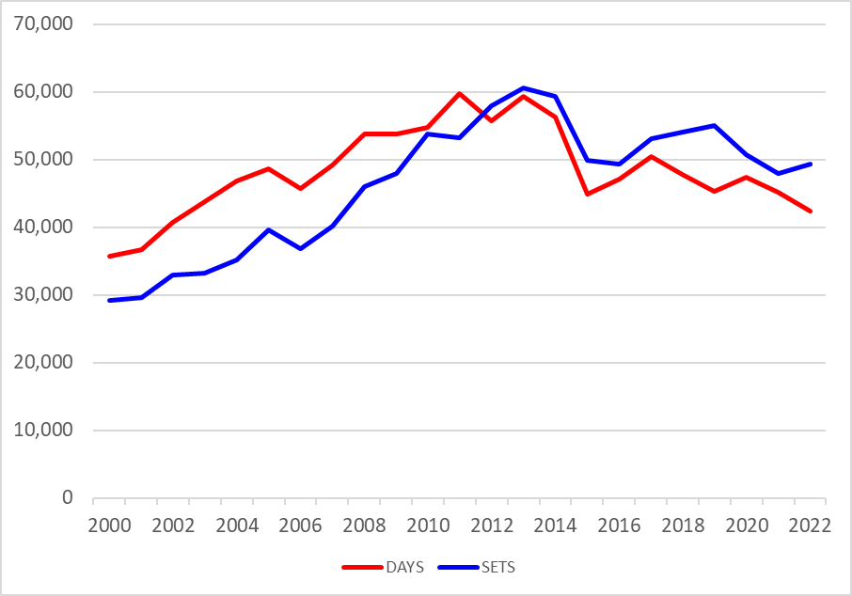

Figure 3. Annual trends in purse seine effort in the WCPFC Convention Area between 20°N and 20°S.

“DAYS” – days fishing and searching. Excludes domestic purse seine effort in Philippines and Indonesia, but includes Philippine domestic-based effort in HSP#1. Estimates are based on raised logsheet data.

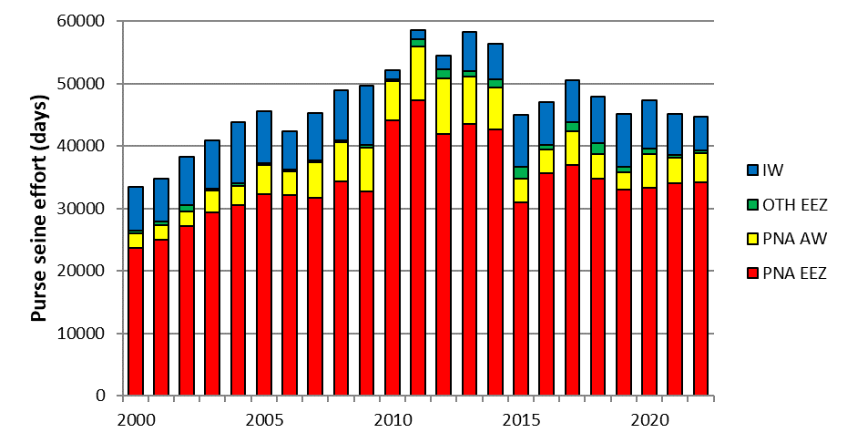

Figure 4. Purse seine effort (days fishing and searching) in the WCPFC Convention Area between 20°N and 20°S.

Excludes domestic purse seine effort in Philippines and Indonesia. Estimates are based on raised logsheet data.

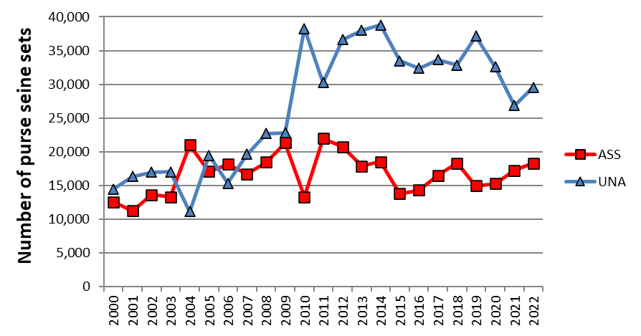

Figure 5. Sets by set type made in the WCPO tropical purse seine fishery, 2000 – 2022.

Associated (ASS) and Unassociated (UNA) sets. Activities in the domestic purse seine fisheries of Indonesia and Philippines are excluded. Associated sets include animal-associated sets.

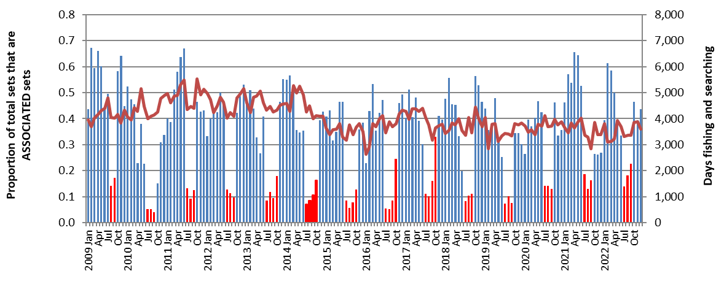

Figure 6. Proportion of the total purse seine fishing activity comprising associated sets.

As indicated by logsheet data**.**

Red bars indicate the FAD closure months. Total effort in days is shown by the plotted line. Activities in the domestic purse seine fisheries of Indonesia and Philippines are excluded.

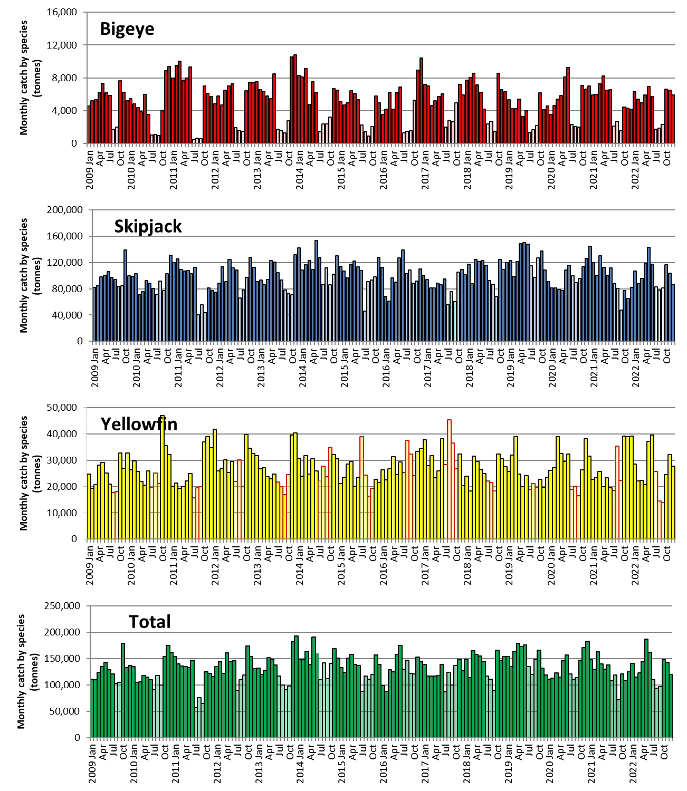

Figure 7. Monthly purse seine catch by species

(raised logsheet data with species composition adjusted using observer sampling with grab sample bias correction). FAD closure months are shaded in lighter colour. Data excludes the domestic fisheries of Indonesia and Philippines.

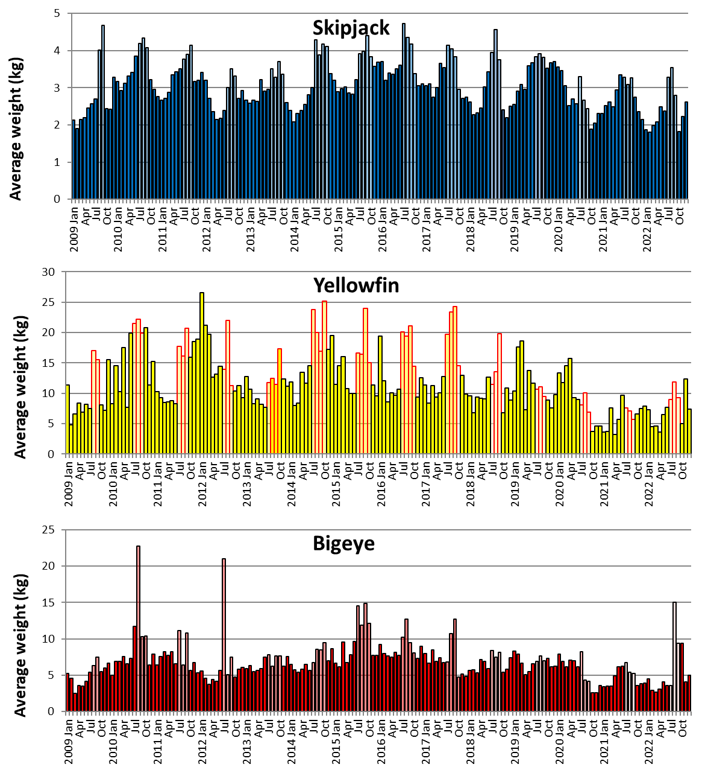

Figure 8. Monthly average weight of bigeye, skipjack and yellowfin tuna.

Estimated from observer sampling data, 2009-2022. FAD closure months are shaded in lighter colour. Data excludes the domestic fisheries of Indonesia and Philippines. Coverage of observer data in years 2020-2022 was approximately 50%, 20% and 15% respectively, due to the impacts of COVID-19 and biased to certain fleets only.

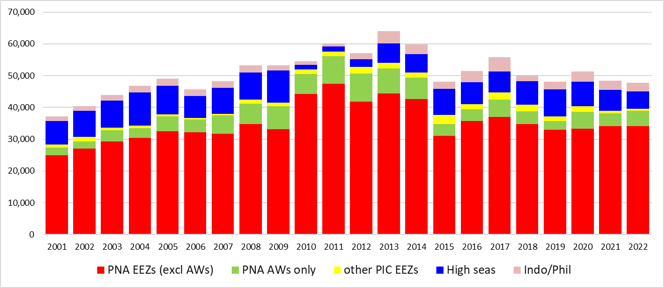

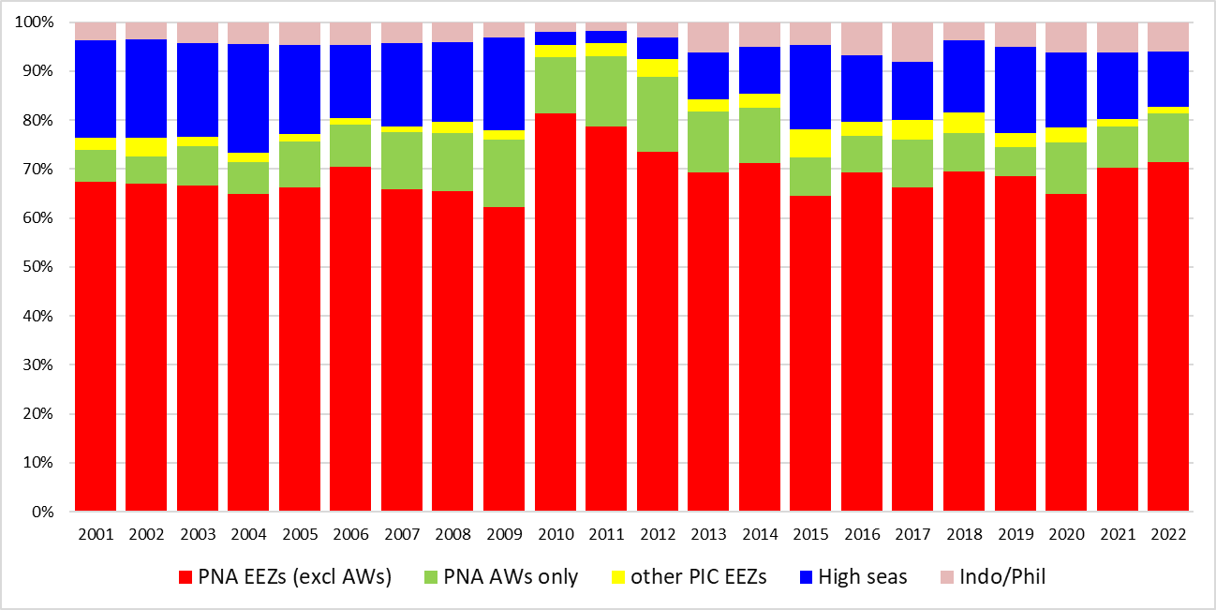

Figure 9. Purse seine effort in waters under national jurisdiction (EEZs and AWs) and in high seas (20°N-20°S)

(days fished–top and percentage days fished–bottom)

***(Refer to NOTES under TABLE 1 above)***

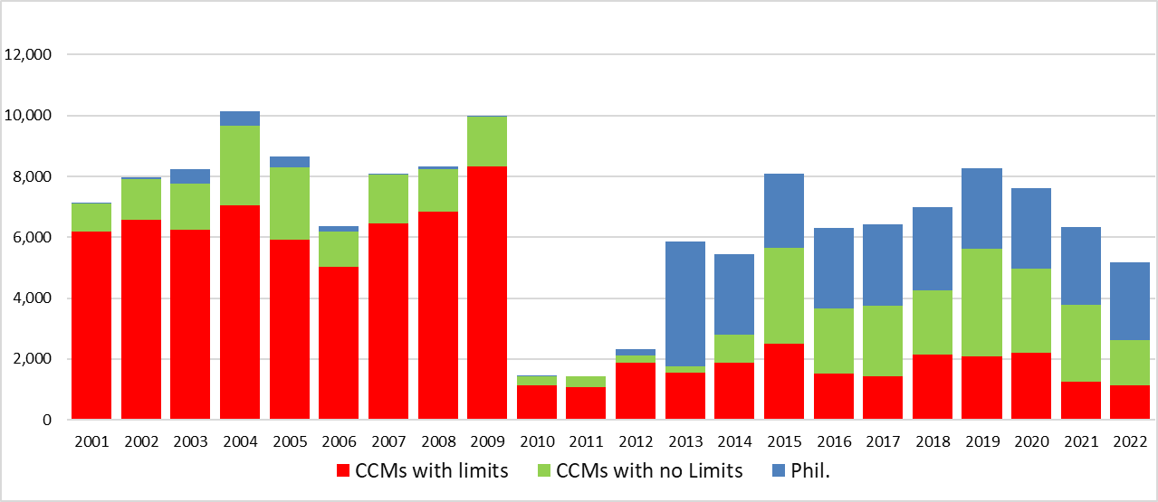

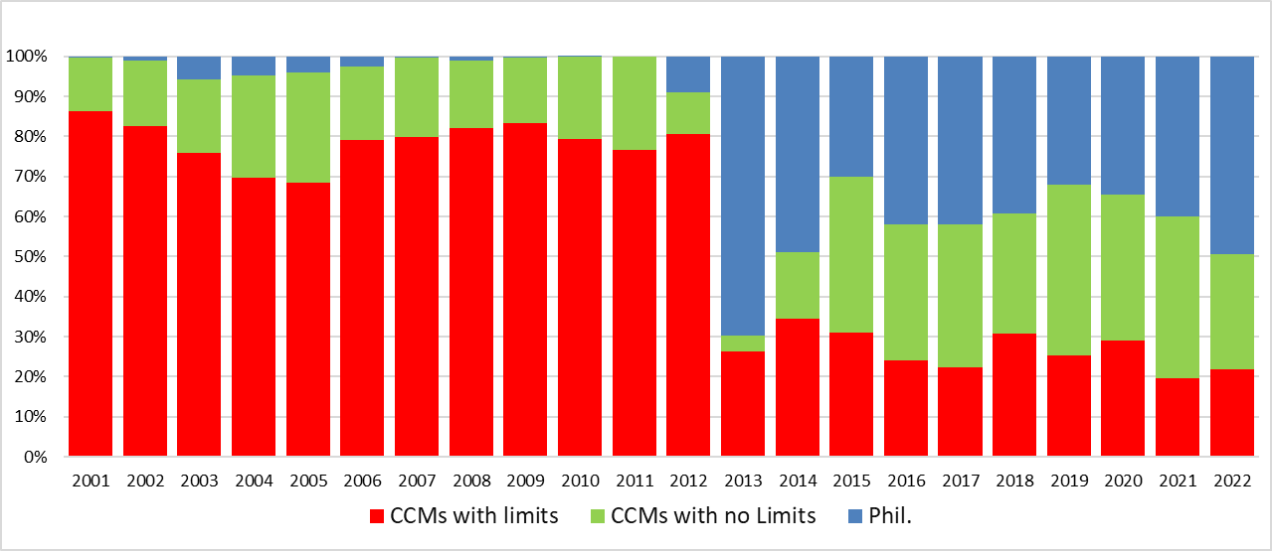

## Figure 10. Purse seine effort in high seas (20°N–20°S), by fleet category.

(days fished–top and percentage days fished–bottom)

***(Refer to NOTES under TABLE 2 above***

***“CCMs with no limits“ are Pacific Island fleets fishing in high seas adjacent to their home waters;***

***Philippines effort data prior to 2013 are not available or underreported)***

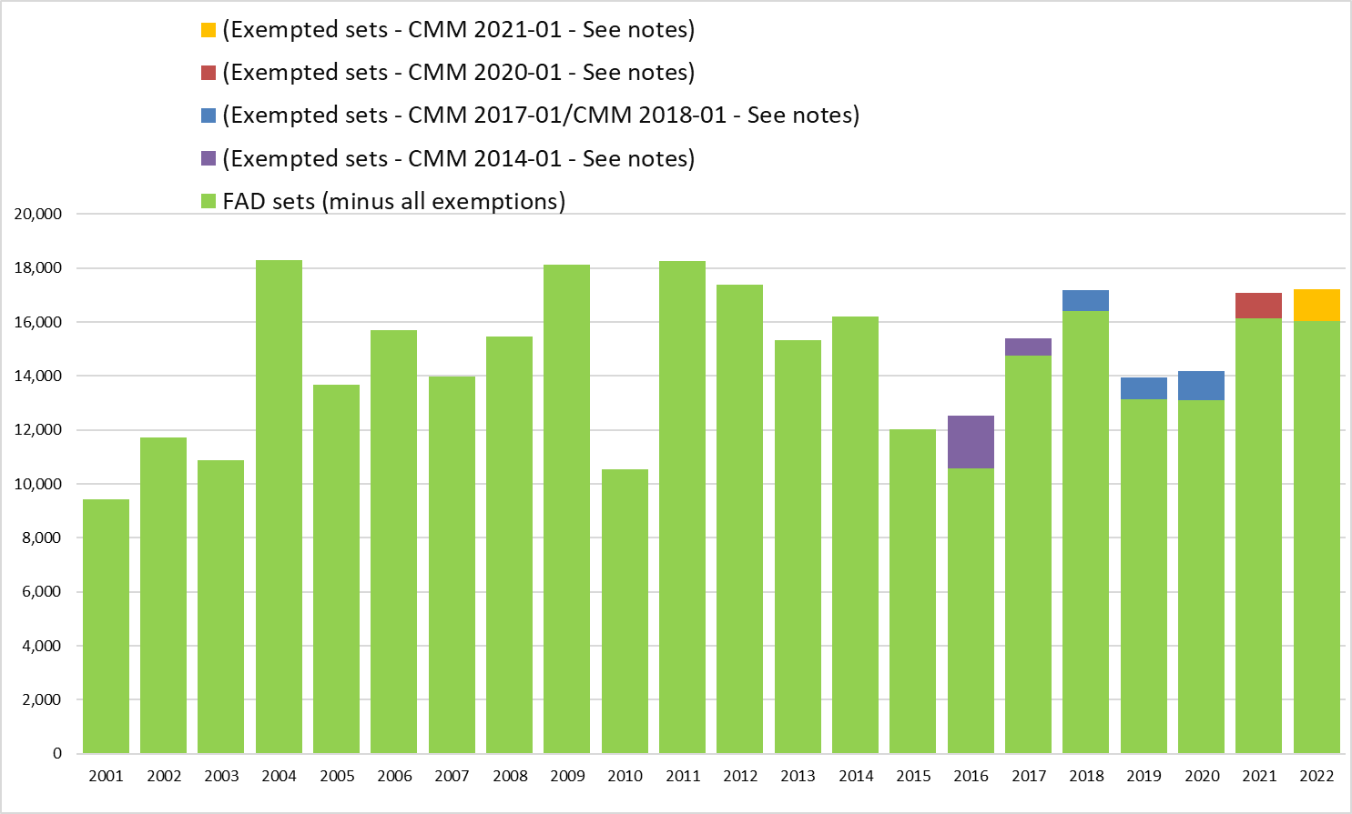

## Figure 11. Estimated FAD sets undertaken in the tropical purse seine fishery (20°N-20°S), by fleet category.

***(Refer to NOTES under TABLE 3 above***

***“Exempted Sets” refers to the footnote 3 exemption of CMM 2014-01; refer to Notes 11, 12, 13 and 14, and CMM 2017-01 (footnote 2) and CMM 2018-01, CMM 2020-01 CMM 2021-01 (footnote 1) refer to Notes 15 of Table 3)***

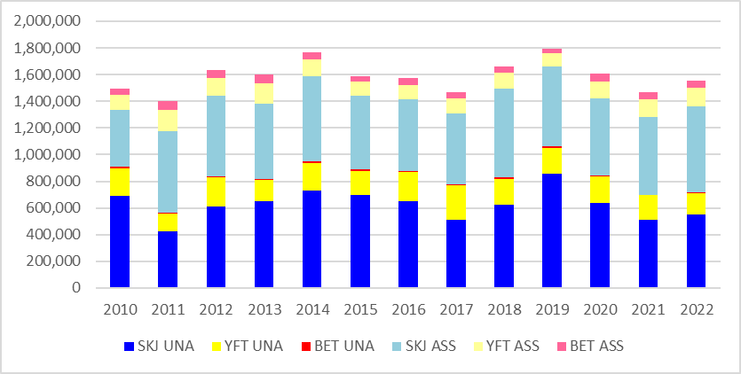

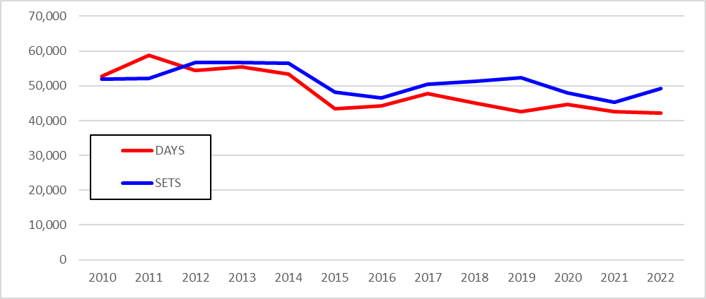

## Figure 12. Purse seine tuna catch (top) and effort (bottom) by set type and species

WCPFC Convention Area between 20°N and 20°S, 2010–2022, excluding domestic purse seine catch/effort in Philippines, Indonesia and Vietnam. Includes domestic-based Philippines catch/effort in the HSP#1.

***(Refer to NOTES under TABLE 4 above)***

# Longline fishery information

## Table 6. Reported longline catches metric tonnes of bigeye tuna in the WCPFC-CA, by flag.



|  |
| --- |
| **Notes**: |
| 1. Source: WCPFC Annual catch estimates as at 2nd July 2023. |
| 2. Catch estimates in **red** have been carried over from previous years. |
| 3. Indonesia and Philippines may revise estimates for previous years. (see the respective Annual Catch Estimate Workshop reports at (http://www.wcpfc.int/west-pacific-east-asia-oceanic-fisheries-management-project) |
| 4. The limits in the columns labelled “CMM limits for 2017” and “CMM limits for 2018” do not apply to small island developing State members and participating Territories according to paragraph 7 of CMM 2014-01 and CMM 2015-01 (or its replacement CMM). |
| 5. Catches and effort of vessels operating under charters and similar arrangements have been attributed to host island states or territories in accordance with paragraph 5 of CMM 2012-01 and paragraph 5 CMM 2013-01 using the best information available to SPC-OFP. However, in several cases, catches have not yet been attributed to the CCM responsible for the "charter or similar arrangements" since the flag state CCM has yet to advise that it has excluded these catches from their data (and thereby avoid double-counting). |
| 6. Estimates include archipelagic water catches which for some countries cannot be separated at this stage. |
| 7. The catch limits established at 2,000t prior to 2010, remain at the level of 2,000t for relevant WCPFC members. (according to CMM 2008-01 Para. 32, CMM 2012-01 para 26 and CMM 2013-01 para 41 and its replacement CMM, including CMM 2017-01). Note although EU fleets are reported here separately by flag, it is understood that as per the relevant CMM the 2000 Mt limit applies to the combined EU-longline fleet. |
| 8. Subject to CNM on participatory rights, in accordance with paragraph 6 of CMM 2014-01 and CMM 2015-01 (or its replacement CMM) for years from 2015 onwards. |
| 9. The Vietnam longline fleet are understood to fish outside the WCPFC Convention Area (South China Sea). |
| 10. Catches by the Chinese longline fleet in the Kiribati EEZ are included in the estimates. |
| 11. Catches by chartered Chinese, Fijian and Chinese-Taipei flagged longline vessels licensed to fish in Solomon Islands waters have been attributed to the Solomon Islands according to the respective WCPFC Charter notifications. |
| 12. Indonesia bigeye tuna catch excludes catches in Archipelagic waters. |
| 13. USA revised limit for 2015 was 3504 t., to take into account the overage in bigeye catch from 2014 |
| 14. "CMM limits for 2017" is according to ATTACHMENT F in CMM 2016-01, and refer to catch limits for 2017 only, and “CMM limits for 2018” is according to Table 3 in CMM 2017-01 or its replacement measure. |
| 15. USA advised by letter to the WCPFC Secretariat that they reduced their 2017 bigeye catch limit (of 3,345 Mt in Att F of CMM 2016-01) to 3,138Mt to offset the overage in 2016. |
| 16. CMM 2017-01 Table 3 and CMM 2018-01, includes this note: Japan will make an annual one-off transfer of 500 metric tonnes of its bigeye tuna catch limit to China. |

## Table 7. Reported longline catches (metric tonnes) of yellowfin tuna in the WCPFC-CA, by flag.



|  |
| --- |
| **Notes**: |
| 1. Source: WCPFC Annual catch estimates as at 2nd July 2023. |
| 2. Catch estimates in **red** have been carried over from previous years. |
| 3. Indonesia and Philippines may revise their estimates for recent years through their annual catch estimates review processes. (see the respective Annual Catch Estimate Workshop reports at http://www.wcpfc.int/west-pacific-east-asia-oceanic-fisheries-management-project) |
| 4. Catches and effort of vessels operating under charters and similar arrangements have been attributed to host island states or territories in accordance with paragraph 2 of CMM 2008-01 (paragraph 5 of CMM 2012-01, paragraph 5 of CMM 2013-01 or its replacement CMM) using the best information available to SPC-OFP. However, in several cases, catches have not yet been attributed to the CCM responsible for the "charter or similar arrangements" since the flag state CCM has yet to advise that it has excluded these catches from their data (and thereby avoid double-counting). |
| 5. Estimates include archipelagic water catches which for some countries cannot be separated at this stage. |
| 6. Subject to CNM on participatory rights, in accordance with paragraph 6 of CMM 2014-01 (or its replacement CMM) for years from 2015 onwards. Belize is not presently a CNM. |
| 7. Senegal committed to limiting its fishing activities in the WCPF Convention Area to one longline vessel - WCPFC5 Report (Para. 44). Senegal is not presently a CNM. |
| 8. The Vietnam longline fleet are understood to fish outside the WCPFC Convention Area (South China Sea). |
| 9. Catches by the Chinese longline fleet in the Kiribati EEZ are included in the estimates. |
| 10. Catches by chartered Chinese and Chinese-Taipei flagged longline vessels licensed to fish in Solomon Islands waters have been attributed to the Solomon Islands according to the respective WCPFC Charter notifications. |
| 11. Does not yet cover development of new fisheries in the waters of small-island developing states (e.g. Tokelau) |
| 12. Indonesia yellowfin tuna catch excludes catches in Archipelagic waters. |
| 13. Note although EU fleets are reported here separately by flag, it is understood that as per the relevant CMM the 2000 Mt limit applies to the combined EU-longline fleet. |

## Table 8. Longline effort (100s of hooks) in the tropical WCPFC LONGLINE fishery (20°N-10°S), by fleet.



|  |
| --- |
| **Notes**: |
| 1. Estimates are based on available aggregate data for the WCPFC Area, 20°N-10°S. |
| 2. Estimates exclude domestic longline effort for Philippines, Indonesia and Vietnam fleets. |
| 3. Excluding vessels targeting South Pacific Albacore is not possible at this stage for a number of reasons – the main reason being the lack of operational data. In the absence of complete operational data (which would include targeting information), the area 20°N-10°S has been selected as the area which best minimises both South and North Pacific albacore targeting. |
| **Fleet Codes**  CK - Cook Islands  CN - China  FJ - Fiji  FM - FSM  JP - Japan  KI - Kiribati  KR - Korea  MH - Marshall Is.  PF - French Polynesia  PG - PNG  PW - Palau  SB - Solomon Is.  TV - Tuvalu  TW - Chinese Taipei  US - USA  VU - Vanuatu |

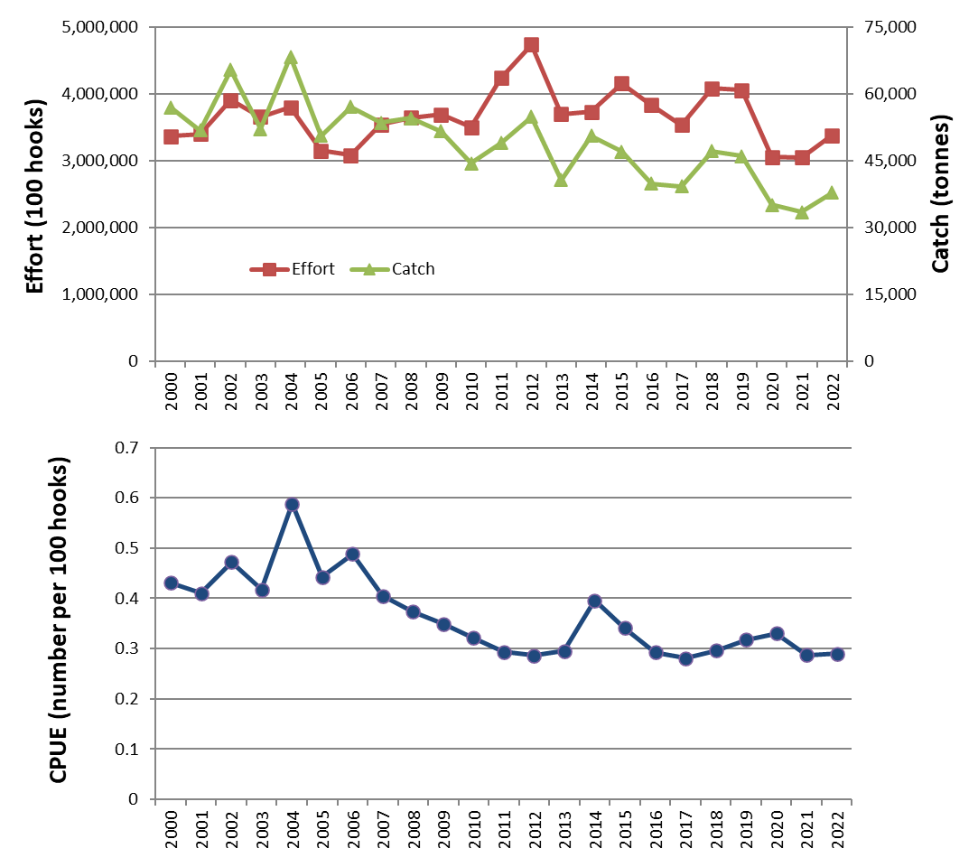

## Figure 13. Estimates of effort, bigeye catch and nominal CPUE for the CORE tropical WCPFC longline fishery

CORE Area is (130°E - 150°W, 20°N - 10°S).

2022 data are provisional.

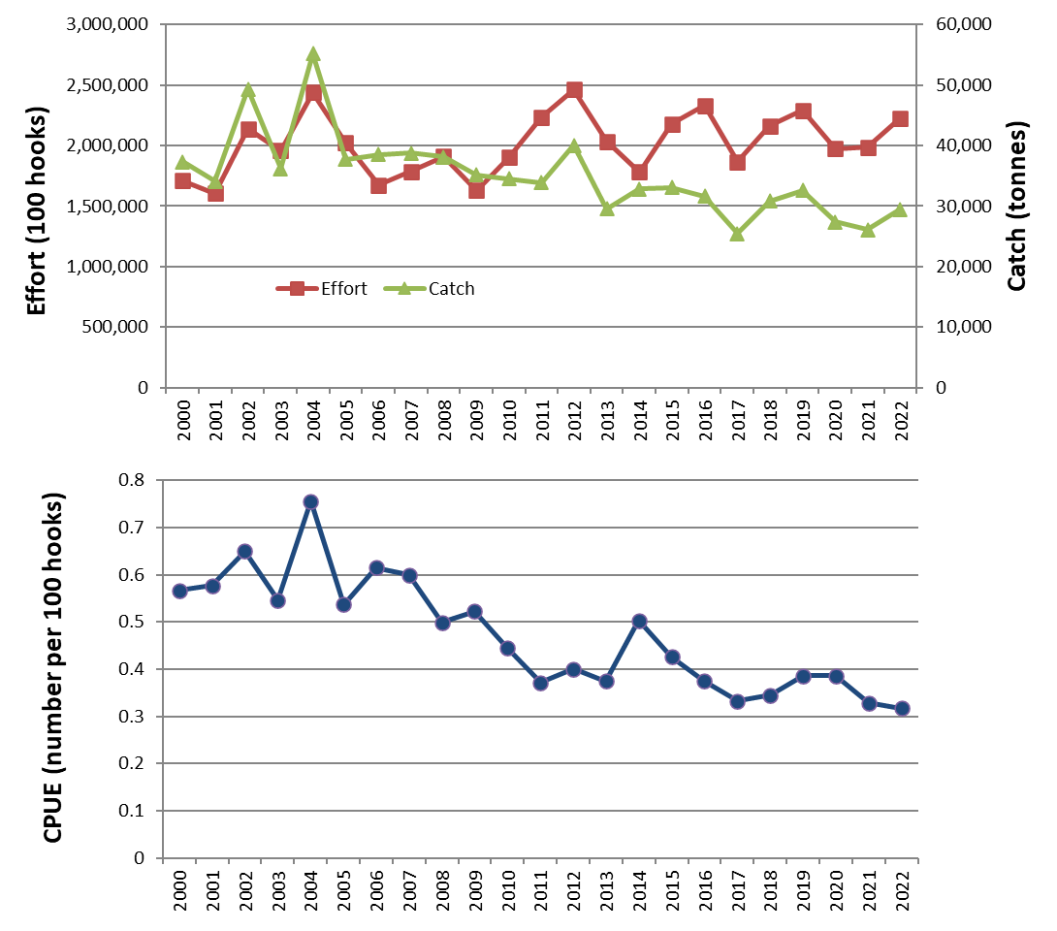

## Figure 14. Estimates of effort, bigeye catch and nominal CPUE for the EASTERN tropical WCPFC longline fishery

Eastern Area is (170°E - 150°W, 20°N - 10°S).

2022 data are provisional.

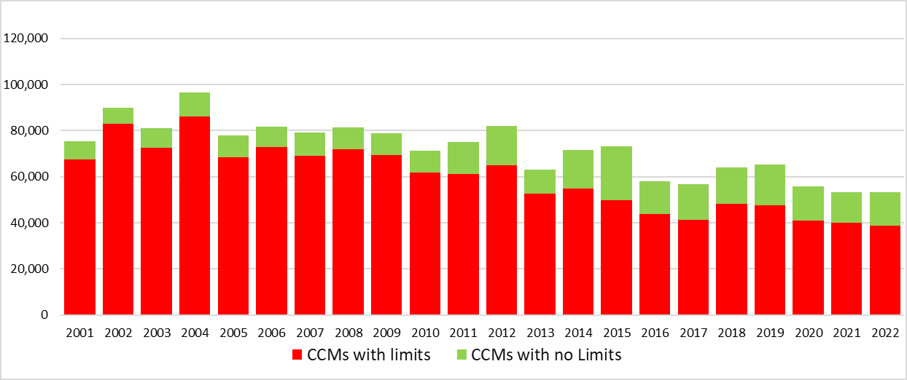

Figure 15. Reported longline catches (metric tonnes) of bigeye tuna in the WCPFC-CA, by fleet category.

***(Refer to NOTES under TABLE 6 above;***

***Vietnam catch is included in “CCMs with no limits”)***

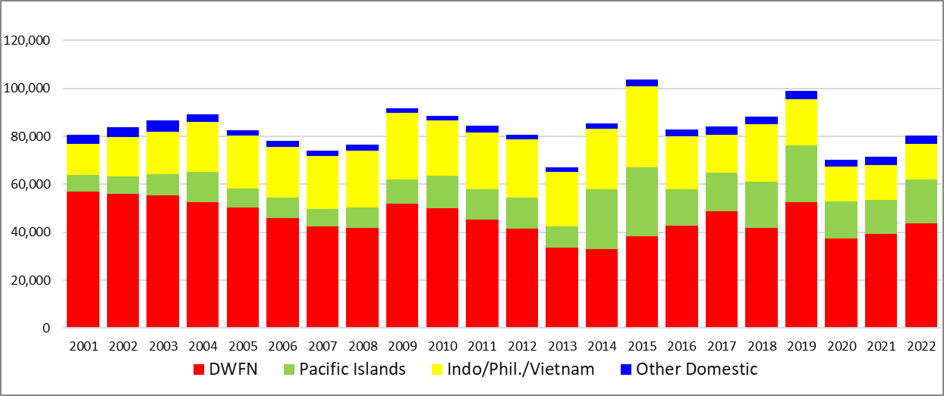

Figure 16. Reported longline catches (metric tonnes) of yellowfin tuna in the WCPFC-CA, by fleet **category.**

***(Refer to NOTES under TABLE 7 above;***

***Vietnam catch is included)***

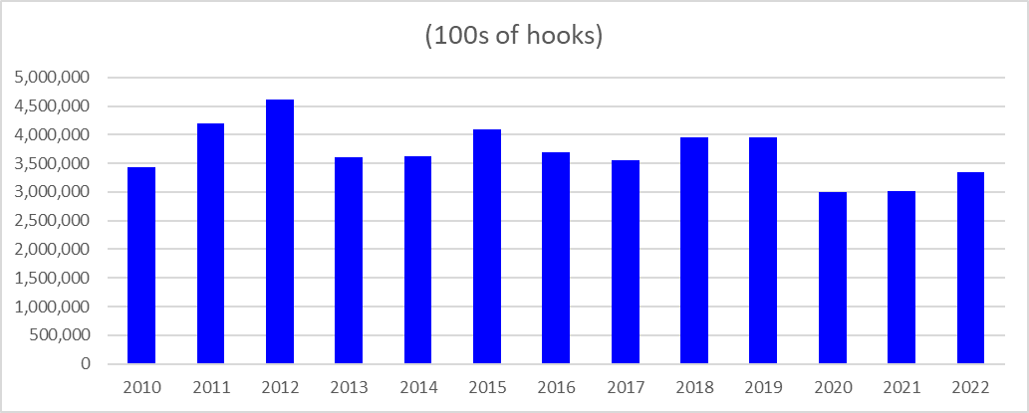

## Figure 17. Longline effort (100s of hooks) in the tropical WCPFC LONGLINE fishery (20°N-10°S), 2010-2022.

***(Refer to NOTES under TABLE 8 above)***

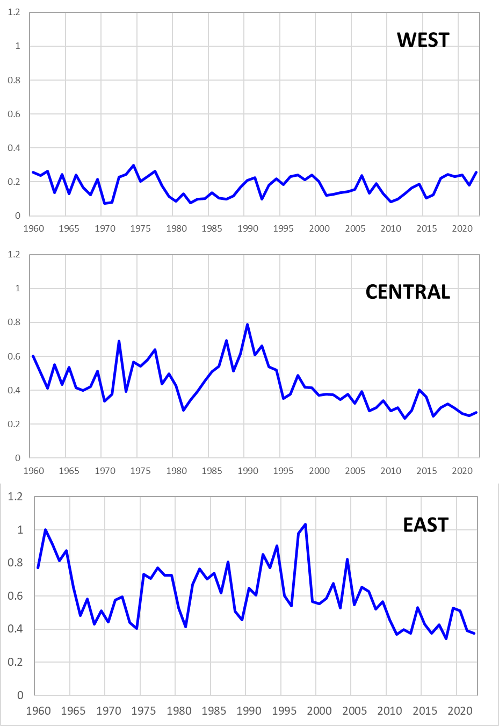

## Figure 18. Annual trends in nominal bigeye tuna CPUE in the tropical WCPFC LONGLINE fishery (20°N-10°S)

**CPUE in number per 100 hooks**

**By assessment region**

“WEST” – Assessment Region 7: 10°S–20°N, 110°–140°E

“CENTRAL” – Assessment Region 3: 10°S–10°N, 130°–170°E

“EAST” – Assessment Region 4: 10°S–10°N, 170°E–150°W

# Other Commercial fisheries information

## Table 9. Tropical tuna catch estimates for OTHER FISHERIES relevant to the tropical tuna measure



|  |
| --- |
| **Notes**: |
| 1. Source: Annual catch estimates; Philippines National Stock Assessment Project (NSAP data); Aggregate logsheet data. 2022 data are provisional. |
| 2. The column labeled “CMM 2020-01" is the maximum value of either (i) the average total skipjack, yellowfin and bigeye tuna catch for 2001-2004, or (ii) 2004. |
| 3. The definition for "Commercial" fisheries, at this stage, includes all fisheries other than purse seine and longline fisheries, until otherwise advised. (Refer to Table 6b.). |
| 4. Advice from Japan -- “Paragraph 9 of CMM 2012-01 provides that this measure applies to all areas of high seas and EEZs in the Convention Area. Therefore, this paragraph does not apply to troll fishery, which operate within territorial sea.   * Regarding pole-and-line fishery and purse seine north of 20N fishery JFA ensure that the total effort and capacity of these tuna fisheries shall not exceed the average level for the period 2001-2004 or 2004 under its licensing system. * Therefore JFA consider fulfilling this requirement. * JFA submits following information of pole-and-line fishery and purse seine north of 20N fishery as attached. On the other hand JFA does not agree with the Secretariat view to consider non provision of these data as a potential compliance issue because it is not required under this paragraph. Effort data (2001-2004 average, 2004 and 2013) Catch data (2001-2004 average, 2004 and 2013)” |
| 5. Indonesia has advised that HANDLINE (hook-and-line) vessels that target small-fish at the surface should not be considered in the "Commercial" category since they are artisanal/subsistence fisheries. However, Indonesia can only provide a catch estimate for the combined small-fish (artisanal) and large fish handline fishery and it is not yet possible to differentiate the large-fish handline catch estimate from this combined total. Also, it is not yet possible to separate out the catches of what might be considered the 'commercial component' of the Handline fishery that are relevant to the tropical tuna measure - that is Indonesian waters outside Archipelagic waters (AWs) and Territorial Seas (TS). |
| 6. The large-fish handline catch for the Philippines outside of archipelagic waters and territorial seas has been determined from the proportion of annual tuna catch outside AWs/TS from data collected from Philippines National Stock Assessment Project (NSAP data : 1997-2022), and specifically based on landings by Philippines Fisheries Management Area (FMAs) and Fishing Ground. There is often considerable inter-annual variation in the activity of this fleet inside and outside archipelagic waters, mainly depending on weather and sea conditions.  7. The 2022 catch estimate for the Indonesia pole-and-line fishery is provisional. |

## Table 10. Tropical tuna catch estimates for OTHER FISHERIES deemed exempt from the tropical tuna measure

(excl. Purse seine and Longline in the WCPFC Statistical Area)



|  |
| --- |
| **Notes**: |
| 1. Source: Annual Catch estimates. 2022 data are provisional. |
| 2. Fisheries with average catches less than 2,000 t of bigeye, yellowfin and skipjack tuna, have been excluded as per CMM 2018-01, CMM 2020-01 and CMM 2021-01 para 51. |
| 3. The definition for "Commercial" fisheries, at this stage, includes all fisheries other than purse seine and longline fisheries, until otherwise advised. |
| 4. Indonesia has advised a range of their small scale/Artisanal fisheries (e.g. troll, small-fish hook-and-line, gillnet) should not be considered in the category "Commercial" Fisheries. |
| 5. The Philippines has advised a range of their small scale/Artisanal fisheries (e.g. troll, small-fish hook-and-line, gillnet, beach seine) operate wholly in their archipelagic waters and/or territorial seas and should not be considered in the category "Commercial" Fisheries. |
| 6. The Indonesia and Philippines catch estimates exclude catches in archipelagic waters. Catches for some other fleets listed here are acknowledged to be in their archipelagic waters and/or territorial seas and will be confirmed with respective member countries (e.g. Kiribati). |

# ANNEX

## Table A1. Notes on major recent changes to tables/figures

| **No.** | **Table Caption** | **Notes on major revisions between WCPFC19 and SC19** | **Notes on major revisions between SC19 and WCPFC20** |
| --- | --- | --- | --- |
| **ALL TABLES** | |  |  |
| **Table 1** | PURSE SEINE days fished in waters under national jurisdiction and in International waters in the WCPFC-CA. | * Updated to include provisional 2022 data |  |
| **Table 2** | PURSE SEINE days fished in international waters in the WCPFC-CA between 20°N and 20°S, by flag, based on available operational data. | * Updated to include provisional 2022 data |  |
| **Table 3** | Estimated PURSE SEINE FAD sets undertaken in the tropical fishery of the WCPFC Convention Area (20°N-20°S), by flag, 2001-2016 | * Updated to include provisional 2022 data |  |
| **Table 4** | Purse seine tuna catch and effort by set type and species in the WCPFC Convention Area between 20°N and 20°S, excluding domestic purse seine effort in Philippines, Indonesia and Vietnam. | * Updated to include provisional 2022 data |  |
| **Table 5** | Annual high seas FAD sets, by fleet, 2015–2022 |  |  |
| **Table 6** | Reported LONGLINE catches (metric tonnes) of bigeye tuna in the WCPFC-CA, by flag. | * Updated to include provisional 2022 data |  |
| **Table 7** | Reported LONGLINE catches (metric tonnes) of yellowfin tuna in the WCPFC-CA, by flag. | * Updated to include provisional 2022 data |  |
| **Table 8** | Longline effort (100s of hooks) in the tropical WCPFC LONGLINE fishery. | * Updated to include provisional 2022 data |  |
| **Table 9** | Total tropical tuna catch estimates for OTHER COMMERCIAL FISHERIES (excl. Purse seine and Longline) in the WCPFC Statistical Area, relevant to CMM 2018-01. | * Updated to include provisional 2022 data |  |
| **Table 10** | Total tropical tuna catch estimates for OTHER FISHERIES (excl. Purse seine and Longline) in the WCPFC Statistical Area, which are exempt from CMM 2018-01 OTHER COMMERCIAL FISHERIES. | * Updated to include provisional 2022 data |  |
| **FIGURES** | [Figures corresponding to relevant tables above | * Updated to include provisional 2022 data |  |