REFINING CANDIDATE REFERENCE POINTS AND HARVEST CONTROL RULES FOR PACIFIC BLUEFIN TUNA

Proposal by the United States of America
to the
Eighth IATTC and WCPFC-NC Joint Working Group Meeting
on the Management of Pacific Bluefin Tuna

Candidate HCRs
The candidate HCR shapes are illustrated in Figures 1 and 2 where fishing mortality is controlled depending on stock status relative to the defined reference points.
For Figure 1, the F_{target} rate applies when the stock is larger or equal to the SSB_{threshold} with a probability of at least 50%, while F_{min} rate applies when the stock is at or smaller than SSB_{limit} with a probability greater than [5-20%] as specified in the management objectives, and there is a linear transition in F for stock sizes between SSB_{limit} and SSB_{threshold}. F_{min} would be defined as an F rate that is less than the F rate corresponding to the F_{target}.
For Figure 2, the F_{target} rate applies when the stock is larger or equal to the SSB_{threshold} with a probability of at least 50%. When the stock is lower than the SSB_{threshold}, there is a linear transition in F between SSB_{threshold} and the origin.
This HCR shall be tested with and without a limit that constrains changes in TAC between consecutive management periods of no more than 20%. This HCR shall also be tested with an allocation based on the recent exploitation pattern and with allocations tuned to reach the WCPO:EPO fishery impact ratio of 70:30 and 80:20.
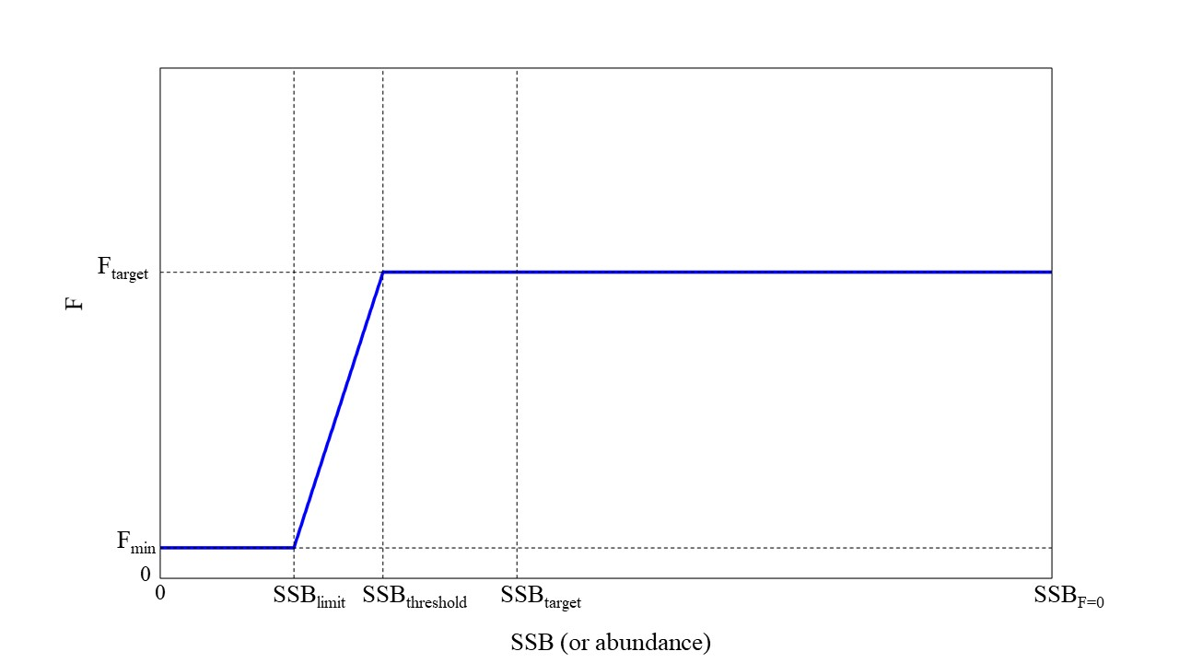
Figure 1. Candidate HCR shape 1
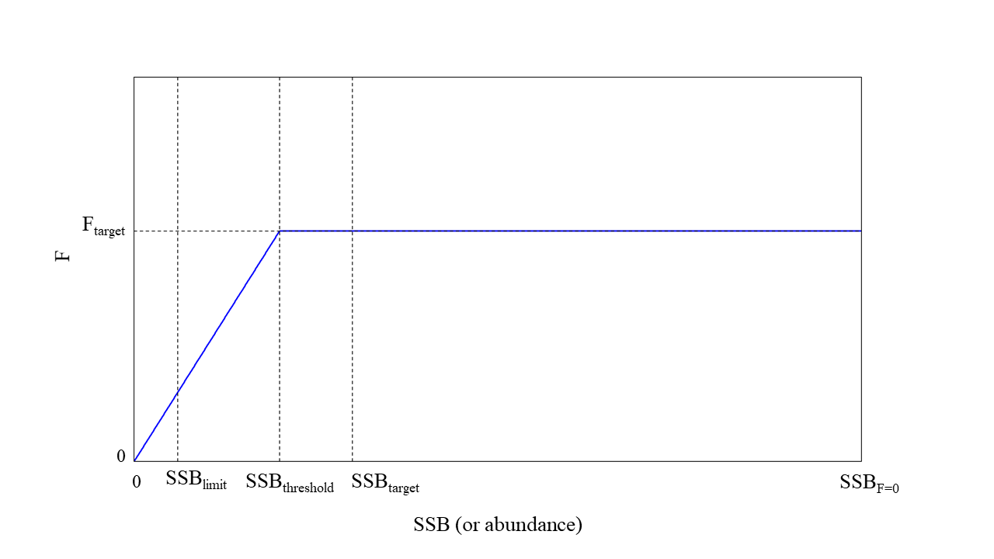
Figure 2. Candidate HCR shape 2.
Candidate HCRs and Reference Points to Evaluate in the MSE
HCR Number | HCR Shape | Fmin | LRP | ThRP | TRP
1 | 1 | F10%F_{Target} | 15%SSB_{F=0} | 20%SSB_{F=0} | FSPR30%
2 | 1 | F10%F_{Target} | 15%SSB_{F=0} | 25%SSB_{F=0} | FSPR30%
3 | 1 | F10%F_{Target} | 15%SSB_{F=0} | 20%SSB_{F=0} | FSPR40%
4 | 1 | F10%F_{Target} | 15%SSB_{F=0} | 25%SSB_{F=0} | FSPR40%
5 | 1 | F10%F_{Target} | 20%SSB_{F=0} | 25%SSB_{F=0} | FSPR40%
6 | 1 | FSPR70% | 10%SSB_{F=0} | 20%SSB_{F=0} | FSPR30%
7 | 1 | FSPR50% | 10%SSB_{F=0} | 20%SSB_{F=0} | FSPR25%
8 | 1* | N/A* | 20%SSB_{F=0} | 20%SSB_{F=0} | FSPR30%
9 | 2 | N/A | Median SSB 1952-2014 | 20%SSB_{F=0} | FSPR20%
10 | 2 | N/A | Median SSB 1952-2014 | 15%SSB_{F=0} | FSPR25%
11 | 1 | F5%F_{Target} | 7.7%SSB_{F=0} | 15%SSB_{F=0} | FSPR30%
12 | 1 | F5%F_{Target} | 7.7%SSB_{F=0} | 20%SSB_{F=0} | FSPR30%
* In this HCR, when %SSB F=0 is lower than ThRP (20%SSBF=0), fishing intensity will be controlled by the management measures that were taken for and succeeded in the recovery of the stock (i.e., WCPFC CMM2020-02 and IATTC Resolution C-18-01).

These new candidate HCRs and reference points replace those from the 2019 recommendation.

