

**The Commission for the Conservation and Management of**

**Highly Migratory Fish Stocks in the Western and Central Pacific Ocean**

**SCIENTIFIC COMMITTEE**

**SIXTEENTH REGULAR SESSION**

**Electronic Meeting**

**12–19 August 2020**

**(Reconvened on 10 September 2020)**

**OUTCOMES DOCUMENT**

Rev. 2 – Text addition in Para 76

**The Commission for the Conservation and Management of**

**Highly Migratory Fish Stocks in the Western and Central Pacific Ocean**

**SCIENTIFIC COMMITTEE**

**SIXTEENTH REGULAR SESSION**

**ELECTRONIC MEETING**

12 – 19 August 2020

**SC16 OUTCOMES DOCUMENT**

**WCPFC17-2020-SC16-01 (Rev.02)**

**16 September 2020**

1. **OPENING OF THE MEETING**
   1. **Welcome address**
   2. **Meeting arrangements**
   3. **Adoption of agenda**
   4. **Reporting arrangements**
2. **DATA AND STATISTICS THEME** 
   1. **Data gaps of the Commission**
3. SC16 recommended that updated versions of SC16-ST-WP-01 (Data gaps) and SC16-ST-IP-02 (ROP data management) be forwarded to TCC16 for consideration.
4. **STOCK ASSESSMENT THEME** 
   1. **Age and growth of yellowfin and bigeye tuna (Project 82)**
   2. **WCPO bigeye tuna (*Thunnus obesus*)**
      1. **Review of 2020 bigeye tuna stock assessment**
5. N. Ducharme-Barth (SPC-OFP) presented **SC16-SA-WP-03** *Stock assessment of bigeye tuna in* the *western and central Pacific Ocean*, which described the 2020 stock assessment of bigeye tuna *Thunnus obesus*. An additional three years of data were available since the previous assessment in 2017, and the model extends through the end of 2018. New developments to the stock assessment include addressing the recommendations for improved growth modelling made in the 2017 stock assessment report, inclusion of spatiotemporal standardized CPUE implemented using “index” fisheries, updating the length-weight relationship, defining reproductive potential as a function of length, and updates to the preparation of the tagging data.
6. Changes made in the progression from the 2017 to 2020 diagnostic models that influence our perception of bigeye tuna stock status were:

* Changes to the preparation and treatment of the tagging data;
* Improvements to the size frequency data preparation and the switch to the index fishery approach;
* Specifying reproductive potential as a function of length;
* Updating the growth curve to using the fixed values from the tag-integrated model;
* Assuming non-decreasing selectivity for certain longline fisheries.

1. The general conclusions of this assessment are as follows:

* All models in the structural uncertainty grid show WCPO bigeye tuna to be above 20%SBF=0, though a substantial decline was estimated by all models.
* Evidence to suggest that the overall stock status is buffered by the temperate regions.
* The equatorial regions show higher levels of regional depletion with region 7 approaching 20%SBF=0 across models.
* The most pessimistic predictions of overall stock status correspond to models where depletion in the temperate regions is predicted to be high and in some cases approach regional 20%SBF=0.
* Indication that the stock could be at risk of overfishing (3 of 24 models in the structural uncertainty grid had *Frecent/FMSY > 1*).
* Despite all models in the structural uncertainty grid showing WCPO bigeye tuna to be above 20%SBF=0, there is reason for caution given the likely over-parametrization.

1. Due to the constraints originating from the virtual online Scientific Committee forum, the SC16 could not fully engage in a complete discussion of the appropriate choice of models within the uncertainty grid. Due to the lack of an objective way of selecting the preferred elements for weighting the grid, SC16 agreed to use the grid with all models as presented by the Scientific Services Provider. As indicated in research needs, further research on the assessment model, including the peer review, is warranted in developing the next WCPO stock assessment.
2. A number of key research needs were identified in undertaking the assessment that should be investigated either internally or through directed research. These can be broadly grouped into two categories: biological/data-inputs and model complexity. Growth proved to be a source of uncertainty again in the current assessment, however this was not included in the structural uncertainty grid since the outcome from the alternative fixed growth model was not found to be plausible and that the growth model estimated internally to Multifan-CL was not well estimated. Additional modelling is needed to determine the mechanism for the implausible outcomes using the alternative growth model. Further developments to Multifan-CL including a true length-based selectivity definition and increased flexibility in the definition of variability around the growth curve at small sizes could aide this. Further biological samples should also be collected to produce more representative samples of reproductive parameters and length-weight and weight-weight conversion factors. Additionally, a number of recommendations for improving the standardized CPUE are made. This work should focus on incorporating the effects of changes in oceanography on catchability, particularly the effects of sub-surface dissolved oxygen. Efforts should also be made to account for changes in catchability over time beyond hooks-between-floats. There should also be an evaluation of the feasibility of conducting a fishery independent survey across the WCPO to be used as an index of abundance within the stock assessments, and to improve the representativeness of biological samples. Lastly, the authors of the assessment noted that there were a number of indications that the model was likely over-parametrized and overly complex. An external peer review or WCPFC modelling workshop is recommended prior to the next WCPO bigeye tuna stock assessment. This effort should be focused on reducing complexity and improving model fit and diagnostics while balancing biological realism. SC16 recommended that the Scientific Services Provider should take full advantage of the possible pan-Pacific bigeye stock assessment being planned by IATTC, in order to obtain further insights for the stock.
   * 1. **Provision of scientific information**
3. **Stock status and trends**
4. The median values of relative recent (2015-2018) spawning biomass depletion (*SBrecent/ SBF=0*) and relative recent (2014-2017) fishing mortality (*Frecent/FMSY*) over the uncertainty grid of 24 models (Table BET-1) were used to define stock status. The values of the upper 90th and lower 10th percentiles of the empirical distributions of relative spawning biomass and relative fishing mortality from the uncertainty grid were used to characterize the probable range of stock status.
5. A description of the updated structural sensitivity grid used to characterize uncertainty in the assessment is illustrated in Table BET-1. The spatial structure used in the 2020 stock assessment is shown in Figure BET-1. Time series of total annual catch by fishing gear over the full assessment period is shown in Figure BET-2. The time series of total annual catch by fishing gear and assessment region is shown in Figure BET-3. Estimated annual average recruitment, spawning potential and total biomass by model region is shown in Figure BET-4. Estimated trends in spawning potential by region for the diagnostic case is shown in Figure BET-5, and juvenile and adult fishing mortality rates from the diagnostic model is shown in Figure BET-6. Estimates of the reduction in spawning potential due to fishing by region is shown in Figure BET-7. Time-dynamic percentiles of depletion (SBt/SBt,F=0) for the 24 models are shown in Figure BET-8. A Majuro and Kobe plot summarising the results for each of the 24 models in the structural uncertainty grid are shown in Figures BET 9 and 10, respectively. Projections are illustrated in Figures BET-11 and BET-12. Table BET-2 provides a summary of reference points over the 24 models in the structural uncertainty grid.
6. A number of investigative models were run with growth, such as: 1) *Oto-Only*, a growth curve that was a ﬁxed Richards growth curve based on high-readability otoliths, 2) *Tag-Int*: a growth curve that was a ﬁxed Richards growth curve based on the same high-readability otolith data-set in addition to bigeye tuna tag-recapture data, and 3) *Est-Richards*: A conditional age-length data-set was constructed from the combined daily and annual otolith dataset. The *Oto-Only* growth model predicted very high levels of biomass and corresponding low level of depletion. The *Est Richards* growth model showed sensitivity to the initial values given for the estimated growth parameters. The implausible results from the *Oto-Only* growth and differing results from the *Est-Richards* indicate questions still remain regarding bigeye tuna growth.
7. SC16 requested the bigeye tuna assessment to try and fit the data for those small bigeye tuna as they are increasingly caught by domestic fisheries in region 7, but the current diagnostic model does not fit those fish that well because the L1 parameter is larger than most of those fish. SPC could consider additional developments to Multifan-CL to model greater variability in size around the growth curve at small ages.
8. The most inﬂuential grid axis is the size-frequency data-weighting axis and further research is required to develop model diagnostics and objective criteria for model inclusion.

**Table BET-1.** Description of the updated structural sensitivity grid used to characterize uncertainty in the assessment. The starred levels denote those assumed in the model diagnostic case.

|  |  |  |  |  |
| --- | --- | --- | --- | --- |
| **Axis** | **Value 1** | **Value 2** | **Value 3** | **Value 4** |
| Steepness | 0.65 | 0.8 \* | 0.95 |  |
| Natural mortality | Diagnostic\* (0.112) | M-hi  (0.146) |  |  |
| Size frequency weighting | 20\* | 60 | 200 | 500 |

**Table BET-2.** Summary of reference points over the 24 models in the structural uncertainty grid. Note that “recent” is the average over the period 2015-2018 for SB and 2014-2017 for fishing mortality, while “latest” is 2018. The values of the upper 90th and lower 10th percentiles of the empirical distributions are also shown. Fmult is the multiplier of recent (2014-2017) fishing mortality required to attain MSY.

|  |  |  |  |  |  |  |
| --- | --- | --- | --- | --- | --- | --- |
|  | **Mean** | **Median** | **Minimum** | **10th percentile** | **90th percentile** | **Maximum** |
| Clatest | 159,738 | 159,288 | 157,297 | 157,722 | 162,033 | 162,271 |
| YFrecent | 136,568 | 134,940 | 117,800 | 124,668 | 149,424 | 161,520 |
| fmult | 1.45 | 1.38 | 0.83 | 0.98 | 2.03 | 2.33 |
| FMSY | 0.05 | 0.05 | 0.04 | 0.04 | 0.07 | 0.07 |
| MSY | 146,715 | 140,720 | 117,920 | 125,628 | 179,164 | 187,520 |
| Frecent/FMSY | 0.74 | 0.72 | 0.43 | 0.49 | 1.02 | 1.21 |
| SBF=0 | 1,395,173 | 1,353,367 | 903,708 | 982,103 | 1,780,138 | 1,908,636 |
| SBMSY | 320,162 | 321,550 | 192,500 | 219,810 | 443,730 | 482,700 |
| SBMSY/SBF=0 | 0.23 | 0.23 | 0.19 | 0.2 | 0.26 | 0.26 |
| SB latest/SBF=0 | 0.38 | 0.38 | 0.23 | 0.3 | 0.47 | 0.51 |
| SB latest/SBMSY | 1.7 | 1.67 | 0.95 | 1.23 | 2.15 | 2.6 |
| SB recent/SBF=0 | 0.4 | 0.41 | 0.21 | 0.27 | 0.52 | 0.55 |
| SB recent/SBMSY | 1.78 | 1.83 | 0.87 | 1.18 | 2.32 | 2.84 |

**Figure BET-1.** Spatial structure for the 2020 bigeye tuna stock assessment.

**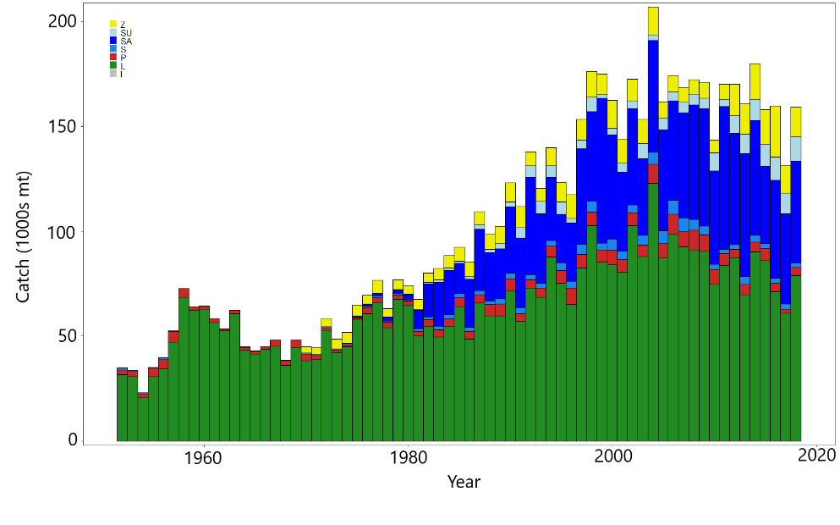**

**Figure BET-2.** Time series of total annual catch (1000s mt) by fishing gear for the diagnostic model over the full assessment period. The different colors refer to longline (green), pole-and-line (red), purse seine (blue), purse seine associated (dark blue), purse seine unassociated (light blue), miscellaneous (yellow), and index (gray). Note that the catch by longline gear has been converted into catch-in-weight from catch-in-numbers and so may differ from the annual catch estimates presented in (Williams et al., 2020), however these catches enter the model as catch-in-numbers.

**Figure BET-3.** Time series of total annual catch (1000s mt) by fishing gear and assessment region for the diagnostic model over the full assessment period. The different colors refer to longline (green), pole-and-line (red), purse seine (blue), purse seine associated (dark blue), purse seine unassociated (light blue), miscellaneous (yellow), and index (gray).

1. Recruitment

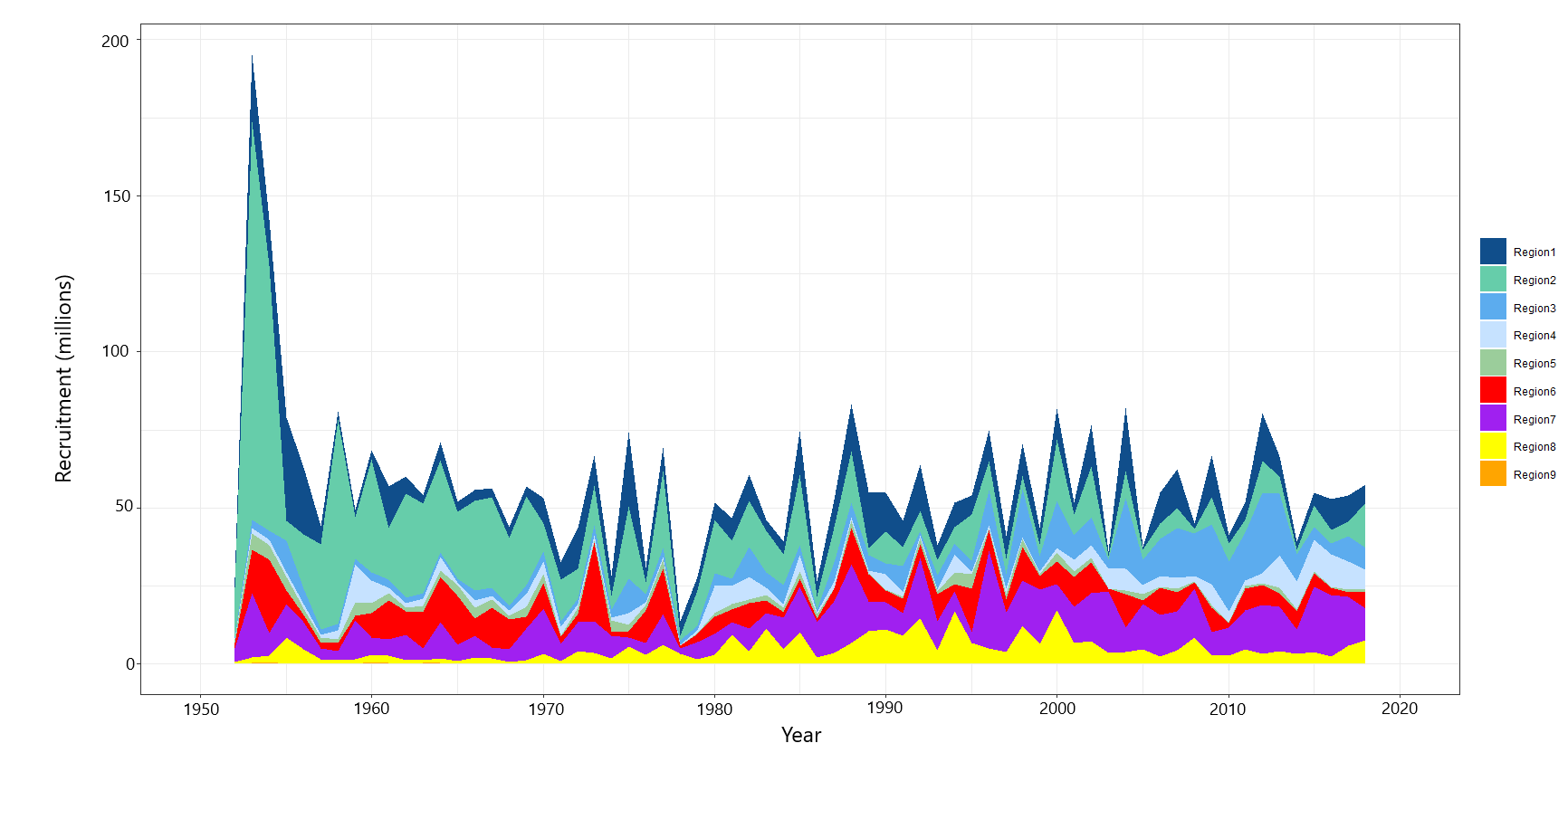

1. Spawning Potential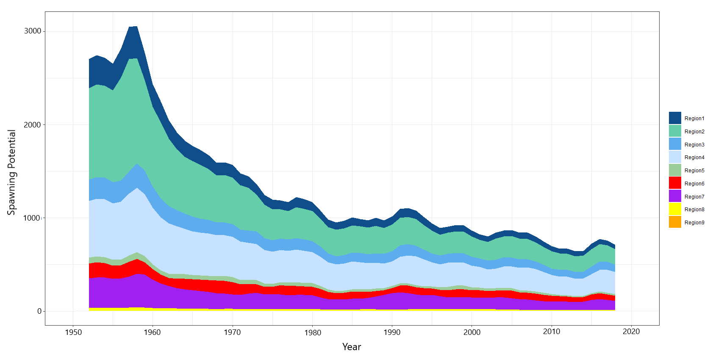
2. Total biomass

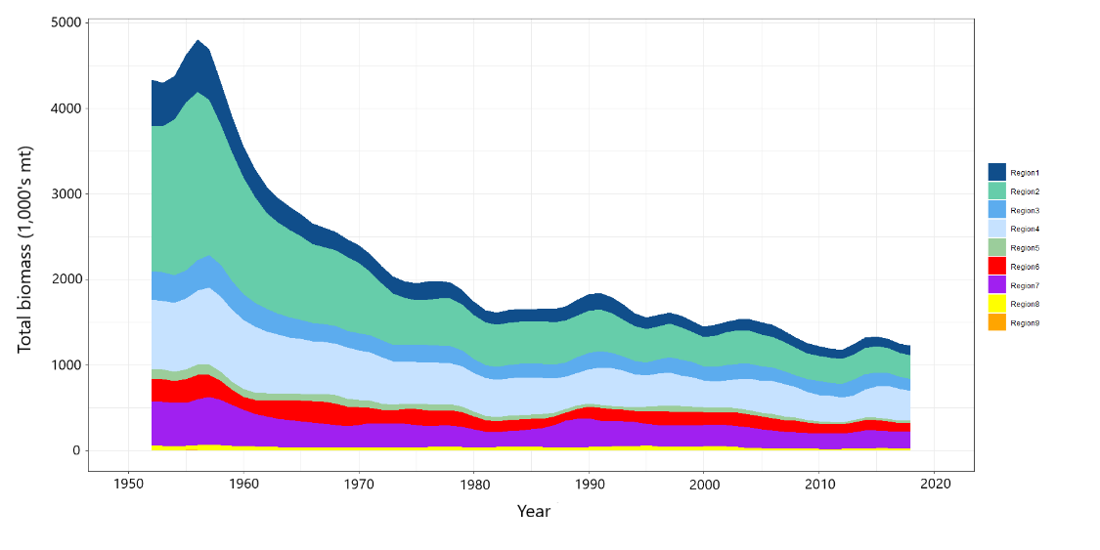

**Figure BET-4.** Estimated (a) annual average recruitment, (b) spawning potential and (c) total biomass by model region for the diagnostic model, showing the relative sizes among regions.

**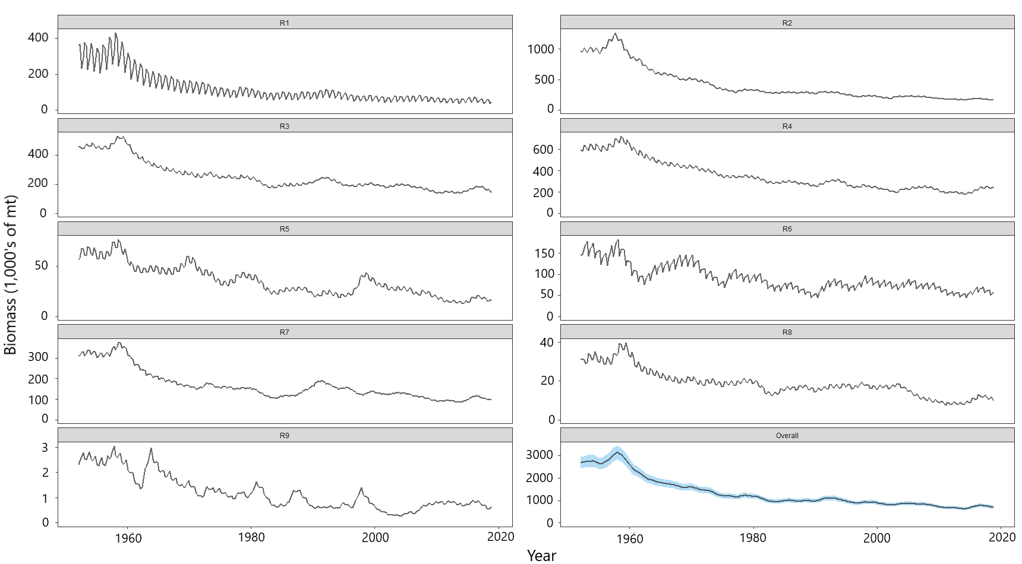**

**Figure BET-5.** Estimated seasonal, temporal spawning potential by model region for the diagnostic model. The asymptotic 95% confidence interval as calculated using the delta-method is shown for the “Overall” region. Note that the scale of the y-axis is not constant across regions.

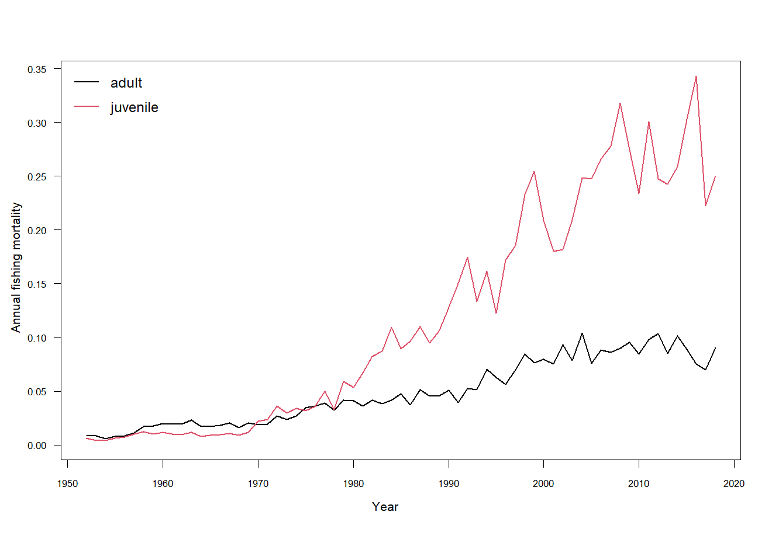

**Figure BET-6.** Estimated annual average juvenile and adult fishing mortality for the diagnostic model.

**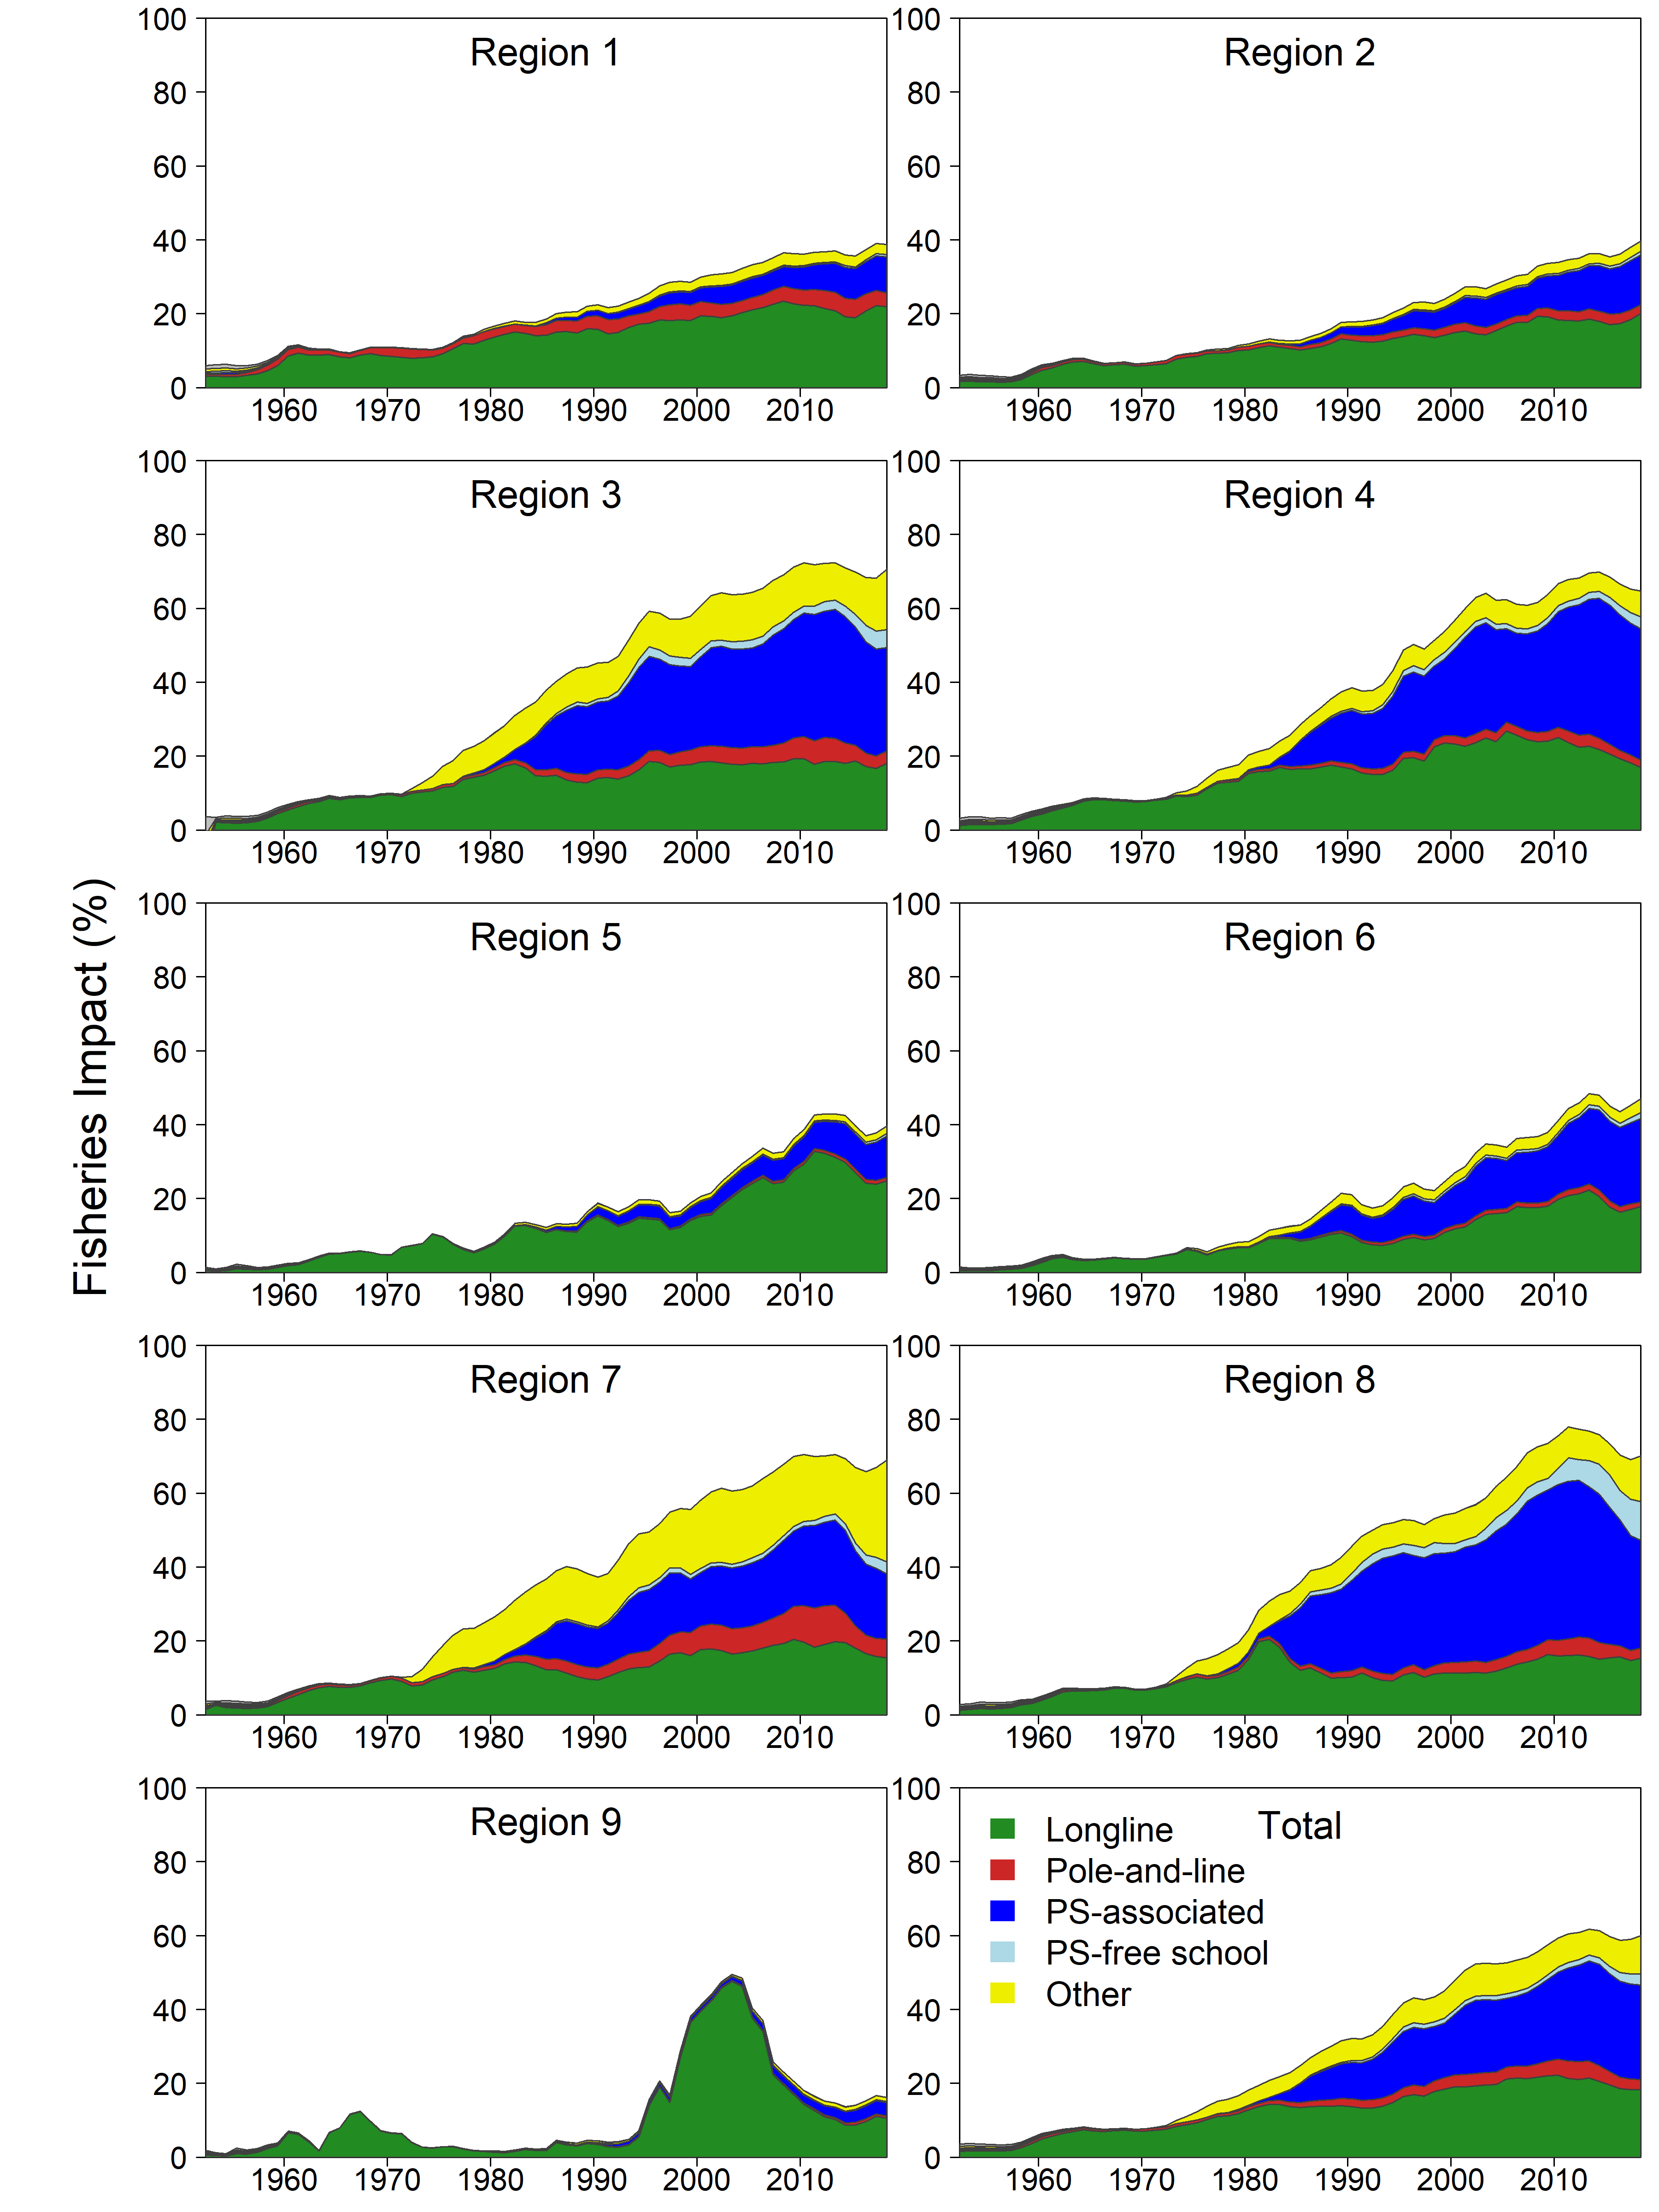**

**Figure BET-7.** Estimates of reduction in spawning potential due to fishing (fishery impact = (1-SBt/SBt;F=0) \* 100% ) by region, and over all regions (lower right panel), attributed to various fishery groups for the diagnostic model.

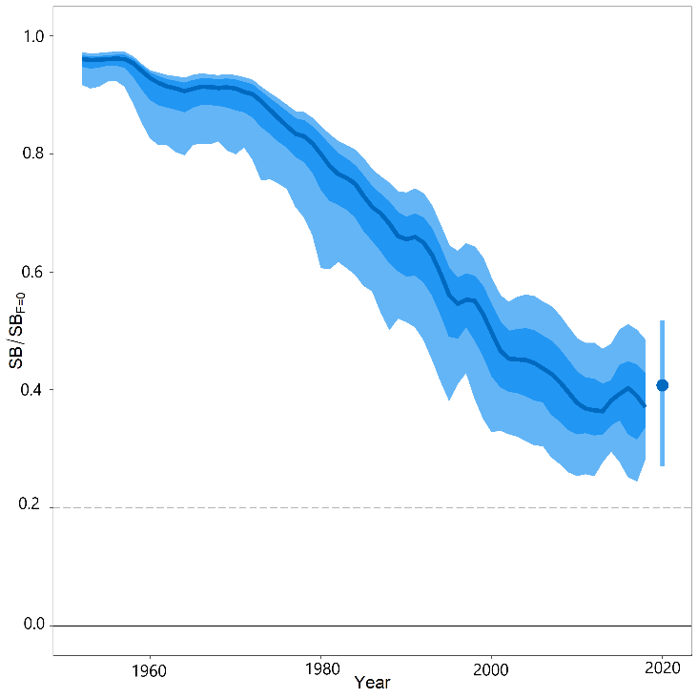

**Figure BET-8.** Time-dynamic percentiles of depletion (SBt/SBt;F=0) and median (dark line) across all 24 models in the structural uncertainty grid. The lighter band shows the 10th to 90th percentiles around the median, and the dark band shows the 50th percentile around the median. The median SBrecent/SBF=0 and 80th percentile is shown on the right by the dot and line.

**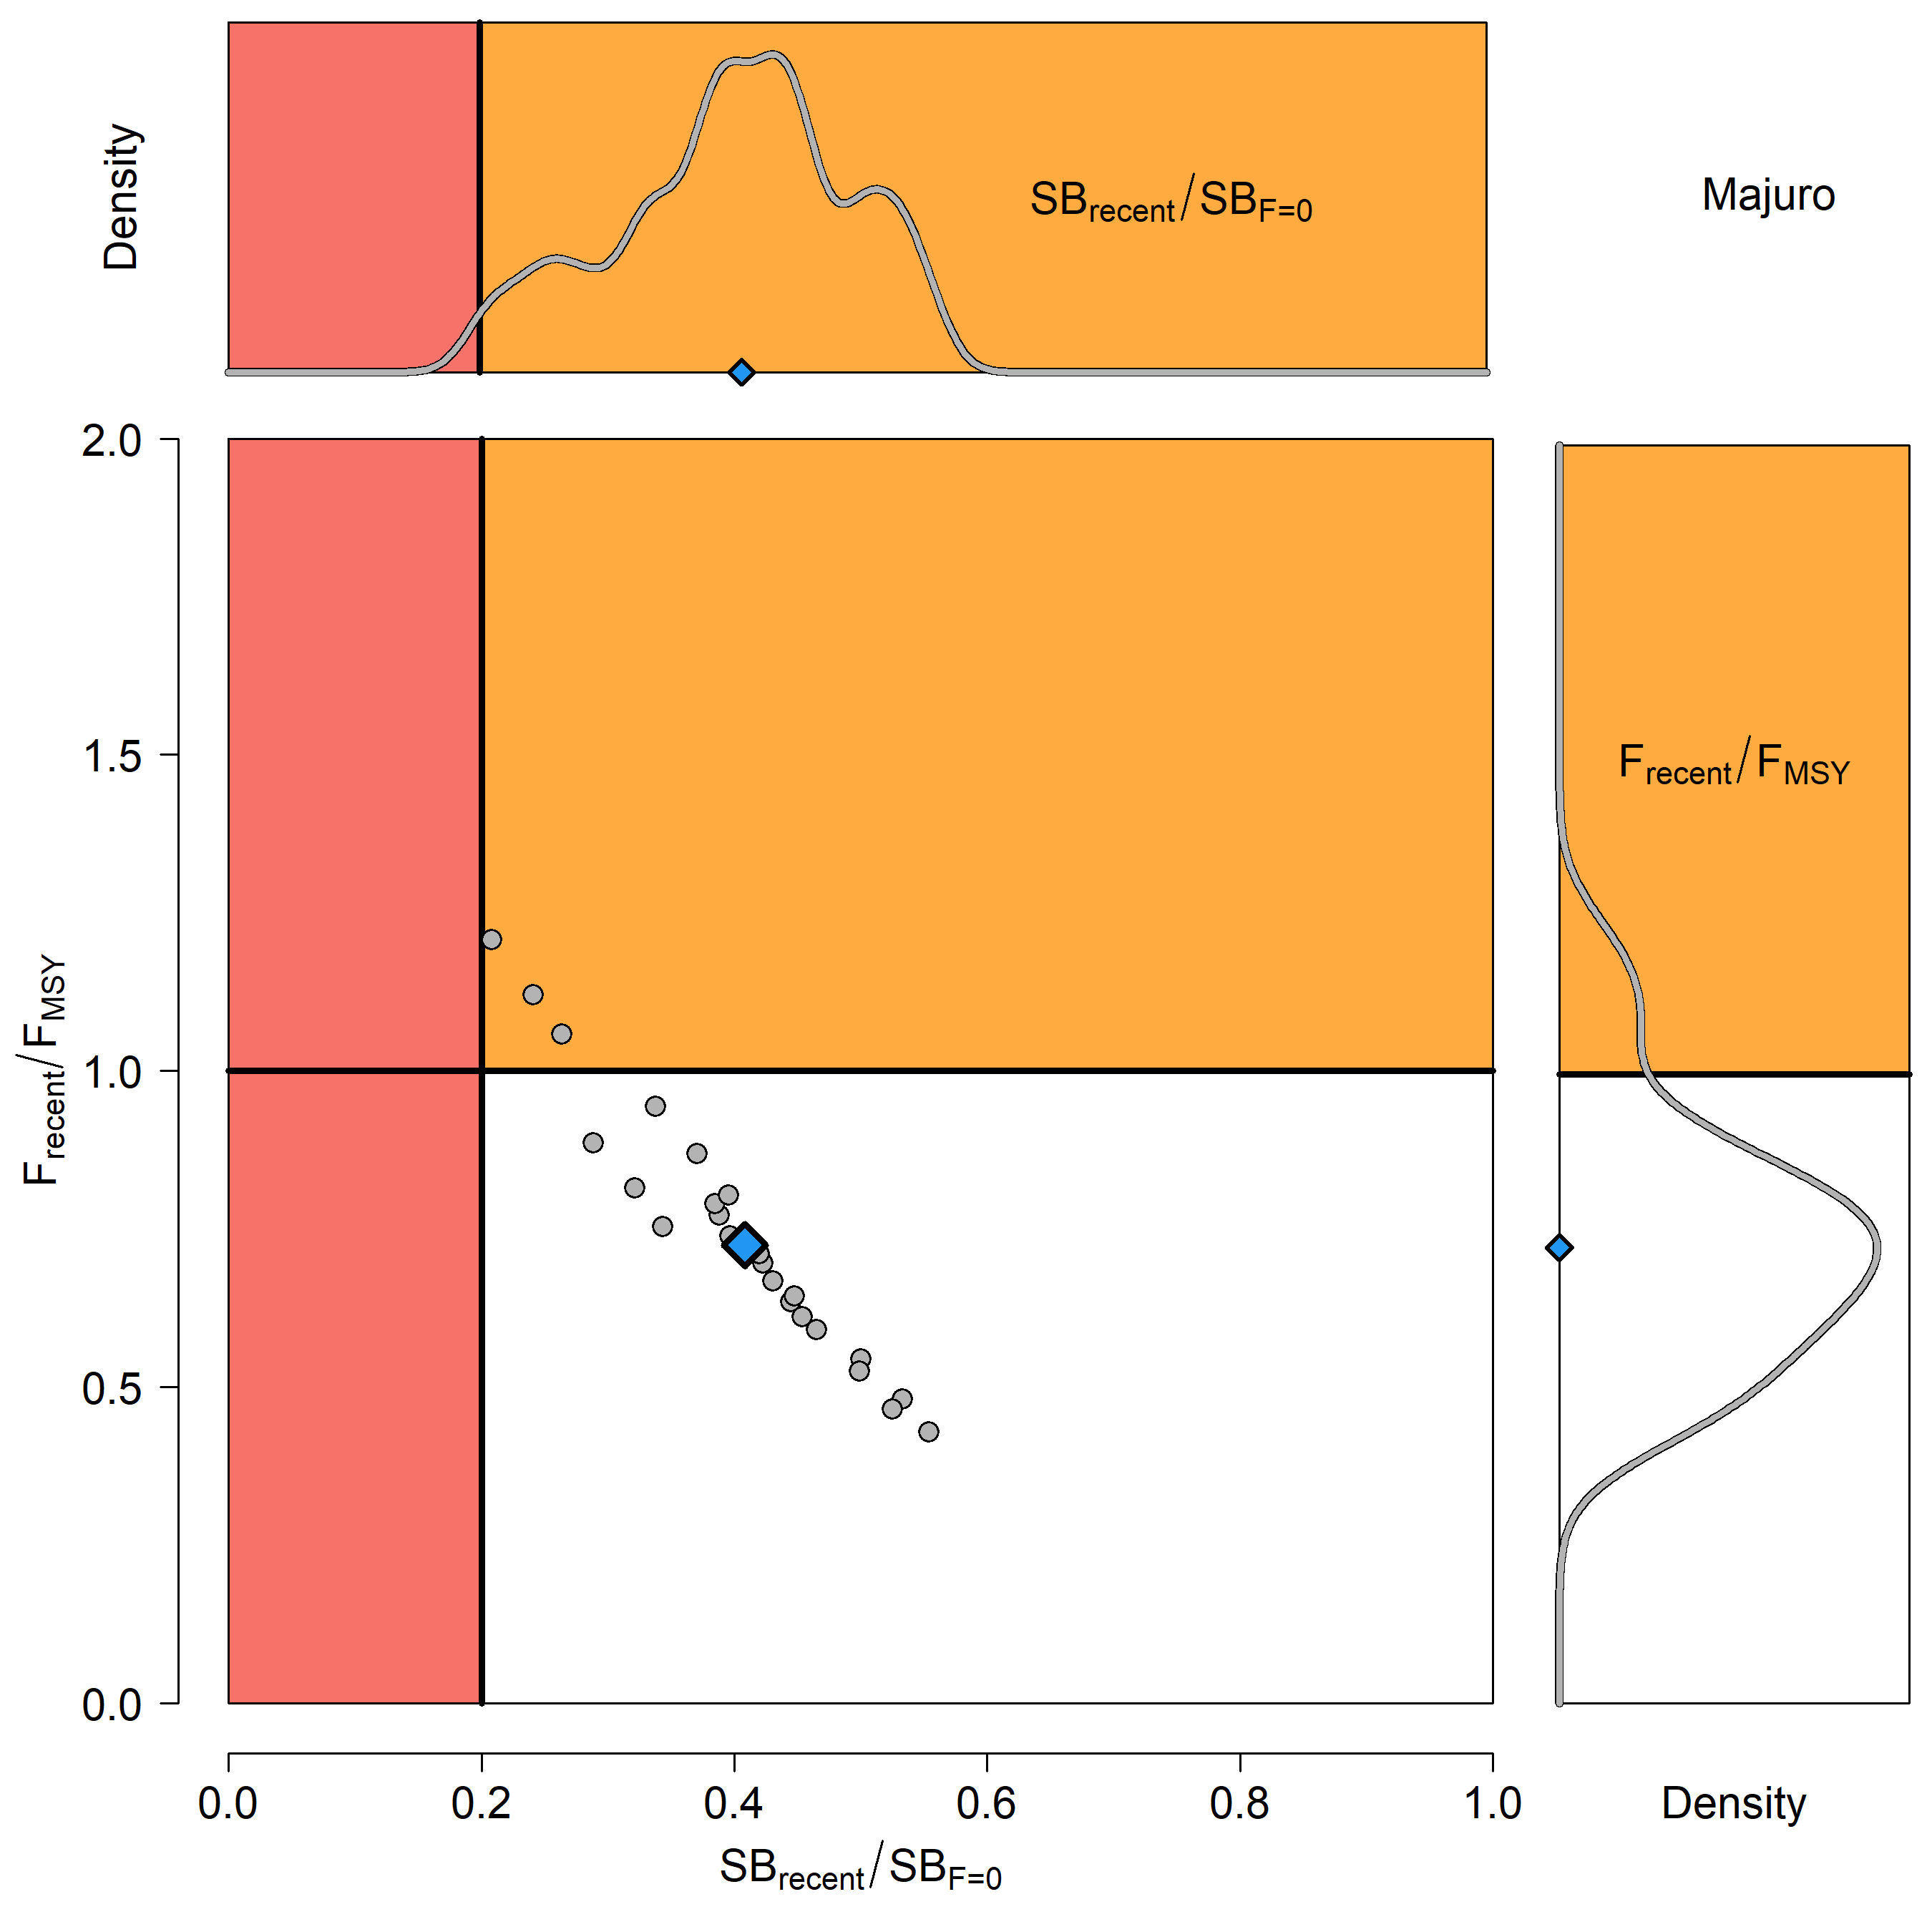**

**Figure BET-9**. Majuro plot for the recent spawning potential (2015–2018) summarizing the results for each of the models in the structural uncertainty grid. The plots represent estimates of stock status in terms of spawning biomass depletion and fishing mortality, and marginal distributions of each are presented. The median is shown in blue.

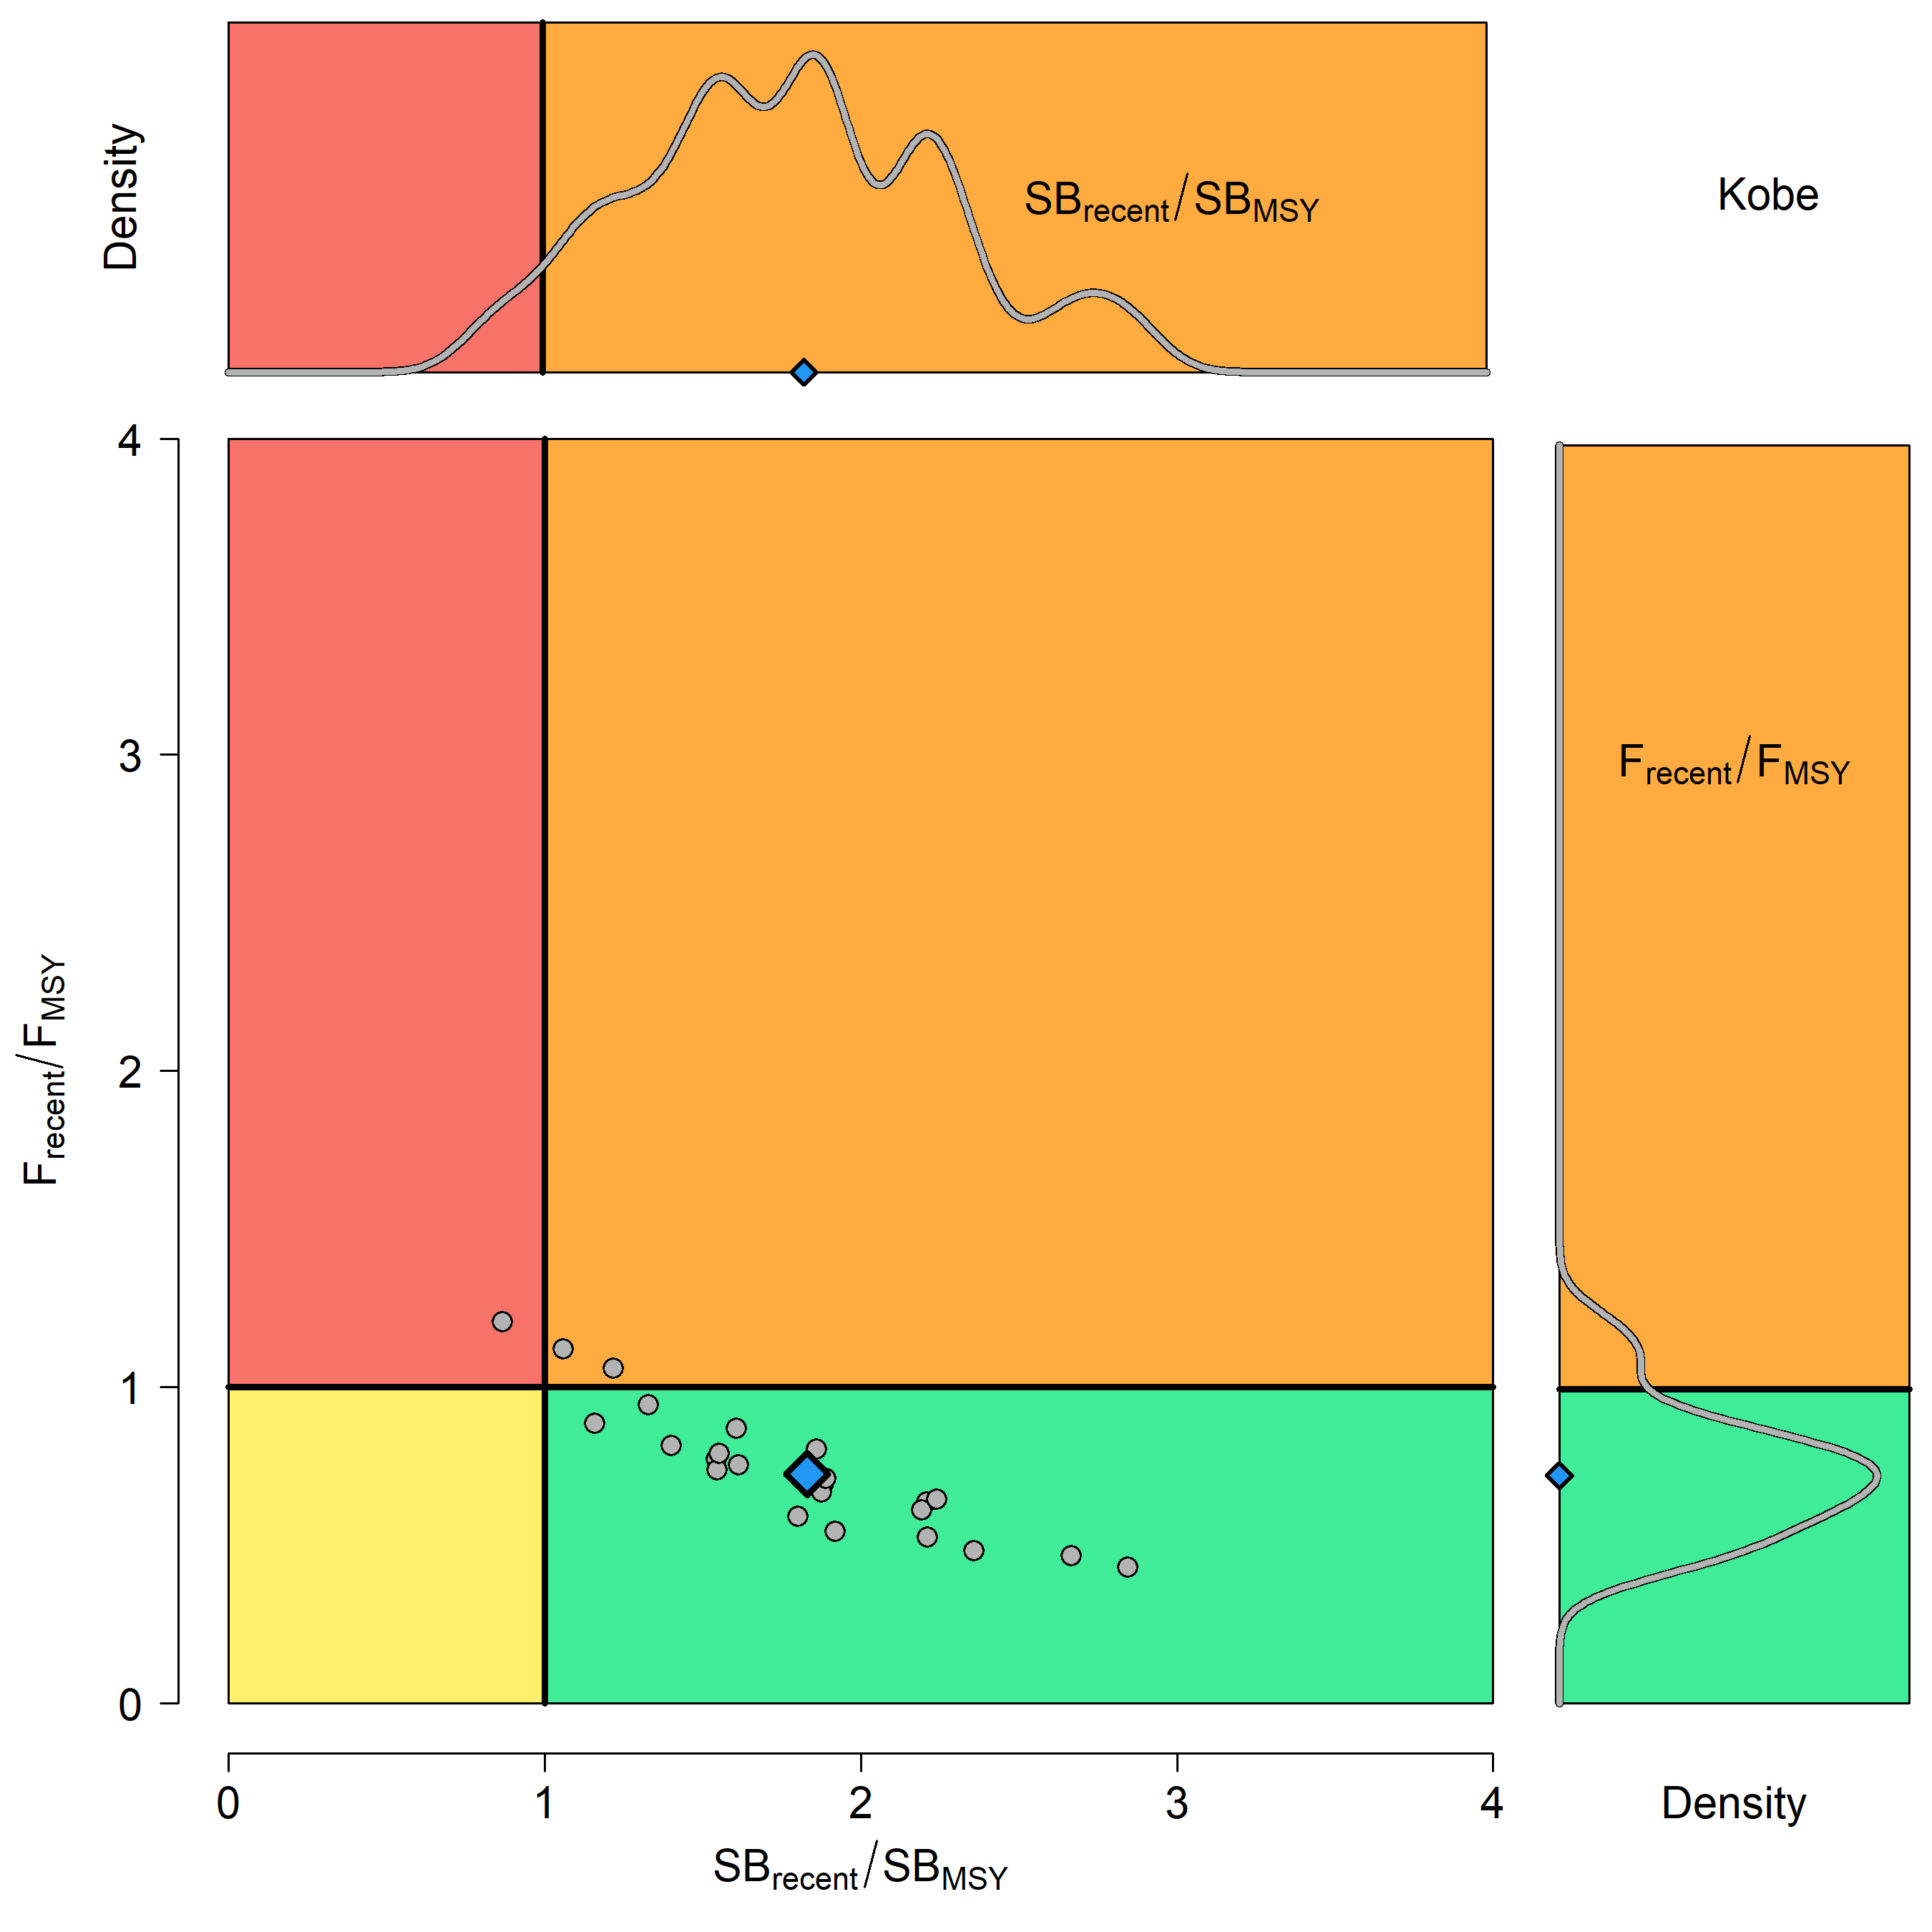

**Figure BET-10**. Kobe plot for the recent spawning potential (2015–2018) summarizing the results for each of the models in the structural uncertainty grid. The plots represent estimates of stock status in terms of spawning biomass depletion and fishing mortality. Marginal distributions of each are presented. The median is shown in blue.



**Figure BET-11**. Time series of bigeye tuna spawning potential SBt/SBF=0, where SBF=0 is the average SB from t-10 to t-1, relative to the current year t, from the uncertainty grid of assessment models for the period 2000 to 2018, and stochastic projection results for the period 2019 to 2048 assuming 2016-2018 average catches in LL and other fisheries and 2018 effort in PS fisheries continue. Vertical gray line at 2018 represents the last year of the assessment. During the projection period (2019-2048) levels of recruitment variability are assumed to match those over the short-term period (2008-2017). The red horizontal dashed line represents the agreed limit reference point.



**Figure BET-12**. Time series of bigeye tuna spawning potential SBt/SBF=0, where SBF=0 is the average SB from t-10 to t-1, relative to the current year t, from the uncertainty grid of assessment models for the period 2000 to 2018, and stochastic projection results for the period 2019 to 2048 assuming 2016-2018 average catches in LL and other fisheries and 2018 effort in PS fisheries continue. Vertical gray line at 2018 represents the last year of the assessment. During the projection period (2019-2048) levels of recruitment variability are assumed to match those over the long-term period (1962-2017). The red horizontal dashed line represents the agreed limit reference point.

1. SC16 noted that the results from the uncertainty grid adopted by SC16 show that the stock has been continuously declining for about 60 years since the late 1950s, except for the recent small increase from 2015 to 2016 with biomass declining thereafter.
2. SC16 also noted that the median value of relative recent (2015-2018) spawning biomass depletion (SB2015-2018/ SBF=0) was 0.41 with a 10th to 90th percentiles of 0.27 to 0.52.
3. SC16 further noted that there was 0% probability (0 out of 24 models) that the recent (2015-2018) spawning biomass had breached the adopted limit reference point (LRP).
4. SC16 noted that there has been a long-term increase in fishing mortality for both juvenile and adult bigeye tuna and while juvenile fishing mortality is higher than that of the adult fish, both adult and juvenile fishing mortality rates have stabilised somewhat since 2008 and have fluctuated without trend since that time.
5. SC16 noted that the median recent fishing mortality (F2014-2017t/FMSY) was 0.72 with a 10th to 90th percentile interval of 0.49 to 1.02.

1. SC16 noted that there was a roughly 12.5% probability (3 out of 24 models) that the recent (2014-2017) fishing mortality was above FMSY.
2. SC16 noted the results of stochastic projections (Figures BET 11 and BET 12) from the 2020 assessment which indicated the potential stock consequences of ﬁshing at “status quo” conditions (2016–2018 average longline and other fishery catch and 2018 purse seine effort levels) and short-term recruitment scenario using the uncertainty framework approach endorsed by SC. Projections indicate that median SB2025/SBF=0 = 0.47; median SB2035/SBF=0 = 0.49 and median SB2045/SBF=0 = 0.49. The risk that SB2048/SBF=0 is less than the Limit Reference Point is 0%.
3. SC16 noted the results of stochastic projections from the long-term recruitment scenario using the uncertainty framework approach endorsed by SC. Projections indicate that median SB2025/SBF=0 = 0.42; median SB2035/SBF=0 = 0.44 and median SB2045/SBF=0 = 0.45. The risk that SB2048/SBF=0 is less than the Limit Reference Point is 5%.
4. **Management advice and implications**
5. SC16 noted that the preliminary estimate of total catch of WCPO bigeye tuna for 2019 was 135,680 mt, a 9% decrease from 2018 and an 8% decrease from the average 2014-2018. Longline catch in 2019 (68,371 mt) was a 0% decrease from 2018 and a 2% increase from the 2014-2018 average. Purse seine catch in 2019 (50,819 mt) was a 22% decrease from 2018 and a 17% decrease from the 2014-2018 average. Pole and line catch (1,400 mt) was a 66% decrease from 2018 and a 66% decrease from the average 2014-2018 catch. Catch by other gear totalled 15,090 mt and was a 33% increase from 2018 and 1% increase from the average catch in 2014-2018.

1. SC16 noted that the catch in the last year of the assessment (2018) was median 159,288 mt which was greater than the median MSY (140,720 mt).
2. Based on the uncertainty grid adopted by SC16, the WCPO bigeye tuna spawning biomass is above the biomass LRP and recent F is very likely below FMSY. The stock is not overfished (100% probability SB/SBF=0>LRP) and likely not experiencing overfishing (87.5% probability F<FMSY).
3. SC16 noted that levels of fishing mortality and depletion differ among regions, and that fishery impact was higher in the tropical regions (Regions 3, 4, 7 and 8 in the stock assessment model), with particularly high fishing mortality on juvenile bigeye tuna in these regions. There is also evidence that the overall stock status is buffered with biomass kept at more elevated level overall by low exploitation in the temperate regions (1, 2, 6 and 9). SC16 therefore re-iterates that WCPFC17 could continue to consider measures to reduce fishing mortality from fisheries that take juveniles, with the goal to increase bigeye fishery yields and reduce any further impacts on the spawning biomass for this stock in the tropical regions.
4. Based on those results, SC16 recommends as a precautionary approach that the fishing mortality on bigeye tuna stock should not be increased from the level that maintains spawning biomass at 2012-2015 levels until the Commission can agree on an appropriate target reference point.
   1. **WCPO yellowfin tuna (*Thunnus albacares*)** 
      1. **Review of 2020 yellowfin tuna stock assessment**
5. M. Vincent (SPC-OFP) presented SC16-SA-WP-04 *Stock assessment of yellowfin tuna in the western and central Pacific Ocean*, which described the 2020 stock assessment of yellowfin tuna *Thunnus albacares.* An additional three years of data were available since the previous assessment in 2017, and the model extends through the end of 2018. New developments to the stock assessment include the incorporation of an index fishery for each region, enforcement of a mixing period of 182 days for a mixing period of 2 quarters and 91 days for a mixing period of 1 quarter, and incorporation of additional biological information.
6. Changes made in the progression from the 2017 to the 2020 diagnostic model that influence our perception of yellowfin stock status were the:

* Incorporation of additional information regarding the growth of yellowfin tuna arising from otolith data;
* Changes to the preparation and treatment of the tagging data, including enforcement of mixing periods in the tagging data, which resulted in reduced estimates of fishing mortality;
* Change in assumptions regarding the sharing of selectivity parameters;
* Use of the maturity-at-length functionality in Multifan-CL.

1. The general conclusions of this assessment are as follows:

* Total biomass and spawning potential declined until the mid-2000s, after which it remained relatively stable, with fluctuations and a small increase in recent years. Estimated recruitment shows a decreasing trend from 1952 until the mid-1990s and a small increasing trend in the recent period;
* Average fishing mortality rates for juvenile and adult age-classes increase throughout the period of the assessment;
* All models in the structural uncertainty grid assessed the stock to be above the adopted LRP, and fishing mortality rates below FMSY, with 100% probability. Based on the results of this assessment, the yellowfin stock in the WCPO is not considered overfished, nor subject to overfishing;
* Overall median depletion over the recent period (2015-2018; SBrecent/SBF=0) was 0.58 with a 10th to 90th percentile interval of 0.51-0.64;
* Recent average fishing mortality (2014-2017; Frecent/FMSY) was 0.36 with a 10th to 90th percentile interval of 0.27-0.47;
* Results from the structural uncertainty grid should be treated with some caution due to indications that there are likely model misspecifications which may be causing optimistic and biologically unreasonable estimates of recruitment distribution and stock status.

1. SC16 notes that the assessment results in general are very optimistic compared to the previous assessments but the causes for such optimistic results were not fully understood, thus uncertain. In particular, the median estimate of MSY from the uncertainty grid in 2020 was 1,091 thousand metric tons of catch biomass, or 63% above the estimate from the 2017 YFT assessment at SC13. Also, due to the constraints originating from the virtual online Scientific Committee forum, the SC16 could not fully engage in a complete discussion of the appropriate choice of models within the uncertainty grid. Due to the lack of an objective way of selecting the preferred elements for weighting the grid, SC16 agreed to use the grid with all models as presented by the Scientific Services Provider. As indicated in research needs, further research on the assessment model, including the peer review, is warranted in developing the next WCPO stock assessment.
2. A number of key research needs were identified in undertaking the assessment that should be investigated either internally or through directed research.
3. Items for internal investigation of the assessment model are as follows:
4. Further refinement of the selectivity to better fit the length composition from the PS fisheries;
5. Investigation of standardization methods of the LL CPUE index to account for environmental covariates and factors driving potential increase in efficiencies in fishing, which may require separation of the time series;
6. Examination of alternative methods to enforce mixing periods while retaining the attrition curve to inform fishing mortality;
7. Exploration of the self-scaling multinomial and the potential for its inclusion in future structural uncertainty grids;
8. Reduction in the model complexity to rectify unrealistic patterns of high recruitment in temperate regions and low recruitment in region 8;
9. Comparison among tropical tuna assessments to ensure biological realism in assessment estimates of all species;
10. Incorporation of spatial functionality of population dynamics regarding regional growth, maturity and/or length-weight; and,
11. Estimation of natural mortality using available tagging data.
12. Items that require directed research and additional funding for implementation:
13. Evaluation of the feasibility of conducting a fishery independent survey across the WCPO to be used as an index of abundance within the stock assessments and to improve the representativeness of biological samples across the WCPO;
14. Further collection of otolith samples for use in investigations of regional differences in growth with increased focus on increasing the spatial coverage of sampling for all lengths and collecting fish less than 30 cm and greater than 120 cm in all regions;
15. Validation of otolith aging techniques through bomb radiocarbon and strontium chloride tagging to clarify causes of discrepancy between growth curves from otoliths, tagging increments, and size composition modal progression;
16. Additional tag seeding experiments required for the estimation of reporting rates necessary to provide better estimates of natural mortality from tagging data;
17. Collection of biological information to inform the components in the reproductive potential ogive such as fecundity, proportion female at length, maturity at length, and spawning fraction in a spatially structured context;
18. Collection of biological samples for the estimation of conversion factors from length to weight, gilled-gutted to whole-weight, and gilled-gutted-trunked to whole weight to be used for the weight composition data.
    * 1. **Provision of scientific information**
19. **Stock Status and trends**

1. The median values of relative recent (2015-2018) spawning biomass depletion (*SBrecent/ SBF=0*) and relative recent (2014-2017) fishing mortality (*Frecent/FMSY*) over the uncertainty grid of 72 models (Table YFT-1) were used to define stock status. The values of the upper 90th and lower 10th percentiles of the empirical distributions of relative spawning biomass and relative fishing mortality from the uncertainty grid were used to characterize the probable range of stock status.
2. A description of the updated structural sensitivity grid used to characterize uncertainty in the assessment is illustrated in Table YFT-1. The spatial structure used in the 2020 stock assessment is shown in Figure YFT-1. Time series of total annual catch by fishing gear over the full assessment period is shown in Figure YFT-2. The time series of total annual catch by fishing gear and assessment region is shown in Figure YFT-3. Estimated annual average recruitment, spawning potential, and total biomass by model region is shown in Figure YFT-4. Estimated trends in spawning biomass depletion for the 72 models in the structural uncertainty grid is shown in Figure YFT-5, and juvenile and adult fishing mortality rates from the diagnostic model is shown in Figure YFT-6. Estimates of the reduction in spawning potential due to fishing by region are shown in Figure YFT-7. Time-dynamic percentiles of depletion (SBt/SBt,F=0) for the 72 models are shown in Figure YFT-8. A Majuro and Kobe plot summarising the results for each of the 72 models in the structural uncertainty grid are shown in Figures YFT-9 and 10, respectively. Projections are illustrated in Figure YFT-11. Table YFT-2 provides a summary of reference points over the 72 models in the structural uncertainty grid.
3. The most influential axis of uncertainty with respect to estimated stock status was growth. The most pessimistic model estimates occurred with models that assumed growth estimated from the modal progression information in the size composition data. The most optimistic stock status estimates were obtained from models that used the growth curve estimated externally from otolith data. Models where growth was estimated by the conditional age-at-length data resulted in estimates that were in between the other two, but were more consistent with the otolith growth curve models. Further research is required to develop alternative growth estimates at the regional spatial scale and develop model diagnostics and objective criteria for model inclusion.

**Table YFT-1.** Description of the updated structural sensitivity grid used to characterize uncertainty in the assessment, where \* denotes the level assumed in the diagnostic model. Equal weighting was given to all axis values.

|  |  |  |  |  |
| --- | --- | --- | --- | --- |
| **Axis** | **Value 1** | **Value 2** | **Value 3** | **Value 4** |
| Growth | Conditional Age-at-length\* | Modal (Size Composition) | Otolith |  |
| Steepness | 0.65 | 0.8 \* | 0.95 |  |
| Size Scalar | 20 | 60 \* | 200 | 500 |
| Mixing Period | 1 Quarter | 2 Quarters \* |  |  |

**Table YFT-2.** Summary of reference points over the 72 models in the structural uncertainty grid. Note that “recent” is the average over the period 2015-2018 for SB and 2014-2017 for fishing mortality, while “latest” is 2018. The values of the upper 90th and lower 10th percentiles of the empirical distributions are also shown. Fmult is the multiplier of recent (2014-2017) fishing mortality required to attain MSY.

|  |  |  |  |  |  |  |
| --- | --- | --- | --- | --- | --- | --- |
|  | **Mean** | **Median** | **Minimum** | **10th percentile** | **90th percentile** | **Maximum** |
| Clatest | 709,389 | 711,072 | 700,358 | 702,279 | 712,761 | 714,073 |
| YFrecent | 779,872 | 784,200 | 661,600 | 707,720 | 877,040 | 908,000 |
| fmult | 2.87 | 2.80 | 1.70 | 2.12 | 3.72 | 4.29 |
| FMSY | 0.11 | 0.10 | 0.08 | 0.09 | 0.12 | 0.15 |
| MSY | 1,090,706 | 1,091,200 | 791,600 | 874,200 | 1,283,920 | 1,344,400 |
| Frecent/FMSY | 0.37 | 0.36 | 0.23 | 0.27 | 0.47 | 0.59 |
| SBF=0 | 3,641,228 | 3,603,980 | 2,893,274 | 3,231,353 | 4,050,429 | 4,394,277 |
| SBMSY | 860,326 | 858,700 | 349,100 | 590,090 | 1,114,400 | 1,322,000 |
| SBMSY/SBF=0 | 0.23 | 0.24 | 0.12 | 0.18 | 0.28 | 0.30 |
| SB latest/SBF=0 | 0.54 | 0.54 | 0.40 | 0.47 | 0.60 | 0.66 |
| SB latest/SBMSY | 2.43 | 2.28 | 1.47 | 1.67 | 3.29 | 4.89 |
| SB recent/SBF=0 | 0.58 | 0.58 | 0.42 | 0.51 | 0.64 | 0.68 |
| SB recent/SBMSY | 2.59 | 2.43 | 1.54 | 1.77 | 3.57 | 5.27 |

**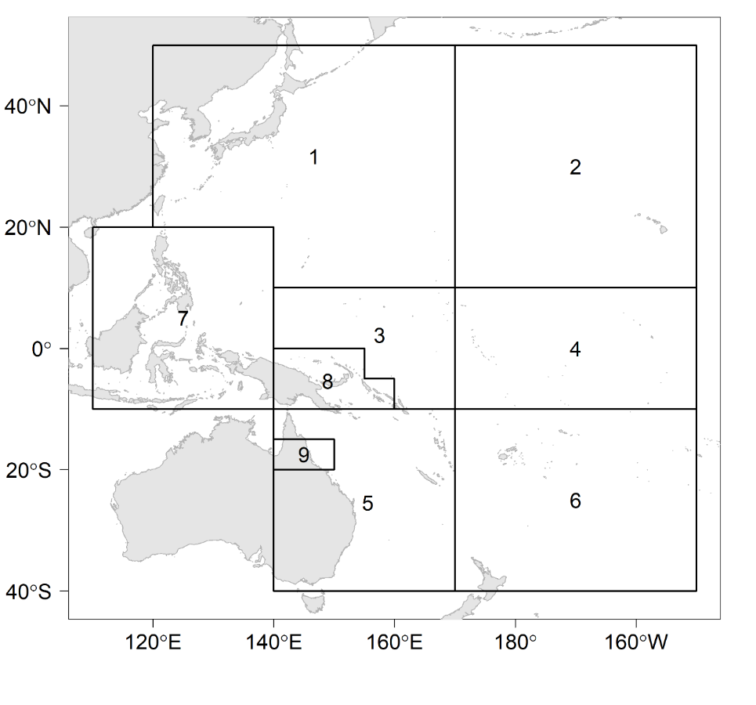**

**Figure YFT-1.** The geographical area covered by the stock assessment and the boundaries for the 9 regions when using the “10N regional structure”.

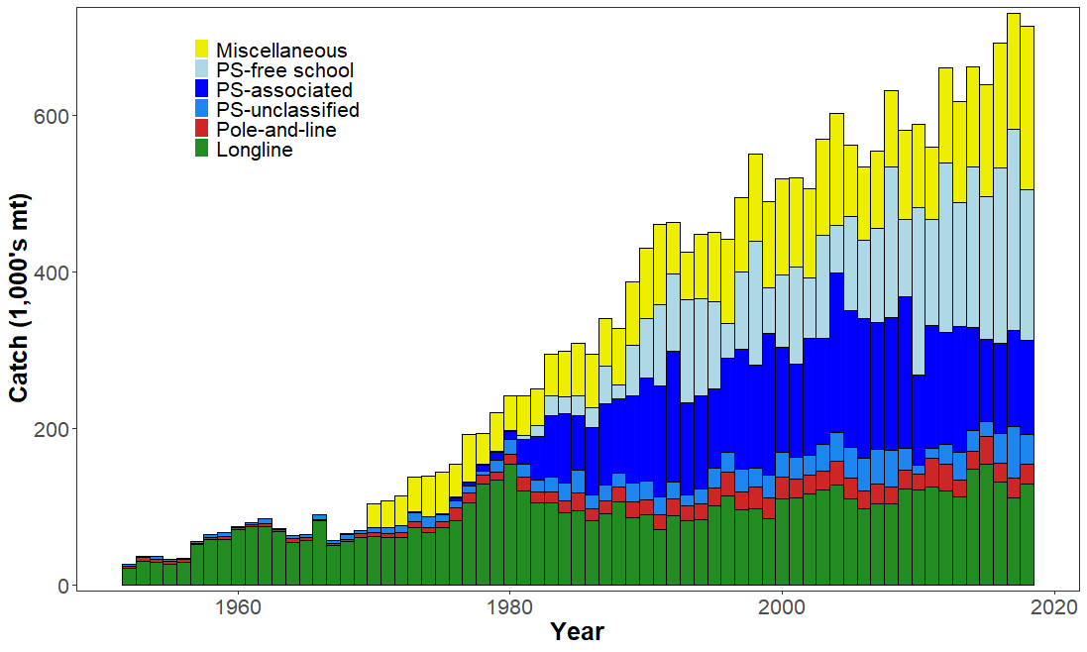

**Figure YFT-2.** Time series of total annual catch (1000s mt) by fishing gear over the full assessment region and time period. The different colours denote longline (green), pole-and-line (red), purse seine unclassified (blue), purse seine-associated (dark blue), purse seine-unassociated (light blue), miscellaneous (yellow).

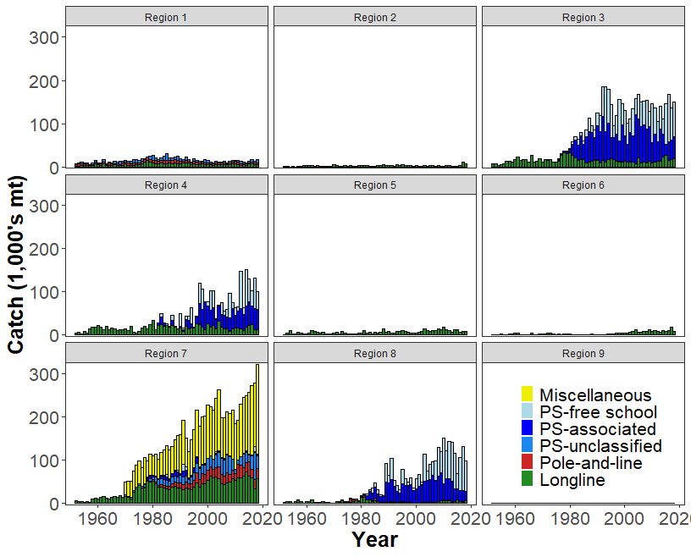

**Figure YFT-3.** Time series of total annual catch (1000s mt) by fishing gear and assessment region over the full assessment period. The different colours denote longline (green), pole-and-line (red), purse seine unclassified (blue), purse seine-associated (dark blue), purse seine-unassociated (light blue), miscellaneous (yellow).

(a) Recruitment

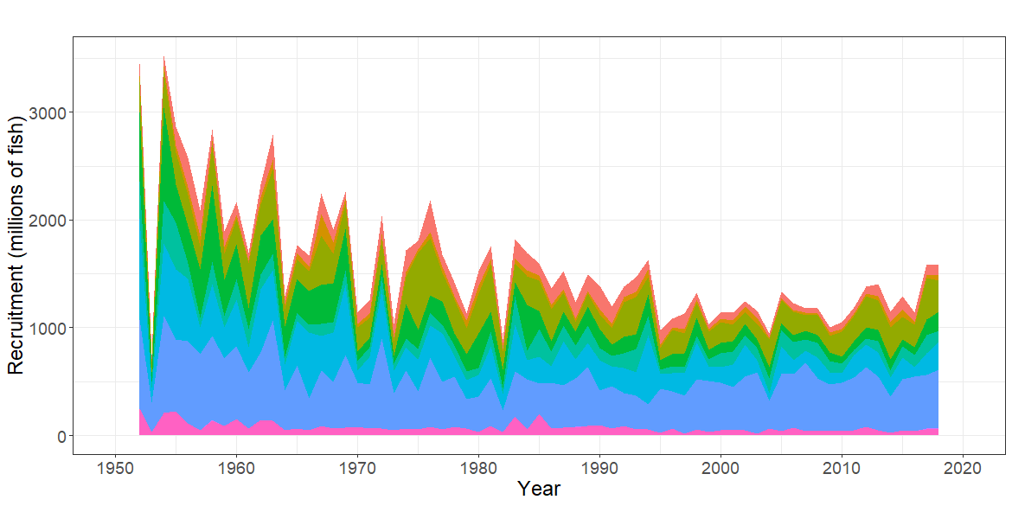

(b) Spawning Potential 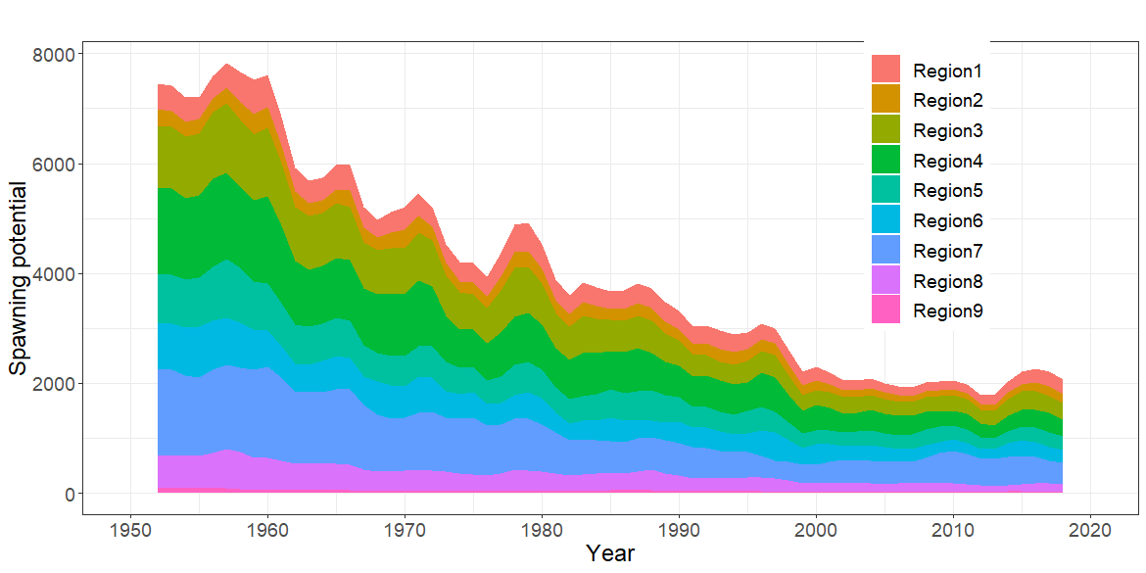

(c) Total Biomass 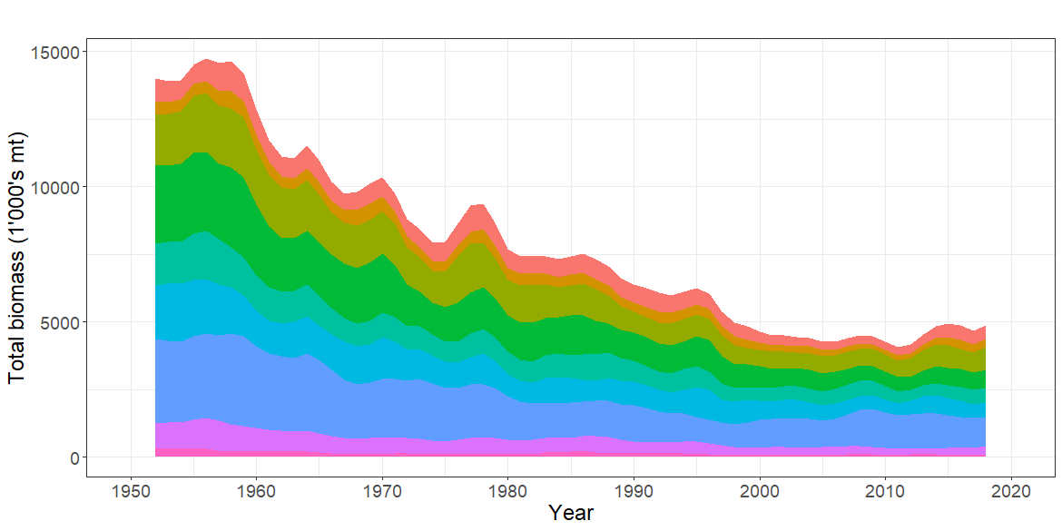

**Figure YFT-4.** Estimated annual average, (a) recruitment (b) spawning potential (c) total biomass by model region for the diagnostic model, showing the relative sizes among regions.

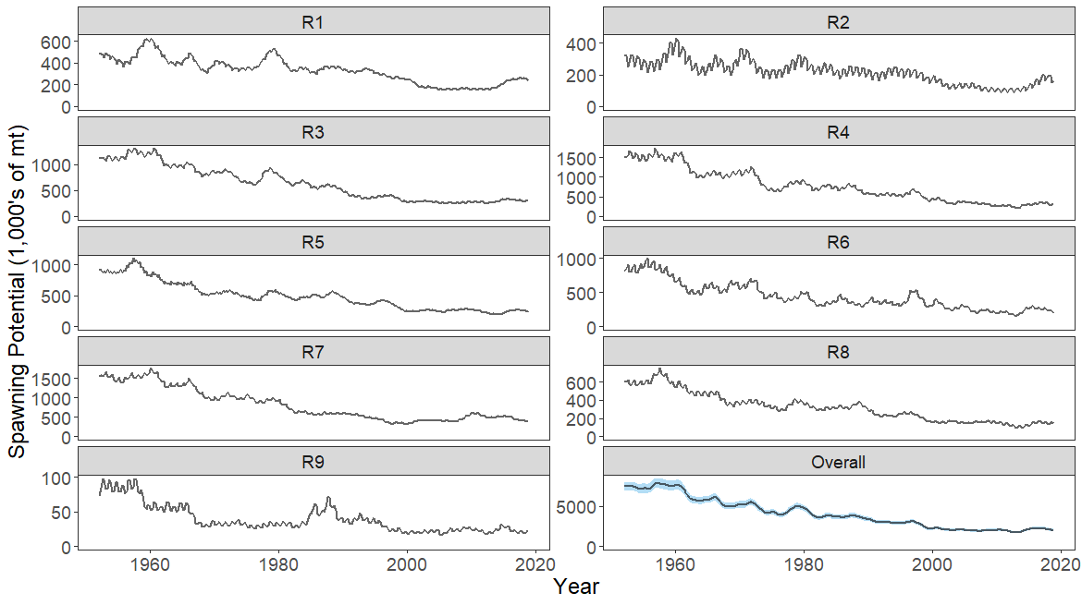

**Figure YFT-5.** The temporal trend in estimated spawning potential by model region for the diagnosticmodel, where the blue shaded region for the overall spawning potential shows the estimated 95% confidence interval based on statistical uncertainty estimated for the diagnostic model. Note that the y-axis scale among panels are not consistent.

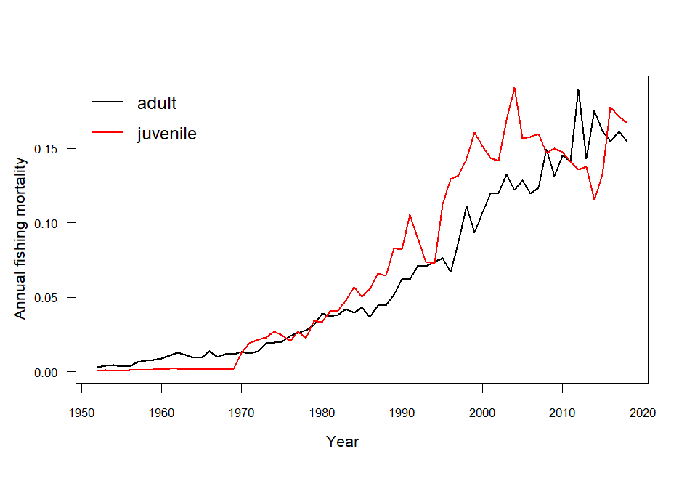

**Figure YFT-6.**  Estimated annual average juvenile and adult fishing mortality for the diagnostic model.

**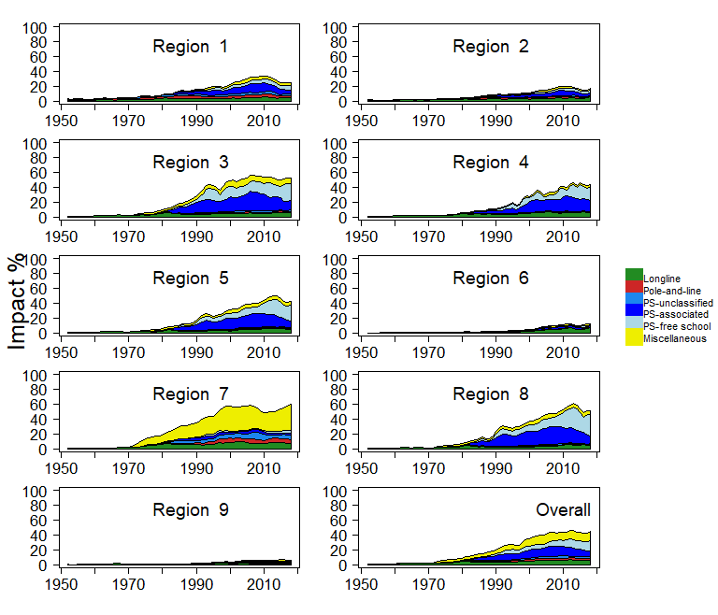**

**Figure YFT-7.** Estimates of reduction in spawning potential due to fishing by region (Fishery Impact = (1-SBt/SBt;F=0) \* 100%) and over all regions (lower right panel), attributed to various fishery groups for the diagnostic model.

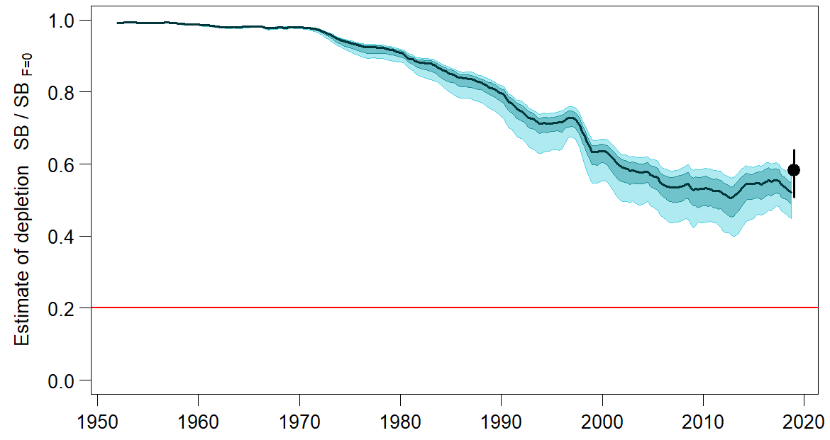

**Figure YFT-8.** Plot showing the trajectories of fishing depletion of spawning potential for the models in the structural uncertainty grid for the median, 50% quantile, and 80% quantile of instantaneous depletion across the structural uncertainty grid and the point and error bars is the median and 10th and 90th percentile of estimates of *SBrecent/SBF*=0.

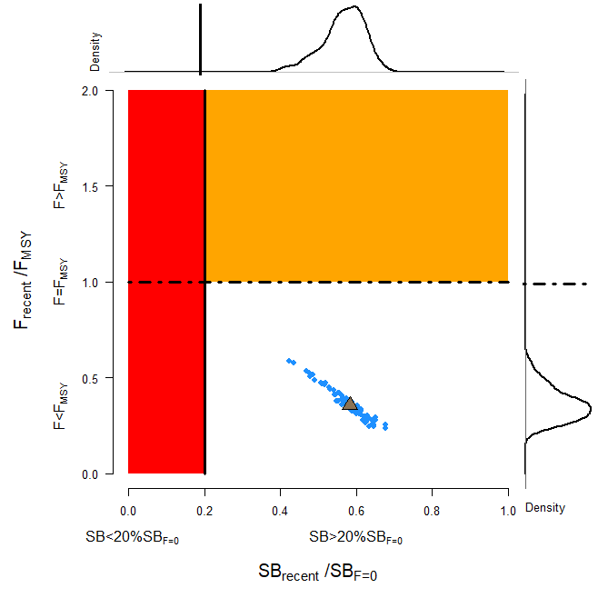

**Figure YFT-9.**  Majuro plot representing stock status in terms of recent spawning potential depletion (2015–2018) and fishing mortality. The plots summarize the results for each of the models in the structural uncertainty grid with marginal distributions for spawning potential depletion and fishing mortality, where the brown triangle is the median of the structural uncertainty grid.

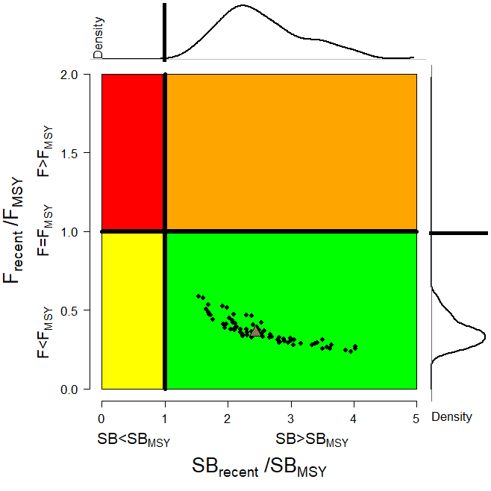

**Figure YFT-10.** Kobe plot for the recent spawning potential (2015–2018) summarizing the results for each of the models in the structural uncertainty grid. The plots represent estimates of stock status in terms of spawning biomass depletion and fishing mortality relative to *MSY* quantities and marginal distributions of each are presented with the median of the structural uncertainty grid displayed as a brown triangle.

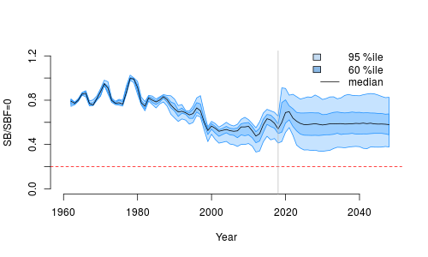

**Figure YFT-11.** Time series of yellowfin tuna spawning biomass (*SBt/SBt,F*=0, where *SBt,F*=0 is the average SB from t-10 to t-1) from the uncertainty grid of assessment models for the period 2000 to 2018, and stochastic projection results for the period 2019 to 2048 assuming 2016-2018 average catches in LL and other fisheries and 2018 effort in PS fisheries continue. Vertical gray line at 2018 represents the last year of the assessment. During the projection period (2019-2048) levels of recruitment variability are assumed to match those over the time period used to estimate the stock-recruitment relationship (1962-2017). The red horizontal dashed line represents the agreed limit reference point.

1. SC16 noted that there has been a long-term decrease in spawning biomass from the 1970s for yellowfin tuna but that the depletion rates have been relatively stable over the last decade.
2. SC16 also noted that the median value of relative recent (2015-2018) spawning biomass depletion (SB2015-2018/SBF=0) was 0.58 with a 10th to 90th percentile interval of 0.51 to 0.64.

1. SC16 further noted that there was 0% probability (0 out of 72 models) that the recent (2015-2018) spawning biomass had breached the adopted LRP.
2. SC16 noted that there has been a long-term increase in fishing mortality for both juvenile and adult yellowfin tuna which is consistent with previous assessments, but since 2010 there has been no directional trend.
3. SC16 noted that the median of relative recent fishing mortality (F2014-2017/FMSY) was 0.36 with a 10th to 90th percentile interval of 0.27 to 0.47.

1. SC16 further noted that there was 0% probability (0 out of 72 models) that the recent (2014-2017) fishing mortality was above FMSY.
2. SC16 noted the results of stochastic projections (Figure YFT-11) from the 2020 assessment which indicated the potential stock consequences of ﬁshing at “status quo” conditions (2016–2018 average longline and other fishery catch and 2018 purse seine effort levels) and long-term recruitment scenario using the uncertainty framework approach endorsed by SC. Projections indicate that median SB2025/SBF=0 = 0.58; median SB2035/SBF=0 = 0.59 and median SB2045/SBF=0 = 0.58. The risk that SB2048/SBF=0 is less than the Limit Reference Point is 0%.
3. **Management advice and implications**
4. SC16 noted that the preliminary estimate of total catch of WCPO yellowfin tuna for 2019 was 669,362 t, a 5% decrease from 2018 and a 1% increase from the average 2014-2018. Purse seine catch in 2019 (364,571 t) was a 4% decrease from 2018 and an 8% decrease from the 2014-2018 average. Longline catch in 2019 (104,440 t) was a 7% increase from 2018 and a 9% increase from the 2014-2018 average. Pole and line catch (37,563 t) was a 43% increase from 2018 and a 40% increase from the average 2014-2018 catch. Catch by other gear totalled 162,788 t and was an 18% decrease from 2018 and a 16% increase from the average catch in 2014-2018.
5. SC16 noted that the median catch in the last year of the assessment (2018) was 711,072 mt which was less than the median MSY (1,091,200 mt).
6. Based on the uncertainty grid adopted by SC16, the WCPO yellowfin tuna spawning biomass is above the biomass LRP and recent F is below FMSY. The stock is not experiencing overfishing (100% probability F<FMSY) and is not in an overfished condition (0% probability SB/SBF=0<LRP). Additionally, stochastic projections predict there to be no risk of breaching the LRP (0% probability SB2048/SBF=0<LRP).
7. SC16 also noted that levels of fishing mortality and depletion differ between regions, and that fishery impact was highest in the tropical region (Regions 3, 4, 7 and 8 in the stock assessment model), mainly due to the purse seine fisheries in the equatorial Pacific and the “other” fisheries within the Western Pacific. There is also evidence that the overall stock status is buffered with biomass kept at a more elevated level overall by low exploitation in the temperate regions (1, 2, 5, 6, and 9). SC16 therefore re-iterates that WCPFC17 could consider measures to reduce fishing mortality from fisheries that take juveniles, with the goal to increase fishery yields and reduce any further impacts on the spawning potential for this stock in the tropical regions.
8. SC16 noted that the 2020 stock assessment results indicate the stock is currently exploited at relatively low levels (median F/FMSY = 0.36, 10th to 90th percentile interval 0.27-0.47). Nevertheless, SC16 recommends that the Commission notes that further increases in YFT fishing mortality would likely affect other stocks/species which are currently moderately exploited due to the multispecies/gears interactions in WCPFC fisheries taking YFT.
9. SC16 also noted that although the structural uncertainty grid presents a positive indication of stock status, the high level of unresolved conflict amongst the data inputs used in the assessment suggests additional caution may be appropriate when interpreting assessment outcomes to guide management decisions.
10. Based on those results, SC16 recommends as a precautionary approach that the fishing mortality on yellowfin tuna stock should not be increased from the level that maintains spawning biomass at 2012-2015 levels until the Commission can agree on an appropriate target reference point.
    1. **North Pacific albacore (*Thunnus alalunga*)** 
       1. **Review of the 2020 North Pacific albacore stock assessment**
11. S. Teo (USA) presented SC16-SA-WP-05 *Stock Assessment of Albacore Tuna in the North Pacific Ocean in 2020*, which detailed the data, biological parameters, model, model diagnostics and sensitivities, and results of the North Pacific albacore stock assessment conducted by ISC’s Albacore Working Group in 2020.
12. All available fishery data for North Pacific albacore for the 1994-2018 period were used in the stock assessment. Catch and size composition data were compiled and assigned to 35 fisheries defined for this assessment (based on flag, gear, area, and season). The same abundance index as the 2017 assessment was fitted in the base case model. The North Pacific albacore stock was assessed using a length-based, age-, and sex-structured Stock Synthesis (SS Version 3.30.14.08) model over the 1994-2018 period and it was assumed that there is instantaneous mixing of albacore on a quarterly basis. Biological parameters like growth, natural morality (M) and stock-recruitment steepness, were the same as for the 2017 assessment. All fisheries were assumed to have dome-shaped length selectivity curves, and age-based selectivity for ages 1-5 were also estimated for surface fisheries (troll and pole-and-line) to address age-based changes in juvenile albacore availability and movement. Selectivity curves were also assumed to vary over time for several fleets.
13. Maximum likelihood estimates of model parameters, derived outputs, and their uncertainties from the base case model were used to characterize stock status. Based on model diagnostics, the ALBWG concluded that the base case model was able to estimate the stock production function and the effect of fishing on the abundance of the north Pacific albacore stock. Due to the moderate exploitation levels relative to stock productivity, the production function was weakly informative about north Pacific albacore stock size, resulting in asymmetric uncertainty in the stock’s absolute scale, with more uncertainty in the upper limit of the stock than the lower limit. It is important to note that the primary aim of estimating the female SSB in this assessment was to determine whether the estimated SSB was lower than the limit reference point (i.e., determine whether the stock is in an overfished condition). Since the lower bound is better defined, it adds confidence to the evaluation of stock condition relative to the limit reference point. Several sensitivity analyses were conducted to evaluate model performance or the range of uncertainty resulting from changes in model parameters, including natural mortality, stock-recruitment steepness, growth, starting year, selectivity patterns, and weighting of size composition data.
    * 1. **Provision of scientific information**
14. **Stock status and trends**
15. SC16 noted that the ISC provided the following conclusions on the stock status of North Pacific albacore:

The Northern Committee (NC) of the Western and Central Pacific Fisheries Commission (WCPFC), which manages this stock together with the Inter American Tropical Tuna Commission (IATTC), adopted a biomass-based limit reference point (LRP) in 2014 (https://www.wcpfc.int/harvest-strategy) of 20% of the current spawning stock biomass when F=0 (20%SSBcurrent, F=0). The 20%SSBcurrent, F=0 LRP is based on dynamic biomass and fluctuates depending on changes in recruitment. For north Pacific albacore tuna, this LRP is calculated as 20% of the unfished dynamic female spawning biomass in the terminal year of this assessment (i.e., 2018) (https://www.wcpfc.int/meetings/nc13). However, neither the IATTC nor the WCFPC have adopted F-based limit reference points for the north Pacific albacore stock.

Stock status is depicted in relation to the limit reference point (LRP; 20%SSBcurrent, F=0) for the stock and the equivalent fishing intensity (F20%; calculated as 1-SPR20%) (Figure NPALB-1). Fishing intensity (F, calculated as 1-SPR) is a measure of fishing mortality expressed as the decline in the proportion of the spawning biomass produced by each recruit relative to the unfished state. For example, a fishing intensity of 0.8 will result in a SSB of approximately 20% of SSB0 over the long run. Fishing intensity is considered a proxy of fishing mortality.

The Kobe plot shows that the estimated female SSB has never fallen below the LRP since 1994, albeit with large uncertainty in the terminal year (2018) estimates. Even when alternative hypotheses about key model uncertainties such as growth were evaluated, the point estimate of female SSB in 2018 (SSB2018) did not fall below the LRP, although the risk increases with this more extreme assumption (Figure NPALB-1). The SSB2018 was estimated to be 58,858 t (95% CI: 27,751 – 89,966 t) and 2.30 (95% CI: 1.49 – 3.11) times greater than the estimated LRP threshold of 25,573 t (95% CI: 19,150 – 31,997 t) (Table NPALB-1). Current fishing intensity, F2015-2017 (0.50; 95% CI: 0.36 – 0.64; calculated as 1- SPR2015-2017) , was at or lower than all seven potential F-based reference points identified for the north Pacific albacore stock (Table NPALB-1).

1. SC16 noted the following stock status from ISC:

Based on these findings, the following information on the status of the north Pacific albacore stock is provided:

1. The stock is likely not overfished relative to the limit reference point adopted by the Western and Central Pacific Fisheries Commission (20%SSBcurrent, F=0), and
2. No F-based reference points have been adopted to evaluate overfishing. Stock status was evaluated against seven potential reference points. Current fishing intensity (F2015-2017) is likely at or below all seven potential reference points (see ratios in Table NPALB-1).
3. **Management advice and implications**
4. SC16 noted the following conservation information from ISC:

Two harvest scenarios were projected to evaluate impacts on future female SSB: F constant at the 2015-2017 rate over 10 years (F2015-2017)and constant catch[[1]](#footnote-1) (average of 2013-2017 = 69,354 t) over 10 years. Median female SSB is expected to increase to 62,873 t (95% CI: 45,123 - 80,622 t) by 2028, with a low probability of being below the LRP by 2028, if fishing intensity remains at the 2015-2017 level (Figure NPALB-2). If future catch is held constant at 69,354 t, the female SSB is expected to increase to 66,313 t (95% CI: 33,463 - 99,164 t) by 2028 and the probability that female SSB will be below the LRP by 2028 is slightly higher than the constant F scenario (Figure NPALB-3). Although the projections appear to underestimate the future uncertainty in female SSB trends, the probability of breaching the LRP in the future is likely small if the future fishing intensity is around current levels.

Based on these findings, the following information is provided:

1. If a constant fishing intensity (F2015-2017) is applied to the stock, then median female spawning biomass is expected to increase to 62,873 t and there will be a low probability of falling below the limit reference point established by the WCPFC by 2028.
2. If a constant average catch (C2013-2017 = 69,354 t) is removed from the stock in the future, then the median female spawning biomass is also expected to increase to 66,313 t and the probability that SSB falls below the LRP by 2028 will be slightly higher than the constant fishing intensity scenario.

|  |  |  |  |
| --- | --- | --- | --- |
| **Table NPALB-1**. Estimates of maximum sustainable yield (MSY), female spawning biomass (SSB), and fishing intensity (F) based reference point ratios for north Pacific albacore tuna for: 1) the base case model; 2) an important sensitivity model due to uncertainty in growth parameters; and 3) a model representing an update of the 2017 base case model to 2020 data. SSB0 and SSBMSY are the unfished biomass of mature female fish and at MSY, respectively. The Fs in this table are indicators of fishing intensity based on SPR and calculated as 1-SPR so that the Fs reflect changes in fishing mortality. SPR is the equilibrium SSB per recruit that would result from the current year’s pattern and intensity of fishing mortality. Current fishing intensity is based on the average fishing intensity during 2015-2017 (F2015-2017). 20%SSBcurrent, F=0 is 20% of the current unfished dynamic female spawning biomass, where current refers to the terminal year of this assessment (i.e., 2018). The model representing an update of the 2017 base case model is highly similar to but not identical to the 2017 base case model due to changes in data preparation and model structure. | | | |
| Quantity | Base Case | Growth  CV = 0.06 for Linf | Update of 2017 base case model to 2020 data |
| MSY (t) A | 102,236 | 84,385 | 113,522 |
| SSBMSY (t)B | 19,535 | 16,404 | 21,431 |
| SSB0 (t)B | 136,833 | 113,331 | 152,301 |
| SSB2018 (t) B | 58,858 | 34,872 | 77,077 |
| SSB2018/20%SSBcurrent, F=0 B | 2.30 | 1.63 | 2.63 |
| F2015-2017 | 0.50 | 0.64 | 0.43 |
| F2015-2017/FMSY | 0.60 | 0.77 | 0.52 |
| F2015-2017/F0.1 | 0.57 | 0.75 | 0.49 |
| F2015-2017/F10% | 0.55 | 0.71 | 0.48 |
| F2015-2017/F20% | 0.62 | 0.80 | 0.54 |
| F2015-2017/F30% | 0.71 | 0.91 | 0.62 |
| F2015-2017/F40% | 0.83 | 1.06 | 0.72 |
| F2015-2017/F50% | 1.00 | 1.27 | 0.86 |
| A – MSY includes male and female juvenile and adult fish  B – Spawning stock biomass (SSB) in this assessment refers to mature female biomass only. | | | |

|  |  |
| --- | --- |
| **A** | **B** |
| C:\Users\steve.teo\Desktop\2020_NPALB_assessment\assessment_report\exec_summary\2019_Exec_Summary_Figs\Fig_ES07v2_Kobe_plot_2color\Fig_ES07_kobe_basecase_timeseries_SPR_B20pct_dynB0_redgreen.png | C:\Users\steve.teo\Desktop\2020_NPALB_assessment\assessment_report\exec_summary\2019_Exec_Summary_Figs\Fig_ES07v2_Kobe_plot_2color\Fig_ES08_kobe_sensitivity_endpt_SPR_B20pct_dynB0_redgreen.png |
| **Figure NPALB-1.** (**A**)Kobe plot showing the status of the north Pacific albacore (*Thunnus alalunga*) stock relative to the 20%SSBcurrent, F=0 biomass-based limit reference point, and equivalent fishing intensity (F20%; calculated as 1-SPR20%) over the base case modeling period (1994-2018). Blue triangle indicates the start year (1994) and black circle with 95% confidence intervals indicates the terminal year (2018). (**B**) Kobe plot showing current stock status and 95% confidence intervals of the base case model (black; closed circle), an important sensitivity run of CV = 0.06 for Linf in the growth model (blue; open square), and a model representing an update of the 2017 base case model to 2020 data (red; open triangle). The coefficients of variation of the SSB/20%SSBcurrent, F=0 ratios are assumed to be the same as for the SSB/20%SSB0 ratios. Fs in this figure are not based on instantaneous fishing mortality. Instead, the Fs are indicators of fishing intensity based on SPR and calculated as 1-SPR so that the Fs reflects changes in fishing mortality. SPR is the equilibrium SSB per recruit that would result from the current year’s pattern and intensity of fishing mortality. Current fishing intensity is calculated as the average fishing intensity during 2015-2017 (F2015-2017), while current female spawning biomass refers to the terminal year of this assessment (i.e., 2018). The model representing an update of the 2017 base case model is highly similar to but not identical to the 2017 base case model due to changes in data preparation and model structure. | |

****

**Figure NPALB-2**. Historical and future trajectory of north Pacific albacore (*Thunnus alalunga*) female spawning biomass (SSB) under a constant fishing intensity (F2015-2017) harvest scenario. Future recruitment is based on the expected recruitment variability. Black line and gray area indicates maximum likelihood estimates and 95% confidence intervals (CI), respectively, of historical female SSB, which includes parameter uncertainty. Red line and red area indicates mean value and 95% CI of projected female SSB, which only includes future recruitment variability and SSB uncertainty in the terminal year. Dashed black line indicates the 20%SSBcurrent F=0 limit reference point for 2018 (25,573 t).

**Figure NPALB-3.** Historical and future trajectory of north Pacific albacore (*Thunnus alalunga*) female spawning biomass (SSB) under a constant catch (average 2013-2017 = 69,354 t) harvest scenario. Future recruitment is based on the expected recruitment variability. Black line and blue area indicates maximum likelihood estimates and 95% confidence intervals (CI), respectively, of historical female SSB, which includes parameter uncertainty. Blue line and blue area indicates mean value and 95% CI of projected female SSB, which only includes future recruitment variability and SSB uncertainty in the terminal year. Dashed black line indicates the 20%SSBcurrent F=0 limit reference point for 2018 (25,573 t).

* 1. **Pacific bluefin tuna (*Thunnus orientalis*)** 
     1. **Review of 2020 Pacific bluefin tuna stock assessmen**

1. H. Fukuda, lead modeler for the ISC Bluefin Tuna Working Group (PBFWG) made a detailed report on the benchmark stock assessment for PBF conducted by the ISC PBFWG in March 2020 (SC16-SA-WP-06). Several modifications — such as the spatio-temporal modeling for CPUE standardization, more detailed modeling of fisheries, inclusions of newly available size data and discard information, and bias correction for the projection results —were made to improve the assessment.
2. Population dynamics during 1952-2018 were modelled using quarterly observations of catch and size compositions, when available, as well as the annual estimates of standardized CPUE based abundance indices. The assessment model was fitted to those input data in a likelihood-based statistical framework. Based on the diagnostic analysis, the PBFWG concluded that the new base-case model represents the data sufficiently and there is an internal consistency among the assumptions of the assessment model and input data. The new base-case model also showed consistent results with the 2016 and 2018 assessments. The ISC plenary 20 considered the 2020 assessment results as the best available scientific information on Pacific bluefin tuna.
3. The stock projections were developed based on the bootstrap replicates of the base-case model and the future harvesting scenarios, which were requested by the WCPFC and IATTC. For the sake of precautionarily in the light of current low level of the SSB and the possible future low recruitment produced thereby, the future recruitments until the stock recovered to the initial rebuilding target were resampled from relatively low recruitment period (1980-1989). For the following years, future recruitments were randomly resampled from whole stock assessment period.
   * 1. **Provision of scientific information**
4. **Stock status and trends**
5. SC16 noted that the ISC provided the following conclusions on the stock status of Pacific bluefin tuna.

The base-case model results show that: (1) spawning stock biomass (SSB) fluctuated throughout the assessment period (fishing years 1952-2018); (2) the SSB steadily declined from 1996 to 2010; (3) there has been a slow increase of the stock biomass continues since 2011; (4) total biomass in 2018 exceeded the historical median with an increase in immature fish; and (5) fishing mortality (F%SPR) declined from a level producing about 1% of SPR[[2]](#footnote-2) in 2004-2009 to a level producing 14% of SPR in 2016- 2018 (Table PBF1). Based on the model diagnostics, the estimated biomass trend for the last 30 years is considered robust although SSB prior to the 1980s is uncertain due to data limitations. The SSB in 2018 was estimated to be around 28,000 t (Table PBF1 and Figure PBF1), which is a 3,000 t increase from 2016 according to the base-case model. An increase of young fish (0-2 years old) is observed in 2016-2018 (Figure PBF2), likely resulting from low fishing mortality on those fish (Figure PBF3) and is expected to accelerate the recovery of SSB in the future.

Historical recruitment estimates have fluctuated since 1952 without an apparent trend. Relatively low recruitment levels estimated in 2010-2014 were of concern in the 2016 assessment. The 2015 recruitment estimate is lower than the historical average while the 2016 recruitment estimate (about 17 million fish) is higher than the historical average (Table PBF1 and Figure PBF1). The recruitment estimates for 2017 and 2018, which are based on fewer observations and more uncertain, are below the historical average.

Estimated age-specific fishing mortalities (F) on the stock during the periods of 2011-2013 and 2016-2018 compared with 2002-2004 estimates (the reference period for the WCPFC Conservation and Management Measure) are presented in Figure PBF3. A substantial decrease in estimated F is observed in ages 0-2 in 2016-2018 relative to the previous years. Note that stricter management measures in the WCPFC and IATTC have been in place since 2015.

Figure PBF5 depicts the historical impacts of the fleets on the PBF stock, showing the estimated biomass when fishing mortality from the respective fleets is zero. Historically, the WPO coastal fisheries group has had the greatest impact on the PBF stock, but since about the early 1990s the WPO purse seine fishery group targeting small fish (ages 0-1) has had a greater impact and the effect of this group in 2018 was greater than any of the other fishery groups. The impact of the EPO fisheries group was large before the mid-1980s, decreasing significantly thereafter. The WPO longline fisheries group has had a limited effect on the stock throughout the analysis period because the impact of a fishery on a stock depends on both the number and size of the fish caught by each fleet; i.e., catching a high number of smaller juvenile fish can have a greater impact on future spawning stock biomass than catching the same weight of larger mature fish. There is greater uncertainty regarding discards than other fishery impacts because the impact of discarding is not based on observed data.

1. SC16 noted the following stock status from ISC:

The WCPFC and IATTC adopted an initial rebuilding biomass target (the median SSB estimated for the period from 1952 through 2014) and a second rebuilding biomass target (20%SSBF=0 under average recruitment), without specifying a fishing mortality reference level. The 2020 assessment estimated the initial rebuilding biomass target (SSBMED1952-2014) to be 6.4%SSBF=0 and the corresponding fishing mortality expressed as F6.4%SPR. The Kobe plot shows that the point estimate of the SSB2018 was 4.5%SSBF=0 and the recent (2016-2018) fishing mortality corresponds to F14%SPR (Table PBF1 and Figure PBF4). Although no reference points have been adopted to evaluate the status of PBF, an evaluation of stock status against some common reference points (Table PBF2) shows that the stock is overfished relative to biomass-based limit reference points adopted for other species in WCPFC (20%SSBF=0) and fishing mortality has declined but not reached the level corresponding to that reference point (F20%SPR).

The PBF spawning stock biomass (SSB) has gradually increased in the last 8 years (2011-2018). Young fish (age 0-2) shows a more rapid increase in recent years (Figure PBF1 and PBF2). These changes in biomass coincide with a decline in fishing mortality over the last decade (Figure PBF3). Based on these findings, the following information on the status of the Pacific bluefin tuna stock is provided:

1. The latest (2018) SSB is estimated to be 4.5% of SSBF=0 which is increased from 4.0% in 2016 (Figure PBF4 and Table PBF1). No biomass-based limit or target reference points have been adopted for PBF. However, the PBF stock is overfished relative to the potential biomass-based reference points (SSBMED and 20%SSBF=0) adopted for other tuna species by the IATTC and WCPFC.
2. The recent (2016-2018) F%SPR is estimated to produce 14%SPR (Figure PBF4 and Table PBF2). Although no fishing mortality-based limit or target reference points have been adopted for PBF by the IATTC and WCPFC, recent fishing mortality is above the level producing 20%SPR. However, the stock is subject to rebuilding measures including catch limits and the capacity of the stock to rebuild is not compromised, as shown by the projection results.
3. In addition, SC16 noted that, although the WCPFC has not established any reference points for PBF, recent fishing mortality is above the level producing 20%SPR, which is the second rebuilding target established by the WCPFC indicating that overfishing is taking place relative to the possible reference point of 20%SPR and some of the other commonly used F-related reference points. SC16 also noted that the projection results, while projected from a single base case model, estimate that the stock may continue to rebuild.
4. SC16 noted that regarding the probability of meeting the rebuilding targets, the approach taken in this assessment is not based on the structural uncertainty grid approach used to characterize uncertainty in the assessment of other stocks in the WCPO. The majority of CCMs recommend that such an approach is adopted in future, especially when using these models to drive management action.
5. However, ISC currently does not see the need for structural uncertainty grid because of internally consistency of the assessment model of PBF.
6. **Management advice and implications**
7. SC16 noted that the improved recruitment in 2016, relative to recent years, noted by SC14 in the previous assessment has now been followed by two much lower recruitments. Apart from the low recruitment in 2014 these estimated recruitments for 2017 and 2018 are the lowest since the early 1990s, while noting that the recruitment in these years is uncertain. The majority of CCMs noted that, given ongoing uncertainty in the stock-recruitment relationship and the very low levels of current spawning biomass estimated by this assessment (4.5%), future recruitments may remain low until there is sufficient recovery in spawning biomass. Indeed, the increase seen in young fish in recent years may be transient unless followed up with a series of higher recruitments.
8. While SC16 recognized the existence of an interim Harvest Strategy for this stock, noting ongoing concerns of low stock size, the current level of overfishing relative to the possible reference point of 20%SPR and some of the other commonly used F-related reference points, and uncertain future recruitments, the majority of CCMs reiterate their advice from SC14 and urge the Commission to take a precautionary approach to the management of Pacific Bluefin tuna, especially in relation to the timing of increasing catch levels, until the rebuilding of the stock to higher biomass levels is achieved.
9. SC16 also noted the following conservation information from ISC:

After the steady decline in SSB from 1995 to the historically low level in 2010, the PBF stock has started recovering slowly, consistent with the management measures implemented in 2014-2015. The spawning stock biomass in 2018 was below the two biomass rebuilding targets adopted by the WCPFC while the 2016-18 fishing mortality (F%SPR) has reduced to a level producing 14%SPR.

The projection results based on the base-case model under several harvest and recruitment scenarios and time schedules requested by the RFMOs are shown in Tables PBF3 and PBF4. The projection results show that PBF SSB recovers to the biomass-based rebuilding targets due to reduced fishing mortality by applying catch limits as the stock increases (Figure PBF6). In most of the scenarios, the SSB biomass is projected to recover to the initial rebuilding target (SSBMED) in the fishing year 2020 (April of 2021) with a probability above the 60% level prescribed in the WCPFC CMM 2019-02 (Table PBF4).

A Kobe chart and impacts by fleets estimated from future projections under the current management scheme are provided for information, (Figures PBF6 and PBF7, respectively). Because the projections include catch limits, fishing mortality (Fx%SPR) is expected to decline, i.e., SPR will increase, as biomass increases. Further stratification of future impacts is possible if the allocation of increased catch limits among fleets/countries is specified.

Based on these findings, the following conservation information is provided:

1. Under all examined scenarios the initial goal of WCPFC and IATTC, rebuilding to SSBMED by 2024 with at least 60% probability, is reached and the risk of SSB falling below historical lowest observed SSB at least once in 10 years is negligible.
2. The projection results assume that the CMMs are fully implemented and are based on certain biological and other assumptions. For example, these future projection results do not contain assumptions about discard mortality. Although the impact of discards on SSB is small compared to other fisheries (Figure PBF7), discards should be considered in the harvest scenarios.
3. Given the low SSB, the uncertainty in future recruitment, and the influence of recruitment has on stock biomass, monitoring recruitment and SSB should continue so that the recruitment level can be understood in a timely manner.

**Table PBF-1.** Total biomass, spawning stock biomass, recruitment, and spawning potential ratio of Pacific bluefin tuna (*Thunnus orientalis*) estimated by the base-case model, 1952-2018.



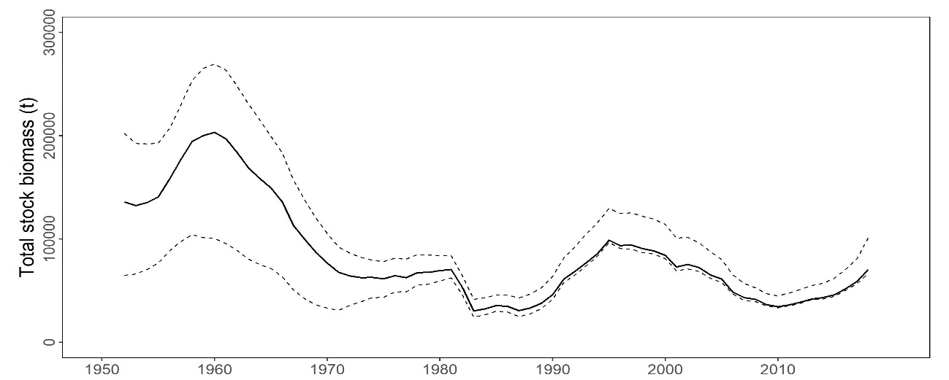

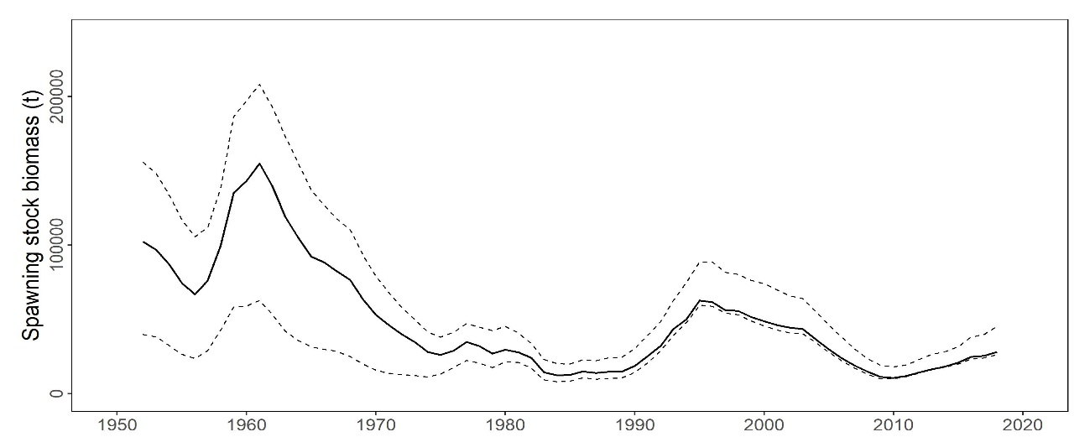

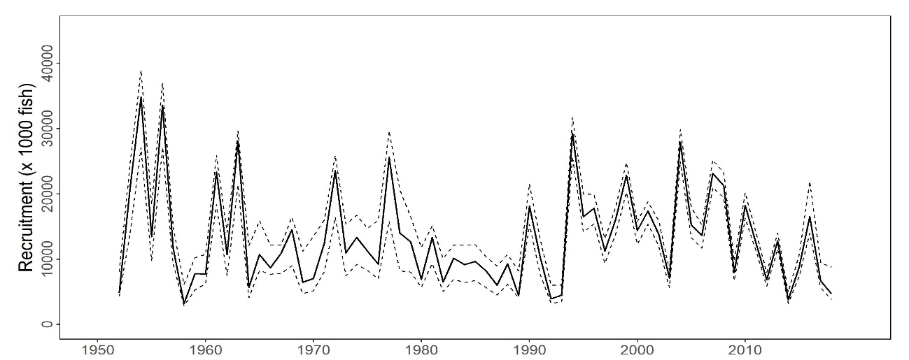

**Figure PBF-1.** Total stock biomass (top), spawning stock biomass (middle), and recruitment (bottom) of Pacific bluefin tuna (*Thunnus orientalis*) (1952-2018) estimated from the base-case model. The solid line is the point estimate and dashed lines delineate the 90% confidence interval.

**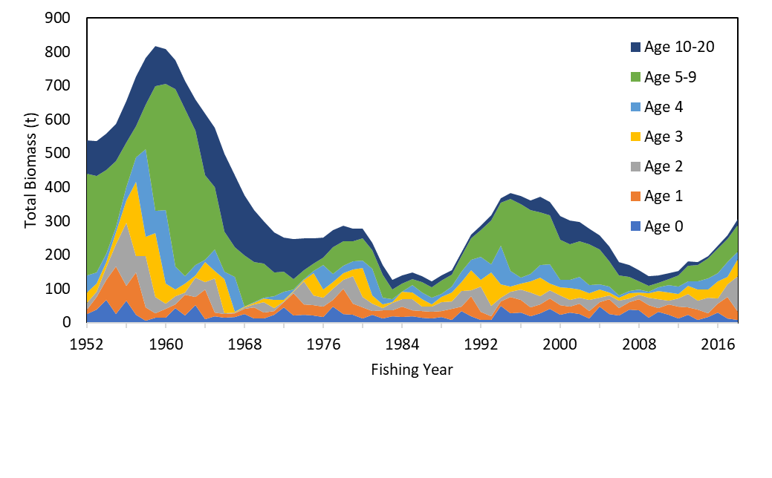**

**Figure PBF-2.** Total biomass (tonnes) by age of Pacific bluefin tuna (*Thunnus orientalis*) estimated from the base-case model (1952-2018).

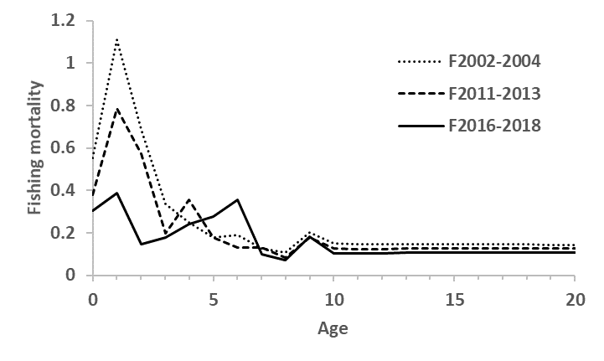

**Figure PBF-3.** Geometric means of annual age-specificfishing mortalities (F) of Pacific bluefin tuna (*Thunnus orientalis*) for 2002-2004 (dotted line), 2011-2013 (broken line) and 2016-2018 (solid line).

**Table PBF-2.** Ratios of the estimated fishing mortalities (Fs and 1-SPRs for 2002-04, 2011-13, 2016-18) relative to potential fishing mortality-based reference points, and terminal year SSB (t) for each reference period, and depletion ratios for the terminal year of the reference period for Pacific bluefin tuna (*Thunnus orientalis*) from the base-case model**.** Fmax: Fishing mortality (F) that maximizes equilibrium yield per recruit (Y/R). F0.1: F at which the slope of the Y/R curve is 10% of the value at its origin. Fmed: F corresponding to the inverse of the median of the observed R/SSB ratio. Fxx%SPR: F that produces given % of the unfished spawning potential (biomass) under equilibrium condition.



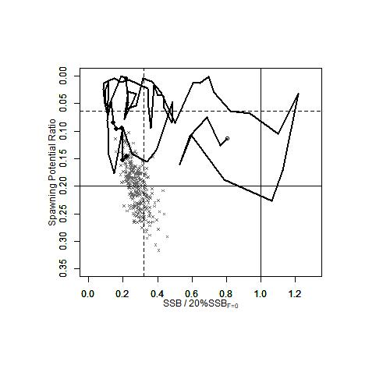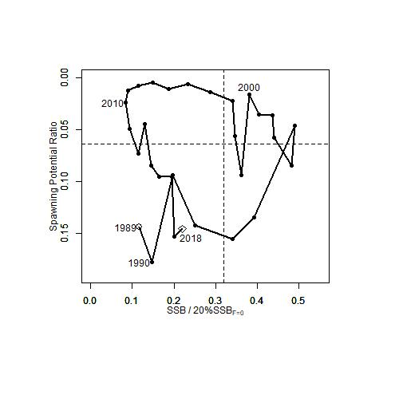

**Figure PBF-4.** Kobe plots for Pacific bluefin tuna (*Thunnus orientalis*) estimated from the base-case model. The X-axis shows the annual SSB relative to 20%SSBF=0 and the Y-axis shows the spawning potential ratio (SPR) as a measure of fishing mortality. Vertical and horizontal solid lines in the left figure show 20%SSBF=0 (which corresponds to the second biomass rebuilding target) and the corresponding fishing mortality that produces SPR, respectively. Vertical and horizontal broken lines in both figures show the initial biomass rebuilding target (SSBMED = 6.4%SSBF=0) and the corresponding fishing mortality that produces SPR, respectively. SSBMED is calculated as the median of estimated SSB over 1952-2014. The left figure shows the historical trajectory, where the open circle indicates the first year of the assessment (1952), solid circles indicate the last five years of the assessment (2014-2018), and grey crosses indicate the uncertainty of the terminal year estimated by bootstrapping. The right figure shows the trajectory of the last 30 years.

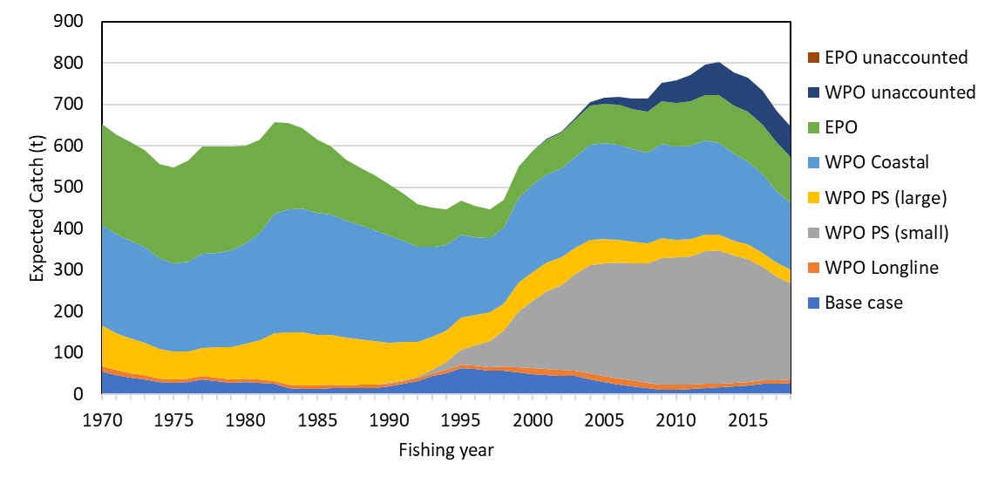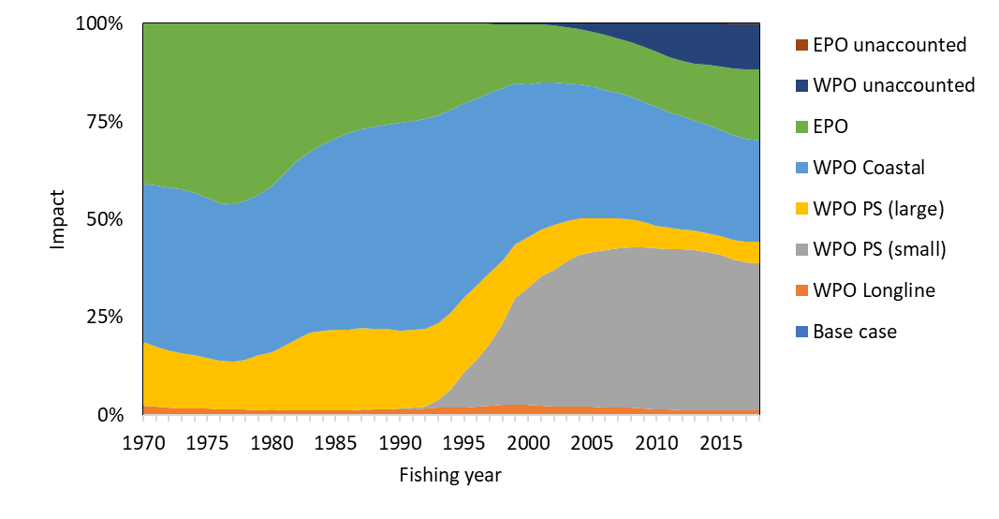

**Figure PBF-5.** The trajectory of the spawning stock biomass of a simulated population of Pacific bluefin tuna (*Thunnus orientalis*) when zero fishing mortality is assumed, estimated by the base-case model. (top: absolute SSB, bottom: relative SSB). Fisheries group definition; WPO longline fisheries: F1, F12, F17, 23. WPO purse seine fisheries for small fish: F2, F3, F18, F20. WPO purse seine fisheries for large fish: F4, F5. WPO coastal fisheries: F6-11, F16, F19. EPO fisheries: F13, F14, F15, F24. WPO unaccounted fisheries: F21, 22. EPO unaccounted fisheries: F25. For exact fleet definitions, please see the 2020 PBF stock assessment report on the ISC website.

**Table PBF-3.** Future projection scenarios for Pacific bluefin tuna (*Thunnus orientalis*) and their probability of achieving various target levels by various time schedules based on the base-case model.



\* The numbering of Scenarios is different from those given by the IATTC-WCPFC NC Joint WG meeting and same as Table 3.

\* Recruitment is switched from low recruitment during 1980-1989 to average recruitment over the whole assessment period in the following year of achieving the initial rebuilding target.

**Table PBF-4.** Expected yield for Pacific bluefin tuna (*Thunnus orientalis*) under various harvesting scenarios based on the base-case model.



\* Catch limits for EPO commercial fisheries are applied for the catch of both small and large fish made by the fleets.

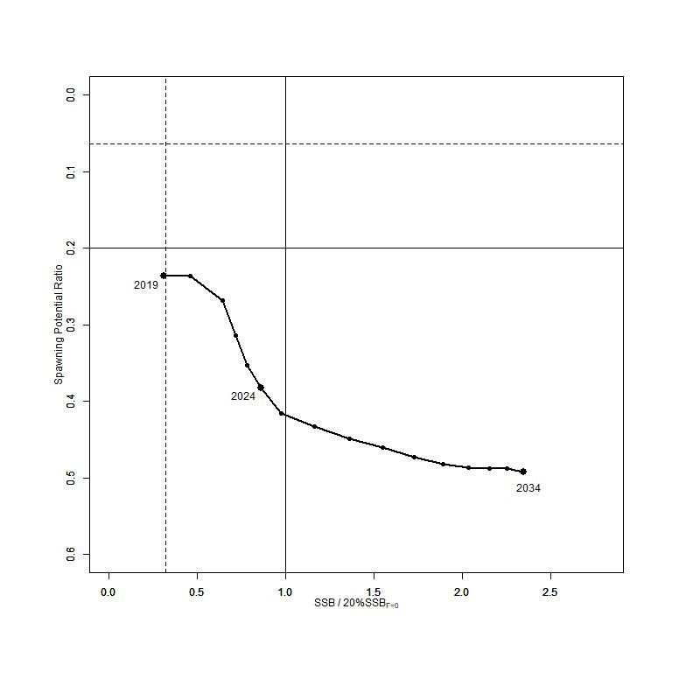

**Figure PBF-6**. “Future Kobe Plot” of projection results for Pacific bluefin tuna (*Thunnus orientalis*) from Scenario 1 from Table PBF3.

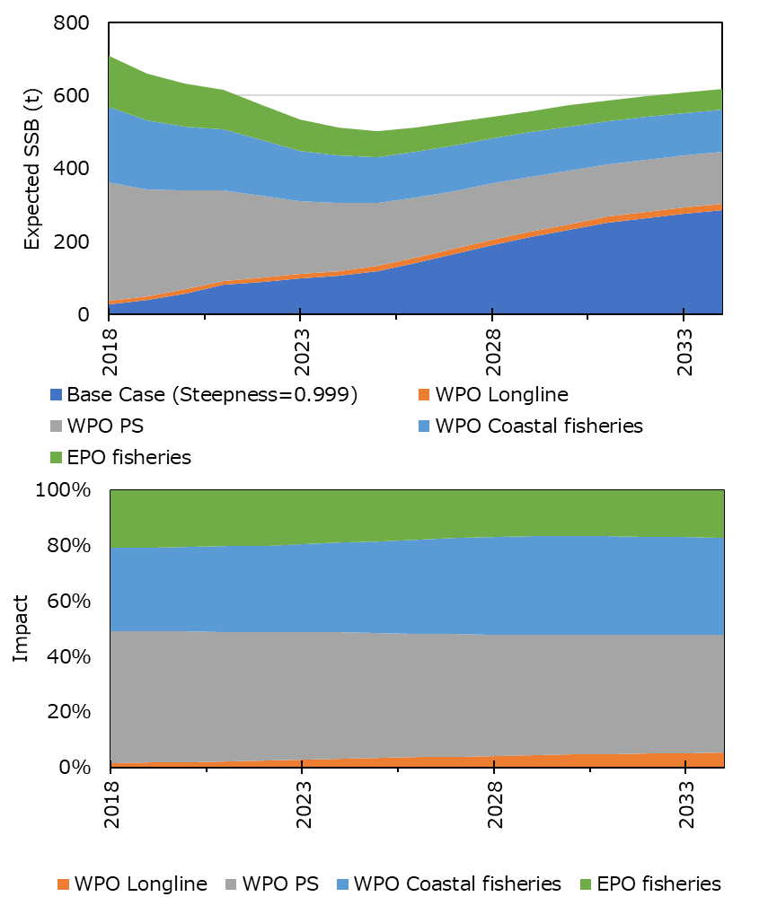

**Figure PBF-7**. “Future impact plot” from projection results for Pacific bluefin tuna (*Thunnus orientalis*) from Scenario 1 of Table S-3. The impact is calculated based on the expected increase of SSB in the absence of the respective group of fisheries.

**3.6 Other Stock Assessment Issues**

**3.6.1 Structural Uncertainty Grids and Projections**

**Recommendations**

1. For species that have assessments that consider axes of uncertainty in a grid approach, the Scientific Services Provider and CCMs should develop objective criteria to quantitatively evaluate the inclusion of axes and respective weighting within each axis to characterize stock status uncertainty. These should be discussed at the SPC pre-assessment workshop.
2. The Scientific Services Provider and CCMs should develop criteria to illustrate a relevant sub-set of diagnostics for all assessment models within the relevant uncertainty grid.
3. For stock assessment projections, provide median estimates of F/FMSY, SB/SBF=0, the risk of breaching an adopted LRP and the probability of being below any interim TRP, at 10 year increments from the beginning of the projection time period.
4. SC16 recommends that the Scientific Services Provider and CCMs should develop criteria to illustrate a relevant sub-set of diagnostics for all assessment models within the relevant uncertainty grid. The Scientific Services Provider and CCMs should develop objective criteria to quantitatively evaluate the inclusion of axes and respective weighting within each axis to characterize stock status uncertainty. This includes the development of standard protocols for weighting alternative models in the ensemble model approach used for stock assessments and management advice. The goal is to develop an objective procedure to down-weigh poorly fitting models and up-weight well-predicting models. To accomplish this, SC16 recommends that the Scientific Services Provider and CCMs hold workshop(s) to develop standard protocols for model weight calculations for assessments that use an uncertainty grid.

**3.6.2 Peer Review**

**Recommendations**

1. SC16 supports an external expert peer review of the yellowfin stock assessment. This would also allow several components of the bigeye tuna assessment to be reviewed given the similar data input structure. This review would examine a number of issues such as model complexity, weighting of data sources, spatial approaches and the extreme sensitivity to assumptions on growth amongst a range of other issues.
2. SC16 provides the following provisional time-line for an external expert peer review.
3. Year 1 would be set aside to allow the SSP to conduct an initial range of testing and analysis internally focussed on YFT and report these findings to SC17. SC17 to finalize ToRs for the external expert review.
4. Year 2 would be set aside for the SSP to conduct further testing and analysis internally focussed on BET and YFT, following SC17 input, and for the external expert review (commencing at the start of 2022) with the review reporting to SC18.
5. Year 3 would provide updated YFT and BET stock assessments which respond to the review. The two assessments would be reported to SC19.
6. In accordance with this, SC16 identified the external review as a project in the budget (provisionally estimated at $USD 50,000) but with no funding commitment until 2022 and 2023.
7. SC16 also tasked the SSP with preparing a draft terms of reference for the external expert review for the consideration of SC17 which would be informed by their analyses during 2021. The draft terms of reference would give consideration to including the bigeye stock assessment in the external review process.
8. Further, SC16 noted that peer review experts of the required calibre may not be easy to secure, thus efforts should be made during late 2020/early 2021 to have them express interest and availability.

**3.6.3 Stock Assessment Schedule**

**Recommendation**

1. SC16 recommended inquiring with the IATTC regarding the potential scheduling for a collaborative Pacific-wide bigeye tuna, south Pacific albacore and south Pacific swordfish assessment. Initial correspondence from the IATTC indicated that their scheduling of stock assessments would occur during the 2020 Scientific Advisory Committee.

**Table 1.** WCPFC provisional assessment schedule 2021-2025 as discussed in the Plenary session. In the schedule, Tuna are scheduled for assessment every 3 years; swordfish every 4 years; and sharks and other billfish every 5 years.

| Species | Stock | Last assessment | 2021 | 2022 | 2023 | 2024 | 2025 |
| --- | --- | --- | --- | --- | --- | --- | --- |
| Bigeye tuna | WCPO | 2020 |  |  | X |  |  |
| Pacific | 2015 | X? |  |  |  |  |
| Skipjack tuna | WCPO | 2019 |  | X |  |  | X |
| Yellowfin tuna | WCPO | 2020 |  |  | X |  |  |
| Albacore | S Pacific | 2018 | X |  |  | X |  |
| N Pacific | 2020 |  |  | X |  |  |
| Pacific bluefin | N Pacific | 2020 |  | X |  | X |  |
| Striped marlin | SW Pacific | 2019 |  |  |  | X |  |
| NW Pacific | 2019 |  |  |  | X |  |
| Swordfish | SW Pacific | 2017 | X |  |  |  |  |
| N Pacific | 2018 |  | X |  |  |  |
| Pacific blue marlin | Pacific |  | X |  |  |  |  |
| Silky Shark | WCPO | 2018 |  |  | X |  |  |
| Oceanic whitetip shark | WCPO | 2019 |  |  |  |  |  |
| Blue shark | S Pacific | 2016 | X |  |  |  |  |
| N Pacific | 2017 |  | X |  |  |  |
| Mako | N Pacific | 2018 |  |  | X |  |  |
|  | SW Pacific |  |  | X |  |  |  |
| Bigeye thresher | Pacific | 2017 |  |  |  |  |  |
| Porbeagle | S Pacific | 2017 |  |  |  |  |  |

1. **MANAGEMENT ISSUES THEME**
   1. **Development of the Harvest Strategy Framework for key tuna species**
      1. **Target reference points**
         1. **Bigeye and yellowfin tuna**
2. Noting the request from WCPFC16 for the Scientific Committee to provide advice on the formulation of TRPs for bigeye and yellowfin tuna, and for the Scientific Service Provider to conduct an analysis for bigeye and yellowfin tuna similar to that undertaken in working paper WCPFC16-2019-14 (Current and projected stock status of WCPO skipjack tuna to inform consideration of an updated target reference point), as outlined in para. 273-275 of the WCPFC16 Summary Report, SC16 reviewed SC16-MI-WP-01 and requested the Scientific Services Provider undertake the analyses for bigeye and yellowfin tuna according to the criteria outlined in the table below:

|  |  |
| --- | --- |
| Issue | Requested Scenario |
| Model settings and the uncertainty grid | The SC16 agreed structural uncertainty grid. |
| Additional scenarios | To use both short- and long-term recruitment for bigeye tuna. |
| The range of candidate TRPs to be explored: | There are some advantages to defining candidate target stock depletion relative to the average biomass within a recent time period. This is consistent with the approach taken for development of the South Pacific Albacore interim TRP and serves to “future proof” the candidate TRP from changes in the biomass time series that have been noted with updated assessments. Specifying a time period also allows reference to some fisheries performance metrics within that period, such as CPUE.  The following candidate TRPs are specified:   * Average SB/SBF=0 for 2012-2015 (consistent with the Aims of CMM-2018-01) * 10% above Average SB/SBF=0 for 2012-2015 * 10% below Average SB/SBF=0 for 2012-2015 * TRPs at intermediate steps between the candidates outlined above (e.g. at 5% intervals) were also recommended. * An alternative TRP based on the average SB for 2000-2004 should also be explored. * Additional candidate TRPs can be identified in terms of the risk of breaching the LRPs; in particular: the SB/SBF=0 levels associated with 10% and 20% risks of breaching the LRP based on an updated analysis using the SC16 adopted structural uncertainty grid. |
| Time period of the projections | 30 years, consistent with the earlier skipjack analyses. Intervals of 10 years will be presented within this period. The rationale is to have a period to allow the population to reach equilibrium. |
| Use of catch or effort | * PS – effort * LL – catch * Other fisheries – catch   SC16 noted that this is for the purposes of these analyses and without prejudice to preferred management arrangements. |
| The baseline catch and effort levels | A recent period is preferable because it is more relevant to recent activity levels and also a more realistic reflection of IND/PHI fisheries catches. |
| Limits to the range of the fishery scalars | SC16 noted that if scalars are too constrained then it might not be possible to achieve the different biomass TRP levels and some guidance on this issue was sought from the SSP.  Scalars would be applied equally to purse seine effort and longline catch. For other fleets, recent catch levels would be assumed. SC16 also noted that this is an exploratory exercise to see what the consequences could be for different TRP choices and not a management recommendation that sets up any kind of precedent. |
| Reporting the output of the analysis: | Similar outputs to the skipjack work reported in WCPFC16-2019-14.  In addition, SC16 recommended reporting against the Aims of CMM-2018-01 paras 12 and 14 being “average SB/SBF=0 for 2012-2015”.  SC16 also noted the request from one CCM that the Scientific Service Provider produce information on the projected yield per recruit and spawning biomass per recruit under the various harvest scenarios. |

1. Noting the large number of scenarios included in the above request, possible analytical challenges that may arise, and the heavy workload of the Scientific Service Provider due to other requests, the following priority was placed on the TRPs to be evaluated.
2. The initial average and +/- 10% proposal (3 scenarios)
3. The additional runs for 10% and 20% risk and the average SB for 2000-2004 (3 scenarios)
4. Intermediate values based upon the results of the above work (e.g., 2-5 scenarios)
5. SC16 recommends that the above analyses be completed by the Scientific Service Provider and a paper summarizing both the analyses undertaken and the tentative results be forwarded to the TCC16 and final results to WCPFC17.
   * + 1. **Skipjack tuna**
6. Noting the request from WCPFC16 to revise the working paper WCPFC16-2019-15 using candidate interim skipjack TRPs of 42%,44%, 46%, 48% and 50% of SB/SBF=0 (para. 259 of the WCPFC16 Summary Report) SC16 reviewed SC16-MI-WP-02 and noted the following:
7. In response to a query from one CCM as to whether based on the presented results that the TRP could be changed from the current interim 50% SB/SBF=0 TRP to a lower level, the Scientific Services Provider noted that 50% SB/SBF=0 was the equilibrium depletion level achieved when projecting under 2012 effort levels from the 2016 skipjack assessment, and was equivalent to the 2012 stock status identified in that assessment. Using the 2019 stock assessment, and performing the same analysis, a TRP of 42% SB/SBF=0 would be consistent with this logic (i.e. would be achieved in the equilibrium under 2012 effort levels and was equivalent to 2012 stock status). In response to a related question as to why 2012 was chosen as the reference year given that catches were made available in recent years in ID, PH and VN, the Scientific Services Provider informed SC16 that as part of this analysis the increased catch levels in these countries in recent years had been included.
8. One CCM noted that in CMM-2018-01 the interim management objective adopted was using the 2012-2015 average as the base line years and requested that an additional table be included in the working paper based on an analysis using these reference years. Another CCM also requested that an indication of the recent effort levels relative to the 2012 effort also be included.
9. In response to a request from one CCM to make the projections based on recent fisheries mortality rather than the 2012 effort (i.e. number of PS sets), the Scientific Services Provider noted that this may be difficult but would investigate the possibility of doing so.
10. Noting the additional requests from WCPFC16 for advice on the formulation of TRPs for skipjack tuna and effort creep estimated in relation to the TRPs (para. 258 of the WCPFC16 Summary Report), SC16 noted that advice pertaining to these requests are also contained in SC16-MI-WP-02.
11. SC16 recommends that SC16-MI-WP-02 be revised to include the additional analyses requested in (ii) and (iii) above, and that this revised paper be forwarded to WCPFC17.
12. SC16 recommends that the Commission take into consideration the information contained in this revised paper when discussing a TRP for skipjack tuna.
    * 1. **Performance indicators, monitoring strategy, harvest control rules and management strategy evaluation**
13. Noting the request by WCPFC16 to review the progress on the technical development of WCPFC harvest strategies for the key WCPO tuna stocks, SC16 reviewed SC16-MI-WP-03 and received a very brief summary of ten (10) related Information Papers (SC16-MI-IP-01 to SC16-MI-IP-10) and provides the following advice to the Commission:
14. SC16 noted the difficulties in structuring the discussions for this large amount of work due to the virtual nature of the meetings format.
15. SC16 also noted the constraints that COVID-19 has had on ongoing capacity building with the result that not all CCMs were as well placed as they would have liked to have been to provide feedback on all aspects of this work.
16. Despite these limitations, SC16 welcomed the work presented by the Science Service Provider on skipjack management procedures and the south pacific albacore MSE framework.
17. SC16 noted that the Operating Model for skipjack tuna had been updated to take account of the updated assessment presented in 2019 and that there were no substantial changes between the model outputs compared to those from the previous model.
18. In response to a question about how and when the elements of the Operating Models for skipjack and SP-albacore would be agreed and adopted to allow testing of Management Procedures (MPs) under a final set of diagnostics, SC16 noted that with further input from CCMs over the coming year (see recommendations below) that adoption of the Operating Models could be undertaken at SC17 with the review of a final suite of MPs to be undertaken by SC18. This would align with the schedule for the adoption of a MP for both skipjack and South Pacific albacore as outlined in the current Harvest Strategy Workplan.
19. SC16 noted that the current Operating Model for skipjack conditioning includes an additional growth element that was not included in the previous model, and there may be a need to expand the grid of uncertainties in relation to the occurrence of exceptional circumstances.
20. One CCM noted the need for Performance Indicators (PI) for the impact on small-scale fisheries, but SC16 was informed that currently it would be difficult to include these fisheries within the Operating Model and unless further information/data pertaining to these fisheries is provided the development of a PI (or a proxy) would also be difficult.
21. Several CMMs also noted the need for a PI to meet requirements of para 12 in CMM 2014-06 (Harvest Strategy CMM), specifically to avoid overfishing and not to transfer a disproportionate burden to developing state parties and territories. They also noted that while such a PI may not be informative in the skipjack MSE it was seen as critical in the multispecies framework. The Scientific Services Provider advised SC16 that input from members on alternative PI options to be included within the framework was welcome.
22. SC16 noted the inclusion of a length-based indicator in the suite of empirical Harvest Control Rules (HCRs) tested for South Pacific albacore and that this had been undertaken to explore different ways of constructing a HCR using empirical data approaches that are not based on CPUE. The limitations of such length-based indicators were noted. SC16 also noted that unless effort creep can be accounted for, the utility of empirical HCRs that are CPUE-based can also be compromised. SC16 noted that model-based approaches might also be appropriate.
23. In relation to the multispecies approach being developed, SC16 noted that it may not be possible to achieve all the TRPs at the same time, and mixed fisheries harvest strategies may lead to one or two stocks being fished above or below the TRP. The Scientific Services Provider advised SC16 that options to support discussion on such issues will be developed within the mixed fishery framework.
24. Noting the key findings and challenges summarised above, SC16 provides the following advice and recommendations to the Scientific Services Provider (SSP) and the Commission:
25. SC16 recommends that WCPFC17 note the progress on the development of the Harvest Strategy Workplan as outlined in SC16-MI-WP-03 (and related Information Papers) and provide additional elements, if any, as specified in the Harvest Strategy Workplan to further progress this work against the scheduled timelines noted in this Workplan.
26. Noting that the virtual SC16 meeting had not provided enough time to consider the ten information papers (SC16-MI-IP-01 to SC16-MI-IP-10) related to the progress of developing the WCPFC harvest strategy framework, and the ongoing needs of the SSP to get further feedback from CCMs on this work, SC16 agreed to continue discussions on these ten papers through the WCPFC Online Discussion Forum (ODF). The purpose of the ODF would be to:
27. facilitate feedback on technical aspects related to the issues covered by the ten information papers presented to SC16;
28. enable CCMs to make suggestions to the SSP on alternative HCRs to consider;
29. get benefit from participant’s feedback on the progress on the SSP’s work;
30. assist with the mutual understanding of this work; and
31. assist with capacity building of the participants.

The ODF should remain open for as long as required.

1. SC16 noted that this ODF activity is outside of the Scientific Committee and any discussions on this ODF will not constitute formal recommendations to the Commission or the SSP.
2. SC16 also noted that given the large range of technical issues included in the ongoing development of the WCPFC harvest strategy framework, and limitations for the SC to undertake a thorough review of these issues, that progress on many of the technical aspects related to this framework would be enhanced through an intersessional workshop, which could be held in conjunction with the annual Pre-Assessment Workshop (PAW) hosted by the SSP. Like the PAW, the aim is for this workshop to be a technical meeting of scientists who have a common interest in providing feedback to the SSP on technical issues related to the development of the harvest strategy framework. The outcomes of the meeting would be documented, and the report of the meeting and other analyses would be submitted to the WCPFC Scientific Committee either as a stand-alone paper or within other relevant papers. SC16 requests the Commission to consider the utility of holding such a workshop.
3. Finally, noting that the development of the WCPFC harvest strategy framework is reaching a mature stage, and the increasing number of issues that require the attention of, and feedback from, managers in order to progress the Harvest Strategy Workplan, SC16 again reiterates its previous recommendations for a Science-Management Dialogue to be convened. In addition, SC16 calls attention to the importance of such a dialogue to ensure the input of managers and stakeholders to the MSE process and to ensure timely execution of the Commission’s harvest strategies workplan.
   1. **Implementation of CMM 2018-01**
      1. **Effectiveness of CMM-2018-01**
4. To provide additional information to the Commission on options for CMM-2018-01, SC16 recommends that the Scientific Services Provider provide to the Commission as early as reasonable, the following:
5. Any updates to SC15-MI-WP01, “minimum target reference points for WCPO yellowfin and bigeye tuna consistent with alternative LRP risk levels, and multispecies implications,” and the following additions to the deterministic projections in Figure 3a and 3b for bigeye tuna (and to Figures 2a and 2b for yellowfin tuna if possible) (as in the original paper, the PS scalar should scale overall PS fishing effort, including both associated and unassociated fishing effort):
   1. Inclusion on the x axis (PS scalar) and y axis (LL scalar) of the absolute quantities that correspond to the scalars (for PS scalar, numbers of both associated sets and unassociated sets, and for LL scalar, longline catch in mt).
   2. Inclusion on the x axis and y axis of the expected fishery impact of the sector on SSB (SB2045/SBF=0) that correspond to the scalars, assuming the other sectors’ (e.g., pole-and-line and other) impacts are as they were in 2013-2015, on average.
   3. Extension of the ranges of the x and y axes to scalars as high as 2.0 (from 1.5).
   4. Indications of the expected PS scalars for the purse seine management regime under CMM 2018-01.
6. One or more tables showing as long a time series as possible, of fishery impact on WCPO bigeye tuna SSB, by fishery sector (for just the diagnostic case, and including at a minimum: longline, purse seine associated, purse seine unassociated, pole-and-line, and other).
7. **FUTURE WORK PROGRAMME AND BUDGET**
   1. **Development of the 2021 work programme and budget, and projection of 2022-2023 provisional work programme and indicative budget** 
      1. **Progress of 2020 SC projects**
8. SC16 adopted the *2021 – 2025 Shark Research Plan* and recommended it to the Commission for endorsement.
   * 1. **Introduction to new and follow-up projects**
     2. **Work programme and budget for** **2021-2023**
9. SC16 agreed to resume SC16 meeting prior to WCPFC17 to discuss and finalize the SC work programme and budget for 2021, and provisional work programme and indicative budget for 2022-2023. It was agreed that the Secretariat would inform CCMs of the details of the Resume SC16 Meeting through a circular.
   * + 1. **Outcomes of the Resume SC16 Meeting**
10. SC16 agreed that the 2021 scientific services from SPC would comprise (i) the South Pacific albacore stock assessment; (ii) the Southwest Pacific swordfish stock assessment; and (iii) additional analyses related to yellowfin tuna in preparation for the stock assessment peer review.
11. SC16 adopted the proposed work programme and budget for 2021 and indicative budget for 2022 – 2023 (Table 1) and forwarded it to the Commission.

**Table 1.** Summary of SC work programme titles and budget for 2021, and indicative budget for 2022–2023, which requires funding from the Commission’s core budget (USD).

| **Project Title** | **TOR** | **Essential** | **Priority Rank** | **2021** | **2022** | **2023** |
| --- | --- | --- | --- | --- | --- | --- |
| SPC-OFP scientific services |  | Yes | High 1 | 943,014 | 961,875 | 981,112 |
|  |  |  |  |  |  |  |
| SPC Additional resourcing |  | Yes | High 1 | 169,810 | 173,206 | 176,670 |
| P35b. WCPFC Tissue Bank | SC15-Att.G | Yes | High 1 | 101,180 | 103,204 | 105,268 |
| P42. Pacific Tuna Tagging Program | SC15-Att.G | Yes | High 1 | 730,000 | 730,000 | 730,000 |
| P60. PS Species Composition | SC15-Att.G | No |  | 40,000 |  |  |
| P65. Peer review of stock assessment modelling (bigeye and yellowfin tuna) | SC17 |  |  |  | 50,000 |  |
| P68. Seabird mortality | SC15-Att.G | No | High 2 |  | 75,000 |  |
| P88. Acoustic FAD analyses | SC15-Att.G |  | High 2 | 15,000 |  |  |
| P90. Length weight conversion | SC15-Att.G | No | High 2 | 20,000 | 75,000 |  |
| P100b. Feasibility of Close-Kin Mark-Recapture assessment for South Pacific albacore in the WCPO | SC16-GN-IP-08 |  | High 2 | 0 |  |  |
| P101. Monte Carlo simulations - shark mitigation | SC15-Att.G |  | High 1 |  |  |  |
| P102. Population projections for oceanic whitetip shark | SC15-Att.G |  | High 1 |  |  |  |
| P104. Appropriate LRPs for Southwest Pacific Ocean striped marlin and other billfish | SC16-GN-IP-08 |  | High 1 | 31,000 |  |  |
| P105. Bomb radiocarbon age validation for bigeye and yellowfin tunas in the WCPO | SC16-GN-IP-08 |  | High2 | 97,980 |  |  |
| P106. Ageing of South Pacific albacore | SC16-GN-IP-08 |  | High 1 | 0 |  |  |
| P107. SP blue shark assessment | SC16-GN-IP-08 |  | High 2 | 20,000 |  |  |
| P108. WCPO silky shark assessment | SC16-GN-IP-08 |  |  |  | 100,000 |  |
| P109. Training observers for elasmobranch biological sampling | SC16-GN-IP-08 |  | High 1 | 25,000 |  |  |
| P110. Non-entangling and biodegradable FADs |  |  | High 1 | 0 |  |  |
| **Total Project Budget** |  |  |  | **1,249,970** | **1,306,409** | **1,011,938** |
| **Total Budget with SPC-SSA** |  |  |  | **2,192,984** | **2,268,284** | **1,993,050** |

**5.2 Streamlining Annual Reporting**

**Recommendations**

1. SC16 noted the updates on streamlining of annual reporting requirements implemented in 2020 that were provided in SC16-GN-IP-07 *Update on Streamlining of Annual Reporting Initiatives.*
2. SC16 also noted that SC16-GN-IP-07 reviewed the experiences and outcomes of the trial Annual Catch and Effort Estimate (ACE) Tables and has provided information that the cost and resources implications of this trial were modest.
3. SC16 recommends to WCPFC17 that the approach of publishing the ACE tables based on the April 30 Scientific Data submissions and subsequent updates and revisions from CCMs is continued.
4. SC16 recommends that the Scientific Services Provider is tasked to review the feasibility of expanding the ACE Tables, to include additional estimates of effort where it is practicable to be derived based on the April 30 scientific data submissions from CCMs and provide an update to SC17.
5. **ADMINISTRATIVE MATTERS** 
   1. **Future operation of the Scientific Committee**
   2. **Election of Officers of the Scientific Committee**
   3. **Next meeting**
6. SC16 recommended to the Commission that, if circumstances allow an in-person meeting to be convened, SC17 would be held in Palau during 11– 19 August 2021. Tonga offered to host SC18 in 2022.
7. **OTHER MATTERS**
   1. **Review of Online Discussion Forum outputs**
8. SC16 noted the results of the Online Discussion Forum (SC16-ODF-01, *Summary of Online Discussion Forum*), which is included as **Attachment F**.
9. **ADOPTION OF THE SUMMARY REPORT OF THE SIXTEENTH REGULAR SESSION OF THE SCIENTIFIC COMMITTEE**
10. SC16 adopted the recommendations of the Sixteenth Regular Session of the Scientific Committee, with the exception of recommendations relating to the future work programme and budget, which were deferred to the Resume SC16 Meeting to be held prior to WCPFC17.
11. SC agreed that the SC16 Summary Report would be adopted intersessionally according to the following schedule:

|  |  |
| --- | --- |
| **Tentative Schedule** | **Actions to be taken** |
| **19 August** | Close of SC16  By 28 August, SC16 Outcomes Document will be distributed to all CCMs and observers (within 7 working days, Rules of Procedure). |
| **26 Aug – 4 Sep** | Secretariat will receive Draft Summary Report from the rapporteur and clear the report. |
| **4 – 11 Sep** | Theme Convenors will review the report |
| **11 – 18 Sep** | Secretariat will compile all edits from convenors |
| **18 Sep – 30 Oct** | CMMs and Observers review and submit comments to the Secretariat (for 30 working days) |

1. **CLOSE OF MEETING**
2. The SC Chair adjourned SC16 at 1530, Pohnpei time on 19 August 2020, until it could be reconvened to consider issues and recommendations relating to the SC future work programme and budget for 2021–2023. (Refer to Section 5.1.2.1 for the results of the Resume SC16 Meeting)
3. The Chair closed SC16 at 13:02 Pohnpei time on Thursday, 10 September 2020.

1. It should be noted that the constant catch scenario is inconsistent with current management approaches for north Pacific albacore tuna adopted by the Inter-American Tropical Tuna Commission (IATTC) and the Western and Central Pacific Fisheries Commission (WCPFC). [↑](#footnote-ref-1)
2. SPR (spawning potential ratio) is the ratio of the cumulative spawning biomass that an average recruit is expected to produce over its lifetime when the stock is fished at the current fishing level to the cumulative spawning biomass that could be produced by an average recruit over its lifetime if the stock was unfished. F%SPR: F that produces % of the spawning potential ratio. [↑](#footnote-ref-2)