

**The Commission for the Conservation and Management of**

**Highly Migratory Fish Stocks in the Western and Central Pacific Ocean**

**Sixteenth Regular Session of the Scientific Committee**

**Electronic Meeting**

**12–19 August 2020**

**(Reconvened on 10 September 2020)**

**SUMMARY REPORT**

**TABLE OF CONTENTS**

[**EXECUTIVE SUMMARY** iii](#_Toc51131428)

[**SUMMARY REPORT** 1](#_Toc51131429)

[AGENDA ITEM 1 — OPENING OF THE MEETING 1](#_Toc51131430)

[AGENDA ITEM 2 — DATA AND STATISTICS THEME 3](#_Toc51131431)

[AGENDA ITEM 3 — STOCK ASSESSMENT THEME 5](#_Toc51131432)

[AGENDA ITEM 4 — MANAGEMENT ISSUES THEME 67](#_Toc51131433)

[AGENDA ITEM 5 — FUTURE WORK PROGRAM AND BUDGET 82](#_Toc51131434)

[AGENDA ITEM 6 — ADMINISTRATIVE MATTERS 90](#_Toc51131435)

[AGENDA ITEM 7 — OTHER MATTERS 91](#_Toc51131436)

[AGENDA ITEM 8 — ADOPTION OF THE SUMMARY REPORT 91](#_Toc51131437)

[AGENDA ITEM 9 — CLOSE OF MEETING 91](#_Toc51131438)

[ATTACHMENTS 92](#_Toc51131439)

[ATTACHMENT A — LIST OF PARTICIPANTS 92](#_Toc51131440)

[ATTACHMENT B — OPENING REMARKS BY THE WCPFC CHAIRmi 113](#_Toc51131441)

[ATTACHMENT C — OPENING REMARKS BY THE WCPFC EXECUTIVE DIRECTOR 114](#_Toc51131442)

[ATTACHMENT D — AGENDA 116](#_Toc51131443)

[ATTACHMENT E — SHARK ASSESSMENT SCHEDULE 118](#_Toc51131444)

[ATTACHMENT F — SUMMARY OF THE SC16 ONLINE DISCUSSION FORUM 119](#_Toc51131445)

[ATTACHMENT G — SUMMARY OF THE RESUME SC16 ONLINE DISCUSSION FORUM 157](#_Toc51131446)

[ATTACHMENT H — LIST OF ABBREVIATIONS 167](#_Toc51131447)

**The Commission for the Conservation and Management of   
Highly Migratory Fish Stocks in the Western and Central Pacific Ocean**

**Scientific Committee**

**Sixteenth Regular Session**

Electronic Meeting

12 – 19 August 2020

|  |
| --- |
| **EXECUTIVE SUMMARY** |

1. **OPENING OF THE MEETING**
2. The Sixteenth Regular Session of the Scientific Committee of the Commission for the Conservation and Management of Highly Migratory Fish Stocks in the Western and Central Pacific Ocean (SC16) took place for six days during 12–19 August 2020 as an electronic meeting in response to the global coronavirus disease (COVID-19) pandemic. The meeting was chaired by Mr Matai’a Ueta Faasili Jr.(Samoa).
3. The following WCPFC Members, Cooperating Non-members and Participating Territories (CCMs) attended SC16: Australia, Canada, China, Cook Islands, European Union (EU), Federated States of Micronesia (FSM), Fiji, Indonesia, Japan, Kiribati, Republic of Korea, Republic of Marshall Islands (RMI), Nauru, New Zealand, Niue, Palau, Papua New Guinea (PNG), Philippines, Samoa, Solomon Islands, Chinese Taipei, Tonga, Tuvalu, United States of America (USA), Vanuatu, French Polynesia, New Caledonia, Tokelau, Wallis & Futuna, Panama and Vietnam.
4. Observers from the following inter-governmental organizations attended SC16: Inter-American Tropical Tuna Commission (IATTC), Pacific Islands Forum Fisheries Agency (FFA), Parties to the Nauru Agreement (PNA), the Pacific Community (SPC), and the Secretariat of the Pacific Regional Environment Programme (SPREP).
5. Observers from the following non-governmental organizations attended SC16: American Tunaboat Association (ATA), Australian National Centre for Ocean Resources and Security (ANCORS), Birdlife International, Blue Ocean Institute, Conservation International (CI), International Pole and Line Foundation (IPNLF), International Seafood Sustainability Foundation (ISSF), Marine Stewardship Council, Sustainable Fisheries Partnership (SFP) Foundation, The Nature Conservancy (TNC), The Ocean Foundation, The Pew Charitable Trusts (Pew), World Tuna Purse Seine Organisation (WTPO) and the World Wide Fund for Nature (WWF).
6. Tuikolongahau Halafihi, SC Vice-Chair and head of the delegation from Tonga, gave the opening prayer. The WCPFC Chair Jung-re Riley Kim, the WCPFC Secretariat’s Executive Director Feleti P Teo, OBE, and the SC Chair Ueta Jr. Faasili (Samoa) delivered opening and welcome speeches.
7. The conveners and their assigned theme were:

|  |  |
| --- | --- |
| **Themes** | **Conveners** |
| **Data and Statistics** | Valerie Post (USA) |
| **Stock Assessment** | Keith Bigelow (USA) and Hiroshi Minami (Japan) |
| **Management Issues** | Robert Campbell (Australia) |
| **Ecosystem and Bycatch Mitigation** | John Annala (New Zealand) and Yonat Swimmer (USA) |

1. **DATA AND STATISTICS THEME** 
   1. **Data gaps of the Commission**
2. SC16 recommended that updated versions of SC16-ST-WP-01 (Data gaps) and SC16-ST-IP-02 (ROP data management) be forwarded to TCC16 for consideration.
3. **STOCK ASSESSMENT THEME** 
   1. **WCPO bigeye tuna (*Thunnus obesus*)**
      1. **Review of 2020 bigeye tuna stock assessment**
4. N. Ducharme-Barth (SPC-OFP) presented **SC16-SA-WP-03** *Stock assessment of bigeye tuna in* the *western and central Pacific Ocean*, which described the 2020 stock assessment of bigeye tuna *Thunnus obesus*. An additional three years of data were available since the previous assessment in 2017, and the model extends through the end of 2018. New developments to the stock assessment include addressing the recommendations for improved growth modelling made in the 2017 stock assessment report, inclusion of spatiotemporal standardized CPUE implemented using “index” fisheries, updating the length-weight relationship, defining reproductive potential as a function of length, and updates to the preparation of the tagging data.
5. Changes made in the progression from the 2017 to 2020 diagnostic models that influence our perception of bigeye tuna stock status were:

* Changes to the preparation and treatment of the tagging data;
* Improvements to the size frequency data preparation and the switch to the index fishery approach;
* Specifying reproductive potential as a function of length;
* Updating the growth curve to using the fixed values from the tag-integrated model;
* Assuming non-decreasing selectivity for certain longline fisheries.

1. The general conclusions of this assessment are as follows:

* All models in the structural uncertainty grid show WCPO bigeye tuna to be above 20%SBF=0, though a substantial decline was estimated by all models.
* Evidence to suggest that the overall stock status is buffered by the temperate regions.
* The equatorial regions show higher levels of regional depletion with region 7 approaching 20%SBF=0 across models.
* The most pessimistic predictions of overall stock status correspond to models where depletion in the temperate regions is predicted to be high and in some cases approach regional 20%SBF=0.
* Indication that the stock could be at risk of overfishing (3 of 24 models in the structural uncertainty grid had *Frecent/FMSY > 1*).
* Despite all models in the structural uncertainty grid showing WCPO bigeye tuna to be above 20%SBF=0, there is reason for caution given the likely over-parametrization.

1. Due to the constraints originating from the virtual online Scientific Committee forum, the SC16 could not fully engage in a complete discussion of the appropriate choice of models within the uncertainty grid. Due to the lack of an objective way of selecting the preferred elements for weighting the grid, SC16 agreed to use the grid with all models as presented by the Scientific Services Provider. As indicated in research needs, further research on the assessment model, including the peer review, is warranted in developing the next WCPO stock assessment.
2. A number of key research needs were identified in undertaking the assessment that should be investigated either internally or through directed research. These can be broadly grouped into two categories: biological/data-inputs and model complexity. Growth proved to be a source of uncertainty again in the current assessment, however this was not included in the structural uncertainty grid since the outcome from the alternative fixed growth model was not found to be plausible and that the growth model estimated internally to Multifan-CL was not well estimated. Additional modelling is needed to determine the mechanism for the implausible outcomes using the alternative growth model. Further developments to Multifan-CL including a true length-based selectivity definition and increased flexibility in the definition of variability around the growth curve at small sizes could aide this. Further biological samples should also be collected to produce more representative samples of reproductive parameters and length-weight and weight-weight conversion factors. Additionally, a number of recommendations for improving the standardized CPUE are made. This work should focus on incorporating the effects of changes in oceanography on catchability, particularly the effects of sub-surface dissolved oxygen. Efforts should also be made to account for changes in catchability over time beyond hooks-between-floats. There should also be an evaluation of the feasibility of conducting a fishery independent survey across the WCPO to be used as an index of abundance within the stock assessments, and to improve the representativeness of biological samples. Lastly, the authors of the assessment noted that there were a number of indications that the model was likely over-parametrized and overly complex. An external peer review or WCPFC modelling workshop is recommended prior to the next WCPO bigeye tuna stock assessment. This effort should be focused on reducing complexity and improving model fit and diagnostics while balancing biological realism. SC16 recommended that the Scientific Services Provider should take full advantage of the possible pan-Pacific bigeye stock assessment being planned by IATTC, in order to obtain further insights for the stock.
   * 1. **Provision of scientific information**
3. **Stock status and trends**
4. The median values of relative recent (2015-2018) spawning biomass depletion (*SBrecent/ SBF=0*) and relative recent (2014-2017) fishing mortality (*Frecent/FMSY*) over the uncertainty grid of 24 models (Table BET-1) were used to define stock status. The values of the upper 90th and lower 10th percentiles of the empirical distributions of relative spawning biomass and relative fishing mortality from the uncertainty grid were used to characterize the probable range of stock status.
5. A description of the updated structural sensitivity grid used to characterize uncertainty in the assessment is illustrated in Table BET-1. The spatial structure used in the 2020 stock assessment is shown in Figure BET-1. Time series of total annual catch by fishing gear over the full assessment period is shown in Figure BET-2. The time series of total annual catch by fishing gear and assessment region is shown in Figure BET-3. Estimated annual average recruitment, spawning potential, and total biomass by model region is shown in Figure BET-4. Estimated trends in spawning potential by region for the diagnostic case is shown in Figure BET-5, and juvenile and adult fishing mortality rates from the diagnostic model is shown in Figure BET-6. Estimates of the reduction in spawning potential due to fishing by region is shown in Figure BET-7. Time-dynamic percentiles of depletion (SBt/SBt,F=0) for the 24 models are shown in Figure BET-8. A Majuro and Kobe plot summarising the results for each of the 24 models in the structural uncertainty grid are shown in Figures BET-9 and BET-10, respectively. Projections are illustrated in Figures BET-11 and BET-12. Table BET-2 provides a summary of reference points over the 24 models in the structural uncertainty grid.
6. A number of investigative models were run with growth, such as: 1) *Oto-Only*, a growth curve that was a ﬁxed Richards growth curve based on high-readability otoliths, 2) *Tag-Int*: a growth curve that was a ﬁxed Richards growth curve based on the same high-readability otolith data-set in addition to bigeye tuna tag-recapture data, and 3) *Est-Richards*: A conditional age-length data-set was constructed from the combined daily and annual otolith dataset. The *Oto-Only* growth model predicted very high levels of biomass and corresponding low level of depletion. The *Est Richards* growth model showed sensitivity to the initial values given for the estimated growth parameters. The implausible results from the *Oto-Only* growth and differing results from the *Est-Richards* indicate questions still remain regarding bigeye tuna growth.
7. SC16 requested the bigeye tuna assessment to try and fit the data for those small bigeye tuna as they are increasingly caught by domestic fisheries in region 7, but the current diagnostic model does not fit those fish that well because the L1 parameter is larger than most of those fish. SPC could consider additional developments to Multifan-CL to model greater variability in size around the growth curve at small ages.
8. The most inﬂuential grid axis is the size-frequency data-weighting axis and further research is required to develop model diagnostics and objective criteria for model inclusion.

**Table BET-1.** Description of the updated structural sensitivity grid used to characterize uncertainty in the assessment. The starred levels denote those assumed in the model diagnostic case.

|  |  |  |  |  |
| --- | --- | --- | --- | --- |
| **Axis** | **Value 1** | **Value 2** | **Value 3** | **Value 4** |
| Steepness | 0.65 | 0.8 \* | 0.95 |  |
| Natural mortality | Diagnostic\* (0.112) | M-hi  (0.146) |  |  |
| Size frequency weighting | 20\* | 60 | 200 | 500 |

**Table BET-2.** Summary of reference points over the 24 models in the structural uncertainty grid. Note that “recent” is the average over the period 2015-2018 for SB and 2014-2017 for fishing mortality, while “latest” is 2018. The values of the upper 90th and lower 10th percentiles of the empirical distributions are also shown. Fmult is the multiplier of recent (2014-2017) fishing mortality required to attain MSY.

|  |  |  |  |  |  |  |
| --- | --- | --- | --- | --- | --- | --- |
|  | **Mean** | **Median** | **Minimum** | **10th percentile** | **90th percentile** | **Maximum** |
| Clatest | 159,738 | 159,288 | 157,297 | 157,722 | 162,033 | 162,271 |
| YFrecent | 136,568 | 134,940 | 117,800 | 124,668 | 149,424 | 161,520 |
| fmult | 1.45 | 1.38 | 0.83 | 0.98 | 2.03 | 2.33 |
| FMSY | 0.05 | 0.05 | 0.04 | 0.04 | 0.07 | 0.07 |
| MSY | 146,715 | 140,720 | 117,920 | 125,628 | 179,164 | 187,520 |
| Frecent/FMSY | 0.74 | 0.72 | 0.43 | 0.49 | 1.02 | 1.21 |
| SBF=0 | 1,395,173 | 1,353,367 | 903,708 | 982,103 | 1,780,138 | 1,908,636 |
| SBMSY | 320,162 | 321,550 | 192,500 | 219,810 | 443,730 | 482,700 |
| SBMSY/SBF=0 | 0.23 | 0.23 | 0.19 | 0.2 | 0.26 | 0.26 |
| SB latest/SBF=0 | 0.38 | 0.38 | 0.23 | 0.3 | 0.47 | 0.51 |
| SB latest/SBMSY | 1.7 | 1.67 | 0.95 | 1.23 | 2.15 | 2.6 |
| SB recent/SBF=0 | 0.4 | 0.41 | 0.21 | 0.27 | 0.52 | 0.55 |
| SB recent/SBMSY | 1.78 | 1.83 | 0.87 | 1.18 | 2.32 | 2.84 |

**Figure BET-1.** Spatial structure for the 2020 bigeye tuna stock assessment.

**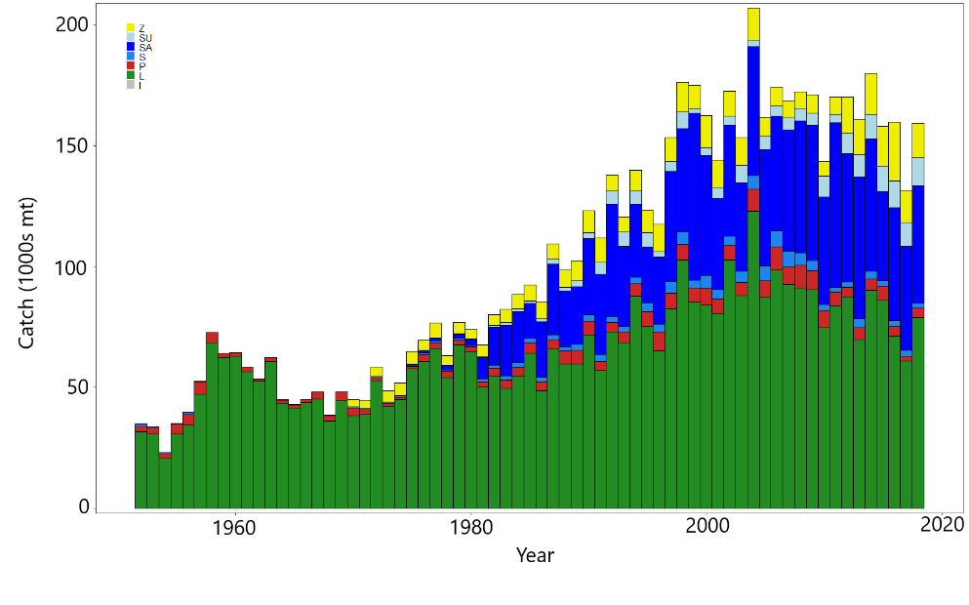**

**Figure BET-2.** Time series of total annual catch (1000s mt) by fishing gear for the diagnostic model over the full assessment period. The different colors refer to longline (green), pole-and-line (red), purse seine (blue), purse seine associated (dark blue), purse seine unassociated (light blue), miscellaneous (yellow), and index (gray). Note that the catch by longline gear has been converted into catch-in-weight from catch-in-numbers and so may differ from the annual catch estimates presented in (Williams et al., 2020), however these catches enter the model as catch-in-numbers.

**Figure BET-3.** Time series of total annual catch (1000s mt) by fishing gear and assessment region for the diagnostic model over the full assessment period. The different colors refer to longline (green), pole-and-line (red), purse seine (blue), purse seine associated (dark blue), purse seine unassociated (light blue), miscellaneous (yellow), and index (gray).

1. Recruitment

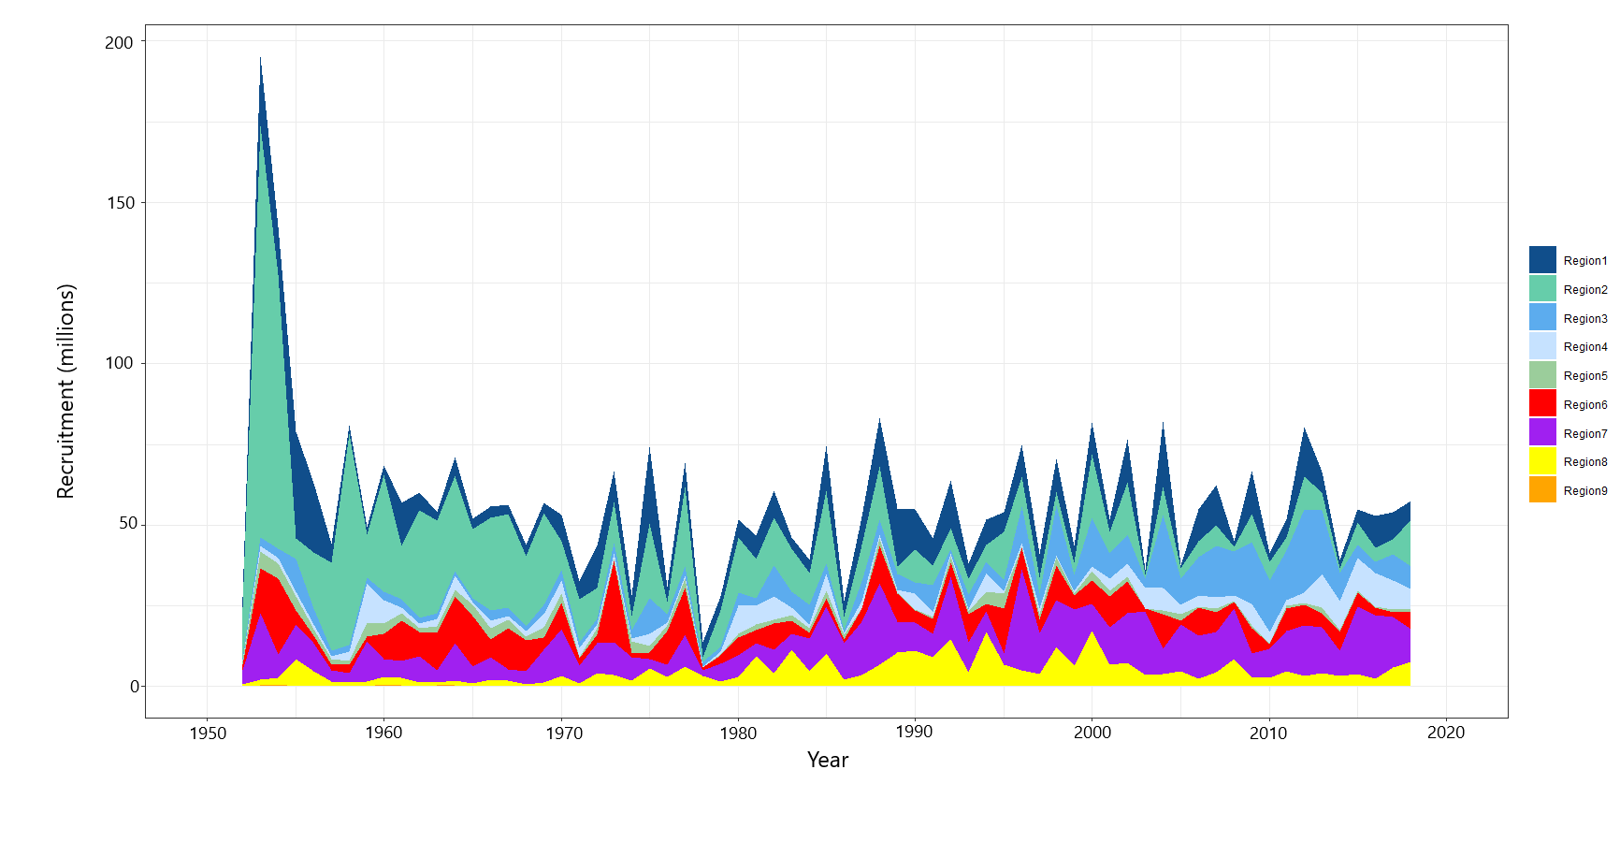

1. Spawning Potential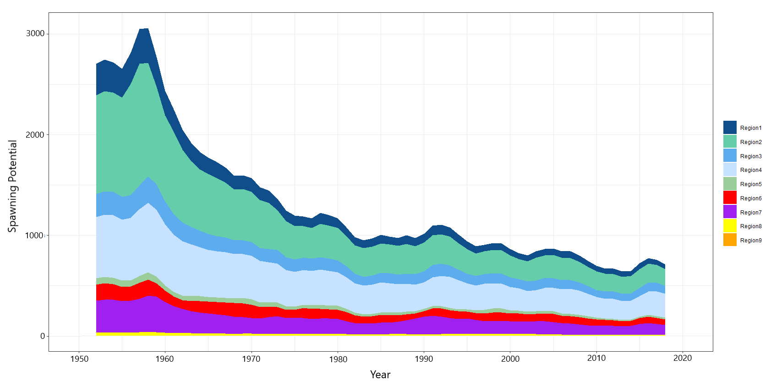
2. Total biomass

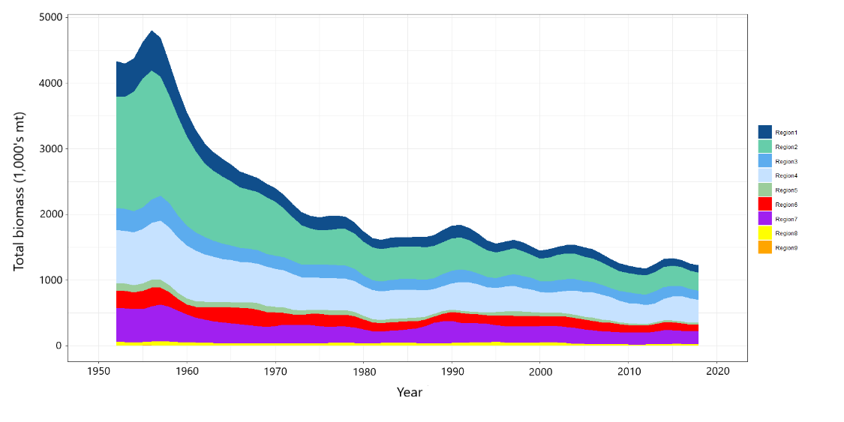

**Figure BET-4.** Estimated (a) annual average recruitment, (b) spawning potential and (c) total biomass by model region for the diagnostic model, showing the relative sizes among regions.

**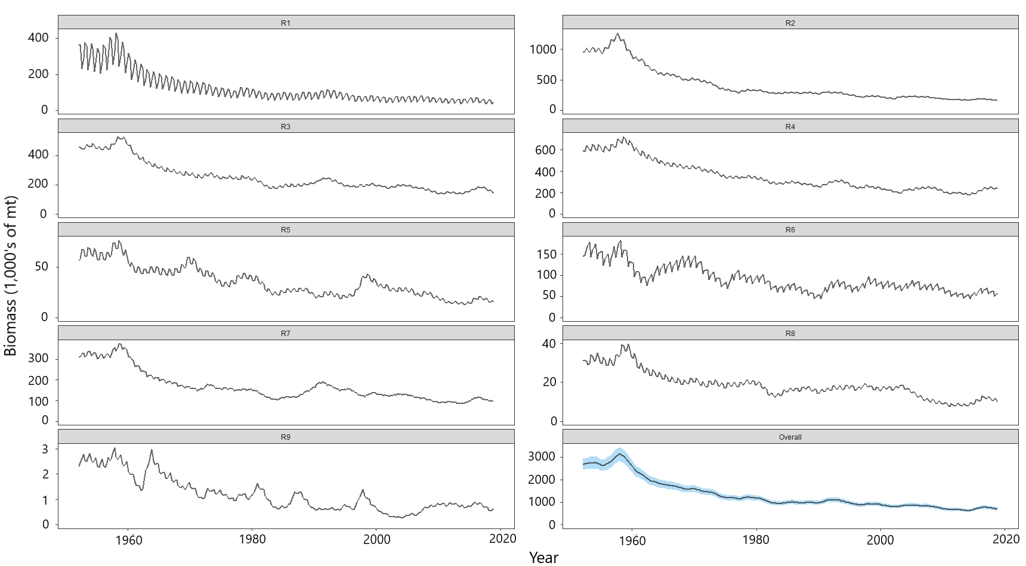**

**Figure BET-5.** Estimated seasonal, temporal spawning potential by model region for the diagnostic model. The asymptotic 95% confidence interval as calculated using the delta-method is shown for the “Overall” region. Note that the scale of the y-axis is not constant across regions.

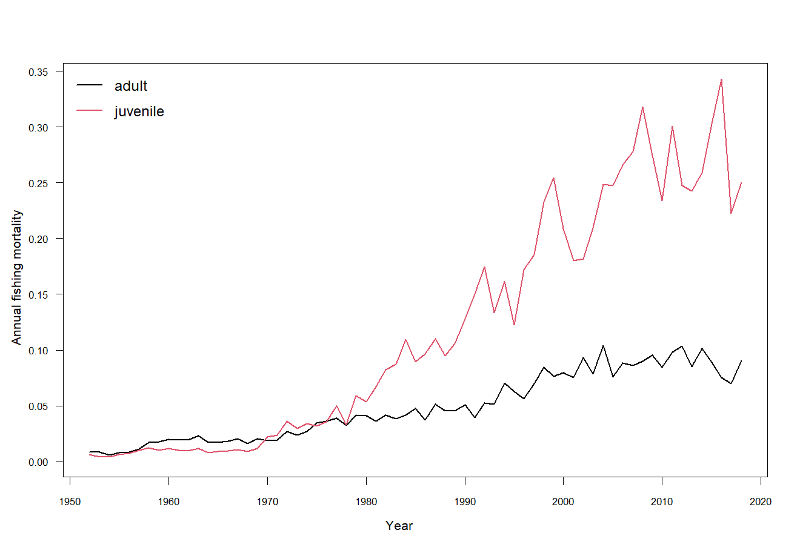

**Figure BET-6.** Estimated annual average juvenile and adult fishing mortality for the diagnostic model.

**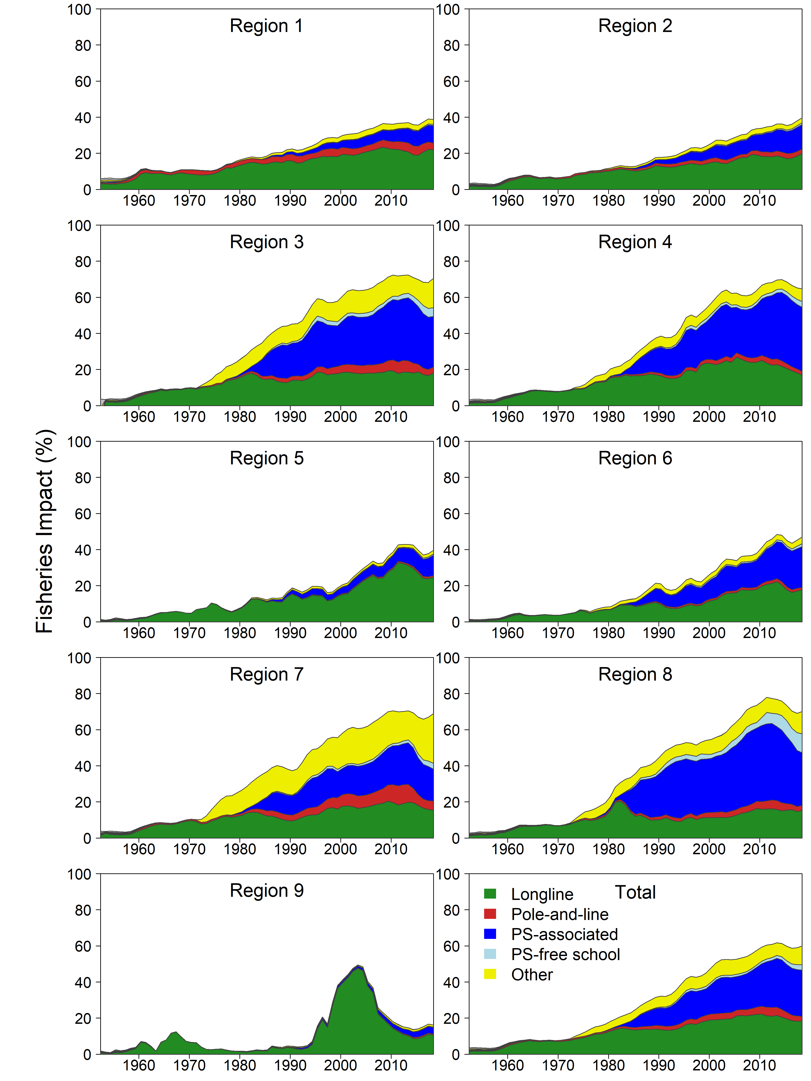**

**Figure BET-7.** Estimates of reduction in spawning potential due to fishing (fishery impact = (1-SBt/SBt;F=0) \* 100%) by region, and over all regions (lower right panel), attributed to various fishery groups for the diagnostic model.

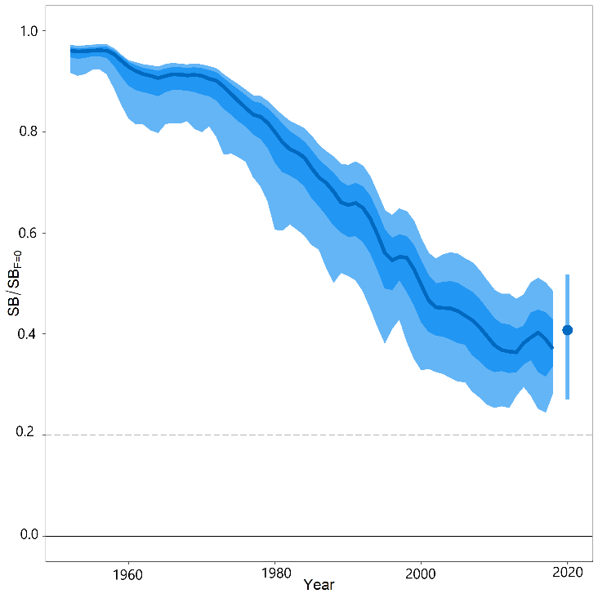

**Figure BET-8.** Time-dynamic percentiles of depletion (SBt/SBt;F=0) and median (dark line) across all 24 models in the structural uncertainty grid. The lighter band shows the 10th to 90th percentiles around the median, and the dark band shows the 50th percentile around the median. The median SBrecent/SBF=0 and 80th percentile is shown on the right by the dot and line.

**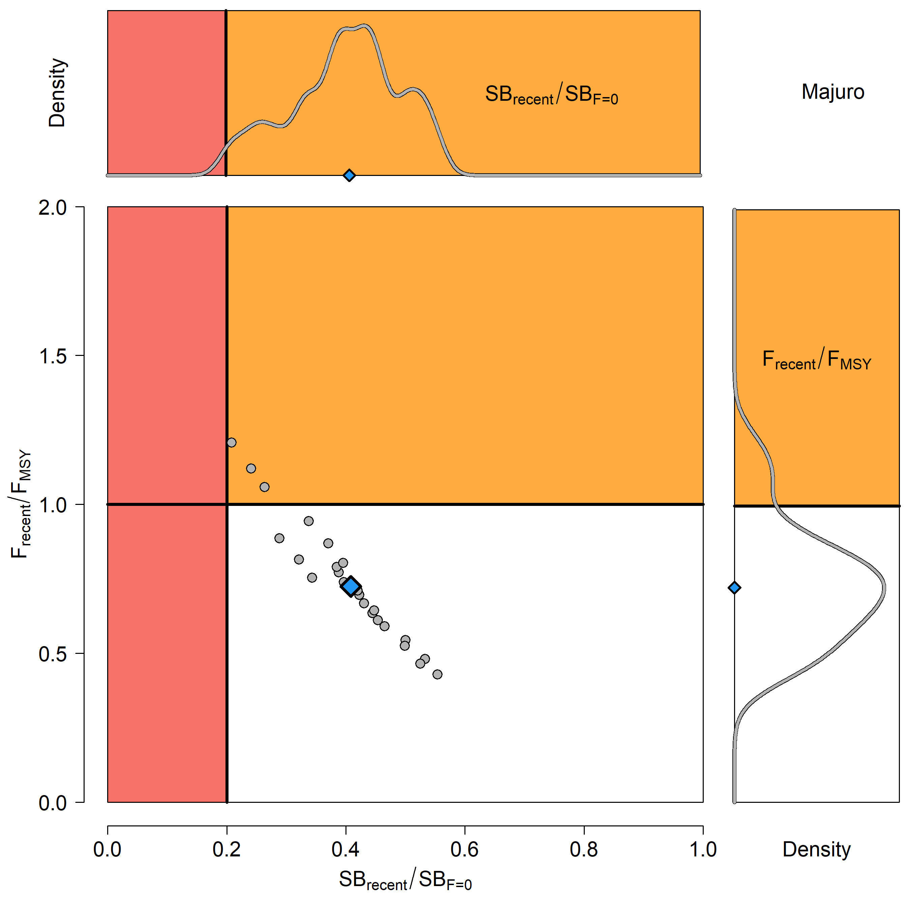**

**Figure BET-9**. Majuro plot for the recent spawning potential (2015–2018) summarizing the results for each of the models in the structural uncertainty grid. The plots represent estimates of stock status in terms of spawning biomass depletion and fishing mortality, and marginal distributions of each are presented. The median is shown in blue.

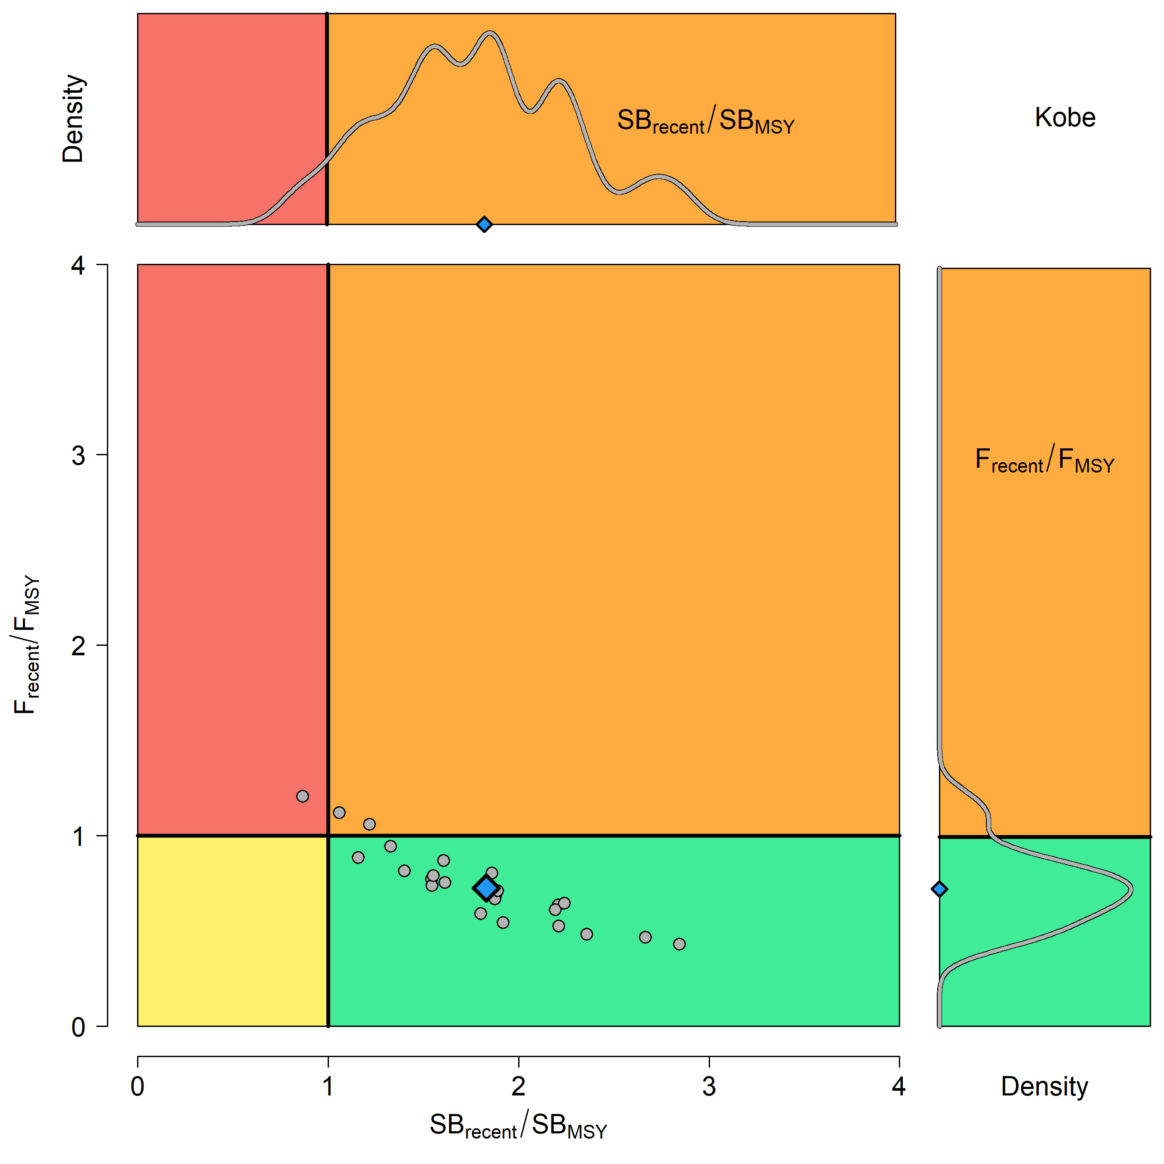

**Figure BET-10**. Kobe plot for the recent spawning potential (2015–2018) summarizing the results for each of the models in the structural uncertainty grid. The plots represent estimates of stock status in terms of spawning biomass depletion and fishing mortality. Marginal distributions of each are presented. The median is shown in blue.



**Figure BET-11**. Time series of bigeye tuna spawning potential SBt/SBF=0, where SBF=0 is the average SB from t-10 to t-1, relative to the current year t, from the uncertainty grid of assessment models for the period 2000 to 2018, and stochastic projection results for the period 2019 to 2048 assuming 2016-2018 average catches in longline and other fisheries and 2018 effort in purse seine fisheries continue. Vertical gray line at 2018 represents the last year of the assessment. During the projection period (2019-2048) levels of recruitment variability are assumed to match those over the short-term period (2008-2017). The red horizontal dashed line represents the agreed limit reference point.



**Figure BET-12**. Time series of bigeye tuna spawning potential SBt/SBF=0, where SBF=0 is the average SB from t-10 to t-1, relative to the current year t, from the uncertainty grid of assessment models for the period 2000 to 2018, and stochastic projection results for the period 2019 to 2048 assuming 2016-2018 average catches in longline and other fisheries and 2018 effort in purse seine fisheries continue. Vertical gray line at 2018 represents the last year of the assessment. During the projection period (2019-2048) levels of recruitment variability are assumed to match those over the long-term period (1962-2017). The red horizontal dashed line represents the agreed limit reference point.

1. SC16 noted that the results from the uncertainty grid adopted by SC16 show that the stock has been continuously declining for about 60 years since the late 1950s, except for the recent small increase from 2015 to 2016 with biomass declining thereafter.
2. SC16 also noted that the median value of relative recent (2015-2018) spawning biomass depletion (SB2015-2018/ SBF=0) was 0.41 with a 10th to 90th percentiles of 0.27 to 0.52.
3. SC16 further noted that there was 0% probability (0 out of 24 models) that the recent (2015-2018) spawning biomass had breached the adopted limit reference point (LRP).
4. SC16 noted that there has been a long-term increase in fishing mortality for both juvenile and adult bigeye tuna and while juvenile fishing mortality is higher than that of the adult fish, both adult and juvenile fishing mortality rates have stabilised somewhat since 2008 and have fluctuated without trend since that time.
5. SC16 noted that the median recent fishing mortality (F2014-2017t/FMSY) was 0.72 with a 10th to 90th percentile interval of 0.49 to 1.02.

1. SC16 noted that there was a roughly 12.5% probability (3 out of 24 models) that the recent (2014-2017) fishing mortality was above FMSY.
2. SC16 noted the results of stochastic projections (Figures BET-11 and BET-12) from the 2020 assessment which indicated the potential stock consequences of ﬁshing at “status quo” conditions (2016–2018 average longline and other fishery catch and 2018 purse seine effort levels) and short-term recruitment scenario using the uncertainty framework approach endorsed by SC. Projections indicate that median SB2025/SBF=0 = 0.47; median SB2035/SBF=0 = 0.49 and median SB2045/SBF=0 = 0.49. The risk that SB2048/SBF=0 is less than the Limit Reference Point is 0%.
3. SC16 noted the results of stochastic projections from the long-term recruitment scenario using the uncertainty framework approach endorsed by SC. Projections indicate that median SB2025/SBF=0 = 0.42; median SB2035/SBF=0 = 0.44 and median SB2045/SBF=0 = 0.45. The risk that SB2048/SBF=0 is less than the Limit Reference Point is 5%.
4. **Management advice and implications**
5. SC16 noted that the preliminary estimate of total catch of WCPO bigeye tuna for 2019 was 135,680 mt, a 9% decrease from 2018 and an 8% decrease from the average 2014-2018. Longline catch in 2019 (68,371 mt) was a 0% decrease from 2018 and a 2% increase from the 2014-2018 average. Purse seine catch in 2019 (50,819 mt) was a 22% decrease from 2018 and a 17% decrease from the 2014-2018 average. Pole and line catch (1,400 mt) was a 66% decrease from 2018 and a 66% decrease from the average 2014-2018 catch. Catch by other gear totalled 15,090 mt and was a 33% increase from 2018 and 1% increase from the average catch in 2014-2018.

1. SC16 noted that the catch in the last year of the assessment (2018) was median 159,288 mt which was greater than the median MSY (140,720 mt).
2. Based on the uncertainty grid adopted by SC16, the WCPO bigeye tuna spawning biomass is above the biomass LRP and recent F is very likely below FMSY. The stock is not overfished (100% probability SB/SBF=0>LRP) and likely not experiencing overfishing (87.5% probability F<FMSY).
3. SC16 noted that levels of fishing mortality and depletion differ among regions, and that fishery impact was higher in the tropical regions (Regions 3, 4, 7 and 8 in the stock assessment model), with particularly high fishing mortality on juvenile bigeye tuna in these regions. There is also evidence that the overall stock status is buffered with biomass kept at more elevated level overall by low exploitation in the temperate regions (1, 2, 6 and 9). SC16 therefore re-iterates that WCPFC17 could continue to consider measures to reduce fishing mortality from fisheries that take juveniles, with the goal to increase bigeye fishery yields and reduce any further impacts on the spawning biomass for this stock in the tropical regions.
4. Based on those results, SC16 recommends as a precautionary approach that the fishing mortality on bigeye tuna stock should not be increased from the level that maintains spawning biomass at 2012-2015 levels until the Commission can agree on an appropriate target reference point.
   1. **WCPO yellowfin tuna (*Thunnus albacares*)** 
      1. **Review of 2020 yellowfin tuna stock assessment**
5. M. Vincent (SPC-OFP) presented SC16-SA-WP-04 *Stock assessment of yellowfin tuna in the western and central Pacific Ocean*, which described the 2020 stock assessment of yellowfin tuna *Thunnus albacares.* An additional three years of data were available since the previous assessment in 2017, and the model extends through the end of 2018. New developments to the stock assessment include the incorporation of an index fishery for each region, enforcement of a mixing period of 182 days for a mixing period of 2 quarters and 91 days for a mixing period of 1 quarter, and incorporation of additional biological information.
6. Changes made in the progression from the 2017 to the 2020 diagnostic model that influence our perception of yellowfin stock status were the:

* Incorporation of additional information regarding the growth of yellowfin tuna arising from otolith data;
* Changes to the preparation and treatment of the tagging data, including enforcement of mixing periods in the tagging data, which resulted in reduced estimates of fishing mortality;
* Change in assumptions regarding the sharing of selectivity parameters;
* Use of the maturity-at-length functionality in Multifan-CL.

1. The general conclusions of this assessment are as follows:

* Total biomass and spawning potential declined until the mid-2000s, after which it remained relatively stable, with fluctuations and a small increase in recent years. Estimated recruitment shows a decreasing trend from 1952 until the mid-1990s and a small increasing trend in the recent period;
* Average fishing mortality rates for juvenile and adult age-classes increase throughout the period of the assessment;
* All models in the structural uncertainty grid assessed the stock to be above the adopted LRP, and fishing mortality rates below FMSY, with 100% probability. Based on the results of this assessment, the yellowfin stock in the WCPO is not considered overfished, nor subject to overfishing;
* Overall median depletion over the recent period (2015-2018; SBrecent/SBF=0) was 0.58 with a 10th to 90th percentile interval of 0.51-0.64;
* Recent average fishing mortality (2014-2017; Frecent/FMSY) was 0.36 with a 10th to 90th percentile interval of 0.27-0.47;
* Results from the structural uncertainty grid should be treated with some caution due to indications that there are likely model misspecifications which may be causing optimistic and biologically unreasonable estimates of recruitment distribution and stock status.

1. SC16 notes that the assessment results in general are very optimistic compared to the previous assessments but the causes for such optimistic results were not fully understood, thus uncertain. In particular, the median estimate of MSY from the uncertainty grid in 2020 was 1,091 thousand metric tons of catch biomass, or 63% above the estimate from the 2017 YFT assessment at SC13. Also, due to the constraints originating from the virtual online Scientific Committee forum, the SC16 could not fully engage in a complete discussion of the appropriate choice of models within the uncertainty grid. Due to the lack of an objective way of selecting the preferred elements for weighting the grid, SC16 agreed to use the grid with all models as presented by the Scientific Services Provider. As indicated in research needs, further research on the assessment model, including the peer review, is warranted in developing the next WCPO stock assessment.
2. A number of key research needs were identified in undertaking the assessment that should be investigated either internally or through directed research.
3. Items for internal investigation of the assessment model are as follows:
4. Further refinement of the selectivity to better fit the length composition from the purse seine fisheries;
5. Investigation of standardization methods of the longline CPUE index to account for environmental covariates and factors driving potential increase in efficiencies in fishing, which may require separation of the time series;
6. Examination of alternative methods to enforce mixing periods while retaining the attrition curve to inform fishing mortality;
7. Exploration of the self-scaling multinomial and the potential for its inclusion in future structural uncertainty grids;
8. Reduction in the model complexity to rectify unrealistic patterns of high recruitment in temperate regions and low recruitment in region 8;
9. Comparison among tropical tuna assessments to ensure biological realism in assessment estimates of all species;
10. Incorporation of spatial functionality of population dynamics regarding regional growth, maturity and/or length-weight; and,
11. Estimation of natural mortality using available tagging data.
12. Items that require directed research and additional funding for implementation:
13. Evaluation of the feasibility of conducting a fishery independent survey across the WCPO to be used as an index of abundance within the stock assessments and to improve the representativeness of biological samples across the WCPO;
14. Further collection of otolith samples for use in investigations of regional differences in growth with increased focus on increasing the spatial coverage of sampling for all lengths and collecting fish less than 30 cm and greater than 120 cm in all regions;
15. Validation of otolith aging techniques through bomb radiocarbon and strontium chloride tagging to clarify causes of discrepancy between growth curves from otoliths, tagging increments, and size composition modal progression;
16. Additional tag seeding experiments required for the estimation of reporting rates necessary to provide better estimates of natural mortality from tagging data;
17. Collection of biological information to inform the components in the reproductive potential ogive such as fecundity, proportion female at length, maturity at length, and spawning fraction in a spatially structured context;
18. Collection of biological samples for the estimation of conversion factors from length to weight, gilled-gutted to whole-weight, and gilled-gutted-trunked to whole weight to be used for the weight composition data.
    * 1. **Provision of scientific information**
19. **Stock Status and trends**

1. The median values of relative recent (2015-2018) spawning biomass depletion (*SBrecent/ SBF=0*) and relative recent (2014-2017) fishing mortality (*Frecent/FMSY*) over the uncertainty grid of 72 models (Table YFT-1) were used to define stock status. The values of the upper 90th and lower 10th percentiles of the empirical distributions of relative spawning biomass and relative fishing mortality from the uncertainty grid were used to characterize the probable range of stock status.
2. A description of the updated structural sensitivity grid used to characterize uncertainty in the assessment is illustrated in Table YFT-1. The spatial structure used in the 2020 stock assessment is shown in Figure YFT-1. Time series of total annual catch by fishing gear over the full assessment period is shown in Figure YFT-2. The time series of total annual catch by fishing gear and assessment region is shown in Figure YFT-3. Estimated annual average recruitment, spawning potential, and total biomass by model region is shown in Figure YFT-4. Estimated trends in spawning biomass depletion for the 72 models in the structural uncertainty grid is shown in Figure YFT-5, and juvenile and adult fishing mortality rates from the diagnostic model is shown in Figure YFT-6. Estimates of the reduction in spawning potential due to fishing by region are shown in Figure YFT-7. Time-dynamic percentiles of depletion (SBt/SBt,F=0) for the 72 models are shown in Figure YFT-8. A Majuro and Kobe plot summarising the results for each of the 72 models in the structural uncertainty grid are shown in Figures YFT-9 and YFT-10, respectively. Projections are illustrated in Figure YFT-11. Table YFT-2 provides a summary of reference points over the 72 models in the structural uncertainty grid.
3. The most influential axis of uncertainty with respect to estimated stock status was growth. The most pessimistic model estimates occurred with models that assumed growth estimated from the modal progression information in the size composition data. The most optimistic stock status estimates were obtained from models that used the growth curve estimated externally from otolith data. Models where growth was estimated by the conditional age-at-length data resulted in estimates that were in between the other two, but were more consistent with the otolith growth curve models. Further research is required to develop alternative growth estimates at the regional spatial scale and develop model diagnostics and objective criteria for model inclusion.

**Table YFT-1.** Description of the updated structural sensitivity grid used to characterize uncertainty in the assessment, where \* denotes the level assumed in the diagnostic model. Equal weighting was given to all axis values.

|  |  |  |  |  |
| --- | --- | --- | --- | --- |
| **Axis** | **Value 1** | **Value 2** | **Value 3** | **Value 4** |
| Growth | Conditional Age-at-length\* | Modal (Size Composition) | Otolith |  |
| Steepness | 0.65 | 0.8 \* | 0.95 |  |
| Size Scalar | 20 | 60 \* | 200 | 500 |
| Mixing Period | 1 Quarter | 2 Quarters \* |  |  |

**Table YFT-2.** Summary of reference points over the 72 models in the structural uncertainty grid. Note that “recent” is the average over the period 2015-2018 for SB and 2014-2017 for fishing mortality, while “latest” is 2018. The values of the upper 90th and lower 10th percentiles of the empirical distributions are also shown. Fmult is the multiplier of recent (2014-2017) fishing mortality required to attain MSY.

|  |  |  |  |  |  |  |
| --- | --- | --- | --- | --- | --- | --- |
|  | **Mean** | **Median** | **Minimum** | **10th percentile** | **90th percentile** | **Maximum** |
| Clatest | 709,389 | 711,072 | 700,358 | 702,279 | 712,761 | 714,073 |
| YFrecent | 779,872 | 784,200 | 661,600 | 707,720 | 877,040 | 908,000 |
| fmult | 2.87 | 2.80 | 1.70 | 2.12 | 3.72 | 4.29 |
| FMSY | 0.11 | 0.10 | 0.08 | 0.09 | 0.12 | 0.15 |
| MSY | 1,090,706 | 1,091,200 | 791,600 | 874,200 | 1,283,920 | 1,344,400 |
| Frecent/FMSY | 0.37 | 0.36 | 0.23 | 0.27 | 0.47 | 0.59 |
| SBF=0 | 3,641,228 | 3,603,980 | 2,893,274 | 3,231,353 | 4,050,429 | 4,394,277 |
| SBMSY | 860,326 | 858,700 | 349,100 | 590,090 | 1,114,400 | 1,322,000 |
| SBMSY/SBF=0 | 0.23 | 0.24 | 0.12 | 0.18 | 0.28 | 0.30 |
| SB latest/SBF=0 | 0.54 | 0.54 | 0.40 | 0.47 | 0.60 | 0.66 |
| SB latest/SBMSY | 2.43 | 2.28 | 1.47 | 1.67 | 3.29 | 4.89 |
| SB recent/SBF=0 | 0.58 | 0.58 | 0.42 | 0.51 | 0.64 | 0.68 |
| SB recent/SBMSY | 2.59 | 2.43 | 1.54 | 1.77 | 3.57 | 5.27 |

**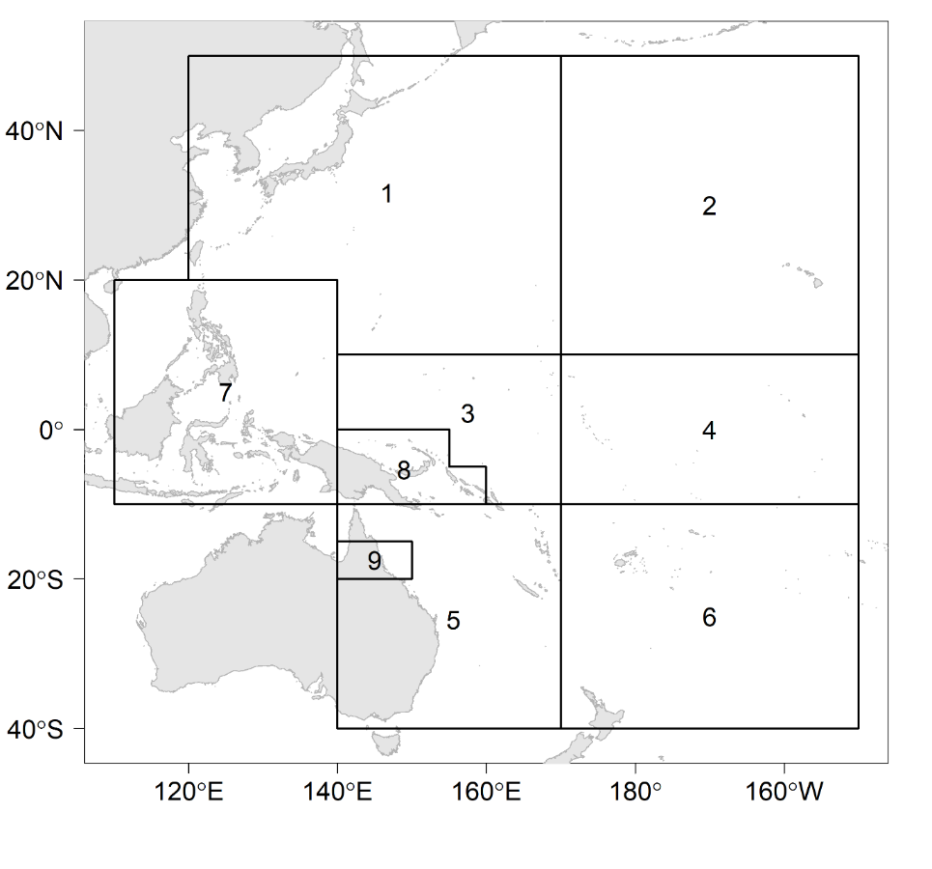**

**Figure YFT-1.** The geographical area covered by the stock assessment and the boundaries for the 9 regions when using the “10N regional structure”.

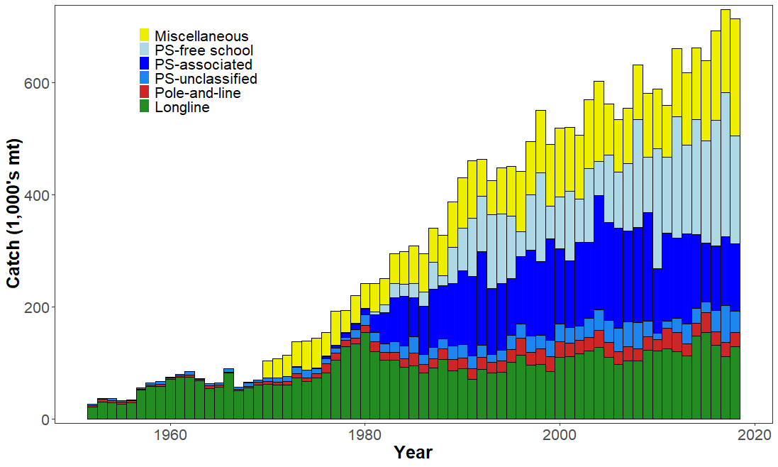

**Figure YFT-2.** Time series of total annual catch (1000s mt) by fishing gear over the full assessment region and time period. The different colours denote longline (green), pole-and-line (red), purse seine unclassified (blue), purse seine-associated (dark blue), purse seine-unassociated (light blue), miscellaneous (yellow).

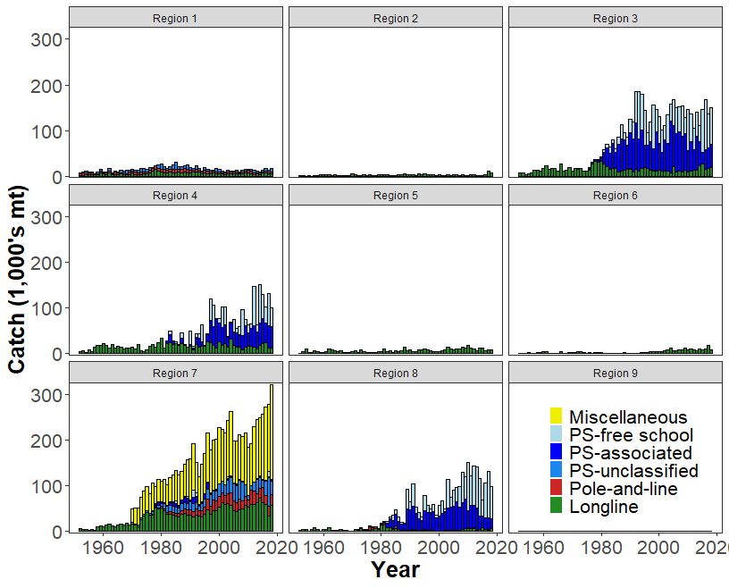

**Figure YFT-3.** Time series of total annual catch (1000s mt) by fishing gear and assessment region over the full assessment period. The different colours denote longline (green), pole-and-line (red), purse seine unclassified (blue), purse seine-associated (dark blue), purse seine-unassociated (light blue), miscellaneous (yellow).

(a) Recruitment

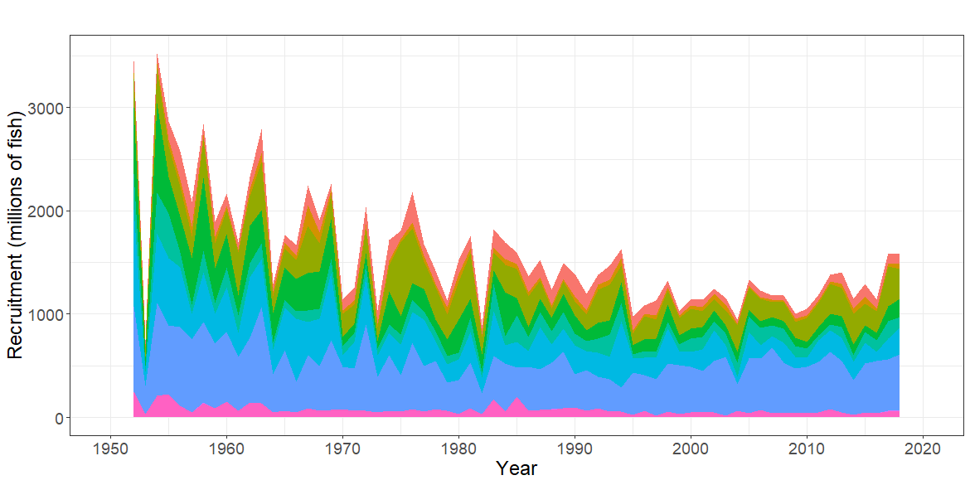

(b) Spawning Potential 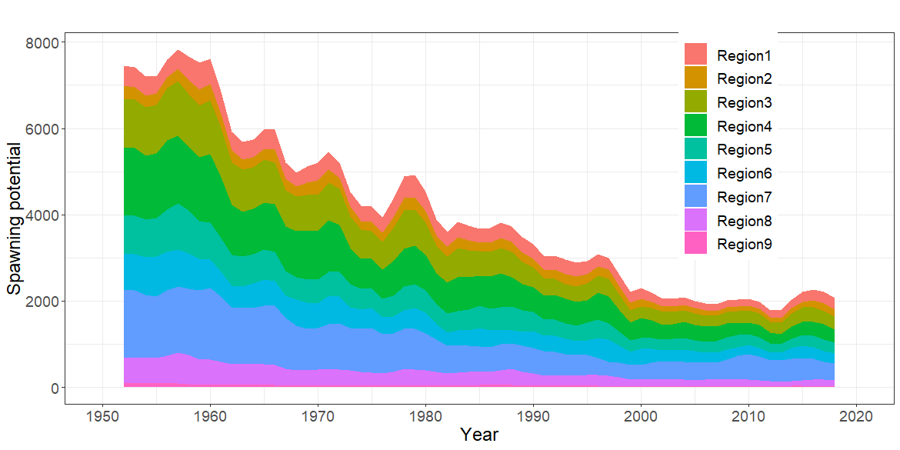

(c) Total Biomass 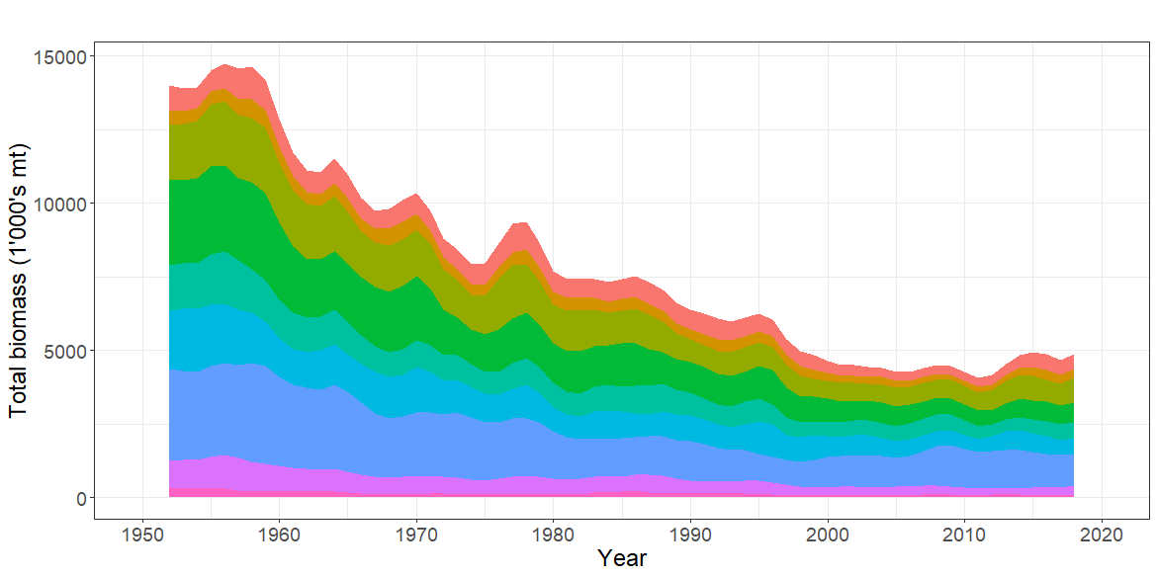

**Figure YFT-4.** Estimated annual average, (a) recruitment (b) spawning potential (c) total biomass by model region for the diagnostic model, showing the relative sizes among regions.

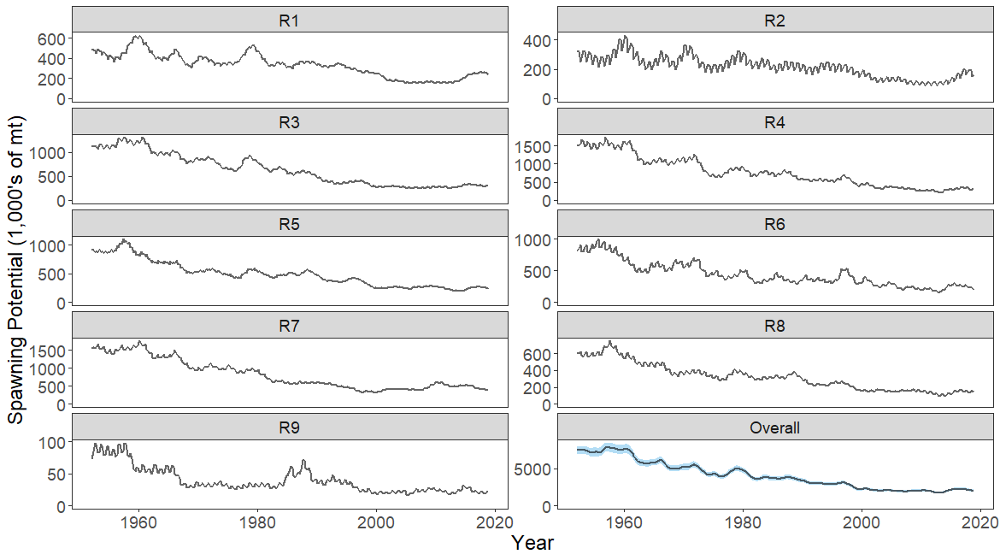

**Figure YFT-5.** The temporal trend in estimated spawning potential by model region for the diagnosticmodel, where the blue shaded region for the overall spawning potential shows the estimated 95% confidence interval based on statistical uncertainty estimated for the diagnostic model. Note that the y-axis scale among panels are not consistent.

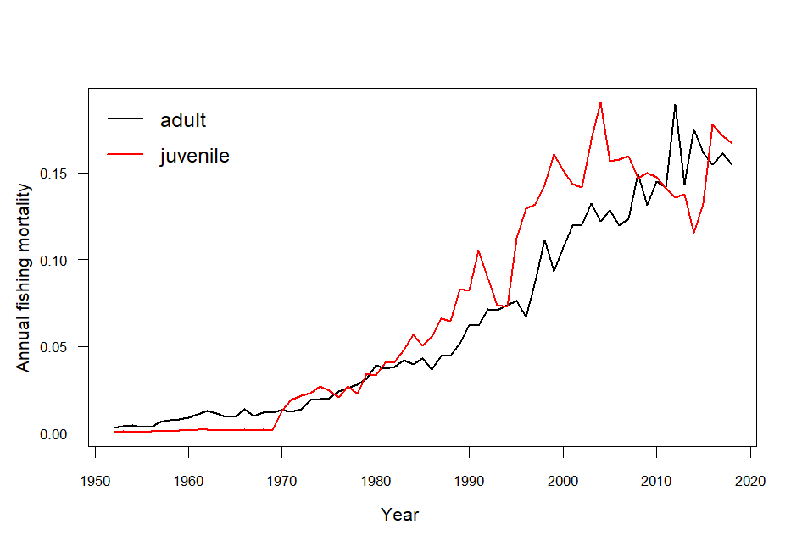

**Figure YFT-6.**  Estimated annual average juvenile and adult fishing mortality for the diagnostic model.

**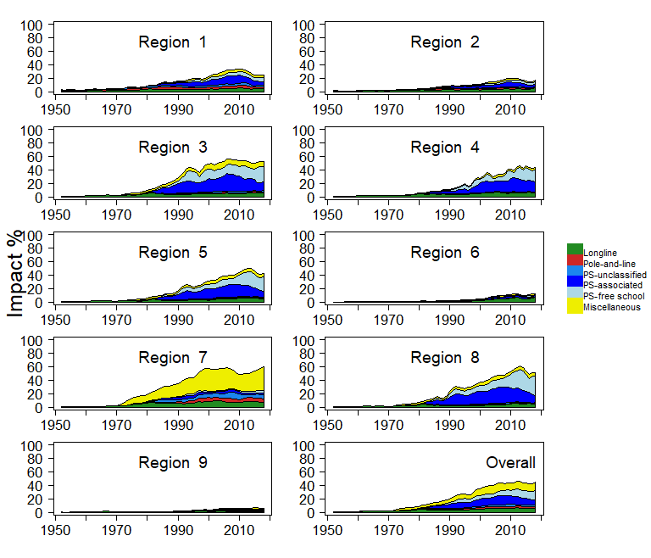**

**Figure YFT-7.** Estimates of reduction in spawning potential due to fishing by region (Fishery Impact = (1-SBt/SBt;F=0) \* 100%) and over all regions (lower right panel), attributed to various fishery groups for the diagnostic model.

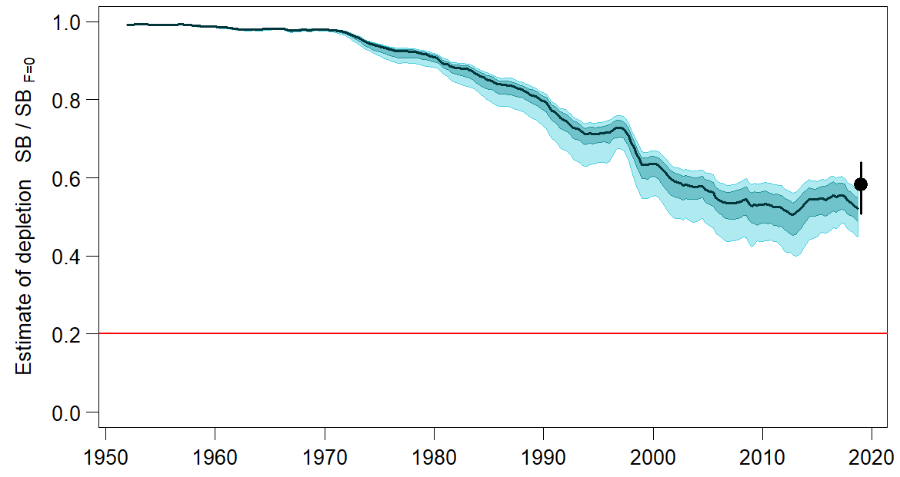

**Figure YFT-8.** Plot showing the trajectories of fishing depletion of spawning potential for the models in the structural uncertainty grid for the median, 50% quantile, and 80% quantile of instantaneous depletion across the structural uncertainty grid and the point and error bars is the median and 10th and 90th percentile of estimates of *SBrecent/SBF*=0.

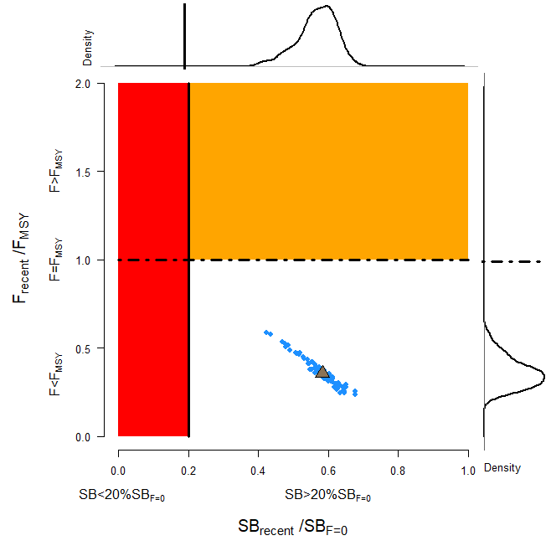

**Figure YFT-9.**  Majuro plot representing stock status in terms of recent spawning potential depletion (2015–2018) and fishing mortality. The plots summarize the results for each of the models in the structural uncertainty grid with marginal distributions for spawning potential depletion and fishing mortality, where the brown triangle is the median of the structural uncertainty grid.

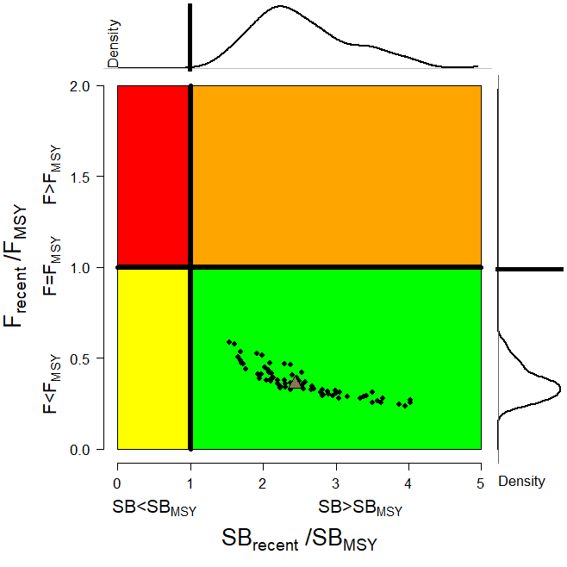

**Figure YFT-10.** Kobe plot for the recent spawning potential (2015–2018) summarizing the results for each of the models in the structural uncertainty grid. The plots represent estimates of stock status in terms of spawning biomass depletion and fishing mortality relative to *MSY* quantities and marginal distributions of each are presented with the median of the structural uncertainty grid displayed as a brown triangle.

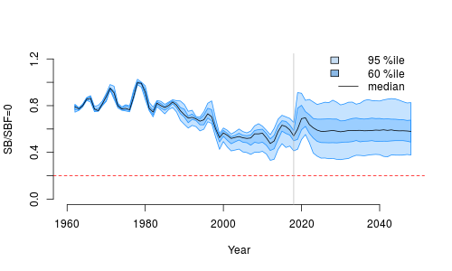

**Figure YFT-11.** Time series of yellowfin tuna spawning biomass (*SBt/SBt,F*=0, where *SBt,F*=0 is the average SB from t-10 to t-1) from the uncertainty grid of assessment models for the period 2000 to 2018, and stochastic projection results for the period 2019 to 2048 assuming 2016-2018 average catches in longline and other fisheries and 2018 effort in purse seine fisheries continue. Vertical gray line at 2018 represents the last year of the assessment. During the projection period (2019-2048) levels of recruitment variability are assumed to match those over the time period used to estimate the stock-recruitment relationship (1962-2017). The red horizontal dashed line represents the agreed limit reference point.

1. SC16 noted that there has been a long-term decrease in spawning biomass from the 1970s for yellowfin tuna but that the depletion rates have been relatively stable over the last decade.
2. SC16 also noted that the median value of relative recent (2015-2018) spawning biomass depletion (SB2015-2018/SBF=0) was 0.58 with a 10th to 90th percentile interval of 0.51 to 0.64.

1. SC16 further noted that there was 0% probability (0 out of 72 models) that the recent (2015-2018) spawning biomass had breached the adopted LRP.
2. SC16 noted that there has been a long-term increase in fishing mortality for both juvenile and adult yellowfin tuna which is consistent with previous assessments, but since 2010 there has been no directional trend.
3. SC16 noted that the median of relative recent fishing mortality (F2014-2017/FMSY) was 0.36 with a 10th to 90th percentile interval of 0.27 to 0.47.

1. SC16 further noted that there was 0% probability (0 out of 72 models) that the recent (2014-2017) fishing mortality was above FMSY.
2. SC16 noted the results of stochastic projections (Figure YFT-11) from the 2020 assessment which indicated the potential stock consequences of ﬁshing at “status quo” conditions (2016–2018 average longline and other fishery catch and 2018 purse seine effort levels) and long-term recruitment scenario using the uncertainty framework approach endorsed by SC. Projections indicate that median SB2025/SBF=0 = 0.58; median SB2035/SBF=0 = 0.59 and median SB2045/SBF=0 = 0.58. The risk that SB2048/SBF=0 is less than the Limit Reference Point is 0%.
3. **Management advice and implications**
4. SC16 noted that the preliminary estimate of total catch of WCPO yellowfin tuna for 2019 was 669,362 t, a 5% decrease from 2018 and a 1% increase from the average 2014-2018. Purse seine catch in 2019 (364,571 t) was a 4% decrease from 2018 and an 8% decrease from the 2014-2018 average. Longline catch in 2019 (104,440 t) was a 7% increase from 2018 and a 9% increase from the 2014-2018 average. Pole and line catch (37,563 t) was a 43% increase from 2018 and a 40% increase from the average 2014-2018 catch. Catch by other gear totalled 162,788 t and was an 18% decrease from 2018 and a 16% increase from the average catch in 2014-2018.
5. SC16 noted that the median catch in the last year of the assessment (2018) was 711,072 mt which was less than the median MSY (1,091,200 mt).
6. Based on the uncertainty grid adopted by SC16, the WCPO yellowfin tuna spawning biomass is above the biomass LRP and recent F is below FMSY. The stock is not experiencing overfishing (100% probability F<FMSY) and is not in an overfished condition (0% probability SB/SBF=0<LRP). Additionally, stochastic projections predict there to be no risk of breaching the LRP (0% probability SB2048/SBF=0<LRP).
7. SC16 also noted that levels of fishing mortality and depletion differ between regions, and that fishery impact was highest in the tropical region (Regions 3, 4, 7 and 8 in the stock assessment model), mainly due to the purse seine fisheries in the equatorial Pacific and the “other” fisheries within the Western Pacific. There is also evidence that the overall stock status is buffered with biomass kept at a more elevated level overall by low exploitation in the temperate regions (1, 2, 5, 6, and 9). SC16 therefore re-iterates that WCPFC17 could consider measures to reduce fishing mortality from fisheries that take juveniles, with the goal to increase fishery yields and reduce any further impacts on the spawning potential for this stock in the tropical regions.
8. SC16 noted that the 2020 stock assessment results indicate the stock is currently exploited at relatively low levels (median F/FMSY = 0.36, 10th to 90th percentile interval 0.27-0.47). Nevertheless, SC16 recommends that the Commission notes that further increases in YFT fishing mortality would likely affect other stocks/species which are currently moderately exploited due to the multispecies/gears interactions in WCPFC fisheries taking YFT.
9. SC16 also noted that although the structural uncertainty grid presents a positive indication of stock status, the high level of unresolved conflict amongst the data inputs used in the assessment suggests additional caution may be appropriate when interpreting assessment outcomes to guide management decisions.
10. Based on those results, SC16 recommends as a precautionary approach that the fishing mortality on yellowfin tuna stock should not be increased from the level that maintains spawning biomass at 2012-2015 levels until the Commission can agree on an appropriate target reference point.
    1. **North Pacific albacore (*Thunnus alalunga*)** 
       1. **Review of the 2020 North Pacific albacore stock assessment**
11. S. Teo (USA) presented SC16-SA-WP-05 *Stock Assessment of Albacore Tuna in the North Pacific Ocean in 2020*, which detailed the data, biological parameters, model, model diagnostics and sensitivities, and results of the North Pacific albacore stock assessment conducted by ISC’s Albacore Working Group in 2020.
12. All available fishery data for North Pacific albacore for the 1994-2018 period were used in the stock assessment. Catch and size composition data were compiled and assigned to 35 fisheries defined for this assessment (based on flag, gear, area, and season). The same abundance index as the 2017 assessment was fitted in the base case model. The North Pacific albacore stock was assessed using a length-based, age-, and sex-structured Stock Synthesis (SS Version 3.30.14.08) model over the 1994-2018 period and it was assumed that there is instantaneous mixing of albacore on a quarterly basis. Biological parameters like growth, natural morality (M) and stock-recruitment steepness, were the same as for the 2017 assessment. All fisheries were assumed to have dome-shaped length selectivity curves, and age-based selectivity for ages 1-5 were also estimated for surface fisheries (troll and pole-and-line) to address age-based changes in juvenile albacore availability and movement. Selectivity curves were also assumed to vary over time for several fleets.
13. Maximum likelihood estimates of model parameters, derived outputs, and their uncertainties from the base case model were used to characterize stock status. Based on model diagnostics, the ALBWG concluded that the base case model was able to estimate the stock production function and the effect of fishing on the abundance of the north Pacific albacore stock. Due to the moderate exploitation levels relative to stock productivity, the production function was weakly informative about north Pacific albacore stock size, resulting in asymmetric uncertainty in the stock’s absolute scale, with more uncertainty in the upper limit of the stock than the lower limit. It is important to note that the primary aim of estimating the female SSB in this assessment was to determine whether the estimated SSB was lower than the limit reference point (i.e., determine whether the stock is in an overfished condition). Since the lower bound is better defined, it adds confidence to the evaluation of stock condition relative to the limit reference point. Several sensitivity analyses were conducted to evaluate model performance or the range of uncertainty resulting from changes in model parameters, including natural mortality, stock-recruitment steepness, growth, starting year, selectivity patterns, and weighting of size composition data.
    * 1. **Provision of scientific information**
14. **Stock status and trends**
15. SC16 noted that the ISC provided the following conclusions on the stock status of North Pacific albacore:

The Northern Committee (NC) of the Western and Central Pacific Fisheries Commission (WCPFC), which manages this stock together with the Inter American Tropical Tuna Commission (IATTC), adopted a biomass-based limit reference point (LRP) in 2014 (https://www.wcpfc.int/harvest-strategy) of 20% of the current spawning stock biomass when F=0 (20%SSBcurrent, F=0). The 20%SSBcurrent, F=0 LRP is based on dynamic biomass and fluctuates depending on changes in recruitment. For north Pacific albacore tuna, this LRP is calculated as 20% of the unfished dynamic female spawning biomass in the terminal year of this assessment (i.e., 2018) (https://www.wcpfc.int/meetings/nc13). However, neither the IATTC nor the WCFPC have adopted F-based limit reference points for the north Pacific albacore stock.

Stock status is depicted in relation to the limit reference point (LRP; 20%SSBcurrent, F=0) for the stock and the equivalent fishing intensity (F20%; calculated as 1-SPR20%) (Figure NPALB-1). Fishing intensity (F, calculated as 1-SPR) is a measure of fishing mortality expressed as the decline in the proportion of the spawning biomass produced by each recruit relative to the unfished state. For example, a fishing intensity of 0.8 will result in a SSB of approximately 20% of SSB0 over the long run. Fishing intensity is considered a proxy of fishing mortality.

The Kobe plot shows that the estimated female SSB has never fallen below the LRP since 1994, albeit with large uncertainty in the terminal year (2018) estimates. Even when alternative hypotheses about key model uncertainties such as growth were evaluated, the point estimate of female SSB in 2018 (SSB2018) did not fall below the LRP, although the risk increases with this more extreme assumption (Figure NPALB-1). The SSB2018 was estimated to be 58,858 t (95% CI: 27,751 – 89,966 t) and 2.30 (95% CI: 1.49 – 3.11) times greater than the estimated LRP threshold of 25,573 t (95% CI: 19,150 – 31,997 t) (Table NPALB-1). Current fishing intensity, F2015-2017 (0.50; 95% CI: 0.36 – 0.64; calculated as 1- SPR2015-2017) , was at or lower than all seven potential F-based reference points identified for the north Pacific albacore stock (Table NPALB-1).

1. SC16 noted the following stock status from ISC:

Based on these findings, the following information on the status of the north Pacific albacore stock is provided:

1. The stock is likely not overfished relative to the limit reference point adopted by the Western and Central Pacific Fisheries Commission (20%SSBcurrent, F=0), and
2. No F-based reference points have been adopted to evaluate overfishing. Stock status was evaluated against seven potential reference points. Current fishing intensity (F2015-2017) is likely at or below all seven potential reference points (see ratios in Table NPALB-1).
3. **Management advice and implications**
4. SC16 noted the following conservation information from ISC:

Two harvest scenarios were projected to evaluate impacts on future female SSB: F constant at the 2015-2017 rate over 10 years (F2015-2017)and constant catch[[1]](#footnote-1) (average of 2013-2017 = 69,354 t) over 10 years. Median female SSB is expected to increase to 62,873 t (95% CI: 45,123 - 80,622 t) by 2028, with a low probability of being below the LRP by 2028, if fishing intensity remains at the 2015-2017 level (Figure NPALB-2). If future catch is held constant at 69,354 t, the female SSB is expected to increase to 66,313 t (95% CI: 33,463 - 99,164 t) by 2028 and the probability that female SSB will be below the LRP by 2028 is slightly higher than the constant F scenario (Figure NPALB-3). Although the projections appear to underestimate the future uncertainty in female SSB trends, the probability of breaching the LRP in the future is likely small if the future fishing intensity is around current levels.

Based on these findings, the following information is provided:

1. If a constant fishing intensity (F2015-2017) is applied to the stock, then median female spawning biomass is expected to increase to 62,873 t and there will be a low probability of falling below the limit reference point established by the WCPFC by 2028.
2. If a constant average catch (C2013-2017 = 69,354 t) is removed from the stock in the future, then the median female spawning biomass is also expected to increase to 66,313 t and the probability that SSB falls below the LRP by 2028 will be slightly higher than the constant fishing intensity scenario.

|  |  |  |  |
| --- | --- | --- | --- |
| **Table NPALB-1**. Estimates of maximum sustainable yield (MSY), female spawning biomass (SSB), and fishing intensity (F) based reference point ratios for north Pacific albacore tuna for: 1) the base case model; 2) an important sensitivity model due to uncertainty in growth parameters; and 3) a model representing an update of the 2017 base case model to 2020 data. SSB0 and SSBMSY are the unfished biomass of mature female fish and at MSY, respectively. The Fs in this table are indicators of fishing intensity based on SPR and calculated as 1-SPR so that the Fs reflect changes in fishing mortality. SPR is the equilibrium SSB per recruit that would result from the current year’s pattern and intensity of fishing mortality. Current fishing intensity is based on the average fishing intensity during 2015-2017 (F2015-2017). 20%SSBcurrent, F=0 is 20% of the current unfished dynamic female spawning biomass, where current refers to the terminal year of this assessment (i.e., 2018). The model representing an update of the 2017 base case model is highly similar to but not identical to the 2017 base case model due to changes in data preparation and model structure. | | | |
| Quantity | Base Case | Growth  CV = 0.06 for Linf | Update of 2017 base case model to 2020 data |
| MSY (t) A | 102,236 | 84,385 | 113,522 |
| SSBMSY (t)B | 19,535 | 16,404 | 21,431 |
| SSB0 (t)B | 136,833 | 113,331 | 152,301 |
| SSB2018 (t) B | 58,858 | 34,872 | 77,077 |
| SSB2018/20%SSBcurrent, F=0 B | 2.30 | 1.63 | 2.63 |
| F2015-2017 | 0.50 | 0.64 | 0.43 |
| F2015-2017/FMSY | 0.60 | 0.77 | 0.52 |
| F2015-2017/F0.1 | 0.57 | 0.75 | 0.49 |
| F2015-2017/F10% | 0.55 | 0.71 | 0.48 |
| F2015-2017/F20% | 0.62 | 0.80 | 0.54 |
| F2015-2017/F30% | 0.71 | 0.91 | 0.62 |
| F2015-2017/F40% | 0.83 | 1.06 | 0.72 |
| F2015-2017/F50% | 1.00 | 1.27 | 0.86 |
| A – MSY includes male and female juvenile and adult fish  B – Spawning stock biomass (SSB) in this assessment refers to mature female biomass only. | | | |

|  |  |
| --- | --- |
| **A** | **B** |
| C:\Users\steve.teo\Desktop\2020_NPALB_assessment\assessment_report\exec_summary\2019_Exec_Summary_Figs\Fig_ES07v2_Kobe_plot_2color\Fig_ES07_kobe_basecase_timeseries_SPR_B20pct_dynB0_redgreen.png | C:\Users\steve.teo\Desktop\2020_NPALB_assessment\assessment_report\exec_summary\2019_Exec_Summary_Figs\Fig_ES07v2_Kobe_plot_2color\Fig_ES08_kobe_sensitivity_endpt_SPR_B20pct_dynB0_redgreen.png |
| **Figure NPALB-1.** (**A**)Kobe plot showing the status of the north Pacific albacore (*Thunnus alalunga*) stock relative to the 20%SSBcurrent, F=0 biomass-based limit reference point, and equivalent fishing intensity (F20%; calculated as 1-SPR20%) over the base case modeling period (1994-2018). Blue triangle indicates the start year (1994) and black circle with 95% confidence intervals indicates the terminal year (2018). (**B**) Kobe plot showing current stock status and 95% confidence intervals of the base case model (black; closed circle), an important sensitivity run of CV = 0.06 for Linf in the growth model (blue; open square), and a model representing an update of the 2017 base case model to 2020 data (red; open triangle). The coefficients of variation of the SSB/20%SSBcurrent, F=0 ratios are assumed to be the same as for the SSB/20%SSB0 ratios. Fs in this figure are not based on instantaneous fishing mortality. Instead, the Fs are indicators of fishing intensity based on SPR and calculated as 1-SPR so that the Fs reflects changes in fishing mortality. SPR is the equilibrium SSB per recruit that would result from the current year’s pattern and intensity of fishing mortality. Current fishing intensity is calculated as the average fishing intensity during 2015-2017 (F2015-2017), while current female spawning biomass refers to the terminal year of this assessment (i.e., 2018). The model representing an update of the 2017 base case model is highly similar to but not identical to the 2017 base case model due to changes in data preparation and model structure. | |

****

**Figure NPALB-2**. Historical and future trajectory of north Pacific albacore (*Thunnus alalunga*) female spawning biomass (SSB) under a constant fishing intensity (F2015-2017) harvest scenario. Future recruitment is based on the expected recruitment variability. Black line and gray area indicates maximum likelihood estimates and 95% confidence intervals (CI), respectively, of historical female SSB, which includes parameter uncertainty. Red line and red area indicates mean value and 95% CI of projected female SSB, which only includes future recruitment variability and SSB uncertainty in the terminal year. Dashed black line indicates the 20%SSBcurrent F=0 limit reference point for 2018 (25,573 t).

**Figure NPALB-3.** Historical and future trajectory of north Pacific albacore (*Thunnus alalunga*) female spawning biomass (SSB) under a constant catch (average 2013-2017 = 69,354 t) harvest scenario. Future recruitment is based on the expected recruitment variability. Black line and blue area indicates maximum likelihood estimates and 95% confidence intervals (CI), respectively, of historical female SSB, which includes parameter uncertainty. Blue line and blue area indicates mean value and 95% CI of projected female SSB, which only includes future recruitment variability and SSB uncertainty in the terminal year. Dashed black line indicates the 20%SSBcurrent F=0 limit reference point for 2018 (25,573 t).

* 1. **Pacific bluefin tuna (*Thunnus orientalis*)** 
     1. **Review of 2020 Pacific bluefin tuna stock assessment**

1. H. Fukuda, lead modeler for the ISC Bluefin Tuna Working Group (PBFWG) made a detailed report on the benchmark stock assessment for PBF conducted by the ISC PBFWG in March 2020 (SC16-SA-WP-06). Several modifications — such as the spatio-temporal modeling for CPUE standardization, more detailed modeling of fisheries, inclusions of newly available size data and discard information, and bias correction for the projection results —were made to improve the assessment.
2. Population dynamics during 1952-2018 were modelled using quarterly observations of catch and size compositions, when available, as well as the annual estimates of standardized CPUE based abundance indices. The assessment model was fitted to those input data in a likelihood-based statistical framework. Based on the diagnostic analysis, the PBFWG concluded that the new base-case model represents the data sufficiently and there is an internal consistency among the assumptions of the assessment model and input data. The new base-case model also showed consistent results with the 2016 and 2018 assessments. The ISC plenary 20 considered the 2020 assessment results as the best available scientific information on Pacific bluefin tuna.
3. The stock projections were developed based on the bootstrap replicates of the base-case model and the future harvesting scenarios, which were requested by the WCPFC and IATTC. For the sake of precautionarily in the light of current low level of the SSB and the possible future low recruitment produced thereby, the future recruitments until the stock recovered to the initial rebuilding target were resampled from relatively low recruitment period (1980-1989). For the following years, future recruitments were randomly resampled from whole stock assessment period.
   * 1. **Provision of scientific information**
4. **Stock status and trends**
5. SC16 noted that the ISC provided the following conclusions on the stock status of Pacific bluefin tuna.

The base-case model results show that: (1) spawning stock biomass (SSB) fluctuated throughout the assessment period (fishing years 1952-2018); (2) the SSB steadily declined from 1996 to 2010; (3) there has been a slow increase of the stock biomass continues since 2011; (4) total biomass in 2018 exceeded the historical median with an increase in immature fish; and (5) fishing mortality (F%SPR) declined from a level producing about 1% of SPR[[2]](#footnote-2) in 2004-2009 to a level producing 14% of SPR in 2016- 2018 (Table PBF1). Based on the model diagnostics, the estimated biomass trend for the last 30 years is considered robust although SSB prior to the 1980s is uncertain due to data limitations. The SSB in 2018 was estimated to be around 28,000 t (Table PBF1 and Figure PBF-1), which is a 3,000 t increase from 2016 according to the base-case model. An increase of young fish (0-2 years old) is observed in 2016-2018 (Figure PBF-2), likely resulting from low fishing mortality on those fish (Figure PBF-3) and is expected to accelerate the recovery of SSB in the future.

Historical recruitment estimates have fluctuated since 1952 without an apparent trend. Relatively low recruitment levels estimated in 2010-2014 were of concern in the 2016 assessment. The 2015 recruitment estimate is lower than the historical average while the 2016 recruitment estimate (about 17 million fish) is higher than the historical average (Table PBF-1 and Figure PBF-1). The recruitment estimates for 2017 and 2018, which are based on fewer observations and more uncertain, are below the historical average.

Estimated age-specific fishing mortalities (F) on the stock during the periods of 2011-2013 and 2016-2018 compared with 2002-2004 estimates (the reference period for the WCPFC Conservation and Management Measure) are presented in Figure PBF-3. A substantial decrease in estimated F is observed in ages 0-2 in 2016-2018 relative to the previous years. Note that stricter management measures in the WCPFC and IATTC have been in place since 2015.

Figure PBF-5 depicts the historical impacts of the fleets on the PBF stock, showing the estimated biomass when fishing mortality from the respective fleets is zero. Historically, the WPO coastal fisheries group has had the greatest impact on the PBF stock, but since about the early 1990s the WPO purse seine fishery group targeting small fish (ages 0-1) has had a greater impact and the effect of this group in 2018 was greater than any of the other fishery groups. The impact of the EPO fisheries group was large before the mid-1980s, decreasing significantly thereafter. The WPO longline fisheries group has had a limited effect on the stock throughout the analysis period because the impact of a fishery on a stock depends on both the number and size of the fish caught by each fleet; i.e., catching a high number of smaller juvenile fish can have a greater impact on future spawning stock biomass than catching the same weight of larger mature fish. There is greater uncertainty regarding discards than other fishery impacts because the impact of discarding is not based on observed data.

1. SC16 noted the following stock status from ISC:

The WCPFC and IATTC adopted an initial rebuilding biomass target (the median SSB estimated for the period from 1952 through 2014) and a second rebuilding biomass target (20%SSBF=0 under average recruitment), without specifying a fishing mortality reference level. The 2020 assessment estimated the initial rebuilding biomass target (SSBMED1952-2014) to be 6.4%SSBF=0 and the corresponding fishing mortality expressed as F6.4%SPR. The Kobe plot shows that the point estimate of the SSB2018 was 4.5%SSBF=0 and the recent (2016-2018) fishing mortality corresponds to F14%SPR (Table PBF-1 and Figure PBF-4). Although no reference points have been adopted to evaluate the status of PBF, an evaluation of stock status against some common reference points (Table PBF-2) shows that the stock is overfished relative to biomass-based limit reference points adopted for other species in WCPFC (20%SSBF=0) and fishing mortality has declined but not reached the level corresponding to that reference point (F20%SPR).

The PBF spawning stock biomass (SSB) has gradually increased in the last 8 years (2011-2018). Young fish (age 0-2) shows a more rapid increase in recent years (Figure PBF-1 and PBF2). These changes in biomass coincide with a decline in fishing mortality over the last decade (Figure PBF-3). Based on these findings, the following information on the status of the Pacific bluefin tuna stock is provided:

1. The latest (2018) SSB is estimated to be 4.5% of SSBF=0 which is increased from 4.0% in 2016 (Figure PBF-4 and Table PBF1). No biomass-based limit or target reference points have been adopted for PBF. However, the PBF stock is overfished relative to the potential biomass-based reference points (SSBMED and 20%SSBF=0) adopted for other tuna species by the IATTC and WCPFC.
2. The recent (2016-2018) F%SPR is estimated to produce 14%SPR (Figure PBF-4 and Table PBF2). Although no fishing mortality-based limit or target reference points have been adopted for PBF by the IATTC and WCPFC, recent fishing mortality is above the level producing 20%SPR. However, the stock is subject to rebuilding measures including catch limits and the capacity of the stock to rebuild is not compromised, as shown by the projection results.
3. In addition, SC16 noted that, although the WCPFC has not established any reference points for PBF, recent fishing mortality is above the level producing 20%SPR, which is the second rebuilding target established by the WCPFC indicating that overfishing is taking place relative to the possible reference point of 20%SPR and some of the other commonly used F-related reference points. SC16 also noted that the projection results, while projected from a single base case model, estimate that the stock may continue to rebuild.
4. SC16 noted that regarding the probability of meeting the rebuilding targets, the approach taken in this assessment is not based on the structural uncertainty grid approach used to characterize uncertainty in the assessment of other stocks in the WCPO. The majority of CCMs recommend that such an approach is adopted in future, especially when using these models to drive management action.
5. However, ISC currently does not see the need for structural uncertainty grid because of internal consistency of the assessment model of PBF.
6. **Management advice and implications**
7. SC16 noted that the improved recruitment in 2016, relative to recent years, noted by SC14 in the previous assessment has now been followed by two much lower recruitments. Apart from the low recruitment in 2014 these estimated recruitments for 2017 and 2018 are the lowest since the early 1990s, while noting that the recruitment in these years is uncertain. The majority of CCMs noted that, given ongoing uncertainty in the stock-recruitment relationship and the very low levels of current spawning biomass estimated by this assessment (4.5%), future recruitments may remain low until there is sufficient recovery in spawning biomass. Indeed, the increase seen in young fish in recent years may be transient unless followed up with a series of higher recruitments.
8. While SC16 recognized the existence of an interim Harvest Strategy for this stock, noting ongoing concerns of low stock size, the current level of overfishing relative to the possible reference point of 20%SPR and some of the other commonly used F-related reference points, and uncertain future recruitments, the majority of CCMs reiterate their advice from SC14 and urge the Commission to take a precautionary approach to the management of Pacific Bluefin tuna, especially in relation to the timing of increasing catch levels, until the rebuilding of the stock to higher biomass levels is achieved.
9. SC16 also noted the following conservation information from ISC:

After the steady decline in SSB from 1995 to the historically low level in 2010, the PBF stock has started recovering slowly, consistent with the management measures implemented in 2014-2015. The spawning stock biomass in 2018 was below the two biomass rebuilding targets adopted by the WCPFC while the 2016-18 fishing mortality (F%SPR) has reduced to a level producing 14%SPR.

The projection results based on the base-case model under several harvest and recruitment scenarios and time schedules requested by the RFMOs are shown in Tables PBF3 and PBF4. The projection results show that PBF SSB recovers to the biomass-based rebuilding targets due to reduced fishing mortality by applying catch limits as the stock increases (Figure PBF-6). In most of the scenarios, the SSB biomass is projected to recover to the initial rebuilding target (SSBMED) in the fishing year 2020 (April of 2021) with a probability above the 60% level prescribed in the WCPFC CMM 2019-02 (Table PBF4).

A Kobe chart and impacts by fleets estimated from future projections under the current management scheme are provided for information, (Figures PBF6 and PBF7, respectively). Because the projections include catch limits, fishing mortality (Fx%SPR) is expected to decline, i.e., SPR will increase, as biomass increases. Further stratification of future impacts is possible if the allocation of increased catch limits among fleets/countries is specified.

Based on these findings, the following conservation information is provided:

1. Under all examined scenarios the initial goal of WCPFC and IATTC, rebuilding to SSBMED by 2024 with at least 60% probability, is reached and the risk of SSB falling below historical lowest observed SSB at least once in 10 years is negligible.
2. The projection results assume that the CMMs are fully implemented and are based on certain biological and other assumptions. For example, these future projection results do not contain assumptions about discard mortality. Although the impact of discards on SSB is small compared to other fisheries (Figure PBF-7), discards should be considered in the harvest scenarios.
3. Given the low SSB, the uncertainty in future recruitment, and the influence of recruitment has on stock biomass, monitoring recruitment and SSB should continue so that the recruitment level can be understood in a timely manner.

**Table PBF-1.** Total biomass, spawning stock biomass, recruitment, and spawning potential ratio of Pacific bluefin tuna (*Thunnus orientalis*) estimated by the base-case model, 1952-2018.



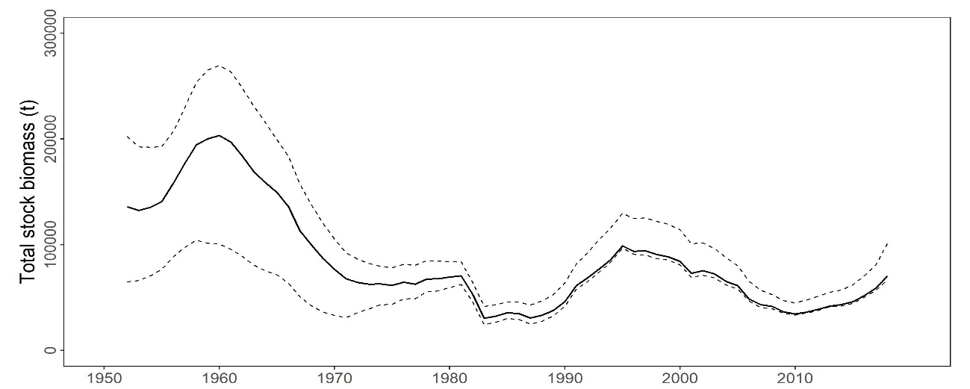

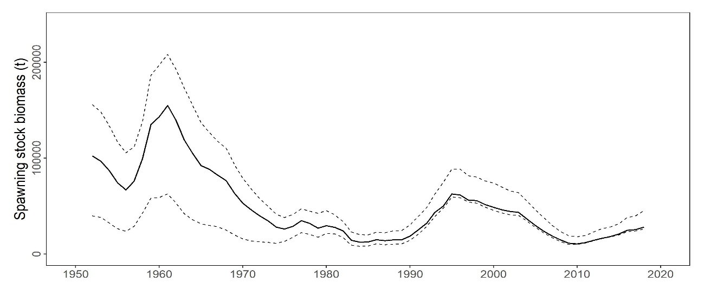

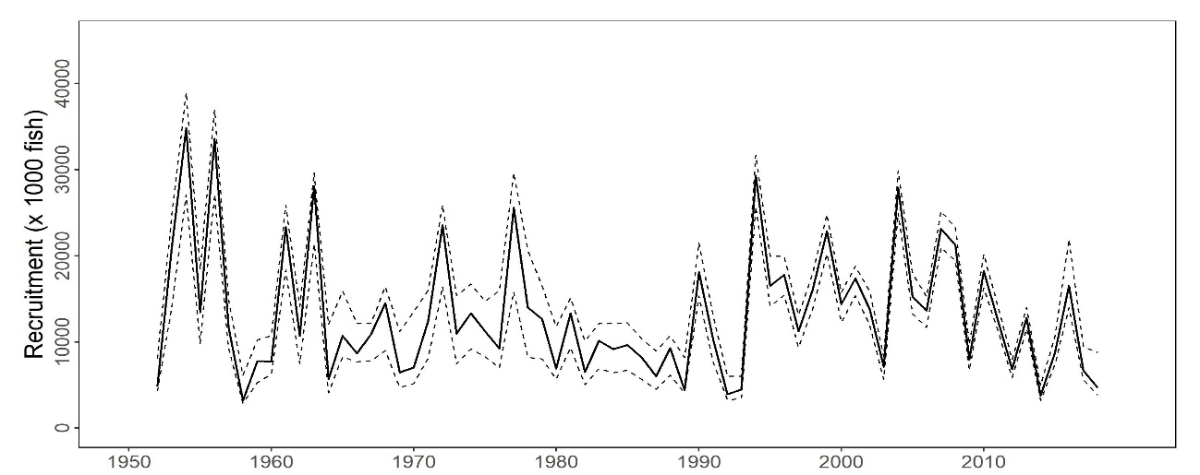

**Figure PBF-1.** Total stock biomass (top), spawning stock biomass (middle), and recruitment (bottom) of Pacific bluefin tuna (*Thunnus orientalis*) (1952-2018) estimated from the base-case model. The solid line is the point estimate and dashed lines delineate the 90% confidence interval.

**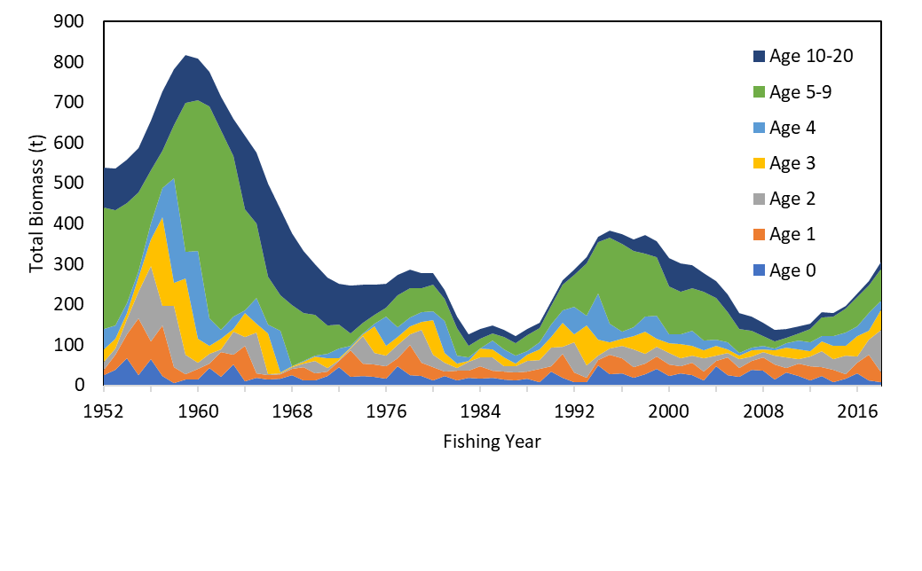**

**Figure PBF-2.** Total biomass (tonnes) by age of Pacific bluefin tuna (*Thunnus orientalis*) estimated from the base-case model (1952-2018).

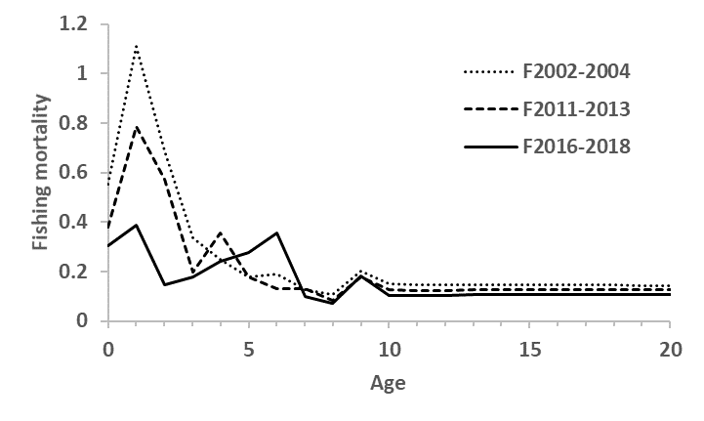

**Figure PBF-3.** Geometric means of annual age-specificfishing mortalities (F) of Pacific bluefin tuna (*Thunnus orientalis*) for 2002-2004 (dotted line), 2011-2013 (broken line) and 2016-2018 (solid line).

**Table PBF-2.** Ratios of the estimated fishing mortalities (Fs and 1-SPRs for 2002-04, 2011-13, 2016-18) relative to potential fishing mortality-based reference points, and terminal year SSB (t) for each reference period, and depletion ratios for the terminal year of the reference period for Pacific bluefin tuna (*Thunnus orientalis*) from the base-case model**.** Fmax: Fishing mortality (F) that maximizes equilibrium yield per recruit (Y/R). F0.1: F at which the slope of the Y/R curve is 10% of the value at its origin. Fmed: F corresponding to the inverse of the median of the observed R/SSB ratio. Fxx%SPR: F that produces given % of the unfished spawning potential (biomass) under equilibrium condition.



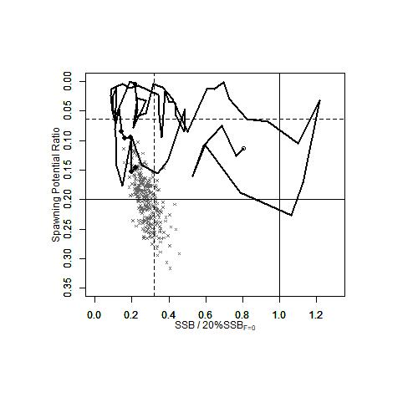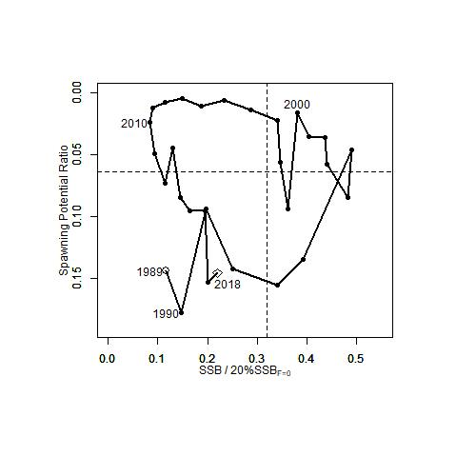

**Figure PBF-4.** Kobe plots for Pacific bluefin tuna (*Thunnus orientalis*) estimated from the base-case model. The X-axis shows the annual SSB relative to 20%SSBF=0 and the Y-axis shows the spawning potential ratio (SPR) as a measure of fishing mortality. Vertical and horizontal solid lines in the left figure show 20%SSBF=0 (which corresponds to the second biomass rebuilding target) and the corresponding fishing mortality that produces SPR, respectively. Vertical and horizontal broken lines in both figures show the initial biomass rebuilding target (SSBMED = 6.4%SSBF=0) and the corresponding fishing mortality that produces SPR, respectively. SSBMED is calculated as the median of estimated SSB over 1952-2014. The left figure shows the historical trajectory, where the open circle indicates the first year of the assessment (1952), solid circles indicate the last five years of the assessment (2014-2018), and grey crosses indicate the uncertainty of the terminal year estimated by bootstrapping. The right figure shows the trajectory of the last 30 years.

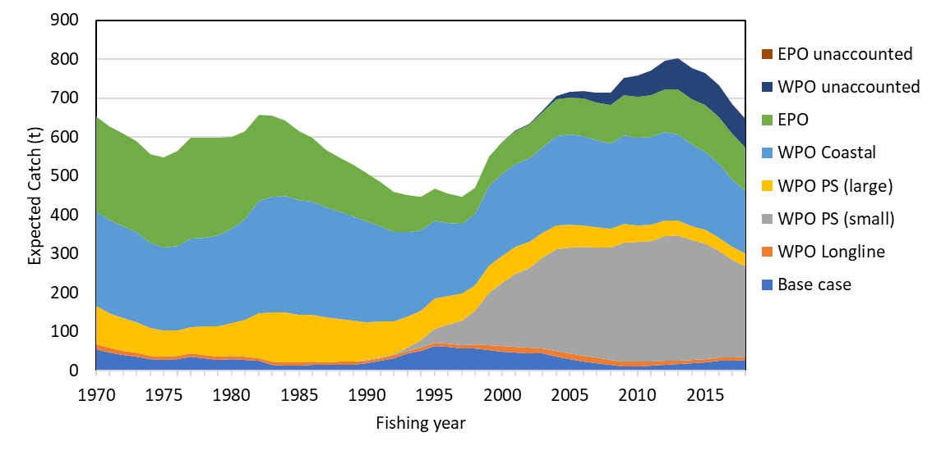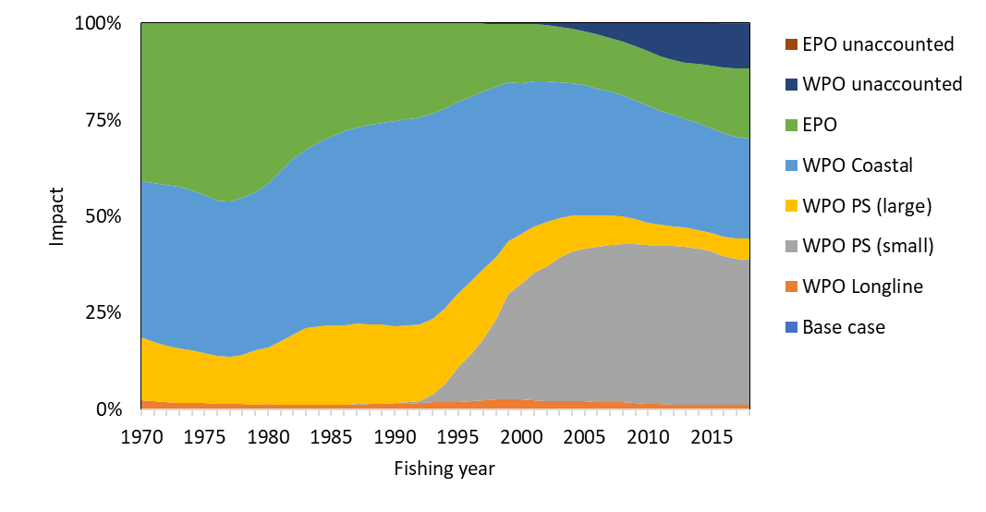

**Figure PBF-5.** The trajectory of the spawning stock biomass of a simulated population of Pacific bluefin tuna (*Thunnus orientalis*) when zero fishing mortality is assumed, estimated by the base-case model. (top: absolute SSB, bottom: relative SSB). Fisheries group definition; WPO longline fisheries: F1, F12, F17, 23. WPO purse seine fisheries for small fish: F2, F3, F18, F20. WPO purse seine fisheries for large fish: F4, F5. WPO coastal fisheries: F6-11, F16, F19. EPO fisheries: F13, F14, F15, F24. WPO unaccounted fisheries: F21, 22. EPO unaccounted fisheries: F25. For exact fleet definitions, please see the 2020 PBF stock assessment report on the ISC website.

**Table PBF-3.** Future projection scenarios for Pacific bluefin tuna (*Thunnus orientalis*) and their probability of achieving various target levels by various time schedules based on the base-case model.



\* The numbering of Scenarios is different from those given by the IATTC-WCPFC NC Joint WG meeting and same as Table 3.

\* Recruitment is switched from low recruitment during 1980-1989 to average recruitment over the whole assessment period in the following year of achieving the initial rebuilding target.

**Table PBF-4.** Expected yield for Pacific bluefin tuna (*Thunnus orientalis*) under various harvesting scenarios based on the base-case model.



\* Catch limits for EPO commercial fisheries are applied for the catch of both small and large fish made by the fleets.

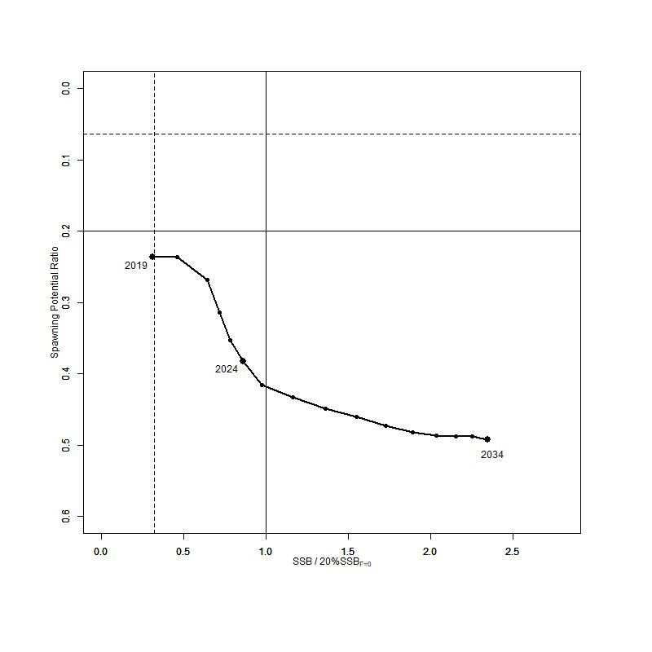

**Figure PBF-6**. “Future Kobe Plot” of projection results for Pacific bluefin tuna (*Thunnus orientalis*) from Scenario 1 from Table PBF3.

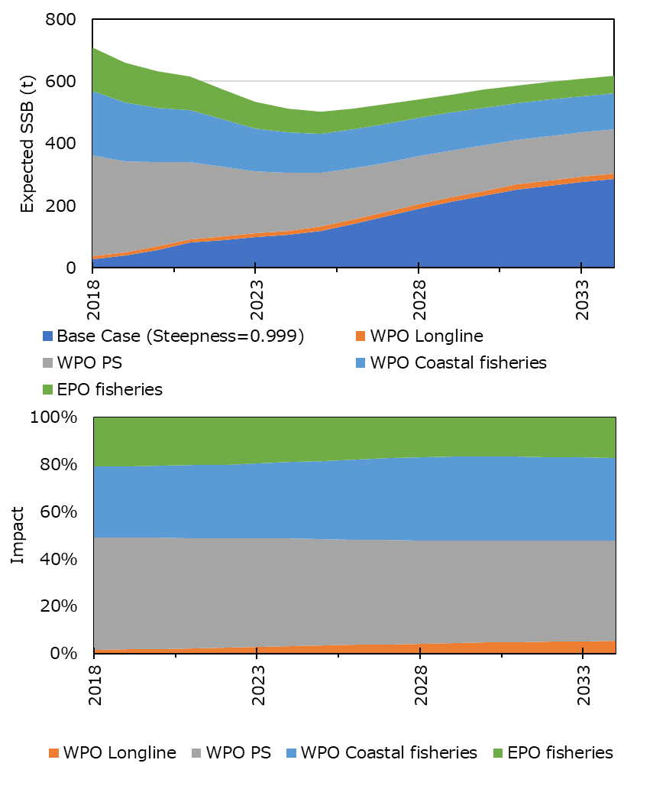

**Figure PBF-7**. “Future impact plot” from projection results for Pacific bluefin tuna (*Thunnus orientalis*) from Scenario 1 of Table S-3. The impact is calculated based on the expected increase of SSB in the absence of the respective group of fisheries.

**3.6 Other Stock Assessment Issues**

**3.6.1 Structural Uncertainty Grids and Projections**

**Recommendations**

1. For species that have assessments that consider axes of uncertainty in a grid approach, the Scientific Services Provider and CCMs should develop objective criteria to quantitatively evaluate the inclusion of axes and respective weighting within each axis to characterize stock status uncertainty. These should be discussed at the SPC pre-assessment workshop.
2. The Scientific Services Provider and CCMs should develop criteria to illustrate a relevant sub-set of diagnostics for all assessment models within the relevant uncertainty grid.
3. For stock assessment projections, provide median estimates of F/FMSY, SB/SBF=0, the risk of breaching an adopted LRP and the probability of being below any interim TRP, at 10 year increments from the beginning of the projection time period.
4. SC16 recommends that the Scientific Services Provider and CCMs should develop criteria to illustrate a relevant sub-set of diagnostics for all assessment models within the relevant uncertainty grid. The Scientific Services Provider and CCMs should develop objective criteria to quantitatively evaluate the inclusion of axes and respective weighting within each axis to characterize stock status uncertainty. This includes the development of standard protocols for weighting alternative models in the ensemble model approach used for stock assessments and management advice. The goal is to develop an objective procedure to down-weigh poorly fitting models and up-weight well-predicting models. To accomplish this, SC16 recommends that the Scientific Services Provider and CCMs hold workshop(s) to develop standard protocols for model weight calculations for assessments that use an uncertainty grid.

**3.6.2 Peer Review**

**Recommendations**

1. SC16 supports an external expert peer review of the yellowfin stock assessment. This would also allow several components of the bigeye tuna assessment to be reviewed given the similar data input structure. This review would examine a number of issues such as model complexity, weighting of data sources, spatial approaches and the extreme sensitivity to assumptions on growth amongst a range of other issues.
2. SC16 provides the following provisional time-line for an external expert peer review.
3. Year 1 would be set aside to allow the SSP to conduct an initial range of testing and analysis internally focussed on YFT and report these findings to SC17. SC17 to finalize ToRs for the external expert review.
4. Year 2 would be set aside for the SSP to conduct further testing and analysis internally focussed on BET and YFT, following SC17 input, and for the external expert review (commencing at the start of 2022) with the review reporting to SC18.
5. Year 3 would provide updated YFT and BET stock assessments which respond to the review. The two assessments would be reported to SC19.
6. In accordance with this, SC16 identified the external review as a project in the budget (provisionally estimated at $USD 50,000) but with no funding commitment until 2022 and 2023.
7. SC16 also tasked the SSP with preparing a draft terms of reference for the external expert review for the consideration of SC17 which would be informed by their analyses during 2021. The draft terms of reference would give consideration to including the bigeye stock assessment in the external review process.
8. Further, SC16 noted that peer review experts of the required calibre may not be easy to secure, thus efforts should be made during late 2020/early 2021 to have them express interest and availability.

**3.6.3 Stock Assessment Schedule**

**Recommendation**

1. SC16 recommended inquiring with the IATTC regarding the potential scheduling for a collaborative Pacific-wide bigeye tuna, south Pacific albacore and south Pacific swordfish assessment. Initial correspondence from the IATTC indicated that their scheduling of stock assessments would occur during the 2020 Scientific Advisory Committee.

**Table 1.** WCPFC provisional assessment schedule for 2021-2025 as discussed in the SC16 Plenary session. In the schedule, tunas are scheduled for assessment every 3 years; swordfish every 4 years; and sharks and other billfish every 5 years.

| Species | Stock | Last assessment | 2021 | 2022 | 2023 | 2024 | 2025 |
| --- | --- | --- | --- | --- | --- | --- | --- |
| Bigeye tuna | WCPO | 2020 |  |  | X |  |  |
| Pacific | 2015 | X? |  |  |  |  |
| Skipjack tuna | WCPO | 2019 |  | X |  |  | X |
| Yellowfin tuna | WCPO | 2020 |  |  | X |  |  |
| Albacore | S Pacific | 2018 | X |  |  | X |  |
| N Pacific | 2020 |  |  | X |  |  |
| Pacific bluefin | N Pacific | 2020 |  | X |  | X |  |
| Striped marlin | SW Pacific | 2019 |  |  |  | X |  |
| NW Pacific | 2019 |  |  |  | X |  |
| Swordfish | SW Pacific | 2017 | X |  |  |  |  |
| N Pacific | 2018 |  | X |  |  |  |
| Pacific blue marlin | Pacific |  | X |  |  |  |  |
| Silky Shark | WCPO | 2018 |  |  | X |  |  |
| Oceanic whitetip shark | WCPO | 2019 |  |  |  |  |  |
| Blue shark | S Pacific | 2016 | X |  |  |  |  |
| N Pacific | 2017 |  | X |  |  |  |
| Mako | N Pacific | 2018 |  |  |  | X |  |
|  | SW Pacific |  |  | X |  |  |  |
| Bigeye thresher | Pacific | 2017 |  |  |  |  |  |
| Porbeagle | S Pacific | 2017 |  |  |  |  |  |

1. **MANAGEMENT ISSUES THEME**
   1. **Development of the Harvest Strategy Framework for key tuna species**
      1. **Target reference points**
         1. **Bigeye and yellowfin tuna**
2. Noting the request from WCPFC16 for the Scientific Committee to provide advice on the formulation of TRPs for bigeye and yellowfin tuna, and for the Scientific Service Provider to conduct an analysis for bigeye and yellowfin tuna similar to that undertaken in working paper WCPFC16-2019-14 (Current and projected stock status of WCPO skipjack tuna to inform consideration of an updated target reference point), as outlined in para. 273-275 of the WCPFC16 Summary Report, SC16 reviewed SC16-MI-WP-01 and requested the Scientific Services Provider undertake the analyses for bigeye and yellowfin tuna according to the criteria outlined in the table below:

|  |  |
| --- | --- |
| Issue | Requested Scenario |
| Model settings and the uncertainty grid | The SC16 agreed structural uncertainty grid. |
| Additional scenarios | To use both short- and long-term recruitment for bigeye tuna. |
| The range of candidate TRPs to be explored: | There are some advantages to defining candidate target stock depletion relative to the average biomass within a recent time period. This is consistent with the approach taken for development of the South Pacific Albacore interim TRP and serves to “future proof” the candidate TRP from changes in the biomass time series that have been noted with updated assessments. Specifying a time period also allows reference to some fisheries performance metrics within that period, such as CPUE.  The following candidate TRPs are specified:   * Average SB/SBF=0 for 2012-2015 (consistent with the Aims of CMM 2018-01) * 10% above Average SB/SBF=0 for 2012-2015 * 10% below Average SB/SBF=0 for 2012-2015 * TRPs at intermediate steps between the candidates outlined above (e.g. at 5% intervals) were also recommended. * An alternative TRP based on the average SB for 2000-2004 should also be explored. * Additional candidate TRPs can be identified in terms of the risk of breaching the LRPs; in particular: the SB/SBF=0 levels associated with 10% and 20% risks of breaching the LRP based on an updated analysis using the SC16 adopted structural uncertainty grid. |
| Time period of the projections | 30 years, consistent with the earlier skipjack analyses. Intervals of 10 years will be presented within this period. The rationale is to have a period to allow the population to reach equilibrium. |
| Use of catch or effort | * PS – effort * LL – catch * Other fisheries – catch   SC16 noted that this is for the purposes of these analyses and without prejudice to preferred management arrangements. |
| The baseline catch and effort levels | A recent period is preferable because it is more relevant to recent activity levels and also a more realistic reflection of IND/PHI fisheries catches. |
| Limits to the range of the fishery scalars | SC16 noted that if scalars are too constrained then it might not be possible to achieve the different biomass TRP levels and some guidance on this issue was sought from the SSP.  Scalars would be applied equally to purse seine effort and longline catch. For other fleets, recent catch levels would be assumed. SC16 also noted that this is an exploratory exercise to see what the consequences could be for different TRP choices and not a management recommendation that sets up any kind of precedent. |
| Reporting the output of the analysis: | Similar outputs to the skipjack work reported in WCPFC16-2019-14.  In addition, SC16 recommended reporting against the Aims of CMM-2018-01 paras 12 and 14 being “average SB/SBF=0 for 2012-2015”.  SC16 also noted the request from one CCM that the Scientific Service Provider produce information on the projected yield per recruit and spawning biomass per recruit under the various harvest scenarios. |

1. Noting the large number of scenarios included in the above request, possible analytical challenges that may arise, and the heavy workload of the Scientific Service Provider due to other requests, the following priority was placed on the TRPs to be evaluated.
2. The initial average and +/- 10% proposal (3 scenarios)
3. The additional runs for 10% and 20% risk and the average SB for 2000-2004 (3 scenarios)
4. Intermediate values based upon the results of the above work (e.g., 2-5 scenarios)
5. SC16 recommends that the above analyses be completed by the Scientific Service Provider and a paper summarizing both the analyses undertaken and the tentative results be forwarded to the TCC16 and final results to WCPFC17.
   * + 1. **Skipjack tuna**
6. Noting the request from WCPFC16 to revise the working paper WCPFC16-2019-14 using candidate interim skipjack TRPs of 42%,44%, 46%, 48% and 50% of SB/SBF=0 (para. 259 of the WCPFC16 Summary Report), SC16 reviewed SC16-MI-WP-02 and noted the following:
7. In response to a query from one CCM as to whether based on the presented results that the TRP could be changed from the current interim 50% SB/SBF=0 TRP to a lower level, the Scientific Services Provider noted that 50% SB/SBF=0 was the equilibrium depletion level achieved when projecting under 2012 effort levels from the 2016 skipjack assessment, and was equivalent to the 2012 stock status identified in that assessment. Using the 2019 stock assessment, and performing the same analysis, a TRP of 42% SB/SBF=0 would be consistent with this logic (i.e. would be achieved in the equilibrium under 2012 effort levels and was equivalent to 2012 stock status). In response to a related question as to why 2012 was chosen as the reference year given that catches were made available in recent years in ID, PH and VN, the Scientific Services Provider informed SC16 that as part of this analysis the increased catch levels in these countries in recent years had been included.
8. One CCM noted that in CMM 2018-01 the interim management objective adopted was using the 2012-2015 average as the base line years and requested that an additional table be included in the working paper based on an analysis using these reference years. Another CCM also requested that an indication of the recent effort levels relative to the 2012 effort also be included.
9. In response to a request from one CCM to make the projections based on recent fisheries mortality rather than the 2012 effort (i.e. number of purse seine sets), the Scientific Services Provider noted that this may be difficult but would investigate the possibility of doing so.
10. Noting the additional requests from WCPFC16 for advice on the formulation of TRPs for skipjack tuna and effort creep estimated in relation to the TRPs (para. 258 of the WCPFC16 Summary Report), SC16 noted that advice pertaining to these requests are also contained in SC16-MI-WP-02.
11. SC16 recommends that SC16-MI-WP-02 be revised to include the additional analyses requested in (ii) and (iii) above, and that this revised paper be forwarded to WCPFC17.
12. SC16 recommends that the Commission take into consideration the information contained in this revised paper when discussing a TRP for skipjack tuna.
    * 1. **Performance indicators, monitoring strategy, harvest control rules and management strategy evaluation**
13. Noting the request by WCPFC16 to review the progress on the technical development of WCPFC harvest strategies for the key WCPO tuna stocks, SC16 reviewed SC16-MI-WP-03 and received a very brief summary of ten (10) related Information Papers (SC16-MI-IP-01 to SC16-MI-IP-10) and provides the following advice to the Commission:
14. SC16 noted the difficulties in structuring the discussions for this large amount of work due to the virtual nature of the meetings format.
15. SC16 also noted the constraints that COVID-19 has had on ongoing capacity building with the result that not all CCMs were as well placed as they would have liked to have been to provide feedback on all aspects of this work.
16. Despite these limitations, SC16 welcomed the work presented by the Science Service Provider on skipjack management procedures and the south pacific albacore MSE framework.
17. SC16 noted that the Operating Model for skipjack tuna had been updated to take account of the updated assessment presented in 2019 and that there were no substantial changes between the model outputs compared to those from the previous model.
18. In response to a question about how and when the elements of the Operating Models for skipjack and SP-albacore would be agreed and adopted to allow testing of Management Procedures (MPs) under a final set of diagnostics, SC16 noted that with further input from CCMs over the coming year (see recommendations below) that adoption of the Operating Models could be undertaken at SC17 with the review of a final suite of MPs to be undertaken by SC18. This would align with the schedule for the adoption of a MP for both skipjack and South Pacific albacore as outlined in the current Harvest Strategy Workplan.
19. SC16 noted that the current Operating Model for skipjack conditioning includes an additional growth element that was not included in the previous model, and there may be a need to expand the grid of uncertainties in relation to the occurrence of exceptional circumstances.
20. One CCM noted the need for Performance Indicators (PI) for the impact on small-scale fisheries, but SC16 was informed that currently it would be difficult to include these fisheries within the Operating Model and unless further information/data pertaining to these fisheries is provided the development of a PI (or a proxy) would also be difficult.
21. Several CCMs also noted the need for a PI to meet requirements of para 12 in CMM 2014-06 (Harvest Strategy CMM), specifically to avoid overfishing and not to transfer a disproportionate burden to developing state parties and territories. They also noted that while such a PI may not be informative in the skipjack MSE it was seen as critical in the multispecies framework. The Scientific Services Provider advised SC16 that input from members on alternative PI options to be included within the framework was welcome.
22. SC16 noted the inclusion of a length-based indicator in the suite of empirical Harvest Control Rules (HCRs) tested for South Pacific albacore and that this had been undertaken to explore different ways of constructing a HCR using empirical data approaches that are not based on CPUE. The limitations of such length-based indicators were noted. SC16 also noted that unless effort creep can be accounted for, the utility of empirical HCRs that are CPUE-based can also be compromised. SC16 noted that model-based approaches might also be appropriate.
23. In relation to the multispecies approach being developed, SC16 noted that it may not be possible to achieve all the TRPs at the same time, and mixed fisheries harvest strategies may lead to one or two stocks being fished above or below the TRP. The Scientific Services Provider advised SC16 that options to support discussion on such issues will be developed within the mixed fishery framework.
24. Noting the key findings and challenges summarised above, SC16 provides the following advice and recommendations to the Scientific Services Provider (SSP) and the Commission:
25. SC16 recommends that WCPFC17 note the progress on the development of the Harvest Strategy Workplan as outlined in SC16-MI-WP-03 (and related Information Papers) and provide additional elements, if any, as specified in the Harvest Strategy Workplan to further progress this work against the scheduled timelines noted in this Workplan.
26. Noting that the virtual SC16 meeting had not provided enough time to consider the ten information papers (SC16-MI-IP-01 to SC16-MI-IP-10) related to the progress of developing the WCPFC harvest strategy framework, and the ongoing needs of the SSP to get further feedback from CCMs on this work, SC16 agreed to continue discussions on these ten papers through the WCPFC Online Discussion Forum (ODF). The purpose of the ODF would be to:
27. facilitate feedback on technical aspects related to the issues covered by the ten information papers presented to SC16;
28. enable CCMs to make suggestions to the SSP on alternative HCRs to consider;
29. get benefit from participant’s feedback on the progress on the SSP’s work;
30. assist with the mutual understanding of this work; and
31. assist with capacity building of the participants.

The ODF should remain open for as long as required.

1. SC16 noted that this ODF activity is outside of the Scientific Committee and any discussions on this ODF will not constitute formal recommendations to the Commission or the SSP.
2. SC16 also noted that given the large range of technical issues included in the ongoing development of the WCPFC harvest strategy framework, and limitations for the SC to undertake a thorough review of these issues, that progress on many of the technical aspects related to this framework would be enhanced through an intersessional workshop, which could be held in conjunction with the annual Pre-Assessment Workshop (PAW) hosted by the SSP. Like the PAW, the aim is for this workshop to be a technical meeting of scientists who have a common interest in providing feedback to the SSP on technical issues related to the development of the harvest strategy framework. The outcomes of the meeting would be documented, and the report of the meeting and other analyses would be submitted to the WCPFC Scientific Committee either as a stand-alone paper or within other relevant papers. SC16 requests the Commission to consider the utility of holding such a workshop.
3. Finally, noting that the development of the WCPFC harvest strategy framework is reaching a mature stage, and the increasing number of issues that require the attention of, and feedback from, managers in order to progress the Harvest Strategy Workplan, SC16 again reiterates its previous recommendations for a Science-Management Dialogue to be convened. In addition, SC16 calls attention to the importance of such a dialogue to ensure the input of managers and stakeholders to the MSE process and to ensure timely execution of the Commission’s harvest strategies workplan.
   1. **Implementation of CMM 2018-01**
      1. **Effectiveness of CMM 2018-01**
4. To provide additional information to the Commission on options for CMM 2018-01, SC16 recommends that the Scientific Services Provider provide to the Commission as early as reasonable, the following:
5. Any updates to SC15-MI-WP-01, “minimum target reference points for WCPO yellowfin and bigeye tuna consistent with alternative LRP risk levels, and multispecies implications,” and the following additions to the deterministic projections in Figure 3a and 3b for bigeye tuna (and to Figures 2a and 2b for yellowfin tuna if possible) (as in the original paper, the PS scalar should scale overall PS fishing effort, including both associated and unassociated fishing effort):
   1. Inclusion on the x axis (PS scalar) and y axis (LL scalar) of the absolute quantities that correspond to the scalars (for PS scalar, numbers of both associated sets and unassociated sets, and for LL scalar, longline catch in mt).
   2. Inclusion on the x axis and y axis of the expected fishery impact of the sector on SSB (SB2045/SBF=0) that correspond to the scalars, assuming the other sectors’ (e.g., pole-and-line and other) impacts are as they were in 2013-2015, on average.
   3. Extension of the ranges of the x and y axes to scalars as high as 2.0 (from 1.5).
   4. Indications of the expected PS scalars for the purse seine management regime under CMM 2018-01.
6. One or more tables showing as long a time series as possible, of fishery impact on WCPO bigeye tuna SSB, by fishery sector (for just the diagnostic case, and including at a minimum: longline, purse seine associated, purse seine unassociated, pole-and-line, and other).
7. **FUTURE WORK PROGRAMME AND BUDGET**
   1. **Development of the 2021 work programme and budget, and projection of 2022-2023 provisional work programme and indicative budget** 
      1. **Review of project progress in 2020**
8. SC16 adopted the *2021 – 2025 Shark Research Plan* and recommended it to the Commission for endorsement.
   * 1. **Work programme and budget for** **2021-2023**
9. SC16 agreed to resume SC16 meeting prior to WCPFC17 to discuss and finalize the SC work programme and budget for 2021, and provisional work programme and indicative budget for 2022-2023. It was agreed that the Secretariat would inform CCMs of the details of the Resume SC16 Meeting through a circular.
   * + 1. **Outcomes of the Resume SC16 Meeting**
10. SC16 agreed that the 2021 scientific services from SPC would comprise (i) the South Pacific albacore stock assessment; (ii) the Southwest Pacific swordfish stock assessment; and (iii) additional analyses related to yellowfin tuna in preparation for the stock assessment peer review.
11. SC16 adopted the proposed work programme and budget for 2021 and indicative budget for 2022 – 2023 (Table 2) and forwarded it to the Commission.

**Table 2.** Summary of SC work programme titles and budget for 2021, and indicative budget for 2022–2023, which requires funding from the Commission’s core budget (USD).

| **Project Title** | **TOR** | **Essential** | **Priority Rank** | **2021** | **2022** | **2023** |
| --- | --- | --- | --- | --- | --- | --- |
| SPC-OFP scientific services |  | Yes | High 1 | 943,014 | 961,875 | 981,112 |
|  |  |  |  |  |  |  |
| SPC Additional resourcing |  | Yes | High 1 | 169,810 | 173,206 | 176,670 |
| P35b. WCPFC Tissue Bank | SC15-Att.G | Yes | High 1 | 101,180 | 103,204 | 105,268 |
| P42. Pacific Tuna Tagging Program | SC15-Att.G | Yes | High 1 | 730,000 | 730,000 | 730,000 |
| P60. PS Species Composition | SC15-Att.G | No |  | 40,000 |  |  |
| P65. Peer review of stock assessment modelling (bigeye and yellowfin tuna) | SC17 |  |  |  | 50,000 |  |
| P68. Seabird mortality | SC15-Att.G | No | High 2 |  | 75,000 |  |
| P88. Acoustic FAD analyses | SC15-Att.G |  | High 2 | 15,000 |  |  |
| P90. Length weight conversion | SC15-Att.G | No | High 2 | 20,000 | 75,000 |  |
| P100b. Feasibility of Close-Kin Mark-Recapture assessment for South Pacific albacore in the WCPO | SC16-GN-IP-08 |  | High 2 | 0 |  |  |
| P101. Monte Carlo simulations - shark mitigation | SC15-Att.G |  | High 1 |  |  |  |
| P102. Population projections for oceanic whitetip shark | SC15-Att.G |  | High 1 |  |  |  |
| P104. Appropriate LRPs for Southwest Pacific Ocean striped marlin and other billfish | SC16-GN-IP-08 |  | High 1 | 31,000 |  |  |
| P105. Bomb radiocarbon age validation for bigeye and yellowfin tunas in the WCPO | SC16-GN-IP-08 |  | High2 | 97,980 |  |  |
| P106. Ageing of South Pacific albacore | SC16-GN-IP-08 |  | High 1 | 0 |  |  |
| P107. SP blue shark assessment | SC16-GN-IP-08 |  | High 2 | 20,000 |  |  |
| P108. WCPO silky shark assessment | SC16-GN-IP-08 |  |  |  | 100,000 |  |
| P109. Training observers for elasmobranch biological sampling | SC16-GN-IP-08 |  | High 1 | 25,000 |  |  |
| P110. Non-entangling and biodegradable FADs |  |  | High 1 | 0 |  |  |
| **Total Project Budget** |  |  |  | **1,249,970** | **1,306,409** | **1,011,938** |
| **Total Budget with SPC-SSA** |  |  |  | **2,192,984** | **2,268,284** | **1,993,050** |

**5.2 Streamlining Annual Reporting**

**Recommendations**

1. SC16 noted the updates on streamlining of annual reporting requirements implemented in 2020 that were provided in SC16-GN-IP-07 *Update on Streamlining of Annual Reporting Initiatives.*
2. SC16 also noted that SC16-GN-IP-07 reviewed the experiences and outcomes of the trial Annual Catch and Effort Estimate (ACE) Tables and has provided information that the cost and resources implications of this trial were modest.
3. SC16 recommends to WCPFC17 that the approach of publishing the ACE tables based on the April 30 Scientific Data submissions and subsequent updates and revisions from CCMs is continued.
4. SC16 recommends that the Scientific Services Provider is tasked to review the feasibility of expanding the ACE Tables, to include additional estimates of effort where it is practicable to be derived based on the April 30 scientific data submissions from CCMs and provide an update to SC17.
5. **ADMINISTRATIVE MATTERS** 
   1. **Next meeting**
6. SC16 recommended to the Commission that, if circumstances allow an in-person meeting to be convened, SC17 would be held in Palau during 11– 19 August 2021. Tonga offered to host SC18 in 2022.
7. **OTHER MATTERS**
   1. **Review of Online Discussion Forum outputs**
8. SC16 noted the results of the Online Discussion Forum (SC16-ODF-01, *Summary of Online Discussion Forum*), which is included as **Attachment F**.
9. **ADOPTION OF THE SUMMARY REPORT OF THE SIXTEENTH REGULAR SESSION OF THE SCIENTIFIC COMMITTEE**
10. SC16 adopted the recommendations of the Sixteenth Regular Session of the Scientific Committee, with the exception of recommendations relating to the future work programme and budget, which were deferred to the Resume SC16 Meeting to be held prior to WCPFC17.
11. SC agreed that the SC16 Summary Report would be adopted intersessionally according to the following schedule:

|  |  |
| --- | --- |
| **Tentative Schedule** | **Actions to be taken** |
| **19 August** | Close of SC16  By 28 August, SC16 Outcomes Document will be distributed to all CCMs and observers (within 7 working days, Rules of Procedure). |
| **26 Aug – 4 Sep** | Secretariat will receive Draft Summary Report from the rapporteur and clear the report. |
| **4 – 11 Sep** | Theme Convenors will review the report |
| **11 – 18 Sep** | Secretariat will compile all edits from convenors |
| **18 Sep – 30 Oct** | CMMs and Observers review and submit comments to the Secretariat (for 30 working days) |

1. **CLOSE OF MEETING**
2. The SC Chair adjourned SC16 at 1530, Pohnpei time on 19 August 2020, until it could be reconvened to consider issues and recommendations relating to the SC future work programme and budget for 2021–2023. (Refer to Section 5.1.2.1 for the results of the Resume SC16 Meeting)
3. The Chair closed SC16 at 13:02 Pohnpei time on Thursday, 10 September 2020.

**The Commission for the Conservation and Management of   
Highly Migratory Fish Stocks in the Western and Central Pacific Ocean**

**Scientific Committee**

**Sixteenth Regular Session**

**Electronic Meeting**

12 – 19 August 2020

|  |
| --- |
| **SUMMARY REPORT** |

# AGENDA ITEM 1 — OPENING OF THE MEETING

# 

1. The Sixteenth Regular Session of the Scientific Committee of the Commission for the Conservation and Management of Highly Migratory Fish Stocks in the Western and Central Pacific Ocean (SC16) took place for six days during 12–19 August 2020 as an electronic meeting in response to the global coronavirus disease (COVID-19) pandemic. The electronic meeting was chaired by Mr Matai’a Ueta Faasili Jr.(Samoa).
2. The following WCPFC Members, Cooperating Non-members and Participating Territories (CCMs) attended SC16: Australia, Canada, China, Cook Islands, European Union (EU), Federated States of Micronesia (FSM), Fiji, Indonesia, Japan, Kiribati, Republic of Korea, Republic of Marshall Islands (RMI), Nauru, New Zealand, Niue, Palau, Papua New Guinea (PNG), Philippines, Samoa, Solomon Islands, Chinese Taipei, Tonga, Tuvalu, United States of America (USA), Vanuatu, French Polynesia, New Caledonia, Tokelau, Wallis & Futuna, Panama and Vietnam.
3. Observers from the following inter-governmental organizations attended SC16: Inter-American Tropical Tuna Commission (IATTC), Pacific Islands Forum Fisheries Agency (FFA), Parties to the Nauru Agreement (PNA), the Pacific Community (SPC), and the Secretariat of the Pacific Regional Environment Programme (SPREP).
4. Observers from the following non-governmental organizations attended SC16: American Tunaboat Association (ATA), Australian National Centre for Ocean Resources and Security (ANCORS), Birdlife International, Conservation International (CI), International Pole and Line Foundation (IPNLF), International Seafood Sustainability Foundation (ISSF), Marine Stewardship Council, Sustainable Fisheries Partnership (SFP) Foundation, The Nature Conservancy (TNC), The Ocean Foundation, The Pew Charitable Trusts (Pew), World Tuna Purse Seine Organisation (WTPO) and the World Wide Fund for Nature (WWF).
5. The full list of participants can be found at **Attachment A**.
   1. Welcome address
6. Dr Tuikolongahau Halafihi, SC vice-chair and head of the delegation from Tonga, gave the opening prayer.
7. SC Chair Ueta Faasili Jr. welcomed participants to the 16th Regular Session of the Scientific Committee.
8. Ms. Jung-re Riley Kim, Chair of the WCPFC, welcomed delegates, observers, the SC Chair, the WCPFC Executive Director and his staff, and the staff of SPC to SC16. She observed that 2020 had been a very difficult year for everyone, with many new challenges, and thanked everyone involved with the SC for their efforts to enable the Commission’s work to continue. She noted the important issues under consideration at SC16, and looked forward to the outcomes of the meeting, which she stated would inform the Commission’s decisions and considerations at WCPFC17. Her full remarks are appended as **Attachment B.**
9. The WCPFC Secretariat’s Executive Director, Feleti P Teo, OBE, welcomed delegates to SC16. He acknowledged the presence of Ms. Riley Kim and welcomed her insights for the work of the SC, and her guidance on the advice sought by the Commission from SC16. He acknowledged all those involved in organizing the meeting, and noted that over 340 participants had registered, about double the usual number. He also reflected on the challenges involved in organizing a virtual meeting for an organization whose membership is global in scope. Given the challenges posed by COVID-19, the Executive Director stressed the need to be innovative while remaining singularly focused on the work at hand, and providing the Commission with the best available scientific advice and information. His full remarks are appended as **Attachment C.**
10. The SC Chair stated that given the circumstances it was fortunate that SC was able to hold such a global meeting. He noted the abbreviated agenda, which was chosen to ensure SC was able focus on key decisions. He encouraged all participants to fully cooperate and ensure SC16 was a constructive meeting. He declared SC16 open at 11:22 am.
    1. Meeting arrangements
11. The Chair outlined procedural matters, including the virtual meeting protocols (WCPFC-SC16-2020-04), the meeting schedule (WCPFC-SC16-2020-06), administrative arrangements, and the list of theme conveners. The conveners and their assigned theme were:

|  |  |
| --- | --- |
| **Themes** | **Conveners** |
| Data and Statistics | Valerie Post (USA) |
| Stock Assessment | Keith Bigelow (USA) and Hiroshi Minami (Japan) |
| Management Issues | Robert Campbell (Australia) |
| Ecosystem and Bycatch Mitigation | John Annala (New Zealand) and Yonat Swimmer (USA) |

1. The Chair noted that as a result of the virtual meeting, topics under the Ecosystem and Bycatch Mitigation theme would not be considered at SC16. The Chair also informed CCMs of the need to find theme co-conveners for the Management Issues theme and the Ecosystem and Bycatch Mitigation theme for SC17.
2. The EU addressed the meeting schedule, and specifically the choice of meeting times for most of the meeting sessions (11 am to 3 pm Pohnpei time), which falls from 2 am to 6 am in Brussels. They noted their objection to the schedule that was adopted, which the EU stated could have been adjusted to ensure that no delegation would have to work in the early morning hours. The EU encouraged CCMs to ensure the Commission’s work arrangements were fair for all members, and stated they would do their best to contribute constructively.
   1. Adoption of the agenda
3. The Chair noted that the Commission (in Circular 2020/47) tasked the Secretariat and the Scientific Services Provider (SSP), in collaboration with the SC Chair and Co-Convenors, to explore an abbreviated agenda consisting of essential items necessary to progress the scientific work of the Commission in 2020 and to provide the scientific advice necessary to inform key decisions of the annual WCPFC17 meeting in December 2020. An initial abbreviated agenda was developed and posted on the meeting website on 12 June. Following an SC16 Preparatory Meeting on 27 July 2020, a revised agenda was developed for the plenary meeting, with some topics slated for consideration through an Online Discussion Forum[[3]](#footnote-3). The agenda was posted on 28 July.
4. The SC16 provisional agenda was adopted **(Attachment D).**
   1. Reporting arrangements
5. The Science Manager reviewed the reporting arrangements and noted that in accordance with the Rule 33 of the Commission’s Rules of Procedure, the text of all decisions adopted by the SC16 would be distributed in the form of the Outcomes Document to all members, territories and observers within seven (7) working days following their adoption. The SC16 Summary Report, including an Executive Summary, would be adopted intersessionally. The Executive Summary includes a brief overview of the meeting, all theme recommendations adopted during the meeting, including a synopsis of stock status and management advice, and any other initiatives arising from the SC16.

# AGEDNA ITEM 2 — DATA AND STATISTICS THEME

* 1. Data gaps of the Commission

1. V. Post (USA), the data and statistics theme convener, noted that the data and statistics theme would consider only one item in plenary at SC16. Some SC16 information papers were addressed through the Online Discussion Forum, but a number of papers were not covered; she suggested those could be considered at SC17.
2. P. Williams (SPC) presented SC16-ST-WP-01 *Scientific data available to the Western and Central Pacific Fisheries Commission*. Two additional papers (SC16-ST-IP-02 *Status of Observer Data Management* and SC16-ST-IP-03 *Estimates of annual catches in the WCPFC statistical area*) were noted.

The paper reports on the major developments over the prior year with regards to filling gaps in the provision of scientific data to the Commission.

1. The review of gaps in 2018 and 2019 scientific data provisions includes the assignment of a tier-scoring evaluation level. There have been no significant developments in some categories of the main data gaps over the preceding five years, and references are therefore provided to relevant sections in past data-gap papers.
2. All CCMs with fleets active in the WCPFC Convention Area provided 2019 annual catch estimates by the deadline of the 30 April 2020. Issues previously reported with respect to annual catch estimates have been further reduced, while the lack of any estimates for key shark species remains the main gap for some CCMs, particularly for years prior to 2017.
3. Aggregate catch and effort data for 2019 were provided by the deadline of 30 April 2020 for all fleets. The quality of aggregate data provided continues to improve with a reduction in recent years in the number of data-gap notes assigned to the aggregate data. The other main data gap concerns the low coverage of operational data available to generate aggregate data for the Indonesian and Vietnamese fleets, and the anticipated under-reporting of key shark species in general.
4. Most CCMs with active fleets provided operational catch and effort data for 2019, with the main gaps being (i) the low coverage in the data provided for the Indonesian and Vietnamese fleets; (ii) the non-provision of a number of required fields in the Indonesian and Vietnamese operational data (e.g. catch in number for longline and handline fisheries), and (iii) catches of key shark species are not included in the Indonesian and Vietnamese fleet data. The coverage of 2019 operational data for some fleets is not complete (100%), although there was some improvement in coverage compared to the 2018 data.
5. The paper also responds to five data-related recommendations from SC15, provides a brief update on the Bycatch Data Exchange Protocol (BDEP) data and makes reference to other SC16 papers for Regional Observer Programme (ROP) data and the trials on Annual Catch Estimates (ACE) tables.
6. The NZ-funded WPEA-Improved Tuna Monitoring (WPEA-ITM) Project contributes WCPFC technical assistance to Indonesia, Philippines and Vietnam to improve monitoring and data management of their domestic fisheries. There has been good progress in the collection and provision of data from each of these countries in recent years and the paper also lists some of the challenges that remain.

**Discussion**

Tonga, on behalf of FFA members, noted that the highlight of key gaps in the Commission's data holdings is something they continue to monitor with interest. However, FFA members stated that they see continuing gaps on outstanding data, specifically historical operational data, and reiterated their points from SC15 that SC should recommend to WCPFC that CCMs consider an agreement such that historical operational data dating from pre-Commission years can only be used for a restricted set of scientific purposes and not for compliance or enforcement purposes. FFA members stated that there were no doubt alternative solutions to making this valuable data available for all scientific purposes, and they would welcome ideas on this issue, so that it could hopefully be resolved.

Korea raised a question regarding inconsistencies between the data reported in SC16-ST-IP-02 and that submitted by Korea. SPC replied that it would communicate directly with Korea to reconcile any data issues.

New Zealand, on behalf of FFA members, thanked SPC for their update on the actions taken to address the recommendations from SC15. Particularly:

* the improvement on the longline observer data with data tables for ease of referencing;
* the revisions on data reporting obligations under the Charter Notification;
* the revision on guidelines for the voluntary submissions of cannery data; and
* the ongoing work addressing the discrepancies between the number of trips reported and observer appointments.

Solomon Islands, on behalf of FFA members, stated they appreciate the improvements that have been made by Indonesia, Philippines and Vietnam working with SPC in recent years on the submission of operational data, but noted that there are still some key data gaps that must be addressed. FFA members stated they remain concerned about a number of these data gaps, particularly the non-provision of data for a number of required fields in the Indonesian and Vietnamese operational data, and encouraged these countries to address these gaps as soon as possible.

Nauru, on behalf of PNA members, supported the FFA statements on the topic. PNA members noted the progress in the two key areas of data gaps—data from Indonesia, Philippines and Vietnam; and species-specific shark data—and stated their appreciation for the progress made in these areas. However, they emphasized the importance of further improvement in addressing these two data gaps: (i) catches continue to grow in the most western waters of the WCPO and continuing improvements in data quality are important to strengthen understanding and management of the key tropical species; and (ii) improving species–specific shark data remains an important priority. PNA members thanked SPC for the information provided on responses to the SC15 recommendations, and proposed that SC16 note the information provided in the paper on those responses.

Indonesia voiced its appreciation for the work done by SPC and stated its understanding that data on sharks in particular needed to be improved. Indonesia observed it had included this as an area where it required capacity assistance. Indonesia had workshops scheduled for 2020 on sharks and longline data and catch limits, but these were deferred until 2021 as a result of COVID-19. Indonesia stated that it expected to improve its performance with respect to the data gaps.

Pew asked for clarification regarding the data fields for observer coverage in SC16-ST-IP-02 (Table 3) for 2018, as some data appeared to be missing compared with that reported at SC15. SPC replied that in response to a request from SC15, Table 3 refers only to ROP-defined trips (which are a measure of compliance); blank fields are domestic trips, and thus non-ROP. Table 5 shows all trips based on overall observer data; these data are used for fisheries analysis.

SPREP stated that, in maps in Figures 3 and 4 of SC16-ST-IP-02, longline effort appears to have moved significantly south, and inquired whether this was actually occurring, and what the time frame was. SPC stated that it could examine the data and provide information if desired.

The data and statistics theme convener suggested that SC could forward SC16-ST-WP-01 and SC16-ST-IP-02 to the TCC16 and WCPFC17. The EU stated its view that the documents are useful for TCC, and that they should be forwarded as had been done in the past. China concurred, but requested that a distinction be made regarding whether data submission was compulsory or voluntary.

**Recommendation**

**SC16 recommended that updated versions of SC16-ST-WP-01 (Data gaps) and SC16-ST-IP-02 (ROP data management) be forwarded to TCC16 for consideration.**

# AGENDA ITEM 3 — STOCK ASSESSMENT THEME

K. Bigelow (USA) and H. Minami (Japan), stock assessment (SA) theme co-convenors, reviewed the proposed report format for the SA theme, and outlined there were 6 working papers that would be addressed in presentations, as well as 21 information papers that would serve as background for the discussions.

* 1. Age and growth of yellowfin and bigeye tuna (Project 82)

1. J. Farley (CSIRO) presented paper SC16-SA-WP-02 *Age and growth of yellowfin and bigeye tuna in the western and central Pacific Ocean from otoliths.* The presentation also referred to two information papers; SC16-SA-IP-03 *Integrated growth models from otolith and tagging data for yellowfin and bigeye tuna in the western and central Pacific Ocean* and SC16-SA-IP-17 *Report on the bomb radiocarbon age validation workshop for tuna and billfish in the WCPO*. The presentation described the results of a regional study of yellowfin age and growth in WCPO using otoliths, and an update of bigeye growth estimation. Over 1500 yellowfin otoliths were selected and sent to Fish Ageing Services for reading. A new algorithm was developed to estimate decimal age using the counts of opaque zones and otolith measurements provided by Fish Ageing Services. The results show that yellowfin may live longer than previously thought, with some reaching 10-15 years, although most fish analysed were less than age 6.
2. Limited direct age validation is available for yellowfin in the WCPO but previous analysis of two chemically marked otoliths and new edge type analysis indicate that one opaque zone is deposited annually. Parameter estimates were obtained for von Bertalanffy (VB) and Richards growth models fitted to the age and length data, with the Richards model preferred. No significant differences were found in growth between sexes, but there was some evidence of longitudinal differences.
3. For bigeye tuna, new daily age estimates were obtained for small fish, which was included in updated growth analyses. The new age algorithm was applied to bigeye to provide improved decimal age estimates. Parameter estimates were obtained for VB and Richards growth models, with the Richards model preferred.
4. Integrated growth models were fit to age-at-length and tag-recapture data for both species and the results show differences between the two datasets. The tag-recapture data suggesting slower initial growth followed by a faster “second phase”, and a larger asymptotic length. This two-stage growth is not observed in the otolith age-at-length data or the otolith weight-at-length data. The reason for these differences is not yet understood and needs to be further investigated. The presentation noted that an electronic workshop was held recently to discuss the feasibility of applying the bomb radiocarbon age validation method to tuna and billfish in the WCPO, and that a project proposal on this validation method has been submitted for consideration.

**Discussion**

1. Japan commented it found the conditional age and related modification of the growth model using otoliths for bigeye and yellowfin reasonable, and the clear description of the methodology helpful. Japan noted its concerns about the stock assessment results produced using the current growth model, and supported the presenter’s recommendation to pursue other methods, including bomb radiocarbon analysis.
2. The EU remarked on the importance of the work and how it has changed perceptions of stock status. The EU referenced the pre-assessment workshop, where the presenter described the effect of latitude and longitude on length at age, and the apparent latitude gradient. (i) Noting that some regions with lower length at age are somehow overrepresented in the sample, the EU inquired if this could introduce some bias in the estimates and might deserve some further analysis. (ii) The EU also mentioned work showing that fish caught in association with FADs grow less than those caught on free schools, possibly because the association with FADs is linked more to size than age; this may have implications on the stock assessment, and may help explain discrepancies between estimates derived from models and tagging. The EU inquired if the presenter had checked any potential effect of fishing gear in the analyses, and if this was possible or advisable. The presenter replied (i) that the analysis lacked a balanced length at age for all size fish and all age classes in all areas; more data are needed to really show what is happening using that method. The model will be run again if the authors get more data, but this is a lower priority until a full size and age range of fish in each area is available. Regarding (ii), she stated that it would be a very useful issue to pursue, and may help explain some of the differences between the tagging and otolith data; she stated the issue would be further investigated.
3. Nauru, on behalf of FFA members, noted the improvements in growth estimates that have resulted from project 82 and supported the need for direct validation studies of these ageing methods, including the proposed bomb radiocarbon project, spanning the entire size range and expected range of longevity. Given that growth is an important parameter in the assessment models, FFA members supported the need to continue refining these estimates. They noted that for the yellowfin study, 89% of the samples were <6 years old and encouraged efforts to obtain older fish to improve the growth model. They also noted the efforts to improve growth estimates through an integrated growth model combining otolith and tagging datasets for yellowfin and bigeye tuna in the WCPO and supported the continued efforts by the authors of the study to investigate the reasons behind discrepancies between the datasets for both species.
4. The USA inquired whether there was any indication that there may be issues with sample selection, and how could have this impacted the overall growth estimate, as well as how otoliths were selected for the overall spatial analysis. The presenter stated that otoliths were selected based on the size, the sex and the area. Otoliths were selected in proportion to the catch in different regions, with more otoliths used from regions with high catch rates. Otoliths were selected by 1 cm length classes, and by sex; all large males and females were selected and read. The authors tried to get as many otoliths as possible from every size and age range from the entire region. The collection now has more otoliths than when the selection was done, and there may be additional large fish that could be studied.
5. IATTC referenced the integrated modelling, stating that they understood the authors fit to the tagging growth increment data and the annual otoliths, and inquired if they had tried to fit to the tagging growth increment and the daily otoliths, and compare those results with those obtained using the annual otoliths? The presenter replied that the daily aging work was included by using a combined (annual and daily) decimal age. The IATTC reiterated that the fit of tagging growth increment and daily otoliths should be compared with the tagging and annual otoliths, because of an apparent conflict between the annual aging and the tagging data; in their view this should be considered as one of the model runs in the model used for the assessment.

1. Indonesia noted the importance of the work for the stock assessment process, and posed two questions: (i) related to Figure 6 (the relationship between otolith weight and length for yellowfin): what produces the outliers? Sampling issues or other issues? The presenter stated that it was likely a sampling issue — if data do not match what is expected, they are noted and deleted from further analysis. Indonesia also asked (ii) regarding the two Richards and VB growth curves: which do you have more confidence in? The presenter stated she would rely on the otolith curve. SPC indicated that previous yellowfin assessments attempted to estimate growth informed primarily by the size composition data, primarily length-frequency (concentrating on purse seine and other fisheries targeting small fish) and weight frequency (these are the predominant data for the longline fisheries). SPC fitted a VB growth curve model within the assessment, but also estimated “offsets” from the VB growth curve for age classes 2-8, which allows for a degree of non-VB growth to be estimated; the effect can be seen in the growth curve shown by the presenter.
2. Chinese Taipei inquired regarding the difference between the integrated growth model and traditional VB growth model. The majority of tagging data were below age 5, but the differences between these two models occur after age 10. Chinese Taipei asked there was a difference in predicted size at age for these larger fish. The presenter stated that the integrated growth curve and the otolith growth curve were different mainly in Linfinity, but it was not clear why.  There are more larger fish in the tagging data set, which would increase the Linfinity. The integrated growth curve includes both tagging and otolith data.
3. Korea stated that looking at the annual increment by age class, the annual increment for age 11 is higher than for age 10. They observed this may be because of low sampling frequency, and suggested the need for additional sampling of fish of that size. The presenter noted there were very few fish that old, and agreed there was a need to sample more fish of that age.
4. Australia referenced a statement from the pre-assessment workshop report, which recommended that the influence of spatial temporal differences in samples should be investigated, and observed that the yellowfin maps appear to show a similar divergence in the spatial pattern between the tags and the otolith data. The presenter agreed the spatial differences need to be reviewed, stating that the only work done on this issue was in trying to restrict the data when there was an overlap between the two. She stated that the spatial differences are difficult to explain, and could reflect the purse seine fleet (whether they target FAD associated or free-swimming fish) or simply be the result of regional differences. She indicated it could be investigated if SC thinks it is worthwhile.
5. The IATTC noted that the study collected many very small fish, perhaps for the daily increment analysis, and asked about the influence on the estimate of the growth curve? IATTC suggested removing these data for the growth curve analysis, as the growth of very small fish often doesn’t follow the growth of larger fish (i.e., those in the fishery). The presenter stated that smaller fish were one of the targets of the project. The earlier growth modelling did not have these, and SPC needed these data in the stock assessment model. SPC stated that the main benefit of the small fish was to help in estimating the L1 parameter (the mean length of the first age class included in the model). That is helpful in particular because SPC has substantial size composition data from fisheries that catch small fish in locations such as Indonesia and the Philippines. These data can also inform the distribution at time of spawning.
6. Regarding spatial variation in growth, New Zealand remarked that fish in areas where most tags and otoliths were sampled tend to be smaller, whereas the stock assessment looks at entire area. They suggested the need to take otoliths more broadly, but observed that most of the biomass comes from the WPO. SPC stated it would try and model spatial variation in growth in the future, and the presenter supported this approach.
7. FSM, on behalf of FFA members, noted that this study found evidence of longitudinal differences for yellowfin tuna, with fish sampled between 140°–180° growing to a larger size-at-age than those sampled to the east and west, and asked if (i) there were possible explanations for this observation, and (ii) whether this warranted further investigation? The presenter stated that the assumption is that in those regions larger fish are caught. It is not known if they are not present in other regions — more sampling of larger fish is needed.
8. In response to a question from China, the presenter stated that the study would benefit from more samples from the CPO high seas area, and more samples of large fish.
   1. WCPO bigeye tuna (*Thunnus obesus*)
      1. Review of 2020 bigeye tuna stock assessment
9. N. Ducharme-Barth (SPC-OFP) presented SC16-SA-WP-03 *Stock assessment of bigeye tuna in the western and central Pacific Ocean*, which described the 2020 stock assessment of bigeye tuna *Thunnus obesus*. An additional three years of data were available since the previous assessment in 2017, and the model extends through the end of 2018. New developments to the stock assessment include addressing the recommendations for improved growth modelling made in the 2017 stock assessment report, inclusion of spatiotemporal standardized CPUE implemented using “index” fisheries, updating the length-weight relationship, defining reproductive potential as a function of length, and updates to the preparation of the tagging data.
10. Changes made in the progression from the 2017 to 2020 diagnostic models that influence our perception of bigeye tuna stock status were:

* Changes to the preparation and treatment of the tagging data;
* Improvements to the size frequency data preparation and the switch to the index fishery approach;
* Specifying reproductive potential as a function of length;
* Updating the growth curve to using the fixed values from the tag-integrated model;
* Assuming non-decreasing selectivity for certain longline fisheries.

1. The general conclusions of this assessment are as follows:

* All models in the structural uncertainty grid show WCPO bigeye tuna to be above 20%SBF=0, though a substantial decline was estimated by all models.
* Evidence to suggest that the overall stock status is buffered by the temperate regions.
* The equatorial regions show higher levels of regional depletion with region 7 approaching 20%SBF=0 across models.
* The most pessimistic predictions of overall stock status correspond to models where depletion in the temperate regions is predicted to be high and in some cases approach regional 20%SBF=0.
* Indication that the stock could be at risk of overfishing (3 of 24 models in the structural uncertainty grid had *Frecent/FMSY > 1*).
* Despite all models in the structural uncertainty grid showing WCPO bigeye tuna to be above 20%SBF=0, there is reason for caution given the likely over-parametrization.

1. Due to the constraints originating from the virtual online Scientific Committee forum, the SC16 could not fully engage in a complete discussion of the appropriate choice of models within the uncertainty grid. **Due to the lack of an objective way of selecting the preferred elements for weighting the grid, SC16 agreed to use the grid with all models as presented by the Scientific Services Provider**. As indicated in research needs, further research on the assessment model, including the peer review, is warranted in developing the next WCPO stock assessment.
2. A number of key research needs were identified in undertaking the assessment that should be investigated either internally or through directed research. These can be broadly grouped into two categories: biological/data-inputs and model complexity. Growth proved to be a source of uncertainty again in the current assessment, however this was not included in the structural uncertainty grid since the outcome from the alternative fixed growth model was not found to be plausible and that the growth model estimated internally to Multifan-CL was not well estimated. Additional modelling is needed to determine the mechanism for the implausible outcomes using the alternative growth model. Further developments to Multifan-CL including a true length-based selectivity definition and increased flexibility in the definition of variability around the growth curve at small sizes could aid this. Further biological samples should also be collected to produce more representative samples of reproductive parameters and length-weight and weight-weight conversion factors. Additionally, a number of recommendations for improving the standardized CPUE are made. This work should focus on incorporating the effects of changes in oceanography on catchability, particularly the effects of sub-surface dissolved oxygen. Efforts should also be made to account for changes in catchability over time beyond hooks-between-floats. There should also be an evaluation of the feasibility of conducting a fishery independent survey across the WCPO to be used as an index of abundance within the stock assessments, and to improve the representativeness of biological samples. Lastly, the authors of the assessment noted that there were a number of indications that the model was likely over-parametrized and overly complex. An external peer review or WCPFC modelling workshop is recommended prior to the next WCPO bigeye tuna stock assessment. This effort should be focused on reducing complexity and improving model fit and diagnostics while balancing biological realism. **SC16 recommended that the Scientific Services Provider should take full advantage of the possible pan-Pacific bigeye stock assessment being planned by IATTC, in order to obtain further insights for the stock.**

**Discussion**

1. Chinese Taipei stated that size frequency weighting has a significant impact on the results, especially for regions 1, 2, 7, and asked (i) why this is; and (ii) if SPC has looked at the diagnostic analysis of the CPUE likelihood profile and the size frequency profile and other likelihood components? Are there any inconsistencies between different likelihood components? SPC replied (i) regarding what is driving difference in depletion in temperate regions 1 and 2, and tropical region 7: downweighting the size-frequency data allows the model to fit other components (CPUE and tagging data) better. The movement dynamics are strongly associated with the size-frequency data; this can be a concern if there are regional patterns to growth, as it could influence the movement dynamics. Those model runs demonstrated differences in the estimated movement patterns as downweighting of the size-frequency data increased (i.e., to 500). There was directional movement (biomass flow out of region 4) in the diagnostic case; in the model runs with the more extreme downweighting of 500, the movement dynamics were flipped and biomass tended to flow out of temperate regions, especially out of region 1. This is what is driving the lower depletion estimates in that region relative to what is seen with the other less extreme size-frequency weighting. (ii) Regarding the likelihood profile, there is conflict between different data components: CPUE is associated with a lower average total biomass level, length-frequency data with a higher level of average total biomass, while weight frequency is in between and closer to what the total likelihood profile shows.
2. In response to a query from Japan, SPC stated that CPUE standardization was done using the consolidated operational dataset housed at SPC, which records the number of fish caught by length, with no weight data. Regarding patterns in the weight caught by flag States, this can’t be accounted for in the dataset, but there could be differences if certain flag states are fishing in specific areas with larger or smaller fish.
3. The IATTC stated that there is a data conflict as can be seen by the influence of the results to weighting of the length-frequency data; this indicates the model (the growth curve) is mis-specified. The influence of the length-frequency data on the estimates of depletion level are different from the tagging and CPUE analysis. IATTC stated that the integrated growth curve should be applied to the daily otolith growth increment and the tagging growth increment data. Also, related to that, SPC mentioned that there was sensitivity to very small fish in the otolith data; for ages 8 and above there was an extra deviate around the growth curve, which provided some flexibility. If otoliths from young fish are to be included, the deviates should be on the growth curve for the young fish, to try and remove the influence of those otoliths on the analysis. SPC replied that with respect to growth deviates, they are not used for bigeye, but they are used for yellowfin. The deviates are applied to the youngest 8 quarterly age classes in order to better fit the data. There was a recommendation from SC to try to fit the data for those small fish as they are increasingly caught by domestic fisheries in region 7, but the current diagnostic model does not fit those fish that well because the L1 parameter is larger than most of those fish. MultifanCL can’t model those small fish and capture the variability at different sizes. SPC stated it would look into the issue.
4. China noted that the purse seine fishery takes a large quantity of bigeye in the WCPO, and inquired regarding figures for the number of bigeye caught by the longline and purse seine fisheries. They also suggested it was important to conduct a Pacific-wide bigeye stock assessment in conjunction with IATTC. The theme convener noted that a decision on stock assessments would have to be made by SC. SPC stated that the indicators paper (SC16-SA-WP-01, rev 1) contained figures with the number and weight of fish caught. They noted that a Pacific-wide bigeye stock assessment was conducted in 2015, and that to their knowledge IATTC was planning one for 2021.
5. The EU noted that the new stock assessment includes some significant refinements, but was consistent with previous outcomes. They inquired regarding the weighting of the various data sources, which are an important source of uncertainty. They asked if the results of the self-scaling multinomial can inform about the adequate levels of the weighting? Regarding scaling of the coefficient of variation (CV) of the index fisheries of 0.2, the EU stated that this seems to be a weighting for this data source, and inquired if SPC has a rationale for this, and whether some degree of uncertainty should be explored? SPC stated that the self-scaling multinomial would allow the different size frequency components to be estimated within the model. This would preclude using the size data weighting axis in future grids. They stated that there is a need to understand potential sensitivities in how fisheries are grouped together. The CPUE CV was taken from that assumed in previous stock assessments (0.2). Changing this will affect the model fit and the stock status; in the future SPC could improve the fit to the CPUE by using a tighter CV, but would have to take a look into the CPUE standardization model to see if they have the confidence to narrow the CV for those index fisheries.
6. The EU stated that (i) some studies have suggested a large portion of the adult biomass may not be amenable to capture in some areas; and (ii) inquired regarding the estimated selectivity in the index fishery in regions 3 and 8, and the effect of sample size, if selectivity is increasing with age? SPC replied regarding (ii): the index fisheries: although it may not be clear in the report, when SPC did the sensitivity runs, with changing non-decreasing penalties, this only applied to select extraction fisheries. The index fisheries shared a selectivity across all spatial regions (assumed to be non-decreasing), and saw all fish in the model if they existed. Regarding (i): there is a potential that CPUE is not accounting for this, and the issue is brought up in the discussion in SC16-SA-IP-07 (on the construction of the CPUE indices). That work needs to be revisited to account for the depth fished by different fisheries, and to take into account spatial variability in oceanography, specifically relating to dissolved oxygen levels in the EPO and SWPO.

The USA commented as follows.

1. Based on information provided by SPC, that the diagnostic model for WCPO bigeye exhibits moderate convergence. In particular, the model gradient evaluated at the reported maximum likelihood estimate has relatively small values for each estimated parameter indicating that it approximately satisfies the necessary conditions for an optimal solution. However, the gradient was non-zero and this indicated that the model likelihood is relatively flat in the neighborhood of the solution. As such, some of the model parameters are not precisely estimated and may exhibit some bias. This point was reinforced by the fact that the covariance matrix for the solution could not be calculated. This means that one cannot derive standard errors and correlations for the estimated parameters. The practical implication is that, while there is parametric uncertainty, it cannot be estimated. The likely cause is that the model is overparameterized. In addition, it may be the case that the model configuration exhibits some structural misspecification relative to some of the input data components, some of which may be in conflict with each other. This type of approximation error might be expected in a complex assessment model that has undergone substantial changes since the last assessment in 2018, in spite of the rigorous approach taken by SPC in developing the new diagnostic model. Overall, the diagnostic model does not meet the best practices guidelines for USA stock assessments that include statistical optimization of parameters of an integrated assessment model. It is important for SC16 to note this problem and to work to resolve it. This includes a recommendation for an interactive external review of the WCPO bigeye assessment model structure to be held in the near future.
2. It also appeared that the diagnostic model had a retrospective pattern based on Figure 52 (c). It was explained that this was not an appropriate comparison because recruitment in the last 6 quarters of the time period were fixed at the mean recruitment level in the model. Taking this into account, the retrospective pattern indicated by the Mohn’s rho for the total recruitment was Mohn’s rho=-0.02, which was negligible and showed that there was no retrospective pattern.
3. This implies that one should be cautious in interpreting future projections as the near-term estimates of recruitments may be reduced when re-estimated in future assessments. The USA stated it may accept the WCPO bigeye assessment results based on the ensemble model with three axes of uncertainty as the best scientific information currently available but has some reservations. In particular, the USA expressed concern over the diagnostic model and strongly recommended that the SPC work towards producing a more robust assessment model for WCPO bigeye tuna. The USA also emphasized that, although the stock status of WCPO bigeye appears positive with respect to overfished and overfishing limit reference points, there appears to be notable depletion of the resource in tropical regions where the regional spawning biomasses appear to be trending towards breaching the biomass limit reference point in comparison to temperate regions. Spatial depletion is an important cause of concern for WCPO bigeye and increased catches in tropical regions are not recommended in the near future given the uncertainties in the assessment and the uneven spatial pattern of exploitation. Last, the USA expressed concern that the total estimated catch of WCPO bigeye appears to have exceeded the MSY catch amount in 2018, the most recent year of reliable reported catch (i.e., the median of MSY was 140.7 (thousand mt) with a probable range of (125.6, 179.2) in comparison to the latest catch estimate in 2018 of Clatest = 159.3)."
4. SPC agreed with all the comments offered by the USA, noting that many were addressed in the report.

Australia observed that size sample weighting has a marked influence on the stock assessment outcomes, and also on distribution of biomass in regions, and anomalies with regard to high biomass in regions with low catches has long been commented upon. Australia stated that the inclusion of the self-scaling multinomial is a good step forward, and strongly supported further work on this, as well as the recommendations for future research to reduce the uncertainties identified in the paper. Other good improvements in the bigeye stock assessment include tag reporting rates are hitting upper bounds, and there is long-term stability in the recruitment trend across the time series. In the past, the bigeye assessment had an increasing trend in recruitment that led to issues in the projections, and Australia inquired what particular element in the updates led to the improvement. SPC replied that it had not looked specifically at why that occurred: mean values are approximately the same but with lower variability in the recent than the early period; the projections do reflect that, being more optimistic than the projections made based on the total recruitment period.

Tokelau commented on behalf of FFA members, noting that while in one of the projections there is a 5% chance of being below the LRP in 2048, the results from the 2020 bigeye stock assessment indicate that the stock currently is not overfished, nor is overfishing occurring, stating FFA members therefore do not think an urgent review of CMM 2018-01 is required for this species, and the CMM could be rolled over to 2021.

Cook Islands inquired if the model is assuming some level of cryptic biomass in the temperate regions that is somehow supporting the tropical regions? They noted that there is no strong data supporting this premise, and inquired whether SPC believes that a model restructure will resolve this issue? Secondly, on behalf of FFA members, Cook Islands noted the improvements to the model for the 2020 bigeye assessment and commended the author’s efforts to further refine the model by investigating ways to reduce model complexity and over-parameterization; they supported the recommendation that the model structure (complexity) should be evaluated by an external peer review or a WCPFC modelling workshop. SPC replied that regarding cryptic biomass in temperate regions, currently the model is specified with selectivities for fisheries in each region to be non-declining with age, and they do not believe there is an issue of cryptic biomass in these regions. The proportion of biomass seen in each region over time does match the pattern seen from the spatial CPUE analysis. A change in the CPUE standardization model could result in a change in the proportion of biomass seen in each region over time; currently it does fit appropriately.

RMI, on behalf of the PNA, noted that all 24 model runs in the structural uncertainty grid were above the LRP in the terminal year of the assessment; the model estimated the stock is not overfished and that overfishing is not taking place. They found the results encouraging and stated the PNA will continue to advocate for ongoing effective management of this resource; they suggested there was no urgent need to revise CMM 2018-01.

PNG, on behalf ofthe PNA noted the need to refine the model periodically and stated that simplifying the model could be desirable. PNA members see that one of the suggested means to improve the model could be to alter the tagging programme or alter the spatial structure of the model to maximise the existing tagging information currently in the database. They noted that the changes to the model regional structure in 2017, while also influenced by other factors such as growth and maturity, did result in a substantial change to SC’s perception of the stock status of bigeye. If SPC decides to pursue this development, the PNA believe that good biological reasons should be driving that change, not hypothetical model fits. Finally, as PNA members are heavily involved in the PTTP, they stated that any future discussions on the PTTP must involve the PNA and the PNA Office.

**Discussion on bigeye tuna grid component selection**

SPC stated that different levels of weighting can be applied; currently each axis and each level have equal weight. The values for 20 and 60 provide very similar outcomes so this implicitly provides more weight for those outcomes. SC can select different levels and weights.

Australia commented regarding the structural uncertainty grid, noting that the inclusion of both the 20 and 60 size-frequency data weighting levels means the scenarios having high size-frequency weighting are overrepresented; they proposed the size-frequency weighting of 60 be removed from the grid with all remaining axes weighted equally.

The USA supported the suggestion by Australia to remove the size data weighting value of 60, which they stated was redundant given the outcomes are similar to weighting of 20; the latter was the middle value used in the most recent stock assessment in 2018, and is therefore consistent. The USA noted that the uncertainty grid lacks a component for growth. They noted that this issue was not well resolved, and that there may be real demographic and spatial variation of bigeye growth in the WCPO; if this is not accounted for, then there may be some mixing of information in terms of consistency between data sources. The lack of inclusion of an axis of uncertainty for growth could be considered for future refinements of this approach.

IATTC agreed that growth should have been one of the axes in the table. They also noted that IATTC just did an extensive risk analysis approach, mostly based on diagnostics of the models, which looked at different ways to weight models based on how well the models performed. They suggested that was probably a better approach to weighting, rather than ad hoc weighting based on results.

The SA theme convener noted that a recommendation from SC15 was to develop better diagnostics and objective criteria for the weighting of the model, but that this wasn’t done due to a lack of time. He looked forward to using some of the work that IATTC has done to assist WCPFC in doing this.

Japan stated that it was hard to have appropriate weighting, but suggested not using 2 values that overlap, and thus supported deleting 20 or 60. Regarding the grid, Japan agreed with the USA and IATTC: growth was a large uncertainty of this stock assessment, thus why not include it? They also noted the tag-related uncertainty (overdispersion) and asked whether a tag-related grid was needed? As to weighting, unless there are actual analyses, Japan suggested it was hard to assign a specific weight. Japan stated that an analytical approach to grid-weighting is needed, but that present information was insufficient to support anything other than equal weighting.

SPC stated that they intended to have multiple axes to a growth axis, but this didn’t seem possible given the results from the otolith-only model; the high biomass estimates associated with growth curve were not credible, so this was not considered to be appropriate to include in the grid. SPC also worked on models with the conditional age at length included within the stock assessment model, thus an internal age at growth that was the same as that from the external estimate; in investigating those models there was some strong starting point dependency to the growth curve that was estimated, and the resulting stock status, and therefore SPC did not feel it was advisable to include that as an axis. SPC started with 3 levels of uncertainty for an axis for growth which quickly became one level; this was mentioned in the report, and SPC hopes to resolve these issues and include growth uncertainty in future bigeye stock assessments. SPC did examine the sensitivity to the mixing period; results were very similar to the mixing period of 2 used in the diagnostic case, and therefore SPC did not include mixing period. Based on results of the 2017 bigeye assessment it did not appear overdispersion access was overly influential for management advice so that is why it was not included, but in future assessments SPC can re-evaluate those decisions.

Nauru, on behalf of the PNA, noted that there were no suggestions in the Online Discussion Forum to amend the grid of models used to describe the stock status for bigeye. They noted that some CCMs suggested removing the 60 size-data weighting models, but said this seemed to be an ad hoc decision based on little other than a visual assessment of the depletion trends. Noting these comments, they stated there appeared to be divergence between models in important assessment regions; removing those runs would bias the grid. They agreed with the statements made by Japan and IATTC that an analytical approach to determining the grid, prior to seeing the results, is more appropriate than ad hoc adjustments. They suggested that the management advice should be based on the grid consisting of the 24 models currently tabled with no weighting.

The SA theme convener noted that the interventions by Australia and USA suggested that inclusion of the 60 axes in addition to the 20 axes was redundant. SPC confirmed that including the 60 and 20 axes would result in some redundancy, and the SA theme co-convener added that there would be little effect on stock status. Japan noted that they also supported deleting the 60 weighting, given the overlap with the weighting of 20. They noted the issue raised by IATTC: that there is no good option other than equal weighting. Japan stated the importance of further analysis of the weighting approach in the future. The SA theme convener noted that two SC recommendations that were mistakenly omitted from the SC15 Summary Report called for development of better objective criteria for weighting, but that no progress had been made on that issue.

Nauru disagreed with the proposal made by Japan, stating that without an analytical assessment, it was hard to decide which runs to remove or retain. They noted that differences between regions meant it was not clear that inclusion of 60 would be redundant — without testing, how would this be determined? They suggested the need to look at the models and come to some agreement. Japan agreed with Nauru that SC lacked an analytical assessment of the model grid, or each model, and thus scientific information with which to determine the best approach. They noted that it was uncertain if deleting 60 would or would not make a difference, and suggested that having balanced model runs, and known equally spread results, would be assumed to be more appropriate. The EU shared the concerns expressed by Nauru, noting that this was an ad hoc decision, and that the selection of values in the axis was also ad hoc. They noted the uncertainties that had been discussed, and supported removal of the 60 weighting as well.

SC16 noted that due to the constraints associated with the virtual online SC forum, SC16 could not fully engage in a complete discussion of the appropriate choice of models within the uncertainty grid. **SC16 tentatively agreed to use the grid with all models as presented by SPC.**

* + 1. Provision of scientific information

1. **Stock status and trends**

**The median values of relative recent (2015-2018) spawning biomass depletion (SBrecent/ SBF=0) and relative recent (2014-2017) fishing mortality (Frecent/FMSY) over the uncertainty grid of 24 models (Table BET-1) were used to define stock status. The values of the upper 90th and lower 10th percentiles of the empirical distributions of relative spawning biomass and relative fishing mortality from the uncertainty grid were used to characterize the probable range of stock status.**

**A description of the updated structural sensitivity grid used to characterize uncertainty in the assessment is illustrated in Table BET-1. The spatial structure used in the 2020 stock assessment is shown in Figure BET-1. Time series of total annual catch by fishing gear over the full assessment period is shown in Figure BET-2. The time series of total annual catch by fishing gear and assessment region is shown in Figure BET-3. Estimated annual average recruitment, spawning potential, and total biomass by model region is shown in Figure BET-4. Estimated trends in spawning potential by region for the diagnostic case is shown in Figure BET-5, and juvenile and adult fishing mortality rates from the diagnostic model is shown in Figure BET-6. Estimates of the reduction in spawning potential due to fishing by region is shown in Figure BET-7. Time-dynamic percentiles of depletion (SBt/SBt,F=0) for the 24 models are shown in Figure BET-8. A Majuro and Kobe plot summarising the results for each of the 24 models in the structural uncertainty grid are shown in Figures BET-9 and BET-10, respectively. Projections are illustrated in Figures BET-11 and BET-12. Table BET-2 provides a summary of reference points over the 24 models in the structural uncertainty grid.**

**A number of investigative models were run with growth, such as: 1) *Oto-Only*, a growth curve that was a ﬁxed Richards growth curve based on high-readability otoliths, 2) *Tag-Int*: a growth curve that was a ﬁxed Richards growth curve based on the same high-readability otolith data-set in addition to bigeye tuna tag-recapture data, and 3) *Est-Richards*: A conditional age-length data-set was constructed from the combined daily and annual otolith dataset. The *Oto-Only* growth model predicted very high levels of biomass and corresponding low level of depletion. The *Est Richards* growth model showed sensitivity to the initial values given for the estimated growth parameters. The implausible results from the *Oto-Only* growth and differing results from the *Est-Richards* indicate questions still remain regarding bigeye tuna growth.**

1. **SC16 requested the bigeye tuna assessment to try and fit the data for those small bigeye tuna as they are increasingly caught by domestic fisheries in region 7, but the current diagnostic model does not fit those fish that well because the L1 parameter is larger than most of those fish. SPC could consider additional developments to Multifan-CL to model greater variability in size around the growth curve at small ages.**

**The most inﬂuential grid axis is the size-frequency data-weighting axis and further research is required to develop model diagnostics and objective criteria for model inclusion.**

**Table BET-1.** Description of the updated structural sensitivity grid used to characterize uncertainty in the assessment. The starred levels denote those assumed in the model diagnostic case.

|  |  |  |  |  |
| --- | --- | --- | --- | --- |
| **Axis** | **Value 1** | **Value 2** | **Value 3** | **Value 4** |
| Steepness | 0.65 | 0.8 \* | 0.95 |  |
| Natural mortality | Diagnostic\* (0.112) | M-hi  (0.146) |  |  |
| Size frequency weighting | 20\* | 60 | 200 | 500 |

**Table BET-2.** Summary of reference points over the 24 models in the structural uncertainty grid. Note that “recent” is the average over the period 2015-2018 for SB and 2014-2017 for fishing mortality, while “latest” is 2018. The values of the upper 90th and lower 10th percentiles of the empirical distributions are also shown. Fmult is the multiplier of recent (2014-2017) fishing mortality required to attain MSY.

|  |  |  |  |  |  |  |
| --- | --- | --- | --- | --- | --- | --- |
|  | **Mean** | **Median** | **Minimum** | **10th percentile** | **90th percentile** | **Maximum** |
| Clatest | 159,738 | 159,288 | 157,297 | 157,722 | 162,033 | 162,271 |
| YFrecent | 136,568 | 134,940 | 117,800 | 124,668 | 149,424 | 161,520 |
| fmult | 1.45 | 1.38 | 0.83 | 0.98 | 2.03 | 2.33 |
| FMSY | 0.05 | 0.05 | 0.04 | 0.04 | 0.07 | 0.07 |
| MSY | 146,715 | 140,720 | 117,920 | 125,628 | 179,164 | 187,520 |
| Frecent/FMSY | 0.74 | 0.72 | 0.43 | 0.49 | 1.02 | 1.21 |
| SBF=0 | 1,395,173 | 1,353,367 | 903,708 | 982,103 | 1,780,138 | 1,908,636 |
| SBMSY | 320,162 | 321,550 | 192,500 | 219,810 | 443,730 | 482,700 |
| SBMSY/SBF=0 | 0.23 | 0.23 | 0.19 | 0.2 | 0.26 | 0.26 |
| SB latest/SBF=0 | 0.38 | 0.38 | 0.23 | 0.3 | 0.47 | 0.51 |
| SB latest/SBMSY | 1.7 | 1.67 | 0.95 | 1.23 | 2.15 | 2.6 |
| SB recent/SBF=0 | 0.4 | 0.41 | 0.21 | 0.27 | 0.52 | 0.55 |
| SB recent/SBMSY | 1.78 | 1.83 | 0.87 | 1.18 | 2.32 | 2.84 |

**Figure BET-1.** Spatial structure for the 2020 bigeye tuna stock assessment.

**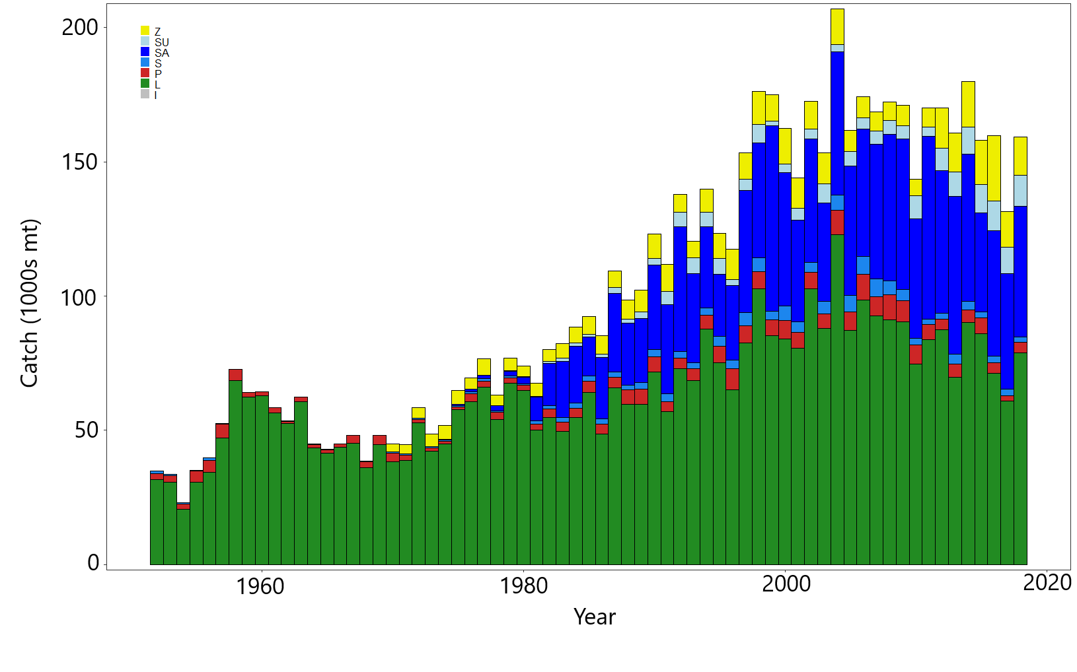**

**Figure BET-2.** Time series of total annual catch (1000s mt) by fishing gear for the diagnostic model over the full assessment period. The different colors refer to longline (green), pole-and-line (red), purse seine (blue), purse seine associated (dark blue), purse seine unassociated (light blue), miscellaneous (yellow), and index (gray). Note that the catch by longline gear has been converted into catch-in-weight from catch-in-numbers and so may differ from the annual catch estimates presented in (Williams et al., 2020), however these catches enter the model as catch-in-numbers.

**Figure BET-3.** Time series of total annual catch (1000s mt) by fishing gear and assessment region for the diagnostic model over the full assessment period. The different colors refer to longline (green), pole-and-line (red), purse seine (blue), purse seine associated (dark blue), purse seine unassociated (light blue), miscellaneous (yellow), and index (gray).

* + 1. Recruitment



* + 1. Spawning Potential
    2. Total biomass



**Figure BET-4.** Estimated (a) annual average recruitment, (b) spawning potential and (c) total biomass by model region for the diagnostic model, showing the relative sizes among regions.

****

**Figure BET-5.** Estimated seasonal, temporal spawning potential by model region for the diagnostic model. The asymptotic 95% confidence interval as calculated using the delta-method is shown for the “Overall” region. Note that the scale of the y-axis is not constant across regions.



**Figure BET-6.** Estimated annual average juvenile and adult fishing mortality for the diagnostic model.

****

**Figure BET-7.** Estimates of reduction in spawning potential due to fishing (fishery impact = (1-SBt/SBt;F=0) \* 100%) by region, and over all regions (lower right panel), attributed to various fishery groups for the diagnostic model.



**Figure BET-8.** Time-dynamic percentiles of depletion (SBt/SBt;F=0) and median (dark line) across all 24 models in the structural uncertainty grid. The lighter band shows the 10th to 90th percentiles around the median, and the dark band shows the 50th percentile around the median. The median SBrecent/SBF=0 and 80th percentile is shown on the right by the dot and line.

****

**Figure BET-9**. Majuro plot for the recent spawning potential (2015–2018) summarizing the results for each of the models in the structural uncertainty grid. The plots represent estimates of stock status in terms of spawning biomass depletion and fishing mortality, and marginal distributions of each are presented. The median is shown in blue.



**Figure BET-10**. Kobe plot for the recent spawning potential (2015–2018) summarizing the results for each of the models in the structural uncertainty grid. The plots represent estimates of stock status in terms of spawning biomass depletion and fishing mortality. Marginal distributions of each are presented. The median is shown in blue.

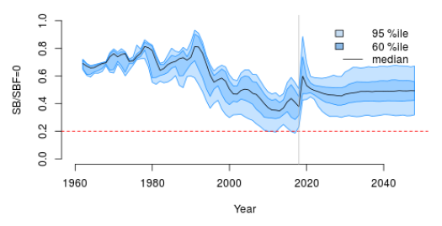

**Figure BET-11**. Time series of bigeye tuna spawning potential SBt/SBF=0, where SBF=0 is the average SB from t-10 to t-1, relative to the current year t, from the uncertainty grid of assessment models for the period 2000 to 2018, and stochastic projection results for the period 2019 to 2048 assuming 2016-2018 average catches in longline and other fisheries and 2018 effort in purse seine fisheries continue. Vertical gray line at 2018 represents the last year of the assessment. During the projection period (2019-2048) levels of recruitment variability are assumed to match those over the short-term period (2008-2017). The red horizontal dashed line represents the agreed limit reference point.

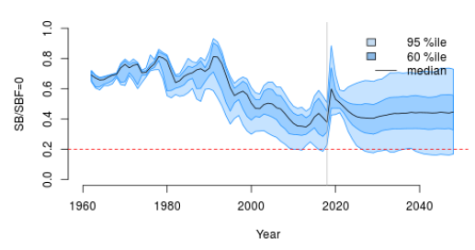

**Figure BET-12**. Time series of bigeye tuna spawning potential SBt/SBF=0, where SBF=0 is the average SB from t-10 to t-1, relative to the current year t, from the uncertainty grid of assessment models for the period 2000 to 2018, and stochastic projection results for the period 2019 to 2048 assuming 2016-2018 average catches in longline and other fisheries and 2018 effort in purse seine fisheries continue. Vertical gray line at 2018 represents the last year of the assessment. During the projection period (2019-2048) levels of recruitment variability are assumed to match those over the long-term period (1962-2017). The red horizontal dashed line represents the agreed limit reference point.

1. **SC16 noted that the results from the uncertainty grid adopted by SC16 show that the stock has been continuously declining for about 60 years since the late 1950s, except for the recent small increase from 2015 to 2016 with biomass declining thereafter.**
2. **SC16 also noted that the median value of relative recent (2015-2018) spawning biomass depletion (SB2015-2018/ SBF=0) was 0.41 with a 10th to 90th percentiles of 0.27 to 0.52.**
3. **SC16 further noted that there was 0% probability (0 out of 24 models) that the recent (2015-2018) spawning biomass had breached the adopted limit reference point (LRP).**
4. **SC16 noted that there has been a long-term increase in fishing mortality for both juvenile and adult bigeye tuna and while juvenile fishing mortality is higher than that of the adult fish, both adult and juvenile fishing mortality rates have stabilised somewhat since 2008 and have fluctuated without trend since that time.**
5. **SC16 noted that the median recent fishing mortality (F2014-2017t/FMSY) was 0.72 with a 10th to 90th percentile interval of 0.49 to 1.02.**

1. **SC16 noted that there was a roughly 12.5% probability (3 out of 24 models) that the recent (2014-2017) fishing mortality was above FMSY.**
2. **SC16 noted the results of stochastic projections (Figures BET-11 and BET-12) from the 2020 assessment which indicated the potential stock consequences of ﬁshing at “status quo” conditions (2016–2018 average longline and other fishery catch and 2018 purse seine effort levels) and short-term recruitment scenario using the uncertainty framework approach endorsed by SC. Projections indicate that median SB2025/SBF=0 = 0.47; median SB2035/SBF=0 = 0.49 and median SB2045/SBF=0 = 0.49. The risk that SB2048/SBF=0 is less than the Limit Reference Point is 0%.**
3. **SC16 noted the results of stochastic projections from the long-term recruitment scenario using the uncertainty framework approach endorsed by SC. Projections indicate that median SB2025/SBF=0 = 0.42; median SB2035/SBF=0 = 0.44 and median SB2045/SBF=0 = 0.45. The risk that SB2048/SBF=0 is less than the Limit Reference Point is 5%.**
4. **Management advice and implications**
5. **SC16 noted that the preliminary estimate of total catch of WCPO bigeye tuna for 2019 was 135,680 mt, a 9% decrease from 2018 and an 8% decrease from the average 2014-2018. Longline catch in 2019 (68,371 mt) was a 0% decrease from 2018 and a 2% increase from the 2014-2018 average. Purse seine catch in 2019 (50,819 mt) was a 22% decrease from 2018 and a 17% decrease from the 2014-2018 average. Pole and line catch (1,400 mt) was a 66% decrease from 2018 and a 66% decrease from the average 2014-2018 catch. Catch by other gear totalled 15,090 mt and was a 33% increase from 2018 and 1% increase from the average catch in 2014-2018.**

1. **SC16 noted that the catch in the last year of the assessment (2018) was median 159,288 mt which was greater than the median MSY (140,720 mt).**
2. **Based on the uncertainty grid adopted by SC16, the WCPO bigeye tuna spawning biomass is above the biomass LRP and recent F is very likely below FMSY. The stock is not overfished (100% probability SB/SBF=0>LRP) and likely not experiencing overfishing (87.5% probability F<FMSY).**
3. **SC16 noted that levels of fishing mortality and depletion differ among regions, and that fishery impact was higher in the tropical regions (Regions 3, 4, 7 and 8 in the stock assessment model), with particularly high fishing mortality on juvenile bigeye tuna in these regions. There is also evidence that the overall stock status is buffered with biomass kept at more elevated level overall by low exploitation in the temperate regions (1, 2, 6 and 9). SC16 therefore re-iterates that WCPFC17 could continue to consider measures to reduce fishing mortality from fisheries that take juveniles, with the goal to increase bigeye fishery yields and reduce any further impacts on the spawning biomass for this stock in the tropical regions.**
4. **Based on those results, SC16 recommends as a precautionary approach that the fishing mortality on bigeye tuna stock should not be increased from the level that maintains spawning biomass at 2012-2015 levels until the Commission can agree on an appropriate target reference point.**
   1. WCPO yellowfin tuna (*Thunnus albacares*)
      1. Review of 2020 yellowfin tuna stock assessment
5. M. Vincent (SPC-OFP) presented SC16-SA-WP-04 *Stock assessment of yellowfin tuna in the western and central Pacific Ocean*, which described the 2020 stock assessment of yellowfin tuna *Thunnus albacares.* An additional three years of data were available since the previous assessment in 2017, and the model extends through the end of 2018. New developments to the stock assessment include the incorporation of an index fishery for each region, enforcement of a mixing period of 182 days for a mixing period of 2 quarters and 91 days for a mixing period of 1 quarter, and incorporation of additional biological information.
6. Changes made in the progression from the 2017 to the 2020 diagnostic model that influence our perception of yellowfin stock status were the:

* Incorporation of additional information regarding the growth of yellowfin tuna arising from otolith data;
* Changes to the preparation and treatment of the tagging data, including enforcement of mixing periods in the tagging data, which resulted in reduced estimates of fishing mortality;
* Change in assumptions regarding the sharing of selectivity parameters;
* Use of the maturity-at-length functionality in Multifan-CL.

1. The general conclusions of this assessment are as follows:

* Total biomass and spawning potential declined until the mid-2000s, after which it remained relatively stable, with fluctuations and a small increase in recent years. Estimated recruitment shows a decreasing trend from 1952 until the mid-1990s and a small increasing trend in the recent period;
* Average fishing mortality rates for juvenile and adult age-classes increase throughout the period of the assessment;
* All models in the structural uncertainty grid assessed the stock to be above the adopted LRP, and fishing mortality rates below FMSY, with 100% probability. Based on the results of this assessment, the yellowfin stock in the WCPO is not considered overfished, nor subject to overfishing;
* Overall median depletion over the recent period (2015-2018; SBrecent/SBF=0) was 0.58 with a 10th to 90th percentile interval of 0.51-0.64;
* Recent average fishing mortality (2014-2017; Frecent/FMSY) was 0.36 with a 10th to 90th percentile interval of 0.27-0.47;
* Results from the structural uncertainty grid should be treated with some caution due to indications that there are likely model misspecifications which may be causing optimistic and biologically unreasonable estimates of recruitment distribution and stock status.

1. SC16 notes that the assessment results in general are very optimistic compared to the previous assessments but the causes for such optimistic results were not fully understood, thus uncertain. In particular, the median estimate of MSY from the uncertainty grid in 2020 was 1,091 thousand metric tons of catch biomass, or 63% above the estimate from the 2017 YFT assessment at SC13. Also, due to the constraints originating from the virtual online Scientific Committee forum, the SC16 could not fully engage in a complete discussion of the appropriate choice of models within the uncertainty grid. Due to the lack of an objective way of selecting the preferred elements for weighting the grid, SC16 agreed to use the grid with all models as presented by the Scientific Services Provider. As indicated in research needs, further research on the assessment model, including the peer review, is warranted in developing the next WCPO stock assessment.
2. A number of key research needs were identified in undertaking the assessment that should be investigated either internally or through directed research.
3. Items for internal investigation of the assessment model are as follows:
4. Further refinement of the selectivity to better fit the length composition from the purse seine fisheries;
5. Investigation of standardization methods of the longline CPUE index to account for environmental covariates and factors driving potential increase in efficiencies in fishing, which may require separation of the time series;
6. Examination of alternative methods to enforce mixing periods while retaining the attrition curve to inform fishing mortality;
7. Exploration of the self-scaling multinomial and the potential for its inclusion in future structural uncertainty grids;
8. Reduction in the model complexity to rectify unrealistic patterns of high recruitment in temperate regions and low recruitment in region 8;
9. Comparison among tropical tuna assessments to ensure biological realism in assessment estimates of all species;
10. Incorporation of spatial functionality of population dynamics regarding regional growth, maturity and/or length-weight; and,
11. Estimation of natural mortality using available tagging data.
12. Items that require directed research and additional funding for implementation:
13. Evaluation of the feasibility of conducting a fishery independent survey across the WCPO to be used as an index of abundance within the stock assessments and to improve the representativeness of biological samples across the WCPO;
14. Further collection of otolith samples for use in investigations of regional differences in growth with increased focus on increasing the spatial coverage of sampling for all lengths and collecting fish less than 30 cm and greater than 120 cm in all regions;
15. Validation of otolith aging techniques through bomb radiocarbon and strontium chloride tagging to clarify causes of discrepancy between growth curves from otoliths, tagging increments, and size composition modal progression;
16. Additional tag seeding experiments required for the estimation of reporting rates necessary to provide better estimates of natural mortality from tagging data;
17. Collection of biological information to inform the components in the reproductive potential ogive such as fecundity, proportion female at length, maturity at length, and spawning fraction in a spatially structured context;
18. Collection of biological samples for the estimation of conversion factors from length to weight, gilled-gutted to whole-weight, and gilled-gutted-trunked to whole weight to be used for the weight composition data.

**Discussion**

The USA inquired regarding the model diagnostics. They noted that although relatively flatter, the CPUE appeared to have a profile relatively similar to the total likelihood, which might indicate that estimated biomass from the overall maximum likelihood estimation is consistent with the CPUE, but it seems that the total biomass likelihood profile shows a strong influence of the conditional age at length and length composition data on total biomass, and how it conflicts with the index. They asked what could be done to reduce future data conflicts. SPC stated that conflict in length composition and conditional age at length appears driven by the growth curve and the fit to purse seine catch estimates; to fit large catches, the model tends to have a higher biomass. SPC hoped that SSMult (self-scaling multinomial distribution) can give objective criteria to down or up-weight specific data sources. The code has only has only recently been finalized and more testing is needed before it can be used. Additionally, it is computationally intensive, which is another reason it was not included in constructing the uncertainty grid.

Japan inquired about differences between Figures A1 and A2 (likelihood profiles) in the document. SPC noted that Figure A1 is from the diagnostic model (it sequentially went from the model in a stepwise fashion); A2 is a likelihood profile developed by J. Hampton, who noted that these profiles are very hard to generate automatically and get a smooth fit. He suggested it would be better to focus on the A2 profile in terms of how the data sources impact on overall likelihood. Japan noted that it was possible to find many inverse relationships between components for the likelihood profile, which indicates that the biomass level of the stock is not clear, and there could be a model mis-specification. Figure 29 indicates that biomass in region 2 is composed of fish only from regions 2 and 4, although other neighbouring regions (e.g., 1 and 3) have high recruitment. Japan suggested the yellowfin stock assessment model could be improved, and stated that they were reluctant to discuss management advice based on this yellowfin stock assessment.

Tuvalu, on behalf of FFA members, stated that although all models in the structural uncertainty grid show WCPO yellowfin tuna to be above 20% SBF=0, they noted some discrepancies with the model predictions that the authors have outlined in the paper, and agreed that there is need for caution with respect to the model results of high biomass and the relatively high recruitment estimates in temperate regions. FFA members stated that the authors note that there is some evidence to suggest that the current structure of the yellowfin tuna stock assessment is overly complex; supported their proposal to further refine the model and reduce model complexity; and stated their belief that there is benefit in having the yellowfin model structure evaluated by an external peer review or a WCPFC modelling workshop.

The IATTC commented that in many stock assessments for tropical tunas, including the EPO bigeye assessment, there is an estimated regime shift in recruitment as the floating object purse seine fishery expanded. One way to remove this is to make the biomass much higher, so therefore the catch doesn’t have a big influence on abundance, and it doesn’t affect the index of abundance, or the related composition data. SPC alluded to this in the presentation. IATTC inquired if this was affecting the results of the yellowfin tuna stock assessment, and why the model does not fit the length-frequency data? SPC replied that in terms of recruitment, there was a decreasing trend throughout the time series, which seemed to be due to the CPUE index, given very high recruitment in temperate regions, especially region 6. In terms of the size composition fit: SPC assumed there were 5 nodes in the spine across the age classes (every 2 years), which is not as flexible as it could be. It would be possible to change the way each node occurs by regrouping the age classes, which would produce a better fit. J. Hampton noted that regarding recruitment, the effect alluded to by IATTC was probably not present in the stock assessment because SPC adopted very small penalties in the recruitment deviations from the stock recruitment relationship, as recommended in the 2012 stock assessment review, meaning the data will drive the relationship, and thus it is unlikely this is inflating the abundance. Regarding the conflict between the length-frequency and weight-frequency data: this is a concern. It was present in the 2017 stock assessment, and SPC needs to look at the issue of conversion factors that convert the gilled and gutted weight to whole weight, and also the length/weight relationship, in relation to the particular growth curve that’s being used in the stock assessment, as this is one area that could produce that inconsistency in the signal from the length and weight frequency data.

The EU stated that the complex interactions make it very difficult to understand what may be happening. Regarding different estimates for small fish vulnerable to the associated purse seine fishery, which may be shifting total biomass: a very small shift in growth is projected between ages 3 and 4 quarters; could the shift be linked to length-based selectivity rather than age based selectivity of the purse seine associated fishery? The EU noted it was unsure if length-based selectivity is implemented in MultifanCL — it could possibly help reconcile the different methodologies for growth estimation, and improve the data fit for these important removals. SPC stated that MultifanCL lacks a length-based selectivity function. There could be confounding between estimates of growth and the selectivity, and there could be a dome shape in selectivity as opposed to the estimated two-phase growth. There is a need for more investigation into this and some validation of the otolith data.

Australia noted the emphasis in the presentation on further work required to address uncertainties, which was also noted in connection with the bigeye stock assessment, and stated that SC needed to discuss this under Agenda Item 5. He noted the phrase in the paper that “This assessment was fraught with strife due to conflict among data inputs”, and inquired if there was any evidence of greater data conflict in the yellowfin stock assessment than the bigeye stock assessment, given the similar fisheries and data sources? If so, why would this be? SPC replied that both the bigeye and yellowfin stock assessments have conflict between length and weight data. There is also conflict between otolith and tagging data in the case of the yellowfin growth curve; this was present to a lesser extent in the bigeye growth curve. Conditional age at length is driving additional conflict in the yellowfin stock assessment that was not present in the bigeye stock assessment. Differences in the biology and behaviour of the fish (such as more schooling of large yellowfin as opposed to bigeye) may also affect the stock assessments, but more data on these factors are needed.

Chinese Taipei inquired regarding the main sources of uncertainty causing differences in recruitment over the current and previous stock assessments? SPC stated that a shift occurred when SPC implemented the new growth curve, which had virtually no recruitment in regions 4 and 8. SPC tried to resolve the issue by fixing selectivity in the first age class to be 0; this resolved the issue in region 4, but not in 8. There seems to be a conflict in the size composition fit; the model can move fish around to fit the regional scaling estimated by the CPUE, and produces estimates of the biomass in regions that are consistent with that. There is little information to inform recruitment, which is about 20 cm at size, as the only fisheries that catch these fish are in region 7. The purse seine fishery starts at about 30 cm, with most caught at 40–60 cm.

Kiribati, on behalf of FFA members, noted that the status of the yellowfin stocks as determined by the current assessment indicates that the stocks are not overfished nor is overfishing occurring; therefore, FFA members believe there are no impediments to rolling over CMM 2018-01 until 2021.

In reply to a request from RMI for further details regarding fishery-independent collection of samples SPC noted that most fisheries have a research vessel that collects samples of the fish that are economically important; these can serve as index of abundance over time, and provide material for studies of growth. In the WCPO this would require multiple research vessels. They noted that Japan, the USA (NOAA), New Zealand and Australia all have research vessels, and suggested that with a coordinated effort it might be possible to sample the entire WCPO. Generally, more information is needed on the biology of these fish. The PTTP tagging cruises spend some time collecting biological samples in tropical waters. A key gap is some level of fishery-independent data to derive catch per unit effort; there is a lack of sampling in the region to address that question.

PNG stated that about 20%–25% of PNG’s purse seine catch and 50% of longline catch is yellowfin. They noted that these fish were coming from somewhere and inquired about adjusting the model to generate more realistic results for region 8, as was done for region 4. SPC stated the selectivity assumptions could be changed. The size composition data overestimates very small fish, especially in region 8. If the selectivity could be better modelled and this was changed it would allow a larger biomass that is not caught by the purse seine fishery. Currently the model says they are not being caught because they are not there. Another option is to incorporate the purse seine index that is being developed and incorporate this in the stock assessment; it was included as a one-off sensitivity but seemed to make little difference. However, SPC did not assume constant catchability among the different regions, as was done for the longline fishery; if that constraint was forced, it could force recruitment across those regions. SPC stated that this needs to be further investigated.

Australia noted that the need for further data for these stock assessments was very important but inquired how this could be realistically addressed. SPC suggested they could examine the size composition and look for changes, but noted that these could be the result of changed selectivity; there could also be temporal changes, or changes over space that are not being accounted for. SPC is considering how to capture these factors, but it has the effect of increasing (as opposed to reducing) the model complexities. There is a need to capture the differences across the region, while reducing the model complexity.

The SA theme co-convener reviewed the three recommendations that were not included in the SC15 Summary Report.

* Recommendation: For species that have assessments that consider axes of uncertainty in a grid approach, the Scientific Services Provider and CCMs should develop objective criteria to quantitatively evaluate the inclusion of axes and respective weighting within each axis to characterize stock status uncertainty. These should be discussed at the SPC pre-assessment workshop.
* Recommendation: The Scientific Services Provider and CCMs should develop criteria to illustrate a relevant sub-set of diagnostics for all assessment models within the relevant uncertainty grid
* Recommendation: For stock assessment projections, provide median estimates of F/FMSY, SB/SBF=0, the risk of breaching an adopted LRP and the probability of being below any interim TRP, at 10 year increments from the beginning of the projection time period.

Discussion on yellowfin tuna structural uncertainty grid

Palau on behalf of PNA members noted that the structural uncertainty grid presents a relatively positive indication of stock status, and the projections also indicate an optimistic future. They also noted the cautions expressed in the paper and believe that this provides a good balance for formulating the management advice. As with bigeye, PNA prefers not to have an ad hoc approach to the grid selection, and favored retaining all 72 models for providing stock status advice.

Japan noted that in the case of bigeye they had identified somewhat redundant axes, and inquired if some overlapped, and why an axis of natural mortality was not used? They noted that although the stock assessment was an improvement from the previous model, Japan expressed concern about the level of instability and inconsistency in the data. Prior results found that yellowfin was the most depleted stock among the three key species, with catch fairly close to BMSY. This stock assessment, in the diagnostic case, suggests almost double the biomass of the historical case, with BMSY almost 1.5x. The depletion level is half of what was previously estimated. Thus, regardless of the grid that is chosen, Japan stated they were very cautious of using this stock assessment as the basis of advice. Even if SC decides not to change the current tropical tuna CMM, if SC adopts the stock assessment it will be considered best available science for yellowfin. Japan asked whether SPC felt comfortable using this stock assessment, noting that accepting it implies at MSY fishing mortality could be increased by 50%. SPC stated that in terms of size composition data, there is generally overlap between all of the size compositions. SC should decide what axis to use. In terms of growth, there is some consistency between otolith growth and conditional age at length, and there may be some redundancy. Regarding natural mortality, this was going to be included, using the value that included the biggest range, but estimates of biomass resulted in median total adult biomass that was 10 times that of skipjack; this did not seem reasonable, and resulted in a less depleted state than was present in the diagnostic model. SPC noted that the implementation of the new growth curves resulted in a less-depleted state for yellowfin. SPC noted that it was up to SC16 to decide whether the stock assessment was to be considered the best available science for yellowfin.

Australia stated they favoured retaining 20, 200, and 500; 20 has the greatest central tendency, meaning the distribution won’t be as broad, so they suggested dropping the 60. In relation to Japan’s comment Australia suggested structuring the grid in the normal manner. Australia noted that there are some uncertainties in relation to yellowfin and suggested that SC should make some additional comments related to those uncertainties.

Palau stated they preferred not to have an ad hoc approach to the grid selection.

* + 1. Provision of scientific information

1. **Stock Status and trends**

**The median values of relative recent (2015-2018) spawning biomass depletion (SBrecent/ SBF=0) and relative recent (2014-2017) fishing mortality (Frecent/FMSY) over the uncertainty grid of 72 models (Table YFT-1) were used to define stock status. The values of the upper 90th and lower 10th percentiles of the empirical distributions of relative spawning biomass and relative fishing mortality from the uncertainty grid were used to characterize the probable range of stock status.**

**A description of the updated structural sensitivity grid used to characterize uncertainty in the assessment is illustrated in Table YFT-1. The spatial structure used in the 2020 stock assessment is shown in Figure YFT-1. Time series of total annual catch by fishing gear over the full assessment period is shown in Figure YFT-2. The time series of total annual catch by fishing gear and assessment region is shown in Figure YFT-3. Estimated annual average recruitment, spawning potential, and total biomass by model region is shown in Figure YFT-4. Estimated trends in spawning biomass depletion for the 72 models in the structural uncertainty grid is shown in Figure YFT-5, and juvenile and adult fishing mortality rates from the diagnostic model is shown in Figure YFT-6. Estimates of the reduction in spawning potential due to fishing by region are shown in Figure YFT-7. Time-dynamic percentiles of depletion (SBt/SBt,F=0) for the 72 models are shown in Figure YFT-8. A Majuro and Kobe plot summarising the results for each of the 72 models in the structural uncertainty grid are shown in Figures YFT-9 and YFT-10, respectively. Projections are illustrated in Figure YFT-11. Table YFT-2 provides a summary of reference points over the 72 models in the structural uncertainty grid.**

**The most influential axis of uncertainty with respect to estimated stock status was growth. The most pessimistic model estimates occurred with models that assumed growth estimated from the modal progression information in the size composition data. The most optimistic stock status estimates were obtained from models that used the growth curve estimated externally from otolith data. Models where growth was estimated by the conditional age-at-length data resulted in estimates that were in between the other two, but were more consistent with the otolith growth curve models. Further research is required to develop alternative growth estimates at the regional spatial scale and develop model diagnostics and objective criteria for model inclusion.**

**Table YFT-1.** Description of the updated structural sensitivity grid used to characterize uncertainty in the assessment, where \* denotes the level assumed in the diagnostic model. Equal weighting was given to all axis values.

|  |  |  |  |  |
| --- | --- | --- | --- | --- |
| **Axis** | **Value 1** | **Value 2** | **Value 3** | **Value 4** |
| Growth | Conditional Age-at-length\* | Modal (Size Composition) | Otolith |  |
| Steepness | 0.65 | 0.8 \* | 0.95 |  |
| Size Scalar | 20 | 60 \* | 200 | 500 |
| Mixing Period | 1 Quarter | 2 Quarters \* |  |  |

**Table YFT-2.** Summary of reference points over the 72 models in the structural uncertainty grid. Note that “recent” is the average over the period 2015-2018 for SB and 2014-2017 for fishing mortality, while “latest” is 2018. The values of the upper 90th and lower 10th percentiles of the empirical distributions are also shown. Fmult is the multiplier of recent (2014-2017) fishing mortality required to attain MSY.

|  |  |  |  |  |  |  |
| --- | --- | --- | --- | --- | --- | --- |
|  | **Mean** | **Median** | **Minimum** | **10th percentile** | **90th percentile** | **Maximum** |
| Clatest | 709,389 | 711,072 | 700,358 | 702,279 | 712,761 | 714,073 |
| YFrecent | 779,872 | 784,200 | 661,600 | 707,720 | 877,040 | 9080,00 |
| fmult | 2.87 | 2.80 | 1.70 | 2.12 | 3.72 | 4.29 |
| FMSY | 0.11 | 0.10 | 0.08 | 0.09 | 0.12 | 0.15 |
| MSY | 1,090,706 | 1,091,200 | 791,600 | 874,200 | 1,283,920 | 1,344,400 |
| Frecent/FMSY | 0.37 | 0.36 | 0.23 | 0.27 | 0.47 | 0.59 |
| SBF=0 | 3,641,228 | 3,603,980 | 2,893,274 | 3,231,353 | 4,050,429 | 4,394,277 |
| SBMSY | 860,326 | 858,700 | 349,100 | 590,090 | 1,114,400 | 1,322,000 |
| SBMSY/SBF=0 | 0.23 | 0.24 | 0.12 | 0.18 | 0.28 | 0.30 |
| SB latest/SBF=0 | 0.54 | 0.54 | 0.40 | 0.47 | 0.60 | 0.66 |
| SB latest/SBMSY | 2.43 | 2.28 | 1.47 | 1.67 | 3.29 | 4.89 |
| SB recent/SBF=0 | 0.58 | 0.58 | 0.42 | 0.51 | 0.64 | 0.68 |
| SB recent/SBMSY | 2.59 | 2.43 | 1.58 | 1.77 | 3.57 | 5.27 |

****

**Figure YFT-1.** The geographical area covered by the stock assessment and the boundaries for the 9 regions when using the “10N regional structure”.



**Figure YFT-2.** Time series of total annual catch (1000s mt) by fishing gear over the full assessment region and time period. The different colours denote longline (green), pole-and-line (red), purse seine unclassified (blue), purse seine-associated (dark blue), purse seine-unassociated (light blue), miscellaneous (yellow).



**Figure YFT-3.** Time series of total annual catch (1000s mt) by fishing gear and assessment region over the full assessment period. The different colours denote longline (green), pole-and-line (red), purse seine unclassified (blue), purse seine-associated (dark blue), purse seine-unassociated (light blue), miscellaneous (yellow).

(a) Recruitment



(b) Spawning Potential 

(c) Total Biomass 

**Figure YFT-4.** Estimated annual average, (a) recruitment (b) spawning potential (c) total biomass by model region for the diagnostic model, showing the relative sizes among regions.



**Figure YFT-5.** The temporal trend in estimated spawning potential by model region for the diagnosticmodel, where the blue shaded region for the overall spawning potential shows the estimated 95% confidence interval based on statistical uncertainty estimated for the diagnostic model. Note that the y-axis scale among panels are not consistent.



**Figure YFT-6.**  Estimated annual average juvenile and adult fishing mortality for the diagnostic model.

****

**Figure YFT-7.** Estimates of reduction in spawning potential due to fishing by region (Fishery Impact = (1-SBt/SBt;F=0) \* 100%) and over all regions (lower right panel), attributed to various fishery groups for the diagnostic model.



**Figure YFT-8.** Plot showing the trajectories of fishing depletion of spawning potential for the models in the structural uncertainty grid for the median, 50% quantile, and 80% quantile of instantaneous depletion across the structural uncertainty grid and the point and error bars is the median and 10th and 90th percentile of estimates of *SBrecent/SBF*=0.



**Figure YFT-9.**  Majuro plot representing stock status in terms of recent spawning potential depletion (2015–2018) and fishing mortality. The plots summarize the results for each of the models in the structural uncertainty grid with marginal distributions for spawning potential depletion and fishing mortality, where the brown triangle is the median of the structural uncertainty grid.



**Figure YFT-10.** Kobe plot for the recent spawning potential (2015–2018) summarizing the results for each of the models in the structural uncertainty grid. The plots represent estimates of stock status in terms of spawning biomass depletion and fishing mortality relative to MSY quantities and marginal distributions of each are presented with the median of the structural uncertainty grid displayed as a brown triangle.



**Figure YFT-11.** Time series of yellowfin tuna spawning biomass (SBt/SBt,F=0, where SBt,F=0 is the average SB from t-10 to t-1) from the uncertainty grid of assessment models for the period 2000 to 2018, and stochastic projection results for the period 2019 to 2048 assuming 2016-2018 average catches in longline and other fisheries and 2018 effort in purse seine fisheries continue. Vertical gray line at 2018 represents the last year of the assessment. During the projection period (2019-2048) levels of recruitment variability are assumed to match those over the time period used to estimate the stock-recruitment relationship (1962-2017). The red horizontal dashed line represents the agreed limit reference point.

**SC16 noted that there has been a long-term decrease in spawning biomass from the 1970s for yellowfin tuna but that the depletion rates have been relatively stable over the last decade.**

**SC16 also noted that the median value of relative recent (2015-2018) spawning biomass depletion (SB2015-2018/SBF=0) was 0.58 with a 10th to 90th percentile interval of 0.51 to 0.64.**

**SC16 further noted that there was 0% probability (0 out of 72 models) that the recent (2015-2018) spawning biomass had breached the adopted LRP.**

**SC16 noted that there has been a long-term increase in fishing mortality for both juvenile and adult yellowfin tuna, which is consistent with previous assessments, but since 2010 there has been no directional trend.**

**SC16 noted that the median of relative recent fishing mortality (F2014-2017/FMSY) was 0.36 with a 10th to 90th percentile interval of 0.27 to 0.47.**

**SC16 further noted that there was 0% probability (0 out of 72 models) that the recent (2014-2017) fishing mortality was above FMSY.**

**SC16 noted the results of stochastic projections (Figure YFT-11) from the 2020 assessment which indicated the potential stock consequences of ﬁshing at “status quo” conditions (2016–2018 average longline and other fishery catch and 2018 purse seine effort levels) and long-term recruitment scenario using the uncertainty framework approach endorsed by SC. Projections indicate that median SB2025/SBF=0 = 0.58; median SB2035/SBF=0 = 0.59 and median SB2045/SBF=0 = 0.58. The risk that SB2048/SBF=0 is less than the Limit Reference Point is 0%.**

1. **Management advice and implications**

**SC16 noted that the preliminary estimate of total catch of WCPO yellowfin tuna for 2019 was 669,362 mt, a 5% decrease from 2018 and a 1% increase from the average 2014-2018. Purse seine catch in 2019 (364,571 mt) was a 4% decrease from 2018 and an 8% decrease from the 2014-2018 average. Longline catch in 2019 (104,440 mt) was a 7% increase from 2018 and a 9% increase from the 2014-2018 average. Pole and line catch (37,563 mt) was a 43% increase from 2018 and a 40% increase from the average 2014-2018 catch. Catch by other gear totalled 162,788 t and was an 18% decrease from 2018 and a 16% increase from the average catch in 2014-2018.**

**SC16 noted that the catch in the last year of the assessment (2018) was 711,072 mt which was less than the median MSY (1,091,200 mt).**

**Based on the uncertainty grid adopted by SC16, the WCPO yellowfin tuna spawning biomass is above the biomass LRP and recent F is below FMSY. The stock is not experiencing overfishing (100% probability F<FMSY) and is not in an overfished condition (0% probability SB/SBF=0<LRP). Additionally, stochastic projections predict there to be no risk of breaching the LRP (0% probability SB2048/SBF=0<LRP).**

**SC16 also noted that levels of fishing mortality and depletion differ between regions, and that fishery impact was highest in the tropical region (Regions 3, 4, 7 and 8 in the stock assessment model), mainly due to the purse seine fisheries in the equatorial Pacific and the “other” fisheries within the Western Pacific. There is also evidence that the overall stock status is buffered with biomass kept at a more elevated level overall by low exploitation in the temperate regions (1, 2, 6, and 9). SC16 therefore re-iterates that WCPFC17 could consider measures to reduce fishing mortality from fisheries that take juveniles, with the goal to increase fishery yields and reduce any further impacts on the spawning potential for this stock in the tropical regions.**

**SC16 noted that the 2020 stock assessment results indicate the stock is currently exploited at relatively low levels (median F/FMSY = 0.36, 10th to 90th percentile interval** **0.27-0.47). Nevertheless, SC16 recommends that the Commission notes that further increases in YFT fishing mortality would likely affect other stocks/species which are currently moderately exploited due to the multispecies/gears interactions in WCPFC fisheries taking YFT.**

**SC16 also noted that although the structural uncertainty grid presents a positive indication of stock status, the high level of unresolved conflict amongst the data inputs used in the assessment suggests additional caution may be appropriate when interpreting assessment outcomes to guide management decisions.**

**Based on those results, SC16 recommends as a precautionary approach that the fishing mortality on yellowfin tuna stock should not be increased from the level that maintains spawning biomass at 2012-2015 levels until the Commission can agree on an appropriate target reference point.**

* 1. North Pacific albacore (*Thunnus alalunga*)

* + 1. Review of the 2020 North Pacific albacore tock assessment

1. S. Teo (USA) presented SC16-SA-WP-05 *Stock Assessment of Albacore Tuna in the North Pacific Ocean in 2020*, which detailed the data, biological parameters, model, model diagnostics and sensitivities, and results of the North Pacific albacore stock assessment conducted by ISC’s Albacore Working Group in 2020.
2. All available fishery data for North Pacific albacore for the 1994-2018 period were used in the stock assessment. Catch and size composition data were compiled and assigned to 35 fisheries defined for this assessment (based on flag, gear, area, and season). The same abundance index as the 2017 assessment was fitted in the base case model. The North Pacific albacore stock was assessed using a length-based, age-, and sex-structured Stock Synthesis (SS Version 3.30.14.08) model over the 1994-2018 period and it was assumed that there is instantaneous mixing of albacore on a quarterly basis. Biological parameters like growth, natural morality (M) and stock-recruitment steepness, were the same as for the 2017 assessment. All fisheries were assumed to have dome-shaped length selectivity curves, and age-based selectivity for ages 1-5 were also estimated for surface fisheries (troll and pole-and-line) to address age-based changes in juvenile albacore availability and movement. Selectivity curves were also assumed to vary over time for several fleets.
3. Maximum likelihood estimates of model parameters, derived outputs, and their uncertainties from the base case model were used to characterize stock status. Based on model diagnostics, the ALBWG concluded that the base case model was able to estimate the stock production function and the effect of fishing on the abundance of the north Pacific albacore stock. Due to the moderate exploitation levels relative to stock productivity, the production function was weakly informative about north Pacific albacore stock size, resulting in asymmetric uncertainty in the stock’s absolute scale, with more uncertainty in the upper limit of the stock than the lower limit. It is important to note that the primary aim of estimating the female SSB in this assessment was to determine whether the estimated SSB was lower than the limit reference point (i.e., determine whether the stock is in an overfished condition). Since the lower bound is better defined, it adds confidence to the evaluation of stock condition relative to the limit reference point. Several sensitivity analyses were conducted to evaluate model performance or the range of uncertainty resulting from changes in model parameters, including natural mortality, stock-recruitment steepness, growth, starting year, selectivity patterns, and weighting of size composition data.

**Discussion**

1. FSM, on behalf of PNA members, noted that like the assessment presented in 2017, this assessment excludes valuable historic data that most assessment scientists find extremely informative. In 2017 it was suggested that these data were removed to resolve an issue with the CPUE data; it was suggested that rather than deleting the historic data IATTC should try and resolve the issues with CPUE. PNA members inquired regarding any advances to the CPUE standardisation that were attempted in order to resolve this conflict, and what progress could be expected in future assessments to re-incorporate these historic data into the assessment? They stated that the initial level of stock depletion appeared to have been assumed to be around 0.6, above that assumed in 2017 (around 0.5), and asked if ISC could clarify how that decision was made, and what influence changing this assumption would have on the perceived stock status? The presenter stated regarding the historical data that the 2017 stock assessment did not use data prior to early 1990s, primarily due to the poorly fit size composition data from the early 1980s. Very large fish caught by the Japanese longline fishery during that period caused a strange fit and skewed the model results. One solution would be to try and estimate growth, but data (or otolith samples) from that period are not available, and fish of that size are not seen today. The selectivity would have been changing at that time, and growth and selectivity can’t be estimated simultaneously. He noted that having a broader data set is not necessarily beneficial, if the processes can’t be modelled correctly. To solve growth in the 1990s and 1980s is difficult. ISC has also sought to address drift gillnets from that time. ISC is confident of the model when using data from the 1990s and later, and it can estimate current stock status well, while trying to model 1980s data results in inaccurate stock estimates. When doing the MSEs, it is necessary to use data from a longer time period, but this can be hard because the stock assessment period is limited. It is necessary to look carefully to see that conditions over the MSE evaluation period have not changing drastically; the initial condition is estimated by the model, from the initial few years of data we have, and not assumed.
2. SPC inquired why ISC had not considered pre-1990s data. Regarding Figure 5.6 in the report (the overall likelihood profile): the assessment is driven by what is labelled as recruitment, which has an overwhelming impact on the likelihood on the assessment. This is a penalty component driven by assumptions about recruitment. This generates quite large penalties and is overwhelming the likelihood; thus, data inputs into the overall likelihood are quite weak. The whole assessment is driven by assumptions around recruitment, especially the choice of such a low sigma r. The presenter stated that regarding shortening the models for tropical tunas: the caution is that one must have very good model diagnostics before doing that, which he stated is the case for this model. He stated that the low sigma r was chosen for consistency with the model recruitment deviates, and that the model is not driven by recruitment.
3. Palau, on behalf of PNA members, stated that the results are interesting, and that PNA members would like to see a figure showing the depletion for all sensitivities runs together against the LRP. In addition, it would be helpful to see a figure showing the confidence intervals for the more pessimistic model runs against the LRP.
4. Fiji, on behalf of FFA members noted that the outcomes of the assessment indicate that the North Pacific albacore stock is likely not overfished relative to the limit reference point adopted by the WCFPC (20%SSBcurrent, F=0) and that stock status evaluated against seven potential reference points indicated that current fishing intensity (F2015–2017) is likely at or below all seven potential reference points. They noted also the changes or improvements made since the 2017 assessment, however with very little change on the sensitivity to model assumptions — thus there were a number of obvious uncertainties such as growth, natural mortality and varying steepness for the model that FFA members believe have a huge influence on stock status.
5. Tonga commented on behalf of FFA members with regard to the management advice and implications. Noting that the Northern Committee has yet to discuss this assessment they stated they would be interested in the views of the Northern Committee on whether or not there should be a review of the current North Pacific albacore measure to reflect the stock assessment and the progress of the Harvest Strategy work for this stock. They cautioned on the expansion of efforts for this stock given the uncertainties noted from the stock assessment, and pointed out that the adoption of a target reference point remains a priority next step in the management of NP albacore, consistent with CMM 2014-06.
   * 1. Provision of scientific information
6. **Stock status and trends**

**SC16 noted that the ISC provided the following conclusions on the stock status of North Pacific albacore.**

The Northern Committee (NC) of the Western and Central Pacific Fisheries Commission (WCPFC), which manages this stock together with the Inter American Tropical Tuna Commission (IATTC), adopted a biomass-based limit reference point (LRP) in 2014 (<https://www.wcpfc.int/harvest-strategy>) of 20% of the current spawning stock biomass when F=0 (20%SSBcurrent, F=0). The 20%SSBcurrent, F=0 LRP is based on dynamic biomass and fluctuates depending on changes in recruitment. For north Pacific albacore tuna, this LRP is calculated as 20% of the unfished dynamic female spawning biomass in the terminal year of this assessment (i.e., 2018) (https://www.wcpfc.int/meetings/nc13). However, neither the IATTC nor the WCFPC have adopted F-based limit reference points for the north Pacific albacore stock.

Stock status is depicted in relation to the limit reference point (LRP; 20%SSBcurrent, F=0) for the stock and the equivalent fishing intensity (F20%; calculated as 1-SPR20%) (Figure NPALB-1). Fishing intensity (F, calculated as 1-SPR) is a measure of fishing mortality expressed as the decline in the proportion of the spawning biomass produced by each recruit relative to the unfished state. For example, a fishing intensity of 0.8 will result in a SSB of approximately 20% of SSB0 over the long run. Fishing intensity is considered a proxy of fishing mortality.

The Kobe plot shows that the estimated female SSB has never fallen below the LRP since 1994, albeit with large uncertainty in the terminal year (2018) estimates. Even when alternative hypotheses about key model uncertainties such as growth were evaluated, the point estimate of female SSB in 2018 (SSB2018) did not fall below the LRP, although the risk increases with this more extreme assumption (Figure NPALB-1). The SSB2018 was estimated to be 58,858 t (95% CI: 27,751 – 89,966 t) and 2.30 (95% CI: 1.49 – 3.11) times greater than the estimated LRP threshold of 25,573 mt (95% CI: 19,150 – 31,997 t) (Table NPALB-1). Current fishing intensity, F2015-2017 (0.50; 95% CI: 0.36 – 0.64; calculated as 1- SPR2015-2017) , was at or lower than all seven potential F-based reference points identified for the north Pacific albacore stock (Table NPALB-1).

**SC16 noted the following stock** status **from ISC:**

Based on these findings, the following information on the status of the north Pacific albacore stock is provided:

1. **The stock is likely not overfished relative to the limit reference point adopted by the Western and Central Pacific Fisheries Commission (20%SSBcurrent, F=0), and**
2. **No F-based reference points have been adopted to evaluate overfishing. Stock status was evaluated against seven potential reference points. Current fishing intensity (F2015-2017) is likely at or below all seven potential reference points (see ratios in Table NPALB-1).**
3. **Management advice and implications**

**SC16 noted the following conservation information from ISC:**

Two harvest scenarios were projected to evaluate impacts on future female SSB: F constant at the 2015-2017 rate over 10 years (F2015-2017)and constant catch[[4]](#footnote-4) (average of 2013-2017 = 69,354 t) over 10 years. Median female SSB is expected to increase to 62,873 mt (95% CI: 45,123 - 80,622 mt) by 2028, with a low probability of being below the LRP by 2028, if fishing intensity remains at the 2015-2017 level (Figure NPALB-2). If future catch is held constant at 69,354 mt, the female SSB is expected to increase to 66,313 mt (95% CI: 33,463 - 99,164 t) by 2028 and the probability that female SSB will be below the LRP by 2028 is slightly higher than the constant F scenario (Figure NPALB-3). Although the projections appear to underestimate the future uncertainty in female SSB trends, the probability of breaching the LRP in the future is likely small if the future fishing intensity is around current levels.

Based on these findings, the following information is provided:

1. **If a constant fishing intensity (F2015-2017) is applied to the stock, then median female spawning biomass is expected to increase to 62,873 mt and there will be a low probability of falling below the limit reference point established by the WCPFC by 2028.**
2. **If a constant average catch (C2013-2017 = 69,354 t) is removed from the stock in the future, then the median female spawning biomass is also expected to increase to 66,313 mt and the probability that SSB falls below the LRP by 2028 will be slightly higher than the constant fishing intensity scenario.**

|  |  |  |  |
| --- | --- | --- | --- |
| **Table NPALB-1**. Estimates of maximum sustainable yield (MSY), female spawning biomass (SSB), and fishing intensity (F) based reference point ratios for north Pacific albacore tuna for: 1) the base case model; 2) an important sensitivity model due to uncertainty in growth parameters; and 3) a model representing an update of the 2017 base case model to 2020 data. SSB0 and SSBMSY are the unfished biomass of mature female fish and at MSY, respectively. The Fs in this table are indicators of fishing intensity based on SPR and calculated as 1-SPR so that the Fs reflect changes in fishing mortality. SPR is the equilibrium SSB per recruit that would result from the current year’s pattern and intensity of fishing mortality. Current fishing intensity is based on the average fishing intensity during 2015-2017 (F2015-2017). 20%SSBcurrent, F=0 is 20% of the current unfished dynamic female spawning biomass, where current refers to the terminal year of this assessment (i.e., 2018). The model representing an update of the 2017 base case model is highly similar to but not identical to the 2017 base case model due to changes in data preparation and model structure. | | | |
| Quantity | Base Case | Growth  CV = 0.06 for Linf | Update of 2017 base case model to 2020 data |
| MSY (t) A | 102,236 | 84,385 | 113,522 |
| SSBMSY (t)B | 19,535 | 16,404 | 21,431 |
| SSB0 (t)B | 136,833 | 113,331 | 152,301 |
| SSB2018 (t) B | 58,858 | 34,872 | 77,077 |
| SSB2018/20%SSBcurrent, F=0 B | 2.30 | 1.63 | 2.63 |
| F2015-2017 | 0.50 | 0.64 | 0.43 |
| F2015-2017/FMSY | 0.60 | 0.77 | 0.52 |
| F2015-2017/F0.1 | 0.57 | 0.75 | 0.49 |
| F2015-2017/F10% | 0.55 | 0.71 | 0.48 |
| F2015-2017/F20% | 0.62 | 0.80 | 0.54 |
| F2015-2017/F30% | 0.71 | 0.91 | 0.62 |
| F2015-2017/F40% | 0.83 | 1.06 | 0.72 |
| F2015-2017/F50% | 1.00 | 1.27 | 0.86 |
| A – MSY includes male and female juvenile and adult fish  B – Spawning stock biomass (SSB) in this assessment refers to mature female biomass only. | | | |

|  |  |
| --- | --- |
| **A** C:\Users\steve.teo\Desktop\2020_NPALB_assessment\assessment_report\exec_summary\2019_Exec_Summary_Figs\Fig_ES07v2_Kobe_plot_2color\Fig_ES07_kobe_basecase_timeseries_SPR_B20pct_dynB0_redgreen.png | **B** C:\Users\steve.teo\Desktop\2020_NPALB_assessment\assessment_report\exec_summary\2019_Exec_Summary_Figs\Fig_ES07v2_Kobe_plot_2color\Fig_ES08_kobe_sensitivity_endpt_SPR_B20pct_dynB0_redgreen.png |
| **Figure NPALB-1.** (**A**)Kobe plot showing the status of the north Pacific albacore (*Thunnus alalunga*) stock relative to the 20%SSBcurrent, F=0 biomass-based limit reference point, and equivalent fishing intensity (F20%; calculated as 1-SPR20%) over the base case modeling period (1994-2018). Blue triangle indicates the start year (1994) and black circle with 95% confidence intervals indicates the terminal year (2018). (**B**) Kobe plot showing current stock status and 95% confidence intervals of the base case model (black; closed circle), an important sensitivity run of CV = 0.06 for Linf in the growth model (blue; open square), and a model representing an update of the 2017 base case model to 2020 data (red; open triangle). The coefficients of variation of the SSB/20%SSBcurrent, F=0 ratios are assumed to be the same as for the SSB/20%SSB0 ratios. Fs in this figure are not based on instantaneous fishing mortality. Instead, the Fs are indicators of fishing intensity based on SPR and calculated as 1-SPR so that the Fs reflects changes in fishing mortality. SPR is the equilibrium SSB per recruit that would result from the current year’s pattern and intensity of fishing mortality. Current fishing intensity is calculated as the average fishing intensity during 2015-2017 (F2015-2017), while current female spawning biomass refers to the terminal year of this assessment (i.e., 2018). The model representing an update of the 2017 base case model is highly similar to but not identical to the 2017 base case model due to changes in data preparation and model structure. | |

****

**Figure NPALB-2**. Historical and future trajectory of north Pacific albacore (*Thunnus alalunga*) female spawning biomass (SSB) under a constant fishing intensity (F2015-2017) harvest scenario. Future recruitment is based on the expected recruitment variability. Black line and gray area indicates maximum likelihood estimates and 95% confidence intervals (CI), respectively, of historical female SSB, which includes parameter uncertainty. Red line and red area indicates mean value and 95% CI of projected female SSB, which only includes future recruitment variability and SSB uncertainty in the terminal year. Dashed black line indicates the 20%SSBcurrent F=0 limit reference point for 2018 (25,573 mt).

**Figure NPALB-3.** Historical and future trajectory of north Pacific albacore (*Thunnus alalunga*) female spawning biomass (SSB) under a constant catch (average 2013-2017 = 69,354 t) harvest scenario. Future recruitment is based on the expected recruitment variability. Black line and blue area indicates maximum likelihood estimates and 95% confidence intervals (CI), respectively, of historical female SSB, which includes parameter uncertainty. Blue line and blue area indicates mean value and 95% CI of projected female SSB, which only includes future recruitment variability and SSB uncertainty in the terminal year. Dashed black line indicates the 20%SSBcurrent F=0 limit reference point for 2018 (25,573 mt).

* 1. Pacific bluefin tuna (*Thunnus orientalis*)

**3.5.1 Review of 2020 Pacific bluefin tuna stock assessment**

1. H. Fukuda, lead modeler for the ISC Bluefin Tuna Working Group (PBFWG) made a detailed report on the benchmark stock assessment for PBF conducted by the ISC PBFWG in March 2020 (SC16-SA-WP-06). Several modifications — such as the spatio-temporal modeling for CPUE standardization, more detailed modeling of fisheries, inclusions of newly available size data and discard information, and bias correction for the projection results —were made to improve the assessment.
2. Population dynamics during 1952-2018 were modelled using quarterly observations of catch and size compositions, when available, as well as the annual estimates of standardized CPUE based abundance indices. The assessment model was fitted to those input data in a likelihood-based statistical framework. Based on the diagnostic analysis, the PBFWG concluded that the new base-case model represents the data sufficiently and there is an internal consistency among the assumptions of the assessment model and input data. The new base-case model also showed consistent results with the 2016 and 2018 assessments. The ISC plenary 20 considered the 2020 assessment results as the best available scientific information on Pacific bluefin tuna.
3. The stock projections were developed based on the bootstrap replicates of the base-case model and the future harvesting scenarios, which were requested by the WCPFC and IATTC. For the sake of precautionarily in the light of current low level of the SSB and the possible future low recruitment produced thereby, the future recruitments until the stock recovered to the initial rebuilding target were resampled from relatively low recruitment period (1980-1989). For the following years, future recruitments were randomly resampled from whole stock assessment period.

**Discussion**

1. Australia stated the updated stock assessment used a steepness value of 0.999 which makes outcomes optimistic, and noted that the assessment report had stated that these estimates were highly uncertain due to a lack of information on the early life stages. The sensitivity run used 0.99, which is also identical to the base case; Australia inquired if other steepness values were investigated. The presenter replied that the base case steepness was based on an independent external estimate, which includes some uncertainty due to a lack of data. ISC used other values (e.g., 0.98, 0.97, 0.95), but these runs did not get convergence. The recruitment estimate is strongly affected by the data, which suggest that there is still some strong recruitment, although the biomass size is very low. The recruit estimate affected the recruitment index, which provided a good fit not only in the model but also alternative modelling test by ASPM, meaning this index has good information for recruitment and implies high productivity. Although the PBFWG considers that the recruitment was well estimated based on the data, the inflexibility of the model with respect alternative steepness assumptions is an outstanding issue for future MSE work.
2. Australia noted that when considering the probability of meeting the rebuilding targets, it is important to have probabilities reflect reasonable characteristics of uncertainties in population dynamics overall, which SPC normally expresses as a grid of models. Noting that recruitment was the only uncertainty considered in the projections they saw the present approach as being inadequate and recommended that the grid-based approach be adopted in future. They also observed that the recruitments in 2017 and 2018 were the lowest since the early 1990s. If actual steepness is much lower than 0.999, and given the very low levels of current spawning biomass estimated by this assessment (4.5%), future recruitments may remain low until there is sufficient recovery in biomass. This would pose a risk if catch is increased in the future. Australia therefore urged that a precautionary approach be adopted when considering any catch increases. The ISC PBFWG noted that ISC and WCPFC use different approaches. ISC chooses a best-case approach because there is internal consistency between the data and model assumptions; if the model develops a conflict with the data, ISC will investigate the reasons for this, and may adopt a grid approach. However, at present the model remains internally consistent. The projection has a single population dynamic function, and does not incorporate a structure of uncertainty. ISC conducts bootstrap analysis before running the projection. The projection also includes parameter estimation uncertainty, which is not included in the WCPFC tuna stock assessments. Regarding the last two recruitment estimates: the high 2016 recruitment was an issue, and has now been re-estimated using a better data series. 2017-2018 recruitments were low, but for those classes there was a higher uncertainty because of limited data. The projection has assumed 2/3 of averaged historical recruitment during the assessment period for future recruitment until the stock reaches SSBmedian.
3. New Zealand observed that the bluefin fishery can target different cohorts through the fishery, which can change the selectivity over time. The CPUE indices for both the Japanese coastal longline fishery 1 and the Taiwanese longline fishery 12 are increasing, and these appear to be the major factors driving the recent productivity increase. Increasing catch rates may be due to targeting a younger and more abundant cohort. There is a note that these size data have been dropped from the model because they are not representative, but the CPUE has increased significantly during this period, and that has been retained in the model. New Zealand asked for comments on these features and whether they are affecting the recent stock trend to make it more optimistic. New Zealand also noted that Japan and Chinese Taipei have developed a spatio-temporal CPUE in the Vector Autoregressive Spatio-Temporal (VAST) software, which can incorporate size information into the standardization, and inquired if there plans to include this in the model in the future, as it might help address these issues? The ISC PBFWG stated that the longline CPUE is already standardized using a spatial model, but ISC couldn’t incorporate the size data into this analysis. The area for higher catchability of PBF by Japanese longline was in the northeast and southwest of Japan based on the seasonal distribution from the current spatiotemporal model. PBF body size differs by the area where they are caught (individuals caught in the southwest are relatively larger than those caught in the northeast). The spatiotemporal model could standardize the difference of catchability by area, probably including the size difference, but incorporating the size information into the standardization will be the next issue when considering this index. When the Taiwanese CPUE data were standardized by VAST, results were similar to the current index standardized by GLM.
4. The EU shared concerns about the consideration of uncertainty in the stock assessment, stating that if structural uncertainty is not included to a greater extent and in management advice, the risks of not achieving the targets may be underestimated. The ISC PBFWG stated that the 2016 bluefin stock assessment incorporated uncertainty in the steepness value (0.9), but that those projection results were more optimistic than the current low recruitment assumption.
5. SPC referred to Figure 5-4 of SC16-SA-WP-06, which concerns the contribution of recruitment to the overall log likelihood. For the lower points across log(R0), the recruitment dominates overall likelihood, similar to what was found for North Pacific albacore. That is not the case on the larger log(R0) points, where recruitment is flat. It suggests that assumptions around recruitment (steepness and sigmaR) are constraining the lower limits of what log(R0) might be estimated to be. SPC inquired regarding ISC’s interpretation of the strong contribution of recruitment to the total likelihood for lower estimates of log (R0). The ISC PBFWG stated that there was a similar discussion at SC14. The stock assessment found that recruitment cannot affect the low side of the log likelihood profile. The likelihood profile is conducted for a narrow range of the model. Most stock assessment model runs suggest R0 in a very narrow range. In the minimum log(R0) estimate, recruitment has only 2 or 3 units of likelihood. The MLE (9.51) is consistent with the CPUE index. The stock assessment prefers a Sigma (R0) of about 0.56. ISC choose 0.6 for sake of continuity.
6. CCMs discussed the clearance of stock status and management advice recommendations. A number of CCMs stated that they expected their comments to be presented to SC16 as written (without modification), with a discussion between the CCM and the theme convener in cases where the theme convener disagreed with the CCM’s suggested text. They acknowledged the special circumstances that applied to the SC16 virtual meeting, but stressed they expected this approach to be followed in the future across all of SC’s themes.

**3.5.2 Provision of scientific information**

1. **Stock status and trends**
2. **SC16 noted that the ISC provided the following conclusions on the stock status of Pacific bluefin tuna.**

The base-case model results show that: (1) spawning stock biomass (SSB) fluctuated throughout the assessment period (fishing years 1952-2018); (2) the SSB steadily declined from 1996 to 2010; (3) there has been a slow increase of the stock biomass continues since 2011; (4) total biomass in 2018 exceeded the historical median with an increase in immature fish; and (5) fishing mortality (F%SPR) declined from a level producing about 1% of SPR[[5]](#footnote-5) in 2004-2009 to a level producing 14% of SPR in 2016- 2018 (Table PBF-1). Based on the model diagnostics, the estimated biomass trend for the last 30 years is considered robust although SSB prior to the 1980s is uncertain due to data limitations. The SSB in 2018 was estimated to be around 28,000 mt (Table PBF-1 and Figure PBF-1), which is a 3,000 mt increase from 2016 according to the base-case model. An increase of young fish (0-2 years old) is observed in 2016-2018 (Figure PBF-2), likely resulting from low fishing mortality on those fish (Figure PBF-3) and is expected to accelerate the recovery of SSB in the future.

Historical recruitment estimates have fluctuated since 1952 without an apparent trend. Relatively low recruitment levels estimated in 2010-2014 were of concern in the 2016 assessment. The 2015 recruitment estimate is lower than the historical average while the 2016 recruitment estimate (about 17 million fish) is higher than the historical average (Table PBF-1 and Figure PBF-1). The recruitment estimates for 2017 and 2018, which are based on fewer observations and more uncertain, are below the historical average.

Estimated age-specific fishing mortalities (F) on the stock during the periods of 2011-2013 and 2016-2018 compared with 2002-2004 estimates (the reference period for the WCPFC Conservation and Management Measure) are presented in Figure PBF-3. A substantial decrease in estimated F is observed in ages 0-2 in 2016-2018 relative to the previous years. Note that stricter management measures in the WCPFC and IATTC have been in place since 2015.

Figure PBF-5 depicts the historical impacts of the fleets on the PBF stock, showing the estimated biomass when fishing mortality from the respective fleets is zero. Historically, the WPO coastal fisheries group has had the greatest impact on the PBF stock, but since about the early 1990s the WPO purse seine fishery group targeting small fish (ages 0-1) has had a greater impact and the effect of this group in 2018 was greater than any of the other fishery groups. The impact of the EPO fisheries group was large before the mid-1980s, decreasing significantly thereafter. The WPO longline fisheries group has had a limited effect on the stock throughout the analysis period because the impact of a fishery on a stock depends on both the number and size of the fish caught by each fleet; i.e., catching a high number of smaller juvenile fish can have a greater impact on future spawning stock biomass than catching the same weight of larger mature fish. There is greater uncertainty regarding discards than other fishery impacts because the impact of discarding is not based on observed data.

1. **SC16 noted the following stock status from ISC:**

The WCPFC and IATTC adopted an initial rebuilding biomass target (the median SSB estimated for the period from 1952 through 2014) and a second rebuilding biomass target (20%SSBF=0 under average recruitment), without specifying a fishing mortality reference level. The 2020 assessment estimated the initial rebuilding biomass target (SSBMED1952-2014) to be 6.4%SSBF=0 and the corresponding fishing mortality expressed as F6.4%SPR. The Kobe plot shows that the point estimate of the SSB2018 was 4.5%SSBF=0 and the recent (2016-2018) fishing mortality corresponds to F14%SPR (Table PBF-1 and Figure PBF-4). Although no reference points have been adopted to evaluate the status of PBF, an evaluation of stock status against some common reference points (Table PBF-2) shows that the stock is overfished relative to biomass-based limit reference points adopted for other species in WCPFC (20%SSBF=0) and fishing mortality has declined but not reached the level corresponding to that reference point (F20%SPR).

The PBF spawning stock biomass (SSB) has gradually increased in the last 8 years (2011-2018). Young fish (age 0-2) shows a more rapid increase in recent years (Figure PBF-1 and PBF-2). These changes in biomass coincide with a decline in fishing mortality over the last decade (Figure PBF-3). Based on these findings, the following information on the status of the Pacific bluefin tuna stock is provided:

1. **The latest (2018) SSB is estimated to be 4.5% of SSBF=0 which is increased from 4.0% in 2016 (Figure PBF-4 and Table PBF-1). No biomass-based limit or target reference points have been adopted for PBF. However, the PBF stock is overfished relative to the potential biomass-based reference points (SSBMED and 20%SSBF=0) adopted for other tuna species by the IATTC and WCPFC.**
2. **The recent (2016-2018) F%SPR is estimated to produce 14%SPR (Figure PBF-4 and Table PBF-2). Although no fishing mortality-based limit or target reference points have been adopted for PBF by the IATTC and WCPFC, recent fishing mortality is above the level producing 20%SPR. However, the stock is subject to rebuilding measures including catch limits and the capacity of the stock to rebuild is not compromised, as shown by the projection results.**
3. **In addition, SC16 noted that, although the WCPFC has not established any reference points for PBF, recent fishing mortality is above the level producing 20%SPR, which is the second rebuilding target established by the WCPFC indicating that overfishing is taking place relative to the possible reference point of 20%SPR and some of the other commonly used F-related reference points. SC16 also noted that the projection results, while projected from a single base case model, estimate that the stock may continue to rebuild.**
4. **SC16 noted that regarding the probability of meeting the rebuilding targets, the approach taken in this assessment is not based on the structural uncertainty grid approach used to characterize uncertainty in the assessment of other stocks in the WCPO. The majority of CCMs recommend that such an approach is adopted in future, especially when using these models to drive management action.**
5. **However, ISC currently does not see the need for structural uncertainty grid because of internal consistency of the assessment model of PBF.**
6. **Management advice and implications**
7. **SC16 noted that the improved recruitment in 2016, relative to recent years, noted by SC14 in the previous assessment has now been followed by two much lower recruitments. Apart from the low recruitment in 2014 these estimated recruitments for 2017 and 2018 are the lowest since the early 1990s, while noting that the recruitment in these years is uncertain. The majority of CCMs noted that, given ongoing uncertainty in the stock-recruitment relationship and the very low levels of current spawning biomass estimated by this assessment (4.5%), future recruitments may remain low until there is sufficient recovery in spawning biomass. Indeed, the increase seen in young fish in recent years may be transient unless followed up with a series of higher recruitments.**
8. **While SC16 recognized the existence of an interim Harvest Strategy for this stock, noting ongoing concerns of low stock size, the current level of overfishing relative to the possible reference point of 20%SPR and some of the other commonly used F-related reference points, and uncertain future recruitments, the majority of CCMs reiterate their advice from SC14 and urge the Commission to take a precautionary approach to the management of Pacific Bluefin tuna, especially in relation to the timing of increasing catch levels, until the rebuilding of the stock to higher biomass levels is achieved.**
9. **SC16 also noted the following conservation information from ISC:**

After the steady decline in SSB from 1995 to the historically low level in 2010, the PBF stock has started recovering slowly, consistent with the management measures implemented in 2014-2015. The spawning stock biomass in 2018 was below the two biomass rebuilding targets adopted by the WCPFC while the 2016-18 fishing mortality (F%SPR) has reduced to a level producing 14%SPR.

The projection results based on the base-case model under several harvest and recruitment scenarios and time schedules requested by the RFMOs are shown in Tables PBF3 and PBF4. The projection results show that PBF SSB recovers to the biomass-based rebuilding targets due to reduced fishing mortality by applying catch limits as the stock increases (Figure PBF-6). In most of the scenarios, the SSB biomass is projected to recover to the initial rebuilding target (SSBMED) in the fishing year 2020 (April of 2021) with a probability above the 60% level prescribed in the WCPFC CMM 2019-02 (Table PBF-4).

A Kobe chart and impacts by fleets estimated from future projections under the current management scheme are provided for information, (Figures PBF6 and PBF7, respectively). Because the projections include catch limits, fishing mortality (Fx%SPR) is expected to decline, i.e., SPR will increase, as biomass increases. Further stratification of future impacts is possible if the allocation of increased catch limits among fleets/countries is specified.

Based on these findings, the following conservation information is provided:

1. **Under all examined scenarios the initial goal of WCPFC and IATTC, rebuilding to SSBMED by 2024 with at least 60% probability, is reached and the risk of SSB falling below historical lowest observed SSB at least once in 10 years is negligible.**
2. **The projection results assume that the CMMs are fully implemented and are based on certain biological and other assumptions. For example, these future projection results do not contain assumptions about discard mortality. Although the impact of discards on SSB is small compared to other fisheries (Figure PBF-7), discards should be considered in the harvest scenarios.**
3. **Given the low SSB, the uncertainty in future recruitment, and the influence of recruitment has on stock biomass, monitoring recruitment and SSB should continue so that the recruitment level can be understood in a timely manner.**

**Table PBF-1.** Total biomass, spawning stock biomass, recruitment, and spawning potential ratio of Pacific bluefin tuna (*Thunnus orientalis*) estimated by the base-case model, 1952-2018.









**Figure PBF-1.** Total stock biomass (top), spawning stock biomass (middle), and recruitment (bottom) of Pacific bluefin tuna (*Thunnus orientalis*) (1952-2018) estimated from the base-case model. The solid line is the point estimate and dashed lines delineate the 90% confidence interval.

****

**Figure PBF-2.** Total biomass (tonnes) by age of Pacific bluefin tuna (*Thunnus orientalis*) estimated from the base-case model (1952-2018).



**Figure PBF-3.** Geometric means of annual age-specificfishing mortalities (F) of Pacific bluefin tuna (*Thunnus orientalis*) for 2002-2004 (dotted line), 2011-2013 (broken line) and 2016-2018 (solid line).

**Table PBF-2.** Ratios of the estimated fishing mortalities (Fs and 1-SPRs for 2002-04, 2011-13, 2016-18) relative to potential fishing mortality-based reference points, and terminal year SSB (t) for each reference period, and depletion ratios for the terminal year of the reference period for Pacific bluefin tuna (*Thunnus orientalis*) from the base-case model**.** Fmax: Fishing mortality (F) that maximizes equilibrium yield per recruit (Y/R). F0.1: F at which the slope of the Y/R curve is 10% of the value at its origin. Fmed: F corresponding to the inverse of the median of the observed R/SSB ratio. Fxx%SPR: F that produces given % of the unfished spawning potential (biomass) under equilibrium condition.



|  |
| --- |
|  |

**Figure PBF-4.** Kobe plots for Pacific bluefin tuna (*Thunnus orientalis*) estimated from the base-case model. The X-axis shows the annual SSB relative to 20%SSBF=0 and the Y-axis shows the spawning potential ratio (SPR) as a measure of fishing mortality. Vertical and horizontal solid lines in the left figure show 20%SSBF=0 (which corresponds to the second biomass rebuilding target) and the corresponding fishing mortality that produces SPR, respectively. Vertical and horizontal broken lines in both figures show the initial biomass rebuilding target (SSBMED = 6.4%SSBF=0) and the corresponding fishing mortality that produces SPR, respectively. SSBMED is calculated as the median of estimated SSB over 1952-2014. The left figure shows the historical trajectory, where the open circle indicates the first year of the assessment (1952), solid circles indicate the last five years of the assessment (2014-2018), and grey crosses indicate the uncertainty of the terminal year estimated by bootstrapping. The right figure shows the trajectory of the last 30 years.

|  |
| --- |
|  |

**Figure PBF-5.** The trajectory of the spawning stock biomass of a simulated population of Pacific bluefin tuna (*Thunnus orientalis*) when zero fishing mortality is assumed, estimated by the base-case model. (top: absolute SSB, bottom: relative SSB). Fisheries group definition; WPO longline fisheries: F1, F12, F17, 23. WPO purse seine fisheries for small fish: F2, F3, F18, F20. WPO purse seine fisheries for large fish: F4, F5. WPO coastal fisheries: F6-11, F16, F19. EPO fisheries: F13, F14, F15, F24. WPO unaccounted fisheries: F21, 22. EPO unaccounted fisheries: F25. For exact fleet definitions, please see the 2020 PBF stock assessment report on the ISC website.

**Table PBF-3.** Future projection scenarios for Pacific bluefin tuna (*Thunnus orientalis*) and their probability of achieving various target levels by various time schedules based on the base-case model.



\* The numbering of Scenarios is different from those given by the IATTC-WCPFC NC Joint WG meeting and same as Table 3.

\* Recruitment is switched from low recruitment during 1980-1989 to average recruitment over the whole assessment period in the following year of achieving the initial rebuilding target.

**Table PBF-4.** Expected yield for Pacific bluefin tuna (*Thunnus orientalis*) under various harvesting scenarios based on the base-case model.



\* Catch limits for EPO commercial fisheries are applied for the catch of both small and large fish made by the fleets.



**Figure PBF-6**. “Future Kobe Plot” of projection results for Pacific bluefin tuna (*Thunnus orientalis*) from Scenario 1 from Table PBF-3.

**Figure PBF-7**. “Future impact plot” from projection results for Pacific bluefin tuna (*Thunnus orientalis*) from Scenario 1 of Table S-3. The impact is calculated based on the expected increase of SSB in the absence of the respective group of fisheries.

3.6 Other stock assessment issues

3.6.1 Structural uncertainty grid and projections

Following discussions regarding the structural uncertainty grids for bigeye and yellowfin tuna under agenda items 3.21 and 3.31, a further discussion was held relating to the grids for both stocks.

The USA referenced the size-frequency weight used in bigeye and yellowfin assessments (weights of 20, 60, 200, 500 were used). They supported use of 20 and 500 as the bounds, but stated that the intermediate weights of 60 and 200 are unbalanced for this continuous parameter, and suggested 20, 180, 340, and 500 would be better balanced and reduce the bias, noting an equally spaced grid provides the best coverage. They stated there was no clear rationale provided for using intermediate weights of 60 and 180, and suggested 20, 200, 500 be used instead.

Japan supported the USA’s suggestions, noting that all weights are subjective, and even the base setting of 20 has no scientific basis. SC should aim for a balanced distribution: 20, 200 and 500 would be less biased.

SPC stated that this is a divisor, thus equal spacing does not lead to equal spacing of the grid. For the yellowfin stock assessment, SPC chose 60 to replicate the fit from the other components; the value of 20 was consistent with other stock assessment. Lower values were selected to downweight the size composition.

The SA Theme co-convener suggested that the entire grids be included as a way forward. He also noted a draft recommendation from SC 15 that was not included in the report, regarding the development of criteria to illustrate a relevant sub-set of diagnostics for all assessment models within the relevant uncertainty grid, and the development of objective criteria to quantitatively evaluate the inclusion of axes and respective weighting within each axis to characterize stock status uncertainty

Japan asked for clarification regarding the inclusion of all models in the grid. The SA theme co-convener noted that although several CCMs spoke about removing 60 from the axis, a number of CCMs stated SC should keep all models in the grid. He suggested all models be kept, and the draft recommendation from SC15 be adopted. This would result in 72 models for yellowfin and 24 bigeye models in the grid.

The USA supported the proposal, noting its preference to set up the grid in a structured manner for future stock assessment ensemble model approaches. PNG supported the proposal. The EU stated that while it also preferred the approach suggested by the USA, Japan and Australia, it would accept using the full grid. Regarding the yellowfin stock assessment, the authors noted that the growth curves from conditional age at length models are similar to the otolith growth only, so the use of otolith data can skew the results of the grid. The EU noted that if the objective criteria will be based on diagnostics, likelihood, etc we must take into account that it will not prevent bias due to the levels of used in the different axes of uncertainty.

Chinese Taipei stated that the draft recommendation was reasonable and it was very positive to develop a way to come up with a relevant uncertainty grid. In SC15, Chinese Taipei proposed using AIC weighting, but observed that data differences between the models could mean this was not comparable. They agreed that it was very important to find a way to develop a relevant grid. Chinese Taipei supported the theme convener’s recommendation.

Japan stated that it would not object to the theme convener’s suggestion, but observed that the decision resulted from an acceptance by CCMs of the limitations of the virtual meeting format, and the limited time available for discussion, and that the result did not reflect SC’s best conclusion from a scientific standpoint.

1. In response to a request from CCMs, SPC made a brief presentation showing bigeye/yellowfin stochastic projections from the stock assessments (Figures BET-11, BET-12, and YFT-11). The projections used a recruitment period of 1962–2018, and for bigeye also considered a “short-term” recruitment period of 2008-2018. The reference period for catch and effort scaling was 2015-2018, with longline fisheries and other fisheries projected on catch, and purse seine fisheries projected on effort from 2018. Projections were conducted across the full grid of models (72 for YFT, and 24 for BET), with equal weighting applied to all models. 1000 projections are conducted for each stock. Catchability is fixed at the terminal value from the stock assessment. The risk of falling below the LRP in 2048 was calculated as 0% for yellowfin and BET, except when the “long-term” recruitment period for bigeye was used, when the risk was 5%.
2. In response to a query from Japan regarding a rapid increase in deletion at begin of the projection period (particularly for bigeye) SPC stated that the dynamics of the stock in the early years of the projection depend a lot on the status and structure of the stock at the outset of the projection (i.e., at the end of the stock assessment). SPC noted that the diagnostics indicate there are some recruitment bumps in particular regions, and that they could look into whether those regions are significantly affecting the overall patterns.

1. The USA commented that SC has not addressed approaches to estimating model averaging weights for ensemble models, noting that this is an important issue to address in the near future, while recognizing difficulties posed by resource limitations. The USA observed that in general SC should focus on down-weighting poorly fitting models and upweighting those that predict well. Of the various perspectives on fitting model weights, the tactical model weights are probably the best approach to consider in the near term. The USA recommended to SC that it hold workshops to develop standard protocols for model weight calculations for assessments that use ensemble models or an uncertainty grid.

**Recommendations**

1. **For species that have assessments that consider axes of uncertainty in a grid approach, the Scientific Services Provider and CCMs should develop objective criteria to quantitatively evaluate the inclusion of axes and respective weighting within each axis to characterize stock status uncertainty. These should be discussed at the SPC pre-assessment workshop.**
2. **The Scientific Services Provider and CCMs should develop criteria to illustrate a relevant sub-set of diagnostics for all assessment models within the relevant uncertainty grid.**
3. **For stock assessment projections, provide median estimates of F/FMSY, SB/SBF=0, the risk of breaching an adopted LRP and the probability of being below any interim TRP, at 10 year increments from the beginning of the projection time period.**
4. **SC16 recommends that the Scientific Services Provider and CCMs should develop criteria to illustrate a relevant sub-set of diagnostics for all assessment models within the relevant uncertainty grid. The Scientific Services Provider and CCMs should develop objective criteria to quantitatively evaluate the inclusion of axes and respective weighting within each axis to characterize stock status uncertainty. This includes the development of standard protocols for weighting alternative models in the ensemble model approach used for stock assessments and management advice. The goal is to develop an objective procedure to down-weigh poorly fitting models and up-weight well-predicting models. To accomplish this, SC16 recommends that the Scientific Services Provider and CCMs hold workshop(s) to develop standard protocols for model weight calculations for assessments that use an uncertainty grid.**

**3.6.2** **Peer review**

1. The SA theme co-convener opened a discussion on the stock assessment peer review. The previous stock assessment review was presented to SC8.
2. Australia noted that both the yellowfin and bigeye assessments make a recommendation for an external review of the stock assessment modelling approach. This review would examine a number of issues such as model complexity, weighting of data sources, spatial approaches and the extreme sensitivity to assumptions on growth amongst a range of other issues. Australia proposed the following on a process for the review:

* Year 1 (the coming year) would be set aside to allow the SSP to conduct an initial range of testing and analysis internally, reporting their findings to SC17 next year.
* Year 2 would be set aside for the external/expert review itself, with the review reporting to SC18.
* Year 3 would see updated YFT/bigeye stock assessments undertaken which respond to the review, reporting to SC19.

1. In accordance with this, they proposed that SC16 identify the external review as a project in the budget but with no funding commitment until 2021–2022. They also recommended that SPC be tasked with preparing draft TOR for the external review for the consideration of SC17 which would be informed by their analyses over the coming year. They noted that experts of the calibre that is needed are not always easy to secure so efforts should be made over the next year to lock them in. If we delay then their schedules will fill up. They noted the review is a high priority item from Australia’s perspective.
2. The SA theme convener suggested wider participation was needed for developing the review TOR. SPC identified some priority development issues that it would like to progress prior to the review. Some were detailed in the SC16-SA-IP-01, including SSMULT random effects approach, which appears to be a promising way of reducing complexity; other developments that have potential to reduce complexity address the approach to recruitment modelling (orthogonal-polynomial parameterization) and a catch conditioned approach for estimating fishing mortalities. The stock assessment papers raise issues regarding consideration of model spatial structure. SPC suggested that any draft TOR be reviewed through the pre-assessment workshop, and of course SC.
3. Japan supported the comments from Australia and SPC, and scheduling suggestions. Japan suggested both yellowfin and bigeye should be considered together. They also suggested a need to consider how this would fit in with SPC’s workplan.

**Recommendations**

1. **SC16 supports an external expert peer review of the yellowfin stock assessment. This would also allow several components of the bigeye tuna assessment to be reviewed given the similar data input structure. This review would examine a number of issues such as model complexity, weighting of data sources, spatial approaches and the extreme sensitivity to assumptions on growth amongst a range of other issues.**
2. **SC16 provides the following provisional time-line for an external expert peer review.**
3. **Year 1 would be set aside to allow the SSP to conduct an initial range of testing and analysis internally focused on YFT and report these findings to SC17. SC17 to finalize ToRs for the external expert review.**
4. **Year 2 would be set aside for the SSP to conduct further testing and analysis internally focused on BET and YFT, following SC17 input, and for the external expert review (commencing at the start of 2022) with the review reporting to SC18.**
5. **Year 3 would provide updated YFT and BET stock assessments which respond to the review. The two assessments would be reported to SC19.**
6. **In accordance with this, SC16 identified the external review as a project in the budget (provisionally estimated at $USD 50,000) but with no funding commitment until 2022 and 2023.**
7. **SC16 also tasked the SSP with preparing a draft terms of reference for the external expert review for the consideration of SC17 which would be informed by their analyses during 2021. The draft terms of reference would give consideration to including the bigeye stock assessment in the external review process.**
8. **Further, SC16 noted that peer review experts of the required calibre may not be easy to secure, thus efforts should be made during late 2020/early 2021 to have them express interest and availability.**

**3.6.3** **Stock assessment schedule**

1. CCMs discussed the stock assessment schedule. SPC noted that its workload for the coming year included three stock assessments (South Pacific albacore, SW Pacific swordfish, and South Pacific blue shark); development work for both bigeye and yellowfin; and work on independent weighting of grids and diagnostic approaches. The combined work well exceeds SPC’s current capacity. They suggested that the blue shark stock assessment could be sub-contracted if the proposed blue shark project and funding were approved. SPC suggested that for blue shark a simpler approach than used previously would be adopted, possibly developing into an SS3 model if feasible, rather than beginning with a more complex modelling approach and working backwards. A few years ago, a risk-based approach was used for thresher shark.
2. New Zealand supported the high priority of swordfish and South Pacific albacore. They noted that the South Pacific blue shark stock assessment in 2016 was not accepted primarily because of data issues, and that there were detailed recommendations to improve data availability and quality; as an interim step prior to conducting a stock assessment, SP blue shark data availability and quality should be assessed.
3. The EU stressed that it considered a stock assessment for swordfish to be a high priority.

1. The USA noted the South Pacific short fin mako was currently listed by CITES, and the last shark indicator analysis suggested some key fisheries indicators are declining; in 2014 CSIRO recommended that stock status be assessed. The USA stated short fin mako was a higher priority than blue shark, and recommended a stock assessment of short fin mako be conducted in 2021. SPC stated data availability was uncertain for both species, and suggested SC should prioritise.
2. CCMs and SPC also discussed the potential for conducting collaborative ocean-wide stock assessments with IATTC for bigeye and South Pacific albacore, and South Pacific swordfish; it was noted that in 2021 the ISC will be preparing a Pacific-wide stock assessment for blue marlin, and research on indicators for short fin mako sharks.

**Recommendation**

1. **SC16 recommended inquiring with the IATTC regarding the potential scheduling for a collaborative Pacific-wide bigeye tuna, south Pacific albacore and south Pacific swordfish assessment. Initial correspondence from the IATTC indicated that their scheduling of stock assessments would occur during the 2020 Scientific Advisory Committee.**

**Table 1.** WCPFC provisional assessment schedule for 2021-2025 as discussed in the SC16 Plenary session. In the schedule, tunas are scheduled for assessment every 3 years; swordfish every 4 years; and sharks and other billfish every 5 years.

| **Species** | **Stock** | **Last assessment** | **2021** | **2022** | **2023** | **2024** | **2025** |
| --- | --- | --- | --- | --- | --- | --- | --- |
| Bigeye tuna | WCPO | 2020 |  |  | X |  |  |
| Pacific | 2015 | X? |  |  |  |  |
| Skipjack tuna | WCPO | 2019 |  | X |  |  | X |
| Yellowfin tuna | WCPO | 2020 |  |  | X |  |  |
| Albacore | S Pacific | 2018 | X |  |  | X |  |
| N Pacific | 2020 |  |  | X |  |  |
| Pacific bluefin | N Pacific | 2020 |  | X |  | X |  |
| Striped marlin | SW Pacific | 2019 |  |  |  | X |  |
| NW Pacific | 2019 |  |  |  | X |  |
| Swordfish | SW Pacific | 2017 | X |  |  |  |  |
| N Pacific | 2018 |  | X |  |  |  |
| Pacific blue marlin | Pacific |  | X |  |  |  |  |
| Silky Shark | WCPO | 2018 |  |  | X |  |  |
| Oceanic whitetip shark | WCPO | 2019 |  |  |  |  |  |
| Blue shark | S Pacific | 2016 | X |  |  |  |  |
| N Pacific | 2017 |  | X |  |  |  |
| Mako | N Pacific | 2018 |  |  |  | X |  |
|  | SW Pacific |  |  | X |  |  |  |
| Bigeye thresher | Pacific | 2017 |  |  |  |  |  |
| Porbeagle | S Pacific | 2017 |  |  |  |  |  |

# AGENDA ITEM 4 — MANAGEMENT ISSUES THEME

1. The Management Issues (MI) theme was convened by R. Campbell (Australia). The theme convener informed the meeting that fourteen Working Papers would be presented during the seven sessionsallocated to this Theme and that a further eleven Information Papers had also been prepared. He reviewed the revisions that were made to the harvest strategy workplan at WCPFC16 as outlined in Attachment H of the WCPFC16 Summary Report; a review of progress is also contained in WCPFC16-2019-09 *An Overview of Progress in Developing WCPFC Harvest Strategies.*

4.1 Development of the harvest strategy framework for key tuna species

4.1.1 Target reference points

4.1.1.1 Bigeye and yellowfin tuna

1. R. Scott presented SC16-MI-WP-01 *Further consideration of candidate target reference points for bigeye and yellowfin tuna in the WCPO*. WCPFC16 requested SC16 to provide advice on the formulation of target reference points (TRPs) for bigeye and yellowfin tuna for candidate TRP indicators other than depletion ratio, such as longline CPUE. WCPFC16 further requested the Scientific Services Provider to conduct an analysis for bigeye and yellowfin tuna similar to that undertaken in WCPFC16-2019-14 for skipjack that could be presented to TCC16 and WCPFC17.
2. Where TRPs are selected to represent favourable conditions that may have occurred in the past (e.g. in CPUE), an important consideration is which sectors of the fishery should be represented in the TRP calculation. Both bigeye and yellowfin tuna are caught throughout the WCPO by a range of different fisheries and gear types. TRPs can be designed based on a combination of all of these gear types and fisheries or on some subset depending on how the stocks are intended to be managed and the preferences of managers. When identifying desirable fishery conditions based on CPUE, the short-term variability; the relationship between CPUE and stock abundance and the impact of recent management measures must all be taken into account. To undertake the requested analyses, and subject to the acceptance of the stock assessments for both bigeye and yellowfin, guidance is requested from SC16 on the range of settings that should be considered for the analyses. In particular:

* The model settings that should be considered for the stock assessment uncertainty grid and any preferential weighting that should be applied to the grid.
* The range of additional scenarios (if any) that should be considered for the future projections (e.g. alternative recruitment regimes).
* The range of target stock depletion levels that should be considered in the analysis (e.g. 30%, 40%, 50%).
* The time period(s) of the projections over which the depletion levels should be computed for comparison to candidate TRPs.
* Which fisheries should be projected on catch and which on effort.
* The baseline catch and effort values to which the scalers should be applied (e.g. average of the recent period 2016-2018).
* Noting that targets can be achieved across a range of different catch and effort scalers for the different gear categories, it would be useful if SC16 could provide guidance on limits for the relative scalers to apply to purse seine, longline and other fishery components.
* The outputs that should be reported from the analysis. The same outputs as the skipjack analysis are initially proposed.

Discussion

1. Australia, on behalf of FFA members, thanked SPC for the progress of these important issues as noted by SC16-MI-WP-01. They proposed the following in response to the request by SPC for guidance from SC16 on the range of settings that should be considered in an analysis for bigeye and yellowfin similar to that undertaken in WCPFC16-2019-14 for skipjack:
2. Regarding model settings and the uncertainty grid: use the SC16 agreed structural uncertainty grids.
3. Regarding the additional scenarios: for bigeye use short- and long-term recruitment.
4. Regarding the range of candidate TRPs to be explored: candidate target stock depletion levels should be defined relative to the average biomass within a recent time period. This approach was used for development of the South Pacific Albacore interim TRP and serves to “future proof” the candidate TRP from changes in the biomass time series that we see with updated assessments. Specifying a time period also allows referencing some fisheries performance metrics within that period, such as CPUE.

* Options for TRP time period reference years are:
  + Average SB/SBF=0 for 2012-2015 (Aims contained within CMM 2018-01)
  + “Recent” 2015-2018 from the SC16 updated assessments
* Explore the following range of candidate stock depletion levels:
  + The average biomass in the reference years (defined above)
  + 10% above the reference years
  + 10% below the reference years

For example, using the “Recent” (2015-2018) reference years the default grid for bigeye assessment, this would result in candidate TRPs of 41%, 51% and 31%.

1. Regarding the time period of the projections: 30 years was used for the earlier skipjack work. The rationale is to have a longer period to let the projections settle; Australia would defer this to SPC.

Regarding the use of catch or effort, use the following:

* + purse seine– effort
  + longline – catch (tropical/ temperate?)
  + Other fisheries – catch (Indonesia/Philippines)

This is for the purposes of this projection work and without prejudice to preferred management arrangements.

1. Regarding the baseline catch and effort levels:

* A recent period is preferable because it is more relevant to recent activity levels and also a more realistic reflection of Indonesia/Philippines fisheries catches.

1. Regarding any limits to the range of the fishery scalars:

* Australia requested guidance from SPC, noting that if scalars are too constrained it might not be possible to achieve the different biomass TRP levels.
* Australia noted that all parties need to be clear that this is an exploratory exercise to see what the consequences could be for TRP choices, and not a management recommendation that sets up any kind of precedent.

1. Regarding reporting the output of the analysis:

* Australia agreed with similar outputs to the skipjack work reported in WCPFC16-2019-14.
* Australia recommended reporting against the aims of CMM 2018-01 paras 12 and 14 being “average SB/SBF=0 for 2012-2015”

1. Japan referenced two options for TRPs — CPUE and depletion — stating they were not supportive of reference points (RPs) based on depletion, especially for TRPs. They noted that a TRP denotes a desirable condition, whereas depletion was not linked to the desirability of a condition. Biomass could be high when depletion is high, or low with low CPUE. The TRP should use actual biomass, specified as biomass in year x. In response to a request for clarifications from SPC, regarding whether Japan would want to consider biomass at the terminal year or averaged across some period, Japan suggested either could be done, with biomass to be reported across the grid and then compared across the grid at the end of whatever period was chosen.
2. The EU suggested they would likely concur with many of FFA’s suggestions as put forward by Australia, but needed time to reflect. They noted regarding the range of additional scenarios that their understanding was that the request from WCPFC16 was to conduct an analysis similar to that shown in WCPFC16-2019-14; noting the time constraints they suggested following the same approach, although if SPC could incorporate additional scenarios they would welcome that. In relation to the scalars, the EU agreed with Australia that these were very hard to determine in advance, and suggested trying different scalars (or different ranges) for different fisheries. SPC replied there were a number of options with respect to scalars, but that it is important to keep the analysis tractable. One option could be to select a scalar, assume no change to one component, and vary the other. SPC did a study a few years ago looking at the generation time of bigeye stocks; 30 years should be enough to reach equilibrium conditions.
3. The MI theme convener noted there were many options, but informed the meeting that this was an initial exploratory analysis that aimed at this first stage for simplicity and greater understanding.
4. Indonesia inquired in the context of HS implementation, where a TRP is in place, whether different species have different types of TRPs? Yellowfin, bigeye and skipjack interact and are caught by the same fisheries — how would the HS work? SPC stated that the work done on HS for skipjack looks at a depletion-based TRP, while albacore uses CPUE to drive the HS. These are two approaches that can be tried: it is certainly possible to use different types of TRP.
5. Korea inquired regarding the model setting for the uncertainty grid, which is different for each stock assessment, and asked how this would be dealt with. SPC stated that the uncertainty grid that is agreed during the stock assessment process is there to capture the range of uncertainty associated with the stock assessment, and sets bounds for the most important uncertainties that exist for that stock assessment. That might change over time. It makes sense to use the grid used with most recent stock assessment to keep factors the same over time.
6. RMI, on behalf of PNA members, supported the proposals on the settings for the analysis of candidate bigeye and yellowfin TRPs proposed by Australia on behalf of FFA members. They stated it is particularly important, as Australia has said, to “future proof” any TRPs from changes in assessment by tying the TRP back to performance metrics for a specific reference period.
7. China stated that in principle they agreed with the general approach suggested by FFA. They would like to see further analysis of TRP linked with further study of possible reduction of effort by purse seine and longline fishing days. They suggested the reference year be 2012-2015, and stated that any TRP needs to be translated to a management measure. Managers should understand for each TRP the percentage reduction in effect.
8. CCMs suggested various revisions to Australia’s proposal in para. 202. The following issues arose during the ensuing discussion:
   * 1. The inclusion of a reference period of 2000–2004 was proposed by Japan on the basis that the TRP indicates a desired condition for fishermen, and this could possibly prove to be a suitable candidate.
     2. SPC indicated that projections would need to be run for each target level, including any intermediate intervals, and the results analysed, and encouraged CCMs to consolidate and possibly prioritise their proposed target levels if possible to facilitate timely completion of this work.
     3. The EU observed that ranges of 10% above and below the average SB/SBF=0 for 2012-2015 could result in changes that were overly extreme (resulting in excessive reductions in effort if 10% above, or in profitability if 10% below), and suggested intermediate (5%) intervals be considered. Japan concurred, suggesting that it was necessary to provide managers with sufficient information to enable effective decision making.
     4. PNA noted that the current status of the SKJ TRP is that there is now no skipjack TRP in place. CMM 2015-06 provided that the TRP established in the CMM would be an interim TRP until it was reviewed in accordance with the review procedures in the CMM. That previous interim TRP has been reviewed in accordance with the measure, and there was no agreement on a new TRP. This means that there is no TRP for skipjack in place.
     5. The USA observed that there is a tradeoff between fishery yield per recruit and juvenile fishing mortality for bigeye. In brief, there is some fishery yield being foregone because juvenile fish are being harvested instead of adults, and information on this tradeoff should be part of the decision process in choosing a TRP for bigeye.

**Recommendations**

1. **Noting the request from WCPFC16 for the Scientific Committee to provide advice on the formulation of TRPs for bigeye and yellowfin tuna, and for the Scientific Service Provider to conduct an analysis for bigeye and yellowfin tuna similar to that undertaken in working paper WCPFC16-2019-14 (Current and projected stock status of WCPO skipjack tuna to inform consideration of an updated target reference point), as outlined in para. 273-275 of the WCPFC16 Summary Report, SC16 reviewed SC16-MI-WP-01 and requested the Scientific Services Provider undertake the analyses for bigeye and yellowfin tuna according to the criteria outlined in the table below:**

|  |  |
| --- | --- |
| **Issue** | **Requested Scenario** |
| Model settings and the uncertainty grid | The SC16 agreed structural uncertainty grid. |
| Additional scenarios | To use both short- and long-term recruitment for bigeye tuna. |
| The range of candidate TRPs to be explored: | There are some advantages to defining candidate target stock depletion relative to the average biomass within a recent time period. This is consistent with the approach taken for development of the South Pacific Albacore interim TRP and serves to “future proof” the candidate TRP from changes in the biomass time series that have been noted with updated assessments. Specifying a time period also allows reference to some fisheries performance metrics within that period, such as CPUE.  The following candidate TRPs are specified:   * Average SB/SBF=0 for 2012-2015 (consistent with the Aims of CMM 2018-01) * 10% above Average SB/SBF=0 for 2012-2015 * 10% below Average SB/SBF=0 for 2012-2015 * TRPs at intermediate steps between the candidates outlined above (e.g. at 5% intervals) were also recommended. * An alternative TRP based on the average SB for 2000-2004 should also be explored. * Additional candidate TRPs can be identified in terms of the risk of breaching the LRPs; in particular: the SB/SBF=0 levels associated with 10% and 20% risks of breaching the LRP based on an updated analysis using the SC16 adopted structural uncertainty grid. |
| Time period of the projections | 30 years, consistent with the earlier skipjack analyses. Intervals of 10 years will be presented within this period. The rationale is to have a period to allow the population to reach equilibrium. |
| Use of catch or effort | * purse seine– effort * longline – catch * Other fisheries – catch   SC16 noted that this is for the purposes of these analyses and without prejudice to preferred management arrangements. |
| The baseline catch and effort levels | A recent period is preferable because it is more relevant to recent activity levels and also a more realistic reflection of IND/PHI fisheries catches. |
| Limits to the range of the fishery scalars | SC16 noted that if scalars are too constrained then it might not be possible to achieve the different biomass TRP levels and some guidance on this issue was sought from the SSP.  Scalars would be applied equally to purse seine effort and longline catch. For other fleets, recent catch levels would be assumed. SC16 also noted that this is an exploratory exercise to see what the consequences could be for different TRP choices and not a management recommendation that sets up any kind of precedent. |
| Reporting the output of the analysis: | Similar outputs to the skipjack work reported in WCPFC16-2019-14.  In addition, SC16 recommended reporting against the Aims of CMM 2018-01 paras 12 and 14 being “average SB/SBF=0 for 2012-2015”.  SC16 also noted the request from one CCM that the Scientific Service Provider produce information on the projected yield per recruit and spawning biomass per recruit under the various harvest scenarios. |

1. **Noting the large number of scenarios included in the above request, possible analytical challenges that may arise, and the heavy workload of the Scientific Service Provider due to other requests, the following priority was placed on the TRPs to be evaluated.**
2. **The initial average and +/- 10% proposal (3 scenarios)**
3. **The additional runs for 10% and 20% risk and the average SB for 2000-2004 (3 scenarios)**
4. **Intermediate values based upon the results of the above work (e.g., 2-5 scenarios)**
5. **SC16 recommends that the above analyses be completed by the Scientific Service Provider and a paper summarizing both the analyses undertaken and the tentative results be forwarded to the TCC16 and final results to WCPFC17.**

4.1.1.2 Skipjack tuna

1. G. Pilling (SPC) presented SC16-MI-WP-02 *Updates to WCPO skipjack tuna projected stock status to inform consideration of an updated target reference point*. The paper provides results of specific analyses as requested by WCPFC16, in particular examining candidate revised interim skipjack TRPs of 42%, 44%, 46%, 48% and 50% of SB/SBF=0 based upon the agreed 2019 skipjack stock assessment. Under baseline fishing levels the stock is predicted, on average, to fall slightly compared to ‘recent’ (2015-2018) levels (44% SBF=0), to 42% SBF=0. This is very slightly below 2012 levels but is an equivalent % SBF=0 value at 2 decimal places. The four other depletion levels requested by WCPFC16 (50%, 48%, 46% and 44% SBF=0) imply reductions in purse seine effort from 2012 levels of 7% to 25%, lead to predicted increases in spawning biomass from 2012 levels of between 3 and 18%, and either maintained biomass at recent levels, or predict an increase by 5% to 13%. Total equilibrium yield is predicted to reduce compared to that under 2012 ‘baseline’ levels, to 69%-78% of MSY. There was no risk of falling below the LRP associated with any of these depletion levels based on the current uncertainty framework.
2. WCPFC16 called for SC16 advice on the formulation of TRPs for skipjack tuna. SC16-MI-WP-02 notes that text defining a TRP should refer to the management objectives that the TRP is designed to achieve. The formulation specified in WCPFC16-2019-DP01 does that and is suitably explicit to allow the technical re-estimation of the TRP-consistent stock depletion value when new knowledge of the stock is obtained. However, two things are noted: 1) the assumption was made that 2012 fishing effort levels are those in the purse seine fishery specifically, as this is not specified within the TRP text; 2) the DP01 formulation is consistent (2012 fishing conditions lead to an ‘equilibrium’ stock status equal to that in 2012), but care must be taken if the incorporation of increased biological or fishery understanding within the skipjack assessment meant this consistency was then lost. Therefore, the weighting of each objective (the fishing effort and 2012 stock status) should be specified.
3. WCPFC16 also requested advice on whether effort creep should be considered when identifying TRP levels. While this is theoretically relevant where the primary management objective relates to fishery CPUE, in practice it is not feasible as the future level of effort creep within a fishery is not known. Estimates of historical trends (if available) do not necessarily indicate future fishery performance, while assuming some arbitrary level of effort creep could lead to an inappropriate TRP level if that assumption were to prove incorrect. Therefore, effort creep has not been assumed in SC16-MI-WP-02 analyses. To ensure objectives are met if effort creep occurs, an adaptive approach where the management settings are reviewed over time is suggested as the most appropriate. This would occur automatically within the harvest strategy framework.

**Table 2.** Median skipjack tuna depletion levels (SB/SBF=0) and corresponding change in biomass from 2012 and 2015-18 average levels, change in purse seine effort (scalar), median equilibrium yield (total yield as % of MSY) and risk of falling below the LRP under baseline fishery conditions (shaded row) and for WCPFC16-nominated depletion levels.

|  |  |  |  |  |  |
| --- | --- | --- | --- | --- | --- |
| Median depletion level (%SBF=0) | Change in spawning biomass (%SBF=0) from 2012 levels | Change in spawning biomass (%SBF=0) from 2015-2018 average | Change in PS effort from 2012 levels\* | Median total equilibrium yield (%MSY) | Risk SB/SBF=0 < LRP |
| 50% | +18% | +13% | -25% | 69% | 0% |
| 48% | +14% | +10% | -21% | 70% | 0% |
| 46% | +9% | +5% | -15% | 73% | 0% |
| 44% | +3% | 0% | -7% | 78% | 0% |
| 42% | -2% | -5% | 0% | 84% | 0% |

\* ‘2012’ conditions as described in the main text. No future ‘effort creep’ assumed, i.e. CPUE is assumed proportional to abundance.

Discussion

1. Japan stated that the simulation was based on 2012 effort, and asked whether this was current or recent effort, especially in relation to recent fishing mortality. They inquired what “maintain 2012 effort” implies for the current level. SPC stated that from memory the most recent level of purse seine effort was slightly lower than that in 2012, in terms of number of purse seine sets.
2. Indonesia inquired if there was still a chance to change the TRP from the current interim 50% to a lower level, stating that for the 5 depletion rates there is no risk of falling below the LRP. SPC replied that on the basis that the TRP objective represents 2012 effort levels or stock status, the TRP could be 42%, which would be equivalent to the former 50%. This change is based on the improved biological understanding of the stock, and the changed stock status. Indonesia further inquired if SC was in a position to choose a new reference year or set of years, and whether there was a clear scientific reason for choosing year 2012. Some countries (such as Indonesia) have seen an increase in effort; when the TRP is set it needs to be achievable. SPC stated the same logic was being used that produced the prior 50% value. The analysis already captures the increased catch in Indonesia, Philippines and Vietnam; the 42% TRP would be consistent with those catch levels.
3. The USA agreed that SC16-MI-WP-02 should be forwarded to the Commission in December.
4. Solomon Islands, on behalf of FFA members, thanked SPC for the comprehensive stock projections in this paper and for following through with the request for specific advice by WCPFC16. Previous assessments including those presented at SC15 and WCPFC16 have unequivocally shown that the skipjack tuna within the WCPO is currently being moderately exploited and current levels of fishing mortality is sustainable. FFA members thanked SPC for the validation (including suggested assumptions) of the approach to the formulation of the skipjack TRP text proposed by FFA in WCPFC16-2019-DP01 which reads as follows: *The target reference point for the WCPO skipjack tuna stock shall be the percentage of the estimated recent average spawning biomass in the absence of fishing, (SBF=0, t1-t2), calculated as the median across the grid of models agreed by the Scientific Committee, that is consistent with the level of fishing effort for skipjack in 2012 and the condition of the skipjack stock in 2012. This percentage is estimated in the 2019 assessment at 42%.* They reiterated that the TRP of 42% of SBF=0 in the 2019 assessments is equivalent to the 50% of SBF=0 in previous assessments undertaken prior to 2019. FFA members agreed that SC16-MI-WP-02 should be forwarded to the Commission for consideration.
5. The EU noted that in CMM 2019-01 (for bigeye and yellowfin) the interim management objective used 2012-2015 as the base years. They noted that this baseline period was not used in the analyses presented, and inquired if it could be easily completed and added to the revised table? SPC affirmed it could calculate the change relative to the 2012-2015 average condition; they noted the prior request from Japan to indicate the recent effort relative to the 2012 effort.
6. RMI stated on behalf of PNA members that they were not able to engage in substantive discussions on an issue as important as the skipjack TRP given the electronic meeting format, but offered some comments on the working paper to support the work being carried forward:

* the paper is an accurate response to the requests from the Commission last year;
* the paper indicates that the FFA formulation is broadly appropriate for the implementation of a depletion-based TRP for skipjack;
* SPC posed two questions in the paper, but those should be discussed by the Commission rather than SC; and
* PNA members support the paper being forwarded to WCPFC17.

1. Nauru, on behalf of PNA members, sought to clarify the status of the skipjack TRP for the purpose of this analysis and other relevant work. They noted that the working paper under consideration includes a very helpful note indicating that discussions on the appropriate TRP value for skipjack tuna continue. PNA stated its position is that there is now no skipjack TRP in place. CMM 2015-06 provided that the TRP established in the CMM would be an interim TRP until it was reviewed in accordance with the review procedures in the CMM. That previous interim TRP has been reviewed in accordance with the measure, and there was no agreement on a new TRP. This means that there is no TRP for skipjack in place. Rather, there is a range of candidate interim TRPs under consideration. Among other things, this means that it is not appropriate to show the previous interim TRP on figures such as the Majuro plot for skipjack, since the previous interim TRP and the current estimate of skipjack spawning biomass depletion were based on different understandings about the productivity of the skipjack stock.

**Recommendations**

1. **Noting the request from WCPFC16 to revise the working paper WCPFC16-2019-14 using candidate interim skipjack TRPs of 42%,44%, 46%, 48% and 50% of SB/SBF=0 (para. 259 of the WCPFC16 Summary Report), SC16 reviewed SC16-MI-WP-02 and noted the following:**
2. **In response to a query from one CCM as to whether based on the presented results that the TRP could be changed from the current interim 50% SB/SBF=0 TRP to a lower level, the Scientific Services Provider noted that 50% SB/SBF=0 was the equilibrium depletion level achieved when projecting under 2012 effort levels from the 2016 skipjack assessment, and was equivalent to the 2012 stock status identified in that assessment. Using the 2019 stock assessment, and performing the same analysis, a TRP of 42% SB/SBF=0 would be consistent with this logic (i.e. would be achieved in the equilibrium under 2012 effort levels and was equivalent to 2012 stock status). In response to a related question as to why 2012 was chosen as the reference year given that catches were made available in recent years in ID, PH and VN, the Scientific Services Provider informed SC16 that as part of this analysis the increased catch levels in these countries in recent years had been included.**
3. **One CCM noted that in CMM 2018-01 the interim management objective adopted was using the 2012-2015 average as the base line years and requested that an additional table be included in the working paper based on an analysis using these reference years. Another CCM also requested that an indication of the recent effort levels relative to the 2012 effort also be included.**
4. **In response to a request from one CCM to make the projections based on recent fisheries mortality rather than the 2012 effort (i.e. number of purse seine sets), the Scientific Services Provider noted that this may be difficult but would investigate the possibility of doing so.**
5. **Noting the additional requests from WCPFC16 for advice on the formulation of TRPs for skipjack tuna and effort creep estimated in relation to the TRPs (para. 258 of the WCPFC16 Summary Report), SC16 noted that advice pertaining to these requests are also contained in SC16-MI-WP-02.**
6. **SC16 recommends that SC16-MI-WP-02 be revised to include the additional analyses requested in (ii) and (iii) above, and that this revised paper be forwarded to WCPFC17.**
7. **SC16 recommends that the Commission take into consideration the information contained in this revised paper when discussing a TRP for skipjack tuna.**

4.1.2 Performance indicators, monitoring strategy harvest control rules and management strategy evaluation (MSE)

1. P. Hamer presented SC16-MI-WP-03 *Overview of recent developments and key decisions for harvest strategies for WCPFC stocks and fisheries* with reference to SC16-MI-IP-01 *Additional trajectories to achieve the South Pacific albacore interim TRP*; SC16-MI-IP-02 *Developing the monitoring strategy for the WCPFC harvest strategy for WCPO skipjack*; SC16-MI-IP-03 *Results of re-evaluations of management procedures for skipjack tuna in the WCPO*; SC16-MI-IP-04 *Retrospective CPUE forecasting of south Pacific albacore*; SC16-MI-IP-05 *HCR design considerations for south Pacific albacore*; SC16-MI-IP-06 *Further consideration of the mixed fishery management strategy evaluation framework for WCPO tuna stocks*; SC16-MI-IP-07 *Developing a set of diagnostics and outputs for MULTIFAN-CL stock assessments*; SC16-MI-IP-08 *Updating the WCPO skipjack operating models for the 2019 stock assessment*; SC16-MI-IP-09 *Developing management procedures for WCPO skipjack: The Estimation Model*; SC16-MI-IP-10 *Simulating future data for WCPO skipjack harvest strategy evaluations*; SC16-MI-IP-11 *Report on the third external MSE review: Developments in the South Pacific albacore MSE framework*.
2. The presenter noted that the last year has seen significant progress in the technical aspects of the harvest strategy workplan. To facilitate discussions at the electronic SC16, this paper provides summaries of 10 harvest strategy related papers submitted to SC16 along with updates on progress with stakeholder engagement and capacity building activities and revisits the key decisions and advice topics that were raised in 2018 at SC14 (SC14-MI-WP-05).
3. The skipjack and South Pacific albacore MSE work is now progressing to the stage of evaluation studies. Elements of the South Pacific albacore MSE framework have also now received external expert review. While refinements to the modelling framework will continue to occur, greater input from managers and stakeholders will be important over the coming year to contribute to the design of more formal evaluation studies to inform the choice of management procedures for these two key tuna stocks in the WCPO, and support the WCPFC to meet its targets under the current WCPFC harvest strategy workplan.
4. To facilitate progress from technical MSE development and testing of management procedures, to adoption and eventual implementation of harvest strategies, will involve consideration of trade-offs among management objectives. Science advice around these trade-offs will be important. To support continued progress of the harvest strategy workplan, mechanisms to allow scientific outputs to be reviewed by managers, and for managers to guide further work will be needed. We encourage the SC16 to consider providing advice on approaches to achieve this (e.g. the concept of a ‘Science Management Dialogue’ proposed at SC15; SC15-MI-IP-08).
5. Following recent developments in the MSE framework for skipjack and albacore, the technical team will look to develop the multispecies modelling framework, as endorsed at SC15. This presents various achievable challenges from a technical perspective.
6. COVID-19 has impacted the momentum with stakeholder engagement and capacity building that was gained through 2019 and early 2020, when the project had offered training on harvest strategies to approximately 170 fishery agency staff from 11 member countries. We are now pursuing approaches to online/remote workshops to continue this important aspect of the harvest strategy workplan, including increased engagement with all CCMs.
7. The authors invited SC16 to provide:

* advice on candidate HCR designs for both skipjack and SP albacore (SC16-MI-IP-03; SC16-MI-IP-05);
* feedback on the presentation of MSE results to assist decision making (SC16-MI-IP-03; SC16-MI-IP-05);
* recommendations for any additional diagnostics that should be included in the online tool developed to display OM (and stock assessment) diagnostics (the ‘hierophant’; SC16-MI-IP-07);
* feedback on the specific requests regarding the calculation of performance indicators for the skipjack monitoring strategy (SC16-MI-IP-02).
* advice on the adequacy of the uncertainties (and their ranges) included in the skipjack and SP albacore MSE frameworks (SC16-MI-IP-03; SC16-MI-IP-05).

1. Further, to progress the development of harvest strategies for WCPO stocks and fisheries, the SC may wish to seek advice from the Commission on the following issues:

* Definition of fisheries and fishery controls within the harvest strategy (SC16-MI-IP-03; SC16-MI-IP-05);
* Procedures for selecting the ‘best performing’ MP (SC16-MI-IP-03).

**Discussion**

1. Samoa, on behalf of FFA members, thanked the SPC for a comprehensive update on the work on harvest strategies and noted the significant progress and fast pace at which progress has occurred. They encouraged all CCMs to try out the new apps (SPAMPLE and Hierophant) that were recently made available and provide feedback to SPC. They noted that the papers prepared for SC16 indicated work on harvest strategies is progressing at a fast pace, and FFA members  suggested that SPC consider increasing the pace of capacity building to align with the rapid pace of work on harvest strategies as this will enable a full understanding on the harvest strategies and informed decision making
2. Japan noted the difficulties in structuring the discussions due to the electronic meeting format. Regarding the overall structure of the MSE for skipjack, Japan asked for clarity on how and when the elements of the operating model will be agreed and adopted — given that the model is continually being updated, when will this be finalised to allow testing of MPs under a final set of diagnostics? SPC stated that in 2020 the process for updating the framework for the related stock assessment was completed, with no substantial changes between model outputs between 2016 and 2019. The range of uncertainty in the grid changes only a small amount, and results are comparable. In regards to the process for adoption of an operating model (OM) grid, this is a question to wider membership as well as for the SC. The OM grid that has been presented based on 2019 assessment has uncertainties and assumptions similar to the 2016 model, which was agreed to by the SC. The assessment is very similar to the 2016 one, with some components simplified. SPC asked SC to consider whether the current grid was acceptable for future evaluations?
3. The MI Theme Convener noted that the discussion illustrated the need for a science-management dialog.
4. Japan observed that the model grid was the same used for the current stock assessment, and the current MSE is simply simulating status quo, and involves no uncertainties outside the current stock assessment model. They suggested the MSE should involve other uncertainties than just those in the stock assessment itself. SPC stated that the stock assessment includes an uncertainty grid that covers major sources of uncertainty associated with the stock assessment. The new model conditioning did include an additional growth element that was not included in the previous model. The aim was to try to replicate the results of the stock assessment model based on the components previously agreed by SC. SPC is seeking to add elements such as effort creep. Regarding the spatial structure of the model they stated that suggestions for what should be added to the uncertainty grid are welcome, and asked whether other elements should be introduced to increase model robustness? Japan agreed that new scenarios might be needed, although what should be included would need to be further discussed. Japan stated that the performance indicator for impact on small scale fisheries is important for Japan’s managers. Regarding the multi-fisheries MSE work, it was agreed to develop a skipjack MSE, but that does not necessarily imply adoption of a multi-species hierarchy for skipjack, with priority given to purse seine fisheries. SPC stated that it would be difficult to include small scale fisheries in the operating model without additional data pertaining to these fisheries to inform the model fit.
5. The MI Theme Convener noted that the current electronic meeting is not the most appropriate forum to discuss all these very technical papers, and suggested opening/extending the Online Discussion Forum to allow additional opportunity to provide feedback to SPC on issues related to these papers.
6. The USA observed that page 2 of SC16-MI-WP-03 states that the harvest strategies sit "below higher-level management and governance frameworks or policies that determine ‘how’ fishing opportunities are regulated (i.e. catch, gear, spatial/temporal closures, direct effort-based controls), and allocated.", but that the USA sees the in the opposite manner: the HS sets the highest-level objectives, under what is stated in the Convention, as it is a management plan.  The on-water fishery controls implement the HS (e.g., through CMMs) and so are at a **lower** level than the HS. The paper discusses a science-management dialogue (on page 1), which the USA continues to support. SPC requested that the USA provide their comment regarding the harvest strategies on the online forum if it goes ahead to commence a further discussion on where HS sit within the management framework.
7. PNG supported Japan’s statement that further discussion was required on some of these points. They stated their understanding that the MSE should be based on the current model, and that the discussion regarding new uncertainties and spatial structure is not what this work was supposed to focus on; instead, it was intended to ensure a standard is in place by which to monitor the fishery. If additional options are to be considered for this work, substantial additional capacity building would be needed during the remainder of 2020.
8. PNG also commented on behalf of the PNA, and aligned themselves with the comments made by Japan: that the MSE projections would be based on the current stock assessment model. These new elements of uncertainty, spatial structures and other specifications go well beyond their understanding of what the management procedure would do. PNA members understood the operating model was to draw a line in the sand to continually assess the performance of the management of fish stocks from a fixed point. Changes to the operating model were only to be considered on the occurrence of exceptional circumstances. They stated that while they appreciated the time and work invested into progressing this work, these new elements go far beyond the understanding of PNA members on this work. PNG stated that speaking from the perspective of a CCM that may lack the technical capacity to digest the changes quickly, the capacity building alluded to in the presentation needs to be increased significantly. PNA members also expressed support for the FFA statement; thanked SPC for the ongoing MSE work and New Zealand for the funding support; and stated they were encouraged by the positive results reported regarding the skipjack management procedures and the south pacific albacore MSE framework.
9. Chinese Taipei commented regarding the length-based HCR included as a test; this was a new test, as previously only a CPUE HCR was used. They noted that length-based indicators are not a good measure of stock status due to inter-annual variations of recruitment and fleet selectivity, and the latitudinal variation in length for the South Pacific albacore. They questioned why a length-based indicator was used when the TRP is set on achieving an increase in CPUE, and stated caution should be exercised with respect to a length-based approach. SPC stated that the development of the length-based indicator was preliminary and had limitations, and that it was tested for exploring different approaches to an HCR using various empirical data.
10. EU thanked SPC for their comprehensive papers, and noted the difficulties in having an in-depth discussion on such technical matters, and the significant differences in understanding on key concepts. They supported the MI theme convener’s suggestion to progress the discussion through an Online Discussion Forum and hoped CCMs would participate in carrying on the conversation.
11. The USA stated that one concern with using empirical CPUE-based HCRs is the high probability of effort efficiency creep (1.5%–3% per year) which can result in increasing fishing mortality with no change in CPUE simply because effort is more efficient. This is akin to hyperstability in CPUE which was not considered in the OM grid. One concern with empirical rules that are length based is that changes in the mean length reflect changes in the proportions at age when there is no density dependent growth and when recruitment is relatively constant. The trends are masked when there is density dependent growth. The signal in the change of mean length decelerates as the population declines and recruitment becomes proportional to spawning abundance. The ranges of steepness in the OM grid used should account for this. They suggested it might be worth exploring asymmetric rules for length-based rules. SPC stated that alternative indicators were included in the paper; for example, empirical MPs can be used that are not based on CPUE, to demonstrate the different type of HCRs that can continue to be developed. There are many caveats that apply to these. SPC stated that, as with skipjack OMs, it seeks input from members and welcomes advice on how the grid should be constructed. The paper demonstrates progress made on the albacore HS MSE framework, and the HCRs are examples of what can be done, noting SC’s request to focus on empirical options. SPC stated that while SC agreed to empirical initially, SC had also noted in the past that analytical approaches might also be appropriate.
12. Tokelau, on behalf of the PNA raised concerns that some of the options being considered within the HCRs do not meet requirements of para 12 in CMM 2014-06 (Harvest Strategy CMM): *to avoid overfishing and not transfer a disproportionate burden to developing state parties and territories*. In their view, any discussion on proposed HCRs should consider whether it creates a disproportionate burden on SIDS. PNA members prefer to see indicator 5 included throughout the MSE frameworks to avoid the possibility that MSE work is invalid because the disproportionate burden has not been considered. They noted it may not be informative in the skipjack MSE but it is critical in the multispecies framework. They stated that there may need to be different indicators within the mixed species framework compared with single species, and inquired regarding SPC’s view on the issue. SPC confirmed that this is the case, and they are looking at how single stock MPs can affect stocks not included in that MP. SPC also agreed that mixed fisheries MPs could open the opportunity for CCMs to provide input on other potential indicators, and welcomed input from CCMs on alternative options to be included within the framework.
13. FSM commented on behalf of the PNA, stating it was clear that in the multi-species tropical fisheries, it will not usually be possible to achieve all the TRPs at the same time, and mixed fisheries harvest strategies will likely lead to one or two stocks being fished above or below the TRP. This tradeoff is not discussed in SC16-MI-IP-06 on mixed fisheries, but the presentation asked how tradeoffs will be dealt with. The PNA’s view is that, ultimately, the models need to be able to evaluate mixed fishery harvest strategies of this kind in a way that directly addresses tradeoffs. Until they do, PNA expects that the Commission will make decisions involving the tradeoffs much as it does now. They asked SPC how the MSE frameworks will inform the discussion about tradeoffs and when models might be developed that can evaluate tradeoffs directly. SPC noted this point, stating that as work continues on developing the multi-species framework those kind of tradeoffs for different species TRP will be presented. It will be up to CCMs to determine how these tradeoffs should be resolved, but information to consider the impact of the different options will be presented from the mixed fishery framework to support discussion on these issues.
14. The MI theme convener acknowledged the work of SPC on the HS work plan and the question from Japan on when the elements of the OMs and MSE will be formally adopted. Currently the schedule is that these will be adopted in 2022, and he stated that hopefully SC17 would be ready to adopt the estimation and operating model to allow identification of a range of HCRs that can be formally tested in time for SC18. SPC raised concerns that a formal process to agree on things such as OM grids is lacking, stating that this needs to be agreed in time for the meeting in 2021, as formal evaluation of management procedures should be occurring at this point. The science-management dialogue was meant to provide such guidance. Feedback from SC to SPC is needed if additional uncertainty or other elements are to be added to the grid. The MI theme convener stated that in the absence of a science-management dialogue, a meeting could be held around the pre-assessment workshop in 2021 to enable SC scientists to discuss some of the more technical aspects of the model to progress this discussion and provide recommendations and advice for SPC to consider.
15. Japan stated that the point raised by SPC was very important, and an outstanding issue that is not clear in the process of the MSE development. They generally supported the suggestions of an Online Discussion Forum and a meeting around the pre-assessment workshop but noted that the workshop is not a formal meeting of the WCPFC; if that approach is used it needs to be clear that it will have highly technical aspects with formal decisions made at SC. What would be done in conjunction with the pre-assessment workshop would need to be clarified.
16. The MI theme convener noted the support voiced by various CCMs and stated that having an Online Discussion Forum open for a few months would allow the discussion to inform a meeting at the pre-assessment workshop, and enable SC to formulate recommendations for the Commission on elements of OMs, an estimation model, and a workplan for HCRs. He noted CCMs could make suggestions to SPC on alternative HCRs to consider, and that there was scope for different options to be put forward to be tested.
17. SPC noted and appreciated the suggestions for a forum and additional meetings to get the feedback they require.
18. In response to a query from Indonesia, SPC stated that initially it looked only at archipelagic waters around PNG and Solomon Islands. They now take into account Indonesian archipelagic waters as well; SPC noted that there are potentially archipelagic waters in the Philippines that also need to be considered.

Recommendations

1. **Noting the request by WCPFC16 to review the progress on the technical development of WCPFC harvest strategies for the key WCPO tuna stocks, SC16 reviewed SC16-MI-WP-03 and received a very brief summary of ten (10) related Information Papers (SC16-MI-IP-01 to SC16-MI-IP-10) and provides the following advice to the Commission:**
2. **SC16 noted the difficulties in structuring the discussions for this large amount of work due to the virtual nature of the meetings format.**
3. **SC16 also noted the constraints that COVID-19 has had on ongoing capacity building with the result that not all CCMs were as well placed as they would have liked to have been to provide feedback on all aspects of this work.**
4. **Despite these limitations, SC16 welcomed the work presented by the Science Service Provider on skipjack management procedures and the south pacific albacore MSE framework.**
5. **SC16 noted that the Operating Model for skipjack tuna had been updated to take account of the updated assessment presented in 2019 and that there were no substantial changes between the model outputs compared to those from the previous model.**
6. **In response to a question about how and when the elements of the Operating Models for skipjack and SP-albacore would be agreed and adopted to allow testing of Management Procedures (MPs) under a final set of diagnostics, SC16 noted that with further input from CCMs over the coming year (see recommendations below) that adoption of the Operating Models could be undertaken at SC17 with the review of a final suite of MPs to be undertaken by SC18. This would align with the schedule for the adoption of a MP for both skipjack and South Pacific albacore as outlined in the current Harvest Strategy Workplan.**
7. **SC16 noted that the current Operating Model for skipjack conditioning includes an additional growth element that was not included in the previous model, and there may be a need to expand the grid of uncertainties in relation to the occurrence of exceptional circumstances.**
8. **One CCM noted the need for Performance Indicators (PI) for the impact on small-scale fisheries, but SC16 was informed that currently it would be difficult to include these fisheries within the Operating Model and unless further information/data pertaining to these fisheries is provided the development of a PI (or a proxy) would also be difficult.**
9. **Several CCMs also noted the need for a PI to meet requirements of para 12 in CMM 2014-06 (Harvest Strategy CMM), specifically** **to avoid overfishing and not to transfer a disproportionate burden to developing state parties and territories. They also noted that while such a PI may not be informative in the skipjack MSE it was seen as critical in the multispecies framework. The Scientific Services Provider advised SC16 that input from members on alternative PI options to be included within the framework was welcome.**
10. **SC16 noted the inclusion of a length-based indicator in the suite of empirical Harvest Control Rules (HCRs) tested for South Pacific albacore and that this had been undertaken to explore different ways of constructing a HCR using empirical data approaches that are not based on CPUE. The limitations of such length-based indicators were noted. SC16 also noted that unless effort creep can be accounted for, the utility of empirical HCRs that are CPUE-based can also be compromised. SC16 noted that model-based approaches might also be appropriate.**
11. **In relation to the multispecies approach being developed, SC16 noted that it may not be possible to achieve all the TRPs at the same time, and mixed fisheries harvest strategies may lead to one or two stocks being fished above or below the TRP. The Scientific Services Provider advised SC16 that options to support discussion on such issues will be developed within the mixed fishery framework.**
12. **Noting the key findings and challenges summarised above, SC16 provides the following advice and recommendations to the Scientific Services Provider (SSP) and the Commission:**
13. **SC16 recommends that WCPFC17 note the progress on the development of the Harvest Strategy Workplan as outlined in SC16-MI-WP-03 (and related Information Papers) and provide additional elements, if any, as specified in the Harvest Strategy Workplan to further progress this work against the scheduled timelines noted in this Workplan.**
14. **Noting that the virtual SC16 meeting had not provided enough time to consider the ten information papers (SC16-MI-IP-01 to SC16-MI-IP-10) related to the progress of developing the WCPFC harvest strategy framework, and the ongoing needs of the SSP to get further feedback from CCMs on this work, SC16 agreed to continue discussions on these ten papers through the WCPFC Online Discussion Forum (ODF). The purpose of the ODF would be to:**
15. **facilitate feedback on technical aspects related to the issues covered by the ten information papers presented to SC16;**
16. **enable CCMs to make suggestions to the SSP on alternative HCRs to consider;**
17. **get benefit from participant’s feedback on the progress on the SSP’s work;**
18. **assist with the mutual understanding of this work; and**
19. **assist with capacity building of the participants.**

**The ODF should remain open for as long as required.**

1. **SC16 noted that this ODF activity is outside of the Scientific Committee and any discussions on this ODF will not constitute formal recommendations to the Commission or the SSP.**
2. **SC16 also noted that given the large range of technical issues included in the ongoing development of the WCPFC harvest strategy framework, and limitations for the SC to undertake a thorough review of these issues, that progress on many of the technical aspects related to this framework would be enhanced through an intersessional workshop, which could be held in conjunction with the annual Pre-Assessment Workshop (PAW) hosted by the SSP. Like the PAW, the aim is for this workshop to be a technical meeting of scientists who have a common interest in providing feedback to the SSP on technical issues related to the development of the harvest strategy framework. The outcomes of the meeting would be documented, and the report of the meeting and other analyses would be submitted to the WCPFC Scientific Committee either as a stand-alone paper or within other relevant papers. SC16 requests the Commission to consider the utility of holding such a workshop.**
3. **Finally, noting that the development of the WCPFC harvest strategy framework is reaching a mature stage, and the increasing number of issues that require the attention of, and feedback from, managers in order to progress the Harvest Strategy Workplan, SC16 again reiterates its previous recommendations for a Science-Management Dialogue to be convened. In addition, SC16 calls attention to the importance of such a dialogue to ensure the input of managers and stakeholders to the MSE process and to ensure timely execution of the Commission’s harvest strategies workplan.**

**4.2 Implementation of CMM 2018-01**

**4.2.1 Effectiveness of CMM 2018-01**

**Recommendations**

1. **To provide additional information to the Commission on options for CMM 2018-01, SC16 recommends that the Scientific Services Provider provide to the Commission as early as reasonable, the following:**
2. **Any updates to SC15-MI-WP-01, “minimum target reference points for WCPO yellowfin and bigeye tuna consistent with alternative LRP risk levels, and multispecies implications,” and the following additions to the deterministic projections in Figure 3a and 3b for bigeye tuna (and to Figures 2a and 2b for yellowfin tuna if possible) (as in the original paper, the purse seine scalar should scale overall purse seine fishing effort, including both associated and unassociated fishing effort):** 
   1. **Inclusion on the x axis (purse seine scalar) and y axis (longline scalar) of the absolute quantities that correspond to the scalars (for purse seine scalar, numbers of both associated sets and unassociated sets, and for longline scalar, longline catch in mt).**
   2. **Inclusion on the x axis and y axis of the expected fishery impact of the sector on SSB (SB2045/SBF=0) that correspond to the scalars, assuming the other sectors’ (e.g., pole-and-line and other) impacts are as they were in 2013-2015, on average.**
   3. **Extension of the ranges of the x and y axes to scalars as high as 2.0 (from 1.5).**
   4. **Indications of the expected purse seine scalars for the purse seine management regime under CMM 2018-01.**
3. **One or more tables showing as long a time series as possible, of fishery impact on WCPO bigeye tuna SSB, by fishery sector (for just the diagnostic case, and including at a minimum: longline, purse seine associated, purse seine unassociated, pole-and-line, and other).**

# AGENDA ITEM 5 — FUTURE WORK PROGRAMME AND BUDGET

5.1 Development of the 2021 work programme and budget, and projection of 2021-2023 provisional work programme and indicative budget

5.1.1 Review of project progress in 2020

1. The Science Manager noted that Attachment A (*Progress of 2020 Projects Including Comments from the Online Discussion Forum*) of SC16-GN-IP-06 (*Intercessional Activities of the Scientific Committee*) provides progress of the 2020 SC projects. In addition to SPC’s scientific services, 12 independent projects were implemented for 2020. WCPFC16 endorsed an additional $75,000 for SPC to conduct additional tasks requested by the Commission. Seven of the 2020 projects listed in Attachment A are to be continued; there were no objections raised in the ODF to their being continued in 2021, as reflected in SC16-ODF-01 *Summary of Online Discussion Forum* (**Attachment F**). Five projects are slated to end in 2020; two of these (Projects 98 and 100) did not spend the allocated funds (totaling $42,500) because of COVID-19 restrictions, and these funds were proposed to be rolled over into related follow-up projects: 100b and 105. The Science Manager noted that the USA is conducting two projects (Projects 101 and 102), with results to be presented at SC17. Regarding Project 97, the final version of the Shark Research Plan was posted as SC16-EB-IP-01, and proposed for adoption by SC16. Several shark-related research projects are proposed for 2021.

1. In response to a query from Japan, the Science Manager stated that all consultants will provide a final report to the SC, except in the case of Project 99, which was delayed as a result of COVID-19. It will report final results to SC17.

1. In response to a query from the EU, the MI Theme Convener stated that Project 103 (LRPs for elasmobranchs) was funded by SC15 as a follow-up to previous work on the issue; the draft output of Project 103 was presented to SC16 through the ODF (as Topic 11), and it will be revised based on those comments, with the final paper to be considered by SC17. The Science Manager confirmed that Project 103 had unspent travel funds intended to enable the lead author to make a presentation to the SC; SC17 will consider the report on Project 103, and the Science Manager stated that the Commission would endeavor to ensure those funds remained available to fund a presentation to SC17 by the lead author.
2. The EB Theme Co-Convener stated that the shark research plan (SC16-EB-IP-01 Rev1) produced through Project 97 was considered through the ODF (as Topic 15), with comments incorporated by the authors. In reply to a query from Australia, one of the authors (S. Brouwer) stated that the schedule of tasks was fairly flexible, and the intent was to review and update these annually through the intercessional working group. The EU inquired if all comments made during the development of the shark research plan were received, and suggested it would be useful to have methodologies to evaluate the efficacy of the CMMs the Commission adopts for sharks. S. Brouwer stated that the intent was to include all comments, and agreed the EU’s suggestion would be includes. He stressed that the plan is a living document that is intended to be updated regularly. The Shark Assessment Schedule is included as **Attachment E;** thefullshark research plan is available at <https://www.wcpfc.int/node/46722>.

**Recommendation**

1. **SC16 adopted the *2021-2025 Shark Research Plan* and recommended it to the Commission for endorsement.**

5.1.2 Introduction to new and follow-up projects

1. The Vice-Chair stated that the terms of reference, scope of work and proposed budget for new and follow-up projects proposed for 2021 and 2022 were posted as SC16-GN-IP-08 (*Terms of Reference for 2021 Proposed Projects*).
2. The USA noted that funding for the proposed projects for 2021 totaled $1.6 million, with 3-year funding of $4.5 million. Previous SCs have said that all projects have a high priority, which does not assist the Finance and Administration Committee in prioritizing project funding. He stated that the United States would assign a low, medium or high priority to the projects, using three criteria: (i) can the objectives be accomplished with relatively low risk?; (ii) will results help with the Commission’s decision making?; and (iii) is there a reasonable cost basis for the project? The United States indicated that the issue was of significance because assessed contributions differ proportionately by members; Japan’s 2019 assessed contribution was the highest in 2019, at $1.1 million, followed closely by the USA at over $1 million. Each new project approved by the Commission will require members such as Japan and the US to contribute a larger proportion or a greater amount of funding. He encouraged members to designate project priority to enable better decision making by the SC.
3. J. Farley (CSIRO) introduced the following projects.
4. Project 100b: Feasibility of Close-Kin Mark-Recapture (CKMR) assessment for South Pacific albacore in the WCPO. She noted this was a follow-on from Project 100, which was intended to be a workshop to estimate total abundance of a species in the WCPO, but that was not contracted because of COVID-19. She noted that SC16-SA-IP-15 *Preliminary Analyses for a Close Kin Mark Recapture Feasibility Study in WCPO* contributes to two of the objectives of Project 100, by undertaking an initial examination of CKMR for South Pacific albacore in the WCPO. Assessment of South Pacific albacore using convention data is considered challenging, because of uncertainties of the absolute abundance. The paper suggested 20,000-25,000 albacore might need to be sampled. Project 100b would do a full feasibility study, including a workshop. A report would be made to SC17. The project budget anticipated in-kind contributions by SPC and CSIRO.
5. Project 105: Bomb radiocarbon age validation for bigeye and yellowfin tunas in the WCPO. This was proposed in response to the need for further age validation. The project emerged from an electronic workshop (*Bomb Radiocarbon Age Validation Workshop for Tuna and Billfish in the WCPO*) held in July and described in SC16-SA-IP-17. Otoliths of juvenile yellowfin and bigeye tuna collected through time from the WCPO will be used to establish a reference curve for bomb-produced 14C that will provide a baseline for testing the validity of adult yellowfin and bigeye age and longevity estimates. The project will report back to SC17. The project proposed to utilize unspent funds from Project 98.
6. Project 106. Ageing of South Pacific Albacore. The next stock assessment is scheduled for 2021 and there is some uncertainty in age estimates, especially for the New Zealand troll fishery. The project would use a combination of daily and annual ageing methods using otoliths collected and analysed in previous studies.
7. SPC introduced Project 104: Identifying appropriate LRPs for SWPO striped marlin and other billfish. SPC noted this emerged from the most recent assessment for striped marlin; the assessment indicated declining trends in biomass and that levels of depletion and indicators of fishing mortality were in the vicinity of LRPs applied to the key tuna stocks in the WCPO. The review of options for LRPs would focus on SWPO striped marlin but also consider other billfish in the region. SPC would expect to report fully to SC17, with a progress update provided to WCPFC17.
8. S. Brouwer (PNA), introduced the following projects.
9. Project X1: Billfish Research Plan. RMI, on behalf of PNA members, noted that billfish are an important resource for PNA member small scale fisheries (e.g., sport fisheries, for domestic consumption, and longline bycatch). Billfish mitigation studies in general are lacking in the WCPO, and there is a lack of clarity around factors influencing catch, targeting, release survival and species identification. PNA members believe more work is needed on billfish in general to resolve these issues. A number of projects were proposed in ODF topics 10, 12 and 14. Given the competing budget priorities and limited personnel resources, and to coordinate work so that project results align in a meaningful way, it was recommended that a billfish research plan be developed. PNA members propose this WCPFC billfish research plan with the intent that it be presented at SC17. PNA members recommended giving this work a high priority.
10. Project X2: SWPO blue shark stock assessment. S. Brouwer noted that a stock assessment was attempted in 2016, which did not succeed because of data issues. The project is designed to assess the stock status of blue sharks in the south Pacific Ocean using a data rich (fully integrated) stock assessment approach if possible, if not then using medium data assessment methods. The assessment should assess the stock status against conventional stock assessment metrics as well as those suggested in the WCPFC 2020 shark research plan (SC16-EB-IP-01 rev 1). Recent aging work on blue shark may help as well as observer data. If this is approved SPC would need to subcontract some work as it has insufficient internal resources. It would be reported to SC17.
11. Project X3: WCPO silky shark stock assessment; due in 2022, last done in 2018. One challenge is that this is now a non-retention species. This would have to be contracted out.
12. Project X6: Estimate silky and oceanic whitetip shark post release survival from WCPO longline fisheries and Project X7: Whale shark post release survival. These are fairly expensive (about $500,000 each). The presenter suggested they be discussed in more detail after Project 101 reports (to SC17); they were included to enable CCMs to consider them, but he suggested they be finalized after Project 101 reports.
13. Project X7: Estimate whale shark post release survival from WCPO purse seine fisheries.
14. Project X8: Training observers for elasmobranch biological sampling. The shark research plan highlighted the large gaps in biological knowledge for many species. The project would develop training material and train observers through workshops.
15. Australia introduced Project X9 (review of stock assessment modeling for bigeye and YFT). The intention would be to spend the next year having SPC do exploratory work. In 2022 an external review would be conducted by experts. SC16 has reviewed the stock assessments for those species, and it seems clear there is a pressing need to investigate how those species are modeled. There would be no budget requirement for 2021.
16. The EU introduced a funding proposal of $400,000 for Project X10 (Non-entangling and biodegradable FAD materials), as part of a voluntary contribution by the EU to WCPFC of about €450,000. The funding would be focused primarily on scientific work focusing on non-entangling and biodegradable FADs, as an effort to follow up on research presented at WCPFC15 and WCPFC16. The EU funding would also support work relating to stock assessments for data-poor stock or species, and some funding could possibly support a stock assessment for SP blue shark or SP shortfin mako. The funds could be spread through 2021 and 2022, but must be committed by the end of 2020.

**Discussion**

1. Japan commented on the projects related to shark research. For Project X2, Japan supported the effort to attempt a simpler assessment than was previously tried. Regarding Project X6, and based on the information contained within SC16-SA-IP-08, Japan stated its understanding that the project used data only from the longline fishery, suggested using purse seine data as well. Regarding Projects X6 and X7, Japan stated these are similar studies, and would benefit if they were not run simultaneously, as insights from the first could inform implementation of the second project. S. Brouwer suggested the results from Project 101 (to be reviewed by SC17) could also be informative, and agreed with Japan regarding Project X7 and sequencing; he noted that typically this is the subject of some discussion in an SC SWG. He stated that one of the projects could be advanced or delayed as needed, depending on which is more critical. Regarding Project X6, he stated that some work was done in the past with data from purse seine vessels by M. Hutchison (USA), and invited her to could comment on how complete that work was, and whether she had any recommendations have regarding the focus of the work, and on purse seine vs. longline data. M. Hutchison commented on the state of the US post-mortality release project: the analysis is almost done, and results should be reported to SC17. The project has 62 tags on oceanic whitetip sharks, 69 tags on blue sharks, 30 tags on silky sharks, 20 on mako sharks, and 43 on bigeye thresher sharks. She stated that the dataset is robust. She noted an earlier discussion regarding a number of tags that were dedicated to silky sharks in addressing post-release mortality, specifically in longline fisheries, and stated several other studies have data, with a total of some 221 tags on silky sharks in the Pacific Ocean with post-release mortality rates that are available.
2. The USA stated it finds Project X7 somewhat duplicative, noting the successful Areas Beyond National Jurisdiction Program (ABNJ) project, and the tags detailed by M. Hutchison. The USA suggested Project X7 be left on the agenda, with the indicative budget removed, and the project reevaluated at SC17, in conjunction with the results of the USA’s work. S. Brouwer suggested that if sufficient data are present for silky sharks then perhaps it could be replaced with another species. He concurred that the projects could be retained, but with no budget allocated, and discussed again, in greater detail, at SC17.
3. The ISSF stated its support for the EU proposal for Project X10, and indicated it would provide matching funding ($20,000) for the project. In response to queries from CCMs, the EU clarified that its proposal would not be implemented by any EU institution or organization, but would be integrated into WCPFC’s funding. TORs for work to be performed would be developed in collaboration with SPC, and a contract signed with WCPFC, which would receive the funding. The EU requested matching funding of 20% from the Commission.

**5.1.3 Work Programme and Budget for 2021-2023**

1. **SC16 agreed to resume SC16 meeting prior to WCPFC17 to discuss and finalize the SC work programme and budget for 2021, and provisional work programme and indicative budget for 2022-2023. It was agreed that the Secretariat would inform CCMs of the details of the Resume SC16 Meeting through a circular.**
2. New Zealand suggested that an Online Discussion Forum could be used to progress the discussion regarding proposed projects prior to the Resume SC16 Meeting.

**5.1.3.1 Outcomes of the Resume SC16 Meeting**

1. The SC Chair called the electronic Resume SC16 Meeting to discuss the SC Future Work Programme and Budget for 2021-2023 to order at 11:15 on Thursday, 10 September 2020.

**a. Scientific services**

1. **SC16 agreed that the 2021 scientific services from SPC would comprise (i) the South Pacific albacore stock assessment; (ii) the Southwest Pacific swordfish stock assessment; and (iii) additional analyses related to yellowfin tuna in preparation for the stock assessment peer review.**

**b. Review of new and follow-up projects**

1. Before considering the remaining projects, CCMs held a discussion regarding the SC budget and decision-making process.

1. Australia noted that the indicative science budget totals just over $2 million, which is already fully committed to the essential scientific services provided by SPC and a few other high priority projects, with basically no discretionary funding available in the budget for projects planned or proposed for 2021; they noted this trend was not new. Australia stated that the remaining proposed projects entail $450,000 in spending, and recommended that SC17 have a dedicated strategic discussion over the budget level and the process for determining priorities. Australia also inquired regarding savings the Commission would realize as a result of reduced travel because of COVID-19 restrictions.
2. The USA also noted the extra-budgetary funding proposals, and expressed concern about the potential increase in the SC budget associated with additional projects. The USA stressed the need for CCMs to prioritize research needs, which would be aided by more focused and specific project descriptions and funding proposals. The USA also observed that a significant portion of any increased spending would be borne by those CCMs with the largest assessed contributions.
3. The EU confirmed that the proposed projects would require significant additional funding, but stressed that it was not role of the SC to decide whether the budget should be increased or decreased, stating that SC’s primary role is to identify the essential scientific work that must be conducted to inform the Commission’s decision making. It is up to the Commission to decide if these needs can be accommodated. The EU stated that SC should clearly prioritize these needs, and let the Commission determine if they can be accommodated.
4. The Executive Director stated that the Commission would realize about $1.4 million in savings in 2020 as a result of travel restrictions associated with COVID-19. He suggested that SC heed the EU’s comments, observing that it was the prerogative of the Commission to determine how any COVID-19-related savings should be allocated.
5. Canada also supported the comments made by the EU, stating the need for the SC to clearly establish the scientific priorities, and to allow the FAC to make the budget decisions.

***High 1 priority projects***

1. **Projects 104 and Project 106.** SC16 agreed to rank Project 104 (Appropriate LRPs for Southwest Pacific Ocean striped marlin and other billfish) and Project 106 (Ageing of South Pacific albacore) as High 1, noting that the cost of Project 106 ($23,000) would be covered by the unspent fund of Project 81 (Further work on bigeye tuna age and growth, 2018) which was paid for from a different funding source of the SPC.
2. **Project 109 (X8).** Regarding Project 109 (Training observers for elasmobranch biological sampling), RMI inquired about the focus of the proposed observer training (targeting ROP or national observers), and who would be doing the training (SPC or the Commission observer program). SPC replied that originally the intent was that SPC would help coordinate the observer training and identify relevant observers from national programmes to carry out the training. One challenge is that training needs to be provided across the fishery, so concentrating only on ROP observers would not necessarily provide the skills needed.
3. **Project 110 (X10).** CCMs discussed Project 110 (Non-entangling and biodegradable FADs), which would be funded entirely through voluntary contributions from the EU, ISSF, and the USA. The Secretariat confirmed it was coordinating with the USA regarding its proposed contribution, and the EU noted that the arrangements for its proposed grant would need to be finalized by the end of 2020. CCMs agreed to rank Project 110 as High 1.

***High 2 priority projects***

1. **Project 100b.** SPC stated that it was very important to have results from Project 100b (Feasibility of Close-Kin Mark-Recapture assessment for South Pacific albacore in the WCPO) prior to conducting the next South Pacific albacore stock assessment. SPC indicated it had tentatively identified donor funding for the project, which would undertake a study to assess the feasibility of collecting the 20,000–25,000 biological samples required for the Close-Kin Mark-Recapture assessment. The USA noted some concerns with respect to the larger population size and undefined spawning grounds of South Pacific albacore as compared with southern bluefin tuna, for which the technique has been used with success. Australia noted that these issues had been addressed through the SC16 ODF (summarized in **Attachment G**, Topic 1). CCMs agreed to retain Project 100b as a WCPFC project, with no WCPFC funding required, and with a priority of High 2.

1. **Project 105.** The USA expressed some technical concerns regarding Project 105 (Bomb radiocarbon age validation for bigeye and yellowfin tunas in the WCPO), stating that while validating growth would be good, their preference was to have SPC and CSIRO further the tag increment analysis. The USA suggested that the otolith work alone is inconclusive, as the length-at-age data indicated a bigeye stock biomass greater than that of skipjack, which is not credible, as the stock assessment indicates. The USA further indicated the need for coral cores with a duration that would overlap with young-of-year within the tissue bank, and stated that laser ablation is an evolving technique with unknown utility. The USA stated it views Project 105 as pure research and probably better suited for academic or university research settings, rather than WCPFC funding. SPC noted that the consensus among its scientists was that there was little likelihood that further progress with respect to age validation could be made through tag analysis. CSIRO responded at length to the USA’s concerns regarding the project (these specific issues are addressed in **Attachment G**, Topic 3). The EU confirmed the importance of validating growth, and inquired regarding the degree to which the research was likely to inform the tag analysis, and whether it would be applicable to the next stock assessment. Japan noted the importance of the work. CCMs agreed to give Project 105 a ranking of High 2. The SC noted that project was proposed to be funded in part with $35,000 in unspent funds from Project 98 (Radiocarbon aging workshop), and that an alternative plan for use of these funds should be proposed by CSIRO, in case Project 105 is not approved.

1. **Project 107 (X2).** The EUnoted that the results of the previous stock assessment for South Pacific blue shark were inconclusive, and as a result the conservation status of the species is unclear. The EU indicated its proposed voluntary contribution would fund Project 107 (South Pacific blue shark assessment), with the need for a matching contribution of $20,000. The USA inquired whether there were recent data that would improve the fit of the SS3 model, and suggested that other sharks may be a high priority. SPC stated that the project TORs would include assessing the available data and determining whether a simpler assessment approach should be used than was adopted for the prior assessment. SPC indicated that issues with the previous assessment in terms of catch reconstruction would be examined, and that conducting an assessment for blue shark could possibly inform the approach to a subsequent mako shark assessment. SPC noted that a two-phase approach would likely be adopted that focussed initially on data gathering and assessment. New Zealand stated that in its view the assessment should be conducted in two phases, focusing on data in 2021, with the assessment conducted in 2022. RMI supported the views put forward by the EU. CCMs agreed to rank the project as High 2.

***Deferred projects***

1. **Project X4 – Project X7**. The SC confirmed that Project X4 (Pacific whale shark assessment) and Project X5 (Pacific silky shark assessment) would not be considered as they lacked project descriptions and budgets, and that consideration of Project X6 (Estimate silky and oceanic whitetip shark post release survival from WCPO longline fisheries) and Project X7 (Estimate whale shark post release survival from WCPO purse seine fisheries) would be deferred to SC17.

1. **Project X1.** The USA stated that its priority was to focus on the recently developed draft tuna research plan **(SC16-SA-IP-20)** rather than developing another research plan (Project X1 – Billfish research plan). RMI noted the lack of mitigation studies, and the need for a plan to guide research. The EU also noted the need for a plan, and suggested the shark research plan (SC16-EB-IP-01) could serve as a model. New Zealand supported the suggestion from the USA, and CCMs agreed to focus on the tuna research plan (SC16-SA-IP-20) in 2021, and to defer consideration of development of a billfish research plan.
2. **Project 108 (X3)**. Regarding Project 108 (WCPO silky shark assessment), the USA suggested that the budget be reduced to $60,000 from $100,000, as the project would entail a stock assessment update, rather than a full assessment. New Zealand noted that it was slated for funding in 2022, and CCMs agreed to further discus the budget for the proposed Project 108 at SC17.
3. **Project 65 (X9).** SC16 agreed that, based on Paragraph 67 of the SC16 Outcomes Document, SC17 will consider the TORs of the Peer Review and deferred further discussion on Project 65 to SC17. SC16 agreed to allocate $50,000 as an indicative budget for Project 65 for 2022 in accordance with Paragraph 66 of the SC16 Outcomes Document. It is expected that SPC will present draft TORs to SC17, with the peer review workshop held in early 2022.

**c. Summary of SC work programme and budget**

1. **SC16 adopted the proposed work programme and budget for 2021 and indicative budget for 2022 – 2023 (Table 2) and forwarded it to the Commission.**

**Table 2.** Summary of SC work programme titles and budget for 2021, and indicative budget for 2022–2023, which requires funding from the Commission’s core budget (USD).

| **Project Title** | **TOR** | **Essential** | **Priority Rank** | **2021** | **2022** | **2023** |
| --- | --- | --- | --- | --- | --- | --- |
| SPC-OFP scientific services |  | Yes | High 1 | 943,014 | 961,875 | 981,112 |
|  |  |  |  |  |  |  |
| SPC Additional resourcing |  | Yes | High 1 | 169,810 | 173,206 | 176,670 |
| P35b. WCPFC Tissue Bank | SC15-Att.G | Yes | High 1 | 101,180 | 103,204 | 105,268 |
| P42. Pacific Tuna Tagging Program | SC15-Att.G | Yes | High 1 | 730,000 | 730,000 | 730,000 |
| P60. PS Species Composition | SC15-Att.G | No |  | 40,000 |  |  |
| P65. Peer review of stock assessment modelling (bigeye and yellowfin tuna) | SC17 |  |  |  | 50,000 |  |
| P68. Seabird mortality | SC15-Att.G | No | High 2 |  | 75,000 |  |
| P88. Acoustic FAD analyses | SC15-Att.G |  | High 2 | 15,000 |  |  |
| P90. Length weight conversion | SC15-Att.G | No | High 2 | 20,000 | 75,000 |  |
| P100b. Feasibility of Close-Kin Mark-Recapture assessment for South Pacific albacore in the WCPO | SC16-GN-IP-08 |  | High 2 | 0 |  |  |
| P101. Monte Carlo simulations - shark mitigation | SC15-Att.G |  | High 1 |  |  |  |
| P102. Population projections for oceanic whitetip shark | SC15-Att.G |  | High 1 |  |  |  |
| P104. Appropriate LRPs for Southwest Pacific Ocean striped marlin and other billfish | SC16-GN-IP-08 |  | High 1 | 31,000 |  |  |
| P105. Bomb radiocarbon age validation for bigeye and yellowfin tunas in the WCPO | SC16-GN-IP-08 |  | High2 | 97,980 |  |  |
| P106. Ageing of South Pacific albacore | SC16-GN-IP-08 |  | High 1 | 0 |  |  |
| P107. SP blue shark assessment | SC16-GN-IP-08 |  | High 2 | 20,000 |  |  |
| P108. WCPO silky shark assessment | SC16-GN-IP-08 |  |  |  | 100,000 |  |
| P109. Training observers for elasmobranch biological sampling | SC16-GN-IP-08 |  | High 1 | 25,000 |  |  |
| P110. Non-entangling and biodegradable FADs |  |  | High 1 | 0 |  |  |
| **Total Project Budget** |  |  |  | **1,249,970** | **1,306,409** | **1,011,938** |
| **Total Budget with SPC-SSA** |  |  |  | **2,192,984** | **2,268,284** | **1,993,050** |

**5.2** **Streamlining Annual Reporting**

1. Lara Manarangi-Trott, WCPFC Compliance Manager, introduced the recommendations on streamlining annual reporting, as outlined in SC16-GN-IP-07 (*Update on Streamlining of Annual Reporting Initiatives*).

**Recommendations**

1. **SC16 noted the updates on streamlining of annual reporting requirements implemented in 2020 that were provided in SC16-GN-IP-07 *Update on Streamlining of Annual Reporting Initiatives*.**
2. **SC16 also noted that SC16-GN-IP-07 reviewed the experiences and outcomes of the trial Annual Catch and Effort Estimate (ACE) Tables and has provided information that the cost and resources implications of this trial were modest.**
3. **SC16 recommends to WCPFC17 that the approach of publishing the ACE tables based on the April 30 Scientific Data submissions and subsequent updates and revisions from CCMs is continued.**
4. **SC16 recommends that the Scientific Services Provider is tasked to review the feasibility of expanding the ACE Tables, to include additional estimates of effort where it is practicable to be derived based on the April 30 scientific data submissions from CCMs and provide an update to SC17.**

# AGENDA ITEM 6 — ADMINISTRATIVE MATTERS

# 

6.1 Future operation of the Scientific Committee

1. There was no discussion under this agenda item.

6.2 Election of officers of the Scientific Committee

1. The Chair noted the discussion held at the HOD meeting prior to SC16 regarding the need for co-conveners for the EB and MI theme, as a result of the impending retirement of John Annala (EB Theme co-convener), and Rob Campbell (MI theme co-convener); Rob noted that he would seek to be available to assist a new MI co-convener at SC17. The SC Chair, Vice-Chair and other theme conveners confirmed they would continue to serve in their current roles for SC17.

6.3 Next meeting

1. **SC16 recommended to the Commission that, if circumstances allow an in-person meeting to be convened, SC17 would be held in Palau during 11– 19 August 2021. Tonga offered to host SC18 in 2022.**

# AGENDA ITEM 7 — OTHER MATTERS

# 

7.1 Review of Online Discussion Forum outputs

1. SC16 noted the results of the Online Discussion Forum (SC16-ODF-01, *Summary of Online Discussion Forum*), which is included as **Attachment F**.

**AGENDA ITEM 8 — ADOPTION OF THE SUMMARY REPORT OF THE SIXTEENTH REGULAR SESSION OF THE SCIENTIFIC COMMITTEE**

1. **SC16 adopted the recommendations of the Sixteenth Regular Session of the Scientific Committee, with the exception of recommendations relating to the future work programme and budget, which were deferred to the Resume SC16 Meeting to be held prior to WCPFC17.**
2. SC agreed that the SC16 Summary Report would be adopted intersessionally according to the following schedule:

|  |  |
| --- | --- |
| **Tentative Schedule** | **Actions to be taken** |
| **19 Aug** | Close of SC16  By 28 August, SC16 Outcomes Document will be distributed to all CCMs and observers (within 7 working days, Rules of Procedure). |
| **26 Aug – 4 Sep** | The Secretariat will receive Draft Summary Report from the rapporteur and clear the report. |
| **4 – 11 Sep** | Theme Convenors will review the report |
| **11 – 18 Sep** | The Secretariat will compile all edits from convenors |
| **18 Sep – 30 Oct** | CCMs and Observers review and submit comments to the Secretariat (for 30 working days) |

**AGEDNA ITEM 9 — CLOSE OF MEETING**

1. The SC Chair adjourned SC16 at 1530, Pohnpei time on 19 August 2020, until it could be reconvened to consider issues and recommendations relating to the SC future work programme and budget for 2021–2023. (Refer to Section 5.1.3.1 for the results of the Resume SC16 Meeting)
2. The Chair closed SC16 at 1302 Pohnpei time on Thursday, 10 September 2020.

**Attachment A**

**The Commission for the Conservation and Management of   
Highly Migratory Fish Stocks in the Western and Central Pacific Ocean**

**Scientific Committee**

**Sixteenth Regular Session**

Electronic Meeting

12 – 19 August 2020

|  |
| --- |
| LIST OF PARTICIPANTS |

***CHAIR***

**Matai’a Ueta Faasili Jr.**

Principal Officer

Fisheries Division - Ministry of Agriculture and Fisheries

PO Box 1874 Apia, Samoa

685 20005

ueta.faasili@maf.gov.ws

***AUSTRALIA***

**James Larcombe**

Principal Scientist

Department of Agriculture, Water and the Environment - Australia

GPO Box 858, Canberra ACT 2601  
+61 415 084514

james.larcombe@awe.gov.au

**Mat Kertesz**

Assistant Director, Regional Fisheries

Department of Agriculture, Water and the Environment

GPO Box 858, Canberra ACT 2601   
+61 2 6271 6334

mat.kertesz@awe.gov.au

**Darci Wallis**

Senior Fisheries Management Officer - Author on Swordfish Bycatch Management Options

Australian Fisheries Management Authority

15 Lancaster Place, Majura Park, Canberra, ACT 2602  
421901457

darci.wallis@gmail.com

**Don Bromhead**

Manager - Tropical Tuna Fisheries

Australian Fisheries Management Authority

Don.Bromhead@afma.gov.au

**Robert Campbell**

Principal Fisheries Scientist

CSIRO

Private Bag No. 1  
Aspendale VIC 3195

+61 3 9239 4681

Robert.Campbell@csiro.au

***CANADA***

**Robert Day**

Director

Fisheries and Oceans Canada

robert.day@dfo-mpo.gc.ca

***CHINA***

**Xiaojie Dai**

Head / Professor

Shanghai Ocean University

999 Hucheng Huan Rd., Pudong  
Shanghai, China 201306

xjdai@shou.edu.cn

**Xiaobing Liu**

Visiting Professor

Shanghai Ocean University

999 Hucheng Huan Rd., Pudong  
Shanghai, China 201306

xiaobing.liu@hotmail.com

**Jiangfeng Zhu**

Professor

Shanghai Ocean University

999 Hucheng Huan Rd., Pudong  
Shanghai, China 201306

jfzhu@shou.edu.cn

**Cheng Zhou**

Research Scientist

Shanghai Ocean University

999 Hucheng Huan Rd., Pudong  
Shanghai, China 201306

c-zhou@shou.edu.cn

**Zhe Geng**

Research Associate

Shanghai Ocean University

999 Hucheng Rd., Pudong  
Shanghai, China 201306

zhegeng1993@foxmail.com

**Qinqin Lin**

Research Associate

Shanghai Ocean University

999 Hucheng Huan Rd., Pudong  
Shanghai, China 201306

qinqinlin\_lucky@yeah.net

**Li Yan**

Deputy Director of Highsea Fisheries

China Overseas Fisheries Association

Room 1216 Jingchao Mansion, No.5 Nongzhanguan Nanlu  
Chaoyang District, Beijing 100125

***COOK ISLANDS***

**Pamela Maru**

Secretary

Ministry of Marine Resources

PO Box 85, Avarua, Rarotonga  
P.Maru@mmr.gov.ck

**Tanga Morris**

VMS Analyst

Ministry of Marine Resources

PO Box 85, Avarua, Rarotonga  
68228721

t.morris@mmr.gov.ck

**Chloe-Ane Wragg**

Data Analyst

Ministry of Marine Resources

PO Box 85, Avarua, Rarotonga  
c.wragg@mmr.gov.ck

**Tiare-Renee Mata-tui-atua Nicholas**

Data Analyst Offshore Division

Ministry of Marine Resources

PO Box 85, Avarua, Rarotonga  
68228721

t.nicholas@mmr.gov.ck

***EUROPEAN UNION***

**Stamatis Varsamos**

Scientific Officer

European Commission

stamatios.varsamos@ec.europa.eu

**Francisco J. Abascal Crespo**

Fisheries Scientist

Spanish Institute of Oceanography

Darsena Pesquera s/n. PCL8  
38180 Santa Cruz de Tenerife  
francisco.abascal@ieo.es

***FEDERATED STATES OF MICRONESIA***

**Jamel T James**

Assistant Biologist

FSM NORMA

Ambrose Building, 2nd Floor, Kolonia  
Pohnpei FM 96941

+6913202329

jamel.james@norma.fm

**Mavrick Adolf**

Electronic Reporting Officer

FSM NORMA

Ambrose Building, 2nd Floor, Kolonia  
Pohnpei, FM 96941

mavrick.adolf@norma.fm

**Dan Gilmete**

EMER Coordinator

FSM NORMA

Ambrose Building, 2nd Floor, Kolonia  
Pohnpei, FM 96941

dan.gilmete@norma.fm

***FIJI***

**Shelvin Chand**

Fisheries Officer

Fiji Ministry of Fisheries

Takayawa building, Level 1, Suva  
(679)3300555

chand13.shelvin@gmail.com

***INDONESIA***

**Trian Yunanda**

Director of Fish Resources Management

Ministry of Marine Affairs and Fisheries of the Republic of Indonesia

Depok, Jawa Barat - Indonesia

81315729129

tryand\_fish@yahoo.com

**Fayakun Satria**

Senior Scientist

Research Institute for Marine Fisheries, Ministry of Marine Affairs and Fisheries

Jln. Medan Merdeka Timur No. 16, Gedung Mina Bahari II, Lantai 10  
Jakarta Pusat, 10110 Indonesia

fsatria70@gmail.com

**Wudianto**

Senior Scientist

Center of Fisheries Research (CFR), Ministry of Marine Affairs and Fisheries

Jl. Pasir Putih II No.3, RW.10, Ancol, Kec. Pademangan, Kota Jkt Utara, Daerah Khusus Ibukota Jakarta 14430

+622164700928

wudianto59@gmail.com

**Lilis Sadiyah**

Senior Scientist

Center for Fisheries Research (CFR), Ministry of Marine Affairs and Fisheries

Jl. Pasir Putih II No.3, RW.10, Ancol, Kec. Pademangan, Kota Jkt Utara, Daerah Khusus Ibukota Jakarta 14430

+622164700928

sadiyah.lilis2@gmail.com

**Augustinus Anung Widodo**

Senior Scientist

Center of Fisheries Research (CFR), Ministry of Marine Affairs and Fisheries

Jl. Pasir Putih II No.3, RW.10, Ancol, Kec. Pademangan, Kota Jkt Utara, Daerah Khusus Ibukota Jakarta 14430

+622164700928

anungwd@yahoo.co.id

**Putuh Suadela**

Deputy Director of Fish Resources Management in IEEZ and High Seas, Directorate General of Capture Fisheries

Ministry of Marine Affairs and Fisheries

Gedung Mina Bahari 2, Jl. Medan Merdeka Timur No. 16 Jakarta

putuhsuadela@gmail.com

**Muhammad Anas**

Head of Subdivision of Data - Directorate General of Capture Fisheries

Ministry of Marine Affairs and Fisheries of the Republic of Indonesia

Alam Tirta Lestari Bogor - Indonesia

81315637667

mykalambe@yahoo.com

**Susiyanti**

Head of Sub Division of Data Processing and Statistics

Ministry of Marine Affairs and Fisheries of the Republic of Indonesia

Tangerang, Banten

81372226104

susiyantidjpt@kkp.go.id

**Rennisca Ray Damanti**

Head of for Statistical Data Division

Ministry of Marine Affairs and Fisheries of the Republic of Indonesia

Bekasi, Jawa Barat

8129271168

rennisca@kkp.go.id

**Ignatius Tri Hargiyatno**

Researcher

Center of Fisheries Research (CFR), Ministry of Marine Affairs and Fisheries

Jl. Pasir Putih II No.3, RW.10, Ancol, Kec. Pademangan, Kota Jkt Utara, Daerah Khusus Ibukota Jakarta 14430

igna.prpt@gmail.com

**I Gede Bayu Sedana**

Cooperation Analyst

Center of Fisheries Research (CFR), Ministry of Marine Affairs and Fisheries

Jl. Pasir Putih II No.3, RW.10, Ancol, Kec. Pademangan, Kota Jkt Utara, Daerah Khusus Ibukota Jakarta 14430

+622164700928

bayu.sedana@gmail.com

**Yayan Hernuryadin**

Marine and Fisheries Analyst

Ministry of Marine Affairs and Fisheries

Jl. Medan Merdeka Timur No. 16, Jakarta, Indonesia

62213453008

yhernuryadin@gmail.com

**Mumpuni Cyntia Pratiwi**

Head of Section for Utilization of Fish Resources in Indonesian EEZ and High Seas

Directorate General of Capture Fisheries, Ministry of Marine Affairs and Fisheries

Mina Bahari Building 2, 14th Floor, Jakarta, Indonesia

mumpuni.cpratiwi@gmail.com

***JAPAN***

**Shuya Nakatsuka**

Deputy Director, Migratory Resource Division

Fisheries Resources Institute, FRA

snakatsuka@affrc.go.jp

Japan

**Yuji Uozumi**

Adviser

Japan Tuna Fisheries Co-operative Association

31-1 Eitai 2-chome Koto-KU Tokyo 135-0034 Japan

81356462382

uozumi@japantuna.or.jp

**Takumi Fukuda**

Director for International Fisheries Coordination, International Affairs Division

Fisheries Agency of Japan

takumi\_fukuda720@maff.go.jp

**Akira Bamba**

Section Chief, International Affairs Division

Fisheries Agency of Japan

akira\_bamba180@maff.go.jp

**Hirohide Matsushima**

Assistant Director, International Affairs Division

Fisheries Agency of Japan

hiro\_matsushima500@maff.go.jp

**Yuichi Tsuda**

Scientist, Tuna Second Group, Highly Migratory Resource Division

Fisheries Resources Institute, FRA

u1tsuda@affrc.go.jp

**Yukiko Inoue**

Scientist, Tuna Third Group, Highly Migratory Resource Division

Fisheries Resources Institute, FRA

yuinoue@affrc.go.jp

**Kei Okamoto**

Scientist, Tuna Third Group, Highly Migratory Resource Division

Fisheries Resources Institute, FRA

keiokamoto@affrc.go.jp

**Hirotaka Ijima**

Senior Scientist, Tuna Fourth Group, Highly Migratory Resource Division

Fisheries Resources Institute, FRA

ijima@affrc.go.jp

**Yasuko Senba**

Senior Scientist, Tuna Fourth Group, Highly Migratory Resource Division

Fisheries Resources Institute, FRA

senbamak@affrc.go.jp

**Koji Uosaki**

Chief Scientist, Tuna Third Group, Highly Migratory Resource Division

Fisheries Resources Institute, FRA

uosaki@affrc.go.jp

**Yosuke Tanaka**

Head, Tuna Biology Group, Highly Migratory Resource Division

Fisheries Resources Institute, FRA

yosuket@affrc.go.jp

**Mikihiko Kai**

Head, Tuna Fourth Group, Highly Migratory Resource Division

Fisheries Resources Institute, FRA

kaim@affrc.go.jp

**Keisuke Satoh**

Head, Tuna Third Group, Highly Migratory Resource Division

Fisheries Resources Institute, FRA

kstu21@affrc.go.jp

**Hidetada Kiyofuji**

Head, Tuna Sesond Group, Highly Migratory Resource Division

Fisheries Resources Institute, FRA

hkiyofuj@affrc.go.jp

**Hiromu Fukuda**

Head, Tuna First Group, Highly Migratory Resource Division

Fisheries Resources Institute, FRA

fukudahiromu@affrc.go.jp

**Hiroshi Minami**

Director, Migratory Resource Division

Fisheries Resources Institute, FRA

hminami@affrc.go.jp

**Daisuke Ochi**

Chief Scientist

National Research Institute of Far Seas Fisheries

Tuna and Skipjack Resources Department,  
5-7-1, Orido, Shimizu  
Shizuoka

543366047

otthii@affrc.go.jp

**Yoshihiro Notomi**

Managing Director

National Offshore Tuna Fisheries Association of Japan

3F Tohan-bld., 1-3-1, Uchikanda, Chiyoda-ku, Tokyo, Japan

notomi@kinkatsukyo.or.jp

**Ryouichi Honobe**

Adviser

JOP (OFCF)

honobe@ofcf.or.jp

**Yumi Okochi**

Staff

JOP (JAPAN NUS CO., LTD.)

okochi-y@janus.co.jp

**Kaoru Oka**

Staff

JOP (JAPAN NUS CO., LTD.)

oka@janus.co.jp

**Yoshinori Kosuge**

Staff

JOP (JAPAN NUS CO., LTD.)

kosuge-y@janus.co.jp

**Mai Miyamoto**

Staff

JOP (JAPAN NUS CO., LTD.)

miyamoto-mi@janus.co.jp

**Yuka Murayama**

Staff

JOP (JAPAN NUS CO., LTD.)

murayama-yk@janus.co.jp

**Tomohide Yamada**

Director, Business Support Division

JOP (OFCF)

yamada@ofcf.or.jp

**Runa Suda**

Business Support Division

JOP (OFCF)

suda@ofcf.or.jp

**Muneharu Tokimura**

Adviser

JOP (OFCF)

tokimura@ofcf.or.jp

**Nobuhiro Katsumata**

Fisheries Expert

JOP (OFCF)

katsumata@ofcf.or.jp

**Hikaru Hamaguchi**

Senior Staff, Business Support Division

JOP (OFCF)

hamaguchi@ofcf.or.jp

**Reiko Ohashi**

Assistant Director

Japan Tuna Fisheries Co-operative Association

ohashi@japantuna.or.jp

**Fuyuki Hayashi**

Assistant Director

Japan Tuna Fisheries Co-operative Association

fhayashi@japantuna.or.jp

**Kikuo Chiyo**

Director

Japan Tuna Fisheries Co-Operative Association

2-31-1 Eitai, Koto-ku, Tokyo

chiyo@japantuna.or.jp

**Toshihiro Hasegawa**

Executive Secretary

Japan Far Seas Purse Seine Fishing Association

hasegawa@kaimaki.or.jp

**Akihito Fukuyama**

Managing Director

Japan Far Seas Purse Seine Fishing Association

fukuyama@kaimaki.or.jp

**Kazushige Hazama**

Chief

National Offshore Tuna Fisheries Association of Japan

zenkinjp@kinkatsukyo.or.jp

***KIRIBATI***

**Kaon Tiamere**

Principal Licencing Officer

Ministry of Fisheries & Marine Resource Development

PO Box 64 Bairiki, Tarawa  
75021099

kaont@mfmrd.gov.ki

**Kobure Norman**

Senior Licensing Officer

Ministry of Fisheries & Marine Resource Development

PO Box 64 Bairiki, Tarawa  
koburen@mfmrd.gov.ki

75021099

**Tim Adams**

Offshore Fisheries Management Adviser

Ministry of Fisheries & Marine Resources Development

tim.adams@gonedau.com

***REPUBLIC OF KOREA***

**Sung-Il Lee**

Scientist

National Institute of Fisheries Science

216 Gijanghaean-ro, Gijang-eup, Gijang-gun,   
Busan 46083

k.sungillee@gmail.com

**Mattew Choo**

Manager

Sajo Industries Co., Ltd.

shc19080@sajo.co.kr

**Minju Jang**

Assistant Director

Ministry of Oceans and Fisheries

minju122122@korea.kr

**Aeri Yoo**

Staff

Sajo Industries Co., Ltd.

aery@sajo.co.kr

**Eui-Sup Shin**

Assistant Manager

Sajo Industries Co., Ltd.

eui@sajo.co.kr

**Kwang-Ho Tae**

Manager

Sajo Industries Co., Ltd.

tkh00@sajo.co.kr

**Peter You**

Manager

Silla Co., Ltd

ysc@sla.co.kr

**Bella Tak**

Manager

Silla Co., Ltd

bbtak@sla.co.kr

**Kofi Kwak**

Manager

Silla Co., Ltd.

ghkwak@sla.co.kr

**Sancho Kim**

General Manager

Silla Co., Ltd

sancho@sla.co.kr

**Kwang-Hwi Park (Damien)**

Assistant Manager

Silla Co., Ltd

362, Baekjegobun-ro, Songpa-gu, Seoul  
+82 2 3434 9721

khpark@sla.co.kr

**Ju-Kwang Ryu**

General Manager

Silla Co., Ltd

362, Baekjegobun-ro, Songpa-gu, Seoul  
jkryu@sla.co.kr

**Kwan-Su Chae**

Manager

Silla Co., Ltd.

362, Baekjegobun-ro, Songpa-gu, Seoul  
kschae@sla.co.kr

**Zang-Geun Kim**

Invited Scientist

National Institute of Fisheries Science

216, Gijanghaean-ro, Gijang-eup, Busan, 46083  
82-010-2549-5803

zgkim5676@gmail.com

**JS Park**

Deputy General Manager

Sajo Industries Co., Ltd.

goodtime9@sajo.co.kr

**Liam Kim**

Assistant Manager

Sajo Industries Co., Ltd.

liam@sajo.co.kr

**Chan-won Jo**

**Senior Staff**

Sajo Industries Co., Ltd.

cwjo@sajo.co.kr

**Min-Sung Lee**

Assistant Manager

Sajo Industries Co., Ltd.

ted@sajo.co.kr

**Jae-geol Yang**

**Policy Analyst**

Korea Overseas Fisheries Cooperation Center

6FL S Building, 253, Hannuri-daero, Sejong

jg718@kofci.org

**Jae-Hwa (Jay) Lee**

Assistant Manager

Dongwon Industries Co., Ltd.

jhlee33@dongwon.com

**Bong-jun Choi**

Assistant Manager

Korea Overseas Fisheries Association

bj@kosfa.org

**Jung-hyun Lim**

Distant Water Fisheries Resources Division

National Institute of Fisheries Sciences

216, Gijanghaean-ro, Gijang-eup, Gijang-gun, Busan 46083

jhlim1@korea.kr

**Tae-hoon Won**

Policy Analyst

Korea Overseas Fisheries Cooperation Center

4indamorning@kofci.org

**Mi-Kyung Lee**

Distant Water Fisheries Resources Division

National Institute of Fisheries Science

216, Gijanghaean-ro, Gijang-eup, Gijang-gun, Busan

ccmklee@korea.kr

***REPUBLIC OF MARSHALL ISLANDS***

**Beau Bigler**

Fisheries Officer

Marshall Islands Marine Resources Authority

bbigler@mimra.com

**Glen Joseph**

Director

Marshall Islands Marine Resources Authority

gjoseph@mimra.com

***NAURU***

**Ace Capelle**

Senior Fisheries Officer

Nauru Fisheries Marine and Resources Authority

Denig District, Republic of Nauru

+674 557 3911

aida\_11@hotmail.com

**Karlick Agir**

Catch Data Officer

Nauru Fisheries & Marine Resource Authority

Fisheries Main Office  
Anibare District  
674 5573733

k.agir1957@gmail.com

**Julian Itsimaera**

Enforcement Officer

Nauru Fisheries & Marine Resource Authority

julian.itsimaera@gmail.com

***NEW ZEALAND***

**John H Annala**

Principal Scientist

New Zealand Ministry for Primary Industries

34-38 Bowen St., Wellington 6011  
john.annala@mpi.govt.nz

**Steve Parker**

International Fisheries Programme Leader

NIWA

217 Akersten St., Nelson  
steve.parker@niwa.co.nz

**Bradley Moore**

Fisheries Scientist

National Institute of Water and Atmospheric Research (NIWA) Ltd.

bradley.moore@niwa.co.nz

**Swazi Lal**

Pacific Fisheries Advisor

Fisheries New Zealand

17 Maurice Wilson Ave, Mangere, Auckland   
swastika.lal2@mpi.govt.nz

**Simon Hoyle**

Fisheries Modeller

NIWA

217 Akersten Street, Port Nelson, Nelson 7010,   
simon.hoyle@niwa.co.nz

**Carla Baker**

Senior International Adviser

Department of Conservation

Conservation House  
18-32 Manners St., Wellington, 6011  
cabaker@doc.govt.nz

**Heather Ward**

Principal Advisor

Ministry for Primary Industries

International Fisheries Management, International Policy, Policy & Trade   
Heather.Ward@mpi.govt.nz

**John Willmer**

Senior Policy Analyst

International Fisheries

Ministry for Primary Industries

John.willmer@mpi.govt.nz

**Robin Tilney**

Business Owner

Thalassa Fisheries Support

Level 12, 36 Kitchener Street, Auckland Central, Auckland  
rob@thalassa.co.nz

**Te Aomihia Walker**

Policy Analyst

Te Ohu Kaimoana

PO Box 3277, Level 4, Woolstore Professional Centre,  
158 The Terrace, Wellington  
teaomihia.walker@teohu.maori.nz

**Aimee Komugabe-Dixson**

Pacific Fisheries Advisor Te Patuitanga Ahumoana a Kiwa

Ministry for Primary Industries

17 Maurice Wilson Ave., Mangere, Auckland  
Aimee.komugabe-dixson@mpi.govt.nz

**Sarah McAvinchey**

Lead Adviser

Ministry of Foreign Affairs and Trade

sarah.mcavinchey@mfat.govt.nz

**Leyla Knittweis**

Principal Scientist

Ministry for Primary Industries (MPI)

leyla.knittweis@mpi.govt.nz

**Hilary Ayrton**

Fisheries Analyst

Fisheries New Zealand - Ministry for Primary Industries

Charles Fergusson Building   
34-38 Bowen Street, Wellington 6011  
hilary.ayrton@mpi.govt.nz

***NIUE***

**Poi Okesene**

Director

Department of Agriculture, Forestry and Fisheries

Ministry of Natural Resources, Government of Niue  
P O Box 79, Alofi  
poi.okesene@mail.gov.nu

**Quentin Hanich**

Advisor

ANCORS - University of Wollongong

hanich@uow.edu.au

**Launoa Gataua**

Principal Fisheries Officer

Fisheries, Ministry of Natural Resources.

Sir Roberts Wharf, Alofi, Niue

W-(683)4302/4668 After hours-(683)4561

launoa.gataua@mail.gov.nu

**Greg Harding**

Fisheries Officer

Niue Fisheries

Alofi  
683 4302

Gregory.harding@mail.gov.nu

***PALAU***

**Kathleen Sisior**

Fisheries Lic./Rev. Officer II

Ministry of Natural Resources, Environment and Tourism

P.O. Box 117, 1st Malakal Street  
Koror, Rep. of Palau 96940

4884394

utau.sisior@gmail.com

***PAPUA NEW GUINEA***

**Dale Sacay**

Associate Vice President

Frabelle PNG Limited

1051 North Bay Boulevard, Navotas city, Philippines

+639178411192

dale.sacay@frabelle.net

**Benthly Sabub**

Fisheries Management Officer, Tuna Fishery

National Fisheries Authority of Papua New Guinea

P.O. Box 2016, Port Moresby  
National Capital District  
(675) 309 0444

bsabub@fisheries.gov.pg

**Sai Ugufa**

Fisheries Management Officer, Tuna Fishery

National Fisheries Authority of Papua New Guinea

P.O. Box 2016, Port Moresby  
National Capital District  
(675) 309 0444

sugufa@fisheries.gov.pg

**Angela Kwapena**

Fisheries Management Officer, Tuna Fishery

National Fisheries Authority of Papua New Guinea

P.O. Box 2016, Port Moresby  
National Capital District  
(675) 309 0444

akwapena@fisheries.gov.pg

**Adrian Nanguromo**

Manager, PNG Observer Program

National Fisheries Authority of Papua New Guinea

P.O. Box 2016, Port Moresby  
National Capital District  
(675) 309 0444

ananguromo@fisheries.gov.pg

**Thomas Usu**

Manager, Tuna Fishery

National Fisheries Authority of Papua New Guinea

P.O. Box 2016, Port Moresby  
National Capital District  
(675) 309 0444

tusu@fisheries.gov.pg

**Gisa Komangin**

Executive Manager, Monitoring, Control and Surveillance

National Fisheries Authority of Papua New Guinea

P.O. Box 2016, Port Moresby  
National Capital District  
(675) 309 0444

gkomangin@fisheries.gov.pg

**Brian Kumasi**

Executive Manager Fisheries Management

National Fisheries Authority

11th Floor, Kina Bank Haus, Douglas Street, Port Moresby

6753090444

bkumasi@fisheries.gov.pg

***PHILIPPINES***

**Drusila Esther Bayate**

Assistant Director for Research, Regulations and International Engagements

Bureau of Fisheries and Aquatic Resources

3rd Floor, PCA Building Elliptical Road, Diliman, Quezon City

6329299597

drusilabayate07@gmail.com

**Edward Coloso**

Head Fishing Research

RD Fishing Group

1st Road Brgy. Calumpang, Gen. Santos City

9985835249

edcoloso@rdfishing.com.ph

**Joshua S. Rivera**

Senior Manager - Operations

RD Fishing Group

joshua.rivera@rdfishing.com.ph

**Bayani B. Fredeluces**

Senior Vice President

RD Fishing Industry, Inc.

1st Road, Calumpang, General Santos City  
bbfredeluces@rdfishing.com.ph

**Asis Perez**

Legal Adviser

SACOPA

Talisay, Tiaong, Quezon City

+639178419320

perezasis@yahoo.com

**Jennifer G. Viron**

Researcher

Bureau of Fisheries and Aquatic Resources

3rd Floor, PCA Building, Elliptical Road, Diliman, Quezon City

6329299597

jennyviron@gmail.com

**Benjamin F.S. Tabios, Jr**

Head, Office of the Special Concerns

Bureau of Fisheries and Aquatic Resources

3rd Floor, PCA Building, Elliptical Road  
Diliman, Quezon City  
6329299597

tabios.bfar@yahoo.com

**Andrew B. Cadfit**

Manager - Fishing Operation

RD Fishing (PNG) Ltd.

Portion 1352, Vidar North Coast Road, P.O Box 1254  
Madang, Papua New Guinea  
Tel. No. :( 675)422-3031 / 422-3047 / 422-5450

+675 73288382

abcabfit@rdfishing-png.com

**Jose Ronald C. Jamilaren**

Operations Manager

Bluecatch Corporation

General Santos City

+639257137013

jrcjamilaren@msvcorp.com.ph

**Justyn Gabriel B. Contreras**

Operation Officer

Bluecatch Corporation

General Santos City

9304048023

justyngabrielbcontreras@gmail.com

**Rafael L. Lapitan**

Assistant Vice President - Operations

RD Fishing (PNG) Ltd.

Portion 1352 Vidar Northcoast Road  
PO Box 1254 Madang   
Papua New Guinea

+675 71900006

rllapitan@rdfishing-png.com

**Alma C. Dickson**

Fisheries Development and Management Consultant

Bureau of Fisheries and Aquatic Resources

4th Floor, Capture Fisheries Division  
PCA Annex Building, Elliptical Road  
Quezon City

+ 639177024362

alma\_dickson@yahoo.com

**Marlo Demoos**

Aquaculturist II

Bureau of Fisheries and Aquatic Resources (BFAR)

Navotas City

9189640454

mbdemoos@gmail.com

**Isidro Tanangonan**

Philippine Fisheries Observer Program Office

Bureau of Fisheries and Aquatic Resources

BFAR MCS Station, Navotas Fishport Complex, Navotas City

+ 639989678087

sidtango.bfar@gmail.com

**Rafael V Ramiscal**

Chief, Capture Fisheries Division

Bureau of Fisheries and Aquatic Resources

PCA Bldg, Elliptical Road, Quezon City, M. Manila  
632-9998847635

rv\_ram55@yahoo.com

**Rosanna Bernadette Contreras**

Executive Director

Socsksargen Federation of Fishing and Allied Industries, Inc.

Market 3 Hall, General Santos City Fish Port Complex   
Barangay Tambler, General Santos City  
fishing.federation@gmail.com

**Francisco Torres Jr**

Science Research Specialist I

National Fisheries Research and Development Institute (Philippines)

Corporate 101 Bldg., 101 Mother Ignacia Avenue, South Triangle, Quezon City

(+632) 83761178

torres.franciscojr@gmail.com

**Lilian C. Garcia**

Acting Executive Director

NFRDI, Philippines

Corporate 101 Bldg., 5th Floor, Mother Ignacia Ave., South Triangle

9175967302

liliangarcia60@yahoo.com.ph

**Suzette B. Barcoma**

Science Research Specialist I / WPEA-ITM Project

National Fisheries Research and Development Institute

101 Corporate Building, Mother Ignacia Avenue  
South Triangle, Quezon City   
+63 2 83725063

suzette\_barcoma@yahoo.com

**Ulysses M Montojo**

Senior Science Research Specialist

National Fisheries Research and Development Institute

5F Corporate 101 Bldg, 101 Mother Ignacia Avenue, Quezon City  
+ 639216385241

Ulyssesmontojo@gmail.com

***SAMOA***

**Magele Etuati Ropeti**

Assistant Chief Executive Officer - Fisheries Division

Ministry of Agriculture and Fisheries

PO Box 1874, Apia  
68520369

magele.ropeti@maf.gov.ws

**Moli Iakopo**

Fisheries Officer

Ministry of Agriculture Fisheries

PO Box 1874, Apia  
68520369

moli.iakopo@maf.gov.ws

**Lui Bell**

Senior Fisheries Officer

Ministry of Agriculture and Fisheries

PO Box 1874, Apia  
68520369

lui.bell.jnr@gmail.com

**Lorian Finau Groves**

Senior Fisheries Officer

Ministry of Agriculture and Fisheries

PO Box 1874, Apia  
68520369

lorian.finau@maf.gov.ws

***SOLOMON ISLANDS***

**Rosalie Masu**

Under Secretary Technical (ag)

Solomon Islands Ministry of Fisheries and Marine Resources

PO Box G2, Honiara  
+677 7647511

RMasu@fisheries.gov.sb

**Edward Honiwala**

Head of Delegation / Director of Fisheries

Solomon Islands Ministry of Fisheries and Marine Resources

PO Box G2, Honiara   
67739143

ehoniwala@fisheries.gov.sb

**Francis Tofuakalo**

Deputy Director Offshore Fisheries

Solomon Islands Ministry of Fisheries and Marine Resources

PO Box G2, Honiara  
(677) 39143

ftofuakalo@fisheries.gov.sb

**Joanna Victoria Mesepitu**

Senior Fisheries Officer

Solomon Islands Ministry of Fisheries and Marine Resources

PO Box G2, Honiara  
(+677) 39143

JMesepitu@fisheries.gov.sb

**Robert Maneiria**

Chief Fisheries Officer

Solomon Islands Ministry of Fisheries and Marine Resources

PO Box G2, Honiara  
39143/39139

rmaneiria@fisheries.gov.sb

**Claudius Ralph Halumwane**

Senior Fisheries Officer-Statistics

Solomon Islands Ministry of Fisheries and Marine Resources

PO Box G2, Honiara  
+677 7173795/ +677 39139

chalumwane@fisheries.gov.sb

***CHINESE TAIPEI***

**Joy, Hsiangyi Yu**

Secretary, International Fisheries Affair Section, Deep Sea Fisheries Division

Fisheries Agency, Council of Agriculture Executive Yuan

hsiangyi@ms1.fa.gov.tw

**Ren-Fen Wu**

Director of Information Division

Overseas Fisheries Development Council

fan@ofdc.org.tw

**Doris, Tak-Wai Lau**

Assistant

Overseas Fisheries Development Council

takwai0603@ms1.fa.gov.tw

**Shui-Kai Chang**

Professor

National Sun Yat-sen University

skchang@faculty.nsysu.edu.tw

**Yi-Jay Chang**

Assistant Professor

National Taiwan University

yjchang@ntu.edu.tw

***TONGA***

**Tuikolongahau Halafihi**

Chief Executive Officer

Ministry of Fisheries

Ministry of Fisheries  
Nuku'alofa  
00676(8413964)

supi64t@gmail.com

**Lavinia Vaipuna**

Fisheries Officer (Data Manager)

Ministry of Fisheries

Ministry of Fisheries,  
BOX 871  
Nukualofa  
6767401201

lavinia.vaipuna@tongafish.gov.to

***TUVALU***

**Siouala Malua**

Senior Fisheries Officer

Oceanic Fisheries, Tuvalu Fisheries Department

Ministry of Fisheries and Trade  
Teone, Funafuti  
688 20343

sioualam@tuvalufisheries.tv

**Michael Batty**

Adviser

Tuvalu Fisheries Department

Teone, Funafuti  
+688 20343 ext 103

michaelb@tuvalufisheries.tv

**Laitailiu Seono**

Fisheries Officer, Oceanic Fisheries

Tuvalu Fisheries Department

Teone, Funafuti  
slaitailiu@gmail.com

**Niukita Taape**

Fisheries Officer, Oceanic Fisheries

Tuvalu Fisheries Department

Teone, Funafuti  
niukzi19@gmail.com

**Rosalia Uoka**

Data Officer, Oceanic Fisheries

Tuvalu Fisheries Department

Teone, Funafuti  
mags.uoka14@gmail.com

***UNITED STATES OF AMERICA***

**Keith Bigelow**

Fisheries Biologist

NOAA / Pacific Islands Fisheries Science Center

1845Â WaspÂ Boulevard., Bldg. #176  
Honolulu, Hawaii 96818  
1 (808) 725-5388

keith.bigelow@noaa.gov

**Jon Kenton Tarsus Brodziak**

Mathematical Statistician

NOAA / Pacific Islands Fisheries Science Center

1845Â WaspÂ Boulevard., Bldg. #176  
Honolulu, Hawaii 96818  
1 (808) 725-5617

jon.brodziak@noaa.gov

**Felipe Carvalho**

Research Mathematical Statistician

NOAA /Pacific Island Fisheries Science Center

1845Â WaspÂ Boulevard., Bldg. #176,   
Honolulu, Hawaii 96818  
1 (808) 725-5605

felipe.carvalho@noaa.gov

**Valerie Post**

Fishery Policy Analyst

NOAA Fisheries - PIRO

1845 Wasp Blvd, Bldg 176  
Honolulu, HI 96818  
1 (808) 725-5034

valerie.post@noaa.gov

**Emily Crigler**

Fishery Policy Analyst

NOAA Fisheries - PIRO

1845 Wasp Blvd, Bldg 176  
Honolulu, HI 96818  
1 (808) 725-5036

emily.crigler@noaa.gov

**T. Todd Jones**

Fisheries Biologist

Pacific Islands Fisheries Center

NOAA Fisheries

todd.jones@noaa.gov

**Yonat Swimmer**

Fisheries Biologist

NOAA PIFSC

3107701270

yonat.swimmer@noaa.gov

**Steven Teo**

Fisheries Biologist

NOAA SWSFC

8901 La Jolla Shores Drive, La Jolla, CA 92037  
steve.teo@noaa.gov

**Mark Fitchett**

Pelagic Ecosystem Fisheries Scientist

Western Pacific Fisheries Management Council (WPFMC)

mark.fitchett@wpcouncil.org

**William Sardinha**

Tuna Vessel Manager

Sardinha & Cileu Management inc

3687 Voltaire St. #D  
San Diego, CA 92106

6194051344

Bill@SardinhaCileu.sdcoxmail.com

**Melanie Hutchinson**

Fisheries Bycatch Researcher

JIMAR

1845Â WaspÂ Boulevard., Bldg. #176,   
Honolulu, Hawaii 96818  
1 (808) 725-5362

melanie.hutchinson@noaa.gov

**Peter Flournoy**

General Counsel

American Fisheries Research Foundation

740 North Harbor Drive, San Diego CA 92101  
1 (619) 232-0954

phf@pacbell.net

**Dorothy Lowman**

Consultant

Lowman and Associates

6507 SW Barnes Road

5038044234

dmlowman01@comcast.net

***VANUATU***

**Tony Taleo**

Principal Data Officer

Vanuatu Fisheries Department

PMB 9045, Port Vila  
678-7748506

ttaleo@gmail.com

**Feeongka Kaltho**

Senior Data Officer Oceanic (National)

Vanuatu Fisheries Department

PMB 9045, Port Vila   
23119/5446368

fkaltho@vanuatu.gov.vu

**Jeyalda Ngwele**

Senior Data Officer (International)

Vanuatu Fisheries Department

PMB 9045, Port-Vila   
+678 23119

njeyalda@vanuatu.gov.vu

**Lucy A. Joy**

Principal Data Officer - National

Vanuatu Fisheries Department

PMB 9045, Port Vila  
6787105823

ljoy@vanuatu.gov.vu

**May Mei-chin Juan**

Executive Assistant to the President

Ming Dar Fishery (Vanuatu) Co. Ltd.

meichin.mdfc@gmail.com

***FRENCH POLYNESIA***

**SOEHNLEN Marie**

Fisheries officer

Direction des ressources marines

+689 40 50 25 14

marie.soehnlen@drm.gov.pf

**TRINH Anne-Marie**

Fisheries officer

Direction des ressources marines

+689 40 50 25 50

anne-marie.trinh@drm.gov.pf

***NEW CALEDONIA***

**Manuel Ducrocq**

Deputy Head

New Caledonia Maritime affairs

BP M2, 2 bis rue felix russeil  
98848 NoumÃ©a cedex  
+687 75 53 78

manuel.ducrocq@gouv.nc

**Mickael Lercari**

Fisheries Officer

New-CAledonia Maritim Affairs

BP M2, 2 bis rue felix russeil  
98848 Noumea cedex   
(+687) 270664

mickael.lercari@gouv.nc

**Juliette Konkamking**

PhD student / Observer in NC delegation

IRD

juliette.konkamking@ird.fr

***TOKELAU***

**G.T.(Stan) Crothers**

Fisheries Advisor

Tokelau Fisheries Management Agency

stan.crothers@gmail.com

**Berry Muller**

Fisheries Technical Adviser

Tokelau Fisheries Management Agency

mullerbk@gmail.com

***WALLIS AND FUTUNA***

**Bruno Mugneret**

Principle Fisheries Officer

Department of Fisheries and Marine Resources Management of Wallis and Futuna

bruno.mugneret@agripeche.wf

***PANAMA***

**Vivian Quiros**

Compliance Officer

Aquatic Resources Authority of Panama

Riviera Building, 45th Street, Bella Vista, Panama

50768733051

vquiros@arap.gob.pa

***VIETNAM***

**Vu Duyen Hai**

Deputy director

DFISH

Directorate of Fisheries, No. 10 Nguyen Cong Hoan

913364925

vuduyenhai10@gmail.com

***INTER-AMERICAN TROPICAL TUNA COMMISSION (IATTC)***

**Alexandre Silva**

Coordinator of Scientific Research

Inter-American Tropical Tuna Commission

8901 La Jolla Shores Drive  
La Jolla CA 92037-1509 USA

858-546-7022

alexdasilva@iattc.org

**Shane Griffiths**

Head of Ecosystem Group, Ecosystem and Bycatch Program

Inter-American Tropical Tuna Commission

8901 La Jolla Shores Drive  
La Jolla CA 92037-1509 USA

858-546-7030

sgriffiths@iattc.org

**Mark Maunder**

Head of Stock Assessment Program

Inter-American Tropical Tuna Commission

8901 La Jolla Shores Drive  
La Jolla CA 92037-1509 USA

858-546-7027

mmaunder@iattc.org

**Carolina Minte-Vera**

Senior Scientist Stock Assessment Program

Inter-American Tropical Tuna Commission

8901 La Jolla Shores Drive  
La Jolla CA 92037-1509 USA

858-546-4621

cminte@iattc.org

**Kurt M. Schaefer**

Head of Life-History and Behavior Group, Biology Program

Inter-American Tropical Tuna Commission

8901 La Jolla Shores Drive  
La Jolla CA 92037-1509 USA

858-546-7159

kschaefer@iattc.or

**Haikun Xu**

Senior Scientist, Stock Assessment Program

Inter-American Tropical Tuna Commission

8901 La Jolla Shores Drive  
La Jolla CA 92037-1509 USA

858-334-2824

hkxu@iattc.org

**Juan Luis Valero**

IATTC MSE Contractor, Fisheries Stock Assessment Scientist

Inter-American Tropical Tuna Commission

5557 38th Ave. NE  
Seattle WA 98105

206-962-1899

jvalero@iattc.org

***PACIFIC ISLANDS FORUM FISHERIES AGENCY (FFA)***

**Matthew Hooper**

Deputy Director General

Pacific Islands Forum Fisheries Agency (FFA)

1 FFA Road, PO Box 629, Honiara  
Solomon Islands

matt.hooper@ffa.int

**Wetjens Dimmlich**

Director, Fisheries Management Division

Pacific Islands Forum Fisheries Agency (FFA)

1 FFA Road, PO Box 629, Honiara  
wetjens@ffa.int

**Christopher Reid**

Director Fisheries Development Division

Pacific Islands Forum Fisheries Agency (FFA)

1 FFA Road, PO Box 629, Honiara  
chris.reid@ffa.int

**Joyce Samuelu-Ah Leong**

Fisheries Management Adviser

Pacific Islands Forum Fisheries Agency (FFA)

1 FFA Road, PO Box 629, Honiara  
7329298

joyce.samuelu-ahleong@ffa.int

**Reuben John Sulu**

Fisheries Management Advisor

Pacific Islands Forum Fisheries Agency (FFA)

1 FFA Road, PO Box 629, Honiara  
21124

reuben.sulu@ffa.int

**Julie Lloyd**

Fisheries Adviser

Pacific Islands Forum Fisheries Agency (FFA)

1 FFA Road, PO Box 629, Honiara  
julie.lloyd@ffa.int

**Rodney Beard**

Fisheries Economics Adviser

Pacific Islands Forum Fisheries Agency (FFA)

1 FFA Road, PO Box 629, Honiara  
rodney.beard@ffa.int

**Taro Kawamoto**

Tuna Industry Adviser

Pacific Islands Forum Fisheries Agency (FFA)

1 FFA Road, PO Box 629, Honiara  
21124

taro.kawamoto@ffa.int

**Thomas Ruaia**

Fisheries Economist

Pacific Islands Forum Fisheries Agency (FFA)

1 FFA Road, PO Box 629, Honiara  
677 7276764

thomas.ruaia@ffa.int

**'Ana F. Taholo**

Compliance Policy Advisor

Pacific Islands Forum Fisheries Agency (FFA)

1 FFA Road, PO Box 629, Honiara  
ana.taholo@ffa.int

***PARTIES TO THE NAURU AGREEMENT (PNA)***

**Les Clark**

Adviser

Parties to Nauru Agreement (PNA)

PNA Office, PO Box 3992  
Majuro, Republic of Marshall Islands

+ 642102445306

les@pnatuna.com

**Sangaalofa Clark**

Policy Advisor

Parties to the Nauru Agreement

PNA Office, PO Box 3992  
Majuro, Republic of Marshall Islands

2108097540

sangaa@pnatuna.com

**Stephen Brouwer**

Advisor

Parties to Nauru Agreement (PNA)

+64 20 383 224

Steve@saggitus.co.nz

**Maurice Brownjohn**

Commercial Manager

Parties to Nauru Agreement (PNA)

PNA Office, PO Box 3992  
Majuro, Republic of Marshall Islands

maurice@pnatuna.com

***SECRETARIAT OF THE PACIFIC COMMUNITY (SPC)***

**Graham Pilling**

Deputy Director FAME (OFP)

The Pacific Community (SPC)

BP D5, Noumea  
New Caledonia

+687 262000

grahamp@spc.int

**Paul Hamer**

Principal Scientist

The Pacific Community (SPC)

BP D5, Noumea  
New Caledonia

754079

paulh@spc.int

**Simon Nicol**

Principal Fisheries Scientist

Ocean Fisheries Programme, The Pacific Community (SPC)

BPD5, Noumea, 98848  
New Caledonia

simonn@spc.int

**Peter Williams**

Principal Fisheries Scientist (Data Mgmt.)

The Pacific Community (SPC)

687290159

peterw@spc.int

**John Hampton**

Chief Scientist

The Pacific Community (SPC)

BP D5, Noumea  
New Caledonia

687 260147

johnh@spc.int

**Aurelien Panizza**

Data Manager

The Pacific Community (SPC)

BP D5, Noumea  
New Caledonia

aurelienp@spc.int

**Andrew Hunt**

Data Analyst/Trainer

The Pacific Community (SPC)

BP D5, Noumea  
New Caledonia

andrewh@spc.int

**Claudio Castillo-Jordan**

Fisheries Scientist

The Pacific Community (SPC)

1122 NE Boat St. Seattle  
USA

2069397421

ccastilloj@gmail.com

**Elizabeth Heagney**

National Scientist

The Pacific Community (SPC)

elizabethh@spc.int

**Finlay Scott**

Scientist

The Pacific Community (SPC)

BP D5, Noumea  
New Caledonia

938439

finlays@spc.int

**Jyanti Jyotishma Singh**

Fisheries Professional- Harvest Strategy

The Pacific Community (SPC)

Suva, Fiji

jyantis@spc.int

**Laura Tremblay-Boyer**

Fisheries Scientist

Dragonfly Data Science

158 Victoria St., Te Aro  
Wellington 6141  
New Zealand

laura@dragonfly.co.nz

**Lauriane Escalle**

Fisheries scientist

Oceanic Fisheries Programme, The Pacific Community (SPC)

BP D5, Noumea  
New Caledonia

laurianee@spc.int

**Marino Wichman**

Fisheries Professional (Oceanic Fisheries/ Purse Seine Effort Creep)

The Pacific Community (SPC)

BP D5, Noumea  
New Caledonia

marinow@spc.int

**Mathew Vincent**

Fisheries Scientist

The Pacific Community (SPC)

BP D5, Noumea  
New Caledonia

matthewv@spc.int

**Nan Yao**

Fishery Scientist

The Pacific Community (SPC)

BP D5, Noumea  
New Caledonia

nany@spc.int

**Nicholas Ducharme-Barth**

Fisheries Scientist (Stock Assessment)

The Pacific Community (SPC)

+687 26 20 00 Ext. 31417

nicholasd@spc.int

**Robert Scott**

Senior Fisheries Scientist

The Pacific Community (SPC)

+687 262000

robertsc@spc.int

**Sam Mckechnie**

Fisheries Scientist

The Pacific Community (SPC)

687 262234

samm@spc.int

**Steven Hare**

Senior Scientist

The Pacific Community (SPC)

BP D5, Noumea  
New Caledonia

stevenh@spc.int

**Tiffany Vidal Cunningham**

Senior Fisheries Scientist

The Pacific Community (SPC)

BP D5, Noumea  
New Caledonia

tiffanyc@spc.int

**Tim Park**

Observer Programme Advisor

The Pacific Community (SPC)

BP D5, 98848 Noumea  
New Caledonia

687952134

timothy.p@spc.int

***SECRETARIAT OF THE PACIFIC REGIONAL ENVIRONMENT PROGRAMME (SPREP)***

**Peter Davies**

Coastal and Marine Ecosystem Adviser

Secretariat of the Pacific Regional Environmental Programme

Apia, Western Samoa

6857634329

peterd@sprep.org

**Karen Baird**

Threatened and Migratory Species Adviser

Secretariat for the Pacific Regional Environment Programme

PO Box 240, Apia, Samoa

+64 284263274

karenb@sprep.org

***AMERICAN TUNABOAT ASSOCIATION (ATA)***

**Raymond Clarke**

Vice President

South Pacific Tuna Corp

PO Box 463, Waialua Hawaii 96791

808 722 0486

rclarke@sopactuna.com

***AUSTRALIAN NATIONAL CENTRE FOR OCEAN RESOURCES AND SECURITY (ANCORS)***

**Ruth Davis**

Master’s Program Coordinator

ANCORS, University of Wollongong

Level 3, ITAMS Building, Innovation Campus  
University of Wollongong  
NSW 2522

rdavis@uow.edu.au

**Bianca Haas**

Student

ANCORS, University of Wollongong

bianca.haas@utas.edu.au

***BIRDLIFE INTERNATIONAL***

**Stephanie Borrelle**

Marine & Pacific Regional Coordinator

BirdLife International

75 Domain Crescent, Muriwai  
New Zealand 0881

64211362531

Stephanie.Borrelle@Birdlife.org

***BLUE OCEAN INSTITUTE***

**Eric Gilman**

Scientist in Residence

The Safina Center

3661 Loulu Street, Honolulu, Hawaii   
96822 USA

EGilman@utas.edu.au

***CONSERVATION INTERNATIONAL (CI)***

**Victoria Jollands**

PhD Candidate.

The University of Auckland

39 Sunkist Bay Road, Beachlands, Auckland  
New Zealand 2018

64211900420

vjollands@gmail.com

**Johann Bell**

Senior Director - Pacific Tuna Fisheries

Conservation International

+61 412 657 319

jbell@conservation.org

***INTERNATIONAL POLE AND LINE FOUNDATION (IPNLF)***

**Jeremy Crawford**

Southeast Asia Director

International Pole and Line Foundation

Monopole Canggu, Office 101;  
Jalan Pantai Batu Bolong 54E;  
Badung, Bali 80361  
Indonesia

jeremy.crawford@ipnlf.org

***INTERNATIONAL SEAFOOD SUSTAINABILITY FOUNDATION (ISSF)***

**Victor Restrepo**

Vice-President for Science

International Seafood Sustainability Foundation

1440 G Street NW  
Washington, DC 20005  
USA

+1 703-226-8101

vrestrepo@iss-foundation.org

***MARINE STEWARDSHIP COUNCIL***

**Bill Holden**

Senior Tuna Fisheries Outreach Manager

Marine Stewardship Council

Building 6, 202 Nicholson Parade  
Cronulla, NSW 2230  
Australia

61415964236

bill.holden@msc.org

**Adrian Gutteridge**

Fisheries Assessment Manager

Marine Stewardship Council

61405390660

adrian.gutteridge@msc.org

**Yowon Heo**

Fishery manager

Marine stewardship council

yowon.heo@msc.org

***PEW CHARITABLE TRUST***

**Glen Holmes**

Officer, International Fisheries

The Pew Charitable Trusts

gholmes@pewtrusts.org

***SUSTAINABLE FISHERIES PARTNERSHIP (SFP) FOUNDATION***

**Alexia Morgan**

Global Tuna Manager

Sustainable Fisheries Partnership

alexia.morgan@sustainablefish.org

***THE NATURE CONSERVANCY (TNC)***

**N Barbara Hanchard**

Consultant

The Nature Conservancy

P.O Box 2132  
Arorangi. Rarotonga  
Cook Islands

+682 81020

barbara@hanchard.net

**David Itano**

Contractor

The Nature Conservancy (TNC)

532 E. Main Street, Ventura, CA 93001

daveitano@gmail.com

***THE OCEAN FOUNDATION***

**Dave Gershman**

Officer, International Fisheries

The Ocean Foundation

Honolulu, HI  
USA

dgershman@oceanfdn.org

**Shana Miller**

Senior Officer, International Fisheries Conservation

The Ocean Foundation

New York, USA

smiller@oceanfdn.org

***WORLD TUNA PURSE SEINE ORGANISATION (WTPO)***

**Marcel Roderick C. Chiu**

Secretariat

World Tuna Purse Seine Organization

17F Frabelle Business Centre 111 Rada Street, Legaspi Village, Makati City, Metro Manila, Philippines

+63917 9469370

wtpo.secretariat.manila@gmail.com

***WORLD WIDE FUND FOR NATURE (WWF)***

**Bubba Cook**

Western and Central Pacific Tuna Programme Manager

World Wide Fund for Nature

PO Box 6237, Marion Square

64278330537

acook@wwf.org.nz

***WCPFC SECRETARIAT***

**Feleti Teo**

Executive Director

Western and Central Pacific Fisheries Commission

Kaselehlie Street, PO Box 2356  
Pohnpei, FM 96941

feleti.teo@wcpfc.int

+691 320 1992/1993

**Aaron Nighswander**

Finance and Administration Manager

Aaron.Nighswander@wcpfc.int

**Lara Manarangi-Trott**

Compliance Manager

Lara.Manarangi-Trott@wcpfc.int

**SungKwon Soh**

Science Manager

SungKwon.Soh@wcpfc.int

**Karl Staisch**

Regional Observer Programme Coordinator

karl.staisch@wcpfc.int

**Tim Jones**

ICT Manager

tim.jones@wcpfc.int

**Elaine Garvilles**

Assistant Manager Science

Elaine.Garvilles@wcpfc.int

**Eidre Sharp**

Assistant Compliance Manager

Eidre.Sharp@wcpfc.int

**Lucille Martinez**

Administrative Officer

Lucille.Martinez@wcpfc.int

**Joseph Jack**

Compliance Officer

Joseph.Jack@wcpfc.int

**Arlene Takesy**

Executive Assistant

Arlene.Takesy@wcpfc.int

**Samuel T. RIkin**

ICT Officer

samuel.rikin@wcpfc.int

**Jeannie Nanpei**

RFV Officer

Jeannie.Nanpei@wcpfc.int

**Virginia Ezekias**

VMS Officer

Virginia.Ezekias@wcpfc.int

**Sureann Poll**

ROP Data Entry Technician

SureAnn.Poll@wcpfc.int

**Emma S. Nelson-Mori**

Project Management Assistant

Emma.Mori@wcpfc.int

**Alice McDonald**

WPEA-ITM Project Manager

alice@nrepeople.com.au

61420476034

**Jung-re Riley Kim**

Chairperson

Western and Central Pacific Fisheries Commission

Government Complex Sejong Bldg #5, 94, Dasom2-ro  
Sejong Special Self-Governing City  
30110 Republic of Korea

+82 44 200 5398

Jung-re.Kim@wcpfc.int

**Penelope Ridings**

Legal Advisor

Western and Central Pacific Fisheries Commission

691 3201992

pennyridings@yahoo.com

**Jessica Farley**

WCPFC Consultant / Senior Experimental Scientist

CSIRO

GPO Box 1538, Hobart, Tasmania 7001  
Australia

61362325189

jessica.farley@csiro.au

**Shijie Zhou**

Senior Principal Scientist

CSIRO

306 Carmody Rd, St Lucia, QLD 4067, Australia

shijie.zhou@csiro.au

**Mark Smaalders**

Rapporteur

244 Heffalump Lane,Lopez WA 98261 USA

+1 360 298 2295

marksmaalders@gmail.com

**Attachment B**

**The Commission for the Conservation and Management of   
Highly Migratory Fish Stocks in the Western and Central Pacific Ocean**

**Scientific Committee**

**Sixteenth Regular Session**

Electronic Meeting

12 – 19 August 2020

|  |
| --- |
| **Opening Remarks**  **by the WCPFC Chair Jung-re Riley Kim** |

Commission Chair’s Remarks at SC 16

CCM delegates and observers, Mr. Ueta Fassili Jr. the Chair of the Scientific Committee, Mr. Feleti Teo, the ED and his team, especially our Science Manager Dr. Soh, Dr. Graham Piling and his team at the SPC,

It is a great pleasure and honor for me to address the 16th Regular Session of the Scientific Committee. Given the very limited time available for the SC sessions online, I will keep my remarks brief.

It has been a very difficult year for all of us, and we have been going through the challenges that we’ve never experienced before. In this regard, I would like to thank CCMs, SC Chair and Vice Chair, Theme Conveners and the Secretariat for your effort and contribution that have enabled us to move forward with our important work as the Commission. I would also like to thank the SPC for your hard work and contribution to the work of the Commission amid various challenges this year. I would like to acknowledge the excellent IT team that the Commission has, who have been playing a very important role.

On a logistical and technological note, as SC16 kicks start the series of Commission-related meetings this year, it will serve as a testbed for meetings that would take place online this year. I understand you have had multiple online consultations prior to SC 16 to make the sessions as efficient as possible, and to make sure that essential work of the Scientific Committee is duly addressed.

The Scientific Committee, as it has always been, is tasked with reviewing the status of stocks under the purview of the Commission and providing the Commission with advice and recommendations. This year’s review and advice is significantly relevant to important issues to be considered by the Commission, especially regarding the review of the tropical tuna measure, as CMM 2018-01 is set to expire in several months from now.

I understand that the SC will take a final review of age and growth of yellowfin tuna to provide robust age and growth estimates for yellowfin and bigeye tuna, which will be incorporated into 2020 stock assessment, and the results of the 2020 bigeye tuna stock assessment.

Full stock assessments on Northern stocks, including NP albacore and Pacific bluefin tuna, will also be reviewed so that the NC will be able to properly informed for its key considerations this year. Development of Harvest Strategy will also continue so that the Commission can carry on its work on this important issue.

Although we have constrains in logistics and time this year, I am convinced that the Scientific Committee will be able to make the best out of what we are given so that the Commission can make informed consideration and decision.

I would like to once again thank every one of you for this opportunity to address the 16th session of the Scientific Committee. I pray that each one of you will keep blessed with good health in these very challenging times and I wish you all the best over the next 6 days. Thank you.

**Attachment C**

**The Commission for the Conservation and Management of   
Highly Migratory Fish Stocks in the Western and Central Pacific Ocean**

**Scientific Committee**

**Sixteenth Regular Session**

Electronic Meeting

12 – 19 August 2020

|  |
| --- |
| **Opening Remarks by WCPFC Executive Director Mr. Feleti P Teo** |

Online SC16 Meeting

**Opening Remarks by Executive Director Feleti P Teo**

Chair of the Scientific Committee Ueta Junior Faasili

Thank you for the chance to make some opening remarks. I will be brief given the precious and limited time for the daily schedules of the online SC16 meeting.

Let me acknowledge the presence of the Commission Chair Ms Riley Kim (Korea) and to thank her for her insight on the work of this Committee and the Commission’s expectations on the guidance it awaits from this Committee.

Likewise I will also acknowledge, Chair, your Vice Chair Tuikolongahau Halafihi and all the SC Co-conveners who worked tirelessly and volunteered their personal time to organize, in conjunction with the Secretariat and the Scientific Services Provider (SPC-OFP), the arrangements for this online SC16 meeting.

Chair, I join the Commission Chair and yourself in welcoming all meeting participants to this inaugural substantive online meeting of the Commission. I understand the enrolment for this meeting exceeds 340 participants which is almost double the usual number of participants at physical meetings of the SC.

From a Secretariat perspective we underestimated the extent of the preparations (and negotiations) required to organize an online meeting, especially for an organization like the WCPFC with a membership whose geographical localities spread across almost the entire surface of the earth.

Although, we didn’t have to deal with travel arrangements and organizing meeting venues, perfecting meeting protocols and getting agreement for meeting schedules for online meetings proved to be a huge challenge. I am very grateful to the officers of the SC ( yourself Chair, Vice-Chair and the Co-conveners) for the time you invested in working closely with the Secretariat and the Scientific Services Provider (SPC-OFP) to firm up the meeting arrangements for this online SC16 meeting. It is my sincere hope that those meeting arrangements do hold up well throughout the six days of your deliberations.

I know the other subsidiary bodies of the Commission and the Commission itself are all keeping a close eye on the progress (and success) of this meeting; not only in terms of its substantive outcomes but also in terms of the manner in which the suite of online meeting functionalities and supporting arrangements preferred for this meeting are able to facilitate the delivery of the desired outcomes of the SC16 meeting.

As earlier acknowledged, we and the rest of the world are being challenged and impacted in ways never seen or experienced before as we navigate through the adverse and indiscriminate impacts of the global COVID-19 pandemic. The pandemic has certainly tested our resolve and innate capacity to be more innovative and to think and do things out of the box, so to speak, but at the same time remain singularly focused on the work that need to be done.

In the context of the Scientific Committee meeting this year, the work that needs to be done is to ensure the continuation of the scientific work of the Commission during the course of this year and beyond and the provision of the necessary and essential scientific advice and information to adequately inform the key decision of the Commission at the end of the year. And I think we have a reasonable appreciation of what those key decisions are - including a successor measure for the tropical tuna measure which will expire on 10 February 2021; progressing work on the Commission’s harvest strategy work plan; ensuring the healthy status of the stocks under the Commission’s management competence; to name but a few key issues.

So, I hope the participants to this meeting do participate and engage in the meeting deliberations with that kind of mindset that these are unprecedented circumstances which challenge us all to be innovative and to think and to do things out of the box without loosing sight of the sole objective of the mandate of this Committee which is to provide the Commission with the best available scientific advice and information.

I wish the Committee successful deliberations and will commit to you the services of the Secretariat and the Scientific Services Provider in supporting your deliberations.

Thank you Chair.

END

**Attachment D**

**The Commission for the Conservation and Management of   
Highly Migratory Fish Stocks in the Western and Central Pacific Ocean**

**Scientific Committee**

**Sixteenth Regular Session**

Electronic Meeting

12 – 19 August 2020

|  |
| --- |
| **AGENDA** |

**AGENDA ITEM 1 — OPENING OF THE MEETING**

* 1. Welcome address
  2. Meeting arrangements
  3. Adoption of agenda
  4. Reporting arrangements

**AGENDA ITEM 2 — DATA AND STATISTICS THEME**

2.1 Data gaps of the Commission

**AGENDA ITEM 3 — STOCK ASSESSMENT THEME**

* 1. Age and growth of yellowfin and bigeye tuna (Project 82)
  2. WCPO bigeye tuna (*Thunnus obesus*)
     1. Review of 2020 bigeye tuna stock assessment
     2. Provision of scientific information

1. Stock status and trends
2. Management advice and implications
   1. WCPO yellowfin tuna (*Thunnus albacares*)
      1. Review of 2020 yellowfin tuna stock assessment
      2. Provision of scientific information

a. Status and trends

b. Management advice and implications

* 1. North Pacific albacore (*Thunnus alalunga*)
     1. Review of 2020 North Pacific albacore stock assessment
     2. Provision of scientific information

a. Status and trends

b. Management advice and implications

* 1. Pacific bluefin tuna (*Thunnus orientalis*)
     1. Review of 2020 Pacific bluefin tuna stock assessment
     2. Provision of scientific information

a. Status and trends

b. Management advice and implications

* 1. Other stock assessment issues
     1. Structural uncertainty grid and projections
     2. Peer review
     3. Stock assessment schedule

**AGENDA ITEM 4 — MANAGEMENT ISSUES THEME**

4.1 Development of the Harvest Strategy Framework for key tuna species

4.1.1 Target reference points

4.1.1.1 Bigeye and yellowfin tuna

4.1.1.2 Skipjack tuna

4.1.2 Performance indicators, monitoring strategy, harvest control rules and management strategy evaluation

4.2 Implementation of CMM 2018-01

4.2.1 Effectiveness of CMM 2018-01

**AGENDA ITEM 5 — FUTURE WORK PROGRAMME AND BUDGET**

* 1. Development of the 2021 work programme and budget, and projection of 2022-2023 provisional work programme and indicative budget
     1. Review of project progress in 2020
     2. Introduction to New and Follow-Up Project
     3. Work Programme and Budget for 2021-2023
        1. Outcomes of the Resume SC16 Meeting
  2. Streamlining Annual Reporting

**AGENDA ITEM 6 — ADMINISTRATIVE MATTERS**

6.1 Future operation of the Scientific Committee

6.2 Election of officers of the Scientific Committee

6.3 Next meeting

**AGENDA ITEM 7 — OTHER MATTERS**

7.1 Review of Online Discussion Forum outputs

**AGENDA ITEM 8 — ADOPTION OF THE SUMMARY REPORT OF THE SIXTEENTH REGULAR SESSION OF THE SCIENTIFIC COMMITTEE**

**AGENDA ITEM 9 — CLOSE OF MEETING**

**Attachment E**

**The Commission for the Conservation and Management of   
Highly Migratory Fish Stocks in the Western and Central Pacific Ocean**

**Scientific Committee**

**Sixteenth Regular Session**

Electronic Meeting

12 – 19 August 2020

|  |
| --- |
| **SHARK ASSESSMENT SCHEDULE 2021-2025** |

|  |  |  |  |  |  |  |  |
| --- | --- | --- | --- | --- | --- | --- | --- |
| **Species** | **Stock** | **Last assessment** | **2021** | **2022** | **2023** | **2024** | **2025** |
| Blue shark | Southwest Pacific | 2016 | X |  |  |  |  |
| Northwest Pacific | 2017 |  | X |  |  |  |
| Mako shark | Southwest Pacific | - |  |  |  |  |  |
| Northwest Pacific | 2018 |  |  |  | X |  |
| Porbeagle | Southwest Pacific | - |  |  |  |  |  |
| Southern Ocean | 2017 |  | ? |  |  |  |
| Silky shark | WCPO | 2018 |  |  | X |  |  |
| Pacific | 2018 |  |  | X |  |  |
| Oceanic whitetip shark | WCPO | 2019 |  |  |  | X |  |
| Pelagic thresher | WCPO | - |  |  |  |  |  |
| Bigeye thresher | Pacific | 2017 |  | X |  |  |  |
| Common thresher | WCPO | - |  |  |  |  |  |
| Greater hammerhead | WCPO | - |  |  |  |  |  |
| Smooth hammerhead | WCPO | - |  |  |  |  |  |
| Scalloped hammerhead | WCPO | - |  |  |  |  |  |
| Winghead shark | WCPO | - |  |  |  |  |  |
| Whale shark | WCPO | - |  |  |  |  |  |
| Pacific | 2018 |  |  | X |  |  |
| Giant manta | WCPO | - |  |  |  |  |  |
| Reef manta | WCPO | - |  |  |  |  |  |
| Spinetail mobula | WCPO | - |  |  |  |  |  |
| General shark work | WCPO | - |  |  |  |  |  |

**Attachment F**

**The Commission for the Conservation and Management of   
Highly Migratory Fish Stocks in the Western and Central Pacific Ocean**

**Scientific Committee**

**Sixteenth Regular Session**

Electronic Meeting

12 – 19 August 2020

|  |
| --- |
| **SUMMARY OF THE SC16 ONLINE DISCUSSION FORUM** |

**INTRODUCTION**

The SC16 online discussion forum was established to facilitate discussions on some agenda items that were omitted from the SC16 abbreviated agenda but required acknowledgment by the SC16 to facilitate their progression in 2020. Substantive discussions and decisions related to topics included in the forum will be deferred to SC17. Forum access was limited to approved SC16 participants.

WCPFC-SC16-2020/05 *Provisional Online Discussion Forum Topics* included the following breakdown of the intended approach to the discussion forum topics.

|  |  |  |
| --- | --- | --- |
| **Topic Number** | **Subject** | **Approach to Comments** |
| 18, 19, 20 | Age and growth, bigeye and yellowfin tuna stock assessments. | Technical questions will be raised and responded prior to SC16 to efficiently facilitate the plenary discussion. |
| 3, 5, 13 | Ongoing Research Projects (60, 88, 90). | Reports require SC acceptance and continuation to year 2021. Non-controversial recommendations (e.g., “This project will continue in 2021”) will be produced by the relevant convenors and endorsed under Agenda Item 5: Work Programme and Budget. |
| 7, 11, 15 | Research Projects Ending in 2020 (97, 98, 103). | Reports require SC’s acceptance to close the project. If there are no objection on the report, then the project output is considered accepted, which will be noted under the agenda Item 5: Work Programme and Budget. |
| 1, 2, 4, 6, 8, 9, 10, 12, 14, 16 | Discussions for future research or further progress of the Commission issues. | To be addressed under Agenda Item 7: Other Matters. |

# Review of the WCPO fisheries

**1.1 Background**

1. SC participants to review and ask questions or provide comments as needed.

**1.2 Relevant Documents**

|  |  |
| --- | --- |
| **SC16-GN-IP-01** | P. Williams and T. Ruaia. **Overview of tuna fisheries in the Western and Central Pacific Ocean, including economic conditions – 2019** |

**1.3 Key Questions and Comments**

1. **Kiribati** (T. Adams) commented they are very pleased to see that the overview paper for 2020 (SC16-GN-IP-01)includes northern stocks of the Commission for the first time. This has previously been a gap in the GN-01 “one-stop-shop” for overview information on WCPFC fisheries.
2. **Question:** Does SPC have any preliminary indications of what the SP-ALB catch in 2020 might be? If not, could SPC - at some point - be able to produce something similar to Figure A1 (cumulative VMS effort) for the longline fishery south of, say, 10°S? This would give us an idea about whether effort in the southern longline fishery is trending similarly to previous years.

* **Reply** (SPC,P. Williams): A revision to the SC16-GN-IP-01 paper will be produced and will include a new figure showing the cumulative VMS effort for longline fleets in the WCPFC Area, south of 10°S. This graph will only consider those domestic, domestic-based foreign and distant-water fleets where VMS data have been provided with high coverage consistently over recent years.

# Use of cannery data

**2.1 Background**

1. In responding to the SC15 recommendation related to cannery data, the paper invites SC16 to:

* review the draft guidelines for voluntary submissions of processor (cannery) data to the Commission,
* where necessary, provide revisions to the guidelines,
* consider SC16 endorsement of the draft guidelines, and
* agree to forward the draft guidelines to other WCPFC processes (e.g. TCC16) for further consideration.

**2.2 Relevant Documents**

|  |  |
| --- | --- |
| **SC16-ST-IP-03** | P. Williams. **An update on cannery data with potential use to the**  **WCPFC** |

**2.3 Key Questions and Comments**

1. The **United States** (V. Post) supports the draft guidelines, and their endorsement by SC16 and forwarding to TCC16 and WCPFC17 for further consideration.
2. **Question:** Do the data rules or the MOUs planned allow CCMs access to data that relates to fish processed from their flagged vessels?

* **Reply** (SPC, P. Williams): Comments are noted with thanks. If SC16 endorses the draft guidelines for forwarding to TCC16 and WCPFC17, then SPC suggests TCC16 considers the question of CCM access to data that relates to fish processed from their flagged vessels.

1. **Nauru** (A. Capelle), on behalf of **PNA members**, thanks those who supported the work described in the paper, noting that any work that improves estimates of purse seine catches is important to PNA. PNA members suggested small revisions to the text of the Guidelines that we will pass to the Secretariat. We note that PNA, other FFA Members, and other CCMs are working towards arrangements, such as Catch Documentation Schemes, that may require the provision of the same or similar data to that intended to be provided to the Commission under the Guidelines; we understand that the Guidelines do not affect the scope for CCMs to require the provision of processor or cannery data for purposes other than provision to the WCPFC.

* **Reply** (SPC, P. Williams): Comments are noted with thanks. SPC looks forward to the small revisions to the text in the guidelines.

**2.4 Summary of Input from CCMs on the Progress of SC Projects**

1. One CCM recommended the draft guidelines be endorsed by SC, and forwarded to TCC16 and WCPFC17 for further consideration.
2. **Post-Forum Response from SPC**: The small revisions to the text of the Guidelines noted in the comments from Nauru (on behalf of PNA members) were received and will be included in the updated paper to be forwarded to TCC16.

# Species composition of purse-seine catches (Project 60)

**3.1 Background**

1. SC16 participants will review the progress of Project 60 in the aspect of Paragraphs 91–93 of the SC15 Summary Report and provide recommendations for the extension of Project 60 activities in 2021.

**3.2 Relevant Documents**

|  |  |
| --- | --- |
| **SC16-ST-IP-04** | T. Peatman, P. Williams, S. Nicol. **Project 60: Progress towards achieving SC15 recommendations** |
| **SC16-ST-IP-05** | T. Peatman. **USA purse seine catch composition** |

**3.3 Key Questions and Comments**

1. The **United States** (V. Post) commented that because of the COVID-19 pandemic and the observer waiver provisions there will be significantly less observer information available for 2020.
2. **Question:** How will purse seine catch compositions be calculated for 2020?

* **Reply** (SPC, S. Nicol): SPC advised the regional observer programs that a prolonged suspension of observer programs in 2020 could potentially compromise future estimates of purse seine catch composition. 2020 catch compositions could be generated using the current agreed approach, which would result in more widespread use of species composition model-based estimates for 2020 than in recent years. The year effects in the model-based estimates so far have not fluctuated greatly. On the assumption that the observer programs re-commence in 2021, the impacts of the observer waiver may not be that influential (i.e. there would be 2019, some 2020, and 2021 data to be used in the estimation process). If the suspension of the observer programs were to continue into 2021 the impact may be more influential. We note that we have proposed that the species composition models be revisited as part of the Project 60 workplan for 2020/21, as a result of analyses reported in SC16-ST-IP-05.

1. **Question:** Could cannery information help inform catch compositions?

* **Reply** (SPC, S. Nicol):Cannery data could be used to estimate catch compositions for 2020 where possible. However, the coverage of SPC’s cannery data holdings for 2020 are likely to be insufficient to inform widespread estimation of catch compositions, given the low proportion of purse seine trips with comprehensive cannery receipts and with species discrimination for all size categories (SC16-ST-IP-03). It is also important to note that cannery data-based catch compositions have only been examined in detail for the US fleet.

**3.4 Summary of Input from CCMs on the Progress of SC Projects**

1. CCMs provided no objections regarding the extension of Project 60 in 2021.

# Bycatch estimates of longline and purse seine

**4.1 Background**

1. SC14 recommended that the Scientific Services Provider continue work on purse seine and longline bycatch estimates, and provide updates every 2–3 years (Paragraph 83, SC14 Summary Report). SC participants will review the calculated annual coefficients of variation for the CPUE data of various taxa collected from longline and purse seine observer data for 2013, 2014, 2015, 2016, 2017, 2018 and 2019. SC16 participants will review an SPC report on fishery interactions data with cetaceans as requested by the Commission (Para. 521, WCPFC16 Summary Report), and provide comments if needed to further refine and finalize the report.

521. *The Commission tasked the Scientific Services Provider to review available data to provide estimates of fishery interaction types and levels with cetaceans, without respect to particular flags, to the lowest possible taxonomic level, in the WCPF Convention Area, and to provide a report to the Scientific Committee for its review.*

**4.2 Relevant Documents**

|  |  |
| --- | --- |
| **SC16-ST-IP-11** | T. Peatman and S. Nicol. **Updated longline bycatch estimates in the**  **WCPO** |
| **SC16-ST-IP-12** | P. Williams, G. Pilling and S. Nicol. **Available data on Cetacean interactions in the WCPFC longline and purse seine fisheries** |

**4.3 Key Questions and Comments**

1. The **Secretariat of the Pacific Regional Environment Programme** (K. Baird) thanked SPC for progressing the work on bycatch of cetaceans with the two information papers, noting that SC16-ST-IP-11 provides estimates for longline only and not for purse seine; the estimates are for all cetaceans, with large confidence intervals and coefficients of variation due to the very low observer coverage. SC16-ST-IP-12 provides a very useful profile of the large range of cetacean species interacting with fisheries in the WCPO and highlights some potential concerns especially for species that are frequently bycaught, such as *Pseudorca*, where interactions occur in both longline and purse seine, as well as for other threatened species. *Pseudorca* are listed as Near Threatened by the IUCN; however, there are populations which are genetically distinct such as the Hawaiian subpopulation. Further work is needed to understand the relationships and genetic connectivity amongst the populations of *Pseudorca* and other oceanic species of cetaceans in the WCPO. SPREP proposes that CCMs request SPC to further progress the cetacean interaction analyses to provide estimates of interactions by species, for most frequently bycaught species (i.e. *Pseudorca*, Short-finned pilot whale, Bryde’s whale, Indo-pacific bottlenose dolphin, Rough-toothed dolphin, Risso’s dolphin) and threatened species (e.g., blue, fin, humpback and sperm whales), combining risk from longline and purse seine where appropriate to develop risk assessment models or these species. It will be necessary to be aware of the potential implications for some species with currently undescribed genetically-distinct subpopulations in the region that may affect the level of risk.

* **Reply** (SPC, P. William): noted the comments from SPREP and acknowledged that SC16 would consider the request in line with any recommendations related to Topic 4.

1. **Tokelau** (B. Muller), on behalf of **PNA** members, commented on SC16-ST-IP-11. They thanked the authors for the important work on longline bycatch estimates, and thanked the observers, vessel operators and others who contribute to the data being available. They stated SC16-ST-IP-11 includes very clear warnings about the reliability of observer-based estimates of longline bycatches because of the low and uneven pattern of observer coverage; that doesn’t detract from the value of the observer data on bycatches, because without the observer data we would have no idea of the impact of longline fisheries on non-target species. At the least, the trends in the data are valuable. Looking ahead, PNA members share the expectation that electronic monitoring will greatly improve the availability of data on bycatch. That has been a key objective of the substantial efforts made by several PNA Members in trialing EM on longliners. However, there is more to this issue than waiting for widespread adoption of EM. Project 93 work undertaken in 2019 addressed the issue of sources and availability of data very broadly. In the report on that work presented to SC15, the project identified vessel operators as the best source of data on catches of key bycatch species with observer data and EM data being used for verification. PNA Members support that approach. We believe that reporting by vessel operators of at least numbers of all key bycatch species is feasible and would substantially strengthen the analysis in the paper, especially when EM data is available for verification. This would require extending vessel operator reporting at the operational data level to include bycatch of sea turtles and cetaceans. CMM 2013-05 already requires operators to enter data on interactions with sea turtles and cetaceans into daily logsheets on the vessels and CMMs 2011-03 and 2018-04 already require CCMs to report annually on interactions with cetaceans and sea turtles. It would not be a major burden in this age of electronic logsheet data recording to include a requirement for provision of this data at the operational level in the Scientific Data Rules.
2. The **United States** (V. Post) raised the following.
3. **Regarding SC16-ST-IP-11:**
4. **Question:** The paper suggests that an update might be better in 4-5 years to see a difference in rates estimated; is SPC suggesting that instead of producing the paper in intervals of 2-3 years, that this paper should be produced every 4-5 years, or just to note that at 2-3 year intervals that may not see changes in estimates? The United States would prefer updates every 3 years if possible.

* **Reply** (SPC,S. Nicol): SC16-ST-IP-11 advised that improvements in precision and accuracy of estimated catches are more likely to be evident with an additional 4-5 years of data (with current observer coverage rates). However, the estimates could be updated in 2-3 years’ time, and may be helpful with respect to monitoring temporal trends in catch rates. Ultimately, the scheduling of updates to the bycatch estimates is a decision for the Scientific Committee. SC16 should note that improved accuracy and precision would be further enhanced by an increase in the spatial and temporal coverage of all longline fleets.

1. **Question:** There is an increase in the identification of turtles as “unidentified turtle.” Why is there a reduction in the observer’s ability to identify turtles to species?

* **Reply** (SPC, S. Nicol): As noted in SC16-ST-IP-11, there has been a recent increase in the recording of captures of ‘unidentified turtles’ in data from specific observer programmes. In recent years, these encounters have been reported from the Japanese (120 in 2018), Chinese Taipei (7 in 2018) and Korean (6 in 2018) observer programmes. Training and marine turtle species identification guides for these observer programmes may be worth considering. Also, to our knowledge, the observers from the Japanese observer programme don’t record the fate of these turtles, which could be helpful in understanding whether individuals were cut-free and the implications this has on species identification. Noting, these possibilities SC16 is advised that the cause of the increase in the usage of ‘unidentified turtles’ was not determined as part of this analyses conducted for SC16-ST-IP-11.
  + **Reply** (Japan, D. Ochi): In reply to the comment by SPC, Japan will explore the cause of the many unclassified sea turtles reported in 2018, but in the case of the Japanese observer program, the species identification of sea turtles (and also seabirds) is based on the two-step identification by observers on board the vessels, and also by scientists based on photographs taken by the observers.

1. **Question:** The paper notes that the sea turtle catch estimates here differ substantially than those estimated from the ABNJ Common Oceans project; does SPC have any idea why the estimates are so different? Is there a different methodology that can account for this?

* **Reply** (SPC, S. Nicol):The modelling approach used at the ABNJ Common Oceans workshops differed from that used in SC16-ST-IP-11. The ABNJ catch rate models included set-level variables, including hook shape and size, and bait types. The ABNJ workshops also used estimates of relative abundance from Delphi surveys to estimate spatial surfaces of catch rates. Further, Japan and Chinese Taipei provided national observer programme data specifically for use at the ABNJ workshops. These differences in the approach and available data likely explain the differences in the catch estimates for sea turtles between the two analyses.

1. **Regarding SC16-ST-IP-12:**
2. **Question:** Is it possible to provide estimates of total interactions by year? Something similar to what is done in IP-11. Are there any other analysis that can be done with the data available?

* **Reply** (SPC, P. Williams): The next iteration of the paper (pending agreement from SC16) can include estimates of total interactions by year.

1. **Question:** Are there any seasonal or spatial patterns seen with cetacean interactions?

* **Reply** (SPC, P. Williams): We have attempted to show seasonal and spatial distribution of the main species encountered in both the purse seine and longline. We could do more in-depth review of patterns in the purse seine fishery (next iteration of the paper, if agreed), but the coverage of longline observer data appears not to be sufficient to warrant further investigation (at this stage).

1. **Question:** For purse seine interactions, most of the interactions do not have any details recorded? Any suggestions on how to encourage better reporting?

* **Reply** (SPC, P. Williams): There are also comments and journal reports which were not considered for this paper here and any future work should consider that information, and what guidelines can be provided to observers to collect additional data, where feasible. This work could be considered for the next iteration of the paper, if SC16 agrees to further work in this area.

1. **Question:** Table 11 indicates that some cetaceans were observed resting on vessel floats or FADs, but seems like those interactions would most likely be for birds or turtles? Is there any more information about these incidents to validate it is correct?

* **Reply** (SPC, P. Williams):These events (2) appear to be instances of mis-reporting the non-gear interaction event, or the species. We will review the relevant observer data and correct the data where necessary and issue a revision to this paper.

1. **Tuvalu** (M. Batty) on behalf of PNA members, thanked SPC for the summaries and valuable information on the interactions with cetaceans. PNA Members support the inclusion of the longline fishery in CMM 2011-03 and continued further review and analyses of the data to improve our understanding of the unusual interactions of cetaceans with longline gear. The paper notes that longline observer coverage does not appear to be sufficient to provide a useful understanding on the spatial/temporal patterns of cetacean interactions in the longline fishery at this stage. Also, the identified areas generally reflect those with relatively high observer coverage and, to some extent, the observer programme’s attention to more detailed levels of cetacean interaction and species identification. These observations highlight the fact that the standard of longline information could be improved by improving longline observer coverage and implementing an effective EM programme. In addition, as suggested for longline bycatch estimates, it is time to require cetacean interactions to be reported in vessels’ operational data through the Scientific Data Rules.

# Better size data for scientific analyses (Project 90)

**5.1 Background**

1. SC16 participants will review the progress of Project 90 and provide recommendations for the extension of Project 90 activities in 2021.

**5.2 Relevant Documents**

|  |  |
| --- | --- |
| **SC16-ST-IP-06** | J. Macdonald, P. Williams, C. Sanchez, E. Schneiter, M. Ghergariu, M. Hosken, A. Panizza, T. Park. **Project 90 update: Better data on fish weights and lengths for scientific analyses** |

**5.3 Key Questions and Comments**

1. The **United States** (V. Post) stated it appreciated the progress report on Project 90 and supports continuation of the project for 2021.

1. **SPC** (J. Macdonald)thanked the United States for their continued support.

**5.4 Summary of Input from CCMs on the Progress of SC Projects**

1. One CCM commented on Project 90 and supported its extension; no objections were raised.

# Update on Streamlining of Annual Reporting Initiatives

**6.1 Background**

1. SC16 participants will review a paper prepared by the Secretariat and the SPC-OFP that presents an update on and a summary of the CCM feedbacks received in response to the delivery of two streamlining of annual reporting initiatives that were first implemented in 2020: WCPFC Annual Catch and Effort Estimate (ACE) Tables and Annual Report Part 2. In addition, this paper also responds to the Commission’s tasking for the Secretariat to prepare a paper in conjunction with SPC-OFP that reviews the experiences and outcomes of the trial ACE Tables and its cost and resources implications for SC16 and TCC16 consideration and advice to WCPFC17.

**6.2 Relevant Documents**

|  |  |
| --- | --- |
| **SC16-GN-IP-07** | Secretariat and SPC-OFP. **Update on streamlining of annual reporting initiatives** |

**6.3 Key Questions and Comments**

1. **Palau** (K. Sisior) on behalf of **PNA Members**, noted the paper and survey provided very valuable feedback on the trial use of online catch and effort tables and Part 2 streamlining. They also stated they appreciated the effort by SPC to get the Annual Catch and Effort Estimate (ACE) Table made available, and by CCMs who have made this trial successful. It is clear from the survey response that there is very strong support among CCMs for the development of the ACE table as an alternative to reporting this data in Part 1 Reports. Providing the data in this way is more valuable to most CCMs as well as reducing the reporting burden which is particularly important to small administration like Palau. On that basis PNA Members support the further development of the ACE Table as an alternative to reporting this data in Part 1 Reports. PNA members also support the Secretariat suggestion in the paper to expand the ACE Tables, where practicable, to include estimates of annual specific area-based CMM quantitative limits. This will also remove the need for reporting this data in Part 1 Reports. On the streamlining of Part 2 reporting, PNA Members greatly appreciate the effort by the Secretariat to develop the List approach for Part 2 reporting. It is clear that this has been a valuable step in streamlining reporting and reducing the burden on small administrations. PNA Members support the recommendations.

# Bomb radiocarbon otolith age validation (Project 98)

**7.1 Background**

1. SC16 participants will review the results of an experts workshop on the feasibility of applying the bomb radiocarbon technique to the validation of annual age counts on otoliths of tunas from the WCPO, and communicate questions and comments if needed to further refine and finalize the project report.

**7.2 Relevant Documents**

|  |  |
| --- | --- |
| **SC16-SA-IP-17** | Jessica Farley, Allen Andrews, Naomi Clear, John Hampton, Taiki  Ishihara, Kyne Krusic-Golub, Jed MacDonald, Kei Okamoto, Keisuke Satoh, Ashley Williams. **Report on the bomb radiocarbon age validation workshop for tuna and billfish in the WCPO** |

**7.3 Key Questions and Comments**

1. **RMI** (B. Bigler), on behalf of **PNA members** supported the workshop recommendations that SC16 note the proposed research on bomb radiocarbon age validation for bigeye and yellowfin tuna.
2. **Question:** We are interested in the potential impact of this work. Could we please have some information on what level of improvement in the bigeye and yellowfin tuna stock assessments could be achieved if this work is successful.

* **Reply** (CSIRO, J. Farley): the bomb radiocarbon age validation work will provide further information on the validity of age estimates (and growth curves) and should lead to a narrow set of uncertainties in assessment grids. It is important to confirm that the age estimates are valid (or not). The assessment will be impacted if the age estimates are not accurate.

**7.4 Summary of Input from CCMs on the Progress of SC Projects**

1. CCMs voiced no objections to the report, supported the workshop recommendations that SC16 note the proposed research on bomb radiocarbon age validation for bigeye and yellowfin tuna, and requested clarification on the work’s potential impact on bigeye and yellowfin stock assessments..

# Review of indicators paper

**8.1 Background**

1. The SC participants will review a compendium of fishery indicators for all key target tuna species not having full stock assessments in 2020, and communicate questions and comments as needed.

**8.2 Relevant Documents**

|  |  |
| --- | --- |
| **SC16-SA-WP-01** | S. Hare, G. Pilling, P. Williams. **A compendium of fisheries indicators for target tuna stocks in the WCPFC Convention Area** |

**8.3 Key Questions and Comments**

1. The **United States** (V. Post) commented that on page 5, in the description of Figure 9, sentence 4 discusses albacore catches by troll and other gear across the South Pacific. Figure 9 notes that “other gear” includes catch by drift gillnet fisheries in the 1980s and 1990s.
2. **Question:** What constitutes “other gear” catches currently?
3. **Reply** (SPC, S. Hare) acknowledged some confusing wording regarding Figure 9. The following revision will be made for SC17 (it seems too minor to issue a Rev.1). Replace the following: ~~Catch by other gear - mostly troll - (4,593t) was a 49% increase from 2018 and a 68% increase from the average catch in 2014-2018.~~ with “Catch by other gear (mostly troll) (4,593t) was a 49% increase from 2018 and 68% increase from the average catch in 2014-2018.” (Not in the revised text, but note that the non-troll “other gear” catch is ~ 1000 mt). **Question:** The second to last sentence in the same paragraph is almost a repeat of the earlier sentence, but is a bit confusing because the paragraph seemed to have shifted to focus on catch within the convention area. Can the sentence clarify whether it means to discuss troll catch in the South Pacific or troll catch in the South Pacific in the Convention Area (which would be a different number and different % increase)?

* **Reply** (SPC):The reason the numbers are identical is because all “other gear” South Pacific albacore catch is in the Convention area south of the equator so the tabulations for “Pacific Ocean south the equator” and “Convention area south of the equator” are identical (for 2019, not so in other years). The data table routines by which they are summarized ended up with a rounding error difference of 1 mt.
* As for what “other” gear catch there is (besides troll, longline, purse seine and pole and line), it is artisanal catch mostly in Indonesia … small handlines and such and a bit from French Polynesia in a category they list as “Other gear”.

1. **Australia** (R. Campbell) commented that in Figure 18 there are quite different temporal patterns in purse-seine CPUE. There is a long decline in CPUE associated with AFADs, a shorter-term decline since 2014 in CPUE associated with DFADs, and a decrease in CPUE on logs only during the last three years.

**Questions:**

1. While bigeye CPUE associated with DFADs has been impacted by management measures, what may be causing the different temporal declines in the two other types of associated CPUE?
2. Related to the previous question, is the temporal decline in purse-seine CPUE for yellowfin tuna on DFADs (c.f. Figure 26) also seen as being related to the same FAD management measures or something different?
3. Also, is there a reason for the large drop in CPUE for AFADs in 2019?

* **Reply** (SPC.S. Hare)**:** Digging into the tropical purse seine data reveals the following. First, the number of both AFAD and Log sets is down by 60%–75% over the past 15 years, a fairly steady decline. This might indicate a shift away for those types of sets by the more efficient vessels and a higher proportion by smaller or domestic vessels, presumably with lower catch rates. One exception to this trend was a sudden spike in 2019 in AFAD sets (double the number in 2018). The low yellowfin tuna CPUE may be related to this. The slow decline in free school CPUE, never high to begin with, might be influenced by a steady increase in unassociated sets that has occurred the past 10 years or so. I would also agree the decline in yellowfin tuna DFAD CPUE is most likely related to the FAD closures that are intended to reduce bigeye CPUE, so a kind of happy byproduct where the catch of small yellowfin tuna is reduced … although the mean weight of yellowfin tuna in associated sets hasn’t really increased.
* To these points, I would be happy to take suggestions on things I could add to the Indicators paper. Just from this dialogue, perhaps a bit of a deeper dive into tropical purse seine CPUE. Perhaps consider illustrating number of sets/days per association type, consider vessel flag/size summaries, quantify number of water sets, etc. Just let me know.

1. **FSM** (J. James), on behalf of the PNA, noted that the short-term projections in this paper predict a slight decline in skipjack biomass. As the paper notes, there is an increase in the average weight of skipjack in the most recent year. This seems to coincide with an increase of the amount of fish around 50+ cm in 2019.
2. **Question:** Can this increase in average weight be attributed to growth of the cohorts of fish approximately 15 cm seen in 2017 and 2018? If that is the case, should this increase in larger fish not contribute to a predicted larger overall adult biomass for 2021?

* **Reply** (SPC, S. Hare): There do appear to be subtle modes passing through the catch-at-size data (Fig. 6), especially for the pole and line fishery. Note though that the increase in mean weight is a few percent (from 2018 to 2019) and the 2019 mean weight is lower than mean weight (across gears) than in all years between 2013 and 2016…But this is not the whole story as adult biomass is composed of weight-at-age times numbers-at-age, and the info in the Indicators paper isn’t enough to determine that - only the assessment is able to estimate numbers of fish in the population (this paper shows numbers of fish, and mean weight, of fish in the catch). So, a small increase in mean weight but a sizable decrease in numbers (from fishing or a sequence of smaller year classes) would lead to a decrease in adult biomass.

**8.4 Post-Forum Response from SPC**

1. We note that a Rev. 1 was submitted subsequent to the closing of the forums. In that revision, we clarified the confusing text on ‘other gear’ catch of albacore and updated total Albacore catch, which now matches GEN-1, due to late additions to the dataset.

# Mobulid rays

**9.1 Background**

1. SC16 participants will review SPC’s report on data requirements for stock assessment of mobulid rays and communicate questions and comments as needed on the feasibility and schedule for an assessment for mobulid rays (Paragraphs 515-516, WCPFC16 Summary Report).

**9.2 Relevant Documents**

|  |  |
| --- | --- |
| **SC16-SA-IP-12** | Laura Tremblay-Boyer, Katrin Berkenbusch. **Data review and potential assessment approaches for Mobulids in the Western and Central**  **Pacific Ocean** |

**9.3 Key Questions and Comments**

1. The **United States** (V. Post) commented that there is no indication of a systematic review of observer photos associated with recorded encounters to confirm species identification. Although the authors note that giant manta are most often assigned a species-specific code, particularly in recent years, the United States has major concerns that there may still be issues with species identification (the US reviewed 6 photos from ROP observer program identified as giant manta, most from 2018. Further review by experts confirmed misidentification and that all six were likely *M. tarapacana*).
2. We encourage better identification training before any reliable assessment can be done.
3. The United States would strongly support increased training in species identification (including measurements and photographs) as well as tagging and sampling of mobulids by WCPFC observers. There have been a number of recent efforts in IATTC in these same areas. We would also encourage coordination between WCPFC and IATTC on this issue.

* **Reply** (SPC, L. Tremblay-Boyer): The authors thank the US delegation for their comments and agree that the recommendation to sample observers’ photographs should be amended to include both manta and devil rays. Notwithstanding the example given of the six photographs of *M. tarapacana* that were incorrectly classified as manta rays, our understanding is that the accuracy of identification of manta rays by observers remains high in the WCPO, and that, as such, a risk assessment based on recent catch data could be undertaken. One approach to ensure any assessment results are robust to identification issues could be to include a sensitivity scenario for species mis-identification which could be parameterized from a more extensive sampling of observer photographs.
* We agree that correct species identification is key to collecting species specific data that can inform management; the need for improvement in identification and increased observer support via an expanded set of tools was highlighted in the paper’s discussion and recommendations.

1. **Tuvalu** (M. Batty), on behalf of **PNA members**, stated the work is informative and highlights how little we know about these species. Manta and mobulid rays are important to PNA members and we note that they interact with our fisheries from time to time.
2. We believe that your long list of recommendations should be prioritised by this discussion forum and then the approved list of work should be incorporated into the shark research plan along with the other elasmobranch work for final prioritisation. To this end we believe that that the proposed mana ray risk assessment (and easi-fish for spinetail [giant] devil ray); post-release mortality work and opportunistic data collection of biological material from all species should be given the top priority for mobulid research.
3. We also believe that the additional observer training and proposed work such as recording condition, while very important, may need to be prioritised against other observer tasks. Some of the biological data collection could also be done onshore as paragraph 6 of CMM2019-05 notes that “ for mobulid rays that are unintentionally caught and landed as part of a purse seine vessel’s operation, the vessel must… surrender the whole mobulid ray to the responsible governmental authorities, or other competent authority… ”

1. **Nauru** (A. Capelle) on behalf of PNA members, note that the PSA analyses have been done in the past within the WCPO and updating these is unlikely to be particularly informative. We believe that this should be given a low priority. PSA results are often based on “expert opinion” and the collection of biological material to improve our understanding of their biology is likely to be more informative than a PSA.
2. **Japan** (M. Kai) offered two major comments and several minor comments for the recommendations.
3. Major comments:
4. Development of E-monitoring and safe-release guideline tools should be comprehensively discussed at TCC and the Commission as well as SC.
5. For the addition of items in the ROP, it is necessary to prioritize the items or to develop alternative measure such as an E-monitoring from the point of view on the reduction of working time of observers.
6. Minor comments:
7. For the sampling, the treatment should be fully considered for the species listed in CITES Appendix II.
8. For item 5, note that the best handling practices of manta and mobulid rays for purse seine and longline are non-binding guidelines.
9. For item 12, Japan had already introduced the species identification metrics based on photos. Japan recommends revising the sentence from “a sampling programme of the collected photographs should be designed” to “a sampling programme of the collected photographs is encouraged to be designed”.
10. For item 14, unbalanced observer coverage among countries should be improved before increasing the observer coverage for all countries because the coverage was not achieved by some countries.
11. For item 15, it is unrealistic and difficult for observers on board to carry it out. If the observer can take photos, researcher might be able to estimate the body length from the photos. Rather such a system should be constructed in the ROP.
12. **SPREP** (K. Baird) supported the recommendations in SC16-SA-IP-12, and in particular the following:
13. undertake a quantitative risk assessment of the giant manta ray, as long as issues relating to identification verification can be resolved;
14. increase the use of tools, such as e-monitoring, to monitor the application of safe release guidelines (note these tools would also be useful for monitoring other SSI species);
15. provide additional training in species ID, supported by the use of photos and biological sampling;
16. use the Pacific Specimen Tissue Bank as a repository for samples to verify other SSI species as well, such as seabirds and cetaceans;
17. further investigate non-lethal DNA collection from SSI species generally to support improved verification of species bycaught.

# Southwest Pacific striped marlin stock projections

**10.1 Background**

1. SC16 participants will review and communicate questions and comments on the results of stochastic stock projections to evaluate the potential long-term performance of the CMM 2006-04 (*CMM for striped marlin in the Southwest Pacific*), including the extension of the geographic scope of the CMM and assuming average fishing effort during 2000-2004 by CCMs and zero fishing mortality in assessment region 1 (Para 341, SC15 Summary Report).

**10.2 Relevant documents**

|  |  |
| --- | --- |
| **SC16-SA-IP-13** | S. Hare, P. Hamer, G. Pilling. **Southwest Pacific striped marlin stock projections to evaluate CMM 2004-06** |

**10.3 Key Questions and Comments**

1. Australia (J. Larcombe) commented that it is clearly very challenging translating the CMM 2006-04 text into quantifiable scenarios of catch/effort. As requested by SC15, the CMM “limits” have been interpreted as average effort of each fleet during 2000-04 for the purposes of the projection scenarios.
2. **Questions:** Does SPC consider that a more accurate reflection of the maximal permissible catch/effort under the CMM would be to use the maximum catch/effort of each fleet within 2000-04? Would this have changed the scalars for the relevant scenarios (2,3 and 4) substantially?

* **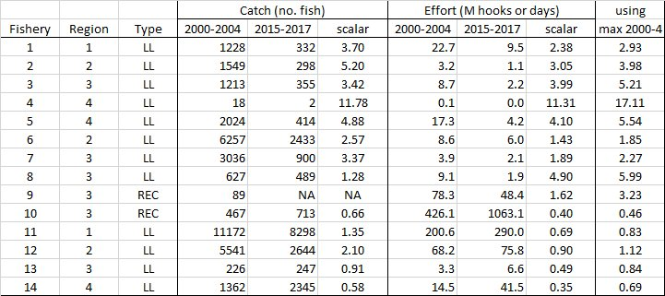Reply:** (SPC S. Hare): As you might suspect, the scalars would change quite a bit given that there is a history of highly variable effort. The reproduction of Table 2 from the report with an extra column shows what the effort scalars would have been using max(2000–2004) rather than mean(2000–2004)

1. **PNG** (B. Kumasi) stated they considered the outcomes of the projections, in particular the performance of the scenarios requested by SC15. There is quite a deal more work that needs to be done to develop the scenarios used for the projections. PNG noted that WCPFC has not formally agreed to an LRP for Southwest Pacific striped marlin. This is an important consideration for PNG given over the last 5 years catch of striped marlin by PNG longline vessels in PNG waters has averaged 6–7 mt, or less than 1% of the longline catch of PNG vessels. Striped marlin is therefore a bycatch species. There is quite clearly a higher standard to be used for management of target species than for bycatch species, regardless of the median for SB/SBF=0 for all scenarios resulting in terminal values above the LRP for tunas. From the above, the rationale behind the development of Scenarios 3 and 4 needs to be dropped and replaced with the consideration of a scenario that does not act in contravention of PNG’s legitimate right to develop its fisheries. On behalf of the PNA, PNG stated that scenarios that would mean cutting all catches in PNA waters to zero are discriminatory and unrealistic. PNA members consider that it will take a long time to develop catch limits, which must be zone-based. In the meantime, the PNA suggest instead that non-allocative mechanisms such as non-retention need to be considered to eliminate targeting and mitigate bycatches of striped marlin.

* **Reply** (SPC, S. Hare): We have noted that several parties wished for different, or dropped, scenarios. But, of course, the intent of this paper was to follow, as best we could, instructions from SC and that included the extreme scenario of projecting zero catch of striped marlin in Region 1. We stand ready to continue this work, having now the framework established to examine quite a diverse set of alternatives.
  + **Reply** (PNG): PNA appreciates the balancing that needs to happen between being objective in performing these analyses and weighing up the different interests of CCMs. For the set of alternatives, there is no prospect of the extension of the kind of flag-based limit currently applied in CMM 2006-04 to cover fishing in PNA waters. If measures to limit fishing on this stock are to be applied in PNA waters, they will have to be zone-based limits with appropriate arrangements to also facilitate SIDS participation in any high seas fisheries for this stock. If the SC wants to continue to explore catch or effort limits to manage fishing on this stock, then zone-based limits will need to be one of the options that is considered.

1. **RMI** (B. Bigler) on behalf of **PNA** **members**, noted striped marlin and other billfish are an important resource for many SIDS for small-scale fisheries for domestic consumption, for sports fisheries, and as a valuable longline bycatch. It seems clear that billfish mitigation studies in general are lacking in the WCPO. Given the lack of information required to understand the stock links between Region 1 and the other regions; and the lack of clarity around factors influencing catch, targeting, mitigation and release survival; PNA believe that more work is required on striped marlin and billfish in general to resolve these issues. This will require some focused research on billfish, and that research needs to be carefully considered and prioritised. We suggest that the WCPFC would benefit from a billfish research plan to manage and coordinate this work. PNA Members propose that the WCPFC develop a billfish research plan to be presented at SC17.

* **Reply** (SPC, S. Hare)**:** we agree that dedicated billfish research has lagged that of the target tunas, and also that billfish are an important economic component of the commercial fisheries in many CCMs. Given that there are quite a few billfish species and many outstanding biological and management issues, a targeted research program with defined priorities should certainly be a necessary step.

# Limit reference points for WCPO elasmobranchs (Project 103)

**11.1 Background**

1. SC16 participants will review the results of Project 103 (*LRPs for elasmobranchs within the WCPFC*) and communicate questions and comments.

**11.2 Relevant documents**

|  |  |
| --- | --- |
| **SC16-MI-IP-21** | Shijie Zhou, Matthew Dunn, Ashely Williams. **Appropriate reference points for WCPO elasmobranchs.** |

**11.3 Key Questions and Comments**

1. The **United States** (V. Post) stated that it is advisable to close this project. However, it is not clear that the analyses and results have clearly identified appropriate reference points for WCPO elasmobranchs. MSY-based reference points are consistent with the Convention. It is advisable that MSY-based reference points be considered as candidate reference points a priori as in the Convention text “ensure that such measures are based on the best scientific evidence available and are designed to maintain or restore stocks at levels capable of producing maximum sustainable yield”.

* **Reply (**CSIRO, S. Zhou): The LRP identified in this paper is based on the MSY concept, e.g., Flim = 1.5FMSY. However, non-target elasmobranchs are not retained so they do not produce a yield. The LRP concerns biological sustainability rather than yield.

1. **Nauru** (A. Capelle), on behalf of **PNA members**, noted that the authors of SC16-MI-IP-21 argue that the Convention Text recommendations for non-target species—of maintaining or restoring populations above levels at which their reproduction may become seriously threatened—equates to a LRP at MSY. Hence, setting aside ecological interaction among species, the biological objective, in their view, is consistent between target and non-target species. PNA do not accept this view as a basis for determining LRPs for sharks. The Commission has adopted as a principle for defining LRPs that LRPs “define a state of the fishery that is considered to be undesirable and which management action should avoid”. Subsequently, using this definition the Commission adopted LRPs of 20% of SB/SBF=0 for key tuna stocks, taking into account undesirable social and economic consequences as well as biological risks associated with these important stocks being depleted below this LRP level. For the main stocks, this LRP is close to SBMSY, being above it for two major stocks and below it for two others. This LRP reflects in particular a concern that, with stocks below this level, there are risks of increasing variability in recruitment and reductions in average fish size (and value) resulting in undesirable economic and social impacts. This is a different standard of management from maintaining or restoring populations of such species above levels at which their reproduction may become seriously threatened, which the Convention applies to non-target species. The PNA will not be able to agree to LRPs for non-target stocks, including non-target shark stocks, that are the same in effect as those adopted by the commission for key fisheries or stocks.

* **Reply** (CSIRO, S. Zhou): The recommended LRP in the paper mainly concerns biological sustainability. As these elasmobranchs are not commercial species so undesirable economic and social impacts are not considered in defining the LRPs.

1. **PNG** (B. Kumasi), on behalf of **PNA members**, noted that the rationale for the discussion of the options presented is that the derivation of LRPs should be based on the same principles for both target and bycatch species. That is, since the WCPFC has adopted a benchmark of 20%SBdynamic10, unfished as the biomass limit reference point (BLIM) for some tuna target species, similar metrics can be naturally transferred to elasmobranchs. However, that is not consistent with the definition of LRPs adopted at WCPFC8. This work is useful but also technically challenging for some Members. To facilitate our understanding in future discussion and in the SC record we request that consistent terminology be used throughout the SC and terms such as SBdynamic10, unfished not be used,[[6]](#footnote-6) when the WCPFC has fairly standard stock status metrics such as SB/SBF=0; or SB/SB0; and F/FMSY. With respect to moving this work forward, we believe that there is a two-tier level of decision-making required. First, agreement is needed on the metrics used to describe the stock status. Once that agreement is reached, we can have a discussion on the level of that metric to be used as the LRP. The PNA agree that a hierarchical approach is needed for the LRP metrics. To this end we recommend using SB/SBF=0; and/or SB/SB0 as metrics to describe stock depletion resulting from data rich assessments. When these depletion estimates are not able to be estimated (i.e. for medium and data-poor assessments) some of the alternatives from the paper can be considered. The PNA suggest metrics relative to Fcrash as this is a level of fishing mortality that should be avoided with a high degree of certainty. We note that Fcrash would be too low as a responsible LRP, however, setting a LRP where F is some proportion below Fcrash could be useful as an LRP. We also believe that this is more consistent with the WCPFC8 definition of LRPs.

* **Reply** (CSIRO, S. Zhou):This paper prefers to use biomass (B) over spawning biomass (SB). The concept of defining LRP is based on the biomass dynamics model, where biomass is vulnerable biomass rather than spawning biomass. Simply using biomass eases the estimation of fishing mortality rate because any fish captured in fisheries is vulnerable to the fishing gear but that fish may be or may not be matured. This advantage is particularly helpful for data-poor stocks that are assessed by risk-based methods. We agree that reference points based on SB/SB0 can be adopted for data-rich stocks. We believe Fcrash should not be used as a reference point for management of any marine species, unless the objective is to get rid of that species (e.g., invasive species in some freshwater systems). The suggested LRP is proportional to Fcrash, i.e. Flim = 0.75Fcrash.

1. **Kiribati** (T. Adams) stated that the paper did not consider empirical reference points. Given the challenges in estimating fishing mortality we believe that empirical reference points should be considered. In this regard if no data rich assessment is possible, but some useful data on the catch are available, we believe that the use of empirical reference points such as CPUE (e.g. x% CPUE from some reference period) would be useful to consider as a LRP. It would be useful for an analysis to be undertaken investigating the possibility of CPUE or other empirical reference points for elasmobranchs. In addition, in order to agree on the level at which we are willing to lower the population to, we will need to establish fishery objectives for WCPO elasmobranchs. These objectives may need to be set as interim objectives that could be updated, as they may change as the WCPFC Harvest Strategies process develops and the overall non-target species objectives are finalised. We therefore recommend that a suite of management objectives for elasmobranchs be developed.

* **Reply** (CSIRO, S. Zhou): These are good points. We also suggested that the LRPs in this paper should be considered as interim.

1. **Japan** (M. Kai) stated that although we have still concern about the theoretical background of three limit reference points (i.e., FMSY, Flim, and Fcrash) recommended for WCPO elasmobranchs, we support the new recommendations in the report (i.e., SC16-MI-IP-21) because we need to progress based on the perspective of feasibility at this moment. The recommended LRPs (i.e., BLIM=0.25B0 and FLIM=1.5FMSY) are reasonable and realistic values in the application. In addition, the authors recommended adopting the reference points estimated in the same stock-assessment for the stocks assessed by integrated stock assessment. We can evaluate these points in the new report.
2. **Question:** We are not sure if the authors are still recommending the three F-based reference points (i.e., FMSY, Flim, and Fcrash) for WCPO elasmobranchs because the authors excluded Fcrash from the calculation of joint F-reference points in the report (p11). Please clarify this and revise the typo error of first recommendation (p. 20) from “Flim=0.5FMSY” to “Flim=1.5FMSY”.

* **Reply** (CSIRO, S. Zhou): We do not recommend using three different reference points (i.e., FMSY, Flim, and Fcrash) as LRPs. For the same type of management quantity (either biomass or fishing mortality), the LRP should only have one reference point. Among the three reference points, FMSY aims for maximum sustainable yield, which is not the objective of discarded species, while Fcrash will drive population to extinction so certainly cannot be used as a reference point. Thank you for spotting the typo, which will be corrected in the final report.

**11.4 Summary of Input from CCMs on the Progress of SC Projects**

1. One CCM stated that it is advisable to close Project 103; no objections to closing the project were raised. CCMs offered a number of comments regarding the setting of appropriate reference points for WCPO elasmobranchs, suggesting: (i) it is not clear that the analyses and results have clearly identified appropriate reference points; (ii) agreement is required regarding the objective of the LRPs for non-target stocks, the metrics to be used to describe stock status, and their levels; (iii) and consideration needs to be given to empirical reference points. One CCM suggested the recommended LRPs be accepted.

# Limit reference points for South Pacific Striped Marlin

**12.1 Background**

1. At WCPFC16, the Commission noted with concern the current status of South Pacific striped marlin and agreed to revisit identification of an appropriate limit reference point for this species in 2020 at WCPFC17 (Para. 459, WCPFC16 Summary Report). SC16 participants will consider the process of developing an appropriate LRP for Southwest Pacific striped marlin and will review any terms of reference proposed for a project (Project 104) for recommendation to WCPFC17.

**12.2 Relevant documents**

|  |  |
| --- | --- |
| **SC16-MI-IP-12** | P. Hamer and G. Pilling. **Terms of Reference for a project to identify appropriate Limit Reference Points for Southwest Pacific Ocean striped marlin and consideration of other billfish species** |

**12.3 Key Questions and Comments**

1. **New Zealand** (J. Annala) stated that the proposal is well constructed and New Zealand supports the proposed workplan and budget.
2. The **United States** (V. Post) stated that, similar to the United States’ comment on WCPO elasmobranchs (Topic 11), MSY-based reference points are consistent with the Convention. It is advisable that MSY-based reference points be considered as candidate reference points *a priori* as in the Convention text “ensure that such measures are based on the best scientific evidence available and are designed to maintain or restore stocks at levels capable of producing maximum sustainable yield”.

* **Reply** (SPC, P. Hamer): The WCPFC hierarchical approach to defining LRPs will be considered for billfish under the ToR, this includes consideration of MSY-based reference points

1. **Kiribati** (T. Adams) on behalf of the **PNA**, welcomed that the terms of reference draw the distinction between target and non-target species with socioeconomic drivers for target species and biological sustainability concepts for non-target species. This is exactly the point we are making in the discussions for reference points for elasmobranchs. As a result, we think that this proposed analysis needs to distinguish between target and non-target species.
2. We would therefore like to add text to the terms of reference to reflect Article 10.1 c) as follows:

Key Activity 6: Recommend additional information requirements to improve the estimation of LRPs for SWPO striped marlin and other billfish (i.e. blue marlin, black marlin, swordfish) as either target or non-target species.

* **Reply** (SPC,P. Hamer): we will make the amendment to key Activity 6 as suggested in a Rev1.

1. In addition, we consider that focusing on recruitment overfishing is not necessarily an appropriate starting point for SWPO striped marlin as a non-target species and suggest that the following sentence under Scope be deleted:

~~The concept of avoiding recruitment overfishing and the stock being depleted to the extent that recruitment potential becomes impaired is therefore highly relevant to developing LRPs for SWPO striped marlin.~~

* **Reply** (SPC): In relation to the comment regarding recruitment overfishing – the ToR indicates that the consideration of LRPs should be based primarily on ‘biological sustainability’ and ‘conservation’ objectives as opposed to social or economic considerations. As such the sentence referring to recruitment overfishing is not necessary and will be removed from Rev 1. The concept of recruitment overfishing would no doubt be considered when defining what constitutes biological sustainability for billfish stocks in the WCPO.

1. **Australia** (J. Larcombe) stated it is supportive of this proposal and offered the following comments and suggestions.
2. Limit reference points are usually identified based on biological considerations only, and in particular on identifying indicators beyond which there is a risk of recruitment impairment. We agree that there may be social/economic consequences of breaching an LRP but such considerations in most instances are not taken into account in identifying the LRP itself. Social/economic consequences may, however, be a consideration with respect the risk of breaching the LRP and are certainly a consideration for identifying a TRP. We would suggest some amendments to the paper and proposal to reflect this understanding.
3. In relation to the statement in the paper that “striped marlin (and other billfish) in the WCPO are not considered key target species, although some targeted fishing may occur”. It may be preferable to state “while billfish in the WCPO are generally not a key target species, they may be important target species for some fleets and more often can be considered an important component of the total catch”.
   * **Reply** (SPC, P. Hamer): Thank you for your comments and recommendation regarding targeting, we will make the suggest change to the ToR text in Rev1, i.e. “while billfish in the WCPO are generally not a key target species, they may be important target species for some fleets and be considered an important component of the total catch”.
4. We are pleased to see that the three-tier hierarchy that has been adopted by the Commission and applied to the key tuna species will be given consideration.

**12.4 Summary of Input from CCMs on the Progress of SC Projects**

1. CCMs offered overall support for the project, as well as a number of specific suggestions and comments regarding the proposed ToRs. Amendments were made to the ToR and a rev 1 was submitted.

# Acoustic FAD analysis (Project 88)

**13.1 Background**

1. The objective of the acoustic FAD analysis (2020 – 2021) is to identify whether acoustic buoys on drifting FADs could provide new fishery independent data for stock assessments (e.g. indices of abundance), and whether limiting sets to only those FADs that have a large biomass beneath them can reduce the levels of small bigeye and yellowfin caught. SC16 participants will review the research outputs, and provide recommendations for the extension of Project 88 activities in 2021.

**13.2 Relevant documents**

|  |  |
| --- | --- |
| **SC16-MI-IP-20** | L. Escalle, B. Vanden Heuvel, R. Clarke, G. Pilling. **Updates on Project 88: FAD acoustics analyses** |

**13.3 Key Questions and Comments**

1. **Solomon Islands,** on behalf of PNA members, thanked SPC, Trimarine and SPTC for their work. They noted that these are only preliminary analyses, but that the work is very important because of the need for improved information on skipjack abundance, as well as other research purposes.

PNA supports a recommendation from SC16 for continuation of the work, noting its scientific value.

PNA also supports the recommendation for improved reporting of identification of FAD Buoys by vessel operators and observers. In that direction, PNA is currently trialing a new electronic FAD logsheet to be completed by vessel operators to give effect to the decision by the Commission in 2015 for vessel operators to provide data on FADs covering FAD design and construction and FAD activity including FAD Buoy Identification. The new FAD logsheet will include a direct linkage to the PNA FAD Buoy Register to address exactly the difficulty faced by SPC in this study in matching FAD Buoy position data with data on the FAD design and reports of fishing activity on that FAD Buoy.

**13.4 Summary of Input from CCMs on the Progress of SC Projects**

1. The PNA supported the continuation of Project 88; no objections were expressed.

# Management of swordfish as bycatch

**14.1 Background**

1. The Commission (at WCPFC16) tasked SC to consider a review of possible measures and options relevant to the management of swordfish taken as bycatch in longline fisheries (WCPFC16 Report, para. 482). The review may include information from available research and literature, logbook and observer data.

**14.2 Relevant documents**

|  |  |
| --- | --- |
| **SC16-MI-IP-22** | Darci Wallis, Don Bromhead, Trent Timmiss, James Larcombe, Kerrie Robertson, Mat Kertesz. **A review of potential options for managing swordfish taken as bycatch in longline fisheries** |

**14.3 Key Questions and Comments**

1. **Australia** (D. Bromhead) noted to participants that Australia sought review and feedback regarding:
2. The likely effectiveness of the proposed measures in capping and preventing unrestrained increases in fishing mortality of swordfish in fleets taking this species as bycatch.
3. Additional management options to consider in a future updated review.
4. Additional information, research or data that would assist a future updated review. This review will, alongside catch projections work scheduled for SC17, assist WCPFC consideration of a revised draft CMM in 2021.
5. **Tokelau** (B. Muller), **on behalf of PNA members**, commented on SC16-MI-IP-22, and thanked Australia for the work. They noted that there is a South Pacific swordfish assessment scheduled for 2021, and stated that there was an opportunity to assess some options as to their effectiveness within the context of the assessment, or at least as part of the fishery characterisation work leading up to the assessment. PNA members also stated their view that a number of options—the removal of lightsticks and squid bait from non-target fisheries; a retention ban; size limits; and releases of live individuals—can be tested under the umbrella of the assessment, as can bycatch limits. The pre-assessment data summaries can also quantify the scale of bycatch from non-swordfish fisheries. This should be tabled as a specific task for SPC as part of the stock assessment. The impacts of these specific management actions can then be reviewed by SC17 in the light of the assessment outcomes in 2021. PNA members also noted that while the discussion is about bycatch, similar approaches might also be necessary for controlling target catch if management of this stock is to be effective.
   * **Reply:** (Australia, D. Bromhead) thanked PNA members for their very helpful inputs. Australia agreed it will be very important to have a fishery characterisation (as part of or associated with the next assessment in 2021) that clarifies the amount of swordfish taken in both target and bycatch fisheries, in-zone and on the high seas, and that that be undertaken by SPC. In addition, Australia agreed that there should be an analysis (again as part of or associated with the next assessment in 2021) that explores the likely impacts of the different management options (including those in the PNA comments) upon swordfish bycatch levels. Further to this, Australia noted the catch projection work requested by WCPFC16 in December 2019 that will test a range of status quo and fully caught scenarios (the latter for fisheries with catch limits south of 20°S). This projection work is designed to account for both bycatch and target fisheries. It will complement the data analyses suggested by PNA members, and additional scenarios could be considered that test the likely impact of some of the quantified bycatch management options. Together with an update of the current paper (SC16-MI-IP-22), this suite of work should form a solid information basis for SC, TCC and WCPFC to move forward in considering a revised and strengthened CMM for South Pacific Swordfish in the Convention Area. Australia invited the Science Service Provider and others to comment on the discussion above.

1. **United States** (V. Post) stated that potential options are outlined well, and that it would be beneficial to consider economic implications of the various options.
   * **Reply (**Australia D. Bromhead): thanked the United States for the suggestion regarding consideration of the economic implications, and agreed it would be extremely important for CCMs to consider the economic implications of different bycatch management options. However, Australia noted it would be very difficult to develop a single overarching analysis of this type. Each CCM’s fishery has its own unique operational and economic circumstances, so the implications of each option could differ across CCMs. Australia suggested it would be more feasible for individual CCMs to use the information from the fishery characterisation (noted in the PNA’s comment at Topic 14, para. 2) the catch projections and associated work, alongside their own information about how their fisheries operate, to determine which options might be more or less acceptable to their fishery from an economic impact perspective.

1. **SPC** (G. Pilling) noted the comments regarding the fishery characterization, stating that this would likely rely on operational/aggregate raised data given the patchy spatial and temporal nature of observer information on longliners. With regards to testing different management options, SPC would suggest that any modelling along these lines wait until SC has discussed the next SWO assessment results, scheduled for 2021.
2. **Japan** (H. Ijima) commented that SC16-MI-IP-2 contains some misleading content for managers:
3. Swordfish is not a low-value fish and is an important commercial fish species for some longline fishers. Thus, it is not possible to unambiguously define it as a bycatch species.

* **Reply** (Australia, D. Bromhead): WCPFC16 specifically tasked Australia to develop a paper for SC16 that presented management options for fisheries that take swordfish as bycatch. However, while we have done this, we also recognise that this species is not a bycatch in all fisheries and we agree that this is only one consideration in the review and updating of CMM 2009-03.
* We also agree that swordfish is not a low value fish. For fleets that target this species in the stock area, such as Australia, New Zealand and the European Union, it is a major component of their catch and economic returns. Australia is interested to understand if there are other CCMs whose longline boats also target swordfish? Is this the case for Japan? For fleets that take this species while targeting tuna, it is also true that it may make a smaller but still economically valuable contribution to the overall catch value. Again, we are interested to hear from CCMs if this is true for their fleets.

1. Although swordfish and sharks have entirely different biological, ecological and fishery properties, the authors showed the management option for pelagic sharks. It is not appropriate to refer to them.
2. Examples of CMMs for other billfish species are based on stock assessment results, and it is essential to consider the results of the stock assessment as the basis for CMMs of South Pacific SWO.

* **Reply** (Australia): It will be critical that the outcomes of the 2021 stock assessment, the catch projections work tasked for review by SC17, plus any other additional work (for example as suggested by PNA in comments above) are considered alongside and in conjunction with this paper on swordfish bycatch fishery options.

1. When SC discusses these candidates CMMs, biological LRPs and results of detailed future projections (or MSEs) are required. It is also necessary to estimate the post-release mortality on the high seas north of 20°S because post-release mortality can vary depending on the oceanography and gear configuration and is one of the most critical parameters to evaluate the performance of CMMs.

* **Reply** (Australia):We agree that post-release mortality is a key factor to consider in the performance of different options, as outlined in the paper, and that it can potentially vary depending on fishing methods, ocean conditions and other factors.

1. **Australia** (D. Bromhead): On behalf of Australia I would like to thank all WCPFC CCMs who have contributed to discussions on this topic, both prior to SC16 and during the online forum. Australia will use these inputs and discussions to update and improve the review of swordfish bycatch management options for further future consideration. We would welcome and encourage all CCMs with an interest in this issue to continue to provide their views to Australia both intersessionally and during WCPFC associated meetings. Thanks again.

# Shark Research Plan for 2021 – 2025 (Project 97)

**15.1 Background**

1. SC16 will review the results of Project 97 and communicate questions and comments to refine and finalize the project report.

**15.2 Relevant documents**

|  |  |
| --- | --- |
| **SC16-EB-IP-01** | S. Brouwer and P. Hamer. **2021-2025 Shark Research Plan** |

**15.3 Key Questions and Comments**

1. **Palau** (K. Sisior) commented on behalf of PNA members, and thanked SPC and the IWG for the work to prepare the draft Plan. They stated that the improved flow of data of specific shark species should enable the Commission to substantially improve its management of sharks in the next 5 to 10 years, and it is important to have a Plan that provides a sound, agreed basis for moving ahead on shark research. PNA members supported the approach in the Plan, and welcomed in particular the work to simplify and standardise shark research work and bring together available information on key shark species in the proposed Report Cards and Information Sheets. This will improve the scope for small island administrations to participate effectively in the Commission’s work on shark conservation and management. PNA Members will provide more specific comments on the draft Plan separately.
2. The **United States** (V. Post) commended the work laid out in the SRP, which is the 3rd WCPFC SRP; this plan covers key WCPFC shark species during 2021–2025. The SRP summarizes the available data and suggests clear guidelines for metrics to be included in assessments to ensure consistency in reporting and ease of comparison among species. The U.S. supported the numerous recommendations to SC that aim to improve future assessments. In addition, the U.S. offered to continue to participate in the process to develop and review the “agreed suite” of biological parameters for use in the WCPFC assessments and to update the information sheets accordingly (Recs. #7, 9), including reviews of the data certainty criteria for the report cards (Rec. #8).

1. **Tuvalu** (M. Batty), on behalf of **PNA members**, suggested improvements to the draft plan as follows:
2. The Plan should include references to the relevant provisions of the Convention to provide context for the work proposed in the Plan. This could be done simply by picking up language from the previous Plan.
3. While the principle of Recommendation 2 below is fine, PNA does not consider that MSY-based metrics should be focused on for stocks that are not retained. PNA suggests that Recommendation 2 be reworded to clarify that this recommendation applies to commercially harvested stocks, and recommends including SB/SB0 as an additional metric for inclusion in all shark assessments.
4. While PNA supports the proposed objectives, they need some rewording to reflect the appropriate role of the SC as “providing advice” on mitigation and safe release.
5. Some editing suggestions, including clarifying the captions in the Report Card maps as relating to CPUE, not catch; and that the figures in Appendix I reflect flag vessel catches by each CCM.
6. PNA members suggest that, if possible, the Plan should include figures showing the distribution of reported catches (in addition to the reported CPUE plots already in the document), at least for the major species. This would likely have to be for a recent period since catches by species have only recently begun to be reported, and may not be useful for some species for which catches are still not well reported at the species level.
7. The Plan includes a useful section on Observer Data Collection. PNA members suggest that this should be broadened to cover also the need for enhanced data provision on sharks from vessel operators and e-monitoring.

1. **Japan** (M Kai) agreed with the recommendations if the current ones are maintained after the online forum because Japan helped improve the descriptions in the shark research plan and had already agreed with that during the intersessional meeting via e-mail. Noting that the report of LRPs for WCPO elasmobranchs (i.e., SC16-MI-IP-21) was updated with revisions, Japan stated that the recommendations of the shark research plan in relation to the LRPs (i.e., 4 and 5) should be updated to reflect them. For example, Zhou et al. (2020) excluded Fcrash from the calculation of joint F-reference points in the report (p. 11). If it means that Fcrash should not be used as a reference point, the recommendations of the shark research plan should be revised as well.

**15.4 Summary of Input from CCMs on the Progress of SC Projects**

1. CCMs expressed no objections to closure of the project, and made various suggestions for updates and changes to improve the 2021-2025 SRP. A Rev 1 was submitted that deals with the comments and recommendations from the forum.

# Effectiveness of CMM 2018-01

**16.1 Background**

1. Noting the scope of updates in SC16-MI-IP-23, SC16 will provide comments on the current progress and advice for future updates after the adoption of updated assessments for bigeye and yellowfin in 2020.

**16.2 Relevant documents**

|  |  |
| --- | --- |
| **SC16-MI-IP-23** | G.M. Pilling, P. Hamer, P. Williams and J. Hampton. **Evaluation of CMM 2018-01 for tropical tuna** |
| **SC16-MI-IP-19** | WCPFC Secretariat and SPC. Catch and effort tables on tropical tuna CMMs |
| **SC16-MI-IP-13** | L. Escalle, T. Vidal, S. Hare, P. Hamer, G. Pilling and the PNA Office.  **Estimates of the number of FAD deployments and active FADs per vessel in the WCPO** |
| **SC16-MI-IP-14** | L. Escalle, B. Muller, S. Hare, P. Hamer, G. Pilling and the PNA Office.  **Report on analyses of the 2016/2020 PNA FAD tracking programme** |
| **SC16-MI-IP-15** | T**.** Vidal, P**.** Hamer, M**.** Wichman., and the PNAO. **Examining Indicators of Technological and Effort Creep in the WCPO Purse Seine** **Fishery** |
| **SC16-MI-IP-16** | Marino-O-Te-Au Wichman, Tiffany Vidal, Paul Hamer. **Purse Seine Effort Creep Research Plan** |
| **SC16-EB-IP-02** | Lauriane Escalle, Steven Hare, Andrew Hunt, Chloé Faure, Kydd Pollock,  Tiare-Renee Nicholas, Mainui Tanetoa, Jamel James, Beau Bigler and Graham  Pilling. **In-country initiatives to collect data on beached and lost drifting**  **FADs, towards a regional database of in-situ data** |
| **SC16-EB-IP-03** | Naiten Bradley Phillip Jr. and Lauriane Escalle. **Updated evaluation of drifting FAD construction materials in the WCPO** |
| **SC16-EB-IP-08** | G. Moreno, J. Salvador, J. Murua, N. B. Phillip Jr., H. Murua, L. Escalle, B. Ashigbui, I. Zudaire, G. Pilling, V. Restrepo. **A multidisciplinary approach to build new designs of biodegradable Fish Aggregating Devices (FADs)** |

**16.3 Key Questions and Comments**

1. The **United States** (E. Crigler) commented on Topic 16, as follows:
2. On **SC16-EB-IP-02:** the paper describes what looks to be an important initiative and is a good model for the issue raised for internal discussion under SC16-MI-IP-14. The United States fully encouraged increased participation, including United States involvement, and encouraged alignment with IATTC given general movements of dFADs from East to West (from the EPO to the WCPO). The United States encouraged SC16 to endorse the following recommendations from the paper:
3. Highlight the need for in-situ data to be collected to better quantify beaching events and the impacts of dFADs on marine ecosystems.
4. Note the development and progress of in country data collection programmes on beached and lost dFADs nearshore, as well as of a regional database.
5. Encourage its extension to other members of WCPFC.
6. **SC16-EB-IP-03**: The United States commended the work accomplished and supported the on-going research activities and at-sea trials of biodegradable and non-entangling design options in the WCPO, and encouraged the authors to provide corresponding advice to the FAD Management Options Intersessional Working Group. The United States suggested SC16 support the proposal in the paper to:
7. Reaffirm the commitment to reduce the use of plastic, entangling and non-biodegradable materials in the construction of FADs in the WCPO to help reduce marine pollution and ecosystem impacts.
8. **SC16-EB-IP-08**: The United States observed that it looks like an interesting and useful project and looked forward to reading about the project’s continuation and results. They United States supported the ISSF ongoing experiment to test the proposed design in the Western Pacific Ocean with the numerous collaborators. The paper includes recommendations (pp. 17–18) based on preliminary results. The United States suggested it was premature for SC to endorse specific recommendations from the paper, given that the study is still ongoing and results are preliminary and incomplete.
9. **SC16-MI-IP-23**: The United States stated their understanding that the evaluation assumed 49 PNA purse seine vessels were exempt from the 3-month FAD closure, as in 2018. Based on the PNA notifications listed in Circular 2020-80, it appears that 78 PNA purse seine vessels are exempt in 2020. When updated after SC16, the evaluation in SC16-MI-IP-23 should take into account this larger number of exempt vessels.

* **Reply** (SPC): Noted.

1. **Australia** (J. Larcombe)stated that SC16 will consider new stock assessments for yellowfin and bigeye tuna including agreement on the structural uncertainty grid for each species. Noting that SC16-MI-IP-23 is not scheduled for discussion in plenary, Australia recommended that upon conclusion of SC16 this paper be updated to reflect the SC16 decisions and be made available for the Commission’s consideration at is meeting in December 2020.

* **Reply** (SPC): Noted.

1. **PNG** (T Usu), on behalf **PNA** members, noted that SC16-MI-IP-23includes very clear and accurate responses to the requests made by PNA, and stated they are encouraged by the results of the projections, which indicate that, depending on some of the assumptions, particularly for bigeye recruitment, the CMM can be expected to broadly achieve the objectives of the CMM and maintain stocks around where they are. These results provide no support for an urgent review of the measure, but rather provide a good basis for agreeing to roll over the existing CMM at a time when any other course is going to be difficult.

1. **SPREP** (K. Baird) commended the work done evaluating DFAD construction materials in paper SC16-EB-IP-03 and particularly the work done by the multidisciplinary team led by ISSF on new designs for biodegradeable DFADs in SC16-EB-IP-08. The suggested need to quantify the effectiveness and the entanglement frequency of species of special interest (SSI) comparing existing DFAD designs with new low entanglement risk, non-entangling and biodegradable DFADs, as suggested in paper IP-03 is welcomed. Although this further data is welcome, in this situation due to the high risk presented by mesh and the increasing numbers of abandoned DFADs, SPREP suggests as an interim measure, the FAD Management Options Intersessional Working Group consider recommending to SC to prohibit use of mesh net in construction of DFADs now. We recognise that further work is needed to confirm the effectiveness of the new DFAD designs in the current trials being undertaken in Micronesia and encourage the continuation of this work so that we can move as quickly as possible to increase the uptake of completely biodegradeable and non-entangling DFADs in the WCPO. SPREP also commended the work through the trial PNA FAD tracking Programme presented in SC16-MI-IP-14. SPREP also noted the increasing % of abandoned DFADs—now around 42% with just 9.4% retrieved, which is further endangering the environment, including coral reefs and vulnerable species including turtles and sharks.
2. **Question**: What is needed to facilitate increased retrieval rates by vessels operating in the WCPO?

* **Reply** (SPC, L. Escalle)**:** This is more a question for managers and the industry, but SPC as scientific services provider can provide, if requested, any analyses to help guide management decisions.

# Other commercial fisheries for bigeye, yellowfin, and skipjack

**17.1 Background**

1. The Commission tasked the SPC, in collaboration with Indonesia and the Philippines, to develop a paper containing all information on ‘other fisheries’ to be presented to SC16. SC16 will review and advise the Commission with the aim of reviewing paragraph 51 in CMM 2018-01 to ensure appropriate limits can be determined, measured and assessed in the Compliance Monitoring Scheme (Paragraph 376, WCPFC16 Summary Report).

(CMM 2018-01)

*51. CCMs shall take necessary measures to ensure that the total catch of their respective other commercial tuna fisheries for bigeye, yellowfin or skipjack tuna, but excluding those fisheries taking less than 2,000 tonnes of bigeye, yellowfin and skipjack, shall not exceed either the average level for the period 2001-2004 or the level of 2004.*

**17.2 Relevant Documents**

|  |  |
| --- | --- |
| **SC16-MI-IP-17** | PH-NFRDI, PH-BFAR, SPC-OFP. **Availability of catch estimates from the other commercial fisheries in the Philippines** |
| **SC16-MI-IP-18** | ID-MMAF and SPC-OFP. **Availability of catch estimates from the other commercial fisheries in Indonesia** |

**17.3 Key Questions and Comments**

1. There were no comments or questions.

# Age and growth for bigeye and yellowfin tuna

**18.1 Background**

1. SC16 will review the project final report for the provision of robust age and growth estimates, and raise any technical questions before the plenary to facilitate discussions and reduce the virtual meeting time at SC16.

**18.2 Relevant Documents**

|  |  |
| --- | --- |
| **SC16-SA-WP-02** | J. Farley, K. Krusic-Golub, P. Eveson, N. Clear, F. Roupsard, C. Sanchez, S. Nicol, J. Hampton. **Age and growth of yellowfin and bigeye tuna in the western and central Pacific Ocean from otoliths** |
| **SC16-SA-IP-03** | P. Eveson, M. Vincent, J. Farley, K. Krusic-Golub, J. Hampton. **Integrated growth models from otolith and tagging data for yellowfin and bigeye tuna in the western and central Pacific Ocean** |

**18.3 Key Questions and Comments**

1. **Tuvalu** (M. Batty) thanked the authors for the rigorous analysis, noting this is a substantial improvement on the previous estimates, and we expect the results to be influential in the assessment. This work contributes significantly to our understanding of yellowfin growth productivity and cements our understanding for bigeye. It is somewhat concerning as to why there are so few females in the sample for fish over five years old.
2. **Question:** While we note that the growth curve is fairly flat from 150cm, do you know if there are other biological samples e.g. for gonads in the SPC tissue bank of very big female fish (even if no otolith sample has been taken)? It would be interesting to know if there are observations of large females and they are just not in the sample or weather they have simply not been observed in the population.

* **Reply** CSIRO (J. Farley): the WCPFC tissue bank has only 11 female yellowfin ≥ 150 cm (with over 6000 fish in the bank in total) so they are rare in the sampling.

1. **Question:** Noting the paucity of females in the older age classes in Figure 14, do you know if there is some time factor at play here where these few old observations are from earlier (e.g. 2009) collection periods?

* **Reply** CSIRO (J. Farley): There does not appear to be a year pattern in catch date of the older females. Two of the oldest were caught in the most recent years (2017–2018). It would be useful if additional otoliths from large yellowfin (males and females) could be collected and analysed.

1. **PNG** (B. Kumasi)noted useful analysis presented in SC16-SA-IP-03, and the differences in growth estimates between tagging and otoliths. We also note that in the absence of reliable, validated growth estimates, tagging data can be a useful alternative for estimating growth. As a result, these differences are worrying and exploring the reasons for the difference is important to continue.
2. **Question:** Did you investigate tagger effects: e.g., if some taggers were tagging mostly fish of one size group, did those fish have higher or lower growth estimates?

* **Reply (**CSIRO, J. Farley): that the integrated model applied in this example did not explicitly include a tagger effect on growth. While it should be recognized that tagging effects can have impacts on mortality and have been reported to have short term effects on growth in fish species, the influence of tagger is likely to be small in comparison to the tagging effect. Where alternate data is unavailable for age and growth, tagging data provides a valuable source of information, while noting that tagging often only occurs on limited size classes and consequently tagging data is rarely representative of all age classes necessary for age and growth estimation.

1. **Question:** What is your plan for continuing this work, as the results may be relevant to other species where tagging data are available but obtaining biological samples for age and growth studies may be complicated?

* **Reply** (CSIRO, J. Farley):Any further work on integrated growth modelling is a decision for the Scientific Committee. There is currently insufficient tagging data available for integrated growth modelling for South Pacific albacore. There may be some capacity for integrated modelling for the billfish species, however an inventory of available tags would need to be undertaken as a first step to determine if sample sizes were sufficient. There may be some capacity for integrated growth modelling for skipjack but this would be a slightly different application as otolith base age estimates for skipjack are limited and generally restricted to the first year of life. For skipjack, the integration would be undertaken with length and tagging data. The next assessments for skipjack are scheduled for 2022 and bigeye and yellowfin are scheduled for 2023.

# Bigeye tuna stock assessment for 2020

**19.1 Background**

1. SC participants will review the working and information papers related to the 2020 bigeye tuna assessment and raise any technical questions before the plenary to facilitate discussions and reduce the virtual meeting time at SC16.

**19.2 Relevant Documents**

|  |  |
| --- | --- |
| **SC16-SA-WP-03** | N. Ducharme Barth, M. Vincent, J. Hampton, P. Hamer, P. Williams, G. Pilling. **Stock assessment of bigeye tuna in the western and central Pacific Ocean** |
| **SC16-SA-IP-04** | T. Peatman. **Analysis of tag seeding data and reporting rates for purse seine fleets** |
| **SC16-SA-IP-05** | J. Scutt Phillips, T. Peatman, M. Vincent, S. Nicol. **Analysis of tagging data for the 2020 tropical tuna assessments: tagger and condition effects** |
| **SC16-SA-IP-06** | N. Ducharme Barth, M. Vincent. Background analyses for the 2020 stock assessments of bigeye and yellowfin tuna in the western and central Pacific Ocean |
| **SC16-SA-IP-07** | N. Ducharme Barth, M. Vincent, T. Vidal. Analysis of Pacific-wide operational longline dataset for bigeye and yellowfin tuna catch-per-unit-effort (CPUE) |
| **SC16-SA-IP-18** | T. Peatman, N. Ducharme Barth, M. Vincent. **Analysis of purse seine and longline size frequency data for bigeye and yellowfin tuna in the WCPO** |

**19.3 Key Questions and Comments**

1. The **United States** (E. Crigler) stated that there is a concern that the growth models being used for WCPO bigeye tuna have been modified in the three most recent assessments and also that historic information on growth from previous decades has been subsumed with new recent size-at-age analyses. It is potentially misleading to extrapolate current estimates of growth decades into the past, because bigeye tuna growth may have varied through time with changes in ocean productivity, as indexed by Pacific decadal oscillation patterns, or with changes in the mixture of EPO and CPO bigeye tuna in the WCPO and IATTC Convention areas, noting that some mixing occurs (Schaefer et al. 2015. Movements, dispersion, and mixing of bigeye tuna … Fish. Res. 161:336-355). This unknown has not been addressed directly in sensitivity analyses conducted for the bigeye assessment. However, it is notable that the use of dynamic B0 reference points for the stock does reduce the potential impacts of time-varying growth on assessment results and status determinations for WCPO bigeye over the past decade.

* **Reply (**SPC, N. Ducharme-Barth): noted the comment and concern that there may be an un-accounted for recency bias in the growth curve used in recent WCPO bigeye assessments. SPC acknowledges that this unknown could impact the determinations of stock status. If early period size-at-age information was available it would have been included in the assessment. Currently, Multifan-CL does not have the capability for temporal variability in growth and a single growth curve was used. However, the capability to include multiple growth curves to account for spatial variability in growth is being developed in Multifan-CL so this feature can be used to address differences in growth between the EPO and WCPO. We note that this will further increase model complexity so the eventual deployment of this feature should be evaluated in the context of the model complexity concerns raised in the discussion section of the report. Also, IATTC will be conducting a Pacific-wide bigeye stock assessment in 2021, and SPC will be contributing to this effort.

1. **New Zealand** (J. Annala) New Zealand thanked the authors for their work and commented as follows:
2. New models have been implemented for tag data, purse seine catch estimates and size composition data. Tagging data are very influential in the model, and several changes had a large impact on results, particularly adjustments to the tagger effects, reporting rate, and tag usability estimates. New Zealand noted the need for more information about these changes, such as model diagnostics and tables of statistical results for the tagger effects, a table of reporting rate priors by fishery/tagging program group and time period, and a detailed description of the tag usability processes and numbers and how they have changed. This would help determine whether they should be considered improvements or alternative hypotheses. New Zealand also noted that mixing remains an important issue for models that include tagging data, and recommended that tests of the mixing hypotheses are carried out in future assessments, in addition to the simulation work currently under way.
3. The new index fishery approach and the spatio-temporal modelling of CPUE are useful enhancements to the assessment. In future assessments it would be useful to further consider factors affecting fishing power such as targeting, vessel effects and effort creep. New Zealand noted that the higher effort dev penalties give more influence to the CPUE indices than in the last bigeye assessment.
4. The new biological parameters for the length-weight relationship and spawning potential are useful improvements to the model.
5. New Zealand noted the improvements to the growth curve and the ongoing difficulties in fitting to the size composition data in different fisheries and regions, given sampling concerns and apparent spatial growth variation. New Zealand encouraged further development and testing of the new SSMULT-RE method. Given the impacts of size data treatments on assessment outcomes, they recommended simulation work to further develop methods and understand these issues. They supported inclusion of size data weighting scenarios in the structural uncertainty grid.
6. New Zealand noted that the independent review of the 2011 bigeye assessment led to major improvements. Nine years on, another independent review would be useful.
7. Based on the 2020 stock assessment, bigeye tuna has a low probability of being currently overfished or subject to overfishing. The estimate of SBrecent/SBF =0 from the assessment is 0.41, which should be added to the text in a similar fashion to what has been included for yellowfin.
8. **Australia** (R. Campbell) noted the comprehensive nature of the assessment and recognised that this assessment represents the best available science at this time for making inferences about the current status of the bigeye tuna stock in the WCPO. Australia also offered the following comments and questions:
9. All models in the structural uncertainty grid show WCPO bigeye tuna to be above 20%SBF=0, which is consistent with the previous assessments.
10. There have been number of developments in the assessment in 2020 as evidenced by the large number of step changes (17) from the previous assessment in 2017 to the 2020 diagnostic assessment. While these changes can be considered improvements, it is interesting to note that the adoption of some of these changes has led to substantial changes in stock status (c.f. Figure 14b). For example, in moving from step 3 (Data Update) to the step 4 (New Tagger Effects) the depletion in the final year changes is reduced by about 10%. There are also a number of changes in the modelled results between the 2017 and 2020 diagnostic models, such as increased movement between regions and changes in the selectivity-at-age curve for some fleets. These observations indicate that model dynamics and assessment outcomes can still be substantially influenced by refinements in data inputs.
11. Given the previous comment and discussions at the end of this paper about the need to improve many of the data inputs into the assessment, current estimates of the stock status may still be influenced by future improvements in data inputs.
12. There are several good improvements in the bigeye assessment this year, including (i) less reporting rates hitting the upper bound (Figure 23 – noting that the high reporting rate for the Australian fleet is not unexpected), and (ii) the long-term stability now seen in overall recruitment (unlike the increases seen in previous assessments which has led to uncertainty about future levels of recruitment and made projections problematic). In reviewing previous bigeye assessments, the SC has noted the unduly large biomass often predicted in the temperate regions. This is also apparent in the assessment this year and noted by the authors who comment on page 54 that “There is evidence to suggest that the overall stock status is “buffered” by the temperature regions (1, 2, 5 and 6)”. To investigate this issue further Figure 4 was used to estimate the proportion of the total catch taken in each region in the final year (2018) and Figure 26c was used to estimate the proportion of the total biomass in each region in 2018.

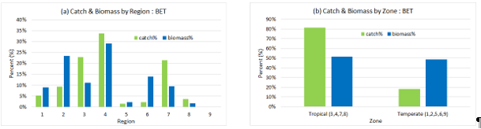

If one assumes that catch is proportional to biomass in a region then there does indeed appear to be a mismatch between the proportion of the total catch taken from a region and the proportion of the total biomass in that region for the diagnostic model (c.f. Figure (a) above). Grouping regions within the tropical and temperate zones also highlights this mismatch (c.f. Figure (b) above). (Note, this mismatch does not appear to be large as for yellowfin tuna.) Whether or not this mismatch between the distributions of catch and biomass indicates some level of model mis-specification, if and how any mis-modelling of the regional dynamics may be influencing the overall status of the stock is perhaps the more important question.

1. The paper contains an honest discussion on the current sources of uncertainty. To help reduce these uncertainties, Australia strongly supports the need to undertake the work recommended in this paper, together with the recommendation to review the current assessment structure. Toward this end, the SC may like to consider the best means for undertaking such a review together with identifying high priority areas for future research.
2. **Question**: Would it be possible to see the likelihood profiles for bigeye, similar to Figure A1 in the yellowfin tuna assessment?

* **Reply (**SPC, G. Pilling) stated that this was included in Figure 51 of SC16-SA-WP-03, rev 1.

1. **PNG** (B. Kumasi) noted the comments on page 136 regarding the perceived potential “buffering” of depletion of more depleted regions by poorly estimated or mis-specification of the Multifan-CL capability to fit the data by manipulating regional biomass through the interaction of seasonal movement and quarterly recruitment deviates.
2. In trying to reconcile the differences in the results from the current assessment with the previous assessment PNG looked at Figure 12 plot of the eﬀort deviation penalties applied to each ﬁshery, by region and the corresponding Figure 10 in the previous assessment. PNG would appreciate some information on how the scale of the deviates differs between the two assessments and the effect on the weighting of a particular CPUE series particularly for regions 1,2,5 and 6.
3. Given the relatively low level of historic catch and effort in these regions we want to understand how these are treated, noting the reference to the “altar of parsimony”.
4. The PNA notes the need to refine the model periodically and that simplifying the model could be desired. We note that the changes to the model in 2017, while also influenced by other factors such as growth and maturity did result in a substantial change to our perception of the stock status of bigeye. If the SPC does decide to pursue this line of thought, we believe that good biological reasons should be driving that change, and not hypothetical model fits. Finally, PNA members are heavily involved in the PTTP, and hope that they will be party to any future discussion on amendments to that program.

* **Reply** (SPC, N. Ducharme-Barth): with regards to the differences in the effort deviate penalties applied to the fisheries which received standardized CPUE, the previous stock assessment used independent delta-GLM CPUE standardization models within each region to calculate the regional effort deviate penalties. The current assessment uses a spatiotemporal CPUE standardization model (previously referred to as “geostats”) to simultaneously estimate standardized CPUE indices and the associated uncertainty around each index for each region. This method preserves the relative uncertainty in the regional indices, both spatially and temporally, which is an improvement from the previous method. The scale of abundance between the regions is also informed by the same spatiotemporal CPUE standardization model, and this is consistent with the approach that was used in the previous assessment.
* With respect to the “altar of parsimony”, that comment in the report was made in reference to not sacrificing biological realism purely in the interests of achieving a better statistical performance or more parsimonious model. Specifically, as it relates to the question of strength of the effort deviates penalties applied to the different regions, the current assessment does maintain biological realism by preserving the scale of the uncertainty in the regional standardized CPUE indices.

1. **Japan** (K. Satoh) commented as follows:
2. In section 7.5.3 of SC16-SA-WP-03 regarding the alternative growth functions, including the Oto-Only model: the growth model wasn’t used for the SPC’s grid analysis because the growth model estimated unreasonably high spawning biomass. The growth model itself is slightly updated by adding 34 specimens of small-sized fish. Japan does not intend to add the growth model into the grid analysis, but further investigation is needed to understand why the Oto-Only model has so great an effect on the spawning biomass level. It could be helpful to test the effect of the spatial growth difference as detected by Eveson et al. in SC16-SA-IP-03 for the huge growth effect. The undergoing age evaluation, including bomb carbon analysis, should be encouraged to solve the large biomass issue.
3. In section 7.4.1 of SC16-SA-WP-03 regarding the effect of recruitment in region 2 into the overall model outcomes: it is curious that the region 2 seems to drive the whole overall decline of biomass, which resulted from the quite high adult biomass level in the region 2. If the high biomass level is true, we have much historical effort for bigeye in this area. However, the bigeye catch and fishing pressure in region 2 is usually low (Figures 5 and 44 of SC16-SA-WP-03). There is no large-scale fishery to catch juveniles in this area, thus there is insufficient information about the recruitment level in this area. However, recruitment in this area seems to be seasonal and recruitment is low according to the low occurrence pattern of larvae in this area (Nishikawa et al. 1985. Average distribution of larvae of oceanic species of scombroid fishes, 1956–1981. *Far Seas Fish.Res.Lab*., 99 p.). Therefore, region 2 does not seem to drive overall decline of biomass. We need to detect the appropriate biomass level in area 2. It could be useful to divide this huge area according to fishery patterns and/or temperate and tropical subregions for this purpose.

# Yellowfin tuna stock assessment for 2020

# 20.1 Background

1. To allow technical questions to be raised before the SC16 plenary to facilitate discussions and reduce the virtual meeting time at SC16.

**20.2 Relevant Documents**

|  |  |
| --- | --- |
| **SC16-SA-WP-04** | M. Vincent, N. Ducharme Barth, J. Hampton, P. Hamer, P. Williams, G.  Pilling. **Stock assessment of yellowfin tuna in the western and central Pacific Ocean** |
| **SC16-SA-IP-04** | T. Peatman. **Analysis of tag seeding data and reporting rates for purse seine fleets** |
| **SC16-SA-IP-05** | J. Scutt Phillips, T. Peatman, M. Vincent, S. Nicol. **Analysis of tagging data for the 2020 tropical tuna assessments: tagger and condition effects** |
| **SC16-SA-IP-06** | N. Ducharme Barth, M. Vincent. **Background analyses for the 2020 stock assessments of bigeye and yellowfin tuna in the western and central Pacific Ocean** |
| **SC16-SA-IP-07** | N. Ducharme Barth, M. Vincent, T. Vidal. **Analysis of Pacific-wide operational longline dataset for bigeye and yellowfin tuna catch-per-unit-effort (CPUE)** |
| **SC16-SA-IP-08** | Vidal, T., P. Hamer. **Developing yellowfin tuna recruitment indices from drifting FAD purse seine catch** **and effort data.** |
| **SC16-SA-IP-18** | T. Peatman, N. Ducharme Barth, M. Vincent. **Analysis of purse seine and longline size frequency data for bigeye and yellowfin tuna in the WCPO** |
| **SC16-SA-IP-19** | Keith Bigelow, Elaine Garvilles, Lilian Garcia, Suzette Barcomaand Maria Angelica Cecilio. **Relative abundance of yellowfin tuna for the purse seine and handline fisheries operating in the**  **Philippines Moro Gulf (Region 12) and High Seas Pocket #1**. |

**20.3 Key Questions and Comments**

1. **Philippines** (S. Barcoma) addressed SC16-SA-WP-04, and raised the following questions and observations. The replies were made by **SPC** (M. Vincent).
2. **Question:** The model showed that the spawning potential and adult depletion is sensitive to natural mortality (M) with values 0.11, 0.13 and 0.15; what is the M value in the 2020 diagnostic model, and does M vary in the diagnostic model?

* **Reply:** The diagnostic model uses the values from the previous assessment where the base level of natural mortality for males was assumed to be 0.2. This translates to a mean natural mortality at age of 0.23. The plot of natural mortality at age is shown in Figure 9, where the diagnostic model is the CondAge line.

1. **Comment**: The 2020 diagnostic model is not sensitive to weight (Figure 42) or CPUE (Figure 43) but sensitive to GROWTH and Tag Mixing =>>> Tag-Oto + Mix1.

* **Reply**: Yes, the diagnostic model is not very sensitive to the different options for the size composition data used or the addition of the other CPUEs. The model is very sensitive to the growth and slightly less to the mixing period. However, the sensitivity to the other options of the size composition may be hidden (and is less than observed in preliminary analyses) because the diagnostic model includes the conditional age-at-length data that seems to have a very large impact on the estimated population size and depletion to a more optimistic state.

1. **Question:** With reference to Figure 48 (b) Maturity: is the Y-axis Length (cm)?

* **Reply:** This is incorrect. This needs to be changed to Reproductive Potential. Good catch. We plan to make this correction once the projections are completed in a Rev1.

1. **Question:** With reference to Figure A3. Estimated spawning potential (a) and ﬁshery depletion (SB/SBF =0) (b) for the previous three assessments: although the trends are the same for 2011, 2014, 2017 and 2020 assessments, what accounts for the big difference in the 2020 assessment (which is more optimistic) compared to the previous assessments, especially from 2000 onwards? Even the last 3–4 years in the 2017 assessment shows a different trend than the 2020 assessment; what is the reason for this?

* **Reply:** The progression from the 2017 assessment to the more optimistic status in 2020 can be seen in the stepwise progression. The largest steps up are due to 1.) enforcing of the mixing period to be 182 days for the diagnostic model, which reduces the estimate of fishing mortality; 2.) the addition of the conditional age-at-length data, which affects the growth estimates of the model; and 3.) changes to the assumptions of shared selectivity parameters seems to result in more biomass and less depleted status. The more optimistic trend in the most recent 3-4 years appears to be driven by an increase observed in the CPUE in regions 1 and 2. It is unclear whether this trend in the nominal CPUE due to an increase in the population or an increase in the efficiency of the gear in these regions that has increased in this time period but has not been standardized out by the hooks between floats in the geostats model.

1. **Question:** For the size-frequency weighting: sample sizes are divided by 10, 60\*, 200 or 500 =>>>. Why is this different than the approach used for bigeye? How are the divisors selected?

* **Reply:** This is a typo in the table (the other figures and rest of the report say 20 and this will be changed in Rev1). The structural uncertainty grid for this axis is the same as bigeye. We chose 20 to be consistent with the previous assessment. 60 was chosen to try to match with the likelihood fit to the other data component from the SSMULT one off sensitivity. 200 and 500 were chosen to reduce the impact of these data sources on scaling the overall population and driving the movement estimates. The scalars are chosen to try to encompass the range of uncertainty observed from the one off sensitivities.

1. **Question:** What is the reason for the differing periods used for Frecent = Average ﬁshing mortality-at-age for a recent period (2014–2017) and SBrecent = Spawning biomass for a recent period (2015–2018)?

* **Reply:** These were chosen by the collective wisdom of SC13 in 2017. It isn’t entirely clear why these time frames differ, but the fishing mortality excludes the most recent period because fishing mortality in the last year is the most uncertain. I think spawning biomass does include the last year so that we have the most recent biomass estimate included, and because for this species adult biomass should not be affected by the recent recruitment estimates.

1. **Question:** Why was the M value 0.2 used in the diagnostic case, same value as the previous assessment? Why not chose a value between 0.11 – 0.15, like in the bigeye assessment?

* **Reply:** Both the yellowfin tuna and bigeye assessments used the value from the previous assessments in their respective diagnostic case. Yellowfin was previously thought to only live to about 7 years and thus had a higher natural mortality value. The value used for bigeye was similar because the maximum age that they live to has remained about the same. For yellowfin, the otolith data suggests that these fish may live longer than previously believed. Sensitivity analyses using the lower values for natural mortality resulted in much larger values of adult biomass that did not seem biologically reasonable. Therefore, we retained the value used in the previous assessment for the sake of consistency. We plan to conduct future investigation of the tagging data to estimate natural mortality, but this requires a good estimate of the reporting rate. However, estimation of reporting rates in recent years has become difficult due to a decrease in tag seeding experiments, which will also be affected by the COVID-19 pandemic.

1. **Australia** (R. Campbell) Australia noted the comprehensive nature of the assessment and recognised that the assessment represents the best available science at this time for making inferences about the current status of the yellowfin tuna stock in the WCPO.
2. All models in the structural uncertainty grid show WCPO yellowfin tuna to be above 20%SBF=0, which is consistent with the previous assessments.
3. There have been number of developments in the assessment in 2020 as evidenced by the large number of step changes (17) from the previous assessment in 2017 to the 2020 diagnostic assessment. While these changes can be considered improvements, it is interesting to note that the adoption of some of these changes has led to substantial changes in stock status (c.f. Figure 14b). For example, in moving from step 9 (IdxNoEff) to the step 17 (2020 diagnostic) the depletion in the final year changes is reduced by about 15% (from ~42% to ~57%). There are also a number of changes between the 2017 and 2020 diagnostic models, such as increased movement between region and changes in the selectivity-at-age curve for some fleets. These observations indicate that model dynamics and assessment outcomes can still be substantially influenced by refinements in data inputs.
4. Given the previous comment and discussions at the end of this paper about the need to improve many of the data inputs into the assessment, current estimates of the stock status may still be subject to influence by future improvements in data inputs. Towards this end the comment on page 60 that “Although the structural uncertainty grid presents a relatively positive indication of stock status, there is reason for caution” is noted.
5. In reviewing previous yellowfin tuna assessments, the SC has noted the unduly large biomass often predicted in the temperate regions. This is also apparent in the assessment this year and noted by the authors who comment on page 52 that “There is evidence to suggest that the overall stock status is “buffered” or kept optimistic by low exploitation in the temperature regions (1, 2, 6, and 9)”. To investigate this issue further Figure 4 was used to estimate the proportion of the total catch taken in each region in the final year (2018) and Figure 33c was used to estimate the proportion of the total biomass in each region in 2018. If one assumes that catch is proportional to biomass in a region then there does indeed appear to be a mismatch between the proportion of the total catch taken from a region and the proportion of the total biomass in that region for the diagnostic model (c.f. Figure (a) below). Grouping regions within the tropical and temperate zones also highlights this mismatch (c.f. Figure (b) below). The authors suggest this is due to the model placing relatively high recruitment level in the temperate regions (page 60). Whether or not this mismatch between the distributions of catch and biomass indicates some level of model mis-specification, if and how any mis-modelling of the regional dynamics may be influencing the overall status of the stock is perhaps the more important question.

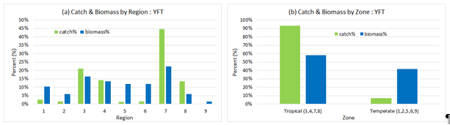

1. The comment on page 59 that “This assessment was fraught with strife due to conflict among data inputs to this assessment” is also noted. This can be clearly seen in the likelihood plot shown in Figure A1 on page 141.
2. The paper contains an honest discussion on the current sources of uncertainty. In order to help reduce these uncertainties. Australia strongly supports the need to undertake the work recommended in this paper, together with the recommendation to review the current assessment structure. Toward this end, the SC may like to consider the best means for undertaking such a review together with identifying high priority areas for future research.

* **Reply** (SPC, M. Vincent): thanked Australia for noting the need for additional collection of data and further improvements for the assessments and noted that the assessment model is fitting the CPUE index well that is input into the assessment. Thus, the difference between the observed catch and the regional abundance is not necessarily a model mis-specification of the assessment model (i.e., a similar result may occur with fewer regions if a similar CPUE index is used). However, it should be noted that the standardized indices estimate abundance for regions 1, 2, and 6 that are less than what would occur assuming abundance is evenly distributed. On the other hand regions 5 and 9 are estimated to have abundance greater than the region area (Figure 2), but is consistent with the observed nominal CPUE in this region which has remained relatively high throughout the time series (see Figure 8 of the assessment report).

[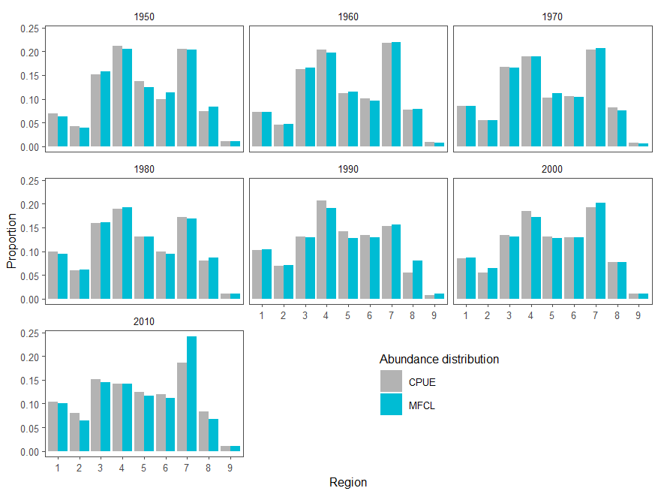](https://forum.wcpfc.int/uploads/default/original/1X/21b8e1a5037a4f541fb529e4241b114b7f76bf7e.png" \o "image)

Figure 1. The average decadal regional proportion of the CPUE and the vulnerable biomass to the index fishery estimated by the MFCL model.

[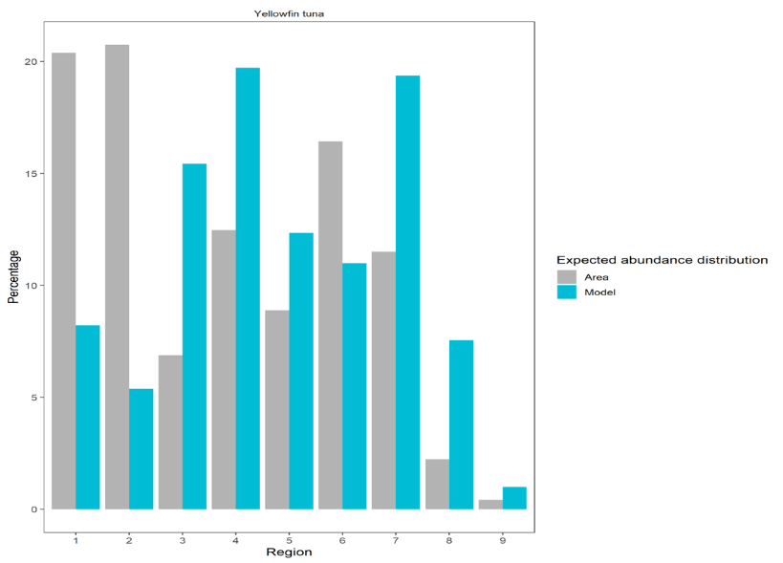](https://forum.wcpfc.int/uploads/default/original/1X/1c5125fc19d5740a232358204a3b252b2efdf1a3.png)  
Figure 2. The regional proportion of biomass predicted from the region area assuming spatially uniform distribution (Area) and predicted from the standardized CPUE index (Model).

1. **Question:** What is driving the poor fit between the observed and model predicted CPUE in region 7 over the past decade?

* **Reply (**SPC, M. Vincent): The poor fit to the CPUE in the last decade of the model in region 7 is due to the low penalty applied to the CPUE in this region. The low penalty occurs because there are relatively few fishing observations in the region at the end of the time period and thus the estimates are less certain from the geostats model. Therefore, the poor fit to the CPUE in this region is not unexpected. It may be worth including one of the indices that was previously included in the assessment for this time period in future analyses (Philippines/Indonesia Hand-line or Purse-seine). However, these two indices showed conflicting trends in abundance so we decided to only use the geostats longline index. Additionally, these indices were on a quarterly scale but the catch for these regions is just the annual estimates evenly divided between the quarters.

1. **Question:** Is there any explanation as to why there is almost no recruitment in Region 8 (c.f. Figure 34)? This is unlike the result from the 2017 assessment (c.f. Figure 31c). This result seems quite strange as this region is between the two regions (3 & 7) with the highest recruitment and is a high catch region.

* **Reply** (SPC, M. Vincent): The strange recruitment distribution was an issue that we attempted to resolve, but were unable to given the available time. It should be noted that the previous assessment estimated almost no recruitment in region 4, which is also a high catch region. This recruitment distribution may be driven by the size composition data and a lack of size composition of fish less than 30 cm in this region (recruitment occurs at 20 cm for the Otolith and CondAge growth models, 27 for the Modal growth). We noticed this issue (with no recruitment in both regions 4 and 8) and a tendency to overestimate less than 40cm fish and thus we fixed the selectivity for age class 1 to be 0 for the purse-seine and pole-and-line fisheries. This did not fully resolve the issue with the recruitment and there were still problems with overestimation of fish less than 30 cm. Thus, the recruitment distribution could be driven by a model mis-specification of the selectivity for the purse-seine fisheries that may also result in an underestimation of fishing mortality, as noted in assessment report. It could also be due to the amount of flexibility that the model has with regards to movement, which allows the fish to be moved around in order to best fit the size composition data and the CPUE data (which is focused on adult fish).

1. **New Zealand** (J. Annala) made the following comments and questions.
2. We note the improvements to the growth curve and the ongoing difficulties in fitting to the size composition data in different fisheries and regions, given sampling concerns and apparent spatial growth variation. We encourage further development and testing of the new SSMULT-RE method. Given the impacts of size data treatments on assessment outcomes, we recommend simulation work and model development to further develop methods and understand these issues. We support inclusion of size data weighting scenarios in the structural uncertainty grid.
3. New models have been implemented for tag data, purse seine catch estimates and size composition data. Tagging data are very influential in the model. Several changes that had a large impact on bigeye results, including adjustments to the tagger effects, reporting rate, and tag usability estimates, were also changed in the yellowfin assessment but their independent impacts were not presented. We note the need for more information about these changes, such as model diagnostics and tables of statistical results for the tagger effects, a table of reporting rate priors by fishery/tagging program group and time period, and a detailed description of the tag usability processes and numbers and how they have changed. This would help determine whether they should be considered improvements or alternative hypotheses. We also note that mixing remains an important issue for models that include tagging data. We recommend that tests of the mixing hypotheses are carried out in future assessments, in addition to the simulation work currently under way, and that the impacts of longer mixing periods are examined.
4. We support an increased focus on tag seeding experiments across the fleet.
5. The new index fishery approach and the spatio-temporal modelling of CPUE are useful enhancements to the assessment. In future assessments it would be useful to further consider factors affecting fishing power and/or regional scaling such as targeting, vessel effects and effort creep.
6. The new biological parameters for the length-weight relationship and spawning potential are useful improvements to the model. We encourage further sampling and analysis work to explore regional variation in biology and population structuring.
7. We note that the independent review of the 2011 bigeye assessment led to major improvements. An independent review of the yellowfin assessment would be useful.
8. **Question:** Changing to the new version of Multifan-CL changed the assessment results significantly for yellowfin but not for bigeye. It would be useful to have a fuller explanation of why the yellowfin results changed so much?

* **Reply** (SPC, M. Vincent): the change in the diagnostic model using the new executable resulted due to an improvement in the likelihood fit to the data. This is likely due to a different **minimizer** that was used in the previous assessment. It is likely that the diagnostic model had converged to a local minimum and the new executable had just found a different minimum. However, we tested the new executable across the entire structural uncertainty grid used in 2017 and the resulting estimates were very similar to the previous assessment and therefore would not change the overall management advice. Some of the requested information on the treatment of the tagging data are included in the inputs paper SC16-SA-IP-06. However, SPC will endeavor to include further information in future reports such as a table of the reporting rates; though, the distribution of the penalties are shown in Figure 29 of the report and the means and penalties for the purse seine should be provided in SC16-SA-IP-04. Additionally, the analysis of the tagger effects is presented in SC16-SA-IP-05 and have more complete detail. In general, for yellowfin there was not much influence of the new methodology because there was generally consistency between the old and new methods. Therefore, we did not explicitly split this step out from the updated data because it did not make a large impact as it did for bigeye (there was a large difference in the tagger effect models for bigeye between the two methods).

1. **Japan** (K. Satoh) made the following comments and questions. Replies are by SPC (M. Vincent).
2. **Question:** Regarding section 6.1 of SC16-SA-WP-04, on the effect of the tagging record from Japan: the Japanese tagging data was slightly updated from the previous stock assessment, in which the effect of inclusion/exclusion of these data is very small, and the results are comparable to the diagnostic case (section 7.5.1 of SC13-SA-WP-06). However, in the current stock assessment the effect of inclusion of the Japanese tagging data is quite large, which leads to optimistic results (sky blue line in Figure 14 of SC16-SA-WP-04). What is the reason for the different effect of the Japanese tagging data sets between the previous and current yellowfin stock assessments?

* **Reply** (SPC)**:** The large impact that is seen in the step labeled JPTP is actually a combination of 3 different steps in the tag data. We combined them in an attempt to reduce the number of steps in the stepwise model progression. The largest impact in this combined step was due to enforcing the mixing period of 182 days. The impact of the inclusion of the JPTP tag data into the assessment was relatively small as was seen in the previous assessment.

1. **Comment:** Usually natural mortality has a great effect on stock assessment results, however the grid analysis axis in paper SC16-SA-WP-04 didn’t include the natural mortality’s variability. According to the description in section 8.2.2 the reason for the exclusion was the poor estimates of fishing mortality and quite high estimates of biomass. In order to interpret the exclusion of the natural mortality, tables are needed of stock assessment results of each one-off-sensitivity analysis, such as Tables 7-9 in the bigeye stock assessment reports.

* **Reply** (SPC)**:** I did not provide tables of management quantities for the one-off sensitivities because **management** advice is based off of the structural uncertainty grid. The inclusion of these tables for the one-off sensitivities are a carry-over from before the structural uncertainty grid was used for management advice. The merits of a model should be decided by the fit of the model to the data (which was much worse for the values of natural mortality that were lower than the diagnostic model) and not the management advice of the model. The instantaneous depletion and spawning potential of these one-off sensitivities are presented in figure 41. If SC deems it is necessary to provide the management quantities for these models they can be calculated.

1. **Comment:** According to section 7.5.1 of the SC16-SA-WP-04, the current diagnostic model used the value assumed from previous assessments in the structural uncertainty grid (base level of 0.2 per quarter). As a result, the natural mortality schedule will be changed according to the changing of the growth model. The effect on the stock assessment results of the inconsistency in the natural mortality schedule and the growth model should be explained.

* **Reply** (SPC): I am not quite clear what you mean by an inconsistency or what the main point of the question is. For each growth curve, the natural mortality at age was calculated based on the fit to the proportion male at length from the longline observer’s dataset. This analysis uses the growth curve to convert the length to age and a base level of natural mortality that is assumed for the males. The base level that is assumed for the males (0.2) was the same for all of the growth curves and is consistent with the previous assessment. The additional mortality that must be experienced by the females to have the observed proportion at length is then estimated and the joint natural mortality is calculated by the sex-specific natural mortalities and the relative proportion of each sex. The growth curve does not affect the base level of natural mortality and only effects the natural mortality at age deviates. Thus, the growth curve is consistent with the natural mortality used in each model in the structural uncertainty grid.

1. **Comment:** According to Figure A3, the retrospective pattern seems to indicate some bias of the depletion rate if the data is added. We need information about Mohn’s rho to detect whether this kind of bias is truly biased or not.

* **Reply** (SPC):
  + mean Mohn’s rho for recruitment = -0.1147781
  + mean Mohn’s rho for SB = -0.05970325
  + mean Mohn’s rho for SBt/ SB{t, F=0} = -0.0614144

1. **Comment:** According to Figure A1, we can find some controversial aspects among data sets, especially for the fish body size data. The fish body size data (weight and length) indicated very different biomass levels, with the weight data indicating a low biomass size. Further exploration of the effect of fish body size data (weight and length) in the stock assessment is needed.

* **Reply** (SPC)**:** We concur that further investigation of the size composition data are required. Additional data regarding the conversion factors for gilled-gutted and gilled-gill cover-gutted-de-tailed to whole weight are needed. Additionally, sensitivity to different assumptions about the conversion of weights during the 1960s through the 1980s could be investigated with different assumptions regarding when the transition between these two processing procedures occurred.

# Pacific bluefin tuna stock assessment in 2020

**21.1 Background**

1. SC16 participants will review the ISC’s 2020 Pacific bluefin tuna stock assessment paper and raise any technical questions before the plenary to facilitate discussions at SC16.

**21.2 Relevant Documents**

|  |  |
| --- | --- |
| **SC16-SA-WP-06** | ISC. **Stock Assessment of Pacific Bluefin Tuna in the Pacific Ocean in 2020** |

**21.3 Key Questions and Comments**

1. **Pew Charitable Trust** (G. Holmes) noted that the probability of PBF rebuilding success heavily relies on an increase in recruitment, and inquired if the authors could further explain the basis of the assumption in the projection model that recruitment will increase to long-term average levels once the primary rebuilding target is met next year. They also commented that the issue of the steepness value used in the assessment has been raised in previous years, and that the current report states that a lower level (0.99) was included as a sensitivity run. This only represents a 1% change from the base case and that including a sensitivity run more departed from the base case is not possible because model convergence is not possible below a steepness of 0.99. While the Pacific Bluefin Working Group acknowledges this as an issue for further investigation (as noted in ISC20), results from a model that only converges when one of its parameters is set at an extreme end should be treated with caution.

**Attachment G**

**The Commission for the Conservation and Management of   
Highly Migratory Fish Stocks in the Western and Central Pacific Ocean**

**Scientific Committee**

**Sixteenth Regular Session**

Electronic Meeting

12 – 19 August 2020

|  |
| --- |
| **SUMMARY OF THE RESUME SC16 ONLINE DISCUSSION FORUM**  **FOR THE WORK PROGRAMME AND BUDGET FOR 2021 – 2023** |

**INTRODUCTION**

1. Because of SC16’s limited virtual meeting time, it was agreed to resume SC16 before the Commission meeting to finalize SC Future Work Program and Budget for 2021–2023.
2. The forum was opened to facilitate efficient discussions at the Resume SC16 Meeting (scheduled for 10 September 2020) by sharing views in advance on the proposed projects and associated budget implications.

1. Additional comments on the proposed projects were submitted to the Secretariat by some CCMs as part of project ranking undertaken in preparation for the Resume SC16 Meeting. Those comments and rankings (some rankings changed during the Plenary discussion) are contained in Annex A.

**Reference Document:**

* **SC16-DRAFT-A5.1**: Secretariat. **[DRAFT] Proposed SC16 Work Programme and Budget**
* **SC16-GN-IP-08**: Secretariat. **Terms of references for 2021 proposed projects**
* **SC16-PP-00:** Secretariat. **Compiled views on the proposed SC projects for 2021-2023**

# (Project 100b) Feasibility of Close-Kin Mark-Recapture (CKMR) assessment for South Pacific albacore in the WCPO

**1.1 Background**

**1.2 Relevant Documents**

|  |  |
| --- | --- |
| SC16-GN-IP-08 | Secretariat. Terms of Reference for 2021 Proposed Projects (Rev.03) |
| SC16-SA-IP-15 | M. Bravington, J. Farley, J. Hampton, S. Nicol. Preliminary analyses for a Close Kin Mark Recapture feasibility study in WCPO |

**1.3 Key Questions and Comments**

1. M. Bravington (CSIRO) made the following responses to comments made during SC16 on the suitability of South Pacific albacore for a close-kin mark recapture (CKMR) study, related to spatial structure and abundance.
2. Unlike southern bluefin tuna (SBT), albacore doesn’t have a single spawning ground.

**Question**: Is that a problem for CKMR?

**Reply:** No, this isn’t a problem, at least not for albacore. There’s no requirement in CKMR for a single well-defined spawning ground, and no requirement that animals be sampled on their spawning grounds either. (The only reason we got adult SBT samples from the spawning ground as opposed to somewhere else, is convenience: that is where most adult SBT get caught). The actual requirement is that either the adults are well-mixed (at sampling), or the juveniles are, or both are. POP (Parent-Offspring Pair) comparisons are between juveniles and adults captured one or more years after juvenile birth, so for albacore those adults should have had plenty of time to mix longitudinally. HSP (Half-Sibling Pair) comparisons (between juveniles) will need some samples from both E and W to compare within-vs-across longitudinal patterns. The basic point is: if there is substantial fine-scale demographic structure— e.g. that adults who spawn once in the East tend to stay to the East, or to spawn there again— then a properly-designed CKMR study will detect it from the geographical patterns in the pairs found. Even if a result like that is found, then it would have important implications for management in its own right; and in any case, finding such a pattern would not be a deal-breaker for CKMR (i.e. models can be adjusted to handle many spatial phenomena) provided the spatial sampling coverage is adequate. BTW: “adequate” certainly doesn’t mean coverage has to be “complete” or “uniform”— just “adequate”. The design study needs to ensure the latter.

There are some species/situations where CKMR can get tricky because of spawning ground issues (for example, with discrete spawning grounds where both adults and juveniles are sampled only during or shortly after spawning/being-spawned). Happily, the WPO albacore situation does not look like one of those.

1. Albacore are more abundant than SBT.

**Question:** Is that a problem?

**Reply:** No. Based on current assessments, albacore adults are only about twice as abundant as SBT, and sample sizes for CKMR scale with the square root of adult abundance (i.e. slower than proportionally), so the required sample size for albacore need not be vastly higher than for SBT; p.3 of the proposal includes a rough calculation using the albacore assessment. In any case, the sample size per se isn’t the key thing for CKMR: the question is whether it’s feasible to collect that many samples (of the right sizes, in the right places, etc.) within a useful timeframe. And from background discussions on WPO albacore, yes that does look feasible within, say, a three- or four-year study. Detailed sample size requirements will vary somewhat depending on the mix of ages sampled, the target for precision, and so on; those are matters to be looked at during a design study.

1. J. Farley (CSIRO) posted the following question and answer (the question was raised outside the forum).
2. **Question:** Is the project critically reliant on marker design, and should that be done as a preliminary step before logistic evaluation?

**Reply:** No. Marker selection for CKMR has nowadays become a reliable process for which we’ve developed a “pipeline” at CSIRO, now used successfully on at least half-a-dozen species. There’s absolutely no reason to think the same process wouldn’t work for albacore. It’s true that marker selection was a painful and long-drawn-out process for the first round of SBTuna CKMR, back in c.2007–2010 — but that was with a different type of genetic marker (microsatellites) and technology that now looks “ancient”. Modern ddRAD methods (DartSeq and DartCap) that look for SNP markers have turned out to be much smoother.

Choosing markers during a logistic design project— as we have proposed here— would save some time later on and provide some general capacity building, but it’s actually not essential to do it now. Since there is no reason for concern about the long-term feasibility of marker selection, we could in fact move all marker-related work out of this design project and defer it to the main project (if such a project does eventually happen) in order to save some short-term costs (see proposal, p6). The most critical part of this proposal, which absolutely does need to happen before any large-scale sampling could start, is the logistics and detailed design.

# (Project 104) Appropriate LRPs for Southwest Pacific Ocean (SWPO) striped marlin and other billfish

**2.1 Background**

**2.2 Relevant Documents**

|  |  |
| --- | --- |
| SC16-GN-IP-08 | Secretariat. Terms of Reference for 2021 Proposed Projects (Rev.03) |
| SC16-MI-IP-12 | P. Hamer and G. Pilling. Terms of Reference for a project to identify appropriate Limit Reference Points for Southwest Pacific Ocean striped marlin and consideration of other billfish species |

**2.3 Key Questions and Comments**

1. There were no questions or comments on this topic.

# (Project 105) Bomb radiocarbon age validation for bigeye and yellowfin tunas in the WCPO

**3.1 Background**

**3.2 Relevant Documents**

|  |  |
| --- | --- |
| SC16-GN-IP-08 | Secretariat. Terms of Reference for 2021 Proposed Projects (Rev.03) |
| SC16-SA-IP-17 | Jessica Farley, Allen Andrews, Naomi Clear, John Hampton, Taiki Ishihara, Kyne Krusic-Golub, Jed MacDonald, Kei Okamoto, Keisuke Satoh, Ashley Williams. Report on the bomb radiocarbon age validation workshop for tuna and billfish in the WCPO |

**3.1 Key Questions and Comments**

1. J. Farley (CSIRO) posted the following questions made outside the forum.
2. **Question**: To validate the otolith age estimates, is there a need for radiocarbon references (i.e., coral core records) with a duration that overlap with YOY otoliths within the tissue bank?

**Reply**: No. Using coral as a bomb radiocarbon reference is the second-best case scenario to using known-date-of-formation otolith material (juvenile) from the species being tested for age estimate accuracy. Our proposal will use otoliths from age-0 fish that currently exist in the tissue bank dating from 2020 to 1996 to create an independent reference that will overlap coral records by 10-20 years.

1. **Question**: Is the laser ablation work required for this study?

**Reply:** The laser ablation work was an exploratory component that would be of interest for future studies on BET and other species that may be affected by deeper depleted radiocarbon signals through ontogeny. This component is not essential and can be removed from the project at a savings of $3000.

# (Project 106) Ageing of South Pacific albacore

**4.1 Background**

1. Funding for this project will be provided from the unspent budget for Project 81 which was supported by SPC and CSIRO.

**4.2 Relevant Documents**

|  |  |
| --- | --- |
| SC16-GN-IP-08 | Secretariat. Terms of Reference for 2021 Proposed Projects (Rev.03) |

**4.3 Key Questions and Comments**

1. There were no comments or questions on this topic.

# (Project X1) Billfish research plan

**5.1 Background**

**5.2 Relevant Documents**

|  |  |
| --- | --- |
| SC16-GN-IP-08 | Secretariat. Terms of Reference for 2021 Proposed Projects (Rev.03) |

**5.1 Key Questions and Comments**

1. There were no comments or questions on this topic.

# (Project X2) SP blue shark assessment

**6.1 Background**

**6.2 Relevant Documents**

|  |  |
| --- | --- |
| SC16-GN-IP-08 | Secretariat. Terms of Reference for 2021 Proposed Projects (Rev.03) |
| SC16-EB-IP-01 | S. Brouwer and P. Hamer. 2021-2025 Shark Research Plan |

**6.3 Key Questions and Comments:**

1. There were no comments or questions on this topic.

# (Project X8) Training observers for elasmobranch biological sampling

**7.1 Background**

**7.2 Relevant Documents**

|  |  |
| --- | --- |
| SC16-GN-IP-08 | Secretariat. Terms of Reference for 2021 Proposed Projects (Rev.03) |

**7.3 Key Questions and Comments:**

1. There were no comments or questions on this topic.

# (Project X9) Review of stock assessment modelling for bigeye and yellowfin tuna

**8.1 Background**

1. SC16 recommendation:
2. SC16 supports an external expert peer review of the yellowfin stock assessment. This would also allow several components of the bigeye tuna assessment to be reviewed given the similar data input structure. This review would examine a number of issues such as model complexity, weighting of data sources, spatial approaches and the extreme sensitivity to assumptions on growth amongst a range of other issues.
3. SC16 provides the following provisional time-line for an external expert peer review.

a) Year 1 would be set aside to allow the SSP to conduct an initial range of testing and analysis internally focused on YFT and report these findings to SC17. SC17 to finalize TORs for the external expert review.

b) Year 2 would be set aside for the SSP to conduct further testing and analysis internally focused on BET and YFT, following SC17 input, and for the external expert review (commencing at the start of 2022) with the review reporting to SC18.

c) Year 3 would provide updated YFT and BET stock assessments which respond to the review. The two assessments would be reported to SC19.

1. In accordance with this, SC16 identified the external review as a project in the budget (provisionally estimated at $USD 50,000) but with no funding commitment until 2022 and 2023.
2. SC16 also tasked the SSP with preparing a draft terms of reference for the external expert review for the consideration of SC17 which would be informed by their analyses during 2021. The draft terms of reference would give consideration to including the bigeye stock assessment in the external review process.
3. Further, SC16 noted that peer review experts of the required calibre may not be easy to secure, thus efforts should be made during late 2020/early 2021 to have them express interest and availability.

**8.2 Relevant Documents**

**8.3 Key Questions and Comments:**

1. There were no comments or questions on this topic.

# (Project X10) Non-entangling and biodegradable FADs

**9.1 Background**

1. A ToR has now been developed for a project to expand the work on non-entangling and biodegradable FADs in the WCPO. The project has been costed at $525,000 and would start in 2021 with completion expected in 2023. The EU will contribute 80% of the total project budget ($420,000), the remaining 20% will be provided as a cash contribution of $20,000 from the ISSF and $85,000 from the WCPFC research budget.

**9.2 Relevant Documents**

|  |  |
| --- | --- |
| SC16-GN-IP-08 | Secretariat. Terms of Reference for 2021 Proposed Projects (Rev.03) |

**9.3 Key Questions and Comments:**

1. The Secretariat of the Pacific Regional Environment Programme commented that this is a very important project contributing towards sustainability of the WCPFC fishery. Biodegradable FAD materials produced locally are both a risk — considering the impact of taking materials from small islands with vulnerable ecosystems — but also an opportunity, as there a great potential for sustainable agroforestry development for growing products such as bamboo, and potentially as part of reforestation projects for sustainable development. SPREP Suggested that these aspects be included in the TORs.

# Other projects proposed

**10.1 Background**

1. Consideration of the following projects was proposed to be deferred as noted.

**10.2 (Project X3) WCPO silky shark assessment**

1. Consideration on this project can be deferred as the assessment is scheduled in 2023. Reference Documents: SC16-EB-IP-01. S. Brouwer and P. Hamer. 2021-2025 Shark Research Plan and SC16-GN-IP-08. Secretariat. Terms of Reference for 2021 Proposed Projects

**10.3 (Project X4) Pacific whale shark assessment and (Project X5) Pacific silky shark assessment**

1. No terms of references are available now and consideration can be deferred to SC17 in 2021.

Reference Documents: SC16-EB-IP-01. S. Brouwer and P. Hamer. 2021-2025 Shark Research Plan

**10.4 (Projects X6) Estimate silky and oceanic whitetip shark post release survival from WCPO longline fisheries and (Project X7) Estimate whale shark post release survival from WCPO purse seine fisheries**

1. SC16 discussed that any further in-situ studies of shark post-release survival are best considered after review of recently completed studies and completion of the up-dated Monte-Carlo simulation study of shark mortality mitigation approaches in tuna fisheries. Review on the need for Project X6 and X7 can be deferred to SC17 in 2021. Reference Documents: SC16-EB-IP-01. S. Brouwer and P. Hamer. 2021-2025 Shark Research Plan and SC16-GN-IP-08. Secretariat. Terms of Reference for 2021 Proposed Projects

**Annex A**

**Compiled views on the proposed SC projects for 2021 – 2023**

| **Project ID** | **Title** | **CCMs** | **Priority\*** | **Comments** |
| --- | --- | --- | --- | --- |
| **P-98** | (2020 Project) Radiocarbon aging workshop (No physical workshop was held in 2020 and $35,000 was unspent.) | USA | Medium | Re-purposes the unspent 35k and asks for an additional 100k for project 105. Cost basis is a medium and overall project is medium. While validating growth would be good, the preference is to have SPC/CSIRO further the tag increment analysis. The otolith work alone is inconclusive as the length at age data indicated a BET stock biomass > SKJ. Not credible as the assessment indicates. To validate or perhaps corroborate the otolith ageing estimates, this requires radiocarbon reference materials. From Figure 1 in SC16-SA-IP-07, there doesn't seem to be any coral cores with a duration that would overlap with YOY within the tissue bank. This would limit the proposed research tractability as only the A Samoa appears to go to 2014. The laser ablation is an evolving technique with unknown utility. The USA views this a pure research and probably better suited for academic or University research settings, rather than WCPFC funding. Again, the USA proposes a Medium designation. |
| \*Agreed Project 98 priority during Plenary discussion: High 1 | | | | |
|  |  |  |  |  |
| **P-100b** | Project 100b. Feasibility of Close-Kin Mark-Recapture (CKMR) assessment for South Pacific albacore in the WCPO | Australia | High 1 | This new method can provide an absolute abundance estimate and would be good to see this trialed in the WCPO. |
| EU | High 1 |  |
| NZ | High 1 |  |
| FFA | High 1 | It will be very useful to do this ahead of South Pacific Albacore assessments. This new method can provide an absolute abundance estimate and would be good to see this trialed in the WCPO. Suggest a ranking of High 1 |
| USA | Medium | The marker develop appears to be crucial. Is there any advantage to initially develop the markers at a reduced cost. Provide an analysis of markers and then proceed to Logistic Evaluation and Detailed Design. |
| \* Agreed Project 100b priority during plenary discussion: High 2. | | | | |
|  |  |  |  |  |
| **P-104** | Project 104. Appropriate LRPs for Southwest Pacific Ocean (SWPO) striped marlin and other billfish (TOR: SC16-GN-IP-08) | Australia | High 1 | The need for the Commission to adopt LRPs for billfish, as it has done for tunas, should be seen as a HIGH1 priority |
| NZ | High 1 |  |
| FFA | High 1 | There is a need for the Commission to adopt LRPs for billfish, as it has done for tunas. |
| USA | High 2 | This research is obviously something that needs to be done, and the amount doesn't seem excessive. |
| \* Agreed Project 104 priority during plenary: High 1. | | | | |
|  |  |  |  |  |
| **P-105** | Project 105. Bomb radiocarbon age validation for bigeye and yellowfin tunas in the WCPO (2020 budget of $35,000 unspent) (TOR: SC16-GN-IP-08) | Australia | High 1 | The need to clarify growth models and reduce associated uncertainty in the related stock assessments is a HIGH1 priority |
| Japan | High 1 | (High priority) The growth model for tropical tuna species are key uncertainties for these species stock assessments in the WCPO. Thus, the age validation of these species is urgent matter and these priorities are high. |
| EU | High 1 |  |
| NZ | High 1 |  |
| FFA | High 2 | FFA members express strong support for this validation testing as it informs the improvement of the work on WCPO BET and YFT tunas. It has a big costing which is a concern but nevertheless a critical piece of work. |
| USA | Medium | Re-purposes the unspent 35k and asks for an additional 100k. Cost basis is a medium and overall project is medium. While validating growth would be good, the preference is to have SPC/CSIRO further the tag increment analysis. The otolith work alone is inconclusive as the length at age data indicated a BET stock biomass > SKJ. Not credible as the assessment indicates. To validate or perhaps corroborate the otolith ageing estimates, this requires radiocarbon reference materials. From Figure 1 in SC16-SA-IP-07, there doesn't seem to be any coral cores with a duration that would overlap with YOY within the tissue bank. This would limit the proposed research tractability as only the A Samoa appears to go to 2014. The laser ablation is an evolving technique with unknown utility. The USA views this a pure research and probably better suited for academic or University research settings, rather than WCPFC funding. Again, the USA proposes a Medium designation. |
| \* Agreed Project 105 priority during plenary: High 2. | | | | |
|  |  |  |  |  |
| **P-106** | Project 106. Ageing of South Pacific albacore (TOR: SC16-GN-IP-08) | Australia | High 1 | Again, needed to reduce associated uncertainty in the related assessments. Cannot be delayed if to be used in 2021 assessment |
| NZ | High 1 | High given importance of data to the assessment |
| FFA | High 1 | Needed to be completed prior to South Pacific Albacore assessment in 2021. Again, this is needed to reduce associated uncertainty in the related assessments. Cannot be delayed if it is to be used in the 2021 assessment. Ranked as HIGH1. |
| USA | High 1 | Are there a total of 4 marked otoliths? Applicability to juveniles? |
| \* Agreed Project 106 priority during plenary: High 1. | | | | |
|  |  |  |  |  |
| **P-X1** | Project X1. Billfish research plan | Australia | High 2 | We are uncertain of the context for this study? |
| Japan |  | (Comment only) The ISC Billfish Working Group has initiated a joint study of North Pacific billfish biology. |
| EU | High 1 |  |
| NZ | High 2 |  |
| FFA | High 2 | FFA members support the importance of this work in addressing the need to collating available data and prioritise the work required to fill the data gaps for the WCPO billfish. |
| USA | Low | There is an SRP, a non-evaluated Tuna Research Plan. Let’s concentrate in reviewing the TRP rather than initiating another Plan. |
| \* Consideration delayed to 2022. | | | | |
|  |  |  |  |  |
| **P-X2** | Project X2. SPC SP blue shark assessment | Australia | ? |  |
| EU | High 1 |  |
| NZ | High 1 | The last assessment in 2016 did not provide results on stock status due to incomplete data. First step in 2021 is to assess data availability and quality and if sufficient conduct assessment in 2022 |
| FFA | Medium | Suggest that in 2021 to investigate a medium info assessment (which may work) and if that works try a data rich assessment in SS3 |
| USA | Low-Medium | This assessment was done by Takeuchi-san, and he just gave up at the end when the model did not fit. We wonder where is the concern. Only one CCM retains sharks (EU) and their Part 1 has 3 longline vessels active in 2019. There is no emerging fishery targeting blue sharks in the SW Pacific. There is no recent research on life history or stock structure for blue sharks that would require substantial changes in the existing MFCL. In contrast, we have greater concern for S Pacific mako shark as a CITES listed species. |
| \* Agreed Project X-2 priority during plenary: High 2. | | | | |
|  |  |  |  |  |
| **P-X3** | Project X3. WCPO silky shark assessment | Australia | ? |  |
| Japan |  | (Comment only) For ProjectX3, the next stock assessment for silky shark is scheduled in 2023 on the shark research plan, however, the objective of the proposal is an implementation of the stock assessment for silky shark. So, we suggest that this project should be given as a low priority compared to the other projects. |
| NZ | High 2 |  |
| USA | High 1 | We think that revisiting the silky shark assessment would be worthwhile. The assessment should be rather simple as the good work that was conducted in the 2018 assessment could be updated with the same framework as the Stock Synthesis model. Given that the framework exists, we recommend that the budget by reduced from $100,000 to ~$60,000. |
| \* To be reviewed at SC17. | | | | |
|  |  |  |  |  |
| **P-X4** | Project X4. Pacific whale shark assessment | Australia | ? |  |
| NZ | Low | Low for 2021 |
| FFA | Low | With regards to Projects X4 and X5: Pacific whale sharks and silky sharks, does the budget need to be re-determined prior to SC17 and if so, do these need to be incorporated in SC16 budget? |
| USA |  | No project description |
|  |  |  |  |  |
| **P-X5** | Project X5. Pacific silky shark assessment | Australia | ? |  |
| NZ | Low | Low for 2021 |
| FFA | Low | With regards to Projects X4 and X5: Pacific whale sharks and silky sharks, does the budget need to be re-determined prior to SC17 and if so, do these need to be incorporated in SC16 budget? |
| USA |  | How is this different than X3 |
|  |  |  |  |  |
| **P-X6** | Project X6. Estimate silky and oceanic whitetip shark post release survival from WCPO longline fisheries | Australia | Medium | High cost ($500,000 over 3 years) and competing against number of other projects |
| Japan |  | (Comment only) For Project X6, silky shark and oceanic whitetip shark caught by both purse seine fishery and longline fishery should be included in the project because many sharks were caught by purse seine fishery as well. |
| NZ | Low | Defer to SC17 for consideration |
| FFA | Medium | Suggesting being rolled over to next year. This is a high cost ($500,000 over 3 years) and competing against a number of other projects |
| USA | Low | The USA finds that this proposal duplicates some of the work developed under the ABNJ/WCPFC tagging program and other studies recently carried out in the region. The second paragraph in the rationale says 117 tags on silky sharks. I am quite sure the ABNJ project had 117 tags TOTAL, including Silky (n =53) and mako sharks (n=57). Concerning a potential replacement species, I believe that the ABNJ project also developed a list of priority species (OCS, BTH, SMA). During the SC14 discussion on the ABNJ tagging project, I recalled that the reason they did not tag OCS was that they did not think they could find them. Recent research (Hutchinson In Prep) have tagged 62 OCS and are relatively rare. The first sentence of the scope paragraph says, "This project is designed to plan the required number of releases by shark catch condition category". We think the ABNJ project already did that. They did this to the best of their ability but ended up have to classify sharks as Injured or Uninjured. Catch condition in the combined analyses was influential so this will be a worthwhile exercise if they move forward. A summary of research indicates that there are at least 221 tags on silky sharks that have been captured in Pacific Ocean longline fisheries and mortality data is available. Early explorations show that post release mortality rates for silky sharks is low. I might suggest that silky shark need not be a target species for this work. A budget of 500k is high. I would recommend before approving this budget, make a request for SPC to provide was done before under the ABNJ/WCPFC project, and if something was not good enough, they need to present why and how they are going to do it better without duplicating or repeating the same mistakes. |
|  |  |  |  |  |
| **P-X7** | Project X7. Estimate whale shark post release survival from WCPO purse seine fisheries | Australia | Medium | High cost project competing with many other projects |
| Japan |  | (Comment only) For Project X6 and X7, both projects are the same objectives on the post release mortality of sharks if the sharks caught by purse seine fishery are included in the project X6. So, either of the projects should be given as a low priority to effectively utilize the outcomes of the implemented project. |
| NZ | Low | Defer to SC17 for consideration, pending US results from current studies and then potentially workshop |
| FFA | Medium | Suggesting being rolled over to next year. This is a high cost project competing with many other projects. |
| USA | Low-Medium | ~ 25 whale sharks tagged in purse seine fisheries worldwide. Post release survival rates are high ~ 95% if the sharks are released using the recommended practices. Catch is seasonal and aggregated. Meta-analysis of tag data generated by several institutions in the Pacific Ocean may reveal environmental drivers of hotspots. May inform avoidance strategies or adaptive management. |
|  |  |  |  |  |
| **P-X8** | Project X8. Training observers for elasmobranch biological sampling | Australia | High 2 | Required to provide better biological data to inform parameters and reduce uncertainty in shark stock assessments. |
| EU | High 1 |  |
| NZ | High 1 | Agree in -person workshop is required but unlikely feasible in 2021 |
| FFA | High 2 | Required to provide better biological data to inform parameters and reduce uncertainty in shark stock assessments. |
| USA | High 1 | SPC could create biological sampling training materials that are available to other observer programs. Worthy of additional funding. |
| \* Agreed Project X-8 priority during Plenary: High 1 | | | | |
|  |  |  |  |  |
| **P-X9** | Project X9. Review of stock assessment modelling for BET and YFT | Australia | High 1 | Year 1= SPC initial testing and analysis. Year 2 =external/expert review. |
| FFA | High 1 | Year 1= SPC initial testing and analysis. Year 2 =external/expert review. |
|  |  |  |  |  |
| **P-X10** | Project X10. Non-entangling and biodegradable FADs (matching fund for EU's voluntary contribution of USD 400,000). | EU | High 1 |  |
| USA | High 1 | Important topic and excellent cost-basis |
| \* Agreed Project X-10 priority during plenary: High 1. | | | | |

**Attachment H**

**The Commission for the Conservation and Management of   
Highly Migratory Fish Stocks in the Western and Central Pacific Ocean**

**Scientific Committee**

**Sixteenth Regular Session**

Electronic Meeting

12 – 19 August 2020

|  |
| --- |
| **LIST OF ABBREVIATIONS** |

|  |  |  |
| --- | --- | --- |
|  | |  |
| *BMSY* | biomass that will support the maximum sustainable yield | | |
| CCMs | Members, Cooperating Non-members and participating Territories | | |
| CMM | Conservation and management measure | | |
| the Convention | The Convention for the Conservation and Management of Highly Migratory Fish Stocks in the Western and Central Pacific Ocean | | |
| COVID-19 | coronavirus disease 2019 | | |
| CSIRO | Commonwealth Scientific and Industrial Research Organization (Australia) | | |
| CV | coefficient of variation | | |
| FAD | fish aggregating device | | |
| FFA | Pacific Islands Forum Fisheries Agency | | |
| FMSY | fishing mortality that will support the maximum sustainable yield | | |
| GLM | generalized linear model | | |
| HCR | harvest control rule | | |
| IATTC | Inter-American Tropical Tuna Commission | | |
| ISC | International Scientific Committee for Tuna and Tuna-like Species in the North Pacific Ocean | | |
| ISSF | International Seafood Sustainability Foundation | | |
| IWG | Intersessional working group | | |
| LRP | limit reference point | | |
| M | mortality | | |
| MOU | memorandum of understanding | | |
| MP | management procedure | | |
| MSE | management strategy evaluation | | |
| MSY | maximum sustainable yield | | |
| mt | metric tons | | |
| OM | operating model | | |
| PNA | Parties to the Nauru Agreement | | |
| PNG | Papua New Guinea | | |
| PTTP | Pacific Tuna Tagging Programme | | |
| ROP | Regional Observer Programme | | |
| RFMO | regional fisheries management organization | | |
| RMI | Republic of the Marshall Islands | | |
| SA | stock assessment | | |
| SB | spawning biomass | | |
| SC | Scientific Committee of the WCPFC | | |
| SIDS | small island developing state | | |
| SPC-OFP | Oceanic Fisheries Programme of the Pacific Community | | |
| SPR | spawning potential ratio | | |
| SSB | spawning stock biomass | | |
| SSI | species of special interest | | |
| SSP | scientific services provider | | |
| TCC | Technical and Compliance Committee of the WCPFC | | |
| TOR | terms of reference | | |
| TRP | target reference point | | |
| VB | von Bertalanffy (growth function) | | |
| VMS | vessel monitoring system | | |
| WCPFC | Western and Central Pacific Fisheries Commission | | |
| WCPFC Convention Area | The area of competence of the Commission for the Conservation and Management of Highly Migratory Fish Stocks in the Western and Central Pacific Ocean | | |
| WCPFC Statistical Area | The WCPFC Statistical Area is defined in para. 8 of the document “Scientific data to be provided to the Commission” | | |
| WCPO | western and central Pacific Ocean | | |
| WG | working group | | |

1. It should be noted that the constant catch scenario is inconsistent with current management approaches for north Pacific albacore tuna adopted by the Inter-American Tropical Tuna Commission (IATTC) and the Western and Central Pacific Fisheries Commission (WCPFC). [↑](#footnote-ref-1)
2. SPR (spawning potential ratio) is the ratio of the cumulative spawning biomass that an average recruit is expected to produce over its lifetime when the stock is fished at the current fishing level to the cumulative spawning biomass that could be produced by an average recruit over its lifetime if the stock was unfished. F%SPR: F that produces % of the spawning potential ratio. [↑](#footnote-ref-2)
3. The results of the Online Discussion Forum were considered under Agenda Item 7, and are appended as Attachment F). [↑](#footnote-ref-3)
4. It should be noted that the constant catch scenario is inconsistent with current management approaches for north Pacific albacore tuna adopted by the Inter-American Tropical Tuna Commission (IATTC) and the Western and Central Pacific Fisheries Commission (WCPFC). [↑](#footnote-ref-4)
5. SPR (spawning potential ratio) is the ratio of the cumulative spawning biomass that an average recruit is expected to produce over its lifetime when the stock is fished at the current fishing level to the cumulative spawning biomass that could be produced by an average recruit over its lifetime if the stock was unfished. F%SPR: F that produces % of the spawning potential ratio. [↑](#footnote-ref-5)
6. Defined in SC16-MI-IP-21 as 20% of the average theoretical level of spawning biomass that would be present during recent 10 years with no fishing, based on SC10-MI-WP-07. [↑](#footnote-ref-6)