NORTHERN COMMITTEE
EIGHTEENTH REGULAR SESSION

ELECTRONIC MEETING
4 - 6 October 2022
Harvest Strategy for North Pacific Albacore Fishery
WCPFC-NC18-2021/WP-03 (Rev.02)

NC Chair

Attachment X below was adopted by NC18 on 4 October 2022, which will be attached to the NC18 Summary Report.

Attachment X

The Commission for the Conservation and Management of
Highly Migratory Fish Stocks in the Western and Central Pacific Ocean

NORTHERN COMMITTEE
EIGHTEENTH REGULAR SESSION

ELECTRONIC MEETING
4 - 6 October 2022

Harvest Strategy for North Pacific Albacore Fishery
Harvest Strategy 2022-XX

Introduction and scope

This Harvest Strategy, applicable to all fisheries that harvest North Pacific albacore, was developed based on the results of the Management Strategy Evaluation (MSE) completed by the International Scientific Committee for Tuna and Tuna-Like Species in the North Pacific Ocean (ISC) in 2021.

Management objectives

Considering the overarching objective of ensuring the sustainability of North Pacific albacore tuna and current fisheries supported by the stock in the Western and Central Pacific Ocean, the following management objectives are established:
- Maintain Spawning Stock Biomass (SSB) above the Limit Reference Point (LRP), with a probability of at least 80% over the next 10 years.
- Maintain depletion of total biomass around historical (2006-2015) average depletion over the next 10 years.
- Maintain fishing intensity (F) at or below the target reference point with a probability of at least 50% over the next 10 years.
- To the extent practicable, management changes (e.g., catch and/or effort) should be relatively gradual between years.

Reference points

For the purpose of the North Pacific albacore tuna harvest strategy, the following reference points are established.:
- Target reference point (TRP) = F45%, which is the fishing intensity (F) level that results in the stock producing 45% of spawning potential ratio (SPR)
- Threshold reference point (SSB_{threshold}) = 30%SSB_{current,F=0,} which is 30% of the dynamic unfished spawning stock biomass
- Limit reference point (LRP) =14%SSB_{current,F=0,} which is 14% of the dynamic unfished spawning stock biomass.

Acceptable levels of risk

The risk of breaching the Limit Reference Point based on the most current estimate of SSB shall be no greater than 20%.

Monitoring strategy

The ISC will conduct a stock assessment every three years, at which time the status relative to the reference points established under paragraph 2 will be evaluated.

When performing a stock assessment, the ISC will consider if the biology, environmental conditions, data sources, status of the stock, and/or other underlying assumptions have changed substantially enough to warrant revisiting the components in this harvest strategy.

Harvest Control Rules (HCR)
- By 2023, the Commission shall adopt harvest control rules as part of the harvest strategy for North Pacific albacore, consistent with Figure 1.
- The harvest control rules adopted pursuant to paragraph 5(a) shall outline inter alia the actions the Commission will take to manage North Pacific albacore tuna.
- The actions referenced under paragraph 5(b) shall be determined by the position of the most recent fishing intensity and biomass estimates relative to the reference points established pursuant to this CMM.

Other Provisions

The Commission shall promote compatibility between the harvest strategy adopted herein and the harvest strategy adopted by the Inter-American Tropical Tuna Commission with respect to North Pacific albacore tuna.

The ISC is requested to develop criteria for identification of exceptional circumstances in 2023.

This Harvest Strategy replaces the “Interim Harvest Strategy for North Pacific Albacore Fishery” adopted as Harvest Strategy 2017-01.

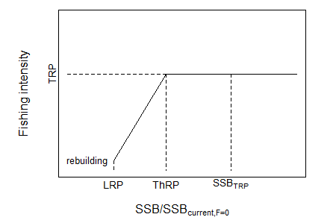

Figure 1. Illustration of the harvest control rules with target reference point (TRP), threshold reference point (ThRP), limit reference point (LRP), and the expected SSB when fishing at the TRP (SSB_{TRP}). The harvest control rules to be adopted pursuant to paragraph 5(a) are intended to include the triggering of a rebuilding plan if the SSB/SSB_{current,F=0} falls below the LRP.

